Australian Government, Great Barrier Reef Marine Park Authority logo

**Coastal Ecosystems Management – Mount Peter, Cairns**

Review of coastal ecosystem management to improve the health and resilience of the Great Barrier Reef World Heritage Area

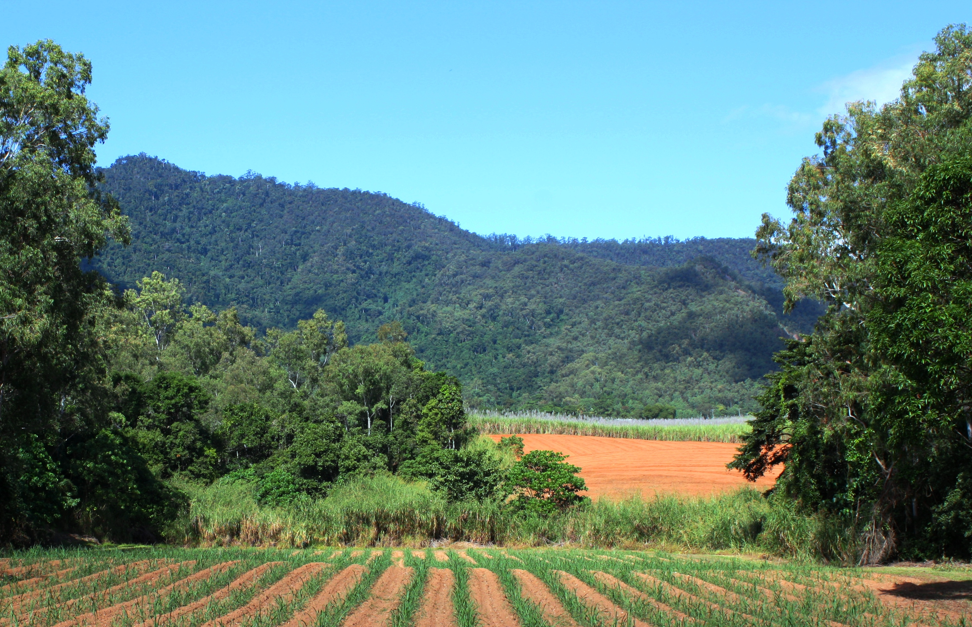

Page intentionally left blank for printing double-sided.

Australian Government Logo - Great Barrier Reef Marine Park Authority


**Urban Planning and Coastal Ecosystems** – Mount Peter, Cairns

Review of coastal ecosystem management to improve the health and resilience of the Great Barrier Reef World Heritage Area

© Commonwealth of Australia 2013

Published by the Great Barrier Reef Marine Park Authority 2013

This work is copyright. You may download, display, print and reproduce this material in unaltered form only (appropriately acknowledging this source) for your personal, non-commercial use or use within your organisation. Apart from any use as permitted under the *Copyright Act 1968*, all other rights are reserved.

**Disclaimer**

The views and opinions expressed in this publication are those of the authors and do not necessarily reflect those of the contributors, the Australian Government or the Minister for Sustainability, Environment, Water, Population and Communities.

While reasonable efforts have been made to ensure that the contents of this publication are factually correct, the Australian Government does not accept responsibility for the accuracy or completeness of the contents, and shall not be liable for any loss or damage that may be occasioned directly or indirectly through the use of, or reliance on, the contents of this publication.

**National Library of Australia Cataloguing-in-Publication entry**

*Coastal ecosystems management – case study: urban planning,* GBRMPA, Townsville.

*Coastal ecosystems management – case study: urban planning,*

ISBN  978 1 922126 20 7 (ebook)

Coastal zone management--Queensland--Mount Peter Region.  
Coastal zone management--Queensland--Great Barrier Reef.  
Natural resources management areas--Queensland--Mount Peter Region.  
Natural resources management areas--Queensland--Great Barrier Reef.  
Great Barrier Reef (Qld.)--Management.  
Great Barrier Reef (Qld.)--Environmental conditions.  
Mount Peter Region (Qld.)--Management.  
Mount Peter Region (Qld.)--Environmental conditions.

Great Barrier Reef Marine Park Authority.

577.099436

**This publication should be cited as:** *Coastal ecosystems management – case study: urban planning,* GBRMPA, Townsville.

The Great Barrier Reef Marine Park Authority would like to thank Terrain Natural Resource Management, Mulgrave Landcare, the Queensland Wetlands Program, Planz Town Planning and Cairns Regional Council for their assistance with this assessment.

Coverphoto: Cane fields and riparian vegetation in the Mulgrave catchment, far North Queensland.

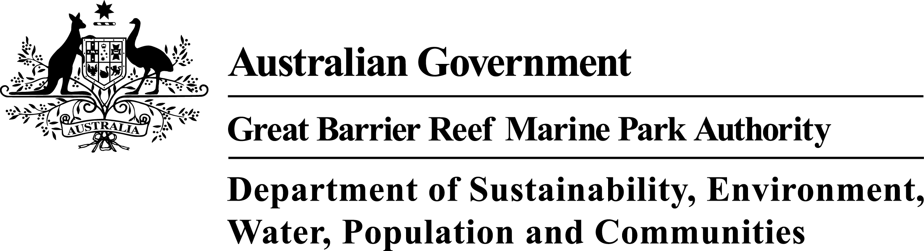

**Requests and enquiries concerning reproduction and rights should be addressed to:**

Great Barrier Reef Marine Park Authority

2-68 Flinders Street (PO Box 1379)

Townsville QLD 4810, Australia

Phone: (07) 4750 0700

Fax: (07) 4772 6093

Email: [info@gbrmpa.gov.au](mailto:info@gbrmpa.gov.au)

www.gbrmpa.gov.au

EXECUTIVE SUMMARY 2

Context 2

Key issues 2

Current management 2

Potential management actions 3

INTRODUCTION 4

Background 4

Objectives and purpose of case study 5

Methodology 6

COASTAL ECOSYSTEMS OF THE MOUNT PETER AREA 7

Overview of the Mount Peter area 8

History of land use change in the Mount Peter area 9

Impacts on coastal ecosystems and current condition 10

Modified ecological functions and processes 12

Catchment response under low, medium and high flow events 15

Forecast of likely future activities and impacts on coastal ecosystems 16

Expected condition of the inshore Great Barrier Reef World Heritage Area 18

LAND USE MANAGEMENT AND COASTAL ECOSYSTEMS 20

Background 20

Management mechanisms influencing coastal ecosystems 20

Managing coastal ecosystems 23

Priority areas for management of coastal ecosystems 32

Ensuring coastal ecosystems remain connected 34

Gaps in protecting and restoring coastal ecosystems 35

Uncertainty in assessment and managing risk 36

Adaptive management 36

DISCUSSION 37

Identifying and validating coastal ecosystem values 37

Hydrology 38

Modelling and best practice 39

Potential management actions 40

REFERENCES 41

APPENDIX A: Ecological processes of natural coastal ecosystems linked to the health and resilience of the Great Barrier Reef. 42

APPENDIX B: Ecological processes of modified systems linked to the health and resilience of the Great Barrier Reef. 43

# EXECUTIVE SUMMARY

## Context

This report is one of five case studies examining how present management and planning decisions support protection of Great Barrier Reef coastal ecosystems with links to the Great Barrier Reef World Heritage Area’s (World Heritage Area) Outstanding Universal Value. This case study considers landscape management associated with previous Master Planning in the Mount Peter area of the Mulgrave-Russell catchment, far north Queensland. The Mount Peter case study site covers an area of 3,352 hectares, and was identified as a future urban development site under the repealed Far North Queensland Regional Plan 2009-2031.

Much of the floodplain rainforest has been cleared from the site, and currently supports extensive agriculture (sugar cane), a quarry and small rural residential communities. The site is adjacent to the Wet Tropics World Heritage Area and the streams that cross the site discharge into the Trinity Inlet of the World Heritage Area. As noted in this review, managing for ecological function in modified landscapes (such as in the Mount Peter area) needs to consider soil infiltration rates, residence time of overland flow and there effect on sediment and nutrient run-off. These impacts are representative of many other Great Barrier Reef catchments and the management of them provides lessons for management of the Great Barrier Reef catchment.

## Key issues

Remnant vegetation areas exist in the Great Barrier Reef catchment, however in many places it may be isolated in the landscape and lack ecosystem corridors to support landscape scale ecological function. In the Mount Peter area, the loss of connection has been brought about by extensive modification to the floodplain. Re-connecting ecosystems in the floodplain can provide multiple ecosystem service benefits in the landscape including improved water management by slowing overland flow, promoting infiltration and groundwater recharge, and subsequent improvement in water quality through the capture of sediments and nutrients and other chemicals. A review of current management tools suggests that reconnecting coastal ecosystems can be achieved through the application and repurposing of existing management tools. These landscape connections may also play a role in providing terrestrial habitat for other matters of national environmental significance.

## Current management

The main legislation influencing the planning of new urban development in Queensland is the *Sustainable Planning Act 2009* (the SPA). In relevant areas other laws are also triggered under the SPA. For example, the Mount Peter area includes important vegetation and fish habitat, therefore the *Vegetation Management Act 1999*, the *Fisheries Act 1994* and the *Environmental Protection Act 1997* would be triggered for new development.

The Mount Peter area is adjacent to the Wet Tropics World Heritage Area and discharges to Trinity Inlet of the World Heritage Area. The site also potentially includes a number of terrestrial matters of national environmental significance. Under these circumstances, the Commonwealth *Environment Protection and Biodiversity Conservation Act 1999* (the EPBC Act) is triggered for new development, requiring assessment of impacts on matters of national environmental significance. In considering linking ecosystems in the landscape, it is important to note that the current landscape of Mount Peter has been developed for cane agriculture since the 1880s (Cairns Regional Council, 2010a); the listing of the Great Barrier Reef (1981) and the Wet Tropics (1988) as World Heritage Areas occurring many decades after.

## Potential management actions

The following are potential management actions for the management of coastal ecosystem or coastal ecological function connectivity to improve outcomes for the World Heritage Area:

1. Important coastal ecosystems and critical ecosystem processes need to be understood at the site scale, with respect to the landscape the site resides in. Queensland Regional Ecosystem Mapping and Appendix A of this report provide a starting point for this assessment. However the location and presence of coastal ecosystems and function need to be verified in the landscape, values and constraints need to be identified and special management arrangements implemented for areas of high priority.
2. Landscape improvement objectives based on critical ecosystem processes and high priority ecosystems or ecological function should be established and integrated into land use planning and management frameworks. Some of the considerations for these ecosystem objectives are discussed below.
3. There are a number of ecosystem processes that are critical for maintaining the health of the World Heritage Area. The landscape is also managed through a variety of overlapping planning and management regimes that can either be complimentary, or may work at cross-purposes to one another. For example, management of natural hydrographs and seasonality of streams and rivers, local capacity for natural detention of overland flow, flow conditions that promote healthy aquatic ecosystems and peak flow conditions of rivers and streams are captured in water resource planning to support different land uses, however improved resource management could also benefit the health of the Great Barrier Reef if coastal ecosystem values were recognised in water resource management. Rather than developing new management tools, consideration should be given to repurposing relevant tools to maintain and improve coastal ecological functions for the Great Barrier Reef.
4. Low flows (1:1 annual return interval) and peak flow conditions are particularly important in maintaining ecological function, along with natural (pre-development) erosion potential (bed shear stress) of streams and rivers. Low-flows are particularly important in maintaining the health of aquatic habitats and ecosystems (typically one to two year annual return intervals), and low flow catchment objectives should be considered in land use planning and management. Peak flood flow conditions increase the area of the catchment inundated, and provide connection to habitat for marine species that utilise freshwater habitats for part of their life cycle. Peak flows can be an important breeding trigger for many marine species. Coastal ecosystems that are inundated by peak flows also serve to capture some of the sediments and nutrients flushed through the system, allowing biological processes to capture and bind them to the soil or transform them and incorporate them into food chains.

# INTRODUCTION

## Background

This case study is part of a series of spatially nested case studies developed in association with the Great Barrier Reef (GBR) Coastal Ecosystem Assessment Framework (CEAF) basin assessments.1 The CEAF delivers an assessment of the cumulative impacts of development in highly developed and less developed areas of the Great Barrier Reef coastal zone to inform assessment of both present and future development pressures and potential net conservation gain opportunities for the World Heritage Area. The case study also supports the Mulgrave-Russell basin assessment report that focuses on investigating the nature, condition and connectivity and management of coastal ecosystems within the basins that form the catchment of the World Heritage Area.

.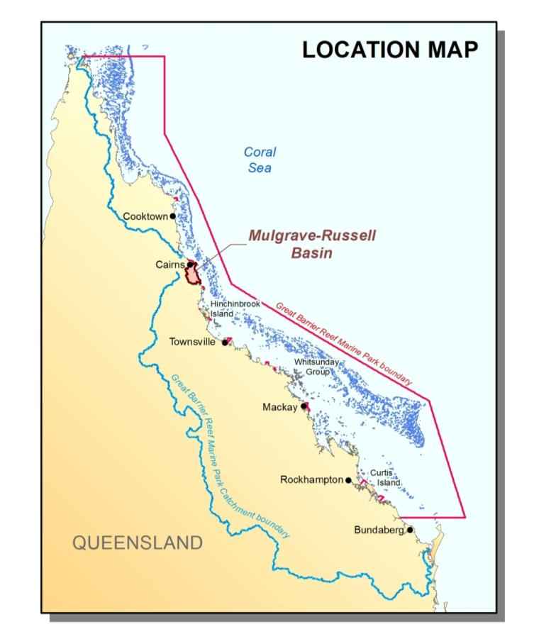

Figure 1: The Mount Peter area is located in the Mulgrave catchment of the Mulgrave-Russell basin

The Great Barrier Reef Marine Park (Marine Park) covers an area of approximately 348,000 km2 and extends from Cape York in the north to Bundaberg in the south. The Great Barrier Reef World Heritage Area was accepted in 1981 for inclusion in the World Heritage List, meeting all four of the natural heritage criteria (aesthetics and natural phenomena; geological processes and significant geomorphic features representing major stages of earth’s history; ecological and biological processes; and habitats for the conservation of biological diversity, including threatened species). The World Heritage Area includes additional areas outside of the Marine Park. The World Heritage Area extends from the low water mark on the Queensland coast to up to 250 km offshore past the edge of the continental shelf and includes coastal and island ecosystems, as well as some port and tidal areas, outside of the Marine Park.

The adjacent Great Barrier Reef catchment encompasses an area of 424,000 km2 with all water flowing from the catchment into the World Heritage Area. The catchment contains a diverse range of terrestrial, freshwater and estuarine ecosystems. These coastal ecosystems include rainforests, forests, woodlands, forested floodplains, freshwater wetlands, heath and shrublands, grass and sedgelands, and estuaries.

Coastal ecosystems support the health and resilience of the World Heritage Area. The ecological functions provided by coastal ecosystems include physical processes (such as sediment and water distribution and cycling), biogeochemical processes (such as nutrient and chemical cycling) and biological processes (such as habitat and food provisioning).

Management and protection of the coastal ecosystems that support the health and resilience of the Great Barrier Reef is challenged by complex factors originating beyond the jurisdictional boundaries of the Great Barrier Reef. Therefore, it is relevant that this Report looks beyond the boundaries of the Great Barrier Reef and assesses coastal ecosystems and their functions, reviews planning and management of the Great Barrier Reef catchment and coast, and considers their connections to the World Heritage Area.

The map products shown in this case study were derived from maps and data from a range of sources. These maps should only be used as a guide for planning. It is recommended more detailed and site-specific maps, assessment and ground-truthing should be obtained as part of any planning process.

## Objectives and purpose of case study

The purpose of this review is to explore, through a case study, the extent and connections of coastal ecosystems, land use of the basins and identify opportunities to improve the ecological functions to the World Heritage Area.

This report examines the ecosystem connections and functions across the Mount Peter area of the Mulgrave-Russell basin (Figure 1), and considers the management frameworks in the context of improving an already modified landscape. Opportunities are considered regarding key issues and information available to support improved management and protection, rehabilitation and restoration of coastal ecosystems and their functions.

## Methodology

This review does not examine coastal ecosystems in detail, or comprehensively review all management mechanisms in relation to land use planning and management. A broad review process was taken to allow a rapid assessment of the general trends in ecological function, and consideration of the main management tools that are associated with these broad trends in ecological function (refer to Figure 2 below). Assessment of coastal ecosystem types and functions they provide for the World Heritage Area was conducted using the Great Barrier Reef CEAF. The CEAF provides an approach to assessing and understanding ecological functions provided by ecosystems in the Great Barrier Reef catchment, the pressures affecting them and the management regimes in place to protect them.

Figure 2: Questions applied in the review of the Mount Peter study site

# COASTAL ECOSYSTEMS OF THE MOUNT PETER AREA

Coastal ecosystems encompass the known ecological functions that connect the Great Barrier Reef catchment to the ecosystems of the Great Barrier Reef. Coastal ecosystem groupings were developed through the assessment of Great Barrier Reef ecological functions provided by vegetation communities identified under the Queensland Regional Ecosystem datasets. Queensland Regional Ecosystems are based on vegetation communities that are consistently associated with a particular combination of geology, land form and soil within bioregions.

Coastal ecosystems and the functions and processes that they support play a significant role in maintaining the health of the World Heritage Area (refer to Appendix A). Development in the Great Barrier Reef catchment has led to modified ecological functions within the catchment. By considering the pre-clear extent of coastal ecosystems to the land use that is now in place within the Mount Peter area of the Cairns region (Figure 3), an assessment can be conducted identifying the expected changes in ecological function within the landscape (refer to Appendix A for ecosystems functions that are provided by different coastal ecosystem types and Appendix B for functions provided by a modified landscape).

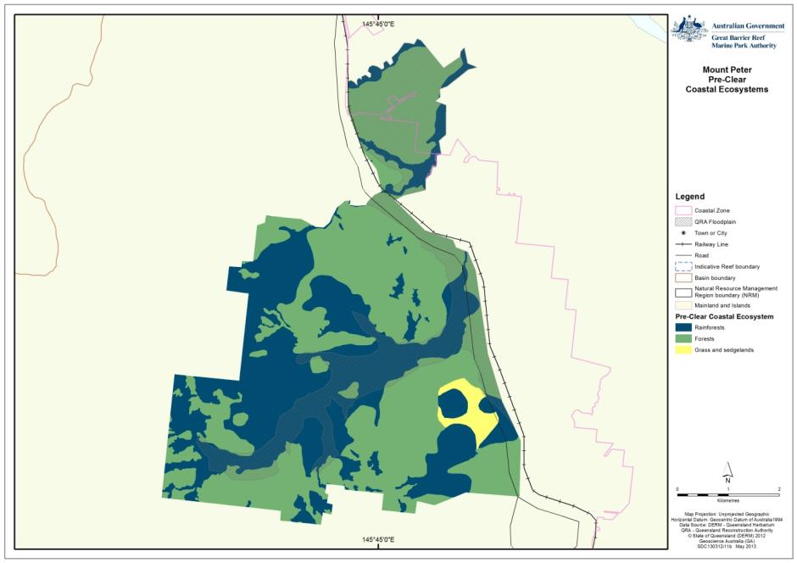

Figure 3: Coastal ecosystems in the Mount Peter master plan area prior to land use changes

## Overview of the Mount Peter area

The Mount Peter area is located between Edmonton and Gordonvale, south of Cairns, and encompasses 3352 hectares of the 313,500 hectare Mulgrave River catchment. The upper catchment of the Mulgrave River is within the relatively undisturbed rainforest environments of the Bellenden Ker Range, which is within the Wet Tropics World Heritage Area (refer to Figure 12 which shows the intactness of coastal ecosystems).

Streams in the Mount Peter area flow into the Trinity Inlet adjacent to the city of Cairns. The main streams in the Mount Peter area include (Figure 4 below – from north to south) Blackfellow Creek, Collinson Creek, Stoney Creek, Wrights Creek and Mackeys Creek. Streams in the Mount Peter area retain some riparian vegetation, although these are under pressure from surrounding land use (including from threats such as animal and plant pests and minor clearing). Wrights Creek in the southern section and the confluence of Wrights, Blackfellow, Collinson and Stoney creeks along the boundary of the northern section, form the main floodplain of the Mount Peter area.

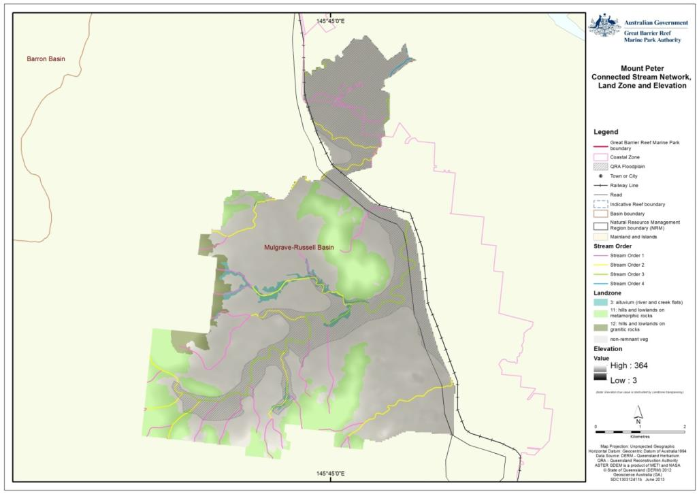

Figure 4: Streams, stream orders and land zones of the Mount Peter area

The Mount Peter area sits adjacent to two World Heritage Areas: the Great Barrier Reef and the Wet Tropics. Streams that cross the Mount Peter area discharge into the Trinity Inlet of the World Heritage Area. The Great Barrier Reef was declared a World Heritage Area in 1981 because of its 'outstanding universal value'. This recognised the Great Barrier Reef as being one of the most remarkable places on earth, as well as its global importance and its natural worth. Streams that cross the Mount Peter area begin within the Wet Tropics World Heritage Area. The Wet Tropics was listed as a World Heritage Area in 1988, and includes 894,420 hectares of mostly tropical rainforest. It stretches along the northeast coast of Australia for some 450 kilometres.

Streams in the Mount Peter area are subject to high wet season rainfall and over-bank flooding. The Mount Peter area typically receives an annual rainfall of greater than 2000 mm, while the Mount Bellenden Ker range adjacent to the site receives an average annual rainfall of 8000 mm.2 Mount Peter area streams discharge into Declared Fish Habitat Area in the Trinity Inlet, which is also a Nationally Important Wetland (Plan Number FHA – 003). This large estuary system incorporates extensive mangrove zones, seagrasses, salt marshes and tidal flats.

## History of land use change in the Mount Peter area

Since the 1880s the Mount Peter area was developed as a cane-growing region. Today, cane fields, cane barracks, tram lines and bridges remain in the landscape. Forestry and mining are also land use remnants in the landscape.2

Prior to European settlement, the majority of the coastal ecosystems in the Mount Peter area were forest and rainforest ecosystems (Table 1).

Table 1: Pre-clear and post-clear extents of rainforests, forests, and grass and sedgelands in the Mulgrave-Russell area (hectares). (Does not include non-remnant land areas)

|  |  |  |  |  |  |
| --- | --- | --- | --- | --- | --- |
|  | **Coastal Ecosystem** | **Pre-clear extent (ha)** | **Post-clear extent 2009 (ha)** | **% remaining 2009** | **% area of the catchment modified** |
|  | Rainforests | 1419 | 249 | 17 | 35% |
|  | Forests | 1873 | 564 | 30 | 39% |
|  | Grass and sedgelands | 58 | 0 | 0 | <2% |
|  | Total Area (ha) | **3351** | **3351** |  | **75%** |

The most extensive changes to coastal ecosystems in the basin have been the modification of forests (from 1874 hectares to 565 hectares) and rainforests (from 1420 hectares to 250 hectares). The coastal ecosystems in the Mount Peter area have also been extensively modified for dryland production purposes (Table 2).

Table 2: Identified land use where coastal ecosystems have been protected or have been modified (2009)

|  |  |  |  |
| --- | --- | --- | --- |
|  | **Land use** | **2009 extent (ha)** | **% area of the catchment modified** |
|  | Conservation, natural environments (inc. wetlands) | 1079.91 | 32 |
|  | Grazing natural vegetation | 30.35 | <1 |
|  | Intensive animal production | 7.40 | <1 |
|  | Intensive commercial | 27.87 | <1 |
|  | Intensive mining | 62.91 | <2 |
|  | Intensive urban residential | 182.28 | 5 |
|  | Production - dryland | 1960.92 | 58 |
|  | Total Area (ha) | **3351.64** |  |

Considering the ecosystem loss identified in Table 1, and associated ecological functions provided by these ecosystems (as outlined in Appendix A to this report), the coastal ecosystem functions currently most impacted are landscape connections that regulate overland and flood flows, and capture and assimilate sediment (including nutrients bound sediment).

### Impacts on coastal ecosystems and current condition

Coastal ecological function, diversity and connectivity have been modified within the region due to changes in land use. Significant changes are mainly associated with the replacement of floodplain ecosystems with sugar cane production.

As noted in the previous section, forest and rainforest coastal ecosystems have been extensively modified in the Mount Peter area, however the most extensive change to coastal ecosystems in this basin has been the loss of grass and sedgelands adjacent to Mackeys Creek (Figure 3 and 5).

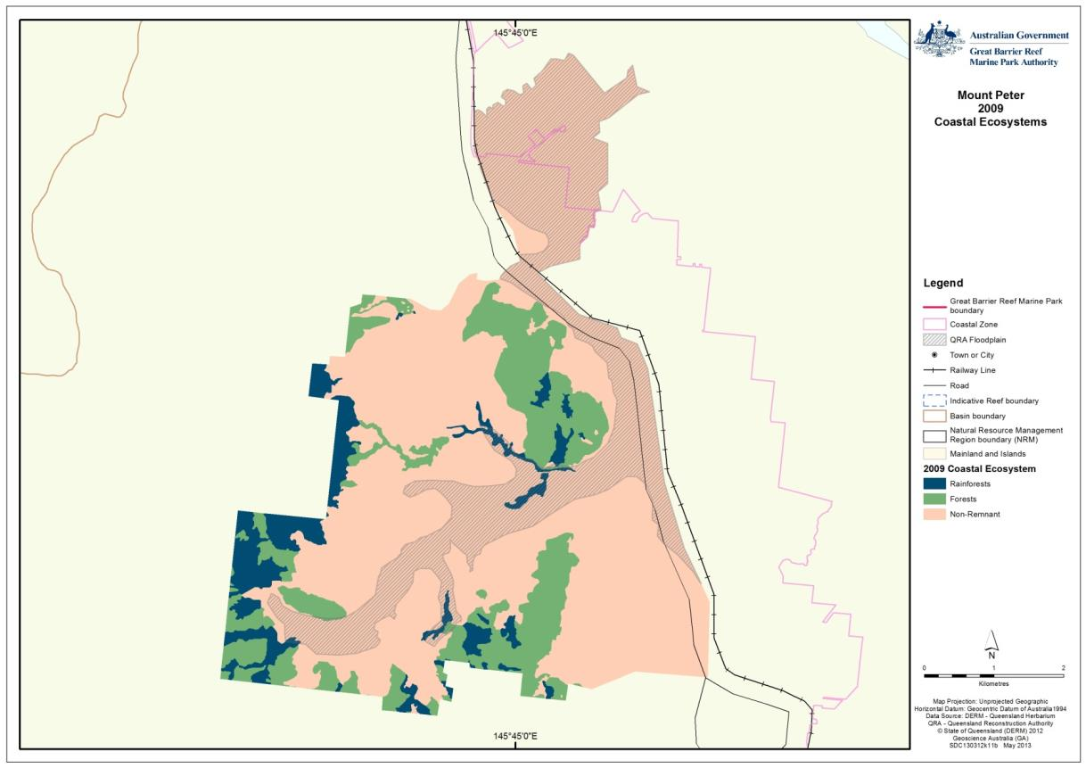

Figure 5: Areas of modified and remaining coastal ecosystems in the Mount Peter Master Planned area

### Modified ecological functions and processes

Although natural values remain in the Mount Peter area, the landscape connection between the Wet Tropics and the Great Barrier Reef is highly modified with respect to the regulation of flows and recapturing of sediments. A number of associated processes have also been modified (refer to Appendix A for known forest and rainforest ecological functions for the World Heritage Area):

* As noted, forests and rainforests play a role in regulating overland water flows by mitigating raindrop generated erosion, entraining rain and slowing the velocity of run-off. The reduced erosion and overland flow velocity means that heavy soil particles are not mobilized as easily and if mobilized not carried as far in overland run-off. Slowing velocity also promotes soil interflow and potentially assists groundwater recharge in suitable soil structures. Rainforests are generally a sediment sink; however forests can be a source of sediment that has undergone biological and geochemical treatment before being released.
* The forest ecosystems sustain improved primary production, and provide a soil environment that promotes conversion and modification of sediments and nutrients into different forms that lock them into the soil system or move these into food chains.
* Forests and woodlands also provide improved regulation of nutrients supplied to the Great Barrier Reef by binding and assimilating nutrients in overland flow, and releasing modified/assimilated nutrients that are less biologically available, for example as timber.
* With appropriate fire regimes, forests are charcoal sinks, providing a role in the environment similar to activated carbon, allowing absorption and capture of nutrients and other chemicals. Rainforests are generally a carbon sink, providing a microclimate that helps regulate carbon cycling. Rainforests also regulate soil and water surface temperatures, which are important for soil biological activity and promoting healthy aquatic ecosystems, respectively.

Although only estimated to have been 58 hectares, the complete removal of grass and sedgeland coastal ecosystems from the Mount Peter area is significant. The capacity of grasslands and sedgelands to provide sediment and water regulation for the World Heritage Area is recognised, although its overall capacity is relatively unknown at present. Potentially grasslands and sedgelands can also assist in the cycling of nutrients and provide habitat and food that is important for species migrating through the catchment during flood periods. Flood modelling conducted for the Mount Peter study suggests that the grasslands and sedgelands in the Mount Peter area may not have been closely connected to Mackeys Creek, influencing the overall ecosystem function outcome it may have played in the landscape for the World Heritage Area.

Seventy five per cent of the coastal ecosystems in the Mount Peter area have been removed to accommodate agriculture (mainly sugar cane). Agriculture can potentially retain some ecological functions important to the World Heritage Area, and some of these functions have been assessed and noted in Appendix B. These include slowing overland flow and entraining sediment; however this role is highly dependent on growing season and relative groundcover. Generally, agriculture provides a very different coastal ecological function (refer to Figure 6 and Appendix A and B). The remaining ecosystem values and functions in the Mount Peter area identified in the Mount Peter Structure Plan include2:

* Terrestrial ecosystems for significant and common wildlife species
* Terrestrial ecosystems that connect ecological communities
* Waterways and other water-bodies
* Ecosystem functions preventing erosion and other land degradation
* Buffer areas of ecological significance (e.g. World Heritage Areas)
* Terrestrial ecosystem’s contribution to scenic amenity
* Important riparian areas of regrowth
* Vegetation identified as Key Conservation Values and Moderate Values under the Cairns Plan, which were generally consistent with remnant vegetation identified under Regional Ecosystem mapping.

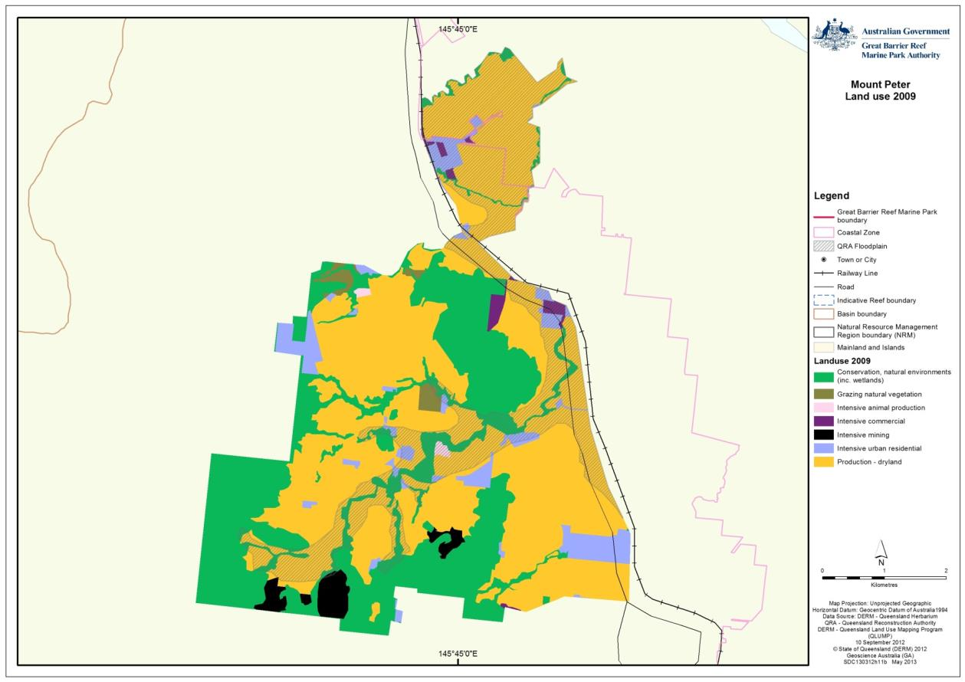

Figure 6: Land use in the Mount Peter area in 2009

### Catchment response under low, medium and high flow events

The formation of catchment systems is a natural balance of the underlying geology and soils, weather and climate condition, and biological systems.3,4 In a storm event, individual streams will have a particular response with regard to the highest peak of flow discharge over time, depending on the catchment’s characteristics that influence surface flow versus infiltration and soil interflow (baseflow) characteristics. The typical rise in a stream’s height (initially from surface run-off), its peak flow, and its slower fall (sometimes fed by baseflow) is termed the flow hydrograph for the stream.

The flood hydrograph magnitude and flood frequency are also related to stream size. Under natural conditions, streams adjust their dimensions to allow for the flood regimes they commonly receive. In unmodified systems, floods that are expected to occur every one to two years will usually fit within a stream channel, while larger events will overflow stream-banks.3,4 Flood frequency and magnitude is affected by such things as:

* Changes in overland flow and infiltration rates due to a change in the coastal ecosystem type to allow use of land for agriculture
* Dams and water diversions capturing, storing and releasing water at different times in the season outside natural cycles
* Levees, straightening of streams and simplifying of in-stream habitat
* Changes in rainfall intensity and duration under climate change.

The frequency and magnitude of floods is one of the many factors determining the type of natural vegetation that grows in the floodplain.

Land use will influence the significance of interception losses of surface run-off as a component of the total water balance of a catchment. Interception storage of rain by plants can be 0.2 to 3 mm; in the wet tropics, storage can be up to 6 mm. Vegetation also contributes to rainfall losses by breaking large drops of rain into smaller and smaller drops reducing their erosive force. The increased surface area promotes increased evaporation and the process can reduce soil surface rainfall by anywhere between three to 37 per cent of the annual rainfall losses. Removing vegetation will reduce interception loss and is one of the factors that lead to increased erosion and run-off following catchment clearing.4

In soil systems, nutrients and organics leave the soil in dissolved form, particulate form or are absorbed onto the surface of sediments. If sedimentation is occurring (as part of normal coastal ecological functions), nutrients and organics will be initially trapped and taken out of run-off and stream systems. Depending on the health of the soil and the residence time of sediment particles, bacterial activity breaks down organic nutrients into inorganic, less bioavailable forms. In the presence of oxygen, phosphorous nutrients are absorbed by iron in sediments, some inorganic nitrogen is lost to the atmosphere as nitrogen, and in time, the balance will be released to waterways.3

The natural flow hydrograph of a stream should be used as a guide for the management of run-off rates (and erosion) and flood regimes in modified catchments. There is a subsequent increase in flood frequency and magnitude of smaller storm discharges, and an increase in sediment and nutrient movement, as a result of an increase in overland flow hydraulic capacity from land use changes and loss of coastal ecosystems. This change can affect the health of in-stream and downstream habitat and stream bank ecosystems and their functions, and increase bank erosion even if riparian areas are robust and intact. The increase in frequency and magnitude of small storm events can present a long-term physical loss in connectivity of the natural system, limiting the ability of aquatic species to recover from these events or maintain healthy habitats. The effects of catchment hydrology, inflow pollutant concentrations, water body hydrodynamics and associated physical, chemical and biological processes combine to present a chemical and physical loss of connectivity in the natural ecosystems, and reduce its ability to maintain the health of the World Heritage Area and its associated species.3,4 A clear indication of in-stream health is the condition and health of ecosystems and species in the in-shore environments of the World Heritage Area.

## Forecast of likely future activities and impacts on coastal ecosystems

The Mount Peter area was identified in the repealed Far North Regional Plan 2009-2031 as the main urban growth corridor for the Far North Queensland region. It was expected that urban development in the Mount Peter area could accommodate up to 50,000 people, with development occurring over 20-30 years.5 The impacts of urban development on coastal ecosystems function are mainly due to the types of contaminants in run-off, and the increase in surface run-off volumes and reduction in soil infiltration. The main impacts on aquatic species (from bacteria to fish) from urban development includes (adapted from Wong, 20063):

* Increased rate and volume of run-off
* Increased frequency of high velocity flows
* Increased rate of erosion, sedimentation and channelisation
* Reduction and loss of riparian zones
* Reduction and loss of in-stream habitat
* Decreased water quality
* Contamination of sediments
* Introduction of barriers
* Reduced diversity of coastal ecosystems and introduction of pest species.

In mentioning these impacts, it must be noted that under both the Regional Plan and the Cairns Regional Council planning scheme, areas of high ecological value to matters of national environmental significance within the Mount Peter area were to be targeted for rehabilitation and protection.

Urban development impacts are generally locally intense, and impact on local inshore systems rather than having a chronic broad scale impact across the Great Barrier Reef.6 Urban development in the Great Barrier Reef catchment increases impervious surface areas (such as roads), and concentrates run-off from rooves and stormwater drains, increasing the frequency of small flood events in streams and rivers. The changes in flood frequency increases flushing of stream habitat, leading to the loss of species less resistant to disturbance. Changes in the flood frequency and timing of small floods will also influence the reproduction and migration of species that have life cycles linked to natural flood regimes.

The increase in the frequency of small flood events and the increase in the magnitude of peak flow events, leads to more efficient stream and river hydraulic capacity. This simplifies stream structure, increases erosion and reduces the system’s ability to maintain habitats suitable for a greater variety of aquatic species. Urban infrastructure may also impact on in-stream hydraulics through the introduction of poorly designed weirs and culverts that can change where a stream floods and erode, modify flow regimes entirely or provide a complete barrier to aquatic species migration.

Urban land pollutants come in many sources, such as industry, vehicular emissions, fertiliser and chemical use in agricultural practices, and atmospheric deposition. Pollutants are transferred to water bodies through stormwater run-off, with localised impacts on ecological processes and soil health. Key pollutants, adapted from reports commissioned by the Townsville City Council through the Ross Black Water Quality Improvement Plan7 include:

* Suspended solids (urban (particularly construction), intensive agriculture, rural) - generated when surface water flows collect and transport unstabilised soils and sediment. Can result in smothering of aquatic habitats and restriction of light penetration.
* Phosphorous (urban, industrial, intensive agriculture) - generated from faecal material and fertilisers, transported by surface rainfall run-off. Encourages algal growth and eutrophication.
* Nitrogen (urban, industrial, intensive agriculture) - generated from faecal material and fertilisers transported by surface rainfall run-off. Encourages algal growth and eutrophication.
* Hydrocarbons (urban, industrial, commercial) - liquid fuels (diesel, petroleum, oil). Can result in smothering of aquatic habitats. Morbidity and mortality in freshwater species, and impact upon reproductive cycles.
* Herbicides (intensive agriculture, urban) - applied to broad scale crops (i.e. sugar cane) gardens and horticulture to control weeds, transported aerially or by surface rainwater run-off. Can result in morbidity and mortality in freshwater and marine species.
* Pesticides (intensive agriculture, urban) - applied to gardens and horticulture typically to control pests such as grubs and insects, transported aerially or by surface rainwater run-off. Can result in morbidity and mortality in freshwater and marine species.
* Heavy metals (urban, rural, industrial) - metals such as mercury, iron, aluminium, arsenic, lead, cadmium. Can result in morbidity and mortality in freshwater and marine species (ecotoxicity).

Additionally the report identified three non-toxic pollutant sources that could impact water quality7:

* Hydrologic stress - results from increases in impervious cover in a catchment, causing higher flow velocities and frequencies than occur naturally.
* Gross pollutants - litter generated typically in commercial and urban areas. This is an aesthetic water quality detractor; however plastic litter in waterways may result in ingestion and associated complications in aquatic animals.
* Antibiotics and other pharmaceuticals (from treated sewage outflows, septic tanks, intensive animal production) may interfere with normal disease resistance and reproductive cycles of aquatic organisms.

Aquatic species are generally adapted to the type and concentration of particular sediment, nutrients and other organic materials. Urban development can rapidly change the composition of sediments and nutrients entering the aquatic environment, and introduces new contaminants to the system that aquatic species are not adapted for. The efficient drainage of storm events from urban areas means that pollutants are delivered to aquatic environments after every rain event, resulting in a significant loss in water quality.3

Sediment is a critical element in determining ecosystem health, as many pollutants are associated and transported in particulate form to be released once it reaches the aquatic environment.3 Benthic in-stream sediments provide both habitat and food source for aquatic benthic communities and the concentration, availability and association of pollutants with sediments threatens the long-term health of aquatic benthic communities.3 With a decrease in the health and diversity of aquatic benthic communities, the capacity to support higher order species also becomes reduced.

### Expected condition of the inshore Great Barrier Reef World Heritage Area

Over the past 150 years of European settlement in the Great Barrier Reef catchment, natural surface and groundwater flows have changed, and sediment, nutrient and other contaminant input to the World Heritage Area have increased. These changes have been brought about by river and land management modification of the Great Barrier Reef catchment.8

Water quality in rivers entering the Great Barrier Reef lagoon has declined because of diffuse pollutants, especially sediments, nutrients and chemicals from cropping and grazing lands in relatively small areas of the adjacent catchments. This diffuse pollution threatens inshore reefs and associated ecosystems.9,10

The health and resilience of the World Heritage Area coastal zone is strongly influenced by run-off of sediments, nutrients and other contaminants from the Great Barrier Reef catchment.8 Many of the coastal ecosystems in the catchment that have been modified are important areas of feeding and breeding grounds for marine species, and as sediment traps and nutrient filters for water entering the Great Barrier Reef.8

Subsequent changes that are being seen in the inshore biodiversity and habitat of the World Heritage Area include impacts on natural accretion and erosion processes of the coastal zone, and the reduction in resilience in, or loss of, marine ecosystems (such as seagrass beds and inshore coral reefs) and species. 9,10

In terms of hydrology, coastal ecosystems provide the following important functions for the World Heritage Area11:

* As a landscape roughness element affecting hillslope overland flow, channel flow and overbank flow (floodplains). The effect of vegetation removal on floodplain flow hydraulics is unclear, and should vary between catchments because of catchment specific flood routing behavior. Reduction of hydraulic roughness within channels due to vegetation removal is likely to have more straightforward impacts, with the existing hydraulics enhanced until feedback increases or reduces sediment supply, at which point the stream channel adjusts its morphology to the new hydraulic regime. In many cases, the feedback is an increased (bedload) sediment supply, and the lower channel roughness will likely result in an adjustment to a wider and shallower channel. If in-channel storage structures such as dams and weirs trap a significant fraction of the bedload sediment budget, then the channel response immediately downstream may be the opposite (narrower and deeper channel).
* A biological ‘pump’ of water back to the atmosphere via evapotranspiration. A widely recognised hydrological impact of vegetation (tree) clearance is an increase in the water available as streamflow both through overland and groundwater flows due to the reduction in transpiration. This effect can be particularly pronounced in tropical areas, where wet area extent may be expanded as a result of increased water availability in the surrounding catchment. One parameter that connects the hydraulic and water balance effects of vegetation is the run-off co-efficient, a measure of how efficiently rainfall is converted to run-off, and can be influenced by both the water balance (soil moisture) and surface roughness. Wetter years (due to La Nina) in the upper Burdekin and Fitzroy resulted in higher run-off coefficients, presumably as a result of the higher soil moisture conditions. In terms of vegetation effects, there is a positive trend of low run-off co-efficient values with increasing remnant catchment vegetation fraction (and the opposite for non-remnant).

Although sugar cane provides a role in entraining sediment and capturing incident rainfall (when soil coverage is good), the coastal ecosystems modified in the basin provide a superior role in managing overland flows and trapping and cycling of sediments and nutrients, especially with respect to groundwater recharge. Overland run-off volumes and relative sediment loads will be above that of the pre-clear ecological function. Overland flow retention, and trapping and cycling of sediments and nutrients in this landscape will have been significantly reduced. Maintenance of areas such as riparian zones in the landscape may somewhat help mitigate the amount of bioavailable nitrogen and phosphorous entering the World Heritage Area.

# LAND USE MANAGEMENT AND COASTAL ECOSYSTEMS

## Background

It is acknowledged that the health and resilience of the World Heritage Area is declining, particularly within the marine environments closest to the Queensland coastline and especially south of Port Douglas. Coastal waters are under pressure from a number of threats. Two of the most significant threats to the health of the World Heritage Area highlighted in the *Great Barrier Reef Outlook Report 2009* included catchment run-off (particularly nutrients, pesticides and sediments) and the impacts of clearing or modifying of coastal habitats (such as wetlands and the connected networks in which they exist) to allow for coastal development.

The Mount Peter area was selected to examine coastal ecosystem connections in the landscape between two World Heritage Areas: Wet Tropics and the Great Barrier Reef. The Mount Peter area was chosen as extensive work has already been undertaken to consider matters of national environmental significance under the EPBC Act under a Strategic Assessment process.

The strategic assessment of the Mount Peter area proposed to consider the potential impacts of urban development in this area on listed migratory and threatened species, the values of the Wet Tropics World Heritage Area and the Great Barrier Reef Marine Park and the World Heritage Area.5

Management mechanisms noted in this report consider relevant current and repealed legislation and planning tools.

## Management mechanisms influencing coastal ecosystems

In Queensland, urban planning and management is primarily delivered through the SPA (*Sustainable Planning Act 2009*). The primary purpose of the SPA is to achieve ecological sustainability by managing development assessment processes, managing the effects of development, and coordination and integration of planning at the local, regional and State levels.12 Outside local and regional planning tools, SPA also has a “master plan” tool that allows for integration of regional and local government plans to a designated area to allow for integrated land use and infrastructure fine-scale planning. The master plan tool can be used to link the broad state interest with the fine scale planning of local government to provide certainty that development along priority development corridors are appropriately serviced in a cost-effective manner, while providing protection for state interests or areas of value to the community. Master plans are implemented through the development of a structure plan which set out environmental, infrastructure and development intents to facilitate detailed development planning for the specified area. Development assessment is managed through the use of an Integrated Development Assessment System that brings together legislative requirements under a number of different Acts.

The Mount Peter Master Planned Area strategic assessment was conducted against the master plan mechanism in the Queensland *Integrated Planning Act 1997* (now SPA), and the associated planning regulations and policies were addressed throughout the resulting Structure Plan for urban development. Various legislation that was considered as part of this study that have a role in managing and protecting terrestrial ecosystems and functions included2:

* The *Environment Protection Biodiversity and Conservation Act 2000*
* The Queensland *Vegetation Management Act 1999* (VMA), including Regional Vegetation Management Code (RVMC): Coastal Bioregions
* Queensland *Nature Conservation Act 1992* (NCA)
* Queensland *Coastal Protection and Management Act 1995* (Coastal Protection Act) and associated State Coastal Management Plan 2001 and the Wet Tropics Regional Coastal Management Plan 2009-2031
* Queensland *Fisheries Act 1994* (Fisheries Act), including guidelines for managing and protecting marine plants and other tidal fish habitat and declared fish habitat areas, fish habitat buffer zones and waterway barrier works and fishway assessment.
* Queensland State Planning Policy 1/03 Mitigating the Adverse Impacts of Flood, Bushfire and Landslip
* Queensland State Planning Policy 2/02 Planning and Managing Acid Sulfate Soils
* *Land Act 1994* (Land Act), particularly with reference to the use and management of Conservation Areas and Protected Reserves.

Wetlands and riparian corridors, and the protected areas that support them are particularly important in promoting coastal ecosystem connectivity, providing sediment and nutrient cycling and quick flow attenuation (Figure 7). During the assessment of the Mount Peter Master Planned Development, waterways, riparian corridors and ecosystem connections were provided a range of protection through the *Water Act 2000*, the VMA, and Regional Vegetation Management Code for Coastal Bioregions and the Fisheries Act(and relevant guidelines) for marine plants.

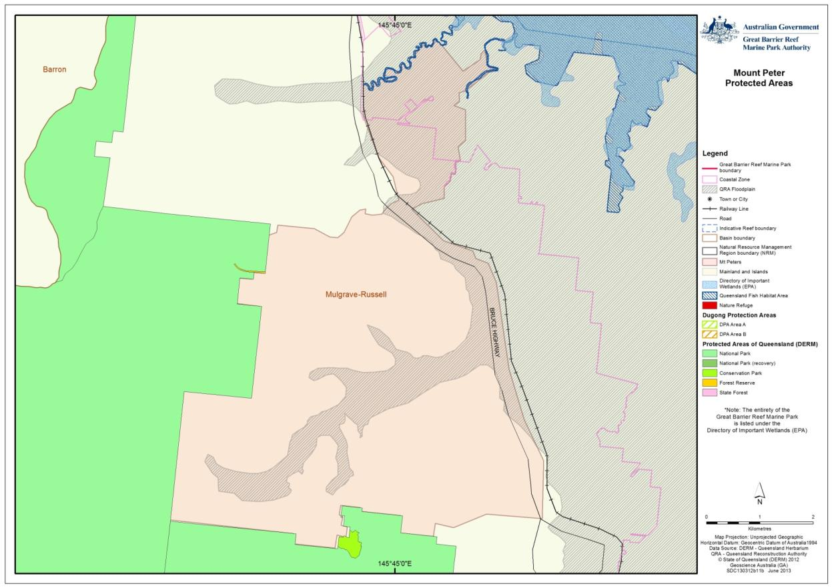

Figure 7: Protected management areas adjacent to the Mount Peter site

The most important management mechanism that applied to vegetated ecosystems in the Mount Peter Master Planned Development was mechanisms associated with the VMA, the *Vegetation Management (Regrowth Clearing Moratorium) Act 2009,* and the RVMC. The VMA in particular provides a framework for identifying terrestrial vegetated ecosystems and putting in place management strategies for maintaining those terrestrial vegetation biodiversity values.

The overarching Far North Queensland Regional Plan 2009-2031 that was in place at the time of the development of the Mount Peter Planned Area Structure provided further support to the protection of terrestrial ecosystems. The general purpose of the Far North Regional Plan 2009-2031 was to manage development across the region by identifying future areas for development, plan for providing infrastructure, protection and enhancement of the region’s natural environment, biodiversity and natural resources, integration of state and local planning across the region. The Far North Regional Plan included policies that provided for protection of high ecological value sites, and ensured that future development (such as new urban development) did not impact on high ecologically significant ecosystems or important coastal areas.

The Australian Government does not have a specific role in urban planning; however the Australian Government does have broad policy that relates to the Commonwealth’s powers under the Constitution, in particular in its role in External Affairs, which provides an important link between international law and Australian domestic law. Since the Australian Government negotiates what Australia’s international legal obligations will be, it provides the Australian Government the legitimacy to implement policy and legislative tools to manage these international responsibilities. This role is enacted through the EPBC Act, for matters of national environmental significance protected under that Act, and can be strategically applied through section 10 of the Act by conducting a strategic assessment.

The Australian Government has a wide range of policies and strategies that provide direction for development in Australia; however the Australian Government has two pieces of existing legislation that can influence urban development directly in the Great Barrier Reef region: the *Great Barrier Reef Marine Park Act 1975* and theEPBC Act.

## Managing coastal ecosystems

Coastal ecosystems provide the physical, geochemical and biological functional connections of the Great Barrier Reef catchment to the World Heritage Area. This functional analysis is based on existing information that is already utilised in the management and protection of terrestrial vegetation in the Great Barrier Reef catchment. In many cases, current management mechanisms play an unrecognised role in managing and protecting coastal ecosystem functions for the health of the World Heritage Area.

The consideration of terrestrial ecosystems and their relationship to the World Heritage Area were captured in the agreement between the Australian and Queensland governments and the Cairns Regional Council, which outlined the following key elements to be included in the strategic assessment of the Mount Peter Master Planned Area5:

* Describe the environments within, adjacent to and downstream of the Mount Peter area that are likely to be directly or indirectly impacted by urban development.
* Identify the environmental assets and characteristics, together with biophysical, ecological and hydrological processes, including considerations of surface and groundwater recharge and discharge, and areas of high biodiversity value.
* Identify areas that provide long-term and viable contribution to the persistence of matters of national environmental significance and the conservation of biodiversity and ecological processes, such as riparian corridors, buffers, habitats for EPBC Act listed species and areas containing native vegetation.

In order to identify ecosystem values and functions on the Mount Peter site, methodologies were developed under the strategic assessment to:

* Identify and map land use constraints by applying the principles, objectives and identified constraints in the tools listed above.
* Identify and map natural hazards, with particular reference to fire hazard, steep slopes and important ecosystem types.
* Map waterways and stream orders, based on methodology developed by the Queensland Department of Environment and Resource Management (DERM) and declared in DERM’s RVMC. The mapping included ground-truthing and establishment of nominal setbacks of 10 metres for waterways identified in the Cairns Plan that were not recognised by the DERM methodology.

The resulting mapping from the strategic assessment (Figure 8) is a compilation of natural area values and natural hazard areas. These ecosystem values and functions identified also represent significant ecological functions important to maintaining the health of the World Heritage Area - the values and constraints identified in the Mount Peter Master Plan study highlighted the terrestrial landscape processes, connections and habitats. These values and constraints in turn represent areas where important ecological processes that have been modified in the Mount Peter landscape, and have a significant role in protecting the health of the World Heritage Area. These processes include flooding regimes, changes in water quality, rates of erosion and sedimentation and the condition of aquatic ecosystem habitat.

The Great Barrier Reef Marine Park Authority (GBRMPA) has mapped these overlaying values and constraint areas, and identified existing map layers that best represent the modified ecosystem functions in the landscape (Figure 9). The mapped areas where coastal ecosystems, connections and functions have been lost or modified have close synergies with natural area and natural hazard areas in the Mount Peter landscape.

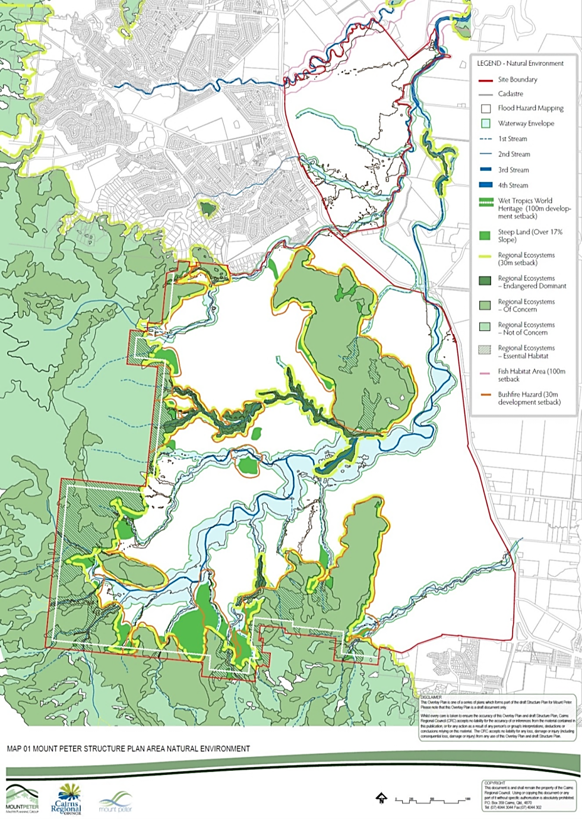

Figure 8: Map one of the Mount Peter Structure Plan Area Natural Environment2

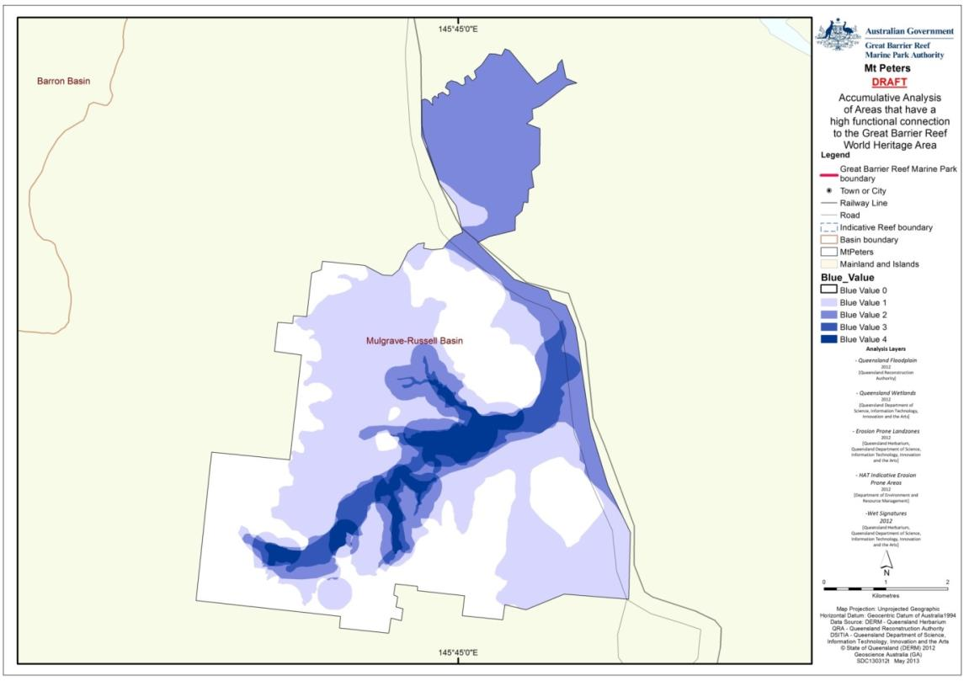

Figure 9: Accumulative analysis of values and natural hazard constraints in the Mount Peter Master Plan area. The darker colours represent where there is a convergence of values and constraints

The mapped layers selected to develop a coastal ecosystem accumulative analysis rely on current information and data obtainable from Queensland and local government:

1. *Queensland floodplain*

The Queensland Floodplain Assessment Overlay represents a floodplain area within drainage sub-basins in Queensland. The data has been developed through a process of drainage sub-basin analysis utilising data sources including 10 metre contours, historical flood records, vegetation and soils mapping and satellite imagery. Correlation to coastal ecological function: forested floodplains and wetlands physical, biogeochemical and biological processes for the Great Barrier Reef, and in most catchments represent the ecosystem that connects the catchment to the Great Barrier Reef.

1. *Queensland wetlands*

This data layer provides mapping of extent and type of wetlands across Queensland (Figure 10). The mapping identifies wetland types and applies buffer areas. Wetland mapping has specific recognition in its ecological functional role for the World Heritage Area. Correlation to coastal ecological function: wetlands represent identified areas in the landscape that have a specific ecological role for supporting aquatic habitat and ecological functions for the Great Barrier Reef.

1. *Erosion prone land zones*

The map in Figure 11 is based on mapping derived from Landsat imagery, comparing Regional Ecosystems with landform and topology. Land zones considered in the accumulative analysis: coastal dunes, alluvium (river creek flats), old loamy and sandy plains, hills and lowlands on granitic rocks. Correlation to ecological function: sediments, and nutrients bound to sediments, represent a significant threat to water quality in the Great Barrier Reef. Ecosystems on soils that are highly erodible assist in managing sediment erosion.

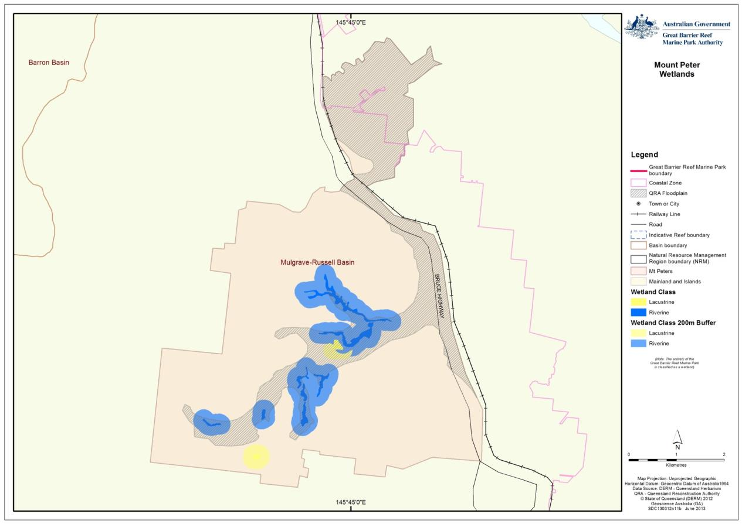

Figure 10: Mapped wetland areas recognised in available State of Queensland spatial data sets

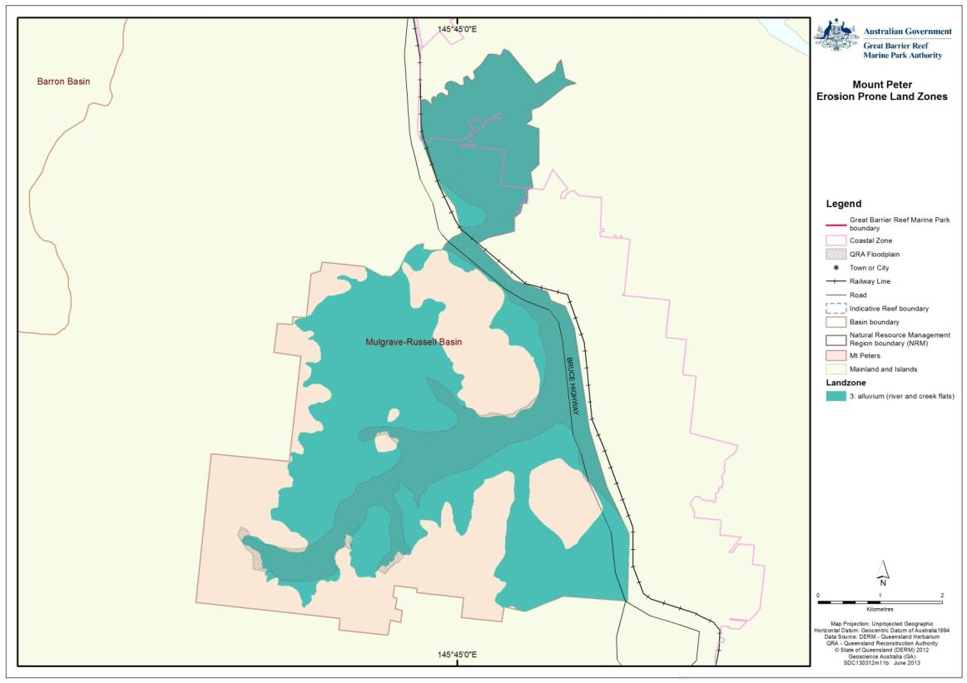

Figure 11: Erosion prone land zones identified by the Great Barrier Reef Marine Park Authority based on land zone areas recognised in available State of Queensland spatial data sets

1. *Highest Astronomical Tide indicative erosion prone areas*

The data layer provides information on areas potentially at risk of adverse coastal hazard impacts such as temporary and permanent sea inundation, and areas subject to coastal erosion. Correlation to ecological function: coastal ecosystems in coastal floodplain areas provide significant physical, biogeochemical and biological processes for the Great Barrier Reef and in most catchments represent the ecosystems that connect the landscape to the Great Barrier Reef.

1. *Wet signatures*

The data layer is based on aerial photography and field survey of vegetation communities that are associated with a landscape that is temporarily or permanently inundated. Correlation to ecological function: similar to wetlands and the floodplain, wet signature regional ecosystems represent those areas that have a specific ecological role for supporting aquatic habitat and ecological functions for the Great Barrier Reef that may not be identified in floodplain and wetland mapping areas.

1. *Regional ecosystems (assessed for ecological function to the Great Barrier Reef and grouped into Coastal Ecosystems)*

The data layers above have been assessed against the pre and post-clear extent and intactness of coastal ecosystems to identify intact and modified coastal ecosystems in the landscape (Figure 12). The resulting analysis in Figure 13 shows dark areas in the landscape that are a priority for rehabilitation and repair of ecological function in the Mount Peter area.

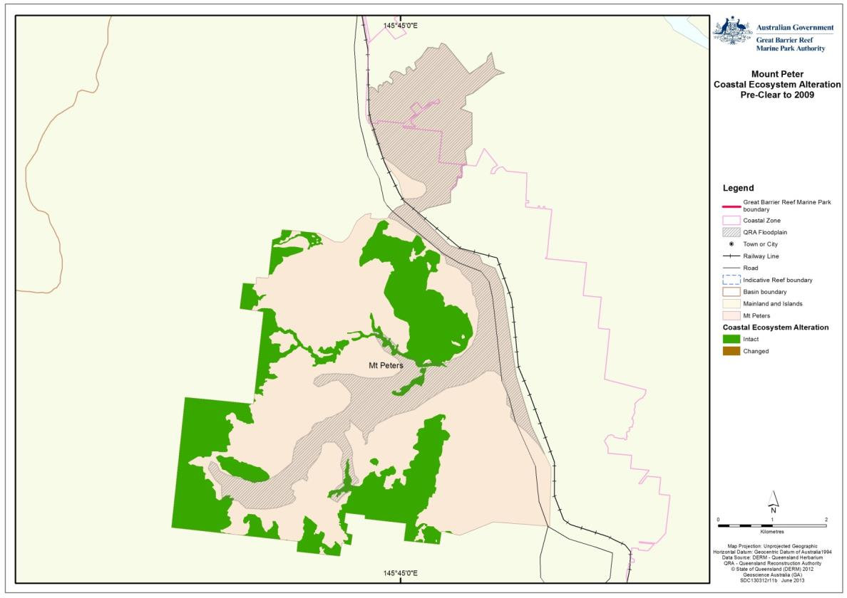

Figure 12: Represents the areas of coastal ecosystems that remain intact in the landscape. Datasets also recognise areas where coastal ecosystems are still present but have been modified (e.g. have changed from a forest coastal ecosystem to a woodland coastal ecosystem). In the Mount Peter area, coastal ecosystems have been mostly cleared, so changed coastal ecosystems are not present

The accumulative analysis is a starting point for further evaluation of ecological functions in the landscape. Further analysis is required to clarify the importance of ecological functions in the landscape, and identify appropriate management tools that will protect, rehabilitate and restore ecological processes and functions for the World Heritage Area into the future.

### Priority areas for management of coastal ecosystems

Figure 9 (above) represents the areas in the Mount Peter area where coastal ecosystems:

* have been largely cleared,
* would have had a strong hydrological link to the Great Barrier Reef
* provide an ecological link between the Wet Tropics and World Heritage Areas.

White areas in the map identify localities where landscape managers, through best management practice, could prioritise the restoration of ecological functions.

Further analysis of this dataset is represented in Figure 13. Darker blue areas in the accumulative analysis map represent areas in the Mount Peter area where ecological functions in the catchment are most important and connected to the World Heritage Area. For the management of ecological function and service, the darker blue areas suggest that these areas would be the highest priority for protection and rehabilitation of coastal ecosystems to provide the functions necessary for maintaining the health of the World Heritage Area.

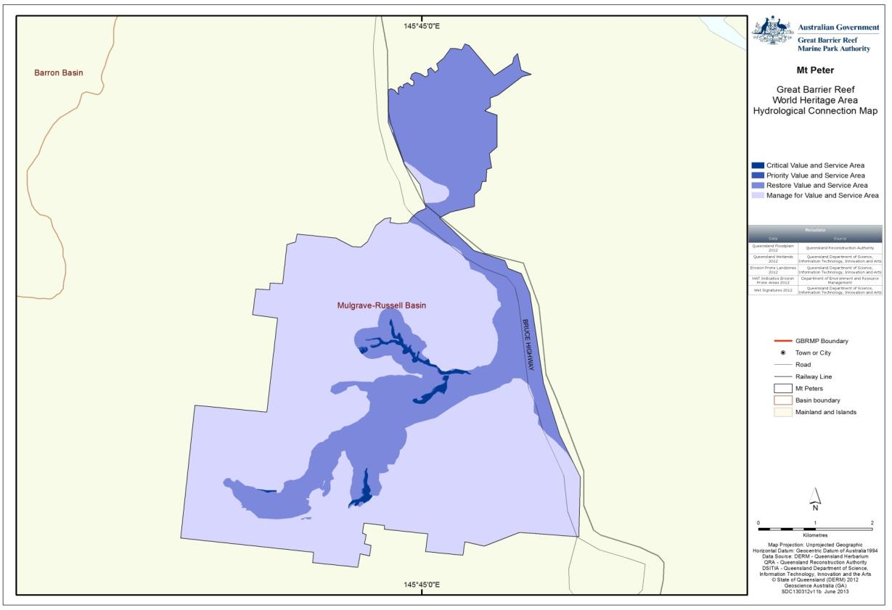

Figure 13: Accumulative analysis of mapped planning layers that represent high hydrological connections to the Great Barrier Reef World Heritage Area in the Mount Peter area

Not surprisingly, the accumulative analysis map (Figure 13) has a number of synergies with Figure 8 from the Cairns Regional Council Mount Peter study, particularly the area identified as a water envelope. It is important to note that the analysis in Figure 13 is focused on areas of high connection with the Great Barrier Reef (primarily through hydrology). Areas which are ecologically important in their own right, such as the Wet Tropics World Heritage Area which fringes the Mount Peter area, are not necessarily identified in Figure 13.

The intent of the resulting analysis in Figure 13 is to focus management on areas that connect the landscape to the World Heritage Area, however the entire map is blue as it recognised that all areas in the catchment require good management to ensure ecological functions and processes are maintained in the landscape, whether it be through coastal ecosystem rehabilitation, best management practice or engineered solutions.

The Mount Peter Master Plan study identified a number of mechanisms for the protection of remnant terrestrial vegetation. At the local scale, the Cairns Plan includes a Vegetation Conservation and Waterway Significance Code for remnant vegetation which recognises that the Mount Peter area has the potential to support important ecological communities that are also listed as threatened under the EPBC Act.

The code protects conservation values by protecting biodiversity, connectivity of vegetation communities (such as through waterways and riparian areas), maintains essential ecological processes, and prevents fragmentation, alienation or adverse impacts in existing vegetation communities.

The code grades waterways and areas of conservation to allow prioritising of protected areas in the Cairns Plan. There were a number of ecological and functional attributes that required defining at the local scale, including the validation of regional ecosystem mapping, functional ecosystem connectivity and hydrological and water quality values.

The establishment of water envelopes in the Mount Peter Master Plan study encompasses areas that protect water courses and aquatic habitats. Applying water envelopes and rehabilitating these areas could restore significant coastal ecosystem functions, such as water retention and nutrient and sediment cycling in the floodplain area. Revegetation and rehabilitation of water envelope areas can also provide terrestrial habitat connectivity for listed threatened species and ecological communities.

### Ensuring coastal ecosystems remain connected

Management mechanisms that applied to catchment planning and management in Queensland have provisions to reconnect and rehabilitate disturbed terrestrial ecosystems. Strategically, the Far North Queensland Regional Plan 2009-2031 provided an emphasis on strategic rehabilitation areas within the regional landscape to improve ecological connectivity, habitat extent and coastal processes, and scenic amenity priority areas and restoration of degraded coastal processes. At the landscape scale, the Mount Peter Planned Area Structure Plan allowed the validation of regional planning by identifying important ecosystem features, such as stream-related terrestrial vegetation corridors, and prioritisation of areas that have high potential for returning ecological connectivity across the site.

Prioritisation of terrestrial ecosystems for connecting remnant ecological communities that currently support listed threatened species and ecological communities at the landscape scale form the basis of value, and are generally already captured in Commonwealth and Queensland Government legislation. Waterways and riparian areas, particularly in the Mount Peter region, were identified as providing important “known and potential” habitat for threatened wildlife species listed under the EPBC Act and the NCA.

One of the key options for reconnection and rehabilitation of coastal ecosystems and functions in the Mount Peter Master Plan study was additional protection to proposed water envelopes (Figure 8), and the location of infrastructure, such as roads and pipes outside the water envelopes. For infrastructure crossing water envelope, it was proposed that infrastructure should be co-located, and the number of crossings for any given water envelope minimised.

### Gaps in protecting and restoring coastal ecosystems

A significant gap in the management and protection of coastal ecosystems and their functions is the recognition and identification of “functional connectivity” in the landscape, and how these functions support the health of the World Heritage Area. In particular, the relationship between coastal ecosystems and catchment hydrology, and the potential impacts on the World Heritage Area should these be modified, should be a focus for further consideration.

An implication of the lack of information in relation to connectivity between catchment ecosystems and the World Heritage Area will be the lack of assessment of the impacts from urban development such as that proposed in the Mount Peter area on the health of the World Heritage Area. However, the approach outlined above for identifying and prioritising values in the Mount Peter area, and the proposed improved management of terrestrial ecosystems under the Mount Peter Structure Plan, has a subsequent, if unrecognised, improved outcome for coastal ecosystems important to the health of the World Heritage Area. Analysis of the risk mapping and value mapping, combined with a review of intact and modified coastal ecosystems, suggests that the GBRMPA’s assessment framework provides a good basis for determining priority management and protection areas for coastal ecosystem functions in the Great Barrier Reef catchment. In summary, planning for ecological functions for the health of the World Heritage Area require:

* The identification of coastal ecosystems and ecological functions as values in the landscape, and linking these values to the protection, rehabilitation and restoration of Great Barrier Reef ecosystems.
* Modelling of catchment scale hydrological regimes (including surface run-off and groundwater interactions) and comparing natural versus developed hydrographs and where necessary groundwater flows.
* Identifying the full extent of ecological functions and processes important to the World Heritage Area (whether the value resides in the landscape, coast or marine environment).
* Establishment of agreed ecosystem health objectives for coastal ecosystems functions.
* Identifying priorities for protection, restoration and rehabilitation of coastal ecosystems and ecological functions.

### Uncertainty in assessment and managing risk

1. Coastal ecosystem and their functional relationships to the World Heritage Area is complex. Due to this complexity, it is recommended that functions and processes be validated at the site scale. There is also a great deal of uncertainty over the relative importance of one coastal ecosystem and its ecological functions over another, and the absolute measurement of the functions provided from coastal ecosystems in a particular area.
2. Much of the water quality monitoring that informs catchment management actions relies on broad sub-catchment and end-of-catchment monitoring.
3. The coastal ecosystems assessment in this report is largely a desktop assessment with some field validation to provide an example of the application of coastal ecosystem data. As previously discussed, the presence or absence of coastal ecosystems may require site verification, as some of the mapping relies on probability or mapping at a large scale (e.g. greater than 1 hectare).
4. A changing climate also presents challenges with modelling catchment peak flow conditions and future rainfall intensity. Both of these factors will influence how stormwater and in-stream flows must be managed to protect ecosystem health of the World Heritage Area into the future.

### Adaptive management

Currently there is limited capacity to fully monitor the result of ecological function degradation, or measure gradual changes in ecosystem services provided to the World Heritage Area. The tools identified in this review require improved monitoring and evaluation of ecological processes and functions important to maintaining the health of the World Heritage Area. Existing monitoring of key water quality parameters is being undertaken as part of the Reef Water Quality Protection Plan (Reef Plan). Reef Plan was designed to improve water quality flowing to the Great Barrier Reef, and includes a set of management actions to achieve established water quality objectives. Reef Plan review processes include reporting on the progress of achieving water quality objectives and will continue to be assessed over time to determine the outcomes of Reef Plan initiatives. Reef Plan provides an opportunity to improve ecosystem function monitoring and improvement in management actions to protect, rehabilitate and restore coastal ecosystems. Management principles of Reef Plan specifically include the repair of ecosystems that help achieve the objectives of Reef Plan:

* Principle 1: Continue to reduce the pollutant load particularly by targeting water quality improvement to the highest risk pollutants in the highest risk regions.
* Principle 2: Protect and enhance key areas of the region including wetlands and riparian areas, which have a water quality protection function and an intrinsic value in their own right.

After the recent analysis of Reef Plan, there is a much greater emphasis on rehabilitation of ecosystems in the catchment. Reef Plan provides an existing framework that can allow the monitoring, review, reporting and adaptive management of actions to improve the health and functions of coastal ecosystems.

# DISCUSSION

Since the 1880s, 75 per cent of coastal ecosystems in the Mount Peter area have been cleared for agriculture. Coastal ecosystem values that remain in the Mount Peter area are associated with areas not suitable for development at this stage, such as steep hill slopes and elevated sites (Figure 4 and Figure 12).

The aim of the case study was to examine present methodologies so linking important landscape features to the Great Barrier Reef could be achieved. The Mount Peter area was chosen as a case study because it is adjacent to two World Heritage Areas: the Great Barrier Reef and the Wet Tropics. Extensive work has already been conducted in assessing matters of national environmental significance under an EPBC Act strategic assessment provision.

The Mount Peter strategic assessment outlined a framework of legislation, assessment and mapping tools linked to the management and protection of key environmental values in the Mount Peter area, including many of those values important to the two adjacent World Heritage Areas.

The strategic assessment showed that remnant vegetation areas remain in the Mount Peter area however these extents are fragmented and isolated by land use, without natural ecological corridors to support landscape scale function (Figure 12). The values that do remain in the Mount Peter landscape link terrestrial areas outside the floodplain (important for wildlife species and connecting terrestrial ecological communities); the presence of some waterway and wetland communities; and vegetated buffer areas adjacent to the Wet Tropics World Heritage Area. However, the key gap in the landscape is the floodplain. Most of the floodplain rainforest have been cleared in the Mount Peter area, leading to a loss or modification of associated ecological functions (refer to Appendix A). Reconnecting ecosystems in the floodplain can provide multiple ecosystem service benefits to the World Heritage Area, including improved water quality through the capturing of sediments and nutrients, and improved water management, by slowing overland flow and promoting infiltration and groundwater recharge. A review of current management tools suggests that reconnecting coastal ecosystems can be achieved through the application and repurposing of existing management tools. Restoring these landscape connections may also provide a role in providing terrestrial habitat for other matters of national environmental significance.

Significant opportunities exist for the improved recognition, protection, restoration and rehabilitation of coastal ecosystems and their functions in the Mount Peter area. In assessing the coastal ecosystems and functions that have been modified across the Mount Peter area, the identification and validation of coastal ecosystem values, changes in hydrological regimes and the increase in movement of sediment and nutrients are the issues that need to be considered further. Key issues are discussed below.

## Identifying and validating coastal ecosystem values

One of the outcomes in the development of the Structural Plan for the Mount Peter Master Planned Area is the recognition and identification of landscape functions. The key gap is the role of coastal ecosystems and the role their functions play in supporting the health of the World Heritage Area. To ensure that coastal ecosystems and their functions are protected, landscape scale values and constraints need to be identified, and special management requirements need to be implemented for areas of high priority. In modified environments, coastal ecological functions should be identified, and measures implemented to return ecological function to the landscape.

To achieve this, site validation and ground-truthing of coastal ecosystems and functions should be conducted to assist in planning for current and future development, including the implementation of site specific set-backs and buffers. Ground-truthing is also required to determine whether regional ecosystems are present in remnant areas. Like the coastal ecosystem mapping, regional ecosystems only provide a guide as to where ecological communities are expected, based on numerous factors including soil, vegetation, rainfall and topology. For green field sites, existing ecological functions should be identified with the aim of maintaining these functions. For modified sites, ground-truthing is required to identify ecosystems and their functions that should be returned to the landscape.

To allow for adaptive management, the measures in place to manage land use and to protect or maintain coastal ecosystems and their functions need to be clearly identified as environmental values, and ecosystem function objectives developed associated with maintaining or where necessary improving these values.

Coastal ecosystem reference sites could also be used: sites where the potential threats and current condition are known. Reference sites can be used to validate ecosystem structure, species composition and visual confirmation of key characteristics, and to allow the monitoring of changes to ecological communities under a changing climate.

### Hydrology

Natural stream and catchment morphology is a balance of the catchments underlying rock and soil and the climatic conditions that the catchment is subject to. Catchment and in-stream ecology has adapted over time to this fine balance. Managing the health of the catchment, aquatic habitat and downstream environments to a defined ecosystem standard therefore require an understanding of the catchment’s soils and underlying geology, the natural flow regimes of catchment run-off and baseflow and groundwater interactions and the catchment and stream response to any modification to these processes.

Critical processes that need to be considered in planning for urban environments include implementing management measures that seek to maintain the natural hydrographs and seasonality of streams and rivers; consideration of local detention; and an understanding of flow conditions that may connect off stream wetland systems and promote healthy aquatic ecosystems (including groundwater), and peak flow conditions that potentially place the public and infrastructure at risk. Along with structural detention basins, coastal ecosystems detain overland flow and attenuate flood flow velocities, capturing sediments and bound nutrients, and promote baseflow recharge. Coastal ecosystems protect stream banks from erosion, provide aquatic habitat and attenuate flows in flood-prone areas, and play an important role in moderating flow velocity, and capturing sediments and nutrients in run-off.

### Modelling and best practice

At the site level, catchment based modelling is required to establish natural and modified flow regimes, particularly low flows (1:1 annual return interval) across floodplain flows and peak flow conditions. Predictable event flows (1:1.5 to 2 year annual return interval) provide an important stream ecosystem reset. They flush stream benthic communities, promote biological stream connectivity and transfer aquatic species throughout the aquatic system, thus increasing species richness and in-stream and downstream biodiversity.3

As discussed earlier in this report, low-flows are particularly important in maintaining the health of aquatic habitats and ecosystems (typically one to two year annual return intervals). In turn, these ecosystems support processes that biologically capture nutrients and modify sediments. These systems also support habitats important to marine species that utilise freshwater for part of their life cycle.

Peak flood flow conditions increase the area of the catchment inundated and provide connections to off stream wetlands and habitat for marine species that utilise freshwater habitats for part of their life cycle. Generally peak flows are those that inundated the floodplain areas identified earlier in this report. Peak flows can be an important breeding trigger for many marine species. Coastal ecosystems that are inundated by peak flows (such as in the floodplain) serve to capture sediments and nutrients flushed through the stream system, allowing biological processes to capture and bind sediments and nutrients to the soil. These permanent off stream wetlands also act as refugia during dry periods.

Modelling of low and peak flows is important for the planning of catchment development and design of infrastructure crossing streams and rivers. Modelling can show how development and infrastructure influence stream hydrographs and catchment flooding patterns, and management mechanisms can be implemented to avoid changes in flood flows and erosion processes. Management tools, such as site specific or regional climate specific water sensitive urban design, have shown to provide significant flow and water quality benefits for aquatic habitats.

## Potential management actions

The following are potential actions for the improved management of coastal ecosystems, ecological functions and connectivity to improve outcomes for the World Heritage Area:

1. Important coastal ecosystems and critical ecosystem processes and functions need to be understood at both the site and landscape scale. Queensland Regional Ecosystem Mapping and Appendix A of this report provide a starting point for this assessment. However landscape scale coastal ecosystems and function need to be verified, landscape values and constraints need to be identified, and special management arrangements need to be implemented for areas of high priority.
2. Landscape improvement objectives based on critical ecological processes, and high priority ecosystems or ecological function need to be established and integrated into current planning and management frameworks.
3. There are a number of ecosystem processes that are critical for maintaining the health of the World Heritage Area. There are also many planning and management overlaps that make work at cross-purposes. Some of the coastal ecosystem processes and functions in both modified and unmodified systems that are managed for other purposes in the catchment and may also represent ecosystem functions important to the health of the World Heritage Area.
4. Rather than developing new management tools, further consideration should be given to repurposing current land management tools to accommodate measures to maintain and improve coastal ecosystems and their ecological functions for the World Heritage Area. For example, water resource planning includes a management framework for land use activities that considers natural hydrographs and seasonality of streams and rivers, local capacity for natural detention of overland flow, flow conditions that promote healthy aquatic ecosystems and peak flow conditions of rivers and streams; however this framework does not include considerations for ecosystem functions important to the health of the Great Barrier Reef.
5. Promoting better understanding of the relationships between sediments, nutrients and the hydrological transport, trapping and transformation processes by coastal ecosystems in the landscape. This would include key biogeochemical factors (such as organic matter, dissolved oxygen, microbial processing), the role of event and seasonal hydrology in nutrient export, and how this links with the surface, soil, and groundwater exchanges and flow paths.
6. Low flows (1:1 annual return interval) and peak flow conditions are particularly important in maintaining ecological function, along with natural (pre-development) erosion potential (bed shear stress) of streams and rivers. Low-flows are particularly important in maintaining the health of aquatic habitats and ecosystems (typically one to two year annual return intervals), and low flow catchment objectives should be considered. Peak flow conditions increase the area of the catchment inundated, and provide connection to habitat for marine species that utilise freshwater habitats for part of their life cycle. Peak flows can be an important breeding trigger for many marine species. Coastal ecosystems that are inundated by peak flows also serve to capture some of the sediments and nutrients flushed through the system, allowing biological processes to capture and bind them to the soil or transform them and incorporate them into food chains.

# REFERENCES

1. Great Barrier Reef Marine Park Authority 2012, *Great Barrier Reef Coastal Ecosystems Assessment Framework,* Great Barrier Reef Marine Park Authority, Townsville.

2. Harris, M. 2010, *Mount Peter Structure Plan Part 5 - Technical Report: Environmental Constraints and Opportunities,* Cairns Regional Council, Cairns.

3. Wong, T. 2006, *Australian runoff quality: a guide to water sensitive urban design*. Personal Communication.

4. Ladson, A.R. 2008, *Hydrology: an Australian introduction,* Oxford University Press Melbourne.

5. Department of Sustainability, Environment, Water, Population and Communities *Strategic assessment of the development of the Mount Peter Master Planned Area, Queensland,* Australian Government, viewed 30/06/2013, <<http://www.environment.gov.au/epbc/notices/assessments/mount-peter-master-planned-area.html>>.

6. Department of Premier and Cabinet 2013, *Reef Water Quality Protection Plan 2013,* Reef Water Quality Protection Plan Secretariat, Department of Premier and Cabinet, Brisbane.

7. Gunn, J. and Barker, G. 2009, *Water Quality Pollutant Types and Sources Report: Black Ross Water Quality Improvement Plan,* Townsville City Council/Creek to Coral, Townsville.

8. Great Barrier Reef Marine Park Authority 2009, *Great Barrier Reef Outlook Report 2009,* Great Barrier Reef Marine Park Authority, Townsville.

9. Productivity Commission 2003, *Industries, land use and water quality in the Great Barrier Reef catchment: research report,* Department of Communications, IT and the Arts, Canberra.

10. Department of Premier and Cabinet 2008, *Scientific consensus statement on water quality in the Great Barrier Reef,* Department of Premier and Cabinet, Brisbane.

11. Larsen, J., Leon, J., McGrath, C. and Trancoso, R. In press, *Review of the catchment processes relevant to the Great Barrier Reef Region,* Great Barrier Reef Marine Park Authority, Townsville.

12. Queensland Government 2000, *Water act 2000*, Act edn, Queensland, Brisbane, Queensland.

13. Great Barrier Reef Marine Park Authority 2011, *Catchment to Reef Ecological Expert Advisory Workshop,* Great Barrier Reef Marine Park Authority, Townsville.

## APPENDIX A: Ecological processes of natural coastal ecosystems linked to the health and resilience of the Great Barrier Reef.

Note: Islands have been excluded as they vary considerably between island types

| Process | Ecological Service | Coral Reefs | Lagoon floor | Open water | Seagrass | Coastline | Estuaries | Freshwater wetlands | Forest floodplain | Heath and shrublands | Grass and sedgelands | Woodlands | Forests | Rainforests |
| --- | --- | --- | --- | --- | --- | --- | --- | --- | --- | --- | --- | --- | --- | --- |
|  | ***Physical processes- transport and mobilisation*** |  |  |  |  |  |  |  |  |  |  |  |  |  |
| Recharge/discharge | Detains water |  |  |  |  |  | MH | H | ✓ |  |  |  |  |  |
| Flood mitigation |  |  |  |  |  | M | ✓ | H |  | L |  |  |  |
| Connects ecosystems |  |  |  |  |  | ✓ | H | H |  |  |  |  |  |
| Regulates water flow (groundwater, overland flows) | H | L |  | ✓ | ✓ | MH | H | ✓ |  | L | MH | MH | H |
| Sedimentation/ erosion | Traps sediment | M | MH | ML | M |  | H | H |  |  | L | MH | MH | MH |
| Stabilises sediment from erosion |  | ✓ |  | M | H | ✓ | ✓ | ✓ | ✓ | L | MH | MH | M |
| Assimilates sediment |  |  |  |  | ✓ | ✓ | H |  |  |  | MH | MH | H |
| Is a source of sediment |  |  |  |  |  |  | M |  |  |  | MH | MH |  |
| Deposition and mobilisation processes | Particulate deposition & transport (sed/nutr/chem. etc.) |  |  |  |  |  |  | H |  |  |  |  |  |  |
| Material deposition & transport (debris, Dissolved Organic Matter, rock etc.) |  |  |  |  |  |  | H |  |  |  |  |  |  |
| Transports material for coastal processes |  |  |  |  |  |  | H |  |  |  |  |  |  |
|  | ***Biogeochemical processes – energy and nutrient dynamics*** |  |  |  |  |  |  |  |  |  |  |  |  |  |
| Production | Primary production | ✓ | ✓ | H | H | ✓ | H | H |  |  |  | M | M | H |
| Secondary production |  |  |  | H | ✓ | H | ✓ |  |  |  |  |  |  |
| Nutrient cycling (N, P) | Detains water, regulates flow of nutrients |  |  |  |  |  |  | H |  |  |  |  |  |  |
| Source of (N,P) |  |  |  | M | L | H |  |  |  |  | M | M | H |
| Cycles and uptakes nutrients | L | H | H | M | L | H | MH |  | ✓ | ✓ |  |  |  |
| Regulates nutrient supply to the reef |  |  |  | M | L | H | M | H |  |  | M | M | H |
| Carbon cycling | Carbon source |  |  |  | M | L | H | H |  |  |  |  |  | H |
| Sequesters carbon | ✓ | H | L | M | L | H | H | ✓ |  |  |  |  |  |
| Cycles carbon | L | H | H | M | L | H |  |  |  |  | H | H | H |
| Decomposition | Source of Dissolved Organic Matter |  |  |  |  |  | H | H |  |  |  |  |  | H |
| Oxidation-reduction | Biochar source |  |  |  |  |  |  |  |  |  |  | H | H |  |
| Oxygenates water |  | H | H |  | L | ✓ |  |  |  |  |  |  |  |
| Oxygenates sediments |  | ✓ |  | M | L | ✓ |  |  |  |  |  |  |  |
| Regulation processes | pH regulation |  |  |  | M |  |  | H |  |  |  |  |  |  |
| Potential acid sulphate soils management |  |  |  |  |  | H | H |  |  |  |  |  |  |
| Salinity regulation |  |  |  |  |  |  |  |  |  |  |  |  |  |
| Hardness regulation |  |  |  |  |  |  | H |  |  |  |  |  |  |
| Regulates temperature |  |  |  |  | ✓ | ✓ | ✓ | ✓ |  |  |  |  | ML |
| Chemicals/heavy metal modification | Biogeochemically modifies chemicals/heavy metals | L |  |  | M |  | ✓ | H |  |  |  |  |  |  |
| Flocculates heavy metals |  |  |  |  |  | ✓ | H |  |  |  |  |  |  |
|  | ***Biological processes (processes that maintain animal/plant populations)*** |  |  |  |  |  |  |  |  |  |  |  |  |  |
| Survival/reproduction | Habitat/refugia for aquatic species with reef connections | H | M | L | ✓ | H | H | H |  | ✓ |  |  |  |  |
| Habitat for terrestrial species with connections to the reef | H |  |  |  |  |  | H |  |  |  |  |  |  |
| Food source |  | ✓ |  | H | ✓ | ✓ | ✓ |  | H |  |  |  |  |
| Habitat for ecologically important animals | H | ✓ |  | H | L | H |  |  | ✓ | ✓ |  |  |  |
| Dispersal/ migration/ regeneration | Replenishment of ecosystems – colonisation (source/sink) | H |  |  | H | M | H | H |  |  |  |  |  |  |
| Pathway for migratory fish |  |  |  |  |  |  | H |  |  |  |  |  |  |
| Pollination |  |  |  |  |  |  |  |  |  |  |  |  |  |  |
| Recruitment | Habitat contributes significantly to recruitment | H |  |  | H | H | H | H |  | H |  |  |  |  |

**Capacity of natural coastal ecosystems to provide ecological functions for the Great Barrier Reef**13

H – high capacity for this system to provide this service, M – medium capacity for this system to provide this function, L – low capacity for this system to provide this function, N – no capacity for this system to provide this function, X – not applicable, ✓– function is provided but capacity unknown. Boxes with no data indicate a lack of information available. Note that the capacity shown for modified systems assumes periods of low hydrological flow.

## APPENDIX B: Ecological processes of modified systems linked to the health and resilience of the Great Barrier Reef.

Note: Islands have been excluded as they vary considerably between island types

| Process | Ecological Service | Groundwater Ecosystems | Irrigated agriculture | Non-irrigated agriculture | Dams & Weirs | Urban | Mining – operational o/cut | Forestry Plantation | Extensive agriculture | Ponded pastures |
| --- | --- | --- | --- | --- | --- | --- | --- | --- | --- | --- |
|  | ***Physical processes- transport & mobilisation*** |  |  |  |  |  |  |  |  |  |
| Recharge/Discharge | Detains water | ✓1 | M |  |  | L | M |  | H |  |
| Flood mitigation | ✓ | N |  |  | L | X |  | X |  |
| Connects ecosystems | H | L |  |  | L | N |  | L |  |
| Regulates water flow (groundwater, overland flows) | H | M |  |  | L | L |  | M |  |
| Sedimentation/ erosion | Traps sediment | N | M4 |  |  | L | M |  | H |  |
| Stabilises sediment from erosion | ✓ | M4 |  |  | H | N |  | H |  |
| Assimilates sediment |  | M |  |  | L | N |  | H |  |
| Is a source of sediment |  | L |  |  | L11 | M |  | L |  |
| Deposition & mobilisation processes | Particulate deposition & transport (sed/nutr/chem. etc.) | ✓2 | L |  |  | L | L |  | H |  |
| Material deposition & transport (debris, DOM, rock etc.) |  | L |  |  | L | L |  | L |  |
| Transports material for coastal processes |  | N |  |  | M | L |  |  |  |
|  | ***Biogeochemical processes – energy & nutrient dynamics*** |  |  |  |  |  |  |  |  |  |
| Production | Primary production | N |  |  |  |  |  |  | M |  |
| Secondary production | ✓3 |  |  |  |  |  |  | H |  |
| Nutrient cycling (N, P) | Detains water, regulates flow of nutrients | ✓ |  |  |  |  |  |  | M13 |  |
| Source of (N,P) | ✓ |  |  |  |  |  |  | M |  |
| Cycles and uptakes nutrients | ✓ |  |  |  |  |  |  | H |  |
| Regulates nutrient supply to the reef | ✓ |  |  |  |  |  |  | H |  |
| Carbon cycling | Carbon source | ✓ |  |  |  |  |  |  | M |  |
| Sequesters carbon | ✓ |  |  |  |  |  |  | MH |  |
| Cycles carbon | ✓ |  |  |  |  |  |  | H |  |
| Decomposition | Source of Dissolved Organic Matter | ✓ |  |  |  |  |  |  | L14 |  |
| Oxidation-reduction | Biochar source |  |  |  |  |  |  |  | X |  |
| Oxygenates water | N |  |  |  |  |  |  | L |  |
| Oxygenates sediments | N |  |  |  |  |  |  | ✓15 |  |
| Regulation processes | pH regulation | ✓ |  |  |  |  |  |  | ✓15 |  |
| PASS management |  |  |  |  |  |  |  | L |  |
| Salinity regulation |  |  |  |  |  |  |  | ✓15 |  |
| Hardness regulation |  |  |  |  |  |  |  | ✓15 |  |
| Regulates temperature |  |  |  |  |  |  |  | L16 |  |
| Chemicals/heavy metal modification | Biogeochemically modifies chemicals/heavy metals | ✓ |  |  |  |  |  |  | X17 |  |
| Flocculates heavy metals | ✓ |  |  |  |  |  |  | L |  |
|  | ***Biological processes (processes that maintain animal/plant populations)*** |  |  |  |  |  |  |  |  |  |
| Survival/reproduction | Habitat/refugia for aquatic species with reef connections | N | L5 | L5 | L8 | L12 | N | N | L | M18 |
| Habitat for terrestrial species with connections to the reef | N | L | L | H9 | L | N | N | L | L19 |
| Food source | N | N | N | M | L | N | L | M | L |
| Habitat for ecologically important animals |  | N | N | L10 | N | N | N | M | L19 |
| Dispersal/ migration/ regeneration | Replenishment of ecosystems – colonisation (source/sink) | N | N | N | L | N | N | N | M | L20 |
| Pathway for migratory fish | - | N6 | N6 | L8 | N | N | N | ✓15 | L21 |
| Pollination |  | - | L7 | L7 | N |  | N |  |  |  |
| Recruitment | Habitat contributes significantly to recruitment |  | N | N | L | N | N | N | M | N |

**Capacity of natural and modified coastal ecosystems to provide ecological functions for the Great Barrier Reef**

H – high capacity for this system to provide this function, M – medium capacity for this system to provide this service, L – low capacity for this system to provide this function, N – no capacity for this system to provide this function, X – not applicable, ✓– function is provided but capacity unknown. Boxes with no data indicate a lack of information available. Note that the capacity shown for modified systems assumes periods of low hydrological flow. End-notes 1 – capacity depends on hydraulic characteristics of the aquifer (porosity, permeability); 2 - particulate transport occurs sometimes in subterranean systems; 3 - secondary production is variable; 4 - dependent upon crop cycle; 5 - habitat for crocodiles and turtles; 6 - especially in channels, but is dependent on water quality; 7 - depends upon crop; 8 - only where fish passage mechanisms exist; 9 - especially water & shorebirds; 10 - particularly aquatic species (though may lack connectivity); 11 - refers to new developments; 12 - impoundments, ornamental lakes and stormwater channels; 13 - hoof compaction of soil increases run-off; 14 - particulate organic carbon is high, dissolved is low; 15 - unchanged from natural ecosystem capacity; 16 - relates more to extent of vegetation clearance of riparian zone; 17 - contaminant; 18 – in the dry season amongst Hymenachne; 19 - particularly for birds; 20 - sink biologically as species move into areas but reduced water quality can affect badly; 21 - subject to water quality and grazing regime.