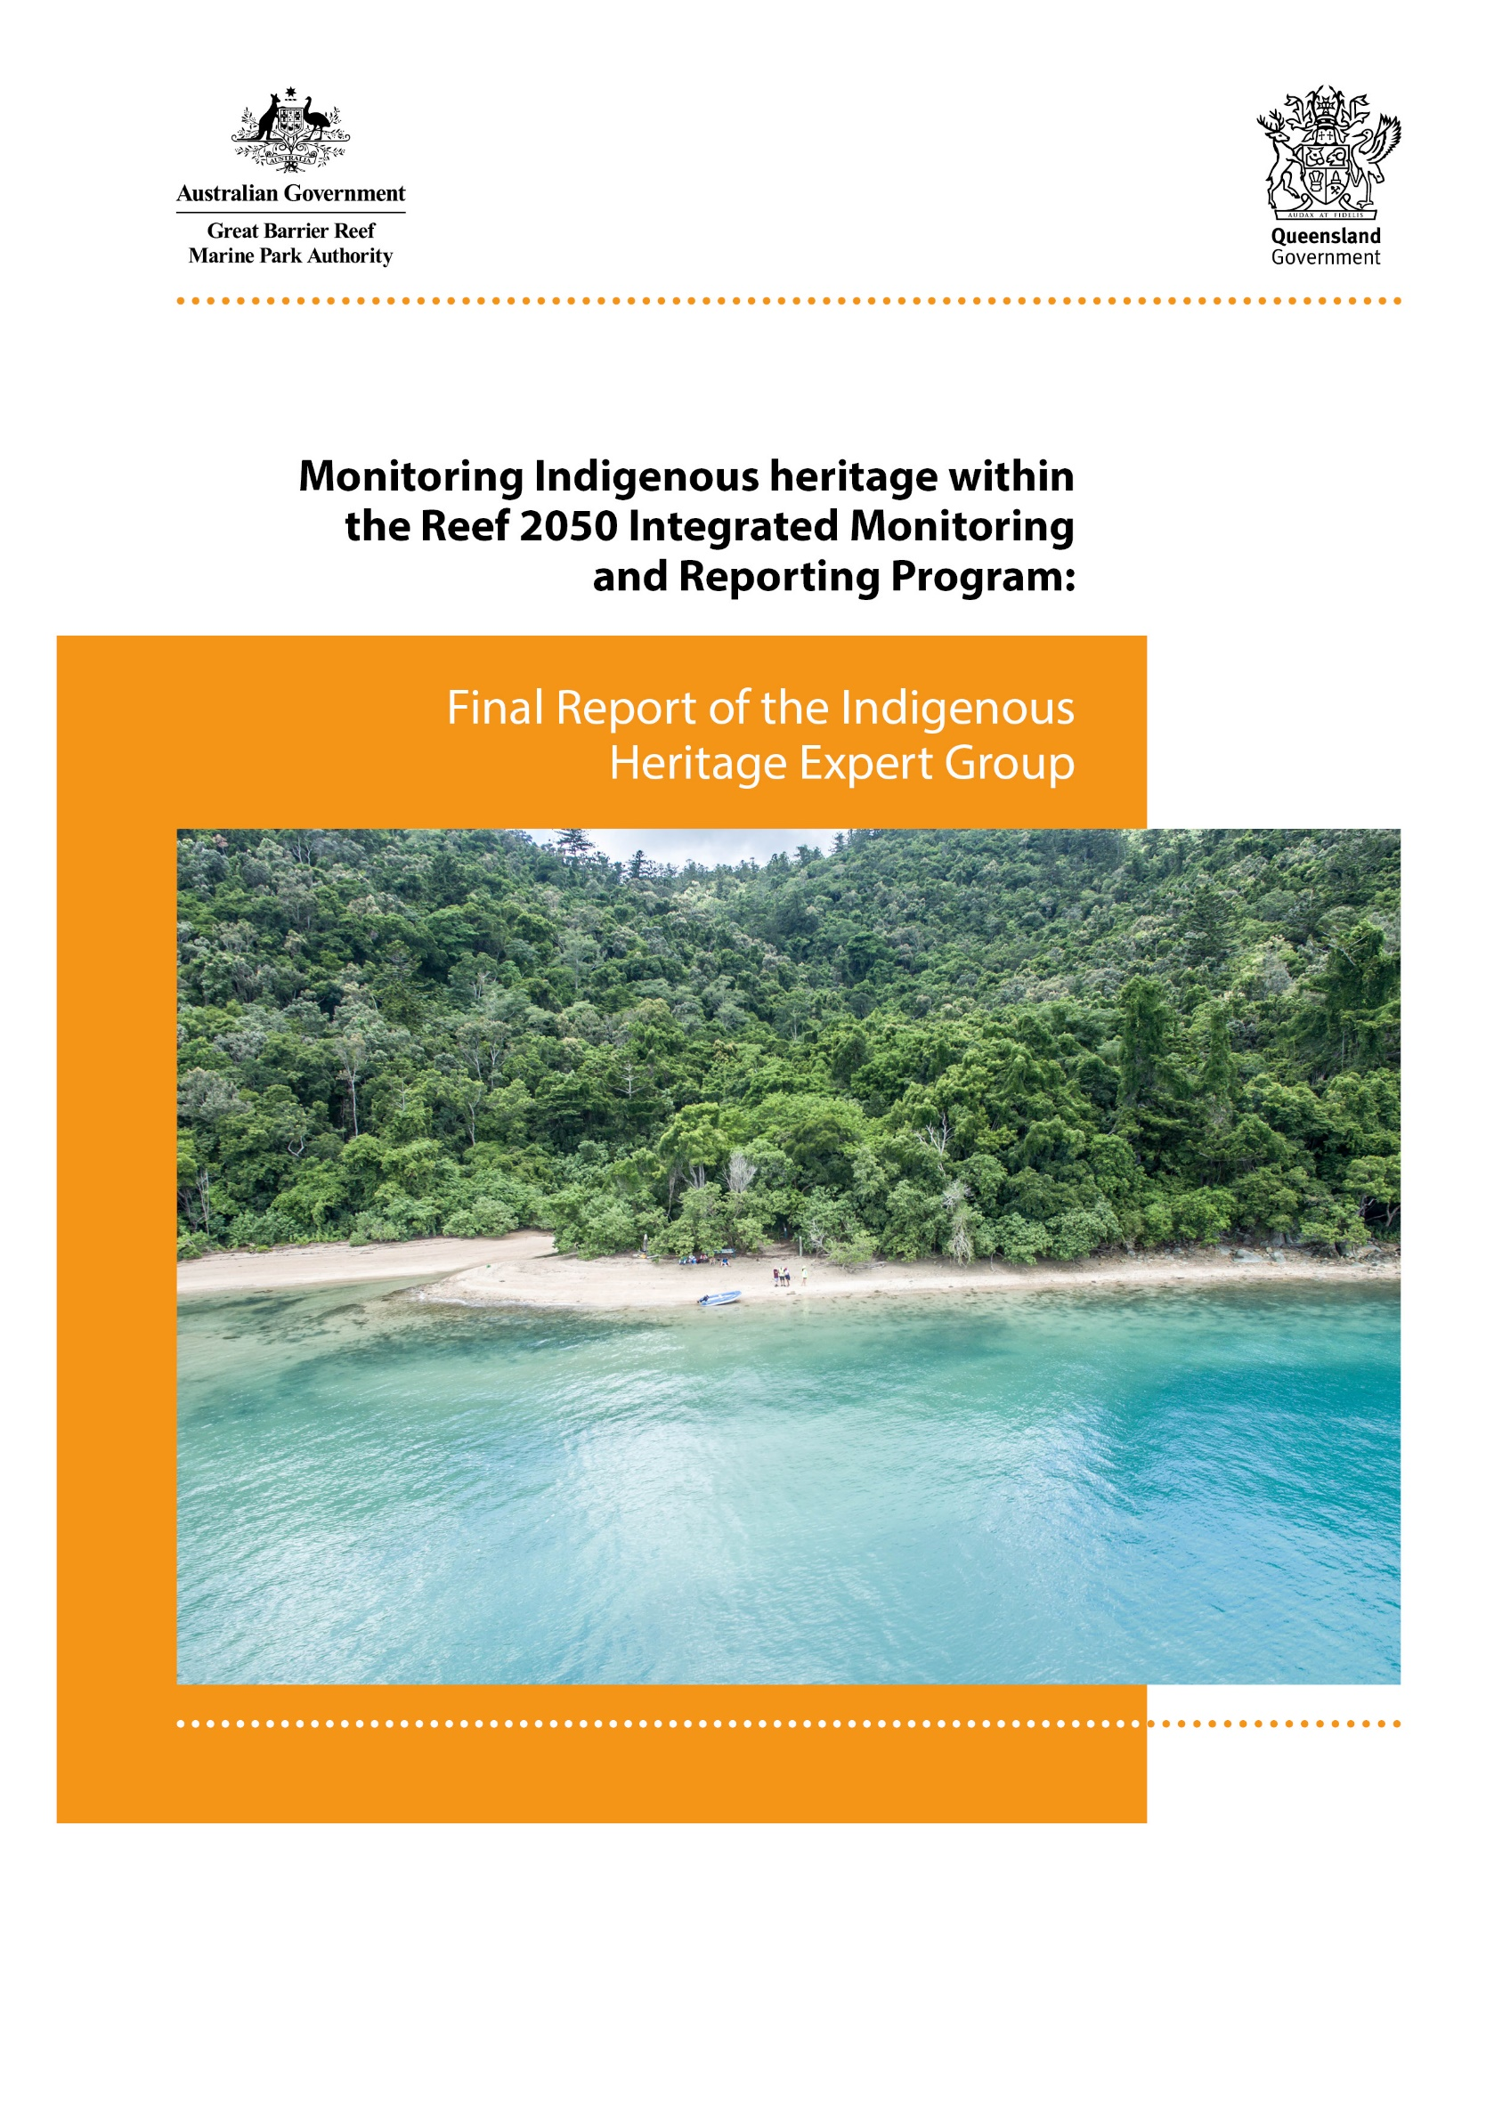
© Commonwealth of Australia (Australian Institute of Marine Science) 2019
Published by the Great Barrier Reef Marine Park Authority
ISBN 978-0-6485892-0-4
This document is licensed for use under a Creative Commons Attribution-Non Commercial 4.0 International licence with the exception of the Coat of Arms of the Commonwealth of Australia, the logos of the Great Barrier Reef Marine Park Authority and the Queensland Government, any other material protected by a trademark, content supplied by third parties and any photographs. For licence conditions see: https://creativecommons.org/licenses/by-nc/4.0/

A catalogue record for this publication is available from the National Library of Australia.

This publication should be cited as:
Jarvis, D., Hill, R., Buissereth, R., Moran, C., Talbot, L.D., Bullio, R., Grant, C., Dale, A., Deshong, S., Fraser, D., Gooch, M., Hale, L., Mann, M., Singleton, G. and Wren, L., 2019, Monitoring the Indigenous heritage within the Reef 2050 Integrated Monitoring and Reporting Program: Final Report of the Indigenous Heritage Expert Group, Great Barrier Reef Marine Park Authority, Townsville.

Front cover image: Aerial drone image of Sawmill Beach, Whitsundays. © Commonwealth of Australia (GBRMPA), Photographer: Andrew Denzin.
DISCLAIMER
While reasonable effort has been made to ensure that the contents of this publication are factually correct, the Commonwealth of Australia, represented by the Great Barrier Reef Marine Park Authority, does not accept responsibility for the accuracy or completeness of the contents, and shall not be liable for any loss or damage that may be occasioned directly or indirectly through the use of, or reliance on, the contents of this publication. The views and opinions in this publication are those of the authors and do not necessarily reflect those of the Australian Government or the Minister for the Environment.
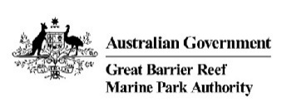

Great Barrier Reef Marine Park Authority
280 Flinders Street Townsville | PO Box 1379 Townsville QLD 4810
Phone: (07) 4750 0700
Fax: 07 4772 6093
Email: info@gbrmpa.gov.au
www.gbrmpa.gov.au

Contents
List of Tables i
List of Figures i
Acronyms iii
Conventions iv
Acknowledgements v
Author, Designer and Artist Contributions vi
1.0 Executive Summary vii
2.0 Background and Design Considerations 1
2.1 Background to Traditional Owners, Indigenous heritage and the Reef 2050 Plan 1
2.2 Design Considerations 2
2.3 Review of Traditional Owner-driven Frameworks 3
2.3.1 Introduction 3
2.3.2 Co-Management Mapping Framework in the Wet Tropics developed by Pert et al. (2015) 5
2.3.3 Wellbeing of Nywaigi Traditional Owners developed by Greiner et al. (2005) 8
2.3.4 Interplay Wellbeing Framework developed by Cairney et al. (2017) 10
2.3.5 Aboriginal Child Health and Wellbeing Framework developed by Priest et al. (2012) ………………………………………………………………………………………...13
2.3.6 The Uunguu Monitoring and Evaluation Plan conducted by Austin et al. (2017) ………………………………………………………………………………………...15
2.3.7 Exploratory Framework for Aboriginal Victorian peoples’ wellbeing created by Kingsley et al. (2013) 16
2.3.8 Mackay-Whitsunday Healthy Rivers to Reef Partnership 18
2.4 Conclusion 21
3.0 Objectives of RIMReP 21
3.1 Information needs relevant to Indigenous heritage for the Great Barrier Reef Outlook Report and other reporting requirements 24
3.1.1 Traditional Owners in the Reef 2050 Plan 24
3.3.2 Traditional Owner Objectives in Reef 2050 24
3.1.3 Traditional Owner targets across all themes 24
3.2 Information needs for Great Barrier Reef management 25
4.0 Current understanding of Indigenous heritage systems and status on the Great Barrier Reef 26
4.1 Synopsis of conceptual system understanding of Indigenous heritage on the Great Barrier Reef 26
4.1.1 Introduction 26
4.1.2 The development of the Strong peoples – Strong country framework 26
4.1.3 The focus of the Strong peoples – Strong country framework 29
4.1.4 Determining the hubs and underlying factors believed to influence wellbeing as embodied by the term Strong peoples – Strong country 30
4.1.5 Country Health 30
4.1.6 People’s Health 31
4.1.7 Heritage and Knowledge 32
4.1.8 Culture and Community 33
4.1.9 Education 34
4.1.10 Empowerment and Economics 34
4.1.11 Testing the Strong peoples – Strong country framework 36
4.1.12 The concept of monitoring and the use of the framework as a monitoring tool 36
4.1.13 Subjective testing and monitoring of the Strong peoples – Strong country framework 37
4.2 Individual survey data collected 40
4.3 Group Survey Data Collected 42
4.4 Results from the analysis of the survey responses 45
4.1 Importance of different factors 45
4.2 Satisfaction with different factors 50
4.3 Bringing together importance and satisfaction scores 54
4.5 Feedback regarding the survey and factors that could be used to improve the survey in future years 61
4.6 Summary of conclusions drawn from analysis of responses 62
4.7 Synopsis of current status of Indigenous heritage on the Great Barrier Reef 62
5.0 Priority indicators to monitor Indigenous heritage on the Great Barrier Reef 64
5.1 Overview of existing objective indicators 64
5.1.1 Indicators to assess Strong peoples – Strong country 64
6.0 Scoping of further potentially relevant objective indicators 65
6.1 Introduction to Traditional Owner-driven indicators 65
6.2 Traditional Owner-driven objective indicators – MERI, two-way and traditional indicators 66
6.3 Key challenges and opportunities for further development of Traditional Owner-driven indicators 68
6.4 Partnering with global initiatives in a Community of Practice 69
6.5 Priority indicators 70
7.0 Evaluation of the adequacy of current monitoring of Indigenous heritage on the Great Barrier Reef 72
7.1 Synopsis of existing monitoring programs 72
7.2 Adequacy of existing monitoring programs 72
7.3 Gaps in current monitoring effort 73
8.0 New technologies for monitoring Indigenous heritage on the Great Barrier Reef 73
9.0 Recommendations for integrated monitoring of Indigenous heritage on the Great Barrier Reef 74
10.0 Assessment of the resources required to implement the recommended design 74
11.0 References 79
12.0 Appendices 82
12.1 Appendix One: Monitoring the Impact of the Traditional Owner Actions in Reef 2050, using the Strong peoples – Strong country indicators 82
12.2 Appendix Two: Monitoring the Impact of the (Draft) Aboriginal and Torres Strait Islander Heritage Strategy, using the Strong peoples – Strong country indicators 93
12.3 Appendix Three: Published and unpublished sources of information about indicators 105
12.4 Appendix Four: Selected indicators relevant to Traditional Owner wellbeing 113
12.5 Appendix Five: Impact Measures associated with each of the six hubs of Traditional Owner wellbeing 128
13.0 Attachments 130

List of Tables
Table 1. Numbers of Traditional Owner-related targets and actions included within each theme 40
Table 2. Importance scores from combined individual surveys, group discussions, plus showing each segments scores separately 62
Table 3. Satisfaction scores from combined individual surveys, group discussions, plus showing each segment scores separately 67
Table 4. Dissatisfaction index of factors based upon combined individual surveys and group discussions, plus showing each segment index separately, ranked by overall index scores 70
Table 5. Dissatisfaction index of hubs based upon combined individual surveys and group discussions, plus showing each segment index separately, ranked by overall index scores 73
Table 6. Dissatisfaction index for males and females 73
Table 7. Dissatisfaction index by hub for different geographic regions 74
Table 8. Factors with highest dissatisfaction index values within each different geographic region (only including those with index value of 50 or higher) 75
Table 9. Condition and trend of Indigenous heritage values (Source: The Great Barrier Marine Park Authority 2015; 2018, p. 13) 78
Table 10. Different levels of indicators in use by Traditional Owner groups 82
Table 11. Priority indicators to monitor Indigenous heritage through our Strong peoples – Strong country framework 85
Table 12. Recommended survey methods, locations and frequency 89
Table 13. Resources required to implement monitoring of Indigenous heritage based on the Strong peoples – Strong country framework and indicators 90
Table 14. Components of work required to develop Traditional Owner-driven objective indicators for Indigenous heritage monitoring and engage Traditional Owners more broadly in monitoring activities across RIMReP 92

List of Figures
Figure 1. The Strong peoples – Strong country framework for monitoring Indigenous heritage in RIMReP © Mallie Designs, licensed for use by RIMReP partners. 13
Figure 2. Modified DPSIR Framework showing pathways of management intervention and identifying Traditional Owner concepts of wellbeing to be included Source: (Hedge P et al. 2013, 72) 17
Figure 3. Reef 2050 Traditional Owner objectives for each outcome (Commonwealth of Australia 2015) 20
Figure 4. The two major themes and their categories for participatory evaluation co-produced with the Rainforest Aboriginal peoples (Pert et al. 2015) 21
Figure 5. Demonstrates the co-produced evaluation maps of the Wet Tropics region using the Rainforest Aboriginal peoples keeping strong subthemes (Pert et al. 2015) 22
Figure 6. Preliminary framework created from Nywaigi Traditional Owner Wellbeing research (Greiner et al. 2005) 24
Figure 7. Final Nywaigi Traditional Owners Wellbeing Framework (Greiner et al. 2015) 25
Figure 8. Shared Space model for working collaboratively (Cairney et al. 2017) 27
Figure 9. The Interplay Wellbeing Framework (Cairney et al. 2017; see https://old.crc-rep.com/wellbeingframework/to explore further using the visualisation tools) 27
Figure 10. Conceptual Framework of Aboriginal Child Health, Development, and Wellbeing in an Urban Setting 29
Figure 11. Traditional owner ranking of target health over time 31
Figure 12. Exploratory Framework of Aboriginal Forces Impacting on Wellbeing 33
Figure 13. Scoring system used by TORG, Terra Rosa, and the Healthy Rivers to Reef Partnership 35
Figure 14. RIMReP program logic. Each of the three goals has associated development and implementation objectives as well as foundational inputs. 38
Figure 15. Levels of Monitoring for Australian Government NRM Programs (Source: Australian Government Regional Land Partnerships MERI Framework at http://www.nrm.gov.au/publications/regional-land-partnerships-meri-framework) 42
Figure 16. Framework for Traditional Owner wellbeing through connections to Country developed from Traditional Owner concepts within the Great Barrier Reef land and sea country. Copyright Mallie Designs. 43
Figure 17. Regional zoning structure developed by the Indigenous Heritage Expert Group for regional classification of Traditional Owners of the land and sea country within the Great Barrier Reef catchment 53
Figure 18. Survey question regarding overall satisfaction level with Traditional Owner wellbeing as epitomised by the term Strong peoples – Strong country 54
Figure 19. Scale used within survey question regarding the importance of individual factors 55
Figure 20. Analysis of individual survey respondents by gender 56
Figure 21. Analysis of individual survey respondents by age group 56
Figure 22. Analysis of individual survey respondents by the geographic zone with which they identify 57
Figure 23. Analysis of group survey respondents by the geographic zone with which they identify 58
Figure 24. Example of one group’s analysis of the importance of different factors within the Empowerment and Economics hub 59
Figure 25. Example of one group’s analysis of their satisfaction with different factors within the Empowerment and Economics hub 59
Figure 26. Example of one group’s analysis of their satisfaction with their quality of life overall 60
Figure 27. Levels of importance expressed by regional group responses to the survey 61
Figure 28. Level of satisfaction expressed by regional group responses to the survey 66
Figure 29. Three levels of monitoring: Activities/outputs; outcomes; and asset condition. Source. Australian Government 2009. See also http://www.nrm.gov.au/system/files/resources/3e040629-4825-4c3a-8a97-133003e73be2/files/regional-land-meri-framework.pdf 81
Figure 30. Attendees at the Action Group Action Group on Knowledge Systems and Indicators of Wellbeing in New York, April 2018 85

Acronyms
ACCHO Aboriginal Community Controlled Health Organisation
CSIRO Commonwealth Scientific and Industrial Research Organisation
DATSIP Department of Aboriginal and Torres Strait Islander Partnerships
DPSIR Driver, Pressure, State, Impact and Response
FPIC Free, Prior and Informed Consent
GAC Girringun Aboriginal Corporation
GBR Great Barrier Reef
HCP Healthy Country Plan
IHEG Indigenous Heritage Expert Group
IPBES Intergovernmental Platform on Biodiversity and Ecosystem Services
JCU James Cook University
MERI Monitoring, Evaluation, Reporting and Improvement
NESP National Environmental Science Programme
RIMReP Reef 2050 Integrated Monitoring and Reporting Program
RRRC Reef and Rainforest Research Centre Limited
TO Traditional Owner
TORG Traditional Owner Reference Group
TWQ Tropical Water Quality
UMEC The Uunguu Monitoring and Evaluation Committee

Conventions
1. Country is capitalised when it refers to specific Country belonging to Traditional Owner groups. Similarly, Culture is capitalised when it refers to specific Culture belonging to Traditional Owner groups. General references to culture and country are lower case.
2. Elders is capitalised when it refers to senior members of Traditional Owner groups.
3. Reef is capitalised when it specifically refers to the Great Barrier Reef.
4. Minimum punctuation style is used in lists and tables i.e. full stops or semi-colons are not used unless somewhere in the list or table column there is an entry with two sentences, in which case full stops appear throughout that column or list; full stops appear at the end of lists.
5. Traditional Owner is used as an acronym only in some Tables in this report.

Acknowledgements
The Indigenous Heritage Expert Group, and the project support team, acknowledge Aboriginal and Torres Strait Islander Traditional Owners’ continuing sea country management and custodianship of the Great Barrier Reef, as well as their rich cultures, heritage values, enduring connections and shared efforts to care for country for future generations.
Traditional Owners of the Great Barrier Reef have welcomed the recognition of Traditional Owner actions as one of six key priority areas for investment under the Reef 2050 Plan’s Investment Framework. The investment by the Australian and Queensland’s government, as part of the Reef 2050 Integrated Monitoring and Reporting Program, and the Australian Institute of Marine Sciences (AIMS) in the Indigenous Heritage Expert Group to contribute to the design of RIMReP is a positive step towards responding to Traditional Owners rights and interests.
The Indigenous Heritage Expert Group (IHEG), and project support team, thank the many Traditional Owners who attend the Reef-wide Traditional Owner Workshop from May 1-3, 2018 for their invaluable contributions and insights. We also acknowledge and greatly appreciate the wonderful collaboration with the Reef and Rainforest Research Centre’s (RRRC) Reef 2050 Traditional Owner Aspirations Project in co-hosting the Reef-wide Traditional Owner Workshop.
We acknowledge the support of the AIMS team working on RIMReP, and thank them for their ongoing guidance, and for the contributions of the AIMS staff to our Reef-wide Traditional Owner Workshop. We would also like to thank the Authority’s RIMReP team, for their ongoing help and guidance, and other Authority staff for their contributions to our Reef-wide Traditional Owner Workshop. Thanks to the Authority’s communications team for reviewing our communications products with the Queensland Government and AIMS.
The Indigenous Heritage Expert Group and project support team are deeply grateful for Luke Mallie of Mallie Designs for providing the artwork for the Strong peoples – Strong country framework in a very short time frame. Mallie Designs holds the copyright for this image, which RIMReP partners are licenced to use. We acknowledge and thank Jacqui Smith from Whitespace Design Studio for the graphic design of the brochures that appear in the Attachments.
We would like to also thank Authority staff for their insight and constructive feedback on an earlier draft of this report. Their feedback has been taken on board resulting in the re-casting of critical components of our report. We also acknowledge peer reviewers whose comments improved this final report.
Finally, we would like to acknowledge and thank the Center for Biodiversity and Conservation at the American Museum of Natural History, and staff Dr Puaʻala Pascua, Dr Eleanor Sterling, Dr Hellin Brink, and Dr Felicity Arengo, and their partners Nia Tero, for supporting Ms Chrissy Grant and Dr Leah Talbot to attend the Action Group on Knowledge Systems and Indicators of Wellbeing meeting in New York City from April 18 – April 23, 2018. The opportunity to participate in the ongoing Community of Practice from this meeting is invaluable.

Author, Designer and Artist Contributions
Dr Diane Jarvis, Dr Ro Hill, Ms Rachel Buissereth, Dr Leah Talbot and Dr Cath Moran wrote parts of the report, reviewed literature, and contributed to the co-design and implementation of the Traditional Owner led research approaches under the leadership of the members of the Indigenous Heritage Expert Group. Diane led the development of the survey, and the collection and analysis of survey data. Ms Rowena Bullio contributed to analysis of data, and to co-design and implementation of Traditional Owner driven approaches. Dr Cath Moran led the development of the Ethics Application for the research. Ms Chrissy Grant, Chair of the Indigenous Heritage Expert Group has provided overall leadership and development of this project, including intellectual and cultural leadership and guidance to the co-design and implementation of the research. Indigenous Heritage Expert Group members ̶ Mr Duane Fraser, Mr Gavin Singleton, Ms Samarla Deshong, Mr Malcolm Mann, Ms Liz Wren, Prof Allan Dale, Dr Margaret Gooch ̶ contributed intellectual and cultural leadership to the co-design and implementation of the research. Dr Ro Hill led the project support team, with responsibility for ensuring delivery of project on time, on target and on budget, coordinating the many co-author contributions and finalising the report. Dr Diane Jarvis, Dr Ro Hill, Ms Rachel Buissereth, Dr Leah Talbot, Ms Rowena Bullio and Dr Margaret Gooch all contributed to the editing of the report.
Graphic design (Attachments A-F): Whitespace Design Studio
Artwork for Strong peoples – Strong country: © Luke Mallie, Mallie Designs. Licensed for use by RIMReP partners.

1.0 Executive Summary
The Indigenous Heritage Expert Group (IHEG) was created to advise on the design of the Indigenous heritage theme of the Reef 2050 Integrated Monitoring and Reporting Program (RIMReP) in a context where it has been recognised that the most striking gap in socio-economic monitoring was the absence of monitoring pertaining to Traditional Owner (TO) use, dependency and wellbeing. The IHEG reviewed a series of Traditional Owner-driven monitoring frameworks implemented throughout Australia. The review is summarised in this report. Many of these frameworks applied an inclusive definition of wellbeing, or the personal, physical, social, economic, and environmental factors of human life, as the focus of monitoring. However, the IHEG determined that the most successful frameworks were biocultural—connecting Indigenous community wellbeing with Country wellbeing through stories and statistics.
For example, the methodology used to inform the Mackay-Whitsunday Healthy Rivers to Reef Partnership (MWHR2RP) Report Card for 2015 was useful, empowered the Traditional Owner communities and contributed to their knowledge of cultural heritage sites and landscape. It also provided a group of Traditional Owners with training and the ability to return to their country – building the capacity of the Traditional Owners on Country.
Through analysis of existing frameworks and monitoring methods such as the one developed for the Healthy Rivers to Reef Partnership, the IHEG developed a unique framework, Strong peoples – Strong country, for Traditional Owners to monitor the Great Barrier Reef (the Reef), and its catchments (herein collectively referred to as the Great Barrier Reef region); and thereby track Traditional Owners’ perceptions of the status of Indigenous heritage, and progress on the Traditional Owner objectives, targets and actions in the Reef 2050 Long-Term Sustainability Plan (Reef 2050 Plan). The framework and indicators provide a structure for monitoring the condition of the Indigenous heritage asset, and for monitoring progress on achieving the Reef 2050 Traditional Owner objectives, targets and actions.
The Indigenous Heritage Expert Group identified six key hubs relevant to Strong peoples – Strong country: Country health; People’s Health; Heritage and Knowledge; Culture and Community; Education; Empowerment and Economics (Figure 1).
Together these hubs encompass Traditional Owners’ understandings of the connections between the people and their country across, and underpinned by, the Great Barrier Reef region. While there is no particular order of where to begin with the hubs, Traditional Owners’ connection to land and sea country is viewed as being primary to their heritage information. Everything else flows from the important consideration of the Country being healthy, including all other influences on Traditional Owner well-being. Forty-five factors that influence each of these six hubs were uniquely described using the worldviews of Indigenous peoples in the Great Barrier Reef region. For example, education is learning from Elders, training, and a passion to learn; and health includes spirituality, access to traditional medicines, and access to medical services.

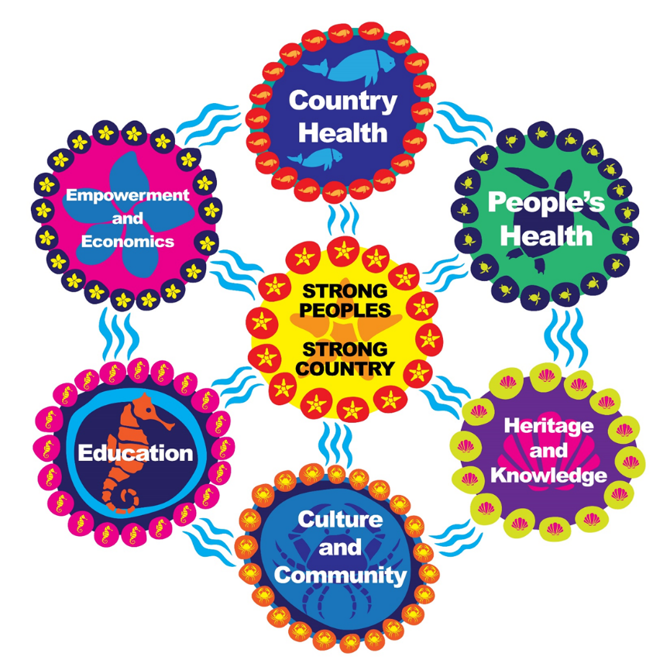
Figure 1. The Strong peoples – Strong country framework for monitoring Indigenous heritage in RIMReP © Mallie Designs, licensed for use by RIMReP partners.
The intention was to cross-validate the Strong peoples – Strong country Framework with statistical tests (of perceived strength of linkages) among attendees at a Reef-wide Traditional Owner Workshop held in Cairns on 1-3 May. However, the limited sample size restricted the statistical tests available. Nevertheless, the indicative results from our analysis are promising. Overall, the Strong peoples – Strong country Framework was found to provide a good basis for future work. We mapped the forty-five factors against the Reef 2050 Traditional Owner objectives and actions (Appendix One) and the Draft Aboriginal and Torres Strait Islander Heritage Strategy (the Draft Strategy) (Appendix Two) and found the framework to be capable of tracking trends in asset condition. We also identified an opportunity to spatially locate data from each Traditional Owner group, enabling us to map trends across the region, which will make the framework even more useful.
We also undertook an initial data collection at the Reef-wide Traditional Owner Workshop held in Cairns on 1-3 May 2018. Free, prior and informed consent was sought from Traditional Owners prior to the survey completion, through provision of relevant information and a question on the front page of a questionnaire for Traditional Owners to tick the box providing their consent. These data have the potential to provide a baseline assessment of the condition of Indigenous heritage once the Draft Strategy is finalised, and an appropriate dashboard has been developed to support the table presented in Appendix Two. Currently the data demonstrate that there is dissatisfaction with the wellbeing of Traditional Owners of the Great Barrier Reef land and sea country, and thereby with the status of their Indigenous heritage, mainly relating to the Empowerment and Economics hub. Thus a clear message is highlighted – to improve the condition of Indigenous heritage, future actions should empower Traditional Owners, and improve their economic prospects.
The project identified that future work is needed to provide Traditional Owner-driven objective indicators and to support the potential contributions of Traditional Owners to monitoring of biophysical aspects of Reef health. The current contract between the Reef and Rainforest Research Centre and Australian Government’s Department of Environment and Energy for the Reef 2050 Traditional Owner Aspirations Project includes services to “Develop an approach to support Traditional Owner engagement in monitoring, evaluation and reporting activities as part of the Reef 2050 Plan reporting” with a final report due in December 2018. This project will therefore scope out and cost these further requirements, the initial components of which have been identified in Table 14.
The Indigenous Heritage Expert Group recommends the adoption of a future monitoring program that gathers longitudinal data on the subjective views of Traditional Owners of the Great Barrier Reef region using the Strong peoples – Strong country Framework and indicators and provides an annual costing for this (Refer to Executive Summary Table 1 – which is the same as Table 13 in the main body of this report). In addition, the IHEG recommends further work to develop objective indicators to support this framework, and provides an initial indication of some of the components required to complete this work, while anticipating further details upon completion of the Reef 2050 Traditional Owner Aspirations Project in December 2018.
Executive Summary Table 1. Resources required to implement monitoring of Indigenous heritage based on the Strong peoples – Strong country framework and indicators
Item | Details (Annual) | Days/dollars (Annual)
Indigenous Heritage Expert Group (paid) | 3 meetings (1-2 days), 9 persons | 40 days
Indigenous community researchers | Training, data collection, 10 days each, 70 Traditional Owner groups | 700 days
Indigenous Heritage Expert Group members visit to the communities | 1 day community meeting to explain the project, including selection of community researchers | 70 days
Costs of community meetings | Venue, lunch, travel costs to attend meetings $800 per meeting | $56,000¹
Research support –scientists (1 FTE) | Data analysis, training, reporting writing, spatial analysis and dashboard design | 200 days
Research support – spatial analyst | Mapping of data | 20 days
Indigenous Heritage Expert Group Research Project Officer – full time project leader (1 FTE) | Project leader, training, Indigenous Heritage Expert Group support | 200 days
Research support – project support | Logistics of meetings | 50 days
Travel – Indigenous governance meeting | $1,000 per person each for each meeting | $27,000
Travel – for Indigenous Heritage Expert Group members to the community meetings | $1,000 per person per meeting | $70,000²
Travel – for Indigenous community members to attend training | $1,000 per person per meeting | $70,000²
Travel – for research project officer to accompany Indigenous | $1,000 per person per meeting | $70,000²
Training workshop- venue and accommodation for 2 days | Training workshop costs | $50,000
Communications, including graphic design support | Indigenous designs, printing materials | $15,000
Operations | Software, editing support, other | $7,500
Meeting venue and catering | $1,000 per meeting | $3,000
Community of Practice on Indigenous and Local People’s Indicators | Ongoing participation in relevant meetings and dialogues to share resources | $5000

2.0 Background and Design Considerations

2.1 Background to Traditional Owners, Indigenous heritage and the Reef 2050 Plan
The Reef 2050 Long-Term Sustainability Plan (Reef 2050 Plan) formally recognises that ‘Aboriginal and Torres Strait Islander peoples are the Traditional Owners of the Great Barrier Reef area and have a continuing connection to their land and sea country’ (Commonwealth of Australia 2015, ii). Furthermore, the Reef 2050 Plan explicitly recognises that inherent in the effective long-term management of the Reef are the cultural and economic aspirations of the Indigenous communities of Queensland where strong connections with country continue.
‘The cultural and ecological knowledge of Traditional Owners will be essential in delivering this plan’ (Commonwealth of Australia 2015, 3)
Traditional Owners were broadly engaged in the development of the Reef 2050 Plan, including in the development of the various outcomes, objectives, targets and actions encompassed therein. Specific Traditional Owner engagement is structured into the Reef 2050 Plan national advisory arrangements, with representatives nominated from Traditional Owner groups in the Great Barrier Reef region being within the Reef 2050 Advisory Committee (chaired by The Honourable Penny Wensley AC). Indigenous actions are embedded right across the Plan’s scope, and Traditional Owners recognise this as a major Reef 2050 Plan achievement (Dale et al. 2016, 16). The importance of Traditional Owner knowledge is explicitly recognised within the Reef 2050 Plan, through the ‘Principles in decision making’ recognising that decisions should be based upon the best available information. This requires that decisions are based on the full range of knowledge, including scientific understanding, Traditional Owner and community knowledge (Commonwealth of Australia 2015, 35).
Traditional Owner input is now being sought across a range of different forums in the Reef 2050 Plan space, in general, and with regard to the Reef 2050 Integrated Monitoring and Reporting Program (RIMReP) specifically. The contribution of Indigenous knowledge in addition to scientific input across all the core areas of RIMReP is recognised as vital for the development of a holistic response to the complex issues relating to the Reef and its catchments. This context underpins our focus on a broad interpretation of Indigenous heritage, consistent with the Great Barrier Reef Marine Park Authority’s (the Authority’s) Draft Strategy. The Authority’s interpretation of Indigenous heritage includes consideration and monitoring of all aspects of Traditional Owner connections to Great Barrier Reef land and sea Country. The RIMReP Indigenous Heritage Expert Group also considered monitoring the relevant objectives, targets and actions in the Reef 2050 Plan.

2.2 Design Considerations
To achieve the RIMReP vision, program design must integrate information from across the expert groups and identify cause-and-effect links (Great Barrier Reef Marine Park Authority and Queensland Government 2015, 10). Despite the recognition of Traditional Owner roles in the Reef 2050 Plan and the Great Barrier Reef region more broadly, Addison et al. (2015, 109) found that ‘the most striking gap in socio-economic monitoring is the absence of dedicated and co-ordinated monitoring pertaining to Traditional Owner use, dependency and wellbeing’. Specific research, monitoring and modelling approaches are key to understanding the complex and dynamic system of the Reef, and more specifically the contributions of Traditional Owners who have been in the region for millennia.
The expert groups are tasked with identifying strategic indicators of condition, trends of heritage values and their attributes and the relationship with system pressures and drivers to inform management actions and ensure effective and integrated monitoring and reporting. Linking monitoring and adaptive management processes empowers communities to share and generate information that will contribute to the overall management (Commonwealth of Australia. 2015). The Driver, Pressure, State, Impact and Response (DPSIR) Framework strengthens the program and underpins the Great Barrier Reef Regional Strategic Assessment (Figure 2) (Great Barrier Reef Marine Park Authority and Queensland Government 2015, 10).
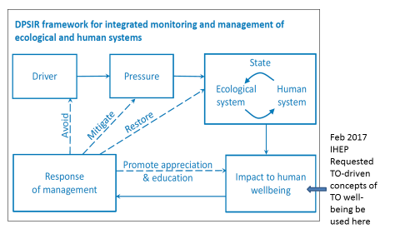
Feb 2017
IHEG requested Traditional Owner-driven concepts of Traditional Owner wellbeing be used here
Figure 2. Modified DPSIR Framework showing pathways of management intervention and identifying Traditional Owner concepts of wellbeing to be included Source: (Hedge P et al. 2013, 72).
The DPSIR Framework is important for understanding causal relationships between the drivers (the direct and indirect effects) and the impacts and/or pressures on the Great Barrier Reef system, and in turn helping to inform its management. Climate change, economic growth, population growth, technological developments and societal attitudes, for example, are all identified as key drivers (Commonwealth of Australia 2015, 70). Understanding influences on the Reef from the drivers and pressures provides insights to the state or condition of the Great Barrier Reef system (including the environmental and human systems). Therefore, if a driver such as climate change is affecting the Reef, identifying associated potential impacts and/or pressures, such as increased water temperatures, could help to explain human systems influences that interact with the Great Barrier Reef system, and enable opportunities for mitigation, avoidance, restoration and education about the system to emerge. Understanding feedback responses and causal relationships assists in developing effective management responses that respond directly to system drivers and pressures. These responses and impacts in turn affect human systems with direct and indirect consequences for human wellbeing (see Figure 2).
Traditional Owners identify that their concepts of wellbeing, recognised as the key impact area in the DPSIR Framework, are critical to framing a monitoring system capable of tracking progress towards the protection of their Indigenous heritage. In a workshop in February 2017, Traditional Owners agreed that they should take a leadership role in designing and developing components of the program that incorporate Traditional Owner wellbeing, which resulted in the formation of an Indigenous Heritage Expert Group, comprised predominantly of Traditional Owners. There was also clear direction that Great Barrier Reef Traditional Owners needed support to develop their concepts of Traditional Owner wellbeing. A team of non-Indigenous and Indigenous scientists from the Commonwealth Scientific and Industrial Research Organisation (CSIRO) and James Cook University (JCU) has been providing this support. The project support team was tasked by the Indigenous Heritage Expert Group to aid the design of a research approach based on Traditional Owner-driven methodologies, and undertaking a review of Traditional Owner-driven monitoring frameworks as the starting point for the IHEG’s deliberations. The first step in design work was preparing an Ethics Application, detailing the Traditional Owner-driven research approach, arranging the protection of Indigenous Intellectual and Cultural Rights, and ensuring Free, Prior and Informed Consent (FPIC) was obtained for the use of any information gathered from Traditional Owners. Ethics Clearance was obtained from the CSIRO Social and Interdisciplinary Science Human Research Ethics Committee in August 2017.

2.3 Review of Traditional Owner-driven Frameworks

2.3.1 Introduction
The term ‘Traditional Owner-driven frameworks’ refers here to research methodologies where Traditional Owners are active decision-makers and drivers throughout the study. Conducting research with Traditional Owners in the driving and decision-making role has been found to increase agency and ownership of projects related to Indigenous communities in Australia. Our review did not identify a formal definition or set of criteria for ‘Traditional Owner-driven’. Here we consider a range of approaches from methodologies:
- that are exclusively developed and conducted by Traditional Owners;
- which have Traditional Owner steering groups; and
- that have Traditional Owners working alongside non-Indigenous researchers.
These types of Traditional Owner-driven projects are often conducted and funded by an external party or Indigenous association for the benefit and social advancement of Indigenous groups.
Many previously developed Traditional Owner frameworks have explored ecosystem-focused assessment, management, and monitoring methodologies (Austin et al. 2017; Pert et al. 2015). While these methodologies are important in conserving the environment, they do not provide a holistic approach to monitoring the people-Country connections that are important for Indigenous communities. Recent interdisciplinary studies on sustainability have identified a strong relationship between different framings of wellbeing reflecting diverse knowledge systems and world views of Indigenous peoples and local communities, and their ecosystems (Díaz et al. 2018a, Díaz et al. 2018b, Sterling et al. 2017).
‘Quality of life’ is the term introduced by the conceptual framework of the Intergovernmental Platform on Biodiversity and Ecosystem Services to encapsulate these broader framings that essentially equate with the concept of “wellbeing”. Quality of life/human wellbeing includes internal factors (for example, personal, physical, and mental health) as well as external factors (for example, social, cultural, ecological, and economic environment) (Greiner et al. 2005, Cairney et al. 2017, Prout 2012, Sterling et al. 2017). More specifically, the health of the Reef is continually connected to Traditional Owners through social, cultural, institutional, and economic factors (Gooch et al. 2017).
Therefore, an innovative, multi-scale, collaborative approach recognising the connection between ecosystems and quality of life is necessary to understanding and monitoring biocultural dimensions. Biocultural approaches help bridge the gap between local outcomes and larger national policy, and hold more traction with Indigenous groups who were closely involved in establishing the biocultural goals within Reef 2050 Plan (Sterling et al. 2017, Díaz et al. 2018a, Pert et al. 2015). Figure 3 lists the Traditional Owner objectives in the Reef 2050 Plan which have a significant impact on the health and sustainability of the Reef as well as the wellbeing of Indigenous communities. These goals emphasise biocultural dimensions of the Reef (Commonwealth of Australia 2015).

Figure 3. Reef 2050 Traditional Owner objectives for each outcome (Commonwealth of Australia 2015).
Non-biocultural frameworks focus on variables such as climate, biodiversity, market system, and politics without recognising Indigenous worldviews and holistic understandings of people-nature (Sterling et al. 2017). When these non-inclusive frameworks are applied, Indigenous communities are measured against culturally irrelevant standards, generating a feeling of helplessness, and often leading to a rejection of the framework altogether. Alternatively, inclusive frameworks grounded in Indigenous values take the time to understand the local context, opinions, community members, and internal community governance structures. These frameworks are rare because culturally-based worldviews are often intangible and difficult to measure (Pert et al. 2015). Yet a biocultural framework is the most successful at increasing the efficacy and efficiency of local and global policy (Sterling et al. 2017).
The following literature review examines Traditional Owner-driven frameworks developed with various Indigenous groups in Australia. The literature review examines frameworks focused on wellbeing as well as those which aim to manage and monitor ecosystems. These frameworks were chosen as positive examples because they were developed through collaborative processes with Traditional Owners, aimed to benefit Indigenous societies, or succeeded in collaboratively monitoring and managing ecosystems with Indigenous communities.

2.3.2 Co-Management Mapping Framework in the Wet Tropics developed by Pert et al. (2015)
North-east Queensland is globally significant for its unique ecosystem where two World Heritage Areas meet — the Great Barrier Reef and the Wet Tropics. Management of these World Heritage Areas and the ecosystem services provided by them are substantially undertaken by government programs and policies. However, cultural ecosystem services are notoriously intangible and have been limited to tourism and recreational activities. Without proper monitoring and management, biocultural factors essential to the wellbeing of the ecosystem and cultural diversity will be forgotten (Pert et al. 2015).
The following study, conducted by CSIRO in North-east Queensland, aimed to work collaboratively with the “Rainforest Aboriginal Peoples” local to the Wet Tropics region and create a mapping, monitoring, and management framework using significant biocultural values. CSIRO worked with the Girrigun Aboriginal Corporation which brings together nine tribal groups and their estates: the Bandjin, Djiru, Nywaigi, Girramay, Gulnay, Warrgamay, Gugu Badhun, Jirribal, and Warungnu. Thus, the southern subset of the Wet Tropics region, between Paluma and Mission Beach, was chosen as a nested smaller study site, in addition to the region-wide study. A participatory co-research method was adopted at the start of the project. This ensured that there was mutual interest, goals and benefits from the project. All organisations agreed to co-research methodologies, categories and indicators were co-produced, participatory evaluation was conducted throughout Rainforest Aboriginal communities, and analysis, interpretation of results, and report writing occurred collaboratively.
The project progressed in five phases. The first phase identified additional stakeholders necessary to the process of ecosystem management. In the second phase, co-research agreements were established with chosen stakeholders. These organisations were asked to ensure proper engagement with the Indigenous peoples as well as the protection of intellectual and cultural property throughout the research process. The third phase co-produced categories through context analysis of the environment and surrounding communities. These categories were selected to represent the complex biocultural environment and were confirmed through participatory workshops with stakeholders and community members. Two main themes were co-produced: Rainforest Aboriginal peoples keeping strong and Keeping engagement with non-Aboriginal people strong. Each of these two major themes have subthemes shown in Figure 4.

Figure 4. The two major themes and their categories for participatory evaluation co-produced with the Rainforest Aboriginal peoples (Pert et al. 2015).

The final two phases of the project engaged Rainforest Aboriginal community organisations in a participatory evaluation of the study site based on these themes. Indicators were developed according to three aspects deemed important: (i) structures, the process of setting things up, starting organisations, and making new laws; (ii) processes, the process of doing things, making plans, and starting projects; and (iii) results, the actual deliverables, good relationships, and healthy Country. The evaluation was represented using a combination of a traffic light and mapping system. Workshop participants and evaluators could identify a single region on a map, and rate an indicator based on a sub-theme. Figure 5 demonstrates the resulting evaluation maps.
The maps created a visual representation of cultural ecosystems in the Wet Tropics region which can be translated both qualitatively and quantitatively. While some maps presented healthy Countries (such as the map in Figure 5), other maps demonstrated a very sick Country in subthemes that dealt with structures for keeping engagement with non-Aboriginal people strong. In particular, the entire study site evaluated for the ‘Regimes for joint management’, such as proper legislation and policy and a clearly defined government role, and was rated as ‘Very sick’.

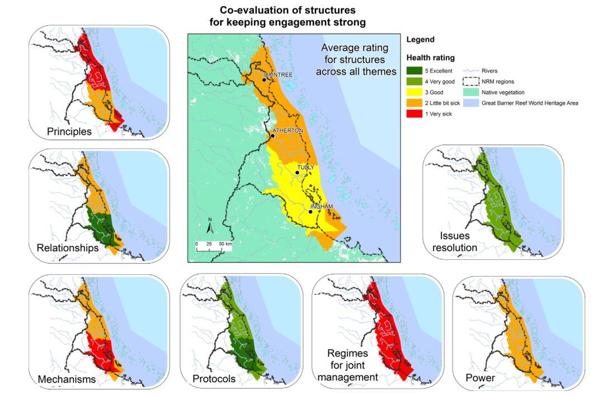
Figure 5. Demonstrates the co-produced evaluation maps of the Wet Tropics region using the Rainforest Aboriginal peoples keeping strong subthemes (Pert et al. 2015).
From the maps created, the Girrigun Aboriginal Corporation identified those themes requiring greater focus, more intense management, and monitoring in the coming years. In addition, tangible evidence could be provided to government entities regarding the policies and interventions that would be the most productive in the various areas. The co-research process, by involving Indigenous peoples as well as Indigenous community organisations, formed relationships necessary to make tangible change in the community and surrounding ecosystem. While the framework developed by this study acts as a potential methodology for future research, the participatory co-research principles on which the study is based acts as a guide for any future actions with Indigenous organisations. The production of this mapping framework occurred over many years, emphasising the idea that proper collaborative research, where all levels are co-produced, requires taking the time to understand communities and form relationships.

2.3.3 Wellbeing of Nywaigi Traditional Owners developed by Greiner et al. (2005)
The Nywaigi Framework was developed by Greiner et al. (2005) when community information was required to inform water resource management and related public policy. It was discovered that there was a severe lack of knowledge about Nywaigi communities making it difficult to supply accurate and relevant information. Consequently, this project commenced to monitor, evaluate, and manage wellbeing in Nywaigi communities. The project was undertaken by a group of CSIRO researchers based in Townville, Queensland, who worked under the guidance of the Girrigun Aboriginal Corporation, Nywaigi Land Corporations, and a Traditional Owner Steering Group. The research occurred in three stages: a review of previous wellbeing methodologies, development of a methodology, and a wellbeing survey.
The IHEG’s literature review first examined philosophical approaches to wellbeing including a normative approach and a subjective approach. Next, keeping subjective and normative approaches in mind, researchers explored a wellbeing model developed by the United Nations as well as other non-wellbeing frameworks. By examining the similarities and differences between philosophical models and applied frameworks, researchers created a preliminary eight-pronged framework with loose definitions of each factor (Figure 6).
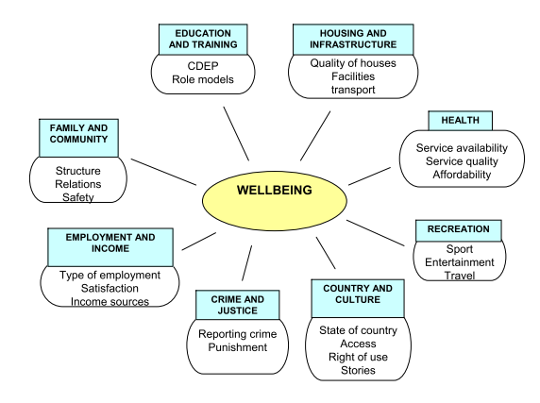
Figure 6. Preliminary framework created from Nywaigi Traditional Owner Wellbeing research (Greiner et al. 2005).
In the second phase, the research team reached out to Nywaigi community members in Townsville, Ingham, Cardwell, Palm Island, and Cairns. Members in each location were invited to participate in the refinement of the framework through focus groups. A total of 58 people participated in 12 focus group discussions. Participants ranged from 12 years old to above 50 years of age and held various roles in the community. The focus group began with an introduction about the research, then participants were shown a photo of a preliminary wellbeing framework. This framework was then removed, and participants were asked to create their own wellbeing framework. With guidance, each group created a diagram and described each of the factors. Once this exercise was completed, participants were asked to identify the three most important domains on the wellbeing framework. Discussions during this time often included stories from community members, as well as discussions of past, current, and future policies affecting the community. To end the workshop, researchers reviewed the exercise, summarised key points, and participants completed a short survey about their sense of wellbeing and belonging in Australian society. The aim of the survey was to create a quantitative assessment of community health to standardise and integrate wellbeing across Nywaigi communities.
The results of the workshops showed that Indigenous groups found health, family and community, and Country and Culture to be the most important factors affecting wellbeing. However, focus groups defined each factor differently, making each map specific to that community. Researchers consolidated these maps, editing the factor names and descriptions to reflect the results of the focus groups (Figure 7). In this diagram, the thickness of the lines was used to demonstrate the importance of each factor.
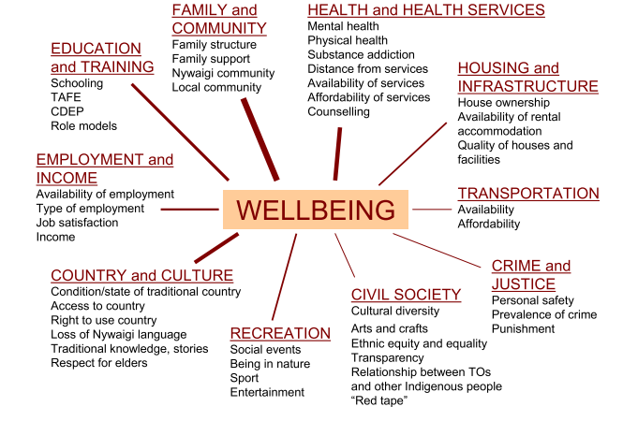
Figure 7. Final Nywaigi Traditional Owners Wellbeing Framework (Greiner et al. 2015).
The methodology used in the Nywaigi Framework is a positive example of researchers working closely with Indigenous groups and with a Steering Group in place to drive the process. Due to the presence of Traditional Owners at every step of this process, research was conducted in a recursive, transparent relationship with Indigenous partners. Focus groups were designed to make Nywaigi community members feel comfortable enough to share cultural knowledge without steering their responses with non-Indigenous or even other-Indigenous perspectives.

2.3.4 Interplay Wellbeing Framework developed by Cairney et al. (2017)
The Interplay Wellbeing Framework was created to assess the wellbeing of Indigenous communities in remote Australia, using factors relevant to Indigenous societies as well as government policy settings. Current community assessments often use economic success as an indicator for community wellbeing, without considering Indigenous cultural values such as learning, livelihoods, and the environment. These partial frameworks reflect government policies, including for example the ‘close the gap’ initiative. The Interplay Wellbeing Framework connects a culture based in storytelling and arts with a statistics-based society to open avenues for more effective connection between government policy and community roles (Cairney et al. 2017).
This research was conducted for the Cooperative Research Centre for Remote Economic Participation. Traditional Owners and Indigenous researchers were embedded into the project at its onset. Indigenous peoples constituted 50 per cent of management and Steering Groups, 94 per cent of field researchers, and two authors on the published report. Through this engagement, Indigenous people had ownership of the project at all levels of the research.
The Interplay Wellbeing Framework was first developed in a three-phase research project called the Interplay Project. First, a literature review was conducted to learn more about Indigenous values, recommend what might be essential factors in a wellbeing framework, and inform how best to conduct research in partnership with Indigenous peoples. Recommendations from the literature review included focusing on interrelationships and accepting broader definitions of education, employment, and health. Next, the Interplay Project developed a ‘Shared Space’ where community, government, and science were equal partners throughout the research project (Figure 8). The ‘Shared Space’ also encouraged thorough discussion of differences and disagreements between groups. Finally, a grass roots community consultation process engaged with Indigenous communities through interviews and community visits. These community consultations informed the language to be used in the framework and following interviews (Cairney et al. 2017).
From this process, the Interplay Wellbeing Framework was created (Figure 9). The framework ultimately combined the views represented through the consultations and literature reviews. All decisions made for this framework were conducted within the Shared Space. Consequently, the framework contains three government priorities: Education, Work, and Health, identified from the ‘Closing the Gap’ policies, as well as three Indigenous priorities: Community, Empowerment, and Culture. The framework was then tested for statistical power. There were 838 Indigenous people surveyed from four ‘Remote’ or ‘Very remote’ areas of Northern Territory and Western Australia. The survey was developed alongside Aboriginal community researchers and reviewed by important Indigenous community organisations. Special attention was paid to the language in each question, so the meaning remained consistent in a cross-cultural setting. The final survey used Likert scale questions which could be checked for significance. All surveys were administered in English (with translators available) on tablets and took between 45 and 60 minutes to complete.

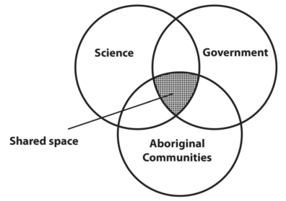
Figure 8. Shared Space model for working collaboratively (Cairney et al. 2017).

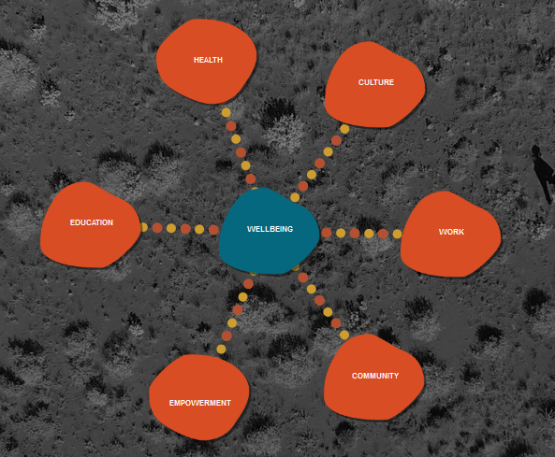
Figure 9. The Interplay Wellbeing Framework (Cairney et al. 2017; see https://old.crc-rep.com/wellbeingframework/ to explore further using the visualisation tools).

Results of the statistical analysis of the surveys confirmed the interconnectedness of the Interplay Wellbeing Framework and shared Aboriginal worldviews represented through consultations and literature reviews. While education, work, and health did contribute to wellbeing, statistical analysis demonstrated that culture, empowerment, and community were perceived by Aboriginal people as essential to their success and wellbeing.
Overall the study was successful in creating a wellbeing framework that represented significant cultural beliefs of Indigenous peoples living in remote communities, together with factors of government significance. The ‘Shared Space’ model allowed research to be conducted in a top-down and bottom-up approach simultaneously. Research participants were required to meet in the middle at all points during the study. This extremely high level of participation from Traditional Owners informed the process greatly. The Interplay Wellbeing Framework also uniquely makes cultural values tangible and provided statistical evidence to support government policy.
Unlike the Nywaigi Framework, this framework was not specific to any particular Indigenous group and assumed some level of conformity between Indigenous peoples in remote areas of Australia. Creating a framework that was unique to an area or particular Indigenous group could have demonstrated stronger relationships between the factors chosen and wellbeing, and informed government policy for specific regions more accurately. Additionally, the project administered all the surveys through tablets. While tablets eased the collection of data from nearly a thousand participants, it likely stifled the range of responses and the types of people who could participate in this study.

2.3.5 Aboriginal Child Health and Wellbeing Framework developed by Priest et al. (2012)
Research on Indigenous wellbeing tends to focus on Aboriginal communities as a whole. Additionally, projects are often conducted in remote areas due to the misconception that Indigenous health and wellbeing in suburban or rural areas is worse than in urban centres. The following study was conducted to narrow the scope of wellbeing research to Indigenous children in an urban setting (Priest et al. 2012).
Unlike the previously explored frameworks, this study used interviews to create a framework, as opposed to using interviews to confirm an already developed framework based on literature review. The methods and progress of this project was guided by constructivist grounded theory, which states that knowledge is mutually constructed. Therefore, researchers aimed to conduct collaborative participatory research, where expertise from researchers and Indigenous community members was considered. This mirrored the ‘Shared Space’ created in the Interplay Project.
Before beginning the interview process, researchers consulted with an Aboriginal Community Controlled Health Service. A formal project was agreed upon with four Indigenous women as project advisors. Next, interview participants, close relatives of Indigenous children living in urban centres, were selected using a snowball sampling method. This created some sampling bias but made the results specific to three local Aboriginal community organisations: an urban health service, an early childhood centre, and the state peak health body. Interviews were conducted in the participant’s home in the presence of an Indigenous co-interviewer, and questions were phrased in an open-ended manner (for example, what is wellbeing for an Aboriginal child?; how would you describe a healthy Aboriginal child?). The first 15 interviews were then transcribed, and important themes were identified using line-by-line coding in NVivo. Ten more interviews then allowed researchers to explore gaps and trends in the data. As themes were identified, discussions between Indigenous project advisors and researchers informed the creation of the framework (Figure 10).
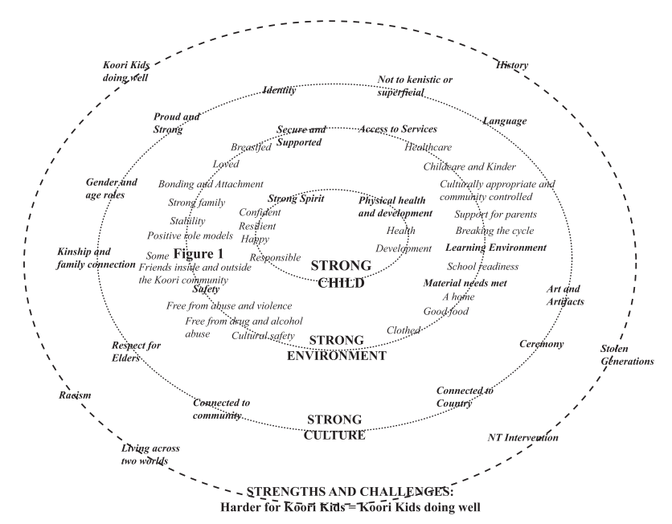

Figure 10. Conceptual Framework of Aboriginal Child Health, Development, and Wellbeing in an Urban Setting.

The resulting framework was structured differently from the web frameworks in the Nywaigi framework and Interplay Wellbeing Framework, yet Indigenous cultural views are still present. Members of the study chose a nested diagram which demonstrated how values interact with each other. A strong child is surrounded by a strong environment and strong culture. While other studies focus on the creation of the framework as the research process, this study focused on the interviewing process which informed the creation of the framework. The collaborative participatory research process allowed Indigenous people to be agents within all levels of the interview and analysis process. The result was a distinctive wellbeing framework for Koori Kids living in urban areas. The specificity of this framework makes it ideal for future policy and social work.

2.3.6 The Uunguu Monitoring and Evaluation Plan conducted by Austin et al. (2017)
The Uunguu Monitoring and Evaluation Plan, while not a wellbeing framework, was founded on a recursive relationship essential to the productivity and collaboration of Indigenous and non-Indigenous groups. This study was conducted to assess the Wunambal Gaambera Healthy Country Plan at its halfway point in 2015. Through this assessment, the Healthy Country Plan could be adapted to reach its goals more effectively and examined for salience after changes in policy and finance (Austin et al. 2017).
Similar to the ‘Shared Space’ model and constructivist grounded theory, all stakeholders were given the opportunity to participate in the evaluation and feedback of the plan and all participants were given an equal weight in the reporting process. The Uunguu Monitoring and Evaluation Committee, consisting of members of the Healthy Country Plan team, Bush Heritage Australia, Charles Darwin University, anthropologists, ecologists, and planning experts, was created. This ensured that data could be analysed from all possible angles and that the Healthy Country Plan was reviewed by both internal and external parties. The information provided in the evaluation process was also supplied by different sectors to reduce bias. Healthy Country Plan reports, surveys conducted by Traditional Owners to local community members, an external evaluation, and a self-evaluation were all used by Uunguu Monitoring and Evaluation Committee to assess the efficacy of the Healthy Country Plan. Finally, the Committee, as an organisation, did not have control over future decisions made on country and were not considered a governing power. Rather, they aimed to integrate knowledge from the bottom-up and create a comprehensive picture of the state of the Healthy Country Plan.
The data from each knowledge sector was collected using different reporting methods. The Healthy Country Report used a conventional table to describe the percent progress and status of specific Healthy Country Plan goals, while Traditional Owners used a traffic light reporting system with time periods to gauge how the land had improved since the inception of the Healthy Country Plan (Figure 11). The external contractor gave a report outlining major achievements and areas for improvement and the internal assessment used a Target viability structure. Using these various reports, Uunguu Monitoring and Evaluation Committee generated a holistic picture of the Healthy Country Plans progress and assessed which goals would and would not be met by the target year from several angles.
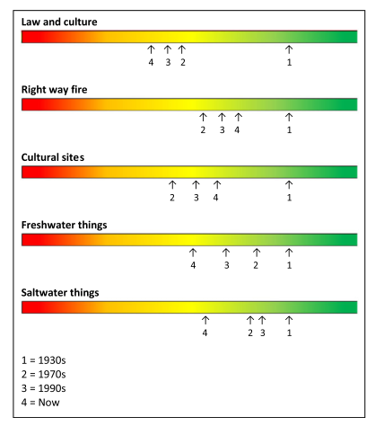
Figure 11. Traditional owner ranking of target health over time.
The Uunguu Monitoring and Evaluation Plan stands out compared to other monitoring and management programs because of the comprehensive involvement of all stakeholders in the project. The project describes respectful co-production and reciprocity between Indigenous and non-Indigenous people. Additionally, the variety of methods removed any cultural bias that could be formed from information gathered, as well as who the information was analysed by, and how the information was analysed.

2.3.7 Exploratory Framework for Aboriginal Victorian peoples’ wellbeing created by Kingsley et al. (2013)
The following framework was developed by a non-Indigenous person through eight years of ethnographic research with Indigenous Australians in Victoria, Australia. While the results were informed by research with Indigenous people, Indigenous communities were not integral to the production of the framework. We include it as an interesting example with a fresh angle on the field.
A group of researchers, based at the School of Health and Social Development and Deakin University and the Melbourne School of Population Health and University of Melbourne conducted a thorough literature review of Indigenous values, human wellbeing, Indigenous wellbeing, and the relationship between Country and wellbeing. Throughout these literature reviews, researchers confirmed theories and themes with previously published research on local Indigenous peoples and publishing materials from Indigenous groups in Victoria.
After becoming familiar with the literature surrounding wellbeing frameworks, researchers examined three wellbeing models before creating their own. Their research on wellbeing models was not limited to those created by Indigenous groups in Australia. The first model examined was the “Mandala of Health” developed in 1985 by health practitioners to highlight factors outside of human biology which may affect human health. The “Mandala of Health” includes factors such as culture, community, family, spirit, body, and mind. Another model examined was the Rumbalara Aboriginal Cooperative holistic model of Indigenous Wellbeing. This model, created by an Aboriginal Community Controlled Health Organisation (ACCHO) in 2008, is an Indigenous-led project specific to the Rumbalara community. In this framework, Sense of Control, History, Threats, Relationship with Mainstream, and Connectedness were all identified as important factors to wellbeing. Like the Nywaigi Framework, each of these factors were defined uniquely to the Rumbalara. Lastly, researchers explored the Butterfly Model of Health for an Ecosystem Context which identifies factors that have a significant impact on a person’s life as opposed to wellbeing. Despite this, it connects similar elements (the biophysical environment and the socioeconomic environment) which have been identified in previous frameworks.
The benefit of examining several frameworks outside of Indigenous wellbeing is that overlapping concepts were artistically represented in three different ways. The Mandala used a concentric circle model, the Rumbalara used a web, and the Butterfly Model used a Venn diagram. Even with these options, the lead researcher on the project designed a completely new layout for the Exploratory Framework for Aboriginal Victorian peoples’ wellbeing (Figure 12). This framework is especially unique because it uses a tree as an analogy. The tree depicts factors which “root” wellbeing (e.g. Country) and “grow” wellbeing (e.g. Caring for Country) as well as what downward or western forces affect the growth of Indigenous wellbeing (e.g. Politics, Racism). This framework encourages a sense of creativity or innovation when developing a new framework and offers an example of other designs which demonstrate Indigenous wellbeing.

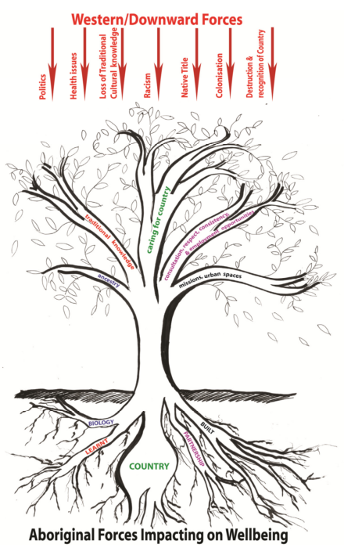
Figure 12. Exploratory Framework of Aboriginal Forces Impacting on Wellbeing.

2.3.8 Mackay-Whitsunday Healthy Rivers to Reef Partnership
The Mackay-Whitsunday Healthy Rivers to Reef Partnership was founded to monitor and manage the Reef and river systems in the Mackay-Whitsunday Region of Queensland. The Partnership panel, made up of stakeholders from mining, agriculture, reef catchments, government, fishing, etc.; was founded on ideals of rigorous science, honesty, community education, communication, and continuous improvement of the Great Barrier Reef region. The project began by assembling various partners and donors to fund the 2014 ‘Reef Report Card’. The Report Card contained an assessment of the environmental, economic, social, and community stewardship factors affecting the health of the estuarine and marine systems in the area. Once the assessment methodologies and funding was in place, The Mackay-Whitsunday Healthy Rivers to Reef Partnership engaged Traditional Owners in the 2015 assessment of the Rivers-to-Reef (Mackay-Whitsunday Healthy Rivers to Reef Partnership 2017).
For the 2015 Rivers-to-Reef assessment, the Mackay-Whitsunday Healthy Rivers to Reef Partnership panel partnered with the external consulting firm Terra Rosa and the Traditional Owner Reference Group (TORG) in the Mackay, Whitsunday, and Isaac region to conduct an Indigenous cultural heritage assessment of relevant sites in the area. The firm Terra Rosa was chosen because of their previous assessments of the Gladstone Ports. Similarly, the TORG was founded in 2005 and had two representatives from seven different Traditional Owner groups in the region (Gia, Ngaro, Juru, Yuwibara, Koinmerburra, Barada and Wiri). The seven Traditional Owner groups came together due to historic cultural relationships and use the reference group to bring community concerns to a larger audience. Outside of the Healthy Rivers project, the TORG is well known and aims to produce tangible outcomes which benefit the ecological, social, and cultural wellbeing of the communities in the region. Therefore, by working with the Traditional Owner Reference Group, Terra Rosa and the Mackay-Whitsunday Healthy Rivers to Reef Partnership could be sure that local cultural heritage was being monitored and safeguarded.
The relationship between the three organisations was structured under best-practice frameworks of heritage management. Methodologies were based on the principles that: (i) Indigenous people are the primary stakeholders of the project; (ii) all members maintain a holistic understanding of heritage values; and (iii) project members adopt a cultural landscape approach. Through these guiding principles, Traditional Owners acted as co-managers to ensure equitable collaboration and awareness of both western and Indigenous worldviews within the Mackay-Whitsunday region. Next, the IHEG worked together to identify indicators which could be tangibly monitored and measured by community members. The TORG identified ways which they saw the country had changed in the past 10-15 years and grouped environmental and cultural indicators into five categories: spiritual/social value; scientific value; physical condition; protection of the site; and cultural maintenance. It was subsequently decided that each of these indicators would be assessed by Traditional Owners while on country using a number/letter scoring system (Figure 13).
The IHEG also worked together to select and evaluate 21 sampling sites (ranging from shell middens to paintings) in the St. Helen’s Zone, Cape Hillsborough Zone, and the Whitsunday, Hood, and South Molle Islands Zone, using the scoring system in Figure 13. The sampling sites and the areas were chosen to include culturally relevant areas for each of the seven Traditional Owner groups represented in the Traditional Owner Reference Group.

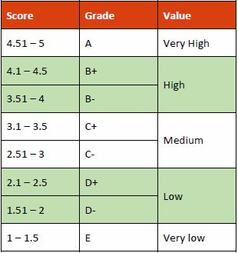
Figure 13. Scoring system used by the TORG, Terra Rosa, and the Healthy Rivers to Reef Partnership.
In order to reduce bias, the overall scores for each location were variably sourced. Data were collected from Traditional Owners directly, scientific data, and online resources. A week-long field trip with members present from all three organisations also collected on-site and current ecological, anthropological, ethnographic data. Terra Rosa was essential in this data collection process as they provided the training for the Traditional Owners as part of the assessment process. Traditional Owners were trained to use GPS, map software on tablets, and input cultural information into a physical database. Throughout this training and data collection process, due to the protocols developed in the partnership, the cultural information shared remained the intellectual property of the Traditional Owners. They also conducted a desktop study to collect old Environmental Impact Statements and reports about the country that were previously unavailable to the community.
A number of barriers were identified during the first year of this assessment. Initially, records from the Department of Aboriginal and Torres Strait Islander Partnerships were found to be inaccurate; this prevented a more specific scoring for the focus areas. Field work also revealed that conservation strategies between sites are inconsistent and heritage places are under pressure from development and recreation stressors. These barriers in combination with the data collected and field assessment resulted in an overall final report card score of 2.48/5 (D+). While the score reflects a need to increase conservation for ecologically and culturally relevant sites within Mackay and Whitsundays, the overall project created a foundational relationship between the Traditional Owner Reference Group, Terra Rosa, and the Healthy Rivers to Reef Partnership.
The methodology and partnerships displayed within this project were successful and strengthened the communities and their cultural heritage, with a focus on sites and landscapes. Traditional Owner cultural values were strengthened and protected. It also provided a group of Traditional Owners with training and the ability to return to their country – building the capacity of the Traditional Owners on country. However, the largest limitation on this project was funding. The amount of funding available limited the number of Traditional Owners that could be involved in the project and how many sites they were able to visit. Funding also constrains the frequency of future cultural assessments of the land. Increased funding for this project would ensure that assessment and monitoring methods for future MWHR2RP are more thorough and collaborative.

2.4 Conclusion
The previous seven frameworks range from very specific wellbeing frameworks identifying specific trends in a single Indigenous community to monitoring and management frameworks for large scale ecosystems. Despite the range, each of the frameworks commonly placed the interests of Indigenous communities first. Six out of seven frameworks identify a principle of co-research using vocabulary such as co-production, co-management, participatory co-research, constructivist grounded theory, or shared space. These same six frameworks also used interviewing, focus groups, or workshops as an integral part of confirming themes and focusing results (Greiner et al. 2005, Priest et al. 2012, Pert et al. 2015, Austin et al. 2017, Cairney et al. 2017). The remaining framework, conducted without the aid of Indigenous peoples, took eight years to conduct a thorough literature review and understand the cultural landscape (Kingsley et al. 2013). The agreement between studies emphasises the importance of working directly, collaboratively, and equitably with any Indigenous population affected by the proposed monitoring.
Despite similarities in Indigenous involvement, the presented frameworks were unique in their style and representation of Indigenous values, and all included a visual communication mode, a key requirement for working with Traditional Owners in land and sea country planning and management (Davies et al. 2013). The frameworks that were created worked well for that particular study and aligned with the aims of the project. The Interplay Wellbeing Framework was the only framework successful in statistically confirming Indigenous wellbeing values whereas the Nywaigi Framework was the only framework which created a community wellbeing assessment for future monitoring. Similarly, the co-management mapping process uniquely combined qualitative, quantitative, and spatial methodologies to biocultural concepts. Future studies should aim to examine the specific goals of the project and consult with the collaborating community to assess what kind of framework would be best for that organisation. The IHEG was informed by the methodologies from these frameworks as part of its work to create a biocultural wellbeing framework specific to the Great Barrier Reef region and the communities surrounding that area. Subsequent to creating this framework, the monitoring or managing methodologies from these studies were reused, to inform the IHEG as it developed its recommended monitoring plan.

3.0 Objectives of RIMReP
The Reef 2050 Plan provides an overarching strategy for managing the Great Barrier Reef. It contains actions, targets, objectives and outcomes to address threats, and protect and improve the Reef’s health and resilience, while allowing ecologically sustainable use. The Reef 2050 Plan has been developed in consultation with partners, including Traditional Owners and the resource, ports, fishing, agriculture, local government, research and conservation sectors.
A key component of the Reef 2050 Plan is the establishment of the Reef 2050 Integrated Monitoring and Reporting Program (RIMReP). The RIMReP will provide a comprehensive and up-to-date understanding of the Reef — the values and processes that support it and the threats that affect it. This knowledge is fundamental to informing actions required to protect and improve the Reef’s condition and to drive resilience-based management.
There are currently over 90 monitoring programs operating in the Great Barrier Reef World Heritage Area and adjacent catchment. These programs have been designed for a variety of purposes and operate at a variety of spatial and temporal scales. The comprehensive strategic assessments of the Great Barrier Reef World Heritage Area and adjacent coastal zone –– both of which formed the basis for the Reef 2050 Plan –– identified the need to ensure existing monitoring programs align with each other and with management objectives. The program will fulfil this need.
The RIMReP will provide information across the seven themes that make up the Reef 2050 Plan Outcomes Framework. The themes are ecosystem health; biodiversity, water quality, heritage, community benefits, economic benefits and governance.
The intent of the RIMReP is not to duplicate existing arrangements but to coordinate and integrate existing monitoring, modelling and reporting programs across disciplines. For example, the Reef 2050 Water Quality Improvement Plan underpins the Reef 2050 Plan’s water quality theme and its Paddock to Reef Integrated Monitoring, Modelling and Reporting Program will form a key part of the new integrated program.
As the driver of resilience-based management under the Reef 2050 Plan, the RIMReP’s primary purpose is to enable timely and suitable responses by Reef managers and partners to emerging issues and risks and enable the evaluation of whether the Reef 2050 Plan is on track to meet its outcomes, objectives and targets.
The RIMReP’s vision is to develop a knowledge system that enables resilience-based management of the Reef and its catchment and provides managers with a comprehensive understanding of how the Reef 2050 Plan is progressing.
Three goals for the knowledge system are that it is:
Effective in enabling the early detection of trends and changes in the Reef’s environment, inform the assessment of threats and risks, and drive resilience-based management.
Efficient in enabling management priorities and decisions to be cost effective, transparent, and based on cost-benefit and risk analyses.
Evolving based on the findings of Great Barrier Reef Outlook Reports, new technologies and priority management and stakeholder needs.

The RIMReP will be central to ensuring decisions regarding the protection and management of the Great Barrier Reef are based on the best available science, consistent with the principles of transparency and accountability, and underpinned by a partnership approach. The Program Logic to support delivery of these three goals is shown in Figure 14.
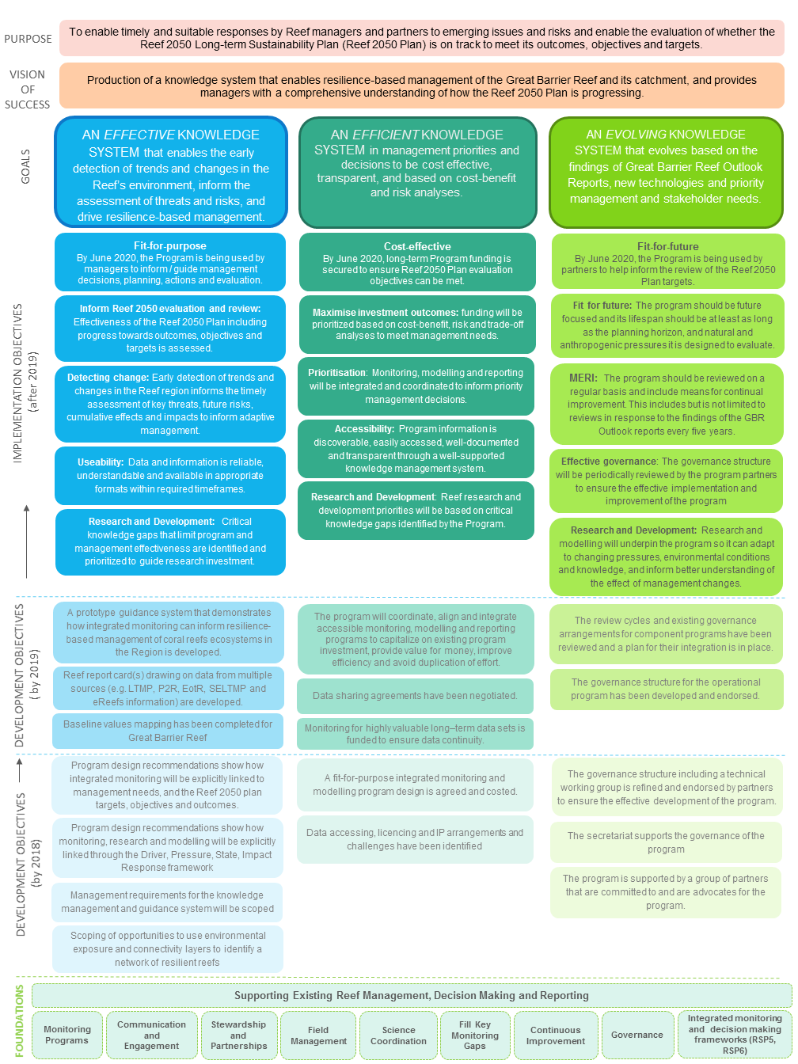
Figure 14. RIMReP program logic. Each of the three goals has associated development and implementation objectives as well as foundational inputs.

3.1 Information needs relevant to Indigenous heritage for the Great Barrier Reef Outlook Report and other reporting requirements

3.1.1 Traditional Owners in the Reef 2050 Plan
As noted above, Traditional Owners were broadly engaged in the development of the Reef 2050 Plan, including in the development of the various outcomes, objectives, targets and actions encompassed within the Plan.

3.3.2 Traditional Owner Objectives in Reef 2050
The importance of the Indigenous communities to the Reef 2050 Plan is acknowledged within each of the seven themes, with each theme encompassing a Traditional Owner dimension. For six of the seven themes (water quality is the exception), there is an objective specifically referring to Traditional Owners with targets and actions underpinning those objectives. The specific Traditional Owner-related objective for each of these themes is as follows:
EHO1: The knowledge, innovations and practices of Traditional Owners relevant for conservation and cultural use of biocultural diversity are preserved and maintained (Ecosystem Health).
BO1: Traditional Owners are engaged and participate in and manage the conservation and ecologically sustainable use of cultural keystone species and biocultural resources (Biodiversity).
HO1: Traditional Owners’ cultural heritage rights and responsibilities are incorporated in all facets of management (Heritage)
CBO1: The rights of Traditional Owners to derive benefits from the conservation and cultural use of biological resources are recognised (Community benefits).
EBO1: Traditional Owners derive economic benefits from conservation and sustainable use of biological resources (Economic benefits).
GO3: Strong partnerships with Traditional Owners, industry, researchers and the community support protection and management of the Great Barrier Reef (Governance).
Whilst the Water Quality theme does not have a specific objective referring to Traditional Owners, there is a specific target, underpinned by actions, that refers to Traditional Owners.

3.1.3 Traditional Owner targets across all themes
The targets and actions within each theme capture the importance and relevance of Traditional Owners to the Great Barrier Reef. As can be seen from the table below, Traditional Owner targets and actions are embedded throughout the Reef 2050 plan.

Table 1. Numbers of Traditional Owner-related targets and actions included within each theme
Reef 2050 Plan Theme | Traditional owner Targets within theme ¹ | Traditional owner actions within theme ^{1,2}
Ecosystem health | 2 of 5 | 6 of 32
Biodiversity | 1 of 5 | 4 of 25
Heritage | 3 of 3 | 8 of 11
Water quality | 1 of 5 | 1 of 24
Community benefits | 2 of 4 | 3 of 13
Economic benefits | 3 of 6 | 2 of 18
Governance | 1 of 5 | 7 of 16
¹ Number of Traditional Owner targets with each theme, and number of targets and actions within each theme taken directly from the Reef 2050 Plan (Commonwealth of Australia 2015)
² Number of Traditional Owner actions within each theme taken from Appendix One: Indigenous strategies associated with Reef 2050 Plan (Dale et al. 2016)

3.2 Information needs for Great Barrier Reef management
Great Barrier Reef managers require information to monitor progress against the objectives, targets and actions relevant to Traditional Owners in the Reef 2050 Plan. In terms of the RIMReP design, the Indigenous Heritage Expert Group is the only group that is required to provide information relevant to targets and actions across all 7 themes in Reef 2050 (Table 1). Great Barrier Reef managers also require information relevant to the DPSIR Framework for RIMReP, which focuses on human wellbeing.
In addition, the Great Barrier Reef managers require information to monitor the Draft Strategy for the Great Barrier Reef Marine Park. This requires a complex and interconnected set of information relevant to understanding trends in values, components of Indigenous heritage (environment, places, technologies, culture and history), and threats. It will be important to ensure that the Strong peoples – Strong country Framework and indicators cover all aspects in this Draft, and eventually Final, Strategy that need monitoring.
The vision of the Draft Strategy is that ‘Indigenous heritage values of the Reef are kept strong, safe and healthy for past, present and future generations’. Within the Draft Strategy, The Authority recognises that ‘the broadest definition of Indigenous heritage is used, which includes everything on sea country. This recognises that Indigenous heritage is biocultural, and includes the environment and intangible components’ (The Great Barrier Marine Park Authority 2018, p.18). This understanding of Indigenous heritage aligns with the direction and monitoring approach established by the Indigenous Heritage Expert Group.
It is important to stress that any strategies or frameworks that are developed by the Authority to monitor natural and cultural values for the effective management of the Reef need to include the Traditional Owners and engage them throughout the processes from the design to the implementation in the monitoring processes. This is important because: (i) Traditional Owners are recognised in the Great Barrier Reef Marine Park Act 1975 through its Regulations and therefore must be recognised and respected as holders of inherent rights and responsibilities; and (ii) Australia has international obligations as signatory to the United Nations Convention on Biological Diversity to follow best practice standards of engaging Traditional Owners and ensuring that they have full and effective participation in the RIMReP processes.

4.0 Current understanding of Indigenous heritage systems and status on the Great Barrier Reef

4.1 Synopsis of conceptual system understanding of Indigenous heritage on the Great Barrier Reef

4.1.1 Introduction
The starting point for the conceptual system understanding is the recognition by the Great Barrier Reef Marine Park Authority (2018) that Indigenous heritage includes everything on sea country, and that all sea country activities contribute to Indigenous heritage activities. The RIMReP uses the DPSIR Framework to provide an approach in which biophysical and human dimensions, including dimensions of Traditional Owner wellbeing, are considered. The framework provides for adaptive management that encompasses adaptation, mitigation and restoration responses. As noted above, the Great Barrier Reef region currently lacks a coordinated framework for understanding and monitoring Traditional Owner use, dependency and wellbeing (Addison et al. 2015).
The Indigenous Heritage Expert Group focused on the dimension within the DPSIR Framework of ‘Impact to Human Wellbeing’ as a basis of conceptual system understanding of Indigenous heritage relevant to Traditional Owners. As discussed above, the IHEG is interested to ensure that Traditional Owner-driven concepts of ‘Human Wellbeing’ should be used. The IHEG has therefore approached the task as including framing ‘Human Wellbeing’ to reflect Traditional Owner worldviews and knowledge systems and identifying the underlying factors that influence this from a Traditional Owner perspective. This resulted in the adaptation of the term ‘Traditional Owner wellbeing’ to the term ‘Strong peoples – Strong country’.

4.1.2 The development of the Strong peoples – Strong country framework
The Indigenous Heritage Expert Group followed an iterative process for the development of the framework, initiated by consideration of the previously developed Indigenous wellbeing frameworks. Many of the Traditional Owner groups in the Great Barrier Reef region have familiarity with Australian and Queensland Governments’ Monitoring, Evaluation, Reporting and Improvement (MERI) approaches due to meeting requirements associated with project grants. These MERI approaches recognise a logic chain from activities, to outputs, to outcomes and, most importantly, impact on the condition of the asset (Australian Government 2009; Figure 15). Traditional Owners recognise the usefulness of some of the MERI work they have undertaken to monitor condition of specific assets — such as through the cultural sites assessment undertaken in by the Mackay-Whitsunday Healthy Rivers to Reef Partnerships project. However, the Indigenous Heritage Expert Group endorsed the conclusion of Addison et al. (2015) that the key gap is monitoring of the Traditional Owner wellbeing and its links to Country, which provides a basis for understanding the condition of the Indigenous heritage asset. Ethical and legal arrangements determine that monitoring of Traditional Owner wellbeing, and its links to Country, can only occur with the Free, Prior and Informed Consent of the Traditional Owners, and their active governance of the process.
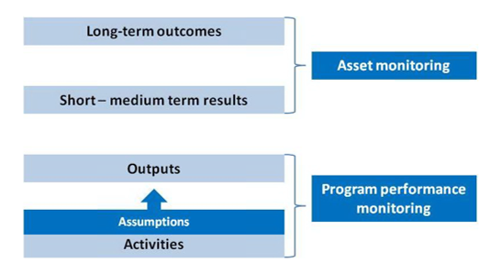
Figure 15. Levels of Monitoring for Australian Government NRM Programs (Source: Australian Government Regional Land Partnerships MERI Framework at http://www.nrm.gov.au/publications/regional-land-partnerships-meri-framework)

The Indigenous Heritage Expert Group produced a Start-up Fact Sheet to initiate communication more broadly with Traditional Owners across the Great Barrier Reef region about the project (Attachment A). Drawing on previous frameworks, the IHEG adapted and developed the framework to both capture the views of the Traditional Owners of the Great Barrier Reef region, and to meet the needs of the RIMReP project.
The first step was a review of the findings from the literature analysis conducted by the project support team to identify previously developed Indigenous wellbeing frameworks; the relative merits of the various frameworks were discussed and debated during a workshop held 14-15 November 2017. Based upon this review, the IHEG determined the Interplay Wellbeing Framework offered a suitable base for further work to create a Great Barrier Reef Traditional Owner-led wellbeing framework. Key benefits of the Interplay Wellbeing Framework is that it:
- is underpinned by a Traditional Owner-driven ‘shared space’ approach;
- is based on Traditional Owners’ perceptions of the impact on the condition of all the factors that underpin Strong peoples – Strong country, and therefore does not require government agencies to hold sensitive information, consistent with principles in the Draft Aboriginal and Torres Strait Islander Heritage Strategy;
- focuses on measurement of the overall condition of the asset, capturing linkages across many relevant aspects;
- has the potential for robust statistical underpinning through multi-factor analysis and can test the extent of Traditional Owner perceptions that these interlinkages exist; and
- emphasises a visual communication mode, a key requirement for working with Traditional Owners in land and sea country planning and management (Davies et al. 2013).
During detailed discussions held in the November 2017 workshop, and further workshops held during March 2018, the Indigenous Heritage Expert Group developed the framework showing key hubs (or factor groups) believed to contribute to the overall level of Traditional Owner wellbeing experienced by the Traditional Owners of the Great Barrier Reef region. These hubs are set out within the diagram shown at Figure 16.
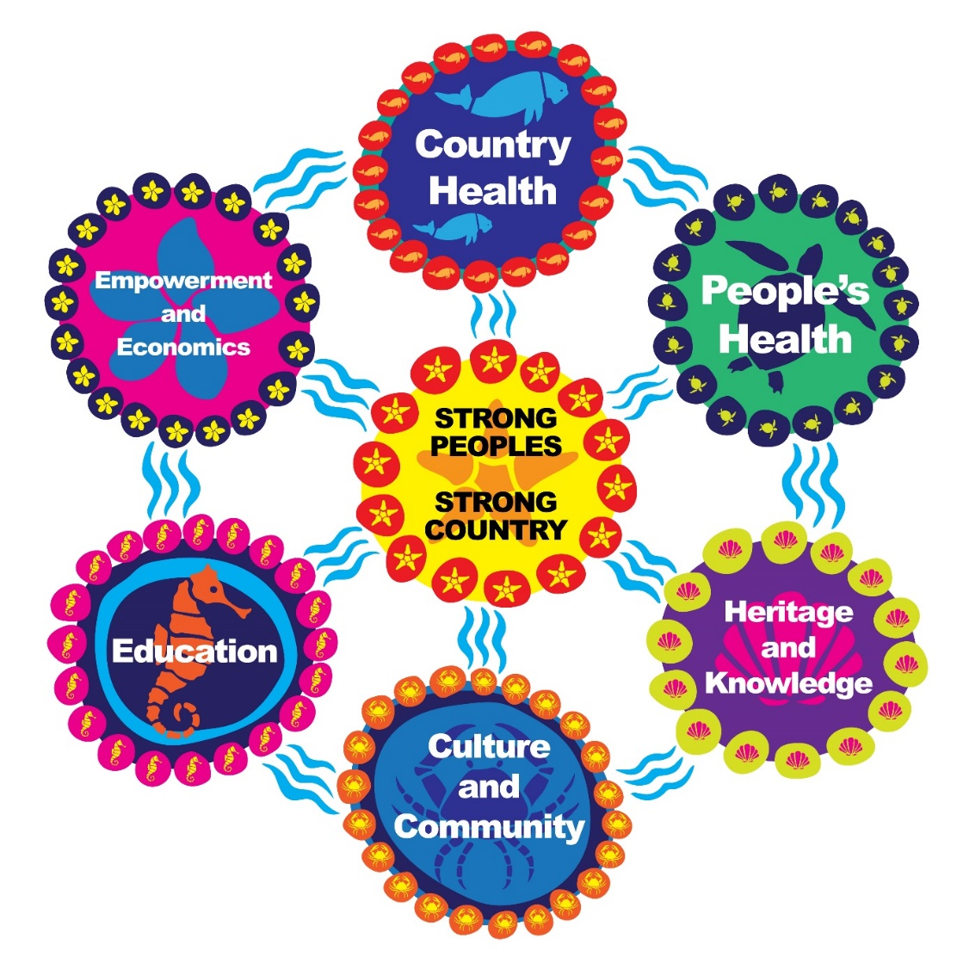

Figure 16. Framework for Traditional Owner wellbeing through connections to Country developed from Traditional Owner concepts within the Great Barrier Reef land and sea country. Copyright Mallie Designs.

During the deliberative processes over three workshops, the framework evolved from an initial framing as “human wellbeing” in general, following the wording of the DPSIR Framework which focuses on impacts to human wellbeing. In this initial draft framework human wellbeing formed the centre hub influenced by eight hubs. The Indigenous Heritage Expert Group recognised the interrelated nature of these hubs, whereby strong connections exist between each. Whilst each hub impacts human wellbeing directly, indirect impacts are also experienced via the impact each hub has on the other hubs. Thus, the framework attempts to capture the interconnectedness of the people-culture-nature system. For each hub, the fundamental characteristics of each group were identified and used to develop a detailed list of key factors that were perceived by the IHEG to embody that hub.
Having developed the initial draft framework and detailed factors during the first workshop, this served as a ‘strawman’ facilitating further review and robust debate during the subsequent workshops held 5-6 March and 27-28 March 2018. The Indigenous Heritage Expert Group strove to distil a truly Indigenous-led framework that encompassed the components that really matter to the Traditional Owners of the Great Barrier Reef region, and reflect their understandings based on their worldviews and knowledge systems. The workshops focused around:
- revisiting the project objectives to ensure the focus of the framework and the project aims were clearly aligned;
- ensuring that the indicators in the framework protected Traditional Owner cultural and intellectual rights and were based on sharing information that Traditional Owners were comfortable to share;
- reviewing and streamlining the key hubs within the framework;
- finalising the detailed factors that underlie each of the hubs; and
- determining an appropriate method for ‘testing’ the framework with Traditional Owners during a Reef wide-workshop held on 1-3 May 2018.

4.1.3 The focus of the Strong peoples – Strong country framework
Detailed discussions ensured the focus of the framework, as embodied by the central hub around which the framework revolves, was clearly aligned with the requirements of the RIMReP project but also aligned with and driven by the insights of the Indigenous Heritage Expert Group and the Traditional Owners of the Great Barrier Reef region. The first important outcomes from the IHEG’s discussions was the requirement that the framework’s central hub should:
- clearly focus on Traditional Owners as opposed to all residents of the region; and
- reflect that the framework has been developed from the perspective of Traditional Owners of the land and sea country adjacent to the Great Barrier Reef to fully encompass the importance of Country, and Traditional Owners’ connections to Country.
These requirements led to the central hub of the framework evolving from “human wellbeing” through a number of iterations whereby the Indigenous Heritage Expert Group attempted to fully capture their understanding of what was meant by “Traditional Owner wellbeing” and the fundamental inseparability of the wellbeing of Traditional Owners from the wellbeing of the Country to which they have connections. The Indigenous Heritage Expert Group members strove to fully represent the holistic Traditional Owner view that the quality of people’s lives is intrinsically and inseparably linked to the Country where they live, and furthermore, expressed in a language that was meaningful to Traditional Owners. Finally, the IHEG developed the phrase Strong peoples – Strong country that fully embraced the complex concepts they were attempting to express. Thus, the central focus of the framework, as set out in Figure 16, became Strong peoples – Strong country.

4.1.4 Determining the hubs and underlying factors believed to influence wellbeing as embodied by the term Strong peoples – Strong country
As part of the development of the final framework, the original group of hubs and underlying factors were also robustly debated. This resulted in some hubs being initially identified as combined, recognising the strongly overlapping and inseparable nature of these different hubs of life; this reduced the final number of hubs, (or factor groupings) to six.
The framework that emerged from these discussions is set out in Figure 16; this framework reflects the final six hubs felt by the IHEG to most contribute to the wellbeing of Traditional Owners from the Great Barrier Reef region through connections to Country, and also reflects that each of these hubs also impacts on, and through, the other hubs. Each of the hubs, and the underlying factors of which they are comprised, are discussed below.

4.1.5 Country Health
This hub reflects the need for Country (land and sea) to be healthy for Traditional Owners to feel that they have carried out their cultural obligations and responsibilities in looking after Country. Whilst this hub encompasses western science concepts such as ‘ecosystem health’ or ‘water quality’, these ideas are expressed using Traditional Owner language and the concepts emerged through the Indigenous-led methodology. Seven factors were considered to fit within the Country health grouping:
- Being on Country — the need for Traditional Owners to be physically present on their country was considered by the IHEG as a fundamental underpinning to the wellbeing of Traditional Owners.
- ‘You to Country’ health — this factor embodies the Traditional Owner concept that a Traditional Owner’s presence is a fundamental requirement for the Country itself to be healthy; that Country without Traditional Owners will get sick. The exact wording of this factor evolved through a number of iterations, including ‘presence for Country’, ‘being for Country’ and ‘you go back to Country to keep it healthy’ before the IHEG settled on ‘You to Country’ health. ‘Country with you’ health may be a more easily understood alternative.
- Healthy animals — this factor, along with healthy coral and other habitats, reflects the importance of maintaining biodiversity and protecting all species, including those species currently threatened and those totemic species of particular importance to Indigenous clans within a Traditional Owner group.
- Healthy coral — this encompasses the Reef as a whole and the corals of which it is comprised.
- Other habitats — this factor aimed to include Great Barrier Reef habitats that are often overlooked such as mangroves, seagrass beds, and estuarine systems.
- Clean saltwater — this factor, along with clean freshwater (below), could together be considered similar to the concept of ‘water quality’. However, Traditional Owners consider their responsibilities to the oceans and the rivers/creeks separately; thus, the importance of separating the concept into two factors.
- Clean freshwater — Traditional Owners consider their responsibilities to rivers and creeks separately from the oceans.

4.1.6 People’s Health
This hub looks broadly through a cultural lens about what you need (physically and emotionally) to keep the body and mind healthy. People’s Health was considered to comprise seven factors:
- Access to Traditional Medicine — this includes bush and sea medicines.
- Spirituality — this factor encompasses beliefs around the meaning and purpose of life depending on connections with the ancestral beings, the Dreaming and Aboriginal cosmology.
- Social and emotional wellbeing — these factors reflect the fact that strong social relationships and emotional support contribute to the mental and physical health of Traditional Owners.
- Cultural wellbeing — includes knowing your cultural traditions and being sure these are healthy and resilient.
- Access to medical services — includes both physical access (i.e. the service is available nearby) and psychosocial access (that Aboriginal people feel comfortable using it).
- Access to traditional foods — this factor encompasses the availability of traditional foods on country and that Traditional Owners are able to collect and use them.
- Know your mob — the Indigenous Heritage Expert Group felt that some of the connections between the Traditional Owners and their country have weakened. There are sections of the Indigenous communities who no longer fully understand who their people are and where they come from; without this understanding and the strong sense of identity built upon this, Traditional Owners cannot be fully healthy in mind and body. Thus, rebuilding and strengthening the sense of belonging will enhance the health of the people.

4.1.7 Heritage and Knowledge
This hub comprises knowing, managing, protecting, and having access to your Country and heritage as well as being able to continue the oral history, transfer of knowledge and interaction with western science. The IHEG debated whether Heritage and Knowledge should be two separate hubs, but concluded the concepts embedded within Heritage and Knowledge were so heavily overlapping and inseparable that they were better represented by one hub. Heritage and Knowledge was considered to be represented by seven key factors:
- Oral history — includes the songlines and stories for Country themselves.
- Knowledge of Country and heritage — ensuring this knowledge forms part of daily life and is not lost.
- Managing knowledge and heritage — includes ensuring the appropriate management of both the oral histories and the physical heritage sites.
- Protecting knowledge and heritage — includes ensuring the oral history and the heritage sites are protected for present and future generations.
- Access to heritage sites — recognises the importance of Traditional Owners being able to access sites as part of their responsibilities and obligations for the ongoing management and protection processes.
- Traditional Owner knowledge transfer — relates to the transfer of knowledge within Traditional Owner communities, and particularly from Elders to the younger generation and between Traditional Owner and non-Indigenous peoples.
- Western science — recognises that western scientific knowledge may be able to offer benefits in conjunction with Traditional knowledge to tell a more integrated and holistic story.

4.1.8 Culture and Community
Culture and Community encompass the different aspects of Traditional Owner Culture as well as mentorship and community activities. This category also recognises the need for Traditional Owners to know their kinship structure and totems. The Indigenous Heritage Expert Group originally considered whether these two aspects should be considered as separate hubs, but for the final framework they were combined. These two hubs were seen as being strongly interlinked and comprising overlapping concepts, as cultural practices are generally inseparable from the community undertaking those practices.
Culture and Community was seen to comprise ten key factors:
- Traditional Owner voices at all levels — a requirement for Traditional Owners to be included and able to participate across the multiple levels of our society
- Getting actively involved in community activities and have some ownership of those activities
- Cultural mentorship — reflects the important role that Elders and established community leaders can have in developing younger generations’ understanding of their Culture, the history of their people, and their place within their Culture.
- Local mentorship (business, education, sporting) — reflects the important role that Elders and established community leaders can have in developing others, both Indigenous and non-Indigenous, encouraging and enabling them to take advantage of the opportunities available to them.
- Cultural authority — this factor recognises that Traditional Owners have their own sui-generis governance arrangement that determines authority over their Culture and heritage, and that this authority needs to be respected by both Traditional Owners, and other Indigenous and non-Indigenous people.
- Language — includes both understanding and speaking traditional languages.
- Lore and ceremony — the ideas and practices that comprise traditional cultural lore and ceremonies were considered as heavily overlapping and indeed ceremony could be considered an expression of lore; thus these factors were grouped together.
- Tool making, hunting, and gathering — this factor includes maintaining the knowledge and practices of making traditional tools, and engaging in traditional hunting and gathering activities.
- Arts, songs, dance — this factor encompasses continuing knowledge and participation in traditional cultural practices such as song, dance, painting and rock art.
- Kinship, family, totems — this factor reflects that an important element involved in identifying as an Indigenous person is to have a strong knowledge of who their family and kin are, past and present, and understanding the totems that are important to their family.

4.1.9 Education
This hub reflects that education includes cultural learning, western education, and the two-way sharing of knowledge in all areas (such as Indigenous science and western science learning from each other, Traditional Owners learning from their neighbours, and sharing with each other within their own communities). Education was seen to comprise five key factors:
- Learning from Elders — the inclusion of the phrase ‘transitions’, either as a separate factor or in conjunction with this factor, was considered by the Indigenous Heritage Expert Group as it was felt to be important that younger people learn enough to enable them to transition to more senior roles within the community and become elders themselves one day. However, after much debate the IHEG concluded that this factor ‘learning from Elders’ was sufficient to also embody the concept of youngsters transitioning to become elders themselves at a later date.
- Enabling, creating, developing, pathways towards career opportunities — these pathways could include taking advantage of further educational or training opportunities.
- Training — this factor represents a wide definition of all training that develops skills, as provided by educational establishments such as schools and TAFE, but also including training in cultural practices provided on Country by other members of the community.
- Having passion to learn — it was considered highly important to inspire this passion within members of the community, and to ensure that opportunities are offered to those with the passion to learn; without such passion training opportunities and other pathways to development can become meaningless exercises.
- Two-way sharing — the use of the term ‘exchange’ or ‘knowledge exchange’ was considered here, but the Indigenous Heritage Expert Group felt that ‘two-way sharing’ better embodied the perspective and approach of Traditional Owners to the exchange of knowledge, both within Indigenous communities and between Traditional Owners and non-Indigenous persons.

4.1.10 Empowerment and Economics
This hub recognises the connectedness between empowerment and economics for Traditional Owners, through support and creation of Traditional Owner-led actions. This includes ownership (that could be from ownership of land, your house, business, and your own destiny) and Traditional Owner-led caring for Country. Empowerment and Economics were originally considered to be separate hubs but, following detailed discussions, were combined into one, as the Indigenous Heritage Expert Group felt that improvements in economic outcomes for the Traditional Owners of the Great Barrier Reef were firmly underpinned by and inseparable from increasing empowerment of the peoples of the region. For example, without the empowerment that comes from a strong sense of identity, personal strength and self-determination, then people are unlikely to be in a position to improve their economic situation (e.g. by establishing their own businesses or taking full advantage of the economic opportunities available). The interconnected concepts of Empowerment and Economics were considered to be built upon nine key factors:
- Ownership — encompasses ownership of the important things within people’s lives, such as their land, their homes, their businesses, and their destiny
- Greater level of management — this was considered as both separate from but also related to the factor of Ownership, as to achieve true economic empowerment Indigenous management should be operating businesses that are Indigenous owned and based on Indigenous owned land. However, as part of achieving this objective, greater management within non-Indigenous owned businesses could form a pathway towards developing economic independence.
- Better policy — this factor was much debated in the deliberative process by the Indigenous Heritage Expert Group as to whether it was necessary to be more specific with regard to what levels or types of policy were being referred to. However, the overall view of the IHEG was that this terminology would be clear and meaningful to the Traditional Owners, as representing the need for better policy reflecting Traditional Owner voices at all levels, without further clarification being required. The Reef-wide Traditional Owner workshop confirmed this was the case with the Traditional Owners present.
- Traditional Owner-led caring for Country — whilst caring for Country initiatives could be funded as part of government initiatives it is important that the practices adopted should be Indigenous led.
- Better roads, better internet, better buildings — embodies the importance of developing the required and necessary service and facility infrastructure.
- More Traditional Owner owned and led business (food, tourism, arts) — this encompasses the desire to encourage Traditional Owners to establish and operate a wide range of Indigenous-led and owned businesses within their community.
- Employment on Country — this includes both creating jobs for Traditional Owners on Country and ensuring that jobs are secure. These jobs may be as a result of government initiatives such as Indigenous land management programmes and Ranger groups, or could be outside of government funding, including but not limited to ‘fee for service’ organisations.
- Having the same opportunities for everyone (age, gender, disability, sexuality) — encompassed concepts of equity and equality, and the desire to remove stereotypes, across the Indigenous communities and across the Country as a whole.
- Your rights, interests, goals — encompassing all aspects as set out in the United Nations Declaration on the Rights of Indigenous Peoples, and the vision and goals of particular Traditional Owner groups.

4.1.11 Testing the Strong peoples – Strong country framework
Having developed the framework and identified a list of factors that compose each hub, the Indigenous Heritage Expert Group considered how to test the validity of the framework. The objective of testing was firstly to ensure that the framework was complete and comprehensive, that is, to ensure that no important factors and/or hubs had been omitted. The second objective of the testing process was to enable perceptions of the strength of the relationships between factors, hubs and the central hub Strong peoples – Strong country to be statistically verified and the level of consensus quantified.
Accordingly, a questionnaire was developed that could be used to survey the views of the Traditional Owners attending the Reef Wide Traditional Owner Workshop on 1-3 May 2018. The Indigenous Heritage Expert Group determined that the first requirement was for Free Prior and Informed Consent to be obtained from Traditional Owners before completing the survey. The IHEG determined that a question about consent should be included at the very beginning of the survey, supported by a Participant Information Sheet that explains the ethical practices that the project is using, and a separate fact sheet providing information about the Strong peoples – Strong country framework and indicators. The IHEG determined the views of Traditional Owners would be elicited at two levels. First, workshop attendees would be requested to complete an individual survey where they can express their own personal views. Second, during a group working session held during the workshop, attendees would be grouped according to the region within the Great Barrier Reef catchment from which they were nominated, and would work through the survey as a group, debating and determining a group response to the survey from the perspective of their region. This survey instrument and accompanying material is described in more detail further below.

4.1.12 The concept of monitoring and the use of the framework as a monitoring tool
During the development of the human wellbeing framework, designed using Traditional Owner concepts to assist with monitoring and reporting, it became apparent that not only should Traditional Owner concepts be applied to understanding human wellbeing but also to understanding what is meant by ‘monitoring’. The Traditional Owner’s definition of monitoring is wider, encompassing a more holistic view of the world and the people within, than more standard definitions.
In response to the question “what is monitoring?” the Indigenous Heritage Expert Group recommended that the term includes the following key concepts:
- observing what is happening on our land and sea country;
- interacting with land and sea country;
- being present on Country;
- being part of nature and using nature; and
- storytelling about Country.
Fundamentally, it was agreed that the Traditional Owner concept of ‘monitoring’ is all about the connections between Country and people.
As the Strong peoples – Strong country framework is also based around a holistic view of the connections between people and Country, this framework provides the groundwork for the development of an Indigenous-led monitoring programme for the Great Barrier Reef region, as a contribution to RIMReP.
The Indigenous Heritage Expert Group recommend that the key components underpinning each hub should form the subjects of the proposed monitoring process, with both objective and subjective indicators being identified as appropriate measures to enable the monitoring of these factors. Recognising that the regions that comprise the Great Barrier Reef catchment are not homogenous, and also recognising that conditions change over time, the importance of the spatial and temporal dimensions needed to be embedded within the proposed monitoring programme.
The Indigenous Heritage Expert Group also recognised that the development of objective indicators will require much more time (see section below on Scoping of further potentially relevant objective indicators).

4.1.13 Subjective testing and monitoring of the Strong peoples – Strong country framework
An initial survey instrument was developed with two key outcomes in mind. Firstly, this survey facilitates testing of the Strong peoples – Strong country framework itself. Secondly, the data collected forms baseline data on the subjective views of the Traditional Owners of the region regarding the current condition of the factors underpinning the framework. As determine by the Indigenous Heritage Expert Group and noted above, the survey instrument was accompanied by information to ensure processes of obtaining Free Prior and Informed Consent were followed. The text of the accompanying letter sent out to Traditional Owners with the survey on 26 April 2018 can be found in Attachment B, and the accompanying factsheet informing Traditional Owners about the Strong peoples – Strong country appears at Attachment C. The Participant Information Sheet to provide details about the ethical practices in the research appears at Attachment C. The Consent Form to collect information at the Reef-wide Traditional Owner Workshop is at Attachment E and finally the Survey instrument is at Attachment F.
The Indigenous Heritage Expert Group developed the survey instrument over the November 2017 and March 2018 workshops alongside the development of the framework itself, and further refined the survey by testing during April 2018. The survey begins by gathering basic regional connections and socio-demographic data on the survey respondents. The IHEG had divided the Great Barrier Reef catchment region into nine zones, as set out in Figure 17 below. The zones were defined geographically as follows: Zone 1 = Torres Strait to Apudthma; Zone 2 = Kalan, Lockhart, Lama Lama; Zone 3 = Cooktown to Hope Vale; Zone 4 = Wujal Wujal to Mossman; Zone 5 = Cairns to Innisfail; Zone 6 = Mission Beach to north of Ross River; Zone 7 = South of Ross River to Bowen; Zone 8 = Bowen to Sarina; and Zone 9 = Sarina to Gladstone. Based on this map and zonal structure, the survey respondents were requested to first identify the zone that best represented the region from which they had been nominated to attend the Reef-Wide Workshop. They were then asked to nominate any other zone(s) with which they had connections. These questions provide data enabling the results to be analysed spatially within the Great Barrier Reef catchment as well as providing global data for the full region. The survey respondent was also asked to specify which Traditional Owner group they felt they belonged to.

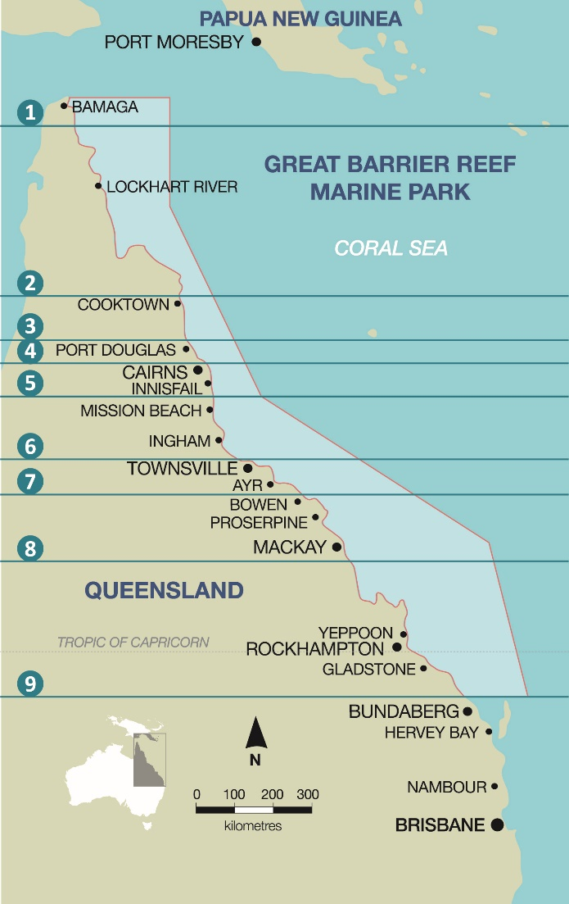
Figure 17. Regional zoning structure developed by the Indigenous Heritage Expert Group for regional classification of Traditional Owners of the land and sea country within the Great Barrier Reef catchment.

The survey respondents were then asked questions regarding their gender and asked to specify which age group they belonged to, from a list of age groups defined with descriptions such as ‘under 20 years’, ‘20 to 29 years’ etc. The collection of age and gender data enables the impact of these variables to be controlled for within the statistical analysis of the relationships represented within the framework. This section of the survey also included a tick box whereby the respondent could indicate their consent that the Indigenous Heritage Expert Group project may use the information that they have provided within the survey responses.
This section is followed by an overall question regarding the respondents’ current level of satisfaction with the wellbeing of the Traditional Owners of the region as embodied in the phrase Strong peoples – Strong country. The respondent was asked to select a score from zero to 10, where zero represents very unsatisfied and 10 is very satisfied. The precise wording of this question is set out at Figure 18. This data serves two purposes; firstly, as part of the process of testing the validity of the framework, and secondly as part of the gathering of baseline data for the recommended monitoring process.

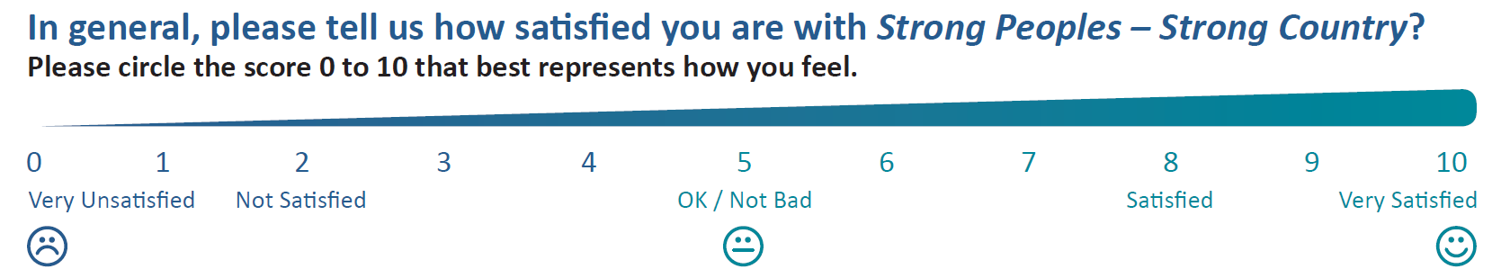
Figure 18. Survey question regarding overall satisfaction level with Traditional Owner wellbeing as epitomised by the term Strong peoples – Strong country.

The survey then moves on to address each hub separately. For each hub, the factors identified as comprising the hub are listed and the respondents are requested to score the importance of each factor using a scale of zero to 10, where zero represents a factor that is completely unimportant whilst 10 represents a factor that would be one of their highest priorities. The aim here is to determine the relative importance of these factors to the specific hub and to Traditional Owner wellbeing overall, enabling priorities to be identified. However, the Indigenous Heritage Expert Group and the support team recognised that previous research had frequently found that Indigenous people have difficulty in assigning scores to different factors due to their holistic view, recognising the interconnectedness of many different factors. The resulting risk is that high importance scores would be assigned to all, or virtually all, of the factors, thus preventing the data informing the prioritisation of future work. This highlights the ongoing need for mixed-methods approaches, for example qualitative research provides deeper insight into meaningful issues. Nevertheless, to reduce this risk somewhat, firstly the wording attached to the scale (shown in Figure 19) did not extend from ‘not very important’ to ‘very important’ as is usually the case in such surveys; instead extra categories at either end of the scale were added to indicate that the highest scores should not be used for all items. Secondly, an additional question was included asking the respondents to circle the factor within each hub that they feel to be the most important to them.

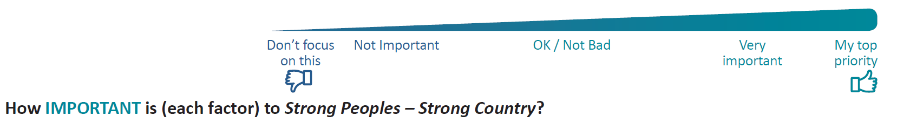
Figure 19. Scale used within survey question regarding the importance of individual factors.

For each hub, following the questions regarding the importance of the factors, the respondent was then asked to score their level of satisfaction with each of the factors, using the same scale from zero to ten as previously used overall.
After these questions had been asked for each of the six hubs, respondents were then asked to list any factors that were important to their quality of life that had been omitted from the survey. Finally, respondents were asked to indicate whether they would be willing to be involved in future surveys relating to the Strong peoples – Strong country framework, and if so, to provide contact phone and/or email details.

4.2 Individual survey data collected
In total, 41 surveys were collected from individual respondents, with 8 respondents completing the on-line version of the survey prior to the workshop commencing, and 33 respondents completing the survey during the morning of the third day of the workshop (3 May, 2018). One of these respondents declined to provide details of gender, age and zone. For the other 40 respondents, the diagrams illustrate the breakdown of these respondents by gender (Figure 20), age group (Figure 21) and zone of origin (Figure 22) are shown below. Results are presented in the context of having only a small sample size (n=41).
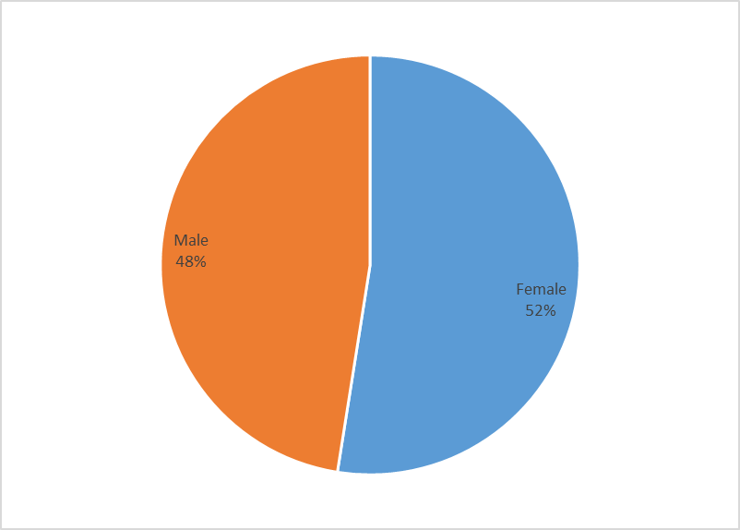
Figure 20. Analysis of individual survey respondents by gender.
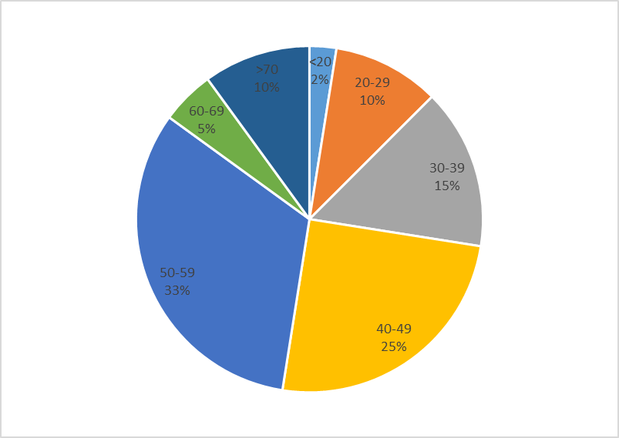
Figure 21. Analysis of individual survey respondents by age group.

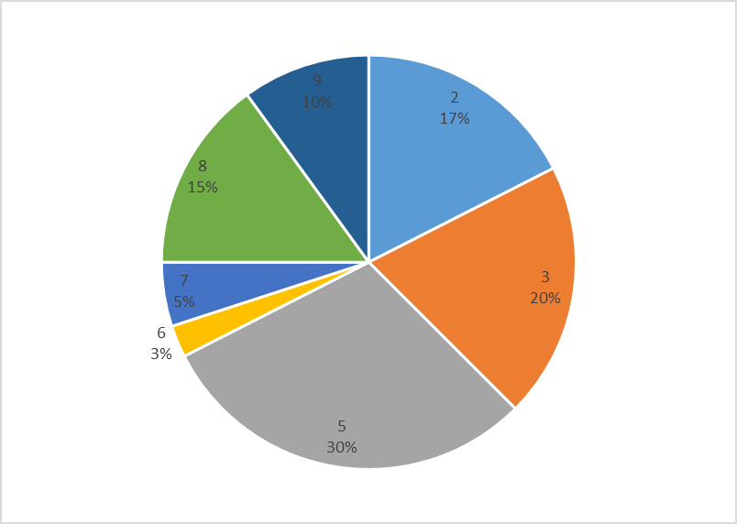
Figure 22. Analysis of individual survey respondents by the geographic zone with which they identify.

Thus, there were slightly more females than male respondents, more than one-third of respondents were within the 50 to 59 years age group, and 30 per cent identified with zone 5, the region from Cairns to Innisfail. Whilst both genders and all age groups were represented within the sample, there were no respondents from either zone 1 (Torres Strait to Apudthma) or zone 4 (Wujal Wujal to Mossman).
Overall, the individual respondents were fairly satisfied with their quality of life as a whole, with an average satisfaction with life score of 6.7.

4.3 Group Survey Data Collected
Group discussions were held during the first afternoon of the workshop, on 1 May 2018. Attendees at the workshop were asked to group themselves by the regions with which they identified. Zone 1 had only one attendee. Accordingly, this Traditional Owner was asked to join with the attendees from zone 2. Zone 2 had a larger number of attendees than other zones, and hence the attendees self-sorted themselves into three separate smaller groups to better facilitate meaningful discussion, where the voices of all group members could be heard. Zone 8 included attendees from three different Traditional Owner groups who were found to have very different views regarding their levels of satisfaction with many of the different factors. Accordingly, different scores were noted for each of these groups rather than the IHEG reaching an overall score. Thus, scores and related discussions were collected for 12 groups in total, broken down by zone as shown in Figure 23 below.
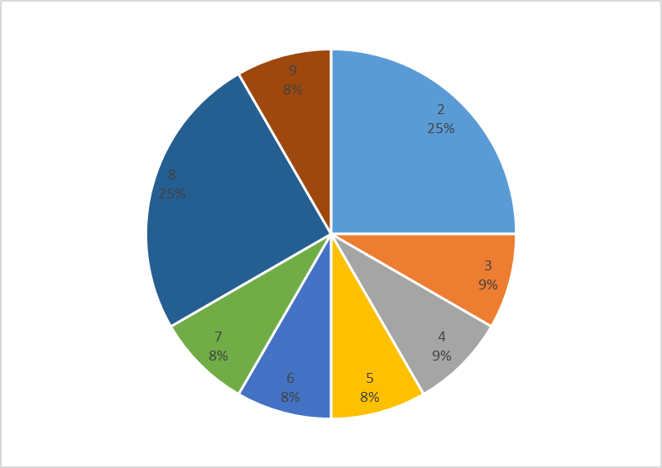
Figure 23. Analysis of group survey respondents by the geographic zone with which they identify.

The IHEG’s discussion session began with a presentation from Chrissy Grant, Chair of the Indigenous Heritage Expert Group, to introduce the framework and the underlying factors. The IHEG was then formed, with a scribe from the project support team and/or a facilitator from the Indigenous Heritage Expert Group allocated to each group to guide the attendees through the process. The IHEG was asked to respond from the viewpoint of the community where they live, rather than purely based on their own personal situation.
For each hub in turn the IHEG was provided with a poster setting out the importance scale and the satisfaction scale and two cards for each factor within that hub. They were then tasked with discussing each of the factors and determining their appropriate position along the scale, based on how important they felt each factor was to people within their community, and how satisfied they felt their community was, as a whole, with each factor. Examples of such a completed poster can be seen below, with an example of importance shown at Figure 24 and an example of satisfaction shown at Figure 25.

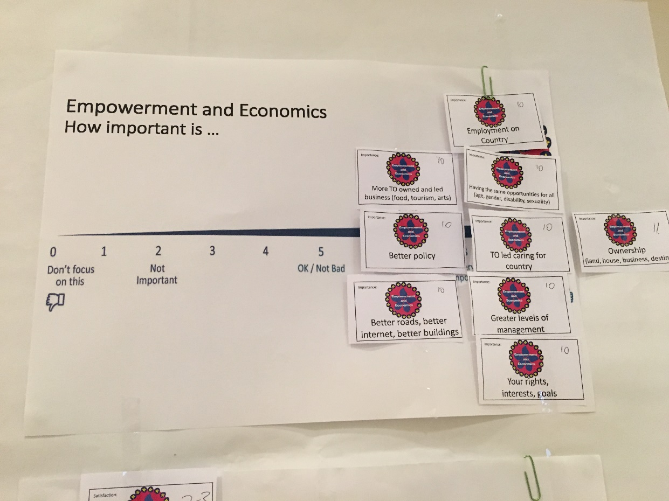
Figure 24. Example of one group’s analysis of the importance of different factors within the Empowerment and Economics hub.
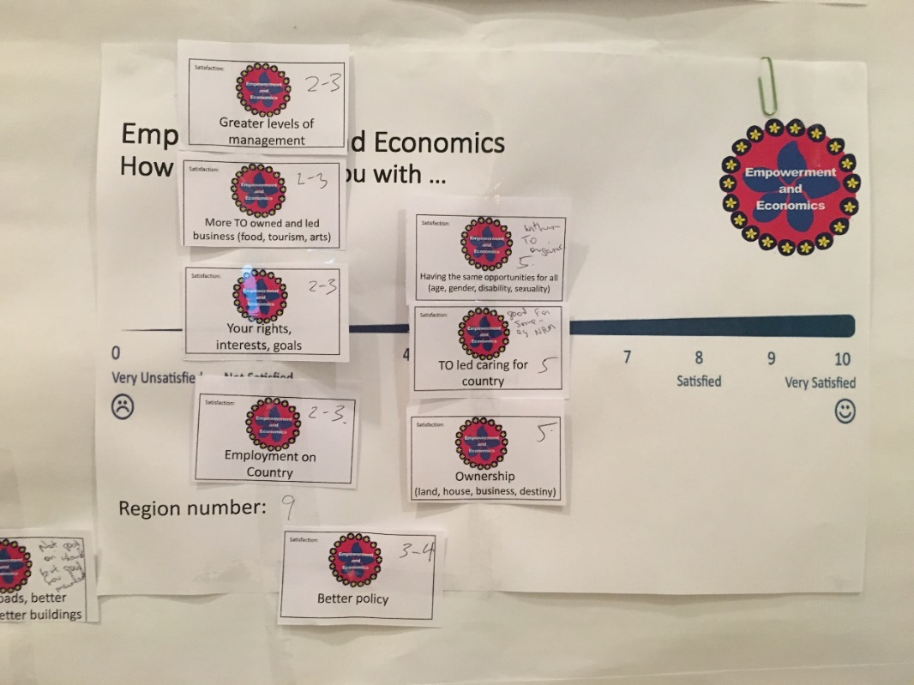
Figure 25. Example of one group’s analysis of their satisfaction with different factors within the Empowerment and Economics hub.

Groups were also asked to consider the quality of the lives of people within their communities overall and agree on a score for this. An example is shown at Figure 26.
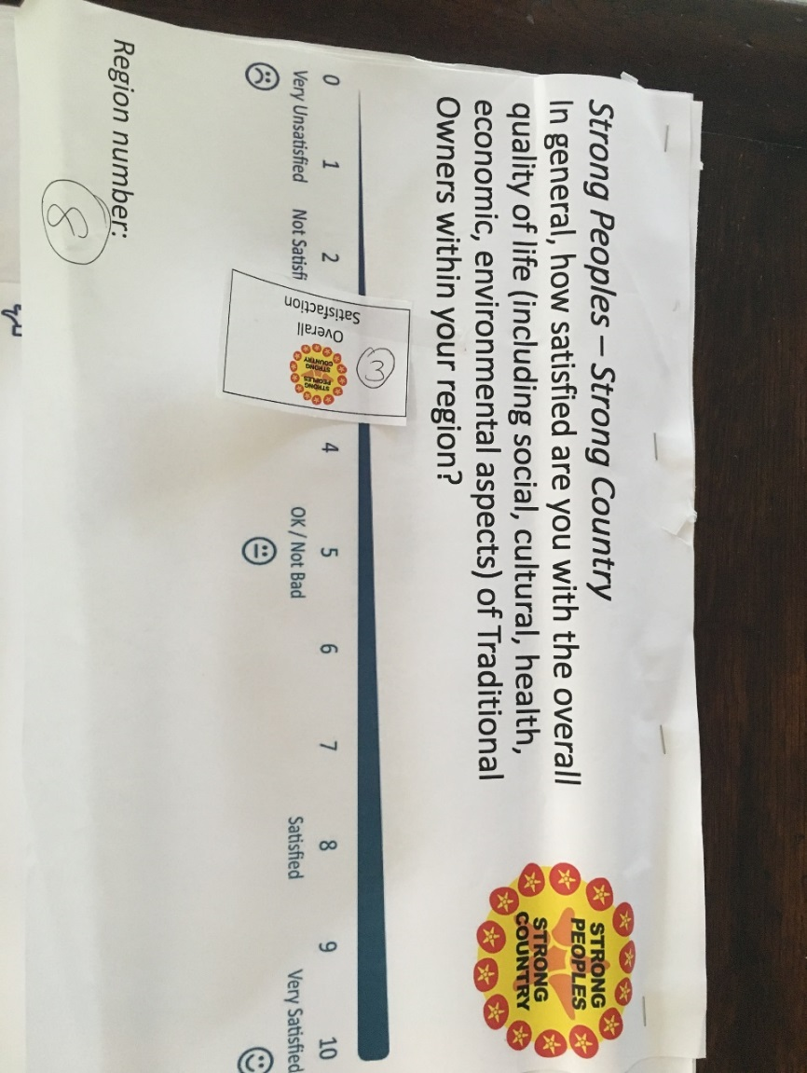
Figure 26. Example of one group’s analysis of their satisfaction with their quality of life overall.

Overall, the responses from the IHEG discussions indicated that the Traditional Owners were fairly dissatisfied with the quality of life as a whole for people within their communities, with an average satisfaction with life score across the IHEG of 3.8.

4.4 Results from the analysis of the survey responses
Due to the fairly small sample sizes for both individual and group responses, in addition to considering the scores attributed to the different groups, the overall scores from the two samples combined were also analysed and compared.

4.1 Importance of different factors
The responses from both the IHEG discussions and the individual surveys revealed that most of the factors were considered highly important to the overall quality of life of Traditional Owners of the region. As shown in Figure 27 and Table 2, every factor received the maximum score of 10 from at least one individual respondent and at least one group. Some factors were occasionally scored as being of low importance, but on average all factors scored highly. The lowest average score overall was 7.58, for Western Science Knowledge, which is far closer to the top importance score of 10 than the lowest possible score of zero. On average the factors within the Country Health hub received the highest importance scores, averaging 9.48. The factors within the Heritage and Knowledge hub received the lowest importance scores, but at an average score of 8.94 these factors are still of vital importance. Differences can be seen between the responses emerging from the IHEG discussions compared to the individual survey responses. In particular, the People’s Health and Heritage, and Knowledge hubs emerged with importance scores from group discussions that were at least 0.5 higher than scores from individual surveys, whilst the opposite was seen for Culture and Community hub. The scores for the other hubs showed differences between group and individual reports of less than 0.5.
The comments recorded during the IHEG discussions generally supported the quantitative scores applied, in that the participants generally thought all factors were important and found it difficult to assign different important scores to the different factors.
These importance scores indicate that the Strong peoples – Strong country framework does comprise factors that are considered to be of great importance to the Traditional Owners of the Great Barrier Reef region and indicates that none of the factors are superfluous or irrelevant.
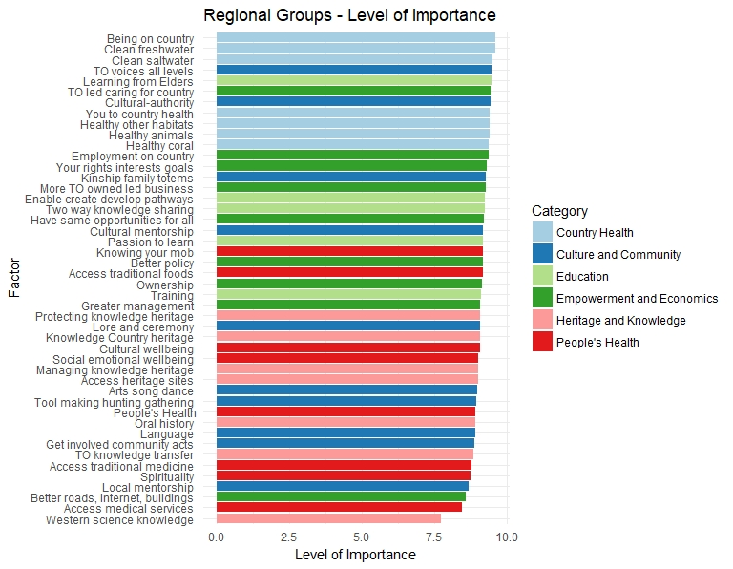
Figure 27. Levels of importance expressed by regional group responses to the survey.

Table 2. Importance scores from combined individual surveys, group discussions, plus showing each segments scores separately.
 | Overall |  |  | Individuals |  |  | Groups
 | Mean | Min | Max | Mean | Min | Max | Mean | Min | Max
Being on Country | 9.68 | 7.00 | 10.00 | 9.63 | 7.00 | 10.00 | 9.83 | 8.00 | 10.00
You to country health | 9.49 | 6.00 | 10.00 | 9.41 | 6.00 | 10.00 | 9.75 | 8.00 | 10.00
Healthy animals | 9.36 | 5.00 | 10.00 | 9.41 | 5.00 | 10.00 | 9.17 | 5.00 | 10.00
Healthy coral | 9.42 | 5.00 | 10.00 | 9.39 | 5.00 | 10.00 | 9.54 | 8.00 | 10.00
Healthy other habitats | 9.42 | 5.00 | 10.00 | 9.41 | 5.00 | 10.00 | 9.46 | 8.00 | 10.00
Clean saltwater | 9.52 | 7.00 | 10.00 | 9.51 | 7.00 | 10.00 | 9.54 | 8.00 | 10.00
Clean freshwater | 9.65 | 7.00 | 10.00 | 9.61 | 7.00 | 10.00 | 9.79 | 8.00 | 10.00
Country Health | 9.48 | 6.57 | 10.00 | 9.58 | 8.14 | 10.00 | 9.51 | 6.57 | 10.00
Access to traditional medicine | 8.97 | 1.00 | 10.00 | 8.80 | 1.00 | 10.00 | 9.59 | 8.00 | 10.00
Spirituality | 8.95 | 1.00 | 10.00 | 8.76 | 1.00 | 10.00 | 9.65 | 8.00 | 10.00
Social emotional wellbeing | 9.11 | 1.00 | 10.00 | 9.03 | 1.00 | 10.00 | 9.41 | 8.00 | 10.00
Cultural wellbeing | 9.25 | 1.00 | 10.00 | 9.08 | 1.00 | 10.00 | 9.86 | 8.50 | 10.00
Access to medical services | 8.67 | 0.00 | 10.00 | 8.45 | 0.00 | 10.00 | 9.45 | 7.50 | 10.00
Access to traditional foods | 9.31 | 5.00 | 10.00 | 9.18 | 5.00 | 10.00 | 9.77 | 8.00 | 10.00
Knowing your mob | 9.28 | 5.00 | 10.00 | 9.18 | 5.00 | 10.00 | 9.65 | 8.00 | 10.00
People’s Health | 9.08 | 2.43 | 10.00 | 8.93 | 2.43 | 10.00 | 9.64 | 8.86 | 10.00
Oral history | 9.11 | 4.00 | 10.00 | 8.93 | 4.00 | 10.00 | 9.77 | 8.00 | 10.00
Knowledge Country heritage | 9.25 | 4.00 | 10.00 | 9.08 | 4.00 | 10.00 | 9.86 | 9.00 | 10.00
Managing knowledge heritage | 9.17 | 4.00 | 10.00 | 9.03 | 4.00 | 10.00 | 9.68 | 9.00 | 10.00
Protecting knowledge heritage | 9.17 | 4.00 | 10.00 | 9.08 | 4.00 | 10.00 | 9.50 | 8.00 | 10.00
Access to heritage sites | 9.21 | 4.00 | 10.00 | 9.03 | 4.00 | 10.00 | 9.86 | 9.00 | 10.00
TO knowledge transfer | 9.05 | 4.00 | 10.00 | 8.85 | 4.00 | 10.00 | 9.77 | 8.00 | 10.00
Western science knowledge | 7.58 | 4.00 | 10.00 | 7.74 | 4.00 | 10.00 | 7.00 | 4.50 | 10.00
Heritage and Knowledge | 8.94 | 4.00 | 10.00 | 8.82 | 4.00 | 10.00 | 9.35 | 8.43 | 10.00
TO voices all levels | 9.57 | 5.00 | 10.00 | 9.50 | 5.00 | 10.00 | 9.82 | 8.00 | 10.00
Get involved community acts | 9.06 | 5.00 | 10.00 | 8.90 | 5.00 | 10.00 | 9.64 | 8.00 | 10.00
Cultural mentorship | 9.29 | 4.00 | 10.00 | 9.20 | 4.00 | 10.00 | 9.64 | 8.00 | 10.00
Local mentorship | 8.92 | 4.00 | 10.00 | 8.70 | 4.00 | 10.00 | 9.73 | 8.00 | 10.00
Cultural-authority | 9.50 | 5.00 | 10.00 | 9.44 | 5.00 | 10.00 | 9.73 | 8.00 | 10.00
Language | 9.14 | 2.00 | 10.00 | 8.93 | 2.00 | 10.00 | 9.91 | 9.00 | 10.00
Lore ceremony | 9.26 | 5.00 | 10.00 | 9.08 | 5.00 | 10.00 | 9.91 | 9.00 | 10.00
Tool making hunting gathering | 9.14 | 5.00 | 10.00 | 8.95 | 5.00 | 10.00 | 9.82 | 8.00 | 10.00
Arts song dance | 9.18 | 5.00 | 10.00 | 8.98 | 5.00 | 10.00 | 9.91 | 9.00 | 10.00
Kinship family totems | 9.39 | 5.00 | 10.00 | 9.28 | 5.00 | 10.00 | 9.82 | 9.00 | 10.00
Culture and Community | 9.09 | 4.90 | 10.00 | 9.79 | 8.80 | 10.00 | 9.24 | 4.90 | 10.00
Learning from Elders | 9.50 | 5.00 | 10.00 | 9.48 | 5.00 | 10.00 | 9.60 | 9.00 | 10.00
Enable create develop pathways | 9.25 | 5.00 | 10.00 | 9.26 | 5.00 | 10.00 | 9.20 | 7.00 | 10.00
Training | 9.26 | 4.00 | 10.00 | 9.13 | 4.00 | 10.00 | 9.80 | 9.00 | 10.00
Passion to learn | 9.30 | 3.00 | 10.00 | 9.18 | 3.00 | 10.00 | 9.80 | 9.00 | 10.00
Two way knowledge sharing | 9.10 | 3.00 | 10.00 | 9.25 | 7.00 | 10.00 | 8.50 | 3.00 | 10.00
Education | 9.28 | 5.60 | 10.00 | 9.26 | 5.60 | 10.00 | 9.38 | 8.60 | 10.00
Ownership | 9.30 | 2.00 | 10.00 | 9.17 | 2.00 | 10.00 | 9.89 | 9.00 | 10.00
Greater management | 9.25 | 3.00 | 10.00 | 9.10 | 3.00 | 10.00 | 9.89 | 9.00 | 10.00
Better policy | 9.27 | 3.00 | 10.00 | 9.18 | 3.00 | 10.00 | 9.67 | 8.00 | 10.00
TO led caring for country | 9.55 | 4.00 | 10.00 | 9.45 | 4.00 | 10.00 | 10.00 | 10.00 | 10.00
Better roads internet buildings | 8.84 | 2.00 | 10.00 | 8.61 | 2.00 | 10.00 | 9.89 | 9.00 | 10.00
More TO owned led business | 9.28 | 5.00 | 10.00 | 9.27 | 5.00 | 10.00 | 9.33 | 8.00 | 10.00
Employment on country | 9.49 | 3.00 | 10.00 | 9.38 | 3.00 | 10.00 | 10.00 | 10.00 | 10.00
Have same opportunities for all | 9.18 | 3.00 | 10.00 | 9.22 | 3.00 | 10.00 | 9.00 | 8.00 | 10.00
Your rights interests goals | 9.30 | 4.00 | 10.00 | 9.32 | 4.00 | 10.00 | 9.22 | 5.00 | 10.00
Empowerment and Economics | 9.28 | 3.44 | 10.00 | 9.19 | 3.44 | 10.00 | 9.65 | 8.67 | 10.00

4.2 Satisfaction with different factors
The responses from both the IHEG discussions and the individual surveys show many differences in the perceptions of satisfaction levels for different factors, and differences between individual responses and those that emerged from group discussions. Widely varying scores were seen for many factors (Figure 28, Table 3), for example the factor ‘Clean Saltwater’ received scores ranging from 1 to 10 for individuals and scores from 0 to 10 from group discussions. Whilst this may indicate (particularly with the individual responses) that there may have been some confusion with regard to what the question actually meant, further analysis of the data also reveals that the differences may reflect real spatial differences between different geographic locations along the length of the Great Barrier Reef. These important spatial differences are discussed further below.
As can be clearly seen, satisfaction levels are generally far lower than the importance scores across all of the different factors and for each hub on average. As a score of 5 represents a neutral level of satisfaction, any score below 5 indicates the respondent is actively dissatisfied with the current quality of that factor, and focuses attention on whether or not remedial action is required. Based on individual responses, the factor ‘Lore and Ceremony’, within the ‘Culture and Community’ hub, and all of the factors within the ‘Empowerment and Economics’ hub received dissatisfied responses. However, based on the IHEG responses, a great many factors received a dissatisfied score. In fact, 33 out of 45 factors received a score less than five, and three factors received average scores of below two indicating the IHEG was highly dissatisfied with the quality of this factor.
The detection of differences between satisfaction reported by individual surveys and the levels of satisfaction that emerged as a consequence of the IHEG discussions has important implications for future research and for monitoring and evaluation activities. This suggests the possibility that data gathered from individuals regarding their own views and circumstances may not represent the views and circumstances of the communities from which the respondents are drawn. If we seek to better understand the influences on wellbeing across and within Traditional Owner communities we may need to focus our data collection at the IHEG level. Hence, it is our recommendation that future monitoring activities within the Great Barrier Reef under the RIMReP should seek information from group discussions with all Traditional Owners of the Great Barrier Reef land and sea country.
The IHEG discussion process revealed a range of different views and some important insights regarding the satisfaction scores awarded to different factors. Some views were highly specific to location or Traditional Owner group, while other insights applied more widely across the Great Barrier Reef catchment. The opportunities to go on Country and be involved in monitoring and protecting the environment, and cultural and heritage sites, varies significantly across the region, which impacts on the views of the participants, whilst environmental conditions also vary significantly. Furthermore, the approach to answering some of the questions varied significantly. For example, with regard to ‘Clean Saltwater’, one group observed that there were “no benchmark and baselines carried out to measure clean saltwater” and consequently did not provide a satisfaction score for this factor, whilst other groups responded based upon anecdotal evidence and their own observations when out on sea country.
A number of groups referred to specific issues that affected the assigned scores; again using ‘Clean Saltwater’ as an example issues included ghost nets, rubbish, shipping, insecticides, pesticides, building works, lack of trees or pine tree plantations, cane farmers, dredging, coal mines, fertilisers, harbour developments and dredging. Some of these issues seemed to be fairly location specific, whilst other issues impacted on all regions.
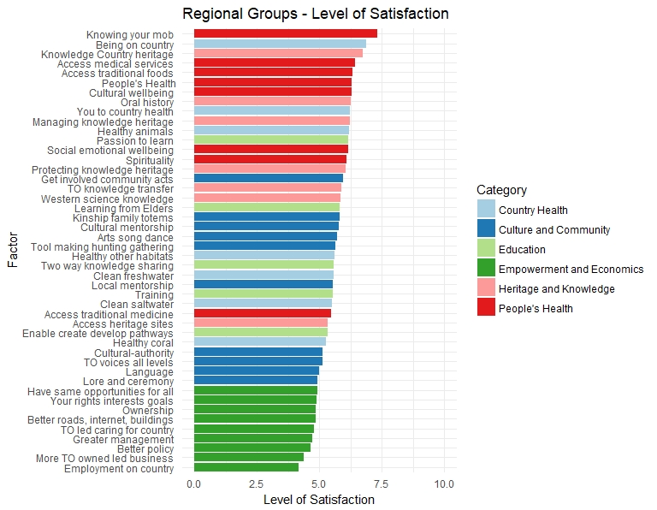
Figure 28. Level of satisfaction expressed by regional group responses to the survey.
Table 3. Satisfaction scores from combined individual surveys, group discussions, plus showing each segment scores separately.
 | Overall |  |  | Individuals |  |  | Groups
 | Mean | Min | Max | Mean | Min | Max | Mean | Min | Max
Being on Country | 6.24 | 1.00 | 10.00 | 6.87 | 2.00 | 10.00 | 4.07 | 1.00 | 8.00
You to country health | 5.69 | 0.00 | 10.00 | 6.21 | 0.00 | 10.00 | 3.70 | 1.00 | 10.00
Healthy animals | 5.85 | 0.00 | 10.00 | 6.18 | 0.00 | 10.00 | 4.69 | 0.00 | 9.00
Healthy coral | 4.81 | 0.00 | 10.00 | 5.26 | 1.00 | 10.00 | 3.23 | 0.00 | 9.00
Healthy other habitats | 5.11 | 1.00 | 10.00 | 5.61 | 1.00 | 10.00 | 3.25 | 1.00 | 9.00
Clean saltwater | 5.10 | 0.00 | 10.00 | 5.49 | 1.00 | 10.00 | 3.73 | 0.00 | 10.00
Clean freshwater | 5.29 | 0.00 | 10.00 | 5.56 | 1.00 | 10.00 | 4.32 | 0.00 | 10.00
Country Health | 5.39 | 1.00 | 10.00 | 5.86 | 1.57 | 10.00 | 3.89 | 1.00 | 9.00
Access to traditional medicine | 5.34 | 0.00 | 10.00 | 5.47 | 0.00 | 10.00 | 4.86 | 1.00 | 10.00
Spirituality | 6.18 | 0.00 | 10.00 | 6.09 | 0.00 | 10.00 | 6.56 | 2.00 | 10.00
Social emotional wellbeing | 5.95 | 0.00 | 10.00 | 6.15 | 0.00 | 10.00 | 5.23 | 1.00 | 9.00
Cultural wellbeing | 6.21 | 0.00 | 10.00 | 6.28 | 0.00 | 10.00 | 5.95 | 3.00 | 10.00
Access to medical services | 6.21 | 0.00 | 10.00 | 6.44 | 0.00 | 10.00 | 5.41 | 0.00 | 8.00
Access to traditional foods | 6.13 | 0.00 | 10.00 | 6.31 | 0.00 | 10.00 | 5.50 | 1.00 | 10.00
Knowing your mob | 7.33 | 2.00 | 10.00 | 7.30 | 2.00 | 10.00 | 7.45 | 2.00 | 10.00
People’s Health | 6.17 | 2.43 | 10.00 | 6.29 | 2.43 | 10.00 | 5.76 | 3.14 | 9.00
Oral history | 5.97 | 2.00 | 10.00 | 6.26 | 2.00 | 10.00 | 4.95 | 2.00 | 10.00
Knowledge Country heritage | 6.52 | 1.00 | 10.00 | 6.72 | 1.00 | 10.00 | 5.82 | 1.00 | 10.00
Managing knowledge heritage | 5.91 | 1.00 | 10.00 | 6.21 | 1.00 | 10.00 | 4.86 | 2.00 | 10.00
Protecting knowledge heritage | 5.59 | 1.00 | 10.00 | 6.05 | 1.00 | 10.00 | 4.00 | 1.00 | 10.00
Access to heritage sites | 5.06 | 0.00 | 10.00 | 5.34 | 0.00 | 10.00 | 4.00 | 0.00 | 10.00
TO knowledge transfer | 5.53 | 1.00 | 10.00 | 5.89 | 1.00 | 10.00 | 4.27 | 1.00 | 10.00
Western science knowledge | 5.31 | 1.00 | 10.00 | 5.86 | 1.00 | 10.00 | 3.45 | 1.00 | 10.00
Heritage and Knowledge | 5.70 | 1.86 | 10.00 | 6.06 | 1.86 | 10.00 | 4.48 | 1.86 | 8.29
TO voices all levels | 4.98 | 0.00 | 10.00 | 5.11 | 0.00 | 10.00 | 4.44 | 0.00 | 9.00
Get involved community acts | 5.80 | 2.00 | 10.00 | 5.95 | 2.00 | 10.00 | 5.13 | 2.00 | 8.00
Cultural mentorship | 5.48 | 1.00 | 10.00 | 5.76 | 1.00 | 10.00 | 4.40 | 2.00 | 10.00
Local mentorship | 5.26 | 0.00 | 10.00 | 5.54 | 0.00 | 10.00 | 3.94 | 2.00 | 10.00
Cultural-authority | 5.02 | 0.00 | 10.00 | 5.14 | 0.00 | 10.00 | 4.56 | 0.00 | 9.00
Language | 4.83 | 0.00 | 10.00 | 5.00 | 0.00 | 10.00 | 4.20 | 1.00 | 10.00
Lore ceremony | 4.62 | 0.00 | 10.00 | 4.92 | 0.00 | 10.00 | 3.33 | 0.00 | 10.00
Tool making hunting gathering | 5.47 | 0.00 | 10.00 | 5.63 | 0.00 | 10.00 | 4.69 | 2.00 | 10.00
Arts song dance | 5.38 | 0.00 | 10.00 | 5.71 | 0.00 | 10.00 | 4.10 | 2.00 | 10.00
Kinship family totems | 5.84 | 0.00 | 10.00 | 5.82 | 0.00 | 10.00 | 5.94 | 0.00 | 10.00
Culture and Community | 5.24 | 1.20 | 10.00 | 5.45 | 1.20 | 10.00 | 4.44 | 1.70 | 9.40
Learning from Elders | 5.98 | 1.00 | 10.00 | 5.82 | 1.00 | 10.00 | 6.67 | 2.00 | 10.00
Enable create develop pathways | 4.94 | 0.00 | 10.00 | 5.32 | 0.00 | 10.00 | 3.33 | 0.00 | 10.00
Training | 5.09 | 0.00 | 10.00 | 5.53 | 0.00 | 10.00 | 3.22 | 0.00 | 10.00
Passion to learn | 5.98 | 0.00 | 10.00 | 6.16 | 0.00 | 10.00 | 5.22 | 2.00 | 9.00
Two way knowledge sharing | 5.36 | 0.00 | 10.00 | 5.58 | 0.00 | 10.00 | 4.44 | 0.00 | 9.00
Education | 5.47 | 0.40 | 10.00 | 5.68 | 0.40 | 10.00 | 4.58 | 1.80 | 9.60
Ownership | 4.27 | 0.00 | 10.00 | 4.85 | 0.00 | 10.00 | 1.78 | 0.00 | 5.00
Greater management | 4.34 | 0.00 | 10.00 | 4.70 | 0.00 | 10.00 | 2.83 | 0.00 | 5.00
Better policy | 4.07 | 0.00 | 10.00 | 4.63 | 0.00 | 10.00 | 1.72 | 0.00 | 4.00
TO led caring for country | 4.72 | 0.00 | 10.00 | 4.79 | 0.00 | 10.00 | 4.44 | 0.00 | 10.00
Better roads internet buildings | 4.71 | 0.00 | 10.00 | 4.85 | 0.00 | 10.00 | 4.06 | 1.00 | 8.00
More TO owned led business | 3.93 | 0.00 | 10.00 | 4.38 | 0.00 | 10.00 | 1.94 | 0.00 | 3.00
Employment on country | 3.78 | 0.00 | 10.00 | 4.18 | 0.00 | 10.00 | 2.06 | 0.00 | 8.00
Have same opportunities for all | 5.01 | 0.00 | 10.00 | 4.92 | 0.00 | 10.00 | 5.39 | 2.00 | 10.00
Your rights interests goals | 4.39 | 0.00 | 10.00 | 4.90 | 0.00 | 10.00 | 2.17 | 0.00 | 9.00
Empowerment and Economics | 4.35 | 0.44 | 10.00 | 4.68 | 0.56 | 10.00 | 2.93 | 0.44 | 5.44
Overall satisfaction with quality of life overall | 6.01 | 2.00 | 10.00 | 6.69 | 2.00 | 10.00 | 3.77 | 2.50 | 5.00

4.3 Bringing together importance and satisfaction scores
Importance and satisfaction scores each provide information regarding different facets of the factors and hubs of life being evaluated. Importance scores let us see what really matters to people but don’t tell us whether action is required to improve or maintain it. Satisfaction scores highlight those factors where people are dissatisfied with the current level, but don’t provide us with information on how to prioritise the remedial actions that could be undertaken to improve the quality of those factors. However, combining information regarding the importance of different factors with the current levels of satisfaction with each of the factors enables us to prioritise which factors should be remedied first. That is, combining importance and satisfaction scores allows us to identify the factors where improvement should have the greatest impact on the wellbeing of Traditional Owners.
One accepted method of combining importance and satisfaction scores is to use a dissatisfaction index (Larson 2010) and use this to prioritise actions (Esparon et al. 2014). The index is calculated by converting the satisfaction score to a dissatisfaction score, where the scores are reversed with zero representing very satisfied and 10 representing very dissatisfied (for example, a satisfied score of eight would equate to a dissatisfied score of two, whereas a satisfied score of three would equate to a dissatisfied score of seven. The dissatisfaction score is then multiplied by the importance score for each factor to create the index. With such an index, the highest value would be 100 indicating a factor of maximum importance (score of 10) and with the greatest dissatisfaction (that is a satisfaction score of zero). The factors with the highest index scores are those where action should be targeted.
The dissatisfaction index scores are sorted into order such as the factor with the highest index score, and hence the factor most in need of policy action, being listed first, based upon overall scores from the individual surveys and the IHEG discussions.
Whilst there are differences in the index scores calculated based on group discussions, individual surveys or a combination of both, the relative positions of many of the factors are very similar (Table 4). Based on overall responses and individual responses alone, the index tells us that the highest priority factor where policy action should be focused is to increase/improve ‘Employment on Country’ (the third highest factor based on group surveys). Based on the IHEG responses the highest priority factor is to increase ‘Ownership’ (the 7th highest factor based on individual surveys). Other factors featuring prominently near the top of the dissatisfaction index based on both data sources suggest policy action should focus on facilitating more Traditional Owner-owned-and-led business, to create better policy, to improve rights, interests and goals, and to facilitate greater levels of Traditional Owner management within non-Traditional Owner-owned businesses. The individual survey data also prioritises Traditional Owner-led Caring for Country programmes, to provide the same opportunities for all, to ensure Traditional Owner voices are heard at all levels and to improve cultural authority. The IHEG discussions also prioritise improvements to lore and ceremony, training, healthy coral and other healthy habitats.
The factors at the top of the index, where improvements to the factors should contribute most to improving the wellbeing of Traditional Owners of the Great Barrier Reef land and sea country, are drawn mainly from the Empowerment and Economics hub. Thus, a clear message is highlighted — to improve Traditional Owner wellbeing, future actions should empower them and improve their economic prospects.
Table 4. Dissatisfaction index of factors based upon combined individual surveys and group discussions, plus showing each segment index separately, ranked by overall index scores.
Factor | Overall | Individuals | Groups
Employment on country | 59.60 | 55.03 | 79.44
More TO owned and led business | 56.75 | 52.51 | 75.11
Better policy | 55.36 | 49.34 | 80.78
Ownership | 53.40 | 46.97 | 81.22
Your rights interests goals | 52.56 | 47.82 | 73.11
Greater management | 52.28 | 47.70 | 71.11
TO led caring for Country | 50.77 | 49.63 | 55.56
Lore ceremony | 49.23 | 45.11 | 66.67
Healthy coral | 49.16 | 44.41 | 66.00
TO voices all levels | 47.77 | 46.34 | 53.78
Cultural authority | 47.65 | 46.27 | 53.33
Language | 47.60 | 44.87 | 58.00
Healthy other habitats | 47.29 | 42.90 | 64.40
Enable create develop pathways | 47.11 | 43.63 | 61.78
Access heritage sites | 46.84 | 43.51 | 59.80
Clean saltwater | 46.74 | 43.28 | 58.98
Better roads internet buildings | 46.55 | 44.13 | 58.38
Training | 46.15 | 41.29 | 66.67
Clean freshwater | 45.77 | 42.85 | 56.11
Have same opportunities for all | 45.73 | 46.36 | 43.00
Arts song dance | 42.94 | 38.71 | 59.00
Local mentorship | 42.44 | 38.51 | 60.63
Cultural mentorship | 42.38 | 38.89 | 55.60
Two way knowledge sharing | 42.17 | 41.34 | 45.67
Toolmaking hunting gathering | 41.65 | 39.24 | 53.13
Protecting knowledge heritage | 41.52 | 36.90 | 57.91
Access to traditional medicine | 41.36 | 38.76 | 50.34
You to country health | 41.17 | 35.53 | 62.60
TO knowledge transfer | 40.64 | 36.41 | 55.64
Healthy animals | 39.02 | 35.72 | 50.73
Managing knowledge heritage | 38.50 | 35.31 | 49.82
Kinship family totems | 38.30 | 37.76 | 40.56
Learning from Elders | 38.02 | 39.45 | 32.00
Get involved community activities | 37.59 | 35.61 | 47.00
Passion to learn | 37.47 | 35.21 | 47.00
Oral history | 37.40 | 34.03 | 49.36
Being on Country | 36.58 | 30.11 | 58.95
Social emotional wellbeing | 36.33 | 33.92 | 44.84
Cultural wellbeing | 35.32 | 32.72 | 44.55
Access traditional foods | 34.95 | 32.26 | 44.48
Knowledge Country heritage | 33.60 | 31.28 | 41.82
Western science knowledge | 33.07 | 30.38 | 42.59
Spirituality | 31.36 | 31.06 | 32.67
Access to medical services | 30.70 | 27.26 | 42.89
Knowing your mob | 22.82 | 22.90 | 22.52

The dissatisfaction index based on average scores for each hub is shown at Table 5. By repeating surveys each year, and recalculating the dissatisfaction index we will be able to monitor and evaluate the impact of actions taken; successful policy and actions in key areas will be reflected in a reduction in the index score for the relevant factors/hubs.
Table 5. Dissatisfaction index of hubs based upon combined individual surveys and group discussions, plus showing each segment index separately, ranked by overall index scores.
Domain | Overall | Individuals | Groups
Empowerment and Economics | 52.50 | 48.77 | 68.65
Culture and Community | 44.22 | 41.34 | 55.20
Country Health | 44.15 | 39.53 | 59.16
Education | 42.16 | 40.19 | 50.51
Heritage and Knowledge | 39.49 | 35.96 | 52.00
People’s Health | 34.65 | 32.46 | 42.39

The dissatisfaction index can also be calculated for different groupings within the sample. For example, comparing males and females we can see that both genders prioritise the Empowerment and Economics hub, but males would prioritise Education next whilst females would prioritise Culture and Community (Table 6).
Table 6. Dissatisfaction index for males and females.
Domain | Male | Rank | Female | Rank
Country Health | 41.01 | 4th= | 39.88 | 3rd
People’s Health | 33.46 | 6th | 33.02 | 6th
Heritage and Knowledge | 41.01 | 4th= | 33.17 | 5th
Culture and Community | 42.49 | 3rd | 42.07 | 2nd
Education | 44.01 | 2nd | 38.48 | 4th
Empowerment and Economics | 50.68 | 1st | 49.26 | 1st

We can also compare the dissatisfaction index across different regional groupings, as shown in Table 7. This analysis reveals substantial differences across the regions. Whilst all regions prioritise the Empowerment and Economics hub, Education is ranked second in the northern region, Culture and Community is ranked second in the central regions, and Country Health is the second most important in the southern region. Furthermore, in the northern and central regions the dissatisfaction of Traditional Owners with the Empowerment and Economics hub factors was much stronger than with any of the other hubs, whilst in the southern region, the dissatisfaction with the second placed hub, Country Health wasn’t much less than the dissatisfaction with the Empowerment and Economics hub. Thus, these index values imply that policy should prioritise improvements within the Empowerment and Economics hub across the entire Great Barrier Reef catchment, and on improvements within the Country Health hub in the south of the Reef region.
We also considered the index scores for individual factors across each of the geographic zones and again found notable differences. The factors causing the greatest dissatisfaction in each region (focusing only on those with a dissatisfaction index of 50 or higher) are set out in Table 8. As can be seen (outlined in table), none of the environmental factors (from within the Country Health hub) feature in this list for the northern region, but Clean Saltwater is a concern for the central region, and Healthy Other Habitats, Clean Freshwater, Clean Saltwater and Healthy Coral are all concerns in the southern region. Thus, the power of this analysis tool in revealing differences in priorities across geographic regions is highlighted by this example.
Extending this analysis in the future, a longitudinal analysis whereby the surveys are repeated with the same groups each year, would enable the evaluation of the impact of policy interventions.
Table 7. Dissatisfaction index by hub for different geographic regions.
Domain | North | Rank | Central | Rank | South | Rank
Country Health | 41.14 | 3rd | 43.04 | 4th | 48.08 | 2nd
People’s Health | 36.46 | 5th | 35.71 | 6th | 32.05 | 6th
Heritage and Knowledge | 35.97 | 6th | 47.58 | 3rd | 36.08 | 5th
Culture and Community | 41.04 | 4th | 47.85 | 2nd | 44.43 | 3rd
Education | 44.97 | 2nd | 38.91 | 5th | 41.84 | 4th
Empowerment and Economics | 53.05 | 1st | 52.83 | 1st | 51.74 | 1st

Table 8. Factors with highest dissatisfaction index values within each different geographic regions (only including those with index value of 50 or higher).
North | North | Central | Central | South | South
Factor | Index | Factor | Index | Factor | Index
Ownership | 56.53 | More TO owned led business | 60.54 | Employment on country | 65.50
Employment on country | 55.12 | Employment on country | 57.31 | Better policy | 56.94
More TO owned and led business | 55.06 | TO knowledge transfer | 55.80 | Your rights interests goals | 56.33
Greater management | 54.40 | Lore ceremony | 55.46 | More TO owned led business | 55.61
Better policy | 54.00 | Better policy | 54.85 | TO led caring for country | 54.47
Better roads internet buildings | 51.53 | Ownership | 54.62 | Training | 53.24
Your rights interests goals | 50.71 | Cultural authority | 54.57 | Healthy other habitats | 52.00
TO voices all levels | 50.00 | TO voices all levels | 54.15 | Clean freshwater | 51.57
 |  | Greater management | 51.62 | Clean saltwater | 51.15
 |  | Language | 51.29 | Greater management | 51.00
 |  | Clean saltwater | 50.80 | Healthy coral | 50.59
 |  | Access heritage sites | 50.13 | Access heritage sites | 50.06

4.5 Feedback regarding the survey and factors that could be used to improve the survey in future years
Comments made in group discussions pertaining to specific factors were as follows:
- Clean freshwater — a number of groups commented that the freshwater was currently clean and of good quality because we are at the end of a good wet season; thus for a longitudinal study some additional context would be required to understands trends in data here. Perhaps an additional question asking about the last wet season is required.
- Spirituality — one group found this factor hard to score as they did not know the context behind this factor; again additional explanatory notes could be provided in future.
- Knowing your mob — one group suggested this factor should be renamed to ‘respecting your mob’. However, these terms do mean different things – the aim of this factor was to capture whether people really know where they come from and where they belong. Thus, additional clarification could be added to a future survey with regard to this factor.
- Protecting knowledge and heritage — it was suggested this could be better named ‘Preserving knowledge and heritage’.
- Access to heritage sites — this factor was interpreted as meaning either (i) whether the Traditional Owners had access themselves to their heritage sites or (ii) whether Traditional Owners were able to control access to their sites by other people, such as tourists.
- Responses also reflected both restricted access due to sites being owned/used by others (for example, mining, farming) but also restrictions to access due to the lack of financial resources to actually get to the sites. Clarification notes should be provided in future, and consideration given to sub-dividing this into two questions.
- Traditional Owner knowledge transfer — it was suggested that ‘transfer’ was a poor choice of words, and this factor should be renamed ‘Traditional Owner knowledge sharing’.
- Cultural authority — the meaning of this factor was questioned by one group, and thus perhaps should be clarified for future surveys.
- Lore and ceremony — one group suggested that lore should be defined.
- Ownership — it was noted that even for groups where Native Title has been determined they still don’t have true ownership of land, and this doesn’t help them to achieve ownership of other assets like housing. The impact of native title (or lack of impact) cannot easily be determined from the questions as currently phrased.
Comments regarding factors important for Traditional Owner wellbeing which respondents felt were missing from the Strong peoples – Strong country wellbeing framework:
- strong engagement with Traditional Owners on all matters pertaining to Traditional Owners
- strong investment in Traditional Owners to ensure land and sea country is protected and cared for by Traditional Owners
- youth advisory and development services.
One respondent also felt that the individual survey was too complicated.

4.6 Summary of conclusions drawn from analysis of responses
Our analysis of the responses to the individual surveys and the IHEG discussions have revealed that the factors identified within the Strong peoples – Strong country wellbeing framework are highly important to the wellbeing of Traditional Owners of the land and sea country of the Great Barrier Reef. Although no significant omissions were revealed, some useful comments were received that will be used to refine the future use of the survey and framework.
Analysis of the responses to both individual surveys and group discussions has been shown to provide useful information regarding the current quality of environmental, social, cultural and economic factors, and can be used to identify priorities for future actions. Repeating the process in future years, and building up a longitudinal dataset, will also facilitate the identification of trends and enable impact evaluation to be undertaken.
Furthermore, our results indicate there may be important spatial differences in the power and impact of the linkages between overall wellbeing and the underlying hubs and factors; that is, the factors that impact most on current levels of wellbeing amongst Traditional Owners differ according to the region where they live or identify with.
Thus, consistent with the purpose of RIMReP, we recommend that the survey process is repeated in future years to build up a longitudinal dataset, facilitating impact evaluation of policy interventions. Additional data would also facilitate further statistical analysis of the strength of the relationships of the interconnected factors and hubs within the wellbeing framework (limited here due to the small sample size). Minor amendments should be made to the survey instrument in future years, reflecting the feedback from participants.

4.7 Synopsis of current status of Indigenous heritage on the Great Barrier Reef
As noted in the beginning of this report, Addison et al. (2015) in their review of existing monitoring, found that “The most striking gap in socio-economic monitoring is the absence of dedicated and co-ordinated monitoring pertaining to Traditional Owner use, dependency and wellbeing”. The Draft Strategy highlights the many interlinked components of heritage, including culture, people and practices. A synopsis of the current status of Indigenous heritage is therefore challenged by the absence of an existing program of monitoring, evaluation and reporting.
Nevertheless, as noted in the Draft Strategy, the Strategic Assessment included an assessment of the condition of Indigenous heritage values. This assessment was based on literature, meetings, workshops and survey undertaken specifically for the strategic assessment in the latter half of 2012, and through direct conversations with Traditional Owners. For the Strategic Assessment, Indigenous heritage values were combined into four broad categories:
- sacred sites, sites of particular significance, places important for cultural tradition;
- Aboriginal and Torres Strait Islander structures, technology, tools and archaeology;
- stories, songlines, totems and languages; and
- cultural practices, observances, customs and lore (The Great Barrier Marine Park Authority 2015).
The Strategic Assessment noted that the Reef had been affected by numerous impacts that were grouped into four broad categories: climate change; catchment run-off; degradation of coastal ecosystems; and direct use. Indigenous heritage values were found to have been severely affected by these impacts, with their effects intensified by the closeness of Traditional Owners’ relationship to the environment Table 2.
The survey results presented above provide an opportunity to present a rating of the current status of Indigenous heritage across the Reef using the indicators to measure asset condition in relation to the outcomes, objectives and actions in the Draft Strategy, once finalised (see Appendix Two).
Table 9. Condition and trend of Indigenous heritage values (Source: The Great Barrier Marine Park Authority 2015; 2018, p. 13)
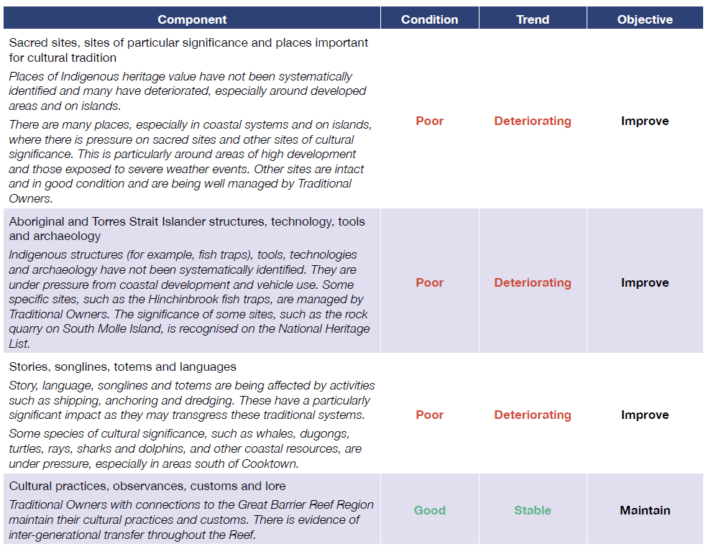

5.0 Priority indicators to monitor Indigenous heritage on the Great Barrier Reef

5.1 Overview of existing objective indicators

5.1.1 Indicators to assess Strong peoples – Strong country
The satisfaction scores in relation to each of the factors in the Strong peoples – Strong country framework provide subjective indicators suitable for establishing a baseline and ongoing monitoring, if repeated as is intended under the Reef 2050 Plan. Thus, this data provides the first point in our recommended Indigenous-led monitoring programme for the Great Barrier Reef region. Furthermore, the satisfaction and importance data can be combined to provide a guide for policy prioritisation (Larson, 2010), in accordance with the following guidelines (based around the work of Esparon et al., (2014)):
- high importance, high satisfaction — as an important factor, this should be a focus of on-going monitoring to ensure it remains at the current high level; if on-going monitoring reveals reducing satisfaction then action is required to rectify the worsening situation.
- high importance, low satisfaction — action should be taken to address current poor condition; on-going monitoring should be implemented to evaluate impact of remedial actions.
- low importance, high satisfaction — a low level monitoring process should be implemented, possibly at lower frequency and intensity than that for high importance factors.
- low importance, low satisfaction — a low level monitoring process should be implemented as for low importance, high satisfaction factors above. Any actions undertaken to address poor condition should be given lower priority than actions to address poor condition of factors rated with higher importance, but if actions are undertaken then monitoring of the outcomes of these actions is required to enable effective impact evaluation to be undertaken.
The responses to the importance of and satisfaction with questions allow us to test the statistical validity of the Strong peoples – Strong country framework and enable the strength of the relationships between the factors and the overall wellbeing of Traditional Owners to be quantified.
Following the questions regarding the importance of and satisfaction with each of the factors, the survey concludes with two final questions. The respondent is told that we have listed all the factors that we think are important to Strong peoples – Strong country within the previous sections of the survey. The respondent is then asked whether they think any factors that are important to them have been omitted, and if so, to let us know by writing in the space provided below. This question provides information to enable us to test the completeness of the Strong peoples – Strong country framework.
The survey concludes by thanking the respondent for completing the survey and asking if they would be willing to participate in further surveys in future years. If so, then they are requested to enter their name and an email address or mobile number so that we are able to contact them. Those respondents who do agree to complete future surveys will form the basis of our longitudinal subjective data monitoring programme, supplemented by other respondents who will be recruited during the following year from the length of the Great Barrier Reef catchment. By gathering longitudinal data over a number of years on the subjective satisfaction of the Traditional Owners of the region with each of the factors, we will be able to both determine any trends that may emerge (either improving or declining satisfaction) and will also be able to evaluate the impact of any actions taken to address any decline in conditions of different factors.
In addition, the Reef-wide Traditional Owner Workshop focused attention on the need to collect data at the Traditional Owner group level, and to spatially locate these data.
These Strong peoples – Strong country indicators provide a good basis for measuring Traditional Owners’ perceptions of the impact of both the Reef 2050 Traditional Owner Actions (Appendix One), and the Draft Strategy (Appendix Two) on condition of the asset.

6.0 Scoping of further potentially relevant objective indicators

6.1 Introduction to Traditional Owner-driven indicators
Indigenous peoples have matured, long-standing traditions of tracking changes in land, water, natural systems, and many now adapt new technologies and tools to their monitoring. The Great Barrier Reef Traditional Owners have established a priority to apply indicators that are two-way and participatory (Dale et al. 2016). The information provided here is intended to support this aim of developing and using two-way participatory indicators, and stimulate further discussion, addition and prioritisation through subsequent participatory processes. More work will need to be carried out to determine the specific details of appropriate indicators with each Traditional Owner group, based on their local cultural perspectives with regard to values, knowledge and needs, and associated with data-sharing arrangements (Sterling et al. 2017). For example, Shortland (2011) describes the process used in New Zealand to select species as indicators of Kauri ngahere:
“To choose which species and indicators were to be included was a four-step process. The first step was the inclusion of species which have been found living on kauri (approximately 60 species). The second step was the inclusion of species which have been identified living near kauri (approximately another 30 species). The third step was to include species from the ngahere known to be vulnerable to environmental change such as pepeketua (frogs). Fourthly, the examination of the 100 or so species for knowledge of their cultural value and their value as a cultural health indicator was carried out. Where limited information was found on the species they were excluded from the report. There were many references to the use of species for ceremonial purposes including for tohi or ceremonies. It was decided that the detail of such information would be excluded from the cultural indicator programme in order to protect the wairua of such matters, but a reference would be made using a general statement such as, “this species was used for ceremonial purposes”.
We reviewed published and available unpublished sources of information about indicators (Appendix Three) and selected from these a range of indicators that potentially tell us something about how we are tracking in terms of the factors that underpin Strong peoples – Strong country. These indicators are presented in Appendix Four.

6.2 Traditional Owner-driven objective indicators – MERI, two-way and traditional indicators
Information collected at the Reef-wide Traditional Owner Workshop from the 1-3 May 2018, showed that three types of indicators are currently in use by Traditional Owners:
- Indicators to meet governments’ requirements for MERI approaches in order to monitor Indigenous Protected Areas, Rangers’ work-plans and other projects
- Two-way indicators, where Traditional Owners have developed data sharing arrangements with key researchers and research investors (e.g. JCU and the National Environmental Science Programme (NESP) Marine Biodiversity Hub)
- Traditional indicators provided by the Elders in situations where people have a greater level of control over their lands and seas. Data generally not shared.
Traditional Owners at the workshop explained that data-sharing agreements would be needed for their own indicators, which are based on Traditional Knowledge, to be shared. Publicly available indicators in use by Traditional Owners in the Great Barrier Reef Marine Park show that indicators are being used that reflect different levels in the Australian Government’s MERI approach.
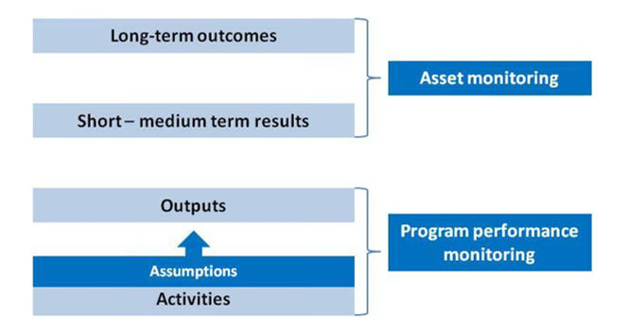
Figure 29. Three levels of monitoring: Activities/outputs; outcomes; and asset condition. Source. Australian Government 2009. See also http://www.nrm.gov.au/system/files/resources/3e040629-4825-4c3a-8a97-133003e73be2/files/regional-land-meri-framework.pdf

Table 10. Different levels of indicators in use by Traditional Owner groups
Indicator objective | Indicator | Type of indicator | Source
Look after springs and wells. We want to get our rangers involved in cleaning and weeding springs and wells. Some might need to be fenced to keep pigs and other animals out. | Numbers of springs and wells cleaned and being maintained | Progress of activities and outputs | Eastern Kuku Yalanji IPA Management Plan  Stage 2 – Jalunji-Warra land and sea country
Employment with QPIandF in monitoring and managing the Fish Habitat Area, and the monitoring of fish populations in the East Trinity Reserve | Those in use by Queensland Government as a starting point | Science-based monitoring of fish populations is a measure of asset condition | Mandingalbay Yidinji Strategic Plan
Protect cling gobies – we will work again with scientists who are researching species of cling gobies (Stiphodon spp.) that have been found only in Wet Tropics coastal creeks. | Numbers of cling gobies surveyed | Progress of activities and outputs | Eastern Kuku Yalanji IPA Management Plan  Stage 2 – Jalunji-Warra land and sea country
Agree protocols for scientific research, including an agreement that scientists will need to be welcomed to Country before their research, be accompanied by TOs during research and make their research findings available to us after their research. | Proportion of scientific researchers who work with Bama when undertaking research on our Country | Progress of activities and outputs
Bring together community knowledge and scientific surveys to describe the current health and status of the mussel beds, and what could affect mussel health | Numbers and health of mussels, DNA samples, and interviews | Measure of asset condition; two-way participatory; data-sharing agreements | Freshwater mussel surveys from the Annan River; Yuku Baja Muliku Country

Traditional Owners’ advice on the processes for ongoing development of indicators were highlighted at the Reef-wide Traditional Owner Workshop. Key points made include:
- development of objective indicators need to start with development of sea country plans by each Traditional Owner Group;
- where Traditional Owner Groups already have sea country plans, these need to be updated to take account of changing conditions;
- a lot more time is needed to develop and collect local-scale and two-way indicators and negotiate their use by RIMReP and others;
- need solid joint management arrangements to develop and use indicators
- pilots that test key [objective] indicators and track their relationship with peoples’ health are important (for example, testing on ground of the Strong peoples – Strong country framework); and
- traditional indicators are showing huge changes, seasonal calendars are out of whack, Traditional Owners need to learn to re-read the country.
In addition, Traditional Owners were very keen to be trained in techniques that would allow them to be employed to collect science-based indicators, including for all the other indicators in the RIMReP.

6.3 Key challenges and opportunities for further development of Traditional Owner-driven indicators
In reviewing information about Traditional Owner-driven indicators, we have encountered similar challenges to those described by Shortland (2011):
- there is a scarcity of information and examples of indicators applicable to Great Barrier Reef land and sea country or to this spatial scale of monitoring;
- cultural indicators have been developed for a variety of different purposes (for example, to measure the success of joint management planning, to monitor the impacts of mining on water resources) and may not be easily transferable to monitoring the biocultural health of the Reef; and
- two-way indicators require collaborative development at the local scale.
Many of the indicators used by Indigenous peoples (Yuhuan et al., 2011) are based on information about:
- life cycles of plants and animals;
- observed behaviour and numbers of native species (for example, animal use of certain habitats, flowering patterns);
- species migrations (for example, when they arrive and depart, length of stay, numbers/locations);
- availability and health of food resources;
- access to medicine, ceremonial and other resources; and
- weather cycles.
Traditional Owners at the Reef-wide Traditional Owner Workshop explained how these indicators were undergoing rapid change.

6.4 Partnering with global initiatives in a Community of Practice
Many groups of Indigenous peoples and local communities around the world are grappling with the challenges associated with identifying, developing and applying Traditional Owner-driven indicators at appropriate scales (Sterling et al. 2017). Recently an Action Group on Knowledge Systems and Indicators of Wellbeing (Action Group) was formed. The Indigenous Heritage Expert Group Chair and an Indigenous scientist in the support team attended a meeting of the IHEG on April 21-22, 2018 at the American Museum of Natural History in New York City. The Action Group aims to inspire action and promote dialogue, exchange, and co-creation of knowledge among different stakeholders regarding the linkages between nature and culture. The Action Group will connect a broad range of people involved with management and protection of nature and culture (including Indigenous peoples and local community representatives, policy makers, researchers, and conservation professionals) for collective thinking about future action, research directions, and policy recommendations to promote and strengthen the links between biological and cultural diversity.
By engaging in cross-cutting exploration of knowledge and wellbeing themes across multiple regions, the Action Group is specifically interested in better understanding of how to synthesize and harmonize across efforts to design indicators that encompass both biological and cultural wellbeing. This Action Group can provide critical support to place-based, culturally relevant indicators for managing and monitoring resources and planning for the future at the local scale. In addition, collaboration between local and international indicator initiatives can synergize cross-scale planning so that the local-scale indicators developed by different Traditional Owner groups can be used over time to gain an objective measure of trends across the Great Barrier Reef region. The April meeting shared information and established a ‘community of practice’ amongst people addressing these common issues (Figure 30). Continuing engagement of Great Barrier Reef Traditional Owners with the community of practice in the next stage of RIMReP will be extremely useful and beneficial.
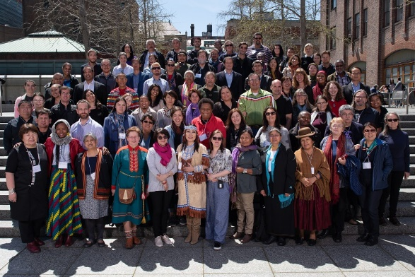
Figure 30. Attendees at the Action Group Action Group on Knowledge Systems and Indicators of Wellbeing in New York, April 2018

6.5 Priority indicators
Given the early stage of development of objective two-way participatory indicators and the challenges involved, we recommend the priority indicators for Indigenous heritage as those to assess the Strong peoples – Strong country framework.
Table 11. Priority indicators to monitor Indigenous heritage through our Strong peoples – Strong country framework
Priority Indicator | Justification for selection
Subjective view of importance of various factors – to be determined by use of survey. Both TO group and individual. | Factors considered important to overall TO wellbeing as embodied by the phrase Strong peoples – Strong country were determined by Indigenous Heritage Expert Group and tested with TOs from across the Great Barrier Reef region at the Reef Wide Workshop in May 201, using both and individual and at TO group measure. This information was selected as understanding relative importance of different factors is vital if we are to appropriately prioritise and target monitoring activities and remedial actions.
Subjective view of satisfaction with overall TO wellbeing with the various underpinning factors – to be determined by use of survey. Both TO group and individual. | The subjective level of satisfaction of TOs with their overall wellbeing and with the individual factors that contribute to their wellbeing was collected from TOs from across the Great Barrier Reef region at the Reef-Wide Workshop in May 2018, again using both individual and TO group perspective. This provides baseline data as at the commencement of the long-term monitoring programme. Longitudinal data should be gathered by repeating the survey on an at least an annual basis. More frequent sampling may pick up seasonal variations, but would also be challenging logistically. Future survey respondents should include as many of the original respondents as possible to establish the beginning of a panel dataset whereby data is gathered from the same people each year. Additional respondents to include within the longitudinal dataset from 2019 onwards should be sourced during the latter half of 2018/early 2019, perhaps by the selection and training of ‘Champions’ based within each of the regions.
Mapping data | The surveys with each TO group in their area would allow a spatial representation of the data, similar to Pert et al. (2015).
Development of the objective participatory two-way indicators that support these subjective indicators is a high priority and requires further investment. The recent Australian Government contract with the Reef and Rainforest Research Centre (RRRC) - Northern Australia Indigenous Land and Sea Management Alliance (NAILSMA) consortium provides an opportunity to further develop these indicators, as the consortium is required to:
“Develop an approach to support Traditional Owner engagement in monitoring, evaluation and reporting activities as part of the Reef 2050 Plan reporting process that: meets the needs of the Reef 2050 Plan reporting obligations; builds Traditional Owner capacity in monitoring, evaluation and reporting activities, including under the Reef 2050 Integrated Monitoring and Reporting Program; and liaise with agencies that partner with Traditional Owners to deliver Reef 2050 Plan actions to ensure a consistent and holistic approach that does not duplicate current reporting processes.”
As noted above, the advice of Traditional Owners at the Reef-wide Traditional Owner Workshop in May 2018 was to work on an approach that included:
  - providing training and employment for Traditional Owners to collect indicators for a range of the RIMReP monitoring activities;
  - support Traditional Owner groups to prepare and update sea country plans;
  - include development of appropriate, participatory, two-way indicators in these plans; and
  - negotiate data sharing agreements with Traditional Owner Groups to enable relevant data to be collected, analysed and scaled across the Great Barrier Reef region.

7.0 Evaluation of the adequacy of current monitoring of Indigenous heritage on the Great Barrier Reef

7.1 Synopsis of existing monitoring programs
The Indigenous Heritage Expert Group has reviewed available information about relevant monitoring in the Great Barrier Reef region, and agrees with the conclusion of Addison et al. (2015) that a key gap exists in relation to monitoring Traditional Owner wellbeing, use and dependency in the Reef.
While a number of objective indicators are in use by Traditional Owner groups, these do not yet constitute an adequate or complete basis for monitoring Indigenous heritage across the Reef. The Strong peoples – Strong country framework and indicators provides an immediate subjective measure addresses the key gaps. Nevertheless, a key priority is to take forward the development of objective indicators through the processes discussed at the Reef-wide Traditional Owner Workshop, in May 2018, including:
- the development of [objective] indicators required to start development of sea country plans by each Traditional Owner Group;
- updating sea country plans, where already in place, to take account of changing conditions;
- more time to develop and collect local-scale and two-way indicators and negotiate their use by RIMReP and others;
- solid joint management arrangements to develop and use indicators
- pilots that test key [Objective] indicators and track their relationship with peoples’ health are important (e.g. testing on ground of the Strong peoples – Strong country framework); and
- a review of traditional indicators which are showing huge changes, seasonal calendars are out of whack. Traditional Owners need to learn to re-read the country.
In addition, Traditional Owners were very keen to be trained in techniques that would allow them to be employed to collect science-based indicators, including for all the other indicators in the RIMReP.

7.2 Adequacy of existing monitoring programs
As noted above, the testing of the Strong peoples – Strong country framework through this project was the first attempt at a Reef-wide assessment using Traditional Owner-driven methodologies. This is an important step forward and can provide an adequate basis for monitoring of asset condition while the objective indicators are developed.
Further data analysis and Indigenous Heritage Expert Group advice is required to prepare a report on the Indigenous heritage asset condition in the Marine Park using the Strong peoples – Strong country framework. In addition, the Draft Strategy needs to be finalised to enable completion of the mapping of indicators against outcomes as presented in Appendix Two.

7.3 Gaps in current monitoring effort
There has been no previous systematic effort to monitor the condition of the Indigenous heritage asset in the Great Barrier Reef region.

8.0 New technologies for monitoring Indigenous heritage on the Great Barrier Reef
Traditional Owner-driven monitoring is a new technology, which involves a range of social and cultural innovations. In particular for this project, this includes:
- an Indigenous governance group (in this case the Indigenous Heritage Expert Group members who are Traditional Owners);
- adoption of Traditional Owner-driven research methodologies; and
- regional community-level collection of data, as well as individual surveys.
Further development of the Strong peoples – Strong country framework and indicators will require further innovations, including:
- Traditional Owner Group-level collection of data;
- training of community researchers to collect the data;
- spatial location of the data;
- ongoing guidance of the work by an Indigenous governance group; and
- collaborative development of the data analysis and reporting dashboard.
The Reef-wide Traditional Owner workshop highlighted that new technologies, such as drones, are in use by Traditional Owner groups as they develop their local-level objective indicators. These technologies will provide interesting input to the objective indicators process.

9.0 Recommendations for integrated monitoring of Indigenous heritage on the Great Barrier Reef
The recommendations are set out in Table 12.
Table 12. Recommended survey methods, locations and frequency
Priority Indicator | Survey Method | Survey Location (Spatial) | Survey Frequency (Temporal) | Other information
Strong peoples – Strong country indicators | TO group survey completion together with individual survey completion annually | Each of the TO groups across the region | Annual. Requires training and meetings of the Indigenous governance groups to accompany the surveys. | Completion of the survey would then require analysis and mapping to provide an assessment of Indigenous heritage asset condition and progress on the Reef 2050 TO objectives and targets (Appendix One and Two)

In addition, further work on indicators with Traditional Owners needs to be taken forward including through an approach that enables:
- provision of training and employment for Traditional Owners to collect indicators for a range of the RIMReP monitoring activities;
- support for Traditional Owner Groups to prepare and update sea country plans and other monitoring for adaptive management approaches currently in use (for example, cultural site monitoring in the Mackay-Whitsunday Healthy Rivers to Reef Partnership);
- support for the development of appropriate Traditional Owner-driven participatory two-way indicators through these plans or other relevant initiatives;
- negotiations of data sharing agreements with Traditional Owner Groups to enable relevant data to be collected, analysed and scaled across the Great Barrier Reef region; and
- design and implementation of the data synthesis procedures and the analysis protocols to contribute to the dashboard for assessment and reporting.

10.0 Assessment of the resources required to implement the recommended design
Table 13 provides information on the people, days and resources required for implementation of the recommended design. The estimates here are based on recognition of approximately 70 different Traditional Owner groups across the Great Barrier Reef region. Not all groups will require the same amount of resourcing, and in some cases not all groups will require all activities. Some of the costs in this table will be much higher in the first year.
Table 13. Resources required to implement monitoring of Indigenous heritage based on the Strong peoples – Strong country framework and indicators
Item | Details (Annual) | Days/dollars (Annual)
Indigenous Heritage Expert Group (paid) | 3 meetings (1-2 days), 9 persons | 40 days
Indigenous community researchers | Training, data collection, 10 days each, 70 TO groups | 700 days
IHEG members visit to the communities | 1 day community meeting to explain the project, including selection of community researchers | 70 days
Costs of community meetings | Venue, lunch, travel costs to attend meetings $800 per meeting | $56,000⁴
Research support –scientists (1 FTE) | Data analysis, training, reporting writing, spatial analysis, development of dashboard | 200 days
Research support – spatial analyst | Mapping of data | 20 days
IHEG Research Project Officer – full time project leader (1 FTE) | Project leader, training, IHEG support | 200 days
Research support – project support | Logistics of meetings | 50 days
Travel – Indigenous governance meeting | $1,000 per person each for each meeting | $27,000
Travel – for IHEG members to the community meetings | $1,000 per person per meeting | $70,000⁵
Travel – for Indigenous community members to attend training | $1,000 per person per meeting | $70,000⁵
Travel – for research project officer to accompany Indigenous | $1,000 per person per meeting | $70,000⁵
Training workshop- venue and accommodation for 2 days | Training workshop costs | $50,000
Communications, including graphic design support | Indigenous designs, printing materials | $15,000
Operations | Software, editing support, other | $7,500
Meeting venue and catering | $1,000 per meeting | $3,000
Community of Practice on Indigenous and Local People’s Indicators | Ongoing participation in relevant meetings and dialogues to share resources | $5,000

We are not able to provide cost estimates for the remainder of the work to develop the objective indicators. However, the further development of Traditional Owner roles in monitoring, including using objective indicators, will be taken forward by the NAILSMA-RRRC project and will enable the provision of cost estimates. Table 14 sets out some of the types of costs that are likely to be involved.

Table 14. Components of work required to develop Traditional Owner-driven objective indicators for Indigenous heritage monitoring and engage Traditional Owners more broadly in monitoring activities across RIMReP.
Item | Details (Annual) | Days/dollars (Annual)
Providing training for Traditional Owners to collect data for indicators for a range of the RIMReP monitoring activities | Community meetings to explain the availability of the training, its likely outcomes, agreement on community processes to select the trainees | $X
 | Payment of staff to organise and conduct community workshops | X days
 | Payment of Traditional Owners to attend training | X days
 | Costs of the training workshops, including trainers, venue, food | $X
 | Travel and accommodation for participation in the training and for the community workshops | $X
Providing employment for Traditional Owners to collect data for indicators for a range of the RIMReP monitoring activities | Organisations responsible for monitoring of other components of RIMReP to employ Traditional Owners with relevant training | X days
 | Providing equipment necessary to undertake the community workshops | $X
 | Other activities to enable ongoing support and supervision of the monitoring effort | X days
Supporting Traditional Owner groups to prepare and update sea country plans and other monitoring for adaptive management in use | Level of resourcing and time required for this will be highly diverse across groups with existing Plans, and those with existing monitoring methods, such as the cultural site monitoring in the Mackay-Whitsunday Healthy Rivers to Reef Partnership | $X
 | May include, for example, payment of staff to organise and conduct community engagement workshops and other elements | X days
Supporting development of appropriate Traditional Owner-driven participatory two-way indicators through these plans or other relevant initiatives | Levels of resourcing and time required will be highly diverse across groups with existing two-way indicators, and those who have not yet begun to implement these. | $X
 | Equipment may be necessary to undertake this work | $X
 | Staff time will be necessary | X days
Negotiating data sharing agreements with Traditional Owner Groups to enable relevant data to be collected, analysed and scaled across the Great Barrier Reef region. | The data sharing agreements required are still in the development phase, and it is not possible to provide any estimate of the likely tasks involved | $X
Designing and implementing the data synthesis procedures and the analysis protocols to contribute to the dashboard for assessment and reporting. | It is not possible at this stage to provide a breakdown of the likely steps involved. | $X

11.0 References
Addison, P., Walshe, T., Sweatman, H., Jonker, M., MacNeil, A., Thompson, A., Logan, M. (2015) Towards an integrated monitoring program: Identifying indicators and existing monitoring programs to effectively evaluate the Long Term Sustainability Plan. Retrieved from http://nesptropical.edu.au/wp-content/uploads/2016/01/NESP-TWQ-3.8-FINAL-REPORT.pdf
Austin, B. J., Vigilante, T., Cowell, S., Dutton, I. M., Djanghara, D., Mangolomara, S., … Clement, Z. (2017). The Uunguu Monitoring and Evaluation Committee: Intercultural Governance of a Land and Sea Management Programme in the Kimberley, Australia. Ecological Management and Restoration, 18(2), 124–133. https://doi.org/10.1111/emr.12257
Australian Government. (2009). NRM MERI Framework Australian government natural resource management monitoring, evaluation, reporting and improvement framework. Canberra, Australia. Online: http://nrmonline.nrm.gov.au/catalog/mql:2338: Caring for our Country.
Babai, D., Molnár, Z. (2018) List of local (IPLC-defined) biocultural indicators closer to the ecological end of the socio-ecological continuum (preliminary listing based on 405 individual indicators found in 51 publications). Unpublished.
Cairney, S., Abbott, T., Quinn, S., Yamaguchi, J., Wilson, B., and Wakerman, J. (2017). Interplay wellbeing framework: A collaborative methodology “bringing together stories and numbers” to quantify Aboriginal cultural values in remote Australia. International Journal for Equity in Health, 16(1), 1–13. https://doi.org/10.1186/s12939-017-0563-5
Commonwealth of Australia. (2015). Reef 2050 Long-Term Sustainability Plan. Retrieved from https://www.environment.gov.au/system/files/resources/d98b3e53-146b-4b9c-a84a-2a22454b9a83/files/reef-2050-long-term-sustainability-plan.pdf
Dale, A., George, M., Hill, R., and Fraser, D. (2016). Tradtional Owners and sea country in the Southern Great Barrier Reef – Which Way Forward? Retrieved from Report to the National Environmental Science Programme. Retrieved from http://nesptropical.edu.au/wp-content/uploads/2016/05/NESP-TWQ-3.9-FINAL-REPORT.pdf
Davies, Jocelyn, Rosemary Hill, Fiona J. Walsh, Marcus Sandford, Dermot Smyth, and Miles C. Holmes. (2013). "Innovation in Management Plans for Community Conserved Areas: Experiences from Australian Indigenous Protected Areas." Ecology and Society 18 (2):14. Online: http://www.ecologyandsociety.org/vol18/iss2/art14/. doi: 10.5751/ES-05404-180214.
Díaz, S., Pascual, U., Stenseke, M., Martín-López, B., Watson, R. T., Molnár, Z., … Shirayama, Y. (2018a). Assessing nature’s contributions to people (Supplementary Information). Science, 359(6373), 270–272. https://doi.org/10.1126/science.aap8826
Díaz, S., Pascual, U., Stenseke, M., Martín-López, B., Watson, R. T., Molnár, Z., … Shirayama, Y. (2018b). Assessing nature’s contributions to people. Science, 359(6373), 270 LP-272. Retrieved from http://science.sciencemag.org/content/359/6373/270.abstract
Du, Y., Luo, G., Xue, D., and Sun, F. (2011). Structure framework of the traditional knowledge database in China. In Proceedings - 2011 4th International Conference on Intelligent Networks and Intelligent Systems, ICINIS 2011 (pp. 232–235). https://doi.org/10.1109/ICINIS.2011.50
Esparon, M., Stoeckl, N., Larson, S., Farr, M., and Schmider, J. (2014). How 'valuable' are the ecosystem services of the Wet Tropics World Heritage Area to residents and tourists? Report to the National Environmental Research Program. Reef and Rainforest Research Centre Limited, Cairns.
The Great Barrier Marine Park Authority. (2015). Great Barrier Reef Region Strategic Assessment: Strategic Assessment Report. Townsville, Australia. Online: http://www.the Authority.gov.au/managing-the-reef/strategic-assessment: Great Barrier Reef Marine Park Authority.
The Great Barrier Marine Park Authority. (2018). Draft Aboriginal and Torres Strait Islander heritage strategy for the Great Barrier Reef Marine Park. Townsville, Australia. Online: http://elibrary.gbrmpa.gov.au/jspui/bitstream/11017/3338/1/GBRMPA_Draft_ATSI_HeritageStrategy.pdf
Gooch, M., Curnock, M., Dale, A., Gibson, J., Hill, R., Marshall, N., … Vella, K. (2017). Assessment and Promotion of the Great Barrier Reef’s Human Dimensions Through Collaboration. Coastal Management, 45(6), 519–537. https://doi.org/10.1080/08920753.2017.1373455
Great Barrier Reef Marine Park Authority and Queensland Government. (2015). Reef 2050 Integrated Monitoring and Reporting Program Strategy. Edited by the Great Barrier Reef Marine Park Authority. Retrieved from https://issuu.com/gbrmpa/docs/rimrep_program_strategy_booklet.
Greiner, R., Larson, S., Herr, A., and Bligh, V. (2005). Wellbeing of Nywaigi Traditional Owners: The contribution of country to wellbeing, (July).
Healthy Rivers to Reef Partnership. (2017). Cultural Heritage Assessments. Retrieved from healthyriverstoreef.com.au/reportcard/cultural-hertiage-assessments/.
Izurieta, A;, Stacey N., Jaram, J. (2011). Guidebook for Supporting Participatory Monitoring and Evaluation of Jointly Managed Parks in the Northern Territory. Retrieved from https://aiatsis.gov.au/sites/default/files/products/handbook_research_outputs/guidebook-supporting-participatory-monitoring-joint-managed-parks.pdf
Kingsley, J., Townsend, M., Henderson-Wilson, C., and Bolam, B. (2013). Developing an Exploratory Framework Linking Australian Aboriginal Peoples’ Connection to Country and Concepts of Wellbeing. International Journal of Environmental Research and Public Health, 10(2), 678–698. https://doi.org/10.3390/ijerph10020678
Larson, S. (2010). Regional well-being in tropical Queensland, Australia: developing a dissatisfaction index to inform government policy. Environment and Planning A, 42(12), 2972-2989. doi:10.1068/a43193
Murray-Darling Basin Authority. (2015). Aboriginal Waterways Assessment program. Retrieved from https://www.mdba.gov.au/sites/default/files/pubs/aboriginal-waterways-assessment-program.pdf
Pert, P. L., Hill, R., Maclean, K., Dale, A., Rist, P., Schmider, J., … Tawake, L. (2015). Mapping cultural ecosystem services with rainforest aboriginal peoples: Integrating biocultural diversity, governance and social variation. Ecosystem Services, 13, 41–56. https://doi.org/10.1016/j.ecoser.2014.10.012
Priest, N., MacKean, T., Davis, E., Briggs, L., and Waters, E. (2012). Aboriginal perspectives of child health and wellbeing in an urban setting: Developing a conceptual framework. Health Sociology Review, 21(2), 180–195. https://doi.org/10.5172/hesr.2012.21.2.180
Prout, S. (2012). Indigenous Wellbeing Frameworks in Australia and the Quest for Quantification. Social Indicators Research, 109(2), 317–336. https://doi.org/10.1007/s11205-011-9905-7
Shortland, T. (2011). Cultural Indicators for Kauri Ngahere. Retrieved from https://www.kauridieback.co.nz/media/1367/monitoring-kauri-cultural-health-shortland-et-al-2011.pdf
Sterling, E. J., Filardi, C., Toomey, A., Sigouin, A., Betley, E., Gazit, N., … Jupiter, S. D. (2017). Biocultural approaches to well-being and sustainability indicators across scales. Nature Ecology and Evolution, 1(12), 1798–1806. https://doi.org/10.1038/s41559-017-0349-6
Tipa, G., Teirney, L.D. (2006). A Cultural Health Index for Streams and Waterways: A tool for nationwide use. Retrieved from https://www.mfe.govt.nz/sites/default/files/cultural-health-index-for-streams-and-waterways-tech-report-apr06.pdf

12.0 Appendices

12.1 Appendix One: Monitoring the Impact of the Traditional Owner Actions in Reef 2050, using the Strong peoples – Strong country indicators
Reef 2050 Theme and TO objective | Traditional Owner Actions | Current status MTR | Impact Measures  Ratings of Traditional Owner Group and Individuals Satisfaction With Relevant subjective indicators in Strong peoples – Strong country framework.
Ecosystem Health  The knowledge, innovations and practices of Traditional Owners relevant for conservation and cultural use of biocultural diversity are preserved and maintained | EHA1 Acknowledge Traditional Owners in new and existing policy and plans | Ongoing | Traditional Owner voices at all levels
 | EHA2 Incorporate and prioritise Traditional Owners’ planning into existing and future ecosystem policies and programs. | Ongoing | Traditional Owner voices at all levels
 | EHA3 Support Traditional Owner stewardship activities that contribute to Reef health and resilience, including removing and, where possible, identifying sources of marine debris. | Ongoing | You to country health  Clean salt water
 | EHA4 Develop further agreements with Traditional Owners addressing management of ecosystems within their traditional estates. | Ongoing | Getting involved in community activities
 | EHA 5 Develop, implement and coordinate a protocol and knowledge management systems for: recording, storing, protecting and, where appropriate, sharing of knowledge, innovation and practices; conserving and cultural use of biocultural diversity; and use in decision making. | Ongoing | Oral history  Knowledge of Country and heritage  Managing knowledge and heritage  Protecting knowledge and heritage
 | EH A27 Implement on-ground activities to reduce the volume of debris generated in or entering the WHA, and undertake education and awareness raising activities to minimise the source and occurrence of marine debris (not a specified Traditional Owner activity but included in the Reef 2050 Indigenous Implementation Plan). | Ongoing | Clean saltwater  You to country health
Biodiversity  Traditional Owners are engaged and participate in and manage the conservation and ecologically sustainable use of cultural keystone species and biocultural resources | BA1 Where agreed through Traditional Owner engagement frameworks, apply traditional knowledge and customary use of biological diversity, including the use of community protocols, in managing protected areas. | Ongoing | Cultural authority  Language  Lore and ceremony  Arts, song, dance  Kinship, family, and totems  You to country health
 | BA2 Work with Traditional Owner groups to identify biocultural resources within their sea country and develop plans of management for conservation and use of those resources. | Ongoing | Healthy animals  Healthy coral  Healthy other habitats  Language  Lore and ceremony  Arts, song, dance  Kinship, family, and totems  You to country health
 | BA3 Improve Traditional Owner engagement to strengthen participation in decision making at all levels relating to the conservation and cultural use of biodiversity. | Ongoing | Being on Country  Traditional Owner knowledge transfer  Learning from Elders  Having passion to learn
 | BA4 Work with Traditional Owners to build capacity to record and manage traditional ecological knowledge and prioritise research to address key Indigenous knowledge gaps. | Ongoing | Oral history  Knowledge of Country and heritage  Traditional Owner knowledge transfer  Learning from Elders
Heritage  Traditional Owners’ cultural heritage rights and responsibilities are incorporated in all facets of management | HA1 Build capacity for the involvement of Traditional Owners and community members in cooperative management, planning and impact assessment. | Ongoing | Oral history  Access to heritage sites  Knowledge of Country and heritage  Managing knowledge and heritage  Protecting knowledge and heritage  Western science
 | MTR HA2 – Implement the Great Barrier Reef Marine Park Commonwealth Heritage Listed Places and Properties Heritage Strategy 2018―21. | Ongoing | Access to heritage sites  Knowledge of Country and heritage  Managing knowledge and heritage  Protecting knowledge and heritage  Western science
 | MTR HA3 – Finalise and implement the Great Barrier Reef Marine Park Authority’s Aboriginal and Torres Strait Islander Heritage Strategy for the Great Barrier Reef Marine Park. | Ongoing | Oral history  Access to heritage sites  Knowledge of Country and heritage  Managing knowledge and heritage  Protecting knowledge and heritage
 | HA4 Update the Great Barrier Reef Marine Park Heritage Strategy 2005 to more comprehensively address Indigenous and non-Indigenous heritage. | Complete | Managing knowledge and heritage  Protecting knowledge and heritage
 | HA5 Develop impact assessment guidelines for cultural heritage values in the Great Barrier Reef Region. | Complete | Managing knowledge and heritage  Protecting knowledge and heritage
 | HA6 Facilitate robust consideration of heritage values in planning processes, including port development and associated activities. | Ongoing | Protecting knowledge and heritage
 | HA7 Consolidate Reef heritage data and identify priorities for protective action | Complete | Managing knowledge and heritage  Protecting knowledge and heritage
 | HA11 Further identify, map, monitor and report on key Reef heritage values and sites, including comprehensive maritime surveys in priority sections of the Reef. | Ongoing | Oral history  Access to heritage sites  Knowledge of Country and heritage  Managing knowledge and heritage  Protecting knowledge and heritage  Western science
Water quality  No specific objective, just the target. | WQA24 Identify and action opportunities for Traditional Owners, industry and community engagement in on-ground water quality improvement and monitoring programs. | Superseded by the Reef 2050 Water Quality Improvement Plan (Reef 2050 WQIP) | Clean freshwater  Being on Country  You to country health  Further work is need to map the Strong peoples – Strong country indicators against Reef 2050 WQIP
Community benefits  The rights of Traditional Owners to derive benefits from the conservation and cultural use of biological resources are recognised | CBA1 Review current mechanisms and processes to improve benefits to Traditional Owners engagement in sea country management | Ongoing | Access to traditional medicines  Access to traditional foods  Tool making, hunting, and gathering  Arts, song and dance
 | CBA 2Work with Traditional Owners to identify world’s best practice in agreement making, strategic planning, and management and implementation of Indigenous programs in relation to the Great Barrier Reef sea country estate. | Ongoing | Traditional Owner voices at all levels  Cultural authority  Kinship, family, and totems  Two-way knowledge sharing
 | CBA3 Develop collaborative working arrangements with Traditional Owners which establish mutual trust and build Indigenous capacity. | Ongoing | Spirituality  Social and emotional wellbeing  Cultural wellbeing  Access to medical services  Knowing your mob
Economic benefits  Traditional Owners derive economic benefits from conservation and sustainable use of biological resources | EBA1 Develop and implement an Indigenous Business Development Plan including a comprehensive review of baseline data, processes and systems to identify existing and potential economic benefits to Traditional Owners. | Ongoing | Ownership (land, house, business, destiny)  Greater levels of management  Better policy  Better roads, better internet, better buildings  Employment on Country  Having the same opportunities for all (age, gender, disability, sexuality)  More Traditional Owner owned and led business (food, tourism, arts)
 | EBA2 Assist Traditional Owners to be business-ready and have improved capacity to generate economic benefits from use and management of their traditional estates. | Ongoing | Enabling, creating, developing pathways to career opportunities  Training  Two-way knowledge sharing
Governance  Strong partnerships with Traditional Owners, industry, researchers and the community support protection and management of the Reef | GA2 Convene a multi-sectoral Reef advisory committee to facilitate engagement with industry and the broader community regarding the implementation and review of the Plan. | Complete | Traditional Owner voices at all levels  Greater levels of management
 | MTRGA4 Develop and implement an Integrated Monitoring and Reporting program that:  - facilitates adaptive management for the Reef that is effective, efficient and evolving;  - enables timely and suitable responses by Reef managers and partners to emerging issues and risks; and  - enables the evaluation of whether the Reef 2050 Plan is on track to meet its outcomes, objectives and targets | Ongoing | Strong Peoples – Strong Country (overall impact measure)
 | GA7 Support cross-cultural training in relation to Traditional Owner Culture and perspectives | Ongoing | Two-way knowledge sharing  Your rights, interests and goals
 | GA10 Work with Traditional owners, industry, regional bodies, local governments, research institutions, and the community to inform delivery of local and regional actions. | Principle | Being on Country  Traditional Owner voices at all levels  Greater levels of management  You to country health
 | GA11 Improve Traditional Owner participation in governance arrangements for protection and management of the Reef. | Ongoing | Traditional Owner voices at all levels  Cultural authority  Kinship, family, and totems  Greater levels of management
 | GA12 Prioritise and develop specific implementation plans and reporting protocols addressing the Plan’s targets and actions in consultation with the community | Ongoing | Being on Country  Traditional Owner voices at all levels  Greater levels of management  You to country health

12.2 Appendix Two: Monitoring the Impact of the (Draft) Aboriginal and Torres Strait Islander Heritage Strategy, using the Strong peoples – Strong country indicators
Draft AandTSI Heritage Outcome | Objectives | Actions | Relevant subjective indicators in Strong peoples – Strong country framework.
Keep Heritage Strong | O1.1 Empower Traditional Owners through our governance and advisory structures | A1.1.1 Maintain and strengthen Aboriginal and Torres Strait Islander peoples’ effective representation on all Authority governance and advisory boards, including the Marine Park Authority Board, the Indigenous Reef Advisory Committee, the Tourism Reef Advisory Committee, Local Marine Advisory Committees and Reef 2050 Reef Advisory Committee. | Traditional Owner voices at all levels  Cultural authority  Your rights, interests and goals
 | O1.2 Respect Aboriginal and Torres Strait Islander people in all our interactions | A1.2.1 Implement the Authority’s Reconciliation Action Plan to increase Authority cultural competence and Aboriginal and Torres Strait Islander peoples’ employment and integration into the Authority. | Traditional Owner voices at all levels  Cultural authority  Your rights, interests and goals
 |  | A1.2.2 Ensure future and revised plans and policies acknowledge Traditional Owners and consider their interests. | Traditional Owner voices at all levels  Cultural authority  Your rights, interests and goals
 |  | A 1.2.3 Develop an Authority list of culturally appropriate contacts for each estate within the Marine Park, including engagement protocols identifying the correct contact for each area and issue. | Traditional Owner voices at all levels  Getting involved in community activities  Your rights, interests and goals
 | O1.3 Promote understanding of Indigenous heritage values | A1.3.1 Develop a communications package and plan to promote Aboriginal and Torres Strait Islander traditional use, connection to sea country and heritage values to the broader public and other users of the Reef. | Oral history  Knowledge of Country and heritage
 |  | A1.3.2 Integrate Indigenous heritage information into Reef HQ Aquarium, including a foyer concourse, Aboriginal and Torres Strait Islander knowledge throughout displays and regular cultural activities and tours. | Oral history  Knowledge of Country and heritage  All indicators for A1.3.3 are also relevant
 |  | A1.3.3 Develop and implement Reef Guardian modules for schools (Aboriginal studies) and councils (cross cultural awareness) to promote understanding of Aboriginal and Torres Strait Islander connection and culture. | Language  Lore and ceremony  Arts, song, dance  Kinship, family, and totems  You to country health  Tool making, hunting, and gathering
 |  | A1.3.4 Finalise and implement modules for the Reef Discovery course and incorporate into the Master Reef Guide certification to increase the cultural awareness of tourism operators. | Language  Lore and ceremony  Arts, song, dance  Kinship, family, and totems  You to country health
 |  | A1.3.5 Encourage and support Traditional Owner-led sea country naming, signage and language initiatives through Authority programs. | Being on Country  Traditional Owner knowledge transfer  Learning from Elders  Having passion to learn  You to country health
Keep Heritage Safe | O2.1 Incorporate Indigenous heritage information into our processes | O2.1.1 Develop and implement information sharing agreements and cultural protocols with Traditional Owner organisations to allow culturally appropriate access to traditional knowledge for management. | Managing knowledge and heritage  Protecting knowledge and heritage
 |  | O2.1.2 Compile information from data agreements, Traditional Use of Marine Resources Agreement projects, assessment guidelines and planning processes into geospatial data layer of components. | Being on Country  You to country health  Clean salt water  Healthy animals  Healthy coral  Healthy other habitats
 |  | O2.1.3 Develop and implement a cultural knowledge management system for managing shared information. | Oral history  Access to heritage sites  Knowledge of Country and heritage  Managing knowledge and heritage
 | O2.2 Identify and protect Indigenous heritage in policy and planning | A2.2.1 Investigate and trial use of Authority planning to protect significant places, including through resilience hotspots, Traditional Use of Marine Resources Agreements, 39ZA arrangements, sea country plans, special management areas, plans of management and site management arrangements. | Access to heritage sites  Access to traditional medicines  Access to traditional foods  Being on Country  You to country health
 | O2.3 Protect Indigenous heritage through compliance | A2.3.1 Maintain and strengthen the Indigenous Compliance Unit of the Authority. | Protecting knowledge and heritage
 |  | A2.3.2 Incorporate surveillance of sites having Indigenous heritage value into compliance plans and patrols. | Access to heritage sites  Protecting knowledge and heritage
 | O2.4 Integrate Traditional Owner knowledge and input into our environmental assessment and permitting process | A2.4.1 Develop and implement place-specific Assessment Guidelines which outline and map Indigenous heritage values for specific Traditional Owner sea country and groups, and establish engagement protocols for consultation on permit applications. | Access to heritage sites  Protecting knowledge and heritage  Traditional Owner knowledge transfer  Western science  Local mentorship (business, education, sporting)
 |  | A2.4.2 Work with native title bodies to better explain Authority processes and increase effectiveness of native title notification system. | Traditional Owner voices at all levels  Cultural authority
 |  | A2.4.3 Develop guidance and templates for applicants on expectations for Traditional Owner consultation, provision of information and the identification of avoidance and mitigation measures. | Your rights, interests and goals
Keep heritage healthy | O3.1 Support Traditional Owners to identify, assess, map and store knowledge on their heritage values | A3.1.1 Conduct an assessment of Indigenous heritage values through supporting Traditional Owner-led identification, mapping, recording and storage of information. | Clean freshwater  Being on Country  You to country health
 | O3.2 Partner with Traditional Owners to manage the Reef through shared decision-making, agreements and capacity building | A3.2.1 Expand partnerships with Traditional Owners, including Traditional Use of Marine Resources Agreements, Indigenous Compliance and education and stewardship programs to increase heritage management and move towards co-management. | Access to traditional medicines  Access to traditional foods  Tool making, hunting, and gathering  Arts, song and dance
 |  | A3.2.2 Explore opportunities to support Traditional Owners in sea country planning to assist integrated planning and management of estates. | Traditional Owner voices at all levels  Cultural authority  Kinship, family, and totems  Two-way knowledge sharing
 |  | A3.2.3 Implement a small grants and sponsorship program to develop capacity in areas such as sea management and tourism by supporting localised sea country projects and attendance at training, conferences and events. | Spirituality  Social and emotional wellbeing  Cultural wellbeing  Access to medical services  Knowing your mob
 |  | A3.2.4 Support secondments, exchanges and internships with the Authority in fields such as communications, compliance and field management. | Training  Having passion to learn  Two-way knowledge sharing
 | O3.3 Facilitate partnerships between Traditional Owners and other Reef managers | A3.3.1 Collaborate with other government agencies and the private sector on partnerships with Aboriginal and Torres Strait Islander people that benefit marine park management, including Queensland Parks and Wildlife Service and Queensland Fisheries, especially for compliance activities. | Greater levels of management  Better policy  Employment on Country  Having the same opportunities for all (age, gender, disability, sexuality)
 |  | A3.3.2 Investigate developing a reporting function specifically for cultural heritage in the Eye on the Reef app. | Enabling, creating, developing pathways to career opportunities  Training  Two-way knowledge sharing
 |  | A3.3.3 Encourage Reef Guardian councils to partner with Traditional Owners through their Council Action Plan, for example, by reporting any work undertaken with Traditional Owner groups. | Employment on Country  Having the same opportunities for all (age, gender, disability, sexuality)  More Traditional Owner owned and led business (food, tourism, arts)
 |  | A3.3.4 Investigate options to increase researcher and tour operator respect for heritage and engagement with Traditional Owners. | Two-way knowledge sharing  Your rights, interests and goals
 | O3.4 Support social and economic outcomes through programs and partnerships | A3.4.1 Expand the use of Aboriginal and Torres Strait Islander organisations (e.g. through service level agreements) to deliver environmental or heritage protection on the Reef. | Being on Country  Traditional Owner voices at all levels  Greater levels of management  You to country health
 |  | A3.4.2 Review current mechanisms and processes (including tourism, research, Traditional Use of Marine Resources Agreements, Field Management Program and compliance program) to improve benefits to Traditional Owners engaged in sea country management. | Traditional Owner voices at all levels  Cultural authority  Kinship, family, and totems  Greater levels of management
 | O3.5 Monitor, evaluate and report on the health of Indigenous heritage in the Reef | A3.5.1 Develop Indigenous heritage indicators and a monitoring program to assess condition over time, for the Reef 2050 Long-Term Sustainability Plan and Outlook Report, from the outcomes of the Reef 2050 Integrated Monitoring and Reporting Program project June 2018. | All indicators  Spirituality  Social and emotional wellbeing  Cultural wellbeing  Access to medical services  Knowing your mob

12.3 Appendix Three: Published and unpublished sources of information about indicators

Source | Notes | Number code in Appendix Four (as applicable)
Izurieta, A., N. Stacey, J.  Karam, with contributions by  M. Moyses, R.Ledgar, M. Burslem, D. Scopel, P.A.Donohoe, P.J.Donohoe  and B.Panton (2011) Guidebook for Supporting Participatory Monitoring and Evaluation of Jointly Managed Parks in the Northern Territory, Research Institute for the Environment and Livelihoods, Charles Darwin University, Darwin | Developed in the context of joint management of Parks in the NT. Provides helpful distinction between monitoring and indicators. Table 1. Provides list of “Common indicators for monitoring and evaluation of joint management”, but it’s not clear where these have come from, nor whether they are specifically Traditional Owner-driven. They are also fairly high-level. Useful information about criteria for selecting indicators. Sets out suggestions for data collection (interview-based), as well as data analysis and interpretation (Table 2). Provides example of an evaluation matrix for measuring state/condition/score of indicators (Table 3). | 1
Forest Peoples Programme, the International Indigenous Forum on Biodiversity and the Secretariat of the Convention on Biological Diversity (2016) Local Biodiversity Outlooks. Indigenous Peoples’ and Local Communities’ Contributions to the Implementation of the Strategic Plan for Biodiversity  2011-2020. A complement to the fourth edition of the Global Biodiversity Outlook. Moreton-in-Marsh, England. | Presents perspectives of Indigenous and local peoples on the Strategic Plan for Biodiversity. Adapted some of the monitoring-relevant recommended actions to the Great Barrier Reef context. Used examples of indicators and monitoring approaches from the document (many in Section 9, Invasive Species). | 2
Farhan Ferrari et al. (2015) Community-based monitoring and information systems  (CBMIS) in the context of the Convention on Biological Diversity (CBD). Biodiversity | Scientific paper; provides information on community-based biodiversity monitoring and examples of Indigenous peoples and local communities monitoring biodiversity actions and management. There is overlap between this and the Forest Peoples Programme report | 3
Executive Secretary (2013) Indicators relevant for traditional knowledge and customary sustainable use | From Montreal UNEP meeting. Discusses issues associated with operationalising previously-determined Indicators relating to traditional knowledge, but deals with different scale than current work. | 4
Du, Y., Luo, G., Xue, D., and Sun, F. (2011). Structure Framework of the Traditional Knowledge Database in China. In Fourth International Conference on Intelligent Networks and Intelligent Systems. | Documents the development of the TK database in China. Describes type of TK. Discussion of indicators based on the types of biological products that are representative of different geographic regions e.g. Pu’er tea. | 5
Shortland, T (2011) Cultural Indicators for Kauri Ngahere. Repo Consultancy Ltd. | Original info source for a case study presented in Forest Peoples Program report. Well-explained information on indicators and the processes used to identify appropriate indicators for Kauri Ngahere. This document also provides a bibliography from their review of cultural indicators. | 6
Yuku Baja Muliku work plan - 2017 | Lists work undertaken by YBM, including a range of monitoring projects (but not usually the specific indicators used) | 7
Reporting Template | A reporting template apparently for use by Land and Sea Rangers or QPWS Departmental Staff. Sets out some possible indicators for the state of sea bird populations on Michaelmas Cay, as well as for involvement by Traditional Owner Elders, knowledge exchange and so on. Not apparently Traditional Owner-driven | 8
Birdlife Australia Easter bird survey form | Provides examples of the types of indicators that could be used to collect information about the state of birds. Not apparently Traditional Owner-driven | 9
Michaelmas Cay Survey Form | Detailed field data sheet presenting a range of indicators used by QPWS to record information about sea birds on Cays. Not apparently Traditional Owner-driven | 10
Murray-Darling Basin Authority (2015) Aboriginal Waterways Assessment program. | Documents a project that tested and adapted a Maori-originated water assessment tool to suit Traditional Owner needs and preferences in the Murray-Darling Basin. Describes processes used to develop the tool used for cultural assessment of water-dependent places. The list of indicator questions is not provided. | 11
Indigenous seasons calendars  https://www.csiro.au/en/Research/Environment/Land-management/Indigenous/Indigenous-calendars/About-the-calendars | 11 seasons calendars developed by Traditional Owners in collaboration with CSIRO. None from Great Barrier Reef land and sea country, but these demonstrate the types of indicators used. | 12
Bayliss P, Woodward E and Lawson TJ (2015). Integrating Indigenous knowledge and survey techniques to develop a baseline for dugong (Dugong dugon) management in the Kimberley: Milestone Report 2/2 of Project 1.2.5 of the Kimberley Marine Research Program Node of the Western Australian Marine Science Institution, WAMSI, Perth. | Project Milestone report on results and outcomes of project. Main aim was to help develop culturally appropriate and more effective monitoring and decisions support tools for dugong management. Used Bayesian approach to integrate indigenous knowledge and western scientific knowledge. Indigenous knowledge was gathered using 2-hour interviews; Interview report held in confidence, so the indicators used are not known. Not apparently Traditional Owner-driven. | 13
Girringun Aboriginal Corporation (2013) Girringun Region Indigenous Protected Areas Management Plan 2013-2023 | Establishes the Traditional Owners and describes the areas of the Girringun Region IPAs, together with priority concerns, planning processes, partnerships and management. Presents co-management assessment framework; steps may be useful to developing longer-term assessment of RIMReP. Page 51 onwards provide interesting examples of how Traditional Owner vision could be used as basis for developing indicators (though not done here). | 14
Caillon, S., G. Cullman, B. Verschuuren, and E. J. Sterling. 2017. Moving beyond the human–nature dichotomy through biocultural approaches: including ecological well-being in resilience indicators. Ecology and Society 22(4):27. | Provides useful information to support the integration of biocultural indicators into nature conservation. Doesn’t provide specific indicators but may help develop broader report. | 15
Babai, D. and Molnár, Z. (2018) List of local (IPLC-defined) biocultural indicators closer to the ecological end of the socio-ecological continuum (preliminary listing based on 405 individual indicators found in 51 publications) | Useful organisation of indicators by the degree to which they are driven by Traditional Owners rather than ecological science. | 16
O’Connor, M.H. and Prober, S.M. (2010). A calendar of Ngadju seasonal knowledge. A report to Ngadju Community and Working Group. CSIRO Sustainable Ecosystems, Floreat, WA | Details the processes used to collaboratively document the Ngadju seasonal calendar. | 17
Sterling et al. (2017) Biocultural approaches in well-being and sustainability indicators across scales. Nature Ecology and Evolution 1, 1798-1806 | Similar framework to (15), but provides examples of biocultural indicators and compares these with externally-driven metrics (Table 1). Also provides useful info about managing cross-cultural indicators. | 18
Tipa, G. and Teirney, L. D. A Cultural Health Index for Streams and Waterways: A tool for nationwide use. (Ministry for the Environment, 2006). | Provides interesting Table which compares the indicators of stream health important to Maori with the indicators used by government, and the small amount of overlap between them. Appendix contains useful template for healthy and unhealthy streams, including the indicators measured. | 19
Isechal, A. L. and Victor, S. (eds) Micronesia Protected Area Management  Effectiveness: A Guide to Administering the MPAME Tool (Micronesia Conservation Trust, 2013). | Couldn’t access primary source; cited via Source 18 | 20
McMillen, H. L. et al. Small islands, valuable insights: systems of customary resource use and resilience to climate change in the Pacific. Ecol. Soc. 19,  44 (2014). | Discusses values of traditional knowledge in the context of resilience. Considers limitations of traditional knowledge as well. | 21
McCarter, J., E. J. Sterling, S. D. Jupiter, G. D. Cullman, S. Albert, M. Basi, E. Betley, D. Boseto, E. S. Bulehite, R. Harron, P. S. Holland, N. Horning, A. Hughes, N. Jino, C. Malone, S. Mauli, B. Pae, R. Papae, F. Rence, O. Revo, E. Taqala, M. Taqu, H. Woltz, and C. E. Filardi. 2018. Biocultural approaches to developing wellbeing indicators in Solomon Islands. Ecology and Society 23(1):32. https://doi.org/10.5751/ES-09867-230132 | Reports on work in Western Province, Solomon Islands, where rural communities are weighing a variety of trade-offs around the use of natural resources. Includes description of processes used to identify values (similar to work done in RIMReP project to develop hubs) and indicators, viz: develop an initial draft set of indicators; “discussed with participants in a series of small group meetings and were refined iteratively over two to three rounds of feedback. “  “We then compared the draft indicator set with similar international programs to identify potential gaps and synergies. This resulted in the addition of a further two sets of indicator categories,”  Don’t provide indicator lists because “indicator development is an iterative process; the indicators will continue to be defined over the next one to two years. | 22
Gidarjil Development Corporation  http://www.gidarjil.com.au/what-we-do/caring-for-country | Website lists Caring for Country objective and associated activities. | 23
Djunbunji Land and Sea Program  http://www.gidarjil.com.au/what-we-do/caring-for-country | Website contains IPA, including info about priority concerns | 24
Dawul Wuru Aboriginal Corporation and Yirrganydji People (2014) Yirrganydgji Kulpul-Wu Mamingal “Looking after Yirrganydji Sea country” | Sets out many of the concerns (e.g. lack of recognition of Traditional Ownership, exclusion of Traditional Owners from governance arrangements) that may be addressed through appropriate implementation of Traditional Owner- driven monitoring. Doesn’t specifically identify suitable indicators but Section on Key Concerns mentions a range of issues amendable to monitoring. | 25
Jackson, M. et al (2015) Developing collaborative marine turtle monitoring in the Kimberley region of northern Australia. Ecological Management and Restoration 16, 163-176 | Provides background info supportive of using/ integrating traditional ecological knowledge into conservation research and management. Describes 3 day form held by NAILSMA which included discussion of Traditional Owner-based indicators of marine turtle populations, although survey methodology seemed to be largely based on western science (Traditional Owner knowledge informed locations). | 26
Stockholm Resilience Centre (2016) Participatory mapping as a tool for mobilisation of indigenous and local knowledge and enhanced ecosystem governance in Ginderberet, Oroma region, Ethiopia. | Report on interesting approach to documenting change over time and describing desired future and alternative likely future if degradation isn’t addressed. No indicators listed. | 27
Hill, R. et al. (Eds) (2017) IPBES-JBF Sub-regional Dialogue Workshop Report on Indigenous and Local Knowledge (ILK) for Pacific sub-region. | Detailed notes and report arising from 3 day workshop. Documents a series of projects incorporating ILK; some indicators listed. | 28
Sterling E.J. et al. (2017) Assessing the evidence for stakeholder engagement in biodiversity conservation Biological Conservation 2019, 159-171. | This paper presents an excellent analysis of the value of stakeholder engagement. The value of Traditional knowledge is reinforced within this broader context. | 29

12.4 Appendix Four: Selected indicators relevant to Traditional Owner wellbeing
Summary of examples from reviewed data sources |  |  | Hubs of Traditional Owner wellbeing
Overarching Issue(s) | Example Approach(es) | Example indicators | Country health | People’s health | Heritage and Knowledge | Culture and Community | Education | Empowerment and Economics
Create more opportunities  to support  transfer of cultural knowledge to  young  people ¹ | YBM Junior Ranger program with school-age children ⁷  Girringun Rangers engage with Elders in planning and management and operate a Junior Ranger Program¹⁴  Gidarjil undertake surveys with Elders and archaeologists  seasonal calendars | number of Elders participating in survey; knowledge or stories exchanged ⁸  number children/Elders engaged in on-country activities/ programs; # events | 1 | 9, 11, 14 | 15, 16, 20 | 24 | 32
Create more  training and skill- building opportunities and take up for Traditional Owners in relation to:  a) governance/decision-making or planning  b) land and sea country management  c) employment and economic business related to monitoring ¹ | Training of Jabalbina rangers, Traditional Owners and Indigenous students to identify, detect and control pond apple in their Bubu (country)²  YBM develop and implement Ranger training program; facilitate one exchange visit with another Indigenous Ranger group.⁷  Collaboration between land and Sea Rangers, Traditional Owners and western scientists to build capacity in scientific data collection ^{7, 8}  Girringun engage with relevant authorities to plan to lead action on natural disaster recovery¹⁴  Gidarjil participate in Regional Ecosystem Bio-condition survey with DERM  FEDIQUEP trained about ten Indigenous monitors from Quechua communities in northern Peru to monitor and document impacts of oil exploitation; developed participatory maps of impacts; led to official recognition of Indigenous monitors by government and advocacy groups used the information to push for impact assessment ³ | Number of new qualifications/ training sessions/ exchanges/ participation in survey team |  |  | 21 | 25 | 33, 34, 36 | 45
Create more employment  opportunities and  take up  of these  by Traditional Owners in monitoring programs as:  a) Land and Sea  rangers  b) employees in other programs  c) contractors  d) cultural advisors/mentors¹ | Indigenous peoples, selected according to cultural protocols² conduct monitoring of sustainable use of resources, the protection of cultural heritage sites, sensitive habitats, etc. ³  YBM Rangers patrol to deter unlawful take of fish, turtle and dugong, illegal camping, to regulate visitor use and maintain campgrounds.⁷  Girringun patrol TUMRA area, work with marine management and compliance agencies to delivery TUMRA implementation plan ¹⁴. | area of land and sea country patrolled | 1 |  | 20 | 24, 25, 26 | 33, 34, 36 | 38, 40, 42, 43, 45
Understanding the effects and sustainability of traditional fishing, hunting and harvesting practices in the context of other uses and management of the Great Barrier Reef ^{2.} Depletion of traditional marine resources ²⁵ | Djunbunji seek to monitor their use of dugong and sea turtle²⁴  Djunbunji seek to develop agreements to share resources among Djunbunji people, based on their monitoring and management²⁴  http://www.forestpeoples.org/customary-sustainable-use-studies  Improve awareness of the importance of Traditional Owner knowledge and systems of customary sustainable use ²  Maori use dead stranded marine mammals for their livelihoods, even though this harvesting is “illegal”²⁸ | Are common marine resources managed sustainably, through locally supported customary management systems?¹⁸ | 1, 2 | 13 | 20, 21 | 26, 28, 29 | 36 | 39, 40, 43, 45
Use culturally-based methodological frameworks for monitoring health/disease² and to inform management (e.g. catch limits^{) 2, 4} | Process used to develop Aboriginal Waterways Assessment involved discussion of what indicators meant, and how they could be adapted to be more culturally appropriate¹¹  Tangata Whenua Roopu program developed by Maori entities to research kauri dieback, methods to control it and public awareness campaigns ²  coastal cultural health index for Tai Tokeru (NZ)²⁸  Micronesia protected area management effectiveness scorecard²⁰  Cultural indicators of health in relation to wastewater discharge into freshwater habitats (Kawakawa Wastewater Treatment plant)²⁸  Indigenous assessment of herbicide eco-cultural impacts (with Environmental Protection Authority, NZ) ²⁸  Example: ‘Sasi’ (Maluku Islands, east Indonesian archipelago), “… a customary resource management system, encompassing spatial and temporal prohibitions on harvesting crops, cutting wood, and gathering other products from the forest, tidal zone, or marine territory of a village (p.28). ²⁸ | Seasons Calendars ^{12, 17} are usually based on past patterns and so can be used as baseline datasets²¹. Seasonal calendars typically describe cycles of substantial change in weather patterns, astronomical cycles and their inter-relationships with biophysical changes in the landscape, together with implications for Traditional Owners, e.g.:  - changes in numbers, distribution or behaviour of animals and plants (cues to seasonal change);  - the fruiting/flowing of edible plants (availability of food);  - life cycle stage of, access to, or suitability for harvest of animals used for food (availability of food);  - implications for management (e.g. fire).  Assessment of site condition: Would you eat fish from this place? Would you taste the water? Would you swim here?¹⁹  Percentage of households in the community with stable food supply throughout the year¹⁸  How long does it take to collect natural resources for cultural practices and how has the amount of time to complete this harvest changed since Elders in the  community were young?¹⁸  Percentage of the food species sourced in the past that are still present at a site. Would you return to the site in the future to harvest/hunt?¹⁹ | 1, 2, 4, 5, 6, 7 | 9, 11 | 15, 16, 17, 20 | 22, 24, 26 | 32, 36 | 37, 38, 40, 43, 44, 45
Culturally-based selection of species or systems for monitoring ^{5, 16} | Yuku Baja Muliku monitoring of freshwater mussels ⁷  Girringun survey cultural sites¹⁴ | Girringun’s Ethnobotany projects; lists of native plant species known to be used by Rainforest Aboriginal Peoples in the Wet Tropics (pages 27-8) and native animals with spiritual and cultural values of significance for Ancestors, Elders and Traditional Owners of Girringun’s member groups (pages 30-1) ¹⁴  Species that are indicators of long-term cycles (e.g. for Ngadju people) pelicans and drought-breaking rain¹⁷. Can be used to detect longer-term changes e.g. from climate change. | 3, 4, 5, 6, 7 |  | 16, 17, 21 | 22, 24, 26, 31 | 36 | 37, 40
Incorporate traditional knowledge, customary laws and cultural protocols into policy/legislation e.g. prioritisation of conservation and zoning (e.g. no-access/ no take zones ²) | Use of participatory mapping to document and communicate social and cultural values of biodiversity and different areas of country ³ e.g. Pagu and Gua communities in Indonesia  Aboriginal Waterways Assessment ¹¹  Customary closure of areas following the death of someone²¹  In Hawai‘i, the community-based subsistence fishing areas sets rules based in traditional resource management without the complete closures that might result in a loss of place-based practice²¹ |  | 2, 3, 4, 5, 6, 7 |  | 16, 17, 20 | 22, 25 26, 28 | 36 | 37, 38, 39, 40, 45
Traditional knowledge is recorded and organised in databases owned and controlled by Traditional Owners ^{3, 5} | YBM Cultural Systems Solutions Data Base  Gidarjil Traditional Knowledge Database  Cape York NRM manages Traditional Owner-collected data (e.g. sea turtle nesting) under data agreements that preserve Traditional Owner ownership of the data.  China’s National Traditional Knowledge Database, which focuses on the ethnic minority areas of China ⁵  http://www.tebtebba.org/index.php/content/358-basic-course-on-community-based-monitoring-a-information-systems-cbmis-for-community-trainers-a-organizers |  |  |  | 15, 17, 18, 20 |  | 36 | 37, 45
Monitoring includes language of Traditional Owners e.g. Indigenous names, oral traditions, taxonomies to preserve complexity of knowledge⁴ |  |  |  | 14 | 15, 16, 18, 20 | 26, 27, 28, 31 | 32, 36 | 37, 40, 45
Marine turtle numbers | YBM monitor using EHP protocols ^{7;}  Girringun monitor and tag nesting turtles with JCU and others¹⁴  Gidarjil monitor and relocate nests, tag, undertake habitat management of turtles at Mon Repos with EPA²³ |  | 1, 2, 3, 4, 5, 6, 7 | 9, 13 | 16, 20, 21 |  | 34, 36 | 43
Dugong numbers | Girringun establishing culturally assured and agreed dugong monitoring with JCU¹⁴ | YBM record the number of dugong sightings while undertaking other work at Archer Point. ⁷ | 1, 2, 3, 5, 6, 7 | 9, 13 | 16, 20, 21 |  | 34, 36 | 40, 43
Concern about habitat loss and degradation for sea turtles and dugong, especially seagrass meadows²⁵ | Undertake seagrass monitoring e.g. YBN⁷ and Girringun ¹⁴ use Seagrass Watch methodology (YBM: 4x/year at 2 sites, 3 transects per site; Girringun at Goold Island). |  | 1, 2, 3, 5, 6, 7 | 9, 13 | 16, 20, 21 |  | 34, 36 | 40, 43
Crocodile numbers (saltwater, freshwater) | YBN undertake at least 2 spotlight croc surveys in Annan River using Charles Darwin Uni methodology⁷ | # of crocodiles⁷ | 1, 3, 5,6, 7 | 9, 13 | 16, 20, 21 |  | 34, 36 | 39, 40, 43
Southern Cassowary numbers | Undertake southern cassowary monitoring ¹⁴ |  | 1, 2, 3, 5 | 9, 13 | 16, 20, 21 |  | 34, 36 | 40, 43
Dolphin numbers | Girringun establishing culturally assured and agreed monitoring system for dolphins with JCU¹⁴ |  | 1, 2, 3, 5, 6 | 9 | 16, 20, 21 |  | 34, 36 | 40, 43
Freshwater mussel populations | YBM undertake at least 4 surveys in collaboration with JCU ⁷ |  | 1, 2, 3, 5, 6, 7 | 1 | 16, 20, 21 |  | 34, 36 | 40, 43
Effects of priority introduced species (e.g. crown of thorns starfish) or other threats (e.g. ghost nets) on natural systems and Traditional Owner cultural economy, e.g. food systems^{.2} | YBM monitoring ghost nets, illegal camping⁷  Girringun survey and record marine debris; feed into Tangaroa Blue¹⁴  Guna monitoring of Lionfish in Panama, involving working with commercial fishers to develop participatory mapping | Percentage of households in the community with stable food supply throughout the year¹⁸  Percentage of the food species sourced in the past that are still present at a site. Would you return to the site in the future to harvest/hunt?¹⁹ | 1, 2, 3, 4, 5, 6, 7 | 8, 13 | 16, 20, 21 | 22, 24, 26, 28, 29 | 32, 33 | 37, 39, 40
Control of feral animals | YBM undertake four pig trapping programs at Archer Point and one on the Annan River ⁷  Girringun operate at least 3-5 pig traps year-round; developing feral cat trapping and dog control programs¹⁴  Gidarjil undertake pig trapping in Granite Ck sub-catchment and on Curtis Is with QPWS | # animals controlled⁷ | 1, 2, 3, 4, 5, 6, 7 |  | 21 | 25 | 33, 34 | 40, 42, 43
Control pest plants | YBM control of lantana and sicklepod on Annan R and Archer Point; weed surveillance and control of camping areas, fencelines tracks and other areas accessed by vehicles⁷  Girringun implement appropriate control (including using fire as appropriate ) of Siam weed, water hyacinth, Hymenachne, rubber nine ,Gamba and guinea grasses, lantana, pond apple, sickle pod (see Pest Management Plan)¹⁴  Gidarjil manage cat’s claw creeper, rat’s tail grass and lantana²³ | area of land treated; number of pest plants controlled⁷ | 1, 2, 3, 5, 7 |  | 21 | 25 | 33, 34 | 40, 42, 43
Declining water quality | YBM undertake at least 2 water quality tests at both Annan R and Spring Ck using South Cape York Catchments methodologies^{. 7}  Girringun conduct at least one biophysical water and vertebrate monitoring event/ year.¹⁴ | Maori-based cultural health index for streams, emphasising traditional significance, tangible and intangible values and stream health measures developed through participatory processes¹⁹ | 1, 2, 6, 7 | 13 | 16, 20, 21 | 25 | 33, 34, 36 | 43
Management of marine animal strandings | Example: Gidarjil work with QPWS to respond to atrandings²³ |  | 1, 2, 3 | 9 | 20, 21 |  | 34, 36 | 43
Use storytelling to document change and level of satisfaction with health of Country | Example: https://www.pmc.gov.au/sites/default/files/publications/indigenous_story_guidelines_FS_0.pdf  Telling stories about a place can release information relevant to assessment ¹¹ |  |  | 9, 10, 11, 14 | 15, 16, 18, 20 | 27, 30 | 32, 36 | 37
Undertake systematic surveys for specific species or taxon groups (e.g. sea birds, food species) |  | record number of individuals and species¹⁰ | 1, 2, 3, 4, 5 |  | 20, 21 |  | 33, 34, 36 | 43
Recovery of threatened species | Gidarjil work with QPWS and Macadamia Conservation Trust on recovery of endangered Bulburin nut (Macadamia jansenii) |  | 3, 4, 5 | 9, 11, 13 | 16, 20, 21 |  | 33, 34, 36 | 43
Acid sulphate soils | Djunbunji seek involvement in acid sulphate soil remediation work²⁴ |  | 2, 5, 6, 7 | 8, 9, 10, 11, 13 | 21 |  | 33, 34 | 40, 43, 45
Fish disease on Great Barrier Reef²⁵ |  |  | 2, 3, 4, 5, 6, 7 | 13 | 16, 21, 21 |  | 33, 34 | 40, 43
Declining coral health due to crown of thorns, bleaching an so on ²⁵ |  |  | 2, 4 | 9, 10, 11, 13 | 16, 20, 21 |  |  | 43
Alternation of natural flow, dredging and dumping, acid sulphate soils etc. in catchment areas²⁵ | Effects on marine and terrestrial species; nursery areas²⁵ |  | 2, 4, 5, 6, 7 | 9, 10, 11, 13 | 16, 19, 21 |  | 33, 34 | 43
Excess nutrients and pollution entering freshwater and marine waters²⁵ |  |  | 2, 3, 4, 5, 6, 7 | 9, 10, 11, 13 | 16 |  | 33, 34 | 43
Impacts of coastal development and loss of coastal habitats e.g. freshwater swamps in Yirrganydji Country. |  |  | 2, 3, 4, 5, 6, 7 | 8, 9, 10, 11, 13 | 16, 19
Loss of access to Country²⁵ |  |  | 1, 2 | 8, 9, 10, 11, 13, 14 | 15, 16, 19, 20 | 24, 28, 29, 30 | 32 | 37, 43

12.5 Appendix Five: Impact Measures associated with each of the six hubs of Traditional Owner wellbeing
Country Health | Peoples health | Heritage and Knowledge | Culture and Community | Education | Empowerment and Economics
1. Being on Country | 8. Access to Traditional Medicine | 15. Oral history | 22. Traditional Owner voices at all levels | 32. Learning from Elders | 37. Ownership
2. You to country | 9. Spirituality | 16. Knowledge of Country and Heritage | 23. Getting involved in community activities | 33. Enabling, creating, developing, pathways towards career opportunities | 38. Greater level of management
3. Healthy animals | 10. Social and Emotional Wellbeing | 17. Managing Knowledge and heritage | 24. Cultural mentorship | 34. Training | 39. Better policy
4. Healthy coral | 11. Cultural wellbeing | 18. Protecting knowledge and heritage | 25. Local mentorship (business, education, sporting) | 35. Having passion to learn | 40. Traditional Owner-led caring for country
5. Other habitats | 12. Access to medical services | 19. Access to heritage sites | 26. Cultural authority | 36. Two-way sharing | 41. Better roads, better internet, better buildings
6. Clean saltwater | 13. Access to traditional foods | 20. Traditional Owner knowledge transfer | 27. Language |  | 42. More Traditional Owner owned and led business (food, tourism, arts)
7. Clean freshwater | 14. Know your mob | 21. Western science | 28. Lore and ceremony |  | 43. Employment on country
 |  |  | 29. Tool making, hunting, and gathering |  | 44. Having the same opportunities for everyone (age, gender, disability, sexuality)
 |  |  | 30. Arts, song, dance |  | 45. Your rights, interests, goals
 |  |  | 31. Kinship, family, and totems

13.0 Attachments
Six attachments accompany this Final Report:
- Attachment A: Start-up Fact Sheet
- Attachment B: Letter accompanying the Survey
- Attachment C: Strong peoples – Strong country Fact Sheet to accompany Surveys
- Attachment D: Participant Information Sheet
- Attachment E: Consent Form
- Attachment F: Survey presented to Reef-wide Traditional Owner Workshop, 1-3 May 2018

These costs will be higher in the first year.
May be less than 70 days if some Traditional Owner groups combine for their community meetings.
http://www.environment.gov.au/marine/gbr/reef2050/advisory-bodies
These costs will be higher in the first year.
May be less than 70 days if some Traditional Owner groups combine for their community meetings.
Superscript numbers in first three columns correspond to codes used for sources in Appendix Three
Numbers in right hand six columns correspond with number codes for each Impact Measure listed in Appendix Five

