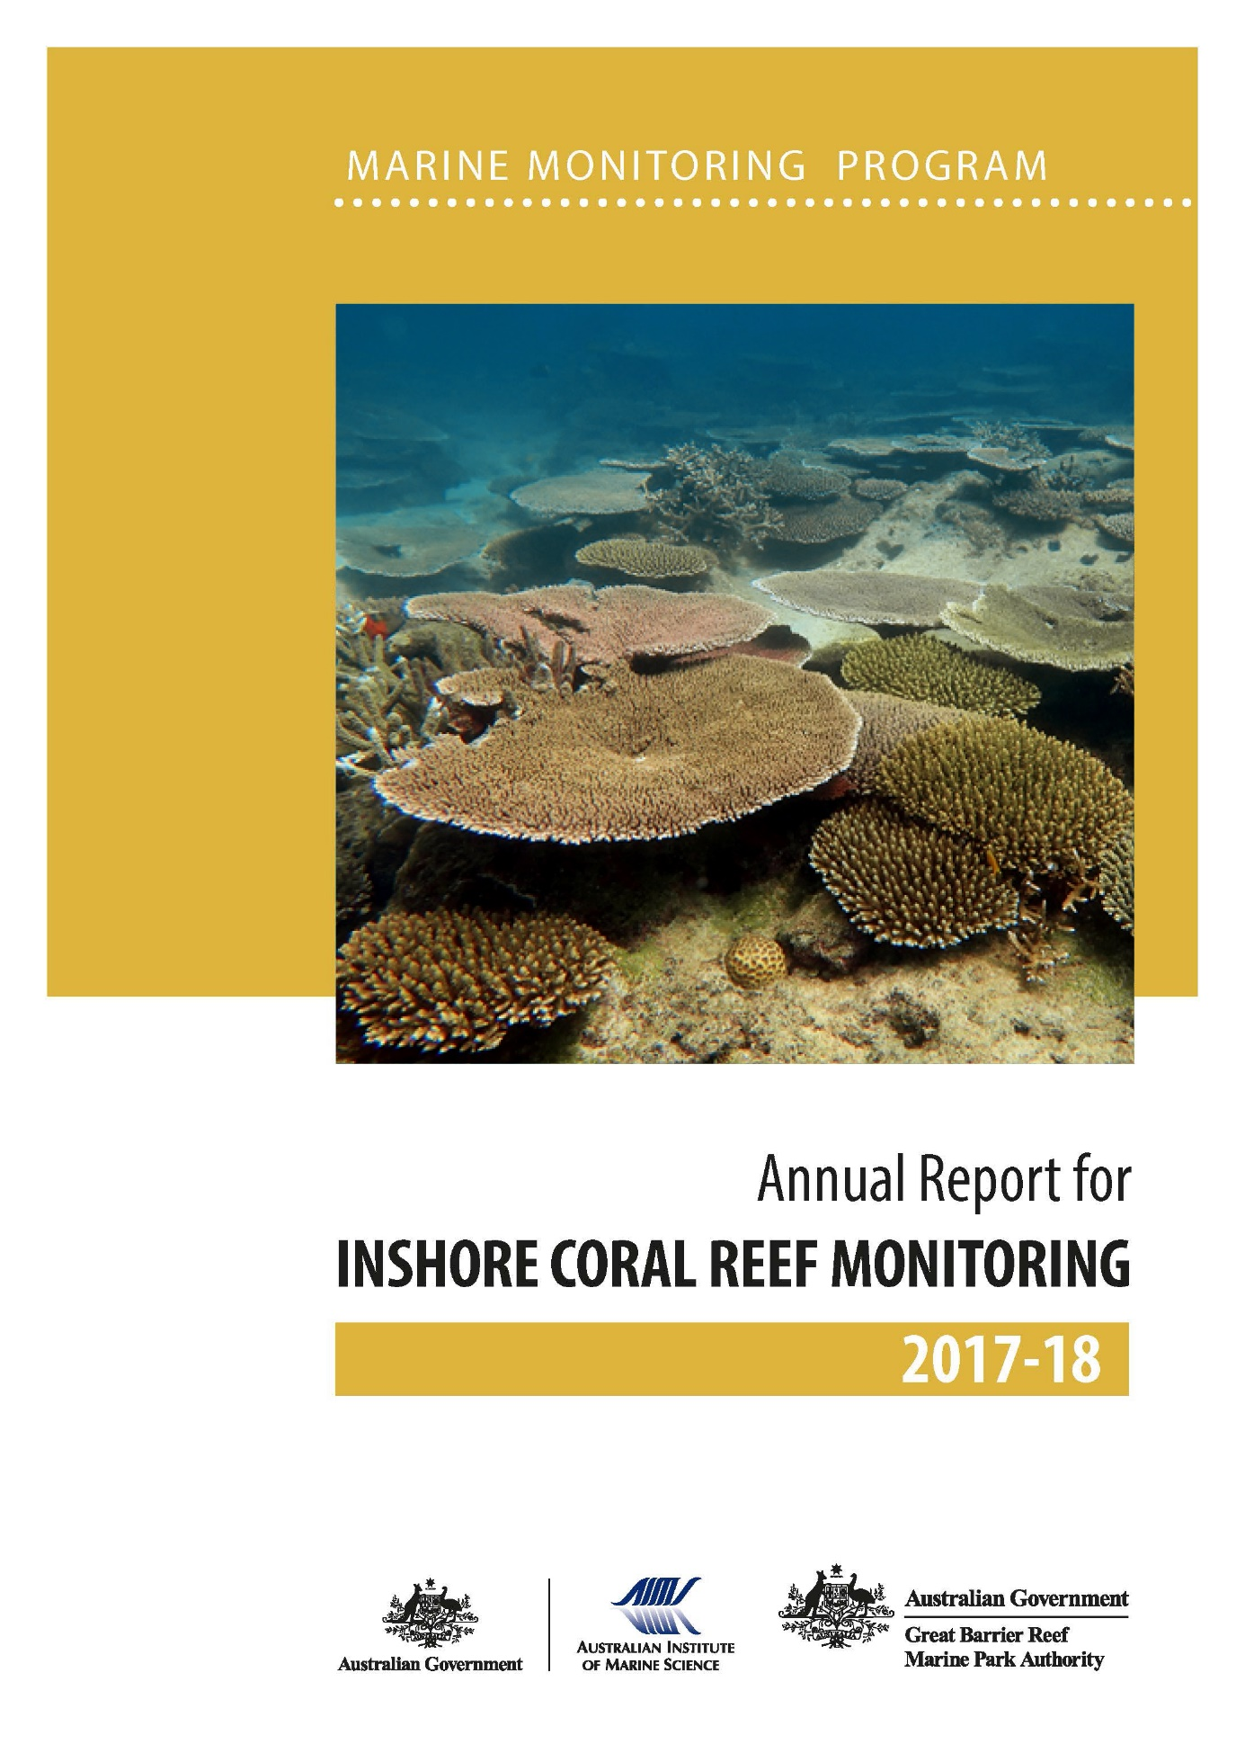
© Copyright Commonwealth of Australia (Australian Institute of Marine Science) 2019
Published by the Great Barrier Reef Marine Park Authority

ISSN 2208-4118
A catalogue record for this publication is available from the National Library of Australia

This document is licensed by the Commonwealth of Australia for use under a Creative Commons By Attribution 4.0 International licence with the exception of the Coat of Arms of the Commonwealth of Australia, the logo of the Great Barrier Reef Marine Park Authority and the Australian Institute of Marine Science, any other material protected by a trademark, content supplied by third parties and any photographs. For licence conditions see: http://creativecommons.org/licences/by/4.0

This publication should be cited as:
Thompson A, Costello P, Davidson J, Logan M, Coleman G (2019) Marine Monitoring Program Annual Report for Inshore Coral Reef Monitoring: 2017–18. Great Barrier Reef Marine Park Authority, Townsville.132 pp.

Front cover photo: A reef in recovery, vibrant healthy corals at Palms East May 2018. © AIMS 2018

DISCLAIMER
While reasonable efforts have been made to ensure that the contents of this document are factually correct, AIMS does not make any representation or give any warranty regarding the accuracy, completeness, currency or suitability for any particular purpose of the information or statements contained in this document. To the extent permitted by law AIMS shall not be liable for any loss, damage, cost or expense that may be occasioned directly or indirectly through the use of or reliance on the contents of this document.

Comments and questions regarding this document are welcome and should be addressed to:

Australian Institute of Marine Science
PMB No 3
Townsville MC Qld 4810

This project is supported by the Great Barrier Reef Marine Park Authority through funding from the Australian Government Reef Program, and the Australian and Queensland governments Reef 2050 Integrated Monitoring and Reporting Program, and the Australian Institute of Marine Science.

Contents
List of figures and tables iii
Appendices: List of figures and tables iv
Glossary iv
Acknowledgments v
Preface v
Executive Summary 1
Wet Tropics region condition 2
Burdekin region condition 2
Mackay–Whitsunday region condition 2
Fitzroy region condition 3
Role of water quality on inshore reef resilience 3
1 Introduction 4
2 Methods 7
2.1 Sampling design 7
2.1.1 Site selection 7
2.1.2 Depth selection 9
2.1.3 Site marking 9
2.1.4 Sampling timing and frequency 9
2.1.5 Environmental pressures 9
2.1.6 Water quality 12
2.1.7 Sea temperature 13
2.1.8 River discharge 14
2.1.9 Sediment characteristics 14
2.1.10 SCUBA search transects 15
2.2 Pressure presentation 15
2.3 Coral community sampling 16
2.3.1 Photo point intercept transects 16
2.3.2 Juvenile coral surveys 17
2.4 The coral index 17
2.4.1 Coral cover metric 17
2.4.2 Macroalgae metric 18
2.4.3 Density of juvenile hard corals metric 19
2.4.4 Cover change metric 20
2.4.5 Community composition metric 22
2.4.6 Aggregating indicator scores to regional scale assessments 23
2.5 Coral reef data analysis and presentation 24
2.5.1 Variation in index and indicator scores among Regions and depths 25
2.5.2 Variation in index and indicator scores to gradients in water quality 25
2.5.3 Relationship between index and indicator scores and temporal variability in environmental conditions 26
2.5.4 Temporal trends in coral index and indicators 26
2.5.5 Analysis of change in index and indicator scores 26
3 Results 27
3.1 Variation of coral index and indicator scores observed in 2018 27
3.1.1 Regional differences 27
3.1.2 Effect of depth 28
3.1.3 Response to environmental gradients 29
3.1.4 Influence of discharge and catchment loads 30
3.2 Regional condition of inshore coral communities 31
3.2.1 Wet Tropics region: Barron Daintree sub-region 31
3.2.2 Wet Tropics region: Johnstone Russell-Mulgrave sub-region 34
3.2.3 Wet Tropics region: Herbert Tully sub-region 38
3.2.4 Burdekin region 41
3.2.5 Mackay Whitsunday region 45
3.2.6 Fitzroy region 49

4 Discussion 53
4.1 Pressures 53
4.1.1 Acute disturbances 53
4.1.2 Chronic conditions – water quality 54
4.2 Ecosystem State 55
4.2.1 Coral condition based on the index 55
4.2.2 Coral cover 56
4.2.3 Rate of change in coral cover 57
4.2.4 Community composition 58
4.2.5 Macroalgae 59
4.2.6 Juvenile density 59
4.3 Regional summaries 60
4.3.1 Wet Tropics 60
4.3.2 Burdekin 61
4.3.3 Mackay Whitsunday 62
4.3.4 Fitzroy 62
4.4 Conclusion 63
5 References 65
6 Appendix 1: Additional Information 75
7 Appendix 2: Publications and presentations 2017–2018 120

List of figures and tables
Figure 1 Regional Coral index with contributing indicator scores. 1
Figure 2 Sampling locations of the coral monitoring. 8
Figure 3 Scoring diagram for the coral cover metric. 18
Figure 4 Scoring diagram for the Macroalgae metric. 19
Figure 5 Scoring diagram for the Juvenile metric. 20
Figure 6 Scoring diagram for Cover Change metric. 22
Figure 7 Scoring diagram for community composition metric 23
Figure 8 Regional distributions of index and indicator scores. 28
Figure 9 Coral index and indicator score relationships to environmental conditions at 2 m 29
Figure 10 Coral index and indicator score relationships to environmental conditions at 5 m 30
Figure 11 Relationship between the coral index and run-off from local catchments. 31
Figure 12 Barron Daintree sub-region environmental pressures. 33
Figure 13 Barron Daintree sub-region index and indicator trends. 34
Figure 14 Johnstone Russell-Mulgrave sub-region environmental pressures. 36
Figure 15 Johnstone Russell-Mulgrave sub-region index and indicator trends. 37
Figure 16 Herbert Tully sub-region environmental pressures. 39
Figure 17 Herbert Tully sub-region index and indicator trends. 40
Figure 18 Burdekin Region environmental pressures.. 43
Figure 19 Burdekin Region index and indicator trends. 44
Figure 20 Mackay Whitsunday Region environmental pressures. 46
Figure 21 Mackay Whitsunday Region index and indicator trends.. 48
Figure 22 Fitzroy Region environmental pressures. 51
Figure 23 Fitzroy Region index and indicator trends. 52

Table 1 Sampling locations. 10
Table 2 Temperature loggers used 13
Table 3 Summary of climate and environmental data included in or considered in this report 11
Table 4 Information considered for disturbance categorisation 16
Table 5 Survey methods used by the MMP and LTMP to describe coral communities 16
Table 6 Threshold values for the assessment of coral reef condition and resilience indicators. 24
Table 7 Presentation of community condition 25
Table 8 Regional differences in index and indicator scores. 27
Table 9 Influence of depth on index and indicator scores.. 29
Table 10 Relationship between changes in index scores and environmental conditions. 30
Table 11 Index and indicator score comparisons in the Barren Daintree sub-region. 32
Table 12 Index and indicator score comparisons in the Johnstone Russell-Mulgrave sub-region.. 35
Table 13 Index and indicator score comparisons in the Herbert Tully sub-region.. 38
Table 14 Index and indicator score comparisons in the Burdekin Region. 41
Table 15 Index and indicator score comparisons in the Mackay Whitsunday Region.. 45
Table 16 Index and indicator score comparisons in the Fitzroy Region. 49

Appendices: List of figures and tables
Figure A 1 Barron Daintree sub-region benthic community composition. 86
Figure A 2 Johnstone Russell-Mulgrave sub-region benthic community composition. 87
Figure A 3 Herbert-Tully sub- region benthic community composition. 90
Figure A 4 Burdekin Region benthic community composition.. 92
Figure A 5 Mackay Whitsunday Region benthic community composition. 96
Figure A 6 Fitzroy Region benthic community composition. 100
Figure A 7 Coral disease by year in each region.. 102
Figure A 8 Temporal trends in water quality: Baron Daintree sub-region.. 114
Figure A 9 Temporal trends in water quality: Johnstone Russell-Mulgrave sub-region.. 115
Figure A 10 Temporal trends in water quality: Herbert Tully sub-region. 116
Figure A 11 Temporal trends in water quality: Burdekin region. 117
Figure A 12 Temporal trends in water quality: Mackay Whitsundays region. 118
Figure A 13 Temporal trends in water quality: Fitzroy region. 119

Table A 1 Thresholds for proportion of macroalgae in the algae communities 75
Table A 2 Eigenvalues for hard coral genera along constrained water quality axis.. 76
Table A 3 Annual freshwater discharge for the major Reef Catchments. 77
Table A 4 Disturbance records for each reef. 78
Table A 5 Reef level Coral index and indicator scores 2018. 83
Table A 6 Environmental covariates for coral locations.. 85
Table A 7 Percent cover of hard coral genera 2018.. 103
Table A 8 Percent cover of soft coral families 2018. 107
Table A 9 Percent cover of Macroalgae groups 2018. 110

Glossary
AIMS | Australian Institute of Marine Science
BOM | Bureau of Meteorology
Chl a | Chlorophyll a
LTMP | Long Term Monitoring Program
MMP | Marine Monitoring Program
Reef 2050 WQIP | Reef 2050 Water Quality Improvement Plan
The Reef | Great Barrier Reef World Heritage Area

Acknowledgments
We acknowledge the valuable contributions to data collection, sampling integrity and reporting of John Carlton, Stephen Neale and Damian Thomson over the first few years of the monitoring program. We thank Aaron Anderson, Joe Gioffre, Charlotte Johansson, Kate Osborne, Shawn Smith, Marcus Stowar and Irena Zagorskis for valuable field assistance over the years. We also thank Ed Butler, Terry Done, Johanna Johnson, Katherine Martin and anonymous reviewers for their detailed reviews that improved the series of reports culminating in this current instalment.

Preface
Management of regional activities associated with catchment development (including agriculture) and direct use of the marine environment is vital to provide corals, and reef organisms in general, with the optimum conditions to cope with global stressors such as climate change (Bellwood et al. 2004, Marshall & Johnson 2007, Carpenter et al. 2008, Mora 2008, Hughes et al. 2010). The management of water quality remains a priority for the Great Barrier Reef Marine Park Authority (the Authority) to ensure the long-term protection of the coastal and inshore ecosystems of the Reef (GBRMPA 2014 a, b). A key plan is the Reef 2050 Water Quality Improvement Plan (Reef 2050 WQIP; Anon. 2017), a component of the Reef 2050 Long Term Sustainability Plan (Commonwealth of Australia, 2015), which provides a framework for integrated management of the Great Barrier Reef World Heritage Area. It is recognised, however, that the management of locally developed pressures, such as water quality, while a critical measure in promoting resilience of coral communities do not discount the need for the urgent reduction of global carbon emissions that are vital for the survival of coral reef ecosystems (Van Oppen & Lough 2018).
The Australian Institute of Marine Science (AIMS) and the Authority entered into a co-investment agreement to provide inshore coral reef monitoring under the Marine Monitoring Program (MMP) as an extension of activities established under previous agreements since 2005.
A summary of the MMP’s overall goals and objectives, and a description of the sub-programs are available online on the Great Barrier Reef Marine Park Authority’s website and the e-atlas website.
The MMP forms an integral part of the Paddock to Reef Integrated Monitoring, Modelling and Reporting program, which is a key action of the Reef 2050 WQIP designed to evaluate the efficiency and effectiveness of implementation and report on progress towards goals and targets. A key output is an annual report card, including an assessment of Reef water quality and ecosystem condition, which is based on MMP information (www.reefplan.qld.gov.au).
This report covers inshore coral reef monitoring conducted by AIMS as part of the MMP until August 2018, with inclusion of data from reefs monitored by the AIMS Long-Term Monitoring Program (LTMP) from 2005 to 2016. In keeping with the overarching objective of the MMP, to “Assess trends in ecosystem health and resilience indicators for the Great Barrier Reef in relation to water quality and its linkages to end-of-catchment loads”, key water quality results reported by Gruber et al. (in prep.) are replicated to support the interpretation of the coral reef results.

Executive Summary
This report presents the findings in the context of the pressures faced by the ecosystem of the long-term health of inshore coral reefs following monitoring conducted under the Marine Monitoring Program.
Environmental conditions over the 2017–18 summer were relatively benign. There were no severe disturbances associated with tropical cyclones or high seawater temperatures impacting the reefs monitored. Flooding in the Herbert Tully sub-region was the only weather-related event to have potentially affected coral condition.
Inshore corals in the 2017–18 year remained in a moderate condition in the Wet Tropics and Burdekin regions. Coral condition continued to decline in the Mackay–Whitsunday region but remained moderate, and remained in poor condition in the Fitzroy region as the full impact of cyclone Debbie (March 2017) was realised.
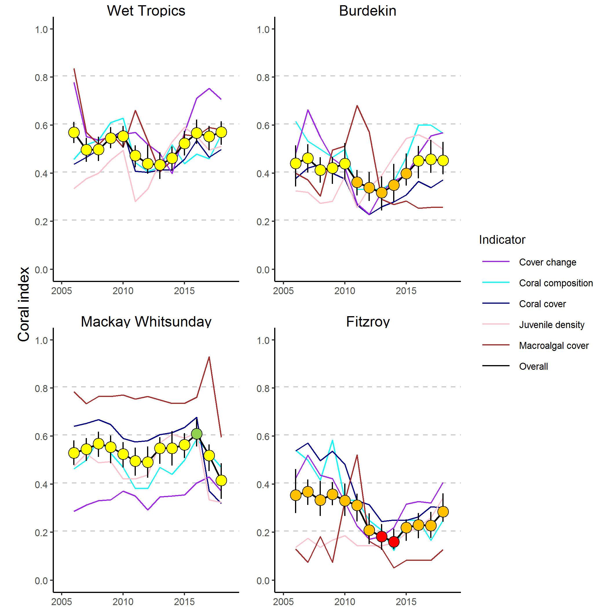
Figure 1 Regional Coral index with contributing indicator scores
. The regional Coral index is derived from the aggregate of scores for indicators of coral community health. Contributing indicators are described in Section 2.4 of the methods.
Inshore coral condition was based on analysis of data collected from 31 reefs monitored at depths of two-metres and five-metres, and an additional nine inshore reefs monitored at single depths under the Australian Institute of Marine Science’s Long-Term Monitoring Program.
Coral condition is a composite of five indicators which are measured at two depths at each reef and given a score. Combining these scores for all reefs in a region gives a rating of coral condition expressed as the coral index. Each indicator represents different processes that contribute to coral community resilience. Indicators are in bold, followed by an explanation for their selection:
- coral cover as an indicator of corals ability to resist the cumulative environmental pressures to which they have been exposed
- proportion of macroalgae in algal cover as an indicator of competition with corals
- juvenile coral density as an indicator of the success of early life history stages in the replenishment of coral populations
- rate at which coral cover changes as an indicator of the recovery potential of coral communities due to growth
- community composition as an indicator of selective pressures imposed by the environmental conditions at a reef.

The coral data contributes to the marine condition score published in the Great Barrier Reef Report Card and regional report cards.

Wet Tropics region condition
Inshore coral remains in a moderate condition, with an improving trajectory since 2012 (Figure 1).
In the Barron Daintree sub-region coral condition remained moderate, with some improvement which was mostly due to growth of corals in shallower water. Low scores for the juvenile density indicator around Snapper Island were the main factor limiting the sub-regional condition.
In the Johnstone Russell-Mulgrave sub-region coral condition improved slightly to return to good, a categorisation last evident in 2016. Increased coral cover and juvenile density at shallower depths contributed most to the improvement. There was ongoing pressure from crown-of-thorns starfish at High Island and in the Frankland Group.
In the Herbert Tully sub-region, coral condition declined slightly although remained moderate. The decline in coral condition was primarily observed at shallower depths, where despite improvement in coral cover, the rate coral cover increased declined as did the density of juvenile corals while macroalgae increased. Low macroalgae and coral cover indicator scores at Bedarra and Dunk South continue to limit sub-regional coral condition.

Burdekin region condition
Inshore coral remains in moderate condition. Coral bleaching in 2017 halted the recovery trajectory observed from 2012 to 2016 following cyclone Yasi in 2011 (Figure 1) and pressures associated with large discharges from the region’s rivers.
Since 2012, scores for most indicators have improved. The exception is that the macroalgae indicator scores remained low due to high cover of macroalgae observed at most reefs inshore of the Palm Island group.

Mackay–Whitsunday region condition
Inshore coral remains in a moderate condition. The coral index has declined sharply since 2016 following cyclone Debbie (Figure 1). Reduction in the coral cover and juvenile density indicators contributed most to this decline. At the shallower two-metre-depth sites, macroalgae cover increased leading to a decline in the macroalgae indicator score.
The influence of high turbidity coupled with the sheltered nature of many reefs pose challenging conditions for most corals at deeper sites. Despite these conditions large colonies of tolerant species persist.
The magnitude of the decline in coral cover following cyclone Debbie is unprecedented in the region since monitoring began in 2005. Ongoing monitoring will observe how these communities recover. To date, data suggests that low juvenile densities and low increase rates of coral cover change will result in slow recovery of these communities.

Fitzroy region condition
Inshore coral condition remains poor but has continued to improve from the very poor condition observed in 2013 and 2014 (Figure 1). A combination of high water temperatures in 2016 and 2017, and pressures associated with flooding in 2017, have likely suppressed this recovery.
The trend to 2018 reflects improvement in the juvenile density and macroalgae scores at both two and five metre depths, and in the coral cover and cover change scores at two metre depths.
Scores for macroalgae remain very low (Figure 1), as a consequence of continued high macroalgal cover.

Role of water quality on inshore reef resilience
Coral reef communities vary along water quality gradients. Pressure imposed by high turbidity and nutrient availability variously support, or select against, different species of corals and their competitors, such as macroalgae. In the inshore areas of the Reef high macroalgae cover persists where high chlorophyll a concentration exceeds guideline values. Where turbidity is high coral community composition changes as sensitive species are precluded.
Acute disturbances such as cyclones, bleaching, and crown-of-thorns starfish outbreaks significantly affect coral community condition. These environmental pressures can confound responses attributable to water quality effects.
The coral condition index is formulated explicitly to emphasise coral communities’ recovery potential. By focusing on periods free from acute disturbance events we demonstrate that incremental changes in the coral index, during periods when reefs were recovering, were inversely related to discharge from local catchments in three of the four regions monitored (the exception being the Mackay Whitsunday region).
The primary premise of the Reef 2050 Water Quality Improvement Plan — that load reduction will have downstream environmental benefits for the Reef — is supported by:
- spatial analyses that demonstrated improved coral index scores along a declining gradient in suspended particulate, and low cover of macroalgae where Chl a concentration met guideline values,
- negative relationships between the recovery of coral communities and pressures from catchment run-off.

In addition to the effects of run-off on the condition of inshore reefs reported here, increased nutrient loads delivered to the Reef lagoon during major flood events result in enhanced water column productivity. While the ecological ramifications of this productivity remain unresolved it is possible that it enhances the survival of crown-of-thorns starfish larvae contributing to outbreaks. Although not typical for inshore reefs, elevated numbers have been observed in the Wet Tropics in recent years (Barron Daintree and Johnstone Russell-Mulgrave sub-regions). In 2018 low numbers of crown-of-thorns starfish were observed at High Island and the Frankland Group.
Results support the premise of the Reef 2050 Water Quality Improvement Plan that the loads entering the Reef are reducing the resilience of these communities. The potential for phase shifts or delayed recovery in combination with an expected increase in disturbance frequency reinforces the importance of reducing local pressures to support the long-term maintenance of these communities.

Introduction
It is well documented that sediment and nutrient loads carried by land-based run-off into the coastal and inshore zones of the Great Barrier Reef (the Reef) have increased since European settlement (e.g., Kroon et al. 2012, Bartley et al. 2017). Ongoing concern that these increases were negatively impacting the Reef ecosystem triggered the formulation and subsequent updating of the Reef 2050 Water Quality Improvement Plan (Reef 2050 WQIP) (Anon. 2003, 2009, 2013, 2017).
The Reef 2050 WQIP includes actions and initiatives to change land management practices to achieve improvement in downstream water quality of creeks and rivers. These actions and initiatives should, with time, lead to improved coastal and inshore water quality that in turn supports the ongoing health and resilience of the Reef (see Brodie et al. 2012a for a discussion of expected time lags in the ecosystem response).
The Reef 2050 WQIP can be considered in a Drivers-Pressures-States-Impacts-Responses (DPSIR) framework (Maxim et al. 2009, Rehr et al. 2012). Social and economic development are two of the drivers of human activities from local, within catchment, through to global scales. Human activities result in local scale pressures on downstream ecosystems such as increased exposure to sediments, nutrients and toxicants, through to direct drivers such as global climate change. These pressures change the state of the Reef ecosystems. This state can then be interpreted in terms of impact on desirable ecosystem functioning or services that can be used to inform decisions for response such as policy or regulatory actions to alleviate that impact.
The full application of a DPSIR framework requires the monitoring of every component, including both pressures and states. Findings should be reported, so that appropriate management responses can be devised, or the outcomes of existing management strategies assessed. Reef 2050 WQIP actions include monitoring programs extending from the paddock to the Reef to assess the effectiveness of implementation. The MMP is an integral part of this monitoring, providing physicochemical and biological data to document the state of: coral reefs, seagrass beds, water quality, and concentrations of pesticides in inshore areas of the Reef. The MMP additionally collates observations of extrinsic pressures such as sea temperature variability, occurrence of tropical cyclones, river discharge volumes, and coral predator populations that also affect ecosystem state. Ultimately the state of marine waters and the ecosystems of the Reef will provide both a basis for assessing the success of the Reef 2050 WQIP and the necessity for future management strategies.
The coral reef component of the MMP is based on the general understanding that healthy and resilient coral communities exist in a dynamic equilibrium, with communities in a cycle of recovery punctuated by acute disturbance events. Common disturbances to inshore reefs include cyclones (often coinciding with flooding), thermal bleaching, and outbreaks of crown-of-thorns starfish, all of which can result in widespread mortality of corals (e.g. Sweatman et al. 2007, Osborne et al. 2011). The potential impact of elevated nutrients carried into the system as run-off may compound the influences of acute disturbances by: increasing the susceptibility of corals to disease (Bruno et al. 2003, Haapkylä et al. 2011, Kline et al. 2006, Kuntz et al. 2005, Weber et al. 2012, Vega Thurber et al. 2013), promoting outbreaks of crown-of-thorns starfish (Wooldridge & Brodie 2015) and increasing susceptibility to thermal stress (Wooldridge & Done 2004, Wiedenmann et al. 2013). Pollutants in run-off may also suppress the recovery process (Schaffelke et al. 2013).
The replacement of corals lost to disturbance is reliant on both the recruitment of new colonies and regeneration of existing colonies from remaining tissue fragments (Smith 2008, Diaz-Pulido et al. 2009). Elevated concentrations of nutrients, agrochemicals, and turbidity can negatively affect reproduction in corals (reviewed by Fabricius 2005, van Dam et al. 2011, Erftemeijer et al. 2012). High rates of sediment deposition and accumulation on surfaces can affect larval settlement (Babcock & Smith 2002, Baird et al. 2003, Fabricius et al. 2003, Ricardo et al. 2017) and smother juvenile corals (Harrison & Wallace 1990, Rogers 1990, Fabricius & Wolanski 2000). In addition, macroalgae have higher abundance in areas with high water column chlorophyll concentrations, indicating higher nutrient availability (De’ath & Fabricius 2010, Petus et al. 2016). High macroalgal abundance may suppress reef resilience (e.g. Hughes et al. 2007, Cheal et al. 2010, Foster et al. 2008, but see Bruno et al. 2009) by increased competition for space or changing the microenvironment into which corals settle and grow (e.g. McCook et al. 2001, Hauri et al. 2010). Macroalgae have been documented to suppress fecundity (Foster et al. 2008), reduce recruitment of hard corals (Birrell et al. 2008b, Diaz-Pulido et al. 2010), diminish the capacity of growth among local coral communities (Fabricius 2005), and suppress coral recovery by altering microbial communities associated with corals (Morrow et al. 2012, Vega Thurber et al. 2012).
The selective pressure of water quality on coral communities is clearly evident in changes in community composition along environmental gradients (De’ath & Fabricius 2010, Thompson et al. 2010, Uthicke et al. 2010, Fabricius et al. 2012). Corals derive energy in two ways; by feeding on ingested particles and planktonic organisms, and from the photosynthesis of their symbiotic algae (zooxanthellae). The ability to compensate by feeding, where there is a reduction in energy derived from photosynthesis, e.g. as a result of light attenuation in turbid waters (Bessell-Brown et al. 2017a), varies between species (Anthony 1999, Anthony & Fabricius 2000). Similarly, the energy required to shed sediment varies between species due to differences in the efficiencies of passive (largely depending on growth form) or active (such as mucus production) strategies for sediment removal (Rogers 1990, Stafford-Smith & Ormond 1992, Duckworth et al. 2017).
At the same time, high nutrient levels may favour particle feeders such as sponges and heterotrophic soft corals which are potential space competitors of hard corals. The cumulative result of these processes is that the combination of environmental parameters at a given location will disproportionately favour some species and thus influence the community composition of coral reef benthos. This variability in corals’ tolerances to environmental pressures allows coral communities to occur in a wide range of environmental settings (e.g. Done 1982, Fabricius & De’ath 2001, DeVantier et al. 2006, De’ath & Fabricius 2010).
Coral reefs in the coastal and inshore zones of the Reef, which are often fringing reefs around continental islands, are subject to high turbidity due to frequent exposure to re-suspended sediment and episodic flood events. It is difficult to quantify the changes to coral reef communities caused by run-off of excess nutrients and sediments because of the lack of historical biological and environmental data that predate significant land use changes on the catchment. However, recent research has strengthened the evidence for causal relationships between water quality changes and the decline of some coral reefs and seagrass meadows in these zones (reviewed in Brodie et al. 2012b and Schaffelke et al. 2013, Clark et al. 2017).
Given that the benthic communities in inshore areas of the Reef show clear responses to gradients in turbidity, sedimentation rates, and nutrient availability (van Woesik et al. 1999, Fabricius & De’ath 2001, Fabricius et al. 2005, Wismer et al. 2009, Uthicke et al. 2010, Fabricius et al. 2012), improved land management practices have the potential to reduce levels of chronic environmental stresses that impact coral reef communities.
Nutrients that sustain the biological productivity of the Reef are supplied by a number of processes and sources such as upwelling of nutrient-enriched deep water from the Coral Sea and nitrogen fixation by bacteria (Furnas et al. 2011). However, land run-off is the largest source of new nutrients to the inshore Reef, especially during monsoonal flood events (Furnas et al. 2011). These nutrients augment the regional stocks of nutrients already stored in biomass or detritus (Furnas et al. 2011) which are continuously recycled to supply nutrients for marine plants and bacteria (Furnas et al. 2005, Furnas et al. 2011).
The complexity of interactions between benthic communities and environmental pressures makes it important to synthesize coral community condition in a way that relates to the pressures of interest. The Reef report card includes coral index scores to annually summarise condition of coral communities in inshore areas of the Reef. The purpose of this report is to provide the data, analyses, and interpretation underpinning coral index scores included in the 2018 Reef report card. The program also contributes data to the Wet Tropics, Burdekin Dry Tropics and Mackay-Whitsunday regional report cards.

To relate changes in the condition of coral reef communities to variations in local water quality, the coral component of the MMP has the overarching objective to “quantify the extent, frequency and intensity of acute and chronic impacts on the condition and trend of inshore coral reefs and their subsequent recovery”. The specific objectives are to monitor, assess and report:
- the condition and trend of Great Barrier Reef inshore coral reefs in relation to desired outcomes (expressed as coral index scores) along identified or expected gradients in water quality;
- the extent, frequency and intensity of acute and chronic impacts on the condition of Great Barrier Reef inshore coral reefs, including exposure to flood plumes sediments, nutrients and pesticides;
- the recovery in condition of Great Barrier Reef inshore coral reefs from acute and chronic impacts including exposure to flood plumes, sediments, nutrients and pesticides;
- trends in incidences of coral mortality attributed to coral disease, crown-of-thorns-starfish, Drupella spp., Cliona orientalis, physical damage and coral bleaching.

Methods

Sampling design
Monitoring of inshore coral reef communities occurs at reefs adjacent to four of the six natural resource management regions with catchments draining into the Reef: Wet Tropics, Burdekin, Mackay Whitsunday and Fitzroy. No reefs are included adjacent to Cape York due to logistic and occupational health and safety issues relating to diving in coastal waters in this region. Limited development of coral reefs in nearshore waters adjacent to the Burnett Mary Region precluded sampling there. Sub-regions were included in the Wet Tropics Region to more closely align reefs with the combined catchments of the:
- Barron and Daintree rivers
- Johnstone and Russell-Mulgrave Rivers
- Herbert and Tully rivers.

Site selection
Initial selection of sites was jointly decided by an expert panel chaired by the Authority. The selection was based on two primary considerations:
- Within the Reef, strong gradients in water quality exist with distance from the coast and increasing distance from rivers, particularly in a northerly direction (Larcombe et al. 1995, Brinkman et al. 2011). The selection of reefs for inclusion in the sampling design was informed by the desire to include reefs spanning these gradients to facilitate the teasing out of water quality associated impacts.
- There was either an existing coral reef community or evidence (in the form of carbonate-based substratum) of past coral reef development.
Exact locations were selected without prior investigation, once a section of reef had been identified that was of sufficient size to accommodate the sampling design a marker was deployed from the surface and transects established from this point.
In the Wet Tropics region, where few reefs exist in the inshore zone and well-developed reefs exist on more than one aspect of an island, separate reefs on windward and leeward aspects were included in the design. Coral reef communities can be quite different on these two aspects even though the surrounding water quality is relatively similar. Differences in wave and current regimes determine whether materials, e.g. sediments, fresh water, nutrients or toxins imported by flood events, accumulate or disperse and hence determine the exposure of benthic communities to environmental stresses. A list of the selected reefs is presented in Table 1 and the geographic locations are shown in Figure 2 and, in more detail, on maps within each (sub-)regional section of the results.
Since the program began in 2005 there have been two changes to the selection of reefs sampled. In 2005 and 2006 three mainland fringing reef locations were sampled along the Daintree coast. Concerns over increasing crocodile populations in this area led to the cessation of sampling at these locations. In 2015 a revision of the marine water quality monitoring component of the MMP resulted in modifications to the sampling design for water quality. This included a concentration of sampling effort along a gradient away from the Tully River mouth. To better match the water quality sampling to the coral reef sampling in the Tully-Herbert sub-region a new reef site was initiated at Bedarra and sampling at King Reef discontinued.
In addition to reefs monitored by the MMP, data from inshore reefs monitored by the AIMS LTMP have been included in this report (Table 1, Figure 1). As the MMP sites at Middle Reef in the Burdekin region were co-located with LTMP sites this reef was removed from the MMP sampling schedule in 2015.

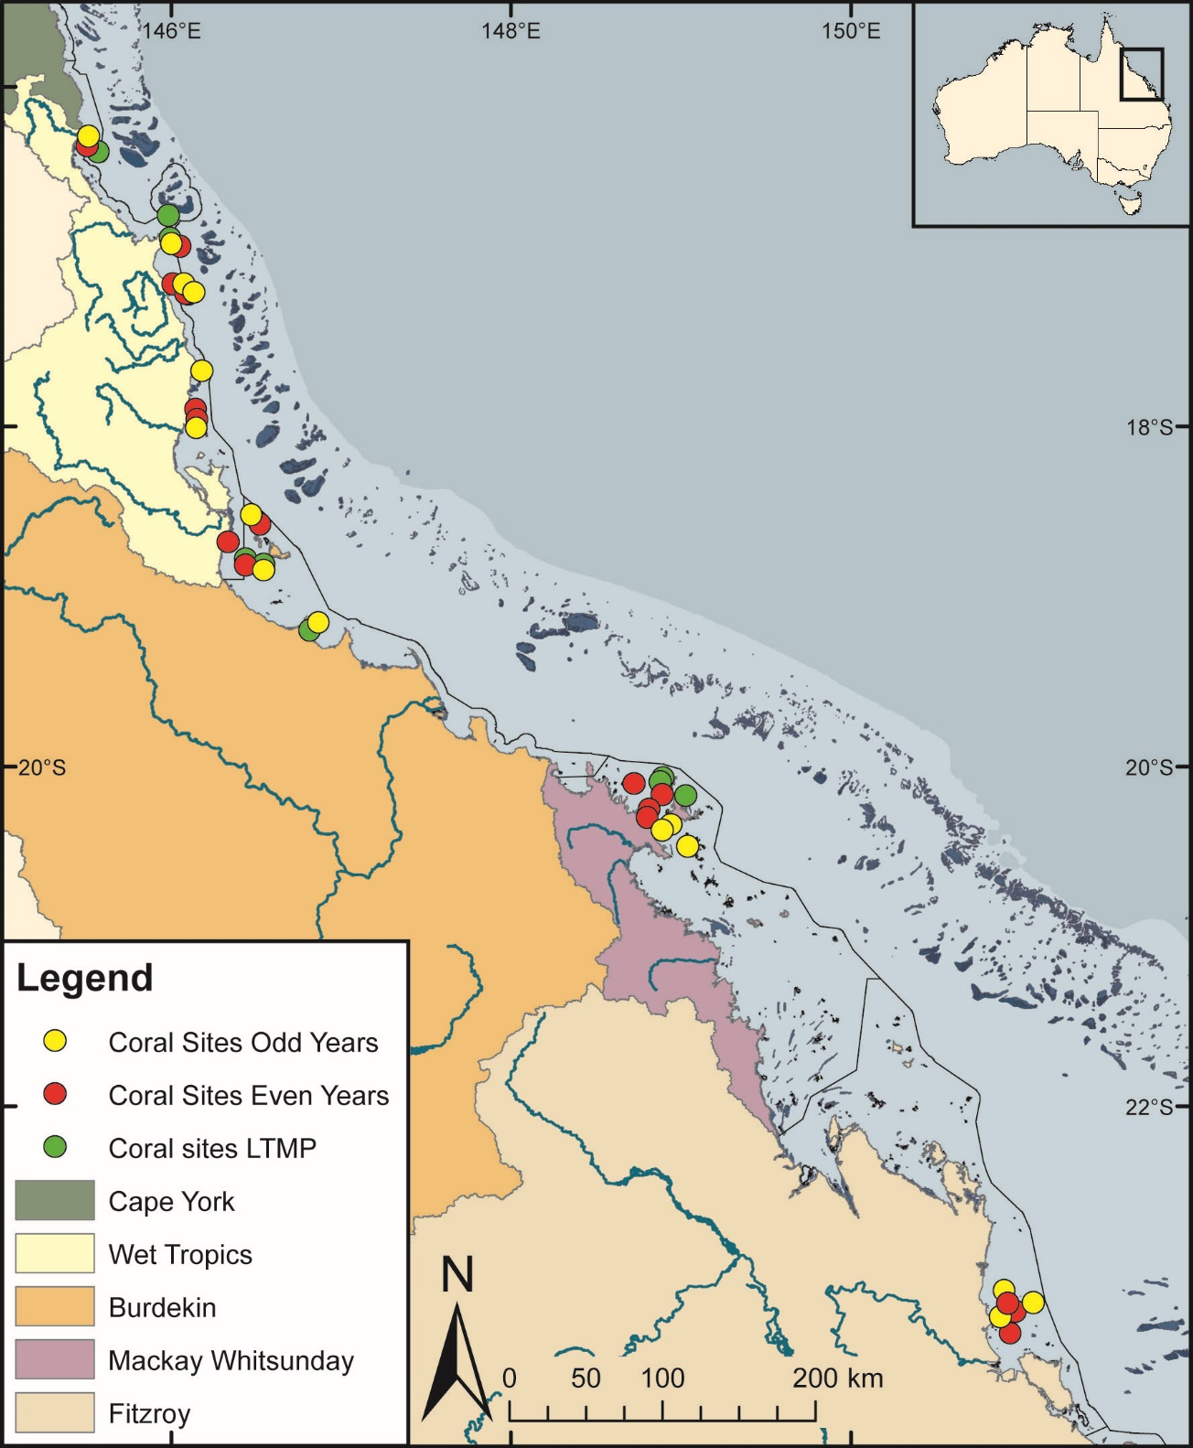
Figure 2 Sampling locations of the coral monitoring. Table 1 (below) describes monitoring activities undertaken at each location. Natural resource management region boundaries are represented by coloured catchment areas.

Depth selection
Within the turbid inshore waters of the Reef the composition of coral communities varies strongly with depth due to differing exposure to pressures and disturbances (e.g. Sweatman et al. 2007). For the MMP, transects were selected at two depths. The lower limit for the inshore coral surveys was selected at 5 m below lowest astronomical tide datum (LAT). Below this depth, coral communities rapidly diminish at many inshore reefs. A shallower depth of 2 m below LAT was selected as a compromise between a desire to sample the reef crest and logistical reasons, including the inability to use the photo technique in very shallow water and the potential for site markers creating a danger to navigation. The AIMS LTMP sites are not as consistently depth defined as those of the MMP with most sites set in the range of 5–7 m below LAT. Middle Reef is the exception with sites there at approximately 3 m below LAT.

Site marking
At each reef, two sites separated by at least 250 m were selected along a similar aspect. These sites are permanently marked with steel fence posts at the beginning of each of five, 20 m-long, transects and smaller steel rods (10 mm-diameter) at the midpoint and the end of each transect. Compass bearings and measured distances record the transect path between these permanent markers. Transects were set initially by running two 60-m fibreglass tape measures out along the desired depth contour. Digital depth gauges were used along with tide heights from the closest location included in ‘Seafarer Tides’ electronic tide charts produced by the Australian Hydrographic Service to set transects as close as possible to the desired depth. Consecutive transects were separated by five metres. The position of the first picket of each site was recorded by GPS. Site directions and waypoints are stored electronically in AIMS databases.

Sampling timing and frequency
Coral reef surveys were undertaken predominantly over the months May-July as this allows most of the influences resulting from summer disturbances, such as cyclones and bleaching events, to be realised. Although the acute events occur over summer, the stress incurred can cause ongoing mortality for several months. The winter sampling also protects observers from potential risk from marine stingers over the summer months. The exception was Snapper Island where sampling occurred typically in the months August – October.
The frequency of survey has changed gradually over time due to budgetary constraints. In 2005 and 2006 all MMP reefs were surveyed. From 2007 through to 2014 a subset of reefs at which there were co-located water sampling sites, were classified as “core” reefs, and sampled annually. The remaining reefs were classified as “cycle” and sampled only in alternate years with half sampled in odd-numbered years (i.e. 2009, 2011 and 2013) and the remainder in even-numbered years.
When an acute disturbance was suspected to have impacted cycle reefs during the preceding summer they were resurveyed irrespective of their odd or even year classification to gain the best estimate of the impact of the acute event and book-end the start of the recovery period. Further funding reductions necessitated the adoption of a biennial sampling cycle for all reefs, although a contingency for the out-of-phase resampling of reefs impacted by acute disturbance was maintained.
In 2018 out-of-phase sampling was undertaken at most reefs in the Wet Tropics and Burdekin regions to capture the full extent of impacts from coral bleaching over the previous two summers. In total, 9 out-of-phase reefs were surveyed across the four regions (Table 1).

Environmental pressures
A range of environmental variables are incorporated into this report as a basis for interpreting spatial and temporal trends in coral communities. Methods are detailed for data collected by this component of the MMP, or when aggregation required substantial manipulation of the source data. The use and source of environmental covariates is summarised in Table 2
Table 1 Sampling locations. Black dots mark reefs surveyed as per sampling design, the “+” symbol indicates reefs surveyed out of schedule to assess disturbance. At each reef surveys of juvenile coral densities, benthic cover estimates derived from photo point intercept transects and scuba searches for incidence of coral mortality are undertaken. WQ, indicates reefs at which water quality monitoring is undertaken, * indicates WQ was ceased in 2014, and ** indicates WQ was begun in 2015. Shading indicates discontinued reefs. Blank cells indicate where reefs were not surveyed.
(Sub-)Region | Reef | Program | 2005 | 2006 | 2007 | 2008 | 2009 | 2010 | 2011 | 2012 | 2013 | 2014 | 2015 | 2016 | 2017 | 2018
Barron Daintree | Cape Tribulation North | MMP | ● | ●
 | Cape Tribulation Mid | MMP | ● | ●
 | Cape Tribulation South | MMP | ● | ●
 | Snapper North (WQ*) | MMP | ● | ● | ● | ● | ● | ● | ● | ● | ● | ● | ● | + | ● | +
 | Snapper South | MMP | ● | ● | ● | ● | ● | ● | ● | ● | ● | ● | ● | ● | + | ●
 | Low Isles | LTMP | ● |  | ● |  | ● |  | ● |  | ● |  | ● |  | ●
Johnstone Russell-Mulgrave | Green | LTMP | ● |  | ● |  | ● |  | ● |  | ● |  | ● |  | ●
 | Fitzroy West | LTMP | ● |  | ● |  | ● |  | ● |  | ● |  | ● |  | ●
 | Fitzroy West (WQ) | MMP | ● | ● | ● | ● | ● | ● | ● | ● | ● | ● | ● | + | ● | +
 | Fitzroy East | MMP | ● | ● | + | ● |  | ● | + | ● |  | ● |  | ● |  | ●
 | High East | MMP | ● | ● | ● |  | ● |  | ● |  | ● |  | ● | + | ● | +
 | High West (WQ) | MMP | ● | ● | ● | ● | ● | ● | ● | ● | ● | ● |  | ● | + | ●
 | Frankland East | MMP | ● | ● | ● |  | ● |  | ● |  | ● |  | ● | + | ● | +
 | Frankland West (WQ) | MMP | ● | ● | ● | ● | ● | ● | ● | ● | ● | ● |  | ● | + | ●
Tully | Barnards | MMP | ● | ● | ● |  | ● |  | ● |  | ● |  | ● |  | ● | +
 | King | MMP | ● | ● |  | ● |  | ● |  | ● |  | ●
 | Dunk North (WQ) | MMP | ● | ● | ● | ● | ● | ● | ● | ● | ● | ● |  | ● | + | ●
 | Dunk South | MMP | ● | ● |  | ● |  | ● | + | ● |  | ● |  | ● | + | ●
 | Bedarra | MMP |  |  |  |  |  |  |  |  |  |  | ● | ● | ● | ●
Burdekin | Palms West (WQ) | MMP | ● | ● | ● | ● | ● | ● | ● | ● | ● | ● | ● | + | ● | +
 | Palms East | MMP | ● | ● |  | ● |  | ● | + | ● |  | ● |  | ● |  | ●
 | Lady Elliot | MMP | ● | ● |  | ● |  | ● |  | ● |  | ● |  | ● |  | ●
 | Pandora North | LTMP | ● |  | ● |  | ● |  | ● |  | ● |  | ● |  | ●
 | Pandora (WQ) | MMP | ● | ● | ● | ● | ● | ● | ● | ● | ● | ● |  | ● | + | ●
 | Havannah North | LTMP | ● |  | ● |  | ● |  | ● |  | ● |  | ● |  | ●
 | Havannah | MMP | ● | ● | ● |  | ● |  | ● |  | ● |  | ● | + | ● | +
 | Middle Reef | LTMP | ● |  | ● |  | ● |  | ● |  | ●
 | Middle Reef | MMP | ● | ● | ● |  | ● |  | ● |  | ●
 | Magnetic (WQ) | MMP | ● | ● | ● | ● | ● | ● | ● | ● | ● | ● | ● | + | ● | +
Mackay Whitsunday | Langford | LTMP | ● |  | ● |  | ● |  | ● |  | ● |  | ● |  | ●
 | Hayman | LTMP | ● |  | ● |  | ● |  | ● |  | ● |  | ● |  | ●
 | Border | LTMP | ● |  | ● |  | ● |  | ● |  | ● |  | ● |  | ●
 | Double Cone (WQ) | MMP | ● | ● | ● | ● | ● | ● | ● | ● | ● | ● |  | ● | + | ●
 | Hook | MMP | ● | ● |  | ● |  | ● |  | ● |  | ● |  | ● |  | ●
 | Daydream (WQ*) | MMP | ● | ● | ● | ● | ● | ● | ● | ● | ● | ● |  | ● | + | ●
 | Shute Harbour | MMP | ● | ● |  | ● |  | ● |  | ● |  | ● |  | ● | + | ●
 | Dent | MMP | ● | ● | ● |  | ● |  | ● |  | ● |  | ● |  | ●
 | Pine (WQ) | MMP | ● | ● | ● | ● | ● | ● | ● | ● | ● | ● | ● |  | ● | +
 | Seaforth (WQ**) | MMP | ● | ● | ● |  | ● |  | ● |  | ● |  | ● |  | ●
Fitzroy | North Keppel | MMP | ● | ● | ● |  | ● |  | ● |  | ● | + | ● |  | ●
 | Middle | MMP | ● | ● |  | ● |  | ● |  | ● |  | ● | + | ● |  | ●
 | Barren (WQ*) | MMP | ● | ● | ● | ● | ● | ● | ● | ● | ● | ● | ● |  | ●
 | Keppels South (WQ*) | MMP | ● | ● | ● | ● | ● | ● | ● | ● | ● | ● | ● | ● | + | ●
 | Pelican (WQ*) | MMP | ● | ● | ● | ● | ● | ● | ● | ● | ● | ● | ● | ● |  | ●
 | Peak | MMP | ● | ● |  | ● |  | ● | + | ● |  | ● | + |  | ●

.

Table 2 Summary of climate and environmental data included in or considered in this report
 | Data range | Method | Usage | Data source
Climate
Riverine discharge | 1980 – 2018 | water gauging stations closest to river mouth, adjusted for ungauged area of catchment | regional discharge plots and table, covariate in analysis of temporal change in Coral index | DNRME, adjustment as tabulated by (Gruber et al. 2019.)
Riverine Total N and Total P loads | 2006–2017 |  | covariate in analysis of temporal change in Coral index | Data provided by the State of Queensland (Department of Science, Information Technology and Innovation)
Environment at coral sites
Degree Heating days | 2006 – 2018 | remote sensing adjacent to coral sites | regional plots, bleaching disturbance categorisation | Bureau of Meteorology
Water temperature | 2005 – 2018 | in situ sensor at coral sites | regional plots, bleaching disturbance categorisation, in situ degree heating day estimates | MMP Inshore Coral monitoring
Chlorophyll a, Turbidity | 2006–2018 | in situ sensor and niskin samples at subset of coral sites | regional trend plots | MMP Water Quality (Gruber et al. in prep.)
Chlorophyll a exposure | 2003–2018 | product of water colour classification derived from remote sensing and coupled niskin samples | mapping, covariate in analysis of spatial trends in index and indicator score, covariate in analysis of temporal variability in index score changes | MMP Water Quality (Gruber et al. in prep.)
Non-algal particulate (NAP)  Chlorophyll a, Kd490 | 2002–2015 | remote sensing adjacent to coral sites | Macroalgae and Community Composition metric thresholds | Bureau of Meteorology
Non-algal particulate (NAP) | 2003 – 2018 | remote sensing adjacent to coral sites | mapping, covariate in analysis of spatial trends in index and indicator score, covariate in analysis of temporal variability in index score changes | Bureau of Meteorology
Sediment grain size | 2006 – 2017 | optical and sieve analysis of samples from coral sites | analysis covariate, Macroalgae metric thresholds | MMP Inshore Coral monitoring

Water quality
Non-algal particulate (NAP) concentration, a proxy for total suspended sediments, derived from the MODIS aqua satellite mounted sensor were downloaded from the Australian Bureau of Meteorology. For each monitoring location a square of nine 1 km² pixels were identified in closely adjacent waters from which daily medians were used to estimate monthly means. For use as a temporal covariate these monthly means were aggregated to annual estimates and for spatial analysis aggregated to reef level means over the period (2003 – 2018).
Relative exposure to Chl a at each reef, in each year, was estimated based on the methods developed by the water quality component of the MMP (Waterhouse et al. 2018, Petus et al. 2016). In brief, MODIS aqua images were used to classify waters into one of six colour classes that range from those typical of primary (colour classes 1–4), secondary (class 5), or tertiary (class 6) river plumes. The lowest (most turbid and nutrient rich) colour class for a given pixel is recorded as the exposure of that pixel in each week.
It is important to note that waters can be classified into these colour classes when not exposed to flood plumes as extra-plume processes, such as wind driven resuspension, may produce waters with similar spectral signatures.
Matching in situ sampling with the classified colour of the water at the date and location of the sample provided estimates of the mean concentration of water quality parameters for each colour class. The Chl a estimates in this report are expressed as the mean exposure to Chl a concentrations above wet-season Guideline values (0.63ugL⁻¹, GBRMPA 2010) over the wet-season (December – April, inclusive) preceding annual coral surveys. Estimates were derived from the same nine pixels as described above for estimation of NAP concentration.
For each group of pixels, Chl a exposure was expressed as the product of the mean proportion of the wet season for which waters were classified as that colour class and the mean concentration of Chl a in that colour classes expressed as a deviation in ugL⁻¹ above guideline levels. The sum of these weekly exposures across colour classes 1–5 (colour class 6 mean Chl a concentration is below guideline levels) provided an estimate of the mean exceedance of guideline concentrations of Chl a (in ugL⁻¹) across the wet-season. Reef level means averaged the annual wet season exposures over the period 2003–2018 to describe the spatial gradient in Chl a exposure.
As a background to regional maps of sampling locations, mean Chl a and NAP concentrations over the period (2003–2018) were derived for all inshore waters using the same methods as described above and scaled to visually demonstrate concentrations relative to Guideline values.
Temporal trends in the in situ Water Quality Index and associated parameters are provided for each (sub-)region in the appendix of this report as a point of reference. These plots are reproduced from the companion 2018 annual MMP Water Quality Monitoring report (Gruber et al. 2019) in which detailed descriptions of water quality sampling methods can also be found. Briefly, for each parameter, except turbidity, data were collected by analysis of water sampled using niskin bottles at all MMP water quality monitoring sites. Estimates of turbidity and an additional data set for Chl a are also included and were derived from WET Labs ECO FLNTUSB Combination Fluorometer and Turbidity Sensors co-located with 5 m coral survey transects at a subset of reefs (Table 1). The data were analysed to generate trend predictions from thin-plate splines fitted via Generalised Additive Mixed Models (GAMMs). These models also incorporated seasonal cyclical cubic splines with sample location set as the random effect.

Sea temperature
Temperature loggers were deployed at each coral monitoring reef at both 2 m and 5 m depths and routinely exchanged at the time of the coral surveys (i.e. every 12 or 24 months). Exceptions were Snapper South, Fitzroy East, High East, Franklands East, Dunk South, and Palms East where loggers were not deployed due to the proximity of those sites to the sites on the western or northern aspects of these same islands, where loggers were deployed. A range of logger models have been used (Table 3).
Table 3 Temperature loggers used
Temperature Logger Model (Supplier) | Deployment period | Recording frequency (mins)
‘392’ and ‘Odyssey’ (Dataflow System) | 2005 to 2008. | 30
‘Sensus Ultra’ (ReefNet) | 2008 to 2017 | 10
‘Vemco Minilog-II-T’ (Vemco) | 2015 onward | 10

Loggers were calibrated against a certified reference thermometer after each deployment and were generally accurate to ± 0.2°C.
For presentation and analysis, the data from all loggers deployed within a (sub-)region were averaged to produce a time-series of mean average water temperature. From these time-series a seasonal climatology for each (sub-)region was estimated as the 14-day running mean temperature for each day of the year over the period 2005 to 2015. Temperature data for each (sub-)region are plotted as anomalies, estimated as the mean difference between daily observations within a (sub-)region and the seasonal climatology.
Two estimates of seasonal temperature anomalies, as an indication of potential temperature stress to corals, are also presented.
The first, $Obs.DHD,$ is derived from the logger time-series and presents the annual (July to June) exposure to temperatures more than the maximum temperature observed in the (sub-)region’s seasonal climatology as:
$$Obs.DHD= \sum{T_{i}-MaxT}$$
Where, $T_{i}$ is the mean (sub-)region temperature for each day (i) that exceeds the (sub-)region’s climatological maximum $Max$.
The second, DHD were derived from pixels adjacent to each coral monitoring location downloaded from the Bureau of Meteorology satellite-based interactive website ReefTemp Next Generation. DHD values were calculated as the sum of daily positive deviations from of 14-day IMOS climatology – a one-degree exceedance for one day equates to one degree heating day, a two-degree exceedance for one day would equates to two degree heating days. DHD anomalies are summed over the period December 1 to March 31 each summer.
The primary difference between these degree heating day estimates are the underlying climatology used and the focus on deviation from the maximum rather than seasonal temperature profile.

River discharge
Daily records of river discharge were obtained from Queensland Government Department of Natural Resources and Mines (DNRME) river gauge stations for the major rivers draining to the Reef. Within each (sub-)region a time-series of the combined discharge from the major gauged rivers were plotted. Total annual discharge for each water year, 1st October to 30th September, were also included along with a long-term median reference estimated over the period 1970–2000.
These annual estimates include a correction factor applied to gauged discharges to account for ungauged areas of the catchment (Waterhouse et al. 2018). Annual discharge and medians for individual rivers are tabulated in the appendix of this report. Total annual river discharge for each region was used as a covariate in analysis of change in coral index scores.
For this analysis the biennial changes in index scores were considered due to the underlying sampling design of the program. To match this sampling frequency, the mean of the total annual discharge from all rivers discharging into a given region for each two-year period between 2006 and 2018 was calculated.

Sediment characteristics
The proportion of sediments with grainsize < 63µm (clay and silt) in sediments from the reefs sites was used as a proxy for exposure to wave and tide mediated resuspension. These estimates were used as covariates in analysis of spatial distributions of index and indicator scores and in analyses that determined reef level thresholds for macroalgae (Thompson et al. 2016).
Grainsize distribution of sediments was estimated from samples collected from the 5 m depth MMP sites at the time of coral sampling until 2014. At each site five 60 ml syringe tubes were used to collect cores of surface sediment from available deposits along the site. The end of the syringe tube was cut away to produce a uniform cylinder. Sediment was collected by pushing the tube into the sediment being careful not to suck sediment and pore-water into the tube with the plunger. A rubber stopper was then inserted to trap the sediment plug. The surface centimetre of sediment was retained and grainsize distribution determined by a combination of sieving and laser analysis carried out by the School of Earth Sciences, James Cook University (2005–2009) and subsequently by Geoscience Australia.
For LTMP sites the clay and silt content of sediments was estimated by interpolating between MMP reefs with similar exposure to the south east as the predominant direction of wave energy in the Reef. Estimated sediment composition was verified by visually checking images including sediment from photo transects against images from MMP reefs with similar exposure.
For the new site at Bedarra sediment samples collected in 2015 were passed through a 63 µm sieve to estimate the clay and silt grain-sized proportion of the sample.

SCUBA search transects
SCUBA search transects document the incidence of disease and other agents of coral mortality and damage. Tracking of these agents of mortality is important, as declines in coral condition due to these agents are potentially associated with increased exposure to nutrients or turbidity (Morrow et al. 2012, Vega Thurber et al. 2013). The resulting data are used primarily for interpretive purposes and help to identify both acute events such as a high proportion of damaged corals following storms, high densities of coral predators, or periods of chronic stress as inferred from high levels of coral disease.
This method follows closely the Standard Operation Procedure Number 9 of the LTMP (Miller et al. 2009). For each 20 m transect a search was conducted within a 2 m wide belt centred on the marked transect line. Within this belt any colony exhibiting a scar (bare white skeleton) was identified to genus and the cause of the scar categorised as either; brown band disease, black band disease, white syndrome (a catch all for unspecified disease), Drupella spp. – in which case the number of Drupella spp. snails were recorded, crown-of-thorns starfish feeding scar, bleaching when the colony was bleached and partial mortality was occurring, and unknown when a cause could not be confidently assumed. In addition, the number of crown-of-thorns starfish and their size-class were counted and colonies being overgrown by sponges were also recorded.
Finally, an 11-point scale was used to record the proportions of the coral community that were bleached or had been physically damaged as indicated by toppled or broken colonies. The scale ranges from 0+ when individual colonies were bleached or damaged through the categories 1 to 5 when 1–10%, 11–30%, 31–50%, 50–75% and 75–100% of colonies affected. The categories 1 to 5 are further refined by inclusion of a –ve or +ve symbol when affected proportions are estimated as being in the lower or upper portion of the category. The physical damage category may include anchor as well as storm damage. The LTMP include these surveys over the full 50 m length of transects used in that program.

Pressure presentation
The most tangible immediate effect of disturbances to coral communities is the loss of coral cover. A summary of disturbance history within each (sub-)region is presented as a bar plot of annual hard coral cover loss. The height of the bar represents the mean coral cover lost across all 2 m and 5 m sites within a region. Bars are segmented based on the proportion of loss attributed to different disturbance types. For each observation of hard coral cover at a reef and depth, the observation was categorised (Table 4) by any disturbance that had impacted the reef since the previous observation and the coral cover lost calculated as:
$$Loss= predicted- observed$$
$w$here, observed is the hard coral cover observed, and predicted was the coral cover predicted from the application of the coral growth models described for the cover change indicator (section 2.4.4). The proportion of coral cover lost per region for each disturbance type is subsequently calculated as:

$$proportional Loss=(\frac{Loss}{∑{Loss}_{r}})$$
Where, $∑{Loss}_{r}$ is the overall cover lost within each region. It is important to note that, for each loss attributed to a specific disturbance any cumulative impact of water quality is implicitly included. For reference among regions the y axis of each plot was scaled to the maximum mean hard coral cover loss observed across regions in a single year (22% loss of coral cover within the Tully region in 2011).

Table 4 Information considered for disturbance categorisation
Bleaching | Consideration of in situ degree heating day estimates and reported observations of coral bleaching
crown-of-thorns starfish | SCUBA search revealing > 40 ha⁻¹ density of crown-of-thorns during present or previous survey of the reef
Disease | SCUBA search revealing high levels of coral disease during present or previous survey of the reef
Flood | Discharge from local rivers sufficient that reduced salinity at the reef sites can reasonably be inferred. An exception was classification of a flood effect in the Whitsundays region based on high levels of sediment deposition to corals. This classification has been retained for historical reasons and would not be classified as a flood effect under the current criteria
Storm | Observations of physical damage to corals during survey that can reasonably be attributable to a storm or cyclone event based on nature of damage and the proximity of the reef to storm or cyclone paths.
Multiple | When a combination of the above occur
Chronic | In years that no acute disturbance was recorded a Loss was recorded when observed hard coral cover fell below the predicted cover and these losses classified as disturbance type ‘Chronic’. This categorisation will include the cumulative impacts of minor exposure to any of the above disturbances along with chronic environmental conditions. Importantly as estimates for each disturbance are a mean and the disturbance categorisation “Chronic” includes all non-disturbance observations any proportion of loss attributed to this category represents a mean under performance in rate of cover increase for reefs not subject to an acute disturbance.

Coral community sampling
Two sampling methodologies were used to describe the benthic communities of inshore coral reefs (Table 5).

Table 5 Survey methods used by the MMP and LTMP to describe coral communities
Survey Method | Information provided | Transect dimension
 |  | MMP (20 m long transects) | LTMP (50 m long transects)
Photo point Intercept | Percentage covers of the substratum of major benthic habitat components. | Approximately 34cm belt along upslope side of transect sampled at 50 cm intervals from which 32 frames are sampled. | Approximately 34cm belt along upslope side of transect sampled at 1m intervals from which 40 frames are sampled.
Demography | Size structure and density of juvenile coral communities. | 34cm belt along the upslope side of transect. Size classes: 0–2 cm, 2–5 cm, 5–10 cm. | 34cm belt along the upslope side of the first 5 m of transect. Size class: 0–5 cm.

Photo point intercept transects
Estimates of the composition of benthic communities were derived from the identification of organisms on digital photographs taken along the permanently marked transects. The method followed closely the Standard Operation Procedure Number 10 of the AIMS LTMP (Jonker et al. 2008). In short, digital photographs were taken at 50 cm intervals along each 20 m transect. Estimates of cover of benthic community components were derived from the identification of the benthos lying beneath five fixed points digitally overlaid onto these images. A total of 32 images were randomly selected and analysed from each transect. Poor quality images were excluded and replaced by an image from those not originally randomly selected. The AIMS LTMP utilised longer 50 m transects sampled at 1m intervals from which 40 images were selected.
For most of hard and soft corals, identification to at least genus level was achieved. Identifications for each point were entered directly into a data entry front end to an Oracle-database, developed by AIMS. This system allows the recall of images and checking of any identified points.

Juvenile coral surveys
These surveys provide an estimate of the number of both hard and soft coral colonies that have successfully survived early life cycle stages culminating in settlement and growth through to visible juvenile corals. The number of juvenile coral colonies were counted along the permanently marked transects. In the first year of this program juvenile coral colonies were counted as part of a demographic survey that counted the number of all individuals falling into a broad range of size classes that intersected a 34-cm wide (data slate length) belt along the upslope side of the first 10 m of each 20-m marked transect. As the focus narrowed to just juvenile colonies, the number of size classes was reduced allowing an increase in the spatial coverage of sampling. From 2006 coral colonies less than 10 cm in diameter were counted within a belt 34 cm wide along the full length of each 20 m transect. Each colony was identified to genus and assigned to a size class of either, 0–2 cm, >2–5 cm, or >5–10 cm. Importantly, this method aims to record only those small colonies assessed as juveniles, i.e. which result from the settlement and subsequent survival and growth of coral larvae, and so does not include small coral colonies considered as resulting from fragmentation or partial mortality of larger colonies. In 2006 the LTMP also introduced juvenile surveys along the first 5 m of each transect and focused on the single size-class of 0–5 cm. In practice corals < 0.5 cm are unlikely to be recorded.

The coral index
Coral community condition is summarised as an index score that aggregates scores for five indicators of reef ecosystem state. The resulting coral index score provides the coral component of the Reef report card. The coral index is formulated around the concept of community resilience. The underlying assumption is that a ‘resilient’ community should show clear signs of recovery after inevitable acute disturbances, such as cyclones and coral bleaching events, or, in the absence of disturbance, maintain a high cover of corals and successful recruitment processes. Each of the five indicators of coral communities represent different processes that contribute to coral community resilience that are potentially influenced by water quality:
- coral cover as an indicator of corals ability to resist the cumulative environmental pressures to which they have been exposed,
- proportion of macroalgae in algal cover as an indicator of competition with corals,
- juvenile coral density as an indicator of the success of early life history stages in the replenishment of coral populations,
- rate at which coral cover increases as an indicator of the recovery potential of coral communities due to growth and
- community composition is an indicator of selective pressures imposed by the environmental conditions at a reef.
For each of these indicators a metric has been developed to allow scoring of observed condition on a consistent scale (0–1). The aggregation of indicator scores provides the coral index score as a summary of coral community condition.

Coral cover metric
High coral cover is a highly desirable state for coral reefs both in providing essential ecological goods and services related to habitat complexity but also from a purely aesthetic perspective with clear socio-economic advantages. In terms of reef resilience, although low cover may be expected following severe disturbance events, high cover implies a degree of resistance to any chronic pressures influencing a reef. Of note, this resistance may have selected for high cover of a relatively few, particularly tolerant, species necessitating some consideration of community composition when assessing high coral cover. Finally, high cover equates to a large brood-stock: a necessary link to recruitment and an indication of the potential for recovery of communities in the local area.
This metric scores reefs based on the level of coral cover derived from point intercept transects. For each reef the proportional cover of all hard (order Scleractinia) and soft (subclass Octocorallia) corals are combined into two groups, “HC” and “SC” respectively. The coral cover indicator is then calculated as:
${Coral cover}_{ij}$ = ${HC}_{ij}$ + ${SC}_{ij}$
Where $i$ = reef and $j$ = time.
The threshold values for scoring this metric were based on assessment of coral cover time-series observed at inshore reefs from LTMP (1992-2014), MMP data (2005-2014) and surveys from Cape Flattery to the Keppel’s by Sea Research prior to 1998 (Ayling 1997) which identified a mean of >50% for combined coral cover on inshore reefs. Due to the low likelihood of coral cover reaching 100% the threshold for this indicator (where the score is a maximum of 1) has been set at 75%. This value is considered to capture the plausible level of coral cover achievable on reefs within the inshore Reef and allows a natural break point for the categorisation of coral cover into the 5 reporting bands of the report card. Thus, the scoring for the coral cover indicator is scaled linearly from zero when cover is 0% through to 1 when cover is at or above the threshold level of 75% (Figure 3).

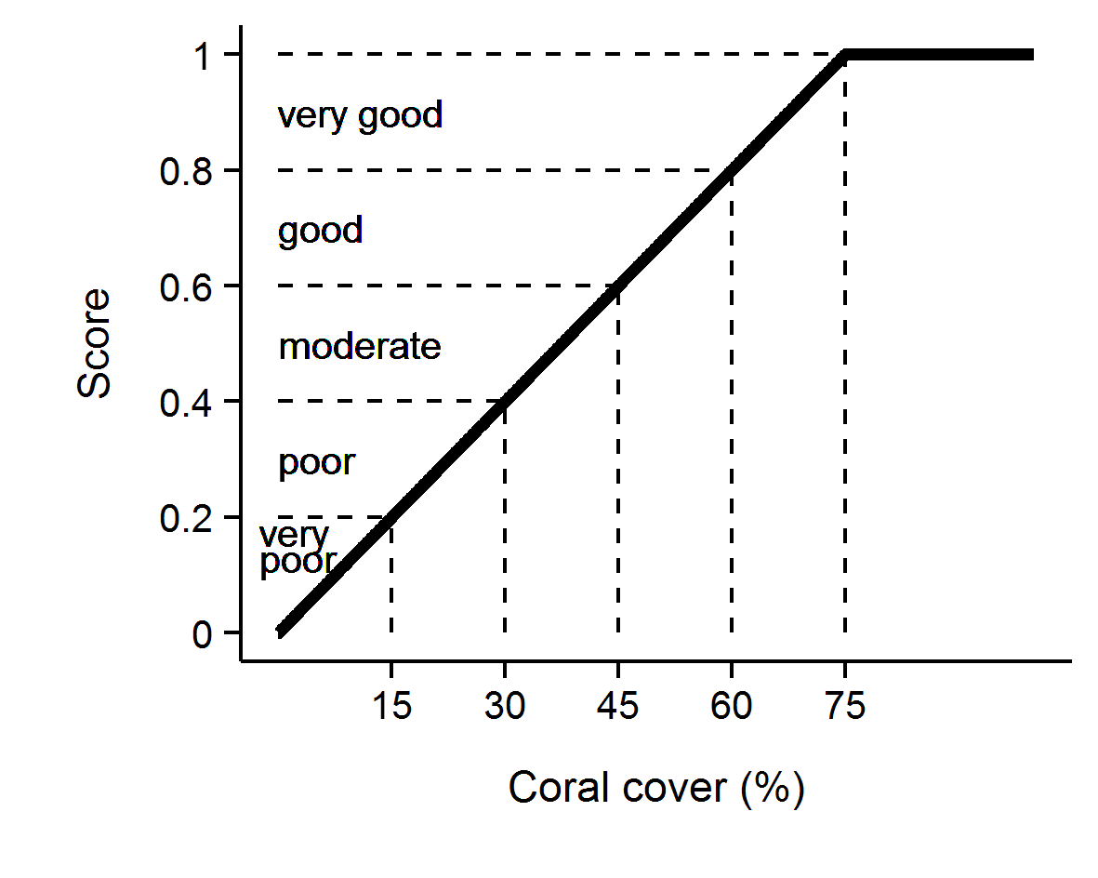
Figure 3 Scoring diagram for the coral cover metric. Numeric scores and associated condition classifications based on observed coral cover are presented.

Macroalgae metric
In contrast to coral cover, high cover of macroalgae on coral reefs is widely accepted as representing a degraded state. As opportunistic colonisers, macroalgae generally out-compete corals, recovering more quickly following physical disturbances. Macroalgae have been documented to suppress coral fecundity (Foster et al. 2008), reduce recruitment of hard corals (Birrell et al. 2008a, b, Diaz-Pulido et al. 2010) and diminish the capacity for growth among local coral communities (Fabricius 2005). The macroalgae metric considers the proportional representation of macroalgae in the algal community based on cover estimates derived from point intercept transects and is calculated as:
${MAproportion}_{ij}$ = ${MA}_{ij}$ / $A_{ij}$
Where, $A$= percent cover of all algae, $i$ = reef, $j$ = time and $MA$ = percent cover of macroalgae.
For the purpose of calculating this metric, the collective term macroalgae defines a broad functional grouping that combines species clearly visible to the naked eye although excluding crustose coralline and fine filamentous or “turf” forms. In addition, as macroalgae show marked differences in abundance across the naturally steep gradient of environmental conditions within the inshore Reef, separate upper and lower thresholds were estimated for each reef and depth (Table A 1). The use of separate thresholds ensures the indicator is sensitive to changes likely to occur at a given reef.
The thresholds for each reef were determined based on predicted MAproportion from Generalised Boosted Models (Ridgeway 2007) that included mean MAproportion over the period 2005–2014 as the response and long-term mean chlorophyll a concentration, suspended sediment concentration, and proportion of clay and silt sized grains in reefal sediments as covariates (Thompson et al. 2016). Recognising the likelihood that the observed cover of macroalgae reflect a shifted baseline an additional consideration in setting the upper threshold for MAproportion was the ecological influence of macroalgae on other indicators of coral community condition. Regression tree analyses that included MAproportion as the predictor variable indicated reduced scores for the juvenile density, coral cover and cover change indicators at higher levels of MAproportion (Thompson et al. 2016). These thresholds for ecological impacts caps informed the setting of upper bounds of MAproportion across all reefs at 23% at 2 m and a 25% at 5 m. The upper bounds for any reefs with predicted MAproportion higher than these caps were reduced to the cap level.
Scores for Macroalgae metric were scaled linearly from 0 when MAproportion is at or above the upper threshold through to 1 when MAproportion is at or below the lower threshold (Figure 4).

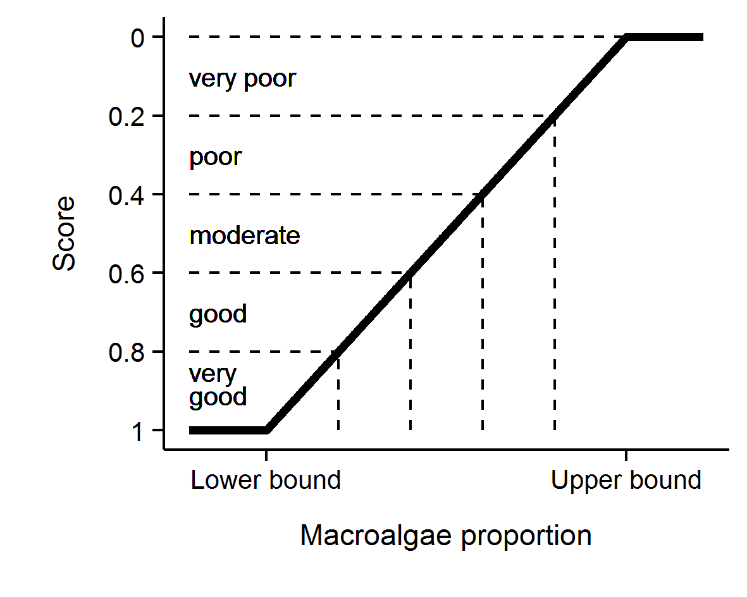
Figure 4 Scoring diagram for the Macroalgae metric. Upper and lower threshold values are reef and depth specific. Numeric scores and associated condition classifications are presented. Note that for this metric the y-axis is inverted as high values reflect poor condition.

Density of juvenile hard corals metric
For coral communities to recover rapidly from disturbance events requires adequate recruitment of new corals into the population. This metric scores the important recruitment process by targeting corals that have survived the early life stages. With the inclusion of LTMP data into the coral index, juvenile count data were subset to only include colonies up to 5 cm in diameter as this size class is common to both MMP and LTMP sampling. Counts of juvenile hard corals were converted to density per m² of space available to settlement as:
${Juvenile density}_{ij}$ = $J_{ij}$ / ${AS}_{ij}$
Where, $J$= count of juvenile colonies < 5 cm in diameter, $i$ = reef, $j$ = time and $AS$ = area of transect occupied by any algae as estimated from the co-located photo point intercept transects.
Selection of thresholds for the scoring of this metric was based on the analysis of recovery outcomes for MMP and LTMP reefs up to 2014 (Thompson et al. 2016). From these time series a binomial model was fit to juvenile densities observed at times when coral cover was below 10% and categorised based on recovery rate as being either below or above the predicted lower estimate of hard coral cover increase as estimated by the cover change indicator described below. This analysis identified a threshold of 4.6 juveniles per m² beyond which the probability that coral cover would subsequently increase at predicted rates outweighed the probability of lower than predicted rates of recovery.
Adding some weight to this result is that it was broadly consistent with the density of 6.3 juveniles per m² in the wider size range <10 cm, necessary for recovery in the Seychelles (Graham et al. 2015). As the upper density of juvenile colonies is effectively unbounded, it was desirable to set an upper threshold for scoring purposes. The density at which the probability was > 80% for coral cover to recover at predicted rates was 13 juveniles per m² and this density was chosen as the upper threshold. Based on this analysis, this metric was scored as follows; juvenile density was scaled linearly from 0 at a density of 0 through to 0.4 at a density of 4.6 colonies per m² then linearly through to a score of 1 when the density was 13 colonies per m² or above (Figure 5).

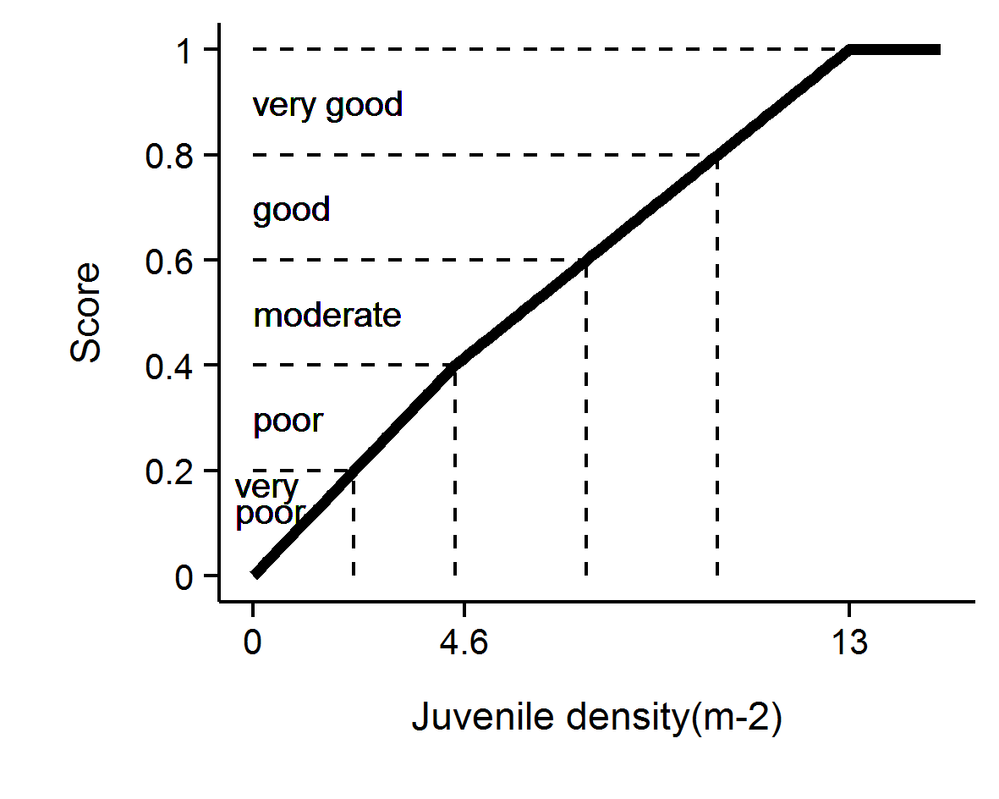
Figure 5 Scoring diagram for the Juvenile metric. Numeric scores and associated condition classifications are presented.

Cover change metric
A second avenue for recovery of coral communities is the growth of corals during periods free from acute disturbance (Gilmour et al. 2013). Chronic pressures associated with water quality may suppress the rate that coral cover increases and indicate a lack of resilience. The change in coral cover indicator score is derived from the comparison of the observed change in coral cover between two visits and the change in cover predicted by Gompertz growth equations parameterised from time-series of coral cover available on inshore reefs up until 2007. Gompertz equations were parameterised separately for the fast-growing corals of the family Acroporidae and the slower growing combined grouping of all other hard corals at each of 2 m and 5 m depths. Initial exploratory analysis provided no justification for a more detailed parameterisation of the coral community, in part due to the inability to gain precise estimates of cover increase when cover is low – as it is for most taxa at most reefs.
Years in which disturbance events occurred at a reef preclude the estimation of this indicator as there is no expectation for increase in such situations. As such estimates are only derived for annual or biennial periods during which no acute disturbances occurred.
A Bayesian framework was used to permit propagation of uncertainty through the predictions of expected coral cover increase from the two separately predicted coral types.

$\ln\left({Acr}_{it}\right) \sim N(μ_{it},σ^{2})$
$μ_{it}=v{Acr}_{i}+\ln\left({Acr}_{it-1}\right)+\left(-\frac{v{Acr}_{i}}{\ln\left(estK_{i}\right)}\right)*ln⁡({Acr}_{it-1}+ {OthC}_{it-1}+ {Sc}_{it-1})$
$v{Acr}_{i}= α+ \sum_{j=0}^{J}{β_{j}{Region}_{i}}\sum_{k=0}^{K}{γ_{k}{Reef}_{i}}$
$α \sim N(0,{10}^{6})$
$β_{j} \sim N(0, σ_{Region}^{2})$
$γ_{k} \sim N(0, σ_{Reef}^{2})$
$σ^{2},σ_{Region}^{2},σ_{Reef}^{2}= U(0,100)$
$rAcr=v{\overline{A}cr}_{i}$

Where, ${Acr}_{it},{OthC}_{it}$ and ${Sc}_{it}$ are the cover of Acroporidae coral, other hard coral and soft coral respectively at a given reef at time ($t$). $eskK$ is the community size at equilibrium (100) and $rAcr$ is the rate of increase (growth rate) in percent cover of Acroporidae coral. Varying effects of Region and Reef ($β_{j}$ and $Υ_{k}$ respectively) were also incorporated to account for spatial autocorrelation. Model coefficients associated with the intercept, Region and Reef ($α_{i}, β_{j}$ and $Υ_{k}$) all had weakly informative Gaussian priors, the latter two with model standard deviation). The overall rate of coral growth$rAcr$, constituted the mean of the individual posterior rates of increase for ${vAcr}_{i}$.
As model predictions relate to annual changes in coral cover, observed cover was adjusted to an estimated annual change since the previous observation (${Acr}_{adj}$) prior to comparison to modelled estimates. Adjusted values, ${Acr}_{adj},$ where estimated as per the following formula:
$${Acr}_{adj}={Acr}_{i-1}+({Acr}_{i}{-Acr}_{i-1})*(365/(days between samples)$$
Where cover declined no adjustment was made and ${Acr}_{adj}$ assumed ${Acr}_{i}$.
Note, the above formulae apply to the family Acroporidae (Acr) and have the same form as those applied for Other Corals (OthC) if these terms are exchanged where they appear in the equations.
Gompertz models were fitted in a Bayesian framework to facilitate combining growth rates and associated uncertainties across models. A total of 20,000 Markov-chain Monte Carlo (MCMC) sampling interactions across three chains with a warm up of 10,000 and thinned to every fifth observation resulted in well mixed samples from stable and converged posteriors (all rhat (potential scale reduction factor) values less than 1.02). Model validation did not reveal any pattern in the residuals. Bayesian models were run in JAGS (Plummer 2003) via the R2jags package (Su & Yajima 2015) for R.
The posteriors of Acroporidae predicted cover and Other Coral predicted cover were combined into posterior predictions of total coral cover from which the mean, median and 95% Highest Probability Density (HPD) intervals were calculated.
As changes in coral cover from one year to the next are relatively small, the indicator value is averaged over valid estimates (inter-annual or biennial periods when cover was not impacted by an acute disturbance) for a four-year period culminating in the reporting year. If no valid observations were available in that four-year period the most recent valid estimate is rolled forward.
To convert this indicator to a metric the following process was applied (Figure 6):
- If coral cover declined between surveys, a score of 0 was applied.
- If cover change was between 0 and the lower HPD interval of predicted total cover change, scores were scaled to between 0.1 when no change was observed through to 0.4 when change was equal to the lower interval of the predicted change.
- If cover change was within the upper and lower HPD intervals of the predicted change the score was scaled from 0.4 at the lower interval through to 0.6 at the upper interval.
- If cover change was greater than the upper HPD interval of predicted change and less than double the upper interval, scores where scaled from 0.6 at the upper interval to 0.9 at double the upper interval.
- If change was greater than double the upper HPD interval, a score of 1 was applied.

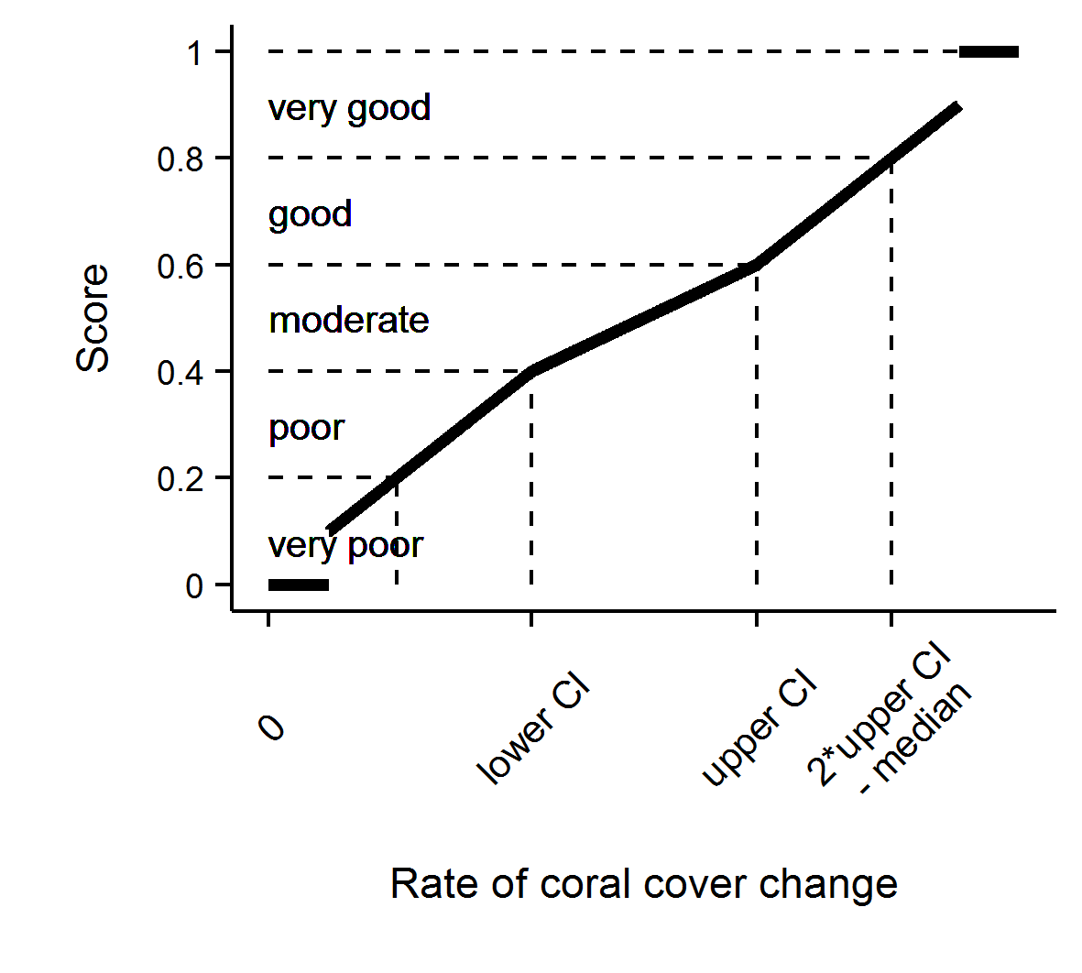
Figure 6 Scoring diagram for Cover Change metric.

Community composition metric
The coral communities monitored by the MMP vary considerably in the relative composition of coral species (Uthicke et al. 2010, Thompson et al. 2014b). As demonstrated by Uthicke et al. (2010) and Fabricius et al. (2012), some of this variability can be attributed to differences in environmental conditions between locations, which implies selection for certain species based on the environmental conditions experienced. Coral communities respond to environmental conditions in a variety of ways. Most noticeably they respond to acute shifts in conditions such as exposure to substantially reduced salinity (van Woesik 1991, Berkelmans et al. 2012), deviations from normal temperature (Hoegh-Guldberg 1999) or hydrodynamic conditions (cyclones); all of which result in reductions in coral cover as susceptible species are killed. In contrast, the increased loads of sediments and nutrients entering the Reef, as a result of land use practices in the adjacent catchments (Waters et al. 2014), may include a combination of acute conditions associated with flood events and then chronic change in conditions as pollutants are cycled through the system. Chronic change in conditions, such as elevated turbidity or nutrient levels, could provide a longer period of selective pressures as environmental conditions disproportionately favour recruitment and survival of species tolerant to those conditions.
This metric compares the composition of hard coral communities at each reef to a baseline composition at that reef (see below) and interprets any observed change as being representative of communities expected under improved or worsened water quality. A full description of this indicator is provided in Thompson et al. (2014b). The basis of the metric is the scaling of cover for constituent genera (subset to life-forms for the abundant genera Acropora and Porites) by weightings that correspond to the distribution of each genus along a water quality gradient. The location of each Reef along the water quality gradient was estimated as the reef’s score along the first axis of a principle component analysis applied to observed turbidity and Chl a concentration. Genus weightings were derived from the location each genus along the axis using these reef level water quality scores as a constraining variable in a Canonical Analysis of Principal Coordinates (partial CAP; Anderson & Willis 2003) applied to MMP data (Thompson et al. 2014b) as:
$$C_{t}= \sum_{i=1}^{n}{H_{it}*G_{i}}$$
Where, $C_{t}$ = the community composition location along the water quality gradient at time $t$,
$H_{it}$ = the Hellinger transformed (Legendre & Gallagher 2001) cover of genus $i$ at time $t$, and
$G_{i}$ = the score for genus $i$ taken from the constrained axis of the partial CAP.
Indicator scores are assigned based on the location of $C_{t}$ for the year of interest relative to a community specific baseline. The baseline for each community is bounded by the 95% confidence intervals about the mean $C_{t}$ from the first five years of observations of the community at each reef and depth. The scoring of the indicator is categorical being 0.5 when $C_{t}$ falls within the 95% confidence intervals for the location, 1 if beyond the confidence interval in a direction toward a community representative of lower turbidity and Chl a concentration, and 0 if beyond the confidence interval in the direction of a community representative of higher turbidity and Chl a concentration (Figure 6).

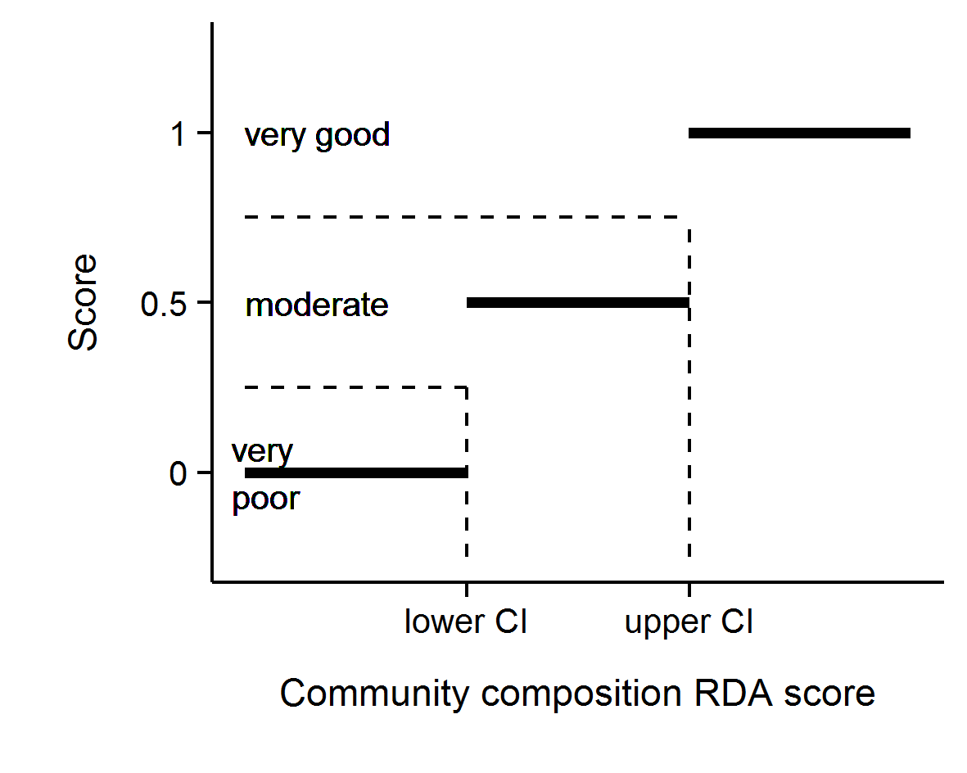
Figure 7 Scoring diagram for community composition metric

Aggregating indicator scores to regional scale assessments
In aggregating scores for various indicators into a single index uncertainty should be considered. The degree of uncertainty in an index score derived for any spatial scale of interest will include uncertainty across multiple levels: from basic observational error, the relevance of thresholds, and then variation in scores for different indicators or communities being assessed.
To derive report card scores for regions that propagated uncertainty through the double hierarchical aggregation of indicators and then reefs, a bootstrapping method was adopted. Firstly, for each indicator a distribution of 10,000 observations was created by resampling (with replacement) from the observed scores for all reef and depth combinations within the Region or sub-region of interest. Secondly these 5 resulting distributions (one for each indicator) were added together and collectively resampled 10,000 times (with replacement) to derive a single distribution comprising 10,000 scores.
To generate estimates of precision (and thus confidence intervals) appropriate for the scale of the sampling design, the bootstrapped distribution of 10,000 scores was resampled once for every original input indicator score. Confidence intervals were calculated as the 2.5% and 97.5% quantiles of repeated estimates of the mean.
Mean index scores for each (sub-)region were estimated as the mean of observed mean scores for each indicator from all reefs and depths within the (sub-)region. Lastly index scores were converted to qualitative assessments by converting to a five-point rating and colour scheme with scores of:
- 0 to 0.2 were rated as ‘very poor’ and coloured red
- 0.21 to 0.4 were rated as ‘poor’ and coloured orange
- 0.41 to 0.6 were rated as ‘moderate’ and coloured yellow
- 0.61 to 0.8 were rated as ‘good’, and coloured light green
- 0.81 were rated as ‘very good’ and coloured dark green.

The indicators and the associated thresholds and scoring system utilised is summarised in Table 6. We note that the community composition indicator is likely to respond over longer time frames than the other indicators due to the inertia in community composition imposed by long-lived coral species.

Table 6 Threshold values for the assessment of coral reef condition and resilience indicators.
Community attribute | Score | Thresholds
Combined hard and soft coral cover | Continuous between 0–1 | 1 at 75% cover or greater
 |  | 0 at zero cover
Rate of increase in hard coral cover (preceding 4 years) | 1 | Change > 2x upper 95% CI of predicted change
 | Continuous between 0.6 and 0.9 | Change between upper 95% CI and 2x upper 95% CI
 | Continuous between 0.4 and 0.6 | Change within 95% CI of the predicted change
 | Continuous between 0.1 and 0.4 | Change between lower 95% CI and 2x lower 95% CI
 | 0 | change < 2x lower 95% CI of predicted change
Proportion of algae cover classified as Macroalgae | Continuous between 0–1 | ≤ reef specific lower bound and ≥ reef specific upper bound
Density of hard coral juveniles (<5 cm diameter) | 1 | > 13 juveniles per m2 of available substrate
 | Continuous between 0.4 and 1 | 4.6 to 13 juveniles per m2 of available substrate
 | Continuous between 0 and 0.4 | 0 to 4.6 juveniles per m2 of available substrate
Composition of hard coral community | 1 | Beyond 95% CI of baseline condition in the direction of improved water quality
 | 0.5 | Within 95% Confidence intervals of baseline composition
 | 0 | Beyond 95% CI of baseline condition in the direction of declined water quality

Coral reef data analysis and presentation
The presentation of coral community condition is in four sections (Table 7).

Table 7 Presentation of community condition.
Section | Scope | Scale | Covariates | Analyses/Presentation
Executive summary | Trends in Coral index and indicator scores | Regional |  | Coral index derivation/ Observed trends
3.1.1 Regional differences  3.1.2 Effect of depth | Spatial variability in Coral index and individual indicator scores observed in 2018 | Inshore GBR | Region and Depth | Generalised Linear Multilevel models / Estimated effect
3.1.3 Response to environmental gradients |  |  | Chl a, Non-algal particulate concentration, sediment grainsize | Generalised Additive Models / Predicted relationships
3.1.4 Influence of discharge and catchment loads | Temporal variability in Coral index in relation to run-off | Regional | Regional riverine discharge, Total N and Total P loads, Chl a exposure, NAP concentration | Generalised Additive Models/ Predicted relationships
3.2 Regional condition of inshore coral communities | Observed trends in Coral index and individual indicators | Regional | Time | Linear mixed models/ Predicted regional trends and observed reef trends
Appendix 1: Additional Information | Trends in benthic community composition. | Reef/Depth |  | Plots and Tables of observations
 | Summaries of 2018 observations | Reef/Depth |  | Observed values

Variation in index and indicator scores among Regions and depths
Spatial variation in index and indicator scores were explored using Generalized Linear Multilevel models. For the index and each individual indicator, separate models were fit that included either a single factor for region or the interaction between region and depth as covariates. The model for depth also included a random term for individual reefs. Data were modelled assuming a Beta response distribution to conform to score ranges between 0 and 1. For individual indicators, scores of 0 and 1 were observed requiring a minor transformation of the observed scores of the form ((Score*0.998) + 0.001) prior to analysis. Weekly informative normally distributed (mean 0, standard deviation 10) priors were applied to model parameters and Cauchy distributed (mean 0, standard deviation 1) priors were applied to random effects. A total of 5,000 Markov-chain Monte Carlo (MCMC) samples were collected for each of three chains with a thinning rate of 5. Mean difference among levels of covariates were reported based on 95% credible intervals predicted from posterior distributions of model parameters. All modelling was conducted using the BRM package in R (R Core Team, 2015).
The community composition indicator is scored categorically and spatial differences in this metric were based on multinomial models.

Variation in index and indicator scores to gradients in water quality
The relationship between the index or indicator scores observed in 2018 and location along water quality gradients were explored via generalised linear models. Each combination of indicator score and depth were fit separately to the two water quality proxies Chl a and NAP. The scores are bound by 0 and 1 and were scaled as (Score*0.998) + 0.001) prior to analysis to allow them to be modelled assuming a beta distribution. The exception were the composition indicator scores that were modelled using a probit regression due to their categorical response. For each combination of indicator or index score and water quality proxy the relationship was modelled as a nonparametric smoothing term parameterised as a penalised beta spline applied to the water quality proxy, a simple linear relationship and a null, intercept only model. Akaike information criterion values corrected for small sample size (AICc) were used to select the most parsimonious of the three models. Generalised linear models were fit via the gamlss package (Stasinopoulos et al. 2017) while the probit model for Composition was fit with the polr function in the MASS package within the R Statistical and Graphical Environment (R Core Team 2018).

Relationship between index and indicator scores and temporal variability in environmental conditions
The response of coral communities to variation in environmental conditions was assessed by comparing changes in index scores to:
- annual discharge and total N and P loads estimated from the adjacent catchments
- exposure to above GL concentrations of Chl a over the wet season
- NAP concentrations.
For these analyses Generalised Additive Models (GAMs) were applied separately to results from each Region. The response variable was the biennial change in the index score (I) at a given reef (r) from one year (y) to the year (y+2). Biennial changes were considered due to the biennial sampling design of the program;
$$ΔI = I_{ry+2}– I_{ry}$$
Similarly, the covariate in each model were summed over the two water years ending in the survey year (y+2). To reduce confounding between the response of the index to acute disturbances, observations of change in the index at reefs categorised as being influenced by an acute disturbance event in a given biennial period were excluded.
In the first instance, GAMs allowed for the fitting of non-linear responses using natural splines; when these models did not support non-linear response, simple linear models were used.
All GAM models were fit via the mgcv package (Wood 2011) and linear models were fit via the stats package within the R Statistical and Graphical Environment (R Core Team 2017).

Temporal trends in coral index and indicators
A panel of plots provide temporal trends in the coral condition index and the five indicators on which the index is based. The derivation of annual coral index scores and associated confidence intervals is detailed in section 2.4.6.
For each of the five indicators that inform the coral index, temporal trends and their 95% confidence intervals were derived from linear mixed effects models. Models for each indicator included a fixed effect for year and random effect for each reef and depth combination. To account for the sampling design, that samples reefs on a biennial cycle, missing data were infilled with observations from the preceding year as is done for the estimation of annual index scores.
Observed trends for individual reef and depth combinations (averaged over sites) are provided as grey lines.
A more detailed summary of raw data for benthic cover and juvenile density at each reef and depth combination is presented as bar plots in Appendix 1. These additional plots breakdown cover and density of corals to the taxonomic level of Family. Genus level data for the current year only are included in table form, also in Appendix 1.

Analysis of change in index and indicator scores
Differences in the index, or individual indicator scores were estimated between focal years identified as local maxima or minima within the time-series of the index scores within each (sub-)region. Confidence in the magnitude of these differences are expressed as a probability that the mean difference in scores was greater or less than zero. Probabilities were estimated based on the location of zero (no difference) within the posterior distribution (n=1000) estimated from the mean and standard deviation of observed differences in scores between focal years. Probabilities were estimated separately for communities at 2 m and 5 m depths.

Results
Results are presented in the following sequence. Firstly, spatial variability in communities in 2018 is related to regional differences, the depth of sampling sites and the location of reefs along water quality gradients. Secondly, changes in index scores in relation to discharge from catchments at a regional scale, and reef level water quality, are presented as a broad approximation of the influence of run-off on coral community resilience. Temporal trends in community attributes are then presented for each (sub-)region along with time-series of data relating to the primary pressures influencing coral communities. Finally, site-specific data and additional information tables are presented in Appendix 1.

Variation of coral index and indicator scores observed in 2018

Regional differences
In 2018 the mean coral condition index scores were highest in the Wet Tropics Region where scores significantly higher than in either Mackay Whitsunday or Fitzroy Regions (Figure 8, Table 8). Scores for all indicators were significantly higher in the Wet Tropics than Fitzroy Region where coral communities have been subjected to multiple pressures in recent years (Table 8, Figure 8). Higher coral cover and cover change indicator scores in the Wet Tropics than in the Mackay Whitsunday region demonstrate both the relative severity and subsequent lower rate of recovery from cyclone Debbie, compared to that following recent bleaching events that impacted Wet Tropics reefs (Table 8, Figure 8).
The lack of recovery from cyclone Debbie compared to moderate to high rates of recovery at several Burdekin Region reefs is evident in the higher cover change scores in the Burdekin compared to Mackay Whitsunday Region (Figure 8, Table 8).The index scores in the Burdekin Region were also significantly higher than those in the Fitzroy Region although it was only scores for the composition indicator that differed between these regions (Figure 8, Table 8). Macroalgae scores in the Fitzroy Region were also lower than those in the compared with both the Wet Tropics and Mackay Whitsundays regions.
Table 8 Regional differences in index and indicator scores
. Tabulated values represent the upper and lower 95% credible limits to the pair-wise comparison of scores between regions. Shading highlights where regional differences in scores were supported on the basis that the distribution of predicted differences exclude zero. Green shading would indicate higher scores for the left-hand compared to right-hand region in the first column, red shading indicates higher scores for the right-hand region. For composition comparisons are for the probability that scores improved (score =1).
Regions | Condition Index |  | Coral Cover |  | Macroalgae |  | Cover Change |  | Juvenile |  | Composition
 | l | u | l | u | l | u | l | u | l | u | l | u
Burdekin - Wet Tropics | -0.21 | 0.00 | -0.25 | 0.02 | -0.37 | 0.02 | -0.26 | 0.08 | -0.24 | 0.12 | -0.44 | 0.35
Mackay Whitsunday - Wet Tropics | -0.26 | -0.05 | -0.31 | -0.07 | -0.15 | 0.26 | -0.49 | -0.15 | -0.36 | 0.01 | -0.62 | 0.17
Fitzroy - Wet Tropics | -0.37 | -0.15 | -0.32 | -0.05 | -0.40 | -0.02 | -0.45 | -0.08 | -0.42 | -0.02 | -0.86 | -0.17
Mackay Whitsunday - Burdekin | -0.16 | 0.07 | -0.22 | 0.06 | -0.01 | 0.42 | -0.43 | -0.03 | -0.33 | 0.09 | -0.52 | 0.22
Fitzroy - Burdekin | -0.27 | -0.02 | -0.23 | 0.07 | -0.25 | 0.16 | -0.38 | 0.06 | -0.37 | 0.08 | -0.78 | -0.12
Fitzroy - Mackay Whitsunday | -0.22 | 0.02 | -0.13 | 0.15 | -0.46 | -0.03 | -0.16 | 0.26 | -0.26 | 0.20 | -0.67 | 0.03

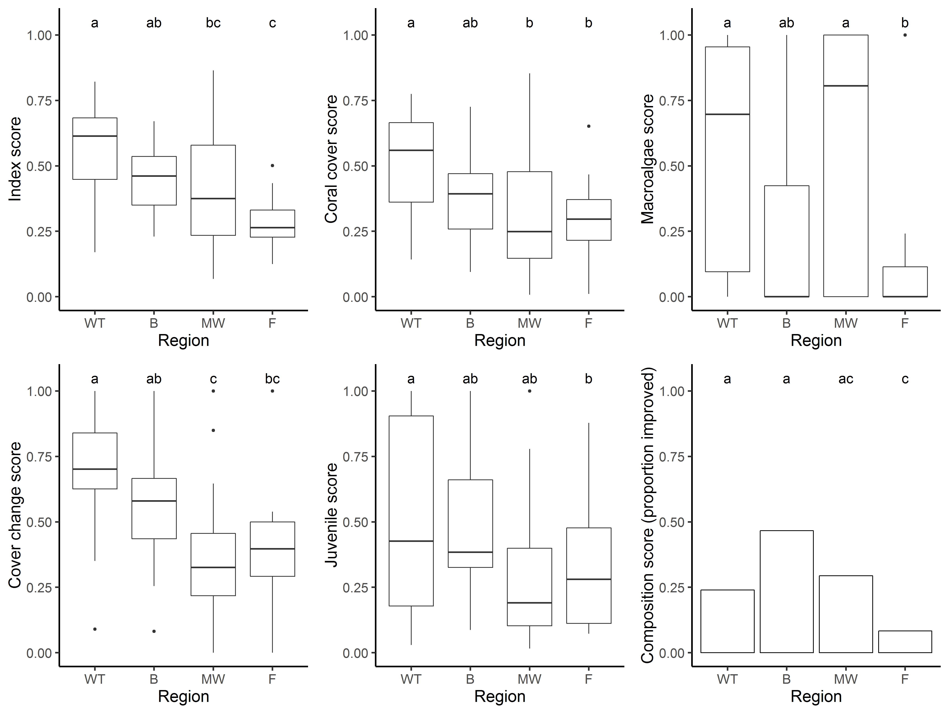
Figure 8 Regional distributions of index and indicator scores
. Boxplots show the median (bold horizontal line) 25th to 75th percentiles (box) and highest and lowest observations within 1.5 times the interquartile range (vertical lines), observations beyond these values are represented as dots. For the composition score a bar chart represents the proportion of observations scored as improved (score = 1). Labels above bars or boxplot elements identify regions with statistically similar distributions, based on the 95% credible intervals presented in Table 8. Regional abbreviations on the x-axis are: Wet tropics (WT), Burdekin (B), Mackay Whitsunday (MW), and Fitzroy (F).

Effect of depth
Index scores observed in 2018 did not differ significantly between 2 m and 5 m depths (Table 9). Of the individual indicators, the juvenile scores were higher at 5 m than at 2 m in both the Wet Tropics and Burdekin regions (Table 9). Influential in these results will have been the comparatively high densities of juvenile Turbinaria spp. at the 5 m depths of several reefs in each region (Figure A 3, Figure A 4).

Table 9 Influence of depth on index and indicator scores
. Tabulated values represent the upper (u) and lower (l) 95% credible limits to the pair-wise comparison of scores between 2 m and 5 m depths within each region. Shading highlights where depth differences in scores were supported on the basis that the distribution of predicted differences excluded zero. Green shading would indicate scores were higher at 2 m depths, red shading indicates scores were higher at 5 m depth. For Composition comparisons are for the probability that scores improved (score =1).
Regions | Condition Index |  | Coral Cover |  | Macroalgae |  | Juvenile |  | Cover Change |  | Composition
 | l | u | l | u | l | u | l | u | l | u | l | u
Wet Tropics | -0.02 | 0.20 | -0.13 | 0.10 | -0.23 | 0.25 | 0.02 | 0.37 | -0.11 | 0.24 | -0.39 | 0.75
Burdekin | -0.11 | 0.18 | -0.07 | 0.24 | -0.34 | 0.22 | 0.16 | 0.62 | -0.12 | 0.43 | -0.69 | 0.32
Mackay Whitsunday | -0.01 | 0.26 | -0.01 | 0.27 | -0.06 | 0.53 | -0.08 | 0.39 | -0.38 | 0.13 | -0.25 | 0.77
Fitzroy | -0.15 | 0.13 | -0.05 | 0.25 | -0.37 | 0.19 | -0.34 | 0.14 | -0.23 | 0.37 | -0.59 | 0.08

Response to environmental gradients
Coral condition index scores in 2018 were inversely related to the long-term mean NAP concentrations at 2 m depth (Figure 9a) highlighting that exposure to high turbidity has a negative influence on the condition of inshore reefs. Of the individual indicators it was only scores for coral cover indicator that where related to NAP concentration (Figure 9b). This relationship was not monotonic, over most of the NAP range observed on inshore reefs scores for both the index and coral cover indicator declined with increasing NAP concentration. This relationship was disrupted by the relatively high coral cover and index scores at Middle Reef in the Burdekin Region that is situated in very turbid waters (NAP concentration of 3.3mgL⁻¹) compared to all other reefs monitored (Figure 9).
At 5 m depth, scores for the macroalgae indicator decline as exposure to above Guideline levels of Chl a increase (Figure 10).

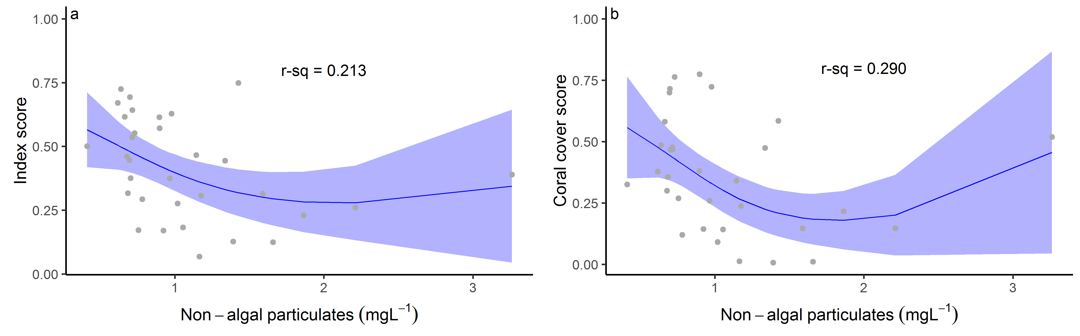
Figure 9 Coral index and indicator score relationships to environmental conditions at 2 m depth sites
. Only index or indicator score for which AICc comparisons to a null model indicated a response are included. Plots present predicted relationship bounded by the 95% confidence intervals of the prediction. R-square values indicate the proportion of variability in scores explained by the predicted relationship. Location of reefs along the environmental gradient indicated by short internal ticks along the x axis.

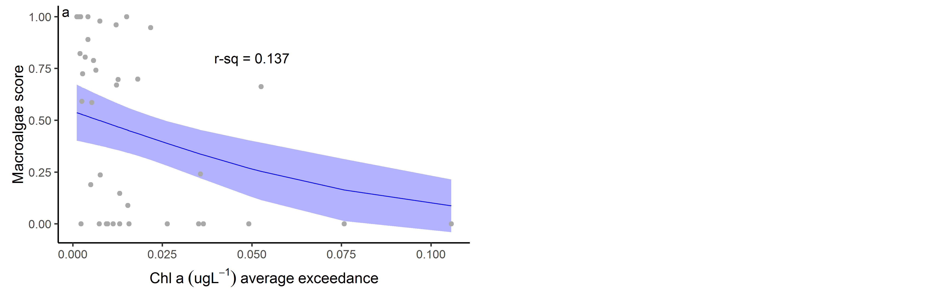
Figure 10 Coral index and indicator score relationships to environmental conditions at 5 m depth sites
. Only index or indicator score for which AICc comparisons to a null model indicated a response are included. Plots present predicted relationship bounded by the 95% confidence intervals of the prediction. R-square values indicate the proportion of variability in scores explained by the predicted relationship. Location of reefs along the environmental gradients indicated by short internal ticks along the x axis.

Influence of discharge and catchment loads
During periods that reefs were not impacted by acute disturbances (cyclones, bleaching, crown-of-thorns starfish or direct exposure to low salinity floodwaters) biennial change in index scores were negatively related to discharge from the local catchments (Table 10, Figure 11). In all four regions observable relationships between the variables selected to be indicative of chronic pressures associated with water quality and changes in coral index scores were consistently negative (Table 10). In the Wet Tropics, Burdekin and Whitsundays regions index scores declined monotonically with increasing discharge, although this relationship was only weakly supported in the Whitsundays. For the Fitzroy region the trend was not monotonic, whilst there is a small rise in the change in index scores at higher discharge, these changes remain negative and recovery is clearly still being inhibited by land-based run-off (Figure 11).
Increasing exposure to above Guideline concentrations of Chl a over the summer period had a clear influence on index scores in both the Wet Tropics and Fitzroy region (Table 10). In each of the Burdekin, Fitzroy and Wet Tropics regions, loads of N and P correlated with changes in index scores. Where relationships between index scores and environmental conditions were not monotonic the flexibility of the model applied would have contributed to the variance explained. In each case, predicted changes in the index were consistently positive at the lowest nutrient loads. The weakest relationship between index scores and the environmental variables occurred in the Mackay Whitsunday region where there was marginal evidence for lower change in index scores during years of high discharge, end-of-catchment loads of N and P or higher Chl a exposure (Table 10).
Table 10 Relationship between changes in index scores and environmental conditions
. Tabulated are the model R-square values for the relationships between the time-series of index score changes during non-disturbance periods and summaries of environmental condition during those periods. Bold font indicates statistically significant (P-values<0.05) relationships. Dark shading indicates these relationships were monotonic with higher increase in index scores at lower exposures to the environmental covariate. Lighter shading indicates where monotonic declines in index change corresponded to increasing exposure although the relationship was weak (P-values between 0.05 and 0.1). An (*) marks instances where highest index score changes were observed at lowest exposures. Results for Total N and P are based on data provided by the State of Queensland (Department of Environment and Science) up until 2017.
Region | Freshwater Discharge | Total N river load | Total P river load | Non algal particulates (reef) | Chlorophyll (reef)
Wet Tropics | 0.174 | 0.166 | 0.186* | 0.00 | 0.086
Burdekin | 0.141 | 0.146* | 0.145* | 0.013 | 0.074*
Mackay Whitsunday | 0.037 | 0.038 | 0.040 | 0.101 | 0.044
Fitzroy | 0.298* | 0.219* | 0.228* | 0.039 | 0.209
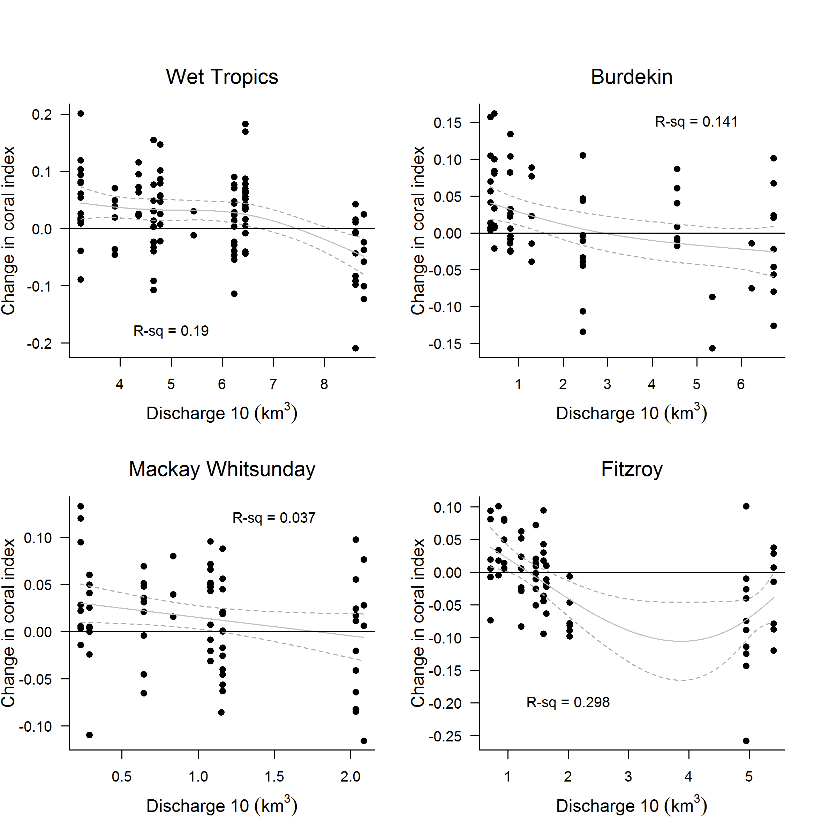
Figure 11 Relationship between the coral index and run-off from local catchments
. Plotted points represent observed change in the index score at each reef and depth over a two-year period. Observations following years for which acute disturbances impacted communities in the period between samples were excluded. Discharge values represent the cumulative discharge from the region’s major rivers over the two-year period corresponding to index changes. Trend lines represent the predicted change in index scores (solid line) and the 95% confidence intervals of the prediction (dash lines).

Regional condition of inshore coral communities

Wet Tropics region: Barron Daintree sub-region
In 2018 the coral condition index improved at both 2 m and 5 m depths and remains categorised as ‘moderate’ (Table 11, Figure 13a). At 2 m depth consistent improvement in coral cover and cover change scores were primarily responsible for the improvement in the coral index compared to 2017 scores. However, ongoing declines in scores for the macroalgae and juvenile indicator s at 2 m result in the index score at this depth remaining below 2014 levels (Table 11, Figure 13a). In contrast, the index has improved since 2014 at 5 m depth due to improved scores for all indicator s except coral cover, which has increased since 2017 (Table 11).
Table 11 Index and indicator score comparisons in the Barren Daintree sub-region
. Data compare the changes in scores between local maxima and minima in the index time-series. For the index, and each indicator, the observed change in the score and the probability that the change was greater or less than zero (no change) are presented. Shading is used as a visual aid to highlight the magnitude of the probability the score improved (blue shades) or declined (red shades). Probabilities are derived from the posterior distribution of observed score changes at each reef and depth.
Period | Depth | Condition Index |  | Coral Cover |  | Macroalgae |  | Juvenile Coral |  | Cover Change |  | Composition
 |  | Score | P | Score | P | Score | P | Score | P | Score | P | Score | P
2008 to 2014 | 2 | -0.21 | 0.89 | -0.36 | 0.71 | -0.17 | 0.76 | -0.41 | 0.93 | -0.62 | 0.99 | 0.50 | 1.00
 | 5 | -0.26 | 0.81 | -0.13 | 0.61 | -0.42 | 0.81 | -0.04 | 0.58 | -0.21 | 0.70 | -0.50 | 1.00
2014 to 2018 | 2 | -0.03 | 0.87 | 0.12 | 0.93 | -0.18 | 0.76 | -0.09 | 0.73 | 0.52 | 0.99 | -0.50 | 0.76
 | 5 | 0.16 | 0.87 | 0.00 | 0.51 | 0.24 | 0.74 | 0.09 | 0.70 | 0.28 | 0.79 | 0.17 | 0.73
2017 to 2018 | 2 | 0.06 | 1.00 | 0.05 | 1.00 | -0.10 | 0.76 | -0.04 | 0.76 | 0.11 | 0.96 | 0.25 | 0.77
 | 5 | 0.05 | 0.75 | 0.02 | 0.83 | 0.23 | 0.73 | 0.02 | 0.67 | -0.03 | 0.64 | 0.00 | 0.00

Scores for most indicators remain poor at Snapper North, however, good scores in the cover change indicator and a decline in the proportional cover of macroalgae at 5 m are promising signs for recovery (Table A 5, Figure A 1). As Low Isles has not been resurveyed since the 2017 bleaching event, the current assessment, based on 2016 observations, will likely be over estimating the index score slightly in this sub-region. Aerial surveys indicated severe bleaching at Low Isles in 2017.
Juvenile coral densities continue to decline at 2 m depths (Figure 13d, Table 11). These reductions are minor and may be partly due to the increased macroalgae cover observed at most sites (Figure A 1). It is reasonable to consider, however, that the impacts of consecutive bleaching events in 2016 and 2017 across the northern Great Barrier Reef contribute to this result both due to both direct impacts on juvenile corals and impacts to adult coral populations with flow on effects for recruitment.
In the context of recent disturbance events, the 2017 bleaching event was relatively minor, accounting for 6% of observed coral cover losses since 2005 (Figure 12e). The bleaching event temporarily disrupted the recovery of the coral communities following a series of more severe disturbances. Sub-regional coral cover reached a low in 2015 (Figure 13b). This loss of coral reflected the cumulative impacts of crown-of-thorns starfish, cyclone Ita and a period of losses attributed to disease and chronic pressures that coincided with relatively high discharge from the Barron and Daintree rivers (Figure 12c, d, e). The relatively minor losses of coral cover attributed to coral bleaching will, in part, reflect the prior loss of sensitive species that occurred during recent disturbances.
The influence of chronic pressures and disease is reflected in the decline in cover change scores through to 2014 (Figure 13e). At the same time, there was an increase in the cover of macroalgae at Snapper North in 2011 (peaks at 2 m and 5 m reefs, Figure 13c, Figure A 1) implicating pressures associated with nutrient availability and consistent with the exposure to above guideline concentrations of Chl a at Snapper Island (Figure 12a). In 2018 the proportion of macroalgae in the algal communities remained elevated (Figure 13c). It is evident however, that the high proportion of macroalgae must also be influenced by additional processes as the similar water quality at Snapper South does not support the cover of macroalgae observed at Snapper North. The juvenile coral score remained poor in 2018 (Figure 13, Table A 5).
Despite variability in discharge (Figure 12d), and associated loads of nutrients and sediments delivered from adjacent catchments (Waterhouse et al. 2018), the water quality index has remained stable and there have been no clear trends in most of measured water quality parameters in the Barron Daintree sub-region. An exception is dissolved organic carbon concentrations which have steadily increased since 2006 (Figure A 8).
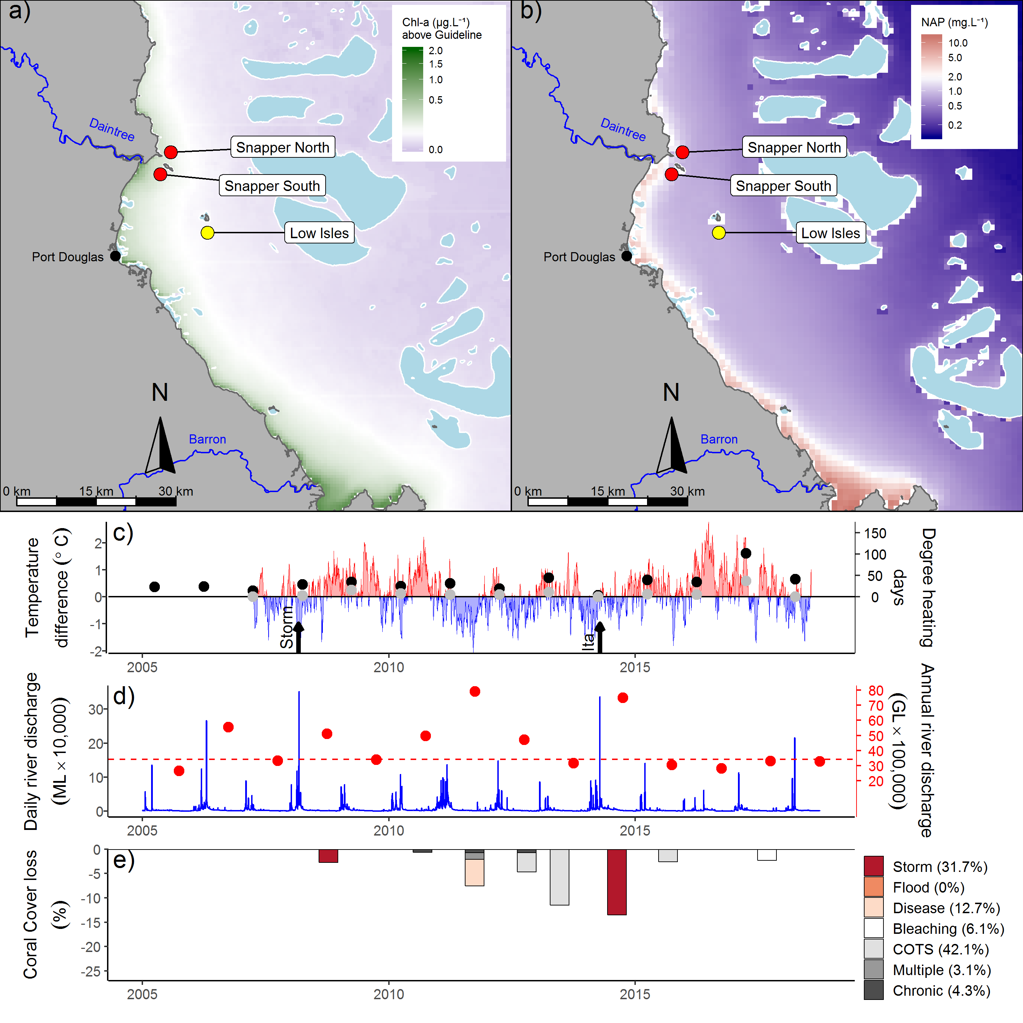
Figure 12 Barron Daintree sub-region environmental pressures
. Maps show location of monitoring sites, red symbols MMP, yellow symbols LTMP along with a) mean chlorophyll a exceedance of wet season Guideline (0.63ugL⁻¹) and b) mean Non Algal Particulate concentrations. Water quality data are mean levels over the period 2003-2018 (NAP). c) Seasonally adjusted temperature deviation, timing of cyclones and storms indicated by black arrows, accumulated degree heating days over the summer period (1st of December – 31st March) as reported by BoM (black symbols) and derived from in situ loggers (grey symbols) d) Combined daily (blue) and annual water year – October to September (red) discharge for the Daintree and Barron rivers, red dashed line represents long-term median discharge (1986–2016). e) break-down of hard coral cover loss by disturbance type; length of bars represents the mean loss of cover across all reefs in the sub-region (see methods section 2.2 further detail).

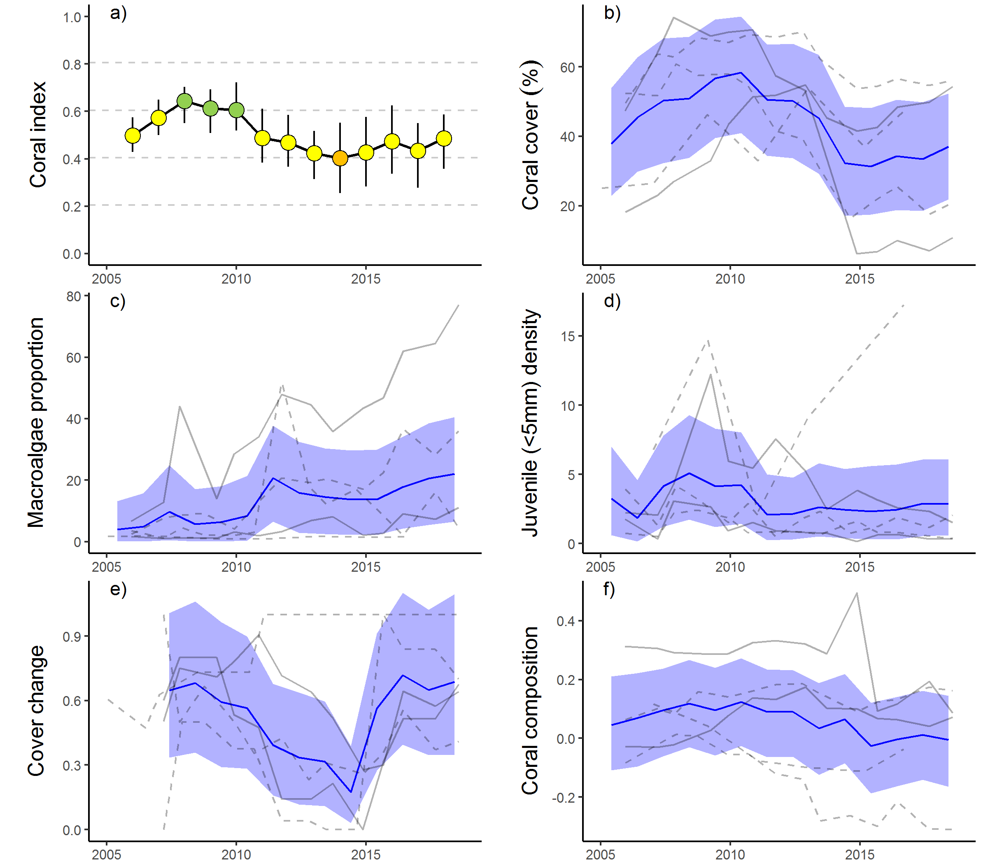
Figure 13 Barron Daintree sub-region index and indicator trends
. a) Coral index, colour coding: dark green-‘very good’; light green-‘good’; yellow – ‘moderate; orange – ‘poor’; red – ‘very poor’. b – f) trends in individual indicators, (blue lines) bound by 95% confidence intervals of those trends (shading), grey lines represent observed profiles at 5 m (dashed) and 2 m (solid) depths for individual reefs.

Wet Tropics region: Johnstone Russell-Mulgrave sub-region
The coral index improved to ’good’ in 2018 recovering from the slight decline observed in 2017 (Figure 15a, Table 12). Contributing most to the improvement were increased scores for the juvenile indicator, the coral cover indicator at 2 m depths and the composition indicator at 5 m depth (Table 12). Two of the eight reefs monitored at 5 m depth in this sub-region have not been surveyed since the 2017 bleaching event (Table 1) as such the general improvement observed between 2012 and 2018 (Table 12) may be overestimated. Coral cover generally increased across the region with declines only evident at the 5 m sites on two reefs (Figure 15b). Scores for the cover change indicator, that are influenced by rapid increases in cover observed prior to the 2017 bleaching event, remained relatively unchanged at good levels (Figure 15e, Table A 5). Scores for macroalgae remain generally good across the region (Figure 15c, Table A 5); the exception was Franklands West where the score for macroalgae remains poor (Table A 5). At Franklands West the macroalgal community is dominated by red algae species (Table A 9). The reason for high cover of red algae at Frankland West is unclear as the water quality is consistently better than at High Island where macroalgae scores are higher (Figure 14a).
Table 12 Index and indicator score comparisons in the Johnstone Russell-Mulgrave sub-region. Data compare the changes in scores between local maxima and minima in the index time-series
. For the index, and each indicator, the observed change in the sub-regional score and the probability that the change was greater or less than zero (no change) are presented. Shading is used as a visual aid to highlight the magnitude of the probability the score improved (blue shades) or declined (red shades). Probabilities are derived from the posterior distribution of observed score changes at each reef and depth.
Period | Depth | Condition Index |  | Coral Cover |  | Macroalgae |  | Juvenile |  | Cover Change |  | Composition
 |  | Score | P | Score | P | Score | P | Score | P | Score | P | Score | P
2009 to 2012 | 2 | -0.21 | 0.93 | -0.24 | 0.85 | -0.21 | 0.70 | -0.12 | 0.80 | -0.21 | 0.70 | -0.25 | 0.73
 | 5 | -0.13 | 0.79 | -0.14 | 0.87 | -0.03 | 0.55 | -0.12 | 0.82 | -0.10 | 0.60 | -0.25 | 0.71
2012 to 2018 | 2 | 0.17 | 0.88 | 0.17 | 0.79 | 0.09 | 0.58 | 0.08 | 0.70 | 0.33 | 0.80 | 0.17 | 0.76
 | 5 | 0.10 | 0.79 | 0.05 | 0.62 | -0.05 | 0.60 | 0.15 | 0.79 | 0.15 | 0.65 | 0.19 | 0.67
2017 to 2018 | 2 | 0.03 | 0.70 | 0.07 | 0.91 | -0.03 | 0.58 | 0.12 | 0.82 | -0.02 | 0.55 | 0.00 | 0.00
 | 5 | 0.04 | 0.76 | 0.01 | 0.60 | -0.02 | 0.55 | 0.04 | 0.73 | -0.08 | 0.65 | 0.25 | 0.82

In general, the trend in the coral index in the sub-region reflects the impact and subsequent recovery of coral communities following the severe impacts associated with cyclones Tasha and Yasi in 2011 (Figure 14). These cyclones caused substantial damage to coral communities at Franklands East, Franklands West and High East. At High West, loss of coral cover at 2 m depth following these cyclones was attributed to low salinity floodwaters (Figure A 2, Table A 4). The effects of cyclones were further compounded by the increased prevalence of disease in 2011 (Figure 14e). Fitzroy Island, which had escaped serious damage from Tasha and Yasi, incurred the highest loss of coral due to disease; at Fitzroy East between 60% (2 m) and 42% (5 m) of the cover of hard corals, predominantly Acropora, was lost (Table A 4). The marked increase in disease observed at Fitzroy Island in 2011 coincided with high discharge from local rivers (Figure 14d). This loss of cover was influential in the regional level association between the change in index scores and discharge from local rivers (Figure 11). The low point in the index reached in 2012 reflects decline in the cover change score in 2012 compounding reductions in other indicator scores in direct response to the cyclones in 2011 (Table 12, Figure 15).
Since 2012 crown-of-thorns starfish have been active in the area, and their feeding will have suppressed improvement in the coral cover indicator over this period. Since monitoring began in 1992 two cycles of crown-of-thorns starfish outbreaks have impacted the reefs in this sub-region. Between 1996 and 2000 substantial loss of cover at Green, Fitzroy West LTMP and the Frankland Group was attributed to crown-of-thorns starfish (Table A 4). In 2012 and 2013 numbers of crown-of-thorns starfish were again increasing. At both Fitzroy Island and Green Island reduction in hard coral cover through to 2015 was attributed to crown-of-thorns starfish feeding (Table A 1). In contrast, although low numbers of crown-of-thorns starfish were observed at the Frankland Group and High Island between 2012 and 2018, growth of corals tended to out-strip losses due to their feeding. It is possible that the losses of coral cover attributed to bleaching in 2017 included some loss due to crown-of-thorns starfish. In 2018 numbers of crown-of-thorns starfish were low with a maximum density of 62.5 per ha at High East. Helping to mitigate the impact of crown-of-thorns has been ongoing population control with 843 starfish removed from the Frankland Group between January 2017 and March 2018 (GBRMPA Eye on the Reef). In June 2018 there was a mean density of 31.5 per ha across Frankland East and West.
The impact of coral bleaching in 2017 was similar in magnitude to the cumulative impact of crown-of-thorns starfish since 2012 (Figure 14) and further interrupted the recovery of the coral communities in recent years (Figure 15a). At individual reefs, up to 23% of the cover of hard corals was lost over the 2017 bleaching event (Table A 4). Surveys in 2018 demonstrated strong recovery of coral cover with scores for the cover change indicator remaining high (Figure 15b, e).

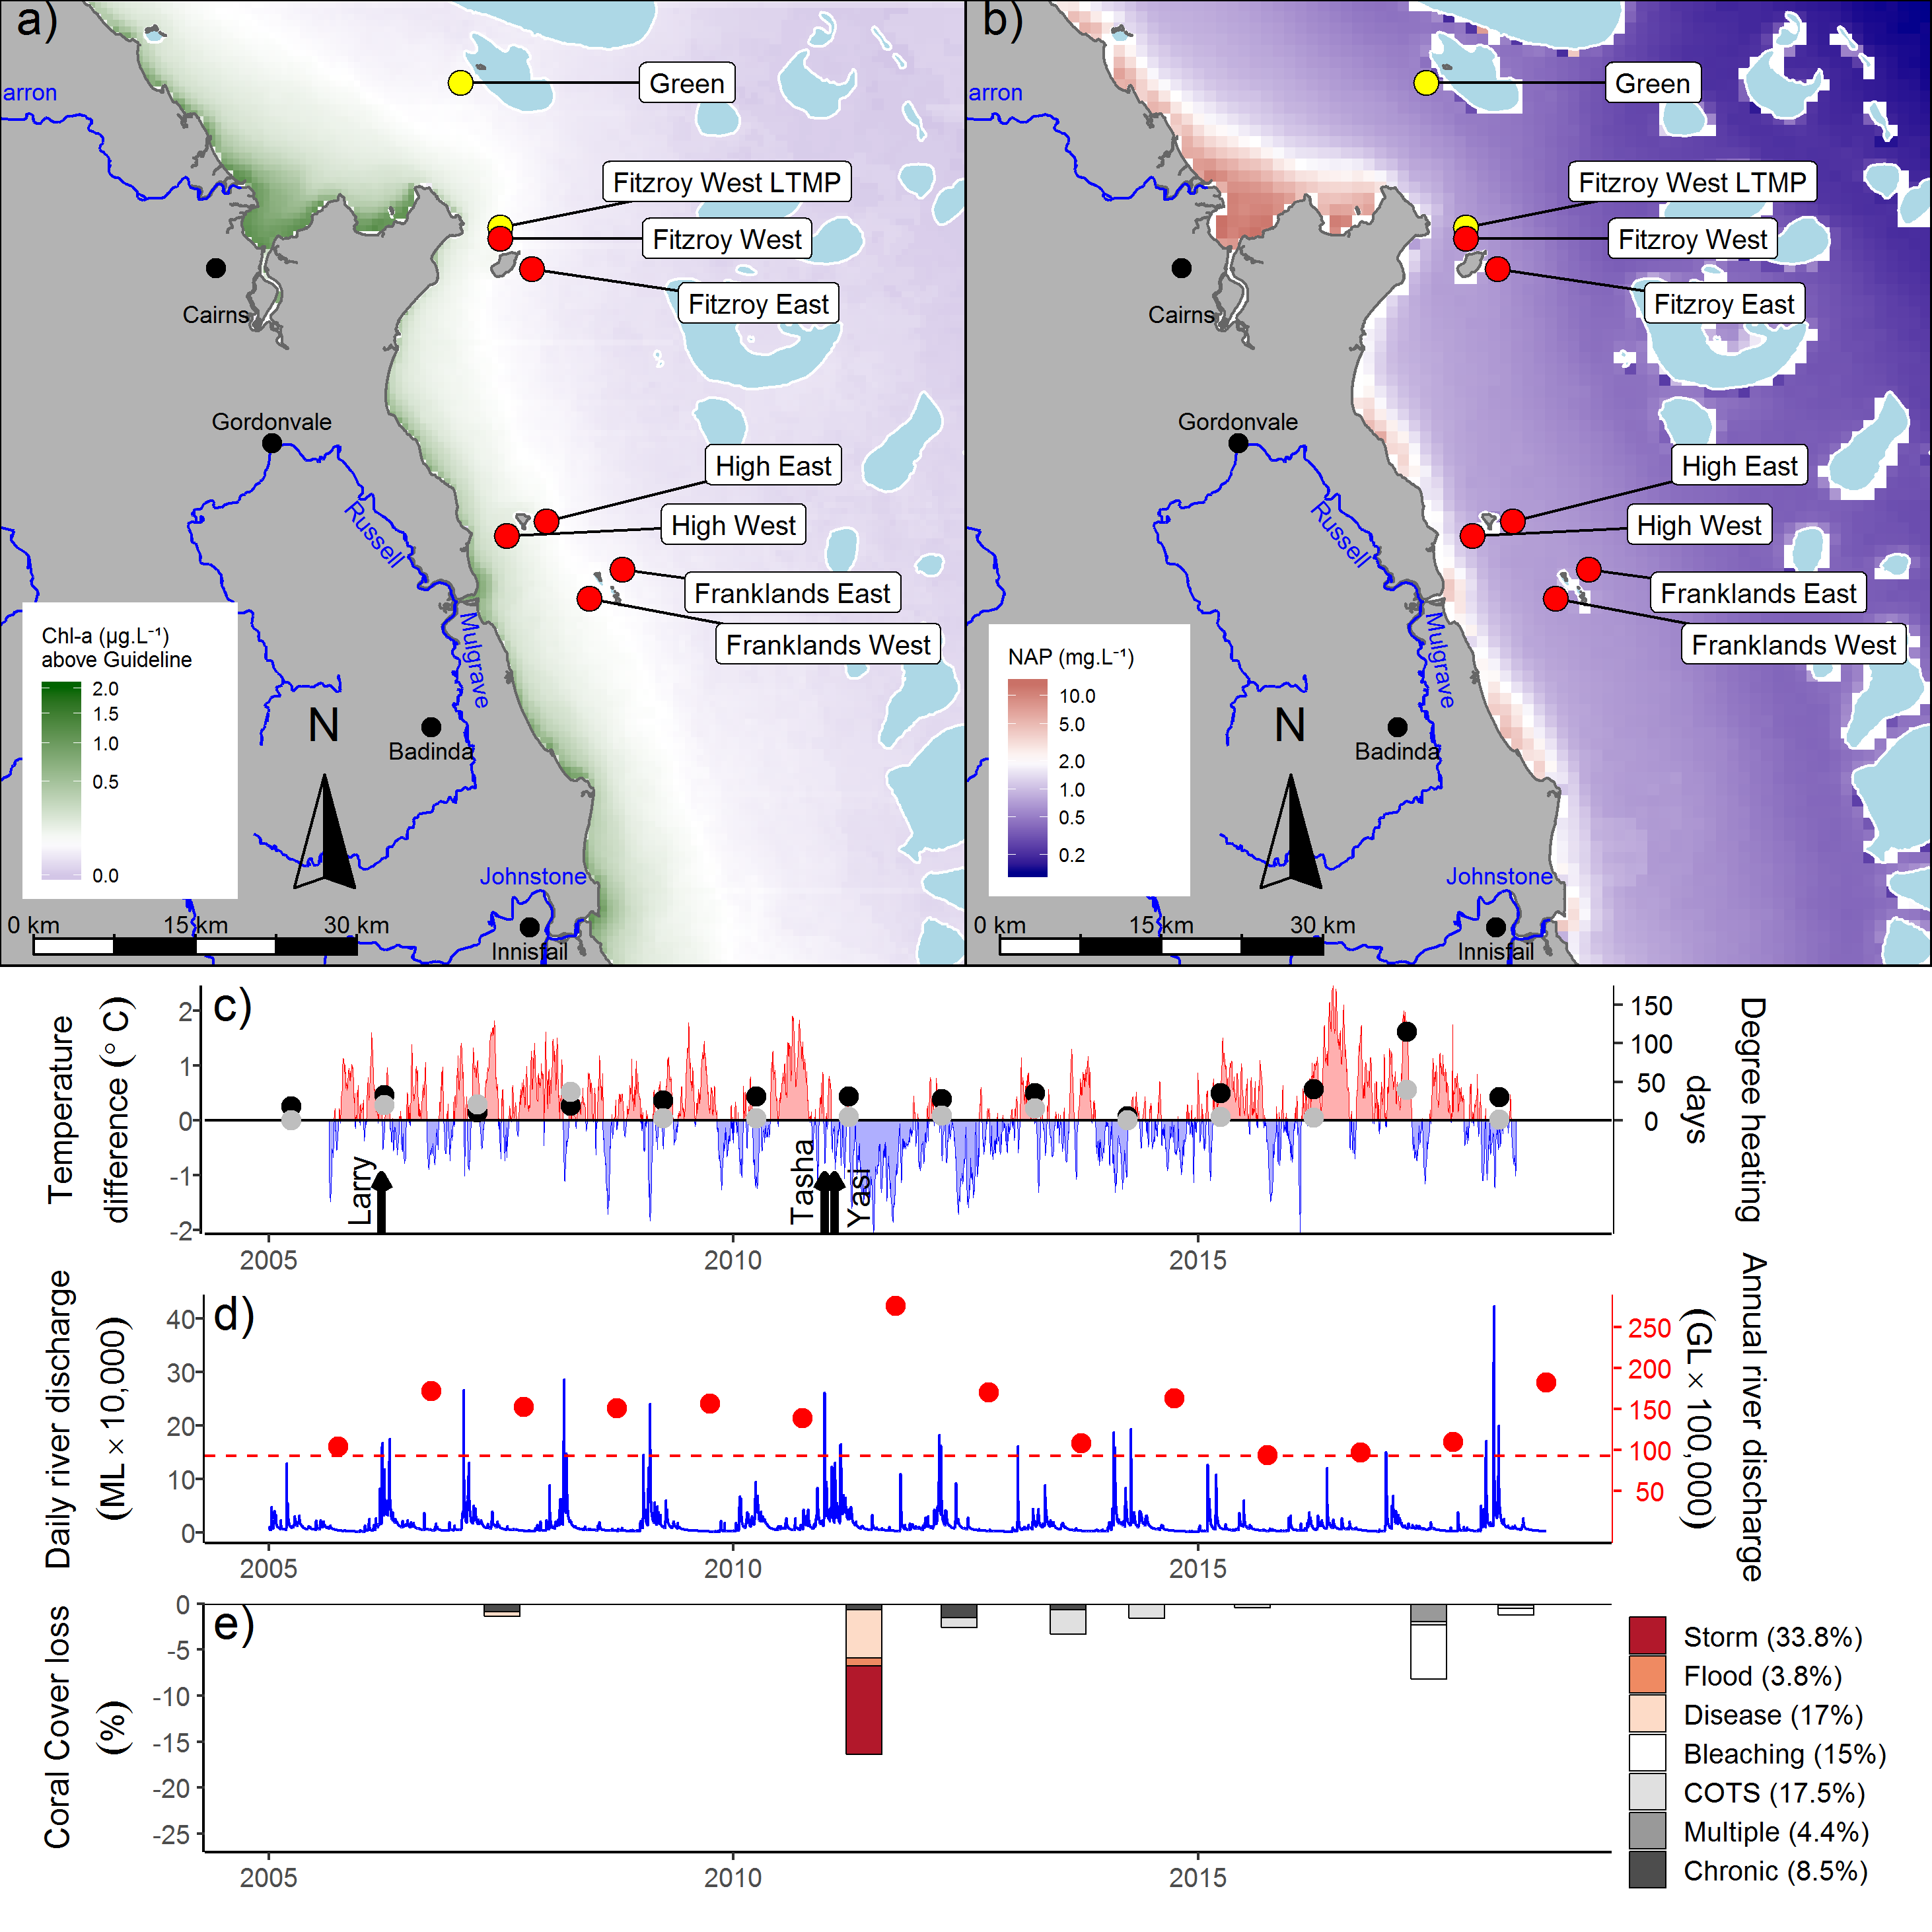
Figure 14 Johnstone Russell-Mulgrave sub-region environmental pressures
. Maps show location of monitoring sites, red symbols MMP, yellow symbols LTMP along with a) mean chlorophyll a exceedance of wet season Guideline (0.63ugL⁻¹) and b) mean Non Algal Particulate concentrations. Water quality data are mean levels over the period 2003–2018 (Chl) and 2003-2018 (NAP). c) Seasonally adjusted temperature deviation, timing of cyclones and storms indicated by black arrows, accumulated degree heating days over the summer period (1st of December – 31st March) as reported by BoM (black symbols) and derived from in situ loggers (grey symbols) d) Combined daily (blue) and annual water year – October to September (red) discharge for the North Johnstone, South Johnstone, Russell and Mulgrave rivers, red dashed line represents long-term median discharge (1986–2016). e) break-down of hard coral cover loss by disturbance type; length of bars represents the mean loss of cover across all reefs (see methods section 2.2 for further detail).

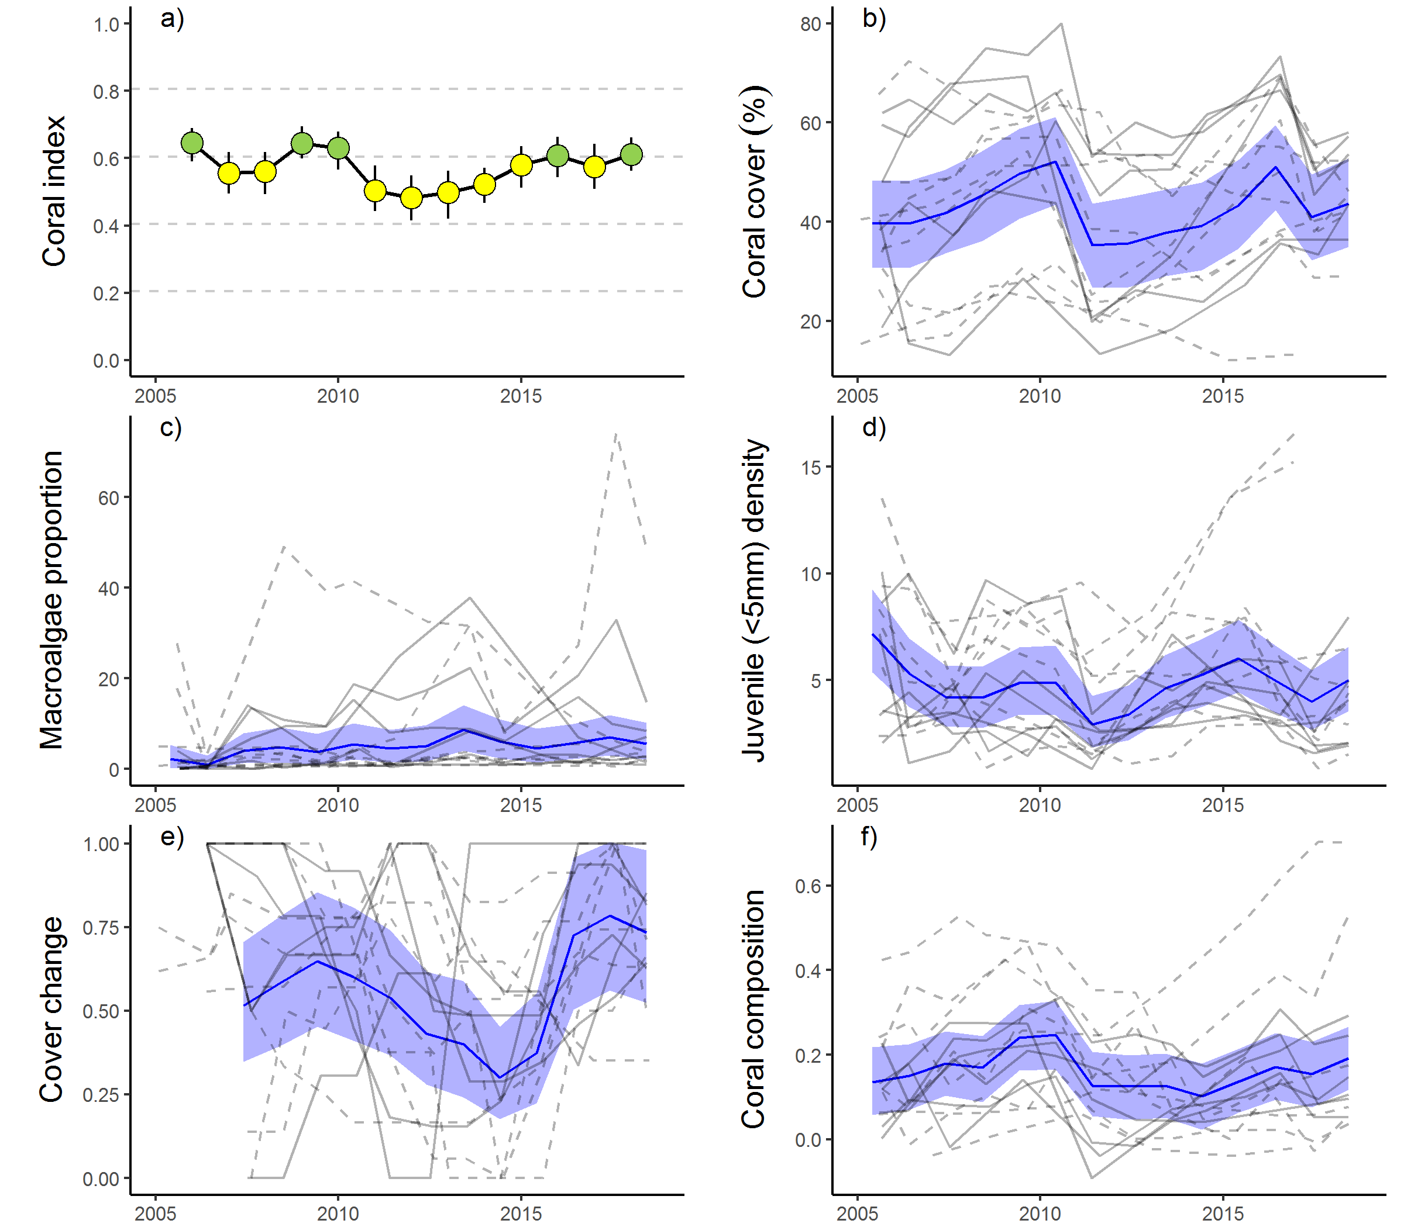

Figure 15 Johnstone Russell-Mulgrave sub-region index and indicator trends
. a) Coral index, colour coding: dark green- ‘very good’; light green – ‘good’; yellow – ‘moderate; orange – ‘poor’; red – ‘very poor’. b – f) trends in individual indicators, (blue lines) bound by 95% confidence intervals of those trends (shading), grey lines represent observed profiles at 5 m (dashed) and 2 m (solid) depths for individual reefs.

Discharge from rivers in the sub-region was above median levels over the 2018 water-year with peak flows reaching the highest levels on record since monitoring commenced following heavy rainfall across the catchment in early March 2018 (Figure 14d). Despite the major flooding, observed increase in cover of sensitive coral species, such as those in the family Acroporidae, at 2 m depths at High Island (Figure A 2) demonstrate minimal exposure to low salinity plume waters. It is possible that while no direct impacts were observed, exposure to plume waters may have reduced fitness of coral communities and contributed to reduced scores for the cover change indicator (Figure 15e). Prior to 2018, discharge had been at, or below, median levels since 2014 (Figure 14d) and under these conditions the coral communities demonstrated a clear recovery from the impost of cyclones, flooding in 2011 and ongoing low-level crown-of-thorns starfish populations. Despite the relatively low flows and associated loads of nutrients and sediments being discharged into the marine environment over that period, there were no clear reductions in regional concentrations of measured water quality parameters. In contrast, concentrations of PN, PP, POC and DOC have all shown a consistent increase (Figure A 9). It remains unclear at this stage whether these increases are the result of ongoing effects of land-based run-off or reflect changes in coastal productivity (Gruber et al. 2019).

Wet Tropics region: Herbert Tully sub-region
The coral condition index in the Herbert Tully sub-region remains categorised as ‘moderate’ despite a slight decline since 2017 (Table 13, Figure 17a). The decline in index scores resulted from reduction in scores at 2 m depth for all indicators, except for coral cover, that improved at all reefs (Table 13). At 5 m depths the coral index in 2018 was unchanged from that observed in 2017, slight decline in the juvenile indicator scores and improvement in the composition indicator scores were the most consistent changes (Table 13).
Influencing the slight decline in the index in 2018 were the continuing effects of coral bleaching in 2017 and the likely influence of ongoing chronic pressures. During surveys in 2017 corals at 5 m depths were severely bleached (Thompson et al. 2018). Minimal increase, or indeed loss, of hard coral cover observed in 2018 at 5m depths at three of the four reefs surveyed (Table A 4) were attributed to the 2017 bleaching event. At 2 m depths on the same reefs (and both depths at Dunk North), few bleached corals were observed during 2017 surveys indicating direct mortality attributable to the bleaching event had run its course with. Although coral cover at 2 m depth increased between 2017 and 2018, the rate of increase had declined compared to that observed prior to the bleaching event (Table 13). The slow recovery of coral cover at 2m depths suggests that recovery was impeded by ongoing chronic pressures. It is reasonable to assume that any chronic pressures will have confounded the losses attributable to bleaching at 5 m depths.
Major flood levels were observed across the region in early March 2018 (Figure 16d) and resulted in above median discharge from the local catchments (Figure 16d). Whilst peak levels were high, this event was short lived and no direct impacts on coral communities were observed at the time of survey. It is possible, however, that the decline in composition indicator scores at 2 m depths reflects exposure to low salinity waters, or stress associated with poor water quality (Table 13).
Table 13 Index and indicator score comparisons in the Herbert Tully sub-region
. Data compare the changes in scores between local maxima and minima in the index time-series. For the index, and each indicator, the observed change in the sub-regional score and the probability that the change was greater or less than zero (no change) are presented. Shading is used as a visual aid to highlight the magnitude of the probability the score improved (blue shades) or declined (red shades). Probabilities are derived from the posterior distribution of observed score changes at each reef and depth.
Period | Depth | Condition Index |  | Coral Cover |  | Macroalgae |  | Juvenile |  | Cover Change |  | Composition
 |  | Score | P | Score | P | Score | P | Score | P | Score | P | Score | P
2008 to 2011 | 2 | 0.10 | 0.76 | -0.08 | 0.75 | 0.67 | 0.92 | -0.05 | 0.64 | 0.33 | 0.94 | -0.38 | 0.93
 | 5 | 0.13 | 0.80 | -0.07 | 0.66 | 0.60 | 0.89 | -0.07 | 0.56 | 0.30 | 0.74 | -0.13 | 0.70
2011 to 2013 | 2 | -0.04 | 0.64 | 0.02 | 0.64 | -0.67 | 0.92 | 0.39 | 0.83 | 0.05 | 0.58 | 0 | NA
 | 5 | -0.12 | 0.88 | 0.01 | 0.54 | -0.59 | 0.90 | 0.20 | 0.75 | -0.08 | 0.60 | -0.13 | 0.70
2013 to 2018 | 2 | 0.27 | 1.00 | 0.29 | 1.00 | 0.40 | 0.79 | -0.01 | 0.51 | 0.35 | 1.00 | 0.33 | 0.87
 | 5 | 0.26 | 0.99 | 0.22 | 0.99 | 0.25 | 0.65 | 0.10 | 0.73 | 0.24 | 1.00 | 0.50 | 1.00
2017 to 2018 | 2 | -0.08 | 0.81 | 0.06 | 0.97 | -0.07 | 0.70 | -0.11 | 0.86 | -0.13 | 0.73 | -0.17 | 0.72
 | 5 | -0.01 | 0.51 | -0.02 | 0.65 | -0.04 | 0.52 | -0.05 | 0.70 | -0.04 | 0.58 | 0.17 | 0.73

Over the period of monitoring changes in the coral index identify distinct declines due to the impacts of cyclone Larry in 2006 and cyclone Yasi in 2011 followed by recovery in subsequent years (Figure 17a). The combined impacts of these cyclones account for 82.6% of the lost cover of hard coral covers since 2005 (Figure 16e). Of note is that following each cyclone, in addition to an immediate reduction, was a lagged decline in the index scores (Figure 16a). This lagged response reflects temporary improvement in the macroalgae indicator score in the first post cyclone survey (Figure 17e). During cyclones, macroalgae are stripped from the substrate, temporarily reducing their abundance. Subsequent colonisation of space made available to algae due to reduced coral cover results in a lagged impact on index scores (Figure 17e).
Despite a small reduction, the index score in 2018 remains well above that observed in 2013. It is only the macroalgae score at 5 m depth and juvenile scores at 2 m depth that remain unchanged (Table 13). At both these depth and indicator combinations most reefs in 2018 had scores categorised as moderate or above (Table A 5).
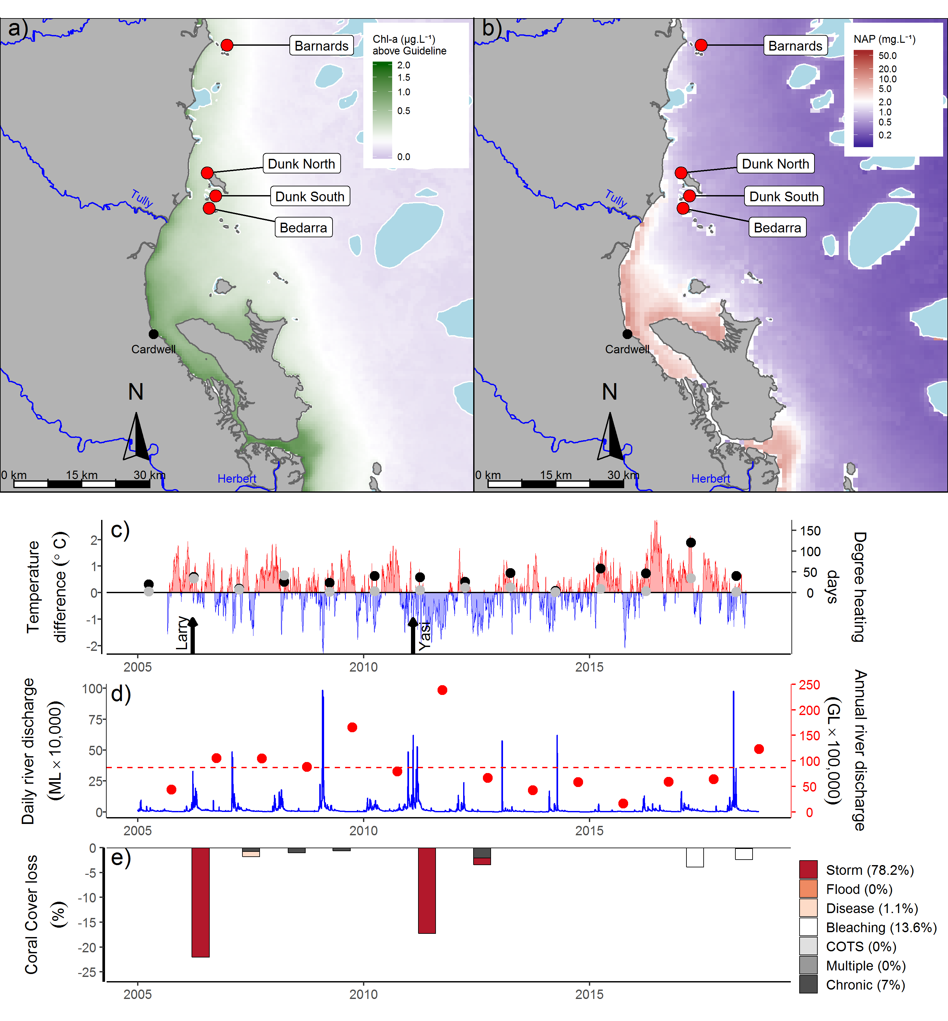
Figure 16 Herbert Tully sub-region environmental pressures
.Maps show location of monitoring sites, red symbols MMP, yellow symbols LTMP along with, a) mean chlorophyll a exceedance of wet season Guideline (0.63ugL⁻¹) and b) mean Non Algal Particulate concentrations. Water quality data are mean levels over the period 2003–2018 (Chl) and 2003–2018 (NAP). c) Seasonally adjusted temperature deviation, timing of cyclones and storms indicated by black arrows, accumulated degree heating days over the summer period (1st of December – 31st March) as reported by BoM (black symbols) and derived from in situ loggers (grey symbols) d) Combined daily (blue) and annual (red) discharge for the Herbert, Murray and Tully rivers, red dashed line represents long-term median discharge (1986–2016). e) break-down of hard coral cover loss by disturbance type; length of bars represents the mean loss of cover across all reefs (see methods section 2.2 for further detail).

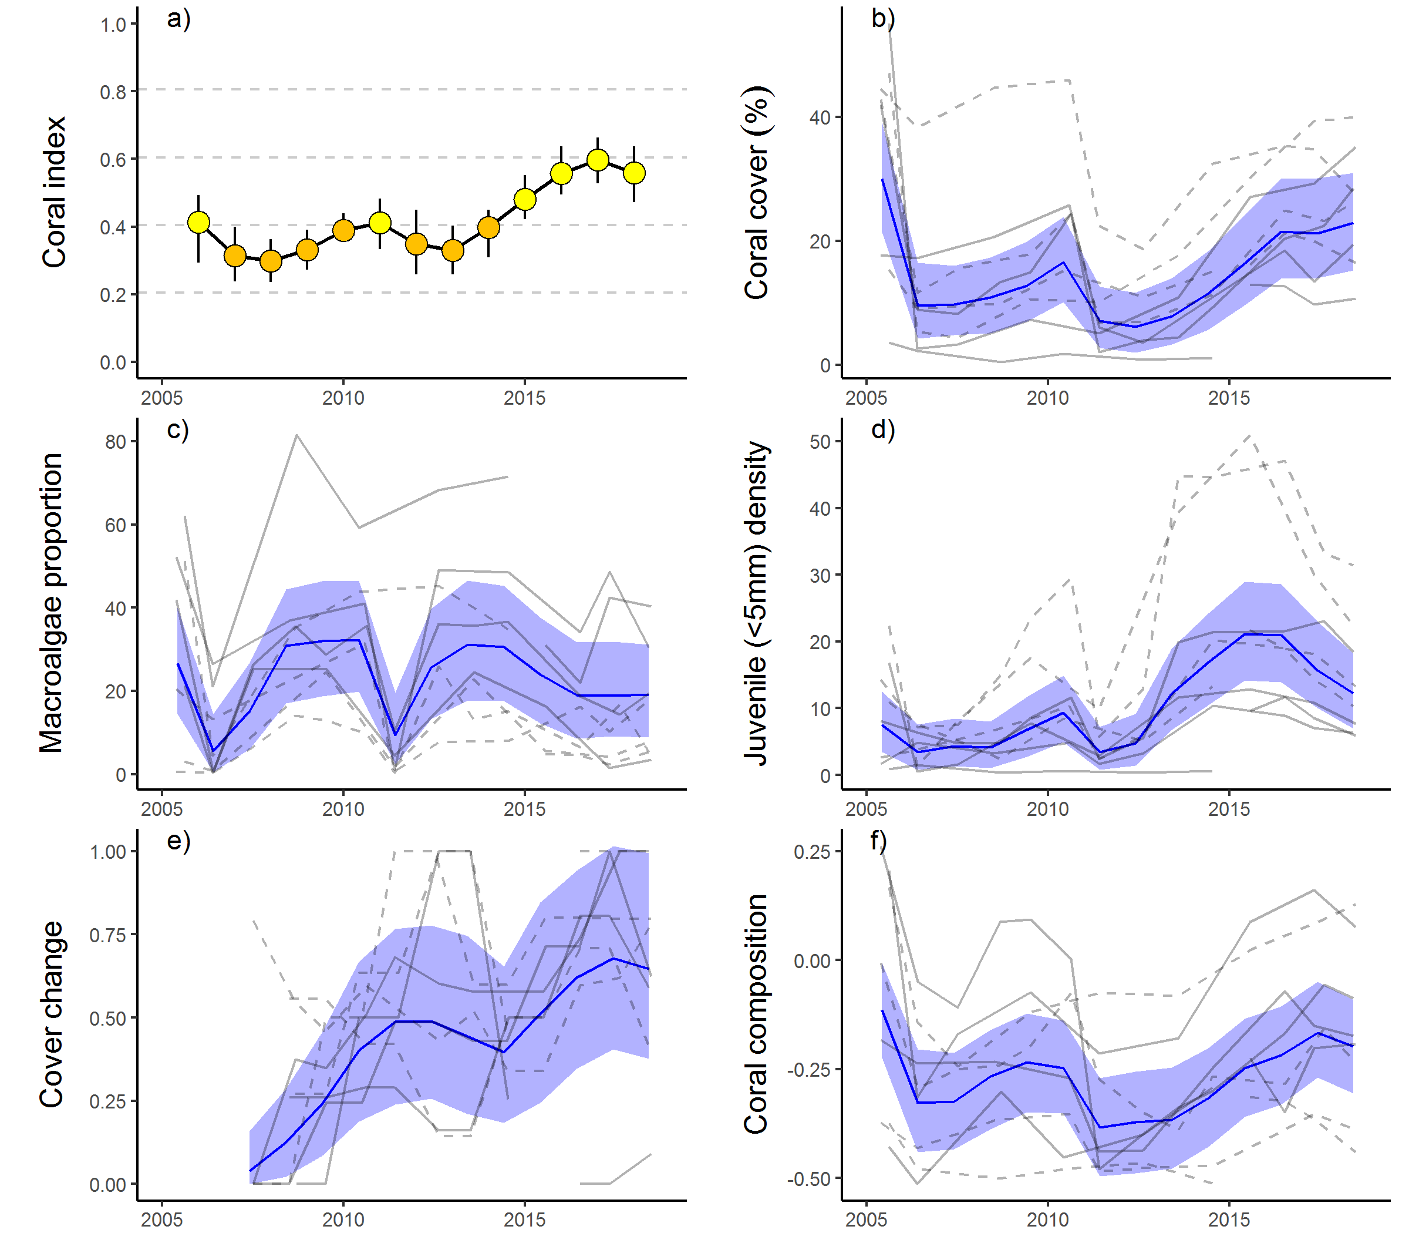

Figure 17 Herbert Tully sub-region index and indicator trends
. a) Coral index, colour coding: dark green- ‘very good’; light green – ‘good’; yellow – ‘moderate; orange – ‘poor’; red – ‘very poor’. b – f) trends in individual indicators, (blue lines) bound by 95% confidence intervals of those trends (shading), grey lines represent observed profiles at 5 m (dashed) and 2 m (solid) depths for individual reefs.

The coral sampling sites in this sub-region are primarily influenced by discharge from the Tully and Herbert rivers. All the coral monitoring sites in this sub-region are situated in relatively clear (turbidity below the guideline), and nutrient rich (Chl a concentration in the wet season generally exceeding the guideline), waters (Figure 12b, Figure A 10). The combination of low turbidity and high nutrient availability is consistent with the prevalence of macroalgae observed in the shallow depths at most reefs (Figure 17c, Table A 5).

Burdekin region
The coral condition index has remained stable and moderate since 2016, which represents an improvement since 2013 (Table 14, Figure 19a). Improvements in indicator scores were most evident at 5 m depths with only the macroalgae and composition indicators showing no change (Table 14). The macroalgae indicator score also remained stable at 2 m depths and continues to perform poorly in this region. The proportional cover of macroalgae has been variable with a low point recorded in 2009, the reason for this decline remains unexplained, and then again in 2011 following stripping of cover that occurred during cyclone Yasi (Figure 19c). By 2012 macroalgae had re-established and, although variable among reefs, the proportional cover of macroalgae regionally has remained consistent through to 2018 (Figure 19c). The coral cover indicator score remains poor, however there was consistent improvement at both 2 m and 5 m depths (Table 14, Figure 19b). The improvement in the composition indicator score at 2 m depths (Table 14) reflects that cover increase includes recovery of taxa sensitive to poor water quality, in particular Acroporidae (Figure A 4). Improved scores for the juvenile indicator were evident at 5 m depths although juvenile densities remain low in the region and are categorised as poor (Figure 19d, Figure A 4).
The observed improvement in the coral index prior to 2017 coincides with a period free from acute disturbances (Figure 18c, e) and below median discharge from the regions rivers (Figure 18d). Despite widespread coral bleaching over the 2016/2017 summer, which accounted for 18% of the coral cover lost since 2005, the index score remained relatively stable. Limiting the influence of the recent bleaching event on the index was the rapid increase in the coral cover indicator that had occurred in the years prior to 2017, that continue to support high scores for the cover change indicator, and the rebound in cover since 2017 at several reefs. Notably, marked increases in coral cover continue at Palms East, demonstrating the strong recovery of these coral communities following the severe impact of cyclone Yasi (Figure 18e, Table A 4).
Table 14 Index and indicator score comparisons in the Burdekin Region
. Data compare the changes in scores between local maxima and minima in the index time-series. For the index, and each indicator, the observed change in the sub-regional score and the probability that the change was greater or less than zero (no change) are presented. Shading is used as a visual aid to highlight the magnitude of the probability the score improved (blue shades) or declined (red shades). Probabilities are derived from the posterior distribution of observed score changes at each reef and depth.
Period | Depth | Condition Index |  | Coral Cover |  | Macroalgae |  | Juvenile |  | Cover Change |  | Composition
 |  | Score | P | Score | P | Score | P | Score | P | Score | P | Score | P
2010 to 2013 | 2 | -0.08 | 0.70 | -0.09 | 0.64 | -0.17 | 0.71 | -0.04 | 0.61 | -0.05 | 0.54 | -0.07 | 0.57
 | 5 | -0.15 | 0.86 | -0.14 | 0.82 | -0.26 | 0.82 | 0.04 | 0.61 | -0.15 | 0.80 | -0.25 | 0.71
2013 to 2018 | 2 | 0.10 | 0.76 | 0.13 | 0.83 | -0.02 | 0.68 | -0.09 | 0.61 | 0.15 | 0.65 | 0.33 | 0.72
 | 5 | 0.18 | 0.84 | 0.14 | 0.87 | -0.03 | 0.58 | 0.25 | 0.80 | 0.34 | 0.91 | 0.19 | 0.66

Declines in the index through to 2013 coincided with the combined influence of cyclone Yasi and a period of very high discharge from the region’s rivers (Figure 18d, e). Since 2005, cyclones and storms have accounted for 50% of hard coral losses (Figure 18e). East–facing locations, such as Palms East and Lady Elliot (2 m), were particularly exposed to storm driven seas, and show the impacts of cyclone Larry (2006) and cyclone Yasi (2011) (Figure A 4, Table A 4). The lagged influence from cyclone Yasi noted in 2012 (Figure 18e), is due to LTMP surveys post Yasi not occurring until that year. The last outbreak of crown-of-thorns starfish on the inshore reefs in this region occurred at Havannah in 2001. No crown-of-thorns starfish were observed during surveys in 2018 however on the mid-shelf reefs in this region crown-of-thorns starfish numbers are in outbreak densities at some reefs (AIMS LTMP).
In addition to losses in coral cover attributed to cyclone Yasi, the period 2010 to 2013 saw a reduction in scores for the cover change indicator at 5 m depths (Table 14). This reduction in rate of increase in coral cover saw observed cover fall below that predicted by coral growth models and accounts for most of the cover loss since 2005 attributed to chronic pressures (Figure 18e).
Although not categorised as a disease outbreak for disturbance estimation, elevated levels of disease were observed from 2007 to 2009 (Figure A 7) and will have contributed to the chronic disturbances recorded over the period 2008 to 2010 (Figure 18e). Chronic pressures are assumed when there is no evidence for impacts associated with acute disturbances, and represent the cumulative impacts of environmental pressures that suppress the annual increments in cover that are the basis of the cover change scores. As Acropora and Montipora were the genera most infected by disease, the disproportional loss of these groups will have contributed to the decline in the composition indicator score. In 2018 lower than predicted coral cover at several reefs have been attributed chronic pressures to (Figure 18e).
In previous years, the absence of chronic pressures between 2014 and 2016 coincided with reduced run-off and nutrient loads from the adjacent catchment (Figure 18d, e). Annual discharge from the Burdekin was just above median levels in 2018 (Figure 18e) however satellite images reveal that reefs in the northern part of the region were exposed to flood plumes from the Herbert River in early March, that resulted in peaks in Chl a and NTU measurements captured by FLNTU loggers at both Pandora and Palms West (Figure A 11, Gruber et al. in prep.). In combination with the likely reduced fitness of corals surviving the 2017 bleaching, exposure to this flood event has likely contributed to the increased levels of disease recorded in the region in 2018 (Figure A 7).
The ten reefs monitored span a distinct gradient in water quality. The reefs closer to the coast: Middle, Magnetic, Lady Elliot and Pandora are more frequently exposed to high wet season Chl a concentration than those further offshore (Figure 18a, Table A 6). The composition of coral communities varies in response to their location along these environmental gradients (Figure 19f). Proportional cover of the families Acroporidae, Pocilloporidae and Poritidae (genus Porites) are high in clear waters, or at 2 m depths in more turbid settings, with other families including Agariciidae, Oculinidae, Pectiniidae and Poritidae (Genus Goniopora) becoming more prevalent as turbidity increases. Higher exposure to Chl a also corresponds to a high proportion of macroalgae in the algal communities at Magnetic, Pandora, and Lady Elliot. The reefs at Havannah appear at the crossroad for conditions that support a high cover of brown macroalgae. In 2018 an increase in available space following the loss of coral cover due to bleaching has seen cover of the brown algae Lobophora and Dictyota increase at both 2 m and 5 m depths (Figure A 4, Table A 9).
Improvement in the coral index between 2013 and 2016 coincided with low discharge, and corresponding relatively low loads of nutrients and sediments being delivered to the Reef (Figure 11, Figure 18d, Waterhouse et al. 2018). Although the coral community has demonstrated a capacity to recover under the conditions observed in recent years, there has been no clear improvement in measured attributes of water quality (Figure A 11, Gruber et al. in prep.), limiting the ability to explicitly link improvement in the index scores to water quality drivers. It should be noted however, that changes to the sampling design of the water quality component of the MMP has increased sampling intensity in recent years which may improve our ability to link changes in index scores to water quality drivers.
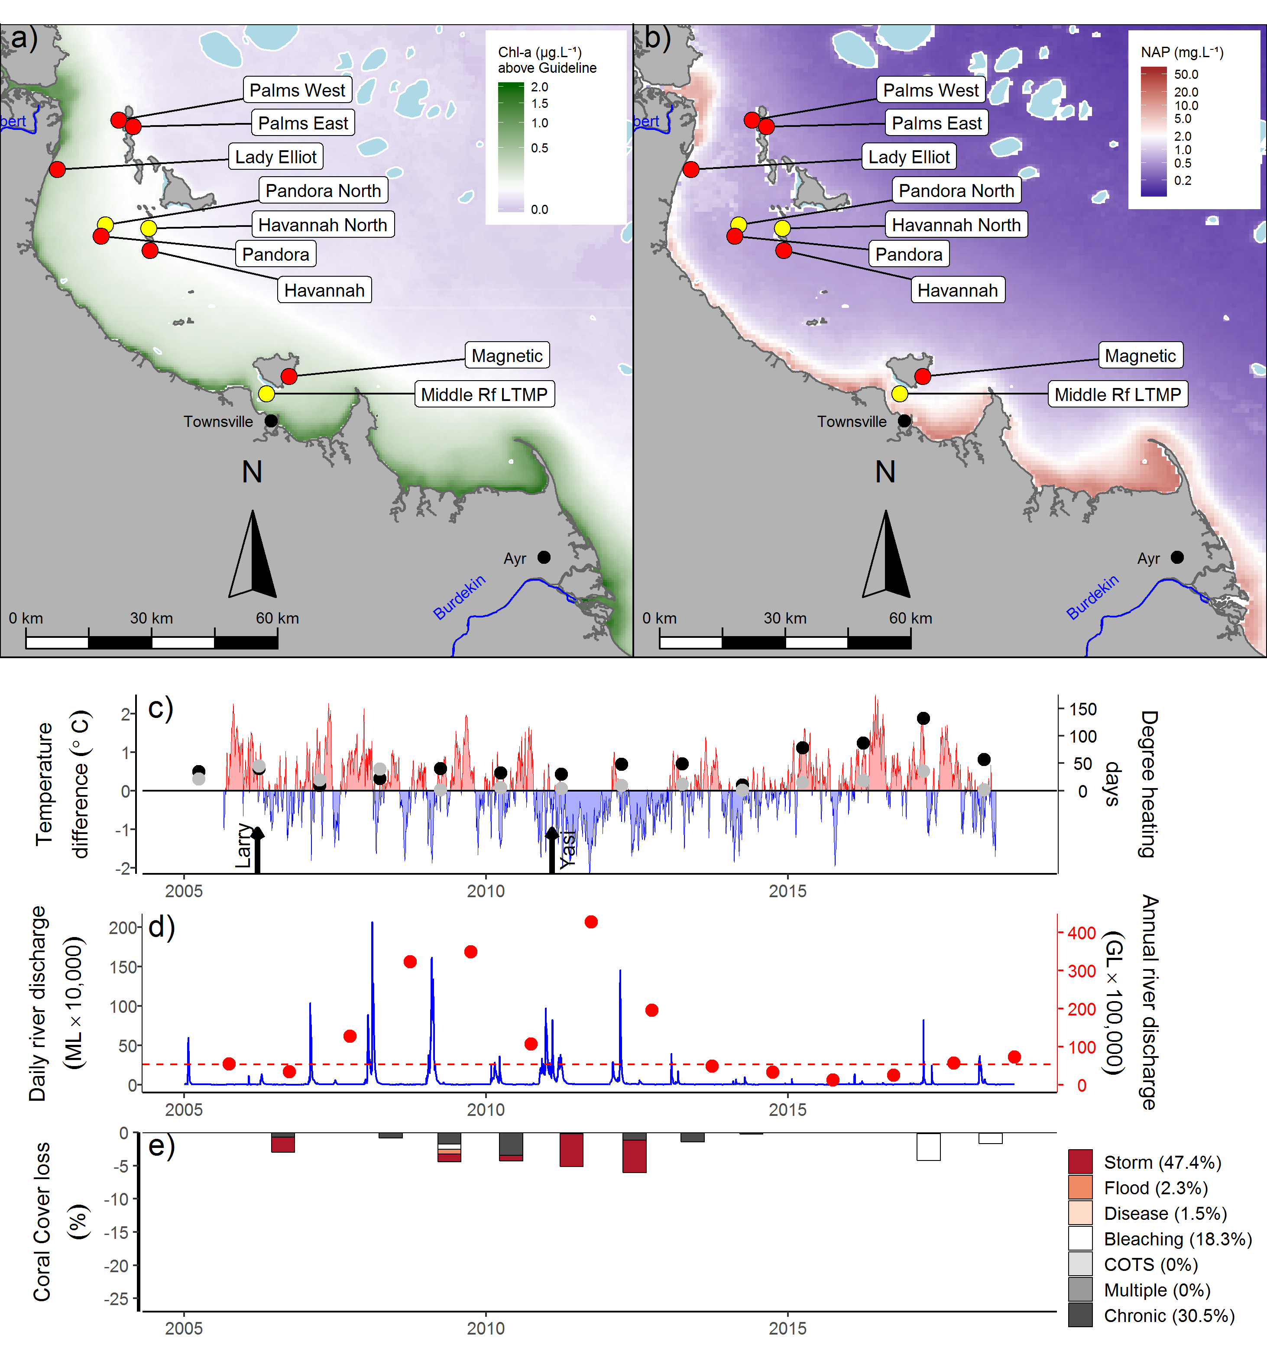
Figure 18 Burdekin Region environmental pressures
. Maps show location of monitoring sites, red symbols MMP, yellow symbols LTMP along with a) mean chlorophyll a exceedance of wet season Guideline (0.63ugL⁻¹) and b) mean Non Algal Particulate concentrations. Water quality data are mean levels over the period 2003–2018 (Chl) and 2003–2018 (NAP). c) Seasonally adjusted temperature deviation, timing of cyclones and storms indicated by black arrows, accumulated degree heating days over the summer period (1st of December – 31st March) as reported by BoM (black symbols) and derived from in situ loggers (grey symbols) d) Combined daily (blue) and annual water year – October to September (red) discharge for the Black, Burdekin, Don and Haughton rivers, red dashed line represents long-term median discharge (1986–2016). e) break-down of hard coral cover loss by disturbance type; length of bars represents the mean loss of cover across all reefs (see methods section 2.2 for further detail).
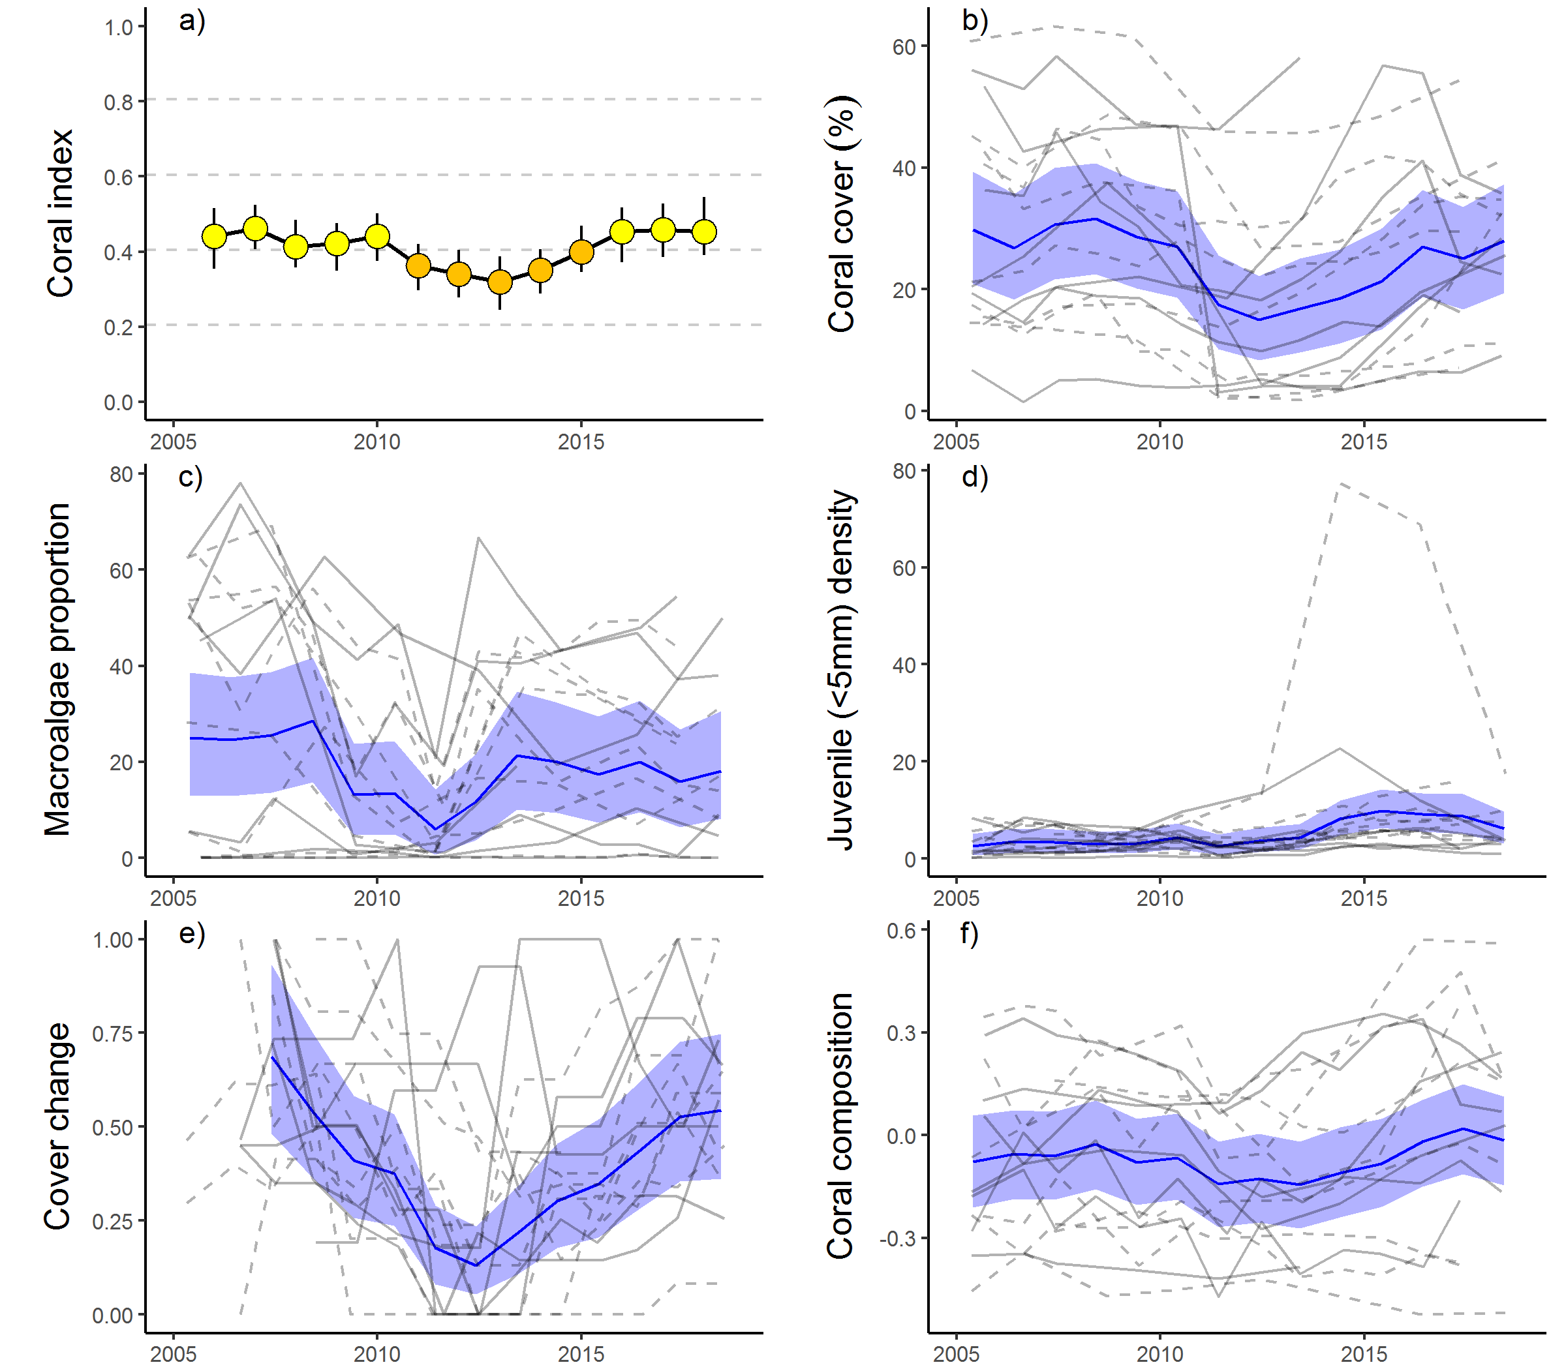
Figure 19 Burdekin Region index and indicator trends
. a) Coral index, colour coding: dark green- ‘very good’; light green – ‘good’; yellow – ‘moderate; orange – ‘poor’; red – ‘very poor’. b – f) trends in individual indicators, (blue lines) bound by 95% confidence intervals of those trends (shading), grey lines represent observed profiles at 5 m (dashed) and 2 m (solid) depths for individual reefs.

Mackay Whitsunday region
The coral condition index has continued to decline, although coral condition remains moderate (Table 15, Figure 21a). The continued decline reflects additional impacts of cyclone Debbie captured by surveys in 2018 (Figure 20e, Figure 21).
The impact of cyclone Debbie was most evident at 2 m depths where scores for the coral cover, macroalgae, juvenile density, and composition indicators have precipitously declined (Table 15, Figures 21b, d, f,). Scores for macroalgae declined in 2018 following the lagged colonisation of space made available by the loss of coral cover (Figure 21c). The increase in macroalgae was particularly noticeable in the 2 m depths at Double Cone and Daydream, where previously abundant but fragile stands of Acropora and Montipora (Acroporidae) have been replaced by dense algal assemblages (Figure A 5, Table A 9). At Pine, macroalgae cover stripped by cyclone Debbie in 2017 had re-established in 2018. The recent increase in macroalgae cover was dominated by Lobophora and red macroalgae species (Table A 9) in contrast to Sargassum that was common in 2016.
The influence of cyclone Debbie on index scores was less severe at 5 m depths (Table 15). While the coral cover and juvenile indicator scores declined (Table 15), the high turbidity and sheltered conditions in the region limits the potential for substantial colonisation by macroalgae and has already selected for species tolerant of poor water quality, limiting the potential for a reduction in the associated indicator scores. In addition, the inclusion of scores for 5 m communities at Hayman, Langford, and Border from AIMS LTMP surveys that predate cyclone Debbie are also likely buffering the response at this depth (Figure A 5).
Among the six reefs surveyed in 2017 soon after cyclone Debbie, the average loss of coral cover was 70% at 2 metres, and 64% at 5 metres (range 45-98% and 26-90% respectively, Table A 4). Of the four reefs surveyed in both 2017 and 2018, coral cover continued to decline at Daydream, Double Cone and Pine. It was only at the least impacted reef, Shute Harbour that coral cover showed signs of recovery (Figure A 5).

Table 15 Index and indicator score comparisons in the Mackay Whitsunday Region
. Data compare the changes in scores between local maxima and minima in the index time-series. For the index, and each indicator, the observed change in the sub-regional score and the probability that the change was greater or less than zero (no change) are presented. Shading is used as a visual aid to highlight the magnitude of the probability the score improved (blue shades) or declined (red shades). Probabilities are derived from the posterior distribution of observed score changes at each reef and depth.
Period | Depth | Condition Index |  | Coral Cover |  | Macroalgae |  | Juvenile |  | Cover Change |  | Composition
 |  | Score | P | Score | P | Score | P | Score | P | Score | P | Score | P
2008 to 2012 | 2 | -0.07 | 0.77 | -0.07 | 0.91 | 0.00 | 0.00 | -0.08 | 0.80 | -0.05 | 0.60 | -0.14 | 0.72
 | 5 | -0.08 | 0.80 | -0.10 | 0.87 | 0.00 | 0.63 | -0.03 | 0.61 | -0.03 | 0.53 | -0.25 | 0.83
2012 to 2016 | 2 | 0.16 | 0.99 | 0.15 | 0.95 | 0.00 | NA | 0.18 | 0.86 | 0.20 | 0.76 | 0.29 | 0.86
 | 5 | 0.09 | 0.77 | 0.06 | 0.72 | -0.01 | 0.63 | 0.17 | 0.75 | 0.05 | 0.57 | 0.15 | 0.68
2016 to 2018 | 2 | -0.33 | 0.90 | -0.53 | 0.98 | -0.30 | 0.73 | -0.39 | 0.97 | -0.09 | 0.67 | -0.36 | 0.74
 | 5 | -0.10 | 0.67 | -0.24 | 0.82 | -0.08 | 0.55 | -0.22 | 0.82 | 0.01 | 0.52 | 0.05 | 0.57

Before the impact of cyclone Debbie, the only acute disturbance events recorded since 2005 were flooding in 2009 and cyclone Ului in 2010 (Figure 20e). These contributed to a slight decline in the coral index through to 2012. Daydream was severely impacted by cyclone Ului, losing 47% of the coral cover at 5 m depth (Figure A 5, Table A 4). By 2016, coral cover at Daydream had recovered to its former level.

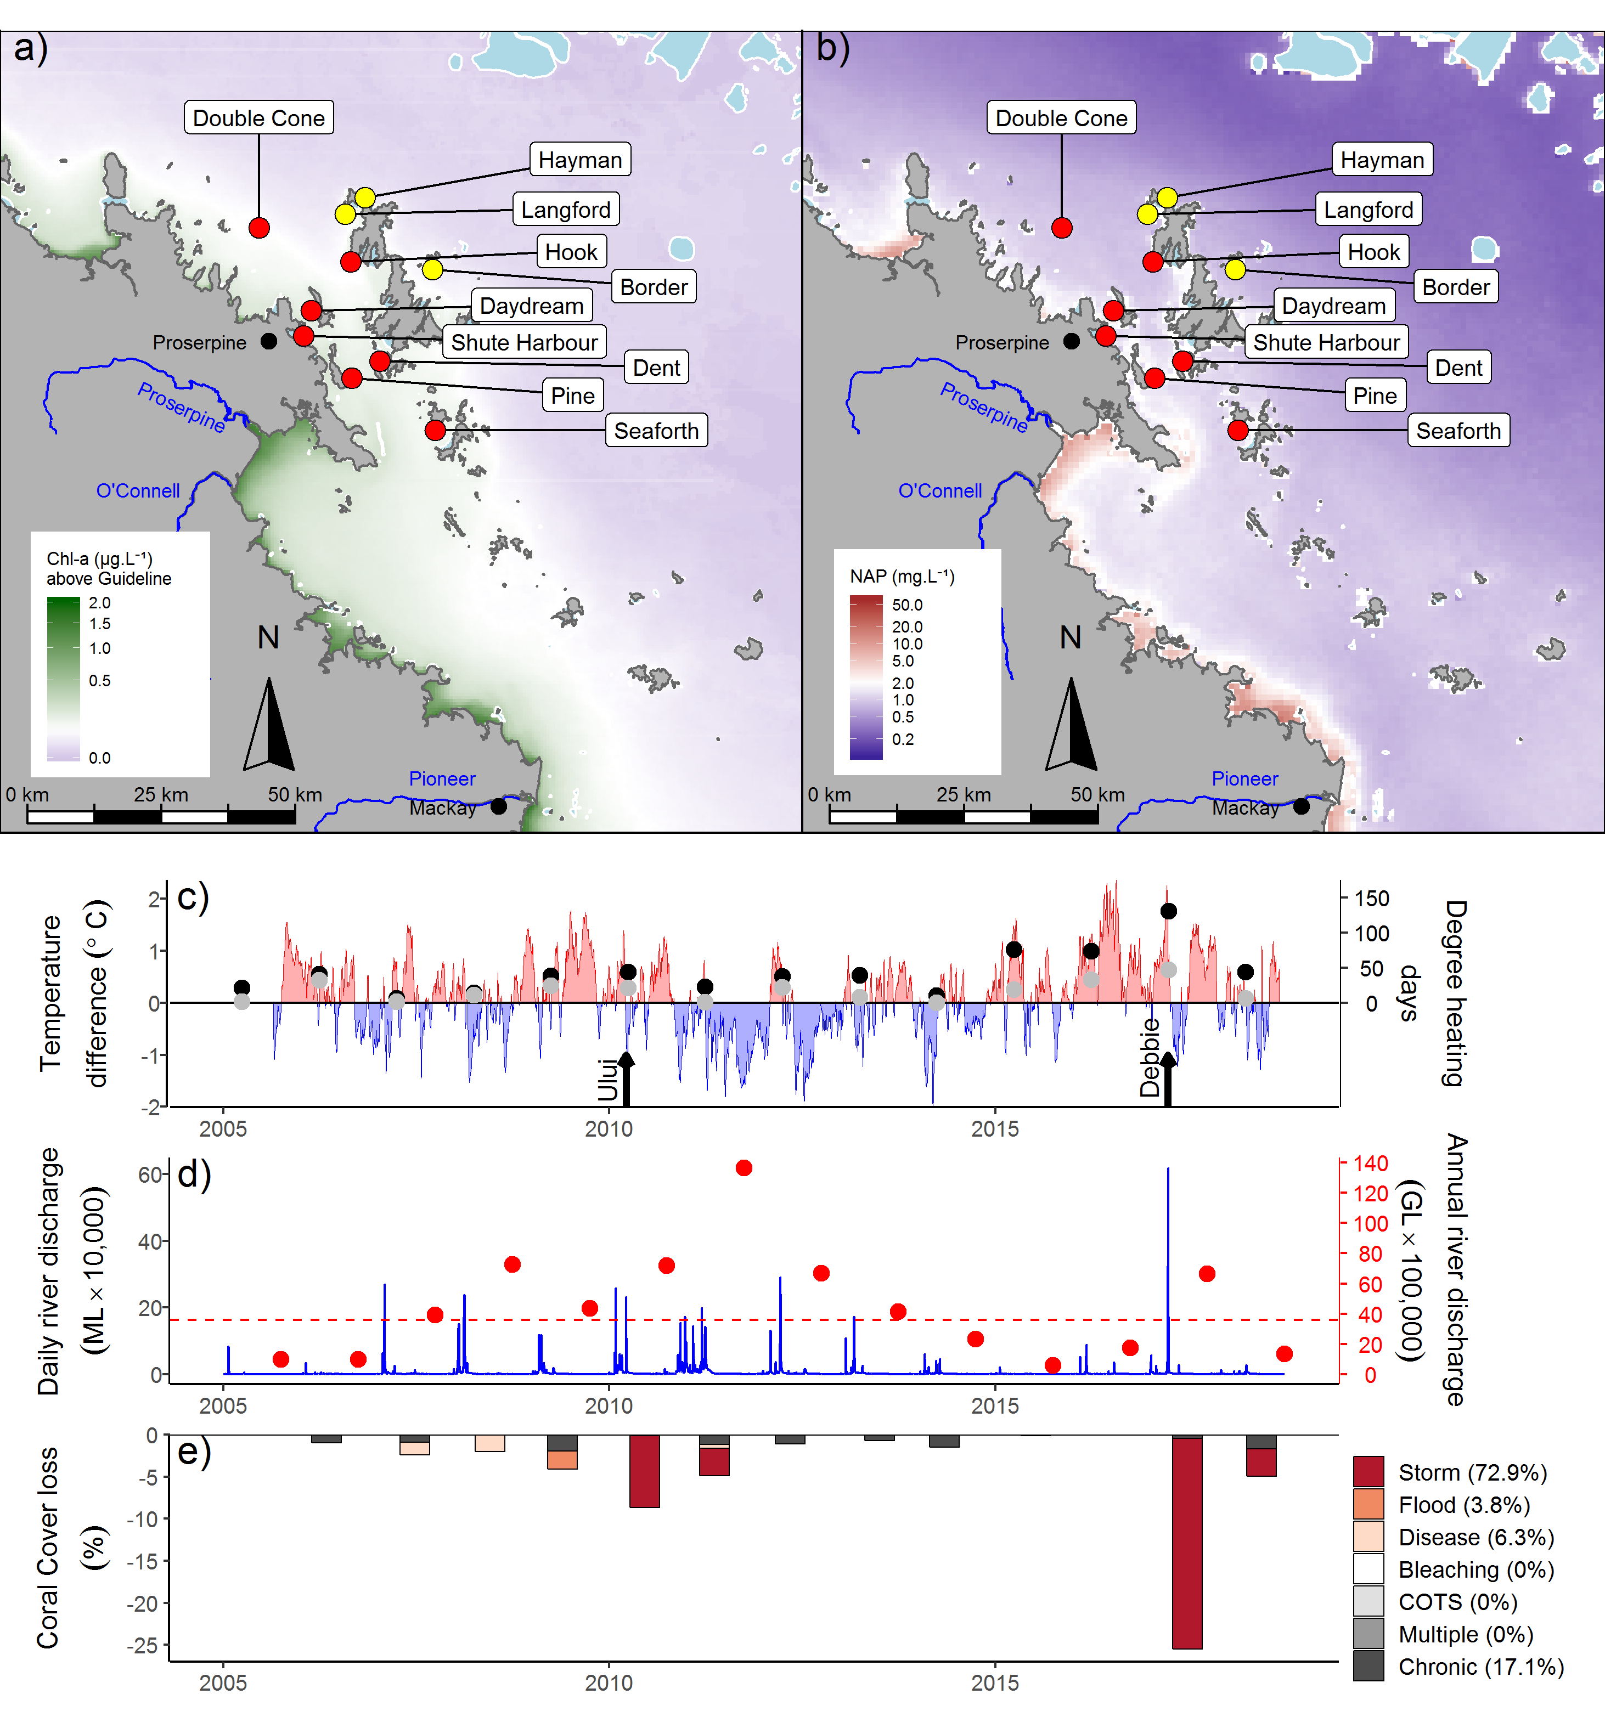
Figure 20 Mackay Whitsunday Region environmental pressures
.. Maps show location of monitoring sites, red symbols MMP, yellow symbols LTMP along with a) mean chlorophyll a exceedance of wet season Guideline (0.63ugL⁻¹) and b) mean Non Algal Particulate concentrations. Water quality data are mean levels over the period 2003–2018 (Chl) and 2003–2018 (NAP). c) Seasonally adjusted temperature deviation, timing of cyclones and storms indicated by black arrows, accumulated degree heating days over the summer period (1st of December – 31st March) as reported by BoM (black symbols) and derived from in situ loggers (grey symbols) d) Combined daily (blue) and annual water year – October to September (red) discharge for the Carmila and Sandy creeks, Gregory, O’Connell and Pioneer rivers, red dashed line represents long-term median discharge (1986–2016). e) break-down of hard coral cover loss by disturbance type; length of bars represents the mean loss of cover across all reefs (see methods section 2.2 for further detail).
The influence of chronic environmental pressures in the region is demonstrated by the marked differences in the composition of coral communities between 2 m and 5 m depths (Figure 21f, Figure A 5). High turbidity at most of the MMP reef sites (Table A 6), in combination with limited exposure to wave energy among the Whitsunday Islands, results in reduced availability of light and accumulation of fine sediments at 5 m depths and the selection for corals tolerant of these conditions. At 5 m depths there is a clear predominance of corals tolerant to low light and high rates of sedimentation (Oculinidae, Pectiniidae, Agariciidae, Poritidae (genus Goniopora)) compared to those at 2 m depths where Acroporidae and Poritidae (genus Porites) are most common (Figure A 5). The pressure imposed by the water quality in this region is also expressed by relatively low scores for the cover change indicator (Figure 21e, Table A 5), that in turn contributes to the frequently categorised chronic stresses (Figure 20e).
High incidence of coral disease were observed in 2007 and 2008 as discharge from local catchments rose to above median levels for the first time since 2001 (Table A 3), and then again in the two years following cyclone Ului and accompanying high river discharges (Figure 20d, e, Figure A 7). Notably, over this same period there has been an increase in concentrations of DOC, PP, and more recently PN and POC (Figure A 12, Gruber et al. in prep.). This, in addition to the general correlation between coral disease and increased run-off, suggests that the corals are sensitive to variations in inputs from the catchments. Direct impacts due to flooding were recorded only in 2009 (Figure 20e), attributed primarily to the high loads of sediments observed on corals during surveys. The source of these sediments is not clear as the local rivers did not experience extreme flooding over the preceding summer (Figure 20d) although local heavy rainfall did result in several land-slides along the adjacent ranges.

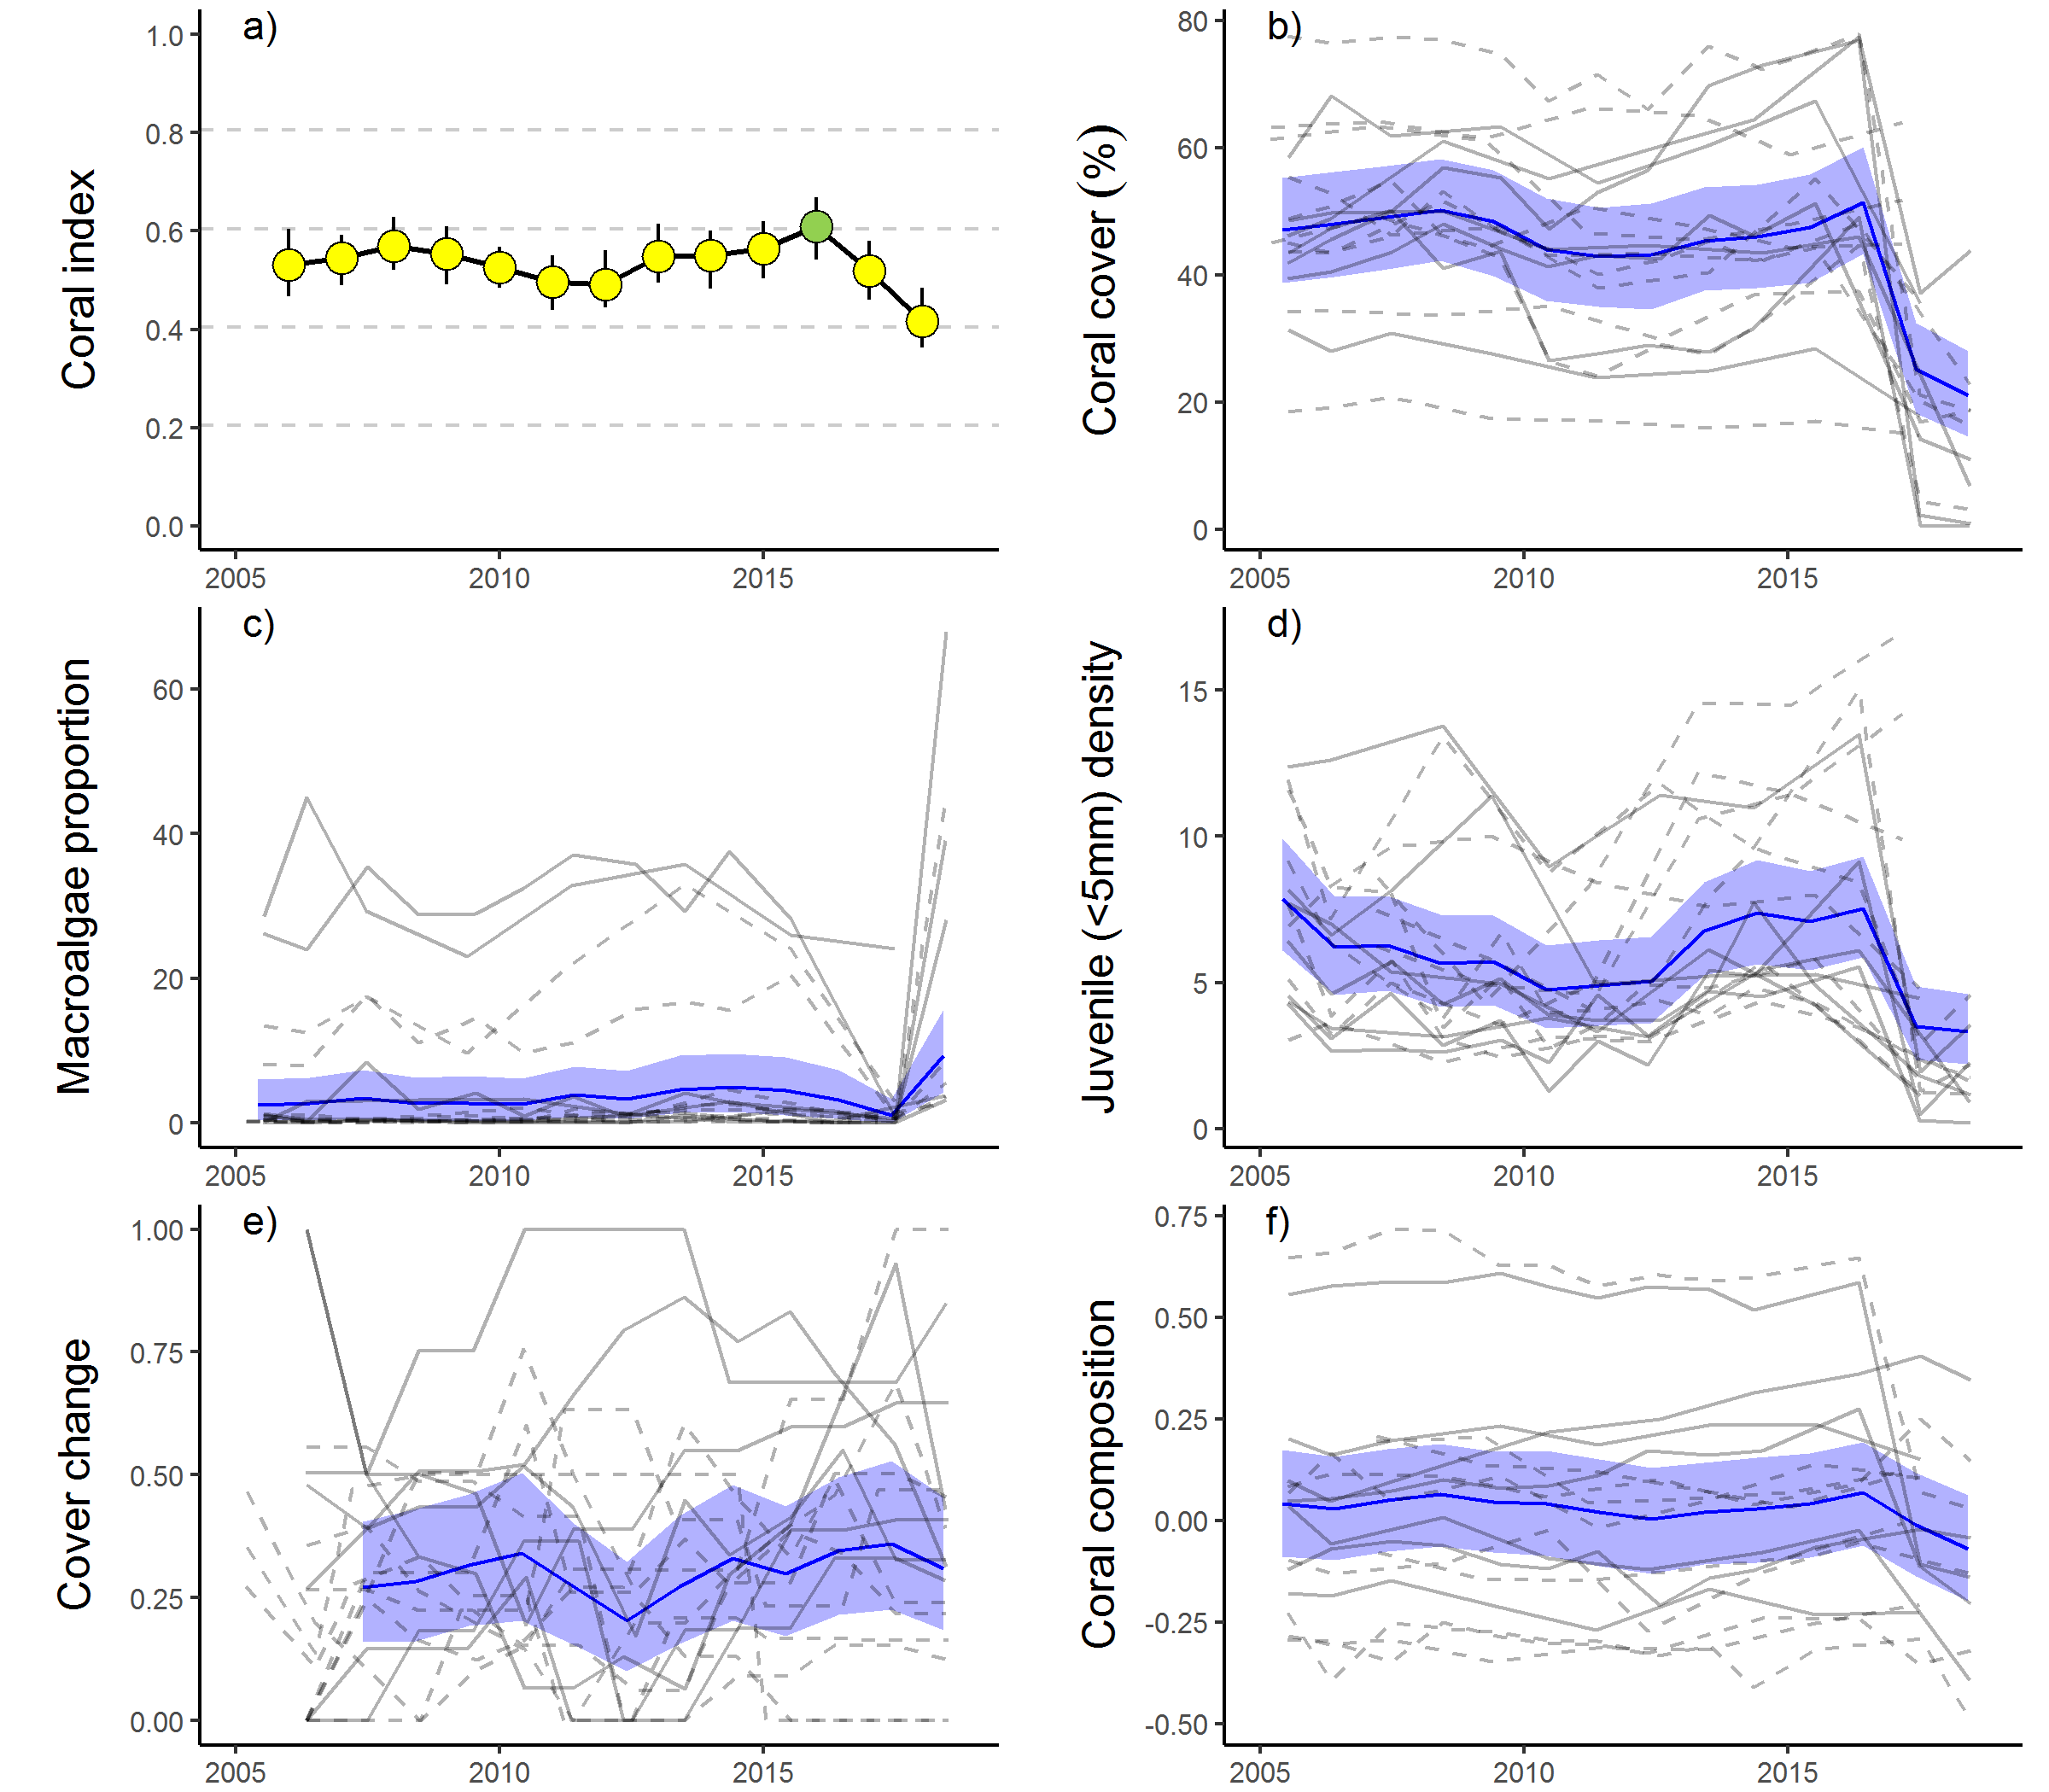
Figure 21 Mackay Whitsunday Region index and indicator trends
. a) Coral index, colour coding: dark green- ‘very good’; light green – ‘good’; yellow – ‘moderate; orange – ‘poor’; red – ‘very poor’. b – f) trends in individual indicators, (blue lines) bound by 95% confidence intervals of those trends (shading), grey lines represent observed profiles at 5 m (dashed) and 2 m (solid) depths for individual reefs.

Fitzroy region
Coral condition in the Fitzroy Region was poor in 2018, having continued to improve from very poor in 2014 (Table 16, Figure 23a). Improvements in coral condition since 2014 were due to consistent improvement in scores for the macroalgae and juvenile indicators at both 2 m and 5 m depths (Table 16, Figure 23c, d). Despite these improvements, macroalgae remain very poor at most reefs and the regional score for juvenile density is poor (Table A 5). At 5 m depth the coral cover and cover change scores have also improved (Table 16).
Table 16 Index and indicator score comparisons in the Fitzroy Region
. Data compare the changes in scores between local maxima and minima in the index time-series. For the index, and each indicator, the observed change in the sub-regional score and the probability that the change was greater or less than zero (no change) are presented. Shading is used as a visual aid to highlight the magnitude of the probability the score improved (blue shades) or declined (red shades). Probabilities are derived from the posterior distribution of observed score changes at each reef and depth.
Period | Depth | Condition Index |  | Coral Cover |  | Macroalgae |  | Juvenile |  | Cover Change |  | Composition
 |  | Score | P | Score | P | Score | P | Score | P | Score | P | Score | P
2007 to 2014 | 2 | -0.25 | 0.92 | -0.36 | 0.85 | -0.05 | 0.67 | -0.06 | 0.61 | -0.41 | 0.88 | -0.42 | 0.98
 | 5 | -0.15 | 0.92 | -0.28 | 0.93 | 0 | NA | 0.02 | 0.57 | -0.13 | 0.72 | -0.33 | 0.90
2014 to 2018 | 2 | 0.13 | 0.89 | 0.05 | 0.68 | 0.10 | 0.75 | 0.22 | 0.88 | 0.10 | 0.67 | 0.17 | 0.67
 | 5 | 0.11 | 0.82 | 0.05 | 0.71 | 0.06 | 0.73 | 0.15 | 0.82 | 0.19 | 0.79 | 0.08 | 0.61

The coral communities monitored are situated along a distinct environmental gradient within Keppel Bay. Peak and Pelican are located in relatively turbid and nutrient rich waters compared to reefs further offshore (Figure 22a, b). Keppels South, Middle and North Keppel are consistently exposed to Chl a concentration in excess of the guidelines whereas at Barren the Chl a level is lower; these four reefs share reasonably low levels of total suspended solids (Figure 22a, b, Table A 6). These gradients in water quality are clearly reflected in the benthic communities. At Peak and Pelican benthic communities differ markedly between 2 m and 5 m depths (Figure A 6) illustrating the substantial attenuation of light due to high turbidity. The differences in community composition are evident in the baseline conditions for the composition indicator (Figure 23f). Pelican has a highly stratified environment, supporting slow growing, low-light tolerant corals at depth, and fast-growing Acroporidae (Acropora, Montipora spp.) in the shallows; although these shallow communities were killed and replaced by macroalgae (Sargassum spp) following exposure to low salinity flood plumes in 2011 (Figure A 6). Closer to the Fitzroy River, Peak is defined by low cover of corals, low density of juvenile corals and high cover of macroalgae (Figure A 6). A lack of substantial reef development at Peak suggests that the environmental conditions at this location are marginal for most corals. In the less turbid waters surrounding the remaining reefs coral communities are dominated by Acroporidae (Figure A 6), principally, but not restricted to, the branching species A. intermedia and A. muricata (Table A 7).
Between 2006 and 2015 reefs within this region were exposed to a series of acute disturbances including cyclones and storms, coral bleaching, and flooding of the Fitzroy River (Figure 22c-e, Table A 4). These disturbances resulted in a clear reduction in coral cover (Table 16, Figure 23b). The disproportionate loss of Acropora (Figure A 6) resulted in a reduction in the community composition indicator scores (Table 16). Compounding the impact of the acute disturbances was a low rate of recovery of coral cover demonstrating the effect of chronic impacts (Figure 22e), high levels of disease (Figure A 7) and declines in the cover change scores between 2007 and 2014 (Table 16), when annual discharge from the Fitzroy River was mostly well above median levels (Figure 22d). No assessment of change in the macroalgae indicator scores between 2007 and 2014 at 5 m depth was possible (Table 16) as scores were zero at all reefs in both years. The initial increase in macroalgae cover occurred as brown algae of the genus Lobophora rapidly occupied space made available by the death of corals in 2006 (Figure 23c, Diaz-Pulido et al. 2009).

Prior to the commencement of the MMP in 2005, Queensland Parks and Wildlife Service monitoring of reefs in Keppel Bay from 1993–2003 recorded substantial loss of coral cover, and subsequent recovery following thermal bleaching events in 1998 and 2002 (Table A 4). Initial MMP surveys in 2005 documented moderate to high hard coral cover on all the Acropora-dominated reefs confirming the potential for recovery at these reefs when not subjected to additional pressures.
Since 2014 there has been no clear improvement in cover change scores (Table 16) leading to the continued categorisation of low rates of coral cover increase as chronic disturbances (Figure 22e). Elevated water temperatures (2016 and 2017, Figure 22c) and exceedance of median discharge levels from the local catchment (ex-cyclone Debbie, 2017, Figure 22d) did not result in substantial loss of coral cover, but are likely causes of observed low rates of increase in coral cover.
Water quality monitoring (in-situ) was discontinued in the Keppels region in 2015. The final year of water quality sampling saw an improvement in the water quality index (Lønborg et al. 2015). Measured levels of Chl a, showed a slight downturn coinciding with a respite in flooding in the region since 2012 (Lønborg et al. 2015). Modelling of total suspended solids and dissolved inorganic nitrogen indicate substantially lower concentrations in the region from 2014 to 2016 compared to those associated with the high discharge years of 2010, 2011 and 2013 (Waterhouse et al. 2017).
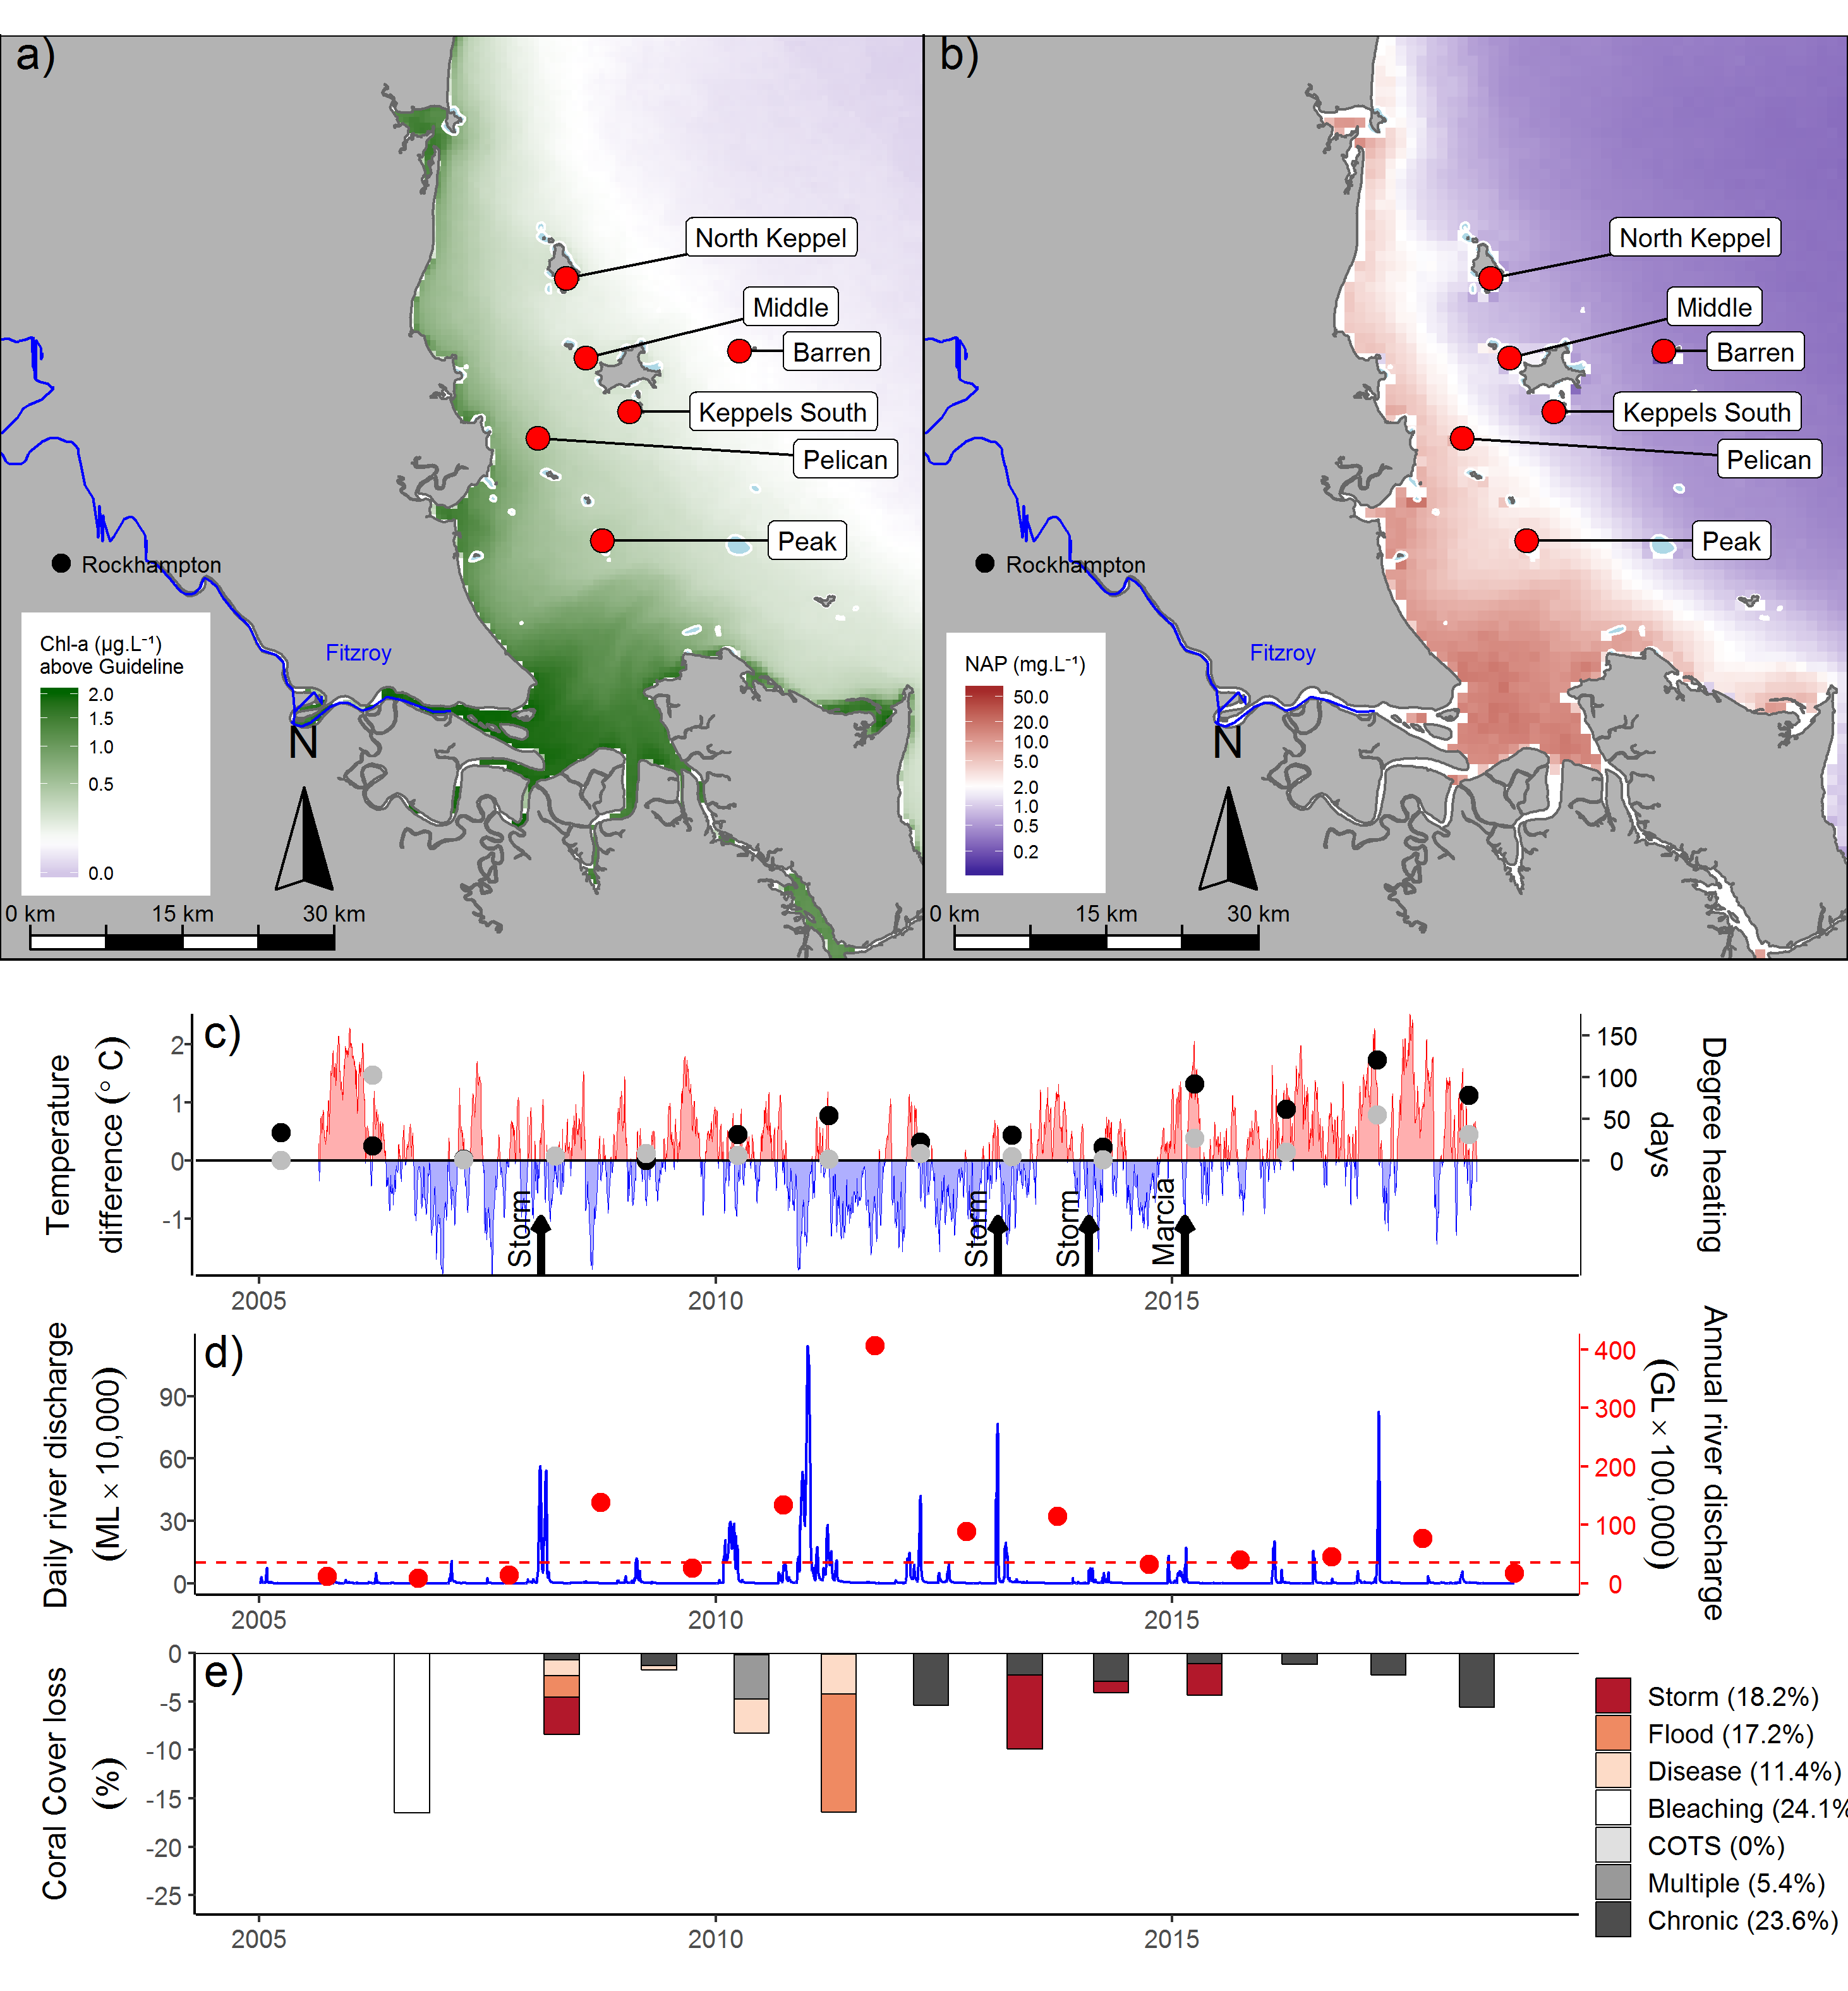
Figure 22 Fitzroy Region environmental pressures
.Maps show location of monitoring sites, red symbols MMP, yellow symbols LTMP along with a) mean chlorophyll a exceedance of wet season Guideline (0.63ugL⁻¹) and b) mean Non Algal Particulate concentrations. Water quality data are mean levels over the period 2003–2018 (Chl) and 2003–2018 (NAP). c) Seasonally adjusted temperature deviation, timing of cyclones and storms indicated by black arrows, accumulated degree heating days over the summer period (1st of December – 31st March) as reported by BoM (black symbols) and derived from in situ loggers (grey symbols) d) Combined daily (blue) and annual water year – October to September (red) discharge for the Calliope and Fitzroy rivers and Waterpark Creek, red dashed line represents long-term median discharge (1986–2016). e) break-down of hard coral cover loss by disturbance type; length of bars represents the mean loss of cover across all reefs (see methods section 2.2 for further detail).

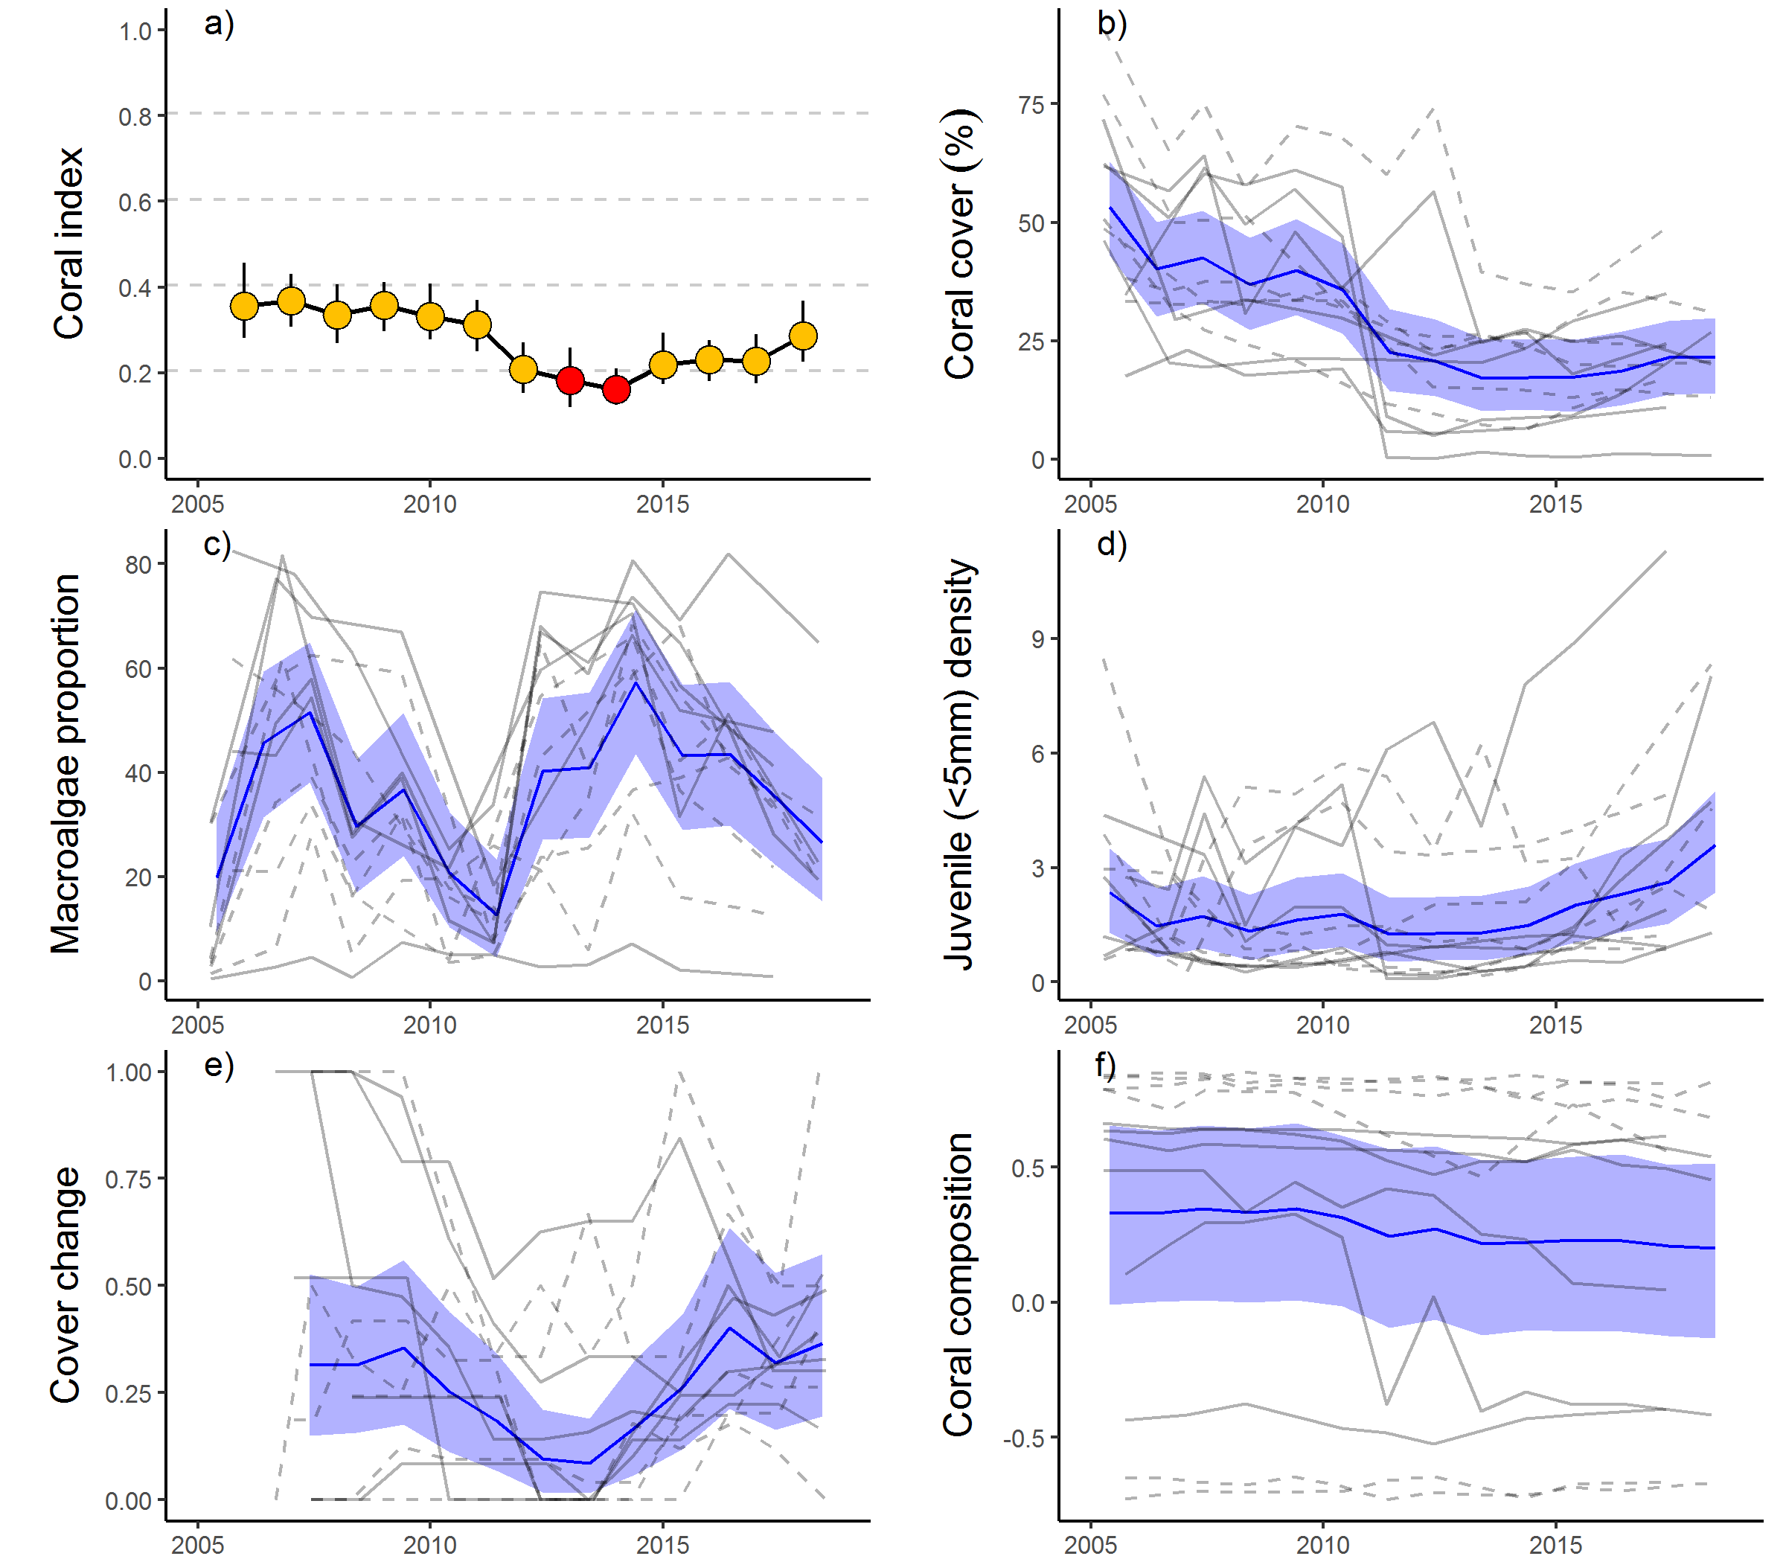
Figure 23 Fitzroy Region index and indicator trends
. a) Coral index, colour coding: dark green- ‘very good’; light green – ‘good’; yellow – ‘moderate; orange – ‘poor’; red – ‘very poor’. b – f) trends in individual indicators, (blue lines) bound by 95% confidence intervals of those trends (shading), grey lines represent observed profiles at 5 m (dashed) and 2 m (solid) depths for individual reefs.

Discussion
As naturally dynamic systems that alternate between impacts and periods of recovery (Connell 1978) it is critical for the persistence of coral communities that there is a long-term balance between disturbance and recovery processes. A primary focus of this component of the MMP is assessing the role of water quality in altering this balance and the potential for the long-term decline in coral communities.
Results are discussed in terms of the Driver-Pressure-State-Impact-Response (DPSIR) framework. This allows identification of some of the key pressures influencing coral condition. In this context, there is a distinction between pressures arising from climate change that are beyond the realm of management under Reef 2050 Water Quality Improvement Plan, such as acute disturbances associated with severe storms or bleaching events, and those related more tangibly to water quality, and as such, expected to be manageable.

Pressures

Acute disturbances
No severe disturbances impacted inshore coral communities over the 2017-18 summer. However, lagged impacts of the high temperatures that led to coral bleaching in early 2017, and those attributed to cyclone Debbie, influenced the coral condition scores in 2018. At the time of survey in 2017 (May-August) up to 66% (mean 14.4%) of the surviving corals were bleached, subsequent surveys of the reefs at which bleached corals were evident during 2017 indicated further loss of coral cover in both the Wet Tropics and Burdekin regions. In the Whitsunday region, Hook Island was not surveyed in 2017, and loss of cover observed in 2018 was attributed to cyclone Debbie. The biennial sampling design means that at reefs not surveyed in 2018 (Hayman Island, Border Island and Langford Island) there is a likelihood that further loss of coral may be observed in 2019 and again attributable to cyclone Debbie.
Heavy rainfall in March 2018 resulted in major flooding of rivers in the Tully Herbert and Johnstone Russell-Mulgrave sub-regions. There was no evidence that these floods had a direct impact on coral communities as species of Acropora, known to be sensitive to exposure to low salinities (Berkelmans et al. 2012), were surviving at the shallow sites on reefs most proximal to the rivers. However, it is likely that the above median annual discharge from these catchments did contribute to chronic pressures on coral communities and may have contributed to impacts attributed to coral bleaching.
Moderate numbers of crown-of-thorns starfish continue to occur at reefs in the Johnstone Russell-Mulgrave sub-region. The individuals observed represented a range of size classes including juveniles <15 cm in diameter and adult individuals (>25 cm diameter) demonstrating recruitment and survival of multiple cohorts. Crown-of-thorns starfish are recognised as a major contributor to loss of coral cover in mid-shelf areas of the Reef (Osborne et al. 2011, De’ath et al. 2012) with population outbreaks in 2018 recorded on reefs between Innisfail and Townsville, as well as off Princess Charlotte Bay in the North and Mackay to Rockhampton in the south (AIMS LTMP). The transport of coastal nutrients to the mid-shelf Reef remains a plausible factor enhancing the survival of crown-of-thorns starfish larvae, and so, potentially extends the influence of run-off to large tracts of the Reef and over long periods of time (Brodie et al. 2005, Fabricius et al. 2010, Furnas et al. 2013, Pratchett et al. 2014, Wooldridge & Brodie 2015, Brodie et al. 2017). However, the role of runoff in crown-of-thorns outbreak dynamics remains unresolved and in need of further research and particularly the co-ordinated monitoring of water quality, phytoplankton communities and the condition of crown-of-thorns larvae (Pratchett et al. 2017).
Since MMP surveys began in 2005 inshore reefs have been impacted by multiple acute disturbance events that have resulted in reductions in coral cover across the regions, these include: thermal bleaching (Fitzroy Region – 2006, Wet Tropics and Burdekin Regions – 2017), cyclone Larry (Wet Tropics and Burdekin Regions – 2006), cyclone Ului (Whitsunday Region – 2010), cyclone Tasha (Wet Tropics – 2011), cyclone Yasi (Wet Tropics and Burdekin Regions – 2011), cyclone Ita (Wet Tropics – 2014), cyclone Marsha (Fitzroy Region – 2015), cyclone Debbie (Whitsunday Region – 2017), sub-cyclonic storms (Barron Daintree sub-region – 2009, Burdekin – 2009, Fitzroy – 2008, 2010, 2013), predation by crown-of-thorns starfish (Wet Tropics – 2012 to 2014, 2016 and 2017) and exposure to low salinity flood waters (2 m depths, Fitzroy Region 2011). These disturbance events contribute strongly to the declines in the coral cover indicator (Lam et al. 2018) and condition index scores in all regions.
Acute pressures most directly influenced coral cover and contributed to between 63% (Fitzroy Region) and 92% (Herbert Tully sub-region) of the coral cover lost since 2005. These losses translated into reductions in the scores for the coral cover indicator and contributed to declines in overall coral condition assessments following severe disturbance events. Each of the remaining four indicator metrics have been formulated to limit responsiveness to acute pressures to focus, as directly as possible, on responses to chronic pressures such as water quality. Given the scale of acute pressures it is inevitable, however, that some lagged or confounding effects of acute pressures will be evident in the response of all indicators.

Chronic conditions – water quality
Water quality is a summary term for a range of chemical and physical properties of marine waters that exert a fundamental influence on the processes governing ecosystem health including coral community composition and condition. Water quality in the inshore Reef shows a strong gradient, improving with distance from the coast and major rivers. Variation in benthic communities on coral reefs along this gradient is evidence for the selective pressures imposed by water quality (van Woesik & Done 1997, van Woesik et al. 1999, Fabricius et al. 2005, De’ath & Fabricius 2008, Uthicke et al. 2010, Fabricius et al. 2012), in combination with physical properties of the sites such as hydrodynamic conditions and depth (Uthicke et al. 2010, Thompson et al. 2010, Browne et al. 2010). Such gradients are a natural part of the Reef ecosystem, albeit with lower levels of input of run-off-derived pollutants than presently occurs (Belperio & Searle 1988, Waters et al. 2014). The premise underpinning the Reef 2050 WQIP is that anthropogenic contaminant loads delivered by rivers create conditions which suppress the health and/or resilience of the Reefs ecosystems. It is the quantification of the compounding influence of run-off on the naturally occurring gradients, and any subsequent improvement under the Reef 2050 WQIP, that is the core focus of the water quality monitoring component of the MMP (see separate report by Gruber et al. in prep.).
For corals, the pressure relating to land management practices is the ‘state’ of marine water quality, which in turn is influenced by the pressure of contaminant loads entering marine waters as run-off. The MMP river plume monitoring (see Gruber et al. in prep.) clearly shows that inshore reefs are directly exposed to elevated loads of sediments and nutrients carried by flood plumes. Variability in nutrient loads delivered to the Reef (Joo et al. 2012, Turner et al. 2011, 2012, Wallace et al. 2014, 2015, Garzon-Garcia et al. 2015) has, however, not been closely linked to variability in marine water quality conditions. This is not unexpected given the complexity of nutrient cycling that occurs in marine waters, dilution of plumes, and the necessarily sparse sampling regime of the long-term water quality monitoring program.
It is evident from the MMP marine water quality time-series, however, that the period of high discharge into the Reef (2008–2013) resulted in a general increase of oxidised forms of dissolved nitrogen (NOx) and dissolved organic carbon (DOC). Of concern is that concentrations of these parameters have remained high (Gruber et al. in prep.). Lønborg et al. (2015) suggest that these observations indicate changes in the carbon and nutrient cycling processes in the Reef lagoon, although the detailed understanding of these processes remains elusive.
Turbidity in the Reef lagoon is strongly influenced by variations in the inflow of particles from the catchment and resuspension by wind, currents and tides (Larcombe et al. 1995). The trends emerging from the MMP support other studies showing that the additional flux of fine sediment imported by rivers remains in the coastal zone for periods of months to years leading to chronically elevated turbidity (Wolanski et al. 2008, Lambrechts et al. 2010, Brodie et al. 2012a, Thompson et al. 2014a, Fabricius et al. 2013a, Fabricius et al. 2014, Fabricius et al. 2016). Any increase in turbidity associated with run-off will reduce the level of photosynthetically active radiation reaching the benthos — a primary energy source for corals and so a key factor limiting coral productivity and growth (Cooper et al. 2007, Muir et al. 2015).

Ecosystem State

Coral condition based on the index
In 2018 coral condition scores were inversely related to the location of reefs along the gradient of exposure to increasing concentrations of non-algal particulates (NAP). In general, these relationships were weak, as is to be expected given the confounding influences of acute disturbances but also the formulation of the coral composition and macroalgae indicators to allow for differing expectations along the underlying gradient. Most influenced by high NAP concentrations were the coral cover and cover change indicator scores. Increased levels of suspended solids in the water column are known to be detrimental to corals through a variety of mechanisms including light limitation, smothering and impacts to feeding (Foster et al. 2010, Bessell-Browne et al. 2017a). The sub-lethal stress associated with high suspended sediment concentrations leads to reduced calcification and growth rates (Bak 1978, Flores et al. 2012). Our results indicate that despite the ability of corals to adopt both autotrophic and heterotrophic modes of nutrition (Anthony 2006), increased concentrations of NAP reduce the rate at which coral cover can increase and so extending the time required for recovery from disturbances.
Coral condition index scores declined in all regions through to low points between 2012 and 2014, prior to improvements through to 2016 that demonstrated recovery was underway. Declines in the index reflect the cumulative influence of multiple acute disturbances (Lam et al. 2018) that coincided with a period of high run-off and associated loads of contaminants entering the Reef from adjacent catchments. In contrast, improvement in index scores through to 2016 occurred during a period largely free from acute disturbance events and typified by low loads of contaminants entering the reef in run-off (Waterhouse et al. 2018). In 2017, coral bleaching and cyclone Debbie interrupted the positive trend in condition index scores in the Wet Tropics, Burdekin and Mackay Whitsunday regions.
In 2018 change in condition index scores varied among regions:
- Reductions in scores as a result of coral bleaching in 2017 were regained in both the Barron Daintree and Johnstone Russell-Mulgrave sub-regions.
- The full impact of coral bleaching in 2017 was likely compounded by pressures associated with local flooding to further reduce the index in the Herbert Tully sub-region.
- The index has remained stable since 2016 in the Burdekin Region where impacts of the 2017 bleaching event have been balanced by strong recovery at some reefs.
- Additional impacts attributed to cyclone Debbie caused the further decline in the index in the Mackay Whitsunday Region.
- The index has continued to improve in the Fitzroy Region.
A point to note when considering index scores in 2018 is that in all regions, other than the Fitzroy, reefs monitored by the LMTP are yet to be resurveyed following the impacts of 2017 and this may be favourably biasing the current scores.
To understand the influence of run-off on the rate of change in the coral condition index, which we consider as representative of community resilience, required explicitly focusing our analysis on observations that were not confounded by the impact of acute events (Flower et al. 2017), i.e. during recovery periods. In the Wet Tropics, Burdekin and, although non-linear, Fitzroy regions, biennial changes in index scores during recovery periods were inversely related to regional discharge. Similar though less linear relationships were evident for end-of-catchment loads of total phosphorus and total nitrogen in these regions. These relationships between river nutrient inputs were realised as a negative response to Chl a concentration around reefs in the Wet Tropics and Fitzroy regions. In contrast while high sediment loads are delivered to the Reef during high discharge years, biennial mean NAP concentrations around reefs are also influenced by the resuspension processes limiting our ability to detect an effect on changes in the coral index over time due to this parameter. As outlined above however, NAP is clearly influencing coral communities along a spatial gradient.
Our results suggest a consistent direction of response, but we are mindful that temporal responses of the index to water quality or discharge varied among reefs. This is expected as index scores at any point in space or time will reflect the cumulative responses of the communities to: past disturbance events and chronic pressures, selective pressures imposed by ambient conditions, and stochasticity in the population dynamics of the diverse communities inhabiting these reefs. In combination, variable exposure to past events and location specific pressures are also likely to have selected for communities tolerant of those conditions. What this means, is that communities in different locations will have different susceptibilities to water quality pressures (e.g. Morgan et al. 2016). It is precisely the inability to accurately measure, or predict, the role of cumulative impacts across a diversity of exposures that supports the use of biological indicators, such as the coral and seagrass (McKenzie et al. 2017) indices in the MMP as tools to identify where, and when, environmental stress is occurring (Karr 2006, Crain et al. 2008). A potential way forward is to consider reef level responses within a decision tree framework that is explicitly aimed at identification of likely drivers of any observed lack of resilience (Flower et al. 2017).
The observed relationship between discharge and changes in the coral condition index implies that the cumulative impacts of river-delivered contaminants suppress the resilience of coral communities. In general, the spatial and temporal variability in index scores presented in this report are consistent with well documented links between increased run-off and stress to corals (Bruno et al. 2003, Kline et al. 2006, Kuntz et al. 2005, Voss & Richardson 2006, Kaczmarsky & Richardson 2010, Haapkylä et al. 2011, 2013, Vega Thurber et al. 2013). Failure to observe a clear relationship between discharge and change in the index scores in the Mackay Whitsunday Region is likely due to the relatively low discharge but high tidal range in this region. This combination will reduce the relative influence of run-off compared with hydrodynamic processes on variability conditions experienced by corals in this region. Indeed, the strong vertical differentiation in community composition at many Mackay Whitsunday reefs, where there is a high representation of species tolerant to high turbidity at the 5 m depths, reflects a selection for turbidity tolerance that is likely to offer a degree of resistance to additional pressures imposed by variable run-off; a point raised by Morgan et al. (2016). Influential in the results for the Mackay Whitsunday Region were declines in the index that occurred in 2006 when discharge was low. While the 2006 declines remain unexplained, our estimation of relative temperature stress - based on in situ loggers rather than satellites, and expressed as degree heating days (available from the Bureau of Meteorology), implicate high summer temperatures as the likely stressor.
Changes in index scores attributed to acute disturbances are also likely to be confounded by water quality pressures. In addition to reducing capacity for recovery, degraded water quality may also increase the susceptibility of corals to acute disturbance events. Evidence from recent research into the interactions between water quality and temperature suggests that coral’s tolerance to heat stress is reduced by exposure to contaminants including nutrients, herbicides and suspended particulate matter (Wooldridge & Done 2004, Negri et al. 2011, Wiedenmann et al. 2013, Fabricius et al. 2013b, Wooldridge 2016, Bessell-Browne et al. 2017b), although during the widespread and severe 2016 bleaching no such effect was detected (Hughes et al. 2017). With widespread bleaching events impacting the Reef in 2016 and 2017 (Hughes et al. 2018) a likely precursor of increasingly frequent bleaching events (van Hooidonk et al. 2017) any interaction between water quality conditions and temperature on the fate of corals remains an ongoing concern. Similarly, the increased stress to corals in response to run-off, discussed above, may compound losses of coral cover attributed to cyclones, floods, or crown-of-thorns starfish.

Coral cover
For corals to persist in a location they need to be able to survive extremes in environmental conditions but also maintain a competitive ability under ambient conditions. Although low scores for the coral cover indicator often occur as a direct result of acute disturbance, low cover, as a response to water quality pressures, can also be inferred from our analyses. In 2018, coral cover was generally higher at reefs with low NAP concentrations. High turbidity or nutrient levels do not, however, preclude high cover of corals on inshore reefs. There is ample evidence from the data presented in this report along with other studies (e.g. Sweatman et al. 2007, Brown et al. 2010, Morgan et al. 2016) that reefs in highly turbid settings can support very high cover of species tolerant to those conditions. Despite claims for high diversity in turbid habitats based on aggregated diversity over a variety of microhabitats (Brown et al. 2010, Morgan et al. 2016), from sites that control for depth and exposure to wave energy, it is evident that as turbidity increases, high coral cover typically results from relatively few species tolerant of their local environment, particularly at deeper depths (De Vantier et al. 2006, Sweatman et al. 2007). These selective pressures will contribute to the observed negative relationship between coral cover and NAP as not only do they limit the number of species that can contribute to recovery of coral cover following disturbance events, they also limit the rate at which corals grow (see below). In combination this leads to prolonged recovery of coral cover and, on balance, lower cover in areas subject to higher water quality pressures.

Rate of change in coral cover
The cover change metric assesses the rate of change in coral cover (growth) during years free from acute disturbances. An adequate rate of coral cover increase is essential to ensure the long-term balance between cover lost to disturbances and that regained under ambient conditions. Within regions, the cover change indicator scores are often highly variable. Such variability is likely due to a combination of both sampling error and real responses as communities are differentially exposed to pressures in both space and time. The formulation of this metric includes the averaging of estimates over a four-year period intended to allow averaging over potential sampling error. Unfortunately, the move to a biennial sampling and the multiple disturbances recorded over the life of the program mean that the scores over a four-year period may represent estimates derived from a single observation of cover change. It was partly to account for this that the program adopted a contingency sampling to ensure visitation of reefs following disturbances and so improve the data available from which to estimate scores for this indicator.
In 2018 the negative relationship between scores for the cover change indicator at 5 m depths and mean NAP concentrations demonstrates the downward pressure imposed by suspended sediment concentration on coral community recovery. Contributing to this result are regionally low scores in the Mackay Whitsunday region where coral cover has shown no sign of recovery on the three reefs most severely impacted by cyclone Debbie. That the cover change indicator score has been consistently low at 5 m depths in the Mackay Whitsunday Region raises some concern for the recovery of these communities.
In contrast, the moderate to high scores for the cover change indicator in Burdekin and Wet Tropics in 2018, that combine the rates of increase observed up to 2016 with those between 2017 and 2018 demonstrate the ongoing potential for recovery of coral communities following acute disturbances at reefs in less turbid waters. Of note is that ongoing presence of low densities of crown-of-thorn starfish at High Island and the Frankland Group are likely to have reduced the rate of increase in cover at these reefs meaning that the cover change score may be slightly underestimated. For the Fitzroy region although the indicator score remains poor it has improved since 2014 suggesting the potential for recovery.
Over the period of the MMP temporal trends in cover change indicator scores can be generalised as having declined to low points in the coral index between 2012 and 2014 and subsequently improved. The exception to this generalisation was the Herbert Tully sub-region where both the index and cover change indicator scores improved between 2008 and 2011. In the Mackay Whitsunday Region, the cover change score did not decline through to the 2012 minima in the index, rather stayed consistently low. The general decline in the cover change indicator scores coincided with a period during which high river discharge delivered high loads of sediments and nutrients to the Reef (Joo et al. 2012, Turner et al. 2012, 2013, Wallace et al. 2014, 2015). During this period the most evident changes in marine water quality were increased concentration of dissolved oxides of nitrogen and DOC (Lønborg et al. 2015). Dissolved organic carbon constitutes the major carbon source for heterotrophic microbial growth in marine pelagic systems (e.g. Lønborg et al. 2011) and increases in DOC have been shown to promote microbial activity and coral diseases (Kline et al. 2006, Kuntz et al. 2005). In each region, we noted peaks in coral lost to disease that corresponded to major flooding in the adjacent catchments. The conclusion that environmental conditions associated with the increased loads of sediments and nutrients delivered by these floods were sufficiently stressful to corals to reduce growth rates, and/or induce disease in susceptible species, is consistent with previous observations linking nutrients and organic matter availability to higher incidence and severity of coral disease (Bruno et al. 2003, Haapkylä et al. 2011, Weber et al. 2012, Vega Thurber et al. 2013).
As discharge from local catchments returned to median levels or below, the cover change indicator scores improved suggesting a link between coral community recovery and catchment inputs. Interestingly, although coral recovery had improved, suggesting at least a partial release from chronic pressures, there is no clear signal for reduced concentrations of any of the monitored nutrients in the surrounding waters. Rather, concentrations appear to have remained stable at elevated levels, or continued to increase.

Community composition
It is well documented that compositional differences in coral communities on the Reef occur along environmental gradients at a range of scales (Done 1982, van Woesik et al. 1999, Fabricius et al. 2005, Browne et al. 2010, De’ath & Fabricius 2010, Uthicke et al. 2010). The relationships between disease and altered environmental conditions, discussed above, demonstrates the dynamic nature of coral community selection occurring on inshore reefs. Sensitive species gain a foot-hold during relatively benign conditions only to be removed during periods when environmental conditions are beyond their tolerance.
In 2018, the composition indicator scores improved in all regions except the Mackay-Whitsunday, demonstrating that recovery of corals sensitive to poor water quality. In general, the coral community composition indicator has tended to track the trend in coral cover indicating the disproportionate loss, and subsequent recovery, of genera sensitive to water quality. This does not necessarily imply poor water quality as a causative agent as the genus most susceptible to poor water quality, Acropora, is also susceptible to cyclones (Fabricius et al. 2008), thermal bleaching (Marshall & Baird 2000), and a preferred prey group for crown-of-thorns starfish (Pratchett 2007). Over the longer term, however, there is evidence that the representation of Acropora on reefs in the Burdekin region has declined since the mid-20th century, possibly due to increased run-off from the adjacent catchments (Roff et al. 2013). This consideration makes the recent recovery of this group in the Burdekin Region, and lack of a disproportionate reduction due to bleaching in 2017, important as it demonstrates the capacity for this group to re-establish under the conditions experienced in recent years. As a genus including a high diversity of rapidly growing species, the Acropora are a key group for the rapid recovery of coral cover and maintenance of diversity on inshore reefs.
That this indicator tends to reiterate changes in coral cover, due to its responsiveness to fluctuations in the cover of a Acropora, mean it is partially redundant within the index but also detracts from the intended detection of longer-term changes in community composition in response to pressures associated with water quality. It is also apparent that the use of a three-level categorical scoring can result in large changes in score with very little actual change in community composition when communities are near categorical thresholds. In light of these realisations, consideration should be given to removing this indicator from the annually reported coral index and investing effort into the development of a less constrained method for the identification changes in community composition and post hoc analyses of the likely drivers of those changes.

Macroalgae
Macroalgae generally benefit from increased nutrient availability due to run-off (e.g. Schaffelke et al. 2005) and, as coral competitors, suppress both coral growth and juvenile settlement or survival (e.g., Tanner 1995, McCook et al. 2001, Birrell et al. 2005, 2008a, b). Clear relationships between Chl a concentration, a proxy for nutrient availability, and the proportion of macroalgae link nutrient availability to reduced coral community resilience in inshore areas of the Reef. Unlike the coral indicators that are plausibly responding to water quality extremes, the persistence of macroalgae during winter surveys may suggest that ambient water quality levels are important for the maintenance of high macroalgal cover. While reef specific thresholds for macroalgae allow for increased abundance of macroalgae in response to naturally occurring gradients of water quality, their cover in 2018, where long-term Chl a concentration exceeds guideline levels, was often at levels likely to have detrimental influences on coral recruitment and growth.
It is important to note, that the relationship between high Chl a concentration and macroalgae cover is correlative only and does not necessarily indicate a direct cause-effect relationship between nutrient concentration and pressures imposed by macroalgae. Chl a may be a proxy for environmental variables or ecological processes other than the direct availability of nutrients that influence macroalgae abundance. Wismer et al. (2009) demonstrate an inverse relationship between macroalgal cover and herbivore biomass and Cheal et al. (2013) link this relationship to water quality by demonstrating a decline in herbivorous fish populations with increasing turbidity. Importantly, the reduction in herbivore biomass noted by Cheal et al. (2013) occurred on the LTMP survey reefs included in this report and are among the reefs toward the better end of the strong water quality gradient in inshore waters. The higher turbidity at most reefs surveyed under the MMP suggest even lower biomass of herbivorous fishes.
Grazing is a key process for the control of macroalgal blooms and research demonstrates the importance of the maintenance of herbivore populations to avoid a phase shift to a macroalgae dominated state (e.g. Hughes et al. 2007). Within the Burdekin region Hughes et al. (2007) demonstrated that dense macroalgal communities could be supported in the absence of grazing on a reef with generally low cover of fleshy macroalgae, partly divorcing macroalgae biomass from direct relationship to water-quality alone. The relative influences of herbivory and nutrients on coral reef macroalgae is undoubtedly complex and likely to ‘depend on the species, circumstances and life-history processes under consideration’ (Diaz-Pulido & McCook 2003).
Irrespective of the underlying mechanism that limits macroalgae on reefs, the environmental conditions at sites where Chl a concentration frequently exceeds the summer guideline value support macroalgal cover at a level detrimental to coral community resilience. The distribution of large brown macroalgae shows a strong relationship to environmental conditions of high nutrient availability, adequate light (prevalence is limited by turbidity at 5 metre depths) and sufficient water movement to preclude the build-up of fine sediments on the substrate (Thompson et al. 2017).
In terms of light availability and water movement, the preferred habitat for brown macroalgae overlaps strongly with that of some corals, particularly the fast growing Acroporidae, highlighting the direct competition for space between these groups. The correspondence between high prevalence of macroalgae and Chl a concentration implies that a reduction in the availability of nutrients, that promote high concentrations of Chl a in the water column, has the potential to shift the competitive relationship between macroalgae and coral back toward coral.

Juvenile density
The early life history stages of corals are sensitive to a range of water quality parameters (Fabricius 2011). Direct effects of high concentrations of suspended sediments can reduce fertilisation (Ricardo et al. 2016) whereas the accumulation of sediments on the substrate can preclude larval settlement (Ricardo et al. 2017). In contrast, conditions that promote macroalgae are likely to have secondary effects on larval settlement and survival (Tanner 1995, McCook et al. 2001, Birrell et al. 2005, 2008a, b). That the juvenile indicator scores do not correspond to observed gradients in water quality almost certainly reflects the interaction of a range of additional limiting factors such as acute disturbances, variable connectivity to brood-stock populations and changes in juvenile community composition among sites.
In general, juvenile densities have increased at most reefs over several years following the major disturbances that led to low points in condition index scores between 2012 and 2014 in each region. While these increases demonstrate an ongoing capacity for recovery of communities via the recruitment of new colonies there are some notable exceptions that suggest a limiting influence of water quality. At many reefs with persistently very poor scores for macroalgae, the scores for the juvenile density indicator were also very poor. Where this relationship is not evident higher juvenile scores result from high densities of juveniles from genera such as Turbinaria, Goniastrea, and Favites that have cover distributions highly skewed toward poor water quality environments (Table A 2). Some of the highest densities of juvenile corals occur in the Herbert-Tully and Burdekin (sub-)regions on reefs where the genus Turbinaria recruits in vast numbers. As this genus was not well represented in the adult community prior to the successive cyclonic disturbances in 2006 and 2011, it is unclear whether this recruitment pattern is simply due to natural variability or indicates the selection for species more suited to the recent environmental conditions (Sofonia & Anthony 2008). These very high densities of Turbinaria juveniles are tolerant of conditions that appear to limit recruitment of other species. This shift in species composition along environmental gradients has the potential to mask trends in sensitive species. A possible solution would be the development of a metric that includes consideration of community composition in addition to abundance of juveniles, or focused on a group, such as, Acropora that is important for recovery of coral communities (Fabricius et al. 2012).

Regional summaries

Wet Tropics
Region-wide reduction in coral condition index scores in 2017 due to coral bleaching, and to a lesser degree crown-of-thorns starfish were recouped in 2018. The cover change score remains good, while all other indicators remain in moderate condition. Overall these results demonstrate the ongoing resilience of the coral communities to the cumulative impacts of a series of acute disturbance events, most notably, tropical cyclones Ita, Larry, Tasha and Yasi, crown-of-thorns starfish in the Barron Daintree and Johnstone Russell-Mulgrave sub-regions and then coral bleaching in 2017. There was, however, some variability in indicator scores and recent trends among the sub-regions that suggest ongoing chronic pressures due to poor water quality.
Among the sub-regions, only the Herbert Tully sub-region showed a decline in coral condition scores between 2017 and 2018. This decline was due to declines in all indicator scores other than coral cover at 2 metre depths. It should be noted that despite these declines, the sub-regional scores remain in moderate to good categories. Further, although the rivers in this sub-region flooded in early 2018 the down-turn in indicator scores cannot be disentangled from a lagged effect of the 2017 bleaching. At the time of survey in 2017 a high proportion of the corals were still bleached and as such it is likely that reduced rate of cover increase was due to this ongoing stress. Although we did observe a reduction in the composition indicator scores at 2 metre depth, since species of Acropora were surviving at this depth at both Bedarra and Dunk South we can preclude exposure to low salinity flood waters as a direct pressure. More broadly, continued very poor scores for the macroalgae indicator point to an enduring chronic influence of high nutrient availability at Bedarra, Dunk South and Snapper Island.
The present ongoing improvement in index scores and ability to recoup losses due to coral bleaching coincide with a period during which discharge from the region’s rivers has not greatly exceeded median flows. In contrast, observations of high levels of coral disease and associated loss of cover following the highest discharges of the region’s rivers in 2011 demonstrate ongoing processes of selection for species tolerant of the realised environmental condition. The additional pressures imposed on coral community condition is revealed by the negative relationship between change in index scores and river discharge in this region.
Crown-of-thorns starfish continue to be a potential threat to coral communities in the region with individuals again observed at the Frankland Group and High Island in 2018. Whilst densities have been declining since 2016, mature individuals (>25cm) were recorded for the first time and their presence increases the likelihood of future loss of corals at these reefs. Helping to mitigate the impact of crown-of-thorns starfish in this region has been the ongoing removal of crown-of-thorns starfish with 15,067 individuals removed from the monitoring reefs prior to surveys in 2018.

Burdekin
The coral condition for the Burdekin region remained stable, with improvements in the coral cover and cover change indicator scores being offset by a decline in scores for the juvenile and coral composition indicators. Three reefs that contribute to the coral index in this region were last surveyed by the AIMS LTMP just prior to 2017 coral bleaching, which means that the magnitude of this event will be slightly underestimated in this report. However, given the recovery seen at MMP reefs and general lack of impacts reported by Reef Check Australia, at reefs that include Middle Reef (Loder & Molinaro 2018), it is unlikely that updated information from these reefs would substantially reduce the coral index scores as reported.
Historically, recovery from acute events, in this region has been slow (Sweatman et al. 2007, Cheal et al. 2013). Poor scores for the juvenile density indicator through to 2013 and low levels of coral settlement compared to other regions (Thompson et al. 2013) suggest that slow recovery may, in part, have been due to recruitment limitation. Preliminary hydrodynamic modelling (Luick et al. 2007, Connie 2.0) and differences in population genetics of corals (Mackenzie et al. 2004) both indicate limited connectivity between Halifax Bay and reefs further offshore. This isolation, coupled with the widespread loss of cover in 1998 and 2002, due to thermal bleaching (Berkelmans et al. 2004), may explain the low densities of juvenile colonies observed (Done et al. 2007, Sweatman et al. 2007). Exacerbating any supply-side limitation to coral recruitment is the persistently high cover of macroalgae at several reefs that is likely to further suppress recruitment success (Tanner 1995, McCook et al. 2001, Birrell et al. 2005, 2008a, b).
Since 2013 the coral index has improved with coral cover indicator scores improving at both shallow and deep sites along with improved scores for the coral change and juvenile density indicators at 5 metre depths. Increased juvenile density scores at 5 metre depths is heavily influenced by increased recruitment of the genus Turbinaria. As discussed above, we are cautious to interpret this result as evidence for a reduction in chronic pressures due to this species tolerance of poor water. Indeed, consistently poor scores for the macroalgae indicator since 2013 may indicate ongoing pressures associated with high nutrient availability. Alternatively, the persistence of macroalgae may represent a phase shift whereby the biomass of algae that occupied space following the severe disturbance to the coral communities has created density dependant feedbacks that help to maintain the macroalgal community (Roff et al. 2015).
In addition to the clear impacts of tropical cyclones, over the period of the MMP changes in the coral index demonstrate an inverse relationship to discharge from the Region’s rivers. It was not until 2014, a year into a period of below median discharges from the Region’s rivers, that the average rates of hard coral cover increase began matching modelled expectations. In addition to generally low rates of cover increase, stress to corals during periods of high catchment input were observed as increased levels of disease in 2007–2009. Over that period discharge from the Region’s rivers were consistently above median levels, in contrast to the below median discharges of the preceding years. This expression of disease and downturn in the rate of cover increase also coincided with a shift in community composition at deeper sites toward communities tolerant of poor water quality. A moderate increase in disease was also noted in 2011 following above median catchment discharge, however the severe impact of cyclone Yasi confounded this observation.
In combination, these results are consistent with the well documented link between increased run-off and stress in coral communities, expressed as increased levels of coral disease (Bruno et al. 2003, Kline et al. 2006, Kuntz et al. 2005, Voss & Richardson 2006, Kaczmarsky & Richardson 2010, Haapkylä et al. 2011, 2013, Vega Thurber et al. 2013). Increased levels of disease recorded in 2018 are likely associated with the reduced fitness of corals due to coral bleaching in the previous year although potentially exacerbated by above median discharge for the first time since 2013.

Mackay Whitsunday
Coral condition remained moderate despite the further decline detected in 2018 for the Mackay Whitsunday Region which was correlated with additional impacts associated with Cyclone Debbie. The only indicator scores to remain in moderate condition were macroalgae and community composition, both of which may be conferring a biased impression of the condition of coral communities. Environmental conditions at monitoring sites in this Region are generally characterised by high turbidity and high rates of sedimentation. In combination, these conditions have imposed strong selective pressures on corals that is clearly illustrated by the marked differences in coral community composition between 2 metres and 5 metres depth at most reefs. Perversely, these conditions also limit the abundance of macroalgae (Thompson et al. 2014b). As such, in contrast to situations where high scores for the macroalgae indicator can be interpreted as evidence for limited pressures associated with poor water quality, in this region the pressures associated with high turbidity are too high for macroalgae to persist. Similarly, there is little room for a reduction in scores for the composition indicator as species sensitive to poor water quality were selected against prior to the setting of the baseline against which this indicator is scored. Further buffering the index decline is that results from the three LTMP reefs are carried forward from surveys in late 2016 that predate the impact of cyclone Debbie.
Despite the clear pressures imposed by the environmental conditions, consistent improvement in the coral index from 2012 to 2016 was observed reflecting both the tolerance of coral communities to their environmental settings and the ability of these reefs to recover from disturbance events. Prior to 2017, the only other major disturbance event to impact this region since LTMP monitoring commenced in 1992 was cyclone Ului in 2010 which contributed to the decline in the index through to 2012. Improvement in the coral index post-2012 was largely due to rapid recovery of communities at 2 metre depths where cover of the family Acroporidae rapidly increased. Whilst impacts of cyclone Ului were widespread they were substantially less severe than those incurred during cyclone Debbie.
The decline in the water quality index (Gruber et al. in prep) captures anecdotal observations from commercial users suggesting high turbidity persisted for several months in the aftermath of cyclone Debbie. At the time of coral surveys in July 2017 turbidity was noticeably high and sedimentation to the substrate ongoing, it is highly likely that these conditions precipitated the further loss of coral cover observed at reefs resurveyed in 2018. Given past observations of low scores for the cover change indicator, the unsuitable nature of the substrate for coral settlement (Ricardo et al. 2017) and the regionally reduced brood-stock, a slow recovery of coral communities at the worst impacted reefs appears likely. In contrast, where corals were not as severely impacted (Shute Harbour) coral cover did improve in 2018.

Fitzroy
The coral index continued to improve in 2018, although coral condition remains poor. The current condition of reefs in the region is still influenced by the cumulative impacts of thermal stress in 2006, a series of cyclones and storms, and flooding of the Fitzroy River that exposed corals to lethally low levels of salinity (Jones & Berkelmans 2014) and introduced high loads of nutrients and suspended sediments into Keppel Bay. These pressures substantially reduced coral cover across the region through to 2014. The recovery from these pressures was limited by high water temperatures in 2016 and 2017. While not resulting in substantial loss of cover, high temperatures did result in coral bleaching (Kennedy 2018) and are likely to have reduced the rate of coral cover increase.
Flooding of the Fitzroy River impacts coral communities in two primary ways. Corals in shallow waters, particularly those to the south of Great Keppel Island, have been repeatedly exposed to the low salinity plumes that kill the corals (van Woesik 1991, data herein, Jones & Berkelmans 2014). In addition, the negative relationship between the rate of change in index scores and discharge from the Fitzroy River demonstrates the wider impact of major flood events on coral community condition within Keppel Bay. Of note were elevated levels of disease following major flood events supporting hypotheses that either reduced salinity (Haapkylä et al. 2011), or increased nutrient enrichment (Vega Thurber et al. 2013) were sufficiently stressful to facilitate coral disease. Reduction in light levels over extended periods of time from increased concentrations of suspended sediments delivered by the floods as well as dense plankton blooms following floods, is another plausible explanation for reduced fitness of corals (Cooper et al. 2007) that may have supressed the recovery of coral cover.
Variation among reefs in the recovery of coral communities further illustrates the role of water quality in supressing coral community resilience. Following coral bleaching in 2006, recovery of coral cover was inversely related to the persistence of macroalgae. At the three Acropora dominated communities on reefs surrounded by waters with Chl a concentration consistently above the wet season guideline level (Keppels South, Middle and North Keppel) macroalgae cover (predominantly Lobophora spp.) rapidly increased and persisted at high densities at the same time the rate of change in coral cover remained low or coral cover continued to decline. In contrast, at Barren, where Chl a concentration is lower, the Lobophora bloom was less pronounced and recovery of the coral community clearly progressed. There is clear evidence that the abundance of macroalgae on the Reef is higher where mean Chl a concentration (as a proxy for nutrients) is above the annual guideline values for coastal and mid-shelf waters of 0.45µgL⁻¹ (De’ath & Fabricius 2008, Thompson et al. 2017). In 2018 scores for the macroalgae indicator did improve although regionally the scores for this indicator remain very poor, indicating macroalgae continue to limit the recovery of coral communities in this region.
A bottleneck for recovery of coral communities is the low density of juvenile corals. Although the juvenile density indicator scores continues to improve, scores in 2018 remain poor. There are likely several processes limiting the density of juveniles in the Fitzroy Region. The prevalence of macroalgae is highly likely to be supressing recruitment processes. Following loss of corals in 2011 the MMP also recorded a substantial decline in the settlement of coral larvae especially at Pelican Island where the cover of potential brood-stock Acroporidae was effectively eradicated. From these results we cannot distinguish between the relative roles of reduced local broodstock and high cover of macroalgae in the lack of coral recruitment. What is evident, however is the coral communities at several reefs in the Keppel Region appear locked in a high macroalgae-low coral cover state.

Conclusion
The cumulative impacts of tropical cyclones and storms, predation by crown-of-thorns starfish, thermal stress and exposure to low salinity flood plumes has clearly impacted the condition of inshore reefs (Lam et al. 2018). Compounding the impact of these acute events are the chronic pressures of water quality that operate both spatially along gradients in water quality and temporally in response to variability in the loads of sediments and nutrients delivered by rivers. The chronic pressures supress the recovery of coral communities following acute events.
The persistence of inshore coral communities will depend on the long-term balance between frequency and severity of acute pressures and the ability of corals to recover. Central to this balance will be management actions or other changes to reduce the influence of chronic pressures that either interact with acute events to exacerbate community declines or suppress the recovery process. Given projections for increased severity and/or frequency of pressures due of climate change and other human activities (Steffen et al. 2013, Halpern et al. 2015, Hughes et al. 2018), the focus on supporting recovery in a climate of increasing disturbance is ever-sharpening.
Disentangling the influence of run-off in the observed declines in coral condition, or the ability of communities to recover, remains difficult for several reasons. Firstly, coral thresholds to the cumulative pressures associated with water quality are likely to be spatially variable because of the selection and acclimation of corals in response to location-specific conditions. Secondly, extrinsic variability, along with low concentrations of many constituents of water quality, limits the ability to quantify additional pressures resulting from run-off at scales relevant to the communities monitored. Finally, effects of interactions between water quality stressors have only been quantified for a limited combination of pressures and few coral species (e.g. Uthicke et al. 2016). The response of coral reef communities to the cumulative impacts of the range of sediment, nutrient and pesticide contaminants carried by rivers along with climate change is still only semi-quantitatively understood. In combination, these knowledge gaps limit the ability to quantify thresholds for water quality that are appropriate to the diversity of coral communities found on inshore reefs. However, focusing on the response of the coral communities (as measured by differences in index scores) does identify both spatial and temporal responses of coral communities to variation in water quality.
Spatially, results from this project reiterate that macroalgae abundance is enhanced, to the detriment of corals, in areas of high nutrient availability (Fabricius et al. 2005). Temporally, the recovery of coral communities, assessed as rate of increase in index scores, also shows a negative relationship to river discharge and the corresponding loads of sediments and nutrients carried therein.
As the time series for the MMP increases some pertinent observations relating to the balance between disturbance regimes and recovery of coral communities can be made.
- In the Wet Tropics and Burdekin and Fitzroy regions coral communities have demonstrated the capacity to recover following severe loss of coral due to acute disturbances. The rate of this recovery has, however, been supressed during periods of high run-off. This indicates the pressures imposed on community recovery by increased loads of sediments and/or nutrients from the adjacent catchments. On balance, condition index scores have returned to those observed at the beginning of the project. However, in 2005 the condition of some reefs in these regions was poor and as such the 2005 condition may not be an appropriate aspirational baseline.
- At reefs where high levels of macroalgae become established the recovery of coral communities can be stalled. There is potential that the density-dependant feedbacks that promote the ongoing persistence of macroalgae have resulted in phase shifts at these reefs. The effect of these phase shifts is that although high nutrient levels may have promoted the initial bloom of macroalgae, the persistence of macroalgae will reduce the sensitivity of measures of recovery to variations in water quality. As a result, the strength of relationship between changes in index scores and environmental variability may be underestimated.
- In the Mackay Whitsunday Region high turbidity coupled with the sheltered nature of many reefs promote challenging conditions for most corals at deeper sites. Despite these conditions large colonies of tolerant species are found. The magnitude of impact from cyclone Debbie is unprecedented in the monitoring time-series from this region. It will be informative to observe how these communities recover. Data to date suggest that low juvenile densities and low rates of cover increase will result in slow recovery of these communities.
While the results presented here do not provide clear guidance in terms of load reductions required to improve coral condition in the inshore Reef they do support the premise of the Reef 2050 WQIP that the loads entering the reef, during high rainfall periods, are reducing the resilience of these communities. The potential for phase shifts or delayed recovery in combination with expected increase in disturbance frequency reinforces the importance of reducing local pressures to support the long-term maintenance of these communities.

References
Anderson MJ, Willis TJ (2003) Canonical analysis of principal coordinates: a useful method of constrained ordination for ecology. Ecology 84:511–525
Anon. (2003) Reef Water Quality Protection Plan for catchments adjacent to the Great Barrier Reef World Heritage Area. The State of Queensland and Commonwealth of Australia. Queensland Department of Premier and Cabinet, Brisbane. 43p
Anon. (2011) Reef Water Quality Protection Plan. First Report 2009 Baseline. The State of Queensland and Commonwealth of Australia. Queensland Department of Premier and Cabinet, Brisbane. 140 pp. Available at www.reefplan.qld.gov.au
Anon. (2013) Reef Water Quality Protection Plan 2013.Securing the health and resilience of the Great Barrier Reef World Heritage Area and adjacent catchments. The State of Queensland. Reef Water Quality Protection Plan Secretariat, Brisbane. 34 p. Available at www.reefplan.qld.gov.au
Anthony KRN (1999) Coral suspension feeding on fine particulate matter. Journal of Experimental Marine Biology and Ecology 232:85-106
Anthony KRN (2006) Enhanced energy status of corals on coastal high-turbidity reefs. Marine Ecology Progress Series 319:111-116
Anthony KRN, Fabricius KE (2000) Shifting roles of heterotrophy and autotrophy in coral energetics under varying turbidity. Journal of Experimental Marine Biology and Ecology 252:221-253
Ayling A (1997) The biological status of fringing reefs in the Great Barrier Reef world heritage area. Proceedings of the State of the Great Barrier Reef World Heritage Area Workshop pp. 109-113
Babcock RC, Smith L (2002) Effects of sedimentation on coral settlement and survivorship. In: Proceedings of the 9th International Coral Reef Symposium, Bali, Indonesia, 245–248
Baird AH, Babcock RC, Mundy CP (2003) Habitat selection by larvae influences the depth distribution of six common coral species. Marine Ecology Progress Series 252:289-293
Bartley R, Waters D, Turner R, Kroon F, Wilkinson S, Garzon-Garcia A, Kuhnert P, Lewis S, Smith R, Bainbridge Z, Olley J, Brooks A, Burton J & Brodie JW (2017) Sources of sediment, nutrients, pesticides and other pollutants to the Great Barrier Reef. In: Scientific Consensus Statement 2017: A synthesis of the science of land-based water quality impacts on the Great Barrier Reef. State of Queensland.
Belperio AP, Searle DE (1988) Terrigenous and carbonate sedimentation in the Great Barrier Reef province. In: J, D.L., H, R.H. (Eds.), Carbonate to Clastic Facies Changes. Developments in Sedimentology. Elsevier Science Publishers, Amsterdam, pp. 143–174
Bellwood DR, Hughes TP, Folke C, Nyströmm (2004) Confronting the coral reef crisis. Nature 429:827-833
Berkelmans R, De’ath G, Kininmonth S, Skirving WJ (2004) A comparison of the 1998 and 2002 coral bleaching events on the Great Barrier Reef: spatial correlation, patterns, and predictions. Coral reefs, 23(1):74-83
Berkelmans R, Jones A, Schaffelke B (2012) Salinity thresholds of Acropora spp. On the Great Barrier Reef. Coral Reefs 31:1103-1110
Bessell-Browne P, Negri AP, Fisher R, Clode PL, Jones R (2017a) Impacts of light limitation on corals and crustose coralline algae. Scientific Reports. doi:10.1038/s41598-017-11783-z
Bessell-Browne P, Negri AP, Fisher R, Clode PL, Jones R (2017b) Cumulative impacts: thermally bleached corals have reduced capacity to clear deposited sediment. Scientific Reports. doi:10.1038/s41598-017-02810-0
Birrell CL, McCook LJ, Willis BL (2005) Effects of algal turfs and sediment on coral settlement. Marine Pollution Bulletin 51:408-414
Birrell CL, McCook LJ, Willis BL, Diaz-Pulido GA (2008a) Effects of benthic algae on the replenishments of corals and the implications for the resilience of coral reefs. Oceanography and Marine Biology: An Annual Review 46:25-64
Birrell CL, McCook LJ, Willis BL, Harrington L (2008b) Chemical effects of macroalgae on larval settlement of the broadcast spawning coral Acropora millepora. Marine Ecology Progress Series 362:129-137
Brinkman R, Herzfeld M, Andrewartha J, Rizwi F, Steinberg C, Spagnol S (2011) Hydrodynamics at the whole of GBR scale. AIMS Final Project Report MTSRF Project 2.5i.1, June 2011. Report to Reef and Rainforest Research Centre. Australian Institute of Marine Science, Townsville. 42pp
Brodie J, Fabricius K, De’ath G, Okaji K (2005) Are increased nutrient inputs responsible for more outbreaks of crown-of-thorns starfish? An appraisal of the evidence. Marine Pollution Bulletin, 51(1):266-278
Brodie J, Wolanski E, Lewis S, Bainbridge Z (2012a) An assessment of residence times of land-sourced contaminants in the Great Barrier Reef lagoon and the implications for management and reef recovery. Marine Pollution Bulletin 65:267-279
Brodie JE, Kroon FJ, Schaffelke B, Wolanski EC, Lewis SE, Devlin MJ, Bohnet IC, Bainbridge ZT, Waterhouse J, Davis AM (2012b) Terrestrial pollutant runoff to the Great Barrier Reef: An update of issues, priorities and management responses. Marine Pollution Bulletin 65:81-100
Brodie JE, Devlin MJ, Lewis S (2017) Potential enhanced survivorship of crown-of-thorns starfish larvae due to near-annual nutrient enrichment during secondary outbreaks on the central mid-shelf of the Great Barrier Reef, Australia. Diversity 9,17
Browne NK, Smithers SG, Perry CT (2010) Geomorphology and community structure of Middle Reef, central Great Barrier Reef, Australia: an inner-shelf turbid zone reef subject to episodic mortality events. Coral Reefs 29: 683-689
Bruno JF, Petes LE, Harvell CD, Hettinger A (2003) Nutrient enrichment can increase the severity of coral diseases. Ecology Letters 6:1056-1061
Bruno JF, Sweatman H, Precht WF, Selig ER, Schutte VGW (2009) Assessing evidence of phase shifts from coral to macroalgal dominance on coral reefs. Ecology 90:1478-1484
Caballes CF, Pratchett MS (2014) Reproductive biology and early life history of the crown-of-thorns starfish. In: Whitmore E (Ed) Echinoderms: ecology, habitats and reproductive biology. Nova Science Publishers, New York, NY, USA
Carpenter KE, Abrar M, Aeby G, Aronson RB, Banks S, Bruckner A, Chiriboga A, Cortes J, Delbeek JC, DeVantier L, Edgar GJ, Edwards AJ, Fenner D, Guzman HM, Hoeksema BW, Hodgson G, Johan O, Licuanan WY, Livingstone SR, Lovell ER, Moore JA, Obura DO, Ochavillo D, Polidoro BA, Precht WF, Quibilan MC, Reboton C, Richards ZT, Rogers AD, Sanciangco J, Sheppard A, Sheppard C, Smith J, Stuart S, Turak E, Veron JEN, Wallace C, Weil E, Wood E (2008) One-Third of Reef-Building Corals Face Elevated Extinction Risk from Climate Change and Local Impacts. Science 321:560-563
Cheal AJ, Emslie M, MacNeil MA, Miller I, Sweatman H (2013) Spatial variation in the functional characteristics of herbivorous fish communities and the resilience of coral reefs. Ecological Applications 23:174-188
Cheal AJ, MacNeil MA, Cripps E, Emslie M, Jonker M, Schaffelke B, Sweatman H (2010) Coral-macroalgal phase shifts or reef resilience: links with diversity and functional roles of herbivorous fishes on the Great Barrier Reef. Coral Reefs 29:1005-1015
Clark, T. R., Roff, G., Zhao, J. X., Feng, Y. X., Done, T. J., McCook, L. J., & Pandolfi, J. M. (2017). U-Th dating reveals regional-scale decline of branching Acropora corals on the Great Barrier Reef over the past century. Proceedings of the National Academy of Sciences, 114(39), 10350-10355.
Cooper TF, Uthicke S, Humphrey C, Fabricius KE (2007) Gradients in water column nutrients, sediment parameters, irradiance and coral reef development in the Whitsunday Region, central Great Barrier Reef. Estuarine, Coastal and Shelf Science 74:458-470Darnell R, Henderson B, Kroon FJ, Kuhnert P (2012) Statistical power of detecting trends in total suspended sediment loads to the Great Barrier Reef. Marine Pollution Bulletin 65:203-209
Crain CM, Kroeker K, Halpern BS (2008) Interactive and cumulative effects of multiple human stressors in marine systems. Ecology letters, 11(12), pp.1304-1315.
De'ath G, Fabricius KE (2008) Water Quality of the Great Barrier Reef: Distributions, Effects on Reef Biota and Trigger Values for the Protection of Ecosystem Health. Research Publication No. 89. Great Barrier Marine Park Authority, Townsville, p. 104p
De'ath G, Fabricius KE (2010) Water quality as a regional driver of coral biodiversity and macroalgae on the Great Barrier Reef. Ecological Applications 20:840–850
De’ath G, Fabricius KE, Sweatman H, Puotinen M (2012) The 27-year decline of coral cover on the Great Barrier Reef and its causes. Proceedings of the National Academy of Sciences 190(44):17995-17999
DeVantier L, De’ath G, Turak E, Done TJ, Fabricius KE (2006) Species richness and community structure of reef-building corals on the nearshore Great Barrier Reef. Coral Reef 25:329-340
Diaz-Pulido G, Harii S, McCook LJ, Hoegh-Guldberg O (2010) The impact of benthic algae on the settlement of a reef-building coral. Coral Reefs 29:203-208
Diaz-Pulido G, McCook LJ (2003) Relative roles of herbivory and nutrients in the recruitment of coral-reef seaweeds. Ecology 84:2026-2033
Diaz-Pulido G, McCook LJ, Dove S, Berkelmans R, Roff G, Kline DI, Weeks S, Evans RD, Williamson DH, Hoegh-Guldberg O (2009) Doom and Boom on a Resilient Reef: Climate Change, Algal Overgrowth and Coral Recovery. PLoS ONE 4(4): e5239
Done T, Turak E, Wakeford M, DeVantier L, McDonald A and Fisk D (2007) Decadal changes in turbid-water coral communities at Pandora Reef: loss of resilience or too soon to tell? Coral reefs 26:789–805
Done TJ (1982) Patterns in the distribution of coral communities across the central Great Barrier Reef. Coral Reefs 1:95-107
Duckworth A, Giofre N, Jones R (2017) Coral morphology and sedimentation. Marine Pollution Bulletin doi.org/10.1016/j.marpolbul.2017.08.036
Erftemeijer PLA, Reigl B, Hoeksema BW, Todd PA (2012) Environmental impacts of dredging and other sediment disturbances on corals: A review. Marine Pollution Bulletin 64:1737-1765
Fabricius KE (2005) Effects of terrestrial runoff on the ecology of corals and coral reefs: Review and synthesis. Marine Pollution Bulletin 50:125-146
Fabricius KE (2011) Factors determining the resilience of coral reefs to eutrophication: a review and conceptual model. In: Dubinsky Z, Stambler N (Eds) Coral Reefs: An Ecosystem in Transition, Springer Press, pp.493-506
Fabricius KE, Cooper TF, Humphrey C, Uthicke S, De’ath G, Davidson J, LeGrand H, Thompson A, Schaffelke B (2012) A bioindicator system for water quality on inshore coral reefs of the Great Barrier Reef. Marine Pollution Bulletin 65:320-332
Fabricius KE, De’ath G, Humphrey C, Zagorskis I, Schaffelke B (2013a) Intra-annual variation in turbidity in response to terrestrial runoff on near-shore coral reefs of the Great Barrier Reef, Estuarine Coastal and Shelf Science 116:57-65
Fabricius KE, Cseke S, Humphrey CA, De’ath G (2013b) Does trophic status enhance or reduce the thermal tolerance of scleractinian corals? A review, experiment and conceptual framework. PLoS ONE 8 e54399
Fabricius KE, De’ath G (2001) Biodiversity on the Great Barrier Reef: Large-scale patterns and turbidity-related local loss of soft coral taxa. In Wolanski E (Ed) Biological-Physical Links: Oceanographic processes on the Great Barrier Reef. CRC Press, Boca Raton
Fabricius KE, De’ath G, McCook L, Turak E, Williams DMcB (2005) Changes in algal, coral and fish assemblages along water quality gradients on the inshore Great Barrier Reef. Marine Pollution Bulletin 51:384-396
Fabricius KE, De’ath G, Puotinen MJ, Done T, Cooper TF, Burgess SC (2008) Disturbance gradients on inshore and offshore coral reefs caused by a severe tropical cyclone. Limnology and Oceanography 53(2): 690-704
Fabricius KE, Logan M, Weeks S, Brodie J (2014) Assessing inter- and intra-annual changes in water clarity in response to river run-off on the central Great Barrier Reef from 10 years of MODIS-Aqua data. Marine Pollution Bulletin 84:191-200
Fabricius KE, Logan M, Weeks SJ, Lewis SE, Brodie J (2016) Changes in water clarity in response to river discharges on the Great Barrier Reef continental shelf: 2002-2013. Estuarine Coastal and Shelf Science 173:A1-A15
Fabricius KE, Okaji K, De’ath G (2010) Three lines of evidence to link outbreaks of the crown-of-thorns seastar Acanthaster planci to the release of larval food limitation. Coral Reefs 29:593-605
Fabricius KE, Wild C, Wolanski E, Abele D (2003) Effects of transparent exopolymer particles and muddy terrigenous sediments on survival of hard coral recruits. Estuarine, Costal and Shelf Science 57:613-621
Fabricius KE, Wolanski E (2000) Rapid smothering of coral reef organisms by muddy marine snow. Estuarine, Costal and Shelf Science 50:115-120
Foster NL, Box SJ, Mumby PJ (2008) Competitive effects of macroalgae on the fecundity of the reef-building coral Montastrea annularis. Marine Ecology Progress Series 367:143-152
Furnas M, Alongi D, McKinnon AD, Trott L, Skuzam (2011) Regional-scale nitrogen and phosphorus budgets for the northern (14°S) and central (17°S) Great Barrier Reef shelf ecosystem. Continental Shelf Research 31:1967-1990
Furnas M, Brinkman R, Fabricius K, Tonin H, Schaffelke B (2013) Linkages between river runoff, phytoplankton blooms and primary outbreaks of crown-of-thorns seastars in the Northern GBR. Chapter 3 in Waterhouse et al. Assessment of the relative risk of water quality to ecosystems of the Great Barrier Reef. Department of the Environment and Heritage Protection, Queensland Government, Brisbane
Furnas MJ, Mitchell AW, Skuza M, Brodie J (2005) In the other 90%: Phytoplankton responses to enhanced nutrient availability in the Great Barrier Reef lagoon. Marine Pollution Bulletin 51: 253-256
Garde LA, Spillman CM, Heron S, Beeden R (2014) ReefTemp Next Generation: A New Operational System for Monitoring Reef Thermal Stress, Journal of Operational Oceanography, 7:21-33
Garzon-Garcia A, Wallace R, Huggins R, Turner RDR, Smith RA, Orr D, Ferguson B, Gardiner R, Thomson B, Warne MStJ (2015) Total suspended solids, nutrient and pesticide loads (2013–2014) for rivers that discharge to the Great Barrier Reef – Great Barrier Reef Catchment Loads Monitoring Program. Department of Science, Information Technology and Innovation. Brisbane
Gilmour JP, Smith LD, Heyward AJ, Baird AH, Pratchett MS (2013) Recovery of an isolated coral reef system following severe disturbance. Science 340(6128):69-71
Graham NAJ, Jennings S, MacNeil MA, Mouillot D, Wilson SK (2015) Predicting climate-driven regime shifts versus rebound potential in coral reefs. Nature 518(7537):94-97
Great Barrier Reef Marine Park Authority (2010) Water Quality Guidelines for the Great Barrier Reef Marine Park. Revised Edition 2010. Great Barrier Reef Marine Park Authority, Townsville. 100p
Great Barrier Reef Marine Park Authority (2014a) Great Barrier Reef Region Strategic Assessment. Great Barrier Reef Marine Park Authority, Townsville
Great Barrier Reef Marine Park Authority (2014b) Great Barrier Reef Outlook Report 2014, Great Barrier Reef Marine Park Authority, Townsville.
Haapkylä J, Melbourne-Thomas J, Flavell M, Willis B (2013) Disease outbreaks, bleaching and a cyclone drive changes in coral assemblages on an inshore reef of the Great Barrier Reef. Coral Reefs 32:815-824
Haapkylä J, Unsworth R, Flavell M, Bourne D, Schaffelke B, Willis BL (2011) Seasonal rainfall and runoff promote coral disease on an inshore reef of the Great Barrier Reef, Australia. PLoS One. 6(2): e16893
Halpern BS, Frazier M, Potapenko J, Casey KS, Koenig K, Longo C, Stewart Lowndes J, Rockwood C, Selig ER, Selkoe KA, Walbridge S (2015) Spatial and temporal changes in cumulative human impacts on the world’s oceans. Nature Communications 6:7615 DOI:10.1038/ncomms8615
Harrison PL, Wallace CC (1990) Reproduction, dispersal and recruitment of Scleractinian corals. In Dubinsky Z (Ed) Ecosystems of the world 25: Coral Reefs. Elsevier, New York, pp 133-202
Hauri C, Fabricius K, Schaffelke B, Humphrey C (2010) Chemical and physical environmental conditions underneath mat- and canopy-forming macroalgae, and the effects on understory corals. PLoS ONE 5(9): e12685
Hoegh-Guldberg O (1999) Climate change, coral bleaching and the future of the world’s coral reefs. Marine and Freshwater Research 50:839-866
Hughes TP, Rodrigues MJ, Bellwood DR, Ceccarelli D, Hoegh-Guldberg O, McCook L, Moltschaniwskyj N, Pratchett MS, Steneck RS, Willis B (2007) Phase Shifts, Herbivory, and the Resilience of Coral Reefs to Climate Change. Current Biology 17:360-365
Hughes TP, Graham NAJ, Jackson JBC, Mumby PJ, Steneck RS (2010) Rising to the challenge of sustaining coral reef resilience. Trends in Ecology and Evolution 25(11):633-642
Hughes TP, Kerry JT, Alvarez-Noriega M, Alvarez-Romero JG, Anderson KD, Baird AH et al. (2017) Global warming and recurrent mass bleaching of corals. Nature 543 373:377 doi: 10.1038/nature21707
Hughes TP, Anderson KD, Connolly SR, Heron SF, Kerry JT, Lough JM, Baird AH, Baum JK, Berumen ML, Bridge TC, Claar DC, Eakin CM, Gilmour JP, Graham NAJ, Harrison H, Hobbs J-PA, Hoey AS, Hoogenboom M, Lowe RJ, McCulloch MT, Pandolfi JM, Pratchett M, Schoepf V, Torda G, Wilson SK (2018) Spatial and temporal patterns of mass bleaching of corals in the Anthropocene. Science 369 (6371): 80-83. DOI: 10.1126/science.aan8048
Jones AM, Berkelmans R (2014) Flood impacts in Keppel Bay, Southern Great Barrier Reef in the aftermath of cyclonic rainfall. PLOS one doi:10.1371/journal.pone.0084739
Jonker M, Johns K, Osborne K (2008) Surveys of benthic reef communities using underwater digital photography and counts of juvenile corals. Long-term Monitoring of the Great Barrier Reef, Standard Operational Procedure Number 10, Australian Institute of Marine Science, Townsville
Joo M, Raymond MA, McNeil VH, Huggins R, Turner RD, Choy S (2012) Estimates of sediment and nutrient loads in 10 major catchments draining to the Great Barrier Reef during 2006–2009. Marine pollution bulletin, 65(4):150-166
Kaczmarsky L, Richardson LL (2010) Do elevated nutrients and organic carbon on Philippine reefs increase the prevalence of coral disease? Coral Reefs 30:253-257
Karr JR (2006) Seven foundations of biological monitoring and assessment. Biologia Ambientale 20(2):7-18
Kennedy EV, Ordonez A, Diaz-Pulido G (2018) Coral bleaching in the southern inshore Great Barrier Reef: a case study from the Keppel Islands. Marine and Freshwater Research 69:191-197
Kline DL, Kuntz NM, Breitbart M, Knowlton N, Rohwer F (2006) Role of elevated organic carbon levels and microbial activity in coral mortality. Marine Ecology Progress Series 314:119–125
Kroon FJ, Kuhnert PM, Henderson BL, Wilkinson SN, Kinsey-Henderson A, Abbott B, Brodie JE, Turner RDR (2012) River loads of suspended solids, nitrogen, phosphorus and herbicides delivered to the Great Barrier Reef lagoon. Marine Pollution Bulletin 65:167–181
Kroon FJ, Schaffelke B, Bartley R (2014) Informing policy to protect coastal coral reefs: Insight from a global review of reducing agricultural pollution to coastal ecosystems. Marine Pollution Bulletin 85:33-41
Kuntz N, Kline D, Sandin S, Rohwer F (2005) Pathologies and mortality rates caused by organic carbon and nutrient stressors in three Caribbean coral species. Marine Ecology Progress Series 294:173–180
Lam V, Chaloupka M, Thompson A, Doropoulos C, Mumby P (2018) Acute drivers influence recent inshore Great Barrier Reef dynamics. Proceedings of the Royal Society B, DOI: 10.1098/rspb.2018.2063
Lambrechts J, Humphrey C, McKinna L, Gourge O, Fabricius KE, Mehta AJ, Lewis S, Wolanski E (2010) Importance of wave-induced bed liquefaction in the fine sediment budget of Cleveland Bay, Great Barrier Reef. Estuarine, Coastal and Shelf Science 89:154-162
Larcombe P, Ridd PV, Prytz A, Wilson B (1995) Factors controlling suspended sediment on inner-shelf coral reefs. Townsville, Australia. Coral Reefs 14:163-171
Legendre P, Gallagher ED (2001) Ecologically meaningful transformations for ordination of species data.Oecologia 129:271-280.
Loder J, Molinaro G (2018) Reef Check Australia Magnetic Island season report 2018. Reef check Foundation Ltd. https://www.reefcheckaustralia.org/publications
Lønborg C, Álvarez-Salgado XA, Martínez-Garcia S, Teira E (2011) Carbon cycling and bacterial growth efficiency in a coastal upwelling system (NW Iberian Peninsula). Aquatic Microbial Ecology 63:183-191
Lønborg C, Devlin M, Brinkman R, Costello P, da Silva E, Davidson J, Gunn K, Logan M, Petus C, Schaffelke B, Skuza M, Tonin H, Tracey D, Wrightm and Zagorskis I (2015) Reef Rescue Marine Monitoring Program. Annual Report of AIMS and JCU Activities 2014 to 2015– Inshore water quality monitoring. Report for the Great Barrier Reef Marine Park Authority. Australian Institute of Marine Science and JCU TropWATER, Townsville.168p
Luick JL, Mason L, Hardy T, Furnas MJ (2007) Circulation in the Great Barrier Reef Lagoon using numerical tracers and in situ data. Continental Shelf Research 27:757-778
McCook LJ, Jompa J, Diaz-Pulido G (2001) Competition between corals and algae on coral reefs: a review of evidence and mechanisms. Coral Reefs 19:400-417
Mackenzie JB, Munday PL, Willis BL, Miller DJ, Van Oppen MJH (2004) Unexpected patterns of genetic structuring among locations but not colour morphs in Acropora nasuta (Cnidaria; Scleractinia). Molecular Ecology 13(1):9-20
Marshall PA, Baird AH (2000) Bleaching of corals on the Great Barrier Reef: differential susceptibilities among taxa. Coral Reefs 19(2):155-163
Marshall PA, Johnson JE (2007) The Great Barrier Reef and climate change: vulnerability and management implications. In: Johnson JE, Marshall PA (Eds) Climate change and the Great Barrier Reef. Great Barrier Reef Marine Park Authority and the Australian Greenhouse Office, Australia, pp 774-801
Maxim L, Spangenberg JH, O’Connerm (2009) An analysis of risks for biodiversity under the DPSIR framework. Ecological Economics 69:12-23
Miller IR, Jonker M, Coleman G (2009) Crown-of-thorns seastars and coral surveys using the manta tow and SCUBA Search techniques. Long-term Monitoring of the Great Barrier Reef Standard Operational Procedure Number 9, Edition 3. Australian Institute of Marine Science, Townsville
Mora C (2008) A clear human footprint in the coral reefs of the Caribbean. Proceedings of the Royal Society B 275:767-773
Morgan KM, Perry CT, Smithers SG, Johnson JA, Daniell JJ (2016) Evidence of extensive reef development and high coral cover in nearshore environments: implications for understanding coral adaptation in turbid settings. Scientific Reports. 6:29616, DOI: 10.1038/srep29616
Morrow KM, Ritson-Williams R, Ross C, Liles MR, Paul VJ (2012) Macroalgal extracts induce bacterial assemblage shifts and sub lethal tissue stress in Caribbean corals. PLoS ONE 7(9):e44859
Muir PR, Wallace CC, Done T, Aguirre DJ (2015) Limited scope for latitudinal extension of reef corals. Science 348:1135-1138
Negri AP, Flores F, Röthig T, Uthicke S (2011) Herbicides increase the vulnerability of corals to rising sea surface temperature. Limnology and Oceanography 56:471-485
Osborne K, Dolman AM, Burgess SC, Johns KA (2011) Disturbance and the Dynamics of Coral Cover on the Great Barrier Reef (1995–2009). PLoS ONE 6:e17516
Petus C, Devlin M, Thompson A, McKenzie L, Teixeira da Silva E, Collier C, Tracey D, Martin K (2016) Estimating the Exposure of Coral Reefs and Seagrass Meadows to Land-Sourced Contaminants in River Flood Plumes of the Great Barrier Reef: Validating a Simple Satellite Risk Framework with Environmental Data. Remote Sensing 8(3):210
Plummer M (2003). JAGS: A Program for Analysis of Bayesian Graphical Models Using Gibbs Sampling, Proceedings of the 3rd International Workshop on Distributed Statistical Computing (DSC 2003), March 20–22, Vienna, Austria. ISSN 1609-395X.
Pratchett MS (2007) Feeding preferences of Acanthastrea planci (Echinodermata: Asteroidea) under controlled conditions of food availability 1. Pacific Science 61(1): 113-120
Pratchett MS, Caballes CF, Rivera-Posada Ja, Sweatman HPA (2014) Limits to understanding and managing outbreaks of crown-of-thorns starfish (Acanthaster spp.) Oceanography and Marine Biology: An Annual Review 52:133-200
Pratchett MS, Caballes CF, Wilmes JC, Matthews S, Mellin C, Sweatman HPA, Nadler LE, Brodie J, Thompson CA, Hoey J, Bos AR, Byrne M, Messmer V, Fortunato SA, Chen CC, Buck ACE, Babcock RC, Uthicke S (2017). Thirty years of research on crown-of-thorns starfish (1986-2016): Scientific advances and emerging opportunities. Diversity, 9,41; doi:10.3390/d9040041
Rehr AP, Small MJ, Bradley P, Fisher WS, Vega A, Black K, Stockton T (2012) A decision support framework for science-based multi-stakeholder deliberation: A coral reef example. Environmental Assessment 50:1204-1218
Ricardo G, Jones, Negri A, Stocker R (2016) That sinking feeling: Suspended sediments can prevent the ascent of coral egg bundles. Scientific Reports. doi:10.1038/srep21567
Ricardo GF, Jones RJ, Nordborg M, Negri AP (2017) Settlement patterns of the coral Acropora millepora on sediment-laden surfaces. Science of The Total Environment doi.org/10.1016/j.scitotenv.2017.07.153
Ridgeway G (2007) Generalized boosted models: a guide to the gbm package, http://www.saedsayad.com/docs/gbm2.pdf
Roff G, Doropoulos C, Zupan M, Rogers A, Steneck RS, Golbuu Y, Mumby PJ (2015) Phase shift facilitation following cyclone disturbance on coral reefs. Oecologia 178(4):1193-1203
Rogers CS (1990) Responses of coral reefs and reef organisms to sedimentation. Marine Ecology Progress Series 62:185-202
Schaffelke B, Anthony K, Blake J, Brodie J, Collier C, Devlin M, Fabricius K, Martin K, McKenzie L, Negri A, Ronan M, Thompson A, Warnem (2013) Supporting evidence to Scientific consensus statement: Land use impacts on Great Barrier Reef water quality and ecosystem condition. Chapter 1, Marine and Coastal ecosystem impacts, Reef Water Quality Protection Plan Secretariat, Brisbane. Available at: www.reefplan.qld.gov.au
Schaffelke B, Mellors J, Duke NC (2005) Water quality in the Great Barrier Reef region: responses of mangrove, seagrass and macroalgal communities. Marine Pollution Bulletin 51:279-296
Smith LD (2008) Resilience of coral communities on an isolated system of reefs following catastrophic mass-bleaching. Coral Reefs 27:197-205
Sofonia JJ, Anthony KRN (2008) High-sediment tolerance in the reef coral Turbinaria mesenterina from the inner Great Barrier Reef lagoon (Australia). Estuarine & Coastal Shelf Science 78: 748–752
Stafford-Smith MG, Ormond RFG (1992) Sediment-rejection Mechanisms of 42 Species of Australian Scleractinian Corals. Australian Journal of Marine and Freshwater Research 43:683-705
Stasinopoulos DM, Rigby RA, Heller G, Voudouris v, De Bastiani F (2017) Flexible regression and Smoothing: Using GAMLSS in R, Chapman and Hall/CRC.
Steffen W, Hughes L, Karoly, D (2013) The Critical Decade: Extreme Weather. Climate Commission Secretariat, Department of Industry, Innovation, Climate Change, Science, Research and Tertiary Education, Commonwealth of Australia, 63p
Sweatman H, Thompson A, Delean S, Davidson J, Neale S (2007) Status of inshore reefs of the Great Barrier Reef 2004. Australian Institute of Marine Science, Townsville
Tanner, J. E. (1995) Competition between scleractinian corals and macroalgae: an experimental investigation of coral growth, survival and reproduction. Journal of Experimental Marine Biology and Ecology 190(2): 151-168
Thompson A, Brando VE, Schaffelke B, Schroeder T (2014a) Coral community responses to declining water quality: Whitsunday Islands, Great Barrier Reef, Australia. Coral Reefs 33:923-938
Thompson A, Schaffelke B, De’ath G, Cripps E, Sweatman H (2010) Water Quality and Ecosystem Monitoring Program-Reef Water Quality Protection Plan. Synthesis and spatial analysis of inshore monitoring data 2005-08. Report to the Great Barrier Reef Marine Park Authority. Australian Institute of Marine Science, Townsville. 81p
Thompson A, Schaffelke B, Logan M, Costello P, Davidson J, Doyle J, Furnas M, Gunn K, Liddy M, Skuza M, Uthicke S, Wrightm and Zagorskis I (2013) Reef Rescue Marine Monitoring Program. Annual Report of AIMS Activities 2012 to 2013– Inshore water quality and coral reef monitoring. Report for the Great Barrier Reef Marine Park Authority. Australian Institute of Marine Science, Townsville. 182p
Thompson A, Lønborg C, Costello P, Davidson J, Logan M, Furnas M, Gunn K, Liddy M, Skuza M, Uthicke S, Wright M and Zagorskis I, Schaffelke B (2014b) Marine Monitoring Program: Annual Report of AIMS Activities 2013 to 2014– Inshore water quality and coral reef monitoring. Report for the Great Barrier Reef Marine Park Authority. Australian Institute of Marine Science 146p
Thompson A, Costello P, Davidson J, Logan M, Gunn K, Schaffelke B (2016) Marine Monitoring Program: Annual report for inshore coral reef monitoring. Report for the Great Barrier Reef Marine Park Authority. Australian Institute of Marine Science 133p
Thompson A, Costello P, Davidson J, Logan M, Coleman G, Gunn K, Schaffelke B (2017) Marine Monitoring Program: Annual Report for inshore coral reef monitoring: 2015 to 2016. Report for the Great Barrier Reef Marine Park Authority, Great Barrier Reef Marine Park Authority, Townsville. 133 pp
Thompson A, Costello P, Davidson J, Logan M, Greg Coleman (2018) Marine Monitoring Program. Annual Report for coral reef monitoring: 2017 to 2018. Australian Institute of Marine Science, Townsville.148 pp.
Turner RDR, Huggins R, Wallace R, Smith RA, Vardy S, Warne MStJ (2012) Sediment, nutrient, and pesticide loads: Great Barrier Reef Catchment Loads Monitoring Program 2009–2010. Department of Science, Information Technology, Innovation and the Arts, Brisbane
Turner RDR, Huggins R, Wallace R, Smith RA, Vardy S, Warne MStJ (2013) Total suspended solids, nutrient and pesticide loads (2010–2011) for rivers that discharge to the Great Barrier Reef: Great Barrier Reef Catchment Loads Monitoring Program 2010–2011. Department of Science, Information Technology, Innovation and the Arts, Brisbane.
Uthicke S, Thompson A, Schaffelke B (2010) Effectiveness of benthic foraminiferal and coral assemblages as water quality indicators on inshore reefs of the Great Barrier Reef, Australia. Coral Reefs 29:209-225
van Dam JW, Negri AP, Uthicke S, Muller JF (2011) Chemical pollution on coral reefs: exposure and ecological effects. In: Sanchez-Bayo F, van den Brink PJ, Mann RM (Eds.), Ecological Impact of Toxic Chemicals. Bentham Science Publishers Ltd.
van Hooidonk R, Maynard J, Tamelander J, Gove J, Ahmadia G, Raymundo L, Willians G, Heron S, Tracey D, Parker B, Planes S (2017) Coral bleaching futures – Downscaled projections of bleaching conditions for the world’s coral reefs, implications of climate policy and management responses. United Nations Environment Programme, Nairobi, Kenya
van Oppen MJ, Lough JM, eds. (2018) Coral bleaching: patterns, processes, causes and consequences. Vol. 233. Springer
van Woesik R (1991) Immediate impact of the January 1991 floods on the coral assemblages of the Keppel Islands. Research Publication No. 23, GBRMPA
van Woesik R, Done TJ (1997) Coral communities and reef growth in the southern Great Barrier Reef. Coral Reefs 16:103-115
van Woesik R, Tomascik T, Blake S (1999) Coral assemblages and physico-chemical characteristics of the Whitsunday Islands: evidence of recent community changes. Marine and Freshwater Research 50:427-440
Vega Thurber RL, Burkepile DE, Fuchs C, Shantz AA, McMinds R, Zaneveld JR (2013) Chronic nutrient enrichment increases prevalence and severity of coral disease and bleaching. Global Change Biology 2014 Feb; 20(2):544-54
Vega Thurber R, Burkepile DE, Correa AMS, Thurber AR, Shantz AA (2012) Macroalgae decrease growth and alter microbial community structure of the reef-building coral, Porites astreoides. PLoS ONE 7(9): e44246
Voss JD, Richardson LL (2006) Nutrient enrichment enhances black band disease progression in corals. Coral Reefs 25:569-576
Wallace R, Huggins R, Smith R, Turner R, Vardy S and Warne MStJ (2014) Total suspended solids, nutrient and pesticide loads (2011–2012) for rivers that discharge to the Great Barrier Reef – Great Barrier Reef Catchment Loads Monitoring Program 2011–2012. Department of Science, Information Technology, Innovation and the Arts. Brisbane
Wallace R, Huggins R, Smith RA, Turner RDR, Garzon-Garcia A and Warne MS J (2015) Total suspended solids, nutrient and pesticide loads (2012–2013) for rivers that discharge to the Great Barrier Reef – Great Barrier Reef Catchment Loads Monitoring Program 2012–2013. Department of Science, Information Technology and Innovation. Brisbane
Waterhouse J, Lønborg C, Brinkman R, Costello P, da Silva E, Davidson J, Gunn K, Lewis S, Logan M, Petus C, Schaffelke B, Skuza M, Tonin H, Tracey D, Wright M and Zagorskis I (2017) Marine Monitoring Program: Annual Report for inshore water quality monitoring, 2016-2017. Report for the Great Barrier Reef Marine Park Authority. Australian Institute of Marine Science and JCU TropWATER, Townsville
Waterhouse J, Lønborg C, Brinkman R, Costello P, da Silva E, Davidson J, Gunn K, Lewis S, Logan M, Petus C, Schaffelke B, Skuza M, Tonin H, Tracey D, Wright M and Zagorskis I (2018) Marine Monitoring Program: Annual Report for inshore water quality monitoring, 2015-2016. Report for the Great Barrier Reef Marine Park Authority. Australian Institute of Marine Science and JCU TropWATER, Townsville
Waters DK, Carroll C, Ellis R, Hateley L, McCloskey GL, Packett R, Dougall C, Fentie B (2014) Modelling reductions of pollutant loads due to improved management practices in the Great Barrier Reef catchments – Whole of GBR, Technical Report, Volume 1, Queensland Department of Natural Resources and Mines, Toowoomba, Queensland (ISBN: 978-1-7423-0999)
Weber M, de Beer D, Lott C, Polerecky L, Kohls K, Abed RMM, Ferdelman TG, Fabricius KE (2012) Mechanisms of damage to corals exposed to sedimentation. Proceedings of the National Academy of Sciences 109(24):E1558-E1567
Wiedenmann J, D'Angelo C, Smith EG, Hunt AN, Legiret FE, Postle AD, Achterberg EP (2013) Nutrient enrichment can increase the susceptibility of reef corals to bleaching. Nature Climate. Change 3:160-164
Wismer S, Hoey AS, Bellwood DR (2009) Cross-shelf benthic community structure on the Great Barrier Reef: relationships between macroalgal cover and herbivore biomass. Marine Ecology Progress Series 376:45-54
Wolanski E, Fabricius KE, Cooper TF, Humphrey C (2008) Wet season fine sediment dynamics on the inner shelf of the Great Barrier Reef. Estuarine, Coastal and Shelf Science 77:755-762
Wood SN (2006) Generalized Additive Models: An Introduction with R. Chapman & Hall/CRC
Wood SN (2011) Fast stable restricted maximum likelihood and marginal likelihood estimation of semiparametric generalized linear models. Journal of the Royal Statistical Society (B) 73(1):3-36
Wooldridge SA (2016) Excess seawater nutrients, enlarged algal symbiont densities and bleaching sensitive reef locations: 1. Identifying thresholds of concern for the Great Barrier Reef, Australia. Marine Pollution Bulletin http://dx.doi.org/10.1016/j.marpolbul.2016.04.054
Wooldridge S, Done T (2004) Learning to predict large-scale coral bleaching from past events: A Bayesian approach using remotely sensed data, in situ data, and environmental proxies. Coral Reefs 23:96–108
Wooldridge S, Brodie JE (2015) Environmental triggers for primary outbreaks of crown-of-thorns starfish on the Great Barrier Reef, Australia. Marine Pollution Bulletin. http://dx.doi.org/10.1016/j.marpollbul.2015.08.049
Su Y-S, Yajima M, (2015). R2jags: Using R to Run 'JAGS'. R package version 0.5-7.
https://CRAN.R-project.org/package=R2jags

Appendix 1: Additional Information

Table A 1 Thresholds for proportion of macroalgae in the algae communities.
Reef | 2 m Depth |  | 5 m Depth |  |  | Reef | 2 m Depth |  | 5 m Depth
 | Upper | Lower | Upper | Lower |  |  | Upper | Lower | Upper | Lower
Barnards | 23 | 4.8 | 20.8 | 1.7 |  | Keppels South | 23 | 3.9 | 24 | 1.7
Barren | 13 | 3.7 | 12.6 | 1.6 |  | King | 23 | 6.2 | 24.8 | 1.8
Bedarra | 23 | 5.3 | 15.6 | 1.9 |  | Lady Elliot | 23 | 6.1 | 15.3 | 1.9
Border |  |  | 8.2 | 1.4 |  | Langford |  |  | 7.9 | 1.4
Daydream | 13.5 | 3.5 | 10.4 | 1.5 |  | Low Isles |  |  | 8.9 | 1.4
Dent | 11.6 | 3.5 | 10.2 | 1.5 |  | Magnetic | 23 | 6.4 | 19 | 2
Double Cone | 8.9 | 3.4 | 7.6 | 1.4 |  | Middle Rf | 21.9 | 5.5
Dunk North | 23 | 4.6 | 13.5 | 1.7 |  | Middle | 23 | 5.2 | 23 | 1.8
Dunk South | 23 | 5.3 | 15.6 | 1.9 |  | North Keppel | 23 | 5.1 | 22.6 | 1.8
Fitzroy East | 11.7 | 3.5 | 10 | 1.5 |  | Palms East | 12.2 | 3.6 | 10.5 | 1.5
Fitzroy West | 12.5 | 3.3 | 13.3 | 1.5 |  | Palms West | 12.8 | 3.4 | 17.5 | 1.5
Franklands East | 12.2 | 3.4 | 10.5 | 1.5 |  | Pandora North |  |  | 13.1 | 1.6
Franklands West | 11.4 | 3.4 | 15.8 | 1.5 |  | Pandora | 23 | 4.7 | 16.2 | 1.6
Green |  |  | 11.9 | 1.6 |  | Peak | 23 | 6.3 | 19.1 | 2
Havannah North |  |  | 21.7 | 1.5 |  | Pelican | 23 | 6.4 | 18.8 | 2
Havannah | 18.2 | 3.4 | 25 | 1.6 |  | Pine | 18.3 | 4.4 | 11.2 | 1.6
Hayman |  |  | 9.4 | 1.4 |  | Seaforth | 11.8 | 3.4 | 10.2 | 1.4
High East | 11.2 | 3.4 | 13 | 1.4 |  | Shute Harbour | 17.6 | 4.2 | 11.7 | 1.6
High West | 22.4 | 4.4 | 12.1 | 1.6 |  | Snapper North | 18.7 | 4.4 | 11.3 | 1.6
Hook | 9.3 | 3.4 | 8.1 | 1.4 |  | Snapper South | 23 | 4.4 | 13.1 | 1.6
Keppels South | 23 | 3.9 | 24 | 1.7

Table A 2 Eigenvalues for hard coral genera along constrained water quality axis
. * indicates genera with both low cover (maximum < 0.5% on any reef) and limited distribution (present on < 25% of reefs).
Genus | 2 m | 5 m | Genus | 2 m | 5 m
Psammocora | -0.194 | -0.366 | Scolymia * | 0.001 | 0.000
Turbinaria | -0.279 | -0.307 | Ctenactis * | 0.016 | 0.001
Goniopora | -0.320 | -0.304 | Anacropora * |  | 0.001
Goniastrea | -0.115 | -0.278 | Physogyra | 0 | 0.001
Pachyseris | -0.077 | -0.235 | Cynarina * | -0.000 | 0.004
Favites | -0.096 | -0.230 | Sandalolitha* | 0.003 | 0.005
Alveopora | -0.076 | -0.221 | Montastrea | 0.019 | 0.005
Hydnophora | -0.047 | -0.213 | Fungia | 0.013 | 0.015
Cyphastrea | -0.386 | -0.193 | Encrusting Acropora | 0.048 | 0.015
Galaxea | -0.081 | -0.159 | Acanthastrea * | -0.014 | 0.017
Mycedium | -0.017 | -0.151 | Symphyllia | 0.034 | 0.018
Favia | -0.134 | -0.136 | Seriatopora | 0.05 | 0.027
Pectinia | -0.030 | -0.126 | Stylophora | 0.035 | 0.033
Podobacia | -0.025 | -0.122 | Oulophyllia | 0.02 | 0.037
Plesiastrea | -0.125 | -0.114 | Digitate Acropora | 0.034 | 0.039
Echinophyllia | -0.002 | -0.11 | Montipora | -0.131 | 0.045
Moseleya * | -0.058 | -0.091 | Leptastrea * | 0.022 | 0.048
Oxypora | -0.008 | -0.076 | Coeloseris | 0.052
Merulina | -0.01 | -0.073 | Bottlebrush Acropora | 0.153 | 0.070
Coscinaraea | -0.011 | -0.062 | Pocillopora | 0.058 | 0.074
Duncanopsammia * |  | -0.042 | Branching Porites | 0.059 | 0.075
Caulastrea | 0.007 | -0.041 | Leptoria | 0.054 | 0.077
Platygyra | 0.048 | -0.040 | Porites rus | 0.122 | 0.087
Herpolitha | -0.013 | -0.034 | Echinopora | 0.076 | 0.096
Lobophyllia | 0.018 | -0.034 | Massive Porites | -0.054 | 0.122
Pavona | -0.152 | -0.024 | Diploastrea | 0.003 | 0.173
Astreopora | 0.031 | -0.023 | Tabulate Acropora | 0.052 | 0.224
Euphyllia | -0.012 | -0.023 | Corymbose Acropora | 0.060 | 0.240
Leptoseris | -0.011 | -0.021 | Branching Acropora | 0.657 | 0.810
Palauastrea * | 0.002 | -0.021
Polyphyllia * | 0 | -0.020
Heliofungia | 0.015 | -0.007
Catalaphyllia * | -0.002 | -0.006
Stylocoeniella * | 0.004 | -0.006
Pseudosiderastrea * | -0.001 | -0.006
Gardineroseris * | -0.004
Submassive Porites | -0.047 | -0.005
Submassive Acropora | 0.043 | -0.004
Halomitra * |  | -0.002
Plerogyra | 0.002 | -0.001
Lithophyllon* |  | -0.001
Tubastrea* | 0.005 | -0.000

Table A 3 Annual freshwater discharge for the major Reef Catchments
. Values represented as proportional to the median (1986-2016). Flows corrected for ungauged area of catchments as per Waterhouse et al. 2017. Levels of exceedance of median flow expressed as multiples of median flow: Yellow = 1.5-1.9, Orange = 2.0-2.9, Red = 3.0 and above.
Region | River | Median | 2001 | 2002 | 2003 | 2004 | 2005 | 2006 | 2007 | 2008 | 2009 | 2010 | 2011 | 2012 | 2013 | 2014 | 2015 | 2016 | 2017 | 2018
Wet Tropics | Daintree River | 1722934 | 1.4 | 0.1 | 0.2 | 2.0 | 0.7 | 1.7 | 1.0 | 1.2 | 0.9 | 1.7 | 2.3 | 1.4 | 1.0 | 3.0 | 1.1 | 0.9 | 1.1 | 0.8
 | Mossman River | 1207012 | 1.2 | 0.5 | 0.7 | 1.4 | 0.9 | 1.5 | 1.0 | 1.1 | 0.9 | 1.3 | 1.7 | 1.3 | 1.0 | 1.6 | 0.7 | 1.0 | 0.9 | 1.2
 | Barron River | 526686 | 1.8 | 0.3 | 0.2 | 2.0 | 0.8 | 1.6 | 0.9 | 3.4 | 1.6 | 1.0 | 4.0 | 1.6 | 0.6 | 1.3 | 0.7 | 0.3 | 0.5 | 1.6
 | Russell - Mulgrave River | 4457940 | 1.1 | 0.3 | 0.5 | 1.3 | 0.8 | 1.2 | 1.1 | 1.1 | 1.0 | 1.1 | 1.8 | 1.3 | 0.8 | 1.2 | 0.7 | 0.7 | 0.7 | 1.3
 | Johnstone River | 4743915 | 1.1 | 0.4 | 0.4 | 1.0 | 0.8 | 1.2 | 1.1 | 1.0 | 1.1 | 1.0 | 2.0 | 1.1 | 0.8 | 1.1 | 0.6 | 0.7 | 1.7 | 1.3
 | Tully River | 3536054 | 1.2 | 0.4 | 0.5 | 1.1 | 0.7 | 1.2 | 1.3 | 1.1 | 1.2 | 1.0 | 2.1 | 1.0 | 0.9 | 1.2 | 0.8 | 0.8 | 0.9 | 1.2
 | Murray River | 1227888 | 1.3 | 0.4 | 0.2 | 1.0 | 0.3 | 1.4 | 1.1 | 1.0 | 1.5 | 0.8 | 3.5 | 1.7 | 0.8 | 1.2 | 0.3 | 0.8 | 0.8 | 1.4
 | Herbert River | 3556376 | 1.4 | 0.3 | 0.2 | 1.0 | 0.4 | 1.2 | 1.2 | 1.0 | 2.9 | 1.0 | 3.5 | 1.3 | 0.9 | 1.2 | 0.3 | 0.5 | 0.6 | 1.8
Burdekin | Black River | 228629 | 1.9 | 0.7 | 0.2 | 0.8 | 0.5 | 1.0 | 2.5 | 3.2 | 5.4 | 2.7 | 6.2 | 3.3 | 0.8 | 1.8 | 0.1 | 0.6 | 0.3 | 2.0
 | Ross River | 445106 | 0.6 | 0.9 | 0.2 | 1.1 | 0.4 | 0.8 | 2.6 | 3.1 | 4.5 | 2.8 | 4.7 | 3.0 | 0.6 | 2.6 | 0.0 | 0.0 | NA | 1.0
 | Haughton River | 553292 | 1.0 | 0.6 | 0.3 | 0.7 | 1.0 | 1.2 | 2.4 | 3.3 | 4.6 | 2.1 | 4.4 | 3.2 | 0.9 | 1.0 | 0.2 | 0.5 | 0.6 | 1.5
 | Burdekin River | 4406780 | 2.0 | 1.0 | 0.5 | 0.3 | 1.0 | 0.5 | 2.2 | 6.2 | 6.7 | 1.8 | 7.9 | 3.5 | 0.8 | 0.3 | 0.2 | 0.4 | 0.9 | 1.3
 | Don River | 342257 | 0.8 | 0.4 | 0.5 | 0.6 | 1.1 | 0.4 | 1.8 | 5.0 | 2.7 | 1.6 | 9.2 | 2.3 | 1.7 | 0.9 | 0.5 | 0.3 | 2.7 | 0.4
Mackay Whitsunday | Proserpine | 887771 | 1.3 | 0.7 | 0.2 | 0.2 | 0.7 | 0.8 | 1.6 | 2.3 | 1.7 | 2.9 | 5.2 | 2.4 | 1.0 | 0.8 | 0.2 | 0.4 | 1.2 | 0.6
 | O’Connell River | 796718 | 1.3 | 0.7 | 0.2 | 0.2 | 0.7 | 0.8 | 1.6 | 2.3 | 1.7 | 2.9 | 5.2 | 2.4 | 1.0 | 0.8 | 0.2 | 0.4 | 1.9 | 0.6
 | Pioneer River | 776984 | 1.0 | 0.3 | 0.2 | 0.1 | 0.3 | 0.1 | 1.3 | 1.9 | 1.3 | 2.0 | 4.7 | 2.0 | 1.5 | 0.8 | 2.6 | 0.8 | 1.7 | 0.3
 | Plane Creek | 1052831 | 1.4 | 0.7 | 0.4 | 0.1 | 0.5 | 0.0 | 1.2 | 2.7 | 1.4 | 2.8 | 4.6 | 2.7 | 1.9 | 0.7 | 0.2 | 0.8 | 2.6 | 0.3
Fitzroy | Water Park Creek | 563267 | 0.6 | 0.2 | 1.0 | 0.1 | 0.4 | 0.2 | 0.5 | 2.5 | 1.0 | 2.8 | 4.8 | 1.5 | 5.2 | 2.9 | 2.0 | 1.8 | 2.6 | 1.3
 | Fitzroy River | 2852307 | 1.1 | 0.2 | 0.9 | 0.5 | 0.3 | 0.2 | 0.4 | 4.4 | 0.7 | 4.1 | 13.3 | 2.8 | 3.0 | 0.6 | 0.9 | 1.3 | 2.2 | 0.3
 | Calliope River | 152965 | 1.0 | 0.1 | 3.2 | 1.2 | 0.2 | 0.1 | 0.0 | 2.1 | 0.9 | 3.4 | 6.5 | 2.3 | 10.2 | 1.9 | 3.1 | 1.0 | 2.7 | 0.9
Table A 4 Disturbance records for each reef
. Tabulated losses of coral cover are calculated using the methods described in section 2.2 of this report and represent the proportion of hard coral lost compared to projected cover based on previous observations as opposed to reduction in observed cover that does not account for expected increase in cover as a result of growth between surveys. * represent cases where bleaching was the likely primary cause of loss although other factors likely contributed, ** bleaching likely however impact confounded by other severe disturbance. Bleaching events that occurred beyond the span of available time-series indicated by n/a.

Sub-Region | Reef | Bleaching |  |  | Other recorded disturbances
 |  | 1998 | 2002 | 2017
Barron  Daintree | Snapper North | 0.92 (19%) | 0.95 (Nil) | 58% (2 m) 38%t (5 m) | Flood 1996 (20%), Cyclone Rona 1999 (74%), Storm 2009 (14% at 2 m 8% at 5 m), Disease 2011 (21% at 2 m, 27% at 5 m), COTS 2012-2013 (78% at 2 m, 66% at 5 m), Cyclone Ita 12th April 2014 (90% at 2 m, 50% at 5 m) – possible flood associated and COTS 2014
 | Snapper South | 0.92 (Nil) | 0.95 (Nil) |  | Flood 1996 (87%), Flood 2004 (32%), COTS 2013 (26% at 2 m, 17% at 5 m), Cyclone Ita April 12th, 2014 (18% at 2 m, 22% at 5 m)
 | Low Islets |  |  | n/a | COTS 1997-1999 (69%), Multiple disturbances (Cyclone Rona, crown-of-thorns) 1999-2000 (61%), Multiple disturbances (Cyclone Yasi, bleaching and disease) 2009-2011 (23%), COTS 2013-2015 (38%)
Johnstone  Russell-Mulgrave | Fitzroy East | 0.92 | 0.95 | n/a | Cyclone Felicity 1989 (75% manta tow data), Disease 2010 (15% at 2 m, 5% at 5 m), Disease 2011 (60% at 2 m, 42% at 5 m), COTS: 2012 (12% at 5 m), 2014 (27% at 2 m, 48% at 5 m), Bleaching 2018 (10% at 5 m)
 | Fitzroy West | 0.92 (13%) | 0.95(15%) | 21% (2 m) 24% (5 m) | COTS 1999-2000 (78%), Cyclone Hamish 2009 (stalled recovery trajectory),  Disease 2011 (42% at 2 m, 17% at 5 m), COTS: 2012 (13% at 5 m), 2013 (32% at 2 m,36% at 5 m), 2014(5% at 2 m)
 | Fitzroy West LTMP | 12% |  | n/a | COTS and continued bleaching 2000 (80%), COTS: 2013 (6%), 2014-15(46%)
 | Franklands East | 0.92 (43%) | 0.80 (Nil) | 22% (2 m) 30%* (5 m) | Unknown although likely COTS 2000 (68%) Cyclone Larry 2006 (64% at 2 m, 50% at 5 m), Disease 2007-2008 (35% at 2 m), Cyclone Tasha/Yasi 2011 (61% at 2 m, 41% at 5 m), 2017* COTS likely to have contributed
 | Franklands West | 0.93 (44%) | 0.80 (Nil) | 17%* (2 m) 21% (5 m) | Unknown although likely COTS 2000 (35%) Cyclone Tasha/Yasi 2011 (35% at 2 m), 2017* COTS likely to have contributed
 | High East | 0.93 | 0.80 | 27% (2 m) 11%* (5 m) | Cyclone Tasha/Yasi 2011 (81% at 2 m, 58% at 5 m), 2017* COTS likely to have contributed, COTS 2018 (10% at 5 m)
 | High West | 0.93 | 0.80 | 18% (2 m) 27% (5 m) | Cyclone Larry 2006 (25% at 5 m), Flood/Bleaching 2009(11% at 2 m), Storm 2011 (21% at 2 m, 35% at 5 m)
 | Green |  |  | n/a | COTS: 1994 (21%), 1997 (55%), 2011-2013 (44%), 2014-2015 (47%)

Table A 4 continued
Sub-Region | Reef | Bleaching |  |  | Other recorded disturbances
 |  | 1998 | 2002 | 2017
Tully - Herbert | Barnards | 0.93 | 0.80 | 17% (2 m) | Cyclone Larry 2006 (95% at 2 m 87% at 5 m), Cyclone Yasi 2011 (53% at 2 m, 24% at 5 m), Bleaching 2018 (10% at 5 m)
 | King Reef | 0.93 | 0.85 | n/a | Cyclone Larry 2006 (56% at 2 m,50% at 5 m), Cyclone Yasi 2011 (71% at 2 m, 37% at 5 m)
 | Dunk North | 0.93 | 0.80 | 18% (2 m) 16% (5 m) | Cyclone Larry 2006 (81% at 2 m, 71% at 5 m), Disease 2007 (34% at 2 m), Cyclone Yasi 2011 (93% at 2 m, 75% at 5 m)
 | Dunk South | 0.93 | 0.85 | 45% (2 m) 6% (5 m) | Cyclone Larry 2006 (23% at 2 m, 19% at 5 m), Cyclone Yasi 2011 (79% at 2 m, 56% at 5 m), Bleaching 2018 (28% at 5 m)
 | Bedarra | n/a | n/a | 36% (2 m) 10% (5 m) | Bleaching 2018 (26% at 5 m)

Table A 4 continued
Region | Reef | Bleaching |  |  | Other recorded disturbances
 |  | 1998 | 2002 | 2017
Burdekin | Palms East | 0.93 | 0.80 | n/a | Cyclone Larry 2006 (23% at 2 m, 39% at 5 m), Cyclone Yasi 2011 (83% at 2 m and at 5 m)
 | Palms West | 0.92 (83%) | 0.80 | 30% (2 m) 15% (5 m) | Unknown 1995-1997 although possibly Cyclone Justin (32%), Cyclone Larry 2006 (15% at 2 m),  Storm 2010 (68% at 2 m)
 | Lady Elliott Reef | 0.93 | 0.85 | n/a | Cyclone Yasi 2011 (86% at 2 m, 45% at 5 m)
 | Pandora Reef | 0.93 (21%) | 0.85 (2%) | 33% (2 m) | Cyclone Tessie 2000 (9%), Cyclone Larry 2006 (80% at 2 m, 34% at 5 m), Storm 2009 (37% at 2 m, 56% at 5 m), Cyclone Yasi 2011 (30% at 2 m, 57% at 5 m)
 | Pandora North | 11% |  | n/a | Cyclone Yasi 2011 (25%)
 | Havannah | 0.93 | 0.95 | 37% (2 m) 11% (5 m) | Combination of Cyclone Tessie and Crown-of-thorns 1999-2001 (66%) Cyclone Yasi 2011 (35% at 2 m, 34% at 5 m), Disease 2016 (9% at 2 m), Bleaching 2018 (26% at 2 m, 16% at 5 m)
 | Havannah North | 49% | 21% | n/a | Cyclone Tessie 2000 (54%), 2001 COTS (44%) Cyclone Yasi 2011 (69%)
 | Middle Reef LTMP | (7%) | (12%) | n/a | Flood 2009 (20%)
 | Magnetic | 0.93 (24%) | 0.95 (37%) | 32% (2 m) | Cyclone Joy 1990 (13%), Bleaching 1993 (10%), Cyclone Tessie 2000 (18%), Cyclone Larry 2006 (39% at 2 m, 5% at 5 m), Cyclone Yasi and Flood/Bleaching 2011 (39% at 2 m, 20% at 5 m)

Table A 4 continued
Region | Reef | Bleaching |  |  | Other recorded disturbances
 |  | 1998 | 2002 | 2017
Mackay Whitsunday | Hook | 0.57 | 1 | n/a | Coral Bleaching Jan 2006, probable although not observed as we did not visit region at time of event. Same for other reefs in region, Cyclone Ului 2010 (31% at 2 m,17% at 5 m), Cyclone Debbie 2017 (recorded in 2018) (83% at 2 m, 45% at 5 m)
 | Dent | 0.57 (32%) | 0.95 | ** | Disease 2007(17% at 2 and at 5 m), Cyclone Ului 2010 most likely although reef not surveyed in that year (21% at 2 m, 27% at 5 m), Cyclone Debbie 2017 (48% at 2 m, 38% at 5 m), Cyclone Debbie 2017 (48% at 2 m, 38% at 5 m)
 | Seaforth | 0.57 | 0.95 | ** | Flood 2009 (16% at 2 m,, 22% at 5 m), Cyclone Debbie 2017 (45% at 2 m, 26% at 5 m)
 | Double Cone | 0.57 | 1 | ** | Flood 2009( 13% at 2 m), Cyclone Ului 2010 (26% at 2 m, 12% at 5 m), Cyclone Debbie 2017 (97% at 2 m, 74% at 5 m)
 | Daydream | 0.31 (44%) | 1 | ** | Disease 2008 (26% at 2 m, 20% at 5 m), Cyclone Ului 2010 (47% at 2 m, 46% at 5 m), Cyclone Debbie 2017 (98% at 2 m, 90% at 5 m)
 | Shute Harbour | 0.57 | 1 | ** | Cyclone Ului 2010 (8% at 2 m), Cyclone Debbie 2017 (48% at 2 m, 55% at 5 m)
 | Pine | 0.31 | 1 | ** | Flood 2009(14% at 2 and at 5 m), Cyclone Ului 2010 (13% at 2 m, 10% at 5 m), Disease 2011(15% at 5 m), Cyclone Debbie 2017 (74% at 2 m, 56% at 5 m)
 | Hayman |  |  | n/a | Cyclone Ului 2010 (36%)
 | Langford |  |  | n/a
 | Border |  | (11%) | n/a

Table A 4 continued
Region | Reef | Bleaching |  |  | Other recorded disturbances
 |  | 1998 | 2002 | 2006
Fitzroy | Barren | 1 | 1 | 25% (2 m) 30% (5 m) | Storm Feb 2008 (43% at 2 m, 24% at 5 m), Storm Feb 2010 plus disease (25% at 2 m,8% at 5 m),  Storm Feb 2013 (51% at 2 m, 48% at 5 m) ), Storm Feb 2014 (18% at 2 m and at 5 m), Cyclone Marcia 2015 (45% at 2 m, 20% at 5 m)
 | North Keppel | 1 (15%) | 0.89 (36%) | 61% (2 m) 41% (5 m) | Storm Feb 2010 possible although not observed as site not surveyed that year. 2011 ongoing disease (26% at 2 m and 54% at 5 m)
 | Middle Is | 1 (56%) | 1 (Nil) | 61% (2 m) 38% (5 m) | Storm Feb 2010 plus disease (29% at 2 m, 42% at 5 m) Cyclone Marcia 2015 (30% at 2 m, 32% at 5 m)
 | Keppels South | 1 (6%) | 1 (26%) | 27% (2 m) 28% (5 m) | Flood 2008 and associated disease (14% at 2 m, 15% at 5 m), Disease 2010 (12% at 2 m 22% at 5 m), Flood 2011 and associated disease (85% at 2 m, 23% at 5 m)
 | Pelican | 1 | 1 | 17% (5 m) | Flood /Storm 2008 (29% at 2 m, 7% at 5 m), Disease 2009 (13% at 5 m), Disease 2010 (28% at 2 m),  Flood 2011 (99%at 2 m, 32% at 5 m), Cyclone Marcia 2015 (65% at 2 m, 35% at 5 m)
 | Peak | 1 | 1 |  | Flood 2008 (28% at 2 m), Flood 2011 (70% at 2 m, 27% at 5 m)
Note: As direct observations of impact were limited during the wide spread bleaching events of 1998 and 2002 tabulated values for these years are the estimated probability that each reef would have experienced a coral bleaching event as calculated using a Bayesian Network model (Wooldridge & Done 2004). The network model allows information about site-specific physical variables (e.g. water quality, mixing strength, thermal history, wave regime) to be combined with satellite-derived estimates of sea surface temperature (SST) to provide a probability (= strength of belief) that a given coral community would have experienced a coral bleaching event. Higher probabilities indicate a greater strength of belief in both the likelihood of a bleaching event and the severity of that event. Where impact was observed the proportional reduction in coral cover is included. For all other disturbances listed the proportional reductions in cover are based on direct observation.
Table A 5 Reef level Coral index and indicator scores 2018
. Coral index and (sub-)regional indicator scores are colour coded by condition categories: red = very poor, orange = poor, yellow = moderate, light green = good and dark green = very good.
Region | Reef | Depth | Coral Cover | Juvenile | Macroalgae | Cover Change | Composition | Coral index
Daintree | Low Isles | 5 | 0.63 | 1.00 | 0.98 | 1.00 | 0.50 | 0.82
 | Snapper North | 2 | 0.14 | 0.03 | 0.00 | 0.68 | 0.00 | 0.17
 |  | 5 | 0.28 | 0.18 | 0.70 | 0.70 | 0.00 | 0.37
 | Snapper South | 2 | 0.72 | 0.13 | 0.64 | 0.64 | 1.00 | 0.63
 |  | 5 | 0.75 | 0.03 | 0.00 | 0.41 | 1.00 | 0.44
Report Card Score - Moderate |  |  | 0.51 | 0.27 | 0.46 | 0.69 | 0..50 | 0.49
Johnstone Russell-Mulgrave | Green | 5 | 0.18 | 1.00 | 0.59 | 0.74 | NA | 0.63
 | Fitzroy East | 2 | 0.49 | 0.64 | 1.00 | 0.50 | 0.50 | 0.63
 |  | 5 | 0.56 | 0.54 | 0.72 | 1.00 | 0.00 | 0.56
 | Fitzroy West | 2 | 0.72 | 0.43 | 1.00 | 0.83 | 0.50 | 0.69
 |  | 5 | 0.61 | 0.41 | 0.89 | 0.67 | 0.50 | 0.61
 | Fitzroy West LTMP | 5 | 0.58 | 1.00 | 1.00 | 0.35 | NA | 0.73
 | Franklands East | 2 | 0.58 | 0.35 | 1.00 | 0.64 | 0.50 | 0.62
 |  | 5 | 0.56 | 0.38 | 0.74 | 0.71 | 1.00 | 0.68
 | Franklands West | 2 | 0.70 | 0.18 | 0.00 | 0.85 | 0.50 | 0.45
 |  | 5 | 0.62 | 0.13 | 0.00 | 0.50 | 1.00 | 0.45
 | High East | 2 | 0.76 | 0.17 | 0.51 | 0.82 | 0.50 | 0.55
 |  | 5 | 0.70 | 0.35 | 0.96 | 1.00 | 1.00 | 0.80
 | High West | 2 | 0.77 | 0.18 | 0.78 | 0.63 | 0.50 | 0.57
 |  | 5 | 0.39 | 0.25 | 0.95 | 0.63 | 0.50 | 0.54
Report Card Score - Moderate |  |  | 0.59 | 0.43 | 0.72 | 0.75 | 0.57 | 0.61
Tully | Barnards | 2 | 0.47 | 0.62 | 1.00 | 0.62 | 0.50 | 0.64
 |  | 5 | 0.53 | 1.00 | 0.67 | 0.80 | 1.00 | 0.80
 | Dunk North | 2 | 0.38 | 1.00 | 0.19 | 1.00 | 0.50 | 0.61
 |  | 5 | 0.35 | 1.00 | 0.70 | 0.77 | 0.50 | 0.66
 | Dunk South | 2 | 0.26 | 0.53 | 0.00 | 0.59 | 0.50 | 0.37
 |  | 5 | 0.37 | 0.81 | 0.00 | 0.42 | 0.50 | 0.42
 | Bedarra | 2 | 0.14 | 0.50 | 0.00 | 0.09 | NA | 0.18
 |  | 5 | 0.22 | 1.00 | 0.66 | 1.00 | NA | 0.72
Report Card Score – Moderate |  |  | 0.34 | 0.81 | 0.40 | 0.66 | 0.58 | 0.56
Burdekin | Palms East | 2 | 0.38 | 0.36 | 0.88 | 0.73 | 1.00 | 0.67
 |  | 5 | 0.44 | 0.62 | 0.24 | 1.00 | 1.00 | 0.66
 | Palms West | 2 | 0.30 | 0.34 | 1.00 | 0.67 | 0.00 | 0.46
 |  | 5 | 0.43 | 0.38 | 1.00 | 0.43 | 0.00 | 0.45
 | Havannah North | 5 | 0.09 | 1.00 | 0.00 | 0.59 | NA | 0.42
 | Havannah | 2 | 0.48 | 0.09 | 0.61 | 0.50 | 1.00 | 0.54
 |  | 5 | 0.46 | 0.33 | 0.00 | 1.00 | 1.00 | 0.56
 | Pandora | 2 | 0.12 | 0.27 | 0.00 | 0.57 | 0.50 | 0.29
 |  | 5 | 0.15 | 0.77 | 0.15 | 0.37 | 1.00 | 0.49
 | Pandora North | 5 | 0.73 | 0.59 | 0.00 | 0.08 | 0.00 | 0.35
 | Lady Elliot | 2 | 0.34 | 0.33 | 0.00 | 0.66 | 1.00 | 0.47
 |  | 5 | 0.55 | 1.00 | 0.00 | 0.65 | 0.00 | 0.44
 | Magnetic | 2 | 0.22 | 0.18 | 0.00 | 0.25 | NA | 0.16
 |  | 5 | 0.39 | 0.71 | 0.00 | 0.45 | NA | 0.39
 | Middle Rf LTMP | 2 | 0.52 | 0.54 | 0.00 | NA | 0.50 | 0.39
Report Card Score – Moderate |  |  | 0.37 | 0.50 | 0.26 | 0.57 | 0.57 | 0.45

Table A 5 continued
Region | Reef | Depth | Coral cover | Juvenile | Macroalgae | Cover Change | Composition | Coral index
Mackay Whitsunday | Hayman | 5 | 0.69 | 1.00 | 1.00 | 0.16 | 0.50 | 0.67
 | Langford | 5 | 0.60 | 0.78 | 1.00 | 0.00 | 0.50 | 0.59
 | Border | 5 | 0.85 | 1.00 | 1.00 | 0.47 | 1.00 | 0.86
 | Hook | 2 | 0.61 | 0.51 | 1.00 | 0.33 | 0.50 | 0.59
 |  | 5 | 0.64 | 0.30 | 1.00 | 0.15 | 0.50 | 0.52
 | Double cone | 2 | 0.01 | 0.02 | 0.00 | 0.31 | 0.00 | 0.07
 |  | 5 | 0.25 | 0.10 | 0.00 | 0.24 | 0.50 | 0.22
 | Daydream | 2 | 0.01 | 0.20 | 0.00 | 0.43 | 0.00 | 0.13
 |  | 5 | 0.04 | 0.19 | 0.19 | 0.39 | 0.00 | 0.16
 | Dent | 2 | 0.47 | 0.10 | 1.00 | 0.65 | 0 | 0.55
 |  | 5 | 0.48 | 0.14 | 1.00 | 1.00 | 0.5 | 0.65
 | Shute Harbour | 2 | 0.59 | 0.31 | 1.00 | 0.85 | 1.00 | 0.75
 |  | 5 | 0.25 | 0.40 | 0.79 | 0.46 | 1.00 | 0.58
 | Pine | 2 | 0.15 | 0.10 | 0.00 | 0.33 | 1.00 | 0.31
 |  | 5 | 0.22 | 0.15 | 0.59 | 0.22 | 0.00 | 0.23
 | Seaforth | 2 | 0.24 | 0.39 | 0.00 | 0.41 | 0.5 | 0.26
 |  | 5 | 0.20 | 0.42 | 0.82 | 0.00 | 1 | 0.36
Report Card Score – Moderate |  |  | 0.32 | 0.32 | 0.60 | 0.37 | 0.47 | 0.42
Fitzroy | Barren | 2 | 0.33 | 0.88 | 1.00 | 0.30 | 0 | 0.63
 |  | 5 | 0.65 | 0.07 | 0.00 | 0.50 | 0 | 0.31
 | North Keppel | 2 | 0.47 | 0.08 | 0.00 | 0.33 | 1 | 0.22
 |  | 5 | 0.23 | 0.11 | 0.00 | 0.54 | 0 | 0.22
 | Middle | 2 | 0.27 | 0.41 | 0.01 | 0.17 | 0.00 | 0.17
 |  | 5 | 0.17 | 0.67 | 0.09 | 0.40 | 0.00 | 0.27
 | Keppels South | 2 | 0.36 | 0.64 | 0.19 | 0.39 | 0.00 | 0.32
 |  | 5 | 0.42 | 0.16 | 0.24 | 0.26 | 0.50 | 0.32
 | Pelican | 2 | 0.01 | 0.11 | 0.00 | 1.00 | 0.00 | 0.22
 |  | 5 | 0.28 | 0.40 | 0.00 | 1.00 | 0.50 | 0.43
 | Peak | 2 | 0.15 | 0.17 | 0.00 | 0.49 | 0.50 | 0.20
 |  | 5 | 0.32 | 0.42 | 0.00 | 0.00 | 0.50 | 0.18
Report Card Score – Poor |  |  | 0.30 | 0.34 | 0.13 | 0.37 | 0.25 | 0.28

Table A 6 Environmental covariates for coral locations
. For chlorophyll a (Chl a) and Non algal particulates (Nap) a square of nine 1km square pixels was selected adjacent to each reef location. From these pixels the mean concentrations for Nap over the period 2005-2018 were downloaded from the Bureau of Meteorology, Marine Water Quality Dashboard. For Chl a mean exceedance of wet season guideline concentrations (0.63ugL⁻¹) were estimated for the period 2003-2018 based on exposure to colour classified waters and measured Chl a concentration as described in the method section of this report. Clay and silt is the mean proportion of sediments from reef sites with grainsize < 63um. Within (sub-)regions, reefs are ordered by Chl a concentration.
(sub) Region | Reef | Chl a  Exposure  (µgL⁻¹) | Nap  (mgL⁻¹) | Clay and silt (%)
Barron Daintree | Low Isles | 0.008 | 0.874 | 7.500
 | Snapper North | 0.013 | 0.923 | 40.462
 | Snapper South | 0.016 | 0.977 | 11.154
Johnstone Russell-Mulgrave | Fitzroy East | 0.003 | 0.637 | 1.653
 | Franklands East | 0.006 | 0.663 | 3.236
 | Green | 0.002 | 0.540 | 6.500
 | Franklands West | 0.011 | 0.694 | 31.268
 | High East | 0.012 | 0.729 | 1.349
 | Fitzroy West | 0.004 | 0.698 | 9.302
 | High West | 0.022 | 0.897 | 12.758
Herbert Tully | Barnards | 0.012 | 0.715 | 6.101
 | Dunk North | 0.018 | 0.896 | 12.321
 | Dunk South | 0.036 | 0.965 | 12.146
 | Bedarra | 0.053 | 1.055 | 42.275
Burdekin | Palms East | 0.008 | 0.616 | 0.480
 | Havannah North | 0.009 | 0.707 | 7.100
 | Palms West | 0.015 | 0.678 | 5.590
 | Havannah | 0.007 | 0.713 | 7.049
 | Pandora | 0.013 | 0.780 | 4.141
 | Pandora North North | 0.013 | 0.791 | 46.000
 | Magnetic | 0.035 | 1.864 | 9.963
 | Lady Elliot | 0.049 | 1.143 | 14.474
 | Middle Rf | 0.070 | 3.262 | 51.539
Mackay Whitsunday | Hayman | 0.002 | 0.759 | 8.000
 | Langford | 0.002 | 0.875 | 46.000
 | Border | 0.001 | 0.992 | 12.500
 | Hook | 0.003 | 1.018 | 35.636
 | Double Cone | 0.002 | 1.165 | 36.103
 | Seaforth | 0.002 | 1.175 | 37.121
 | Dent | 0.001 | 1.337 | 53.768
 | Daydream | 0.005 | 1.391 | 72.426
 | Shute Harbour | 0.006 | 1.425 | 53.872
 | Pine | 0.005 | 1.589 | 60.969
Fitzroy | Barren | 0.010 | 0.411 | 4.236
 | Middle | 0.015 | 0.756 | 4.766
 | North Keppel | 0.026 | 0.702 | 21.317
 | Keppels South | 0.036 | 0.684 | 9.785
 | Peak | 0.076 | 2.211 | 9.532
 | Pelican | 0.106 | 1.659 | 2.125

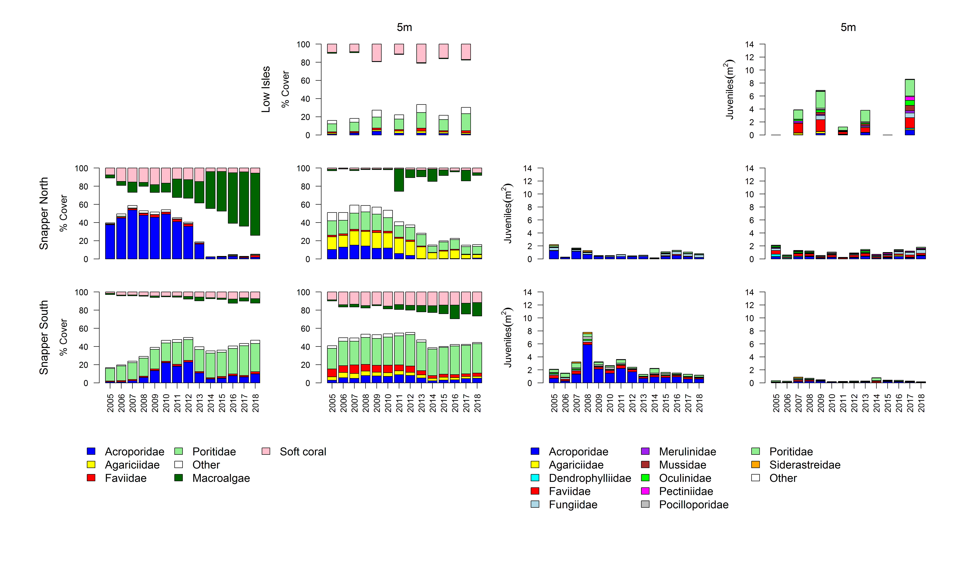
Figure A 1 Barron Daintree sub-region benthic community composition
. Cover estimates are separated into regionally abundant hard coral families and the total cover for soft corals and macroalgae (hanging). Juvenile density estimates are for regionally abundant hard coral families. Separate legends relevant groupings for cover and juvenile density estimates are located beneath the relevant plots.

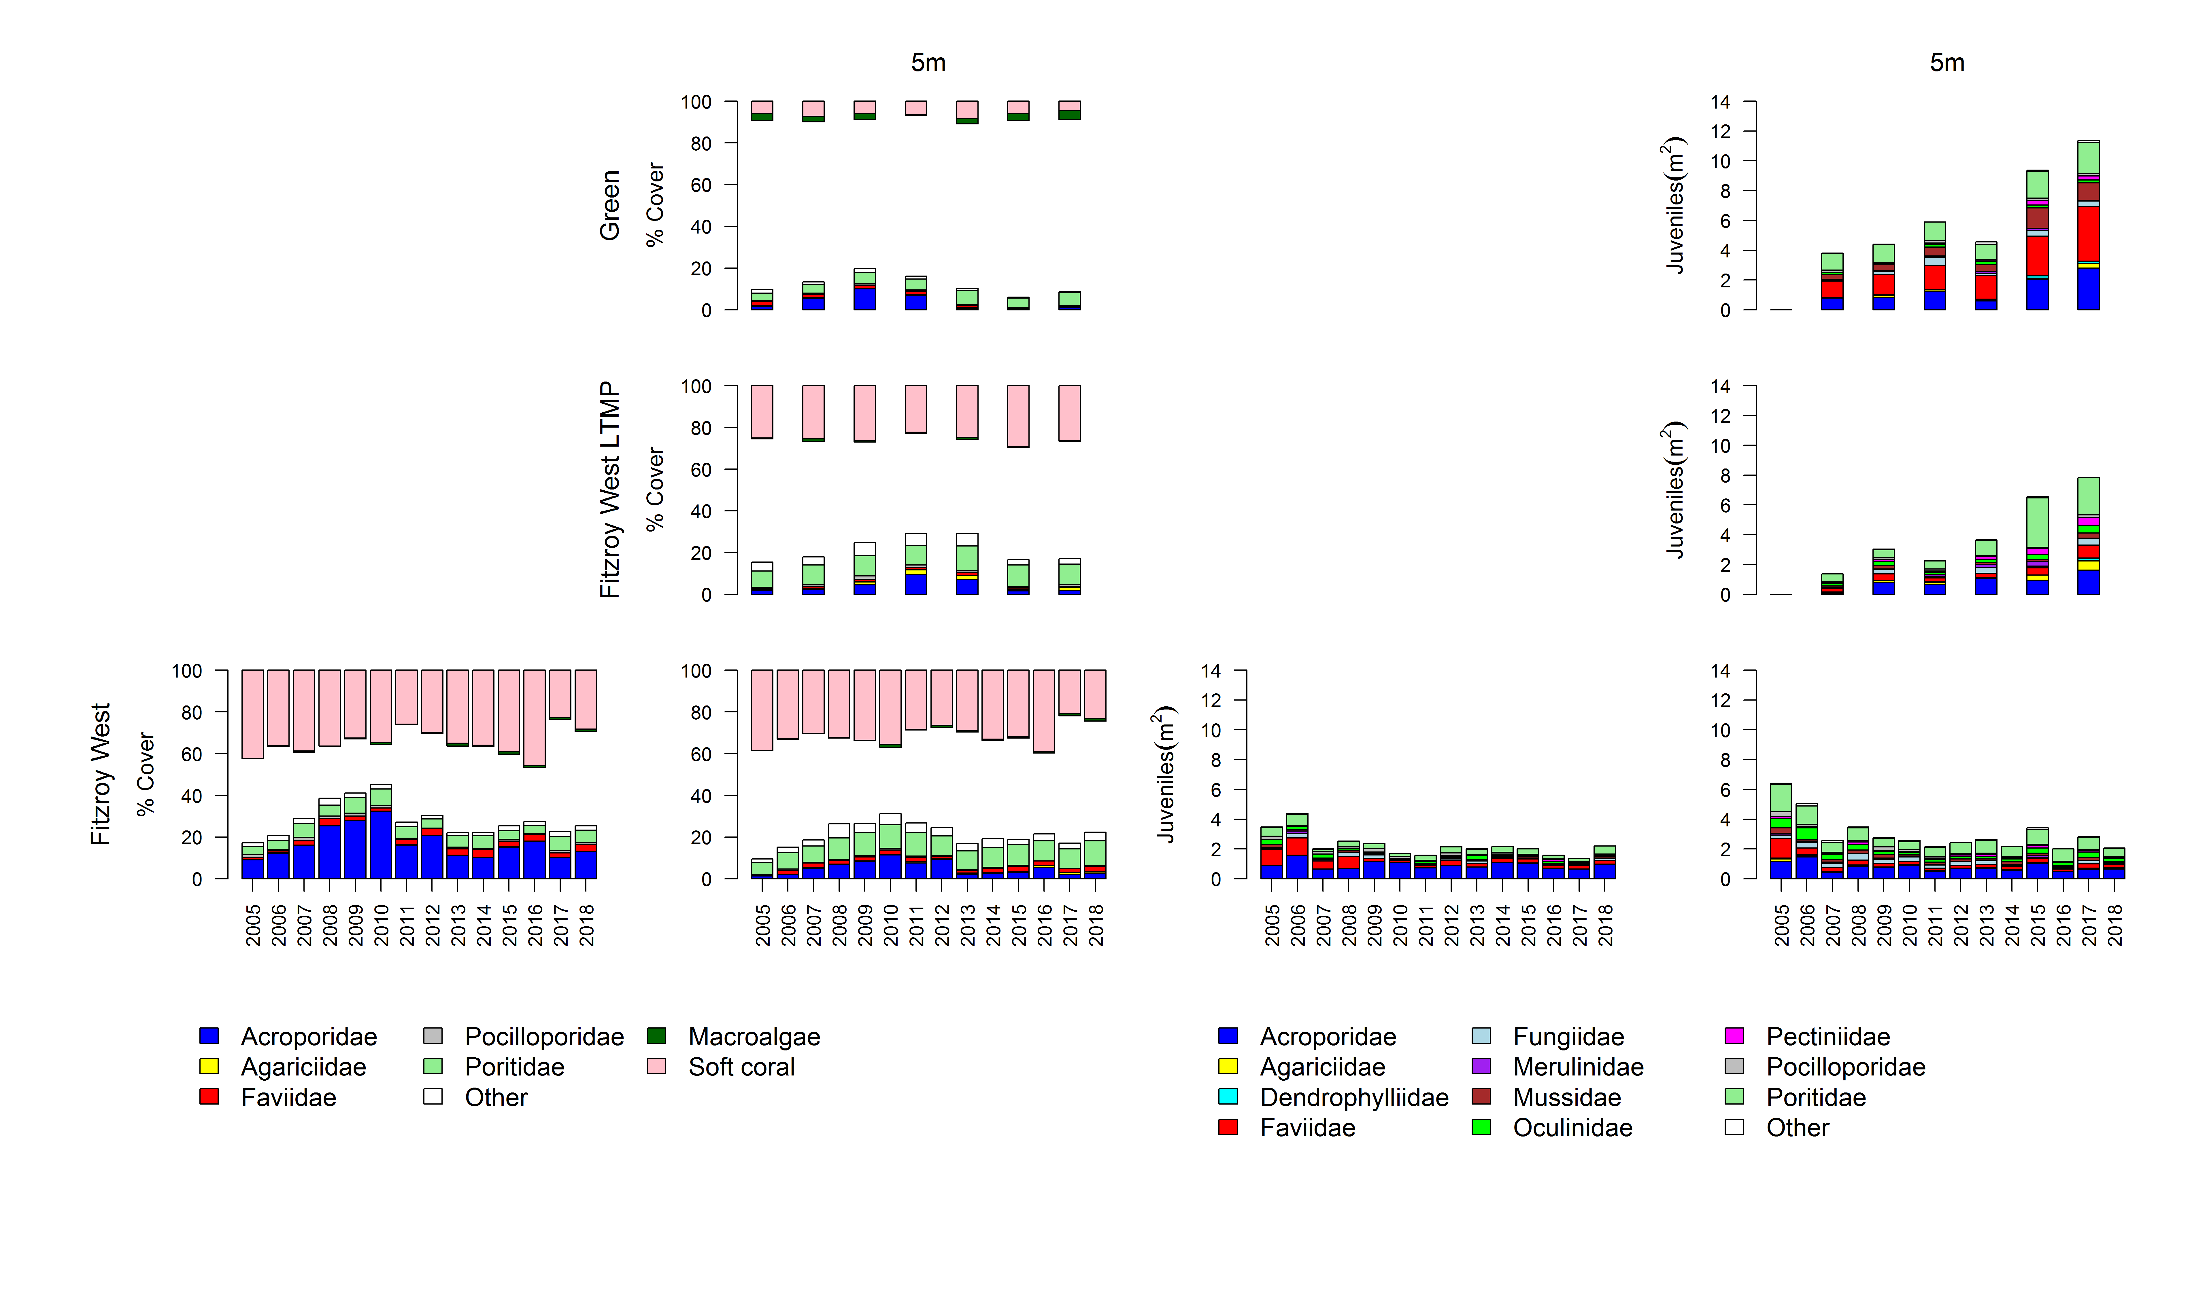
Figure A 2 Johnstone Russell-Mulgrave sub-region benthic community composition
. Cover estimates are separated into regionally abundant hard coral families and the total cover for soft corals and macroalgae (hanging). Juvenile density estimates are for regionally abundant hard coral families. Separate legends relevant groupings for cover and juvenile density estimates are located beneath the relevant plots.

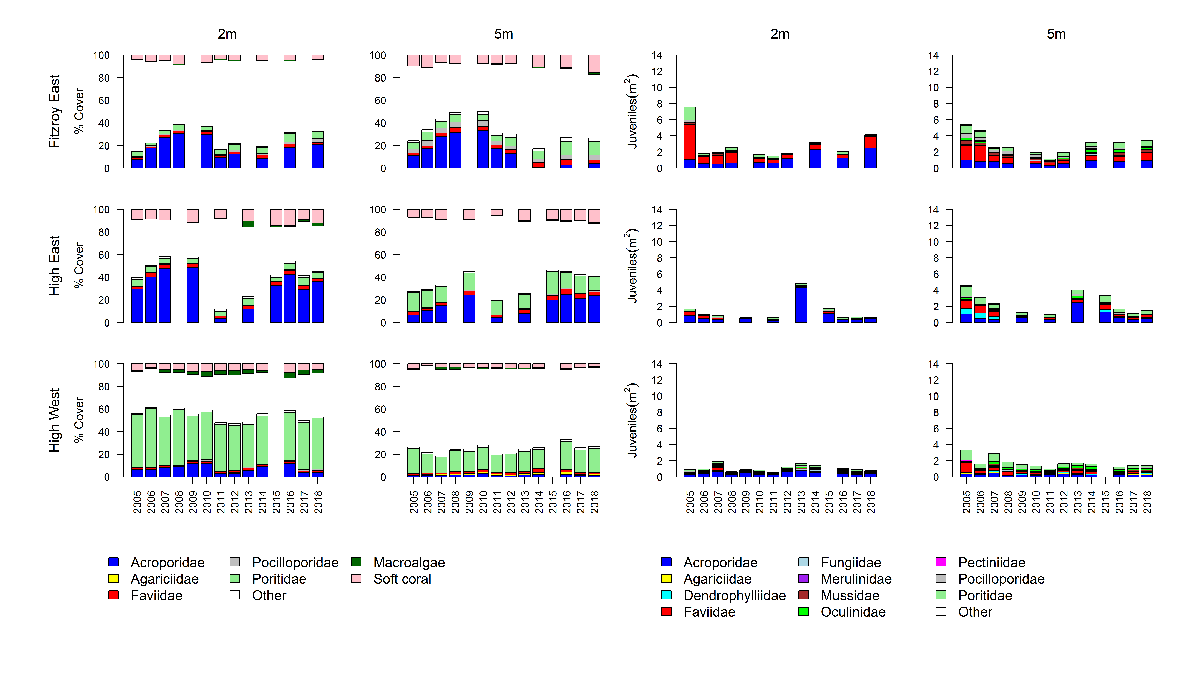
Figure A 2 continued

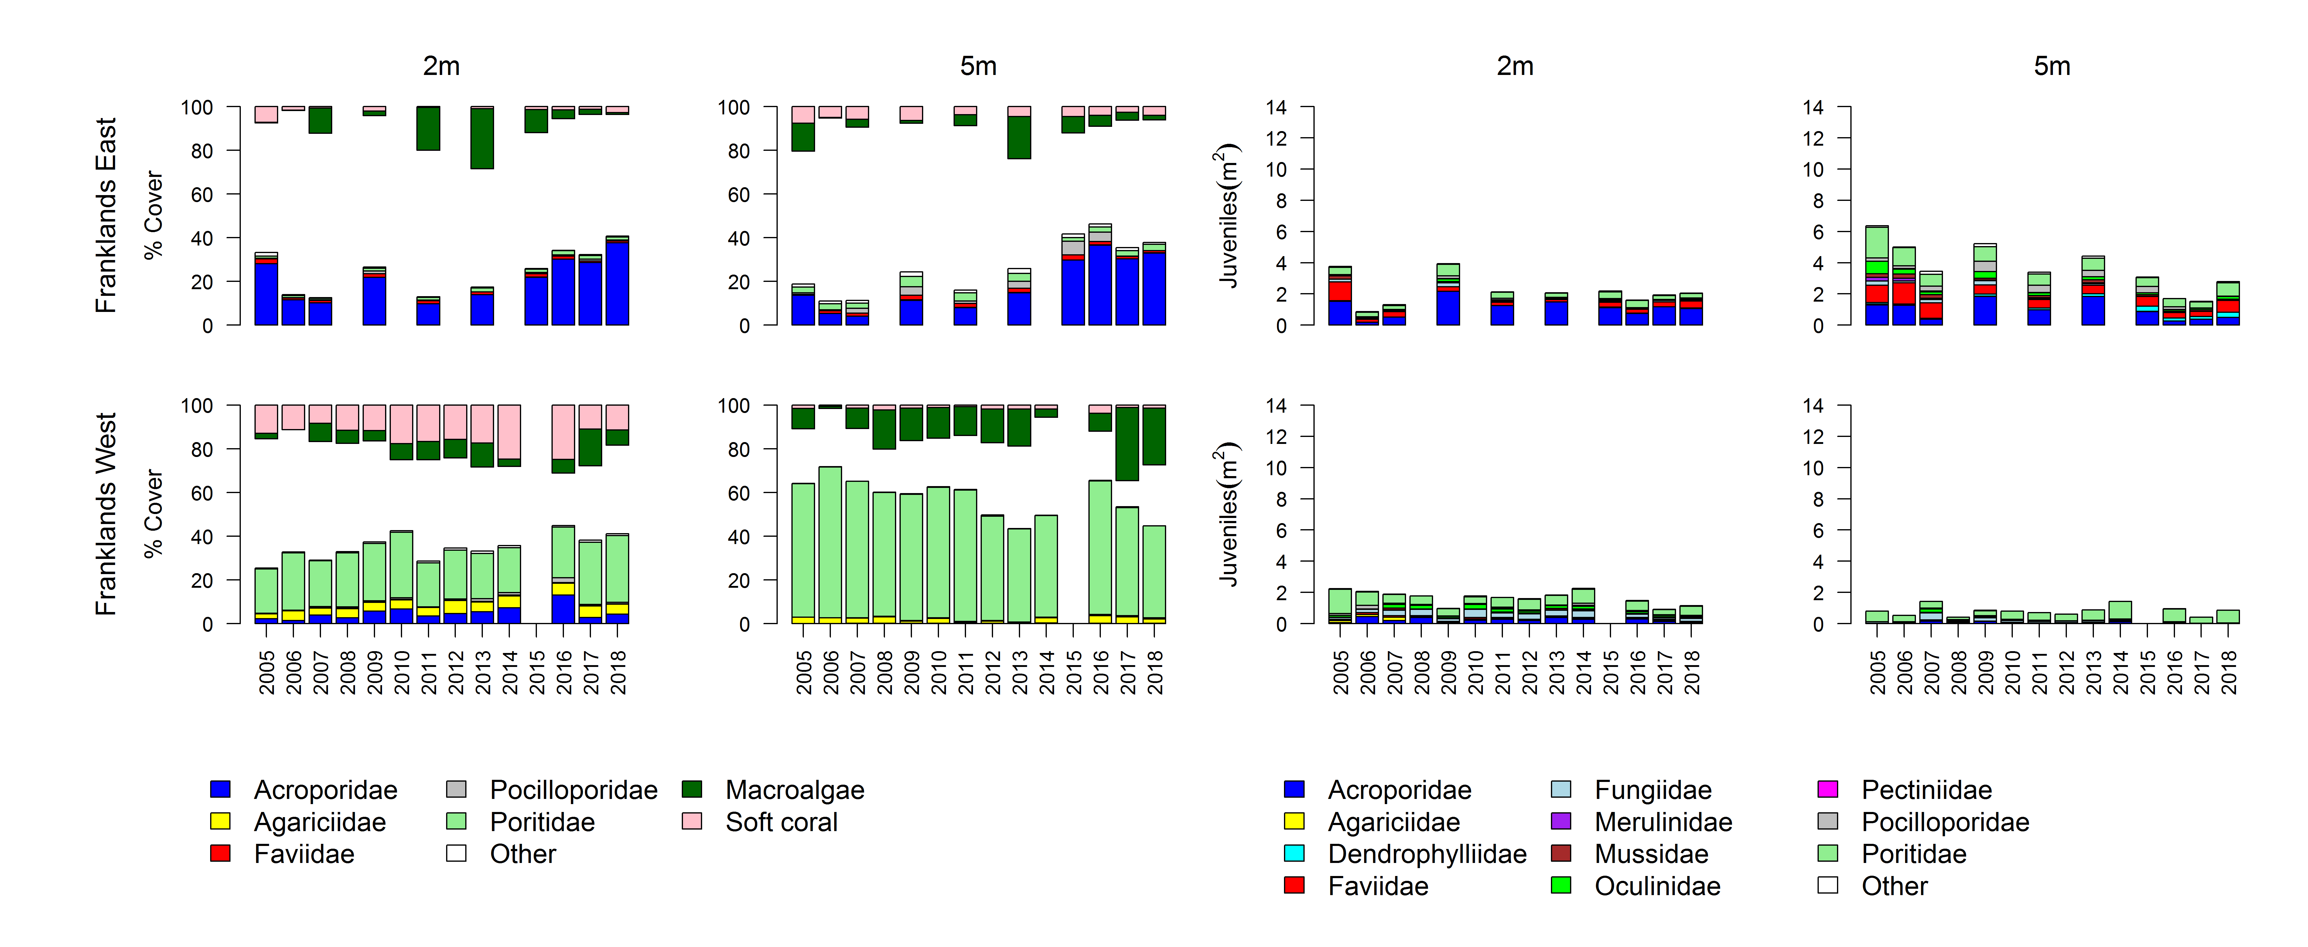
Figure A 2 continued

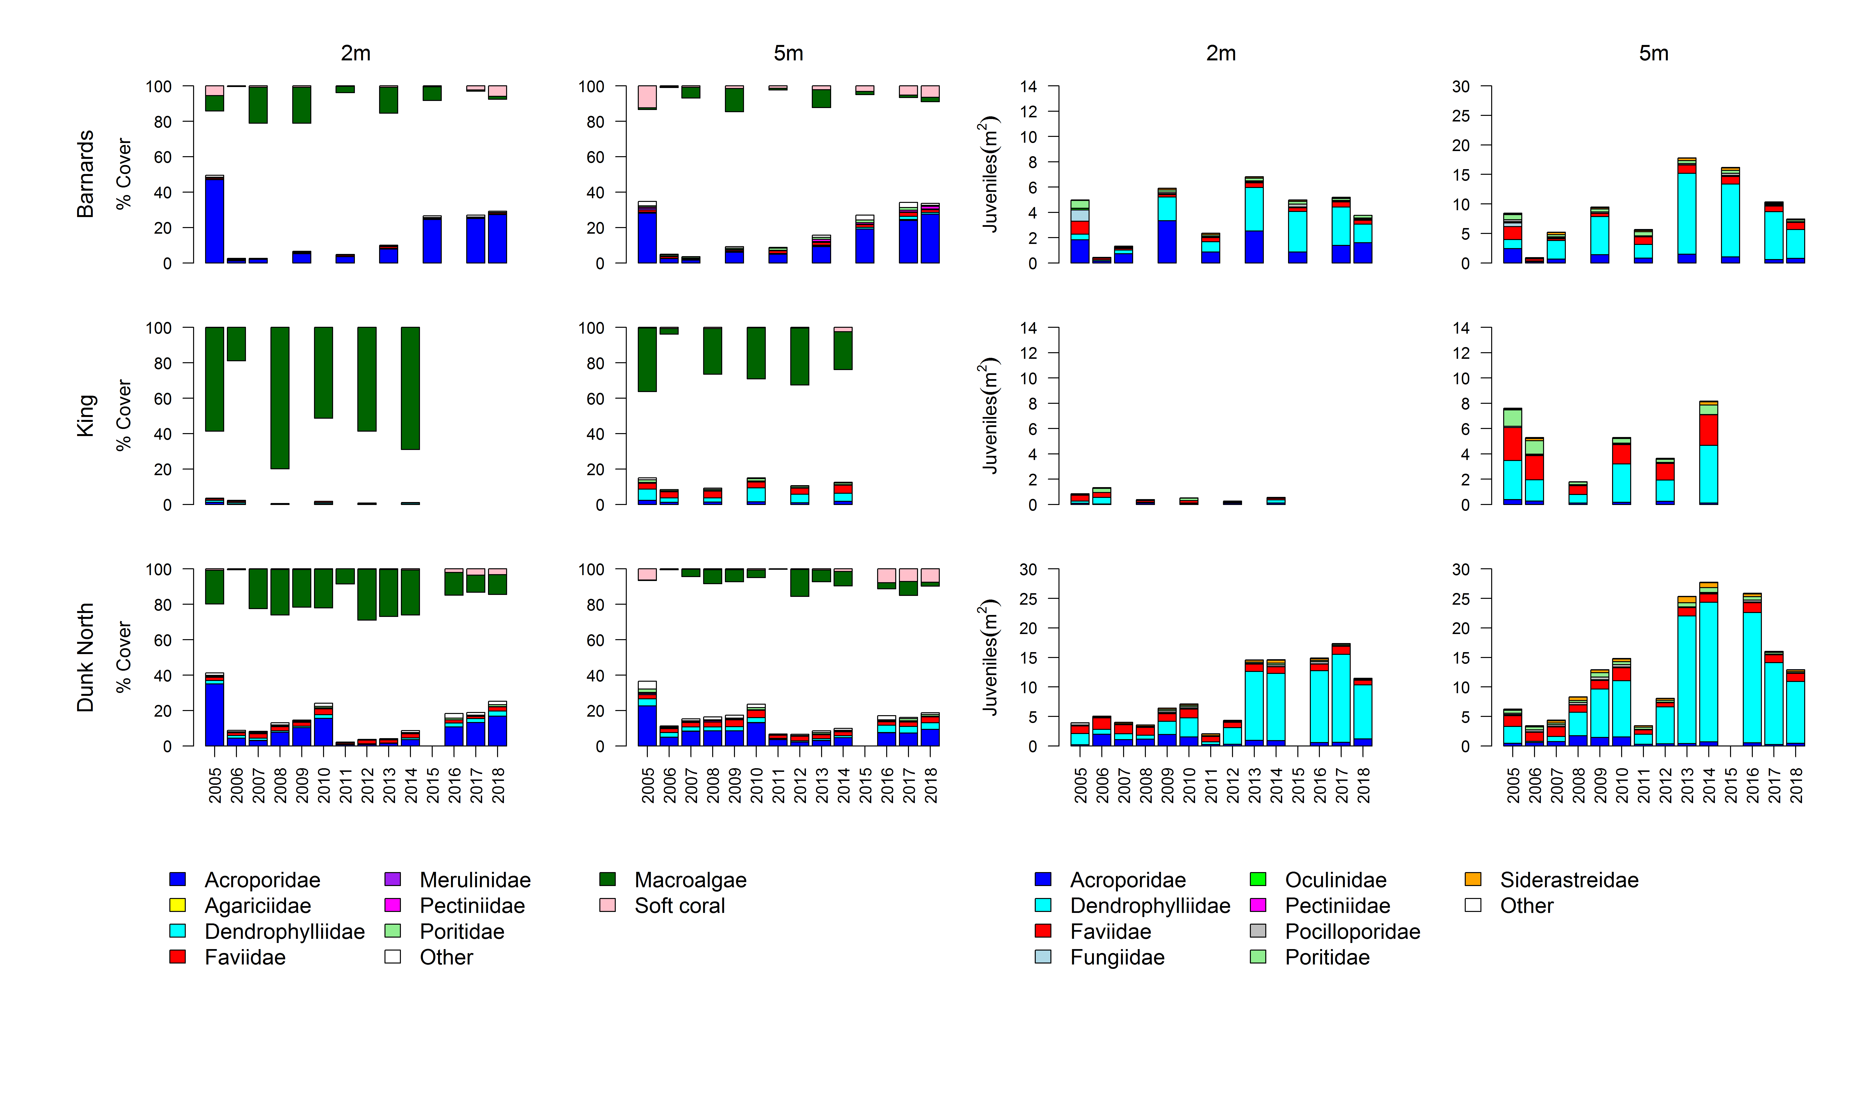
Figure A 3 Herbert-Tully sub- region benthic community composition
. Cover estimates are separated into regionally abundant hard coral families and the total cover for soft corals and macroalgae (hanging). Juvenile density estimates are for regionally abundant hard coral families. Separate legends with relevant groupings for cover and juvenile density estimates are located beneath the respective plots.

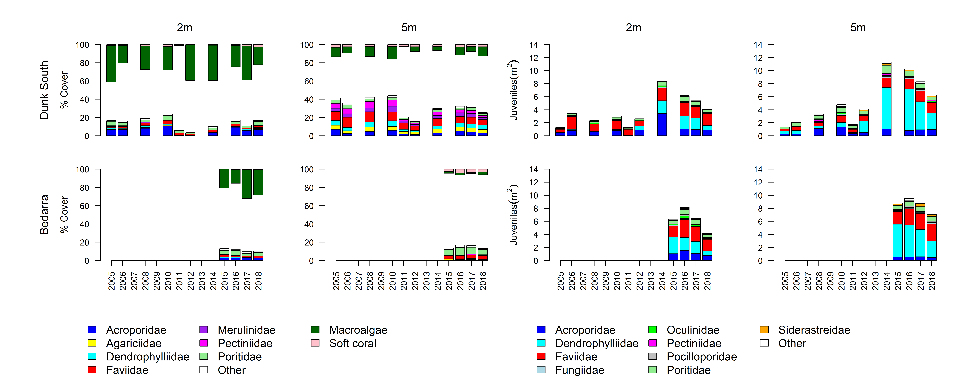
Figure A 3 continued

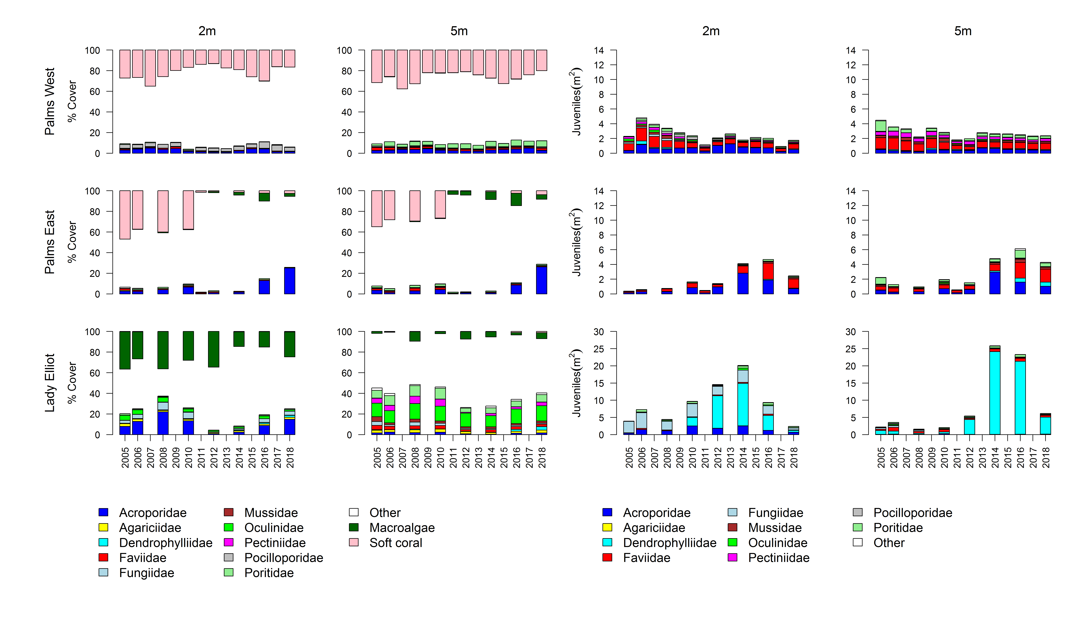
Figure A 4 Burdekin Region benthic community composition
. Cover estimates are separated into regionally abundant hard coral families and the total cover for soft corals and macroalgae (hanging). Juvenile density estimates are for regionally abundant hard coral families. Separate legends with relevant groupings for cover and juvenile density estimates are located beneath the respective plots.

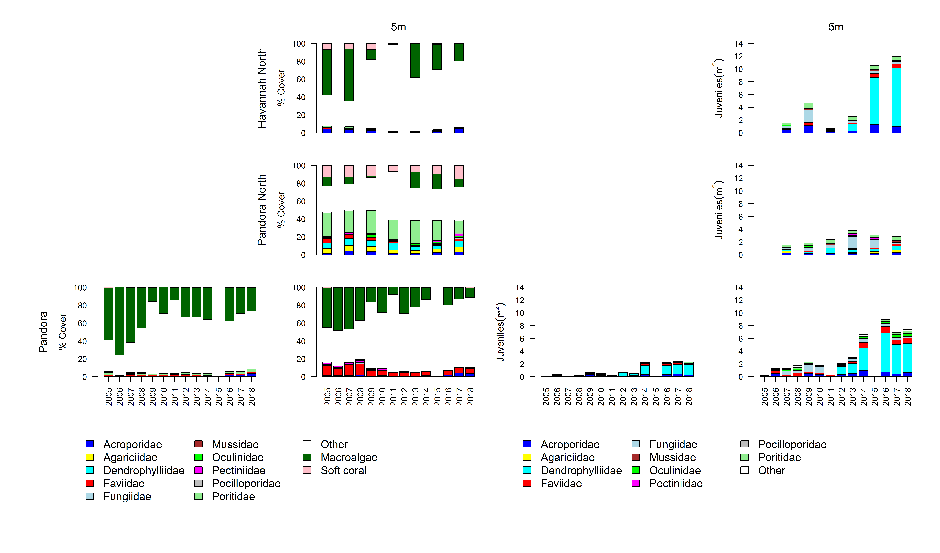
Figure A 4 continued

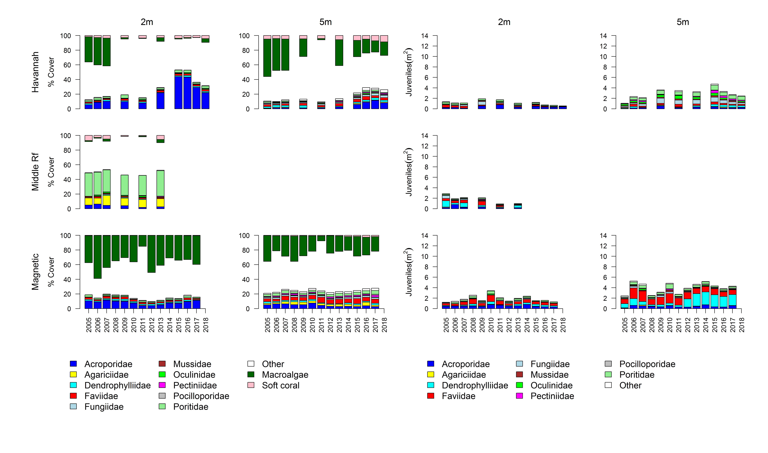
Figure A 4 continued

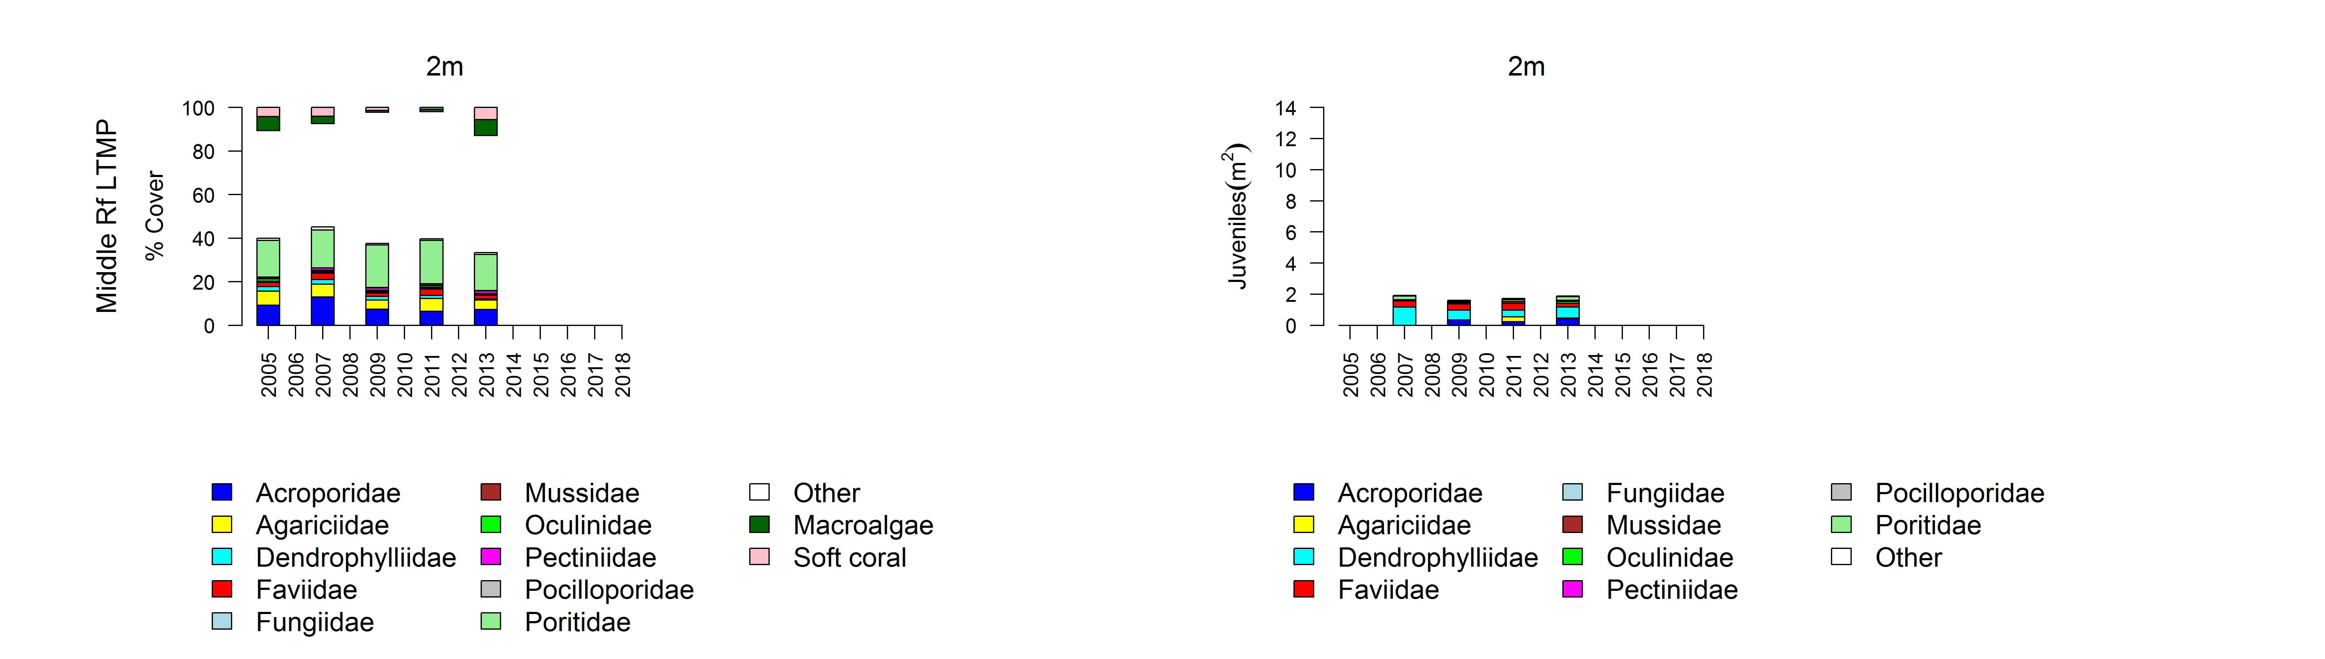
Figure A 4 continued

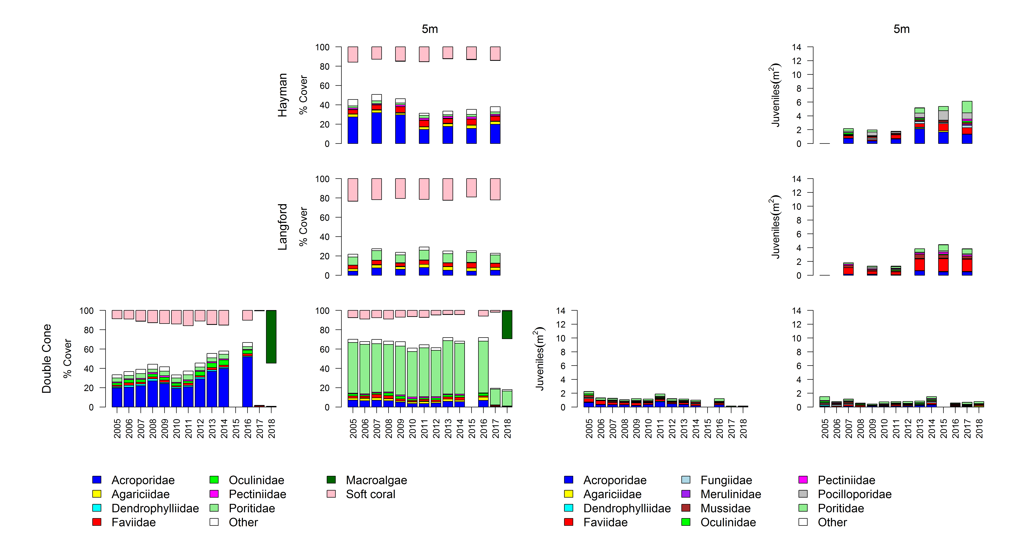
Figure A 5 Mackay Whitsunday Region benthic community composition
. Cover estimates are separated into regionally abundant hard coral families and the total cover for soft corals and macroalgae (hanging). Juvenile density estimates are for regionally abundant hard coral families. Separate legends with relevant groupings for cover and juvenile density estimates are located beneath the respective plots.

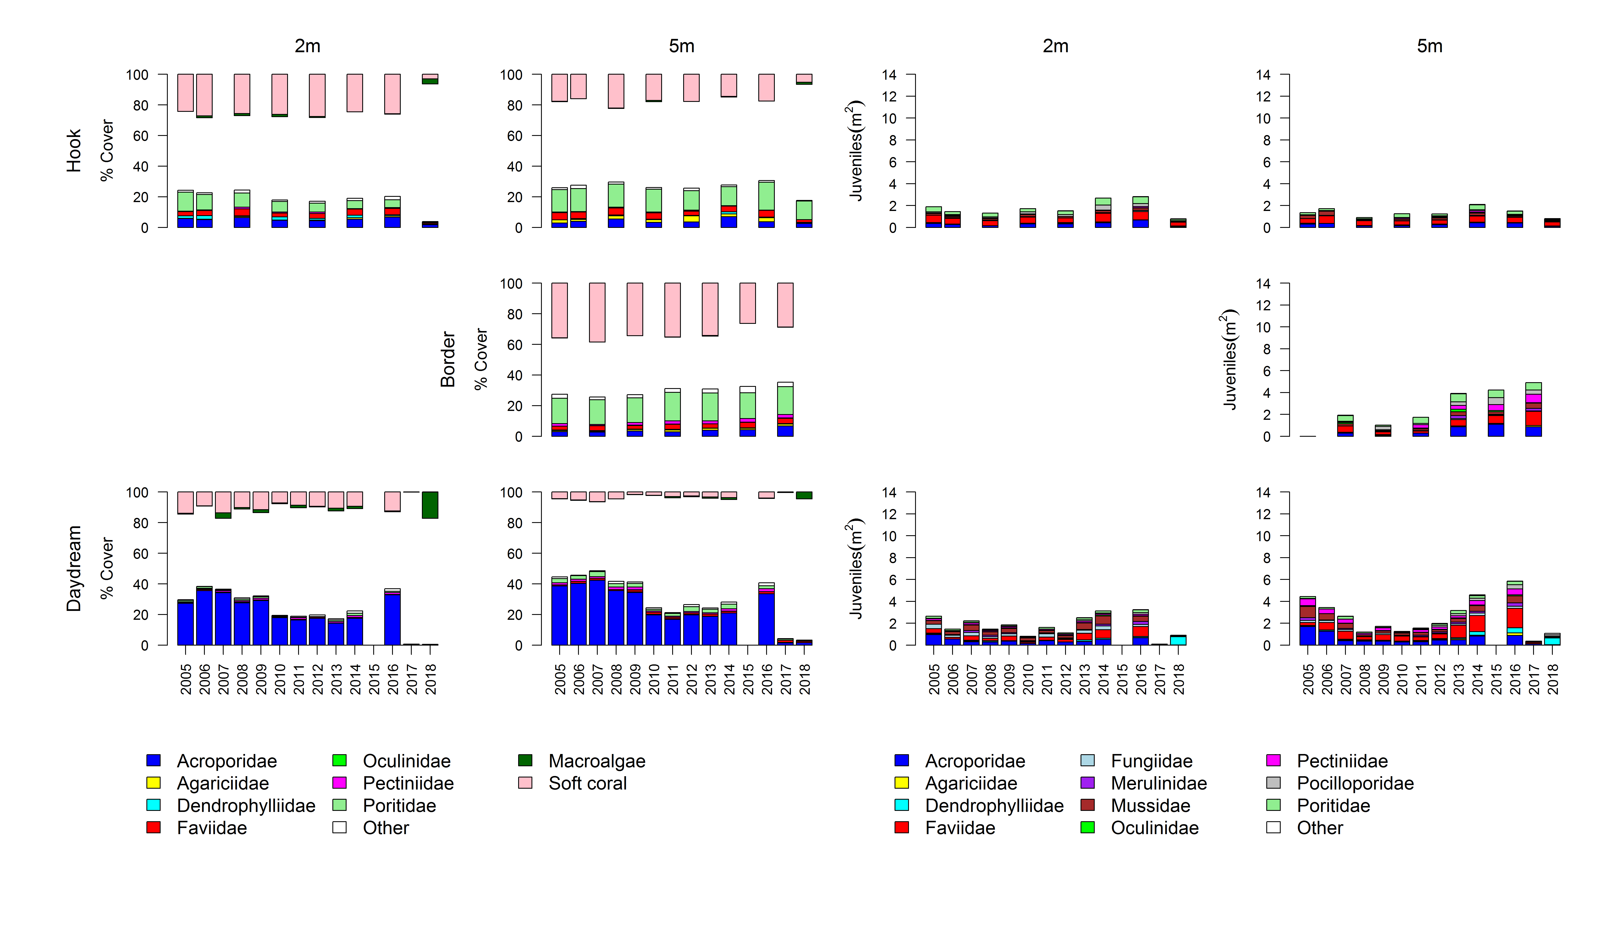
Figure A 5 continued

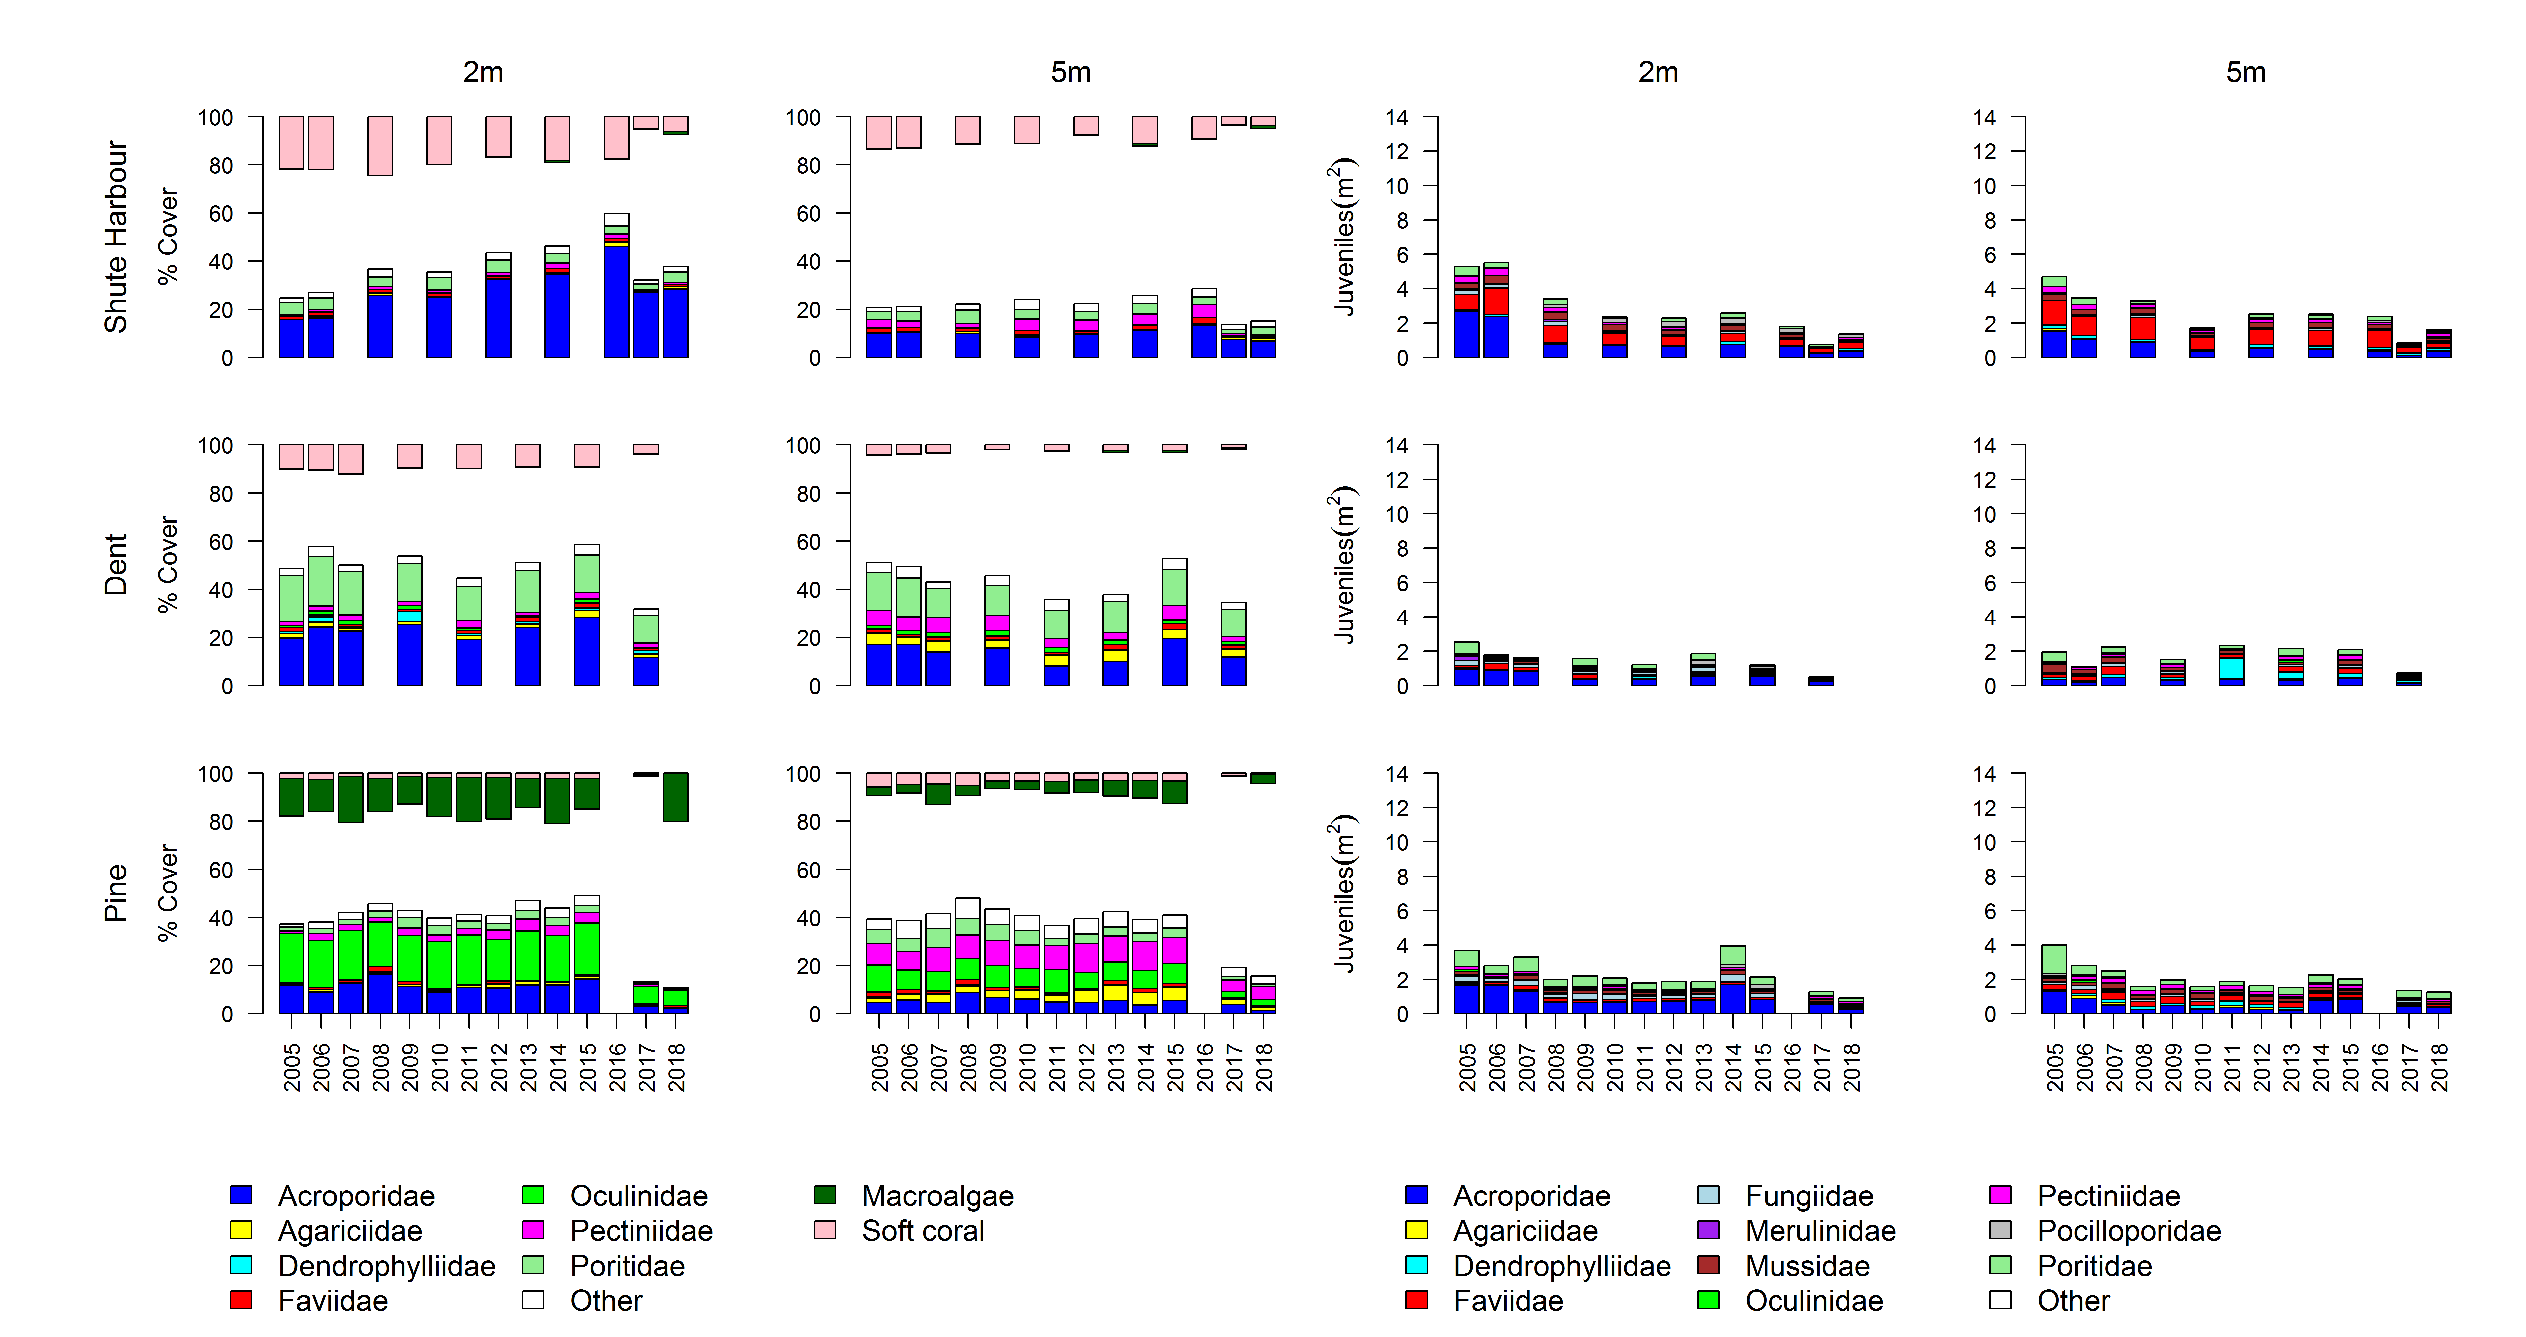
Figure A 5 continued

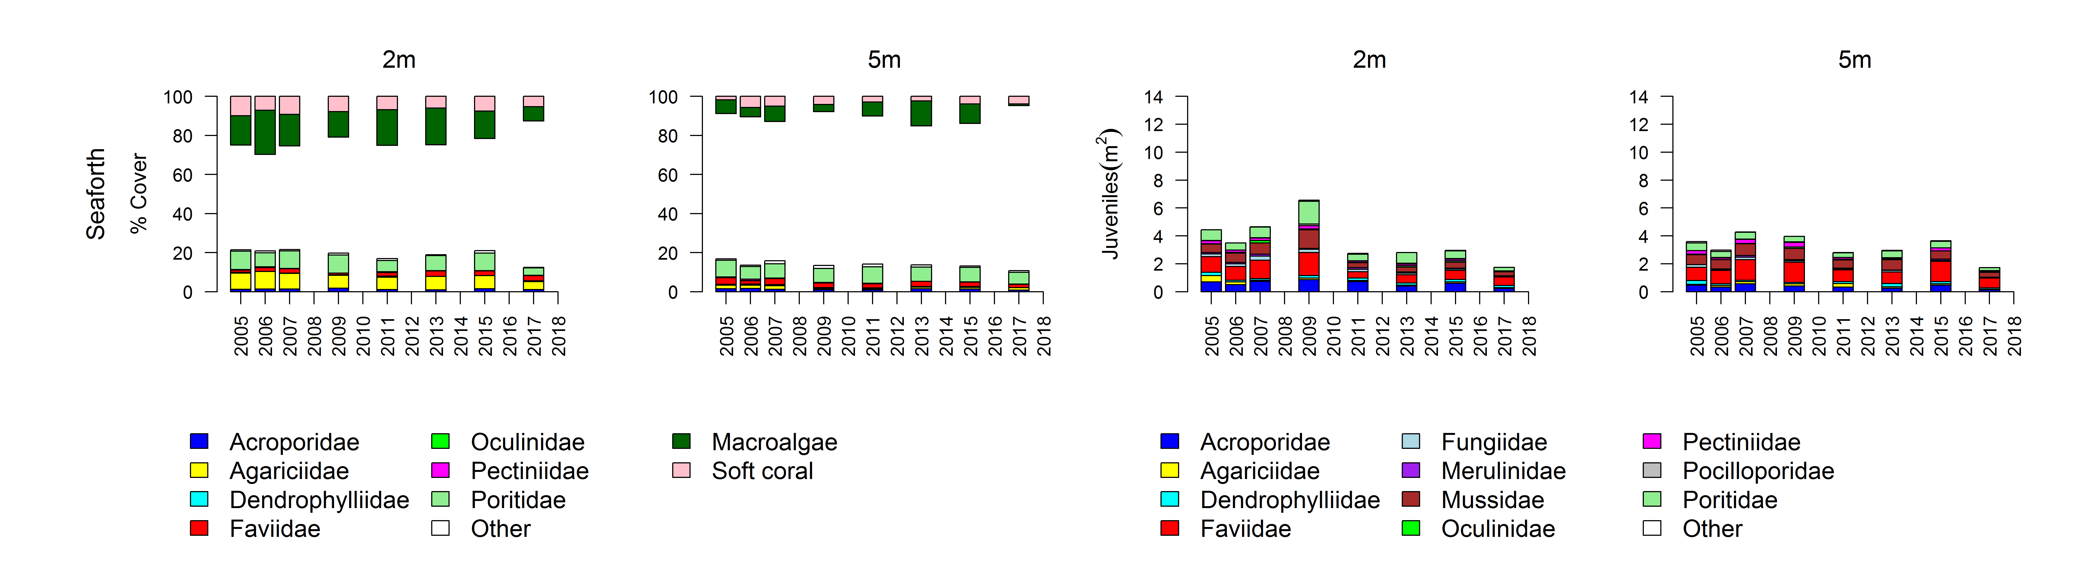
Figure A 5 continued

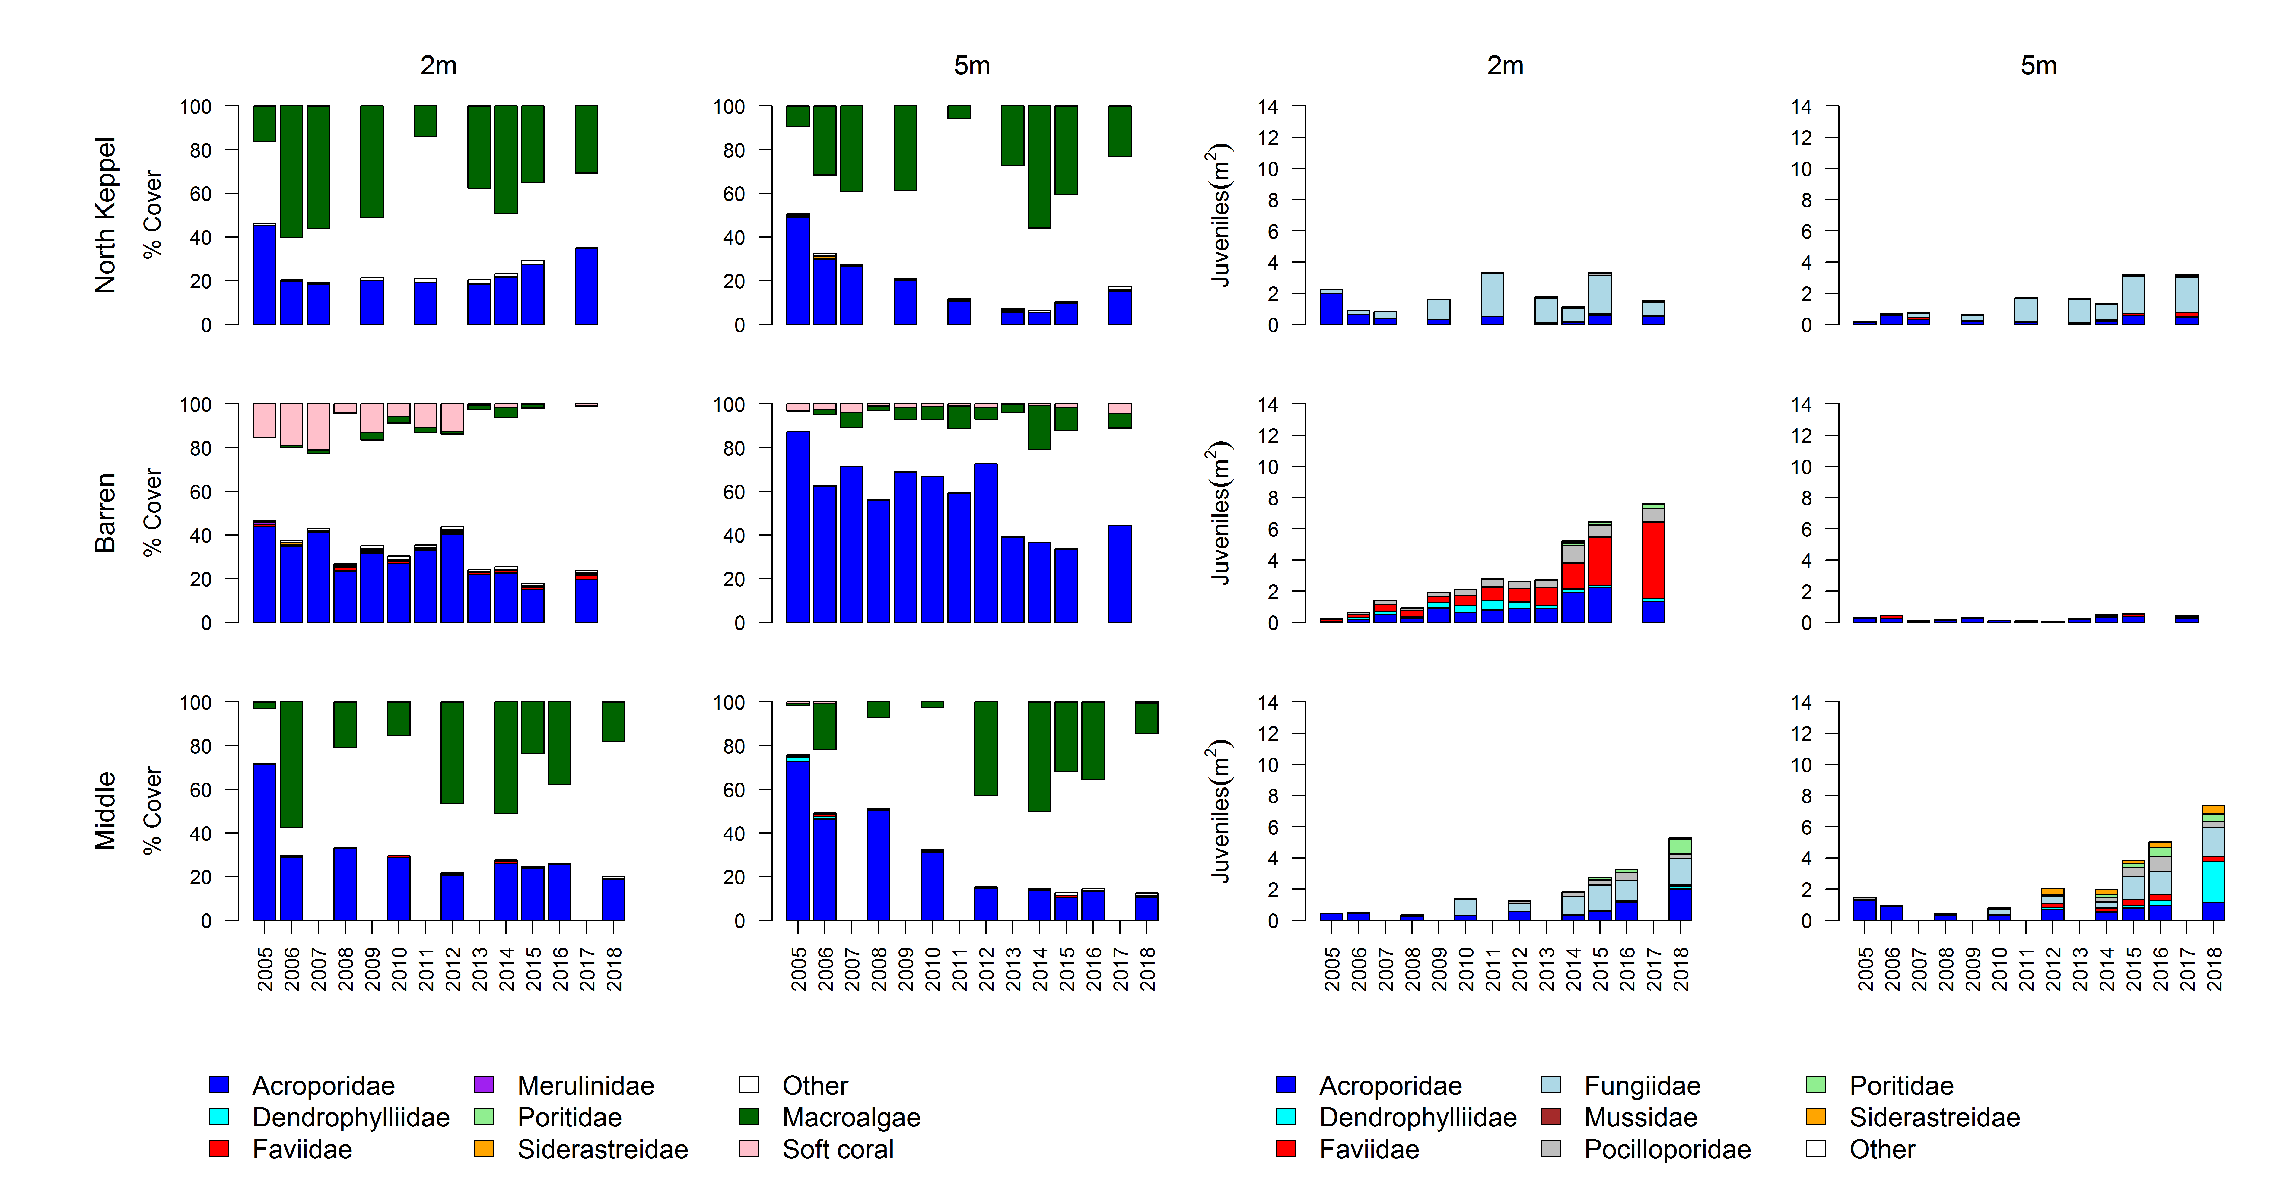
Figure A 6 Fitzroy Region benthic community composition
. Cover estimates are separated into regionally abundant hard coral families and the total cover for soft corals and macroalgae (hanging). Juvenile density estimates are for regionally abundant hard coral families. Separate legends with relevant groupings for cover and juvenile density estimates are located beneath the respective plots.

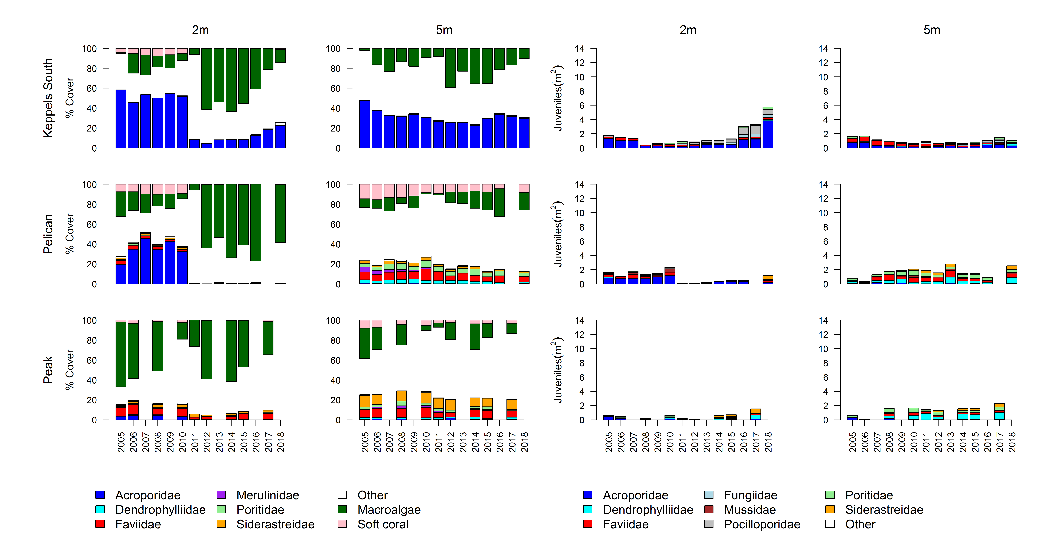
Figure A 6 continued

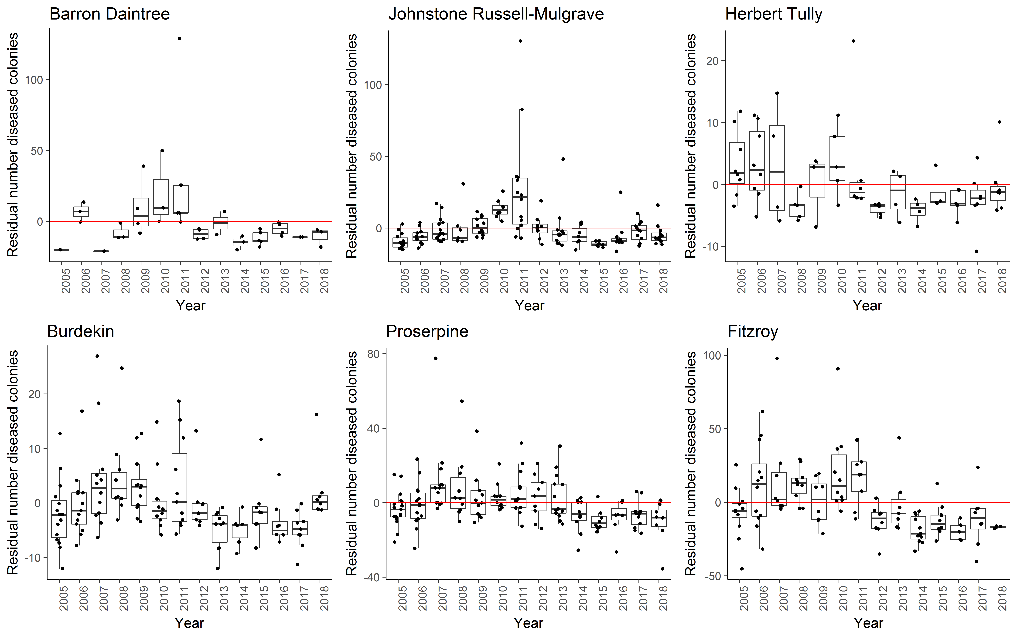
Figure A 7 Coral disease by year in each region
. Boxplots include the number of coral colonies suffering ongoing mortality attributed to either disease, sedimentation or ‘unknown causes’ for each reef, depth and year. Data are standardised to the reef and depth mean across years.
Table A 7 Percent cover of hard coral genera 2018
. Genera for which cover did not exceeded 1% on at least one reef or were unidentified to genus level are grouped as “other”.
subregion | Reef | Depth | Acropora | Alveopora | Caulastrea | Cyphastrea | Diploastrea | Echinophyllia | Echinopora | Favia | Favites | Fungia | Galaxea | Goniastrea | Goniopra | Isopora | Lobophyllia | Merulina | Montipora | Mycedium | Oxypora | Pachyseris | Pavona | Pectinia | Platygyra | Plesiastrea | Pocillopora | Podobacia | Porites | Psammocora | Seriatopora | Turbanaria | Other
Daintree | Snapper North | 2 | 1.63 |  | 0.04 |  |  |  | 2.04 |  |  | 0.21 | 0.21 |  | 0.04 |  | 0.04 |  | 0.17 |  |  |  |  |  | 0.13 |  |  |  | 0.71
 |  | 5 | 0.31 |  | 0.19 |  |  |  |  | 0.19 | 0.06 | 0.38 | 0.31 | 0.06 | 5.81 |  |  |  | 0.63 | 0.13 | 0.06 | 2.56 | 0.56 | 0.06 | 0.06 |  | 0.38 | 0.13 | 2.69 |  |  |  | 1.13
 | Snapper South | 2 | 6.42 |  |  | 0.25 |  |  |  | 0.21 | 0.13 |  | 2.29 | 1.38 | 0.17 |  | 0.04 |  | 3.42 |  |  |  | 0.13 |  | 0.04 |  | 0.54 |  | 30.88 | 0.42 |  | 0.17 | 0.46
 |  | 5 | 4.94 |  | 3.31 |  |  |  | 0.06 |  | 0.06 | 0.19 | 0.13 |  | 2.63 |  |  |  | 0.19 |  |  | 1.75 | 0.25 |  | 0.13 |  |  |  | 29.69 | 0.69 |  | 0.31 | 0.13
 | Low Isles | 5 | 0.27 |  | 0.07 | 0.03 | 0.43 |  | 1.13 | 0.13 | 0.17 | 0.23 | 3.33 | 0.10 | 0.10 |  | 1.23 | 0.33 | 0.67 |  | 0.03 | 1.17 | 0.13 | 0.10 | 0.07 | 0.03 | 0.10 | 0.07 | 18.73 | 0.17 | 0.10 | 0.07 | 1.27
Johnstone | Green | 5 | 0.67 |  |  |  | 0.03 |  |  | 0.27 | 0.03 |  | 0.07 | 0.10 | 0.10 |  | 0.30 | 0.03 | 0.23 |  |  | 0.10 |  |  | 0.07 |  |  |  | 6.27 | 0.03 |  | 0.03 | 0.40
 | Fitzroy West LTMP | 5 | 0.43 |  |  |  |  |  | 0.10 | 0.10 |  | 0.20 | 0.53 |  | 0.07 |  | 0.73 | 0.10 | 1.33 | 0.13 | 0.17 | 1.47 |  | 0.17 | 0.13 |  | 0.27 |  | 9.70 |  | 0.17 | 0.03 | 1.37
 | Fitzroy East | 2 | 16.19 |  |  | 0.06 |  |  |  | 0.13 | 0.38 |  |  | 0.44 | 0.06 |  |  |  | 4.88 |  |  |  | 0.06 |  | 0.13 |  | 3.31 |  | 5.94 |  |  |  | 0.81
 |  | 5 | 2.81 |  |  |  | 0.63 |  | 0.75 | 0.44 | 0.25 | 0.19 | 1.13 | 0.44 | 0.19 |  | 0.56 | 0.06 | 0.56 |  |  | 0.06 | 0.06 |  | 0.31 |  | 4.44 |  | 11.69 | 0.75 |  |  | 1.31
 | Fitzroy West | 2 | 10.13 |  |  | 0.06 | 0.25 |  | 2.13 | 0.38 | 0.25 | 0.56 | 0.56 |  | 0.63 |  | 0.25 | 0.19 | 2.81 |  | 0.06 |  | 0.06 |  | 0.31 |  | 0.75 |  | 5.50 | 0.06 |  | 0.19 | 0.31
 |  | 5 | 1.57 |  | 0.19 | 0.06 | 1.25 |  | 0.50 |  |  | 0.38 | 0.56 | 0.06 | 0.88 |  | 2.19 | 0.13 | 1.13 |  | 0.13 | 0.81 | 0.06 |  | 0.25 |  | 0.25 |  | 11.02 | 0.38 |  | 0.06 | 0.44
 | Franklands East | 2 | 18.81 |  |  |  |  |  | 0.38 | 0.19 |  | 0.06 | 0.13 | 0.06 | 0.19 |  |  |  | 18.75 |  |  |  | 0.06 |  | 0.19 |  | 0.44 |  | 1.13 |  |  |  | 0.38
 |  | 5 | 30.81 |  |  |  |  |  | 0.38 | 0.13 | 0.06 | 0.06 | 0.19 |  | 0.13 |  | 0.06 | 0.06 | 2.06 |  |  | 0.06 |  | 0.25 | 0.25 |  | 0.06 |  | 2.75 | 0.13 |  | 0.13 | 0.31
 | Franklands West | 2 | 4.00 |  |  |  |  |  |  |  | 0.06 | 0.25 | 0.31 |  | 1.81 |  | 0.06 |  | 0.25 |  |  | 4.69 |  |  |  |  | 0.56 |  | 28.69 |  | 0.19 |  | 0.25
 |  | 5 | 0.13 |  |  |  |  |  | 0.31 |  |  |  | 0.06 |  |  |  |  |  |  |  |  | 1.94 |  |  |  |  |  |  | 42.06 |  | 0.25
 | High East | 2 | 28.25 |  |  | 0.13 |  |  | 1.19 | 0.13 | 0.06 |  | 0.31 | 0.69 | 0.25 |  | 0.13 |  | 7.63 |  |  |  | 0.25 |  | 0.44 |  | 0.38 |  | 4.63 | 0.13 |  | 0.06 | 0.44
 |  | 5 | 17.31 |  |  | 0.25 |  |  | 1.56 | 0.38 | 0.31 |  | 0.25 | 0.06 | 0.56 |  |  | 0.06 | 6.56 | 0.06 | 0.06 |  |  |  | 0.06 |  | 0.69 |  | 11.75 | 0.13 |  |  | 0.81
 | High West | 2 | 3.19 |  |  |  | 0.06 |  | 0.13 | 0.19 | 0.06 | 0.19 | 0.31 |  | 3.38 |  | 0.38 | 0.13 | 0.38 |  |  | 0.19 | 0.44 |  | 0.31 | 0.06 | 1.38 |  | 41.64 |  |  |  | 0.63
 |  | 5 | 1.06 |  |  |  |  |  |  | 0.44 | 0.38 | 0.13 | 0.69 |  | 4.00 |  |  |  |  |  | 0.06 | 0.38 | 1.00 |  | 0.19 |  |  | 0.13 | 17.45 |  |  | 0.06 | 0.81
Tully | Barnards | 2 | 15.53 |  |  | 0.19 |  |  | 0.13 | 0.06 |  |  | 0.06 |  |  |  |  |  | 11.70 |  |  |  |  |  | 0.06 | 0.13 | 0.50 |  | 0.13 | 0.06 |  | 0.38 | 0.25
 |  | 5 | 15.31 |  |  | 0.38 |  |  | 0.13 | 0.25 | 0.06 | 0.13 | 0.06 | 0.19 | 0.13 |  | 0.44 | 0.44 | 12.13 | 0.38 | 0.63 | 0.06 |  |  | 0.38 |  | 0.19 |  | 0.44 | 0.13 |  | 1.00 | 0.75
 | Dunk North | 2 | 12.81 |  |  | 0.56 |  |  | 0.31 | 0.44 | 0.50 |  | 0.25 | 0.31 | 0.06 |  |  |  | 4.06 |  |  |  |  |  | 0.13 | 0.13 | 1.38 |  | 1.06 | 0.19 |  | 2.81 | 0.25
 |  | 5 | 3.63 | 0.13 |  | 0.25 |  |  |  | 0.25 | 1.25 | 0.06 | 0.13 | 0.19 | 0.13 |  | 0.13 |  | 5.13 | 0.13 | 0.06 |  |  |  | 1.06 | 0.06 | 0.25 |  | 0.75 | 0.38 |  | 3.63 | 1.25
 | Dunk South | 2 | 4.75 |  |  | 1.38 |  |  |  |  | 0.19 |  | 0.88 | 0.25 | 0.19 |  | 0.13 |  | 2.19 |  |  |  | 1.06 |  |  |  |  |  | 3.75 | 0.06 |  | 1.25 | 0.63
 |  | 5 | 1.19 |  | 0.06 | 0.38 |  |  | 0.44 | 2.44 | 1.00 | 0.06 | 0.13 | 0.63 | 0.06 |  | 0.31 | 1.94 | 1.94 | 0.94 | 0.69 | 3.13 | 0.31 | 0.06 | 0.94 |  | 0.31 | 0.25 | 1.88 |  |  | 5.13 | 1.19
 | Bedarra | 2 | 2.06 |  |  | 0.69 |  |  |  | 0.38 | 0.38 | 0.06 | 0.19 |  | 0.31 |  | 0.38 |  | 0.50 | 0.06 | 0.19 |  | 0.06 |  | 0.13 | 0.06 | 0.38 | 0.25 | 3.44 |  |  | 0.19 | 0.44
 |  | 5 | 0.00 |  |  | 0.13 |  | 0.06 |  | 2.50 | 0.69 |  |  | 0.13 | 2.31 |  | 0.69 | 0.38 |  | 0.69 |  | 0.44 | 0.06 |  | 0.13 | 0.19 | 0.13 | 0.13 | 3.50 | 0.06 |  | 0.31 | 0.75
Burdekin | Palms East | 2 | 24.69 |  |  |  |  |  |  |  | 0.06 |  |  | 0.31 |  |  |  |  | 0.44 |  |  |  |  |  |  |  |  |  | 0.31
 |  | 5 | 24.56 |  |  | 0.06 |  |  | 0.06 |  | 0.19 |  | 0.19 | 0.13 | 0.06 | 0.13 | 0.06 | 0.06 | 1.38 |  |  |  | 0.06 |  | 0.06 |  | 0.44 |  | 1.00 | 0.06 |  |  | 0.25
 | Palms West | 2 | 0.88 |  |  | 0.06 |  |  | 0.13 | 0.06 | 0.06 |  |  |  | 0.25 | 0.13 |  |  | 0.44 |  |  |  |  | 0.06 |  | 0.06 | 3.50 |  | 0.13 |  |  |  | 0.25
 |  | 5 | 1.88 |  |  | 0.13 | 0.38 |  | 0.06 | 0.19 | 0.19 |  | 0.06 | 0.13 | 1.38 |  | 0.06 |  | 0.81 |  | 0.06 | 0.13 | 0.06 | 0.06 | 0.19 |  | 0.81 |  | 4.38 |  |  | 0.06 | 1.13
 | Havannah North | 5 | 2.97 |  |  | 0.07 |  | 0.10 |  |  |  | 0.07 | 0.27 | 0.07 | 0.03 |  |  | 0.27 | 0.93 |  |  |  |  |  |  |  | 0.13 | 0.03 | 0.30 |  |  | 0.17 | 0.70
 | Havannah | 2 | 12.69 |  |  |  |  |  | 1.63 |  |  | 0.13 | 0.94 |  | 0.25 | 2.44 | 0.06 | 0.25 | 6.56 |  |  |  | 0.44 |  | 0.81 |  | 0.56 |  | 2.94 |  |  | 1.69 | 0.19
 |  | 5 | 5.00 |  | 0.06 | 0.25 | 1.13 | 0.06 | 1.19 | 0.13 |  | 2.31 | 0.69 | 0.13 | 0.31 | 0.13 | 0.63 | 3.19 | 2.94 | 0.13 | 0.75 | 0.88 | 0.25 | 0.44 | 0.38 |  |  | 0.56 | 0.50 | 0.25 |  | 2.56 | 1.25
 | Pandora North | 5 | 1.27 | 1.10 | 0.50 | 0.03 |  | 1.00 | 0.83 | 0.37 | 0.10 | 0.23 | 1.40 | 0.07 | 10.73 | 0.30 | 0.30 | 0.77 | 1.40 | 0.77 | 0.07 | 4.53 | 0.13 | 0.63 | 0.13 |  | 0.27 | 0.30 | 2.03 |  | 0.03 | 7.03 | 2.70
 | Pandora | 2 | 2.06 |  |  | 0.25 |  |  |  |  | 0.06 |  |  | 0.06 | 0.13 |  |  |  | 1.63 |  |  |  |  |  |  | 0.81 |  |  | 3.13 |  |  | 0.06 | 0.50
 |  | 5 | 2.44 |  |  | 0.31 | 3.00 |  |  | 0.63 | 0.25 | 0.38 | 0.38 |  | 0.13 |  |  | 0.19 | 0.69 |  |  | 0.13 |  |  | 0.69 |  | 0.13 |  | 0.06 |  |  | 0.19 | 0.69
 | Lady Elliot | 2 | 9.25 |  |  | 0.19 |  |  |  | 0.13 |  | 3.63 | 1.44 |  | 0.13 |  | 0.06 | 0.06 | 5.63 |  |  |  | 1.88 |  |  |  |  |  | 0.69 |  |  | 1.88 | 0.13
 |  | 5 | 1.19 | 1.19 |  | 0.25 |  |  |  | 0.81 | 0.56 |  | 14.69 | 0.13 | 3.69 |  | 2.13 | 0.56 | 0.44 | 1.19 | 1.88 | 2.75 |  | 0.44 | 0.44 |  |  | 0.88 | 2.31 | 0.19 |  | 3.38 | 1.31
 | Middle Reef LTMP | 2 | 1.47 |  |  | 0.07 |  |  | 0.07 | 0.91 | 0.10 | 0.03 | 0.13 | 0.07 | 15.38 | 0.23 | 0.24 | 0.47 | 5.54 | 0.07 | 0.20 | 4.27 | 0.13 | 0.41 | 0.24 |  | 0.13 | 0.23 | 1.31 |  |  | 0.37 | 1.21
 | Magnetic | 2 | 2.81 |  |  | 0.31 |  |  | 0.25 | 0.06 | 0.31 |  | 0.19 |  | 0.06 |  |  | 0.13 | 8.31 |  | 0.06 | 0.19 | 0.13 |  |  | 0.25 |  |  | 1.25 |  |  | 0.81 | 0.56
 |  | 5 | 1.06 |  |  | 0.19 |  |  |  | 2.00 | 1.31 | 0.25 | 0.25 |  | 3.19 |  | 0.25 | 2.44 | 1.63 | 0.44 | 1.06 | 2.06 |  | 1.13 | 1.63 | 0.19 | 0.56 | 1.81 | 1.81 |  |  | 2.50 | 2.06
Proserpine | Hayman | 5 | 6.71 |  |  | 0.10 | 1.87 | 0.30 | 1.17 | 0.70 | 0.33 | 0.13 | 0.47 | 0.53 | 0.27 | 0.03 | 0.73 | 1.27 | 12.98 | 0.33 | 0.17 | 2.74 | 0.27 | 0.63 | 0.23 |  | 0.37 | 0.10 | 2.17 |  | 1.93 | 0.30 | 1.14
 | Langford | 5 | 4.07 | 0.13 |  | 0.07 | 0.33 | 0.03 | 1.90 | 0.90 | 0.23 |  | 0.07 | 0.20 | 6.07 |  | 0.63 |  | 0.93 | 0.03 |  | 0.33 | 2.50 | 0.20 | 0.20 |  | 0.47 |  | 2.20 |  | 0.20 | 0.23 | 0.87
 | Border | 5 | 5.13 | 0.37 |  | 0.03 | 0.43 | 0.60 | 0.67 | 0.90 | 0.27 | 0.17 | 0.20 | 0.27 | 13.00 | 0.07 | 0.87 | 0.27 | 1.43 | 0.43 | 0.10 | 0.70 | 0.47 | 1.07 | 0.40 |  | 0.20 |  | 4.87 |  | 0.70 | 0.27 | 1.37
 | Hook | 2 | 0.00 |  |  | 0.13 |  |  |  | 0.13 | 0.13 |  |  | 0.06 | 0.13 |  |  |  | 1.63 |  |  | 0.25 | 0.06 |  | 0.06 |  |  |  | 0.50 |  |  | 0.25 | 0.44
 |  | 5 | 0.13 |  |  | 0.13 |  |  | 0.06 | 0.81 | 0.38 |  |  |  | 1.19 |  | 0.06 | 0.06 | 2.31 |  |  | 0.38 | 0.13 |  | 0.19 |  |  |  | 11.00 | 0.13 |  | 0.19 | 0.50
 | Double Cone | 2 | 0.00 |  |  |  |  |  | 0.19 | 0.13 |  |  |  |  | 0.13 |  | 0.06 |  | 0.06 |  |  | 0.06 |  |  | 0.06 |  |  |  | 0.06
 |  | 5 | 0.06 |  |  |  |  |  | 0.13 |  |  |  | 0.31 | 0.31 | 14.25 |  | 1.38 | 0.06 |  |  | 0.06 | 0.19 |  |  |  |  |  | 0.06 | 1.13 |  |  |  | 0.13
 | Daydream | 2 | 0.00 |  |  |  |  |  |  |  | 0.06 |  |  |  |  |  |  |  | 0.13 |  | 0.06 |  |  |  |  |  |  |  | 0.25
 |  | 5 | 0.06 |  |  |  |  |  | 0.44 | 0.06 | 0.06 |  |  | 0.25 |  |  |  |  | 1.31 |  |  | 0.06 |  |  |  |  |  |  | 0.63 |  |  |  | 0.38
 | Dent | 2 | 11.31 |  |  |  |  |  | 0.44 | 0.13 | 0.19 |  | 0.38 |  | 4.88 |  | 1.50 | 0.56 | 0.19 |  | 0.44 |  | 1.63 | 1.50 |  |  | 0.06 |  | 6.75 | 0.19 | 0.06 | 1.44 | 0.19
 |  | 5 | 10.81 |  |  | 0.06 |  |  | 0.06 | 0.50 | 0.06 |  | 1.56 | 0.06 | 10.19 |  | 0.50 | 1.31 | 0.69 | 0.19 | 0.94 | 2.81 | 0.06 | 0.81 | 0.31 |  | 0.25 | 0.25 | 1.06 |  |  | 0.38 | 1.75
 | Shute Harbour | 2 | 25.00 |  | 0.13 |  |  |  | 0.06 | 0.25 | 0.13 |  | 0.13 | 0.06 | 3.75 |  | 0.75 | 0.25 | 3.38 | 0.13 | 0.25 | 0.44 | 0.63 | 0.38 | 0.06 |  | 0.44 |  | 0.50 |  |  |  | 0.94
 |  | 5 | 4.00 | 0.06 | 0.06 |  |  |  | 0.06 |  | 0.06 | 0.06 | 0.38 |  | 2.13 | 0.31 | 1.50 | 0.19 | 2.44 |  | 0.56 | 0.75 | 0.25 | 0.19 | 0.25 |  | 0.31 |  | 1.00 |  |  |  | 0.63
 | Pine | 2 | 0.75 |  |  | 0.06 |  |  |  | 0.06 |  |  | 6.38 | 0.50 |  |  | 0.25 |  | 1.50 | 0.13 |  | 0.38 |  | 0.25 |  |  |  |  | 0.38 |  |  |  | 0.19
 |  | 5 | 0.00 |  |  |  |  |  |  | 0.19 | 0.25 |  | 2.50 | 0.06 | 1.00 |  | 1.38 |  | 1.25 | 0.63 | 1.44 | 1.00 | 0.06 | 2.88 | 0.13 |  |  | 0.81 | 0.19 |  |  | 0.25 | 1.69
 | Seaforth | 2 | 1.06 | 0.13 |  | 0.06 |  |  | 0.06 | 0.44 | 1.19 | 0.06 | 0.06 | 0.25 | 0.38 |  | 0.25 |  |  | 0.06 |  |  | 4.06 |  |  |  | 0.06 |  | 3.25 |  |  | 0.31 | 0.81
 |  | 5 | 0.44 |  | 0.06 |  | 0.63 |  |  | 0.38 | 0.31 | 0.13 | 0.06 |  | 5.06 |  | 0.38 |  | 0.19 |  |  |  | 1.06 |  | 0.31 |  | 0.13 |  | 0.94 |  |  | 0.13 | 0.56
Fitzroy | Barren | 2 | 9.00 |  |  | 0.19 |  |  |  |  | 0.38 |  |  | 0.19 |  | 3.06 |  |  | 7.44 |  |  |  | 0.63 |  | 0.44 |  | 0.19 |  | 0.69 | 0.19 |  |  | 1.44
 |  | 5 | 40.69 |  |  |  |  |  |  |  |  |  |  |  |  |  |  |  | 3.69 |  |  |  |  |  |  |  |  |  | 0.06
 | North Keppel | 2 | 33.38 |  |  |  |  |  |  |  |  | 0.38 |  |  |  |  |  |  | 1.25 |  |  |  |  |  |  |  | 0.06
 |  | 5 | 12.75 |  |  |  |  |  |  |  | 0.06 | 1.13 |  |  |  |  |  |  | 2.25 | 0.13 |  |  |  |  | 0.25 |  |  |  |  | 0.63
 | Middle | 2 | 16.59 |  |  |  |  |  |  |  |  | 0.19 |  |  |  |  |  |  | 2.32 |  |  |  |  |  |  |  | 0.69 |  | 0.19 | 0.06
 |  | 5 | 9.50 |  |  | 0.13 |  |  |  |  |  | 0.50 |  | 0.13 |  |  |  |  | 0.88 |  |  |  |  |  |  |  | 0.75 |  | 0.25 |  |  | 0.13 | 0.25
 | Keppels South | 2 | 17.24 |  |  | 0.19 |  |  |  |  |  | 0.06 |  |  |  |  |  |  | 4.89 |  |  |  |  |  | 0.06 |  | 2.88 |  | 0.13 |  |  |  | 0.06
 |  | 5 | 28.31 |  |  |  |  |  |  |  |  | 0.13 |  |  |  |  |  |  | 1.44 |  |  |  |  |  |  |  | 0.31 |  | 0.31 |  |  | 0.06 | 0.13
 | Pelican | 2 | 0.00 |  |  | 0.13 |  |  |  |  | 0.06 |  |  |  |  |  |  |  | 0.13 |  |  |  |  |  |  | 0.19 |  |  |  | 0.13
 |  | 5 | 0.06 | 3.00 |  | 0.56 |  |  |  | 0.06 | 2.81 |  |  | 1.13 | 0.44 |  | 0.31 |  | 0.19 |  |  |  |  |  | 0.63 | 0.19 |  |  |  | 0.81 |  | 1.69 | 0.63
 | Peak | 2 |  | 0.06 |  | 0.75 |  |  |  |  | 0.81 |  |  |  | 0.13 |  |  |  |  |  |  |  |  |  |  | 4.75 |  |  | 0.94 | 2.13 |  | 0.06 | 0.13
 |  | 5 |  | 0.19 |  | 1.13 |  |  |  | 0.38 | 2.06 |  |  | 1.44 | 0.69 |  |  |  | 0.38 |  |  |  |  |  |  | 1.50 |  |  | 0.50 | 9.50 |  | 2.25 | 0.63

Table A 8 Percent cover of soft coral families 2018
.Families for which cover did not exceeded 0.25% on at least one reef or corals not identified to family level are grouped to ‘Other’.
subregion | Reef | Depth | Alcyoniidae | Anthothelidae | Briareidae | Clavulariinae | Ellisellidae | Heliporidae | Neptheidae | Xeniidae | Gorgoniidae like | Other
Daintree | Snapper North | 2 | 0.06 |  | 2.42 | 1.35 |  |  |  |  | 0.04
 |  | 5 |  |  | 0.31 | 0.16 |  |  |  | 0.65
 | Snapper South | 2 | 0.39 |  | 1.13 | 0.06 |  | 3.00
 |  | 5 | 0.01 |  | 6.31 |  | 0.25 | 5.06
 | Low Isles | 5 | 0.97 |  | 8.70 | 0.03 |  | 0.03 |  |  | 0.17 | 0.20
Johnstone | Green | 5 | 0.52 |  |  |  |  |  | 0.02 | 0.01 |  | 0.13
 | Fitzroy West LTMP | 5 | 3.20 |  | 0.33 | 0.05 |  |  | 0.01 |  | 0.03 | 0.08
 | Fitzroy East | 2 | 0.28 |  | 1.13 | 0.28 |  |  | 0.01
 |  | 5 | 0.99 |  | 6.44 | 0.13 |  |  | 0.10
 | Fitzroy West | 2 | 3.40 |  | 1.00
 |  | 5 | 2.87 |  | 0.13 |  |  |  |  |  | 0.13
 | Franklands East | 2 | 0.06 |  | 0.06 | 0.41 |  | 0.25 | 0.01 | 0.16
 |  | 5 | 0.23 |  | 1.75 | 0.22 |  |  |  | 0.01
 | Franklands West | 2 | 0.52 |  |  | 3.53 |  | 0.06 | 0.01
 |  | 5 | 0.14 |  |  | 0.13
 | High East | 2 | 0.65 |  | 6.69 | 0.06 |  |  |  | 0.03
 |  | 5 | 0.09 |  | 10.94 | 0.03 |  |  |  | 0.01
 | High West | 2 | 0.31 |  | 0.25 |  |  | 2.31
 |  | 5 | 0.13 |  | 0.63 |  |  | 0.75
Tully | Barnards | 2 | 0.06 |  | 1.50 | 0.03 |  |  |  | 0.55
 |  | 5 | 0.21 |  | 2.69 |  |  |  |  | 0.29
 | Dunk North | 2 | 0.29 |  | 0.19 | 0.03 |  |  |  | 0.10
 |  | 5 | 0.10 |  | 0.19 |  |  |  |  | 0.79 | 1.06
 | Dunk South | 2 | 0.13 |  | 0.88 | 0.41
 |  | 5 | 0.08 |  | 1.81
 | Bedarra | 2 | 0.07
 |  | 5 | 0.05 | 0.06 | 2.63 |  |  |  |  |  | 0.19
Burdekin | Palms East | 2 | 0.31 |  | 0.06
 |  | 5 | 0.45 |  | 0.06 |  |  |  |  | 0.03 |  | 0.03
 | Palms West | 2 | 1.41 |  | 0.50 | 0.72 |  |  | 0.35 |  | 0.06
 |  | 5 | 1.58 |  | 5.00 | 0.28 | 0.13 |  | 0.15 |  | 0.31
 | Havannah | 5 | 0.10 |  | 3.44
 |  | 2 | 0.03 |  | 8.38 |  |  |  |  | 0.01
 | Havannah North | 5 | 0.04 |  | 0.43 | 0.08 |  |  |  |  |  | 0.03
 | Pandora North | 5 | 0.33 |  | 7.10 | 2.48 |  |  |  |  |  | 0.68
 | Pandora | 2 | 0.05
 |  | 5 | 0.05 |  |  | 0.28
 | Lady Elliot | 2 | 0.06
 |  | 5 | 0.12 |  | 0.06 |  | 0.06 |  |  |  | 0.06
 | Magnetic | 2 | 0.06 |  | 0.06
 |  | 5 | 0.19 |  | 0.13 |  |  |  | 0.01
 | Middle Reef LTMP | 2 | 0.48 |  |  |  | 0.03 |  | 0.01 |  | 1.23 | 0.37
Proserpine | Hayman | 5 | 1.48 |  | 1.43 |  |  |  | 0.04 | 0.02 | 0.03 | 0.07
 | Langford | 5 | 2.68 |  | 0.23 |  |  |  | 0.01 | 0.01 | 0.07 | 0.08
 | Border | 5 | 3.52 |  | 0.20 |  | 0.03 |  | 0.02 | 0.01 | 0.03 | 0.07
 | Hook | 2 | 0.34 |  | 0.31
 |  | 5 | 0.58 |  | 0.56
 | Double Cone | 2 | 0.02
 |  | 5 | 0.07 |  | 0.06
 | Daydream | 2 |  |  |  |  |  |  | 0.01
 |  | 5
 | Dent | 2 | 0.12 |  | 2.81
 |  | 5 | 0.07 |  | 0.56 |  |  |  | 0.01
 | Shute Harbour | 2 | 0.71 |  | 0.25 |  |  |  | 0.03
 |  | 5 | 0.43 |  |  |  |  |  | 0.01
 | Pine | 2 |  |  | 0.19
 |  | 5 | 0.02 |  | 0.44
 | Seaforth | 2 | 0.62 | 0.06 | 0.31 |  |  |  |  | 0.01
 |  | 5 | 0.15 | 0.44 | 2.25 |  | 0.06
Fitzroy | Barren | 2 | 0.02 |  |  |  |  |  |  | 0.07
 |  | 5 |  |  |  |  |  |  |  | 0.63
 | North Keppel | 2
 |  | 5 | 0.01
 | Middle | 2 | 0.01 |  |  |  |  |  |  | 0.01
 |  | 5 | 0.06
 | Keppels South | 2 | 0.06 |  |  |  |  |  |  | 0.11
 |  | 5 | 0.01 |  |  |  |  |  |  | 0.05
 | Pelican | 2 | 0.02 |  |  |  |  |  |  | 0.01
 |  | 5 | 0.66 | 1.06 |  | 0.06 | 0.25 |  | 0.01 | 0.03 | 1.19
 | Peak | 2 | 0.07 | 0.56 |  | 0.03 |  |  |  |  | 0.06
 |  | 5 | 0.11 | 0.31 |  | 0.06 |  |  | 0.03 |  | 1.31 | 0.25

Table A 9 Percent cover of Macroalgae groups 2018
. Genera for which cover exceeded 0.5% on at least one reef are included, rare or unidentified genera are grouped to ‘Other within major classes of Macroalgae’.
subregion | Reef | Depth |  |  |  | Rhodophyta (red algae) |  |  |  |  | Chlorophyta (green algae) |  |  | Phaeophyta (brown algae)
 |  |  | Hypnea |  | Peyssonnelia | Calcareous | Liagora | Asparagopsis | Red Algal Assemblage | Other | Caulerpa | Halimeda | Other | Spatoglossum | Padina | Dictyota | Lobophora | Sargassum | Other
Daintree | Snapper North | 2 | 0.58 |  | 0.42 | 2.75 |  | 10.08 |  | 32.46 | 0.17 | 4.21 |  |  |  | 17.71 |  |  | 0.04
 |  | 5 |  |  |  | 0.13 |  |  |  |  |  | 0.06 |  |  |  | 2.75
 | Snapper South | 2 | 1.33 |  | 0.29 | 0.63 | 0.04 |  |  | 2.00 |  |  | 0.29 |  |  | 0.21
 |  | 5 | 1.31 |  | 0.69 | 4.13 |  |  |  | 6.38 |  |  |  |  |  | 2.31
 | Low Isles | 5 |  |  | 0.07 |  |  |  |  | 0.17 |  | 0.03 | 0.07 |  |  |  |  |  | 0.07
Johnstone | Green | 5 |  |  |  |  |  |  |  | 4.70 |  | 2.70 | 0.05 |  | 1.00 |  |  |  | 0.20
 | Fitzroy West LTMP | 5 |  |  |  |  |  | 0.30 |  | 0.20 |  | 0.30
 | Fitzroy East | 2 |  |  | 0.06 | 0.13 |  |  |  | 0.31
 |  | 5 |  |  | 0.38 | 0.06 |  |  |  | 1.50 |  |  | 0.06
 | Fitzroy West | 2 | 0.06 |  | 0.19 | 0.31 |  |  |  | 0.63 |  |  | 0.06
 |  | 5 |  |  | 0.19 | 0.13 |  |  |  | 0.75 |  |  | 0.06
 | Franklands East | 2 | 0.25 |  | 0.13 | 0.06 |  |  |  | 0.19 |  |  | 0.06 |  |  |  |  |  | 0.06
 |  | 5 |  |  | 0.25 | 1.44 |  |  |  | 0.19 |  |  |  |  |  |  |  |  | 0.13
 | Franklands West | 2 | 0.63 |  | 0.19 | 2.25 |  |  |  | 3.06 |  | 0.06 |  |  |  | 0.50 | 0.06 |  | 0.19
 |  | 5 | 0.19 |  |  | 3.19 | 3.06 |  |  | 19.38 |  | 0.13
 | High East | 2 | 1.06 |  | 0.19 | 0.06 |  |  |  | 1.25 | 0.06
 |  | 5 | 0.25 |  | 0.19 |  |  |  |  | 0.25
 | High West | 2 | 1.32 |  |  | 0.06 |  |  |  | 1.82 |  |  | 0.06
 |  | 5 |  |  | 0.19 |  |  |  |  | 0.75 |  |  |  |  |  | 0.06
 | Barnards | 2 | 0.06 |  |  |  |  |  |  |  |  |  |  |  |  | 1.63
 |  | 5 |  |  | 0.50 |  |  |  |  |  |  |  |  |  |  | 2.06
 | Dunk North | 2 |  |  | 0.25 | 0.31 |  |  |  | 1.75 |  |  |  |  |  | 0.13 | 0.81 | 7.44 | 0.56
 |  | 5 |  |  | 0.56 | 0.06 |  |  |  | 0.19 |  |  |  |  |  | 0.44 | 0.50 | 0.38
 | Dunk South | 2 |  |  | 0.13 | 0.69 |  |  |  | 0.75 |  |  | 0.13 |  | 0.13 | 0.50 | 4.69 | 10.44 | 1.94
 |  | 5 |  |  | 1.63 |  |  |  |  | 0.13 |  |  |  |  |  | 0.06 | 8.56
 | Bedarra | 2 | 0.56 |  | 0.19 | 0.75 |  |  |  | 2.81 |  |  | 0.13 |  | 0.50 | 7.25 | 0.38 | 7.06 | 8.00
 |  | 5 |  |  | 0.19 |  |  |  |  | 0.13 |  |  |  |  |  | 2.31 | 0.06 |  | 0.19
Burdekin | Palms East | 2 |  |  |  |  |  |  |  | 0.19 | 2.50 |  | 0.13 |  |  | 0.06
 |  | 5 |  |  |  |  |  |  |  | 0.13 | 4.19 |  | 0.06 |  |  | 0.06
 | Palms West | 2
 |  | 5 |  |  |  |  |  |  |  |  | 0.06
 | Havannah | 2 |  |  | 0.06 | 0.25 |  | 0.75 |  | 0.81 |  |  | 0.13 |  | 0.06 | 1.94 | 1.00 |  | 0.13
 |  | 5 |  |  | 0.06 | 0.06 |  |  |  | 0.38 |  |  |  |  |  | 0.50 | 15.31 | 1.19 | 0.94
 | Havannah North | 5 |  |  |  | 0.15 |  |  |  | 3.40 | 0.60 | 0.30 | 2.85 |  | 0.20 | 0.55 | 17.90 | 9.05 | 1.35
 | Pandora North | 5 |  |  |  | 0.20 |  |  |  | 3.20 |  |  |  |  |  | 1.50 | 18.30 | 2.90 | 0.30
 | Pandora | 2 |  |  | 0.25 | 0.06 |  | 0.06 |  | 0.63 | 0.06 |  | 0.06 |  |  | 3.25 | 5.44 | 14.69 | 1.88
 |  | 5 |  |  | 0.19 | 0.06 |  |  |  |  |  |  |  |  |  | 1.56 | 5.50 | 3.00 | 0.13
 | Lady Elliot | 2 | 10.63 |  | 2.50 | 0.31 |  |  |  | 3.13 |  |  |  |  | 0.44 | 3.56 | 0.13 | 2.31 | 1.13
 |  | 5 | 0.06 |  | 0.94 | 0.56 |  |  |  | 1.56 |  |  |  |  |  | 2.44 |  |  | 0.31
 | Magnetic | 2 |  |  | 0.19 | 0.19 |  |  |  | 0.44 |  |  |  |  |  | 1.75 | 6.69 | 28.81 | 1.06
 |  | 5 |  |  | 0.56 | 1.06 |  |  |  | 1.00 |  |  |  |  |  | 1.75 | 1.31 | 13.81 | 0.63
 | Middle Reef LTMP | 2 |  |  | 0.55 | 0.10 |  | 1.25 |  | 0.65 |  |  |  |  | 0.35 | 2.51 | 2.81 | 1.32 | 0.51
Proserpine | Hayman | 5 |  |  |  |  |  |  |  | 0.50 |  |  |  |  |  |  | 0.30
 | Langford | 5
 | Border | 5 |  |  |  |  |  |  |  | 0.10
 | Hook | 2 |  |  | 0.06 | 0.88 |  |  | 1.56 | 0.19 | 0.13 |  | 0.31 |  |  |  | 0.13 |  | 0.81
 |  | 5 |  |  |  | 0.06 |  |  | 1.06 | 0.06 |  |  | 0.19
 | Double Cone | 2 |  |  | 0.06 | 11.88 |  | 0.19 | 37.56 | 0.63 | 0.06 |  | 0.06 |  | 2.31 | 0.56 | 0.69 | 0.06 | 0.06
 |  | 5 |  |  |  | 0.38 |  |  | 27.69 |  | 0.38 |  |  |  | 0.13 | 0.06 | 0.06
 | Daydream | 2 |  |  |  | 3.06 |  | 4.19 | 2.50 | 2.81 |  |  | 0.25 |  | 0.63 | 1.94 | 0.94 | 0.06 | 0.31
 |  | 5 |  |  |  | 0.56 |  | 0.81 | 1.38 | 1.31 | 0.06 |  |  |  | 0.19 | 0.06 | 0.19 |  | 0.06
 | Dent | 2 |  |  |  | 0.06 |  |  |  | 0.19
 |  | 5 |  |  | 0.25 | 0.13 |  |  |  | 0.06 |  |  |  |  |  |  |  | 0.06
 | Shute Harbour | 2 |  |  | 0.06 |  |  | 0.13 |  | 0.50 |  |  |  |  |  |  | 0.38 |  | 2.56
 |  | 5 |  |  | 0.19 | 0.06 |  |  |  | 0.25 |  |  | 0.13 |  | 0.06 |  | 0.13 | 0.06
 | Pine | 2 |  |  | 0.25 | 0.19 |  | 0.13 | 10.25 | 2.56 |  | 0.25 |  |  |  | 0.19 | 3.38 | 0.13 | 2.19
 |  | 5 |  |  | 0.38 | 0.06 |  |  | 1.25 | 0.19 |  | 0.44 |  |  |  |  | 1.50
 | Seaforth | 2 | 0.19 |  |  | 0.19 |  |  |  | 0.56 |  |  |  |  | 0.25 | 1.50 | 0.38 | 1.94 | 0.13
 |  | 5 |  |  |  | 0.19 |  |  |  | 0.13 |  |  |  |  |  | 0.13 | 0.25 | 0.13 | 0.38
Fitzroy | Barren | 2 |  |  | 0.44 |  |  |  |  | 0.13
 |  | 5 |  |  | 0.50 |  |  |  |  | 4.94 |  |  |  |  |  |  | 1.06
 | North Keppel | 2 |  |  | 1.44 |  |  |  |  | 0.13 |  |  |  |  |  | 0.13 | 29.00 |  | 0.06
 |  | 5 |  |  | 2.31 |  |  |  |  | 0.19 |  |  |  |  |  |  | 20.56 |  | 0.06
 | Middle | 2 |  |  | 3.00 |  |  |  |  | 0.75 |  |  |  |  |  |  | 14.15 |  | 0.06
 |  | 5 |  |  | 4.88 |  |  |  |  | 3.25 |  |  |  |  |  | 0.13 | 5.38 |  | 0.13
 | Keppels South | 2 |  |  | 4.33 |  |  |  |  | 0.94 |  |  |  |  |  | 0.19 | 7.65 |  | 0.06
 |  | 5 |  |  | 3.63 |  |  |  |  | 0.25 |  |  |  |  |  | 0.06 | 5.69
 | Pelican | 2 |  |  | 0.25 | 2.75 |  |  |  | 10.19 |  |  | 0.13 | 0.88 | 0.06 | 1.00 | 5.50 | 34.25 | 3.50
 |  | 5 |  |  | 0.94 | 0.63 |  |  |  | 5.38 |  |  | 0.44 |  |  | 0.13 | 7.56 | 1.63 | 1.00
 | Peak | 2 |  |  | 2.00 | 1.00 |  | 0.13 |  | 16.38 |  | 1.44 |  |  |  | 0.06 | 2.31 | 7.38 | 2.75
 |  | 5 |  |  | 1.50 | 0.06 |  |  |  | 8.00 |  | 0.31 |  |  |  |  | 0.13 |  | 0.19

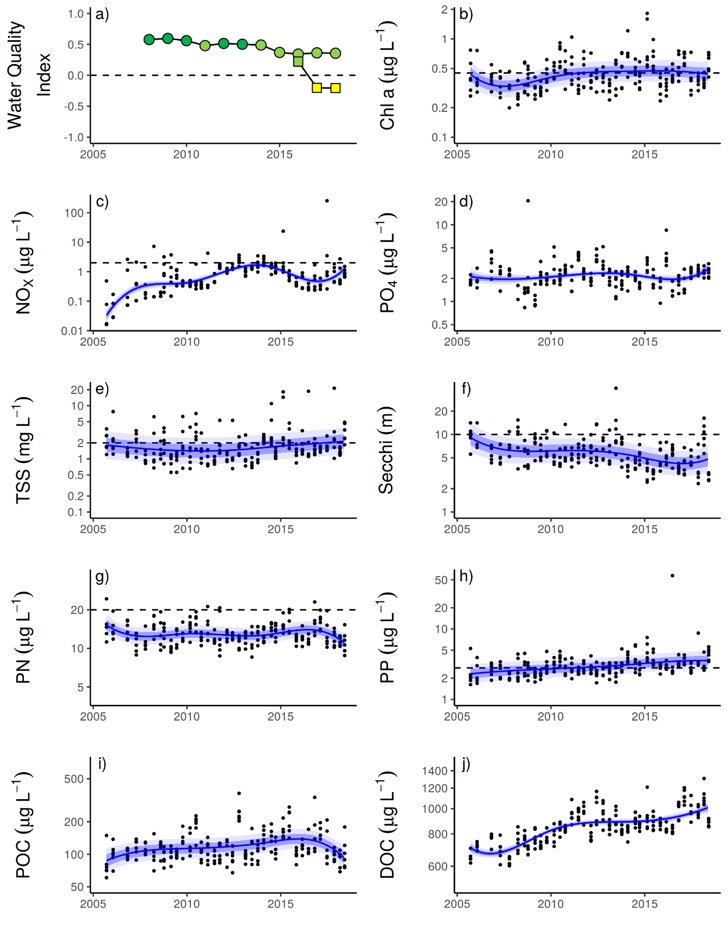
Figure A 8 Temporal trends in water quality: Baron Daintree sub-region
. a) water quality index, b) chlorophyll a, c) nitrate/nitrite, d) Phosphate, e) total suspended solids, f) secchi depth, g) particulate nitrogen, h) particulate phosphorus, i) particulate organic carbon and j) dissolved organic carbon. Water quality index colour coding: dark green- ‘very good’; light green – ‘good’; yellow – ‘moderate; orange – ‘poor’; red – ‘very poor’. The water quality index is the aggregate of variables plotted in b, c, e - h and calculated as described in Waterhouse et al. (2018). Trends in PO4, POC and DOC values are plotted here (d, I, j); threshold levels have yet to be established. Trends in manually sampled water quality variables are represented by blue lines with blue shaded areas defining 95% confidence intervals of those trends, black dots represent observed data. Dashed reference lines indicate guideline values (GBRMPA 2010). Extract from Gruber et al. (in prep).

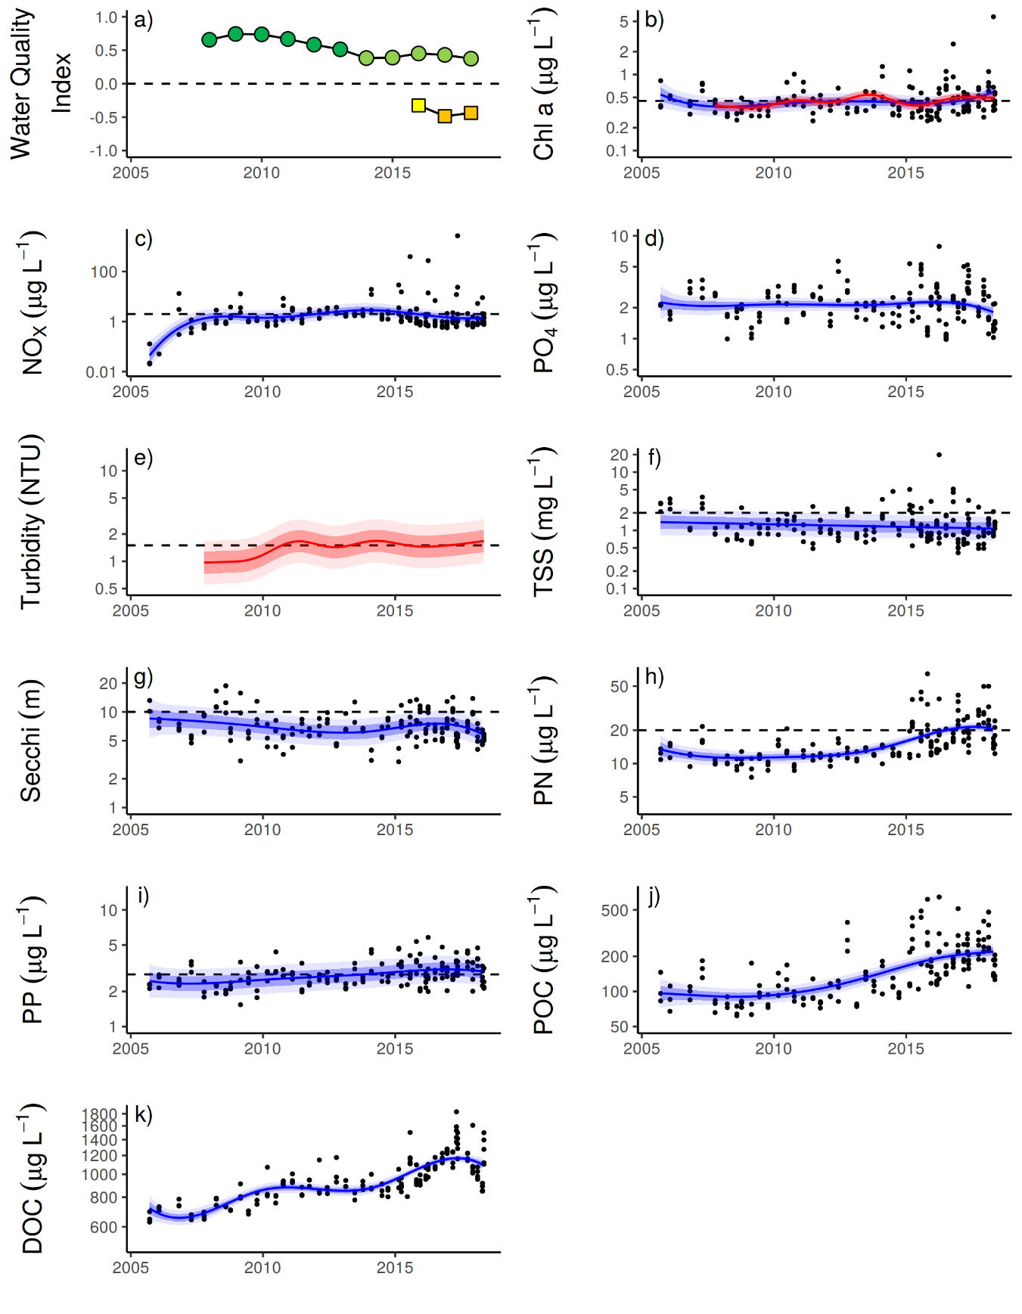
Figure A 9 Temporal trends in water quality
. Johnstone Russell-Mulgrave sub-region. a) water quality index, b) chlorophyll a, c) nitrate/nitrite, d) Phosphate e) turbidity, f) total suspended solids, g) secchi depth, h) particulate nitrogen, i) particulate phosphorus j), particulate organic carbon and k) dissolved organic carbon. Water quality index colour coding: dark green- ‘very good’; light green – ‘good’; yellow – ‘moderate; orange – ‘poor’; red – ‘very poor’. The water quality index is the aggregate of variables plotted in b, c, f - i and calculated as described in Waterhouse et al. (2018). Trends in PO4, POC and DOC values are plotted here (d, j, k); threshold levels have yet to be established. Trends in manually sampled water quality variables are represented by blue lines with blue shaded areas defining 95% confidence intervals of those trends, black dots represent observed data. Trends of records from ECO FLNTUSB instruments (b, e) are represented in red, individual records are not displayed. Dashed reference lines indicate guideline values (GBRMPA 2010). Extract from Gruber et al. (in prep).

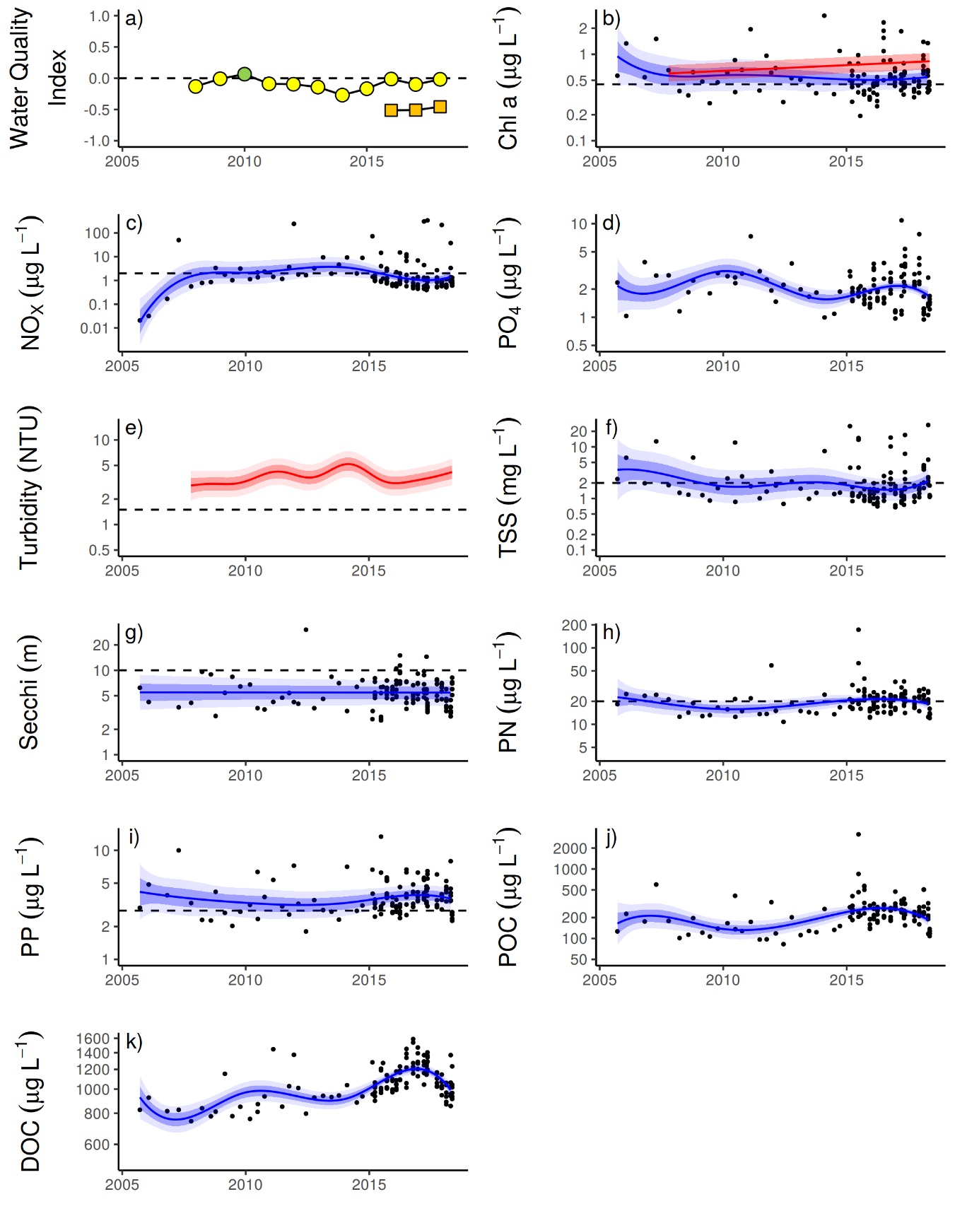
Figure A 10 Temporal trends in water quality: Herbert Tully sub-region
. a) water quality index, b) chlorophyll a, c) nitrate/nitrite, d) Phosphate e) turbidity, f) total suspended solids, g) secchi depth, h) particulate nitrogen, i) particulate phosphorus, j) particulate organic carbon and k) dissolved organic carbon. Water quality index colour coding: dark green- ‘very good’; light green – ‘good’; yellow – ‘moderate; orange – ‘poor’; red – ‘very poor’. The water quality index is the aggregate of variables plotted in b - i and calculated as described in Gruber et al. (in prep). Trends in PO4, POC and DOC values are plotted here (d, j, k); threshold levels have yet to be established. Trends in manually sampled water quality variables are represented by blue lines with blue shaded areas defining 95% confidence intervals of those trends, black dots represent observed data. Trends of records from ECO FLNTUSB instruments (b, e) are represented in red, individual records are not displayed. Dashed reference lines indicate guideline values (GBRMPA 2010). Extract from Gruber et al. (in prep).

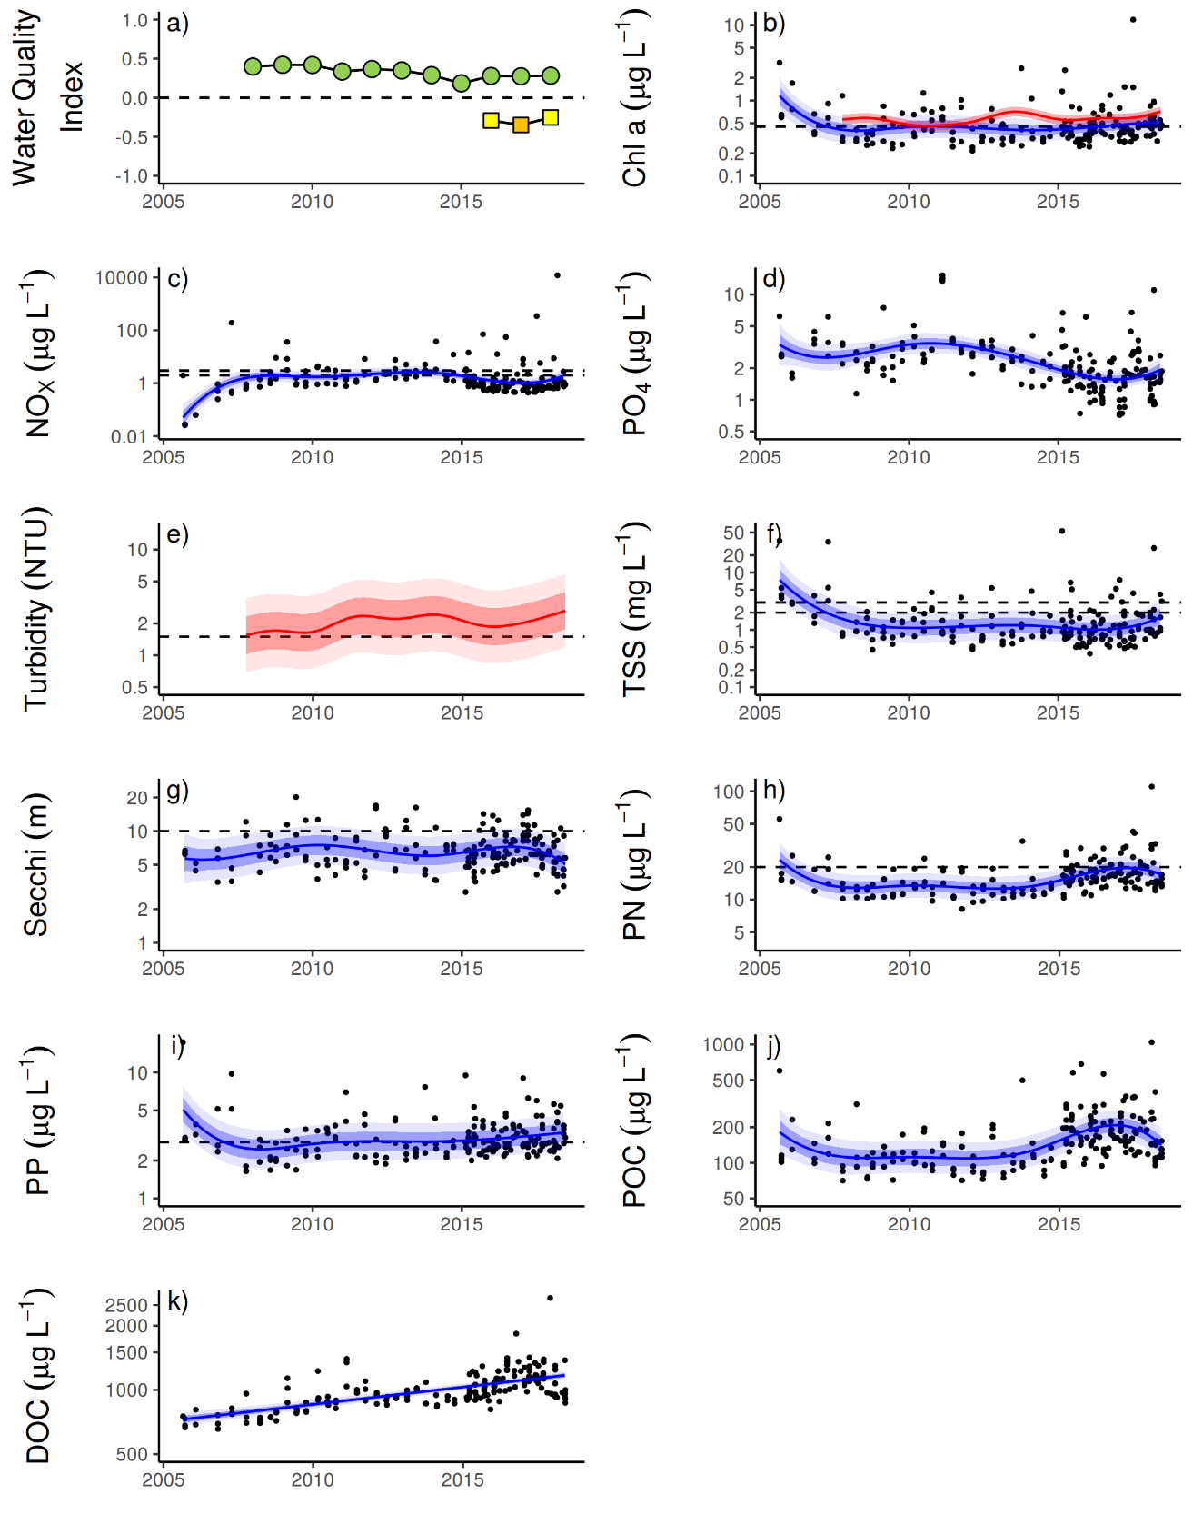
Figure A 11 Temporal trends in water quality: Burdekin region
. a) water quality index, b) chlorophyll a, c) nitrate/nitrite, d) Phosphate e) turbidity, f) total suspended solids, g) secchi depth, h) particulate nitrogen, i) particulate phosphorus, j) particulate organic carbon and k) dissolved organic carbon. Water quality index colour coding: dark green- ‘very good’; light green – ‘good’; yellow – ‘moderate; orange – ‘poor’; red – ‘very poor’. The water quality index is the aggregate of variables plotted in b - i and calculated as described in Gruber et al. (in prep). Trends in PO4, POC and DOC values are plotted here (d, j, k); threshold levels have yet to be established. Trends in manually sampled water quality variables are represented by blue lines with blue shaded areas defining 95% confidence intervals of those trends, black dots represent observed data. Trends of records from ECO FLNTUSB instruments (b, e) are represented in red, individual records are not displayed. Dashed reference lines indicate guideline values (GBRMPA 2010). Extract from Gruber et al. (in prep).

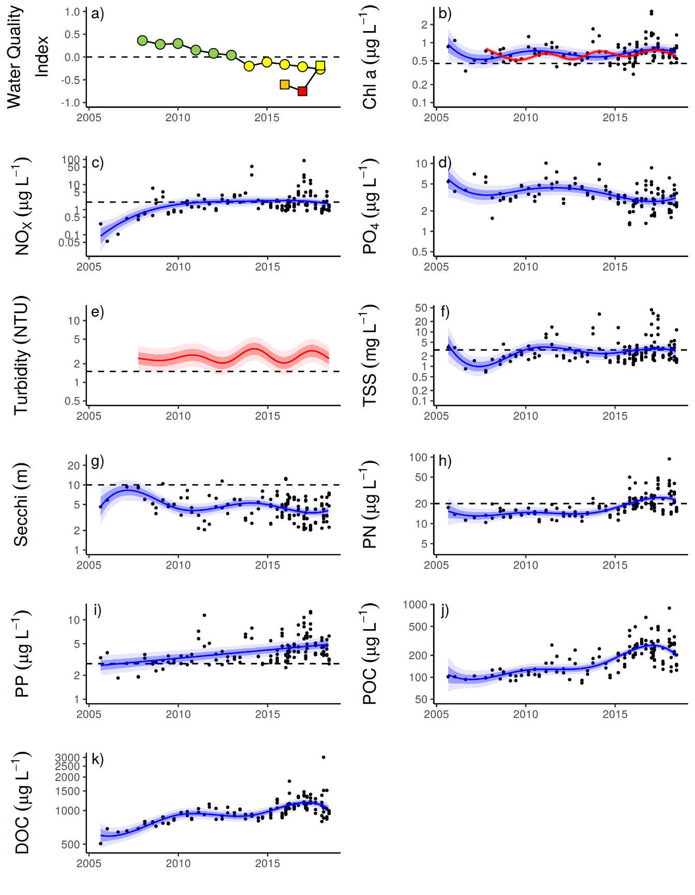
Figure A 12 Temporal trends in water quality
. Mackay Whitsundays region. a) water quality index, b) chlorophyll a, c) nitrate/nitrite, d) Phosphate e) turbidity, f) total suspended solids, g) secchi depth, h) particulate nitrogen, i) particulate phosphorus, j) particulate organic carbon and k) dissolved organic carbon. Water quality index colour coding: dark green- ‘very good’; light green – ‘good’; yellow – ‘moderate; orange – ‘poor’; red – ‘very poor’. The water quality index is the aggregate of variables plotted in b - i and calculated as described in Gruber et al. (in prep). Trends in PO4, POC and DOC values are plotted here (d, j, k); threshold levels have yet to be established. Trends in manually sampled water quality variables are represented by blue lines with blue shaded areas defining 95% confidence intervals of those trends, black dots represent observed data. Trends of records from ECO FLNTUSB instruments (b, e) are represented in red, individual records are not displayed. Dashed reference lines indicate guideline values (GBRMPA 2010). Extract from Gruber et al. (in prep).

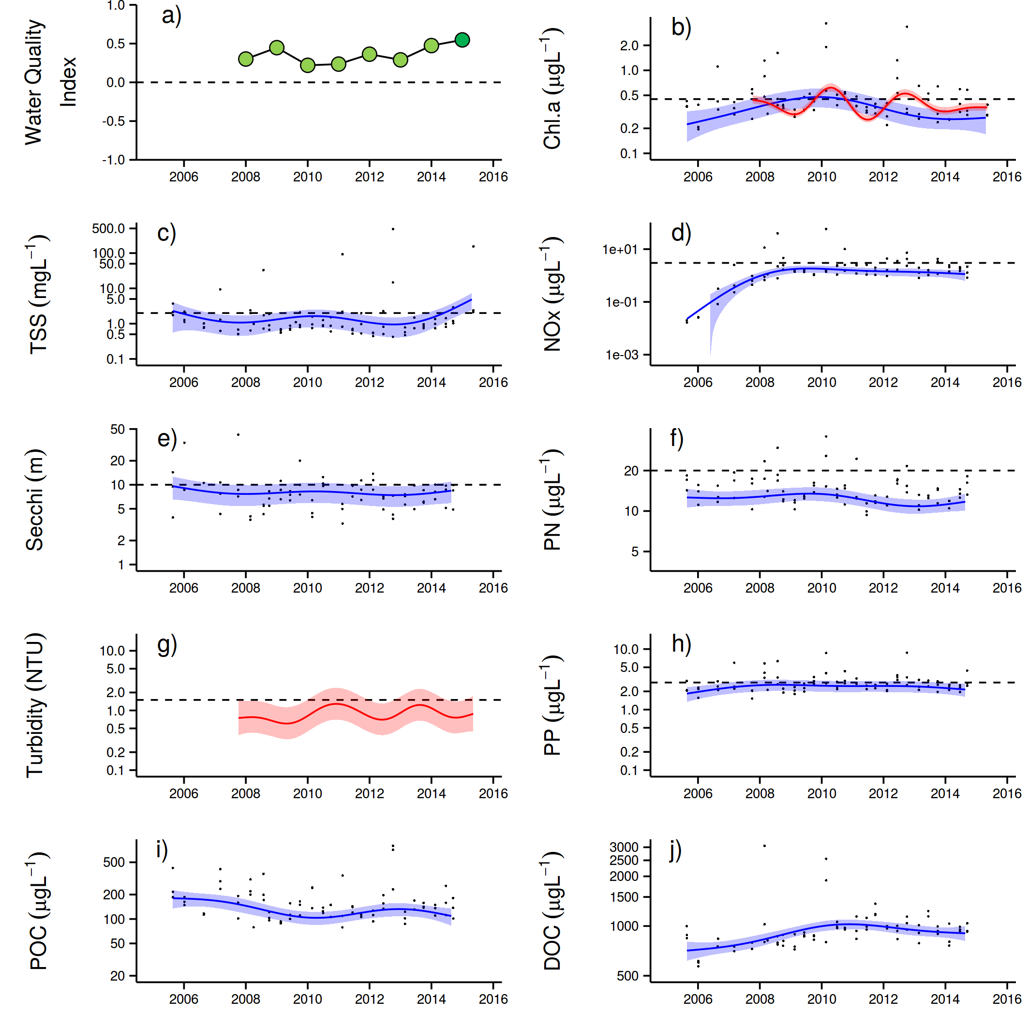
Figure A 13 Temporal trends in water quality: Fitzroy region
. a) water quality index, b) chlorophyll a, c) total suspended solids, d) nitrate/nitrite, e) secchi depth, f) particulate nitrogen, g) turbidity, h) particulate phosphorus, i) particulate organic carbon and j) dissolved organic carbon. Water quality index colour coding: dark green- ‘very good’; light green – ‘good’; yellow – ‘moderate; orange – ‘poor’; red – ‘very poor’. The water quality index is the aggregate of variables plotted in b - h and calculated as described in Gruber et al. (in prep). Trends in POC and DOC values are plotted here (I, j); threshold levels have yet to be established. Trends in manually sampled water quality variables are represented by blue lines with blue shaded areas defining 95% confidence intervals of those trends, black dots represent observed data. Trends of records from ECO FLNTUSB instruments (b, g) are represented in red, individual records are not displayed. Dashed reference lines indicate guideline values (GBRMPA 2010). Extract from Gruber et al. (in prep).

Appendix 2: Publications and presentations 2017–2018
Lam V, Chaloupka M, Thompson A, Doropoulos C, Mumby P (2018) Acute drivers influence recent inshore Great Barrier Reef dynamics. Proceedings of the Royal Society B, DOI: 10.1098/rspb.2018.2063

Marine water quality indices produced by the Australian Bureau of Meteorology as a contribution to eReefs - a collaboration between the Great Barrier Reef Foundation, Australian Government, Bureau of Meteorology, Commonwealth Scientific and Industrial Research Organisation, Australian Institute of Marine Science and the Queensland Government. Data are acquired from NASA spacecraft. http://www.bom.gov.au/marinewaterquality/. Although the confidence in individual estimates of Chl a in turbid inshore waters is low the time averaged conditions do describe gradient that correspond to differences in benthic communities.
. ReefTemp Next Generation was developed through the Centre for Australian Weather and Climate Research (CAWCR) – a partnership between CSIRO and the Bureau of Meteorology (Garde et al. 2014).
Australian Government crown-of-thorns starfish management programme data supplied by Great Barrier Reef Marine Park Authority, Eye on the Reef.
Connie 2.0, CSIRO Connectivity Interface, CSIRO connie2

