Future Leaders Eco Challenges 2019: Executive Summary
From its inception in 2003, the Reef Guardian Schools program helps communities facilitate stewardship action. By sharing knowledge, developing networks, connecting partners and providing opportunities to act, the program fosters future stewardship leaders who care for the Reef. Small acts by many people make a big difference, showing we can all act local and think global.

Future Leaders Eco Challenge objective
The Reef Guardian Schools program annually facilitates the Future Leaders Eco Challenges (FLECs), a series of stewardship workshops held across the Great Barrier Reef catchment. FLECs are designed to empower students, teachers and communities by giving them new skills and connecting them to the bigger picture of Reef protection. Teachers also achieve professional development hours though capacity building at the FLECs.
FLECs provide an opportunity to empower schools to learn and collaborate to ‘secure a positive future for the Reef’ as outlined in the Great Barrier Reef blueprint for resilience, aligning with partner organisations and contributing to stewardship. This key activity is an action in the Reef 2050 Long-Term Sustainability Plan.

Theme
Each year, the focus of the program follows the strategic direction of the Authority. This year, the theme was ‘Protect Your Patch’, allowing each region to focus on suitable activities relevant to their community.

Stewardship community support
FLECs provide our Great Barrier Reef catchment partners an opportunity to collaborate with schools on new and existing projects. FLECs provide a practical and local approach to Reef protection where partners can share knowledge and resources with participants to address local issues. The support of regional partners is crucial to the success of the FLECs. Partners include Reef Guardian Councils, Local Marine Advisory Committees, Natural Resource Management organisations, Traditional Owner and Indigenous groups, environmental education centres, government, local and not-for-profit organisations.

Future Leaders Eco Challenge 2019 participants

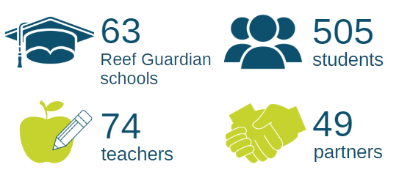

Future Leaders Eco Challenge 2019 locations

Ingham and Cardwell

Townsville

Burdekin
- Bowen
- Whitsundays
- Mackay
- Rockhampton
- Gladstone
- Bundaberg

Highlights
Traditional Owners provided a Welcome to Country at eight of the nine events. Students learnt about how Traditional Owners have protected their sea country for thousands of years, and continue to do so.

The ReefClean consortium, consisting of several partners such as Tangaroa Blue, Conservation Volunteers Australia, Reef Check and Eco Barge Clean Seas, participated in FLECs. Marine Debris activities, including beach clean-ups activities, collected over 30kgs of rubbish. Source reduction workshops, held at seven of the nine FLECs, resulting in students developing an action plan to take back and implement at school.

Students at FLECs participated in activities explaining the importance of fishing rules compliance and explored allowed activities in the various Marine Park zones through a Reef Rangers game.

‘The day was fun. It is good to learn how to look after the Reef’ — Louise Nicholas, Home Hill State High School

Bundaberg, Gladstone and Rockhampton participants learnt from their local council leaders on the important role that vegetation plays in stabilising coastal areas, such as dunes, and how those plants survive in harsh environments. Students also planted native vegetation to improve the health and long term resilience of these areas.

‘I believe this is a great event that promotes a great understanding for the youth’ — Gladstone Regional Council

Students in Mackay and Burdekin learnt about the importance of protecting catchments, as litter and chemicals can easily flow from catchments to the Reef after rain events.

Burdekin, Townsville, Ingham and Cardwell participants played a game of Turtle Hatchlings where students played the roles of either hatchlings trying to reach the sea or predators and human influences, demonstrating the dangers turtles face and the importance of students protecting their patch.

‘Kids came away from the day eager to start making a change’ — Elyse Charles, Kelso State School

Summary
Through the 2019 FLECs, the Reef Guardians team achieved their mission by encouraging students and teachers to become empowered environmental stewards, contributing to conservation and protection of the Great Barrier Reef.

Through their experiences at the FLECs, students have become advocates for the Reef and can influence not only their fellow classmates and teachers at school, but their families and the wider community around them.

Students shared the Reef-friendly actions they learnt at their FLECs via 34 school assemblies and through school newsletters, potentially influencing over 14,000 students across the Great Barrier Reef catchment.

