

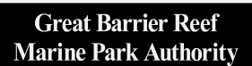
Permits Online
The Permits Online system allows you to apply for, and manage, Marine Parks permits issued jointly by the
Great Barrier Reef Marine Park Authority (Reef Authority) and
Queensland Parks and Wildlife Service (QPWS)
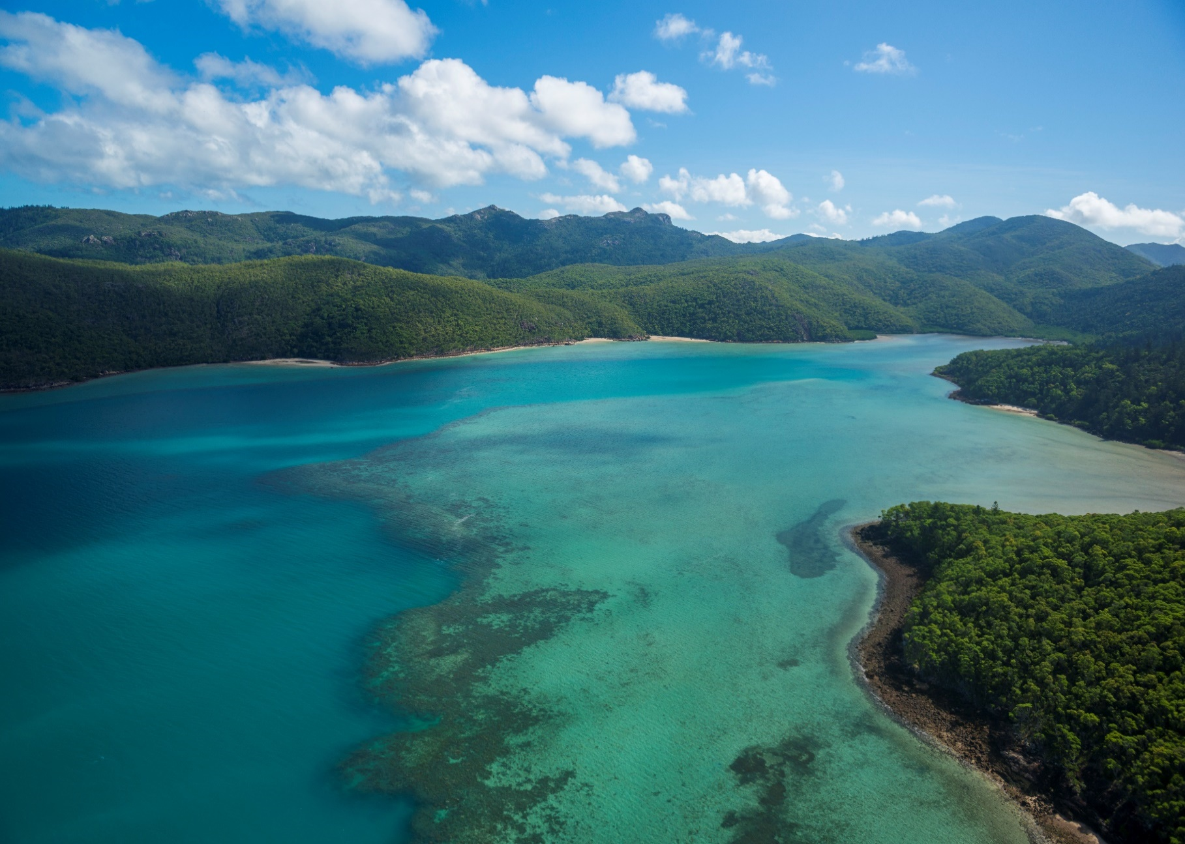
User Manual
Nara Inlet by Jumbo Aerial Photography

© Commonwealth of Australia 2022
Published by the Great Barrier Reef Marine Park Authority (the Reef Authority)
This document is licensed by the Commonwealth of Australia for use under a Creative Commons By Attribution 4.0 International licence with the exception of the Coat of Arms of the Commonwealth of Australia, the logo of the Great Barrier Reef Marine Park Authority, any other material protected by a trademark, content supplied by third parties and any photographs. For licence conditions see: http://creativecommons.org/licences/by/4.0


This publication should be cited as:
Great Barrier Reef Marine Park Authority 2022, Permits Online Manual, 6th edition,
the Reef Authority, Townsville.
Comments and questions regarding this document should be addressed to:

Great Barrier Reef Marine Park Authority
280 Flinders Street
(PO Box 1379)
Townsville QLD 4810, Australia
Phone: (07) 4750 0700
Email: info@gbrmpa.gov.au
www.gbrmpa.gov.au

After reviewing this manual, if you still require assistance using the Permits Online System please contact the Reef Authority.
Phone: (07) 4750 0700 during business hours (8.30am to 5.00pm EST weekdays).

For permits that involve tailored assessment please contact the Environmental Assessment and Protection Unit for further information.
Phone (07) 4750 0860 during business hours or email: assessments@gbrmpa.gov.au.
All feedback regarding the Permits Online system or its data should be sent directly to: Email: assessments@gbrmpa.gov.au.

Contents
1.0 Great Barrier Reef Marine Park Authority 1
2.0 About Permits Online 1
2.1 Permits Online Rules 1
2.2 Further Information 2
2.3 Accessing and Navigating Permits Online 2
2.4 Accessing Permits Online for the first time 2
2.5 Registering as a new user 3
2.6 Using Permits Online for the first time 5
2.7 Selecting a Permittee 6
2.8 Managing Authorised contacts 7
2.9 Changing contact details 8
2.10 Permittee list 8
2.11 Reset passwords 9
3.0 Glossary 9
4.0 System Menus 15
4.1 System sub menus 15
5.0 Applications Menu 17
5.1 Open (Hyperlink on Applications screen) 17
5.2 Email (Hyperlink on Applications screen) 18
5.3 Withdraw (Hyperlink on Applications screen) 18
5.4 Summary (Hyperlink on Applications screen) 18
5.5 Other Options (Continue, Transfer, Surrender) 19
6.0 Permits Menu 19
7.0 Historical Permits 20
8.0 Reasonable Use 21
9.0 Making an Application 21
9.1 New applications 21
9.2 Adding primary contact 22
9.3 Applying for a jointly held Permit 26
9.4 Making Declarations / Submitting your application 31
10.0 Tourism or Charter Activities 33
10.1 Routine Tourism and Charter 33
10.1.1 Other Tourism Application Types sub menu 45
10.2 Tourism - Aircraft 46
10.3 Tourism – Bareboats 65
10.4 Tourism – Hire 79
10.5 Tourism – Craftless 94
10.6 Tourism – Routine Cruise Ship 111
10.7 Tourism – Tailored Cruise Ships 120
10.8 Tourism – Guided Tours (Motorised) 135
10.9 Tourism – Guided Tours (Non-Motorised) 147
10.10 Tourism – Vessel Operation 160
11.0 Install / operate a Facility (Including Mooring) 178
11.1 Install / operate a Mooring Facility 178
11.2 Install / operate another type of facility 190
12.0 Conduct Research 204
12.1 Routine Commercial Research 206
12.2 Tailored Research 211
13.0 Conduct an Educational Program 237
14.0 Harvest Fishery 256
15.0 COTS and/or DRUPELLA 267
15.1 Routine COTS and/or DRUPELLA 267
15.2 Tailored COTS and/or DRUPELLA 272
16.0 Barge / Cargo Vessel Program 277
16.1 Routine Barge and Charter Program 279
16.2 Tailored Barge / Cargo Vessel Program 285
17.0 Carrying Out Works 299
18.0 Other Activities 313
18.1 Filming and/or Photography (Including Drones) 314
18.2 Other Activities in the Marine Parks 321
19.0 Continue a Current Permit 327
19.1 Tourism Continuation 338
19.2 Continue as Routine Tourism and Charter Permit 346
19.3 Research Continuation 353
19.4 Continue as Routine Commercial Research 365
20.0 Surrender a Current Permit 375
21.0 Transfer a Current Permit 381
22.0 Lodge Requirements 392
22.1 Lodge Requirements – Research Report 392
22.1.1 Sites 394
22.1.2 Trips 398
22.1.3 Collection 400
22.1.4 Equipment 406
22.1.5 Publications 411
22.1.6 Summary Screen 413
22.1.7 Any Other Matters / Comments 414
22.1.8 Declarations 414
22.1.9 Final Report 415
22.1.10 Validations 416
22.2 Lodge Requirements – Other Reports 417
22.2.1 Upload Documents 417
22.2.2 Comments 418
22.2.3 Declarations 419
22.2.4 Validations 420
22.3 Lodge Requirements – Requests For Further Information 421
22.3.1 Upload Documents 421
22.3.2 Comments 422
22.3.3 Declarations 423
22.3.4 Validations 424
23.0 Notification Approvals 425
23.1 Vessel / Ship Notification Approval 426
23.2 Aircraft Notification Approval 427
23.3 Mooring Notification Approval 428
23.4 Other Notification Approval 429
23.5 Notification Approvals – Print and Email 430
24.0 Payments 431
24.1 Select Outstanding Charges 431
24.2 Select Payment Method 432
24.2.1 Select Payment Method – Credit Card 433
24.2.2 Submit Credit Card Payment 433
24.2.3 Select Payment Method - BPAY 434
24.2.4 Submit Payment Pledge - BPAY 435
24.2.5 Select Payment Method – Direct Debit 436
24.2.6 Submit Payment Pledge – Direct Debit 437
24.3 Print Icon 438
24.4 Email Confirmation 438
24.5 Validations 439
24.5.1 Validation – Credit Card Declined 439
24.6 Payments Management 440
24.6.1 Date from and Date to 440
24.6.2 View Outstanding Fees 441
24.6.3 View Payment 441
24.6.4 View Pledge 442
24.6.5 Delete 443

- Great Barrier Reef Marine Park Authority
As a permit holder, or authorised contact, you contribute directly to the protection of the Great Barrier Reef Marine Park by ensuring you operate according to your Marine Parks permit.
Permits Online has been developed to provide you with a user-friendly, online platform to apply for and manage your existing and future permits.
The Great Barrier Reef Marine Park Authority (the Reef Authority) and the Department of Environment and Science (DES) are the primary regulators for protecting the Great Barrier Reef. Our role is to set the standards necessary to provide certainty about where uses may occur, the type of activities allowed and the conditions under which activities may proceed. This is achieved by using a combination of management tools and approaches, including zoning, plans of management, permits, education, compliance and enforcement.
This online system allows you to apply for and manage Marine Park permits issued jointly by the Reef Authority and QPWS.
- About Permits Online
Permits Online is a feature of the Reef Authority’s Reef Management System that allows Marine Park users to:
- Apply for a permission for Marine Parks use, including submitting documentation for consideration.
- Manage existing Marine Parks permits, including updating vessel, aircraft, facility and equipment information.
- Manage and update contact details, including allocation of authorised contacts and preferred contact method.
- View the status of your Marine Parks permits.
- View requirements for documentation such as moorings certificates and submit these to comply with permit conditions.
- Permits Online Rules
Permits Online has various rules and validations throughout the system. Each page containing questions within the applications process includes a validation check to ensure mandatory information is provided. If a question is not answered and you try to move to the next page of your application, you will receive a Response required or similar validation.
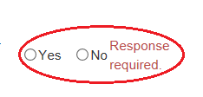
Figure 1 - Screenshot of Yes/No radio buttons with a red circle around the Yes and No buttons and validation wording Response required
- Further Information
Further information on Permits Online is located in the About section of the system.
Other helpful materials include:
Permission system overview
Application guidelines
Assessment guidelines
Fees and charges

If you need help, please check the Help screen (the answer may be there) or contact the Environmental Assessment and Protection team for further information.
Phone: (07) 4750 0860 during business hours or Email: assessments@gbrmpa.gov.au
- Accessing and Navigating Permits Online
Permits Online is hosted by the Reef Authority and is available via the internet at https://secure.gbrmpa.gov.au/PermitsOnline/
Permits Online can also be accessed directly through the Reef Authority’s external website secure login facility. This is available via our home page at www.gbrmpa.gov.au.

- Accessing Permits Online for the first time
The first page you will see when accessing Permits Online is the Home Page. Current users of the Reef Authority’s online systems (Bookings Online and/or EMC Online) will automatically have access to Permits Online using the same details.
If you are a new user of Reef Authority’s online systems, please use the Register feature located on the home page as shown below. This will allow you to enter your email address and choose a password. You will receive an email link confirming your registration. If you do not receive this email, please check your junk / spam filter as it may be there. For assistance, you can contact the Reef Authority by emailing assessments@gbrmpa.gov.au.
Please allow up to one business day for a response. Please do not re-register."
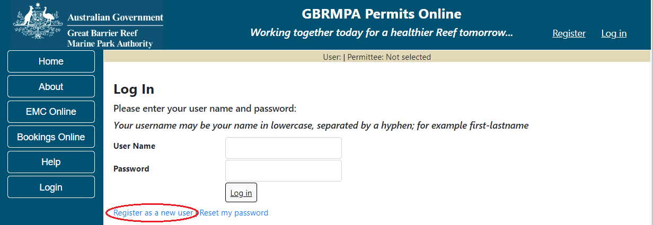
Figure 2 - Screenshot of Permits Online Log In screen with red circle around Register as a new user
- Registering as a new user
Current users of the Reef Authority’s online systems (Bookings Online and/or EMC Online) will automatically have access to Permits Online. Your username and password will be the same for Permits Online.
If you are a new Permit Holder/applicant to the Reef Authority, you can register your details and receive a link to access the system. To register your details, select the Register hyperlink at the top right-hand corner of the screen. Alternatively, you can select the Register as a new user hyperlink located on the log in screen.
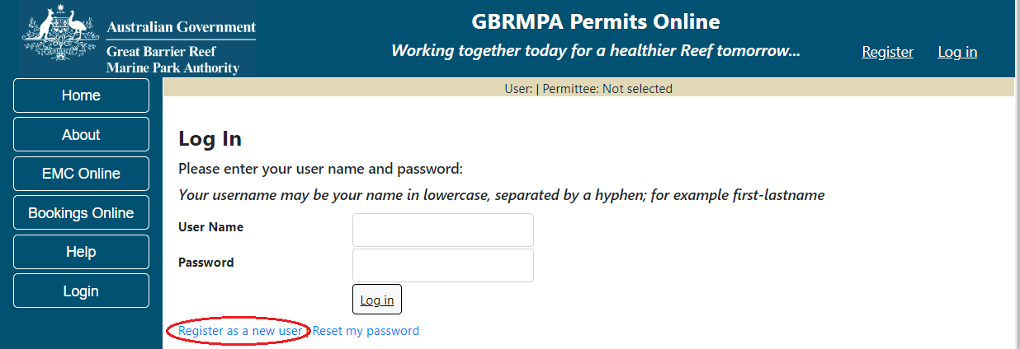
Figure 3 - Screenshot of Permits Online Log In screen with a red circle around Register as a new user option

Once the link is selected the system will navigate to a Register page where a new user can create an account. On the register as a new user page, the system will ask for details of First Name, Last name, Email, Password and Confirm Password. There is also a security feature on the page. If the letters are not visible, please select Refresh.
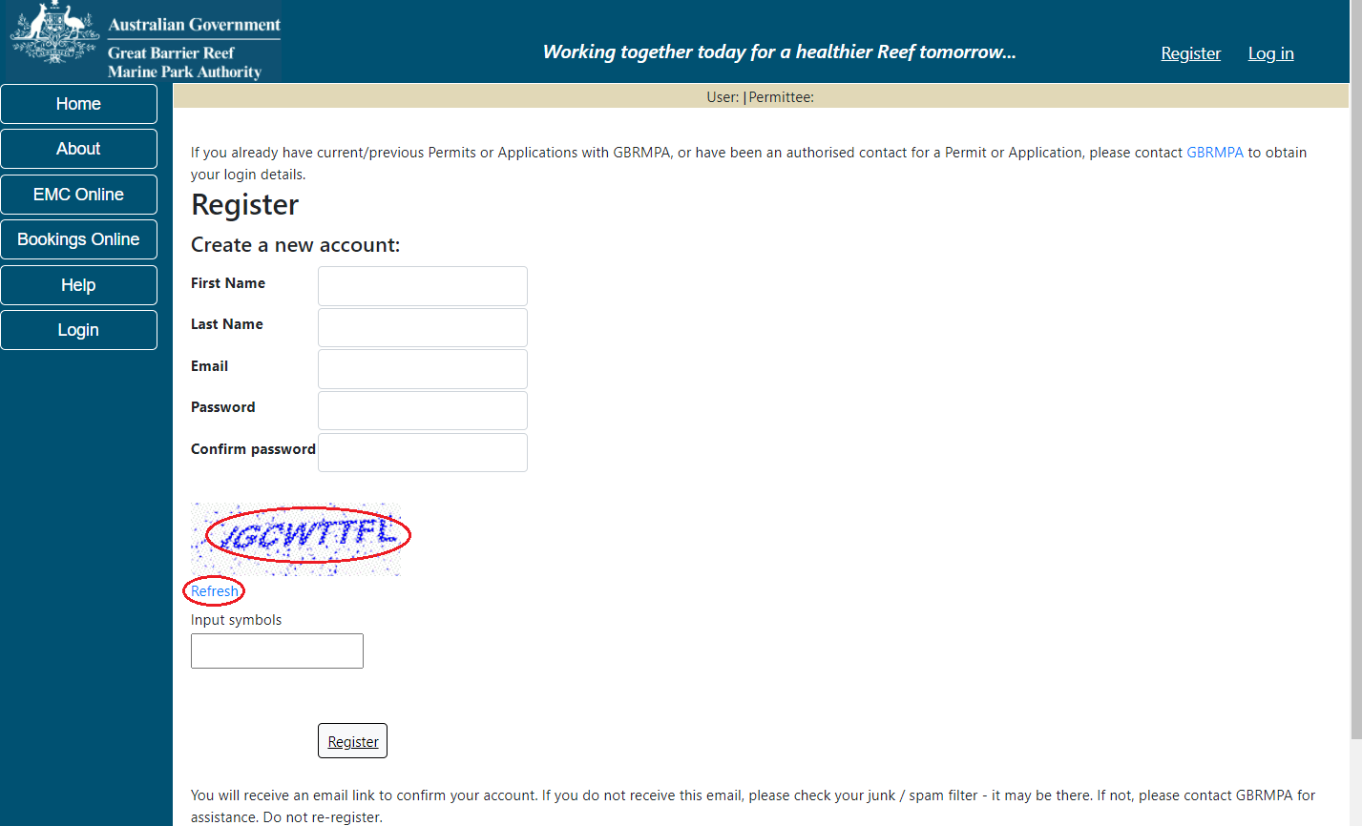
Figure 4 - Screenshot of Permits Online Register screen with a red circle around the Captcha letters and Refresh link

Fill in the details to register your account. You will need to complete the mandatory fields and the Captcha security feature. PLEASE NOTE: You will receive an email link to confirm your account. If you do not receive this email, please check your junk / spam filter - it may be there. If not, please contact the Reef Authority for assistance.
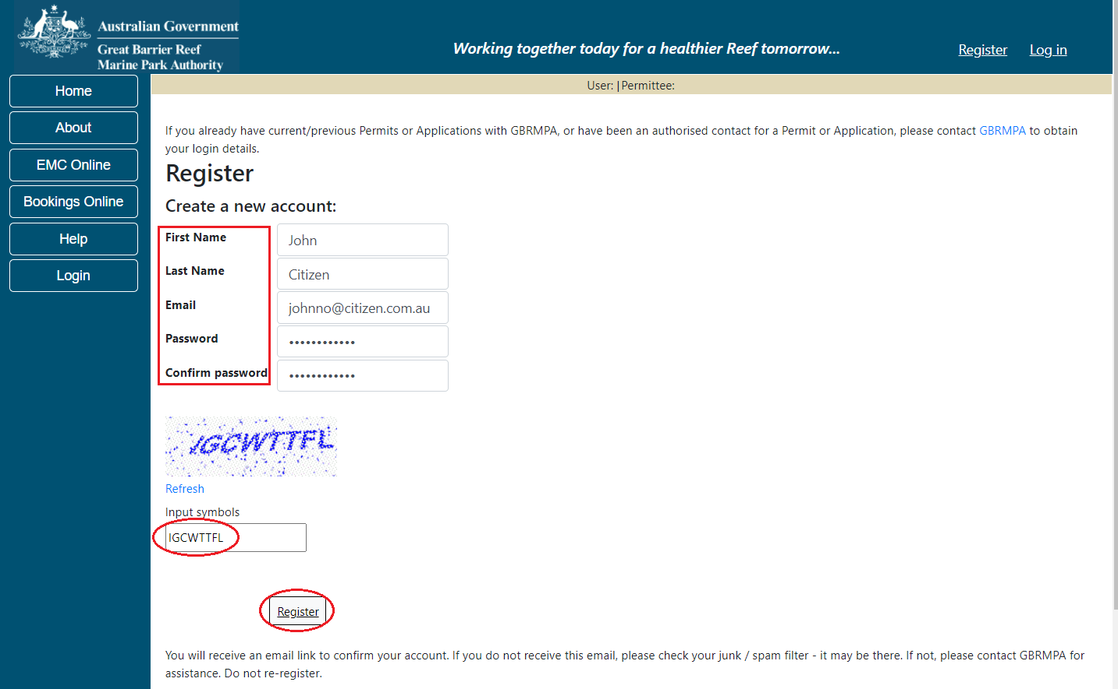
Do not re-register.
Figure 5 - Screenshot of Permits Online Register screen with a red box around information required, a red circle around the Input symbols field and a red circle around the Register button
- Using Permits Online for the first time
If the Reef Authority has issued you with login and password details, it is recommended that you change your password the first time you access the system.
Select the Admin option on the left-hand toolbar and select Change Password.
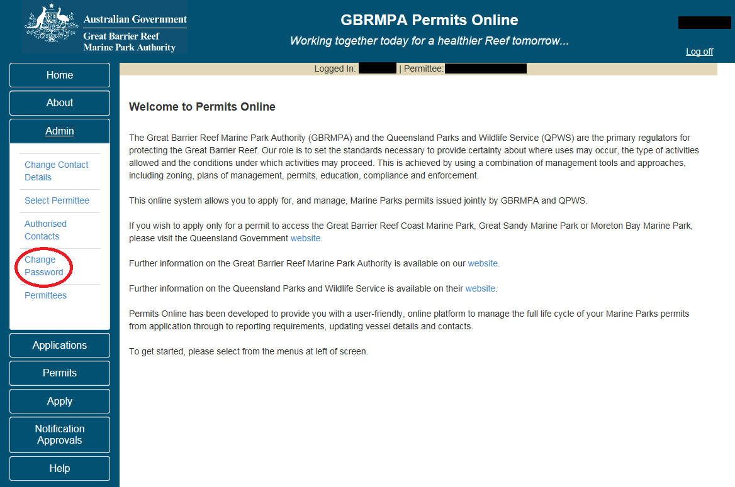
Figure 6 - Screenshot of Permits Online site with a red circle around Change Password option

For security purposes, there are rules for creating a new password. Any attempt to enter a password that does not fit the below guidelines will be rejected and will result in an error message.
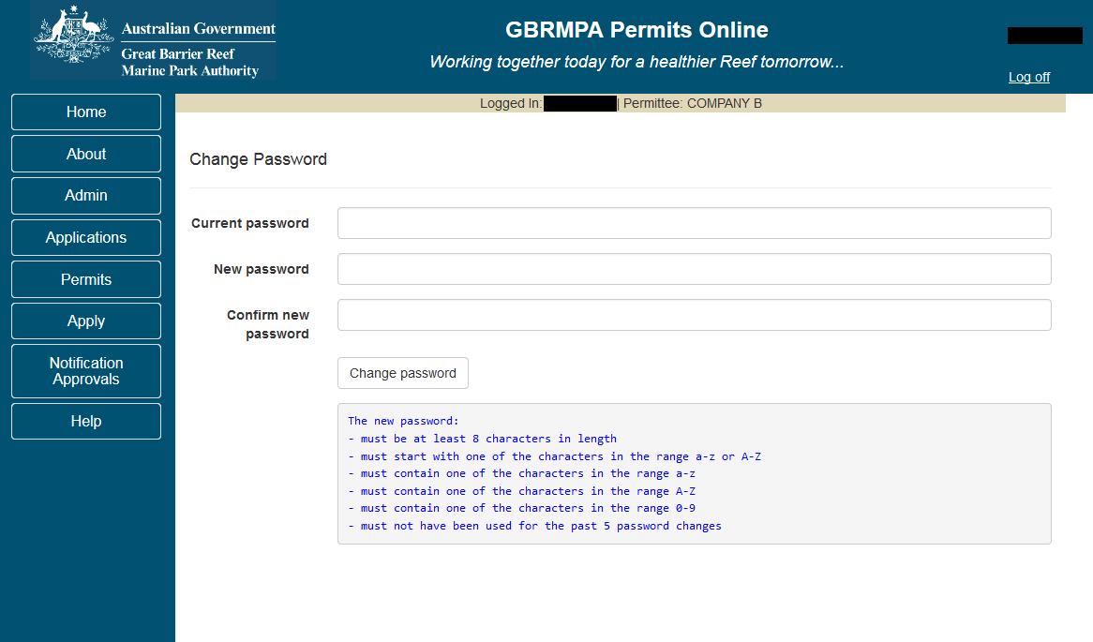
Figure 7 - Screenshot showing the Change Password screen
- Selecting a Permittee
To select a Permit Holder, choose Select Permittee in the Admin tab on the navigation section. Note that you can only select a different Permit Holder if you are an approved authorised contact. Contacts may be authorised by the Permit Holder, or, if the Permit Holder is an organisation, a Director of that organisation.
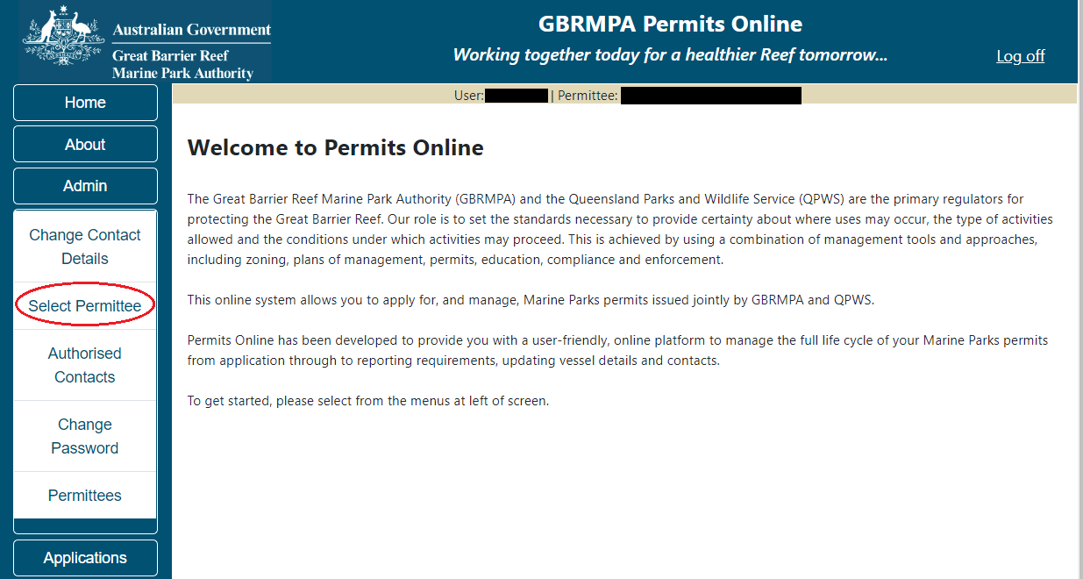
Figure 8 - Screenshot of Permits Online with a red circle around Select Permittee

You will progress to the Select Permittee page to choose which Permit Holder you would like to make the application for. The Select Permittee screen also appears as the first screen once you log in. You can also switch between permittees by selecting the permittee drop list within the banner on any screen.
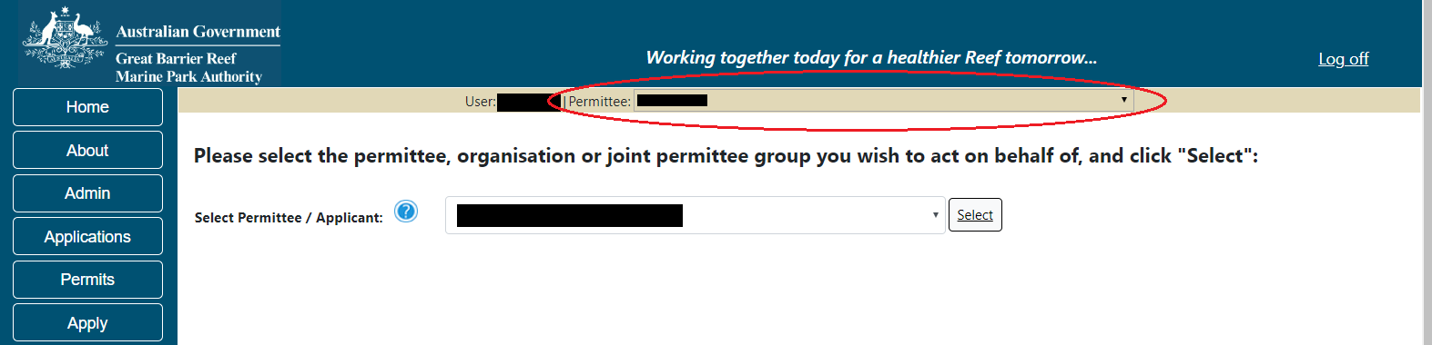
Figure 9 - Screenshot of Permits Online showing the Select Permittee drop list and a red circle around the Permittee drop list in the banner

- Managing Authorised contacts
To manage authorised contacts associated with your permits, choose Authorised Contacts in the Admin tab on the navigation section.
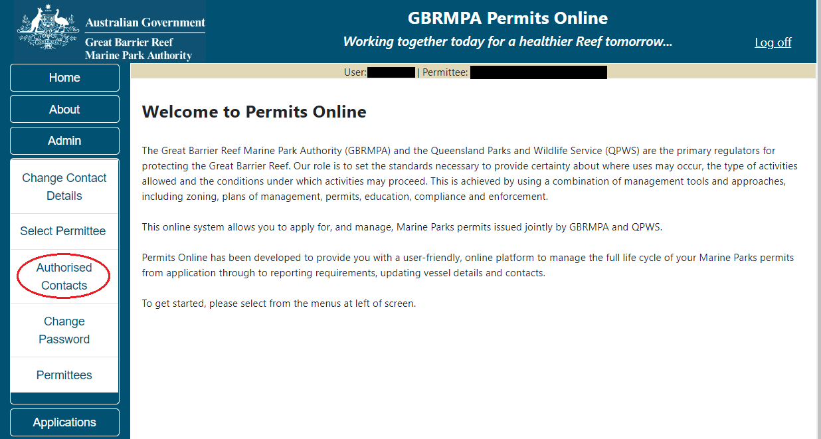
Figure 10 - Screenshot of Permits Online with a red circle around Authorised Contacts option

You will then progress to the Manage Authorise Contacts screen. As a Permit Holder, you can add details of individuals you authorise to liaise with the Reef Authority on your behalf and select particular permits they can administrate.
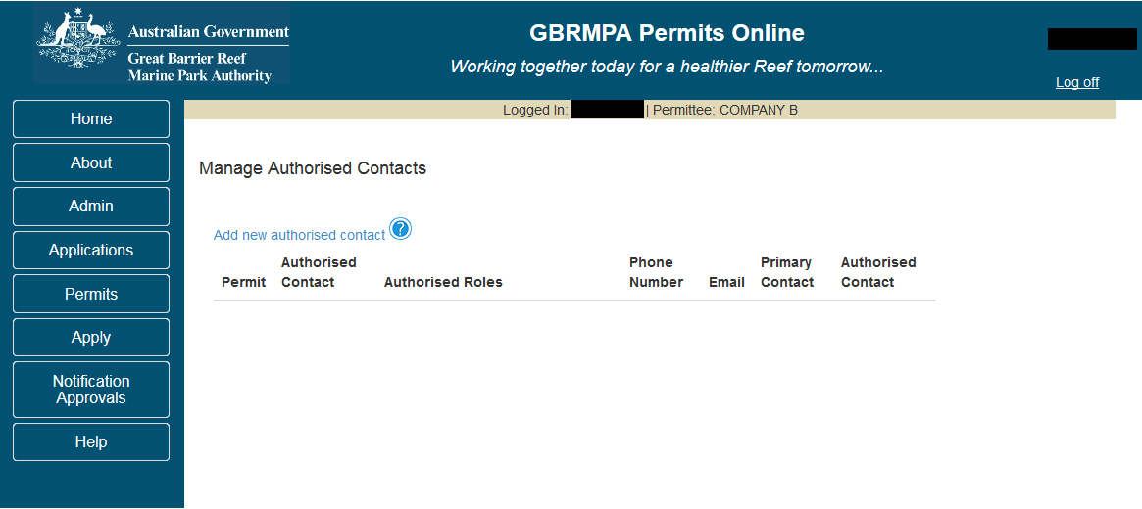
Figure 11 - Screenshot of Manage Authorised Contacts screen

- Changing contact details
Applicants are required to maintain accurate contact details in the system so the Reef Authority can communicate important permit information. Use this screen to ensure your details remain accurate. Mandatory fields are marked with an (*) and are required to be completed. A validation message will appear if any mandatory fields are not completed. Select Save to update the details.
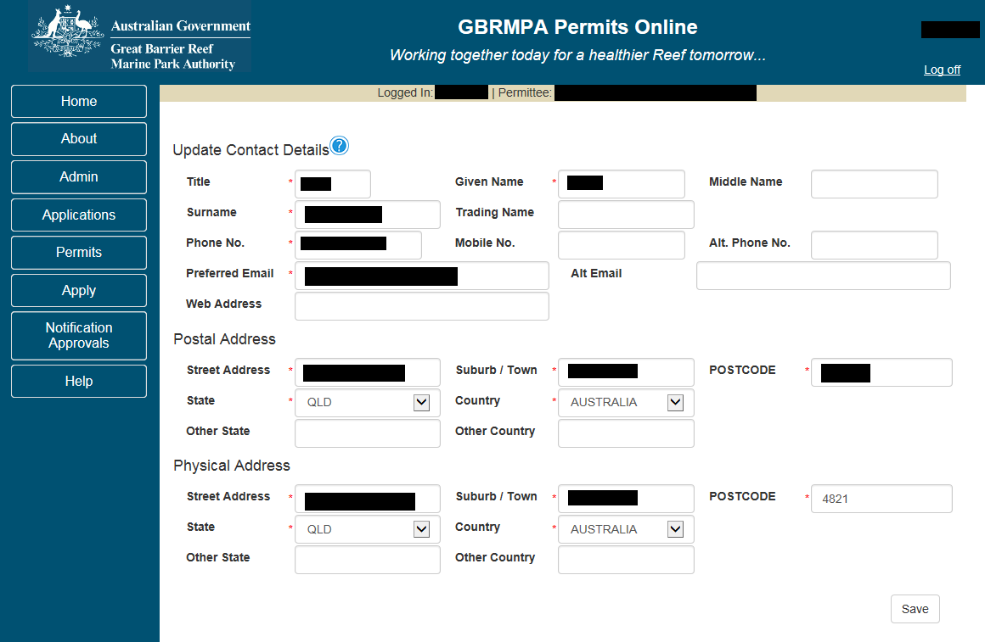
Figure 12 - Screenshot of Update Contact Details screen
- Permittee list
The Permittee section in Permits Online is a summary of the Applicants/Permit Holders you are authorised to act for regarding their Marine Parks permits. The data shown will indicate how many applications are currently in process and how many current permits have been approved. Once an application has been approved by the Managing Agencies, it will move from the Number of Applications columns to the Number of Permits column.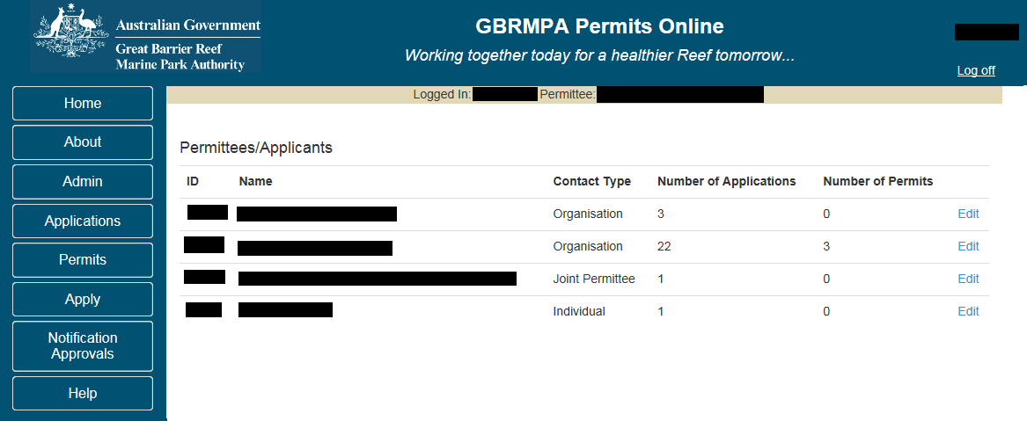
Figure 13 - Screenshot of Permittee / Applicants screen
- Reset passwords
If you have already registered or have a username with the Reef Authority and have forgotten your password, select the Reset my password hyperlink on the Log In screen. You will progress to a reset password section where you can request an email link to reset your password.
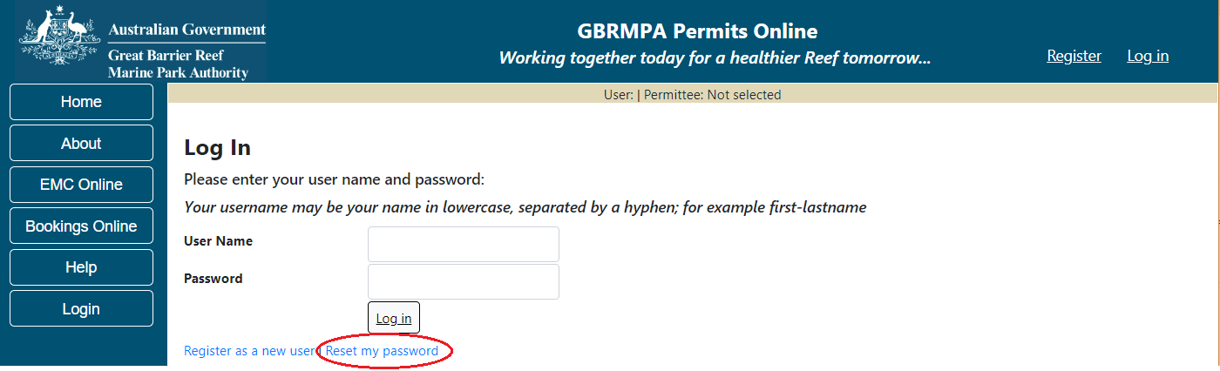
Figure 14 - Screenshot of Permits Online Log In screen with a red circle around Reset my password option

- Glossary
Mandatory questions are indicated by a red asterisk *. This section describes the primary fields and icons used in Permits Online.
 The ‘?’ icon provides a pop-up information box. Click on the ‘?’ for the information to appear. Information boxes are used throughout Permits Online to provide useful information regarding terms, requirements or other guidance.
Figure 15 - Image of blue question mark symbol, white text on a blue background

 The Log off icon is located at the top right hand corner of Permits Online. To log out of the system, select the Log off icon
Figure 16 – Image of Log off hyperlink, white text on a blue background

The assessments@gbrmpa.gov.au hyperlink is located on the About screen. If you need to contact the Reef Authority, you can select the assessments@gbrmpa.gov.au icon/hyperlink and a blank email with the assessments address will appear.
Figure 17 – Image of assessments@gbrmpa.gov.au hyperlink, blue text on a white background

The Email hyperlink is located on the application screen. When you select the Email link, a page with an area to fill information will appear. When you click Save an email will be sent to assessments@gbrmpa.gov.au with your application number as a reference.
Figure 18 – Image of Email hyperlink, blue text on a white background
The withdraw hyperlink is located on the Applications screen. When the Withdraw hyperlink is selected, you will be able to withdraw the selected application.
Figure 19 – Image of withdraw hyperlink, blue text on a white background
Once an application has been submitted, the Summary hyperlink will appear next to the submitted application. Selecting the Summary hyperlink will open a pdf of the selected application.
Figure 20 – Image Summary hyperlink, blue text on a white background

The Open hyperlink is located on the Applications screen. When you select the Open hyperlink, you will progress to an Application Summary page from which you can edit your application.
Figure 21 – Image of Open hyperlink, blue text on a white background

 When the print icon is selected, you will be provided options to print your application.
Figure 22 - Image of Print hyperlink and printer symbol, blue text on a white background

 The Email hyperlink with an envelope icon is to Email a copy of the application to the applicant
Figure 23 - Image of Email hyperlink and envelope symbol, blue text on a white background

The Edit hyperlink is located in the Application Summary screen. When selected, you are provided the opportunity to edit details of your application.
Figure 24 - Image of Edit hyperlink, blue text on a white background

The Remove hyperlink is located on the application summary screen. When selected this will remove the selected permission from the application, meaning you will no longer have permission to undertake that activity in the Marine Parks.
Figure 25 - Image of Remove hyperlink, blue text on a white background

 The Apply for another permission button is located in the Application Summary screen. When selected, further permissions can be added to the application.
Figure 26 - Image of Apply for another permission button, black text on a white background
 The Change hyperlink is located in the Application Summary screen. When selected the applicant will be able to change the primary contact for the application.
Figure 27 - Image of Change hyperlink, blue text on a white background

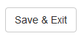 The Save & Exit button is located in the Application summary screen. When selected, your information is saved and you are returned to the Applications main page.
Figure 28 – Image of Save and Exit button, black text on a white background

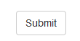 The Submit button is located in the application summary screen and on all Notification Approval screens. When selected you will progress to the Declaration pages of the application. Once the declarations are completed, the application can be submitted.
Figure 29 - Image of Submit button, black text on a white background

The Link to PDF hyperlink is located on the Current Permits page and the Historical Permits page. This opens a pdf version of the current permit document.
Figure 30 - Image of Link to PDF hyperlink, blue text on a white background

The Email hyperlink is located on the Current Permits screen. When you select the Email link, a page with an area to fill information will appear. When you select Save an email will be sent to assessments@gbrmpa.gov.au with your Permit number as a reference.
Figure 31 - Image of Email hyperlink, blue text on a white background

 The Summary hyperlink is located on the Current Permits and Historical Permits pages. When selected you will progress to a summary screen with information about the selected current or historical permit. This summary hyperlink is different to the summary hyperlink located on the Applications screen.
Figure 32 - Image of Summary hyperlink, blue text on a white background

The Back hyperlink appears on a number of screens and is presented in blue text. When selected you are taken back to the previous page. This hyperlink appears in Current Permits and all email screens. The Back hyperlink is different to the Back Button. Explanation of the Back button is provided on the following page.
Figure 33 - Image of Back hyperlink, blue text on a white background

 The Reef Authority Permits Online User Manual hyperlink is located on the help page. This opens Permits Online User Manual, and provides an option to download or save the document.
Figure 34 - Image of the Reef Authority Permits Online User Manual hyperlink, blue text on a white background

The website hyperlink is located in a number of locations, the Help screen and the Home screen. This will open the referenced website in a new window.
Figure 35 - Image of website hyperlink, blue text on a white background

The when a permission is required hyperlink is located on the Help page. When selected you will be directed to the Reef Authority website with information about permits and permit applications.
Figure 36 - Image of when a permission is required hyperlink, blue text on a white background

The apply for permissions hyperlink is located on the Help screen. When selected you will progress to the Reef Authority website with information about permits and permit applications.
Figure 37 - Image of apply for permissions hyperlink, blue text on a white background

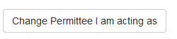 The Change Permittee I am acting as button is located in the Apply screen. When selected you will progress to the Select Permittee screen where you can change to a different Permittee if required.
Figure 38 - Image of Change Permit Holder I am acting as button, black text on a white background

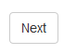 The Next button is located on most screens. When Next is selected, the information entered on the current page is saved and you are progressed to the next page.
Figure 39 - Image of Next button, black text on a white background

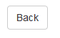 The Back button will appear on all application screens (except page 1 screens). When selected the Back button will save the information on the current application screen and take you back to the previous page.
Figure 40 - Image of Back button, black text on a white background

Radio Buttons are located throughout the Permits Online System. These buttons are generally assigned to yes / no or multiple-choice questions.
Figure 41 - Image of radio button

 The Save button will appear on a number of screens in Permits Online. Once selected the information you have entered on the screen will be saved.
Figure 42 - Image of Save button, black text on a white background


Various hyperlinks are located throughout the Permits Online system. The hyperlink will display details of the page you will progress to (the first example above will take you to the Reef Authority’s high standard tourism page, the second example will take you to the EPBC page for the Department of Environment).
Figure 43 - Image of the Reef Authority’s high standard tourism hyperlink and image of EPBC hyperlink, blue text on a white background

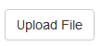 The Upload file button is located on screens where further information needs to be upload/added to the application. You can save multiple files, however they must be uploaded one file at a time.
Figure 44 - Image of Upload File button, black text on a white background

 The ‘X’ is located next to a file once it is loaded. The ’X’ is an option to remove/delete the file.
Figure 45 - Image of ‘x’ close button, black text on a white background

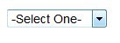 Picklists are used throughout Permits Online to provide selectable responses. Select the option you require, then click Next to move to the next section.
Figure 46 - Image of application questions Picklist, black text on a white background

 The picklist at the top of each application page can be used to navigate between pages (if required).
Figure 47 - Image of Page number picklist, black text on a white background

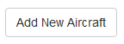The Add New Aircraft button is located in applications where an aircraft may be applied for to be used in the Marine Parks.
Figure 48 - Image of Add New Aircraft button, black text on a white background

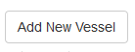 The Add New Vessel button is located in application types to use a vessel in the Marine Parks.
Figure 49 - Image of Add New Vessel button, black text on a white background

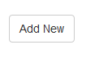 The Add New button is located throughout various application types. When selected you will be able to add additional selections relevant to the section you are completing. E.g. Ancillary vessels/equipment, locations, taxon, permission, activities etc.
Figure 50 - Image of Add New button, black text on a white background

 If an application is in the process of being submitted and details are still required, you can use the Return to Application hyperlink to edit the application.
Figure 51 - Image of Return to application hyperlink, blue text on a white background

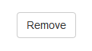The Remove button is located in a few places in Permits Online. When selected the item will be removed from the page you are on. The Remove button is located in the activities and permissions and other screens in the system.
Figure 52 - Image of Remove button, black text on a white background

Yes and No radio buttons are in all application types. A question that requires a yes or no answer will have the button displayed for the applicant to choose an answer. These questions are often mandatory in nature.
Figure 53 - Image of Yes No radio buttons, black text on a white background with a blue dot in the Yes field

- System Menus
The Menu is located on the left hand side of the screen. Some menu items contain sub menus. Links to other Reef Authority systems, Bookings Online and EMC Online are provided in the menu.

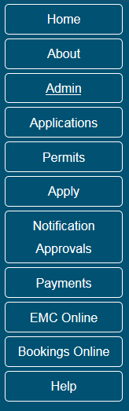
Figure 54 - Screenshot of Permits Online system Menu

  - System sub menus
The Admin sub menu contains; Change Contact Details, Select Permittee, Authorised Contacts, Change Password, Permittees.

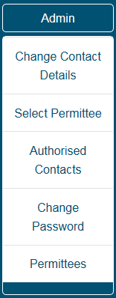
Figure 55 - Screenshot of Permits Online Admin Sub Menu
The Apply sub menu contains New Permit, Continue a current permit, Surrender a current permit and Transfer a current permit.
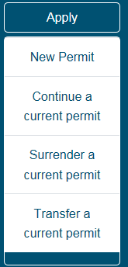
Figure 56 - Screenshot of Permits Online Apply Sub Menu

The Permits sub menu contains: Current Permits, Historical Permits and Check Reasonable Use and Lodge Requirements.
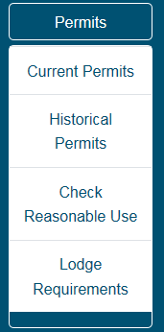
Figure 57 - Screenshot of Permits Online Permits Sub Menu

The Notification Approvals sub menu contains; Vessel/Ship, Aircraft, Mooring and Other Notification approval processes, and a Print option.
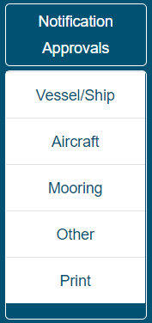
Figure 58 - Screenshot of Permits Online Notification Approval Sub Menu
- Applications Menu
Once an application has been started or completed the application will appear in the Applications screen. In the Applications screen you have a number of fields and hyperlink options.
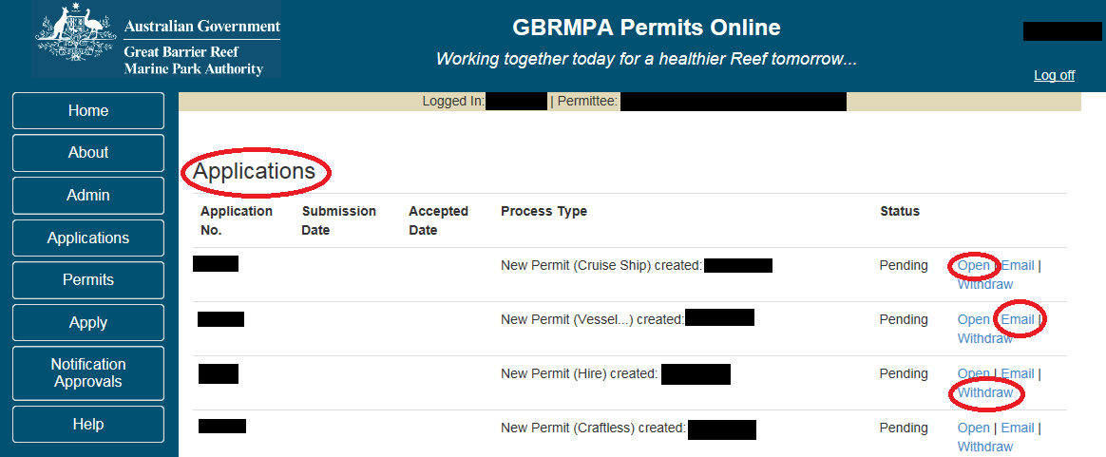
Figure 59 - Screenshot of Applications screen with red circle around Title. Red circles around Open, Email, and Withdraw hyperlink options

  - Open (Hyperlink on Applications screen)
When the Open hyperlink is selected you will progress to an Application Summary page with further options to Submit (via Next button), Edit, Remove, Change Primary Contact, and Apply for another permission.
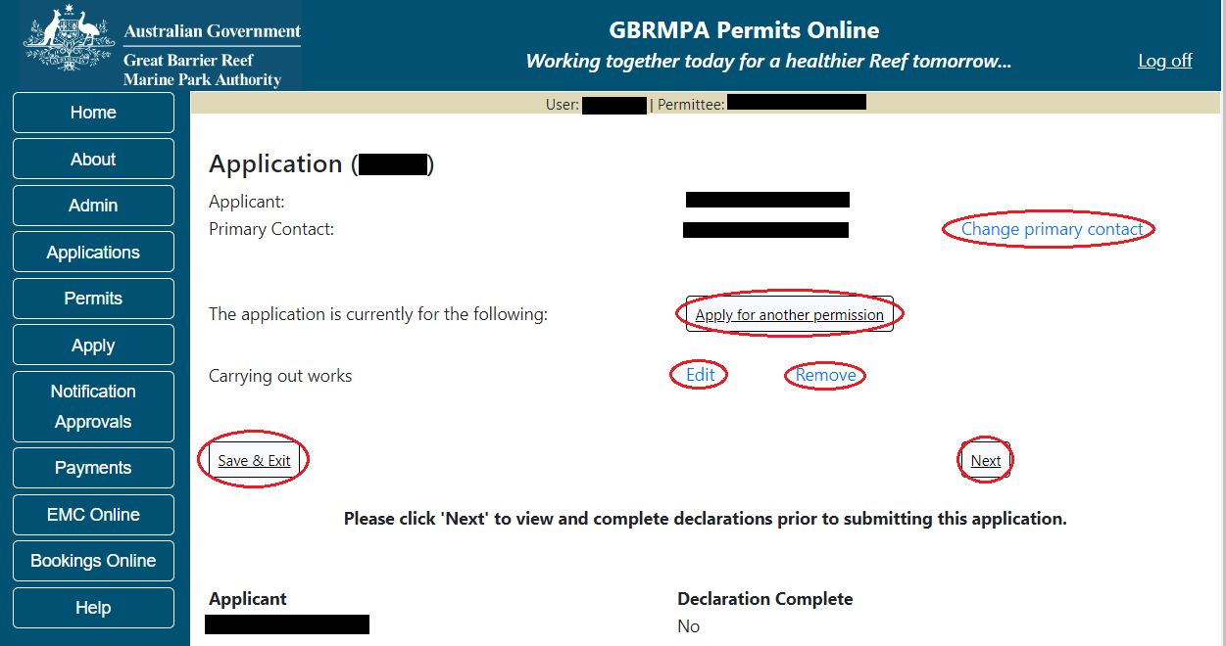
Figure 60 - Screenshot of Application Summary screen with red circles around all selectable options
  - Email (Hyperlink on Applications screen)
When the Email hyperlink is selected you can add the information of your enquiry, upload any required documents submit them to the Reef Authority with your application number as the reference. If you select Cancel/Back you will return to the Applications screen.
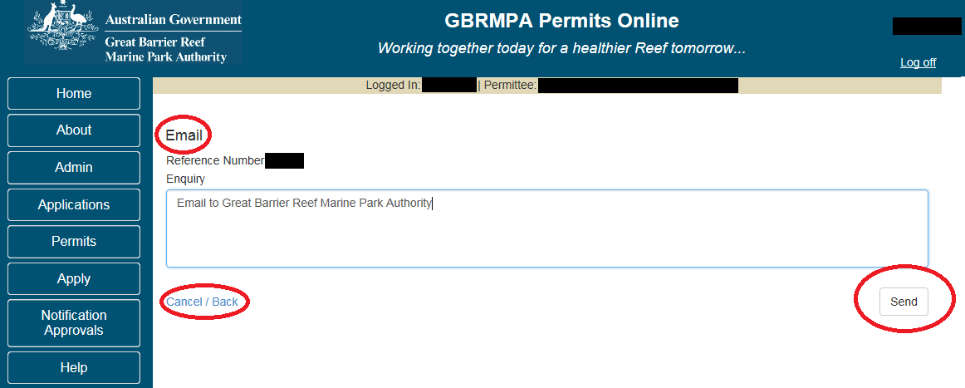
Figure 61 - Screenshot of Applications Email screen with red circle around the screen’s title. Red circle around Cancel/Back button and red circle around Send button

  - Withdraw (Hyperlink on Applications screen)
When the Withdraw hyperlink is selected you will progress to the Withdraw screen. Selecting the Withdraw button in this screen will withdraw the application. If you select no/return you will return to the Application screen.
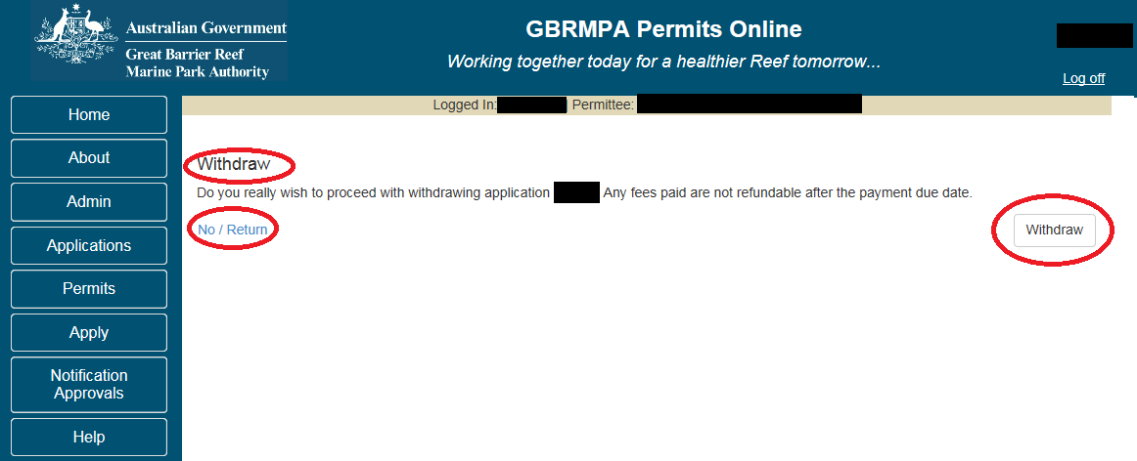
Figure 62 - Screenshot of Applications Withdraw screen with red circle around the screen’s title. Red circle around No / Return button and red circle around Withdraw button

  - Summary (Hyperlink on Applications screen)
Once an application is submitted to the Reef Authority a Summary hyperlink will appear. When selected the summary will open a PDF copy of your application.
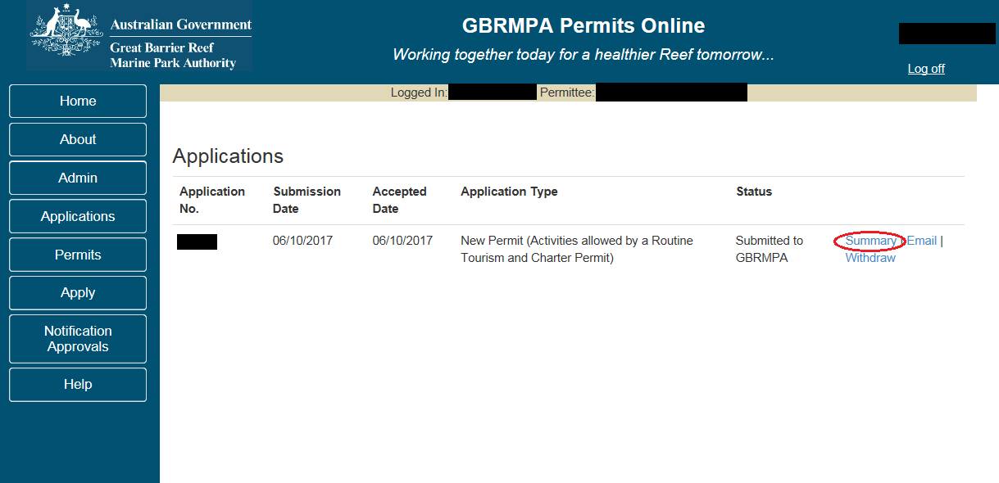
Figure 63 - Screenshot of Applications screen with red circle around Summary hyperlink option

  - Other Options (Continue, Transfer, Surrender)
Other hyperlink options will appear if you have applied for a Continuation, Transfer or Surrender. Selecting these hyperlinks will take you back into the application for editing and submission.
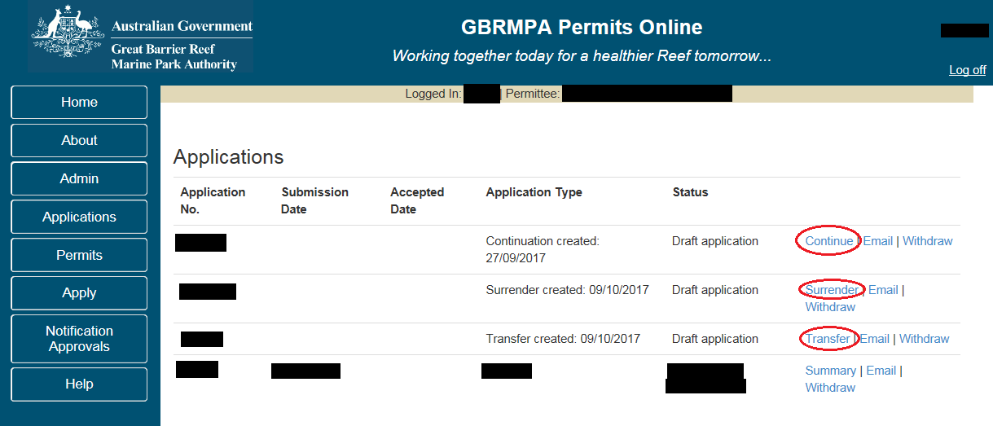
Figure 64 - Screenshot of Applications screen with red circle around Continue, Surrender and Transfer hyperlink options

- Permits Menu
Within the Permits Online system there is a section to view current permits. Select the Permits icon to view the Permits sub menu, then select Current Permits to view your current permits
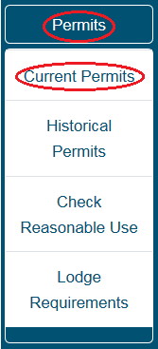
Figure 65 - Screenshot of Current Permits sub menu with a red circle around Permits icon and a red circle around the Current Permits icon

Once selected you will progress to the Current Permits screen. You are able to view a pdf copy of your permit, email the Reef Authority or view a summary of the permit. Selecting the associated hyperlink will enable the selected action.
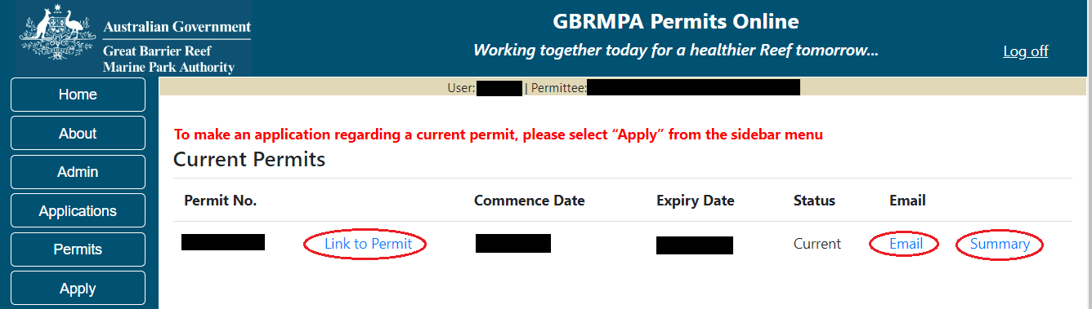
Figure 66 - Screenshot of Current Permits screen with a red circle around hyperlink options - Link to Permit, Email and Summary

- Historical Permits
Within the Permits Online system there is a section to view historical permits. You are able to view a pdf copy of your permit, email the Reef Authority or access a summary of the permit. Selecting the associated hyperlink will enable the selected action.
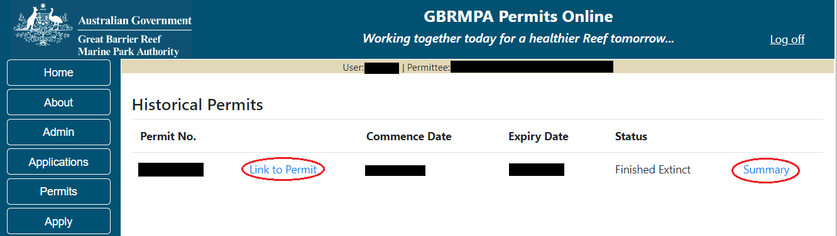
Figure 67 - Screenshot of Historical Permits screen.. Red circle around hyperlink options - Link to PDF and Summary

- Reasonable Use
For Permit Holders with Special Tourism Permissions a reasonable use check facility is available in Permits Online.
It will indicate how many days have been used, days required, days left over and whether reasonable use is met at that point in time. This area is date driven meaning if you log in on 5/9/21 it will give you a total up to and including the 5/9/21. Relevant EMC information is required to be entered in EMC Online this will then match the data you view in Permits Online.
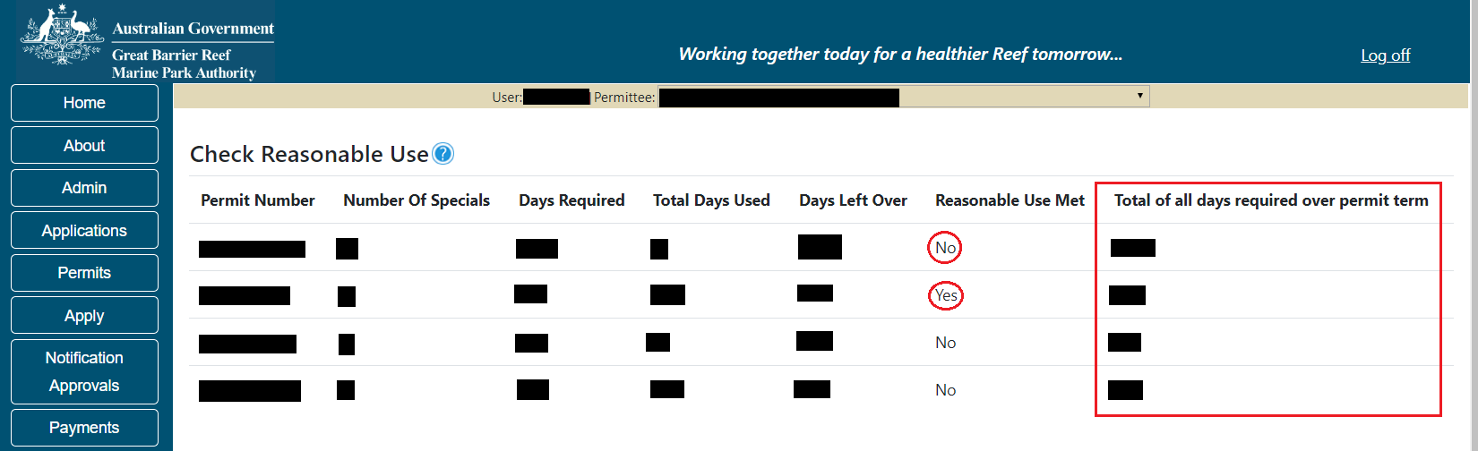
Figure 68 - Screenshot of Check Reasonable Use screen with a red circle around Yes under Reasonable Use Met field and a red box around Total of all days required over permit term column

- Making an Application

  - New applications
To apply for a new permit, select the New Permit option in the Apply sub menu. When viewing the Apply – Who is applying for this permit page, you have the option to change the Permit Holder you are acting on behalf of, if required.
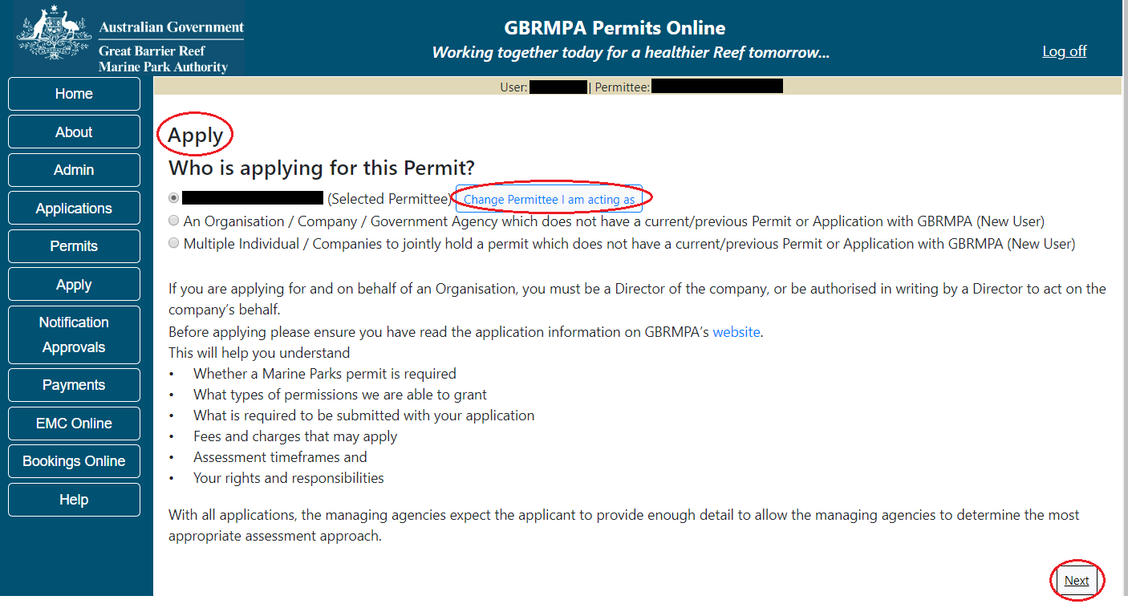
Figure 69 - Screenshot of Permits Online Apply screen with red circles around Apply, Change Permittee I am acting as button and Next button

  - Adding primary contact
Once you select Next on the first apply screen you will progress to the second apply screen where you can confirm or choose the primary contact for the application. The first option is Contact me; this will generally be the contact person that is logged into Permits Online. If this contact will be the primary contact, select this option then select Next.
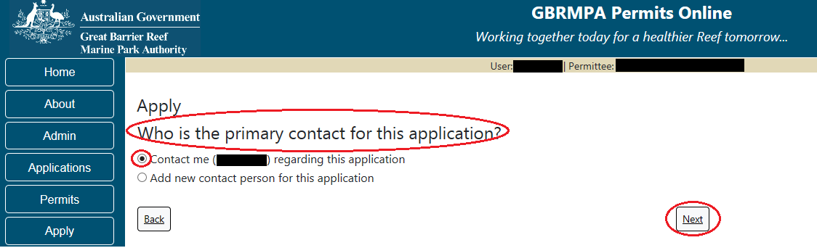
Figure 70 - Screenshot of Permits Online Apply screen with a red circle around the contact me, who is the primary contact for this application and the next button
If the current user is not going to be the primary contact, select option 2 Add a new contact person for this application. Once this option is selected, you are prompted to search for existing contacts by entering their name and email address.
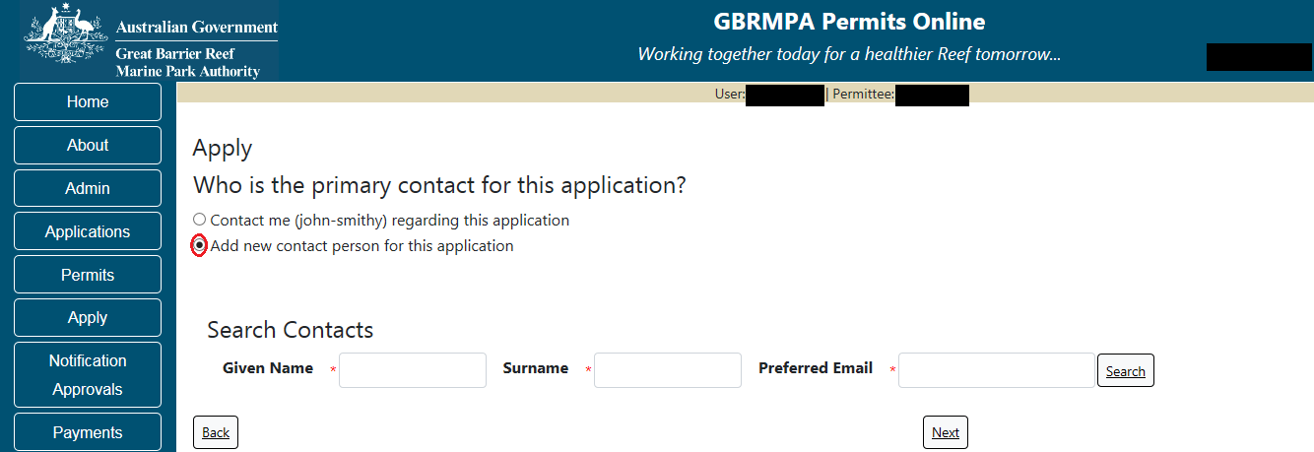
Figure 71 - Screenshot of Apply screen with a red circle around Add new contact for this application

NOTE: The contact search area is located in all New Permits, Continuation and Transfer applications

Add details of Given Name, Surname and Preferred Email address, then select Search.
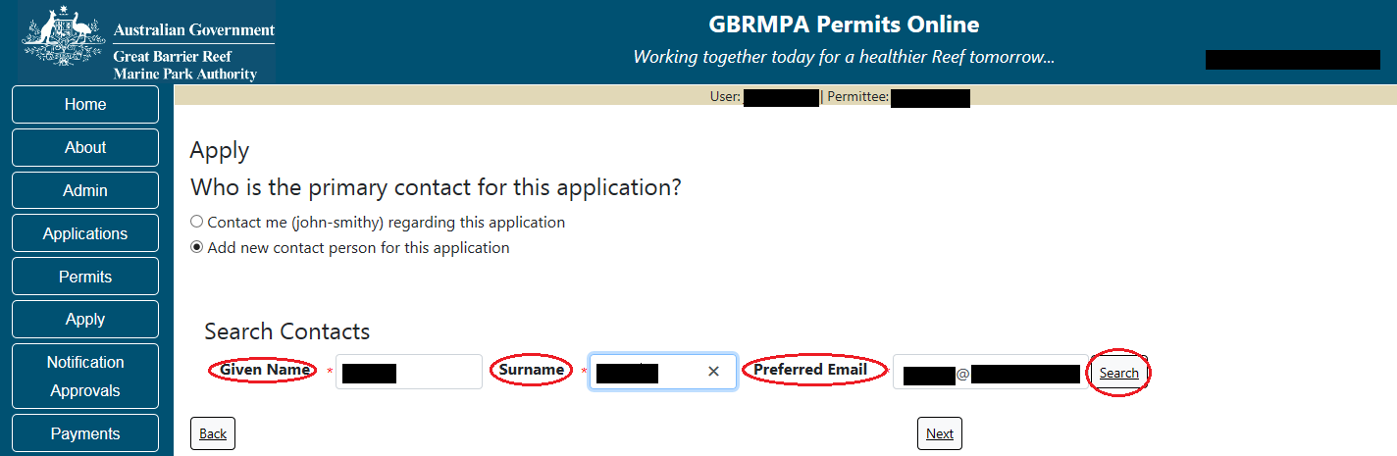
Figure 72 - Screenshot of Apply screen with red circles around given name, surname, preferred email and the search button

Once Search is selected, the system will return contact options for selection if the contact exists in the Reef Authority’s system. Press the Select button that appears next to the contact and you will then progress to the next screen.
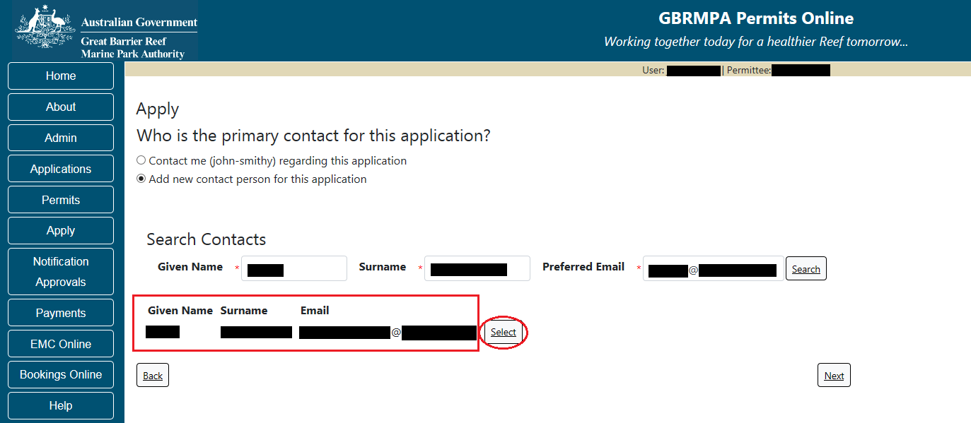
Figure 73 - Screenshot of Apply screen with a red box around contact details and a red circle around the Select button

If a contact does not exist in the system, you will be required to add their details. Any data that was entered in the search fields will be pre-populated. Ensure you fill in all fields marked with (*) which are the mandatory fields and then select Save.
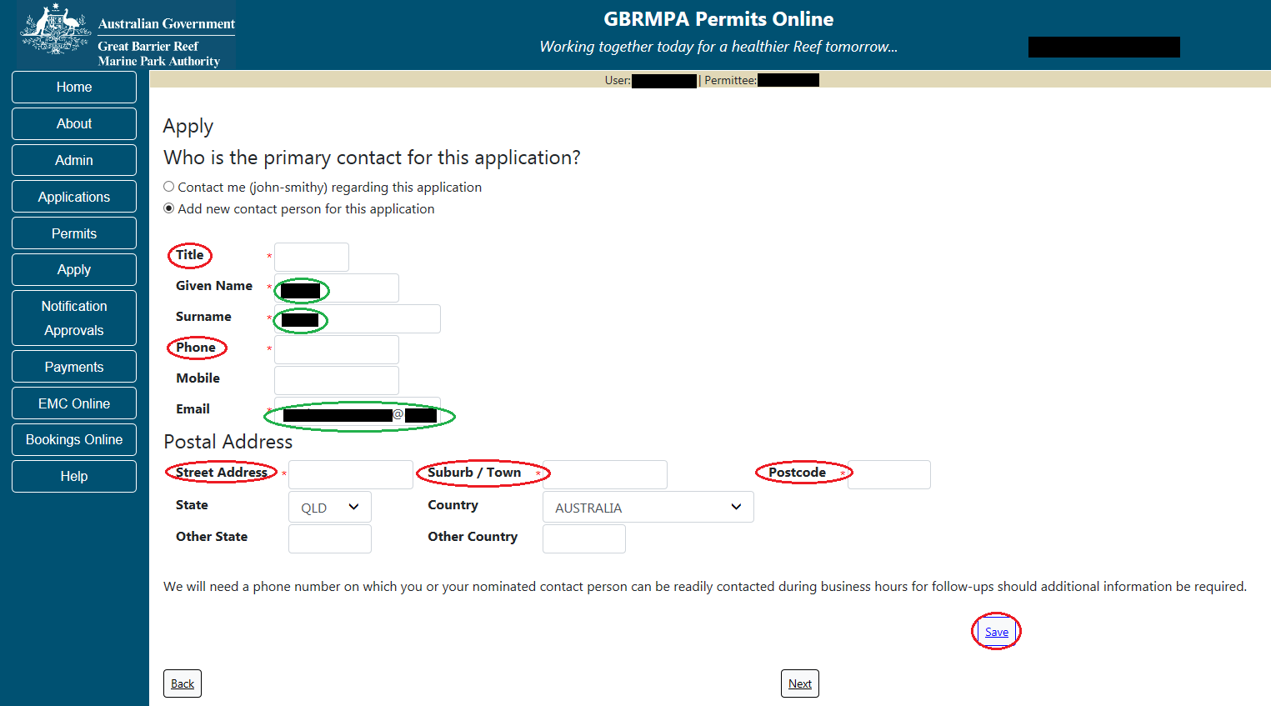
Figure 74 - Screenshot of Permits Online Apply screen with green circles around pre-populated data given name, surname preferred email, red circles around mandatory fields title, phone, street address, suburb, postcode and a red circle around the Save buttons
Once Save is selected, a message will appear on screen stating new contact saved. Press ok for this message, then select Next to progress.
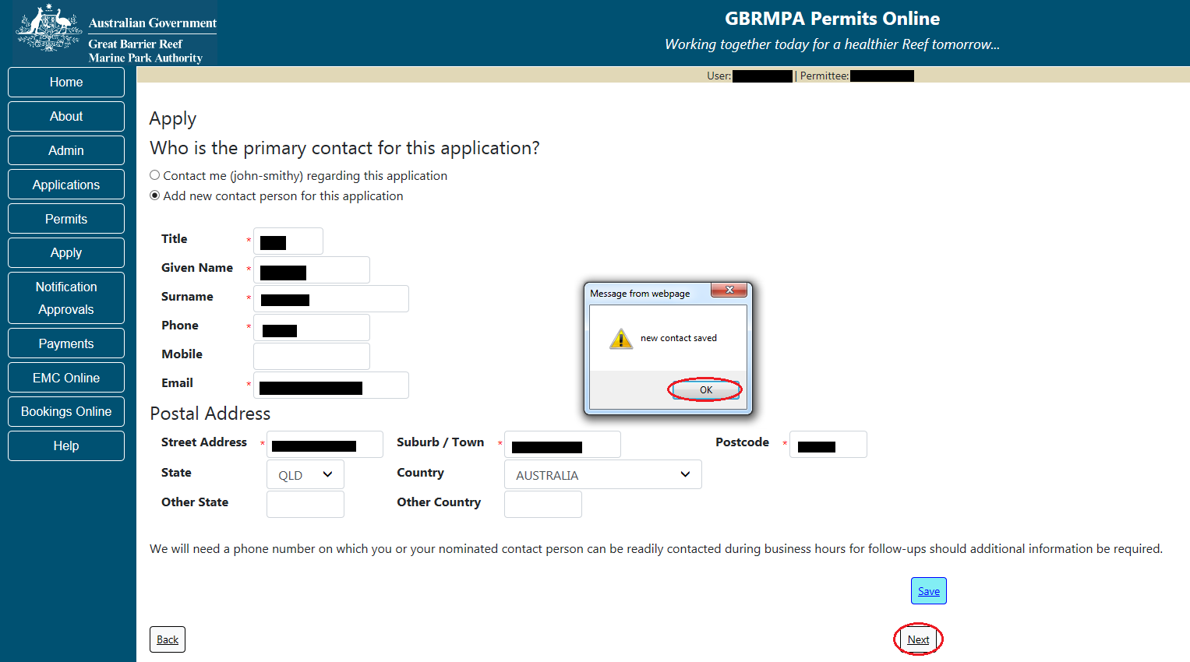
Figure 75 - Screenshot of Apply screen with a red circle around ok in message window, red circle around the next button

Once next is selected you will progress to the What are you seeking to do in the Marine Parks page of the apply screens. This is where you can choose the type of application / permission you wish to apply for.
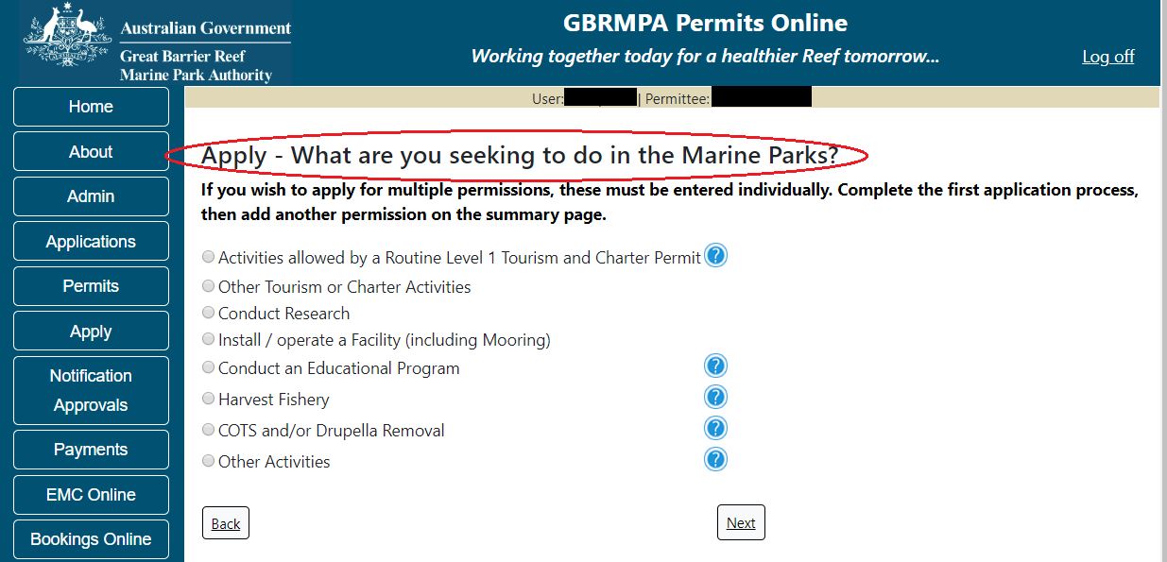
Figure 76 - Screenshot of Permits Online Apply screen with a red circle around the title What are you seeking to do in the Marine Parks?
  - Applying for a jointly held Permit
If you are applying for a jointly held permit select the Apply hyperlink then select New Permit.
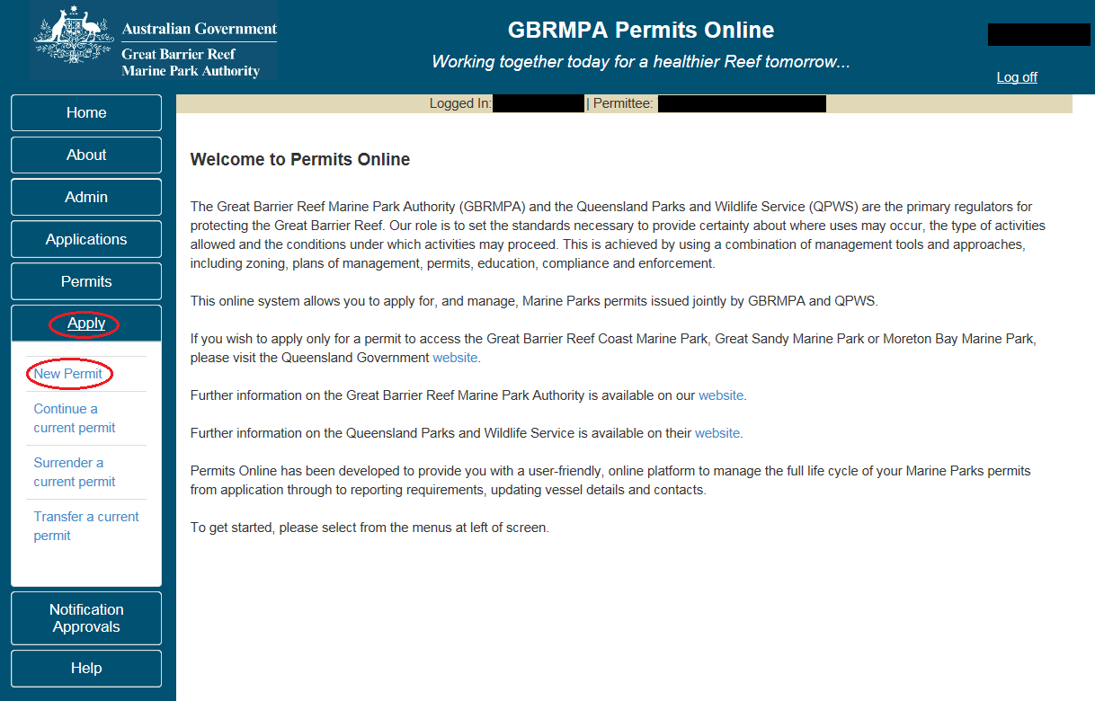
Figure 77 - Screenshot of Permits Online Home page with a red circle around Apply Icon, red circle around New permit option

When on the Apply – Who is applying for this Permit screen select the third option – Multiple Individual / Companies to jointly hold a permit which does not have a current/previous Permit or Application with the Reef Authority (New User) option.
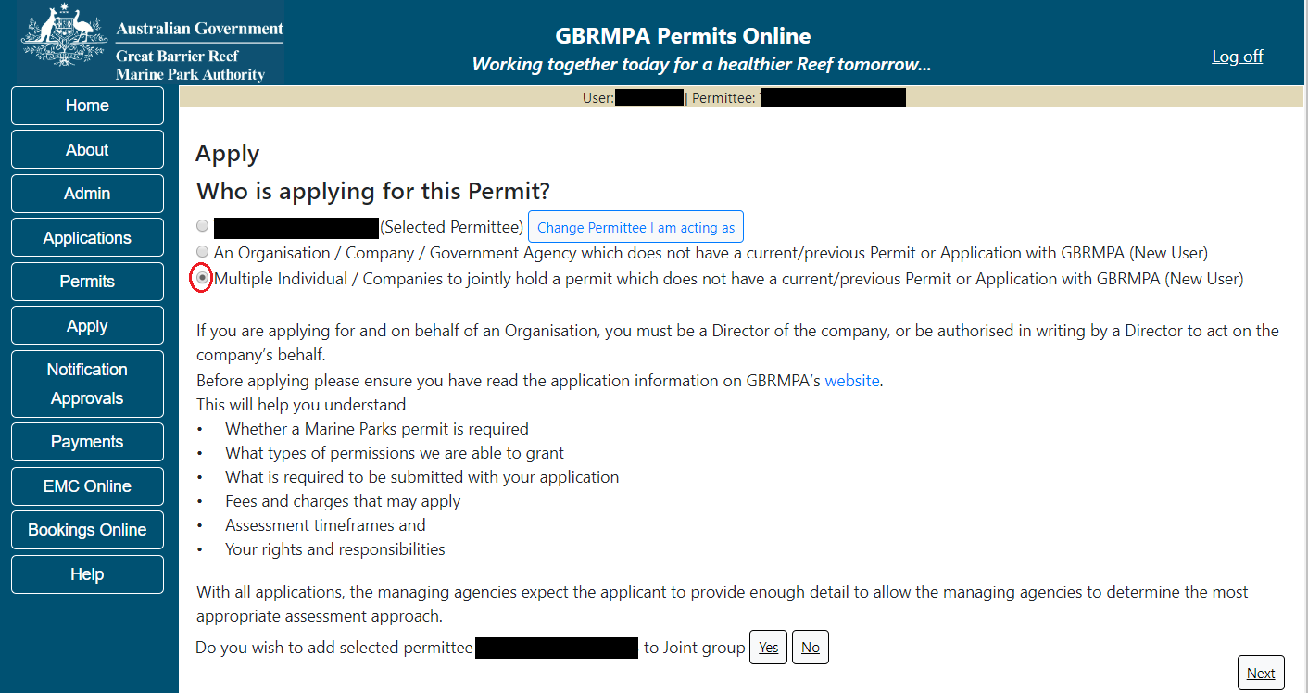
Figure 78 - Screenshot of - Who is applying for this Permit page. Red circle around selection - Multiple / Individual / Companies to jointly hold a permit which does not have a current/previous Permit or Application with the Reef Authority (New User)
You will be asked if the Permit Holder that is logged in is to be added to the joint application. (Example on screen is TEST COMPANY). Select Yes if you would like to use the existing selected Permit Holder.
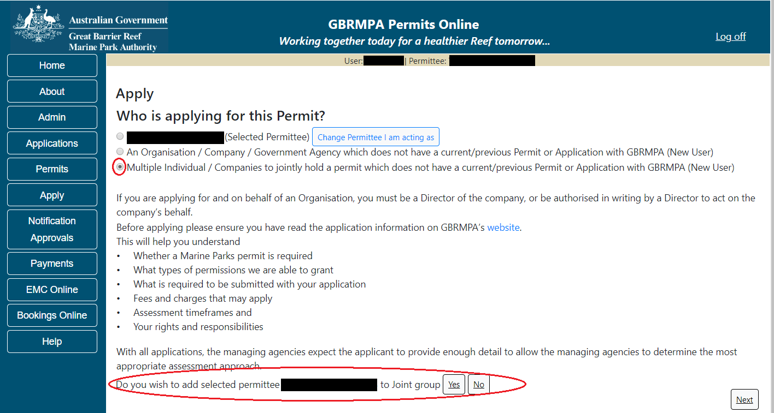
Figure 79 - Screenshot of Who is applying for this Permit page with Multiple Individual / Companies selected. Red Circle around question - Do you wish to add selected Permit Holder TEST COMPANY PTY LTD to Joint group with Yes and No options circled in red

If no is selected an Add Applicants button will be presented and no contacts will appear as being selected (at this stage). Select the Add Applicants button to add the other applicants.
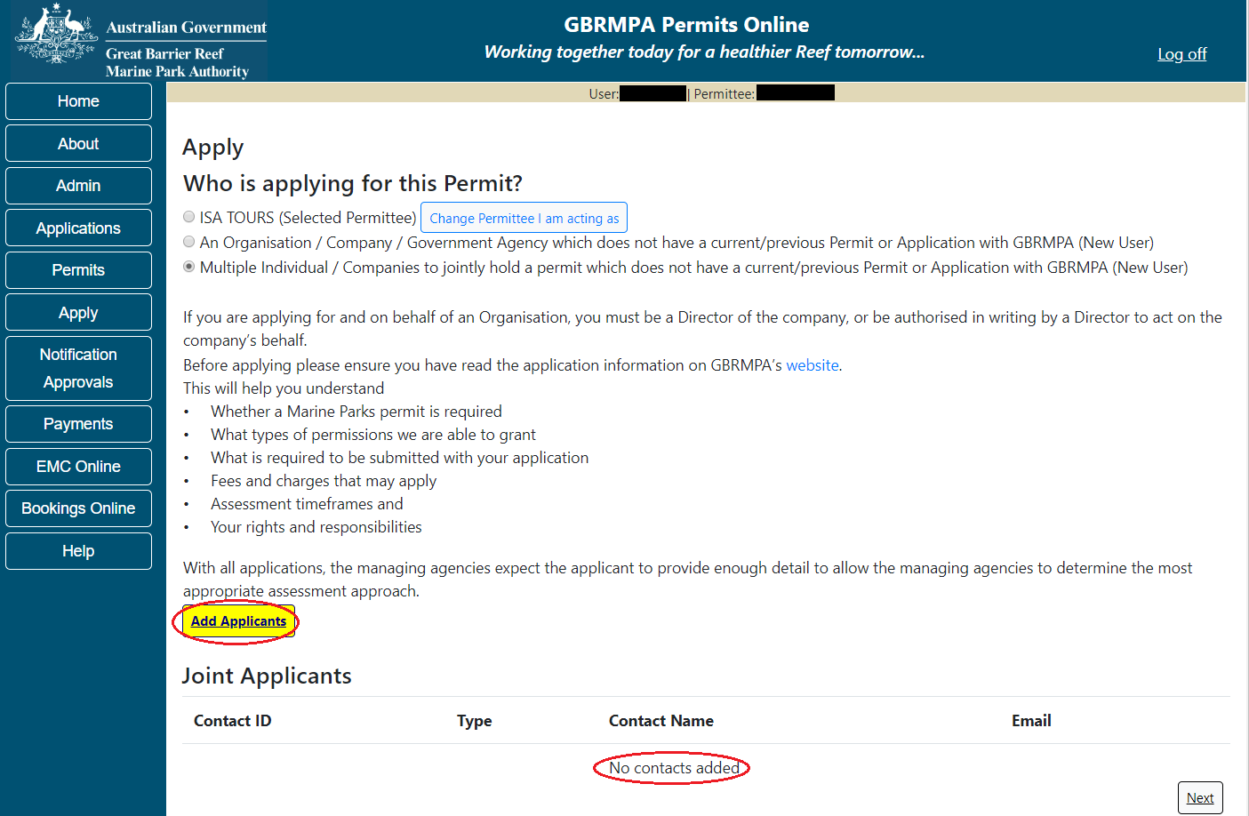
Figure 80 - Screenshot of Who is Applying for this Permit page with Add Applicant button circled in red. Red circle around - No contact name selected under the Contact name field
If Yes was selected, the chosen contact (Example used -TEST COMPANY) will appear in the applicant list. You will also have an Add Applicants button appear and a Remove button. If you wish to remove the contact, select Remove. To add other contact to the jointly held permit application select the Add Applicants button.
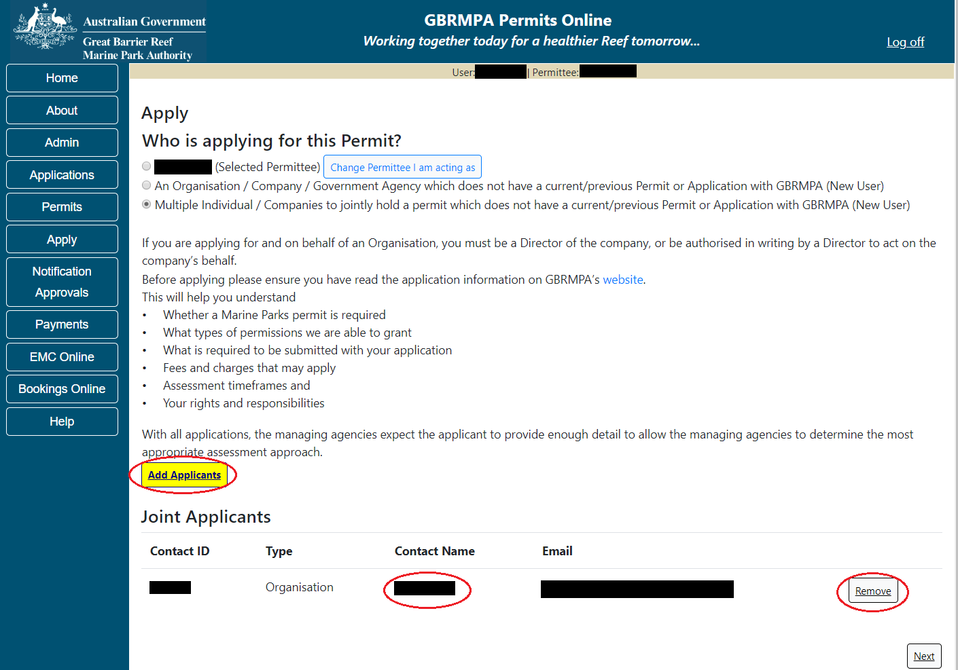
Figure 81 - Screenshot of - Who is Applying for this Permit page with Add Applicant button circled in red. Red circle around - Contact name selected under the Contact name field. Red circle around Remove button

When adding an applicant, you are presented with two options: Individual and an Organisation / Company / Government Agency. Select which option is required. If it is an individual, select Individual. You will be presented with an area to search for the contact. If the contact is known to the Reef Authority, add the details of the contact and click search.
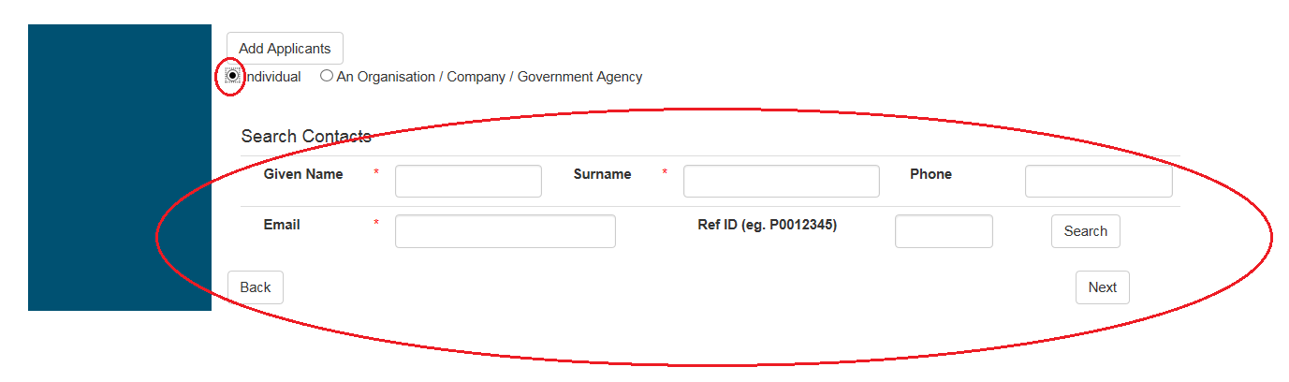
Figure 82 - Screenshot of Add Applicant fields. Individual selected and circled in red. Red circle around Search contact fields

If the contact details match the Reef Authority’s system details, matches will appear for you to select.
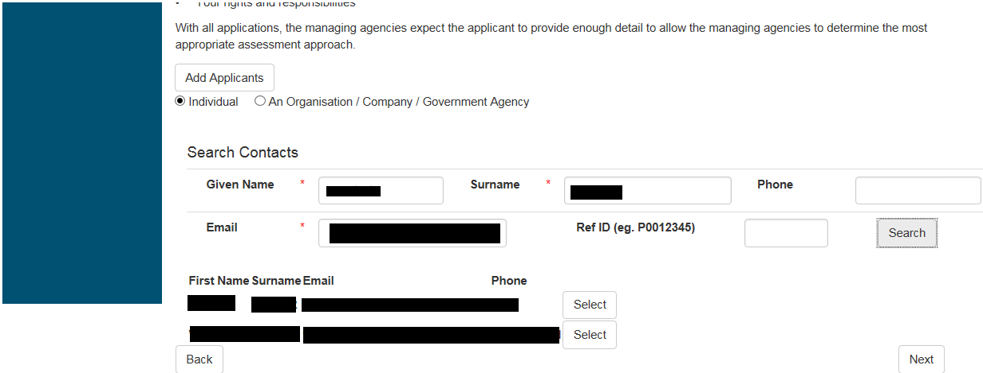
Figure 83 - Screenshot of Add Applicant fields. Individual selected and information completed

If the information entered is not exact or is a new contact to the Reef Authority, a Contact Details area will appear on screen to add the details of the contact (either individual or company details). Enter requested details and select Save.
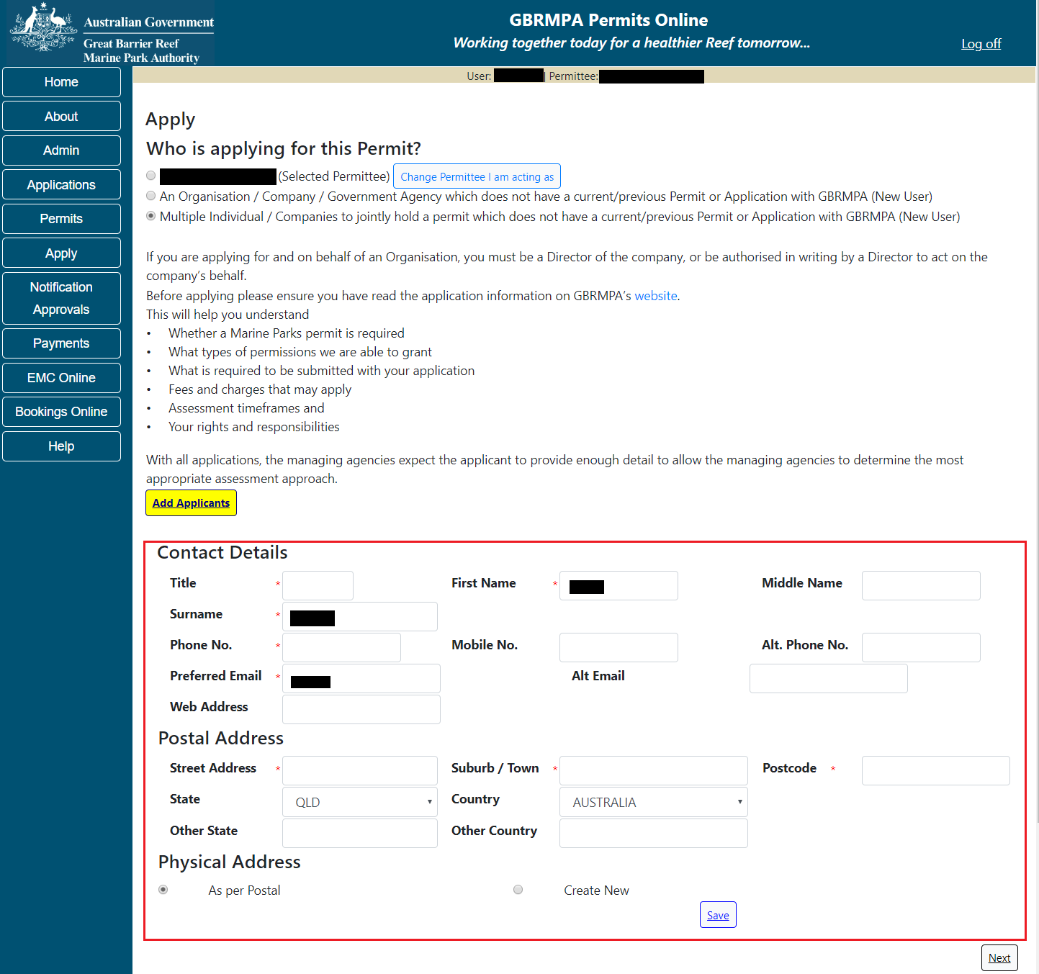
Figure 84 - Screenshot of Add Applicant field with Contact Details area displayed
If the contact is known to the Reef Authority, their details will be provided and the entity selected. Once selected the contact will appear in your applicant list. If all contacts have been added then select Next to continue.
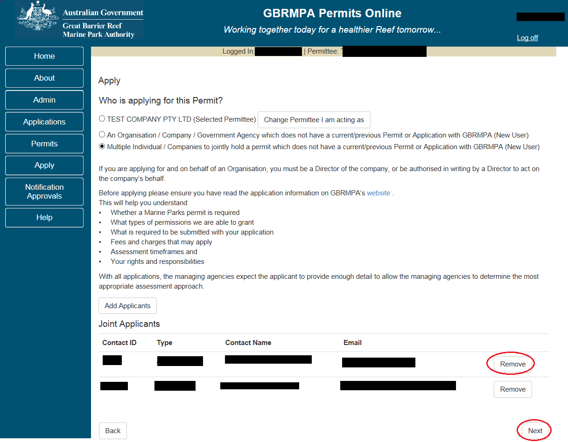
Figure 85 - Screenshot of - Who is Applying for this Permit page with Add Applicant section displayed and red circle around Remove and Next buttons
Once all contacts have been added to the applicant list, select Next and you will progress through the Apply question pages where you can choose the type of permission you wish to apply for. Please note: Once you have drafted the application, it will be saved to the account of the joint Permit Holder entity you created. Please use the Admin – Change Permittee function to select the joint entity. You can then access the application from the Applications menu.
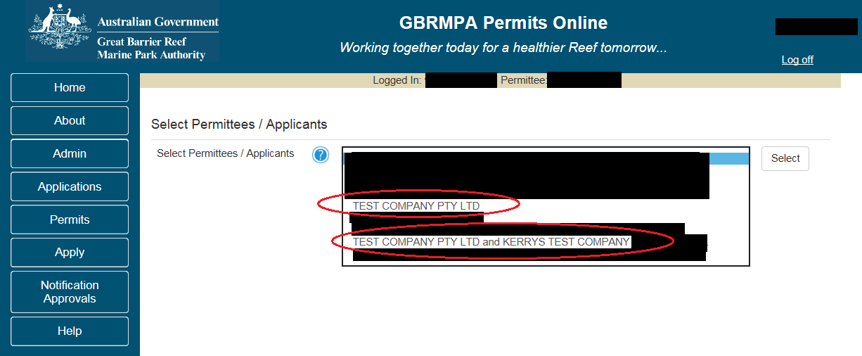
Figure 86 - Screenshot of Select Permit Holders / Applicants screen with examples of Company and Joint Permittee contact circled

The above example shows that TEST COMPANY PTY LTD created a joint application with KERRYS TEST COMPANY PTY LTD – When the application was submitted the user was logged in as User A with TEST COMPANY PTY LTD selected as the Permit Holder. To view the joint Permit Holder application please select TEST COMPANY PTY LTD AND KERRYS TEST COMPANY PTY LTD from the Permittee list.
  - Making Declarations / Submitting your application
Your application cannot be submitted until you complete certain legally binding declarations verifying the information you have provided. To complete the declarations section of this application, you must either be the applicant, or if applying on behalf of an organisation / company / government agency, you must be a Director of that organisation / company / government agency. Authorised contacts cannot complete the declarations section, as it contains legally binding commitments that take the place of a physical signature.
Please read all questions carefully, provide a response to each, and select Next.
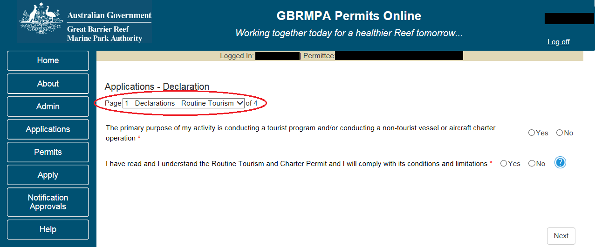
Figure 87 - Screenshot of Declarations screen for Routine Tourism and Charter permit application

On the final page of declarations there is a submit button. Once the submit button is selected the application will be submitted to the Reef Authority and is no longer available to be edited. The status of the application on the Applications screen will then display ‘Submitted to GBRMPA’. The application’s Primary Contact will receive an emailed acknowledgement notice from a delegated Assessment Officer within 10 business days.
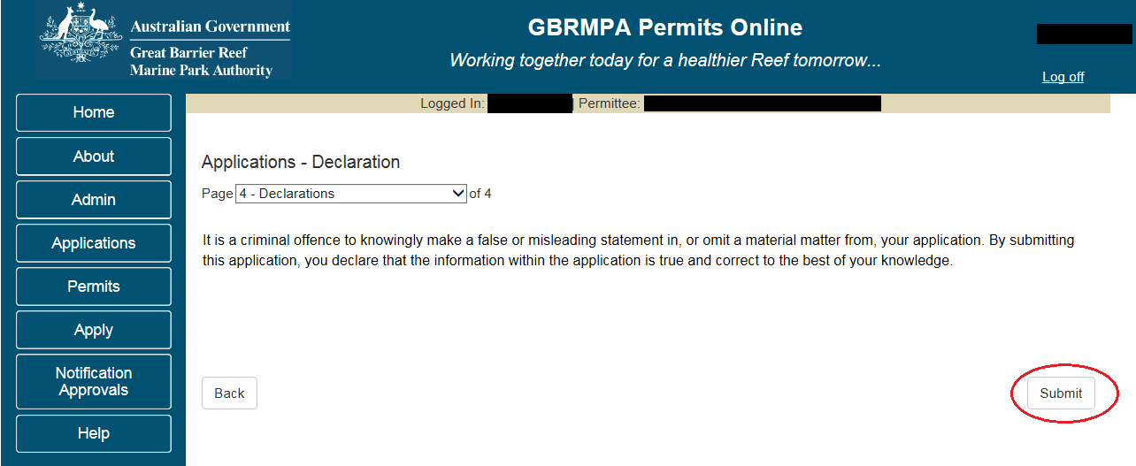
Figure 88 - Screenshot of Declaration page with a red circle around Submit button
Once you submit your application, a reference/application number is allocated.
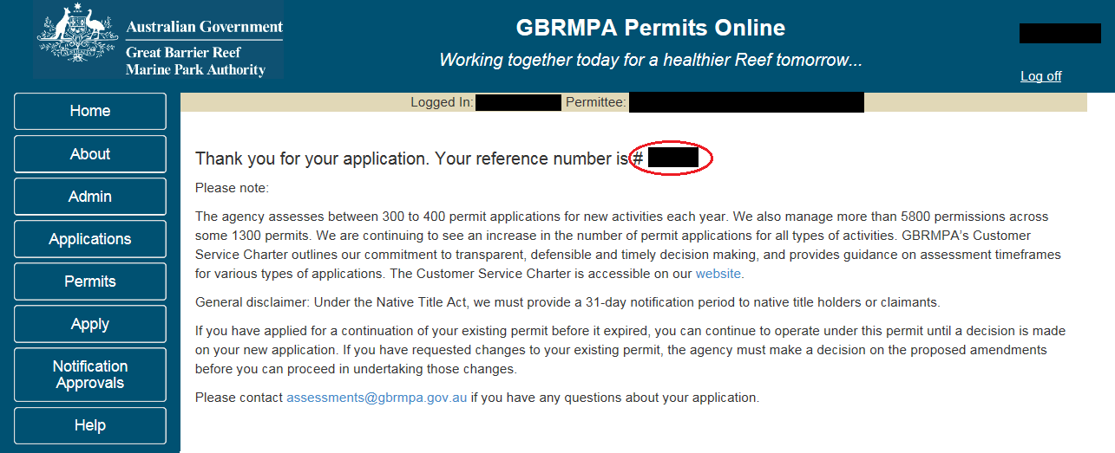
Figure 89 - Screenshot of Permits Online Thank you for your application page with a red circle around reference number

- Tourism or Charter Activities
  - Routine Tourism and Charter
Apply – new permit application– activities allowed by a routine tourism and charter permit
For information on applying for jointly held permits (e.g. multiple entities responsible for the permitted activity) please see section 9.3 Applying for a jointly held Permit of this document
To apply for a Routine Tourism and Charter Permit, select this option on the Apply – What are you seeking to do in the Marine Parks page.
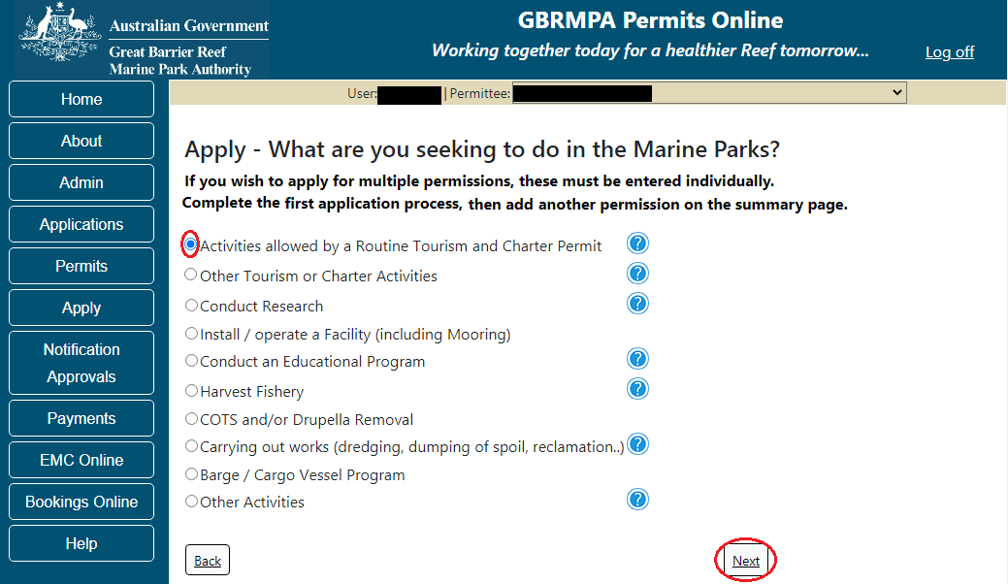
Figure 90 - Screenshot of Apply - What are you seeking to do in the Marine Parks screen with a red circle around Activities allowed by a Routine Tourism and Charter Permit and Next button
You will then progress to the Application Questions area of Permits Online. Each page that has questions requires a response. If you try to navigate to the next page without entering information, you will receive a validation notice stating ‘Response required’.
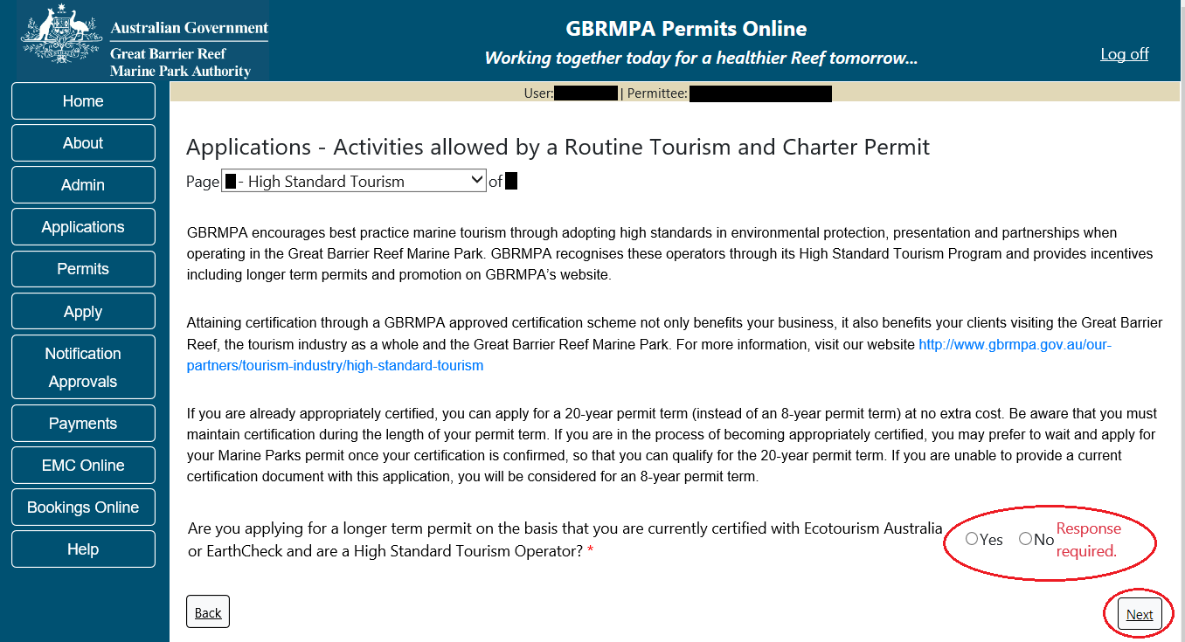
Figure 91 - Screenshot of High Standard Tourism page with a red circle around validation Response required and red circle around Next button
Page 1 of the Routine Tourism and Charter Permit application is the Application Details page. Fill in information about the number of vessels and/or aircraft you wish to use and the total amount of passengers.
Please note that this is the total number of passengers you propose to cater for, across all vessels and/or activities. This number determines the appropriate Permit Application Assessment Fee. Current fees are published on the Reef Authority’s website. Select ‘Next’ to continue.
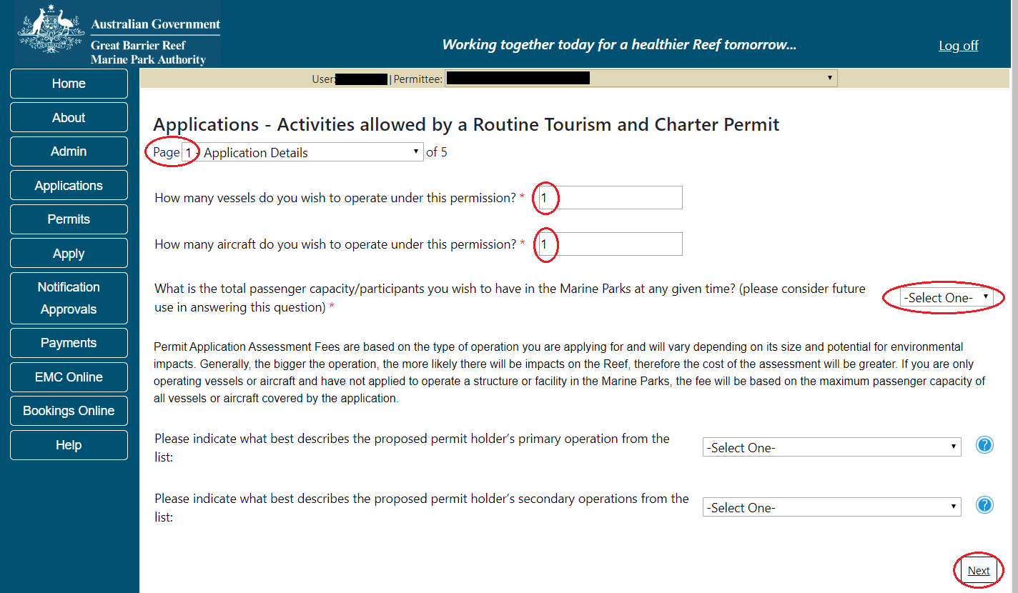
Figure 92 - Screenshot of Application Details screen with red circles around the required fields
Page 2 of the Routine Tourism and Charter Permit application refers to State Marine Park Rivers and Streams. If you have a vessel of less than 8 meters in length, carrying less than 8 passengers, select ‘Yes’.
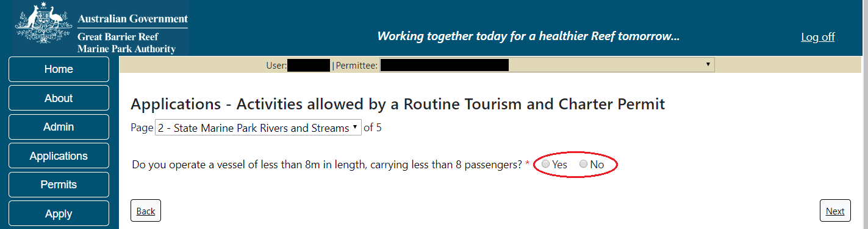
Figure 93 - Screenshot of State Marine Park Rivers and Streams page with a red circle around the Yes and No radio buttons

If ‘Yes’ is selected a further two (2) questions will appear. If you wish to operate in rivers and streams between Mission Beach and the Starcke River or between Slade Point and Midge Point select ‘Yes’. If you wish to operate guided interpretive tours in the Hinchinbrook Channel select Yes. Select Next to progress to the next page.
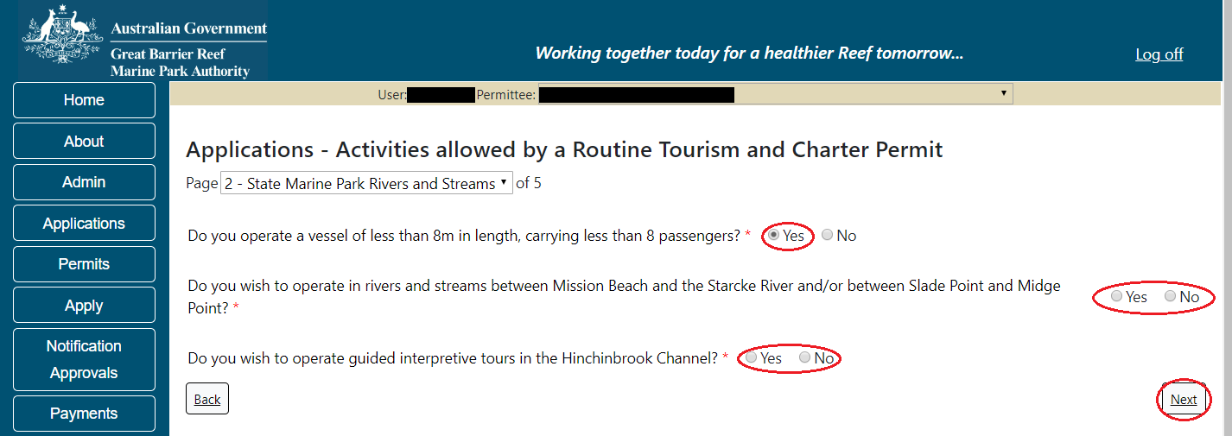
Figure 94 - Screenshot of State Marine Park Rivers and Streams page with a red circle around the ‘Yes’ and ‘No’ radio buttons and a red circle around the ‘Next’ button.

Page 3 of the Routine Tourism and Charter Permit application is the Vehicles page. On this page, you have options to ‘Add New Aircraft’ and ‘Add New Vessel’. To add an aircraft select the Add New Aircraft button.
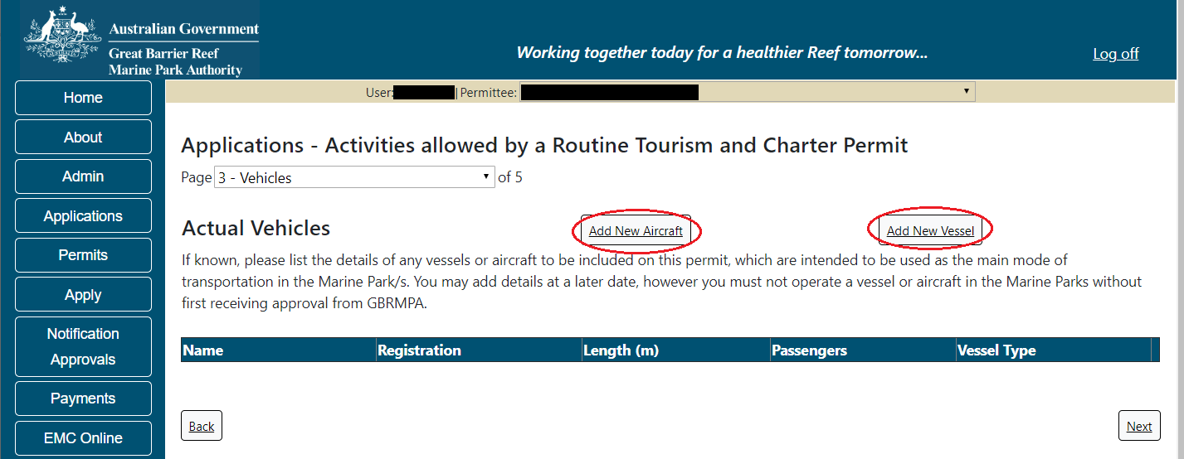
Figure 95 - Screenshot of Vehicles screen with red circles around ‘Add New Aircraft’ and ‘Add New Vessel’

The ‘Add New Aircraft’ pop up window will appear. Select the aircraft type from the list.
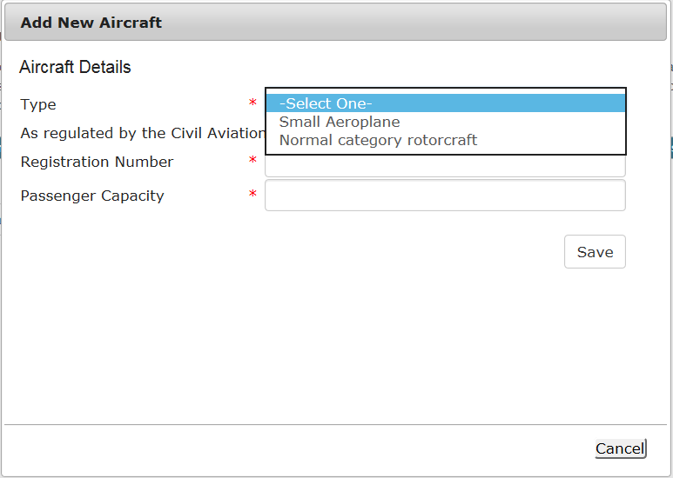
Figure 96 - Screenshot of ‘Add New Aircraft’ pop up window
Add details of the aircraft and select ‘Save’
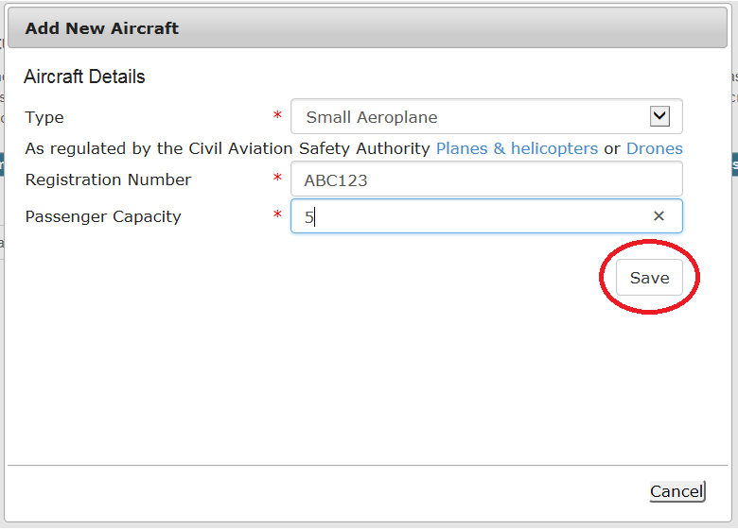
Figure 97 - Screenshot of ‘Add Aircraft’ pop up window with aircraft information added and a red circle around ‘Save’ button

The details will save on the page, with a ‘Remove’ button and an ‘Edit’ button. If you need to edit or remove the aircraft, select the button needed and add the changes or remove the aircraft.
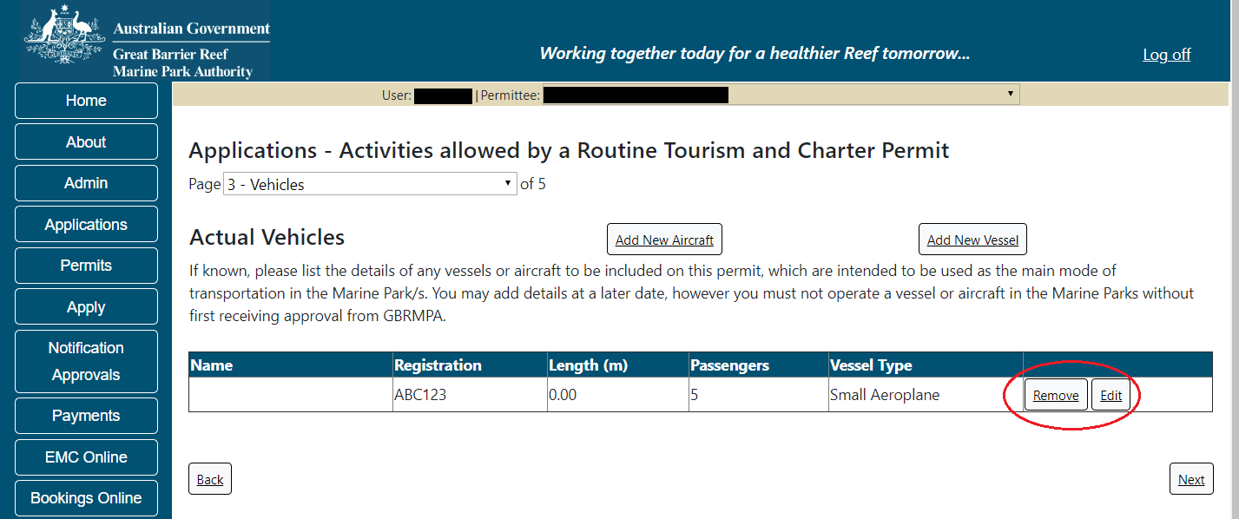
Figure 98 - Screenshot of Vehicles screen with aircraft information displaying and a red circle around the ‘Remove’ and ‘Edit’ buttons

To add a vessel select the ‘Add New Vessel’ button.
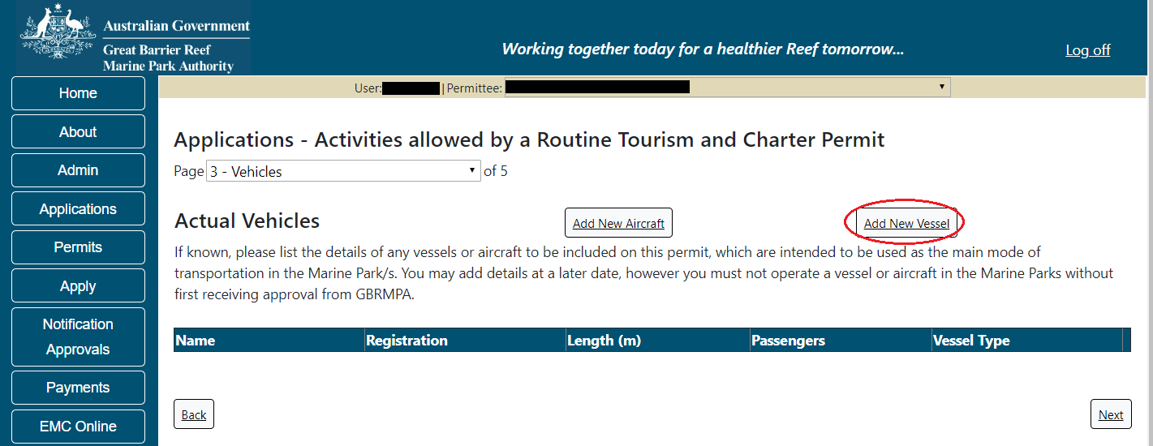
Figure 99 - Screenshot of Vehicles screen with a red circle around ‘Add New Vessel’ button

An ‘Add New Vessel’ pop up window will appear. Add the details of your vessel in the fields provided, then select ‘Save’.
Please note: Routine Tourism and Charter permits only provide for vessels 35m or less in length. The system will not allow you to enter vessels that exceed this length
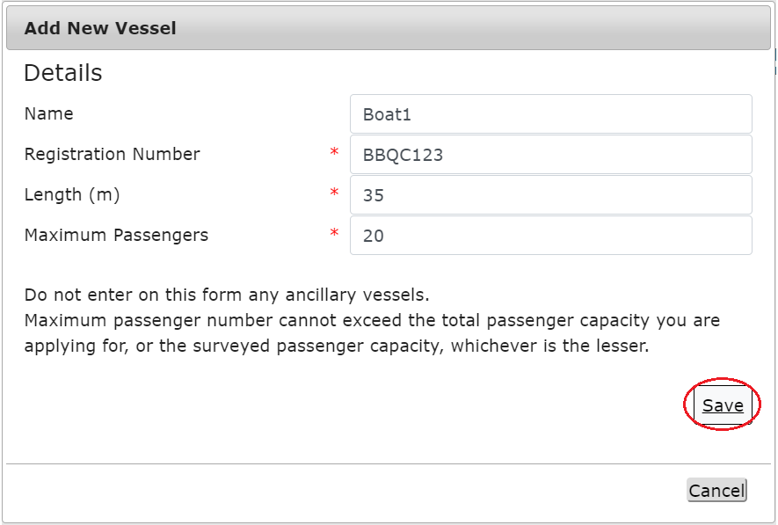
Figure 100 - Screenshot of Add New Vessel pop up window with information entered and a red circle around ‘Save’

Your entered details will be displayed on the screen. Select ‘Next’ to continue.
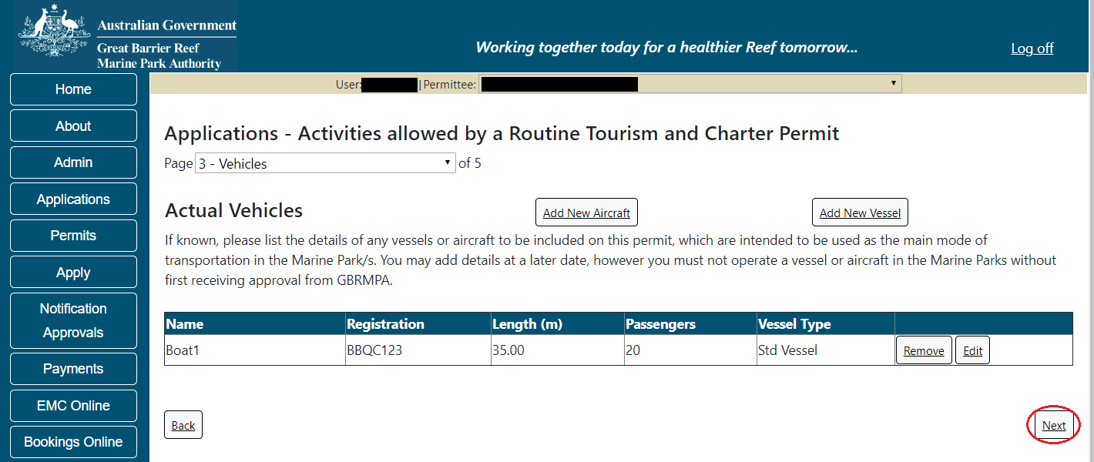
Figure 101 - Screenshot of Vehicles screen displaying Vessel details and a red circle around ‘Next’ button

Page 3 of the Routine Tourism and Charter Permit application is the Ancillary Vessels and Equipment page. To add details of any ancillary vessels or equipment select the ‘Add New’ button.
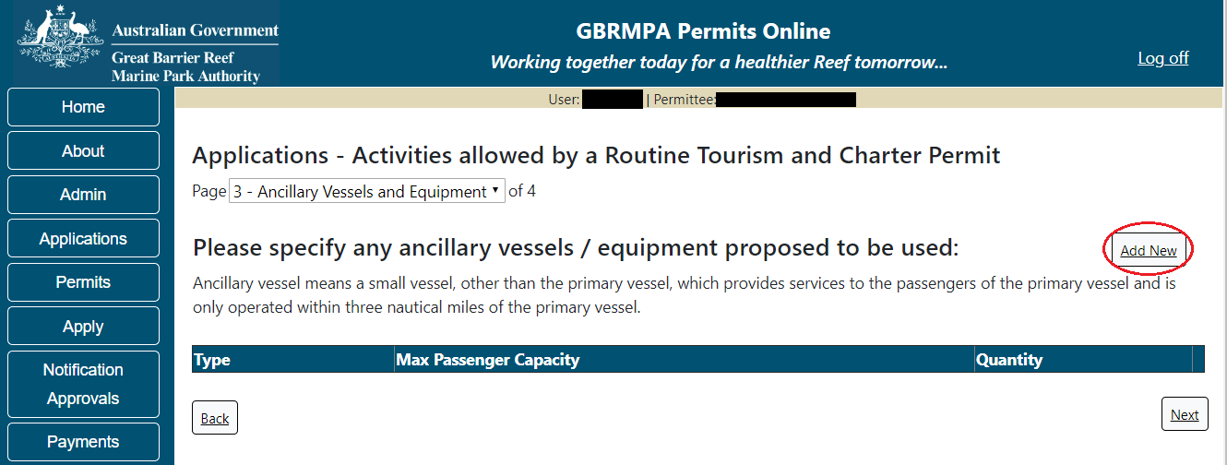
Figure 102 - Screenshot of Ancillary Vessels and Equipment page with a red circle around ‘Add New’ button

An ‘Add New Ancillary Vessels/Equipment’ window will appear.
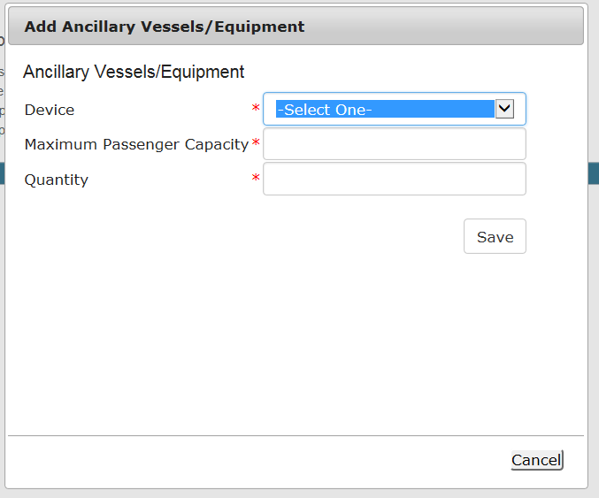
Figure 103 - Screenshot of ‘Add Ancillary Vessels / Equipment’ pop up window

Select an ancillary vessel or equipment from the Device list.
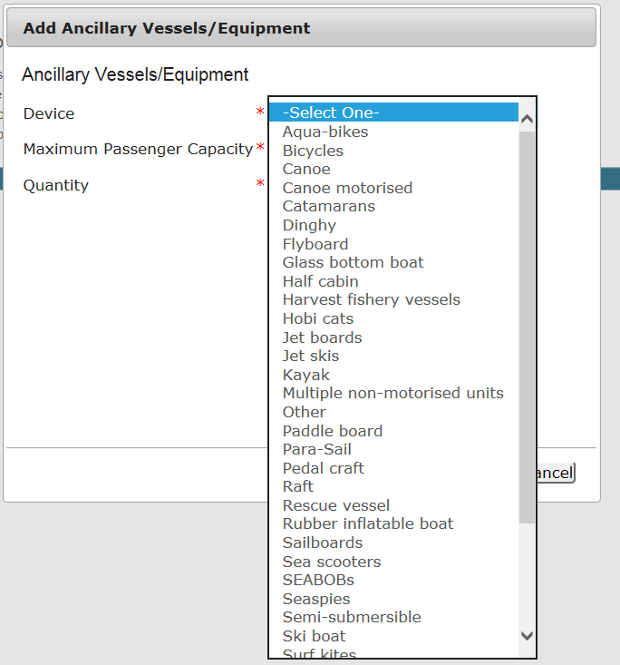
Figure 104 - Screenshot of Add Ancillary Vessels / Equipment pop up window showing the Device Type list

Add details of the ancillary vessels or equipment, then select ‘Save’. Please note: Maximum passenger capacity here refers to the number of passengers that can use the equipment at any one time (e.g. a two-person canoe or Jet Ski). Quantity refers to the number of this type of equipment you propose to use under your permit.
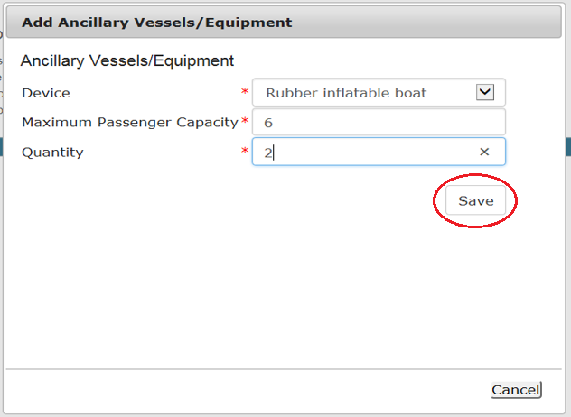
Figure 105 - Screenshot of ‘Add Ancillary Vessels / Equipment’ with information completed and a red circle around the ‘Save’ button
The details of ancillary vessels or equipment will appear on the screen. Once you have added your ancillary vessels and/or equipment select ‘Next’.
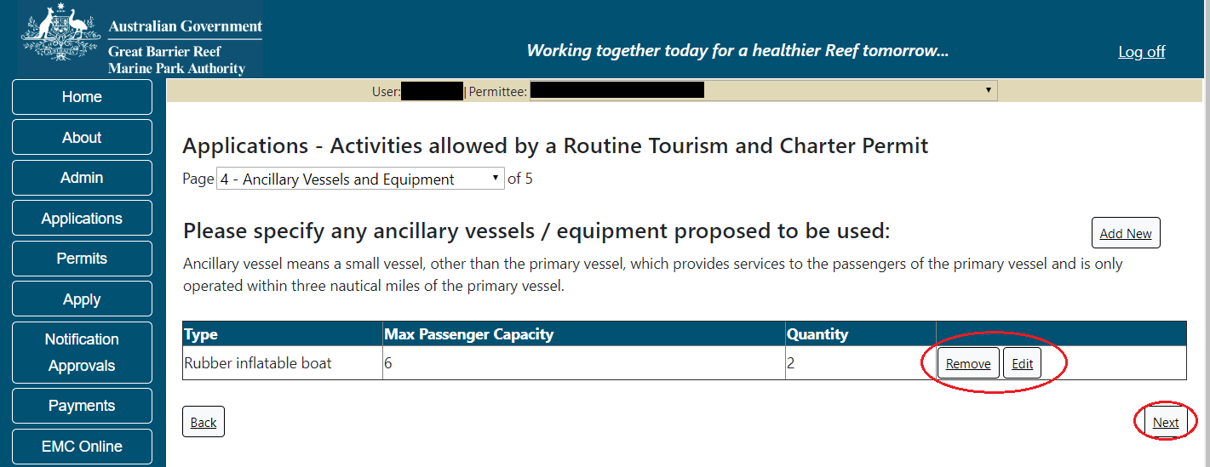
Figure 106 - Screenshot of Ancillary Vessels and Equipment page displaying information with a red circle around the ‘Remove’, ‘Edit’ and ‘Next’ buttons

Page 5 of the Routine Tourism and Charter Permit application refers to High Standard Tourism operators. If you have obtained a High Standard Tourism certification with an approved certification scheme, select ‘Yes’ then upload a copy of your certificate using the ‘Upload File’ button.
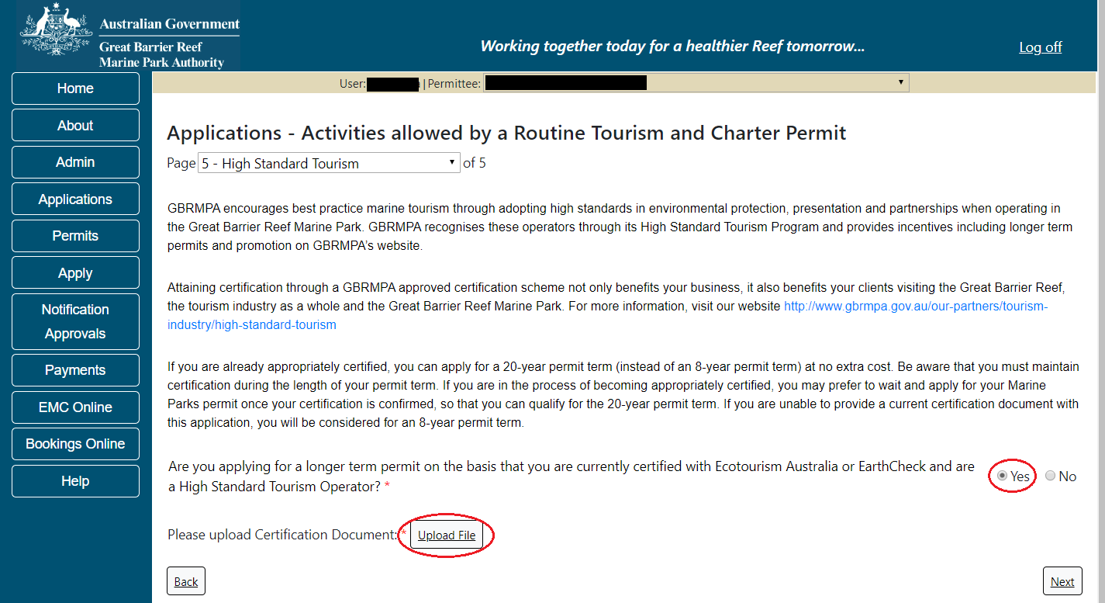
Figure 107 - Screenshot of High Standard Tourism page with a red circle around ‘Yes’ and ‘Upload File’

The ‘File Upload’ screen will appear. Select ‘Browse’.
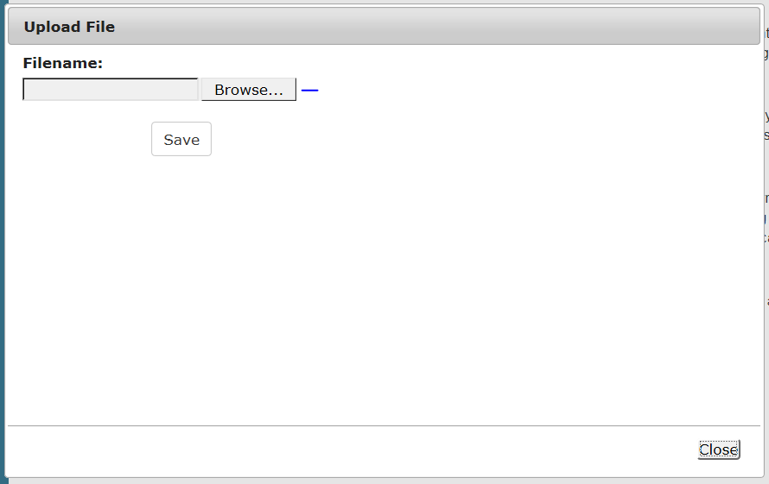
Figure 108 - Screenshot of Upload File pop up window

Once you load a copy of your certificate, you will see the filename with a ‘Remove’ button next to it. If you wish to remove the file, select the ‘Remove’ button. Select ‘Next’ to go to the next page.
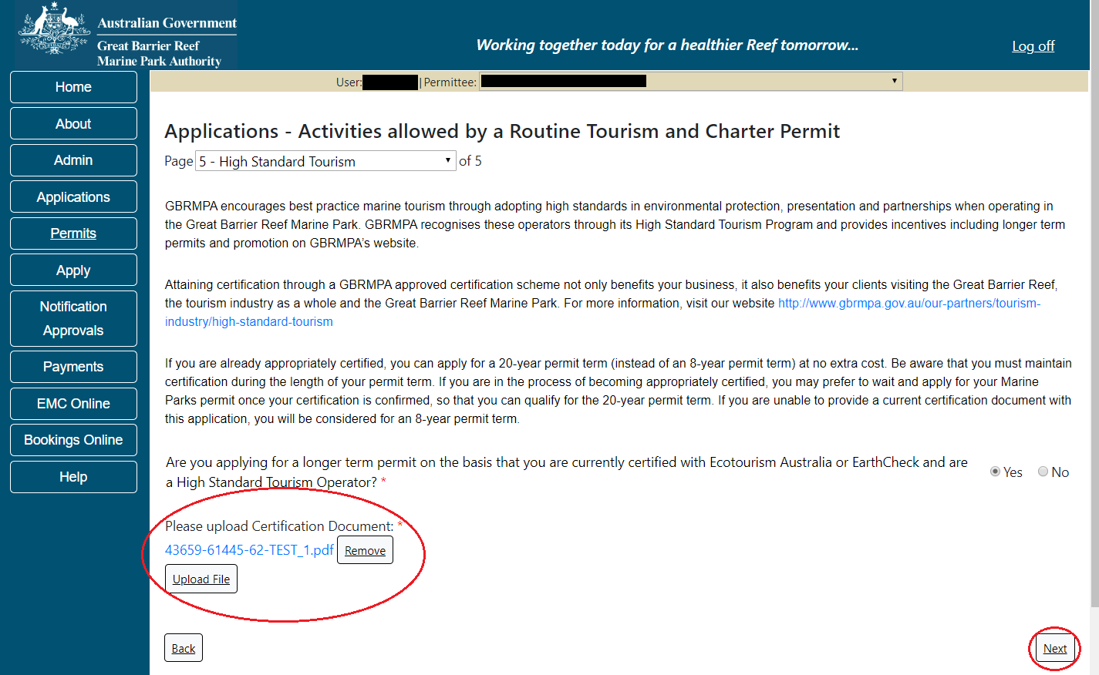
Figure 109 - Screenshot of High Standard Tourism page with a red circle around the uploaded file and ‘Next’ button

Completing a set of declarations is mandatory prior to submitting your application. To complete the declarations section of this application, you must either be the applicant, or if applying on behalf of an organisation / company / government agency, you must be a Director of that organisation / company / government agency. Authorised contacts cannot complete the declaration section, as it contains legally binding commitments in place of a physical signature.
Please read all questions carefully, provide a response to each, and select ‘Next’.
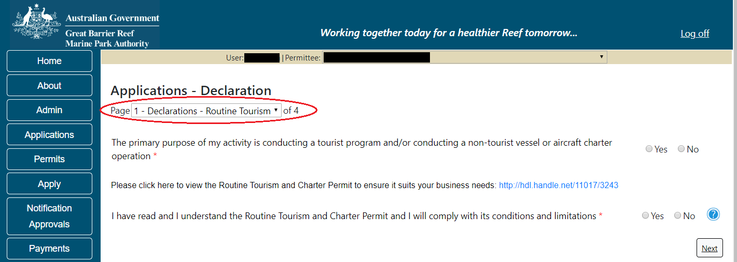
Figure 110 - Screenshot of Declarations screen for Routine Tourism and Charter permit application
On the final page of declarations there is a submit button. Once the submit button is selected the application will be submitted to the Reef Authority and is no longer available to be edited. The status of the application on the Applications screen will then display ‘Submitted to GBRMPA’. The application’s Primary Contact will receive an emailed acknowledgement notice from a delegated Assessment Officer within 10 business days.
Figure 111 - Screenshot of Declaration page with a red circle around Submit button

Once you submit your application, you are reminded of your application number and provided further information on the assessment process.
Figure 112 - Screenshot of Permits Online Thank you for your application page with a red circle around reference number

Your application will appear in the Applications screen with the reference/application number also displayed. You have further options to view a summary of your application, email the Reef Authority or withdraw the application.
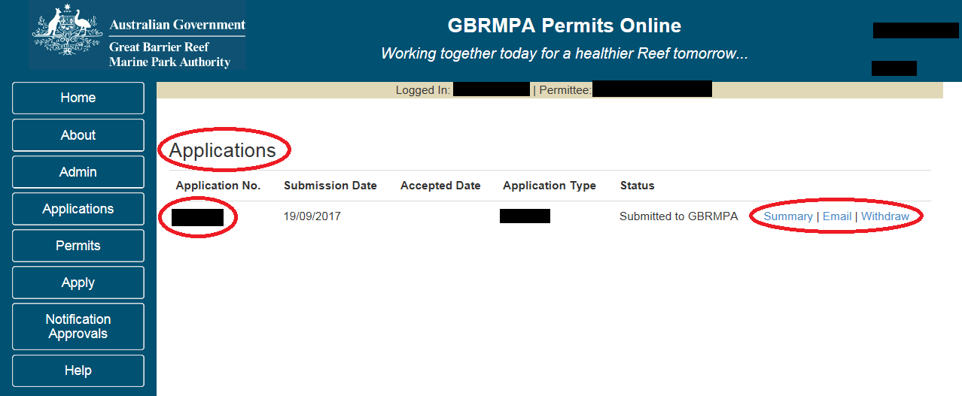
Figure 113 - Screenshot of Applications screen with a red circle around Application number, ‘Summary’, ‘Email’ and ‘Withdraw’ options

    - Other Tourism Application Types sub menu
The ‘Other Tourism’ types sub menu has options for Aircraft, Bareboat, Hire, Craftless, Cruise Ship, Guided Tours (Motorised), Guided Tours (Non-Motorised) and Vessel. Select which permission you wish to apply for then select ‘Next’
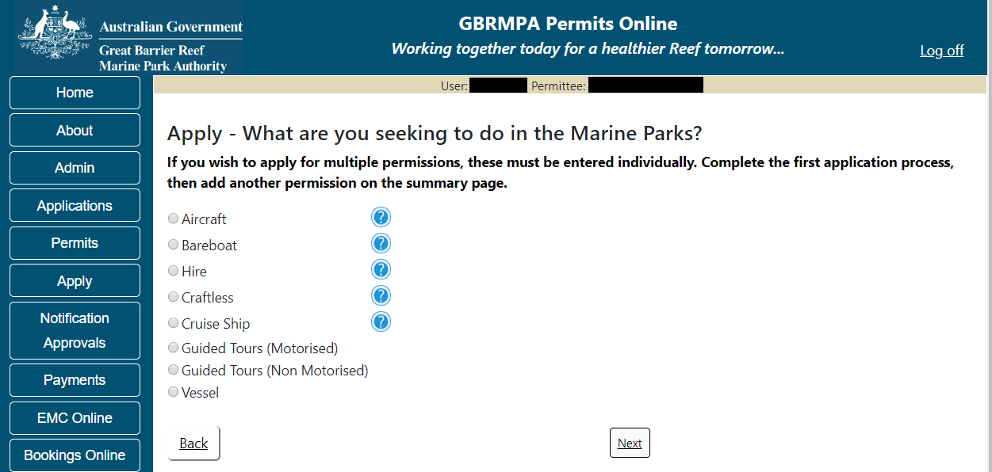
Figure 114 - Screenshot of Other Tourism application types sub menu

  - Tourism - Aircraft
Apply – new permit application – other tourism activities – aircraft
To apply for Other Tourism and Charter Activities, select this option on the Apply – What are you seeking to do in the Marine Parks page.
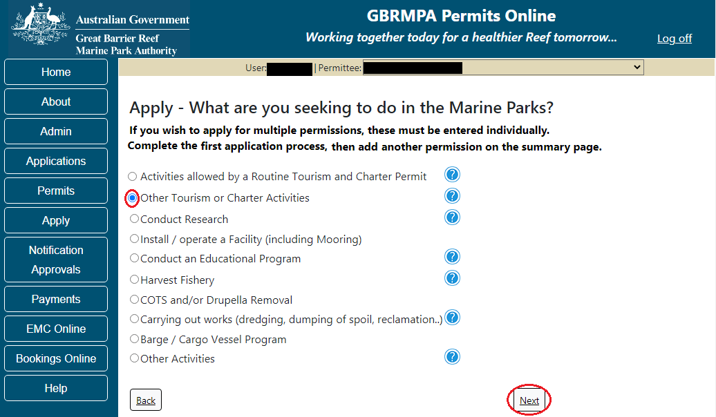
Figure 115 - Screenshot of Apply - What are you seeking to do in the Marine Parks page with Other Tourism and Charter Activities selected and a red circle around the ‘Next’ button

You will progress to the application types sub menu, where you can choose which type of Tourism or charter activity you wish to apply for (example below is Aircraft). Select ‘Next’ to progress to the application questions.
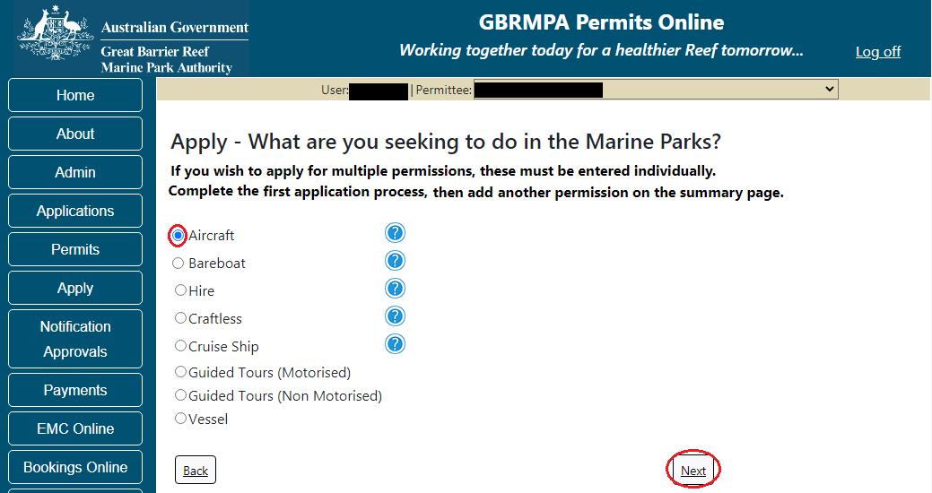
Figure 116 - Screenshot of ‘Apply - What are you seeking to do in the Marine Parks’ page with Aircraft selected and a red circle around ‘Next’ button
Page 1 of the Aircraft application is the Environment Protection and Biodiversity Conservation Act page. This provides advice on matters of national environmental significance that must be considered when assessing an application. This screen is for your information only at this stage. Your assessing officer will contact you if it is determined to be relevant to your application.
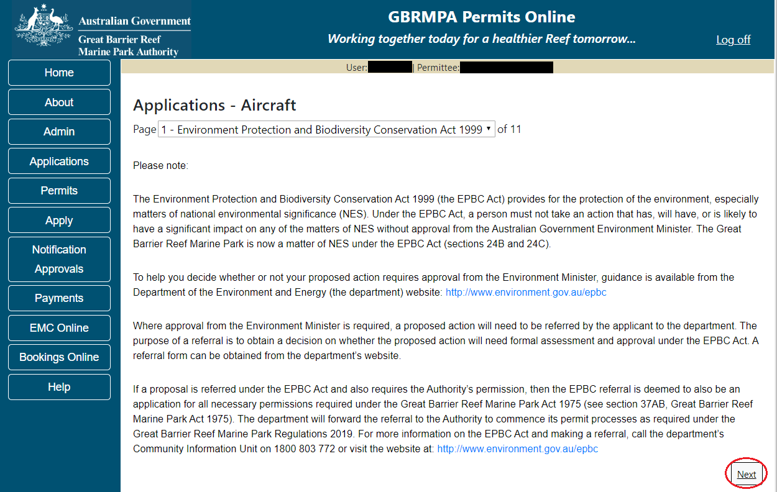
Figure 117 - Screenshot of Environmental Protection Biodiversity Conservation page with red circle around ‘Next’ button

Links on the Environment Protection and Biodiversity Conservation page www.environment.gov.au/epbc will take you to the Department of Climate Change, Energy, the Environment and Water site. Here you can find information about the Environment Protection and Biodiversity Conservation Act 1999 and your obligations under the Act.

Page 2 of the Aircraft application is the Permissions and Activities page. Default permissions and activities for this type of application are listed.
If there are activities you do not wish to include on your permit, you can remove them by selecting the ‘Remove’ button next to the activity. Please note that if you remove an activity, you are no longer permitted to undertake that activity in the Marine Parks. Please consider potential future usage of your permit when removing or adding activities.
For some permissions, additional activities can be added using the ‘Add new’ option. To apply for an entirely different permission (e.g. to install a mooring or operate a vessel program), please complete this application, then use the ‘Add new’ permission option on the summary screen.
Select ‘Next’ to continue.
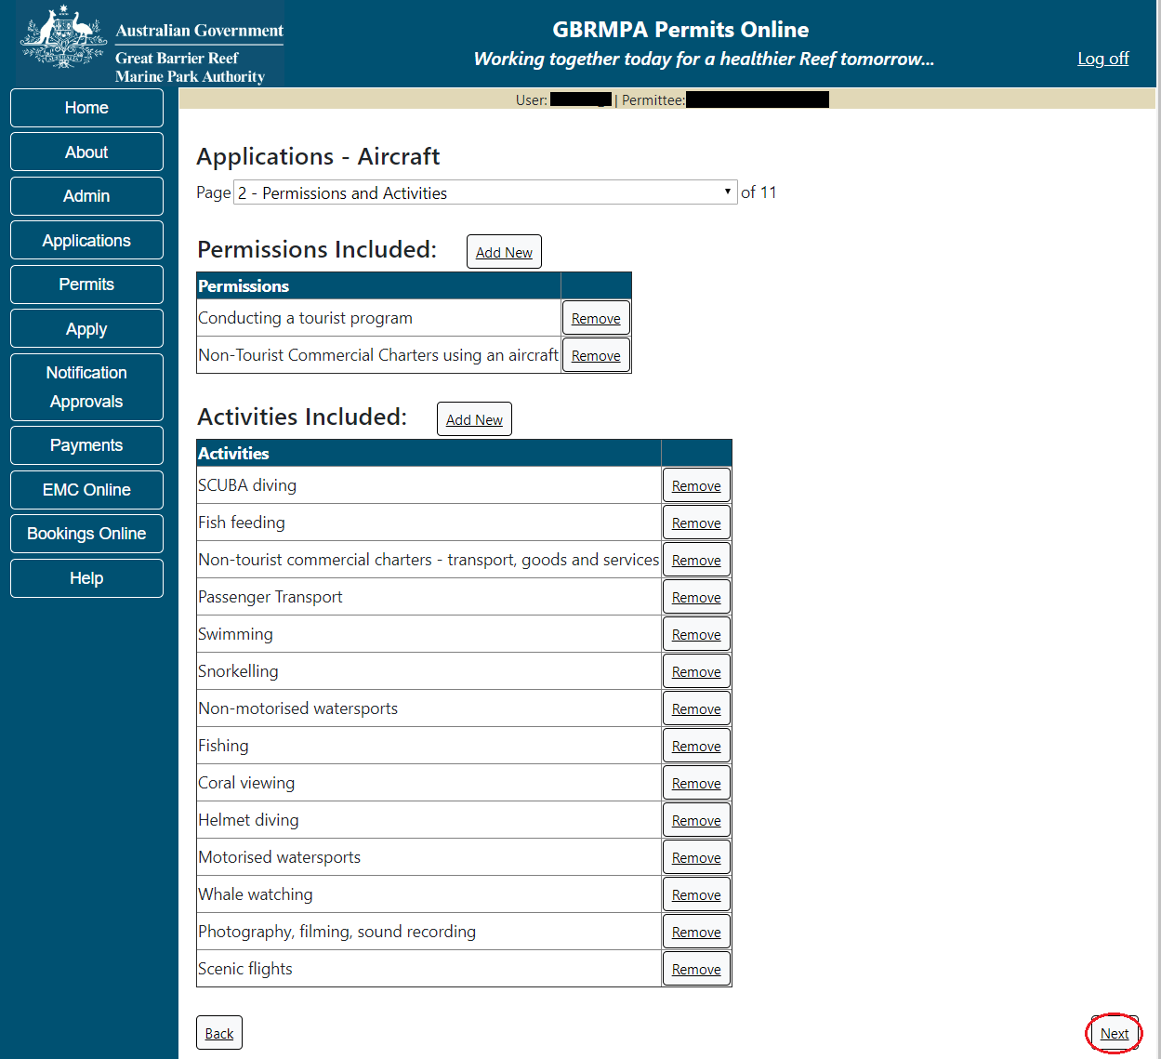
Figure 118 - Screenshot of Activities page for Aircraft (Landing) application with red circle around the ‘next’ button

Page 3 of the Aircraft application is the Total Passenger Capacity / Participants page. Please select the number of participants you wish to cater for across all activities in the Marine Parks in this section, considering any future business growth potential. Your answer to this question will determine the appropriate Permit Application Assessment Fee for the application. Select ‘Next’ to continue.
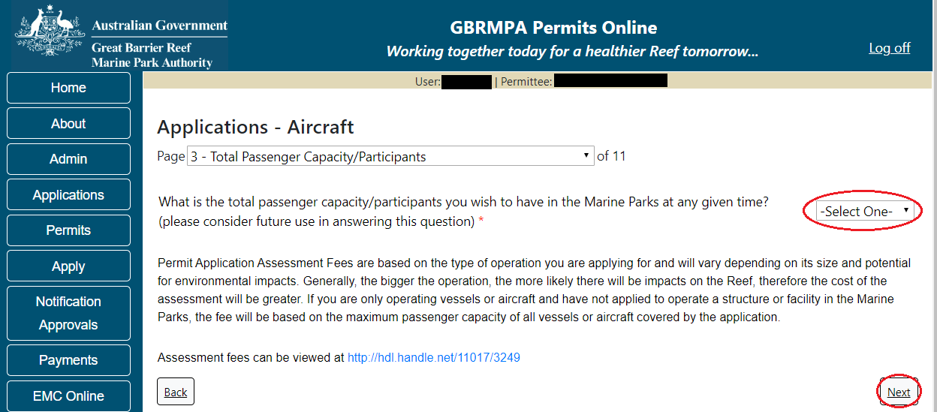
Figure 119 - Screenshot of the Total Passenger Capacity / Participants page with a red circle around the Select One drop list and a red circle around the ‘next’ button
Page 4 of the Aircraft application allows you to select the management areas in which you wish to operate. Please consider potential future use when making this decision. All management areas are selected as default for Aircraft applications. If you do not wish to access a certain management area, deselect it by clicking the tick box.
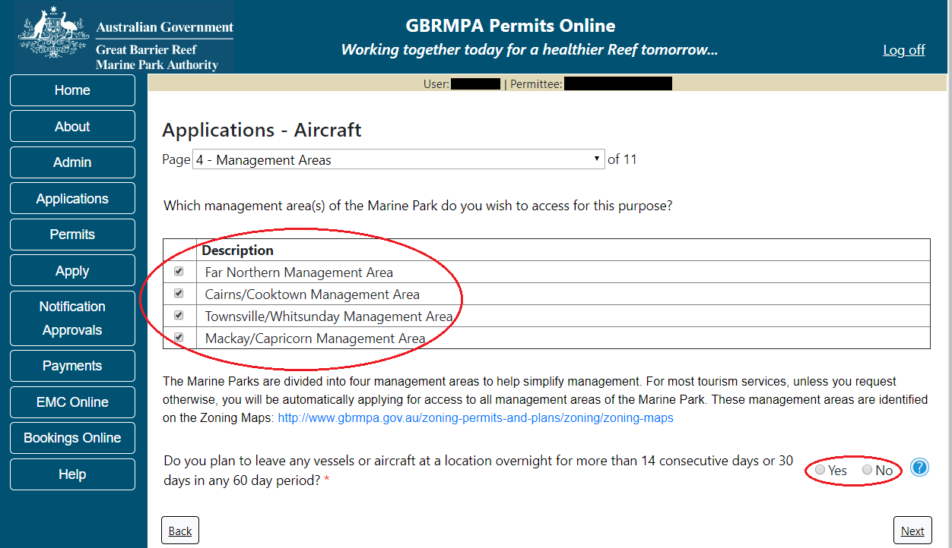
Figure 120 - Screenshot of One Vicinity check page with a red circle around the management area and Yes No option

If you wish to operate a vessel or aircraft at a location for more than 14 consecutive days; or for more than 30 days in any period of 60 days select Yes and provide details of your proposed use (e.g. leaving a glass bottomed boat at a particular location for a set timeframe). Select ‘Next’ to continue.
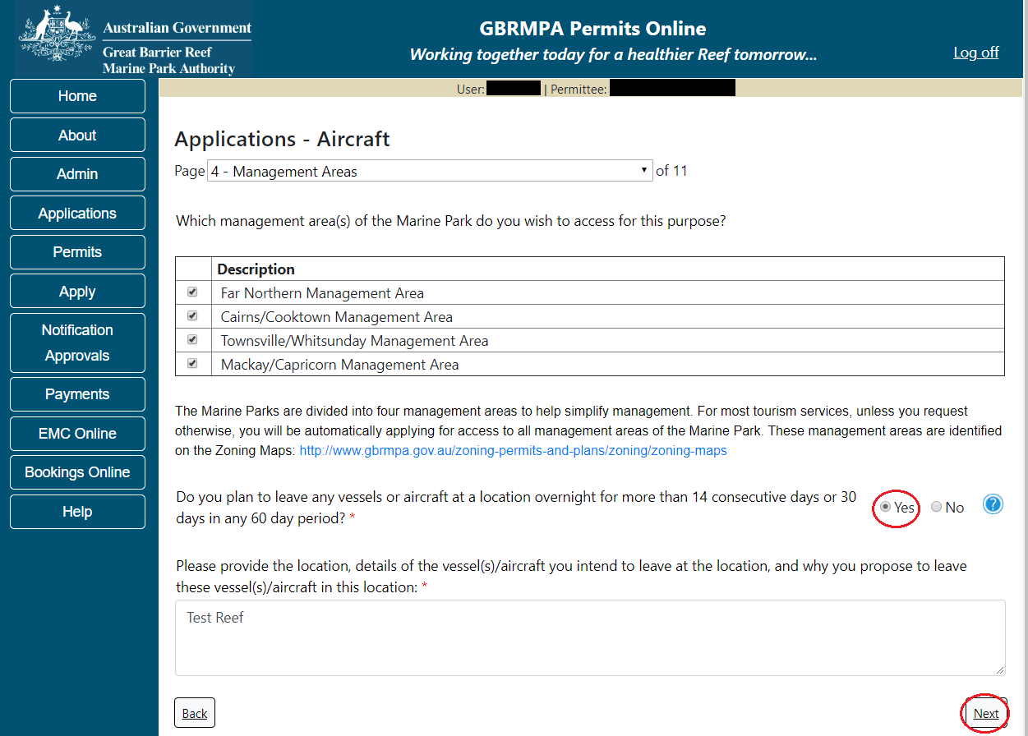
Figure 121 - Screenshot of Management Areas page with Yes selected and a red circle around the ‘Next’ button

Page 5 of the Aircraft application allows you to apply to access areas of the Marine Park more frequently than 2 days in every 7-day period. This option is only available outside the Plans of Management. If you wish to apply to visit a location more frequently than 2 days in every 7-day period, select ‘Add New’.
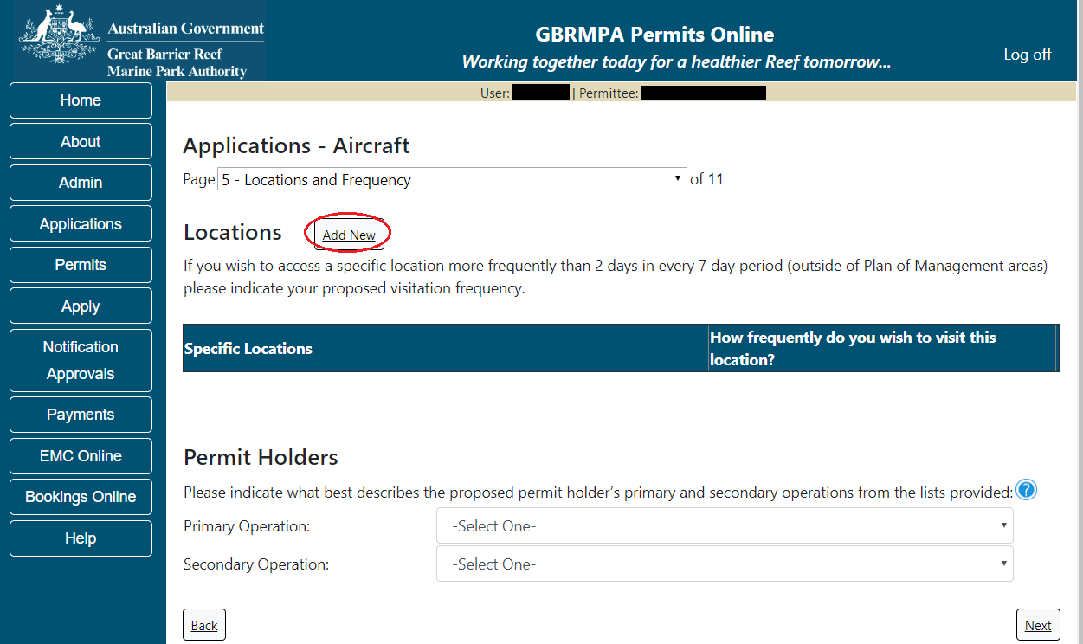
Figure 122 - Screenshot of Locations and Frequency screen with red circle around ‘Add new’ button
If the ‘Add new’ button is selected the ‘Location’ pop up window will appear.
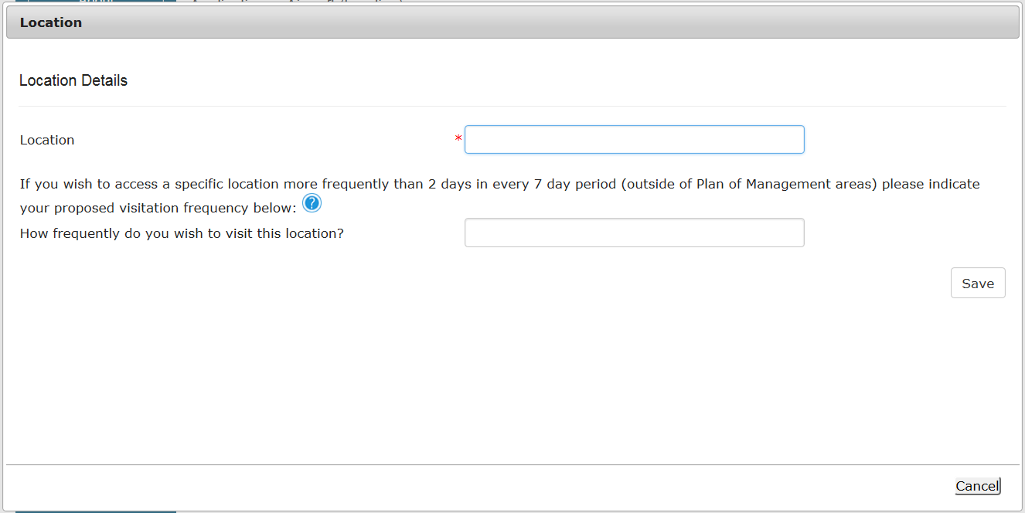
Figure 123 - Screenshot of Location pop up window

Type in the name of the location you wish to visit in the location field. As you type, the list will produce relevant matches. Select your desired location then select ‘Save’.
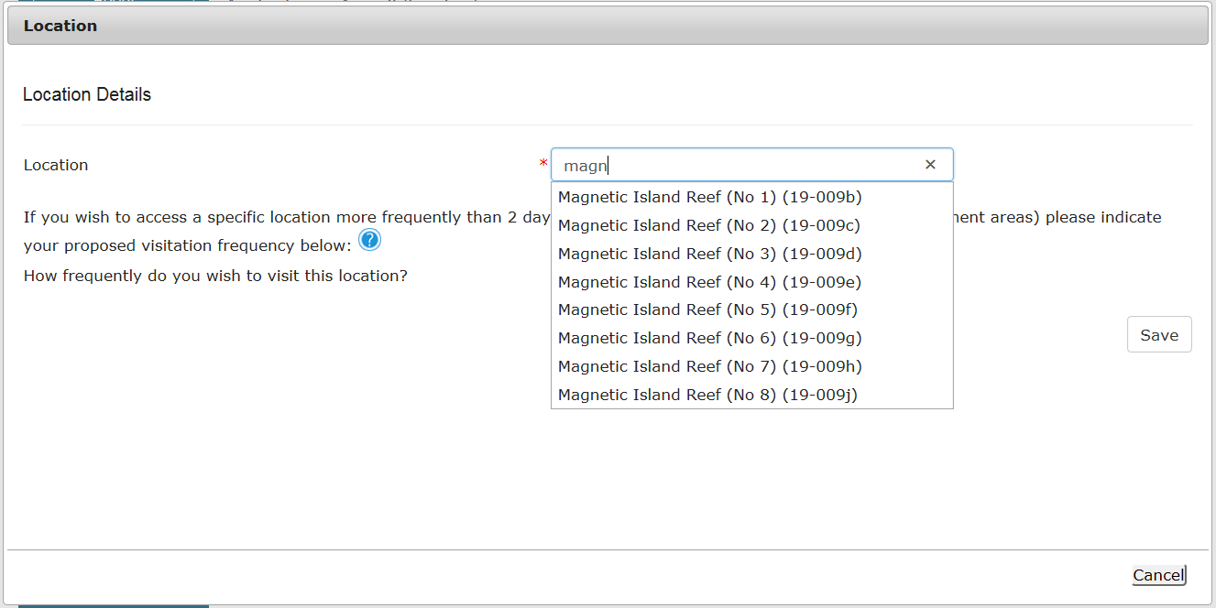
Figure 124 - Screenshot of ‘Location’ pop up window with locations to select

Add the frequency at which you wish to visit the location and select ‘Save’.
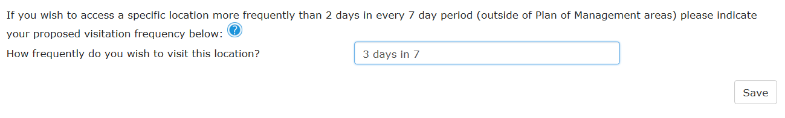
Figure 125 - Screenshot of question - How frequently do you wish to visit this location? with information completed.

The location will be reflected on the Location and Frequencies page within the locations table. If you wish to remove the location, select the Remove button next to the location.
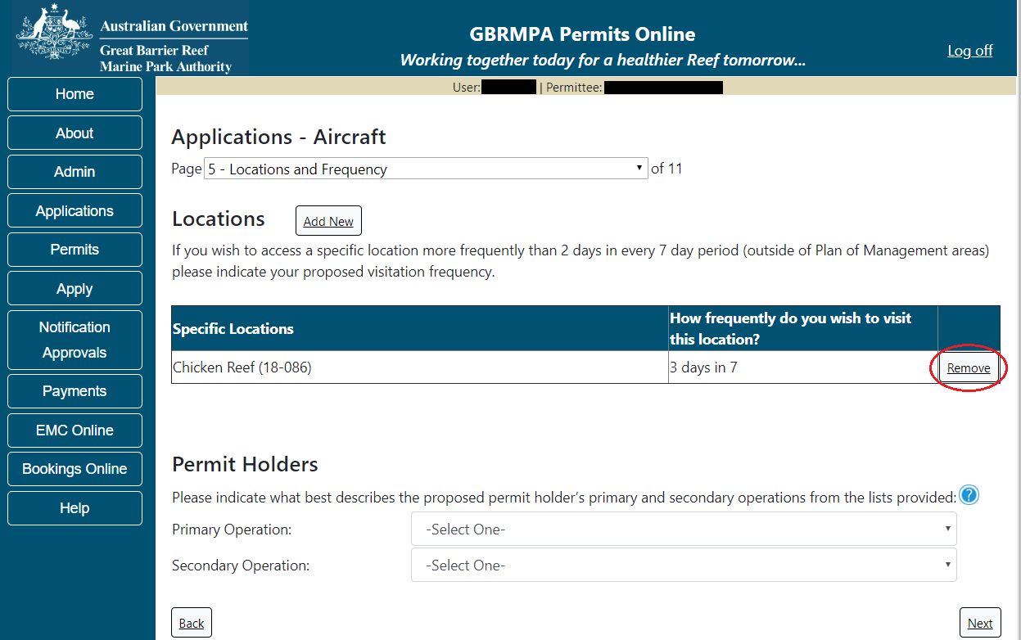
Figure 126 - Screenshot of Location and Frequency screen with information displaying and a red circle around Remove button
Please also provide details of what best describes the proposed Permit Holder’s primary and secondary operations from the two (2) lists located towards the bottom of the page. For this type of application, select Aircraft. This information assists our Tourism and Commercial section in providing relevant information for your operation over the life of your permit. Select Next to continue.
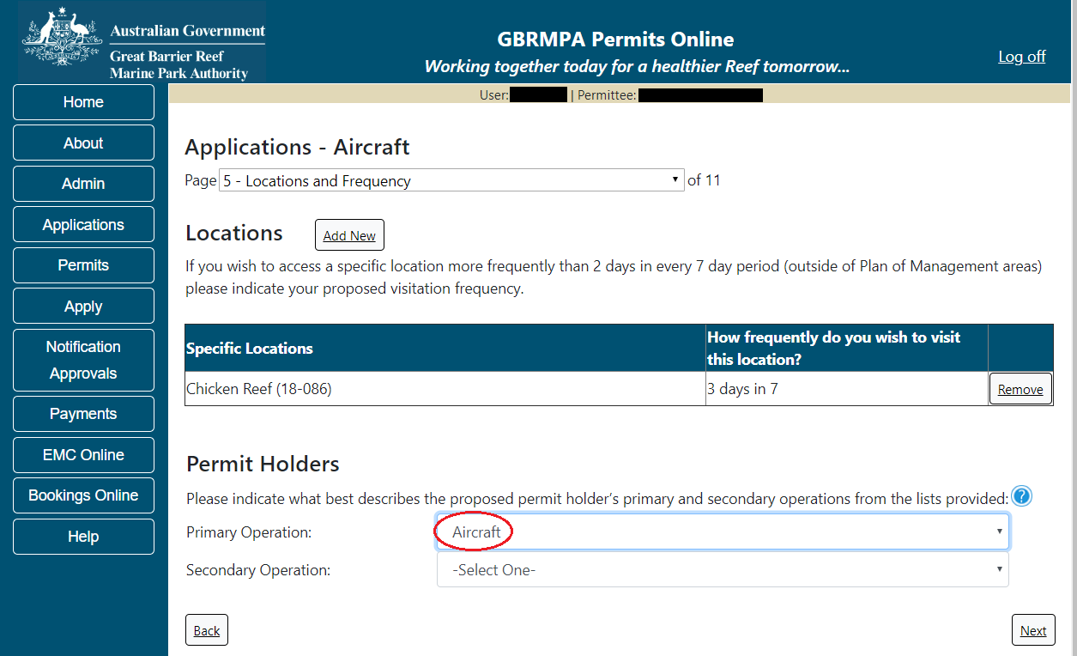
Figure 127 - Screenshot of Locations and Frequency screen with a red circle around Aircraft in the Permit Holders section

Page 6 of Aircraft application refers to Additional State Access. If you wish to extend your operations to include mainland or island national parks adjoining the Marine Parks and/or rivers and streams between Mission Beach and the Starcke River, select Yes and an area will appear with Please specify details. Add details of the islands or national parks and/or River and streams you wish to access.
Please also indicate whether you wish to conduct operations in the Green Island Recreational Area of Management. Once completed select Next to continue.
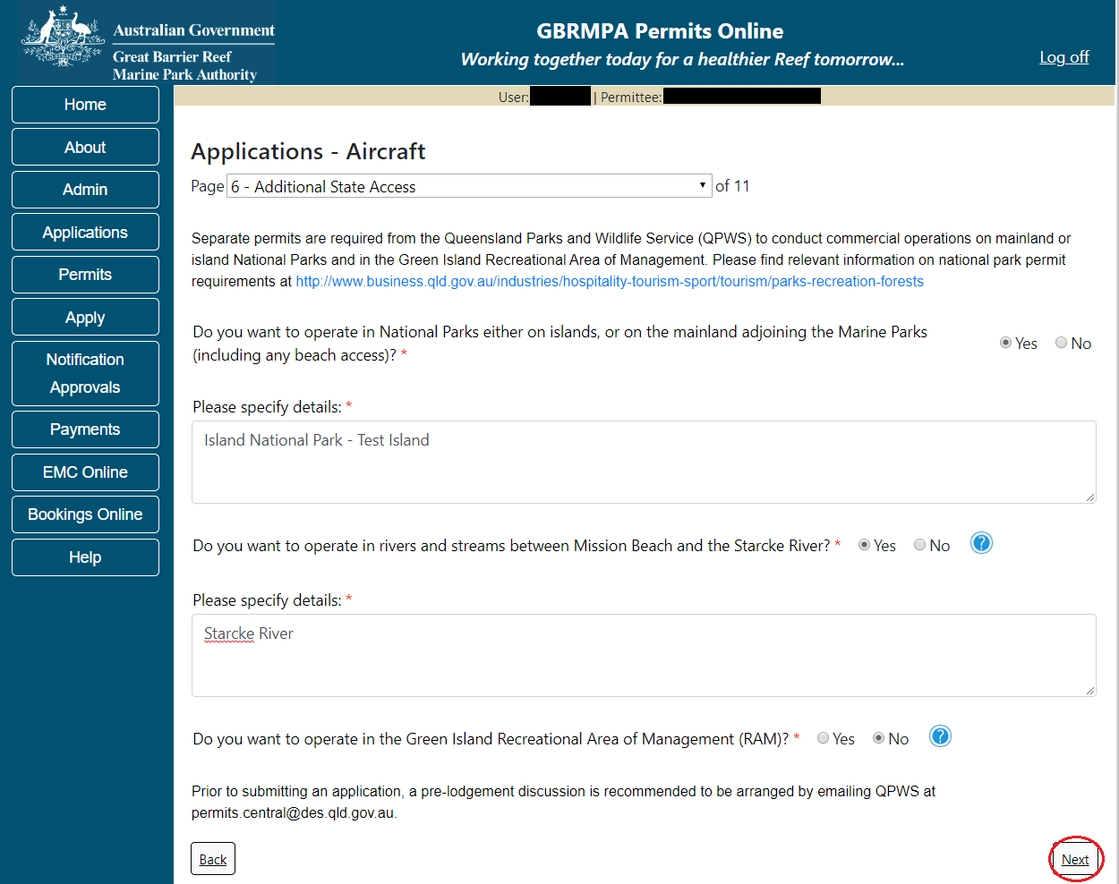
Figure 128 - Screenshot of Additional State Access screen with information displaying and a red circle around Next button

Page 7 of Aircraft application asks for the number of aircraft you propose to use in the Marine Parks. Add the details of the number of passengers, then select Next.
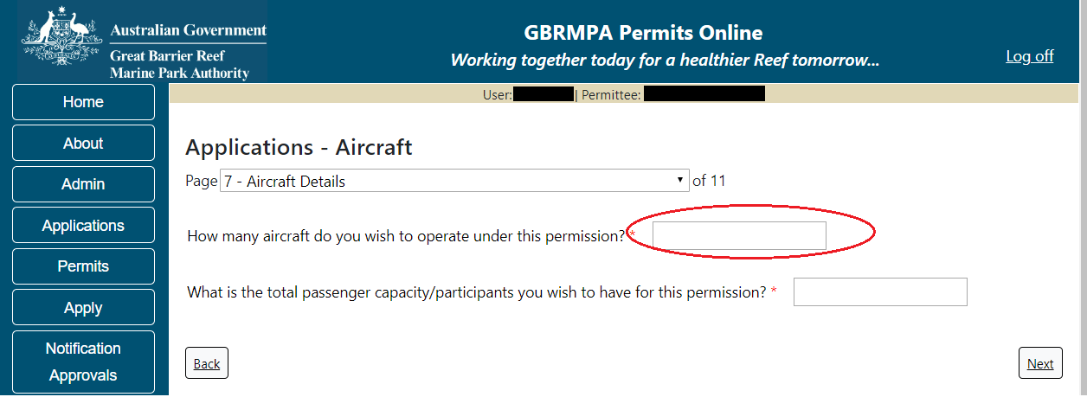
Figure 129 - Screenshot of Application details Aircraft screen with a red circle around question How many aircraft do you wish to operate under this permit

Please note that this is the total number of passengers you propose to cater for, across all vessels and/or activities. This number determines the appropriate Permit Application Assessment Fee. Current fees are published on the Reef Authority’s website. Select Next to continue.
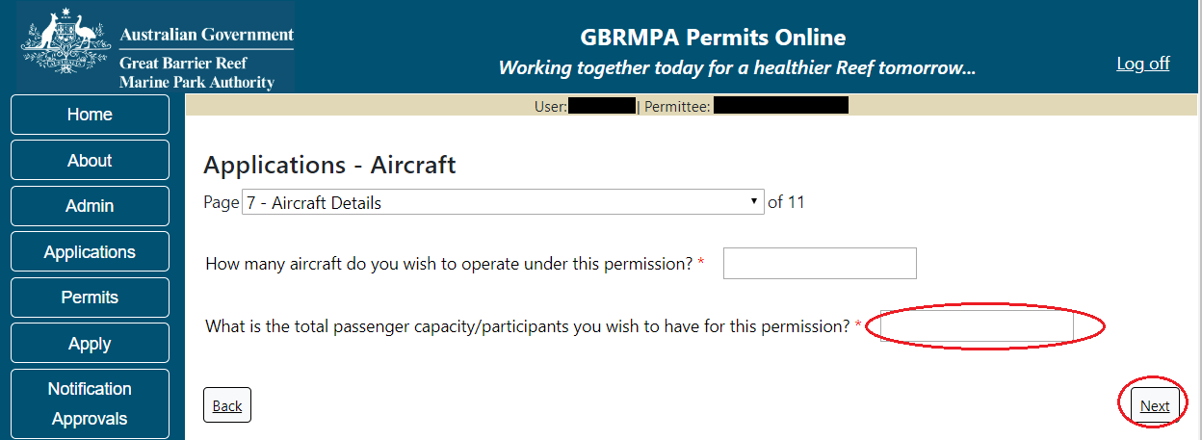
Figure 130 - Screenshot of Application details Aircraft with a red circle around the Total passenger field

Page 8 of Aircraft application asks for details of the aircraft to be used in the Marine Parks. This is optional at this stage, however details of the aircraft must be provided to, and approved by the Reef Authority prior to operating the aircraft in the Marine Parks. You can notify the Reef Authority of your aircraft details using the Notification Approvals menu on the left of screen later.
You can use the Add New Aircraft button to provide aircraft details as part of your permit application if you wish.
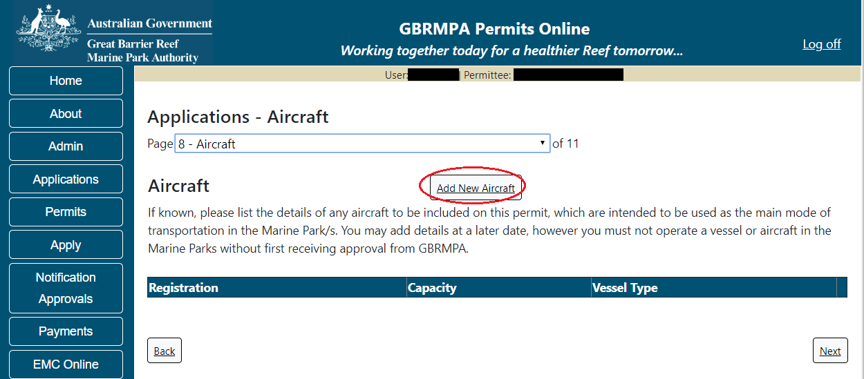
Figure 131 - Screenshot of Aircraft screen with red circle around Add New Aircraft button

To add an aircraft select the Add New Aircraft button; an Add New Aircraft pop up window will appear. Select the aircraft type from the list provided.
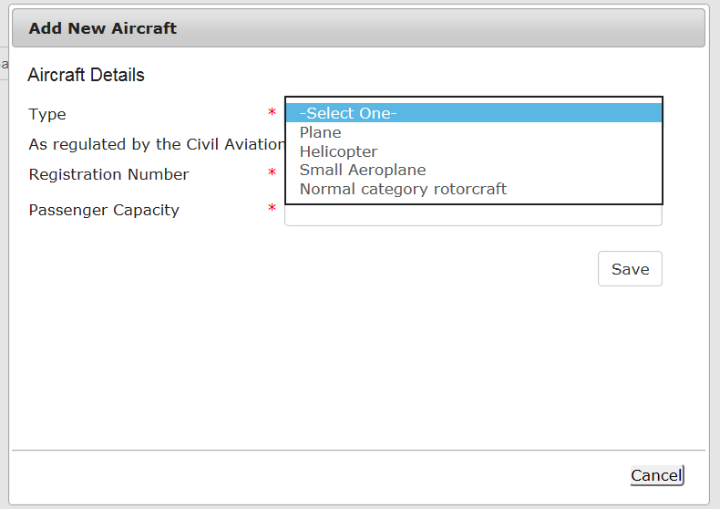
Figure 132 - Screenshot of Add New Aircraft pop up window with options to select from Type list

Please enter exact details of the aircraft you propose to operate in the Marine Parks then select Save
Figure 133 - Screenshot of Add New Aircraft pop up window with information completed and a red circle around Save button

Links are provided to the Civil Aviation Safety Authority explaining rules that apply to the operation of Planes and Helicopters.
The submitted details of your aircraft/s will save on the page, with a Remove button and an Edit button. If you need to remove the aircraft, select Remove. If you wish to edit the details, select Edit. Click next to continue.
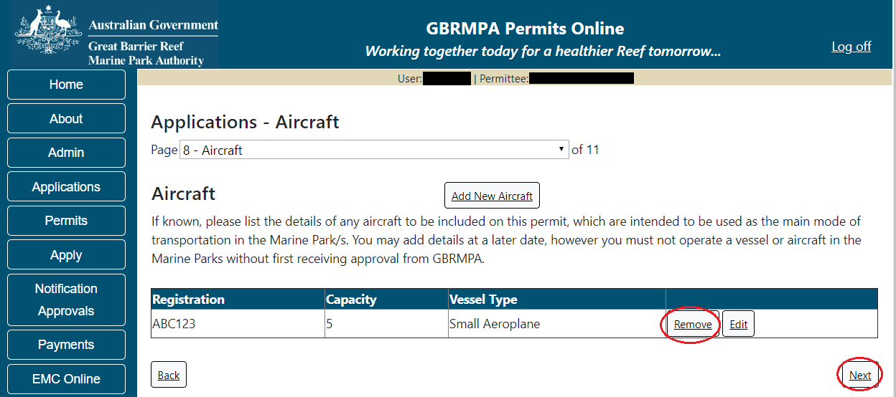
Figure 134 - Screenshot of Aircraft screen with information displaying and a red circle around the Remove and Edit buttons and a red circle around the Next button
Page 9 of aircraft application is ancillary vessels and equipment. To add details of ancillary vessels or equipment, select Add New.
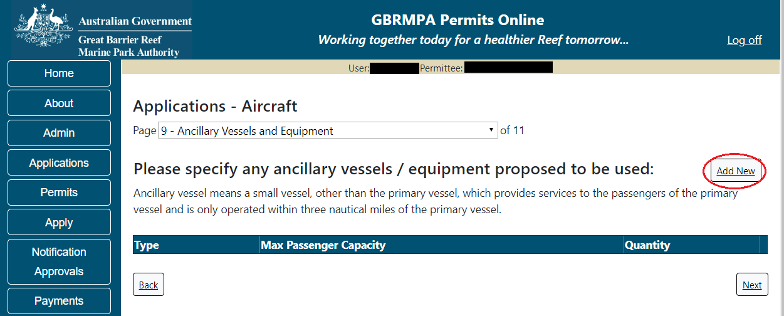
Figure 135 - Screenshot of Ancillary Vessels and Equipment page with a red circle around the Add New button

An Add New Ancillary Vessels/Equipment window will appear.
Figure 136 - Screenshot of Add Ancillary Vessels / Equipment pop up window

Select Ancillary Vessels or Equipment from the Device list
Figure 137 - Screenshot of Add Ancillary Vessels / Equipment displaying the Device list

Add details of the ancillary vessels or equipment, then select Save. Maximum passenger capacity here refers to the number of passengers each ancillary vessel or piece of equipment can carry individually.
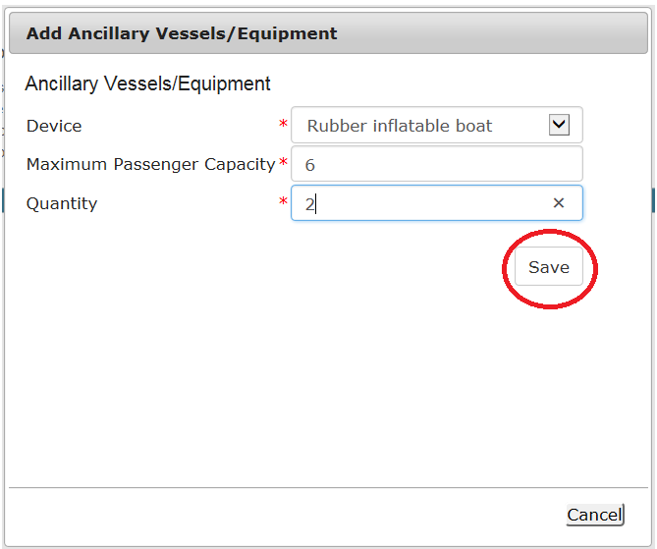
Figure 138 - Screenshot of Add Ancillary Vessels / Equipment with information completed and a red circle around the Save button
The details of ancillary vessels or equipment will appear on the screen. A Remove button and an Edit button is also presented. If you need to remove the aircraft, select Remove. If you wish to edit the details, select Edit. Select Next to continue.
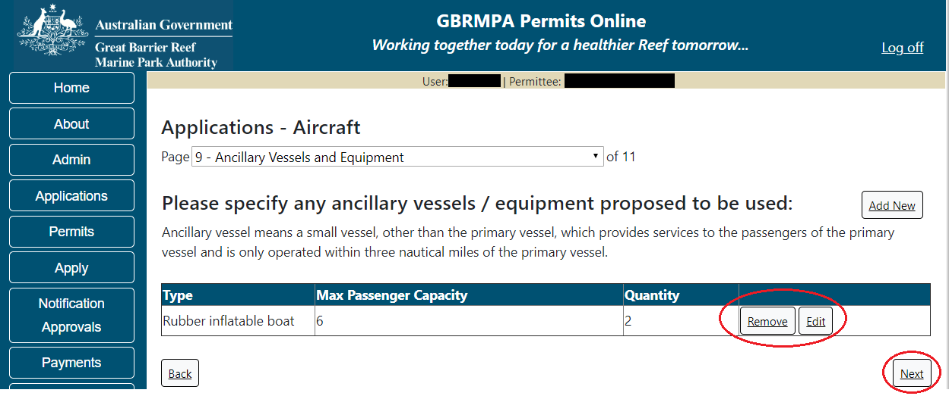
Figure 139 - Screenshot of Ancillary Vessels and Equipment page displaying information with a red circle around the Remove and Edit buttons and a red circle around the Next button

Page 10 of the Aircraft application refers to High Standard Tourism operators. If you have obtained a High Standard Tourism certification with an approved certification scheme, select Yes.
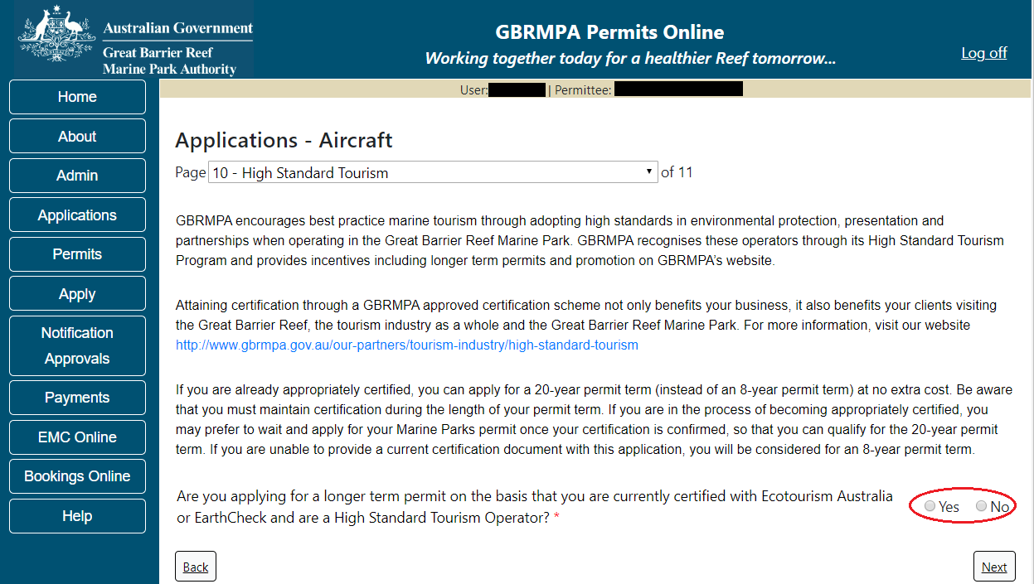
Figure 140 - Screenshot of High Standard Tourism page with red circle around Yes and No options

Once the Yes button is selected an upload file button will appear. Select the upload file button.
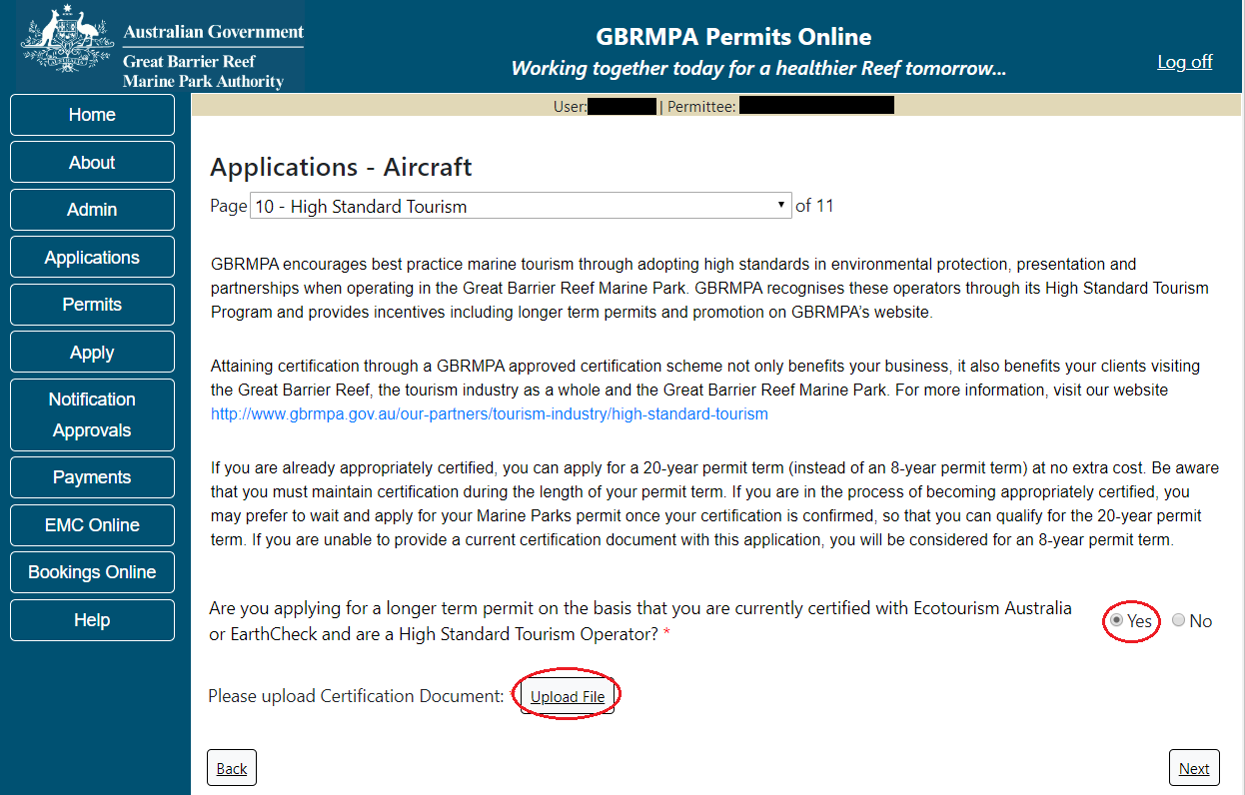
Figure 141 - Screenshot of High Standard Tourism page with a Yes selected and a red circle around Yes and Upload File button

The File Upload screen will appear. Select Browse
Figure 142 - Screenshot of Upload File pop up window

Once you load a copy of your certificate, you will see the filename with a Remove option beside it. If you wish to remove the file, select the Remove button. Select Next to go to the next page.
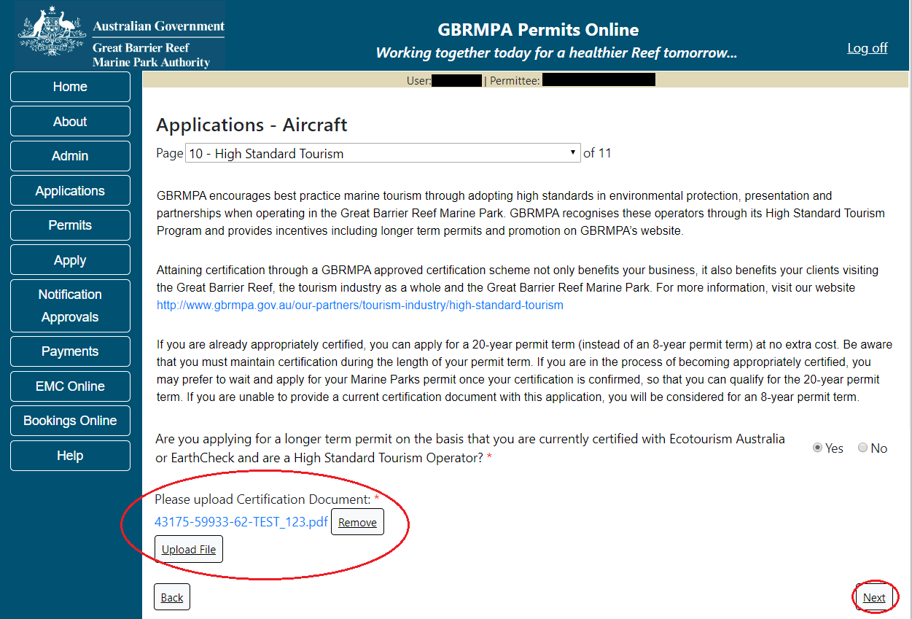
Figure 143 - Screenshot of High Standard Tourism screen with Yes selected and a red circle around the Uploaded File and Next button
Page 11 provides opportunity for you to add any other information you feel will assist the Managing Agencies in assessing your application. Add supporting information by typing in the text field or upload a file if required. If a file is uploaded it will appear on the screen with the file name and an Remove to remove the file if uploaded in error.
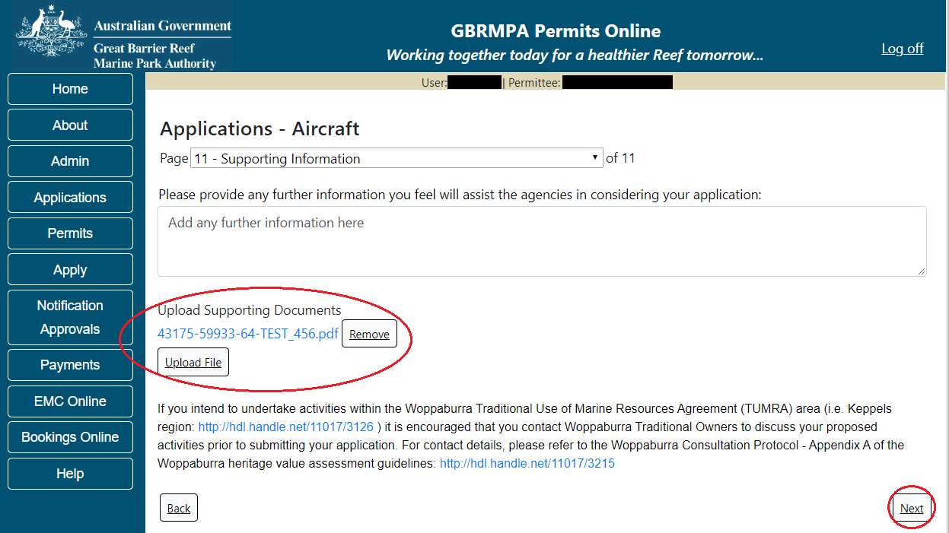
Figure 144 - Screenshot of Supporting Information screen with a red circle around Uploaded File area and a red circle around Next button
Once you have completed the supporting information page select Next from the last page of the application questions, you will progress to an application summary screen with a number of options available via links or buttons. Select Next on the summary screen to progress to the Declarations screens.
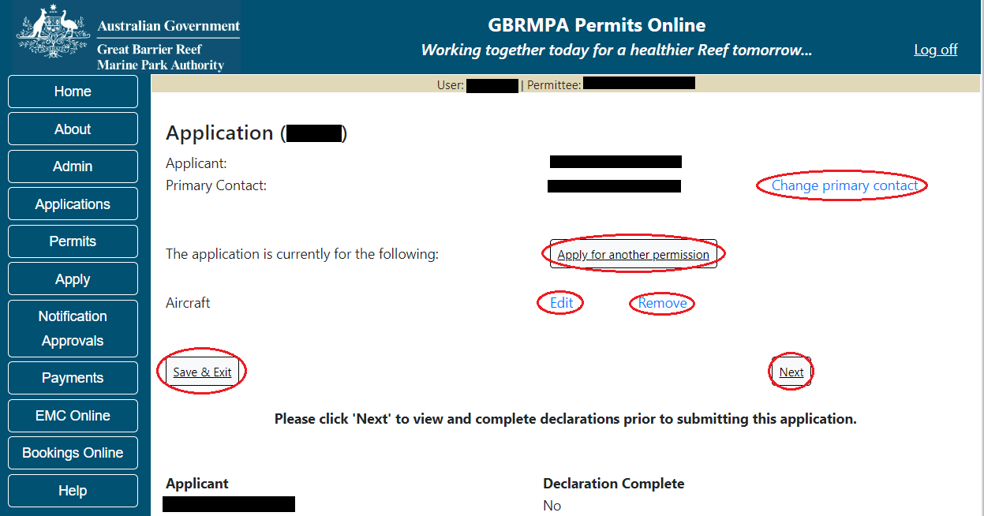
Figure 145 - Screenshot of Application Summary page with red circles around all options available

Additional Information - Summary screen, links and buttons;
- Change primary contact: If the change primary contact link is selected the applicant will progress to the primary contact page where the primary contact can be changed.

- Apply for another permission: If the apply for another permission button is selected, the applicant will progress to the What are you seeking to do in the Marine Parks page where another permission type can be added. (e.g. add a mooring permission to the tourism permission).

- Edit: If edit is selected the application/permission will be reopened to apply any changes.

- Remove: If remove is selected the application/permission will be removed.

- Save & Exit: If the Save & Exit button is selected the applicant will progress to the applications screen.

- Next: If next is selected the applicant will progress to the submission process including declaring and submitting the application.

Completion of a set of declarations is mandatory prior to submitting your application. To complete the declarations section of this application, you must either be the applicant, or if applying on behalf of an organisation / company / government agency, you must be a Director of that organisation / company / government agency. Authorised contacts cannot complete the declaration section, as it contains legally binding commitments in place of a physical signature.
Please read all questions carefully, provide a response to each, and select Next.
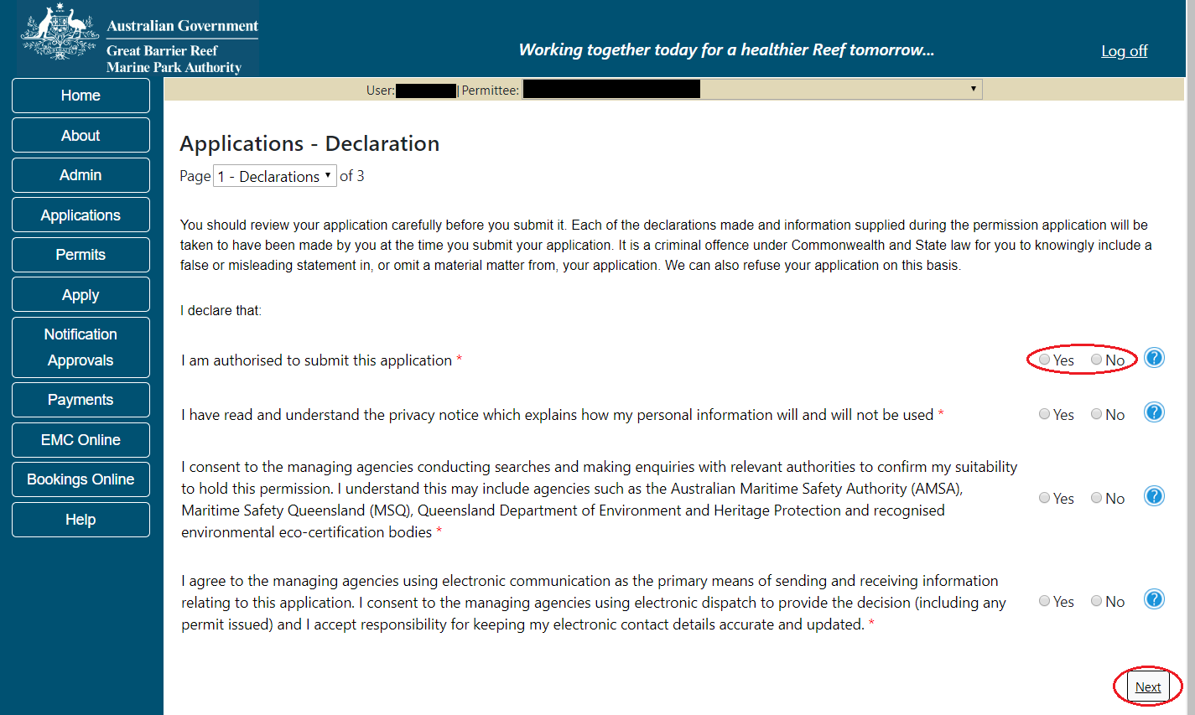
Figure 146 - Screenshot of Declarations page with red circle around Yes and No options and Next button

On the final page of declarations there is a Submit button. Once the Submit button is selected, the application will be submitted to the Reef Authority and is no longer available to be edited. The status of the application on the Applications screen will then display ‘Submitted to GBRMPA’. The application’s Primary Contact will receive an emailed acknowledgement notice from a delegated Assessment Officer within 10 business days.
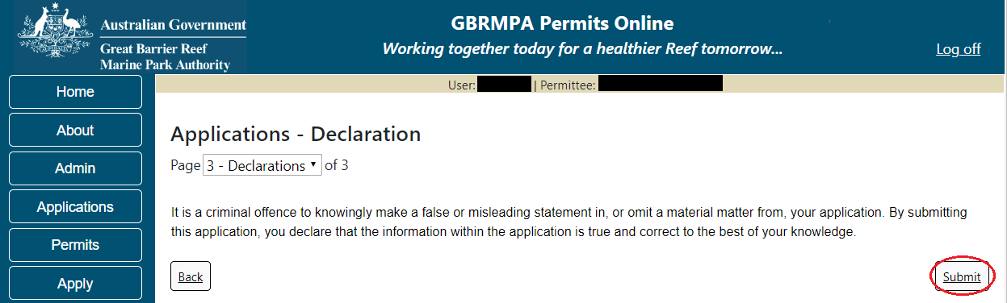
Figure 147 - Screenshot of Declarations screen with a red circle around the Submit button
Once you submit your application, you are reminded of your application number and provided further information on the assessment process.
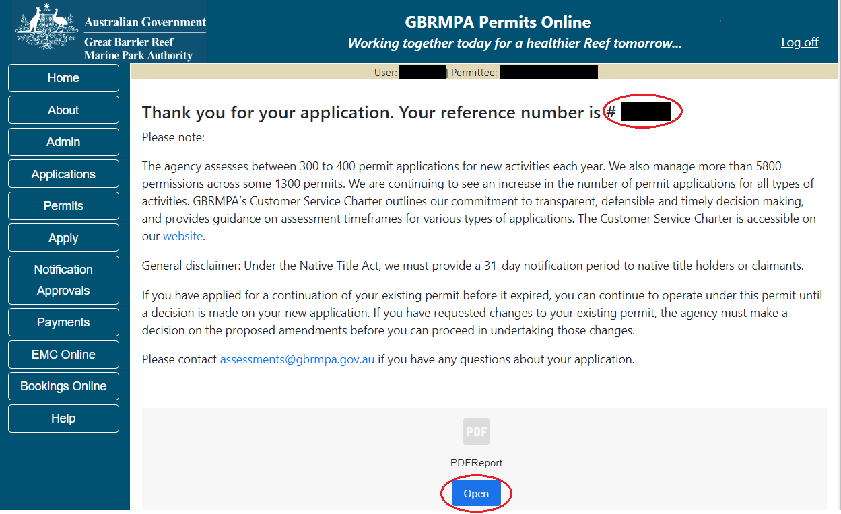
Figure 148 - Screenshot of the Thank you for your application screen with a red circle around Reference number and a red circle around the open pdf button

Your application will appear in the Applications screen with the reference/application number also displayed. You have further options to view a summary of your application, email the Reef Authority or withdraw the application.
Figure 149 - Screenshot of Applications screen with a red circle around Application No., Summary, Email and Withdraw options

  - Tourism – Bareboats
Apply – new permit application – other tourism activities – bareboat
To apply for Other Tourism and Charter Activities, select this option on the Apply – What are you seeking to do in the Marine Parks page.
Figure 150 - Screenshot of Apply - What are you seeking to do in the Marine Parks screen with Other Tourism and Charter Activities selected and a red circle around the Next button

You will progress to the application types sub menu, where you can choose which type of Tourism or charter activity you wish to apply for (example used is Bareboat). Select Next to progress to the application questions.
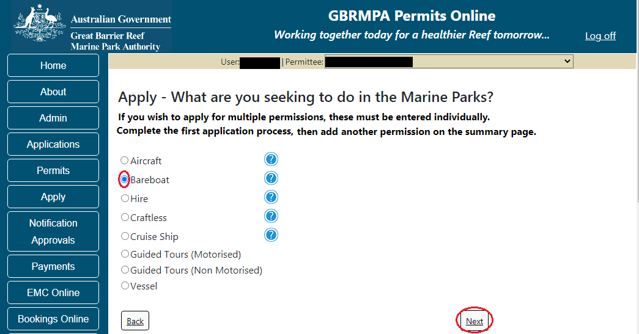
Figure 151 - Screenshot of Apply - What are you seeking to do in the Marine Parks - Other Tourism and Charter Activities sub menu screen with Bareboat selected and a red circle around Next button
Page 1 of Bareboat application is the Environment Protection and Biodiversity Conservation Act page. This provides advice on matters of national environmental significance that must be considered when assessing an application. This screen is for your information only at this stage. Your assessing officer will contact you if it is determined to be relevant for your application.
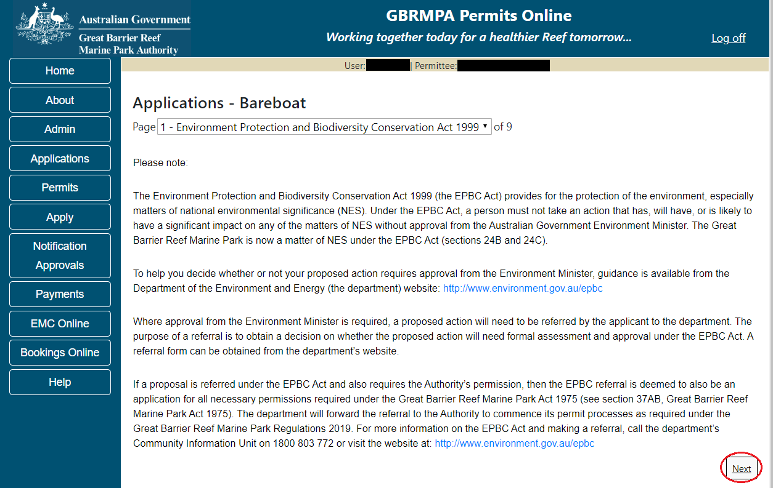
Figure 152 - Screenshot of Environment Protection Biodiversity Conservation page with red circle around Next button

Links on the Environment Protection and Biodiversity Conservation page www.environment.gov.au/epbc will take you to the Department of Climate Change, Energy, the Environment and Water site. Here you can find information about the Environment Protection and Biodiversity Conservation Act 1999 and your obligations under the Act.

Page 2 of Bareboat application is the Permissions and Activities page.
Default permissions and activities for this type of application are listed.
If there are activities you do not wish to include on your permit, you can remove them by selecting the Remove button next to the activity.
Please note that if you remove an activity, you are no longer permitted to undertake that activity in the Marine Parks. Please consider potential future usage of your permit when removing or adding activities.
For some permissions, additional activities can be added using the Add new option. To apply for an entirely different permission (e.g. to install a mooring or operate a vessel program), please complete this application, then use the Add New permission option on the summary screen.
Select Next to continue.
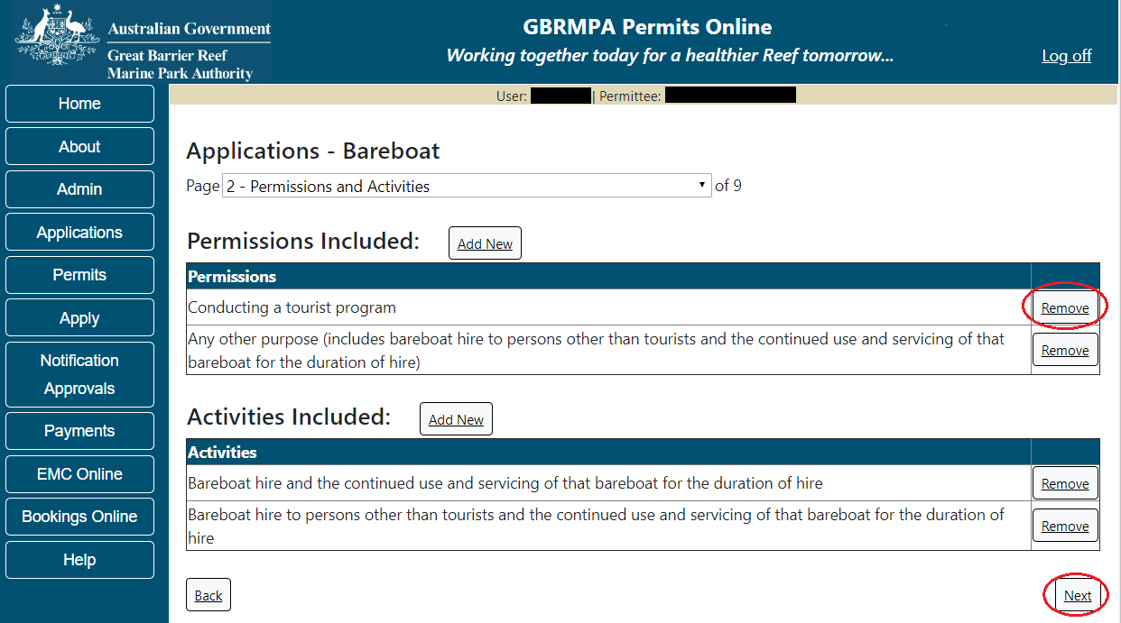
Figure 153 - Screenshot of Permissions and Activities screen with a red circle around Remove button and Next button

Page 3 of Bareboat application is the Total Passenger Capacity / Participants page. Please select the number of participants you wish to cater for across all activities in the Marine Parks in this section, considering any future business growth potential. Your answer to this question will determine the appropriate Permit Application Assessment Fee for the application. Select Next to continue.
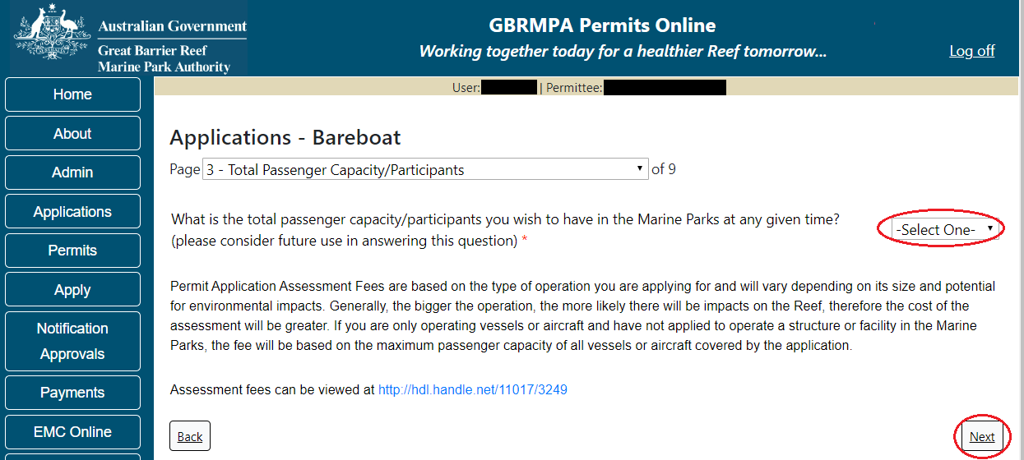
Figure 154 - Screenshot of the Total Passenger Capacity / Participants page with a red circle around the Select One drop list and a red circle around the next button

Page 4 of Bareboat application allows you to select the management area/s in which you wish to operate. Please consider potential future use when making this decision. For bareboat applications no areas are selected as default. Please select the Management Area/s in which you wish to operate. Select all if you wish to operate in all management areas, considering future use.
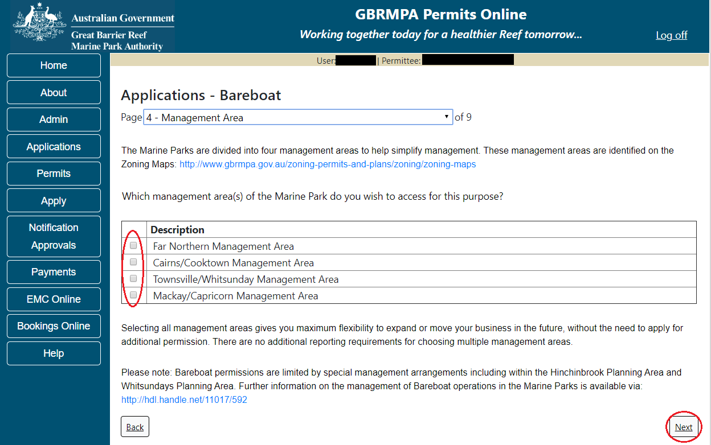
Figure 155 - Screenshot of Management Area page with red circle around tick boxes to select and a red circle around Next button
Page 5 of Bareboat application refers to Additional State Access. If you wish to extend your operations to include mainland or island national parks adjoining the Marine Parks and/or rivers and streams between Mission Beach and the Starcke River, select Yes and an area will appear with Please specify details. Add details of the islands or national parks and/or River and streams you wish to access.
Please also indicate whether you wish to conduct operations in the Green Island Recreational Area of Management. Once completed select Next to continue.
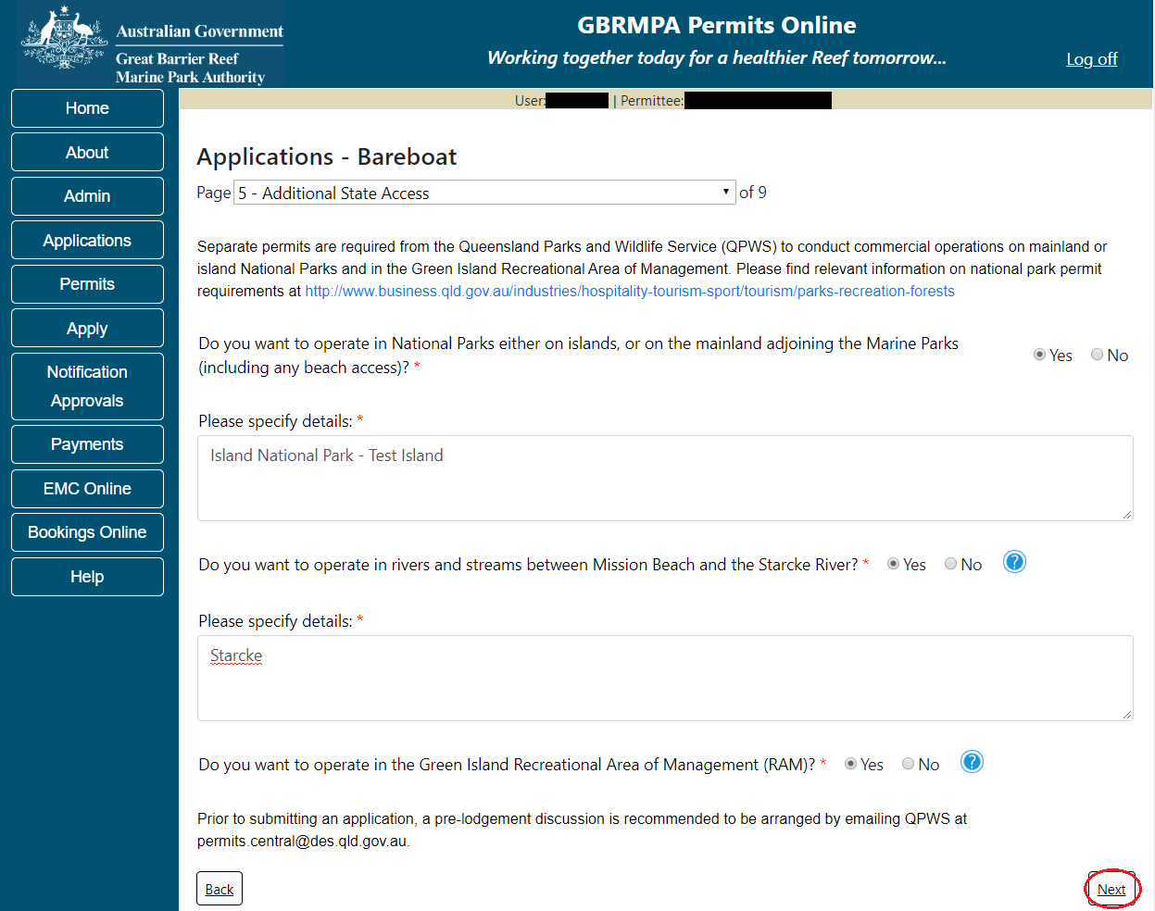
Figure 156 - Screenshot of Additional State Access screen with information displaying and a red circle around Next button

Page 6 of Bareboat application is the vessel details page. Add in the number of vessels you wish to apply for in the field marked How many vessels do you wish to operate under this permit?
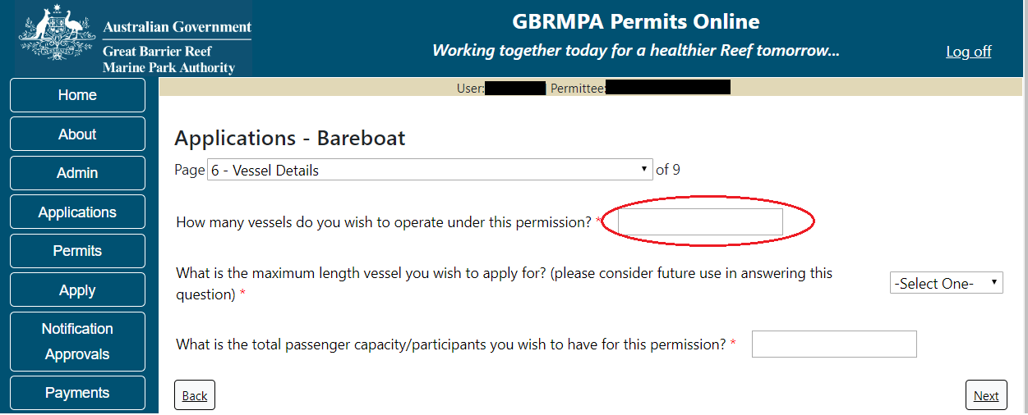
Figure 157 - Screenshot of Vessel details screen with a red circle around field to enter - How many vessels do you wish to operate under this permit

Select your proposed vessel length from the list provided.
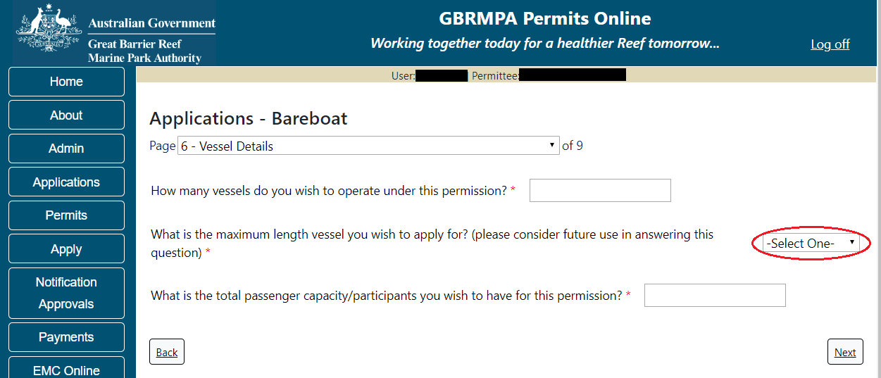
Figure 158 - Screenshot of Vessel details page with a red circle around Vessel maximum length list

Add your proposed passenger number from the list provided. Once you have completed the vessel numbers, length and passengers select Next. Please note that this is the total number of passengers you propose to cater for, across all vessels and/or activities.
This number determines the appropriate Permit Application Assessment Fee. Current fees are published on Reef Authority’s website. Select Next to continue.
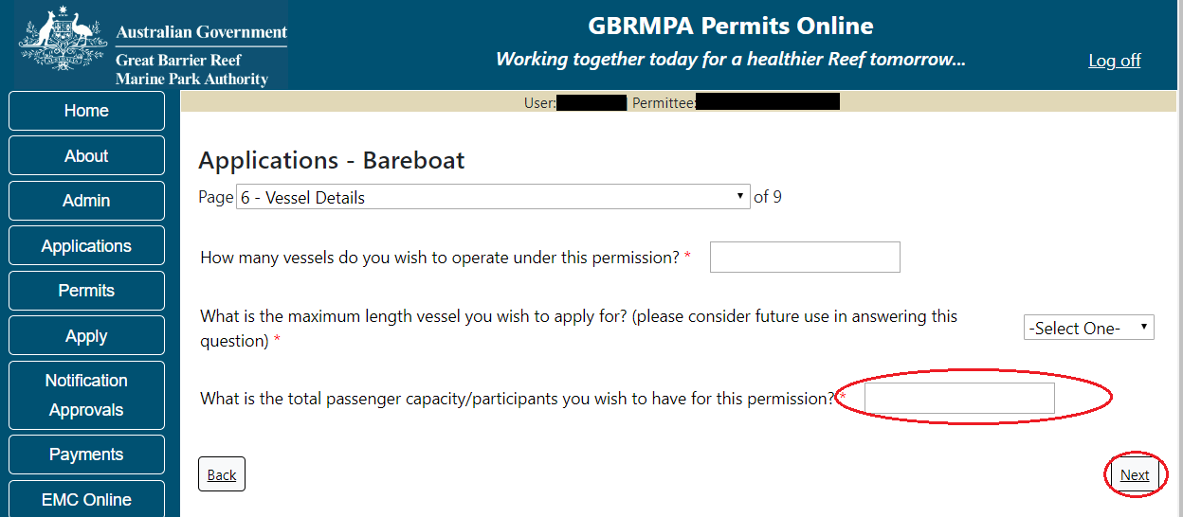
Figure 159 - Screenshot of Vessel details screen with a red circle around total passengers field list and Next button

Page 7 of Bareboat application refers to the vessels proposed to be used in the Marine Parks. On this page, add the details of each Bareboat you wish to operate. (NOTE: If you have multiple bareboats, each boat will need to be entered individually). Select the Add New button to enter details of Bareboat/s.
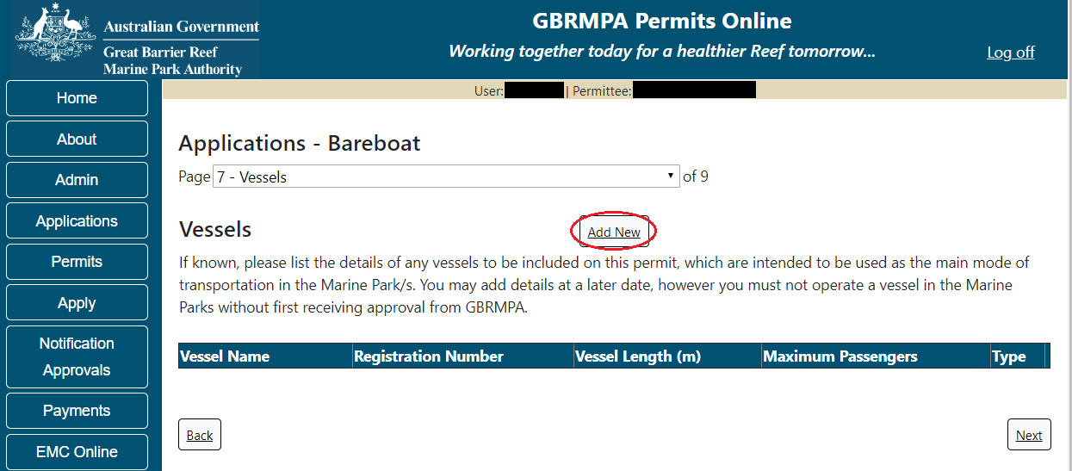
Figure 160 - Screenshot of Vessels screen with red circle around Add New button

An Add New Vessel pop up window will appear with fields for Name, Registration Number, Length (in metres), Passenger Capacity and the vessel type.
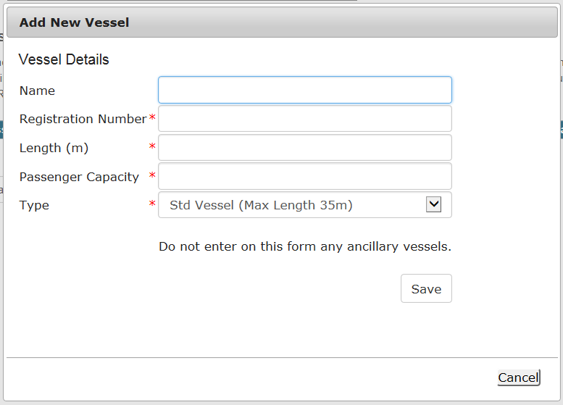
Figure 161 - Screenshot of Add New Vessel pop up window

Add the details of each vessel and select Save
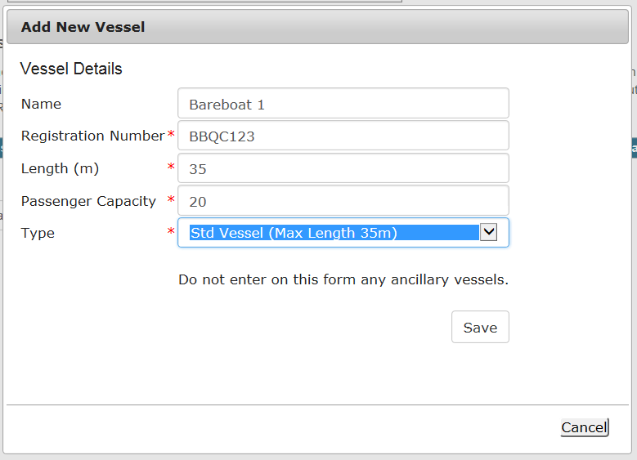
Figure 162 - Screenshot of Add New Vessel pop up window with information entered

The details of your vessel/s will save on the page, with a Remove button and an Edit button. If you need to remove the vessel, select Remove. If you wish to edit the details, select Edit. Select Next to continue.
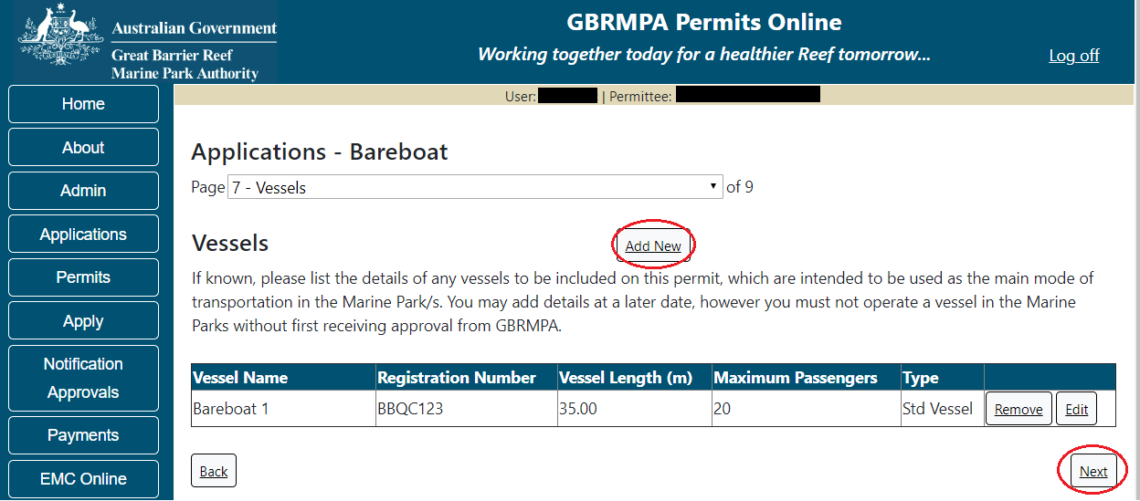
Figure 163 - Screenshot of Vessels page with information displayed and a red circle around Next button

Page 8 of Bareboat application refers to High Standard Tourism operators. If you have obtained a High Standard Tourism certification with an approved certification scheme, select Yes then upload a copy of your certificate using the upload feature.
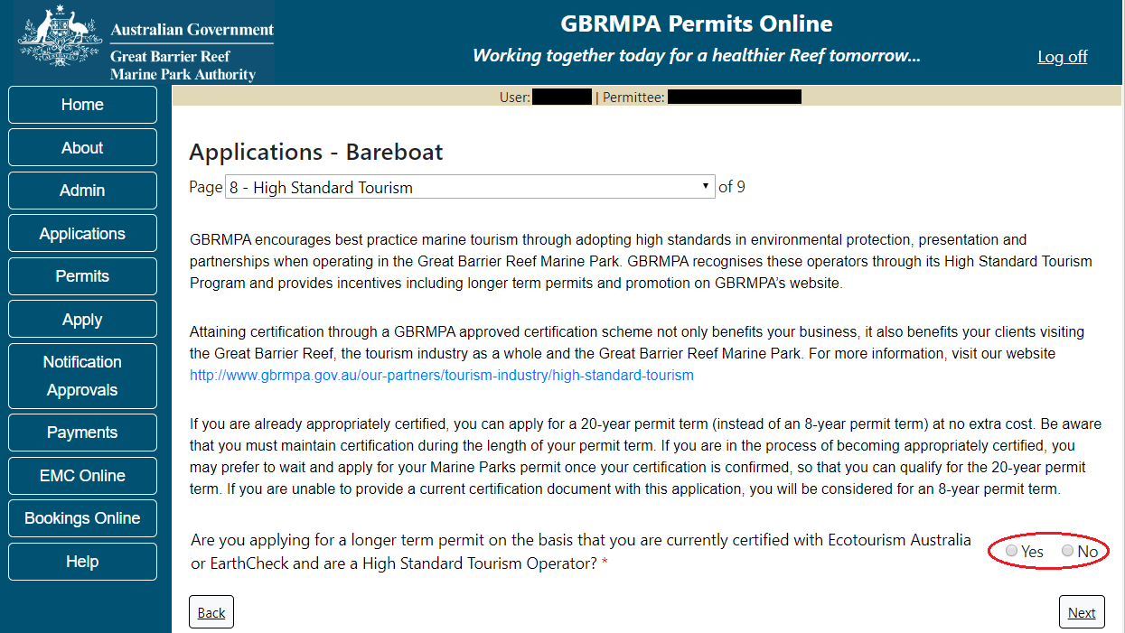
Figure 164 - Screenshot of High Standard Tourism page with red circle around Yes and No options
Once the Yes button is selected, an upload file button will appear. Select the upload file button.
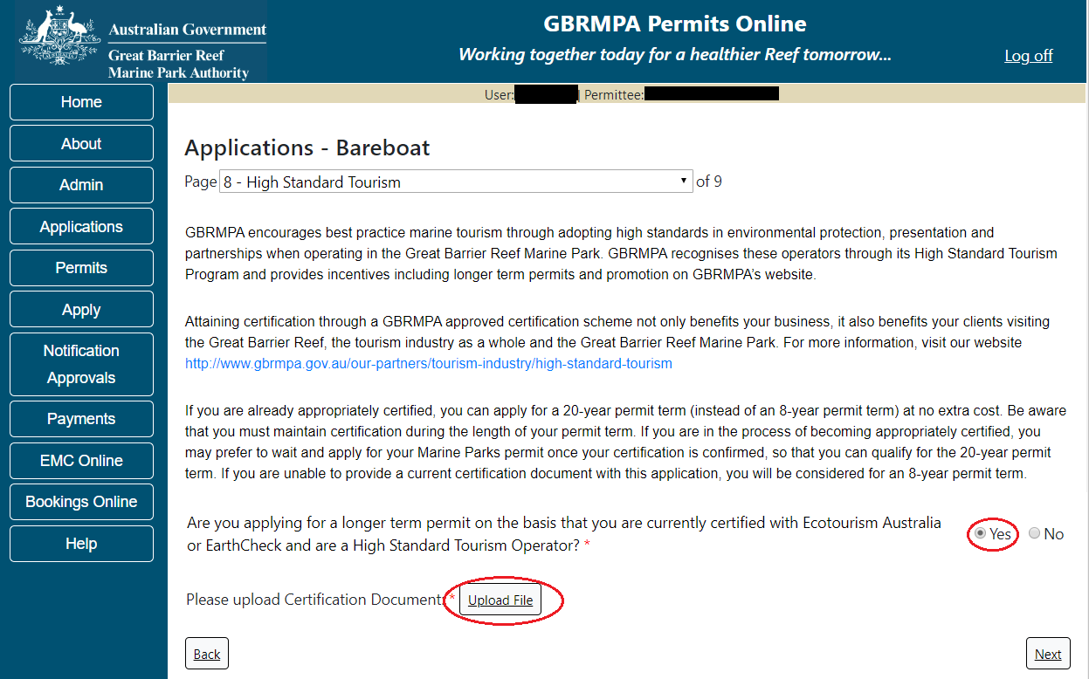
Figure 165 - Screenshot of High Standard Tourism page with Yes selected and circled and Upload File button circled

The File Upload screen will appear. Select Browse
Figure 166 - Screenshot of Upload File pop up window

Once you load a copy of your certificate, you will see the filename with a Remove button next to it. If you wish to remove the file, select the Remove button. Select Next to go to the next page.
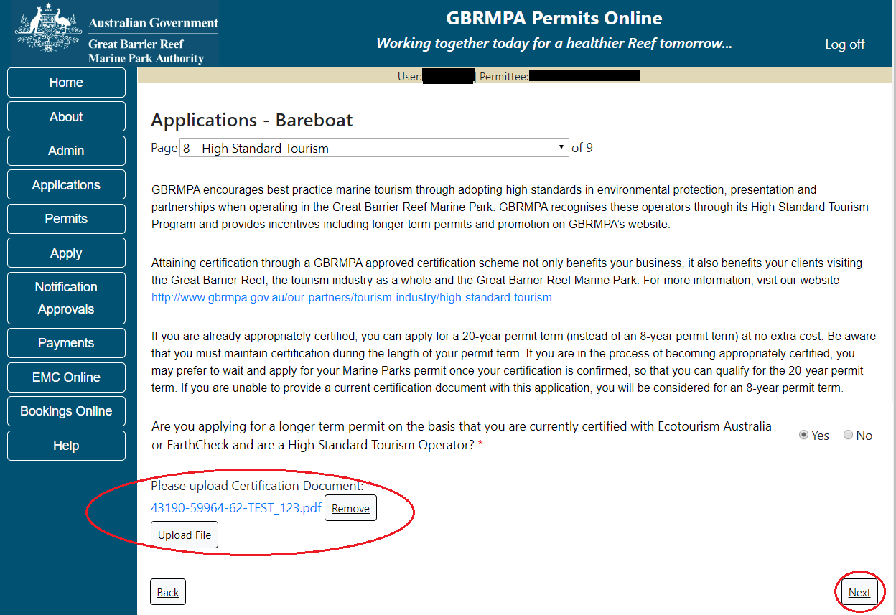
Figure 167 - Screenshot of High Standard Tourism page with Yes selected and a red circle around the Uploaded File and red circle around Next button

Page 9 of Bareboat application provides opportunity for you to add any other information you feel will assist the Managing Agencies in assessing your application. Add supporting information by typing in the text field or upload a file if required. If a file is uploaded it will appear on the screen with the file name and a Remove button to remove the file if the wrong file is selected.
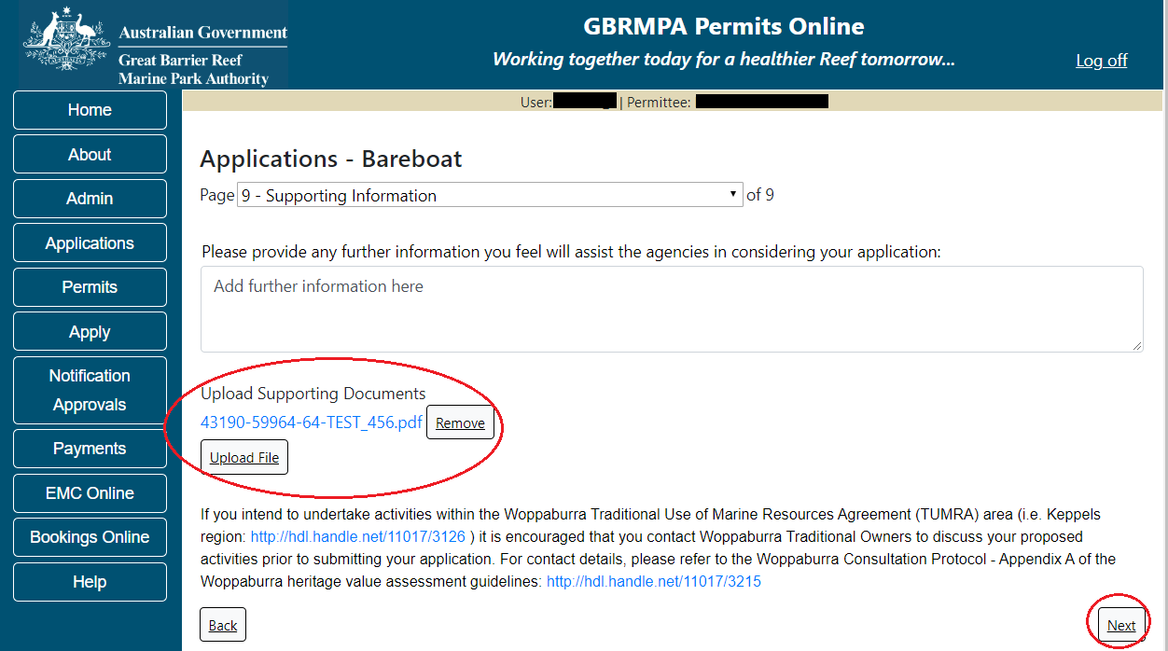
Figure 168 - Screenshot of Supporting Information screen with a red circle around Uploaded File area and a red circle around Next button
Once you have completed the supporting information page select Next from the last page of the application questions; you will progress to an application summary screen with a number of options available via links or buttons. Select Next on the summary screen to progress to the Declarations screens.
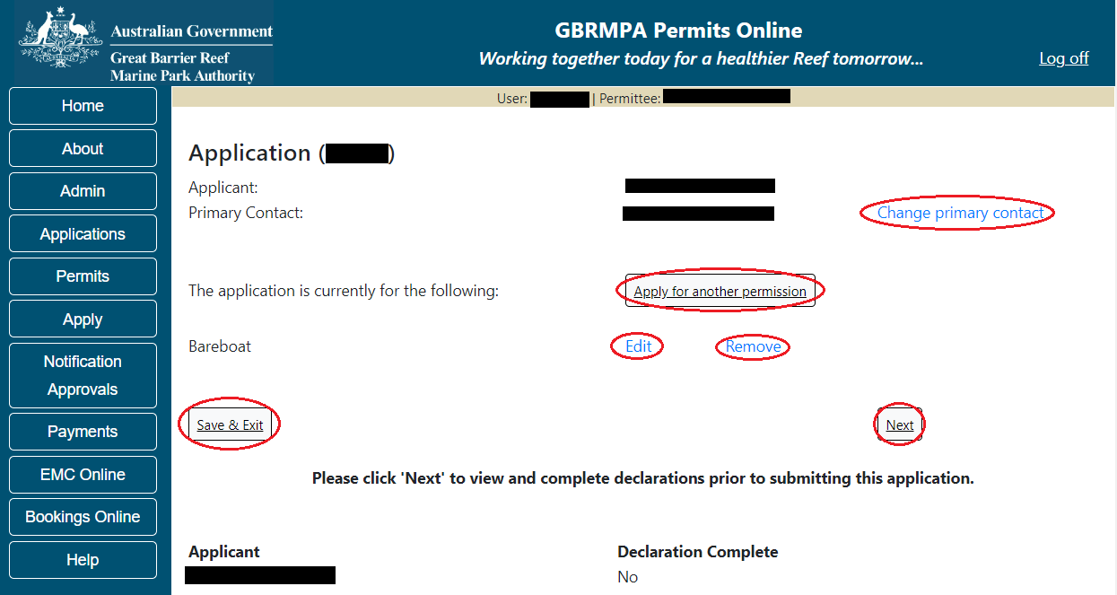
Figure 169 - Screenshot of Application Summary page with red circles around all options available

Additional Information - Summary screen, links and buttons;
- Change primary contact: If the change primary contact link is selected the applicant will progress to the primary contact page where the primary contact can be changed.

- Apply for another permission: If the apply for another permission button is selected, the applicant will progress to the What are you seeking to do in the Marine Parks page where another permission type can be added. (e.g. add a mooring permission to the tourism permission).

- Edit: If edit is selected the application/permission will be reopened to apply any changes.

- Remove: If remove is selected the application/permission will be removed.

- Save & Exit: If the Save & Exit button is selected the applicant will progress to the applications screen.

- Next: If next is selected the applicant will progress to the submission process including declaring and submitting the application.

Completion of a set of declarations is mandatory prior to submitting your application. To complete the declarations section of this application, you must either be the applicant, or if applying on behalf of an organisation / company / government agency, you must be a Director of that organisation / company / government agency. Authorised contacts cannot complete the declaration section, as it contains legally binding commitments in place of a physical signature.
Please read all questions carefully, provide a response to each, and select Next.
Figure 170 - Screenshot of Declarations page with red circle around Yes and No options and Next button

On the final page of declarations there is a Submit button. Once the Submit button is selected, the application will be submitted to the Reef Authority and is no longer available to be edited. The status of the application on the Applications screen will then display ‘Submitted to GBRMPA’. The application’s Primary Contact will receive an emailed acknowledgement notice from a delegated Assessment Officer within 10 business days.
Figure 171 - Screenshot of Declarations screen with a red circle around the Submit button
Once you submit your application, it is no longer available to be edited. The status of the application on the Applications screen will then display ‘Submitted to GBRMPA’. The application’s Primary Contact will receive an emailed acknowledgement notice from a delegated Assessment Officer within 10 business days.
Figure 172 - Screenshot of the Thank you for your application screen with a red circle around Reference number and a red circle around the open pdf button

Your application will appear in the Applications screen with the reference/application number also displayed. You have further options to view a summary of your application, email the Reef Authority or withdraw the application.
Figure 173 - Screenshot of Applications screen with a red circle around Application No., Summary, Email and Withdraw options

  - Tourism – Hire
Apply – new permit application – other tourism activities – hire
To apply for Other Tourism and Charter Activities, select this option on the Apply – What are you seeking to do in the Marine Parks page.
Figure 174 - Screenshot of Apply - What are you seeking to do in the Marine Parks screen with Other Tourism and Charter Activities selected and a red circle around the Next button

You will progress to the application types sub-menu, where you can choose which type of tourism or charter activity you wish to apply for (example used is Hire). Select Next to progress to the application questions.
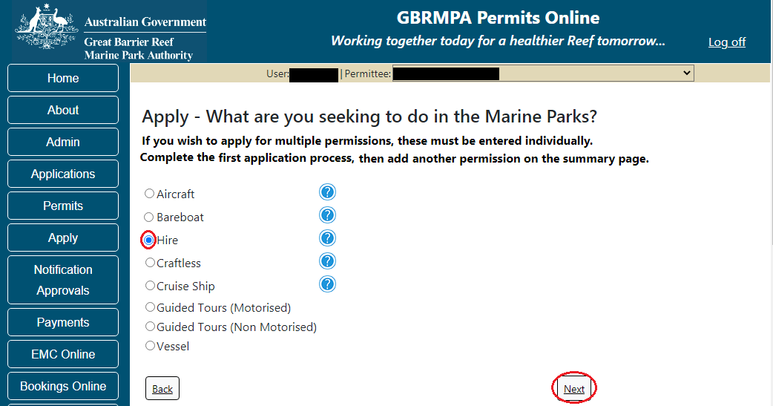
Figure 175 - Screenshot of Apply - What are you seeking to do in the Marine Parks - Other Tourism and Charter Activities sub menu screen with Hire selected and a red circle around Next button
Additional information - Hire operations
Beach equipment hire operations are focused close to resort areas and regional population centres. The craft and equipment hired usually includes motorised vessels such as dinghies, jet skis and personal watercraft non-motorised vessels such as kayaks, sailboards and surf skis and equipment such as snorkel gear.
Please note:
• There are special management arrangements for the Cairns, Hinchinbrook and Whitsunday Planning Areas, including sensitive locations and significant bird sites. You must only hire your craft from outside the Planning Areas, or in the Hinchinbrook area from intensive use locations and in the Whitsundays from setting 1 areas. The client using your equipment or craft may access the whole of the Planning Areas including sensitive sites and setting areas, providing that they are not performing motorised water sports.
• If you obtain a hire permission you must pay the Environmental Management Charge, even when there was no activity.
• There are specific management arrangements when you are conducting motorised water sports: http://www.gbrmpa.gov.au/zoning-permits-and-plans/responsible-reef-practices/motorised-water-sports.

Additional information - Environmental management charge
Please note: Quarterly fixed Environmental management charges (EMC) apply to hire operations depending on the number of pieces of equipment used. These charges apply even if there was no activity in that quarter.
Environmental management charge for non-motorised beach hire: Fewer than 6 pieces of equipment - $12 per quarter; Six or more pieces of equipment - $25 per quarter.
Environmental management charge for dinghy hire: Fewer than 6 dinghies - $50 per quarter; Six or more dinghies - $12 per dinghy per quarter.
Environmental management charge for motorised water sports*: Jet boats designed to carry no more than 2 persons - $25 per quarter; Motorised equipment that does not include jet boats - $62 per quarter; Jet boats and other motorised equipment - $87 per quarter; If the equipment is jet boats designed to carry no more than 2 persons and jet boats designed to carry more than 2 persons - $25 plus $87 per quarter.

Page 1 of Hire application is the Environment Protection and Biodiversity Conservation Act page. This provides advice on matters of national environmental significance that must be considered when assessing an application. This screen is for your information only at this stage. Your assessing officer will contact you if it is determined to be relevant for your application.
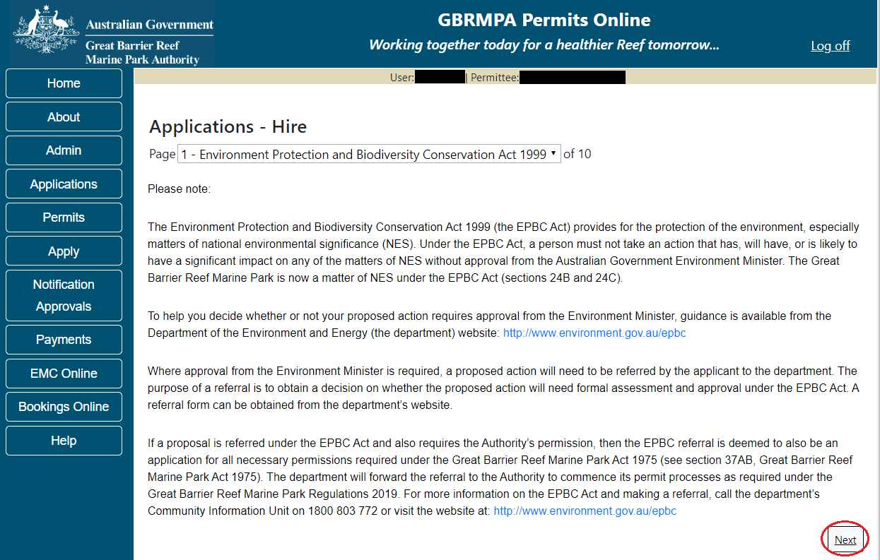
Figure 176 - Screenshot of Environment Protection and Biodiversity Conservation screen with a red circle around Next button

Links on the Environment Protection and Biodiversity Conservation page www.environment.gov.au/epbc will take you to the Department of Climate Change, Energy, the Environment and Water site. Here you can find information about the Environment Protection and Biodiversity Conservation Act 1999 and your obligations under the Act.

Page 2 of Hire application is the Permission and Activities page. All permissions and activities listed are available and will be included in the application. If there are any activities you do not wish to retain permission for, you can remove them by selecting the Remove button next to the activity. Select Next to continue.
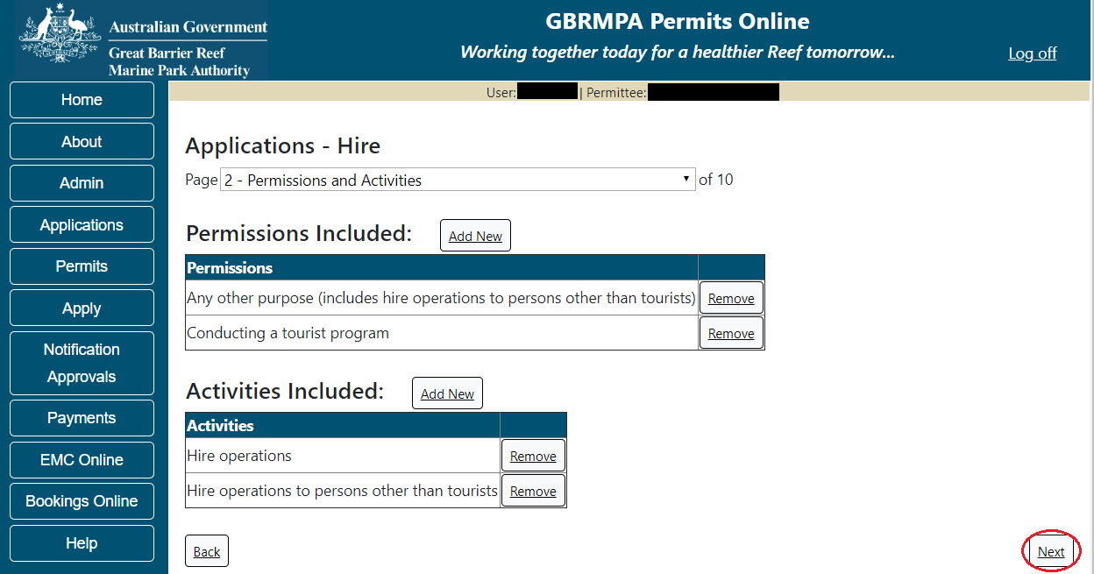
Figure 177 - Screenshot of Permissions and screen with a red circle around the Next button

Page 3 of Hire application is the Total Passenger Capacity / Participants page. Applicants are asked What is the total passenger capacity/participants you wish to have in the Marine Parks at any given time? (please consider future use in answering this question). Select a number from the list provided. Select Next to continue.
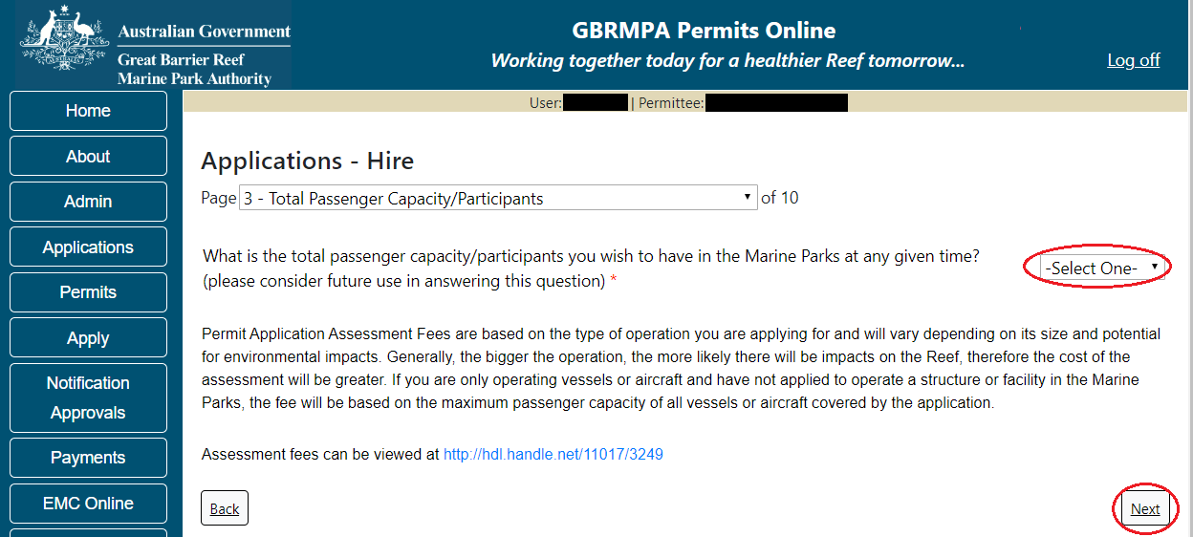
Figure 178 - Screenshot of the Total Passenger Capacity / Participants page with a red circle around the select one picklist and a red circle around the next button
Page 4 of Hire application refers to Marine Park Management Areas you may wish to access. Please select the Management Area/s in which you wish to operate your bareboat/s. Select all if you wish to operate in all management areas, taking future use into consideration.
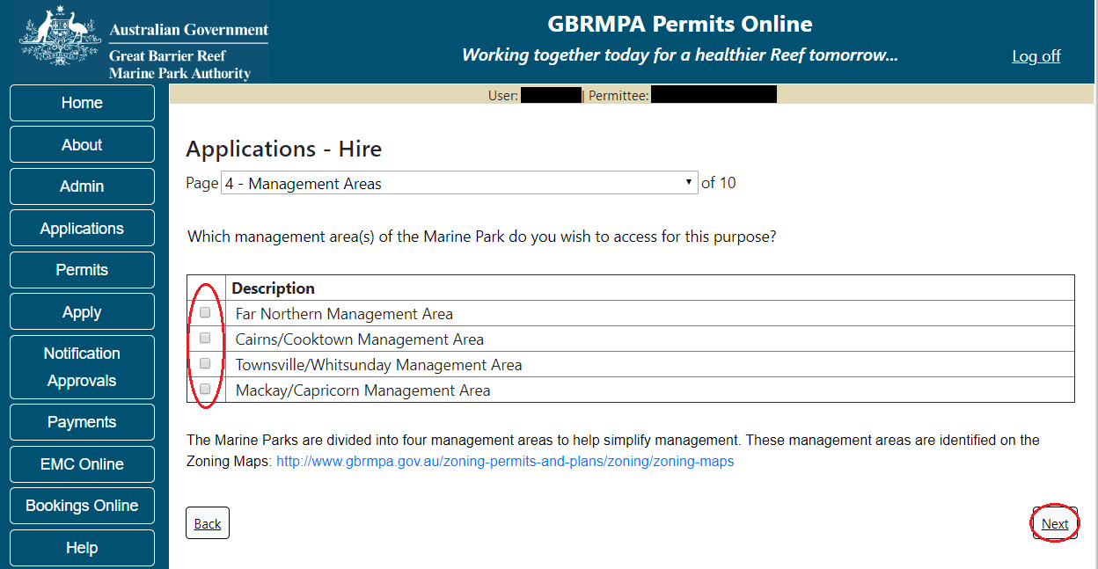
Figure 179 - Screenshot of page with a red circle Management Area page with a red circle around tick boxes to select and a red circle around Next button

Additional Information - Management areas and maps
The Marine Parks are divided into four management areas to help simplify management. These management areas are identified on the Zoning Maps.

The Great Barrier Reef Marine Park zoning maps are tools to help you get to know the zones in the Great Barrier Reef Marine Park and Great Barrier Reef Coast Marine Park.

Zoning exists in the Great Barrier Reef Marine Park to protect plants, animals and habitats. Like a town planning scheme, it defines what activities can occur in each location.

Further information about zoning and maps, including electronic zoning maps are located on the Reef Authority’s website using the below link.
http://www.gbrmpa.gov.au/access-and-use/zoning/zoning-maps

Page 5 of Hire application provides for Additional State Access. If you want to extend your operations to mainland or island national parks adjoining the Marine Parks and/or rivers and streams between Mission Beach and the Starcke River, select yes and an area will appear with Please Specify details. Add details of the islands or national parks and/or rivers and streams you wish access.
Please also indicate whether you wish to operate in the Green Island Recreational Area of Management. Once completed, select Next to continue.
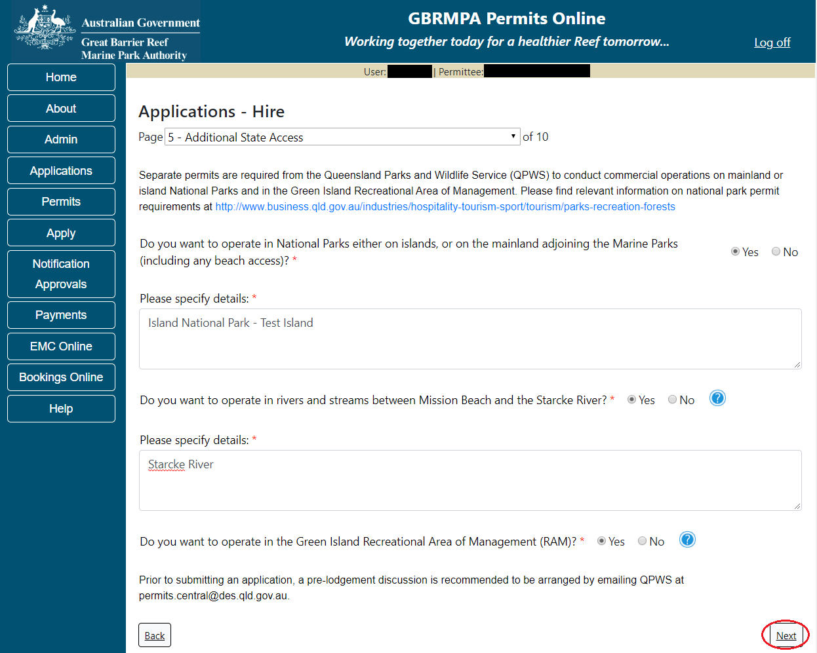
Figure 180 - Screenshot of Additional State Access screen with information displaying and a red circle around Next button

Page 6 of Hire application is the Hire Location page. Add details of Hire Location then select Next.
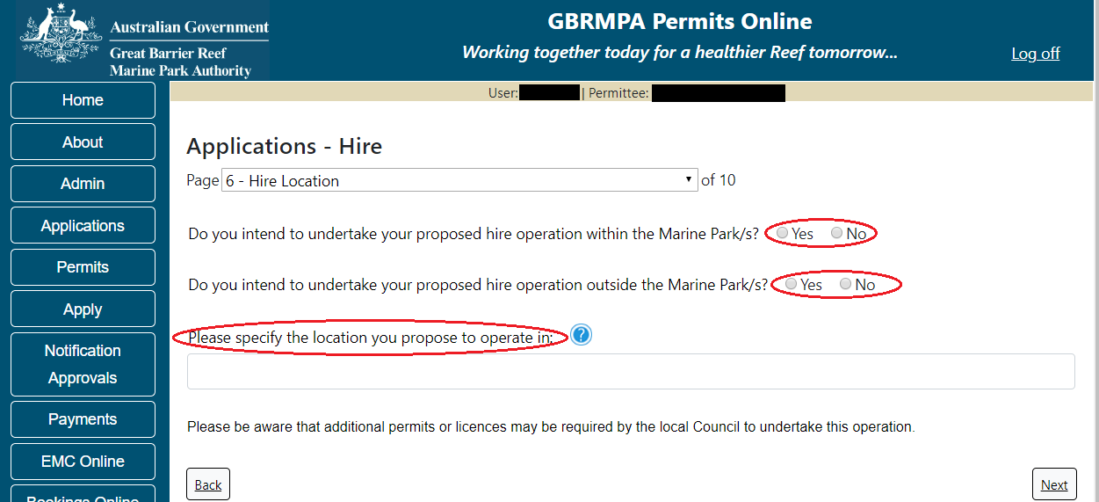
Figure 181 - Screenshot of Hire Location screen with a red circle around Yes and No and red circle around options and a red circle around question - Please specify the location you propose to operate in

Page 7 of Hire application addresses Participant Details. Add the total capacity / participants you wish to cater for under this permission, then select Next to move to the next page.
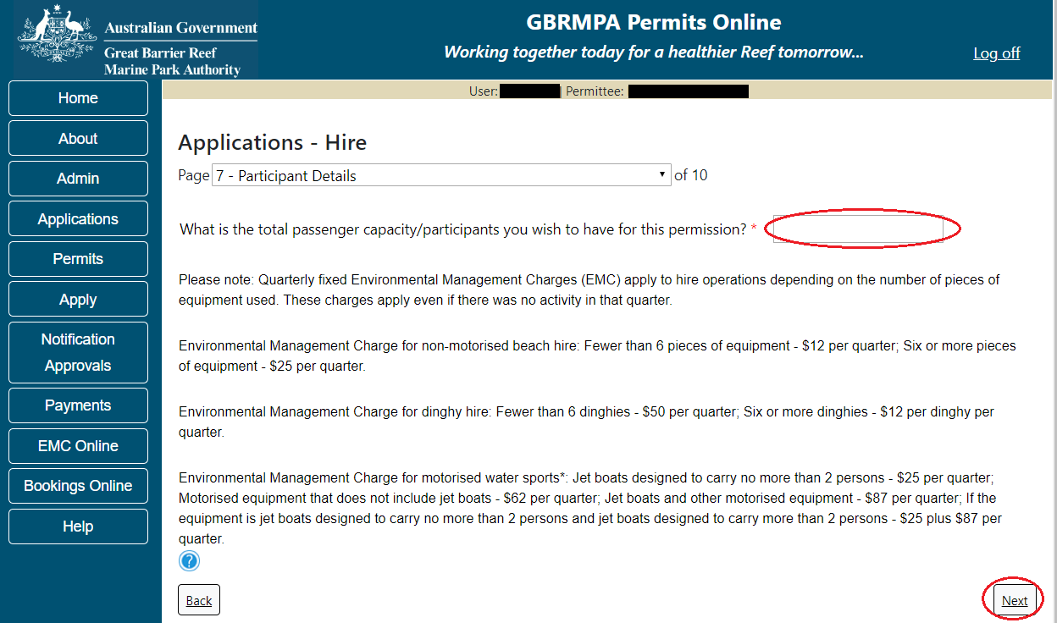
Figure 182 - Screenshot of Participant Details page with a red circle around the field to add the total passenger capacity and a red circle around the next button

Page 8 of Hire application addresses Equipment for hire in the Marine Parks. Please note that the Equipment page is a mandatory page for a Hire permission application; at least one equipment item is required to be added for the applicant to move to the next page. To add equipment, select the Add New button.
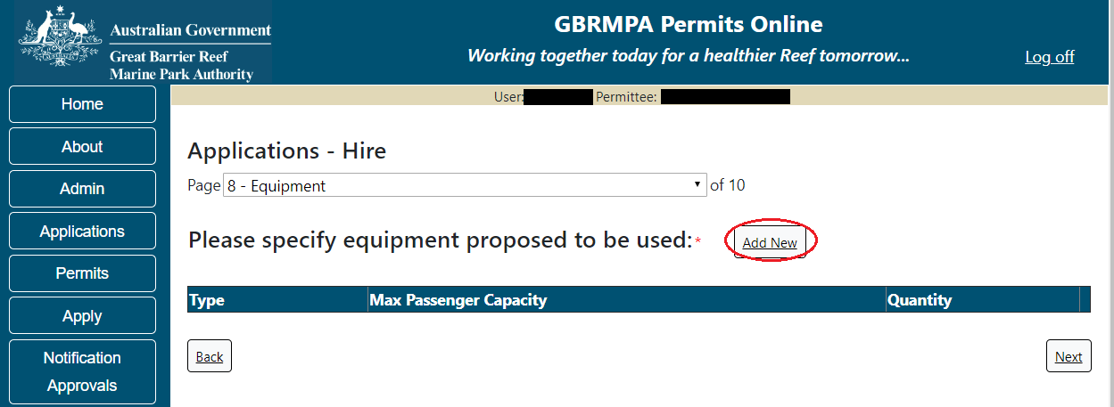
Figure 183 - Screenshot of Ancillary Vessels and Equipment screen with circle around Add New

An Add Ancillary Vessels/Equipment window will appear.
Figure 184 - Screenshot of Add Ancillary Vessels / Equipment pop up window

Select Ancillary Vessels or Equipment from the Device list
Figure 185 - Screenshot of Add Ancillary Vessels / Equipment pop up window with Device list displayed

Record the details of the ancillary vessels or equipment, then select Save.
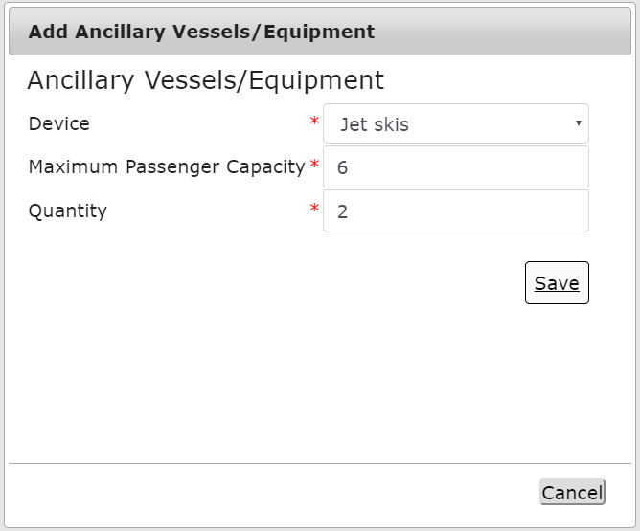
Figure 186 - Screenshot of Add Ancillary Vessels / Equipment pop up window with information entered and a red circle around Save
The details of your vessel/s will save on the page, with a Remove and an Edit button. Select Next to continue.
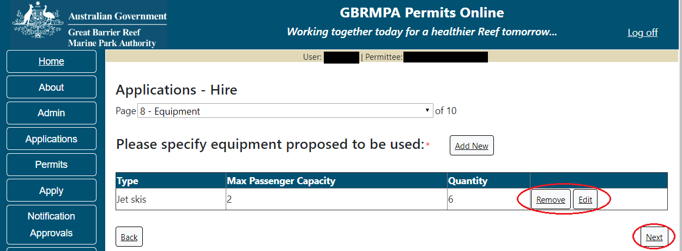
Figure 187 - Screenshot of Ancillary Vessels and Equipment page displaying information with a red circle around the Remove and Edit buttons and a red circle around the Next button

Page 7 of Hire application refers to High Standard Tourism operators. If you have obtained a High Standard Tourism certification with an approved certification scheme, select Yes then upload a copy of your certificate using the upload feature.
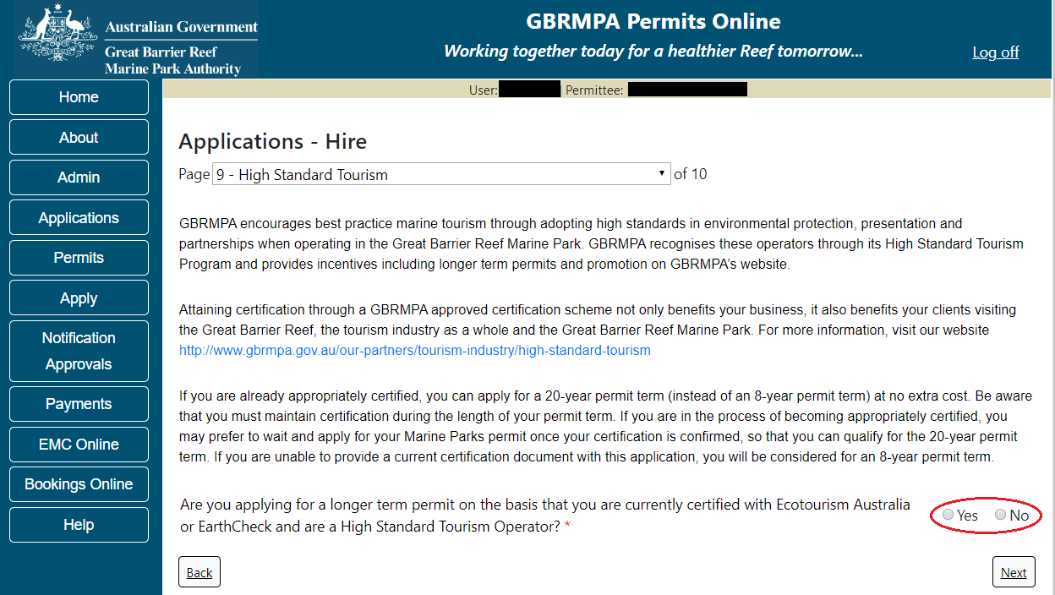
Figure 188 - Screenshot of High Standard Tourism page with a red circle Yes and No options

Once the Yes button is selected an Upload File button will appear. Select the Upload File button.
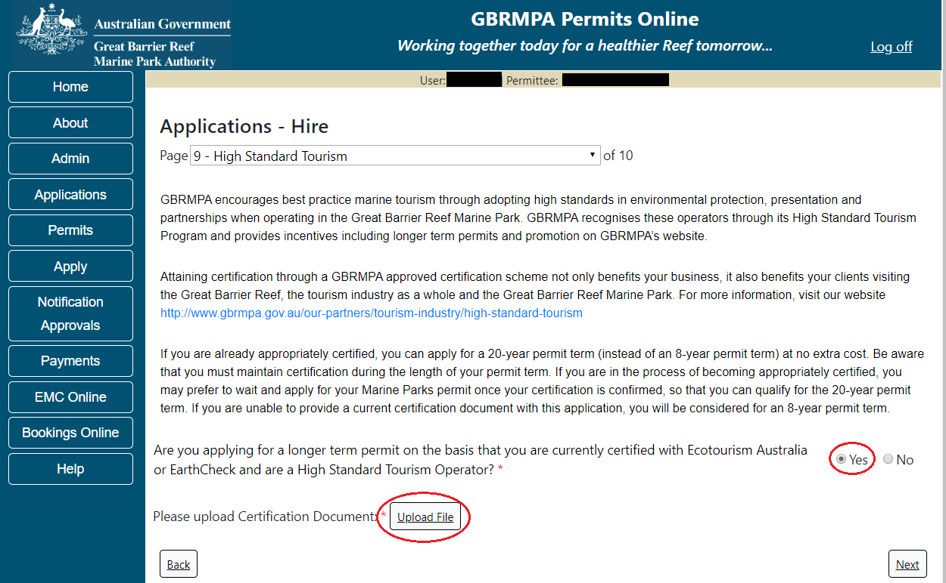
Figure 189 - Screenshot of High Standard Tourism page with Yes selected and circled and Upload File button circled

The File Upload screen will appear. Select Browse
Figure 190 - Screenshot of Upload File pop up window

Once you load a copy of your certificate, you will see the filename with a Remove button next to it. If you wish to remove the file, select the Remove button. Select Next to go to the next page
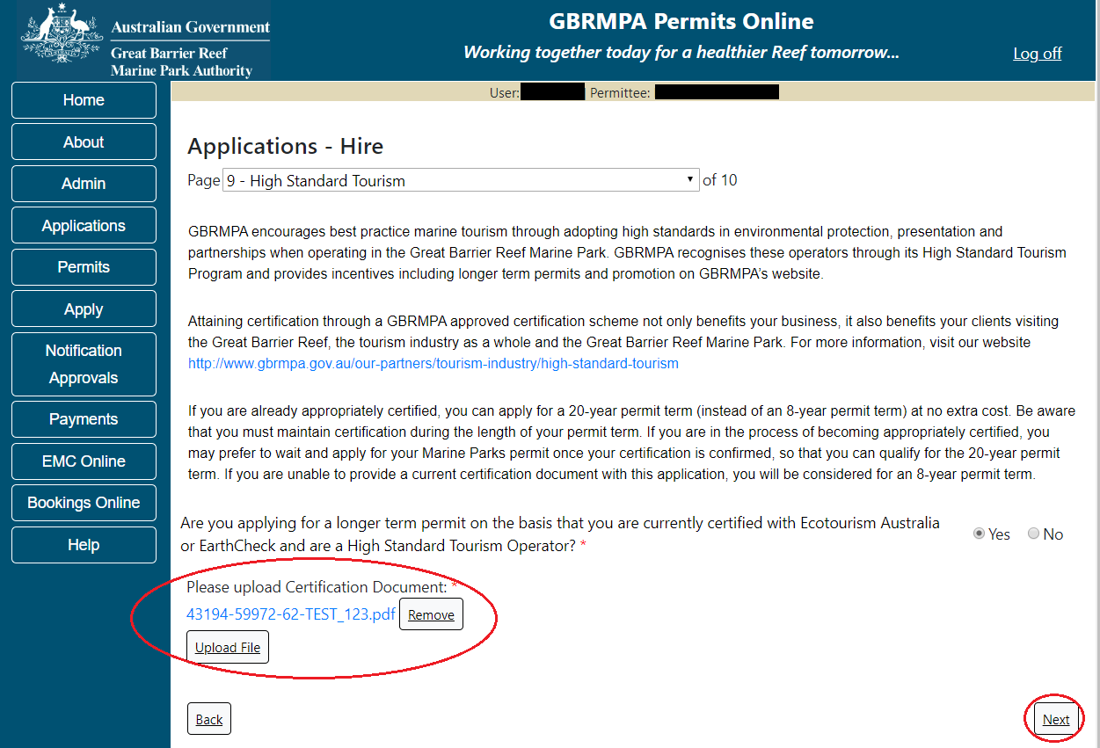
Figure 191 - Screenshot of High Standard Tourism page with Yes and a red circle around the Uploaded File and red circle around Next button

Page 8 of Hire application provides opportunity for you to add any other information you feel will assist the Managing Agencies in assessing your application. Add supporting information by typing in the text field or upload a file if required. If a file is uploaded it will appear on the screen with the file name and a Remove button to remove the file if incorrectly selected.
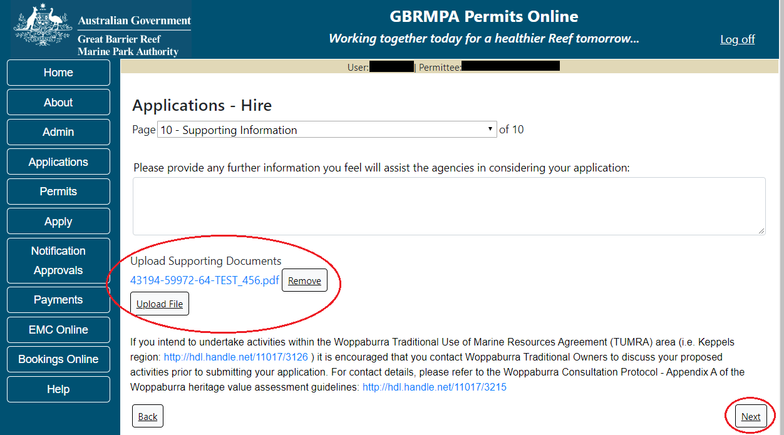
Figure 192 - Screenshot of Supporting Information screen with a red circle around Uploaded File area and a red circle around Next button
Once you have completed the supporting information page, select Next from the last page of the application questions and review a summary of your application. Select Next on the summary screen to progress to the Declarations screens.
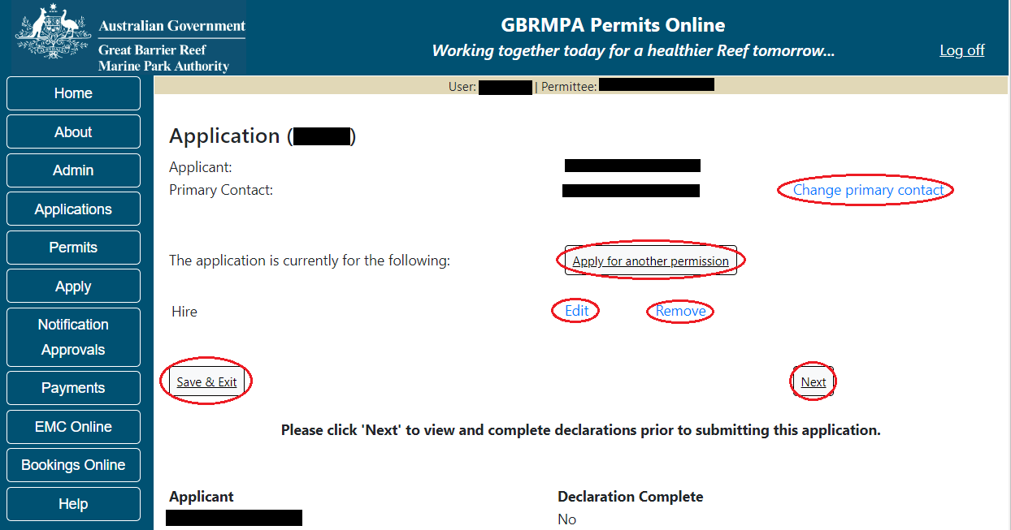
Figure 193 - Screenshot of Application Summary page with red circles around all options available

Additional Information - Summary screen, links and buttons;
- Change primary contact: If the change primary contact link is selected the applicant will progress to the primary contact page where the primary contact can be changed.

- Apply for another permission: If the apply for another permission button is selected, the applicant will progress to the What are you seeking to do in the Marine Parks page where another permission type can be added. (e.g. add a mooring permission to the tourism permission).

- Edit: If edit is selected the application/permission will be reopened to apply any changes.

- Remove: If remove is selected the application/permission will be removed.

- Save & Exit: If the Save & Exit button is selected the applicant will progress to the applications screen.

- Next: If next is selected the applicant will progress to the submission process including declaring and submitting the application.

Completion of a set of declarations is mandatory prior to submitting your application. To complete the declarations section of this application, you must either be the applicant, or if applying on behalf of an organisation / company / government agency, you must be a Director of that organisation / company / government agency. Authorised contacts cannot complete the declaration section, as it contains legally binding commitments in place of a physical signature.
Please read all questions carefully, provide a response to each, and select Next.
Figure 194 - Screenshot of Declarations page with red circle around Yes and No options and Next button

On the final page of declarations there is a Submit button. Once the Submit button is selected, the application will be submitted to the Reef Authority and is no longer available to be edited. The status of the application on the Applications screen will then display ‘Submitted to GBRMPA’. The application’s Primary Contact will receive an emailed acknowledgement notice from a delegated Assessment Officer within 10 business days.
Figure 195 - Screenshot of Declarations screen with a red circle around the Submit button
Once you submit your application, you will be provided with a reference/application number and can follow the progress of your application via the Applications menu on the left.
Figure 196 - Screenshot of the Thank you for your application screen with a red circle around Reference number and a red circle around the open pdf button

Your application will appear in the Applications screen with the reference/application number also displayed. You have further options to view a summary of your application, email the Reef Authority, or withdraw the application.
Figure 197 - Screenshot of Applications screen with a red circle around Application No., Summary, Email and Withdraw options

  - Tourism – Craftless
Apply – new permit application – other tourism activities – craftless
To apply for Other Tourism and Charter Activities, select this option on the Apply – What are you seeking to do in the Marine Parks page.
Figure 198 - Screenshot of Apply - What are you seeking to do in the Marine Parks screen with Other Tourism and Charter Activities and a red circle around the Next button

You will progress to the application types sub menu, where you can choose which type of Tourism or charter activity you wish to apply for (example used is Craftless). Select Next to progress to the application questions.
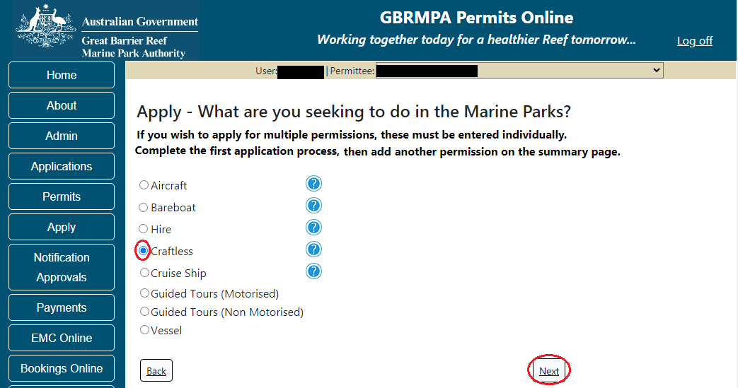
Figure 199 - Screenshot of Apply - What are you seeking to do in the Marine Parks - Other Tourism and Charter Activities sub menu screen with Craftless and a red circle around Next button
Information - Craftless operation
Craftless operation addresses equipment to be hired in the Marine Parks eg. canoes, kayaks, paddle boards, catamarans etc.
Craftless Operations are those that operate from the beach or ‘piggy back’ on other vessels to access the reef (e.g. dive schools, glass bottom boats, rubber inflatable boats etc).
Craftless Operations-
• do not allow for the independent operation of a vessel or aircraft, though the Permit Holder may travel on board other operations.
• allow daily access to planning areas, subject to the same access and activity conditions as the permitted vessel or aircraft that is being used.

Information - Environmental management charge
Please note: Quarterly fixed Environmental management charges (EMC) apply to hire operations depending on the number of pieces of equipment used. These charges apply even if there was no activity in that quarter.
Environmental management charge for non-motorised beach hire: Fewer than 6 pieces of equipment - $12 per quarter; Six or more pieces of equipment - $25 per quarter.
Environmental management charge for dinghy hire: Fewer than 6 dinghies - $50 per quarter; Six or more dinghies - $12 per dinghy per quarter.
Environmental management charge for motorised water sports*: Jet boats designed to carry no more than 2 persons - $25 per quarter; Motorised equipment that does not include jet boats - $62 per quarter; Jet boats and other motorised equipment - $87 per quarter; If the equipment is jet boats designed to carry no more than 2 persons and jet boats designed to carry more than 2 persons - $25 plus $87 per quarter.

Page 1 of Craftless application is the Environment Protection and Biodiversity Conservation Act page. This provides advice on matters of national environmental significance that must be considered when assessing an application. This screen is for your information only at this stage. Your assessing officer will contact you if it is determined to be relevant for your application.
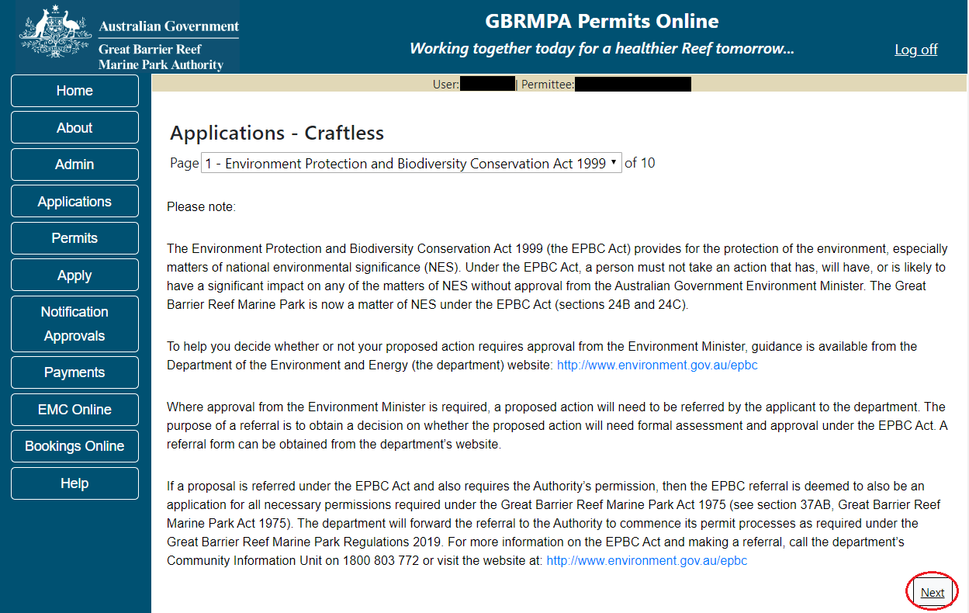
Figure 200 - Screenshot of Environment Protection and Biodiversity Conservation screen with a red circle around Next button

Links on the Environment Protection and Biodiversity Conservation page www.environment.gov.au/epbc will take you to the Department of Climate Change, Energy, the Environment and Water site. Here you can find information about the Environment Protection and Biodiversity Conservation Act 1999 and your obligations under the Act.

Page 2 of Craftless application is Permissions and Activities page.
All Permissions and activities listed are available and will be included in the application. If there are any activities you do not wish to retain permission for, you can remove them by selecting the Remove button next to the activity.
Select Next to continue.
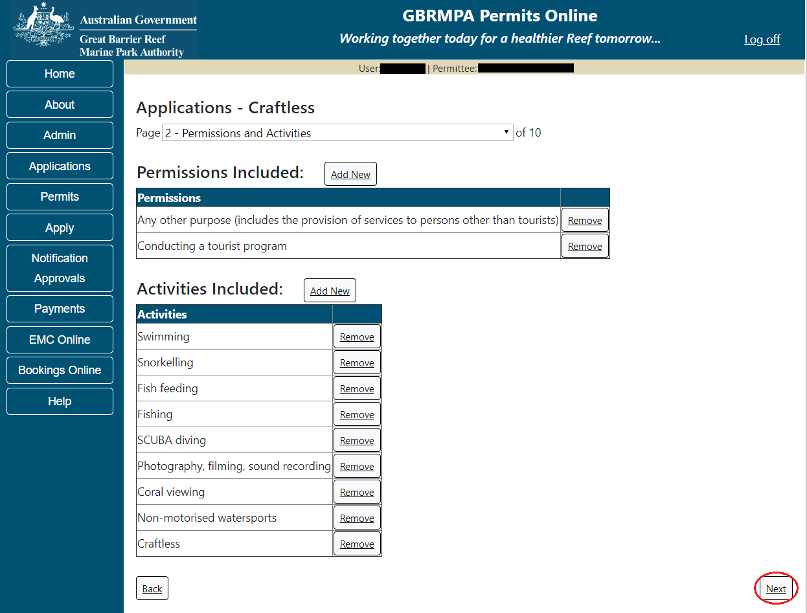
Figure 201 - Screenshot of Permissions and screen with a red circle around the Next button

Page 3 of Craftless application is the Total Passenger Capacity / Participants page. Applicants are asked What is the total passenger capacity/participants you wish to have in the Marine Parks at any given time? (please consider future use in answering this question). Select a number from the list provided. Select Next to continue.
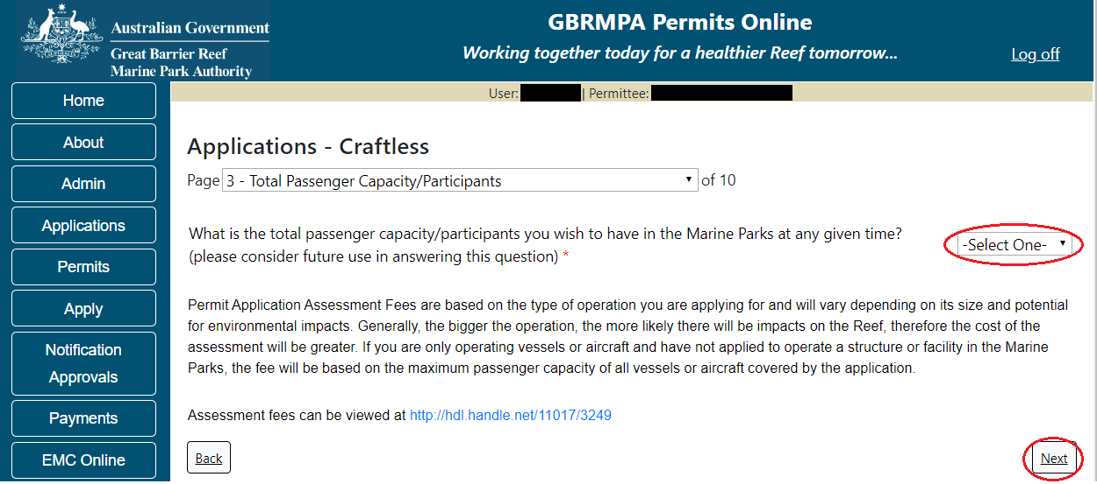
Figure 202 - Screenshot of the Total Passenger Capacity / Participants page with a red circle around the select one drop list and a red circle around the next button

Page 4 of Craftless refers to Marine Park Management Areas you may wish to access. Please select the Management Area/s in which you wish to operate. Select all if you wish to operate in all management areas, considering future use.
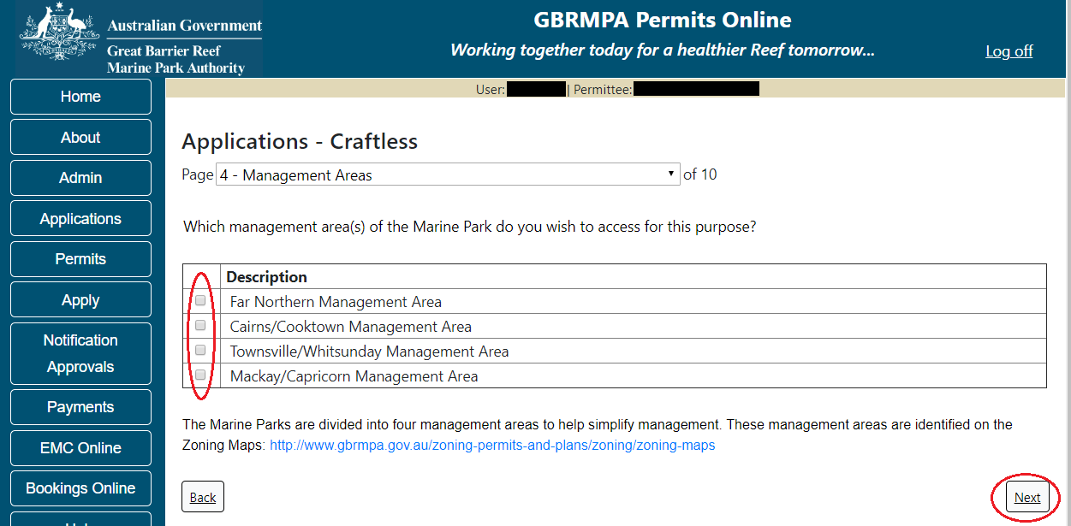
Figure 203 - Screenshot of Management / Operation screen with circle around management areas tick boxes, a circle around Permit holders primary operation and red circle around Next button

Page 5 allows you to apply to access areas of the Marine Park more frequently than the standard 2 days in every 7-day period. This option is only available outside the Plans of Management. If you wish to apply to visit a location more frequently than 2 in every 7-day period, select Add New.
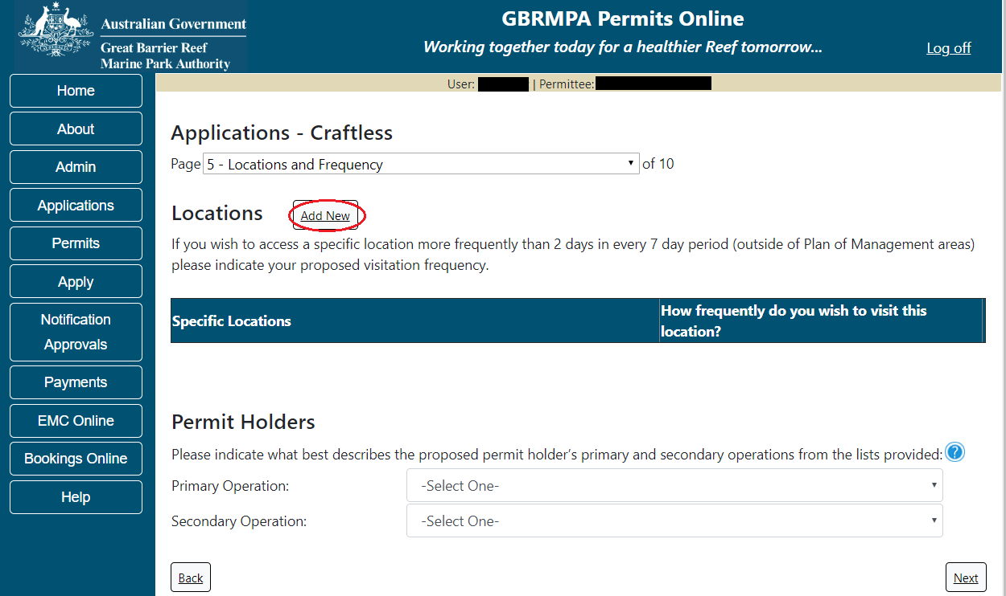
Figure 204 - Screenshot of Locations and Frequency screen with circle around Add new button

If the Add New button is selected the Location pop up window will appear
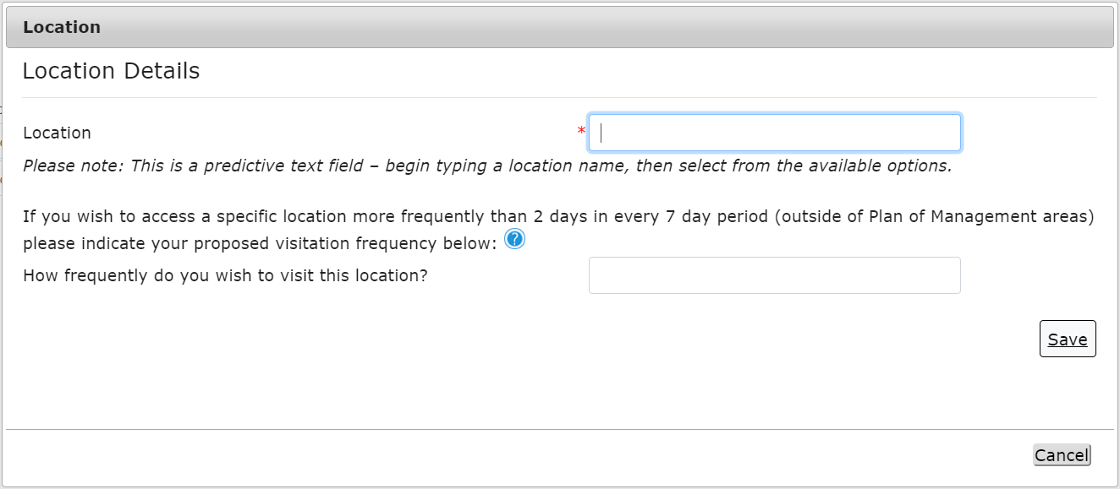
Figure 205 - Screenshot of Location pop up window

Type in the name of the location you wish to visit in the location field. As you type, the list will produce relevant matches. Select the location then select Save.
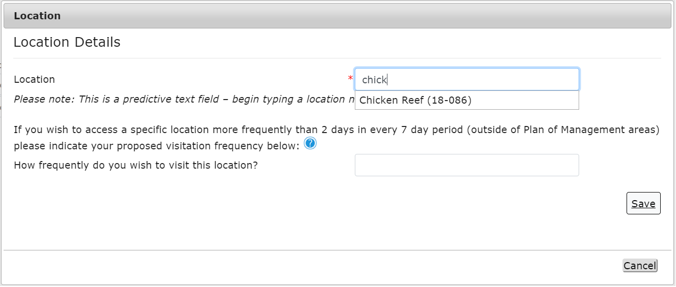
Figure 206 - Screenshot of Location pop up window with locations to select

Then add the frequency you wish to visit the location and select Save.
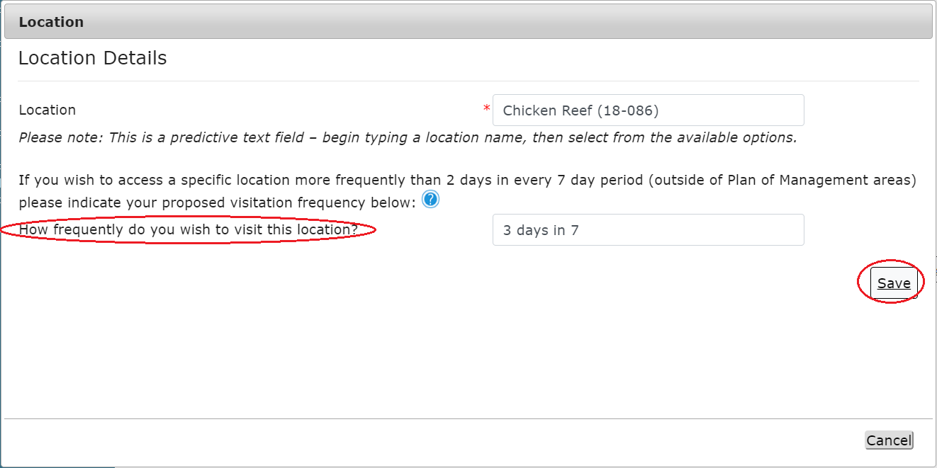
Figure 207 - Screenshot of location pop up window with a red circle around question - How frequently do you wish to visit this location with information completed and a red circle around the Save button.

The location will be entered on the Location and Frequencies page within the locations table. If you wish to remove the location, select the Remove button next to the location.
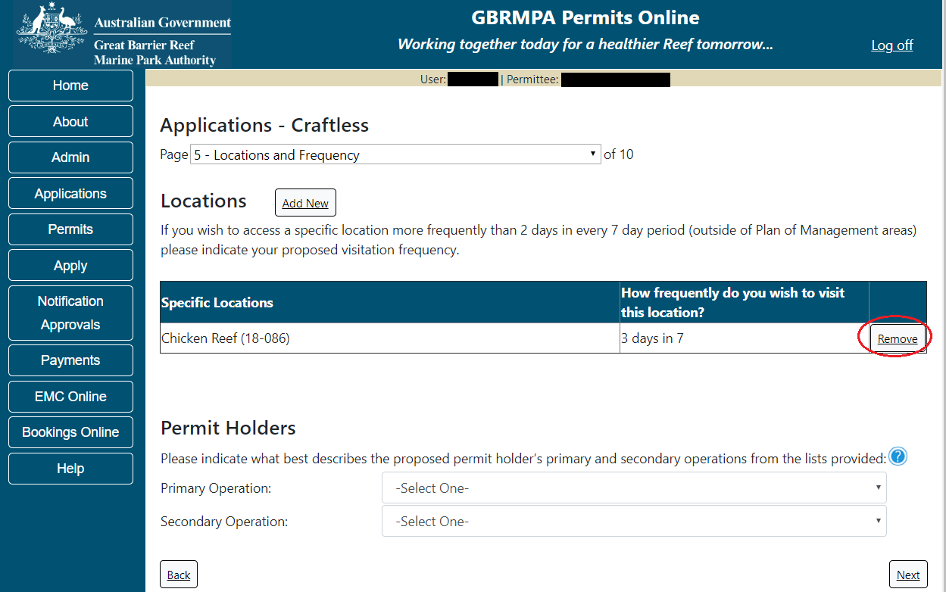
Figure 208 - Screenshot of Location and Frequency screen with information displaying and a red circle around Remove button

Please also select activities that best describe the proposed permit holder’s primary and secondary operations from the two lists located towards the bottom of the page. This information assists our Tourism and Commercial section in providing relevant information for your operation over the life of your permit. Select Next to continue.
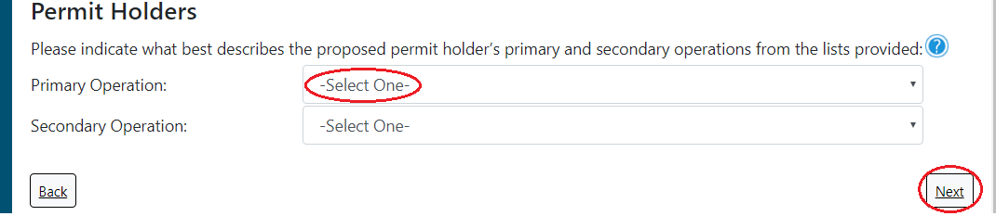
Figure 209 - Screenshot of Locations and Frequency screen with a red circle around Select One in the Permit Holders section and a red circle around the Next button

Page 6 of Craftless application provides for Additional State Access. If you want to extend your operations to mainland or island national parks adjoining the Marine Parks and/or rivers and streams between Mission Beach and the Starcke River, select Yes and an area will appear with Please specify details, add details of the islands or national parks and/or Rivers and streams you wish access.
Please also indicate whether you wish to operate in the Green Island Recreational Area of Management. Once completed, select Next to continue.
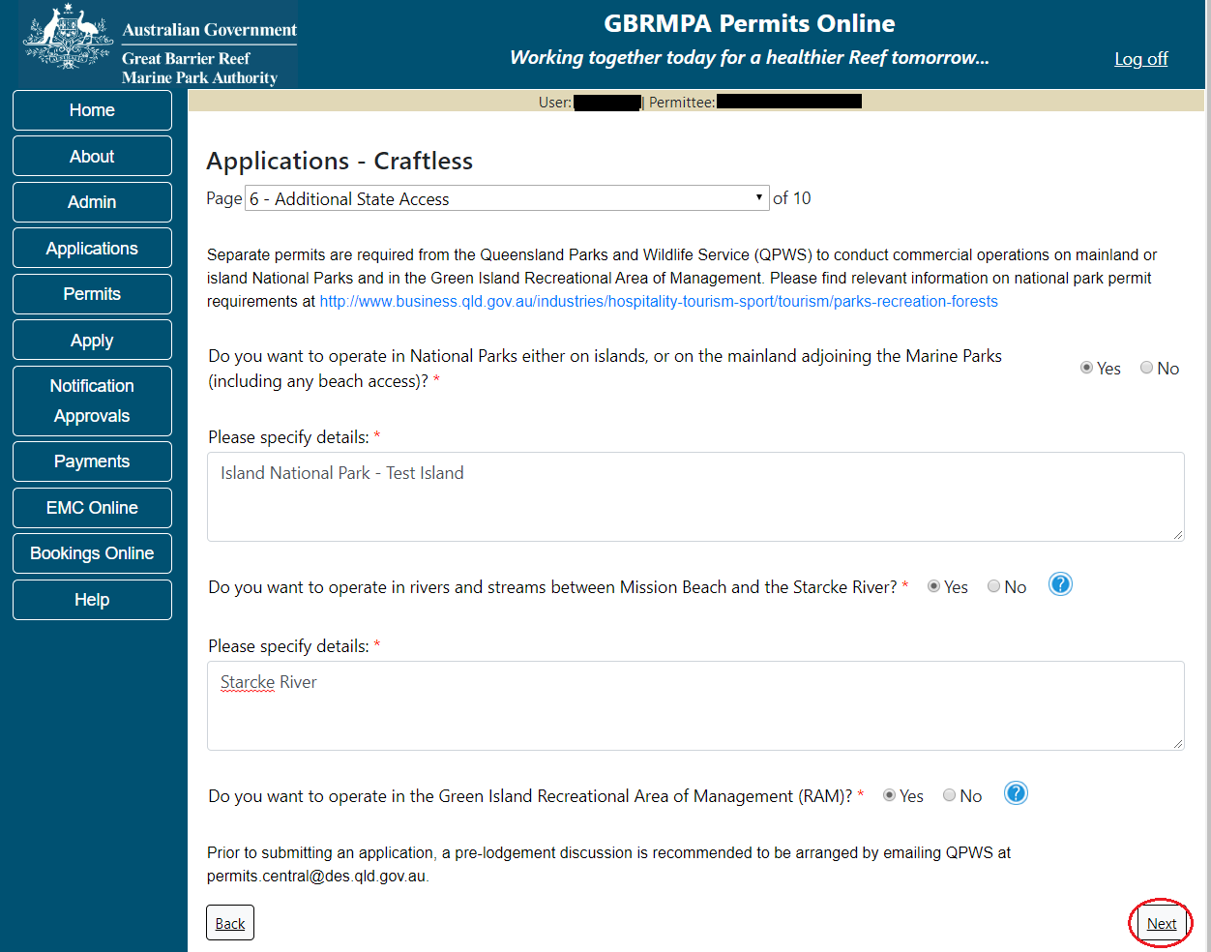
Figure 210 - Screenshot of Additional State Access screen with information displaying and a red circle around Next button

Page 7 of Craftless application addresses Participant Details. Add the total capacity / participants you wish to cater for under this permission, then select Next to move to the next page. The total passenger capacity you wish to cater for determines the applicable Permit Application Assessment Fee payable. Please view current fees here. Current Environmental Management Charge obligations are also listed here.
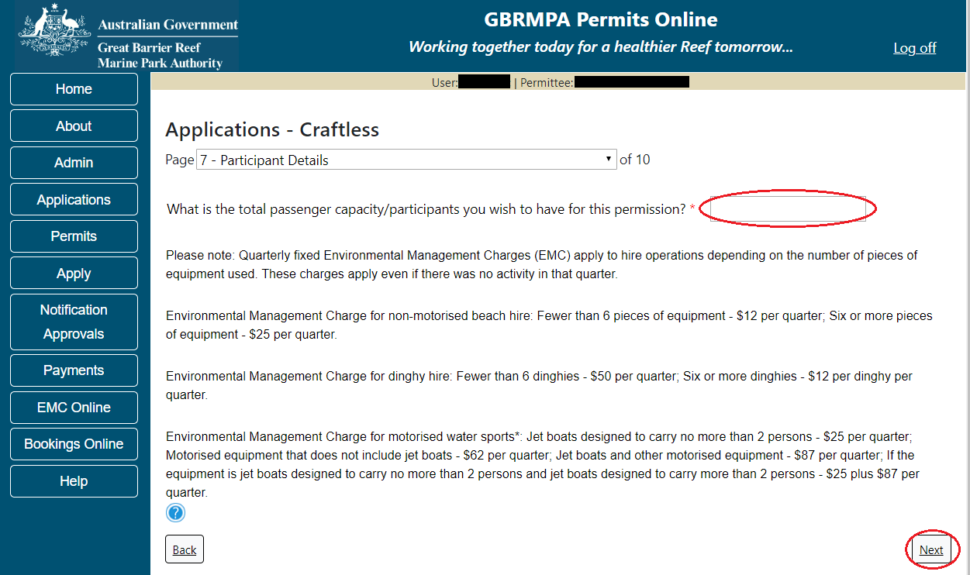
Figure 211 - Screenshot of Participant Details page with a red circle around the field to add the total passenger capacity and a red circle around the next button

Page 8 of Craftless application addresses Equipment to be hired in the Marine Parks. Please note that the Equipment page is a mandatory page for a Hire permission application; at least one equipment item is required to be added for the applicant to move to the next page. To add equipment select the Add New button.
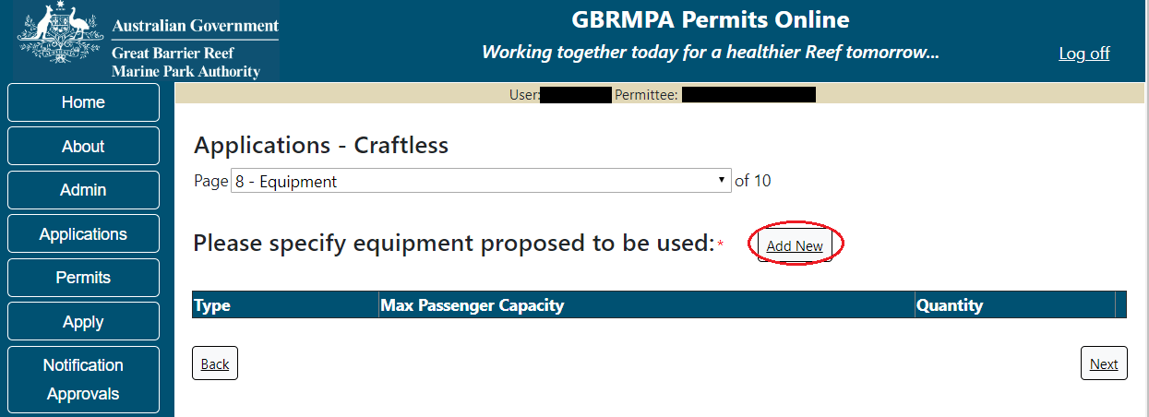
Figure 212 - Screenshot of Ancillary Vessels and Equipment screen with circle around Add New
An Add Ancillary Vessels/Equipment window will appear.
Figure 213 - Screenshot of Add Ancillary Vessels / Equipment pop up window

Select Ancillary Vessels or Equipment from the Device list
Figure 214 - Screenshot of Add Ancillary Vessels / Equipment pop up window with Device list displayed

Record the details of the ancillary vessels or equipment, then select Save.
Figure 215 - Screenshot of Add Ancillary Vessels / Equipment pop up window with information entered and a red circle around Save
The details of your vessel/s will save on the page, with a Remove button and an Edit button. Select Next to continue.
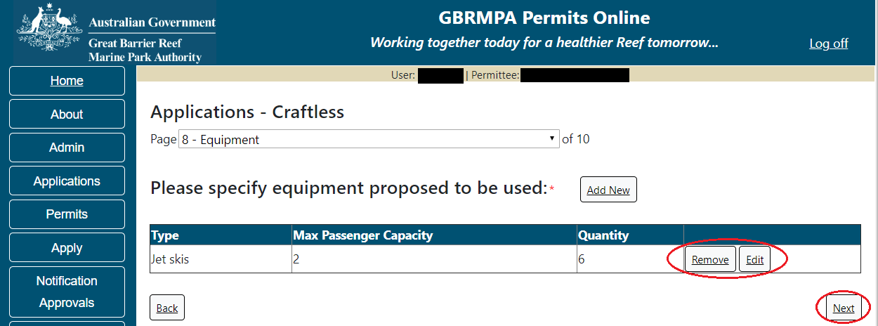
Figure 216 - Screenshot of Ancillary Vessels and Equipment page displaying information with a red circle around the Remove and Edit buttons and a red circle around the Next button

Page 9 of Craftless application refers to High Standard Tourism operators. If you have obtained a High Standard Tourism certification with an approved certification scheme, select Yes then upload a copy of your certificate using the upload feature.
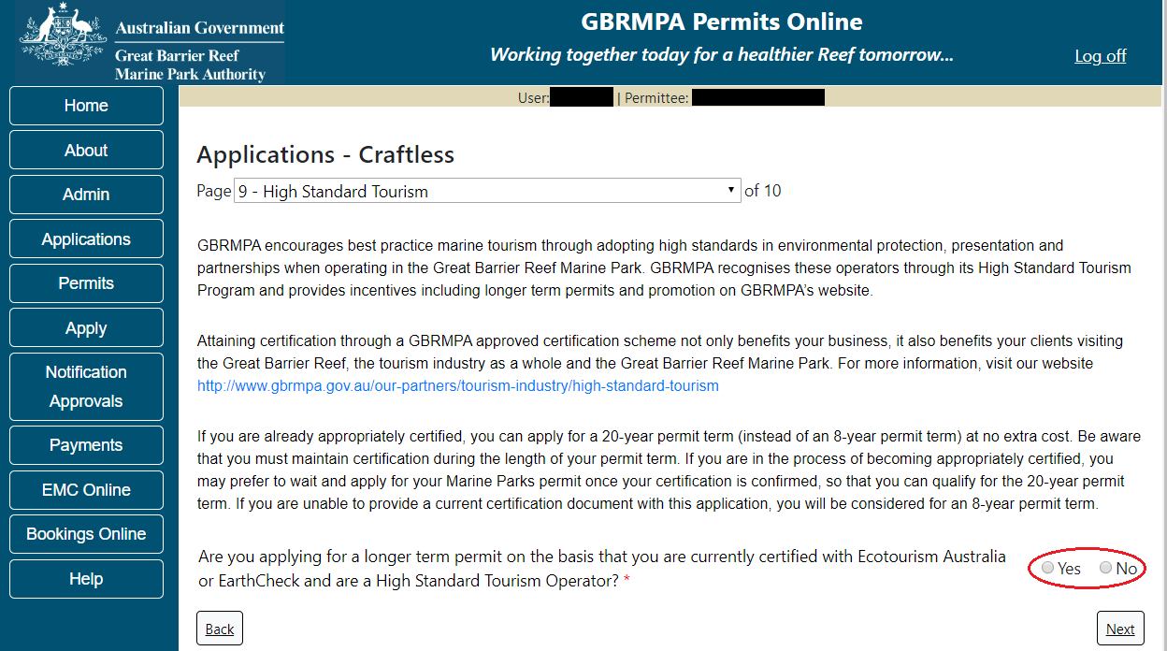
Figure 217 - Screenshot of High Standard Tourism page with red circle around Yes and No options

Once the Yes button is selected an upload file button will appear. Select the upload file button.
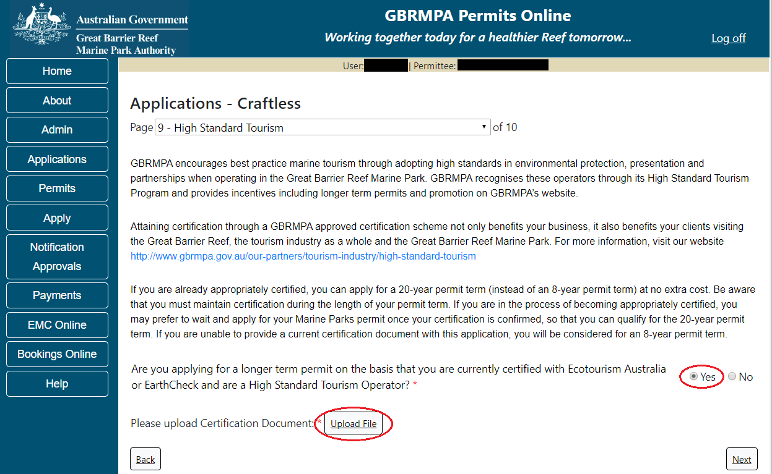
Figure 218 - Screenshot of High Standard Tourism page with Yes selected and circled and Upload File button circled

The File Upload screen will appear. Select Browse
Figure 219 - Screenshot of Upload File pop up window

Once you load a copy of your certificate, you will see the filename with a Remove button next to it. If you wish to remove the file, select the Remove button. Select Next to continue.
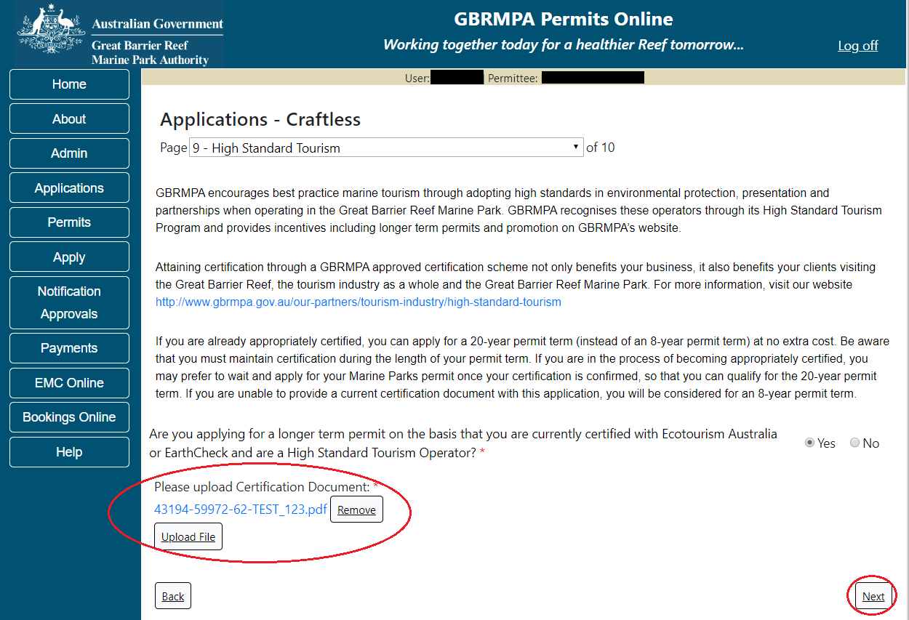
Figure 220 - Screenshot of High Standard Tourism page with Yes selected and a red circle around the Uploaded File and a red circle around Next button

Page 8 of Craftless application provides opportunity for you to add any other information you feel will assist the Managing Agencies in assessing your application. Add supporting information by typing in the text field or upload a file if required. If a file is uploaded it will appear on the screen with the file name and a Remove button to remove the file if incorrectly selected.
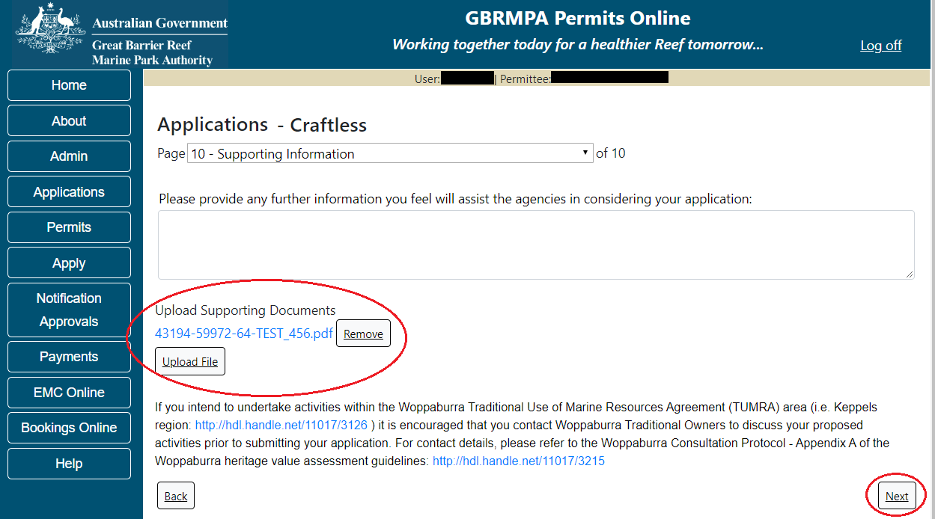
Figure 221 - Screenshot of Supporting Information screen with a red circle around Uploaded File area and a red circle around Next button
Once you have completed the supporting information page select Next from the last page of the application questions, you will progress to an application summary screen with a number of options available via links or buttons. Select Next on the summary screen to progress to the Declarations screens.
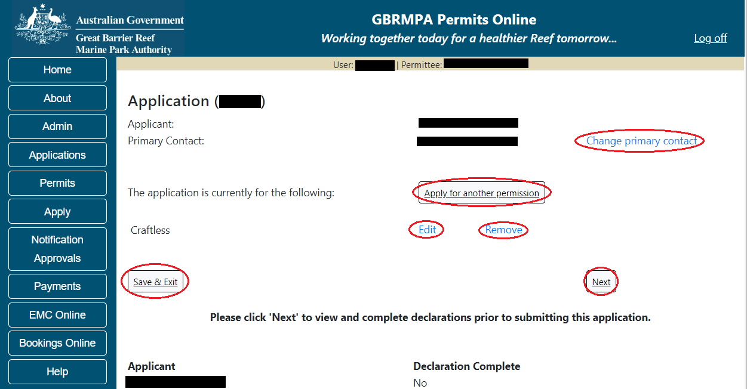
Figure 222 - Screenshot of Application Summary page with red circles around all options available

Additional Information - Summary screen, links and buttons;
- Change primary contact: If the change primary contact link is selected the applicant will progress to the primary contact page where the primary contact can be changed.

- Apply for another permission: If the apply for another permission button is selected, the applicant will progress to the What are you seeking to do in the Marine Parks page where another permission type can be added. (e.g. add a mooring permission to the tourism permission).

- Edit: If edit is selected the application/permission will be reopened to apply any changes.

- Remove: If remove is selected the application/permission will be removed.

- Save & Exit: If the Save & Exit button is selected the applicant will progress to the applications screen.

- Next: If next is selected the applicant will progress to the submission process including declaring and submitting the application.

Completion of a set of declarations is mandatory prior to submitting your application. To complete the declarations section of this application, you must either be the applicant, or if applying on behalf of an organisation / company / government agency, you must be a Director of that organisation / company / government agency. Authorised contacts cannot complete the declaration section, as it contains legally binding commitments in place of a physical signature.
Please read all questions carefully, provide a response to each, and select Next.
Figure 223 - Screenshot of Declarations page with red circle around Yes and No options and Next button

On the final page of declarations there is a Submit button. Once the Submit button is selected, the application will be submitted to the Reef Authority and is no longer available to be edited. The status of the application on the Applications screen will then display ‘Submitted to GBRMPA’. The application’s Primary Contact will receive an emailed acknowledgement notice from a delegated Assessment Officer within 10 business days.
Figure 224 - Screenshot of Declarations screen with a red circle around the Submit button
Once you submit your application, you will be provided with a reference/application number and can follow the progress of your application via the Applications menu on the left.
Figure 225 - Screenshot of the Thank you for your application screen with a red circle around Reference number and a red circle around the open pdf button

Your application will appear in the Applications screen with the reference/application number also displayed. You have further options to view a summary of your application, email the Reef Authority or withdraw the application.
Figure 226 - Screenshot of Applications screen with a red circle around Application No., Summary, Email and Withdraw options

  - Tourism – Routine Cruise Ship

Apply – new permit application – other tourism activities – routine cruise ship
To apply for Other Tourism and Charter Activities, select this option on the Apply – What are you seeking to do in the Marine Parks page.
Figure 227 - Screenshot of Apply - What are you seeking to do in the Marine Parks screen with Other Tourism and Charter Activities and a red circle around the Next button

You will progress to the application types sub menu, where you can choose which type of Tourism or Charter Activity you wish to apply for (example used is Cruise Ship). Select Next to progress to the application questions.
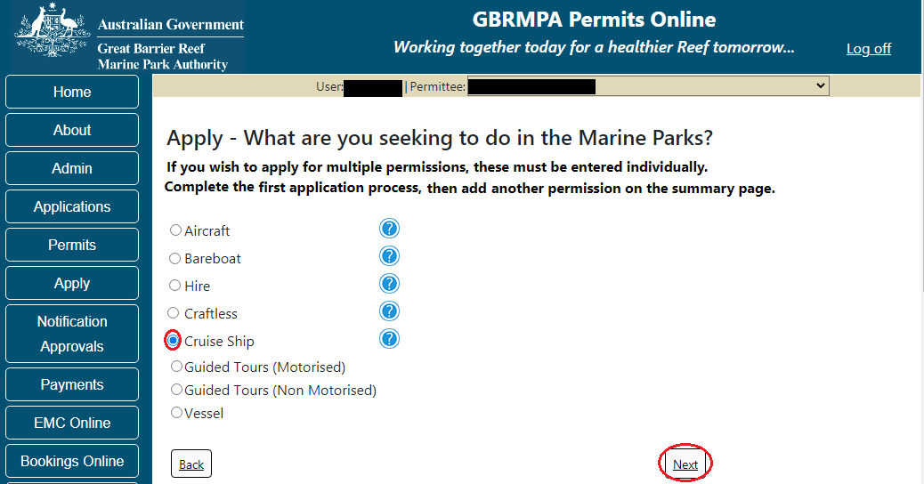
Figure 228 - Screenshot of Apply - What are you seeking to do in the Marine Parks - Other Tourism and Charter Activities sub menu screen with Cruise Ship and a red circle around Next button
The landing page of the Cruise ship Application is an initial page with questions and information. Depending on the nature of the cruise ship operation and what answers are obtained will determine if the applicant is eligible for a Routine Cruise ship permit Application, or if the application will be a Tailored Cruise ship Application. On this screen, there are also two links, a link to a copy of the Routine Cruise ship permit and a link to the assessment approach information on how the permit application will be assessed.
If you would like to apply for a Routine Cruise ship permit you have the option to select Yes or No. If Yes is selected you will progress to the Routine Cruise ship permit application. Continue from the below screenshot.
If no is selected you will progress to the Tailored Cruise ship permit application screens. (Go to 10.7 of this manual to continue)
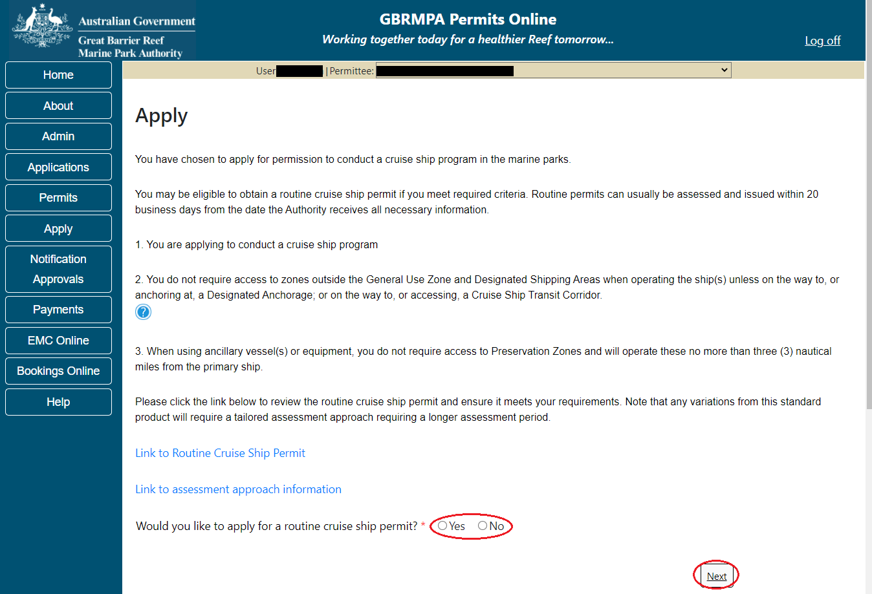
Figure 229 - Screenshot of initial questions and information page with a red circle around the Yes and No buttons and a red circle around the Next button

Information - Cruise ship operations
Cruise ship access to the Marine Parks is guided by the Cruise Ship Operations within the Great Barrier Reef Guidelines. The guidelines allow for protected area managers to advise cruise ship operators, booking agents and tourists about management arrangements and how best to operate in the Marine Parks. Please review the guidelines to determine if permission to operate a Cruise Ship in the Marine Parks is the best option for your business.
Cruise Ship Operations within the Great Barrier Reef guidelines: http://hdl.handle.net/11017/3337
Page 1 of the Routine Cruise ship permit application is the Total Passenger Capacity / Participants page. Applicants are asked What is the total passenger capacity/participants you wish to have in the Marine Parks at any given time? (please consider future use in answering this question). Select a number from the list provided. Select Next to continue
Please note that this is the total number of passengers you propose to cater for, across all vessels and/or activities. This number determines the appropriate Permit Application Assessment Fee. Current fees are published on the Reef Authority’s website. Select ‘Next’ to continue.
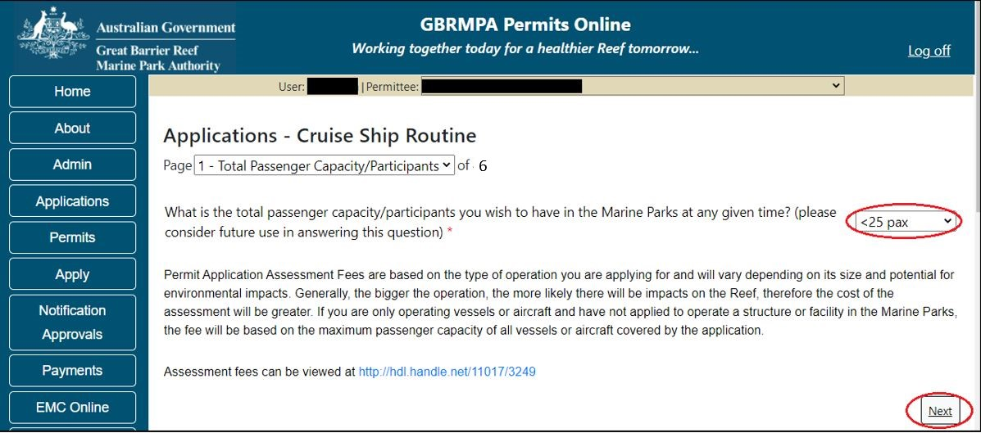
Figure 230 - Screenshot of the Total Passenger Capacity / Participants page with a red circle around the Select One drop list and a red circle around the ‘next’ button

Page 2 of the Routine Cruise ship Permit application is the Ship Details page. Fill in information about the number of Ship/s you wish to use and select Next to continue.
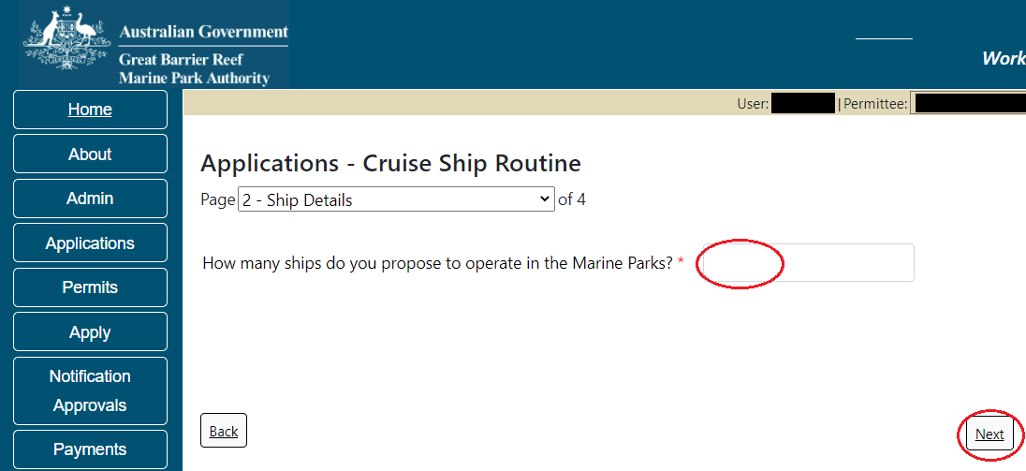
Figure 231 - Screenshot of Ship Details page with information completed and a red circle around answer for How many ships do you propose to operate in the Marine Parks field and a red circle around Next button
Page 3 of the Routine Cruise ship Permit application is the Ships page. On this page, you have options to ‘Add New’ Ship/s. To add a ship select the ‘Add New’ button
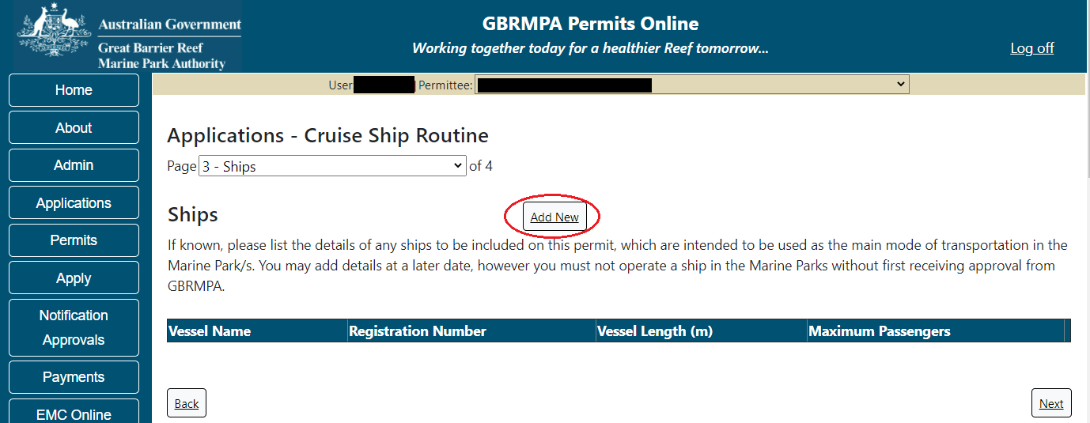
Figure 232 – Screenshot of Ships screen with circle around Add New

An ‘Add New Vessel’ pop up window will appear. Add the details of your vessel in the fields provided, then select ‘Save’.
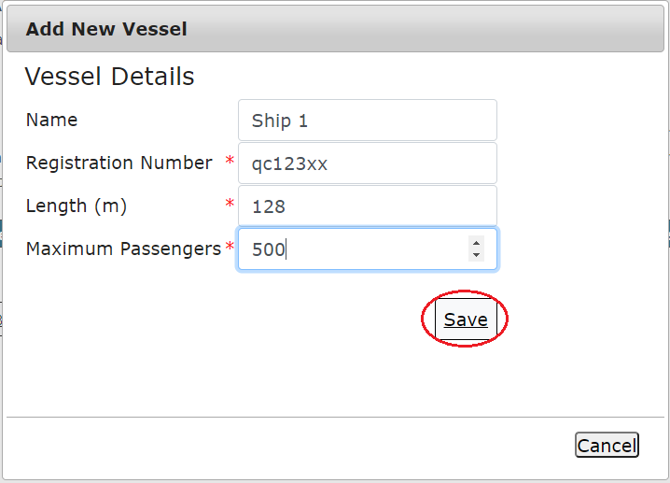
Figure 233 - Screenshot of Add New Vessel pop up window with information entered and a red circle around ‘Save’

The details will save on the page, with a ‘Remove’ button and an ‘Edit’ button. If you need to edit or remove the ship, select the button needed and add the changes or remove the ship. Select ‘Next’ to continue
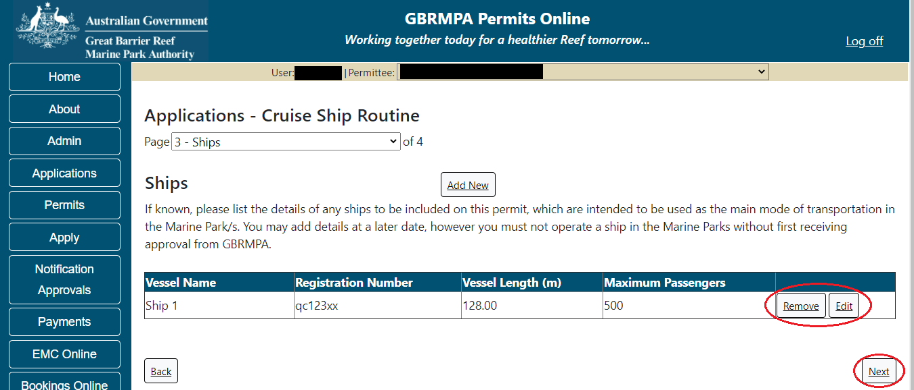
Figure 234 - Screenshot of Ships page with information displayed and a red circle around Remove and Edit buttons and a red circle around the Next button

Page 4 of the Routine Cruise ship Permit application is the Ancillary Vessels and Equipment page. To add details of any ancillary vessels or equipment select the ‘Add New’ button
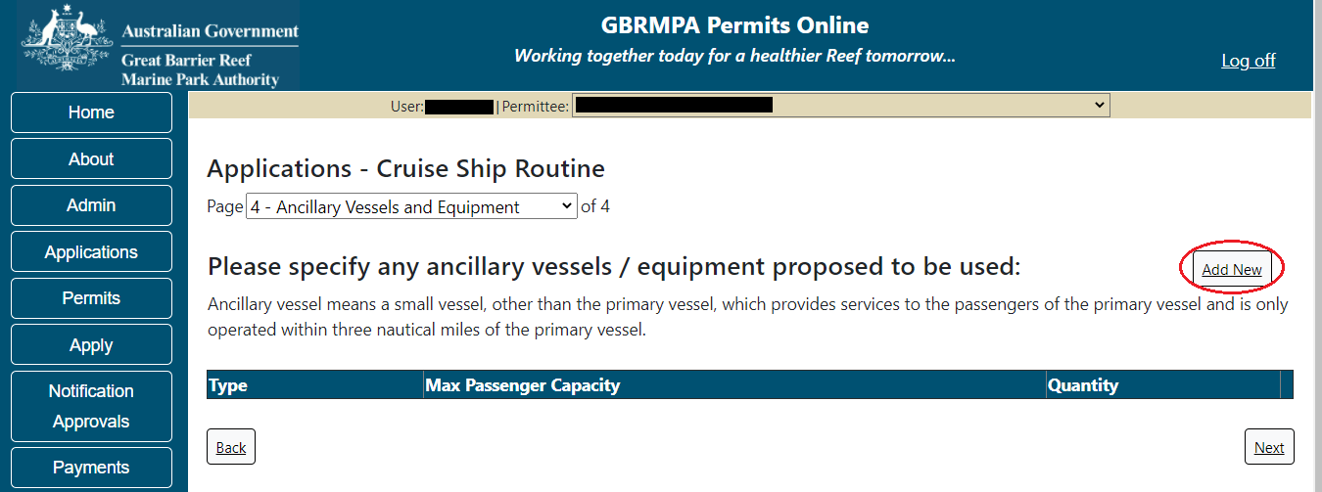
Figure 235 - Screenshot of Ancillary Vessels and Equipment screen with circle around Add New

An ‘Add New Ancillary Vessels/Equipment’ window will appear.
Figure 236 - Screenshot of ‘Add Ancillary Vessels / Equipment’ pop up window

Select an ancillary vessel or equipment from the Device list.
Figure 237 - Screenshot of Add Ancillary Vessels / Equipment pop up window showing the Device Type list

Add details of the ancillary vessels or equipment, then select ‘Save’. Please note: Maximum passenger capacity here refers to the number of passengers that can use the equipment at any one time (e.g. rubber inflatable boat). Quantity refers to the number of this type of equipment you propose to use under your permit.
Figure 238 - Screenshot of ‘Add Ancillary Vessels / Equipment’ with information completed and a red circle around the ‘Save’ button

The details of ancillary vessels or equipment will appear on the screen. Once you have added your ancillary vessels and/or equipment, select ‘Next’ to continue.
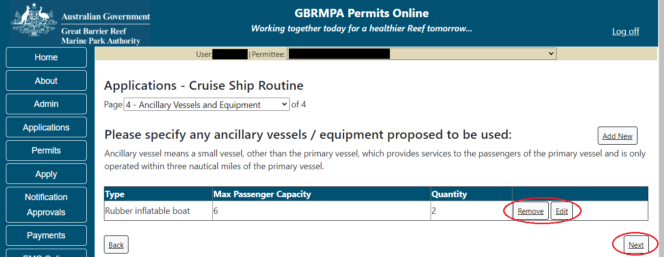
Figure 239 - Screenshot of Ancillary Vessels and Equipment page displaying information with a circle around the ‘Remove’, ‘Edit’ and ‘Next’ buttons

Completing a set of declarations is mandatory prior to submitting your application. To complete the declarations section of this application, you must either be the applicant, or if applying on behalf of an organisation / company / government agency, you must be a Director of that organisation / company / government agency. Authorised contacts cannot complete the declaration section, as it contains legally binding commitments in place of a physical signature.
Please read all questions carefully, provide a response to each, and select ‘Next’.
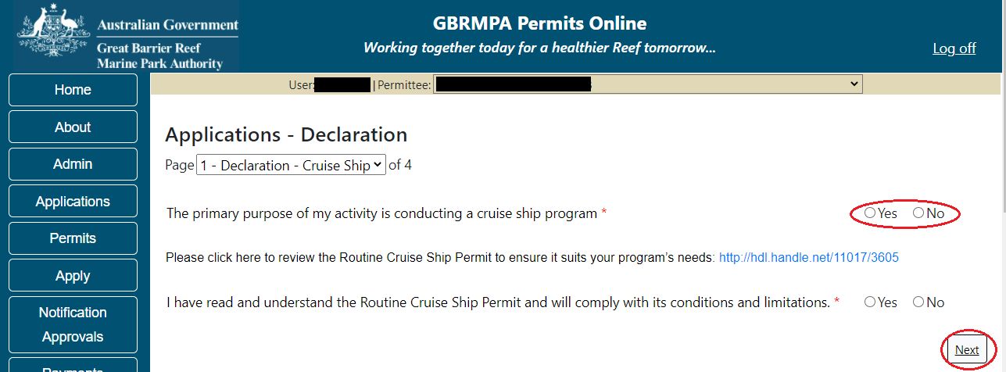
Figure 240 - Screenshot of Declarations page with red circle around Yes and No options and Next button

On the final page of declarations there is a Submit button. Once the Submit button is selected the application will be submitted to the Reef Authority and is no longer available to be edited. The status of the application on the Applications screen will then display ‘Submitted to GBRMPA’. The application’s Primary Contact will receive an emailed acknowledgement notice from a delegated Assessment Officer within 10 business days.
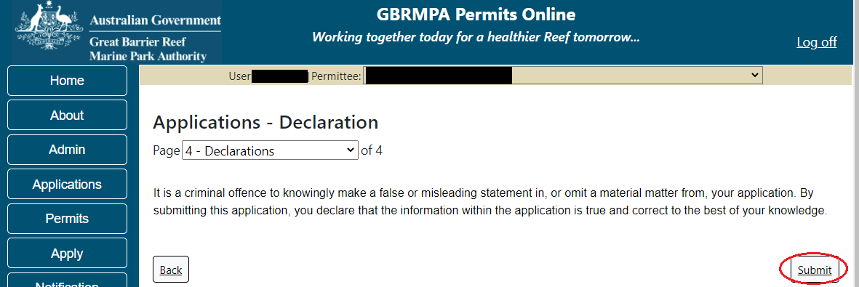
Figure 241 - Screenshot of Declarations screen with a red circle around the Submit button

Once you submit your application, you are reminded of your application number and provided further information on the assessment process.
Figure 242 - Screenshot of Permits Online Thank you for your application page with a red circle around reference number

Your application will appear in the Applications screen with the reference/application number also displayed. You have further options to view a summary of your application, email the Reef Authority or withdraw the application.
Figure 243 - Screenshot of Applications screen with a red circle around Application number, ‘Summary’, ‘Email’ and ‘Withdraw’ options

  - Tourism – Tailored Cruise Ships
Apply – new permit application – other tourism activities – Tailored Cruise Ship
To apply for Other Tourism and Charter Activities, select this option on the Apply – What are you seeking to do in the Marine Parks page.
Figure 245 - Screenshot of Apply - What are you seeking to do in the Marine Parks screen with Other Tourism and Charter Activities and a red circle around the Next button

You will progress to the application types sub menu, where you can choose which type of Tourism or Charter Activity you wish to apply for (example used is Cruise Ship). Select Next to progress to the application questions.
Figure 246 - Screenshot of Apply - What are you seeking to do in the Marine Parks - Other Tourism and Charter Activities sub menu screen with Cruise Ship and a red circle around Next button
The landing page of the Cruise ship Application is an initial page with questions and information. Depending on the nature of the cruise ship operation and what answers are obtained will determine if the applicant is eligible for a Routine Cruise ship permit Application, or if the application will be a Tailored Cruise ship Application.
On this screen, there is a link to the assessment approach information on how the permit application will be assessed.
If No is selected you will progress to the Tailored Cruise ship permit application. Select Next to continue.
Figure 247 - Screenshot of initial questions and information page with a red circle around the Yes and No buttons and a red circle around the Next button
Page 1 of Cruise Ship application is the Environment Protection and Biodiversity Conservation Act page. This provides advice on matters of national environmental significance that must be considered when assessing an application. This screen is for your information only at this stage. Your assessing officer will contact you if it is determined to be relevant for your application.
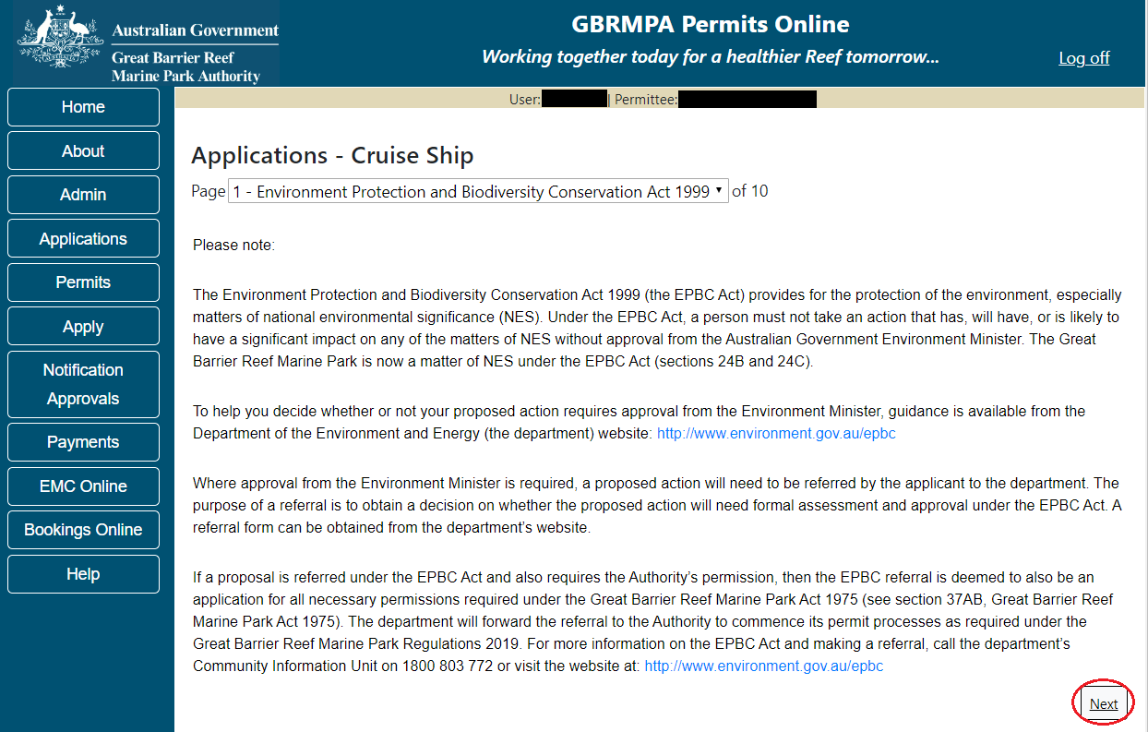
Figure 244 - Screenshot of Environment Protection and Biodiversity Conservation screen with a red circle around Next button
Links on the Environment Protection and Biodiversity Conservation page www.environment.gov.au/epbc will take you to the Department of Climate Change, Energy the Environment and Water site. Here you can find information about the Environment Protection and Biodiversity Conservation Act 1999 and your obligations under the Act.

Information - Cruise ship operations
Cruise ship access to the Marine Parks is guided by the Cruise Ship Operations within the Great Barrier Reef Guidelines. The guidelines allow for protected area managers to advise cruise ship operators, booking agents and tourists about management arrangements and how best to operate in the Marine Parks. Please review the guidelines to determine if permission to operate a Cruise Ship in the Marine Parks is the best option for your business.
Cruise Ship Operations within the Great Barrier Reef guidelines: http://hdl.handle.net/11017/3337
Page 2 of Cruise Ship application is the Permission and Activities page. All Permissions and activities listed are available and will be included in the application.
If there are any activities you do not wish to have you can remove them by selecting the Remove button next to the activity.
Select Next to continue.
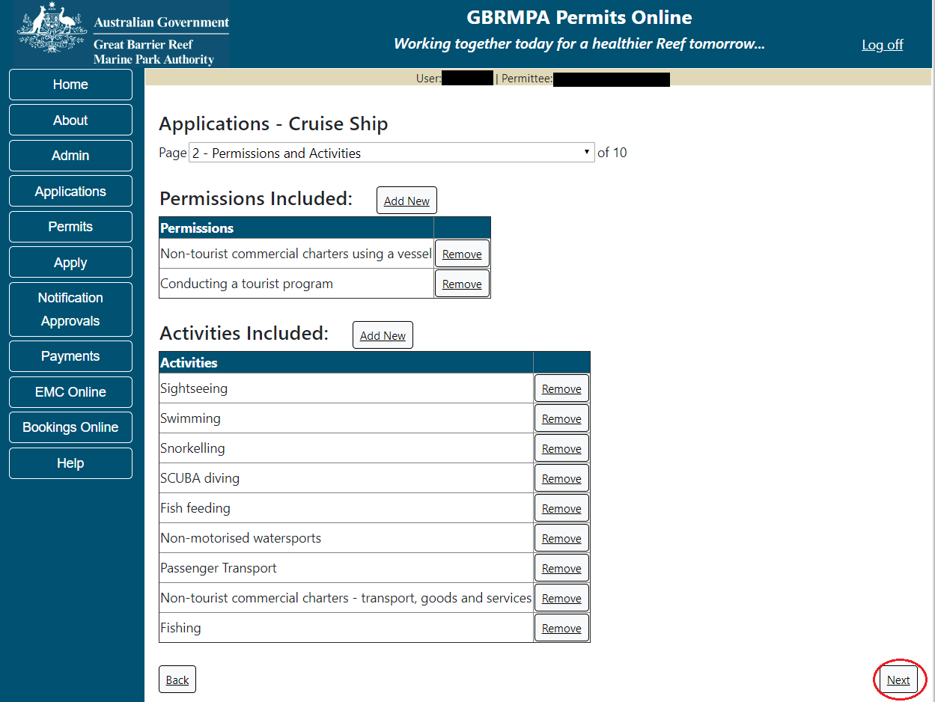
Figure 245 - Screenshot of Permissions and Activities screen with a red circle around the Next button
Page 3 of Cruise ship application is the Total Passenger Capacity / Participants page. Applicants are asked What is the total passenger capacity/participants you wish to have in the Marine Parks at any given time? (please consider future use in answering this question). Select a number from the list provided. Select Next to continue.
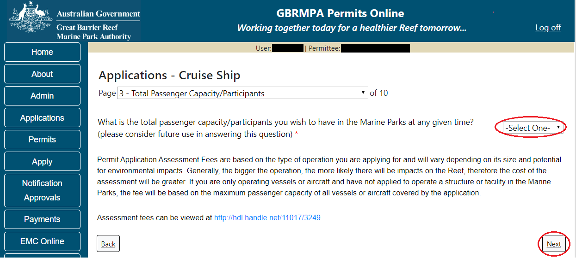
Figure 246 - Screenshot of the Total Passenger Capacity / Participants page with a red circle around the select one drop list and a red circle around the next button

Page 4 of Cruise ship application refers to Marine Park Management Areas you may wish to access. Please select the Management Area/s in which you wish to operate. Select all if you wish to operate in all management areas, considering future use.
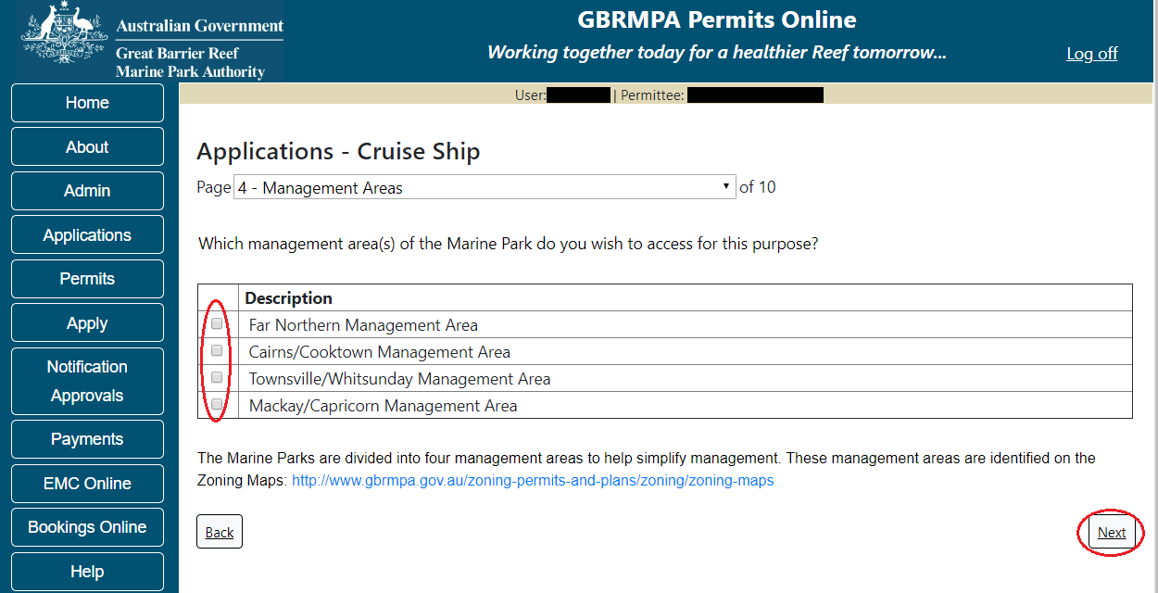
Figure 247 - Screenshot of Management Areas screen with circle around management areas tick boxes, a circle around Permit holders primary operation and red circle around Next button

Information - Management areas and maps
The Marine Parks are divided into four management areas to help simplify management. These management areas are identified on the Zoning Maps.

The Great Barrier Reef Marine Park zoning maps are tools to help you get to know the zones in the Great Barrier Reef Marine Park and Great Barrier Reef Coast Marine Park.

Zoning exists in the Great Barrier Reef Marine Park to protect plants, animals and habitats. Like a town planning scheme, it defines what activities can occur in each location.
Further information about zoning and maps, including electronic zoning maps are located on the Reef Authority’s website using the below link.
http://www.gbrmpa.gov.au/access-and-use/zoning/zoning-maps

Page 5 of Cruise Ship application provides for Additional State Access. If you want to extend your operations to mainland or island national parks adjoining the Marine Parks and/or rivers and streams between Mission Beach and the Starcke River, select Yes and an area will appear with Please specify details, add details of the islands or national parks and/or rivers and streams you wish access.
Please also indicate whether you want to operate in the Green Island Recreational Area of Management. Once completed, select Next to continue.
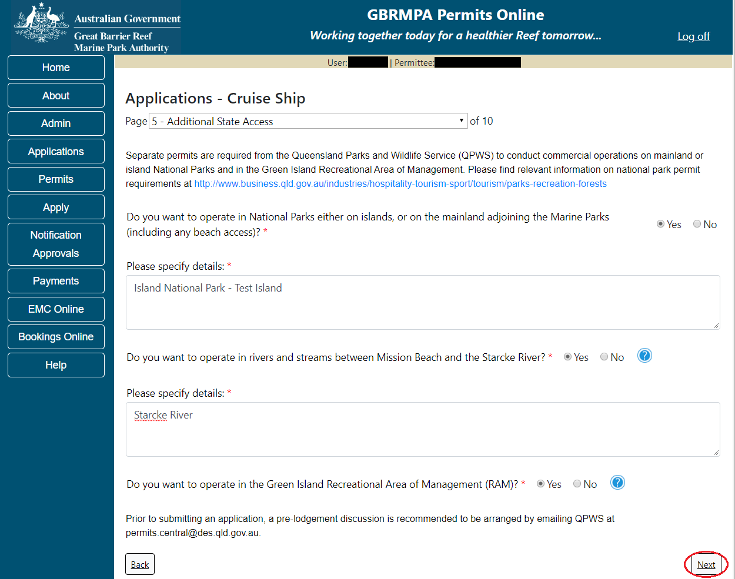
Figure 248 - Screenshot of Additional State Access screen with information displaying and a red circle around Next button
Page 6 of Cruise Ship application is the Number of Ships page. Enter the number of ships you propose to operate in the Marine Parks then select Next to continue.
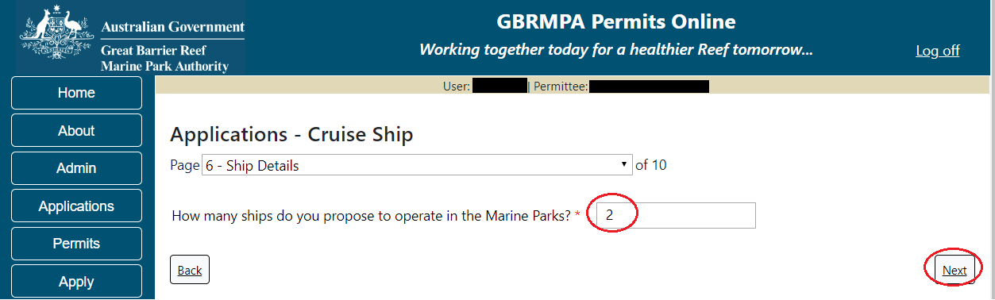
Figure 249 - Screenshot of Number of Ships page with information completed and a red circle around answer for How many ships do you propose to operate in the Marine Parks field and a red circle around Next button

Page 7 of Cruise Ship application is the Vessels page. On this page, add the details of each Cruise Ship you wish to operate. (NOTE: if you have multiple vessels each will need to be entered individually). Select the Add New button to enter details.
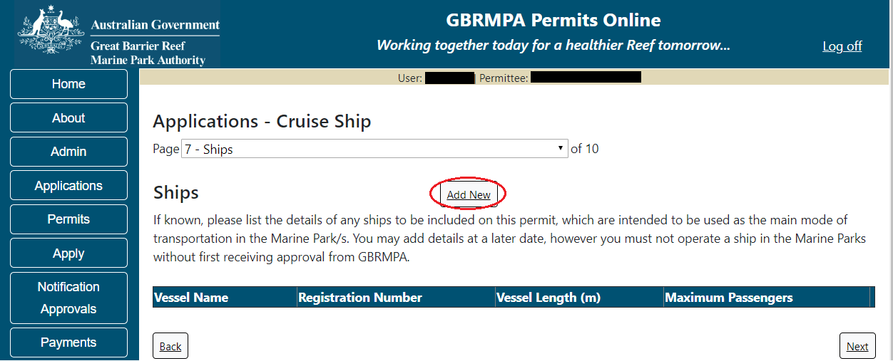
Figure 250 - Screenshot of Ships screen with circle around Add New

An Add New Vessel pop up window will appear with fields for Name, Registration Number, Length (in metres) and Maximum Passenger Capacity.
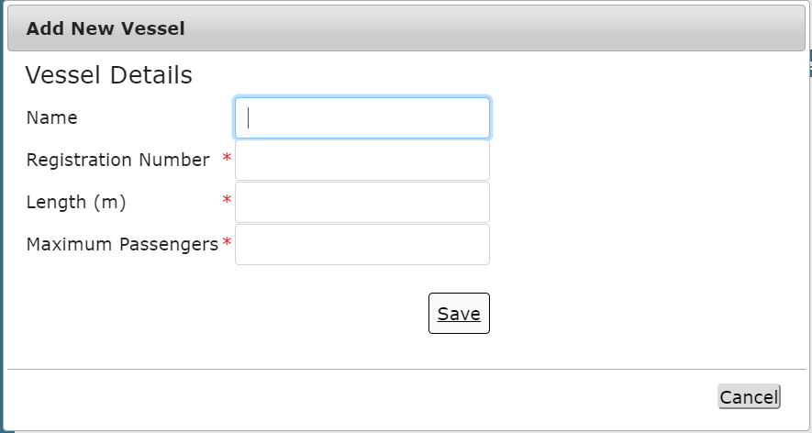
Figure 251 - Screenshot of Add New Vessel pop up window

Add the exact details of each vessel and select Save.
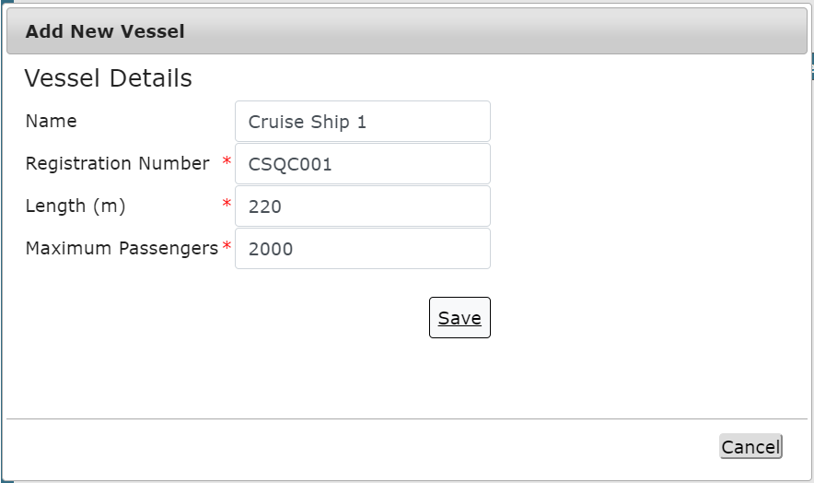
Figure 252 - Screenshot of Add New Vessel pop up window with information entered

The details of your vessel/s will save on the page, with a Remove button. Select Next to continue.
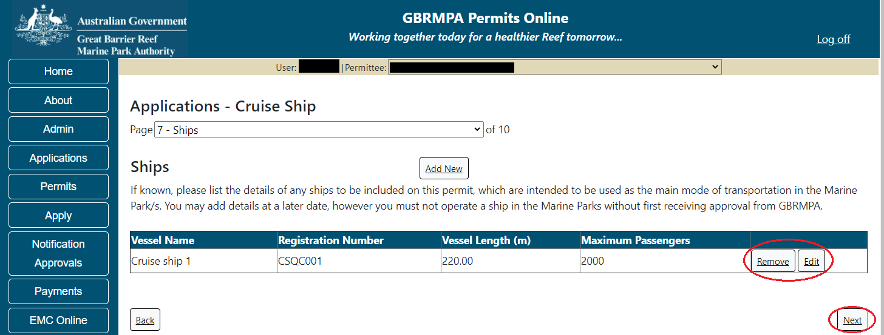
Figure 253 - Screenshot of Vessel page with information displayed and a red circle around Remove and Edit buttons and a red circle around the Next button

Page 8 of Cruise Ship application addresses ancillary vessels and equipment. To add ancillary vessels or equipment select the Add New button.
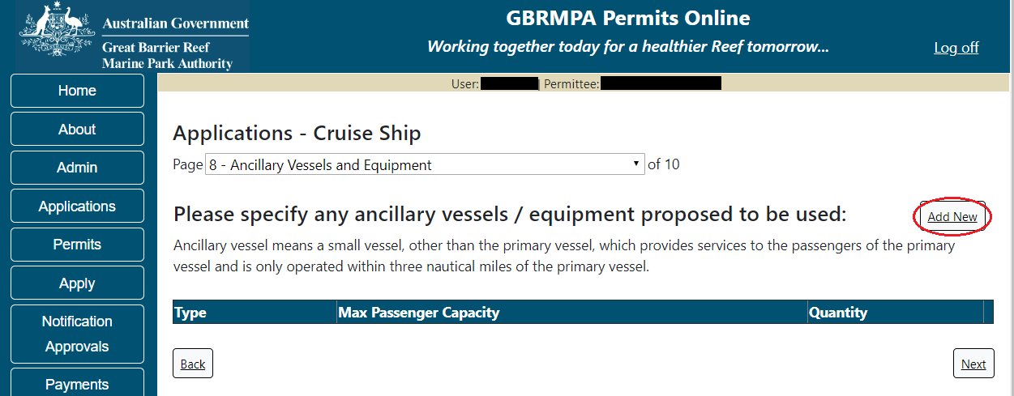
Figure 254 - Screenshot of Ancillary Vessels and Equipment screen with circle around Add New
An Add New Ancillary Vessels/Equipment window will appear.
Figure 255 - Screenshot of Add Ancillary Vessels / Equipment pop up window
Select Ancillary Vessels or Equipment from the Device list
Figure 256 - Screenshot of Add Ancillary Vessels / Equipment pop up window with Device list displayed

Add exact details of the ancillary vessels or equipment, then select Save.
Figure 257 - Screenshot of Add Ancillary Vessels / Equipment pop up window with information entered and a red circle around Save
The details of ancillary vessels or equipment will save on the page, with a Remove button and an Edit button. If you need to remove the ancillary vessel or equipment select Remove and the details will be deleted. If you wish to edit the details, select the Edit button. Select Next to continue.
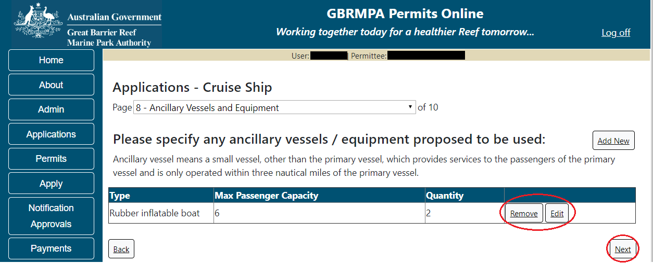
Figure 258 - Screenshot of Ancillary Vessels and Equipment page with information displayed and a red circle around Remove button and Next button

Page 9 of Cruise Ship application refers to High Standard Tourism operators. If you have obtained a High Standard Tourism certification with an approved certification scheme, select Yes. Then upload a copy of your certificate using the upload feature.
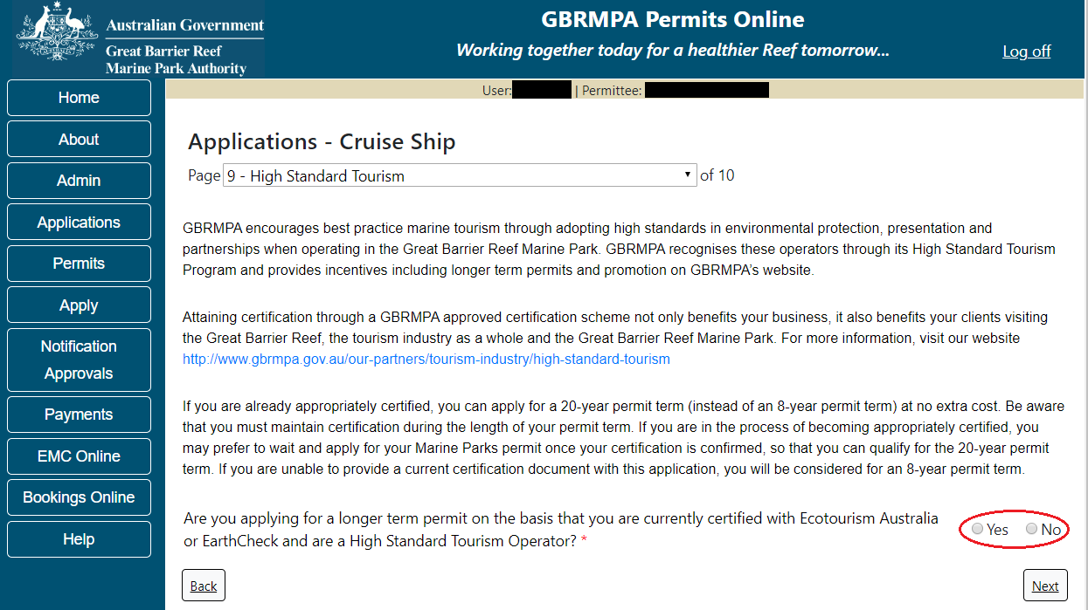
Figure 259 - Screenshot of High Standard Tourism page with a red circle Yes and No options
If you have certification, select the Yes button, an upload file button will appear. Select the upload file button.
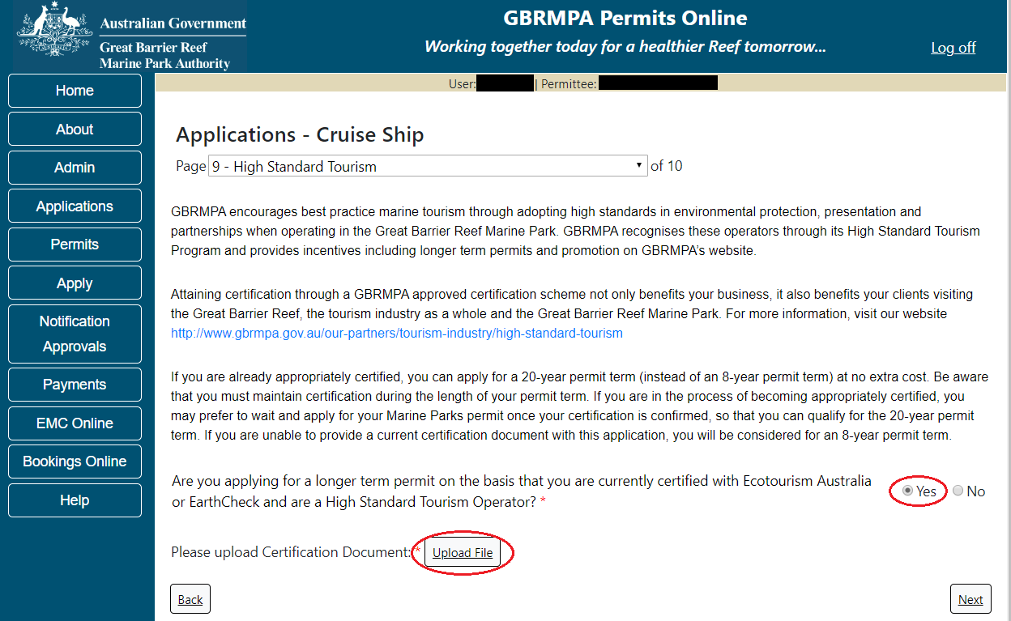
Figure 260 - Screenshot of High Standard Tourism page with Yes selected and circled and Upload File button circled

The File Upload screen will appear. Select Browse
Figure 261 - Screenshot of Upload File pop up window
Once you load a copy of your certificate, you will see the filename with a Remove button next to it. If you wish to remove the file, select the Remove button. Select Next to go to the next page.
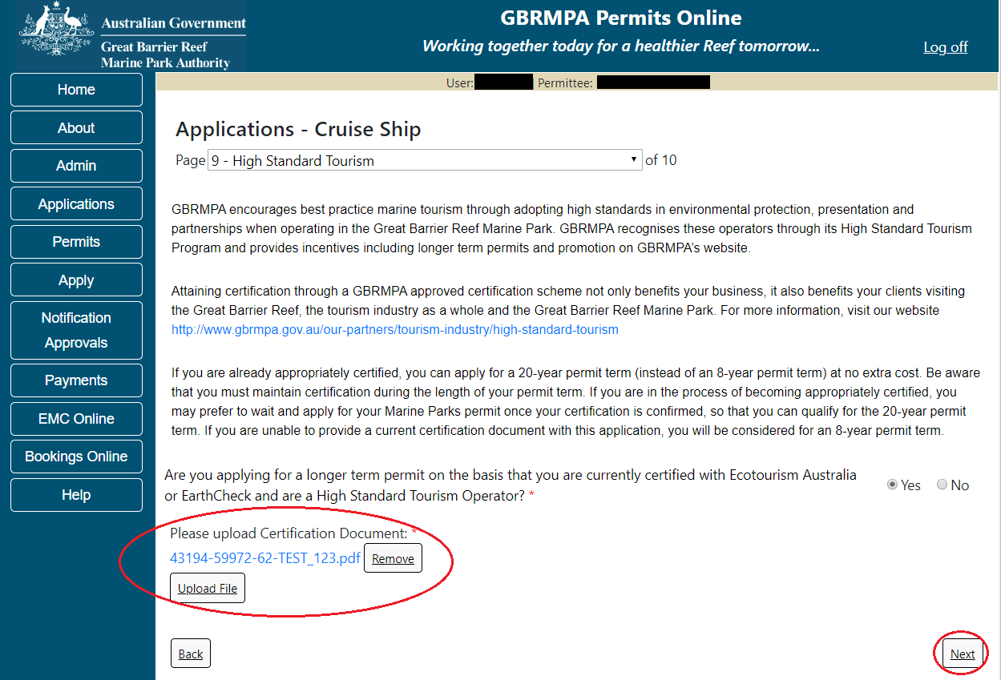
Figure 262 - Screenshot of High Standard Tourism page with Yes and a red circle around the Uploaded File and red circle around Next button

Page 10 of the Cruise Ship application provides opportunity for you to add any other information you feel will assist the Managing Agencies in assessing your application. Add supporting information by typing in the text field or upload a file if required. If a file is uploaded it will appear on the screen with the file name and a Remove button to remove the file if the wrong file is selected.
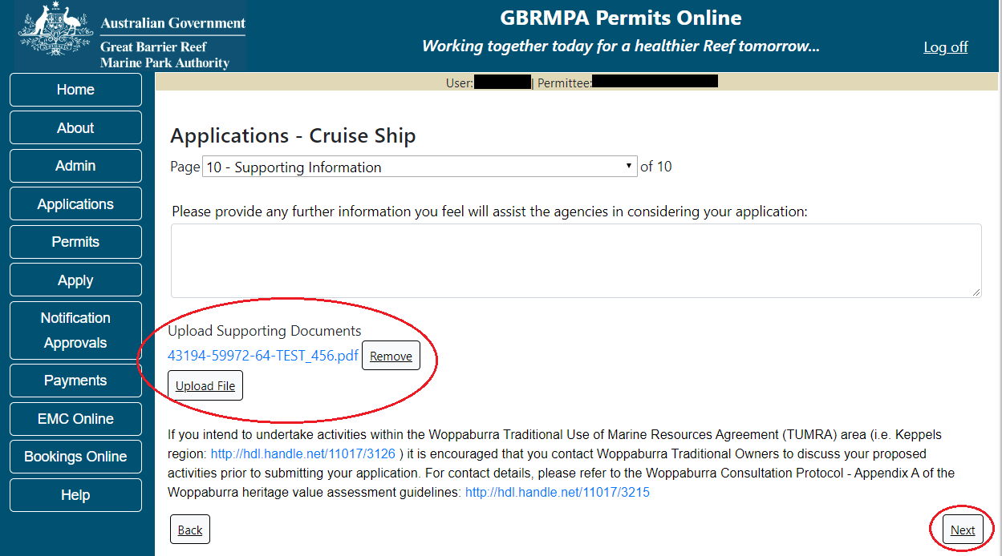
Figure 263 - Screenshot of Supporting Information screen with a red circle around Uploaded File area and a red circle around Next button
Once you have completed the supporting information page select Next from the last page of the application questions, you will progress to an application summary screen with a number of options available via links or buttons. Select Next on the summary screen to progress to the Declarations screens.
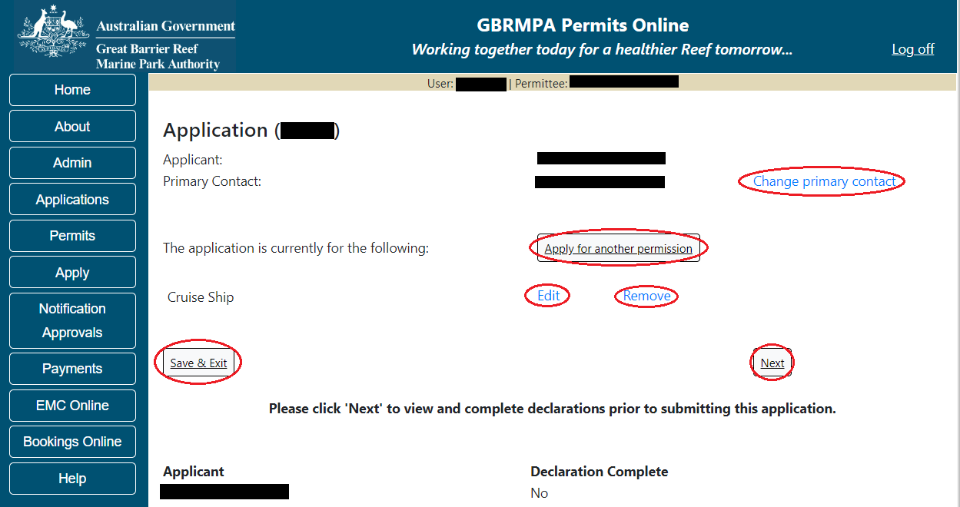
Figure 264 - Screenshot of Application Summary page with red circles around all options available

Additional Information - Summary screen, links and buttons;
- Change primary contact: If the change primary contact link is selected the applicant will progress to the primary contact page where the primary contact can be changed.

- Apply for another permission: If the apply for another permission button is selected, the applicant will progress to the What are you seeking to do in the Marine Parks page where another permission type can be added. (e.g. add a mooring permission to the tourism permission).

- Edit: If edit is selected the application/permission will be reopened to apply any changes.

- Remove: If remove is selected the application/permission will be removed.

- Save & Exit: If the Save & Exit button is selected the applicant will progress to the applications screen.

- Next: If next is selected the applicant will progress to the submission process including declaring and submitting the application.
Completion of a set of declarations is mandatory prior to submitting your application. To complete the declarations section of this application, you must either be the applicant, or if applying on behalf of an organisation / company / government agency, you must be a Director of that organisation / company / government agency. Authorised contacts cannot complete the declaration section, as it contains legally binding commitments in place of a physical signature.
Please read all questions carefully, provide a response to each, and select Next.
Figure 265 - Screenshot of Declarations page with red circle around Yes and No options and Next button

On the final page of declarations there is a Submit button. Once the Submit button is selected, the application will be submitted to the Reef Authority and is no longer available to be edited. The status of the application on the Applications screen will then display ‘Submitted to GBRMPA’. The application’s Primary Contact will receive an emailed acknowledgement notice from a delegated Assessment Officer within 10 business days.
Figure 266 - Screenshot of Declarations screen with a red circle around the Submit button
Once you submit your application, you will be provided with a reference/application number and can follow the progress of your application via the Applications menu on the left.
Figure 267 - Screenshot of the Thank you for your application screen with a red circle around Reference number and a red circle around the open pdf button

Your application will appear in the Applications screen with the reference/application number also displayed. You have further options to view a summary of your application, email the Reef Authority or withdraw the application.
Figure 268 - Screenshot of Applications screen with a red circle around Application No., Summary, Email and Withdraw options

  - Tourism – Guided Tours (Motorised)
Apply – new permit application – other tourism activities – guided tours (motorised)
To apply for Other Tourism and Charter Activities, select this option on the Apply – What are you seeking to do in the Marine Parks page.
Figure 269 - Screenshot of Apply - What are you seeking to do in the Marine Parks screen with Other Tourism and Charter Activities and a red circle around the Next button

You will progress to the application types sub menu, where you can choose which type of Tourism or Charter activity you wish to apply for [example used is Guided Tours (Motorised)]. Select Next to progress to the application questions.
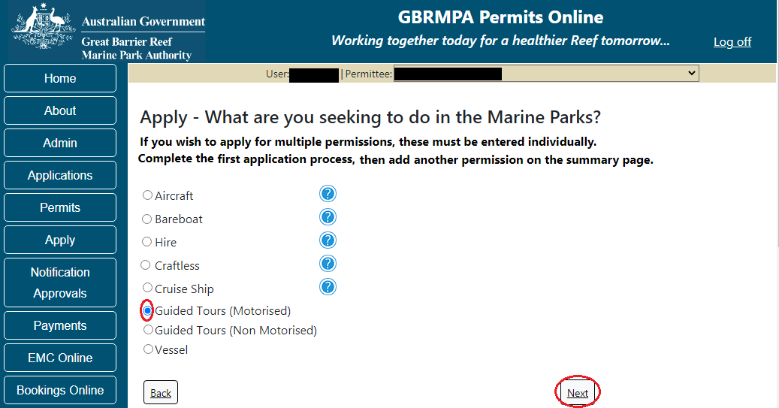
Figure 270 - Screenshot of Apply - What are you seeking to do in the Marine Parks - Other Tourism and Charter Activities sub menu screen with Guided Tours (Motorised) and a red circle around Next button
Page 1 of Guided Tours (Motorised) application is the Environment Protection and Biodiversity Conservation Act page. This provides advice on matters of national environmental significance that must be considered when assessing an application. This screen is for your information only at this stage. Your assessing officer will contact you if it is determined to be relevant for your application.
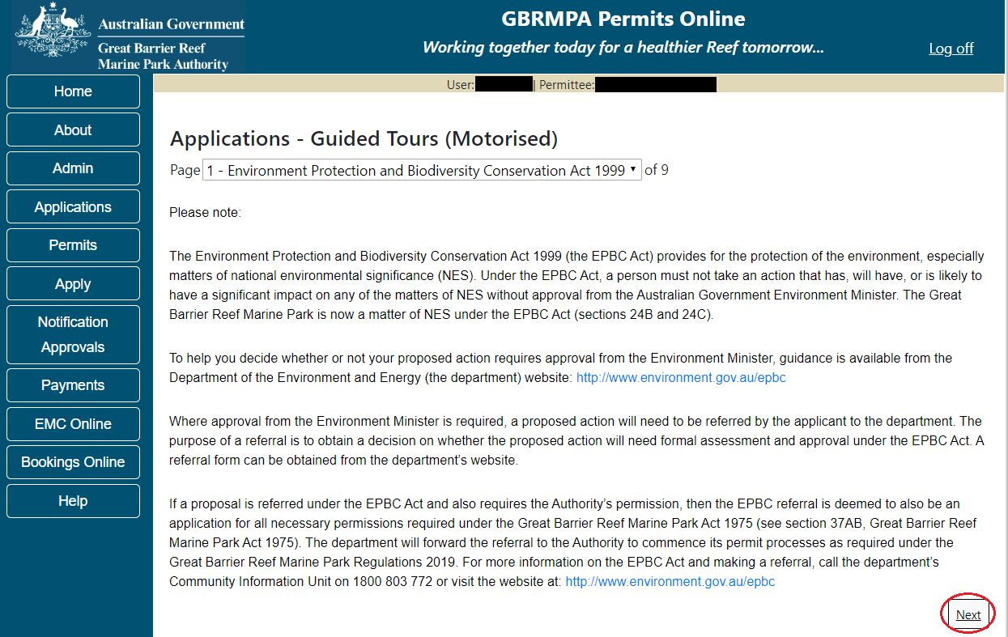
Figure 271 - Screenshot of Environment Protection and Biodiversity Conservation screen with a red circle
around Next button
Links on the Environment Protection and Biodiversity Conservation page www.environment.gov.au/epbc will take you to the Department of Climate Change, Energy the Environment and Water site. Here you can find information about the Environment Protection and Biodiversity Conservation Act 1999 and your obligations under the Act.
Page 2 of the Guided Tours (Motorised) application is the Permissions and Activities page. All Permissions and activities listed are available and will be included in the application.
If there are any activities you do not wish to have you can remove them by selecting the Remove button next to the activity.
Select Next to continue.
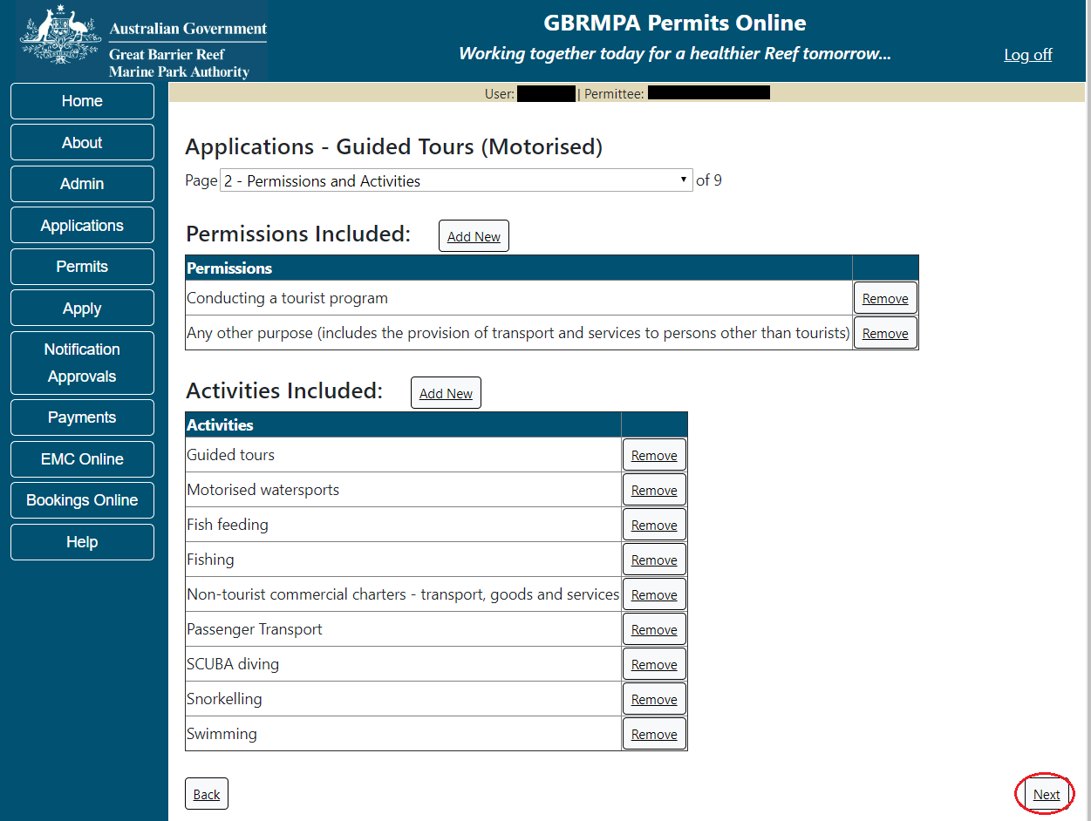
Figure 272 - Screenshot of Permissions and Activities screen with a red circle around Next button

Page 3 of Guided Tours (motorised) application is the Total Passenger Capacity / Participants page. A question for What is the total passenger capacity/participants you wish to have in the Marine Parks at any given time? (please consider future use in answering this question) is presented. Select a number from the list provided. Select Next to continue.
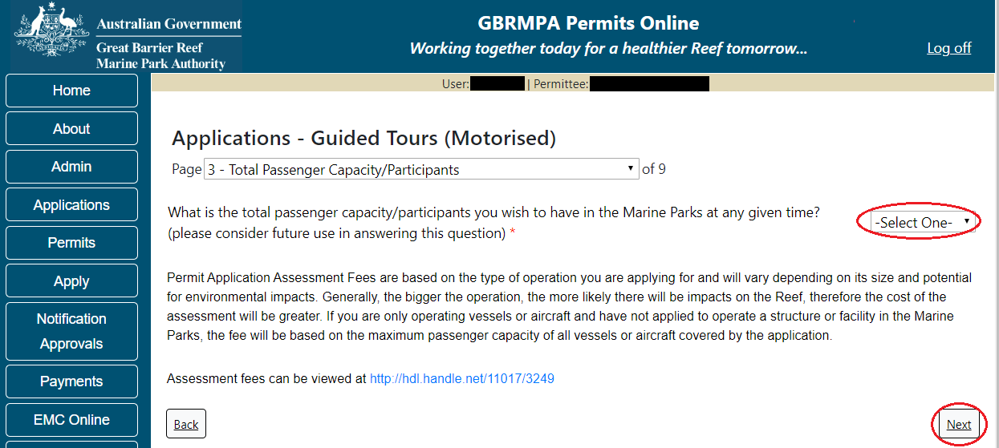
Figure 273 - Screenshot of the Total Passenger Capacity / Participants page with a red circle around the select one drop list and a red circle around the next button

Page 4 of Guided Tours (motorised) application is the Management / Operation page. For Guided Tours (motorised) applications, no areas are selected as default. Please select the Management Area/s in which you wish to operate. Select all if you wish to operate in all management areas, considering future use.
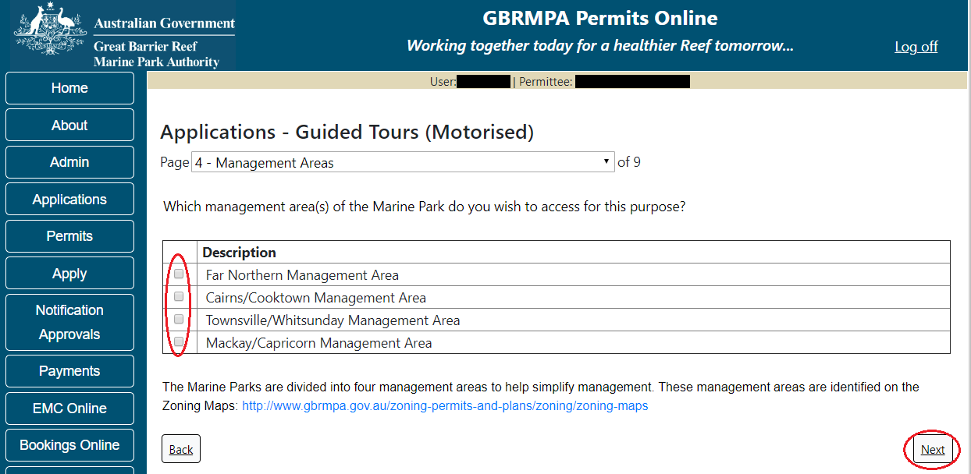
Figure 274 - Screenshot of Management Areas screen with circle around management areas tick boxes, a circle around Permit holders primary operation and red circle around Next button

Page 5 of Guided Tours (Motorised) application is the Guided Tours Details page. Add details of where you propose to operate your tours in the Marine Park.
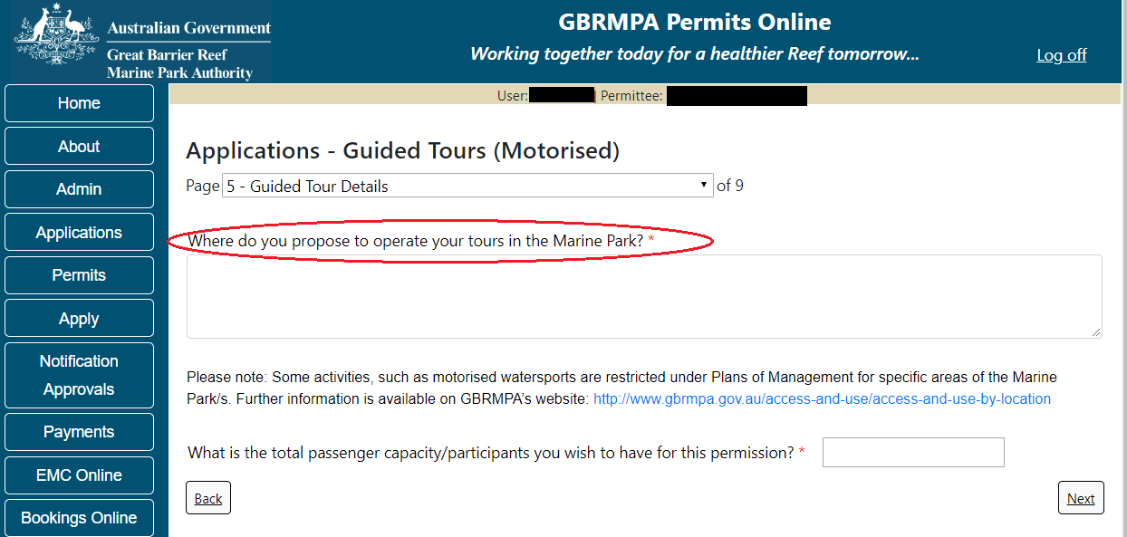
Figure 275 - Screenshot of Guided Tours Details screen with a red circle around question - Where do you propose to operate your tours in the Marine Park

For the question, What is the total passenger capacity / participants you wish to have for this permission add the amount of passengers for this permission. Select Next to move to the next page.
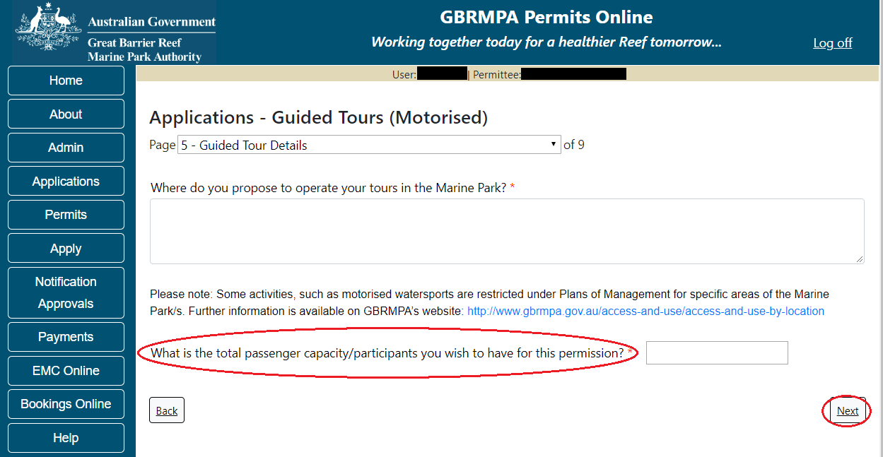
Figure 276 – Screenshot of Guided Tours Details screen with a red circle around question – What is the total passenger capacity / participants you wish to have for this permission and a red circle around the next button

Page 6 of Guided Tours (Motorised) application is the Additional State Access. If you want to extend your operations to mainland or island national parks adjoining the Marine parks and/or rivers and streams between Mission Beach and the Starcke River, select yes and an area will appear with Please Specify details, add details of the islands or national parks and/or Rivers and streams you wish access.
Please also indicate if you want to operate in the Green Island Recreational Area. Once completed select Next to continue.
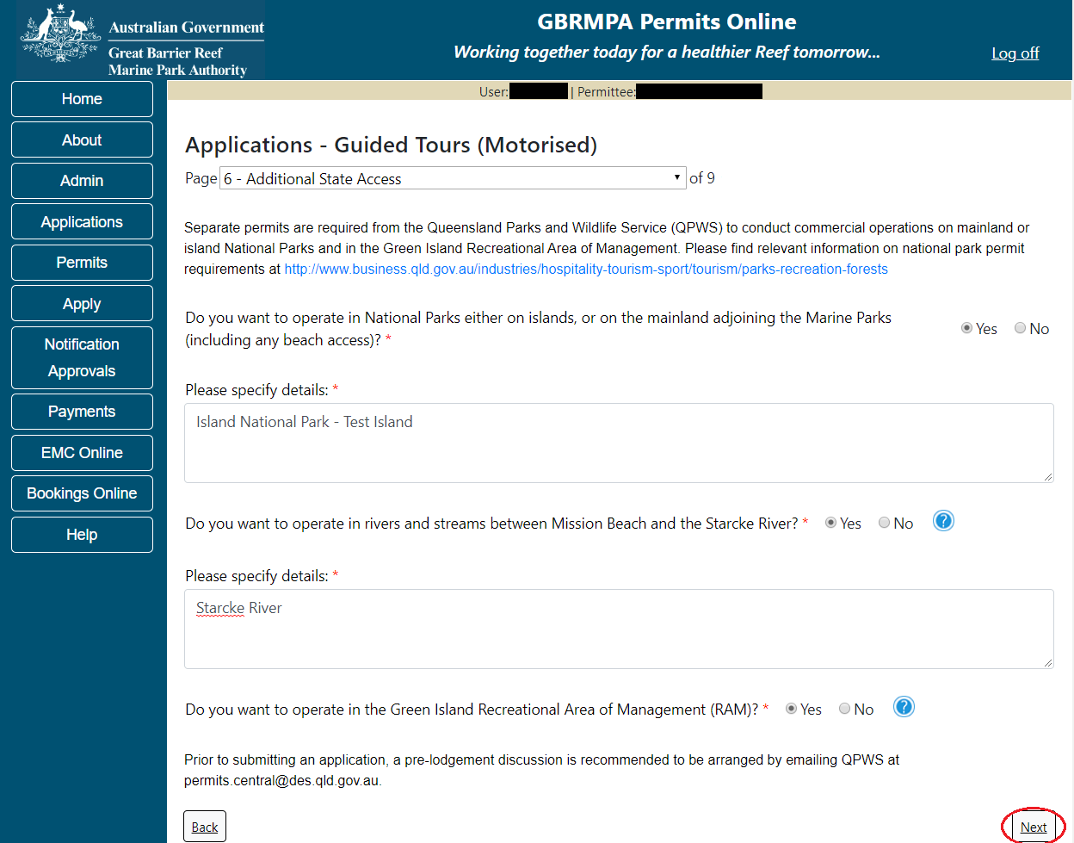
Figure 277 - Screenshot of Additional State Access screen with information displaying and a red circle around Next button
Page 7 of Guided Tours (Motorised) is the Equipment page. To add equipment, select the Add New button.
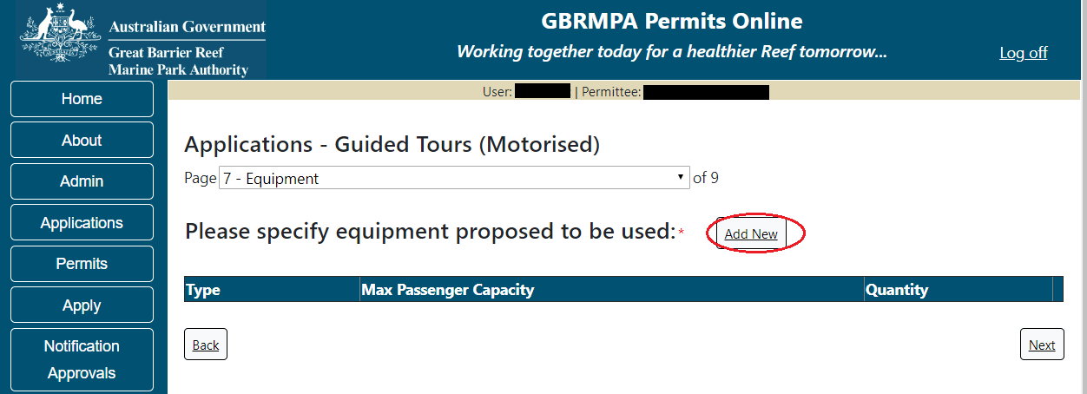
Figure 278 - Screenshot of Ancillary Vessels and Equipment screen with circle around Add New

An Add New Ancillary Vessels/Equipment window will appear.
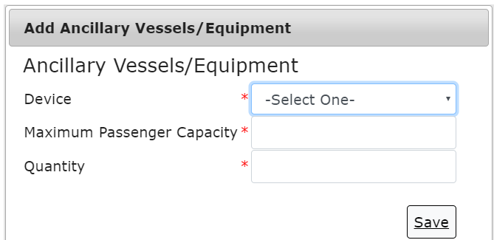
Figure 279 - Screenshot of Add Ancillary Vessels / Equipment pop up window

Select Ancillary Vessels or Equipment from the Device list. If your Motorised ancillary vessel or equipment is not in the list provided, please add details and load any specifications documents on (page 9) Supporting Information.
Figure 280 - Screenshot of Add Ancillary Vessels / Equipment pop up window with Device list displayed

Add the exact details of the equipment, then select Save.
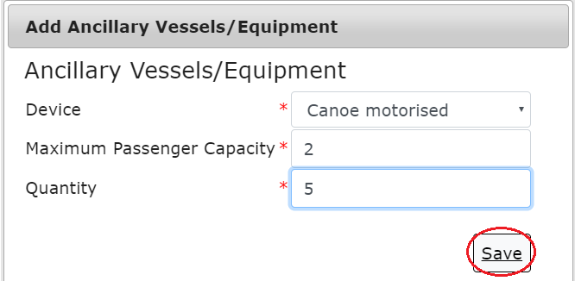
Figure 281 - Screenshot of Add Ancillary Vessels / Equipment pop up window with information entered and a red circle around Save

The details of ancillary vessels or equipment will save on the page, with a Remove button and an Edit button. If you need to remove the equipment select Remove and the details will be deleted. If you wish to edit the details, select the Edit button. Select Next to continue.
NOTE: If you have multiple motorised ancillary vessels or equipment each type of ancillary vessel or equipment is to be entered separately. (E.g. Canoe Motorised and Jet skis are entered as separate types of ancillary vessels or equipment).
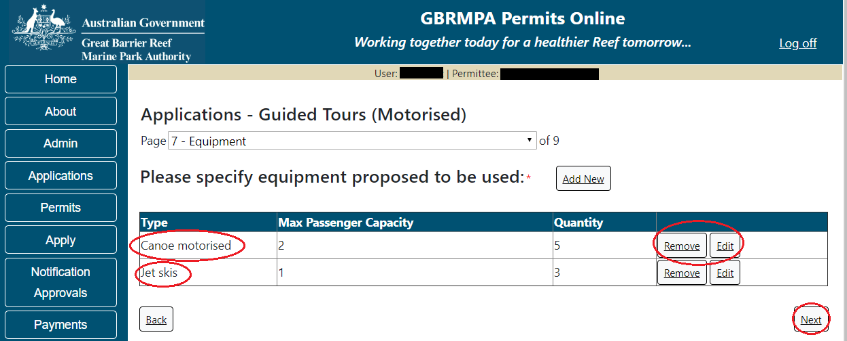
Figure 282 - Screenshot of Ancillary Vessels and Equipment page with information displayed and a red circle around Canoe motorised and Jet skis and a red circle around the next button

Page 9 refers to High Standard Tourism operators. If you have obtained a High Standard Tourism certification with an approved certification scheme, select Yes then upload a copy of your certificate using the upload feature.
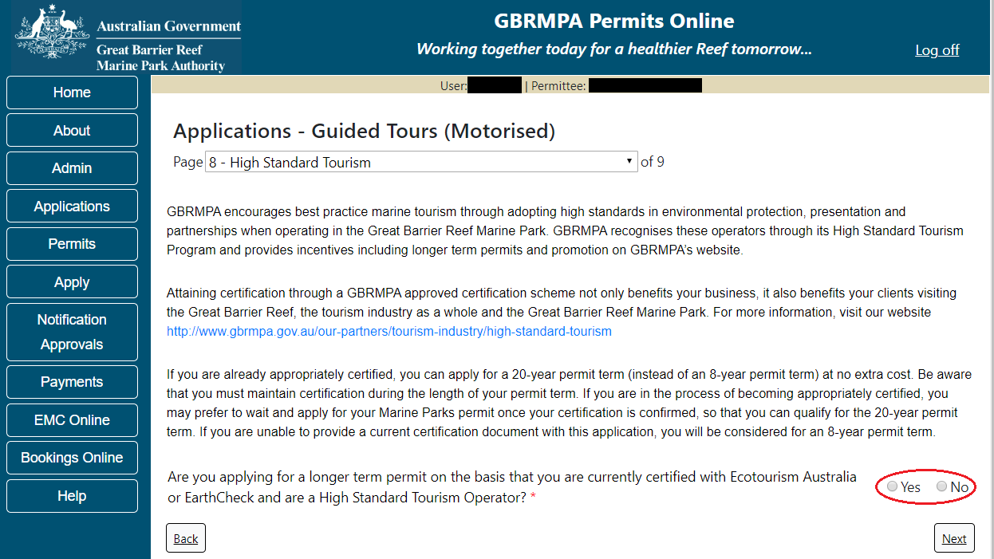
Figure 283 - Screenshot of High Standard Tourism page with a red circle around Yes and No options

If you have certification, select the Yes button, an upload file button will appear. Select the upload file button and upload a file.
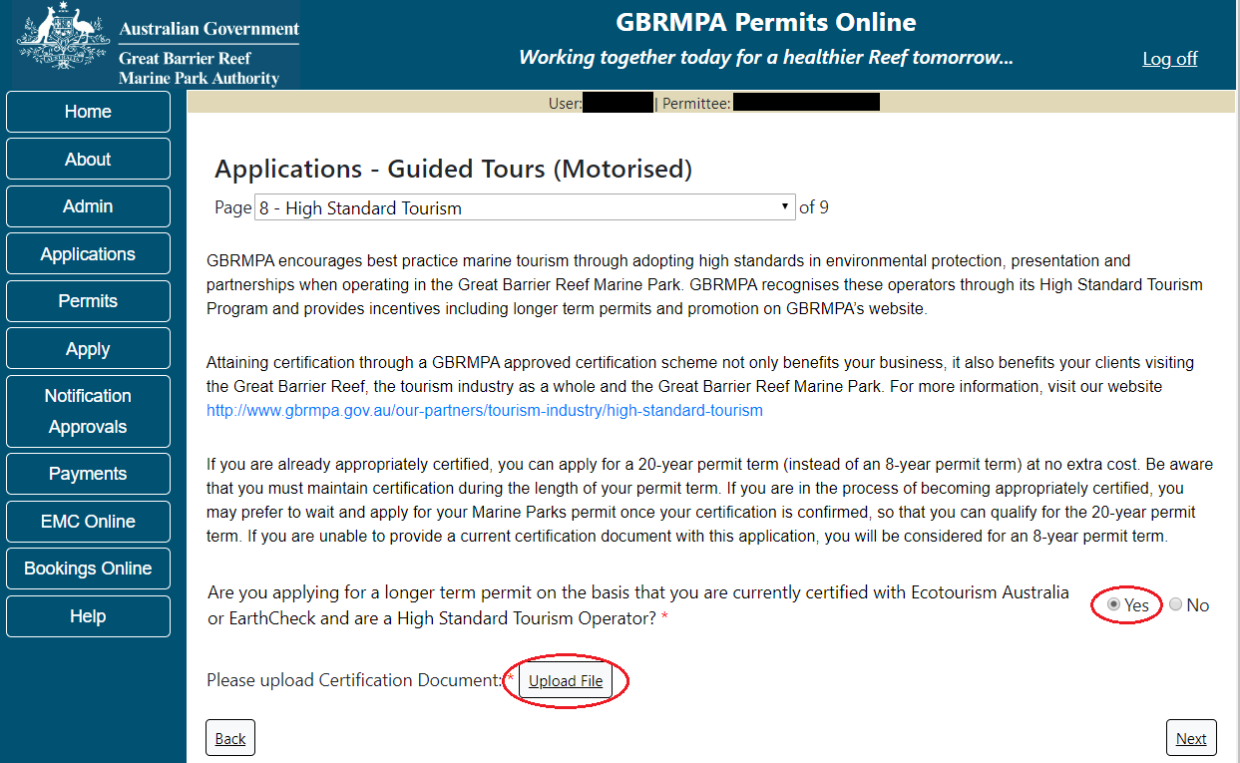
Figure 284 - Screenshot of High Standard Tourism page with Yes selected and circled and Upload File button circled
Once you load a copy of your certificate, you will see the filename with a Remove button next to it. If you wish to remove the file, select the Remove button. Select Next to go to the next page.
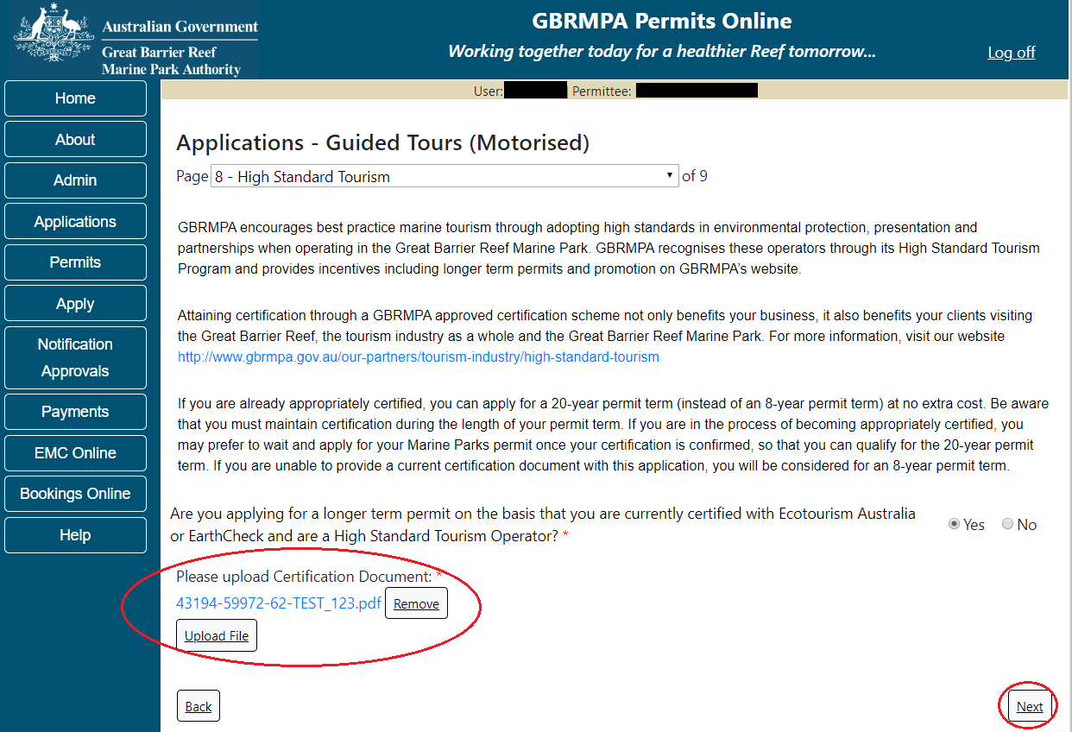
Figure 285 - Screenshot of High Standard Tourism page with Yes selected and a red circle around the Uploaded File and red circle around Next button

Page 9 of Guided Tours (Motorised) is provides opportunity for you to add any other information you feel will assist the Managing Agencies in assessing your application. Add supporting information by typing in the text field or upload a file if required. If a file is uploaded it will appear on the screen with the file name and a Remove button, to remove the file if the wrong file is selected.
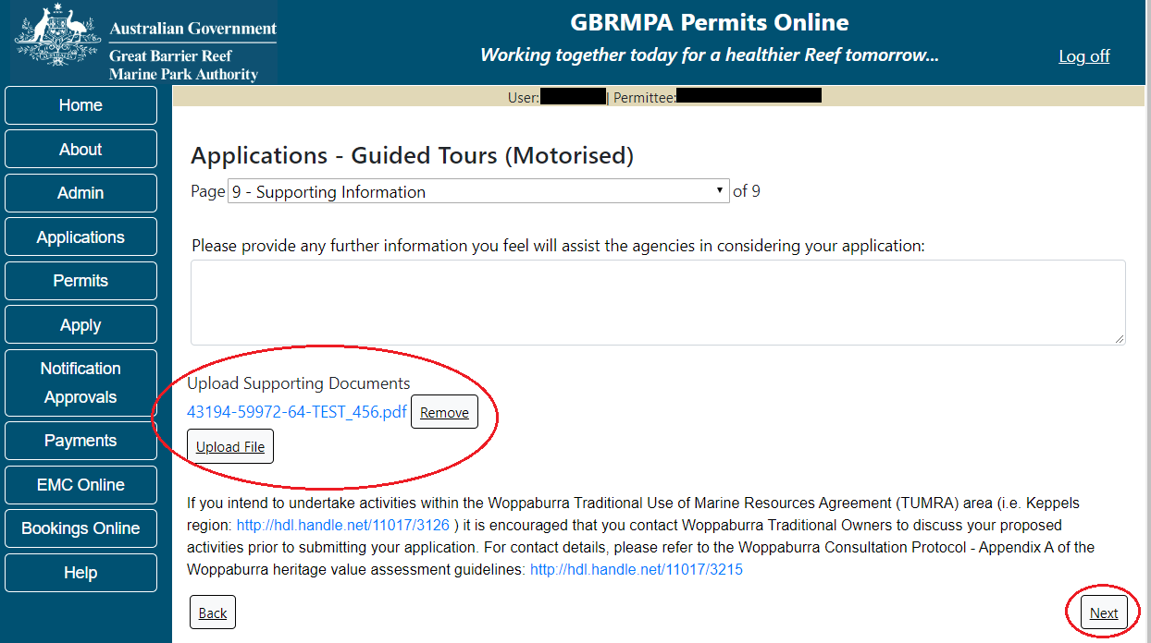
Figure 286 - Screenshot of Supporting Information screen with a red circle around Uploaded File area and a red circle around Next button
Once you have completed the supporting information page select Next from the last page of the application questions, you will progress to an application summary screen with a number of options available via links or buttons. Select Next on the summary screen to progress to the Declarations screens.
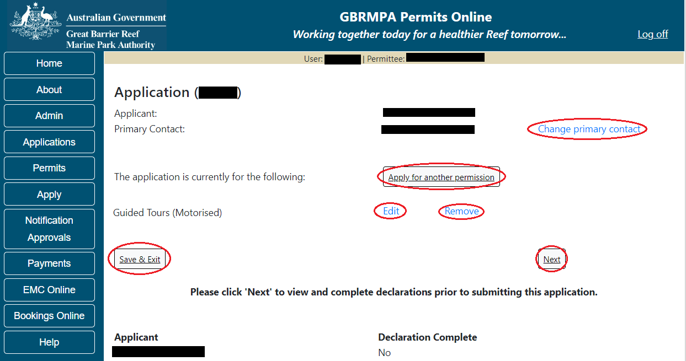
Figure 287 - Screenshot of Application Summary page with red circles around all options available

Additional Information - Summary screen, links and buttons;
- Change primary contact: If the change primary contact link is selected the applicant will progress to the primary contact page where the primary contact can be changed.

- Apply for another permission: If the apply for another permission button is selected, the applicant will progress to the What are you seeking to do in the Marine Parks page where another permission type can be added. (e.g. add a mooring permission to the tourism permission).

- Edit: If edit is selected the application/permission will be reopened to apply any changes.

- Remove: If remove is selected the application/permission will be removed.

- Save & Exit: If the Save & Exit button is selected the applicant will progress to the applications screen.

- Next: If next is selected the applicant will progress to the submission process including declaring and submitting the application.
Completion of a set of declarations is mandatory prior to submitting your application. To complete the declarations section of this application, you must either be the applicant, or if applying on behalf of an organisation / company / government agency, you must be a Director of that organisation / company / government agency. Authorised contacts cannot complete the declaration section, as it contains legally binding commitments in place of a physical signature.
Please read all questions carefully, provide a response to each, and select Next.
Figure 288 - Screenshot of Declarations page with red circle around Yes and No options and Next button
On the final page of declarations there is a Submit button. Once the Submit button is selected, the application will be submitted to the Reef Authority and is no longer available to be edited. The status of the application on the Applications screen will then display ‘Submitted to GBRMPA’. The application’s Primary Contact will receive an emailed acknowledgement notice from a delegated Assessment Officer within 10 business days.
Figure 289 - Screenshot of Declarations screen with a red circle around the Submit button
Once you submit your application, you will be provided with a reference/application number and can follow the progress of your application via the Applications menu on the left.
Figure 290 - Screenshot of the Thank you for your application screen with a red circle around Reference number and a red circle around the open pdf button

Your application will appear in the Applications screen with the reference/application number also displayed. You have further options to view a summary of your application, email the Reef Authority or withdraw the application.
Figure 291 - Screenshot of Applications screen with a red circle around Application No., Summary, Email and Withdraw options

  - Tourism – Guided Tours (Non-Motorised)
Apply – new permit application – other tourism activities – guided tours (non-motorised)
To apply for Other Tourism and Charter Activities, select this option on the Apply – What are you seeking to do in the Marine Parks page.
Figure 292 - Screenshot of Apply - What are you seeking to do in the Marine Parks screen with Other Tourism and Charter Activities selected and a red circle around the Next button

You will progress to the application types sub menu, where you can choose which type of Tourism or charter activity you wish to apply for [example used is Guided Tours (Non-Motorised)]. Select Next to progress to the application questions.
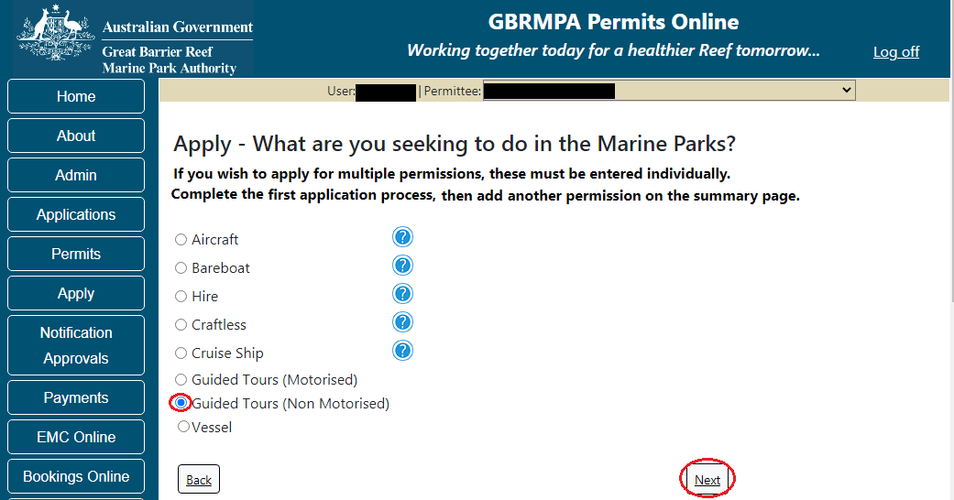
Figure 293 - Screenshot of Apply - What are you seeking to do in the Marine Parks - Other Tourism and Charter Activities sub menu screen with Guided Tours (Non-Motorised) selected and a red circle around Next button
Page 1 of Guided Tours (Non-Motorised) application is the Environment Protection and Biodiversity Conservation Act page. This provides advice on matters of national environmental significance that must be considered when assessing an application. This screen is for your information only at this stage. Your assessing officer will contact you if it is determined to be relevant for your application.
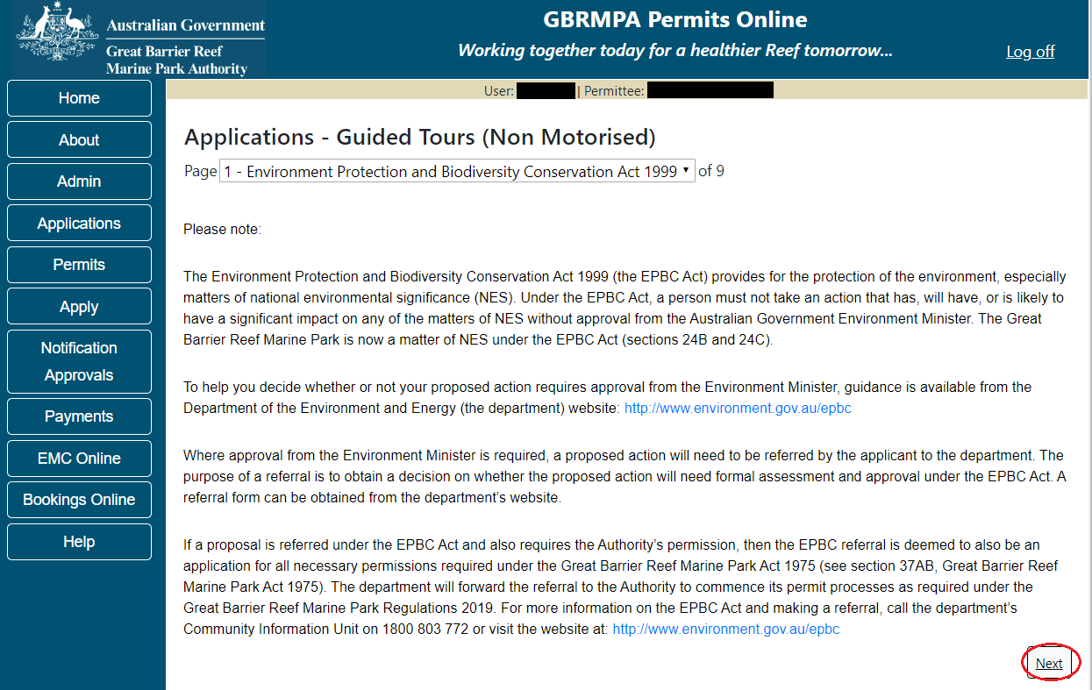
Figure 294 - Screenshot of Environment Protection and Biodiversity Conservation screen with
a red circle around Next button
Links on the Environment Protection and Biodiversity Conservation page www.environment.gov.au/epbc will take you to the Department of Climate Change, Energy, the Environment and Water site. Here you can find information about the Environment Protection and Biodiversity Conservation Act 1999 and your obligations under the Act.
Page 2 of Guided Tours (Non-Motorised) is the Permissions and Activities page. All Permissions and activities listed are available and will be included in the application.
If there are any activities you do not wish to have you can remove them by selecting the Remove button next to the activity. Select Next to continue.
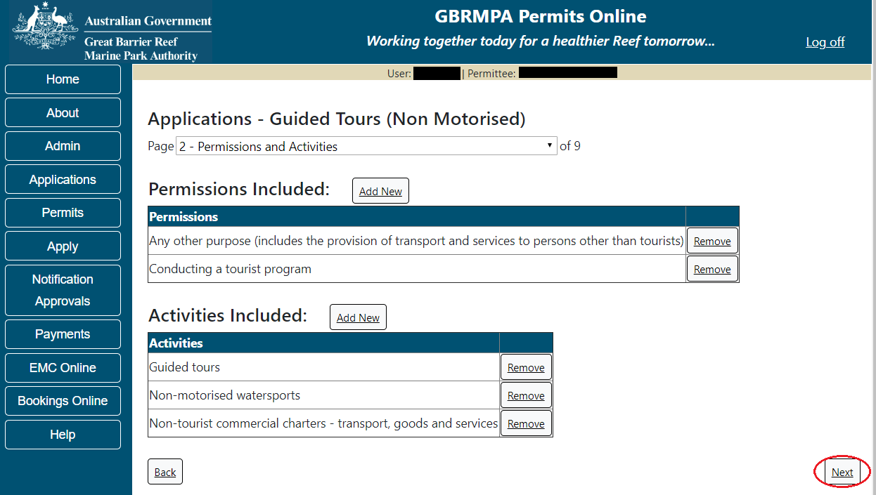
Figure 295 - Screenshot of Permissions and Activities screen with a red circle around Remove button and Next button
Page 3 of Guided Tours (non-motorised) application is the Total Passenger Capacity / Participants page. A question for What is the total passenger capacity/participants you wish to have in the Marine Parks at any given time? (please consider future use in answering this question) is presented. Select a number from the list provided. Select Next to continue.
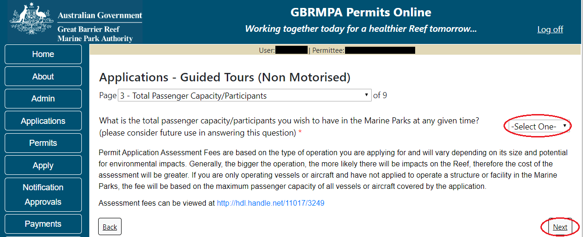
Figure 296 - Screenshot of the Total Passenger Capacity / Participants page with a red circle around the select one drop list and a red circle around the next button

Page 4 of Guided Tours (motorised) application is the Management / Operation page. For Guided Tours (motorised) applications no areas are selected as default. Please select the Management Area/s in which you wish to operate. Select all if you wish to operate in all management areas, considering future use.
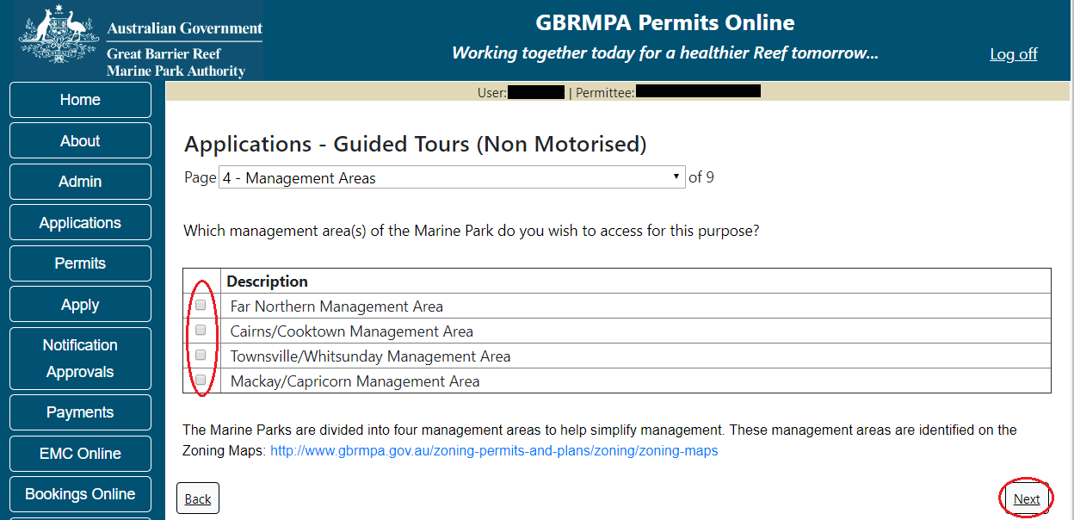
Figure 297 - Screenshot of Management Areas screen with circle around management areas tick boxes, a circle around Permit holders primary operation and red circle around Next button

Page 5 of Guided Tours (Non-Motorised) application is the Guided Tours Details page. Add details of where you propose to operate your tours in the Marine Park.
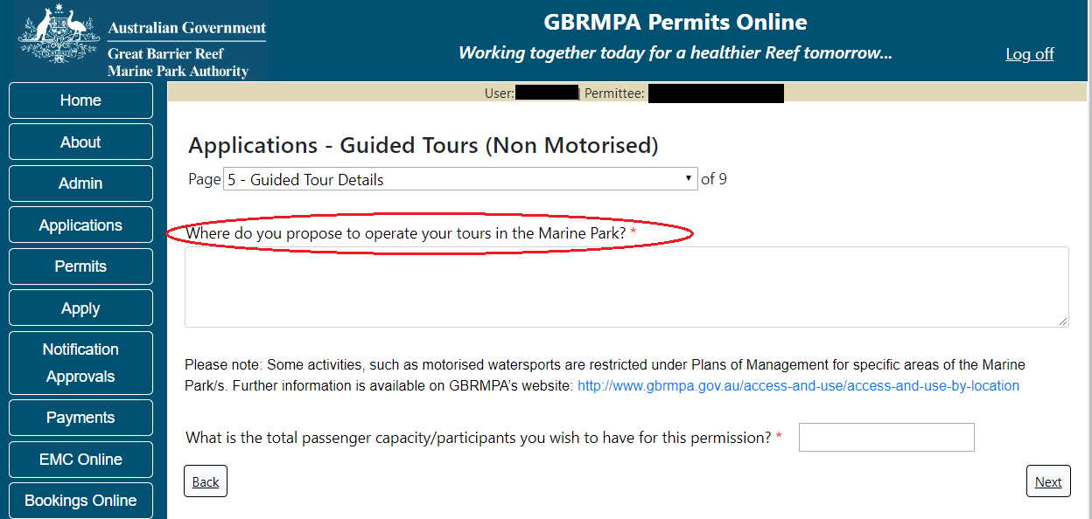
Figure 298 - Screenshot of Guided Tours Details screen with a red circle around question - Where do you propose to operate your tours in the Marine Park

For the question What is the total passenger capacity / participants you wish to have for this permission add the amount of passengers for this permission. Select Next to move to the next page
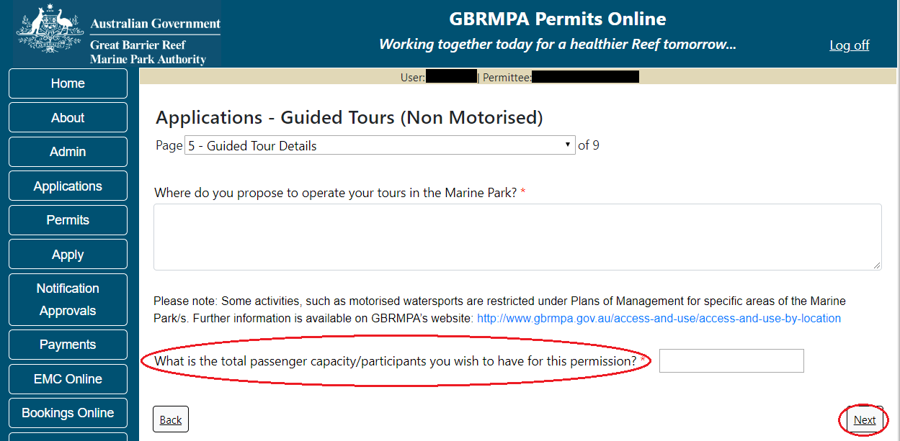
Figure 299 – Screenshot of Guided Tours Details screen with a red circle around question – What is the total passenger capacity / participants you wish to have for this permission and a red circle around the next button
Page 6 of Guided Tours (Non-Motorised) application is the Additional State Access screen. If you want to extend your operations to mainland or island national parks adjoining the Marine parks and/or rivers and streams between Mission Beach and the Starcke River, select yes and an area will appear with Please Specify details, add details of the islands or national parks and/or Rivers and streams you wish access.
Please also indicate if you want to operate in the Green Island Recreational Area. Once completed select Next to continue.
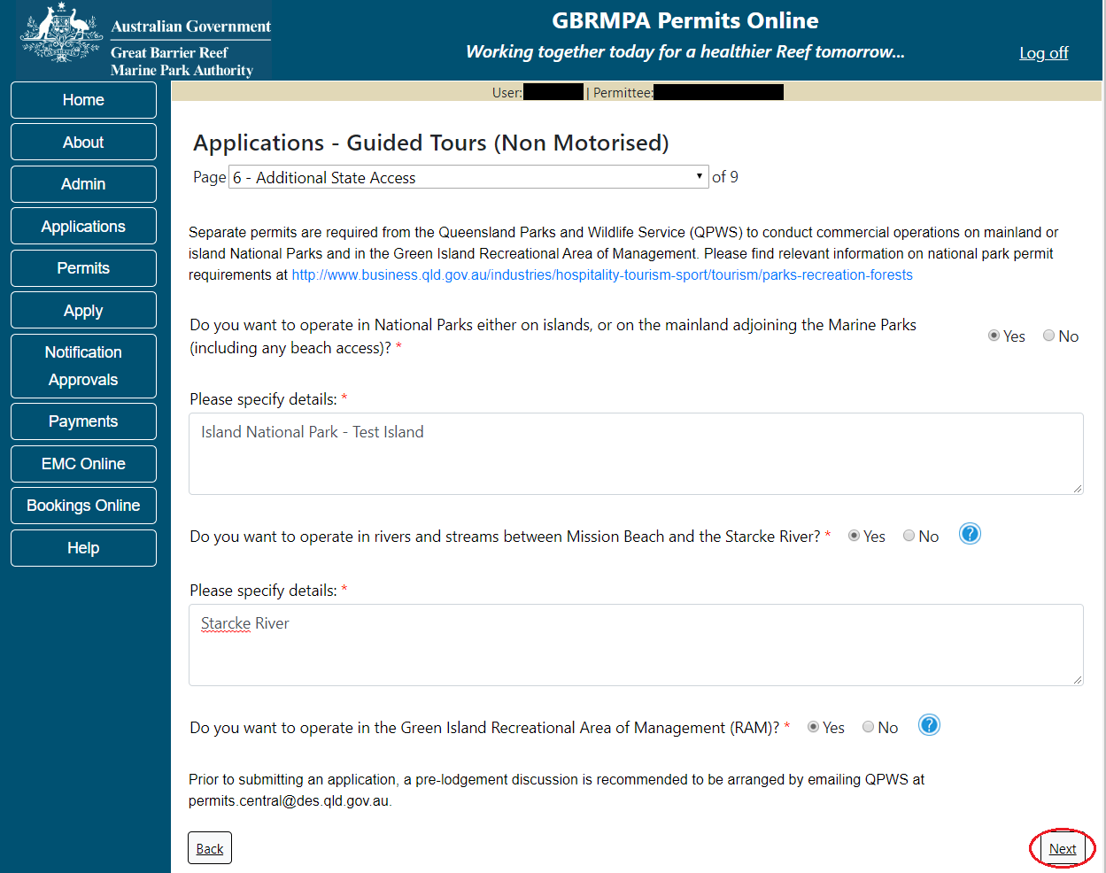
Figure 300 - Screenshot of Extend Operations screen with information displaying and a red circle around Next button
Page 7 of Guided Tours (Non-Motorised) application is the Equipment page. To add equipment, select the Add New button.
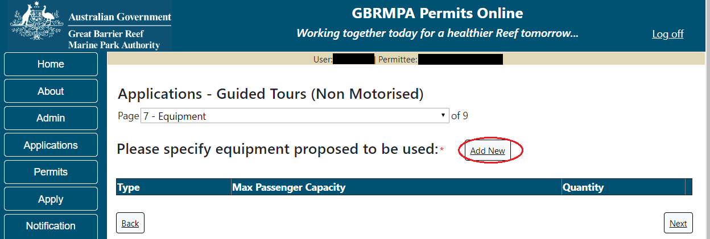
Figure 301 - Screenshot of Ancillary Vessels and Equipment screen with circle around Add New
An Add New Ancillary Vessels/Equipment window will appear.
Figure 302 - Screenshot of Add Ancillary Vessels / Equipment pop up window

Select Ancillary Vessels or Equipment from the Device list
Figure 303 - Screenshot of Add Ancillary Vessels / Equipment pop up window with Device list displayed

Add exact details of the ancillary vessels or equipment, then select Save.
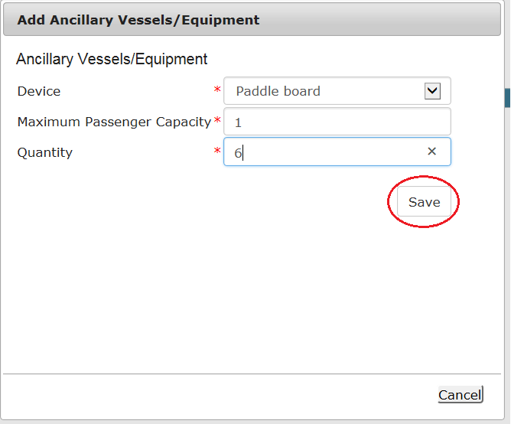
Figure 304 - Screenshot of Add Ancillary Vessels / Equipment pop up window with information entered and a red circle around Save
The details of equipment will appear on the screen. If you wish to remove any equipment, select the Remove button next to the item/s you wish to remove. Once you have added your ancillary vessels and/or equipment select Next to continue.
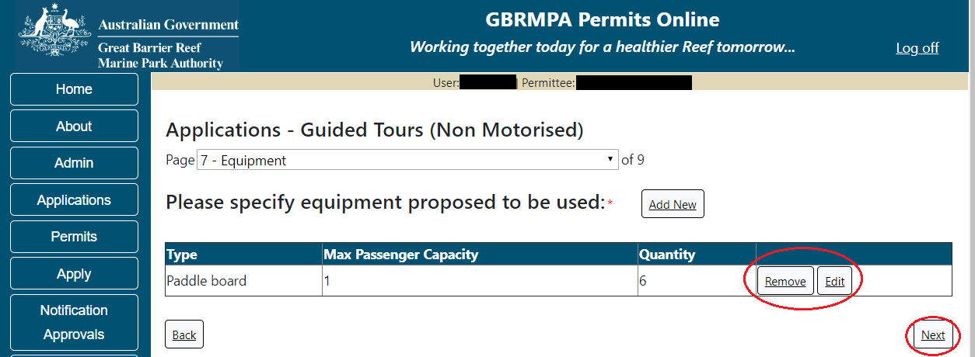
Figure 305 - Screenshot of Ancillary Vessels and Equipment page with information displayed and a red circle around Remove and Edit buttons and Next button

Page 8 of Guided Tours (Non-Motorised) refers to High Standard Tourism operators. If you have obtained a High Standard Tourism certification with an approved certification scheme, select Yes then upload a copy of your certificate using the upload feature.
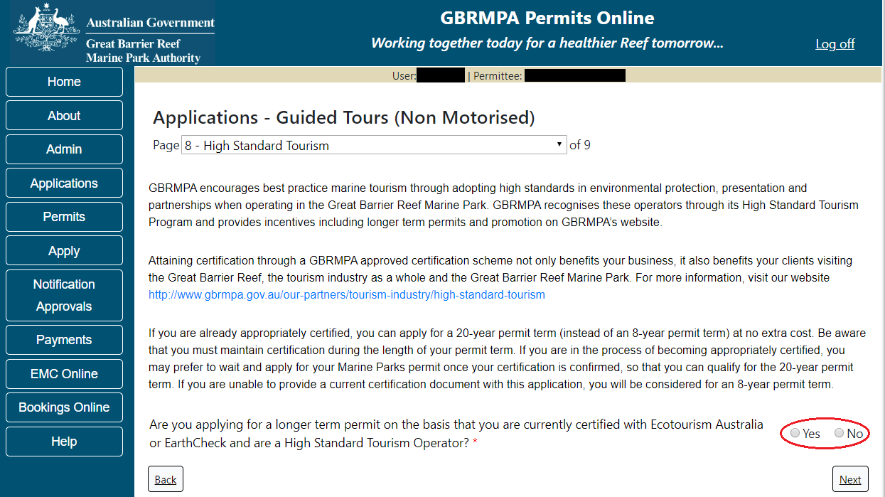
Figure 306 - Screenshot of High Standard Tourism page with a red circle Yes and No options

If you have certification, select the Yes button, an upload file button will appear. Select the upload file button.
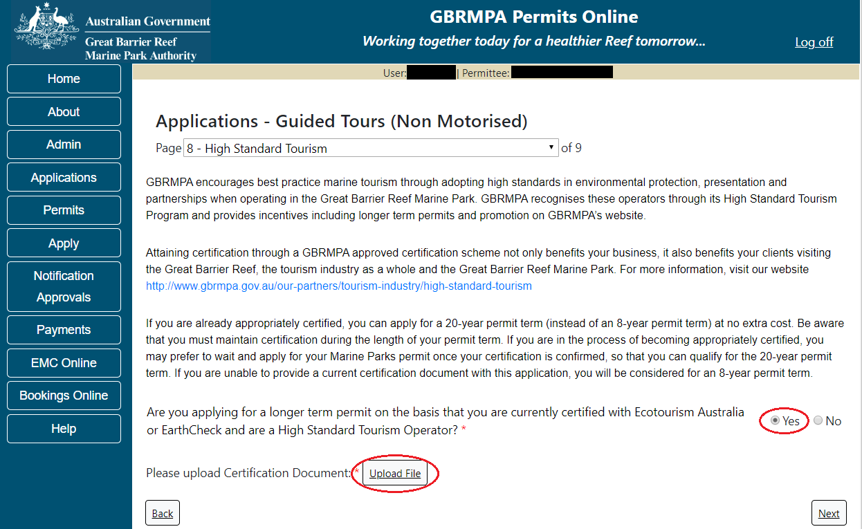
Figure 307 - Screenshot of High Standard Tourism page with Yes selected and circled and Upload File button circled

The File Upload screen will appear. Select Browse
Figure 308 - Screenshot of Upload File pop up window

Once you load a copy of your certificate, you will see the filename with a Remove button next to it. If you wish to remove the file, select the Remove button. Select Next to go to the next page.
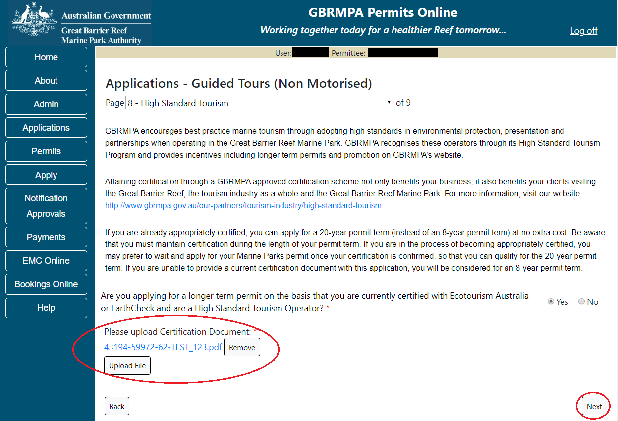
Figure 309 - Screenshot of High Standard Tourism page with Yes selected and a red circle around the Uploaded File and red circle around Next button

Page 8 of Guided Tours (Non-Motorised) provides opportunity for you to add any other information you feel will assist the Managing Agencies in assessing your application. Add supporting information by typing in the text field or upload a file if required. If a file is uploaded it will appear on the screen with the file name and a Remove button to remove the file if the wrong file is selected.
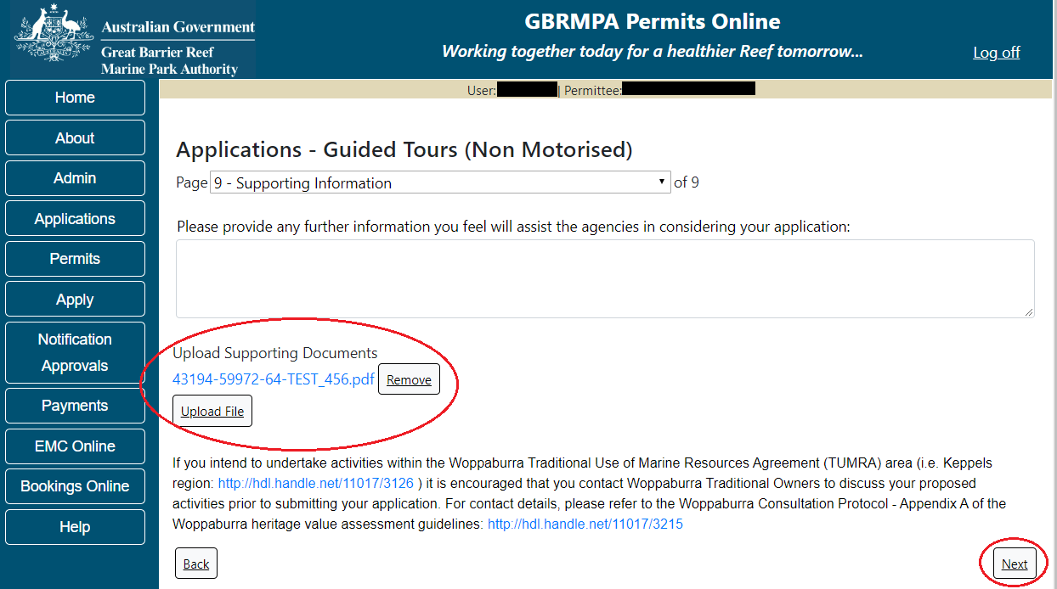
Figure 310 - Screenshot of Supporting Information screen with a red circle around Uploaded File area and a red circle around Next button
Once you have completed the supporting information page select Next from the last page of the application questions, you will progress to an application summary screen with a number of options available via links or buttons. Select Next on the summary screen to progress to the Declarations screens.
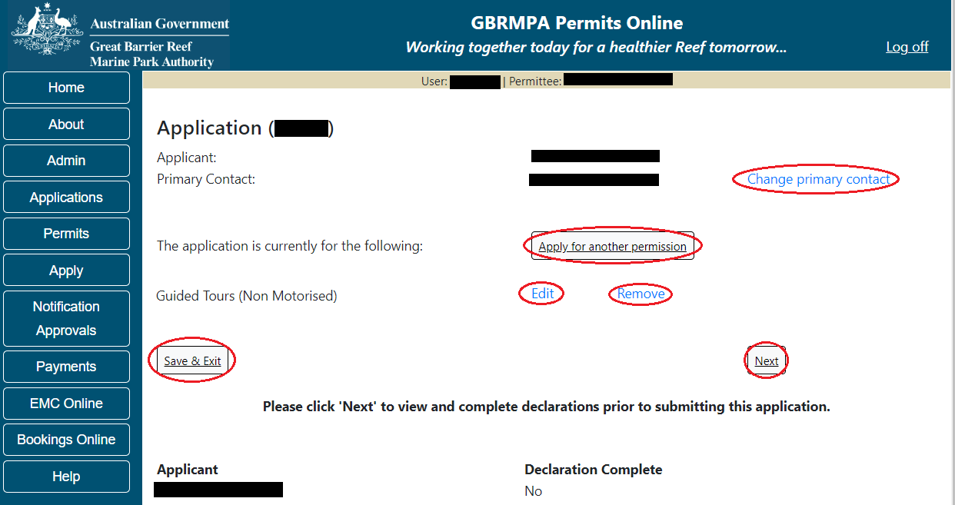
Figure 311 - Screenshot of Application Summary page with red circles around all options available

Additional Information - Summary screen, links and buttons;
- Change primary contact: If the change primary contact link is selected the applicant will progress to the primary contact page where the primary contact can be changed.

- Apply for another permission: If the apply for another permission button is selected, the applicant will progress to the What are you seeking to do in the Marine Parks page where another permission type can be added. (e.g. add a mooring permission to the tourism permission).

- Edit: If edit is selected the application/permission will be reopened to apply any changes.

- Remove: If remove is selected the application/permission will be removed.

- Save & Exit: If the Save & Exit button is selected the applicant will progress to the applications screen.

- Next: If next is selected the applicant will progress to the submission process including declaring and submitting the application.

Completion of a set of declarations is mandatory prior to submitting your application. To complete the declarations section of this application, you must either be the applicant, or if applying on behalf of an organisation / company / government agency, you must be a Director of that organisation / company / government agency. Authorised contacts cannot complete the declaration section, as it contains legally binding commitments in place of a physical signature.
Please read all questions carefully, provide a response to each, and select Next.
Figure 312 - Screenshot of Declarations page with red circle around Yes and No options and Next button

On the final page of declarations there is a Submit button. Once the Submit button is selected, the application will be submitted to the Reef Authority and is no longer available to be edited. The status of the application on the Applications screen will then display ‘Submitted to GBRMPA’. The application’s Primary Contact will receive an emailed acknowledgement notice from a delegated Assessment Officer within 10 business days.
Figure 313 - Screenshot of Declarations screen with a red circle around the Submit button
Once you submit your application, you will be provided with a reference/application number and can follow the progress of your application via the Applications menu on the left.
Figure 314 - Screenshot of the Thank you for your application screen with a red circle around Reference number and a red circle around the open pdf button

Your application will appear in the Applications screen with the reference/application number also displayed. You have further options to view a summary of your application, email the Reef Authority or withdraw the application.
Figure 315 - Screenshot of Applications screen with a red circle around Application No., Summary, Email and Withdraw options

  - Tourism – Vessel Operation
Apply – new permit application – other tourism activities – vessel
To apply for Other Tourism and Charter Activities, select this option on the Apply – What are you seeking to do in the Marine Parks page.
Figure 316 - Screenshot of Apply - What are you seeking to do in the Marine Parks screen with Other Tourism and Charter Activities selected and a red circle around the Next button

You will progress to the application types sub menu, where you can choose which type of Tourism or charter activity you wish to apply for (example used is Vessel). Select Next to progress to the application questions.
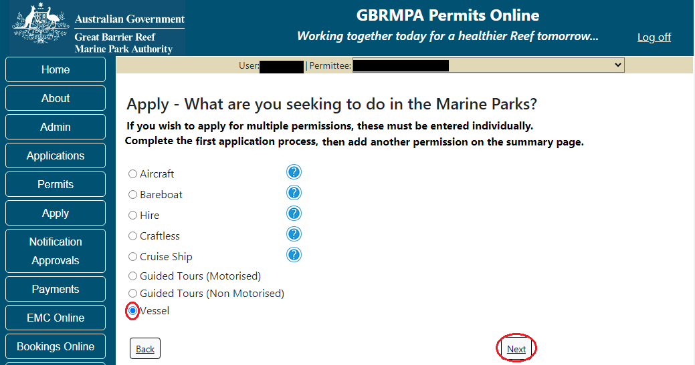
Figure 317 - Screenshot of Apply - What are you seeking to do in the Marine Parks - Other Tourism and Charter Activities sub menu screen with Vessel selected and a red circle around Next button
Page 1 of Vessel Application is the Environment Protection and Biodiversity Conservation Act page. This provides advice on matters of national environmental significance that must be considered when assessing an application. This screen is for your information only at this stage. Your assessing officer will contact you if it is determined to be relevant for your application.
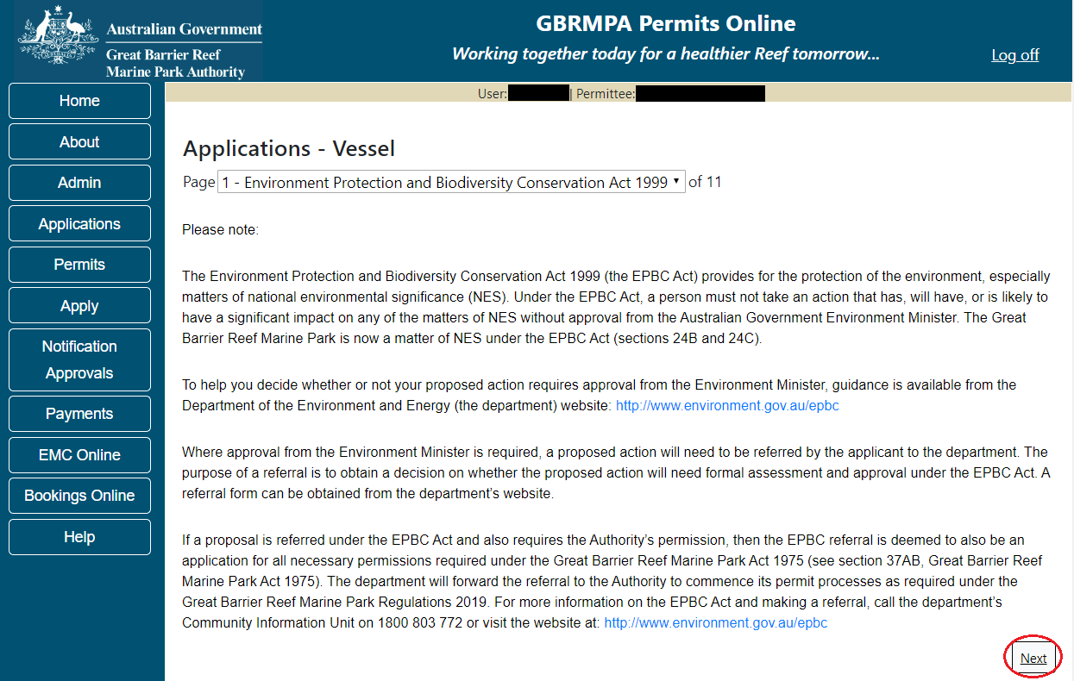
Figure 318 - Screenshot of Environment Protection and Biodiversity Conservation screen with a red circle around Next button

Links on the Environment Protection and Biodiversity Conservation page www.environment.gov.au/epbc will take you to the Department of Climate Change, Energy, the Environment and Water site. Here you can find information about the Environment Protection and Biodiversity Conservation Act 1999 and your obligations under the Act.

Page 2 of Vessel application is Permissions and Activities page. All Permissions and Activities listed are available and will be included in the application. If there are any activities you do not wish to have you can remove them by selecting the Remove button next to the activity. Select Next to continue.
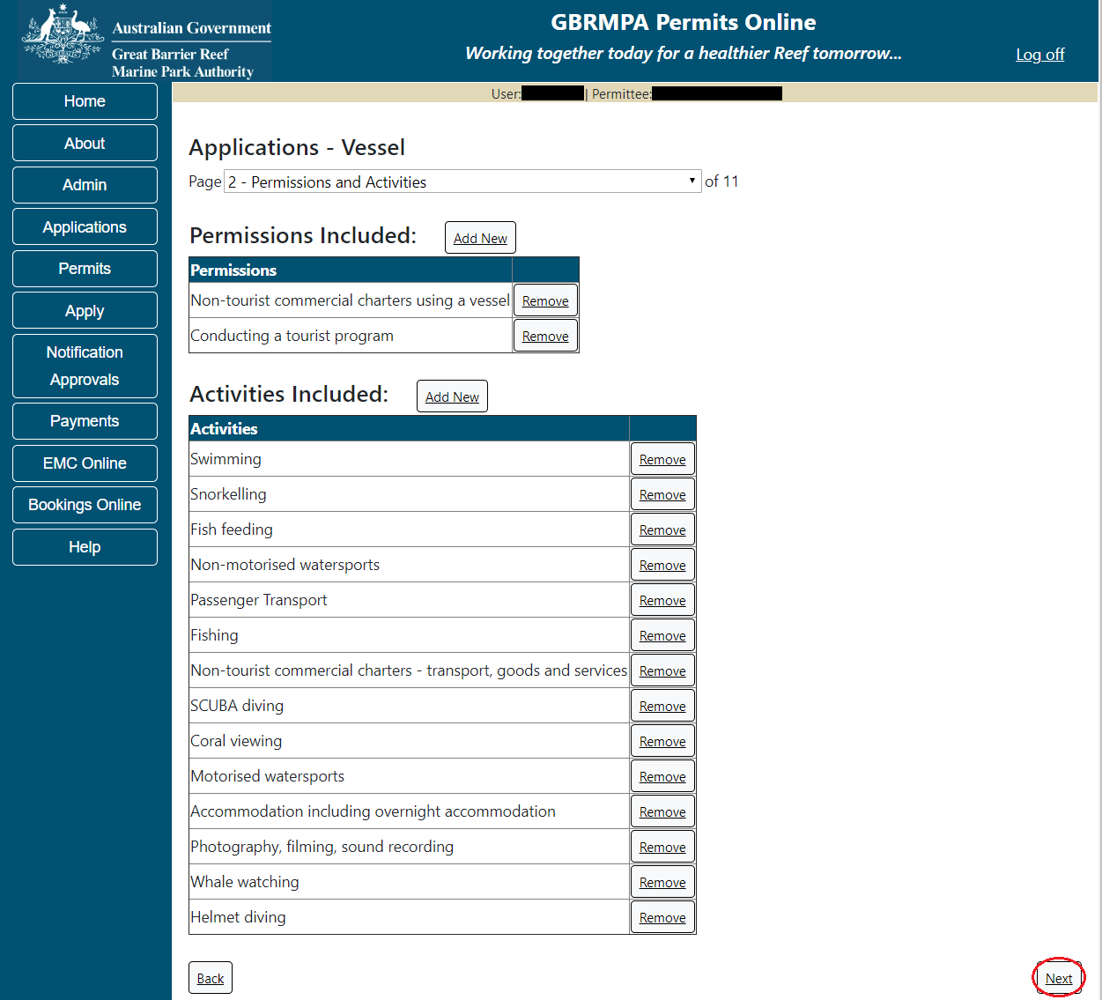
Figure 319 - Screenshot of Permissions and Activities screen with a red circle around Remove button and Next button
Page 3 of vessel application is the Total Passenger Capacity / Participants page. A question for What is the total passenger capacity/participants you wish to have in the Marine Parks at any given time? (please consider future use in answering this question) is presented. Select a number from the list provided. Select Next to continue.
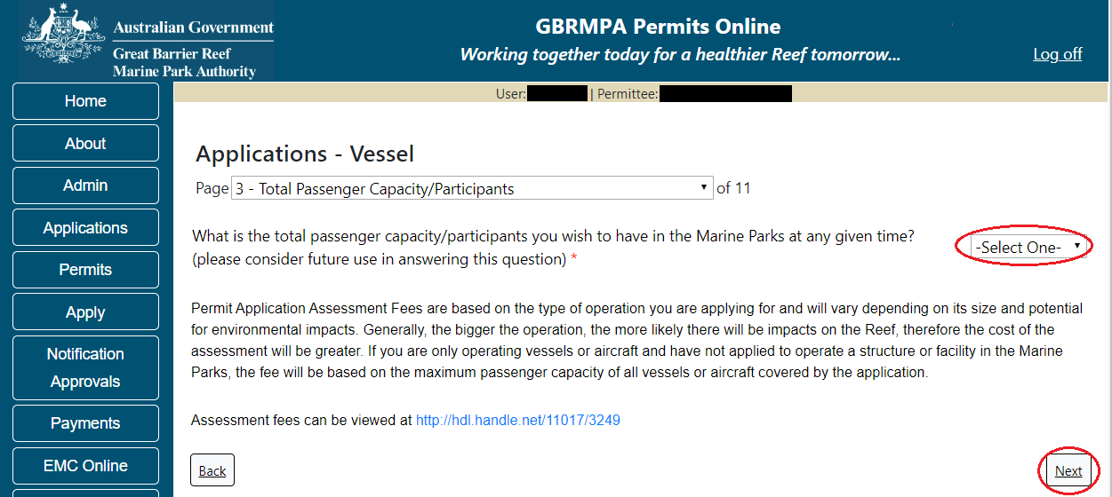
Figure 320 - Screenshot of the Total Passenger Capacity / Participants page with a red circle around the select one drop list and a red circle around the next button
Page 4 of vessel application is the Management / Operation page. For vessel applications, all management areas are selected as default, unselect any areas that you do not wish to visit. Please select the Management Area/s in which you wish to operate. Select all if you wish to operate in all management areas, considering future use.
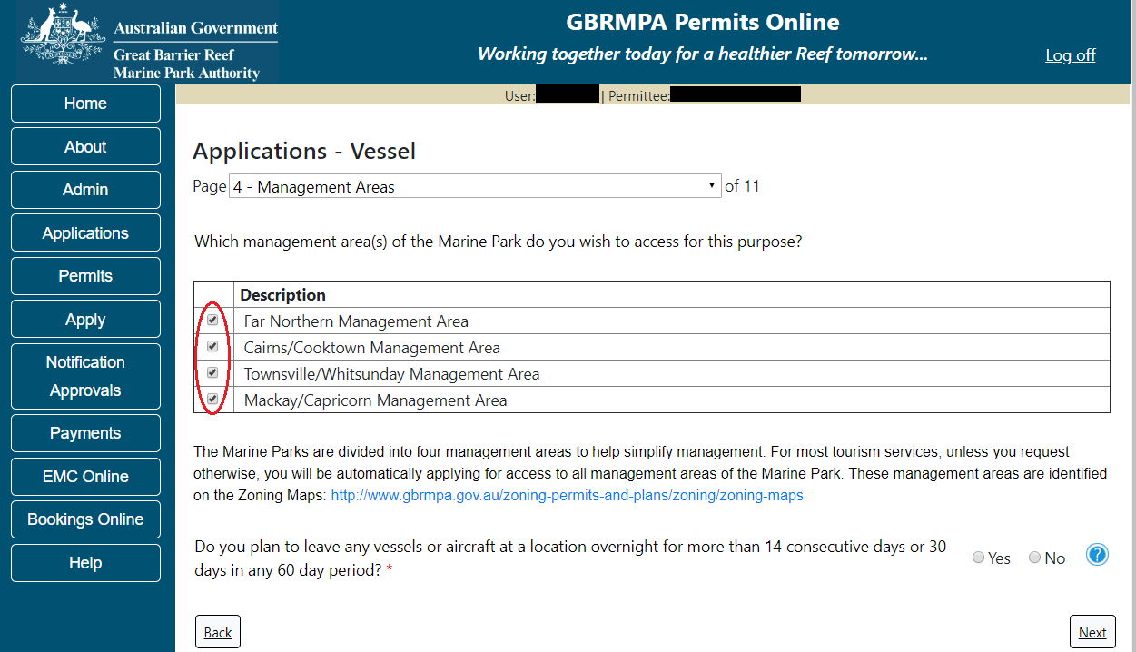
Figure 321 - Screenshot of Management Areas screen with a red circle around the management areas tick boxes
If you wish to operate a vessel or aircraft at a location for more than 14 consecutive days; or for more than 30 days in any period of 60 days select Yes and provide details of your proposed use (e.g. leaving a glass bottomed boat at a particular location for a set timeframe). Select Next to continue.
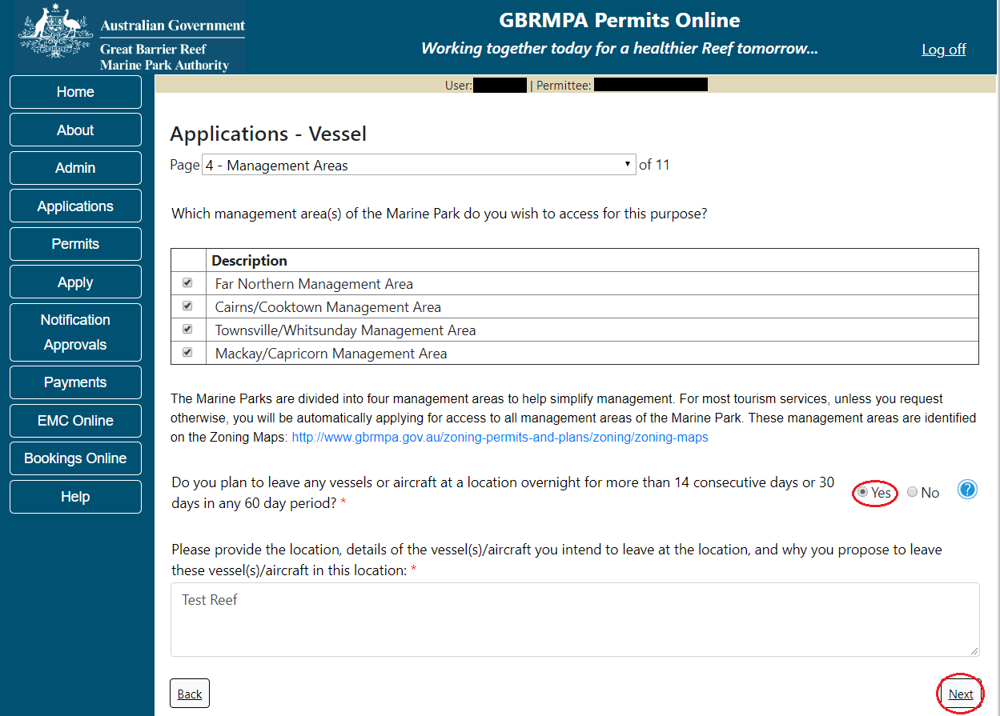
Figure 322 - Screenshot of Management Areas page with Yes selected and a red circle around the Next button
Page 5 allows you to apply to access areas of the Marine Park more frequently than 2 days in every 7-day period. This option is only available outside the Plans of Management. If you wish to apply to visit a location more frequently than 2 in every 7- day period, select Add New.
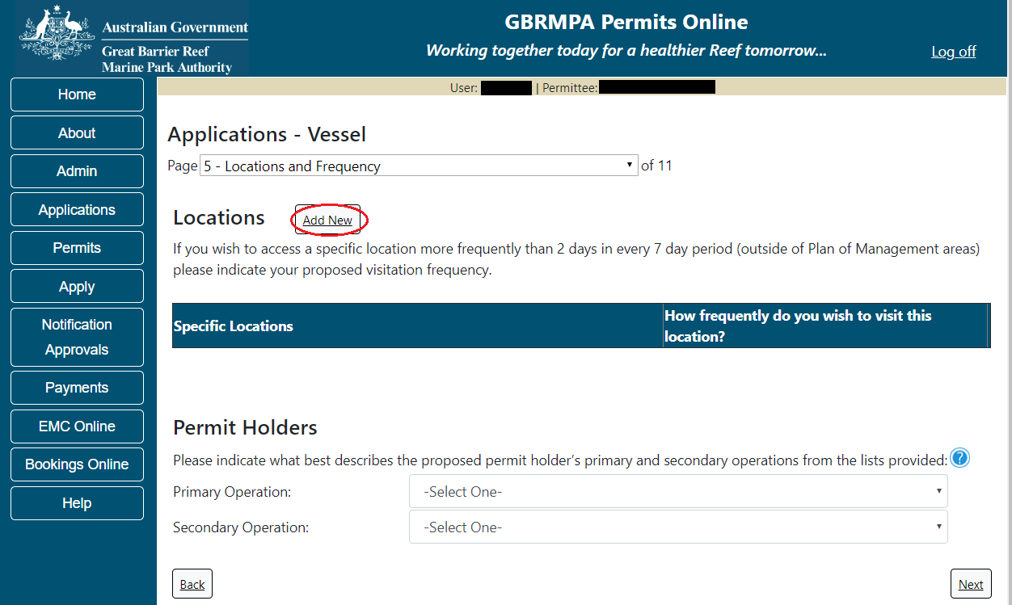
Figure 323 - Screenshot of Locations and Frequency screen with circle around Add new button

If the Add New button is selected the Location pop up window will appear
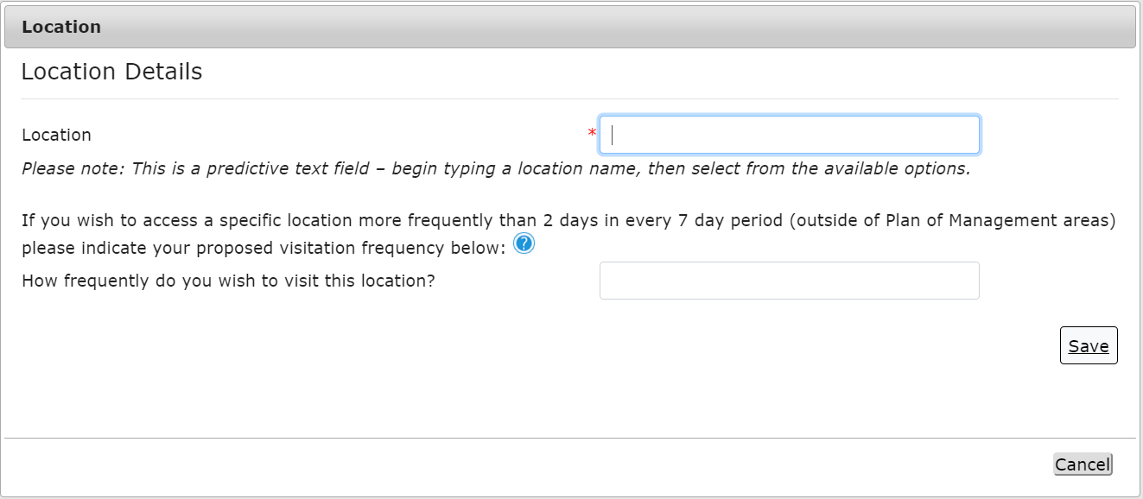
Figure 324 - Screenshot of Location pop up window
Type in the name of the location you wish to visit in the location field. As you enter the name, the list will produce relevant matches. Select the location then select Save.
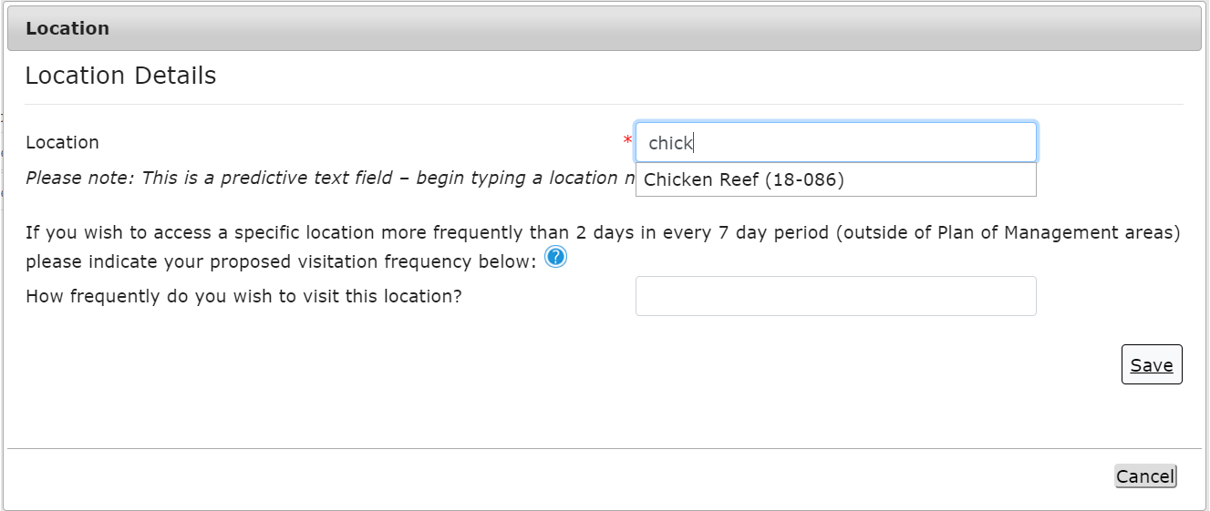
Figure 325 - Screenshot of Location pop up window with locations to select

Then add the frequency you wish to visit the location and select Save.
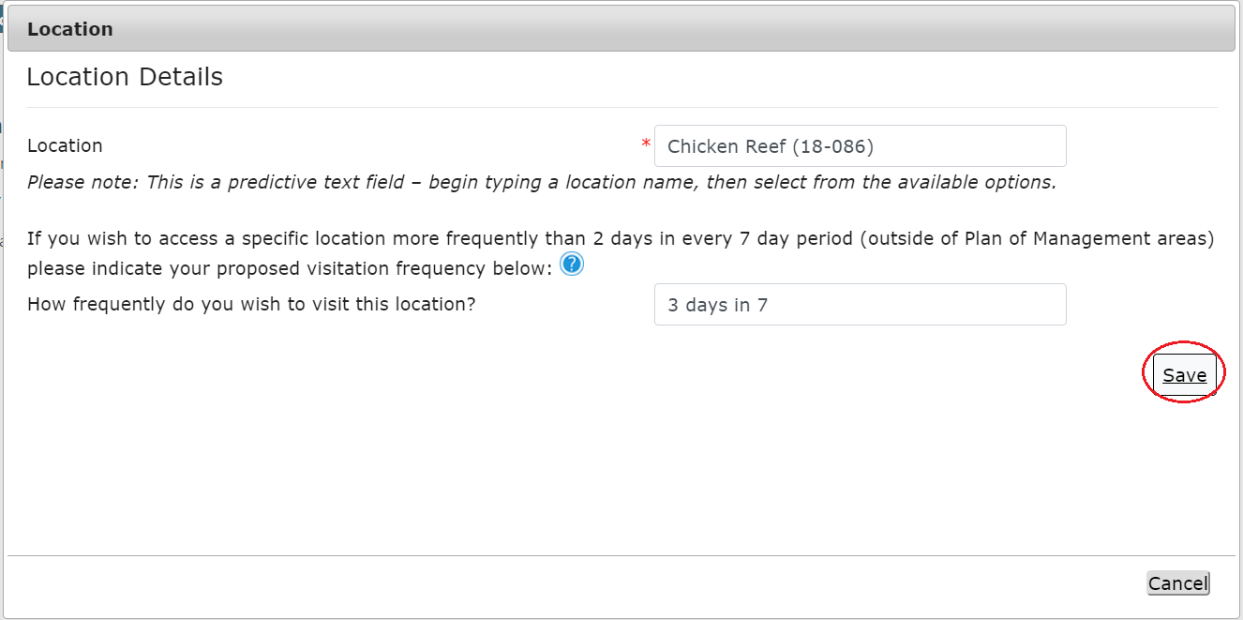
Figure 326 - Screenshot of Location pop up window with information completed and a red circle around the Save button

The location will be entered on the Location and Frequencies page within the locations table. If you wish to remove the location, select the Remove button next to the location.
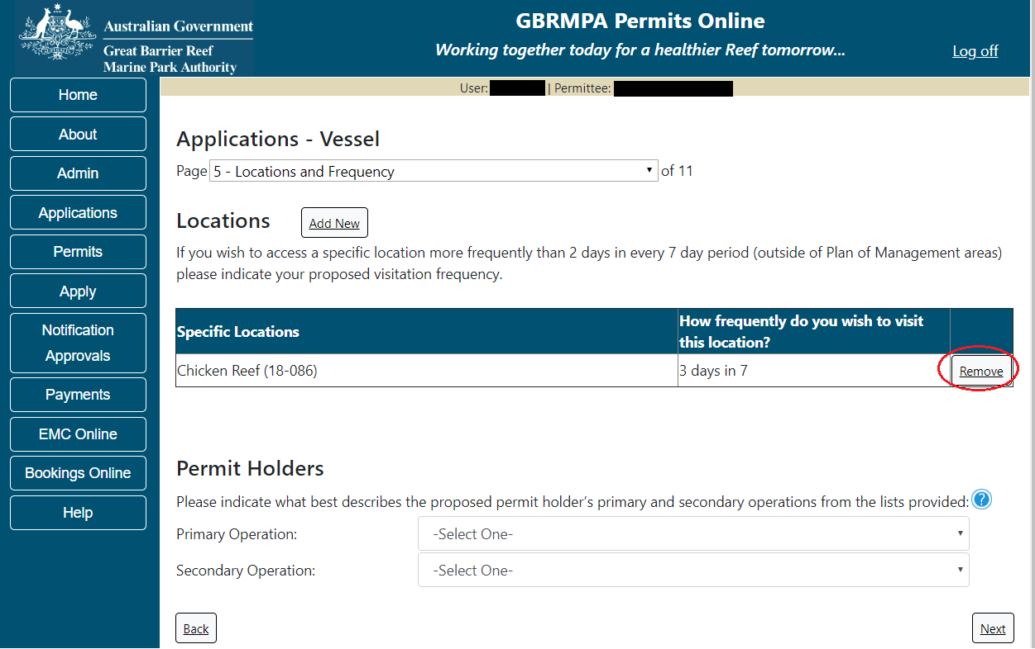
Figure 327 - Screenshot of Location and Frequency screen with information displaying, and a red circle around Remove button

Please also fill in details of what best describes the proposed permit holder’s primary and secondary operations from the two lists located towards the bottom of the page. This information assists our Assessment Officers by providing relevant information for your operation over the life of your permit. Select Next to continue.
Figure 328 - Screenshot of Locations and Frequency screen with a red circle around Select One in the Permit Holders section and a red circle around the Next button

Page 6 of Vessel application is Additional State Access page. If you want to extend your operations to mainland or island national parks adjoining the Marine parks and/or rivers and streams between Mission Beach and the Starcke River, select yes and an area will appear with Please Specify details, add details of the islands or national parks and/or Rivers and streams you wish access.
Please also indicate if you want to operate in the Green Island Recreational Area. Once completed select Next to continue.
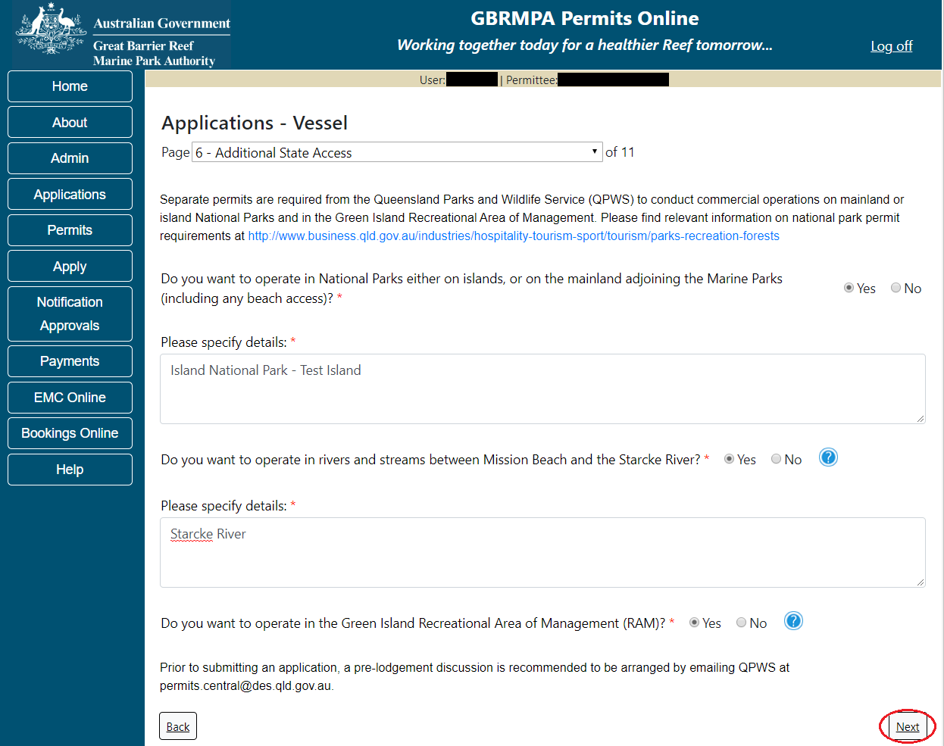
Figure 329 - Screenshot of Additional State Access screen with information displaying and a red circle around Next button

Page 7 of Vessel application is Vessel Details. On this screen, enter details of how many vessels, the maximum length and total capacity you wish to apply for. Select Next to continue.
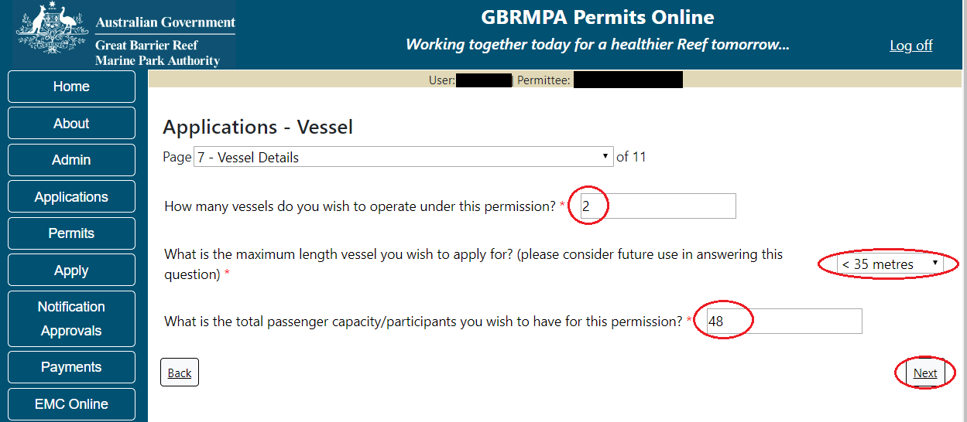
Figure 330 - Screenshot of Vessel Details screen with a red circle around field to enter - How many vessels do you wish to operate under this permit, a circle around Maximum Vessel Length selection, a circle around Passenger capacity selection and red circle around Next

Page 8 of Vessel application asks for details of the vessel to be used in the Marine Parks. This is optional at this stage, however details of the aircraft must be provided to, and approved by the Reef Authority prior to operating the vessel in the Marine Parks.
You can notify the Reef Authority of your vessel details using the Notification Approvals menu on the left of screen later. You can use the Add New button to provide vessel details as part of your permit application if you wish. Select Add New.
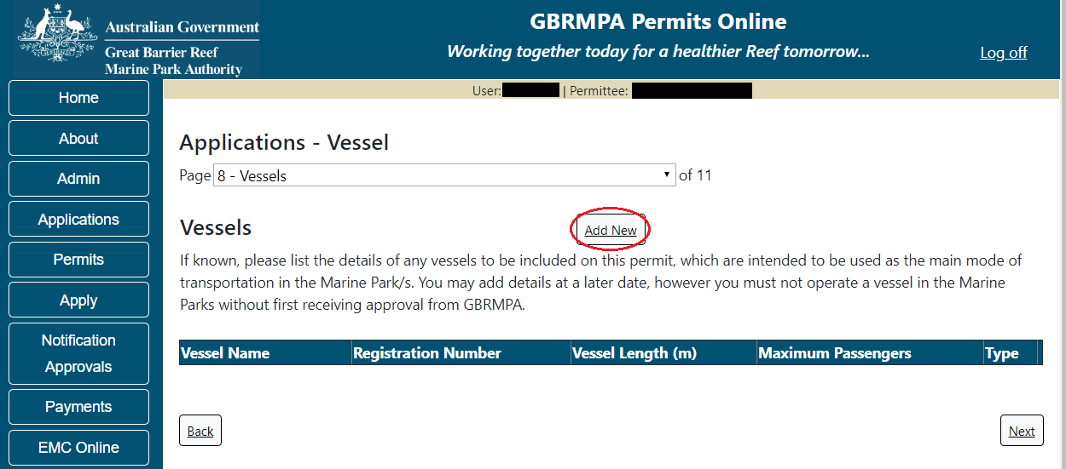
Figure 331 - Screenshot of Vessels screen with circle around Add New button

An Add New Vessel pop up window will appear with fields for Name, Registration Number, Length (in metres), Passenger Capacity and the vessel type.
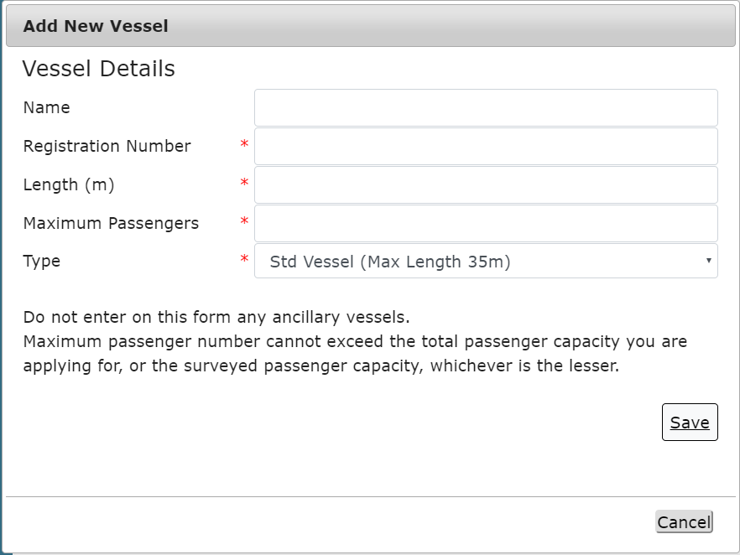
Figure 332 - Screenshot of Add New Vessel pop up window

Add the exact details of each vessel and select Save.
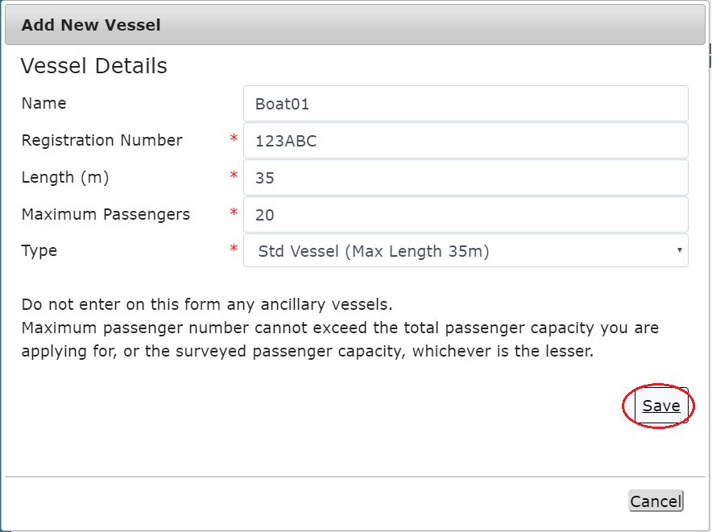
Figure 333 - Screenshot of Add New Vessel pop up window with information entered and a red circle around Save

Once you enter your vessel details and select save the details will display on screen with a Remove button and an Edit button. If you need to remove the vessel select Remove and the details will be deleted. If you wish to edit the details, select the Edit button. Select Next to continue.
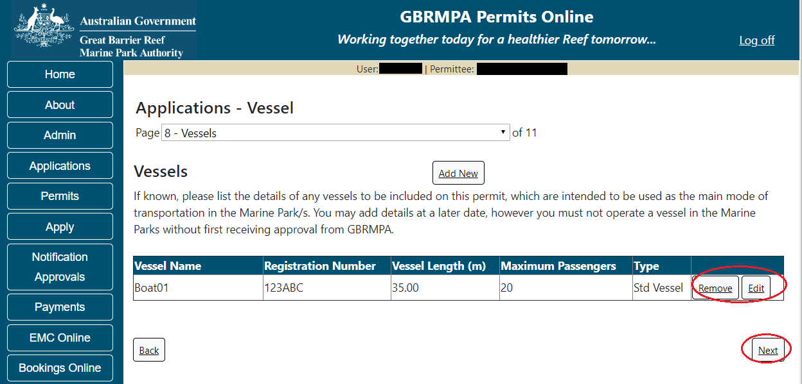
Figure 334 - Screenshot of Vessels page with information displayed and a red circle around Remove and Edit buttons and a red circle around the Next button

Page 9 of Vessel application is Ancillary Vessels and Equipment page. To add ancillary vessels or equipment select the Add New button.
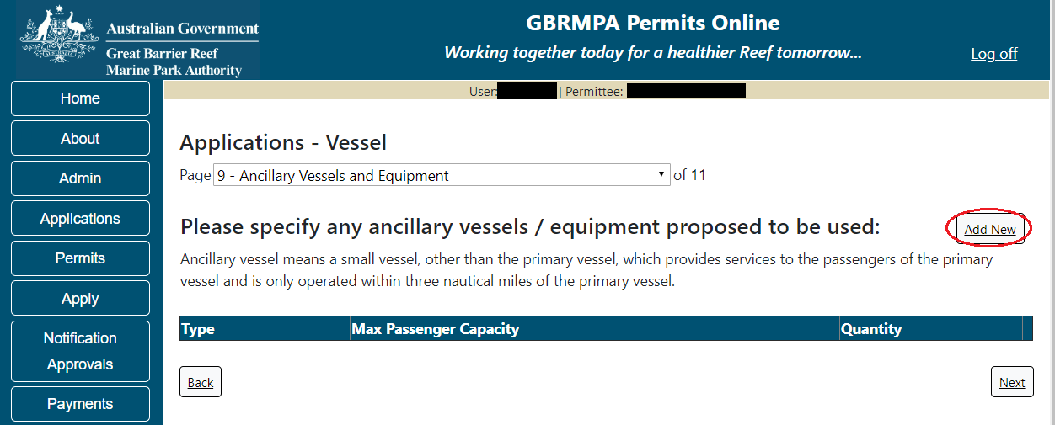
Figure 335 - Screenshot of Ancillary Vessels and Equipment screen with circle around Add New button

An Add New Ancillary Vessels/Equipment window will appear.
Figure 336 - Screenshot of Add Ancillary Vessels / Equipment pop up window

Select Ancillary Vessels or Equipment from the Device list
Figure 337 - Screenshot of Add Ancillary Vessels / Equipment pop up window with Device list displayed

Add exact details of the ancillary vessels or equipment, then select Save.
Figure 338 - Screenshot of Add Ancillary Vessels / Equipment pop up window with information entered and a red circle around Save

The details of ancillary vessels or equipment will appear on the screen. A Remove button and an Edit button is also presented. If you need to remove the vessel select Remove and the details will be deleted. If you wish to edit the details, select the Edit button. Select Next to continue.
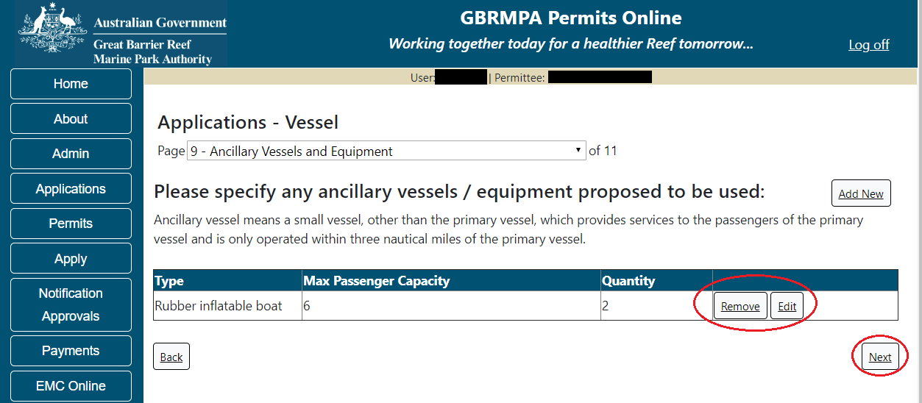
Figure 339 - Screenshot of Ancillary Vessels and Equipment page with information displayed and a red circle around Remove and Edit buttons and Next button

Page 10 of Vessel application refers to High Standard Tourism operators. If you have obtained a High Standard Tourism certification with an approved certification scheme, select Yes then upload a copy of your certificate using the upload feature.
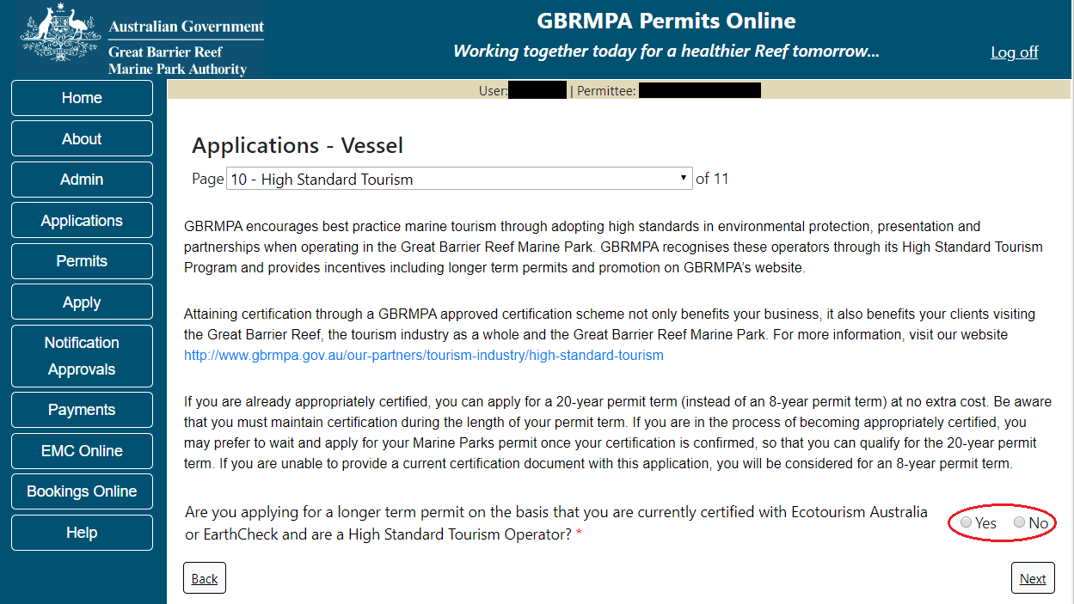
Figure 340 - Screenshot of High Standard Tourism page with a red circle Yes and No options

If you have certification, select the Yes button, an upload file button will appear. Select the upload file button and upload a file.
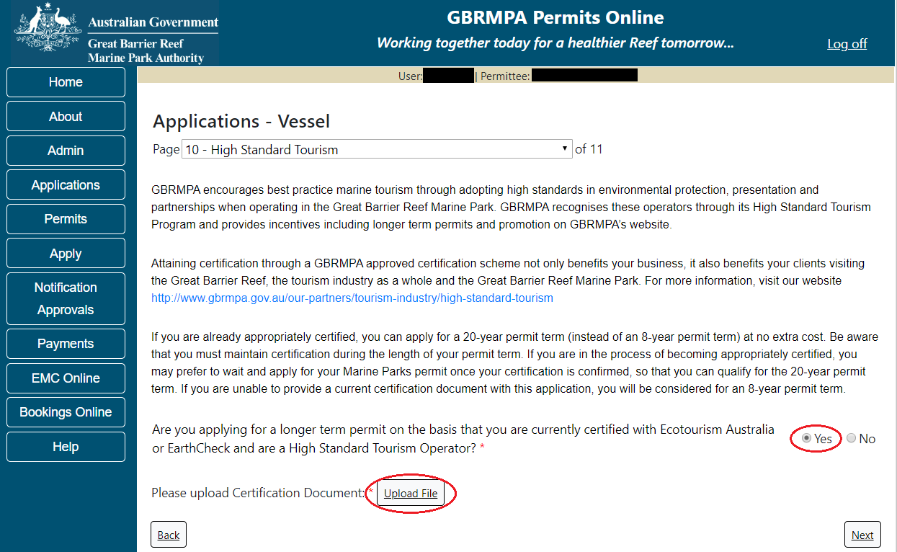
Figure 341 - Screenshot of High Standard Tourism page with Yes selected and circled and Upload File button circled
Once you load a copy of your certificate, you will see the filename with a Remove button next to it. If you wish to remove the file, select the Remove button. Select Next to go to the next page.
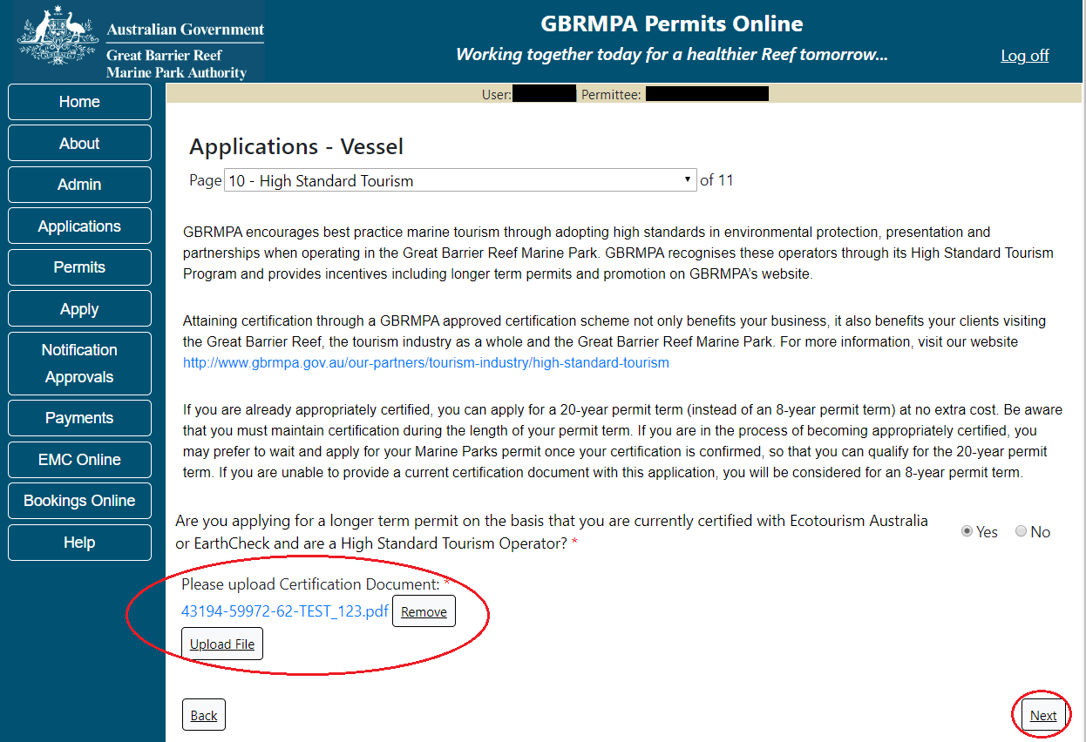
Figure 342 - Screenshot of High Standard Tourism page with Yes selected and a red circle around the Uploaded File and red circle around Next button

Page 11 of Vessel application provides opportunity for you to add any other information you feel will assist the Managing Agencies in assessing your application. Add supporting information by typing in the text field or upload a file if required. If a file is uploaded it will appear on the screen with the file name and an Remove to remove the file if the wrong file is selected.
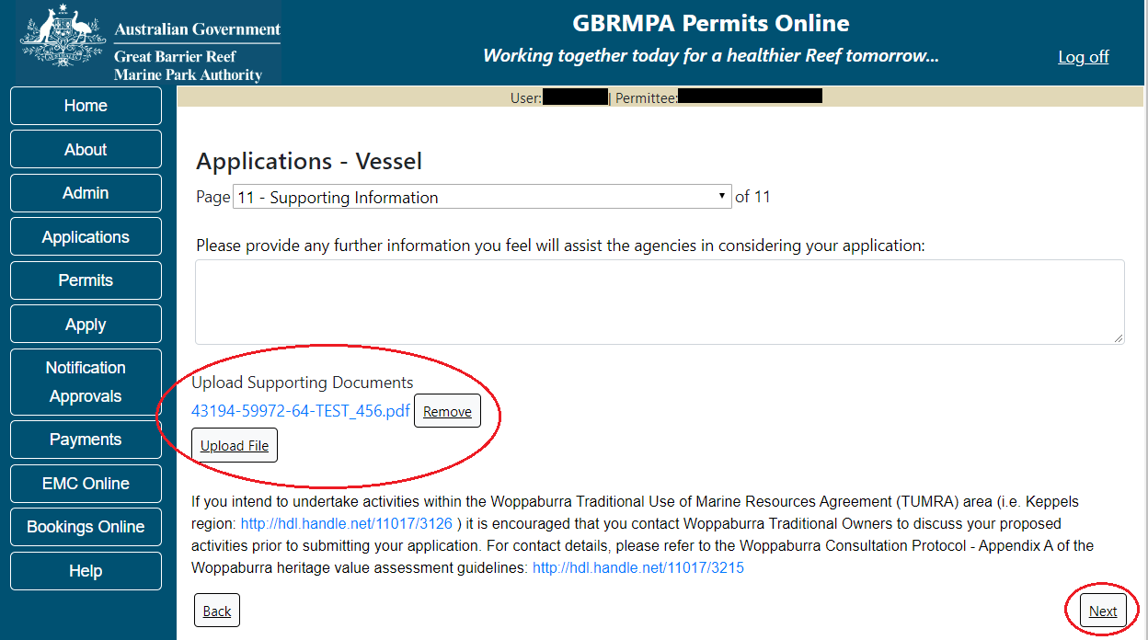
Figure 343 - Screenshot of Supporting Information screen with a red circle around Uploaded File area and a red circle around Next button
Once you have completed the supporting information page select Next from the last page of the application questions, you will progress to an application summary screen with a number of options available via links or buttons. Select Next on the summary screen to progress to the Declarations screens.
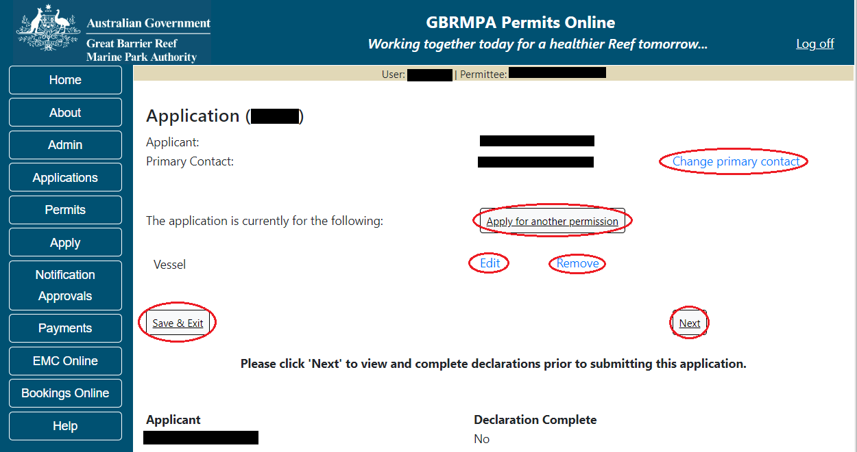
Figure 344 - Screenshot of Application Summary page with red circles around all options available

Additional Information - Summary screen, links and buttons;
- Change primary contact: If the change primary contact link is selected the applicant will progress to the primary contact page where the primary contact can be changed.

- Apply for another permission: If the apply for another permission button is selected, the applicant will progress to the What are you seeking to do in the Marine Parks page where another permission type can be added. (e.g. add a mooring permission to the tourism permission)

- Edit: If edit is selected the application/permission will be reopened to apply any changes.

- Remove: If remove is selected the application/permission will be removed.

- Save & Exit: If the Save & Exit button is selected the applicant will progress to the applications screen.

- Next: If next is selected the applicant will progress to the submission process including declaring and submitting the application.

Completion of a set of declarations is mandatory prior to submitting your application. To complete the declarations section of this application, you must either be the applicant, or if applying on behalf of an organisation / company / government agency, you must be a Director of that organisation / company / government agency. Authorised contacts cannot complete the declaration section, as it contains legally binding commitments in place of a physical signature.
Please read all questions carefully, provide a response to each, and select Next.
Figure 345 - Screenshot of Declarations page with red circle around Yes and No options and Next button

On the final page of declarations there is a Submit button. Once the Submit button is selected, the application will be submitted to the Reef Authority and is no longer available to be edited. The status of the application on the Applications screen will then display ‘Submitted to GBRMPA’. The application’s Primary Contact will receive an emailed acknowledgement notice from a delegated Assessment Officer within 10 business days.
Figure 346 - Screenshot of Declarations screen with a red circle around the Submit button
Once you submit your application, you will be provided with a reference/application number and can follow the progress of your application via the Applications menu on the left.
Figure 347 - Screenshot of the Thank you for your application screen with a red circle around Reference number and a red circle around the open pdf button

Your application will appear in the Applications screen with the reference/application number also displayed. You have further options to view a summary of your application, email the Reef Authority or withdraw the application.
Figure 348 - Screenshot of Applications screen with a red circle around Application No., Summary, Email and Withdraw options

- Install / operate a Facility (Including Mooring)

  - Install / operate a Mooring Facility
Apply – new permit – install / operate a facility (including mooring) – Install / operate a Mooring Facility
To apply for Install / operate a Facility (including Mooring), select this option on the Apply – What are you seeking to do in the Marine Parks page.
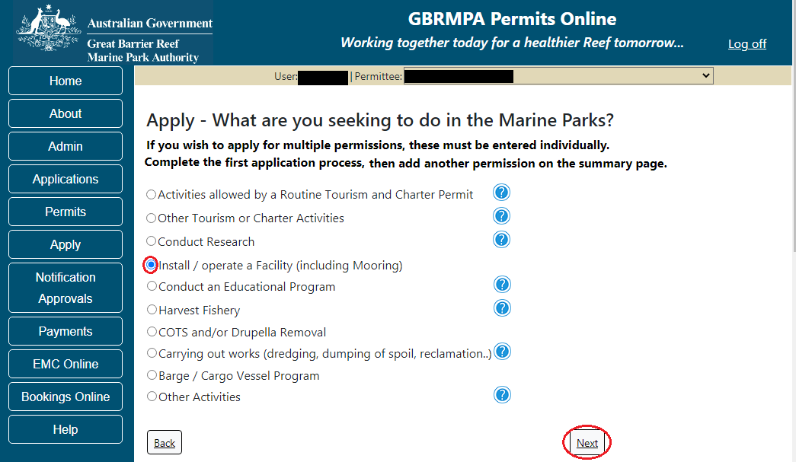
Figure 349 - Screenshot of Apply - What are you seeking to do in the Marine Parks screen with Install / operate a Facility (including Mooring) Activities selected and a red circle around the Next button

You will progress to the application types sub menu, where you can choose which type of Facility you wish to apply for (example used is Install / operate a Mooring facility). Select the facility type then select Next.
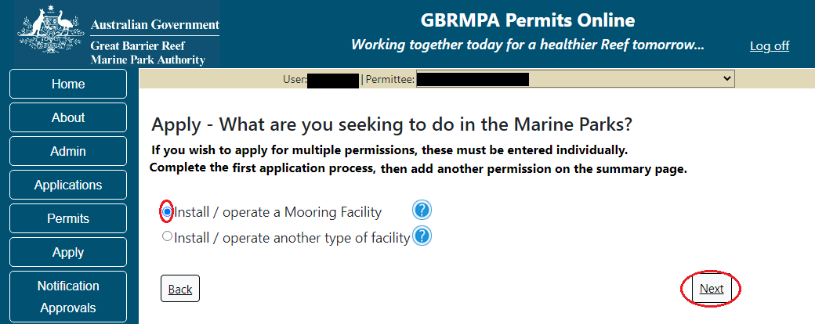
Figure 350 - Screenshot of Apply - What are you seeking to do in the Marine Parks - Install / operate a Mooring Facility selected and a red circle around Next button
Please Note: This permission includes constructing or operating mooring facilities for vessels or aircraft including installation, maintenance, upgrade, de-tackling, re-tackling, re-location, decommissioning or removal.
Page 1 of Install / operate a Mooring Facility is the Environment Protection and Biodiversity Conservation Act page. This provides advice on matters of national environmental significance that must be considered when assessing an application. This screen is for your information only at this stage. Your assessing officer will contact you if it is determined to be relevant for your application.
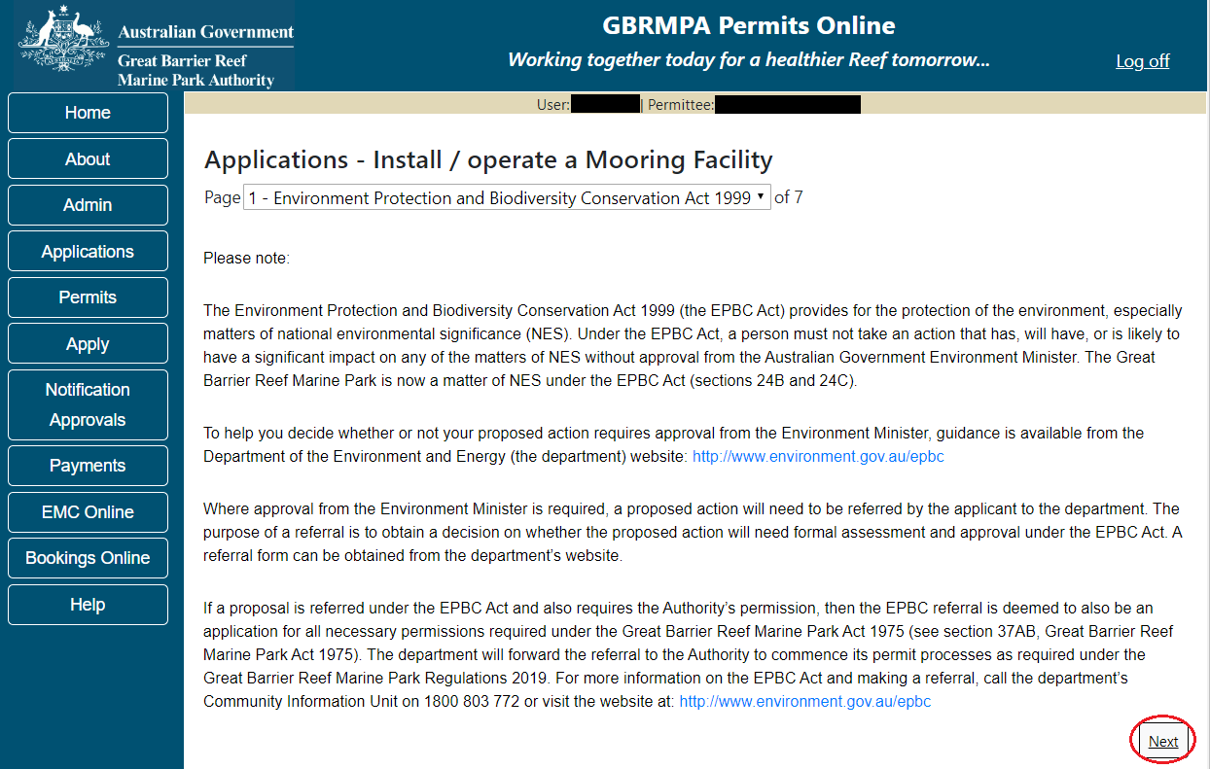
Figure 351 - Screenshot of Environment Protection and Biodiversity Conservation screen with a red circle around Next button

Links on the Environment Protection and Biodiversity Conservation page www.environment.gov.au/epbc will take you to the Department of Climate Change, Energy the Environment and Water site. Here you can find information about the Environment Protection and Biodiversity Conservation Act 1999 and your obligations under the Act.

Page 2 of Install / operate a Mooring Facility is the Justification for Marine Park use page. On this page, add details of why you need to use the Marine Park? What alternatives have been considered and why have they been ruled out? Once you have added your detail select Next to continue.
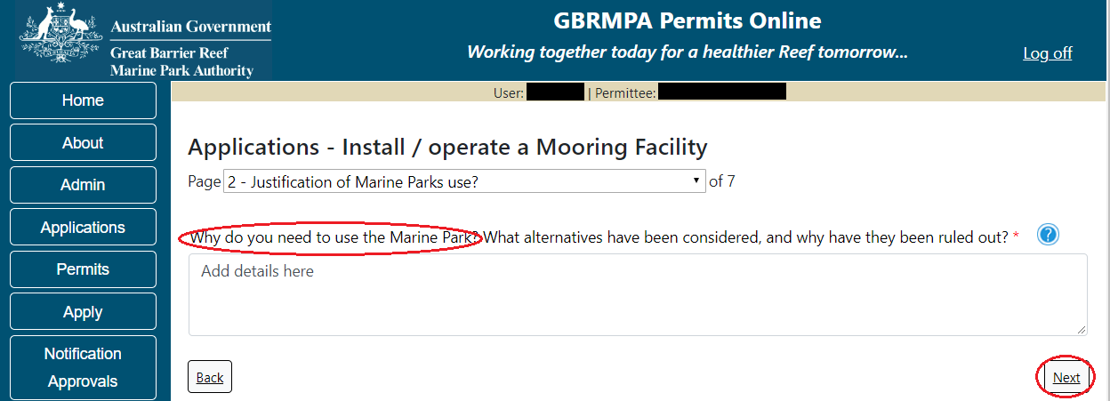
Figure 352 - Screenshot of Justification for Marine Park Use page with a red circle question - Why do you need to use the Marine Park? Circle around Save button

Page 3 of Install / operate a Mooring Facility is the Commercial Nature page. If your operation is of a commercial nature, select yes. If not select no. NOTE: Activities of a commercial nature are those from which a profit is drawn or intended to be drawn. After you make your selection, select Next to continue.
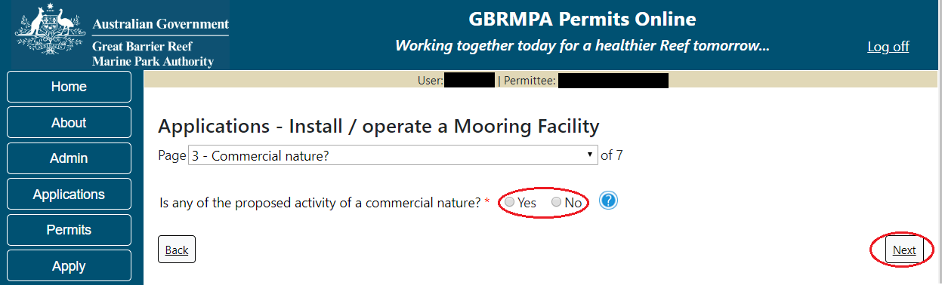
Figure 353 - Screenshot of Commercial Nature page with red circle around Yes and No options and red circle around Next button

Page 4 of Install / operate a Mooring Facility is the Facility Information page. There are a number of mandatory fields on this page. All mandatory fields must be completed to continue.
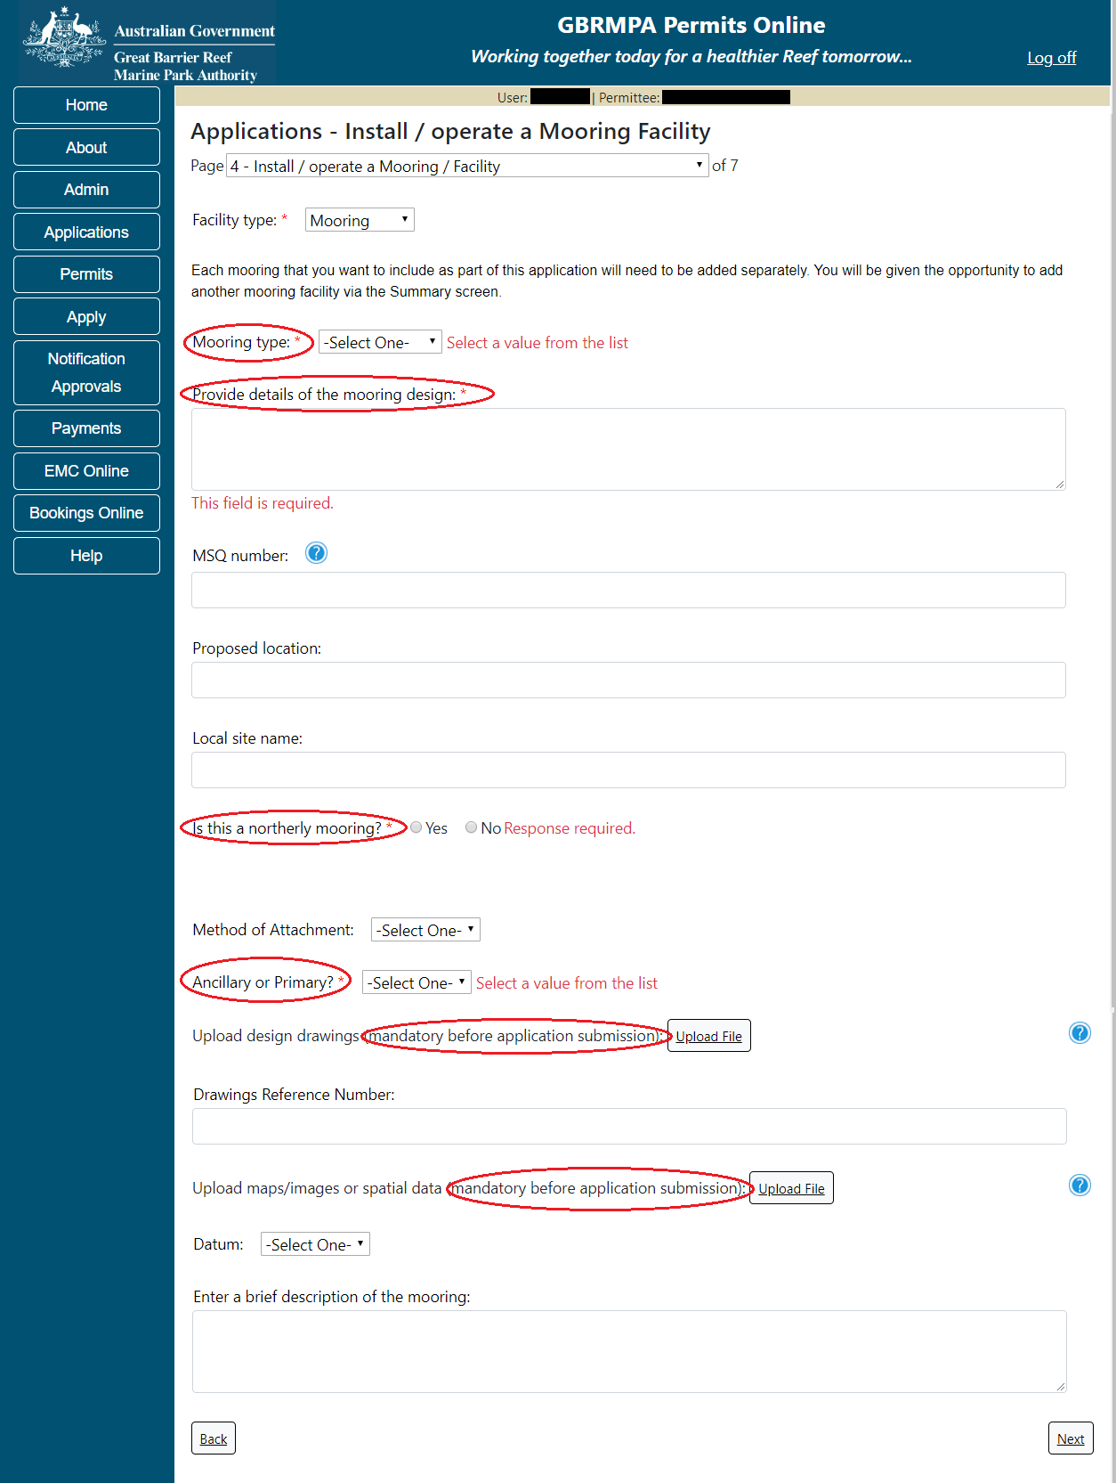
Figure 354 - Screenshot of Install / operate a Mooring Facility page with red circles around all mandatory fields (Mooring Type, Provide Details, Northerly Mooring, Ancillary or Primary, Upload design drawings, Upload maps)

Fill in the mandatory fields with the required information for Mooring type, MSQ Number, Proposed location and Local site name. If the mooring is a northerly mooring select Yes and an addition field will appear. Add the existing mooring associated with the application in the addition field.
Select an option from primary or ancillary and an option from the method of attachment list. Upload the required design drawings and upload maps, images or spatial data. Enter the datum and a brief description of the mooring. Select Next to continue.
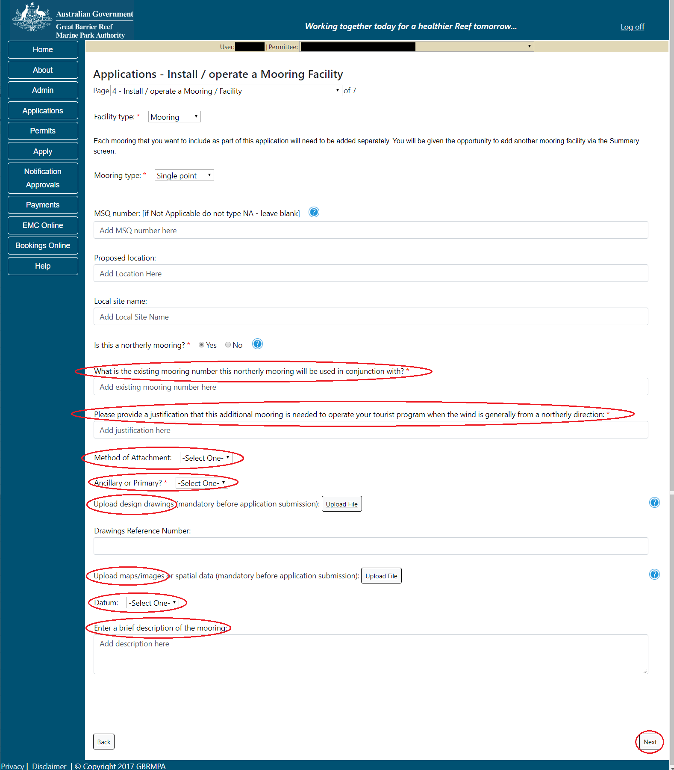
Figure 355 - Screenshot of Install / operate a Mooring Facility page with red circles around Existing mooring number field, justification field, Method of attachment, Upload Design Drawings, Upload Maps, Datum and Enter a brief description fields, circle around Next button
Page 5 of Install / operate a Mooring Facility is the Locations and Co-ordinates page. To add the locations latitude and longitude select Add New.
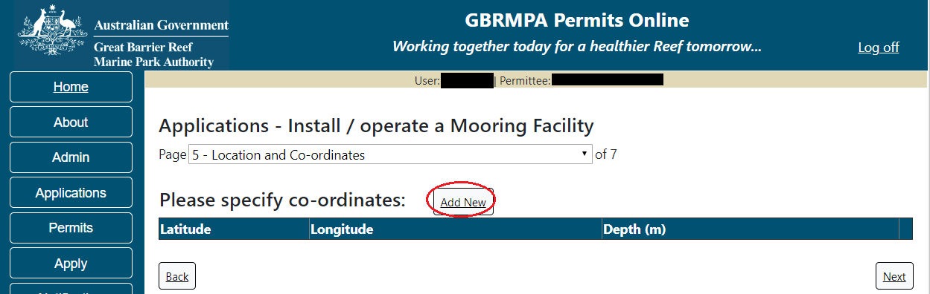
Figure 356 - Screenshot of Locations and Co-ordinates screen with a red circle around Add New button

The Add Latitude / Longitude pop up window will appear. If a location is entered that is not within the latitude and longitude for the Great Barrier Reef the system will produce an error. The Latitude field must be between -30.000000 and -10.000000. The Longitude must be between 135 and 155. Add the co-ordinates in Decimal Degrees.
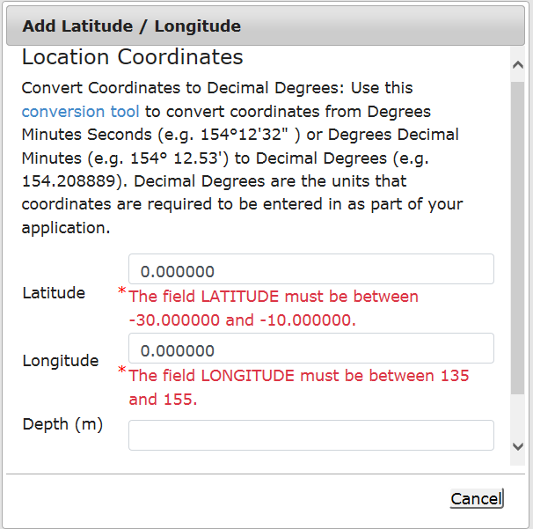
Figure 357 - Screenshot of Add Latitude / Longitude pop up window displaying validations for Co-Ordinates

Co-ordinates need to be entered in Decimal Degrees. There is a link to a conversion tool within the Add Latitude / Longitude pop up window. If you need to use the conversion tool, select the link and you will progress to the Australian Antarctic Data Centre website that has conversion tool.
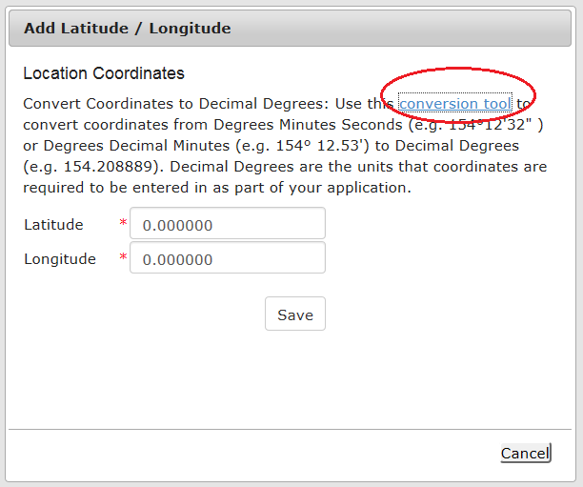
Figure 358 - Screenshot of Add Latitude / Longitude pop up window with red circle around conversion tool hyperlink

Once on the site enter Degrees Minutes and Seconds into the conversion tool and select Click for conversion. You will be presented with a Decimal Degrees figure.
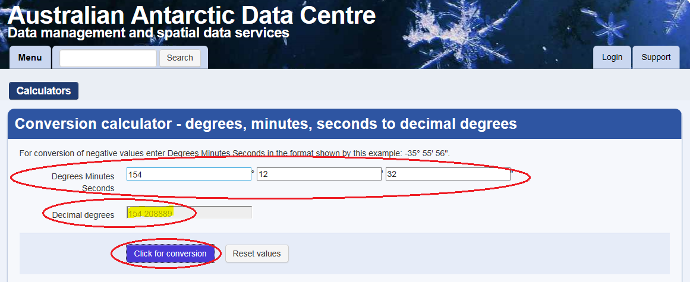
Figure 359 - Screenshot of Antarctic Division home page with Conversion calculator displayed

Enter the co-ordinates to 6 decimal places; add the depth and select Save.
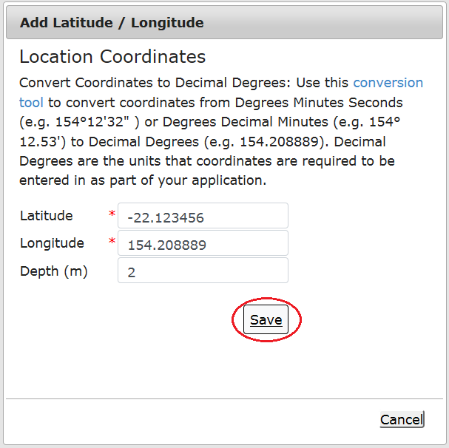
Figure 360 - Screenshot of Add Latitude / Longitude pop up window with Co-ordinates completed and red circle around Save button

Your co-ordinate will be displayed on the screen including the depth entered. Remove and Edit buttons will also appear. If you wish to edit the co-ordinates, select Edit and make the changes required. If you wish to remove the co-ordinate select Remove and it will be deleted from your application.
If you have a fore and aft mooring, add both the fore and aft co-ordinates. Select Next to continue.
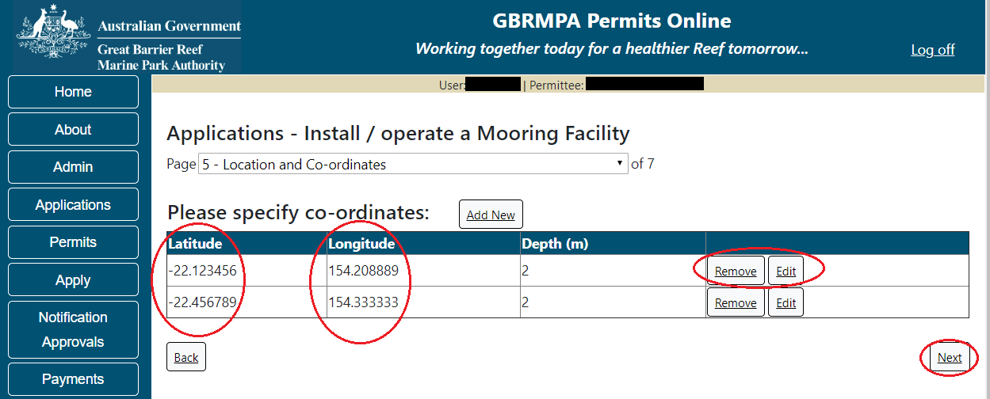
Figure 361 - Screenshot of Location and Co-ordinates screen with information displayed and a red circle around Latitude and Longitude columns, circle around Remove and Edit buttons and red circle around Next button

Page 6 of Install / operate a Mooring Facility provides opportunity for you to add any other information you feel will assist the Managing Agencies in assessing your application. Add supporting information by typing in the text field or upload a file if required. If a file is uploaded it will appear on the screen with the file name and a Remove button to remove the file if the wrong file is selected. Select Next to continue.
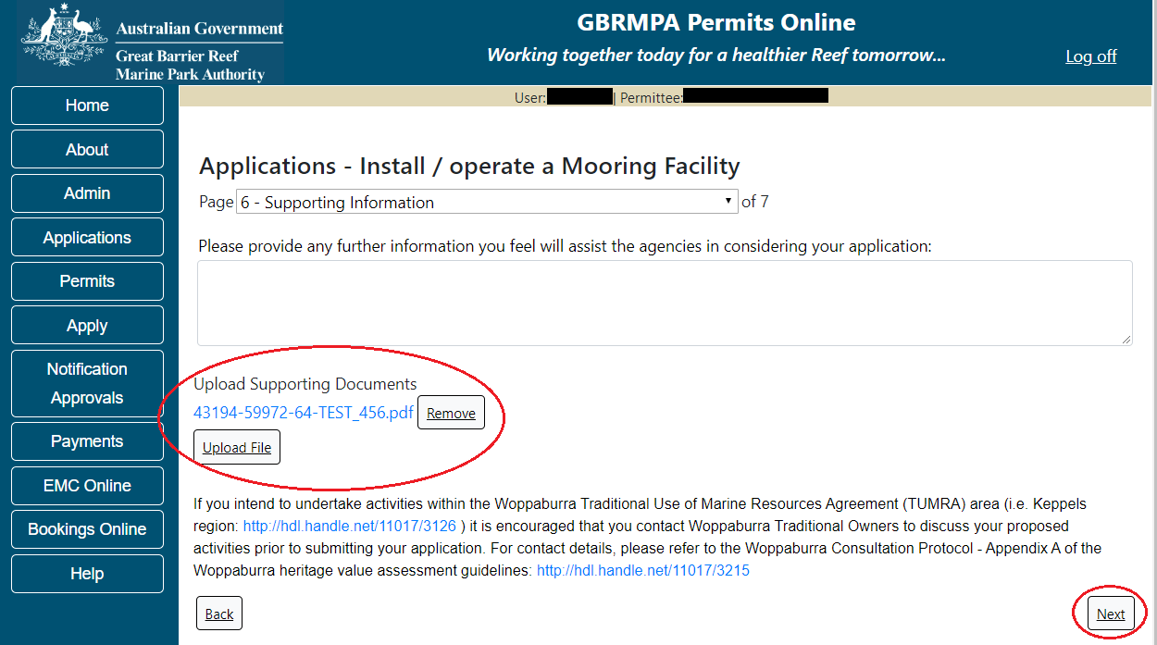
Figure 362 - Screenshot of Supporting Information screen with a red circle around Uploaded File area and a red circle around Next button

Page 7 of Install / operate a Mooring Facility is the Summary Page. On this screen, you have options to Add a New Mooring Type, Add a New Facility type, Edit or Remove the Mooring/Facility just entered. If you wish to edit or remove the facility, select the required button. If you wish to add another mooring or another facility select the appropriate hyperlink and you will be able to enter information for the additional mooring/facility. If you have completed your application details select Next to progress.
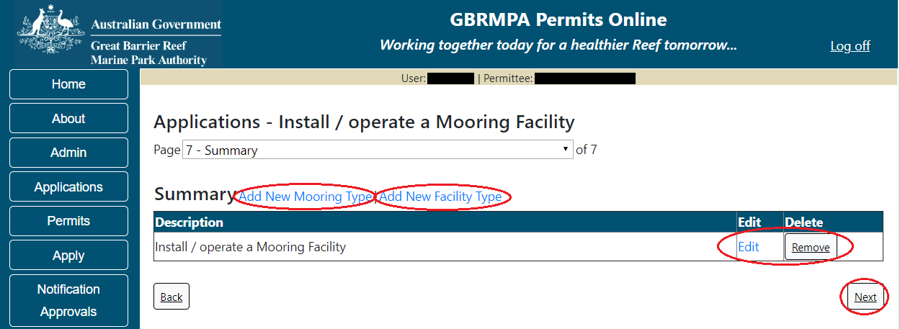
Figure 363 - Screenshot of mooring Summary page with red circles around options for Add New Mooring Type, Add New Facility Type, circle around Edit, Remove and Next buttons
Once you have completed the supporting information page select Next from the last page of the application questions, you will progress to an application summary screen with a number of options available via links or buttons. Select Next on the summary screen to progress to the Declarations screens.
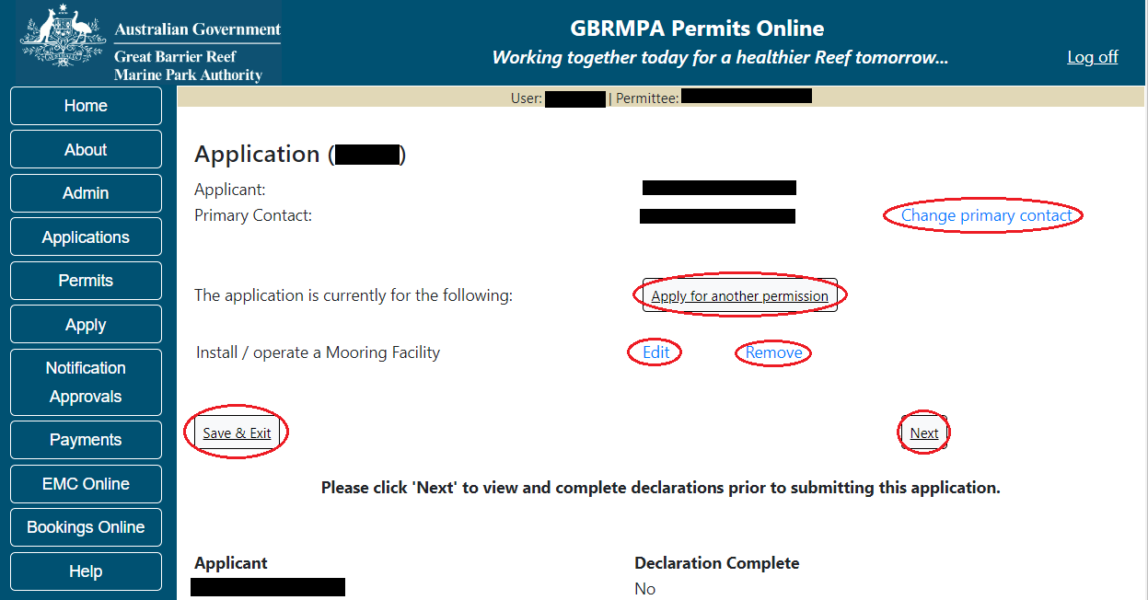
Figure 364 - Screenshot of Application Summary page with red circles around all options available

Additional Information - Summary screen, links and buttons;
- Change primary contact: If the change primary contact link is selected the applicant will progress to the primary contact page where the primary contact can be changed.

- Apply for another permission: If the Apply for another permission button is selected, the applicant will progress to the What are you seeking to do in the Marine Parks page where another permission type can be added. (e.g. add a tourism permission to the mooring permission)

- Edit: If edit is selected the application/permission will be reopened to apply any changes.

- Remove: If remove is selected the application/permission will be removed.

- Save & Exit: If the Save & Exit button is selected the applicant will progress to the applications screen.

- Next: If next is selected the applicant will progress to the submission process including declaring and submitting the application.

Completion of a set of declarations is mandatory prior to submitting your application. To complete the declarations section of this application, you must either be the applicant, or if applying on behalf of an organisation / company / government agency, you must be a Director of that organisation / company / government agency. Authorised contacts cannot complete the declaration section, as it contains legally binding commitments in place of a physical signature.
Please read all questions carefully, provide a response to each, and select Next.
Figure 365 - Screenshot of Declarations page with red circle around Yes and No options and Next button

On the final page of declarations there is a Submit button. Once the Submit button is selected, the application will be submitted to the Reef Authority and is no longer available to be edited. The status of the application on the Applications screen will then display ‘Submitted to GBRMPA’. The application’s Primary Contact will receive an emailed acknowledgement notice from a delegated Assessment Officer within 10 business days.
Figure 366 - Screenshot of Declarations screen with a red circle around the Submit button
Once you submit your application, you will be provided with a reference/application number and can follow the progress of your application via the Applications menu on the left.
Figure 367 - Screenshot of the Thank you for your application screen with a red circle around Reference number and a red circle around the open pdf button

Your application will appear in the Applications screen with the reference/application number also displayed. You have further options to view a summary of your application, email the Reef Authority or withdraw the application.
Figure 368 - Screenshot of Applications screen with a red circle around Application No., Summary, Email and Withdraw options

  - Install / operate another type of facility
Apply – new permit application – install / operate a facility (including mooring) – another type of facility
To apply for Install / operate another type of Facility select this option on the Apply – What are you seeking to do in the Marine Parks page.
Figure 369 - Screenshot of Apply - What are you seeking to do in the Marine Parks screen with Install / operate a Facility (including Mooring) and a red circle around the Next button

You will progress to the application types sub menu, where you can choose which type of Facility you wish to apply for (example used is Install / operate another type of facility).
Select the facility type then select Next. Please Note: This permission may include discharging waste from a facility; building, assembling, fixing in position, maintaining or demolishing a facility; or operating a landing area or facility for aircraft. A facility may include a building, a structure, a vessel, goods, equipment or services.
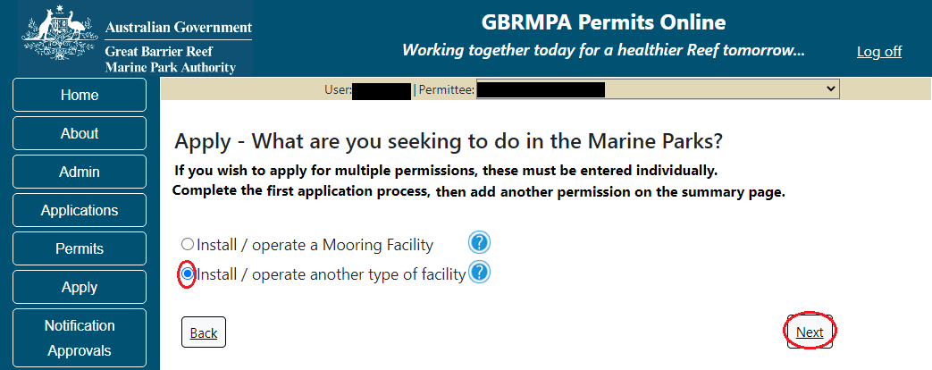
Figure 370 - Screenshot of Apply - What are you seeking to do in the Marine Parks - Install / operate another type of Facility and a red circle around Next button
Page 1 of Install / operate another type of facility application is the Environment Protection and Biodiversity Conservation Act page. This provides advice on matters of national environmental significance that must be considered when assessing an application. This screen is for your information only at this stage. Your assessing officer will contact you if it is determined to be relevant for your application.
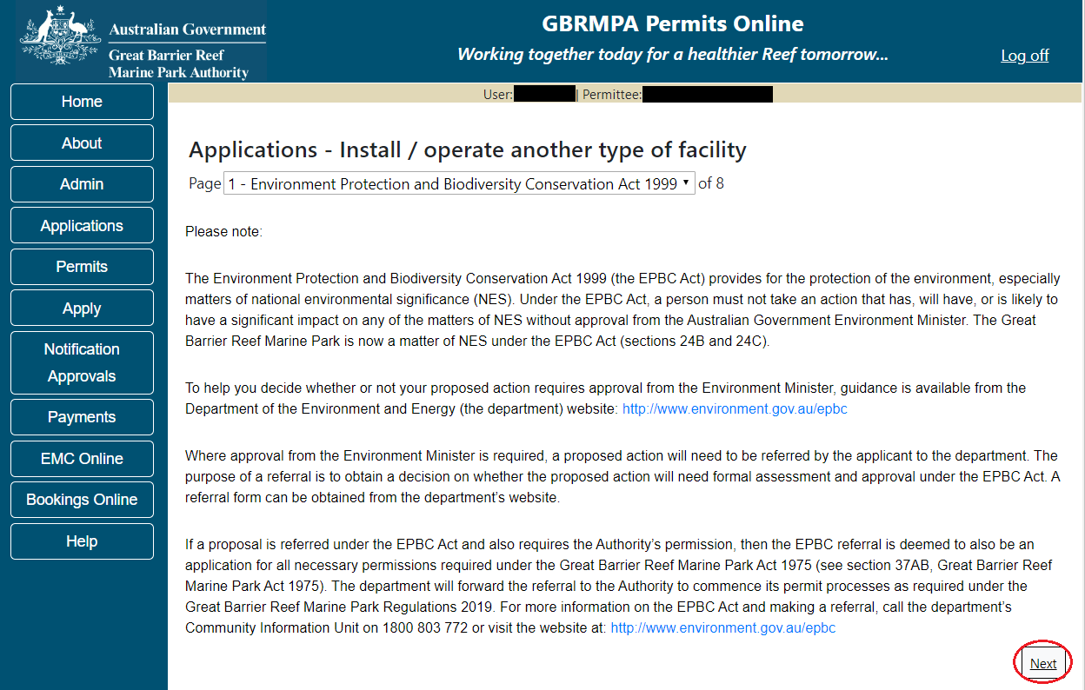
Figure 371 - Screenshot of Environment Protection and Biodiversity Conservation screen with a red circle around Next button

Links on the Environment Protection and Biodiversity Conservation page www.environment.gov.au/epbc will take you to the Department of Climate Change, Energy the Environment and Water site. Here you can find information about the Environment Protection and Biodiversity Conservation Act 1999 and your obligations under the Act.

Page 2 of Install / operate another type of facility application is the Justification for Marine Park use page. On this page add details of why you need to use the Marine Park? What alternatives have been considered and why have they been ruled? Once you have added your detail select Next to continue.
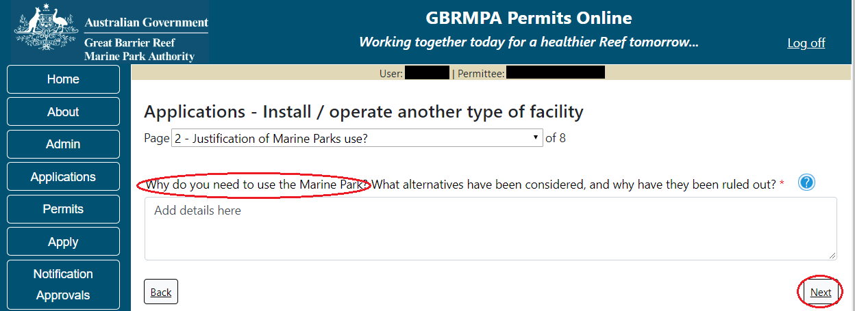
Figure 372 - Screenshot of Justification for Marine Park Use page with a red circle question - Why do you need to use the Marine Park? Circle around Next button

Page 3 of Install / operate another type of facility application is the Commercial Nature page. If your operation is of a commercial nature select yes. If not select no. NOTE: Activities of a commercial nature are those from which a profit is drawn or intended to be drawn. After you make your selection, select Next to continue.
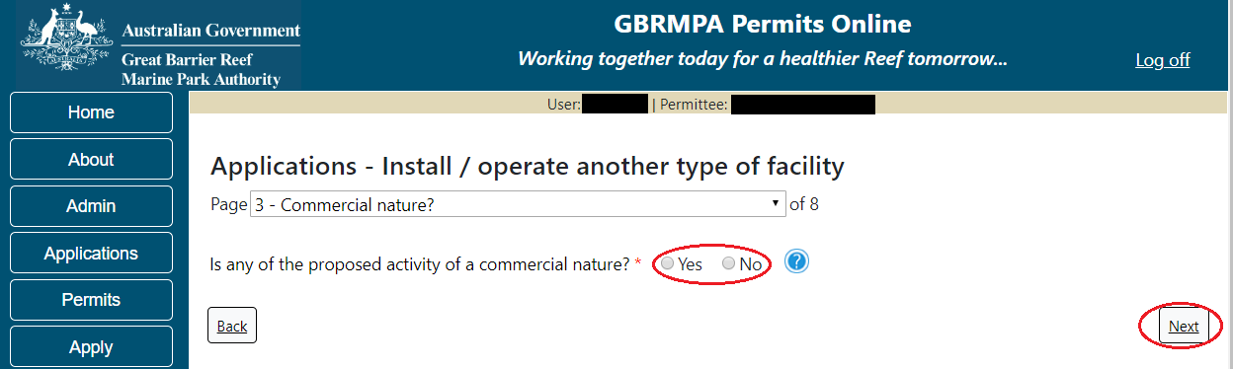
Figure 373 - Screenshot of Commercial Nature page with red circle around Yes and No options and red circle around Next button

Page 4 of Install / operate another type of facility application is the Facility Information page. There are a number of mandatory fields on this page. All mandatory fields must be completed to continue.
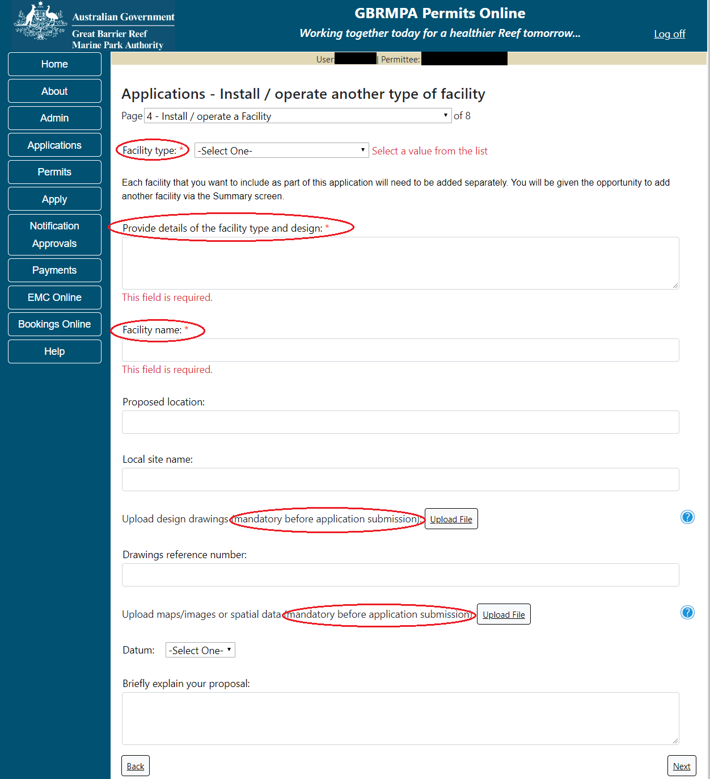
Figure 374 - Screenshot of Install / operate a Facility page with red circles around all mandatory fields (Facility Type, Provide Details, Facility Name, Upload design drawings and upload maps)

Fill in the mandatory fields with the required information for Facility type, Facility Name, proposed location and local site name. Upload the required design drawings and upload maps, images /spatial data and enter Datum. Enter a brief explanation of your proposal. Select Next to continue.
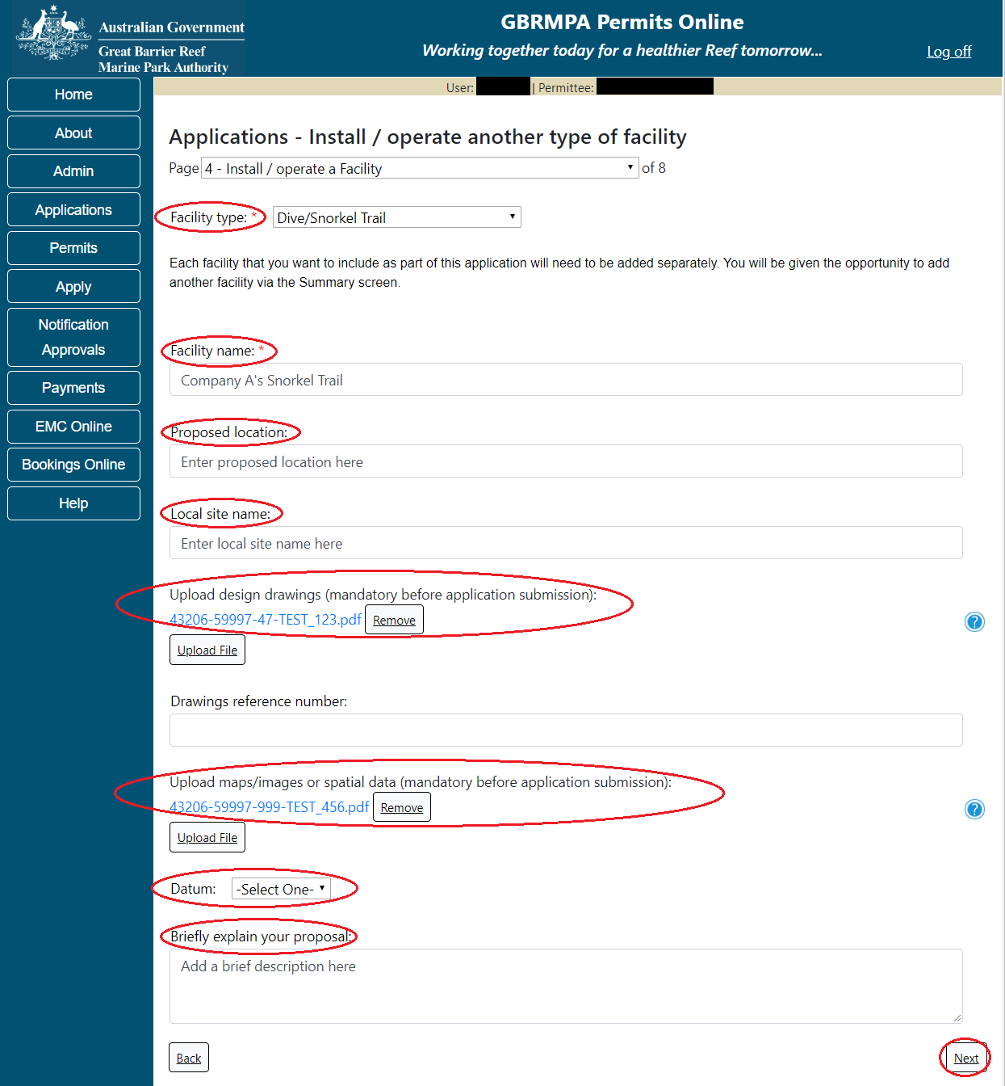
Figure 375 - Screenshot of Install / operate a Facility page with red circles around all questions with information completed for all areas, and red circle around Next button

Page 5 of Install / operate another type of facility application is the Locations and Co-ordinates page. To add the locations latitude and longitude select Add New.
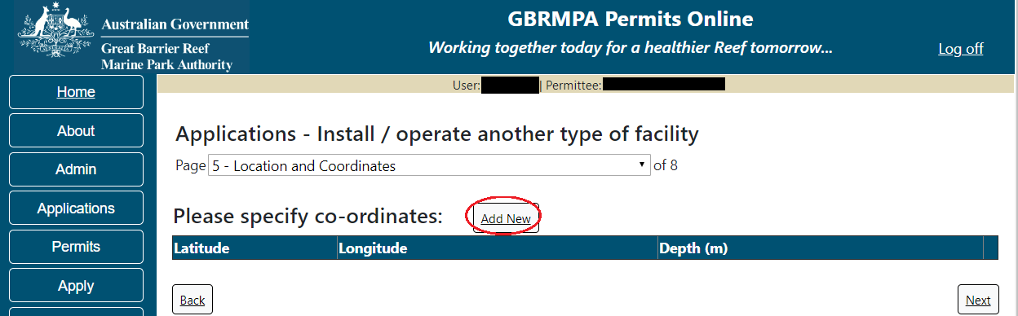
Figure 376 - Screenshot of Locations and Co-ordinates screen with a red circle around Add New button

The Add Latitude / Longitude pop up window will appear. If a location is entered that is not within the latitude and longitude for the Great Barrier Reef, the system will produce an error. The Latitude field must be between -30.000000 and -10.000000. The Longitude must be between 135 and 155. Add the co-ordinates in Decimal Degrees.
Figure 377 - Screenshot of Add Latitude / Longitude pop up window displaying validations for Co-Ordinates

Co-ordinates need to be entered in Decimal Degrees. There is a link to a conversion tool within the Add Latitude / Longitude pop up window. If you need to use the conversion tool, select the link and you will progress to the Australian Antarctic Data Centre website that has a conversion tool.
Figure 378 - Screenshot of Latitude / Longitude pop up window with red circle around conversion tool hyperlink

Once on the site enter Degrees Minutes and Seconds into the conversion tool and select Click for conversion. You will be presented with a Decimal Degrees figure.
Figure 379 - Screenshot of Antarctic Division home page with Conversion calculator displayed

Enter the co-ordinates to 6 decimal places, add depth and select Save.
Figure 380 - Screenshot of Add Latitude / Longitude pop up window with Co-ordinates completed and red circle around Save button

Your co-ordinate will be displayed on the screen. A Remove button will also appear. If you wish to remove the co-ordinate select Remove and it will be deleted from your application. If you have a fore and aft mooring, add both the fore and aft co-ordinates. Select Next to continue.
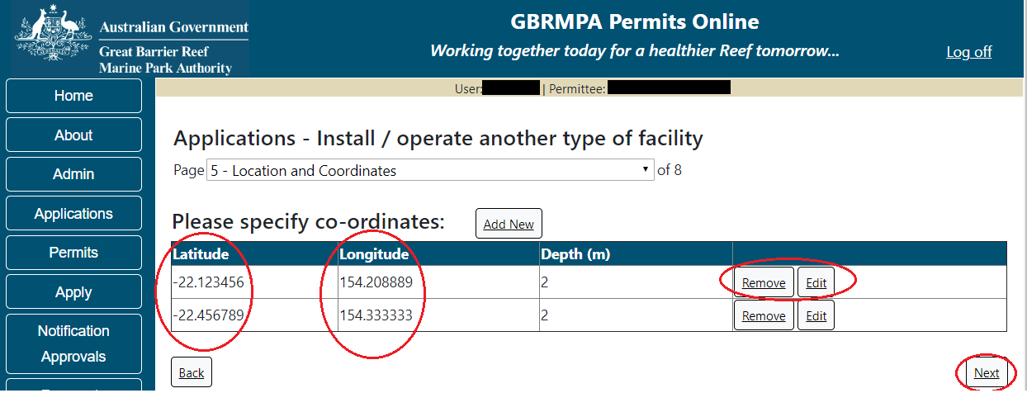
Figure 381 - Screenshot of Location and Co-ordinates screen with information displayed and a red circle around Latitude and Longitude columns, red circle around Remove button and red circle around Next button

Page 6 of Install / operate another type of facility application is the Environmental Management Plan (EMP) page. Preparing EMP may be a condition of your Marine Parks permit. The condition of your permit will outline when you are required to submit your EMP if you do not upload one at this stage. Further information on EMPs is located on the next page and on the Reef Authority website. If you have an EMP for your facility select the Upload File button.
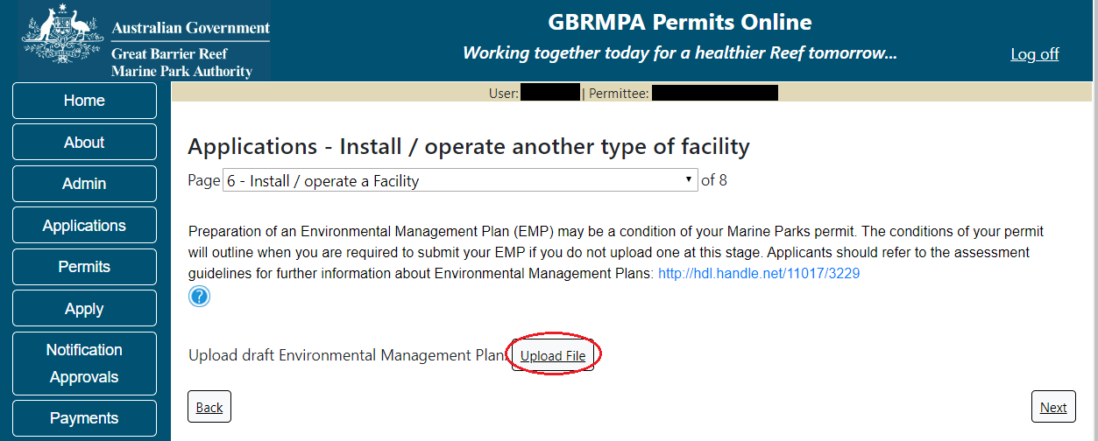
Figure 382 - Screenshot of Install / operate a Facility page with a red circle around Upload File button

Select the file from your computer files and then select save. The file will appear with the file name. Once you have loaded your file/s select Next to continue.
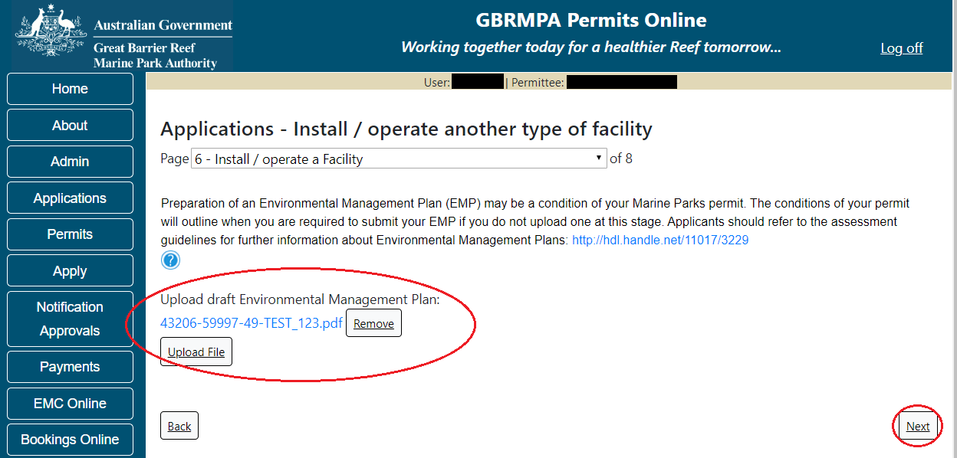
Figure 383 - Screenshot of Install / operate a Facility page with a red circle around Uploaded File and red circle around Next button

Information Environmental Management Plans (EMP)
A draft Environmental Management Plan should include at a minimum:
- Description of physical site characteristics including water depths, type of substrate, physical conditions (wave, wind, currents)
- Description of biological site characteristics, including habitat types, species present and how these species use the site (feeding, reproduction, rest, transit)
- Description of social site characteristics, including other facilities and uses (both recreational and commercial) within 1km of the proposed location
- Evaluation of whether the site may have historic heritage values
- Description of Indigenous heritage values associated with the site
- Construction and installation schedule - proposed timeframes of the project
- Description of the methods and materials to be used in transporting materials, installing the facility and disposing of wastes
- Description of the activities proposed to take place on or around the facility once operational, including any ancillary equipment or vessels that will be stored at the facility
- Inspection and maintenance schedule including description of how (logistically) the facility will be serviced
- Proposed method of removal, including an explanation of how the facility has been designed for easy removal with minimal impact on the surrounding environment
- Details of any proposed reef health monitoring programs.

- Risk assessment using the Reef Authority’s Risk Assessment Procedure
http://hdl.handle.net/11017/3231 including:
(a) Values which may be impacted (directly, indirectly, consequentially or from cumulative pressures)
(b) Risks posed to the values by these potential impacts
(c) How risks will be avoided, mitigated or offset to achieve no net loss of Marine Park values.

Page 7 of the Install / operate another type of facility application provides opportunity for you to add any other information you feel will assist the Managing Agencies in assessing your application. Add supporting information by typing in the text field or upload a file if required. If a file is uploaded it will appear on the screen with the file name and a button to remove the file if the wrong file is selected. Select Next to continue.
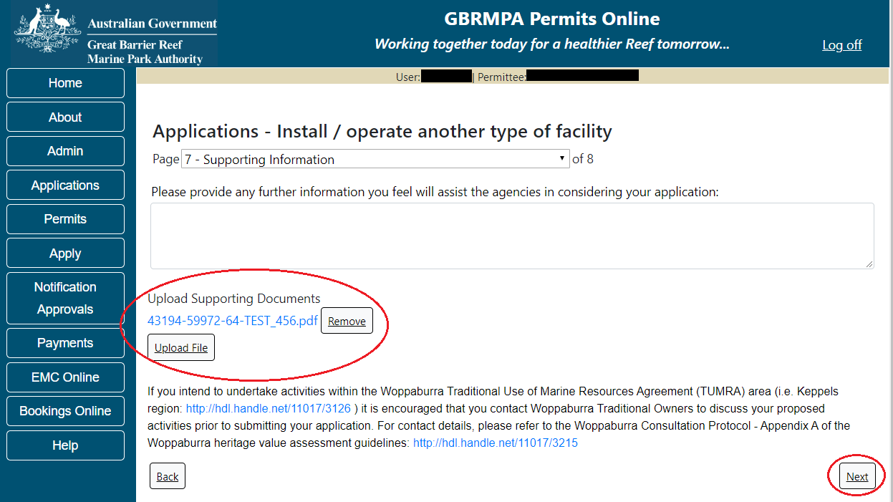
Figure 384 - Screenshot of Supporting Information screen with information entered and a red circle around Please provide further information section, red circles around Uploaded File and Next button

Page 8 of the Install / operate another type of facility is the Summary Page. On this screen you have options to Add a New Mooring Type, Add a New Facility type, Edit or Remove the Mooring/Facility just entered. If you wish to edit or remove the facility, select the required button. If you wish to add another mooring or another facility select the appropriate hyperlink and you will be able to enter information for the additional mooring/facility. If you have completed your application details select Next to progress.
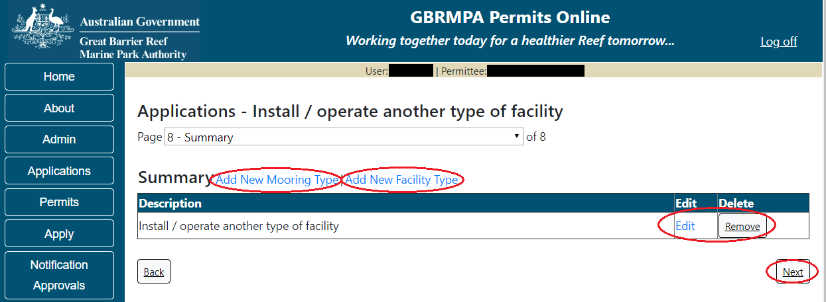
Figure 385 - Screenshot of Facility Summary page with red circles around options for Add New Mooring Type, Add New Facility Type, red circles around Edit button and Next button

Once you have completed the supporting information page select Next from the last page of the application questions, you will progress to an application summary screen with a number of options available via links or buttons. Select Next on the summary screen to progress to the Declarations screens.
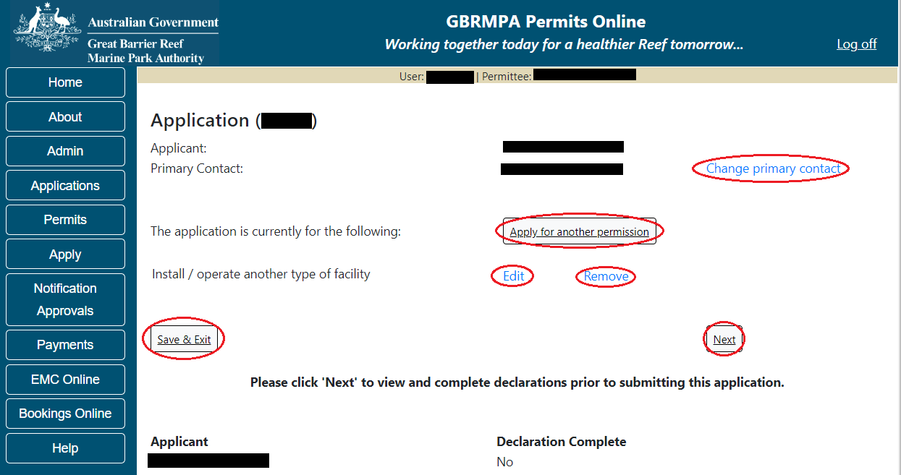
Figure 386 - Screenshot of Application Summary page with red circles around all options available
Additional Information - Summary screen, links and buttons;
- Change primary contact: If the change primary contact link is selected the applicant will progress to the primary contact page where the primary contact can be changed.

- Apply for another permission: If the Apply for another permission button is selected, the applicant will progress to the What are you seeking to do in the Marine Parks page where another permission type can be added. (e.g. add a mooring permission to the facility permission)

- Edit: If edit is selected the application/permission will be reopened to apply any changes.

- Remove: If remove is selected the application/permission will be removed.

- Save & Exit: If the Save & Exit button is selected the applicant will progress to the applications screen.

- Next: If next is selected the applicant will progress to the submission process including declaring and submitting the application.

Completion of a set of declarations is mandatory prior to submitting your application. To complete the declarations section of this application, you must either be the applicant, or if applying on behalf of an organisation / company / government agency, you must be a Director of that organisation / company / government agency. Authorised contacts cannot complete the declaration section, as it contains legally binding commitments in place of a physical signature.
Please read all questions carefully, provide a response to each, and select Next.
Figure 387 - Screenshot of Declarations page with red circle around Yes and No options and Next button

On the final page of declarations there is a Submit button. Once the Submit button is selected, the application will be submitted to the Reef Authority and is no longer available to be edited. The status of the application on the Applications screen will then display ‘Submitted to GBRMPA’. The application’s Primary Contact will receive an emailed acknowledgement notice from a delegated Assessment Officer within 10 business days.
Figure 388 - Screenshot of Declarations screen with a red circle around the Submit button
Once you submit your application, you will be provided with a reference/application number and can follow the progress of your application via the Applications menu on the left.
Figure 389 - Screenshot of the Thank you for your application screen with a red circle around Reference number and a red circle around the open pdf button

Your application will appear in the Applications screen with the reference/application number also displayed. You have further options to view a summary of your application, email the Reef Authority or withdraw the application.
Figure 390 - Screenshot of Applications screen with a red circle around Application No., Summary, Email and Withdraw options

- Conduct Research
Apply – new permit – conduct research
To apply for Conduct Research, select this option on the Apply – What are you seeking to do in the Marine Parks page. Select Next to progress to application questions in Permits Online.
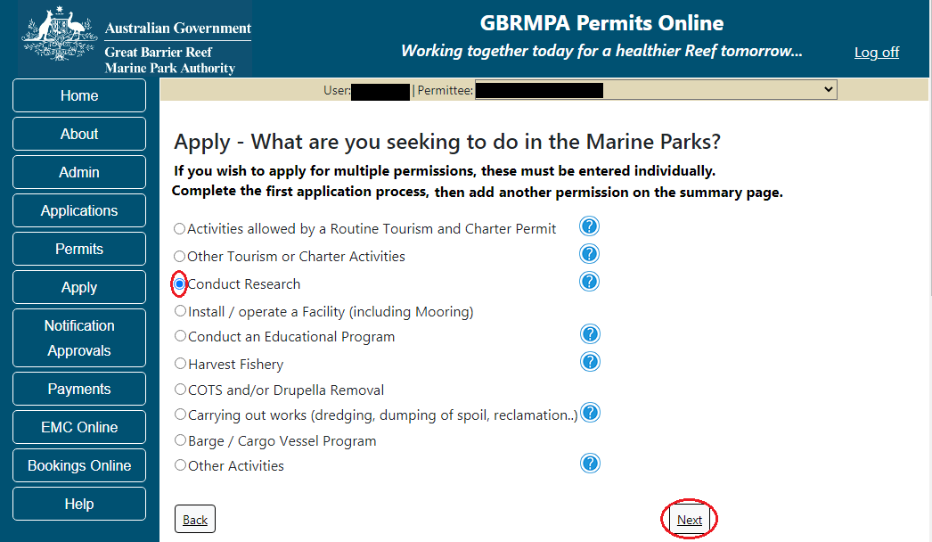
Figure 391 - Screenshot of Apply - What are you seeking to do in the Marine Parks screen with Conduct Research and a red circle around Next button

Information Research applications
The Great Barrier Reef Marine Park Authority recognises the important role that research plays in contributing to our understanding of the Great Barrier Reef.

Research provides us with a scientific basis for management decisions, which helps us in protecting the environment, biodiversity and heritage values of the Great Barrier Reef Marine Park.

The Zoning Plan and regulations set out the way activities are managed in the Marine Parks.

The guidelines for managing research in the Marine Park outlines our approach to managing research activities and key considerations and limitations in relation to research.

Further information on Research applications are located on the Reef Authority’s website. http://www.gbrmpa.gov.au/zoning-permits-and-plans/permits/research-permissions

The landing page of the Research Application is an initial page with questions and information. Depending on the nature of the Research and what answers are obtained will determine if the applicant is eligible for a Routine Commercial Research permit Application or if the application will be a Tailored Research Application. On this screen, there are also two links, a link to a copy of the Routine Commercial Research permit and a link to the assessment approach information on how the permit application will be assessed.
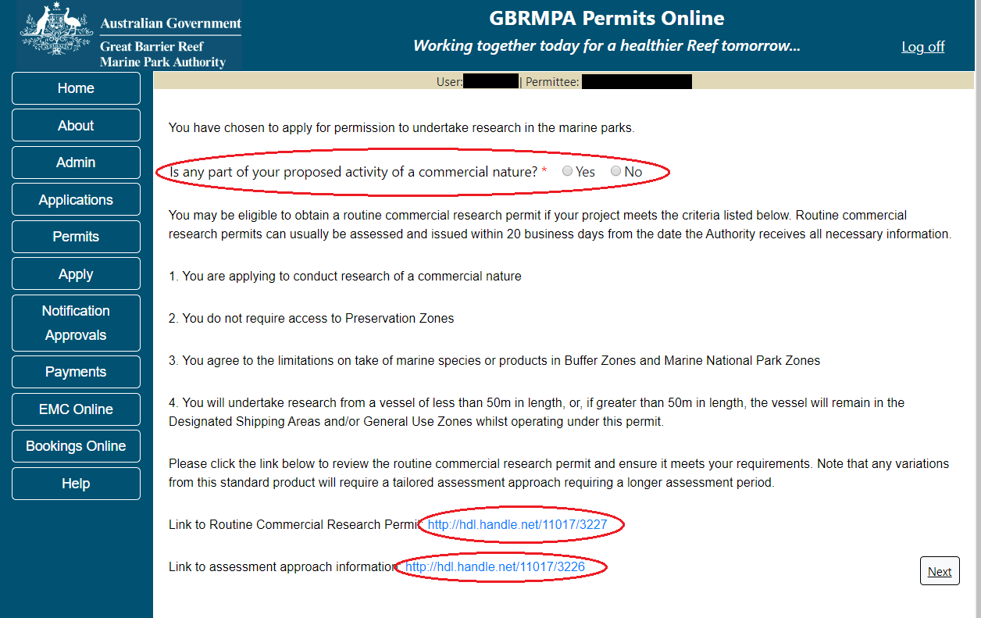
Figure 392 - Screenshot of Research initial question and information page with a red circle around question Is any part of your proposed activity of commercial nature? and red circles around hyperlinks to Routine Commercial Research Permit and Assessment Approach information

Please Note: If No is selected for question Is any part of your proposed activity of a commercial nature? the system will take the applicant through the Tailored Research Permit Application once Next is selected.

If Yes is selected for question Is any part of your proposed activity of a commercial nature? A second question will appear. Would you like to apply for a routine commercial permit?
If Yes is selected for question Would you like to apply for a routine commercial permit, the system will take the applicant through the Routine Commercial Research Permit Application once Next is selected.
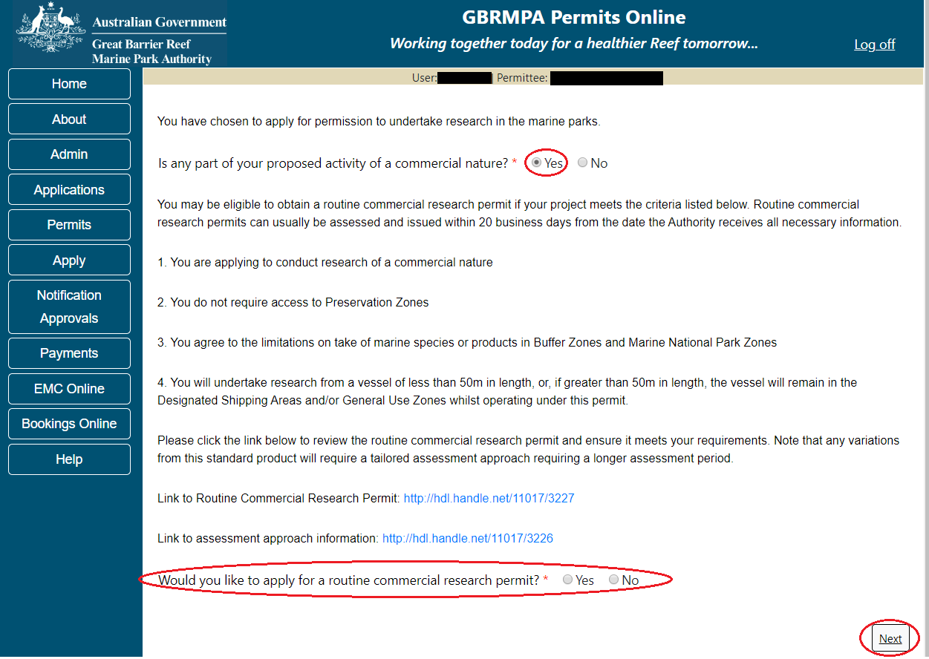
Figure 393 - Screenshot of Research initial question and information page with a red circle around question Would you like to apply for a routine commercial research permit? and a red circle around the Next button
Please Note: If No is selected for question Would you like to apply for a routine commercial permit? The system will take the applicant through the Tailored Research Permit Application once Next is selected.

  - Routine Commercial Research
Page 1 of the routine commercial research permit application page is where you can indicate if bio discovery will be involved. This page also guides applicants to what information is needed around Sampling Plans. There is an upload file section to upload the Sampling Plan. Select Next to continue.
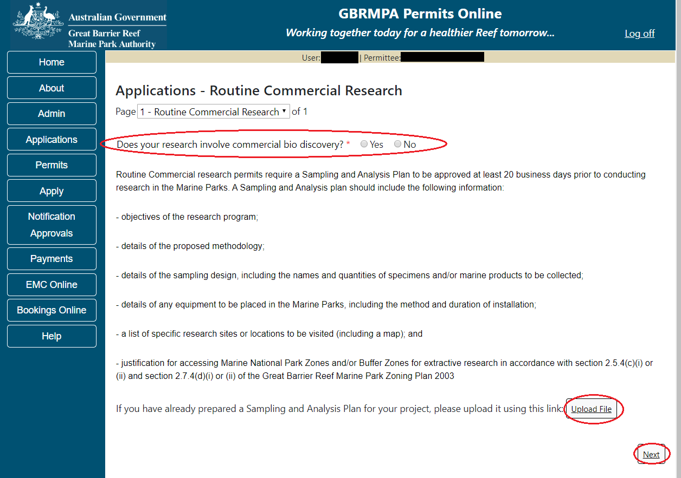
Figure 394 - Screenshot of Routine Commercial Research page with a red circle around question Does your research involve commercial bio discovery? Red circles around the Upload File button and the Next button

Information Routine Commercial Research – Sampling and Analysis Plans
Routine Commercial research permits require a Sampling and Analysis Plan to be approved at least 20 business days prior to conducting research in the Marine Parks. A Sampling and Analysis plan should include the following information:
- objectives of the research program;
- details of the proposed methodology;
- details of the sampling design, including the names and quantities of specimens and/or marine products to be collected;
- details of any equipment to be placed in the Marine Parks, including the method and duration of installation;
- a list of specific research sites or locations to be visited (including a map); and
- justification for accessing Marine National Park Zones and/or Buffer Zones for extractive research in accordance with section 2.5.4(c)(i) or (ii) and section 2.7.4(d)(i) or (ii) of the Great Barrier Reef Marine Park Zoning Plan 2003

Once you have completed the supporting information page select Next from the last page of the application questions, you will progress to an application summary screen with a number of options available via links or buttons. Select Next on the summary screen to progress to the Declarations screens.
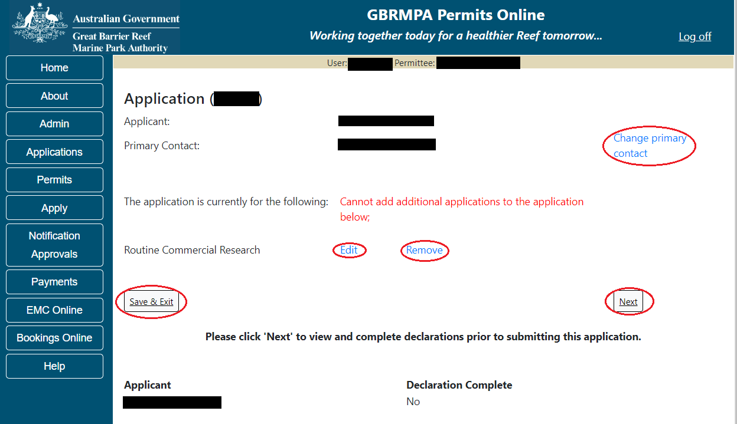
Figure 395 - Screenshot of Application Summary page with red circles around all options available

Additional Information - Summary screen, links and buttons;
- Change primary contact: If the change primary contact link is selected the applicant will progress to the primary contact page where the primary contact can be changed.

- Edit: If edit is selected the application/permission will be reopened to apply any changes.

- Remove: If remove is selected the application/permission will be removed.

- Save & Exit: If the Save & Exit button is selected the applicant will progress to the applications screen.

- Next: If next is selected the applicant will progress to the submission process including declaring and submitting the application.

Completion of a set of declarations is mandatory prior to submitting your application. To complete the declarations section of this application, you must either be the applicant, or if applying on behalf of an organisation / company / government agency, you must be a Director of that organisation / company / government agency. Authorised contacts cannot complete the declaration section, as it contains legally binding commitments in place of a physical signature.
Please read all questions carefully, provide a response to each, and select Next.
A copy of a Routine Commercial Research permit can be view by selecting the attached link. https://elibrary.gbrmpa.gov.au/jspui/handle/11017/3605
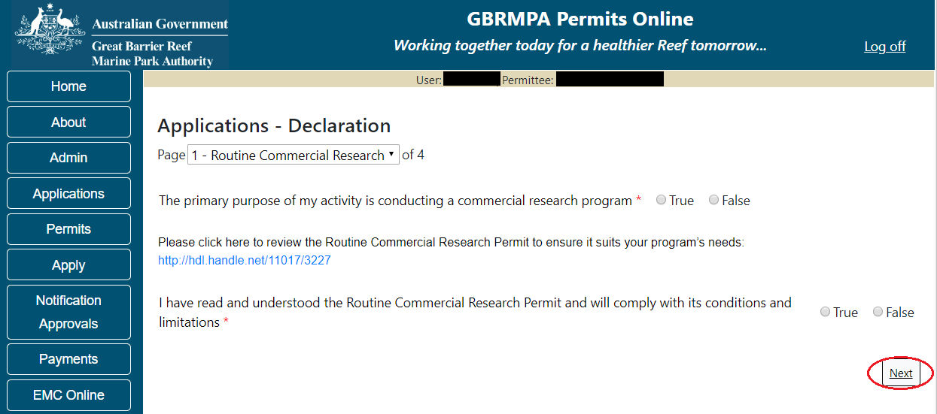
Figure 396 - Screenshot of Declarations screen for Routine Tourism and Charter permit application with a red circle around the Next button

On the final page of declarations there is a submit button. Once the Submit button is selected the application will be submitted to the Reef Authority and is no longer available to be edited.
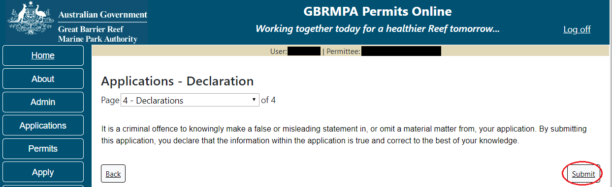
Figure 397 - Screenshot of Declaration page with a red circle around Submit button

Once you submit your application, you will be provided with a reference/application number and can follow the progress of your application via the Applications menu on the left.
Figure 398 - Screenshot of the Thank you for your application screen with a red circle around Reference number and a red circle around the open pdf button

Your application will appear in the Applications screen with the reference/application number also displayed. You have further options to view a summary of your application, email the Reef Authority or withdraw the application.
Figure 399 - Screenshot of Applications screen with a red circle around Application No., Summary, Email and Withdraw options

  - Tailored Research
If No is selected for any of the questions on the initial research questions and information page, you will progress to the Tailored Research Application within Permits Online.
Page 1 of Conduct Research application is the Environment Protection and Biodiversity Conservation Act page. This provides advice on matters of national environmental significance that must be considered when assessing an application. This screen is for your information only. Your assessing officer will contact you if it is determined to be relevant for your application.
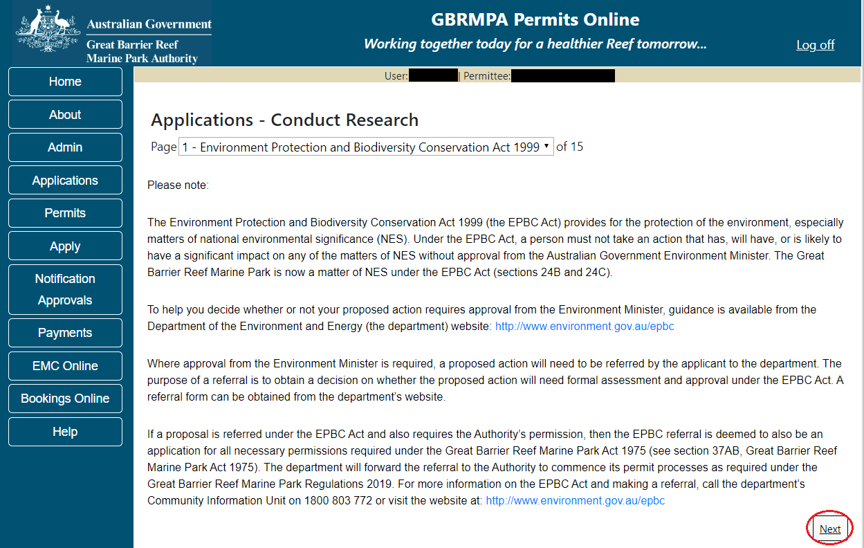
Figure 400 - Screenshot of Environment Protection and Biodiversity Conservation screen with a red circle around Next button

Links on the Environment Protection and Biodiversity Conservation page www.environment.gov.au/epbc will take you to the Department of Climate Change, Energy, the Environment and Water site. Here you can find information about the Environment Protection and Biodiversity Conservation Act 1999 and your obligations under the Act.

Page 2 of Conduct Research application asks about the nature of your research. If your research is of a commercial nature, select yes. If not select no. NOTE: Activities of a commercial nature are those from which a profit is drawn or intended to be drawn. After you make your selection, select Next to continue.
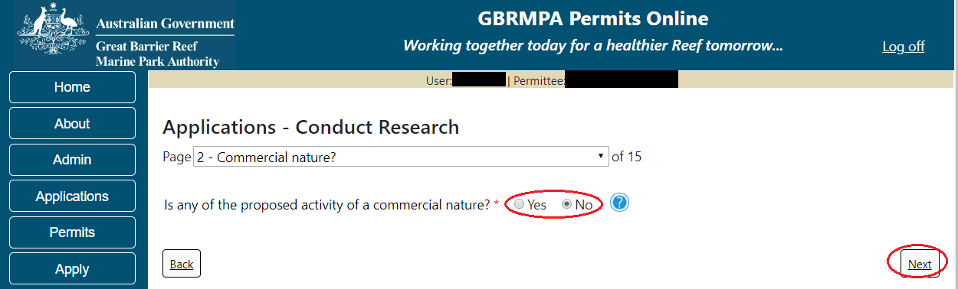
Figure 401 - Screenshot of Commercial Nature page with a red circle around Yes and No options, and red circle around Next button

Information Commercial nature
The Managing Agencies consider whether the purpose of the activity is of a commercial nature, not whether the applicant is of a commercial nature. In determining if an activity is of a commercial nature, the Managing Agencies consider if the activity constitutes, or has sufficient connection with, the provision of goods and services for reward (either monetary or non-monetary). This includes activities that are carried out with a view to profit or an intention to make a profit, but may also cover goods and services for non-monetary reward such as free publicity or free trips on a boat.

Page 3 of Conduct Research application is Additional State Access. If you wish to extend your operations to include mainland or island national parks adjoining the Marine Parks and/or rivers and streams between Mission Beach and the Starcke River, select Yes and an area will appear with Please specify details. Add details of the islands or national parks and/or River and streams you wish to access.
Please also indicate whether you wish to conduct operations in the Green Island Recreational Area of Management.
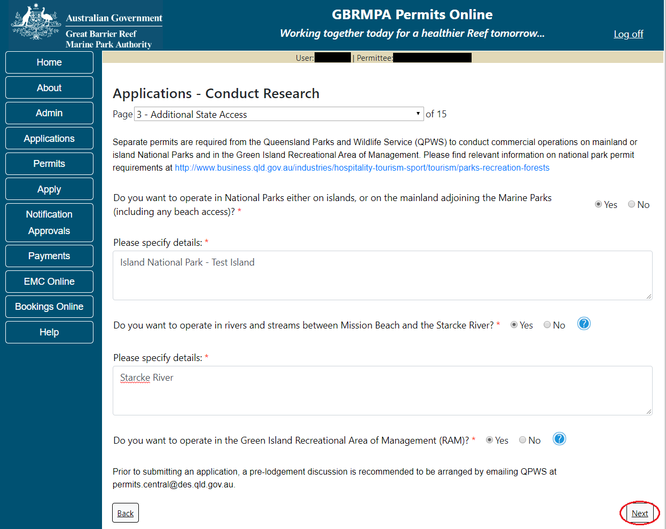
Figure 402 - Screenshot of Extend Operations screen with information displaying and a red circle around Next button

Once your details have been completed select Next to continue.

Page 4 of Conduct Research application is the Research Questions page. Add details of your Research including a Title and a brief summary. You also have an option to upload a file/s if needed. Once you have entered your Research information select Next to continue.
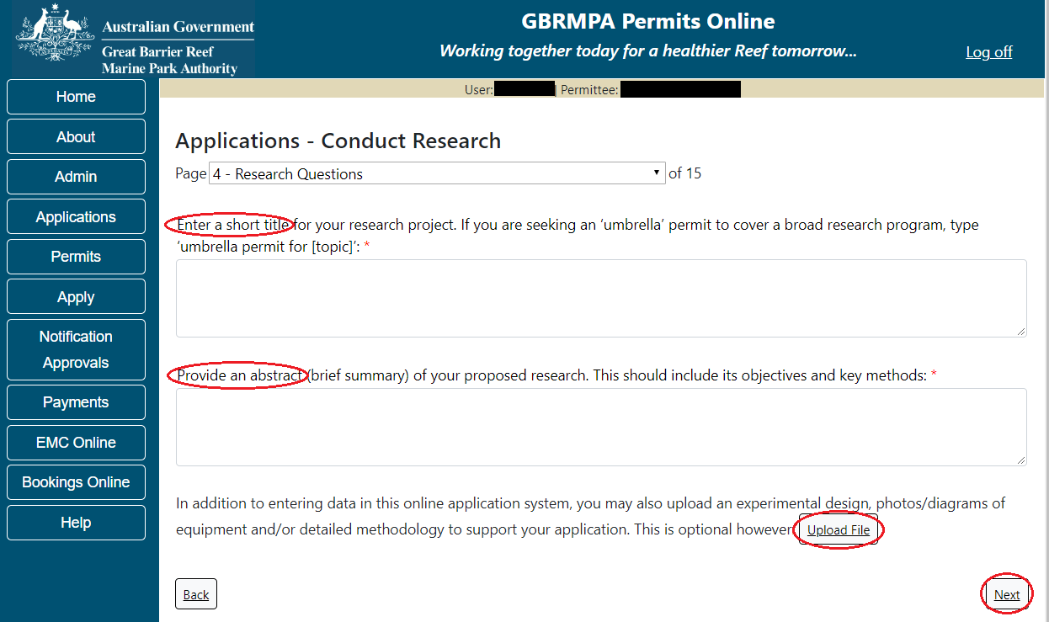
Figure 403 - Screenshot of Research Questions page with a red circle Enter a short title for your research project, circle around Provide an abstract of you research proposal, red circle around File Upload button and a red circle around Next button

Page 5 of Conduct Research application is the further Research questions. On this page, please add details of the number of researchers, the proposed permit duration, Bio discovery and how you propose to move through the Marine Park/s.
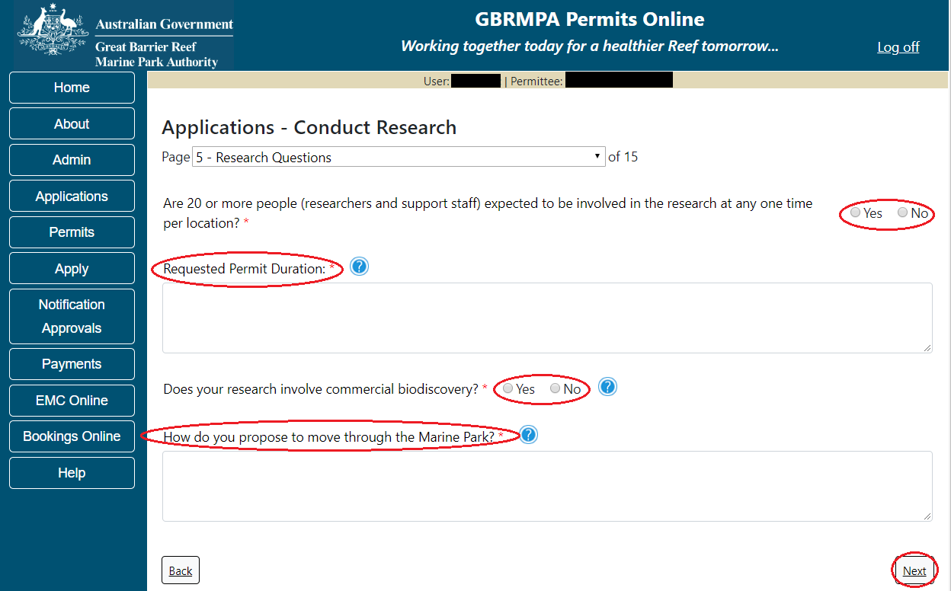
Figure 404 - Screenshot of Research Questions page with a red circle around all questions to be answered on the page, circle around Next button
Page 6 of Conduct Research application is the Proposed Activities page. Each tick box has activities associated with it.
If your research will involve Collection of Marine products, Collection/manipulation of specimens or the take of a protected species select these and fields to enter this information will appear in the following pages.
If your research involves non-extractive research including surveys select this option, a field to enter survey information will appear in the following pages.
If your research will involve the use of chemicals select this option and a page will appear in the following pages to add the chemicals you propose to use.
If your research will involve the use of equipment or structures select this option and a page will appear in the following pages to add the equipment and/or structures you propose to use.
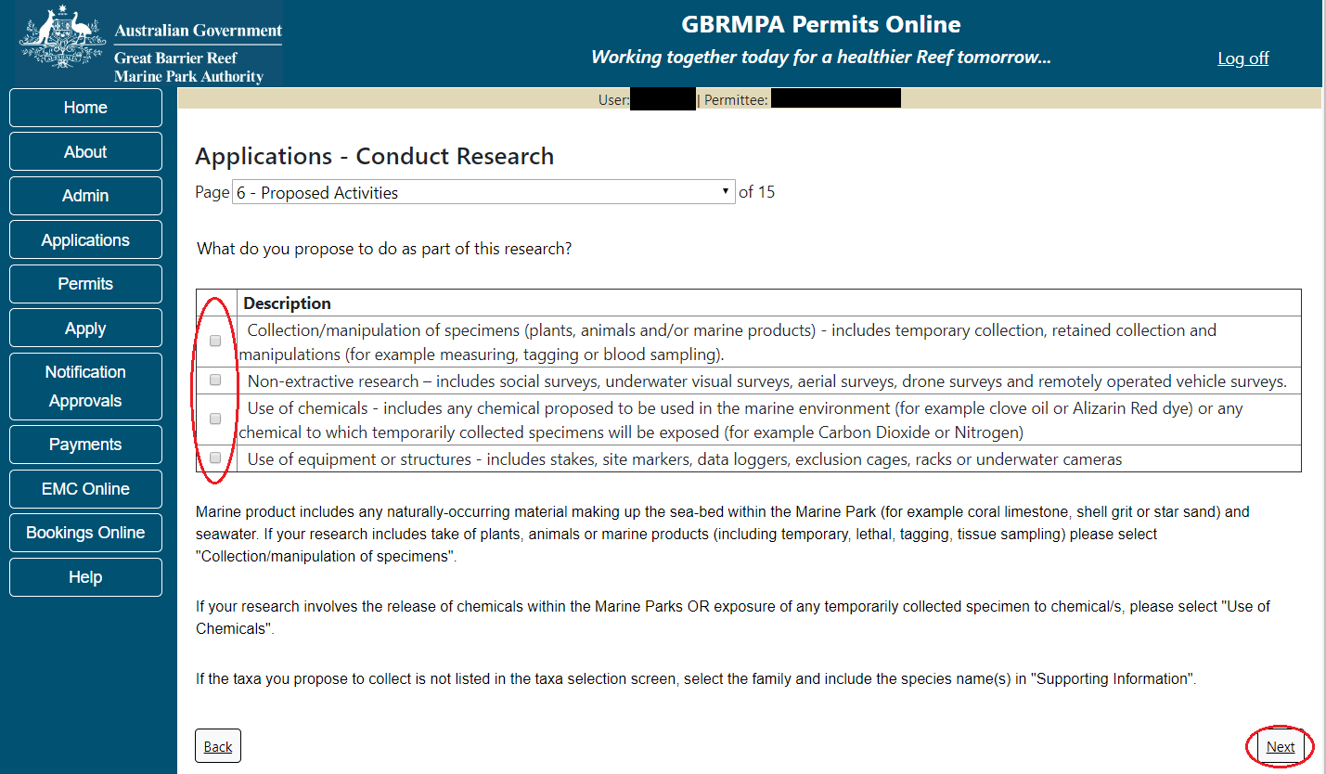
Figure 405 - Screenshot of Permissions and Activities screen with a red circle around Activity tick boxes and red circle around Next button

Once you have selected the activities associated with your research application select Next to continue.

Page 7 of Conduct Research application is the Survey Methods page.
If you did not select this option in the previous page the system will indicate that this activity was not selected. If you wish to add this activity, select back and select the activity in the Proposed Activities page (page 6)
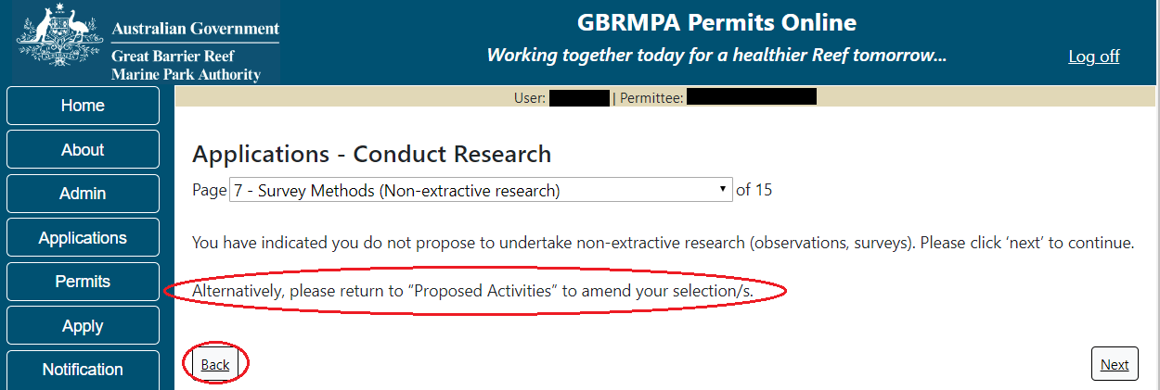
Figure 406 - Screenshot of Survey Methods screen when survey option is not selected on Activities page, circle around alternatively please return to Proposed Activities to amend your select and red circle around back button

If you selected to Non-extractive-research in the activities page, a table and an Add New button will appear on the Survey Methods page. To add your survey methods select Add New.
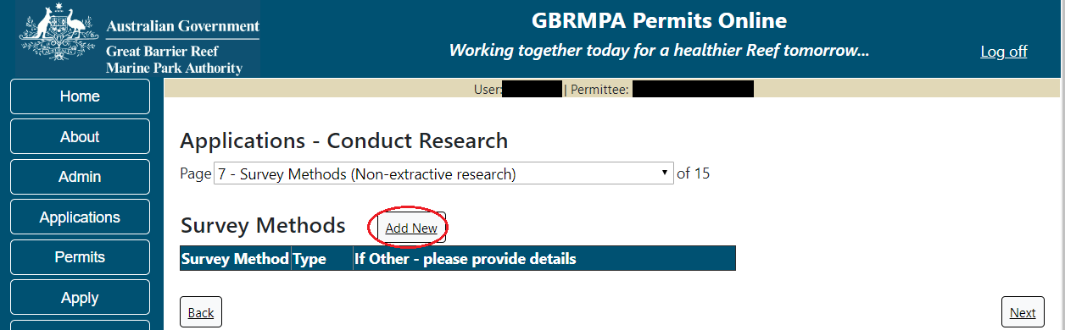
Figure 407 - Screenshot of Survey Method page with a red circle around Add New button

A Survey Methods pop up screen will appear. Options for Survey method, Survey Type and Description are available in the pop up window.
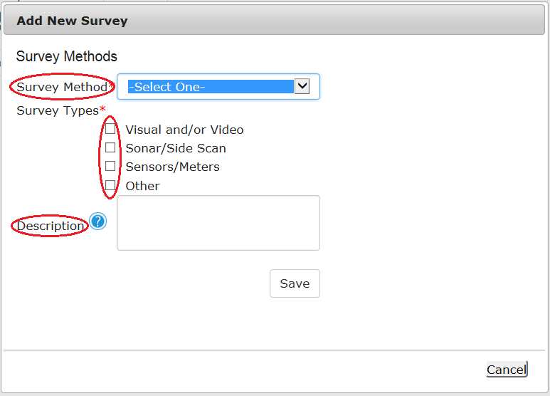
Figure 408 - Screenshot of Add New Survey Method pop up window with circles around Survey Method, Survey Types tick boxes and Description

Enter details of the Survey Method, Type and a Description if needed.
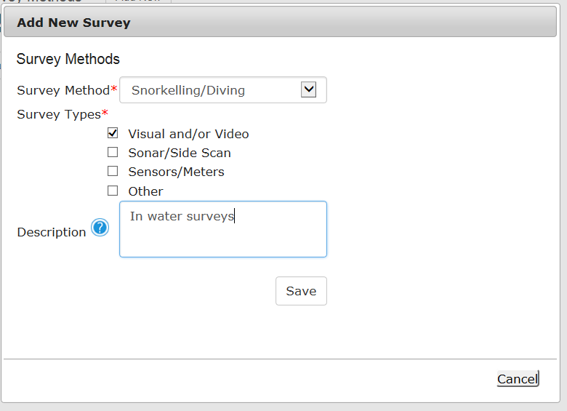
Figure 409 - Screenshot of Add New Survey Method pop up window with information completed

If Other is selected please explain in further detail. Select Save once you have entered the survey information.
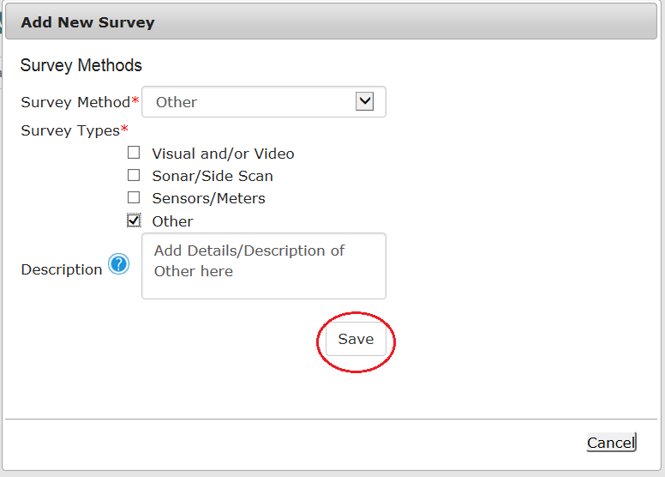
Figure 410 - Screenshot of Add New Survey Method pop up window with information completed and red circle around Save button
The details of the survey methods, types and description will be entered on the page with Remove and Edit buttons. If you wish to remove the survey method select Remove and it will be deleted from the page. If you wish to edit the survey method select Edit and apply the required changes. Once you have entered all you survey methods select Next to continue.
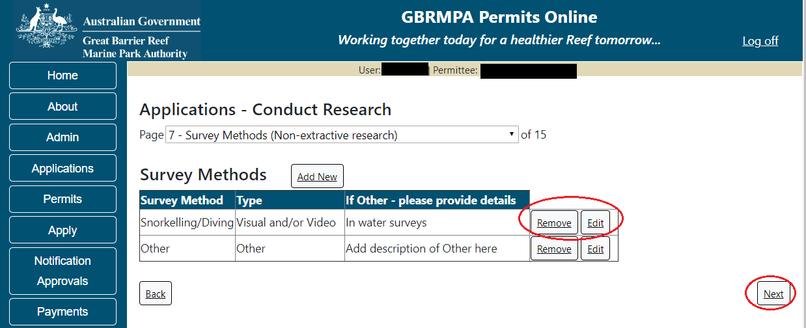
Figure 411 - Screenshot of Survey Methods screen with information of Surveys displayed, circles around Remove and Edit buttons and Next button

Page 8 of the Conduct Research application is the Chemicals screen. If you did not select this option in the Propose Activities page the system will indicate that this activity was not selected. If you wish to add this activity select back (twice or use the drop menu and select page 6) and select the activity in the Proposed Activities page (page 6)
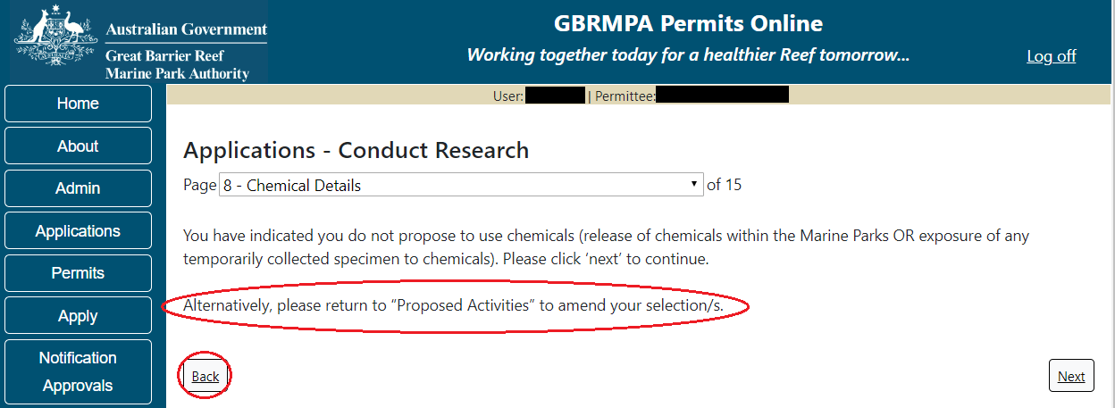
Figure 412 - Screenshot of Chemical Details screen when Chemical option is not selected on Activities page, circle around alternatively please return to Proposed Activities to amend your select and red circle around back button

If you did select Use of Chemicals as an activity the chemical table will appear. Select a tick box next to the chemical/s you propose to use. If the chemical is not listed, select Other and add a description.
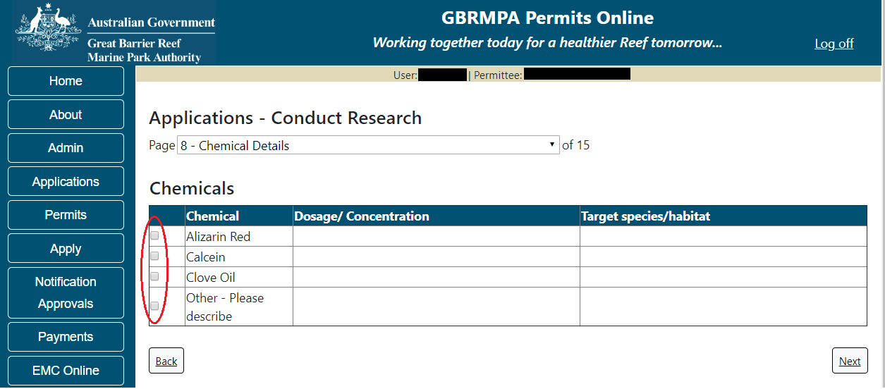
Figure 413 - Screenshot of Chemical Details page with a red circle around tick box options for Chemicals to select

Once you have selected the chemical/s you propose to use, the Dosage/Concentration and the Target Species/Habitat fields will appear, enter the details and select Next to continue.
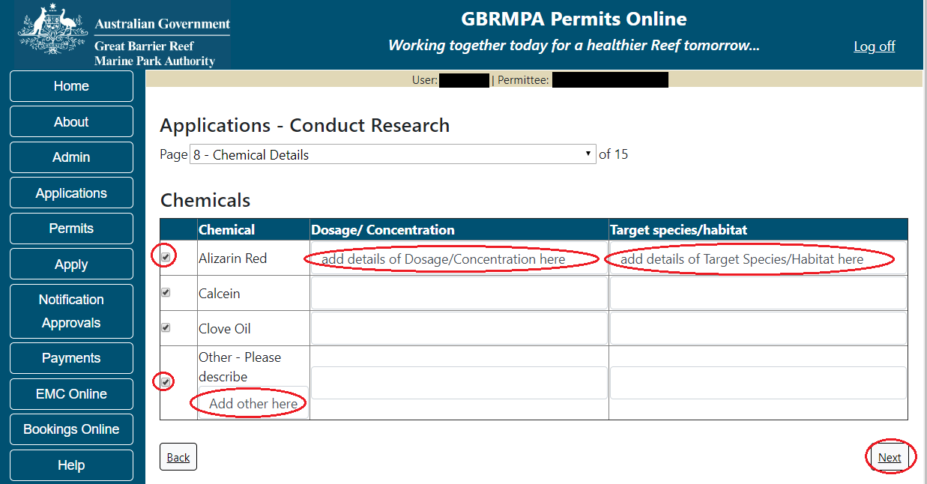
Figure 414 - Screenshot of Chemical Details screen with information completed and red circle around Next button

Page 9 of Conduct Research application is the Equipment page. If you did not select this option in the Propose Activities page, the system will indicate that this activity was not selected. If you wish to add this activity select back (three times or use the drop menu and select page 6) and select the activity in the Proposed Activities page (page 6)
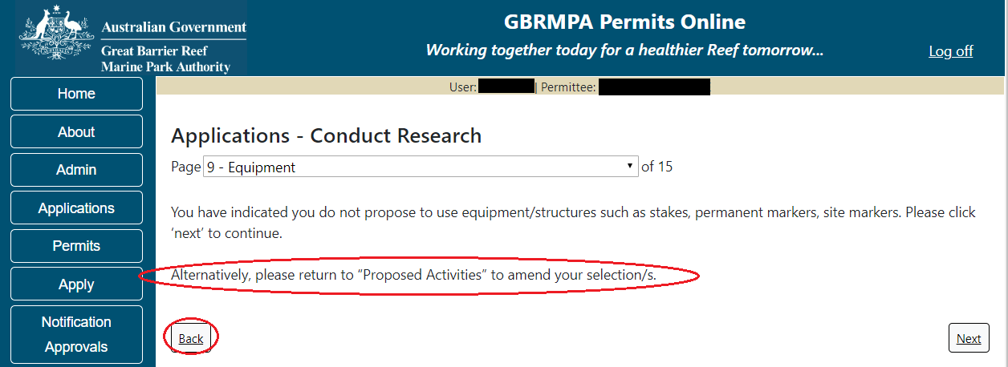
Figure 415 - Screenshot of Equipment screen when Equipment option is not selected on Activities page, circle around alternatively please return to Proposed Activities to amend your select and red circle around back button

If you selected yes to the Use of Equipment or Structures a table will appear with an Add New button. Select the Add New button to enter equipment or structure information.
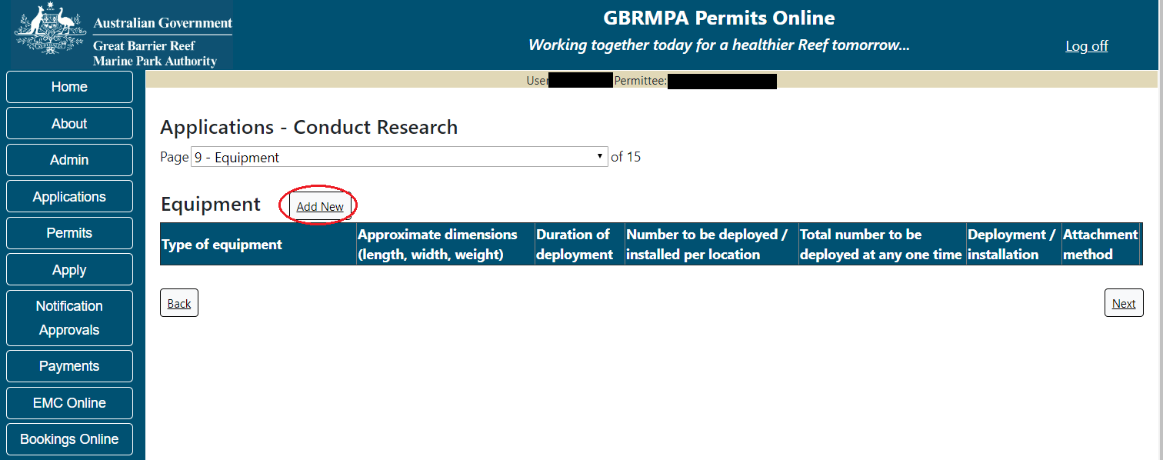
Figure 416 - Screenshot of Equipment page with a red circle around Add New button

The Add New Equipment pop up window will appear. Add details of Equipment type, Duration of deployment, Quantity deployed per location, Total quantity deployed, Deployment / installation environment and Attachment method.
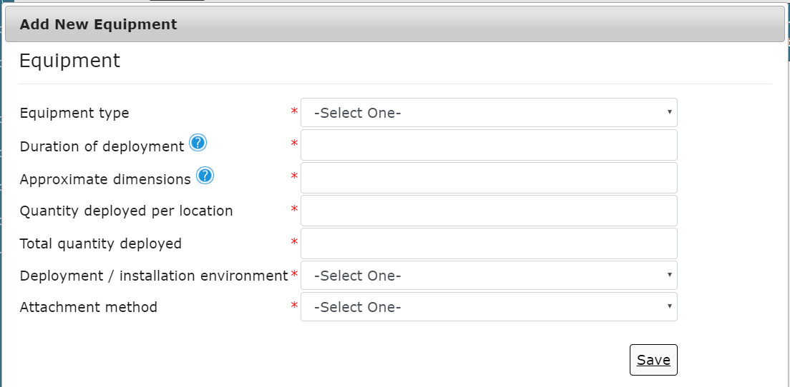
Figure 417 - Screenshot of Add New Equipment pop up window

Depending on your selection/s other fields will appear to select or add details. If Underwater or Benthic is selected a sub category section will appear. Select a sub category and then select your attachment method.
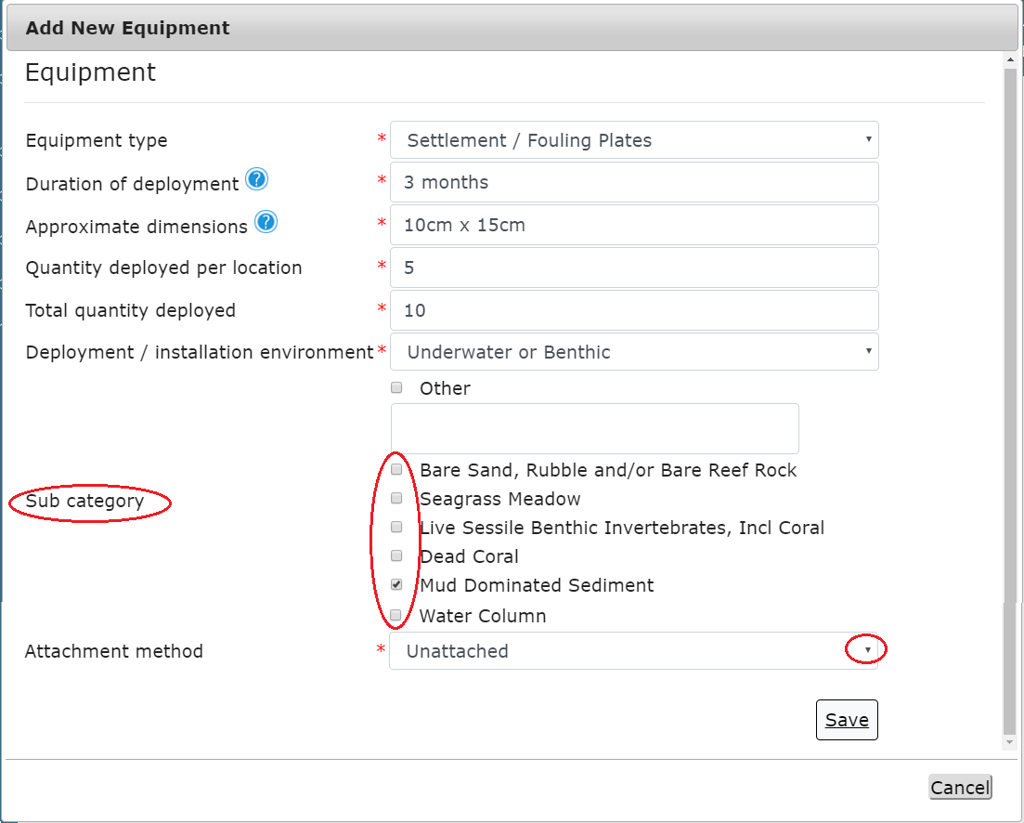
Figure 418 - Screenshot of Add New Equipment pop up window with information completed and red circle around Sub Category fields and red circle around Attachment method drop box
Depending or the Attachment method you select further fields may also appear. If you select Attached to Underwater Anchoring Point or Other a Please Describe field will appear to add details. Once you have complete all the fields select Save
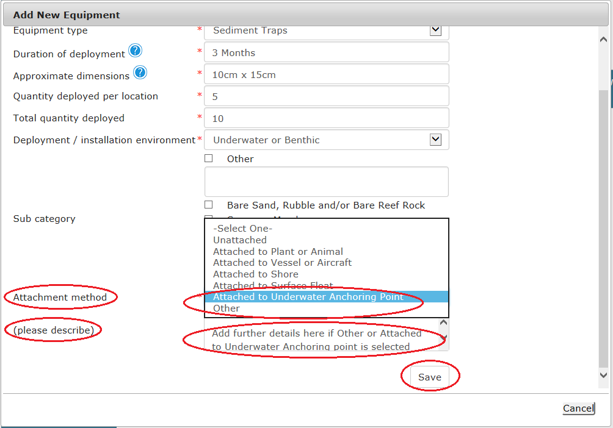
Figure 419 - Screenshot of Add New Equipment pop up window with information completed and red circle around Attachment method drop box and please describe fields, circle around Save button

Once Save is selected the details of Equipment or Structures will appear on the page. You will have options to Edit or Remove the equipment or structure details. Select Next to continue.
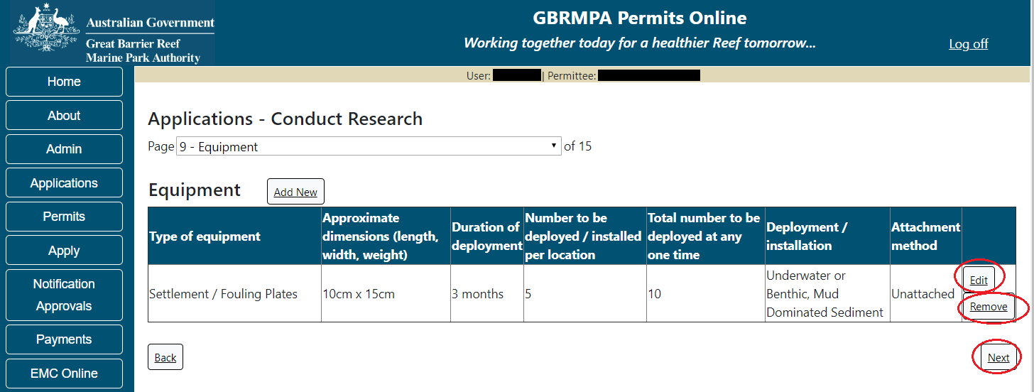
Figure 420 - Screenshot of Equipment screen with information of Equipment displayed, circles around Remove button, Edit button and Next button

Page 10 of the Conduct Research application is the Locations screen. Select Add New to enter your Research Location/s.
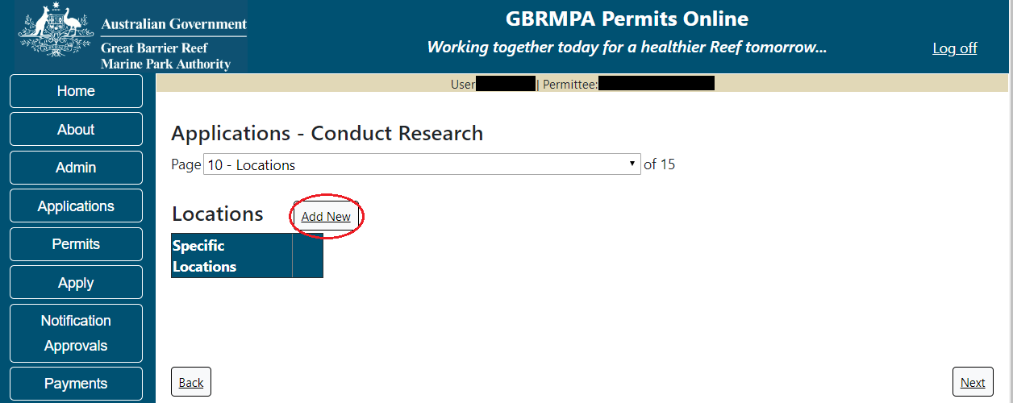
Figure 421 - Screenshot of Location page with a red circle around Add New button

If the Add New button is selected the Location pop up window will appear
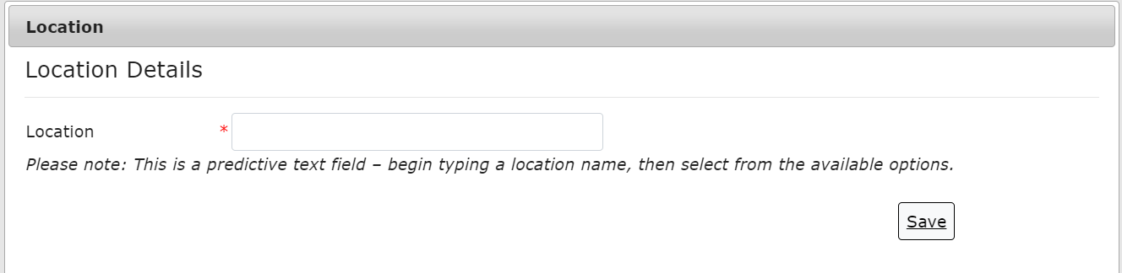
Figure 422 - Screenshot of Location pop up window

Type in the name of the location you wish to visit in the location field. As you enter the name, the list will produce relevant matches. Select the location then select Save.
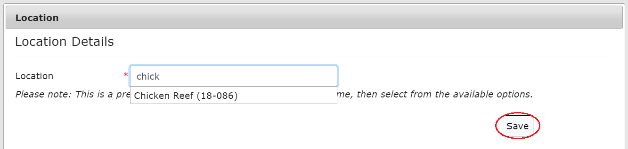
Figure 423 - Screenshot of Location pop up window with locations to select and red circle around Save button

Once Save is selected, the details of the location/s will appear on the page. If you wish to remove a location select the Remove button next to the location and it will be deleted. Once you have added your research locations select Next to continue.
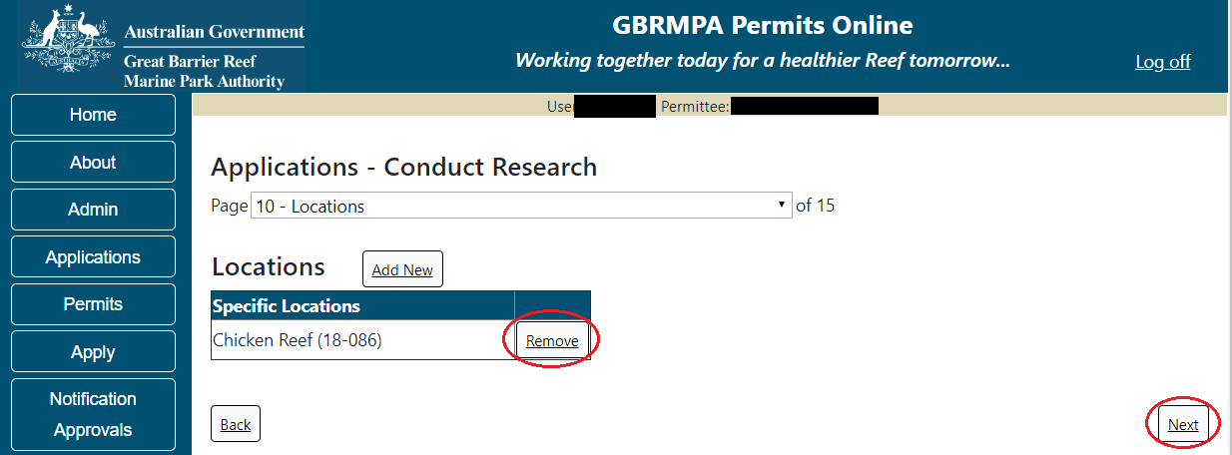
Figure 424 - Screenshot of Locations screen with information displaying and a circle around Remove button and Next button

Page 11 of Conduct Research application is the further Research Locations questions. If you will only use certain locations for specific purposes please provide these details in the free text field. An upload feature is also available to upload written approval/s for entry to One Tree Island Reef or the Australian Institute of Marine Science Restricted Access Special management Area. Once you have completed your details select Next to continue.
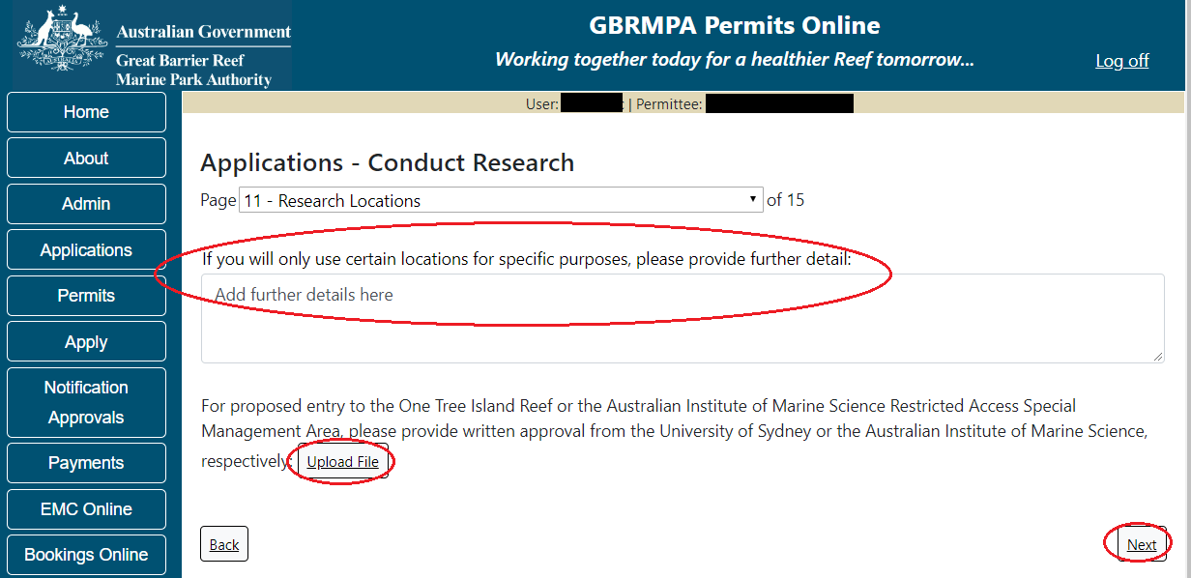
Figure 425 - Screenshot of Research Locations page with red circle around question - If you will only use certain locations for specific purposes, please provide further details, circle around File Upload button, circle around Next button

Page 12 of Research application is the Add Taxa / Sample Details (Extractive Activities) page. If you did not select this option in the Propose Activities page, the system will indicate that this activity was not selected. If you wish to add this activity return to page 6 and select the activity in the Proposed Activities page (page 6)
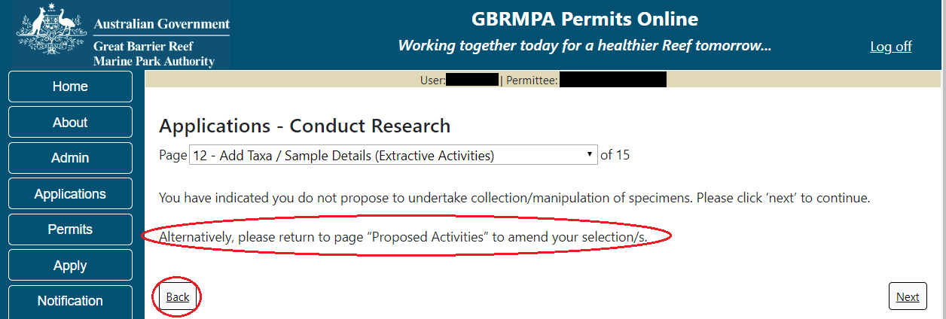
Figure 426 - Screenshot of Add Taxa /Sample Details screen when Extractive Activities option is not selected on Activities page, circle around Alternatively, please return to Proposed Activities to amend your selection and red circle around back button

If you have selected Collection/manipulation of specimens from the Proposed Activities page an Add New button will appear on page 12 to add the Taxa/Sample details.
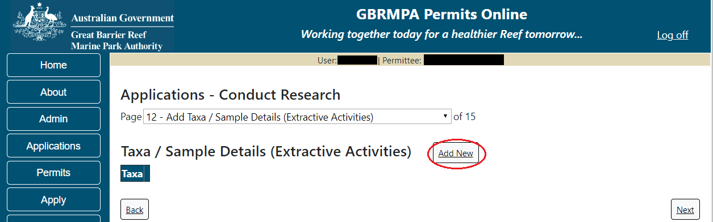
Figure 427 - Screenshot of Add Taxa / Sample Details page with a red circle around Add New button

Select Add New and the Taxon pop up window will appear. There are a number of fields to enter on the form. All details marked with a red (*) asterisk are required, please enter the exact details of Taxon take/s. Select the Taxon button to add the Taxon.
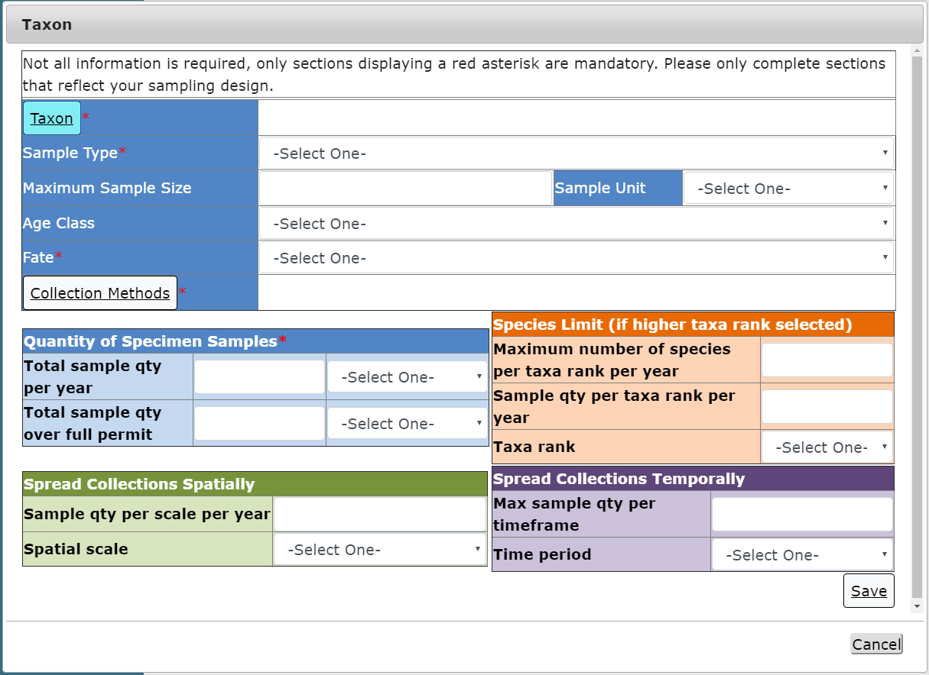
Figure 428 - Screenshot of Taxon pop up window

An Add Taxa / Sample Details window will appear. In the search field enter the name of the Taxon you propose to take. As you type in details the results field will narrow down.
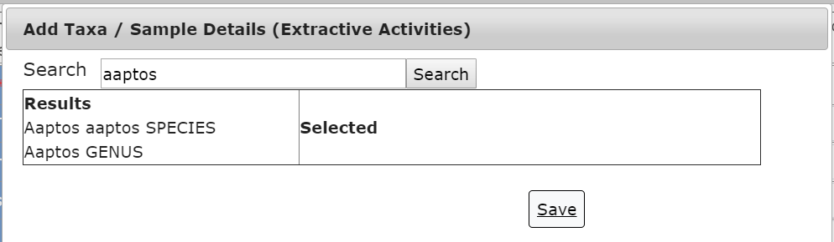
Figure 429 - Screenshot of Add Taxa / Sample Details pop up window with search results displayed

Once you select a Taxon it will move from the results field to the selected field with a Remove button. Select Save once you have selected your taxon.
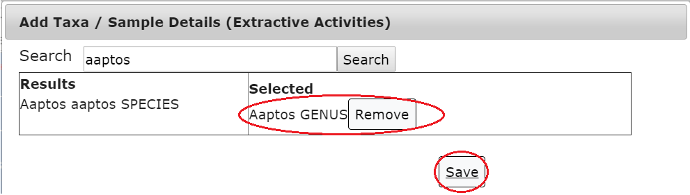
Figure 430 - Screenshot of Add Taxa / Sample Details pop up window with search results displayed, red circle around Selected taxa and red circle around Save button

If multiple Taxon are required you can select more than one option. NOTE: if each Taxon will have different sample types etc. then each different type will need to be added separately (E.g. only add multiple if the take/sample details are the same, if different add separately).
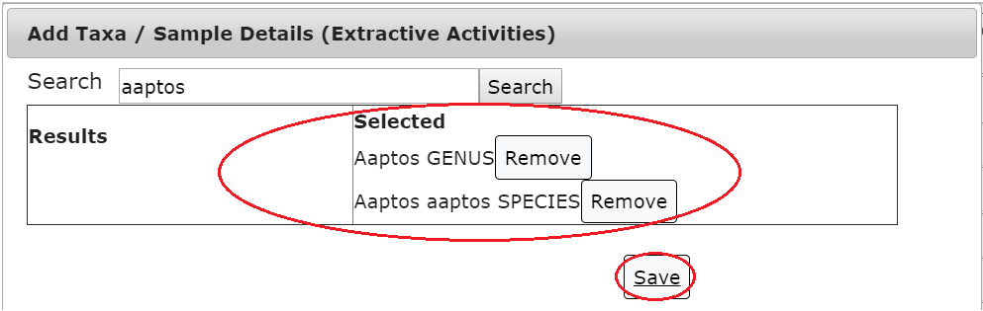
Figure 431 - Screenshot of Add Taxa / Sample Details pop up window with search results displayed, red circle around Multiple Selected taxa and red circle around Save button

Once you have selected you Taxon add details of Sample Type, Maximum Sample Size, Sample Unit, Age Class and Fate. Then select the Collection Methods button.
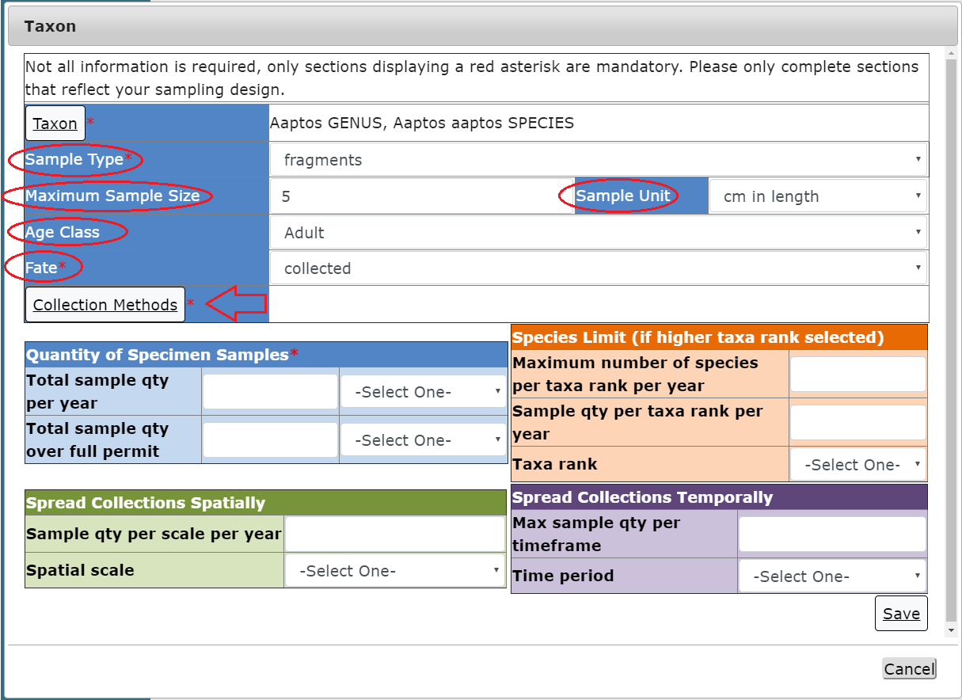
Figure 432 - Screenshot of Taxon window with circles around Sample Type, Maximum Sample Size, Age Class, Fate and Sample Unit. Arrow pointed at Collection Methods button

A pop up window called Add Collection Method will appear with tick box options to choose. Select the collection methods proposed for taxon take.
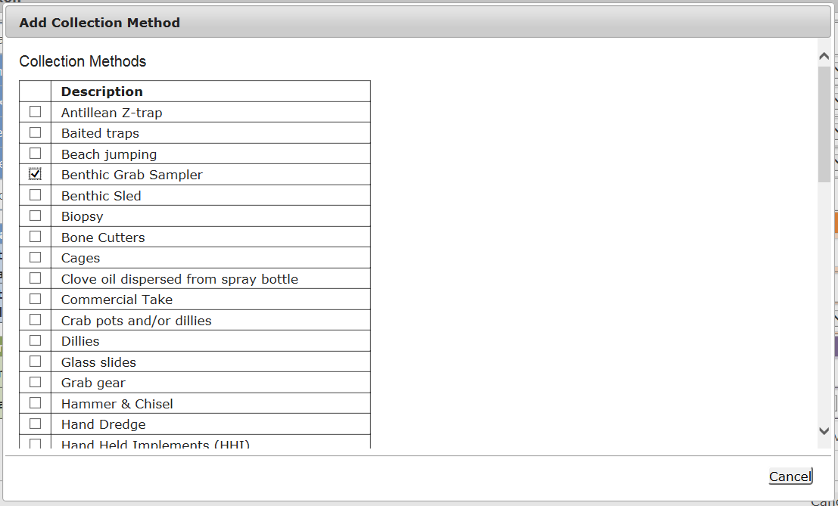
Figure 433 - Screenshot of Add Collection Method pop up window with Benthic Grab Sampler option selected

Once you have made your selection/s from the list select the Save button.
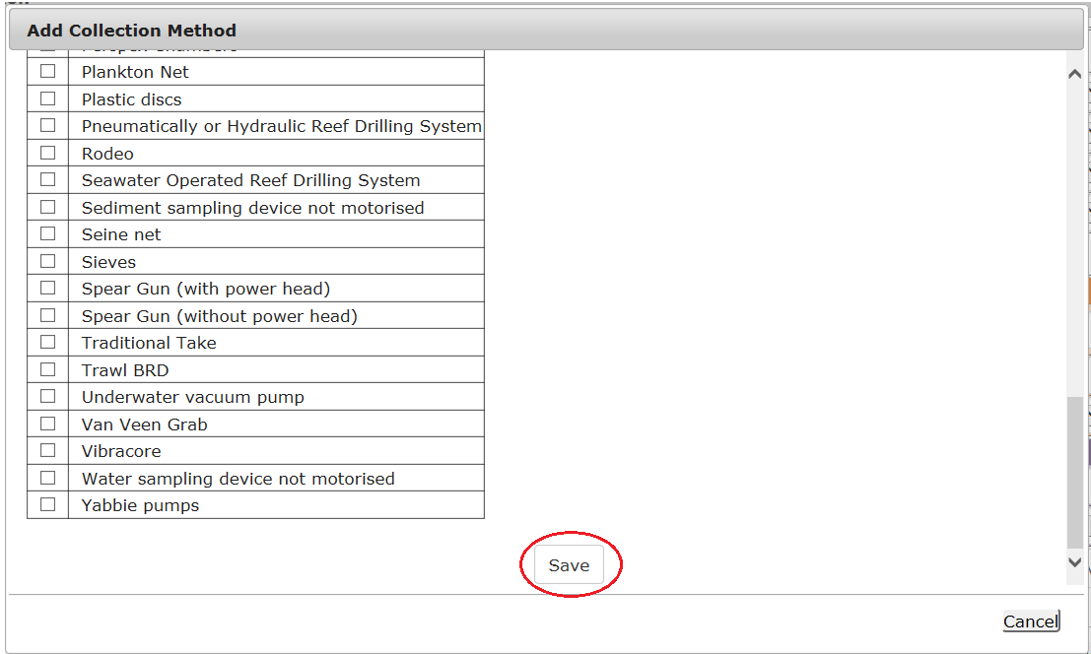
Figure 434 - Screenshot of Add Collection Method pop up window with red circle around Save button

Your Collection Method/s will then appear in the Collections Methods field. Fill in the remaining details under the Quantity of Specimen Samples, Spread Collections Spatially, Species Limit and Spread Collection Temporally fields. Select Save once all Taxon details are entered.
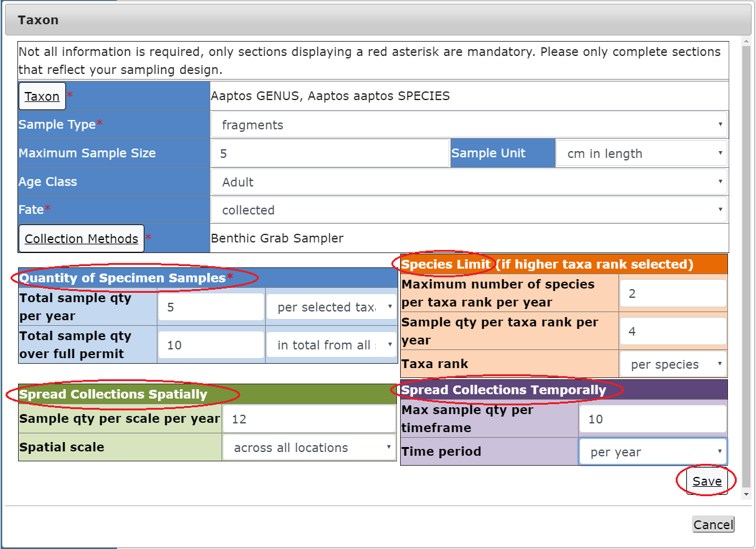
Figure 435 - Screenshot of Taxon pop up window with all fields and information entered. A red circle around Save button
Details of the Taxon will be displayed on the page. Options for Edit and Remove will also appear. If you select Edit the Add Taxon screen will open and you can edit your details. If Remove is selected then the Taxon will be removed from the application. Select Next to continue.
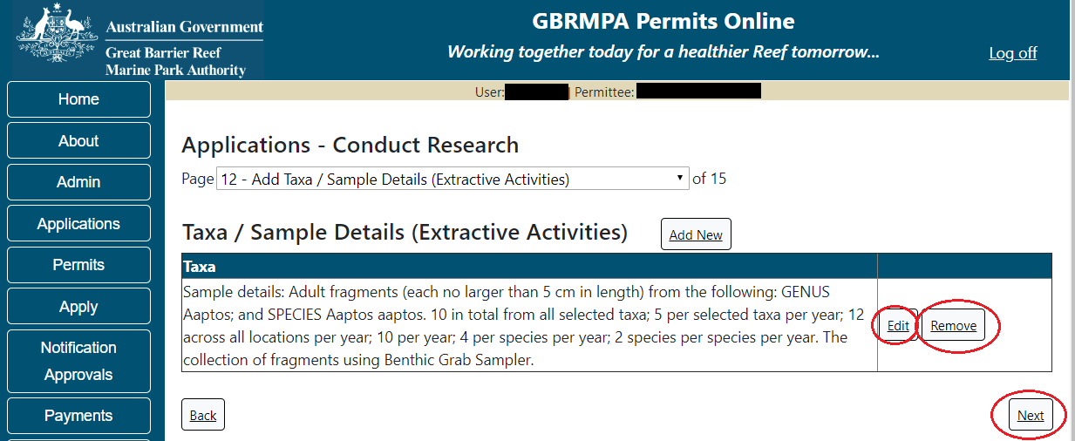
Figure 436 - Screenshot of Add Taxa / Sample Details page with Taxa information displayed and red circle around Edit and Remove buttons, circle around Save button

Page 13 of Conduct Research is the Research Further Information page. If you selected Fragments as the Sample Type in the Taxon table you will be asked to confirm Will fragment collections total no more than 10% of each donor colony?
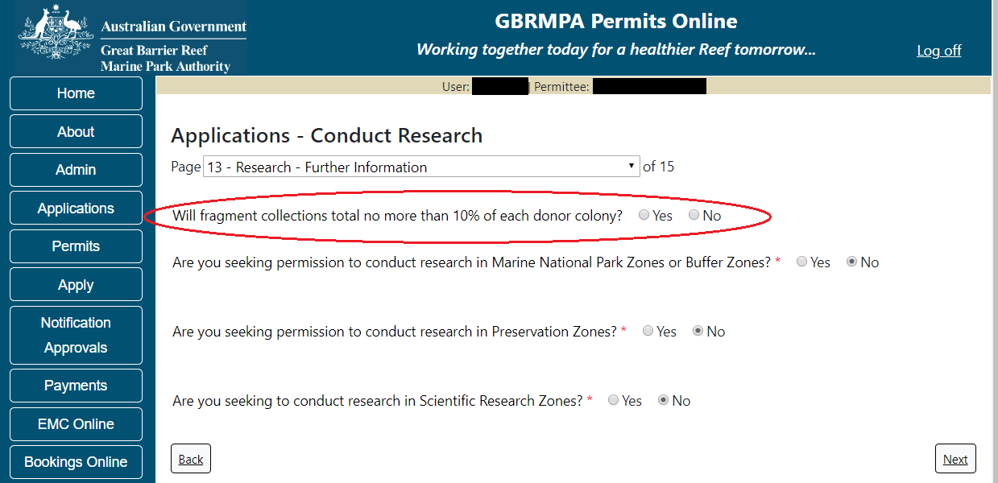
Figure 437 - Screenshot of Research Further Information page with a red circle around question - Will fragments collected total no more than 10% of each donor colony

If you are seeking to conduct research in Marine National Park Zones or Buffer Zones select Yes. A free text field will appear, add details of why the research is relevant or why the research cannot reasonably be conducted elsewhere.
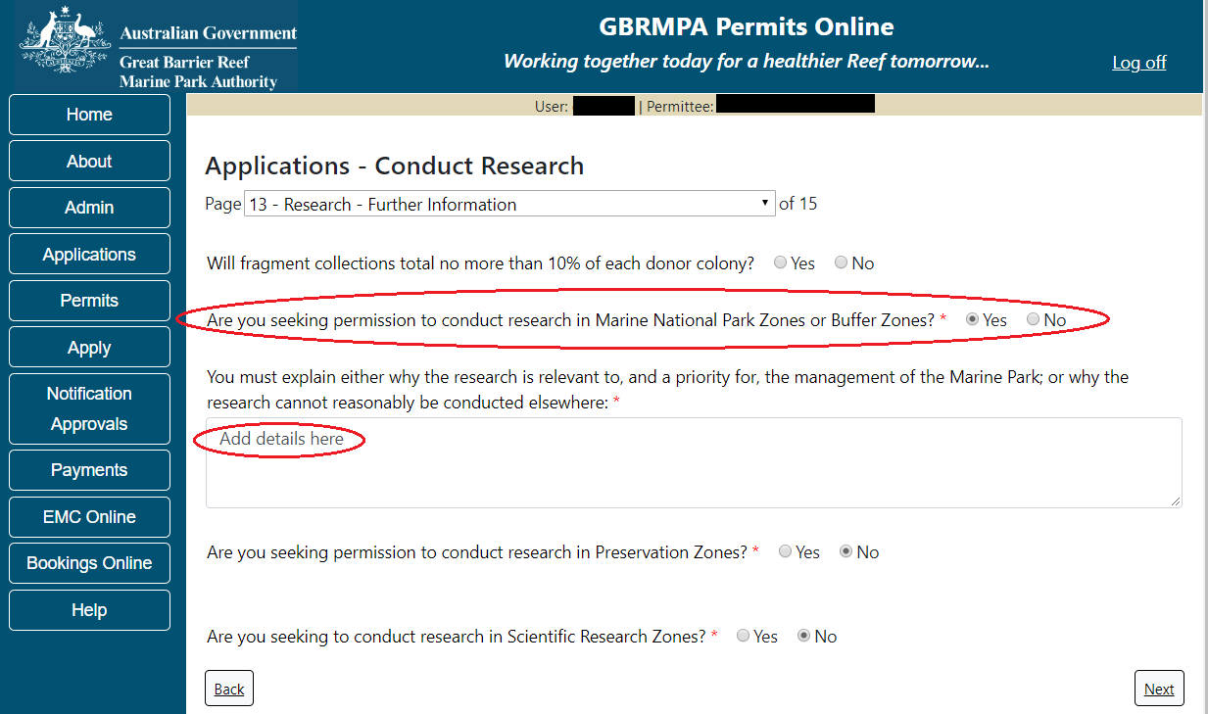
Figure 438 - Screenshot of Research Further Information page with a red circle around question - Are you seeking permission to conduct research in Marine National Park Zones or Buffer Zones with Yes option selected, circle around Add details here

If you are seeking permission to conduct research in Preservation Zones, select Yes. A free text field will appear, add details of why the research is relevant and why the research cannot reasonably be conducted elsewhere. If you are seeking to conduct research in the Scientific Zones select Yes.
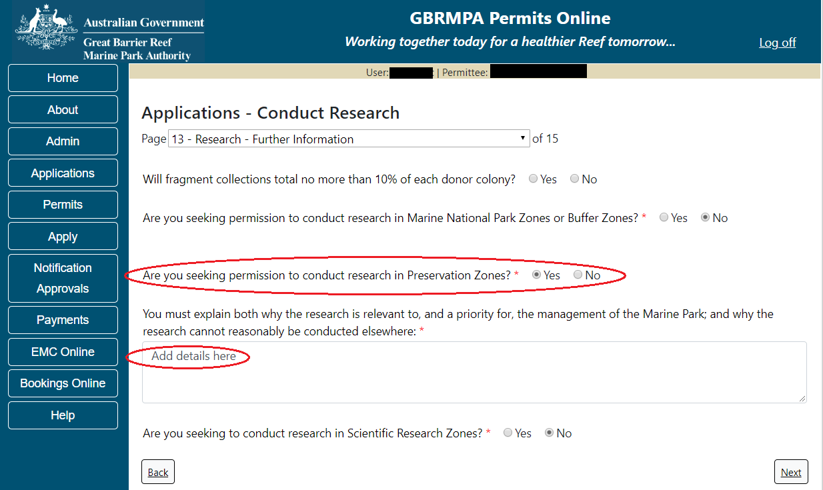
Figure 439 - Screenshot of Research Further Information page with a red circle around question - Are you seeking permission to conduct research in Preservation Zones with yes option selected, circle around Add details here
A further question will appear asking if you understand that the Reef Authority may seek the research station manager’s views on my research proposal. I consent to the details of my application being provided to the station manager for this purpose.
Select Yes or No then select Next to continue.
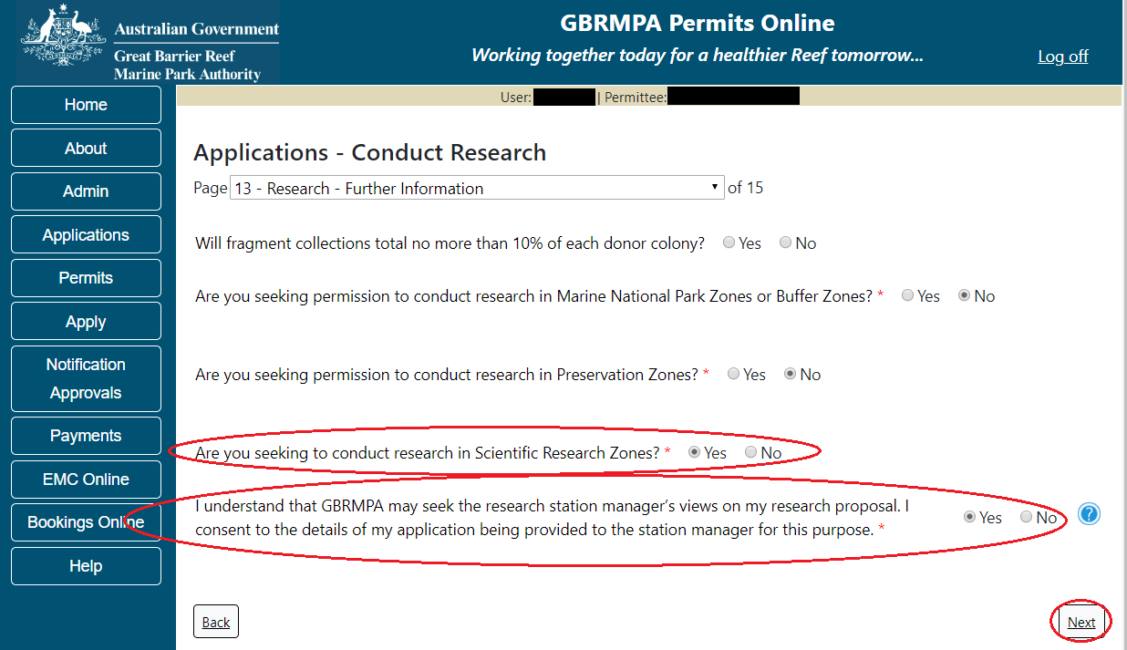
Figure 440 - Screenshot of Research Further Information page, circle around question - Are you seeking to conduct research in Scientific Zones with Yes option selected, Circle around consent statement with Yes option selected, circle around Save button

Page 14 of Conduct Research application is a second Further Research questions page. Please indicate your proposed inspection and maintenance schedule for any equipment being deployed for more than 6 months by adding these details in the field provided.
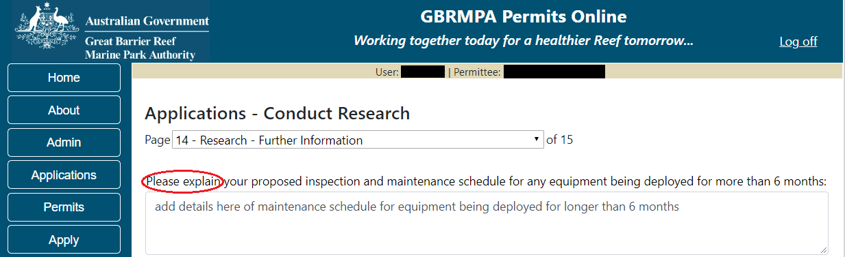
Figure 441 - Screenshot of Research Further Information page, circle around question - Please explain your proposed inspection and maintenance schedule for any equipment being deployed for more than 6 months with information completed

Please also explain any seasonal or other timing considerations associated with your proposed activity. Choose the relevant fields and enter details. Select Next to continue.
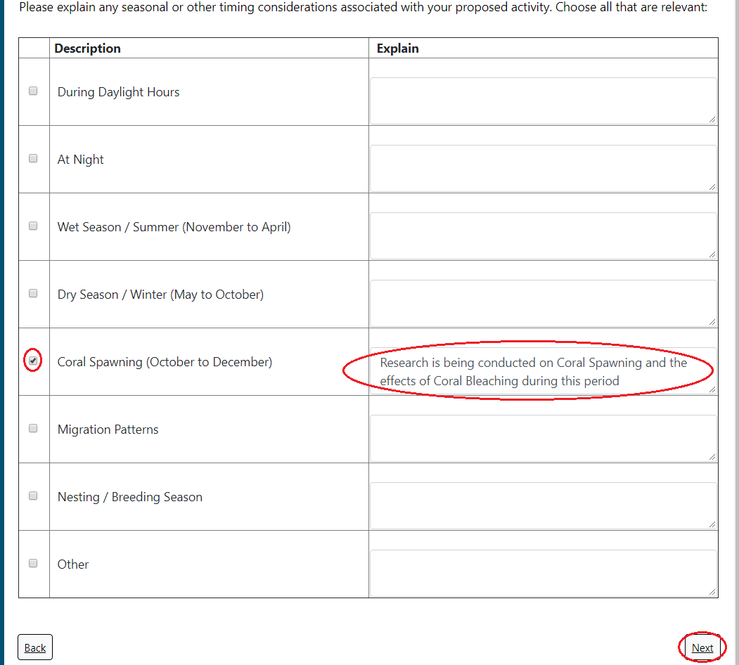
Figure 442 - Screenshot of Timing Considerations fields with Coral Spawning selected and information entered in the Explain field, circle around Save button

Page 15 of the Conduct Research application provides opportunity for you to add any other information you feel will assist the Managing Agencies in assessing your application. Add supporting information by typing in the text field or upload a file if required. If a file is uploaded it will appear on the screen with the file name and an Remove button to remove the file if the wrong file is selected.
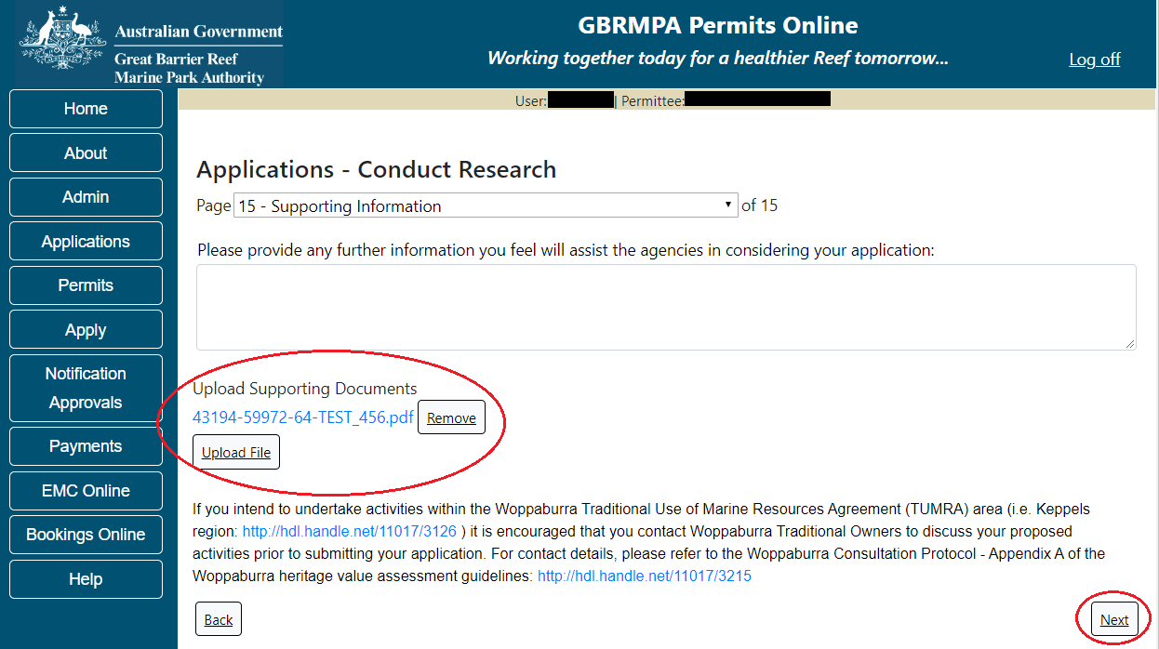
Figure 443 - Screenshot of Supporting Information screen with information entered and a red circle around Please provide details section, red circle around Uploaded File and Next button
Once you have completed the supporting information page select Next from the last page of the application questions, you will progress to an application summary screen with a number of options available via links or buttons. Select Next on the summary screen to progress to the Declarations screens.
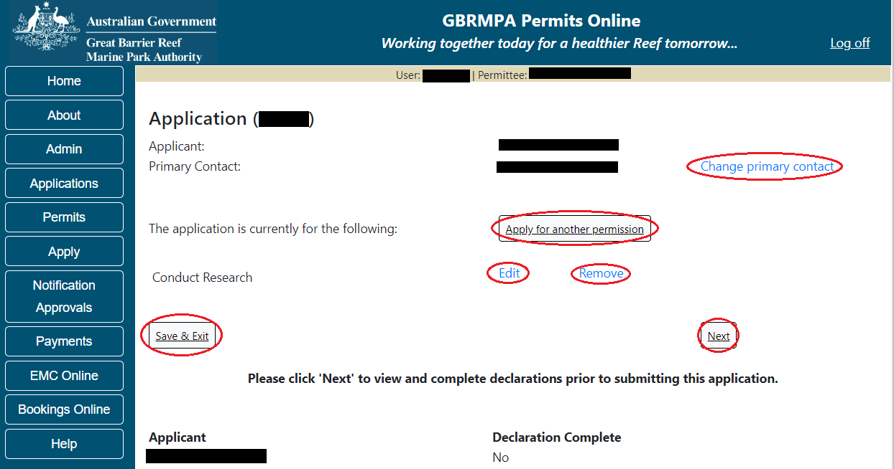
Figure 444 - Screenshot of Application Summary page with red circles around all options available

Additional Information - Summary screen, links and buttons;
- Change primary contact: If the change primary contact link is selected the applicant will progress to the primary contact page where the primary contact can be changed.

- Apply for another permission: If the Apply for another permission button is selected, the applicant will progress to the What are you seeking to do in the Marine Parks page where another permission type can be added. (e.g. add a mooring permission to the research permission).

- Edit: If edit is selected the application/permission will be reopened to apply any changes.

- Remove: If remove is selected the application/permission will be removed.

- Save & Exit: If the Save & Exit button is selected the applicant will progress to the applications screen.

- Next: If next is selected the applicant will progress to the submission process including declaring and submitting the application.

Completion of a set of declarations is mandatory prior to submitting your application. To complete the declarations section of this application, you must either be the applicant, or if applying on behalf of an organisation / company / government agency, you must be a Director of that organisation / company / government agency. Authorised contacts cannot complete the declaration section, as it contains legally binding commitments in place of a physical signature.
Please read all questions carefully, provide a response to each, and select Next.
Figure 445 - Screenshot of Declarations page with red circle around Yes and No options and Next button

On the final page of declarations there is a Submit button. Once the Submit button is selected, the application will be submitted to the Reef Authority and is no longer available to be edited. The status of the application on the Applications screen will then display ‘Submitted to GBRMPA’. The application’s Primary Contact will receive an emailed acknowledgement notice from a delegated Assessment Officer within 10 business days.
Figure 446 - Screenshot of Declarations screen with a red circle around the Submit button
Once you submit your application, you will be provided with a reference/application number and can follow the progress of your application via the Applications menu on the left.
Figure 447 - Screenshot of the Thank you for your application screen with a red circle around Reference number and a red circle around the open pdf button

Your application will appear in the Applications screen with the reference/application number also displayed. You have further options to view a summary of your application, email the Reef Authority or withdraw the application.
Figure 448 - Screenshot of Applications screen with a red circle around Application No., Summary, Email and Withdraw options

- Conduct an Educational Program
Apply – new permit application – conduct an educational program
To apply to Conduct an Education Program select this option on the Apply – What are you seeking to do in the Marine Parks page. Select Next to progress to application questions in Permits Online
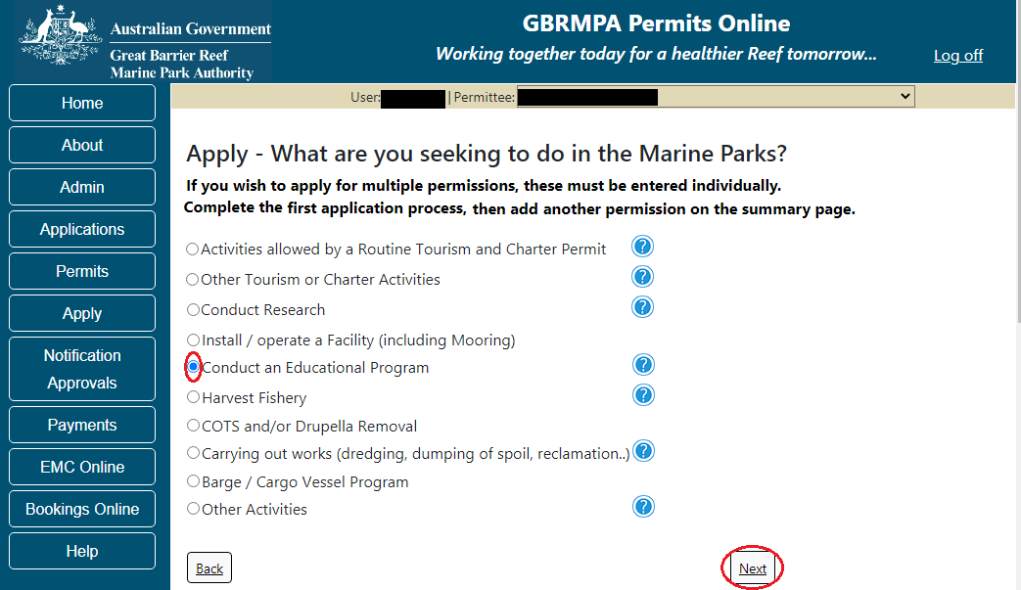
Figure 449 - Screenshot of Apply - What are you seeking to do in the Marine Parks screen with Conduct an Education Program selected and a red circle around the Next button

Information Education programs
Educational programs must be either;
(a) An accredited course delivered by a registered training organisation; or
(b) A learning activity which is part of a formal curriculum led by, or on behalf of, a primary or secondary school, tertiary institution or university.
If you're not sure whether your proposal includes an educational program, check out our Application Guidelines
http://hdl.handle.net/11017/3229

Page 1 of Conduct an Education Program application is the Environment Protection and Biodiversity Conservation Act page. This provides advice on matters of national environmental significance that must be considered when assessing an application. This screen is for your information only at this stage. Your assessing officer will contact you if it is determined to be relevant for your application.
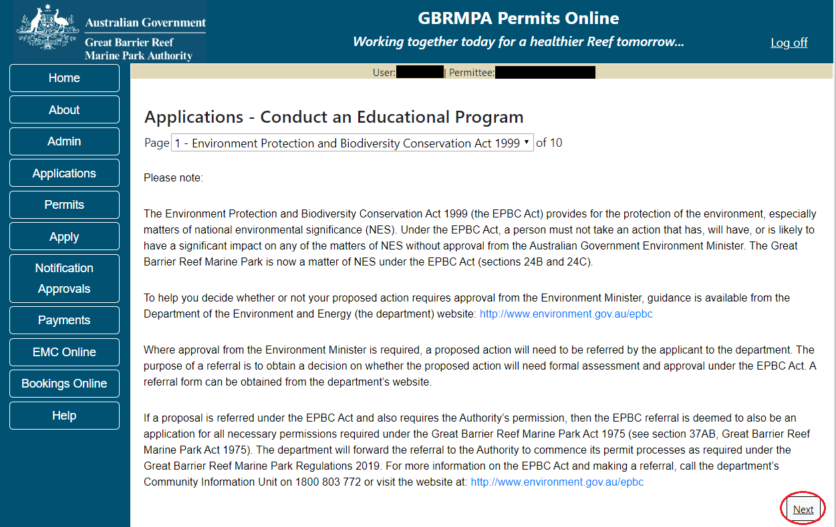
Figure 450 - Screenshot of Environment Protection and Biodiversity Conservation screen with a red circle around Next button

Links on the Environment Protection and Biodiversity Conservation page www.environment.gov.au/epbc will take you to the Department of Climate Change, Energy the Environment and Water site. Here you can find information about the Environment Protection and Biodiversity Conservation Act 1999 and your obligations under the Act.

Page 2 of Conduct an Education Program is the Permissions and Activities page. All Permissions and activities listed are available and will be included in the application.
If there are any activities you do not wish to have, you can remove them by selecting the Remove button next to the activity. Select Next to continue.
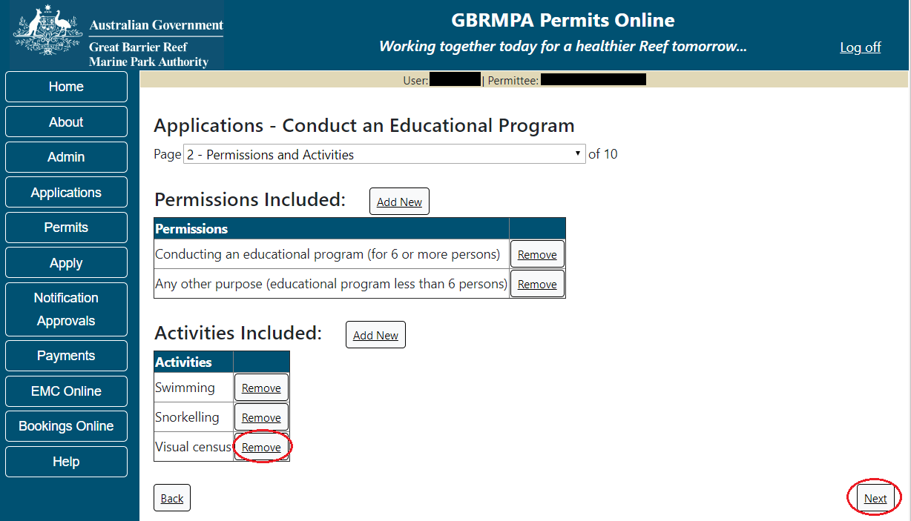
Figure 451 - Screenshot of Permissions and Activities screen with a red circle around Remove button and Next button

Page 3 of Conduct an Education Program is the Total Passenger Capacity / Participants page. A question for What is the total passenger capacity/participants you wish to have in the Marine Parks at any given time? (please consider future use in answering this question) is presented. Select a number from the list provided. Select Next to continue.
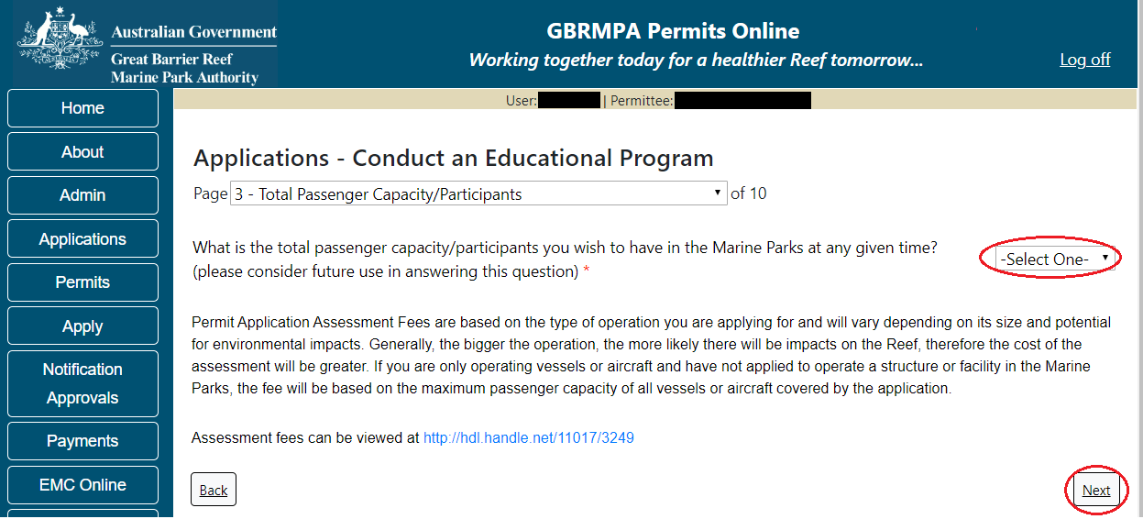
Figure 452 - Screenshot of the Total Passenger Capacity / Participants page with a red circle around the select one drop list and a red circle around the next button
Page 4 of Conduct an Education Program is the Commercial Nature page. If your Education Program is of a commercial nature select Yes. If not select No. NOTE: Activities of a commercial nature are those from which a profit is drawn or intended to be drawn. After you make your selection, select Next to continue.
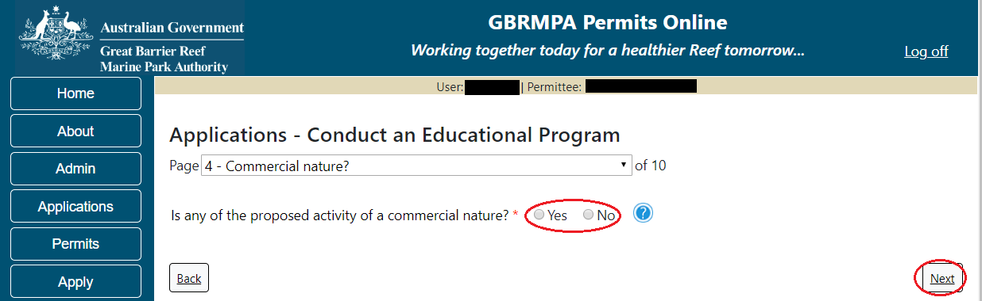
Figure 453 - Screenshot of Commercial Nature page with red circle around Yes and No options and red circle around Next button
Page 5 of Conduct an Education Program application is the Locations screen. Select Add New to enter your Location/s.
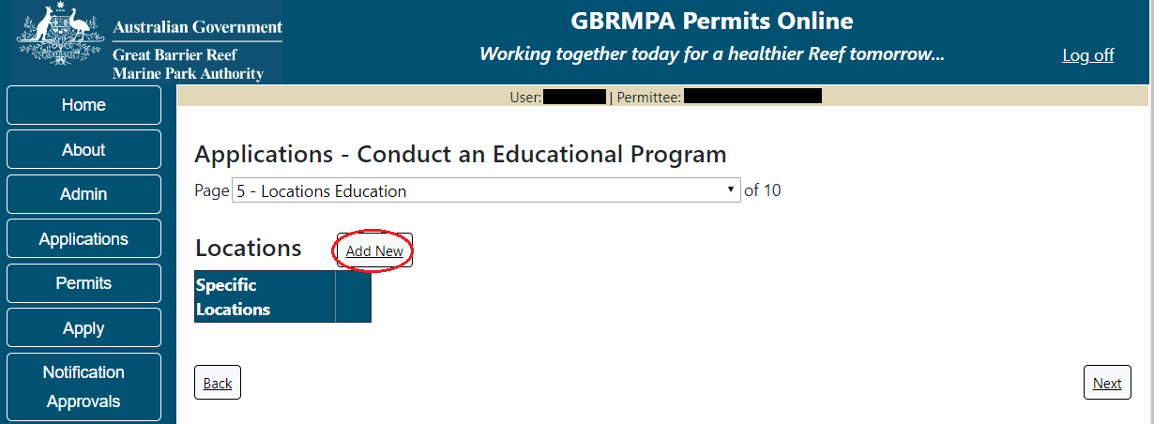
Figure 454 - Screenshot of Location page with a red circle around Add New button
If the Add New button is selected the Location pop up window will appear
Figure 455 - Screenshot of Location pop up window

Type in the name of the location you wish to visit in the location field. As you enter the name the list will produce relevant matches. Select the location then select Save.
Figure 456 - Screenshot of Location pop up window with locations to select and a red circle around Save button

Once Save is selected the details of the location/s will appear on the page. If you wish to remove a location, select the Remove button next to the location and it will be deleted. Once you have added your research locations select Next to continue.
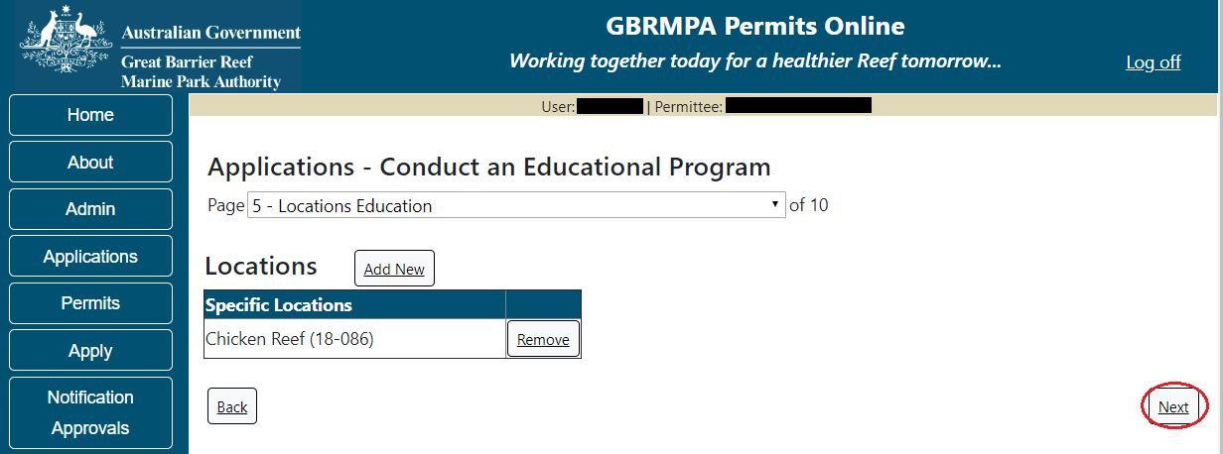
Figure 457 - Screenshot of Locations screen with information displaying red circles around Next button

Page 6 of Conduct an Education Program application is the Additional State Access. If you want to extend your operations to mainland or island national parks adjoining the Marine parks and/or rivers and streams between Mission Beach and the Starcke River, select yes and an area will appear with Please Specify details, add details of the islands or national parks and/or Rivers and streams you wish access.
Please also indicate if you want to operate in the Green Island Recreational Area.
Once your details have been completed select Next to continue.
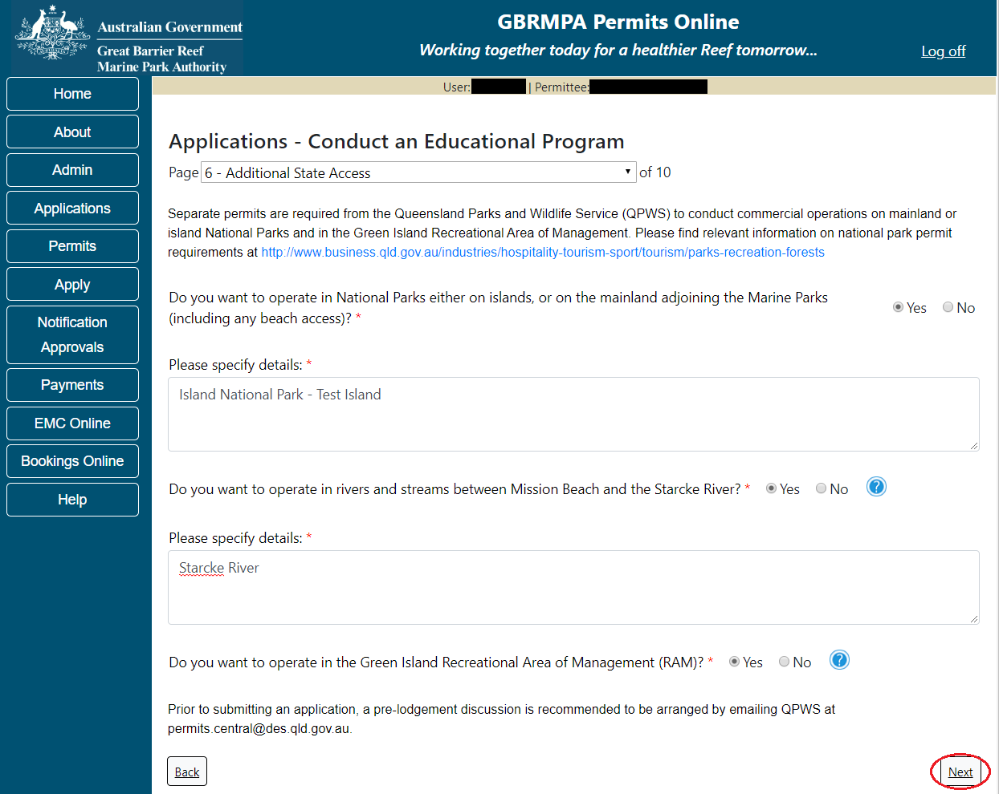
Figure 458 - Screenshot of Extend Operations screen with information displaying and a red circle around Next button

Page 7 of Conduct an Education Program is the Education page. There are a number of mandatory fields on this page. All mandatory fields need to be completed for you to continue.
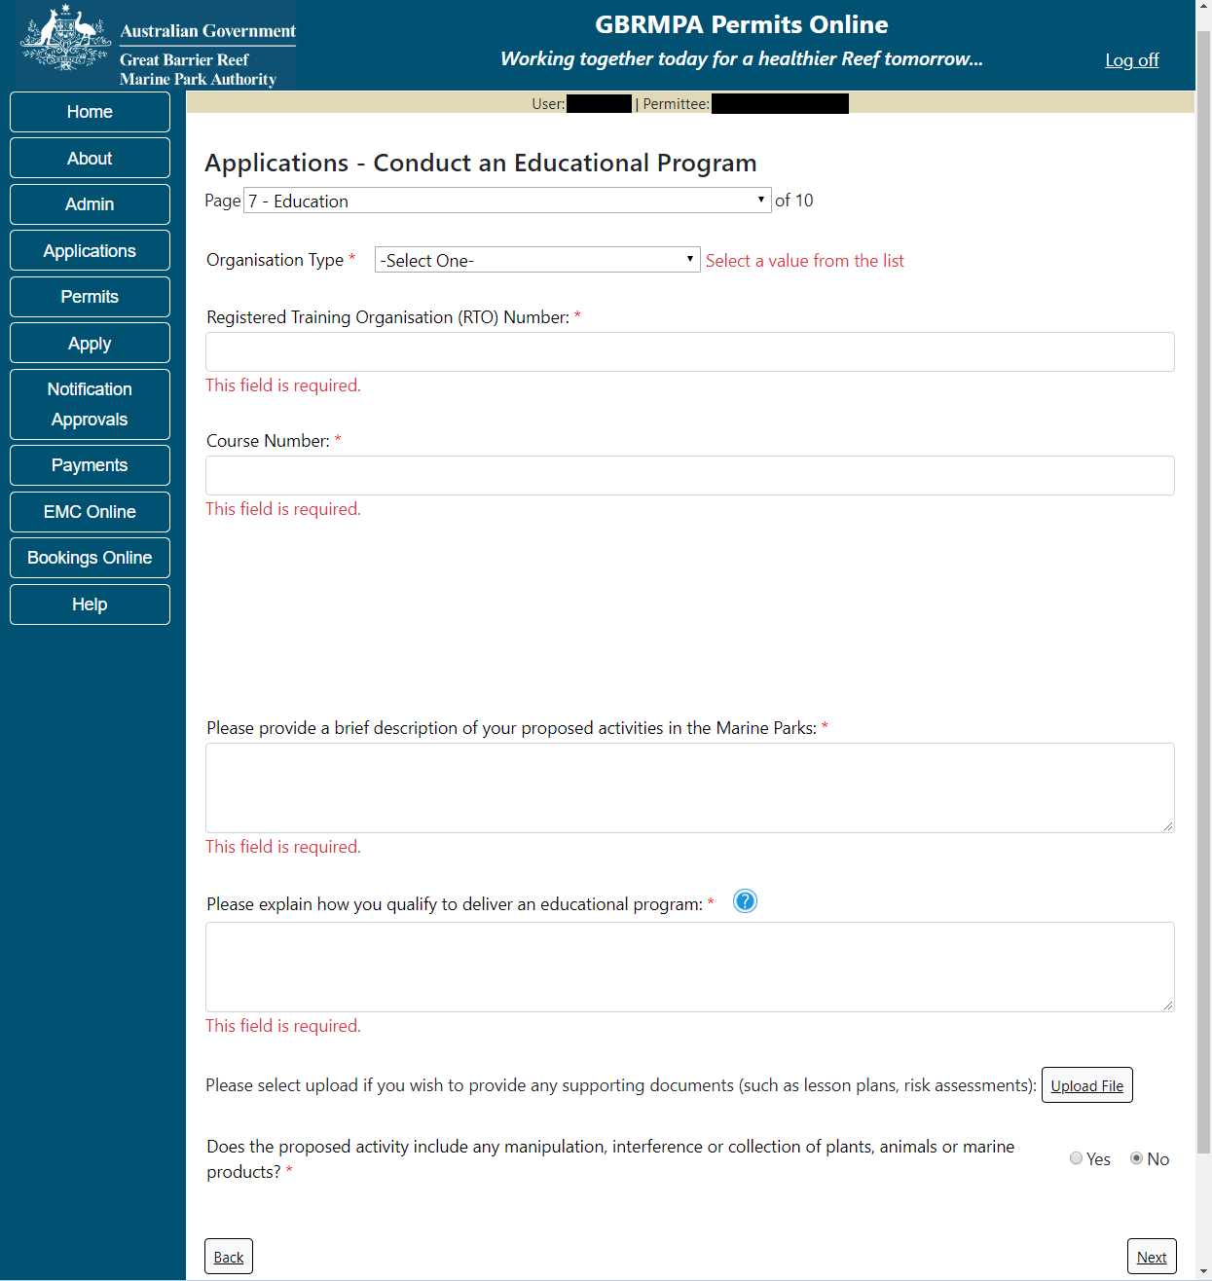
Figure 459 - Screenshot of Education page showing mandatory fields that are required to be completed

Depending on the Organisational Type you select the fields at the top of the screen will change for Registered Training Organisation, Primary or Secondary School, Australian Registered Tertiary Institution or Other. The fields at the bottom of the screen Brief Description, Please explain how you qualify to deliver an educational program, upload file/s (lesson plans, risk assessments) will remain the same.
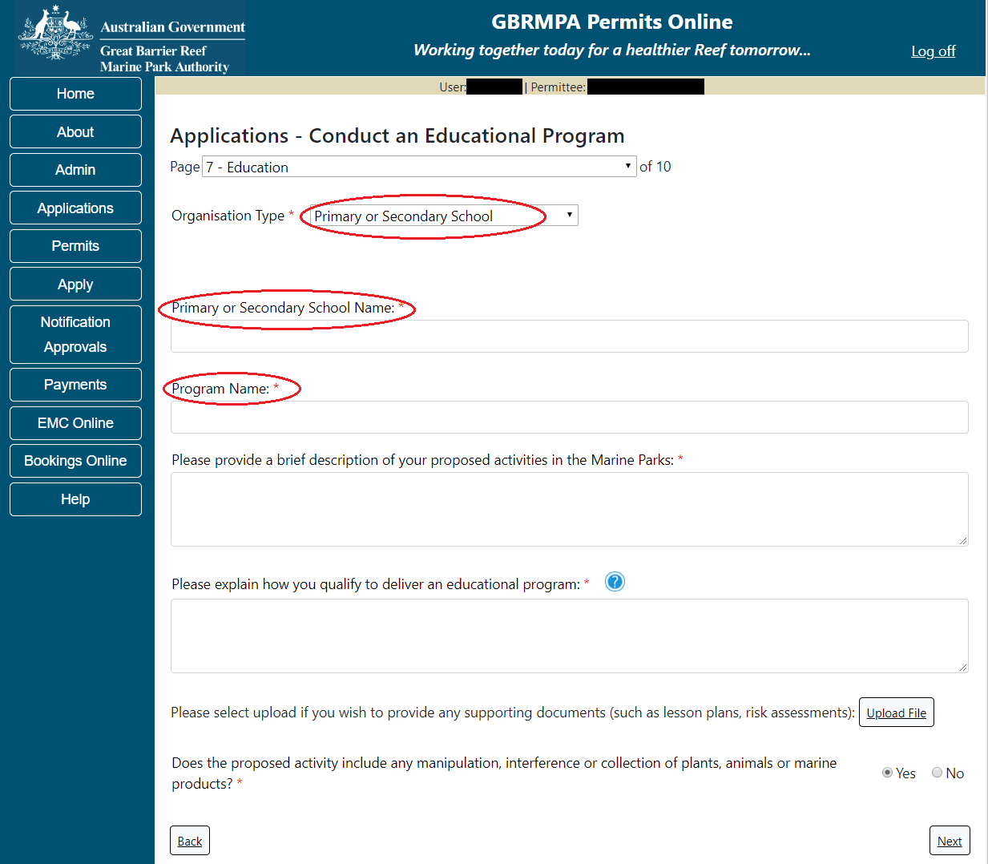
Figure 460 - Screenshot of Education page with a red circle around Organisation Type list, a red circle around Primary or Secondary School Name, and red circle around Program Name

The question Does the proposed activity include any manipulation, interference or collection of plants, animals or marine products you will also need to complete the Taxa / sample take table on page 9
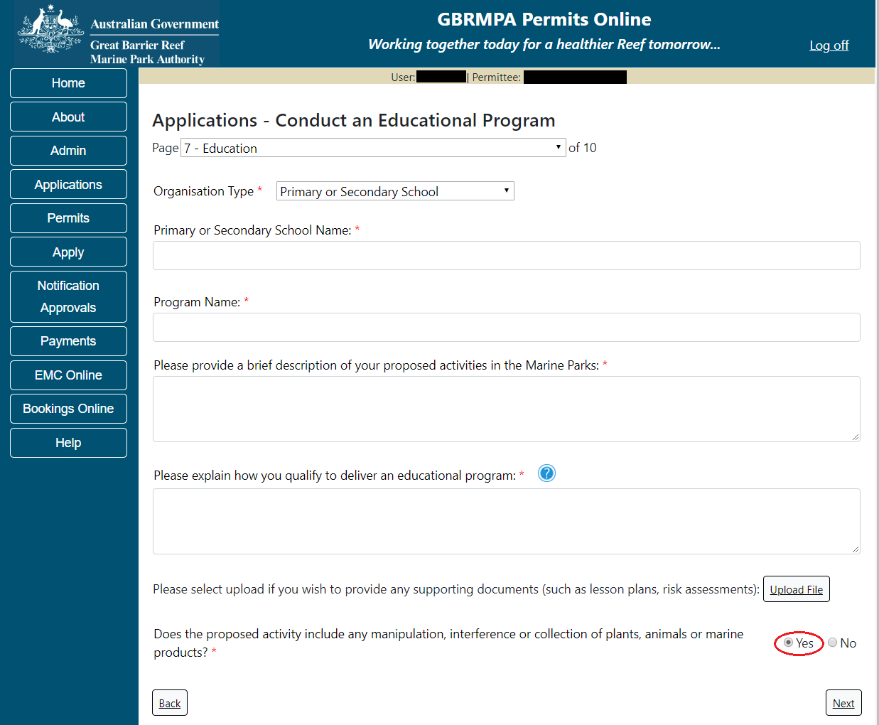
Figure 461 - Screenshot of question - Does the proposed activity include any manipulation, interference or collection of plants, animals or marine products with Yes selected and a red circle around Yes

If Yes is selected an extra activity will be added to the page 2 under the Activities area.
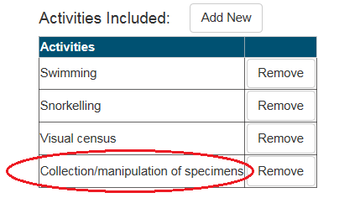
Figure 462 - Screenshot of Activities list with red circle around Collection/Manipulation of specimens

Page 8 of Conduct an Education Program is the Participant Details page. Add details of Over how many years do you propose to run this educational program, What is the total number of participants (including teachers / supervisors) proposed to undertake this activity at any one time and What is the teacher: student ratio. Select Next to continue.
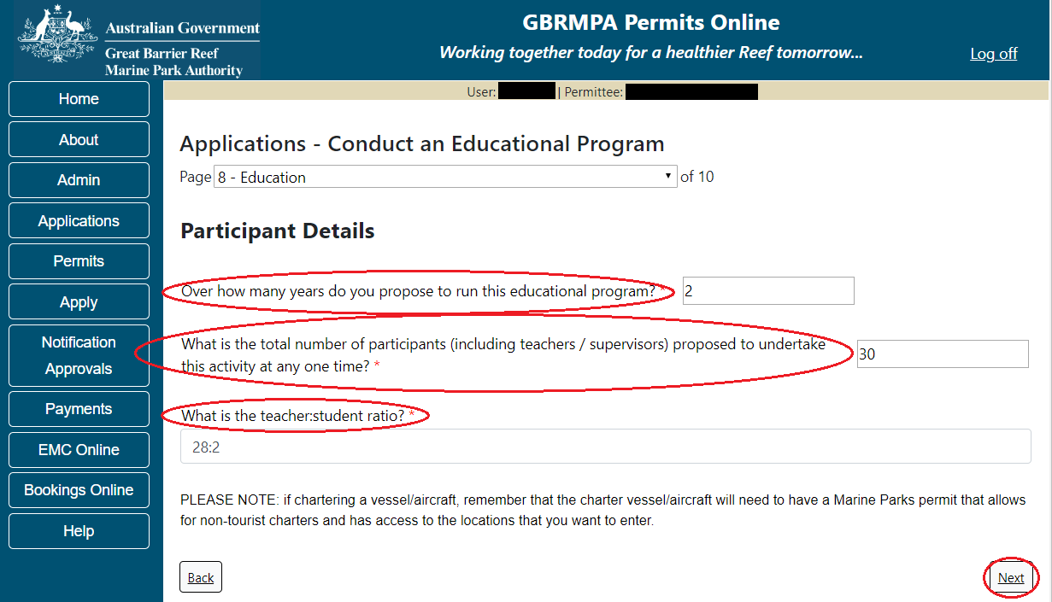
Figure 463 - Screenshot of Participant Details page with a red circle around over how many years to you propose to run this educational program, red circle around what is the total number of participants, what is the teacher student ration, red circle around Next button

Page 9 of Conduct an Education Program application is the Add Taxa / Sample Details (Extractive Activities) page. If you selected No to Does the proposed activity include the manipulation, interference or collection of plants, animals or marine products on Page 7, you will not need to enter any information on this page.
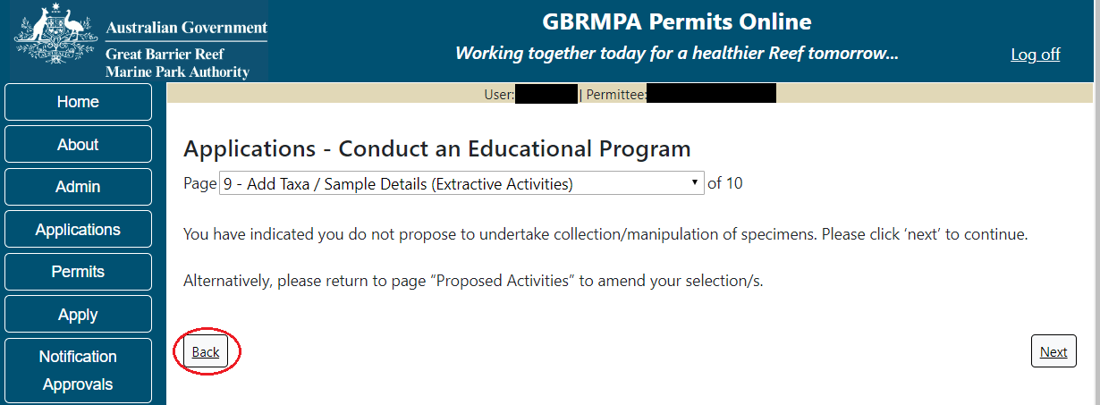
Figure 464 - Screenshot of Add Taxa / Sample Details screen when Collection / Manipulation of specimens option is not selected on Activities page, red circle around Back button
If you wish to add this activity (Collection / Manipulation of specimens) return to page 7 and select Yes to the question Does the proposed activity include the manipulation, interference or collection of plants, animals or marine products?.
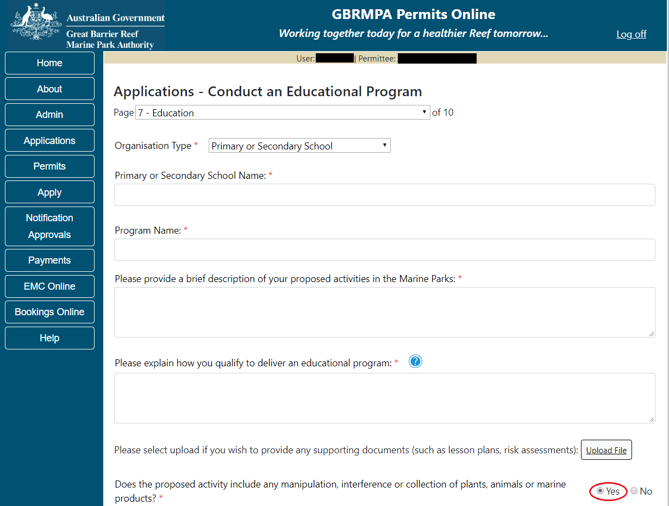
Figure 465 - Screenshot of question - Does the proposed activity include any manipulation, interference or collection of plants, animals or marine products with Yes selected and a red circle around Yes

If you have selected to Collect/manipulate specimens from the Education questions on page 7, an Add New button will appear on page 9 to add the Taxa/Sample details.
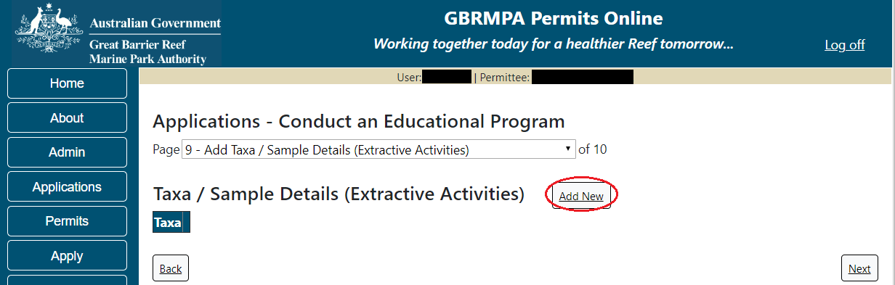
Figure 466 - Screenshot of Add Taxa / Sample Details page with a red circle around Add New button

Select Add New and the Taxon pop up window will appear. There are a number of fields to enter on the form. All details marked with a red (*) asterisk are required, please enter the exact details of Taxon take/s. Select the Taxon button to add the Taxon.
Figure 467 - Screenshot of Taxon pop up window

An Add Taxa / Sample Details window will appear. In the search field enter the name of the Taxon you propose to take. As you type in details the results field will narrow down.
Figure 468 - Screenshot of Add Taxa / Sample Details pop up window with search results displayed

Once you select a Taxon it will move from the results field to the selected field with a Remove button. Select Save once you have selected your taxon.
Figure 469 - Screenshot of Add Taxa / Sample Details pop up window with search results displayed, red circle around Selected taxa and red circle around Save button

If multiple Taxon are required you can select more than one options. NOTE if each Taxon will have different sample types etc. then each different type will need to be added separately. (E.g. only add multiple taxon if the take/sample details are the same, if different add separately)
Figure 470 - Screenshot of Add Taxa / Sample Details pop up window with search results displayed, red circle around Multiple Selected taxa and red circle around Save button

Once you have selected your Taxon add details of Sample Type, Maximum Sample Size, Sample Unit, Age Class and Fate. Then select the Collection Methods button.
Figure 471 - Screenshot of Taxon window with red circles around Sample Type, Maximum Sample Size, Age Class, Fate and Sample Unit. Arrow pointed at Collection Methods button

A pop up window called Add Collection Method will appear with tick box options to choose. Select the collection methods proposed for taxon take.
Figure 472 - Screenshot of Add Collection Method pop up window with Benthic Grab Sampler option selected

Once you have made your selection/s from the list select the Save button.
Figure 473 - Screenshot of Add Collection Method pop up window with red circle around Save button

Your Collection Method/s will then appear on the Collections Methods field. Fill in the remaining details under the Quantity of Specimen Samples, Spread Collections Spatially, Species Limit and Spread Collection Temporally fields. Select Save once all Taxon details are entered.
Figure 474 - Screenshot of Taxon pop up window with all fields and information entered. A red circle around Save button
Details of the Taxon will be displayed on the page. Options for Edit and Remove will also appear. If you select Edit the Add Taxon screen will open and you can edit your details. If Remove is selected then the Taxon will be removed from the application. Select Next to continue.
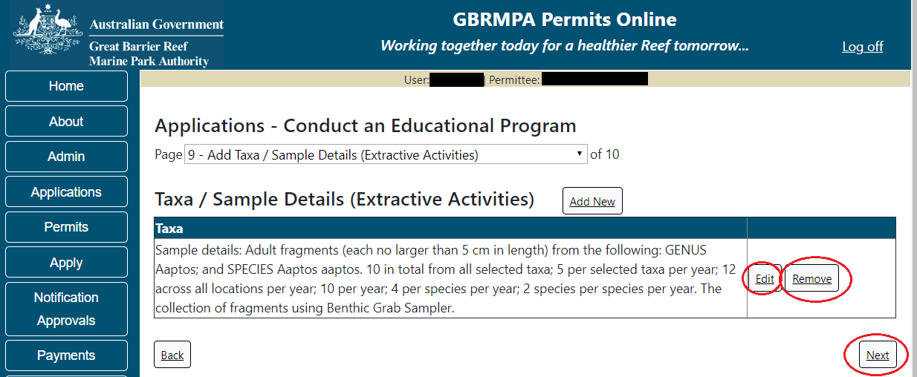
Figure 475 - Screenshot of Add Taxa / Sample Details page with Taxa information displayed and red circle around Edit and Remove buttons, circle around Next button

Page 9 of Conduct an Education Program provides opportunity for you to add any other information you feel will assist the Managing Agencies in assessing your application. Add supporting information by typing in the text field or upload a file if required. If a file is uploaded it will appear on the screen with the file name and an Remove to remove the file if the wrong file is selected.
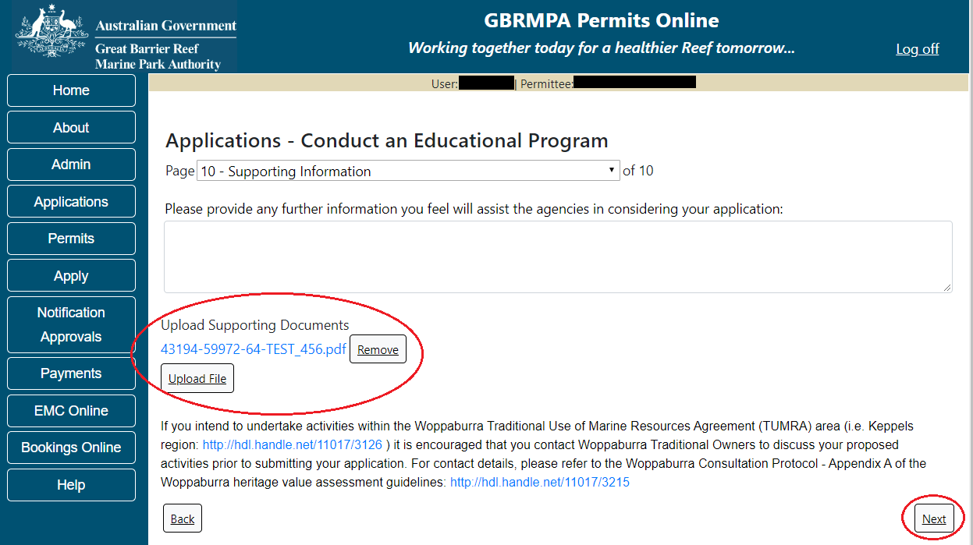
Figure 476 - Screenshot of Supporting Information screen with information entered and a red circle around. Please provide details section, circles around Uploaded File and Next button
Once you have completed the supporting information page select Next from the last page of the application questions, you will progress to an application summary screen with a number of options available via links or buttons. Select Next on the summary screen to progress to the Declarations screens.
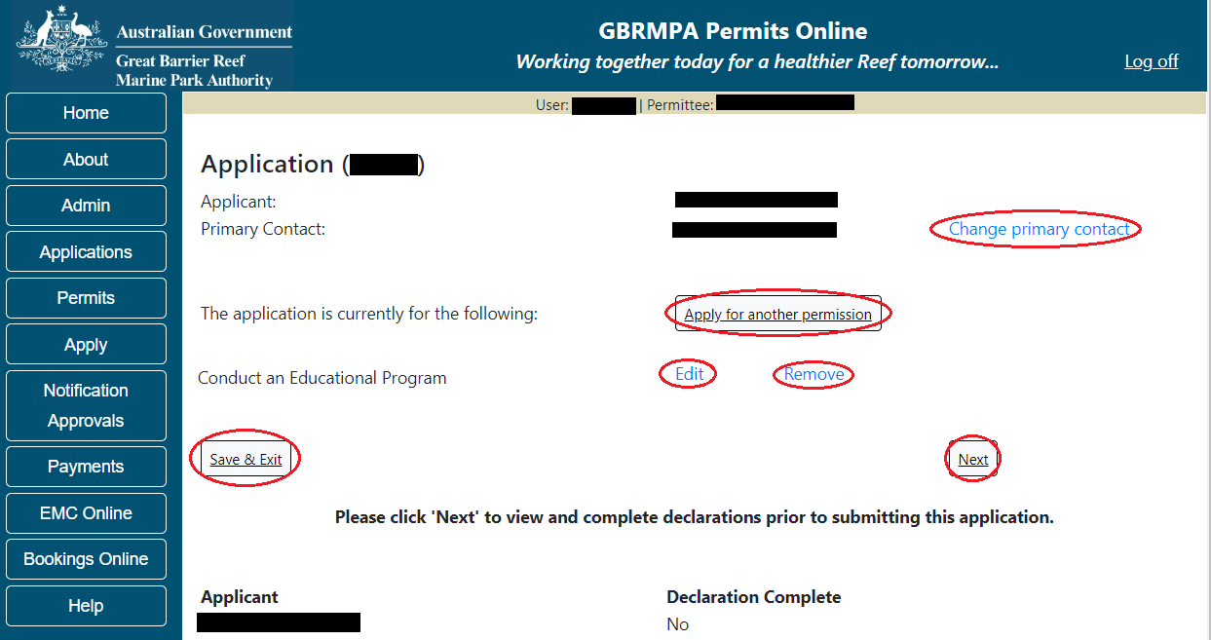
Figure 477 - Screenshot of Application Summary page with red circles around all options available

Additional Information - Summary screen, links and buttons;
- Change primary contact: If the change primary contact link is selected the applicant will progress to the primary contact page where the primary contact can be changed.

- Apply for another permission: If the apply for another permission button is selected, the applicant will progress to the What are you seeking to do in the Marine Parks page where another permission type can be added. (e.g. add a tourism permission to the education permission).

- Edit: If edit is selected the application/permission will be reopened to apply any changes.

- Remove: If remove is selected the application/permission will be removed.

- Save & Exit: If the Save & Exit button is selected the applicant will progress to the applications screen.

- Next: If next is selected the applicant will progress to the submission process including declaring and submitting the application.

Completion of a set of declarations is mandatory prior to submitting your application. To complete the declarations section of this application, you must either be the applicant, or if applying on behalf of an organisation / company / government agency, you must be a Director of that organisation / company / government agency. Authorised contacts cannot complete the declaration section, as it contains legally binding commitments in place of a physical signature.
Please read all questions carefully, provide a response to each, and select Next.
Figure 478 - Screenshot of Declarations page with red circle around Yes and No options and Next button

On the final page of declarations there is a Submit button. Once the Submit button is selected, the application will be submitted to the Reef Authority and is no longer available to be edited. The status of the application on the Applications screen will then display ‘Submitted to GBRMPA’. The application’s Primary Contact will receive an emailed acknowledgement notice from a delegated Assessment Officer within 10 business days.
Figure 479 - Screenshot of Declarations screen with a red circle around the Submit button
Once you submit your application, you will be provided with a reference/application number and can follow the progress of your application via the Applications menu on the left.
Figure 480 - Screenshot of the Thank you for your application screen with a red circle around Reference number and a red circle around the open pdf button

Your application will appear in the Applications screen with the reference/application number also displayed. You have further options to view a summary of your application, email the Reef Authority or withdraw the application.
Figure 481 - Screenshot of Applications screen with a red circle around Application No., Summary, Email and Withdraw options

- Harvest Fishery
Apply – new permit application – harvest fishery
To apply for a Harvest Fishery application select this option on the Apply – What are you seeking to do in the Marine Parks page.
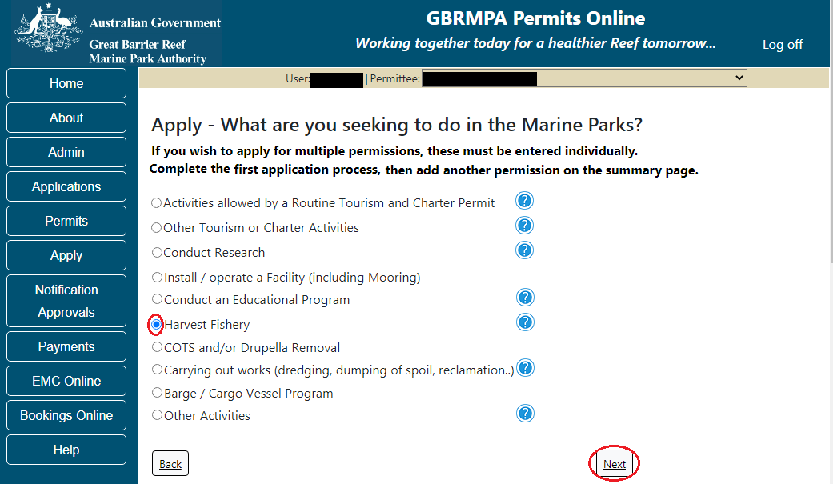
Figure 482 - Screenshot of Apply - What are you seeking to do in the Marine Parks screen with Harvest Fishery and a red circle around the Next button
You will progress to the application sub type menu with further options to select the type of Harvest Fishery you wish to apply for. Select the Harvest Fishery type. (Option selected is Tropical Rock Lobster Fishery). Select Next to progress to application questions.
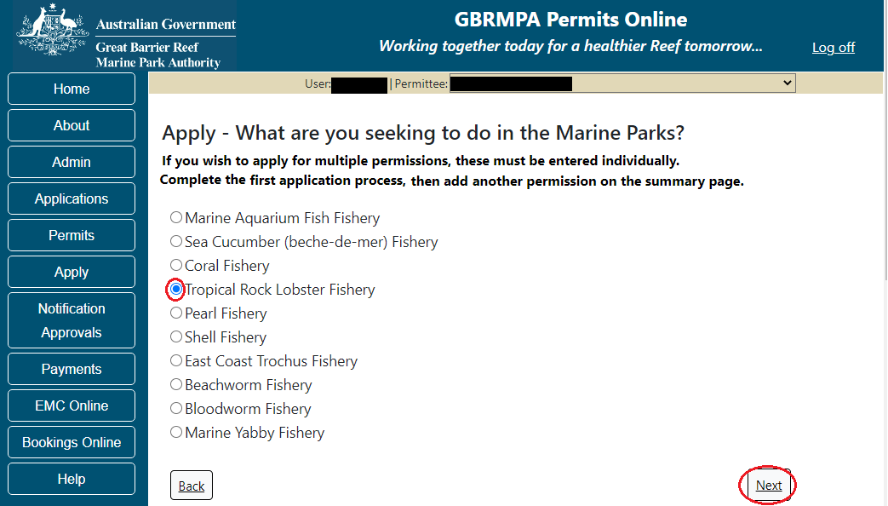
Figure 483 - Screenshot of Apply - What are you seeking to do in the Marine Parks – Harvest Fishery sub menu with Tropical Rock Lobster and a red circle around Next button
Page 1 of Harvest Fishery application is the Environment Protection and Biodiversity Conservation Act page. This provides advice on matters of national environmental significance that must be considered when assessing an application. This screen is for your information only at this stage. Your assessing officer will contact you if it is determined to be relevant for your application.
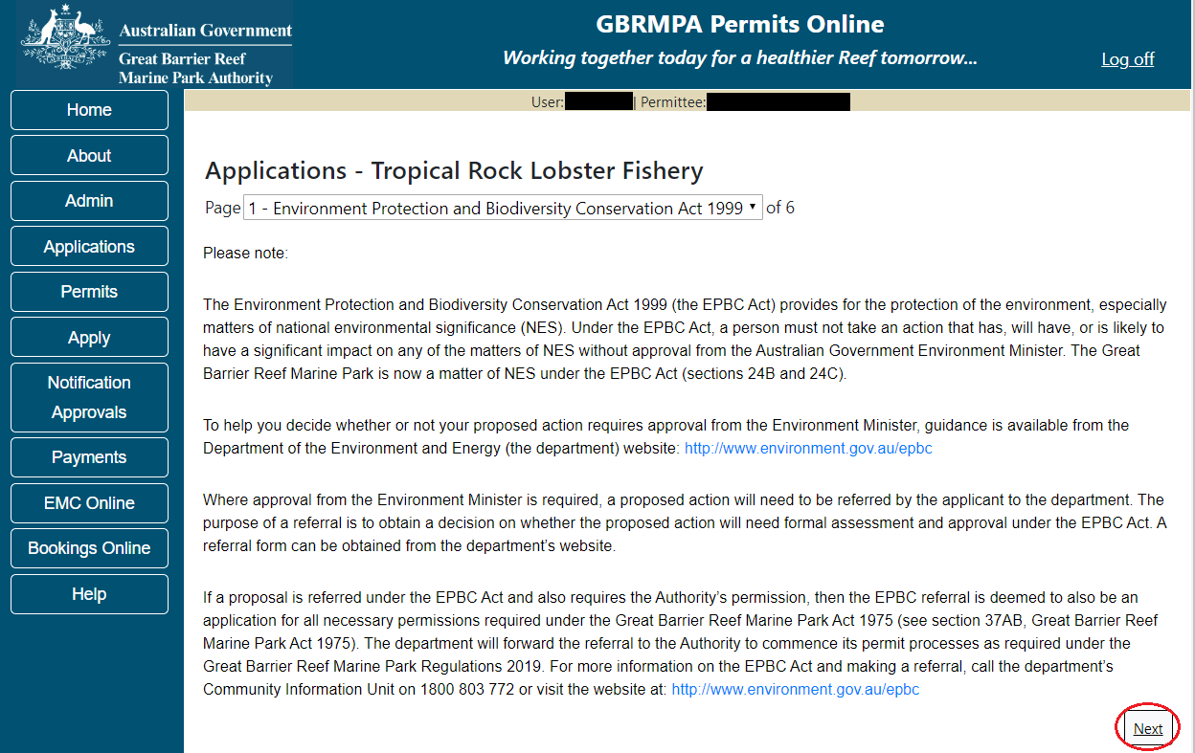
Figure 484 - Screenshot of Environment Protection and Biodiversity Conservation screen with a red circle around Next button
Links on the Environment Protection and Biodiversity Conservation page www.environment.gov.au/epbc will take you to the Department of Climate Change, Energy the Environment and Water site. Here you can find information about the Environment Protection and Biodiversity Conservation Act 1999 and your obligations under the Act.

Page 2 of Harvest Fishery application is the Vessel Details page. In this screen enter details of how many vessels, the maximum length and total capacity you wish to apply for this permission. Select Next to continue.
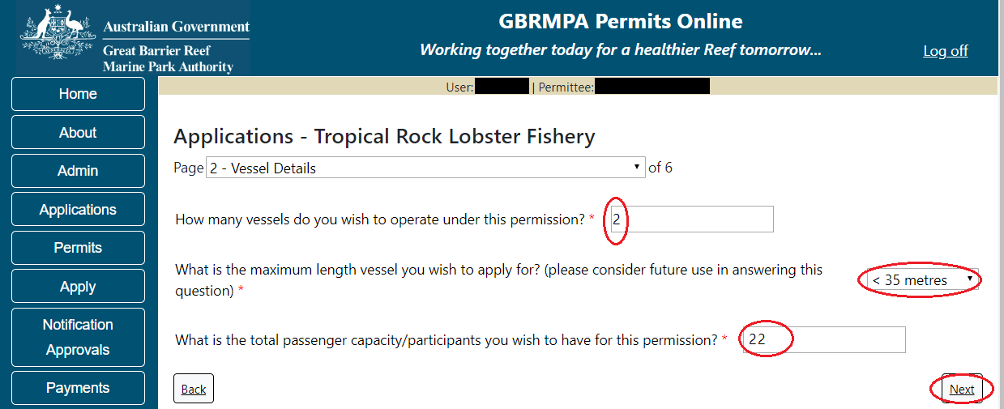
Figure 485 - Screenshot of Vessel Details screen with a red circle around field to enter - How many Vessels do you wish to operate under this permission, red circle around Maximum length selected, red circle around passenger capacity selected and red circle around Next button

Page 3 of Harvest Fishery application is the Vessels page. On this page you can enter the actual vessel details. To add vessel details select the Add New button.
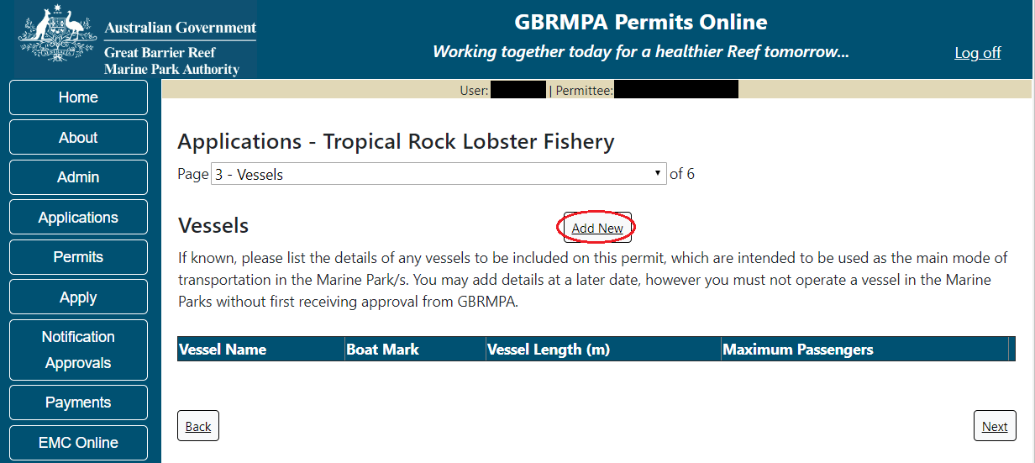
Figure 486 - Screenshot of Vessels screen with red circle around Add New button

An Add New Vessel pop up window will appear with fields for Name, Boat Mark, Length (in metres) and Passenger Capacity. There is a link for information on boat marks and other Queensland Fisheries requirements. https://www.business.qld.gov.au/industries/farms-fishing-forestry/fisheries/licences/boat-licence Select the link if you wish to find out more information.
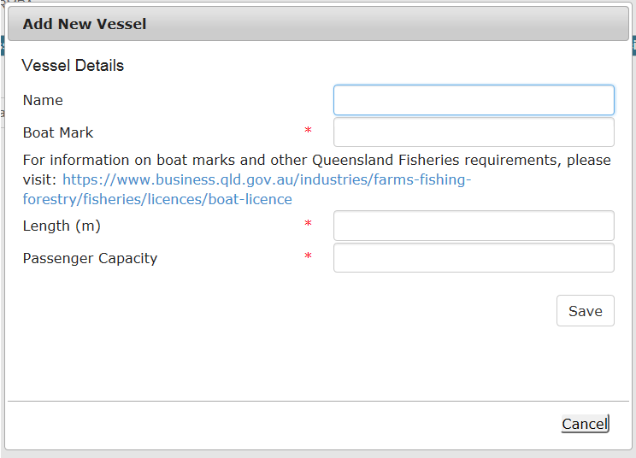
Figure 487 - Screenshot of Add New Vessel pop up window

Add the exact details of each vessel and select Save.
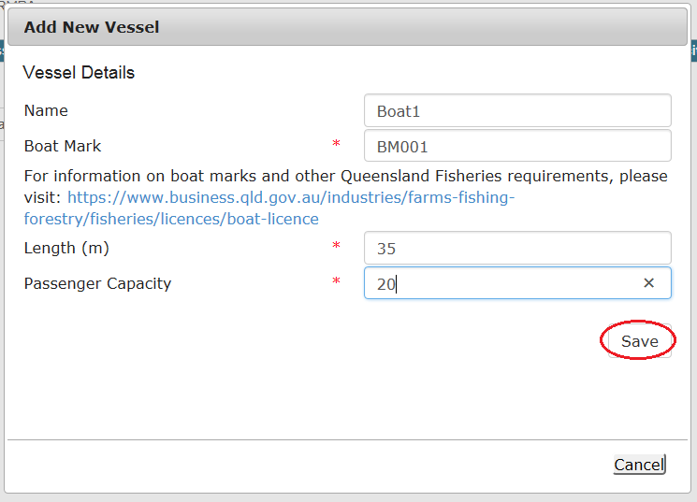
Figure 488 - Screenshot of Add New Vessel pop up window with information entered and a red circle around Save

Once you enter your vessel details and select Save, the details will be displayed on the screen in the Vessels table. A Remove button will also be displayed. If you wish to remove the vessel details select Remove and the details will be deleted from your application. If you wish to edit the details select Edit and amend the required information. Select Next to continue.
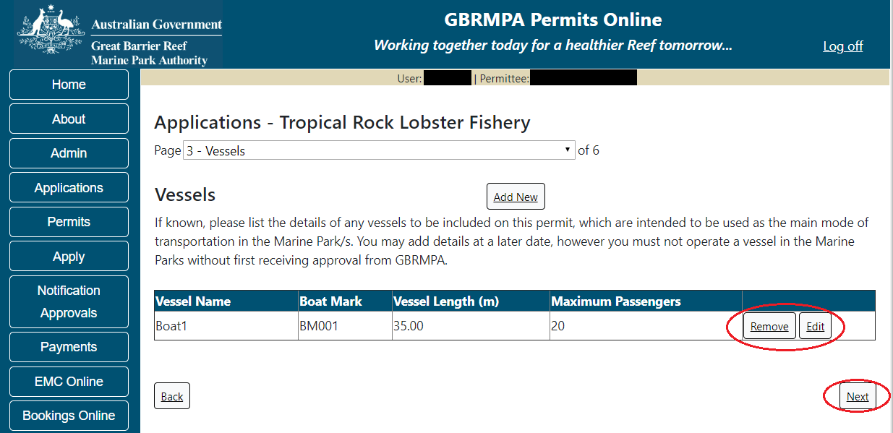
Figure 489 - Screenshot of Vessels page with information displayed and a red circle around Remove button and Next button

Page 4 of Harvest Fishery application is the Ancillary Vessels and Equipment page. To add ancillary vessels or equipment select the Add New button.
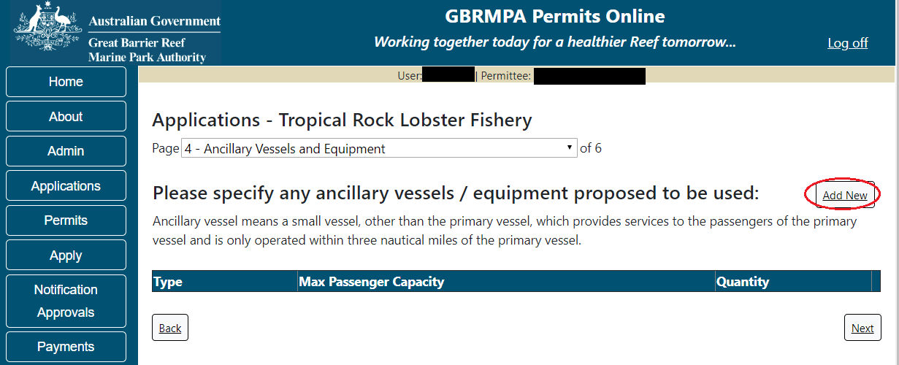
Figure 490 - Screenshot of Ancillary Vessels and Equipment screen with red circle around Add New button

An Add New Ancillary Vessels/Equipment window will appear.
Figure 491 - Screenshot of Add Ancillary Vessels / Equipment pop up window

Select Ancillary Vessels or Equipment from the Device list
Figure 492 - Screenshot of Add Ancillary Vessels / Equipment pop up window with Device list displayed

Add exact details of the ancillary vessels or equipment, then select Save.
Figure 493 - Screenshot of Add Ancillary Vessels / Equipment pop up window with information entered and a red circle around Save
The details of ancillary vessels or equipment will appear on the screen. If you wish to remove any ancillary vessels or equipment select the Remove button next to the item/s you wish to remove. If you wish to edit the details select Edit and amend the required information. Once you have added your ancillary vessels and/or equipment select Next to continue.
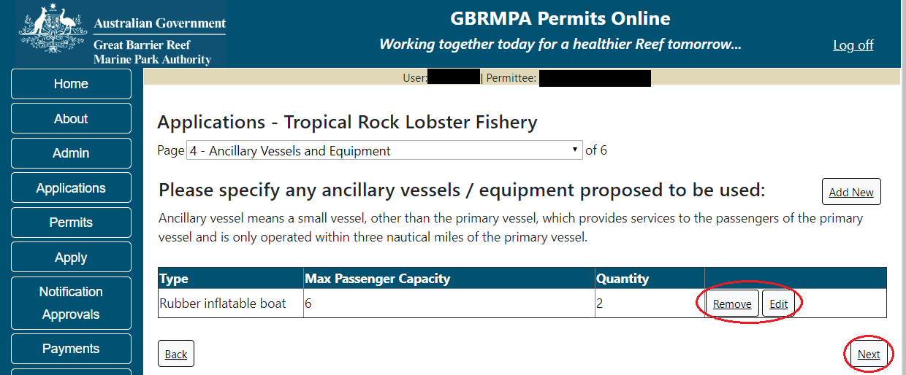
Figure 494 - Screenshot of Ancillary Vessels and Equipment page with information displayed and a red circle around Remove button and Next button

Page 5 of Harvest Fishery application is the Harvest Fishery details page.
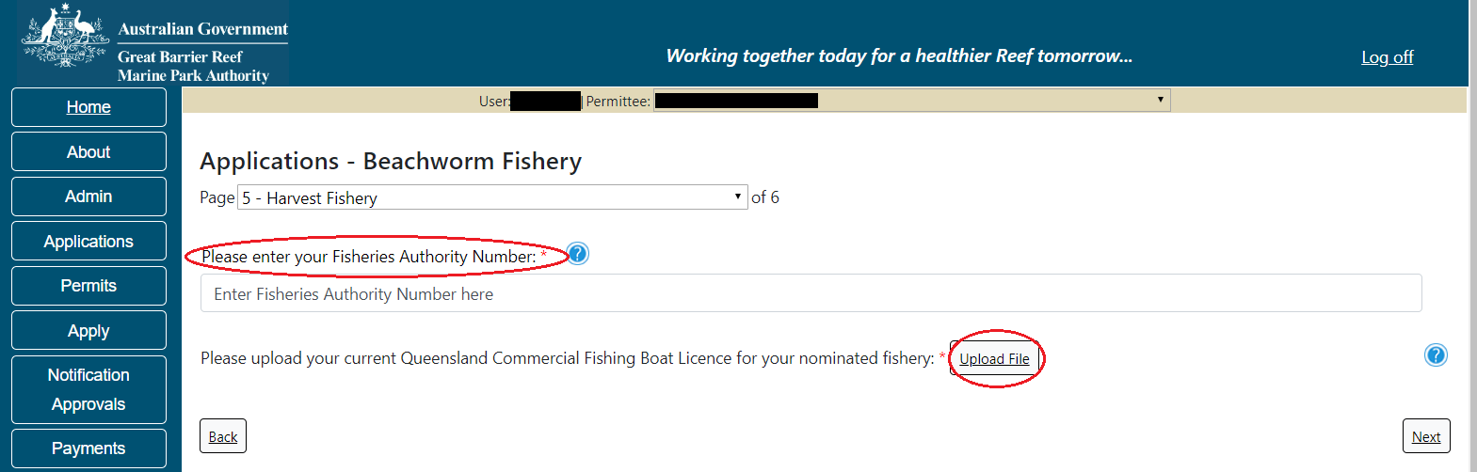
Figure 495 - Screenshot of Harvest Fishery page with Upload File button circled. Red circle around Please enter your Fisheries Authority Number

For information on Fisheries Authority Number, please visit:
http://www.business.qld.gov.au/industries/farms-fishing-forestry/fisheries/licences
For information on Queensland Commercial Fishing Licencing requirements, please visit:
http://www.business.qld.gov.au/industries/farms-fishing-forestry/fisheries/licences/fisher-licence

Add details by uploading a copy of your Queensland Commercial Fishing Boat Licence and enter your Fisheries Authority Number. Select Next to continue.
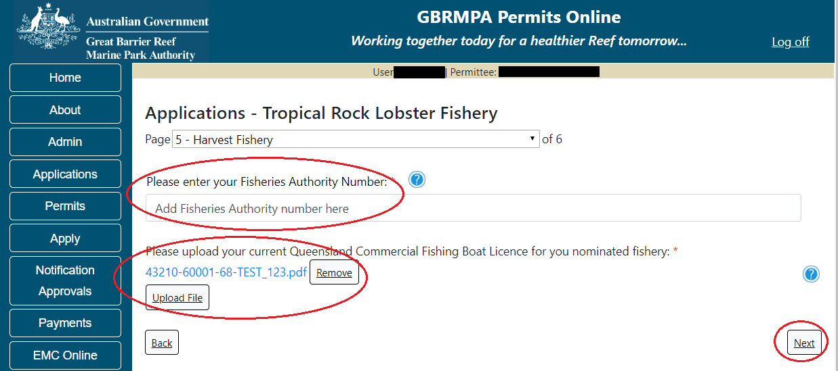
Figure 496 - Screenshot of Harvest Fishery page with Uploaded File circled. Red circle around Please enter your Fisheries Authority Number section with information displayed, red circle around Next button

Page 6 of Harvest Fishery application provides opportunity for you to add any other information you feel will assist the Managing Agencies in assessing your application. Add supporting information by typing in the text field or upload a file if required. If a file is uploaded it will appear on the screen with the file name and a Remove button to remove the file if the wrong file is selected.
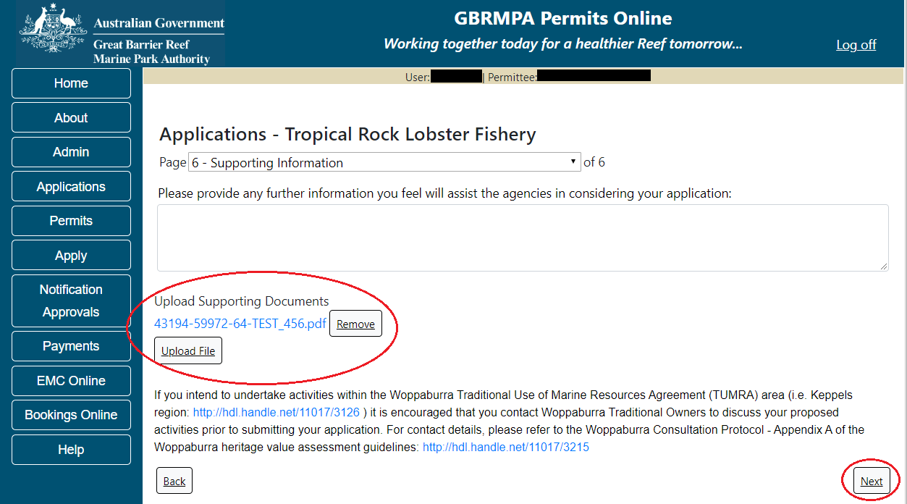
Figure 497 - Screenshot of Supporting Information screen with information entered and a red circle around Uploaded File and Next button

Once you have completed the supporting information page select Next from the last page of the application questions, you will progress to an application summary screen with a number of options available via links or buttons. Select Next on the summary screen to progress to the Declarations screens.
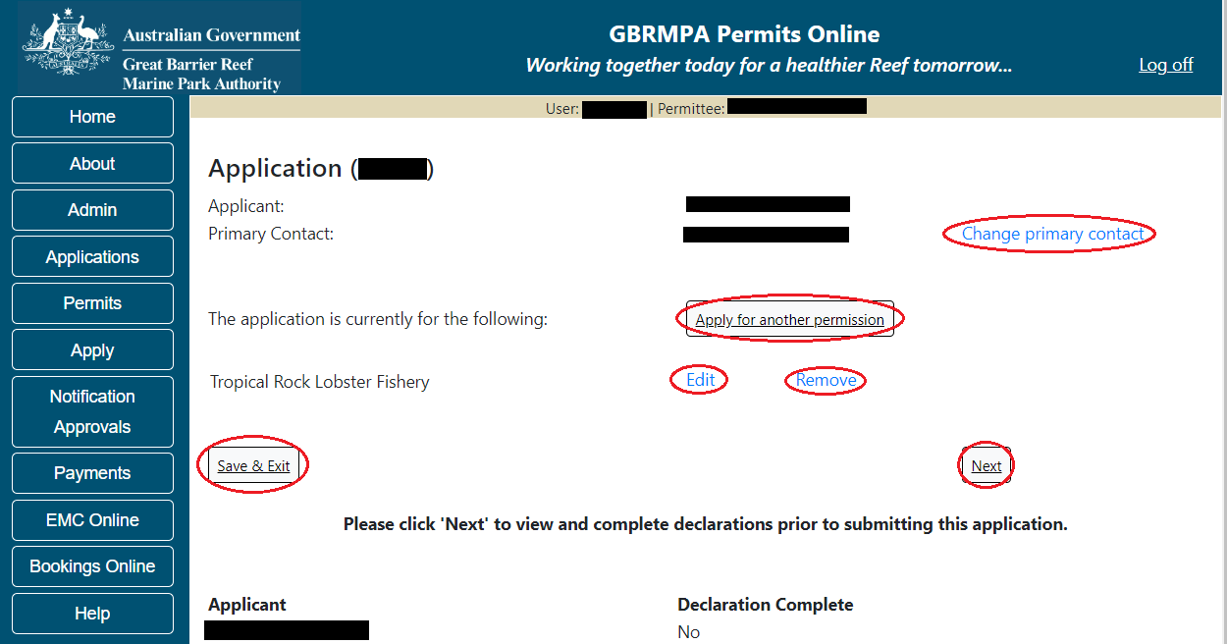
Figure 498 - Screenshot of Application Summary page with red circles around all options available

Additional Information - Summary screen, links and buttons;
- Change primary contact: If the change primary contact link is selected the applicant will progress to the primary contact page where the primary contact can be changed.

- Apply for another permission: If the Apply for another permission button is selected, the applicant will progress to the What are you seeking to do in the Marine Parks page where another permission type can be added. (e.g. add a mooring permission to the fishery permission).

- Edit: If edit is selected the application/permission will be reopened to apply any changes.

- Remove: If remove is selected the application/permission will be removed.

- Save & Exit: If the Save & Exit button is selected the applicant will progress to the applications screen.

- Next: If next is selected the applicant will progress to the submission process including declaring and submitting the application.

Completion of a set of declarations is mandatory prior to submitting your application. To complete the declarations section of this application, you must either be the applicant, or if applying on behalf of an organisation / company / government agency, you must be a Director of that organisation / company / government agency. Authorised contacts cannot complete the declaration section, as it contains legally binding commitments in place of a physical signature.
Please read all questions carefully, provide a response to each, and select Next.
Figure 499 - Screenshot of Declarations page with red circle around Yes and No options and Next button

On the final page of declarations there is a Submit button. Once the Submit button is selected, the application will be submitted to the Reef Authority and is no longer available to be edited. The status of the application on the Applications screen will then display ‘Submitted to GBRMPA’. The application’s Primary Contact will receive an emailed acknowledgement notice from a delegated Assessment Officer within 10 business days.
Figure 500 - Screenshot of Declarations screen with a red circle around the Submit button
Once you submit your application, you will be provided with a reference/application number and can follow the progress of your application via the Applications menu on the left.
Figure 501 - Screenshot of the Thank you for your application screen with a red circle around Reference number and a red circle around the open pdf button

Your application will appear in the Applications screen with the reference/application number also displayed. You have further options to view a summary of your application, email the Reef Authority or withdraw the application.
Figure 502 - Screenshot of Applications screen with a red circle around Application No., Summary, Email and Withdraw options

- COTS and/or DRUPELLA
  - Routine COTS and/or DRUPELLA
Apply – new permit application – Routine COTS and/or Drupella
To apply for a COTS and/or Drupella Removal application select this option on the Apply – What are you seeking to do in the Marine Parks page. Select Next to progress to application questions.
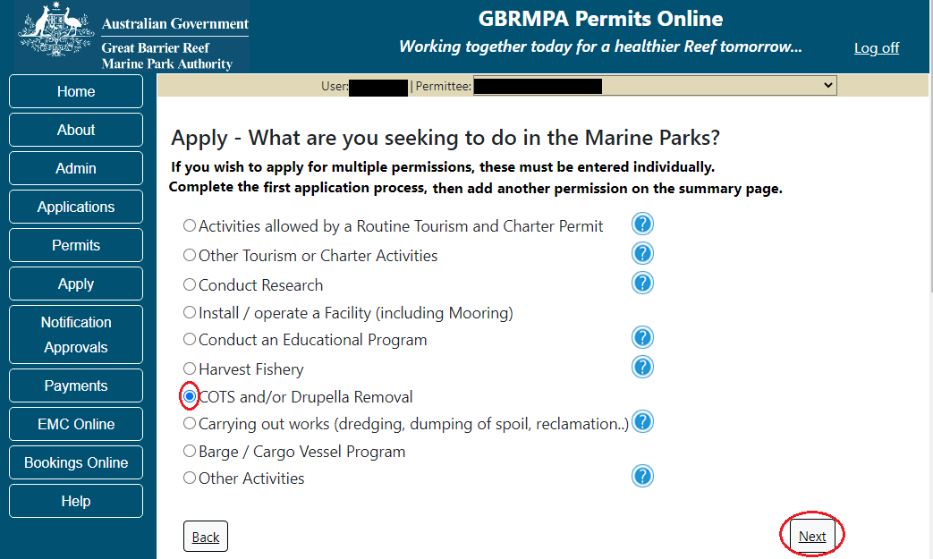
Figure 503 - Screenshot of Apply - What are you seeking to do in the Marine Parks screen with Other Activities and a red circle around the Next button
Information – Routine COTS and/or DRUPELLA Removal
You may be eligible to obtain a routine COTS and/or Drupella control permit if you meet the criteria below:
1. You are applying to control COTS and / or Drupella in the Marine Parks in accordance with GBRMPA Guidelines.
2. You do not require access to Preservation Zones.
3. You will undertake COTS and/or Drupella control from a vessel of less than 50m in length, or, if greater than 50m in length, the vessel will remain in the Designated Shipping Channel and/or General Use Zones whilst operating under this permit.
NOTE: if chartering a vessel/aircraft, remember that the charter vessel/aircraft will need to have a Marine Parks permit that allows for non-tourist charters and has access to the locations that you want to enter.
Routine permits can usually be assessed and issued within 25 business days from the date the Reef Authority receives all necessary information. Please click the link below to review the routine COTS and/or Drupella control permit and ensure it meets your requirements. Note that any variations from this standard product will require a tailored assessment approach, incurring a longer assessment period.
Link to EXAMPLE Routine COTS and/or Drupella Control Permit
Link to assessment approach information
The landing page of the COTS and/or Drupella application is an initial page with information and ability to choose routine or not. A copy of the guidelines is available as well as a link to an example permit and a link to the assessment approach used by the Reef Authority.
If you would like to apply for a routine COTS and/or Drupella control permit you have the option to select Yes or No. If Yes is selected you will progress to the Routine COTS and /or Drupella application. Continue from the below screenshot.
If No is selected you will progress to the Tailored (Standard) COTS and/or Drupella application screens (refer to page Figure 511 of this manual to continue).
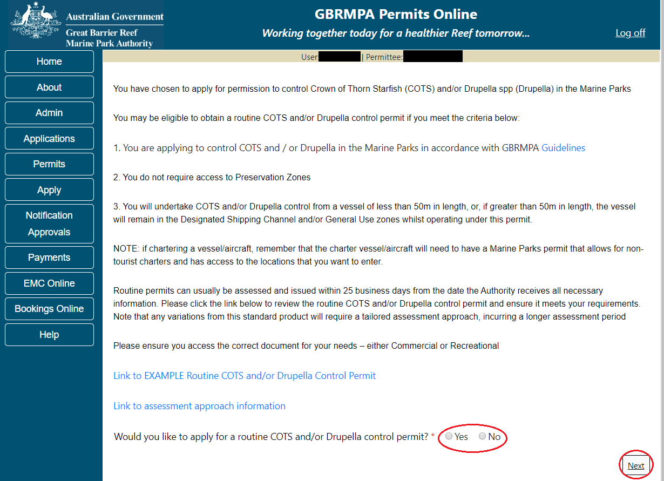
Figure 504 - Screenshot of initial questions and information page with a red circle around the Yes and No buttons and a red circle around the Next button
Page 1 of the routine COTS and /or Drupella application is the application questions page. Select whether the program will be recreational or commercial. Please also select which type of program you wish to conduct then select Next.
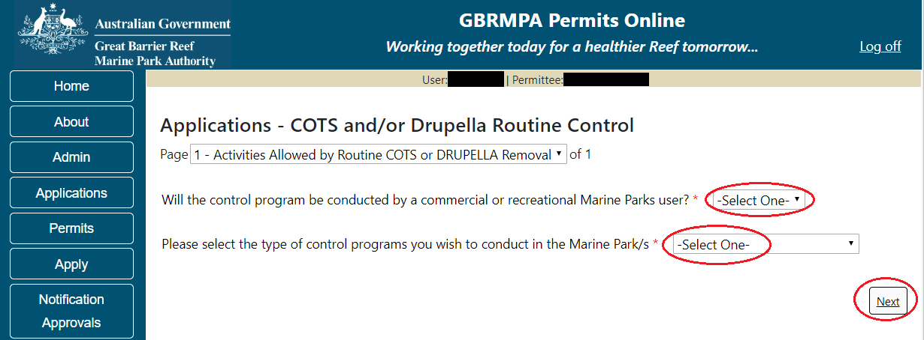
Figure 505 - Screenshot of routine COTS and/or drupella application questions page with a red circle around the question drop lists and a red circle around the next button
Once you select Next from the last page of the application questions, you will progress to an application summary screen with a number of options available via links or buttons. Select Next on the summary screen to progress to the Declarations pages.
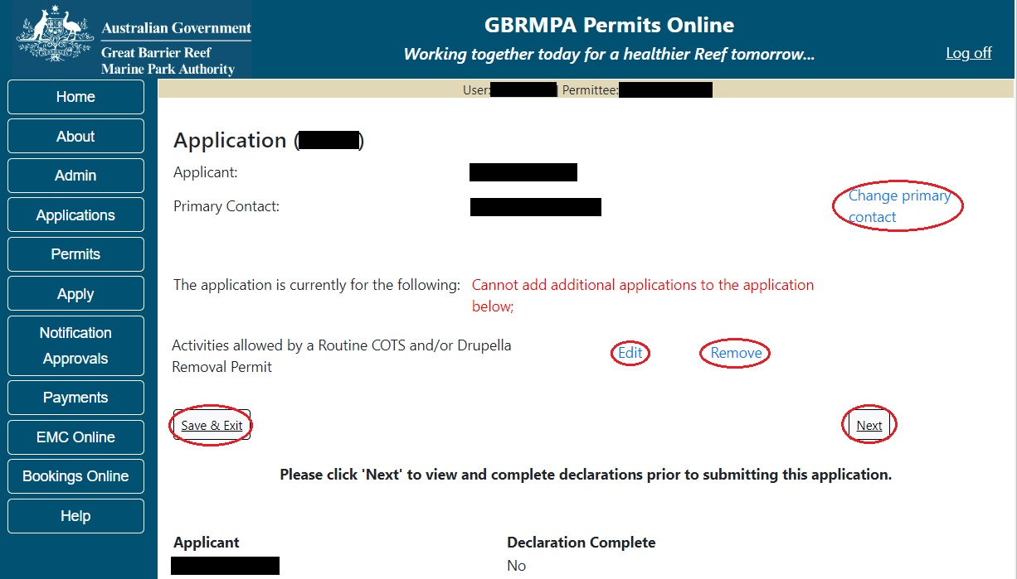
Figure 506 - Screenshot of Application Summary page with red circles around all options available

Additional Information - Summary screen, links and buttons;
- Change primary contact: If the change primary contact link is selected the applicant will progress to the primary contact page where the primary contact can be changed.

- Edit: If edit is selected the application/permission will be reopened to apply any changes.

- Remove: If remove is selected the application/permission will be removed.

- Save & Exit: If the Save & Exit button is selected the applicant will progress to the applications screen.

- Next: If next is selected the applicant will progress to the submission process including declaring and submitting the application.

Completion of a set of declarations is mandatory prior to submitting your application. To complete the declarations section of this application, you must either be the applicant, or if applying on behalf of an organisation / company / government agency, you must be a Director of that organisation / company / government agency. Authorised contacts cannot complete the declaration section, as it contains legally binding commitments in place of a physical signature.
Please read all questions carefully, provide a response to each, and select Next.
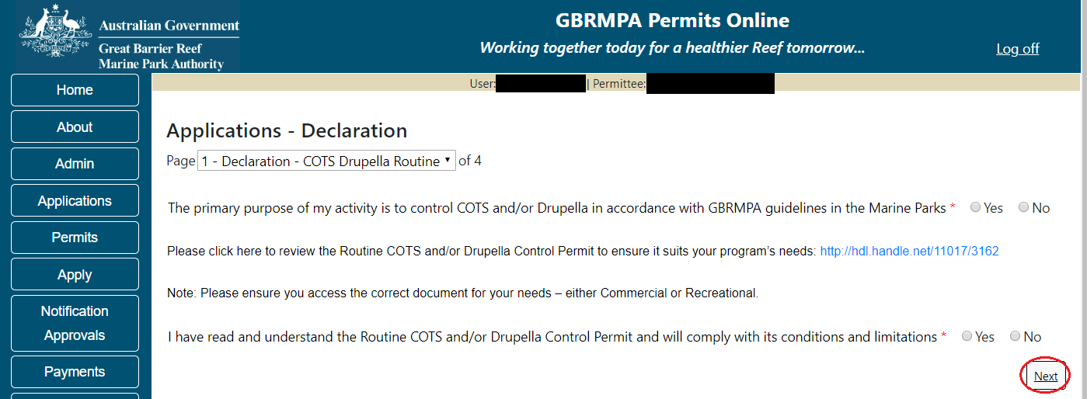
Figure 507 - Screenshot of Declarations page with red circle around Yes and No options and Next button

On the final page of declarations there is a submit button. Once the submit button is selected the application will be submitted to the Reef Authority.
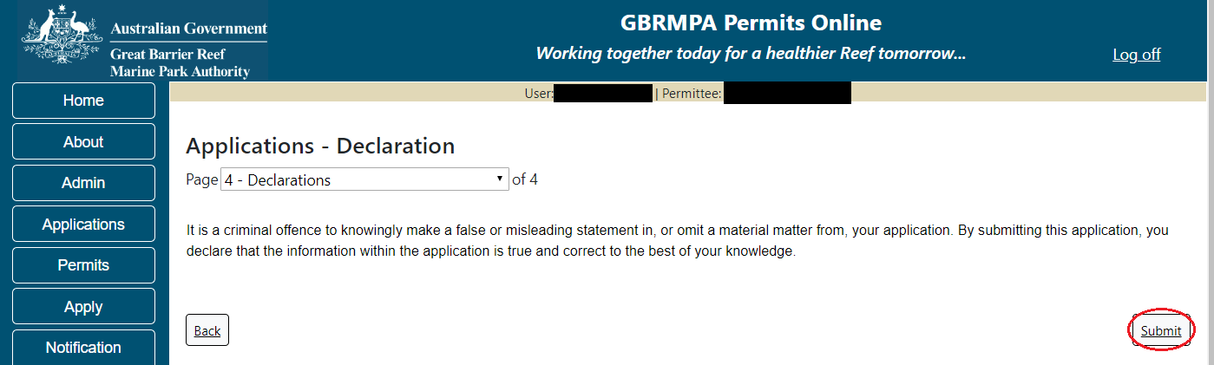
Figure 508 - Screenshot of Declarations screen with a red circle around the Submit button

Once you submit your application, you will be provided with a reference/application number and can follow the progress of your application via the Applications menu on the left.
Figure 509 - Screenshot of the Thank you for your application screen with a red circle around Reference number and a red circle around the open pdf button

Your application will appear in the Applications screen with the reference/application number also displayed. You have further options to view a summary of your application, email the Reef Authority or withdraw the application.
Figure 510 - Screenshot of Applications screen with a red circle around Application No., Summary, Email and Withdraw options

  - Tailored COTS and/or DRUPELLA
Apply – new permit application – COTS and/or Drupella
If no is selected for Routine cots and/or drupella application the Tailored COTS AND /OR DRUPELLA application will appear.
Page 1 of the COTS and/or Drupella Removal application is the Environment Protection and Biodiversity Conservation Act page. This provides advice on matters of national environmental significance that must be considered when assessing an application. This screen is for your information only at this stage. Your assessing officer will contact you if it is determined to be relevant for your application.
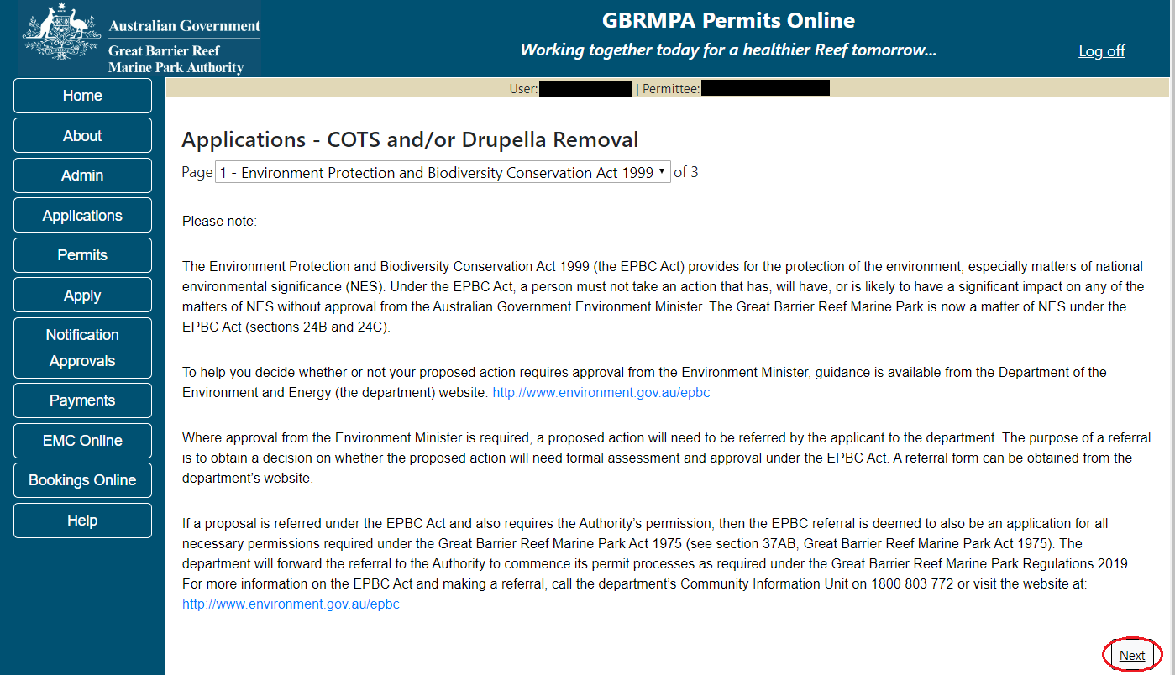
Figure 511 - Screenshot of Environment Protection and Biodiversity Conservation screen with a red circle around Next button

Links on the EPBC page www.environment.gov.au/epbc will take you to the Department of Climate Change, Energy the Environment and Water site. Here you can find information about the Environment Protection and Biodiversity Conservation Act 1999 and your obligations under the Act.

Page 2 of the COTS and/or Drupella Removal application has an option to select whether the program will be recreational or commercial. Please also select which type of program you wish to conduct. Select Next to move to the next page of the application.
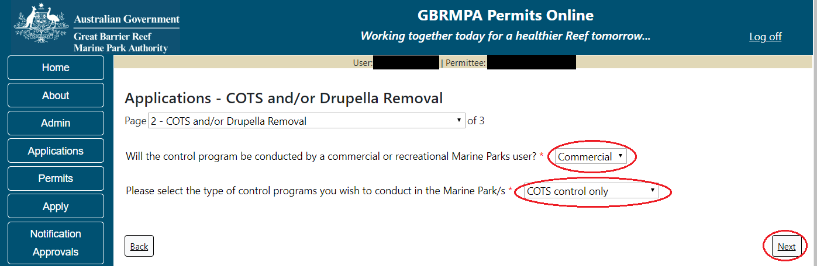
Figure 512 - Screenshot of COTS page with a red circle around the User Type field, A red circle around the guideline link and the Next button

Page 3 of the COTS and/or Drupella Removal application provides opportunity for you to add any other information you feel will assist the Managing Agencies in assessing your application. Add supporting information by typing in the text field or upload a file if required. If a file is uploaded it will appear on the screen with the file name and a Remove button to remove the file if the wrong file is selected.
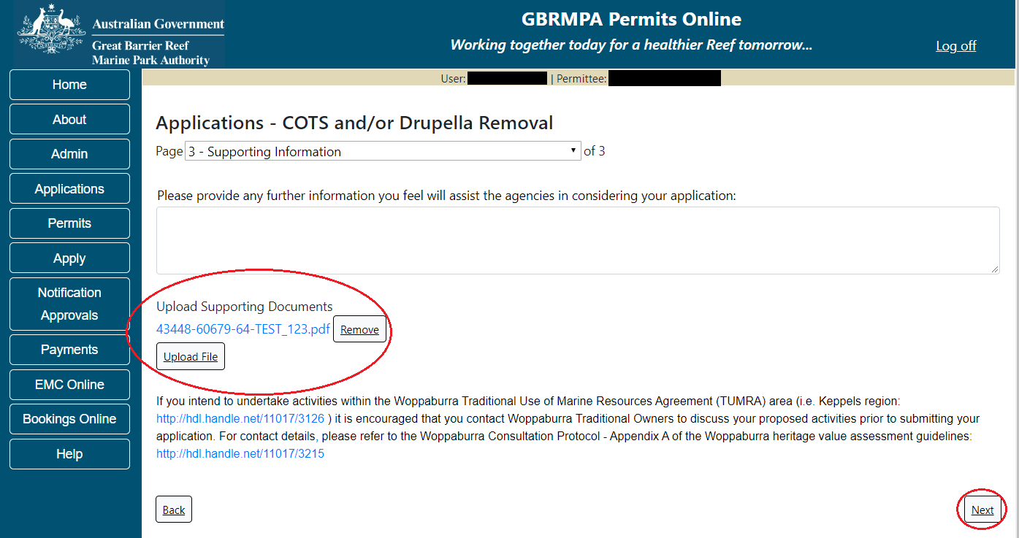
Figure 513 - Screenshot of Supporting Information screen with information entered and a red circle around Uploaded File and Next button

Once you have completed the supporting information page select Next and you will progress to an application summary screen with a number of options available via links or buttons. Select Next on the summary screen to progress to the Declarations screens.
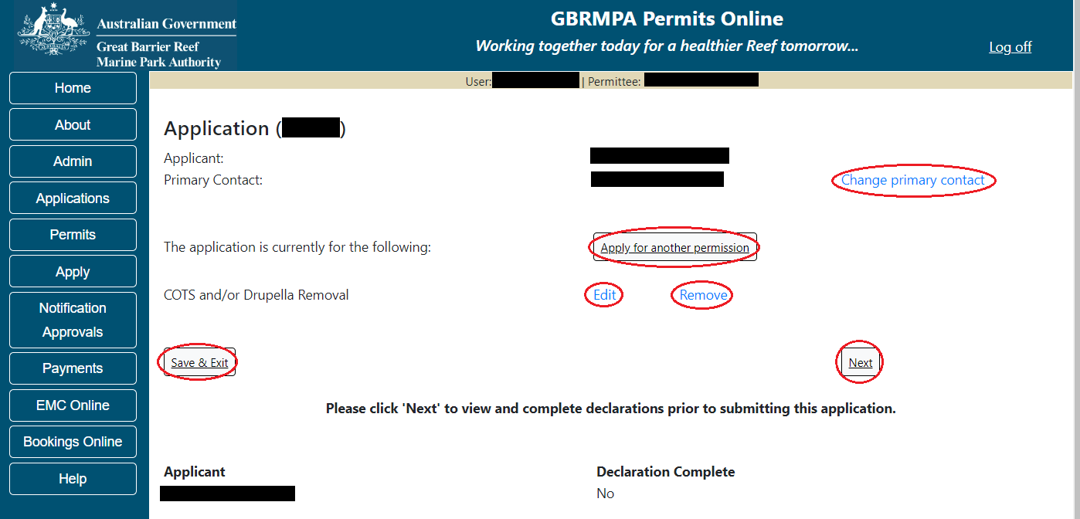
Figure 514 - Screenshot of Application Summary page with red circles around all options available

Additional Information - Summary screen, links and buttons;
- Change primary contact: If the change primary contact link is selected the applicant will progress to the primary contact page where the primary contact can be changed.

- Apply for another permission: If the apply for another permission button is selected, the applicant will progress to the What are you seeking to do in the Marine Parks page where another permission type can be added. (e.g. add a tourism permission to the COTS and/or Drupella Removal permission).

- Edit: If edit is selected the application/permission will be reopened to apply any changes.

- Remove: If remove is selected the application/permission will be removed.

- Save & Exit: If the Save & Exit button is selected the applicant will progress to the applications screen.

- Next: If next is selected the applicant will progress to the submission process including declaring and submitting the application.

Completion of a set of declarations is mandatory prior to submitting your application. To complete the declarations section of this application, you must either be the applicant, or if applying on behalf of an organisation / company / government agency, you must be a Director of that organisation / company / government agency. Authorised contacts cannot complete the declaration section, as it contains legally binding commitments in place of a physical signature.
Please read all questions carefully, provide a response to each, and select Next.
Figure 515 - Screenshot of Declarations page with red circle around Yes and No options and Next button

On the final page of declarations there is a Submit button. Once the Submit button is selected, the application will be submitted to the Reef Authority and is no longer available to be edited. The status of the application on the Applications screen will then display ‘Submitted to GBRMPA’. The application’s Primary Contact will receive an emailed acknowledgement notice from a delegated Assessment Officer within 10 business days.
Figure 516 - Screenshot of Declarations screen with a red circle around the Submit button
Once you submit your application, you will be provided with a reference/application number and can follow the progress of your application via the Applications menu on the left.
Figure 517 - Screenshot of the Thank you for your application screen with a red circle around Reference number and a red circle around the open pdf button

Your application will appear in the Applications screen with the reference/application number also displayed. You have further options to view a summary of your application, email the Reef Authority or withdraw the application.
Figure 518 - Screenshot of Applications screen with a red circle around Application No., Summary, Email and Withdraw options

- Barge / Cargo Vessel Program

Apply – new permit application – other tourism activities – routine barge / cargo vessel program
To apply for Barge / Cargo Vessel Program, select this option on the Apply – What are you seeking to do in the Marine Parks page.
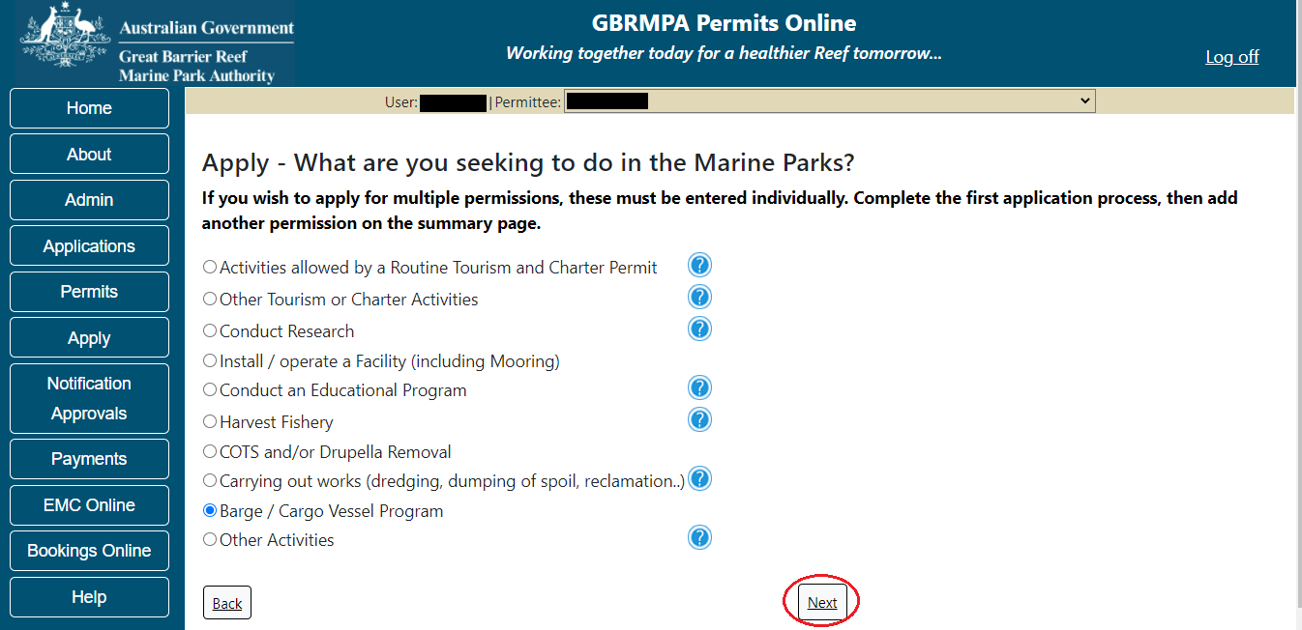
Figure 519 - Screenshot of Apply - What are you seeking to do in the Marine Parks screen with Barge / Cargo Vessel Program and a red circle around the Next button

Information – Routine Barge and Charter Program
Routine Barge and Charter permits will also contain permission to undertake non-tourist commercial charters (permission to provide charter services to people other than tourists).
The Environmental Management Charge is applicable to this permission, along with mandatory reporting requirements. Further information is available on our Website.

Eligibility Criteria for Routine Barge and Charter permits:
- You do not propose to operate a cargo vessel
- The size of any vessel proposed to be operated under this permit is less than 50 metres
- When in a tug-and-tow configuration with a total length of tow greater than 150 metres, vessels are only operated within Designated Shipping Areas or General Use Zones unless transiting to or from an approved intertidal area
- Your operation does not require access to Preservation Zones
- Your operation does not include works or transfer of bulk fuel
Please click the link below to review the Routine Barge and Charter permit and ensure it meets your requirements. Note that any variations from this standard product will require a tailored assessment approach and longer assessment period.
Link to Routine Barge and Charter Permit
Link to assessment approach information
The landing page of the Barge / Cargo vessel program Application is an initial page with questions and information. Depending on the nature of the barge operation and what answers are obtained will determine if the applicant is eligible for a Routine Barge and Charter permit Application, or if the application will be a Tailored Barge / Cargo Vessel Program application.
On this screen, there are also two links, a link to a copy of the Routine Barge and Charter permit and a link to the assessment approach information on how the permit application will be assessed.
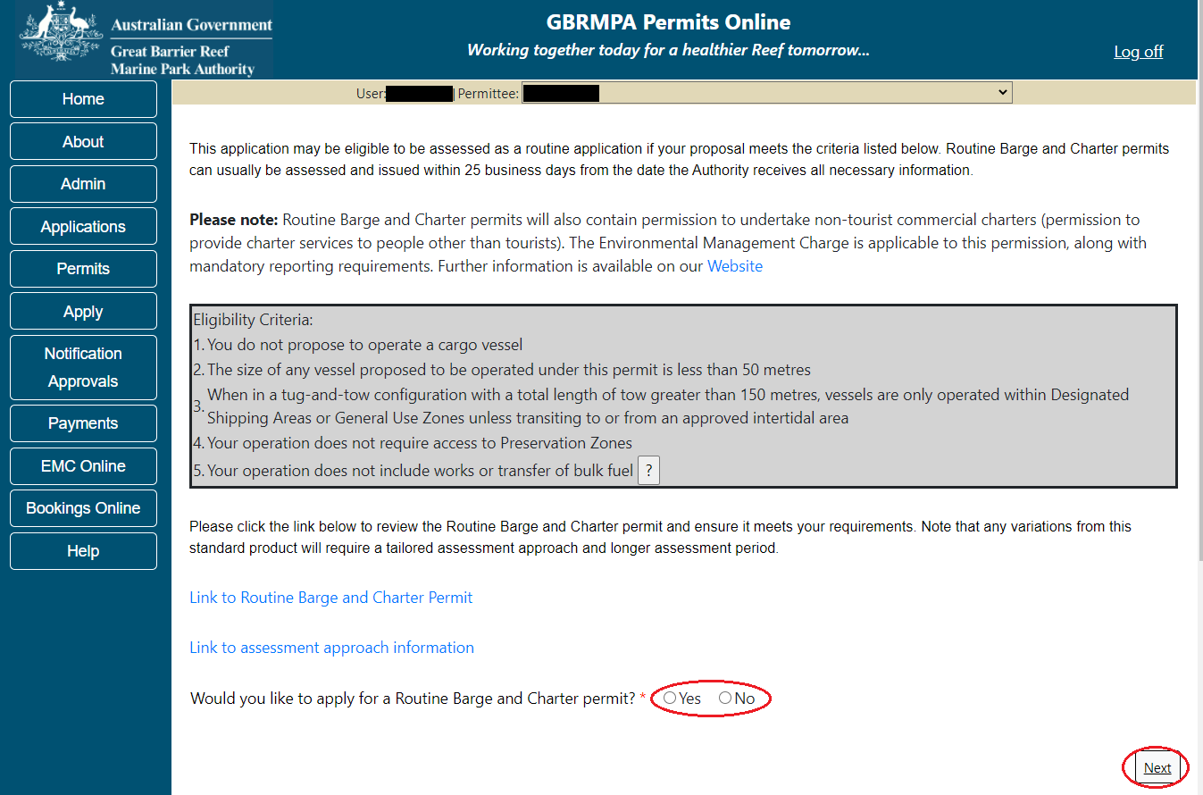
Figure 520 - Screenshot of initial questions and information page with a red circle around the Yes and No buttons and a red circle around the Next button

  - Routine Barge and Charter Program
Apply – new permit application – other tourism activities – routine barge and charter program
Page 1 of the routine barge and charter vessel program application is the Vessel Details page. On this screen, enter details of how many barge and/or tug vessels you wish to apply for. Select Yes or No for the question Do you wish to operate any ancillary vessels under this permission. Select Next to continue.
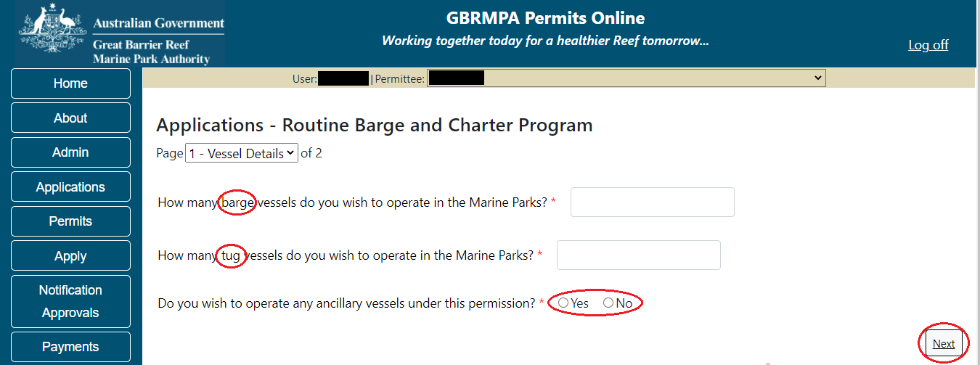
Figure 521 - Screenshot of Vessel Details page with a red circle around Barge, Tug, the Yes No radio buttons and the next button

Page 2 of the routine barge and charter vessel program application asks for details of the vessel to be used in the Marine Parks. This is optional at this stage, however details of the vessel must be provided to, and approved by the Reef Authority prior to operating the vessel in the Marine Parks.
You can notify the Reef Authority of your vessel details using the Notification Approvals menu on the left of screen later. You can use the Add New button to provide vessel details as part of your permit application if you wish. Select Add New.
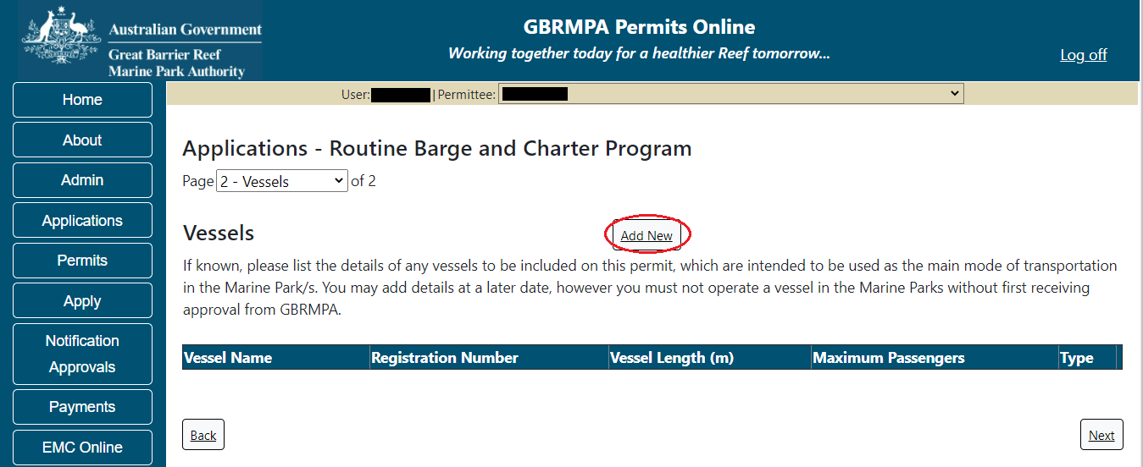
Figure 522 - Screenshot of Vessels screen with red circle around Add New button
An ‘Add New Vessel’ pop up window will appear. Add the details of your vessel in the fields provided, then select ‘Save’.
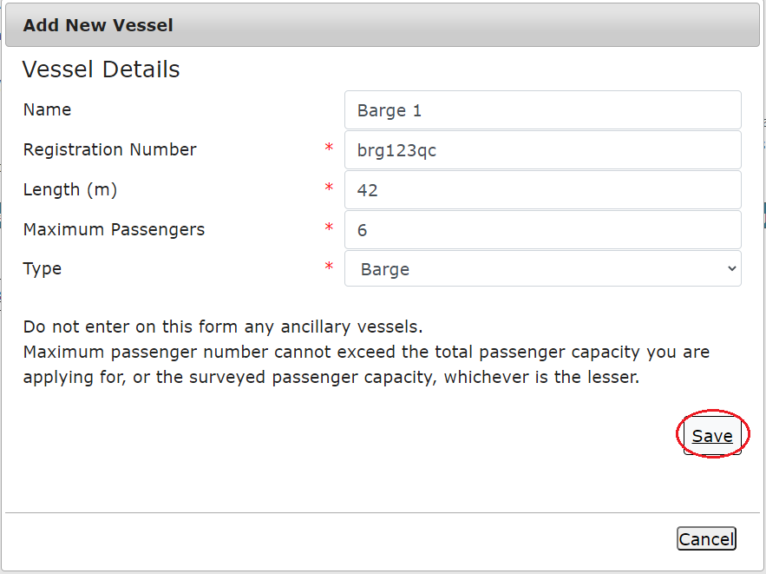
Figure 523 - Screenshot of Add New Vessel pop up window with information entered and a red circle around Save

The details will save on the page, with a ‘Remove’ button and an ‘Edit’ button. If you need to edit or remove the vessel, select the button needed and add the changes or remove the vessel. Select ‘Next’ to continue.
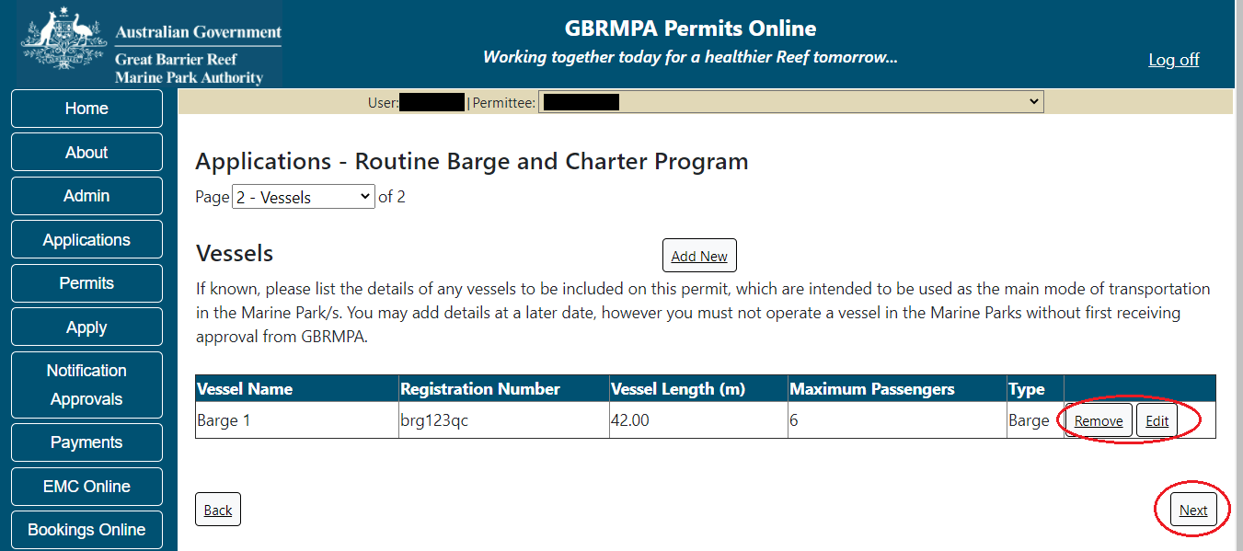
Figure 524 - Screenshot of Vehicles screen displaying Vessel details and a red circle around Remove and Edit buttons and a red circle around the Next button
To add details of any tug vessels select the ‘Add New’ button.
Figure 525 - Screenshot of Vessels screen with red circle around Add New button

An ‘Add New Vessel’ pop up window will appear. Add the details of your tug vessel in the fields provided, then select ‘Save’.
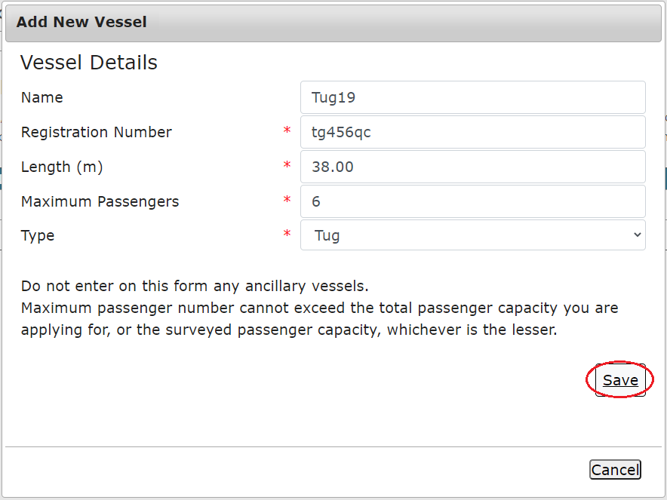
Figure 526 - Screenshot of Add New Vessel pop up window with information entered and a red circle around Save

The details will save on the page, with a ‘Remove’ button and an ‘Edit’ button. If you need to edit or remove the vessel, select the button needed and add the changes or remove the vessel. Select ‘Next’ to continue
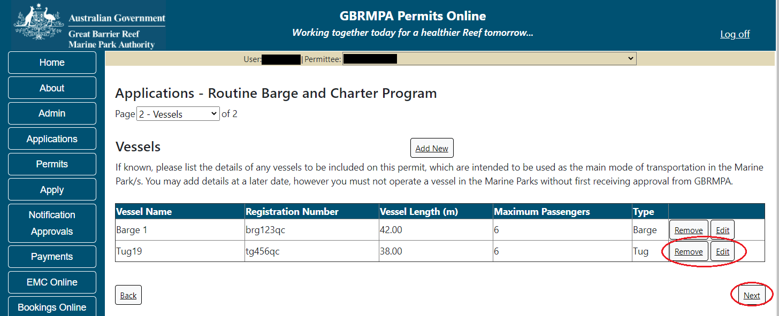
Figure 527 - Screenshot of Vehicles screen displaying Vessel details and a red circle around Remove and Edit buttons and a red circle around the Next button

Once you have completed the supporting information page select Next from the last page of the application questions, you will progress to an application summary screen with a number of options available via links or buttons. Select Next on the summary screen to progress to the Declarations screens. Other options include, editing or removing the application, changing or adding a primary contact or applicant, and a Save and Exit button.
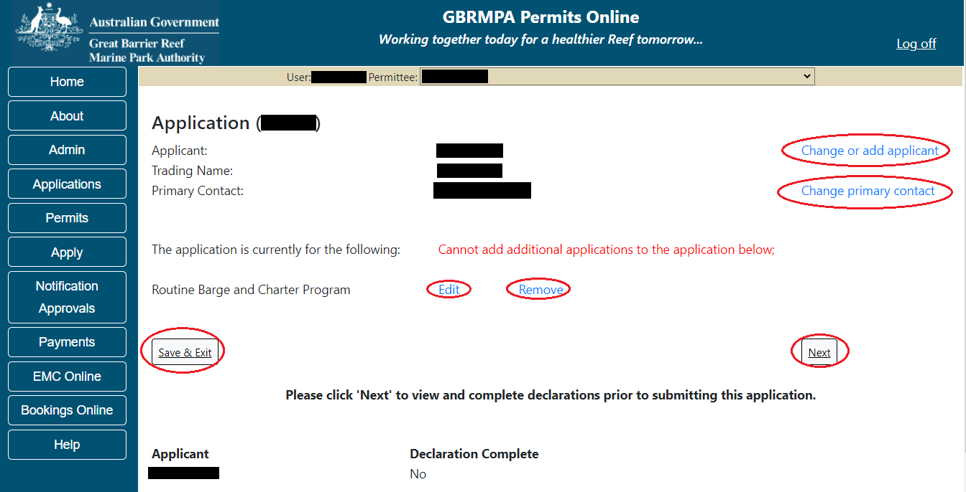
Figure 528 – Screenshot of Application Summary page with red circles around all options available

Completing a set of declarations is mandatory prior to submitting your application. To complete the declarations section of this application, you must either be the applicant, or if applying on behalf of an organisation / company / government agency, you must be a Director of that organisation / company / government agency. Authorised contacts cannot complete the declaration section, as it contains legally binding commitments in place of a physical signature.
Please read all questions carefully, provide a response to each, and select ‘Next’
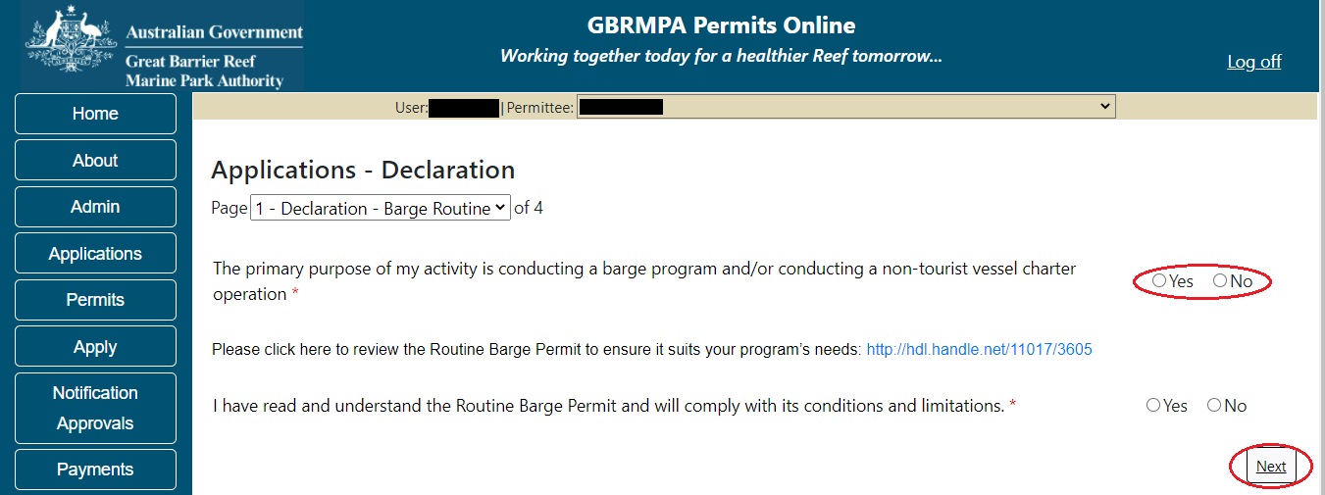
Figure 529 - Screenshot of Declarations page with red circle around Yes and No options and Next button
On the final page of declarations there is a submit button. Once the submit button is selected the application will be submitted to the Reef Authority and is no longer available to be edited. The status of the application on the Applications screen will then display ‘Submitted to GBRMPA’. The application’s Primary Contact will receive an emailed acknowledgement notice from a delegated Assessment Officer within 10 business days.
Figure 530 - Screenshot of Declarations screen with a red circle around the Submit button

Once you submit your application, you are reminded of your application number and provided further information on the assessment process.
Figure 531 - Screenshot of Permits Online Thank you for your application page with a red circle around reference number

Your application will appear in the Applications screen with the reference/application number also displayed. You have further options to view a summary of your application, email the Reef Authority or withdraw the application.
Figure 532 - Screenshot of Applications screen with a red circle around Application number, ‘Summary’, ‘Email’ and ‘Withdraw’ options

  - Tailored Barge / Cargo Vessel Program

Page 1 of the tailored Barge / Cargo vessel program application is the Environment Protection and Biodiversity Conservation Act page. This provides advice on matters of national environmental significance that must be considered when assessing an application. This screen is for your information only at this stage. Your assessing officer will contact you if it is determined to be relevant for your application.
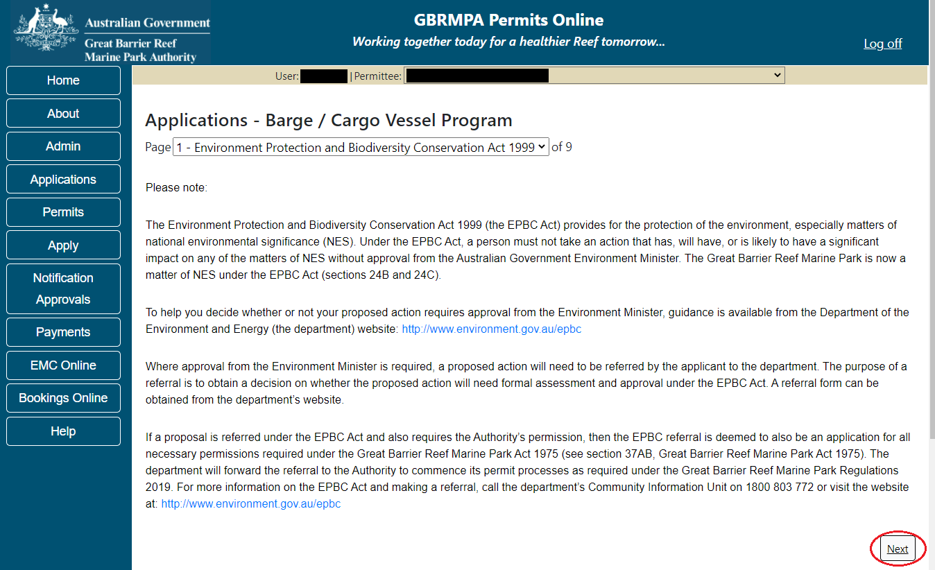
Figure 533 - Screenshot of Environment Protection and Biodiversity Conservation screen with a red circle around Next button

Links on the Environment Protection and Biodiversity Conservation page www.environment.gov.au/epbc will take you to the Department of Climate Change, Energy the Environment and Water site. Here you can find information about the Environment Protection and Biodiversity Conservation Act 1999 and your obligations under the Act.

Page 2 of the tailored Barge / Cargo vessel program application is the Vessel Details page. On this screen, enter details of how many barge, tug and/or cargo vessels you wish to apply for. Select Yes or No for the question Do you wish to operate any ancillary vessels under this permission. Select Next to continue.
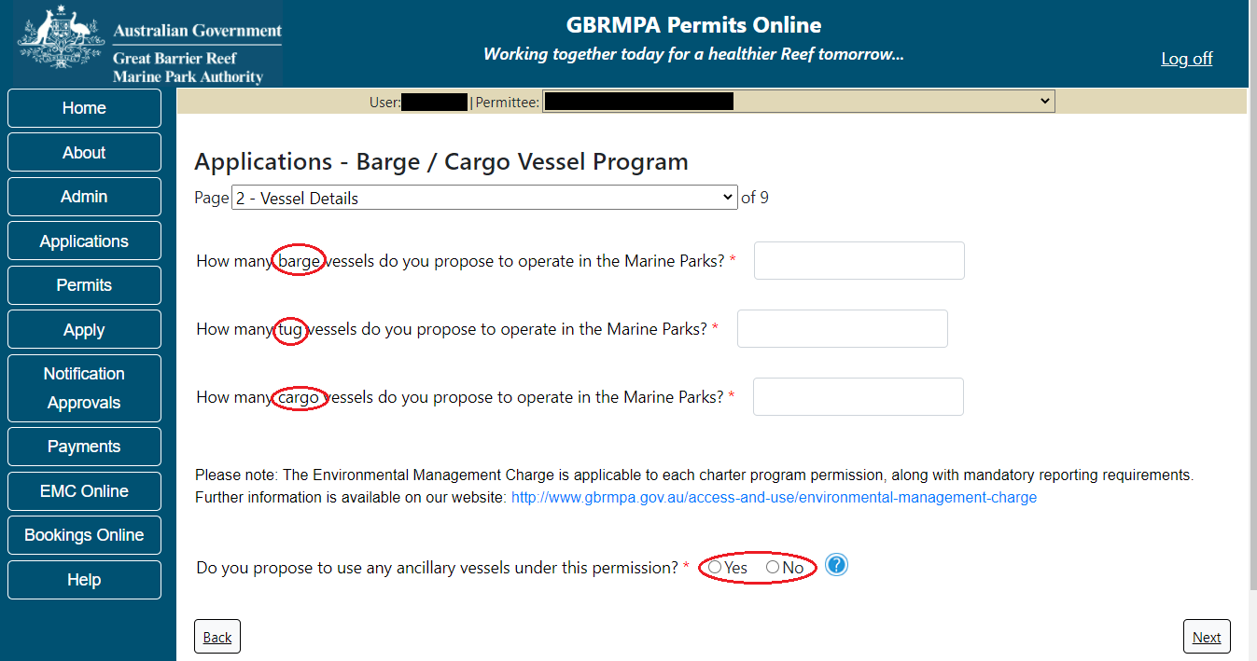
Figure 534 - Screenshot of Vessel Details page with red circles around Barge, Tug, cargo and the Yes No radio buttons

Depending on what is entered for how many barge, tug and/or cargo vessels you wish to apply for, will determine if further questions are produced. If a number greater than 0 is added for any of the vessel type’s barge, tug or cargo, the questions about whether a charter program is required for these vessel types will then appear.
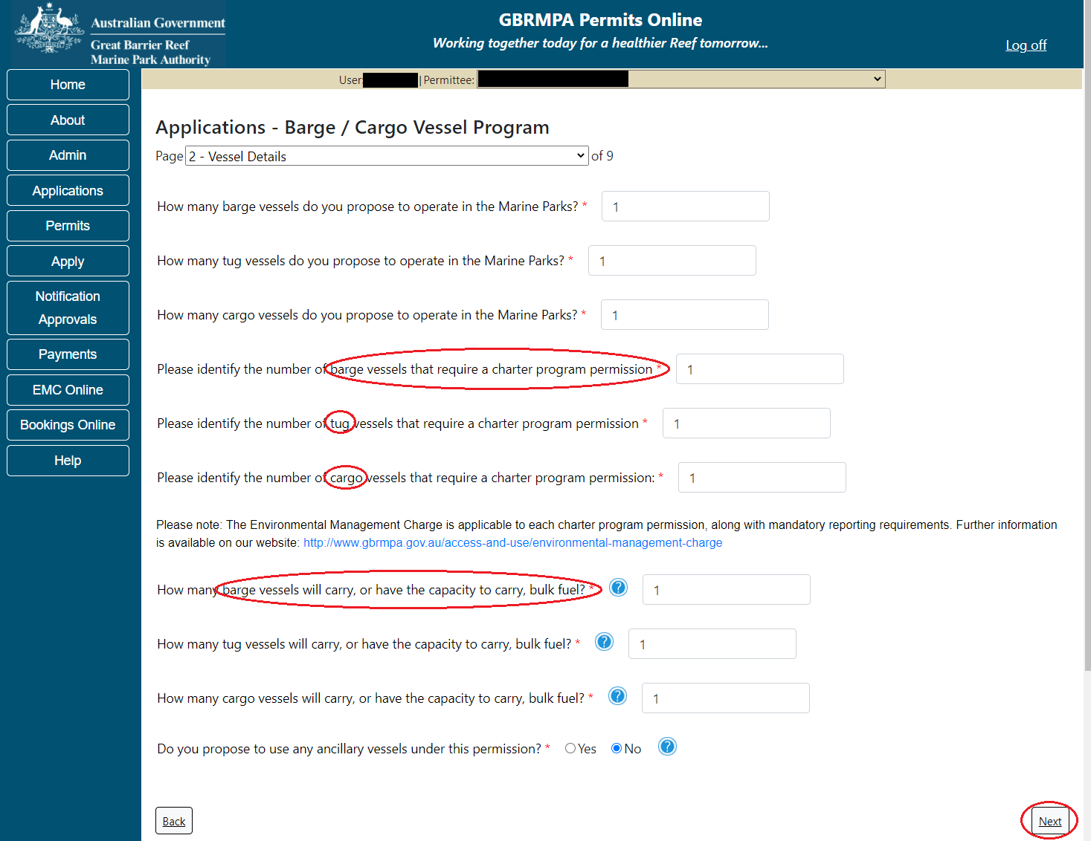
Figure 535 - Screenshot of Vessel Details page with red circles around wording
Depending on what is entered for how many barge, tug and/or cargo vessels you wish to apply for, will determine if further questions are produced about the capacity to carry bulk fuel. If a number greater than 0 is added for any of the vessel type’s barge, tug or cargo, the questions about whether the vessel has the capacity to carry bulk fuel will then appear.
Figure 536 - Screenshot of Vessel Details page with red circles around wording and a red circle around the Next button

Additional information charter program
If a charter program is required The Environmental Management Charge is applicable to each charter program permission, along with mandatory reporting requirements. Further information is available on our website http://www.gbrmpa.gov.au/access-and-use/environmental-management-charge

Additional information bulk fuel
Any vessel with the capacity to carry oil or chemicals in the cargo spaces and/or fuel carried in container(s) with a capacity greater than 3,000 Litres but not including the vessel's primary fuel tank.
Page 3 of the tailored Barge / Cargo vessel program application asks for details of the vessel to be used in the Marine Parks. This is optional at this stage, however details of the vessel must be provided to, and approved by the Reef Authority prior to operating the vessel in the Marine Parks.
You can notify the Reef Authority of your vessel details using the Notification Approvals menu on the left of screen later. You can use the Add New button to provide vessel details as part of your permit application if you wish. Select Add New.
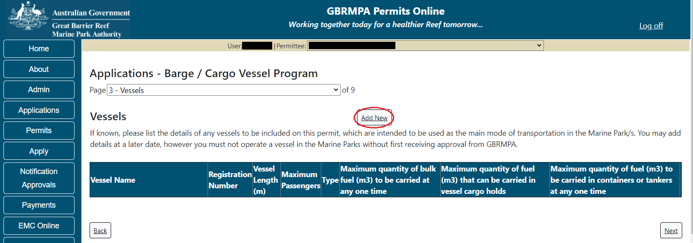
Figure 537 - Screenshot of Vessels screen with red circle around Add New button

An ‘Add New Vessel’ pop up window will appear. Add the details of your barge vessel in the fields provided, then select ‘Save’.
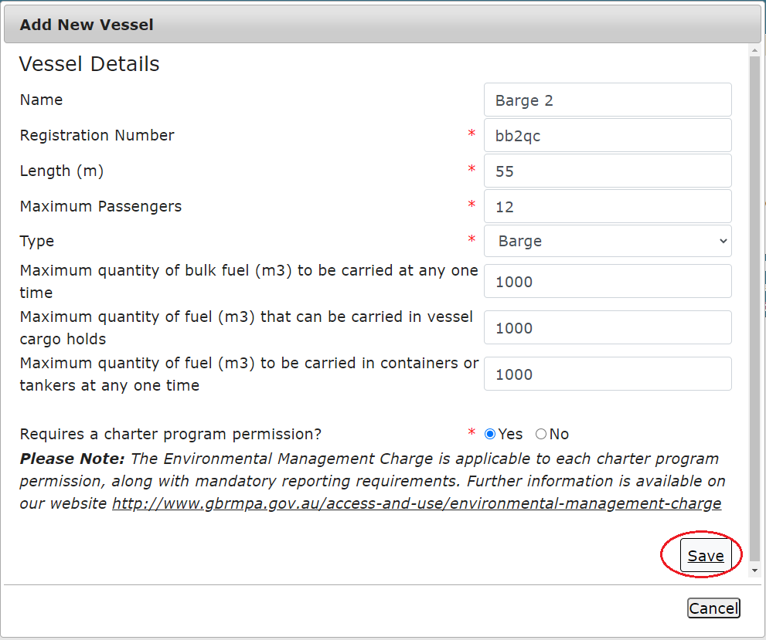
Figure 538 - Screenshot of Add New Vessel pop up window with information entered and a red circle around Save
The details will save on the page, with a ‘Remove’ button and an ‘Edit’ button. If you need to edit or remove the ship, select the button needed and add the changes or remove the vessel. Select ‘Next’ to continue or select the ‘Add New’ button to add details of a Cargo, Tug or Other vessel details as part of your permit application if you wish.
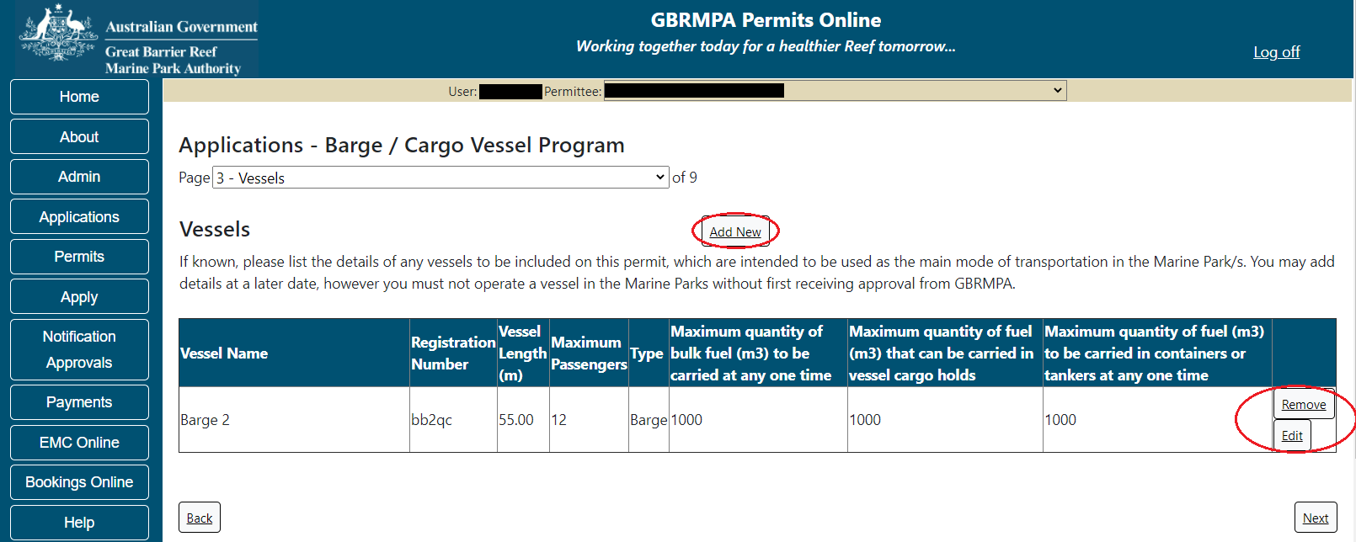
Figure 539 - Screenshot of Vehicles screen displaying Vessel details and a red circle around the Add New button and the Remove and Edit buttons

If the ‘Add New’ button is select the Add New Vessel pop up window will appear. In the Type field there are options for Barge, Cargo, Tug and Other. Select the vessel type you wish to add details for.
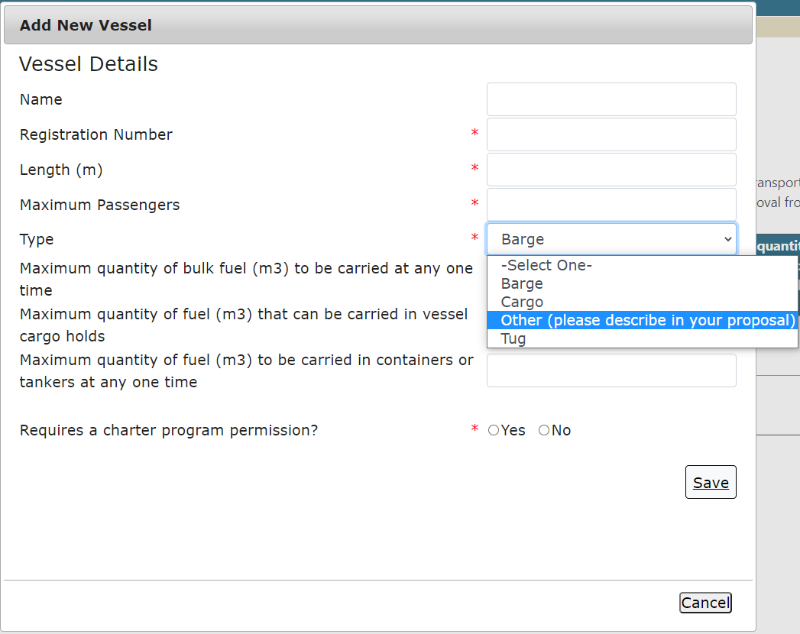
Figure 540 - Screenshot of Add New Vessel pop up window with the vessel Type list displaying
Add the remaining details of the cargo, tug or other vessel and select Save.
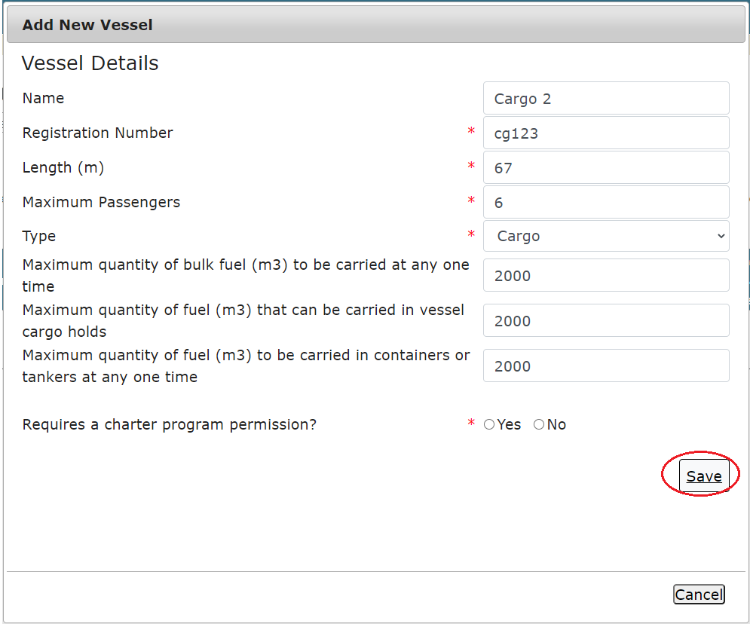
Figure 541 - Screenshot of Add New Vessel pop up window with information entered and a red circle around Save

The details will save on the page, with a ‘Remove’ button and an ‘Edit’ button. If you need to edit or remove the vessel, select the button needed and add the changes or remove the vessel. Select ‘Next’ to continue.
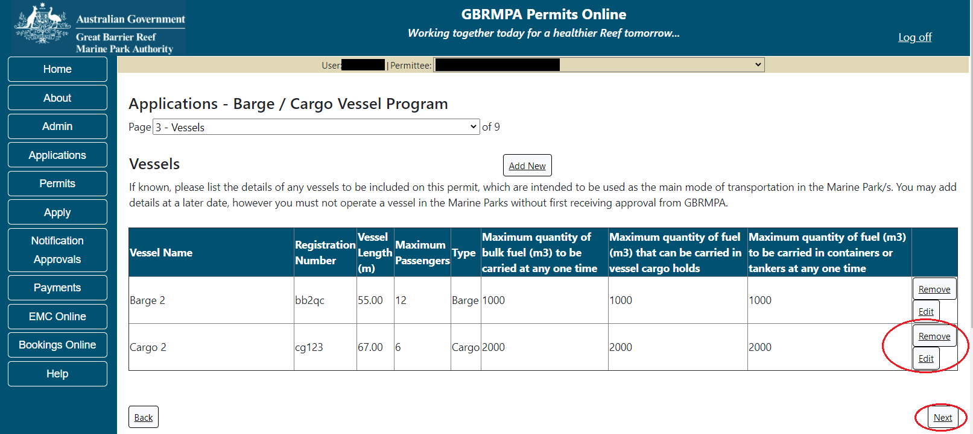
Figure 542 - Screenshot of Vehicles screen displaying Vessel details and a red circle around Remove and Edit buttons and a red circle around the Next button
Page 4 of the tailored Barge / Cargo vessel program application is the Vessel Documents page. Upload of the vessel documents is optional at this stage of the application, but submission may assist the assessment process.
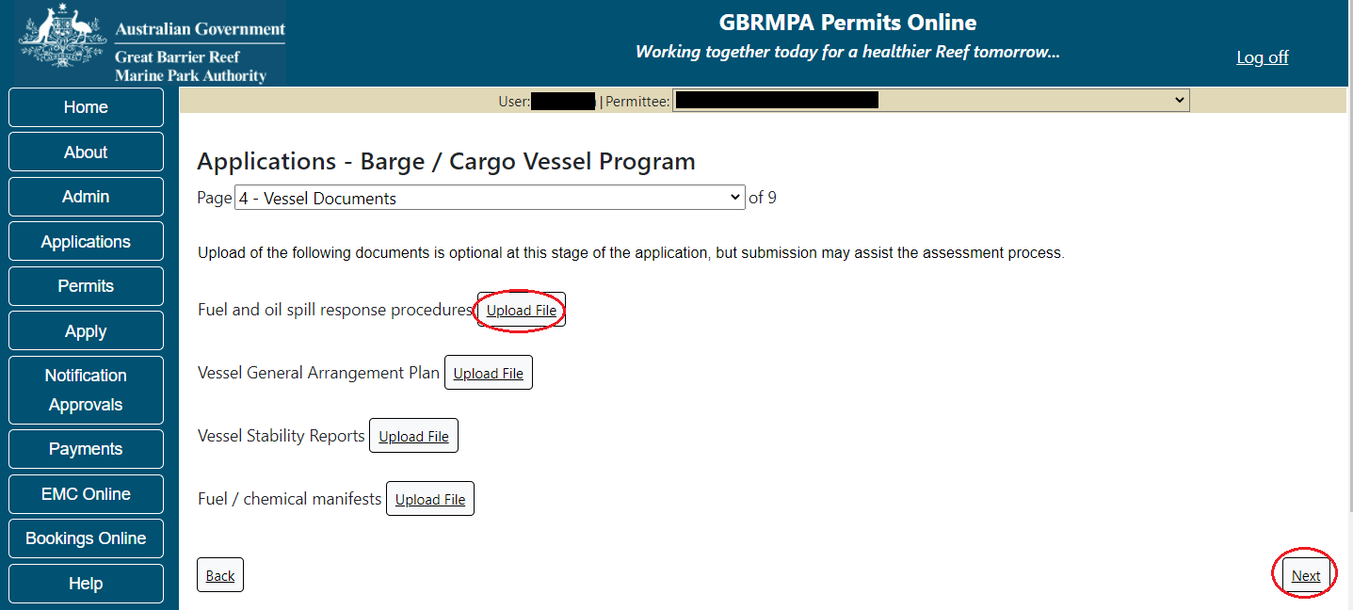
Figure 543 - Screenshot of Vessel Documents screen with a red circle around Uploaded File button and Next button

Page 5 of the tailored Barge / Cargo vessel program application is the Management / Areas page. Please select the Management Area/s in which you wish to operate. Select all if you wish to operate in all management areas, considering future use.
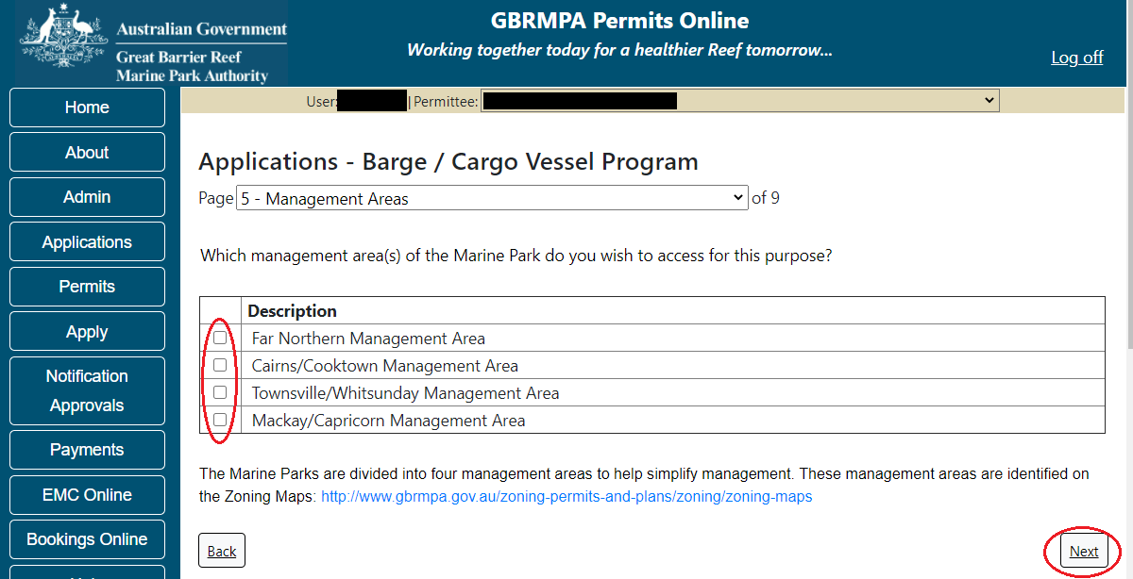
Figure 544 - Screenshot of Management Areas screen with a red circle around the management areas tick boxes and a red circle around the Next button

Page 6 of the tailored Barge / Cargo vessel program application is the special management areas page. Please select the Management Area/s in which you wish to operate. Select all if you wish to operate in all management areas, considering future use.
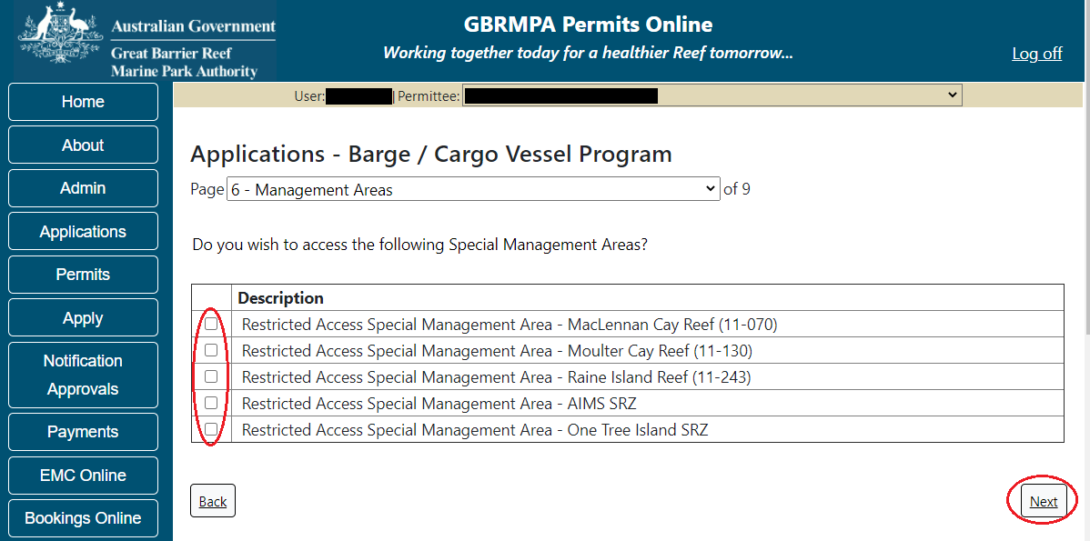
Figure 545 - Screenshot of Management Areas screen with a red circle around the special management areas tick boxes and a red circle around the Next button

Page 7 of the tailored Barge / Cargo vessel program application allows you to apply to access areas of the Marine Park more frequently than 2 days in every 7-day period. This option is only available outside the Plans of Management. If you wish to apply to visit a location more frequently than 2 in every 7-day period, select Add New.
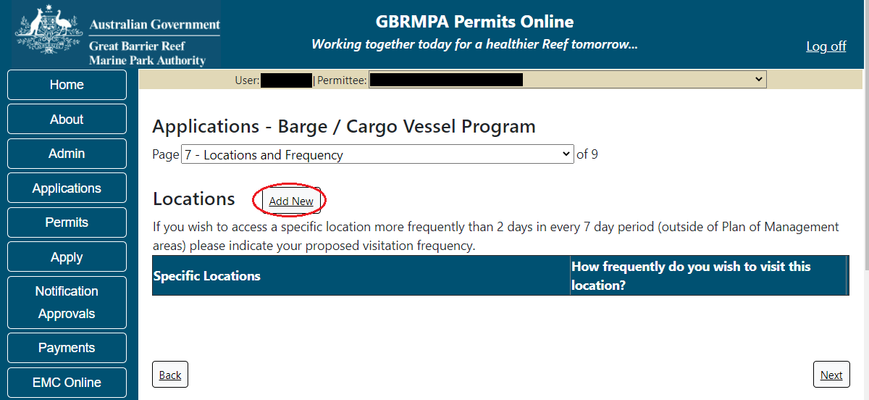
Figure 546 - Screenshot of Locations and Frequency screen with red circle around Add new button

If the Add New button is selected the Location pop up window will appear
Figure 547 - Screenshot of Location pop up window

Type in the name of the location you wish to visit in the location field. As you enter the name, the list will produce relevant matches. Select the location then select Save.
Figure 548 - Screenshot of Location pop up window with locations to select

Then add the frequency you wish to visit the location and select Save.
Figure 549 - Screenshot of Location pop up window with information completed and a red circle around the Save button

The location will be entered on the Location and Frequencies page within the locations table. If you wish to remove the location, select the Remove button next to the location.
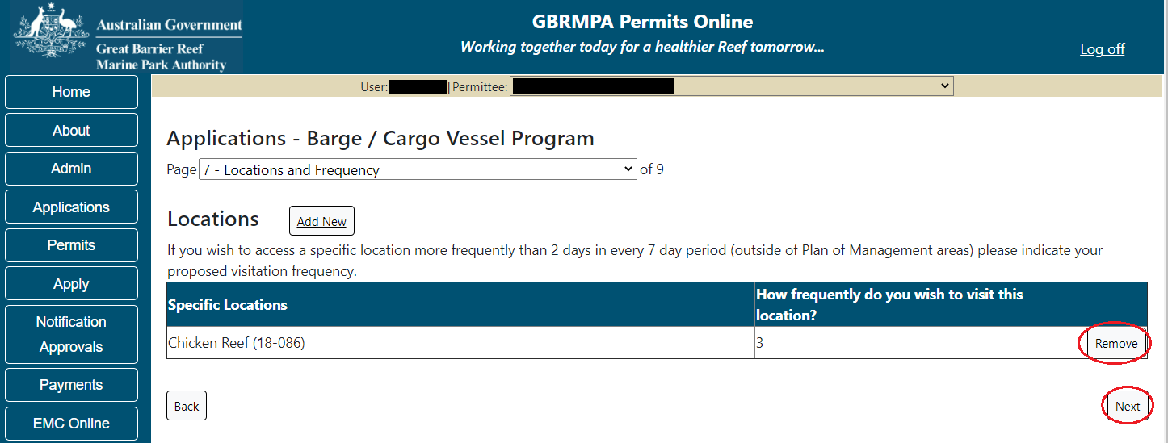
Figure 550 - Screenshot of Location and Frequency screen with information displaying, and a red circle around Remove and the Next button

Page 8 of the tailored Barge / Cargo vessel program application is the Additional State Access page. If you want to extend your operations to mainland or island national parks adjoining the Marine parks and/or rivers and streams between Mission Beach and the Starcke River, select yes and an area will appear with Please Specify details, add details of the islands or national parks and/or Rivers and streams you wish access. Please also indicate if you want to operate in the Green Island Recreational Area.
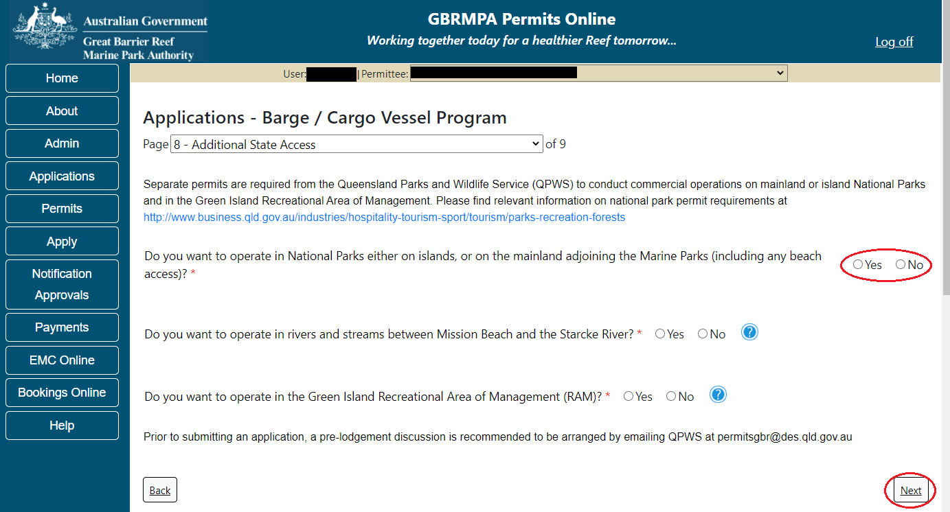
Figure 551 - Screenshot of Additional State Access screen with a red circle around the Yes and No buttons and a red circle around Next button

Page 9 of the tailored Barge / Cargo vessel program application provides opportunity for you to add any other information you feel will assist the Managing Agencies in assessing your application. Add supporting information by typing in the text field or upload a file if required. If a file is uploaded it will appear on the screen with the file name and an Remove to remove the file if the wrong file is selected.
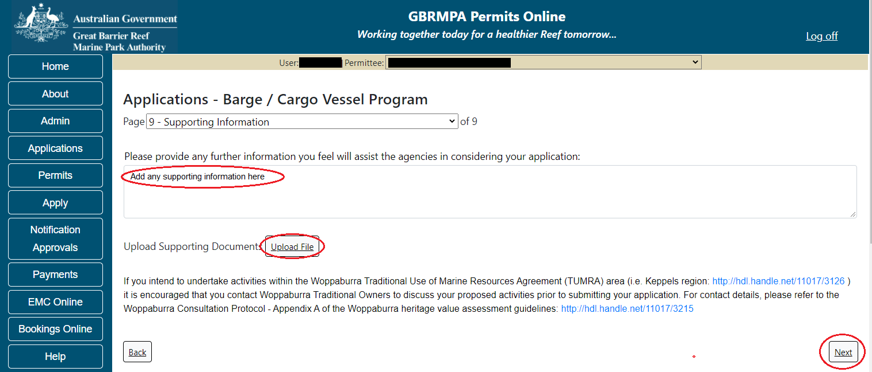
Figure 552 - Screenshot of Supporting Information screen with information displayed, a red circle around Add any supporting information here, the Uploaded File button and a red circle around Next button
Once you have completed the supporting information page select Next from the last page of the application questions, you will progress to an application summary screen with a number of options available via links or buttons. Select Next on the summary screen to progress to the Declarations screens.
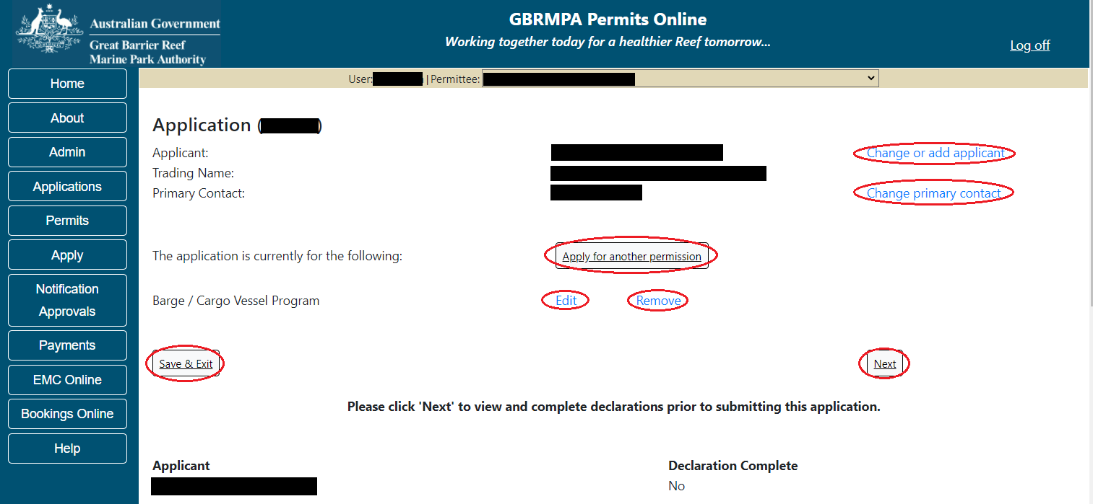
Figure 553 - Screenshot of Application Summary page with red circles around all options available

Additional Information - Summary screen, links and buttons;
- Change primary contact: If the change primary contact link is selected the applicant will progress to the primary contact page where the primary contact can be changed.

- Apply for another permission: If the Apply for another permission button is selected, the applicant will progress to the What are you seeking to do in the Marine Parks page where another permission type can be added. (e.g. add a mooring permission to the tourism permission).

- Edit: If edit is selected the application/permission will be reopened to apply any changes.

- Remove: If remove is selected the application/permission will be removed.

- Save & Exit: If the Save & Exit button is selected the applicant will progress to the applications screen.

- Next: If next is selected the applicant will progress to the submission process including declaring and submitting the application.

Completion of a set of declarations is mandatory prior to submitting your application. To complete the declarations section of this application, you must either be the applicant, or if applying on behalf of an organisation / company / government agency, you must be a Director of that organisation / company / government agency. Authorised contacts cannot complete the declaration section, as it contains legally binding commitments in place of a physical signature.
Please read all questions carefully, provide a response to each, and select Next.
Figure 554 - Screenshot of Declarations page with red circle around Yes and No options and Next button

On the final page of declarations there is a Submit button. Once the Submit button is selected, the application will be submitted to the Reef Authority and is no longer available to be edited. The status of the application on the Applications screen will then display ‘Submitted to GBRMPA’. The application’s Primary Contact will receive an emailed acknowledgement notice from a delegated Assessment Officer within 10 business days.
Figure 555 - Screenshot of Declarations screen with a red circle around the Submit button
Once you submit your application, you will be provided with a reference/application number and can follow the progress of your application via the Applications menu on the left.
Figure 556 - Screenshot of the Thank you for your application screen with a red circle around Reference number and a red circle around the open pdf button

Your application will appear in the Applications screen with the reference/application number also displayed. You have further options to view a summary of your application, email the Reef Authority or withdraw the application.
Figure 557 - Screenshot of Applications screen with a red circle around Application No., Summary, Email and Withdraw options

- Carrying Out Works
Apply – new permit application – carrying out works (dredging, dumping of spoil, reclamation..)
To apply for a Carrying our works application, select this option on the Apply – What are you seeking to do in the Marine Parks page.
Select the activity type option, Carrying out works (dregding, dumping of spoil, reclamation) and select Next.
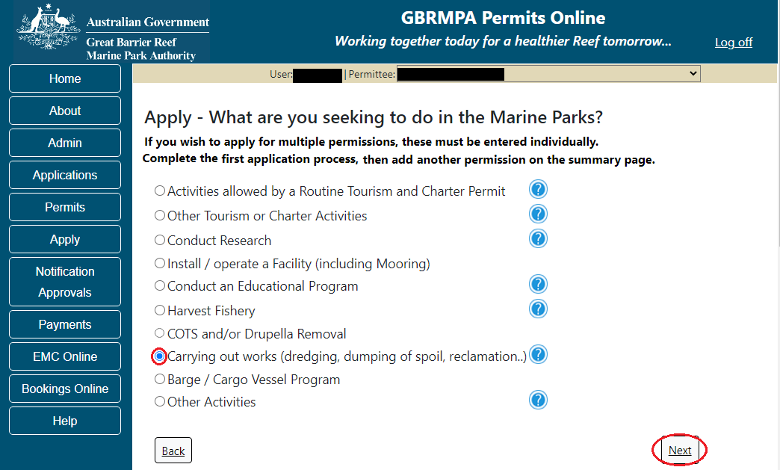
Figure 558 - Screenshot of Apply - What are you seeking to do in the Marine Parks screen with Carrying out works (dredging, dumping of spoil, reclamation) and a red circle around Next button. Select Next to progress to application questions.

Additional Information - Carrying out works
This includes carrying out works for a purpose that is consistent with the objective outlined in the Zoning Plan 2004 for the zone in which the works are proposed, including:
(i) dredging; or
(ii) dumping of spoil; or
(iii) reclamation; or
(iv) beach protection works; or
(v) harbour works.

Page 1 of Carrying out works application is the Environment Protection and Biodiversity Conservation Act page. This provides advice on matters of national environmental significance that must be considered when assessing an application. This screen is for your information only at this stage. Your assessing officer will contact you if it is determined to be relevant for your application.
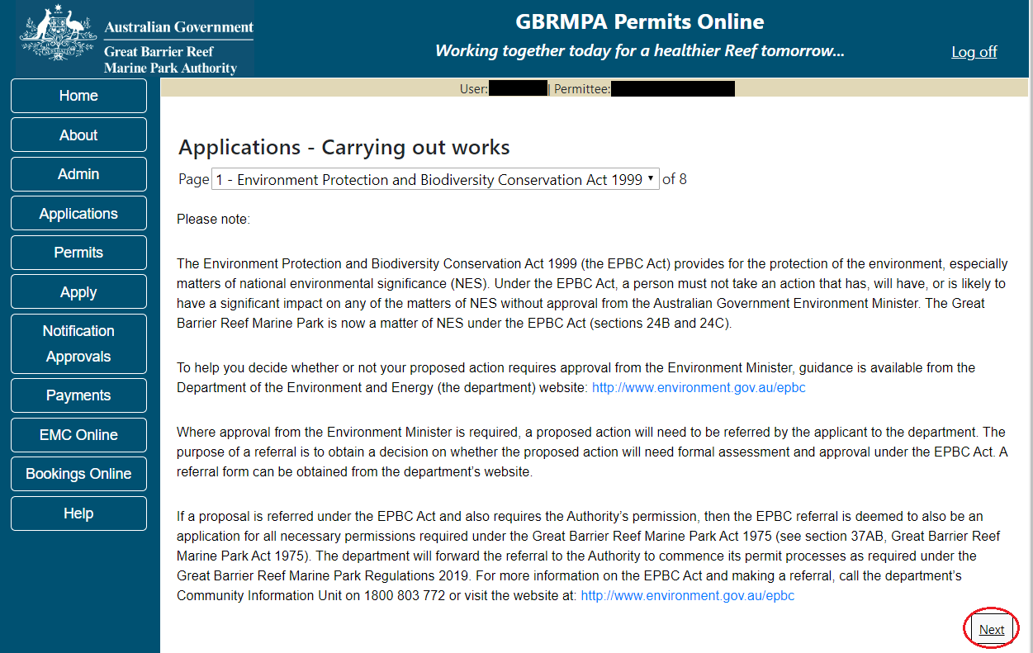
Figure 559 - Screenshot of Environment Protection and Biodiversity Conservation screen with a red circle around Next button

Links on the Environment Protection and Biodiversity Conservation page www.environment.gov.au/epbc will take you to the Department of Climate Change, Energy the Environment and Water site. Here you can find information about the Environment Protection and Biodiversity Conservation Act 1999 and your obligations under the Act.

Page 2 of the Carrying out works application is the Commercial Nature page. If your Carrying out works is of a commercial nature select Yes. If not select No. NOTE: Activities of a commercial nature are those from which a profit is drawn or intended to be drawn. After you make your selection, select Next to continue.
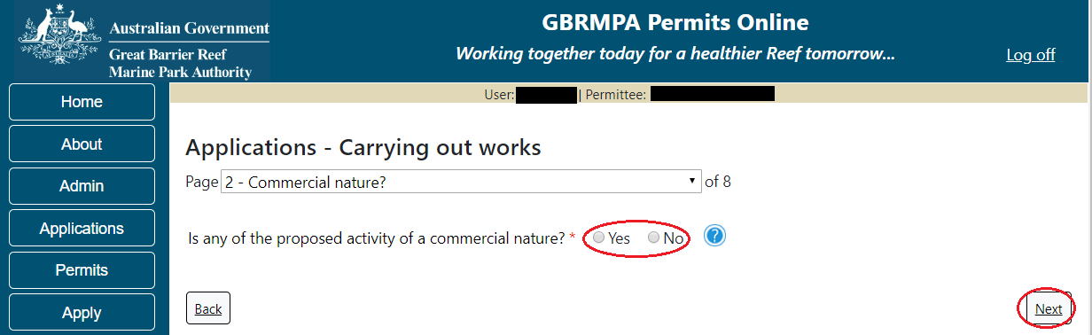
Figure 560 - Screenshot of Commercial Nature page with a red circle around Yes and No options and red circle around Next button

Page 3 of Carrying out works application is the Justification for Marine park use page. On this page add details of why you need to use the Marine Park? What alternatives have been considered and why have they been rules out? Once you have added your detail select Next to continue.
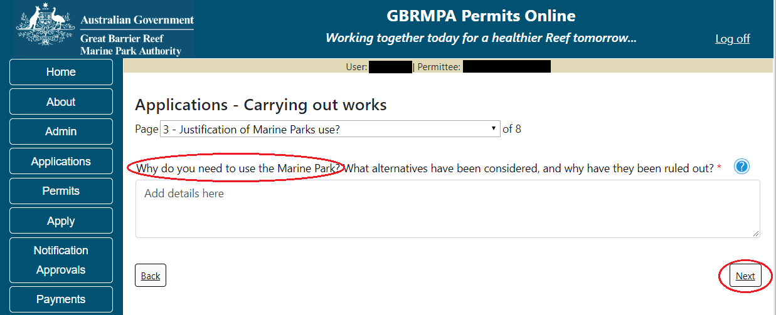
Figure 561 - Screenshot of Justification for Marine Park Use page with a red circle around question - Why do you need to use the Marine Park? Information displayed and red circle around Next button

Page 4 of Carrying out works application is the Other works details page. There are a number of mandatory fields on this page. Ensure you select the Works type, add a brief explanation and upload a design drawing are all mandatory fields.
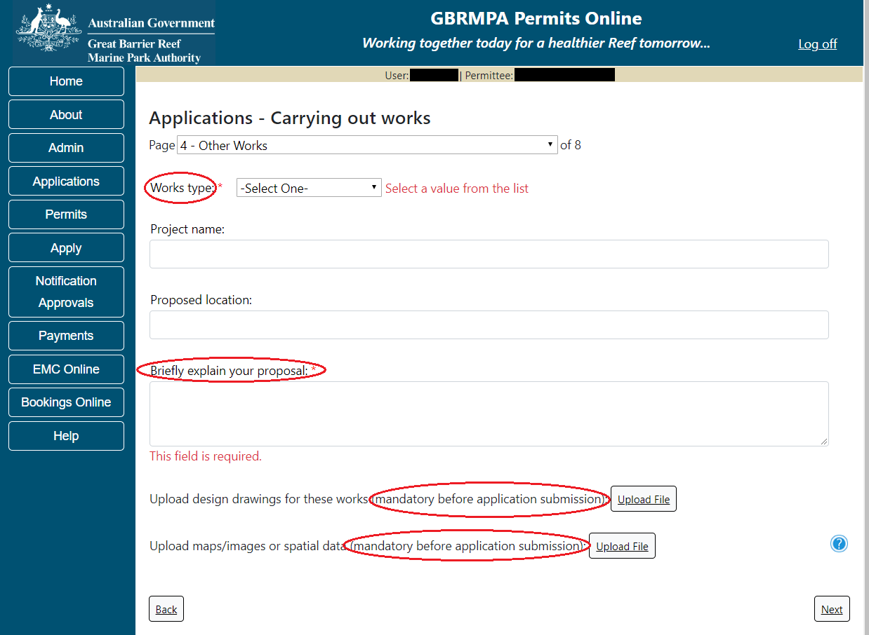
Figure 562 - Screenshot of Other Works page with red circles around all mandatory fields (Works Type, Briefly explain your proposal, Upload design drawings and Upload maps/images)

Additional Information - Carrying out works - Map
A PDF map showing the proposed footprint of the works, overlaid on a satellite image using the highest resolution imagery possible must be provided with your application.

Fill in all details required including the mandatory fields and the Project Name, Project Location and upload any maps or spatial data. Select Next once all information is completed.
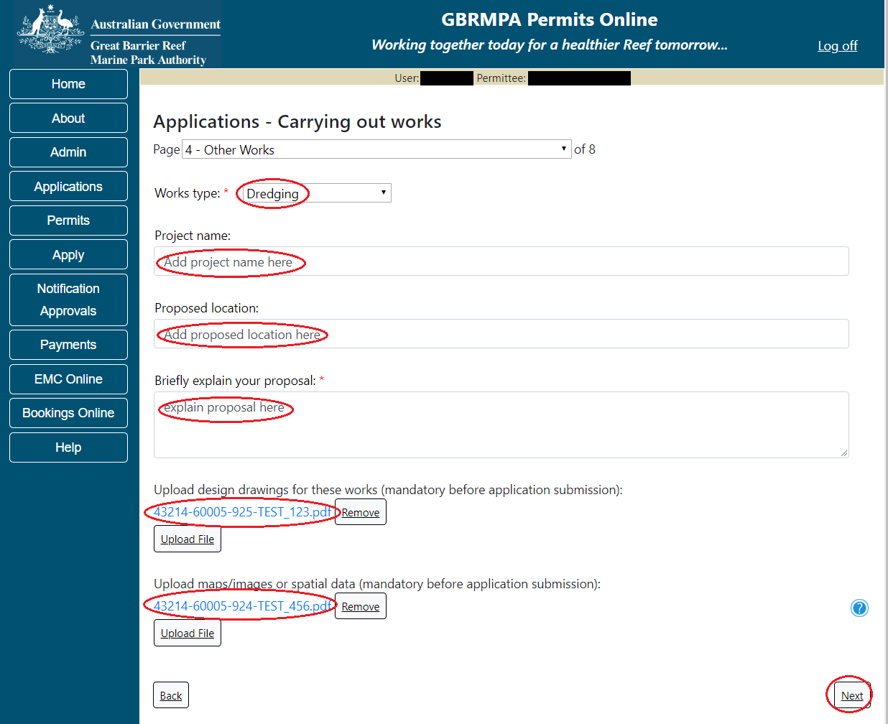
Figure 563 - Screenshot of Other Works page with red circles around all mandatory fields. Information displayed in each field, red circle around Next button

Page 5 of Carrying out works application is the Location and Co-Ordinates page. To add the Latitude and longitude of the proposed works select the Add New button
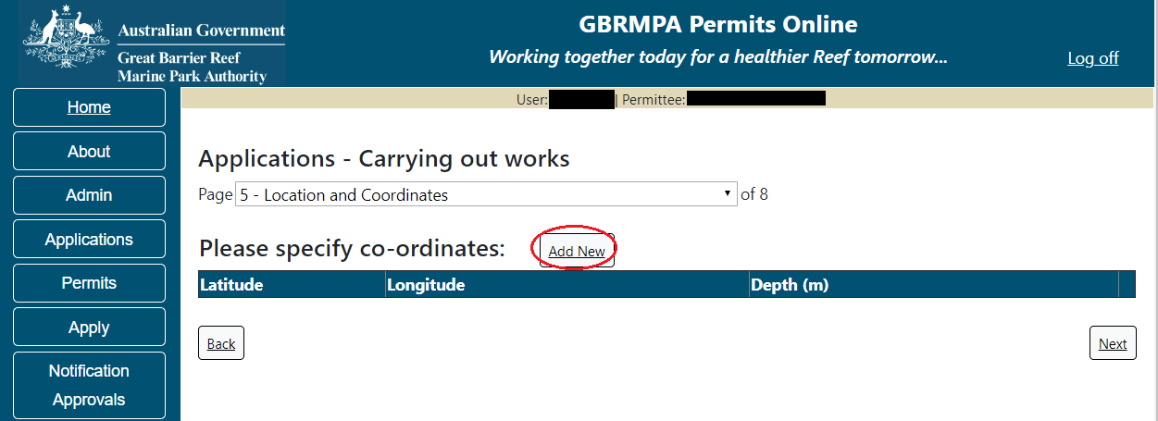
Figure 564 - Screenshot of Locations and Co-ordinates screen with a red circle around Add New button

The Add Latitude / Longitude pop up window will appear. If a location is entered that is not within the latitude and longitude for the Great Barrier Reef, the system will produce an error.
The Latitude field must be between -30.000000 and -10.000000. The Longitude must be between 135 and 155. Add the co-ordinates in Decimal Degrees.
Figure 565 - Screenshot of Add Latitude / Longitude pop up window displaying validations for Co-Ordinates

Co-ordinates need to be entered in Decimal Degrees. There is a link to a conversion tool within the Add Latitude / Longitude pop up window. If you need to use the conversion tool, select the link and you will progress to the Australian Antarctic Data Centre website which has the conversion tool.
Figure 566 - Screenshot of Add Latitude / Longitude pop up window with red circle around conversion tool hyperlink

Once on the site enter Degrees Minutes and Seconds into the conversion tool and select Click for conversion. You will be presented with a Decimal Degrees figure.
Figure 567 - Screenshot of Antarctic Division home page with Conversion calculator displayed

Enter the co-ordinates to 6 decimal places, add depth and select Save.
Figure 568 - Screenshot of Add Latitude / Longitude pop up window with Co-ordinates completed and red circle around Save button

Your co-ordinate will be displayed on the screen. A Remove button will also appear. If you wish to remove the co-ordinate select Remove and it will be deleted from your application. If you have multiple co-ordinates add all co-ordinates for the application. Select Next to continue.
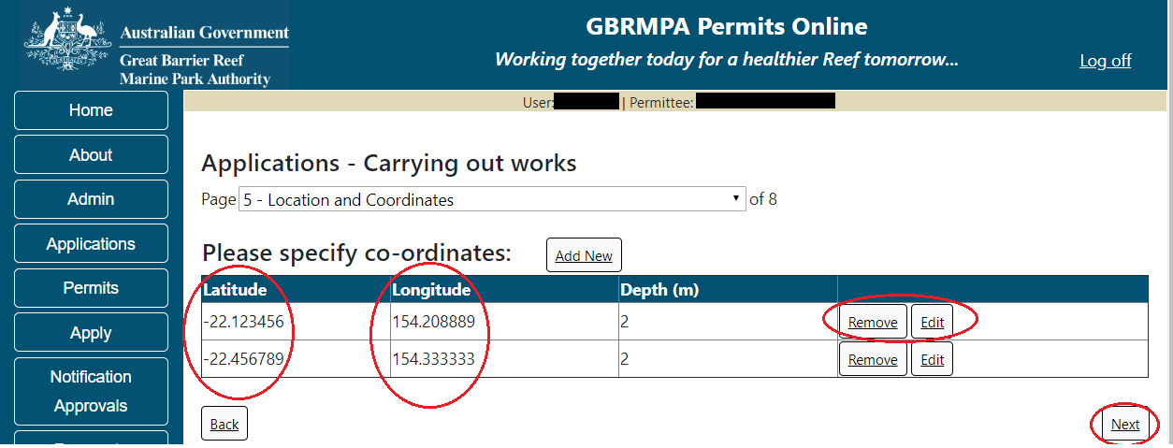
Figure 569 - Screenshot of Location and Co-ordinates screen with information displayed and a red circle around Remove button and red circle around Next button

Page 6 of Carrying out works application is the Environmental Management Plan (EMP) page. Preparing an EMP may be a condition of your Marine Parks permit. The condition of your permit will outline when you are required to submit your EMP if you do not upload one at this stage. Further information on EMPs is located on the next page and on the Reef Authority website. If you have an EMP for your facility select the Upload File button.
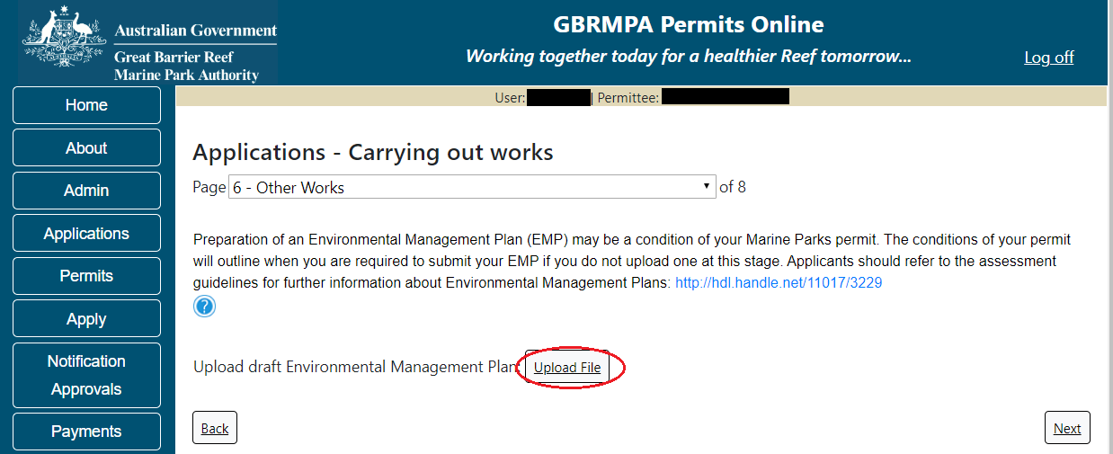
Figure 570 - Screenshot of Install / operate a Facility page with a red circle around the Upload File button

Select the file from your computer files and then select Save. The file will appear with the file name. Once you have loaded your file/s select Next to continue.
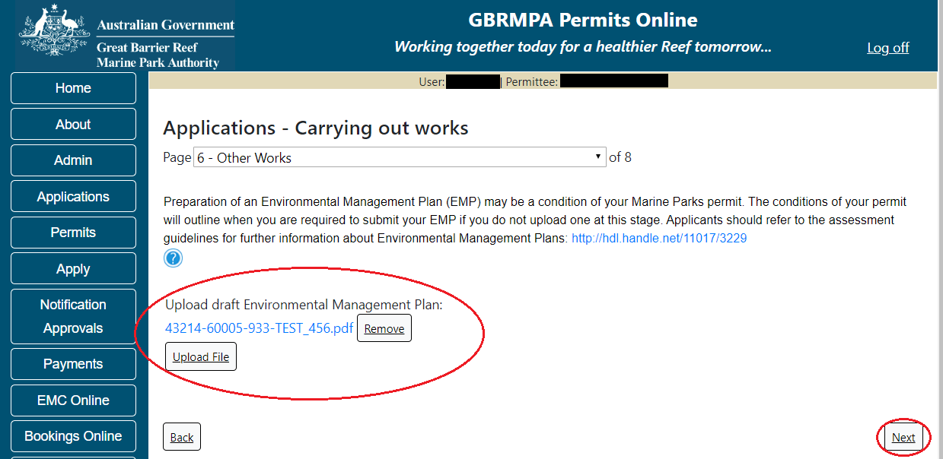
Figure 571 - Screenshot of Install / operate a Facility page with a red circle around Uploaded File and red circle around Next button

Information Environmental Management Plans (EMP)
A draft Environmental Management Plan should include at a minimum:
- Description of physical site characteristics including water depths, type of substrate, physical conditions (wave, wind, currents)
- Description of biological site characteristics, including habitat types, species present and how these species use the site (feeding, reproduction, rest, transit)
- Description of social site characteristics, including other facilities and uses (both recreational and commercial) within 1km of the proposed location
- Evaluation of whether the site may have historic heritage values
- Description of Indigenous heritage values associated with the site
- Construction and installation schedule - proposed timeframes of the project
- Description of the methods and materials to be used in transporting materials, installing the facility and disposing of wastes
- Description of the activities proposed to take place on or around the facility once operational, including any ancillary equipment or vessels that will be stored at the facility
- Inspection and maintenance schedule including description of how (logistically) the facility will be serviced
- Proposed method of removal, including an explanation of how the facility has been designed for easy removal with minimal impact on the surrounding environment
- Details of any proposed reef health monitoring programs.

- Risk assessment using the Reef Authority’s Risk Assessment Procedure
http://hdl.handle.net/11017/3231 including:
(a) Values which may be impacted (directly, indirectly, consequentially or from cumulative pressures),
(b) Risks posed to the values by these potential impacts,
(c) How risks will be avoided, mitigated or offset to achieve no net loss of Marine Park values.

Page 6 of Carrying out works application is the Other Works – Add Another Activity page. If you have further Works activities for the same Project you can select Add Another Activity and you will be able to fill in details of these works on the same application.
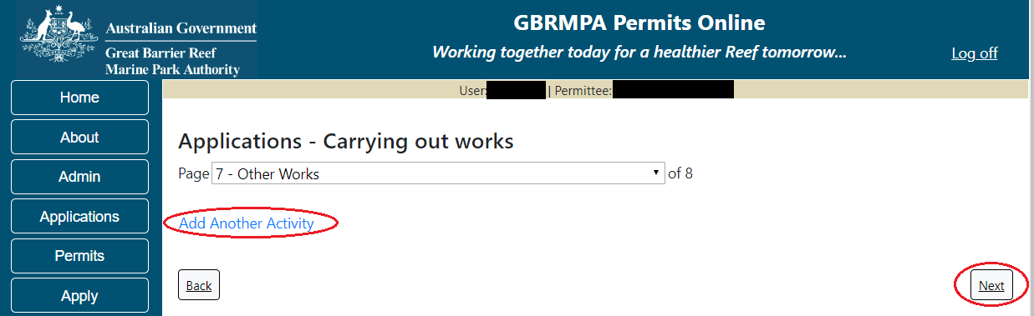
Figure 572 - Screenshot of Other Works Summary page with red circles around options for Add Another Activity hyperlink, red circle around Next button

Page 8 of the Carrying out works application provides opportunity for you to add any other information you feel will assist the Managing Agencies in assessing your application. Add supporting information by typing in the text field or upload a file if required. If a file is uploaded it will appear on the screen with the file name and a Remove button to remove the file if the wrong file is selected. Select Next to continue.
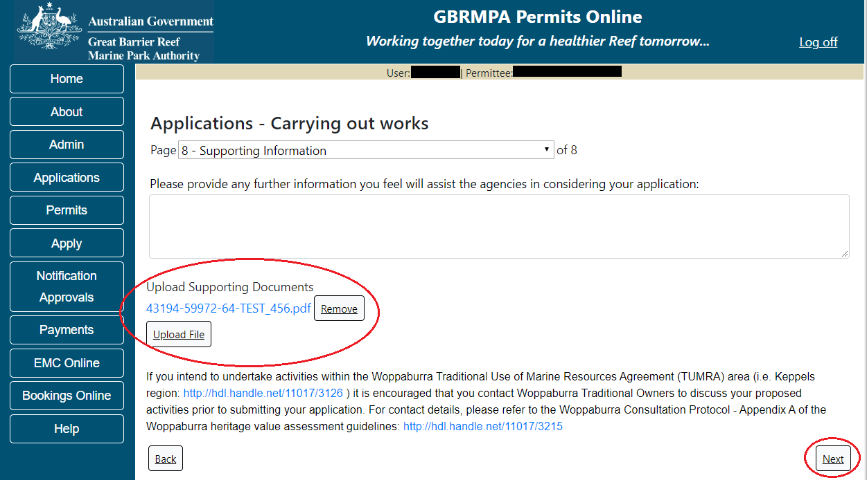
Figure 573 - Screenshot of Supporting Information screen with information entered and a red circle around Please provide details section, red circles around Uploaded File and Next button

Once you have completed the supporting information page select Next from the last page of the application questions, you will progress to an application summary screen with a number of options available via links or buttons. Select Next on the summary screen to progress to the Declarations screens.
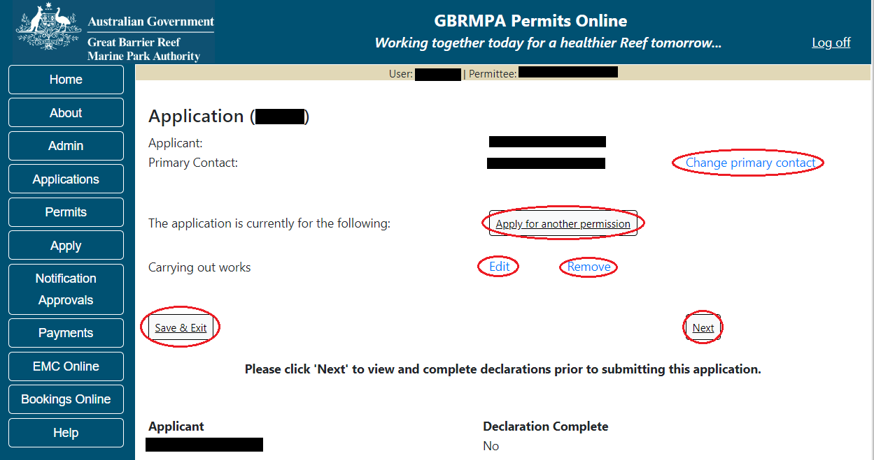
Figure 574 - Screenshot of Application Summary page with red circles around all options available

Additional Information - Summary screen, links and buttons;
- Change primary contact: If the change primary contact link is selected the applicant will progress to the primary contact page where the primary contact can be changed.

- Apply for another permission: If the Apply for another permission button is selected, the applicant will progress to the What are you seeking to do in the Marine Parks page where another permission type can be added. (e.g. add a mooring or facility permission to the carrying out works permission).

- Edit: If edit is selected the application/permission will be reopened to apply any changes.

- Remove: If remove is selected the application/permission will be removed.

- Save & Exit: If the Save & Exit button is selected the applicant will progress to the applications screen.

- Next: If next is selected the applicant will progress to the submission process including declaring and submitting the application.

Completion of a set of declarations is mandatory prior to submitting your application. To complete the declarations section of this application, you must either be the applicant, or if applying on behalf of an organisation / company / government agency, you must be a Director of that organisation / company / government agency. Authorised contacts cannot complete the declaration section, as it contains legally binding commitments in place of a physical signature.
Please read all questions carefully, provide a response to each, and select Next.
Figure 575 - Screenshot of Declarations page with red circle around Yes and No options and Next button

On the final page of declarations there is a Submit button. Once the Submit button is selected, the application will be submitted to the Reef Authority and is no longer available to be edited. The status of the application on the Applications screen will then display ‘Submitted to GBRMPA’. The application’s Primary Contact will receive an emailed acknowledgement notice from a delegated Assessment Officer within 10 business days.
Figure 576 - Screenshot of Declarations screen with a red circle around the Submit button
Once you submit your application, you will be provided with a reference/application number and can follow the progress of your application via the Applications menu on the left.
Figure 577 - Screenshot of the Thank you for your application screen with a red circle around Reference number and a red circle around the open pdf button

Your application will appear in the Applications screen with the reference/application number also displayed. You have further options to view a summary of your application, email the Reef Authority or withdraw the application.
Figure 578 - Screenshot of Applications screen with a red circle around Application No., Summary, Email and Withdraw options

- Other Activities
Apply – new permit – other activities
The Other Activities application has a number of different application types associated. These include Filming or photography and an Other application type to cover any miscellaneous application types not listed. Select Other Activities then select Next.
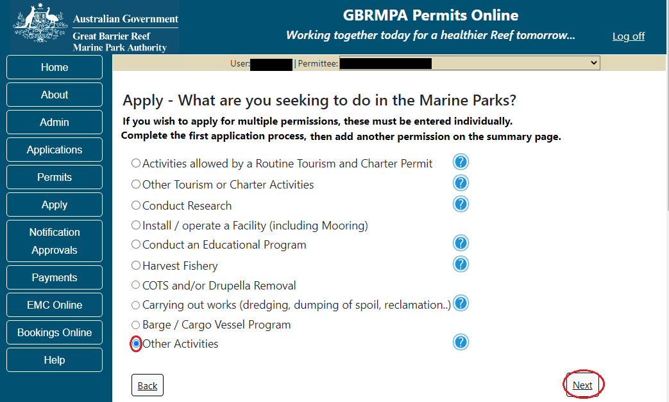
Figure 579 - Screenshot of Other Activities menu with Other Activities selected and a red circle around the Next button

The Other Activities types sub menu will appear with options for filming and/or photography and an Other application type. Select which Other type you wish to apply for then select Next.
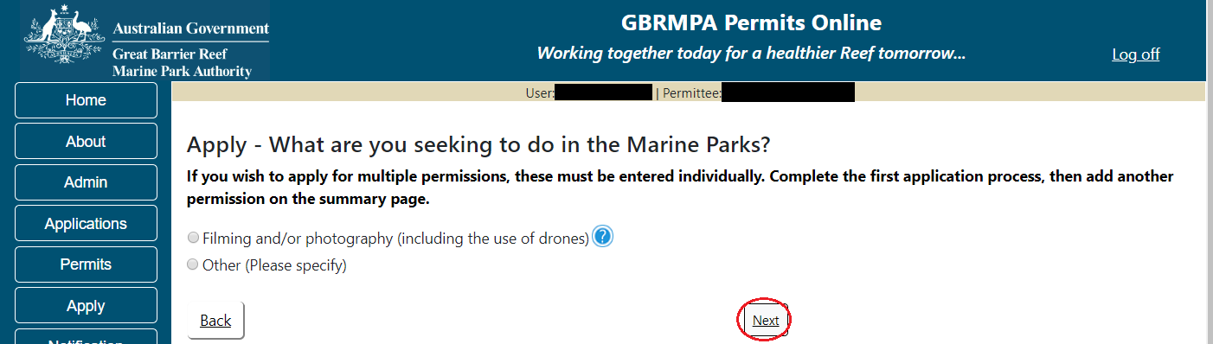
Figure 580 - Screenshot of Other Activities sub menu with a red circle around the Next button

  - Filming and/or Photography (Including Drones)
Apply – new permit application – other activities – filming and/or photography (including the use of drones)
To apply for an Other Activities application select this option on the Apply – What are you seeking to do in the Marine Parks page.
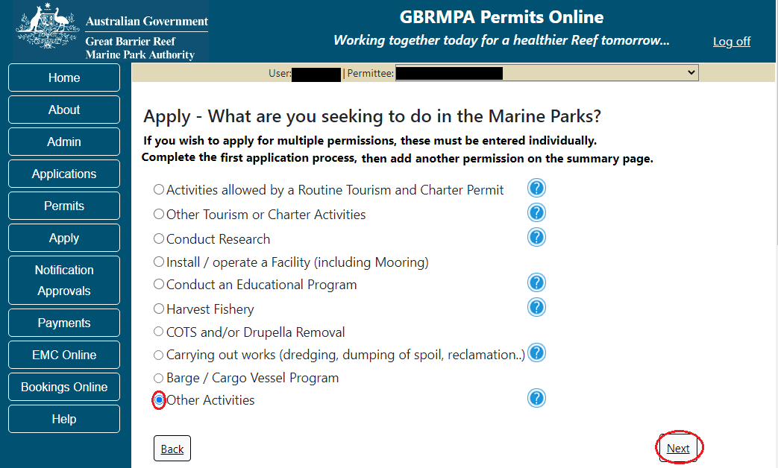
Figure 581 - Screenshot of Apply - What are you seeking to do in the Marine Parks screen with Other Activities and a red circle around the Next button

You will progress to the application sub type menu with further options to select the type of Other Activity you wish to apply for. Select the option for Filming and/or photography (including the use of drones). Select Next to progress to application questions.
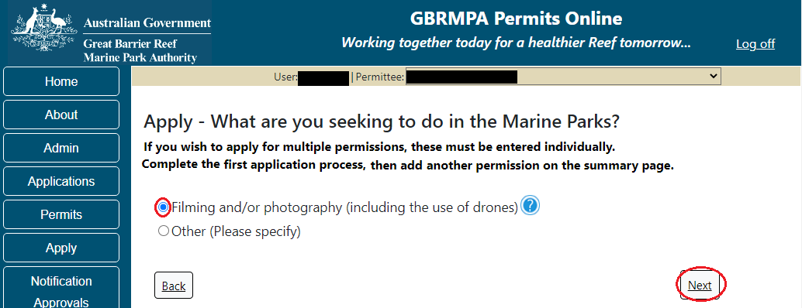
Figure 582 - Screenshot of Apply - What are you seeking to do in the Marine Parks – Other Activities sub menu with Filming and/or photography (including the use of drones) and a red circle around Next button

Information Filming and/or photography (including the use of drones)
Under the Great Barrier Reef Marine Park Zoning Plan 2003, photography, filming and/or sound recording on or under the water is allowed without a permit in most areas of the Marine Park if it is done in a way that has, or is likely to have, negligible impact on the Marine Park.
However, a permit is required if your activities involve;
• The placing of structures
• The placing of certain equipment on coral / seagrass or in close proximity to coral and seagrass
• Special effects such as simulated explosions
• Introduction of biological and/or artificial props
• The need to manage other Marine Park users during filming (for example, temporarily excluding some users from the filming location)
• Manipulation of habitat
• Handling of marine life
• Cetaceans (i.e. whales and dolphins)
• Highly protected areas
• Anything that may have an impact on the physical, social, cultural or heritage value of the Marine Park

Page 1 of Filming and/or photography application is the Environment Protection and Biodiversity Conservation Act page. This provides advice on matters of national environmental significance that must be considered when assessing an application. This screen is for your information only at this stage. Your assessing officer will contact you if it is determined to be relevant for your application.
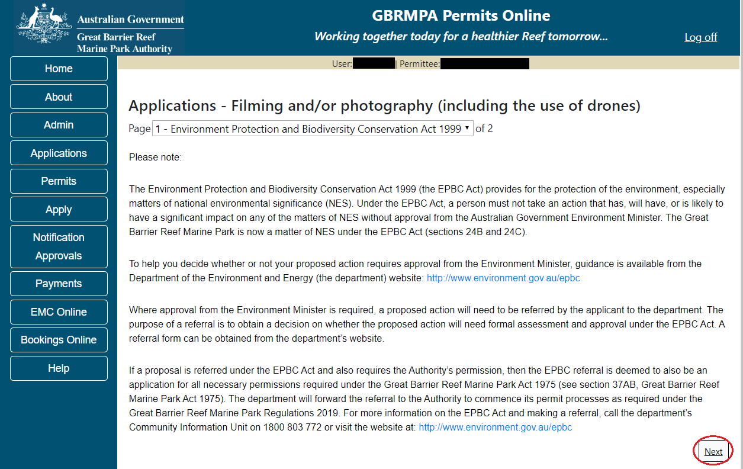
Figure 583 - Screenshot of Environment Protection and Biodiversity Conservation screen with a red circle around Next button

Links on the Environment Protection and Biodiversity Conservation page www.environment.gov.au/epbc will take you to the Department of Climate Change, Energy the Environment and Water site. Here you can find information about the Environment Protection and Biodiversity Conservation Act 1999 and your obligations under the Act.

Page 2 of the Filming and/or photography application provides opportunity for you to add any other information you feel will assist the Managing Agencies in assessing your application. Add supporting information by typing in the text field or upload a file if required by selecting the Upload File button.
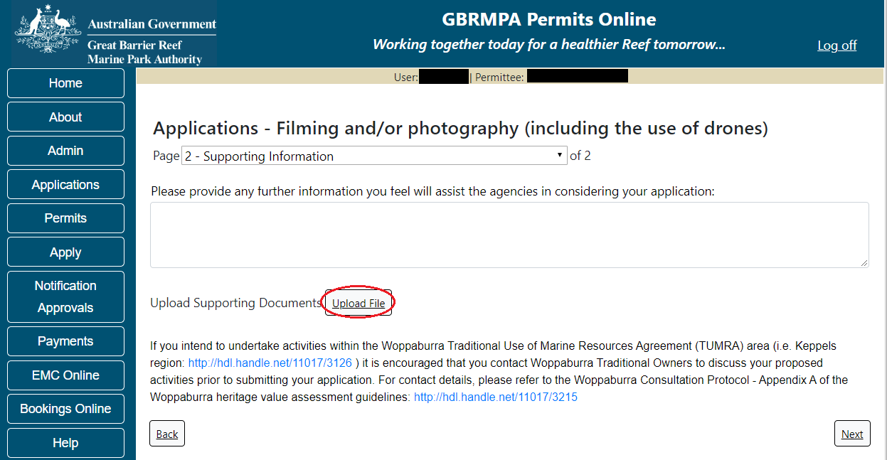
Figure 584 - Screenshot of Supporting Information screen with a red circle around the Upload File button

If a file is uploaded it will appear on the screen with the file name and a Remove button to remove the file if the wrong file is selected.
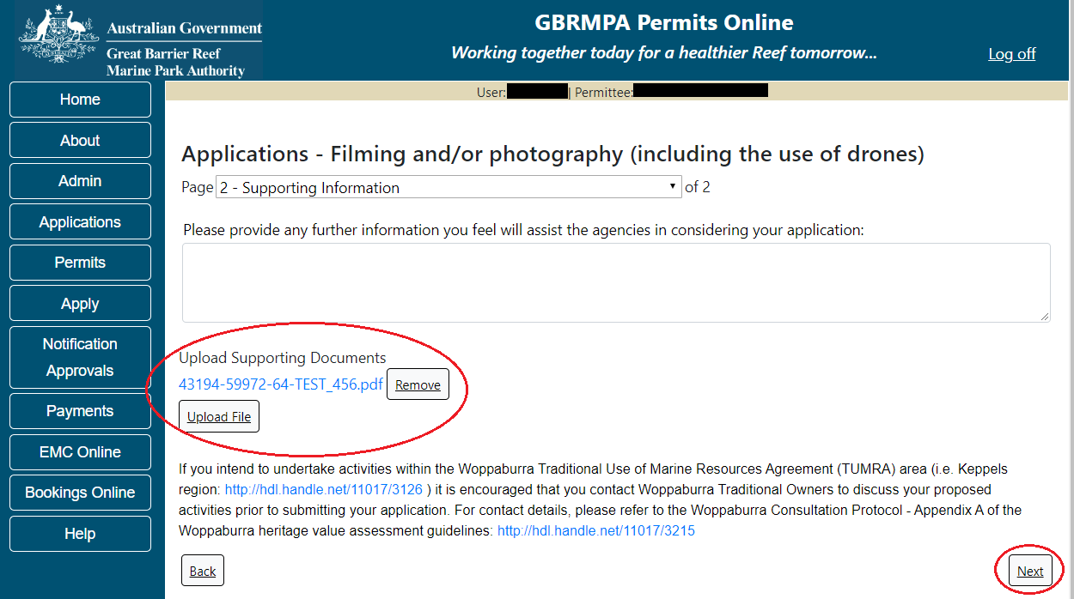
Figure 585 - Screenshot of Supporting Information screen with information entered and a red circle Uploaded File and Next button
Once you have completed the supporting information page select Next from the last page of the application questions, you will progress to an application summary screen with a number of options available via links or buttons. Select Next on the summary screen to progress to the Declarations screens.
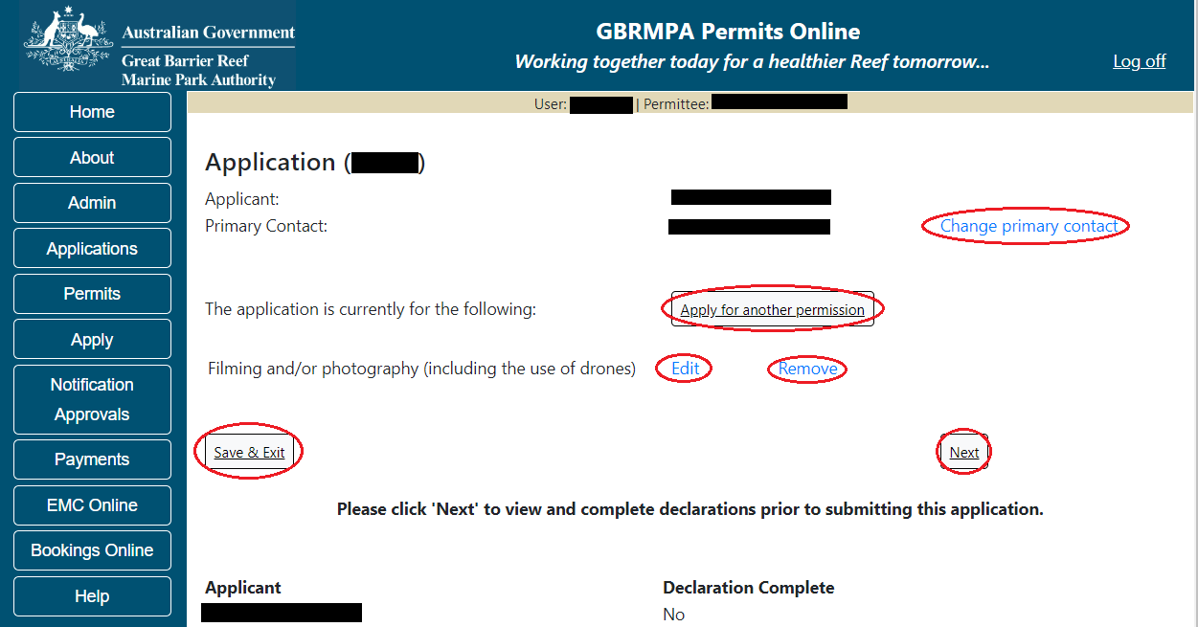
Figure 586 - Screenshot of Application Summary page with red circles around all options available

Additional Information - Summary screen, links and buttons;
- Change primary contact: If the change primary contact link is selected the applicant will progress to the primary contact page where the primary contact can be changed.

- Apply for another permission: If the Apply for another permission button is selected, the applicant will progress to the What are you seeking to do in the Marine Parks page where another permission type can be added. (e.g. add a research permission to the filming permission).

- Edit: If edit is selected the application/permission will be reopened to apply any changes.

- Remove: If remove is selected the application/permission will be removed.

- Save & Exit: If the Save & Exit button is selected the applicant will progress to the applications screen.

- Next: If next is selected the applicant will progress to the submission process including declaring and submitting the application.

Completion of a set of declarations is mandatory prior to submitting your application. To complete the declarations section of this application, you must either be the applicant, or if applying on behalf of an organisation / company / government agency, you must be a Director of that organisation / company / government agency. Authorised contacts cannot complete the declaration section, as it contains legally binding commitments in place of a physical signature.
Please read all questions carefully, provide a response to each, and select Next.
Figure 587 - Screenshot of Declarations page with red circle around Yes and No options and Next button

On the final page of declarations there is a Submit button. Once the Submit button is selected, the application will be submitted to the Reef Authority and is no longer available to be edited. The status of the application on the Applications screen will then display ‘Submitted to GBRMPA’. The application’s Primary Contact will receive an emailed acknowledgement notice from a delegated Assessment Officer within 10 business days.
Figure 588 - Screenshot of Declarations screen with a red circle around the Submit button
Once you submit your application, you will be provided with a reference/application number and can follow the progress of your application via the Applications menu on the left.
Figure 589 - Screenshot of the Thank you for your application screen with a red circle around Reference number and a red circle around the open pdf button

Your application will appear in the Applications screen with the reference/application number also displayed. You have further options to view a summary of your application, email the Reef Authority or withdraw the application.
Figure 590 - Screenshot of Applications screen with a red circle around Application No., Summary, Email and Withdraw options

  - Other Activities in the Marine Parks
Apply – new permit – other activities – other
To apply for an Other Activities application select this option on the Apply – What are you seeking to do in the Marine Parks page.
Figure 591 - Screenshot of Apply - What are you seeking to do in the Marine Parks screen with Other Activities and a red circle around the Next button

You will progress to the application sub type menu with further options to select the type of Other Activity you wish to apply for. Select the Other Activity type (Option selected is Other). Select Next to progress to application questions.
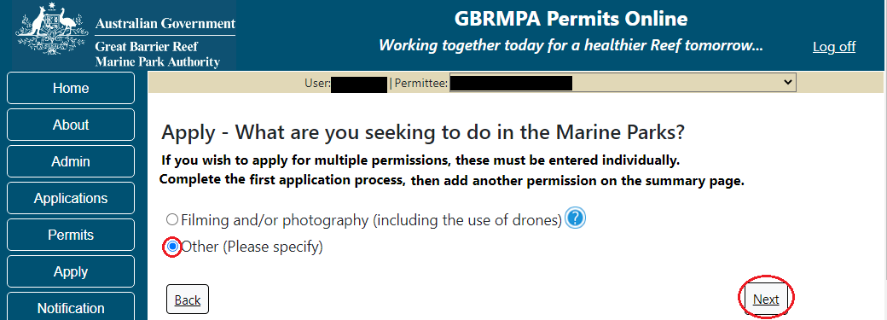
Figure 592 - Screenshot of Apply - What are you seeking to do in the Marine Parks – Other (Please specify) selected and a red circle around Next button

Page 1 of Other application is the Other Type Details page. Add a short description of your proposal. Select Next to continue.
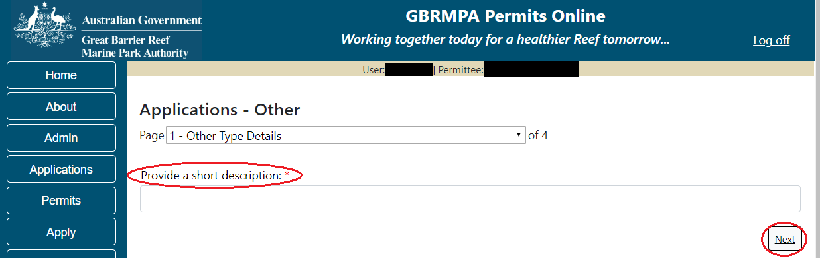
Figure 593 - Screenshot of Other Type Details page with a red circle around Provide a short description field and a red circle around Next button

Page 2 of Other application is the Environment Protection and Biodiversity Conservation Act page. This provides advice on matters of national environmental significance that must be considered when assessing an application. This screen is for your information only at this stage. Your assessing officer will contact you if it is determined to be relevant for your application.
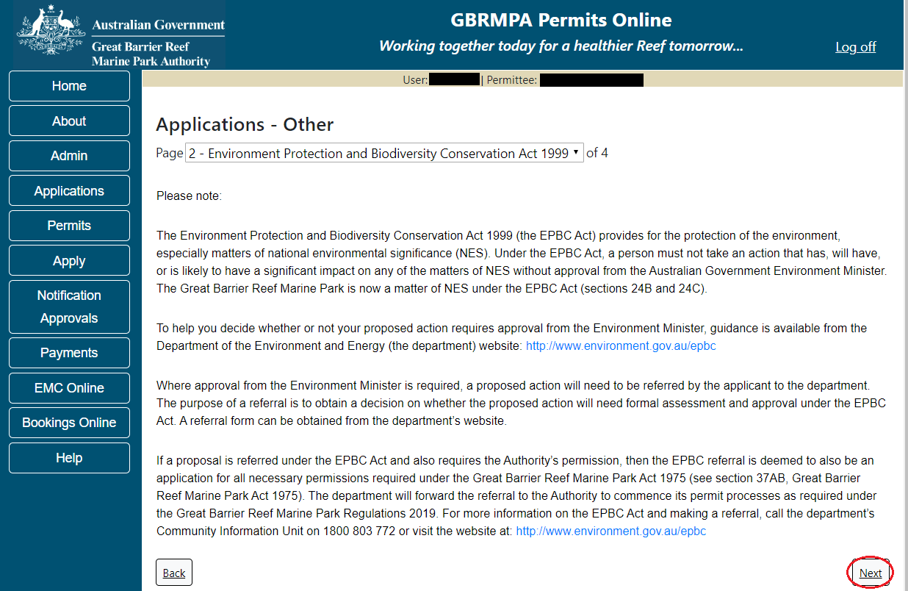
Figure 594 - Screenshot of Environment Protection and Biodiversity Conservation screen with a red circle around Next button
Links on the Environment Protection and Biodiversity Conservation www.environment.gov.au/epbc will take you to the Department of Climate Change, Energy the Environment and Water site. Here you can find information about the Environment Protection and Biodiversity Conservation Act 1999 and your obligations under the Act.
Page 3 of Other application is the Justification for Marine Park use. On this page add details of why you need to use the Marine Park? What alternatives have been considered and why have they been ruled out? Once you have added your details select Next to continue.
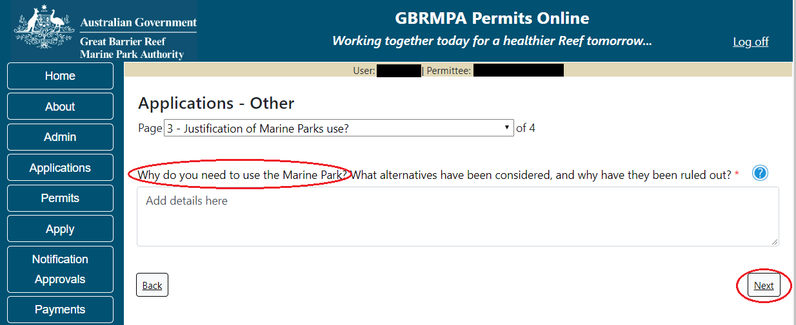
Figure 595 - Screenshot of Justification for Marine Park Use page with a red circle question - Why do you need to use the Marine Park? Information displayed and red circle around Next button

Page 4 of Other application provides opportunity for you to add any other information you feel will assist the Managing Agencies in assessing your application.
Add supporting information by typing in the text field or upload a file if required. If a file is uploaded it will appear on the screen with the file name and a Remove button to remove the file if the wrong file is selected. Select Next to continue.
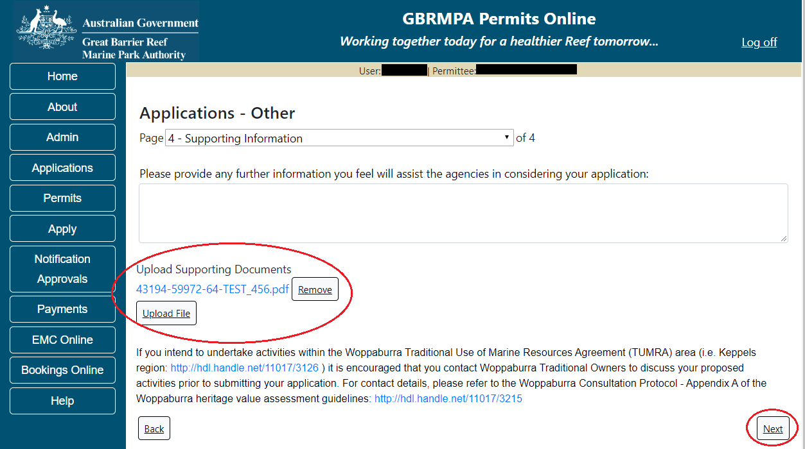
Figure 596 - Screenshot of Supporting Information screen with information entered and a red circle around Uploaded File and Next button
Once you have completed the supporting information page select Next from the last page of the application questions, you will progress to an application summary screen with a number of options available via links or buttons. Select Next on the summary screen to progress to the Declarations screens.
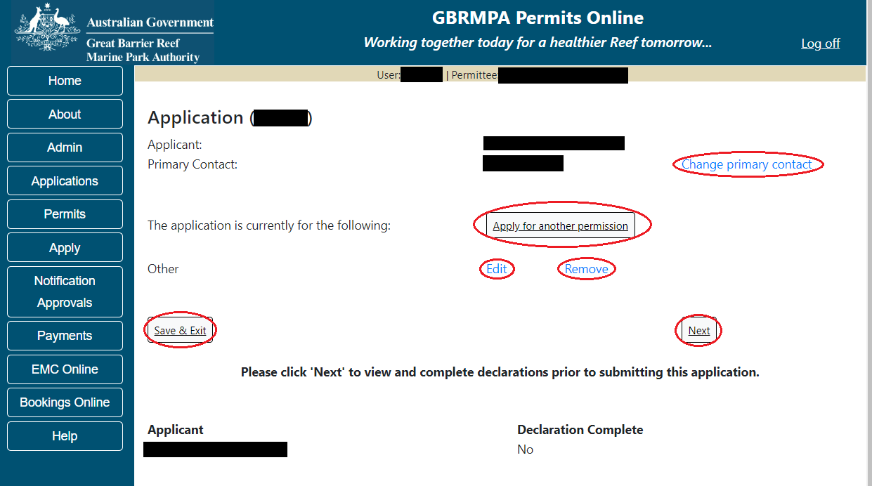
Figure 597 - Screenshot of Application Summary page with red circles around all options available

Additional Information - Summary screen, links and buttons;
- Change primary contact: If the change primary contact link is selected the applicant will progress to the primary contact page where the primary contact can be changed.

- Apply for another permission: If the Apply for another permission button is selected, the applicant will progress to the What are you seeking to do in the Marine Parks page where another permission type can be added. (e.g. add a tourism permission to the other permission).

- Edit: If edit is selected the application/permission will be reopened to apply any changes.

- Remove: If remove is selected the application/permission will be removed.

- Save & Exit: If the Save & Exit button is selected the applicant will progress to the applications screen.

- Next: If next is selected the applicant will progress to the submission process including declaring and submitting the application.

Completion of a set of declarations is mandatory prior to submitting your application. To complete the declarations section of this application, you must either be the applicant, or if applying on behalf of an organisation / company / government agency, you must be a Director of that organisation / company / government agency. Authorised contacts cannot complete the declaration section, as it contains legally binding commitments in place of a physical signature.
Please read all questions carefully, provide a response to each, and select Next.
Figure 598 - Screenshot of Declarations page with red circle around Yes and No options and Next button

On the final page of declarations there is a Submit button. Once the Submit button is selected, the application will be submitted to the Reef Authority and is no longer available to be edited. The status of the application on the Applications screen will then display ‘Submitted to GBRMPA’. The application’s Primary Contact will receive an emailed acknowledgement notice from a delegated Assessment Officer within 10 business days.
Figure 599 - Screenshot of Declarations screen with a red circle around the Submit button
Once you submit your application, you will be provided with a reference/application number and can follow the progress of your application via the Applications menu on the left.
Figure 600 - Screenshot of the Thank you for your application screen with a red circle around Reference number and a red circle around the open pdf button

Your application will appear in the Applications screen with the reference/application number also displayed. You have further options to view a summary of your application, email the Reef Authority or withdraw the application.
Figure 601 - Screenshot of Applications screen with a red circle around Application No., Summary, Email and Withdraw options

- Continue a Current Permit
To continue a permit, select the Apply tab. You will be provided options to choose from, select Continue a current permit.
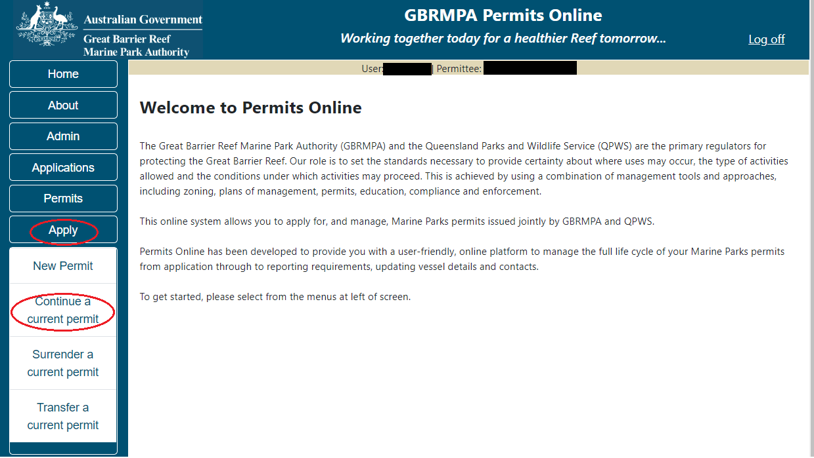
Figure 602 - Screenshot of Permits Online Home page with a red circle Apply menu and Continue a current permit circled

You will then progress to the Current Permits screen with options to choose which permit you wish to Continue.
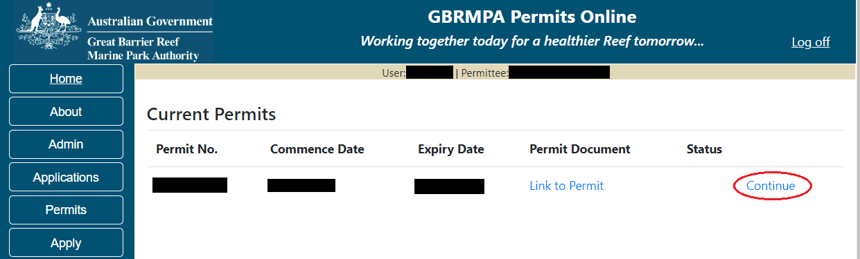
Figure 603 - Screenshot of Current Permits screen with continue option circled in red

Select Continue to move to the next page of the application.

The Current Permit Details screen will appear, select the Continue button to move to the next page of the application.
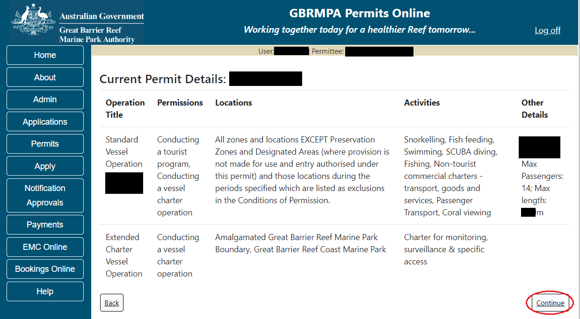
Figure 604 - Screenshot of Continue an Existing Permit page with permit information displayed and a red circle around continue

The primary contact screen is where you can select who is the primary contact for this application. Select the existing primary contact if that person is going to be the primary contact for this application. If the details are correct select the tick box next to the These contact details are correct, then select Next. You will progress to the application summary screen (refer to Figure 549 to continue).
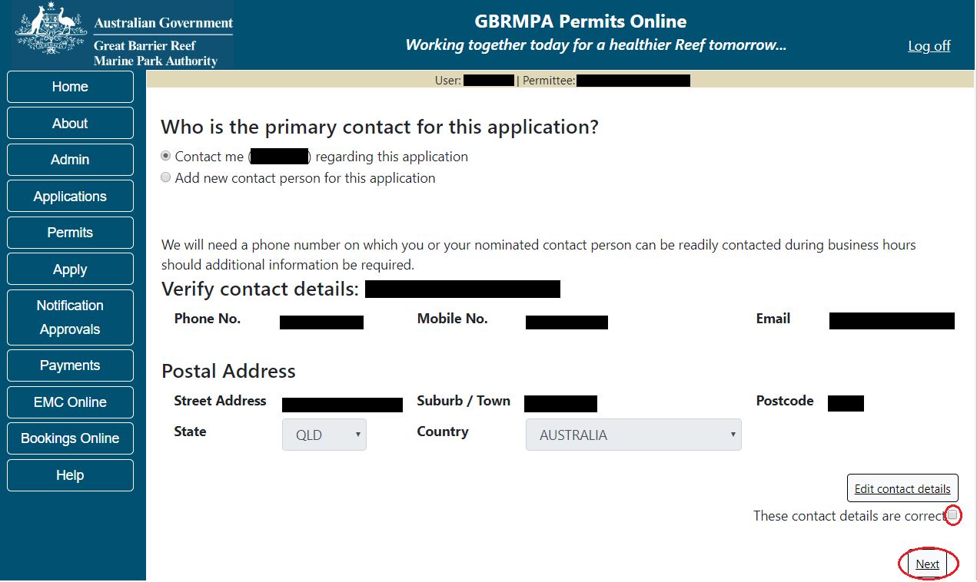
Figure 605 - Screenshot of Who is the primary contact for this application screen with a red circle around the These details are correct tick box and a red circle around the Next button
If the details require an update select the Edit contact details button.
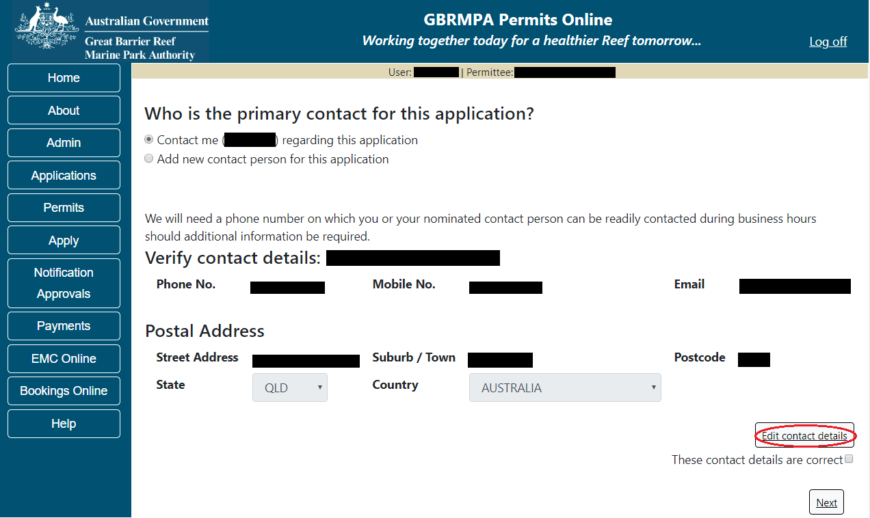
Figure 606 – Screenshot of the Who is the primary contact for this application screen with a red circle around the Edit contact details button

Edit the details that require updating. For example if the phone number requires updating add the new details into the field. Select Save once all the updated details have been added.
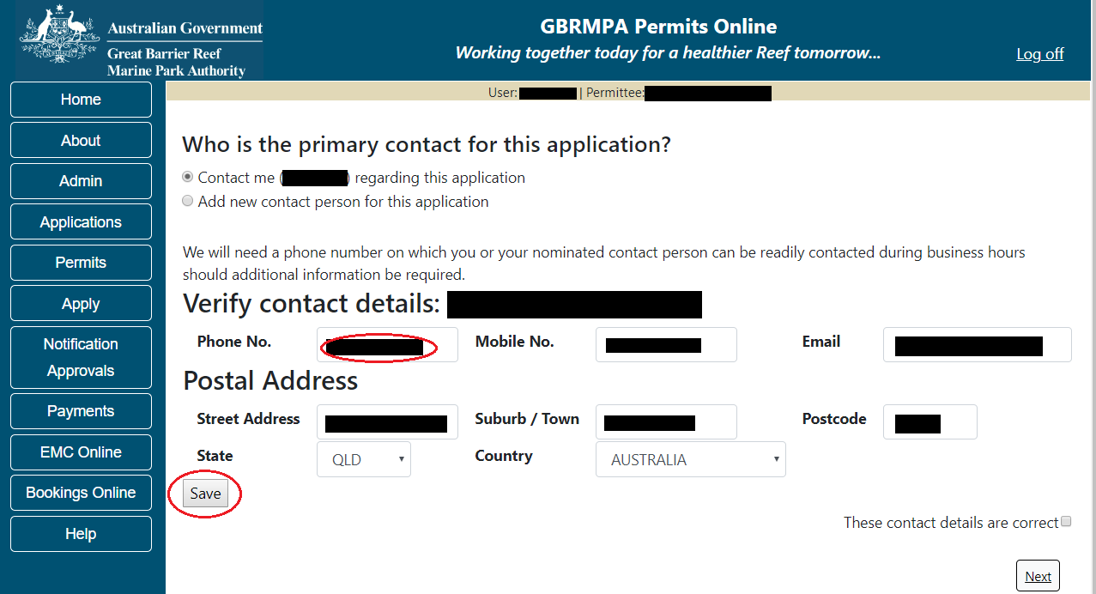
Figure 607 – Screenshot of Who is the primary contact for this application screen with a red circle around the Phone number details and a red circle around the Save button
Once save is selected confirm the new details are correct by selecting the These contact details are correct, then select Next.
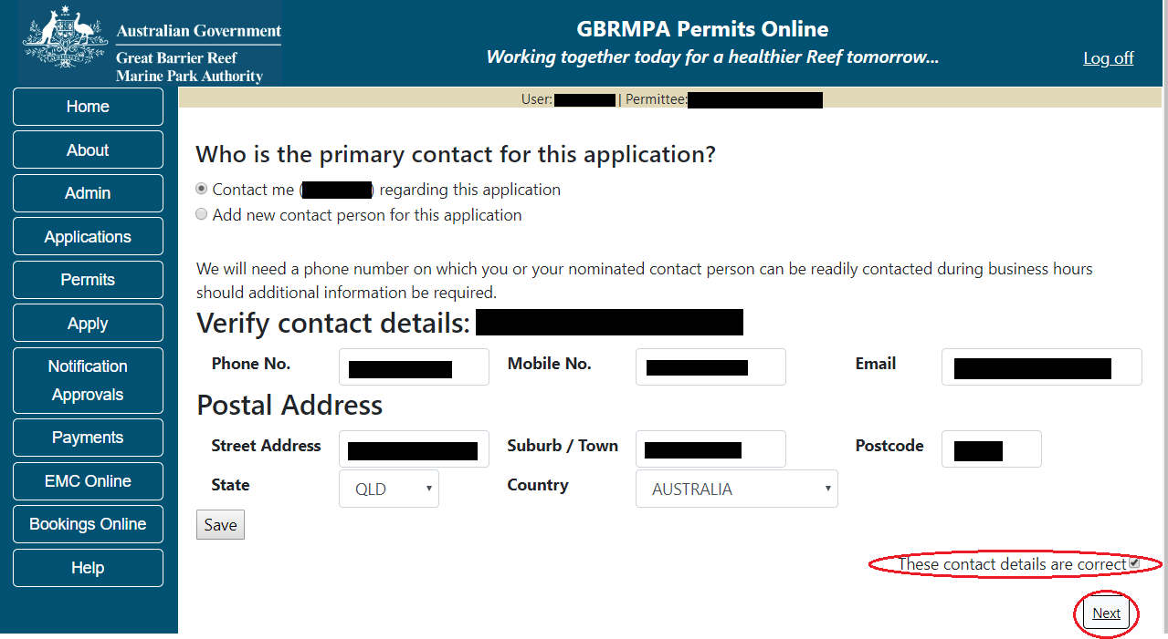
Figure 608 - Screenshot of Who is the primary contact for this application screen with a red circle around the These details are correct tick box and a red circle around the Next button

If the existing contact is not the primary contact select Add a new contact person for this application, the search contacts field will appear.
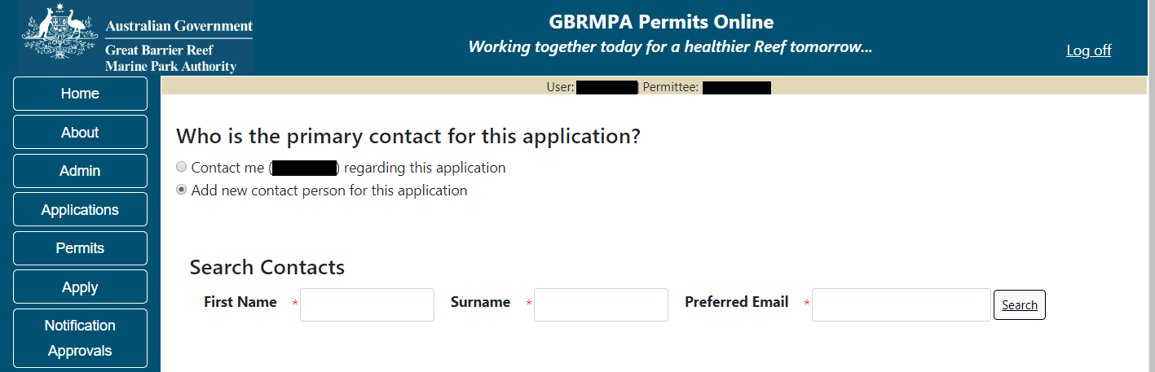
Figure 609 - Screenshot of Who is the primary contact for this application screen with Add new contact person for this application selected

Add details of Given Name, Surname and Preferred Email address, then select Search.
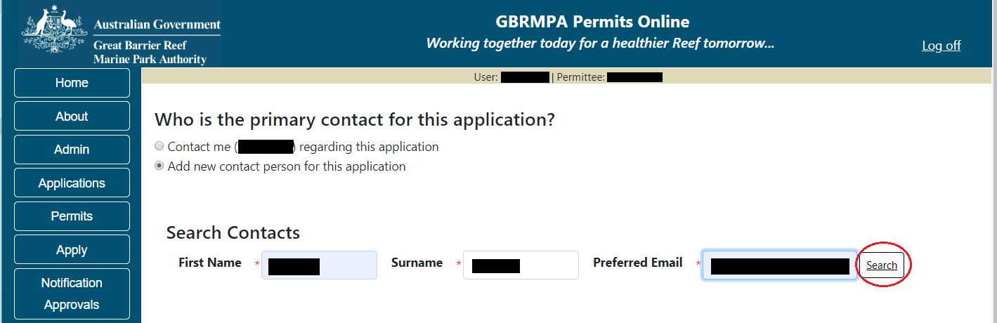
Figure 610 – Screenshot of Who is the primary contact for this application screen with a red circle around the Search button

Once Search is selected, the system will display the contact, if the contact exist within the Reef Authority’s system. If the contact is an existing contact to the Reef Authority, a Select button will appear next to the contact. Press the Select button that appears next to the contact and you will then progress to the next screen.
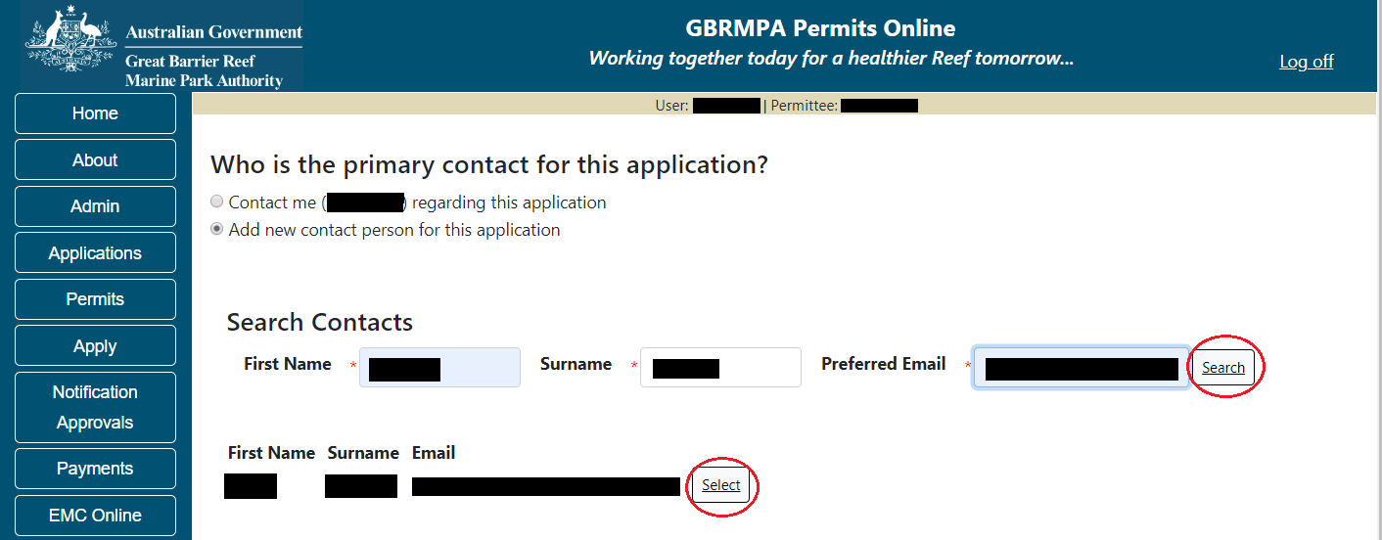
Figure 611 – Screenshot of Who is the primary contact for this application screen with a red circle around the Search button and a red circle around the Select button

If the contact is not found within the Reef Authority’s system a screen to add the details of the new contact appears.
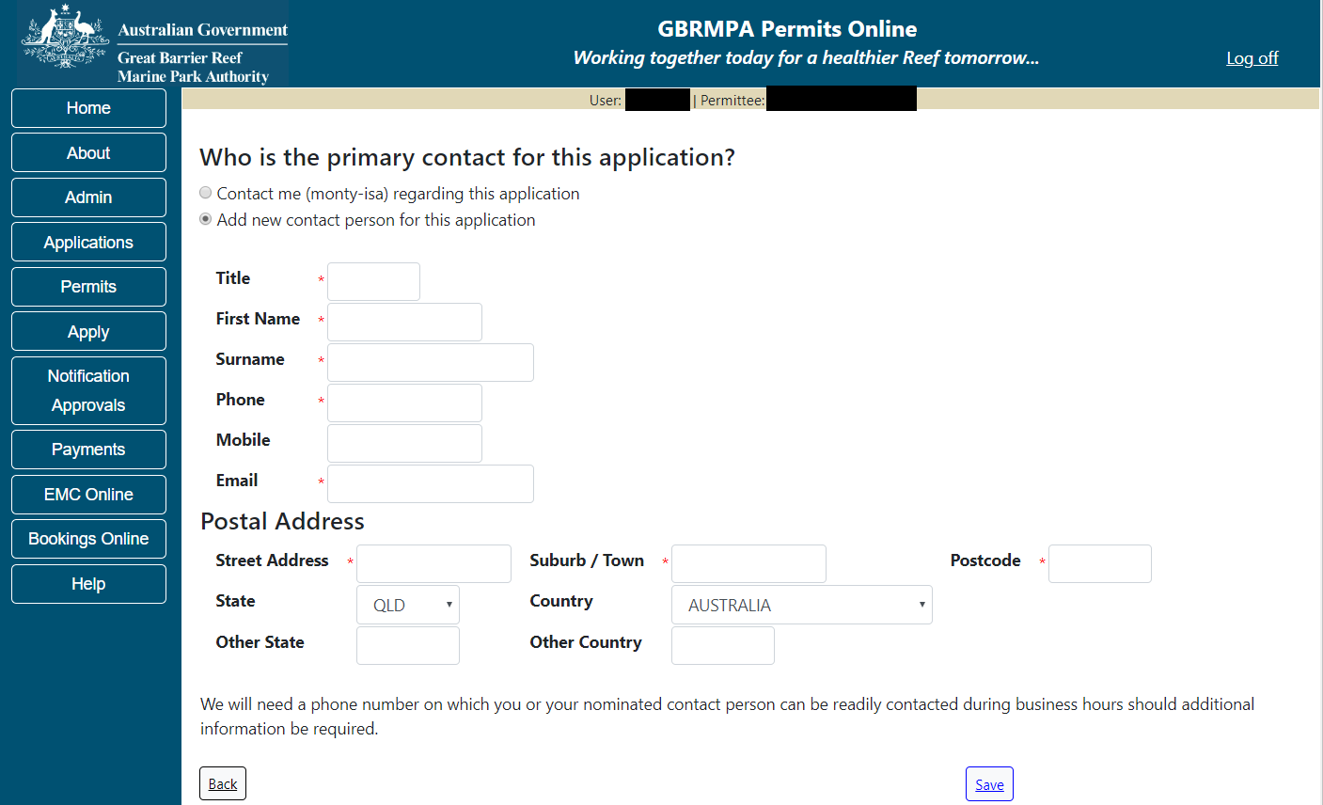
Figure 612 - Screenshot of Who is the primary contact for this application screen with Add new contact person for this application selected

Add the details of the new contact filling in all fields marked with a mandatory (*) and select Save.
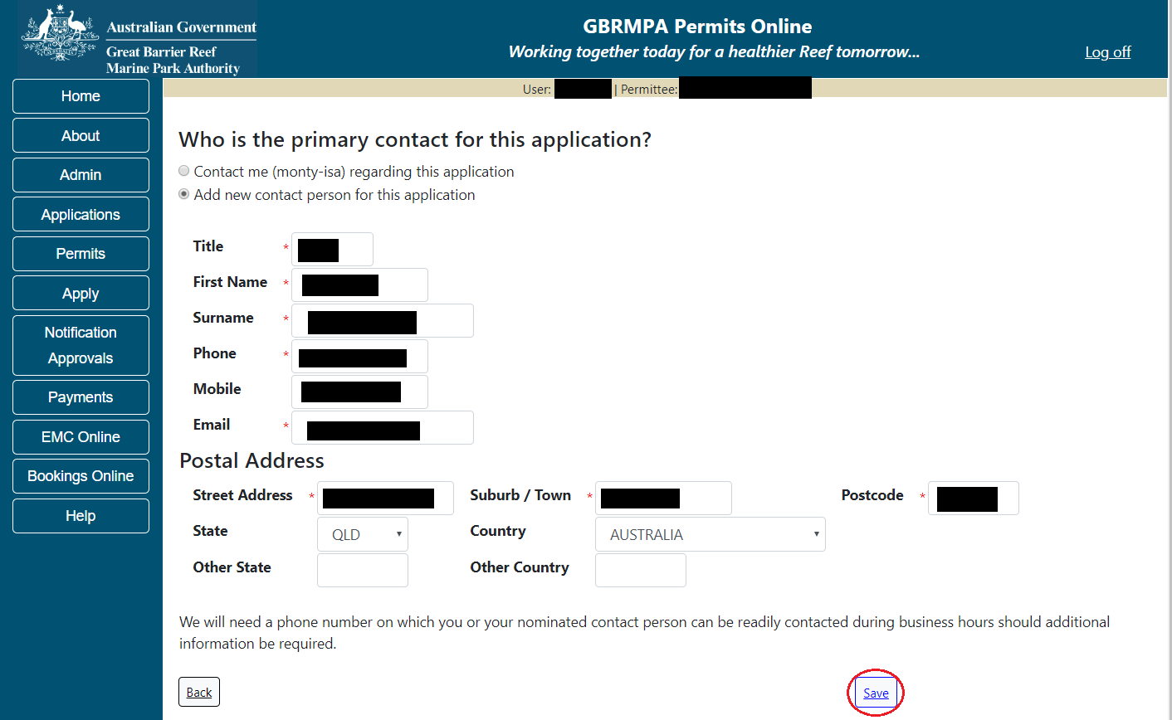
Figure 613 - Screenshot of Who is the primary contact for this application screen with Add new contact person for this application selected and a red circle around the Save button
You will then progress to the Continue Application Summary Screen. Here you have a number of options available via links or buttons. Select Next on the summary screen to progress to the Declarations screens.
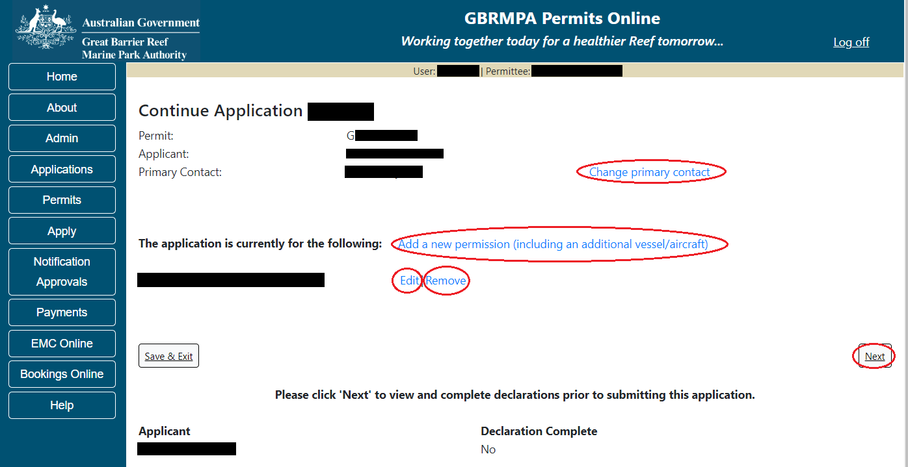
Figure 614 - Screenshot of Application Summary screens with red circles around all options available

Additional Information - Summary screen, links and buttons;
- Change primary contact: If the change primary contact link is selected the applicant will progress to the primary contact page where the primary contact can be changed.

- Add a new permission (including an additional vessel/aircraft): If the Add a new permission link is selected, the applicant will progress to the What are you seeking to do in the Marine Parks page where another permission type can be added. (e.g. add a mooring permission to the tourism permission).

- Edit: If edit is selected the application/permission will be reopened to apply any changes.

- Remove: If remove is selected the application/permission will be removed.

- Save & Exit: If the Save & Exit button is selected the applicant will progress to the applications screen.

- Next: If next is selected the applicant will progress to the submission process including declaring and submitting the application.

If your continue application is a tourism application that is not being continued as a Routine Tourism and Charter Permit, the submission process will have 3 additional pages of questions to answer.
Page 1 is the total passenger capacity question for What is the total passenger capacity/participants you wish to have in the Marine Parks at any given time? (please consider future use in answering this question) is presented. Select a number from the list provided. Select Next to continue.
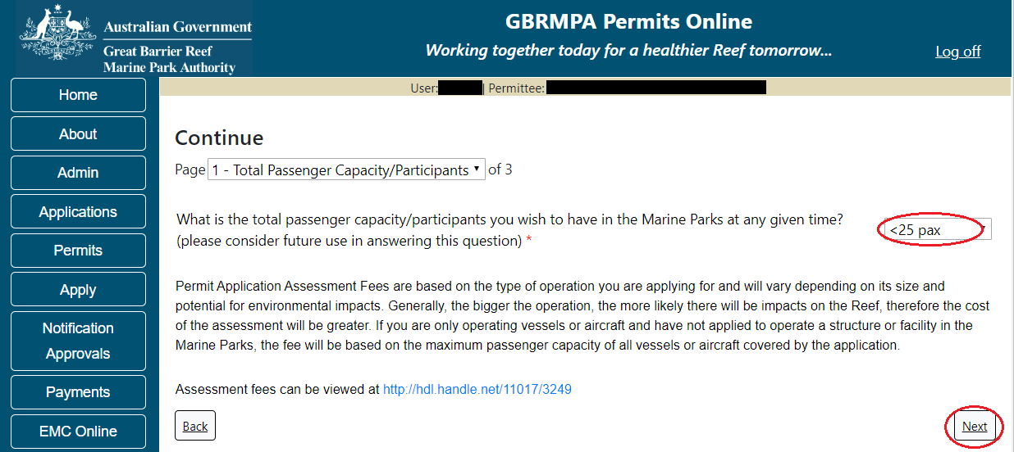
Figure 615 - Screenshot of the Total Passenger Capacity / Participants page with a red circle around the total passenger capacity/participants drop list and a red circle around the Next button

Page 2 refers to High Standard Tourism operators. If you have obtained a High Standard Tourism certification with an approved certification scheme, select Yes then upload a copy of your certificate using the upload feature. Once you select the Yes button, an Upload File button will appear. Select the Upload File button and upload a file.
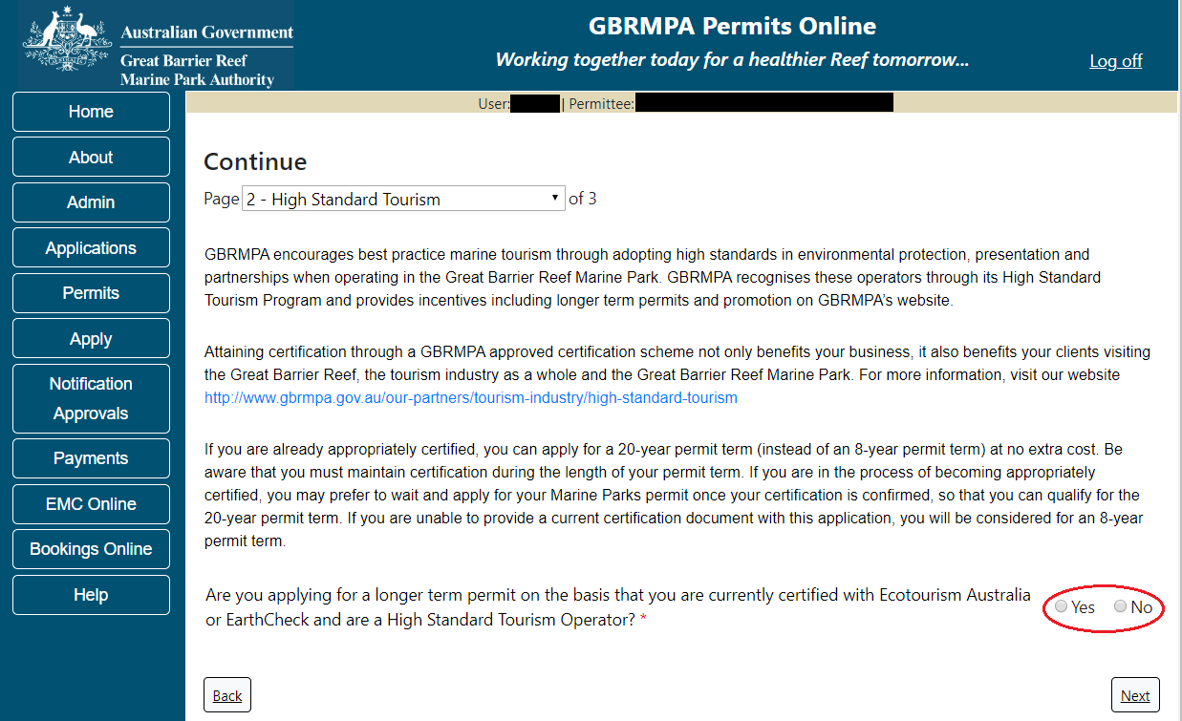
Figure 616 - Screenshot of High Standard Tourism page with a red circle Yes and No options
If your continue application is a not a tourism application, the submission process will have 1 additional page, Supporting Information. Add any other information you feel will assist the Managing Agencies in assessing your application by typing in the text field or upload a file if required.
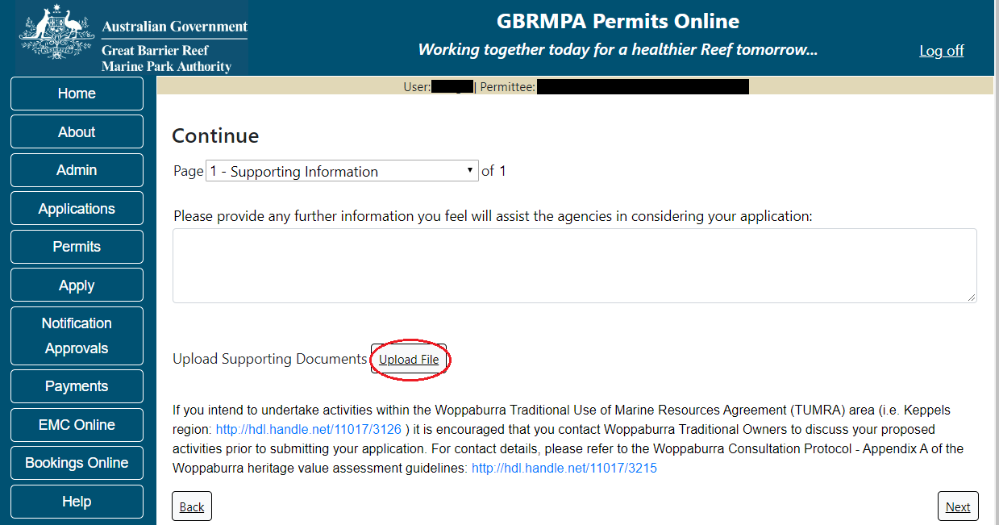
Figure 617 - Screenshot of Supporting Information screen with a red circle around the Uploaded File button

If a file is uploaded it will appear on the screen with the file name and a Remove button to remove the file if the wrong file is selected. Select Next to progress to the declaration pages.
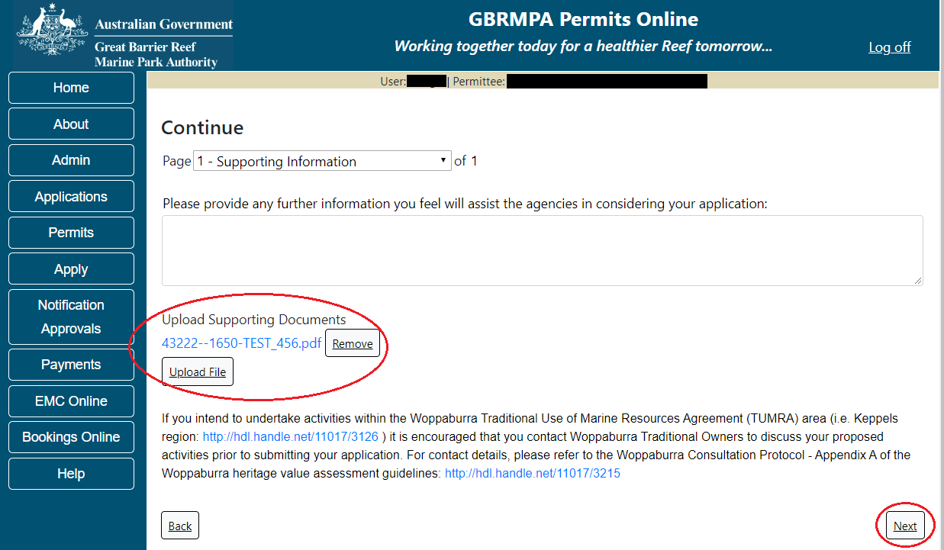
Figure 618 - Screenshot of Supporting Information screen with a red circle around Uploaded File and Next button
Completion of a set of declarations is mandatory prior to submitting your application. To complete the declarations section of this application, you must either be the applicant, or if applying on behalf of an organisation / company / government agency, you must be a Director of that organisation / company / government agency. Authorised contacts cannot complete the declaration section, as it contains legally binding commitments in place of a physical signature.
Please read all questions carefully, provide a response to each, and select Next.
Figure 619 - Screenshot of Declarations page with red circle around Yes and No options and Next button

On the final page of declarations there is a Submit button. Once the Submit button is selected, the application will be submitted to the Reef Authority and is no longer available to be edited. The status of the application on the Applications screen will then display ‘Submitted to GBRMPA’. The application’s Primary Contact will receive an emailed acknowledgement notice from a delegated Assessment Officer within 10 business days.
Figure 620 - Screenshot of Declarations screen with a red circle around the Submit button
Once you submit your application, you will be provided with a reference/application number and can follow the progress of your application via the Applications menu on the left.
Figure 621 - Screenshot of the Thank you for your application screen with a red circle around Reference number and a red circle around the open pdf button

Your application will appear in the Applications screen with the reference/application number also displayed. You have further options to view a summary of your application, email the Reef Authority or withdraw the application.
Figure 622 - Screenshot of Applications screen with a red circle around Application No., Summary, Email and Withdraw options

  - Tourism Continuation
To continue a tourism permit, select the Apply tab. You will be provided options to choose from, select Continue a current permit.
Figure 623 - Screenshot of Permits Online Home page with a red circle Apply menu and Continue a current permit circled

You will then progress to the Current Permits screen with options to choose which permit you wish to Continue.
Figure 624 - Screenshot of Current Permits screen with continue option circled in red

Select Continue to move to the next page.

The Current Permit Details screen will appear, select the Continue button to move to the next page of the application.
Figure 625 - Screenshot of Continue an Existing Permit page with permit information displayed and a red circle around permit number hyperlink option

The primary contact screen is where you can select who is the primary contact for this application. Select the existing primary contact if that person is going to be the primary contact for this application. If the details are correct select the tick box next to the These contact details are correct, then select Next. You will progress to the application summary screen (refer to Figure 568 to continue).
Figure 626 - Screenshot of Who is the primary contact for this application screen with a red circle around the These details are correct tick box and a red circle around the Next button
If the details require an update select the Edit contact details button.
Figure 627 – Screenshot of the Who is the primary contact for this application screen with a red circle around the Edit contact details button

Edit the details that require updating. For example if the phone number requires updating add the new details into the field. Select Save once all the updated details have been added.
Figure 628 – Screenshot of Who is the primary contact for this application screen with a red circle around the Phone number details and a red circle around the Save button
Once Save is selected confirm the new details are correct by selecting the These contact details are correct, then select Next.
Figure 629 – Screenshot of Who is the primary contact for this application screen with a red circle around the These details are correct tick box and a red circle around the Next button

If the existing contact is not the primary contact select Add a new contact person for this application, the search contacts field will appear.
Figure 630 - Screenshot of Who is the primary contact for this application screen with Add new contact person for this application selected

Add details of Given Name, Surname and Preferred Email address, then select Search
Figure 631 – Screenshot of Who is the primary contact for this application screen with a red circle around the Search button

Once Search is selected, the system will display the contact, if the contact exist within the Reef Authority’s system. If the contact is an existing contact to the Reef Authority, a Select button will appear next to the contact. Press the Select button that appears next to the contact and you will then progress to the next screen.
Figure 632 – Screenshot of Who is the primary contact for this application screen with a red circle around the Search button and a red circle around the Select button

If the contact is not found within the Reef Authority’s system a screen to add the details of the new contact appears.
Figure 633 - Screenshot of Who is the primary contact for this application screen with Add new contact person for this application selected

Add the details of the new contact filling in all fields marked with a mandatory (*) and select Save.
Figure 634 - Screenshot of Who is the primary contact for this application screen with Add new contact person for this application selected and a red circle around the Save button
You will then progress to the Continue Application Summary Screen. Here you have a number of options. If your application/permit is eligible for a routine tourism and charter permit the question Continue as a routine application will need to be answered and Save selected for the system to progress to the next step.
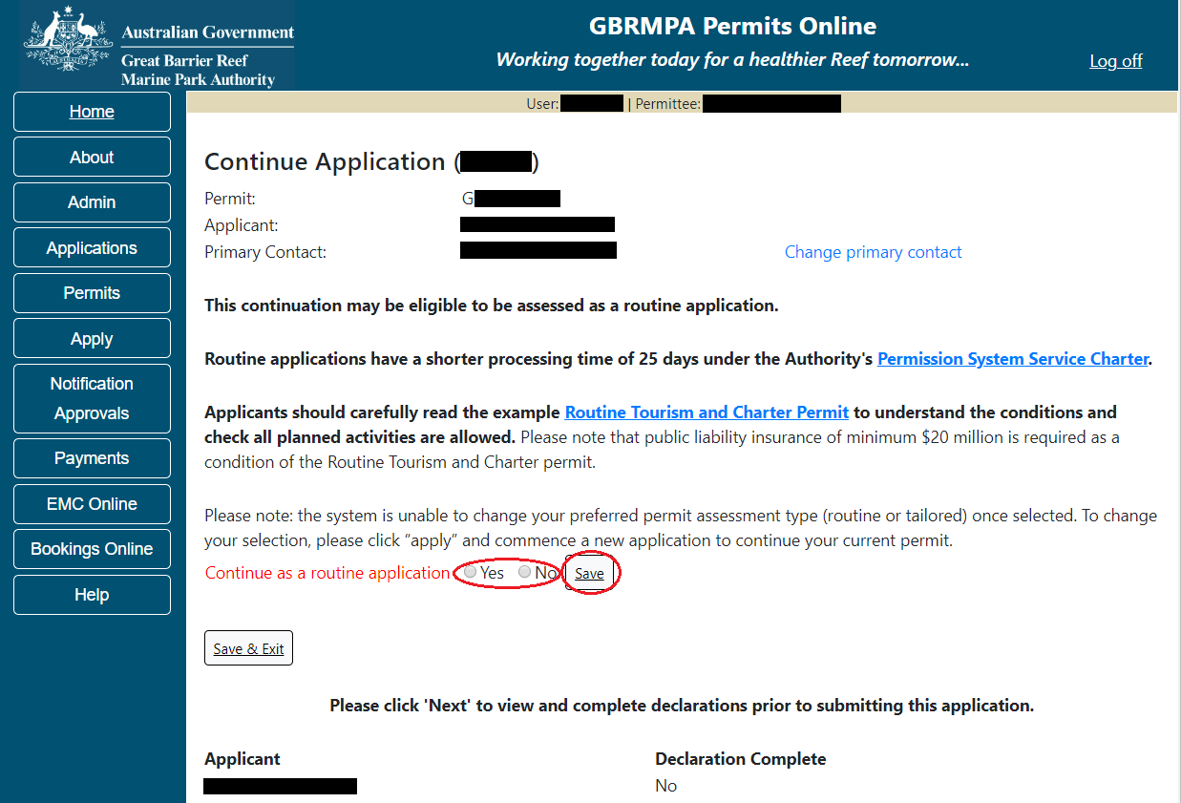
Figure 635 - Screenshot of Application Summary screens with a red circle around Yes and No options and a red circle around the Save button

Additional Information - Routine Tourism and Charter Permit
Links to the Authorities Permission Service Charter and an example Routine Tourism and Charter Permit are below. Applicants should carefully read the example Routine Tourism and Charter Permit to understand the conditions and check all planned activities are allowed.
Please note that public liability insurance of minimum $20 million is required as a condition of the Routine Tourism and Charter permit.
- Links to the Reef Authority’s Permissions Service Charter (http://elibrary.gbrmpa.gov.au/jspui/handle/11017/3247)

- Link to an example routine tourism and charter permit (https://elibrary.gbrmpa.gov.au/jspui/handle/11017/3605) are also on screen.
If No is selected or your previous tourism permit is not eligible to be continued as a Routine Tourism the screen will refresh and the application will remain a standard (Tailored) continuation.
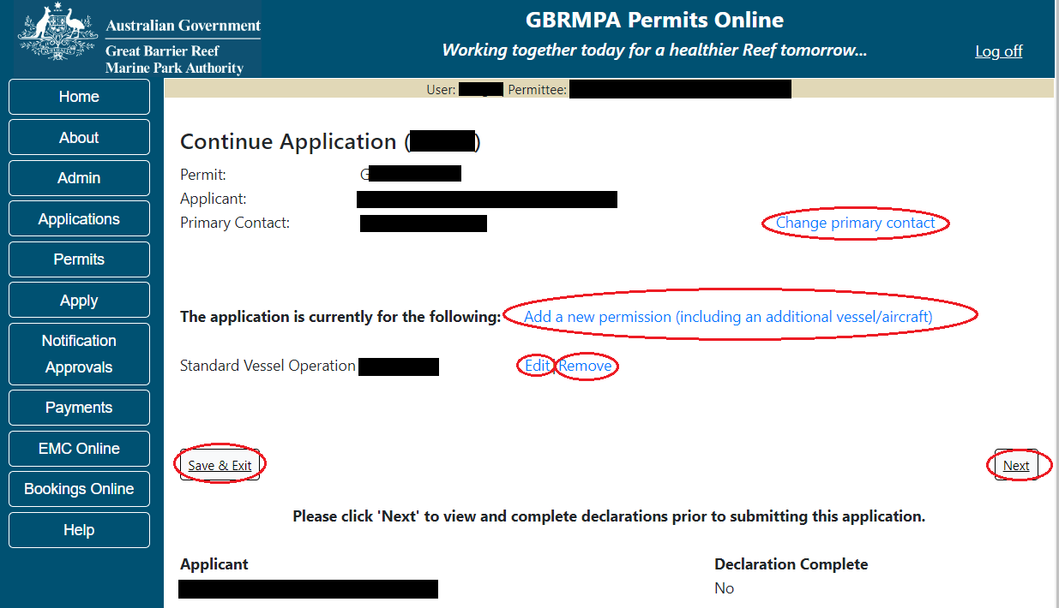
Figure 636 - Screenshot of Application Summary screens with red circles around all options available

If Yes is selected the screen will refresh and update to a routine tourism and charter continuation, continue from the next page of this manual if Yes is selected.
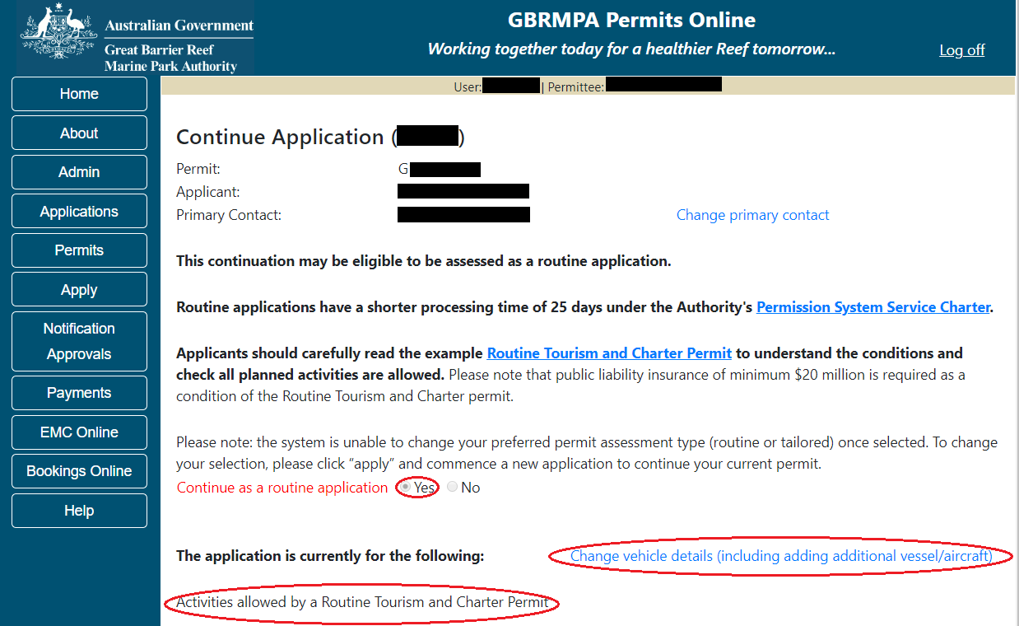
Figure 637 - Screenshot of Screenshot of Application Summary screens with a red circle around Yes and a red circle around the application type and the Change Vehicle details (including adding additional vessel/aircraft) link
  - Continue as Routine Tourism and Charter Permit
Once Yes is selected the screen will update to display the Routine Tourism and Charter application. A link to Change vehicle details (including adding additional vessel/aircraft) will also appear. A number of other options and links are also displayed. Further details on these are below.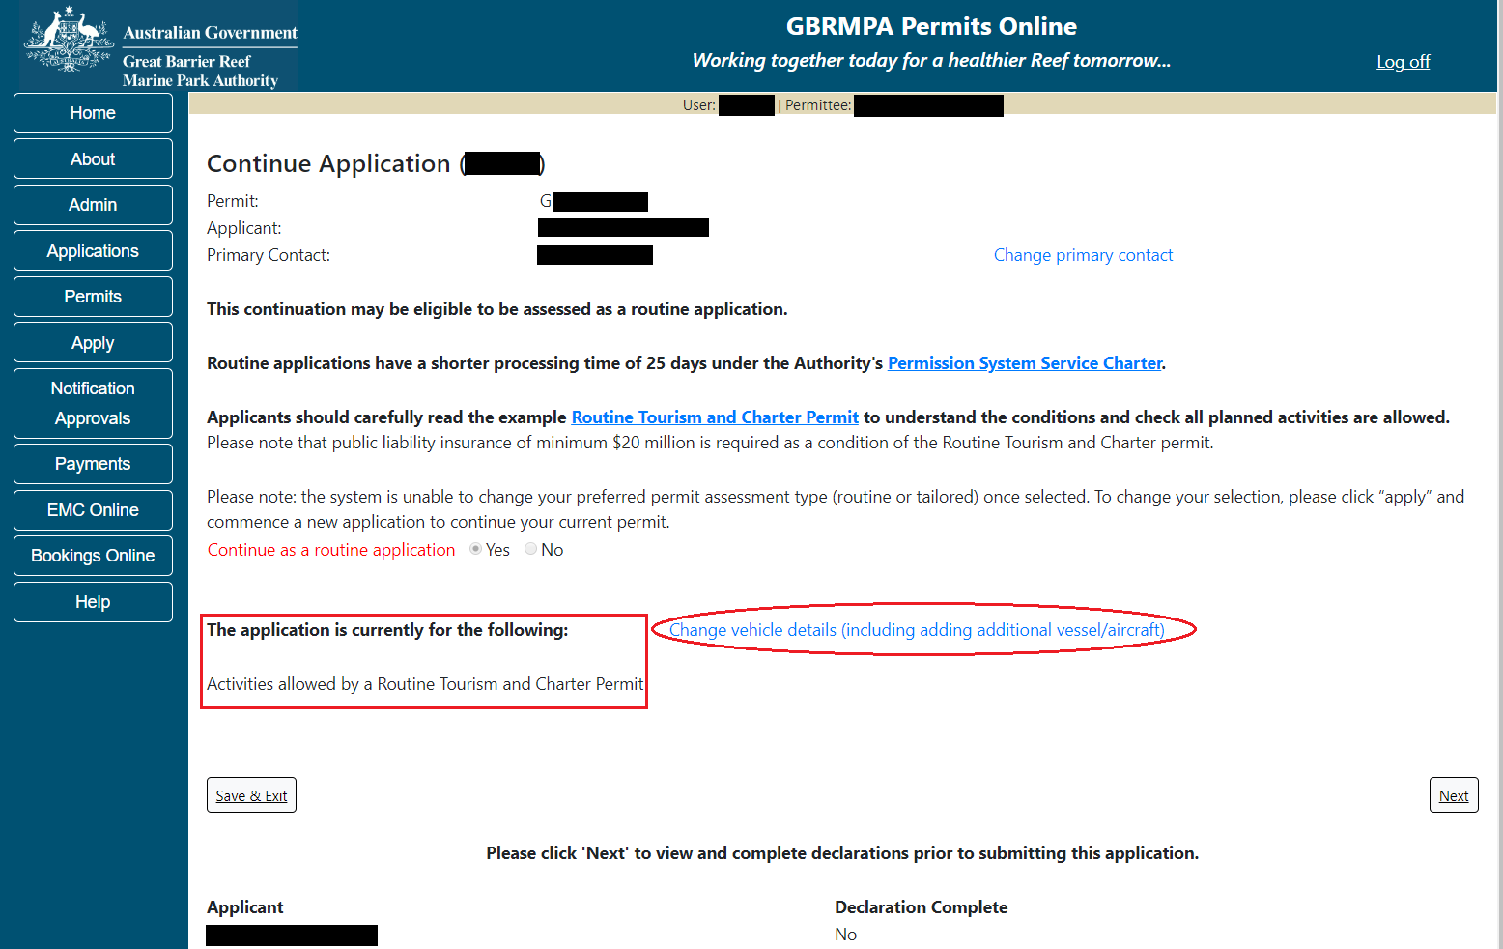
Figure 638 - Screenshot of Application Summary screens with red circles around application type and the Change Vehicle details (including adding additional vessel/aircraft) link

Additional Information - Summary screen, links and buttons;
- Change primary contact: If the change primary contact link is selected the applicant will progress to the primary contact page where the primary contact can be changed.

- Change Vehicle details (including adding additional vessel/aircraft): If the Change Vehicle details link is selected additional vehicles can be added or existing vehicles edited. Details about ancillary vessels or equipment can also be added.

- Links to the Reef Authority’s Permissions Service Charter (http://elibrary.gbrmpa.gov.au/jspui/handle/11017/3247)

- Link to an example routine tourism and charter permit (https://elibrary.gbrmpa.gov.au/jspui/handle/11017/3605) are also on screen.

- Save & Exit: If the Save & Exit button is selected the applicant will progress to the applications screen.

- Next: If next is selected the applicant will progress to the submission process including declaring and submitting the application.

When the Change Vehicle details (including adding additional vessel/aircraft) is selected the system will produce 3 pages of questions to be answered.
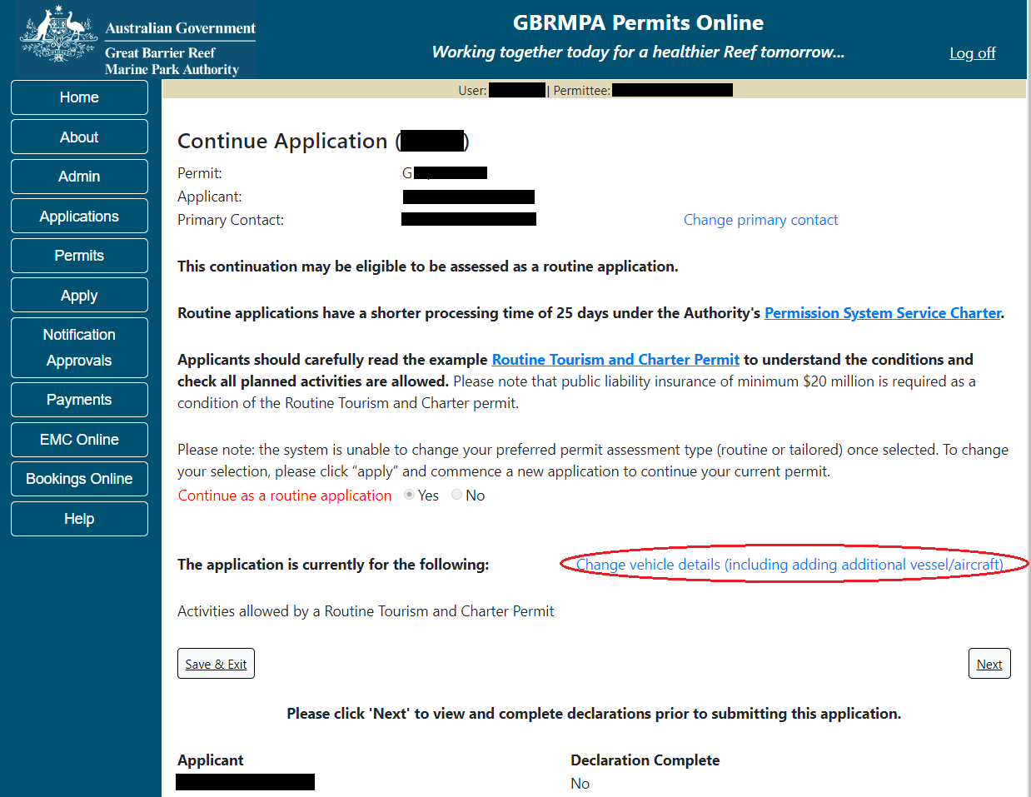
Figure 639 - Screenshot of Application Summary screens with the Change Vehicle details (including adding additional vessel/aircraft) link

Page 1 of the Continue as a Routine Tourism and Charter Permit is the Vessel / Aircraft page. Fill in information about the number of extra vessels and/or aircraft you wish to use. Select Next to go to the next page.
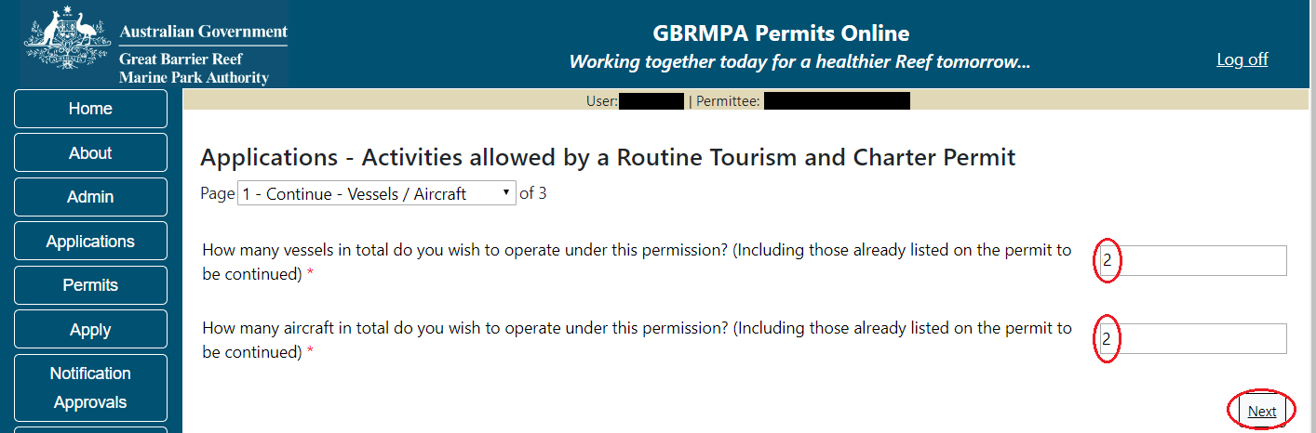
Figure 640 - Screenshot of Continue Vessels/Aircraft screen with red circles around the number of vessels and number of aircraft fields, a red circle around the Next button
Page 2 of the Continue as a Routine Tourism and Charter Permit is the Vehicles page. On this page you have options to Add New Aircraft and Add New Vessels.
To add an aircraft select the Add New Aircraft button. Fill in the required details and select Save.
To add a Vessel select the Add New Vessel button. Fill in the required details and select Save.
Your details will be displayed on the screen. Select Next to continue.
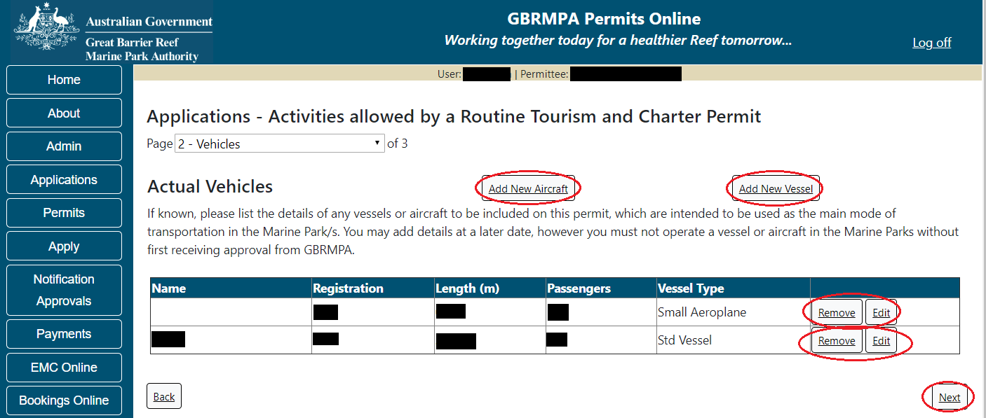
Figure 641 - Screenshot of Vehicles screen with aircraft and vessel information displaying, red circles around the Add New Aircraft, Add New Vessel, Remove and Edit buttons. A red circle around the Next button

Page 3 of the Continue as a Routine Tourism and Charter Permit application is Ancillary Vessels and Equipment page. To add ancillary vessels or equipment select the Add New button. The details of ancillary vessels or equipment will appear on the screen. A Remove button and an Edit button is also presented. If you need to remove the vessel select remove and the details will be deleted. If you wish to edit the details, select the Edit button. Select Next to continue.
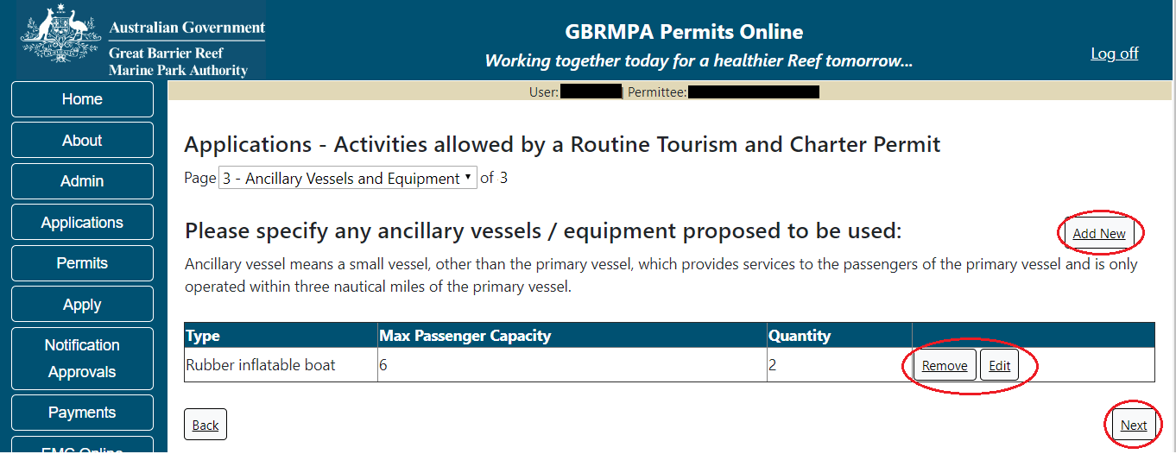
Figure 642 - Screenshot of Ancillary Vessels and Equipment page displaying information with a red circle around Add New, the Remove and Edit buttons and a red circle around the Next button
When Next is selected from the application summary screen, you will progress to the submission process including declaring and submitting the application.
Page 1 is the Total Passenger Capacity / Participants page. A question for What is the total passenger capacity/participants you wish to have in the Marine Parks at any given time? (please consider future use in answering this question) is presented. Select a number from the list provided. Select Next to continue.
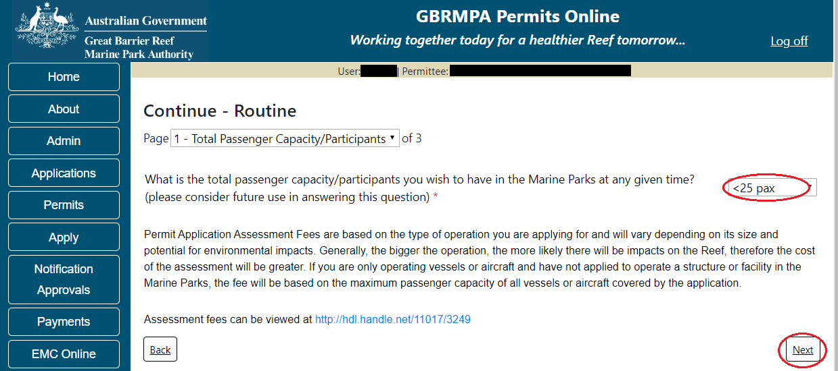
Figure 643 - Screenshot of Total Passenger Capacity / Participants page with a red circle around the select one drop list and a red circle around the next button

Page 2 refers to High Standard Tourism operators. If you have obtained a High Standard Tourism certification with an approved certification scheme, select Yes then upload a copy of your certificate using the upload feature. After you select the Yes button, an upload file button will appear. Select the Upload File button and upload the certificate.
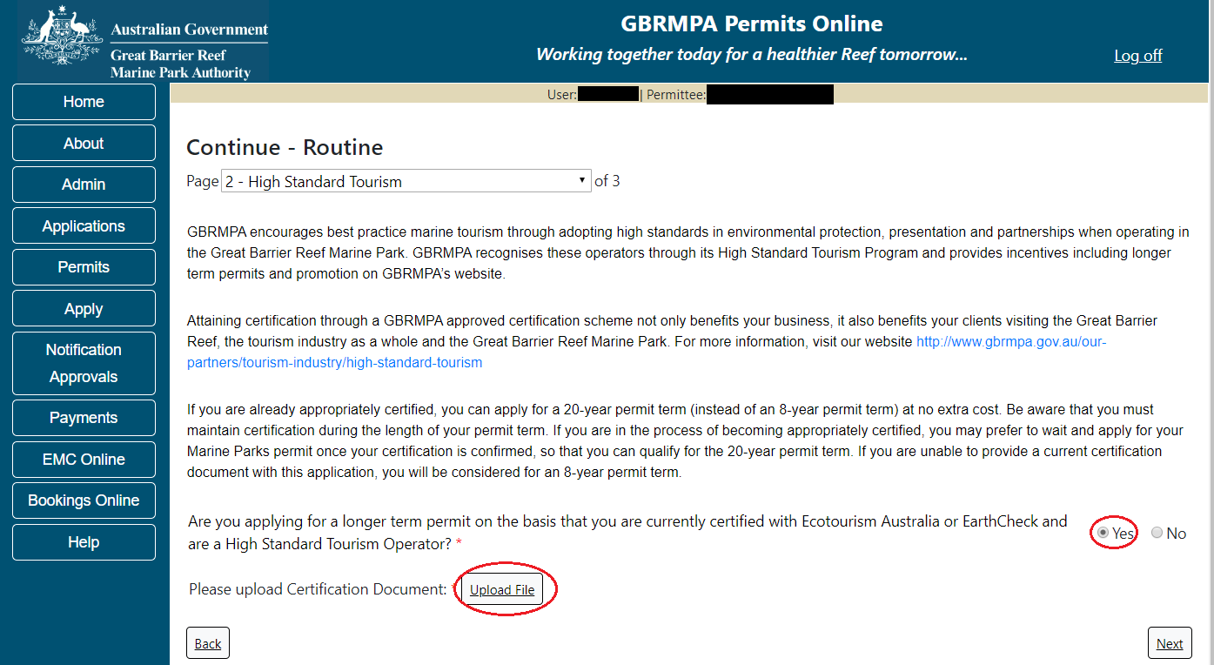
Figure 644 - Screenshot of High Standard Tourism page with Yes selected and circled and Upload File button circled in red
Once you load a copy of your certificate you will see the filename with a Remove next to it. If you wish to remove the file, select the Remove button. Select Next to go to the next page.
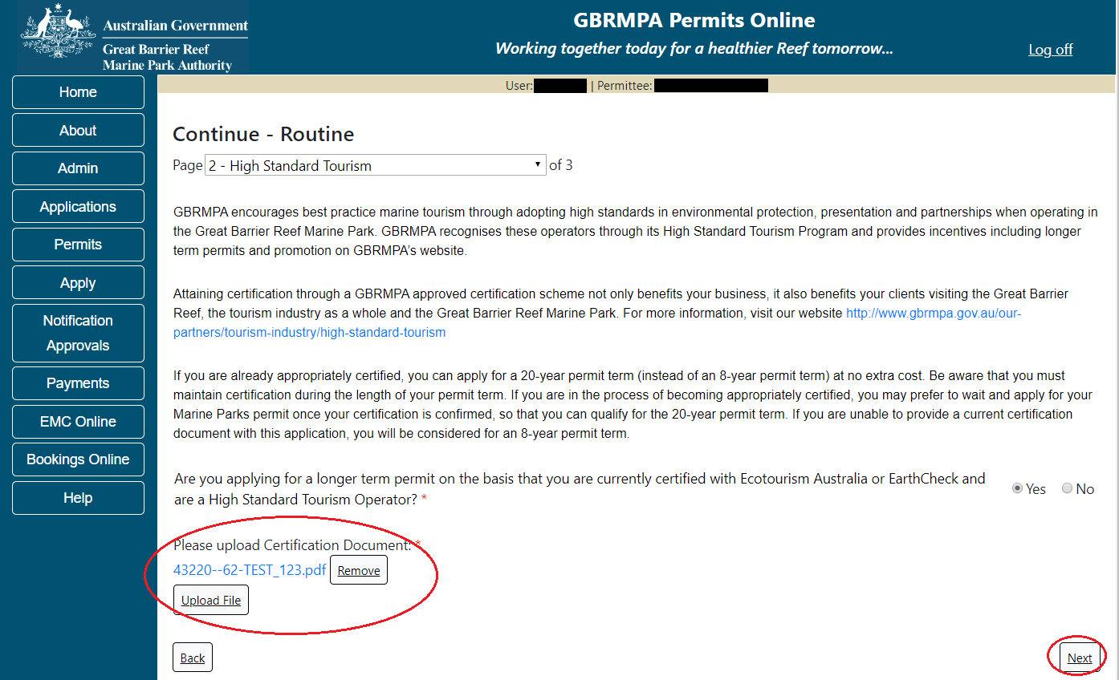
Figure 645 - Screenshot of High Standard Tourism page with Yes selected and a red circle around the Uploaded File and red circle around Next button

Page 3 provides opportunity for you to add any other information you feel will assist the Managing Agencies in assessing your application. Add supporting information by typing in the text field or upload a file if required. If a file is uploaded it will appear on the screen with the file name and a Remove button to remove the file if the wrong file is selected. Select Next to continue.
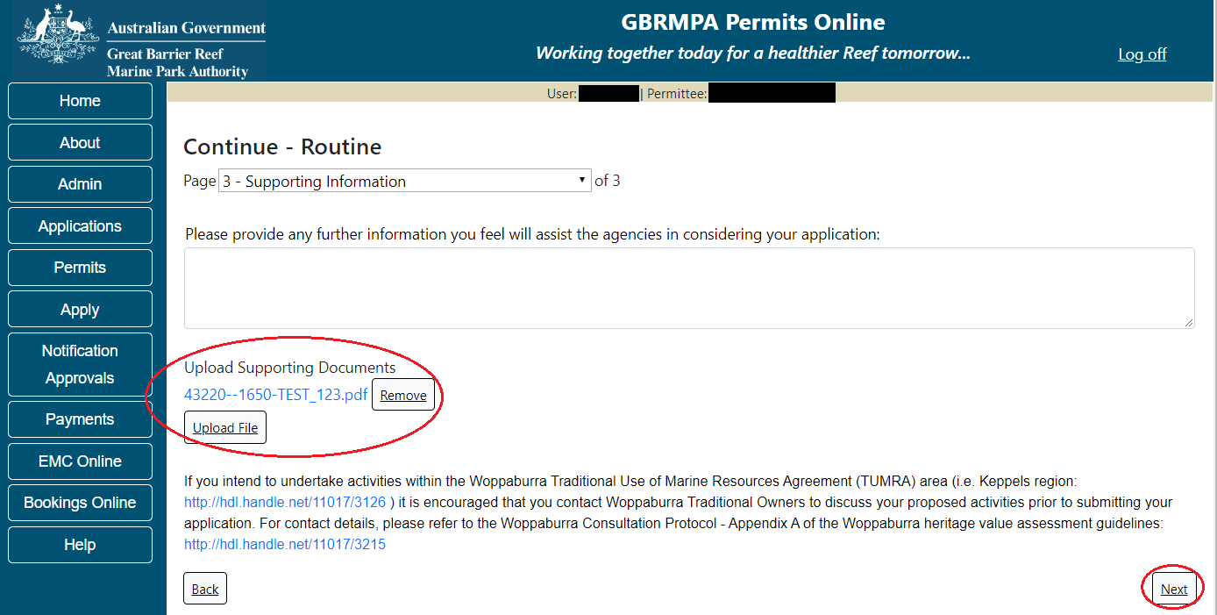
Figure 646 - Screenshot of Supporting Information screen with a red circle around Uploaded File area and a red circle around Next button
Completion of a set of declarations is mandatory prior to submitting your application. To complete the declarations section of this application, you must either be the applicant, or if applying on behalf of an organisation / company / government agency, you must be a Director of that organisation / company / government agency. Authorised contacts cannot complete the declaration section, as it contains legally binding commitments in place of a physical signature.
Please read all questions carefully, provide a response to each, and select Next.
Figure 647 - Screenshot of Declarations page with red circle around Yes and No options and Next button

On the final page of declarations there is a Submit button. Once the Submit button is selected, the application will be submitted to the Reef Authority and is no longer available to be edited. The status of the application on the Applications screen will then display ‘Submitted to GBRMPA’. The application’s Primary Contact will receive an emailed acknowledgement notice from a delegated Assessment Officer within 10 business days.
Figure 648 - Screenshot of Declarations screen with a red circle around the Submit button
Once you submit your application, you will be provided with a reference/application number and can follow the progress of your application via the Applications menu on the left.
Figure 649 - Screenshot of the Thank you for your application screen with a red circle around Reference number and a red circle around the open pdf button

Your application will appear in the Applications screen with the reference/application number also displayed. You have further options to view a summary of your application, email the Reef Authority or withdraw the application.
Figure 650 - Screenshot of Applications screen with a red circle around Application No., Summary, Email and Withdraw options

  - Research Continuation
Permits Online enables you to apply to continue (renew) your research permit. To begin, select the Apply from the left side menu, then select Continue a current permit.
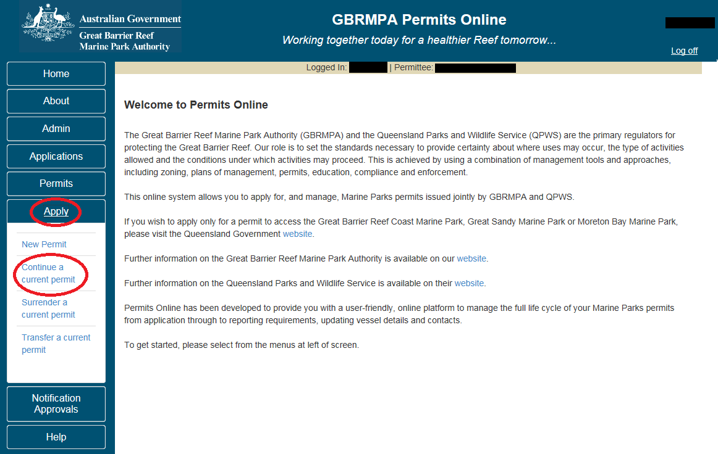
Figure 651 - Screenshot of Apply sub menu with a red circle around Apply and a red circle around the Continue a current permit icon

You will progress to the Current Permits screen with options to choose which permit you wish to Continue.
Figure 652 - Screenshot of Current Permits screen with continue option circled in red

Select Continue to move to the next page of the application.
The Current Permit Details screen will appear, here you can check over the permissions and activities associated with the permit you wish to continue. Select the Continue button to move to the next page of the application.
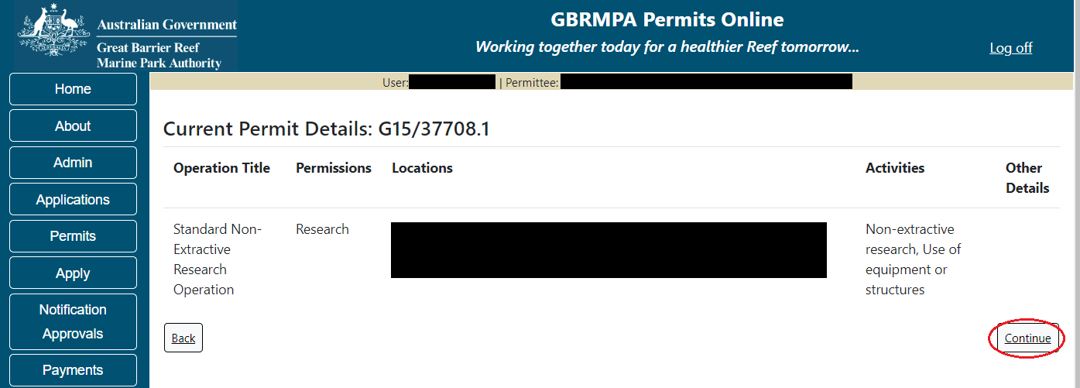
Figure 653 - Screenshot of Current Permit Details screen with red circle around Continue button

The primary contact screen is where you can select who is the primary contact for this application. Select the existing primary contact if that person is going to be the primary contact for this application. If the details are correct select the tick box next to the These contact details are correct, then select Next. You will progress to the application summary screen (refer to Figure 652 to continue).
Figure 654 - Screenshot of Who is the primary contact for this application screen with a red circle around the These details are correct tick box and a red circle around the Next button

If the details require an update select the Edit contact details button.
Figure 655 – Screenshot of the Who is the primary contact for this application screen with a red circle around the Edit contact details button

Edit the details that require updating. For example if the phone number requires updating add the new details into the field. Select Save once all the updated details have been added.
Figure 656 – Screenshot of Who is the primary contact for this application screen with a red circle around the Phone number details and a red circle around the Save button
Once Save is selected confirm the new details are correct by selecting the These contact details are correct, then select Next.
Figure 657 - Screenshot of Who is the primary contact for this application screen with a red circle around the These details are correct tick box and a red circle around the Next button

If the existing contact is not the primary contact select Add a new contact person for this application, the search contacts field will appear.
Figure 658 - Screenshot of Who is the primary contact for this application screen with Add new contact person for this application selected

Add details of Given Name, Surname and Preferred Email address, then select Search.
Figure 659 – Screenshot of Who is the primary contact for this application screen with a red circle around the Search button

Once Search is selected, the system will display the contact, if the contact exist within the Reef Authority’s system. If the contact is an existing contact to the Reef Authority, a Select button will appear next to the contact. Press the Select button that appears next to the contact, and you will then progress to the next screen.
Figure 660 – Screenshot of Who is the primary contact for this application screen with a red circle around the Search button and a red circle around the Select button

If the contact is not found within the Reef Authority’s system a screen to add the details of the new contact appears.
Figure 661 - Screenshot of Who is the primary contact for this application screen with Add new contact person for this application selected

Add the details of the new contact filling in all fields marked with a mandatory (*) and select Save.
Figure 662 - Screenshot of Who is the primary contact for this application screen with Add new contact person for this application selected and a red circle around the Save button
You will progress to the Continue Application summary page. Once on the summary screen please select Continue Permitted Activity to answer mandatory questions associated with continuing a Research Permit.
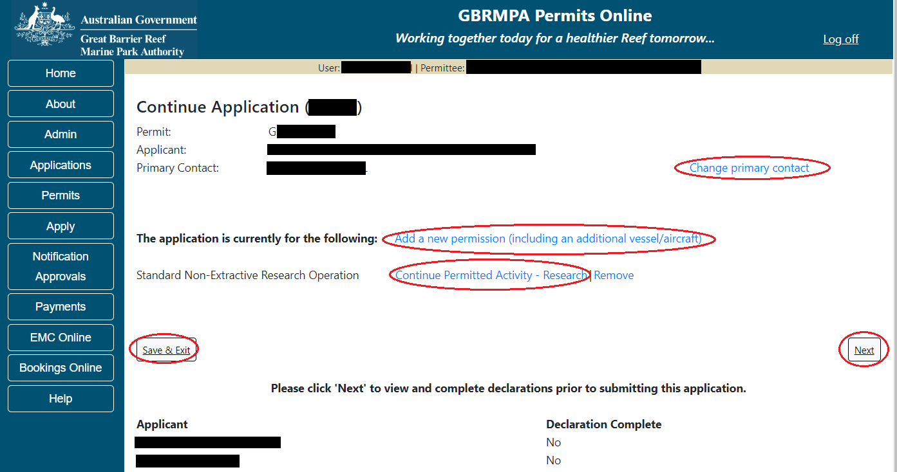
Figure 663 - Screenshot of Continue Application Summary screen with a red circle around Continue Permitted Activity hyperlink

Additional Information - Summary screen, links and buttons;
- Change primary contact: If the change primary contact link is selected the applicant will progress to the primary contact page where the primary contact can be changed.

- Apply for another permission: If the Apply for another permission button is selected, the applicant will progress to the What are you seeking to do in the Marine Parks page where another permission type can be added. (e.g. add a mooring permission to the tourism permission).

- Edit: If edit is selected the application/permission will be reopened to apply any changes.

- Remove: If remove is selected the application/permission will be removed.

- Save & Exit: If the Save & Exit button is selected the applicant will progress to the applications screen.

- Next: If next is selected the applicant will progress to the submission process including declaring and submitting the application.

Once selected you will progress to the Research Continuation further questions section. If you wish to keep the same details as the previous permit, select Yes for this question.
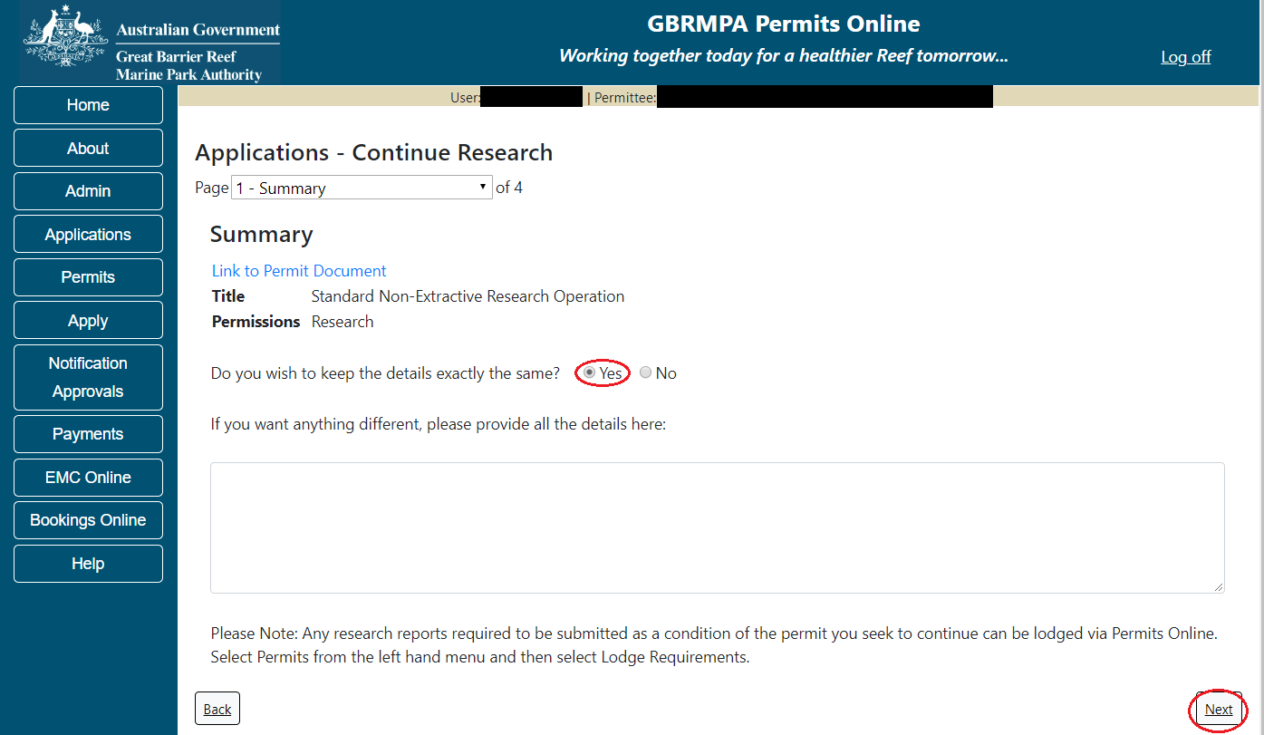
Figure 664 - Screenshot of Research Summary screen with a red circle Yes and a red circle around the Next button

If you wish to add further details to the permit, select No for question Do you wish to keep the details exactly the same? and add the details of anything different you would like added or removed from the permit in the text field provided. Select Next to progress.
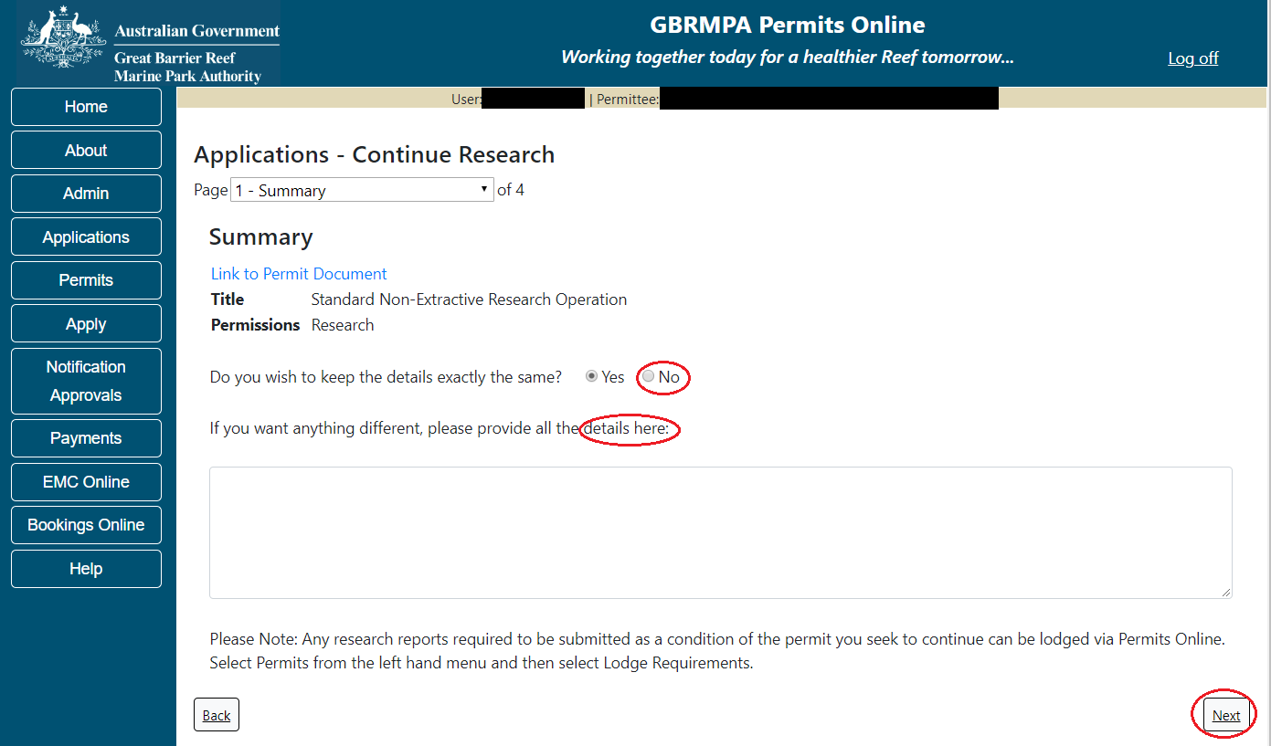
Figure 665 - Screenshot of Research Summary screen with a red circle around No and a red circle around Add details of anything different here text field and a red circle around the Next button
Page 2 of Continue Research application is the Research Justification page. Please fill out the details in the text field provided, then select Next to progress.
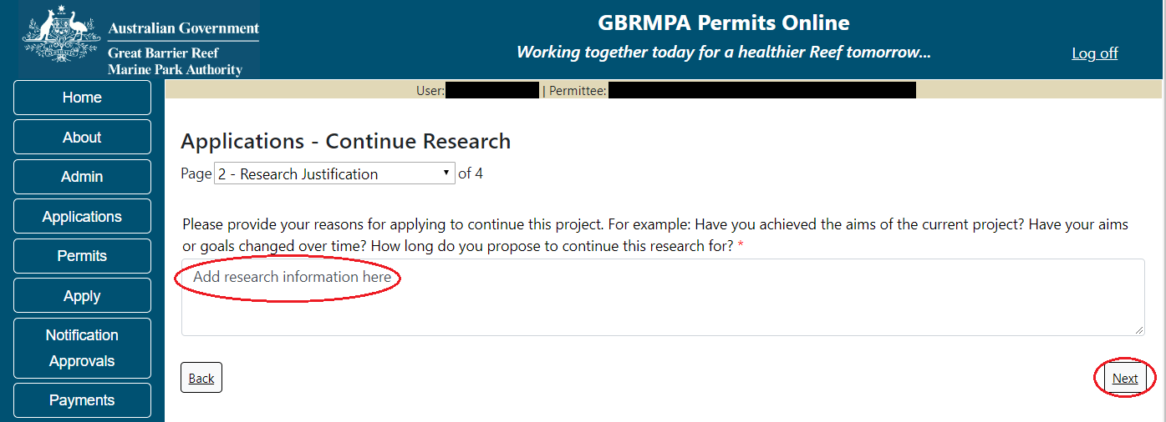
Figure 666 - Screenshot of Research Summary screen with a red circle around Add research information here text field, and a red circle around the Next button

Page 3 of Continue Research application is the further information questions. If you wish to seek permission to conduct research in Marine Park Zones or Buffer Zones, Preservation Zones or Scientific Research Zones, select Yes and add the details into the free text area. (For more information around Zones, refer here for further details).
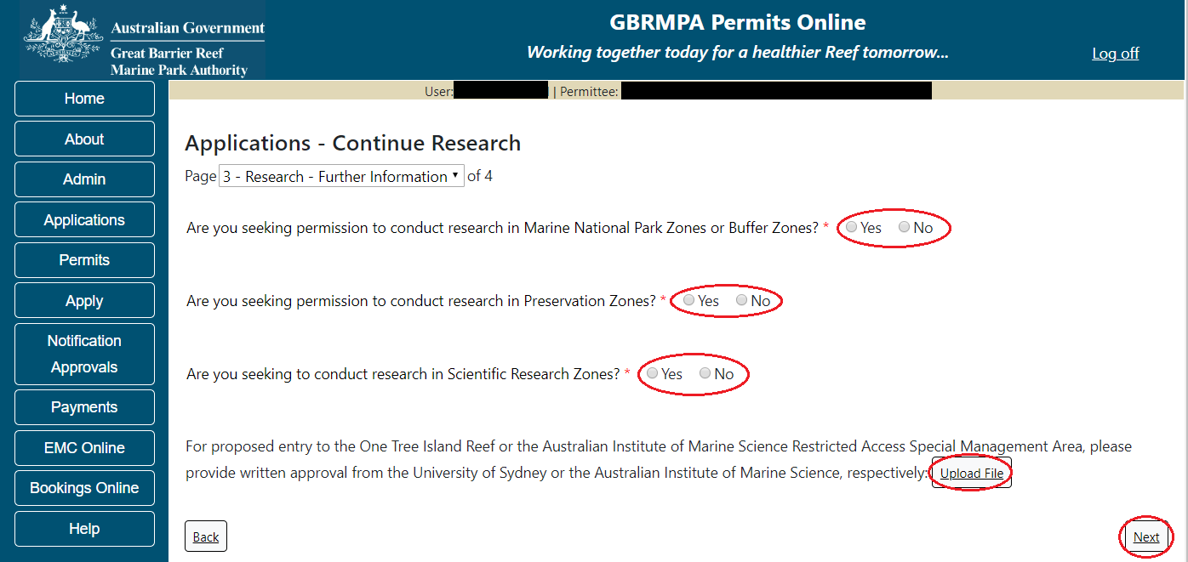
Figure 667 - Screenshot of Research Further Information page with a red circle around three Yes/No buttons, a red circle around Upload File button and a red circle around the Next button

Once the Research Continuation questions have been answered you will progress to the application summary screen, select Next on the summary screen to progress to the Declarations screens.
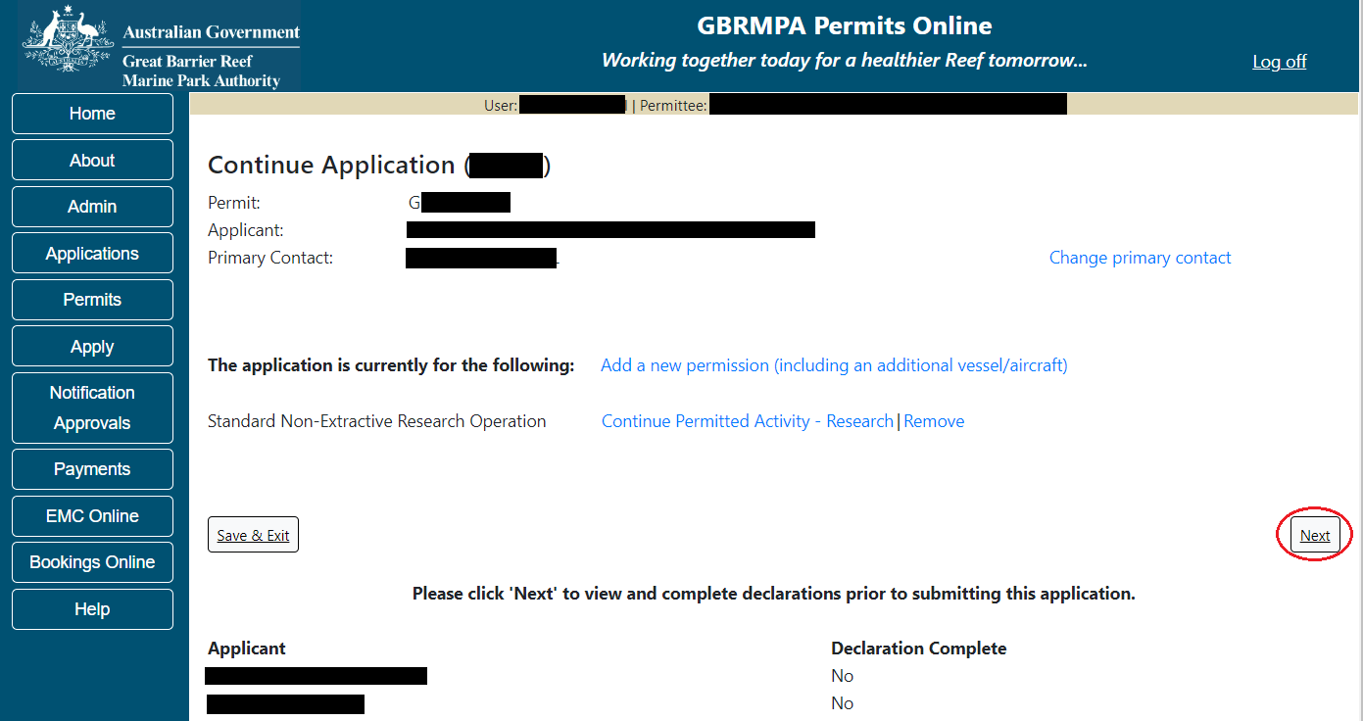
Figure 668 - Screenshot of Research Summary Screen with a red circle around the Next button

The submission process will have 1 additional page, Supporting Information. Add any other information you feel will assist the Managing Agencies in assessing your application by typing in the text field or upload a file if required. If a file is uploaded it will appear on the screen with the file name and a Remove button to remove the file if the wrong file is selected. Select Next to progress to the Declarations screens.
Figure 669 - Screenshot of Supporting Information screen with information entered and a red circle around Uploaded File and Next button
Completion of a set of declarations is mandatory prior to submitting your application. To complete the declarations section of this application, you must either be the applicant, or if applying on behalf of an organisation / company / government agency, you must be a Director of that organisation / company / government agency. Authorised contacts cannot complete the declaration section, as it contains legally binding commitments in place of a physical signature.
Please read all questions carefully, provide a response to each, and select Next.
Figure 670 - Screenshot of Declarations page with red circle around Yes and No options and Next button

On the final page of declarations there is a Submit button. Once the Submit button is selected, the application will be submitted to the Reef Authority and is no longer available to be edited. The status of the application on the Applications screen will then display ‘Submitted to GBRMPA’. The application’s Primary Contact will receive an emailed acknowledgement notice from a delegated Assessment Officer within 10 business days.
Figure 671 - Screenshot of Declarations screen with a red circle around the Submit button
Once you submit your application, you will be provided with a reference/application number and can follow the progress of your application via the Applications menu on the left.
Figure 672 - Screenshot of the Thank you for your application screen with a red circle around Reference number and a red circle around the open pdf button

Your application will appear in the Applications screen with the reference/application number also displayed. You have further options to view a summary of your application, email the Reef Authority or withdraw the application.
Figure 673 - Screenshot of Applications screen with a red circle around Application No., Summary, Email and Withdraw options

  - Continue as Routine Commercial Research
Permits Online enables you to apply to continue (renew) your research permit. To begin, select the Apply link on the left hand side menu, then select Continue a current permit.
Figure 674 - Screenshot of Apply sub menu with a red circle around Apply and a red circle around the Continue a current permit icon

You will progress to the Current Permits screen with options to choose which permit you wish to Continue.
Figure 675 - Screenshot of Current Permits screen with continue option circled in red

Select Continue to move to the next page of the application.
The Current Permit Details screen will appear, here you can check over the permissions and activities associated with the permit you wish to continue. Select the Continue button to move to the next page of the application.
Figure 676 - Screenshot of Current Permit Details screen with red circles around Continue button

The primary contact screen is where you can select who is the primary contact for this application. Select the existing primary contact if that person is going to be the primary contact for this application. If the details are correct select the tick box next to the These contact details are correct, then select Next. You will progress to the application summary screen refer to Figure 675 to continue.
Figure 677 - Screenshot of Who is the primary contact for this application screen with a red circle around the These details are correct tick box and a red circle around the Next button

If the details require an update select the Edit contact details button.
Figure 678 – Screenshot of the Who is the primary contact for this application screen with a red circle around the Edit contact details button

Edit the details that require updating. For example if the phone number requires updating add the new details into the field. Select Save once all the updated details have been added.
Figure 679 – Screenshot of Who is the primary contact for this application screen with a red circle around the Phone number details and a red circle around the Save button
Once Save is selected confirm the new details are correct by selecting the These contact details are correct, then select Next.
Figure 680 – Screenshot of Who is the primary contact for this application screen with a red circle around the These details are correct tick box and a red circle around the Next button

If the existing contact is not the primary contact select Add a new contact person for this application, the search contacts field will appear.
Figure 681 - Screenshot of Who is the primary contact for this application screen with Add new contact person for this application selected

Add details of Given Name, Surname and Preferred Email address, then select Search.
Figure 682 – Screenshot of Who is the primary contact for this application screen with a red circle around the Search button

Once Search is selected, the system will display the contact, if the contact exists within the Reef Authority’s system. If the contact is an existing contact to the Reef Authority, a Select button will appear next to the contact. Press the Select button that appears next to the contact, and you will then progress to the next screen.
Figure 683 – Screenshot of Who is the primary contact for this application screen with a red circle around the Search button and a red circle around the Select button

If the contact is not found within the Reef Authority’s system a screen to add the details of the new contact appears.
Figure 684 - Screenshot of Who is the primary contact for this application screen with Add new contact person for this application selected

Add the details of the new contact filling in all fields marked with a mandatory (*) and select Save.
Figure 685 - Screenshot of Who is the primary contact for this application screen with Add new contact person for this application selected and a red circle around the Save button
You will then progress to the Continue Routine Commercial Research Application Summary Screen. Here you have a number of options available via links or buttons. Select Next on the summary screen to progress to the Declarations screens.
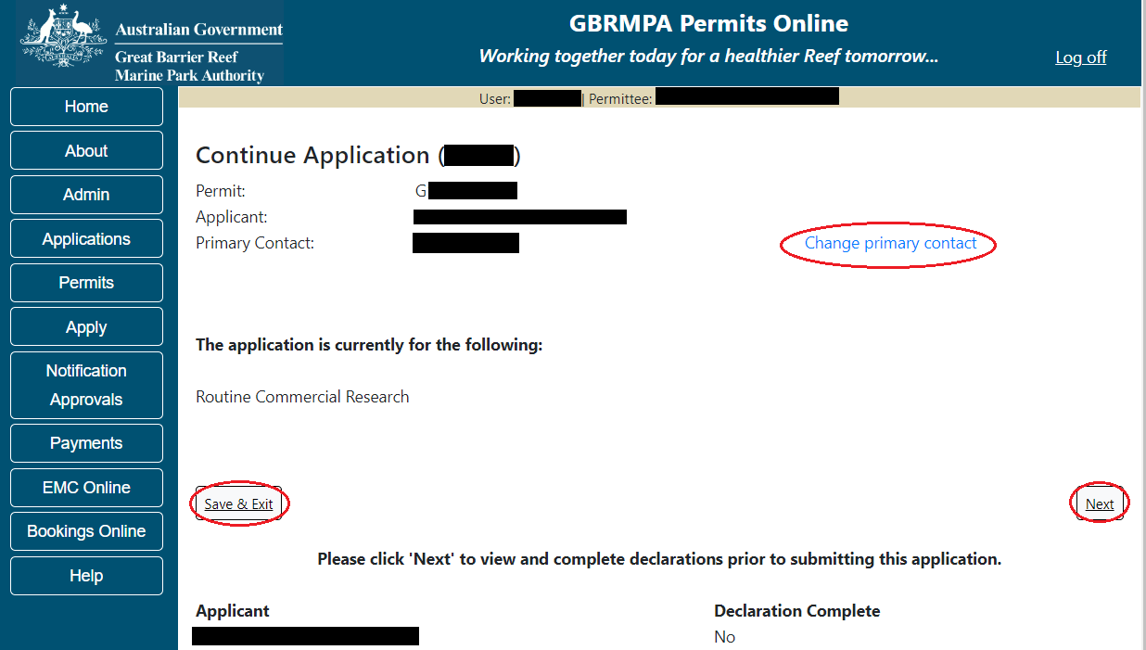Figure 686 - Screenshot of Application Summary screens with red circles around all options available

Additional Information - Summary screen, links and buttons;
- Change primary contact: If the change primary contact link is selected the applicant will progress to the primary contact page where the primary contact can be changed.

- Save & Exit: If the Save & Exit button is selected the applicant will progress to the applications screen.

- Next: If next is selected the applicant will progress to the submission process including declaring and submitting the application.

The submission process will have 1 additional page, Supporting Information. Add any other information you feel will assist the Managing Agencies in assessing your application by typing in the text field or upload a file if required.
Figure 687 - Screenshot of Supporting Information screen with a red circle around the Upload File button

If a file is uploaded it will appear on the screen with the file name and a Remove button to remove the file if the wrong file is selected. Select Next to progress to the Declarations screens.
Figure 688 - Screenshot of Supporting Information screen with information entered and a red circle around Uploaded File and Next button
Completion of a set of declarations is mandatory prior to submitting your application. To complete the declarations section of this application, you must either be the applicant, or if applying on behalf of an organisation / company / government agency, you must be a Director of that organisation / company / government agency. Authorised contacts cannot complete the declaration section, as it contains legally binding commitments in place of a physical signature.
Please read all questions carefully, provide a response to each, and select Next.
Figure 689 - Screenshot of Declarations page with red circle around Yes and No options and Next button

On the final page of declarations there is a Submit button. Once the Submit button is selected, the application will be submitted to the Reef Authority and is no longer available to be edited. The status of the application on the Applications screen will then display ‘Submitted to GBRMPA’. The application’s Primary Contact will receive an emailed acknowledgement notice from a delegated Assessment Officer within 10 business days.
Figure 690 - Screenshot of Declarations screen with a red circle around the Submit button
Once you submit your application, you will be provided with a reference/application number and can follow the progress of your application via the Applications menu on the left.
Figure 691 - Screenshot of the Thank you for your application screen with a red circle around Reference number and a red circle around the open pdf button

Your application will appear in the Applications screen with the reference/application number also displayed. You have further options to view a summary of your application, email the Reef Authority or withdraw the application.
Figure 692 - Screenshot of Applications screen with a red circle around Application No., Summary, Email and Withdraw options

- Surrender a Current Permit
To surrender a current permit, select the Apply tab menu, then select Surrender a Current Permit. You will progress to the Current Permits screen with options to choose which permit you wish to Surrender.
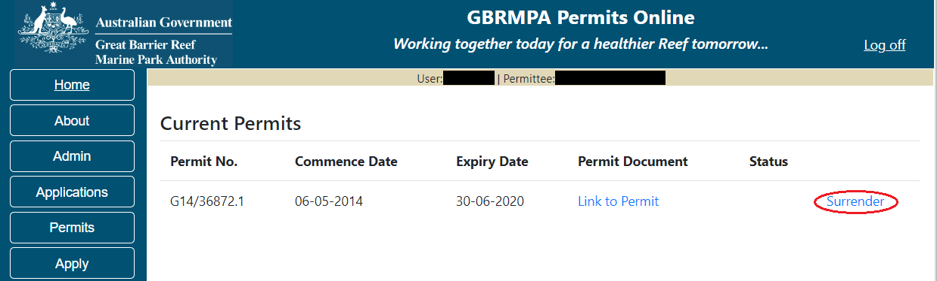
Figure 693 - Screenshot of Current Permits page with a red circle around the Surrender hyperlink option

The Surrender permissions page is an information page. Read the details then select Next to continue or select Back to go back.
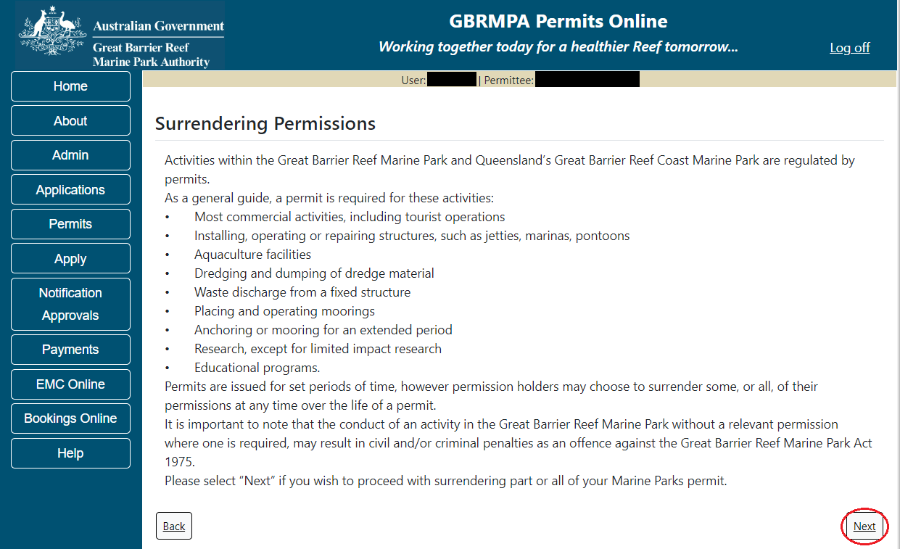
Figure 694 - Screenshot of Surrendering Permissions page with information displayed and red circle around Next button

The Surrender details page will list the active Permission available to be surrendered. To view the details of the permission, select the View Details button.
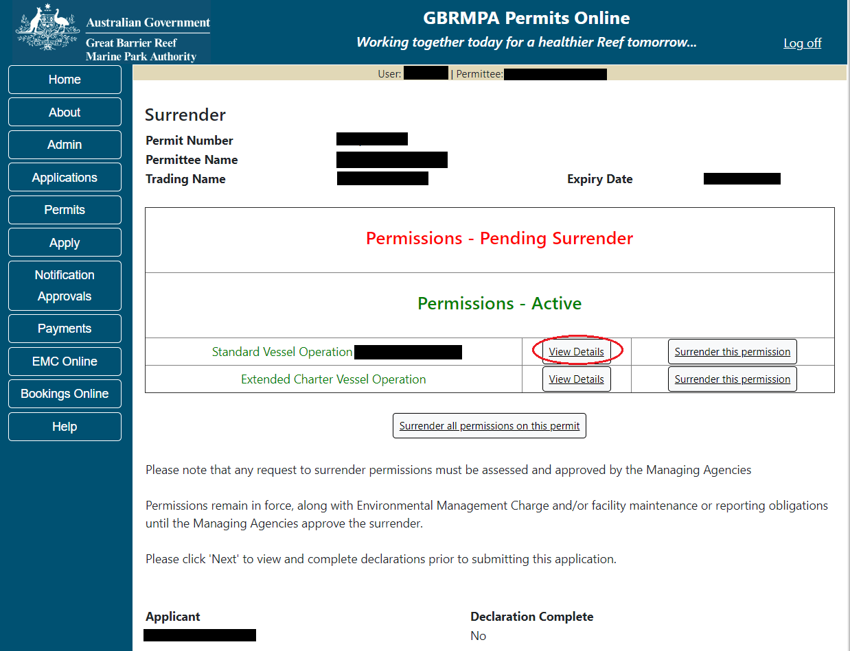
Figure 695 - Screenshot of Surrender page with a red circle around View Details button

The details of the permission will appear. You can review the details. To continue with the Surrender application select the Cancel/Back button.
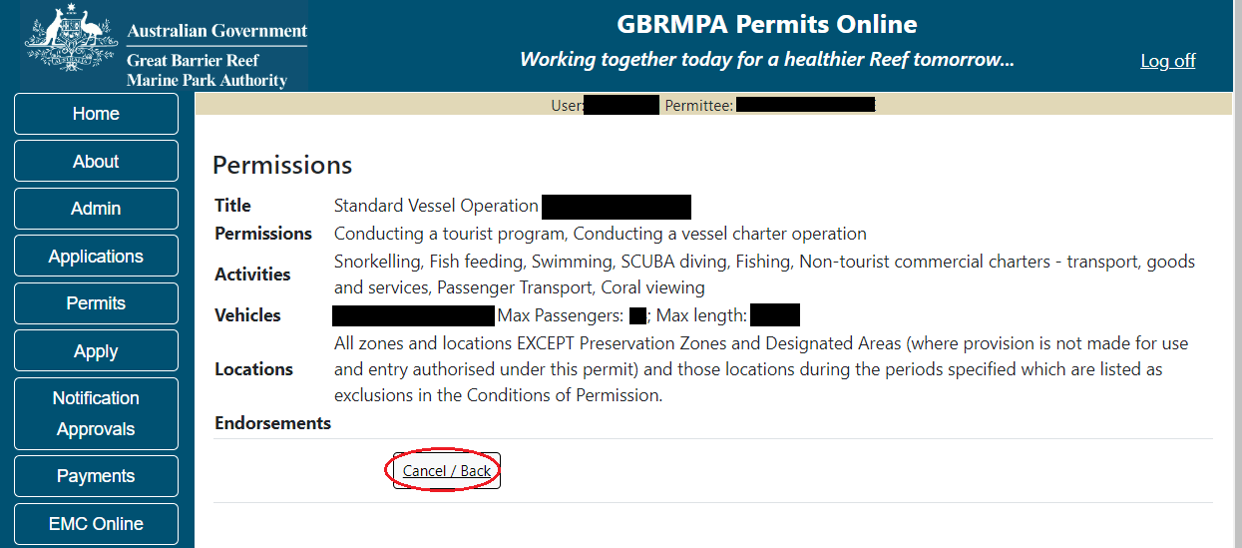
Figure 696 - Screenshot of Permissions page with a red circle around Cancel / Back button

To surrender a permission select the Surrender this permission button.
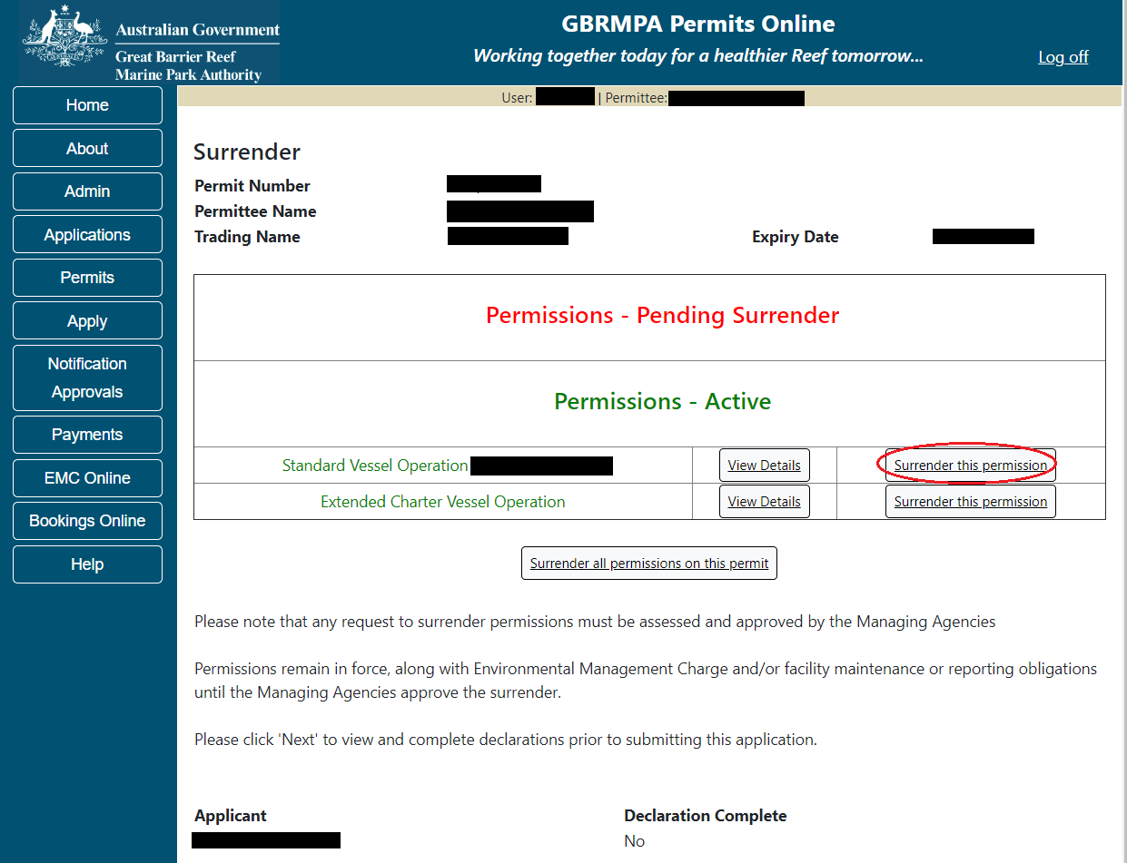
Figure 697 - Screenshot of Surrender page with a red circle around Surrender this permission button

The permission will then appear in the Permissions – Pending Surrender field
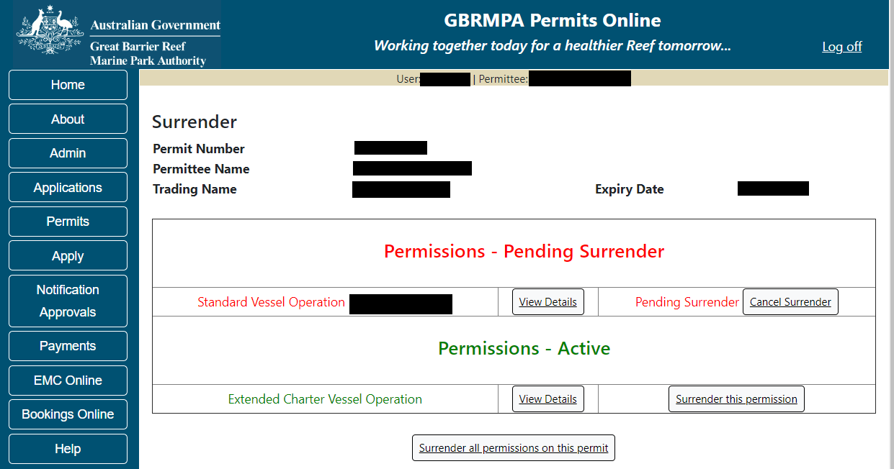
Figure 698 - Screenshot of Surrender page with permission showing in Pending Surrender area

If you have multiple permission and you wish to surrender all permissions, select the Surrender all permissions on this permit button
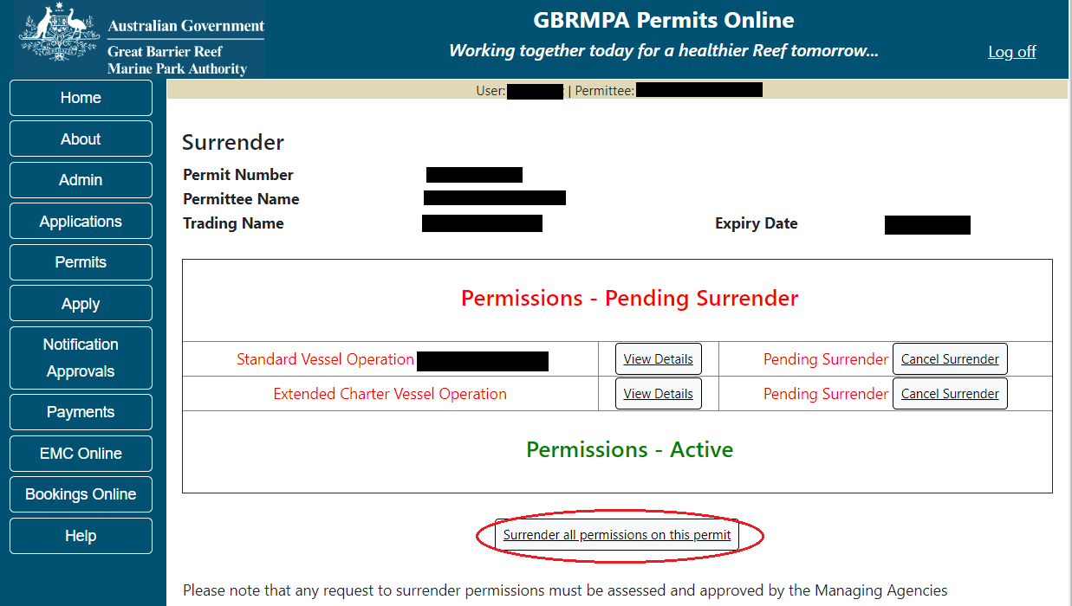
Figure 699 - Screenshot of Surrender page with a red circle around Surrender all permissions on this permit button

Once you have selected the permission/s to be surrendered then select Next to progress to the Declarations screens.
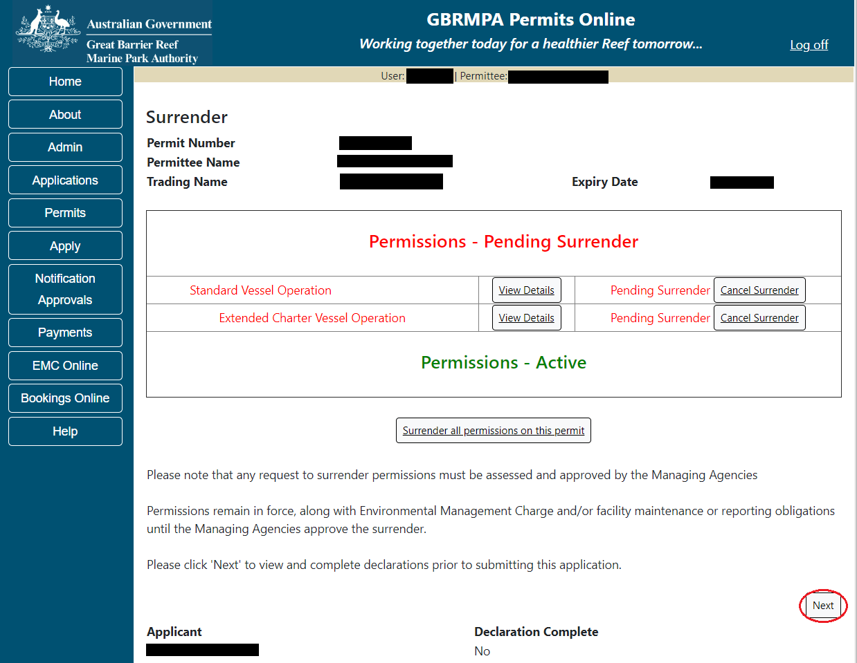
Figure 700 - Screenshot of Surrender page with permission showing in Pending Surrender area and red circle around Submit button
Completion of a set of declarations is mandatory prior to submitting your application. To complete the declarations section of this application, you must either be the applicant, or if applying on behalf of an organisation / company / government agency, you must be a Director of that organisation / company / government agency. Authorised contacts cannot complete the declaration section, as it contains legally binding commitments in place of a physical signature.
Please read all questions carefully, provide a response to each, and select Next.
Figure 701 - Screenshot of Declarations page with red circle around Yes and No options and Next button

On the final page of declarations there is a Submit button. Once the Submit button is selected, the application will be submitted to the Reef Authority and is no longer available to be edited. The status of the application on the Applications screen will then display ‘Submitted to GBRMPA’. The application’s Primary Contact will receive an emailed acknowledgement notice from a delegated Assessment Officer within 10 business days.
Figure 702 - Screenshot of Declarations screen with a red circle around the Submit button
Once you submit your application, you will be provided with a reference/application number and can follow the progress of your application via the Applications menu on the left.
Figure 703 - Screenshot of the Thank you for your application screen with a red circle around Reference number and a red circle around the open pdf button

Your application will appear in the Applications screen with the reference/application number also displayed. You have further options to view a summary of your application, email the Reef Authority or withdraw the application.
Figure 704 - Screenshot of Applications screen with a red circle around Application No., Summary, Email and Withdraw options

- Transfer a Current Permit
To transfer a current permit to another Permit Holder, select the Transfer option in the Apply sub menu.
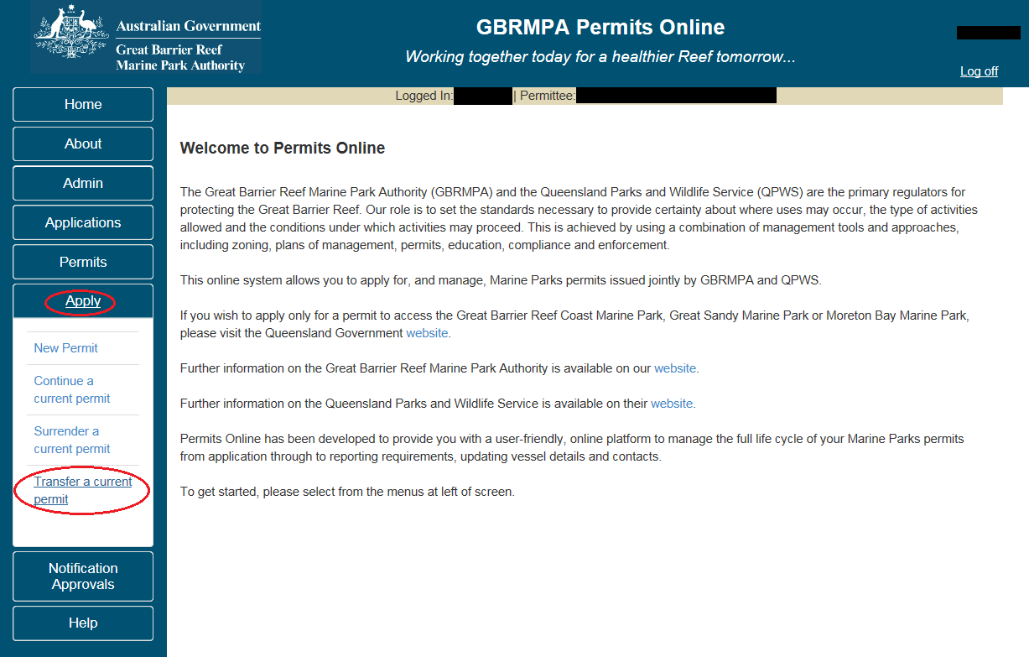
Figure 705 - Screenshot of Permits Online Home page with a red circle around Apply and red circle around Transfer a current permit option

You will progress to the Current Permits screen with options to choose which permit you wish to Transfer. Select Transfer next to the permit number you wish to Transfer.
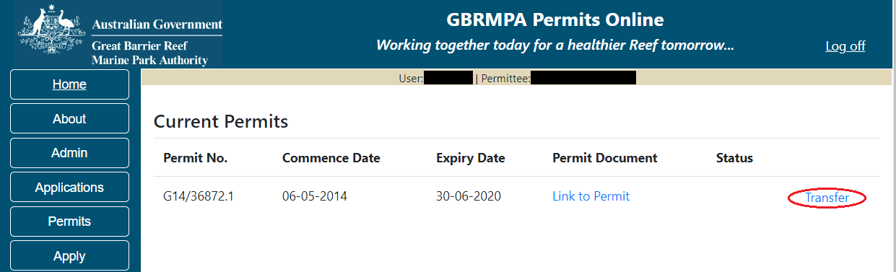
Figure 706 - Screenshot of Current Permits page with a red circle around Transfer hyperlink option

You will progress to the Current Permit Details screen with details of your operations, permissions, locations, vehicle details, activities, structures and any endorsements you may have. Select the permit number hyperlink to continue to the next page.
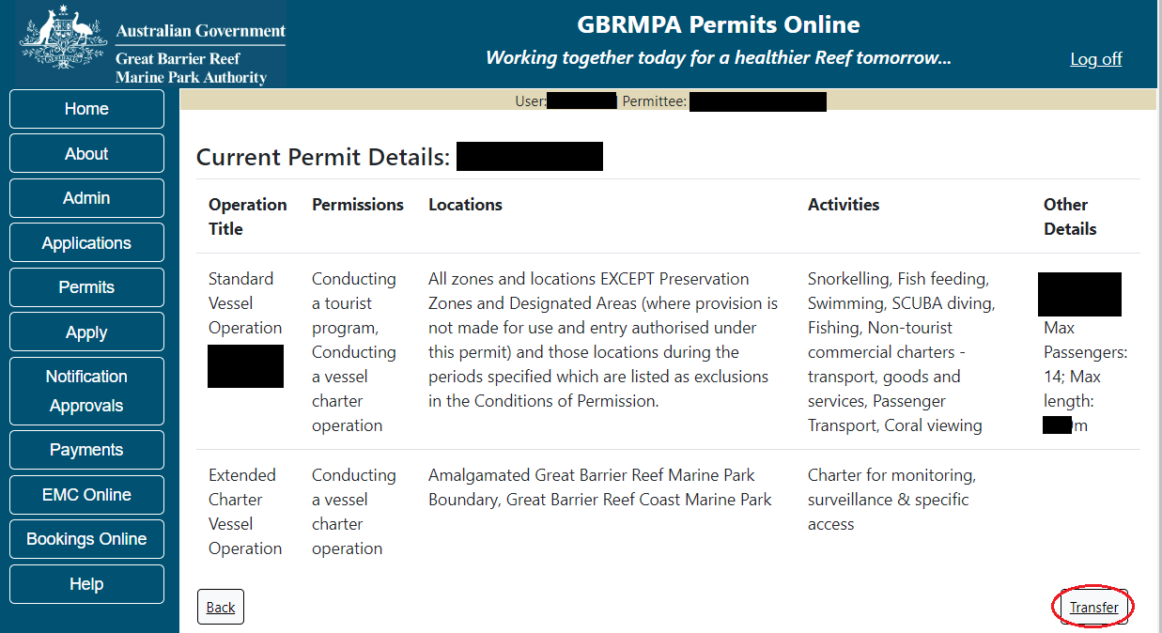
Figure 707 - Screenshot of Transfer an Existing Permit screen with a red circle around transfer button

You will progress to the Transferring Your Permit page. On this page there are a number of info hyperlinks with information about transferring a permit.
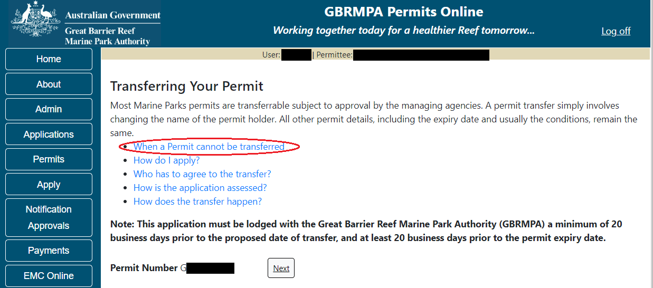
Figure 708 - Screenshot of Transferring Your Permit page with a red circle around When a Permit cannot be transferred Hyperlink

Selecting one of the hyperlinks will display information below the hyperlink. Select any of the hyperlinks to read the information. Select Next to progress.
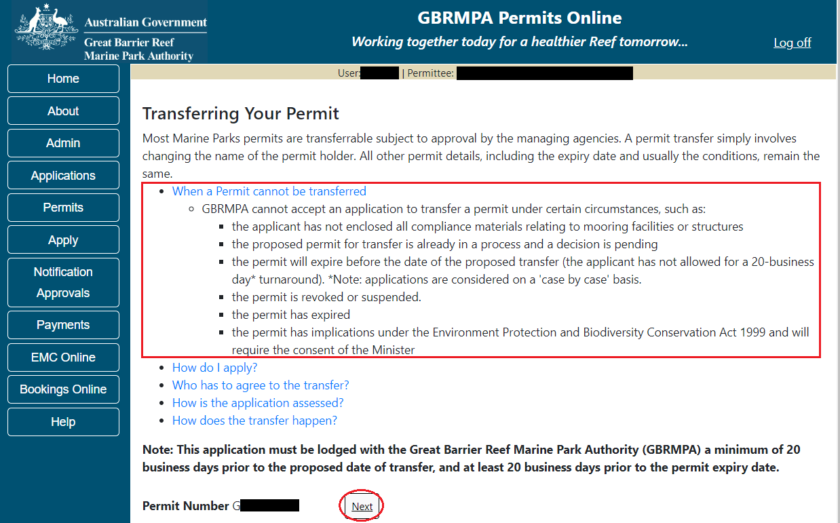
Figure 709 - Screenshot of Transferring Your Permit page with a red outline around the information for - When a Permit cannot be transferred information and a red circle around Next button

You will progress to the Permittee Details screen. Here you are asked Does the intended permit holder currently have a Marine Parks Permit or previously had a Marine Park Permit or application? Select Yes or No.
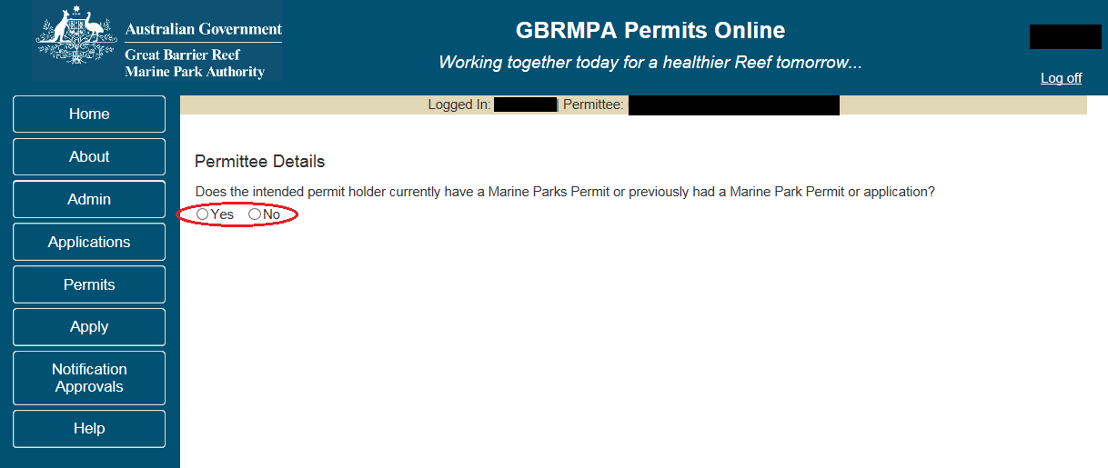
Figure 710 - Screenshot of Permittee Details screen with a red circle around Yes and No options

If No is selected a Next button will appear. Select the Next button
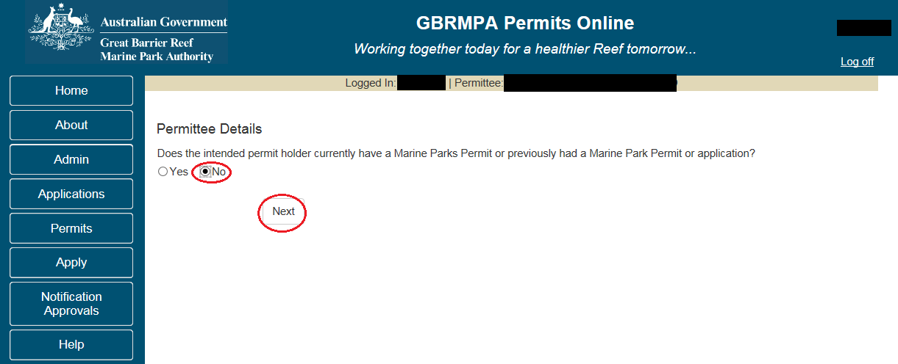
Figure 711 - Screenshot of Permittee Details screen with No selected and circled and a red circle around Next button

You will progress to the Who is applying to acquire this Permit page. Here you can fill in the details of the contact person that the permit is being transferred to. Other selections are available if the permit is being transferred to an organisation or if it is being transfer to joint applicants. Add the contact details ensuring you enter details in all mandatory fields, then select Save.
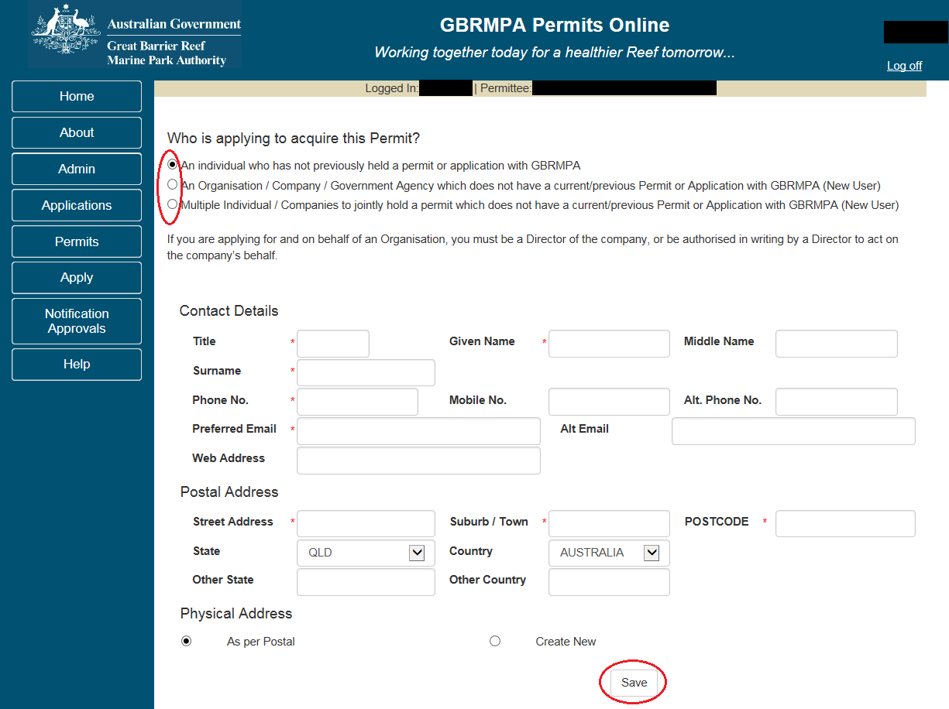
Figure 712 - Screenshot of Who is applying to acquire this Permit screen with an individual who has not previously held a permit or application with the Reef Authority selected with all options circled and red circle around Save button
If Yes is selected further fields will appear. A field to add an existing Authority permit number, and a field to search for an ACN number of the intended permit holder. Add in details of either the permit number or ACN number (which is a permit number or ACN number for the person the permit is being transferred to). Once the number has been entered select Search.
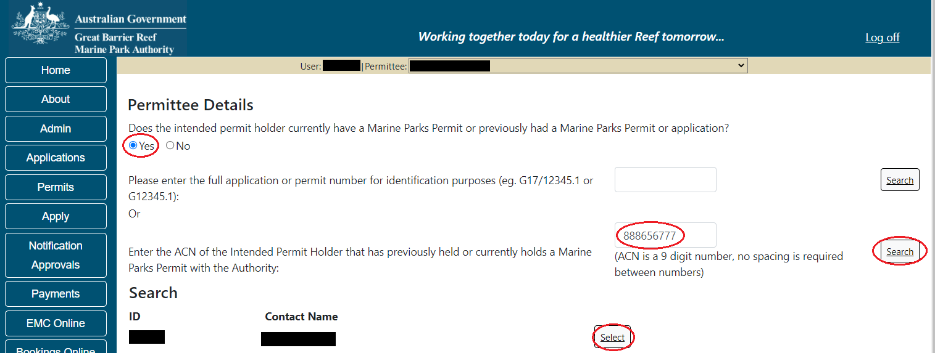
Figure 713 - Screenshot of Permittee Details screen with Yes selected and red circle around Search Field and Search button

Once Search is selected if the intended permit holder has a contact with the Reef Authority their details will appear with a Select button.
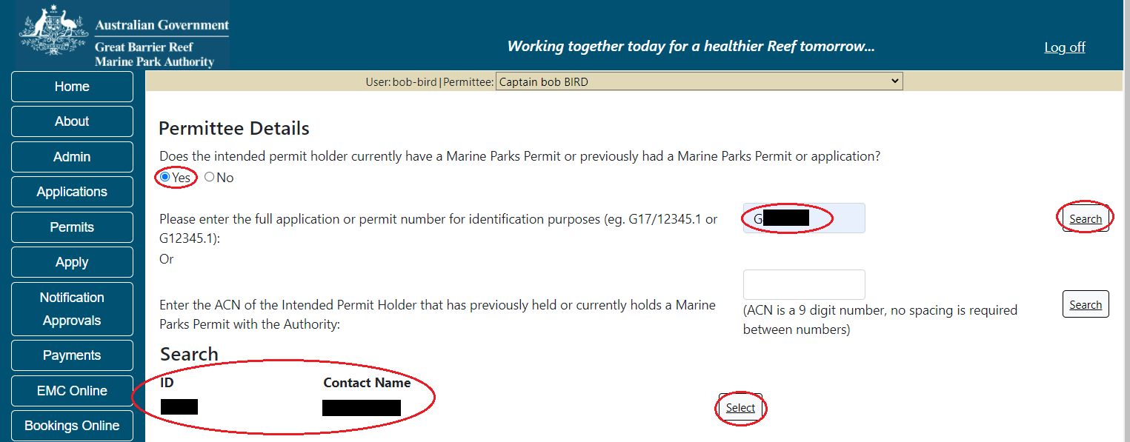
Figure 714 - Screenshot of Permittee Details screen with red circle around Search results and red circle around Select button

Once you click on Select you will be asked to verify Is this the intended permit holder? If you select No you will progress back to add details of the new contact. If you select Yes, then select the Next button.
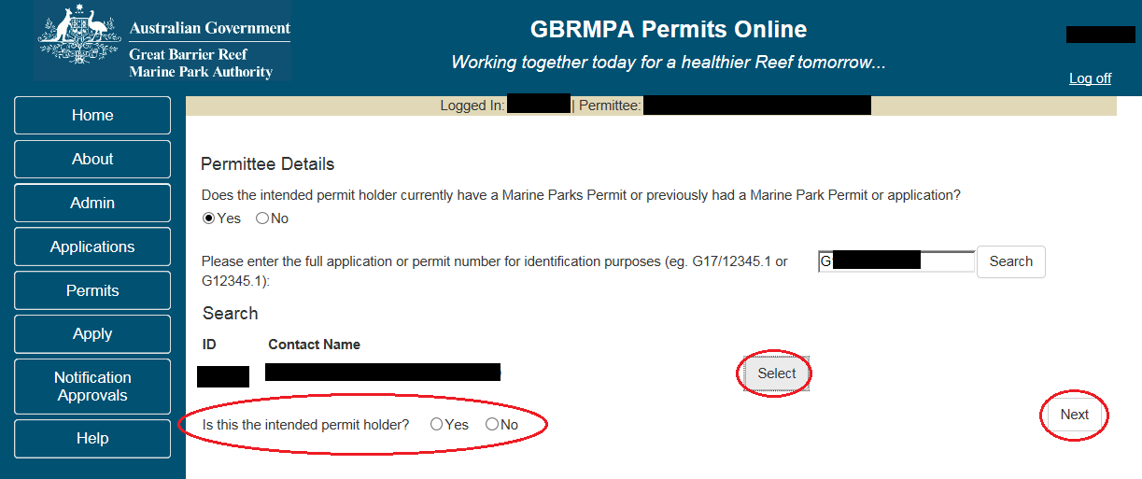
Figure 715 - Screenshot of Permittee Details screen with red circle around question - Is this the intended permit holder and Yes No options, red circles around Select and Next button

You will then be asked to add a primary contact of the intended permit holder. Once this option is selected the contact search will appear.
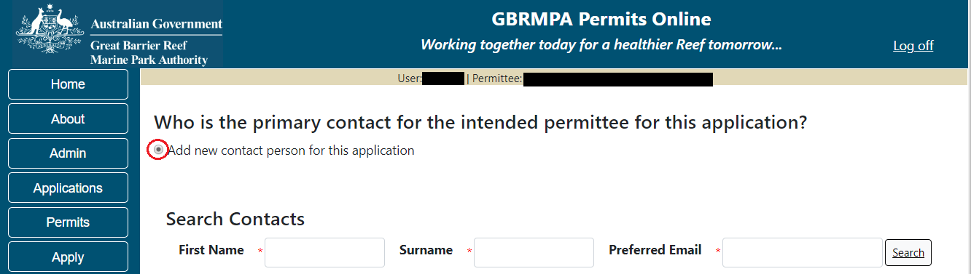
Figure 716 - Screenshot of Apply screen with a red circle around Add new contact for this application

Add details of Given Name, Surname and Preferred Email address, then select Search.
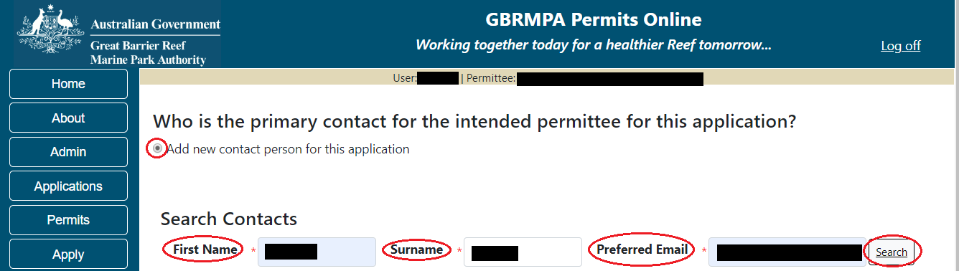
Figure 717 - Screenshot of Apply screen with red circles around first name, surname, preferred email and the search button
Once Search is selected on the previous screen, the system will display the contact, if the contact exists within the Reef Authority’s system. If the contact is an existing contact to the Reef Authority, a Select button will appear next to the contact. Press the Select button that appears next to the contact and you will progress to the next screen.
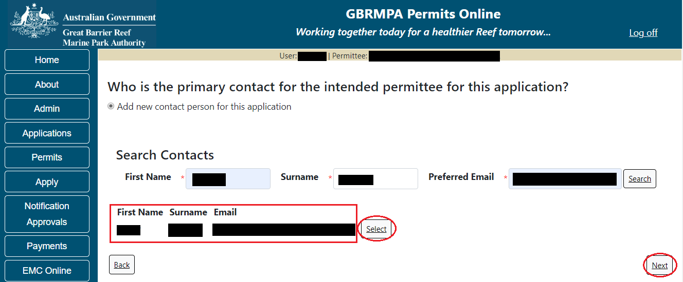
Figure 718 - Screenshot of Apply screen with a red box around contact details and a red circle around the Select button

If a primary contact is not within the system for the data entered in the search fields, the add details screen will appear. Any data that was entered in the search fields will be pre-populated. Ensure you fill in all fields marked with (*) which are the mandatory fields and ensure you select Save.
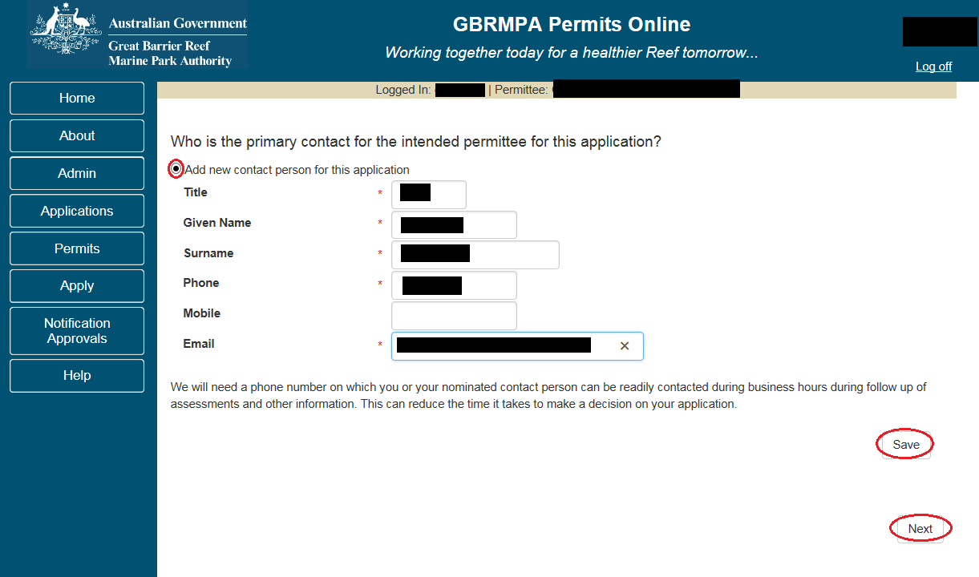
Figure 719 - Screenshot of Who is the primary contact for the intended Permit Holder for this application screen with information completed and red circle around Save and Next buttons
Once Next is selected you will progress to the Application Summary screen. To complete the application, select the Next button on the summary screen to progress to the application questions area for a Transfer application.
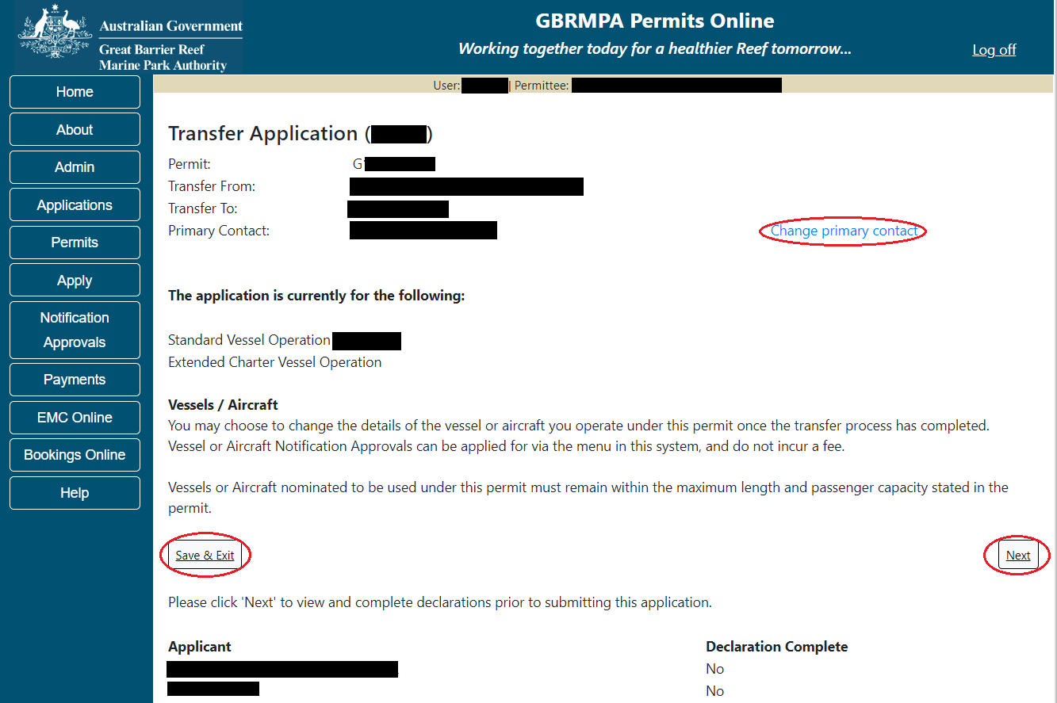
Figure 720 - Screenshot of Transfer Application Summary screen with red circles around all options available to select

Additional Information - Summary screen, links and buttons;
- Change primary contact: If the change primary contact link is selected the applicant will progress to the primary contact page where the primary contact can be changed.

- Save & Exit: If the Save & Exit button is selected the applicant will progress to the applications screen.

- Next: If next is selected the applicant will progress to the submission process including declaring and submitting the application.

Page 1 of Transfer application provides opportunity for you to add any other information you feel will assist the Managing Agencies in assessing your application. Add supporting information by typing in the text field or upload a file if required.
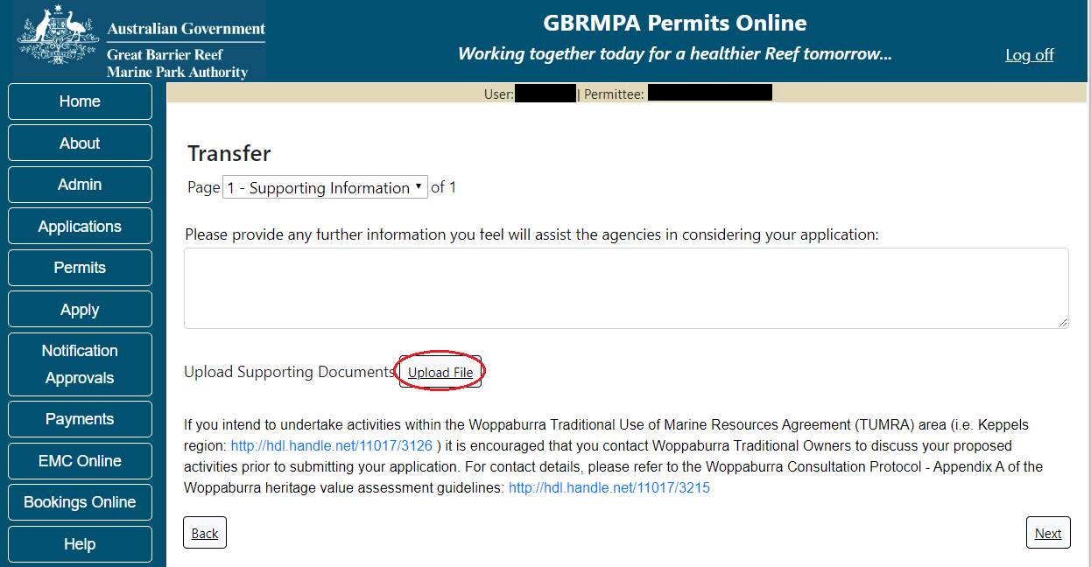
Figure 721 - Screenshot of Supporting Information screen with a red circle around Uploaded File button

If a file is uploaded it will appear on the screen with the file name and a Remove button to remove the file if the wrong file is selected. Select Next to continue.
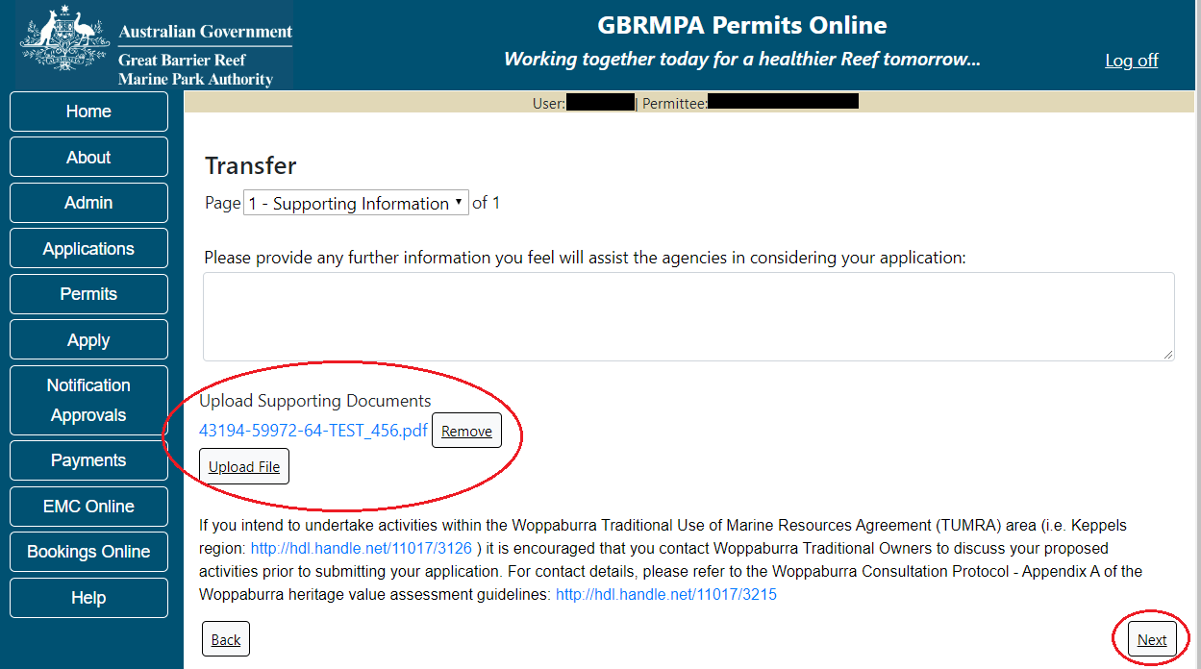
Figure 722 - Screenshot of Supporting Information screen with information entered and a red circle around Please provide details section, red circles around Uploaded File and Save button

You will then progress to the declarations area. Declarations need to be submitted by both the permit holder and the intended permit holder. As the permit holder you will need to submit your application first. Then an email will be automatically sent to the intended permit holder to log on and complete their declaration.
Completion of a set of declarations is mandatory prior to submitting your application. To complete the declarations section of this application, you must either be the applicant, or if applying on behalf of an organisation / company / government agency, you must be a Director of that organisation / company / government agency. Authorised contacts cannot complete the declaration section, as it contains legally binding commitments in place of a physical signature. Please read all questions carefully, provide a response to each, and select Next.
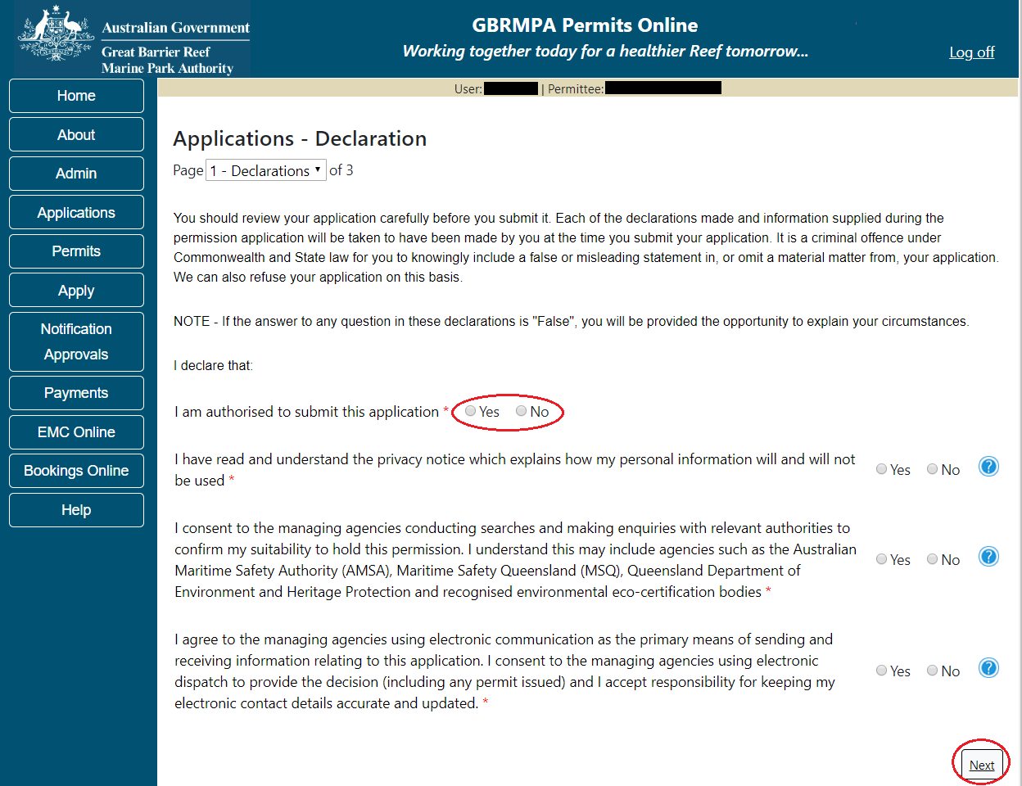
Figure 723 - Screenshot of Declarations page with red circle around Yes and No options and Next button

On the final page of declarations there is a Submit button. Once the Submit button is selected the application will be submitted to the Reef Authority.
Figure 724 - Screenshot of Declarations screen with a red circle around the Submit button
Once you submit your application, you will be provided with a reference/application number and can follow the progress of your application via the Applications menu on the left.
Figure 725 - Screenshot of the Thank you for your application screen with a red circle around Reference number and a red circle around the open pdf button

Your application will appear in the Applications screen with the reference/application number also displayed. You have further options to view a summary of your application, email the Reef Authority or withdraw the application.
Figure 726 - Screenshot of Applications screen with a red circle around Application No., Summary, Email and Withdraw options

- Lodge Requirements
Your Marine Parks permit may contain conditions requiring you to submit certain information at specified times. Such requirements may be lodged via Permits Online by selecting the ‘Permits’ menu, then ‘Lodge Requirements’.
The Lodge Requirements area is where Research Reports, Other Reports and for Further Information requested by the Reef Authority, can be lodged.

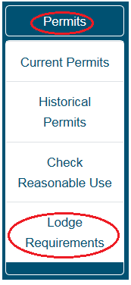
Figure 727 - Screenshot of Current Permits sub menu with a red circle around Permits icon and a red circle around the Lodge Requirements icon

  - Lodge Requirements – Research Report
Most research permits require the lodgement of annual reports, with a final project report to be provided upon completion of your research project. Reporting requirements are shown against each permit on the Lodge Requirements screen. Select the ‘Open’ hyperlink to enter required reporting information.

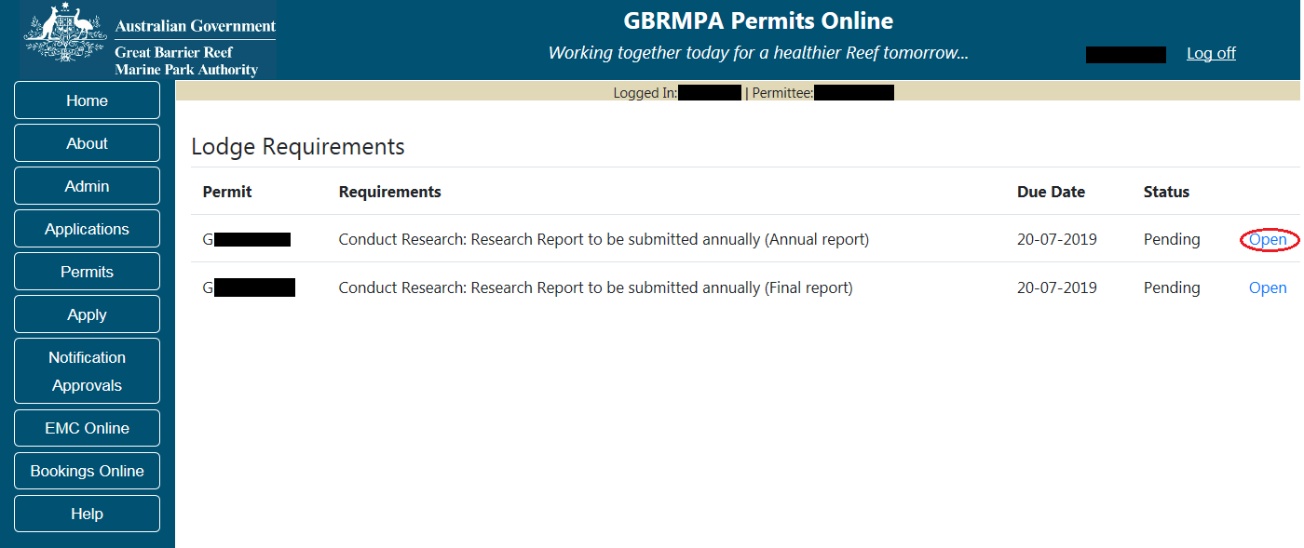
Figure 728 - Screenshot of Lodge Requirements screen with a red circle around Open

You will be presented with a series of questions relevant to your research project. Answer with ‘Yes’, ‘No’ or free text and progress through the pages using the ‘Back’ and ‘Next’ buttons. Mandatory questions are indicated by a red asterisk (*). Some questions will require documents to be uploaded as part of your response.
Fill in the required information for each question, upload a map of Research Site Locations and select ‘Next’ to continue.
If this is the Final Report select ‘Yes’, Select ‘No’ if future reports will be lodged.

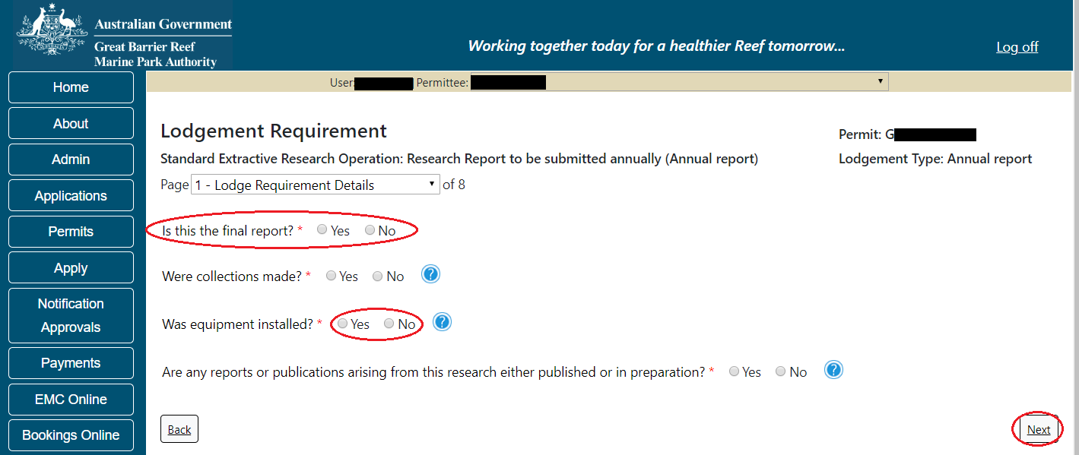
Figure 729 - Screenshot of Lodge Requirements Page 1 screen with a red circle around questions and Yes No radio buttons and red circle around Next button

Page 2 of the research return module requests maps of the research sites be uploaded. To upload a file select the ‘Add New’ button. Please note that the preferred format of files are KML/KMZ file types.
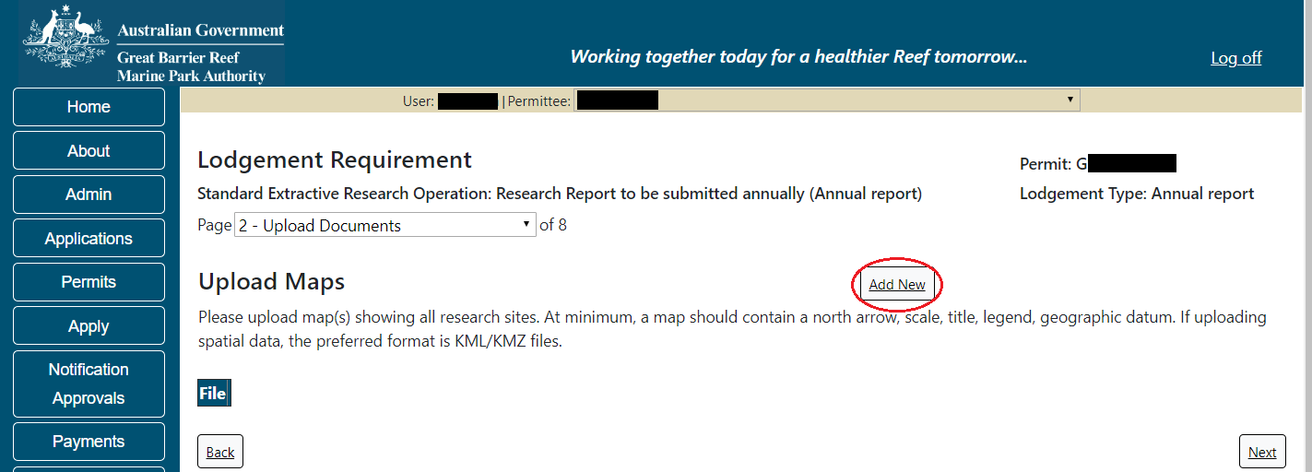
Figure 730 - Screenshot of Lodge Requirements Page with a red circle around the Add New button

Once uploaded a ‘Remove’ button will appear. Select ‘Remove’ if you wish to remove the file. Please note that the preferred format of files are KML/KMZ file types
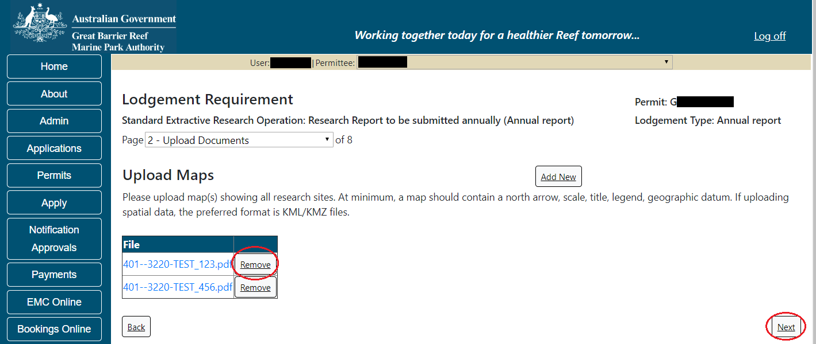
Figure 731 - Screenshot of Lodge Requirements Page with a red circle around the Remove and Next button

    - Sites
Page 3 of the research return module requests information on research sites accessed. On this page you have the option to add a new site or add existing sites (if previously set up). Select the Add New button to enter details of the first site where research collections were made.
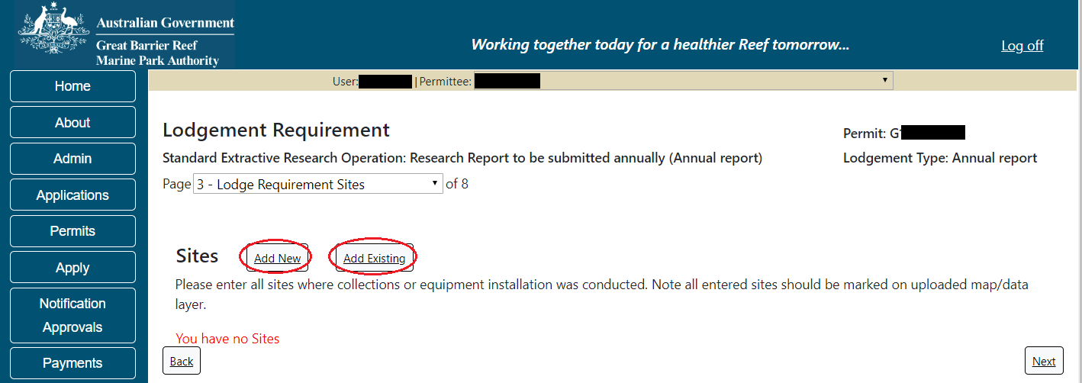
Figure 732 - Screenshot of Sites screen with a red circle around Add New and Add Existing buttons

Once Add New is selected the Sites pop up window will appear. Select identified reef location that is closest to the Site (Research Site) where collections were made. This field is a predictive dropdown list that will allow you to search via reef name, reef number or the Reef Authority zoning details. Begin typing the location and select from the list.
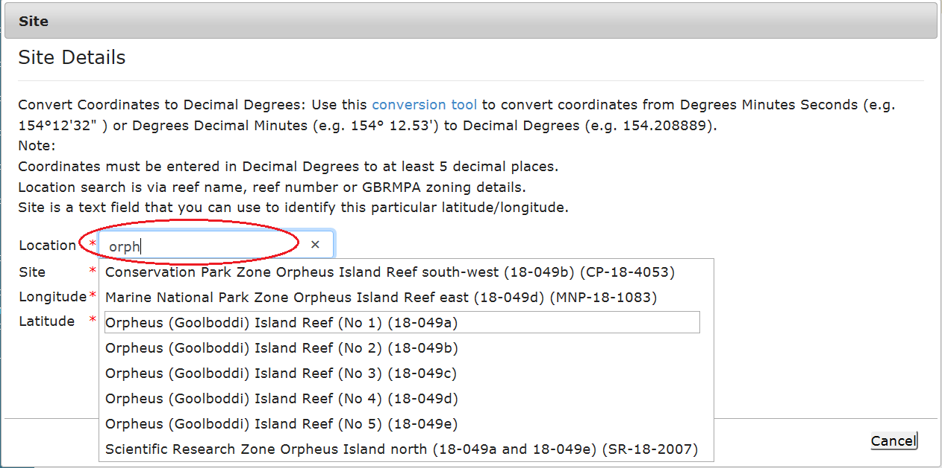
Figure 733 - Screenshot of Sites pop up window with a red circle around the location field

The Site field is a text field requiring you to provide the coordinates of the research site. The Site field refers to the name the researcher has applied to the site (e.g. Site 1, Site 2) or a name of your choosing (e.g. JCU Site 01, Collection site 1, collection site Orpheus Island, Orpheus01)
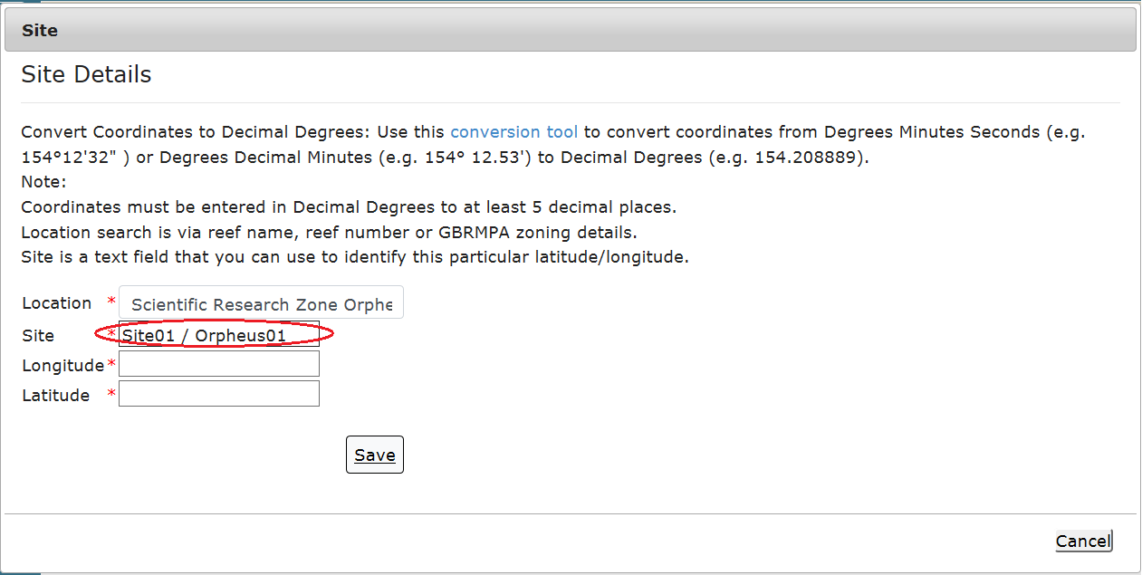
Figure 734 - Screenshot of Sites pop up window with a red circle around the Site field

Within the sites pop up window there is a conversion tool link. Coordinates must be provided in the form of Decimal Degrees. You may use the conversion tool to convert other formats such as Degrees Minutes Seconds or Degrees Decimal Minutes to Decimal Degrees. Link to the conversion tool - https://data.aad.gov.au/aadc/calc/dms_decimal.cfm
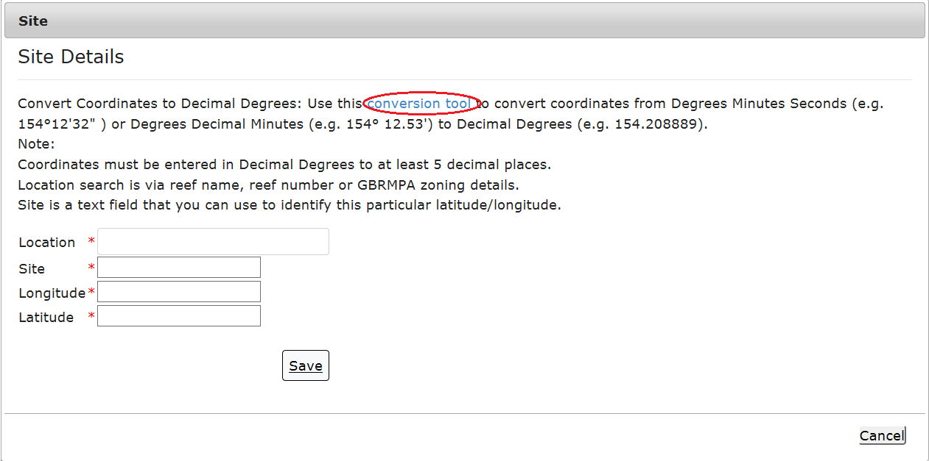
Figure 735 - Screenshot of Sites pop up window with a red circle around the conversion tool link

Add the co-ordinates of the site in Decimal Degrees to at least 5 decimal places. When entering the Latitude ensure you add a ‘-‘(minus sign) as a prefix.
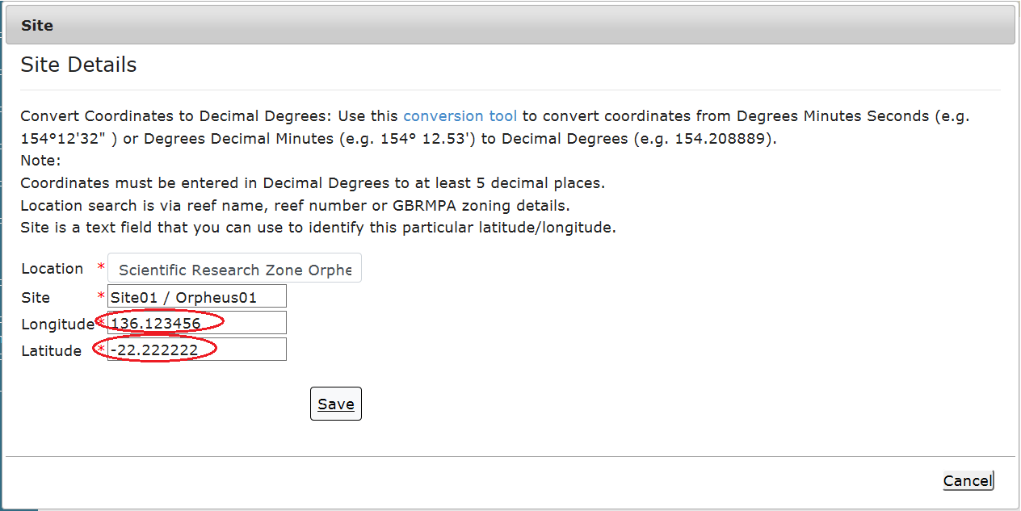
Figure 736 - Screenshot of Sites pop up window with a red circle around the latitude and longitude fields

If your co-ordinates are not within the Marine Park a validation message will show. The co-ordinate boundaries for the Marine Park are within 135.00000 and 155.00000 degrees Longitude, and between -30.00000 and -10.00000 degrees Latitude.
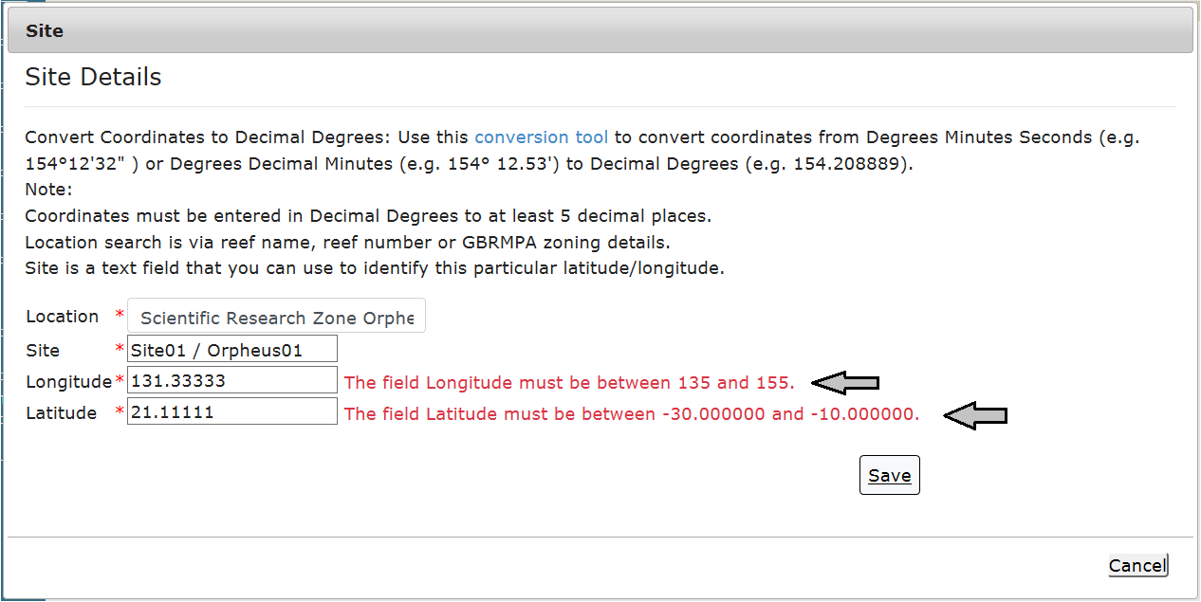
Figure 737 - Screenshot of Site pop up window displaying validation message for Longitude and Latitude errors

To add an Existing Site you will need to have previously listed sites to select from. Select the Add Existing button and the Sites pop up window will appear. If you have previously listed sites they will be available within this window to select.
(This function is designed to streamline population of subsequent reports. For example, once an annual report is submitted including the sites, when completing the next annual report or the Final report, the sites provided in previous reports will be selectable in this area).
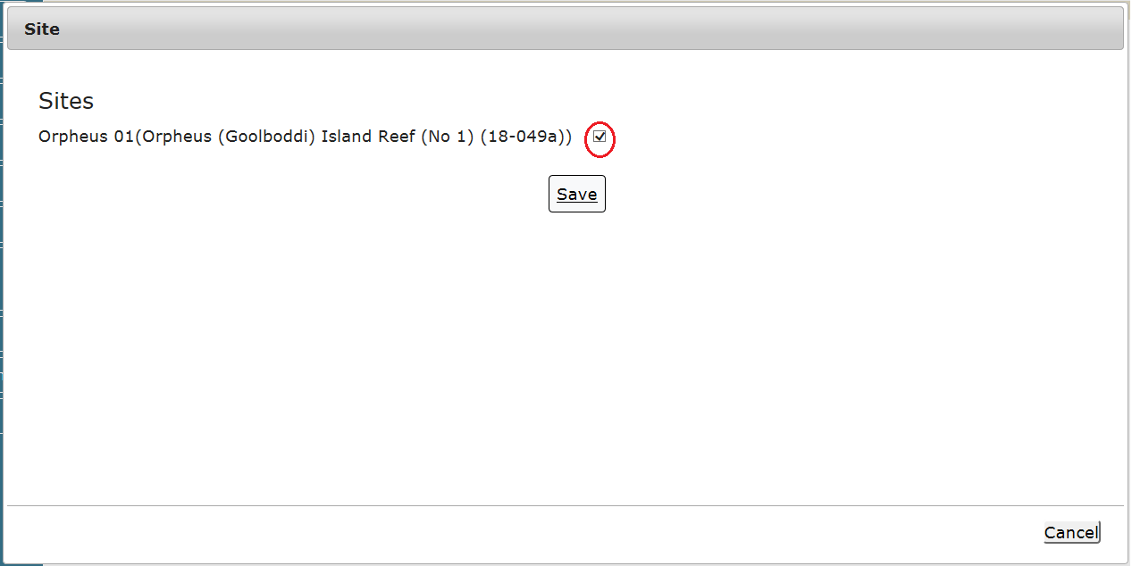
Figure 738 - Screenshot of Existing Sites pop up window with a red circle around the existing site
Once site information has been entered and the details saved, it will display on the sites page. You will be presented with 2 buttons, an Edit and a Remove button. Select Next to continue.
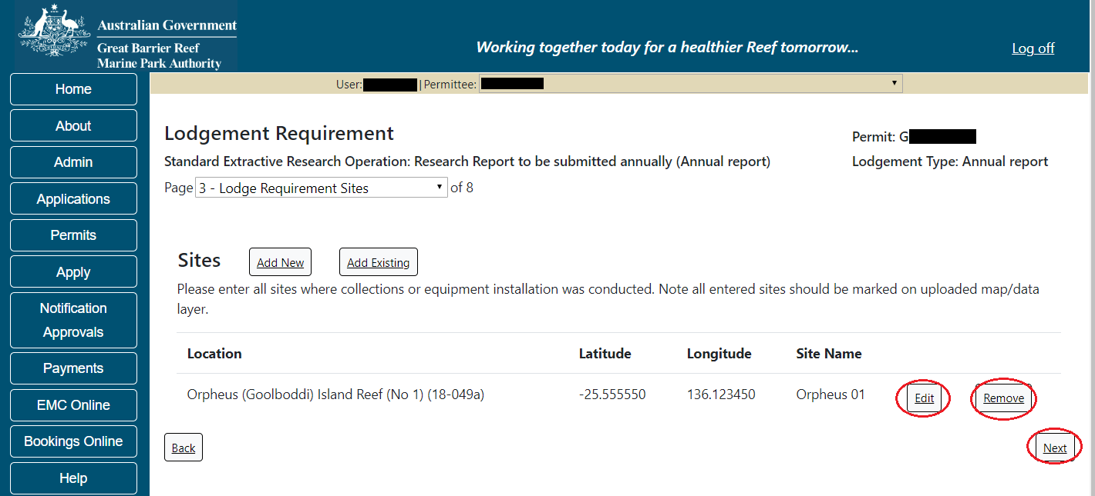
Figure 739 - Screenshot of Sites page with a red circle around Edit, Remove and Next buttons

    - Trips
Page 4 of the research return module asks about the trips upon which collections were made. Please add the dates of each trip where collections were made (e.g. between 15/06/2018- 17/06/2018 a research trip was conducted and collections were made). Select the Add New button for the Trips pop up window to appear.
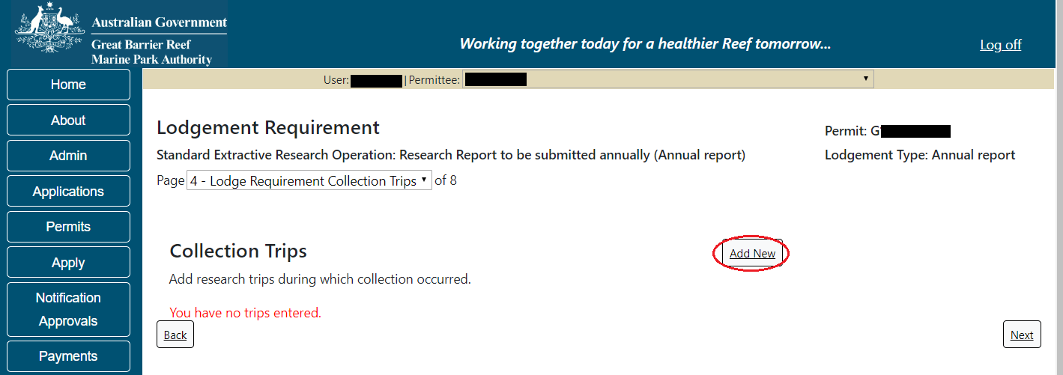
Figure 740 - Screenshot of Collections page with a red circle around Add New button

Once Add New is selected the Trips pop up window appears. Depending on the type of device and web browser being used, the date fields will display as per the browser design. For example, Microsoft Edge will display the dates with the year provided first and will need to be typed in, Chrome and Firefox will have a calendar icon to select the date, and if using an iPad the scroll dates appear for this field.
Add the dates where trips involving collections were made and select Save.
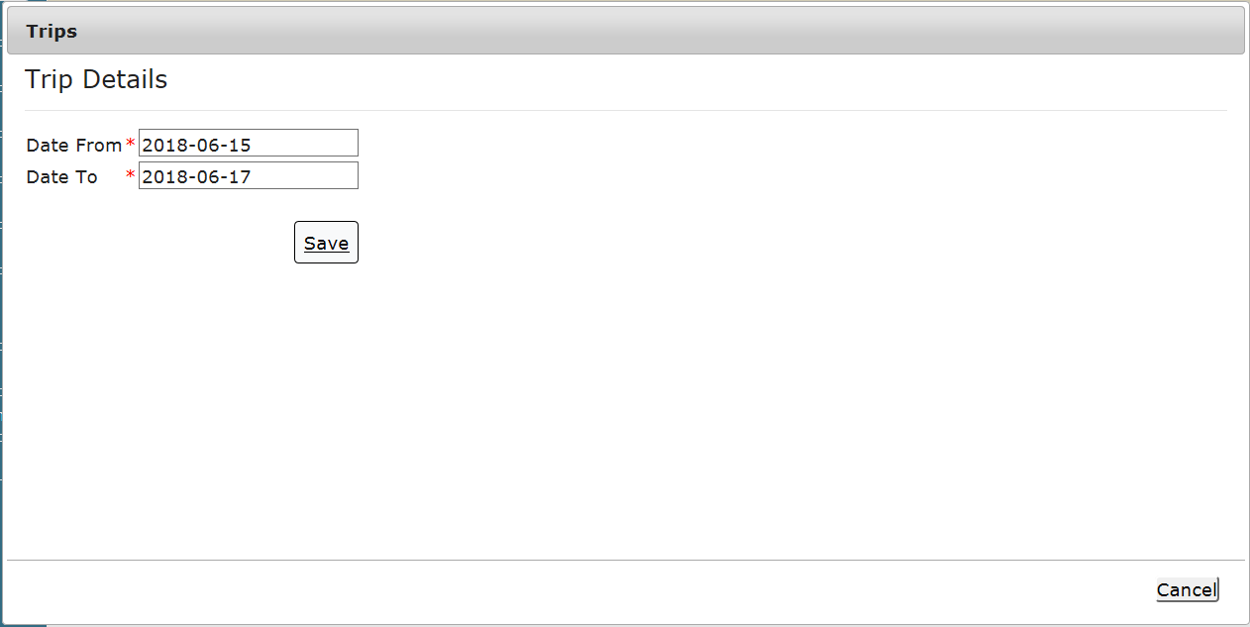
Figure 741 - Screenshot of Trips pop up window

Once you have added the Collection Trip Dates the Collections button will appear beside the dates. Select the Collections button to add details of collections made on the trip.
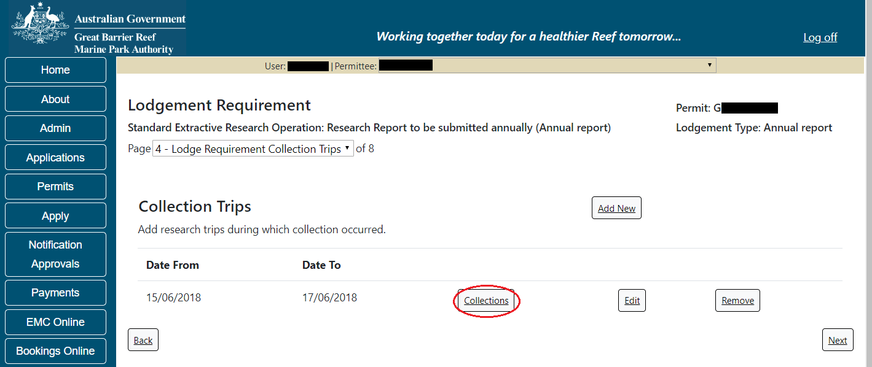
Figure 742 - Screenshot of Collection Trips page with a red circle around the collections button

    - Collection
Once selected, the collections page will be displayed. You will be presented with 2 buttons, a Back to Trips button and an Add New button. To add collections for this trip (15/06/2018 – 17/06/2018), select the Add New button.
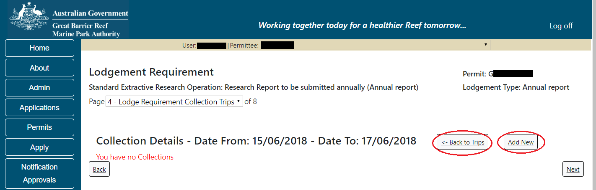
Figure 743 - Screenshot of collection details screen with a red circle around the back to trips and the add new buttons

Once the Add New button is selected the Collections pop up window will appear. Fields marked with a red asterisk (*) are mandatory, fields with a down arrow are dropdown picklists.
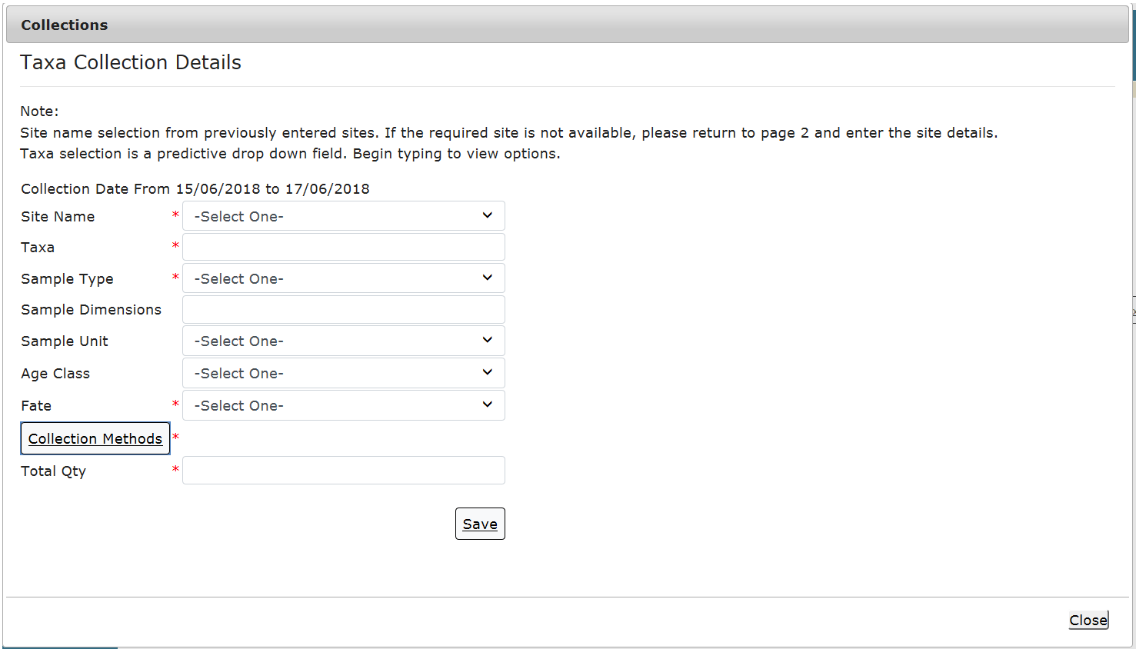
Figure 744 - Screenshot of collections pop up window

Site Name will contain any sites that you have previously set up in this report. Select the down arrow and select your site.
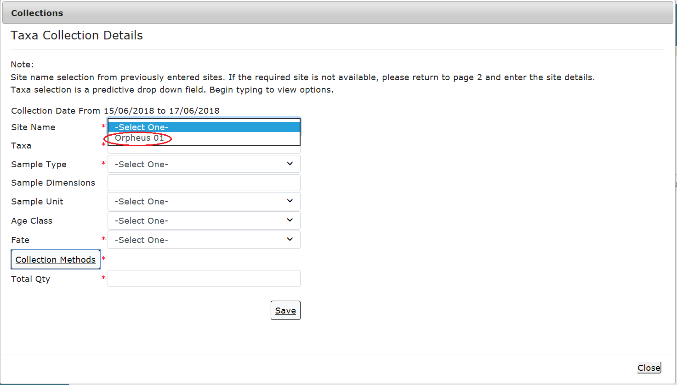
Figure 745 - Screenshot of collections pop up window with a red circle around the site name drop list

Taxa is a predictive drop down field, begin typing to view options.
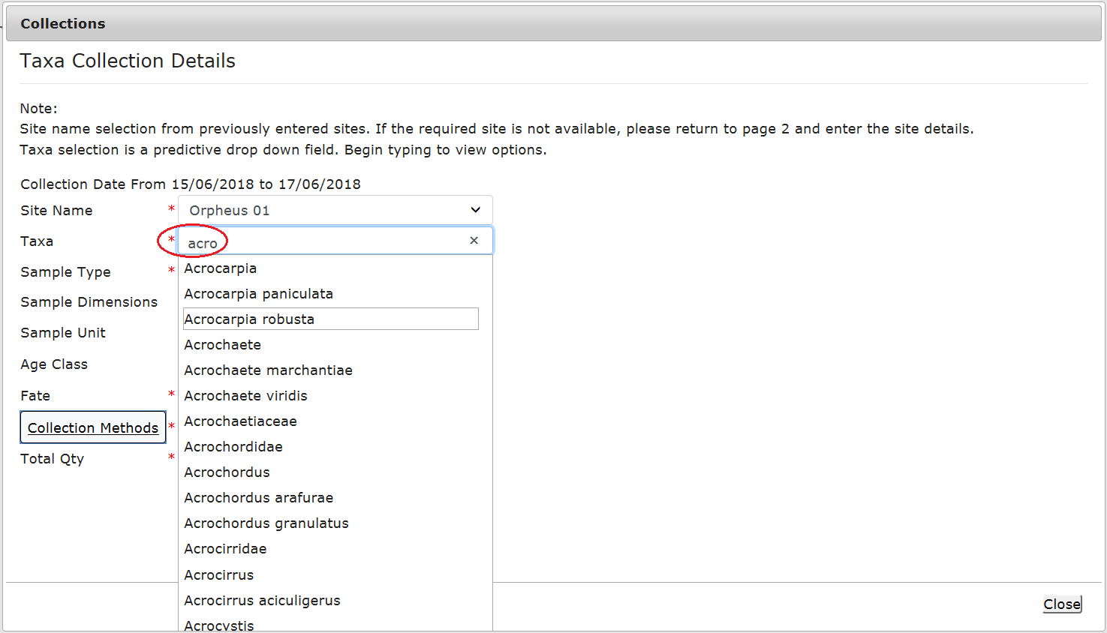
Figure 746 - Screenshot of collections pop up window with a red circle around the Taxa drop down field

Sample Type, Sample Unit, Age Class and Fate are all dropdown picklists. Select the appropriate Sample Type, Sample Unit, Age Class and Fate from the lists.
Sample Type – Picklist

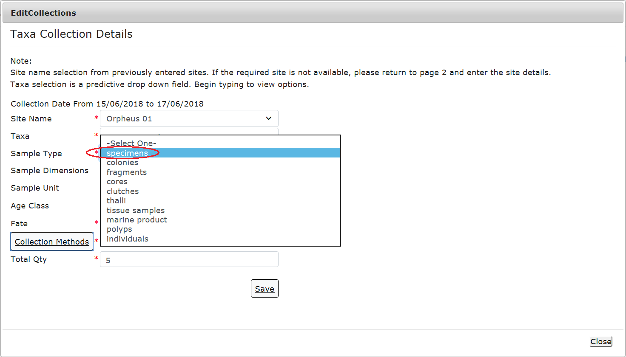
Figure 747 - Screenshot of Edit collections window with a red circle around the Sample type pick list

Sample Unit – Picklist

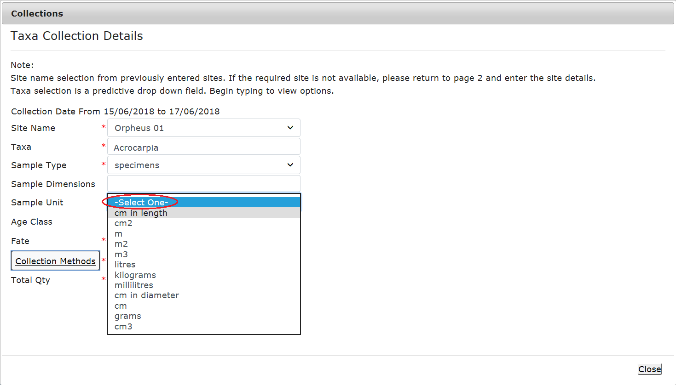
Figure 748 - Screenshot of Edit collections window with a red circle around the Sample unit pick list

Age Class – picklist

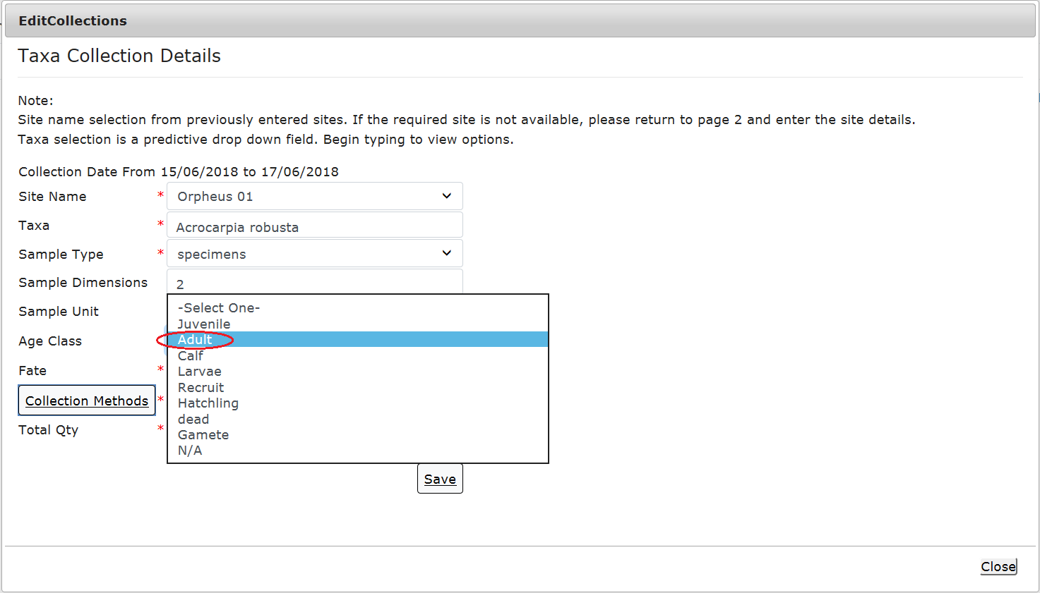
Figure 749 - Screenshot of Edit collections window with a red circle around the Age Class pick list

Fate – picklist

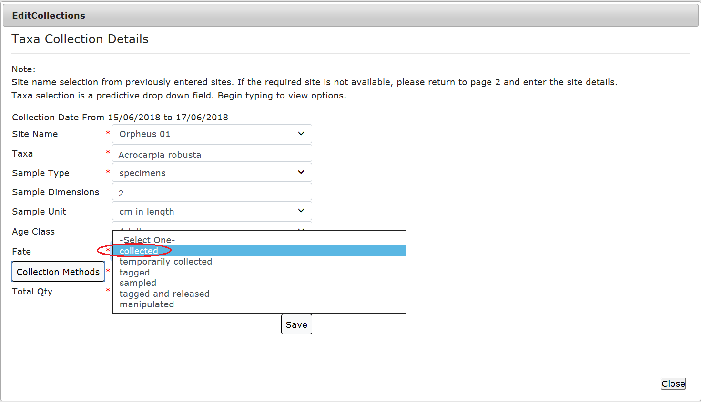
Figure 750 - Screenshot of Edit collections window with a red circle around the Fate pick list

To add a collection method, select the Collection Methods button.
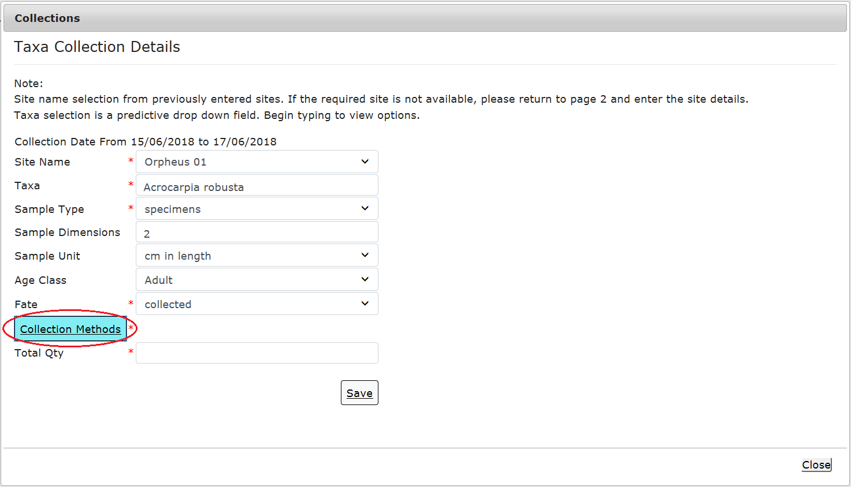
Figure 751 - Screenshot of collections pop up window with a red circle around the collection methods button

The Add Collection Method pop up window will appear. Select the collection method or multiple collection methods if applicable and then select Save.
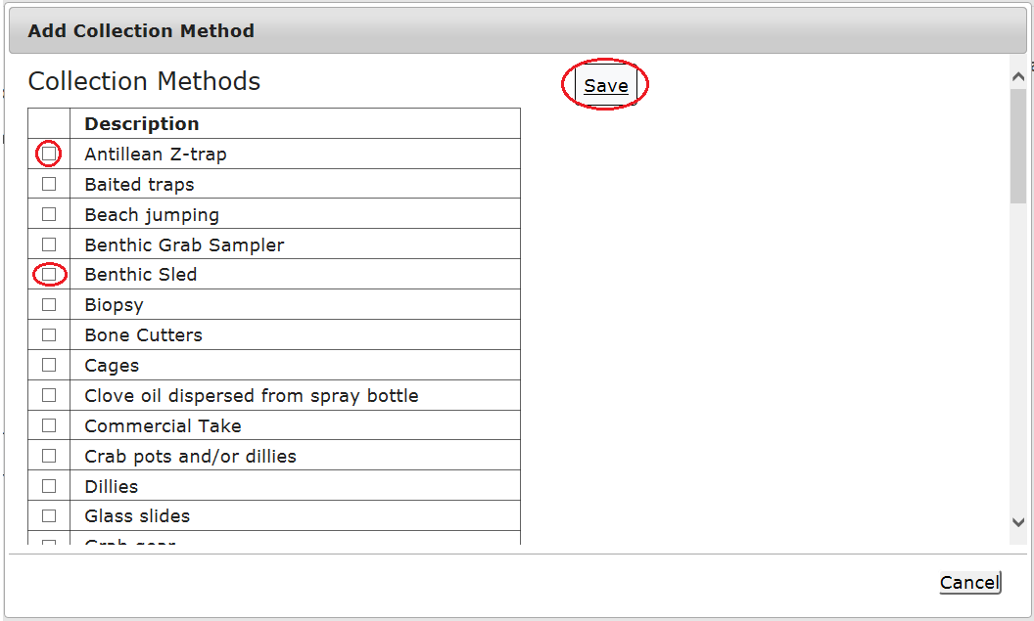
Figure 752 - Screenshot of the Add Collection Methods pop up window with a red circle around 2 options in the list and red circle around the Save button

The collection method will then be saved in the Collections pop up window.
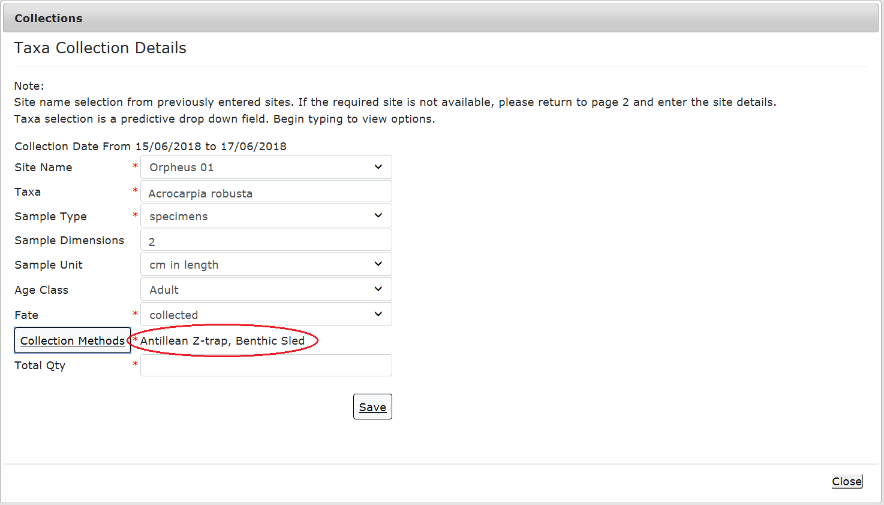
Figure 753 - Screenshot of collections pop up window with a red circle around the collections methods selected

Ensure you add the Sample Dimensions and the Total Quantity collected. The Sample Dimensions and Total Quantity are text fields. Once you have added all collection details select Save.

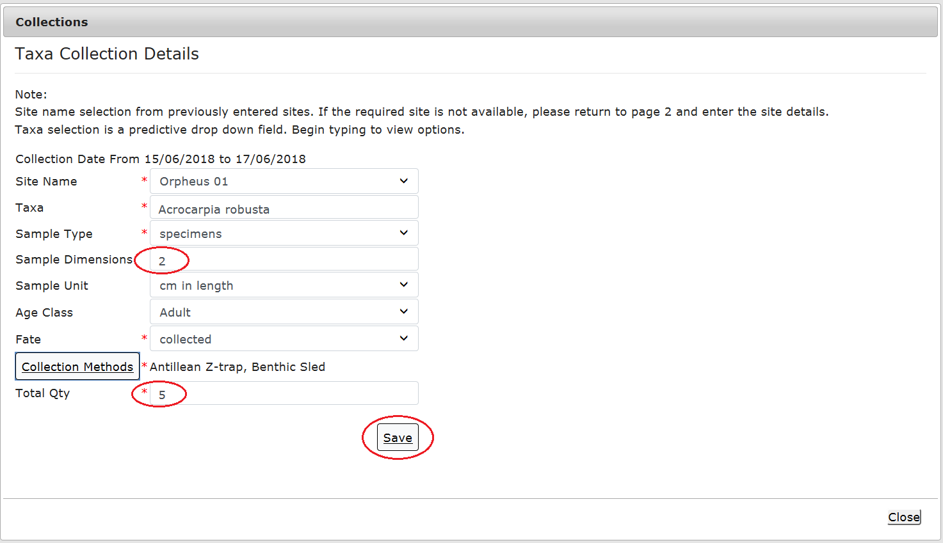
Figure 754 - Screenshot of collections pop up window with a red circle around the sample dimensions and total quantity fields and a red circle around the Save button
Your collections will then display on the collections screen. You will also be presented with options to Edit or Remove the Collection. Select Next to progress.
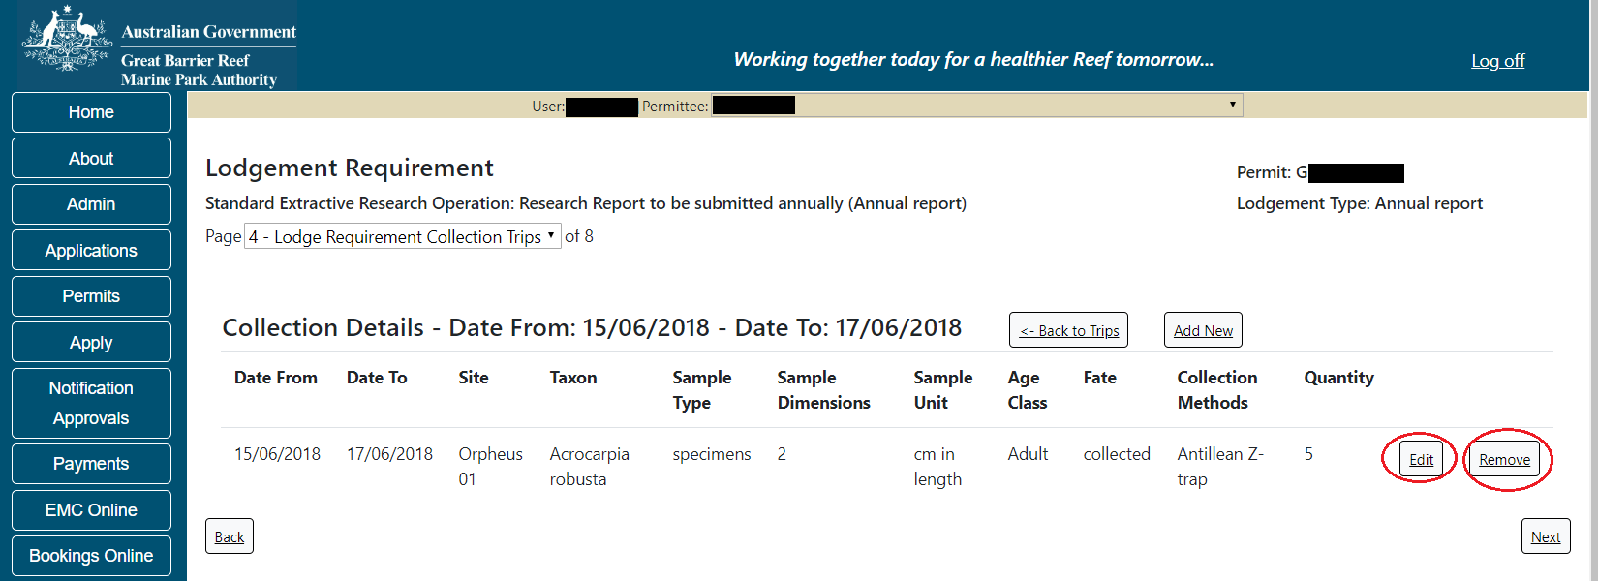
Figure 755 - Screenshot of collection details page with red circles around Edit and Remove buttons

    - Equipment
Equipment that was added or removed from the Marine Parks throughout the life of the permit should be entered on the Equipment screen. Adding equipment and the status of the equipment assists the Reef Authority in managing what is installed in the Marine Park and where. Please add all equipment that was used throughout the period of reporting in this section.
To add equipment select the Add New button.
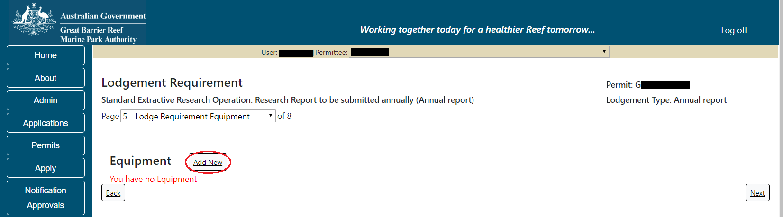
Figure 756 - Screenshot of equipment page with a red circle around add new button

The Equipment the pop up window will appear. The equipment pop up window will have text fields and drop lists, depending on what field you select.

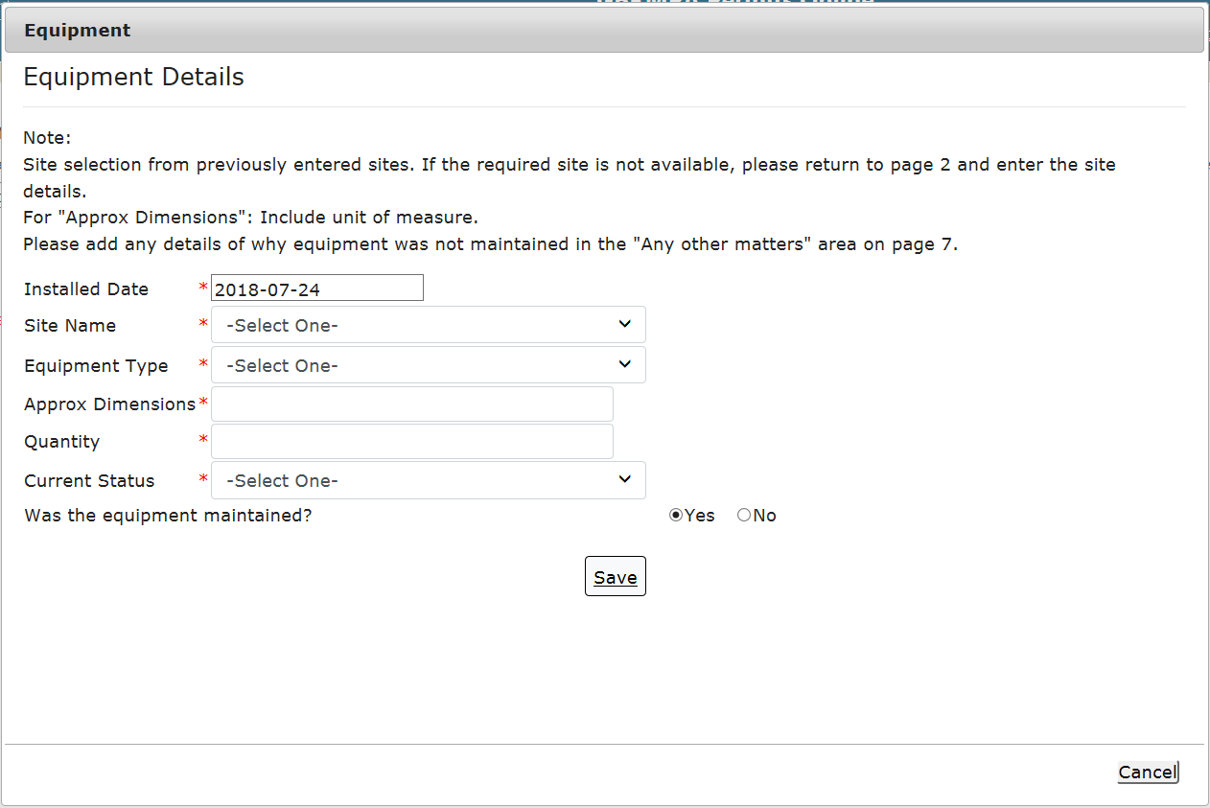
Figure 757 - Screenshot of equipment pop up window

The Installation Date will default to today’s date, which you can change to reflect the actual date of installation. You must also select the Site at which the equipment was installed. The list of sites is provided from site details entered earlier in this process. You must set up sites prior to adding any equipment.

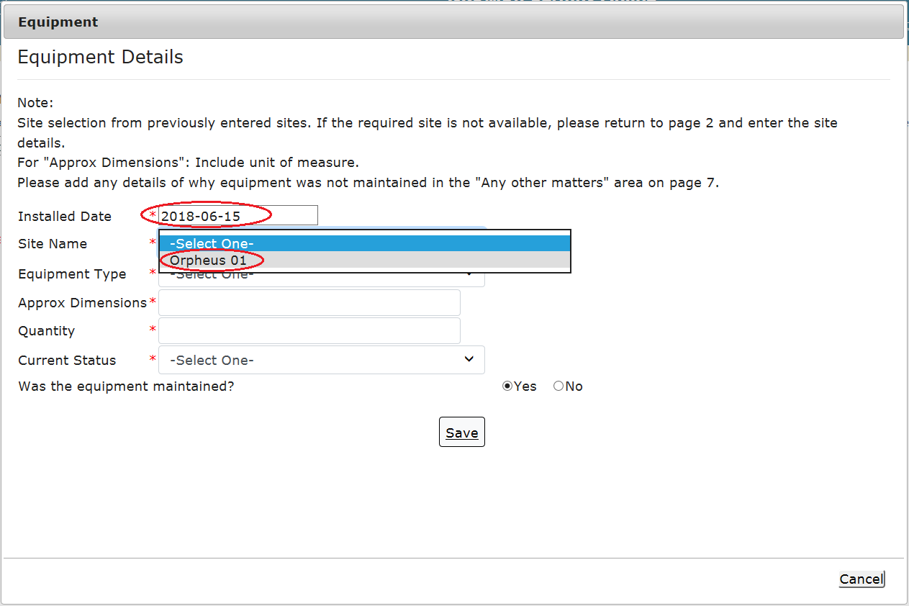
Figure 758 - Screenshot of equipment pop up window with red circles around installed date and site name
Select the equipment type dropdown picklist to see the available equipment. If your equipment is not listed please add details under ‘Any Other Matters’.

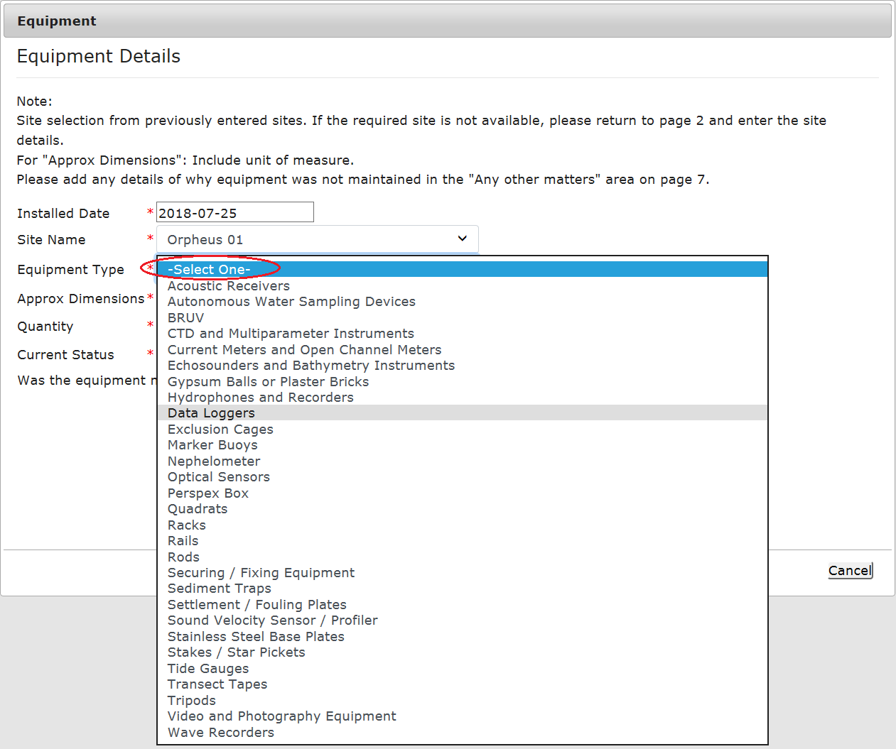
Figure 759 - Screenshot of equipment pop up window with red circles around equipment type pick list

For Approx. Dimensions please include the unit of measure in this field (e.g. centimetres / millimetres etc.). Approx. Dimensions and Quantity are text fields.

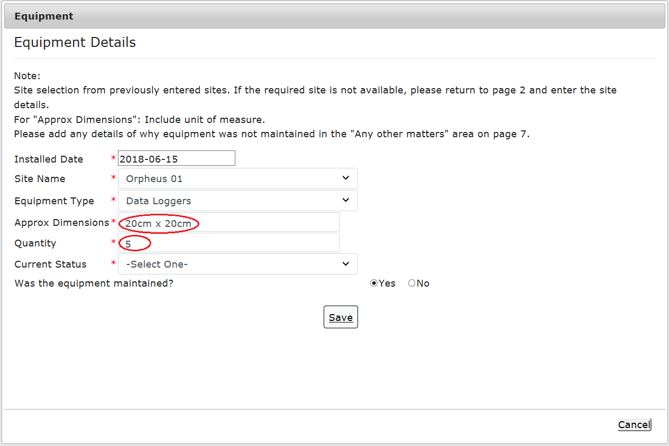
Figure 760 - Screenshot of equipment pop up window with red circles around approximate dimensions and quantity fields

Current Status is a drop list with 2 options. Select either Installed or Removed.
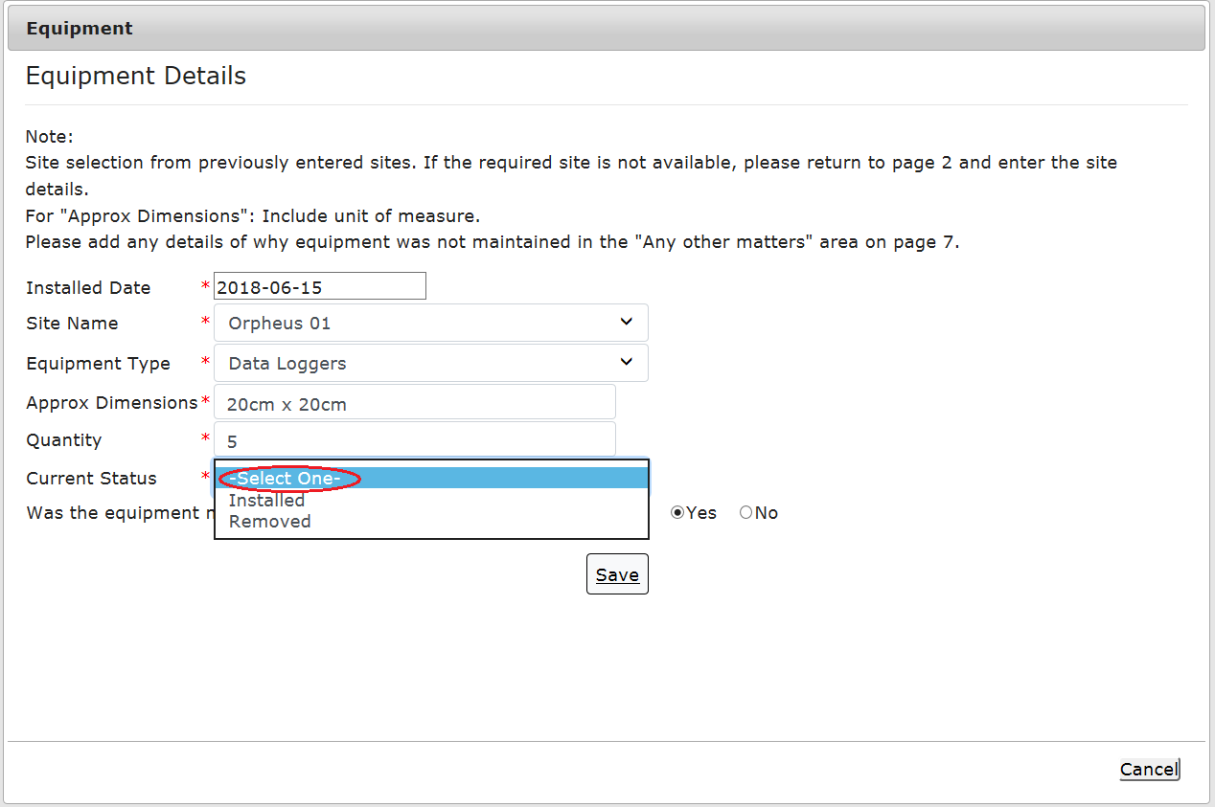
Figure 761 - Screenshot of equipment pop up window with red circles around current status pick list

Select whether the equipment was maintained and then select Save. Please add details of why any equipment was not maintained in the Any other matters area on page 7.
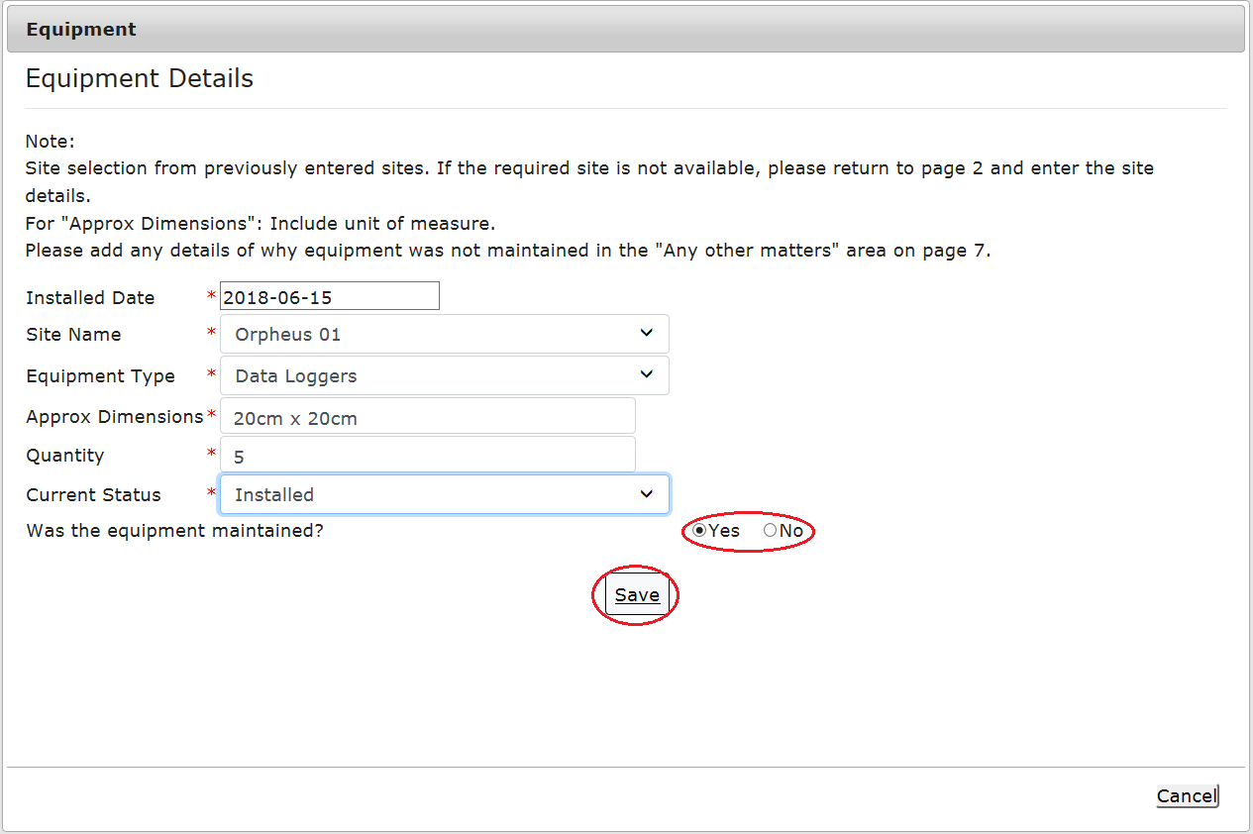
Figure 762 - Screenshot of equipment pop up window with red circle around Yes and No options for question was the equipment maintained and a red circle around the Save button
If the equipment has been removed from the Marine Park, select the Removed status and complete the declarations that the equipment was removed and maintained. Select Save to continue.
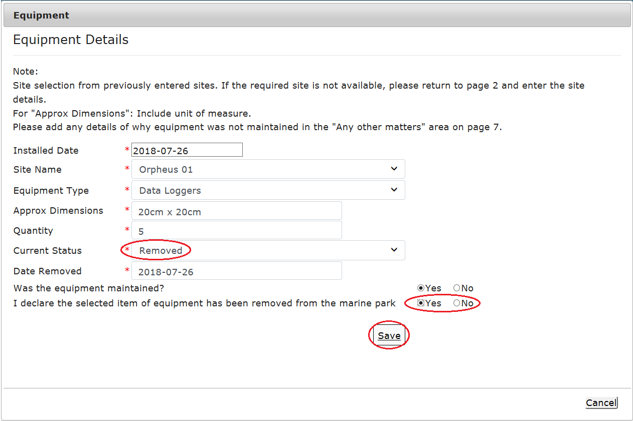
Figure 763 - Screenshot of equipment pop up window with red circle around Yes and No options for question I declare the selected item of equipment has been removed from the marine park and a red circle around the Save button

Once Save is selected the equipment details will display on screen. You will be presented with options to Edit or Remove the equipment entered. Enter any additional equipment that was installed, then select Next to progress.
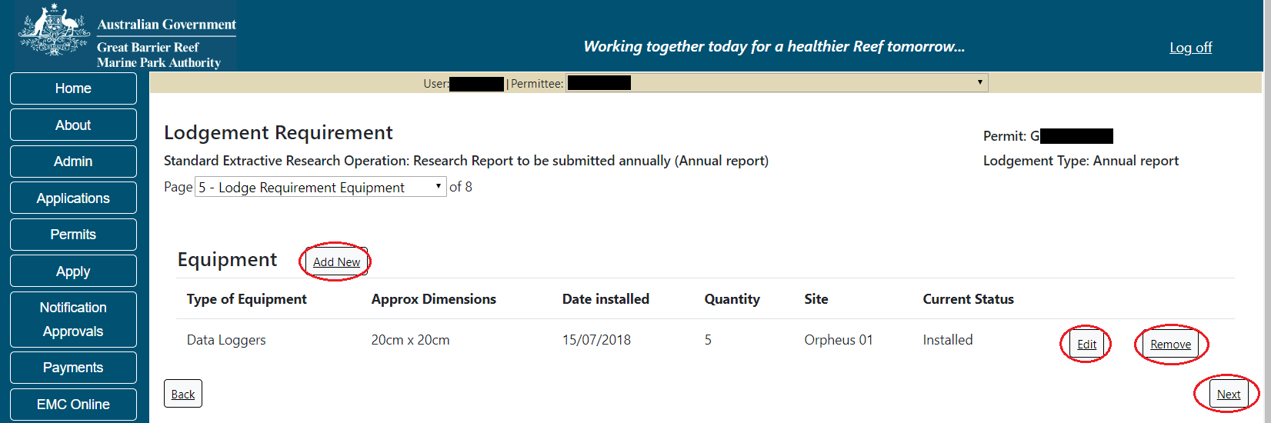
Figure 764 - Screenshot of equipment page with red circles around the Edit, Remove and Next buttons

    - Publications
If any publications arose from the permitted research, please add details in this section. To begin, select the Add New button.
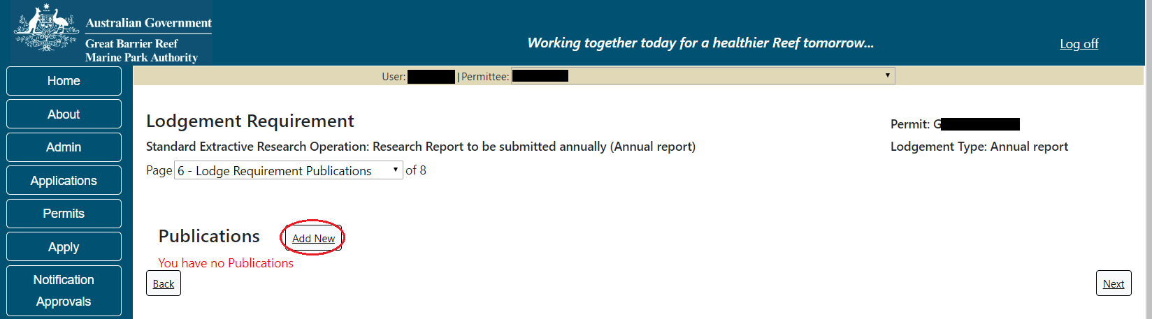
Figure 765 - Screenshot of publications screen with a red circle around the add new button

The Publications pop up window will appear.
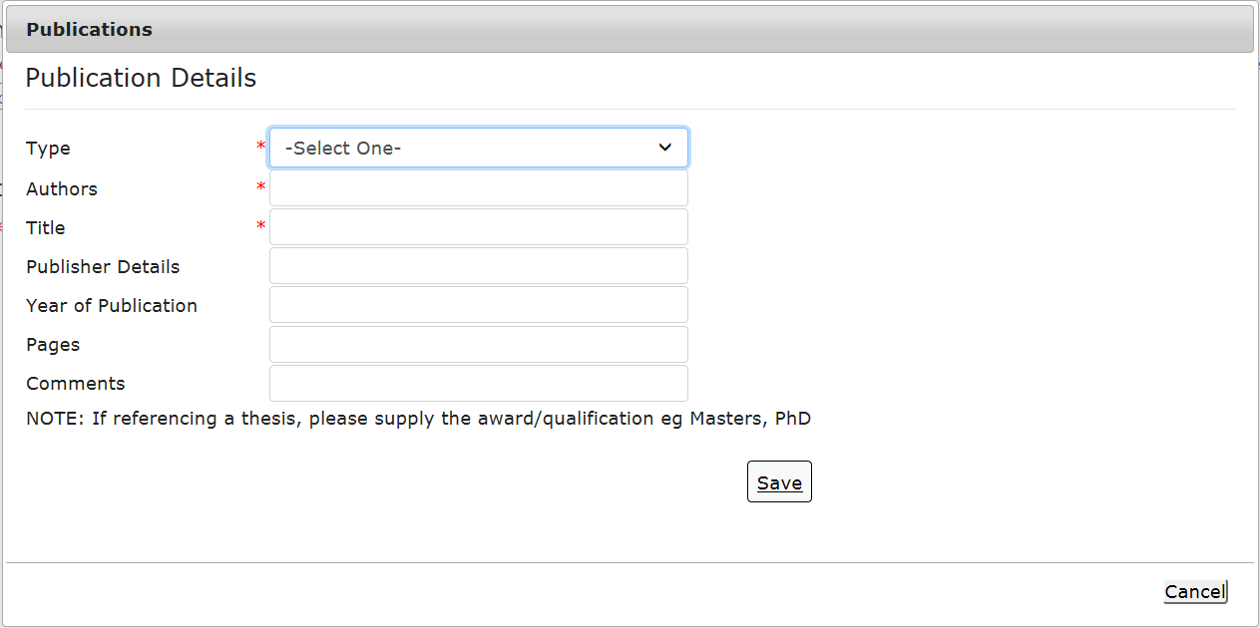
Figure 766 - Screenshot of publications pop up window

The Type field is the only drop down picklist in this pop up window. All other fields are text fields. Mandatory fields are indicated with an asterisk (*). Select the publication type from the list provided.
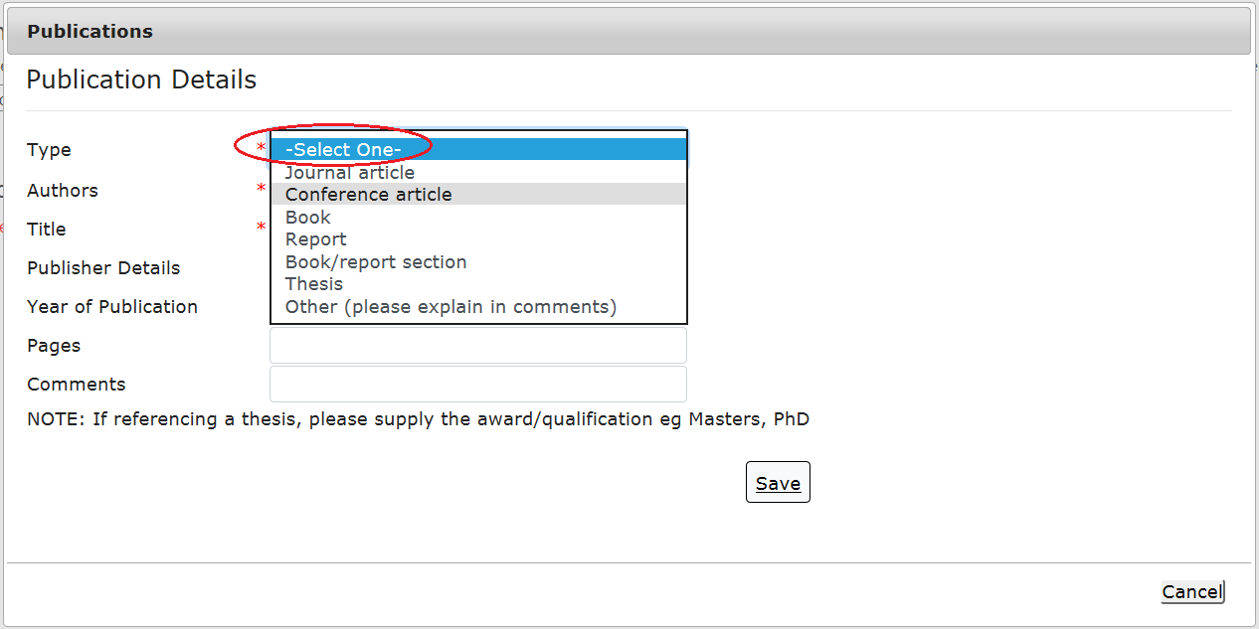
Figure 767 - Screenshot of publications pop up window with a red circle around the type pick list

Add details of the Author/s, Title, Publisher Details, Year of Publication, number of pages and any comments. Once all fields are complete select Save.
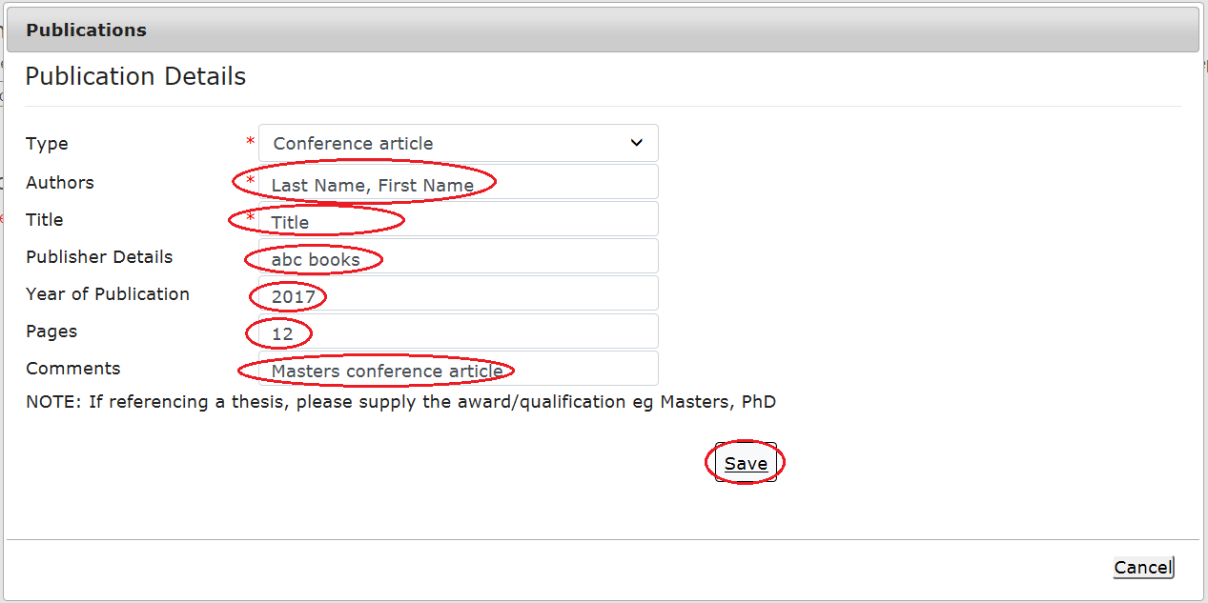
Figure 768 - Screenshot of publications pop up window with red circles around the authors, title, publisher details, year of publication, pages and comments field, and a red circle around Save button

Once Save is selected the publication details will display on the publications screen. You will be presented with options to Edit or Remove the publication entered. Select Next to progress.
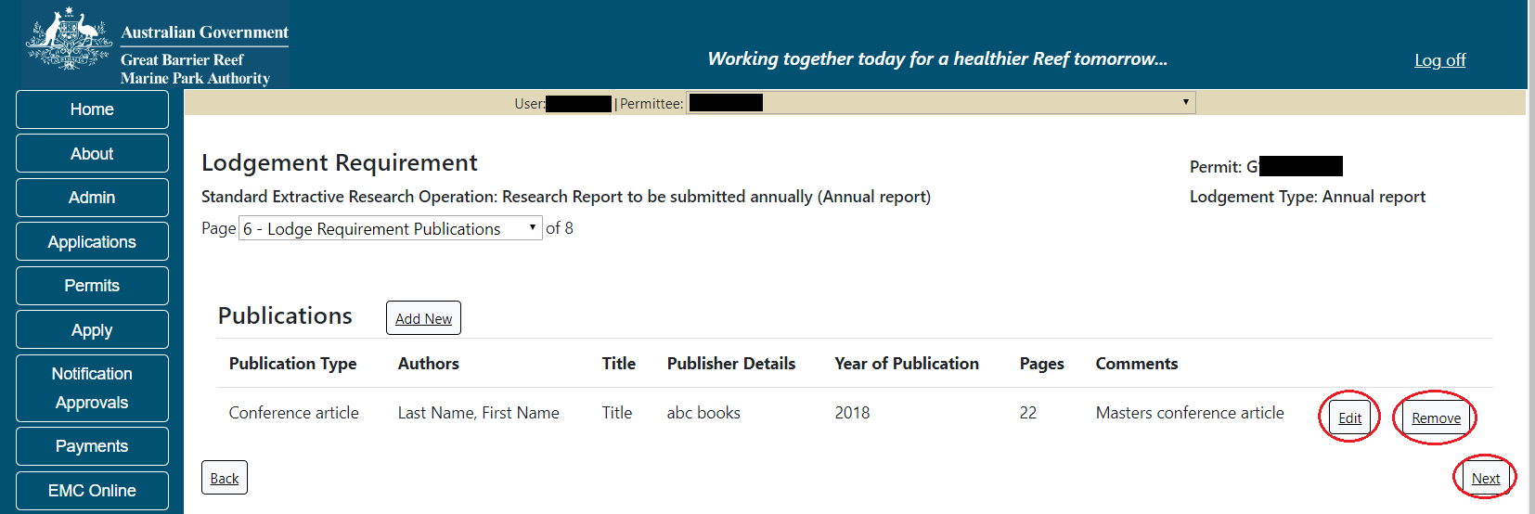
Figure 769 - Screenshot of publications page with red circles around the Edit, Remove and Next buttons

    - Summary Screen
As you enter details of sites, trips, collections, equipment, and publications, these will display on the Summary page. Review the details entered and amend as required by using the Back button or the drop list at the top of the page. Select Next to progress.
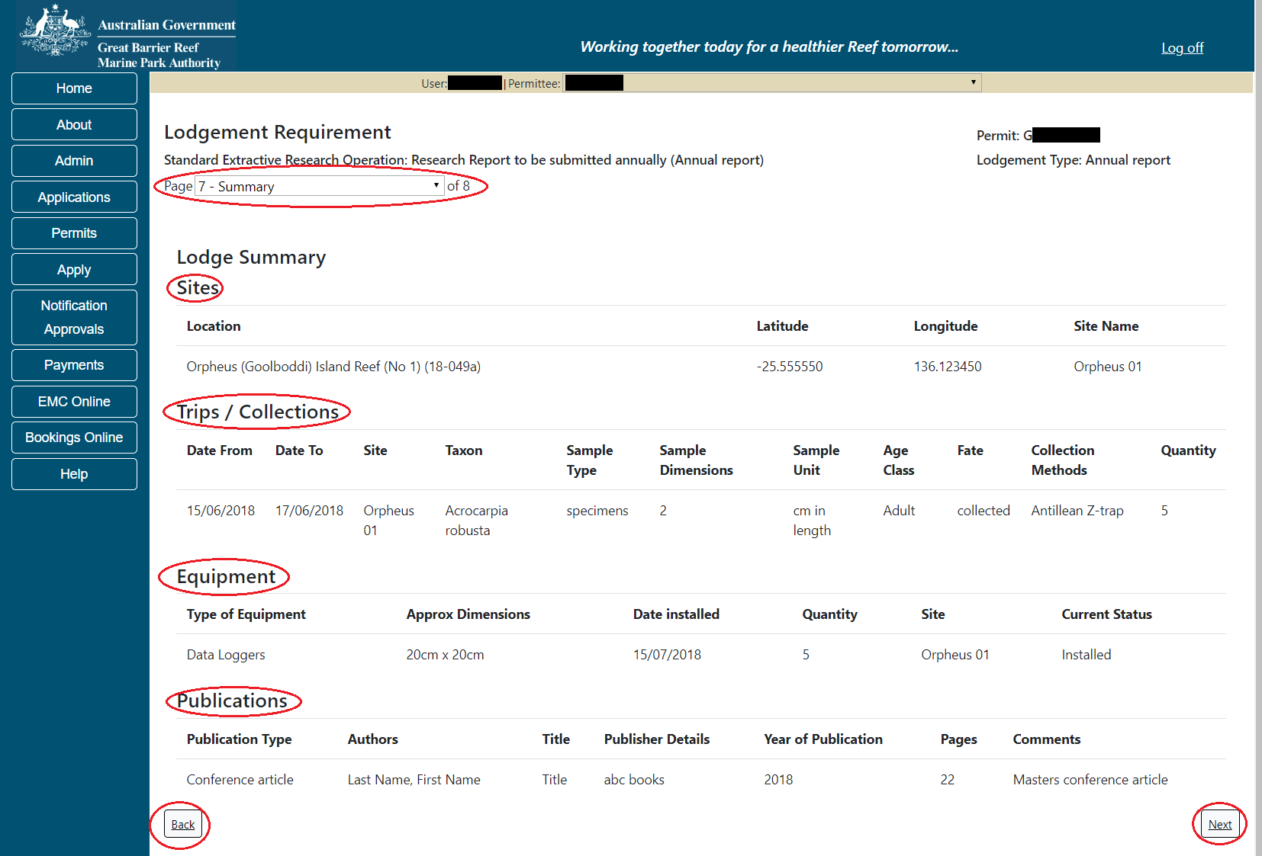
Figure 770 - Screenshot of publications page with red circles around page drop list, sites, trips, collections, equipment and publication titles, red circles around back and next buttons
    - Any Other Matters / Comments
Add details of any other matters or comments pertaining to the Research Report here. Select Next to progress.
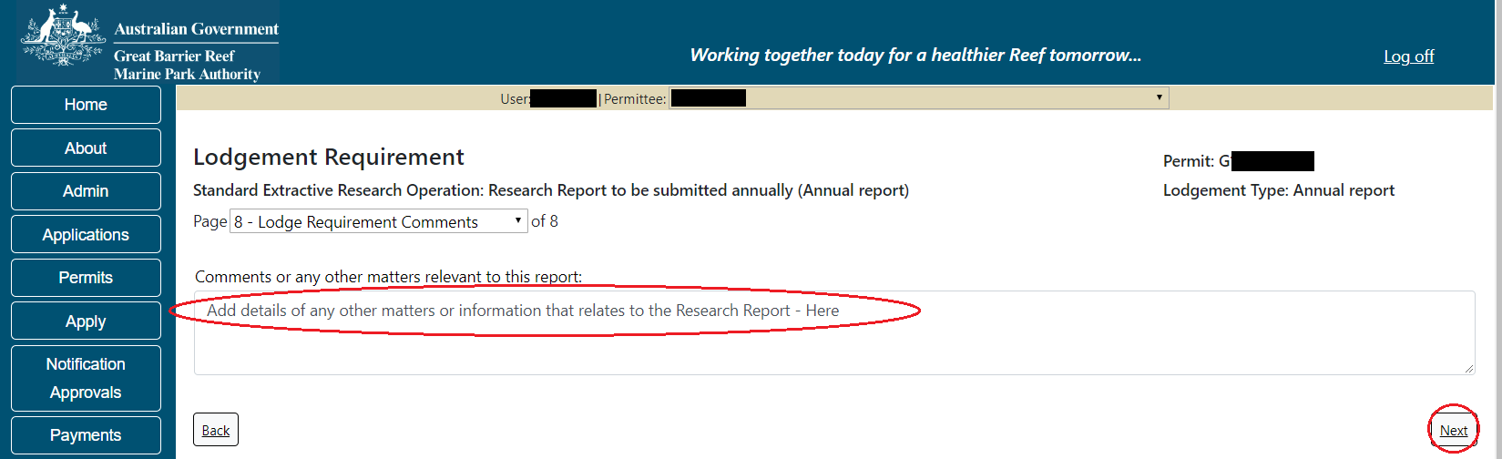
Figure 771 - Screenshot of comments or any other matters page with a red circle around add details here section

    - Declarations
Each report that is submitted is required to have a set of declarations answered prior to final submission. Answer the questions accordingly and select Submit.
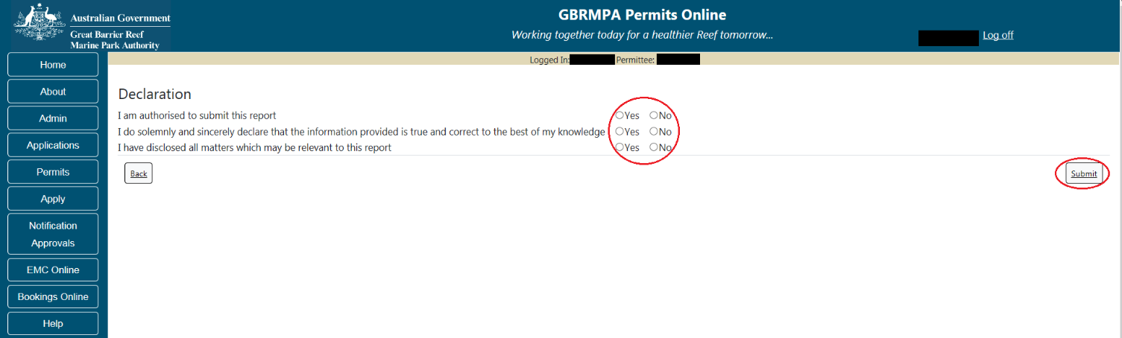
Figure 772 - Screenshot of Declarations screen with a red circle around the Yes and No answers

Once you submit your report the system will generate a PDF version which you can save or print the report.
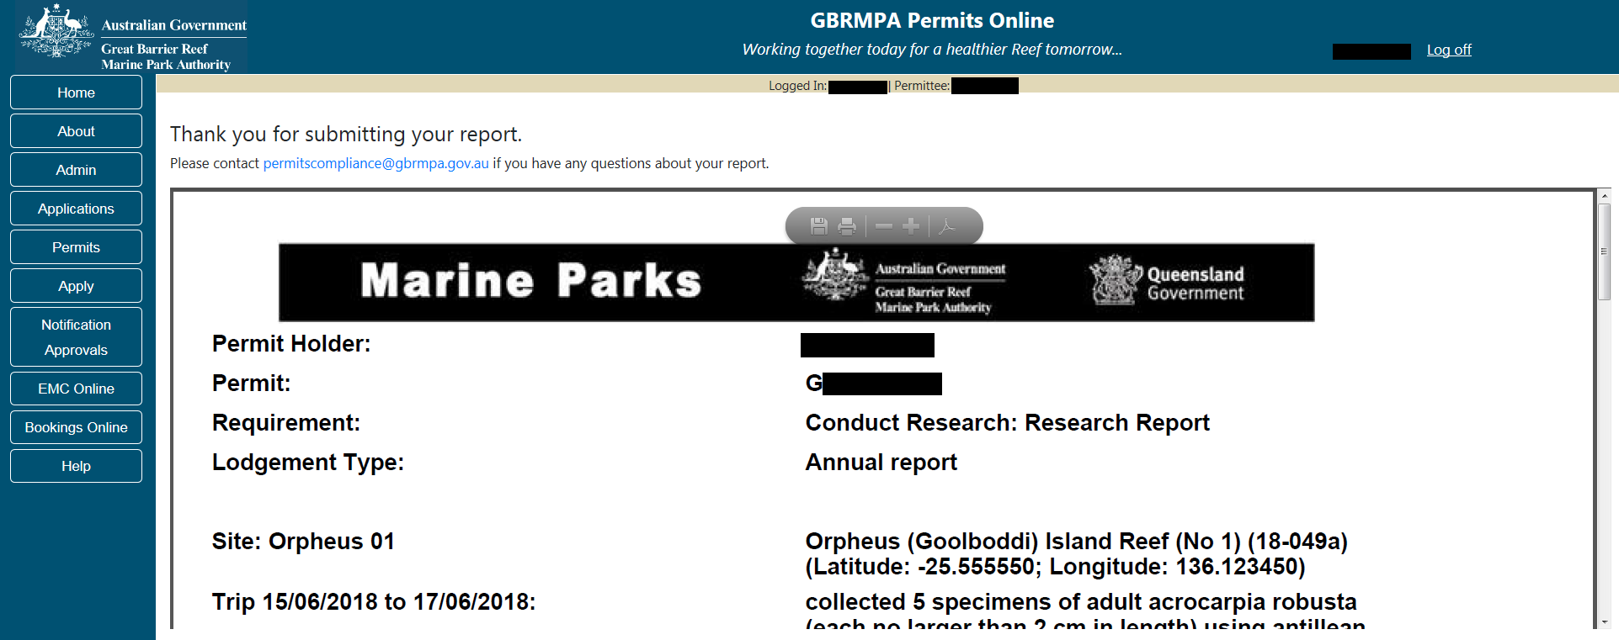
Figure 773 - Screenshot of submitted report

Once the report is submitted the status will change on the main Lodge Requirements screen. You will be presented with 2 options; a Summary hyperlink and a Resubmit hyperlink. Summary will open a PDF version of the report. If Resubmit is selected, the report will then be able to be amended and resubmitted.
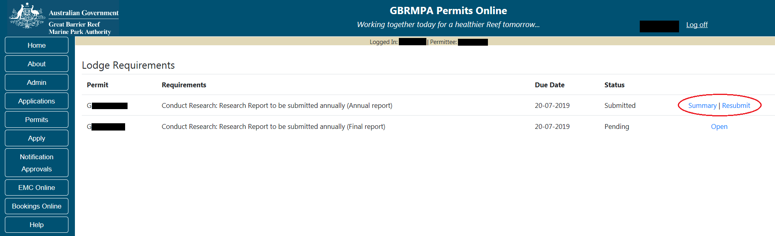
Figure 774 - Screenshot of Lodge Requirements page with a red circle around the summary and resubmit hyperlinks

    - Final Report
Depending on your reporting requirements you may need to lodge a Final Report. The Final report has all the same questions as the Annual Report.

    - Validations
Each page contains validations to flag where information is missing. Page 1 provides the basis for validating the report. For example if you select Yes to Were collections made? and you do not add any collections, you will receive an error message upon submission.
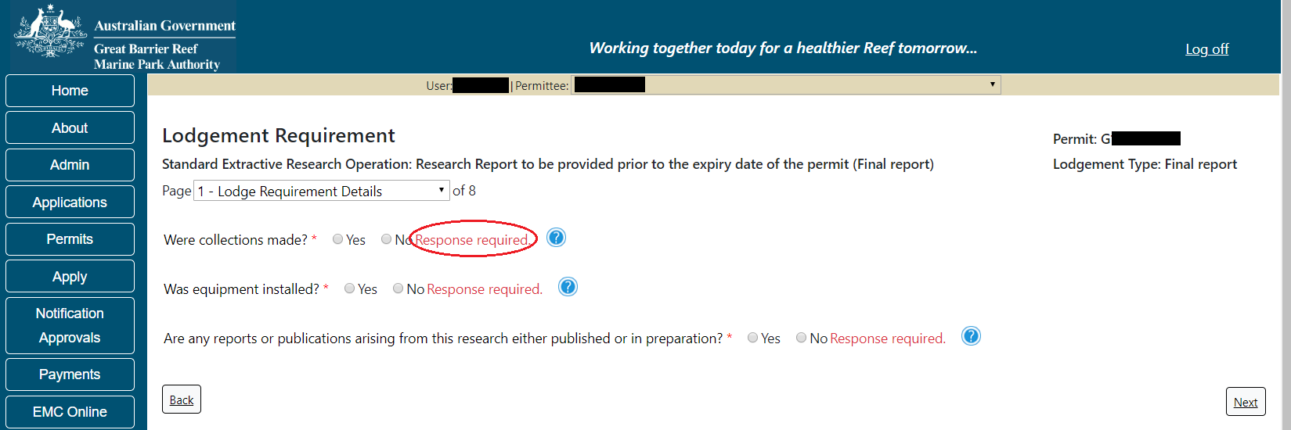
Figure 775 - Screenshot of Lodge Requirements page 1 with red circle around validation message Response required

Any questions on the Declaration screen that are answered with No will prompt an error message upon submission. The person submitting the report must be authorised to do so; the information in the report must be true and correct; and any other relevant matters should have been entered on Page 7 Any other matters.
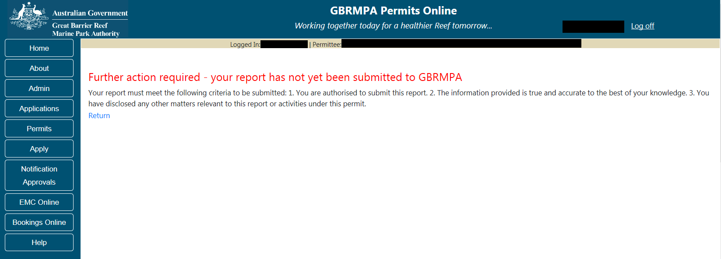
Figure 776 - Screenshot of validation screen

To fix any validation messages, select the Return hyperlink and you will progress back to page 1 to review your report from the beginning.
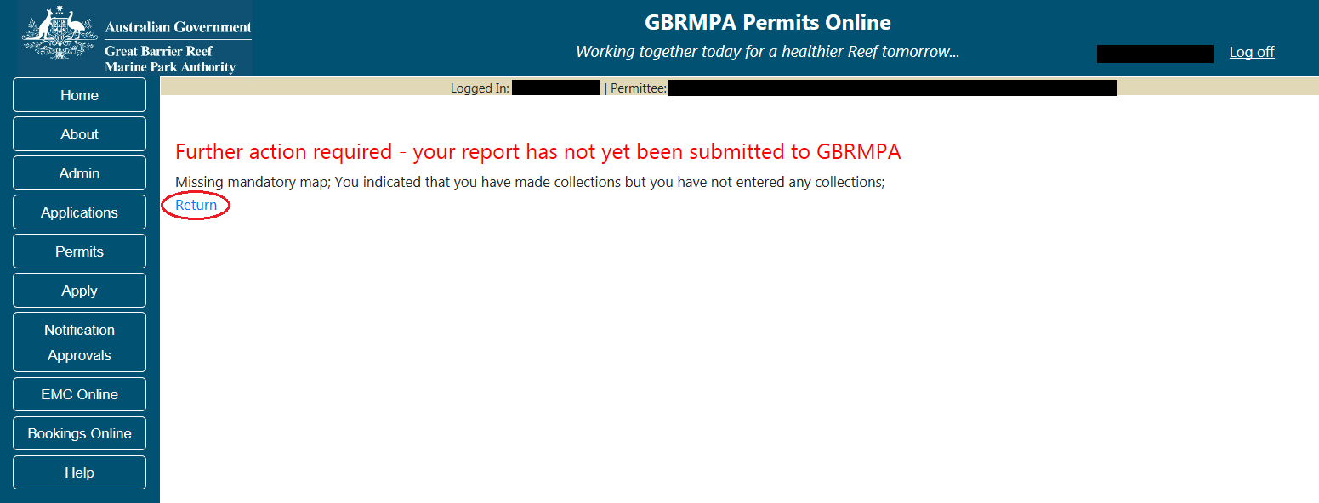
Figure 777 - Screenshot of validation screen with a red circle around return hyperlink

  - Lodge Requirements – Other Reports
Some permits require the lodgement of specific Reports to the Reef Authority. Reporting requirements are shown against each permit on the Lodge Requirements screen. Select the ‘Open’ hyperlink to enter required reporting information.

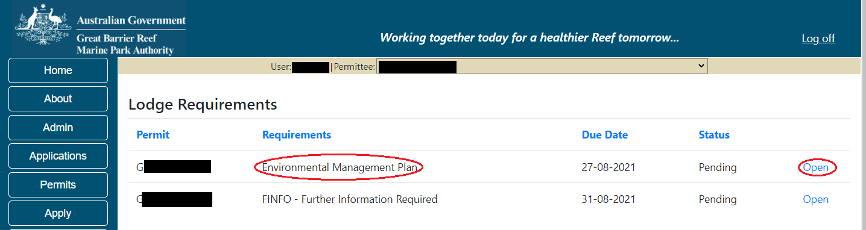
Figure 778 - Screenshot of Lodge Requirements screen with a red circle around the Requirement and the Open link

You will be presented with a series of questions relevant to your Permit Requirements. Answer with free text and progress through the pages using the ‘Back’ and ‘Next’ buttons. Some questions will require documents to be uploaded as part of your response.
Fill in the required information for each question

    - Upload Documents
Page 1 of the Lodge Requirements – Other Reports is a document upload page. Upload the required document/report/plan by selecting the Upload File button. Select the appropriate file from your C: Drive and select save. If multiple documents are required, upload each document separately.
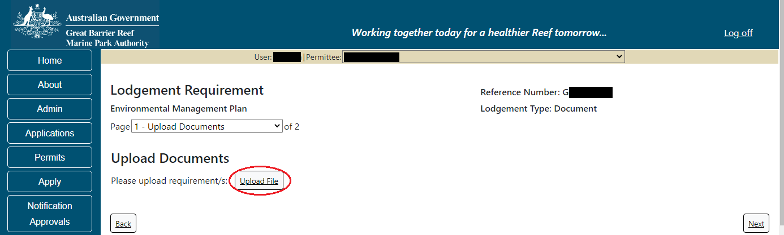
Figure 779 - Screenshot of Lodge Requirements screen with a red circle around Upload File button

Once a document is upload it will appear with the file name and an option to Remove. Once you have loaded all required documents, please select Next to continue to the next page
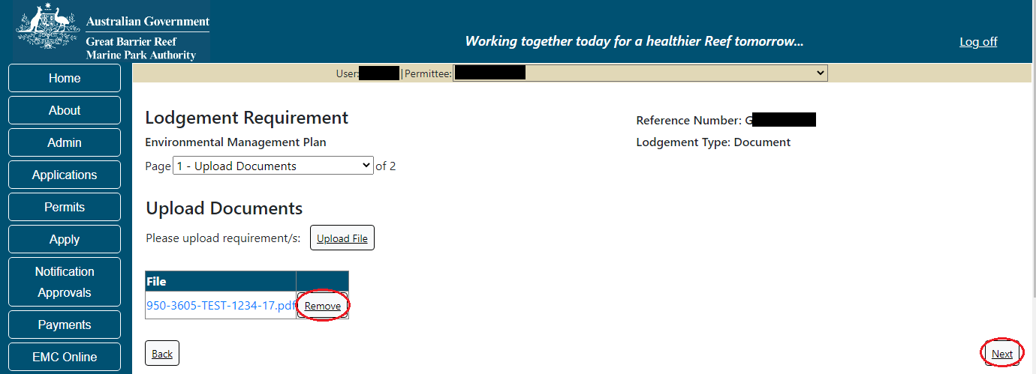
Figure 780 - Screenshot of Lodge Requirements screen with a red circle around the Remove button and Next button

    - Comments
Add details of any other matters or comments pertaining to the Report here. Select Next to progress.
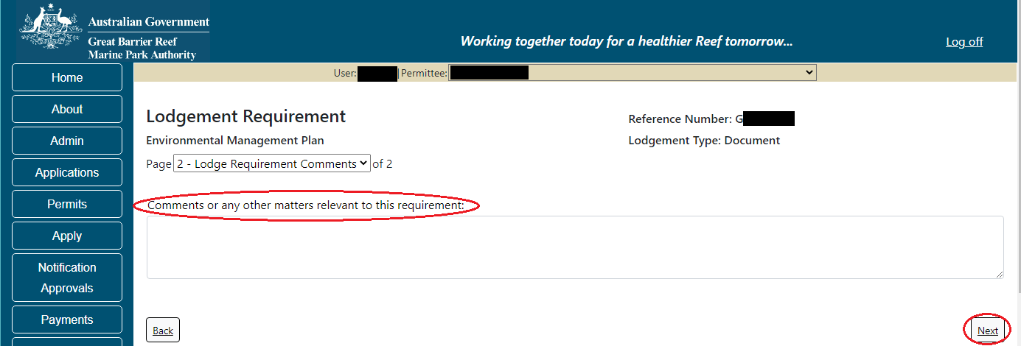
Figure 781 - Screenshot of comments page with a red circle around add details here section

    - Declarations
Each report that is submitted is required to have a set of declarations answered prior to final submission. Answer the questions accordingly and select Submit.
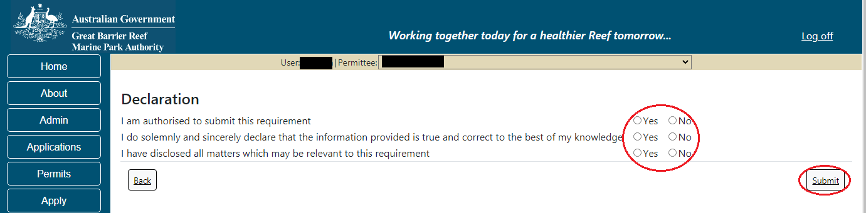
Figure 782 - Screenshot of Declarations screen with a red circle around the Yes and No answers

Once you submit your report the system will generate a PDF version which you can save or print the report.
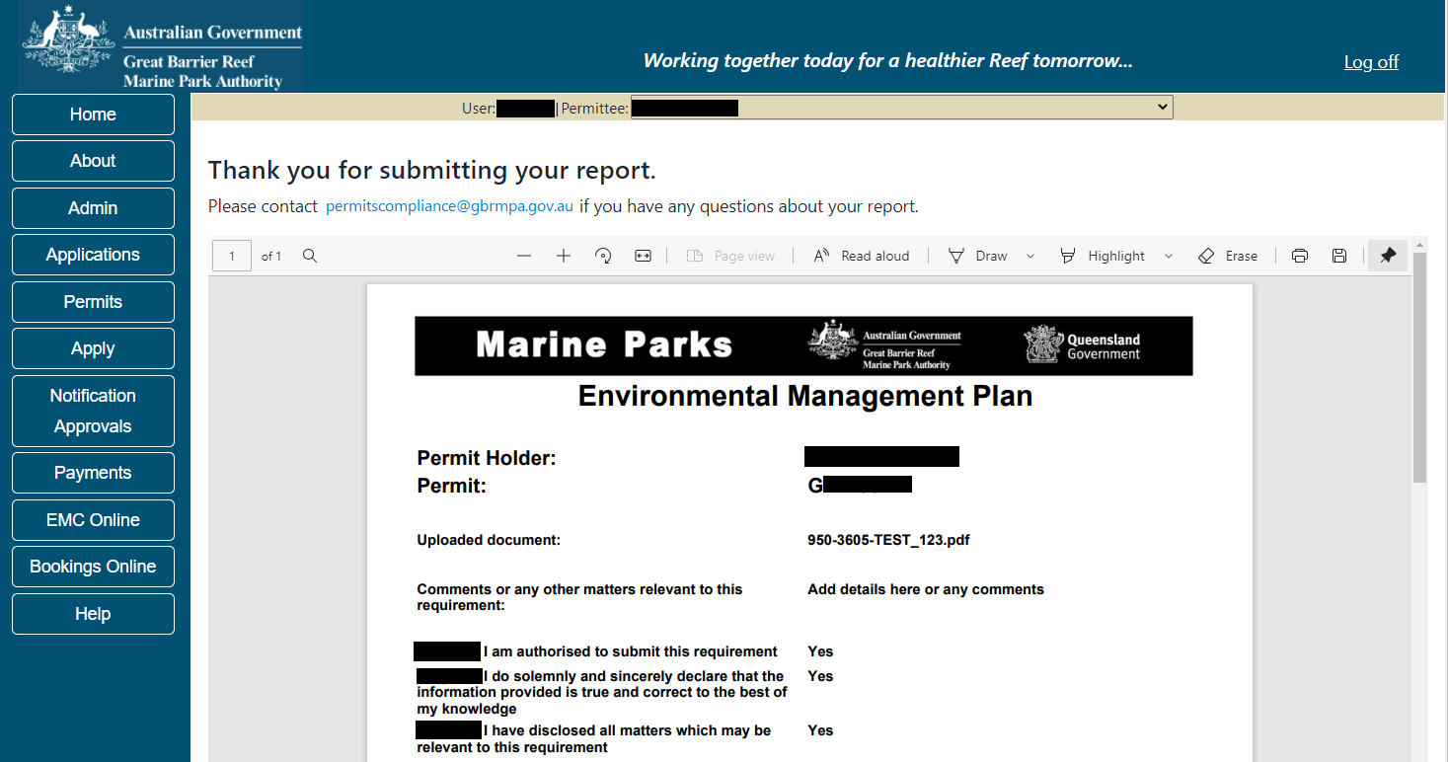
Figure 783 - Screenshot of submitted report

Once the report is submitted the status will change on the main Lodge Requirements screen. You will be presented with 2 options; a Summary hyperlink and a Resubmit hyperlink. Summary will open a PDF version of the report. If Resubmit is selected, the report will then be able to be amended and resubmitted.
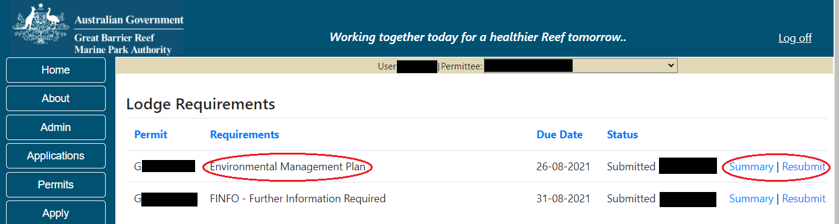
Figure 784 - Screenshot of Lodge Requirements page with a red circle around the summary and resubmit hyperlinks

    - Validations
Any questions on the Declaration screen that are answered with No will prompt an error message upon submission. The person submitting the report must be authorised to do so; the information in the report must be true and correct; and any other relevant matters should have been entered against ‘Any other matters’.
Figure 785 - Screenshot of validation screen

To fix any validation messages, select the Return hyperlink and you will progress back to page 1 to review your report from the beginning.
Figure 786 - Screenshot of validation screen with a red circle around return hyperlink

  - Lodge Requirements – Requests For Further Information
Depending on your reporting requirements you may need to lodge a Further Information (FINFO) Response. Reporting requirements are shown against each permit on the Lodge Requirements screen. Select the ‘Open’ hyperlink to enter required reporting information.
The FINFO has all the same questions as the Other Lodge Requirement Report area.
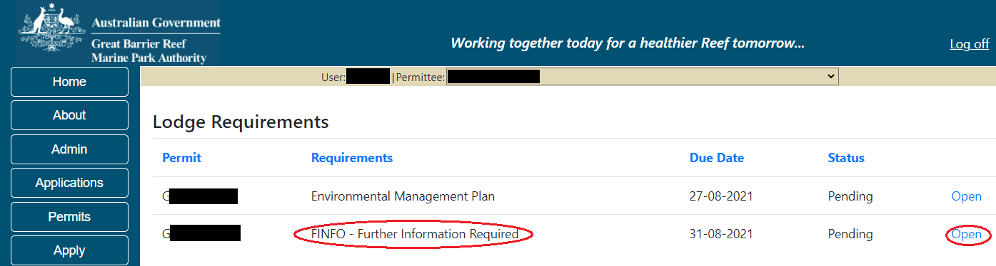
Figure 787 - Screenshot of Lodge Requirements screen with a red circle around the Requirement and the Open link

You will be presented with a series of questions relevant to your Permit Requirements. Answer with free text and progress through the pages using the ‘Back’ and ‘Next’ buttons. Some questions will require documents to be uploaded as part of your response.
Fill in the required information for each question
    - Upload Documents
Page 1 of the Lodge Requirements – Further Information Required is a document upload page. Upload the required information by selecting the Upload File button. Select the appropriate file from your C: Drive and select save. If multiple documents are required, upload each document separately.
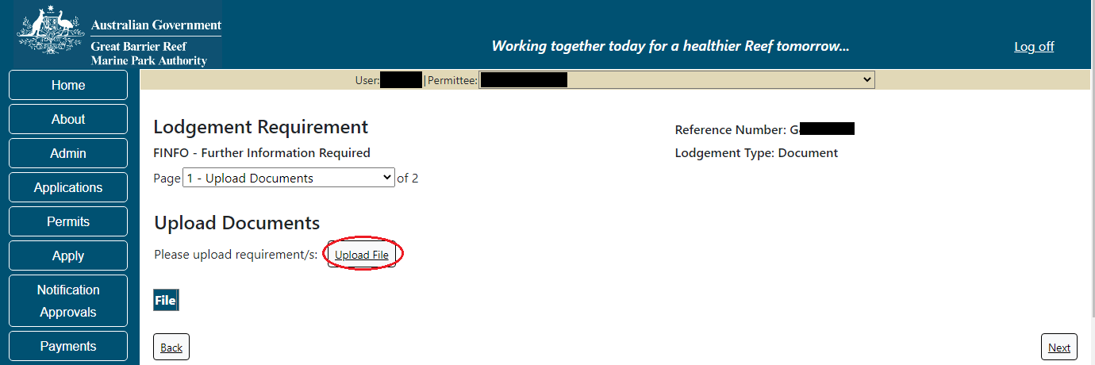
Figure 788 - Screenshot of Lodge Requirements screen with a red circle around Upload File button

Once a document is upload it will appear with the file name and an option to Remove. Once you have loaded all required documents, please select Next to continue to the next page
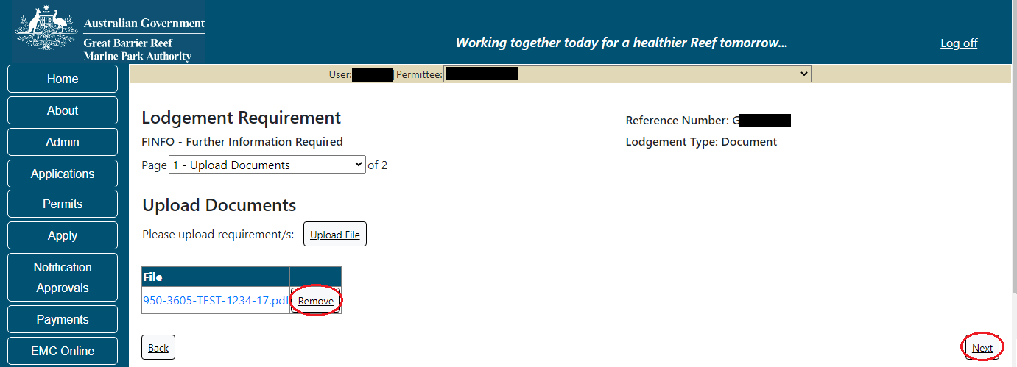
Figure 789 - Screenshot of Lodge Requirements screen with a red circle around the Remove button and Next button

    - Comments
Add details of any other matters or comments pertaining to the Report here. Select Next to progress.
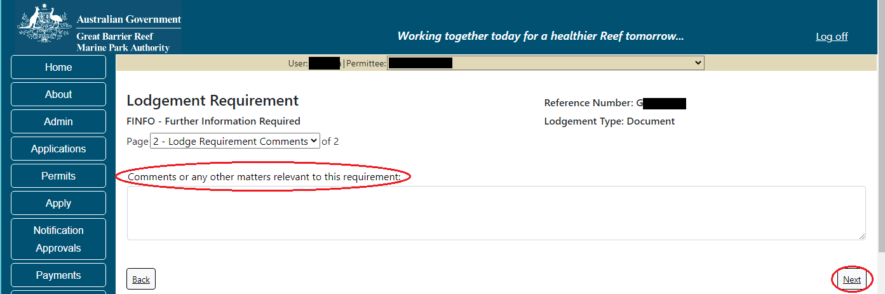
Figure 790 - Screenshot of comments or any other matters page with a red circle around add details here section and red circle around Next button

    - Declarations
Each report that is submitted is required to have a set of declarations answered prior to final submission. Answer the questions accordingly and select Submit.
Figure 791 - Screenshot of Declarations screen with a red circle around the Yes and No answers and Submit button
Once you submit your report the system will generate a PDF version which you can save or print the report.
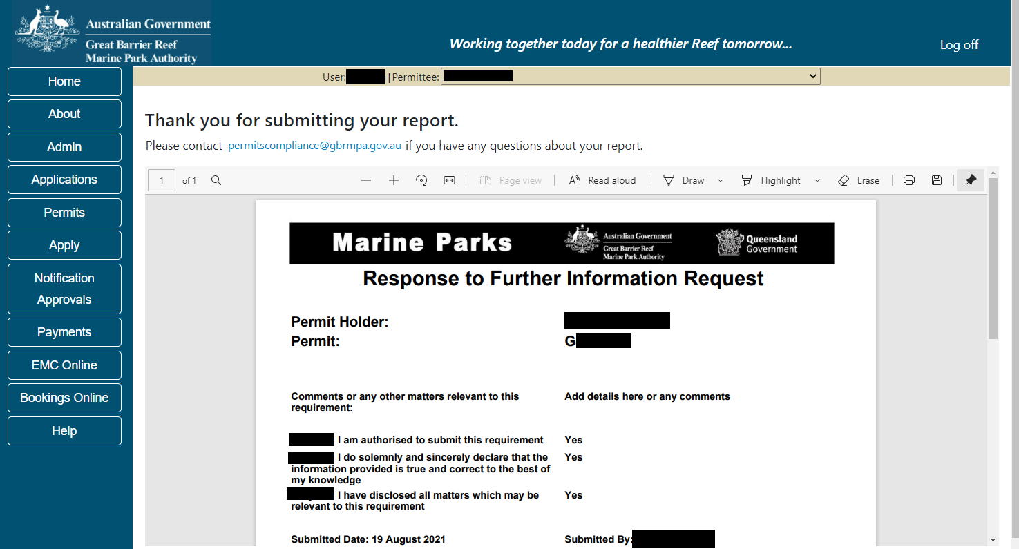
Figure 792 - Screenshot of submitted report

Once the report is submitted the status will change on the main Lodge Requirements screen. You will be presented with 2 options; a Summary hyperlink and a Resubmit hyperlink. Summary will open a PDF version of the report. If Resubmit is selected, the report will then be able to be amended and resubmitted.
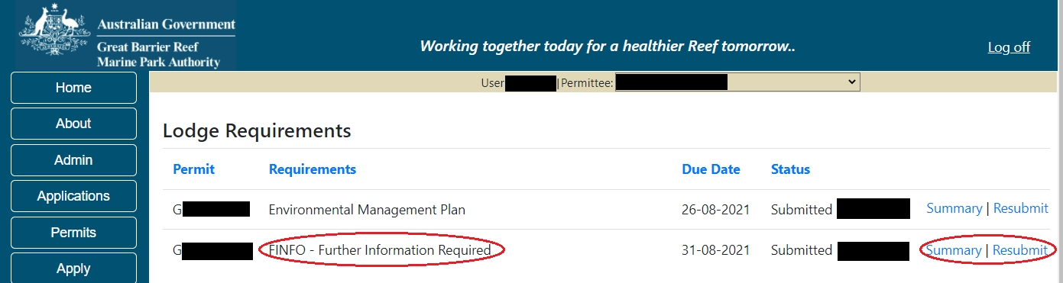
Figure 793 - Screenshot of Lodge Requirements page with a red circle around the summary and resubmit hyperlinks
    - Validations
Any questions on the Declaration screen that are answered with No, will prompt an error message upon submission. The person submitting the report must be authorised to do so; the information in the report must be true and; and any other relevant matters should have been entered on Page 2 Any other matters.
Figure 794 - Screenshot of validation screen
To fix any validation messages, select the Return hyperlink and you will progress back to page 1 to review your report from the beginning.
Figure 795 - Screenshot of validation screen with a red circle around return hyperlink

- Notification Approvals
When you select the Notification Approvals Menu, a sub menu will appear. At this point, select the type of Notification Approval you wish to submit (Vessel/Ship, Aircraft, Mooring or Other).
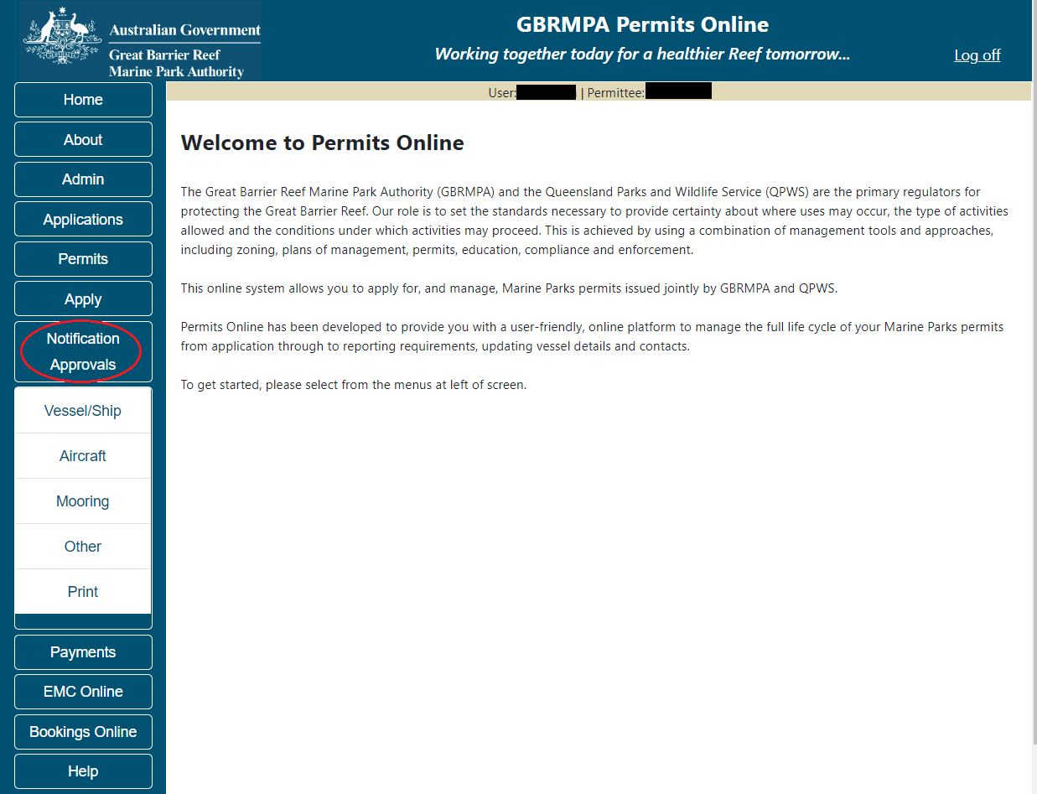
Figure 796 - Screenshot of Permits Online Home page with a red circle around Notification Approval icon

  - Vessel / Ship Notification Approval
The Notification Approvals – Vessel/Ship area in Permits Online enables Permit Holders to update vessel/ship details. Select the permit number associated with the vessel/ship then add the new details of the vessel/ship. Then Select Submit to submit the application to the Reef Authority. The maximum length of, and number of passengers you are permitted to carry on, your vessel is listed on your permit. Any vessels to be used under this permit in the Marine Parks must be within the allowed parameters of your permit.
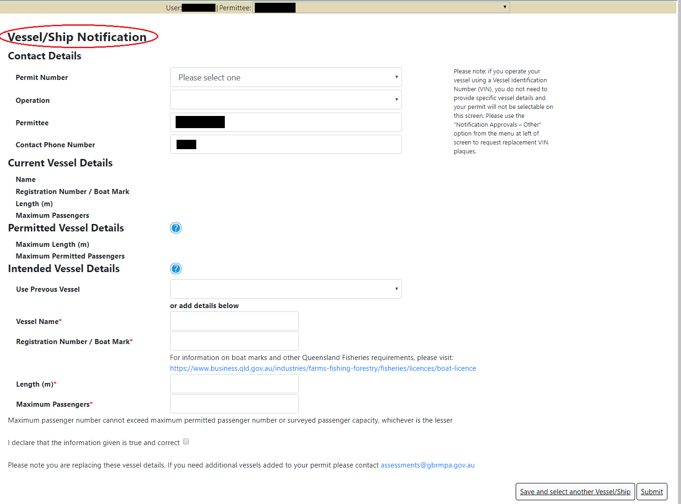
Figure 797 - Screenshot of Vessel Notification page with Title - Vessel/Ship Notification circled in red

Once submitted you will be presented with options to print a copy or email a copy of the Notification.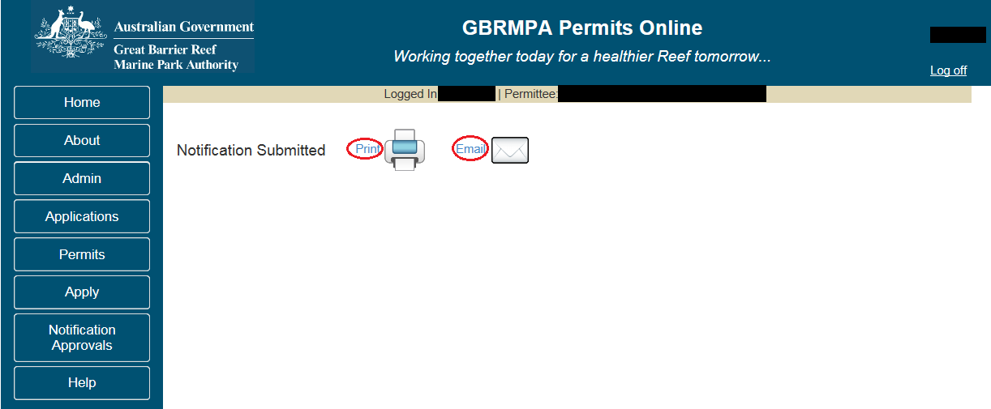
Figure 798 - Screenshot of Notification Submitted page with Print and Email hyperlink options circled in red
  - Aircraft Notification Approval
The Notification Approvals – Aircraft area in Permits Online enables Permit Holders to update Aircraft details. Select the permit number associated with the aircraft, and then add the new details of the aircraft.
The type, and number of passengers you are permitted to carry on your aircraft is listed on your permit. Any aircraft to be used under this permit in the Marine Parks must be within the allowed parameters of your permit.
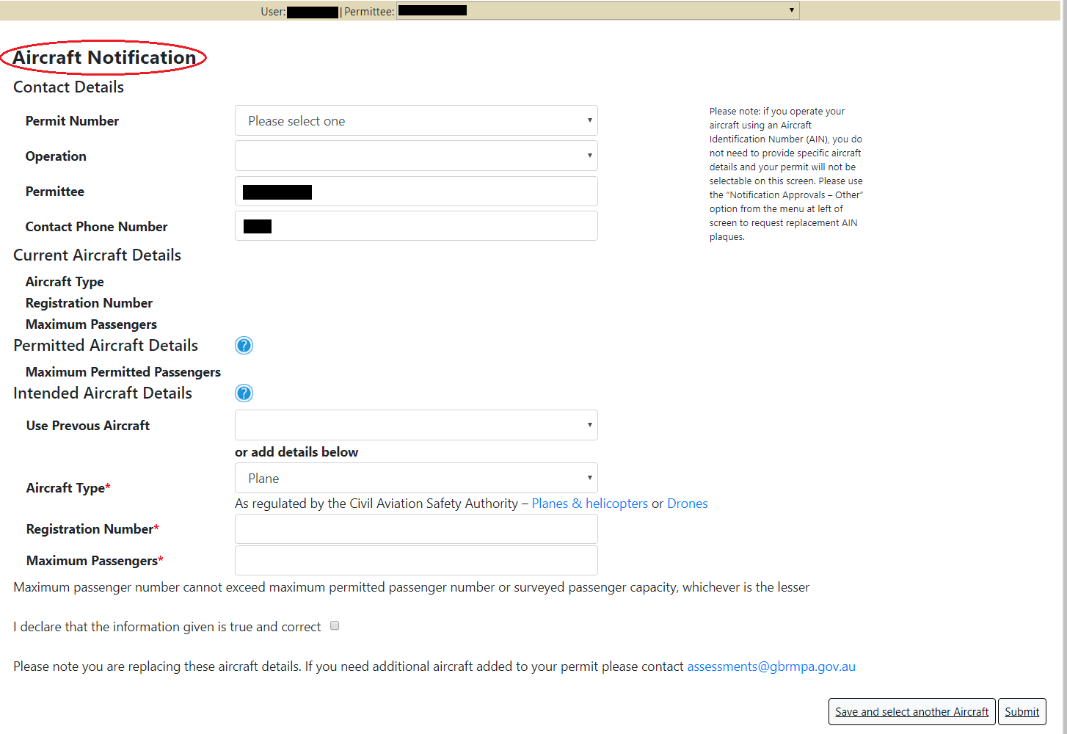
Figure 799 - Screenshot of Aircraft Notification page with Title Aircraft Notification circled in red

Once submitted you will be presented with options to print or email a copy of the Notification.
Figure 800 - Screenshot of Notification Submitted page with Print and Email hyperlink options circled in red
  - Mooring Notification Approval
The Notification Approvals - Mooring area in Permits Online enables Permit Holders to update Mooring details. Select the permit number associated with the mooring, and then add the new details of the mooring. Associated documentation can also be uploaded.
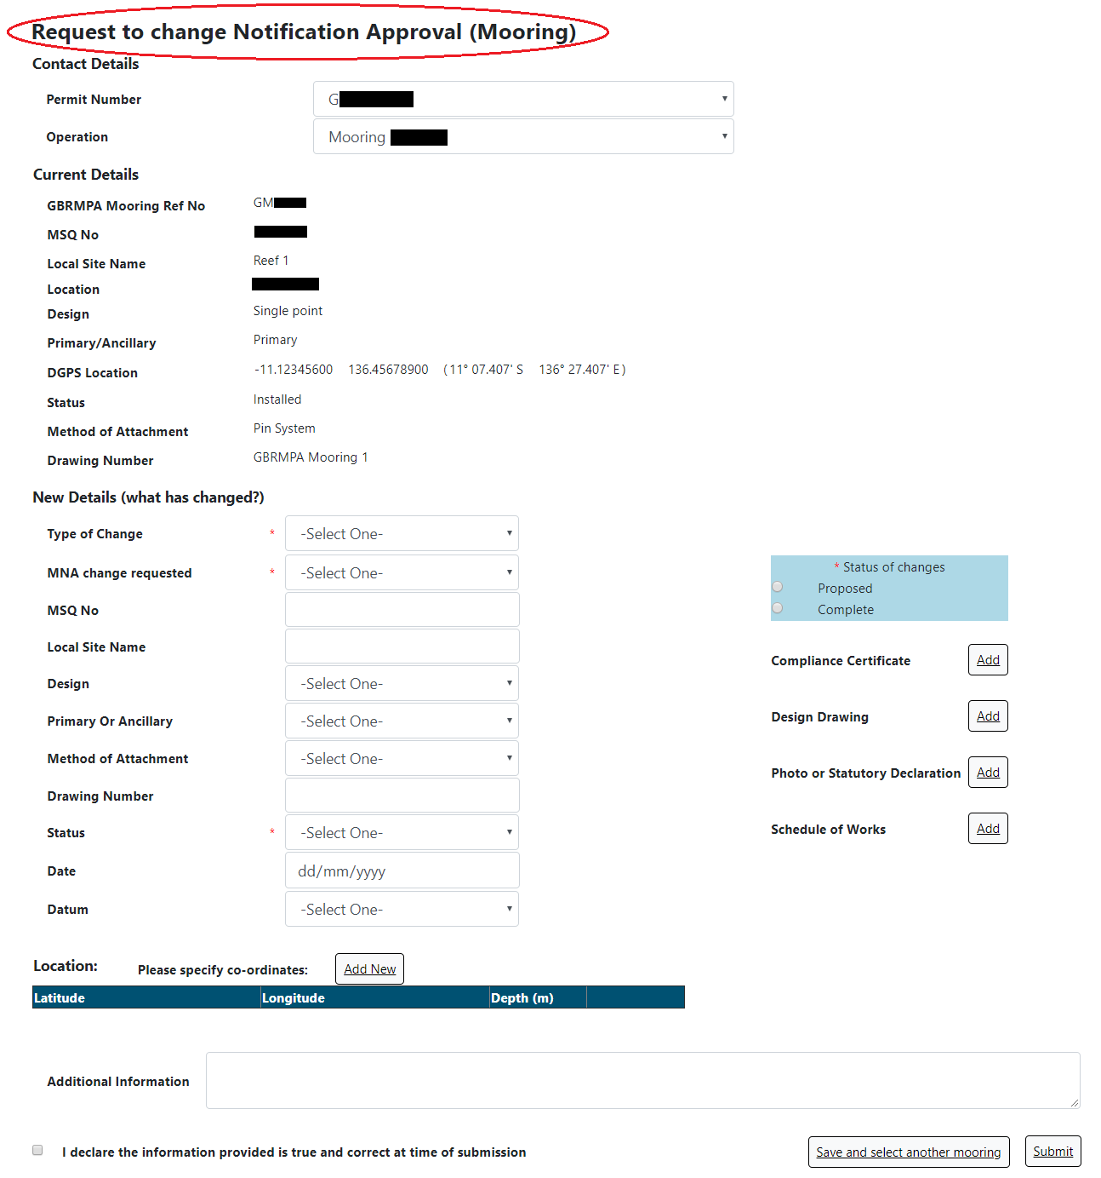
Figure 801 - Screenshot of Mooring Notification page with title Request to Change Notification Approval (Mooring) circled in red

Once submitted you will be presented with options to print or email a copy of the Notification.
Figure 802 - Screenshot of Notification Submitted page with Print and Email hyperlink options circled in red
  - Other Notification Approval
The Other Notification Approvals section can be used to update Moorings, Facilities, Bareboat and Equipment details. Select the permit number associated with the mooring, facility, equipment or bareboat, explain what you would like to change, and why, then select Submit.
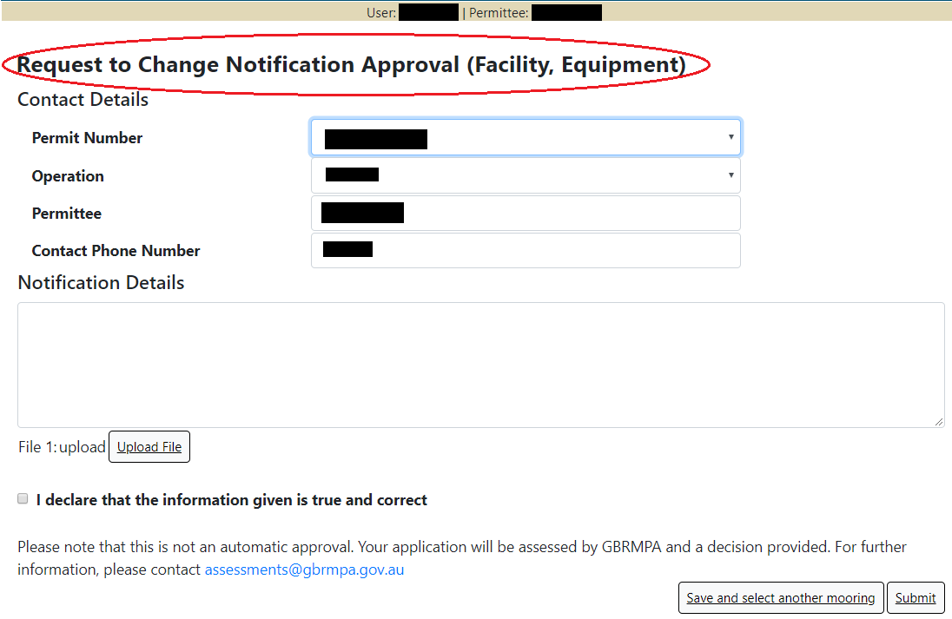
Figure 803 - Screenshot of Other Notification page with Title - Request to Change Notification Approval (Facility, Equipment) circled in red

Once submitted you will be presented with options to print or email a copy of the Notification.
Figure 804 - Screenshot of Notification Submitted page with Print and Email hyperlink options circled in red

  - Notification Approvals – Print and Email
To print or email a copy of your notification approval, select the Notification Approvals icon, then select print from the sub menu. When you land on the Print / Email page, select the Type of notification approval, select the permit number, then select Submit.
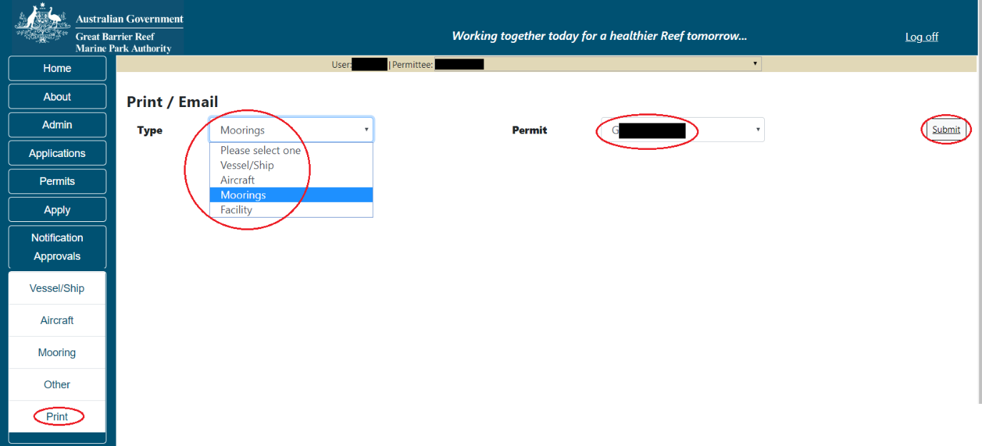
Figure 805 - Screenshot of Notification Approval Print / Email screen with a red circle around type, permit number and submit

Once submit is selected the notification approval details will display on the screen. You are given options to Print or Email the notification approval.

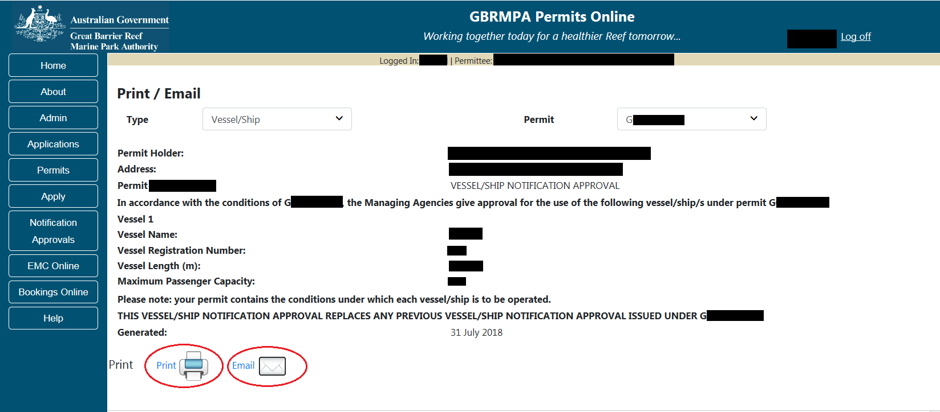
Figure 806 - Screenshot of Notification Approval print / email page with a red circle around the print and email buttons

- Payments

  - Select Outstanding Charges
When the Payments icon is selected from the Menu, the Select Outstanding Charges screen will appear. If no payments are due then the screen will show a View Payments History button and a link to EMC online.
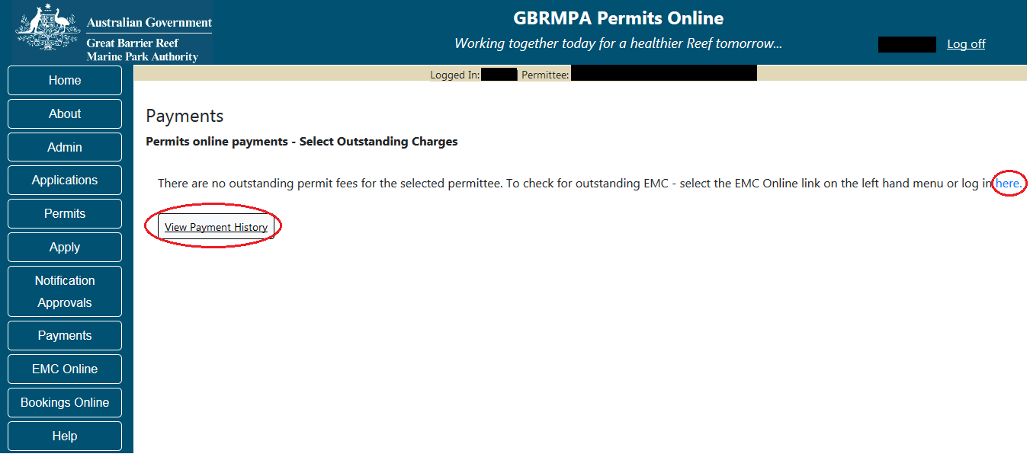
Figure 807 - Screenshot of Payments - Select Outstanding Charges screen with a red circle around the View Payments History button and a red circle around the here hyperlink to EMC Online
If charges are outstanding the Select Outstanding charges screen will show which charges are to be paid. Select the tick box of the payment/s you wish to make, then select Next. If Cancel is selected on this screen, you will progress to the Payments Management screen.
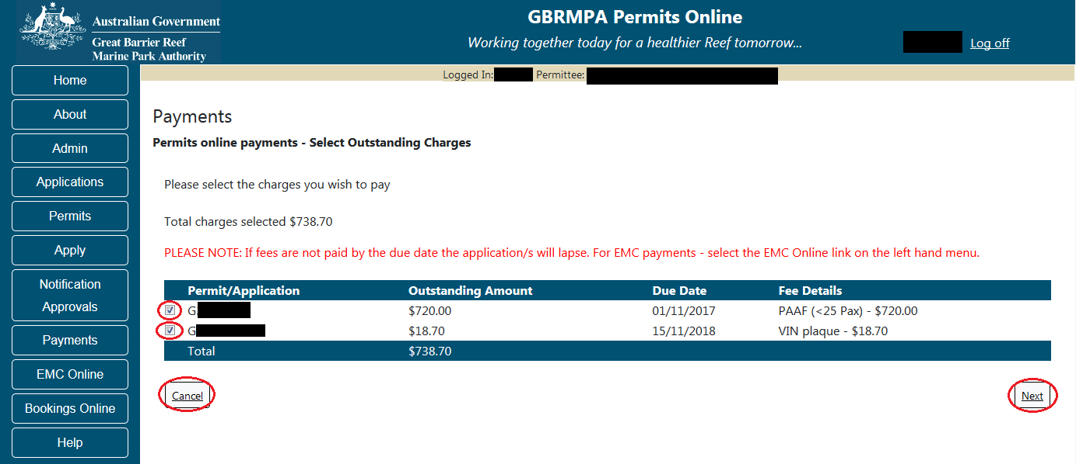
Figure 808 - Screenshot of Payments - Select Outstanding Charges screen with a red circle around the payment tick boxes and red circles around Cancel and Back buttons
  - Select Payment Method
Once Next is selected from the select outstanding charges screen, you will progress to the Select Payment Method page. Options for Back and Cancel are available on the page. To select a Payment Method use the drop list to make your selection.
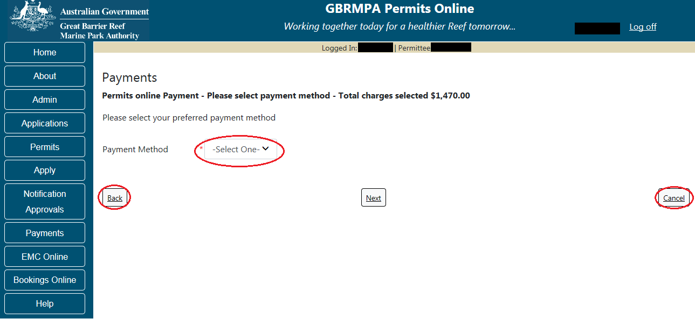
Figure 809 - Screenshot of Select Payment Method screen with a red circle around the payment method drop list. Red circles around back and next buttons

The Payment Method drop list has 3 options. Credit Card, BPAY, and Direct Debit. Select which option you require from the list, then select Next to continue.
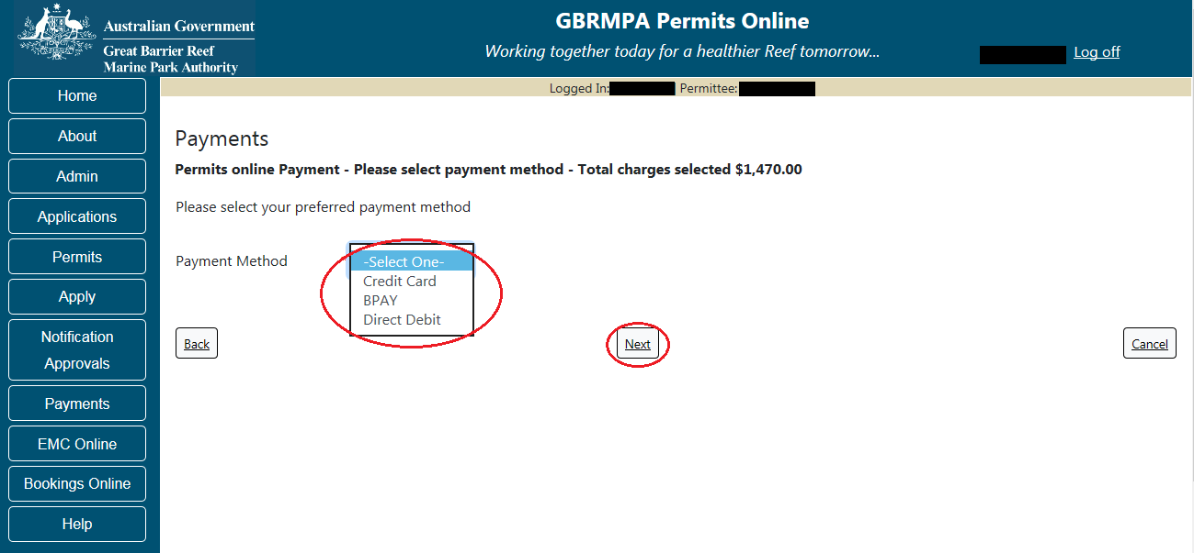
Figure 810 - Screenshot of Select Payment Method screen with a red circle around the payment method drop list which is displaying the 3 options in the list, and a red circle around the next button

    - Select Payment Method – Credit Card
When the Credit Card method is selected, the screen will display the details required for the applicant / Permit Holder to make the payment immediately. Details include Credit card type, credit card number, name on credit card, Month, Year and Security Code. Add details of your credit card and select Next to continue. PLEASE NOTE PAYMENTS BY CREDIT CARD ATTRACT A 1% SURCHARGE
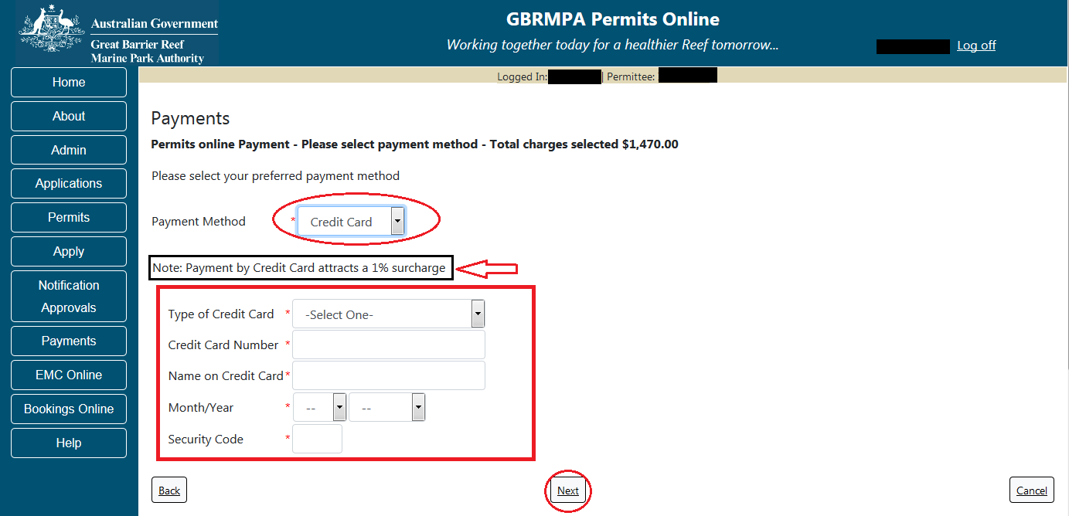
Figure 811 - Screenshot of select payment method screen with a red circle around credit card option, a black box and red arrow indicating 1% surcharge and a red box around the credit card details area

    - Submit Credit Card Payment
Once Next is selected on the Select Payment Method screen, you will be presented with a Payment by Credit Card Confirmation screen. The details of the payment are displayed on the screen. Select the Submit Credit Card Payment Now button to continue.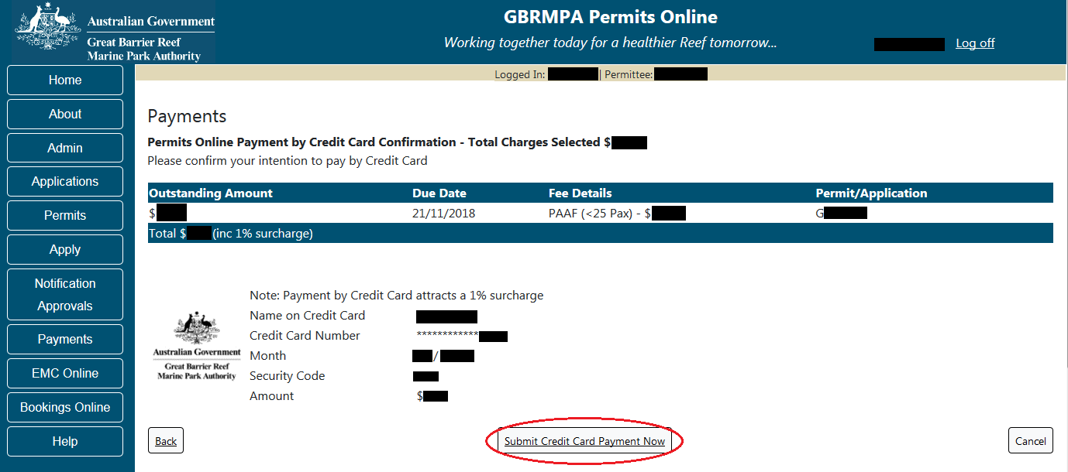
Figure 812 - Screenshot of Payment by Credit Card Confirmation screen with a red circle around the Submit Credit Card Payment Now button
Once the Submit Credit Card Payment Now button is selected the payment will be processed. Details of the payment will appear on screen with a successful or unsuccessful message as well as an option to Print the payment details via a Print Icon.
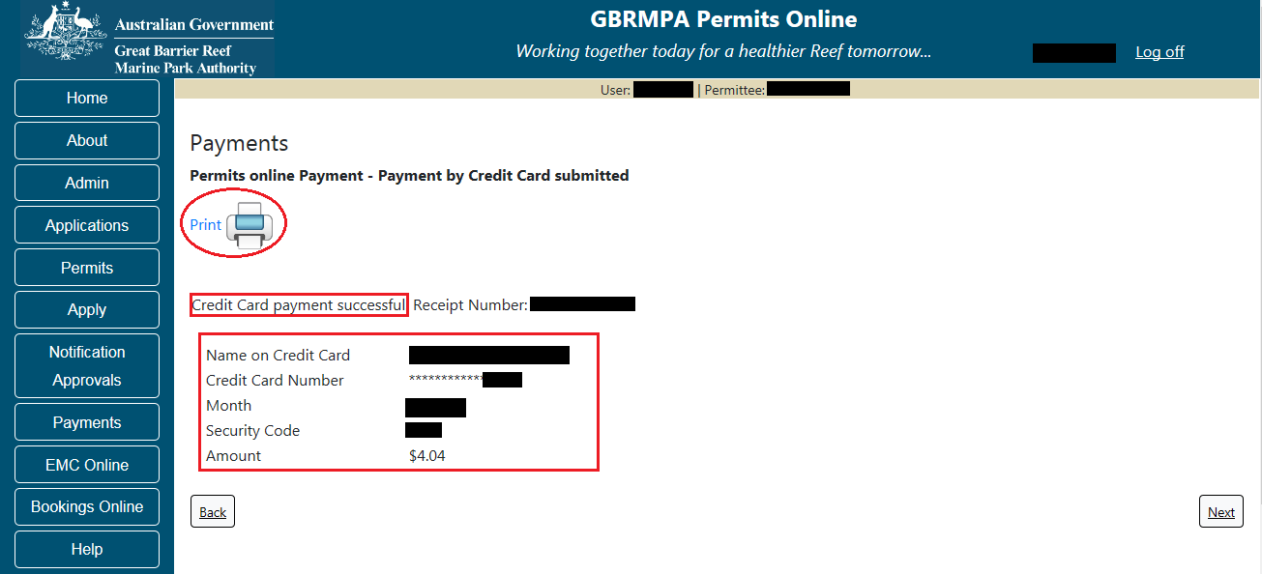
Figure 813 - Screenshot of Payment by Credit Card screen with a red circle around the Print icon. A red box surrounds wording Credit Card payment successful and a red box around the credit card payment details.

    - Select Payment Method - BPAY
When the BPAY method is selected, the screen will display the details required for the applicant to submit the payment. Details include Expected Payment Date, Biller Code, BPAY Reference (CRN) and Amount. If the BPAY method is selected, the Payment is identified as a Payment Pledge.
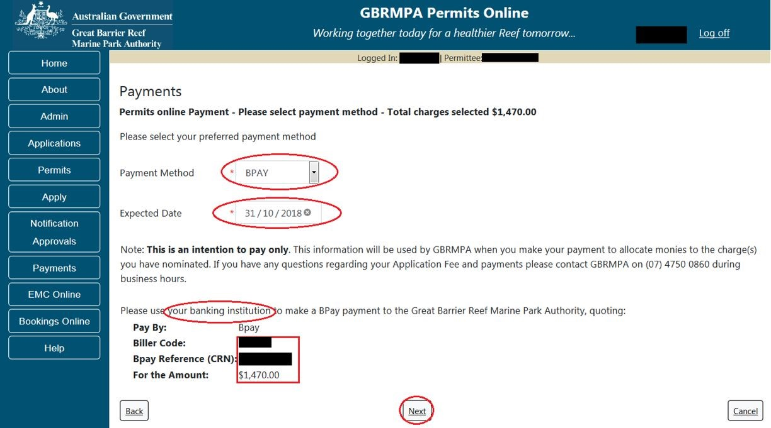
Figure 814 - Screenshot of Select Payment Method screen with a red circle around payment method drop list with BPAY selected. A red circle around the expected date and a red circle around wording your banking institute. A red box around the BPAY details and a red circle around the next button

    - Submit Payment Pledge - BPAY
Once Next is selected on the Select Payment Method screen, you will be presented with a Payment Pledge by BPAY Confirmation screen. The details of the payment pledge are displayed on the screen. Select the Submit BPAY Intention Now button to continue.
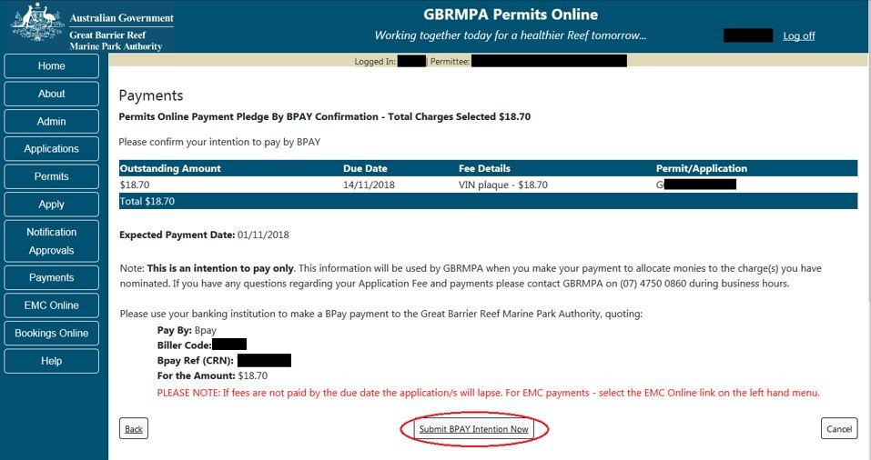
Figure 815 - Screenshot of Payment Pledge by BPAY Confirmation screen with a red circle around the Submit BPAY Intention Now button

Once the Submit BPAY Intention Now button is selected you will be presented with a Pledge Submitted screen with an option to print a pdf copy of the Pledge. Select Next to progress to the Payments Management screen.
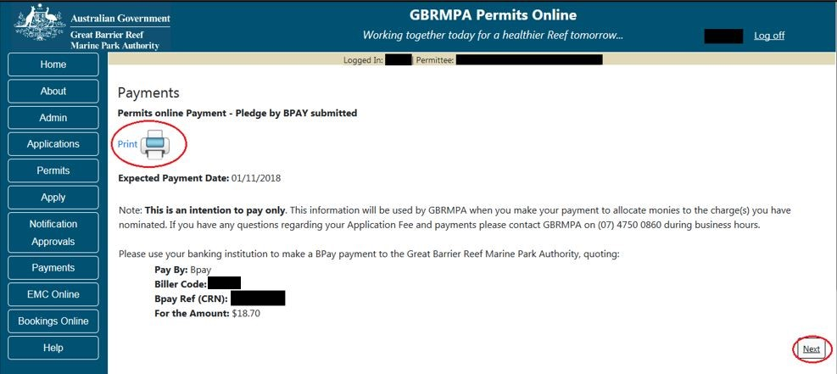
Figure 816 - Screenshot of Pledge by BPAY submitted screen with a red circle around Print icon and a red circle around the Next button
    - Select Payment Method – Direct Debit
When the Direct Debit method is selected, the screen will display the details required for the applicant to submit the Payment. Details include Expected Payment Date, Account Number, Account Name, Amount, Due Date and Reference Number. If the Direct Debit method is selected, the Payment is identified as a Payment Pledge.
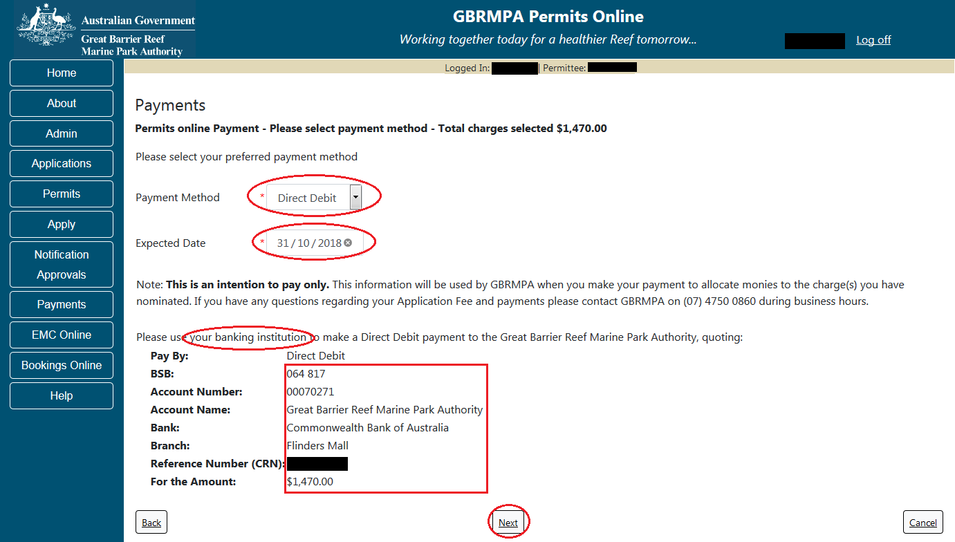
Figure 817 - Screenshot of Select Payment Method screen with a red circle around payment method drop list with. A red circle around the expected date and a red circle around wording your banking institute. A red box around the Direct Debit details and a red circle around the next button

    - Submit Payment Pledge – Direct Debit
Once Next is selected on the Select Payment Method screen, you will be presented with a Payment Pledge By Direct Debit Confirmation screen. The details of the payment pledge are displayed on the screen. Select the Submit Direct Debit Intention Now button to continue.
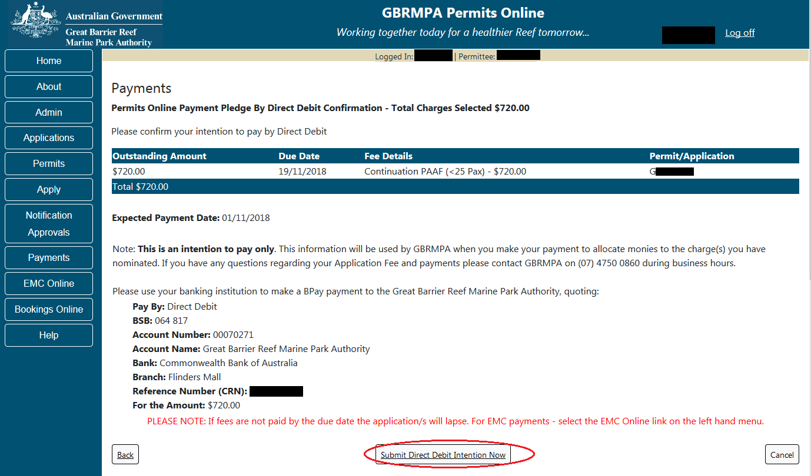
Figure 818 - Screenshot of Payment Pledge by Direct Debit Confirmation screen with a red circle around the Submit Direct Debit Intention Now button
Once the Submit Direct Debit Intention Now button is selected you will be presented with a Pledge Submitted screen with an option to print a pdf copy of the Pledge. Select Next to progress to the Payments Management screen.
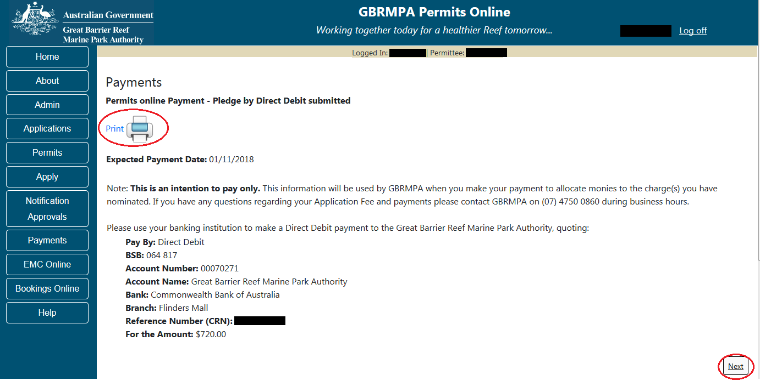
Figure 819 - Screenshot of Pledge by Direct Debit submitted screen with a red circle around Print icon and a red circle around the Next button

  - Print Icon
When the Print icon is selected a PDF will display the details of the Payment or Payment Pledge. A message of successful or unsuccessful will appear in the Payment Method line.
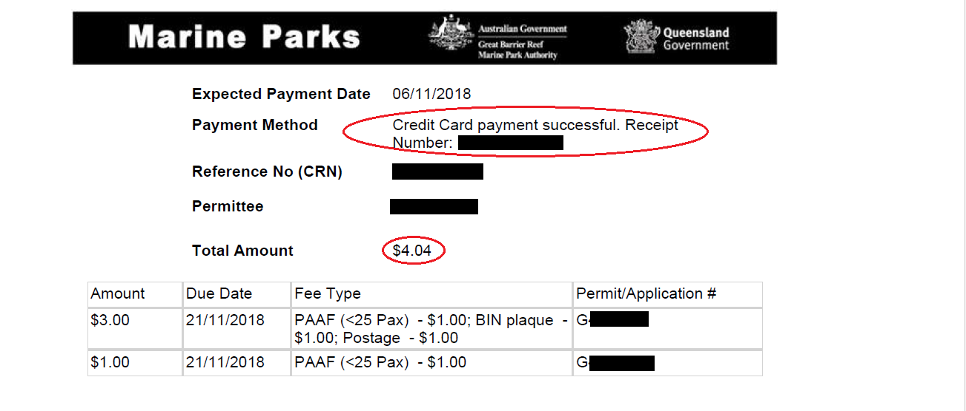
Figure 820 - Screenshot of PDF showing details of the credit card payment. A red circle is around the Credit card payment successful and receipt number. A red box is also around the total amount paid.

  - Email Confirmation
All payment and pledge options, once completed, will automatically be emailed to the Permit Holder / applicant. Details on the email will contain……….
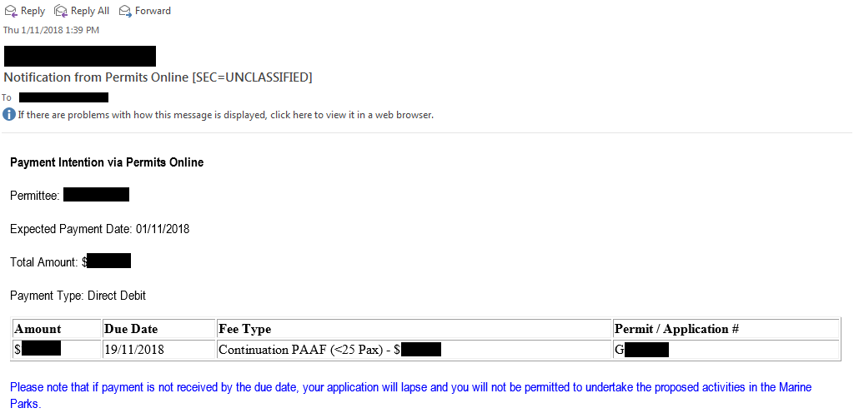
Figure 821 - Screenshot of system generated email once payment or pledge completed

  - Validations
Validations on the select payment method – credit card screen are presented when any of the credit card fields have no details added.
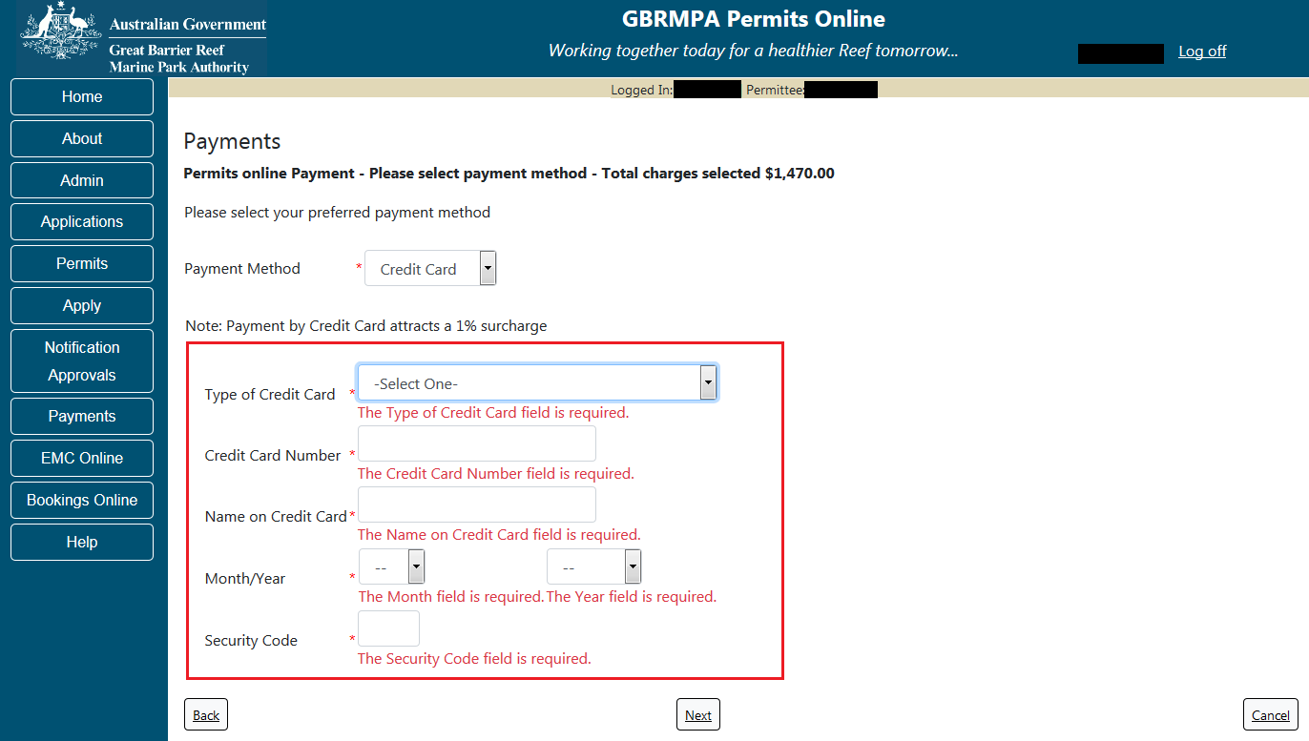
Figure 822 - Screenshot of Select Payment Method screen with a red box around Credit Card Validations
    - Validation – Credit Card Declined
If a credit card payment is declined, a message will appear on the screen. Select Back to amend the details and re-submit the payment.
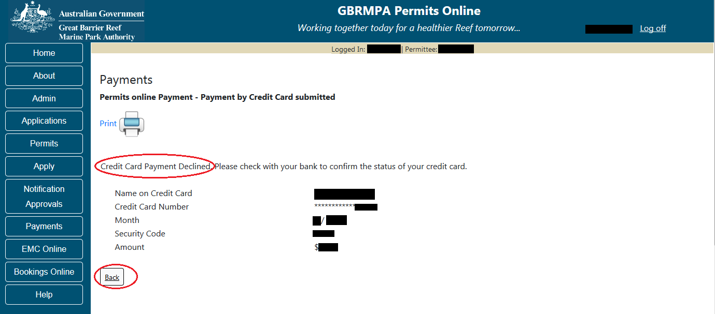
Figure 823 - Screenshot of Credit card declined page, with a red circle around message Credit Card Payment Declined and a red circle around the Back button

  - Payments Management
The Payments Management screen will display details of Payments and Pledges.
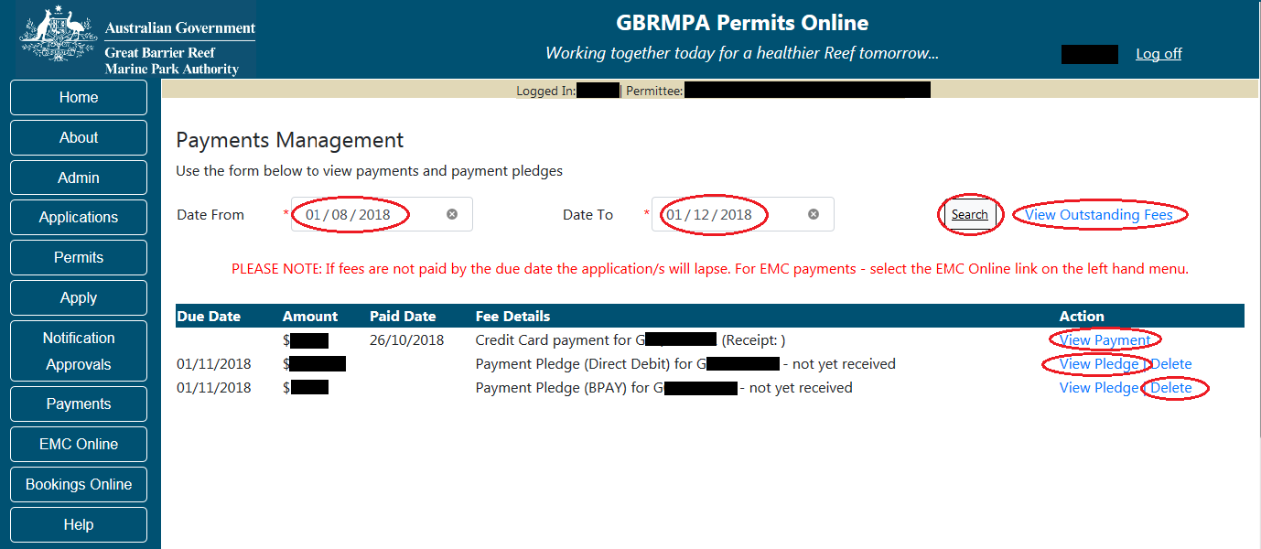
Figure 824 - Screenshot of Payments Management screen with red circles around Date From, Date To, Search Button, View Outstanding fees hyperlink, view payment hyperlink and delete hyperlink

    - Date from and Date to
The Date From and Date To fields are for use by the applicant when wanting to view payments history. The Date From will show as a default of today’s date minus three months, and the Date to will display as today’s date plus one month. Example if logged in on 01/11/2018 the Date From will display as 01/08/2018 and the date to will display as 01/12/2018. If you require to view information for a period longer than the defaults, select the Date From Field and enter the desired date. Select Search to display the desired results.
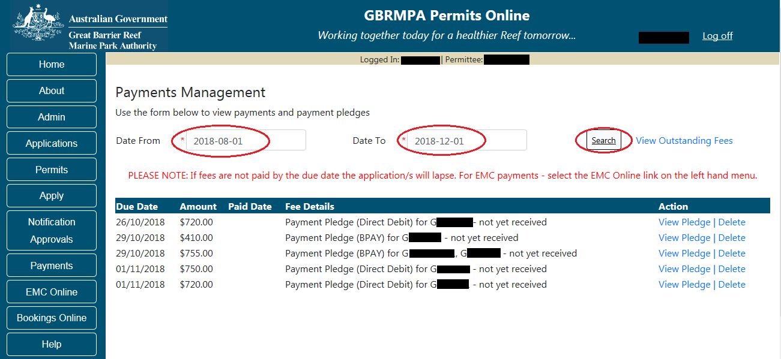
Figure 825 - Screenshot of Payments Management screen with a red circle around Date From, Date To and Search button
Please Note: When Using Internet Explorer as the web browser, the dates displayed in Internet Explorer are in reverse, Example 2018/08/01.

    - View Outstanding Fees
If the View Outstanding Fees hyperlink is selected you will progress to the Select Outstanding Payments screen to view and pay any outstanding fees.
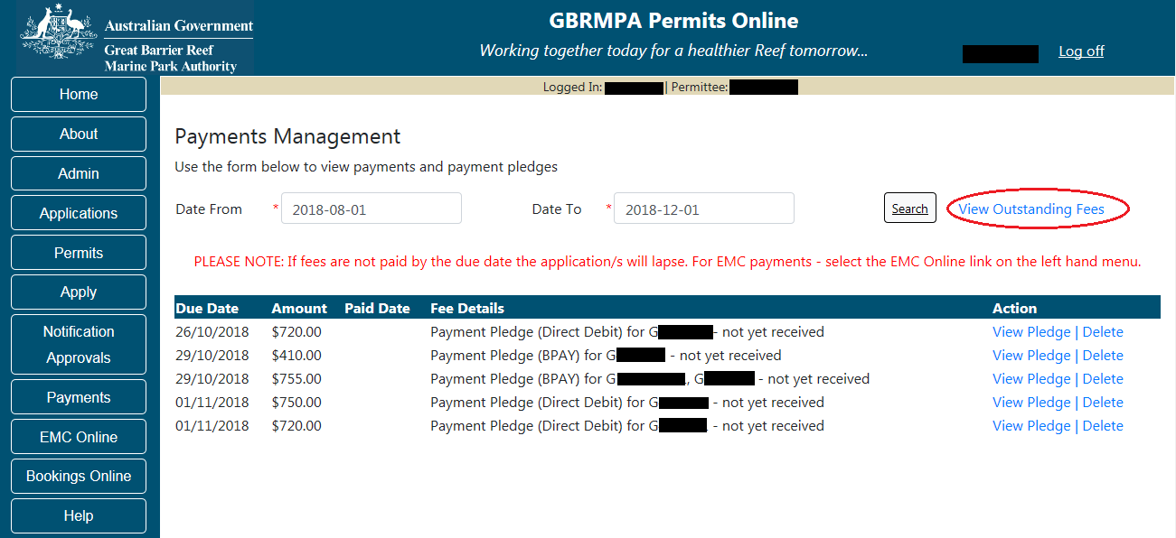
Figure 826 - Screenshot of Payments Management screen with a red circle around the View Outstanding Fees hyperlink
    - View Payment
If the View Payment hyperlink is selected, details of the payment will appear on screen.
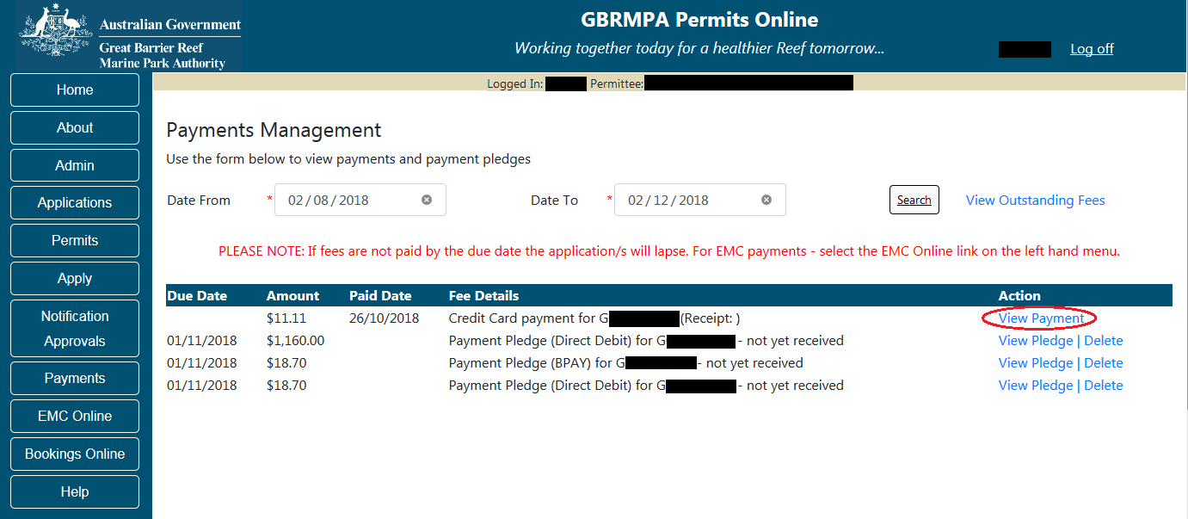
Figure 827 - Screenshot of Payments Management screen with a red circle around the View Payment hyperlink

The details of the Payment will appear in a pop up window once View Payment is selected.
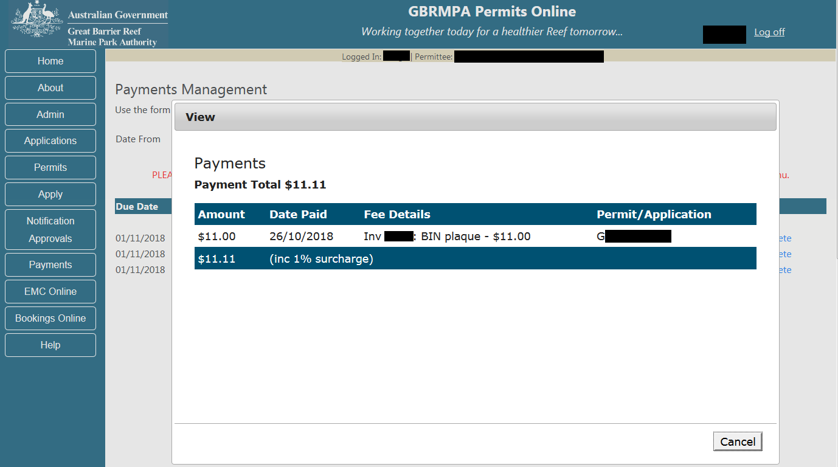
Figure 828 - Screenshot of View Payments pop up window

    - View Pledge
If the View Pledge hyperlink is selected, details of the pledge will appear on screen.
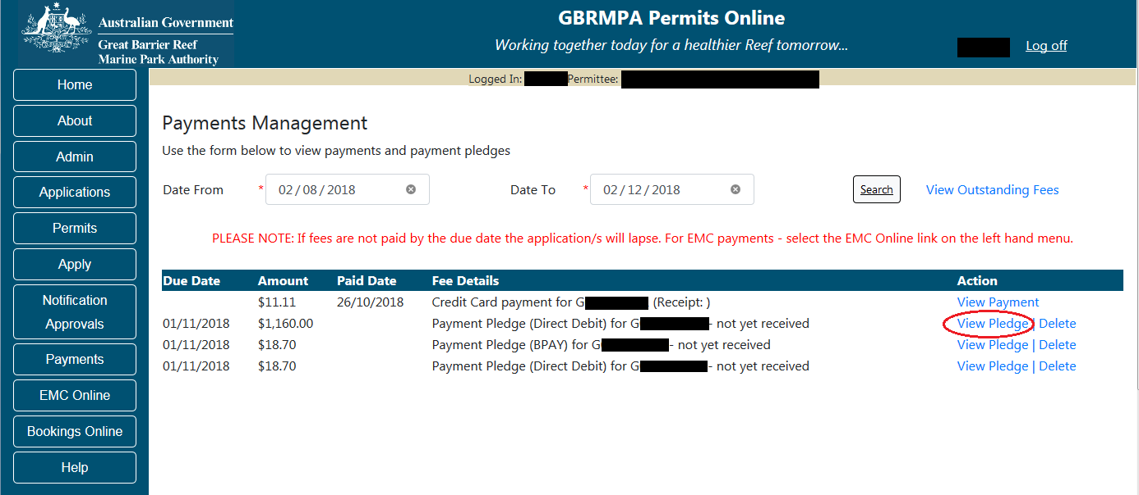
Figure 829 - Screenshot of Payments Management screen with a red circle around the View Pledge hyperlink

The details of the Payment Pledge will appear in a pop up window once View Pledge is selected.
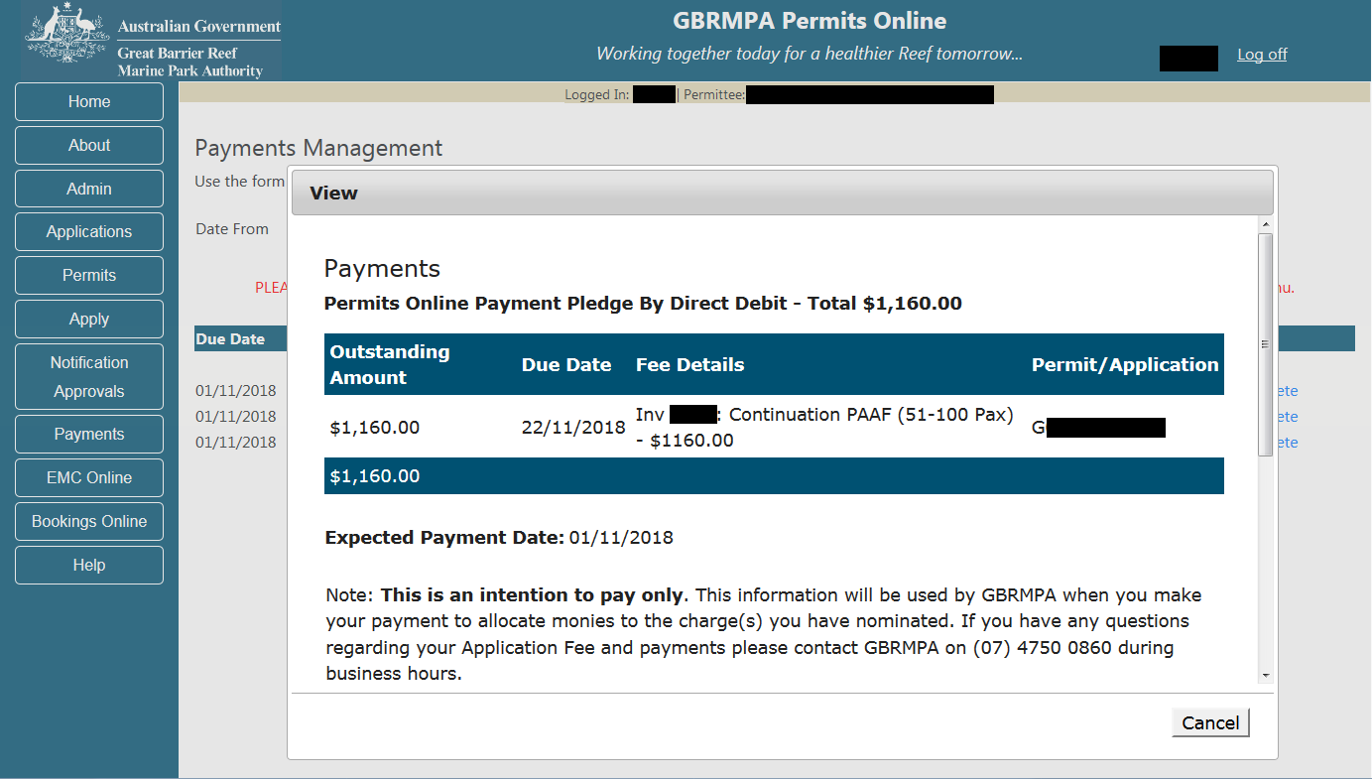
Figure 830 - Screenshot of View Payment Pledge pop up window

    - Delete
If the Delete hyperlink is selected it will delete the associated Payment Pledge. Once deleted the outstanding amount will re-appear on the Select Outstanding Charges screen to be paid or re-pledged.
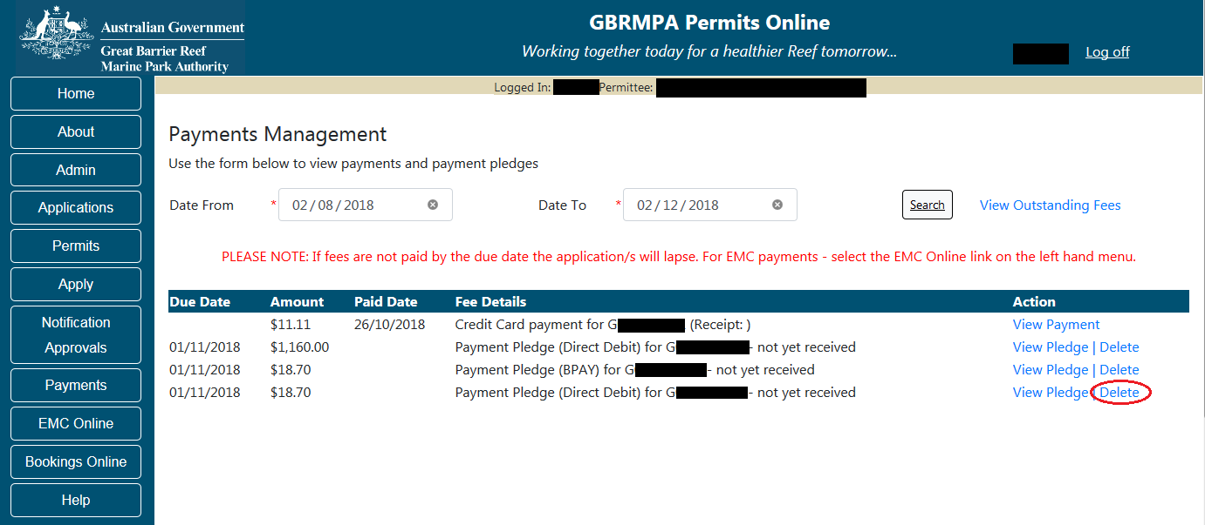
Figure 831 - Screenshot of Payments Management screen with a red circle around the Delete hyperlink

Comments and questions regarding this document are welcome and should be
addressed to:
Great Barrier Reef Marine Park Authority
280 Flinders Street
(PO Box 1379)
Townsville QLD 4810, Australia
Phone: (07) 4750 0700
Email: info@gbrmpa.gov.au
www.gbrmpa.gov.au

For permits that involve tailored assessment please contact the Environmental Assessment and Protection Unit for further information.
Phone (07) 4750 0860 during business hours or Email: assessments@gbrmpa.gov.au.
All feedback regarding the Permits Online system or its data should be sent directly to: Email: assessments@gbrmpa.gov.au.

