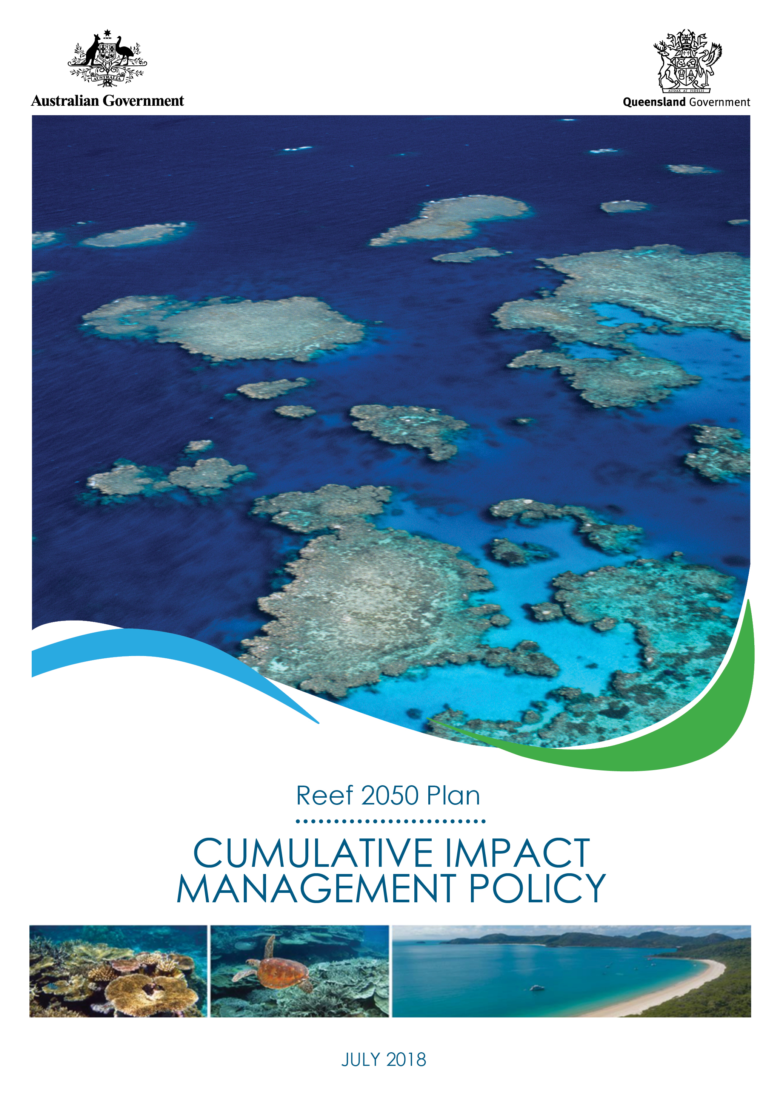
© Commonwealth of Australia 2018
Published by the Great Barrier Reef Marine Park Authority
ISBN 978-0-6480964-6-7
The Cumulative impact management policy is licensed by the Commonwealth of Australia for use under a Creative Commons By Attribution 4.0 International licence with the exception of the Coat of Arms of the Commonwealth of Australia, the logo of the Great Barrier Reef Marine Park Authority, any other material protected by a trademark, content supplied by third parties and any photographs. For licence conditions see: http://creativecommons.org/licences/by/4.0

A cataloguing record for this publication is available from the National Library of Australia

This publication should be cited as:
Great Barrier Reef Marine Park Authority 2018, Cumulative impact management policy, GBRMPA, Townsville.
Comments and questions regarding this document are welcome and should be addressed to:
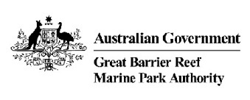
Great Barrier Reef Marine Park Authority
2–68 Flinders Street
(PO Box 1379)
Townsville QLD 4810, Australia

Phone: (07) 4750 0700
Fax: (07) 4772 6093
Email: info@gbrmpa.gov.au
www.gbrmpa.gov.au

Contents
Purpose 3
Objective 3
Target audience 3
Context 4
Principles for managing cumulative impacts 6
Process 11
Implementation 11
Related legislation 13
Review and evaluation 13
Definitions 14
Further information 18
Attachment 1: Drivers of change, pressures and impacts on the Great Barrier Reef 19
Attachment 2: Risks to Great Barrier Reef values as reported in the Great Barrier Reef Outlook Report 22
Attachment 3: Condition and trend of Great Barrier Reef values 26
Attachment 4: Values, attributes and processes that underpin matters of national environmental significance relevant to the Great Barrier Reef 28
Attachment 5: Examples of decision-making considerations in implementing the cumulative impact management policy for plans, programs and actions 32
Attachment 6: Policy application - example 33

Purpose
To provide a systematic and consistent approach to managing and reducing cumulative impacts on the Great Barrier Reef.
Cumulative impacts are defined as the interaction of effects between one or more impacts
and past, present and reasonably foreseeable future pressures.
Cumulative impact assessment takes into account direct, indirect and consequential impacts and the incremental and compounding effects of these impacts over time, including past, present and reasonably foreseeable future pressures.
This policy provides a framework to mitigate or reduce cumulative impacts on Great Barrier Reef values.

Objective
To reduce pressures on Great Barrier Reef values from multiple sources through rigorous decision-making that:
- identifies past, present and reasonably foreseeable pressures;
- examines their combined effects on Great Barrier Reef values and
- designs and applies appropriate management measures to avoid and mitigate impacts.

Target audience
The target audience for this policy is the Great Barrier Reef Marine Park Authority and other Australian and Queensland government agencies making decisions that may affect the values of the Great Barrier Reef (Refer to Definitions for environment, decision, Great Barrier Reef and values).
Government agencies and authorities should apply this policy when revising or preparing relevant agreements, policies, plans, strategies and programs when they are likely to contribute to the drivers and pressures on Great Barrier Reef values
Cumulative impacts should be considered at a strategic level, such that where proposed activities are consistent with management approaches that have already considered cumulative impacts, then project level cumulative impact assessments would not be required.
However, activities that pose a higher risk to Great Barrier Reef values and are generally the subject of an environmental impact assessment or similar, will be required to assess cumulative impacts, in accordance with this policy.
Where required, proponents should apply this policy when seeking approvals - under the Environment Protection and Biodiversity Conservation Act 1999, the Great Barrier Reef Marine Park Act 1975 or relevant Queensland legislation – for actions that are likely to adversely affect attaining the desired outcomes for Great Barrier Reef values. These are most likely to be proposed actions for which formal environmental impact assessment, or similar, is required.
Local government, businesses, industry, community groups and other people are encouraged to use this policy to better understand the different types of pressures and impacts affecting the Great Barrier Reef, and to provide guidance to reduce impacts either through taking direct action, partnering or influencing others. Small positive actions have the potential to deliver a cumulative positive impact for the Reef.
Attachments 1 and 3 will help identify potential interactions that contribute to drivers and pressures on Great Barrier Reef values, and target opportunities to deliver better outcomes for the Reef.

Context
The Great Barrier Reef Outlook Report 2014 (Outlook Report) identified the four main pressures on the Great Barrier Reef as:
  - climate change (global scale)
  - coastal land-use change (Great Barrier Reef catchment scale)
  - poor water quality from land-based run-off (Great Barrier Reef catchment scale)
  - some remaining impacts of fishing (Great Barrier Reef Region scale).
Impacts on the Great Barrier Reef rarely occur in isolation but often overlap and interact with each other (Figure 1). Where impacts accumulate over time and space, they create cumulative impacts which lower the resilience of the ecosystem and its ability to recover from disturbance.
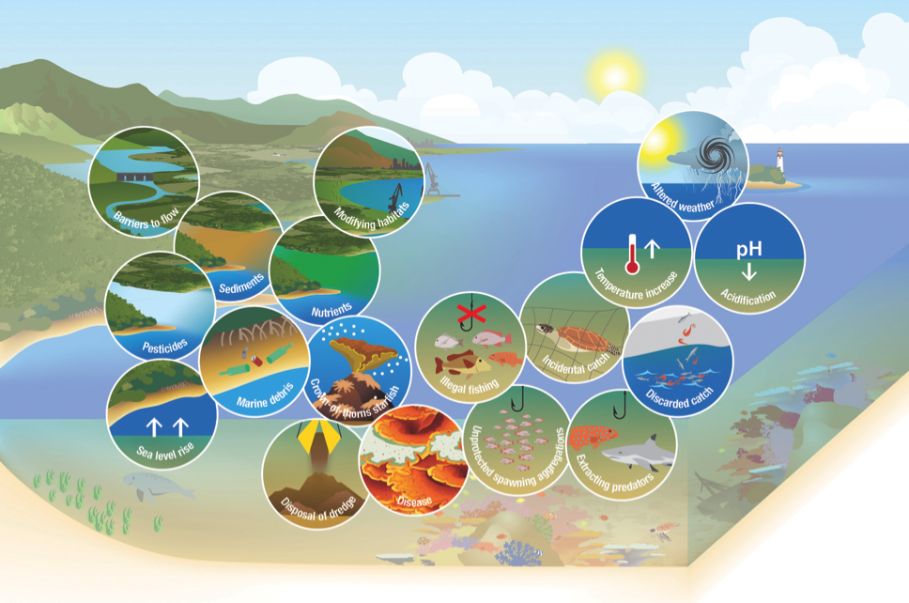
Reducing the pressures from local, Marine Park, catchment and global levels is required to improve the condition of Great Barrier Reef values and build resilience. Attachment 1 lists drivers and pressures affecting the Great Barrier Reef and their relative risk to values.
Figure 1 - Example of multiple impacts within an area – multiple impacts, including those presenting high and very high risks to the Reef’s values (see Table A1.1), can overlap and interact within an area. They can combine to present a serious cumulative risk to local habitats and species, and the community and economic benefits they support.
The impact is not just on the Great Barrier Reef ecosystem, but also impacts on the cultural values of Traditional Owners; economic values to the tourism and fishing industries which rely on a healthy Reef; social values for communities along the coast for whom the Reef is part of their daily life; together with the broader Australian and international community who consider it to be an irreplaceable icon – belonging to the global community.
It is critical for reefs worldwide, including the Great Barrier Reef, that global scale efforts to reduce climate change pressures are effective. International actions to limit the Earth’s temperature increase to 1.5^{Ο}C above pre-industrial levels (or ideally less) are underway through the Paris Climate Agreement. To ensure a future for the Great Barrier Reef as a functioning reef ecosystem, these efforts need to be supported by improving the Reef’s resilience to climate change through reducing local pressures.
Improving management of cumulative impacts to reduce pressures, together with delivering decisions that result in an improvement in the condition of values, is critical to the future health and resilience of the Great Barrier Reef.
The Reef 2050 Plan provides an overarching strategy for long-term management of the Great Barrier Reef. It brings together actions across government, Traditional Owners, industry, researchers and the community. The Plan provides an agreed outcomes-based, target-driven framework for protecting the Great Barrier Reef’s health and resilience while allowing for ecologically sustainable use.
The Plan details primary principles to consider in all decision-making that affects the Great Barrier Reef which are:
  - maintaining and enhancing outstanding universal value in every action
  - basing decisions on the best available science
  - delivering a net benefit to the ecosystem
  - adopting a partnership approach to management.
Practical approaches for addressing these principles are contained in the Reef 2050 Policy Guideline for Decision Makers. Good Practice Decision Management for the Great Barrier Reef provides additional direction for decision-makers and the broader community.
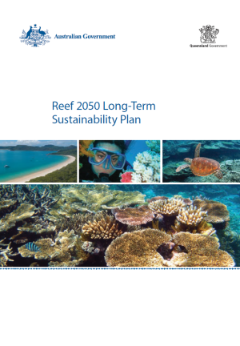
This policy is one of a number of Reef 2050 documents being developed to provide decision-makers and the community with additional information and guidance about priorities and processes for implementation (Figure 2).
Figure 2 - Policy guidance supporting implementation of the Reef 2050 Plan
Net benefit policy
Cumulative impact management policy
Guidance for good management in the Great Barrier Reef
Reef 2050 Plan policy guideline for decision makers

Principles for managing cumulative impacts
Adopt a consistent approach to cumulative impact management terminology and methods
Terms used in the Great Barrier Reef Region Strategic Assessment Report and 2014 Outlook Report should be adopted to assess, monitor and report on cumulative impacts at regional and Great Barrier Reef–wide scales. These are outlined in this policy’s Definitions and Attachments 1-3.
Methods used to assess cumulative impacts should build on approaches used in the Great Barrier Reef Region Strategic Assessment Report. This report outlines a suite of tools to understand and assess cause-and-effect relationships of pressures on values.
Methods should be updated as new science and information becomes available, including standards and protocols being established as part of the Reef 2050 Integrated Monitoring and Reporting Program.
Understand issues of scale, and cause and effect
For those decisions where Cumulative Impact Assessment is required, the Driver Pressures State Impact Response framework (Figure 4) should be used to identify the broadest range of opportunities to reduce cumulative impacts. Management interventions to reduce risks from drivers, pressures and impacts should be explicitly mapped to this framework.
Assessment of cumulative impacts should identify:
- the space and time scales at which drivers, pressures and impacts – including direct, indirect and consequential impacts – are operating (refer to text box on the next page)
- the space and time scales in which affected values are present and relationships or dependencies between values
- the cause and effect relationships between drivers, pressures, impacts and risk on values
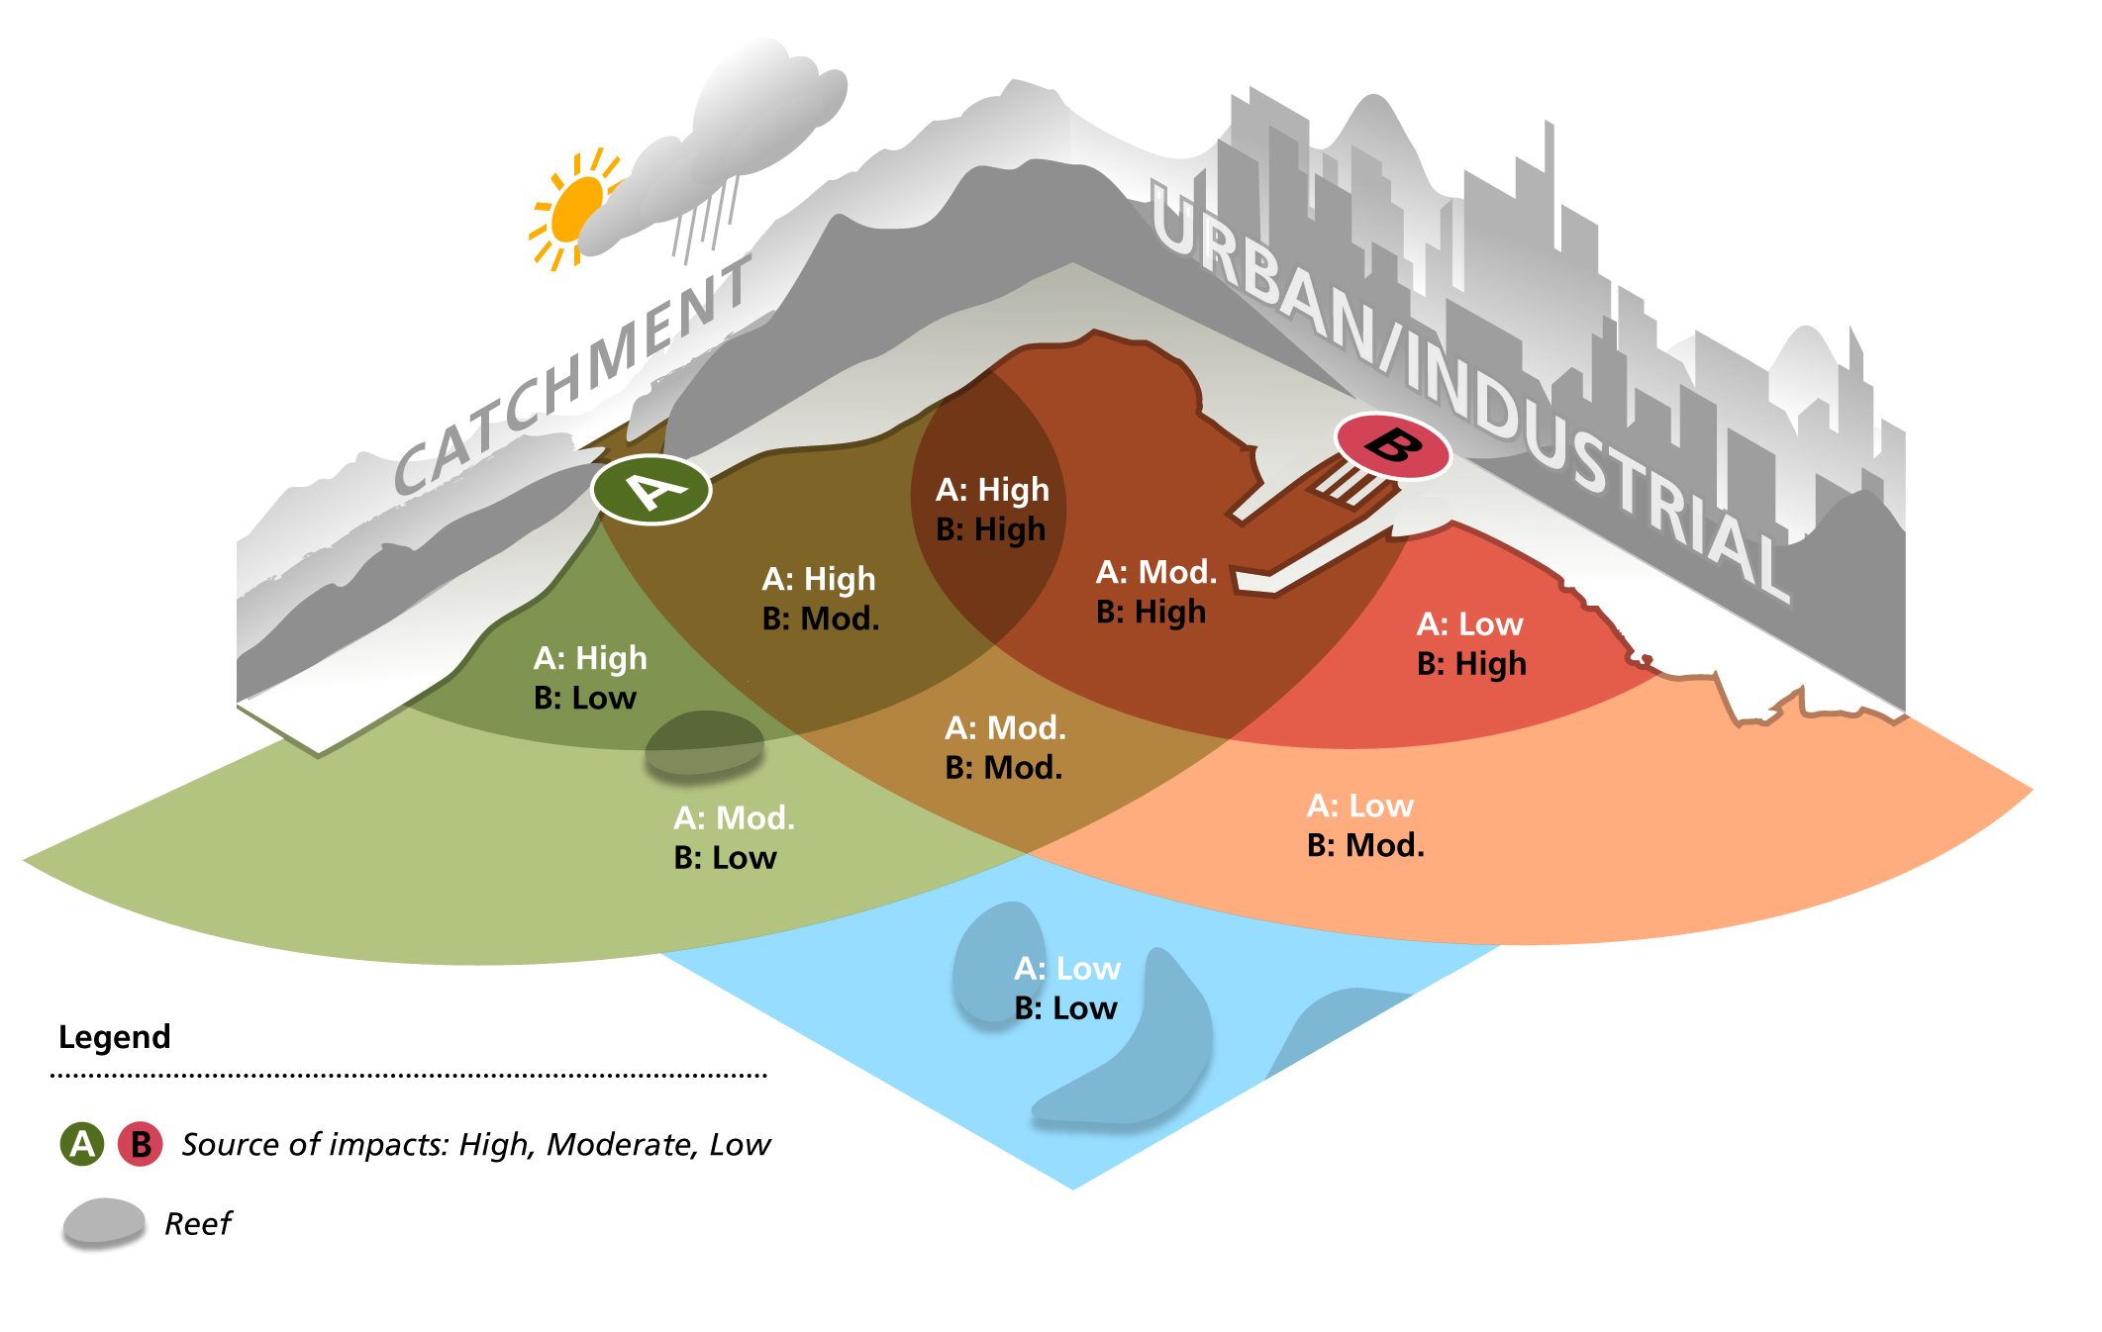
- the resulting zone of influence (Figure 3) – the area and time scale of effect at which impacts are occurring and the scope of response available or required to manage these impacts.
Figure 3 - The zone of influence is the area in which an activity or pressure could directly or indirectly impact part of the environment. Source: Anthony, K.R.N. et al 2013, A framework for understanding cumulative impacts, supporting environmental decisions and informing resilience-based management of the Great Barrier Reef World Heritage Area, Great Barrier Reef Marine Park Authority, Townsville, 112 p. http://hdl.handle.net/11017/2850

Project-based, regional or strategic assessment of cumulative impacts may be required to manage the drivers and activities leading to pressures and consequential impacts within the zone of influence (refer to Attachment 5). Consideration also needs to be given to any consequential impacts such as downstream consequences of altered connectivity between land and sea.
Different types of cumulative pressures on marine ecosystems.
Cumulative effects caused by the same pressure accumulate in a range of ways through time and space. Some examples include:
- Sequential acute events of the same pressure, such as those caused by repeated or seasonal pressures in the same area (e.g. flood events that have increased volume and pollutants above natural background)
- Subsequent acute effects occur before full recovery from the previous stress event
- Simultaneous pulses of the same pressure (e.g. nutrient and pesticides discharged from a number of adjacent catchments)
- Chronic (long term) exposure to the same pressure (e.g. effects of climate change, such as acidification and increased sea temperature).
The cumulative effect of multiple pressures is even more complex. A simultaneous or successive effect by two or three (or more) acute events may lead to reduction in ecosystem health.
On the Great Barrier Reef it is not unusual for reefs to be successively affected by Crown of Thorns Starfish (CoTS), cyclones and bleaching from thermal stress.
In a DPSIR framework, this means that numerous drivers and activities, such as atmospheric changes in carbon dioxide concentrations, fisheries and agriculture, may interact to lead to cumulative pressure.
Some of these pressures (especially the global and chronic pressures of ocean acidification and global warming) can be seen as slowly ramping up over decades, while other pressures simultaneously affect the community in an acute or chronic fashion.
(Adapted from page 10 of Uthicke, S., Fabricius, K., De’ath, G., Negri, A., Warne, M., Smith, R., Noonan, S., Johansson, C., Gorsuch, H. and Anthony, K. (2016). Multiple and cumulative impacts on the GBR: assessment of current status and development of improved approaches for management: Final Report Project 1.6. Report to the National Environmental Science Programme. Reef and Rainforest Research Centre Limited, Cairns (144pp.)).

Assess against desired state, current condition, thresholds and standards
Cumulative impact assessments should determine the current condition and trend of affected values within the zone of influence of the plan, program or action. This provides the reference point and context for assessing and managing cumulative impacts. Use the best available information including:
  - The Outlook Report identifies the condition and trend for values that contribute to the outstanding universal value of the Great Barrier Reef and that underpin Reef-related matters of national environmental significance (see Attachment 3).
  - The Great Barrier Reef Strategic Assessment Program Report established the desired state of these values by linking their current condition and trend to international and national obligations for protecting the Great Barrier Reef.
  - The Outlook Report assesses the condition and trend of the Reef’s values every five years.
  - Advice from Traditional Owners and stakeholders on important ecological, cultural, social and economic values within the zone of influence.
The desired outcomes for Great Barrier Reef values are outlined in Table 1. At a minimum, it should be considered whether the management of cumulative impacts associated with any proposed decision:
- will facilitate or restrict delivery of the desired outcome for specified values
- is consistent with ecological sustainable use principles
- accommodates for the effects of global warming of at least 1.5ºC above pre-industrial levels.
Project-based cumulative assessments should align with any cumulative impact findings or directions embedded in strategic and regional assessments and plans that are consistent with the principles and procedures of this policy. Where an action is likely to have a significant impact on Great Barrier Reef values, environmental impact assessment processes should evaluate project-specific contributions to the current and desired condition of impacted values to determine their acceptability.
Relevant standards, guidelines and thresholds for affected values should be considered. Currently there are standards for water quality, ecosystem health and limits of acceptable change for Ramsar wetlands.
Current condition | Desired outcome
Very good | The condition is maintained
Good | The condition is maintained and enhanced
Poor | The condition is restored to good
Very poor | The condition is restored to good
Trend in condition | Desired outcome
Improving | The trend is maintained
Stable | The trend is maintained and improved
Deteriorating | The decline is halted and reversed
Table 1: Desired outcomes for Great Barrier Reef values

Use integrated approaches and a range of management mechanisms
Management of cumulative impacts should consider how decisions about planning, programs, development assessment and on-ground actions within the Great Barrier Reef, along the coast, in coastal catchments and globally will impact Great Barrier Reef values.
Cumulative impacts should be considered at all scales of decision-making and applied proportionately to the nature and scale and risk of likely impacts. For some decisions, cumulative impacts are incorporated in developing overarching strategies or legislative frameworks.
In most cases, cumulative impacts are best avoided or managed through regional or system scale planning that guides local scale assessment and management.
Management should be guided by risk assessment using forecasting scenarios (e.g. climate and global economy) that examine alternative strategies for intervention and planning. Transparent analysis of risks and consequences under alternative scenarios and options can help identify the most sustainable and effective options for managing cumulative impacts. Those options should be integrated into strategic, regional and, where required, local management mechanisms.
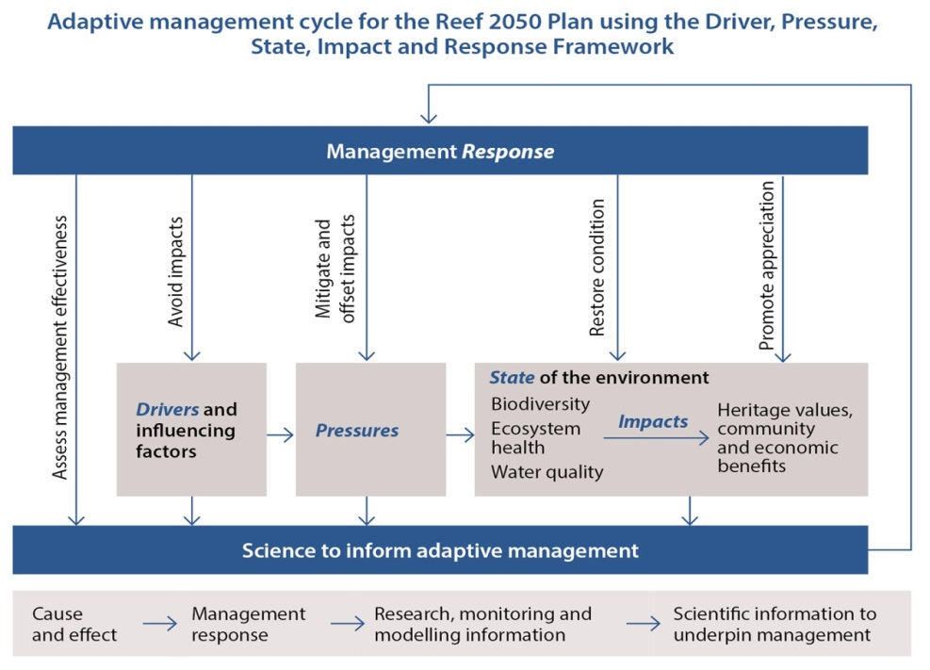
Figure 4 - Reef 2050 Plan adaptive management framework
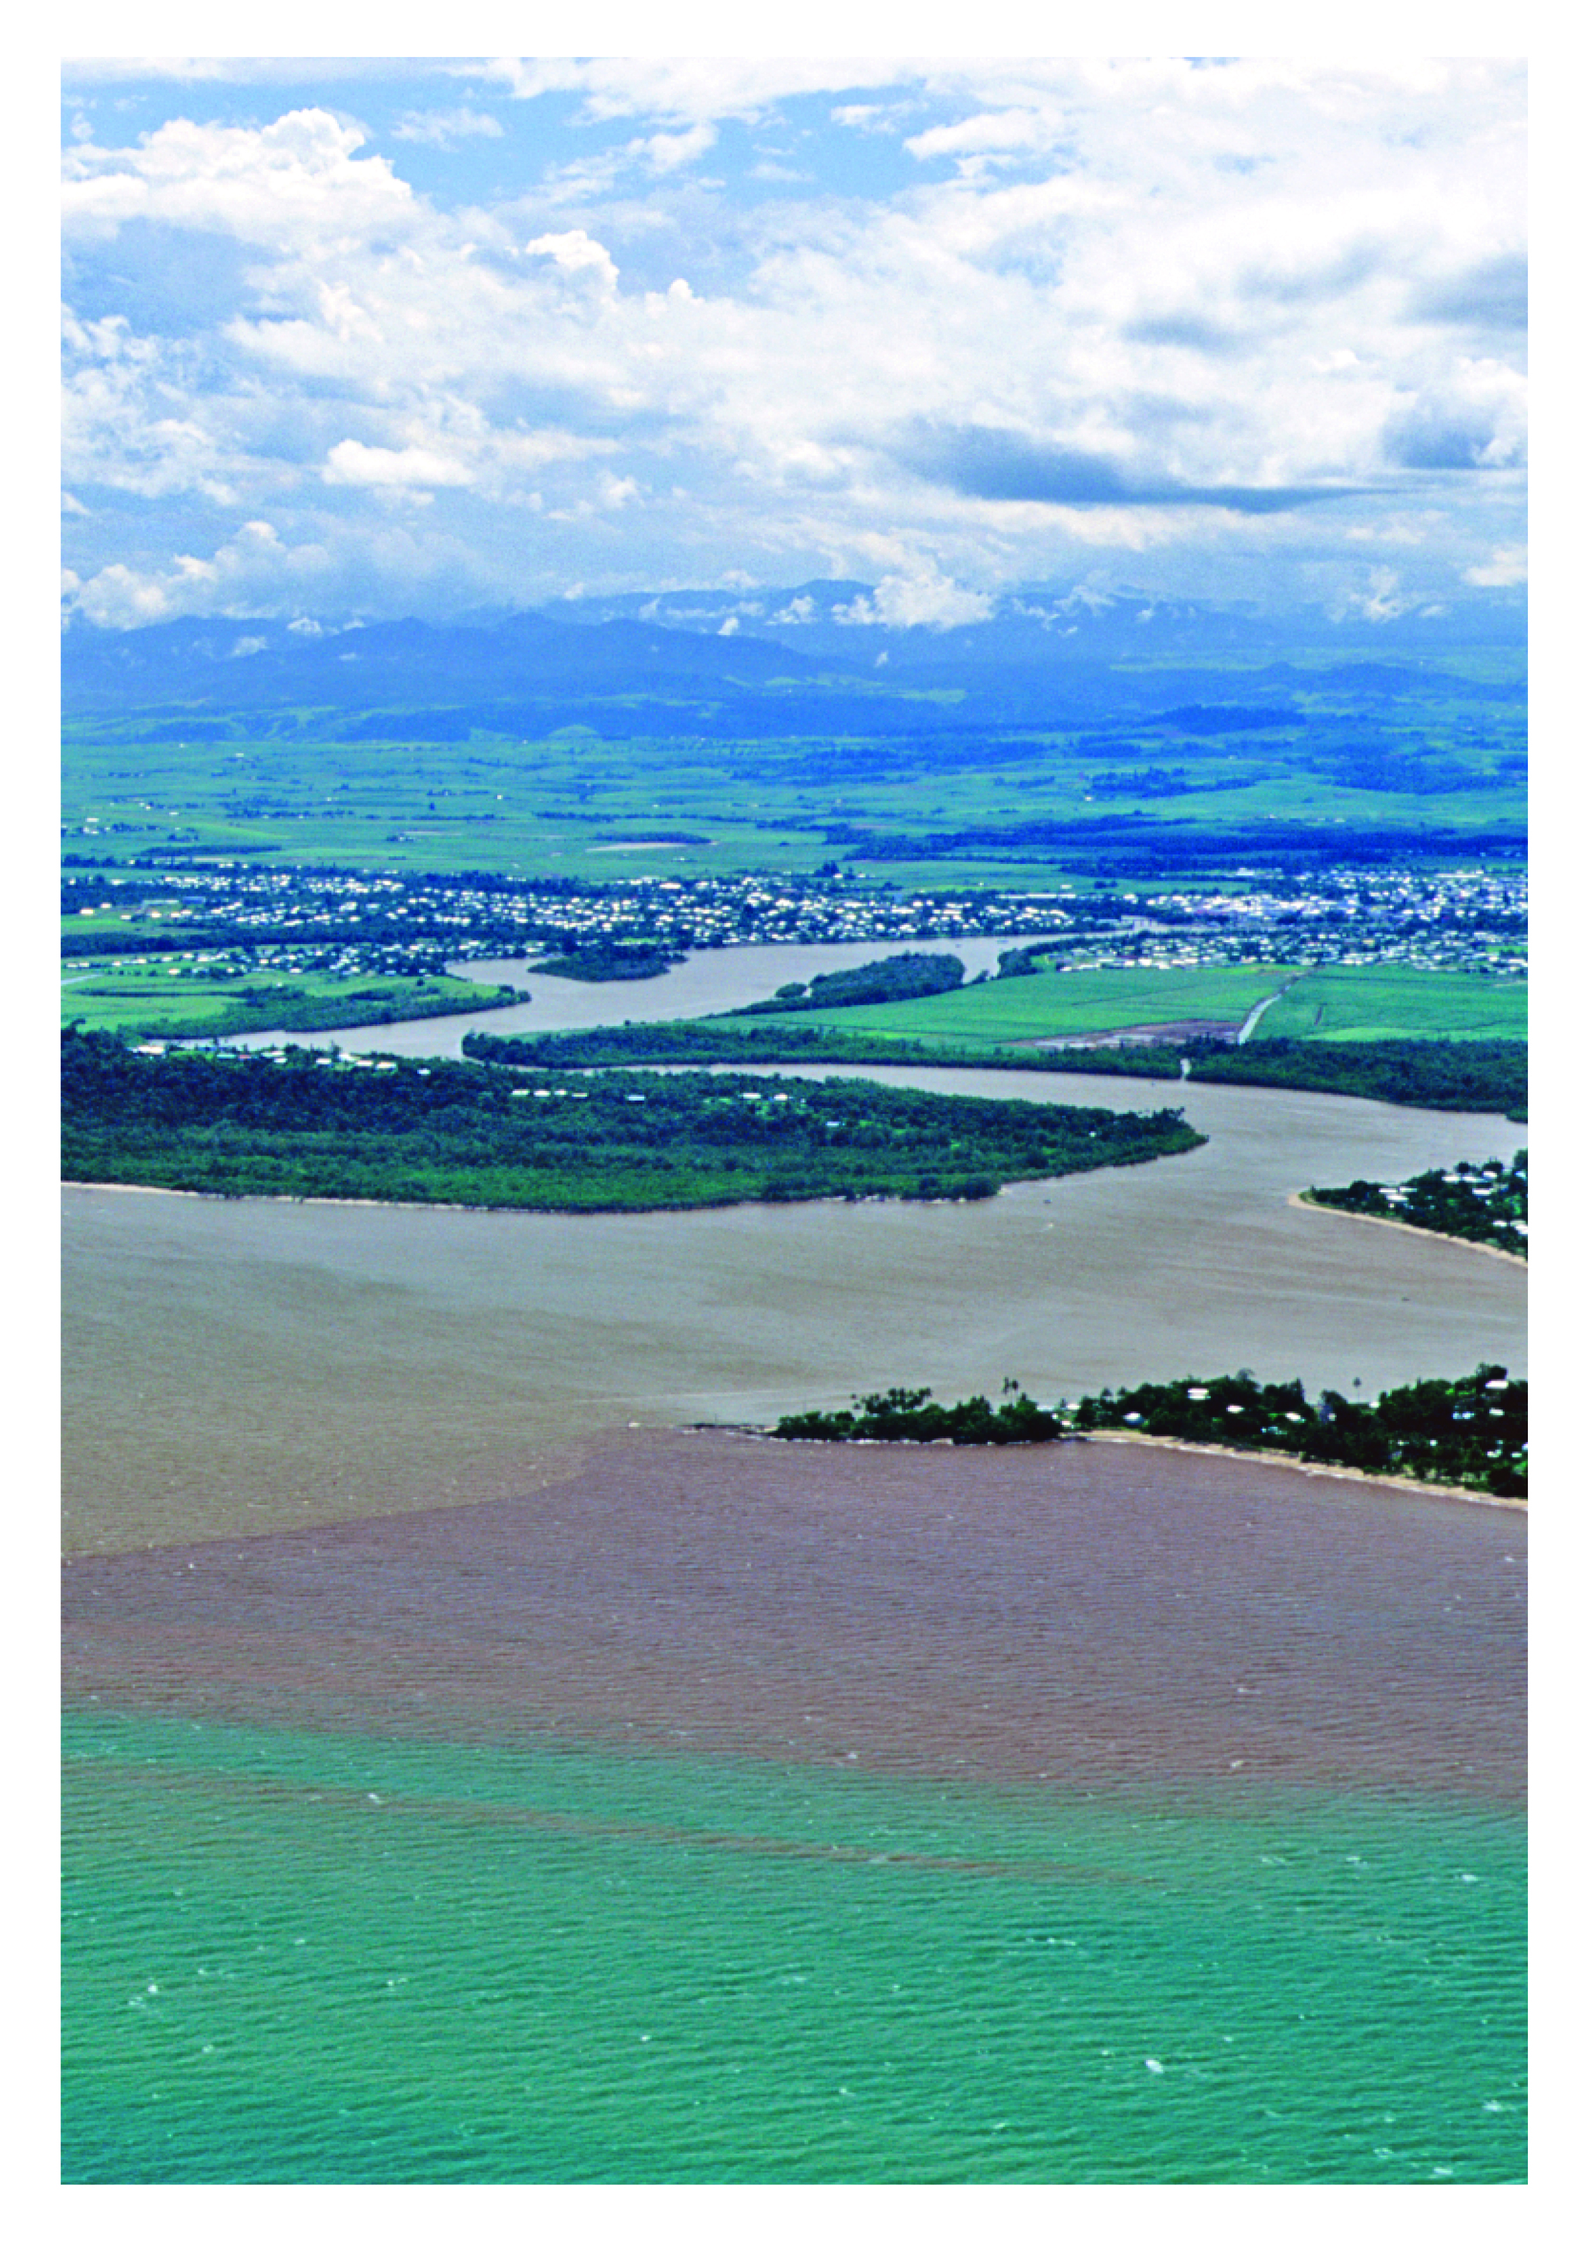

Process
The process for cumulative impact assessment and management for the Great Barrier Reef are similar to best practice environmental impact assessment, with a broader focus on understanding the context and underlying pressures on the system, its values and desired outcomes. The process should be used when:
  - scoping, with analysis based on a desktop assessment
or
  - undertaking a detailed assessment to improve information or reduce uncertainty in decision-making.
Attachment 6 includes a suggested process to undertake cumulative impact assessment or management and includes references to critical resources to be consulted for information about the Great Barrier Reef.

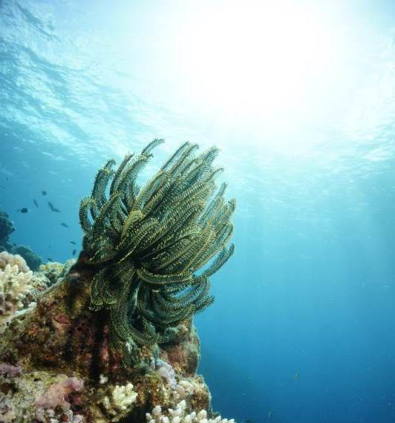
Implementation
Identify values and impact interactions
ASSESS CUMULATIVE IMPACTS
Implementation of this policy will be staged, recognising the need to develop specific guidance to better manage cumulative impacts for:
  - government agencies, including planning and assessment officers
  - different industry sectors
  - natural resource management bodies
  - the broader community.
This policy is to be read in conjunction with the Reef 2050 Policy Guideline for Decision Makers which illustrates a wide range of actions designed to manage drivers and pressures on the Reef.
Cumulative impacts will be considered to the extent permissible under legislation with respect to the planning, assessment and approval processes operating within and adjacent to the Great Barrier Reef. Implementation will take a risk-based approach focussing first on addressing the pressures and impacts that present a Very High or High level of risk (refer Attachments 1 and 2).
Where assessment and management of cumulative impacts is consistent with this policy and has been included in plans, governing arrangements or class assessments, the assessment of cumulative impacts is not required for individual decisions guided by and consistent with these plans, governing arrangements or class assessments.
The Cumulative Impact Management Policy has been developed in parallel with the Reef 2050 Plan Net Benefit Policy and guidance for Good Practice Management under the overall governance framework for the Reef 2050 Plan (Figure 5).
Reef 2050 Plan, supported by Reef 2050 Plan specific guidance policies, progress reports and investment strategies
Implemented by Australian and Queensland governments and partner organisations.
Implementation advice from the Reef 2050 Independent Expert Panel and the Reef 2050 Advisory Committee.

Implemented through Inter-governmental Agreement on the Great Barrier Reef
  - Ministerial decision – making
  - Supported by Senior Officer Committee
Progress monitored through the Reef 2050 Annual Reports and Integrated Monitoring and Reporting Program.
Effectiveness of management reported through the Great Barrier Reef Outlook Report and Reef 2050 Annual Report

Figure 5- Framework supporting the implementation of the Reef 2050 Plan

Related legislation
Australian Government, including:
  - Environment Protection and Biodiversity Conservation Act 1999 (EPBC Act)
  - Great Barrier Reef Marine Park Act 1975 (GBRMP Act)
Queensland Government, including:
  - Environmental Offsets Act 2014
  - Environmental Protection Act 1994
  - Fisheries Act 1994
  - Marine Parks Act 2004
  - Nature Conservation Act 1992
  - Planning Act 2016
  - Regional Planning Interests Act 2014
  - State Development and Public Works Organisation Act 1971
  - Sustainable Ports Development Act 2015
  - Vegetation Management Act 1999

Review and evaluation
The effectiveness of this policy will be reviewed and evaluated in line with the assessment of risks to the Reef’s values through the five yearly Outlook Report. Effective management of cumulative impacts should deliver decisions and actions that recognise and seek to reduce cumulative impacts. In the longer term this should translate to a decrease in pressures, or risks, to the Reef.

Definitions
Action
Actions and activities are used to describe projects and project parts under the EPBC Act and GBRMP Act. For this policy actions are used, assuming activities comprise action, or a subset of an action. Also includes development proposals and/or planning actions.
Adaptive capacity
The ability for a component of the environment to adapt to impacts to maintain or improve its condition. Includes the environmental component’s ability to recover, reorganise or build capacity to learn and adapt in between events.
Adaptive management
A systematic process for continually improving management practices through learning from the outcomes of previous management. It includes a monitoring, evaluation, reporting and improvement cycle.
Avoid-mitigate-offset hierarchy
Is used to guide assessment of actions and inform decision-making. The highest priority is given to avoiding impacts on the environment. Avoidance measures must consider prudent and feasible alternatives to a proposed action. Potential impacts that cannot be avoided must be minimised. Mitigation measures must consider direct, indirect and cumulative impacts, and account for the likely spatial and temporal scales of impacts across the duration of the proposed activity. Offsets compensate for the residual adverse impacts of an action on the environment.
Baseline condition
A description of existing conditions to provide a starting point (e.g. pre-project condition of biodiversity) against which comparisons can be made (e.g. post-impact condition of biodiversity), allowing the change to be quantified. Baseline conditions for the Marine Park are measured from its World Heritage Declaration in 1981.
Biodiversity elements
Biodiversity is the variety of life on Earth. It includes all living things and the way they interact with each other and their environment. The Region’s biodiversity values which underpin matters of national environmental significance include:
- Great Barrier Reef habitats
- terrestrial habitats that support the Great Barrier Reef
- species
Community benefit
The interconnectedness of people and their environment as reflected in the definition of ‘environment’ under the EPBC Act and GBRMP Act and as defined in this document.
Consequential impacts
Are a form of ‘indirect’ impact resulting from further actions (including actions by third parties) that are made possible or are facilitated by implementation of the activity. For example, a port expansion may result in an increase in shipping activity which may bring with it a suite of consequential impacts (e.g. anchoring impacts, displacement of uses).
Cumulative impacts
Cumulative impacts are defined as the interaction of effects between one or more impacts and past, present, and reasonably foreseeable future pressures.
Cumulative impact assessment
Takes into account direct, indirect and consequential impacts and the incremental and compounding effects of these impacts over time, including past, present and reasonably foreseeable future pressures.
Decision
Decisions are not limited to regulatory decision-making. Decisions include developing, revising or implementing relevant agreements, policies, plans, strategies and programs; implementing legislation as part of the Great Barrier Reef planning and assessment processes; prioritising and undertaking on-ground actions.
Drivers
An overarching cause that can drive change in the environment. It can affect the environment indirectly by changing the way people undertake activities that affect the environment (indirect drivers) or by directing changing conditions in the environment itself (direct drivers). Examples include climate change, economic growth and population growth.
Ecological processes and functions
Ecological processes comprise a number of functions including: microbial processes, particle feeding, primary production, herbivory, predation, symbiosis, recruitment, reef building, competition and connectivity. Key ecological processes of the Great Barrier Reef are listed in Table A4.2. Changes in these processes can have direct and indirect effects on other species such as depletion of prey or predators and the delivery of ecosystem services. Ecosystem services are the benefits provided to humans through the transformations of resources (or environmental assets, including land, water, vegetation and atmosphere) into a flow of essential goods and services e.g. clean air, water, and food 12 (Ecosystem services definition cited in Department of the Environment, Water, Heritage and the Arts (2009). Ecosystem Services: Key Concepts and Applications, Occasional Paper No 1, Department of the Environment, Water, Heritage and the Arts, Canberra).
Ecologically sustainable use
The principles of ecologically sustainable use are defined in section 3AA of the GBRMP Act as:
- decision-making processes should effectively integrate both long-term and short-term environmental, economic, social and equitable considerations
- the precautionary principle
- the principle of inter-generational equity—that the present generation should ensure that the health, diversity and productivity of the environment is maintained or enhanced for the benefit of future generations
- the conservation of biodiversity and ecological integrity should be a fundamental consideration in decision-making
- improved valuation, pricing and incentive mechanisms should be promoted
Effect
Is a deviation from the expected (positive or negative).
Environment
Includes ecosystems and their constituent parts, including people and communities; natural and physical resources; the qualities and characteristics of locations, places and areas; heritage values of places; and the social, economic and cultural aspects of the above. (EPBC Act and GBRMP Act).
Event
A change in situation; something happening or not happening (when it was expected); an incident or occurrence that exposes a value to a hazard.
Exposure
The magnitude, frequency and duration of an environmental component’s contact with a hazard.
Great Barrier Reef
Refers to the Great Barrier Reef World Heritage Area, Great Barrier Reef Marine Park and Great Barrier Reef Region areas relevant to the decision-making or action.
Hazard
A source of potential harm; a situation, action or behaviour that may negatively impact on an environmental component, whether intentionally or unintentionally.
Heritage values
The Region’s heritage values, which underpin matters of national environmental significance, are grouped into five broad categories:
- Indigenous heritage values: the heritage values of a place that are of significance to Aboriginal and Torres Strait Islander persons in accordance with their practices, observances, customs, traditions, beliefs or history
- other heritage values: a place’s natural and cultural environment having aesthetic, historic, scientific or social significance, or other significance, for current and future generations of Australians
- world heritage values: the natural heritage and cultural heritage of a property that is internationally recognised as being of outstanding universal value
- national heritage values: the values of a place that are of national significance as recognised through placement on the National Heritage List
- Commonwealth heritage values: the values of a place that are specified in its placement on the Commonwealth Heritage List.
Integrity
Relates to ‘wholeness and intactness’ of the World Heritage property and how it conveys the values it holds. Integrity can also relate to the size of the property (sufficient size to continue to represent the values) and to any threats affecting the property.
Impact
The result or effect that happens when an environmental component is exposed to a hazard; may be positive or negative.
Matters of national environmental significance
Those matters as defined in the Environment Protection and Biodiversity Conservation Act.
Net benefit
A decision or action which results in a net improvement to the condition and/or trend of a Great Barrier Reef environmental value or process as described in Attachment 4 – Tables A4.1 and A4.2.
Outstanding universal value
Cultural and/or natural significance which is so exceptional as to transcend national boundaries and to be of common importance for present and future generations of all humanity. Outstanding universal value is distributed throughout the entire Great Barrier Reef World Heritage Area. The relationship between outstanding universal value and Great Barrier Reef values is described in Attachment 4.
Pressure (Threats)
An activity or group of activities that cause an impact on a value.
Program
Includes programs, plans, decisions and on-ground actions.
Reference condition
Assessment of the reference condition and trend of Great Barrier Reef values (taking into account past and present effects) is described in Attachment 3 and values are benchmarked and graded every five years through the Outlook Report.
Reference scenario
What is likely to have occurred in the absence of management response. The reference scenario is based on the current condition and trend, taking into account reasonably foreseeable future pressures. Grading statements for condition are described in Attachment 3 – Table A3.1.
Resilience
The ability of an environmental component to cope with change or exposure and remain in a desirable functioning state. It includes the ability to absorb impacts and continue functioning, and recover, reorganise or build capacity to learn and adapt in between events.
Risk
Defined by the Australia/New Zealand Standard for Risk Management (AS/NZS 31000:2009) as “effect of uncertainty on objectives.” For this policy/guideline, risk relates to uncertainty as to whether the objectives of the policy can be achieved i.e. achieving desired states for Great Barrier Reef values.
Sensitivity
The degree to which a component of the environment is responsive to a specific impact.
Severity
How serious a consequence would be if it occurred; the degree of degradation that would occur to the value if that consequence occurred.
Values
Refers to values and processes as described in Attachment 4. Foremost, healthy and resilient ecosystems are fundamental to the protection of biodiversity and heritage values and the community benefits they support.
Vulnerability
The susceptibility of environmental components to degradation from impacts. Vulnerability is a function of the environmental component’s exposure, sensitivity and adaptive capacity.
Zone of influence
The area or spatial extent in which an activity or pressure has the potential to impact a component of the environment. The ‘zone of influence’ or ‘zone of impact’ is used to describe the area and temporal scale of effect at which impacts (such as from an action, project, plan or program) are occurring and the scope of response available or required to manage impacts. The zone of influence includes the assessment of the boundaries to biological and life processes needed to encompass the spatial and temporal extent of impacts that influence the condition of environmental values, ecosystem processes and socio-ecological systems throughout the period during which impacts of the decision will occur. The zone of influence can be described in three parts:
- zone of ecological influence - the area or spatial extent in which an activity or pressure directly impacts a component of the environment
- zone of system influence - the area or spatial extent in which an activity or pressure has an indirect or consequential impact on a component of the environment, recognising the boundaries to biological and life processes extend beyond the direct impact of the activity
- zone of management influence – which includes the scope of response encompassing direct and indirect impacts and other past, present pressures and threats affecting values and processes.

Further information
Director- Policy and Planning
Great Barrier Reef Marine Park Authority
2 - 68 Flinders Street
PO Box 1379
Townsville Qld 4810
Australia

Phone + 61 7 4750 0700
Fax + 61 7 4772 6093
email reefcoords@gbrmpa.gov.au

www.gbrmpa.gov.au
Document control information
Approved by: | Great Barrier Reef Ministerial Forum | Approved date: | 19 June 2018
Last reviewed: | New
Next review:
Created: | July 2018
Document custodian: | Director- Policy and Planning, Great Barrier Reef Marine Park Authority
Replaces: | New

Attachment 1: Drivers of change, pressures and impacts on the Great Barrier Reef
Drivers are overarching causes that can drive change in the environment (State of the Environment, 2011; Strategic Assessment Report, 2014) and have also been referred to as underlying causes of change in the environment (Outlook Report, 2014). For the purposes of this policy and the Reef Integrated Monitoring and Reporting Program, it is proposed to adopt six drivers of change for the Great Barrier Reef system:
- Climate change
- Population growth
- Economic growth
- Technological developments
- Societal attitudes
- Governance systems
Pressures and impacts are mechanisms that exert a change force (either positive or negative) on a value. Put another way, pressures and impacts are the change mechanisms (e.g. processes or activities) that result from drivers. For the purposes of this policy, pressures are defined consistent with the Outlook Report ‘threats’ (2014) and the Strategic Assessment Report ‘impacts’ (2014). The green boxes in Table A1.1 are pressures and impacts of particular relevance in the Great Barrier Reef catchment. Refer to Attachment 2 for the process for assessment of risk to Great Barrier Reef values.

Table A1.1 – Pressures and impacts, their definitions and their risks to values
 | Pressures and impacts | Risk |  | Definitions
 |  | Ecosystem | Heritage
REGION-WIDE | Cyclone activity |  |  | Cyclone activity.
 | Sea temperature increase |  |  | Increasing sea temperature.
 | Ocean acidification |  |  | Increasing acidity of the Region’s waters.
 | Rising sea level |  |  | Rising sea level.
 | Modifying supporting terrestrial habitats |  |  | Clearing or modifying supporting terrestrial habitats such as wetlands, saltmarshes, mangroves and sand dunes — this also includes trampling and damage from recreational vehicle use.
 | Nutrients from catchment run-off |  |  | Nutrients entering the Region in run-off from the catchment.
 | Sediments from catchment run-off |  |  | Sediments entering the Region in run-off from the catchment.
 | Outbreak of crown-of-thorns starfish |  |  | Outbreak of crown-of-thorns starfish (i.e. when the density exceeds about 30 starfish per hectare).
 | Illegal fishing and poaching |  |  | Illegal fishing, collecting and poaching (foreign or domestic) including of species of conservation concern.
 | Extraction – incidental catch of species of conservation concern |  |  | Immediate or post-release effects (such as death, injury, reduced reproductive success) of interactions of species of conservation concern with fishing gear.
 | Increased freshwater inflow |  |  | Increased freshwater inflow from prolonged or heavy rainfall including flood events, and from changes to catchment ecosystems; resulting in reduced salinity.
 | Artificial barriers to flow |  |  | Artificial barriers to riverine and estuarine flow including breakwalls, weirs, dams, gates, ponded pastures, and weeds causing changes to hydrology, groundwater and ecological connectivity.
 | Marine debris |  |  | Manufactured material discarded, disposed of or abandoned in the marine and coastal environment (including discarded fishing gear and plastics).
 | Incompatible uses  REGION-WIDE |  |  | Activities undertaken within the Region that disturb or exclude other users, such as recreational use in areas important for cultural activities.
 | Extraction – discarded catch |  |  | Immediate or post-release effects (such as death, injury, reduced reproductive success) on discarded species as a result of interactions with fishing gear. Does not include species of conservation concern.
 | Extraction — top order predators |  |  | Retained take (extraction) of top order predators (e.g. sharks) through commercial, recreational and traditional fishing and the Queensland Shark Control Program.
 | Extraction — lower order predators |  |  | Retained take (extraction) of lower order predators (e.g. coral trout and snapper) through commercial, recreational and traditional fishing.
 | Extraction — lower trophic orders |  |  | Retained take (extraction) of lower trophic orders (e.g. scallops, sea cucumbers and prawns) through commercial, recreational and traditional fishing.
 | Altered ocean currents |  |  | Altered ocean currents due to climate change or anomalies related to the El Niño-Southern Oscillation, and altered coastal water movement at a local scale.
LOCAL or REGIONAL | Pesticides from catchment run-off |  |  | Pesticides (including herbicides, insecticides, fungicides) entering the Region in run-off from the catchment.
 | Disposal and resuspension of dredge material |  |  | Sea dumping of dredge material including smothering, loss and modification of seabed habitats and resuspension.
 | Extraction — fishing in spawning aggregations |  |  | Retained take (extraction) of fish from unidentified or unprotected spawning aggregations.
 | Outbreak of disease |  |  | Outbreak of disease, both naturally occurring and introduced.
 | Outbreak or bloom of other species |  |  | Outbreak of naturally occurring or native species, excluding crown-of-thorns starfish.
 | Urban and industrial discharge |  |  | Point and diffuse-source land-based discharge of pollutants from urban and industrial land use and mining, including polluted water, sewage, wastewater and stormwater.
 | Acid sulphate soils |  |  | Exposure and subsequent oxidation of potential acid sulphate soils.
 | Artificial light |  |  | Artificial lighting including from resorts, industrial infrastructure, mainland beaches and coastlines, vessels and ships.
 | Damage to reef structure |  |  | Physical damage to reef benthos (reef structure) through actions such as snorkelling, diving, anchoring and fishing, but not vessel grounding.
 | Damage to seafloor |  |  | Physical damage to non-reef benthos (seafloor) through actions such as trawling and anchoring, but not vessel grounding.
 | Dredging |  |  | Dredging of the seafloor.
 | Coastal reclamation |  |  | Coastal land reclamation, including for ports and groynes.
 | Exotic species and diseases |  |  | Introduction of exotic species and diseases from aquaculture operations, hull fouling, ballast release, imported bait and release of aquarium specimens to the Region, plus the introduction of weeds and feral animals to islands.
 | Extraction – herbivores |  |  | Retained take (extraction) of herbivores (e.g. some fish, molluscs, dugongs, green turtles) through commercial and non-commercial uses.
 | Grounding large vessel |  |  | Grounding of large vessels (>50m) including physical damage and the dislodging of antifoulants.
 | Illegal activities — other |  |  | Illegal activities such as entering a protected or restricted area, illegal release of industrial discharge, shipping outside of designated shipping areas.
 | Noise pollution |  |  | Noise from human activities, both below and above water.
 | Spill — large chemical  LOCAL or REGIONAL |  |  | Chemical spill that triggers a national or regional response or is more than 10 tonnes.
 | Spill — large oil |  |  | Oil spill that triggers a national or regional response or is more than 10 tonnes.
 | Vessel strike on wildlife |  |  | Death or injury to wildlife as a result of being struck by a vessel of any type or size.
 | Waste discharge from a vessel |  |  | Waste discharged from a vessel into the marine environment.
 | Wildlife disturbance |  |  | Disturbance to wildlife including from snorkelling, diving, fish feeding, walking on islands and beaches, and the presence of boats; not including noise pollution.
 | Grounding small vessel |  |  | Grounding of small vessels (<50m) including physical damage and the dislodging of antifoulants.
 | Spill — small chemical and oil |  |  | Chemical or oil spill that does not trigger a national or regional response and is less than 10 tonnes
 | Atmospheric pollution |  |  | Pollution of the atmosphere related to domestic, industrial and business activities in both the Region and adjacent areas. The contribution of gases such as carbon dioxide to climate change is not included as this is encompassed under threats such as sea temperature increase and ocean acidification.

Attachment 2: Risks to Great Barrier Reef values as reported in the Great Barrier Reef Outlook Report
The Great Barrier Reef Outlook Report provides a full description of threats and risks. The Outlook Report has a standard set of criteria to allow the comparison of different types of threats within the one risk assessment, based on the likelihood and consequence of each threat. The likelihood and consequence of each predicted threat are ranked on five-point scales, as described below.

Figure A2.1 - Likelihood scale
Likelihood | Expected frequency of a given threat
Almost certain | Expected to occur more or less continuously throughout a year
Likely | Not expected to be continuous but expected to occur one or more times a year
Possible | Not expected to occur annually but expected to occur within a 10-year period
Unlikely | Not expected to occur in a 10-year period but expected to occur in a 100-year period
Rare | Not expected to occur within the next 100 years

Figure A2.2 - Consequence scale - based on current management
Consequence | Ecosystem |  | Heritage
 | Broad scale | Local scale
Catastrophic | Impact is clearly affecting, or would clearly affect, the nature of the ecosystem over a wide area. Recovery periods greater than 20 years likely |  | Impact is or has the potential to destroy a class or collection of heritage places on a large scale; or is clearly affecting, or would clearly affect, a range of heritage values over a wide area.
Major | Impact is, or would be, significant as a wider scale. Recovery periods of 10 to 20 years likely. | Impact is, or would be, extremely serious and possibly irreversible to a sensitive population or community.  Condition of an affected part of the ecosystem possibly irretrievably compromised. | Impact is, or would be, adversely affect the heritage values of a number of places; destroy individual heritage places of great significance; or significantly affect the heritage values over a wide area.
Moderate | Impact is, or would be, present at a wider scale, affecting some components of the ecosystem. Recovery periods of five to 10 years likely. | Impact is, or would be, serious and possibly irreversible over a small area. Recovery periods of 10 to 20 years likely. | Impact is, or would, affect individual heritage places or values of significance; or affect to some extent the heritage values at a wider scale.
Minor | Impact is, or would be, not discernible at a wider scale.  Impact would not impair the overall condition of the ecosystem, or a sensitive population or community, over a wider level. | Impact is, or would be, significant to a sensitive population or community at a local level. Recovery periods of five to 10 years likely. | Impact is, or would, affect heritage places or values of local significance, but not at a wider scale. Impact would not impair the overall condition of the heritage values.
Insignificant | No impact; or if impact is, or would be, present then only to the extent that it has no discernible effect on the overall condition of the ecosystem. | No impact; or if impact is, or would be, present then only to the extent that it has no discernible effect on the overall condition of the ecosystem. | No impact; or if impact is, or would be, present then only to the extent that it has no discernible effect on the heritage values; or positive impacts.

Figure A2.3 - Risk matrix legend
Likelihood and consequence are combined to determine risk level, in accordance with the Australian Standard for Risk Assessment (AS/NZS ISO 31000:2009).

 |  | LIKELIHOOD
 |  | Rare | Unlikely | Possible | Likely | Almost certain
CONSEQUENCE | Catastrophic
 | Major
 | Moderate
 | Minor
 | Insignificant

Risk
 | Low |  | Medium |  | High |  | Very high

Photograph: Chris Jones
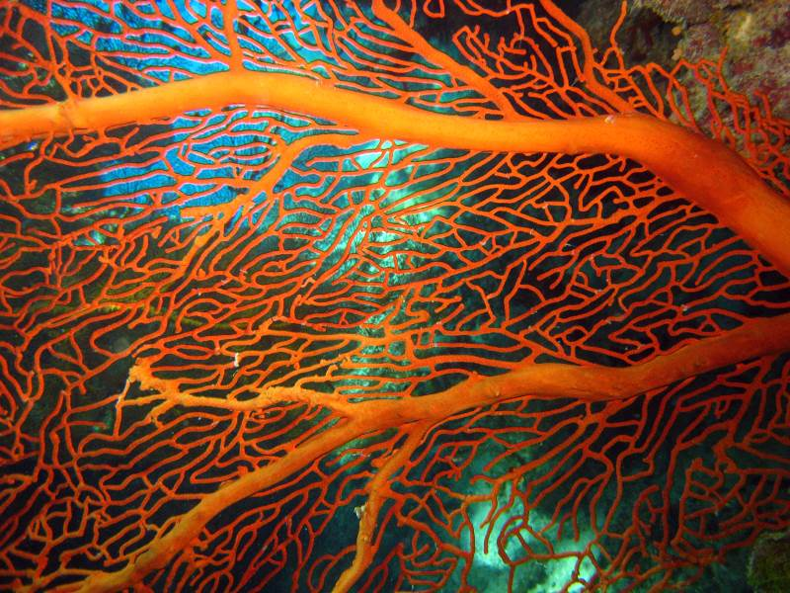
Example: Risk assessment procedure for the Marine Park permission system:
Determine sensitivity and exposure
Determine whether a risk event may occur. A risk event is when an activity exposes a value to hazard to which that value is sensitive. An event only occurs if two things are true:
  - The value is sensitive to that hazard; and
  - The value may be exposed to that hazard.
Consider sensitivity – is the value sensitive to the hazard, that is, likely to change in response to the hazard, creating an impact?
  - Low sensitivity – Value is not known to be affected by the hazard
  - Medium sensitivity – Value is known to be slightly affected by the hazard (sub-lethal effects)
  - High sensitivity – Hazard has well-documented negative impacts on the value (lethal effects are possible)
  - Uncertain – There is a high degree of scientific uncertainty, or no knowledge about the value’s sensitivity.
Consider exposure – is the value likely to be exposed to the hazard?
  - Low exposure – The value is not known to occur in the zone of impact, or has been reported as a rare, aberrant visitor. There are no reasons to believe that the value occurs in the zone of impact.
  - Medium exposure – The value has occasionally been reported in the zone of impact, or there is reason to believe that the value occurs in the zone of impact.
  - High exposure – The value is commonly reported or known to occur in the zone of impact.
  - Uncertain - There is a high degree of scientific uncertainty, or no knowledge about the value’s occurrence or range.
Use figure A2.4 to determine whether a risk event needs to be considered in the assessment.

Figure A2.4 – Does a risk event need to be considered in the assessment?
SENSITIVITY | Uncertain | Low | Medium | High
EXPOSURE
Low | Case by case decision | No | No | Yes
Medium |  | No | Yes | Yes
High |  | Yes | Yes | Yes
Uncertain |  | Case by case decision

Analyse the risks
Analyse the likelihood and consequence of how a risk may affect a value. These effects are called “impacts.”
A “risk rating” is calculated based on:
  - the consequence of the impacts to a value (expressed in terms of severity) if a risk event occurs and
  - the likelihood of that risk event occurring (expressed in terms of probability or frequency).
The risk rating provides a measure of the level of risk, which is then used to decide the acceptability of that risk and to establish management priorities for treating the risk.
Standard descriptions for consequence and likelihood, based on a five-point scale, allow the comparison of different types of hazards within a single risk assessment.

Determine the possible impacts
For each event and hazard, list the potential impacts to relevant values that might reasonably be expected to occur.
Impacts are distinct effects on some aspect of a value. They are different from consequences (which are considered in the next step); a consequence is the overall outcome on the condition or trend of the value.
Consider the full range of values that might be impacted. For example, death of a dolphin may impact not only on the biophysical value of dolphins, but also on social or Indigenous heritage values associated with dolphins.
Where quantitative information is available, this should be used to more accurately identify the potential impacts.
Determine the severity of consequences
This step moves from impacts on an aspect of a value to considering the consequence – that is, the overall outcome on the condition or trend of the value.
Table A2.2 provides a standardised description of consequences for different general categories of values. These generic descriptions may be supplemented with:
  - The individual Value assessment guidelines provide consequence tables unique to specific values.
  - Expert advice may be used to develop a consequence table for a specific value, where Value Assessment Guidelines are not yet available.
Consider each value that may experience consequences, and how the severity of these consequences differ depending on the value.
Consider at what scale the consequence may occur:
  - Local scale – A single bay, reef or island; generally an area less than 100 square kilometres
  - Regional scale – A Natural Resource Management region
  - Widespread scale – Overall condition of the value across multiple regions or across the entire Marine Park; generally, affecting 50 per cent or more of the value’s extent.
Consider the vulnerability of the value, or of sub-groups within that value. If there are populations, groups or individuals that are particularly vulnerable to a certain impact, the consequence level will typically be higher. In particular:
  - impact to different life histories/processes
  - the dependency of values on impacted resources
  - the current condition and trend in condition of values
  - relevant health thresholds
  - the ability of the value to adapt to the new impact to maintain or improve its condition, such as the rate of recovery between disturbances, based on current condition or rate of change and reorganising of a system to a desirable functioning state.

Attachment 3: Condition and trend of Great Barrier Reef values

Relationship between values and processes and ‘outstanding universal value’
A property is considered to be of ‘outstanding universal value’ if it meets one or more of 10 world heritage criteria and is inscribed on the World Heritage List. To be deemed to be of outstanding universal value ‘a property must also meet the conditions of integrity and/or authenticity and must have an adequate protection and management system to ensure its safeguarding’. Effective future protection of the Great Barrier Reef’s outstanding universal value, together with the seven matters of national environmental significance, relies on the integration of management measures and a systems approach to the protection of values and processes.
Given the scale and complexity of the Great Barrier Reef and its diversity and interconnectedness, key values and processes are combined into one comprehensive set as a basis for assessment of outstanding universal value and the seven matters of national environmental significance. The key values and processes presented in the following tables are based on those identified in the description of each matter in Sections 4.2 to 4.9 of the Great Barrier Reef Region Strategic Assessment Report.

Great Barrier Reef Outlook report condition and trend assessment approach (adapted from page 9 of the Great Barrier Reef Outlook Report 2014)
A set of assessment criteria is used to analyse available evidence. For example, the assessment of biodiversity uses two assessment criteria — habitats to support species and populations of species or groups of species. Within each assessment criterion there are multiple assessment components. A series of statements is then used to standardise the allocation of grades for all components examined in an assessment, as well as the overall grade for the criterion.

Grading statements (refer to Table A3.1)
The grade allocated is a ‘grade of best fit’, based on a qualitative assessment of the available evidence for the Region. It is not a comparison of the Region in relation to other tropical ecosystems around the world. The statements developed for assessing most heritage values are based on those used in the Australian State of the Environment Report and Strategic Assessment draft report. Those for the assessment of world and national heritage values are adapted from a grading system developed by the International Union for Conservation of Nature to assess the outstanding universal value of natural world heritage sites. One aspect considered in grading the condition of heritage values is the degree to which those values have been recorded and identified. This recognises the important role an understanding of heritage plays in its protection.

Trend and confidence
The approach to grading is refined by including an indication of trend and confidence, similar to the Australian State of the Environment Report and the Strategic Assessment report. There are four categories for trend: improved, stable, deteriorated and no consistent trend. The category of ‘no consistent trend’ is applied to a component when the available information is too variable to establish a trend, for example where there is strong variation across broad areas or across species within a group. The terms ‘improved’ and ‘deteriorated’ are replaced with ‘increased’ and ‘decreased’ in assessments of benefits, impacts, threats and risks. Similar to the Australian State of the Environment Report and the Strategic Assessment report, the level of confidence in each assessment of grade and trend is rated. The categories used are:
  - adequate high quality evidence and high level of consensus
  - limited evidence or limited consensus
  - inferred, very limited evidence.
For components where the confidence level is ‘inferred, very limited evidence’, the assessment is based on knowledge from managing agencies, Traditional Owners, topic experts and informed stakeholders (expert elicitation).

Evidence used
The evidence used in the Great Barrier Reef Outlook Report is derived from existing research and information sources. It is drawn from the best available published science based on:
  - relevance to the required assessments
  - duration of study
  - extent of area studied
  - reliability (such as consistency of results across different sources, peer review and rigour of study).

Table A3.1 - Condition of values grading statements
Functional group of values | Condition grading statement
 | Very good | Good | Poor | Very poor
Habitat to support species | All major habitats are essentially structurally and functionally intact and able to support all dependent species. | There is some habitat loss, degradation or alteration in some small areas, leading to minimal degradation but no persistent, substantial effects on populations of dependant species. | Habitat loss, degradation or alteration has occurred in a number of areas leading to persistent substantial effects on populations of dependent species. | There is widespread habitat loss, degradation or alteration leading to persistent, substantial effects on many populations of dependent species.
Populations of species and groups of species | Only a few, if any, species populations have deteriorated as a result of human activities or declining environmental conditions. | Populations of some species (but no species groups) have deteriorated significantly as a result of human activities or declining environmental conditions. | Populations of many species or some species groups have deteriorated significantly as a result of human activities or declining environmental conditions. | Populations of a large number of species have deteriorated significantly.
Physical, chemical and ecological processes | There are no significant changes in processes as a result of human activities. | There are some significant changes in processes as a result of human activities in some areas, but these are not to the extent that they are significantly affecting ecosystem function. | There are substantial changes in processes as a result of human activities, and these are significantly affecting ecosystem functions in some areas. | There are substantial changes in processes across a wide area as a result of human activities, and ecosystem functions are seriously affected in much of the area.
Outbreak of disease, introduced species and pest species | No records of diseases above expected natural levels; no introduced species recorded; pests populations within naturally expected levels. | Diseases occasionally above expected natural levels but recovery prompt; any occurrences or introduced species successfully addressed; pests sometimes present above natural levels with limited effects on ecosystem function. | Unnaturally high levels of disease regularly recorded in some areas; occurrences of introduced species require significant intervention; pests outbreaks in some areas affecting ecosystem function more than expected under natural conditions. | Unnaturally high levels of disease often recorded in many areas; uncontrollable outbreaks of introduced pests; opportunistic pests seriously affecting ecosystem function in many areas.
Indigenous, historic, social, aesthetic, scientific, Commonwealth and Natural heritage values | Heritage values have been systematically and comprehensively identified and included in relevant inventories or reserves. Known heritage values are well maintained and retain a high degree of integrity. | Heritage values have been mostly identified and included in relevant inventories or reserves. Known heritage values are generally maintained and retain much of their integrity. | Heritage values have not been systematically identified. Known heritage values are degrading and generally lack integrity. | Heritage values have not been identified. Known heritage values are degraded and lack integrity.
World and national heritage values | All elements necessary to maintain the outstanding universal value are essentially intact, and their overall condition is stable or improving. Available evidence indicates only minor, if any, disturbance to this element of outstanding universal value. | Some loss or alteration of the elements necessary to maintain the outstanding universal value has occurred, but their overall condition is not causing persistent or substantial effects on this element of outstanding universal value. | Loss or alteration of the elements necessary to maintain outstanding universal value has occurred, which is leading to a significant reduction in this element of the outstanding universal value. | Loss or alteration of most elements necessary to maintain the outstanding universal value has occurred, causing a major loss of the outstanding universal value.
Economic and social benefits of use | Use of the Region provides significant economic and social benefit, in ways that sustain the fundamental value of the natural resource. The Region is strongly recognised, valued and enjoyed by catchment residents, the nation and the world community. | Use of the Region provides valuable economic and social benefit. The Region is valued by catchment residents, the nation and the world community. | There are few and declining economic and social benefits derived from the use of the Region. Many do not recognise the value of the Region and do not enjoy their visit to the Region. | Use of the Region contributes little or no economic and social benefit. The Region holds little value for catchment residents, the nation or the world community.

Attachment 4: Values, attributes and processes that underpin matters of national environmental significance relevant to the Great Barrier Reef

Table A4.1 - Key values and attributes of matters of national environmental significance

The following table outlines key values and attributes for the Great Barrier Reef. These values and attributes underpin Reef-related Matters of National Environmental Significance. For the World Heritage Area, values are based the Statement of Outstanding Universal Value.

 | World heritage properties |  |  |  |  |  |  |  | Listed migratory and  threatened species
Key values and attributes | Criterion i (now viii) | Criterion ii (now ix) | Criterion iii (now vii) | Criterion iv (now x) | Integrity | Great Barrier Reef Marine Park | National heritage places | Commonwealth marine areas | Marine turtles | Estuarine crocodiles | Whales | Dolphins | Dugongs | Sharks and rays | Seabirds | Shorebirds | Wetlands of international importance
Biodiversity — Great Barrier Reef habitats
Islands
Beaches and coastlines
Mangrove forests
Seagrass meadows
Coral reefs (<30 m)
Deeper reefs (>30 m)
Lagoon floor
Shoals
Halimeda banks
Continental slope
Open waters
Biodiversity — terrestrial habitats that support the Great Barrier Reef
Saltmarshes
Freshwater wetlands
Forested floodplain
Heath and shrublands
Grass and sedgelands
Woodlands
Forests
Rainforests
Connecting water bodies
Biodiversity — species
Mangroves
Seagrasses
Macroalgae
Benthic microalgae
Corals
Other invertebrates
Plankton and microbes
Bony fish
Sharks and rays
Sea snakes
Marine turtles
Estuarine crocodiles
Seabirds
Shorebirds
Whales
Dolphins
Dugongs
Geomorphological features
Coral reefs
Islands and shorelines
Channels and canyons
River deltas
Halimeda banks
Seagrass meadows
Aboriginal and Torres Strait Islander heritage
Cultural practices, observances, customs and lore
Sacred sites, sites of particular significance, places important for cultural tradition
Stories, songlines, totems and languages
Indigenous structures, technology, tools and archaeology
Historic heritage
Places of historic significance — historic shipwrecks
Places of historic significance — World War II features and sites
Places of historic significance — lightstations
Places of historic significance — other
Places of scientific significance (research stations, expedition sites)
Places of social significance — iconic sites
Community benefits of the environment
Income
Employment
Understanding
Appreciation
Enjoyment
Access to Reef resources
Personal connection
Health benefits
Aesthetics

Table A4.2 Key environmental processes relevant to matters of national environmental significance
For the World Heritage Area, connections are based on the Statement of Outstanding Universal Value. For listed species, processes that have a major supporting role in maintaining the species are shown (for example, the role that beaches play in the nesting of listed marine turtles). For wetlands of international importance, the connections shown are those discussed in the Ramsar Convention information sheet.

 | World heritage properties |  |  |  |  |  |  |  | Listed migratory and  threatened species
Key environmental processes | Criterion i (now viii) | Criterion ii (now ix) | Criterion iii (now vii) | Criterion iv (now x) | Integrity | Great Barrier Reef Marine Park | National heritage places | Commonwealth marine areas | Marine turtles | Estuarine crocodiles | Whales | Dolphins | Dugongs | Sharks and rays | Seabirds | Shorebirds | Wetlands of international importance
Waves, currents and tides
Cyclones
Wind
Sedimentation
Sea level
Sea temperature
Light
Nutrient cycling
Ocean acidity
Freshwater inflow and salinity
Microbial processes
Particle feeding
Primary production
Herbivory
Predation
Symbiosis
Competition
Connectivity
Recruitment
Reef building

Attachment 5: Examples of decision-making considerations in implementing the cumulative impact management policy for plans, programs and actions
Step | Planning and program considerations | Project considerations | Existing examples to facilitate management and assessment of cumulative impacts on Great Barrier Reef values
Initial zone of influence - determine initial area boundary of project | Is your planning area described in legislation?  Are the actions to be managed by the plan restricted to within the planning area? | What are the consequential actions facilitate by your action?  What is the spatial scale of your action plus consequential actions? | Zone of influence for planning:  Plans of Management under the Great Barrier Reef Marine Park Act and Traditional Use of Marine Resources Agreement under the Great Barrier Reef Marine Park Act in conjunction with the Reef 2050 Plan.
Determine area boundary based on an understanding of likely direct, indirect and consequential impacts | What are the likely impacts from those actions to be managed by the plan? | What are the likely direct, indirect and consequential impacts from your action? | Refer to Attachment 1 for a list of pressures and impacts relevant to the Great Barrier Reef. The pressures and impacts of particular relevance in the Great Barrier Reef catchment are highlighted in green.  Chapter 6 of the Great Barrier Reef Region Strategic Assessment provides an example for assessing the effects of past and present impacts on key values and attributes of matters of national environmental significance.
Identify affected values the space and time scale at which they occur, and consider connectivity between values. | Use the Policy supporting documents to identify the drivers, pressures and impacts and other current and reasonably foreseeable sources, Government plans and programs, and the values that may be affected.  Identify and engage the affected community and stakeholders regarding what ecological, social and economic values are represented by the affected area of the Great Barrier Reef. | Through the plan, identify the values likely to be affected by your action?  Use the Policy supporting documents, and relevant plans, programs and strategies to identify drivers, pressures and impacts from the project, other current and reasonably foreseeable sources, Government plans and programs, and the values that may be affected. | The Great Barrier Reef values are listed in Attachment 3.  Note that impacts may be of a positive and/or adverse nature. The extent of the impact on effected values should be considered having regard to space and time scales, and connectivity.  Refer to Local Mariner Advisory Committees, the Great Barrier Reef Marine Park Authority, Australian Institute of Marine Science and the CSIRO to gain further information of potential values represented in the area of interest.  Identify and engage the relevant Aboriginal and Torres Strait Islander groups about cultural heritage that may be impacted, and can speak with authority for effected country.
The first three steps are an iterative process; once you have scoped the impacts and values, the resulting spatial and temporal distribution of impacts and values is the zone of influence.

Determine the current condition of affected values, and their desired state. | Refer to the Reef 2050 Plan, the Great Barrier Reef Outlook Report and progress reporting through the Reef Integrated Monitoring and Reporting Program.  Identify and engage the affected community of key stakeholders regarding what ecological, social and economic values are represented by the affected area of the Great Barrier Reef. | Does a relevant plan, program or strategy identify values and their condition at a scale relevant to your decision making? | The Great Barrier Reef values are listed in Attachment 3.  Refer to Local Mariner Advisory Committees, the Great Barrier Reef Marine Park Authority, Australian Institute of Marine Science and the CSIRO to gain further information of potential values represented in the area of interest.  Identify and engage the relevant Aboriginal and Torres Strait Islander groups about cultural heritage that may be impacted, and can speak with authority for effected country.  For assessment and evaluation, refer to the latest Outlook Report to describe the current condition and desired outcome for the affected value/s, at a Reef-wide scale. Data from the Reef 2050 Integrated Monitoring and Reporting Program and local and/or regional monitoring arrangements, which may be collected by the proponent or other third party, should be used to refine the current condition of the affected value at a smaller scale.  Detailed consideration of the available evidence informed the assessment of the current condition and trend of the Region’s key values and attributes including relevant matters of national environmental significance in Chapter 7 of the Great Barrier Reef Region Strategic Assessment. The assessment of condition is graded relative to the best available knowledge about likely original condition. Where limited information is available, evidence of the condition of supporting ecosystems and processes was taken into consideration in assessing condition and trend. The outcomes are presented separately for key values and attributes, including more detailed analysis of the condition and trend of values and attributes of particular concern. Each assessment is comprehensively referenced.
Examine the cause and effect of impact contributions | Refer to Table 2.1 of the Great Barrier Reef Region Strategic Assessment for a list of tools to help.  Choose a method that effectively deals with complexity and uncertainty in your given scenario. | Does a program, plan or strategy provide cause and effect methodology that you can use?  If not, refer Table 2.1 of the Great Barrier Reef Region Strategic Assessment to identify and understand cause and effect relationships. The assessment of impacts on the affected value/s should be measurable.  Choose a method that effectively deals with complexity and uncertainty in your given scenario. | Examples of methods used in the Great Barrier Reef Region Strategic Assessment:  Structured lists are used in Chapter 4 to identify key values and attributes of national environmental significance (see Tables 4.8 and 4.9) and again in Chapter 6 to define the scope of impacts to be considered and to connect the identified impacts to direct drivers and activities.  Based on a detailed analysis of each impact, matrices are used to assess the past and current effect of each impact on key values and attributes of biodiversity, geomorphological features and indigenous and historic heritage values (see Tables 6.6 to 6.9). The resulting impacts on community benefits are also described (see section 6.7). While matrices present a more complete understanding of the range of impacts and the effects of each impact acting on an individual value, they do not allow consideration of complex interactions and cumulative impacts.  Conceptual diagrams and influence diagrams are used to map relationships between different impacts, values and processes. Examples are presented throughout the report (see Figures 4.14 and 4.15). These types of diagrams are also employed during the process of building qualitative process models, the tenth tool in the hierarchy shown in Table 2.1.  Qualitative models are used in Chapter 6 to document how key impacts affect matters of national environmental significance associated with coral reefs and seagrass meadows (including dugong). These models can be used to assess the multiple drivers and activities that act simultaneously on complex ecological systems. The models were developed in workshops with experts in these fields. An advantage of qualitative models is that they provide a relatively rapid and flexible means to understand system dynamics, predict cumulative impacts and consider potential management interventions. Because they can be constructed and analysed relatively quickly, they can be used to compare alternative models about how a system works.  Bayesian networks, based on qualitative models, are employed in Chapter 11 (see Figures 11.1 and 11.2) to model possible future scenarios for the condition of coral reefs, seagrass meadows and dugongs, given the predicted trends in some impacts. Bayesian networks are statistical models that represent variables within a system and their dependencies.  Quantitative modelling has been applied to generate a series of exposure maps of coral reefs to key impacts and of key water quality variables (see Section 6.8). These models are useful where management questions require definition of critical thresholds for limits to acceptable change to a value or attribute. Quantitative models can produce precise predictions for highly specified details of a system’s biological and ecological components, processes and relationships; however, they typically require a large amount of data.
Undertake a risk assessment.  Use resilience and vulnerability risk analyses as a basis for understanding how ecosystem values are affected by multiple drivers and pressures in space and time.  Compare the outcome of the assessment with the desired outcome for the state of the value or process and relevant standards and guidelines. | For this policy, risk relates to the likelihood of the impact affecting a Great Barrier Reef value and the consequence of the impact on a Great Barrier Reef value.  For the assessment of vulnerability of a value, identify the likely exposure to potential pressures.  Prepare a risk assessment for the program, plan or strategy in accordance with the Australian/New Zealand International Standard AS/NZS ISO 31000:2009 Risk management principles and guidelines to provide practical direction for managing and improving risk associated with the program, plan or strategy. This step should guide reliable decision-making and planning and afford greater certainty in decision making. | Prepare a risk assessment consistent with the Australian/New Zealand International Standard AS/NZS ISO 31000:2009 Risk management principles and guidelines to provide practical direction for managing and reducing risk on Great Barrier Reef values. This step should guide reliable decision-making and planning and afford greater certainty in decision making. | Talk to Great Barrier Reef Marine Park Authority, Australian Institute of Marine Science and the CSIRO to gain further information on sensitivity, or consult the best available, peer-reviewed information.  Refer to Attachment 2 for risk assessment methodology, and Table 1 for desired outcome for Great Barrier Reef values.  Refer to the Great Barrier Reef Marine Park Authority’s Risk Assessment – Permission System (Revision 1, effective from 04 October 2017) for an example in applying risk to activities within the Great Barrier Reef Marine Park.  Use the literature review in the latest Outlook Report, or other methods consistent with the Outlook Report, to understand the resilience of the affected value/s to individual and multiple impacts.  Use the existing vulnerability assessments prepared in accordance with the Great Barrier Reef Biodiversity Conservation Strategy 2013 or the associated assessment method where one is not available to understand the vulnerability of the affected value/s.  The assessment of the projected condition of matters of national environmental significance in the Great Barrier Reef Region Strategic Assessment is informed, in part, by an understanding of ecosystem resilience. The description of ecosystem resilience considers factors such as: capacity to either resist (absorb) an impact, or to recover from that impact; capacity for recruitment; diversity; connectivity; scale and complexity (see Chapter 10).  To assess future risks to the Great Barrier Reef ecosystem posed by identified impacts, the Australian Standard for Risk Assessment (AS/NZS 31000:2009) was adopted. The assessment is based on the assessments of current trends in drivers and activities, past and present impacts, current state of the values, effectiveness of management and current ecosystem resilience.  Both the likelihood and consequence of each predicted impact are ranked on a five-point scale and an overall risk level for each threat is determined.  Where relevant, an impact is individually assessed for its likely future effect on biodiversity, geomorphological features, Indigenous heritage values and historic heritage values. The flow-on implications for community benefits are outlined. The outcomes are presented in Chapter 10.  The projected condition of matters of national environmental significance (see Chapter 11) is based on:  - an understanding of drivers and activities and the past and present effects of impacts  - the evaluation of the current condition and trend of key values and attributes of the matters of national environmental significance, including consideration of integrity  - the effectiveness of current management arrangements to protect values and manage impacts, both on a broad scale and the demonstration case studies  - an understanding of ecosystem resilience  - the evaluation of overall risk, identifying the most serious future impacts  - a consideration of scenarios of the likely future projected condition of the Region, using the qualitative models outlined in Section 6.8.  The assessment of projected condition is presented for the key values and attributes and summarised for each relevant matter of national environmental significance.
Design and apply management measures based on the mitigation hierarchy. | Avoid impacts, or avoid increased effects from drivers, and revisit the zone of influence and risk to values. Avoiding impacts may significantly reduce overall impact.  Mitigate impacts, or provide opportunities for mitigation or restoration.  Consider opportunities to improving the condition and trend of values and promote ecologically sustainable development. | Identify where impacts could be avoided, mitigated or managed.  Avoid impacts, or avoid increased effects from drivers, and revisit the zone of influence and risk to values. Avoiding impacts may significantly reduce overall impact.  Design appropriate mitigation and management measures and apply them in a revised risk assessment to understand if the risk from the project and with other sources is reduced on affected value/s.  Where possible, implement mitigation and management measures in collaboration with other stakeholders to maximise environmental outcomes. | For planning:  Avoidance measures may include identifying no-go areas, or minimum standards that ensure impacts are avoided.  In allowing an action to occur, planning may include a prescribed approach to mitigation of impacts.  Planning may also include or specifically allow for opportunities to restore or provide overall net improvement to values. Refer to the Net Benefit policy for guidance on how to deliver a net benefit to the Great Barrier Reef.  For projects  Apply planning or strategy minimum standards prescribed to ensure impacts are avoided and mitigated.  Where your action may conflict with a desired outcome of a value, planning may also include or specifically allow for opportunities to restore or provide overall net improvement to values. Refer to the Net Benefit policy for guidance on how to deliver a net benefit to the Great Barrier Reef.
Monitor, evaluate and report. | The design of the monitoring and evaluation must be relevant to tracking condition and trend of affected values and measures implemented to mitigate and restore condition and trend. | The design of the monitoring and evaluation must be relevant to tracking condition and trend of affected values and measures implemented to mitigate and restore condition and trend. | In some cases, existing monitoring and modelling may be available, and should be used, although consistency with the Reef Integrated Monitoring and Reporting Program monitoring standards and indicators should be applied.  Where possible, design and implement a monitoring program in collaboration with other stakeholders consistent with the Reef 2050 Integrated Monitoring and Reporting Program to evaluate the effectiveness of the mitigation and management measures against legislative requirements and report accordingly.  The decision-maker should hold and supply data for current and reasonably foreseeable projects, and Government programs and plans made available in the public domain to allow stakeholders to accurately assess other sources.
Drive continuous improvement by adapting plans, programs and actions in response to new information, emerging issues and changing circumstances. | When evaluating implementation, consider opportunities to further avoid and mitigate impacts on Great Barrier Reef values.  Restoration opportunities should be available and utilised if the condition of values declines. | Measures to adapt management and restoration opportunities should be available and utilised if the condition of values declines. | Reef 2050 Plan adaptive management processes, which include the Great Barrier Reef Outlook Report and the Reef Integrated Monitoring and Reporting Program to guide policy review and adjust to approach.  Drive continuous improvement by adapting actions in response to new information, emerging issues and changing circumstances.

Attachment 6: Policy application - example
MANAGE, MONITOR AND ADAPT
Identify values and impact interactions
ASSESS CUMULATIVE IMPACTS
Examine the cause and effect of planning, program or project-specific impact contributions. A range of tools is available to understand cause and effect relationships, for different levels of complexity.
1a
1b
repeat if needed
Identify the relevant drivers, pressures and impacts; the space and time scale at which they occur; and any planning or project-specific contributions. Identify any other current and/or reasonably foreseeable plans or projects and their potential contributions to the total cumulative impact.
Identify affected values, the space and time scale at which they occur, and consider connectivity between values. Temporal connections may occur over short periods, over seasons or in cycles (for example, many species migrate as part of their life history). Spatial connections may occur between values and/or across local, regional or Reef-wide scales.
Design and apply management measures based on the mitigation hierarchy. Identify how any likely impacts may be avoided, such as through re-scoping, relocating or altering the timeframe. Identify potential alternatives to your proposed decision that mitigate impacts and reduce risk to acceptable levels for the desired outcomes for the Reef’s values. Consider how the decision could be redesigned, restored, rehabilitated or altered to lessen likely impacts.
6
7
8
Refer to the Reef 2050 Integrated Monitoring and Reporting Program for review, monitoring and reporting processes. This program will inform adaptive management by considering the effect of decisions in managing cumulative impacts.
Drive continuous improvement by adapting plans, programs and actions in response to new information, emerging issues and changing circumstances.
Monitor, evaluate and report.
Design targeted monitoring and reporting – consistent with the Reef 2050 Integrated Monitoring and Reporting Program – to evaluate effectiveness and meet legislative obligations.
4
Undertake a risk assessment. To identify and understand the likely scale and magnitude of any risks to Great Barrier Reef values, highlight vulnerability and uncertainties and the risk of any potentially irreversible impacts.
Refer to Attachment 2 which outlines how likelihood and consequence are defined and used for the Outlook Report.
Refer to the best available information including the Strategic Assessment; the Outlook Report, which assesses the condition and trend of the Reef’s values every five years; and the Reef 2050 Integrated Monitoring and Reporting Program, which provides the latest condition and trend data.
Determine the current condition of affected values, and their desired state. The Outlook Report provides a cumulative impact assessment of values at a whole-of-Reef scale. Individual cumulative impact assessments should determine where current condition of affected values within the zone of influence (see Step 1) differs from the Outlook Report.
2
Use Attachment 3 to identify the values that may be affected by the decision. Refer to the Strategic Assessment and Outlook Report for information.
Use Attachments 1 & 3 to identify drivers and pressures affecting values and leading to cumulative impacts. Refer to the Great Barrier Reef Region Strategic Assessment and Great Barrier Reef Outlook Report.
Where a values recovery and resistance to pressures can be influenced by management, they are more likely to be resilient to cumulative impacts.

Use resilience and vulnerability risk analyses as a basis for understanding how ecosystem values are affected by multiple drivers and pressures in space and time.

4a
5
Refer to the Strategic Assessment and Outlook Report for information and the Reef 2050 Integrated Monitoring and Reporting Program for relevant standards and guidelines.
Compare the outcome of the assessment with the desired outcome for the state of the value or process and relevant standards and guidelines.
3
1
Refer to Table 2.1 of the Strategic Assessment for a list of tools to help, identify and understand cause and effect relationships.
Determine the program, plan or project area boundaries based on an understanding of likely direct, indirect and consequential impacts of the decision. The boundary area should be refined to align with the space and time boundaries (zone of influence) of relevant drivers, pressures, impacts, and affected values.

The drivers, pressures and impacts of most relevance in the Great Barrier Reef catchment are highlighted in Attachment 1

