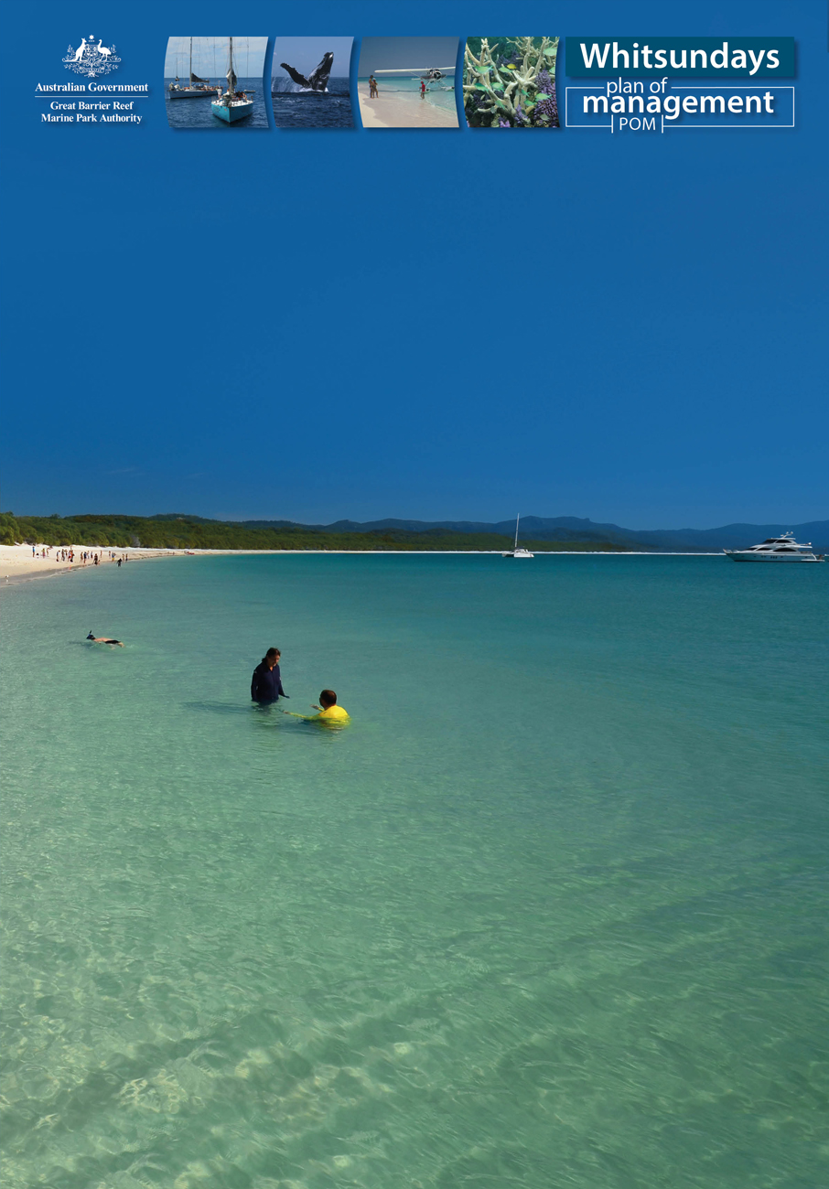

Call for expressions of interest

Special permissions in the Whitsunday Planning Area

April 2018
Main Image: © Matt Curnock Banner images: 1: © Chris Jones 2: M. Simmons © GBRMPA 3: R. Berkelmans © GBRMPA 4: © Chris Jones

Banner images:
Image1:
Image2: 138091 M. Simmons © GBRMPA
Image3: 113794 R. Berkelmans © GBRMPA
Image4: Whitsunday Outer Reef_Chris Jones3 © Chris Jones

About the opportunities on offer
The Great Barrier Reef Marine Park Authority (the Authority) is calling for expressions of interest for the following special permissions, which are limited opportunities in the Whitsunday Planning Area (Map 1) within the Great Barrier Reef Marine Park and the Great Barrier Reef Coast Marine Park (the Marine Parks) that cover:
- five (5) opportunities for permissions to conduct daily regional tour operations using a fixed-wing aircraft for scenic flights.
- three (3) opportunities for private mooring permissions in the Woodwark Bay South Location.
- three (3) opportunities for Bowen operation permissions to conduct daily operations providing all passengers embark or disembark from Bowen.
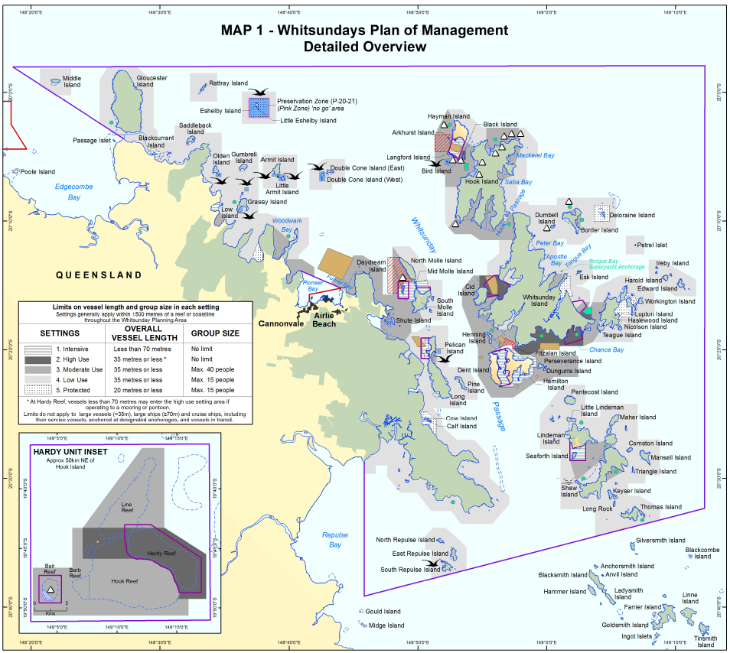
This document provides information about the opportunities provided for under the Whitsundays Plan of Management 1998 and instructions about how to lodge an expression of interest.
Extract of Map 1: Whitsunday Plan of Management. Detailed Overview – refer to this link for a larger scale map

Regional tour operations using a fixed-wing aircraft
Five regional tour operations opportunities using a fixed-wing aircraft to provide daily scenic flight opportunities in the Whitsunday Planning Area (Map 1) are being offered.
These are commercial tourism opportunities to offer visitors a bird’s eye view of stunning island locations within the Whitsunday Planning Area.

What the opportunity allows
- Daily access to the Whitsunday Planning Area without a booking.
- Allows for the use of fixed-wing aircraft (that is not a seaplane, flying boat or amphibian) for scenic flights without landing in the Planning Area.
- Operation of a scenic flight as part of a tourist program to fly at a height of no lower than 1000 feet (above ground or water) over the Whitsunday Planning Area.
Where multiple permissions are applied for, the applicant is able to complete one approved application form but must submit a lodgement fee for each permission. Expressions of interest can be made by new and existing marine tourism operators.

Private moorings in the Woodwark Bay South Location
Three private mooring opportunities are available in the Woodwark Bay South Location (Map 2) within the Whitsunday Planning Area where potential applicants can enjoy and showcase this idyllic area. The location of the moorings is also in close proximity to a
pre-existing resort.

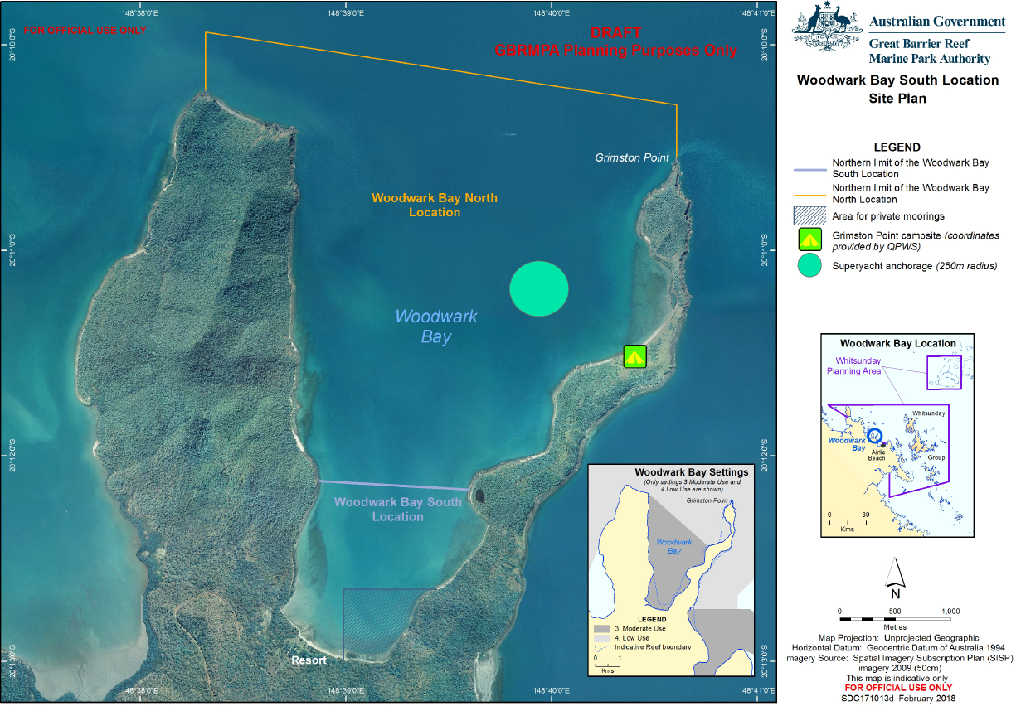
Map 2: Woodwark Bay South location

The installation of these private moorings will be required to be in accordance with the finalised site plan for this location. The Authority is currently seeking public comment on the draft Woodwark Bay site plan. Applicants are encouraged to review this draft site plan and comment on the proposed area for private moorings proposed in the site plan.

What the opportunity allows
- Three opportunities to install and operate a private mooring in the Woodwark Bay South location (specific location of moorings is determined by the site plan.)
- Able to be used for tourism and recreation.
Where multiple permissions are applied for, the applicant is able to complete one approved application form but must submit a lodgement fee for each permission. Expressions of interest can be made by new and existing marine tourism operators or by recreational users. Interested applicants should familiarise themselves with the Authority’s policy, ‘Moorings on the Great Barrier Reef’ which contains supporting information to the policy.

Bowen operations
Three Bowen operations are available to encourage marine tourism opportunities operating from Bowen. These permissions enable daily access to the Whitsunday Planning Area (Map 1) and offer the potential to showcase the natural beauty of the region.
The Bowen operations provide commercial tourism opportunities to take visitors to coral reef and island locations and provide them with an exciting tourist experience, enjoying spectacular scenery, corals, fish and other wildlife.

What the opportunity allows
- Daily access without a booking to the Whitsunday Planning Area, providing all passengers embark or disembark from Bowen.
- Allows the use of one primary vessel up to an overall length of less than 70 metres (in accordance with the Great Barrier Reef Marine Park Zoning Plan 2003 and the Queensland Marine Parks Act 2004).
- Ability to access all setting areas providing that the vessel and group size matches that setting (for example access to Gloucester Island for a vessel under 35 metres and a maximum group size of 15).
- Ability to undertake a range of tourism activities including snorkelling, non-motorised water sports, birdwatching, scuba diving and fishing activities (in line with relevant zoning rules and the Whitsundays Plan of Management).
Where multiple permissions are applied for, the applicant is able to complete one approved application form but must submit a lodgement fee for each permission. Expressions of interest can be made by new and existing marine tourism operators.

Management arrangements
The Whitsundays is recognised as a significant presentation area for Great Barrier Reef World Heritage values, and it is a showpiece tourism destination for Queensland. Visitors are attracted by the spectacular scenery of the numerous islands (most of which are State managed national parks). The reefs and islands support a diverse range of animal and plant life. These include protected species such as humpback whales, marine turtles, beach stone-curlews and Proserpine rock-wallabies. The Planning Area and its adjacent islands remain a significant place for traditional use by Traditional Owners.
Successful expressions of interest applicants will have the opportunity to apply for the special permission. A special permission is a joint Marine Parks permit providing access to both the Great Barrier Reef Marine Park (Commonwealth) and Queensland Great Barrier Reef Coast Marine Park (State) granted under the Great Barrier Reef Marine Park Regulations 1983 and the Queensland Marine Parks Regulation 2017 (the Regulations). Applications are assessed under these regulations and will detail conditions for conducting the tourism operation or for installing and operating a mooring. This includes applicant suitability requirements.
All operations under these permissions must be conducted in accordance with all relevant Commonwealth and State legislation and management arrangements, particularly the Whitsundays Plan of Management and any specific conditions of the permission. For example, the Whitsundays Plan of Management assigns a setting for all locations within the Planning Area. These settings detail the number of people, vessel size and type of tourist related activities permitted in a location (see Map 1).
Detailed information about the management arrangements are in the Whitsundays Plan of Management, which is available at the Authority’s Plans of management web page. Applicants are advised to research their legal requirements in preparing their expression of interest or their permit application (if successful in the expression of interest process).
The Authority and Queensland Parks and Wildlife Service (QPWS) have complementary regulations which require them to assess a joint Marine Parks permit application against a range of assessment criteria, such as an assessment of an applicant’s status against suitable person criteria (see page 17 of the Authority’s Permission assessment and decision guidelines). Applicants submitting an expression of interest should make themselves familiar with the permit assessment criteria as it is possible they may be successful in meeting the expression of interest selection criteria but not granted a Marine Parks permit because they don’t meet the Marine Parks permit criteria.
Interested applicants wanting to conduct a tourist program should note that access to island national parks will require separate permission from the QPWS. More information is available via the Business Queensland website.
There are also specific requirements about the use of special permissions relating to commencing operations and reasonable use. Once the permission is granted, the operator is required to start the new operation in the Marine Park within two years. In addition, upon continuation of a vessel or aircraft special tourism permission the operator will be required to demonstrate reasonable use (an average of 50 days operation a year) in order to retain the special permission.
Further information regarding special permissions is available by contacting the Great Barrier Reef Marine Park Authority via email to allocations@gbrmpa.gov.au.

Allocation of special permissions
Special permissions require a more extensive decision-making process than a normal Marine Parks permit assessment. These permissions will be allocated through a clear and transparent expression of interest process. All prospective applicants are treated equally.

Application for the special permission opportunity
To apply for one of these opportunities you must complete the application form at the end of this package. Each application must:
- be in the approved form.
- be submitted to the Authority between the advertised opening date Friday 13 April 2018 and closing date 5:00 pm AEST Monday 14 May 2018.
- include the non-refundable application lodgement fee of $354 for each special permission being applied for.
- address the selection criteria and standard application requirements.
Where multiple permissions are applied for, the applicant is able to complete one approved application form but must submit a lodgement fee for each permission.
The section making an Expression of Interest application (page 7) will help you complete the application form.

Assessment of applications
Interest for the permissions is likely to be greater than the opportunities available. The Authority will rank the applications to identify the most suitable.
The highest ranked applicants will be offered the opportunity to apply for the special permissions. In the event that the highest ranked applicant is not granted a permission because they don’t meet Marine Parks permit assessment criteria or withdraws their application, the next highest ranked applicant in the expression of interest process will be given the opportunity to apply for the special permission.
Applicants must address the following selection criteria:
- Demonstrated competence and knowledge relevant to the tourism or mooring opportunity.
- Extent to which the operation will enhance protection of Marine Park values, for example through adoption of best practices and use of environmentally friendly technology.
- Extent to which the operation will enhance presentation of Marine Park values, for example the quality and quantity of interpretation and education and the standard of client services and infrastructure.
- Contribution to management that directly assists the Authority to fulfil its management responsibilities (for example undertaking specific management tasks).
All selection criteria are weighted equally.
You must provide all the relevant information in response to the selection criteria at the time of expressing interest. The Marine Park delegate will base their decision on the information provided in the application and may request further information on the application if required. There is no capacity for applicants to amend their offer as expressed in their response to the selection criteria after the expression of interest application period has closed.
An advisory panel comprising staff from the Authority, QPWS and one person who holds expertise relevant to the types of permissions on offer or for the region will provide advice to the Marine Park delegate on the ranking of applications based on the quality of the responses to selection criteria.

Decision – Stage 1
Applications will be ranked on how well the selection criteria have been addressed. Where more than two suitable applications are considered of equal ranking, a ballot will be conducted to separate these applications and identify the successful applicants.
The top ranking applicants will be offered the opportunity to apply for the special permission, through a Marine Parks permit application, within 15 business days of the ranking decision.
Applicants will be notified individually of the decision in relation to their application. Notification of all Marine Parks permit decisions will be published in the Commonwealth Gazette as soon as practical after the decisions are finalised.

Stage 2
The highest ranking applicants will be required to pay a non-refundable permit application assessment fee when their application for the joint Marine Parks permit (which includes the special permission) is received and accepted. To assist applicants with this process the Authority has a checklist of information (including those for installation of a mooring) that is required to be submitted at the time of application. Applicants should plan to have this information ready to submit, if they are successful in the expression of interest process.
The Authority will assess any Marine Parks permit application against the permission assessment criteria in the Great Barrier Reef Marine Park Regulations 1983 and the Queensland Marine Parks Regulation 2017.
For successful applicants, should a permit be granted any commitments that were made during the application process may be reflected in permit conditions or a deed of agreement.

Review procedures and rights for permission application decisions
An applicant for a special permission has the right to request a reconsideration of a decision to refuse the application. In some cases, a third party whose interests are affected by the granting or refusal of a permit application may also seek a reconsideration of the Authority’s decision.
A request for reconsideration must be made within 21 days of the decision being published on the Authority’s website.
If the applicant or third party are dissatisfied with the outcome of the subsequent reconsideration, they may also have a further right to apply to the Administrative Appeals Tribunal for a review of the reconsidered decision.
As most decisions about whether to grant or refuse a permission are made jointly with QPWS, such applicants may also need to consider whether they need to seek review of any decision made by QPWS. Applicants should apply to QPWS for an internal review using the ‘Request for internal review of a QPWS decision’ form here.

Making an Expression of Interest application
Your expression of interest application must include the completed application form and payment slip provided at the end of this document. You must complete all relevant questions and address the selection criteria for your application to be considered valid. It is the Authority’s preference to receive these applications via e-mail: allocations@gbrmpa.gov.au.
An expression of interest application form is at the end of this document, or can be obtained by contacting the Project Manager, Policy and Planning via e-mail allocations@gbrmpa.gov.au.
Information to help you fill out the application form and address the selection criteria can be found in this document.
Individual applicants may make more than one application. Joint applications will be accepted where the applicants have formed a partnership and therefore are not individually liable.
Where multiple permissions are applied for, the applicant is able to complete one approved application form but must submit a lodgement fee for each permission.

Part A–D – applicant and activity details
Part A–D establishes the applicant, the contact details and general information about the proposed operation such as types of craft to be used, structures to be built and activities to be undertaken. You are required to provide payment of the application lodgement fee at the time of application. During the application period, the Authority will register Part A–D of your application and receipt your application lodgement fee.

Questions 1–4
These questions ask who is applying for the opportunity including the contact details of the person or company. Please nominate a contact person who is authorised to discuss matters relating to this expression of interest and is available during working hours throughout the evaluation period.

Questions 5–11
These questions ask for information about the type of special permission you are applying for and provides further details such as where you are going to operate, what type of craft you intend to use, whether you will be using ancillary crafts, what activities you intend to undertake and whether the operation extends to an island national park. If your proposal is likely to significantly affect other users of the Marine Parks, at the Marine Parks application stage you may be required to fulfil public advertising requirements and additional costs will be involved.

Application lodgement fee
An application lodgement fee of $354 for each special permission you apply for is required with the lodgement of your application. Where multiple permissions of one type are applied for, the applicant is able to complete one approved application form but must submit a lodgement fee for each permission. The application form has a section for the payment details. We encourage submissions via e-mail to allocations@gbrmpa.gov.au.

Part E – responses to selection criteria
Part E is where you respond to the advertised selection criteria. If you applied for more than one permission but all of the same type (e.g. aircraft) you will only need to address the selection criteria once. If you applied for more than one type of permission (e.g. aircraft and a mooring), you will need to complete a response to the selection criteria for each type of permission applied for. Part E of your application will be treated as commercially sensitive and will not be provided to the advisory panel until the end of the application period when all applications will be assessed.

Applicant’s declaration
You must confirm that all the information you provided is correct and that you are willing to have the information you provided in your answers to the selection criteria reflected in the permission.

Additional fees
If your application is of the highest ranked, the opportunity will be offered to you. If you choose to apply for the Marine Parks permit including the special permission, your application will need to be assessed against the assessment criteria in the Regulations. You will be required to pay the permit application assessment fee (PAAF). For details of payments required for permit assessments please see the 2018 Permit Assessment Fee information sheet.

Lodgement
Each application must include:
- Part A–D: Completed and signed application form and payment slip.
- Lodgement fee of $354 for each special permission applied for (note 2% surcharge if paying by credit card).
- Part E: Statement addressing the selection criteria for each type of permission applied for.
- Any relevant information to support your claims against the selection criteria.
Email your application to allocations@gbrmpa.gov.au.

Closing date:
5.00 pm AEST on Monday 14 May 2018.

Late applications
Late applications will not be considered.

Contact person:
Project Manager, Policy and Planning Section
Great Barrier Reef Marine Park Authority
Phone: +61 7 4750 0700
Email: allocations@gbrmpa.gov.au.
Applicants are advised to regularly check the Authority's website for information regarding this call for expressions of interest.

Important considerations

General
- The onus is on the applicant to understand this application process and the implications of being involved in the process. The Authority will not accept responsibility for any misunderstanding arising from an applicant’s failure to comply with the application process. The applicant is advised to examine the information provided in this call for applications document, the application form, web pages and information in the Regulations, Act and Plans of Management when preparing the application.
- The applicant involves themselves in this process at their own expense and without any costs being payable by the Authority.
- The Authority reserves the right to add to, delete from, vary, withdraw or reissue the call for expressions of interest (including conditions in this call for expressions of interest documentation) at any time whatsoever. The Authority will make reasonable endeavours to inform any affected parties.
- An applicant, on submitting an application, shall have granted the Authority a permanent, irrevocable, royalty-free licence to copy the application and any supporting material for the purpose of the allocation process.
- Applying for a special permission during this application process does not constitute a binding agreement for either party.
- The Authority and the advisory panel will rank the applications and only offer the opportunities to those applications that meet the selection criteria to the highest standard. Applications of equal merit will be ranked by ballot. The Authority reserves the right to not allocate all, or any, of the opportunities available, if there are insufficient applications that adequately meet the selection criteria.

Actions of the applicants
- Applicants and their employees must not place themselves in a position that may or does create a conflict of interest.
- Applicants and their employees must not engage in any collusive bidding, anti-competitive conduct or similar conduct with any other applicant.
- Applicants must not engage in misleading or deceptive conduct, including making a statement or representation during this process. Prior to completing the application form you should review relevant sections of the Commonwealth Trade Practices Act 1974.
- Joint applications will only be accepted where the applicants have formed a partnership and therefore are not individually liable.
- The successful applicants will not make press or other media announcements or releases relating to this allocation process unless approved by the Authority.

Application information made available
- Please be aware that the Authority makes basic information about all current permit applications and decisions available on its website.
- The information that may be made publicly available about an application are: applicant’s name, date of application, application number, permit type requested, section of Marine Park to be used, type of craft to be used, structures to be built and activities to be undertaken.
- All other information in the application (including supporting material) shall be treated by the Authority as commercially sensitive and protected from disclosure unless required to be disclosed by law, by the Parliament or a committee of the Parliament, or to be disclosed for the purpose of evaluation (e.g. internal audit). In this case, any third parties shall be informed of the sensitivity attached to that material or information and required to protect it accordingly.
- Applications will remain on the premises of the Authority and hardcopy and computer security will be maintained as per Australian Government requirements.
- Permits, once granted, are publicly available documents and any commitments made against the selection criteria by successful applicants are likely to be reflected in permit conditions and therefore be available to the public.

Questions from applicants
- Where prospective applicants ask for further information or clarification from the Authority, questions should be addressed to the Project Manager and provided either verbally or in writing (preferably email). The Project Manager will respond to the individual prospective applicant and where it is deemed the answer is of importance to all applicants, and not confidential in nature, the advice will be placed on the web at www.gbrmpa.gov.au. A list of advice will be kept on the web page for all applicants to view. Correspondence between the Project Manager and applicants will be held as records.

Providing all the required information
- You must provide all the relevant information about your proposal, including your response to the selection criteria, at the time of applying. The Authority will base its decision on the information you provide.
- The Authority may request further information on the application but there is not the capacity for applicants to amend their offer as expressed in their response to the selection criteria.
- The Authority may seek validation of your claims or extra information about other parts of your application. Where the Authority requests information from the applicant, during the evaluation process, a reasonable response will be required in 20 days after the request is made. If no response is made the application is taken to be withdrawn by the applicant. The Authority is not under any obligation to take into account further information.

Application for special tourism permission

Special permissions
Special permissions allow operators to undertake an activity or operation that is limited or capped under the management arrangements for the Great Barrier Reef Marine Park. These permissions may only be allocated through an expression of interest process. The expression of interest process is used to rank applications and will not necessarily result in the offer of an opportunity. Only the highest ranked applicant(s) will have the opportunity to go on and apply for a Marine Parks permit which would include the special permission opportunity. Application fees will not be refunded to unsuccessful applicants.

Lodging your application
The application must include:
- Part A-D: Completed and signed application form and payment slip.
- Lodgement fee of $354 for each special permission applied for (note 2% surcharge if paying by credit card).
- Part E: Statement addressing the selection criteria for each type of permission applied for.
- Any relevant information to support your claims against the selection criteria.

Email your application to: allocations@gbrmpa.gov.au

Applications close 5.00 pm AEST Monday 14 May 2018.

Please note:
It is important that the Authority receive correct information about your permit application. There are significant penalties for giving false or misleading information. The information you provide may be given to other Commonwealth and State agencies, which have a role in the management of the area.

Part A

Applicant details
- Is the applicant a company/organisation?
Note: Applicants must identify as:
- a REGISTERED COMPANY;
- an INDIVIDUAL; or
- multiple INDIVIDUALS/COMPANIES.
Yes ☐ No ☐ Go to Question 2

Registered company name: |  | ACN
Registered office street address: |  |  | Postcode:
Postal address: |  |  | Postcode:
Email address:

- Is the applicant an individual, more than one individual, or an individual plus a company (partners etc.)?
Yes ☐ No ☐ Go to Question 3
Please list the names and addresses of all persons who are proposed to be included on the permit (additional boxes can be created if required.)
Full name(s):
Residential address: |  | Postcode:
Postal address: |  | Postcode:
Email address:

Full name(s):
Residential address: |  | Postcode:
Postal address: |  | Postcode:
Email address:

- Does the applicant wish to include a trading name on its permit?
Yes ☐ No ☐ Go to Question 4

Trading name:: |  | ABN:

- Authorised contact person:
Title: |  |  | Name:
Employment position: |  |  |  |  | Tel:
Email address: |  |  |  |  | Mob:
Note: The nominated contact person will need to be available to respond to any queries that arise during the assessment of the application. Non-availability may result in the application not being ranked.

- Please indicate the special tourism permission being applied for:
Where multiple permissions are being applied, the applicant can complete one application form but must submit a lodgement fee for each of the permissions applied for.
Permission being applied for: | Number being applied for | Part of application to be completed
☐ Regional tour operation using a fixed-wing aircraft |  | Go to Part B
☐ Private mooring in the Woodwark Bay South location |  | Go to Part C
☐ Bowen operation |  | Go to Part D

Part B – Regional tour operation using a fixed-wing aircraft
- If applying for a Regional tour operation using a fixed-wing aircraft, please list the details of the aircraft to be included on this permit.

Aircraft type |  | Registration number | Surveyed passenger capacity | Max number of participants in program (passengers and crew) | Usual aircraft departure point

- If applying for a Regional tour operation using a fixed-wing aircraft, briefly describe the type of tourist operation you plan to undertake (e.g. likely flight paths).
Response:

Part C – Mooring at Woodwark Bay

- If applying for a Woodwark Bay mooring, briefly detail if it is for commercial nor non-commercial use, the type of mooring proposed (e.g. single point, fore and aft mooring), and how you intend to use the mooring (e.g. frequency of use, size of vessel to be catered for, etc.).

Response:

Part D – Bowen operation

- If applying for a Bowen operation, please list the details of the primary vessel to be included on this permit.
Vessel name | Registration number | Vessel length (m) | Surveyed passenger capacity | Max number of participants in program (passengers and crew)

- If applying for a Bowen operation, do you intend to use any equipment in its operation? Some examples of equipment include tender vessels, glass-bottom boats and semi-subs, jet skis, catamarans, dinghies, kayaks etc.

Equipment/vessel type | Number | Passenger capacity

- If applying for a Bowen operation, briefly describe the type of tourist operation you plan to undertake. Provide details about the activities the proposed operation will include (e.g. swimming, snorkelling, guided tours) and the locations the operation will visit (e.g. reefs, islands, National Parks.)
Response:

Part E

Selection criteria
Please attach a document entitled ‘Part E’ to your application which addresses each of the selection criteria outlined in this section. Applications which fail to address all of the criteria will not be considered. Where multiple permissions of the same type (e.g. three aircraft permissions) are being applied for, then one response to the selection criteria will be considered for all those permissions. Where multiple permissions for more than one type (e.g. a mooring and a Bowen operation) are being applied for, please ensure that you address the selection criteria for each type of permission that you are applying for. Incorrect and incomplete applications will not be considered.
Selection criteria for all opportunities
- Demonstrated competence and knowledge relevant to the tourism or mooring opportunity.
- Extent to which the operation will enhance protection of Marine Park values, for example, through adoption of best practices and use of environmentally friendly technology.
- Extent to which the operation will enhance presentation of Marine Park values, for example the quality and quantity of interpretation and education and the standard of client services and infrastructure.
- Contribution to management that directly assists the Great Barrier Reef Marine Park Authority to fulfil its management responsibilities (for example undertaking specific management tasks).
Note: All selection criteria will have equal weighting for this assessment.

Applicant's declaration: Please read the following carefully.

Privacy collection notice
Personal information that you provide the Authority as part of your expression of interest for a special permission is protected by the Privacy Act 1988 (the Privacy Act). The Authority will use your personal information for the purposes of assessing your expression of interest, which may include any or all of the following:
- to contact you in order to discuss any aspects of expression of interest.
- to assess your suitability for a permission under the Great Barrier Reef Marine Park Regulations 1983.
- to notify you of the outcome of the expression of interest process.
- in the event that you are granted a permission in accordance with the Great Barrier Reef Marine Park Regulations 1983 to notify you of any changes to your permission.
To properly assess your expression of interest, the Authority may also need to share your information with an advisory panel established for the purposes of considering the expressions of interest.
In the event that you are declared to be an entitled person to make an application for a special permission under Regulation 88A, the Authority may also disclose your personal information to State and Australian Government agencies that have responsibility for managing activities associated with any special permission you may apply for.
If you are granted a special permission, a copy of the permit document and other details about your application, such as your name and address, will be published on the internet.
The Authority will not otherwise disclose your personal information to any third party without your consent, unless authorised by law. However, the Authority may use your personal information to produce aggregated, de-identified data for statistical purposes and this data may be made publically available. Such data will not allow you to be personally identified in any way.
If the details that you have provided to us change, you agree to notify us so that we can ensure our records are kept up to date and accurate by contacting:
Policy and Planning
Great Barrier Reef Marine Park Authority
PO Box 1379, Townsville, QLD 4810
Phone: +61 7 4750 0700
  - For further information about how the Authority collects and handles personal information and the Authority’s complaints process please read our Privacy policy.
  - For more information on privacy and the Privacy Act, see the Office of the Australian Information Commissioner's website.

ABN 12 949 356 885

(This fee is GST exempt in accordance with A New Tax System Determination 2000

(No. 2) Item 6.35)
Payment slip
-------------------------------------------------------------------------------------------------------------------------------------------
Application lodgement fee – special permissions
Permission being applied for: | Number being applied
☐ Regional tour operation using a fixed-wing aircraft
☐ Private mooring in the Woodwark Bay South location
☐ Bowen operation
Total (the number of permissions applied for multiplied by $354) | $
Where multiple permissions are applied for, the applicant is able to complete one approved application form but must submit a lodgement fee for each permission.
Name:

Trading name:

Email address:

Postal Address:

Suburb: | State: | Post code:
Amount: $ (plus 2% surcharge if paying by credit card)
Payment method: ☐ Direct Deposit (bank details below – please include first initial and surname as payment reference)
☐ Credit card (complete details below, 2% surcharge applies)

VISA/Mastercard (circle one) or other:
Name on card:

Card number:

Card expiry: | CVC:
Cardholder’s signature: Date:

PAYMENT OPTION – DIRECT DEPOSIT
A/c Name: Great Barrier Reef Marine Park Authority
Bank: Commonwealth Bank
BSB: 064817
A/c No: 00070271
Swift Code: CTBAAU2S
Bank address: 151-172 Sturt St, TOWNSVILLE, QLD 4810
Please include your first initial and surname as your payment reference please.

