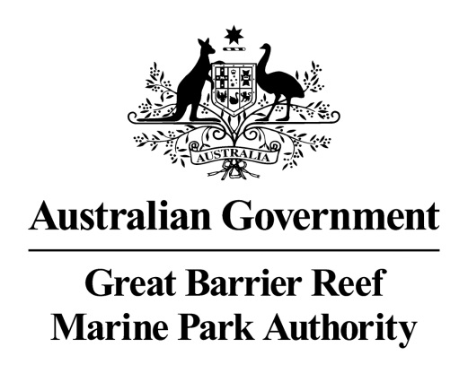

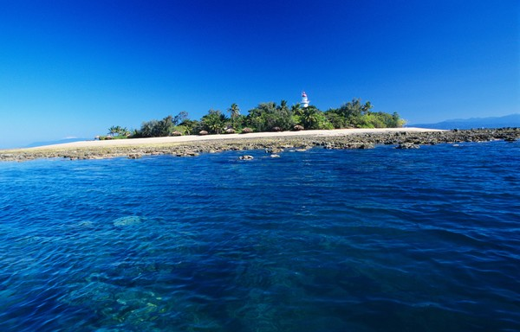
© Commonwealth of Australia (Great Barrier Reef Marine Park Authority)

Low Islet Lightstation and Low Island
Heritage Register

December 2017

The Low Islet lightstation is listed on the Commonwealth Heritage List for its historic heritage value. Low Island is listed on the Commonwealth Heritage List for its Indigenous heritage value. The property is managed by the Great Barrier Reef Marine Park Authority, a Commonwealth Government agency. This Register is required by the Environment Protection and Biodiversity Conservation Act 1999 s341ZB). It lists the Commonwealth Heritage values that the Marine Park Authority is charged with identifying, conserving, managing, interpreting and celebrating.
Commonwealth Heritage List Place ID Number | 105367
Current Status | Listed place, 28 May 2008
Ownership | As the lighthouse is a working aid to navigation it is the property of the Australian Maritime Safety Authority (AMSA). Otherwise the site is managed by the Marine Park Authority.
Location | Low Island is in Trinity Bay, about 15 km north east of Port Douglas, and 60 km north of Cairns (16º 23' 02.6” s and 145º 33' 35.58” e) Immediately to its west is Woody Island. Together these islands are known as the Low Isles and their relationship to the mainland can be seen in the Google Map below.  On the Google Earth view on the next page, the red arrow is pointing to the light house tower.
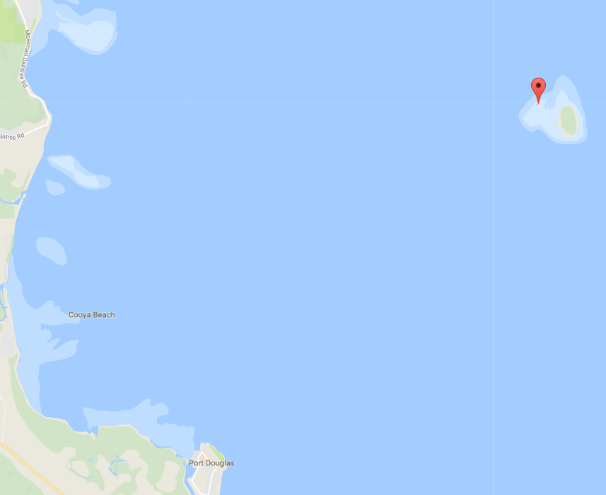
Google Maps map data © 2018 GBRMPA, Google Australia
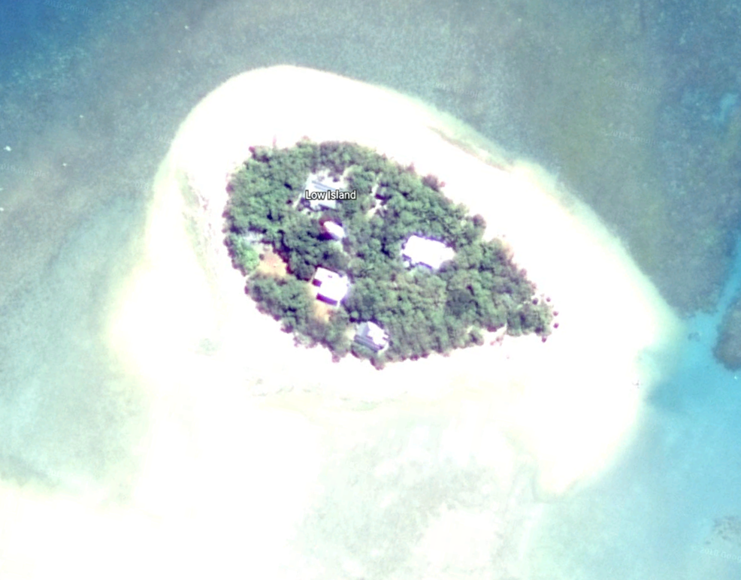
© Google
Description | The Low Islets lighthouse was the fifth to be built in northern Queensland using the iron-clad timber-framed method first used at Lady Elliott Island in 1873. However, the cladding was galvanised iron, instead of black iron plates round, timber-framed towers clad with galvanised iron sheets were unique to Queensland and incorporated Queensland resources.  The lighthouse is a truncated 21-metre conical tower, and the timber frame construction sheathed with iron is in the typical fashion of Queensland lighthouses. The tower is painted white with a red dome, stands on a concrete base, and was the first to have porthole windows.  An internal timber staircase gives access to the lantern room. The optical apparatus consists of a Chance Brothers Third Order revolving lens supported by a roller bearing rotating pedestal, driven by an electric motor. Solar conversion was undertaken at the lightstation in 1993. The beam source is a 120-volt 1000-watt tungsten halogen lamp and solar array.  The grouping of the buildings of the lightstation follows a generally radial pattern with the lighthouse as the axis, rather than the more common lineal layout found on many other lightstations. This radial layout may have been determined by the physical size of the island, giving more privacy to keepers and maximising the use of the limited space on the island. The cottages and sheds are built in a compact arrangement around the Lighthouse, forming one physical precinct combining both service and residential functions, and are surrounded by thick vegetation. The original cottages were demolished and replaced by new keepers' residences, timber framed and clad with fibro, in the early.  The elements which make up the lightstation are the lighthouse; the head keeper's house; the assistant keeper's house; the relieving quarters; the old power house; the old fuel store; later service structures including a bulk fuel store, a power house and a boat house; and a toilet block constructed to meet the needs of tourism. There is also an unmarked grave on the site.  Low Islets is part of a geographic complex, which includes Snapper Island (Minyi Gambyi), the mouth of the Daintree (Binda) and Cape Kimberley (Baku). There is a legend that a down-welling stream inland from Mossman Gorge exists undersea near Low Isles.  There is evidence of the past activities of the Kuku Yalanji people from the presence of shell midden sites and the lower-woody mangrove which is still used for hunting practices.
Sequential summary use of place | Kuku Yalanji and Yiriganji Traditional Owner groups visited regularly  1770: Noted by Lieutenant James Cook on the Endeavour in 1770 and the location marked on his chart.  1819: Captain Phillip Parker King on a survey voyage on HMS Mermaid officially named the place Low Isles.  1860s-1870s: Low Island was used intermittently by bêche-de-mer fishermen  1876: Authorisation sought to build a lighthouse  1877: Tenders call and the contract for construction signed  1878: Lighthouse construction completed in 7 months by W P Clark (Brisbane) for £2,865 and the first superintendent appointed, Daniel Owen  Date unknown: Three separate cottages built  1923: Light was upgraded to incandescent kerosene lighting  1928-1929: British-Australian Great Barrier Reef Expedition to Low Isles led by Charles Maurice Yonge  1930: Lens mounted on a new mercury float pedestal with a new weight-driven clock allowing the lens to rotate faster and the flashes went from intervals of 60 seconds to 2.5 seconds  1934: Cyclone demolishes outbuildings, tears of the rooves of two cottages and the Yonge’s laboratory  1941: Provided a radio transceiver to receive orders about extinguishing or relighting during World War II  1961: Powering of the Lighthouse converted to electricity  1993: Lighthouse converted to solar-electric operation and the last of the lightkeepers left the island  1998: Island surveyed by Queensland National Parks and Wildlife Service for use as a tourist site: network of paths, removal of structures, installation of others, interpretation signage, toilets, orientation centre and office space.
Statement of significance | Constructed in 1878, the Low Islets lightstation was the first lightstation in the north of Queensland, and its location inside the Great Barrier Reef represented the first attempt to address the dangers to shipping approaching newly established ports from the north, including Cairns and Port Douglas which developed in the 1870s as a result of the discovery of gold in the region. The establishment of the Low Islets lightstation gave increased certainty to shipping in the Inner Passage inside the Great Barrier Reef, and improved safety of access to these developing northern ports.  Low Islets lightstation demonstrates an important step in the establishment of maritime navigational aids along the Queensland coast and reflects the growth and development of Queensland after its separation from New South Wales.  Low Island has heritage significance to Kuku Yalanji and Yiriganji as part of their dreamings.
Official heritage values | Criterion A processes  Low Islets lightstation was first lit in 1878, offshore from Port Douglas and inside the Great Barrier Reef. It was the first lighthouse constructed in the north of the colony of Queensland, and its location inside the Reef represented the first attempt to address the dangers to shipping approaching the northern Queensland ports, including Cairns and Port Douglas. It is significant in Australian cultural history as it occupies an integral part in the establishment of maritime navigational aids along the Queensland coast which allowed overseas trade to be developed in Queensland’s northern ports. This trade was important for the growth and development of Queensland. The lighthouse tower and its relationship with the light keepers’ houses, the two engine houses, the boat shed, and the fuel tank installation, dating from 1878 to the 1960s are also relevant attributes.
Criterion I Indigenous tradition
Low Island has heritage significance to Kuku Yalanji and Yiriganji as part of their dreamings. Kuku Yalanji believe the Low Islets and Snapper Island ('Minya Gambyi'), the mouth of the Daintree ('Binda') and Cape Kimberley ('Baku') were once part of a united landmass that became separated during the creation period (the Dreamtime). Traditionally, these three sites were visited regularly by Traditional Owners to maintain contact with important dreaming sites and stories and the local Aboriginal community continues to maintain a strong spiritual connection to these places).

Other heritage listings | Nil
Access restrictions | Low island is held by the Marine Park Authority on behalf of the Commonwealth of Australia.  The Australian Maritime Safety Authority (AMSA) leases two small adjoining parcels of land on Low Island on which the Lighthouse stands. The lighthouse is an operating aid to navigation owned by AMSA and there is no public access.  There are currently five operators with Marine Parks Permits endorsed to access Low Island daily for 365 days a year. A further two bookings for other operators is available daily but for a maximum of 50 days per year for each operator.
Consultation requirements | Consultation is directed by the EPBC Act when developing the Heritage Management Plan; involves stakeholder and public consultation.
Date last updated | 2012
Other places significant by association | Lady Elliot Island lightstation
Archived records | Nil

