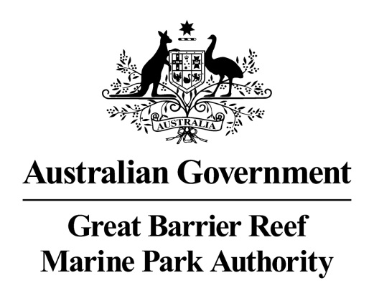
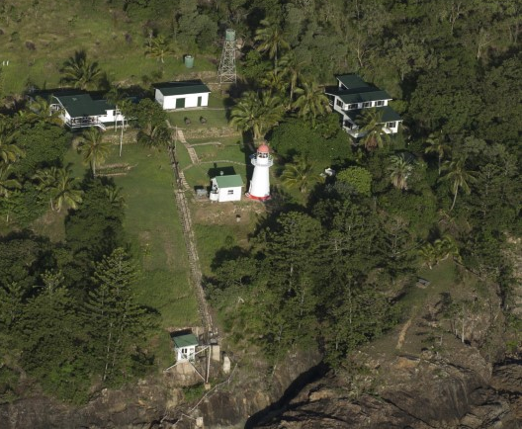
Aerial view of Dent Island lightstation © Commonwealth of Australia (Great Barrier Reef Marine Park Authority)

Dent Island Lightstation
Heritage Register

December 2017
The Dent Island lightstation is listed on the Commonwealth Heritage List for its historic heritage value. The property is managed by the Great Barrier Reef Marine Park Authority, a Commonwealth Government agency. This Register is required by the Environment Protection and Biodiversity Conservation Act 1999 s341ZB). It lists the Commonwealth heritage values that the Marine Park Authority is charged with identifying, conserving, managing, interpreting and celebrating.
Commonwealth Heritage List Place ID Number | 105369
Current Status | Listed place since 22 June 2004
Ownership | This property is owned by the Marine Park Authority on behalf of the Commonwealth. The southern part of Dent Island comprises four leased areas. Two relate to the lightstation.  Lot 1 HR2019 (58 m²): This small area contains the lighthouse tower and is leased from the Marine Park Authority by the Australian Maritime Safety Authority (AMSA). AMSA owns the Lighthouse and the associated equipment and is responsible for maintaining this structure. AMSA has rights of access to the site through the surrounding areas.  Lot 2 HR2019 (2836 m²): This lease contains the former light keepers’ houses and other ancillary structures of the lightstation and is leased from the Marine Park Authority by a private lessee. The private lessee is responsible for the day-to-day maintenance of this Lot.
Location | Dent Island is in the Whitsunday Island Group of the Great Barrier Reef approximately 18 km south-east of Shute Harbour (20º20'21"s, 148º55'48"e).  Dent Island is in between the Queensland coast and the outer Reef. It is approximately 1.5 km west of the largest inhabited island in the Whitsundays, Hamilton Island, positioned about midway along the coastline between Brisbane and Cairns. The island has a surveyed area of about 312 ha.  The yellow arrow on the below Google Map view is pointing to Dent Island, and on the Google Earth view it is pointing to the location of the Lightstation on Dent Island.
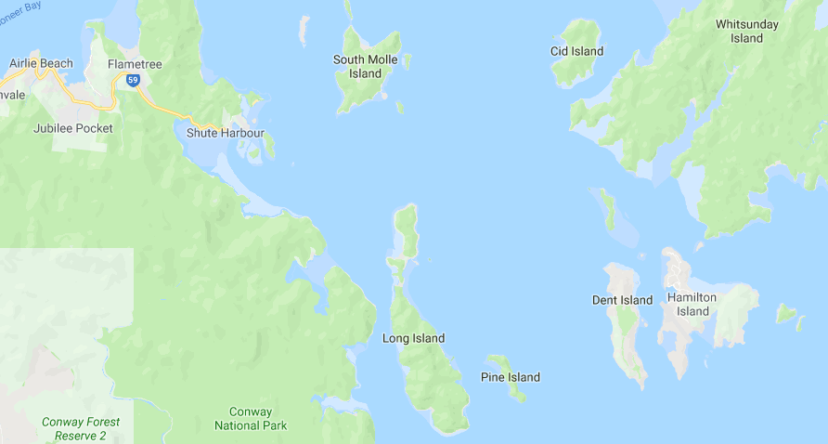

Google Maps map data © 2018 GBRMPA, Google Australia
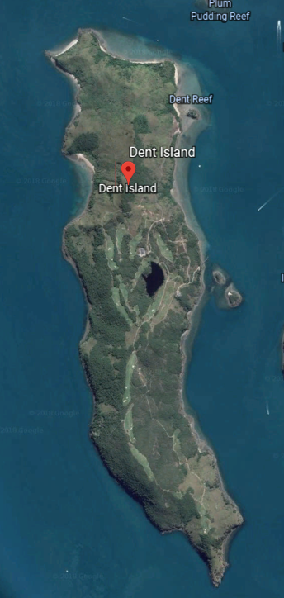
© Google Earth
Description | The light provides navigational guidance for ships passing through the narrow passage between Whitsunday Island and the islands adjacent to the mainland.  The tower is erected around a timber frame of colonial hardwood. The conical boiler plate casing is non-structural.  The six buildings associated with the tower (two residences, a winch house, store shed, engine room and combined workshop/radio room) are constructed variously of weatherboard and fibro sheeting on timber frames, with galvanised iron roofs.  The red domed, white conical tower of timber framed, iron clad construction stands 10 metres high. A circular cast iron staircase runs inside the tower to the light platform. A fourth order lens, and oil wick burner were originally installed in the light.  The lens is presently surmounted by a 6ft 7.75in diameter lantern manufactured by Chance Brothers of Birmingham, England. The optical apparatus consists of a self-contained electric beacon mounted on the handrail of the tower balcony. It is powered by banks of solar cells housed on a north facing prefabricated stand erected close to the tower. The apparatus gives a character of flashing every five seconds with an intensity of 1,310 candelas resulting in a nominal visible range of 10 nautical miles.  Accommodation consists of two timber framed, fibrocement cottages.  Cottage 1 is a two level building with three bedrooms and a bathroom located on the lower level and living room, kitchen, storage room, toilet, laundry and enclosed verandah on the upper level.  Cottage 2 is of single level construction with three bedrooms, living room, dining, kitchen, laundry, toilet, bathroom and store room and open front verandah. Just up the hill from the tower is a tiny, white picket fence enclosing the grave of a newborn baby (apparently the first born of an early light keeper).  Other structures on the site (store shed, engine room and combined workshop/radio room), have concrete floors, are timber framed and have flat asbestos cement external wall cladding. A boat ramp is provided at the base of the cliff and concrete steps have been erected to provide access to the upper level. Associated buildings include a weatherboard bulk fuel store and winch shed located adjacent to the crane landing and haulage way. A diesel powered winch was used to transfer stores from ship to shore.  It is possible that the place may have Indigenous heritage value. The national estate value of this aspect of the site's heritage significance has yet to be assessed.
Sequential history | 1878: Commander George Poynter Heath, the Chairman of the Queensland Marine Board, wrote to the Colonial Treasurer in February recommending the construction of lights on both Cape Cleveland and Dent Island. Formal approval was granted in April and tenders were subsequently called. William P Clark was awarded the contract to erect the tower and two ancillary cottages for 1820 pounds.  1879: Building completed in September.  1925: The burner was replaced by a 35mm incandescent kerosene mantle and the intensity of the light increased from 4,000 to 225,000 candelas.  1927: The original lens was replaced by a reconditioned fourth order lens from Cape Cleveland.  1960: Accommodation consisting of two timber framed, fibrocement cottages is erected.  1982: The light was converted to electric operation and down-graded from 18 nautical miles to 10 nautical miles.

Statement of significance | Dent Island Lighthouse is significant as a light tower built in response to, and to further encourage, the expansion of regular coastal shipping along the inner route of the Great Barrier Reef, following the economic development of northern Queensland. The Lighthouse is significant as an intact representative example of a timber-framed, iron clad tower an innovative structural system designed in the office of the Queensland Colonial Architect and typical of Queensland lighthouses of the time. Dent Island Lighthouse is important as one of a pair of identical lighthouse towers built at the same time, the other being situated at Cape Cleveland. The lightstation complex of tower, houses, store shed, engine room and combined workshop/radio room is significant as a complete intact example of a lightstation complex in Queensland. Later stages of development have integrated with the original fabric and detail of the lightstation, contributing to the continuum of a complex dedicated to the single aim of maintaining the aid to navigation.
Official heritage values | Criterion A processes  Dent Lighthouse, constructed in 1879, is significant as a light tower built in response to the dramatic expansion of regular coastal shipping along the inner route of the Great Barrier Reef, following the economic development of northern Queensland.  The lightstation complex of tower, houses, store shed, engine room and combined workshop/radio room, dating from 1879 to c 1960 is significant as a complete intact example of a lightstation complex in Queensland. Later stages of development have integrated with the original fabric and detail of the lightstation, contributing to the continuum of a complex dedicated to the single aim of maintaining the aid to navigation.  Attributes  The lighthouse and its relationship to the houses, storage shed, engine room and combined workshop/radio room, dating from 1879 to c 1960.
Criterion D characteristic values
The lighthouse is significant as an intact representative example of a timber — framed, iron clad tower an innovative structural system designed in the office of the Queensland Colonial Architect and typical of Queensland lighthouses of the time. Dent Island lighthouse is important as one of a pair of identical lighthouse towers built at the same time, the other is at Cape Cleveland.
Attributes
The structural system and all of the fabric including timber framing and iron cladding.

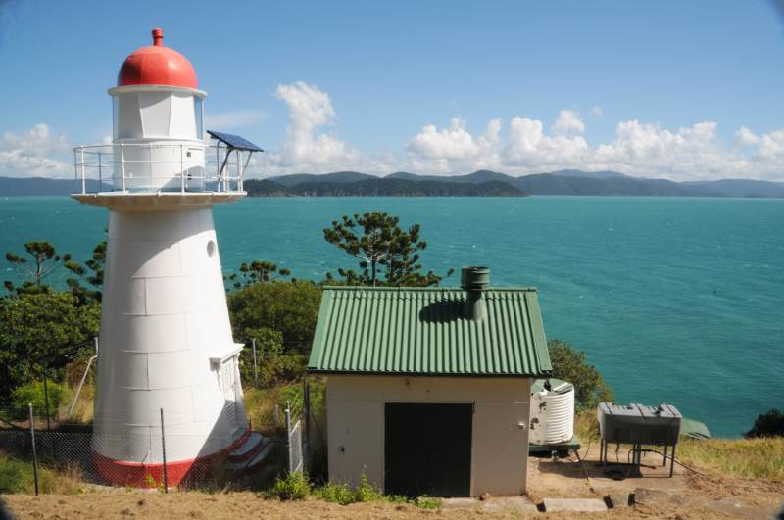
Dent Island lighthouse 2013 © Commonwealth of Australia (Great Barrier Reef Marine Park Authority)

Other current heritage listings | Nil
Access restrictions | The lightstation excluding the lighthouse is managed by the Marine Park Authority and a lessee is in place. The lessee manages all access as they utilise it as accommodation for staff.  The lighthouse is still working and is managed by the Australian Maritime Safety Authority. There is no public access.  Access to Dent Island is only by water motor craft.
Consultation requirements | The Marine Park Authority consults with the lessee.  Consultation is directed by the EPBC Act when developing the Heritage Management Plan; involves stakeholder and public consultation.
Relevant documents or references | Dent Island Lightstation Heritage Management Plan 2013
Date last updated | 2013
Other places significant by association | The lighthouse, erected on the island in 1879, was one of a series of 12 lighthouse towers of a distinctive type, built between 1873 and 1890.

