Incident Summary

Overview
This section provides a synopsis of the grounding incident, including the movement of Shen Neng 1 over Douglas Shoal. A summary of damaged sustained by Shen Neng 1 is also included. The purpose of this section is to help contextualise the description of physical damage and antifouling paint contamination provided in Section 4. Key points are summarised below. Information and data gaps are included at the end of this section.

Key Points
- Shen Neng 1, a Chinese bulk carrier, was constructed in 1993 at 36,575 gross tonnes (71,181 DWT), 225 m long with a beam of 32.66 m and a draught of 13.29 m.
- The hull of Shen Neng 1 was originally covered with antifouling paint containing tributyltin (TBT).
- TBT is a highly effective biocide that was banned internationally in 2009.
- While in dry-dock (2008) the hull of Shen Neng 1 was coated with Interswift 655 and Interswift 455FB, third generation copper oxide based antifouling paints.
- On 3 April 2010, Shen Neng 1 grounded on Douglas Shoal, moving across some 42 hectares during the 10 days before she was re-floated and towed away.
- Shen Neng 1 suffered extensive plate damage during the grounding. This damage comprised plate indentation, push-up, buckling and cracking. The rudder was slightly damaged but the propeller was not.
- Underwater inspection and sampling of the hull was undertaken by Monkivitch (2010), some 6 weeks following the grounding incident indicated that:
  - Damaged sections (sides of the hull) showed evidence of significant paint loss.
  - The entire underside (flats) of the hull is highly likely to have been in contact with the shoal at some time during the grounding.
  - Whilst only target areas of the hull were inspected, during the grounding antifouling paint is highly likely to have been lost from most of the underside of the Shen Neng 1 to similar extents to that observed (to the sides of the hull).
  - Chemical analysis of paint samples confirmed the presence of active (biocide) ingredients including tributyltin, zinc oxide and copper oxide, copper pyrithione and zineb at environmentally significant concentrations.
- No accurate calculations of total paint and biocide lost during the grounding were available in any of the reports reviewed.

Key Information and Data Sources
Negri et al (2010), (GBRMPA 2011) and Kettle (2011) provide excellent summaries of the incident. A comprehensive description of the grounding and the subsequent response is provided by ATSB (2011) - available here: https://www.atsb.gov.au/publications/investigation_reports/2010/mair/274-mo-2010-003
Monkivitch (2010) completed an assessment of the post grounding condition of the vessel’s hull, identified the antifouling paint (AFP) products applied, and provided estimates of volume of AFP (kg) applied to the hull of Shen Neng 1 when in dry dock (2008). Data sources and build reports for Figures 3-1 and 3-2 are provided in Appendix E.

Shen Neng 1
Shen Neng 1 (now the ‘Jia Yong’) a Chinese bulk carrier was constructed in 1993 at 36,575 gross tonnes (71,181 DWT), 225 m long with a beam of 32.66 m and a draught of 13.29 m.
In 2008, Shen Neng 1 was in dry dock for maintenance and repair. According to the Coating and Inspection Report (appendices to Monkivitch (2010), the hull was largely free of biofouling organisms, suggesting the antifoulant properties of the pre-existing paint (containing tributyltin) were still effective. Due to the global ban on tributyltin (TBT) based antifoulants, Shen Neng 1 was coated with Interswift 655 and Interswift 455FB, third generation copper oxide based antifouling paints- (AFP).
Table 3-1 (reproduced from (Monkivitch 2016) includes a list of paint products applied to the vessel’s hull, the active ingredient and their concentrations. No similar data relating to the TBT based antifouling paint layer was available.
            - Applied paint products, volumes and key active ingredients
Hull section | Surface area (m²) | Paint type | Paint volume (l) | Density wet (kg/l) | Paint applied wet (kg) | Active ingredient |  | Concentration by weight (%)* |  | Amount applied (kg)
Underwater Sides | 3819 | lnterswift 655 Brown (BMA008) | 740 | 1.935 | 1431.9 | Copper Oxide | 25-<50 |  | 358 - 716
 |  |  |  |  |  | Zinc Oxide | 10-<25 |  | 143 - 358
Underwater Sides | 3819 | lnterswift 655 Dark Red (BMA004) | 740 | 1.935 | 1431.9 | Copper Oxide | 25-<50 |  | 358 - 716
 |  |  |  |  |  | Zinc Oxide | 10-<25 |  | 143 - 358
Flats | 7000 | lnterswift 455FB Dark Red (BBA004) | 1560 | 1.925 | 3003_0 | Copper Oxide | 25-<50 |  | 751- 1502
 |  |  |  |  |  | Zinc Oxide | 10-<25 |  | 300 - 751
Complemented with copper pyrithione 2.5-10%, xylene 10-25%, Rosin 2.5-10%, N-butanol 1-2.5%, Amorphous formed silica 1-2.5%, Silica (as quartz) 1-2.5%, Iron oxide <1%.

Grounding of the Shen Neng 1
The ship’s initial grounding position and movement over the shoal (with corresponding tidal information and dates) are shown in Figure 3-1. The vessel’s stern position and the outside boundary of the vessel’s ‘path’ are included in Figure 3-2. This path (orange polygon) delineates the grounding footprint.
A brief description of the grounding, incident response and salvage is provided below:
- At approximately 11:00 hours on Saturday 3 April 2010, the Shen Neng 1 left its berth in Gladstone Harbour bound for China. She was loaded with 68,052 tonnes of coal and had a forward draft of 13.29m and an aft draft of 13.38 m (ATSB 2010).
- At 17:10 hours on 3 April 2010 the Shen Neng 1 ran aground on the south-western section of Douglas Shoal (Figure 3-1).
- At 17:30 hours, under the command of the Master of the Shen Neng 1, a single starboard anchor was dropped with approximately 60 m of chain.
- Following the initial impact, an estimated 3.0 to 3.9 long tons of heavy fuel oil was lost (see Figure 3-3 Plate A), creating a narrow oil slick some 3.7 km in length.
- Over the next 3 days (due to being inadequately secured) the vessel moved to the west, then northwest, then to the southwest before settling on 6 April 2010 at 23º06.11’S, 151º39.93’E with a heading of 322º.
- The vessel’s heading and location varied little after 6 April 2010 (Figure 3-1).
- Shortly after 18:00 on 12 April 2010 three tugs (under the direction of Maritime Safety Queensland - MSQ) with cables hooked up to the Shen Neng 1 began pulling the vessel off Douglas Shoal. At 19:48 the ship was successfully re-floated and towed to an anchorage to enable a safety inspection.

Damage to Shen Neng 1
ATSB (2010) found that that the bottom of Shen Neng 1 had suffered extensive plate damage during the grounding. This damage comprised plate indentation, push-up, buckling and cracking. The rudder was slightly damaged but the propeller was not.
Inspection and sampling of the hull was undertaken by Monkivitch (2010), some 6 weeks following the grounding incident. Monkivitch (2010) states that:
- Paint loss from the hull varied from significantly damaged areas of bare exposed metal with corrosion (underside of hull holds 1, 2, 3, 4 and 5) to areas with no noticeable impact and with full paint coverage such as the stern areas adjacent the propeller shaft.
- Observations of the ship’s sides, where only minor abrasion/damage occurred, indicate that loss of the top coats of paint was sufficient to expose the grey barrier coat. Areas receiving more abrasion such as the underside of holds clearly resulted in loss of topcoats, exposure of historic paints and loss of historic paints to the extent of exposing bare metal
- The entire underside (flats) of the hull is highly likely to have been in contact with the shoal at some time during the grounding.
- Whilst only target areas of the hull were inspected, during the grounding antifouling paint is highly likely to have been lost from the underside of the Shen Neng 1 to similar extents to that observed.
To characterise the nature of AFP applied to the hull of Shen Neng 1, thirty three (33) hull scrapings and 146 images were collected. Chemical analysis of paint samples confirmed the presence of active (biocide) ingredients (37.1% of AFP by weight, pers. comm., Gilbert 2017), including tributyltin (TBT), zinc oxide and copper oxide, at environmentally significant concentrations.

Data and Information Gaps
Key gaps are listed below. Potential risks associated with these gaps are presented in Section 6.
G3.1 The chemical composition (including biocides) of all AFP layers applied to the hull of Shen Neng 1 is unknown.
G3.2 The total amount of AFP abraded from the hull of Shen Neng 1 is not known.
G3.3 The efficacy (toxicity) of AFP particles abraded from the hull of Shen Neng 1 is not understood.
G3.4 The long term behaviour (for example half-life, leach-ability, effects of abrasion and susceptibility to weathering) of abraded AFP at Douglas Shoal are unknown.

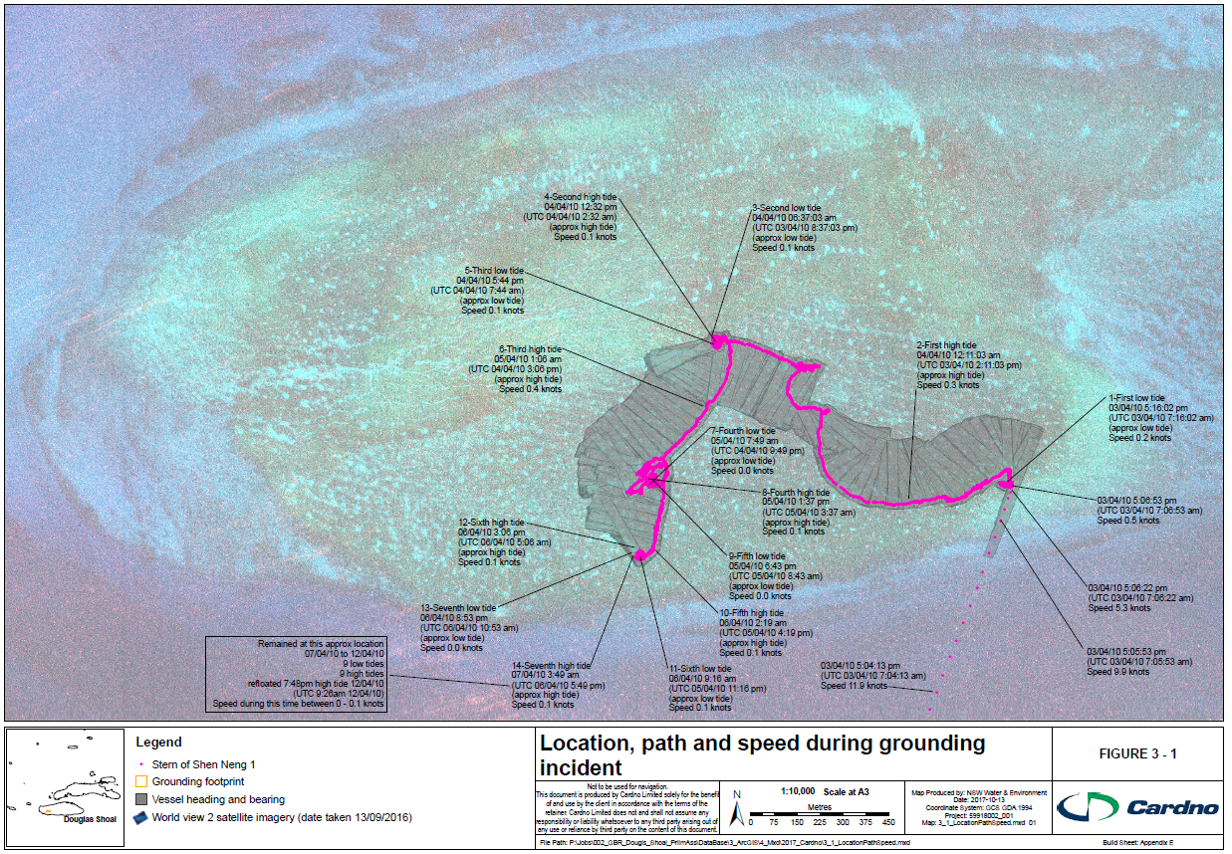
          - Location, path and speed of Shen Neng 1 during grounding incident

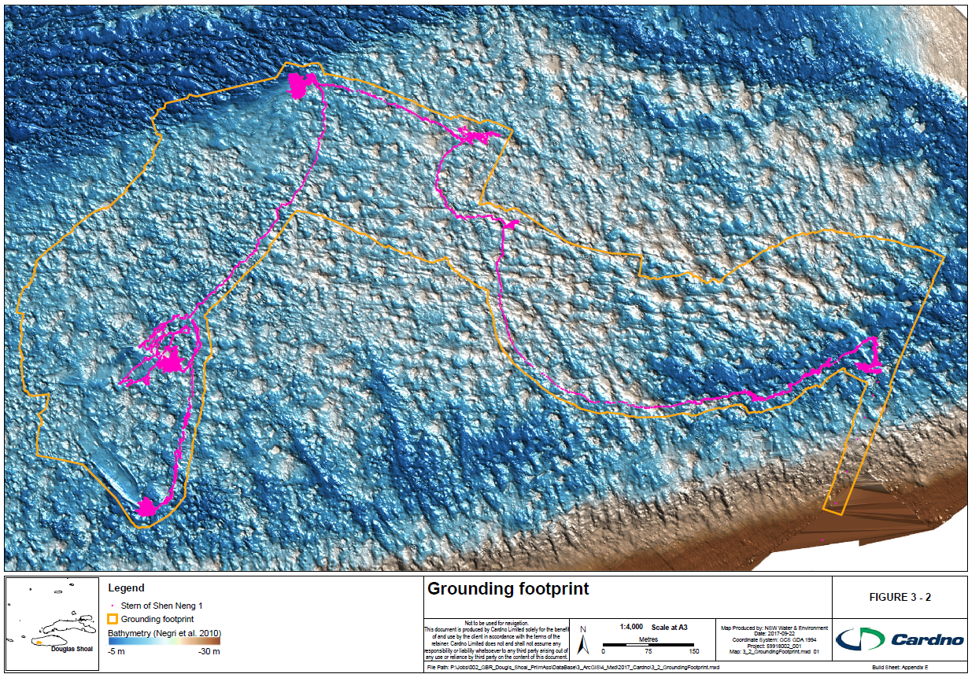
          - Grounding footprint

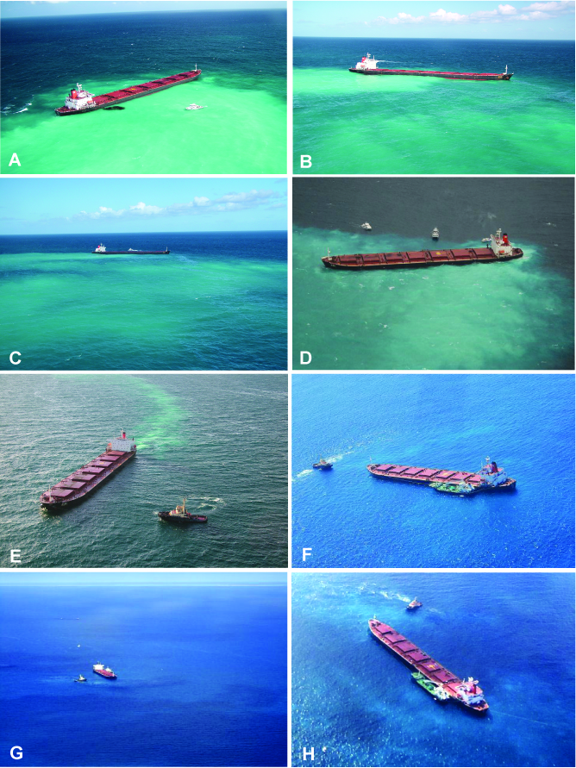
          - Images of Shen Neng 1 aground at Douglas Shoal. Aerial imagery of sediment plumes created during the Shen Neng 1 grounding period. Flood tide (A, B, C; MSQ 2010) and ebb tide (D; AMSA 2010) plume movement on April 4. Aerial images from April 6 (E), (F) (G & H) (MSQ, 2010)

Physical Damage and Contamination

Overview
This section:
- Summarises the results of damage and contamination reported in GBRMPA-commissioned studies / reports (Table 4-1)
- Presents a series of figures / maps that combine all relevant georeferenced data from each GBRMPA-commissioned study
- Describes (using the above figures / maps) the nature and scale of physical damage and contamination.
The purpose of this section is to:
- Inform the identification of possible priority areas for remediation
- Identify gaps and uncertainties that may represent a risk to effective remediation planning and monitoring.
Key points are summarised below. Information gaps included at the end of this section.

Key Points
- The grounding footprint is located at the western section of Douglas Shoal.
- Figures herein suggest there is a close correlation between the area traversed by Shen Neng 1 during the grounding incident and the physical damage and contamination recorded
- The morphology of the adjoining High Relief Terrace constrained the movement of Shen Neng 1 during the grounding incident, with most physical damage identified situated within the Low Relief Terrace.
- While no data are available for 77% of the grounding footprint, the distribution of physical damage is focussed at four quite distinct areas with patches of physical damage recorded between these locations.
- Physical damage includes fractured and displaced benthic substrate and habitat.
- Due to low rates of cementation / coral accretion, fractured and or displaced benthic substrate is unlikely to repair itself at rates similar to biogenic reefs. This includes displaced and fractured substrate in the form rubble, which are unlikely to consolidate. These morphological features are likely to remain for decades.
- Unconsolidated rubble is likely to cause secondary impacts to the natural environment of Douglas Shoal by preventing new growth and possibly mobilising during storms, damaging previously unaffected areas.
- Distribution of antifouling paint particles (AFP particles) and concentrations of TBT, copper and zinc are highly variable across the grounding footprint.
- Some contamination was recorded outside the grounding footprint.
- The geotextural properties (shape, size) of abraded AFP particles lost from the hull of Shen Neng 1 vary significantly.
- The amount (by weight) of AFP particles present at Douglas Shoal is estimated to be in the many tonnes.

GBRMPA-commissioned Studies – Summary of Damage and Contamination
Table 4-1 summarises the purpose, objectives and approach for the 10 GBRMPA-commissioned studies. Reported results / key observations together with date / timing of site visits are also included.

Approach to Consolidating Results and Findings

Rationale
During the development of this report, Cardno identified a number of differences between GBRMPA-commissioned studies and reports. For example, earlier studies (Marshall, 2010) used rapid assessment techniques to broadly define and characterise physical damage and contamination, others focussed on potential remediation techniques or were developed to support legal proceedings. Additionally, different terms are used to describe physical damage and impacts. While the reasons for these inconstancies are likely to relate to the timing and objectives of each study, direct comparison between data sets is problematic.

Concepts and Definitions

Framework / Structure
The structure and language of this section is based on the Driver, Pressure, State, Impact, Response framework (DPSIR). DPSIR is a framework that conceptualises the cause-and-effect chain that links drivers, activities and impacts to the state of relevant environmental values and the benefits these values provide (Oesterwind et al. 2016).

Definitions
While the DPSIR is a widely used framework for identifying and evaluating environmental effects, inconsistent use of language can cause confusion and affect the delivery of key messages being communicated (Oesterwind et al. 2016). For example, GBRMPA-commissioned reports tend to use the terms damage and impact interchangeably, yet most data relate to damage or contamination, not impacts.
It is suggested that the clear differentiation between the ‘environmental receptor state change’ and ‘impacts’ may help to strategically focus future remediation planning effort. Definitions are provided in Table 4-2. These are further expanded upon below.
Driver
The driver is the grounding of Shen Neng 1 (Section 3); the action that resulted in changes in condition of the environmental receptor state (Douglas Shoal).

Pressures
Pressures can be considered either as direct or secondary.
Direct pressures include:
- Contact with the hull of Shen Neng 1
- Contact with the vessel’s anchor while Shen Neng 1 was adrift
- Contact with anchors deployed by the incident response team
- Contact with the propeller of Shen Neng 1
- Smothering by sediment generated during the grounding incident
- Loss of bunker fuel
- Loss of AFP particles from the hull of Shen Neng 1.
Secondary pressures are mechanisms created by a receptor state change. These include:
- Movement of displaced benthic habitat in the form of rubble
- Modified water quality
- Modified sediment quality.

Environmental Receptor State
The environmental receptor state is the inferred composition and condition of benthic substrate and habitat within the Low Relief Terrace (Section 2) prior to the grounding incident.

            - Summary of results / observations relating to physical damage and contamination (GBRMPA-commissioned studies)
Citation | Purpose / Key Objectives | Data captured / Approach | Reported results / observations
Stieglitz 2010 | Assess and delineate structural damage of the Reefal Shoal structural impact | High-resolution multibeam sonar bathymetry (15 - 17 April 2010) | - Sonar data detected structural impact at four locations within the grounding footprint  - Strong correlation between these four locations and locations where Shen Neng 1’s stern remained stationary for ‘some duration’  - Structural damage was not detected at locations where the stern of Shen Neng 1was either moving or stationary for ‘short periods of time’  - Movement of Shen Neng 1 between locations with the grounding footprint correlate to increase clearance (under keel) associated with tidal fluctuations
Negri et al. 2010 | Map Douglas Shoal using high-resolution multibeam sonar to:  - Quantitatively estimate the extent and severity of damage  - Assess the benthic habitat and biota within the grounding footprint  - Assess the benthic habitat and biota outside the grounding footprint | Georeferenced imagery (~ 16 km of towed underwater video 17 - 18 April 2010) paired with the High-resolution multibeam sonar bathymetry data (collected by Steiglitz 2010 between 15 - 17 April 2010) | - Presents the results of Steiglitz 2010 (above)  - Identified extensive areas of unconsolidated rubble (within the grounding footprint) associated with contact of the hull of Shen Neng 1  - Identified ‘broad areas levelled by Shen Neng 1  - Identified dislodged corals and or reef substrate  - Identified distinctive drag marks associated with anchor drag  - Identified areas of undamaged substrate and benthic habitat
Marshall 2010 | - Inspect areas of Douglas Shoal in the vicinity of the known path of the grounded vessel and identify areas that had suffered recent physical damage  - Delineate areas of recent physical damage and characterise the type and severity of damage  - Collect indicative samples of sediments, including samples of any reef material visibly affected by antifoulant paint  - Collect water samples (if there was any indication of oil leakage or hydrocarbon contamination of discharged ballast water)  - Collect photos and video footage representative of damaged and undamaged areas of Douglas Shoal. | - Still photographs and video footage paired with handheld GPS towed on a boogie board  - Samples of sediments and antifoulant paint and metal debris  - Contemporaneous field reports / logs (12 – 13 April 2010) | - Found spatially extensive and severe damage to the reef community on Douglas Shoal  - Severely damaged areas (13,448 m²) were characterised by near‐complete destruction of the ecological community, with the underlying reef substrate either scraped clear or covered in expanses of freshly created coral rubble  - Estimated 4,293 m² of seabed was moderately damaged and approximately 1,346 m2 had minor damage  - Estimated that 19,087 m² of reef area to be damaged (in-total)  - Particles of antifouling paint were observed amongst the rubble and smeared onto the reef substrate in some of the severely damaged areas  - Additional, more detailed surveys will help ascertain the full extent of physical damage, the severity and distribution of contamination from antifoulant paints, and inform evaluation of remediation options
Monkivitch 2010 | - Estimate the amount of damage to the hull of Shen Neng 1  - Inform an assessment of paint lost from the vessel during grounding incident  - Determine the chemical composition of hull coatings | - Underwater inspection and sampling of the hull of Shen Neng 1  - Thirty three (33) hull scrapings and 146 images were collected during a single day inspection (21 May 2010) | - Recorded damage for all underside areas of the hull with extensive areas of paint loss  - Chemical analysis of paint samples confirmed the presence of active (biocide) ingredients, including tributyltin (TBT), zinc oxide and copper oxide, at environmentally significant concentrations  - Observations confirmed that the damage to the hull was sufficient to expose and abrade the underlying TBT containing paints from the hull and therefore contamination of the sediments of Douglas Shoal with antifouling paints including TBT is certain to have occurred as a result of the grounding incident
GBRMPA 2011 | Compiles the results of Steiglitz (2010, Negri et al. (2010) and Marshall (2010) | - Additional site visit 11 – 12 May 2010  - Sediment samples  - Photographic data  - Contemporaneous field reports / logs  - Plus desktop review of Steiglitz (2010, Negri et al. (2010) and Marshall (2010) | - Estimated 116,353 m2 of severe damage  - Estimated 290,985 m² of ‘patchy moderate to severe’ damage’
Kettle 2011 | Independent technical review / analysis of:  - GBRMPA (2011)  - Monkivitch 2010 | - Desktop review  - 1 day site visit  - Sediment sampling  - Dive observations | - Estimated 187,246 m² of severe physical damage within the grounding footprint  - Estimated 220,092 m² of minor physical damage within the grounding footprint  Estimated 1000 m² of physical damage outside the grounding footprint  - No estimate of AFP contamination within the grounding footprint  - Estimated 173,823 m² of AFP contamination outside the grounding footprint
Kettle 2014 | Analysis of:  - Damage, including type, extent and severity  - Changes in nature and extent of damage since Kettle (2011)  - Extent of any natural recovery  Recommended steps to remediate the site | - Five day site visit (9 to 13 October 2013)  - SCUBA  - Observations  - Sediment samples collected from 5 ‘rubble filled’ depressions  - Laboratory analysis  - Video transects of benthic habitat  - Trialling diver operated dredging and water treatment  - Sampling of sediment as part of the remediation trial  - Analysis of samples  - Diver observations and field logs | - Found that physical damage associated with the grounding incident was still ‘readily identifiable’  - Found some evidence of weathering of AFP flakes and smears  - Found small areas of rubble colonised by algae and other organisms  - Found macro algae dominated Douglas Shoal, with Dictyopteris sp. six times more abundant within the grounding footprint  - Found evidence of TBT degrading to DBT (in one location only)  - Observed that ‘pollutants are well mixed into the sediment profile’  - Concluded that remediation will require larger scale operations compared to that trialled  - Little if any reef stabilisation or recovery was observed  - AFP particles include smeared rubble, aggregates, and flakes  - Found evidence of contamination outside the grounding footprint  - Potential for resuspension of contaminants exists
Kettle 2015 (a) | Development of an effective method for remediating Douglas Shoal – pre cyclone Marcia work
Kettle 2015 (b) | Develop an effective method for remediating Douglas Shoal – post cyclone Marcia work | - Sampling of sediment as part of the remediation trial  - Analysis of samples  - Diver observations and field logs | - Found evidence of contamination outside the grounding footprint  - AFP particles were observed outside the vessel path
Marshall 2016 | The objectives of the survey were to:  - Determine the concentrations of contaminants associated with antifoulant compounds in mobile fauna inhabiting the contamination sites at Douglas Shoal  - Determine if levels of contamination in biota from Douglas Shoal are significantly different from adjacent reefs  - Determine if there are detectable differences in the levels of contamination of mobile fauna between the different contamination sites within Douglas Shoal  - Determine if there are indications of bioaccumulation or biomagnification of contaminants through the trophic system at Douglas Shoal  - Determine if contamination in species of mobile fauna targeted by fishers exceed thresholds for human health. | - Collection of mobile fauna from contaminated and reference sites (Douglas Shoal, Haberfield and Tryon shoals) 10 – 13 July 2016  - Sampling of tissue from specimens  - Laboratory analysis for organotins, copper and zinc | - Mobile fauna inhabiting the contamination site at Douglas Shoal did not have consistent or high levels of contamination from antifoulant chemicals, compared to reference sites+  - Only 2% (3 out of 157 specimens) of mobile fauna sampled in the survey had detectable concentrations of organotins (TBT and its breakdown products) in their tissues  - All specimens had detectable concentrations of copper and zinc, but there was no evidence of consistently elevated levels in specimens from Douglas Shoal compared to Reference locations.  - Provides evidence that there is negligible risk to the health of humans consuming seafood caught at Douglas Shoal in relation to contamination from TBT, copper or zinc.

            - Framework components and definitions
Term | Definition
‘Driver’ | The action that resulted in change to the ‘receptor state’
‘Pressure’ | The result of the driver-initiated mechanism causing an effect, that may alter the state of the receptor
‘Environmental receptor state’ | The actual condition of Douglas Shoal and its components (Marine Park values) prior to the grounding incident
‘Environmental receptor change state’ | The actual condition of Douglas Shoal and its components (Marine Park values) following the grounding incident
‘Impacts’ | The consequences of a receptor state change
‘Response‘ | The management actions seeking to reduce or prevent an unwanted change or to develop a positive (desirable) change in the receptor state

Environmental Receptor State Change
The resultant changes to benthic substrate and habitat as a result of initial and secondary pressures. In this report they include physical damage and contamination.

Physical Damage Descriptors
In this report, physical damage is described as either displaced and or fractured. These simplified categories are adapted from Precht (2006). Figure 4-2 includes examples of physical damage sustained during the grounding incident.

Impacts
Impacts are the measurable consequences of an environmental state change and may include loss or modification of Marine Park Values.

Physical Damage
This section provides a description of nature and scale of physical damage (an environmental state change).

Nature of Physical Damage
Nature refers to location and type of physical damage.

Location
With regard to location of physical damage, Figure 4-1 presents data as 10 x 10 m colour coded grid cells. Where physical damage was recorded within a cell, it is coloured coded yellow. Where no damage was observed, cells are colour coded green and reported as undamaged. In the absence of data, grid cells are left empty (transparent). Please note that in most cases, each cell contains a single data point (interpolated to the full extent of the 10 x 10 m cell). Therefore, while a cluster of yellow cells may indicate a broad area of physical damage, the results displayed in Figure 4-1 may not be representative of physical damage for the entire cell (see Appendix E for build report).
Figure 4-1 shows that recorded physical damage is located predominantly within the Low Relief Terrace. It appears that the morphology of the adjoining High Relief Terrace constrained the movement of Shen Neng 1 (during the grounding incident) and may have influenced the nature of the associated physical damage. The scale (extent) of physical damage recorded within and immediately adjacent to the grounding footprint is described in Section 4.4.2.

Environmental Receptor State Change / Physical Damage Type
Environmental receptor state changes were described by Marshall (2010), GBRMPA (2011), and Kettle (2011). Figure 4-2 includes some images from within the grounding footprint showing displaced and fractured substrate and habitat. Additional photos taken by Marshall (2010) are included in Appendix F (Figures F - 14 through F – 17). These particular photos were taken 13 April 2010(immediately following the grounding incident). Please note that no locational data were available for these photos.

Scale of Physical Damage

Spatial Extent
Figure 4-1 shows the interpolated extent of recorded physical damage within and adjacent to the grounding footprint (in 10 x 10 m grid cells).
Of the 4503 grid cells that are within the grounding footprint, or overlap its boundary, 598 (13.2 %) contain recorded physical damage, 418 (9.28%) have no observed physical damage and 3487 cells (77%) have no data.
The distribution of physical damage across the grounding footprint is focussed at four quite distinct areas. These include the location the Shen Neng 1 first ran aground and three locations where she was stationary for 6 hours or more. At the latter locations, displaced substrate, reflecting the shape of the hull of Shen Neng 1 are clearly identifiable. Patches of physical damage were recorded between these locations.
In addition to sonar (which measure depth from the device to the substrate), Steiglitz (2010) collected backscatter data. Backscatter records the strength of the signal being reflected off the substrate. Signal strength can be affected by nature of substrate e.g. sand or rubble versus intact limestone pavement. Interestingly, the number of cells with physical damage increases when the backscatter data are included for the eastern most segment of the grounding footprint (see inset of Figure 4-1) from 3,800 m² to 58,400 m². For the remainder of the grounding footprint, the number of yellow coded cells remain generally static (when the backscatter data is added). This variability is either anomalous or alternatively, it may indicate a different type of physical damage in the area where Shen Neng 1 first ran aground (e.g. displaced habitat with limited displacement of substrate).
Outside the grounding footprint, 25 cells contain recorded physical damage and 1063 have no observed physical damage. All other cells (N=78,431) have no data.
A qualitative review of TUV images suggest the damage identified in the northern most yellow coded cell shown in Figure 4-1 is an anomaly and appears to be a natural deep gutter with sand. The remaining 24 cells are categorised as damage. Further analysis of the TUV data could be undertaken and might reveal that some of these 24 other outliers are also naturally occurring features rather than physical damage.

Persistence of Physical Damage
No data were collected regarding the likely persistence of physical damage. However, it is understood that:
- The scars shown in Figure 3-2 (2010) are still visible in satellite imagery captured in 2016 (Figure 4-6) and are likely to remain morphological features for decades.
- Due to low rates of cementation / coral accretion, fractured and or displaced benthic substrate is unlikely to repair itself at rates similar to biogenic reefs. This includes displaced and fractured substrate in the form of rubble, which are unlikely to consolidate.
- This unconsolidated rubble is likely to cause secondary impacts to the natural environment of Douglas Shoal by preventing new growth and possibly mobilising during storms, damaging previously unaffected areas.

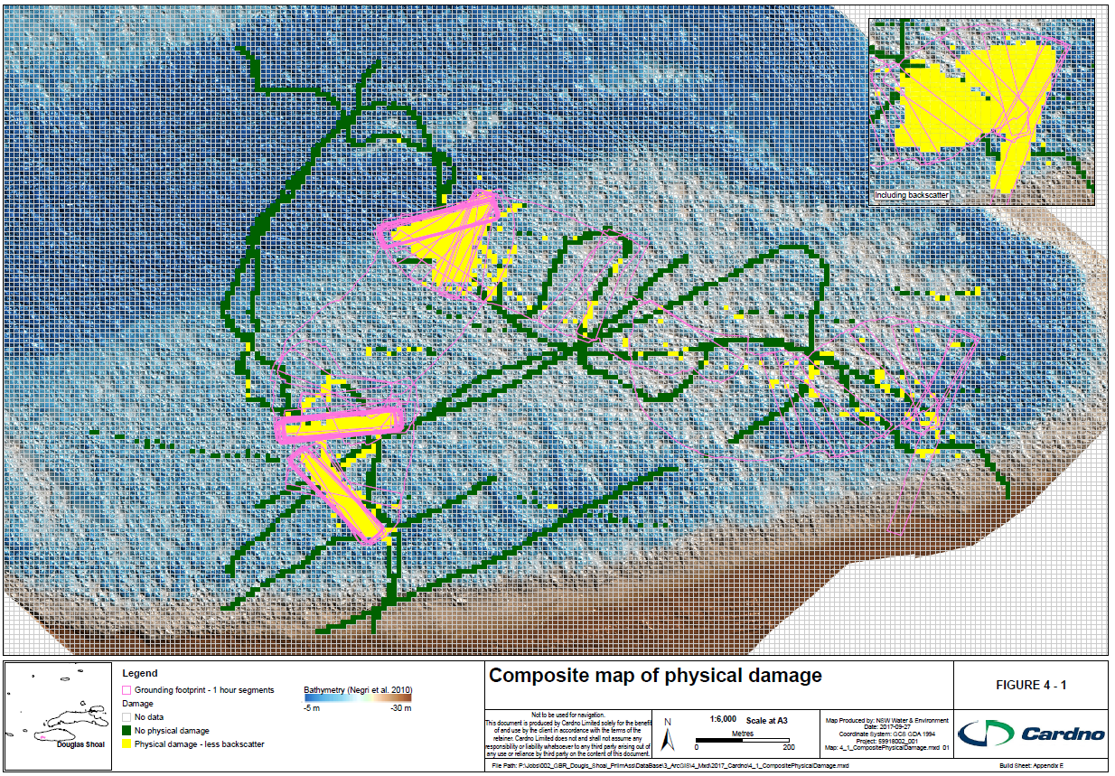
          - Composite map of physical damage

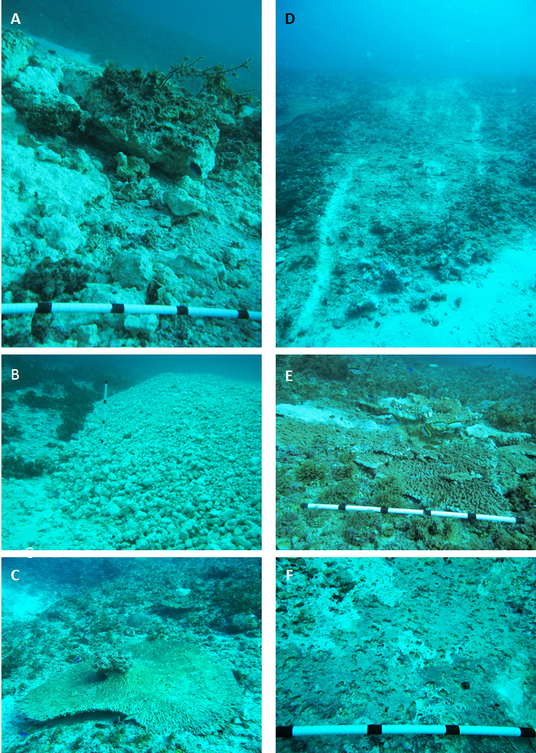
          - Images of physical damage
Figure 4-2: A) Substrate - fractured & displaced. B) Substrate - displaced (berm). C) Benthic fauna – displaced (toppled). D) Substrate – displaced (scarring). E) Benthic fauna – dislodged. F) Substrate – displaced (compressed).

Contamination
This section provides a description of nature and scale of contamination (an environmental receptor state change).

Nature
Nature refers to the location and type of contamination.

Location
Figure 4-3 (see Appendix E for build report) presents data as 10 x 10 m colour coded grid cells. Where contamination (TBT, copper or zinc) or AFP particles were recorded, the cell is orange. Where a sample was analysed, but nothing detected, cells are colour coded green and reported as ‘no contamination detected’. In the absence of data, grid cells are left empty (transparent). As per Figure 4-1, each cell may contain a single data point (interpolated to the full extent of the 10 x 10 m cell). Therefore, the attributed status of each cell may not be representative of the entire area within that particular cell.
Similarly to physical damage, data presented suggest there is a clear relationship between the grounding footprint and recorded contamination. The distribution of contamination is discussed in Section 4.5.2.

Form of contamination
The source of contamination (the pressure) is the abraded antifouling paint particles lost from the hull of Shen Neng 1. A summary of these paints and their active constituents is provided in Section 3. Images of AFP taken within the grounding footprint are included in Figure 4-4. Kettle 2015(a) provides a comprehensive assessment of the ‘types of AFP recovered’ during a remediation trial. In summary, AFP particles include:
- Smears embedded onto substrate
- Smears on displaced and or fractured substrate (rubble)
- Flakes, ranging from 2-3 mm to 100 mm
- Chips 1-2 mm
- Microscopic < 1mm.

Scale of Contamination

Volume of AFP abraded from Shen Neng 1
The volume of paint abraded is unknown. However, conservative estimates provided by Gilbert (pers com. 2017) suggest tonnes of AFP particles were lost from the hull of Shen Neng 1 during the grounding incident.

Spatial extent / Distribution / Concentrations
Distribution of AFP particles and concentrations of TBT, copper and zinc are highly variable. Figure 4-3 shows the extent of recorded contamination derived from 412 samples. Of these:
- 218 cells or ~ 53% contained no contamination; 62 cells were inside and 156 were outside the grounding footprint.
- 194 cells (~ 48%) contained either TBT, copper, zinc or AFP particles
- 135 cells (~ 69%) with recorded contamination, were situated within the grounding footprint or overlap its boundary, 59 (~30%) were located outside the grounding footprint.
Noting the high number of samples with no detected contamination (i.e. below laboratory detection limits), it is suggested that recorded concentrations of TBT, copper and zinc exceed pre-grounding values of these determinands.
The location of TBT, copper, zinc sample results are available in Appendix F (Figures F-5 through F-8 respectively). AFP particle count sample locations and results are shown in Figure F-9 (Appendix F). These data indicate that:
- The area in which Shen Neng 1 initially ran aground contains the highest number of AFP particles per sample and concentrations of TBT, copper and zinc that exceed ANZECC High guideline (NAGD 2009).
- TBT, copper and zinc were detected in close proximity to areas where Shen Neng 1 was stationary or was moving slowly
- AFP particles were also detected in close proximity to areas where Shen Neng 1 was stationary or was moving slowly.
- 3 samples containing TBT were located outside the grounding footprint
- 2 samples containing copper were located outside the grounding footprint
- 2 samples containing zinc were located outside the grounding footprint
- AFFP were recorded outside the grounding footprint, but most within close proximity to the grounding footprint.
No data were available regarding:
- The location of AFP particles smears (as shown in Figure 4-4)
- The vertical distribution of AFP particles or concentrations of contamination within sediment
- Bioavailability and toxicity of contamination as present
- The ecological risks of the contamination as present.

Persistence
Kettle 2015(a) does present results which suggest TBT is breaking down at some locations. However, no studies or investigations have systematically evaluated the likely persistence of contamination at Douglas Shoal. Including:
- Leaching rates of biocides
- The fate of AFP particles (spatially and temporally).

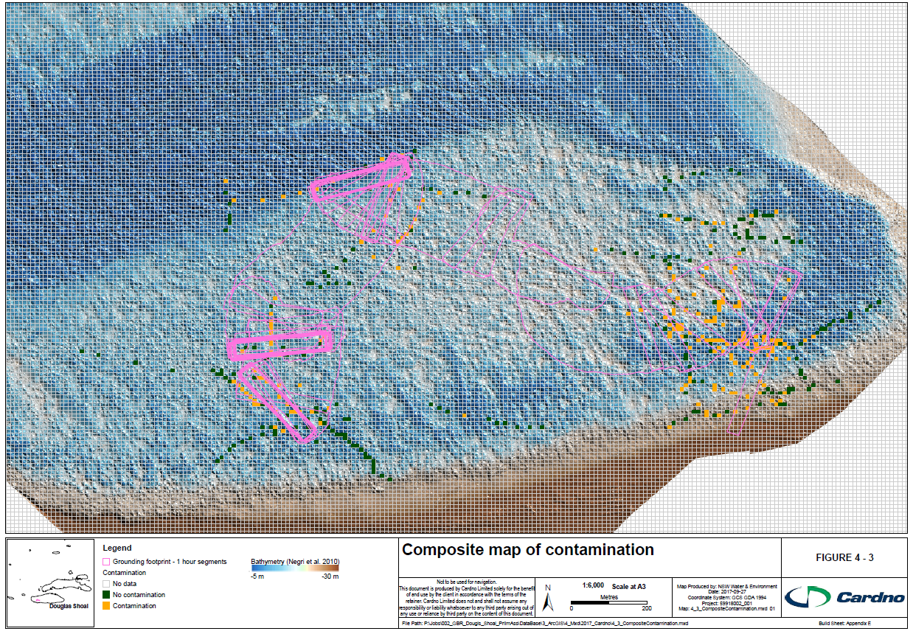
          - Composite map of contamination

Physical Damage and Contamination
Data from Figure 4-1 and 4-3 were combined to develop Figure 4-5. This composite map presents data as 10 x 10 m coded grid cells. Where only physical damage was recorded, the cell is yellow. Where only contamination was recorded, cells are colour coded orange. A red colour code denotes locations where physical damage and contamination where recorded in the same cell. Where either no damage or no contamination were recorded, cells are colour coded green. In the absence of data, grid cells are left empty (transparent).
Of the 4503 grid cells that are within the grounding footprint, or overlap its boundary (Figure 4-5):
- 437 or 9.7% have no recorded contamination or damage (green)
- 68 or 1.5 % have recorded physical damage and contamination
- 530 or 11.8% have recorded physical damage only (yellow)
- 89 or 1.9% have recorded contamination only (orange)
- 3349 or ~ 75% have no data (transparent).
Figure 4-5 suggests there is a close correlation between the areas traversed by Shen Neng 1 during the grounding incident and the physical damage and contamination recorded. These results are consistent with observations made by GBRMPA (2011) and Kettle (2011).
Importantly, four broad areas with both physical damage and contamination are identifiable. These areas are further delineated and discussed in Section 5.

Potential Impacts
As previously stated, impacts are the measurable consequences of environmental receptor state changes. While scientific literature provides a general understanding of the likely impacts of physical damage and AFP contamination on the marine environment, there has been no systematic, deliberate assessment conducted to determine the actual or likely impacts at Douglas Shoal. It is suggested that without a sound understanding of how the local ecosystem functions, it may be difficult to attribute certain impacts to Shen Neng 1, or to evaluate how successful remediation has been.
Notwithstanding the above, and for completeness purposes, a brief summary of possible potential impacts to Marine Park values (identified in Section 2) are provided below. Please note that without a comprehensive study that identifies environmental receptor state change - impact relationships, the following section is descriptive and unlikely to be comprehensive.

Biodiversity
Impacts to biota may arise due to environmental state changes in the habitats and ecosystems on which they rely (Precht, 2006). For example, in relation to groundings, displacement of the substrate resulting in habitat reduction, at a local scale, can impact the health or survival of individual animals. Furthermore, populations may rely on specific habitat features to provide nursery, feeding and breeding areas and impacts to the benthic substrate and habitat may result in indirect impacts on populations. Impacts may also result from factors such as a reduction in available habitats for settlement of coral recruits or secondary physical damage from the movement of displaced substrate (rubble).

Traditional Owner Values
Traditional Owners have custodial responsibilities as part of their lore which ties them to country, thereby ensuring the maintenance of spiritual, cultural, biological and other values of such sites. As a result, impacts on biodiversity degrade and impact on Traditional Owner heritage values as biodiversity is fundamental to their connection to land and sea country.
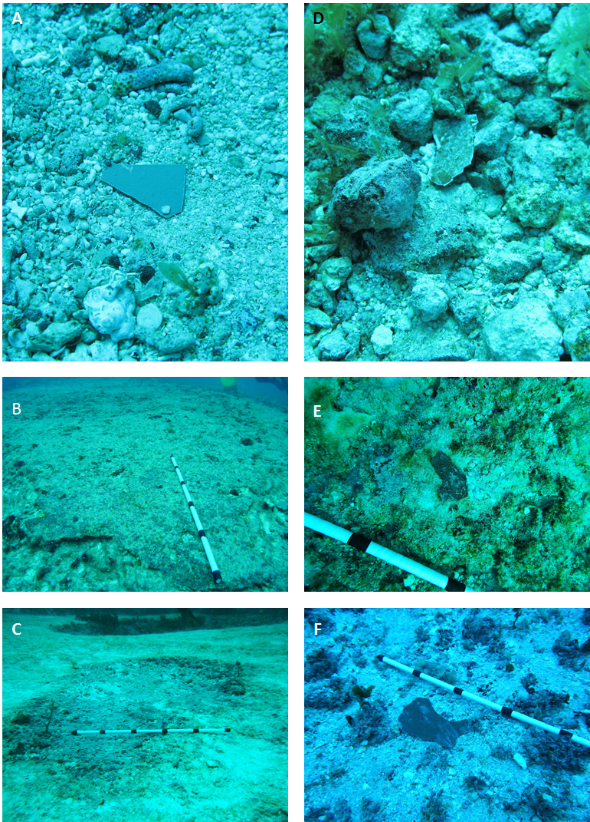
          - Images of in-situ AFP
Figure 4-4: A) Flake B) Large smear. C) Large smear (toppled). D) Flake amongst rubble. E) Small smear F) Large flake.
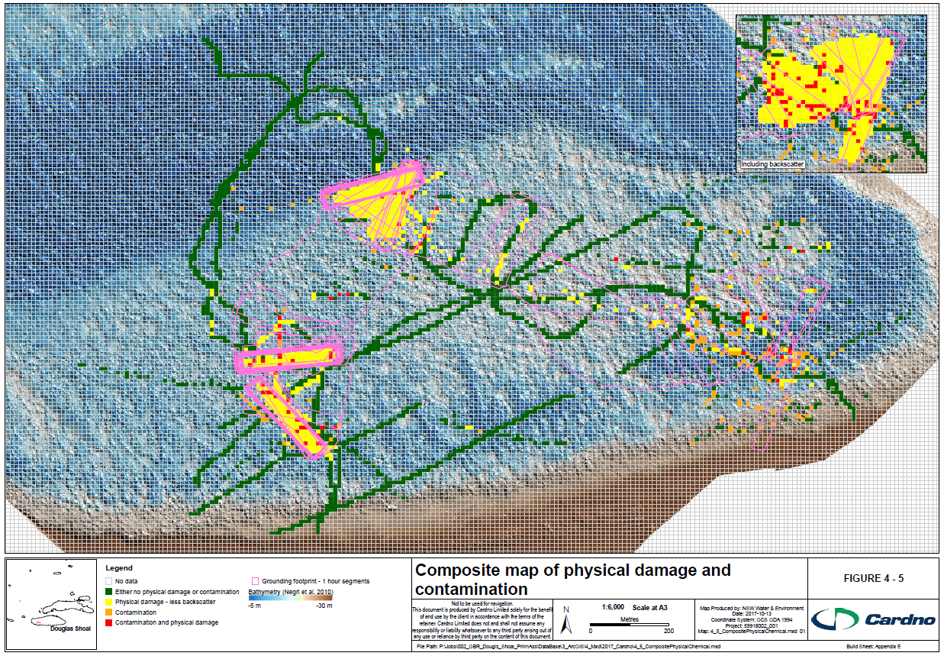
          - Composite map of physical damage and contamination
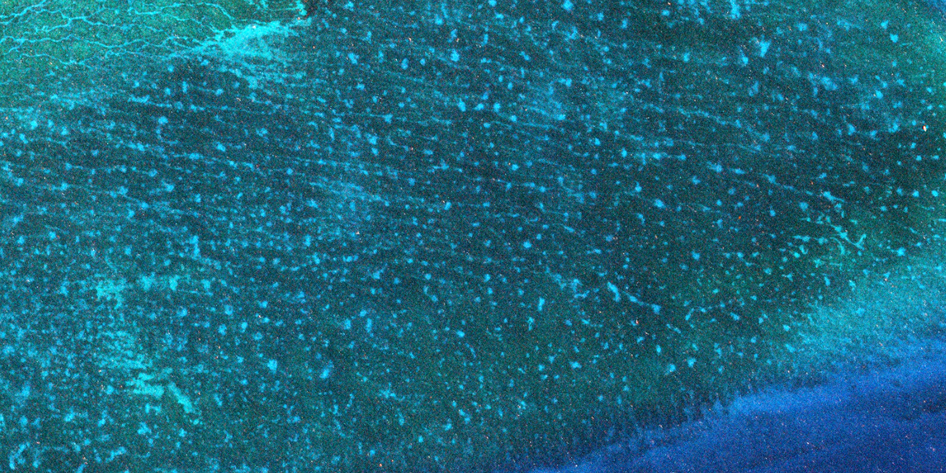
          - 2016 World View 2 satellite imagery (red arrows point to visible scars, see Figure 3-2 for corresponding bathymetry)

Historic Heritage Values
While no historic heritage sites are known to exist at Douglas Shoal, it is important to consider during planning for remediation that historic heritage artefacts can be lost if accidentally disturbed. In addition, many people have personal connections to historic heritage through their ancestors and may feel personally impacted if a site is damaged.

Social and Economic Values
Potential impacts from the grounding may relate to the loss of perceived value associated with the grounding incident. Secondary impacts may include restrictions on access to sections of Douglas Shoal during the remediation works and subsequent performance monitoring programs.

Data and Information Gaps
Key gaps are listed below. Potential risks associated with these gaps are presented in Section 6.
G4.1 Data are not available to identify the nature (category) of all physical damage associated with the grounding incident.
G4.2 No data are available to further refine the extent of damaged and undamaged areas of Douglas Shoal.
G4.3 Data on the recovery potential of non-biogenic reefs from ship groundings (persistence of physical damage) or other perturbations is absent in the literature.
G4.4 No systematic, deliberate assessment of the consequences (impacts) from physical damage has been undertaken.
G4.5 No data are available to further refine the nature (form) and scale (extent and concentration) of contamination present
G4.6 No studies or investigations have systematically evaluated the likely persistence of contamination at Douglas Shoal. Including:
- Leaching rates of biocides
- The fate of AFP particles (spatially and temporally).
G4.7 No data exists regarding the vertical distribution of contamination within sediments.
G4.8 The geotextural properties of sediment (grain size, composition) have not been characterised, nor has a facies map been developed.

- are applied to the hulls of vessel’s to prevent the build-up of marine organisms
Antifouling paints incorporate biocides (active ingredients), which retard or prevent growth of marine organisms on the hull of ship’s
These data do not reflect the actual amount of paint lost only what was on the hull (to[p coat) prior to the grounding
see Figure 2-2 which shows the shoal in its entirety
Summary of relevant results / observations only. Please see the original reports for complete results.
Based on towed underwater video imagery (Negri et al. (2010); manually delineation of visibly displaced substrate, and georeferenced images from Marshall (2010) – see Appendix E
Not all samples were included due to locational reference issues

