# GREAT BARRIER REEF MARINE PARK AUTHORITY

# 2017–18 CORPORATE PLAN

# for 2017-18 to 2020-21

## Traditional Owner acknowledgement

The Great Barrier Reef Marine Park Authority acknowledges the continuing sea country management and custodianship of the Great Barrier Reef by Aboriginal and Torres Strait Islander Traditional Owners whose rich cultures, heritage values, enduring connections and shared efforts protect the Reef for future generations.

## Chairman’s foreword

The Great Barrier Reef Marine Park Authority is responsible for protection of the Great Barrier Reef.

The Reef is a jewel in the crown of Australia’s environmental estates—famous for its spectacular beauty and diversity of marine life and habitats. As an iconic feature of the Australian landscape, listed on the World Heritage register in 1981, and one of the most valuable ecosystems on the planet, the future of the Great Barrier Reef is a priority for the Australian Government.

The Authority appreciates the Reef’s value to people everywhere and in particular respects the unique cultural value the Reef holds for its Traditional Owners, who have a special and continuing connection with the area.

The independent Authority was established by the Australian Government’s *Great Barrier Reef Marine Park Act 1975* and its purpose is *to ensure the long-term protection, ecologically sustainable use, understanding and enjoyment of the Great Barrier Reef for all Australians and the international community through the care and development of the Marine Park.*

Like tropical coral reefs around the world, the Great Barrier Reef is under pressure from a range of impacts including climate change, declining water quality, coastal development and illegal fishing.

While the Authority and its partners have a strong record of managing this internationally-acclaimed natural wonder, changes in the condition of the Reef require us to strengthen our focus and resources on the key priorities that will best enable us to achieve our vision of a healthy Reef for future generations.

One of our greatest challenges is to strike the right balance between the care and protection of the environment, biodiversity and heritage values—that are world renowned and celebrated as an integral part of Australia’s identity— with the management of the Marine Park as a multiple use area. To address this challenge we will continue to strengthen our permissions system; work to influence the handling of major risks external to the Marine Park; focus on increased compliance, particularly through our Joint Field Management Program and build our knowledge of the system and its uses, based on the best available science.

Tackling the global effects of climate change while reducing local stresses to build the Reef’s resilience is key to improving the outlook for the Great Barrier Reef.

The Authority will continue its partnership to implement the Reef 2050 Plan—a coordinated, integrated effort by the Australian and Queensland governments that provides an overarching framework for protecting and managing the Great Barrier Reef until 2050. The Reef 2050 Plan responds to the pressures facing the Reef and will address cumulative impacts and increase the Reef’s resilience to longer term threats such as climate change.

Over the forward period the Authority will look to further bolster its relationships with Great Barrier Reef Traditional Owner groups, scoping the progression of co-management arrangements for the care and protection of the Great Barrier Reef. Such arrangements would deliver great environmental outcomes for the Reef, providing extra support to improve its resilience, and increasing and strengthening the network responsible for looking after it.

As a priority the Authority is also introducing a new program focused on embedding climate change-related actions through developing, implementing and enabling interventions to build Reef resilience. This signals a strategic shift towards stronger action to minimise further ecosystem losses and halt the declining condition of the Reef.

Work on this has already commenced with the Authority hosting the Great Barrier Reef Summit — Managing for Resilience, where more than 70 regional, national and international delegates (representing Marine Park managers, Traditional Owners, governance agencies, research institutions, industry groups, Reef users and other stakeholders) came together to develop a blueprint for the Authority and its partners in response to mass bleaching and cumulative impacts on the Great Barrier Reef.

This blueprint extends the resilience-based framework for coral reefs established through the Climate Change Action Plan 2012–2017 and its implementation will have flow-on benefits to many of the Reef’s values.

As managers of the Great Barrier Reef Marine Park the Authority’s top priority is building the Reef’s resilience so it can better tolerate the increasing levels of risks posed by human activities at global and local scales.

We will continue to urge the global community to take strong action on climate change to protect not only the Great Barrier Reef, but the world’s coral reef ecosystems. Together we can secure the future of the Reef—but we must try harder, do more and act now.

Australia is strongly committed to the implementation of the Paris Agreement; to ensure that every effort is made globally to hold the increase in global average temperature to well below 2 degrees above pre-industrial levels and pursuing efforts to limit the global temperature increase to 1.5 degrees.

Effective implementation of the 2015 Paris Agreement to reduce greenhouse gas emissions is essential to reduce the likelihood of more frequent extreme events such as mass coral bleaching and increasingly severe tropical cyclones.

At the same time as we increase protection measures for the Reef we will also focus on our people. We will undertake significant workforce planning to look critically at our skills base and talent pool and position our workforce to best deliver on our business priorities while managing workforce-related risks.

This Corporate plan 2017–18 has been prepared for the Ministers responsible for the Environment and Finance portfolios in accordance with the *Public Governance, Performance and Accountability Act 2013*. It also guides the Authority’s staff and informs the public and stakeholders about our objectives, the scope of our work and our priorities in fulfilling our responsibilities under the Great Barrier Reef Marine Park Act 1975.

**Dr Russell Reichelt FTSE**

Chairman and Chief Executive

August 2017

## Introduction (Statement of preparation)

I, Russell Reichelt as the Chairperson of the Great Barrier Reef Marine Park Authority and the accountable authority, present the Authority’s four-year Corporate Plan, as required under paragraph 35 (1)(b) of the *Public Governance, Performance and Accountability Act 2013*.

The plan is prepared in accordance with the *Public Governance, Performance and Accountability Rule 2014*.

Dr Russell Reichelt FTSE

Chairman and Chief Executive

August 2017

## Vision

A healthy Great Barrier Reef for future generations

### Purpose

The long-term protection, ecologically sustainable use, understanding and enjoyment of the Great Barrier Reef for all Australians and the international community through the care and development of the Marine Park.

The Authority achieves its purpose by focusing on three goals:

* Protect and restore the Reef’s ecosystem health, resilience and biodiversity
* Safeguard the Reef’s heritage
* Ensure ecologically sustainable use and benefits for current and future generations.

To enable the effective measurement of success against its goals and purpose, the Authority prepares the Great Barrier Reef Outlook Report every five years. This includes an assessment of the condition and trend of the Reef’s values and an independent review of management effectiveness. The five-yearly assessment process acknowledges the lag time between the implementation of actions and subsequent results when operating in marine environments.

### Role

The Great Barrier Reef Marine Park Authority is established under the *Great Barrier Reef Marine Park Act 1975* and is the Australian Government statutory authority responsible for protecting and managing the environment, biodiversity and heritage values of the Great Barrier Reef Region.

The Authority reports to the Australian Government Minister for the Environment and Energy and advises the Minister on a range of matters relevant to the care and development of the Great Barrier Reef, including day to day park management, development and implementation of policies, plans and programs to protect biodiversity, build capacity through stewardship and education and synthesise knowledge to guide adaptive management.

### How the Authority operates

To achieve its purpose the Authority will deliver its work under four main program areas with a focus on protecting, managing and restoring the Great Barrier Reef’s ecosystem health, resilience, biodiversity, and heritage values; while working with others to reduce the effects of an accumulation of impacts on this iconic natural wonder.

**Program area 1:** Providing expert knowledge to influence and advise key decision makers on managing, reducing or avoiding significant threats to the Reef.

**Program area 2:** Regulating and ensuring Marine Park user compliance.

**Program area 3:** Educating and fostering stewardship to enhance protection of the Reef.

**Program area 4:** Enhancing reef resilience through continuous improvement and new initiatives across all aspects of management.

### Values

*The Authority is visionary, embraces innovation, demonstrates leadership and integrity, and fosters partnerships with stakeholders in its management of the Great Barrier Reef Marine Park.*

### Planning and Reporting

The Authority has an integrated planning, budgeting and reporting process. This corporate plan is directly aligned to the relevant outcome, programs and performance criteria set out in the *Portfolio Budget Statements 2017–18 Budget Related Paper No 17 Environment and Energy Portfolio*.

The Portfolio Budget Statement together with this corporate plan complement each other to provide a consistent performance story. All documents have a clear line of sight from vision to implementation.

The Authority’s purpose is consistent with its outcome represented in the 2017–18 Portfolio Budget Statement.

Performance measures are grouped under the four program areas detailed in this corporate plan and the 2017-18 Portfolio Budget Statement. This will inform reporting on Program 1.1 *Improving the Outlook for the Great Barrier Reef* associated with Outcome 1. This information will be reported collectively in the Authority’s annual report, specifically in the annual performance statement.

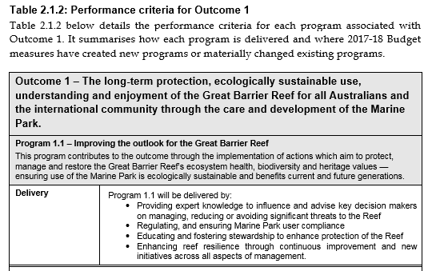

### Working together to improve Reef resilience

The Authority has managed a number of different threats over the last four decades. Today, the most significant threats to the long-term health of the Great Barrier Reef are outside the Authority’s direct control.

Climate change remains the most significant threat to the Great Barrier Reef. Global action to reduce human-caused greenhouse gas emissions is essential to slow global ocean warming which has already caused widespread oceanic heat-waves and the consequential loss of corals world-wide over the past three decades.

The Reef has experienced two significant extreme weather events during 2017—its second consecutive year of ocean heat waves causing mass coral bleaching and the damaging effects of category 4 tropical cyclone Debbie which crossed reefs in the Whitsundays region of the Marine Park. Other threats outside the Marine Park boundary come from human activities relatively more local and manageable – for example poor land use practices leading to pollution and habitat losses.

In order to address these significant challenges, the Authority has stepped up its efforts in working with key partners and decision-makers in State and Commonwealth agencies to raise awareness of the effects of activities outside the Marine Park, particularly on those activities associated with water quality and coastal development—with an aim to create positive influence to improve the health of the Reef.

The Authority’s management approaches include the development and implementation of conservation actions that aim to build the Reef’s resilience; empowerment of others to protect the Reef through education and stewardship programs and provision of expert knowledge to influence and advise key decision makers on managing, reducing or avoiding significant threats to the Reef. These are supported by a range of tools including marine park planning, policy and regulation—such as zoning plans, plans of management, permits, policies and strategies, formal agreements, site management arrangements and compliance and enforcement.

The Field Management Program is the Authority’s key strategic partnership with the Queensland Government—and is essential for the effective management of marine parks (including protected islands) and a large, diverse and complex World Heritage Area. It is integral to the delivery of actions under all the Authority’s program areas.

This joint arrangement—which operates across the Commonwealth Marine Park and the Queensland Great Barrier Reef Coast Marine Park—includes delivering on-ground conservation actions, monitoring ecological and heritage values, responding to incidents, welcoming people and upholding compliance with the Great Barrier Reef Marine Park Zoning Plan. Engaging and involving Aboriginal and Torres Strait Islander peoples in field management is an intrinsic part of program delivery.

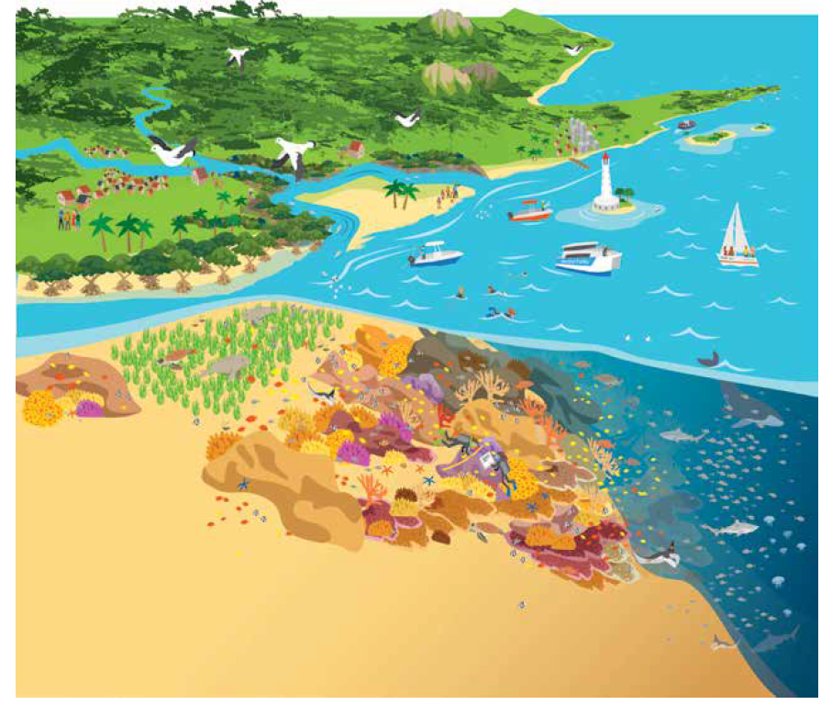

**Figure 1**: **The Great Barrier Reef is a large, diverse, bio-cultural, multiple use marine protected area.**

Under the Field Management Program, the Authority is purchasing a second state-of-the-art patrol vessel to boost field capacity in the southern region of the Great Barrier Reef, enabling improved policing of the Marine Park, particularly against illegal fishing.

Vessel patrols in the Great Barrier Reef World Heritage Area with Queensland Parks and Wildlife Service, Queensland Boating and Fisheries, and the Queensland Water Police will continue to target illegal recreational and commercial fishing. Aerial surveillance of the Marine Park in partnership with Maritime Border Command is now shifting to also include trialling the use of drones in compliance operations. To maximise results from collective resources, ‘cross-decking’ arrangements with partners ‑ sharing staff and other resources between vessels ‑ will remain a priority.

As part of its world leading zoning plan, the Authority ensures commercial use of the Marine Parks remains ecological sustainable through a comprehensive joint permissions systems with Queensland Parks and Wildlife Service. The Authority receives regular advice and guidance from the Tourism Reef Advisory Committee on matters relating to the conservation and ecologically sustainable tourism use of the Marine Park.

The Authority’s comprehensive management is underpinned by a knowledge base that drives its adaptive approach, focusing on managing for resilience in the face of cumulative impacts, particularly climate change. It uses the best available information to inform its management approaches and report on their effectiveness, including scientific, monitoring and modelling data, together with Traditional Owner and stakeholder knowledge. The Authority works with the scientific community to influence research priorities and address gaps in its knowledge.

In delivering its work the Authority continues to build effective relationships with Traditional Owners who are the traditional custodians of the Great Barrier Reef with connections to the area dating back more than 60,000 years. Major projects taking place in close partnerships with Traditional Owners include the realisation of an updated Aboriginal and Torres Strait Islander Heritage Strategy, continuation of the land and sea country partnerships program and progression of data sharing agreements for safeguarding heritage information. The Indigenous Reef Advisory Committee also provides important advice and guidance on sea country management issues building a greater understanding of Traditional Owner values associated with Marine Park management.

The Authority’s Reef Guardian program facilitates the adoption of environmentally sustainable best practices by the community, local government and industry to achieve environmental outcomes for the Great Barrier Reef.

Reef HQ Great Barrier Reef Aquarium, the Authority’s national education centre for the Great Barrier Reef also fosters community and stakeholder behaviour change and participation in actions to address threats to the Reef by ensuring they have a clear understanding of the value of the Great Barrier Reef, the threats to its sustainable future and the actions they can take to protect it.

The Authority works with the Reef and Rainforest Research Centre and the Association of Marine Park Tourism Operators to protect coral cover by culling the crown-of-thorns starfish at priority reefs, particularly key tourism reefs and those at the leading edge of the outbreak.

## Operating environment

### Legislation

The Authority’s legislative operating environment is shaped by the *Great Barrier Reef Marine Park Act 1975*, the *Public Governance, Performance and Accountability Act 2013, the Public Service Act 1999*, the Great Barrier Reef Intergovernmental Agreement with the State of Queensland, and a range of memoranda of understanding.

The Great Barrier Reef Marine Park Act provides for the long-term protection and conservation of the environment, biodiversity and heritage values of the Region. It allows for ecologically sustainable use and encourages stakeholder engagement in protecting and managing the Region. The Act sets out the Authority’s role and through its objects, provides the basis for management of the Region.

### Condition and trend of the Reef

The 2014 Outlook Report found the overall outlook for the Reef had worsened since the previous report in 2009 and was likely to deteriorate in the absence of action to address threats, including at local and regional levels. The report found the most significant factors influencing the values of the Marine Park were climate change, water quality, coastal development and some fishing impacts.

In 2017, a second consecutive year of mass coral bleaching occurred on the Great Barrier Reef, due to ocean warming caused by climate change. The 2017 bleaching impacts add to those from 2016 and extend the cumulative footprint of severe bleaching further south. These events have resulted in unprecedented level of bleaching-related coral die-off in the Great Barrier Reef.

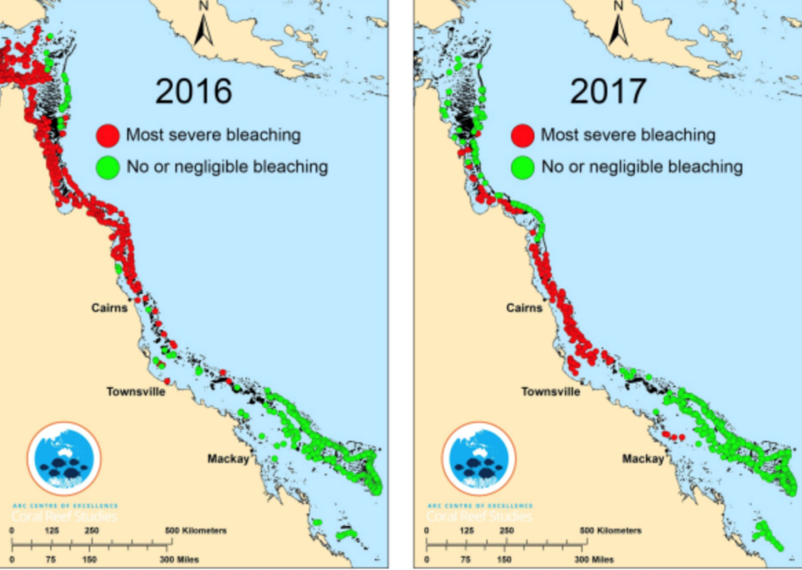

**Figure 2**: **Areas affected by coral bleaching in 2016 and 2017**

Source: Australian Research Council, Centre of Excellence for Coral Reef Studies

In addition to these severe bleaching impacts, large portions of the Reef were subjected to other impacts in early 2017 which occurred simultaneously. Outbreaks of coral disease and crown-of-thorns starfish, damaging seas from a severe cyclone and flood plumes all affected the Reef from January 2017. The cumulative impact of these disturbances has likely reduced overall coral condition and severely diminished the resilience of many reefs north of Mackay.

The cumulative impacts are not only on the Great Barrier Reef ecosystem but also affect nationally important and regionally vital industries, particularly tourism and commercial fishing. These sectors are acutely aware they are also vulnerable to the effects of a changing climate. Similarly the effects extend to the cultural and heritage values of Traditional Owners, social values for communities along the coast for whom the Reef is part of their enjoyment and daily life, and the broader Australian and international community who consider it to be an irreplaceable icon.

Bleaching events are expected to increase in frequency and severity as a result of climate change, making resilience (including recovery processes) increasingly important for reefs to persist as coral dominated systems. The Authority’s priority is supporting the Reef’s resilience and recovery in the wake of the mass coral bleaching which has affected reefs worldwide over the last three years.

These bleaching events highlight the importance of the Authority’s efforts to manage the Reef to support its natural resilience. In relation to the health of corals and recovery processes for reefs, key actions include the targeted crown-of-thorns starfish control program to cull this coral predator and the *Reef Water Quality Protection Plan* to improve water quality. There is also growing evidence that protecting biodiversity through Marine Park zoning is enhancing ecosystem resilience.

### International focus on the state of the Reef

The World Heritage Committee, at its 41st annual meeting in Krakow, Poland, provided strong endorsement that the Reef 2050 plan is working—keeping the Great Barrier Reef off the ‘in danger’ list. The Committee’s concerns originated in 2012 from development along the coastline adjacent to the Reef. The World Heritage Committee focused the public’s attention on the health of the Reef which led to widespread media attention and public scrutiny on Reef management, particularly the actions of the Australian and Queensland governments. The non-stop news cycle and the rise of social media also played a part, enabling heightened community awareness of environmental concerns.

The community is becoming increasingly concerned about the long-term health of the Reef. This has been confirmed through recent market research commissioned by the Authority which found people felt a sense of shame and sadness about the idea of losing the Reef.

It is critical the Authority focuses its efforts on where it can have the most effect in protecting the Reef.

### Reef 2050 Plan – coordinating actions

The Australian and Queensland governments have responded to increased concerns about the health of the Reef with the Reef 2050 Plan – an overarching strategy and approach for the management of the Reef. The plan is based on the best available science and expert advice and defines outcomes, objectives, targets and actions for seven themes including water quality, biodiversity, ecosystem health, heritage, community benefits, economic benefits and governance.

The Reef 2050 plan builds on the finding of the 2014 Outlook Report and the Strategic Assessment of the Great Barrier Reef World Heritage Area and adjacent coastal zone, and provides a high-level strategy to guide investment and actions required to continue building Reef health and resilience.

The Authority is playing a lead role in delivery of the Reef 2050 plan together with the Federal Department of the Environment and Energy, the Queensland Government and other key partners. The Authority is responsible for delivering 74 of the 151 actions identified in the Reef 2050 plan. The Reef Integrated Monitoring and Report Program (RIMReP) is one of the Authority’s most significant new actions being implemented under the Reef 2050 Plan.

The Authority works closely with the Australian Government’s Department of the Environment and Energy and the Queensland Government as well as Traditional Owners, industry and community stakeholders in the delivery of the Reef 2050 Plan.

### Extending influence through partnerships

Stakeholder expectations of the Authority extend beyond its legislative responsibilities. Their interest is driven by increasing public focus on the Reef’s long-term health.

Many of the key threats to the Reef originate from areas outside of the Authority’s jurisdiction, including climate change, coastal development, declining water quality from catchment runoff and some fishing impacts. The Authority’s partnership approach is critical to influencing the management actions of others to reduce pressures on the Reef and build ecosystem resilience. The Authority is working with its Australian Government and Queensland counterparts to highlight areas where more work can be done to improve Reef health either at a policy or operational level, as well as providing advice and feedback through formal consultation processes.

Building on its 40 years of Reef management, the Authority uses the best available scientific information and Traditional Owner and community knowledge to identify the key issues it seeks to influence based on the best outcomes for the Reef.

## Program areas and performance

The Authority’s work program has an emphasis on protecting, managing and restoring the Great Barrier Reef’s ecosystem health and resilience, biodiversity and heritage values. Its restoration approach is increasingly investigating intervention tools to assist with Reef recovery.

The Authority delivers its work program by providing expert knowledge to influence and advise decision makers, regulating use of the Marine Park, educating and fostering stewardship and enhancing reef resilience through continuous improvement in management of the Marine Park.

### Program area 1: Providing expert knowledge to influence and advise decision makers on managing, reducing or avoiding significant threats to the Reef

The Authority continues to work with stakeholders and partners to manage threats to the Reef’s resilience, including climate change, water quality, coastal development and fishing.

Although these threats originate from sources outside the Authority’s jurisdiction it provides expert technical and policy advice to partner organisations in relation to avoiding, mitigating and managing these Reef-related threats.

The Authority’s involvement in the Reef 2050 Plan in particular provides it with an opportunity to influence the coordinated response to key Reef threats in partnership with other Australian Government agencies, the Queensland Government and other parties.

Information collected through the Reef Integrated Monitoring and Reporting Program, as well as the best available information and knowledge from scientists, Traditional Owners, stakeholders, and the Authority’s own staff will form the basis of the Authority’s advice.

Information from the Reef Integrated Monitoring and Reporting Program will also underpin the development of the 2019 Outlook Report, the assessment of Reef 2050 Plan effectiveness and the Reef 2050 plan’s review in 2018.

To complement this targeted engagement, the Authority will also develop its own policies and position statements on addressing threats to the Reef including recommendations on how to best avoid, mitigate and manage threats.

With an increasing number of government and non-government organisations involved in Reef protection, the Authority will make a concerted effort to target its engagement with key stakeholders responsible for critical response plans, frameworks and actions to minimise the greatest risks to the Reef and will focus its involvement to where it can have the greatest impact.

Objective:to consolidate the Great Barrier Reef Marine Park Authority’s influence as the authoritative voice of the Reef.

#### What will the Authority do to focus effort?

* **Focus effort strategically on the stakeholders the Authority needs to influence**, informed by the Outlook Report’s findings on the current state and predicted health of the Reef and market research.
* **Develop position statements on external issues affecting the Reef** — guided by the Outlook Report’s findings, the Authority will continue to work to influence the handling of major risks external to the Marine Park, such as those risks posed by climate change, water quality, coastal development and fishing.
* **Empower partners to undertake activities in areas where the Authority reduces its effort,** such as Reef monitoring, and influence their decisions on where, when and how to act.

#### What does success look like?

* The Authority continues to be seen as the trusted and authoritative voice on the management and protection of the Marine Park and World Heritage values.
* The Authority’s influence — in terms of effort and direction — is focused on outcomes that improve Reef health.
* The Authority’s advice is timely, high quality and tailored for the desired audience, providing positive outcomes for the Reef.
* Knowledge is synthesised efficiently in position statements to help the public understand the Authority’s stance on particular issues.
* Partners are empowered to take complementary actions and make better decisions for the health of the Reef.

#### Performance

| **Performance criteria** | **Target** | **Evaluation** |
| --- | --- | --- |
| Key threats to the Great Barrier Reef are identified, and either addressed or, where external, acknowledged through the provision of authoritative and trusted advice. | Partner entities and peak bodies acknowledge the:   * quality of the Authority’s advice * professionalism and expertise of Authority staff | The number of partners who adopt the Authority’s position on managing key risks. |
|  | 100% of very high or high risks to the Reef are identified, or have effective actions against them in the Reef 2050 Plan or other plans and strategies. | Assessment of very high and high risks identified in the Outlook Report that are reflected in strategies and action plans produced by the Authority, the Queensland Government and the Australian Government. |

### Program area 2: Regulating and ensuring Marine Park user compliance

The Authority is the primary environmental regulator for protecting the Great Barrier Reef. Its role is to set the standards necessary to achieve its purpose and goals and provide certainty about where uses may occur, the types of activities allowed and the conditions under which activities may proceed.

In delivering its work under this program area the Authority uses a combination of management tools and approaches including zoning plans, plans of management, agreements, permits, education, compliance and enforcement.

The Authority’s regulatory framework is effective in managing use of the Marine Park and protecting its values. The 2003 Zoning Plan in particular is regarded world leading and has improved the resilience of the Reef.

Despite this success there is still an opportunity for the Authority to better focus its regulatory effort on activities presenting the highest risks to the Reef and to improve ecosystem resilience in the face of future challenges, such as the effects of climate change and increasing visitor numbers.

The implementation of this work program will also see the Authority scoping co-management arrangements with Great Barrier Reef Traditional Owner groups to further progress and advance current sea country management actions increasing the network responsible for the Reef’s care and protection.

Objective:an efficient and effective risk based regulatory system.

#### What will the Authority do to focus effort?

* **Undertake pre-emptive, Reef-wide planning** to set the risk appetite across the Authority and the Marine Park and identify the areas where the Authority should focus its effort.
* **Take a risk-based approach to issuing permits** by focusing effort on activities and areas deemed to pose high risk to Reef health and reducing effort and investment on low risk activities and areas of the Marine Park to allow more efficient use of the Authority’s resources, and implementing legislative and policy change where required to achieve this.
* **Review existing tools**, such as plans of management, to determine their effectiveness and make changes to improve efficiency and flexibility, and develop new tools through the use of technology to **increase compliance** across the Marine Park.

#### What does success look like?

* Increased compliance and reduced number of non-compliance issues across the Marine Park.
* The right management tools are applied at the right times and in the right places.
* Management tools and interventions are contemporary, reflect best practice and take advantage of cutting edge technology where appropriate.
* Impacts are managed more cumulatively through planning rather than individually through permits.
* The risk appetite is understood and consistent across the Authority and with relevant partners, including the Queensland Parks and Wildlife Service.
* Investment of effort and resources is focused on high risk activities and areas with appropriate investment on low risk activities and areas.

#### Performance

| **Performance criteria** | **Target** | **Evaluation** |
| --- | --- | --- |
| The impacts of human activity on the Great Barrier Reef are reduced through effective and efficient regulation and compliance. | Whitsundays Plan of Management finalised and in force. | Assessment of delivery against project plan |
|  | New permit guidelines finalised and existing ones reviewed to improve transparency and consistency in permit decisions. | Assessment of delivery against project plan |
|  | Spatial planning tools identified and priority sites determined for improved protection. | The number of trials of new tools in place at priority sites/locations. |
|  | 25% of the Marine Park coastline is managed in accordance with an accredited Traditional Use of Marine Resources Agreement or Indigenous Land Use Agreement. | The number of accredited Traditional Use of Marine Resources Agreements or Indigenous Land Use Agreements in place and the area covered. |
|  | 740 compliance patrol days funded through the joint Field Management Program. | Assessment of delivery against Joint Field Management Annual Business Plan targets |
|  | New compliance tools are identified, trialled and reviewed for effectiveness to address key risks. | Assessment of delivery against Joint Field Management Annual Business Plan targets. |

### Program area 3: Educating and fostering stewardship to enhance protection of the Reef

The Authority implements a wide range of education and stewardship programs across the Great Barrier Reef catchment and beyond. These include Reef Guardians, Local Marine Advisory Committees, industry training and the management and operation of the Authority’s national education centre, Reef HQ Great Barrier Reef Aquarium.

Through these programs the Authority provides technical expertise and advice to its stakeholders including local government, volunteer groups, schools, tourism operators, fishers, farmers, natural resource management bodies and industry.

The aim of these programs is to raise awareness, influence best practice and find pragmatic solutions to achieve the Authority’s purpose and goals. Ultimately, these programs are aimed at building a sense of collective responsibility and care for the Reef.

Education and stewardship programs will continue to play an important role in the Authority’s comprehensive management program for the protection and management of the Great Barrier Reef. However, through working with partners the Authority seeks to achieve more collaborative arrangements to delivering these programs.

The Authority will focus on empowering stakeholders to take action through providing the tools and building the capacity of others to be champions for the Reef.

Objective:Empower others to protect the Reef through education and stewardship.

#### What will the Authority do to focus effort?

* **Shift focus from designing and running large programs** to empowering others by **building their capacity** to be champions for the Reef and take actions.
* **Develop fit for purpose education and communication tools** that can be delivered by others in the community with limited ongoing involvement from the Authority.
* **Measure the effects of education and stewardship activities**, including what behavioural changes have occurred, to understand where effort should be focused and in what way.

#### What does success look like?

* Stakeholders are empowered and mobilised to take actions for the Reef.
* Education and stewardship programs are delivered more effectively and at a lower cost to the Authority.
* There is increased compliance and improved practices through a greater understanding of the Authority’s policies and regulations.
* The Authority’s approach to designing education and stewardship tools is informed by data and expert knowledge.

#### Performance

| **Performance criteria** | **Target** | **Evaluation** |
| --- | --- | --- |
| Improved awareness and adoption of sustainable best practices through education and stewardship programs. | Participants of stewardship and education programs, including Reef HQ programs, report:   * improved awareness of the Great Barrier Reef’s values and threats * changed practice and behaviour to protect and enhance the Reef’s values. | Rolling program of impact evaluations and case studies   * Reef Guardians * High Standard Tourism Operators * Industry training   Case studies  Reef HQ visitor surveys  Longitudinal market research |

### Program area 4: Enhancing Reef resilience through continuous improvement and new initiatives across all aspects of management

In addition to its strategic planning for the Reef, such as the Zoning Plan, the Authority has a history of undertaking significant actions to enhance Reef resilience, including the implementation of the crown-of-thorns starfish control program, island conservation projects (such as the Raine Island turtle conservation project), enhanced protection of herbivorous fish, and the commencement of the Douglas Shoal remediation project. These actions highlight the Authority’s responsiveness in adapting its management approach to address new threats and incidents which affect the Reef’s resilience.

Since early 2016, the resilience of the Reef has faced the greatest test yet in the form of two consecutive years of mass coral bleaching, coral disease outbreaks and a category four tropical cyclone which crossed the Reef in the Whitsundays. Adding to the climate-related impacts is a major crown-of-thorns starfish outbreak, and continued impacts from declining water quality, commercial and recreational fishing pressures and coastal development.

In light of recent events the Authority has revisited and adjusted its strategic plans for managing the Reef and as a priority is further increasing its efforts to embed actions to mitigate the risks posed by climate change – particularly by developing, implementing and enabling interventions to build the Reef’s resilience in the face of climate change.

In line with this the Authority has already accelerated its efforts by holding the *Great Barrier Reef Summit — Managing for Resilience*. The Summit brought together more than 70 regional, national and international delegates representing marine park managers, Traditional Owners, government agencies, research institutions, industry groups, Reef users and other stakeholder to develop a blueprint for the Authority and its partners in response to mass bleaching and cumulative impacts on the Great Barrier Reef.

Under this new work program the Authority will maintain incident response capability, strengthen the delivery of the targeted crown-of-thorns starfish control program, progress the Douglas Shoal remediation work, and adjust its Marine Park zoning compliance program to take into account the rapid decline in Reef health and improve ecosystem resilience, particularly in identified priority locations.

The Authority is improving its use of spatial tools to identify specific locations that require priority management and interventions using existing programs, such as field management activities, as well as trialling innovative approaches. The Authority is reviewing its permitting arrangements to facilitate the delivery of conservation actions and interventions that could be delivered by the Authority and other parties to improve Reef recovery processes.

Objective: Develop, implement and enable interventions to build Reef resilience*.*

#### What will the Authority do to focus effort?

* **Identify the ‘resilience hot spots’** that are specific locations where action is required **and the priority interventions** the Authority and others should undertake in the short-term to respond to specific incidents (such as coral bleaching) and over the long-term to respond to key threats (such as climate change).
* **Develop a ‘prospectus’ of possible interventions in the Marine Park** that could be taken by the Authority and others to build Reef resilience and drive forward-focused decision-making by all partners.
* **Develop new and innovative approaches essential to Marine Park management activities and learn** from experiences to drive continuous improvement in managing and protecting the Marine Park.

#### What does success look like?

* The Authority is the expert on appropriate responses to threats and incidents in the Marine Park and can quickly employ strategic actions required to address them.
* The Authority’s partners are engaged in, and understand, the reasonable interventions that should be made, including the reasons why the actions could work, as well as the potential costs and risks.
* The adaptive management of the Marine Park is future-focused (on long-term outcomes) and efficient (in terms of resources applied).
* The Authority’s approach to interventions and adaptive management improve its reputation among stakeholders.

#### Performance

| **Performance criteria** | **Target** | **Evaluation** |
| --- | --- | --- |
| Enhanced coral reef resilience through identifying and working with partners to implement adaptive management interventions | Develop and release a position statement on potential interventions to enhance Reef resilience. | The number of partners who adopt the Authority’s position on interventions |
|  | Management intervention options to support resilience are identified and prioritised. | Assessment of delivery against annual business plans |
|  | A number of new interventions that are prioritised progress to piloting and evaluation. | Assessment of delivery against number of new interventions |

### Capability: supporting a high performing organisation

The Authority currently employs 210 staff (2017–18) and has an annual budget of $59 million, including $17 million for the Joint Field Management Program co-funded by the Queensland Government.

The Authority needs to remain a high-performing organisation that continuously adapts to changing priorities driven by the changing condition of the Reef. This requires investment in a high quality workforce and working environment so the skills and competencies of its staff foster innovation and improvement. The Authority seeks to support its staff through integrated, efficient and effective administrative systems and modern, safe and sustainable infrastructure.

The Authority continues to provide a safe and secure work environment and invest in its people by offering training opportunities to support professional development.

Objective: Efficient and effective support for the organisation*.*

The Authority will focus on growing and enhancing its capabilities in the following areas over the next four years to achieve its purpose and goals:

* Establish a knowledge management system that supports the Authority’s functions
* Introduce and maintain processes for determining priorities and allocating resources
* Introduce systems and culture to support an agile organisation.

#### Establish a knowledge management system that supports the Authority’s functions

The Authority synthesises a significant amount of information and data which underpin, guide and support the management of the Great Barrier Reef. A more efficient and effective knowledge management system will help the Authority to deliver its key priorities and strategic ambition by better enabling timely access to relevant data and information. It will enable Authority staff to assess and analyse key risks to specific Marine Park locations, habitats or species and better inform implementation of site-specific management actions to address those risks. It will also support more effective compliance and investigation efforts and allow for sophisticated modelling, forecasting and scenario planning around impacts on the Reef to support informed decision making.

To establish and implement a knowledge management system the Authority will undertake the following actions:

* Conduct a comprehensive scoping exercise to identify the goals, responsibilities, boundaries, risks and mitigation strategies for the project.
* Build support for the development of a knowledge management system within the Authority and with key partners including Queensland Parks and Wildlife Service, Australian Institute of Marine Science and James Cook University.

#### Introduce and maintain processes for determining priorities and allocating resources

The Authority has a good understanding of its priorities based on addressing key threats to the Reef, alignment of key priorities, and the level of risk and impact of poor or non-performance of each activity. With the rapid change in the condition of the Reef due to major environmental disturbances, the Authority will reassess its efforts on key priorities by determining how high priority activities should be resourced and by further developing our business planning process that will allow the Authority to:

* compare and prioritise all activities performed across the Authority.
* describe the work undertaken to ensure it aligns with identified priorities.
* sufficiently determine the cost of new activities and short-term projects and allocate resources accordingly.

#### Introduce systems and promote a culture used by agile organisations

One of the Authority’s main functions is the analysis and synthesis of scientific information regarding the effects of activities on the Reef. Understanding the science often takes time and while the Authority would prefer to understand the full picture before it releases information publicly, the rise of social media and the public’s thirst for instant information, necessitates a more risk-based approach to communicating information.

While the Authority will not compromise on its commitment to getting information right, it will shift its approach to respond more quickly and communicate its positon on issues. To do this effectively the Authority will take a risk-based approach to determining when it has enough information to communicate publicly. It will also improve its agility by revising its processes and systems.

The Authority will become more agile and responsive to its four priority areas by:

* scanning for, and being open to, new ideas and opportunities, particularly those sourced from outside its traditional networks.
* developing systems and processes to allow resources to be mobilised and redeployed quickly and efficiently to respond to new opportunities.

#### Effective communication

Effective internal communication is a critical success factor for effective day-to day business, a positive and engaged workforce, and any change or employee engagement initiative. As a small organisation, the Authority is well-placed to effectively share information among its employees.

The Authority will continuously improve its internal communications and generate positive engagement.

Staff undertake a wide range of stakeholder engagement including statutory public consultation processes, community advisory committees, the Reef Guardians stewardship program and staff attendance at meetings and events. With community and non-government organisations increasingly involved in Reef protection, there are multiple opportunities to partner with others to leverage positive messages about the status of this natural icon and measures to improve its health, including fostering Reef-friendly practices and stewardship actions.

The Authority will develop a new communication and engagement strategy to provide an opportunity to sharpen the focus of the Authority’s engagement, which is vital for the effective management and future health of the Reef

A new communication and engagement strategy for the Authority will better position the organisation as Australia’s lead management agency for the Great Barrier Reef and, importantly, help ensure the agency is able to fulfil its obligation to protect the Reef.

## Risk oversight and management

The Authority recognises risk management as a critical component of good regulatory and corporate governance. The Authority’s framework for the management of risks is governed by the Commonwealth Risk Management Policy, is consistent with the principles and processes of the International and Australian risk management standard (AS/NZS ISO 31000:2009), and supported internally by a policy, guideline and operational tools and templates.

This risk management framework explains the Authority’s approach to risk and the responsibilities all workers have for effective risk management so that:

* decisions are transparent, defendable and contribute to organisational viability and development
* resources are directed towards threats to achieve strategic, corporate and operational objectives
* the quality of the Authority’s work and internal controls continuously improves
* exposure to possible litigation, operational disruption and other losses are minimised
* a culture that rewards risk reporting and management can be supported
* the Authority’s world-leading reputation as trustee of the Great Barrier Reef World Heritage Area is sustained, and
* people are safe in undertaking their work.

Figure 3: Categories of risks to the Authority's program areas

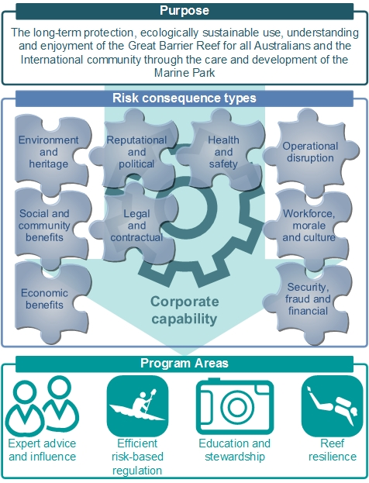

The Authority’s peer-reviewed Outlook Report provides (every five years) an assessment of risks to the ecosystems of the Great Barrier Reef Region. This report and the associated independent assessment of management effectiveness, provide the mechanisms through which risks to the region and the way it is managed are strategically identified and assessed. Actions to manage these risks (where jurisdictionally applicable) are integrated into the Corporate Plan and made operational through the Authority’s Annual Operating Plan.

To address identified knowledge gaps critical to management, a Science and Information Needs Strategy is also developed to inform the scientific community, research funding providers and providers of monitoring and other relevant information.

The Authority’s approach to risk management includes cultivating inherent controls, and establishing formal ones through strategic oversight and informed decision-making across the consequence types that could impact its objectives (these are illustrated by Figure 3).

The Authority monitors its key strategic risks which may impact the achievement of program objectives.

## Great Barrier Reef Marine Park Corporate Plan overview

| **Purpose: The long-term protection, ecologically sustainable use, understanding and enjoyment of the Great Barrier Reef for all Australians and the international community through the care and development of the Marine Park.** | | | |
| --- | --- | --- | --- |
| **Program Area 1:** Providing expert knowledge to influence and advise decision makers on managing, reducing or avoiding significant threats to the Reef.  **Programs:**   * Reef knowledge and information * Strategic advice | **Program Area 2:** Regulating and ensuring Marine Park user compliance  **Programs:**   * Marine Park planning, policy and regulation * Permissions system * Marine Park Compliance | **Program Area 3:** Educating and fostering stewardship to enhance protection of the Reef.  **Programs:**   * Stewardship * Education (including Reef HQ) | **Program Area 4:** Enhancing reef resilience through continuous improvement and new initiatives across all aspects of management.  **Programs:**   * Incident response * Conservation actions |
| **Objective:**Consolidate the Great Barrier Reef Marine Park Authority’s influence as the authoritative voice of the Reef. | **Objective:**Ensure an efficient and effective risk-based regulatory system. | **Objective:**Empower others to protect the Reef through education and stewardship. | **Objective:** Develop, implement and enable interventions to build Reef resilience*.* |
| **Performance criteria:** Key threats to the Great Barrier Reef are identified, and either addressed or, where external, acknowledged through the provision of authoritative and trusted advice. | **Performance criteria:** The impacts of human activity on the Great Barrier Reef are reduced through effective and efficient regulation and compliance. | **Performance criteria:** Improved awareness and adoption of sustainable best practices through education and stewardship programs. | **Performance criteria:** Enhanced coral reef resilience through identifying and working with partners to implement adaptive management interventions. |
| **Targets:**   * Partner entities and peak bodies acknowledge the:   + quality of the Authority’s advice   + professionalism and expertise of Authority staff * 100% of very high or high risks to the Reef are identified, or have effective actions against them in the Reef 2050 Plan or other plans and strategies. | **Targets:**   * Whitsundays Plan of Management finalised and in force. * New permit guidelines finalised and existing ones reviewed to improve transparency and consistency in permit decisions. * Spatial planning tools identified and priority sites determined for improved protection. * 25% of the Marine Park coastline is managed in accordance with an accredited Traditional Use of Marine Resources Agreement or Indigenous Land Use Agreement. * 740 compliance patrol days funded through the joint field management program. * New compliance tools are identified, trialled and reviewed for effectiveness to address key risks. | **Targets:**   * Participants of stewardship and education programs, including Reef HQ programs, report:   + improved awareness of the Great Barrier Reef’s values and threats   + changed practice and behaviour to protect and enhance the Reef’s values. | **Targets:**   * Develop and release a Position Statement on potential interventions to enhance Reef resilience. * Management intervention options to support resilience are identified and prioritised. * A number of new interventions that are prioritised progress to piloting and evaluation. |
| **Efficient and effective support for the organisation** | | | |
| **Capability:** Corporate functions which improve the delivery of programs  **Programs:** Finance and Governance, People, Communications, Information Technology and Management, Property and Security, Legal | | | |
| **Values** | | | |
| *The Authority is visionary, embraces innovation, demonstrates leadership and integrity, and fosters partnerships with stakeholders in its management of the Great Barrier Reef Marine Park* | | | |
| **Risk management and oversight** | | | |
| *The Great Barrier Reef Marine Park Authority applies a framework of principles and processes to the management of risks, so decisions can be systematic, transparent and credible.  The Authority’s risk management framework consists of:*   * *a risk management policy* * *a framework guideline* * *templates (such as risk assessment templates and risk management plan templates), and* * *tools (such as the risk register and risk/hazard reporting tools).* | | | |