Preliminary investigation of alternative approaches for the Reef Plan Report Card Water Quality Metric

Authors: Dieter Tracey, Jane Waterhouse and Eduardo da Silva

TropWATER Report 16/63
July 2016

Preliminary investigation of alternative approaches for the Reef Plan Report Card Water Quality Metric
DRAFT REPORT
A Report to the Great Barrier Reef Marine Park Authority as part of the Reef Plan Marine Monitoring Program Inshore Water Quality Program

TropWATER Report 16/63
July 2016

Dieter Tracey, Jane Waterhouse and Eduardo da Silva
TropWATER, James Cook University

Centre for Tropical Water & Aquatic Ecosystem Research
(TropWATER)
James Cook University
Townsville
Phone : (07) 4781 4262
Email: TropWATER@jcu.edu.au
Web: www.jcu.edu.au/tropwater/

© James Cook University (TropWATER), 2017
Published by the Great Barrier Reef Marine Park Authority
ISBN: 978-0-9953732-7-3
Preliminary investigation of alternative approaches for the Reef Plan Report Card Water Quality Metric. A Report to the Great Barrier Reef Marine Park Authority as part of the Reef Plan Marine Monitoring Program Inshore Water Quality Program is licensed for use under a Creative Commons By Attribution 4.0 International licence with the exception of the Coat of Arms of the Commonwealth of Australia, the logos of the Great Barrier Reef Marine Park Authority, James Cook University and TropWATER, any other material protected by a trademark, content supplied by third parties and any photographs. For licence conditions see: http://creativecommons.org/licences/by/4.0

This publication should be cited as:
Tracey, D., Waterhouse, J. and da Silva, E. 2016. Preliminary investigation of alternative approaches for the Reef Plan Report Card Water Quality Metric. A Report to the Great Barrier Reef Marine Park Authority as part of the Reef Plan Marine Monitoring Program Inshore Water Quality Program. TropWATER Report 16/63, Great Barrier Reef Marine Park Authority, Townsville.

A catalogue record for this publication is available from the National Library of Australia

DISCLAIMER
While reasonable efforts have been made to ensure that the contents of this document are factually correct, JCU and TropWater do not make any representation or give any warranty regarding the accuracy, completeness, currency or suitability for any particular purpose of the information or statements contained in this document. To the extent permitted by law JCU and TropWater shall not be liable for any loss, damage, cost or expense that may be occasioned directly or indirectly through the use of or reliance on the contents of this document.

Comments and questions regarding this document are welcome and should be addressed to:

TropWATER- Centre for Tropical Water and Aquatic Ecosystem Research
James Cook University
Townsville, Qld 4811
Tropwater@jcu.edu.au

This project is supported by the Great Barrier Reef Marine Park Authority through funding from the Australian Government Reef Program, the Reef 2050 Integrated Monitoring, and Reporting Program and JCU.

Contents
Acknowledgements ii
Disclaimers ii
Executive Summary iii
1. Introduction 1
1.1. Background 1
1.2. Purpose and scope 2
2. Method 3
2.1. Overview 3
2.2. Data sources 4
2.2.1. Waterbody boundaries 4
2.2.2. Annual data 5
2.2.3. Seasonal data 5
2.3. Area calculation 6
2.4. NetCDF to raster conversion 6
2.5. Masking enclosed coastal waterbodies 6
2.6. Tabulating areas of exceedance of annual and seasonal thresholds 6
3. Results 6
3.1. Waterbody areas 6
3.2. 2014-15 annual data and the effect of masking enclosed coastal waterbodies 7
3.3. 2014-15 seasonal data 9
3.4. Historical comparison 14
3.5. Marine Water Quality Metric calculations 14
4. Options and recommendations 18
5. Future work 18
6. References 19
7. Appendix A: Historical data 20
8. Appendix B: Comparison to Seasonal WQ Guidelines 32
9. Appendix C: Seasonal mean values 34

Acknowledgements
The authors of this report would like to acknowledge the team of people that have ongoing interest and involvement in this work and have provided guidance in this project, including: Roger Shaw and Peter Doherty from the Reef Plan Independent Science Panel; Katherine Martin, Carol Honchin and Bronwyn Houlden from the Great Barrier Reef Marine Park Authority; Britta Schaffelke and Murray Logan from the Australian Institute of Marine Science; Robert Johnson, Jamie Treleaven and Greg Stuart from the Bureau of Meteorology; Cedric Robillot from eReefs in the Great Barrier Reef Foundation; Carl Mitchell and Nyssa Henry from the Office of the Great Barrier Reef in the Department of Environment and Heritage Protection; and Angela Stokes from the Department of the Environment. The project was funded by the Reef Plan Marine Monitoring Program Inshore Water Quality Program.

Disclaimers
TropWATER advises that the information contained in this publication comprises general statements based on scientific research. The reader is advised and needs to be aware that such information may be incomplete or unable to be used in any specific situation. To the extent permitted by law, TropWATER (including its employees and consultants) excludes all liability to any person for any consequences, including but not limited to all losses, damages, costs, expenses and any other compensation, arising directly or indirectly from using this publication (in part or in whole) and any information or material contained in it.

Executive Summary
Inshore water quality for the Reef Plan Report Card is currently assessed by remote sensing of Chlorophyll-a (Chl-a) and total suspended solids (TSS, based on non-algal particles) in the Inshore water body of the Great Barrier Reef (GBR). In the preparation of the 2016 Report Card, the Reef Plan Independent Science Panel (Reef Plan ISP) expressed concerns with the Marine Water Quality Metric used in the Reef Plan Report Card including concerns with the accuracy of Chl-a concentrations derived from Ocean Colour remote sensing particularly in turbid coastal waters, the influence of the proportion of valid observations on the metric calculation, and the spatial and temporal insensitivities of the metric associated with averaging data over large areas and over annual conditions.
The purpose of this report was to conduct a rapid and preliminary review of the Marine Water Quality Metric presented in the 2015-16 Reef Plan Report Card, focusing on issues highlighted by the Reef Plan ISP associated with data confidence of remotely sensed data in inshore areas. This followed unresolved issues in 2014-15 reporting. It has been hypothesised that the highly turbid and shallow waters, with limited data validation, and temporal and spatial variability in the number of valid observations, can bias the Marine Water Quality Metric calculation. To test this hypothesis, highly turbid and shallow inshore areas were excluded in the metric computation. For this purpose, Enclosed Coastal waters were defined as a proxy for highly turbid and shallow areas.
The report constrained the evaluation of excluding Enclosed Coastal waters to the assessment of changes to the temporal trend of the Marine Water Quality metric at annual and seasonal intervals. Results are presented for a range of scenarios for Chl-a, including annual and seasonal data, and assessment of historical data in both cases.
While the results did show some differences in the regional assessments, exclusion of the Enclosed Coastal water body did not make a significant difference to the actual metric results. It was therefore recommended that marine water quality be reported for the 2014-15 period using the approach from previous years to maintain consistency and focus efforts on longer term improvement to the metric. It was recommended that the Marine Water Quality Metric should be scored as low confidence.
It was out of the scope of this report to provide improvements to the remote sensing data acquisition, algorithms, and/or development of alternative method for the metric calculation. These are necessary and valid tasks, but require more extensive work over a wider time frame (at least 8-10 months). Additional areas for future work are included in Section 6.

Introduction

Background
In preparation of the 2015-16 Reef Plan Report Card, the Reef Plan Independent Science Panel (ISP) expressed concerns with the water quality metric currently used in the Reef Plan Report Card. This followed unresolved issues in 2014-15 reporting. The metric is calculated using Ocean Colour remote sensing data for Chlorophyll-a (Chl-a) and total suspended solids (TSS, based on NAP, non-algal particles) in the 'inshore water body' — as used by the Great Barrier Reef Marine Park Authority (GBRMPA), and defined in De'ath and Fabricius (2008). The foundational remote sensing data is processed by the Bureau of Meteorology (BoM). The Marine Water Quality remote sensing workflow is documented on the Bureau’s website and in an operations bulletin (Bureau of Meteorology, 2015). The process to produce the Reef Plan Report Card Marine Water Quality Metric is summarised below.
- Step 1: Calculation of the relative area of the inshore water body where the annual mean value exceeds the Great Barrier Reef (GBR) Water Quality Guideline value for Chl-a and TSS in each marine NRM region.
- Step 2: Allocation of a score for Chl-a and TSS, which is the relative area of the inshore water body where the annual mean value (on a per pixel basis) does not exceed the Water Quality Guideline value (e.g. if annual mean value exceeded the GBR Water Quality Guideline value in 80% of the inshore water body, the regional score is 0.2).
- Step 3: Calculation of a combined Chl-a and TSS score using the mean of the Chl-a and TSS scores calculated in Step 2.
- Step 4: Calculation of a GBR-wide score. A weighting is applied to the scores in Step 2 based on the proportion of the GBR coastal area that is in the NRM region. For example, 13% of the GBR coastal area is in the Wet Tropics NRM region, and so the score calculated in Step is multiplied by 0.13 to give a weighted score. A weighting of zero is applied to Cape York and Burnett Mary NRM regions due to low confidence in the data in these regions (established at the Marine Monitoring Program workshop 11 August 2011). The final GBR score is the sum of all of the weighted regional scores.
The concerns are summarised very briefly below and were reviewed in more detail by the Reef Plan ISP in their meeting in April 2016.
Concerns with the accuracy of Chl-a concentrations derived from Ocean Colour remote sensing
- Extracting Chl-a concentrations from remotely sensed reflectance data is notoriously challenging in optically complex (case II) coastal waters like the GBR lagoon and the limitations of the remote sensing data must be understood to efficiently use these data as a monitoring tool. These limitations have been well documented by CSIRO in past (see examples of references in Bureau of Meteorology, 2014).
- Analyses in the GBR and from around the world show that there is a trend toward an increase of uncertainties in the satellite Chl-a concentration when the TSS concentration increases and the bottom depth decreases (see review in Petus et al. 2015); with preliminary thresholds values estimated around an NAP (proxy for TSS) of 2 mg L⁻¹ (which is the GBR water quality guideline trigger value for TSS in the open coastal and midshelf water body) and depth less than 25 metres (Petus et al. 2015).
Proportion of valid observations
- Cloud cover is an important influence in the availability of remote sensing data. Valid observations are made less than 40% of the time using the current GBR algorithms for Chl-a and TSS, which has significant implications when assessing the exceedance of thresholds (Maynard et al. 2015).
- The percentage of valid observations should be factored into any assessment of remote sensing data of water quality concentrations to factor in the spatial and temporal variability of retrievals. This data is readily available and should be considered in metric calculations.
Shortcomings in the metric calculation
- The current Marine Water Quality Metric is based on annual or seasonal averages over a large area. This means it is relatively insensitive to temporal (i.e. intra-annual) and spatial changes, which are important objectives of the Australian Government Reef Program - Marine Monitoring Program (MMP) and the Paddock to Reef Program. The area also currently does not separate the enclosed coastal water body (see Section 2.2.1 and Figure 1), which has different guidelines and is likely to have Chl-a estimates with a high uncertainty.
- The deviation from guideline trigger values is only done on a binary basis, i.e. the annual mean value of a pixel exceeds or complies with guidelines trigger value. This again leads to the metric being insensitive to change in areas where values are much higher than the trigger (i.e. needs a large change to get close to the guidelines) but conversely also leads to high variability in areas where values are very close to the guideline (i.e. neighbouring pixels that have very similar actual means may get opposite scores if they are just compliant or juts exceeding). A ‘distance from guidelines’ approach is used in the MMP site-specific water quality index (see Thompson et al. 2014).

Purpose and scope
The purpose of this report was to conduct a rapid and preliminary review of the Marine Water Quality Metric presented in the 2015-16 Reef Plan Report Card, focusing on issues highlighted by the Reef Plan ISP associated with data confidence of remotely sensed data in inshore areas. It has been hypothesised that the highly turbid and shallow waters, with limited data validation, and temporal and spatial variability in the number of valid observations, can bias the Marine Water Quality Metric calculation. To test this hypothesis, highly turbid and shallow inshore areas were excluded in the metric computation. For this purpose, Enclosed Coastal waters were defined by the GBRMPA shapefile (see Section 2.2.1 and Figure 1) as a proxy for highly turbid and shallow areas.
The report constrains the evaluation of the exclusion of enclosed coastal waters to the assessment of changes to the temporal trend of the Marine Water Quality Metric at annual and seasonal intervals. It is out of the scope of this report to provide improvements to the remote sensing data acquisition, algorithms, and/or development of alternative method for the metric calculation. These are necessary and valid tasks, but require more extensive work over a wider time frame (at least 8-10 months).

Method

Overview
The main tasks of the project were:
- Generate basic data summaries of the Chl-a and TSS (as satellite retrieval of non-algal particles, NAP) data in each NRM region and at the GBR-wide scale for 1) all water bodies, and 2) with the Enclosed Coastal waterbody excluded, including:
  - Annual assessment - tables of:
  - annual mean concentrations;
  - mean concentrations above an annual threshold;
  - the number of valid observations above an annual threshold;
  - the percentage of valid observations above an annual threshold; and
  - the percentage of pixels with a mean above an annual threshold.
  - Seasonal assessment (wet and dry periods) – tables of:
- seasonal means of concentrations;
- the mean concentrations above a seasonal threshold;
- the number of valid observations above a seasonal threshold;
- the percentage of valid observations above a seasonal threshold;
- the percentage of pixels with a mean above a seasonal threshold.

- Alternative metric calculations based on:
  - Excluding the Enclosed Coastal water body; and
  - Considering dry season only.

The boundaries and water quality thresholds used in the assessment are shown in Figure 1.
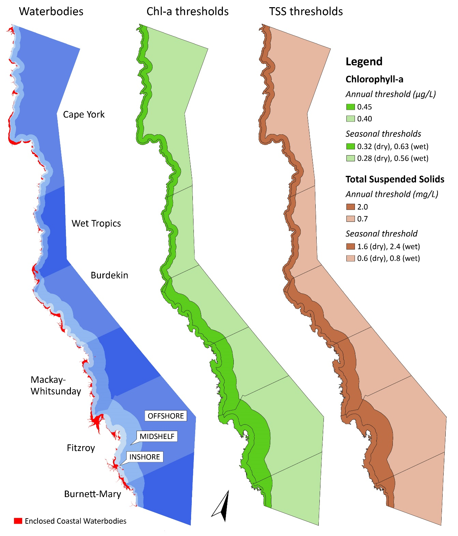
Figure 1. Waterbody boundaries and thresholds for Chl-a and TSS used in the assessment.

Data sources

Waterbody boundaries
Waterbody boundaries were provided by GBRMPA (Enclosed coastal waterbodies: EnclosedCoastalWaterBodies_V2_4.shp; NRM marine waterbody boundaries: NRM_Marine231009.shp). To tabulate areas of exceedance of annual and seasonal thresholds, gridded waterbody boundaries (cell size 0.01 decimal degrees) were extracted from the 'mwq-reefmask.0.01.nc' NetCDF file from the BoM, which was derived from the NRM_Marine231009 shapefile. The regions in this file are published and defined in De'ath and Fabricius (2008).
Data grids were downloaded from the THREDDS Data Server at BoM (http://ereeftds.bom.gov.au/ereefs/tds/catalog/ereef/mwq/catalog.html) on 4 July 2016. Annual data by 'GBRMPA reporting year' (1 May to 30 April) was downloaded from http://ereeftds.bom.gov.au/ereefs/tds/catalog/ereef/mwq/P1A_0501/catalog.html. Seasonal data was downloaded from http://ereeftds.bom.gov.au/ereefs/tds/catalog/ereef/mwq/P6M/catalog.html.

Annual data
The Annual data extracted for the assessment is listed in Table 1. The annual assessment follows the same period as used in previous reporting, i.e. 1 May to 30 April.
Table 1. NetCDF files used to extract the annual data
Dataset | Last modified
A20020501.P1A.ANN_MIM_RMP.nc | 2014-05-13 T04:54:43Z
A20030501.P1A.ANN_MIM_RMP.nc | 2014-05-13 T04:54:45Z
A20040501.P1A.ANN_MIM_RMP.nc | 2014-05-13 T04:54:46Z
A20050501.P1A.ANN_MIM_RMP.nc | 2014-05-13 T04:54:41Z
A20060501.P1A.ANN_MIM_RMP.nc | 2014-05-13 T04:54:38Z
A20070501.P1A.ANN_MIM_RMP.nc | 2014-05-13 T04:54:31Z
A20080501.P1A.ANN_MIM_RMP.nc | 2014-05-13 T04:54:36Z
A20090501.P1A.ANN_MIM_RMP.nc | 2014-05-13 T04:54:51Z
A20100501.P1A.ANN_MIM_RMP.nc | 2014-05-13 T04:54:28Z
A20110501.P1A.ANN_MIM_RMP.nc | 2014-05-13 T04:54:32Z
A20120501.P1A.ANN_MIM_RMP.nc | 2014-05-13 T04:54:48Z
A20130501.P1A.ANN_MIM_RMP.nc | 2014-05-13 T04:54:34Z
A20140501.1.P1A.ANN_MIM_RMP.nc | 2016-07-01 T12:37:23Z
A20150501.P1A.ANN_MIM_RMP.nc | 2016-07-01 T12:38:12Z

Seasonal data
The Seasonal data extracted for the assessment is listed in Table 2. The dry season is defined as 1 May to 30 October, and the wet season is defined as 1 November to 30 April.
Table 2. NetCDF files used to extract the seasonal data.
Dataset | Last modified
A20130501.P6M.ANN_MIM_RMP.nc | 2014-03-09 T22:19:14Z
A20131101.43.P6M.ANN_MIM_RMP.nc | 2014-05-02 T04:37:57Z
A20140501.223.P6M.ANN_MIM_RMP.nc | 2014-10-31 T17:39:45Z
A20141101*.215.P6M.ANN_MIM_RMP.nc | 2015-12-29 T22:54:23Z
A20150501*.2.P6M.ANN_MIM_RMP.nc | 2016-06-30 T01:30:35Z
A20151101*.3.P6M.ANN_MIM_RMP.nc | 2016-06-30 T00:25:42Z

Area calculation
To calculate waterbody areas, the shapefiles were projected using the Australia Albers Equal Area Conic projection (http://spatialreference.org/ref/sr-org/6644/). The area calculation was performed using 'calculate geometry' in ArcGIS 10.2 (ESRI, 2013).

NetCDF to raster conversion
For the Marine Water Quality Metric, annual and seasonal chlorophyll and NAP remote sensing data were acquired from the BoM eReefs MWQ THREDDS Data Server (http://ereeftds.bom.gov.au/ereefs/tds/catalog.html). Data was downloaded using RCurl interface in R, which is specific for data downloading from the Web (Temple Lang and the CRAN team, 2016; Temple Lang, 2007). The downloaded files were converted from NetCDF format to raster format using raster function in R (Hijmans et al., 2015). Each band in the NetCDF files was saved in individual GeoTIFF files (georeferenced information embedded within a TIFF file) for follow-up analysis in ArcGIS (ESRI, 2013).

Masking enclosed coastal waterbodies
Processing was performed using Python 2.7.3 (Python Software Foundation 2012) and ArcGIS 10.2 (ESRI, 2013). Enclosed coastal waterbodies: from GBRMPA (EnclosedCoastalWaterBodies_V2_4.shp), were converted to raster (polygon to raster conversion, cell size 0.01 decimal degrees, assignment type by cell centre, snapped to grid) and these pixels removed from the analysis.

Tabulating areas of exceedance of annual and seasonal thresholds
Pixel counts were generated using Tabulate Area tool in ArcGIS Spatial Analyst, and zonal statistics (mean and standard deviation) using Zonal Statistics as Table.

Results

Waterbody areas
The area (in km²) of each waterbody considered in the assessment, for each NRM region, is shown in Table 3. Overall, the exclusion of Enclosed Coastal waters reduced the Inshore waterbody by 23%, it had a slight effect of the Mid-shelf waterbody area (<1% reduction), and no effect at all in the Offshore waterbody. Combining all the waterbodies together, the exclusion of the Enclosed Coastal waters represented an area reduction of <2%.

Table 3. Waterbody areas in km² before and after excluding Enclosed Coastal waterbodies.
NRM region | Waterbody area (km²) |  |  | Waterbody areas excluding Enclosed Coastal waterbodies (km²)
 | Inshore | Mid-shelf | Offshore | Inshore | Mid-shelf | Offshore
Cape York | 5,763 | 14,988 | 75,423 | 3,863 | 14,860 | 75,423
Wet Tropics | 2,565 | 6,534 | 22,871 | 2,049 | 6,421 | 22,871
Burdekin | 4,330 | 11,204 | 31,455 | 3,475 | 11,204 | 31,455
Mackay Whitsunday | 5,524 | 12,280 | 31,089 | 4,733 | 12,276 | 31,089
Fitzroy | 7,813 | 18,926 | 59,705 | 5,980 | 18,895 | 59,705
Burnett Mary | 909 | 3,291 | 33,191 | 660 | 3,270 | 33,191

2014-15 annual data and the effect of masking enclosed coastal waterbodies
The results for the 2014-15 annual data (1 May 2014 to 30 April 2015) are shown in Table 4, and when Enclosed Coastal waters are excluded (masked) are presented in Table 5. A comparison of masked and unmasked data is presented in Figure 2.
Table 4. Relative area (%) of the waterbody where the annual mean value exceeds the WQ Guideline values for Chlorophyll-a and TSS (as NAP readings) in 2014-15.
NRM region | Chlorophyll-a |  |  | Total Suspended Solids
 | Inshore | Mid-shelf | Offshore | Inshore | Mid-shelf | Offshore
Cape York | 90.7 | 24.1 | 1.1 | 46.4 | 6.3 | 6.6
Wet Tropics | 93.2 | 22.7 | 0.4 | 40.2 | 4.8 | 0.5
Burdekin | 71.1 | 5.7 | 0.1 | 43.9 | 0.4 | 0.0
Mackay Whitsunday | 52.9 | 7.4 | 3.6 | 31.3 | 10.4 | 8.5
Fitzroy | 80.5 | 10.3 | 1.3 | 49.6 | 4.4 | 1.9
Burnett Mary | 97.1 | 9.9 | 0.0 | 22.6 | 0.9 | 0.3

Table 5. Relative area (%) of the waterbody where the annual mean value exceeds the WQ Guideline values for Chlorophyll-a and TSS (as NAP readings) in 2014-15 with Enclosed Coastal waterbodies excluded from the analysis.
NRM region | Chlorophyll-a |  |  | Total Suspended Solids
 | Inshore | Mid-shelf | Offshore | Inshore | Mid-shelf | Offshore
Cape York | 85.5 | 22.8 | 1.1 | 19.9 | 5.1 | 6.6
Wet Tropics | 91.4 | 21.3 | 0.4 | 25.2 | 3.2 | 0.5
Burdekin | 64.0 | 5.7 | 0.1 | 30.5 | 0.4 | 0.0
Mackay Whitsunday | 45.8 | 7.4 | 3.6 | 21.6 | 10.4 | 8.5
Fitzroy | 74.3 | 10.0 | 1.3 | 33.3 | 4.1 | 1.9
Burnett Mary | 96.2 | 9.2 | 0.0 | 2.2 | 0.4 | 0.3

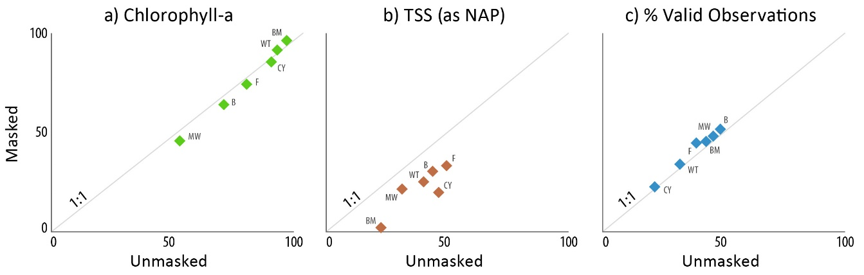
Figure 2. Scatterplots comparing the relative inshore area (%) where the 2014-15 annual mean value exceeds the Annual GBR Water Quality Guideline before and after masking out enclosed coastal waterbodies for (a) Chl-a, (b) TSS and (c) the percent of valid observations. Letters stand for the initial of the NRM region where CY = Cape York; WT = Wet Tropics; B = Burdekin; MW = Mackay Whitsunday; F = Fitzroy and BM = Burnett Mary. Seasonal data is presented in Section 3.4.
Figure 2(a) suggests the exclusion of the enclosed coastal waters does not have much of an effect on the proportion of satellite-derived Chl-a data above the annual GBR Water Quality Guideline for Inshore waters (average reduction of <7%) even though Enclosed Coastal waters represent 23% in areas of the Inshore waterbody. Conversely, the equivalent measure for TSS (as NAP satellite-derived readings) reduced by 47% (Figure 2(b)). The bigger effect the area exclusion had on TSS is associated with the fact that most TSS settles within 4 km from the river mouth (Bainbridge et al., 2012), in areas belonging to the Enclosed Coastal waters. Therefore, by excluding Enclosed Coastal waters, higher values of Chl-a and TSS (as NAP readings) are excluded from the Marine Water Quality Metric calculation. Excluding Enclosed Coastal waters very slightly increased the average percentage of valid observations per pixel (Figure 2(c)).
Figure 3 shows that mean values for satellite derived Chl-a and TSS (as NAP) were well above the annual GBR Water Quality Guidelines and that nearly all data pixels in Enclosed Coastal waters exceeded guideine values (> 99% for Chl-a; 96% for TSS).
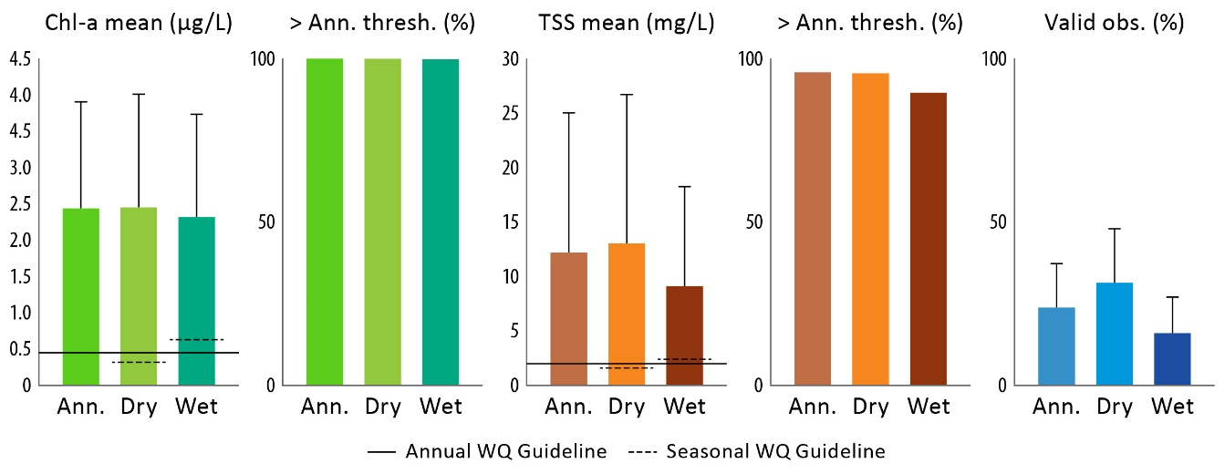
Figure 3. Summary of 2014-15 water quality values in GBR Enclosed Coastal waterbodies (from left to right): annual and seasonal mean concentrations of Chl-a (error bars are one standard deviation above the mean); relative area of Enclosed Coastal waters where the annual or seasonal mean value for Chl-a exceeds the annual GBR Water Quality Guideline; annual and seasonal mean concentrations of TSS (as NAP readings); relative area where mean TSS values exceed the annual GBR Water Quality Guideline; and the mean percentage of valid observations per pixel.

2014-15 seasonal data
Similar analysis was performed with data from 2014-15, but using the the eReefs data for dry (c.a. May to October, inclusive) and wet (c.a., November to April, inclusive) seasons. Results for relative area (%) of the waterbody where seasonal means exceed the annual GBR Water Quality Guidelines are shown in Tables 6 to 9. A comparison to the seasonal GBR Water Quality Guidelines (see Figure 1) is given in Appendix B. Maps of the 2014-15 seasonal data (seasonal mean, area above annual and seasonal thresholds, and percentage of valid observations) are presented in Figures 4 and 5. Data showing the effects of masking Enclosed Coastal waterbodies on seasonal patterns of Chl-a and TSS are provided in Appendix C. The effect of masking Enclosed Coastal waters on seasonal means and % valid observations is summarised for Inshore waters in Figure 6.
Figure 7(a) shows that the small annual effect of excluding Enclosed Coastal waters on the proportion of satellite-derived Chl-a data above the annual GBR Water Quality Guideline for Inshore waters was greater in the dry season (average reduction of 12%) than the wet season (average reduction of 4%). The equivalent measure for TSS reduced by 51% in the wet season compared to 44% in the dry season (Figure 7(b)). As shown in Figure 6, both TSS and especially Chl-a, exhibited a seasonal pattern of higher concentrations during the dry season in certain shallow water areas but elevated concentrations further offshore during the wet season.
Table 6. Relative area (%) of the waterbody where the Dry Season mean value exceeds the annual GBR Water Quality Guideline values for Chl-a in 2014-15.
NRM Region | Enclosed Coastal waterbodies included |  |  | Enclosed Coastal waterbodies excluded
 | Inshore | Mid-shelf | Offshore | Open Coast. | Mid-shelf | Offshore
Cape York | 80.6 | 14.4 | 0.6 | 69.7 | 13.0 | 0.6
Wet Tropics | 93.3 | 21.0 | 0.3 | 91.6 | 19.6 | 0.3
Burdekin | 68.3 | 5.3 | 0.1 | 60.5 | 5.3 | 0.1
Mackay Whitsunday | 51.3 | 7.4 | 1.5 | 43.9 | 7.4 | 1.5
Fitzroy | 67.9 | 6.0 | 0.8 | 57.5 | 5.8 | 0.8
Burnett Mary | 68.1 | 3.7 | 0.0 | 58.9 | 3.0 | 0.0

Table 7. Relative area (%) of the waterbody where the Wet Season mean value exceeds the annual GBR Water Quality Guideline values for Chl-a in 2014-15.
NRM Region | Enclosed Coastal waterbodies included |  |  | Enclosed Coastal waterbodies excluded
 | Inshore | Mid-shelf | Offshore | Open Coast. | Mid-shelf | Offshore
Cape York | 94.3 | 42.6 | 4.6 | 91.2 | 41.6 | 4.6
Wet Tropics | 92.0 | 25.5 | 0.9 | 90.0 | 24.3 | 0.9
Burdekin | 76.9 | 7.6 | 0.4 | 71.4 | 7.6 | 0.4
Mackay Whitsunday | 57.8 | 8.5 | 10.8 | 51.6 | 8.5 | 10.8
Fitzroy | 97.7 | 25.0 | 5.2 | 97.2 | 24.8 | 5.2
Burnett Mary | 99.5 | 32.6 | 0.2 | 99.3 | 32.1 | 0.2

Table 8. Relative area (%) of the waterbody where the Dry Season mean value exceeds the annual GBR Water Quality Guideline values for TSS (as NAP readings) in 2014-15.
NRM Region | Enclosed Coastal waterbodies included |  |  | Enclosed Coastal waterbodies excluded
 | Inshore | Mid-shelf | Offshore | Open Coast. | Mid-shelf | Offshore
Cape York | 50.7 | 7.7 | 7.8 | 26.2 | 6.6 | 7.8
Wet Tropics | 45.6 | 6.0 | 1.0 | 32.4 | 4.3 | 1.0
Burdekin | 47.9 | 0.6 | 0.0 | 35.4 | 0.6 | 0.0
Mackay Whitsunday | 31.7 | 10.5 | 9.8 | 21.9 | 10.5 | 9.8
Fitzroy | 48.5 | 3.8 | 2.8 | 32.1 | 3.5 | 2.8
Burnett Mary | 19.3 | 0.5 | 0.3 | 1.1 | 0.2 | 0.3

Table 9. Relative area (%) of the waterbody where the Wet Season mean value exceeds the annual GBR Water Quality Guideline values for TSS (as NAP readings) in 2014-15.
NRM Region | Enclosed Coastal waterbodies included |  |  | Enclosed Coastal waterbodies excluded
 | Inshore | Mid-shelf | Offshore | Open Coast. | Mid-shelf | Offshore
Cape York | 32.3 | 4.3 | 3.4 | 8.9 | 3.0 | 3.4
Wet Tropics | 27.8 | 3.8 | 0.3 | 10.9 | 2.1 | 0.3
Burdekin | 33.2 | 0.1 | 0.0 | 18.5 | 0.1 | 0.0
Mackay Whitsunday | 30.3 | 10.0 | 7.8 | 21.7 | 10.0 | 7.8
Fitzroy | 49.8 | 5.2 | 1.3 | 34.4 | 4.9 | 1.3
Burnett Mary | 27.8 | 1.2 | 0.3 | 8.2 | 0.5 | 0.3

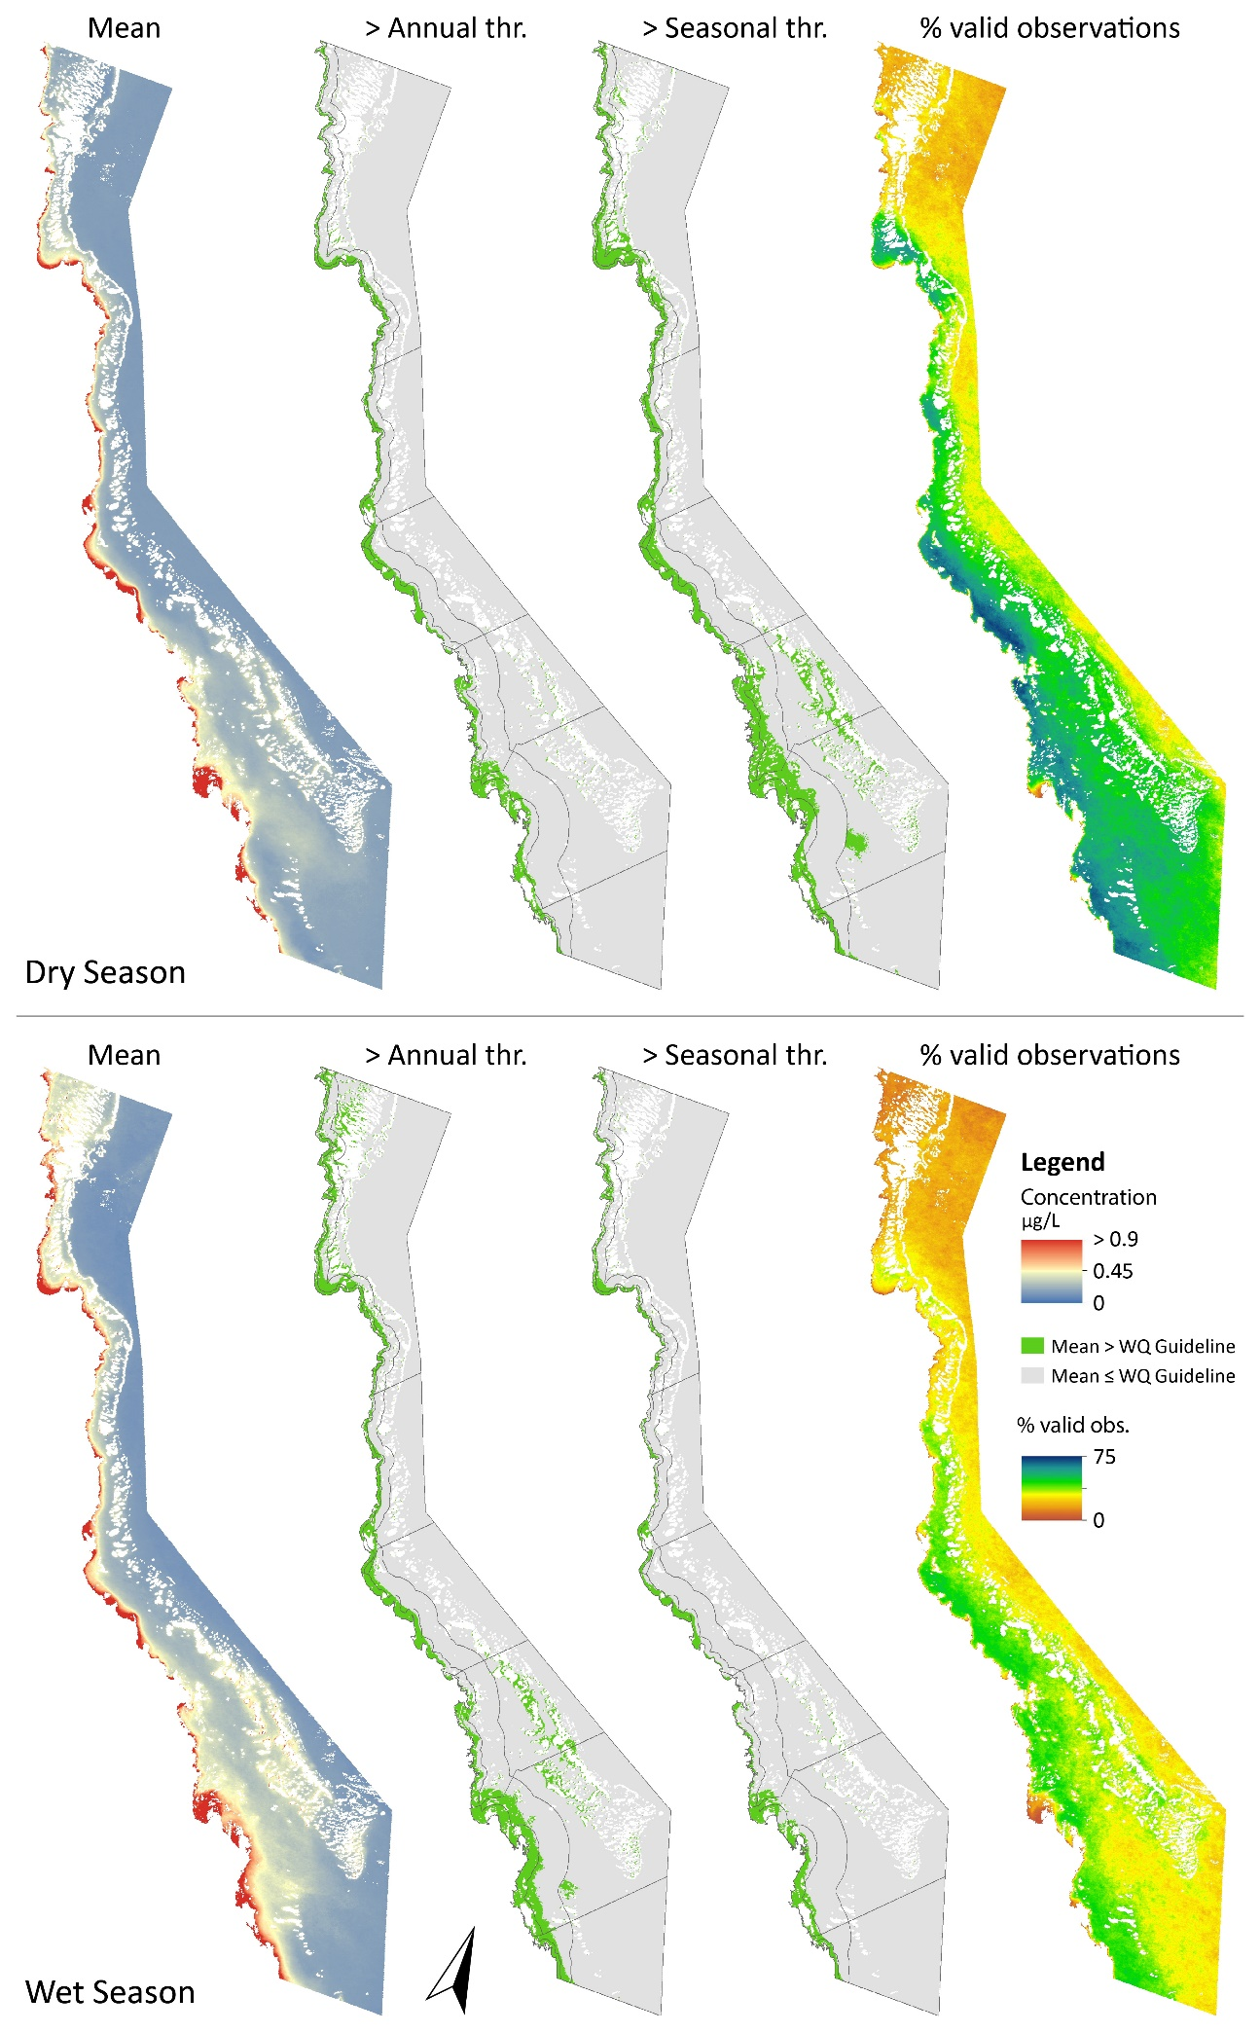
Figure 4. Maps of Chl-a seasonal values for 2014-15. From left to right: Seasonal mean, area above the annual GBR Water Quality Guideline, area above the seasonal GBR Water Quality Guideline, percentage of valid observations.
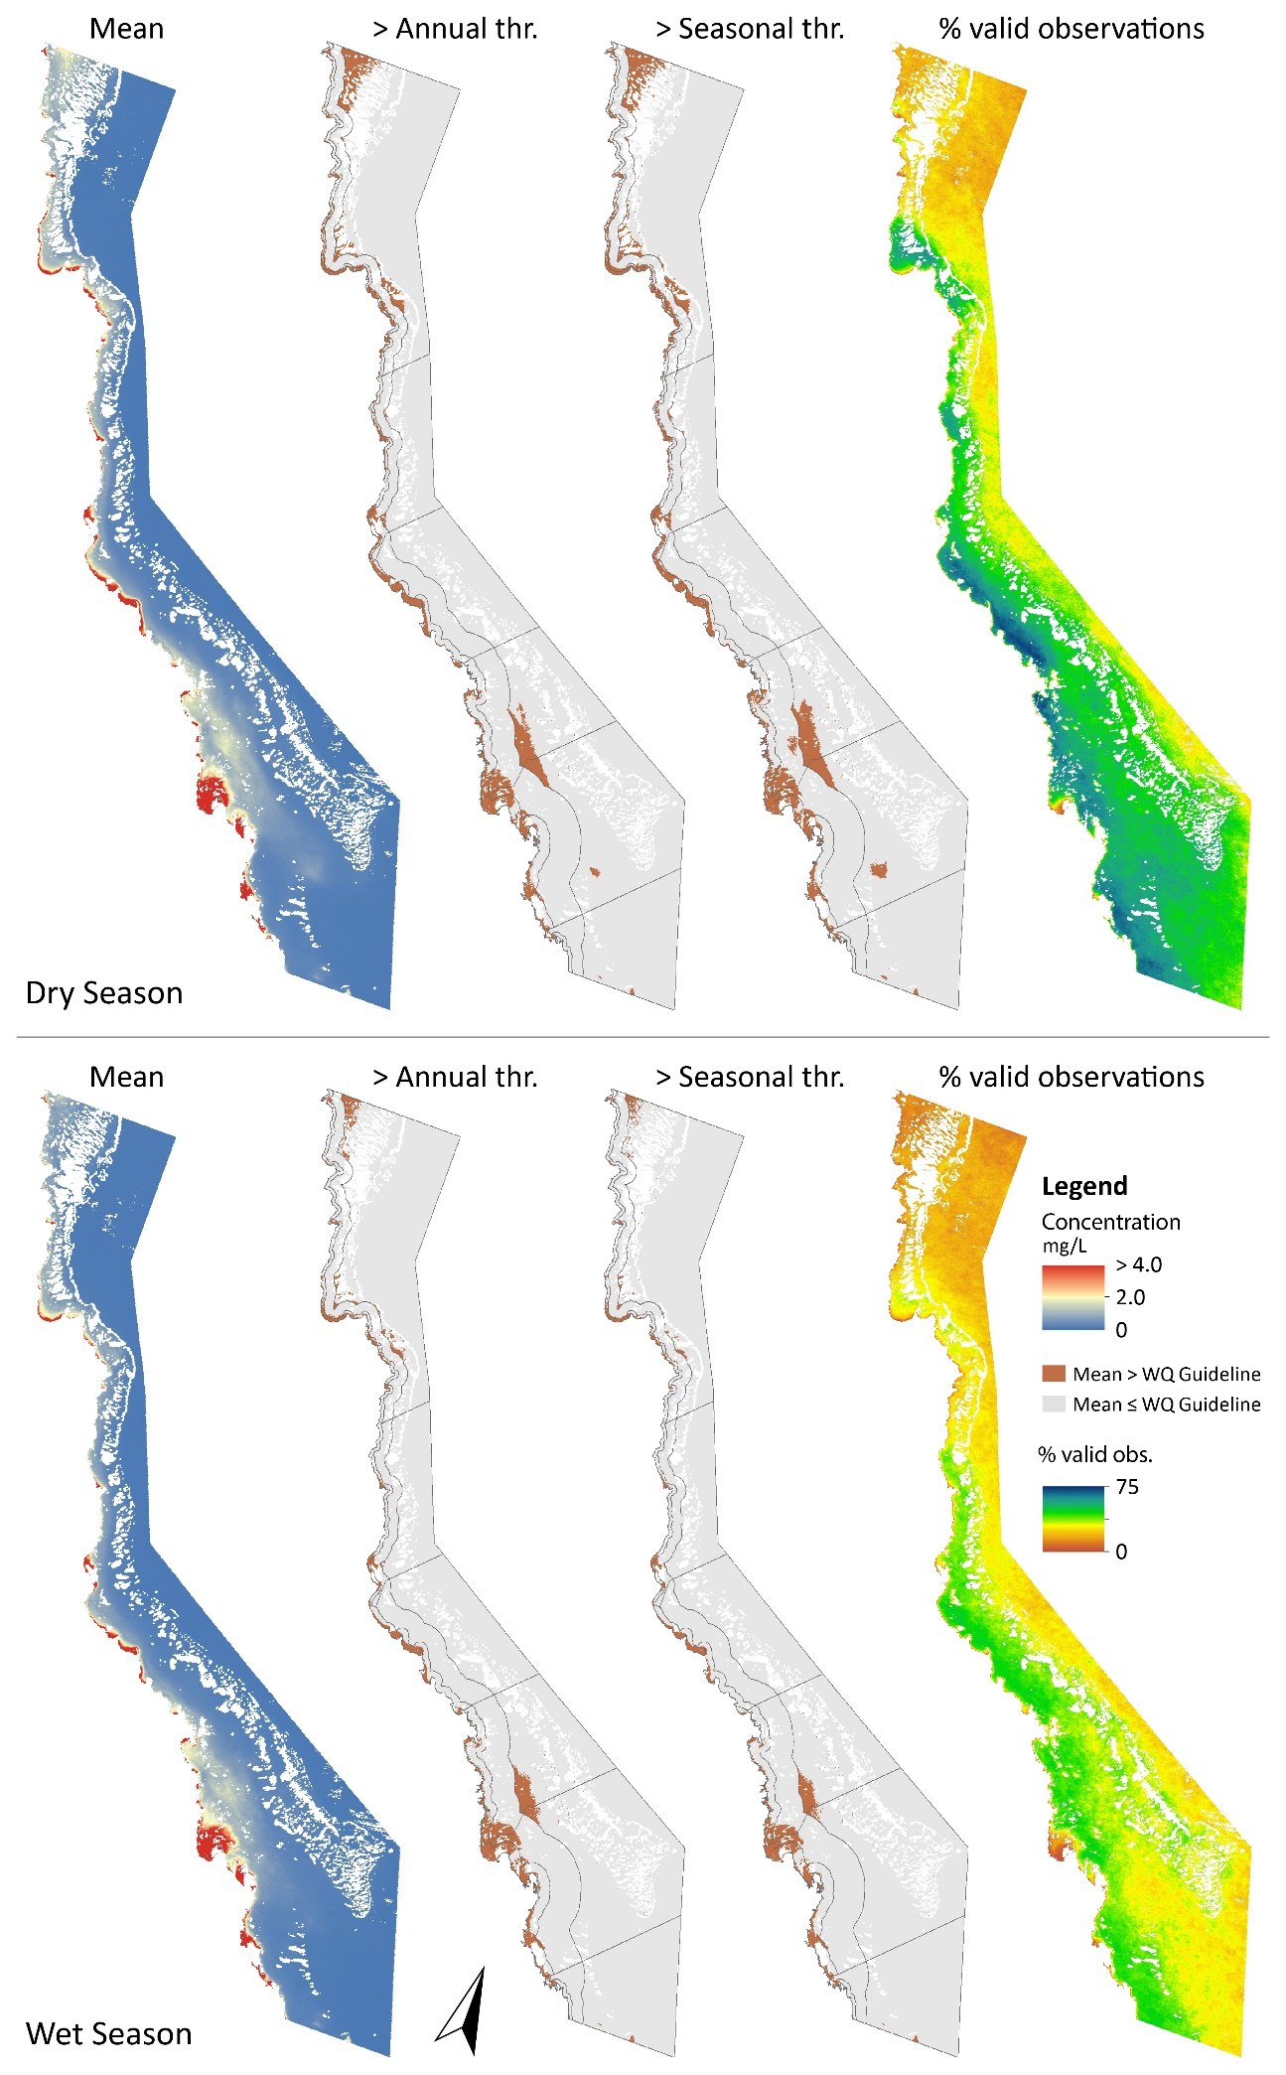
Figure 5. Maps of TSS seasonal values for 2014-15. From left to right: Seasonal mean, area above the Annual WQ Guideline, area above the Seasonal WQ Guideline, percentage of valid observations.
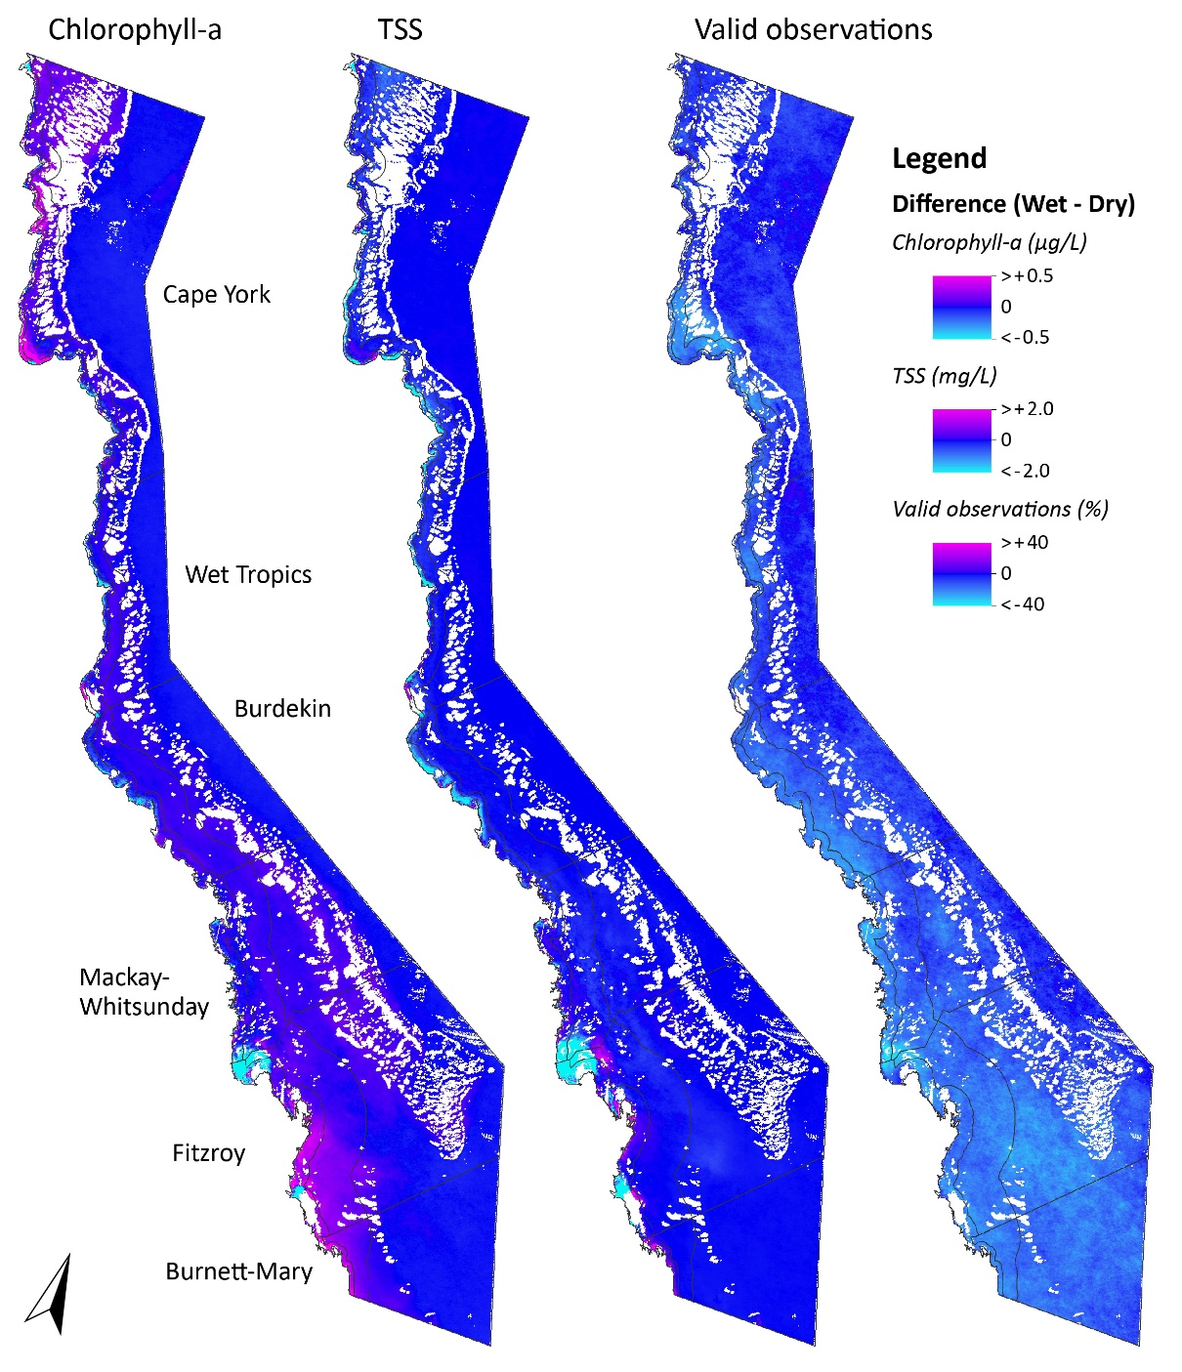
Figure 6. Maps showing the difference in seasonal mean concentrations of Chlorophyll-a and TSS, and for the percentage of valid observations, between wet and dry seasons for 2014-15.
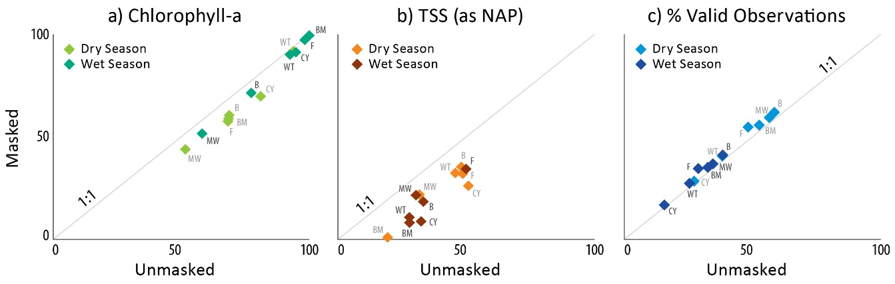
Figure 7. Scatterplots comparing the relative Inshore area (%) where the 2014-15 seasonal mean value exceeds the annual GBR Water Quality Guideline before and after masking out Enclosed Coastal waterbodies for (a) Chl-a, (b) TSS (as NAP), and (C) percentage of valid observations. Letters stand for the initial of the NRM regions, where CY = Cape York; WT = Wet Tropics; B = Burdekin; MW = Mackay Whitsunday; F = Fitzroy and BM = Burnett Mary. Annual data is presented in Section 3.2.

Historical comparison
One of the key recommendations from GBRMPA to the Reef Plan ISP (which was endorsed) was to reprocess the data from previous years, so that we could assess the effect of excluding the enclosed coastal waters on the scores. These results are shown in Appendix A from 2002-03 to 2014-15, and summarised in Figure 8, below. As shown in Figure 8, the percentage decrease in the area of inshore waters above Chl-a and TSS guidelines was closely linked to the unmasked Inshore area below the guideline. Because enclosed coastal waters were mostly above guideline values (e.g. see Figure 3), removing this roughly constant area had a proportionately greater effect in years when less of the inshore area was above guidelines. The impact of excluding this area on the Marine Water Quality Metric calculations is described in Section 3.5, below.
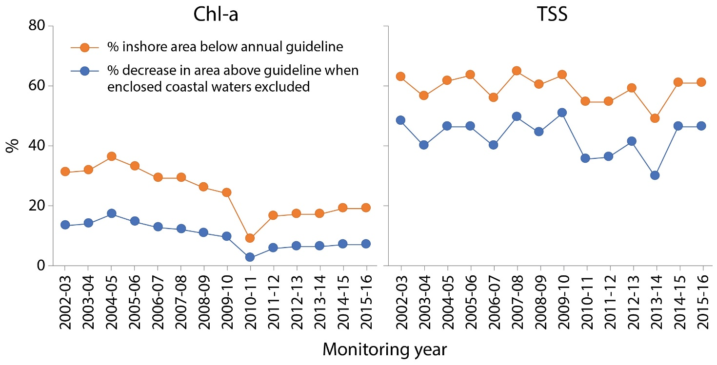
Figure 8. Time series showing the percentage of inshore area below the annual GBR guidelines for Chl-a and TSS, and the percent decrease in area above the annual GBR guideline when enclosed coastal waters are excluded, for the monitoring years 2002-03 to 2015-16. Values in each case are averages of all NRM regions.

Marine Water Quality Metric calculations
Since 2011, the Reef Plan Report Card Marine Water Quality Metric has been calculated using the steps outlined in Section 1.1. This approach was not changed for this exercise, but the influence of including or excluding the Enclosed Coastal waterbody in the calculation was assessed.
The Marine Water Quality Metric calculations including the Enclosed Coastal waterbody, i.e. the standard method, are shown in Table 10, and represented in Figure 9, and those excluding the Enclosed Coastal waterbody are shown in Table 11, and represented in Figure 10.
Exclusion of the Enclosed Coastal waterbody influences the metric in the following ways:
- There are differences in the scores, especially for TSS. The results are all Good (except in 2013-14) with the Enclosed Coastal waterbody excluded, compared to Moderate without. The score for the overall metric is also typically better, especially in last 5 years.
- Both TSS and Chl-a metrics are positively affected, as they present overall better water quality conditions after exclusion of the Enclosed Coastal waterbody, since removing Enclosed Coastal waters generally removes an area where Chl-a and TSS have been shown to be high, and mostly above the GBR Water Quality Guidelines (see Figure 3).
- Because the increase in score was greater in years when the initial score was higher (see Section 3.4 and Figure 8), excluding Enclosed Coastal waters had the effect of amplifying differences between years. For instance, the range of scores (high minus low) for the GBR increased from 29 to 37 for Chl-a; from 9 to 16 for TSS; and from 19 to 24 for the overall Marine Water Quality Metric.
- TSS is affected to a greater extent than Chl-a, as TSS concentrations reduce rapidly away from the coast, and the results in the Enclosed Coastal waters represent a larger proportion of the area above the GBR Water Quality Guidelines compared to Chl-a.
- Independently of whether Enclosed Coastal waters are excluded, the general trend remains the same. The unexpected poor results for Cape York in all cases are possibly a result of low confidence in the data in this region due to limited validation data to support the remote sensing algorithm, and require further investigation.

Table 10. Marine Water Quality Metric calculations including the Enclosed Coastal waterbody, 2005-06 to 2014-15.
 | Chlorophyll a
Region | 2005/06 | 2006/07 | 2007/08 | 2008/09 | 2009/10 | 2010/11 | 2011/12 | 2012/13 | 2013/14 | 2014/15
Cape York | 14 | 9 | 23 | 20 | 23 | 8 | 15 | 23 | 16 | 9
Wet Tropics | 12 | 6 | 13 | 7 | 10 | 3 | 4 | 9 | 8 | 7
Burdekin | 34 | 33 | 28 | 21 | 24 | 20 | 25 | 26 | 20 | 29
Mackay Whitsunday | 59 | 51 | 51 | 46 | 49 | 20 | 39 | 35 | 33 | 47
Fitzroy | 40 | 39 | 30 | 31 | 24 | 2 | 15 | 10 | 22 | 19
Burnett Mary | 38 | 39 | 30 | 30 | 14 | 0 | 0 | 0 | 4 | 3
Great Barrier Reef | 40 | 37 | 33 | 30 | 29 | 11 | 22 | 20 | 23 | 27

 | Total suspended solids
Region | 2005/06 | 2006/07 | 2007/08 | 2008/09 | 2009/10 | 2010/11 | 2011/12 | 2012/13 | 2013/14 | 2014/15
Cape York | 63 | 47 | 64 | 51 | 65 | 52 | 58 | 63 | 42 | 54
Wet Tropics | 54 | 43 | 64 | 58 | 60 | 54 | 47 | 60 | 44 | 60
Burdekin | 56 | 52 | 63 | 59 | 58 | 55 | 50 | 57 | 47 | 56
Mackay Whitsunday | 73 | 57 | 70 | 69 | 66 | 49 | 57 | 61 | 46 | 69
Fitzroy | 55 | 56 | 51 | 52 | 55 | 50 | 48 | 47 | 46 | 50
Burnett Mary | 78 | 82 | 77 | 77 | 76 | 70 | 69 | 69 | 69 | 77
Great Barrier Reef | 60 | 54 | 60 | 59 | 59 | 51 | 51 | 55 | 46 | 58

 | Overall water quality index
Region | 2005/06 | 2006/07 | 2007/08 | 2008/09 | 2009/10 | 2010/11 | 2011/12 | 2012/13 | 2013/14 | 2014/15
Cape York | 39 | 28 | 44 | 36 | 44 | 30 | 37 | 43 | 29 | 31
Wet Tropics | 33 | 25 | 39 | 33 | 35 | 29 | 26 | 35 | 26 | 33
Burdekin | 45 | 43 | 46 | 40 | 41 | 38 | 38 | 42 | 34 | 42
Mackay Whitsunday | 66 | 54 | 61 | 58 | 58 | 35 | 48 | 48 | 40 | 58
Fitzroy | 48 | 48 | 41 | 42 | 40 | 26 | 32 | 29 | 34 | 35
Burnett Mary | 58 | 61 | 54 | 54 | 45 | 35 | 35 | 35 | 36 | 40
Great Barrier Reef | 50 | 45 | 47 | 44 | 44 | 31 | 37 | 37 | 34 | 43

Classifications
81 - 100 | 61 - 80 | 41 - 60 | 21 - 40 | 0 - 20
very good | good | moderate | poor | very poor
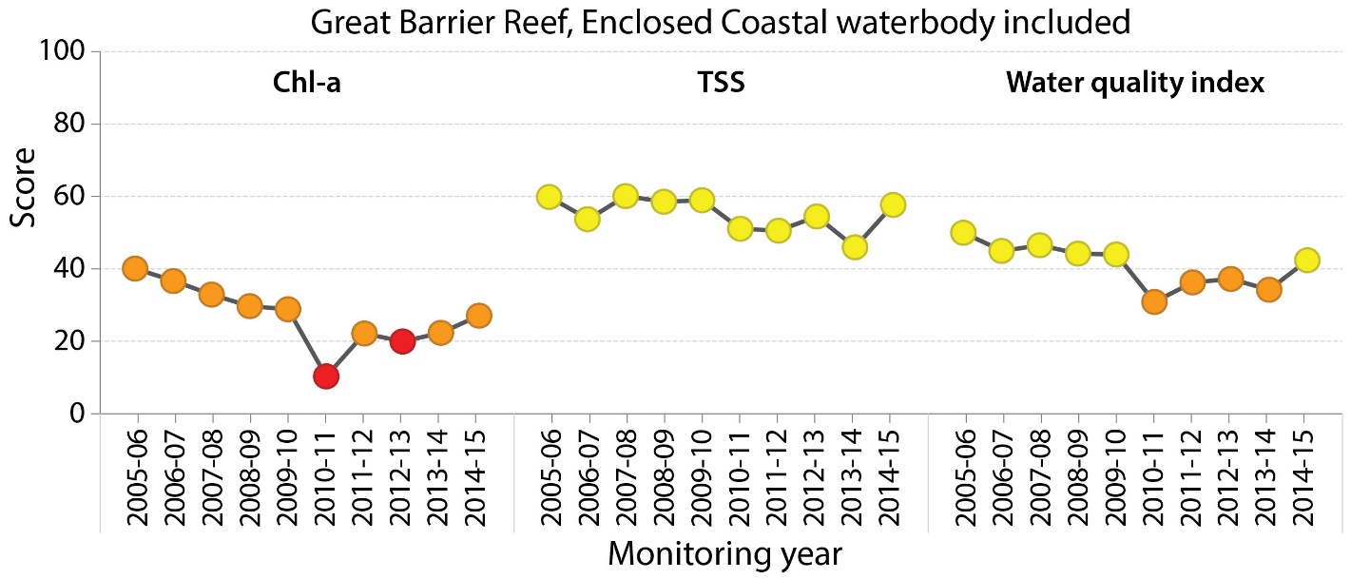
Figure 9. Time series of the Marine Water Quality Metric including the Enclosed Coastal waterbody, 2005-06 to 2014-15.
Table 11. Marine Water Quality Metric calculations excluding the Enclosed Coastal waterbody, 2005-06 to 2014-15.
 | Chlorophyll a
Region | 2005/06 | 2006/07 | 2007/08 | 2008/09 | 2009/10 | 2010/11 | 2011/12 | 2012/13 | 2013/14 | 2005/06
Cape York | 22 | 14 | 36 | 30 | 35 | 12 | 23 | 36 | 24 | 15
Wet Tropics | 15 | 7 | 16 | 9 | 13 | 3 | 5 | 11 | 10 | 9
Burdekin | 42 | 41 | 35 | 27 | 31 | 24 | 31 | 33 | 25 | 36
Mackay Whitsunday | 68 | 58 | 58 | 53 | 56 | 22 | 45 | 40 | 38 | 54
Fitzroy | 53 | 51 | 41 | 41 | 32 | 3 | 19 | 14 | 29 | 26
Burnett Mary | 50 | 51 | 39 | 40 | 18 | 0 | 0 | 0 | 5 | 4
Great Barrier Reef | 50 | 46 | 41 | 37 | 36 | 13 | 27 | 25 | 28 | 34

 | Total suspended solids
Region | 2005/06 | 2006/07 | 2007/08 | 2008/09 | 2009/10 | 2010/11 | 2011/12 | 2012/13 | 2005/06 | 2006/07
Cape York | 83 | 69 | 90 | 74 | 93 | 75 | 83 | 90 | 64 | 80
Wet Tropics | 67 | 53 | 78 | 71 | 73 | 66 | 58 | 73 | 55 | 75
Burdekin | 70 | 64 | 77 | 73 | 72 | 68 | 62 | 70 | 59 | 69
Mackay Whitsunday | 83 | 65 | 79 | 78 | 76 | 55 | 66 | 69 | 53 | 78
Fitzroy | 72 | 74 | 68 | 68 | 73 | 67 | 64 | 62 | 61 | 67
Burnett Mary | 99 | 100 | 96 | 98 | 98 | 90 | 90 | 89 | 88 | 98
Great Barrier Reef | 74 | 67 | 74 | 72 | 74 | 64 | 63 | 67 | 58 | 72

 | Overall water quality index
Region | 2005/06 | 2006/07 | 2007/08 | 2008/09 | 2009/10 | 2010/11 | 2011/12 | 2012/13 | 2005/06 | 2006/07
Cape York | 52 | 41 | 63 | 52 | 64 | 44 | 53 | 63 | 44 | 47
Wet Tropics | 41 | 30 | 47 | 40 | 43 | 35 | 31 | 42 | 33 | 42
Burdekin | 56 | 52 | 56 | 50 | 51 | 46 | 47 | 51 | 42 | 53
Mackay Whitsunday | 76 | 62 | 69 | 66 | 66 | 39 | 55 | 55 | 46 | 66
Fitzroy | 62 | 63 | 54 | 54 | 53 | 35 | 41 | 38 | 45 | 46
Burnett Mary | 75 | 75 | 68 | 69 | 58 | 45 | 45 | 44 | 46 | 51
Great Barrier Reef | 62 | 56 | 58 | 55 | 55 | 38 | 45 | 46 | 43 | 53

Classifications
81 - 100 | 61 - 80 | 41 - 60 | 21 - 40 | 0 - 20
very good | good | moderate | poor | very poor

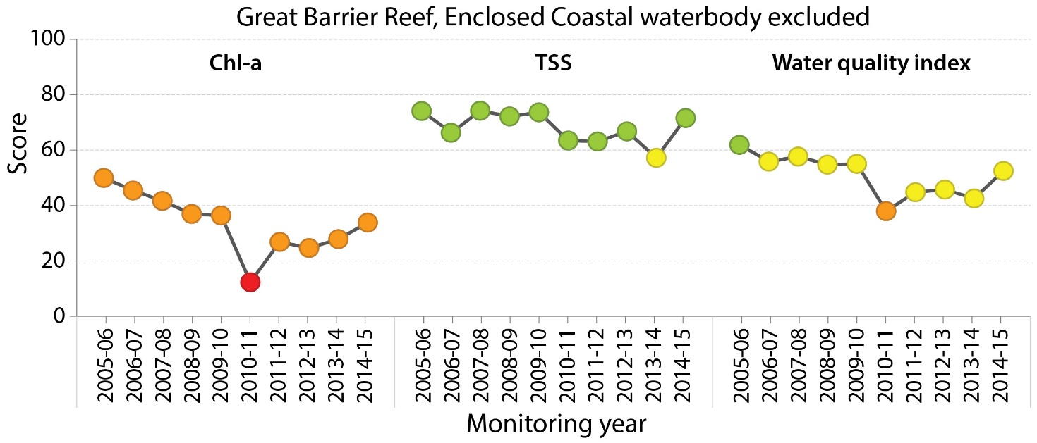
Figure 10. Time series of the Marine Water Quality Metric excluding the Enclosed Coastal waterbody, 2005-06 to 2014-15.

Options and recommendations
This analysis has shown that removing the Enclosed Coastal waters data from the Marine Water Quality Metric calculation resulted in an overall improvement in the water quality results and metric scores. This improvement was about 24% for Chl-a, TSS and both combined.
Despite the progress made in our understanding of the sensitivity of the metric in this interim project, the changes have not been significant enough to warrant changing the approach to the Marine Water Quality Metric for the 2015 Report Card (2014-15 data). The preference of decision makers is also to maintain consistent methodology between Report Cards, to avoid confusion and further justification. As shown in Figures 9 and 10 the trend in metric scores was largely unaffected by excluding Enclosed Coastal waters (although scores were consistently improved). This is because satellite-derived Chl-a and TSS (as NAP) values were consistently above GBR Water Quality Guideline values for most pixels in the Inshore waterbody in all years (data not shown, but see Figure 3 for the 2014-15 example).
It is therefore recommended that marine water quality be reported for the 2014-15 period using the approach from previous years in order to maintain consistency and focus efforts on longer term improvement to the Marine Water Quality Metric. The Marine Water Quality Metric should be scored as low confidence and notation included in the Tier 1 report that work is being done to improve the metric over the next year.

Future work
Development of an improved Marine Water Quality Metric was a recommendation of the 2014 review of the Marine Monitoring Program, and as shown in this interim project, this still needs to be progressed. Factors to be considered to progress this include:
- Publication and peer review of the Enclosed Coastal waterbody boundary and associated Guidelines.
- Clarification of seasonal combinations to align with other reporting – i.e. wet season followed by dry season in a reporting year (has been reported as dry season followed by wet season so far).
- Revision of the actual Marine Water Quality Metric calculation instead of averaging annually and over large areas to enable greater spatial and temporal sensitivity.
- Assessment of the confidence in remote sensing data in different water quality conditions, and criteria for determining the reliability of the data, particularly Chl-a (e.g. below certain TSS concentration or depth).
- Investigation of the incorporation of alternative data sources (e.g. in-situ data) into the Marine Water Quality Metric calculation.
- Development of a confidence index using the number of valid pixels in each reporting unit.
- Development of a method to take into account magnitude, duration, frequency of Guideline exceedance. This would be more of a ‘secondary’ metric that is more representative of exposure or risk and would need to be in addition to a metric assessing water quality status and trend.

References
Bainbridge, Z., Wolanski, E., Álvarez-Romero, J., Lewis, S., Brodie, J. 2012. Fine sediment and nutrient dynamics related to particle size and floc formation in a Burdekin River flood plume, Australia. Marine Pollution Bulletin 65, 236-248.
Bureau of Meteorology, 2014. eReefs Marine Water Quality Dashboard Scientific References http://www.bom.gov.au/environment/activities/mwqd/documents/scientific-references.pdf
Bureau of Meteorology, 2015. Operational Implementation of the Marine Water Quality system, 1 May 2015. Bureau National Operations Centre, Operations Bulletin Number 104. http://www.bom.gov.au/environment/activities/mwqd/documents/BNOC-Operations-Bulletin-Number-104.pdf
De'ath, A.G., Fabricius, K.E. 2008. Water quality of the Great Barrier Reef: distributions, effects on reef biota and trigger values for the protection of ecosystem health. Research Publication No.89. Great Barrier Reef Marine Park Authority. 104 p.
ESRI, 2010. ArcGIS 10.0. Environmental Systems Research Institute (ESRI). Redlands, CA.
ESRI, 2013. ArcGIS: Release 10.2. Environmental Systems Research Institute (ESRI). Redlands, CA.
Hijmans, R.J., Etten, J. van, Mattiuzzi, M., Sumner, M., Greenberg, J.A., Lamigueiro, O.P., Bevan, A., Racine, E.B., Shortridge, A. 2015. raster: Geographic Data Analysis and Modeling.
Petus, C., Devlin, M., da Silva, E., Brodie, J. 2015. Mapping uncertainty in chlorophyll a assessments from remote sensing in the Great Barrier Reef. Outcomes of a joint project for the Cape York, Burdekin and Fitzroy Water Quality Improvement Plans, 2015 (funded by Cape York NRM, NQ Dry Tropics and the Fitzroy Basin Association).
Maynard, J., Heron, S., Tracey, D. 2015. Improved ocean colour variable outputs for use in Great Barrier Reef Water Quality Improvement Plans and a future Great Barrier Reef-wide risk assessment. Outcomes of a joint project for the Cape York, Burdekin and Fitzroy Water Quality Improvement Plans, 2015 (funded by Cape York NRM, NQ Dry Tropics and the Fitzroy Basin Association).
PythonWin 2.7.3 (default, Apr 10 2012). Python IDE and GUI Framework for Windows. Copyright 1994-2008 Mark Hammond. Python is Copyright (c) 2001-2012 Python Software Foundation.
Temple Lang, D. 2007. R as a Web Client — the RCurl package, Journal of Statistical Software, http://www.omegahat.net/RCurl/RCurlJSS.pdf
Temple Lang, D., and the CRAN team, 2016. Package ‘RCurl’, Version 1.95-4.8, https://cran.r-project.org/web/packages/RCurl/RCurl.pdf
Thompson, A., Lønborg, C., Logan, M., Costello, P., Davidson, J., Furnas, M., Gunn, K., Liddy, M., Skuza, M., Uthicke, S., Wright, M., Zagorskis, I., Schaffelke, B. 2014. Marine Monitoring Program. Annual Report of AIMS Activities 2013 to 2014– Inshore water quality and coral reef monitoring. Report for the Great Barrier Reef Marine Park Authority. Australian Institute of Marine Science, Townsville.160 pp.

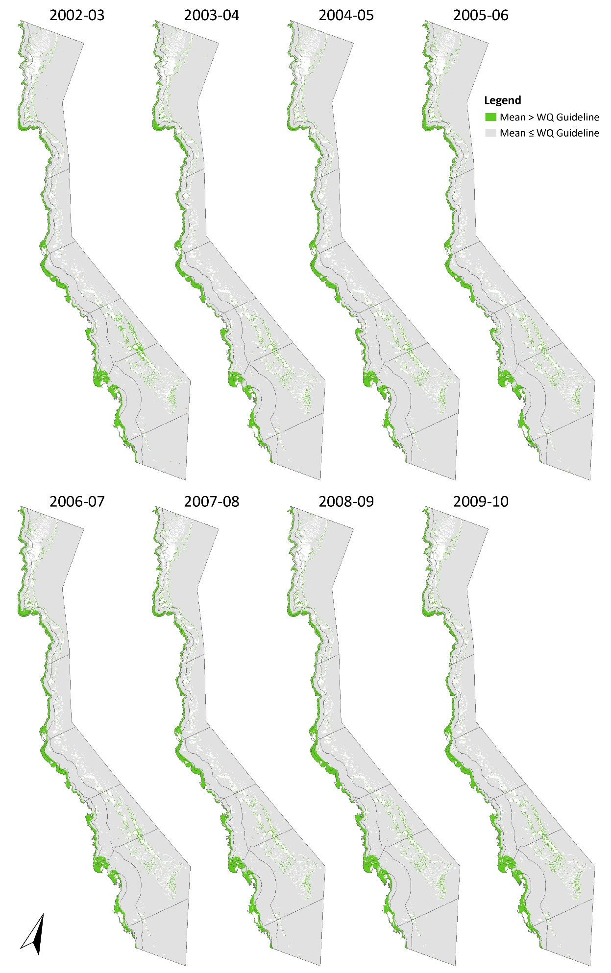
Appendix A: Historical data
Figure 11. Maps showing the area of exceedance of annual GBR Water Quality Guideline values for chlorophyll-a (annual mean) from 2002-03 to 2013-14 (continued on the next page).

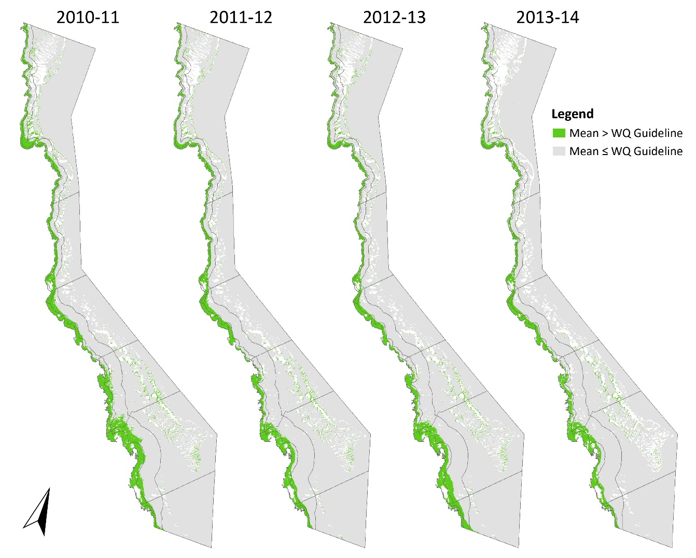
Figure 11 continued. Maps showing the area of exceedance of annual GBR Water Quality Guideline values for chlorophyll-a (annual mean) from 2002-03 to 2013-14 (continued from previous page).
The following tables show the effect of masking enclosed coastal waters on the relative area above threshold for chlorophyll-a from 2002-03 to 2013-14. Values quoted refer to the relative area (%) of the water body where the annual mean value exceeds the WQ Guideline value.
Table 12. Exceedance of annual Chlorophyll-a thresholds for 2002-03.
NRM region | Enclosed Coastal waterbodies included |  |  | Enclosed Coastal waterbodies excluded
 | Inshore | Mid-shelf | Offshore | Open Coastal | Mid-shelf | Offshore
Cape York | 69.7 | 12.2 | 2.5 | 54.2 | 10.9 | 2.5
Wet Tropics | 84.0 | 16.1 | 1.1 | 80.1 | 14.5 | 1.1
Burdekin | 66.8 | 4.1 | 0.7 | 58.6 | 4.1 | 0.7
Mackay Whitsunday | 45.7 | 6.4 | 8.3 | 37.5 | 6.4 | 8.3
Fitzroy | 67.4 | 5.9 | 3.7 | 56.9 | 5.6 | 3.7
Burnett Mary | 79.5 | 4.1 | 0.1 | 73.0 | 3.3 | 0.1
Table 13. Exceedance of annual Chlorophyll-a thresholds for 2003-04.
NRM Region | Enclosed Coastal waterbodies included |  |  | Enclosed Coastal waterbodies excluded
 | Inshore | Mid-shelf | Offshore | Open Coastal | Mid-shelf | Offshore
Cape York | 76.8 | 17.1 | 2.6 | 64.6 | 15.8 | 2.6
Wet Tropics | 91.0 | 20.7 | 1.3 | 89.0 | 19.2 | 1.3
Burdekin | 66.2 | 3.9 | 0.5 | 57.8 | 3.9 | 0.5
Mackay Whitsunday | 43.4 | 4.2 | 4.7 | 34.8 | 4.2 | 4.7
Fitzroy | 62.0 | 4.8 | 3.0 | 49.6 | 4.5 | 3.0
Burnett Mary | 71.6 | 4.7 | 0.1 | 62.7 | 3.9 | 0.1

Table 14. Exceedance of annual Chlorophyll-a thresholds for 2004-05.
NRM Region | Enclosed Coastal waterbodies included |  |  | Enclosed Coastal waterbodies excluded
 | Inshore | Mid-shelf | Offshore | Open Coastal | Mid-shelf | Offshore
Cape York | 70.2 | 11.4 | 2.3 | 54.8 | 10.1 | 2.4
Wet Tropics | 85.7 | 16.3 | 1.0 | 82.3 | 14.6 | 1.0
Burdekin | 67.6 | 3.7 | 0.6 | 59.5 | 3.7 | 0.6
Mackay Whitsunday | 39.1 | 5.0 | 5.0 | 29.8 | 5.0 | 5.0
Fitzroy | 60.8 | 4.6 | 3.4 | 47.9 | 4.3 | 3.4
Burnett Mary | 60.0 | 3.0 | 0.2 | 47.1 | 2.2 | 0.2

Table 15. Exceedance of annual Chlorophyll-a thresholds for 2005-06.
NRM Region | Enclosed Coastal waterbodies included |  |  | Enclosed Coastal waterbodies excluded
 | Inshore | Mid-shelf | Offshore | Open Coastal | Mid-shelf | Offshore
Cape York | 85.9 | 21.5 | 2.6 | 78.4 | 20.3 | 2.6
Wet Tropics | 87.8 | 15.8 | 1.0 | 84.9 | 14.2 | 1.0
Burdekin | 66.4 | 3.4 | 0.5 | 57.9 | 3.4 | 0.5
Mackay Whitsunday | 41.0 | 5.9 | 4.9 | 32.1 | 5.9 | 4.9
Fitzroy | 60.4 | 5.1 | 3.3 | 47.5 | 4.9 | 3.3
Burnett Mary | 61.6 | 3.1 | 0.2 | 49.7 | 2.3 | 0.2

Table 16. Exceedance of annual Chlorophyll-a thresholds for 2006-07.
NRM Region | Enclosed Coastal waterbodies included |  |  | Enclosed Coastal waterbodies excluded
 | Inshore | Mid-shelf | Offshore | Open Coastal | Mid-shelf | Offshore
Cape York | 90.8 | 22.8 | 2.6 | 86.1 | 21.7 | 2.6
Wet Tropics | 93.9 | 22.8 | 1.1 | 92.6 | 21.3 | 1.1
Burdekin | 67.2 | 4.7 | 0.4 | 59.0 | 4.7 | 0.4
Mackay Whitsunday | 49.4 | 5.7 | 4.7 | 41.9 | 5.7 | 4.7
Fitzroy | 61.4 | 5.1 | 2.6 | 48.7 | 4.8 | 2.6
Burnett Mary | 61.3 | 3.1 | 0.1 | 48.8 | 2.3 | 0.1

Table 17. Exceedance of annual Chlorophyll-a thresholds for 2007-08.
NRM Region | Enclosed Coastal waterbodies included |  |  | Enclosed Coastal waterbodies excluded
 | Inshore | Mid-shelf | Offshore | Open Coastal | Mid-shelf | Offshore
Cape York | 76.5 | 15.4 | 2.5 | 64.4 | 14.1 | 2.5
Wet Tropics | 87.0 | 18.8 | 1.2 | 83.9 | 17.2 | 1.2
Burdekin | 72.0 | 5.0 | 0.5 | 65.0 | 5.0 | 0.5
Mackay Whitsunday | 49.6 | 5.1 | 4.4 | 42.1 | 5.1 | 4.4
Fitzroy | 69.5 | 6.0 | 2.9 | 59.5 | 5.8 | 2.9
Burnett Mary | 70.3 | 4.5 | 0.2 | 60.9 | 3.7 | 0.2

Table 18. Exceedance of annual Chlorophyll-a thresholds for 2008-09.
NRM Region | Enclosed Coastal waterbodies included |  |  | Enclosed Coastal waterbodies excluded
 | Inshore | Mid-shelf | Offshore | Open Coastal | Mid-shelf | Offshore
Cape York | 80.0 | 16.2 | 2.5 | 69.7 | 14.9 | 2.5
Wet Tropics | 93.0 | 25.9 | 1.4 | 91.3 | 24.4 | 1.4
Burdekin | 78.6 | 8.7 | 0.5 | 73.3 | 8.7 | 0.5
Mackay Whitsunday | 53.9 | 7.7 | 4.8 | 46.9 | 7.7 | 4.8
Fitzroy | 69.4 | 6.3 | 3.5 | 59.5 | 6.0 | 3.5
Burnett Mary | 69.6 | 4.0 | 0.2 | 60.0 | 3.2 | 0.2

Table 19. Exceedance of annual Chlorophyll-a thresholds for 2009-10.
NRM Region | Enclosed Coastal waterbodies included |  |  | Enclosed Coastal waterbodies excluded
 | Inshore | Mid-shelf | Offshore | Open Coastal | Mid-shelf | Offshore
Cape York | 77.2 | 15.3 | 2.6 | 65.0 | 14.0 | 2.6
Wet Tropics | 89.8 | 21.9 | 1.4 | 87.3 | 20.4 | 1.4
Burdekin | 75.5 | 6.6 | 0.6 | 69.3 | 6.6 | 0.6
Mackay Whitsunday | 51.2 | 7.2 | 5.1 | 43.7 | 7.2 | 5.2
Fitzroy | 75.7 | 7.9 | 3.9 | 67.8 | 7.6 | 3.9
Burnett Mary | 86.1 | 5.8 | 0.2 | 81.6 | 5.0 | 0.2

Table 20. Exceedance of annual Chlorophyll-a thresholds for 2010-11.
NRM Region | Enclosed Coastal waterbodies included |  |  | Enclosed Coastal waterbodies excluded
 | Inshore | Mid-shelf | Offshore | Open Coastal | Mid-shelf | Offshore
Cape York | 91.8 | 30.8 | 3.1 | 87.6 | 29.7 | 3.1
Wet Tropics | 97.4 | 35.6 | 2.3 | 96.9 | 34.4 | 2.3
Burdekin | 80.5 | 14.9 | 0.5 | 75.6 | 14.9 | 0.5
Mackay Whitsunday | 80.5 | 19.9 | 4.5 | 77.6 | 19.9 | 4.5
Fitzroy | 98.0 | 19.7 | 2.7 | 97.4 | 19.5 | 2.7
Burnett Mary | 99.8 | 19.0 | 0.3 | 99.8 | 18.3 | 0.3

Table 21. Exceedance of annual Chlorophyll-a thresholds for 2011-12.
NRM Region | Enclosed Coastal waterbodies included |  |  | Enclosed Coastal waterbodies excluded
 | Inshore | Mid-shelf | Offshore | Open Coastal | Mid-shelf | Offshore
Cape York | 84.9 | 18.0 | 2.2 | 77.1 | 16.8 | 2.2
Wet Tropics | 96.1 | 30.6 | 1.5 | 95.1 | 29.3 | 1.5
Burdekin | 74.7 | 11.5 | 0.5 | 68.6 | 11.5 | 0.5
Mackay Whitsunday | 60.6 | 5.6 | 4.2 | 54.7 | 5.6 | 4.2
Fitzroy | 85.5 | 9.3 | 2.5 | 80.7 | 9.0 | 2.5
Burnett Mary | 99.8 | 16.0 | 0.2 | 99.8 | 15.3 | 0.2

Table 22. Exceedance of annual Chlorophyll-a thresholds for 2012-13.
NRM Region | Enclosed Coastal waterbodies included |  |  | Enclosed Coastal waterbodies excluded
 | Inshore | Mid-shelf | Offshore | Open Coastal | Mid-shelf | Offshore
Cape York | 76.5 | 16.1 | 2.5 | 64.1 | 14.8 | 2.5
Wet Tropics | 90.8 | 22.3 | 1.2 | 88.6 | 20.8 | 1.2
Burdekin | 73.6 | 7.2 | 0.4 | 67.1 | 7.2 | 0.4
Mackay Whitsunday | 65.2 | 8.0 | 3.8 | 59.9 | 8.0 | 3.8
Fitzroy | 89.7 | 19.4 | 2.6 | 86.3 | 19.2 | 2.6
Burnett Mary | 100.0 | 39.8 | 0.8 | 100.0 | 39.3 | 0.8

Table 23. Exceedance of annual Chlorophyll-a thresholds for 2013-14.
NRM Region | Enclosed Coastal waterbodies included |  |  | Enclosed Coastal waterbodies excluded
 | Inshore | Mid-shelf | Offshore | Open Coastal | Mid-shelf | Offshore
Cape York | 84.3 | 18.8 | 1.0 | 75.8 | 17.4 | 1.0
Wet Tropics | 92.0 | 25.4 | 0.5 | 89.9 | 24.1 | 0.5
Burdekin | 80.0 | 7.4 | 0.1 | 75.0 | 7.4 | 0.1
Mackay Whitsunday | 67.0 | 6.7 | 2.7 | 61.9 | 6.7 | 2.7
Fitzroy | 78.4 | 8.8 | 1.0 | 71.4 | 8.6 | 1.0
Burnett Mary | 96.1 | 10.1 | 0.0 | 94.9 | 9.4 | 0.0

Table 24. Exceedance of annual Chlorophyll-a thresholds for 2014-15.
NRM Region | Enclosed Coastal waterbodies included |  |  | Enclosed Coastal waterbodies excluded
 | Inshore | Mid-shelf | Offshore | Open Coastal | Mid-shelf | Offshore
Cape York | 90.7 | 24.1 | 1.1 | 85.5 | 22.8 | 1.1
Wet Tropics | 93.2 | 22.7 | 0.4 | 91.4 | 21.3 | 0.4
Burdekin | 71.1 | 5.7 | 0.1 | 64.0 | 5.7 | 0.1
Mackay Whitsunday | 52.9 | 7.4 | 3.6 | 45.8 | 7.4 | 3.6
Fitzroy | 80.5 | 10.3 | 1.3 | 74.3 | 10.0 | 1.3
Burnett Mary | 97.1 | 9.9 | 0.0 | 96.2 | 9.2 | 0.0
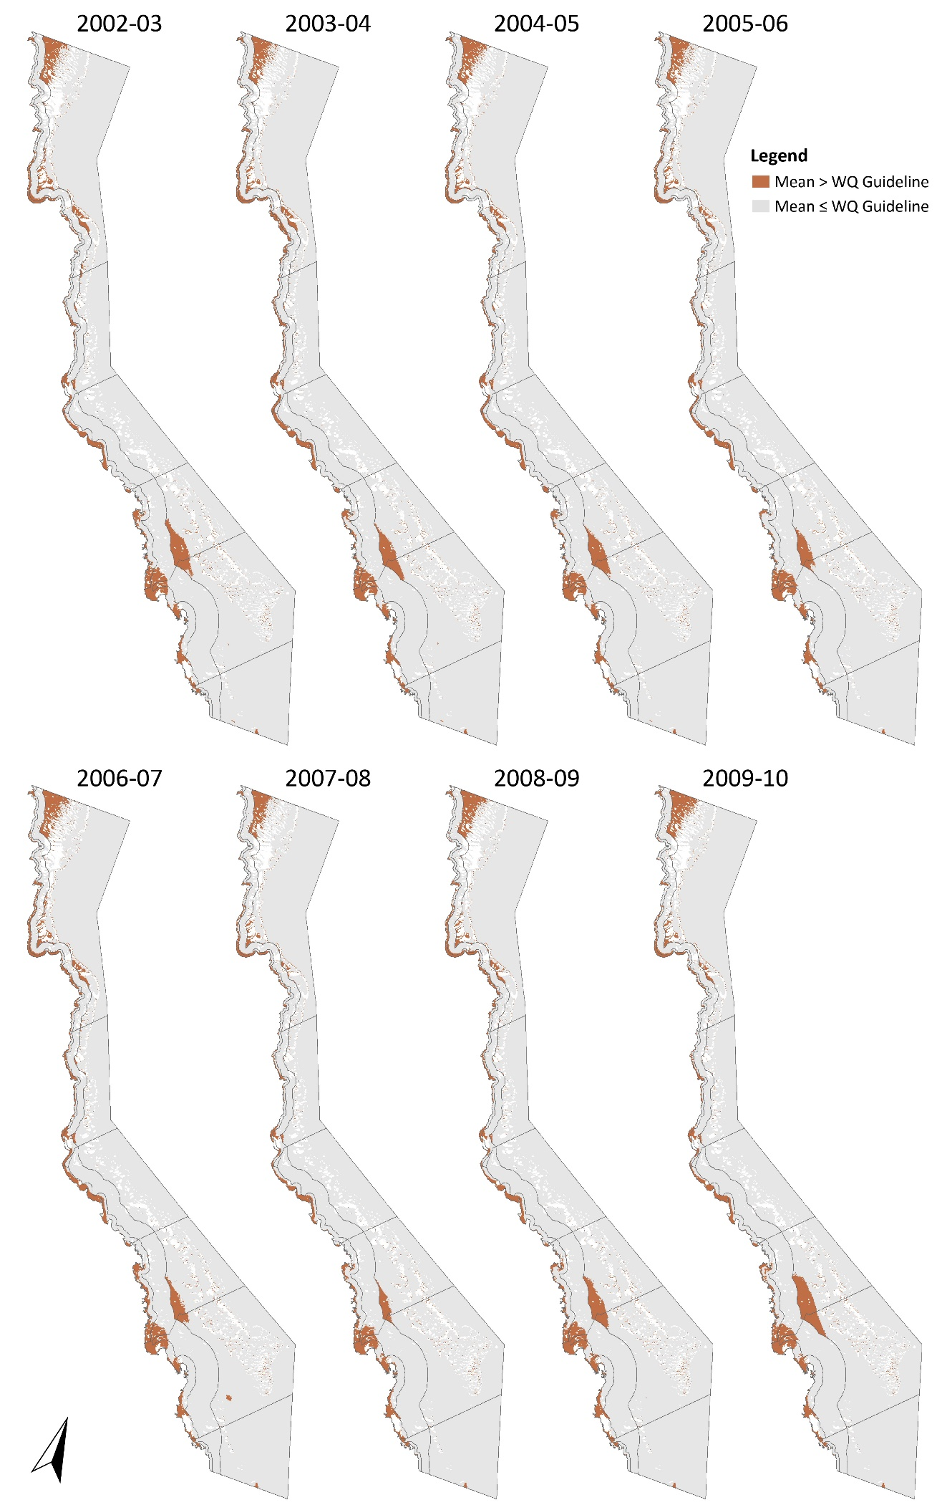
Figure 12. Maps showing the area of exceedance of annual GBR Water Quality Guideline values for total suspended solids (annual mean) from 2002-03 to 2013-14 (continued on next page).

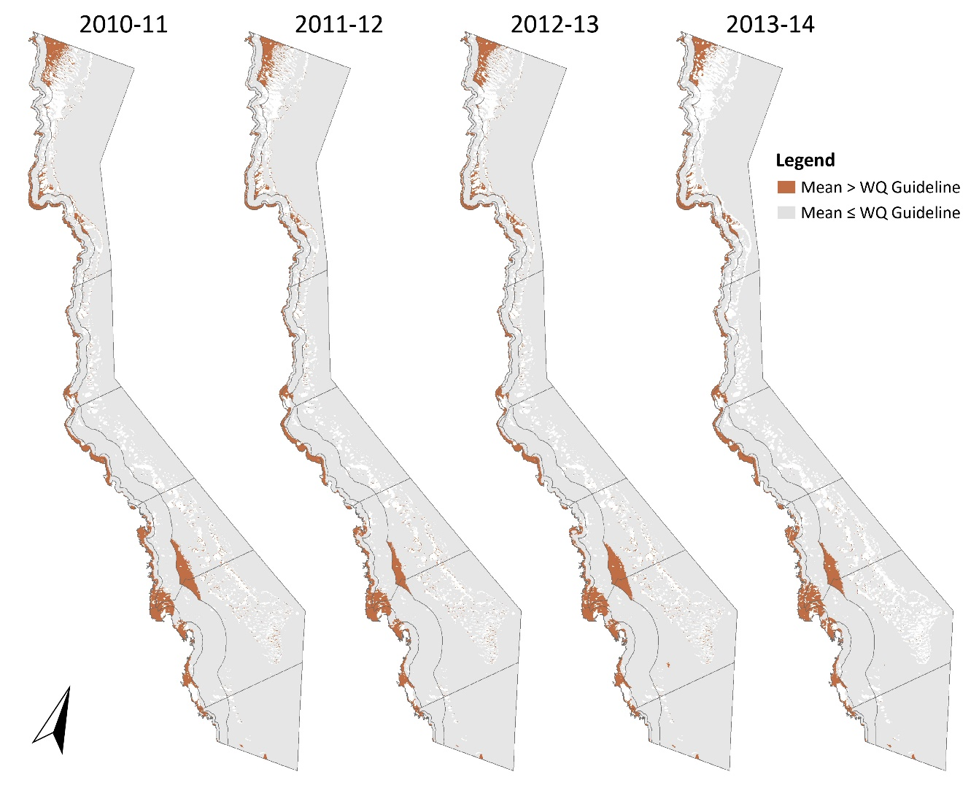
Figure 12 continued. Maps showing the area of exceedance of annual GBR Water Quality Guideline values for total suspended solids (annual mean) from 2002-03 to 2013-14 (see previous page).
The following tables show the effect of masking enclosed coastal waters on the relative area above threshold for chlorophyll-a from 2002-03 to 2013-14. Values quoted refer to the relative area (%) of the water body where the annual mean value exceeds the WQ Guideline value.
Table 25. Exceedance of annual TSS thresholds for 2002-03.
NRM region | Enclosed Coastal waterbodies included |  |  | Enclosed Coastal waterbodies excluded
 | Inshore | Mid-shelf | Offshore | Open Coastal | Mid-shelf | Offshore
Cape York | 35.3 | 4.3 | 9.8 | 10.6 | 3.0 | 9.8
Wet Tropics | 41.9 | 4.0 | 2.2 | 28.9 | 2.1 | 2.2
Burdekin | 41.9 | 0.2 | 0.2 | 28.0 | 0.2 | 0.2
Mackay Whitsunday | 36.6 | 9.4 | 13.0 | 27.9 | 9.4 | 13.0
Fitzroy | 43.1 | 2.8 | 3.0 | 25.0 | 2.5 | 3.0
Burnett Mary | 22.3 | 1.0 | 0.4 | 2.1 | 0.4 | 0.4
Table 26. Exceedance of annual TSS thresholds for 2003-04.
 | Enclosed Coastal waterbodies included |  |  | Enclosed Coastal waterbodies excluded
 | Inshore | Mid-shelf | Offshore | Open Coastal | Mid-shelf | Offshore
Cape York | 50.8 | 6.9 | 8.6 | 30.1 | 5.5 | 8.7
Wet Tropics | 56.8 | 5.7 | 1.6 | 47.2 | 4.0 | 1.6
Burdekin | 48.7 | 0.3 | 0.2 | 36.6 | 0.3 | 0.2
Mackay Whitsunday | 35.5 | 7.9 | 9.9 | 26.3 | 7.9 | 9.9
Fitzroy | 44.9 | 2.9 | 3.4 | 27.1 | 2.6 | 3.4
Burnett Mary | 22.8 | 1.1 | 0.3 | 1.9 | 0.4 | 0.3

Table 27. Exceedance of annual TSS thresholds for 2004-05.
 | Enclosed Coastal waterbodies included |  |  | Enclosed Coastal waterbodies excluded
 | Inshore | Mid-shelf | Offshore | Open Coastal | Mid-shelf | Offshore
Cape York | 40.0 | 3.5 | 9.3 | 18.3 | 2.3 | 9.3
Wet Tropics | 47.4 | 4.2 | 2.0 | 35.5 | 2.4 | 2.0
Burdekin | 45.6 | 0.2 | 0.2 | 32.4 | 0.2 | 0.2
Mackay Whitsunday | 29.4 | 7.7 | 10.2 | 19.4 | 7.7 | 10.2
Fitzroy | 44.0 | 2.9 | 3.0 | 26.1 | 2.6 | 3.0
Burnett Mary | 21.4 | 0.9 | 0.3 | 0.9 | 0.3 | 0.3

Table 28. Exceedance of annual TSS thresholds for 2005-06.
 | Enclosed Coastal waterbodies included |  |  | Enclosed Coastal waterbodies excluded
 | Inshore | Mid-shelf | Offshore | Open Coastal | Mid-shelf | Offshore
Cape York | 36.6 | 4.1 | 8.6 | 17.3 | 2.7 | 8.6
Wet Tropics | 45.6 | 3.6 | 1.7 | 33.4 | 1.8 | 1.7
Burdekin | 43.5 | 0.3 | 0.2 | 30.2 | 0.3 | 0.2
Mackay Whitsunday | 26.5 | 8.7 | 8.8 | 16.8 | 8.7 | 8.8
Fitzroy | 45.2 | 3.2 | 2.0 | 27.7 | 2.9 | 2.0
Burnett Mary | 21.6 | 0.7 | 0.3 | 1.3 | 0.3 | 0.3

Table 29. Exceedance of annual TSS thresholds for 2006-07.
 | Enclosed Coastal waterbodies included |  |  | Enclosed Coastal waterbodies excluded
 | Inshore | Mid-shelf | Offshore | Open Coastal | Mid-shelf | Offshore
Cape York | 53.3 | 5.3 | 9.8 | 31.3 | 3.9 | 9.8
Wet Tropics | 56.5 | 5.1 | 2.3 | 46.9 | 3.4 | 2.3
Burdekin | 48.0 | 0.4 | 0.2 | 36.0 | 0.4 | 0.2
Mackay Whitsunday | 43.2 | 8.3 | 8.9 | 35.1 | 8.3 | 8.9
Fitzroy | 44.0 | 2.7 | 2.5 | 26.0 | 2.4 | 2.5
Burnett Mary | 18.3 | 0.7 | 0.3 | 0.2 | 0.3 | 0.3

Table 30. Exceedance of annual TSS thresholds for 2007-08.
 | Enclosed Coastal waterbodies included |  |  | Enclosed Coastal waterbodies excluded
 | Inshore | Mid-shelf | Offshore | Open Coastal | Mid-shelf | Offshore
Cape York | 35.8 | 2.7 | 7.1 | 10.3 | 1.6 | 7.1
Wet Tropics | 35.8 | 3.4 | 1.2 | 21.9 | 1.6 | 1.2
Burdekin | 37.4 | 0.1 | 0.2 | 23.3 | 0.1 | 0.2
Mackay Whitsunday | 30.3 | 7.3 | 6.6 | 20.7 | 7.3 | 6.6
Fitzroy | 48.6 | 3.0 | 1.6 | 32.4 | 2.7 | 1.6
Burnett Mary | 23.3 | 1.3 | 0.3 | 3.6 | 0.6 | 0.3

Table 31. Exceedance of annual TSS thresholds for 2008-09.
 | Enclosed Coastal waterbodies included |  |  | Enclosed Coastal waterbodies excluded
 | Inshore | Mid-shelf | Offshore | Open Coastal | Mid-shelf | Offshore
Cape York | 48.8 | 4.8 | 8.6 | 25.7 | 3.5 | 8.7
Wet Tropics | 42.3 | 3.6 | 1.4 | 29.3 | 1.8 | 1.4
Burdekin | 40.8 | 0.2 | 0.2 | 26.7 | 0.2 | 0.2
Mackay Whitsunday | 31.4 | 9.6 | 11.2 | 22.0 | 9.6 | 11.2
Fitzroy | 48.4 | 3.6 | 2.9 | 31.9 | 3.4 | 2.9
Burnett Mary | 23.2 | 1.2 | 0.3 | 1.7 | 0.6 | 0.3

Table 32. Exceedance of annual TSS thresholds for 2009-10.
 | Enclosed Coastal waterbodies included |  |  | Enclosed Coastal waterbodies excluded
 | Inshore | Mid-shelf | Offshore | Open Coastal | Mid-shelf | Offshore
Cape York | 34.9 | 3.3 | 9.1 | 7.1 | 2.0 | 9.1
Wet Tropics | 40.2 | 4.5 | 1.4 | 26.8 | 2.7 | 1.4
Burdekin | 41.9 | 0.2 | 0.2 | 27.7 | 0.2 | 0.2
Mackay Whitsunday | 33.6 | 8.3 | 14.6 | 24.3 | 8.3 | 14.6
Fitzroy | 44.5 | 3.5 | 4.0 | 26.7 | 3.2 | 4.0
Burnett Mary | 23.7 | 0.9 | 0.3 | 2.1 | 0.3 | 0.3

Table 33. Exceedance of annual TSS thresholds for 2010-11.
 | Enclosed Coastal waterbodies included |  |  | Enclosed Coastal waterbodies excluded
 | Inshore | Mid-shelf | Offshore | Open Coastal | Mid-shelf | Offshore
Cape York | 48.3 | 5.4 | 8.0 | 24.9 | 4.0 | 8.1
Wet Tropics | 46.2 | 4.7 | 1.4 | 34.0 | 2.9 | 1.4
Burdekin | 44.5 | 0.2 | 0.2 | 31.8 | 0.2 | 0.2
Mackay Whitsunday | 51.2 | 8.3 | 10.1 | 44.6 | 8.3 | 10.1
Fitzroy | 49.6 | 3.4 | 3.0 | 33.3 | 3.1 | 3.0
Burnett Mary | 30.5 | 1.5 | 0.4 | 10.3 | 0.7 | 0.4

Table 34. Exceedance of annual TSS thresholds for 2011-12.
 | Enclosed Coastal waterbodies included |  |  | Enclosed Coastal waterbodies excluded
 | Inshore | Mid-shelf | Offshore | Open Coastal | Mid-shelf | Offshore
Cape York | 42.3 | 2.7 | 7.5 | 17.1 | 1.9 | 7.6
Wet Tropics | 52.9 | 7.4 | 1.4 | 42.4 | 5.6 | 1.5
Burdekin | 49.6 | 0.5 | 0.2 | 37.8 | 0.5 | 0.2
Mackay Whitsunday | 42.6 | 8.2 | 7.4 | 34.5 | 8.2 | 7.4
Fitzroy | 51.7 | 3.6 | 1.9 | 36.3 | 3.4 | 1.9
Burnett Mary | 30.7 | 1.7 | 0.3 | 10.5 | 0.8 | 0.3

Table 35. Exceedance of annual TSS thresholds for 2012-13.
 | Enclosed Coastal waterbodies included |  |  | Enclosed Coastal waterbodies excluded
 | Inshore | Mid-shelf | Offshore | Open Coastal | Mid-shelf | Offshore
Cape York | 36.5 | 3.3 | 8.4 | 10.3 | 2.1 | 8.5
Wet Tropics | 40.4 | 4.1 | 1.3 | 26.7 | 2.3 | 1.3
Burdekin | 43.1 | 0.4 | 0.2 | 30.3 | 0.4 | 0.2
Mackay Whitsunday | 39.4 | 9.6 | 10.6 | 31.0 | 9.6 | 10.6
Fitzroy | 53.3 | 4.2 | 3.3 | 38.3 | 3.9 | 3.3
Burnett Mary | 30.9 | 1.7 | 0.4 | 11.1 | 0.9 | 0.4

Table 36. Exceedance of annual TSS thresholds for 2013-14.
 | Enclosed Coastal waterbodies included |  |  | Enclosed Coastal waterbodies excluded
 | Inshore | Mid-shelf | Offshore | Open Coastal | Mid-shelf | Offshore
Cape York | 57.9 | 9.8 | 6.5 | 36.3 | 8.3 | 6.5
Wet Tropics | 55.8 | 7.4 | 1.4 | 44.8 | 5.8 | 1.4
Burdekin | 52.9 | 1.5 | 0.0 | 41.5 | 1.5 | 0.0
Mackay Whitsunday | 53.6 | 12.5 | 8.3 | 46.7 | 12.5 | 8.3
Fitzroy | 53.8 | 4.3 | 1.5 | 38.9 | 4.0 | 1.5
Burnett Mary | 31.2 | 1.8 | 0.4 | 12.2 | 1.0 | 0.4

Table 37. Exceedance of annual TSS thresholds for 2014-15.
 | Enclosed Coastal waterbodies included |  |  | Enclosed Coastal waterbodies excluded
 | Inshore | Mid-shelf | Offshore | Open Coastal | Mid-shelf | Offshore
Cape York | 46.4 | 6.3 | 6.6 | 19.9 | 5.1 | 6.6
Wet Tropics | 40.2 | 4.8 | 0.5 | 25.2 | 3.2 | 0.5
Burdekin | 43.9 | 0.4 | 0.0 | 30.5 | 0.4 | 0.0
Mackay Whitsunday | 31.3 | 10.4 | 8.5 | 21.6 | 10.4 | 8.5
Fitzroy | 49.6 | 4.4 | 1.9 | 33.3 | 4.1 | 1.9
Burnett Mary | 22.6 | 0.9 | 0.3 | 2.2 | 0.4 | 0.3

Appendix B: Comparison to Seasonal WQ Guidelines
Table 38. Relative area (%) of the waterbody where the Dry Season mean value exceeds the Seasonal GBR Water Quality Guideline values for Chlorophyll-a in 2014-15.
NRM Region | Enclosed Coastal waterbodies included |  |  | Enclosed Coastal waterbodies excluded
 | Inshore | Mid-shelf | Offshore | Open Coast. | Mid-shelf | Offshore
Cape York | 97.0 | 45.5 | 3.7 | 95.3 | 44.6 | 3.7
Wet Tropics | 99.3 | 39.2 | 1.3 | 99.1 | 38.1 | 1.3
Burdekin | 86.9 | 13.7 | 0.4 | 83.7 | 13.7 | 0.4
Mackay Whitsunday | 95.4 | 39.1 | 14.6 | 94.6 | 39.1 | 14.6
Fitzroy | 86.4 | 20.4 | 7.2 | 82.0 | 20.1 | 7.2
Burnett Mary | 98.8 | 15.3 | 0.4 | 98.4 | 14.7 | 0.4

Table 39. Relative area (%) of the waterbody where the Wet Season mean value exceeds the Seasonal GBR Water Quality Guideline values for Chlorophyll-a in 2014-15.
NRM Region | Enclosed Coastal waterbodies included |  |  | Enclosed Coastal waterbodies excluded
 | Inshore | Mid-shelf | Offshore | Open Coast. | Mid-shelf | Offshore
Cape York | 67.6 | 13.0 | 0.4 | 50.2 | 11.5 | 0.4
Wet Tropics | 56.5 | 6.4 | 0.1 | 45.3 | 4.8 | 0.1
Burdekin | 52.9 | 0.7 | 0.1 | 41.6 | 0.7 | 0.1
Mackay Whitsunday | 26.0 | 4.9 | 1.5 | 15.1 | 4.9 | 1.5
Fitzroy | 68.5 | 5.8 | 0.5 | 59.0 | 5.6 | 0.5
Burnett Mary | 94.4 | 8.0 | 0.0 | 92.9 | 7.3 | 0.0

Table 40. Relative area (%) of the waterbody where the Dry Season mean value exceeds the Seasonal GBR Water Quality Guideline values for TSS in 2014-15.
NRM Region | Enclosed Coastal waterbodies included |  |  | Enclosed Coastal waterbodies excluded
 | Inshore | Mid-shelf | Offshore | Open Coast. | Mid-shelf | Offshore
Cape York | 59.4 | 12.2 | 9.2 | 38.3 | 10.7 | 9.2
Wet Tropics | 56.6 | 8.4 | 1.8 | 45.9 | 6.8 | 1.8
Burdekin | 54.2 | 1.6 | 0.0 | 43.0 | 1.6 | 0.0
Mackay Whitsunday | 43.0 | 15.5 | 13.9 | 34.6 | 15.5 | 13.9
Fitzroy | 54.0 | 4.8 | 4.1 | 39.3 | 4.5 | 4.1
Burnett Mary | 22.4 | 0.9 | 0.4 | 2.7 | 0.4 | 0.4

Table 41. Relative area (%) of the waterbody where the Wet Season mean value exceeds the Seasonal GBR Water Quality Guideline values for TSS in 2014-15.
NRM Region | Enclosed Coastal waterbodies included |  |  | Enclosed Coastal waterbodies excluded
 | Inshore | Mid-shelf | Offshore | Open Coast. | Mid-shelf | Offshore
Cape York | 25.6 | 2.3 | 2.0 | 4.1 | 1.6 | 2.0
Wet Tropics | 23.0 | 3.1 | 0.1 | 5.7 | 1.5 | 0.1
Burdekin | 28.7 | 0.0 | 0.0 | 13.7 | 0.0 | 0.0
Mackay Whitsunday | 23.9 | 8.5 | 6.1 | 14.9 | 8.5 | 6.1
Fitzroy | 46.4 | 4.1 | 0.7 | 30.0 | 3.9 | 0.7
Burnett Mary | 24.5 | 0.9 | 0.3 | 4.5 | 0.4 | 0.3

Appendix C: Seasonal mean values
Table 42. Spatial mean and standard deviation of chlorophyll-a including Enclosed Coastal waterbodies.
NRM region and waterbody | Dry Season |  |  | Wet Season
 | Pixels | Mean | StDev | Pixels | Mean | StDev
Cape York-inshore | 2918 | 0.97 | 0.89 | 2909 | 1.06 | 0.88
Cape York-midshelf | 9471 | 0.34 | 0.13 | 9471 | 0.48 | 0.2
Cape York-offshore | 49914 | 0.17 | 0.05 | 49914 | 0.18 | 0.1
Wet Tropics-inshore | 1399 | 1.12 | 1 | 1394 | 1.07 | 1.03
Wet Tropics-midshelf | 5061 | 0.37 | 0.33 | 5060 | 0.42 | 0.35
Wet Tropics-offshore | 16031 | 0.17 | 0.04 | 16031 | 0.17 | 0.06
Burdekin-inshore | 3108 | 0.97 | 0.94 | 3105 | 0.94 | 0.84
Burdekin-midshelf | 9423 | 0.24 | 0.1 | 9423 | 0.29 | 0.09
Burdekin-offshore | 22459 | 0.16 | 0.02 | 22459 | 0.17 | 0.05
Mackay-Whitsunday-inshore | 3609 | 0.67 | 0.6 | 3606 | 0.65 | 0.53
Mackay-Whitsunday-midshelf | 9858 | 0.33 | 0.2 | 9858 | 0.37 | 0.14
Mackay-Whitsunday-offshore | 21657 | 0.22 | 0.06 | 21657 | 0.28 | 0.11
Fitzroy-inshore | 4803 | 1.34 | 1.55 | 4778 | 1.34 | 1.29
Fitzroy-midshelf | 16103 | 0.32 | 0.33 | 16103 | 0.42 | 0.19
Fitzroy-offshore | 41636 | 0.21 | 0.05 | 41636 | 0.25 | 0.09
Burnett-Mary-inshore | 545 | 0.7 | 0.52 | 545 | 1.13 | 0.66
Burnett-Mary-midshelf | 2968 | 0.25 | 0.1 | 2968 | 0.42 | 0.17
Burnett-Mary-offshore | 28454 | 0.18 | 0.02 | 28454 | 0.17 | 0.03

Table 43. Spatial mean and standard deviation of chlorophyll-a excluding Enclosed Coastal waterbodies.
NRM region and waterbody | Dry Season |  |  | Wet Season
 | Pixels | Mean | StDev | Pixels | Mean | StDev
Cape York-inshore | 1940 | 0.59 | 0.26 | 1937 | 0.67 | 0.22
Cape York-midshelf | 9312 | 0.34 | 0.12 | 9312 | 0.46 | 0.16
Cape York-offshore | 49914 | 0.17 | 0.05 | 49914 | 0.18 | 0.1
Wet Tropics-inshore | 1121 | 0.74 | 0.32 | 1120 | 0.67 | 0.22
Wet Tropics-midshelf | 4977 | 0.34 | 0.18 | 4977 | 0.38 | 0.16
Wet Tropics-offshore | 16031 | 0.17 | 0.04 | 16031 | 0.17 | 0.06
Burdekin-inshore | 2547 | 0.64 | 0.34 | 2546 | 0.65 | 0.27
Burdekin-midshelf | 9423 | 0.24 | 0.1 | 9423 | 0.29 | 0.09
Burdekin-offshore | 22459 | 0.16 | 0.02 | 22459 | 0.17 | 0.05
Mackay-Whitsunday-inshore | 3170 | 0.5 | 0.22 | 3170 | 0.51 | 0.17
Mackay-Whitsunday-midshelf | 9858 | 0.33 | 0.2 | 9858 | 0.37 | 0.14
Mackay-Whitsunday-offshore | 21657 | 0.22 | 0.06 | 21657 | 0.28 | 0.11
Fitzroy-inshore | 3695 | 0.66 | 0.57 | 3695 | 0.82 | 0.41
Fitzroy-midshelf | 16059 | 0.31 | 0.28 | 16059 | 0.42 | 0.18
Fitzroy-offshore | 41636 | 0.21 | 0.05 | 41636 | 0.25 | 0.09
Burnett-Mary-inshore | 434 | 0.51 | 0.15 | 434 | 0.86 | 0.22
Burnett-Mary-midshelf | 2945 | 0.25 | 0.09 | 2945 | 0.41 | 0.15
Burnett-Mary-offshore | 28454 | 0.18 | 0.02 | 28454 | 0.17 | 0.03

Table 44. Spatial mean and standard deviation of TSS including Enclosed Coastal waterbodies.
NRM region and waterbody | Dry Season |  |  | Wet Season
 | Pixels | Mean | StDev | Pixels | Mean | StDev
Cape York-inshore | 2918 | 3.27 | 3.39 | 2909 | 2.15 | 2.37
Cape York-midshelf | 9471 | 1.13 | 0.5 | 9471 | 0.87 | 0.46
Cape York-offshore | 49914 | 0.22 | 0.3 | 49914 | 0.19 | 0.19
Wet Tropics-inshore | 1399 | 2.84 | 2.66 | 1394 | 2.11 | 2.03
Wet Tropics-midshelf | 5061 | 0.92 | 0.88 | 5060 | 0.76 | 0.84
Wet Tropics-offshore | 16031 | 0.17 | 0.13 | 16031 | 0.16 | 0.1
Burdekin-inshore | 3108 | 3.14 | 3.21 | 3105 | 2.5 | 3
Burdekin-midshelf | 9423 | 0.52 | 0.33 | 9423 | 0.46 | 0.25
Burdekin-offshore | 22459 | 0.15 | 0.07 | 22459 | 0.14 | 0.06
Mackay-Whitsunday-inshore | 3609 | 2.95 | 3.64 | 3606 | 2.38 | 2.31
Mackay-Whitsunday-midshelf | 9858 | 1.59 | 2.44 | 9858 | 1.25 | 1.31
Mackay-Whitsunday-offshore | 21657 | 0.34 | 0.27 | 21657 | 0.29 | 0.24
Fitzroy-inshore | 4803 | 8.71 | 13.73 | 4778 | 5.94 | 8.92
Fitzroy-midshelf | 16103 | 1.02 | 3.39 | 16103 | 0.8 | 1.73
Fitzroy-offshore | 41636 | 0.25 | 0.16 | 41636 | 0.2 | 0.12
Burnett-Mary-inshore | 545 | 1.1 | 1.25 | 545 | 1.74 | 1.63
Burnett-Mary-midshelf | 2968 | 0.29 | 0.26 | 2968 | 0.3 | 0.37
Burnett-Mary-offshore | 28454 | 0.15 | 0.09 | 28454 | 0.12 | 0.1

Table 45. Spatial mean and standard deviation of TSS excluding Enclosed Coastal waterbodies.
NRM region and waterbody | Dry Season |  |  | Wet Season
 | Pixels | Mean | StDev | Pixels | Mean | StDev
Cape York-inshore | 1940 | 1.67 | 0.92 | 1937 | 1.17 | 0.58
Cape York-midshelf | 9312 | 1.1 | 0.42 | 9312 | 0.83 | 0.36
Cape York-offshore | 49914 | 0.22 | 0.3 | 49914 | 0.19 | 0.19
Wet Tropics-inshore | 1121 | 1.97 | 1.47 | 1120 | 1.34 | 0.57
Wet Tropics-midshelf | 4977 | 0.84 | 0.53 | 4977 | 0.67 | 0.42
Wet Tropics-offshore | 16031 | 0.17 | 0.13 | 16031 | 0.16 | 0.1
Burdekin-inshore | 2547 | 2.02 | 1.46 | 2546 | 1.46 | 0.97
Burdekin-midshelf | 9423 | 0.52 | 0.33 | 9423 | 0.46 | 0.25
Burdekin-offshore | 22459 | 0.15 | 0.07 | 22459 | 0.14 | 0.06
Mackay-Whitsunday-inshore | 3170 | 2.32 | 2.94 | 3170 | 1.84 | 1.27
Mackay-Whitsunday-midshelf | 9858 | 1.59 | 2.44 | 9858 | 1.25 | 1.31
Mackay-Whitsunday-offshore | 21657 | 0.34 | 0.27 | 21657 | 0.29 | 0.24
Fitzroy-inshore | 3695 | 3.1 | 5.32 | 3695 | 2.37 | 2.58
Fitzroy-midshelf | 16059 | 0.92 | 2.82 | 16059 | 0.75 | 1.51
Fitzroy-offshore | 41636 | 0.25 | 0.16 | 41636 | 0.2 | 0.12
Burnett-Mary-inshore | 434 | 0.56 | 0.34 | 434 | 1.02 | 0.66
Burnett-Mary-midshelf | 2945 | 0.28 | 0.19 | 2945 | 0.28 | 0.26
Burnett-Mary-offshore | 28454 | 0.15 | 0.09 | 28454 | 0.12 | 0.1

The Reef Plan ISP is administered by the Office of the Great Barrier Reef, Queensland Department of Environment and Heritage. Further information about the role of this group, or access to minutes of the meetings is available through the Office of the Great Barrier Reef or the Great Barrier Reef Marine Park Authority.
http://www.bom.gov.au/environment/activities/mwqd/info.shtml
http://ereeftds.bom.gov.au/ereefs/tds/catalog/ereef/mwq/P1A_0501/catalog.htm (Annual data source)
http://ereeftds.bom.gov.au/ereefs/tds/catalog/ereef/mwq/summary_P6M/catalog.html (Seasonal data source)

