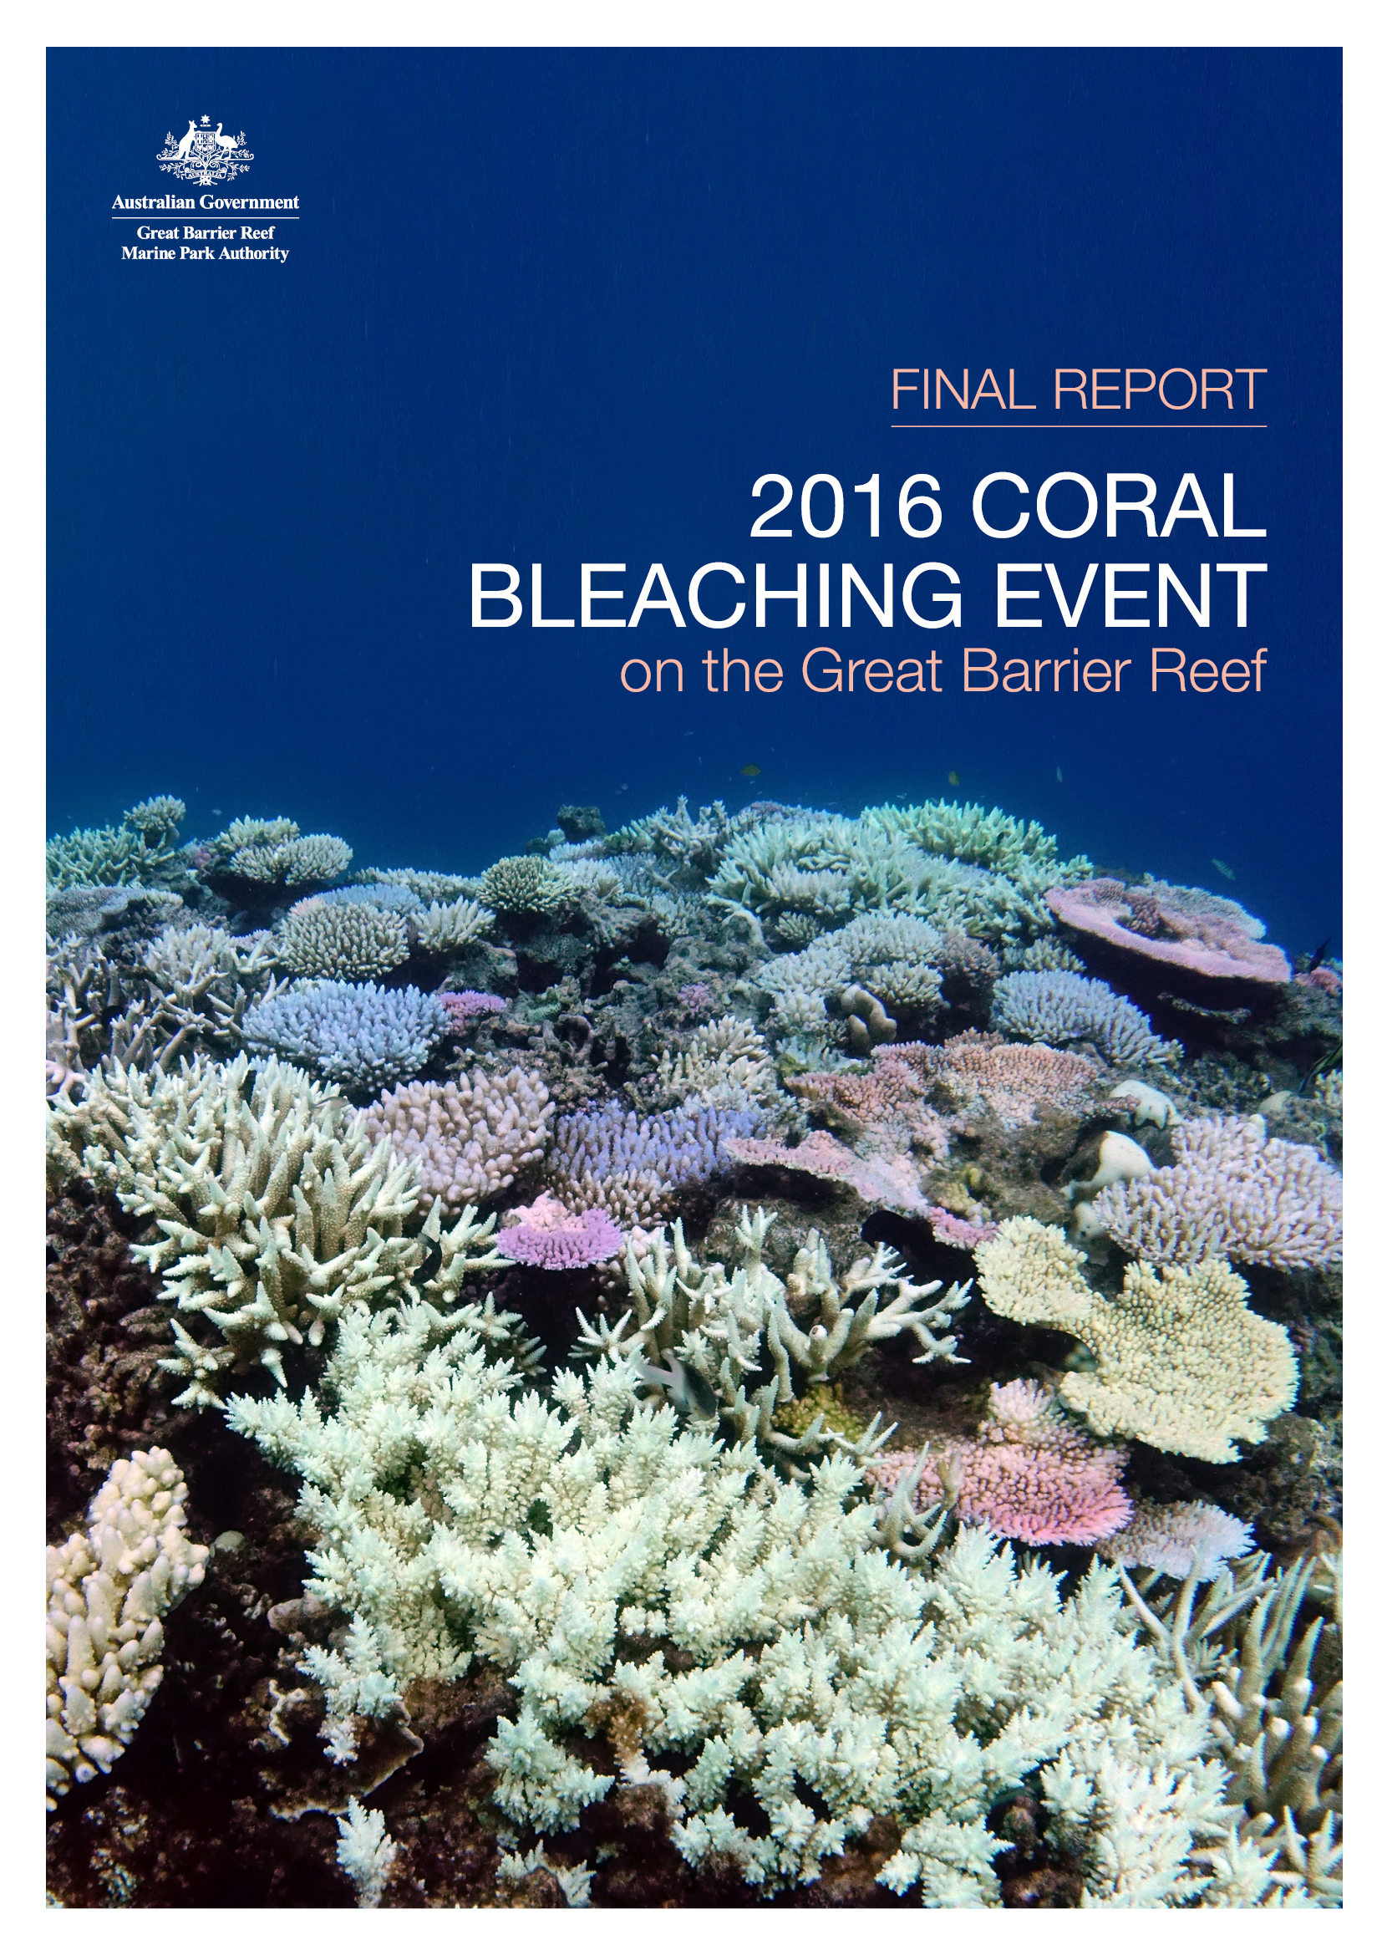

Final report: 2016 coral bleaching event on the Great Barrier Reef
Findings of a rapid ecological impact assessment and summary of environmental monitoring and incident response
June 2017

© Commonwealth of Australia 2017
Published by the Great Barrier Reef Marine Park Authority
ISBN 9780995373167
The Final report: 2016 coral bleaching event on the Great Barrier Reef is licensed by the Commonwealth of Australia for use under a Creative Commons By Attribution 4.0 International licence with the exception of the Coat of Arms of the Commonwealth of Australia, the logo of the Great Barrier Reef Marine Park Authority, any other material protected by a trademark, content supplied by third parties and any photographs. For licence conditions see: http://creativecommons.org/licences/by/4.0

A catalogue record is available for this publication from the National Library of Australia

This report was compiled and edited by Rachel J. Pears, Jessica Stella, Jen Dryden and David Wachenfeld of the Great Barrier Reef Marine Park Authority.

This publication should be cited as:
Great Barrier Reef Marine Park Authority 2017, Final report: 2016 coral bleaching event on the Great Barrier Reef, GBRMPA, Townsville.

Comments and questions regarding this document are welcome and should be addressed to:
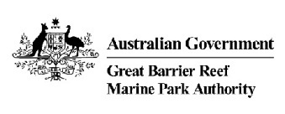
Great Barrier Reef Marine Park Authority
2–68 Flinders Street
(PO Box 1379)
Townsville QLD 4810, Australia

Phone: (07) 4750 0700
Fax: (07) 4772 6093
Email: info@gbrmpa.gov.au
www.gbrmpa.gov.au

Executive Summary

Climate change is internationally-recognised as one of the biggest threats to coral reefs around the world, including the Great Barrier Reef. For the last three years, coral bleaching, due to ocean warming associated with climate change, has impacted coral reefs worldwide. Mass coral bleaching events occur during extended periods of elevated sea surface temperatures and have the potential to result in significant and widespread loss of coral.
The current mass coral bleaching occurring in tropical regions across the world since 2014 is the longest mass bleaching event ever recorded. This is a global event triggered by record-breaking sea surface temperatures caused by climate change and amplified in 2016 by a strong El Niño. The ocean is warmer than at any time since the instrumental record began. For Australia’s Great Barrier Reef, this resulted in the worst ever coral bleaching in 2016.
The Great Barrier Reef Marine Park Authority (GBRMPA or ‘the agency’) has a range of management arrangements in place, including its Reef Health Incident Response System, which was used to predict, forward-plan and respond to the coral bleaching event. Based on early warning tools in 2015, the agency and key partners recognised several months in advance that there would be a high risk of bleaching in the summer of 2016. As the mass bleaching unfolded, the agency triggered its Coral Bleaching Risk and Impact Assessment Plan and, consequently, it’s largest-ever in-water monitoring effort. GBRMPA formed an incident management team to coordinate and undertake the surveys, with the team also responsible for logistics, mapping, data analysis, stakeholder information and broader communications. Many collaborations and partnerships supported the incident response, and the agency was also a member of Australia's National Coral Bleaching Taskforce convened by the Australian Research Council (ARC) Centre of Excellence for Coral Reef Studies.
This report covers the coral bleaching that occurred in 2016 on the Great Barrier Reef. It includes the results of two rounds of in-water reef health and impact surveys conducted by GBRMPA and the Queensland Parks and Wildlife Service, partners in the joint Field Management Program. Similar information was provided to the public through regular updates on GBRMPA’s website and associated communication tools. The first round of Reef-wide surveys conducted from March to early June 2016 provided a rapid assessment of the spatial extent and severity of the 2016 mass coral bleaching event. The second round of Reef-wide surveys conducted from mid-September to end of November 2016 assessed survivorship approximately six months after the peak bleaching period.
The first round of Reef-wide surveys documented widespread but patchy bleaching of varying levels of severity throughout the Marine Park in 2016. There was a strong latitudinal gradient in bleaching severity, with the most severe bleaching having occurred between the tip of Cape York and just north of Port Douglas (that is, in the remote northern third of the Marine Park). This area experienced the greatest heat stress in 2016, with abnormally high sea surface temperatures persisting for a long period of time and as a result, a substantial amount of severely bleached coral died.
Coral mortality as a result of the coral bleaching in the Marine Park increased substantially during 2016 in areas that experienced the most severe bleaching. The second round of surveys found extreme mortality (more than 75 per cent) of shallow-water corals (to about 10 metres depth) in 16 per cent of survey reefs.
An estimated 29 per cent of shallow-water coral cover was lost during 2016 across the Great Barrier Reef Marine Park. Over 75 per cent of this mortality occurred in the far north — the 600 kilometre stretch between the tip of Cape York and just north of Lizard Island. Bleaching-related coral mortality was highest on inshore and mid-shelf reefs in the far north around Cape Grenville and Princess Charlotte Bay, with 80 per cent loss of shallow-water coral cover recorded on average. Severe bleaching and die-off also occurred at all shelf locations in the Lizard Island region. Bleaching-related coral mortality south of Port Douglas was highly variable among and within reefs. Overall the southern Great Barrier Reef had little or no mortality from bleaching in 2016. These results are consistent with the findings from additional surveys by the ARC Centre of Excellence for Coral Reef Studies, the Australian Institute of Marine Science and the Global Change Institute.
The Great Barrier Reef has typically been able to recover from disturbances. However such severe bleaching will have lasting impacts on the health and resilience of affected reefs, primarily via reductions in the amount of coral, shifts in coral community structure, and flow-on effects for reef fish and invertebrate communities. These impacts have the potential to affect the social and/or economic value of reef sites important to Reef-based industries.
The second round of surveys indicated the coral cover as at November 2016 in the southern half of the Marine Park, where bleaching was generally only minor, remained at similar levels to immediately prior to the mass bleaching event. However, coral cover is expected to have further declined since then by varying amounts across most of the Marine Park due to continued bleaching and additional severe disturbances impacting the Reef only a few months later in 2017. On 10 March 2017, GBRMPA confirmed mass coral bleaching was occurring on the Great Barrier Reef for a second consecutive year. A separate report by GBRMPA covers Reef health impacts in early 2017 including bleaching and cyclone damage; therefore, 2017 bleaching impacts, which are still unfolding, are not covered here. Nevertheless, it is important to recognise the cumulative impacts to the Reef from these multiple severe disturbances over such a short period of time, and other pressures such as poor water quality.
The severity of this bleaching event, and the re-occurrence of bleaching in 2017, reinforce the need for much greater international efforts under the Paris Agreement to rapidly mitigate global climate change, as well as national and local actions to build the Reef’s resilience by reducing direct and indirect pressures. Active reef interventions may also play a small role (e.g. to augment recovery at key sites). These efforts are our best insurance for protecting this precious natural icon.

Table of Contents

Executive Summary iv
Introduction 1
Environmental monitoring and incident response 3
Early warning system to detect heat stress 3
Pre-summer risk assessment and national taskforce 4
Global pattern of heat stress in 2016 4
Pattern of heat stress for Great Barrier Reef waters in 2016 5
Incident response as the coral bleaching event unfolded 6
Survey plan and methods for bleaching impact assessment 9
Detailed observations and results 12
Scale and spatial patterns of coral bleaching 12
Scale and spatial patterns of coral mortality (as at 3 June 2016) 18
Scale and spatial patterns of coral mortality (as at November 2016) 18
Spatial patterns of remaining coral cover (as at November 2016) 21
Conclusions and outlook for recovery 24
Acknowledgements 27
References 28
APPENDIX A: List of reefs surveyed in each cross-shelf transect. 34
APPENDIX B: example illustrations and descriptions 35
APPENDIX C: Time-series images 36

Introduction

The future of coral reefs worldwide is under threat from climate change and its associated impacts.^{1,2} Increasing atmospheric carbon dioxide and other greenhouse gases (fuelled by human activities particularly fossil fuel emissions) are warming ocean temperatures beyond thresholds in which corals can thrive. One of the responses to severe heat stress is mass coral bleaching — moderate to severe coral bleaching across a large spatial scale. Severe and prolonged bleaching can cause substantial loss of coral.^{3,4,5} As corals form the foundation of coral reefs, and provide essential habitat to reef fish and invertebrates^{6,7}, the loss of coral and reef habitat can reduce the populations of other reef inhabitants.⁸ In turn, people, cultural values and businesses that depend on reefs are also affected.
In mid-2014 a global mass-bleaching event began in the north Pacific. It has continued into 2017 , severely affecting many reef locations across all tropical ocean basins. From 2014 to 2016, record-breaking sea temperatures were observed over several months at various locations throughout the world. These higher than average temperatures were caused by climate change and boosted by a strong El Niño^{9,10,11}, triggering mass coral bleaching in the Caribbean, Indian and Pacific oceans and Australia’s Great Barrier Reef. Many different stressors can cause coral bleaching, including freshwater inundation and poor water quality from run-off. However, heat stress from above-average temperatures is the only known cause of mass coral bleaching.^{1,12,13,14} Prior to the 2016 summer, the worst global mass bleaching event occurred in 1998 when up to 16 per cent of the world’s area of coral reefs was severely damaged; after which some areas no longer resembled coral reefs.¹⁵ The current event is only the third global mass bleaching on record and has been the longest lasting and most widespread.
Corals reefs are particularly vulnerable to ocean warming as corals can tolerate only a narrow range of temperatures and, when exceeded even by one degree Celsius above the normal summer maximum, corals experience heat stress.^{1,16,17} Most corals have microscopic marine algae (called zooxanthellae) living inside their tissue which colours the coral tissue and provides up to 90 per cent of their food. When corals are under stress, this symbiotic relationship breaks down and corals expel the zooxanthellae ¹⁸. As the natural pigments in corals’ tissue are often fluorescent, the corals may then display a striking fluorescent hue in pink, yellow, purple or blue.^{19,20} If they lack fluorescent pigments — or their fluorescence is not visible to the human eye — they will instead appear bright white due to their underlying skeleton. Although these corals may appear astonishingly vivid, the corals are severely stressed. A fully-white bleached coral and a bright fluorescent bleached coral may have comparable low concentrations of zooxanthellae, and therefore similar bleaching status.
The level of exposure to heat stress largely determines the fate of the coral and overall impacts to the ecosystem.¹⁷ If heat stress is only mild or short-term, bleached corals can recover as indicated by the return of zooxanthellae and hence, regaining their darker colour.²¹ However, residual effects of the stressful conditions during the bleaching may negatively impact coral reproduction for one or two years^{5,22,23}, slow coral growth and calcification rates^{24,25}, and increase their susceptibility to disease.^{26,27,27}
If heat stress is more severe or prolonged, bleached corals will starve and die within weeks to months. The ecological implications of severe bleaching include a reduction in the abundance of coral, shifts in coral community structure, altered habitat composition, and many other ecosystem flow-on effects.^{3,8,13,28,29,30} Some of these impacts may not become apparent until many years after the event.⁸ Coral reefs that have high rates of coral death from bleaching are likely to take many years or decades to recover^{28,29,31}, and can potentially shift from being coral-dominated to algal-dominated.^{32,33,34}
Ongoing climate change is expected to increase the frequency and severity of coral bleaching events.^{17,35,36} On the Great Barrier Reef prior to 2016, there were two widespread mass bleaching events — in 1998 and 2002.^{37,38} Additional more localised bleaching events have also occurred on the Reef (e.g. in 2006). In both of the previous widespread bleaching events it was estimated nearly half of the 3000+ reefs in the Marine Park experienced some bleaching, with about 18 per cent experiencing severe bleaching.³⁸ However, most corals survived, and in each event available estimates suggest approximately five per cent or less of reefs in the Marine Park experienced high coral mortality. While this indicates the Reef has been resilient to mass bleaching events in the past, the capacity of the ecosystem to recover is likely to diminish as the frequency and intensity of disturbances increases.^{39,40,41} Severe bleaching also has various implications for communities and industries that depend on the Great Barrier Reef.^{42,43,44}
Bleaching is not the only threat to coral reef habitats and its impacts cannot be viewed in isolation from the legacy impacts of past practices and current pressures. These pressures include severe tropical cyclones, coral predation by the crown-of-thorns starfish, poor water quality and direct use. Research by the Australian Institute of Marine Science shows average coral cover on the Reef fell by approximately 40 per cent between 1985 and 2012, due mainly to several cyclones, outbreaks of crown-of-thorns starfish and mass bleaching. However, between 2012 and 2015, there was an overall 19 per cent relative increase in coral cover (to almost 20 per cent from a low point of about 17 per cent).
The biggest increase during this time was in the southern Great Barrier Reef (Australian Institute of Marine Science, 2016). As exposure to major disturbances in the southern Reef was minimal in these three years (i.e. 2012–2015, noting surveys occurred prior to cyclone Marcia), these results demonstrate the capability of the Reef to recover from past disturbances in the absence of new ones. Reducing other pressures, for example by improving water quality and controlling outbreaks of crown-of-thorns starfish, is crucial to improve the ecosystem’s resilience in the face of multiple pressures and supporting recovery following coral bleaching.³¹
The Great Barrier Reef Marine Park Authority (GBRMPA or ‘the agency’) is responsible for managing the Great Barrier Reef Marine Park, a 344,400 square kilometre multiple-use marine protected area off the north-east coast of Australia. GBRMPA works with a range of partners and stakeholders to manage this area for the future.
Given the implications of severe bleaching, GBRMPA has a responsibility to monitor risks, better understand coral bleaching impacts, and keep the public informed. An interim report released in 2016 ⁴⁵ presented the preliminary results of the first round of in-water surveys conducted by GBRMPA and the Queensland Parks and Wildlife Service to assess the spatial extent and severity of the 2016 mass coral bleaching event in the Great Barrier Reef Marine Park.
This final report extends the interim report by incorporating findings from the second round of surveys that took place in late 2016 to assess recovery rates and survivorship approximately six months after the peak bleaching period. The Torres Strait also had severe bleaching in 2016, but is beyond the scope of this report.
In 2017, another mass coral bleaching event is occurring on the Great Barrier Reef.
This unfolding event, and other Reef health impacts in 2017, are reported on in a separate publication available at www.gbrmpa.gov.au

GBRMPA uses its Reef Health Incident Response System⁴⁶ and associated plans, specifically the Coral Bleaching Risk and Impact Assessment Plan⁴⁷, to respond to coral bleaching. Greater understanding of the impacts and implications of these events is essential to refining and further developing management strategies and policies that give the Reef ecosystem and Reef-based industries the best chance as the climate changes.

Environmental monitoring and incident response

Early warning system to detect heat stress
The agency has an early warning system to predict Reef health risks, including bleaching. Mass coral bleaching is preceded by a series of environmental conditions that can be used to assess the probability of such an event occurring. A number of agencies and research institutions have developed tools, in close collaboration with GBRMPA, to monitor these conditions. These tools predict future conditions and enable near real-time monitoring of conditions conducive to bleaching (for example, sea surface temperature anomalies).
The agency’s Eye on the Reef program also routinely assesses information submitted by Reef users for any indications of reef health impacts, including any signs of bleaching within the Marine Park. Key partners in this monitoring network include the marine tourism industry and science partners.
Collectively, these tools provide the early warning system for coral bleaching and include:
- climate forecasts in the months preceding the summer to ascertain the likelihood of bleaching
- near real-time monitoring of temperature stress during the summer to assess bleaching risks and target monitoring efforts
- a monitoring network to detect early signs of bleaching
- detailed site inspections to ground-truth predictions or reports of bleaching and to determine if specific incident response thresholds have been exceeded¹.
In late 2015, GBRMPA informed the public of the high risk of coral bleaching in the Great Barrier Reef in summer 2016.

Pre-summer risk assessment and national taskforce
Before each summer, the agency convenes a workshop to seek expert advice on the probable risks to reef health for the coming summer. Attendees include Marine Park managers, climate and weather scientists, coral reef ecologists, water quality specialists and fishery managers from organisations such as the Australian Bureau of Meteorology, the Australian Institute of Marine Science, the National Oceanic and Atmospheric Administration, the ARC Centre of Excellence for Coral Reef Studies, the University of Queensland, the Queensland Parks and Wildlife Service and the Department of Agriculture and Fisheries.
After reviewing climate outlooks, the workshop attendees conduct a collective risk assessment. The risk assessment for the 2015–16 austral summer (i.e. December 2015 to April 2016) concluded there were high environmental risks to the Great Barrier Reef from possible mass coral bleaching and chronic effects of coral disease, and a very high risk from ongoing crown-of-thorns starfish outbreaks. The highest risk period for mass bleaching was identified as early February to March 2016— a period when the probability for accumulated heat stress to exceed known bleaching thresholds is at its greatest. The public were again informed. Subsequently, the agency monitored predictive tools weekly and regularly reported results to senior decision-makers and stakeholders on the likelihood of summer bleaching.
The agency also joined and contributed to the National Coral Bleaching Taskforce, established by the Centre of Excellence to coordinate the research efforts by marine scientists in the event of mass bleaching across Australia. The taskforce brought together many scientists from 10 institutions across Australia (ARC Centre of Centre of Excellence for Coral Reef Studies, Australian Institute of Marine Science, CSIRO, Great Barrier Reef Marine Park Authority, James Cook University, NOAA, University of Queensland, University of Sydney, University of Western Australia, and WA Department of Parks and Wildlife).

Global pattern of heat stress in 2016
Each of the first six months of 2016 set a record as the warmest respective month globally in the modern temperature record, which dates back to 1880. When combined, this six-month period was also the planet's warmest half-year on record, with an average air temperature of 1.3 degrees Celsius higher than the late 19th century.
June 2016 marked the 14th consecutive month where the monthly global temperature record was broken, the longest such period in the 137-year instrumental temperature record. In addition to the global warming trend, the El Niño in the tropical Pacific had increased global sea surface temperatures since October 2015.

Pattern of heat stress for Great Barrier Reef waters in 2016
The 2016 mass coral bleaching on the Great Barrier Reef was triggered by record-breaking sea surface temperatures (Figure 1). The rising temperatures reflect the underlying trend of global ocean warming caused by climate change. In 2016 Great Barrier Reef waters had warmed by approximately 0.80 degree Celsius since 1871, and the rate of warming has accelerated since the 1950s. A strong El Niño also resulted in reduced monsoon activity and, as a consequence, long periods without cloud cover or strong winds which would typically have offered corals some respite from heat stress.

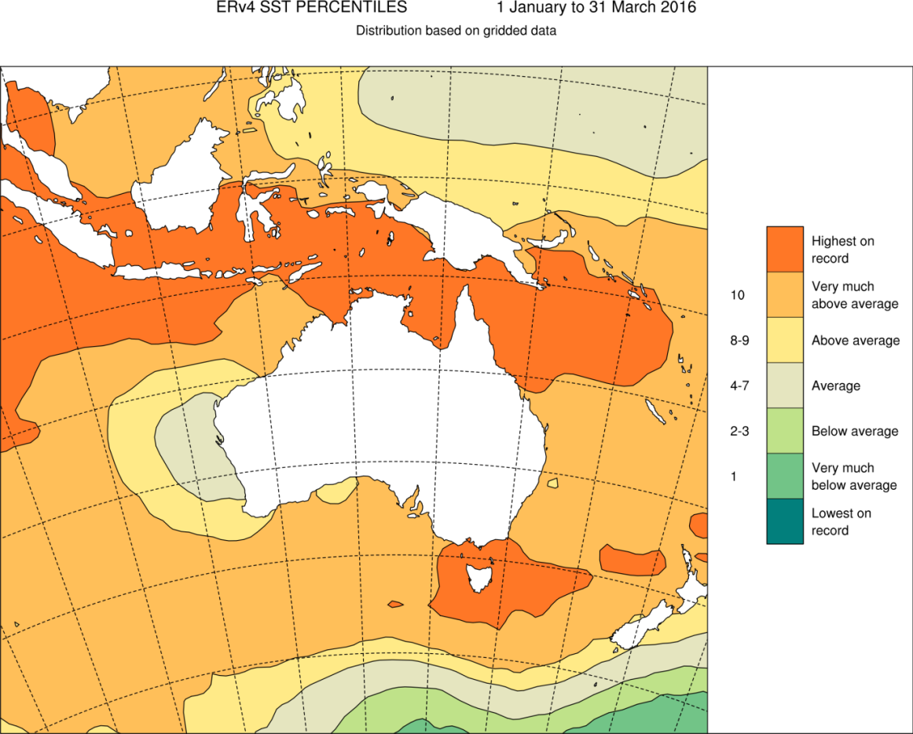
Figure 1 Distribution of record-breaking sea surface temperatures around Australia from 1 January to 31 March, 2016.
Note: “Highest on record” refers to highest sea surface temperature value since 1900. Decile 10 is the highest 10 percent of records — this category is 'very much above average'. Analysis supplied by the Bureau of Meteorology. Based on the ERSST v4 dataset produced by the National Oceanic and Atmospheric Administration. © Australian Bureau of Meteorology
As the El Niño broke down in late summer, warmer waters in the central equatorial Pacific were brought towards Australia, leading to further warming of sea surface temperatures on the Reef.⁴⁸
According to the Bureau of Meteorology, the Great Barrier Reef recorded its hottest-ever average sea surface temperatures for February, March, April, May and June 2016 since records began in 1900, based on the Extended Reconstructed Sea Surface Temperature (ERSST) v4 satellite SST dataset. Each month was 1.0 to 1.3 degrees Celsius higher than the 1961–1990 monthly averages.⁴⁸ Importantly, heat stress was not uniform across the Reef over these months. Local weather patterns, including rain and heavy cloud cover, also influenced regional sea temperatures — the southern half of the Reef experienced late summer cooling due to ex-cyclones Winston and Tatiana. Therefore, some regions avoided the worst of the heat stress and hence severe coral bleaching did not occur there.

Incident response as the coral bleaching event unfolded
GBRMPA uses the Australasian Inter-service Incident Management System framework to coordinate the governance, planning, operations, logistics, financial and inter-agency liaison arrangements required to adequately respond to a reef health incident.
Information gathered from the early warning system and site inspections helps the agency to understand the severity and spatial extent of impacts. The extent and severity is classified based on the standardised criteria for each incident, and a matrix is used to ‘score’ the event and inform a detailed situational analysis by the agency’s incident management team (Figure 2).
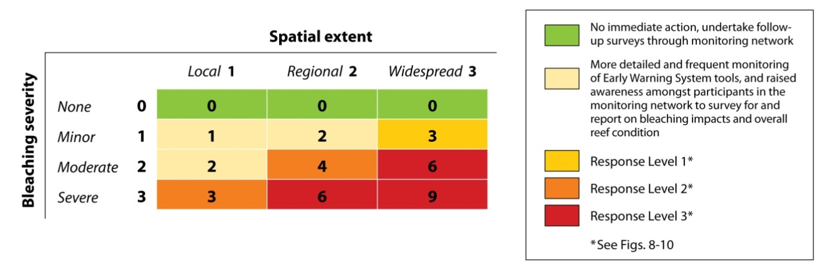

Figure 2 Matrix combining impact severity and spatial extent used to inform a situation analysis.
The situational analysis provides the basis for a decision on the required level of response. There are three potential response levels — 1, 2 and 3. Each increment corresponds to an increase in the severity and spatial extent of the impacts, and the management resources that might be deployed to respond.
By early March 2016, the agency’s Eye on the Reef program received reports of minor to moderate coral bleaching in 40 per cent of recent surveys in three of the four management areas (i.e. in Far Northern, Cairns–Cooktown, Townsville–Whitsundays). As a result, GBRMPA declared a coral bleaching response level one under the Coral Bleaching Risk and Impact Assessment Plan.
After in-water site inspections by Reef managers and rangers in the far north revealed severe bleaching and high mortality on inshore and mid-shelf reefs, the agency declared a coral bleaching response level two. Once further site inspections documented moderate to severe bleaching offshore of Townsville, a level three response was declared due to severe regional bleaching and moderate bleaching over multiple management areas.
Aerial surveys by the ARC Centre of Excellence for Coral Reef Studies (with participation by a staff member from GBRMPA on many of the flights) were undertaken in March 2016.³¹ The aerial surveys provided a rapid Reef-wide assessment of the spatial extent of shallow-water bleaching and proportion of coral cover bleached on 876 reefs within the Marine Park (Figure 3), enhancing situational awareness and helping to direct where in-water survey efforts should be targeted.
This final report summarises the findings of the agency’s detailed in-water reef health and impact surveys. These two rounds of surveys enabled a rapid environmental assessment.
Surveys detailed in this report were supplemented by additional surveys by science partners, and complemented by information from tourism industry operators, Indigenous rangers and community members. In particular, the Australian Institute of Marine Science conducted in-water surveys and the ARC Centre of Excellence for Coral Reef Studies conducted aerial and in-water surveys, and the Global Change Institute conducted XL Catlin Surveys of the northern Reef. While all available information on reef health and condition, and the impacts of bleaching, informed the incident response and public updates during the 2016 event, these other data sources are being reported on in other collaborative scientific publications (e.g. ^{31,49,50}) and additional detailed analyses are ongoing.

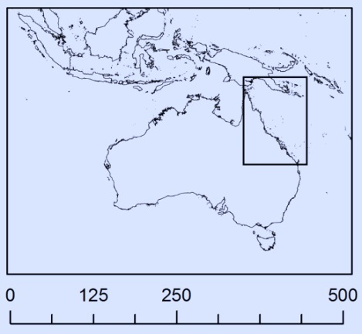
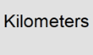
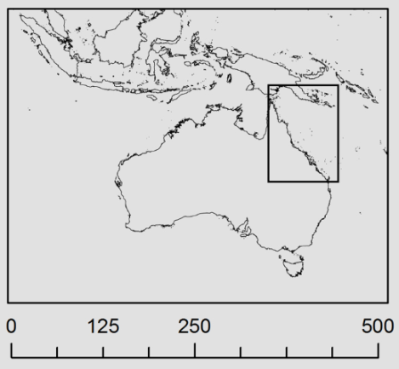
Townsville
QUEENSLAND
Coral Sea
Figure 3 Map showing aerial survey results of coral bleaching during the peak of the bleaching event in March 2016. Source: Australian Research Council Centre of Excellence for Coral Reef Studies.
The footprint of coral bleaching on the Great Barrier Reef in 2016, measured by extensive aerial surveys: dark green (< 1% of corals bleached), light green (1–10%), yellow (10–30%), orange (30–60%), red (> 60%).

Survey plan and methodS for bleaching impact assessment

The Coral Bleaching Risk and Impact Assessment Plan contains an approach to rapidly assess the severity and extent of coral bleaching on up to 45 reefs from the Lizard Island area (off Cooktown) south to the Swains (off Rockhampton), using standard reef health and impact surveys (RHIS).⁵¹ The plan is scalable (e.g. could be applied in one region only for a localised bleaching event) and also recommends additional reefs be included if needed to fully cover an event (e.g. the heat stress extends to areas beyond these 45 reefs).
The plan was modified in 2016 to include the addition of 18 reefs in two northern transects, meaning the final survey plan implemented covered a total of 63 reefs across seven transects (Figure 4). This design covered the whole Marine Park and ensured inclusion of areas that experienced the most significant heat stress and the least heat stress (represented as degree heating days (DHDs), Figure 4) and a representation of cross-shelf and/or latitudinal gradients across/along the Reef.
Where feasible, reefs for which there were historical data through ongoing monitoring programs were chosen, e.g. the AIMS Long-term Monitoring Program. This maximised the value of the RHIS surveys to longer-term studies of reef health and resilience in the face of climate-related disturbances and other impacts such as crown-of-thorns starfish predation.
The seven transects (reef groupings) are located at latitudes centred on Cape Grenville (approximately latitude 11°S), Princess Charlotte Bay (latitude 13°S), Lizard Island (latitude 14°S), Cairns–Port Douglas (latitude 16°S), Townsville (latitude 18°S), Whitsunday Islands (latitude 20°S) and Rockhampton (latitude 22°S). Each transect consisted of nine reefs, located on a cross-shelf gradient (i.e., roughly perpendicular to the coast, from inshore to offshore). However, in the Whitsundays only eight reefs were surveyed as poor weather conditions prevented access to the ninth reef. Therefore, a total of 62 reefs were surveyed under the structured assessment reported here in each of two rounds of surveys: “Round 1 from 1 March to 3 June 2016, and Round 2 from 20 September to 27 November 2016.
The 62 reefs are listed in Appendix A. As the Great Barrier Reef Marine Park is divided into four Management Areas (shown on Figure 5), Appendix A also identifies which transects are in each of these Management Areas.
The standard protocol for RHIS surveys⁵¹ was followed. The RHIS survey form is divided into four sections: observer and site details, benthos, impacts and additional information. A copy of the RHIS form is available in Beeden et al. 2014. Key information recorded includes: i) estimates of the percentage of the benthos (sea floor) made up by macroalgae, live coral, recently dead coral, live coral rock, coral rubble and sand; and ii) observations of coral impacts, and this is done over a series of five-metre radius point surveys (with one RHIS form completed for each circular plot of 78.5 square metres). These are 50 metres apart at each location.

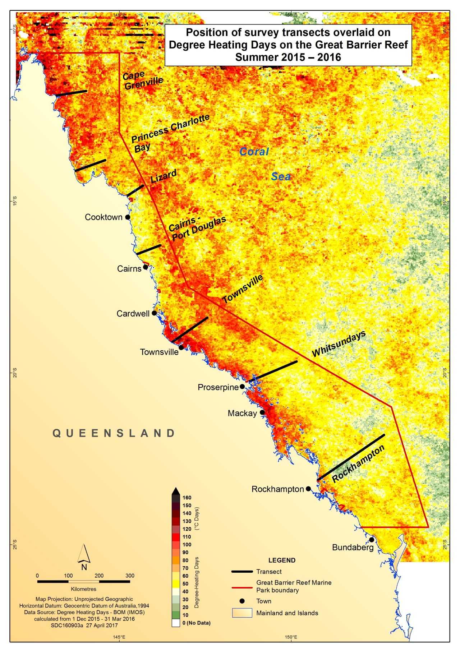
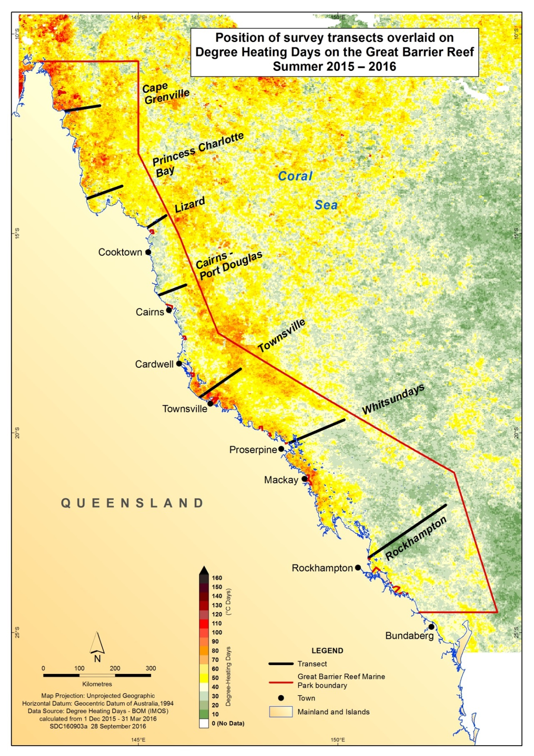
Figure 4 Location of each GBRMPA RHIS survey transect along the length of the Great Barrier Reef overlaid on the pattern of accumulated heat stress for the summer of 2015-2016.
Heat stress of Great Barrier Reef surface waters is measured as Degree Heating Days (DHD) and accumulated over the summer period (1 December - 31 March). One DHD is calculated as one degree Celsius above the local long-term average monthly temperature. If sea surface temperatures exceed the monthly average by two degrees Celsius on a single day, it is counted as two DHDs. Higher DHD counts relate to an increased risk of bleaching. Degree Heating Day data sourced from ReefTemp Next Generation, Bureau of Meteorology.
Three inshore, three mid-shelf and three outer shelf reefs were surveyed in each cross-shelf transect (reef names listed in Appendix A).
To increase assessment reliability, and to capture variability in bleaching patterns within a reef (based on wave exposure and depth), the survey plan aimed to conduct 15 or more RHIS surveys (that is, replicate samples) across three different locations on each reef, corresponding to three different aspects (north-east, north-west and south-west). At each of the western locations (i.e. north-west and south-west), three RHIS surveys were conducted at the same depth (approximately one to four metres), making a total of six RHIS. At the north-eastern location, three surveys were conducted at three different depths (approximately one to three metres, six metres and nine metres), making a total of nine RHIS. Therefore, this assessment was of shallow-water coral habitats only (with surveys covering reef habitat to approximately 10 metres depth).
Survey data was uploaded to the Eye on the Reef system, and analysed daily to ‘score’ bleaching impact severity at the survey and reef level (Appendix B). The Round 1 results showed the extent and severity of bleaching, which was communicated in near real-time to senior management, government officials, partner organisations, stakeholders and the public.
In Round 1, the percentage of coral cover (if any) that had recently died from each impact-type (that is, bleaching, disease, predation, damage) was estimated as described in Beeden et al. 2014 ⁵¹ for each RHIS survey by examining all coral colonies within the point surveys for any impacts. These data were used to categorise the average percentage of coral bleaching mortality for each reef (and recorded as the "observed coral mortality as at June 2016") as follows:
- none (0 per cent)
- low (greater than 0 per cent and less than 10 per cent)
- medium (10 per cent or more and less than 30 per cent)
- high (30 per cent or more and less than 50 per cent)
- very high (50 per cent or more).
RHIS surveys with no coral present (living or recently dead) were excluded from the analysis of bleaching impacts. Such point surveys typically were in areas with high damage from previous cyclones.
A second round of surveys was conducted after approximately six months to provide an updated assessment of bleaching-related mortality, reef health and resilience following the 2016 mass coral bleaching event. The same RHIS survey protocol was used.
The structured Round 2 surveys (from mid-September to end of November 2016) covered the same 62 reefs across seven transects (Figure 4) examined in Round 1 so that Reef-wide patterns of bleaching mortality could be estimated.
In Round 2, the percentage change in coral cover at comparable sites (in terms of depth and aspect) on the 62 transect reefs assessed in both rounds of surveys was used to provide an updated estimate of coral mortality as at November 2016. This was recorded as the "coral loss by November 2016". Due to the unprecedented severity of this event, in Round 2 the upper coral mortality category was further divided into 2 categories:
- very high (50 per cent and less than 75 per cent)
- extreme (75 per cent or more).
The estimated overall loss of shallow-water coral cover from bleaching in 2016 was calculated as follows using data from the structured surveys of transect reefs, which provided balanced representation of reefs throughout the Marine Park.
The Marine Park was divided into seven sectors centred on each survey transect. For each sector, estimated pre-bleach coral cover (mean total coral cover from Round 1 surveys for each of the nine transect reefs) and official GBRMPA reef area data were used to calculate the area covered by corals at the onset of bleaching, in this way taking into account regional patterns in the initial abundance of coral in the estimate. The total loss of coral area for each sector during 2016 was calculated as the product of the pre-bleach coral area and the mean percentage change in coral cover by November 2016. Since the survey data was collected from approximately the first 10 metres of water, this loss is considered to represent shallow-water corals only, and mortality at deeper levels could not be systematically estimated. Estimated losses of coral area for each sector were then summed to give the amount of coral area lost within the Marine Park, and the proportion of total shallow-water coral lost during the 2016 bleaching event.
Coral cover (total cover of hard and soft corals) in early 2016 was estimated from Round 1 surveys for inshore, mid-shelf and outer shelf reefs in each of the seven transects. Similarly, remaining live coral cover (hard and soft corals) in late 2016 was estimated from Round 2 surveys for inshore, mid-shelf and outer shelf reefs in each of the seven transects. Indicative maps of coral cover were produced, based on the assumptions that coral cover and bleaching impacts on reefs within each shelf position and sector were similar to surveyed reefs on average. Early signs of recovery from bleaching were also noted.
Between March and November 2016, each reef was surveyed either once or more. Re-surveying the same reefs provides information on bleaching severity and subsequent bleaching-related mortality or recovery (see time-series photographs in Appendix C).

Detailed observations and results

Scale and spatial patterns of coral bleaching
Across the Great Barrier Reef in Round 1, all surveyed reefs exhibited bleaching to some degree, however there was high spatial variation in bleaching severity (Figure 5). The severity generally varied in relation to the amount of accumulated heat stress over the summer (Figure 4).
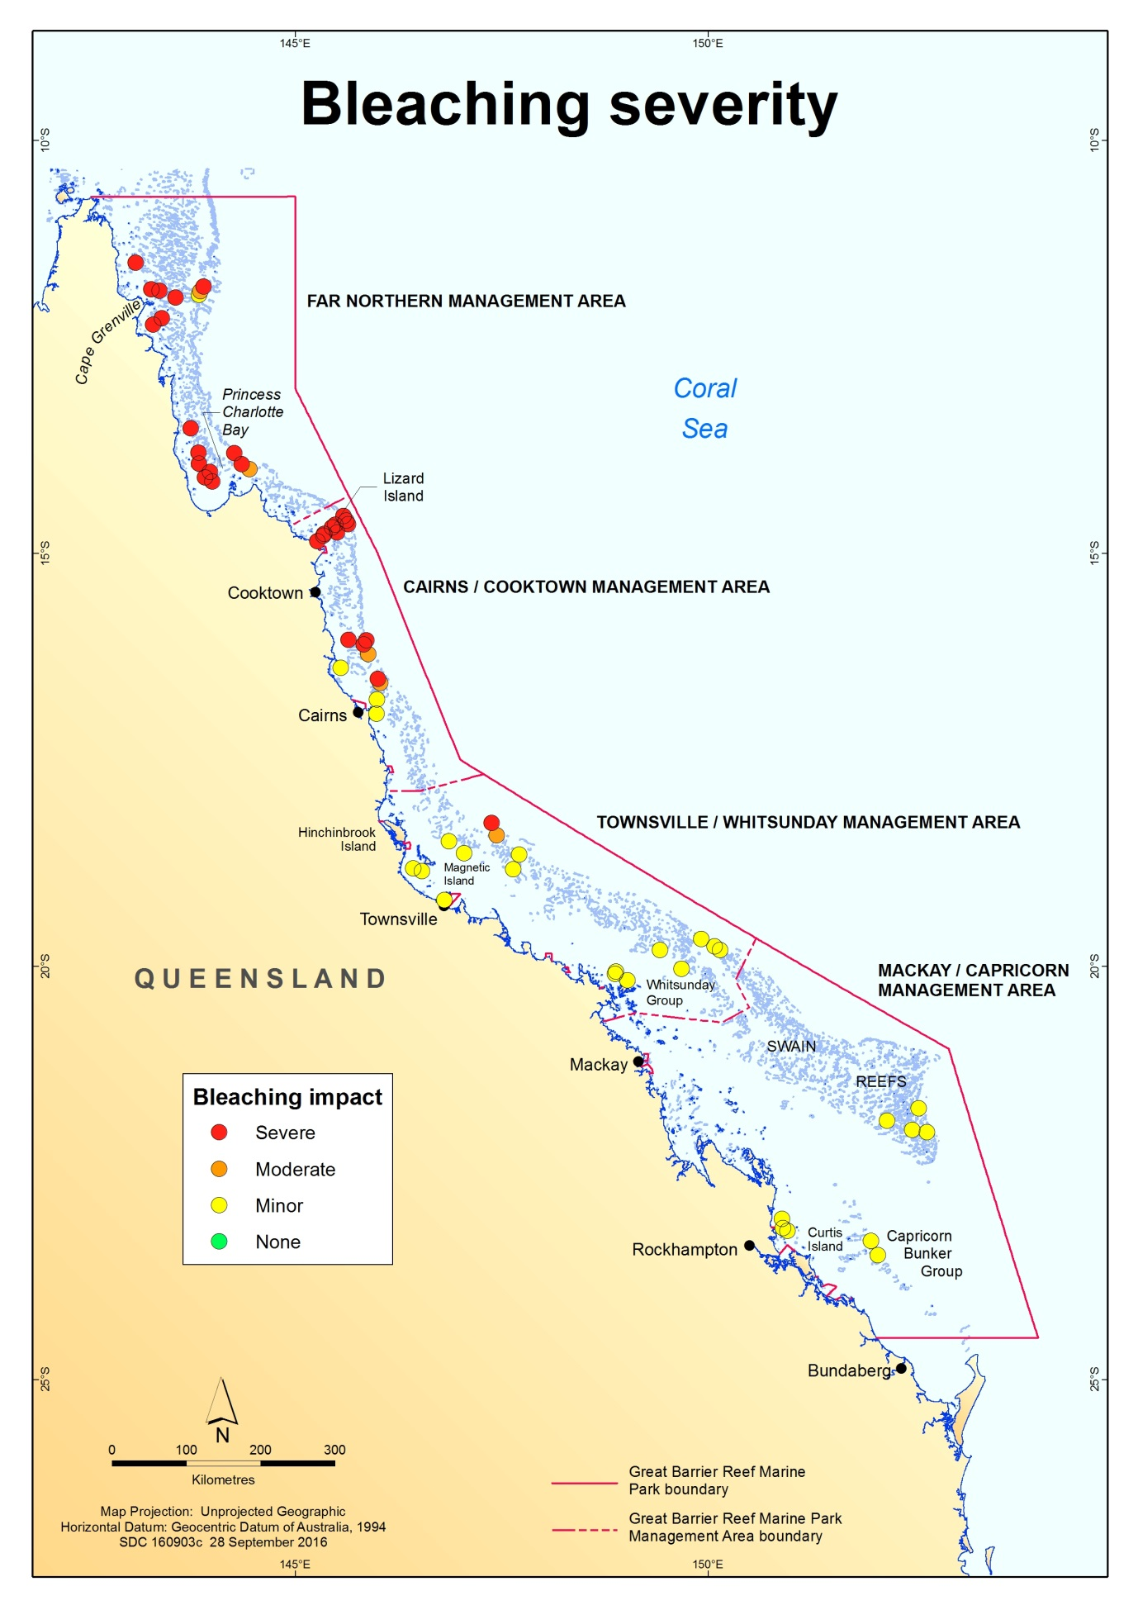Figure 5 Reef-wide pattern of bleaching severity impacts on the Great Barrier Reef in 2016 on 62 reefs surveyed using the RHIS method. Each circle represents a survey reef and colours indicate severity category, with red indicating the most severely impacted reefs. See Appendix B for descriptions. Data are from Round 1 reef health and impact surveys (March to June 2016).
A latitudinal gradient of bleaching severity was observed — with more severe bleaching on reefs within the three northern-most transects, and impacts generally decreasing southward (Figure 6). The Cairns–Port Douglas area exhibited the highest variability in bleaching patterns across reefs, with a mix of minor, moderate and severely bleached reefs. Supplementary reef health and impact surveys confirmed this pattern of bleaching. Only one surveyed reef (Myrmidon Reef) was categorised as severely bleached on the Townsville transect. Reefs in the Whitsunday transect experienced only minor bleaching. Although some severe bleaching was observed at some sites within reefs in the Rockhampton transect, the overall impact of bleaching was minor on all reefs in this transect. All survey reefs had some level of bleaching, consistent with a Reef-wide mass bleaching event.

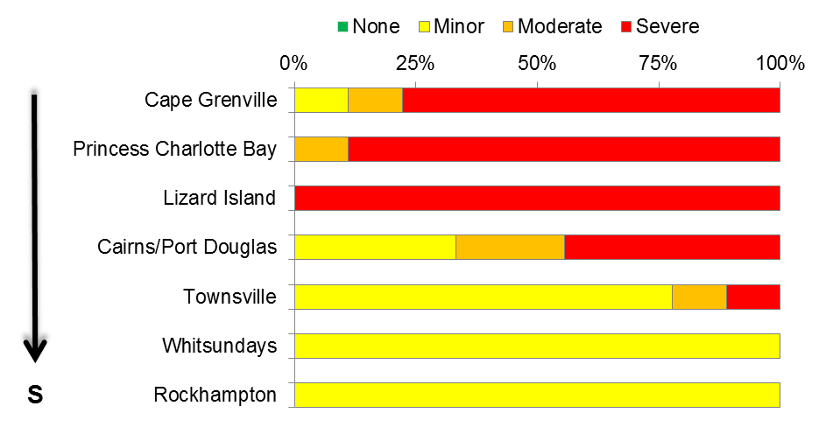
N
N
N
Figure 6 Illustration of the proportion of reefs within each transect that exhibited either no, minor, moderate or severe bleaching. Data are from Round 1 RHIS surveys of 62 reefs.

The high variability in bleaching severity during the peak of the event is best illustrated by analysis at the survey level. Of all Round 1 reef health and impact surveys, bleaching was observed in 92.1 per cent. Most of the 873 Round 1 surveys at transect reefs analysed in this report recorded minor bleaching impact (48.6 per cent), followed by 33.2 per cent of surveys with an overall severe bleaching impact. In 10.3 per cent of surveys moderate bleaching impacts were recorded. Only 7.9 per cent of all Round 1 surveys showed no bleaching. Of Round 1 surveys with bleaching present, there was a high variability in the proportion of coral bleached, ranging from 0.2 per cent of coral cover to 100 per cent.
Across the entire Reef, severe bleaching did not follow a strong pattern with regards to shelf position. Of the 290 Round 1 surveys that recorded severe bleaching impacts, 35.5 per cent were located on inshore reefs, 39 per cent on mid-shelf reefs and 25.5 per cent on outer shelf reefs.
However, latitudinally (by transect), severe bleaching was highly variable amongst shelf positions (Figure 7a, b, c). Although the two northern-most transects had severe bleaching in all shelf positions, most of the severe bleaching occurred on the inshore and mid-shelf reefs. In the Lizard Island region, severe bleaching occurred at all shelf positions. For the Cairns–Port Douglas transects, the most severe bleaching occurred on the mid and outer shelf reefs, whereas the Townsville transect had the most severe bleaching on outer shelf reefs. In the two southern-most transects, the Whitsundays reefs did not exhibit any severe bleaching, while the Rockhampton transect only exhibited severe bleaching on some inshore reef surveys (Figure 7a, b, c).
Only minor impacts were recorded from non-bleaching impacts (i.e. coral disease, predation by crown-of-thorns starfish (Acanthaster planci) and snails (Drupella spp.), and recent damage) on the 62 surveyed reefs in 2016. The non-bleaching impacts only affected a very low percentage of coral cover (less than 1 per cent on average) during Round 1 surveys.
Even on individual reefs, large variations in bleaching severity were observed, as illustrated by plotting bleaching severity impacts from individual surveys on a reef outline (Figure 8a, b, c). As replicate RHIS surveys within a particular aspect of the reef (for example, north-east) were only 50 metres apart, the severity of bleaching within a small area differed greatly (Figure 8a, b, c). On all but the most severely impacted reefs, patches of unbleached coral cover were often found adjacent to completely bleached corals. Bleaching was observed at all surveyed depths (Figure 8b) in this example (as was generally the case), and depth did not appear to be a factor in bleaching severity. Direct observations of bleaching down to 25 metres were noted on several reefs (but beyond the areas surveyed).
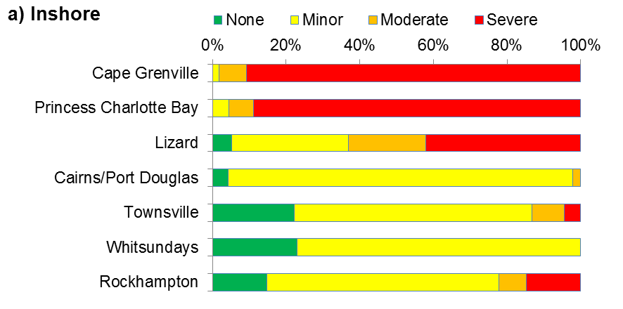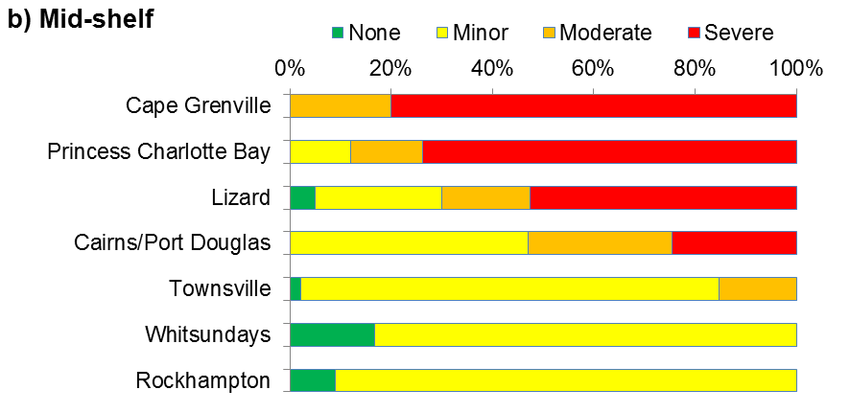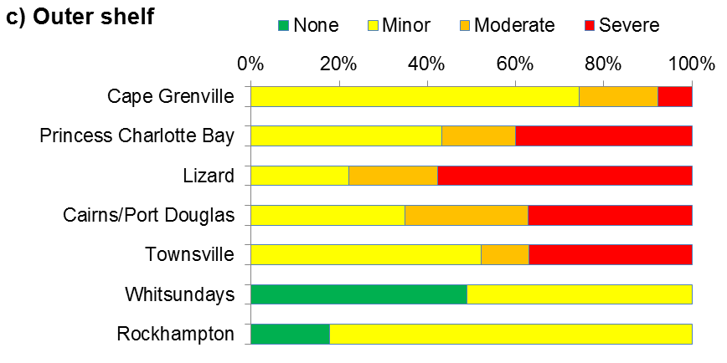
Figure 7a,b,c Illustration of bleaching severity impacts during the peak of the event as a proportion of the total surveys conducted on a) inner shelf reefs, b) mid-shelf reefs and c) outer shelf reefs of each transect along the Great Barrier Reef. Data are from Round 1 RHIS surveys (March to June 2016).
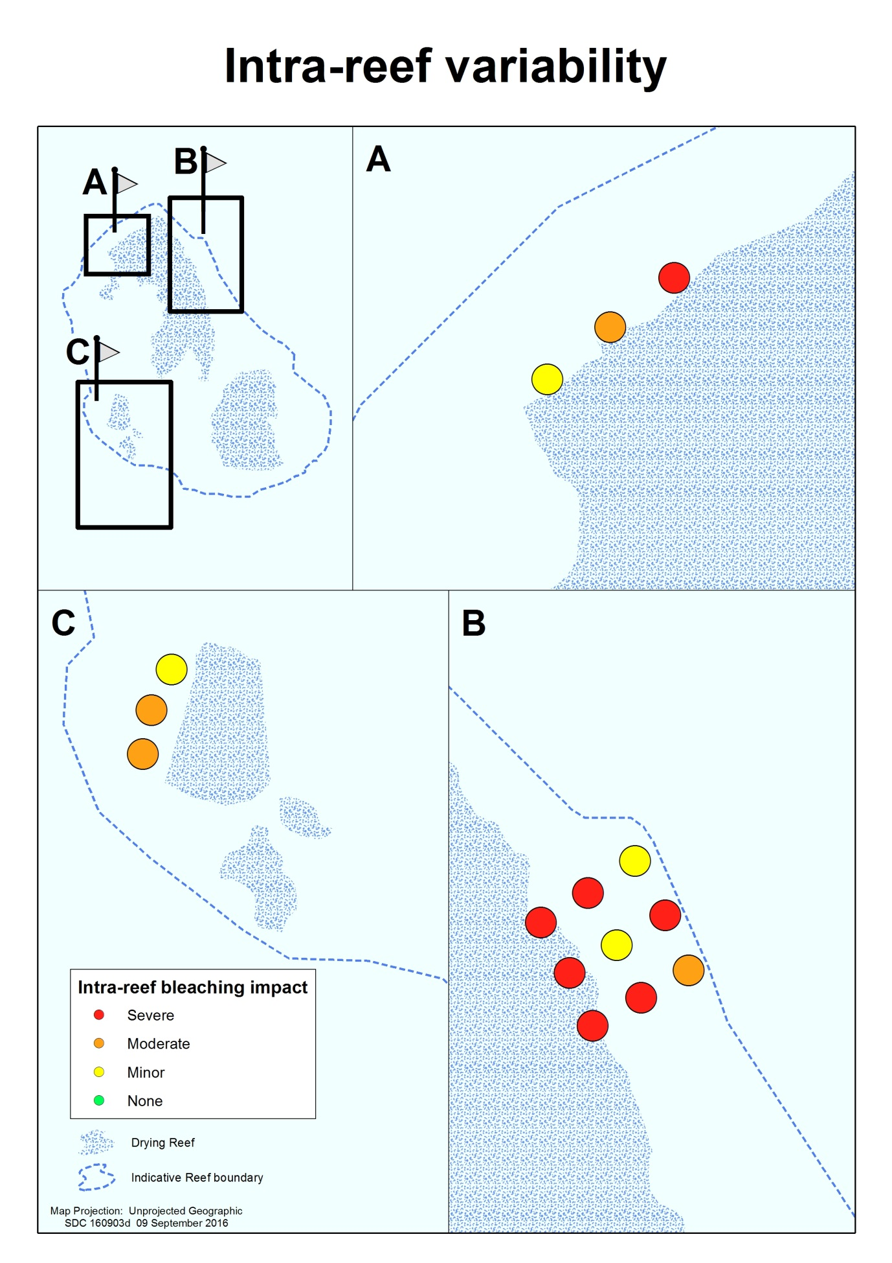Figure 8a,b,c Illustration of bleaching variability within a reef.
Bleaching severity impacts recorded on individual RHIS surveys 50 metres apart on three different reef aspects and depths: a) one depth on the north-west aspect, b) three depths on the north-east aspect and c) one depth on the south-west aspect. In this example, based on actual survey data, bleaching severity within a reef varied from minor to severe.

Scale and spatial patterns of coral mortality (as at 3 June 2016)
Reef-wide coral bleaching caused substantial die-off of corals by early June and patterns of mortality also exhibited a north-south gradient, with high variability across locations
(Figure 9). The proportion of coral in Round 1 surveys that had recently died due to severe bleaching ranged from zero to 100 per cent of total coral cover in individual RHIS surveys, and many areas escaped with little or no bleaching mortality. Some reefs off the Cape Grenville and Princess Charlotte Bay transects had very high bleaching mortality, losing over 50 per cent of their coral cover, whereas reefs in the south had little to no coral mortality from bleaching. The proportion of coral that died on each reef was associated with bleaching severity — the highest levels of mortality were observed in areas with the highest bleaching severity (estimated based on the RHIS surveys, Figure 5) and the most accumulated heat stress (Figure 4).
The agency’s preliminary findings indicated 22 per cent of coral on the Reef had died due to severe bleaching by early June 2016.⁴⁵ This was for shallow-water corals (less than approximately 10 metres depth), which are the most diverse and productive corals, and provide the key reef habitat important for Reef users (e.g. tourism). Eighty-five per cent of this mortality occurred in the 600 kilometre stretch between the tip of Cape York and just north of Lizard Island. At reefs around Lizard Island, Round 1 surveys were conducted before the peak of bleaching and initial mortality, and further mortality was reported during June 2016 (i.e. still during the Round 1 survey period). Therefore, estimates for reefs in that transect area in particular were anticipated to underestimate mortality to June 2016.
The level of bleaching-related mortality differed depending on shelf-position. Of all surveys that recorded coral mortality, the greatest proportion of die-off was on mid-shelf reefs (47 per cent of all surveys), then inshore reefs (32 per cent of surveys), with the least coral mortality observed on outer shelf reefs (21 per cent).
Eye on the Reef reports of bleaching and coral mortality continued into the 2016 Austral winter (i.e. mid-year).

Scale and spatial patterns of coral mortality (as at November 2016)
Bleaching-related mortality had increased by the time the Round 2 surveys in late 2016 were conducted, approximately six-months after peak bleaching, again exhibiting a north-south gradient with high variability across locations (Figure 10).
Between June and November 2016, the proportion of the 62 surveyed reefs that had lost more than half of their coral cover (i.e. with 50 per cent or greater bleaching-related mortality) increased from 10 per cent to just under 30 per cent. Mortality increased substantially in areas that experienced the most severe bleaching — with extreme mortality (more than 75 per cent) of shallow-water corals in 16 per cent of surveyed reefs reported here.
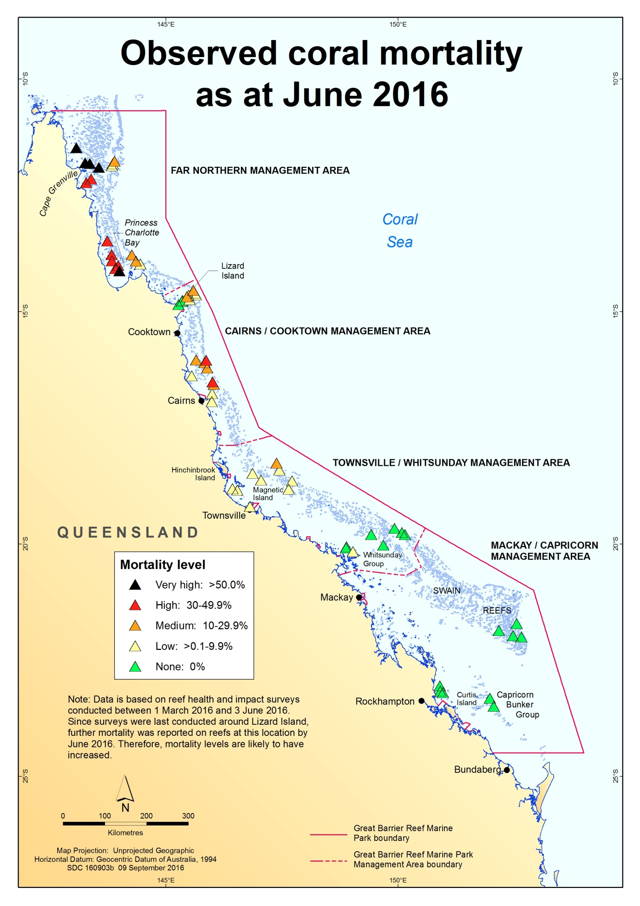Figure 9 Reef-wide pattern of observed recent coral mortality due to coral bleaching as at June 2016 on the Great Barrier Reef.
Each triangle represents a reef, and colours indicate the percentage of coral cover that died (mortality level). Black triangles indicate reefs with greater than 50 per cent coral loss due to severe bleaching.
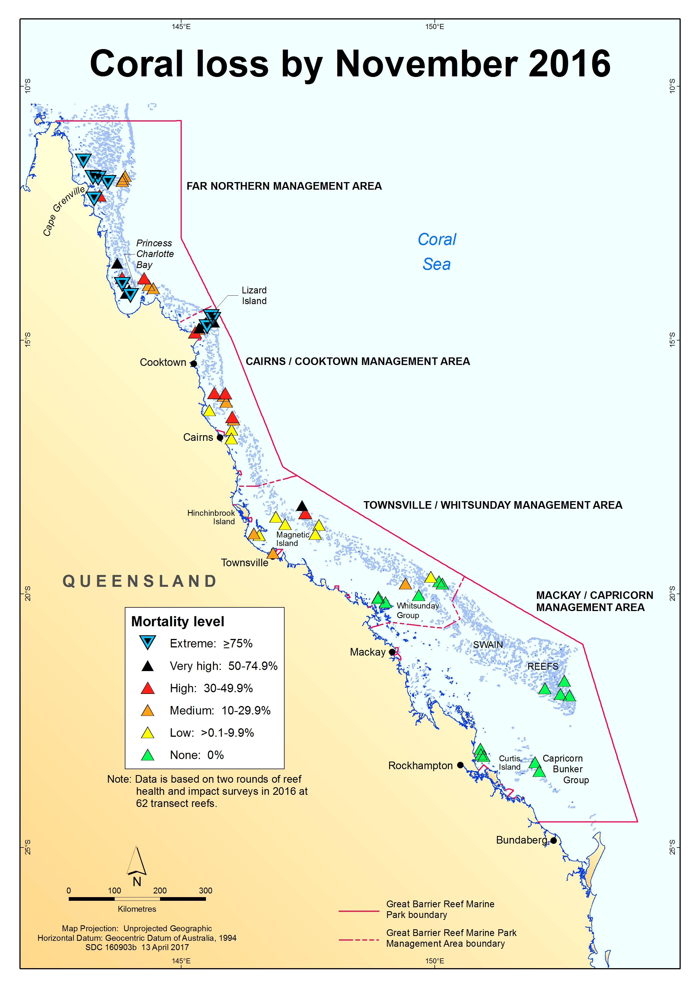Figure 10 Reef-wide pattern of estimated coral loss (proxy for coral mortality) as at November 2016 on the Great Barrier Reef.
Each triangle represents a reef, and colours indicate the percentage of coral cover that died (mortality level). Blue triangles indicate reefs with extreme mortality (greater than 75 per cent coral loss due to severe bleaching).
At the worst affected sites (e.g. on reefs with very high or extreme levels of bleaching-related mortality), few if any hard or soft corals without visible impacts remained, and up to 100 per cent of the coral cover had died from bleaching. Extensive algal overgrowth was observed on some reefs.
Coral mortality increased during 2016, with an increase from the June 2016 estimate of 22 per cent to an estimated 29 per cent loss of shallow-water corals on the Great Barrier Reef by November 2016 due to the worst mass bleaching event on record. Over seventy five per cent of all the bleaching-related mortality in 2016 occurred in the far north — the 600 kilometre stretch between the tip of Cape York and just north of Lizard Island. Overall, the southern Great Barrier Reef did not exhibit significant bleaching-related mortality (or other major reef health impacts) in 2016, consistent with the lower exposure to heat stress (Figure 4) in that area.
Early signs of recovery (such as coral colonies regaining their normal colour) were observed during 2016, particularly during the second half of the year in areas where bleaching had been less severe. However, in late 2016 some live coral colonies were still visibly fully-bleached, or had partial colony mortality, indicating ongoing bleaching impacts.

Spatial patterns of remaining coral cover (as at November 2016)
Round 1 surveys provided total coral cover estimates for early 2016 (i.e. immediately prior to the onset of mass coral bleaching in 2016,) using summed live coral cover and recently dead coral cover estimates from that round of RHIS surveys. This showed that coral cover was variable, but most surveyed reefs still had moderate to high coral cover (Figure 11).
Despite coral losses due predominantly to coral bleaching, many surveyed reefs still had relatively high coral cover (42 per cent or more of hard and soft coral cover) in late 2016 (i.e. when each reef was last assessed between September and November 2016). However, there was high variation in coral cover across the Marine Park, and by late 2016 some surveyed reefs and the whole Lizard region now had very low coral cover (well under 10 per cent). These patterns (Figure 12) varied in relation to the coral cover immediately prior to bleaching (Figure 11), and the scale and spatial patterns of coral mortality described above.
(See the separate report by GBRMPA for information on ongoing bleaching and other Reef health disturbances affecting coral cover in 2017, available at www.gbrmpa.gov.au).

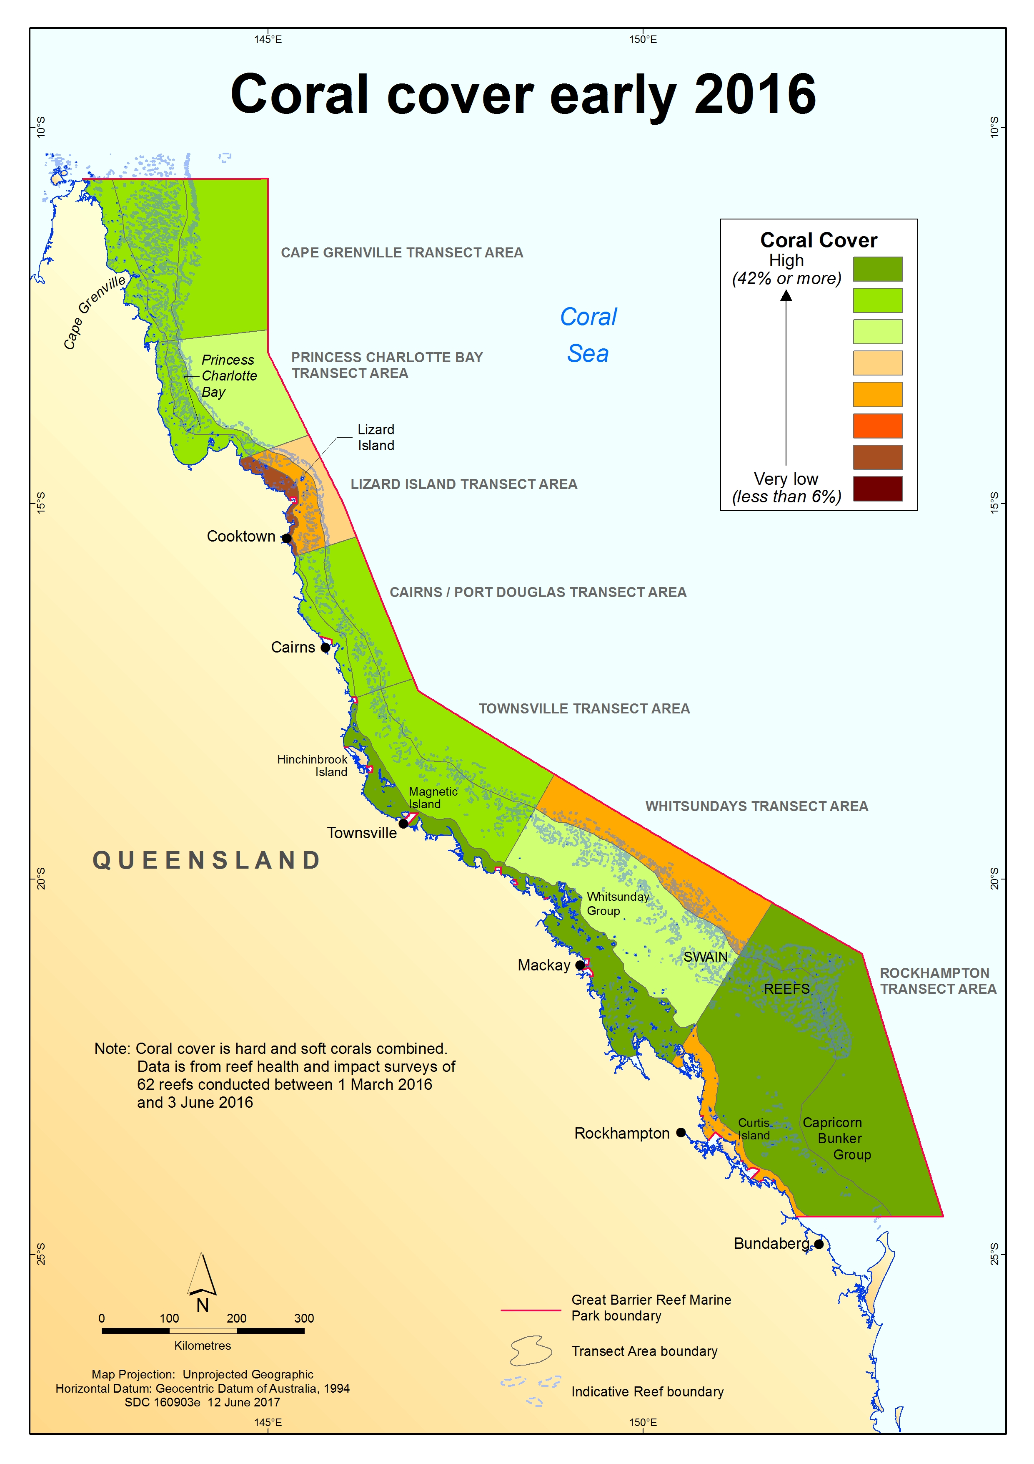Figure 11 Estimated coral cover as at early 2016 on the Great Barrier Reef.
The colour scale represents indicative coral cover (from high to very low) using estimated averages (means) for surveyed reefs
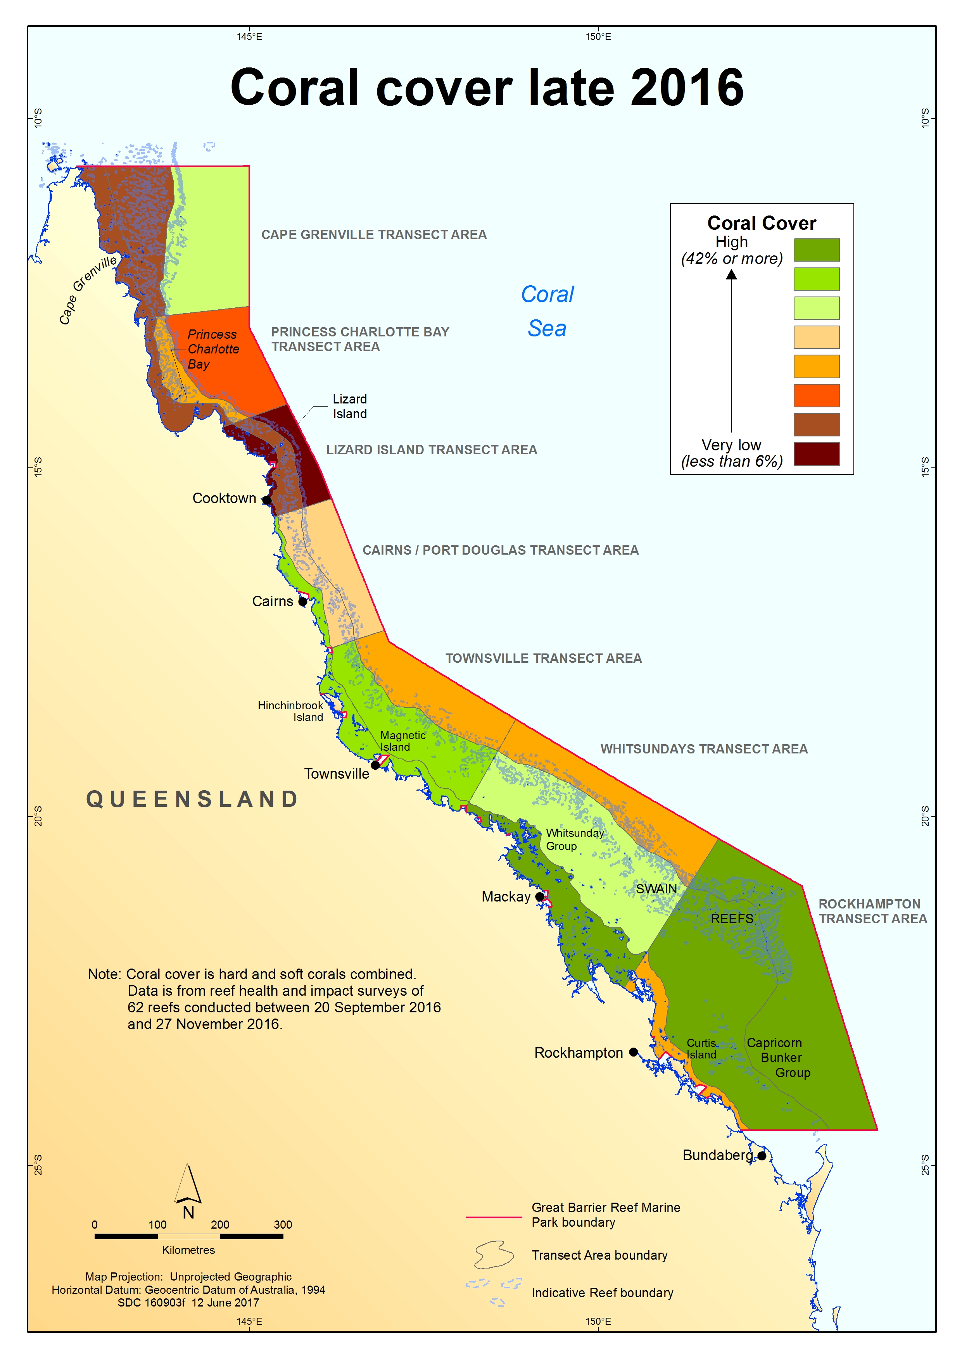Figure 12 Estimated coral cover as at late 2016 on the Great Barrier Reef.
The colour scale represents indicative coral cover (from high to very low) using estimated averages (means) for surveyed reefs.

Conclusions and outlook for recovery

Since 2014 there has been a global mass coral bleaching due to record-breaking temperatures, resulting in the most severe and widespread coral bleaching event recorded on the Great Barrier Reef in 2016. The impacts are ongoing.
Underwater surveys documented widespread bleaching of varying levels of severity throughout the Reef, with the most severe bleaching occurring north of Port Douglas. The results are consistent with other published findings.^{31,49,50} A second round of surveys in late 2016 updated preliminary estimates of bleaching-related mortality. As at November 2016, estimates based on surveys of 62 reefs indicated that prolonged heat stress driven by climate change resulted in the loss of an average of 29 per cent of shallow-water coral on the Great Barrier Reef in 2016. The highest coral mortality and associated reef habitat loss was on inshore and mid-shelf reefs around Cape Grenville and Princess Charlotte Bay, in the far north.
The reef health and impact surveys recorded minor non-bleaching impacts from coral disease, predation and recent damage on the 62 surveyed reefs in 2016. However, those impacts only affected a very low percentage of coral cover (less than 1 per cent on average), so by far the major impact in this period was coral bleaching. Coral bleaching did extend beyond depths divers typically survey to, but mortality cannot be systematically estimated for deeper corals due to lack of data, and their role in reef recovery is unknown.
Variability in bleaching severity and coral mortality was greatest among reefs in the Cairns–Port Douglas areas. Most reefs in the southern half of the Marine Park did not have major impacts from bleaching. As at November 2016 early signs of coral recovery had been observed on parts of the Reef. At the end of 2016, remaining coral cover (of hard and soft corals combined) varied across the Marine Park from very low (6 per cent or less) to high (42 per cent or more).
The second consecutive year of mass coral bleaching on the Great Barrier Reef in 2017 is causing further substantial coral loss. This adds to the impacts reported here, since the Reef has not had enough time for recovery between these disturbances. Coral disease has increased and is considered to be a consequence of the heat stress. Other simultaneous impacts (including from crown-of-thorns starfish outbreaks and severe tropical cyclone Debbie in March 2017) are also affecting the Reef, as summarised in a 2017 report by GBRMPA, further reducing coral cover.
A bleached reef can recover in two ways: its surviving corals recover from bleaching by regaining their symbiotic algae and continue to grow, and/or successful coral recruitment replenishes the reef with juvenile corals which, if no further stress is experienced, will grow to eventually take the place of corals that died in this event.^{5,13} In ideal circumstances, bleached corals can regain their colour within a period of weeks to months once water temperatures return to normal.⁵²
Even if a coral regains its symbionts and hence colour, this does not necessarily mean it is in good health. Research shows bleaching can deplete the corals' energy and prevent it from reproducing for one or two years.^{5,22,23} Corals can also grow slower and have lower calcification rates for up to eight years^{24,25}, and are more vulnerable to coral diseases^{26,27}. Ultimately, therefore, bleaching has acute and chronic impacts on corals, and recovery of coral cover may be slower than following some other types of disturbances.^{24,53}
Bleaching-related coral mortality has flow-on effects for reef-associated species. Many coral reef fishes and invertebrates rely on live, healthy coral for their survival, and so are particularly vulnerable to impacts from this event.^{6,7,54} Given the unprecedented scale and nature of the bleaching, reef resilience overall may have been reduced. It is too early to estimate how many years it will take for coral reefs to recover from this period of extreme heat stress. This is especially the case for the Far Northern Great Barrier Reef (north of Lizard Island), as these reefs are poorly studied and have had few major disturbances since long-term monitoring began in 1985.
The severity of this bleaching event reinforces the urgent need for the strongest possible global action on climate change, and strong local action to improve the resilience of the Reef ecosystem.^{31,55} From a coral reefs perspective, it is critical to limit global temperature rise to no more than 1.5 degrees Celsius above pre-industrial levels, and preferably less (noting average global temperatures are already approaching 1 degree Celsius).^{56,57,58} This requires much greater emissions reduction efforts globally than currently pledged by nations around the world.
The Great Barrier Reef has previously demonstrated the ability to recover from past disturbances, including mass bleaching events.^{59,60,61} However, bleaching events are expected to increase in frequency and severity as a result of climate change, making recovery processes increasingly important for reefs to persist as coral-dominated systems.^{32,62} Significantly, many human activities adversely affect the Reef — compounding the risks imposed by coral bleaching and potentially lengthening recovery timeframes.^{63,64} For example, chronic stress due to poor water quality can affect the recovery potential of reef communities because reproduction and larval recruitment in corals are particularly sensitive to environmental conditions.^{65,66,67} Reducing compounding stressors will help reefs cope with or recover from coral bleaching events, which will in turn build the resilience of reefs to future climate-related disturbances, but only to a point. Further loss of coral as global warming continues is inevitable and can be minimised rather than prevented if the aspirational goal of the 2015 Paris Agreement is reached.
Assessing reef condition and impacts ensures GBRMPA has an up-to-date understanding of Reef health, including the acute and chronic effects of heat stress. It also assists in targeting resilience-building management strategies and raising awareness (for example, communicating the importance of protecting herbivorous reef fishes to support recovery processes on coral reefs). Event-based impact assessments (such as this one) are underpinned by an integrated monitoring and reporting program, which includes long-term monitoring of coral cover by AIMS since 1985. This provides a holistic picture of trends in coral cover, including both coral losses from impacts and coral growth from recovery, allowing disturbance events to be viewed in a historical context.
The agency is also working with researchers to rapidly advance its understanding of factors which increase the resilience of reefs, as measured by the capacity to resist, tolerate and recover from disturbances. It is also increasing its understanding of spatial variability in the likelihood a site will be impacted by disturbances such as bleaching, disease outbreaks, floods and cyclones based on location, coral community composition and thermal history. Greater knowledge of how spatial variability contributes to reef resilience is essential to inform resilience-based management. This also enables assessments of the effectiveness of strategies implemented to support resilience.
The bleaching highlights the importance of GBRMPA’s strong measures in place to protect biodiversity, including no-take green zones which make up 33 per cent of the Marine Park. These no-take reefs may have higher recovery potential and greater resistance to moderate disturbances.^{61,61,61,68} Practical conservation actions for species and habitats are also undertaken to support ecosystem resilience. In addition, the agency is working with partners to explore active restoration approaches, which may in the longer-term confer some local benefits to reefs.
Through the Australian and Queensland governments’ Reef 2050 Long-Term Sustainability Plan, significant investment is being made to restore the integrity of Reef catchments and improve water quality entering the Reef. This is in addition to work that has been taking place since 2003 to reduce nutrients, pesticides and sediments in farm run-off. Considerable efforts are also being made under the plan to reduce the impacts of other pressures to help reefs cope with or recover from disturbances.
In addition to measures aimed at building ecosystem resilience, partnerships with a broad range of stakeholders can help build social and economic resilience to coral bleaching events. GBRMPA is partnering with Reef users to ensure they are well-informed of risks and are included in management and contingency planning to help them cope and adapt to reef health incidents. Similarly, stewardship activities such as the Reef Guardian program are encouraging responsible reef practices, such as not anchoring on corals or disposing of fishing tackle on the Reef.
While these actions to reduce pressures and build resilience remain crucial, environmental management efforts can only compensate for reduced coral reef resilience in the face of climate change to a limited extent and over a limited timeframe.⁶⁹
The Great Barrier Reef Outlook Report 2014⁶⁴ found the overall outlook for the Reef ecosystem is poor and worsening. This assessment was reached after taking into account 150 years of past and accumulating human-caused impacts such as poor water quality and crown of thorns starfish outbreaks, and then secondly taking into account the very poor forward outlook for the reef under climate change driven by the enhanced greenhouse effect.
Unprecedented mass coral bleaching occurring in successive years, in 2016 and 2017, has hastened the decline. As an agency tasked with managing and protecting the Reef for current and future generations, GBRMPA remains extremely concerned about the current and future very destructive impacts of climate change on the Great Barrier Reef Marine Park and World Heritage Area. We are keenly aware that mitigating global climate change remains the most difficult policy challenge to secure the long-term future of the Great Barrier Reef, and other coral reef ecosystems worldwide.

Acknowledgements

The Great Barrier Reef Marine Park Authority (GBRMPA) thanks peer-reviewers for constructive feedback that improved this report. GBRMPA also acknowledges and thanks its partners, stakeholders and staff who participated in the coral bleaching incident response in 2016. Understanding how coral bleaching impacted the Marine Park — an area bigger than Italy — benefits from a network of science, tourism and reef partners assisting us in our efforts.
The first round of field assessments under the agency’s incident response was mainly resourced through the Field Management Program, jointly funded by the Australian and Queensland governments. Program staff, the incident management team, and the agency’s spatial data centre contributed to this work, along with many other agency teams. The second round of surveys and associated resilience assessment received financial support from the Great Barrier Reef Foundation, and additional resourcing from the Field Management Program. The agency’s Reef Recovery section led the forward-planning and environmental assessment.
The GBRMPA Eye on the Reef program provided the monitoring network and reporting system that underpinned this assessment. We thank everyone who contributes to this important monitoring effort. Further details on the program are available on our website.
The Reef health early warning system uses tools and services provided by the Australian Bureau of Meteorology, the United States National Oceanic and Atmospheric Administration and several other organisations. For details, see GBRMPA's Coral Bleaching Risk and Impact Assessment Plan.
We thank staff from the agency and Queensland Parks and Wildlife Service who conducted or supported in-water surveys and helped collect and process the data. We also extend our thanks to Scott Firth, Alex Ainscough, Matthew Trueman, Matthew Marshall, Jessica Walker, Michelle Coates, Jai Harley and Catherine Hacket-Brooks from the Association of Marine Park Tourism Operators (AMPTO), Lyle Vail from Lizard Island Research Station, and Paul Marshall and Adam Smith from Reef Ecologic for assisting with some of the surveys.
In-kind fieldwork support was provided by the Australian Institute of Marine Science and the ARC Centre of Excellence for Coral Reef Studies. We thank the crews of the joint Field Management Program vessels, AMPTO’s MV Hero and Audamas, and Australian Institute of Marine Science’s Cape Ferguson, as well as Adrenalin Dive’s Sea Esta. Thanks also to the many staff who provided operational, communications and administrative support.
The bleaching impact assessment has been conducted in collaboration with the Queensland Parks and Wildlife Service, and many other partners including the Bureau of Meteorology, National Oceanic and Atmospheric Administration, Australian Institute of Marine Science, Australian Research Council Centre of Excellence for Coral Reef Studies, and the National Coral Bleaching Taskforce (instigated by Prof Terry Hughes, Centre of Excellence).
The information in this report is focused on the Great Barrier Reef. We recognise the global coral bleaching event is ongoing, and has affected and is continuing to affect other parts of Australia and the world.

References
1. Hughes, T.P., Baird, A.H., Bellwood, D.R., Card, M., Connolly, S.R., Folke, C., Gosberg, R., Hoegh-Guldberg, O., Jackson, J.B.C., Kleypas, J.A., Lough, J.M., Marshall, P.A., Nyström, M., Palumbi, S.R., Pandolfi, J.M., Rosen, B. and Roughgarden, J. 2003, Climate change, human impacts, and the resilience of coral reefs, Science 301: 929-933.
2. Hoegh-Guldberg, O., Hughes, T., Anthony, K., Caldeira, K., Hatziolos, M. and Kleypas, J. 2009, Coral reefs and rapid climate change: impacts, risks and implications for tropical societies, in Climate change: global risks, challenges and decisions. IOP conference series: earth and environmental science, eds. Anonymous, IOP Publishing, pp. 1-2.
3. Loya, Y., Sakai, K., Yamazato, K., Nakano, Y., Sambali, H. and van Woesik, R. 2001, Coral bleaching: the winners and the losers, Ecology Letters 4(2): 122-131.
4. Marshall, P.A. and Baird, A.H. 2000, Bleaching of corals on the Great Barrier Reef: differential susceptibilities among taxa, Coral Reefs 19(2): 155-163.
5. Baird, A.H. and Marshall, P.A. 2002, Mortality, growth and reproduction in scleractinian corals following bleaching on the Great Barrier Reef, Marine Ecology Progress Series 237: 133-141.
6. Pratchett, M.S., Munday, P.L., Wilson, S.K., Graham, N.A.J., Cinner, J.E., Bellwood, D.R., Jones, G.P., Polunin, N.V.C. and McClanahan, T.R. 2008, Effects of climate-induced coral bleaching on coral-reef fishes: ecological and economic consequences, Oceanography and Marine Biology: An Annual Review 46: 251-296.
7. Stella, J.S., Pratchett, M.S., Hutchings, P.A. and Jones, G.P. 2011, Coral-associated invertebrates: diversity, ecological important and vulnerability to disturbance, Oceaongraphy and Marine Biology: An Annual Review 49: 43-104.
8. Graham, N.A.J., Wilson, S.K., Jennings, S., Polunin, N.V.C., Robinson, J.A.N., Bijoux, J.P. and Daw, T.M. 2007, Lag effects in the impacts of mass coral bleaching on coral reef fish, fisheries, and ecosystems, Conservation Biology 21(5): 1291-1300.
9. Cai, W., Santoso, A., Wang, G., Yeh, S.W., An, S.I., Cobb, K.M., Collins, M., Guilyardi, E., Jin, F., Kug, J.S., Lengaigne, M., McPhaden, M.J., Takahashi, K., Timmermann, A., Vecchi, G., Watanabe, M. and Wu, L. 2015, ENSO and greenhouse warming, Nature Climate Change 5: 849-859.
10. Cai, W., Borlace, S., Lengaigne, M., van Rensch, P., Collins, M., Vecchi, G., Timmermann, A., Santoso, A., McPhaden, M.J., Wu, L., England, M.H., Wang, G., Guilyardi, E. and Jin, F.F. 2014, Increasing frequency of extreme El Niño events due to greenhouse warming, Nature Climate Change 4: 111-116.
11. Mann, M.E., Ramstorf, S., Steinman, B.A., Tingley, M. and Miller, S.K. 2016, The likelihood of recent record warmth, Scientific Reports 6: 19831.
12. Brown, B.E., LeTissier, M.D.A. and Bythell, J. 1995, Mechanisms of bleaching deduced from histological studies of reef corals sampled during a natural bleaching event, Marine Biology 12224800: 655-663.
13. Goreau, T.J. 1992, Bleaching and reef community change in Jamaica: 1951-1991, American Zoologist 32: 683-695.
14. Glynn, P.W. and D'Croz, L. 1990, Experimental evidence for high temperature stress as the cause of El Niño-coincident coral mortality, Coral Reefs 8: 181-191.
15. Wilkinson, C. (ed) 2004, Status of Coral Reefs of the World: 2004, Volume 2 edn, Australian Institue of Marine Science, Townsville.
16. Hoegh-Guldberg, O., Mumby, P.J., Hooten, A.J., Steneck, R.S., Greenfield, P., Gomez, E., Harvell, C.D., Sale, P.F., Edwards, A.J., Caldeira, K., Knowlton, N., Eakin, C.M., Iglesias-Prieto, R., Muthiga, N., Bradbury, R.H., Dubi, A. and Hatziolos, M.E. 2007, Coral reefs under rapid climate change and ocean acidification, Science 318: 1737-1742.
17. Hoegh-Guldberg, O. 1999, Climate change, coral bleaching and the future of the world's coral reefs, Marine and Freshwater Research 50(8): 839-866.
18. Sumich, J.L. (ed) 1996, Introduction to the biology of marine life, Sixth edn, Wm. C. Brown Publishers, Dubuque, IA.
19. Salih, A., Larkum, A., Cox, G., Kuhl, M. and Hoegh-Guldberg, O. 2000, Fluorescent pigments in corals are photoprotective, Nature 408(6814): 850-853.
20. Salih, A., Cox, G., Szymczak, R., Coles, S.L., Baird, A.H., Dunstan, A., Cocco, G., Mills, J. and Larkum, A. 2006, The role of host-based colour and fluorescent pigments in photoprotection and in reducing bleaching stress in corals, in Proc. 10th Int. Coral Reef Symp. eds. Anonymous, pp. 746-756.
21. Jokiel, P.L. and Coles, S.L. 1990, Response of Hawaiian and other Indo-Pacific reef corals to elevated temperature, Coral Reefs 824520: 155-162.
22. Hoeke, R.K., Jokiel, P.L., Buddemeier, R.W. and Brainard, R.E. 2011, Projected changes to growth and mortality of Hawaiian corals over the next 100 years, PloS one 6(3): e18038.
23. Ward, S., Harrison, P. and Hoegh-Guldberg, O. 2000, Coral bleaching reduces reproduction of scleractinian corals and increases susceptibility to future stress, in Proceedings of the 9th International Coral Reef Symposium, eds. M. K. Moosa and et al, Ministry of Environment, Indonesia Institute of Sciences, Bali, Indonesia, pp. 1123-1128.
24. Cantin, N.E. and Lough, J.M. 2014, Surviving coral bleaching events: Porites growth anomalies on the Great Barrier Reef, PLoS One. 9(2): e8872.
25. Cantin, N.E., Cohen, A.L., Karnauskas, K.B., Tarrant, A.M. and McCorkle, D.C. 2010, Ocean warming slows coral growth in the Central Red Sea, Science 329(5989): 322-325.
26. Bruno, J.F., Selig, E.R., Casey, K.S., Page, C.A., Willis, B., Harvell, C.D., Sweatman, H. and Melendy, A.M. 2007, Thermal stress and coral cover as drivers of coral disease outbreaks, PLoS Biology 5(6): e124.
27. Jones, R.J., Bowyer, J., Hoegh-Guldberg, O. and Blackall, L. 2004, Dynamics of a temperature-related coral disease outbreak, Marine Ecology Progress Series 281: 63-77.
28. Glynn, P.W. 1993, Coral reef bleaching: ecological perspectives, Coral Reefs 12(1): 1-17.
29. Baker, A.C., Glynn, P.W. and Riegl, B. 2008, Climate change and coral reef bleaching: an ecological assessment of long-term impacts, recovery trends and future outlook, Estuarine, Coastal and Shelf Science 80(4): 435-471.
30. Przeslawski, R., Ahyong, S., Byrne, M., Worheide, G. and Hutchings, P. 2008, Beyond corals and fish: the effects of climate change on noncoral benthic invertebrates of tropical reefs, Global Change Biology 14(12): 2773-2795.
31. Hughes, T.P., Kerry, J.T., Ãlvarez-Noriega, M., Ãlvarez-Romero, J.G., Anderson, K.D., Baird, A.H., Babcock, R.C., Beger, M., Bellwood, D.R., Berkelmans, R., Bridge, T.C., Butler, I.R., Byrne, M., Cantin, N.E., Comeau, S., Connolly, S.R., Cumming, G.S., Dalton, S.J., Diaz-Pulido, G., Eakin, C.M., Figueira, W.F., Gilmour, J.P., Harrison, H.B., Heron, S.F., Hoey, A.S., Hobbs, J.-.A., Hoogenboom, M.O., Kennedy, E.V., Kuo, C.-., Lough, J.M., Lowe, R.J., Liu, G., McCulloch, M.T., Malcolm, H.A., McWilliam, M.J., Pandolfi, J.M., Pears, R.J., Pratchett, M.S., Schoepf, V., Simpson, T., Skirving, W.J., Sommer, B., Torda, G., Wachenfeld, D.R., Willis, B.L. and Wilson, S.K. 2017, Global warming and recurrent mass bleaching of corals, Nature 543: 373-377.
32. Hughes, T.P. 1994, Catastrophes, phase shifts, and large-scale degradation of a Caribbean coral reef, Science 265(5178): 1547-1551.
33. Hughes, T.P., Rodrigues, M.J., Bellwood, D.R., Ceccarelli, D., Hoegh-Guldberg, O., McCook, L.J., Moltschaniwskyj, N.A., Pratchett, M.S., Steneck, R.S. and Willis, B. 2007, Phase shifts, herbivory, and the resilience of coral reefs to climate change, Current Biology 17(4): 360-365.
34. Bellwood, D.R., Hoey, A.S., Ackerman, J.L. and Depczynski, M. 2006, Coral bleaching, reef fish community phase shifts and the resilience of coral reefs, Global Change Biology 12(9): 1587-1594.
35. Done, T., Whetton, P., Jones, R.J., Berkelmans, R., Lough, J.M., Skirving, W. and Wooldridge, S. 2003, Global climate change and coral bleaching on the Great Barrier Reef, Department of Natural Resources and Mines, Brisbane.
36. Donner, S.D., Skirving, W.J., Little, C.M., Oppenheimer, M. and Hoegh-Guldberg, O. 2005, Global assessment of coral bleaching and required rates of adaptation under climate change, Global Change Biology 11(12): 2251-2265.
37. Berkelmans, R. and Oliver, J.K. 1999, Large-scale bleaching of corals on the Great Barrier Reef, Coral Reefs 18: 55-60.
38. Berkelmans, R., De'ath, G., Kininmonth, S. and Skirving, W.J. 2004, A comparison of the 1998 and 2002 coral bleaching events on the Great Barrier Reef: Spatial correlation, patterns and predictions, Coral Reefs 23(1): 74-83.
39. Anthony, K.R.N., Maynard, J.A., Diaz-Pulido, G., Mumby, P.J., Marshall, P.A., Cao, L. and Hoegh-Guldberg, O. 2011, Ocean acidification and warming will lower coral reef resilience, Global Change Biology 17: 1798-1808.
40. Bellwood, D.R., Hughes, T.P., Folke, C. and Nyström, M. 2004, Confronting the coral reef crisis, Nature 429: 827-833.
41. Hughes, T.P., Barnes, M.L., Bellwood, D.R., Cinner, J.E., Cumming, G.S., Jackson, J.B.C., Kleypas, J., van de Leemput, I.A., Lough, J.M., Morrison, T.H., Palumbi, S.R., van Nes, E.H. and Scheffer, M. 2017, Coral reefs in the Anthropocene, Nature 546: 82-90.
42. Westmacott, S., Cesar, H., Pet-Soede, L. and Lindén, O. 2000, Coral Bleaching in the Indian Ocean: Socio-Economic Assessment of Effects, in Collected Essays on the Economics of Coral Reefs, ed. H. Cesar, CORDIO, Kalmar University, Sweden, pp. 94-106.
43. Cesar, H., Pet-Soede, L., Westmacott, S., Mangi, S. and Aish, A. 2002, Economic Analysis of Coral Bleaching in the Indian Ocean – Phase II, in Coral degradation in the Indian Ocean: Status Report 2002., ed. D. Obura, CORDIO, Department of Biology and Environmental Science, University of Kalmar, Kalmar, Sweden, pp. 251-262.
44. Westmacott, S., Teleki, K., Wells, S. and West, J. 2000, Management of bleached and severely damaged coral reefs, Washington, DC.
45. Great Barrier Reef Marine Park Authority 2016, Interim report: 2016 coral bleaching event on the Great Barrier Reef, GBRMPA, Townsville.
46. Great Barrier Reef Marine Park Authority 2011, Reef health Incident response system, GBRMPA, Townsville.
47. Great Barrier Reef Marine Park Authority 2013, Coral bleaching risk and impact assessment plan, GBRMPA, Townsville.
48. Bureau of Meteorology 2016, 2016 marine heatwave on the Great Barrier Reef, Bureau of Meteorology, <www.bom.gov.au/environment/doc/marine-heatwave-2016.pdf>.
49. González-Rivero, M., Rodriguez-Ramirez, A., Tonk, L., Puotinin, M., Heron, S., Skirving, W., Kennedy, E., Ridgway, T. and Hoegh-Guldberg, O. 2017, The effect of cumulative stress on reef slope coral communities in the far northern and northern Great Barrier Reef: 2012 to 2016. Final report to the Department of Environment and Energy, University of Queensland, Brisbane.
50. Hughes, T., Schaffelke, B. & Kerry, J. 2016, "How much coral has died in the Great Barrier Reef's worst bleaching event?", The Conversation, [Online], no. 29 November. Available from: https://theconversation.com/how-much-coral-has-died-in-the-great-barrier-reefs-worst-bleaching-event-69494.
51. Beeden, R.J., Turner, M.A., Dryden, J., Merida, F., Goudkamp, K., Malone, C., Marshall, P.A., Birtles, A. and Maynard, J.A. 2014, Rapid survey protocol that provides dynamic information on reef condition to managers of the Great Barrier Reef, Environmental Monitoring and Assessment 186(12): 8527-8540.
52. Douglas, A.E. 2003, Coral bleaching-how and why? Marine Pollution Bulletin 46: 385-392.
53. Osborne, K., Thompson, A.A., Cheal, A.J., Emslie, M.J., Johns, K.A., Jonker, M.J., Logan, M., Miller, I.R. and Sweatman, H.P.A. 2017, Delayed coral recovery in a warming ocean, Global Change Biology doi: 10.1111/gcb.13707.
54. Jones, G.P., McCormick, M.I., Srinivasan, M. and Eagle, J.V. 2004, Coral decline threatens fish biodiversity in marine reserves, Proceedings of the National Acadamy of Sciences of the United States of America 101(21): 8251-8253.
55. Department of the Environment and Energy 2017, Reef 2050 Plan Independent Expert Panel: Communique 5 May 2017, Australian Government.
56. Frieler, K., Meinhausen, M., Golly, A., Mengel, M., Lebek, K., Donner, S.D. and Hoegh-Guldberg, O. 2013, Limiting global warming to 2ºC is unlikely to save most coral reefs, Nature Climate Change 3: 165-170.
57. Schleussner, C.F., Lissner, T.K., Fischer, E.M., Wohland, J., Perrette, M., Golly, A., Rogelj, J., Childers, K., Schewe, J., Frieler, K., Mengel, M., Hare, W. and Schaeffer, M. 2016, Differential climate impacts for policy-relevant limits to global warming: the case of 1.5 °C and 2 °C, Earth System Dynamics 7(2): 327-351.
58. King, A.D., Karoly, D.J. and Henley, B.J. 2017, Australian climate extremes at 1.5ºC and 2ºC of global warming, Nature Climate Change 7: 412-416.
59. Halford, A., Cheal, A.J., Ryan, D. and Williams, D.M. 2004, Resilience to large-scale disturbance in coral and fish assemblages on the Great Barrier Reef, Australia, Ecology 85: 1892-1905.
60. Beeden, R.J., Maynard, J., Puotinen, M.L., Marshall, P., Dryden, J., Goldberg, J. and Williams, G. 2015, Impacts and recovery from severe tropical Cyclone Yasi on the Great Barrier Reef, PLoS ONE 10(4): e0121272.
61. Emslie, M.J., Cheal, A.J., Sweatman, H. and Delean, S. 2008, Recovery from disturbance of coral and reef fish communities on the Great Barrier Reef, Australia, Marine Ecology Progress Series 371: 177-190.
62. Bruno, J.F., Sweatman, H., Precht, W.F., Selig, E.R. and Schutte, V.G.W. 2009, Assessing evidence of phase shifts from coral to macroalgal dominance on coral reefs, Ecology 90(6): 1478-1484.
63. Hughes, T.P. and Connell, J.H. 1999, Multiple stressors on coral reefs: a long-term perspective, Limnology and Oceanography 44(3): 932-940.
64. Great Barrier Reef Marine Park Authority 2014, Great Barrier Reef Outlook Report 2014, Great Barrier Reef Marine Park Authority, Townsville.
65. Wooldridge, S.A. and Done, T.J. 2009, Improved water quality can ameliorate effects of climate change on corals, Ecological Applications 19: 1492-1499.
66. Wooldridge, S.A. 2009, Water quality and coral bleaching thresholds: formalising the linkage for the inshore reefs of the Great Barrier Reef, Australia, Marine Pollution Bulletin 58(5): 745-751.
67. De'ath, G. and Fabricius, K.E. 2008, Water quality of the Great Barrier Reef: Distributions, effects on reef biota and trigger values for the protection of ecosystem health, Great Barrier Reef Marine Park Authority, Townsville.
68. Mellin, C., MacNeil, M.A., Cheal, A.J., Emslie, M.J. and Caley, M.J. 2016, Marine protected areas increase resilience among coral reef communities, Ecology Letters 19(6): 629-637.
69. Anthony, K.R.N. 2016, Coral reefs under climate change and ocean acidification: challenges and opportunities for management and policy, Annual Review of Environment and Resources 41(1): 59-81.

APPENDIX A: List of reefs surveyed in each cross-shelf transect.
Official reef identification numbers are provided for each reef, and the first two digits represent the latitude of the reef. The Great Barrier Reef Marine Park is divided into four Management Areas, and the table shows which transects are in each of these.
Transect | Inshore | Mid-shelf | Outer shelf
Far Northern Management Area
Cape Grenville | U/N Reef (11–060)  Nomad Reef (12–007)  Kay Reef (12–010) | Guthray Reef (11–171)  Cockburn Reef (11–173)  Sir Charles Hardy Islands Reef (11–184c) | Three Reefs (11–223)  Devlin Reef (11–229a)  Five Reefs (11–232)
Princess Charlotte Bay | Pelican Island Reef  (13–107)  Eden Reef (14–008)  Wharton Reef (14–022) | Morris Island Reef  (13–072)  Magpie Reef (13–087)  Grub Reef (14–003) | U/N Reef (13–121)  Rodda Reef (13–127)  Davie Reef (13–130)
Cairns–Cooktown Management Area
Lizard Island | Martin Reef (14–123)  Linnet Reef (14–126)  Decapolis Reef (14–131) | MacGillivray Reef  (14–114)  Lizard Island Reef (Lagoon) (14–116d)  North Direction Reef (14–143) | Carter Reef (14–137)  Yonge Reef (14–138)  No Name Reef (14–139)
Cairns–Port Douglas | Low Islands Reef  (16–028)  Green Island Reef  (16–049)  Fitzroy Island Reef  (16–054a&f) | Mackay Reef (16–015)  Hastings Reef (16–057)  Michaelmas Reef  (16–060) | Agincourt Reefs (No. 1) (15-099c)  St Crispin Reef (16–019)  Opal Reef (16–025)
Townsville–Whitsundays Management Area
Townsville | Pandora Reef (18-051)  Havannah Reef (18-065)  Middle Reef (19-011) | Rib Reef (18–032)  John Brewer Reef  (18–075)  Davies Reef (18-096) | Myrmidon Reef (18–034)  Dip Reef (18–039)  Chicken Reef (18–086)
Whitsundays | Hayman Island Reef (20–014)  Langford-Bird Reef  (20–019)  Border Island Reef (No.1) (20–067a) | U/N Reef (19–138)  U/N Reef (20–104) | Slate Reef (19–159)  Hyde Reef (19–207)  Rebe Reef (19–209)
Mackay–Capricorn Management Area
Rockhampton | North Keppel (Ko-no-mie) Island Reef (No. 1) (23–004a)  Middle (Ba-la-ba) Island Reef (23–010)  Halfway Island Reef  (23–014) | U/N Reef (21–529)  Wreck Island Reef  (23–051)  One Tree Island Reef (23–055a) | Gannett Cay Reef  (21–556)  Turner Reef (21–562)  Chinaman Reef  (22–102)

APPENDIX B: example illustrations and descriptions
Below are examples of coral bleaching impact severity levels used to assess reef health. Factors that differ among severity levels are: types of coral, bleaching severity, depth and number affected (Coral Bleaching Risk and Impact Assessment Plan 2013).
Minor | Moderate | Severe
Photos taken at 2–3 metres | Photos taken at 3–6 metres | Photos taken at >9 metres
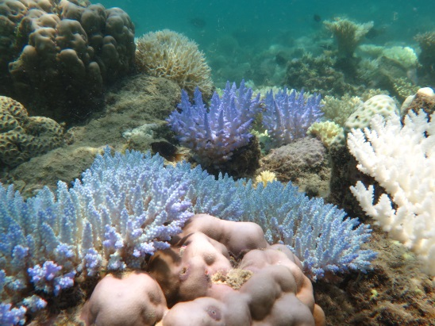 | 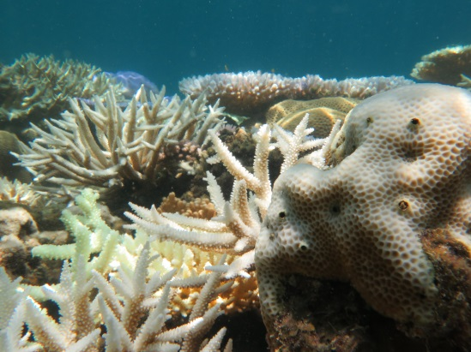 | 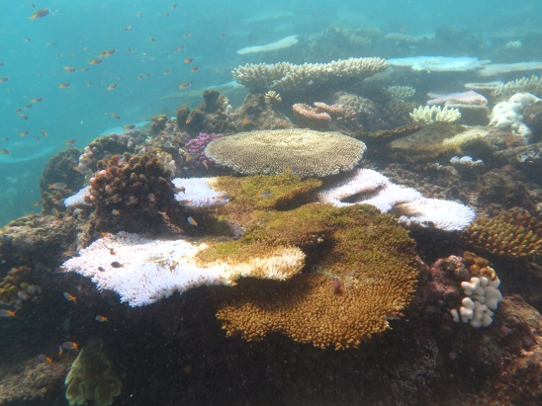
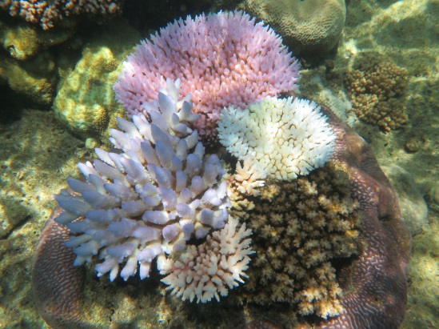 | 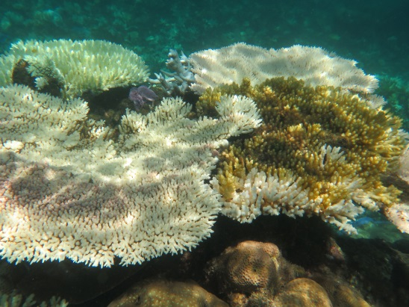 | 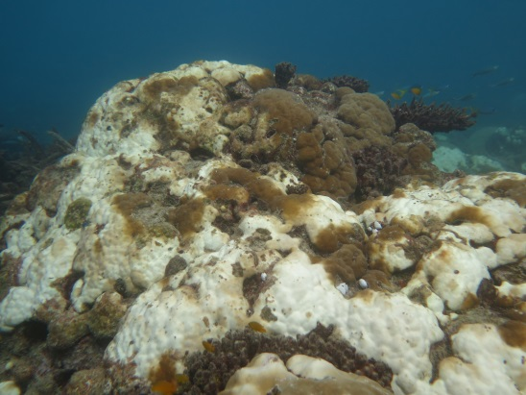
- Bleaching mainly confined to reef flat  - Severe bleaching of many (10–50 per cent) colonies of taxa (Acropora and Pocillopora), or morphologies (branching, bushy, tabular/plate) usually highly sensitive to bleaching)  - Severe bleaching of some (<10 per cent) colonies of taxa (Montipora and Faviids) or morphologies with low sensitivity to bleaching (encrusting and mushroom)  - Paling of colonies of taxa (Porites) or morphologies (massives) with very low sensitivity to bleaching  - Severe bleaching of colonies of taxa or morphologies with low or very low sensitivity to bleaching but confined to reef flat. | - Mortality confined to reef flat; bleaching extends deeper than reef flat  - Severe bleaching of most (>50 per cent) colonies of taxa or morphologies usually highly sensitive to bleaching  - Severe bleaching of many (10–50 per cent) colonies of taxa or morphologies with low sensitivity to bleaching below reef crest  - Severe bleaching of some (<10 per cent) colonies of taxa or morphologies with very low sensitivity to bleaching  - Some mortality of colonies of taxa or morphologies usually highly sensitive to bleaching but confined | - Bleaching extends deeper than upper reef slope  - Mortality of many (>50 per cent) colonies of taxa or morphologies usually highly sensitive to bleaching  - Severe bleaching of most (>50 per cent) colonies of taxa or morphologies with low sensitivity to bleaching  - Severe bleaching of many (10–50 per cent) colonies of taxa or morphologies with very low sensitivity to bleaching.

APPENDIX C: Time-series images

Below are time-series images taken at a patch of coral reef over 10 months, illustrating the impacts of bleaching over time. Red stars indicate areas of coral that died due to severe coral bleaching and the two yellow stars on the third photograph indicate crown-of-thorns starfish feeding scars:
a) healthy coral on a reef flat in October 2015
b) In April 2016, about half of the coral had died from bleaching with the other half, predominantly in the centre of the image still bleached.
c) In September 2016, surviving coral colonies in the centre of the image show signs of recovery (regained their natural brown colour) after the peak of the bleaching event, amid very high mortality (>50 per cent) of surrounding colonies .
The bleaching susceptibility of an area of reef will be influenced by the community composition since different coral tax have different bleaching susceptibility, among other factors.
(Photos: ©Taylor Simpkins 2016)
a) 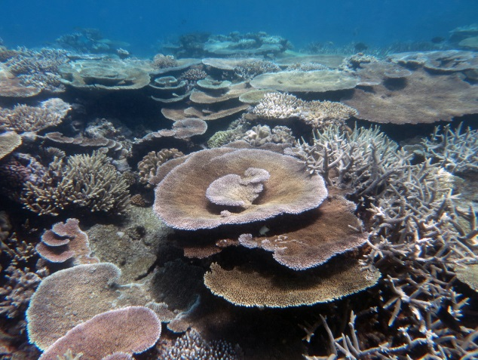 b) 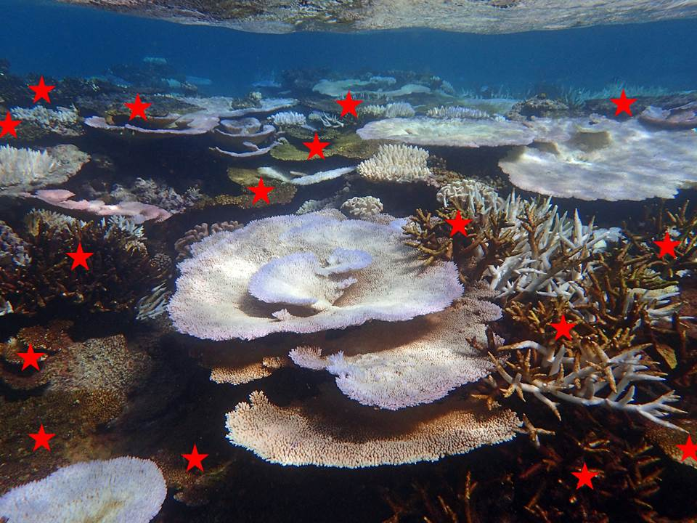 c) 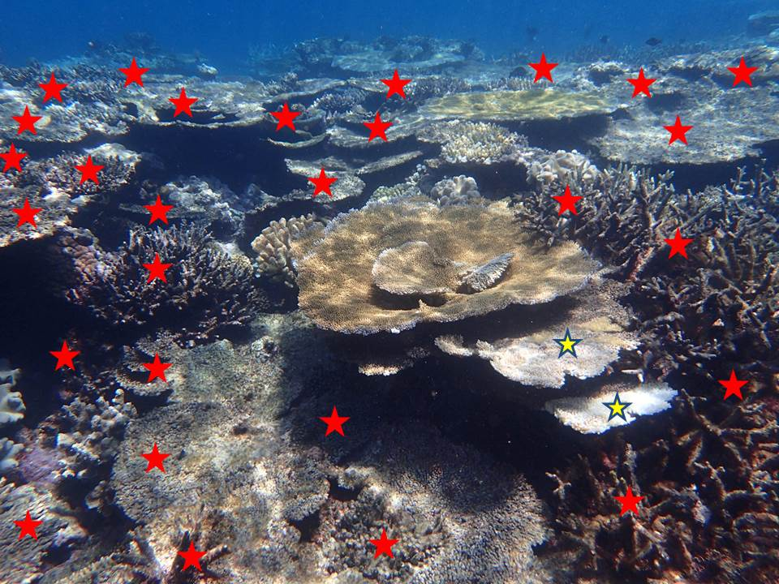

This report covers the Great Barrier Reef during 2016 only. At the time of writing in early 2017, the bleaching event is ongoing, driven by climate change, even though the El Niño Southern Oscillation Index has returned to neutral.
Source: Goddard Institute for Space Studies
J Lough (AIMS) pers comm. [Using data from HadISST, HadCRUTv4].
Detailed analyses of reef-scale temperature data are still underway at the time of writing.
Australasian Fire Authority Council website, 2004, www.afac.com.au
The survey was carefully designed so that bleaching patterns could be assessed at a range of scales.
The score given for the severity of the bleaching impact is a composite measure of the impact the stress has had on corals. The four levels of impact (no bleaching, minor impacts, moderate impacts, and severe impacts) are assigned based on a range of factors as set out in Appendix B.
But see below — this category was split into two for Round 2 surveys.
Percentage change in coral cover is the difference in cover between the estimated pre-bleach coral cover (total coral cover from Round 1 made up of live coral and recently dead coral lightly covered in algae) and live coral cover as at late 2016 (from Round 2), relative to the pre-bleach coral cover.
Additional information on bleaching severity and mortality was available for six additional reefs (Moore Reef, Vlasoff Reef, Agincourt Reefs (No3), Chinaman Reef, Parkinson Reef and Outer Reef) surveyed opportunistically by GBRMPA at the same times as the Round 1 and Round 2 surveys. Bleaching severity information was also examined for a further 61 reefs from supplementary surveys and anecdotal reports where there was sufficient information provided through the Eye on the Reef monitoring network. These data provided greater spatial coverage, particularly in the Port Douglas to Townsville area, and confirmed bleaching patterns described in this report.
The Lizard Island region only accounted for a small proportion of the Marine Park’s pre-bleaching coral cover (due to its history of disturbances including two recent severe cyclones and the available area of reef habitat). Therefore, the overall coral loss figure is not strongly influenced by results for that area.

