Commercial and non-commercial use
Chapter 5
‘an assessment of the commercial and non-commercial use…’ of the Great Barrier Reef Region, Section 54(3)(c) of the Great Barrier Reef Marine Park Act 1975
< Photograph on front cover of tourists looking over the side admiring a large coral bommie that is visible beneath the surface, Copyright Matt Curnock.

2014 Summary of assessment
Economic and social benefits of use | Use of the Great Barrier Reef continues to contribute to local communities and the national economy. Its economic value has increased over the past five years as has the number of jobs it supports. The number of recreational visits appears to be increasing and declines in tourism visitor numbers until 2011 are now beginning to be reversed. Traditional use helps maintain Traditional Owner connections to their sea country. Some users financially contribute to management. | Very good, Stable
Impact of use | The impacts of different uses of the Great Barrier Reef overlap and are concentrated inshore, particularly next to developed areas. Some uses have only minor and localised effects, for example defence activities, research and educational activities, and traditional use. Cumulative effects of tourism and recreation activities are localised around popular locations. Port activities and their flow-on impacts are generally in areas that are already under pressure from an accumulation of impacts. There are concerns about overfishing of some fish stocks, and the effects of fishing on some species of conservation concern. The survival of non-retained species is not monitored or well understood. | High impact, Increased
Full assessment summary: see Section 5.10

Commercial and non-commercial use

Background
Outlook Report 2009: Overall summary of commercial and non-commercial use
Almost all commercial and non-commercial uses of the Great Barrier Reef Region are dependent on the biodiversity and health of its ecosystem. Use occurs across the length and breadth of the ecosystem with most use and impact concentrated inshore, near developed coasts and on coral reef habitats. The current state and trends of most uses are known, with fluctuations largely determined by global factors such as fuel prices, human health issues and economic development. There are some concerns about localised impacts and effects on some species with potential flow on effects to some ecological processes.
Uses of the Great Barrier Reef are economically important to regional communities and tourism is economically important nationally. They provide income to and employment for local industries and are an integral component of coastal communities. Traditional Owner aspirations are being increasingly recognised and formalised in law. However, they are also being increasingly impacted by other activities occurring in the Great Barrier Reef and along the adjacent coastal zone.
Declines in many coral reef ecosystems around the world are likely to increase the commercial and non-commercial value placed on components of the Great Barrier Reef and potentially alter use patterns in the future.
Overall trends of use of the Great Barrier Reef are difficult to predict because each use is shifting at different rates and in response to different drivers. The future cumulative effects of all use and the ecosystem-level impacts are poorly understood.

Key message: All of the Region’s major uses are assessed.
For thousands of years the Great Barrier Reef Region (the Region) has been an important resource and valued sea country for Traditional Owners. Since European settlement, 160 years ago, the Reef and its resources have been used and enjoyed by a variety of non-commercial and commercial uses, forming an important part of the social and economic fabric of regional Queensland, the Australian community, and the broader international community. A 2013 national survey estimated that 44 per cent of Australians had visited the Region in their lifetime.¹
For almost 40 years, the Region has been managed as a multiple-use marine protected area, providing for protection, allowing for ecologically sustainable use, promoting understanding and enjoyment, and encouraging engagement. In managing the Region, environmental, economic and social aspects are considered in order to achieve the best outcomes for both the Great Barrier Reef and the community.
The Region supports significant commercial and non-commercial uses, especially commercial marine tourism and fishing (Figure 5.1). It is estimated that, in 2011–12, the Great Barrier Reef contributed approximately $5.6 billion to the Australian economy (Table 5.1) and supported employment equivalent to about 69,000 full-time positions.² This is an increase of about $200 million and 14,000 positions since 2006–07.^{2,3} These estimates, however, are likely to be only a portion of the total economic value of the Reef as most ecosystem services of the Reef have not yet been calculated.⁴ At the same time, ports and shipping activity adjacent to and through the Region has continued to increase, providing a link in the production chain for many industries and services in regional Queensland.
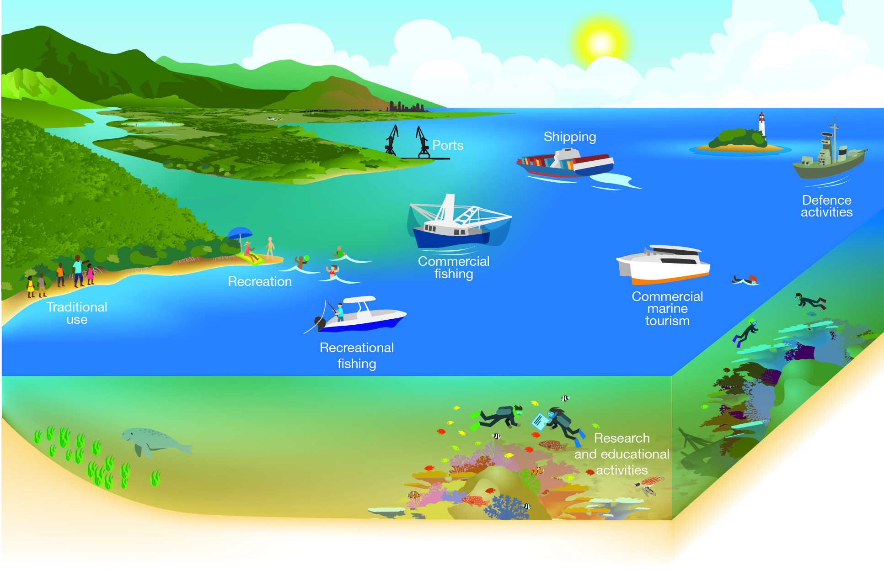
Figure 5.1 Commercial and non-commercial uses
There are a range of uses of the Region; some depend directly on the Reef’s resources.

Table 5.1 Economic contributions of selected activities dependent on the Great Barrier Reef,
2006–07 and 2011–12
In 2011–12, Great Barrier Reef industries directly and indirectly contributed an estimated $5.6 billion to the Australian economy. This is an increase of approximately $200 million since 2006–07, but likely a small decrease in real terms. The value for tourism includes activity in both the Great Barrier Reef and its catchment. Value added refers to the output after deducting the value of inputs. Source: Access Economics 2008 and 2012^{2,3}

Activity | 2006–07  Value added ($million) | 2011–12  Value added  ($million)
Tourism | $5117 | $5176
Commercial fishing | $139 | $160
Recreational use (including fishing) | $153 | $244
Total contribution | $5409 | $5580

This assessment of commercial and non-commercial use examines the current state and trends of the major uses of the Region and their associated benefits and impacts, with particular focus on changes since the Great Barrier Reef Outlook Report 2009⁵. The evidence provided in this assessment forms the basis for the assessment of direct use as a factor influencing the Region's values (see Section 6.6).
The uses assessed are:
- commercial marine tourism
- defence activities
- fishing
- ports
- recreation (not including fishing)
- research and educational activities
- shipping
- traditional use of marine resources.
Ports and shipping have been separated in this Outlook Report because of the differences in their likely impacts and management arrangements. Educational activities have been included with research to recognise use of the Region for primary, secondary and tertiary education.
Some of the activities assessed are directly dependent on the Region’s natural resources (Reef-dependent) and others are carried out regardless of the natural environment (not Reef-dependent). Examples of Reef-dependent activities are traditional use of marine resources, commercial marine tourism, fishing, recreation, and research and educational activities. Reef-dependent activities are likely to be more sensitive to changes in the condition of the Region’s values.⁶ Examples of activities not dependent on the Reef include shipping, ports and defence activities.
Commercial and non-commercial uses occurring outside the Region that may indirectly affect its ecosystem and heritage values are considered in Chapter 6.

Commercial marine tourism

Current state and trends of commercial marine tourism
Key message: Commercial marine tourism continues to be a significant use of the Reef.
Key message: Reef visitation is recovering after many years of decline.
The long-term attractiveness of the Region as a tourism destination is largely based on the Great Barrier Reef’s reputation as the world's largest and best known coral reef ecosystem — one that has spectacular and diverse species — combined with high standard tourism and protected area management. The Region’s tourism industry is almost exclusively nature-based, with coral reefs and islands as the focus, and is reliant on an intact Great Barrier Reef ecosystem. There are opportunities to see iconic wildlife such as whales, marine turtles, sharks and seabirds and to go boating, diving, snorkelling, fishing, sailing, hiking, camping or to enjoy various water sports. Swimming, snorkelling, scuba diving and viewing animals are consistently popular tourist activities (Figure 5.2). The industry offers a wide range of tourism experiences, from cruise ships and live-aboard vessels to day trips on high speed catamarans, fishing charters and kayaking tours.

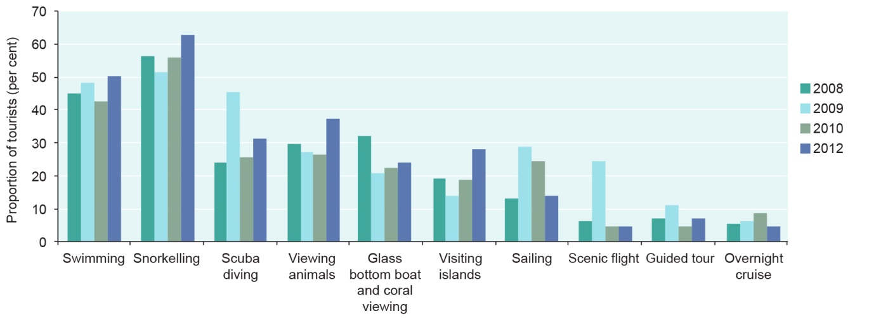
Figure 5.2 Reef activities undertaken by tourists departing Cairns, 2008–2012
Surveys of tourists departing from Cairns (a sample of 4337 people) showed swimming and snorkelling to be the most popular activities undertaken. No surveys were taken in 2011. Source: Prideaux et al. 2013⁷

Commercial marine tourism continues to be the most significant use of the Reef — both in terms of economic value and employment. Tourism activity in the Great Barrier Reef remains focused in a small portion of the Region with about 83 per cent of all tourism activity occurring in about seven per cent of the Region during 2013 (Figure 5.3). In that year, about 40 per cent of the full day visits took place in the Cairns Planning Area (offshore from Cairns and Port Douglas) compared with 44 per cent in 2008. For the Whitsunday Planning Area (the Whitsunday islands and adjacent reefs), there was the same proportion of the full day visits in 2013 compared with 2008 (43 per cent).
After a peak in 2004–05, visitor days to the Great Barrier Reef Marine Park declined by more than 16 per cent between 2005 and 2011 (Figure 5.4). The decline was attributable to a range of factors, including the high exchange rate of the Australian dollar, increased competition from international destinations, extreme weather events and the global financial crisis. Tourism is showing signs of a sustained recovery across the Marine Park and visitation in 2013 has increased by approximately 60,000 since 2012.⁸ Visitation to the Cairns Planning Area is recovering strongly. Much of this result is attributable to attracting new Chinese tourists and the recovery of some traditional markets such as Japan. Visitation to the Whitsunday Planning Area and southern areas of the Region is also now recovering.
In 2013, a total of 1,887,317 visits were made to the Great Barrier Reef Marine Park by tourists on commercial tourism operations, of which 1,382,530 were full day visits and 195,249 were part-day visits or visitors who did not pay the full Environmental Management Charge.⁹ While the overall number of visits has varied from year to year, the proportions between these three categories of visitation have remained relatively stable.
In 2012, 66 per cent of tourism visitor days were carried by the 25 most active operators, 80 per cent were carried by 50 operators and 93 per cent by 100 operators. Many operations are small-scale and carry only small numbers of tourists (less than 10 people) or operate infrequently (less than 50 days per year).
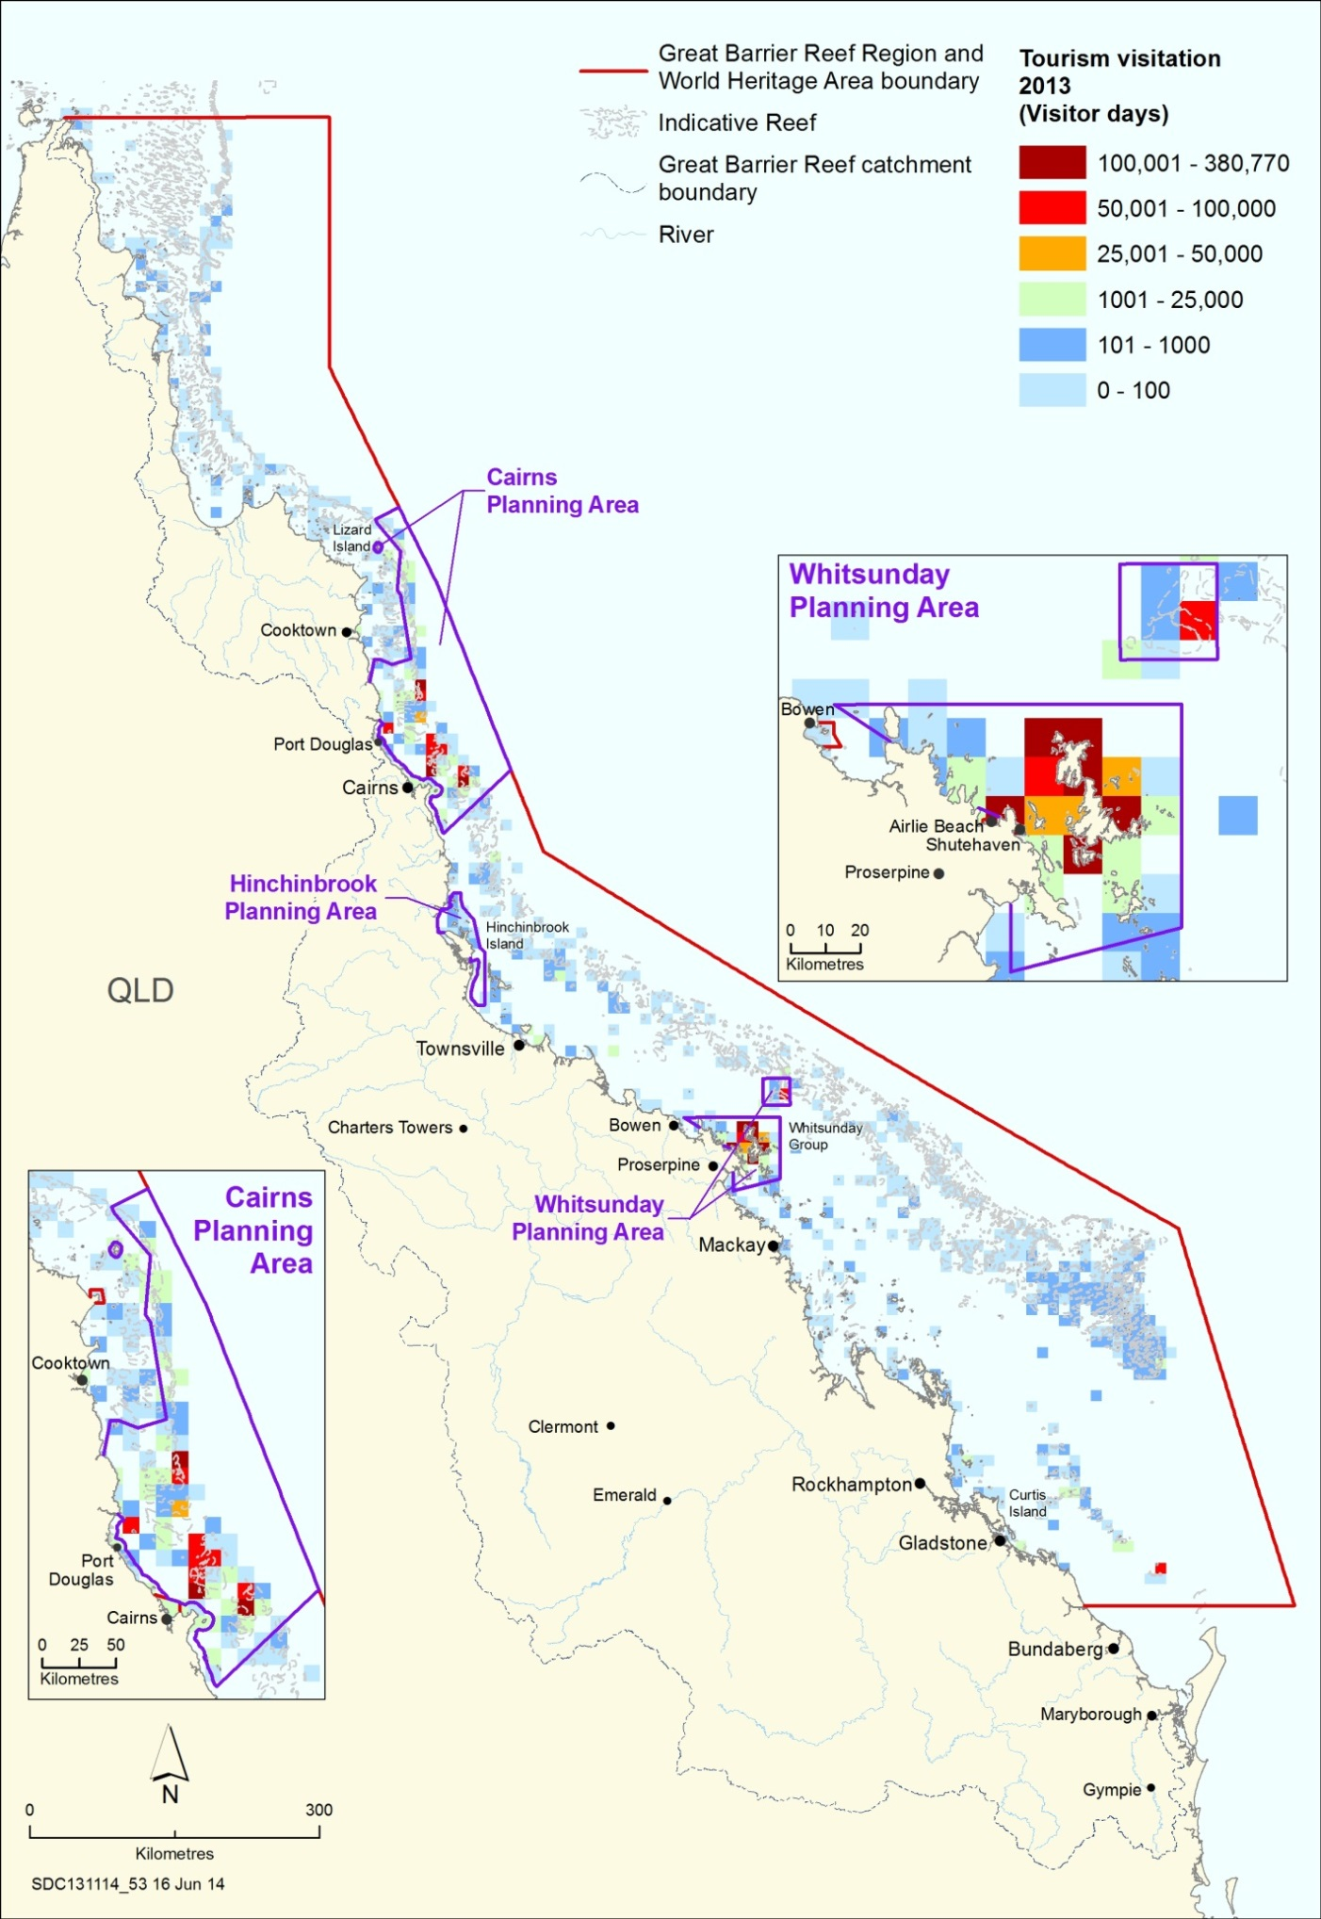
Figure 5.3 Distribution of tourism activity, 2013
Tourism use of the Great Barrier Reef Marine Park continues to be strongly focused on the areas offshore from Cairns and Port Douglas and around the Whitsunday islands and adjacent reefs.
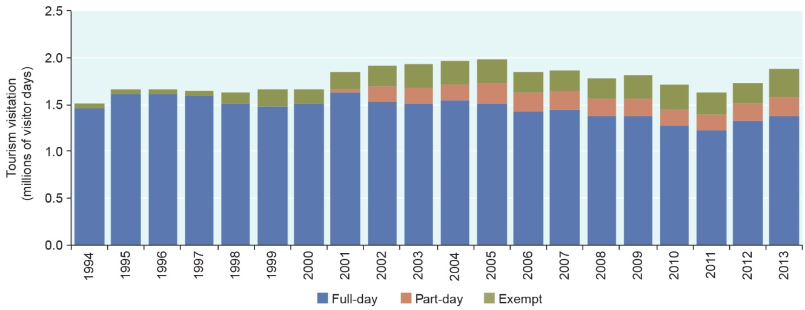
Figure 5.4 Number of tourism visitor days, 1994–2013
A ‘visitor day’ is a visit by one tourist for one day. For overnight visits, each day is counted separately (e.g. a three-day visit by a tourist to the Great Barrier Reef Marine Park represents three visitor days). A part-day visit refers to visitors who undertake a trip of less than three hours, and free of charge visitors include young children and trade familiarisations. Ongoing improvements in the way environmental management charge information is recorded have progressively allowed more accurate differentiation of visitation. This figure does not include stand-alone coral viewing activities and scenic flights, estimated at more than 0.2 million per year. It also does not include the estimated 2.3 million passenger transfers conducted each year through the Region to and from islands. Source: Great Barrier Reef Marine Park Authority 2013⁹

Management The conduct of all tourism operations continues to be closely managed in the Great Barrier Reef, focusing on the areas of highest use and sensitivity. Under the Great Barrier Reef Marine Park Zoning Plan 2003, commercial marine tourism may be conducted in almost all zones and localities of the Great Barrier Reef Marine Park so long as a Marine Parks permit has been obtained. Statutory plans of management for the Cairns Area, Hinchinbrook and the Whitsundays set out more detailed tourism management arrangements, including capping some permit types and defining maximum group and vessel sizes in individual locations. In addition, a range of site management arrangements and specific policies, such as those addressing permit latency, apply to tourism operations.
As well as the mandatory management arrangements for commercial marine tourism, operators have the opportunity to demonstrate the achievement of best practice environmental, economic and social standards in their operations by becoming independently certified with the ECO Certification program managed by Ecotourism Australia. As part of its High Standard Tourism program, the Great Barrier Reef Marine Park Authority recognises certified operators through longer term permits, plus promotion on its website and at conferences and trade events.¹⁰
The number of Reef-based tourism operations that are certified as operating to high standards has increased from 44 in 2009 to 64 in 2013.¹¹ This has resulted in approximately 64 per cent of commercial tourists visiting the Great Barrier Reef with ECO Certified operators in 2013 (Figure 5.5)⁹. While there is a small decrease (one per cent) in the proportion of tourists carried by ECO Certified operators between 2012 and 2013, the total number of tourists carried continues to increase.
[Photograph of the jetty at Green Island featuring a tourism vessel, some people walking along the jetty and a group of snorkelers in the water. Copyright Matt Curnock. Caption:Green island and surrounding reef are a popular tourism destination.]
As at 2013, 15 of the certified high standard operators are also certified by Ecotourism Australia through the Climate Action Certification program.¹¹ The program recognises tourism operators that operate to best practice and take initiatives to reduce greenhouse gas emissions.
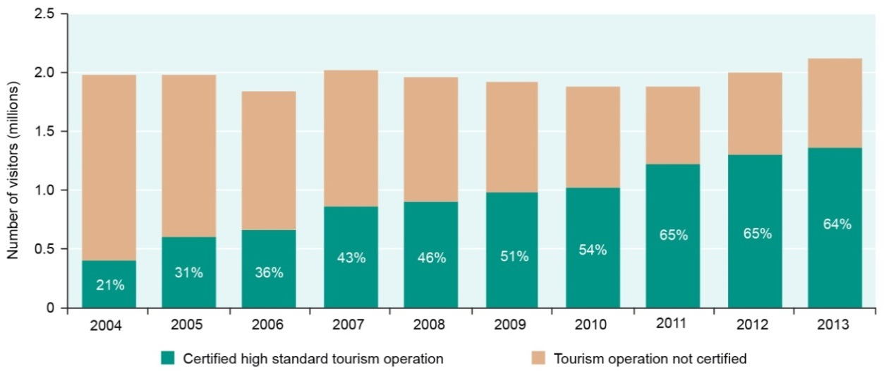
Figure 5.5 Percentage of visitors carried on high standard tourism operations, 2004–2013
Since the Great Barrier Reef Marine Park Authority’s High Standard Tourism program began in 2004, the increasing number of certified high standard tourism operations has resulted in a higher number and proportion (percentage shown in the bars) of tourists using certified tourism products to visit the Reef. (Visitor numbers shown includes those undertaking coral viewing and scenic flights.) Source: Great Barrier Reef Marine Park Authority 2013⁹

The Great Barrier Reef Tourism Climate Change Action Strategy 2009–2012 resulted in a range of products being developed to assist the tourism industry to reduce its climate footprint, including case studies, operator workshops, an online tourism operator’s emissions calculator, climate incident response plans and climate action standards in both the Climate Action Certification and ECO Certification programs.

[BEGIN COLOURED BOX]
Marine tourism taking climate action
Lady Elliot Island Eco Resort is located on the southernmost reef island in the Great Barrier Reef. Operating an island resort 80 kilometres out to sea presents a multitude of daily challenges. The resort generates its own power, desalinates seawater for drinking, maintains a waste water treatment plant and recycles the majority of its rubbish. The resort has gained a wealth of knowledge about efficient technologies, sustainable island management and is a model for sustainable tourism on the Great Barrier Reef.
The resort is certified under both the ECO Certification and Climate Action Certification programs. It operates on a ‘Four Es’ philosophy — to look after our Environment we need to be Efficient, Economically sustainable and able to Educate
effectively.

An energy audit of the resort’s use of diesel generators and appliances was undertaken in 2005. By 2008, the generators had been replaced with a large hybrid solar power system. At the same time the resort’s energy use was reduced by 32 per cent. By 2013, the resort’s diesel consumption was almost 70 per cent lower.
[Photograph of the island’s lessee, Peter Gash, standing in front of a bank of solar panels, Lady Elliot Island. A superimposed locator map shows Lady Elliot Island is in the southern area of the Region. Caption: The island’s lessee, Peter Gash, with a bank of solar panels]

[END COLOURED BOX]

Benefits of commercial marine tourism
Key message: Tourism operators are active stewards of the Reef.
Key message: Commercial marine tourism presents the values of the Reef to millions of visitors.
Tourism in the Great Barrier Reef and its catchment represents about 90 per cent of the value-added economic contribution of Reef-dependent activities (Table 5.1).² In 2011–12, the industry made a contribution (directly and indirectly) of approximately $5.2 billion to the Australian economy and supported the equivalent of 64,338 full-time positions — making up 90 per cent of all full-time positions derived from the Great Barrier Reef.²
Although the Great Barrier Reef provides an impetus for travel to the broader catchment, not all visitors to the catchment visit the Reef. Analysis of more Reef-specific information indicates direct Reef-related expenditure in 2012 was about $480 million, which contributed almost $389 million (value-added) to Australia’s economy and generated employment equivalent to more than 4800 full-time jobs. This is based on 1.9 million direct visits to the Great Barrier Reef Marine Park annually and excludes the 2.3 million passengers who transfer through it to adjacent islands.²
Importantly, the Reef is considered a major driver or incentive for international travellers to visit Australia.^{7,12} Its biodiversity, aesthetic beauty, world heritage status, plus its scientific, educational and lifestyle values are strongly valued.¹²
A high proportion (84 per cent) of tourists surveyed in Cairns during 2012 reported that they had a ‘good’ experience at the Great Barrier Reef, 14 per cent reported that their experience was ‘fair’ and only 2 per cent rated their experience as ‘poor’.⁷ Tourist satisfaction is closely aligned to the attributes of their visit that are most important to them (Figure 5.6).¹³
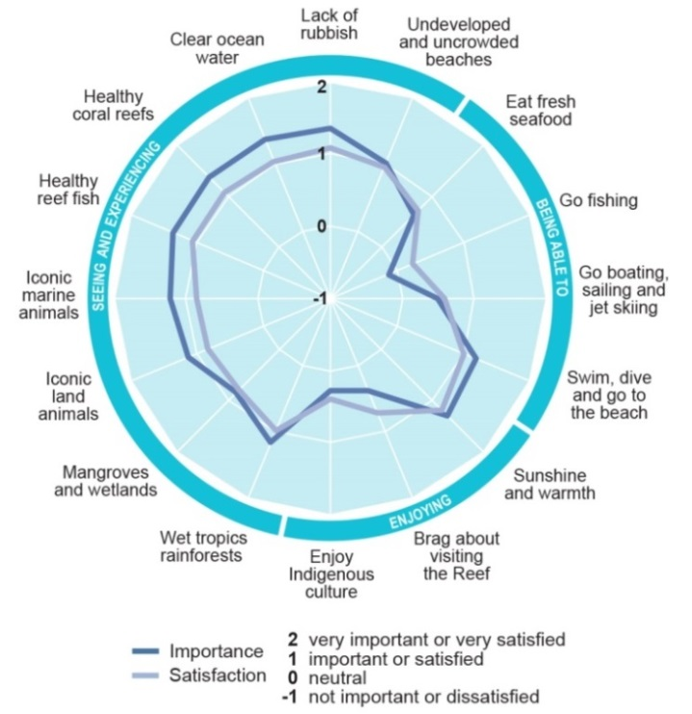
Figure 5.6 Importance and satisfaction scores for tourists, offshore Cairns, 2013
Tourists were surveyed to determine how important a range of factors were to them when deciding to come to the Cairns area, and how satisfied they were with those factors after their visit. The circle shows a rating for how important each factor was (the light blue line) compared to how satisfied visitors were with that factor during their visit (the dark blue line). Environmental factors shown on the left of the circle were identified as being most important. For those factors, mean satisfaction scores were consistently less than their importance scores. Source: Adapted from Stoeckl et al. 2013¹³

The tourism industry is a key partner in protection and management of the Great Barrier Reef. As well as permit fees paid by operators, the tourism industry collects about $8 million each year from tourists on behalf of the Australian Government through the Environmental Management Charge (Figure 5.7). These funds directly contribute to management of the Great Barrier Reef.
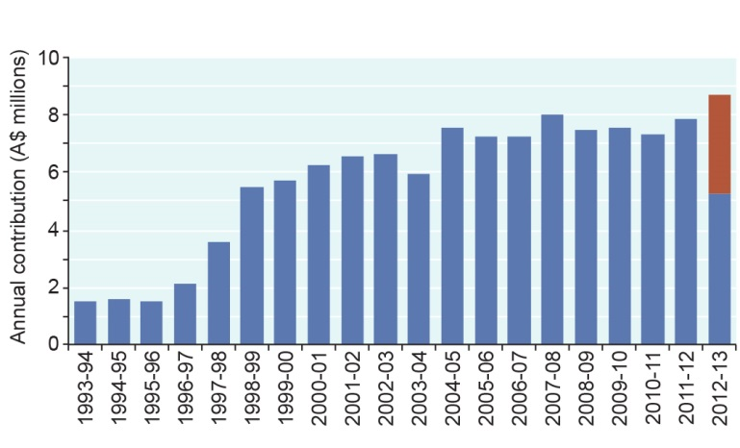
Figure 5.7 Financial contributions received from the Environmental Management Charge, 1993–94 to 2012–13
The tourism industry collects an Environmental Management Charge on behalf of the Australian Government from tourists to the Reef. These funds are vitally important in day-to-day management of the Great Barrier Reef Marine Park and in improving its long-term resilience. The value of the charge for a full day visitor has increased from $1.00 in 1994, to $2.00 in 1997, $4.00 in 1998, $4.50 in 2003, $5.00 in 2007, and $5.50 in 2010. It was temporarily reduced to $3.50 in 2012 for a period of three years, with the reduction in the charge being offset by the Australian Government (shown in red). Source: Great Barrier Reef Marine Park Authority 2013⁹

Tourism operators have remained actively involved as stewards of the Reef over the past five years. Through the High Standard Tourism program and voluntary actions, operators are increasingly working to incorporate best practice standards into their activities. The Association of Marine Park Tourism Operators, in partnership with the Authority, is undertaking targeted control of crown-of-thorns starfish (see Section 7.3.12). Tourism operators also contribute to starfish reduction at individual sites through permitted culling activities. All these actions improve the sustainability of the industry and the health and resilience of the Reef.
Many operators continue to participate in research and monitoring programs, such as visitor surveys and the Eye on the Reef environmental monitoring program. Tourism operators have been engaged in the Eye on the Reef program since 1998 and, in 2013, 25 operators were involved in the Tourism Weekly monitoring program where crew monitor and report the environmental condition of reef sites they regularly visit. This monitoring now provides time series data focused in the areas offshore Cairns and Port Douglas and in the Whitsundays (Figure 5.8). Tourist operators also contribute to Reef Health and Impact Surveys, Sightings Network and the Rapid Monitoring survey program. Despite the financial pressures experienced through the downturn in tourism, tourism operators continued to actively gather reef health data through the different components of the Eye on the Reef program.
Importantly, the tourism industry continues to make much of the vast area of the Great Barrier Reef accessible to visitors. Without it, many visitors simply would not be able to enjoy or experience the Region's values. The industry, therefore, plays a key role in fulfilling Australia’s world heritage obligation to ‘present’ the Great Barrier Reef World Heritage Area. Most tourism programs include education and interpretation activities, aimed at increasing appreciation and understanding of the natural environment and sustainable practices that support the Reef.
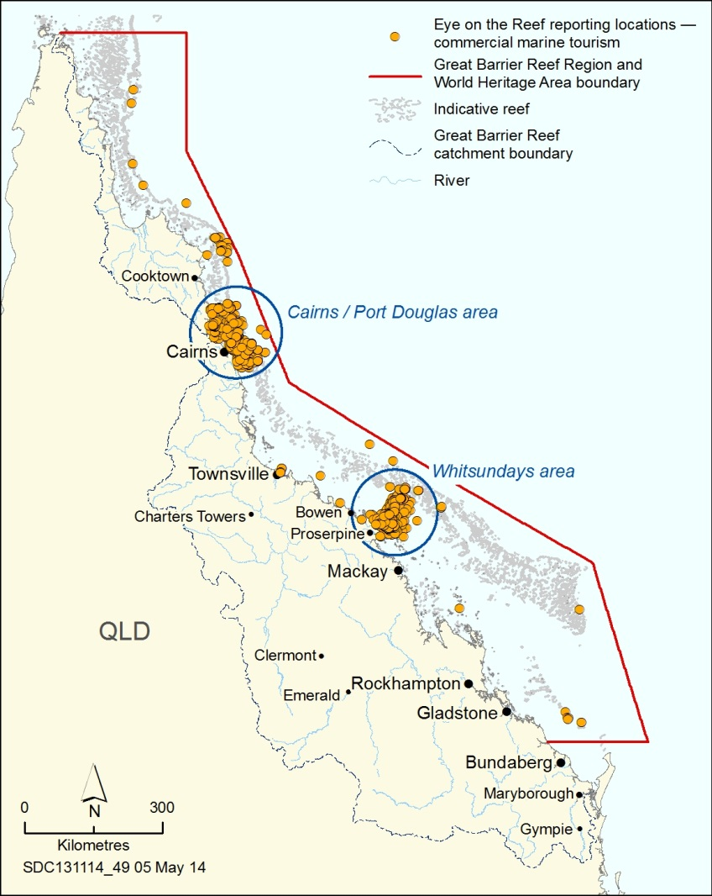
Figure 5.8 Location of Eye on the Reef weekly monitoring by tourism operators, 2011–2013
Monitoring of Reef condition by tourism operators through the Eye on the Reef program is focused in areas offshore Cairns and Port Douglas (22 operators), and in the Whitsundays (15 operators).

Impacts of commercial marine tourism
Key message: Tourism impacts are localised, mainly in a few intensively managed areas.
The Outlook Report 2009 highlighted that impacts caused by tourism are generally localised and have been largely reduced by regulation (for example, whale approach distances); site management arrangements (such as group size limits at locations, use of moorings, seasonal seabird closure areas); permit arrangements (for example, conditions to avoid and mitigate the impacts of structures and intensive activities, including fish feeding guidelines); education; and the adoption of best practices for activities (such as diving and snorkelling). While this assessment remains current for most aspects of commercial tourism use, there are some emerging areas and some not previously identified.
Reduced profitability across the industry has increased the potential risks associated with maintaining tourism-related structures in the Region (such as pontoons, jetties, underwater observatories and moorings). As structures age, they require more investment in maintenance to ensure they are not a threat to the surrounding environment, safe during cyclones and do not affect the amenity and presentation values of a location.
Coastal development, marinas and ancillary services associated with commercial marine tourism can cause consequential impacts on the environment within the Region, including contributions to dredging and disposal of dredge material, clearing or modifying coastal habitats and decreased water quality.
Tourism use of the Region has the potential to affect or displace other users, such as commercial fishers, Traditional Owners and recreational users, particularly in high use areas. There have been some recent examples of incompatibility between the activities of tourism operations and those of Traditional Owners exercising their traditional hunting rights.¹⁴ There are also potential conflicts between sectors within the industry, such as charter fishers and site-based dive tourism. Into the future, an increasing number of tourists may affect visitor satisfaction, for example both tourists and local residents believe they would be much less satisfied with their experiences if there were twice as many tourists at their Reef destination.¹³
Discharge of sewage at sea (more than one nautical mile from any reef or island and the mainland) remains necessary for many tourism operations as there are insufficient land-based facilities to service the fleet’s pump-out requirements.
Commercial marine tourism is not a main focus of compliance activities as offences by tourism operators are considered to be generally low impact to the ecosystem. However, a number of compliance incidents involving the tourism industry are reported annually, particularly from the more intensively used Cairns and Whitsunday areas. Examples include: breaches of marine parks permits; unpermitted activity; plan of management offences (such as undertaking activities not in accordance with group and vessel size limits); and moorings offences.

Defence activities

Current state and trends of defence activities
Key message: Most defence activities occur within a limited area of the Region.
The Australian Defence Force has operated and trained in the Great Barrier Reef Region for more than 100 years. Operational defence activities in the Region include ocean surveillance, maritime search and rescue missions, and hydrographic survey and charting. Defence forces also provide critical support for border protection activities such as environment and fisheries protection, immigration controls, and biosecurity. Australian Navy, Army and Air Force bases at Cairns and Townsville serve as the key platforms for defence operational activities in the Region.
Training activities are regularly undertaken in designated areas of the Region, covering less than four per cent of the area (Figure 5.9). While most of the designated defence training areas within or adjacent to the Region are small, the Townsville Star and the Shoalwater Bay Defence Training Area near Rockhampton are some of Australia’s largest.
The Region is predicted to increase in importance as a defence training area over the next 25 years.¹⁵ Some recent trends in defence activities include enhancing its capabilities in amphibious landings and other ship-to-shore or coastal manoeuvres. In addition, a recent shift in global military focus by the United States of America to enhance its capabilities in the Asia–Pacific region will likely affect defence use of the Region.¹⁶
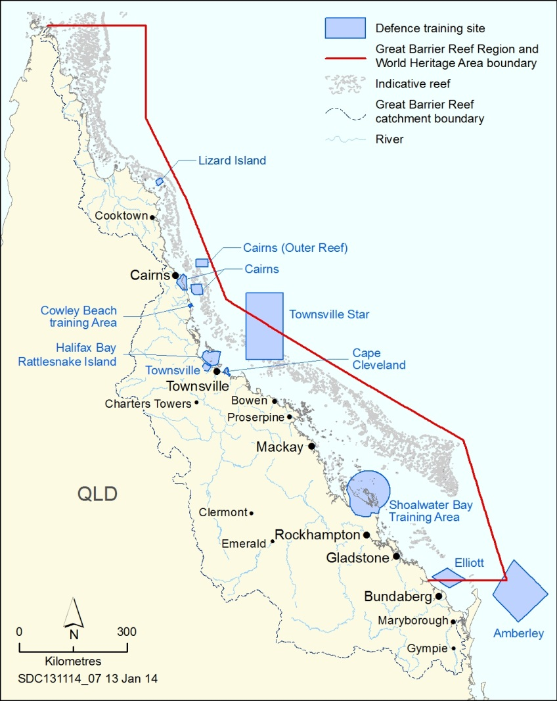
Figure 5.9 Defence training sites
The Australian Defence Force has operated and trained in the Region for over 100 years. Training is undertaken within designated areas.

Management All defence operational training activities are managed directly by the Australian Department of Defence. It is responsible for the conduct of training activities by defence forces, including those visiting from overseas. Management of the environmental impacts of defence training within the Great Barrier Reef is undertaken by the Department of Defence in collaboration with the Great Barrier Reef Marine Park Authority, the Australian Department of the Environment and Queensland Government agencies.
Defence activities are allowed under the zoning plan, with prior notification of intended activities. The Department of Defence has an environmental management plan that includes objectives to implement best practice environmental management. A strategic environmental assessment for defence activities¹⁵ is implemented through a management agreement between the Department of Defence and the Great Barrier Reef Marine Park Authority¹⁷.
The Department of Defence has a moratorium on the use of high explosives in the Great Barrier Reef World Heritage Area except in the Shoalwater Bay Training Area. Many defence activities are conducted with dedicated observers, who are able to collect data on marine wildlife sightings, as well as ensure activities are delayed if required.

Benefits of defence activities
Key message: Defence activities in the Region directly contribute to the Australia’s defence services.
Defence activities in the Region continue to directly contribute to the training and operation of Australia’s defence services. Operational activities can also help, directly and indirectly, to achieve management objectives for the Region including hydrographic surveys, and fisheries and border protection patrols. In addition, the acquisition of land and sea areas around Shoalwater Bay in 1965 has provided ecological benefits. That area continues to support high biodiversity, including internationally significant migratory species and wetlands, and has stunning landscape features.¹⁸
[Photograph of a US Navy hovercraft landing on the beach. Caption: Exercises during Talisman Sabre 2013.]
Defence bases at Cairns and Townsville also continue to strongly support these regional economies. Little is known of the economic benefits of most defence training activities to the coastal communities adjacent to the Region. The Talisman Sabre 2013 exercise was estimated to contribute $4 million to the Rockhampton economy and $200,000 to the Townsville economy.¹⁹ Periodic visits from the United States of America, New Zealand and Singapore naval ships to ports at Townsville and Cairns also generate short-term economic benefits.²⁰

Impacts of defence activities
Key message: The level of planning and resourcing mean defence incidents are rare.
Defence activities continue to be well planned and well resourced, so incidents causing harm to the habitats and species of the Region are rare. Standard operating procedures and contingency plans cover all defence activities, and any incidents are promptly reported and closely investigated. For example in July 2013, two explosive and two inert practice bombs were jettisoned from a United States marines aircraft during a military exercise. The explosive ordnance were located, retrieved and disposed of within two months.²¹
However, by their nature, defence activities pose risks which must be continually monitored and managed. The Australian Defence Force employs stringent quarantine measures to reduce the risk of introducing marine pests.²² Other local and regional scale impacts include: debris and residue from expendable stores; death, injury or disruption to marine life; exclusion of other users; discharge of sewage and other wastes; oil spills; and risks to other users and their property if they stray into defence training areas during exercises.
There are a range of legacy impacts associated with past defence activities. Most significant is the presence of large amounts of unexploded ordnance (such as shells, missiles and bombs) and chemical warfare agents that were deliberately dumped at sea at the end of World War II.^{23,24}
While modern defence training activities are well managed and have negligible impacts on the Great Barrier Reef, the predicted intensification of defence activities in the Region coincides with a decline in the Region’s ecosystem health caused by a range of other pressures. The Australian Defence Force continues to work with management agencies to review the risks posed by defence activities in light of new information about the Region’s declining ecosystem resilience.

Fishing
At a state-wide scale, the Region represents an important resource for Queensland’s fisheries. The Great Barrier Reef supports a range of fishing activities targeting a variety of species including fishes, sharks, crabs and prawns. For the purposes of this report, the term ‘fishing’ includes recreational, charter and commercial fisheries, plus the Queensland shark control program. Fishing activities associated with traditional use are considered in Section 5.9.

Current state and trends of fishing
Key message: Recreational fishing catch rates may be declining.
Key message: The major commercial fisheries operating in the Region are trawl, net, line and pot.
Key message: Knowledge about bycatch and discards is poor.
Key message: Catch in the main seafood fisheries fluctuates: it has generally been lower in recent years.
Key message: Global trends may increase pressures on fishing activities and the environment.
Key message: The Queensland Government has a core role in managing fishing.
Recreational fishing Recreational fishing is one of the most popular activities on the Great Barrier Reef. There has been a steady increase in vessel registrations in the Region’s catchments over the past few decades (Section 5.6.1)²⁵, which may translate to increased recreational fishing effort. A 2013 survey found approximately 65 per cent of catchment residents who had recently visited the Region in a boat went fishing.²⁶ A 2010 state-wide survey estimated that 703,000 residents went fishing in the 12 months prior to June 2010, capturing approximately 13.3 million individual fish, including a diverse range of bony fishes and sharks, skates and rays.²⁷ Coral trout, redthroat emperor, tropical snapper, morwong and sweetlip were commonly caught.²⁷ The most common recreational fishing method (80 per cent) was line fishing (including the use of baited hooks and lures), followed by fishing with pots (13 per cent).²⁷ Together, fishing and collecting with cast nets, pumps and spades, diving using spears, and hand collection comprised only seven per cent of all fishing effort.²⁷ It is estimated that the recreational sector has more non-retained catch than that retained.⁵
The 2010 survey indicated that people were catching fewer fish for a similar level of effort compared to a decade ago.²⁷ This may reflect lower abundances or reduced accessibility to some target species in the last decade.

The availability of larger, more affordable and more fuel efficient vessels, combined with improvements in safety, mean recreational fishers are likely to be fishing further from the mainland and in more isolated areas. Strong growth in regional communities (see Section 6.2) is likely to increase the number of recreational fishers.
Charter fishing The average annual retained catch for charter fishing was slightly lower in the period 2009 to 2012 (357 tonnes retained, 162 tonnes discarded) compared to the period 2005 to 2008 (413 tonnes retained, 241 tonnes discarded), and the number of charter fishing days recorded decreased by around 2200 days per year.²⁸
[Photograph of a fisher holding up a coral trout. Caption: Coral trout are commonly caught by recreational fishers.]
Shark control program Since 1962, the Queensland shark control program has been implemented to minimise the risk of a shark attack on bathers in popular swimming locations by employing a combination of nets and drumlines. At the time of the Outlook Report 2009 there was capacity for 10 nets (five in Cairns, five in Mackay) and 317 drumlines within the Great Barrier Reef World Heritage Area. Since then, five nets have been removed from Cairns and replaced with 14 drumlines. The five nets in Mackay remain. There are currently up to 191 drumlines deployed at any one time within the World Heritage Area. The total of drumlines and nets varies — for example one net at Mackay is withdrawn during the marine turtle nesting season and replaced with six additional drumlines.
Commercial fishing Of the major commercial fisheries in the Region, trawl, net, line and pot remain the largest. The spatial distributions of fishing effort for these fisheries in the Region are presented in (Figure 5.10).
The retained commercial catch in the Region was about 7900 tonnes of fisheries product in 2012 (Table 5.2). These four fisheries together retained about 7300 tonnes in 2012, a decrease of about a thousand tonnes from 2007.²⁸ The coral and marine aquarium supply fishery catch has remained fairly stable since 2007 (Table 5.2).
There is concern about the amount of biomass discarded and returned to the sea globally.²⁹ Preliminary analysis for the Region presented in the Outlook Report 2009 suggested that the non-retained catch by commercial fisheries is likely to be very much higher than that retained, with the trawl fishery still responsible for most of the commercial non-retained catch.⁵ However, with no contemporary data on most fisheries bycatch and discards, knowledge about the quantum of non-retained catch in the Great Barrier Reef has not improved and uncertainty remains high.
In the sea cucumber fishery, there has been a shift to other species since the closure of the black teatfish fishery in 1999 and a reduction in catches of white teatfish. New species include the burying blackfish and the curryfish which together make up 80 per cent of the current total catch (Figure 5.11).³⁰ In 2004, rotational fishing was introduced to spread and limit the risk of over-exploitation of sea cucumbers.³¹ This is designed to allow time to gauge fishing impact and for stock recovery between fishing pulses³⁰. Recent management strategy evaluation for the sea cucumber fishery indicates that under the current management arrangements and catch levels, the overall risk of depletion for most reef-associated species under most scenarios was low. However, some current and past highly targeted species such as black teatfish and white teatfish show some risks under higher catch scenarios and should be managed with caution and more data gathered.
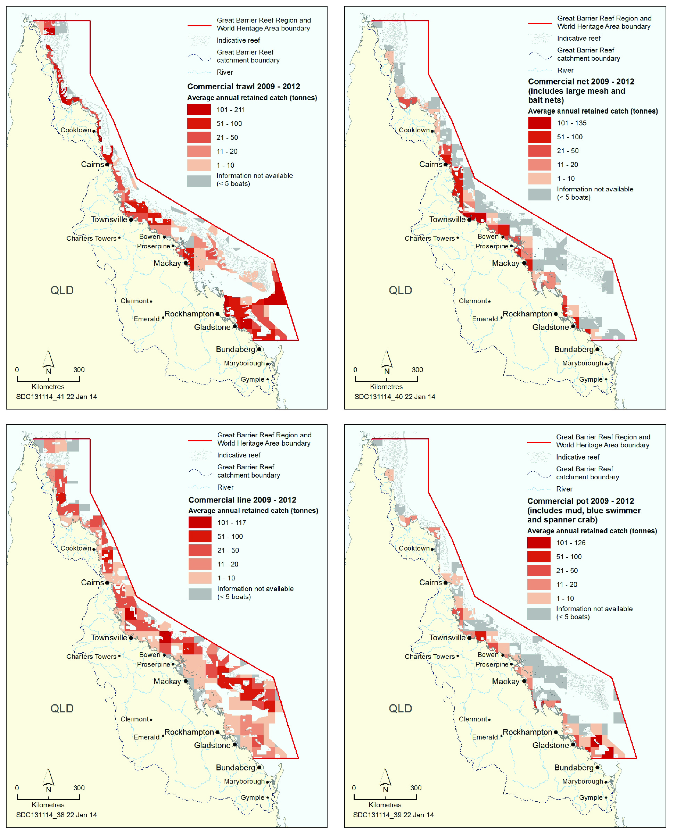
Figure 5.10 Spatial distribution of mean annual retained catch by commercial trawl, net, line and pot fisheries, 2009–2012
The amount of fisheries product taken from different areas in the Region varies for each of the major fisheries. Net and pot fisheries are primarily undertaken close to the coast, whereas line fishing and trawling extend further offshore and to the far north. The tonnages shown are for each fisheries ‘grid’ (a 30 nautical mile square), excluding the zones closed to fishing. Note: netting data displayed in the Conservation Park Zone include commercial bait netting (other netting is prohibited in this zone). Source: Department of Agriculture, Fisheries and Forestry (Qld) 2013²⁸

Table 5.2 A comparison of commercial fisheries, 2007 and 2012
Source: Department of Agriculture, Fisheries and Forestry (Qld) 2013²⁸
Type of fishery | Fishery | No. of primary fishing licences issued  in Queensland  2012  (2007) | No. of active primary fishing licences operating in the Region  2012  (2007) | Estimated proportion (%) of Queensland catch occurring within the Region  2012  (2007) | Retained commercial catch in the Region  2012  (2007) | Main target species in the Region
Trawl | Otter trawl — on or near the seabed | 438  (460) | 179  (239) | 52  (57) | 3397  (3317)  tonnes | Prawns, scallops, bugs, squids
 | Beam trawl — on seabed | 109  (unknown) | 21  (25) | 9  (7) | 15  (28)  tonnes | Prawns
Net (mainly large mesh nets) | East Coast Inshore Fin Fish (principally) | 424  (500) | 200  (227) | 21  (28) | 1429  (2016)  tonnes | Barramundi, sharks, grey mackerel, threadfin salmons
Hook and line | Coral Reef Fin Fish, Spanish Mackerel and hook and line component of the East Coast Inshore Fin Fish  (principally) | 1285  (1531) | 271  (280) | 80  (69) | 1734  (2115)  tonnes | Coral trouts, cods, emperors, and tropical snappers, Spanish mackerel, other mackerels, barramundi, sharks, cobia
Pot | Mud crab, blue swimmer crab trap | 430  (781) | 179  (194) | 30  (22) | 559  (364)  tonnes | Mud crab, blue swimmer crab
 | Spanner crab trap | 414  (507) | 17  (24) | 20  (34) | 204  (525)  tonnes | Spanner crab
Dive-based collection | Coral | 59  (59) | 31  (22) | 75  (72) | 89  (109)  tonnes | ‘Live rock’ and potentially hundreds of species
 | Marine aquarium fish | 45  (49) | 28  (27) | 50  (40) | ~73,000  (~74,000)  fish | Potentially hundreds of species — mostly damselfish, anemone fish, wrasses, angel fish
 | Tropical rock lobster | 28  (28) | 8  (11) | 99  (99) | 142  (224)  tonnes | Tropical rock lobster
 | Trochus | 6  (6) | 1  (5) | 100  (100) | 16  (153)  tonnes | Trochus
 | Sea cucumber | 18  (18) | 5  (7) | 99  (100) | 376  (252)  tonnes | White teatfish, blackfish, curryfish

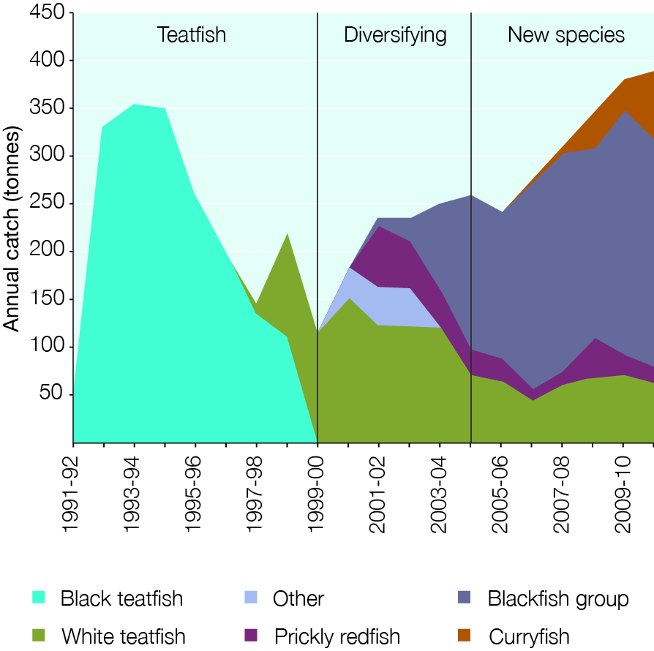
Figure 5.11 Catch of sea cucumbers, 1991–92 to 2010–11
Since the closure of the black teatfish fishery, a number of other sea cucumber species have been targeted in the fishery. The three phases of ‘teatfish’, ‘diversifying’ and ‘new species’ represent changes in the catch composition of the fishery. The blackfish group includes predominantly burying blackfish (Actinopyga spinea) and a small amount of blackfish (Actinopyga miliaris). Source: Eriksson et al. 2013³⁰

Several marine-based aquaculture operations (fishes, pearls and sponges) have been proposed or have begun in the Region over the past two decades but none are in operation at present, primarily due to economic or environmental sustainability issues. There are some land-based aquaculture operations in the adjacent catchment (see Section 6.4.1).
. Catch and effort in the commercial, trawl, net, line and pot fisheries have fluctuated over the last couple of decades (Figure 5.12), with annual catches and fishing effort lower in recent years compared to historical peaks. Factors influencing these patterns include abundance of resource species, management arrangements, weather events such as cyclones, market demands and other external factors (such as foreign exchange rates and fuel prices).
For example, the areas affected by cyclones such as Hamish in 2009 and Yasi in 2011 are reported to have significantly reduced catch rates of coral trout. This can have flow-on effects on other areas. After cyclone Hamish some active commercial live coral trout fishers moved their operations northward away from the cyclone-affected areas.³² The commercial catch rates of coral trout, though recovering in some areas, have generally remained depressed since these cyclones.²⁸
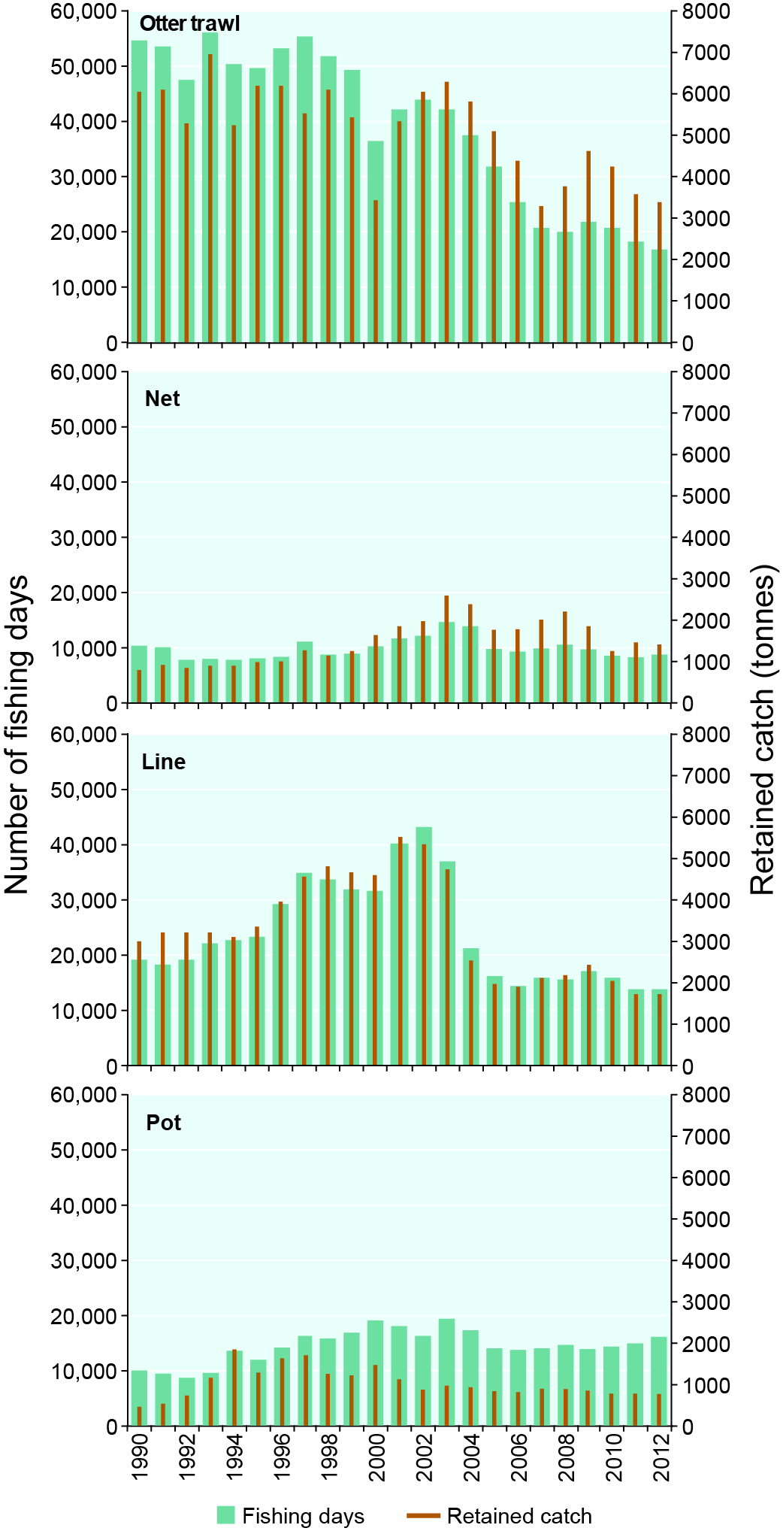
Figure 5.12 Trends in major fisheries, 1990–2012
Annual commercial fishing catch and effort for the Great Barrier Reef Region from 1990 to 2012 for the four major fisheries. Data is based on commercial fisher logbook records. A day of fishing effort has not been standardised over time and does not account for changes in fishing power (such as technology advances and fishing efficiency). Source: Department of Agriculture, Fisheries and Forestry (Qld) 2013²⁸

There have been changes in the distribution of annual catch within the four main commercial fisheries in the period 2009 to 2012, compared to 2005 to 2008.²⁸ Areas where catch has changed by around 50 per cent or more include:
- Trawl — catch increased in the deep-water trawl area adjacent to the Swain Reefs; inshore areas adjacent to Gladstone; the area adjacent to Mackay; Bowen; and offshore Hinchinbrook. Decreases occurred in the southern Great Barrier Reef and Capricorn–Bunker Group area; the Burdekin and inshore Hinchinbrook regions; and slightly in all trawlable areas north of Cooktown.
- Net — catch increased in the Babinda, Hinchinbrook, Bowling Green Bay, Bowen, Whitsunday, Mackay and Town of 1770 areas. The most significant decreases in catch occurred from Cairns north to Cape Grenville, just south of Cape York, with marked decreases also occurring in the Upstart Bay, Broadsound, Shoalwater Bay, Keppel Bay and Gladstone regions.
- Line — catch increased in nearly all fishable reef areas from Cairns to Cape York, with marked increases of over 100 per cent in most fishable grids from Port Stewart to Cape York. In contrast, catch decreased for most areas of the eastern Swain Reefs area and offshore reefs east of Mackay, Bowen and Townsville.
- Pot — spanner crab catch declined significantly in the Region’s far south lagoonal and deeper waters. Mud crab catch increased in the Hinchinbrook, Bowen and Whitsunday areas, with average annual catch in the most important mud crab producing area of Bowling Green Bay more than doubling in recent years. Decreases occurred in the Cairns, Mission Beach, Townsville, Upstart Bay, Shoalwater Bay and Keppel Bay areas.
Commercial fishing harvests many species, across multiple ecological groups. Figure 5.13 shows the breakdown by ecological group for retained catch in the four largest commercial fisheries.
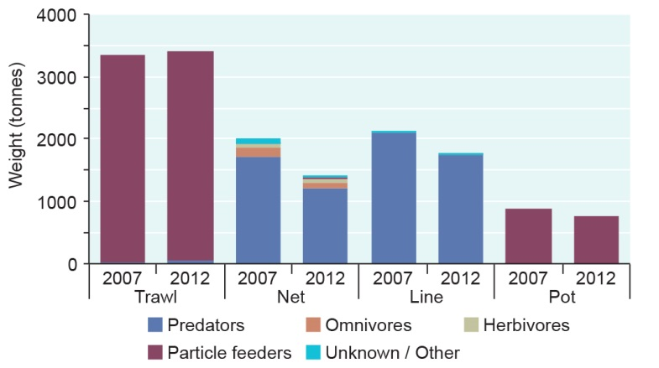
Figure 5.13 Ecological groups retained by major commercial fisheries, 2007 and 2012
By far the majority of species retained by commercial fishing in the Region are predators and particle feeders. Data is for commercial retained catch only. Discarded catch and bycatch are not included. ‘Particle feeders’ includes filter feeders, detritivores and scavengers. Source: Department of Agriculture, Fisheries and Forestry (Qld) 2013²⁸

Increasing fuel prices and the loss of crew to alternative opportunities related to mining continue to affect profitability³³ and, in some cases, areas of operation of Great Barrier Reef fisheries. The strength of the Australian dollar has also put pressure on commercial fisheries. In this economic environment, exported product is less profitable and there is increasing competition in the local market from cheap imports. However, as many wild-caught fisheries throughout the world continue to be fully exploited or over exploited³⁴, the economic value of the Region’s fisheries resources may increase.⁵ International demand for wild-caught Queensland seafood may increase pressure to further exploit currently fished resources (legally and illegally), target additional species, and develop intensive aquaculture within the Region and its catchment.⁵ Expected growth in aquaculture around the world³⁵ (for example, aquaculture-raised coral trout are expected to be commercially viable in the near future³⁶) may also lead to diversification within the Coral Reef Fin Fish Fishery.
Management The Great Barrier Reef Marine Park Zoning Plan 2003 applies to all fishing activities. It specifies areas that can be fished and the type of fishing that can be undertaken. It results in about two-thirds of the Great Barrier Reef Marine Park being available for various types of fishing. It allows trawling in about one-third of the Marine Park.
Subject to meeting the requirements of the Great Barrier Reef Marine Park Act, including the overarching objective of long-term protection and conservation, the Offshore Constitutional Settlement³⁷ provides for fisheries management within the Region to be undertaken by the Queensland Government. The fisheries are included in statewide management arrangements under the Fisheries Act 1994 (Qld). Under the Great Barrier Reef Intergovernmental Agreement 2009, the Australian and Queensland governments are undertaking an integrated and collaborative approach to management. A key aim is ecologically sustainable fishing in the Region.
For commercial fishing activities, direct management arrangements include commercial fishing licences for all operators, total allowable commercial catch limits (quotas) for some species, fish size and possession limits, restrictions on fishing apparatus, closed areas and seasonal closures. Species for which quotas apply include tropical rock lobster, trochus, coral, grey mackerel, Spanish mackerel, shark, coral trout, red throat emperor, and all other coral reef fin fishes. For some commercial fisheries, such as the marine aquarium fishery and developmental fisheries, Marine Parks permits are also required. The Queensland shark control program is required to have both Queensland and Marine Parks permits.
A trawl fishery effort cap is in place for the Region; however, current levels of effort could approximately double before the current cap is reached.
The management arrangements for most commercial fisheries in the Region are accredited against the guidelines for the ecologically sustainable management of fisheries³⁸ under the Environment Protection and Biodiversity Conservation Act 1999. The accreditation process is designed to assess the environmental performance of fisheries and promote ecologically sustainable management. All accreditations in the Region are subject to conditions and recommendations.
Since the Outlook Report 2009, a competitive annual total allowable commercial catch for shark species has been introduced. In addition, collection of basic information about shark species that interact with this fishery has improved^{39,40,41} with stock assessments of selected shark species taken in this fishery due for completion in 2014⁴². However, fishers’ logbook reporting is no longer verified following cessation of the independent fishery observer program and there are no mechanisms to warn that the annual total allowable commercial catch is close to being reached.
Recreational fishing is subject to gear restrictions, size and possession limits and seasonal closures. Charter fishing operations operating in the Marine Park require both a Queensland licence and a Marine Parks permit.
Some fish spawning aggregations are protected by seasonal closures under Queensland Government legislation or by marine park zoning.
Fisheries management arrangements are subject to ongoing amendment. Over the past 20 years, there have been extensive changes with the aim of improving the sustainability of the state’s fisheries. Key reforms have been around reducing and constraining capacity and the introduction of the legal mechanisms to enable continuous improvement in management. Examples include:
- Capping commercial fishing licences and fishery symbols over recent decades has led to a steady decrease in the number available; however, some latency and overcapacity issues remain for some fisheries in the Region.
- The number of participants and fishing days in the otter trawl fishery has more than halved since the late 1990s (Figure 5.12). Reforms in this fishery, principally in 2000, included the introduction of effort units into the fishery, satellite tracking of vessels, and a number of gear changes including mandatory use of turtle excluder devices.
- The first two phases of the Queensland Government voluntary netting buyback scheme had, in early 2014, bought back 69 commercial netting symbols plus a number of other fishery symbols.
- Management reforms to the Coral Reef Fin Fish Fishery in 2004 and the East Coast Inshore Fin Fish Fishery in 2009.
A major review of the Queensland Government’s fisheries management arrangements was announced in March 2014.
Through the joint Field Management Program, the Australian and Queensland governments work cooperatively in fisheries compliance in the Great Barrier Reef World Heritage Area, including surveillance and other enforcement activities. Fisheries compliance staff operate from eight bases adjacent to the Region.

Benefits of fishing
Key message: Commercial fishing and aquaculture in and adjacent to the Region generates about $160 million per year.
Key message: Recreational fishing is one of the most popular pastimes in the Region.
Commercial fisheries have been operating in the Region for many decades and have played an important role in the development of regional Queensland. Fisheries product from the Region continues to be important to local communities, as well as domestic and international markets. A very high proportion (around 90 per cent) of the Queensland coastal population consumes fresh seafood.⁴³ In a 2008 survey, many consumers reported they preferred Queensland, wild-caught species, despite it being more expensive than imported seafood products, and many believed it would benefit their community and the Australian economy.⁴³ Fisheries within the Region continue to contribute a major component of Queensland’s total seafood catch. In 2012 it represented about 52, 80, 21 and 30 per cent of Queensland’s retained catch in the trawl, line, net and pot fisheries, respectively (Table 5.2).
In 2011–12 the economic contribution of the commercial fishing and aquaculture industries of the Region and its adjacent catchment to the national economy was estimated to be $160.3 million (Table 5.1).² This value-added figure is the gross value of production minus tax on production and other factors such as operating costs and labour. Separate recent valuations of the major fishery sectors (calculated on the price paid to fishers at the first point of sale) reported the value of the East Coast Inshore Fin Fish Fishery to be about $19.6 million per year⁴⁴, the reef line fishery about $31 million per year⁴⁵ and the trawl fishery about $110 million each year⁴⁶. In 2012, commercial fishing in the Region was estimated to have generated the equivalent of 975 full-time jobs.²
The coral and marine aquarium collection fisheries collect a vast array of fishes, corals and invertebrates to supply domestic and international markets.⁴⁷ The gross value of production of this fishery is estimated to be roughly $10 to $12 million dollars per annum.⁴⁷
Commercial fishers continue to have a high attachment to their industry, and most have been involved in the industry for more than 20 years.^{48,49} Generally they are very reliant on the industry, with most fishers receiving more than 75 per cent of their household income from fishing.^{49,50} Commercial fishing is more than just a job for most fishers. In a 2008 survey of inshore commercial fishers in the Region, 63 per cent preferred to be at sea than on the land; 98 per cent stated they liked being a fisher; 93 per cent stated fishing is a lifestyle, not just their job; and 79 per cent felt proud to tell others they were a commercial fisher. Seventy per cent also stated they would still be fishing in three years.⁴⁸
Recreational fishing is one of the most popular recreational pastimes in the Region, and contributed significantly to the $243.9 million² generated by recreational users in 2011–12 (Table 5.1). People enjoy recreational fishing in the Region for many reasons, apart from the opportunity to catch local fresh fish. These include appreciating the Region’s natural beauty, opportunities for wildlife watching, personal relaxation, and opportunities to spend time with family and friends.⁵¹
Charter fishing operations provide opportunities for people to participate in recreational fishing within the Region and contribute to local economies.⁵²
The Queensland shark control program provides protection to bathers by reducing the risk of a shark attack at popular swimming beaches.
[Photograph of a shop display counter full of prawns and other seafood caught in the Region. Caption: Fisheries product from the Great barrier Reef is important to local communities.]

Impacts of fishing
Key message: The status of most targeted species is not well known.
Key message: Reductions in predator populations can have long-term effects on the food chain.
Key message: Fishing extracts mostly predators and particle feeders.
Key message: Fishing practices and management continue to improve; more can be done.
Key message: Contemporary estimates of bycatch and discard are lacking in most fisheries.
Key message: Species of conservation concern continue to be impacted by fishing.
Key message: Illegal fishing remains a concern, especially intentional targeting of protected zones.
Key message: Indigenous heritage values can be affected by fishing.
Fishing is the largest extractive use of the Region. The harvest of fisheries resources affects the abundance of targeted species and there are community and scientific concerns about the status of some targeted species.^{42,53,54} There are also concerns for the sustainability of fishing spawning aggregations, illegal fishing activity, discarded catch and marine debris associated with fishing activities.
Predators (such as coral trout, mackerel and sharks) make up about half of the retained catch in the four largest commercial fisheries (Figure 5.13), and make up a large percentage of recreational fishing catch²⁷. The Queensland shark control program contributes to the extraction of predators; in the last decade between 521 and 716 sharks were removed each year from Queensland waters.⁵⁵
The Outlook Report 2009 highlighted the limited information on the identity and quantum of different shark species caught in the East Coast Inshore Fin Fish Fishery and the general impacts of fishing on some species of sharks and rays. A wide range of shark species is captured by, or interacts with, fisheries (and the shark control program) in the Region and there is a paucity of information about the status of their populations. The most recent annual fisheries stock status report assesses the collective grouping of shark species harvested in the Region as ‘undefined’.⁴² Several of the species taken in the East Coast Inshore Fin Fish Fishery are now not considered at high risk from fishing. However, some species at risk are still being caught such as the green sawfish, Australian blacktip and pigeye shark.⁴¹ In 2005, an estimated 182,000 sharks were caught by recreational fishers in Queensland, with a release rate of approximately 84 per cent.⁵⁶
Pink snapper are classified as ‘overfished’⁴², and the stock status of coral trout was downgraded in 2012 from ‘sustainably fished’ to ‘uncertain’ due to depressed catches and catch rates.⁴² The stock status of over half the 65 Queensland east coast fisheries resources that have been assessed are currently classified as ‘uncertain’ or ‘undefined’, including commercially and recreationally important king threadfin, barred javelin, and grey mackerel. The status of other important fishery species, including golden snapper (fingermark), giant queenfish and black jewfish, are not assessed by Fisheries Queensland.⁴² In a recent ecological risk assessment⁴¹, king threadfin are assessed as being at very high risk, and giant queenfish, black jewfish and barred javelin as being at high risk.
Reductions in predator populations can have long-term effects⁵⁷, including direct and indirect effects on the food chain (see Section 3.4.5).⁵⁸ Changes in predator abundance and behaviour causes changes throughout trophic levels which modify food webs, indirectly acting upon herbivore populations that maintain coral substrates.⁵⁹
[Photograph of a pile of coral trout caught by fishers. Caption: Predators make up half the retained catch.]
Over half of the weight of the retained commercial catch is comprised of particle feeders (such as prawns and scallops) which fulfil a range of ecosystem roles such as providing prey for other species and assisting with nutrient cycling. Fishing causes lower abundances of some particle feeders, particularly in more heavily trawled areas. The flow-on effect of extraction of particle feeders may include net loss of nutrients from the ecosystem and changes to other ecosystem processes (for example predation through changed feeding opportunities). The amount of effort in the trawl fishery is the main determinant of impacts on particle feeding in the Region. While effort has been relatively low for about the last decade, risks could increase if effort levels rise.⁵³
Recent research has raised concerns about the sustainability of the Region’s sea cucumber fishery, especially in the light of recent shifts in the species harvested (Figure 5.11).³⁰ It suggests that the fishery has developed faster than the science and policy necessary to ensure sustainable harvesting. Without adequate management, stocks may be reduced to below critical thresholds of recovery — a global pattern in tropical sea cucumber fisheries.³⁰
The potential impacts from the coral fishery are very localised⁶⁰ and appropriate management practices are in place, including an industry stewardship action plan⁶¹. As part of this plan, a voluntary moratorium on coral collecting around the Keppel Islands has been implemented after reef degradation from flooding and coral bleaching.⁵
In addition to the extraction of the retained catch, fishing has additional effects through the death, injury and stress of discarded species.^{29,62,63,64} Discarded species (other than those of conservation concern) include:
- otter trawl — undersize target species, small fishes, other crabs and prawns, other benthic invertebrates
- net — undersize and oversize target fish species, non-target fish species, non-target sharks and rays
- line — undersize and oversize target fish species, discarded legal target fish species, non-target fish species, non-target sharks and rays, octopus
- pot — undersize male crabs, no-take female crabs, fish species, molluscs, rays
- dive-based collection — little or no bycatch
- recreational fishing — undersize and oversize target species, discarded legal target fish species, non-target species
- shark control program — non-target shark and other species.
Management requirements in the trawl fishery, such as the requirement to install bycatch reduction devices and turtle excluder devices, combined with lower trawl fishing effort have reduced the death of discarded catch in this fishery including marine turtles, large sharks and rays.^{65,66,67} However, a recent ecological assessment found a range of species are still subject to high and intermediate levels of risk from trawling.⁵³ Many smaller species of sharks and rays remain in the bycatch of prawn and scallop trawlers. Eleven species of skates and rays (a shovelnose ray, a coffin ray, three species of stingrays, two species of stingarees, three species of skates and a butterfly ray) have been identified as at high risk from incidental catch in the trawl fishery⁵³ and little is known of their population status and trend. Survival of sharks and rays after being caught in trawl nets and then discarded is often poor.⁵³ Changes to levels of fishing effort are likely to be the most important aspect of the fishery for mitigating risks to sharks and rays as this influences level of interaction, and current bycatch reduction devices are ineffective for these species.
Fishery observer information for the Region’s commercial fishery focused on deep-water eastern king prawns indicates immediate shark and ray survival of 35 per cent on average, and only 17 per cent were released alive.⁵³ Of the large number of sea snakes caught as trawl bycatch each year (estimated to be over 100,000), it is estimated that about 26 per cent die.⁶⁷
Except for species of conservation concern, commercial fishers are not required to report discards of targeted species and most bycatch species, and there are no contemporary estimates of the quantum of bycatch and discard. The limited data are fragmented or old. There are currently no arrangements in place to collect data that would enable such estimates to be produced.
There has been a significant reduction in the ecological impacts of the trawl fishery since the 1990s due to changes in management arrangements.⁵³ However some concerns remain, particularly for the skates and rays mentioned above, two species of Balmain bugs, and two species of sea snakes.
A significant ecological impact on the Region’s values from commercial fishing is incidental capture, entanglement and death of species of conservation concern, including inshore dolphins, dugongs and turtles (Table 5.3). The magnitude of these impacts may be underestimated because most interactions are unreported despite being mandatory⁶⁸.
[Photograph of a marine turtle with fishing net wrapped around its neck and flipper. Copyright Kathy Townsend. Caption: marine turtles can be incidentally caught in fishing nets.]
Species of conservation concern are also impacted by the Queensland shark control program. Nets set for sharks have caught species including dugongs, inshore dolphins and marine turtles (mostly green turtles) and the program’s drumlines have caught marine turtles (mostly loggerhead turtles). In most locations, nets have been replaced with drumlines, significantly reducing impacts on marine mammal populations.⁶⁹
The loss of even a small number of individuals of some vulnerable species, such as dugongs, Australian snubfin dolphins, and Indo-Pacific humpback dolphins, may have significant implications for their population status, resilience and rate of recovery from past impacts.^{70,71}
Table 5.3 Fisheries interactions with species of conservation concern, 2006–2012
Interactions reported are as recorded in Species of Conservation Interest (SOCI) logbooks completed by fishers in each major commercial fishery between 2006 and 2012. Interactions include any form of contact or behaviour change of an animal due to the presence of fishing gear. The dataset does not give a complete list of species and gear interactions for the Region. Source: Department of Agriculture, Fisheries and Forestry (Qld) 2013²⁸
 | Major commercial fishery gear type
Species | Otter trawl | Net | Line | Pot
Crocodile — estuarine
Crocodile — unspecified
Dolphin — offshore bottlenose
Dugong
Gannets and boobies
Sawfish — dwarf
Sawfish — green
Sawfish — narrow
Sea snake — unspecified
Seadragon — leafy
Seahorse — unspecified
Turtle — flatback
Turtle — green
Turtle — hawksbill
Turtle — loggerhead
Turtle — saltwater unspecified
Whale — humpback
Whale — minke

Concern remains over the potential impacts of fishing spawning aggregations that are not protected by seasonal closures (for example, grey mackerel^{72,73}). Aggregations are in decline globally, with many decreasing or wiped out due to overfishing.⁷⁴ Within the Region, it is likely that many spawning aggregations of coral reef fin fish species are protected by zoning arrangements and some benefit from short seasonal closure periods (two five-day closures per year). For inshore species, while spawning aggregations are protected to some extent by the current zoning arrangements, it appears that the protection afforded is less extensive than for coral reef fin fish species. In addition, for aggregations other than barramundi, inshore species are not protected by seasonal closure periods. Relevant species include grey mackerel, golden snapper, barred grunter and black jewfish (the last two are assessed as being at high ecological risk⁴¹). Loss of fish spawning aggregations leads to declines in fish populations through reduced recruitment, with negative ecological consequences.⁷⁵ Spawning aggregations are recognised as a natural phenomenon that contributes to the Reef’s outstanding universal value.⁷⁶
Fishing activities can also cause physical damage to the seabed and reef habitats. For example, trawl gear can cause direct physical impacts on habitats, such as altering the vertical relief of seabed features and redistributing sediments, and removing or damaging seabed plants and animals.^{77,78,79,80,81,82} Line fishing gear can cause physical damage to live coral tissue and coral colonies.⁸³ Additionally some of the small vessels that have accidentally run aground and damaged reefs and shoals have been commercial and recreational fishing vessels.
Fishing activities, both inside and outside the Region, can contribute to marine debris through loss of gear.^{84,85}
Illegal fishing can cause serious effects on the Region’s ecosystem, especially by compromising the effectiveness of the zoning arrangements.⁸⁶ Based on knowledge gained through compliance and enforcement activities and on field intelligence, high priority areas for enforcement include non-compliance with zoning requirements within the Coral Reef Fin Fish Fishery, and with netting requirements in the East Coast Inshore Fin Fish Fishery. Reliable information indicates illegal activity in the Coral Reef Fin Fish Fishery continues to be significant despite the recent low number of offences detected.
Non-compliance in recreational fishing accounted for the most frequently reported offence types in 2012–13 with fishing in Marine National Park zones increasing from 144 in 2011–12 to 459 in 201213 (Figure 5.14). This trend has continued during the first half of 2013–14. The increase reflects the greater surveillance focus owing to concerns around flow-on ecosystem effects and the intentional targeting of protected zones by some fishers. Night-time fishing is a growing challenge for surveillance. While cooperative planning of patrol effort has always been a focus of the compliance program, there have been significant recent enhancements in intelligence sharing and coordination between partner agencies in delivering patrols at the times and locations of highest risk.
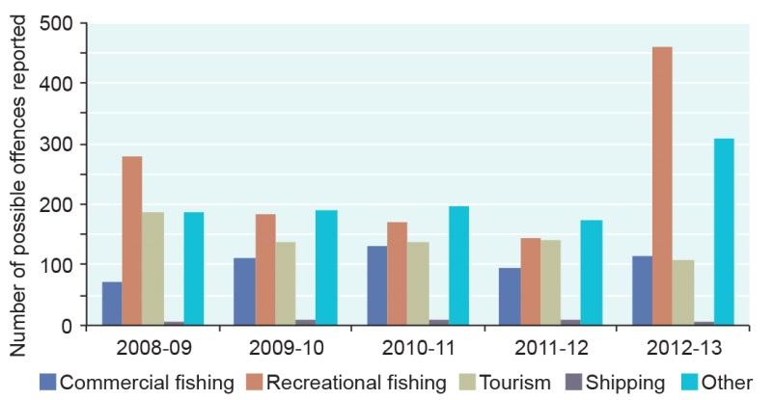
Figure 5.14 Possible offences reported to the Field Management Compliance Unit, 2008–09 to 2012–13
Possible recreational fishing offences are the most commonly reported. The spike in 2012–13 reflects a greater surveillance focus. (Note: ‘Other’ offences include those related to vessel groundings, pollution, recreational not related to fishing (e.g. island national park offences), wildlife, research and moorings). Source: Great Barrier Reef Marine Park Authority⁸⁷

As well as affecting the ecosystem, the effects of fishing have flow-on implications for the Region’s Indigenous heritage values. Reduced populations of species affected during fishing activities can mean Traditional Owners’ ability to catch food is diminished, resulting in a break with cultural practice, lore and custom, and interference with sites of particular cultural significance. Extraction of predators can also affect Indigenous heritage values. For example, in the northern town of Injinoo, a key food source of Traditional Owners, the black jewfish, is now found in much lower numbers and in much smaller sizes. This affects the ability of Traditional Owners to maintain their cultural practices and customs. This decline has been attributed to fishing pressure.⁸⁸ Any depletion of culturally significant species including dugongs, green turtles, sea snakes, sharks, rays, crayfish, mullet, oysters, pipi, clamshells, whiting and bream can have direct effects on Indigenous heritage values such as cultural practices, observances, lore, stories, songlines and sites. Taking culturally significant species at the wrong time of year, in the wrong numbers or at culturally sensitive sites reduces the numbers available for use in traditional ways and forces Traditional Owners to change their customs and practice.⁸⁸
Although a legacy activity, past commercial harvesting of herbivores, such as green turtles and dugongs, has ongoing effects on Indigenous cultural values and has significantly changed cultural practices. The low population size, in part due to the previous commercial harvests, limits the number of animals available for hunting, as well as changing where animals occur.⁸⁹

Ports

Current state and trends of ports
Key message: Great Barrier Reef ports account for about three-quarters of Queensland’s port throughput.
There are 12 ports in or adjacent to the Region (Figure 5.15). Of these, eight are located at least partly in the Region and only the minor ports of Cooktown and Quintell Beach in Cape York are located within the Marine Park. In 2011–12, ports within or adjacent to the Region accounted for 76 per cent of the total throughput for all Queensland ports combined. This amounted to 199.8 million tonnes of imports and exports through the Region, up from 191.5 million tonnes in 2008–09.⁹⁰ In that same year, for all Queensland ports combined, coal made up 63 per cent of the throughput volume, petroleum products six per cent, and metals and minerals five per cent.⁹¹ Other commodities include agricultural products, and general cargo.
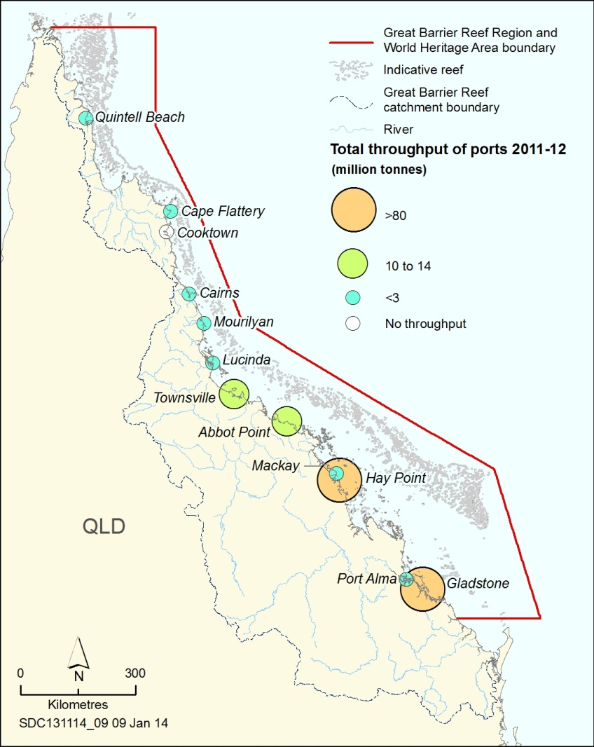
Figure 5.15 Total port throughput, 2011–12
In 2011–12, ports within or adjacent to the Region handled 76 per cent of the throughput for all Queensland ports. Cargo throughput (in millions of tonnes) is imports and exports combined. Source: Ports Australia 2012⁹⁰

The four busiest ports in relation to commercial vessel visits in 2011–12 were Gladstone (1453 visits), Hay Point (809 visits), Townsville (747 visits) and Cairns (720 visits).⁹⁰ In terms of infrastructure and operational capacity, the largest ports on the Region’s coast are Abbot Point, Gladstone, Hay Point and Townsville. Over the last decade, the total throughput of these ports has increased (Figure 5.16). The Gladstone, Abbot Point and Hay Point ports are major hubs for the export of coal.⁹² Hay Point is one of the largest coal export terminals in the world⁹³, handling more than 80 million tonnes of coal in 2011–12.⁹⁰ During 2010–11, it had the highest value of coal exports among all Queensland ports at $18 billion.⁹⁴
There has been major growth in port activity on the Region’s coast over the past two decades.⁹⁵ Increases in bulk commodity exports from these ports are driving increases in shipping. As at February 2014, four of the 12 ports (Cairns, Townsville, Hay Point and Gladstone) had active proposals for port expansions, driven mainly by growth in the resources sector. During 2012 and 2013 there were proposals for the development of three new ports along the Region’s coast (Wongai in Cape York, the Fitzroy terminal project, and Balaclava Island — now withdrawn). Not all current proposals may proceed.
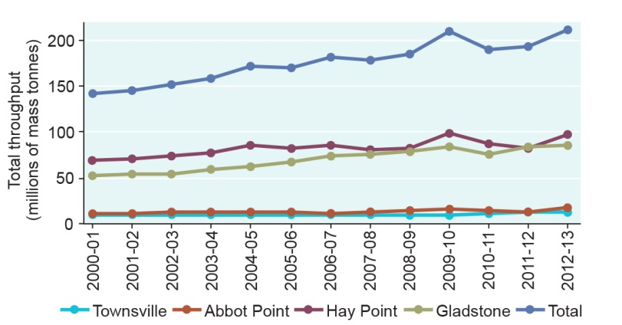
Figure 5.16 Throughput of four major ports, 2000–01 to 2012–13
Over the last decade, the total throughput (imports and exports) of the four major ports has increased, especially the ports of Gladstone and Hay Point. Source: Ports Australia 2012⁹⁰ and Department of Transport and Main Roads (Qld) 2014⁹⁶

Dredging — the extraction of parts of the seafloor to deepen an area for improved access — has been undertaken in ports and associated access channels for many decades but now involves much greater volumes. Today, both capital and maintenance dredging are undertaken within and adjacent to the Region, including in large-scale programs at major ports, smaller scale programs at minor ports and to provide access to islands within the Region. Most large-scale dredging and dredge material disposal are associated with the larger and busier ports such as Townsville, Abbot Point, Mackay, Hay Point and Gladstone.⁹⁴
Dredge material (sediments and other material from the seafloor) may be disposed at sea or on land. Some permitted ocean disposal sites are located within and adjacent to the Region. Between 2001 and 2013, the total volume of dredge material (from both capital and maintenance dredging) disposed in the Great Barrier Reef World Heritage Area was approximately 28 million cubic metres (Figure 5.17). In January 2014, a proposal for Abbot Point was approved to dispose of three million cubic metres. Proposals involving sea disposal in the Great Barrier Reef World Heritage Area that are currently under assessment include (but are not limited to): Cairns shipping development project (five million cubic metres); Townsville port expansion (5.7 million cubic metres); and expansions of the Dudgeon Point coal port facility (up to 13 million cubic metres) and the Port of Gladstone (up to 12 million cubic metres).
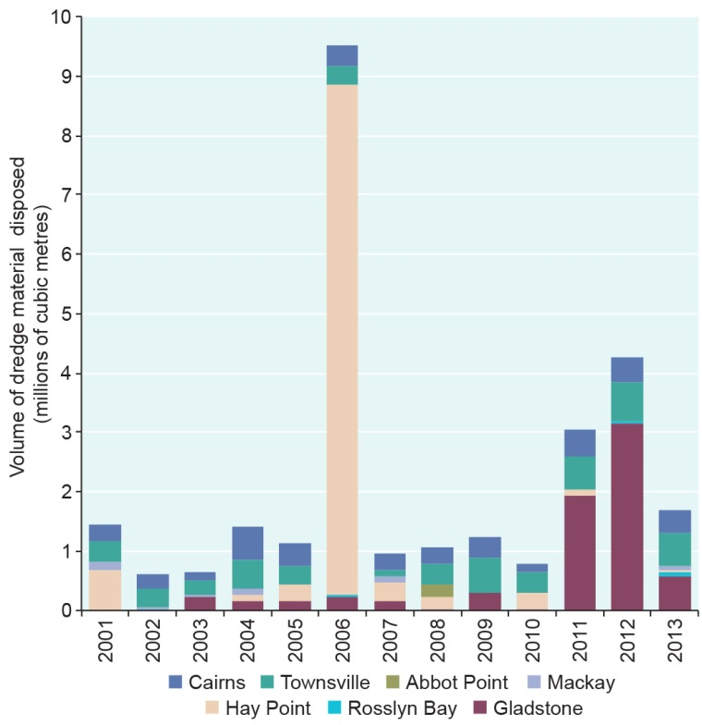
Figure 5.17 Dredge material disposal, Great Barrier Reef World Heritage Area, 2001–2013
The graph shows volumes of dredge material disposed in the Great Barrier Reef World Heritage Area between 2001 and 2013. Source: Data derived from the International Maritime Organisation sea disposal reports submitted to the Great Barrier Reef Marine Park Authority and Australian Government Department of the Environment

Management All the ports of the Great Barrier Reef are managed by four Port Authorities, which are Queensland Government-owned corporations. Port activities are governed by local, state, national and international requirements including for protection of the environment from dredging and dredge material disposal, waste, pollution and introduced marine pests.
The International Maritime Organisation requires that Australia, as a party to the International Convention for the Prevention of Pollution from Ships (MARPOL) Annex V, provides adequate waste reception facilities at all ports. Ships are encouraged to report ports that do not provide an adequate service, which are then investigated and reported to the International Maritime Organisation.
Proposals for port development, including dredging and disposal of dredge material in the Region, are assessed under Commonwealth and Queensland legislation including the Environment Protection and Biodiversity Conservation Act, the Great Barrier Reef Marine Park Act and the Environment Protection (Sea Disposal) Act 1981, as appropriate. The National Assessment Guidelines for Dredging 2009⁹⁷ are considered in assessing applications.
The National Ports Strategy⁹⁸ includes initiatives to improve integrated planning and environmental management regimes. The 2014 Queensland Ports Strategy⁹⁹ is expected to critically influence future planning and management of ports in and adjacent to the Region, including environmental protection arrangements. The Strategy foreshadows that significant port development will be prioritised and consolidated in major port areas, restricting significant port development (within and adjoining the Great Barrier Reef World Heritage Area) to within existing major port limits for the next 10 years until 2022.⁹¹
The Great Barrier Reef Marine Park Authority has a policy¹⁰⁰ that guides assessment and management processes for dredging and dredge material disposal. It includes restrictions on: the location of dredging and dredge material disposal; contaminated dredge material disposal; and annual volumes of sea disposal within the Marine Park. It supports long-term planning to minimise impacts.

Benefits of ports
Key message: The economic contribution of Great Barrier Reef ports is increasing.
As an island nation, Australia is dependent on maritime trade. Consequently, ports and their associated infrastructure are of significant economic and social importance to Australia. A number of Queensland’s ports, including those in and adjacent to the Region, are nationally significant for cargo throughputs⁹⁰ and contributions to the national economy. The value of goods shipped from ports adjacent to the Region is approximately $40 billion each year.¹⁰¹ Their increasing throughput makes it likely that the economic contribution of Great Barrier Reef ports has increased since 2009.

Impacts of ports
Key message: The cumulative effects of dredging and dredge disposal are not well understood.
Key message: Dredging and dredge material disposal have local adverse environmental impacts.
Impacts to the marine environment from the installation and maintenance of port infrastructure and general port operations include clearing and modifying coastal habitats; disturbance, displacement, dredging, disposal and resuspension of dredge material; injury and death of wildlife; the risk of large and small chemical and oil spills; some contribution to marine debris; altered light regimes; and diminished aesthetic values. Noise pollution associated with general port activities such as pile driving may be affecting marine life¹⁰². However little is known of its effects in the Region. High concentrations of coal dust have been detected around a loading facility¹⁰³, but the potential effects of this and any other port-generated atmospheric pollution are not well understood.
The Outlook Report 2009 stated the impacts of dredging and construction of port facilities — such as seabed disturbance, transport or resuspension of contaminants, alteration of sediment movement and changes in coastal processes — can be significant, but are localised. Since 2009, understanding of the effects of dredging and the disposal and resuspension of dredge material has advanced, although broader regional and cumulative effects on inshore biodiversity remain poorly understood. Many of the inshore environments in which ports operate are already under pressure from an accumulation of other impacts such as those associated with land-based run-off, shipping and coastal development. There is also increased community interest in this activity and its potential effects.
The specific effects of dredging activities are well documented and include: seabed disturbance^{104,105}; removal or modification of seafloor habitats^{106,107}; loss of species, including benthic organisms⁹³ and injury or mortality to species of conservation concern^{104,108}; changes in species behaviour¹⁰⁹; degradation of water quality^{106,110} including increased sedimentation and turbidity from dredge plumes¹⁰⁵; changes to hydrodynamics and coastal hydrology¹⁰⁵; increased underwater noise¹⁰²; and an increased risk of oil spills¹⁰⁹. The most severe effects are at the site of dredging but some, including sedimentation, turbidity, noise and disruption of fish habitats, may also occur some distance from the site. With regard to heritage values, there can be sea burial sites, sacred sites and sites of other cultural significance in the areas where dredging is undertaken and, previously, inadequate consultation with Traditional Owners has meant some of these values have been affected.¹¹¹ In addition, dredging activities can disturb Indigenous cultural practices¹¹². Aspects of the Region’s aesthetic value such as ‘beauty’, ‘naturalness’ and ‘remoteness’ are considered highly sensitive to industrial development including ports.¹¹³
Major direct impacts of sea disposal of dredge material include the burial or smothering of plants and animals on the seafloor¹⁰⁶, degradation of water quality⁹³, and loss and modification of habitats¹⁰⁵. There is also emerging evidence of a higher prevalence of coral disease in areas exposed to dredge material.¹¹⁴
Understanding of the extent to which dredge material remains within the defined disposal area has improved.^{115,116} Modelling in a recent screening-level analysis of potential disposal areas — the first to incorporate the effects of large-scale oceanic currents — suggests dredge material has the potential to migrate over greater distances and for longer periods than previously understood (more than 100 kilometres).¹¹⁷
Dredging and disposal of dredge material can also remobilise, redistribute and resuspend sediments and nutrients that were otherwise held within seafloor sediments. Fine sediments can become resuspended over several years by wind and waves, contributing to increased turbidity.^{118,119} Increases in turbidity reduce the light available for photosynthesis, affecting coral and seagrass habitats and species that rely on them.¹⁰⁵ This is particularly significant if these effects happen during periods critical for seagrass survival, growth and reproduction. Increased turbidity also affects coral growth, structure and survival.^{110,120}
The consequential impacts of ports are also linked to those associated with shipping and ship anchorages (Section 5.8).

Recreation (not including fishing)

Current state and trends of recreation
Recreation is defined as an independent visit to the Region for enjoyment that is not part of a commercial operation. It is distinct from tourism and charter fishing where a visitor pays to use a commercial operation (Section 5.2).
People living adjacent to the Region, as well as domestic and international visitors, use the Region for a wide range of recreational activities, including fishing, snorkelling, diving, swimming, boating, beach and island walking, sightseeing, relaxing and socialising. For residents of the catchment, going to the beach, fishing (Section 5.4) and boating were the most popular activities in 2013 (Figure 5.18).¹³
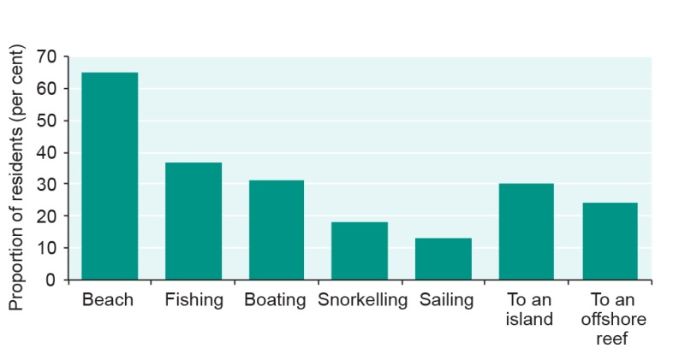
Figure 5.18 Main activities of catchment residents in the Great Barrier Reef, 2013
The graph shows the percentage of residents surveyed who undertake each type of activity more than once a year. Going to the beach was the most popular activity for residents, followed by fishing and boating. Source: Stoeckl et al. 2013¹³

The most popular offshore destinations for recreational visitors to the Region are islands, followed by reefs, shoals, cays and wrecks.¹²¹
The number of recreational visits from residents in the catchment appears to have risen substantially between 2003 and 2008, most likely as a result of three factors: population growth, an increase in the proportion of the population visiting the Region and a rise in the average number of visits each person makes.¹²¹ It is estimated that 87 per cent of residents in coastal towns adjacent to the Region have visited the area for recreation.¹³ The majority of coastal town residents feel there is no better place to undertake the recreation activities they enjoy than the Great Barrier Reef.²⁶
There has been a steady increase in vessel registrations over the past few decades (Figure 5.19) which is likely to have translated into more recreational vessel trips in the Region. Townsville and Mackay have the highest numbers of vessel registrations adjacent to the Region (Figure 5.20). Improving vessel and navigational technology has presumably influenced the distribution of recreational activities within the Region.
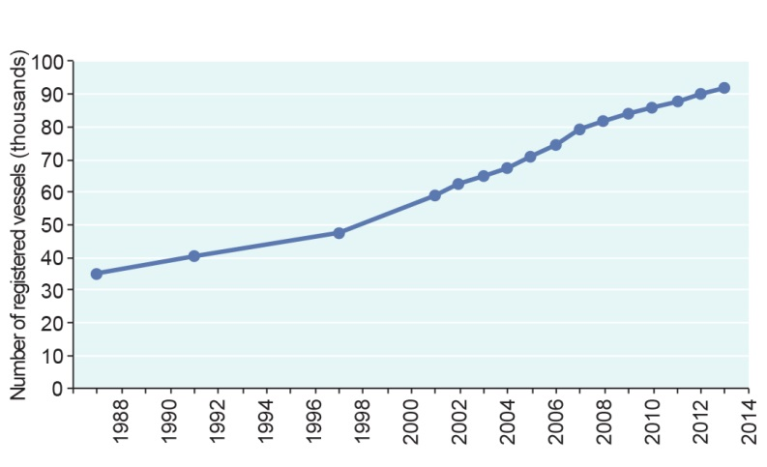
Figure 5.19 Number of recreational vessels registered in the catchment, 1987–2013
The number of vessels registered in areas close to the Great Barrier Reef has continued to increase. Source: Department of Transport and Main Roads (Qld)²⁵
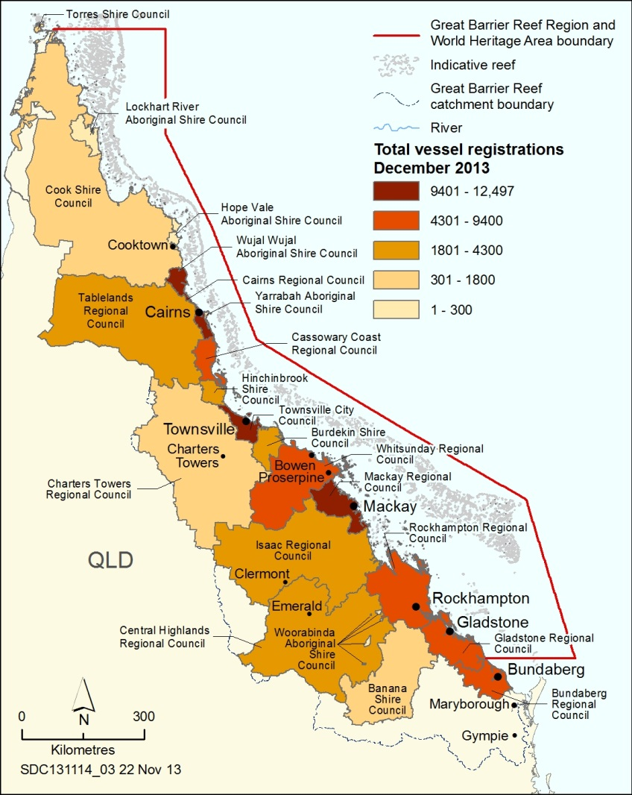
Figure 5.20 Recreational vessel registrations, 2013
Vessel ownership is concentrated in local government areas close to the coast adjacent to the Region. Source: Department of Transport and Main Roads (Qld)²⁵

Management Recreational activities that do not involve fishing can be undertaken in almost all of the Region. Many Australian and Queensland government agencies are responsible for managing aspects of recreational use of the Region. In the more intensively used areas (such as offshore Cairns and the Whitsundays), detailed arrangements for reducing the impacts of recreation (and tourism) are outlined in plans of management, including specifying group and vessel size limits and no anchoring areas. Public moorings are provided throughout the Region at some of the more popular recreational locations. Public education and encouraging users to adopt best practices play a major part in managing recreational use, along with compliance activities. Recreational vessel and personal watercraft registration and licensing are managed by Maritime Safety Queensland. The Recreation Management Strategy for the Great Barrier Reef Marine Park¹²² provides an overarching framework for the management of recreation by the Great Barrier Reef Marine Park Authority.

Benefits of recreation
Key message: The opportunity to enjoy the Region’s environment is of enormous community benefit.
The opportunity to enjoy the Region’s environment is of enormous social and cultural value to Queensland residents, other Australians and international visitors.¹²² The Great Barrier Reef is viewed as inspiring, beautiful, amazing and unique by Australians who have already visited the Reef and those who are yet to visit.¹ In 2011–12, recreational activities (including fishing) were the second largest direct use of the World Heritage Area, generating $244 million (value-added), a substantial increase on the estimate of its value in 2006–07 ($153 million). The activities generated employment equivalent of 2724 full-time jobs, up from approximately 1700 in 2006–07.^{2,3} Most of the contribution associated with recreational activity was derived from expenditure on equipment, largely reflecting the purchase of boats and maintenance or repair of recreational equipment.²
Recreational users contribute to protection and management of the Region’s values through programs such as Clean Up Australia Day, Order of Underwater Coral Heroes Volunteers (OUCH), Tangaroa Blue, Eco-Barge, the Strandings Hotline and the Sightings Network.
Undertaking recreational activities in the Region is one of the key ways that its social values are realised. For example, it is principally through recreation that people enjoy and learn to appreciate the Reef environment and gain access to its resources. Visitors often report that they derive health benefits from the Great Barrier Reef environment including being able to ‘unwind’ and ‘get away from it all’, release stress, improve their fitness through outdoor activities, and improve their diet through access to wild-caught seafood. Many also report a close personal connection to particular sites in the Region, which is maintained through visiting the sites and enjoying experiences there.^{13,26,123} Catchment residents are most satisfied with being able to spend time on the beach, go swimming or diving; boating, sailing and jet skiing; and having undeveloped and uncrowded beaches and islands. Residents rated environmental factors like healthy coral reefs and clear open water as being much more important to their overall quality of life than economic factors (such as benefiting from jobs and incomes related to industries in the catchment and Region) (Figure 5.21).¹³

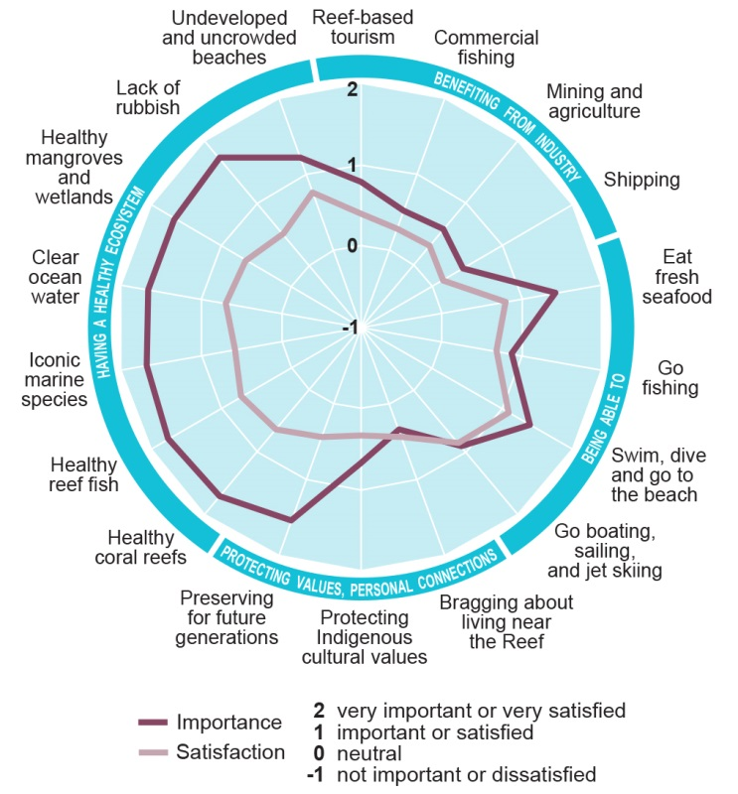
Figure 5.21 Importance and satisfaction of goods and services to residents’ overall quality of life, 2013
Residents of the Great Barrier Reef catchment were surveyed (1592 respondents) to determine how important a range of goods and services were to their overall quality of life, and how satisfied they were with them. The circle shows a rating for how important each factor was (the dark red line) compared to how satisfied visitors were with that factor during their visit (the light red line). Factors associated with having a healthy ecosystem, shown on the left of the circle, were identified as being most important. For those factors, mean satisfaction scores were consistently much less than their importance scores. Source: Adapted from Stoeckl et al. 2013¹³

Impacts of recreation
Key message: Recreation impacts are mostly close to the coast, close to regional centres.
The likely impacts of recreational use relate to both the activities undertaken and the use of vessels to access and travel throughout the Region. Most of the identified impacts are likely to only have minor effects; and be concentrated close to the coast, in popular areas¹²².
For activities such as snorkelling and diving, the impacts are most likely to be minor localised damage to corals and disturbance to wildlife. Activities on beaches and islands, including the use of vehicles, can result in disturbance to seabirds and other wildlife, trampling of coastal vegetation and the introduction of weeds and feral animals. Recreational users are also likely to contribute to litter in the Region, both on the water and on islands.
The impacts associated with the use of vessels are generally similar regardless of whether they are used for recreation or another purpose, for example localised but frequent anchor damage to corals and seagrass meadows; boat strikes on marine mammals and turtles; the risk of introducing species through vessel fouling, especially those from overseas; oil and chemical spills; vessel sewage discharge; and disturbance of wildlife. Vessel groundings, including vessels used for recreation, are reported from throughout the Region, concentrated in coastal areas (Figure 5.22). Most groundings only have a localised impact.
High demand and long wait times at popular access points can result in use being spread to adjacent, less popular areas as people choose to spend more time travelling and less time queuing.¹²² Alternatively increasing recreational use could lead to increased localised pressure on some access points close to urban centres.¹²²
Any increases in recreational use are likely to increase effects on heritage values, especially in those cases where recreational activities are incompatible with Traditional Owner cultural use of marine resources in their sea country areas.
Compliance incidents associated with recreational activities other than fishing include vessel groundings and sinkings, installing unpermitted moorings, pollution including littering and illegal discharges, entering restricted areas or zones, approaching whales too closely and offences on islands such as camping without a permit, lighting campfires and taking domestic animals ashore.¹²⁴
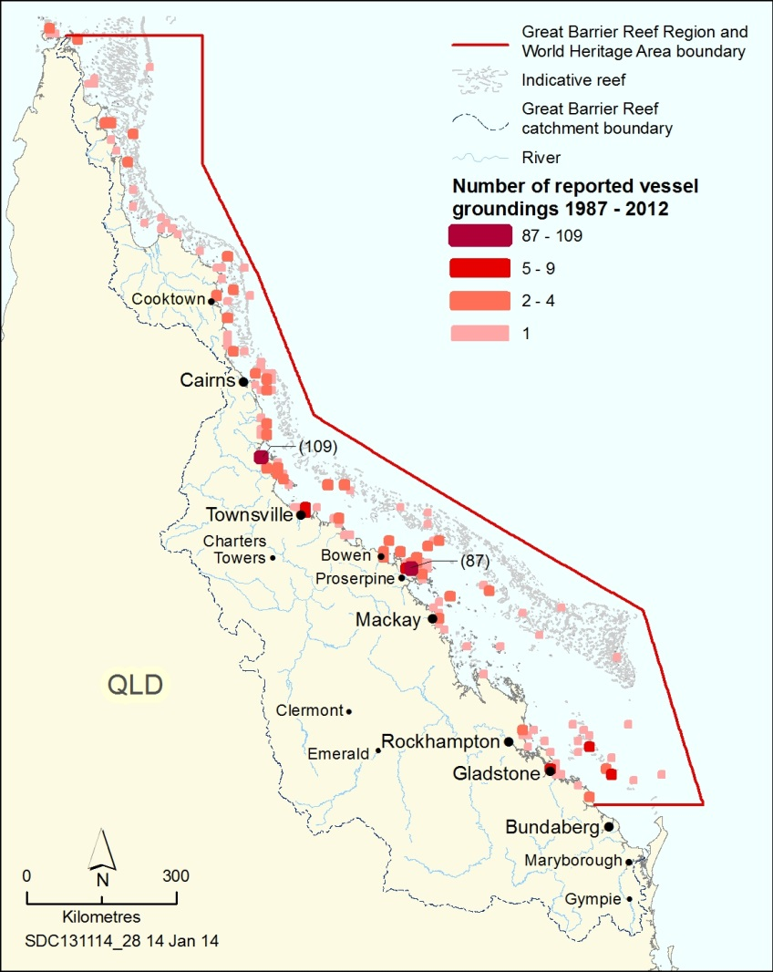
Figure 5.22 Reported vessel groundings, 1987–2012
The locations with a very high number of groundings in the Region over the period are those associated with cyclonic events. Data includes all types of vessels that have grounded or beached.

Research and educational activities

Current state and trends of research and educational activities
Key message: The Region is highly valued for educational and research activities.
The Great Barrier Reef has historically been an area of high scientific interest because of its biological and ecological diversity, geomorphology and cultural heritage. Scientific research has made a substantial contribution to the way the Region is understood, managed and used.^{125,126} Available monitoring results enable tracking of trends in some of the Region’s values and in the factors affecting them.¹²⁷
A network of six island research stations located at Lizard Island, Low Isles, Green Island, Orpheus Island, Heron Island and One Tree Island continues to be integral to research activities on the Reef. Eighty per cent of scientific research has been conducted around Lizard, Heron and Orpheus islands.¹²⁸ The research stations are also a focus for permitted educational use. Over half of the education permits issued between July 2008 and June 2013 were for Heron Island and the adjacent Wistari Reef.¹²⁹
Management Scientific research is provided for in the Great Barrier Reef Marine Park Zoning Plan 2003. Scientific Research Zones provide opportunities for scientific research in relatively undisturbed areas. Individual research activities are managed through permits issued jointly by the Great Barrier Reef Marine Park Authority and the Queensland Government or through accreditation of research institutions. Educational activities require a permit.

Benefits of research and educational activities
Key message: Research and educational activities are concentrated around research stations; minor, localised effects are likely.
Research and monitoring of the Great Barrier Reef continues to contribute to global knowledge about individual species, coral reef systems and tropical marine ecology. An improved understanding of the Region’s values and how its components interact and respond to changing conditions has contributed substantially to its protection and management.¹³⁰ In addition, the results of targeted and applied research are providing managers with information to better measure the outcomes of management initiatives.
A range of academic institutions and government agencies undertake research about the Great Barrier Reef, providing income and employment in regional communities. Major institutions include Australian Institute of Marine Science, CSIRO, James Cook University, Australian Research Council’s Centre of Excellence in Coral Reef Studies, University of Queensland, and the Australian Museum.
Knowledge derived from research related to the Region has supported management including informing development of Water Quality Guidelines for the Great Barrier Reef¹³¹, evaluating the effectiveness of the 2004 Great Barrier Reef Marine Park rezoning¹³², and redefining the baseline condition of healthy inshore reefs¹³³. In addition, a long-term social and economic monitoring program is being developed and implemented.¹³⁴Impacts of research and educational activities
The concentration of research and educational activities around research stations has the potential to locally deplete some species, disturb wildlife and cause some minor, localised physical damage to habitats. Little is known about the cumulative impacts of research and educational activities at any particular location; however, given the scale of activities, overall impacts are likely to have only localised effects.

Shipping

Current state and trends of shipping
Key message: The risks of shipping are closely managed.
Thousands of domestic and international ships transit the Region every year, carrying export goods, servicing coastal and inland communities and transporting passengers. Shipping, as described in this report, includes vessels greater than 50 metres in overall length or carrying specialised product regardless of length (for example, oil tankers, chemical or liquefied gas carriers). It includes cruise ships and super yachts.
Shipping use of the Region has increased substantially since 2000 (Figure 5.23), driven mainly by industrial and mining activity. Based on information from the Great Barrier Reef and Torres Strait vessel traffic service (REEFVTS), there were 9619 ship voyages through the Region in 2012–13.¹³⁵ This was an increase of about two per cent on the 9403 voyages in 2011–12 (the first year of the extended vessel tracking service). The profile of the ship fleet visiting the Region is changing, with the number of individual ships increasing by an average of 3.4 per cent per annum from 2008–09 to 2012–13 and average carrying capacity rising by four per cent per annum over the same period.¹³⁵ Based on projected export capacities, information from existing development proposals and predictions for the Region’s four major ports, the number of vessel calls to ports adjacent to the Region is forecast to increase by about 250 per cent over the next 20 years ¹³⁶ (Figure 5.24). This is likely to be driven by growth in the mining and liquefied natural gas industry, port expansions and increases in trade.⁹⁴
There is also a global trend towards longer, deeper draft ships.¹³⁷
[Photograph of a large ship docked in port. Caption: Worldwide, ships are becoming longer with deeper drafts.]

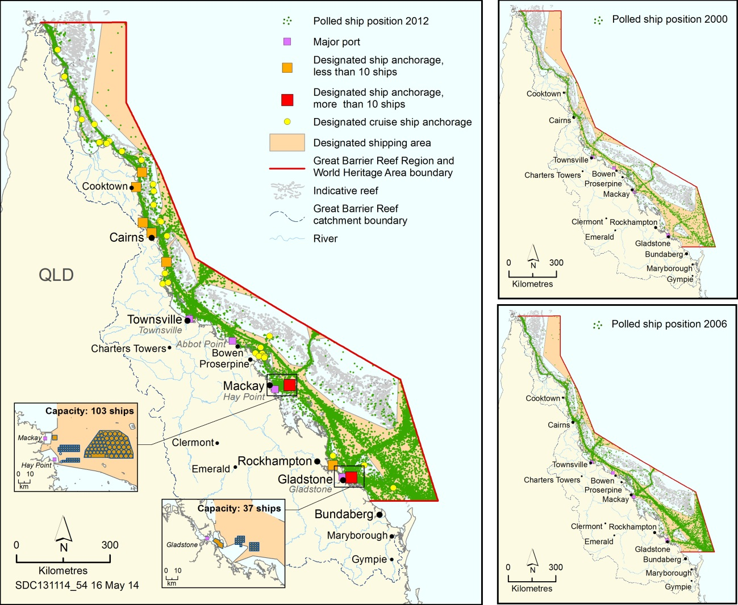
Figure 5.23 Ship anchorages and traffic, 2000, 2006 and 2012
The number of ship voyages through the Region has increased markedly over the last decade. Each polled ship position for the year is marked by a green dot. Source: Polled ship positions from the Australian Maritime Safety Authority for 2000¹³⁸, 2006¹³⁹, 2012¹⁴⁰

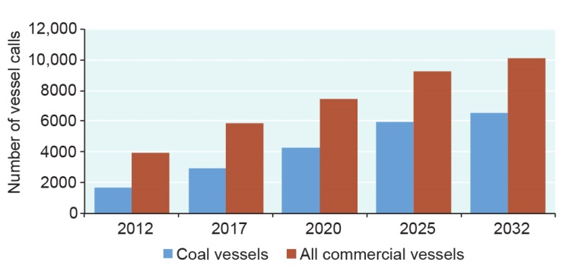
Figure 5.24 Projected shipping increases at major ports, 2012–2032
The category ‘all commercial vessels’ includes coal carriers, bulk carriers, container carriers, vehicle carriers, general cargo ships, tankers and cruise ships. Fishing, other tourism and recreational vessels are not included. The graph is based on projections of 4.8 per cent annual growth for all commercial vessels and 7.2 per cent annual growth for coal vessels. It is recognised that these projections may be higher than the eventual shipping traffic, depending on variables such as economic conditions. Source: Polglaze, Griffin, Miller and Associates 2012¹³⁶

Cruise ships comprise a minor component of the commercial vessels transiting the Region, representing only 1.5 per cent of the commercial vessel calls to Great Barrier Reef ports in 2011–12.⁹⁰ The cruise shipping industry is predicted to grow over coming decades.¹⁴¹
Super yachts — large, high-value, luxury vessels — visit the Region. Their numbers are likely to increase into the future underpinned by an increasing number being based in the Asia/Pacific region and by recovering cruising and charter activity across the international market.
Management There are stringent management arrangements for commercial shipping in the waters of the Great Barrier Reef, which is designated a Particularly Sensitive Sea Area by the International Maritime Organisation.
Shipping traffic is largely confined to a designated shipping area in the Great Barrier Reef Marine Park (Figure 5.23). For ships over 70 metres, and loaded oil tankers, chemical carriers and liquefied gas carriers (irrespective of length), there is compulsory pilotage for the inner route of the Great Barrier Reef (north of about Cairns), Hydrographer’s Passage and in and around the Whitsundays.
Mandatory ship reporting improves navigational safety, reduces the risk of shipping incidents and minimises any resulting ship-sourced pollution in the Region. The REEFVTS monitors ship movements in the Region and provides safety information and navigational assistance.
Ship safety is also improved by ship inspections conducted by the Australian Maritime Safety Authority while vessels are in port. Between 2008–09 and 2012–13, the annual inspection rates for ships which visited ports in or adjacent to the Region, were between 58 and 66 per cent.¹³⁵ The Australian Maritime Safety Authority’s safety regulatory responsibilities were extended in 2013 to include all foreign ships visiting Australian ports regardless of the nature or route of the voyages involved.
There are designated anchorages with a total capacity for 154 ships adjacent to some ports (Figure 5.23). Including swing room, the anchorages cover about 1200 square kilometres. Some have defined anchor points, for example adjacent to the Port of Hay Point.
There are special management arrangements for cruise ships accessing the Marine Park. In addition to requiring a Marine Parks permit, there is a booking system for cruise ships accessing planning areas and designated cruise ship anchorages in both the Cairns and Whitsunday planning areas. Marine park management arrangements for super yachts vary according to their size and whether the visit is for commercial purposes. Their management is guided by the Queensland Superyacht Strategy 2008–2013¹⁴² developed by the Queensland Government, in conjunction with industry and other stakeholders.
Amendments to the International Maritime Organisation’s International Convention for the Prevention of Pollution from Ships (MARPOL) Annex V, which came into force on 1 January 2013, prohibit the discharge of garbage from any vessel into the sea (except under specific circumstances).
In 2013, government agencies with jurisdiction over shipping activities in the north-eastern waters of Australia collaboratively developed the draft North–East Shipping Management Plan¹⁴³ in preparation for predicted increases in shipping and the associated risks. The draft plan applies to the Great Barrier Reef, the Torres Strait and the Coral Sea (within Australia’s Exclusive Economic Zone). It identifies potential risks such as collisions, groundings, release of air emissions and other pollutants, marine pest introduction, wildlife disturbance, altered aesthetic value, and wildlife collisions, as well as impacts on Indigenous, cultural and social values.

Benefits of shipping
Key message: Shipping provides benefits to catchment communities and the nation.
Ships that transit the waters of the Great Barrier Reef provide a service to communities adjacent to the Region, transporting export and import cargo as well as visitors to the Region. Australia's export trade carried through the Region (Section 5.5.2) has more than doubled since 2004–05.¹⁴⁴ The economic activity generated by this shipping traffic provides a range of social and economic benefits to catchment communities and beyond.
Cruise shipping and super yachts provide an important platform for the presentation of the Region’s values to both national and international visitors.

Impacts of shipping
Key message: Despite an increase in shipping activity, impacts are relatively stable.
Key message: Ship grounding sites can take decades to recover.
To date, the impacts of shipping have mainly related to: physical damage and pollution from toxic antifoulant paint as a result of ship groundings; small chemical spills; large and small oil spills; increased noise; vessel strikes on wildlife; vessel-based waste discharge; the introduction of exotic marine species; and marine debris.⁹⁴
Despite the steady increase in shipping activity in the Region, the number of reported ship groundings and collisions has remained relatively stable in recent years (Figure 5.25).¹⁴⁵
The introduction of additional management arrangements, such as extending the vessel traffic service to the southern boundary of the Region in 2011, has helped reduce the likelihood of incident almost occurred in 2012 when the bulk carrier, ID Integrity, broke down in the Coral these incidents. There is also the potential for shipping incidents outside the Region to affect the Region, for example through a disabled vessel or a spill drifting into the area. Such an Sea and drifted for five days.
The decline in the age of ships visiting ports in north-east Queensland, from 9.5 years in 2008–09 to 7.8 years in 2012–13 (not including ships on intrastate voyages), is also likely have improved ship safety in the Region.¹³⁵

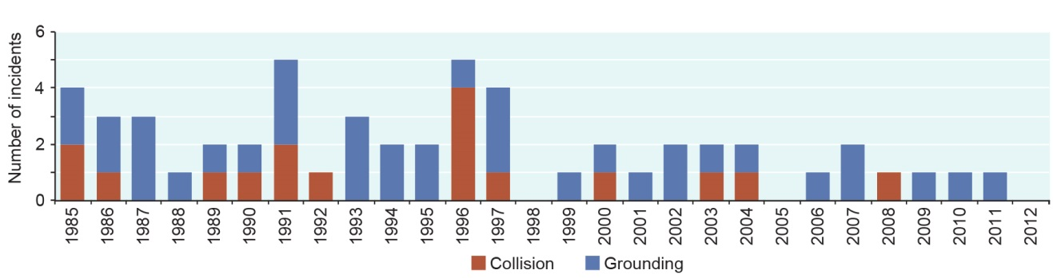
Figure 5.25 Ship groundings and collisions, 1985–2013
Incidents graphed are groundings and collisions reported to the Great Barrier Reef Marine Park Authority involving ships within the World Heritage Area. Note: All collisions identified were between ships and smaller vessels — there were no ship-to-ship collisions reported. Groundings include those within designated port areas. Source: Great Barrier Reef Marine Park Authority¹⁴⁵

Ship groundings affect the Region’s Indigenous heritage values. For Traditional Owners, the reefs of the Great Barrier Reef have many stories associated with them, and cultural practices and lore linked with such story places can be ‘broken’ or affected by a grounding. Particular examples include Piper Reef where the Peacock ran aground in 1996¹⁴⁶ and the Doric Chariot in 2002¹⁴⁷. Piper Reef is an important story place for its Traditional Owners and these groundings are likely to have affected the cultural heritage of the site. Sudbury Reef, where the Bunga Teratai Satu ran aground in 2000¹⁴⁸, is not only a story place but an important cultural place where young men go for a traditional rite of passage¹⁴⁹.
[START COLOURED BOX]
Grounding of Shen Neng I, April 2010
In April 2010, a Chinese-registered coal carrier Shen Neng I ran aground on Douglas Shoal in the Great Barrier Reef. The vessel was grounded for nine days, severely damaging an estimated 115,000 square metres of reef and causing patchy or moderate damage to much of the rest of the 400,000 square metres that the ship covered during the incident.¹⁵⁰ It is the largest ship grounding scar on the Great Barrier Reef. At best, it is expected the site of impact will take decades to recover.¹⁵⁰ Following the incident there was no immediate access to the resources needed for clean up or restoration of the area and, as at December 2013, none had been undertaken. Antifouling chemicals will be affecting marine life at the site. These chemicals combine with pulverised reef to damage corals and other animals both at the grounding site and surrounding area. The grounding focused attention on the risks of shipping in the southern areas of the Region and, in 2011, the REEFVTS area was extended to its southern boundary.
[Photograph of the grounded Shen Neng I with smaller boats in attendance.]
[END COLOURED BOX]

Disturbance from the anchoring of ships is a localised chronic impact which is expected to become more frequent close to ports.¹⁵¹ For many of the areas where ships anchor, the biodiversity values are likely to be relatively low.¹⁵¹ The increasing prevalence of ships anchoring off ports is likely to reduce or alter aesthetic values.¹⁵¹ Other risks include the potential for pest introduction and for the displacement of other users such as recreational visitors and commercial fishers.¹⁵¹ Unidentified heritage values may also be affected, for example World War II wrecks and shipwrecks, plus Indigenous sites of significance, story places and songlines.
Introduced species can enter the Region on all types and sizes of vessels from yachts to cargo ships (see Section 3.6.3). Species may be transferred on external and internal surfaces of vessel hulls and on equipment which makes contact with the water (for example, propellers, ropes, chains and intake grates). Introduced marine species have been found in ports along the Great Barrier Reef coastline (for example Asian green mussels in the Cairns port), although none have been recorded beyond these ports. The most recent detection was of Asian green mussels on a tug at the Port of Hay Point. There is the potential for introduced species to have regional effects on the ecosystem — the nature of those effects would depend on the species introduced.
There is emerging evidence of additional impacts from ship operations worldwide, for example the leaching of biocides from ships’ antifouling coatings^{152,153}, loss of ‘communication space’ for marine animals as a result of vessel noise¹⁵⁴ and the disturbance and resuspension of sediment from the wakes of deep-draft vessels.¹⁵⁵ However there is limited information of the effects of these impacts within the Region.

Traditional use of marine resources

Current state and trends of traditional use of marine resources
Key message: There are Traditional Owner agreements for about 13 per cent of the Region.
Traditional Owners’ connection to sea country within the Region continues to be practised and maintained according to traditional customs and spiritual lore, reflecting ongoing stewardship and custodianship. Traditional use of marine resources is the undertaking of activities as part of Aboriginal and Torres Strait Islander people's customs or traditions, for the purpose of satisfying personal, domestic or communal needs. It includes fishing, collecting (for example, shellfish) and hunting, as well as looking after cultural and heritage sites.
For thousands of years, traditional use of the Region’s marine resources has been conducted by Aboriginal people and Torres Strait Islanders. Impacts such as coastal development, habitat degradation, vessel strike on wildlife, marine debris, extractive use and land-based run-off have affected Traditional Owners’ use of the marine environment (see Chapter 6). Some Traditional Owners are now working in partnership with government agencies to conserve and protect species and ecosystems critical to the health of people, culture and country.
There is limited information about trends in traditional use of the Region.
Management Traditional Owners with sea country in the Region have traditionally managed the sustainability of their practices as part of maintaining their culture and livelihoods. In the modern context, traditional use must be considered in the overall management of the Region along with many other, often competing, uses and their associated impacts. Traditional Owners from a number of communities have been working collaboratively with managing agencies to manage their sea country through developing and implementing Traditional Use of Marine Resources Agreements. There are currently seven Traditional Use of Marine Resources Agreements (covering 43,221 square kilometres or about 13 per cent of the Region) and one Indigenous Land Use Agreement (Figure 5.26). The area covered by the agreements has more than doubled since the Outlook Report 2009.
The Great Barrier Reef Marine Park Authority Board membership has included a Traditional Owner representative from the Region for most of the time since late 1996, contributing to setting policy and management direction for the Great Barrier Reef Marine Park.
Through their own practices and partnerships with managing agencies, including through the Traditional Use of Marine Resources Agreements, Traditional Owners are working to look after culturally significant species such as dugongs and green turtles. Dedicated Indigenous community compliance liaison officers of the Great Barrier Reef Marine Park Authority work with Traditional Owners and the wider Indigenous community to identify and document concerns about illegal activities on sea country, resulting in improved reporting and detection of illegal activities.
Six Traditional Use of Marine Resources Agreements have an approved Compliance Management Plan, and the seventh is under development. Two have also been developed for areas that do not yet have a Traditional Use of Marine Resources Agreement (Mackay area and Northern Peninsula area).¹⁵⁶
Participants in the Eyes and Ears Incident Reporting program and compliance training for Indigenous community members have included Indigenous rangers, Indigenous and non-Indigenous community members and Traditional Owners of the Great Barrier Reef. More than 300 people have taken part in compliance supporting training packages since 2009. Indigenous rangers contribute to on-ground joint compliance patrols and surveillance within the Region. As a result of the training and education activities there are many more reporting opportunities from geographically isolated locations and the number of reported illegal poaching incidents is expected to increase in the shorter term.¹⁵⁶
In 2013, the Australian Government announced a dugong and turtle protection plan that will increase Indigenous ranger enforcement and compliance programs to address illegal poaching.
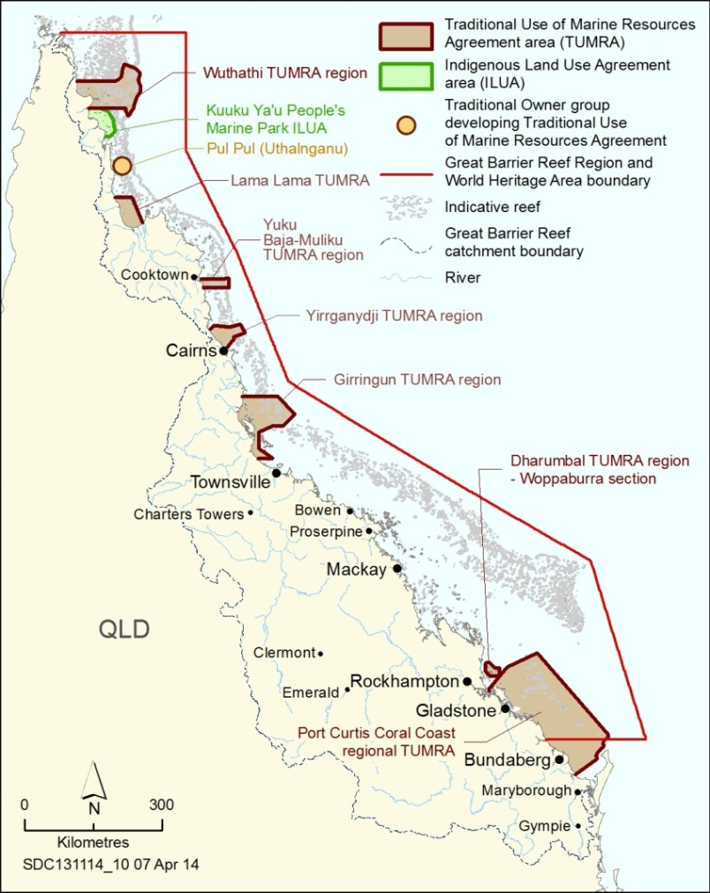
Figure 5.26 Areas of the Great Barrier Reef covered by Traditional Owner agreements, 2014
Some Traditional Owners have formalised their aspirations for sea country through Traditional Use of Marine Resource Agreements and Indigenous Land Use Agreements.

Benefits of traditional use of marine resources
Key message: Traditional use of marine resources continues to provide environmental, social and cultural benefits.
The continuing sea country management and custodianship of the Great Barrier Reef by Aboriginal and Torres Strait Islander Traditional Owners is an important component to the heritage values of the Region.
Many Traditional Owners use marine resources to practise their sustainable ‘living maritime culture’, provide traditional food for families,¹⁵⁷ and educate younger generations about traditional and cultural rules, protocols and activities in sea country.¹⁵⁸
Traditions are of high cultural importance, while social sharing during special events that require traditional resources is also critical to maintaining culture.¹⁵⁷ Traditional Owners hold many cultural, economic and spiritual connections to the Region, establishing effective partnerships with them helps protect cultural and heritage values, conserve biodiversity and enhance the resilience of the Great Barrier Reef.

Impacts of traditional use of marine resources
Key message: Levels of traditional take are considered sustainable.
Impacts attributable to traditional use of marine resources undertaken according to customs and traditions are considered to have only minor or localised effects. Though the traditional use of marine resources is considered largely sustainable, some culturally important species such as dugongs are facing multiple other threats. In response, some Traditional Owner groups have voluntarily agreed not to hunt dugongs for a period of time.^{159,160}
This is distinct from illegal poaching of species of conservation concern undertaken without the customary approval of the relevant Traditional Owners — a focus of compliance effort in the Region.¹⁵⁶
There have been some recent examples of incompatible use between Traditional Owners’ cultural use of marine resources in the sea country areas where they express their native title rights and the activities of tourism operators and other visitors.¹⁴

Assessment summary — Commercial and non-commercial use
Section 54(3)(c) of the Great Barrier Reef Marine Park Act 1975 requires '… an assessment of the commercial and non-commercial use…' of the Great Barrier Reef Region. The assessment is based on two assessment criteria:
- economic and social benefits of use
- impacts of use on the Region’s values.

Economic and social benefits of use
Outlook Report 2009: Assessment summary
Use of the Great Barrier Reef contributes strongly to the regional and national economy and local communities. Its economic value is derived almost exclusively from its natural resources, either through extraction of those resources or through tourism and recreation focused on the natural environment, and would be affected by declines in those resources. Millions of people visit the Great Barrier Reef every year and are very satisfied with their visit. The Great Barrier Reef is valued well beyond its local communities, with strong national and international scientific interest. The Great Barrier Reef is of major importance to Traditional Owner culture. Some users financially contribute to management.
Assessment component | Summary | Benefits 2009 | Benefits 2014 and trend since 2009 | 2014 confidence
 |  |  |  | Grade | Trend
Commercial marine tourism | Tourism continues to make a significant contribution to the presentation, management and economic value of the Great Barrier Reef. | Very good | Very good, Stable | Adequate | Adequate
Defence activities | Activities in the Great Barrier Reef continue to directly contribute to the training and operations of Australia’s defence services. | Good | Good, Stable | Adequate | Adequate
Fishing | Commercial fishing and aquaculture in and adjacent to the Region generate about $160 million per year. Recreational fishing continues to be one of the most popular pastimes in the Region. | Good | Good, Stable | Adequate | Adequate
Ports | Ports adjacent to the Region support trade for Queensland industries and communities. Their economic contribution is increasing. | Not assessed | Very good | Adequate | Not assessed
Recreation (not including fishing) | The opportunity to enjoy the Region’s environment continues to be of social value to Queensland residents, other Australians and international visitors. | Very good | Very good, Stable | Limited | Limited
Research and educational activities | A range of academic institutions and government agencies undertake research about the Great Barrier Reef, providing income and employment in regional communities. | Very good | Very good, Stable | Adequate | Adequate
Shipping | Shipping through the Region provides a range of social and economic benefits to catchment communities and the nation. | Not assessed | Very good | Adequate | Not assessed
Traditional use of marine resources | Traditional use of marine resources continues to provide environmental, social and cultural benefits to Traditional Owners and their sea country. | Very good | Very good, Stable | Inferred | Inferred
Economic and social benefits of use | Use of the Great Barrier Reef continues to contribute to local communities and the national economy. Its economic value has increased over the past five years as has the number of jobs it supports. The number of recreational visits appears to be increasing and declines in tourism visitor numbers until 2011 are now beginning to be reversed. Traditional use helps maintain Traditional Owner connections to their sea country. Some users financially contribute to management. | Very good | Very good, Stable

Benefits
Very good | Use of the Region provides significant economic and social benefit, in ways that sustain the fundamental value of the natural resource. The Region is strongly recognised, valued and enjoyed by catchment residents, the nation and the world community.
Good | Use of the Region provides valuable economic and social benefit. The Region is valued by catchment residents, the nation and the world community.
Poor | There are few and declining economic and social benefits derived from use of the Region. Many do not recognise the value of the Region and do not enjoy their visit to the Region.
Very poor | Use of the Region contributes little or no economic and social benefit. The Region holds little value for catchment residents, the nation or the world community.
Trend since 2009
Improved, Stable, Deteriorated, No consistent trend
Confidence in condition and trend
Adequate | Adequate high-quality evidence and high level of consensus
Limited | Limited evidence or limited consensus
Inferred | Inferred, very limited evidence

Impacts of use on the Region’s values
Outlook Report 2009: Assessment summary
The impacts of different uses of the Great Barrier Reef overlap and are concentrated inshore and next to developed areas. There are some concerns about localised impacts and effects on some species. In particular, species of conservation concern such as dugongs, some bony fish, sharks, seabirds and marine turtles are at risk, especially as a result of fishing, disturbance from increasing use of coastal habitats, illegal fishing, poaching and traditional use of marine resources. There is evidence that fishing is also significantly affecting the populations of some targeted species. The survival success of non-retained species is not well understood, nor are the ecosystem effects of fishing.
Assessment component | Summary | 2009 Impacts | 2014 Impacts and trend since 2009 | Confidence
 |  |  |  | Impacts | Trend
Commercial marine tourism | Marine tourism extends throughout the Great Barrier Reef; its impacts are localised, mainly in a few intensively managed areas. | Very low impact | Very low impact, Stable | Adequate | Adequate
Defence activities | Most defence activities occur within a limited area. The level of planning and resourcing for defence activities means incidents are rare. | Very low impact | Very low impact, Stable | Adequate | Adequate
Fishing | Fishing occurs in many parts of the Region, extracting mostly predators and particle feeders. It can result in the entanglement and death of species of conservation concern, reductions of targeted species with implications on the food chain, and impact on Indigenous heritage values. The status of most targeted species and estimates of discarded catch are not well known. Fisheries management continues to improve; more can be done. Illegal fishing remains a concern. | High impact | High impact, Stable | Limited | Limited
Ports | Port activities have local adverse impacts, including from dredging and dredge material disposal. Understanding of the effects of dredging and disposal is improving; the cumulative effects are not well understood. | Not assessed | High impact | Limited | Not assessed
Recreation (not including fishing) | The impacts of recreation are mainly localised in inshore areas, particularly close to regional centres. | Low impact | Low impact, Stable | Limited | Limited
Research and educational activities | Research and educational activities are concentrated around research stations; minor, localised effects are likely. | Very low impact | Very low impact, Stable | Limited | Limited
Shipping | Despite an increase in shipping activity, impacts are relatively stable. Proactive management is addressing emerging risks. Ship grounding sites can take decades to recover. | Not assessed | Low impact | Adequate | Not assessed
Traditional use of marine resources | Traditional hunting, fishing and collecting involves a range of marine species (some of conservation concern) but levels of take are considered sustainable. Poaching is being addressed. | High impact | Very low impact, Decreased | Limited | Limited
Impact of use | The impacts of different uses of the Great Barrier Reef overlap and are concentrated inshore, particularly next to developed areas. Some uses have only minor and localised effects, for example defence activities, research and educational activities, and traditional use. Cumulative effects of tourism and recreation activities are localised around popular locations. Port activities and their flow-on impacts are generally in areas that are already under pressure from an accumulation of impacts. There are concerns about overfishing of some fish stocks, and the effects of fishing on some species of conservation concern. The survival of non-retained species is not monitored or well understood. | Low impact | High impact, Increased

Impacts
Very low impact | Any impacts attributable to use of the Region are minor and localised, with no observable effects on overall ecosystem function or heritage values.
Low impact | The impacts of use are observable in some locations or on some values, but only to the extent that limited additional intervention would be required for the use to be sustainable.
High impact | The impacts of use are obvious in many locations or to many values to the extent that significant additional intervention would be required for the use to be sustainable.
Very high impact | The impacts of use are widespread, to the extent that ecosystem function and heritage values are severely compromised.
Trend since 2009
Increased, Stable, Decreased, No consistent trend
Confidence in condition and trend
Adequate | Adequate high-quality evidence and high level of consensus
Limited | Limited evidence or limited consensus
Inferred | Inferred, very limited evidence

Overall summary of commercial and non-commercial use
The economic contribution of the Great Barrier Reef to the Australian economy has increased from approximately $5.4 billion in 2006–07 to $5.6 billion in 2011–12. This is likely to be a small decrease in real terms. There has also been an increase in the full-time positions that are dependent on the Reef from 53,800 in 2006–07 to 69,000 in 2011–12.
Commercial marine tourism continues to be the most significant use of the Reef — both in terms of economic value and employment. In 2011, tourism visitation to the Region was at its lowest point since 1998 most likely due to extreme weather events and the strong Australian dollar. Visitor numbers have since increased in 2012 and 2013.
Commercial and recreational fishing continue to be the most widespread significant extractive use of the Region. Trawl, net, line and pot remain the major commercial fisheries. Some aspects of fishing practices and management arrangements have improved, but more can be done. There is some evidence that, despite ongoing popularity of recreational fishing, recreational catch rates are declining and there have also been some decreases in the commercial catch.
Some fishing activities continue to interact with species of conservation concern and the status of a range of target and bycatch species is poorly understood. There are currently no contemporary estimates of the quantum of bycatch and discard species. Some fishes, sea snakes, sharks, sea cucumbers, skates, rays and associated habitats are at particular risk and, in general, spawning aggregations of inshore fish species are not as protected as those of coral reef fin fish. Illegal activities, particularly associated with illegal fishing and poaching, continue to affect the Region’s ecosystem and some of its heritage values. There is evidence of intentional targeting of protected zones by some fishers.
A wide variety of recreational activities occur in the Region, and popular destinations include islands and reefs. Visits to the Region by catchment residents are increasing, likely tied to local population growth and people visiting more frequently. Most impacts from recreational use are localised, however there is potential for cumulative effects over time and in popular areas. Research and educational activities in the Region continue to generate high quality knowledge and learning experiences. These activities are thought to have only localised effects.
Port activities and their flow-on impacts are generally in areas that are already under pressure from an accumulation of impacts. Since the Outlook Report 2009, port activity has increased, as have port development proposals, including dredging and disposal of dredge material. Understanding of the effects on the Region’s values of dredging and the disposal and resuspension of dredge material is improving, but many gaps remain. The broader regional and cumulative effects on inshore biodiversity of port activities remain poorly understood. Implementation of national and state ports strategies is expected to critically influence future planning and management of ports in and adjacent to the Region, including environmental protection arrangements.
Ships travelling through the Region have become larger over recent years and their average age is decreasing. Risks associated with projected increases in shipping through the Region are being proactively addressed. Disturbance from the anchoring of ships is likely to become more frequent as the number of ships grows, particularly near ports. Introduction of marine species via shipping continues to be a threat, although there have been only a few recent reported incidents.
Limited information is available on the trends in traditional use of the Region. Traditional Owners continue to work in partnership to help protect cultural and heritage values, conserve biodiversity and enhance the resilience of the Great Barrier Reef. Seven Traditional Use of Marine Resources Agreements and one Indigenous Land Use Agreement are in place.
There are a number of key knowledge gaps in relation to direct use of the Region: reliable estimates of bycatch and discards are currently not available; recreational use, particularly recreational fishing, is not well understood; and advancements in understanding of dredging and the disposal and resuspension of dredge material are necessary to inform near and long-term risk assessments. In addition, there is poor understanding of the community benefits derived from the Region and how population and economic growth and changing societal attitudes affect patterns of use.

References
1. Goldberg, J., Marshall, N.A., Gooch, M., Birtles, A., Bohensky, E., Curnock, M., Parry-Husbands, H., Pert, P., Stone-Jovicich, S., Tobin, R.C. and Villani, C. 2013, National Environmental Research Program SELTMP 2013: the Great Barrier Reef national survey, CSIRO.
2. Deloitte Access Economics 2013, Economic contribution of the Great Barrier Reef, Great Barrier Reef Marine Park Authority, Townsville.
3. Access Economics 2008, Economic contribution of the GBRMP, 2006–07: prepared for the Great Barrier Reef Marine Park Authority, Great Barrier Reef Marine Park Authority, Townsville.
4. Stoeckl, N., Hicks, C.C., Mills, M., Fabricius, K., Esparon, M., Kroon, F., Kaur, K. and Costanza, R. 2011, The economic value of ecosystem services in the Great Barrier Reef: our state of knowledge, Annals of the New York Academy of Sciences 1219: 113-133.
5. Great Barrier Reef Marine Park Authority 2009, Great Barrier Reef outlook report 2009, GBRMPA, Townsville.
6. Marshall, N.A. and Marshall, P.A. 2007, Conceptualizing and operationalizing social resilience within commercial fisheries in northern Australia, Ecology and Society 12(1): Art. 1.
7. Prideaux, B., Sakata, H. and Thompson, M. 2013, Tourist exit survey report: February – September 2012. Annual patterns of reef and rainforest tourism in North Queensland from exit surveys conducted at Cairns domestic airport. Report to the National Environmental Research Program, Reef and Rainforest Research Centre Limited, Cairns.
8. Great Barrier Reef Marine Park Authority 2012, Environmental management charge, GBRMPA, Townsville, <http://www.gbrmpa.gov.au/zoning-permits-and-plans/environmental-management-charge>.
9. Great Barrier Reef Marine Park Authority 2013, Environmental management charge data, GBRMPA, Townsville, <http://www.gbrmpa.gov.au/visit-the-reef/visitor-contributions/gbr_visitation/numbers>.
10. Great Barrier Reef Marine Park Authority 2013, High standard tourism operations, GBRMPA, Townsville, <http://www.gbrmpa.gov.au/visit-the-reef/choose-a-high-standard-operator/high-standard-tourism-operation>.
11. Ecotourism Australia 2013, 'Ecotourism Australia annual report to the GBRMPA: ECO Certification program 20122013'.
12. Curnock, M., Marshall, N., Tobin, R., Stone-Jovicich, S., Bohensky, E., Pert, P., Goldberg, J., Gooch, M., Gillet, S. and Scherl, L. 2014, The social and economic long term monitoring program (SELTMP) 2013. Tourism in the Great Barrier Reef. Report to the National Environmental Research Program, Reef and Rainforest Centre Limited, Cairns.
13. Stoeckl, N., Farr, M. and Sakata, H. 2013, What do residents and tourists value most in the GBRWHA? Project 10-2 Socioeconomic systems and reef resilience: Interim report on residential and tourist data collection activities including descriptive data summaries, Reef and Rainforest Research Centre Limited, Cairns.
14. Packham, L. 2013, Calls for action on traditional turtle hunting after tourists witness slaughter on Green Island, April 23, The Cairns Post, Cairns.
15. URS Australia Pty Ltd 2006, Strategic environmental assessment of defence activities in the Great Barrier Reef World Heritage Area, Directorate of Environmental Stewardship, Department of Defence, Canberra.
16. Department of Defence 2013, Defence White Paper, Commonwealth of Australia, Canberra.
17. Department of Defence and Great Barrier Reef Marine Park Authority 2008, Management agreement between Department of Defence and the Great Barrier Reef Marine Park Authority on implementation of the strategic environmental assessment of defence activities in the Great Barrier Reef Marine Park, GBRMPA, Townsville.
18. O'Neill, P. 2009, State of the Environment Report for Shoalwater Bay Training Area 2008, Department of Defence, Canberra.
19. Aurecon Australia 2012, Talisman Sabre 2013: Public environment report (draft for consultation), Aurecon Australia, Canberra.
20. Townsville Enterprise 2012, Townsville North Queensland Region: destination tourism strategy 2012-2016, Townsville Enterprise, <http://townsvilleenterprise.com.au/Files/232480%20%20DTS%20-%20Townsville%20North%20Queensland%20FINAL.PDF>.
21. Courier Mail 2013, Two bombs dropped by US Marines over the Great Barrier Reef retrieved, two "inert ordnance" remain, 01 September, News Ltd, Brisbane.
22. Australian Defence Force 2009, Maritime activities environment management plan and supporting planning guides: Ship planning guides and procedure cards, ADF, Canberra.
23. Fairfax Media 1947, Dangerous tasks for men of the Navy, 18 June, Sydney Morning Herald, Sydney.
24. Royal Australian Navy 2013, HMAS Bungaree, Royal Australian Navy, Canberra, <http://www.navy.gov.au/hmas-bungaree>.
25. Department of Transport and Main Roads 2014, Vessel Registration data retrieved by LGA from the Transport Registration and Integrated Licensing System (TRAILS), Unpublished data, DTMR, Brisbane.
26. Tobin, R., Bohensky, E., Curnock, M., Goldberg, J., Gooch, M., Marshall, N., Nicotra, B., Pert, P., Scherl, L. and Stone-Jovicich, S. 2013, National Environmental Research Program SELTMP 2013: Recreation in the Great Barrier Reef. Report to the National Environmental Research Program, Reef and Rainforest Research Centre Limited, Cairns.
27. Taylor, S., Webley, J. and McInnes, K. 2012, 2010 State wide recreational fishing survey, Department of Agriculture, Fisheries and Forestry, Brisbane.
28. Department of Agriculture, Fisheries and Forestry 2013, Unpublished data.This work is licensed under the Creative Commons Attribution-NoDerivs 3.0 Australia License. To view a copy of this license, visit http://creativecommons.org/licenses/by/3.0/au/ or send a letter to Creative Commons, 444 Castro Street, Suite 900, Mountain View, California, 94041, USA.
29. Alverson, D., Freeberg, M., Pope, J. and Murawski, S. 1994, A global assessment of bycatch and discards. FAO fisheries technical paper No. 339, Food and Agriculture Organization, Rome, Italy.
30. Eriksson, H. and Byrne, M. 2013, The sea cucumber fishery in Australia's Great Barrier Reef Marine Park follows global patterns of serial exploitation, Fish and Fisheries: 10.1111/faf.12059.
31. Skewes, T., Plaganyi, E., Murphy, N., Pascual, R. and Fischer, M. 2014, Evaluating rotational harvest strategies for sea cucumber fisheries: an MSE of the Qld east coast sea cucumber fishery. FRDC Project No. 2012/200, CSIRO, Brisbane.
32. Tobin, A.J., Schlaff, R., Tobin, R., Penny, A., Ayling, T., Ayling, A., Krause, B., Welch, D., Sutton, S., Sawynok, B., Marshall, N.A., Marshall, P.A. and Maynard, J.A. 2010, Adapting to change: minimising uncertainty about the effects of rapidly-changing environmental conditions on the Queensland Coral Reef Fin Fish Fishery, Final Report to the Fisheries Research and Development Corporation, Project 2008/103, James Cook University, Townsville.
33. Thébaud, O., Innes, J., Norman-Lopez, A., Slade, S., Cameron, D., Cannard, T., Tickell, S., Kung, J., Kerrigan, B., Williams, L. and Little, R. 2014, Micro-economic drivers of profitability in an ITQ-managed fishery: An analysis of the Queensland Coral Reef Fin-Fish Fishery, Marine Policy 43: 200-207.
34. Food and Agriculture Organization 2007, The state of the world's fisheries and aquaculture 2006, FAO, Rome, Italy.
35. The World Bank 2013, Fish to 2030: Prospects for fisheries and aquaculture. World Bank report number 83177-GLB, The World Bank, Washington DC.
36. Sim, S.Y. 2004, Regional developments and update. April-June, Asia-Pacific Marine Finfish Aquaculture Network, Bangkok, Thailand, http://library.enaca.org/AquacultureAsia/Articles/April-June-2004/10mfan-ezine-april04.pdf.
37. Attorney-General's Department 2014, Offshore Constitutional Settlement, Australian Government, Canberra, <http://www.ag.gov.au/Internationalrelations/InternationalLaw/Pages/TheOffshoreConstitutionalSettlement.aspx>.
38. Department of the Environment and Water Resources 2007, Guidelines for the ecologically sustainable management of fisheries, Australian Government, Canberra.
39. Harry, A.V., Tobin, A.J., Simpfendorfer, C.A., Welch, D.J., Mapleston, A., White, J., Williams, A.J. and Stapley, J. 2011, Evaluating catch and mitigating risk in a multispecies, tropical, inshore shark fishery within the Great Barrier Reef World Heritage Area, Marine and Freshwater Research 62(6): 710-721.
40. Welch, D.J., Ovenden, J., Simpfendorfer, C.A., Tobin, A.J., Morgan, J.A.T., Street, R., White, J., Harry, A.V., Schroeder, R. and Macbeth, W.G. 2011, Stock structure of exploited shark species in north-eastern Australia: report to the Fisheries Research and Development Corporation project 2007/35, Fishing and Fisheries Research Centre, Townsville.
41. Tobin, A.J., Simpfendorfer, C.A., Mapleston, A., Currey, L., Harry, A.V., Welch, D.J., Ballagh, A.C., Chin, A., Szczecinski, N., Schlaff, A., White, J. and Moore, B. 2010, A quantitative ecological risk assessment of sharks and finfish of the Great Barrier Reef World Heritage Area inshore waters: a tool for fisheries and marine park managers. Identifying species at risk and potential mitigation strategies, Marine and Tropical Sciences Research Facility, Cairns.
42. Department of Agriculture, Fisheries and Forestry 2013, Stock status of Queensland's fisheries resources 2012 summary, DAFF, Brisbane.
43. Tobin, R.C., Beggs, K., Sutton, S.G. and Penny, A. 2010, Baseline socio-economic data for Queensland east-coast inshore and rocky reef fishery stakeholders. Part D: Seafood consumers, Technical Report No. 8, Fishing and Fisheries Research Centre, James Cook University, Townsville.
44. Department of Sustainability, Environment, Water, Populations and Communities 2012, Assessment of the East Coast Inshore Fin Fish Fishery, Commonwealth of Australia, Canberra.
45. Department of Agriculture, Fisheries and Forestry 2012, Commercial line fishing in Queensland, DAFF, Brisbane, <http://www.daff.qld.gov.au/fisheries/commercial-fisheries/queenslands-commercial-fisheries/line-fisheries>.
46. Department of Agriculture, Fisheries and Forestry 2012, Commercial trawling in Queensland, DAFF, Brisbane, <http://www.daff.qld.gov.au/fisheries/commercial-fisheries/queenslands-commercial-fisheries/trawl-fishery>.
47. Donnelly, R. 2011, Climate change vulnerability assessment: Queensland Marine Aquarium Supply Industry, 2010, Research Publication No. 108, Great Barrier Reef Marine Park Authority, Townsville.
48. Tobin, R.C., Beggs, K., Sutton, S., Penny, A., Maroske, J. and Williams, L. 2010, Baseline socioeconomic data for Queensland east coast inshore and rocky reef fishery stakeholders, Part B: Charter fishers, Fishing and Fisheries Research Centre, James Cook University, Townsville.
49. Marshall, N.A. and Tobin, R. 2012, "More than meets the eye": The social and economic impacts of recent natural disasters on marine resource dependent industries of the Great Barrier Reef Region, Great Barrier Reef Marine Park Authority, Townsville.
50. Tobin, R., Sutton, S., Penny, A., Williams, L., Maroske, J. and Nilsson, J. 2010, Baseline socio-economic data for Queensland east-coast inshore and rocky reef fishery stakeholders. Part A: commercial fishers, FRDC Project No. 2007/048, Technical Report No. 5, Fishing and Fisheries Research Centre, James Cook University, Townsville.
51. Great Barrier Reef Marine Park Authority 2012, Great Barrier Reef Region Strategic Assessment stakeholder workshop reports, GBRMPA, Townsville.
52. Lédée, E.J.I., Sutton, S.G., Tobin, R.C. and De Freitas, D.M. 2012, Responses and adaptation strategies of commercial and charter fishers to zoning changes in the Great Barrier Reef Marine Park, Marine Policy 36: 226-234.
53. Pears, R.J., Morison, A.K., Jebreen, E.J., Dunning, M.C., Pitcher, C.R., Courtney, A.J., Houlden, B. and Jacobsen, I.P. 2012, Ecological risk assessment of the East Coast Otter Trawl Fishery in the Great Barrier Reef Marine Park: Technical report, Great Barrier Reef Marine Park Authority, Townsville.
54. Andersen, J. 2012, Reef fishery in crisis as stocks drop, 16 January 2012, Townsville Bulletin, Townsville.
55. Office of Economic and Statistical Research 2012, Shark control program: shark caught by type, Queensland, 2001 to 2002 until 2011 to 2012, Queensland Treasury and Trade, Brisbane, <http://www.oesr.qld.gov.au/products/tables/shark-control-program-caught-type/index.php>.
56. McInnes, K. 2008, Experimental results from the fourth Queensland recreational fishing diary program (2005), Department of Employment, Economic Development and Innovation, Brisbane.
57. Stevens, J.D., Bonfil, R., Dulvy, N.K. and Walker, P.A. 2000, The effects of fishing on sharks, rays and chimaeras (chondrichthyans), and the implications for marine ecosystems, ICES Journal of Marine Science 57: 476-494.
58. Myers, R.A., Baum, J.K., Shepherd, T.D., Powers, S.P. and Peterson, C.H. 2007, Cascading effects of the loss of apex predatory sharks from a coastal ocean, Science 315: 1846-1850.
59. Hughes, T.P., Rodrigues, M.J., Bellwood, D.R., Ceccarelli, D., Hoegh-Guldberg, O., McCook, L.J., Moltschaniwskyj, N.A., Pratchett, M.S., Steneck, R.S. and Willis, B. 2007, Phase shifts, herbivory, and the resilience of coral reefs to climate change, Current Biology 17(4): 360-365.
60. Harriott, V.J. 2001, The sustainability of Queensland’s coral harvest fishery, CRC Reef Research Centre, Townsville.
61. Donnelly, R. 2013, Stewardship Action Plan 2013: Mitigating ecological risk in a changing climate, Pro-vision Reef Inc., Cairns.
62. Kelleher, K. 2005, Discards in the world's marine fisheries. An update. FAO fisheries technical paper. No. 470, Food and Agriculture Organization, Rome, Italy.
63. Hall, M., Alverson, D. and Metuzals, K. 2000, Bycatch: problems and solutions, Marine Pollution Bulletin 41: 204-219.
64. Welch, D., Mapstone, B. and Begg, G. 2008, Spatial and temporal variation and effects of changes in management in discard rates from the commercial reef line fishery of the Great Barrier Reef, Australia, Fisheries Research 90: 247-260.
65. Brewer, D., Rawlinson, N., Eayrs, S. and Burridge, C. 1998, An assessment of bycatch reduction devices in a tropical Australian prawn trawl fishery, Fisheries Research 36(2-3): 195-215.
66. Courtney, A.J., Haddy, J.A., Campbell, V., Roy, D.P., Tonks, M.L., Gaddes, S.W., Chilcott, K.E., O.Neill, M.F., Brown, I.W., McLennan, M., Jebreen, E.J., van der Geest, C., Rose, C., Kistle, S., Turnbull, C.T., Kyne, P.M., Bennett, M.B. and Taylor, J. 2007, Bycatch weight, composition and preliminary estimates of the impact of bycatch reduction devices in Queensland's trawl fishery, Department of Primary Industries and Fisheries, Brisbane.
67. Courtney, A.J., Schemel, B.I., Wallace, R.M., Campbell, M.J. and Mayer, D.J. 2010, Reducing the impact of Queensland's trawl fisheries on protected sea snakes, Fisheries Research and Development Corporation and Department of Employment, Economic Development and Innovation, Brisbane.
68. Great Barrier Reef Marine Park Authority and Queensland Government 2013, Suspicious dugong strandings - Townsville: 2010 to 2013, Unpublished.
69. Sumpton, W.D., Taylor, S.M., Gribble, N.A., McPherson, G. and Ham, T. 2011, Gear selectivity of large-mesh nets and drumlines used to catch sharks in the Queensland shark control program, African Journal of Marine Science 33(1): 37-43.
70. Sobtzick, S., Hagihara, R., Grech, A. and Marsh, H. 2012, Aerial survey of the urban coast of Queensland to evaluate the response of the dugong population to the widespread effects of the extreme weather events of the summer of 201011, Final report to the Australian Marine Mammal Centre and the National Environmental Research Program, James Cook University, Townsville.
71. Berg Soto, A. 2012, Evaluation of different management approaches to reduce the bycatch of the Indo-Pacific humpback dolphin (Sousa chinensis) and the Australian snubfin dolphin (Orcaella heinsohni) in Queensland, Australia, PhD thesis, James Cook University, Townsville.
72. Great Barrier Reef Marine Park Authority 2011, A vulnerability assessment for the Great Barrier Reef: grey mackerel, GBRMPA, Townsville.
73. Cook, D. 2008, The possible collapse of a grey mackerel population and the decline of an inshore fishery within the World Heritage Great Barrier Reef Marine Park, demonstrating the need to implement the precautionary principle to immediately close local inshore waters to all offshore and itinerant netting: A Case Study, Unpublished.
74. Sadovy de Mitcheson, Y. and Colin, P.L. (eds) 2012, Reef fish spawning aggregations: Biology, research and management, Fish and Fisheries Series, Vol 35, Springer Science and Business Media, New York, USA.
75. Russell, M. and Pears, R.J. 2007, Management and science of fish spawning aggregations in the Great Barrier Reef Marine Park, summary of workshop held 17-20 July 2007, Museum of Tropical Queensland, Great Barrier Reef Marine Park Authority, Townsville.
76. Lucas, P.H.C., Webb, T., Valentine, P.S. and Marsh, H. 1997, The outstanding universal value of the Great Barrier Reef World Heritage Area, Great Barrier Reef Marine Park Authority, Townsville.
77. Poiner, I.R., Glaister, J., Pitcher, C.R., Burridge, C.Y., Wassenberg, T.J., Gribble, N.A., Hill, B.J., Blaber, S.J.M., Milton, D., Brewer, D. and Ellis, N. 1998, Environmental effects of prawn trawling in the far northern section of the Great Barrier Reef: 1991-96, CSIRO Division of Marine Research, Cleveland.
78. Pitcher, C.R., Burridge, C.Y., Wassenberg, T.J., Hill, B.J. and Poiner, I.R. 2009, A large scale BACI experiment to test the effects of prawn trawling on seabed biota in a closed area of the Great Barrier Reef Marine Park, Australia, Fisheries Research 99(3): 168-183.
79. Pitcher, C.R., Wassenberg, T.J., Cappo, M.C., Smith, G.P., Austin, M., Gordon, S.R., Bustamante, R.H., Moeseneder, C.H., Speare, P.J., Kennedy, J.A., Doherty, P.J. and Hooper, J.N.A. 2004, Dynamics of large sessile seabed fauna, important for structural fisheries habitat and biodiversity of marine ecosystems and the use of these habitats by key finfish species, Final report to the FRDC on project 1997/205, CSIRO Marine Research, Cleveland, Qld.
80. Pitcher, C.R., Poiner, I.R., Hill, B.J. and Burridge, C.Y. 2000, Implications of the effects of trawling on sessile megazoobenthos on a tropical shelf in northeastern Australia, ICES Journal of Marine Science 57(5): 1359-1368.
81. Burridge, C.Y., Pitcher, C.R., Hill, B.J., Wassenberg, T.J. and Poiner, I.R. 2006, A comparison of demersal communities in an area closed to trawling with those in adjacent areas open to trawling: A study in the Great Barrier Reef Marine Park, Australia, Fisheries Research 79(1-2): 64-74.
82. Burridge, C.Y., Pitcher, C.R., Wassenberg, T.J., Poiner, I.R. and Hill, B.J. 2003, Measurement of the rate of depletion of benthic fauna by prawn (shrimp) otter trawls: An experiment in the Great Barrier Reef, Australia, Fisheries Research 60(2-3): 237-253.
83. Asoh, A., Yoshikawa, T., Kosaki, R. and Marschall, E. 2004, Damage to cauliflower coral by monofilament fishing lines in Hawaii, Conservation Biology 18(6): 1645-1650.
84. Hardesty, B.D. and Wilcox, C. 2011, Understanding the types, sources and at-sea distribution of marine debris in Australian waters, CSIRO, Collingwood.
85. Reisser, J., Shaw, J., Wilcox, C., Hardesty, B.D., Proietti, M., Thums, M. and Pattiaratchi, C. 2013, Marine plastic pollution in waters around Australia: characteristics, concentrations, and pathways, PLoS ONE 8(11): e80466.
86. McCook, L.J., Ayling, T., Cappo, M., Choat, J.H., Evans, R.D., DeFreitas, D.M., Heupel, M., Hughes, T.P., Jones, G.P., Mapstone, B., Marsh, H., Mills, M., Molloy, F.J., Pitcher, C.R., Pressey, R.L., Russ, G.R., Sutton, S., Sweatman, H., Tobin, R., Wachenfeld, D. and Williamson, D. 2010, Adaptive management of the Great Barrier Reef: A globally significant demonstration of the benefits of networks of marine reserves, Proceedings of the National Academy of Sciences 107(43): 18278-18285.
87. Great Barrier Reef Marine Park Authority 2013, Field Management Compliance Coordination Unit Data and Assessments, Unpublished.
88. Ross, H., Innes, J., George, M. and Gorman, K. 2004, Traditional owner aspirations towards cooperative management of the Great Barrier Reef World Heritage Area: Community case studies, CRC Reef Research Centre, Townsville.
89. Ross, A., Herman, K.P., Snodgrass, J.G., Delcore, H.D. and Sherman, R. 2011, Indigenous peoples and the collaborative stewardship of nature, Left Coast Press, Walnut Creek, California, USA.
90. Ports Australia 2012, Trade statistics for 2011/12, Ports Australia, Sydney, <http://www.portsaustralia.com.au/tradestats/>.
91. Department of State Development, Infrastructure and Planning 2013, Queensland ports strategy, draft for consultation, DSDIP, Brisbane.
92. Bureau of Resources and Energy Economics 2012, Australian bulk commodity exports and infrastructure: outlook to 2025, BREE, Canberra.
93. Brunner, R.W.J. 2011, Sustainability in the design of bulk coal ports: an Australian case study, North Queensland Bulk Ports Corporation, Mackay, Queensland.
94. Great Barrier Reef Marine Park Authority 2012, Ports and shipping information sheet, GBRMPA, Townsville.
95. Department of Sustainability, Environment, Water, Population and Communities 2013, State Party Report on the state of conservation of the Great Barrier Reef World Heritage Area (Australia) property ID N154 in response to World Heritage Committee decision WHC 35 COM 7B.10, DSEWPaC, Canberra.
96. Department of Transport and Main Roads 2014, Trade statistics for Queensland ports for the five years ending 30 June 2013, DTMR, Brisbane.
97. Department of the Environment, Water, Heritage and the Arts 2009, National assessment guidelines for dredging, Department of the Environment, Water, Heritage and the Arts, Canberra.
98. Infrastructure Australia and National Transport Commission 2010, National ports strategy. Infrastructure for an economically, socially, and environmentally sustainable future, Australian Government, Canberra.
99. Department of State Development, Infrastructure and Planning 2014, Queensland ports strategy, State of Queensland, Brisbane.
100. Great Barrier Reef Marine Park Authority 2010, Dredging and spoil disposal policy, Great Barrier Reef Marine Park Authority, Townsville.
101. Department of Environment and Heritage Protection 2014, Great Barrier Reef: Reef facts, Queensland Government, Brisbane.
102. Ellison, W.T., Southall, B.L., Clark, C.W. and Frankel, A.S. 2011, A new context-based approach to assess marine mammal behavioral responses to anthropogenic sounds, Conservation Biology 26(1): 21-28.
103. Burns, K. and Brinkman, D. 2011, Organic biomarkers to describe the major carbon inputs and cycling of organic matter in the central Great Barrier Reef region, Estuarine, Coastal and Shelf Science 93(2): 132-141.
104. Foster, T., Corcoran, E., Erftemeijer, P.L., Fletcher, C., Peirs, K., Dolmans, C., Smith, A. and Yamamoto, H. 2010, Dredging and port construction around coral reefs, Envicom Report 108, PIANC Secretariat, Belgium.
105. Erftemeijer, P.L. and Lewis, R.R. 2006, Environmental impacts of dredging on seagrasses: A review, Marine Pollution Bulletin 52(12): 1553-1572.
106. Smith, R., Boyd, S.E., Rees, H.L., Dearnaley, M.P. and Stevenson, J. 2006, Effects of dredging activity on epifaunal communities - surveys following cessation of dredging, Estuarine, Coastal and Shelf Science 70(1-2): 207-223.
107. Erftemeijer, P.L., Riegl, B., Hoeksema, B.W. and Todd, P.A. 2012, Environmental impacts of dredging and other sediment disturbances on corals: a review, Marine Pollution Bulletin 64(9): 1737-1765.
108. Biddle, T.M. and Limpus, C.J. 2011, Marine wildlife stranding and mortality database annual report 2005-2010, Marine turtles, Conservation and Technical Data Report 2011(1): 1-124.
109. Organisation for Economic Co-operation and Development 2011, Environmental impacts of international shipping: The role of ports, OECD Publishing, Paris, France.
110. Rasheed, K. and Balchand, A.N. 2001, Environmental studies on impacts of dredging, International Journal of Environmental Studies 58(6): 703-725.
111. Blackman, C. 2012, Personal Communication, Gurang Traditional Owner.
112. Bird, M. and Heijm, N. 2009, Appendix R1: Indigenous cultural heritage report, in Port Expansion Project EIS Port of Townsville, Townsville, pp. 79-84.
113. Context Pty Ltd 2013, Defining the aesthetic values of the Great Barrier Reef, Department of Sustainability, Environment, Water, Population and Communities, Canberra.
114. Pollock, F.J., Lamb, J.B., Field, S.N., Heron, S.F., Schaffelke, B., Shedrawi, G., Bourne, D.G. and Willis, B.L. 2014, Sediment and turbidity associated with offshore dredging increase coral disease prevalence on nearby reefs, PLoS ONE 9(7): e102498.
115. Trimarchi, S. and Keane, J. 2007, Port of Hay Point apron areas and departure path capital dredging project: environmental review, Ports Corporation of Queensland Limited, Brisbane.
116. Islam, A., Wang, L., Smith, C., Reddy, S., Lewis, A. and Smith, A. 2007, Evaluation of satellite remote sensing for operational monitoring of sediment plumes produced by dredging at Hay Point, Queensland, Australia, Journal of Applied Remote Sensing 1(1): 1-15.
117. Sinclair Knight Merz Pty Ltd and Asia-Pacific Applied Science Associates 2013, Improved dredge material management for the Great Barrier Reef Region: Synthesis report, Great Barrier Reef Marine Park Authority, Townsville.
118. Fabricius, K.E., De'ath, G., Humphrey, C., Zagorskis, I. and Schaffelke, B. 2013, Intra-annual variation in turbidity in response to terrestrial runoff on near-shore coral reefs of the Great Barrier Reef, Estuarine Coastal and Shelf Science 116: 57-65.
119. Fabricius, K.E., Logan, M., Weeks, S. and Brodie, J. 2014, The effects of river run-off on water clarity across the central Great Barrier Reef, Marine Pollution Bulletin DOI: 10.1016/j.marpolbul.2014.05.012.
120. Smith, A., Foster, T., Corcoran, E. and Monkivitch, J. 2007, Dredging and material relocation in sensitive coral environments, in Proceedings of the 18th World Dredging Conference, 1 June, 2007, Florida, eds. Anonymous, Great Barrier Reef Marine Park Authority, Townsville, pp. 945-955.
121. Lawrence, K., van Putten, I. and Fernbach, M. 2010, Profiles of recreational use of the Great Barrier Reef Marine Park, Great Barrier Reef Marine Park Authority, Townsville.
122. Great Barrier Reef Marine Park Authority 2012, Recreation management strategy for the Great Barrier Reef Marine Park, GBRMPA, Townsville.
123. Great Barrier Reef Marine Park Authority 2013, Great Barrier Reef Region strategic assessment stakeholder and community engagement report, Unpublished, Townsville.
124. Great Barrier Reef Marine Park Authority 2013, Great Barrier Reef Marine Park Authority annual report 2012-13, GBRMPA, Townsville.
125. Oceans Policy Science Advisory Group 2013, Marine nation 2025: Marine science to support Australia's blue economy, Australian Government, Canberra.
126. Great Barrier Reef Marine Park Authority 2009, Scientific information needs for the management of the Great Barrier Reef Marine Park 2009–2014, GBRMPA, Townsville.
127. Hedge, P., Molloy, F., Sweatman, H., Hayes, K., Dambacher, J., Chandler, J., Gooch, M., Chin, A., Bax, N. and Walshe, T. 2013, An integrated monitoring framework for the Great Barrier Reef World Heritage Area, National Environmental Research Program Marine Biodiversity Hub, Townsville.
128. Great Barrier Reef Marine Park Authority 2012, Scientific research: information sheet, GBRMPA, Townsville.
129. Department of National Parks, Recreation, Sport and Racing and Great Barrier Reef Marine Park Authority 2013, Education permits issued between July 2008 and June 2013 within the Great Barrier Reef Region, Unpublished data.
130. Woodley, S.J., Williams, D.M., Harvey, T. and Jones, A. 2006, World Heritage research: making a difference. CRC Reef research, education and capacity building 1999-2006, CRC Reef Research Centre, Townsville.
131. Great Barrier Reef Marine Park Authority 2010, Water quality guidelines for the Great Barrier Reef Marine Park, GBRMPA, Townsville.
132. Harrison, H.B., Williamson, D.H., Evans, R.D., Almany, G.R., Thorrold, S.R., Russ, G.R., Feldheim, K.A., van Herwerden, L., Planes, S., Srinivasan, M., Berumen, M.L. and Jones, G.P. 2012, Larval export from marine reserves and the recruitment benefit for fish and fisheries, Current Biology 22(11): 1023-1028.
133. Roff, G., Clark, T.R., Reymond, C.E., Zhao, J., Feng, Y., McCook, L.J., Done, T.J. and Pandolfi, J.M. 2013, Palaeoecological evidence of a historical collapse of corals at Pelorus Island, inshore Great Barrier Reef, following European settlement, Proceedings of the Royal Society B: Biological Sciences 280(1750): 2012-2100.
134. Marshall, N.A., Bohensky, E., Curnock, M., Goldberg, J., Gooch, M., Pert, P., Scherl, L., Stone-Jovicich, S. and Tobin, R.C. 2013, A Social and Economic Long Term Monitoring Program for the Great Barrier Reef: key findings, 2013. Report to the National Environmental Research Program, Reef and Rainforest Research Centre Limited, Cairns.
135. Australian Maritime Safety Authority 2013, Unpublished data.
136. Polglaze, Griffin, Miller and Associates 2012, Great Barrier Reef shipping: review of environmental implications, PGM Environment, Safety Bay, Western Australia.
137. Braemar Seascope 2013, North Queensland Ship Traffic Growth Study Supplementary report for public release, Braemar Seascope, Subiaco, Western Australia.
138. Australian Maritime Safety Authority Australian Ship Reporting records (AUSREP) for the calendar year 2000, AMSA, Canberra.
139. Australian Maritime Safety Authority Australian Ship Reporting records (AUSREP) for the calendar year 2006, AMSA, Canberra.
140. Australian Maritime Safety Authority Australian Ship Reporting records (AUSREP) for the calendar year 2012, AMSA, Canberra.
141. Deloitte Access Economics 2012, The economic contribution of the cruise sector to Australia, Deloitte Access Economics, Canberra.
142. Queensland Government 2008, Queensland superyacht strategy 2008–2013, Queensland Government, Brisbane.
143. North–East Shipping Management Group 2013, Northeast shipping management plan (draft for consultation), Australian Maritime Safety Authority, Canberra.
144. Office of Economic and Statistical Research 2012, Overseas export of goods by port value, Queensland Ports, 200102 to 201112, Queensland Treasury and Trade, Brisbane, <http://www.oesr.qld.gov.au/regions/mackay/tables/os-export-goods-port-qld-ports/index.php>.
145. Great Barrier Reef Marine Park Authority 2013, Maritime incident database, GBRMPA, Townsville.
146. Australian Transport Safety Bureau 1997, Departmental investigation into the grounding of the Panamanian flag refrigerated cargo vessel Peacock on Piper Reef, in the Great Barrier Reef, on 18 July 1996, ATSB, Canberra.
147. Marshall, P.A. 2002, Impact assessment report: grounding of the MV Doric Chariot on Piper Reef, Great Barrier Reef Marine Park Authority, Townsville.
148. Australian Transport Safety Bureau 2001, Independant investigation into the grounding of the Malaysian flag container ship: Bunga Teratai Satu, ATSB, Canberra.
149. Tapim, J. 2012, Gungandji Traditional Owners Discussion with Manager, Indigenous Partnerships Group, Great Barrier Reef Marine Park Authority (Personal communication).
150. Great Barrier Reef Marine Park Authority 2011, Grounding of the Shen Neng 1 on Douglas Shoal, April 2010: impact assessment report, GBRMPA, Townsville.
151. GHD Pty Ltd 2013, Ship anchorage management in the Great Barrier Reef World Heritage Area, Great Barrier Reef Marine Park Authority, Townsville.
152. Turner, A. 2010, Marine pollution from antifouling paint particles, Marine Pollution Bulletin 60(2): 159-171.
153. Konstantinou, I. and Albanis, T. 2003, Worldwide occurrence and effects of antifouling paint booster biocides in the aquatic environment: A review, Environment International 30(2): 235-248.
154. Hatch, L.T., Clark, C.W., Van Parijs, S.M., Frankel, A.S. and Ponirakis, D.W. 2012, Quantifying loss of acoustic communication space for right whales in and around a U.S. National Marine Sanctuary. Conservation Biology 26(6): 983-994.
155. Garel, E., Lopez Fernández, L. and Collins, M. 2008, Sediment resuspension events induced by the wake wash of deep-draft vessels, Geo-Marine Letters 28(4): 205-211.
156. Great Barrier Reef Marine Park Authority 2014, Reef Rescue Land and Sea Country Indigenous Partnerships Program Report 2008-2013, Great Barrier Reef Marine Park Authority, Townsville.
157. Smith, A. 1989, Usage of marine resources by Aboriginal people of the east coast of Cape York Peninsula, Research Publication No. 10, Great Barrier Reef Marine Park Authority, Townsville.
158. UNESCO 2014, World Heritage list: Great Barrier Reef, UNESCO, <http://whc.unesco.org/en/list/154>.
159. Fairfax Media 2011, Clans agree to stop dugong hunting, September 9, Sydney Morning Herald.
160. Pickrell.J. 2011, Aboriginal groups impose dugong hunting ban, September 13, Australian Geographic Society, Sydney.

