Ecosystem health
Chapter 3
‘an assessment of the current health of the ecosystem within the Great Barrier Reef Region and of the ecosystem outside that region to the extent that it affects that region’, Section 54(3)(a) of the Great Barrier Reef Marine Park Act 1975
< Photograph of an underwater reefscape with a red fish swimming above pink corals on front cover, Copyright Chris Jones.
2014 Summary of assessment
Physical processes | The condition of all physical processes has declined since 2009. Further changes in processes such as sea temperature, sea level, cyclones and wind, freshwater inflow, waves and currents are expected under climate change projections. Reduced sediment loads entering the Region are likely to improve the processes of sedimentation and light availability in the longer term. | Good, Deteriorated
Chemical processes | Nutrient cycling in the Region continues to be affected by nutrients from land-based run-off but changes in land management are likely to result in long-term improvements. Heavy rainfall in recent years has temporarily affected ocean salinity in some parts of the Region. Ocean pH is changing and is projected to decline in the future under climate change scenarios. Unlike the Outlook Report 2009, this assessment does not include consideration of pesticide accumulation. | Good, Deteriorated
Ecological processes | At a Reef-wide scale, most ecological processes are considered to be in good condition but significant losses in coral cover and declines in ecosystem health in the inshore, southern two-thirds of the Region are likely to have affected some key ecological processes such as connectivity, reef building and recruitment. | Good, Deteriorated
Terrestrial habitats that support the Great Barrier Reef | Terrestrial habitats that support the Reef are generally in better condition in the northern catchment. However, supporting habitats have been substantially modified in areas south of about Port Douglas, especially wetlands, forested floodplains, grass and sedgelands, woodlands and forests, and rainforests. | Poor,  Trend not assessed
Outbreaks of disease, introduced species and pest species | Coral disease is being increasingly observed on the Great Barrier Reef and is predicted to increase in the future. There are few incidences of other disease and introduced species in the marine environment and they tend to be localised. Outbreaks may be becoming more frequent as ecosystem conditions decline. The overall assessment is ‘poor’ due to the severity of outbreaks of crown-of-thorns starfish which seriously affect coral reef habitats on a large scale. | Poor,  No consistent trend
Full assessment summary: see Section 3.7

Ecosystem health

Background
Outlook Report 2009: Overall summary of ecosystem health

Many of the key processes of the Great Barrier Reef ecosystem are changing and this is negatively affecting the health of the ecosystem.
Increased sedimentation and inputs of nutrients and pesticides to the ecosystem are affecting inshore areas, causing algal blooms and pollutants to accumulate in sediments and in marine species, reducing light, and smothering corals. Sea temperatures are increasing because of climate change, leading to mass bleaching of corals; and increasing ocean acidity is affecting rates of calcification. These processes combined are essential to the fundamental ecological processes of primary production and building coral reef habitats on the Great Barrier Reef.
It is considered that the overall food web of the Great Barrier Reef is being affected by declines in herbivory in inshore habitats because the urban coast dugong population is a fraction of its former population; in predation on reef habitats because of potential reef-wide differences in coral trout and shark numbers on reefs open and closed to fishing; and in particle feeding on reef habitats because of the reduction in at least one species of sea cucumber.
Combined with more frequent outbreaks of disease and pests and changes in other physical, chemical and ecological processes, declines in these processes mean that the health of the Great Barrier Reef ecosystem is reduced.

As outlined in the Great Barrier Reef Outlook Report 2009¹, the notion of ‘health’ can be applied to both individual organisms and an ecosystem as a whole. An ecosystem is considered healthy if it is able to maintain its structure and function in the face of external pressures.²
In order to systematically assess the health of the Great Barrier Reef ecosystem, its main physical, chemical and ecological processes are considered (Figure 3.1). These processes are interconnected and the overall health of the ecosystem requires all to be in good condition. Many are important attributes recognised as contributing to the outstanding universal value of the Great Barrier Reef World Heritage Area (Appendix 3).
The individual processes assessed have remained the same as those in the Outlook Report 2009, except the ecological process of recruitment has been included; and, recognising that it is not a natural process, consideration of pesticide accumulation has been relocated to Section 6.5. An assessment of the condition of terrestrial habitats that support the Great Barrier Reef is also included in this Outlook Report. This recognises the important role of terrestrial habitats in the health of the Great Barrier Reef — from capturing nutrients and sediments to providing feeding and breeding areas for a range of species.
As in the Outlook Report 2009, outbreaks of disease and introduced and pest species are examined as their frequency and severity are a gauge of overall ecosystem health.
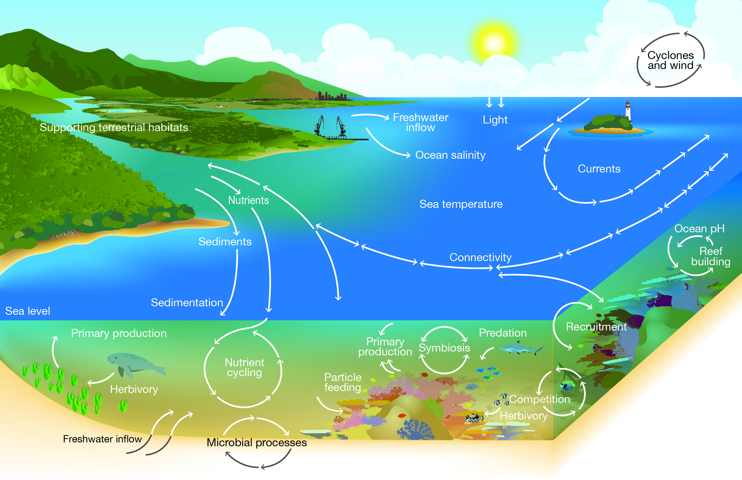
Figure 3.1 Major physical, chemical and ecological processes
The health of the Great Barrier Reef ecosystem is assessed by considering its physical, chemical and ecological processes as well as the condition of its supporting terrestrial habitats. Outbreaks of pests and diseases are also considered as a guide to overall health.

Current condition and trends of physical processes

Currents
Key message: There is evidence of intensified flow and accelerated warming in the East Australian Current.
The Great Barrier Reef is part of a larger system of ocean circulation throughout the Pacific Ocean, which delivers nutrients and larvae from other regions as well as deep water into the Great Barrier Reef Region (the Region). Currents and upwellings are recognised as key ecological processes that contribute to the Reef’s outstanding universal value.³
At the largest spatial scale (thousands of kilometres), major oceanic currents of the Coral Sea affect patterns of connectivity and the temperature of the Region’s waters.⁴ At very small scales (centimetres to metres) turbulence can affect the larval settlement patterns of a range of species such as corals.⁴ While surface currents are primarily driven by wind, deeper ocean currents are mainly driven by relative densities of seawater, affected by salinity and temperature.⁴
Upwelling of cold, nutrient-rich waters to the sea surface creates ‘hotspots’ of marine primary production.⁴ In the Great Barrier Reef, upwelling intrusions include those on the central Great Barrier Reef which are enhanced during consistently low winds.⁵ During these conditions, the southward-flowing East Australian Current flows faster, lifting the thermocline closer to the surface, spilling cooler waters onto the shelf.^{4,5,6}
The Outlook Report 2009 reported there was little information about any changes to ocean currents on the Great Barrier Reef. Since then there has been increasing evidence of intensified flow and accelerated warming in the East Australian Current adjacent to the Region’s southern coast (see Section 6.3.1).⁷ This current is transporting greater volumes of warmer water southward, carrying larvae and juveniles with it.⁸ There remains little information about the Hiri Current which moves north along the coast in northern Great Barrier Reef waters.^{7,9,10}

Cyclones and wind
Key message: Between 2005 and 2013, there were six category 3 or above cyclones in the Region.
Key message: There is emerging evidence of increases in wind strength Australia-wide.
Cyclones regularly affect tropical marine and terrestrial habitats at regional and local scales. In addition to strong winds and rain, the powerful waves generated during cyclones can seriously damage habitats and landforms, particularly coral reefs and shorelines.^{4,11,12,13} It is estimated that cyclone damage has been one of several factors in coral cover loss in the Region.¹⁴
Between 2005 and 2013, there were six category 3 or above cyclones that affected the Great Barrier Reef (Figure 3.2).^{15,16} Impacts on the ecosystem were most severe in the southern half of the Region, causing significant damage to coral reef habitats, particularly due to cyclone Hamish in March 2009 which affected more than 50 per cent of the coral reefs in the Region.^{15,16}
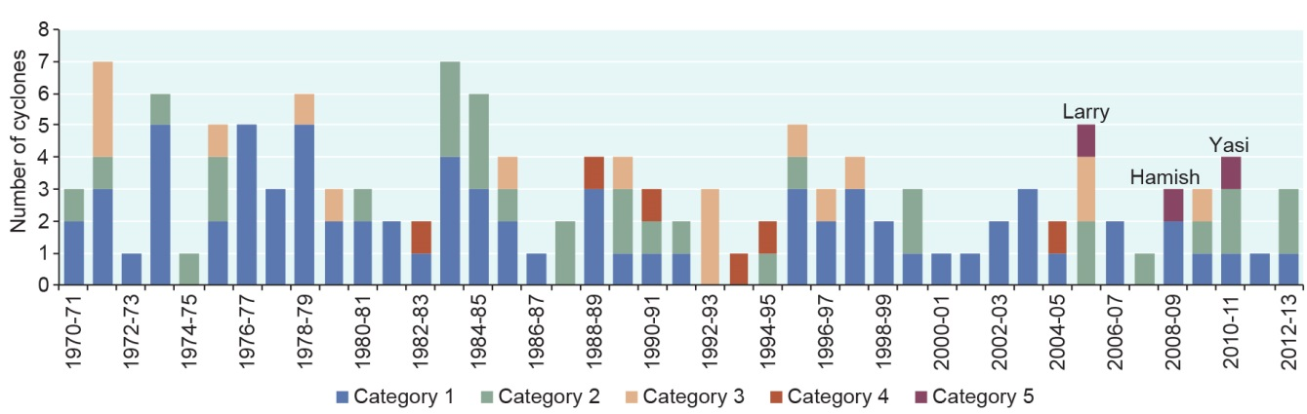
Figure 3.2 Number and severity of cyclones, 1970–2013
A number of severe cyclones have affected the Region over recent years. Source: Bureau of Meteorology¹⁷

In February 2011, cyclone Yasi crossed the Queensland coast, one of the most powerful cyclones to have affected Queensland since records commenced.^{18,19} Previous cyclones of comparable intensity include the 1899 cyclone Mahina in Princess Charlotte Bay, and the two cyclones of 1918 at Mackay (January) and Innisfail (March). The damage from cyclone Yasi was extensive. Overall, some level of coral damage was reported in over 89,000 square kilometres of the Region. Approximately 15 per cent of the Region’s total reef area sustained some coral damage and six per cent was severely damaged. Most of the damage occurred between Cairns and Townsville.¹⁶
In April 2014, category 5 cyclone Ita entered the northern area of the Region, crossing the coast near Cape Flattery. The impacts of cyclone Ita were being assessed at the time of writing.

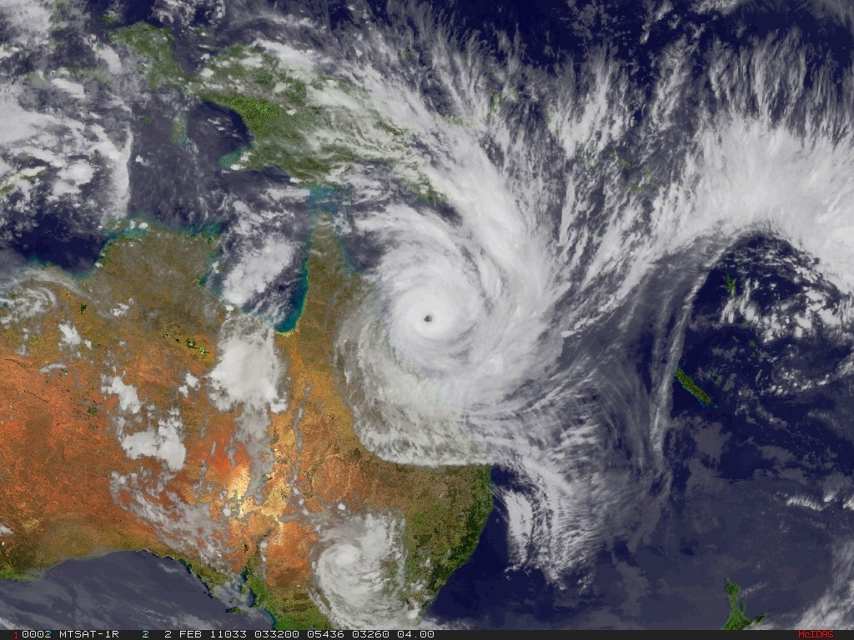
Category 5 cyclone Yasi affected much of the central Great Barrier Reef in February 2011.
Source: Satellite image originally processed by the Bureau of Meteorology from the geostationary meteorological satellite MTSAT-2 operated by the Japan Meteorological Agency

Wind also plays a role in the marine ecosystem; in particular, it can cause substantial changes in the shape of islands and coastlines and can affect ocean currents.⁴ There is emerging evidence of increases in wind strength Australia-wide, but little information specific to the Region.²⁰ Changes in wind patterns may have consequences for inshore ocean turbidity through resuspension of sediments²¹; island formation²²; and the distribution of planktonic larvae²³.
Warming sea temperatures have implications for cyclones and wind (see Section 6.3.1).²⁴

Freshwater inflow
Key message: Large volumes of freshwater flowed into the Region in the past five years, including some record flows.
The rivers and streams flowing into the Region drain an area of 424,000 square kilometres along the east coast of Queensland — the Great Barrier Reef catchment. There are six major natural resource management catchment regions: Cape York, Wet Tropics, Burdekin, Mackay Whitsundays, Fitzroy and Burnett Mary. While the Wet Tropics rivers (from Ingham to about Port Douglas) deliver water to the Region almost all year, in other catchments there is little or no flow most of the time, interspersed with major floods usually during the summer monsoon season and on decadal timescales.²⁵
In the Outlook Report 2009 it was reported that the flow of freshwater from 2004 to 2007 was significantly lower than the long-term average. Since that time, increased annual rainfall and floods have resulted in much greater volumes of freshwater entering the Region (Figure 3.3). Between 2008 and 2012 higher than average annual freshwater discharges were recorded for many of the major rivers, especially in southern catchments.²⁶ In 2011, discharge volumes in the Fitzroy and Proserpine rivers were the largest ever recorded.²⁶ In the Herbert River, the volume was equal to the biggest ever recorded, while the Burdekin River experienced the third biggest.²⁶
Increased freshwater inflow to the Region during flood events carries with it pulses of nutrients, sediments, pesticides and other pollutants including marine debris, which have significant effects on inshore Great Barrier Reef habitats and species.²⁷
Depending on geology and soil permeability, freshwater also enters estuaries and the sea as groundwater.²⁸ Some mangroves, saltmarsh plants and seagrasses depend on freshwater seepage.²⁸ Some marine animals, for example sea snakes, consume freshwater from submarine groundwater seepages.²⁹ Freshwater also seeps through the ocean floor from drowned river channels called ‘wonky holes’.³⁰ Wonky holes are considered important natural sources of nutrients for coral reefs³¹ and seagrass meadows³².
Changes to terrestrial habitats and infrastructure associated with development in the catchment are affecting the flow of water to the Region (see Section 6.4).

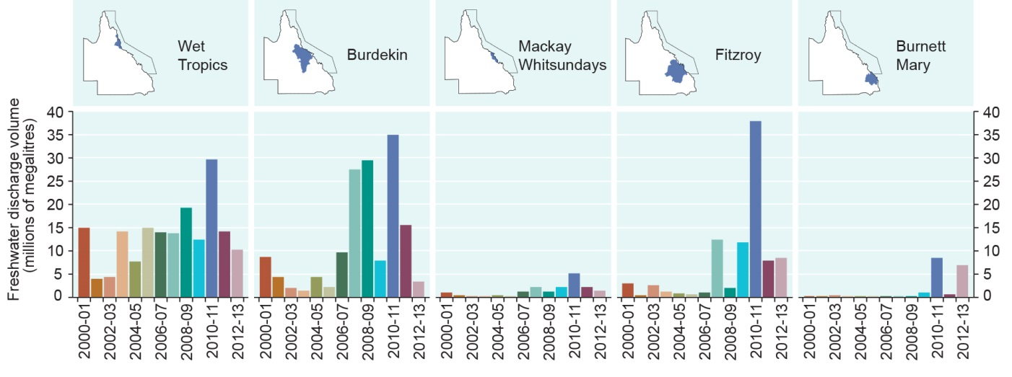
Figure 3.3 Annual freshwater discharge from major rivers, 2000–2013
Much greater volumes of freshwater entered the Great Barrier Reef lagoon between 2008 and 2012 compared to previous years. The annual discharges from the major rivers are combined for each natural resource management region. Each year is shown in a different colour and represents the discharge for the 12-month period starting in October. Source: Data supplied by Department of Natural Resources and Mines (Qld) compiled by the Australian Institute of Marine Science 2012²⁶ and McKenzie et al. 2014³³

Sedimentation
Key message: Sediment loads entering the Region are more than double those before European settlement.
Key message: Improved land management is beginning to reduce sediment input.

Sedimentation — the inflow, dispersion, resuspension and consolidation of sediments — has been a natural phenomenon in the Region since the current sea level was reached about 6500 years ago.^{34,35,36} However, exposure of the Great Barrier Reef to terrestrial sediments and resuspended marine sediments has increased since European settlement of the adjacent catchment.^{35,37,38} It is estimated that suspended sediment loads are now more than twice as high as before European settlement in the 1850s.^{39,40} These increased loads affect sedimentation processes.
Modelling of pre-European exposure to suspended sediment suggests that its effects were concentrated very close to the coast around river mouths, with the largest plume adjacent to the Burdekin River.³⁴ Modelling for the years 2007 to 2011 indicates a vastly increased area of exposure (Figure 3.4). Inshore areas continue to be exposed to the most sediment, especially areas close to river mouths.^{37,38} However, during flood events, suspended sediment may be carried offshore — as far as 100 kilometres northward for the Burdekin River plume in the 2010–11 wet season⁴¹. Longshore drift^{41,42,43,44,45,46,47}, tides and currents^{4,48,49,50,51} widely redistribute sediment along the coast and across the continental shelf.^{49,52,53,54,55} Possible increases in wind speed in the Region²⁰ are likely to cause more sediment resuspension in shallow water.²¹
Significant investments in land management practises from 2009 to 2013 have resulted in a modelled 11 per cent reduction in the average annual suspended sediment load delivered to the Great Barrier Reef.⁵⁶ However, there is likely to be a significant lag time before there are measurable and ecologically significant water quality improvements in the Region, with effects continuing for at least decades.⁵⁷
Activities within the Region that contribute to increased sedimentation and resuspension plumes include anchoring and vessel wash from shipping, dredging, and disposal of dredge material. Recent modelling suggests resuspended sediment could potentially travel considerably further than previously understood.^{58,59}
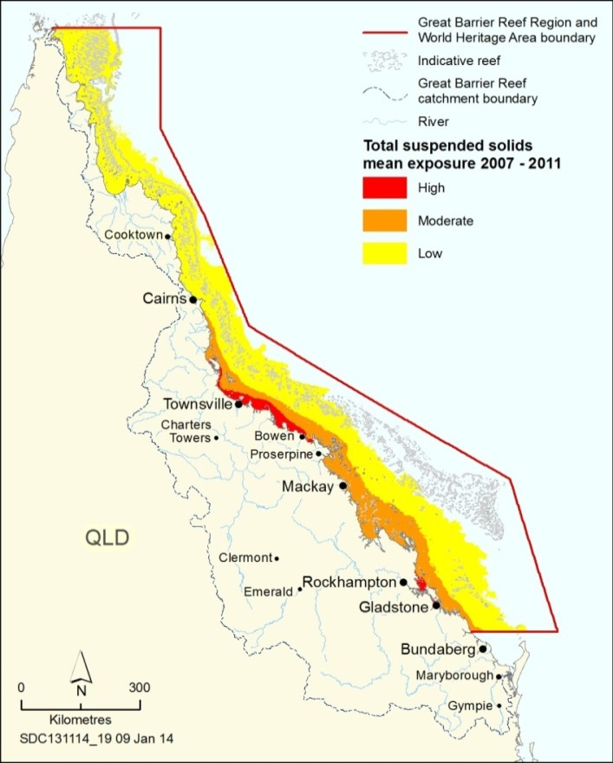
Figure 3.4 Exposure to suspended sediments, 2007–2011
The assessment classes (high, moderate and low) are relative and derived from a combination of scaled river load data and flood plume frequency analysis from remote sensing data. The mean of the five annual distributions was selected as a way of factoring in inter-annual variability in river discharge, although it is recognised that this period was characterised by several extreme rainfall events. Source: Brodie et al. 2013⁶⁰

Sea level
Key message: The fastest rates of sea level rise in Australian waters are in northern areas.
Sea level is an important determinant of species and habitat distribution and affects foraging and reproduction activities of many species.^{61,62,63} It varies naturally day to day with the tides and over longer time scales with the El Niño–Southern Oscillation. In addition, cyclonic winds can cause storm surges — onshore rises of water above the predicted tide.⁶⁴
Over the past 100,000 years sea levels have risen and fallen many times, shifting the position of reef growth on the continental shelf.⁶⁵ The role of sea level in the geomorphological evolution of the Great Barrier Reef is recognised in its world heritage listing.³
Sea level is rising in Australian waters, with the fastest rises being recorded in northern areas.^{64,66} In the Region, sea level is rising by an average of about 3.1 millimetres per year.^{64,67,68} Sea level data presented in the Outlook Report 2009 showed the Townsville area had experienced an average increase of 1.2 millimetres per year between 1959 and 2007 and the rate may be increasing. Since then, the rate of increase has accelerated, peaking in 2010 at 125 millimetres above the long-term (1959–2012) average (Figure 3.5).⁶⁹ Sea level at Townsville has now risen an average of 2.6 millimetres per year from 1959 to 2012 and an average of 11.8 millimetres per year between 2007 and 2012.⁶⁹
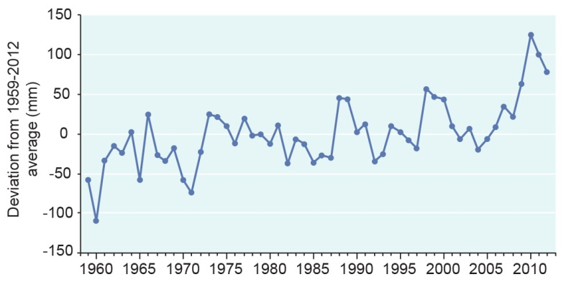
Figure 3.5 Annual average sea level, Townsville, 1959–2012
From 1959 to 2012 sea level in Townsville has varied 235 millimetres around the average for that period. Since the 1980s, the deviation from the average sea level has tended to be above the average. Source: Permanent Service for Mean Sea Level 2013⁶⁹

Most reefs in the Region will probably be able to accommodate the current rate of sea level increase as the maximum rate of reef growth is about twice this.⁷⁰ However, sea level rise is predicted to increase at a higher rate (see Section 6.3.1) and coral reef growth may not be able to keep pace.⁷¹ The shape and existence of some coastlines, cays and islands may also be affected.^{22,,72}
Even modest rises in sea level may have substantial consequences for other aspects of the Region, especially when combined with natural variability arising from the El Niño–Southern Oscillation. For example, the ability of marine turtles to rest and the survival of their eggs may be reduced if islands are inundated.⁷²

Sea temperature
Key message: The ocean has warmed substantially over the last century, with most of the warmest years in the past two decades.
Sea temperature is a key environmental factor controlling the distribution and diversity of marine life.⁷³ It is critical to reef building and is one of the key variables that determine coral reef diversity and the north-south limits of coral reefs.⁷⁴ The average sea surface temperature in the Coral Sea has risen substantially over the past century. Since instrumental records began, 15 of the 20 warmest years have been in the past 20 years⁷⁵ (Figure 3.6 and see Section 6.3.1).
When temperature limits are exceeded, physiological processes may break down.^{75,76} For reef habitats, the most critical mechanism affected is the symbiotic association between animals (such as corals and clams) and the microscopic algae which live within their tissues and provide much of their nutrition through photosynthesis. If sea temperatures exceed a certain threshold these algae are expelled — an effect known as bleaching.⁷⁷
Severe bleaching is linked to climate phenomena such as El Niño–Southern Oscillation which results in sustained elevated regional temperatures. At least nine mass bleaching events have affected the world’s reefs since 1979. The Great Barrier Reef was most severely affected by the 1998 and 2002 events⁷⁸ but was also affected by bleaching in 2006.⁷⁹
In the Region, the combination of other environmental variables such as cloud cover⁸⁰ and wind⁸¹ have meant recent periods of elevated sea temperature have not been as prolonged as those of the late 1990s and early 2000s and have not resulted in widespread coral bleaching.
Sea temperature plays a role in ocean circulation as cooler, denser water sinks to the bottom and warmer, less dense water rises.⁷⁵ It also provides additional energy to the formation of tropical cyclones.²⁴
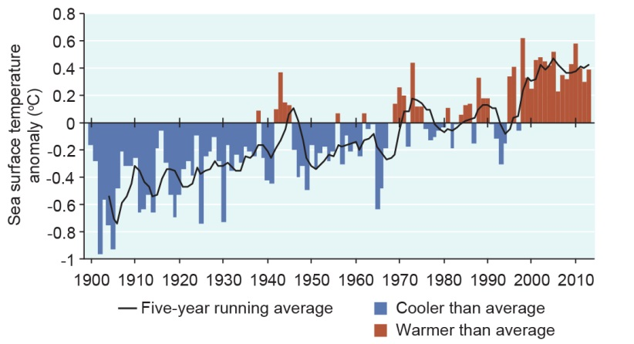
Figure 3.6 Sea surface temperature anomalies for the Coral Sea, 1900–2013
The hottest five-year running averages of sea surface temperature have all been in the last 15 years. This graph uses the 1961 to 1990 average as a baseline for depicting change. Source: Bureau of Meteorology 2014⁸²

Light
Key message: It is likely that light availability has decreased substantially in the inshore areas of the southern two-thirds of the Region.
The availability of light is central to the health and productivity of seagrasses and other plants as well as the symbiotic relationship between some animals (for example, corals and clams) and algae. Levels of available light control the depth range of marine plants (for example, seagrasses⁸³ and algae) as well as animals which rely on photosynthesis through symbiosis.⁸⁴
The rate at which light decreases in the water column is determined by both depth and water turbidity.⁸⁵ As a result, light becomes limiting at shallower depths in inshore, more turbid areas compared to offshore habitats which have less turbid water. Turbidity is affected by a number of external factors, such as sediment becoming resuspended by wind²¹, currents and tides⁸⁶; nutrients from land-based run-off⁸⁵; as well as activities within the Region such as anchoring⁸⁷, vessel wash⁸⁷, dredging and the resuspension of dredge material⁸⁸. Nutrients from land-based run-off can increase the growth of phytoplankton resulting in a decrease in the ambient light levels.⁸⁵ Extended periods of cloud cover also reduce light availability for the ecosystem.³³
Turbidity is very variable from year to year (Figure 3.7) and week to week (Figure 3.8). In recent years turbidity is likely to have increased due to extreme flooding and the resuspension of sediment associated with storms and cyclones.⁸⁹
A comparison of secchi disc readings from the 1928–29 British Museum Expedition to Low Isles with more recent readings from nearby sites offshore from Cairns suggest a 50 per cent decline in mean water clarity,⁹⁰ although there was less data in the 1928–29 sample.
Land-based run-off strongly affects light availability, not only in inshore areas but can extend up to 80 kilometres from the coast.⁹¹ Given the increased input of sediments since European settlement (Section 3.2.4), it can be assumed that light availability has decreased substantially in inshore areas in the southern two-thirds of the Region.

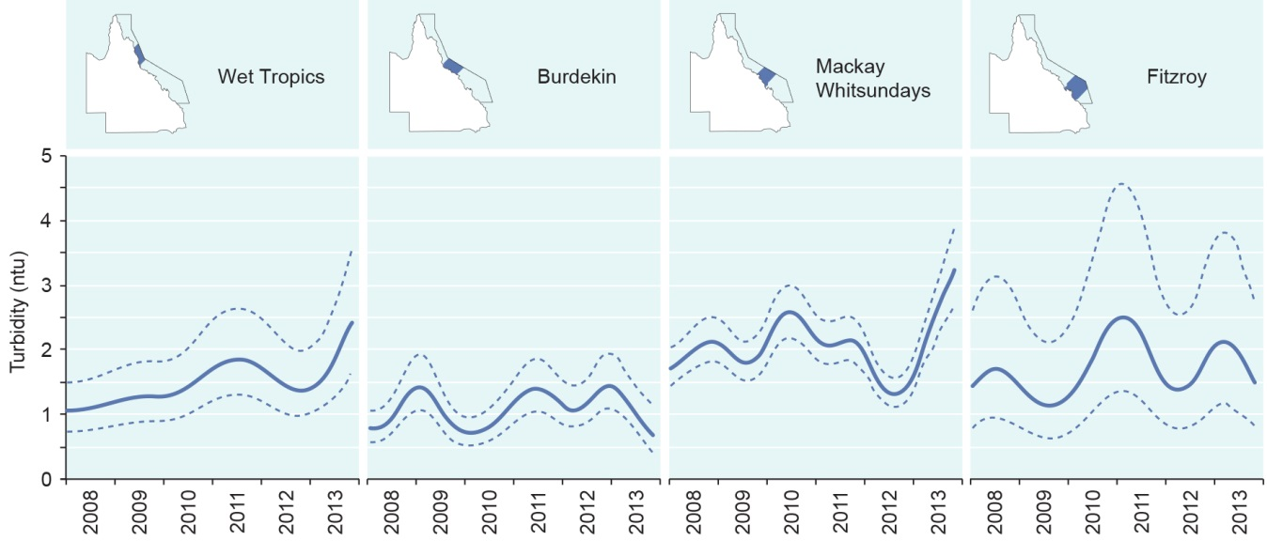
Figure 3.7 Regional trends in turbidity of inshore areas, 2008–2013
The solid line curves represent regional trends bounded by dashed lines depicting 95 per cent confidence intervals. (Data to October 2013). Data presented relate to turbidity levels in inshore areas of mapped regions. Source: Thompson et al. 2014⁹²

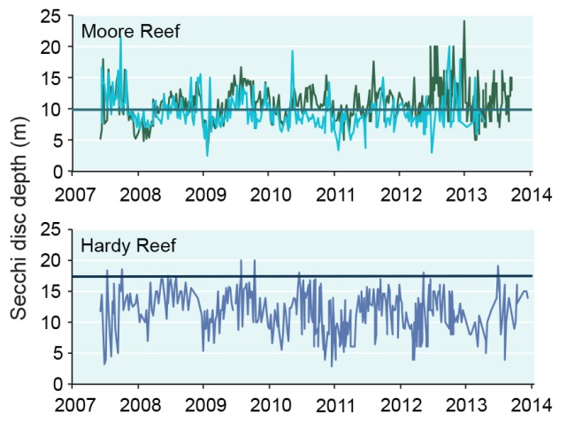
Figure 3.8 Water clarity at two tourism sites, 2007–2013
Clear water is a major motivation for people to visit the Reef. Secchi disc depth data collected voluntarily by tourism operators as part of the Great Barrier Reef Marine Park Authority’s Eye on the Reef program from Moore Reef near Cairns (two operators), and Hardy Reef in the Whitsundays (one operator) provide an indicator of water clarity. The horizontal lines indicate the mean annual water quality trigger level for water clarity relevant to that site, based on the Water Quality Guidelines for the Great Barrier Reef.⁹³ Source: Great Barrier Reef Marine Park Authority 2014⁹⁴

Current condition and trends of chemical processes

Nutrient cycling
Key message: Most inshore areas of the southern two-thirds of the Region are exposed to elevated nutrient concentrations.
Nutrient cycling plays a critical role in maintaining ecosystem health. Most nutrient concentrations (for example nitrogen and phosphorus) in the open ocean are naturally low.⁹⁵ Low concentrations of nitrates, in particular, severely limit plant productivity. Coral reefs farther from land are able to survive in low nutrient waters by having a high level of nutrient cycling.⁹⁵ For reefs nearer land, additional nutrients are derived naturally from terrestrial sources. An overabundance of nutrients increases plant growth, resulting in effects like algal blooms and increased macroalgal growth, which can affect ecosystem health⁹⁶, for example through reducing available light for seafloor communities and trapping sediment.
Modelling of pre-European exposure to dissolved inorganic nitrogen from river discharges suggests that it was concentrated very close to the coast around river mouths, with the largest plume adjacent to the Wet Tropics rivers and the Burdekin River.³⁴ Since European settlement in the adjacent catchment, nutrient loads entering the Region are estimated to have increased⁴⁰ almost two-fold for both nitrogen and phosphorus.⁹⁷ Most inshore areas of the southern two-thirds of the Region are now exposed to nutrients at elevated concentrations⁹⁸ (Figure 3.9), disrupting nutrient cycling in the ecosystem.
Recent investments in improving land management practices from 2009 to 2013 have resulted in a modelled 16 per cent reduction in the average annual dissolved inorganic nitrogen load leaving the catchment.^{56,99} Long-term benefits are expected to follow for the Region’s ecosystem.^{98,100} However, the lag between improved practices and environmental benefits is likely to mean that the nutrient cycle will continue to be affected for some decades.⁵⁷
Offshore and remote northern areas of the Region are believed to be mostly unaffected by increased nutrients and hence nutrient cycling is assumed to be functioning naturally.
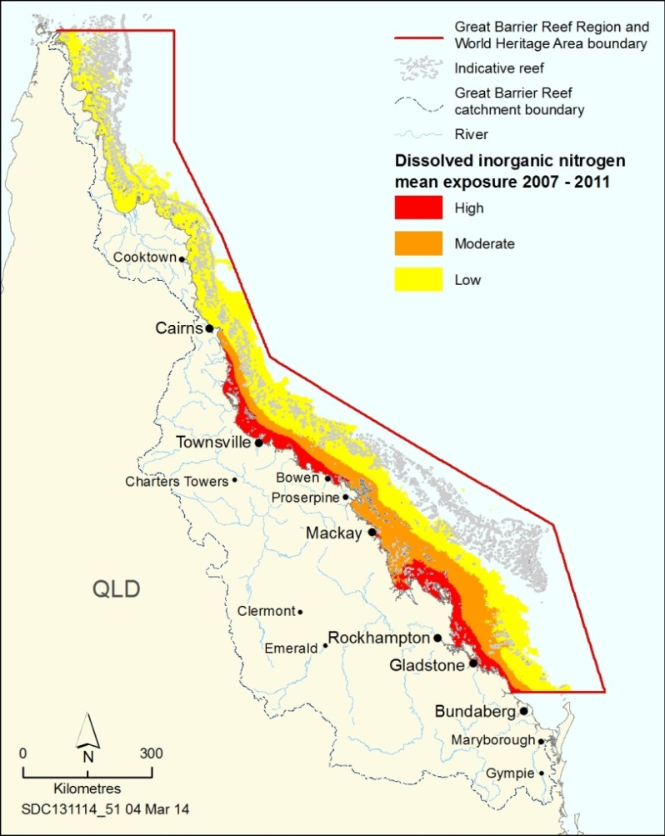
Figure 3.9 Exposure to dissolved inorganic nitrogen, 2007–2011
Nutrients, such as dissolved inorganic nitrogen, are now present in the ecosystem at far higher concentrations than those likely to have been present prior to European settlement. The assessment classes (high, moderate and low) are relative and derived from a combination of scaled river loads data and flood plume frequency analysis from remote sensing data. The mean of the five annual distributions was selected as a way of factoring in inter-annual variability in river discharge, although it is recognised that this period was characterised by several extreme rainfall events. Source: Brodie et al. 2013⁶⁰

Ocean pH
Key message: Decreasing ocean pH is likely to affect the ecosystem Reef-wide in the future.
It is estimated that an increase in the amount of carbon dioxide absorbed by the ocean has already caused a decrease in global ocean acidity of 0.1 pH units compared to the long-term average.^{101,102} From a current pH of 8.1¹⁰², it is predicted that the ocean could fall to a pH of about 7.6 by 2100, with slight regional variation.⁶⁶
The pH of the ocean is of vital importance to many marine animals and plants. Decreases in ocean pH can have a range of impacts on species and habitats (see Section 6.3.2) and it is predicted that the ecosystem will be affected on a Reef-wide scale. For example, more acidic water can reduce the ability of some animals to grow strong calcium carbonate shells or skeletons^{101,103} (Section 3.4.8). The consequences of decreases in pH and other changes in ocean chemistry are just beginning to be understood.¹⁰²

Ocean salinity
Key message: Recent floods have caused periods of reduced salinity in inshore areas and beyond.
The salinity of Great Barrier Reef waters can vary from zero in the surface waters near river mouths to 37 parts per thousand, but overall it remains generally stable around an average of 35 parts per thousand.¹⁰⁴ Inflow from the creeks and rivers in the Great Barrier Reef catchment naturally forms a thin layer of freshwater on the surface of the heavier seawater and during floods, this layer may extend to mid-shelf reefs.^{44,105,106,107} This can result in extensive fluctuations in ocean salinity, especially in intertidal and shallow habitats. Heavy rainfall directly on the ocean can also reduce surface salinity. Salinity is a key driver of ocean circulation.⁴
Abnormally large freshwater inflows can have negative effects, for example low salinity bleaching and mortality in corals¹⁰⁸. Much of the inshore area of the Region has experienced freshwater events between 2001 and 2011 (Figure 3.10). Identifying the effects attributable to decreased salinity is confounded by the effects of pollutants carried by the waters, and by other concurrent processes, for example cyclone damage.⁹²
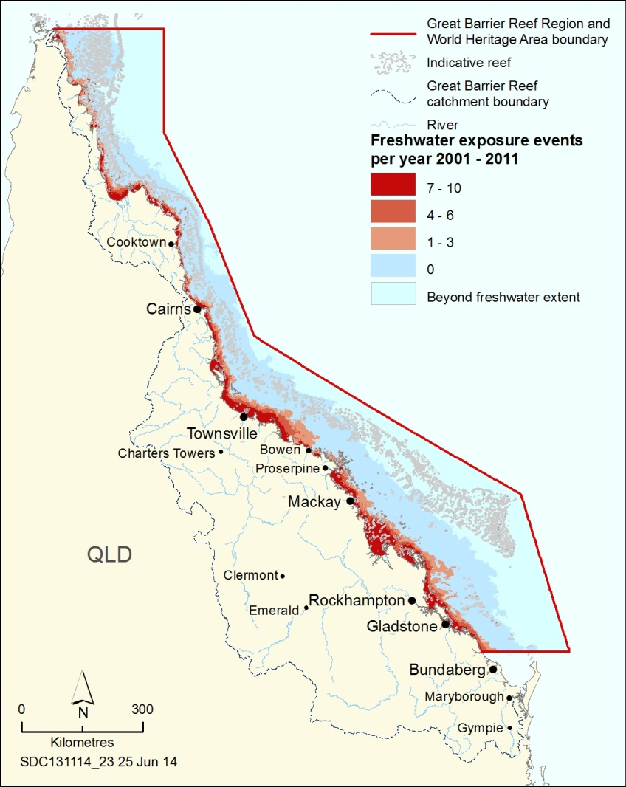
Figure 3.10 Freshwater exposure, 2001–2011
Frequency of freshwater plumes in the Region between 2001 and 2011 modelled from remotely sensed concentrations of dissolved organic matter (a proxy for freshwater). Gradings are based on the number of times a freshwater plume with a measured concentration of salinity less than 30 (+/- 4) parts per thousand was observed in any given year over the 10-year period. Gradings are expressed as: low (1–3 events), medium (4–6 events) and high (7–10 events) where the maximum frequency of events observed was 10. Source: Maynard et al. in preparation¹⁰⁹

Current condition and trends of ecological processes

Microbial processes
Key message: Microbial processes are responsive to changes in environmental conditions.
Microbes, including viruses, bacteria and fungi, are estimated to account for more than 90 per cent of the ocean’s biomass and live in a wide range of habitats.^{110,111} Microbial processes play a central role in supporting and maintaining many other forms of life. These processes regulate the composition of the atmosphere, influence climate, recycle nutrients, and decompose pollutants.¹¹² Despite their importance, microbial processes are poorly understood.¹¹³ There are some observable changes in bacterial levels in the Region’s water column and in benthic organisms, such as the frequency of diseases (Section 3.6.1) and amounts of marine snow — a continuous shower of mostly organic detritus falling from the upper layers of the water column.^{114,115,116}
Microbial processes are very responsive to organic and inorganic nutrient concentrations and changes in environmental conditions such as temperature, pH, salinity and oxygen.^{113,117} In recent decades, there has been a global increase in reports of disease in marine species, linked to increasing temperatures and thermal stress.¹¹⁷

Particle feeding
Key message: The process of particle feeding is likely to have deteriorated.
Particle feeding, including filter feeding and detritivory, is undertaken by a wide range of animals from the very large (whale sharks and some whales) to the microscopic (copepods). Most marine invertebrates, such as sea cucumbers, scallops, sponges, corals and many crustaceans (for example prawns and some crabs) are particle feeders.⁹⁵ They are an important part of the energy and nutrient cycle, feeding on detritus, bacteria, plankton and particulate nutrients.⁹⁵ Ecosystems that have become severely degraded through high nutrient levels, anoxia or acidification are almost entirely populated with benthic particle feeders.¹¹⁸
The clay fraction of sediments can affect particle feeders as their feeding mechanisms are readily choked by these sediments or are kept clean at a high metabolic cost.^{114,119,120} Turbidity increases the rate of particle feeding by corals.¹²¹
Hard coral cover is estimated to have halved in the last 30 years¹⁴, which is likely to have affected levels of particle feeding. Some other particle feeding species have been or continue to be commercially harvested, such as prawns, scallops and some crabs. They range from being considered ‘sustainably fished’ such as banana prawns; to ‘not fully utilised by fisheries’ such as endeavour prawns; and ‘data deficient’ such as burrowing blackfish sea cucumbers.¹²² Populations of some sea cucumber species do not appear to have recovered from previous harvesting (see Section 8.3.3).^{118,123}

Primary production
Key message: Some seafloor primary producers, such as seagrass have declined; others such as macroalgae may be more abundant.
Most food webs are based on primary production — the production of food by photosynthesis using energy from the sun. It is closely linked to concentrations of available inorganic nutrients.¹²⁴ In tropical marine ecosystems such as the Great Barrier Reef, primary production is undertaken by plants such as macroalgae, turf algae, seagrasses and mangroves, and, in large part, by phytoplankton and symbiotic algae in corals and some other animals (such as giant clams).
The presence of elevated levels of chlorophyll a, together with extensive phytoplankton blooms following the discharge of nutrient-rich flood waters, suggests open water (pelagic) primary production in inshore areas of the southern two-thirds of the Region is significantly affected by elevated nutrient loads.^{46,124,125} This in turn affects zooplankton populations, such as larvae of the crown-of-thorns starfish (Section 3.6.2).¹²⁵
Certain primary producers, such as seagrasses, have declined in some areas, resulting in a loss of primary production, especially in central and southern areas.^{83,126} However, there is evidence of increased macroalgae at some reefs¹²⁷, indicating a possible increase in primary production.

Herbivory
Key message: Declines in dugongs are likely to have affected herbivory in the Region.
Consuming plants for food (herbivory) is a key process for the health and resilience of tropical marine ecosystems, including coral reefs^{96,128,129}. Herbivores have a particularly important role in maintaining reef ecosystems — without their constant presence, many reefs would be rapidly overtaken by algae that compete with corals for space to establish and grow.^{96,128}
Fish are important herbivores in the coral reef habitats of the Great Barrier Reef.¹²⁹ Studies on the Great Barrier Reef suggest that populations and diversity of herbivorous fishes continue to be sufficient to control algal growth on most offshore reefs^{128,130}, in part because there is minimal direct pressure on their populations.
Dugongs and green turtles are important herbivores in seagrass meadow habitats.^{131,132,133,134} Dugongs forage mainly on seagrass, and green turtles on seagrass and macroalgae. The dugong population has declined significantly in the southern two-thirds of the Region¹³⁵ but remains stable for the area north of Cooktown (see Section 2.4.17). Populations of green turtle in the Region are still affected by legacy impacts of commercial harvesting (see Figure 2.1). The southern population is now increasing while the northern population is showing early signs of decline after previous significant increases (see Section 2.4.11). Population changes affect levels of herbivory in the Region which can in turn affect seagrass community structure and productivity.¹³⁶
Levels of herbivory are likely to have been affected by recent broadscale losses in seagrass abundance (see Section 2.3.4).³³

Predation
Key message: Decreased predator populations affect the process of predation.
Predation (animals consuming other animals) has a fundamental influence on marine ecosystems by controlling the abundance of many prey animals and through a range of cascading effects through the food web.¹³⁷ Predators in coral reef ecosystems include most big bony fishes and sharks, as well as a wide array of smaller fishes and invertebrates, seabirds, some marine turtles, sea snakes, crocodiles and some marine mammals.¹³⁸
While little is known about trends in the ecological process of predation in the Region, the condition of predator populations can provide an indication of levels of predation and the condition of the supporting food web. The Outlook Report 2009 reported on research indicating that at some locations on the Great Barrier Reef there has been a marked decrease in populations of coral trout and some reef shark species both of which are targeted by fishing activities.¹³⁹ Over the last five years none of the predator species monitored have shown strong recovery and many remain at reduced numbers or their population sizes are poorly understood. Examples of effects on predator populations include:
- Coral trout numbers continue to occur in lower densities on reefs open to fishing compared to similar reefs closed to fishing (see Section 2.4.8).¹⁴⁰
- Of the four highest ecological risk predatory fishes taken in the East Coast Inshore Fin Fish Fishery¹⁴¹, two (king threadfin and barred javelin) have an undefined stock status and the other two (black jewfish and giant queenfish) were not assessed in the 2012 Queensland stock assessment¹²².
- The Queensland shark control program has targeted predators such as tiger sharks since its inception in 1962.
- Many sharks are incidentally caught in commercial fisheries.^{138,142}
- There are declining populations of some seabird populations (see Section 2.4.13) and suspected declines in some dolphin species (see Section 2.4.16).
The partial recovery of crocodile and loggerhead turtle populations will have increased predation by those species.
[Photograph of a shark. Copyright Matt Curnock. Caption: Predation has a fundamental influence on the ecosystem.]

Symbiosis
Key message: Symbiotic relationships are likely to have deteriorated in the southern two-thirds of the Region.
Symbiosis is the interdependence of different organisms that benefits one or both participants. There are a wide range of symbiotic relationships in the Great Barrier Reef including those that are mutually beneficial (mutualism); beneficial for one organism without affecting the other (commensalism); and beneficial for one organism to the detriment of another (parasitism).
One of the most important symbioses in the Region is between corals and microscopic algae.¹⁴³ This symbiosis is an example of mutualism. The algae photosynthesise like other green plants, however up to 95 per cent of the nutrients produced are used by the coral host organism.^{143,144} In return, the coral provides the algae with a safe habitat. An example of commensalism is the association between the Chelonibia barnacle and its marine turtle hosts.¹⁴⁵ Isopod crustaceans gaining shelter and food by living on the gills of many reef fishes is an example of parasitism.¹⁴⁶ High numbers of parasites can be an indicator of poor environmental conditions.¹⁴⁷
Very little is known about the condition and trend of most symbiotic relationships in the Region. Based on the overall condition of the ecosystem, it is likely they are in good condition in the northern third of the Region. The poorer overall condition of the ecosystem in the southern two-thirds of the Region¹⁴⁸ may have affected symbiotic processes. The extent of the effect would depend on the individual species involved. In particular, the coral–algal symbiosis will have been significantly affected by the decline in hard coral cover (see Section 2.3.5) and thermal stress events (resulting in coral bleaching) (Section 3.2.6).^{149,150,151,152,153}

Recruitment
Key message: Recruitment is reduced for many key species.
While not included in the Outlook Report 2009, recruitment is an important ecological process that contributes to the replenishment of populations and to processes such as productivity, reef building and habitat connectivity.¹⁵⁴ The sustainability of a population relies on sufficient individuals being recruited through their life history stages and into the adult population. The global significance of some of the Reef’s recruitment processes, including coral spawning, marine turtle and seabird nesting, and humpback whale calving is recognised as a key attribute of its outstanding universal value.
Although poorly understood, recruitment processes for many species are likely to be functioning well across most of the Region. However, there are some species and groups of species which are known to be affected by poor recruitment.
For coral reefs, a key habitat of the Region, the apparent lack of recovery of many severely degraded reefs in the inshore southern two-thirds of the Region is partly due to poor coral larval recruitment and low juvenile survival.¹⁵⁵ Between 2010 and 2011, there was a 43 per cent decline in recruitment of inshore corals.⁸⁹ This continued from a general decrease since 2007, although there were a few isolated recruitment pulses.⁸⁹ Surveys of the 2011 recruitment season recorded the lowest number of settled corals since the surveys began in 2005.⁸⁹ As coral larvae need hard surfaces to settle on, increases in macroalgae (see Section 2.4.3) are likely to have affected coral recruitment in some areas.¹⁵⁶ Increased sedimentation (Section 3.2.4) inhibits the settlement of coral and smothers newly settled recruits.^{85,156,157} Predicted changes in ocean pH are likely to affect the settlement rates of coral larvae and the crustose coralline algae that provide important settlement substrate.¹⁵⁸
Fishing in spawning aggregations affects recruitment of the aggregating species, with potentially long-term effects.¹⁵⁹ Given the longevity and late sexual maturity of many aggregating fish species, the effects of fishing in spawning aggregations may not be evident for many years — increasing the risk of overexploitation.¹⁵⁹ There is limited information about the status of spawning aggregations in the Region. However, declines in some fish species (see Section 2.4.8) and the changes in fish abundance between zones open and closed to fishing^{139,160,161,162} indicates that recruitment is likely to have been affected in areas open to fishing.
Broadscale losses of seagrass meadows are likely to have affected both the recruitment of seagrass and a range of other species that rely on the habitat as nursery grounds^{163,164} or for food — for example the availability of seagrass is a key factor in the reproductive rate and successful recruitment of dugongs and green turtles (see Chapter 2).¹⁶⁵ For slow-breeding species that are in low abundance, such as dugongs^{166,167}, recruitment of juveniles into the adult population is a key part of their recovery.
For green and loggerhead turtles there is reduced recruitment of juveniles into the foraging stock¹⁶⁸ and reduced recruitment rates of first-time nesting females into the nesting stock.^{169,170}
Deteriorating recruitment has been evident in some seabird populations. Some years have seen almost complete reproductive failure of the wedge-tailed shearwaters in the Capricorn–Bunker group of islands. This is likely due to a decreased growth rate of chicks as a result of a reduced ability for adults to supply food, linked to higher than normal sea surface temperatures.¹⁷¹ This directly affects the level of recruitment of juveniles into the adult population.

Reef building
Key message: Declines in coral cover have likely affected the contribution of coral to reef building.
Only a small proportion of a coral reef is living coral — the remainder is coral-based pavement, boulders, fragments, beach-rock accretions and sediment.¹⁷² Reef building is the net result of processes that form calcium carbonate (calcification) and the physical, chemical or biological erosion that removes it. The formation of calcium carbonate skeletons by living coral is the primary source of calcification, however corals are only one of a number of groups that contribute to reef construction.¹⁷² Others include molluscs, crustaceans, foraminifera and red and green algae. Many of the organisms that calcify at high rates benefit from photosynthesis by symbiotic algae (Section 3.4.6).¹⁷³ The rate of deposition of calcium carbonate is dependent on light (Section 3.2.7), temperature (Section 3.2.6) and the availability of carbonate ions in the water column.¹⁷⁴
Increasing sea temperature and ocean acidification are likely to be contributing to reduced calcification rates of corals throughout the Region.^{101,175} Skeletal records of massive corals from the inshore Great Barrier Reef indicate that between 1990 and 2005 there was an 11 per cent decline in calcification.^{101,176} This is the fastest and most severe decline in at least 400 years.¹⁰¹ There is no information on more recent trends.
The impact of future changes in temperature and ocean acidification on the process of calcification is uncertain. Decreasing ocean pH has an increasing negative effect on the calcification process and thus progressively slows the process of reef building.^{101,174,177} However, the impact varies between coral species as well as between organisms.¹⁷⁸ The predicted concurrent warming of the oceans speeds up the calcification process — potentially counteracting to some extent the negative effects of decreasing ocean pH at some reefs.¹⁷⁹ In addition, ocean chemistry fluctuates greatly at small scales across a reef, and corals are capable of modifying their seawater carbon chemistry, thus potentially negating some of the possible large-scale impacts of climate change on reef building.¹⁸⁰
The contribution of coral to the reef building process is likely to be higher in the northern areas of the Region as coral cover remains relatively high¹⁴. The reduced amount of living coral in the southern two-thirds of the Region¹⁴ is likely to have affected its contribution to reef building processes.

Competition
Key message: There is little information about the multitude of competitive interactions.
Competition for all resources, including space, nutrients and food, is always intense in tropical marine ecosystems. This is partly because they are diverse, meaning individual species have many others to compete with, and also because the habitats are three-dimensional. Water, far more than air, is a medium that allows for high levels of biological interaction and nutrient transfer, and therefore competition.
The most studied competition that occurs on coral reefs is that between coral and macroalgae.^{181,182,183} For coral reefs to be maintained in the ecosystem there must be continual settlement and growth of juvenile corals.¹⁸¹ This recruitment may be hampered if a reef becomes overgrown by algae.¹⁸⁴ On degraded coral reefs in nutrient-rich waters, it is likely that a phase shift will occur from a coral-dominated reef to one dominated by macroalgae; this phenomena has been reported from some reefs in the Region.¹²⁷ Decreasing ocean pH is predicted to further change the balance of this competition in favour of algae, possibly as a result of changes in corals’ chemical competitive mechanisms.^{185,186}
The multitude of other competitive interactions in the Great Barrier Reef ecosystem forms a complex network; relatively few have been studied and little is known of their condition.

Connectivity
Key message: Marine species and habitats remain connected; connectivity with some terrestrial habitats is disrupted.
Ecological connectivity is the movement of species and materials across and through landscapes and seascapes. It includes processes as different as nutrient flows, migration, larval dispersal and gene flow and is important to every aspect of the Reef ecosystem.
Within the Region, there are connections between estuarine and inshore habitats and those further offshore; north–south connections between habitats; and connections between open water and seabed habitats. There are also larger-scale connections to environments outside the Region, for example the Torres Strait, Coral Sea, and Antarctica. Connectivity may be related to migration between breeding and foraging areas (for example humpback whales, seabirds and marine turtles), movement by ocean currents (for example coral spawn, fish larvae and marine turtle hatchlings) or dispersal (for example dugongs and fishes). Genetic connectivity is a crucial process in the Region’s ecosystem. Currents can play a major role in genetic connectivity for some marine animals. For example, changes to major ocean currents and other hydrodynamic features could have important effects on the dispersal and survival of tropical fish larvae.^{187,188} Genetic connectivity between some reefal areas remains strong with evidence of the larvae of two coral reef fish species transferring from areas in the Keppel Islands that have been closed to fishing to adjacent areas open to fishing.¹⁶⁰
Having functional connections between the Great Barrier Reef and adjacent land areas is very important to the Reef ecosystem, allowing water, nutrients and sediments to be transported and providing a movement corridor between feeding and breeding areas for some marine species.¹⁸⁹ For example, as many as 78 Great Barrier Reef marine and estuarine fish species use freshwater systems for part of their life cycle.¹⁹⁰ Aquatic connections between freshwater and marine environments are still functioning largely undisturbed in the Cape York area.^{25,189} In contrast, connecting waterbodies have been substantially altered in the central and southern catchment^{25,191,192,193}, mainly due to changes to hydrological flows and the construction of bunds, dams, weirs and other structures.^{189,192,193,194,195} For example, 41 impediments to natural environmental flows have been identified as affecting the internationally listed Bowling Green Bay wetland¹⁹³, and in the wider Burdekin region there are estimated to be more than 1000 obstructions to fish passage.¹⁹²
Aquatic connectivity is also provided through groundwater which can enter the Region via wonky holes — submarine groundwater discharge points (Section 3.2.3).³⁰
Connectivity between habitats can increase the resilience of the Reef ecosystem. For example, connectivity between mangroves and coral reefs provides benefits for herbivorous fish populations, which contribute to coral reef resilience by grazing on algae.¹⁹⁶ However, connectivity across seascapes can also spread macroalgae, disease, and invasive species that have the potential to affect ecosystem health.¹⁹⁷
Migration is a key component of connectivity on a broad scale. Whale migration is recognised as one of the superlative natural phenomena that contributes to the Great Barrier Reef’s outstanding universal value. A number of species of conservation concern live in the Region for only part of the year or for part of their life — this includes humpback¹⁹⁸ and dwarf minke whales¹⁹⁹; green, loggerhead and hawksbill turtles^{200,201,202}; and some seabirds²⁰³ and shorebirds. There is emerging evidence that some seabirds that nest in the Region over-winter far beyond it, for example some non-breeding wedge-tailed shearwaters have been tracked migrating from Heron Island to Micronesia.²⁰⁴ Some fish species, like marlin, are also highly mobile and travel well beyond the Region for parts of their life cycle.²⁰⁵
Threats to migratory species often occur well beyond the Region. For example, some marine turtles that nest or forage in the Region may be injured or killed, or ingest marine debris, in areas hundreds or even thousands of kilometres away.^{170,206} Similarly, migratory shorebirds may be affected by factors during other parts of their annual journey to the northern hemisphere.²⁰⁷

Current condition and trends in terrestrial habitats that support the Great Barrier Reef
Key message: Past broadscale land clearing has affected habitats that support the Reef.
The Outlook Report 2009 highlighted the loss of coastal habitats as a high risk to the long-term outlook of the Region’s ecosystem. Based on the outcomes of extensive, synthesised research since then189,208,209,210,211,212,213,214,215, supporting terrestrial habitats in the catchment have been added to the assessment of ecosystem health. The habitats are grouped into seven categories: saltmarshes; freshwater wetlands; forested floodplains; heath and shrublands; grasslands and sedgelands; woodlands and forests; and rainforests.
These habitats play a key role in supporting the Reef ecosystem, particularly by providing ecosystem services such as slowing overland water flow, trapping sediments and nutrients, and providing feeding and breeding areas for marine species. Aquatic connections directly and indirectly link land-based habitats to the marine system (Section 3.4.10). Figure 3.11 presents preliminary maps of the relative importance of areas within four basins of the Great Barrier Reef catchment to the healthy functioning of the marine ecosystem. They illustrate the particular importance of tidal and riparian habitats to the Region.

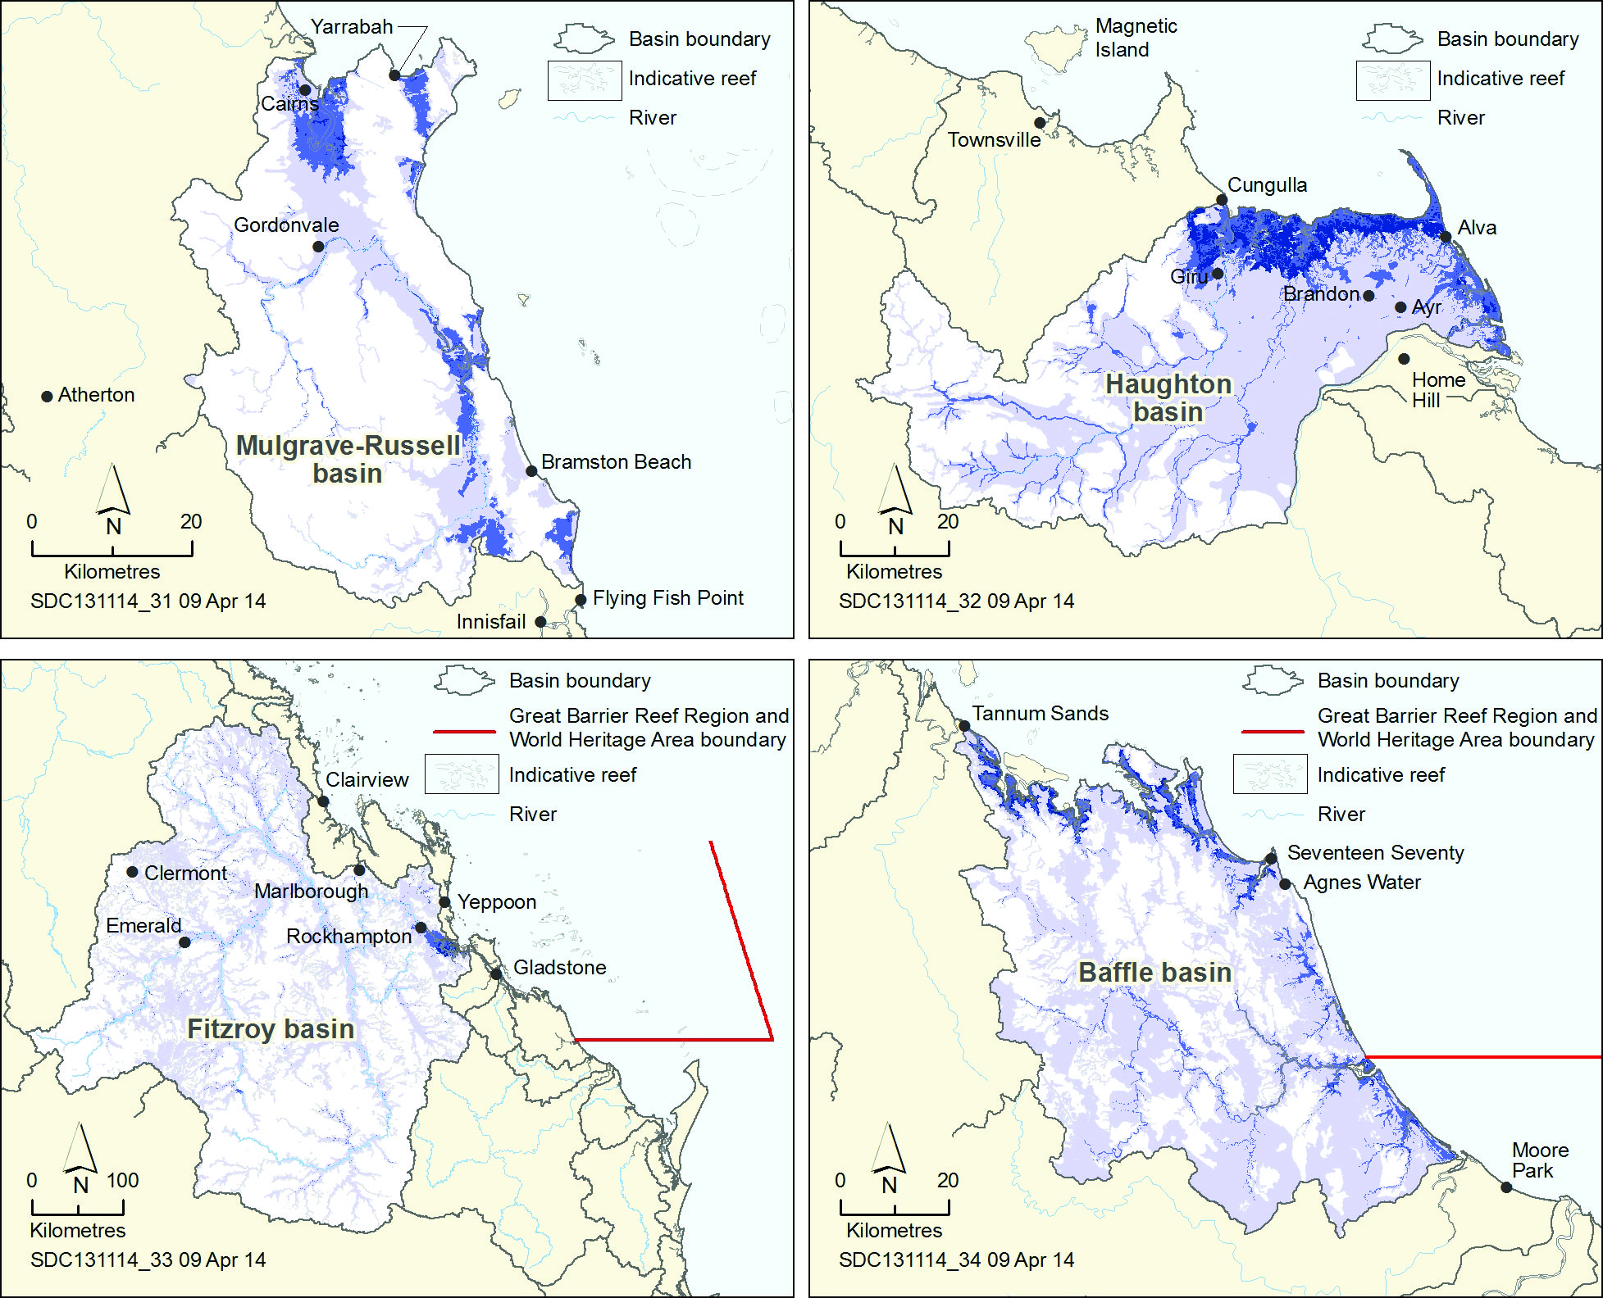
Figure 3.11 Examples of areas in catchment basins that support the Great Barrier Reef
Examples of areas of the Mulgrave-Russell, Haughton, Fitzroy and Baffle basins that support the Region. The darker areas shown are of higher importance to the healthy functioning of the Great Barrier Reef ecosystem because of their proximity to and connectivity with the Great Barrier Reef. The analysis takes into account wetlands and areas that are frequently inundated or flooded, as well as areas influenced by tidal processes and storm surges. It represents the surface level hydrology only and does not include groundwater. Source: Great Barrier Reef Marine Park Authority 2014²¹⁶

Past broadscale land clearing, principally in the southern two-thirds of the Great Barrier Reef catchment, has significantly affected each of the supporting terrestrial habitats. Clearing began in the 1870s and was undertaken to allow more intensive agricultural use. It further increased when intensive cropping on the coastal floodplain began in the early 1900s and again in the 1930s and 1940s when heavy machinery made clearing easier. The rate of clearing continued to increase until the late 1990s.¹⁸⁹ Ongoing agricultural use of these habitats also affects their ability to support the Reef ecosystem.
The majority of vegetation in the catchment now is classed as ‘non-remnant’, that is it has been modified to the extent that its natural ecological function has been modified or lost. This classification includes areas of regrowth from past clearing, some of which continues to provide functions that support the Region.¹⁸⁹ Changes in the extent of each habitat within the Great Barrier Reef catchment are summarised in Table 3.1 and mapped in Figure 3.12.

Table 3.1 Changes in the extent of supporting terrestrial habitats
Source: Great Barrier Reef Marine Park Authority, 2012¹⁸⁹ with minor updates
Supporting terrestrial habitat | Total area before European settlement (km²) | Total area remaining (km²) | Per cent remaining
Saltmarshes | 2146 | 1830 | 85 per cent
Freshwater wetlands | 1431 | 1237 | 86 per cent
Forested floodplains | 24,597 | 12,655 | 51 per cent
Heath and shrublands | 5351 | 5025 | 94 per cent
Grass and sedgelands | 12,364 | 5988 | 48 per cent
Woodlands | 105,123 | 64,592 | 61 per cent
Forests | 239,602 | 145,379 | 61 per cent
Rainforests | 26,886 | 16,744 | 62 per cent
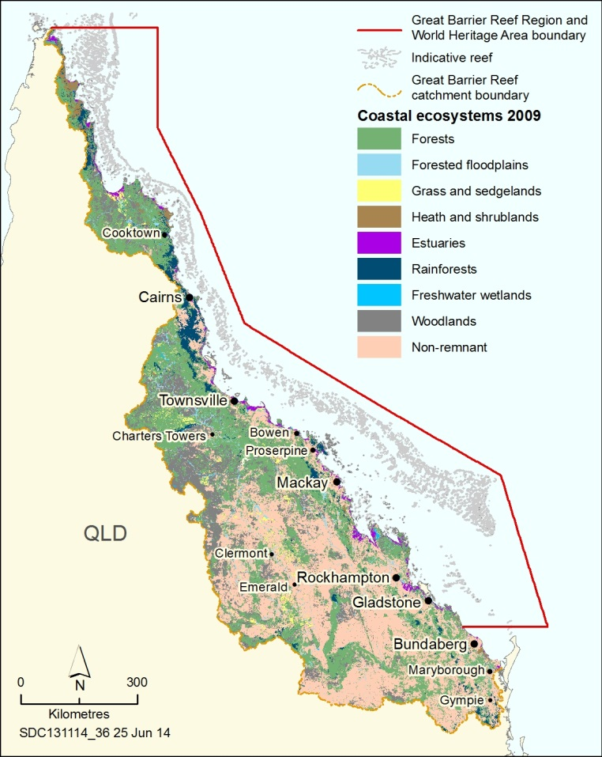
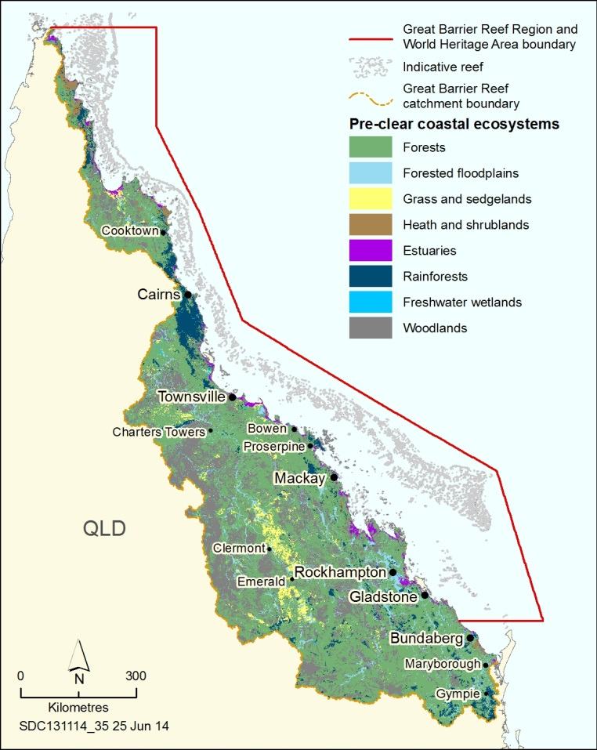
Figure 3.12 Changes in supporting terrestrial ecosystems, pre-European and 2009
Before European settlement there were extensive areas of forests, woodlands and forested floodplain interspersed with wetlands and other aquatic habitats across much of the catchment. These habitats supported the Great Barrier Reef ecosystem. An extensive area of the catchment has been changed from forest to grassland for grazing purposes and there has been a significant increase in non-remnant vegetation. Source: Great Barrier Reef Marine Park Authority, 2012¹⁸⁹

The resultant loss and modification of habitats has led to significant increases in pollutants, principally nutrients and sediments, entering the Great Barrier Reef lagoon¹⁸⁹ which has reduced the ecosystem’s ability to bounce back after impacts, especially in southern inshore areas.²¹⁷ In addition, the loss of freshwater coastal habitats has affected some ecological functions and numerous marine species, including the freshwater sawfish which is now threatened, in part, due to habitat loss.²¹⁸

Saltmarshes
Key message: Some saltmarsh areas have been modified.
Saltmarshes are an important, highly productive, interface between marine and terrestrial environments in the upper intertidal area along the length of the Great Barrier Reef coast.^{219,220} They provide feeding and breeding areas for many marine species including many commercial fish and prawn species.^{163,221} Coastal development has modified saltmarshes, affecting more than 15 per cent of the habitat in the catchment.²²² The impact is highest in areas with grazing and cropping, urban growth or large population centres.¹⁸⁹

Freshwater wetlands
Key message: Freshwater wetlands remain in many areas; many are functioning poorly.
Freshwater wetlands slow the overland flow of water and capture and recycle nutrients and sediments that would otherwise enter the Great Barrier Reef.¹⁸⁹ They are also used by some marine species for parts of their life cycle and are important dry season refuges for many species including the threatened largetooth sawfish.²²³ Freshwater wetlands at a whole-of-catchment scale are relatively intact, but many are functioning poorly due to a range of factors, including loss of connectivity, sediment and nutrient overload, changes to groundwater, and weed infestations.¹⁸⁹ In areas where ecological function of freshwater wetlands is good, water quality and coastal habitats tend to be in better condition than where it is lost or modified.²¹⁴ As the accuracy of mapping of wetlands improves, estimates of their extent and loss are refined, especially for infrequently inundated wetlands on highly developed coastal floodplains. In some coastal floodplain basins (for example the Barron, Kolan and Johnstone rivers) up to 80 per cent of freshwater wetlands have been lost.¹⁸⁹ The rate of wetland loss has slowed in recent years.¹⁸⁹
[Photograph of a freshwater wetland. Caption: Freshwater wetlands capture and recycle nutrients.]

Forested floodplains
Key message: The area of forested floodplain has been halved and much of it is grazed.
Forested floodplains help slow, capture and recycle nutrients and sediments and are important nursery areas for many species with connections to the Great Barrier Reef.¹⁸⁹ Forested floodplains also protect the soil surface from the erosive forces of rain.¹⁸⁹ Since European settlement, the area of forested floodplain has been reduced by nearly 50 per cent across the catchment.¹⁸⁹ The largest loss is in the Fitzroy basin which is estimated to have lost 6638 square kilometres of forested floodplains. Much of the remaining 12,700 square kilometres is grazed.¹⁸⁹ The habitat has been affected by clearing and land modification, changes to overland and groundwater flows, weed and pest invasion, water extraction and reduced connectivity.¹⁸⁹

Heath and shrublands
Heath and shrublands help slow the overland flow of water, prevent erosion, recycle nutrients and sediments, and are important as buffers on steep coastal hill slopes.¹⁸⁹ Approximately 94 per cent of the heath and shrublands in the catchment remains intact, with about 78 per cent protected in national parks, conservation areas and state forests.¹⁸⁹ Almost 70 per cent of the current total area of heath and shrublands occurs in the Cape York region.¹⁸⁹

Grass and sedgelands
Key message: Grasslands and sedgelands have been modified extensively in southern catchments, especially close to the coast.
Grass and sedgeland habitats occur throughout the catchment. They are typically composed of perennial native grasses with no canopy of trees. The habitat is used for feeding and roosting by migratory birds; helps slow the overland flow of water; and captures nutrients and sediments.¹⁸⁹ Little modification has occurred in the Cape York region.¹⁸⁹ The greatest loss has been in the Burdekin and Fitzroy regions where more than 40 and 60 per cent, respectively, of the habitat has been lost. Coastal grasslands have been extensively modified for agricultural production or urban settlements, particularly in the Burdekin and Fitzroy regions.¹⁸⁹

Woodlands and forests
Woodlands and forests regulate sediment and nutrient supply to the Great Barrier Reef and reduce flooding by slowing the overland flow of water.¹⁸⁹ They also indirectly influence the ecosystem through their contributions to the hydrological cycle, for example evapotranspiration, cloud formation and rainfall generation.¹⁸⁹
The extent of woodlands and forests varies throughout the catchment. There have been significant losses of woodland habitats in the Burdekin and Fitzroy regions and an average loss of 39 per cent throughout the catchment.¹⁸⁹ It is estimated that the total loss of forests and woodlands since European settlement is 134,754 square kilometres.¹⁸⁹ Forests in the Cape York and the Wet Tropics regions have remained largely intact. The loss of woody vegetation is thought to be due mainly to clearing for agriculture and, to a much lesser extent, urban development.¹⁸⁹

Rainforests
Key message: The greatest losses of rainforest have been in the Wet Tropics, Fitzroy and Burnett Mary regions.
Rainforests minimise soil loss from erosion, including binding and stabilising soils, and provide foraging habitat for species that also use Great Barrier Reef islands, such as pied imperial pigeons. There have been losses in rainforest habitats throughout the catchment, in particular the Wet Tropics, Fitzroy and Burnett Mary regions.¹⁸⁹ The loss of rainforest has averaged 38 per cent across the Great Barrier Reef catchment since pre-European settlement.¹⁸⁹ Logging of rainforests in north Queensland ceased 26 years ago. The Wet Tropics rainforest is now inscribed on the World Heritage List and the habitat is well protected.

Current condition and trends of outbreaks of disease, introduced species and pest species

Outbreaks of disease
Key message: Disease has affected corals, green turtles, dugongs and the Queensland groper in recent years.
Whether natural or introduced, disease outbreaks are an indicator of stress in an ecosystem, species or habitat.²²⁴ They have affected a range of the Region’s species in recent years, including corals⁹², green turtles^{225,226}, dugongs²²⁶ and the Queensland groper²²⁷.
Coral disease has been identified as a key indicator of coral reef resilience due to its prevalence in disturbed areas²²⁸ such as those exposed to flood events¹¹⁶, higher levels of turbidity and sedimentation²²⁹, and high sea temperatures^{230,231}. In other countries, degraded coral reef ecosystems are likely to have a high incidence of diseases.²³²
Coral disease is being increasingly observed on the Great Barrier Reef and is predicted to increase in the future.^{233,234} Major outbreaks of the naturally occurring white syndrome disease have been recorded after especially warm years on reefs with high coral cover, indicating a potential link between coral disease and increasing sea temperatures as a result of climate change.^{230,233,235,236} More recently, coral disease has also been linked to cooler-than-normal conditions.²³⁰
Reduced salinity can play a role in coral disease. For example, between January and March 2009, following a period of moderately high sea surface temperature and a severe decline in salinity (to 20 parts per thousand), there was a 10-fold increase in the average number of coral colonies infected with disease in Geoffrey Bay, Magnetic Island.²³¹ When salinity returned to normal (about 35 parts per thousand), the average number of diseased colonies declined rapidly.²³¹
[Photograph of a coral colony showing a whitened area. Caption: White syndrome disease on coral.]

Investigations into a suspected outbreak of disease in fishes in Gladstone Harbour concluded that the majority of lesions in barramundi were the result of physical damage after being washed over the Awoonga Dam during heavy rainfall. The stress of their forced relocation and increased crowding and competition for food resulted in the fish becoming more susceptible to parasites and disease.²³⁷
Outbreaks of disease have also been observed in species of conservation concern. Green turtle fibropapillomatosis was first reported in Australia more than 40 years ago²³⁸ and the frequency of recorded cases increased up to the early 1990s²³⁹. In the Queensland population, fibropapillomas are rare on green turtles from offshore reefal environments, but prevalent in semi-enclosed bays.¹⁷⁰ There is evidence from other parts of the world of a link to land-based run-off.²⁴⁰ The overall effect on the Region’s population from this disease currently appears to be low²⁴¹, and there are instances of the species recovering naturally^{170,242}.

[Photograph of hands holding a small turtle with many lumps on its skin. Copyright James Cook University, photographed by Ellen Ariel. Caption: Fibropapilloma lesions around the tail of a young green turtle.]

Necropsies conducted on deceased dugongs indicate disease was the cause of death for between 20 and 25 per cent of the 298 animals examined between 1996 and 2010 for which the cause of death was determined.²⁴³ In 2011, after extreme weather, 30 dugongs were recorded as dying of disease or ill health in Queensland.²²⁶ Of these, 12 died after extended ill health and had poor body condition, pneumonia was associated with the deaths of three dugongs, and a further 15 died of unidentified disease.²²⁶
Disease may be a factor in causing inshore dolphins to strand, as was the case in 2000 and 2001²⁴⁴, but there has been little recent disease monitoring of dolphins within the Region.
Investigations into the deaths of 94 Queensland gropers between 2007 and 2011 confirmed that 12 had died from Streptococcus agalactiae infection.²²⁷
There is limited information about disease in species that are not iconic or targeted during fishing activities.

Outbreaks of crown-of-thorns starfish
Key message: Changes in ecosystem conditions may have resulted in more frequent outbreaks of crown-of-thorns starfish.
Crown-of-thorns starfish are a major predator of coral. An adult crown-of-thorns starfish can consume up to 478 square centimetres (about the size of a dinner plate) of coral each day.²⁴⁵
Under natural conditions, it is thought that crown-of thorns starfish populations increase to outbreak concentrations in a 50 to 80 year cycle.²⁴⁶ However, human impacts may have increased the frequency and severity of outbreaks.²⁴⁶ Over the past half-century, they have occurred from 1962 to 1976, 1978 to 1990, and 1993 to 2005²⁴⁷ and there is currently another outbreak concentrated between Lizard Island and Cairns. An outbreak of crown-of-thorns starfish is considered to be occurring when they are at densities greater than about 30 starfish per hectare.^{248,249}
Outbreaks of crown-of-thorns starfish are one of the major causes of coral cover decline in the Region¹⁴ (see Section 2.3.5). Each outbreak has resulted in severe reductions in coral cover on a regional scale, particularly in the central area of the Region.¹⁴ Outbreaks appear to initiate in the area between Lizard Island and Cairns, and gradually progress south over several years,²⁵⁰ although independent outbreaks have been observed in the Swain Reefs in the far south (Figure 3.13).
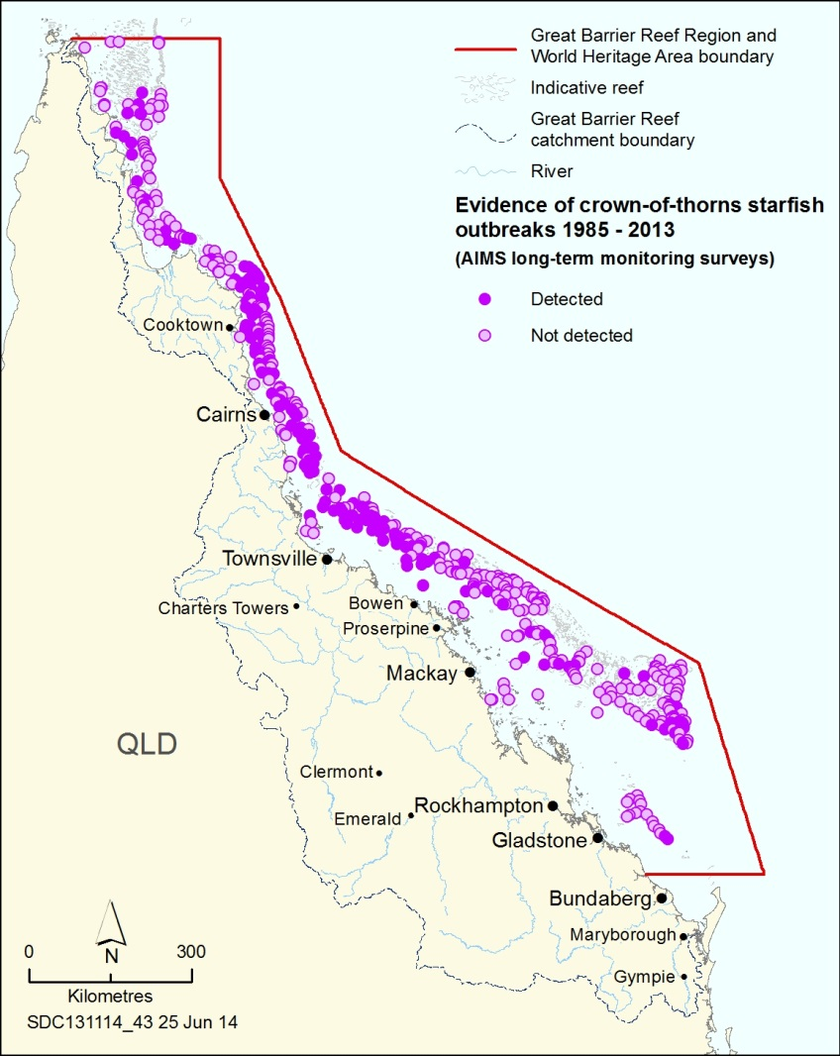
Figure 3.13 Evidence of crown-of-thorns starfish outbreaks, 1985–2013
The map shows areas where evidence of a crown-of-thorns outbreak has been detected as part of the Australian Institute of Marine Science Long-term Monitoring Program. Reefs with an outbreak detected have shown evidence of an active outbreak, an incipient outbreak or recovery from an outbreak. ‘Not detected’ refers to surveyed reefs with no signs of a crown-of-thorns outbreak within the survey period. Source: Australian Institute of Marine Science Long-term Monitoring Program, unpublished data.²⁵¹

There are indications that increased nutrient loads contribute to crown-of-thorns starfish outbreaks due to increased food supply and therefore survival of their larvae (Figure 3.14).^{246,252,253}
Importantly, the increased frequency of outbreaks, combined with other stresses on corals¹⁴, means coral populations are increasingly unable to fully recover before the next outbreak occurs.
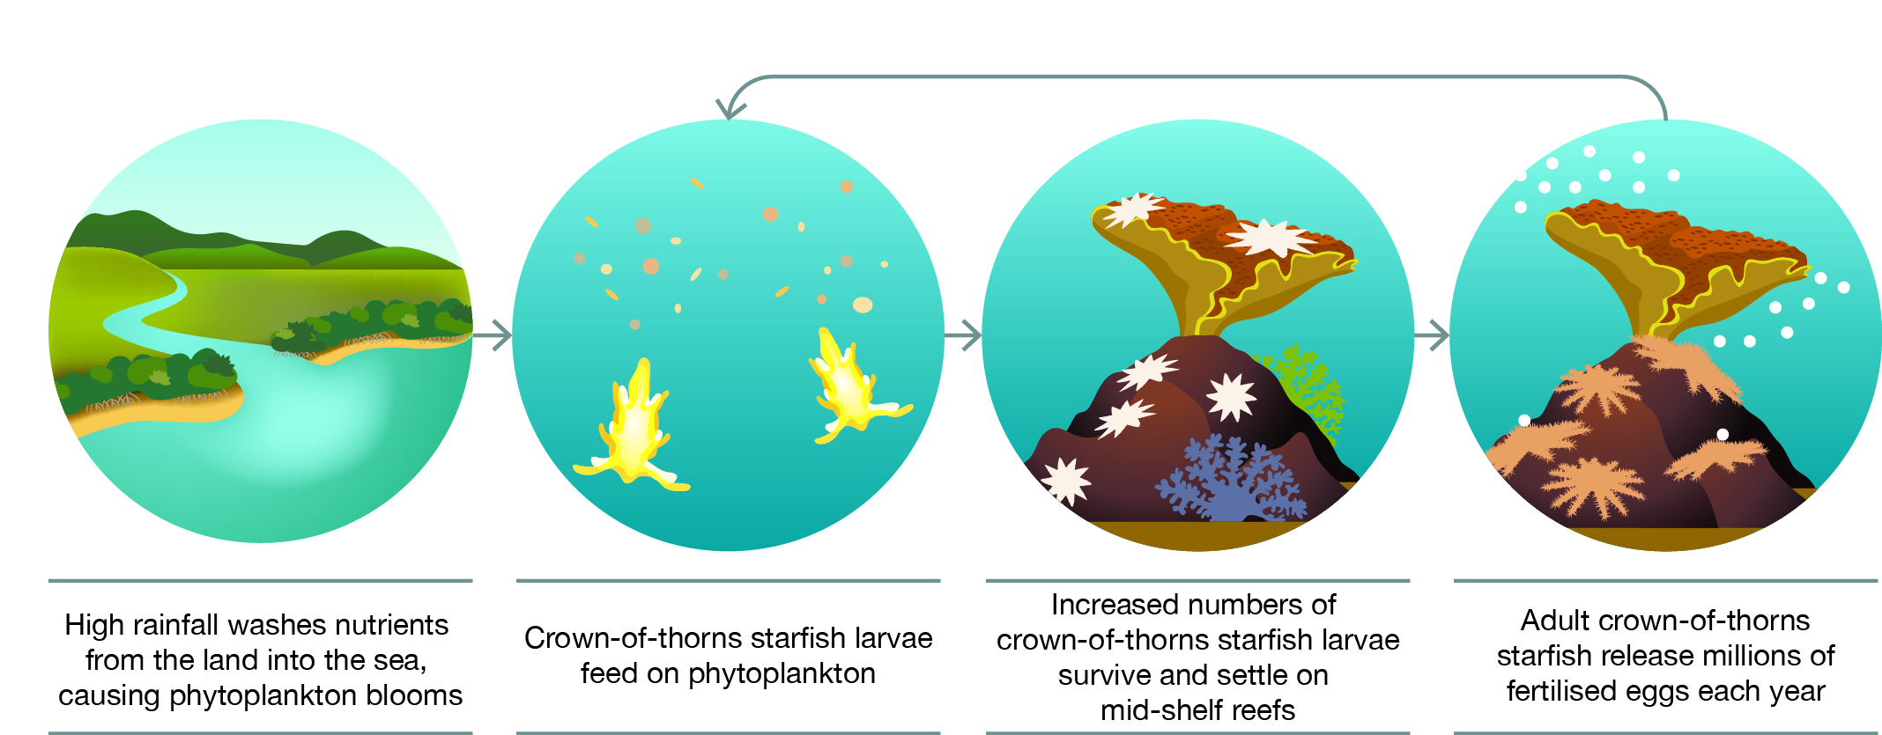
Figure 3.14 Potential role of nutrients in the population dynamics of crown-of-thorns starfish
Crown-of-thorns starfish are a major cause of loss of coral cover. One line of evidence suggests that their populations are significantly affected by the concentration of nutrients and, therefore, the amount of phytoplankton in Great Barrier Reef waters. Source: Fabricius et al. 2010²⁴⁶, Brodie et al. 2005²⁴⁷, Furnas et al. 2013 ²⁵⁴

Introduced species
Key message: Introduced marine species continue to be recorded in and adjacent to the Region.
Introduced species are non-native plants or animals that have arrived in an environment outside their normal distribution. They can have severe negative consequences for local native species and habitats. In the marine environment they are normally transported attached to the hulls of ships, in ballast water, via visits to islands or occasionally through aquaculture operations. Introduced species have been found in both the Region’s marine and island ecosystems.
Around Australia, approximately 250 introduced marine species have been reported, some of which have had major ecological impacts.²⁵⁵ For the most part, tropical marine environments seem less susceptible to invasion than temperate ones.²⁵⁶
Asian green mussels are considered the highest risk for invasion and impact in Australia.²⁵⁵ They have been detected in ports along the Great Barrier Reef coastline a number of times over the past decade.²⁵⁷ The most recent report was in September 2013, when they were found in the internal heat exchanger of a work boat in Mackay port.²⁵⁷ Extensive investigations in port areas around Mackay did not detect any further mussel introductions.
Introduced species such as rats and dogs affect seabird and turtle nesting on islands and along the mainland coast. Insect invasions have caused serious declines in Pisonia forests²⁵⁸ which are important nesting habitats for several seabird species. In January 2014, an outbreak of fire ants was detected on Curtis Island.²⁵⁹ Originating from South America, fire ants are very aggressive and voracious feeders on small animals including insects, spiders, lizards, frogs, birds and mammals. They can displace or eliminate some of Australia's unique native species.²⁶⁰ A fire ant restricted area was declared on Curtis Island and the adjacent mainland following the outbreak, restricting the movement of some earth materials which could contain the introduced species.²⁶¹ Introduced weeds have also affected native vegetation on a number of islands within the Region.²⁶² There is no regular monitoring of pests on Great Barrier Reef islands.

Other outbreaks
Key message: Outbreaks of some other species are likely to have resulted from declining ecosystem conditions.
An outbreak of a species refers to a rapid increase in abundance, biomass or population of naturally occurring marine plants and animals. Outbreaks of the naturally occurring crown-of-thorns starfish are examined previously (Section 3.6.2). Outbreaks and blooms of other species can be harmful or lethal to other marine species as they can compete for resources such as food, sunlight and oxygen.
Extensive phytoplankton blooms can result from nutrients in flood discharges.^{125,263}
Trichodesmium is a cyanobacteria found in nutrient-poor tropical waters. Outbreaks of the species appear as slicks on the water’s surface and can be distinctly pungent. It was first described by Captain Cook and, though it occurs naturally, blooms in the central Great Barrier Reef are thought to have increased, possibly due to nutrients in land-based run-off, in particular phosphorus, iron and organic material.^{264,265} The blooms have been implicated in directly smothering corals and increasing the bioavailability of heavy metals.²⁶⁶
Drupella are marine snails that occur naturally in the Indo-Pacific region, including the Great Barrier Reef, and are known to damage corals when in high densities.²⁶⁷ Outbreaks have been reported in Western Australia, Japan and the northern Red Sea.²⁶⁸ To date, no outbreaks of Drupella have been reported in the Region, although some tourism operators are permitted to implement control measures for this species. Numbers are monitored regularly at some locations in the Region through the Eye on the Reef monitoring program.
Periodic blooms of the cyanobacterium Lyngbya majuscula have been recorded on the Great Barrier Reef.^{269,270} Lyngbya can smother seagrass, corals and other benthic habitats and has been linked with reduced reproductive success in some turtles in Moreton Bay.²⁷¹
Macroalgal blooms can occur on degraded coral reefs in nutrient-rich waters, resulting in a phase shift from a coral-dominated reef to one dominated by macroalgae; this phenomena has been reported from some reefs in the Region.¹²⁷
There is no regular monitoring of outbreaks for any species other than crown-of-thorns starfish and Drupella.

Assessment summary — Ecosystem health
Section 54(3)(a) of the Great Barrier Reef Marine Park Act 1975 requires ‘… an assessment of the current health of the ecosystem within the Great Barrier Reef Region and of the ecosystem outside that region to the extent that it affects that region’. This assessment is based on five assessment criteria:
- physical processes
- chemical processes
- ecological processes
- terrestrial habitats that support the Great Barrier Reef
- outbreaks of disease, introduced species and pest species.

Physical processes
Outlook Report 2009: Assessment summary
The physical processes of the Great Barrier Reef are changing, in particular sedimentation and sea temperature. Further changes in factors such as sea temperature, sea level and sedimentation are expected because of climate change and catchment runoff.
Assessment component | Assessment summary | Grade 2009 | Grade 2014 and trend | Confidence
 |  |  |  | Grade | Trend
Currents | There is evidence of intensified flow and accelerated warming in the East Australian Current. | Very good | Very good, Deteriorated | Anecdotal | Anecdotal
Cyclones and wind | Between 2005 and 2013, there were six category 3 or above cyclones in the Region. There is emerging evidence of increases in wind strength Australia-wide. | Good | Good, Deteriorated | Limited | Limited
Freshwater inflow | Large volumes of freshwater have entered the Region in the past five years, including record flows for some rivers. | Good | Good, Deteriorated | Adequate | Adequate
Sedimentation | Sediment loads entering the Region continue to be at least double those occurring before European settlement. Improved land management is beginning to reduce sediment input, but measurable improvements in the Region may take decades. | Poor | Poor, Deteriorated | Adequate | Adequate
Sea level | The fastest rates of sea level rise in Australian waters are in northern areas. Average sea level rise in the Region is 3.1 millimetres per year. | Good | Good, Deteriorated | Adequate | Adequate
Sea temperature | The ocean has warmed substantially over the last century. Most of the warmest years have been in the past two decades. | Poor | Poor, Deteriorated | Adequate | Adequate
Light | It is likely that light availability has decreased substantially in the inshore areas of the southern two-thirds of the Region due to land-based run-off and extreme weather. | Good | Good, Deteriorated | Limited | Limited
Physical processes | The condition of all physical processes has declined since 2009. Further changes in processes such as sea temperature, sea level, cyclones and wind, freshwater inflow, waves and currents are expected under climate change projections. Reduced sediment loads entering the Region are likely to improve the processes of sedimentation and light availability in the longer term. | Good | Good, Deteriorated

Grading statements
Very good | There are no significant changes in processes as a result of human activities.
Good | There are some significant changes in processes as a result of human activities in some areas, but these are not to the extent that they are significantly affecting ecosystem functions.
Poor | There are substantial changes in processes as a result of human activities, and these are significantly affecting ecosystem functions in some areas.
Very poor | There are substantial changes in processes across a wide area as a result of human activities, and ecosystem functions are seriously affected in much of the area.
Trend since 2009
Improved, Stable, Deteriorated, No consistent trend
Confidence in condition and trend
Adequate | Adequate high-quality evidence and high level of consensus
Limited | Limited evidence or limited consensus
Inferred | Inferred, very limited evidence

Chemical processes
Outlook Report 2009: Assessment summary
For much of the Great Barrier Reef, the chemical environment has deteriorated significantly, especially inshore close to developed areas. This trend is expected to continue. Acidification of all Great Barrier Reef waters as a result of increased concentrations of atmospheric carbon dioxide is an emerging serious issue which is likely to worsen in the future.

Assessment component | Assessment summary | Grade 2009 | Grade 2014 and trend | Confidence
 |  |  |  | Grade | Trend
Nutrient cycling | Most inshore areas of the southern two-thirds of the Region are exposed to elevated nutrient concentrations. Improved land practices are helping to reduce nutrient inputs. | Poor | Poor, Deteriorated | Adequate | Adequate
Ocean pH | Decreasing ocean pH is likely to affect the ecosystem on a Reef-wide scale in the future. | Good | Good, Deteriorated | Adequate | Adequate
Ocean salinity | Recent floods have caused periods of reduced salinity in inshore areas and beyond. | Very good | Good, Deteriorated | Adequate | Adequate
Chemical processes | Nutrient cycling in the Region continues to be affected by nutrients from land-based run-off but changes in land management are likely to result in long-term improvements. Heavy rainfall in recent years has temporarily affected ocean salinity in some parts of the Region. Ocean pH is changing and is projected to decline in the future under climate change scenarios. Unlike the Outlook Report 2009, this assessment does not include consideration of pesticide accumulation. | Poor | Good, Deteriorated

Grading statements
Very good | There are no significant changes in processes as a result of human activities.
Good | There are some significant changes in processes as a result of human activities in some areas, but these are not to the extent that they are significantly affecting ecosystem functions.
Poor | There are substantial changes in processes as a result of human activities, and these are significantly affecting ecosystem functions in some areas.
Very poor | There are substantial changes in processes across a wide area as a result of human activities, and ecosystem functions are seriously affected in much of the area.
Trend since 2009
Improved, Stable, Deteriorated, No consistent trend
Confidence in condition and trend
Adequate | Adequate high-quality evidence and high level of consensus
Limited | Limited evidence or limited consensus
Inferred | Inferred, very limited evidence

Ecological processes
Outlook Report 2009: Assessment summary
Most ecological processes remain intact and healthy on the Great Barrier Reef, but further declines in physical and chemical processes are expected to affect them in the future. There is concern for predation, as predators are much reduced in many areas. Populations of large herbivores (such as dugongs) are severely reduced; however populations of herbivorous fish remain intact.

Assessment component | Assessment summary | Grade 2009 | Grade 2014 and trend | Confidence
 |  |  |  | Grade | Trend
Microbial processes | There is limited information on microbial processes in the Region but they are responsive to changes in environmental conditions. | Good | Good, Stable | Anecdotal | Anecdotal
Particle feeding | The process of particle feeding is likely to have deteriorated given the decline in the abundance of coral and other particle-feeding species. | Good | Good, Deteriorated | Anecdotal | Anecdotal
Primary production | Elevated nutrients are likely to be affecting pelagic primary production in central and southern inshore areas. Some seafloor primary producers, such as seagrass, have declined; macroalgae abundance may have increased. | Very good | Very good, No consistent trend | Limited | Limited
Herbivory | Herbivorous fishes and green turtle populations remain stable. Declines in dugongs are likely to have affected herbivory in the Region. | Good | Good, Deteriorated | Limited | Limited
Predation | Decreased predator populations affect the process of predation. No species is showing strong recovery and many remain at reduced numbers or their population sizes are poorly understood. | Poor | Poor, No consistent trend | Anecdotal | Limited
Symbiosis | Symbiotic relationships are likely to have deteriorated in the southern two-thirds of the Region, reflecting the poorer overall condition of the ecosystem. | Good | Good, Deteriorated | Anecdotal | Limited
Recruitment | Recruitment is reduced for many key species such as corals, some fishes, dugongs, some marine turtles and seabirds. | Not assessed | Poor | Limited | Not assessed
Reef building | Declines in coral cover in the southern two-thirds of the Region are likely to have affected the contribution of coral to the reef-building process. | Good | Good, Deteriorated | Anecdotal | Anecdotal
Competition | There is little information about the multitude of competitive interactions. | Good | Good, Stable | Anecdotal | Anecdotal
Connectivity | Marine species and habitats remain connected; although connectivity with some terrestrial habitats is disrupted. | Good | Good, Deteriorated | Limited | Limited
Ecological processes | At a Reef-wide scale, most ecological processes are considered to be in good condition but significant losses in coral cover and declines in ecosystem health in the inshore, southern two-thirds of the Region are likely to have affected some key ecological processes such as connectivity, reef building and recruitment. | Good | Good, Deteriorated

Grading statements
Very good | There are no significant changes in processes as a result of human activities.
Good | There are some significant changes in processes as a result of human activities in some areas, but these are not to the extent that they are significantly affecting ecosystem functions.
Poor | There are substantial changes in processes as a result of human activities, and these are significantly affecting ecosystem functions in some areas.
Very poor | There are substantial changes in processes across a wide area as a result of human activities, and ecosystem functions are seriously affected in much of the area.
Trend since 2009
Improved, Stable, Deteriorated, No consistent trend
Confidence in condition and trend
Adequate | Adequate high-quality evidence and high level of consensus
Limited | Limited evidence or limited consensus
Inferred | Inferred, very limited evidence

Terrestrial habitats that support the Great Barrier Reef
Outlook Report 2009: Not assessed
Assessment component | Assessment summary | Condition 2009 | Condition 2014 and trend since 2009 | Confidence
 |  |  |  | Condition
Saltmarshes | Some saltmarsh areas have been modified in the catchment. | Not assessed | Good | Limited
Freshwater wetlands | Freshwater wetlands remain intact in many areas, but many are functioning poorly. | Not assessed | Poor | Limited
Forested floodplains | The area of forested floodplain has been halved and much of it is grazed. | Not assessed | Poor | Limited
Heath and shrublands | Heath and shrublands are largely intact and well protected. | Not assessed | Very good | Limited
Grass and sedgelands | Grasslands and sedgelands have been modified extensively in central and southern catchments, especially close to the coast. | Not assessed | Poor | Limited
Woodlands and forests | There have been significant losses of woodlands and forests in much of the catchment, particularly in the Burdekin and Fitzroy regions. | Not assessed | Poor | Limited
Rainforests | The greatest losses of rainforest have been in the Wet Tropics, Fitzroy and Burnett Mary regions. Wet Tropics rainforests have been protected since their inscription on the World Heritage List. | Not assessed | Good | Limited
Terrestrial habitats that support the Great Barrier Reef | Terrestrial habitats that support the Reef are generally in better condition in the northern catchment. However, supporting habitats have been substantially modified in areas south of about Port Douglas, especially wetlands, forested floodplains, grass and sedgelands, woodlands and forests, and rainforests. | Not assessed | Poor

Grading statements
Very good | All major habitats are essentially structurally and functionally intact and able to support all dependent species.
Good | There is some habitat loss, degradation or alteration in some small areas, leading to minimal degradation but no persistent, substantial effects on populations of dependent species.
Poor | Habitat loss, degradation or alteration has occurred in a number of areas leading to persistent substantial effects on populations of some dependent species.
Very poor | There is widespread habitat loss, degradation or alteration leading to persistent, substantial effects on many populations of dependent species.
Trend since 2009
New assessment for this report; no trend provided
Confidence in condition
Adequate | Adequate high-quality evidence and high level of consensus
Limited | Limited evidence or limited consensus
Inferred | Inferred, very limited evidence

Outbreaks of disease, introduced species and pest species
Outlook Report 2009: Assessment summary
Outbreaks of diseases appear to be becoming more frequent and more serious on the Great Barrier Reef. Outbreaks of pest species appear to be above natural levels in some areas.
Assessment component | Assessment summary | Condition 2009 | Condition 2014 and trend since 2009 | Confidence
 |  |  |  | Condition | Trend
Outbreaks of disease | Disease has affected corals, green turtles, dugongs and the Queensland groper in recent years. Most outbreaks have not been recorded on a wide scale. | Good | Good, No consistent trend | Limited | Anecdotal
Outbreaks of crown-of-thorns starfish | Growing evidence indicates ecosystem conditions may have resulted in more frequent outbreaks of crown-of-thorns starfish over the last 30 years across much of the Region. These have seriously affected the ecosystem. | Poor | Very poor, Deteriorated | Limited | Limited
Introduced species | Introduced marine species continue to be recorded in and adjacent to the Region. Introduced weeds have affected a number of islands within the Region. | Good | Good, No consistent trend | Anecdotal | Anecdotal
Other outbreaks | Outbreaks of some other species are likely to have resulted from declining ecosystem conditions. | Good | Good, No consistent trend | Anecdotal | Anecdotal
Outbreaks of disease, introduced species and pest species | Coral disease is being increasingly observed on the Great Barrier Reef and is predicted to increase in the future. There are few incidences of other disease and introduced species in the marine environment and they tend to be localised. Outbreaks may be becoming more frequent as ecosystem conditions decline. The overall assessment is ‘poor’ due to the severity of outbreaks of crown-of-thorns starfish which seriously affect coral reef habitats on a large scale. | Poor | Poor, No consistent trend

Grading statements
Very good | No records of diseases above expected natural levels; no introduced species recorded; no outbreaks; pest populations within naturally expected levels.
Good | Disease occasionally above expected natural levels but recovery prompt; any occurrences of introduced species successfully addressed; pests sometimes present above natural levels with limited effects on ecosystem function.
Poor | Unnaturally high levels of disease regularly recorded in some areas; occurrences of introduced species require significant intervention; pest outbreaks in some areas affect ecosystem function more than expected under natural conditions.
Very poor | Unnaturally high levels of disease often recorded in many areas; uncontrollable outbreaks of introduced pests; opportunistic pests seriously affecting ecosystem function in many areas.
Trend since 2009
Improved, Stable, Deteriorated, No consistent trend
Confidence in condition and trend
Adequate | Adequate high-quality evidence and high level of consensus
Limited | Limited evidence or limited consensus
Inferred | Inferred, very limited evidence

[Photograph of a fish swimming among mangrove roots. Copyright Matt Curnock. Caption: Healthy connections between marine and freshwater habitats are important to the Reef ecosystem.]

Overall summary of ecosystem health
The past decade of extreme weather events, combined with the continuing poor condition of key processes such as sedimentation and nutrient cycling, have caused the overall health of the Great Barrier Reef ecosystem to deteriorate since 2009. While improved land management practices are beginning to reduce the amount of nutrients and sediments leaving the catchment, there is likely to be a long lag time between these improvements and reductions in pollutants flowing into the Region, and again between that and improvements in related marine processes.
The decline in ecosystem health is most pronounced in inshore areas of the southern two-thirds of the Region. In contrast, the continuing good and very good condition of almost all processes in the northern third of the Region and in offshore areas means that the ecosystem in these areas continues to be healthy. Ecosystem processes are integral to the attributes recognised in the world heritage listing of the Great Barrier Reef. The deteriorating condition of many is likely to be affecting its outstanding universal value.
One indicator of declining ecosystem health is that crown-of-thorns starfish outbreaks are becoming more frequent. Rather than experiencing outbreaks in a natural cycle of about every 50 to 80 years, the Reef has been affected by three in the past 50 years and a new outbreak has begun. Crown-of-thorns starfish have been a major cause of coral loss in recent decades. There is growing evidence of a link between outbreaks and deterioration in the process of nutrient cycling. The overall grade of ‘good’ for outbreaks of disease, introduced species and pest species is borderline with ‘poor’ due to the severity of crown-of-thorns starfish outbreaks in recent years.
Sea temperature is increasing. While other environmental conditions (for example cloud cover and wind) have meant periods of elevated temperature have not been as prolonged as those in the late 1990s and early 2000s, the trend of increasing temperatures places the ecosystem at serious risk into the future. Other processes likely to have a Reef-wide influence on ecosystem health, such as ocean pH and sea level, are also expected to deteriorate into the future.
Terrestrial habitats that support the Great Barrier Reef ecosystem are generally in very good condition north of Port Douglas. Further south, in the bulk of the Region’s catchment, all supporting habitats have been substantially modified. This has affected connectivity and the capacity for these habitats to support marine habitats and species.
Knowledge of the key variables that contribute to some physical and chemical processes — such as sedimentation, sea temperature, nutrient cycling and freshwater inflow — is improving. There remains a poor understanding and almost no monitoring of many others, especially ecological processes, such as connectivity, competition, predation and microbial processes. Monitoring of pest introductions remains a gap.

References
1. Great Barrier Reef Marine Park Authority 2009, Great Barrier Reef outlook report 2009, GBRMPA, Townsville.
2. Costanza, R. and Mageau, M. 1999, What is a healthy ecosystem? Aquatic Ecology 33(1): 105-115.
3. Department of Sustainability, Environment, Water, Population and Communities 2012, Statement of Outstanding Universal Value: Great Barrier Reef World Heritage Area, DSEWPaC, Canberra.
4. Kingsford, M.J. and Wolanski, E. 2008, Oceanography, in The Great Barrier Reef: Biology, environment and management, ed. P. Hutchings, et al., CSIRO Publishing, Collingwood, pp. 28-39.
5. Andrews, J.C. and Furnas, M.J. 1986, Subsurface intrusions of Coral Sea water into the central Great Barrier Reef - I. Structures and shelf-scale dynamics, Continental Shelf Research 6: 491-514.
6. Berkelmans, R., Weeks, S.J. and Steinberg, C.R. 2010, Upwelling linked to warm summers and bleaching on the Great Barrier Reef, Limnology and Oceanography 55(6): 2634-2644.
7. Ridgway, K. and Hill, K. 2012, East Australian Current, in A marine climate change impacts and adaptation report card for Australia 2012, ed. E.S. Poloczanska, et al., CSIRO, Canberra, pp. 47-60.
8. Williams, K.J. and Crimp, S. 2012, Queensland's biodiversity under climate change: An overview of climate change in Queensland, Climate Adaptation Flagship Working Paper No 12A, CSIRO Climate Adaptation Flagship, Canberra.
9. Steinberg, C. 2007, Impacts of climate change on the physical oceanography of the Great Barrier Reef, in Climate change and the Great Barrier Reef: a vulnerability assessment, ed. J.E. Johnson and P.A. Marshall, Great Barrier Reef Marine Park Authority and Australian Greenhouse Office, Townsville, pp. 51-74.
10. Williams, K.J., Dunlop, M., Bustamante, R.H., Murphy, H.T., Ferrier, S., Wise, R.M., Liedloff, A., Skewes, T.D., Harwood, T.D., Kroon, F., Williams, R.J., Joehnk, K., Crimp, S., Smith, M.S., James, C. and Booth, T. 2012, Queensland’s biodiversity under climate change: Impacts and adaptation – synthesis report, CSIRO Climate Adaptation Flagship, Canberra.
11. Devney, C.A., Short, M. and Congdon, B.C. 2009, Cyclonic and anthropogenic influences on tern populations, Wildlife Research 36: 368-378.
12. Fuentes, M.M.P.B., Bateman, B.L. and Hamann, M. 2011, Relationship between tropical cyclones and the distribution of sea turtle nesting grounds, Journal of Biogeography 38: 1886-1896.
13. Fuentes, M.M.P.B., Limpus, C.J. and Hamann, M. 2011, Vulnerability of sea turtle nesting grounds to climate change, Global Change Biology 17(1): 140-153.
14. De'ath, G., Fabricius, K.E., Sweatman, H. and Puotinen, M. 2012, The 27–year decline of coral cover on the Great Barrier Reef and its causes, Proceedings of the National Academy of Sciences 109(44): 17995-17999.
15. Great Barrier Reef Marine Park Authority 2010, Observed impacts from climate extremes on the Great Barrier Reef: summer 2008/2009, GBRMPA, Townsville.
16. Great Barrier Reef Marine Park Authority 2011a, Impacts of tropical cyclone Yasi on the Great Barrier Reef: A report on the findings of a rapid ecological impact assessment, GBRMPA, Townsville.
17. Bureau of Meteorology 2014a, The Australian tropical cyclone database, Bureau of Meteorology, <http://www.bom.gov.au/cyclone/history/>.
18. Bureau of Meteorology 2011, Severe tropical cyclone Yasi, Bureau of Meteorology, <http://reg.bom.gov.au/cyclone/history/yasi.shtml>.
19. Great Barrier Reef Marine Park Authority 2011b, Extreme weather and the Great Barrier Reef, GBRMPA, Townsville.
20. Troccoli, A., Muller, K., Coppin, P., Davy, R., Russell, C. and Hirsch, A. 2011, Long-term wind speed trends over Australia, Journal of Climate 25(1): 170-183.
21. Verspecht, F. and Pattiaratchi, C. 2010, On the significance of wind event frequency for particulate resuspension and light attenuation in coastal waters, Continental Shelf Research 30(18): 1971-1982.
22. Smithers, S.G., Harvey, N., Hopley, D. and Woodroffe, C.D. 2007, Vulnerability of geomorphological features in the Great Barrier Reef to climate change, in Climate change and the Great Barrier Reef: a vunerability assessment, ed. J.E. Johnson and P.A. Marshall, Great Barrier Reef Marine Park Authority and Australian Greenhouse Office, Townsville, pp. 667-716.
23. Munday, P.L., Cheal, A.J., Graham, N.A.J., Meekan, M.G., Pratchett, M.S., Sheaves, M., Sweatman, H. and Wilson, S.K. 2012, Tropical coastal fish, in Marine climate change impacts and adaptation report card for Australia 2012, ed. E.S. Poloczanska, et al., CSIRO, Canberra, pp. 186-204.
24. Emanuel, K. 2003, Tropical cyclones, Annual Review of Earth and Planetary Sciences 31: 75-104.
25. Larsen, J., Leon, J., McGrath, C. and Trancoso, R. 2013, Review of the catchment processes relevant to the Great Barrier Reef Region, Great Barrier Reef Marine Park Authority, Townsville.
26. Schaffelke, B., Carleton, J., Costello, P., Davidson, J., Doyle, J., Furnas, M., Gunn, K., Skuza, M., Wright, M. and Zagorskis, I. 2012, Reef Rescue Marine Monitoring Program. Final report of AIMS activities 2011/12: Inshore water quality monitoring. Produced for the Great Barrier Reef Marine Park Authority, Australian Institute of Marine Science, Townsville.
27. Brodie, J., Binney, J., Fabricius, K., Gordon, I., Hoegh-Guldberg, O., Hunter, H., O’Reagain, P., Pearson, R., Quirk, M., Thorburn, P., Waterhouse, J., Webster, I. and Wilkinson, S. 2008, Scientific consensus statement on water quality in the Great Barrier Reef, Reef Water Quality Protection Plan Secretariat, Brisbane.
28. Gleeson, J., Santos, I.R., Maher, D.T. and Golsby-Smith, L. 2013, Groundwater-surface water exchange in a mangrove tidal creek: evidence from natural geochemical tracers and implications for nutrient budgets, Marine Chemistry 156: 27-37.
29. Lillywhite, H.B., Babonis, L.S., Sheehy III, C.M. and Tu, M. 2008, Sea snakes (Laticauda spp.) require fresh drinking water: implication for the distribution and persistence of populations, Physiological and Biochemical Zoology 81(6): 785-796.
30. Stieglitz, T. 2005, Submarine groundwater discharge into the near-shore zone of the Great Barrier Reef, Australia, Marine Pollution Bulletin 51(1-4): 51-59.
31. Johannes, R.E. 1980, Ecological significance of the submarine discharge of groundwater, Marine Ecology Progress Series 3(4): 365-373.
32. Peterson, B.J., Stubler, A.D., Wall, C.C. and Gobler, C.J. 2012, Nitrogen-rich groundwater intrusion affects productivity, but not herbivory, of the tropical seagrassThalassia testudinum, Aquatic Biology 15(1): 1-9.
33. McKenzie, L.J., Collier, C. and Waycott, M. 2014, Reef Rescue Marine Monitoring Program: Inshore seagrass. Annual report for the sampling period 1st July 2012 - 31st May 2013, Centre for Tropical Water & Aquatic Ecosystems Research, James Cook University, Cairns.
34. Maughan, M., Brodie, J. and Waterhouse, J. 2008, Reef exposure model for the Great Barrier Reef lagoon, Australian Centre for Tropical Freshwater Research, James Cook University, Townsville.
35. Kroon, F.J., Kuhnert, P.M., Henderson, B.L., Wilkinson, S.N., Kinsey-Henderson, A., Abbott, B., Brodie, J.E. and Turner, R.D.R. 2012, River loads of suspended solids, nitrogen, phosphorus and herbicides delivered to the Great Barrier Reef lagoon, Marine Pollution Bulletin 65(4-9): 167-181.
36. Hopley, D., Smithers, S.G. and Parnell, K.E. 2007, The geomorphology of the Great Barrier Reef: Development, diversity and change, Cambridge University Press, Cambridge, UK.
37. Reef Water Quality Protection Plan Secretariat 2011, Great Barrier Reef first report card: 2009 baseline, Reef Water Quality Protection Plan, Reef Water Quality Protection Plan Secretariat, Brisbane.
38. Reef Water Quality Protection Plan Secretariat 2013, Great Barrier Reef report card 2011, Reef Water Quality Protection Plan, Reef Water Quality Protection Plan Secretariat, Brisbane.
39. Reef Water Quality Protection Plan Secretariat 2013, Great Barrier Reef report card 2011, Reef Water Quality Protection Plan (technical report), Reef Water Quality Protection Plan Secretariat, Brisbane.
40. Kroon, F., Turner, R., Smith, R., Warne, M., Hunter, H., Bartley, R., Wilkinson, S., Lewis, S., Waters, D. and Carroll, C. 2013, Sources of sediment, nutrients, pesticides and other pollutants in the Great Barrier Reef catchment, in Synthesis of evidence to support the Reef Water Quality Scientific Consensus Statement 2013 Department of the Premier and Cabinet, Brisbane, pp. 1-42.
41. Bainbridge, Z.T., Wolanski, E., Álvarez-Romero, J.G., Lewis, S.E. and Brodie, J.E. 2012, Fine sediment and nutrient dynamics related to particle size and floc formation in a Burdekin River flood plume, Australia, Marine Pollution Bulletin 65(4): 236-248.
42. Wolanski, E., Jones, M. and Williams, W.T. 1981, Physical properties of Great Barrier Reef lagoon waters near Townsville. II. Seasonal variations, Australian Journal of Marine and Freshwater Research 32: 321-334.
43. Wolanski, E. and van Senden, D. 1983, Mixing of Burdekin river flood waters in the Great Barrier Reef, Australian Journal of Marine and Freshwater Research 34: 49-63.
44. Devlin, M.J., McKinna, L.I.W., Alvarez-Romero, J.G., Abbott, B., Harkness, P. and Brodie, J. 2012, Mapping the pollutants in surface river plume waters in the Great Barrier Reef, Australia, Marine Pollution Bulletin 65: 224-235.
45. Devlin, M.J. and Brodie, J. 2005, Terrestrial discharge into the Great Barrier Reef lagoon: Nutrient behaviour in coastal waters, Marine Pollution Bulletin 51(1-4): 9-22.
46. Brodie, J., Schroeder, T., Rohde, K., Faithful, J., Masters, B., Dekker, A., Brando, V. and Maughan, M. 2010, Dispersal of suspended sediments and nutrients in the Great Barrier Reef lagoon during river-discharge events: conclusions from satellite remote sensing and concurrent flood-plume sampling, Marine and Freshwater Research 61(6): 651-664.
47. Schroeder, T., Devlin, M.J., Brando, V.E., Dekker, A.G., Brodie, J.E., Clementson, L.A. and McKinna, L. 2012, Inter-annual variability of wet season freshwater plume extent into the Great Barrier Reef lagoon based on satellite coastal ocean colour observations, Marine Pollution Bulletin 65(4-9): 210-223.
48. Black, K.P. 1993, The relative importance of local retention and inter-reef dispersal of neutrally buoyant material on coral reefs, Coral Reefs 12(1): 43-53.
49. Lambrechts, J., Humphrey, C., McKinna, L., Gourge, O., Fabricius, K.E., Mehta, A.J., Lewis, S. and Wolanski, E. 2010, Importance of wave-induced bed liquefaction in the fine sediment budget of Cleveland Bay, Great Barrier Reef, Estuarine, Coastal and Shelf Science 89(2): 154-162.
50. Luick, J.L., Mason, L.B., Hardy, T. and Furnas, M.J. 2007, Circulation in the Great Barrier Reef lagoon using numerical tracers and in situ data, Continental Shelf Research 27(6): 757-778.
51. Wolanski, E. 1994, Physical oceanographic processes of the Great Barrier Reef, CRC Press, Boca Raton.
52. Margvelashvili, N., Herzfeld, M.G. and Webster, I.T. 2006, Modelling of fine-sediment transport in the Fitzroy estuary and Keppel Bay, Cooperative Research Centre for Coastal Zone Estuary and Waterway Management, Indooroopilly.
53. Wolanski, E., Fabricius, K.E., Cooper, T.E. and Humphrey, C. 2008, Wet season fine sediment dynamics on the inner shelf of the Great Barrier Reef, Estuarine, Coastal and Shelf Science 77(4): 755-762.
54. Ryan, D.A., Brooke, D.P., Bostock, H.C., Radke, L.C., Siwabessy, P.J.W., Margvelashvili, N. and Skene, D. 2007, Bedload sediment transport dynamics in a macrotidal embayment, and implications for export to the southern Great Barrier Reef shelf, Marine Geology 240: 197-215.
55. Wolanski, E., Fabricius, K., Spagnol, S. and Brinkman, R. 2005, Fine sediment budget on an inner-shelf coral-fringed island, Great Barrier Reef of Australia, Estuarine, Coastal and Shelf Science 65(1): 153-158.
56. Reef Water Quality Protection Plan Secretariat 2014a, Great Barrier Reef Report Card 2012 and 2013, Reef Water Quality Protection Plan. Report Card key findings, Reef Water Quality Protection Plan Secretariat, Brisbane.
57. Brodie, J., Wolanski, E., Lewis, S. and Bainbridge, Z. 2012, An assessment of residence times of land-sourced contaminants in the Great Barrier Reef lagoon and the implications for management and reef recovery, Marine Pollution Bulletin 65: 267-279.
58. Sinclair Knight Merz Pty Ltd and Asia-Pacific Applied Science Associates 2013, Improved dredge material management for the Great Barrier Reef Region: Synthesis report, Great Barrier Reef Marine Park Authority, Townsville.
59. Great Barrier Reef Marine Park Authority 2013a, Improved dredge material management for the Great Barrier Reef Region: interpretive statement of findings and management implications of the technical reports for the Great Barrier Reef Strategic Assessment, GBRMPA, Townsville.
60. Brodie, J., Waterhouse, J., Maynard, J., Bennett, J., Furnas, M., Devlin, M., Lewis, S., Collier, C., Schaffelke, B., Fabricius, K., Petus, C., da Silva, E., Zeh, D., Randall, L., Brando, V., McKenzie, L.J., O’Brien, D., Smith, R., Warne, M.S.J., Brinkman, R., Tonin, H., Bainbridge, Z., Bartley, R., Negri, A., Turner, R.D.R., Davis, A., Bentley, C., Mueller, J., Alvarez-Romero, J.G., Henry, N., Waters, D., Yorkston, H. and Tracey, D. 2013a, Assessment of the relative risk of water quality to ecosystems of the Great Barrier Reef: A report to the Department of the Environment and Heritage Protection,Centre for Tropical Water & Aquatic Ecosystems Research, James Cook University, Townsville..
61. Woodroffe, C.D. 1990, The impact of sea-level rise on mangrove shorelines, Progress in Physical Geography 14(4): 483-520.
62. Cazenave, A. and Le Cozannet, G. 2014, Sea level rise and its coastal impacts, Earth's Future 2(2): 15-34.
63. Manson, F.J., Loneragan, N.R., Skilleter, G.A. and Phinn, S.R. 2005, An evaluation of the evidence for linkages between mangroves and fisheries: a synthesis of the literature and identification of research directions, Oceanography and Marine Biology: An Annual Review 43: 483-515.
64. Church, J.A., White, N.J., Hunter, J.R. and McInnes, K.L. 2012, Sea level, in A marine climate change impacts and adaptation report card for Australia 2012, ed. E.S. Poloczanska, et al., CSIRO, Canberra, pp. 27-46.
65. Abbey, E., Webster, J.M. and Beaman, R.J. 2011, Geomorphology of submerged reefs on the shelf edge of the Great Barrier Reef: The influence of oscillating Pleistocene sea-levels, Marine Geology 288(1): 61-78.
66. Hobday, A.J. and Lough, J.M. 2011, Projected climate change in Australian marine and freshwater environments, Marine and Freshwater Research 62(9): 1000-1014.
67. Department of Climate Change 2010, Adapting to climate change in Australia: an Australian Government position paper, Commonwealth of Australia, Canberra.
68. Department of Climate Change and Energy Efficiency 2011, Climate change risks to coastal buildings and infrastructure: A supplement to the First Pass national assessment, DCCEE, Canberra.
69. Permanent Service for Mean Sea Level 2013, PSMSL monthly and annual mean sea level station files: Townsville, PSMSL, National Oceanography Centre, <http://www.psmsl.org/data/obtaining/stations/637.php>.
70. Smith, S.V. 1983, Coral reef calcification, in Perspectives on coral reefs, ed. D.J. Barnes, Brian Clouston Publisher, Manuka, Australia, pp. 240-247.
71. Anthony, K.R.N. and Marshall, P. 2012, Coral Reefs, in A marine climate change impacts and adapation report card for Australia 2012, ed. E.S. Poloczanska, et al., CSIRO, Canberra, pp. 259-280.
72. Fuentes, M.M.P.B., Hamann, M. and Lukoschek, V. 2012, Marine reptiles, in A marine climate change impacts and adaptation report card for Australia 2012, ed. E.S. Poloczanska, et al., CSIRO, Canberra, pp. 379-400.
73. Poloczanska, E.S., Babcock, R.C., Butler, A., Hobday, A., Hoegh-Guldberg, O., Kunz, T., Matear, R., Milton, D., Okey, T. and Richardson, A.J. 2007, Climate change and Australian marine life, Oceanography and Marine Biology: An Annual Review 45: 407-478.
74. Bellwood, D.R., Hughes, T.P., Connolly, S.R. and Tanner, J. 2005, Environmental and geometric constraints on Indo-Pacific coral reef biodiversity, Ecology Letters 8(6): 643-651.
75. Lough, J., Gupta, A.S. and Hobday, A.J. 2012, Temperature, in A marine climate change impacts and adaptation report card for Australia 2012, ed. E.S. Poloczanska, et al., CSIRO, Canberra, pp. 1-26.
76. Hale, R., Calosi, P., McNeill, L., Mieszkowska, N. and Widdicombe, S. 2011, Predicted levels of future ocean acidification and temperature rise could alter community structure and biodiversity in marine benthic communities, Oikos 120: 661-674.
77. van Oppen, M.J.H. and Lough, J.M. (eds) 2009, Coral bleaching: patterns, processes, causes and consequences, Springer, Berlin.
78. Berkelmans, R., De'ath, G., Kininmonth, S. and Skirving, W.J. 2004, A comparison of the 1998 and 2002 coral bleaching events on the Great Barrier Reef: Spatial correlation, patterns and predictions, Coral Reefs 23(1): 74-83.
79. Oliver, J.K., Berkelmans, R. and Eakin, C.M. 2009, Coral bleaching in space and time, in Coral bleaching: Patterns, processes, causes and consequences, ed. M.J.H. van Oppen and J.M. Lough, Springer, Berlin, pp. 21-40.
80. Leahy, S.M., Kingsford, M.J. and Steinberg, C.R. 2013, Do clouds save the Great Barrier Reef? Satellite imagery elucidates the cloud-SST relationship at the local scale. PLoS ONE 8(7): 12.
81. Carrigan, A.D. and Puotinen, M. 2014, Tropical cyclone cooling combats region‐wide coral bleaching, Global Change Biology 20(5): 1604-1613.
82. Bureau of Meteorology 2014b, Australian climate variability and change: time series graphs. Coral Sea, Bureau of Meteorology, <http://www.bom.gov.au/cgi-bin/climate/change/timeseries.cgi?graph=sst&area=cor&season=0112&ave_yr=5>.
83. Collier, C. and Waycott, M. 2009, Drivers of change to seagrass distributions and communities on the Great Barrier Reef, literature review and gaps analysis. Report to the Marine and Tropical Sciences Research Facility, Reef and Rainforest Research Centre, Cairns.
84. Weeks, S., Werdell, P.J., Schaffelke, B., Canto, M., Lee, Z., Wilding, J.G. and Feldman, G.C. 2012, Satellite-derived photic depth on the Great Barrier Reef: spatio-temporal patterns of water clarity, Remote Sensing 4(12): 3781-3795.
85. Fabricius, K.E. 2005, Effects of terrestrial runoff on the ecology of corals and coral reefs: Review and synthesis, Marine Pollution Bulletin 50(2): 125-146.
86. Fabricius, K.E., De'ath, G., Humphrey, C., Zagorskis, I. and Schaffelke, B. 2013, Intra-annual variation in turbidity in response to terrestrial runoff on near-shore coral reefs of the Great Barrier Reef, Estuarine Coastal and Shelf Science 116: 57-65.
87. North-East Shipping Management Group 2013, North-east shipping management plan (draft for consultation), Australian Maritime Safety Authority, Canberra.
88. Erftemeijer, P.L., Riegl, B., Hoeksema, B.W. and Todd, P.A. 2012, Environmental impacts of dredging and other sediment disturbances on corals: a review, Marine Pollution Bulletin 64(9): 1737-1765.
89. Thompson, A., Costello, P., Davidson, J., Schaffelke, B., Uthicke, S. and Liddy, M. 2013, Reef Rescue Marine Monitoring Program. Report of AIMS activities: Inshore coral reef monitoring 2012. Report for Great Barrier Reef Marine Park Authority, Australian Institute of Marine Science, Townsville.
90. Wolanski, E. and Spagnol, S. 2000, Pollution by mud of Great Barrier Reef coastal waters, Journal of Coastal Research 16(4): 1151-1156.
91. Fabricius, K.E., Logan, M., Weeks, S. and Brodie, J. 2014, The effects of river run-off on water clarity across the central Great Barrier Reef, Marine Pollution Bulletin 84: 191-200.
92. Thompson, A., Schaffelke, B., Logan, M., Costello, P., Davidson, J., Doyle, J., Furnas, M., Gunn, K., Liddy, M., Skuza, M., Uthicke, S., Wright, M. and Zagorskis, I. 2014, Reef Rescue Monitoring Program. Draft final report of AIMS activities 2012 to 2013 - Inshore water quality and coral reef monitoring. Report for Great Barrier Reef Marine Park Authority, Australian Institute of Marine Science, Townsville.
93. Great Barrier Reef Marine Park Authority 2010, Water quality guidelines for the Great Barrier Reef Marine Park, GBRMPA, Townsville.
94. Great Barrier Reef Marine Park Authority (Unpublished), Eye on the Reef, [database].
95. Hoegh-Gulberg, O. and Dove, S. 2008, Primary production, nutrient recycling and energy flow through coral reef ecosystems, in The Great Barrier Reef: Biology, environment and management, ed. P. Hutchings, et al., CSIRO Publishing, Collingwood, pp. 59-73.
96. McCook, L.J., Folke, C., Hughes, T., Nyström, M., Obura, D. and Salm, R. 2007, Ecological resilience, climate change and the Great Barrier Reef, in Climate change and the Great Barrier Reef: A vulnerability assessment, ed. J.E. Johnson and P.A. Marshall, Great Barrier Reef Marine Park Authority and Australian Greenhouse Office, Townsville, pp. 75-96.
97. Reef Water Quality Protection Plan Secretariat 2013, Great Barrier Reef report card 2011: Reef Water Quality Protection Plan, Reef Water Quality Protection Plan Secretariat, Brisbane.
98. Brodie, J., Waterhouse, J., Schaffelke, B., Kroon, F., Thorburn, P., Rolfe, J., Johnson, J., Fabricius, K., Lewis, S., Devlin, M., Warne, M. and McKenzie, L.J. 2013, 2013 Scientific Consensus Statement: Land use impacts on Great Barrier Reef water quality and ecosystem conditions, Reef Water Quality Protection Plan Secretariat, Brisbane.
99. Reef Water Quality Protection Plan Secretariat 2014, Great Barrier Reef report card 2012 and 2013, Reef Water Quality Protection Plan (detailed results), Reef Water Quality Protection Plan Secretariat, Brisbane.
100. Thorburn, P., Rolfe, J., Wilkinson, S., Silburn, M., Blake, J., Gongora, M., Windle, J., VanderGragt, M., Wegschield, C., Ronan, M. and Carroll, C. 2013, The water quality and economic benefits of agricultural management practices, in 2013 Scientific Consensus Statement: Land use impacts on Great Barrier Reef water quality and ecosystem condition Reef Water Quality Protection Plan Secretariat, Brisbane.
101. De'ath, G., Lough, J.M. and Fabricius, K.E. 2009, Declining coral calcification on the Great Barrier Reef, Science 323(5910): 116-119.
102. Rhein, M., Rintoul, S.R., Aoki, S., Campos, E., Chambers, D., Feely, R., Gulev, S., Johnson, G., Josey, S., Kostianoy, A., Mauritzen, C., Roemmich, D., Talley, L. and Wang, L. 2013, Chapter 3. Observations: Ocean, in Climate Change 2013: The physical science basis. Contribution of Working Group I to the Fifth Assessment Report of the Intergovernmental Panel on Climate Change, ed. T.F Stocker, D. Qin, G.-K. Plattner, M. Tignor, S.K. Allen, J. Boschung, A. Nauels, Y. Xia, V. Bex and P.M. Midgley, Cambridge University Press, UK, pp. 255-315.
103. Orr, J.C., Fabry, V.J., Aumont, O., Bopp, L., Doney, S.C., Feely, R.A., Gnanadesikan, A., Gruber, N., Ishida, A., Joos, F., Key, R.M., Lindsay, K., Maier-reimer, E., Matear, R., Monfray, P., Mouchet, A., Najjar, R.G., Plattner, G.K., Rodgers, K.B., Sabine, C.L., Sarmiento, J.L., Schlitzer, R., Slater, R.D., Totterdell, I.J., Weirig, M.F., Yamanaka, Y. and Yool, A. 2005, Anthropogenic ocean acidification over the twenty-first century and its impact on calcifying organisms, Nature 437(7059): 681-686.
104. Andutta, F.P., Ridd, P.V. and Wolanski, E. 2011, Dynamics of hypersaline coastal waters in the Great Barrier Reef, Estuarine, Coastal and Shelf Science 94: 299-305.
105. Devlin, M., Harkness, P., McKinna, L. and Waterhouse, J. 2011, Mapping the surface exposure of terrestrial pollutants in the Great Barrier Reef. Report to the Great Barrier Reef Marine Park Authority, Australian Centre for Tropical and Freshwater Research, James Cook University, Townsville.
106. Devlin, M., Wenger, A., Waterhouse, J., Alvarez-Romero, J., Abbott, B. and Teixeira da Silva, E. 2011, Reef Rescue Marine Monitoring Program: flood plume monitoring annual report 2010-11, Incorporating results from the Extreme Weather Response Program flood plume monitoring, Report for the Great Barrier Reef Marine Park Authority, Australian Centre for Tropical Freshwater Research, James Cook University, Townsville.
107. Devlin, M., Waterhouse, J., Taylor, J. and Brodie, J. 2001, Flood plumes in the Great Barrier Reef: spatial and temporal patterns in composition and distribution, Great Barrier Reef Marine Park Authority, Townsville.
108. Berkelmans, R., Jones, A.M. and Schaffelke, B. 2012, Salinity thresholds of Acropora spp. on the Great Barier Reef, Coral Reefs 31: 1103-1110.
109. Maynard, J.A., Johnson, J.C., Beeden, R., Puotinen, M., Devlin, M., Dryden, J. and Marshall, P. 2014, Historic and projected future exposure of habitats in the Great Barrier Reef Marine Park to disturbances. Draft Report, Great Barrier Reef Marine Park Authority, Townsville.
110. Whitman, W.B., Coleman, D.C. and Wiebe, W.J. 1998, Prokaryotes: the unseen majority, Proceedings of the National Academy of Sciences of the United States of America 95(12): 6578-6583.
111. Fuhrman, J.A., Sleeter, T.D., Carlson, C.A. and Proctor, L.M. 1989, Dominance of bacterial biomass in the Sargasso Sea and its ecological implications, Marine Ecology Progress Series 57: 207-217.
112. Amaral-Zettler, L., Artigas, L.F., Baross, J., Loka Bharathi, P.A., Boetius, A., Chandramohan, D., Herndl, G., Kogure, K., Neal, P., Perdos-Alio, C., Ramette, A., Schouten, S., Stal, L., Thessen, A., Leeuw, J. and Sogin, M. 2010, Chapter 12: A global census of marine microbes, in Life in the World's Oceans, ed. A. McIntyre, Wiley-Blackwell.
113. Webster, N.S. and Bourne, D.G. 2012, Microbes, in A marine climate change impacts and adaptation report card for Australia 2012, ed. E.S. Poloczanska, et al., CSIRO, Canberra.
114. Fabricius, K.E. and Wolanski, E. 2000, Rapid smothering of coral reef organisms by muddy marine snow, Estuarine, Coastal and Shelf Science 50(1): 115-120.
115. Danovaro, R., Corinaldesi, C., Dell'Anno, A., Fuhrman, J.A., Middelburg, J.J., Noble, R.T. and Suttle, C.A. 2011, Marine viruses and global climate change, FEMS Microbiology Reviews 35(6): 993-1034.
116. Haapkylä, J., Unsworth, R.K.F., Flavell, M., Bourne, D.G., Schaffelke, B. and Willis, B.L. 2011, Seasonal rainfall and runoff promote coral disease on an inshore reef, PLoS ONE 6(2): e16893.
117. Harvell, C.D., Mitchell, C.E., Ward, J.R., Altizer, S., Dobson, A.P., Ostfeld, R.S. and Samuel, M.D. 2002, Climate warming and disease risks for terrestrial and marine biota, Science 296(5576): 2158-2162.
118. Uthicke, S., Welch, D. and Benzie, J.A.H. 2004, Slow growth and lack of recovery in overfished holothurians on the Great Barrier Reef: evidence from DNA fingerprints and repeated large-scale surveys, Conservation Biology 18(5): 1395-1404.
119. Risk, M. and Endinger, E. 2011, Impacts of sediments on coral reefs, in Encyclopedia of modern coral reefs, ed. D. Hopley, Springer, pp. 575-586.
120. Weber, M., Lott, C. and Fabricius, K.E. 2006, Sedimentation stress in a scleractinian coral exposed to terrestrial and marine sediments with contrasting physical, organic and geochemical properties, Journal of Experimental Marine Biology and Ecology 336: 18-32.
121. Anthony, K. 2000, Enhanced particle-feeding capacity of corals on turbid reefs (Great Barrier Reef, Australia), Coral Reefs 19: 59-67.
122. Department of Agriculture, Fisheries and Forestry 2013, Stock status of Queensland's fisheries resources 2012 summary, DAFF, Brisbane.
123. Uthicke, S. 2004, Overfishing of holothurians: Lessons from the Great Barrier Reef, in Advances in sea cucumber aquaculture and management, ed. A. Lovatelli, et al., Food and Agriculture Organization of the United Nations, Rome, Italy, pp. 163-171.
124. Brodie, J., De'ath, G., Devlin, M., Furnas, M. and Wright, M. 2007, Spatial and temporal patterns of near-surface chlorophyllain the Great Barrier Reef lagoon, Marine and Freshwater Research 58(4): 342-353.
125. Brodie, J.E., Devlin, M., Haynes, D. and Waterhouse, J. 2011, Assessment of the eutrophication status of the Great Barrier Reef lagoon (Australia), Biogeochemistry 106(2): 281-302.
126. McKenzie, L.J., Collier, C. and Waycott, M. 2012, Reef Rescue Marine Monitoring Program: Inshore seagrass, annual report for the sampling period 1st July 2010 – 31st May 2011, Fisheries Queensland, Cairns.
127. Cheal, A.J., MacNeil, M.A., Cripps, E., Emslie, M.J., Jonker, M., Schaffelke, B. and Sweatman, H. 2010, Coral-macroalgal phase shifts or reef resilience: links with diversity and functional roles of herbivorous fishes on the Great Barrier Reef, Coral Reefs 29(4): 1005-1015.
128. Hughes, T.P., Rodrigues, M.J., Bellwood, D.R., Ceccarelli, D., Hoegh-Guldberg, O., McCook, L.J., Moltschaniwskyj, N.A., Pratchett, M.S., Steneck, R.S. and Willis, B. 2007, Phase shifts, herbivory, and the resilience of coral reefs to climate change, Current Biology 17(4): 360-365.
129. McCook, L.J. 1999, Macroalgae, nutrients and phase shifts on coral reefs: scientific issues and management consequences for the Great Barrier Reef, Coral Reefs 18: 357-367.
130. McCook, L.J. 1996, Effects of herbivores and water quality onSargassum distribution on the central Great Barrier Reef: cross-shelf transplants, Marine Ecology Progress Series 139: 179-192.
131. Limpus, C.J., Limpus, D.J., Arthur, K.E. and Parmenter, C.J. 2005, Monitoring green turtle population dynamics in Shoalwater Bay, 2000-2004, Great Barrier Reef Marine Park Authority, Townsville.
132. Aragones, L.V., Lawler, I.R., Foley, W.J. and Marsh, H. 2006, Dugong grazing and turtle cropping: Grazing optimization in tropical seagrass systems? Oecologia 149(4): 635-647.
133. Aragones, L.V. 1996, Dugongs and green turtles: grazers in the tropical seagrass ecosystem, PhD, James Cook University, Townsville.
134. Aragones, L.V. and Marsh, H. 2000, Impact of dugong grazing and turtle cropping on tropical seagrass communities, Pacific Conservation Biology 5: 277-288.
135. Marsh, H., De'ath, G., Gribble, N.A. and Lane, B. 2001, Shark control records hindcast serious decline in dugong numbers off the urban coast of Queensland, Great Barrier Reef Marine Park Authority, Townsville.
136. Moran, K.L. and Bjorndal, K.A. 2005, Simulated green turtle grazing affects structure and productivity of seagrass pastures, Marine Ecology Progress Series 305: 235-247.
137. Myers, R.A., Baum, J.K., Shepherd, T.D., Powers, S.P. and Peterson, C.H. 2007, Cascading effects of the loss of apex predatory sharks from a coastal ocean, Science 315: 1846-1850.
138. Chin, A., Tobin, A.J., Simpfendorfer, C. and Heupel, M. 2012, Reef sharks and inshore habitats: patterns of occurrence and implications for vulnerability, Marine Ecology Progress Series 460: 115-125.
139. Ayling, A.M. and Choat, J.H. 2008, Abundance patterns of reef sharks and predatory fishes on differently zoned reefs in the offshore Townsville region, Great Barrier Reef Marine Park Authority, Townsville.
140. Miller, I., Cheal, A.J., Emslie, M., Logan, M. and Sweatman, H. 2012, Ongoing effects of no-take marine reserves on commercially exploited coral trout populations on the Great Barrier Reef, Marine Environmental Research 79: 167-170.
141. Tobin, A.J., Simpfendorfer, C.A., Mapleston, A., Currey, L., Harry, A.V., Welch, D.J., Ballagh, A.C., Chin, A., Szczecinski, N., Schlaff, A., White, J. and Moore, B. 2010, A quantitative ecological risk assessment of sharks and finfish of the Great Barrier Reef World Heritage Area inshore waters: a tool for fisheries and marine park managers. Identifying species at risk and potential mitigation strategies, Marine and Tropical Sciences Research Facility, Cairns.
142. Heupel, M.R., Williams, A.J., Welch, D.J., Ballagh, A., Mapstone, B.D., Carlos, G., Davies, C. and Simpfendorfer, C.A. 2009, Effects of fishing on tropical reef associated shark populations on the Great Barrier Reef, Fisheries Research 95(2-3): 350-361.
143. Stanley, G.D. 2006, Photosymbiosis and the evolution of modern coral reefs, Science 312: 857-858.
144. Muscatine, L. 1973, Nutrition of corals, in Biology and geology of coral reefs, ed. O.A. Jones and R. Endean, Academic Press, New York, USA, pp. 77-115.
145. Epibiont Research Cooperative 2007, A synopsis of the literature on the turtle barnacles (Cirripedia: Balanomorpha: Coronuloidea) 1758-2007, ERC Special Publication Number 1.
146. Grutter, A.S. 2003, Feeding ecology of the fish ectoparasite Gnathia sp.(Crustacea: Isopoda) from the Great Barrier Reef, and its implications for fish cleaning behaviour, Marine Ecology Progress Series 259: 295-302.
147. Lewis, J., Hoole, D. and Chappell, L.H. 2003, Parasitism and environmental pollution: parasites and hosts as indicators of water quality, Parasitology 126(7): S1-S3.
148. Great Barrier Reef Marine Park Authority 2013, Great Barrier Reef Region Strategic Assessment: Program Report. Draft for public comment, GBRMPA, Townsville.
149. Oliver, T.A. and Palumbi, S.R. 2011, Many corals host thermally resistant symbionts in high-temperature habitat, Coral Reefs 30(1): 241-250.
150. Stat, M., Loh, W.K., LaJeunesse, T.C., Hoegh-Guldberg, O. and Carter, D.A. 2009, Stability of coral–endosymbiont associations during and after a thermal stress event in the southern Great Barrier Reef, Coral Reefs 28: 709-713.
151. van Oppen, M.J.H., Baker, A.C., Coffroth, M.A. and Willis, B.L. 2009, Bleaching resistance and the role of algal endosymbionts, in Coral bleaching: patterns, processes, causes and consequences, ed. M.J.H. van Oppen and J.M. Lough, Springer, Berlin, pp. 83-102.
152. Jones, A.M., Berkelmans, R., van Oppen, M.J.H., Mieog, J.C. and Sinclair, W. 2008, A community change in the algal endosymbionts of a scleractinian coral following a natural bleaching event: Field evidence of acclimatization, Proceedings of the Royal Society B-Biological Sciences 275(1641): 1359-1365.
153. Császár, N.B.M., Ralph, P.J., Frankham, R., Berkelmans, R. and van Oppen, M.J.H. 2010, Estimating the potential for adaptation of corals to climate warming, PLoS ONE 5(3): e9751.
154. Hughes, T.P., Baird, A.H., Dinsdale, E.A., Motschaniwskyj, N.A., Pratchett, M.S., Tanner, J.E. and Willis, B.L. 2000, Supply-side ecology works both ways: The link between benthic adults, fecundity, and larval recruits, Ecology 81(8): 2241-2249.
155. Thompson, A., Davidson, J., Uthicke, S., Schaffelke, B., Patel, F. and Sweatman, H. 2011, Reef Rescue Monitoring Program: Final Report of AIMS activities 2010: Project 3.7.1b inshore coral reef monitoring, Australian Institute of Marine Science, Townsville.
156. Mumby, P.J., Harbourne, A.R., Williams, J., Kappel, C.V., Brumbaugh, D.R., Micheli, F., Holmes, K.E., Dahlgren, C.P., Paris, C.B. and Blackwell, P.G. 2007, Trophic cascade facilitates coral recruitment in a marine reserve, Proceedings of the National Acadamy of Science 104(20): 8362-8367.
157. Birrell, C.L., McCook, L.J. and Willis, B.L. 2005, Effects of algal turfs and sediment on coral settlement, Marine Pollution Bulletin 51: 408-414.
158. Doropoulos, C., Ward, S., Diaz-Pulido, G., Hoegh-Guldberg, O. and Mumby, P.J. 2012, Ocean acidification reduces coral recruitment by disrupting intimate larval-algal settlement interactions, Ecology Letters 15(4): 338-346.
159. Sadovy, Y. and Domeier, M. 2005, Are aggregation-fisheries sustainable? Reef fish fisheries as a case study, Coral Reefs 24(2): 254-262.
160. Harrison, H.B., Williamson, D.H., Evans, R.D., Almany, G.R., Thorrold, S.R., Russ, G.R., Feldheim, K.A., van Herwerden, L., Planes, S., Srinivasan, M., Berumen, M.L. and Jones, G.P. 2012, Larval export from marine reserves and the recruitment benefit for fish and fisheries, Current Biology 22(11): 1023-1028.
161. Russ, G.R., Cheal, A.J., Dolman, A.M., Emslie, M.J., Evans, R.D., Miller, I.R., Sweatman, H. and Williamson, D.H. 2008, Rapid increase in fish numbers follows creation of world's largest marine reserve network, Current Biology 18(12): R514-R515.
162. Evans, R.D., Williamson, D.H., Sweatman, H., Russ, G.R., Emslie, M.J., Cheal, A.J. and Miller, I.R. 2006, Surveys of the effects of rezoning of the GBR Marine Park in 2004 on some fish species: preliminary findings, Marine and Tropical Sciences Research Facility, Townsville.
163. Meynecke, J., Lee, S., Duke, N. and Warnken, J. 2007, Relationships between estuarine habitats and coastal fisheries in Queensland, Australia, Bulletin of Marine Science 80(3): 773-793.
164. Rasheed, M.A., Dew, K.R., McKenzie, L.J., Coles, R.G., Kerville, S.P. and Campbell, S.J. 2008, Productivity, carbon assimilation and intra-annual change in tropical reef platform seagrass communities of the Torres Strait, north-eastern Australia, Continental Shelf Research 28(16): 2292-2303.
165. Marsh, H. and Kwan, D. 2008, Temporal variability in the life history and reproductive biology of female dugongs in Torres Strait: The likely role of sea grass dieback, Continental Shelf Research 28(16): 2152-2159.
166. Marsh, H., Lawler, I.R., Hodgson, A. and Grech, A. 2006, Is dugong management in the coastal waters of urban Queensland effective species conservation? Final report to the Marine and Tropical Science Research Facility, Reef and Rainforest Research Centre, Cairns.
167. Grech, A. and Marsh, H. 2010, Conditions, trends and predicted futures of dugong populations in the Great Barrier Reef World Heritage Area: Including an evaluation of the potential cost-effectiveness of indicators of the status of these populations, Reef and Rainforest Research Centre, Cairns.
168. Jensen, M.P. 2010, Assessing the composition of green turtle (Chelonia mydas) foraging grounds in Australasia using mixed stock analyses, PhD thesis, University of Canberra, Canberra.
169. Limpus, C.J., Miller, J.D., Parmenter, C.J. and Limpus, D.J. 2003, The green turtle, Chelonia mydas, population of Raine Island and the northern Great Barrier Reef: 1843-2001, Memoirs of the Queensland Museum 49(1): 349-440.
170. Limpus, C.J. 2008, A biological review of Australian marine turtle species, 2 Green turtle,Chelonia mydas(Linnaeus), Environmental Protection Agency, Brisbane.
171. Smithers, B.V., Peck, D.R., Krockenberger, A.K. and Congdon, B.C. 2003, Elevated sea-surface temperature, reduced provisioning and reproductive failure of wedge-tailed shearwaters (Puffinus pacificus) in the southern Great Barrier Reef, Australia, Marine and Freshwater Research 54(8): 973-977.
172. Hutchings, P. and Hoegh-Guldberg, O. 2008, Calcification, erosion and the establishment of the framework of coral reefs, in The Great Barrier Reef: biology, environment and management, ed. P. Hutchings, et al., CSIRO Publishing, Collingwood, pp. 74-84.
173. Birkeland, C.E. (ed.) 1997, Life and death of coral reefs, Chapman and Hall, New York.
174. Pennisi, E. 2009, Calcification rates drop in Australian reefs, Science 323(5910): 27.
175. Cooper, T.F., De'ath, G., Fabricius, K.E. and Lough, J.M. 2008, Declining coral calcification in massive Poritesin two nearshore regions of the northern Great Barrier Reef, Global Change Biology 14(3): 529-538.
176. De'ath, G., Fabricius, K. and Lough, J. 2013, Yes: Coral calcification rates have decreased in the last twenty-five years! Marine Geology 346: 400-402.
177. Doney, S.C., Fabry, V.J., Feely, R.A. and Kleypas, J.A. 2009, Ocean acidification: the other CO<SUB>2</SUB>problem, Annual Review of Marine Science 1: 169-192.
178. Fabricius, K.E., Langdon, C., Uthicke, S., Humphrey, C., Noonan, S., De'ath, G., Okazaki, R., Muehllehner, N., Glas, M. and Lough, J.M. 2011, Losers and winners in coral reefs acclimatized to elevated carbon dioxide concentrations, Nature Climate Change 1: 165-169.
179. Cooper, T.F., O’Leary, R.A. and Lough, J.M. 2012, Growth of Western Australian corals in the Anthropocene, Science 335(6068): 593-596.
180. Anthony, K., Kleypas, J.A. and Gattuso, J.P. 2011, Coral reefs modify their seawater carbon chemistry–implications for impacts of ocean acidification, Global Change Biology 17(12): 3655-3666.
181. Norström, A.V., Nyström, M., Lokrantz, J. and Folke, C. 2009, Alternative states on coral reefs: Beyond coral–macroalgal phase shifts, Marine Ecology Progress Series 376: 295-306.
182. McCook, L.J., Jompa, J. and Diaz-Pulido, G. 2001, Competition between corals and algae on coral reefs: a review of evidence and mechanisms, Coral Reefs 19(4): 400-417.
183. McCook, L.J. 2001, Competition between corals and algal turfs along a gradient of terrestrial influence in the nearshore central Great Barrier Reef, Coral Reefs 19: 419-425.
184. Birrell, C.L., McCook, L.J., Willis, B.L. and Harrington, L. 2008, Chemical effects of macroalgae in larval settlement of the broadcast spawning coral Acropora millepora, Marine Ecology Progress Series 362: 129-137.
185. Diaz-Pulido, G., Gouezo, M., Tilbrook, B., Dove, S. and Anthony, K.R.N. 2011, High CO<SUB>2</SUB>enhances the competitive strength of seaweeds over corals, Ecology Letters 14: 156-162.
186. Anthony, K.R.N., Maynard, J.A., Diaz-Pulido, G., Mumby, P.J., Marshall, P.A., Cao, L. and Hoegh-Guldberg, O. 2011, Ocean acidification and warming will lower coral reef resilience, Global Change Biology 17: 1798-1808.
187. Munday, P.L., Jones, G.P., Pratchett, M.S. and Williams, A. 2008, Climate change and the future of coral reef fishes, Fish and Fisheries 9(3): 261-285.
188. Munday, P.L., Leis, J., Lough, J.M., Paris, C., Kingsford, M.J., Berumen, M. and Lambrechts, J. 2009, Climate change and coral reef connectivity, Coral Reefs 28(2): 379-395.
189. Great Barrier Reef Marine Park Authority 2012, Informing the outlook for Great Barrier Reef coastal ecosystems, GBRMPA, Townsville.
190. Veitch, V. and Sawynok, B. 2005, Freshwater wetlands and fish: importance of freshwater wetlands to marine fisheries resources in the Great Barrier Reef, Great Barrier Reef Marine Park Authority, Townsville.
191. Lukacs, G. 1996, Wetlands of the Townsville area. Final report to the Townsville City Council, Australian Centre for Tropical Freshwater Research, James Cook University, Townsville.
192. Carter, J., Tait, J., Kapitzke, R. and Corfield, J. 2007, Burdekin Dry Tropics NRM region fish passage study, Alluvium Consulting, Townsville.
193. Lawrence, M.L., Sully, D.W., Couchman, D. and Beumer, J.P. 2011, Inventory of instream structures impacting on Ramsar wetlands, Report to the Queensland Wetlands Program, Fisheries Queensland, Department of Employment, Economic Development and Innovation, Brisbane.
194. Hyland, S.J. 2002, An investigation of the impacts of ponded pastures on barramundi and other finfish populations in tropical coastal wetlands: Final project report QO02005, Fisheries Queensland, Brisbane.
195. Resource Assessment Commission 1993, Coastal Zone Inquiry, Final Report, RAC, Canberra.
196. Olds, A.D., Pitt, K.A., Maxwell, P.S. and Connolly, R.M. 2012, Synergistic effects of reserves and connectivity on ecological resilience, Journal of Applied Ecology 49: 1195-1203.
197. Elmhirst, T., Connolly, S.R. and Hughes, T.P. 2009, Connectivity, regime shifts and the resilience of coral reefs, Coral Reefs 28(4): 949-957.
198. Noad, M.J., Dunlop, R.A., Paton, D. and Kniest, H. 2011, Abundance estimates of the east Australian humpback whale population: 2010 survey and update, University of Queensland, Brisbane.
199. Darby, A. 2013, Minke route pits whale hunt against tourism, Sydney Morning Herald, Fairfax Limited, <http://www.smh.com.au/environment/whale-watch/minke-route-pits-whale-hunt-against-tourism-20131129-2yh0p.html>.
200. Limpus, C.J., Miller, J.D., Parmenter, C.J., Reimer, D., McLachlan, N.C. and Webb, R. 1992, Migration of green (Chelonia mydas) and loggerhead (Caretta caretta) turtles to and from eastern Australian rookeries, Wildlife Research 19: 347-358.
201. Dethmers, K., Jensen, M.P., Fitzsimmons, N., Broderick, D., Limpus, C.J. and Moritz, C. 2010, Migration of green turtles (Chelonia mydas) from Australasian feeding grounds inferred from genetic analysis, Marine and Freshwater Research 61: 1376-1387.
202. Miller, J.D., Dobbs, K.A., Limpus, C.J., Mattocks, N. and Landry, A.M. 1998, Long-distance migrations by the hawksbill turtle, Eretmochelys imbricata, from north-eastern Australia, Wildlife Research 25: 89-95.
203. Dobbs, K.A. 2005, Recoveries of seabirds banded between 1978 and 1987 at Raine Island, MacLennan and Moulter Cays and Sandbanks No. 7 and 8, northern Great Barrier Reef, Australia, Corella 29: 65-72.
204. McDuie, F. and Congdon, B. 2013, National Environment Research Program Project 6.3: Critical seabird foraging locations and trophic relationships for the Great Barrier Reef. Trans-equatorial migration of tropical shearwaters: wintering with tuna, Reef and Rainforest Research Centre.
205. Domeier, M.L. and Speare, P. 2012, Dispersal of adult black marlin (Istiompax indica) from a Great Barrier Reef spawning aggregation, PLoS ONE 7(2): e31629.
206. Limpus, C.J. 2008, A biological review of Australian marine turtle species, 1 Loggerhead turtle, Caretta caretta (Linnaeus), Environmental Protection Agency, Brisbane.
207. Asia-Pacific Migratory Waterbird Conservation Committee 2001, Asia-Pacific migratory waterbird conservation strategy 2001-2005, Wetlands International Asia Pacific, Kuala Lumpur, Malaysia.
208. Great Barrier Reef Marine Park Authority 2013, Scoping a methodology to identify priority areas that support the Great Barrier Reef World Heritage Area, GBRMPA, Townsville.
209. Great Barrier Reef Marine Park Authority 2013, Mulgrave-Russell Basin Assessment. Wet Tropics NRM region: Assessment of ecosystem services within the Mulgrave-Russell basin focusing on understanding and improving the health and resilience of the Great Barrier Reef, GBRMPA, Townsville.
210. Great Barrier Reef Marine Park Authority 2013, Coastal Ecosystem Management. Mount Peter, Cairns: review of coastal ecosystem management to improve the health and resilience of the Great Barrier Reef World Heritage Area, GBRMPA, Townsville.
211. Great Barrier Reef Marine Park Authority 2013, Haughton Basin Assessment: Burdekin Dry Tropics Natural Resource Management Region, GBRMPA, Townsville.
212. Great Barrier Reef Marine Park Authority 2013, Fitzroy Basin Assessment, Fitzroy Basin Association Natural Resource Management region: Assessment of ecosystem services within the Fitzroy Basin focusing on understanding and improving the health and resilience of the Great Barrier Reef, GBRMPA, Townsville.
213. Great Barrier Reef Marine Park Authority 2013, Fish habitat connectivity case study: Lower Fitzroy basin, GBRMPA, Townsville.
214. Great Barrier Reef Marine Park Authority 2013, Baffle Basin Assessment. Burnett-Mary Regional Management Group NRM region: Assessment of ecosystem services within the Baffle Basin focusing on understanding and improving the health and resilience of the Great Barrier Reef, GBRMPA, Townsville.
215. Great Barrier Reef Marine Park Authority 2013, Development case study: Baffle Basin, GBRMPA, Townsville.
216. Great Barrier Reef Marine Park Authority (in press), A method for identifying and prioritising coastal ecosystem functional connections to the Great Barrier Reef World Heritage Area and Great Barrier Reef Marine Park, GBRMPA, Townsville.
217. Roff, G., Clark, T.R., Reymond, C.E., Zhao, J., Feng, Y., McCook, L.J., Done, T.J. and Pandolfi, J.M. 2013, Palaeoecological evidence of a historical collapse of corals at Pelorus Island, inshore Great Barrier Reef, following European settlement, Proceedings of the Royal Society B: Biological Sciences 280(1750): 2012-2100.
218. Kyne, P.M., Carlson, J. and Smith, K. 2013, Pristis pristis (Indo-West Pacific subpopulation): IUCN Red List of Threatened Species Version 2013.1, International Union for Conservation of Nature, Cambridge, UK, <http://www.iucnredlist.org/details/43508905/0>.
219. Adam, P. 2009, Australian saltmarshes in global context, in Australian saltmarsh ecology, ed. N. Saintilan, CSIRO Publishing, Collingwood, pp. 1-22.
220. Goudkamp, K. and Chin, A. 2006, Mangroves and saltmarshes, in The state of the Great Barrier Reef, ed. A. Chin, Great Barrier Reef Marine Park Authority, Townsville.
221. Sheaves, M., Brookes, J., Coles, R., Freckelton, M., Groves, P., Johnston, R. and Winberg, P. 2014, Repair and revitalisation of Australia's tropical estuaries and coastal wetlands: opportunities and constraints for the reinstatement of lost function and productivity, Marine Policy 47: 23-38.
222. Department of Natural Resources and Mines 2001, Policy for development and use of ponded pastures, DNRM, Brisbane.
223. Stevens, J.D., McAuley, R.B., Simpfendorfer, C.A. and Pillans, R.D. 2008, Spatial distribution and habitat utilisation of sawfish (Pristis spp.) in relation to fishing in northern Australia: a report to the Department of the Environment, Water, Heritage and the Arts, CSIRO, Canberra.
224. Johnson, P.T.J., Townsend, A.R., Cleveland, C.C., Glibert, P.M., Howarth, R.H., McKenzie, V.J., Rejmankova, E. and Ward, M.H. 2010, Linking environmental nutrient enrichment and disease emergence in humans and wildlife, Ecological Applications 20(1): 16-29.
225. Flint, M., Morton, J.M., Limpus, C.J., Patterson-Kane, J.C., Murray, P.J. and Mills, P.C. 2010, Development and application of biochemical and haematological reference intervals to identify unhealthy green sea turtles (Chelonia mydas), Veterinary Journal 185(3): 299-304.
226. Meager, J.J. and Limpus, C.J. 2012, Marine wildlife stranding and mortality database annual report 2011, I Dugong, Conservation and Technical Data Report 2011(1): 1-30.
227. Bowater, R.O., Forbes‐Faulkner, J., Anderson, I.G., Condon, K., Robinson, B., Kong, F., Gilbert, G.L., Reynolds, A., Hyland, S. and McPherson, G. 2012, Natural outbreak of Streptococcus agalactiae (GBS) infection in wild giant Queensland grouper, Epinephelus lanceolatus (Bloch), and other wild fish in northern Queensland, Australia, Journal of Fish Diseases 35(3): 173-186.
228. McClanahan, T.R., Donner, S.D., Maynard, J.A., MacNeil, M.A., Graham, N.A.J., Maina, J., Baker, A.C., Alemu, J.B., Beger, M., Campbell, S.J., Darling, E.S., Eakin, C.M., Heron, S.F., Jupiter, S.D., Lundquist, C.J., McLeod, E., Mumby, P.J., Paddack, M.J., Selig, E.R. and van Woesik, R. 2012, Prioritizing key resilience indicators to support coral reef management in a changing climate, PLoS ONE 7(8): e42884.
229. Pollock, F.J., Lamb, J.B., Field, S.N., Heron, S.F., Schaffelke, B., Shedrawi, G., Bourne, D.G. and Willis, B.L. 2014, Sediment and turbidity associated with offshore dredging increase coral disease prevalence on nearby reefs, PLoS ONE 9(7): e102498.
230. Ruiz-Morenol, D., Willis, B.L., Page, A.C., Weil, E., Cróquer, A., Vargas-Angel, B., Jordan-Garza, A.G., Jordán-Dahlgren, E., Raymundo, L. and Harvell, C.D. 2012, Global coral disease prevalence associated with sea temperature anomalies and local factors, Diseases of aquatic organisms 100: 249-261.
231. Paley, A.S., Abrego, D., Haapkyla, J. and Willis, B.L. 2013, Coral disease outbreak monitoring program: implications for management, Great Barrier Reef Marine Park Authority, Townsville.
232. Brandt, M.E. and McManus, J.W. 2009, Disease incidence is related to bleaching extent in reef-building corals, Ecology 90(10): 2859-2867.
233. Bruno, J.F., Selig, E.R., Casey, K.S., Page, C.A., Willis, B., Harvell, C.D., Sweatman, H. and Melendy, A.M. 2007, Thermal stress and coral cover as drivers of coral disease outbreaks, PLoS Biology 5(6): e124.
234. Heron, S.F., Willis, B.L., Skirving, W.J., Eakin, C.M., Page, C.A. and Miller, I.R. 2010, Summer hot snaps and winter conditions: modelling white syndrome outbreaks on Great Barrier Reef corals, PLoS One 5(8): e12210.
235. Harvell, C.D., Jordan-Dahlgren, E., Merkel, S., Rosenburg, E., Raymundo, L., Smith, G., Weil, G. and Willis, B. 2007, Coral disease, environmental drivers and the balance between coral and microbial associates, Oceanography 20(1): 36-59.
236. Maynard, J., Anthony, K., Harvell, C., Burgman, M., Beeden, R., Sweatman, H., Heron, S., Lamb, J. and Willis, B. 2011, Predicting outbreaks of a climate-driven coral disease in the Great Barrier Reef, Coral Reefs 30(2): 485-495.
237. Department of Sustainability, Environment, Water, Population and Communities 2013, Independent review of the Port of Gladstone, Commonwealth of Australia, Canberra.
238. Flint, M.J., Limpus, C.J., Patterson-Kane, J.C., Murray, P.J. and Mills, P.C. 2010, Corneal fibropapillomatosis in green sea turtles (Chelonia mydas) in Australia, Journal of Comparative Pathology 142: 341-346.
239. Herbst, L.H. 1994, Fibropapillomatosis of marine turtles, Annual Review of Fish Diseases 4: 389-425.
240. van Houtan, K.S., Hargrove, S.K. and Balazs, G.H. 2010, Land use, macroalgae, and a tumour-forming disease in marine turtles, PLoS ONE 5(9): e12900.
241. Flint, M., Patterson-Kane, J.C., Limpus, C.J. and Mills, P.C. 2010, Health surveillance of stranded green turtles in southern Queensland, Australia (2006-2009): an epidemiological analysis of causes of disease and mortality, EcoHealth 7(1): 135-145.
242. Chaloupka, M.Y., Balazs, G.H. and Work, T.M. 2009, Rise and fall over 26 years of a marine epizootic in Hawaiian green sea turtles, Journal of Wildlife Diseases 45(4): 1138-1142.
243. Biddle, T.M., Boyle, M. and Limpus, C.J. 2011, Marine wildlife stranding and mortality database annual report 2009 and 2010: Dugong, Department of Environment and Resource Management, Brisbane.
244. Bowater, R.O., Norton, J., Johnson, S., Hill, B., O'Donoghue, P. and Prior, H. 2003, Toxoplasmosis in Indo-Pacific humpbacked dolphins (Sousa chinensis), from Queensland, Australian Veterinary Journal 81(10): 627-632.
245. Keesing, J.K. and Lucas, J.S. 1992, Field measurement of feeding and movement rates of the crown-of-thorns starfishAcanthaster planci (L.), Journal of Experimental Marine Biology and Ecology 156: 89-104.
246. Fabricius, K.E., Okaji, K. and De'ath, G. 2010, Three lines of evidence to link outbreaks of the crown-of-thorns seastar Acanthaster planci to the release of larval food limitation, Coral Reefs 29: 593-605.
247. Brodie, J., Fabricius, K.E., De'ath, G. and Okaji, K. 2005, Are increased nutrient inputs responsible for more outbreaks of crown-of-thorns starfish? An appraisal of the evidence, Marine Pollution Bulletin 51(1-4): 266-278.
248. Engelhardt, U., Miller, I., Lassig, B.R., Sweatman, H.P.A. and Bass, D. 1997, Crown-of-thorns starfish (Acanthaster planci) populations in the Great Barrier Reef World Heritage Area: Status report 1995-96, in Proceedings of the State of the Great Barrier Reef World Heritage Area Workshop, eds. D. Wachenfeld, J. Oliver and K. Davis, Great Barrier Reef Marine Park Authority, Townsville, pp. 158-187.
249. Sweatman, H., Cheal, A.J., Coleman, G.J., Emslie, M.J., Johns, K., Jonker, M., Miller, I.R. and Osborne, K. 2008, Long-term monitoring of the Great Barrier Reef: Status Report 8, Australian Institute of Marine Science, Townsville.
250. Kenchington, R.A. 1977, Growth and recruitment of Acanthaster planci (L.) on the Great Barrier Reef, Biological Conservation 11: 103-118.
251. Australian Institute of Marine Science Unpublished, 'Crown-of-thorns starfish survey data (1985-2013)'.
252. Brodie, J.E. 1992, Enhancement of larval and juvenile survival and recruitment inAcanthaster plancifrom the effects of terrestrial runoff: a review, Australian Journal of Marine and Freshwater Research 43: 539-554.
253. Brodie, J.E. and Mitchell, A.W. 2005, Nutrients in Australian tropical rivers: Changes with agricultural development and implications for receiving environments, Marine and Freshwater Research 56(3): 279-302.
254. Furnas, M., Brinkman, R., Fabricius, K., Tonin, H. and Schaffelke, B. 2013, Chapter 1: Linkages between river runoff, phytoplankton blooms and primary outbreaks of crown-of-thorns-seastars in the northern GBR, in Assessment of the relative risk of degraded water quality to ecosystems of the Great Barrier Reef: supporting studies. A report to the Department of Environment and Heritage Protection, , ed. J. Waterhouse, Centre for Tropical Water & Aquatic Research, James Cook University, Townsville.
255. Hayes, K., Silwa, C., Migus, C., McEnnulty, F. and Dunstan, P. 2005, National priority pests: part II: ranking of Australian marine pests: an independent report undertaken for the Department of the Environment and Heritage by CSIRO Marine Research, Department of the Environment and Heritage, Canberra.
256. Hutchings, P.A., Hilliard, R.W.L. and Coles, S. 2002, Species introductions and potential for marine pest invasions into tropical marine communities, with special reference to the Indo-Pacific, Pacific Science 56(2): 223-233.
257. Department of Agriculture, Fisheries and Forestry 2013, Asian green mussel surveillance underway in Mackay, DAFF, <http://www.daff.qld.gov.au/services/news-and-updates/biosecurity/news/asian-green-mussel-surveillance-underway-in-mackay>.
258. Kay, A., Olds, J., Elder, R., Bell, K., Platten, J. and Mulville, K. 2003, The impact and distribution of the soft scalePulvinaria urbicolain thePisonia grandis forests of the Capricorn Cays National Parks: 1993-2002 report on the scale insect and vegetation monitoring program on Tryon Island and the scale insect surveys on other Capricornia cays, Environmental Protection Agency, Brisbane.
259. The Observer 2014, Fire ant nests found on Curtis Island's QCLNG worksite, 22nd January, The Observer, Gladstone.
260. Department of Agriculture, Fisheries and Forestry 2014, Fire ants impacts - why they are a problem, DAFF, <http://www.daff.qld.gov.au/plants/weeds-pest-animals-ants/invasive-ants/fire-ants/general-information-about-fire-ants/impacts>.
261. Department of Agriculture, Fisheries and Forestry 2014, Restrictions for businesses due to fire ants, DAFF, <http://www.daff.qld.gov.au/services/news-and-updates/biosecurity/news/restrictions-for-businesses-due-to-fire-ants>.
262. Batianoff, G.N., Naylor, G.C., Olds, J. and Neldner, V.J. 2009, Distribution patterns, weed incursions and origins of terrestrial flora at the Capricorn-Bunker Islands, Great Barrier Reef, Australia, Cunninghamia 11(1): 107-121.
263. Furnas, M., Mitchell, A., Skuza, M. and Brodie, J.E. 2005, In the other 90%: Phytoplankton responses to enhanced nutrient availability in the Great Barrier Reef lagoon, Marine Pollution Bulletin 51: 253-265.
264. Bell, P.R.F., Elmetri, I. and Uwins, P. 1999, Nitrogen fixation by Trichodesmium spp. in the central and northern Great Barrier Reef lagoon: relative importance of the fixed-nitrogen load, Marine Ecology Progress Series 186: 119-126.
265. Bell, P. 1991, Must GBR pollution become chronic before management reacts? Search 22(4): 117-119.
266. Jones, G.B. 1992, Effect of Trichodesmium blooms on water quality in the Great Barrier Reef lagoon, in Marine pelagic cyanobacteria: Trichodesmium and other diazotrophs, ed. E.J. Carpenter, et al., Kluwer Academic Press, Dordrecht, pp. 273-287.
267. Cumming, R. 2009, Population outbreaks and large aggregations ofDrupellaon the Great Barrier Reef, Great Barrier Reef Marine Park Authority, Townsville, Australia.
268. Cumming, R. 2009b, Case study: impact of Drupella spp. on reef-building corals of the Great Barrier Reef, Great Barrier Reef Marine Park Authority, Townsville.
269. Arthur, K.E., Limpus, C.J., Roelfsema, C.M., Udy, J.W. and Shaw, G.R. 2006, A bloom ofLyngbya majusculain Shoalwater Bay, Queensland, Australia: an important feeding ground for the green turtle (Chelonia mydas), Harmful Algae 5(3): 251-265.
270. Albert, S., O’Neil, J.M., Udy, J.W., Ahern, K.S., O’Sullivan, C.M. and Dennison, W.C. 2005, Blooms of the cyanobacteriumLyngbya majusculain coastal Queensland: disparate sites, common factors, Marine Pollution Bulletin 51(1-4): 428-437.
271. Department of Environment and Heritage Protection 2012, Lyngbya, Queensland Government, <http://www.ehp.qld.gov.au/coastal/ecology/lyngbya-updates/index.html#impacts_of_lyngbya_blooms>.

