Biodiversity
Chapter 2
‘an assessment of the current biodiversity within…’ the Great Barrier Reef Region, Section 54(3)(b) of the Great Barrier Reef Marine Park Act 1975
< Photograph of nautilus on front cover, Copyright Chris Jones

2014 Summary of assessment
Habitats to support species | Information on the condition and trend of habitats is highly variable with some well known (for example shallower coral reefs) and others poorly known, particularly habitats in remote areas or deep waters (for example Halimeda banks). The habitats of the northern third of the Region are believed to remain in very good condition and are able to support dependent species. Habitats in the southern two-thirds of the Region — especially those inshore — have deteriorated, particularly seagrass meadows and coral reefs. | Good,  Deteriorated
Populations of species and groups of species | There is only condition and trend information for a limited number of species and species groups; hence the assessment of some components is highly uncertain. Of those for which there is information, there have been significant declines in many, especially in the inshore southern two-thirds of the Region, and some iconic and cultural keystone species. For example, significant declines have been recorded in most hard corals and seagrasses, some fishes and sharks, dugongs, plus some seabird populations. There are four examples of species showing good recovery after past serious declines: humpback whales, estuarine crocodiles, loggerhead turtles and green turtles (southern stock). However, even these species have not recovered to their original numbers. The overall condition of the Region’s species appears to have deteriorated significantly and the assessment of ‘good’ is considered borderline with ‘poor’. | Good, Deteriorated
Full assessment summary: see Section 2.5

Biodiversity

Outlook Report 2009: Overall summary of biodiversity
The Great Barrier Reef is one of the world’s best known and most complex natural systems and it continues to support extensive plant and animal biodiversity. This biodiversity is nationally and internationally important for the continued survival of many species.
The sheer scale of the ecosystem means monitoring has focused on a few key habitats and species or groups of species, generally those that are iconic (such as coral reefs, seabirds), commercially important (such as seagrass meadows, coral trout) or threatened (such as dugongs, marine turtles). There are few long-term monitoring programs established and the baseline from which to make comparisons is different for each group studied.
There is little detailed information about the status and trends of many habitat types within the Great Barrier Reef (for example the lagoon floor, shoals, Halimeda banks and the continental slope). However, there is some evidence of a small decline in coral reef habitat over recent decades. This may have already begun to affect species that depend on that habitat.
Populations appear to be intact for the vast majority of species or groups of species in the Great Barrier Reef ecosystem. Latitudinal and cross-shelf biodiversity appears to be being maintained; however inshore species and their habitats adjacent to the developed coast are under more pressure than those both offshore and further north. Populations of a number of ecologically significant species, particularly predators (such as sharks, seabirds) and large herbivores (dugongs), are known to have seriously declined. Declines in species or groups of species have been caused by a range of factors, some of which have been addressed with evidence of recovery of some affected species (e.g. humpback whales, the southern Great Barrier Reef green turtle stock).

Background
Key message: The Great Barrier Reef is one of the world’s most diverse marine ecosystems.
Biodiversity is the variety among all living things. It includes all natural variation, from genetic differences within a species to variations across a habitat or a whole ecosystem.
The Great Barrier Reef is one of the world’s most diverse and remarkable ecosystems, with a wide range of habitats and many thousands of different species. The Reef’s biodiversity is the basis of its Outstanding Universal Value recognised in its world heritage listing (Appendix 3).
This assessment focusses on the broad habitats that make up the Reef’s ecosystem, plus the species and groups of species these habitats support. The species and habitats assessed are consistent with those in the Great Barrier Reef Outlook Report 2009, with the addition of shorebirds.

Legacies and shifted baselines

Legacy impacts
Some activities previously undertaken within what is now the Great Barrier Reef Region (the Region) and on its islands have had severe and long-lasting impacts on its biodiversity (Figure 2.1). Most of these activities stopped before the area’s protection as a marine park and its recognition as a world heritage area, but their legacy remains. These past activities need to be considered when assessing the current condition and trends of affected habitats and species.
The most significant legacy impacts were from large-scale commercial harvesting, especially of long-lived species such as dugongs, marine turtles, crocodiles and humpback whales.
- Dugongs were harvested for meat, bones, hide and oil.¹ Initially, the number of dugongs taken by commercial harvesting was so high that a scarcity forced a closure of the industry in 1890.² Large harvests resumed between the 1930s and 1969.³
- It is estimated thousands of mature female green turtles were harvested² from 1867 onwards^{1,4}, primarily to supply meat and soup for export. The harvesting was focused in the Capricorn Bunker group, but occurred as far north as Raine Island.²
- Hawksbill turtles were harvested commercially for many decades from 1871, primarily as a source of tortoiseshell. The harvesting concentrated in the northern Great Barrier Reef. By 1900, the hawksbill turtle had been already heavily exploited.^{2,5}
- Historically, otter trawling caused hundreds of marine turtles to drown in trawl nets annually and contributed to population declines of some species (especially loggerhead turtles).⁶ Mandatory use of turtle excluder devices since the early 2000s has largely mitigated this impact.^{6,7,8,9,10}
- It is estimated that, historically, high intensity prawn trawling locally removed about 70 to 90 per cent of seabed animals.¹¹ Although very few areas of the Region were fished so intensively, scientific evidence shows historical patterns and the amount of trawl fishing resulted in substantial effects and changes to seabed habitats and species at a Reef-wide scale.^{11,12,13}
- When hunting of humpback whales ceased in the 1960s¹, the eastern Australian population was less than five per cent of that estimated earlier in the century.
Historical reductions in dugong, green turtle and hawksbill turtle populations have substantially affected those species’ ability to recover from more recent impacts.^{3,4,5}

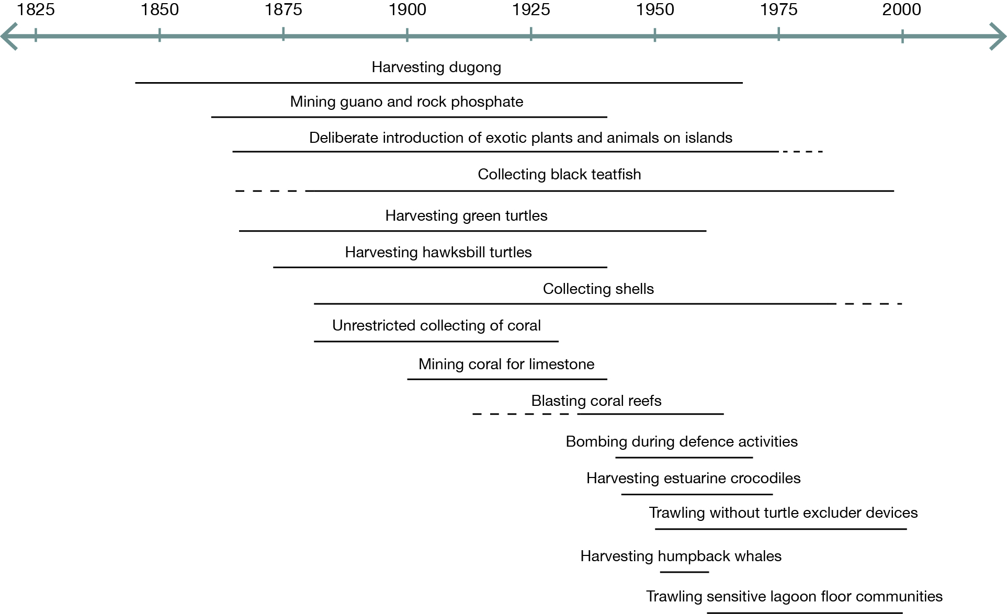
Figure 2.1 Past activities in the Region affecting its biodiversity
Source: Daley 2005¹, Daley et al. 2008², Limpus 2008⁴, Limpus 2009⁵, Burridge et al. 2003¹¹, Poiner et al. 1998¹², Pitcher et al. 2007¹³, Daley and Griggs 2008¹⁴, Roelofs 2004¹⁵

[Photograph of a green turtle nesting. Caption: Past commercial harvesting of species such as green turtles seriously depleted their populations.]

Shifting baselines

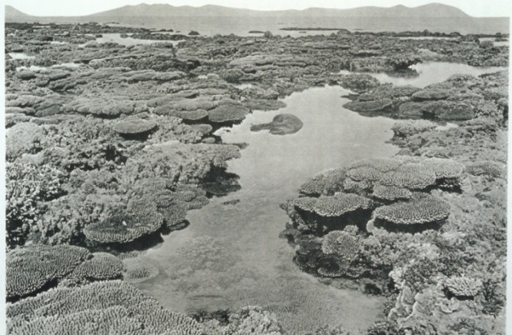
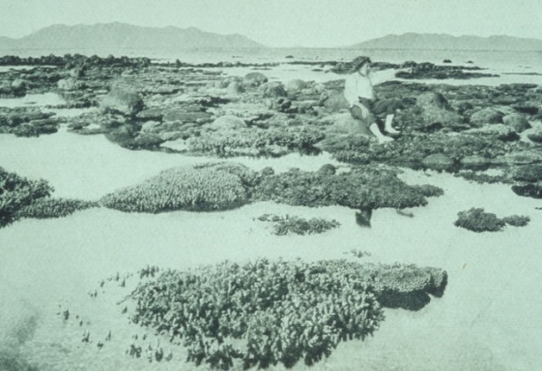
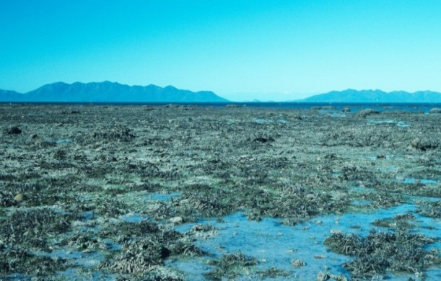
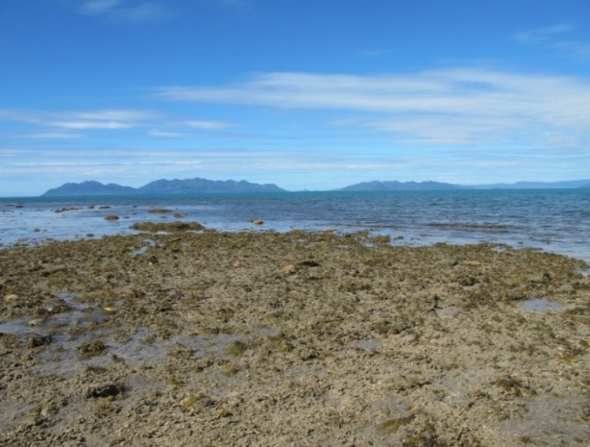
When looking at the Great Barrier Reef today, people tend to compare it with their own previous experiences. However, what is considered natural gradually shifts as changes in the environment accumulate — a ‘shifting baseline’. Such shifts are particularly an issue in marine environments where the technology to study the ecosystem has been developed only recently. In fact, much marine research has been conducted in ecosystems that are already degraded to some extent, and there is little understanding of how these ecosystems operated in the absence of human activity.¹⁶
circa 1890
1915
1994
2012
On the Great Barrier Reef, most scientific research and monitoring began in the 1970s and 1980s, but there is increasing evidence of significant changes in the Reef well before then, some stretching back over the past 200 years. The lack of such long-term scientific data across a number of habitats and groups of species presents a significant challenge for assessing the true condition and trend of the ecosystem, including the risk of using a shifted baseline to make the assessment. For example, the first systematic surveys of subtidal reefs in the late 1960s began after an outbreak of crown-of-thorns starfish had affected coral reef habitats along much of the Great Barrier Reef.¹⁶ Understanding the significance of recent declines in coral reefs^{17,18} depends critically on the context of those past declines.
Evidence for shifted baselines in the Great Barrier Reef has come from older people who remember how conditions were different¹⁹ or from observations recorded in images such as those of Stone Island near Bowen²⁰ (Figure 2.2), journals and ship’s logs. Traditional Owners and many older people in the broader community¹⁹ consider that fish stocks and other marine resources have declined from the very considerable early bounty that was available on the Reef. Subsequent surveys suggest coral trout stocks on studied reefs were markedly depleted before widespread monitoring began.²¹
Figure 2.2 Inshore coral reefs over time, Stone Island, offshore Bowen
Historical photographs of inshore coral reefs have been especially powerful in illustrating changes over time. The changes in the fringing reefs at Stone Island are typical of many inshore reefs. They largely took place before monitoring programs began — illustrating that modern assessments of the condition of coral reefs are likely to be based on an already shifted baseline. (2012 photograph copyright The University of Queensland, courtesy of Tara Clark)

Current condition and trends of habitats to support species
The Great Barrier Reef ecosystem consists of a wide variety of habitats from mangroves and seagrass meadows to coral reefs and open waters (Figure 2.3). Even within each of these habitats there is substantial variation, depending on a complex interplay of ecological factors. Variations of habitats across the continental shelf and beyond — from inshore, shallow water habitats to deep, offshore ocean habitats — are more pronounced than those along the length of the Reef.²² The overall condition of the Region’s biodiversity depends on maintaining the condition of all its habitats and the interconnections between them. Habitats for the conservation of biodiversity are one of the four criteria on which the Reef’s world heritage listing is based.²³
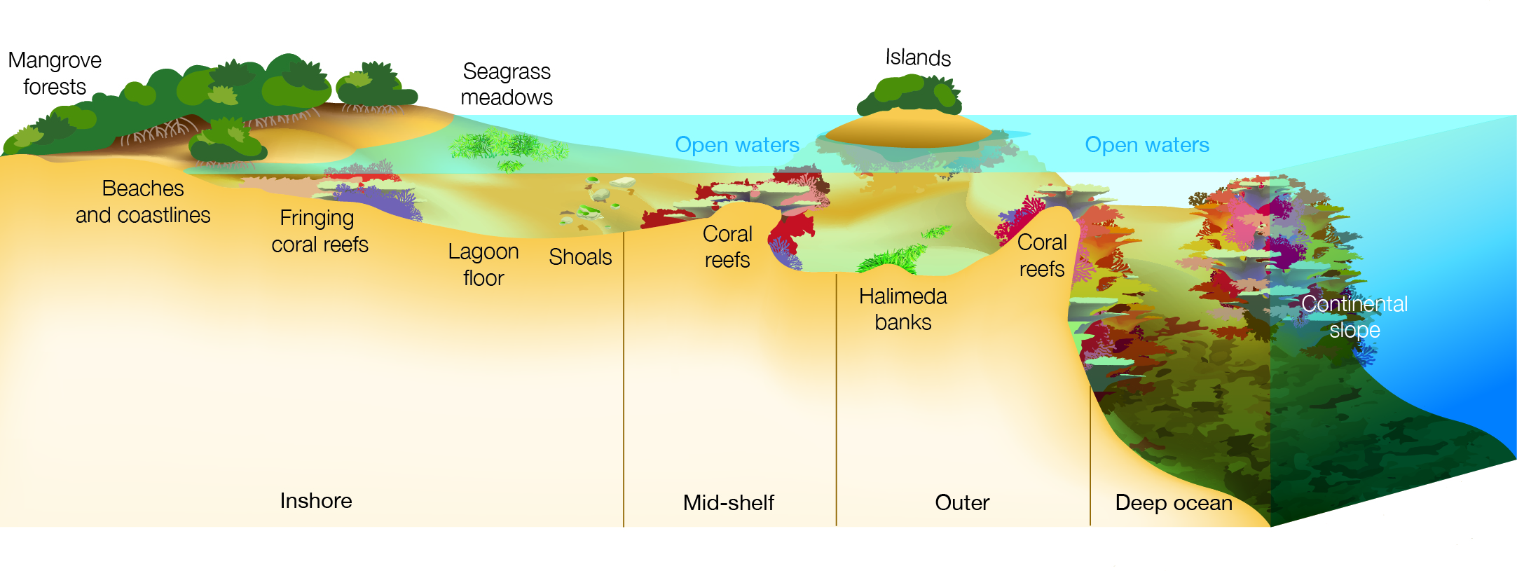
Figure 2.3 Major habitats of the Great Barrier Reef Region
A wide variety of habitats make up the Great Barrier Reef ecosystem. The most pronounced variation is across the continental shelf from the inshore coastal habitats, such as mangroves and beaches, eastwards to the continental slope and deep ocean.

Islands
Key message: Some islands have been affected by cyclones, pests, and the impacts of use.
The Great Barrier Reef ecosystem includes approximately 1050 islands, comprising coral cays, continental islands and mangrove islands. Of these, 70 Commonwealth islands are part of the Region, with the remainder under Queensland Government jurisdiction. The diversity of islands and the habitats they provide are attributes that contribute to the Reef’s Outstanding Universal Value.²³
Several species of terrestrial plants and animals are endemic to Great Barrier Reef islands (such as Pisonia forests²⁴).²⁵ Islands also provide important nesting grounds for a number of marine species such as marine turtles and seabirds.²⁶ There is limited new information and monitoring of the condition of most islands. Recent severe cyclones²⁷, invasive pests²⁸ and weeds²⁹, marine debris, and changes driven by coastal development (see Section 6.4) have affected the condition of some islands. Islands are also considered vulnerable to climate change.^{25,30,31}

Mainland beaches and coastlines
Key message: Some beaches and coastlines have been modified especially around urban centres and ports.
The beaches and coastlines of the Great Barrier Reef ecosystem stretch approximately 2300 kilometres along the mainland coast of Queensland. Sandy shores typically occur on the exposed coastline and are generally a highly dynamic habitat. They support a wide range of species including by providing nesting and staging grounds for shorebirds³² and marine turtles³³. Muddy shores are generally adjacent to river mouths and estuaries in sheltered areas. They act as depositional areas for sediments and nutrients discharged from the catchment or transported along the coast. Rocky coasts are intermittently distributed, providing habitat for many sessile species such as oysters. Beaches and coastlines in the northern area remain relatively unaltered, except for marine debris brought in by currents and tides, and extreme weather events such as cyclones. Structures such as marinas, groynes and port infrastructure have heavily modified some coastline habitats at a local scale and affected local coastal processes. Sediment supply to some beaches is disrupted by artificial barriers to flow (for example dams and weirs) and mangrove forests have replaced beaches where fine sediments have increased.³⁴

Mangrove forests
Key message: Mangrove forests remain relatively stable and abundance is being maintained.
Mangrove forests are an intertidal habitat of trees and shrubs covering an estimated 2070 square kilometres in and adjacent to the Region.³⁴ The habitat occurs in sheltered areas where fine sediments accumulate and where there is inundation by seawater during the tidal cycle.³⁵ The mangrove forests of the Great Barrier Reef are very diverse^{36,37,38}, with the highest diversity in the far north.³⁸ Mangrove forests are an integral part of the Reef ecosystem, providing essential structure and habitat for a range of terrestrial, marine and intertidal species. They play a critical role as: a source of primary production and carbon sequestration; nursery and breeding sites³⁹; depositional areas for suspended sediments from the water; and physical barriers to storms and weather events.^{35,40,41} Mangrove habitats are dynamic, with some localised declines and some expansions.³⁴ In contrast to international trends, the overall condition of mangrove forests in and adjacent to the Region is relatively stable and abundance is being maintained.^{34,35,40,41}
[Photograph of mangroves. Copyright Chris Jones. Caption: Mangrove forests are habitat for terrestrial, marine and intertidal species]

Seagrass meadows
Key message: Many inshore seagrass meadows have declined since 2009.
Seagrass meadows are an important component of the Reef ecosystem. They are the main food source for dugongs and green turtles; provide nursery habitat for many commercial fisheries species^{42,43}; are a major source of primary production^{44,45,46} and sequester significant amounts of carbon⁴⁷. Seagrass meadows also contribute to trapping and stabilising large amounts of sediment^{48,49} and nutrient cycling⁵⁰.
Seagrass meadows grow in estuaries, shallow coastal waters, and in the lagoon — sometimes in association with coral reefs.^{51,52,53} Intertidal and shallow subtidal seagrasses (less than 15 metres deep) are estimated to cover approximately 5700 square kilometres.⁵⁴ Deep-water seagrasses (deeper than 15 metres) are estimated to cover 40,000 square kilometres, although at these depths seagrass generally becomes very sparse (less than five per cent cover).^{53,55,56,57,58}
The earliest ‘baseline’ for the condition and distribution of seagrass is from 1984 to 1988.^{42,59,60} However this baseline may be shifted as hindcast estimates of dugong populations prior to historical commercial harvesting (Section 2.2.1) suggest far more seagrass would have been needed to support larger dugong populations.³
The Outlook Report 2009 noted the overall area of seagrass meadows was considered to have been relatively stable over the preceding 20 year period. Since then, monitoring of about 30 intertidal seagrass meadows along the central and southern coast indicates that their overall abundance has declined (Figure 2.4). Other indicators of the condition of seagrass meadows such as reproductive effort and nutrient status have also deteriorated. Shallow subtidal seagrass meadows are less extensively monitored, but many sites also show declines in abundance. Examples of intertidal and subtidal meadows declining include Mourilyan Harbour where seagrass meadows had been consistently present since 1993 but have now almost all been lost⁶¹, as well as substantial reductions in the meadows adjacent to Cairns⁵², Townsville^{62,63} and Gladstone⁶⁴. Remaining seagrasses are highly vulnerable to further impacts as they have been reduced to small remnant patches and have few seed banks.⁶⁵
These broadscale losses of seagrass are thought to be mainly due to a combination of acute disturbances (for example significant losses occurred between Cairns and Townsville in 2011 due to physical damage by cyclone Yasi⁶³) and ongoing chronic impacts such as poor water quality⁶⁵ and extended periods of cloud cover in the wet season (which limits growth through a reduction in light). Intertidal and subtidal seagrass meadows that have been relatively unaffected by disturbances since 2012 are showing early signs of recovery, beginning with the return of fast-growing pioneer species.^{65,66} A more diverse seagrass habitat generally takes a number of years to re-establish.^{51,63,67,68}
The abundance and condition of deep-water seagrass meadows is less studied, and few are routinely monitored. In a number of central and northern parts of the Region these meadows are dominated by pioneer species and can be highly seasonal or annual.^{69,70} A number of deep-water seagrass meadows affected by floods and cyclones are showing early signs of recovery.⁷¹
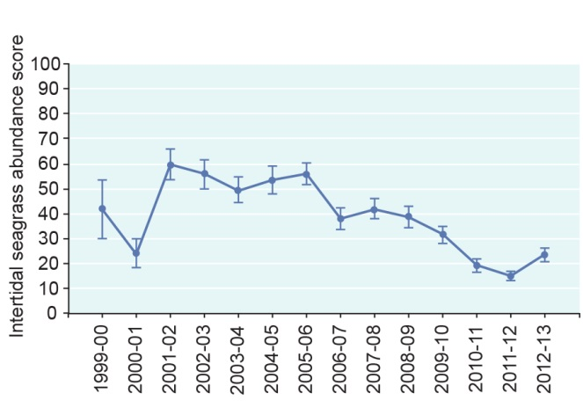
Figure 2.4 Seagrass abundance score for intertidal seagrass meadows, 1999–2013
Substantial declines in the abundance score of intertidal seagrass meadows have been recorded in the Region south of about Cooktown since 2007. Some recovery was observed during 2012-13. Source: McKenzie et al. 2014⁶⁵

Coral reefs
Key message: A series of disturbances has reduced coral cover in the southern two-thirds of the Region.
Key message: There are few indications of recent damage to deeper reefs.
Coral reefs are the cornerstone of the Great Barrier Reef ecosystem and its evolutionary history. Their species diversity, habitat value and natural beauty are major contributors to the Reef’s outstanding universal value as a world heritage area.²³ The Great Barrier Reef is the world's largest coral reef ecosystem, ranging over 14 degrees in latitude and comprising more than 2900 separate coral reefs⁷².
The overall status of coral reef habitats is generally measured by assessing the proportion of a reef covered by living coral — known as coral cover. For the Great Barrier Reef, the most comprehensive, long-term dataset on coral cover is derived from systematic monitoring of a series of reefs since 1985.¹⁸ Results from the monitoring program presented in the Outlook Report 2009 indicated the overall condition of coral reefs in the Region was relatively good, but likely to be declining slightly, especially in inshore areas. It was also reported that coral cover has undergone a wide range of changes, including dramatic increases and decreases on different reefs, and that there is no strong, consistent overall trend in the condition of coral reefs across the Great Barrier Reef.
However, recent analysis of the long-term dataset shows hard coral cover has significantly declined over the past 30 years (Figure 2.5).¹⁸ Since 1986, though there have been some periods of recovery, the overall average hard coral cover in the Region is estimated to have declined from 28 to 13.8 per cent and the rate of decline has increased substantially in recent years.¹⁸ The decline has been most severe on reefs south of latitude 20 degrees (near Bowen) particularly since 2006. Since that time, hard coral cover has reduced from about 35 per cent to eight per cent in the southern third of the Region. Hard coral cover in the northern area has not shown similar declines and is in better condition.
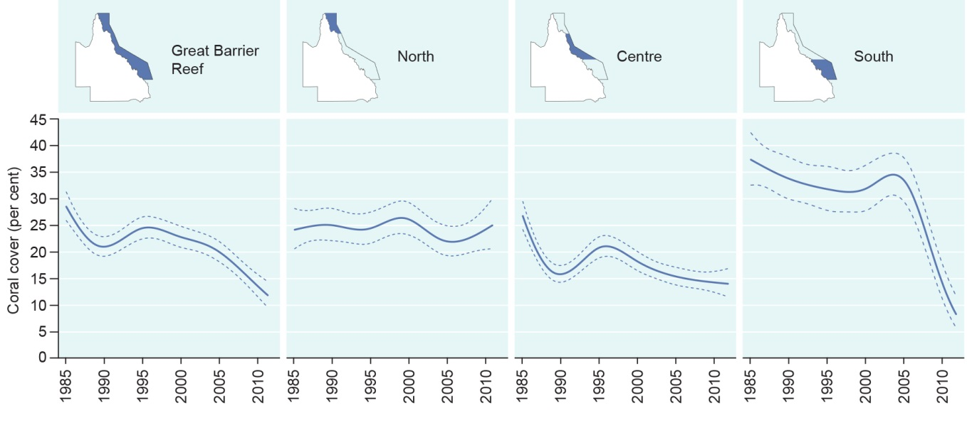
Figure 2.5 Hard coral cover, 1986–2012
The solid line represents modelled coral cover based on the analysis of data collected from 214 reefs across the Region; while the dashed lines either side represent the associated standard errors. Average hard coral cover in the Region has declined significantly since monitoring began in 1986.¹⁸ Declines have been most severe in the south. Source: De’ath et al. 2012¹⁸

The recent declines in coral cover are largely the result of a combination of cyclones, crown-of-thorns starfish outbreaks and mass bleaching events, with insufficient time for recruitment and growth between these disturbances (see Section 8.3.1).^{18,73} Elevated loads of nutrients, sediments and pesticides in land-based run-off are likely to have affected recovery periods in inshore areas.^{74,75,76,77} While coral reefs have a natural ability to recover from periodic disturbances, corals exposed to chronic pressures, such as poor water quality, are likely to have less resilience.⁷⁸ For example, corals have been shown to be more susceptible to bleaching and disease in the presence of elevated nutrients.^{79,80,81}
There are early signs of regeneration of some reefs affected by cyclone Yasi in 2011. Surveys undertaken in 2013 recorded recovery from fragments and recruitment of new corals.⁸²
Data from an inshore marine monitoring program, although over a shorter timeframe, indicates that on average, cover on inshore reefs has declined by 34 per cent since 2005.⁷⁷ In addition, there are emerging signs of low coral cover on inshore reefs accompanied by low numbers of juveniles and slow rates of increase in cover during periods free from disturbances.⁸³
Assessments of coral reef condition over recent decades are almost certainly from a ‘shifted baseline’, with the condition of inshore reefs already substantially reduced before monitoring began. Changes in marine water quality associated with land use practices, such as increased nutrient and sediment loads in river run-off, have resulted in changes in coral colonies and communities over time.^{76,84,85,86,87} For example, evidence from Pelorus Island (in the Palm Island group, north of Townsville) suggests that, between the 1920s and the 1950s, coral composition changed in favour of those species better adapted to more turbid, muddy waters and in some places little live coral remained.⁷⁶ There is evidence, including from historical photographs²⁰ (Section 2.2.2) and anecdotal reports¹⁹, of other inshore reefs undergoing similar shifts.
Since the Outlook Report 2009, there has been an increase in research on deeper coral reef habitats in the Region — those at depths greater than 30 metres. However, they remain poorly understood compared to their shallow-water counterparts.⁸⁸ Mesophotic coral reefs (at depths of between 30 and 150 metres) are characterised by the presence of light-dependent corals in areas where there is limited light for photosynthesis.^{89,90} Modelling indicates mesophotic reefs are likely to be widespread along the Great Barrier Reef shelf edge^{91,92} and may add substantially to the known coral reef area in the Region. In fact, about 60 per cent (25,600 square kilometres) of the seabed where coral reefs are likely to grow is deep-water habitat.⁹³
Cold water coral reefs (below 150 metres) typically occur in depths where light does not penetrate and temperatures are between four and 14 degrees Celsius.⁹⁴ They can form reefs or knolls and be hotspots of biodiversity on the deep seabed.⁹⁵ Although no cold water coral reefs have been identified within the Region, there are locations potentially suitable for them.⁹⁶
There is no long-term data on the condition of deeper reefs; for most of the Region, it is unlikely there has been recent physical damage.^{92,95} However, the substantial damage recorded at Myrmidon Reef offshore from Townsville as a result of the category 5 cyclone Yasi in 2011^{97,98}, indicates that deeper reefs can also be affected by the physical damage of intense cyclones.

Lagoon floor
Key message: Reduced trawling effort and better management have reduced the area of lagoon floor being affected.
The lagoon floor makes up about 210,000 square kilometres, approximately 61 per cent of the Region.⁹⁹ It includes the non-reefal seafloor inside the outer barrier reefs, typically at depths of between 20 and 40 metres.³⁴ The lagoon floor habitat is variable and includes some marine life that rises above the seafloor with sponges, sea-whips, gorgonians (sea fans) and interreefal gardens.¹⁰⁰ The lagoon floor supports many species, such as nematodes and microbial communities, which are important elements of a healthy functioning ecosystem¹⁰¹. Larger organisms use the lagoon floor for food and shelter and as a nursery habitat. These include shellfish, crabs, prawns, sea urchins, sea stars, sea cucumbers, sponges, worms, fishes (including sharks and rays) and some marine turtles. The ecological importance of interreefal areas is recognised in the Reef’s world heritage listing.
While a large-scale study of the Region’s lagoon floor provided a comprehensive and extensive snapshot of the habitat¹³, there is no long-term monitoring. In recent years, the area affected by trawling has decreased (see Section 5.4.1).^{9,102} On a more local scale close to the coast, the lagoon floor is affected by dredging, disposal and resuspension of dredge material, land-based run-off and anchoring.
[Photograph of a crinoid. Caption: The lagoon floor and shoals are not well studied]

Shoals
Key message: Shoals are likely to be affected by physical damage from fishing activities, anchoring, vessel groundings and storms.
Shoals are submerged features on the seafloor away from obvious emergent coral reefs.¹⁰³ They include continental rock, and Pleistocene reef edges.¹⁰³ They are diverse and variable and attract and support many fishes and other species, such as gorgonians, sponges, algae, macroalgae and seagrasses.^{104,105,106} Based on limited studies to date,^{13,104,107} shoals are likely to be affected by physical damage from fishing activities, anchoring, vessel groundings and storms; however, there is no ongoing monitoring of shoals in the Region.

Halimeda banks
Halimeda banks comprise large areas of the northern Great Barrier Reef, inshore of the Ribbon Reefs, and are also found further south (Figure 2.6).¹³ They have a thin top layer of living macroalgae — predominantly calcareous green algae (Halimeda species) which forms banks when it dies ¹⁰⁸, typically up to 20 metres thick^{109,110}. They are usually in waters deeper than 40 metres.¹¹¹ The active calcification and accretion of Halimeda banks over thousands of years is recognised as one of the Reef’s attributes that contributes to its Outstanding Universal Value.²³
As reported in Outlook Report 2009, there remains limited information on the condition and trend of this habitat. Halimeda banks are isolated from land-based impacts and have a high level of protection from trawling through zoning.⁹ The future condition of Halimeda banks is likely to be affected by declining rates of calcification from changes in ocean chemistry¹¹² and any changes in nutrient upwellings¹¹³ because of changes in ocean circulation.
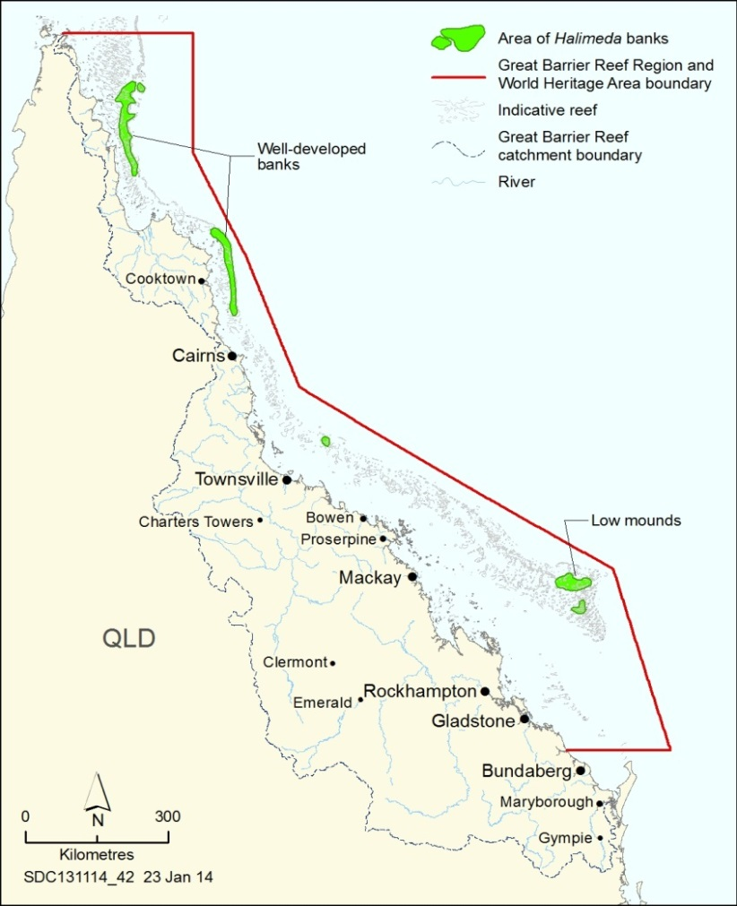
Figure 2.6 Locations of Halimeda banks
Areas in the Region containing known Halimeda banks are indicated. The banks are dominated by Halimeda algae, and provide habitat for a range of other species. Those in the north are particularly well developed. Source: Australian Institute of Marine Science 1988¹¹⁴, Drew and Abel 1988¹¹⁵, Orme and Salama 1988¹¹⁰, Pitcher et al. 2007¹³, Hurrey et al. 2013¹¹⁶

Continental slope
Key message: Much of the continental slope remains undisturbed.
The continental slope is a complex area composed of relic reefs, landslides, canyons and plateaux that extends down to more than 1000 metres.^{117,118} It comprises approximately 15 per cent of the Region or about 51,900 square kilometres.⁸ The continental slope supports many species, including some at-risk skates and rays.^{9,119} There has been little investigation of this remote habitat or the deep-water seabed habitats beyond and no ongoing monitoring.⁸
A deep-water trawl fishery (from 90 to over 200 metres deep) has been operating in continental slope habitat in the south-eastern part of the Region for several decades, with high levels of fishing effort.^{9,120} Based on the amount of fishing effort and a lack of knowledge about habitats and associated species, trawling has been graded as presenting a precautionary high ecological risk in the area that includes these fishing grounds.⁹

Open waters
Key message: Inshore open water habitats are degraded in the southern two-thirds of the Region.
The Region has a total water volume of around 7200 cubic kilometres.¹²¹ This open water habitat is critical to the healthy functioning of the whole Great Barrier Reef ecosystem. It provides connectivity between other habitats, from the coast to beyond the continental slope. Open water is dominated by microorganisms (plankton) and supports a range of other plants and animals such as invertebrates, fishes, reptiles and marine mammals. Inshore areas of open water have been degraded, particularly in the southern two-thirds of the Region. Elevated concentrations of nitrogen and suspended sediment are affecting the overall quality of this habitat¹²², especially inshore, for a range of dependent species. Offshore and northern open water areas are considered to be in better condition (see Figure 6.12). More information on the condition and trends in water quality of the open water habitat is provided in Chapters 3 and 6.
[Photograph of fish swimming. Copyright Chris Jones. Caption: Open waters connect the Reef’s habitats]

Current condition and trends of populations of species and groups of species
Key message: The Great Barrier Reef is home to many species of conservation concern.
The Region is home to thousands of species (Table 2.1). It provides particularly important habitat for species of conservation concern such as dugongs, whales, dolphins, seabirds, marine turtles, sharks and rays. Inscription of the Great Barrier Reef on the World Heritage List recognises the global significance of its species diversity, especially its endemic species.²³ It is recognised that there are many new species yet to be discovered and named.¹³
Table 2.1 Species diversity of plants and animals
Thousands of species make up the Great Barrier Reef ecosystem. Many have not been identified and described. For some, the number of species recorded is provided; for others the most up-to-date estimate is given.^{9,123,124} The sub-Antarctic fur seal, a threatened species, is rarely seen within the Region. The table includes the number of listed migratory species (M) and listed threatened species (T) under the Environment Protection and Biodiversity Conservation Act 1999.
Plants and animals of the Great Barrier Reef | Number of species recorded
Mangroves | 39
Seagrass | 15
Marine macroalgae | 630
Sponges | at least 2500
Soft corals and sea pens | at least 150
Hard corals | 411
Echinoderms | 630
Crustaceans | about 1300
Molluscs | as many as 3000
Worms | at least 500
Bony fishes | 1625
Sharks and rays | 136 (M: 5, T:7)
Sea snakes | 14 breeding species
Marine turtles | 6 (M:6, T:6)
Crocodiles | 1 (M:1, T:1)
Seabirds | 20 nesting species (M:23, T:6)
Shorebirds | 41 (M:30)
Whales and dolphins | more than 30 (M:10, T:4)
Dugongs | 1 (M:1)

Some species in the Great Barrier Reef are classified as species of conservation concern. This means that they are protected by law or require special management. These include:
- Threatened species: Twenty-five marine species that occur in the Region are listed as ‘vulnerable’, ‘endangered’ or ‘critically endangered’ under the Environment Protection and Biodiversity Conservation Act 1999 (EPBC Act) and are therefore matters of national environmental significance. There are seven marine reptiles, five marine mammals, seven sharks and rays and six seabird species (Table 2.1). The Great Barrier Reef is vital to the recovery and survival of many of these.
- Migratory species: The Region supports 76 of the migratory species currently listed under the EPBC Act, making them matters of national environmental significance. This comprises six marine turtle species; 11 mammal species including dugongs and two inshore dolphins; five species of shark; 53 species of shorebirds and seabirds; and the estuarine crocodile (Table 2.1). The fact that these species move during their life histories — sometimes very large distances — means they may spend much of their time outside the Region and hence may be exposed to impacts well beyond the boundaries of the Region or Australia.
- Iconic species: These are well-known plants or animals, such as sea snakes, seahorses, Maori wrasse, whales and dolphins, which often need specific management in the Region.
- ‘At risk’ species or habitats: These are not necessarily protected by legislation, but are facing serious pressure and require special management. Examples include some coral reefs, giant clams, triton shells, seagrass meadows and some sharks and rays.

Mangroves
The Region’s mangrove forests are very diverse with at least 39 mangrove species and hybrids recorded.^{34,36,37,38} The diversity and abundance of mangrove species along the Great Barrier Reef coast are being maintained.³⁴

Seagrasses
Key message: Seagrass abundance has declined and community composition has changed in central and southern inshore areas.
The Great Barrier Reef is one of the most species-rich areas for seagrass in the world.¹²⁵ Fifteen species (which is half of Australia’s total number of species) occur within the seagrass meadows of the Region.^{57,126,127} There is no record of species loss from the Region^{65,128}; however, between 2007 and 2011 there were significant declines in abundance (Section 2.3.4) and shifts in species composition in the inshore southern two-thirds of the Region.^{52,63,66} The species composition of seagrass meadows changes as the habitat recovers from disturbance. Early recovery begins with fast-growing pioneer species and the species composition gradually becomes more diverse, dominated by longer lived, slow-growing foundation species (Figure 2.7).
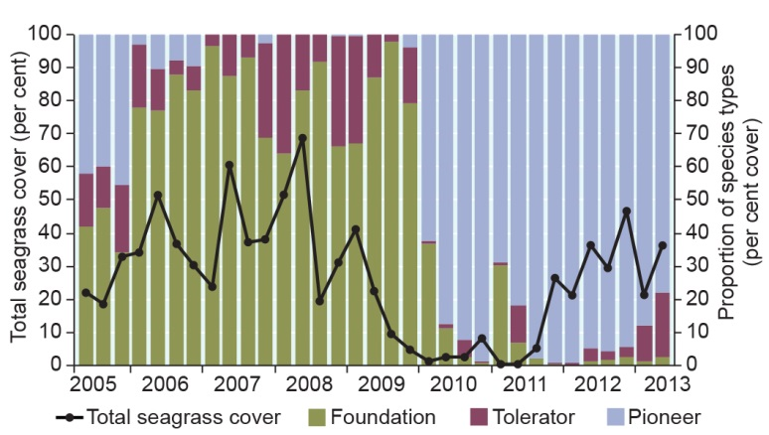
Figure 2.7 Species composition and abundance of seagrass, Cockle Bay, Magnetic Island, 2005–2013
Fast-growing pioneer species are likely to be the first to colonise a disturbed area; however, as meadows grow over time in the absence of disturbances, the longer lived foundation species become more prevalent. Species composition is then likely to remain stable until the next cycle of disturbance and recovery. Source: Adapted from McKenzie et al. 2014⁶⁵

Macroalgae
Key message: The diversity of macroalgae is being maintained and abundance has increased in some areas.
There are over 600 species of macroalgae recorded on the Great Barrier Reef.¹²⁹ Algal communities are highly variable in species composition and abundance.¹³⁰ Some are also highly seasonal.¹³⁰ Forms of macroalgae include turf algae, fleshy macroalgae and crustose coralline algae. Macroalgae also form dominant cover in many non-reef areas such as parts of the lagoon floor.¹³ Macroalgae forms an extensive and important habitat covering between 25,000 and 30,000 square kilometres of the Region.¹¹⁶ Algal diversity is greatest off the coast of Gladstone, Rockhampton and Townsville and lowest in areas characterised by high turbidity and muddy sediments. ¹¹⁶ Thirty-six species of macroalgae are classified as ‘vulnerable’ or ‘vulnerable within a narrow range’.¹³¹
Some fleshy macroalgae are likely to benefit from increased nutrients from land-based run-off but this is likely to be detrimental to natural macroalgal community composition.^{132,133} Nutrients can cause a shift in the balance between macroalgae and corals (see Section 3.4.9).¹³⁴
In 2011 cyclone Yasi caused a short-term reduction in algal cover on inshore reefs in the central part of the Region with cover re-establishing or exceeding pre-cyclone levels in 2012.⁸³
The abundance of inshore macroalgae is considered to be generally stable, but some locally significant changes have been recorded in the Fitzroy region (Figure 2.8).⁸³ Between 2005 and 2007 there was an increase in macroalgal cover in the Fitzroy area, partly as a result of the coral bleaching mortality event in 2006¹³⁵; then in 2010 and 2011, declines in cover followed storm events and associated flooding of the Fitzroy River.⁸³ From 2011, macroalgal cover increased again, probably as the loss of coral cover from the flooding created additional space for growth.⁸³

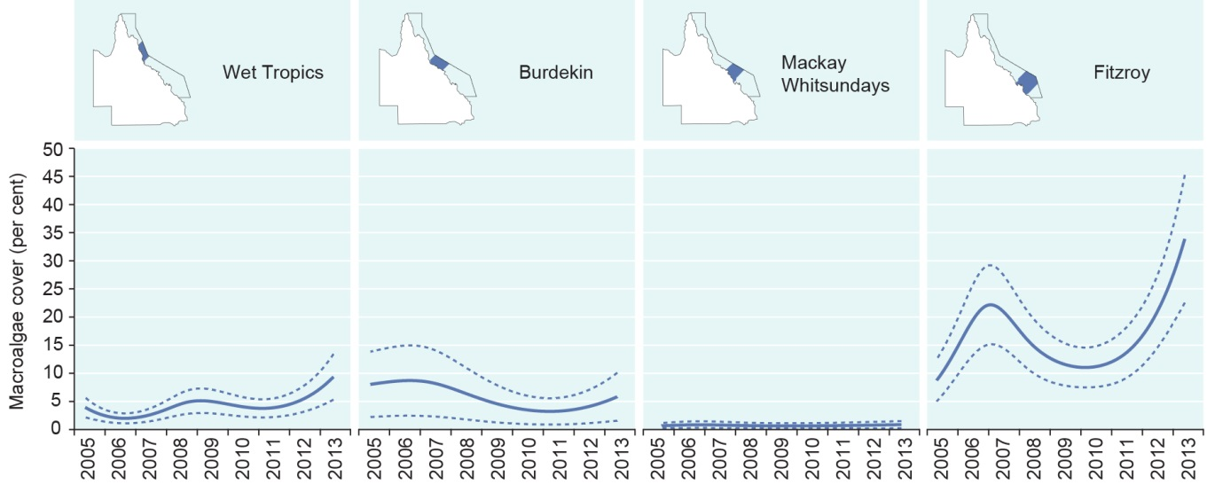
Figure 2.8 Regional trends in inshore macroalgae cover, 2005–2013
The abundance of macroalgae is stable at a Reef-wide scale, but there have been marked regional changes over the last decade. Solid blue curves represent predicted regional trend bounded by blue dashed lines depicting the 95 per cent confidence intervals of that trend. Data presented in graphs relate to macroalgae cover in inshore areas of mapped regions above. Source: Thompson et al. 2014⁷⁸

Benthic microalgae
Key message: Some benthic microalgae are likely to have benefited from elevated nutrients.
Benthic microalgae are microscopic plants which grow on habitats comprising hard bottoms and sandy or muddy sediments. These algae play important roles in primary production and nutrient dynamics in the Region’s ecosystem.¹³⁶ The biomass of benthic microalgae is typically several orders of magnitude higher than that of plants in the water column (phytoplankton).^{136,137} These species are little studied and understanding of their condition, distribution and trend has not improved significantly since the Outlook Report 2009. It is assumed they experience similar disturbances to those identified for the lagoon floor (Section 2.3.6). Some are likely to have benefited from elevated nutrient levels.

Corals
Key message: The community composition of inshore coral reefs changed over the last century.
There are more than 400 species of hard coral^{138,139} and at least 150 species of soft corals, sea fans and sea pens¹⁴⁰ in the Region. Coral diversity contributes strongly to the Outstanding Universal Value of the Great Barrier Reef World Heritage Area.²³ Recent studies indicate deeper, mesophotic reefs have a higher coral diversity than previously thought.^{88,92}
In addition to the decline in hard coral cover described in Section 2.3.5, there is also evidence of changes in species composition on reefs. Evidence from Pelorus Island (in the Palm Island group, north of Townsville) indicates that the community composition of inshore coral reefs changed over the last century.⁷⁶ Historically, the reefs were dominated by Acropora corals, thought to be characteristic of less polluted waters.⁷⁶ However, between 1920 and 1955, the coral composition changed and either shifted to corals typical of more turbid, muddy waters or had little live coral.⁷⁶ More recently, chronic impacts of poor water quality and outbreaks of disease have resulted in a loss of sensitive species in affected inshore areas and therefore reduced species diversity.⁷⁸
Soft coral cover in inshore areas has been generally stable over the period 2005 to 2010 with some decline in 2011 in the central area caused by physical destruction of colonies by cyclone Yasi.⁸³ Record flooding of the Fitzroy River in 2011 also killed almost all shallow-water soft corals (at or above two metres deep) on reefs inshore of Great Keppel Island and caused declines in deeper water.⁸³

Other invertebrates
Key message: Invertebrates are likely to be affected by changing environmental conditions and fishing activities.
There are thousands of species of invertebrates (animals without backbones) in the Region. This biodiversity is nationally and internationally significant (including as part of the Reef’s world heritage listing). An estimated 30 per cent of Australia’s sponge species and more than 10 per cent of the world’s echinoderms (starfish, sea urchins and sea cucumbers) are found within the Region.¹⁴¹ Some groups, such as prawns, crabs and sea cucumbers, are important in fisheries. Fishing activities have reduced abundances of a number of invertebrate species, although no invertebrate species are currently assessed as ‘overfished’ in fisheries stock status reports.¹⁴² The black teatfish fishery was closed in 1999 following concerns for the long-term viability of the harvested stock and has not been reopened (see Section 8.3.3). There are some concerns about the sustainability of the sea cucumber fishery.^{143,144}
Little is known about the condition and trends of most species. Some invertebrate species have been protected (for example tridacnid clams, helmet shell, triton shell). It is likely that deteriorating water quality and the changing condition of southern inshore habitats in the southern two-thirds of the Region has affected dependent invertebrates.
Outbreaks of crown-of-thorns starfish continue to occur on the Great Barrier Reef (see Section 3.6.2). There is strong evidence to support a connection between human-related impacts (in particular, nutrients from land-based run-off) and outbreaks of crown-of-thorns starfish.^{145,146}
[Photograph of shrimp. Caption: These commensal shrimp are one of the Region’s thousands of species of invertebrates.]

Plankton and microbes
Key message: Changes in water temperature and quality are likely to be altering plankton communities.
Although plankton and microbes play a vital role in the Great Barrier Reef ecosystem as the foundation of the food web and in many ecological processes, there remains little known about their condition and trend.^{147,148} Changes in water temperature and quality are likely to be altering plankton communities which, in turn, will be affecting higher trophic levels.^{147,148,149} For example, there is growing evidence that increases in nutrients cause shifts in phytoplankton populations, providing favourable conditions for the development of crown-of-thorns starfish larvae.¹⁴⁶
The condition and trend in phytoplankton abundance are monitored through indicators such as chlorophyll a, which is now recorded in the Region via remote sensing as well as in situ sampling.150,151,152,153,154,155,156,157 For the years 2010 to 2012, differences were recorded in the abundance and diversity of the phytoplankton between the northern third of the Region and areas further south, although there is not yet sufficient data to detect trends.¹⁵⁷
While there is still limited information about the condition and trend of zooplankton in the Region, there is now increased data collection^{158,159}.

Bony fishes
Key message: Reef fishes are likely to have been negatively affected by declines in habitats.
Key message: The abundance of some fished species has declined.
There are about 1600 species of bony fish in the Region. This diversity of species is recognised in the world heritage listing of the Great Barrier Reef.²³
Decades of research have improved understanding of fish biology and ecology, particularly commercial species, but very little is known about the status of most species.¹⁴² There is long-term monitoring of 214 species of coral reef fish populations^{160,161} (Figure 2.9). Fisheries-dependent monitoring provides some information on the trend of a number of species targeted by fishers¹⁶²; however, there is limited fisheries-independent monitoring.
There has been no comprehensive analysis of the long-term trends in the populations of the coral reef fish species that are monitored. Populations of the coral reef fish species are likely to have been affected by the declines in their habitats^{163,164} especially in the southern two-thirds of the Region.
Current understanding of fishing activities suggests targeted species are under significantly more pressure in the southern two-thirds of the Region (see Section 5.4). These patterns are likely to be similar for non-targeted fish species that interact with the fishery. The condition of northern populations of targeted and non-targeted species is not well known.
Of the species targeted in fishing activities, decades of fishing pressure have reduced the size of individual fish, reduced abundances, and contributed to population declines — at least for the more heavily fished species.¹⁶⁵ This is likely to have been exacerbated by extreme weather, reduced habitat availability and declining water quality.¹⁶⁶ Selective fishing can also lead to potentially irreversible evolutionary changes in populations of targeted fish species.^{167,168} Zoning arrangements within the Region have been shown to affect the abundance and biomass of targeted species.^{169,170,171} The biomass of coral trout, one of the most commonly targeted reef fishes, is greater in no-take zones than in zones open to fishing^{165,172} (Figure 2.10).

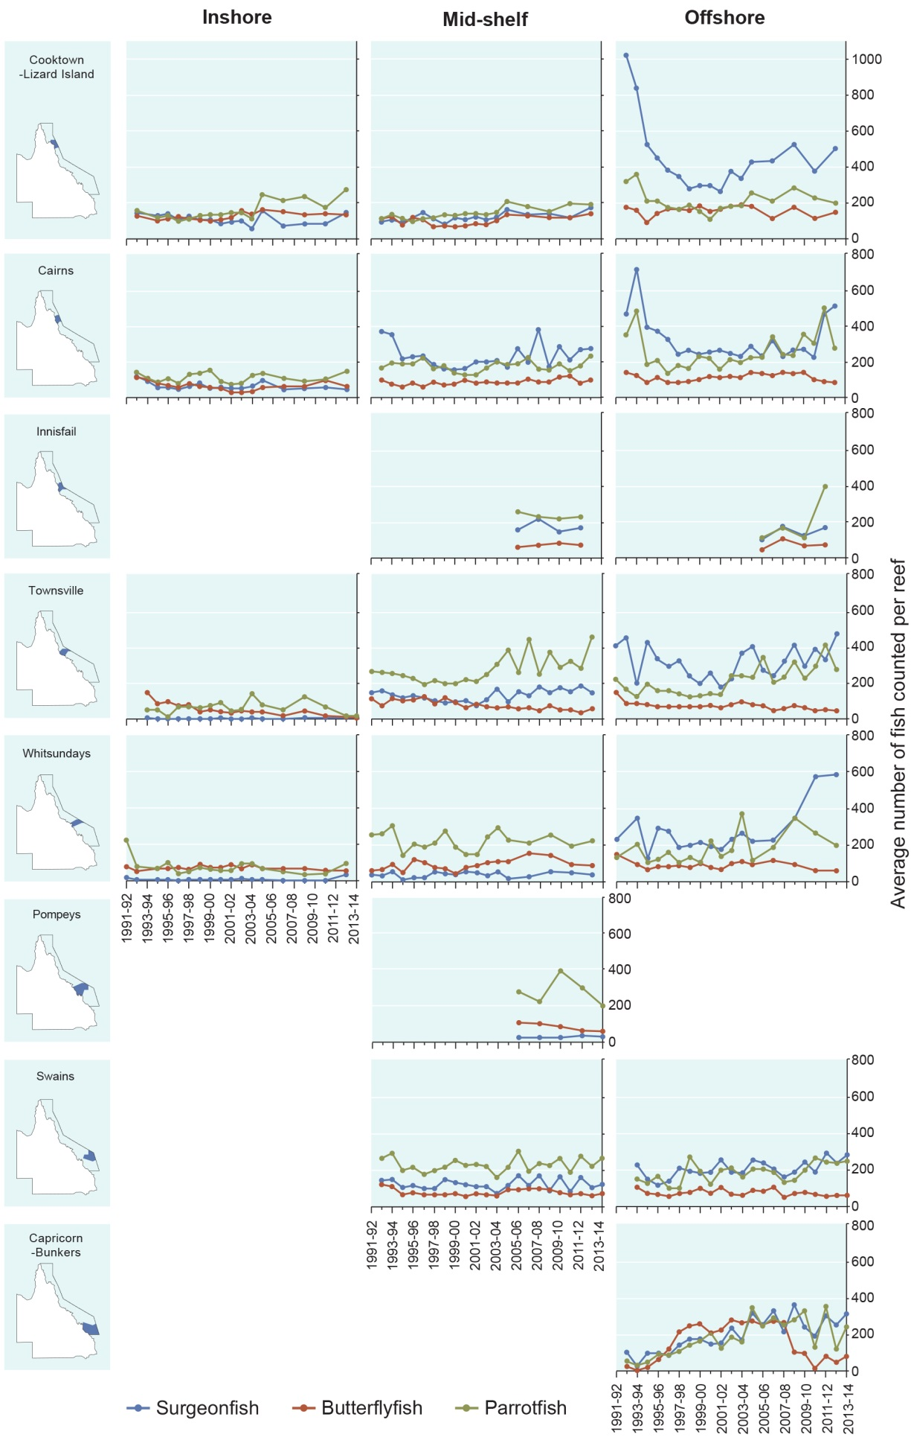
Figure 2.9 Abundance of some coral reef fishes, 1991–2013
Surgeonfish, butterflyfish and parrotfish are examples of how the number of some groups of reef fish changes in different areas of the Region over time. Fish abundance is derived by visual census of a total of fifteen 50 metre by five metre transects at each reef. Where possible three or more reefs were selected at inshore, mid-shelf and offshore positions across the continental shelf. Source: Australian Institute of Marine Science Long-term Monitoring Program 2008¹⁶¹ and 2014¹⁶⁰
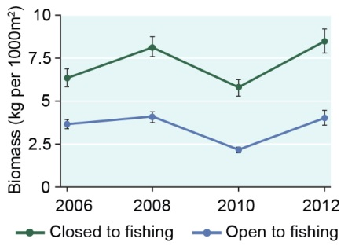
Figure 2.10 Biomass of coral trout in zones open and closed to fishing, 2006–2012
There is more biomass of coral trout on reefs that are closed to fishing. The graph shows the biomass of coral trout (mean plus or minus one standard error) averaged from surveys of 28 pairs of reefs (one open to fishing, one closed to fishing in 2004) in five areas of the Great Barrier Reef. The data was collected using underwater visual census along transects on the reef slope of northeast flanks of each reef. Source: Australian Institute of Marine Science Long-term Monitoring Program¹⁶⁰

Life history traits, habitat preferences and cumulative pressures mean that populations of some targeted species may be particularly vulnerable. The vulnerability of two species of threadfin salmon has been assessed as ‘high’.¹⁷³ The vulnerability of grey mackerel has been assessed as ‘medium’, with concerns about the future sustainability of stocks in the Region.¹⁷⁴
Stock assessments undertaken as part of fisheries management provide an indication of the condition of some targeted species. The stock of snapper has been assessed as ‘overfished’ (where harvest may be exceeding sustainable levels and/or yields may be higher in the long term if the effort is reduced) for the past three years.¹⁴² The stock status of Spanish mackerel could be approaching ‘overfished’.¹⁷⁵ In 2012, the stock status of coral trout moved from ‘sustainably fished’ to ‘uncertain’ due to low catches and catch rates.¹⁴² The ecological consequences of reduced fish populations and biomass, for example flow-on effects to other trophic levels, are largely unknown. The biology of some of these fishes (for example being long-lived, late maturing or forming aggregations for spawning) makes them vulnerable to depletion.¹⁷⁶ In addition, fishing activity, including illegal fishing in zones closed to fishing, has contributed to population declines of some targeted fish species.¹⁷¹

Zoning benefits biodiversity

Zoning, a system of spatial planning and management, is one of the key management tools for the Great Barrier Reef. The amalgamated Great Barrier Reef Marine Park Zoning Plan (Cth)¹⁷⁷ and the complementary Marine Parks (Great Barrier Reef Coast) Zoning Plan (Qld)¹⁷⁸ were implemented in 2004. They provide for a range of ecologically sustainable uses, principally by defining the activities that are allowed, those that are prohibited, and those requiring a permit in each of seven zones. Their design and implementation set a global standard for marine reserve networks^{179,180} and they are recognised as having a wide range of benefits for biodiversity, with flow-on benefits for uses of the Region²¹.
There is strong evidence that fish populations benefit from the protection provided by the Marine National Park (green) Zone which is closed to fishing. There are consistently more and larger coral trout and other target fish species in zones protected from fishing.^{21,169,172,181} Increased reproduction in the no-take zone as a result of more and bigger fish appears to also benefit fish populations in the entire ecosystem.¹⁸² Importantly, the zones operate as a connected network; most reefs (both open and closed to fishing) are within the range of dispersal from a reef closed to fishing.^{21,183,184}
The zoning arrangements appear to benefit overall ecosystem health and resilience. Areas closed to fishing have served as refuges for fish after acute disturbances such as coral bleaching and floods.¹⁶⁵ Even highly vulnerable species, such as dugongs and marine turtles, may benefit from the zoning arrangements, despite the area of each zone being much smaller than the ranges of these species.^{21,185,186}
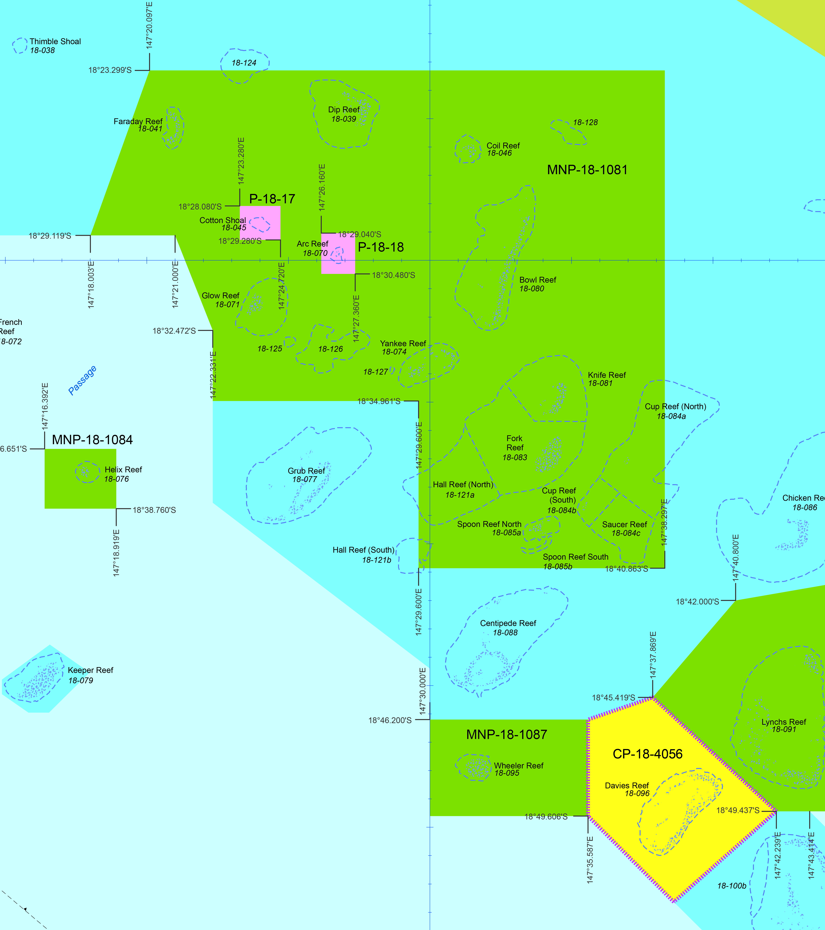
The effectiveness of zoning depends critically on effective compliance — even a relatively small amount of illegal fishing can have ecologically serious impacts. There is evidence that some areas in zones closed to fishing may be significantly depleted due to illegal fishing,²¹ implying the ecological benefits of zoning could be greater still with better compliance.
Given the major threat posed by climate change, the zoning network provides a critical and cost-effective contribution to enhancing the resilience of the Great Barrier Reef.

A network of zones is benefiting biodiversity

Sharks and rays
Key message: One species of shark is likely to be near extinction or extinct in the Region.
Key message: The condition of most shark and ray species is unknown; many are considered at risk.
There are 136 shark and ray species known to inhabit the Region.^{9,187} Five are listed migratory species and seven are listed threatened species. Of the listed species:
- There have been significant range contractions and population declines recorded for the largetooth (previously called the freshwater), green and dwarf sawfish.
- The speartooth shark has now become extinct on the east coast of Australia.¹⁸⁸
- The whale shark, shortfin mako, longfin mako and porbeagle shark are pelagic species for which there is no information on status and trends.
- The white shark and grey nurse shark are temperate species which are rarely sighted in the Region. A 2011 satellite tagging study revealed grey nurse sharks occupying deep-water habitats within the Region.¹⁸⁹
While understanding of the life history traits of some of the Region’s shark and ray species has improved since 2009¹⁹⁰, there is still limited information about the population status of many. There are concerns about the condition and vulnerability of a number of shark and ray species:
- Seventeen currently caught shark species have been assessed as particularly vulnerable to exploitation¹⁹¹, principally due to slow growth rates, slow maturity and low reproductive rates.
- There is concern for some species or groups of species including the grey and whitetip reef sharks,^{192,193} hammerhead sharks¹⁹⁴, as well as some sharks and rays that interact with fisheries.^{9,195,196}
- Species which use inshore, coastal and estuarine habitats almost exclusively or at specific times in their life cycles are the most affected by cumulative human-induced impacts.^{191,197,198}
- Green sawfish, the Australian blacktip shark, the pigeye shark and the blacktip reef shark are among the most vulnerable species that interact with the East Coast Inshore Fin Fish Fishery.¹⁹⁶
- Exploitation presents a risk to a number of batoids (including rays, skates, stingrays, guitarfishes and sawfishes).¹⁹⁹ Shark-like batoids are particularly vulnerable to incidental capture in nets set in inshore waters due to their body shape and preference for inshore habitats.²⁰⁰
- While the ecological risk of trawl fisheries to large sharks and rays has been significantly reduced through the introduction of mandatory excluder devices, many smaller species of sharks and rays remain in the bycatch of prawn and scallop trawlers (see Section 5.4.3).^{9,201}
There is limited information on the distribution and habitat use of either the pelagic or deep-water shark species of the Region.¹⁹¹ Deep-water species of sharks and rays have lower growth rates, later age at maturity, and live longer than both shelf and pelagic species, meaning their populations will take longer to recover from exploitation or other factors causing declines.¹¹⁹

Sea snakes
Key message: A large number of sea snakes are caught as bycatch.
There are 16 species of sea snakes recorded in the Region with 14 species maintaining permanent breeding populations.²⁰² In general, sea snake species richness declines from north to south.²⁰³
While the broad distributions have been documented^{203,204}, information about the distribution and abundance of individual sea snake species is limited, in part due to logistical difficulties associated with counting sea snakes.²⁰⁵ Hence, there is little information and no regular monitoring of population trends.
The trawl fishery continues to interact with and cause mortality to sea snakes. Of the large number of sea snakes caught as trawl bycatch each year (estimated to be over 100,000), it is estimated that about 26 per cent die.²⁰⁴ Reduction in trawl fisheries effort (see Section 5.4) and management initiatives promoting the adoption of fisheye bycatch reduction devices are likely to have reduced impacts on some sea snakes. Two species of sea snakes, the ornate reef sea snake and the elegant sea snake, have been identified as being at high risk to the impacts of otter trawling, and two species, the spectacled sea snake and the small-headed sea snake, as at intermediate risk.^{9,204}
[Photograph of a sea snake swimming. Copyright Matt Curnock. Caption: Sixteen species of sea snakes are recorded in the Region.]

Marine turtles
Key message: Nesting populations of most marine turtle populations are stable or increasing. Some are in decline and all are conservation dependent.
Six of the world’s seven species of marine turtle occur on the Great Barrier Reef, with globally significant nesting areas for four species: loggerhead, green, hawksbill and flatback turtles.²⁰⁶ The international importance of the Reef’s marine turtle populations, including the significance of Raine Island as a turtle rookery, is recognised in its world heritage listing.
Within the Great Barrier Reef, 38 islands are identified as being important nesting sites for marine turtles.²⁰⁷ Of these, Raine Island supports the world’s largest aggregation of nesting green turtles.²⁰⁸ Other important islands include Milman Island (hawksbill and green turtles), Moulter Cay (green turtles), Wild Duck Island (flatback turtles), Peak Island (flatback turtles) and the cays of the Capricorn Bunker Group (loggerhead and green turtles).^{4,5,6,209} Within the Great Barrier Reef there are two distinct genetic stocks of green turtles, a southern stock and a northern stock²¹⁰, which experience different pressures.
The number of nesting green turtles from the southern Great Barrier Reef stock increased at 3.8 per cent per year for the four decades up to 2008.⁴ In 2011 some 1020 marine turtles were reported stranded on the Region’s coast, 879 in 2012 and 483 in 2013 (Figure 2.11).²¹¹ Most were green turtles²¹² and stranded in response to reduced availability of seagrass, their primary food source.⁶⁶
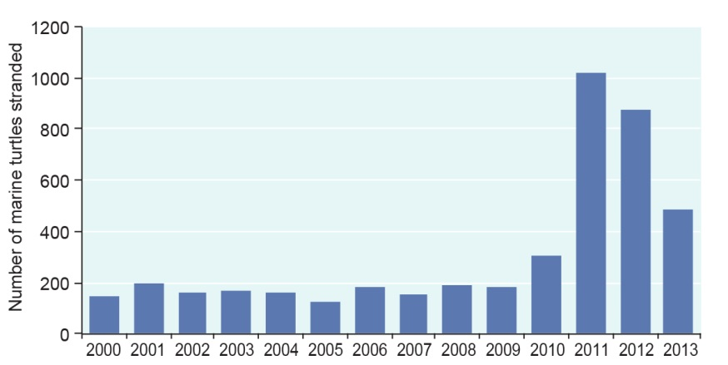
Figure 2.11 Marine turtle strandings, 2000–2013
Marine turtle strandings (dead or alive) in the Region in 2011 were about five times that of previous years. Higher than normal strandings were also recorded in 2012 and 2013. Only cases confirmed in the field by a trained person and later verified by an expert are graphed. Source: Department of Environment and Heritage Protection (Qld)²¹³ and Department of Agriculture, Forestry and Fisheries (Qld) unpublished data²¹⁴

In the northern stock of green turtles, long-term data indicates that the number of nesting turtles at Raine Island has increased significantly since the mid-1970s; although the past two decades have seen a plateau and slight decline to the previously sustained increase in nesting numbers.²¹⁵ Based on published data (to 2001)²⁰⁸, the average size of nesting females is decreasing, and the remigration periods for nesting are increasing which is consistent with a decrease in the proportion of older females returning to breed.^{4,208} These signs indicate the northern Great Barrier Reef stock of nesting females may be in the early stages of decline.^{4,208} There are also concerns about poor hatching success of eggs on Raine Island.
Milman Island, in the northern Great Barrier Reef, is the primary index nesting site for Torres Strait–northern Great Barrier Reef stock of hawksbill turtles. A ten-year study on Milman Island indicated an annual rate of decline of three per cent in the nesting population.²¹⁶ A later study of foraging animals inhabiting the Howick group of islands, also in the northern Great Barrier Reef and within the same hawksbill turtle stock, found a similar decline between the late 1990s and the late 2000s, with some stabilisation between 2003 and 2008.²¹⁷
Wreck, Erskine and Tryon islands in the Capricorn group of islands and the Woongarra coast, just south of the Region, are key nesting locations for the eastern Australian loggerhead turtle stock. This stock continues to recover after declining by more than 80 per cent between 1970 and the early 2000s (Figure 2.12).⁶ Threats outside the Region may be affecting juvenile recruitment into the foraging population.⁶

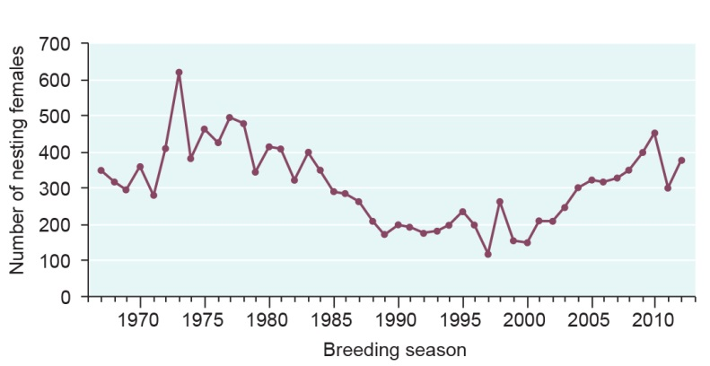
Figure 2.12 Trends in loggerhead turtle nesting, Woongarra coast, 1967–2012
After a gradual decline in the loggerhead turtle nesting populations on the Woongarra coast, including Mon Repos Beach – a key nesting site for turtles that inhabit the Region – there is now evidence of recovery. Data for 1967 and 1968 are population estimates. Other data is derived from population census. Source: Limpus et al. 2008⁶ and Limpus (personal communication)²¹⁸

Key nesting locations for the eastern Australian flatback turtle stock are Peak, Wild Duck and Avoid islands in the southern Great Barrier Reef. There has been no obvious trend in the size of the annual nesting population at these rookeries over three decades and the population is considered to be stable.²⁰⁹ However, there is no new published data since the Outlook Report 2009 and there continues to be virtually no data on the foraging population.²⁰⁹
A very small number of leatherback turtles are known to have nested on mainland beaches adjacent to the Region but no nesting has been recorded since 1996. The Region’s population is considered to be part of the south-west Pacific genetic stock, which has declined.²¹⁹
There is no nesting of olive ridley turtles in the Region and there is virtually no data on the foraging animals that visit the Region.²²⁰
For those marine turtle species that migrate outside the Region, there is a poor understanding of their activities and the impacts on them in those other places.

Estuarine crocodiles
Key message: The estuarine crocodile population continues to recover steadily.
Estuarine crocodiles occur in most coastal waters of the Great Barrier Reef. They are also regularly reported at mid-shelf and some offshore islands.²²¹ Although crocodiles once were extensively commercially harvested, their numbers in northern Queensland are now recovering following full protection under Queensland legislation since 1974.²²¹ The most recent surveys conducted in 2009–10 in the southern two-thirds of the Region showed the population continues to steadily recover, with no southerly expansion of its range.²²² The species’ recovery is limited primarily by the availability of suitable nesting habitat.²²³

Seabirds
Key message: Trends in seabird populations are highly variable between different species and locations.
Key message: There are declines in some seabird breeding areas and changes in key supporting resources
Islands and cays within the Great Barrier Reef support breeding populations of 20 seabird species.²⁶ It is estimated that between 1.4 and 1.7 million seabirds breed throughout the Great Barrier Reef each year.²²⁴ This represents more than 25 per cent of Australia's tropical seabirds, more than 50 per cent of offshore–foraging black noddies and approximately 25 per cent of wedge-tailed shearwaters, brown and masked boobies and red-tailed tropic birds.²²⁴ The number of non-breeding birds (birds which use the Region for feeding but breed elsewhere) is estimated to be about 425,000, giving a total seabird population that may exceed two million.²⁰⁶ The global importance of the Reef’s seabird populations contributes to its outstanding universal value.²³
In terms of variety of species, numbers of breeding adults and conservation significance, the four most important seabird areas in the Great Barrier Reef are Raine Island²²⁵, Michaelmas Cay²²⁶, the islands of the Capricorn–Bunker Group²²⁷ and the cays of the Swain Reefs.²²⁸ While there is regular monitoring at many of these sites²²⁹, long-term trend information is only available for a small number of islands, such as Michaelmas Cay, and for only a limited number of species. Fourteen seabird species regularly breed at Raine Island in the Region’s north making it one of the most important seabird rookeries in the Region.²⁶ Information presented in the Outlook Report 2009 suggested there were declines in many seabird species at Raine Island; however, a review of the survey method and recent survey data indicate declines may not be evident in all species.²³⁰ Surveys of Raine Island conducted in July 2013 recorded the highest numbers of breeding pairs of lesser frigatebirds since surveys began in 1979.²³⁰
Monitoring at Michaelmas Cay shows wide annual variation in seabird breeding numbers. It suggests there have been no significant long-term trends in the island’s breeding populations of common noddies, crested terns and sooty terns over the past 30 years (Figure 2.13).
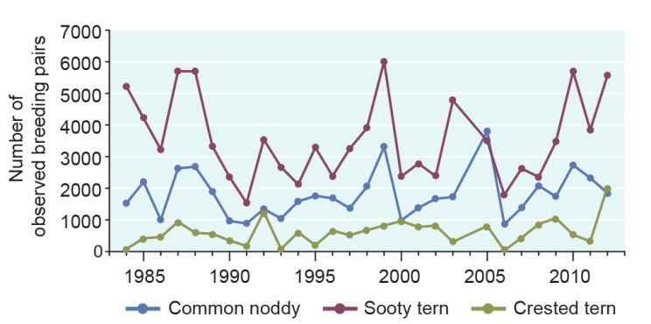
Figure 2.13 Mean number of observed seabird breeding pairs, Michaelmas Cay, 1984–2012
The number of seabirds breeding on Michaelmas Cay varies from year to year. There are no clear long-term trends. The data represents the average number of breeding pairs recorded during field observations of three seabird species: the common noddy, sooty tern and crested tern. Source: Queensland Coastal Bird Atlas, 2014²³¹

Monitoring data collected from islands in the Capricorn–Bunker Group indicate the wedge-tailed shearwater population may have declined by nearly 40 per cent over the past 15 years while black noddy numbers have remained relatively steady.²³² Despite a ten-year gap in the monitoring effort and limited recent surveys, these trends are cause for concern in the context of associated declines in New Caledonia²³² and likely changes in key supporting resources and environmental conditions ²³² as a result of factors such as climate change^{233,234}.
The population of the brown booby nesting in the Swain Reefs may have declined between the 1980s and the 1990s as vegetation was lost from key breeding cays, principally from a series of cyclones in the area, and the habitat has only partially recovered.^{228,235} Gannet Cay (named for the boobies breeding on it) was a very important breeding island in the Swain Reefs and a sharp decline in breeding pairs was observed following almost complete vegetation loss in the mid-1980s²²⁸ (Figure 2.14).
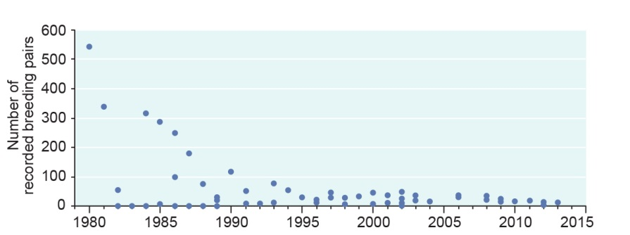
Figure 2.14 Number of observed brown booby breeding pairs, Gannet Cay, 1980–2013
The data represents the number of breeding pairs recorded during field observations. The number of brown boobies breeding at Gannet Cay in the Swain Reefs declined following the almost complete loss of vegetation in the mid-1980s. Source: Queensland Coastal Bird Atlas 2014²³¹

[Photograph of a seabird and its chick. Caption: Brown booby and chick, Raine Island.]

Shorebirds
Key message: There are no population estimates for the Region’s shorebirds; there are declines Australia-wide.
At least 41 species of shorebirds are known to inhabit the Great Barrier Reef.²³⁶ A number of sites are known to provide important habitats for shorebirds, including the islands off False Orford Ness in Cape York, Pelican Island and nearby islands, Cairns foreshore, Cape Bowling Green, Burdekin River delta, Pioneer River to McEwan's Beach and Notch Point near Mackay, Shoalwater Bay and Broad Sound.²³⁷
There are no population estimates for the Region’s shorebirds. Australia-wide declines of between 70 and 80 per cent have been recorded in the past 24 years²³⁸, including for populations that migrate through the Region.

Whales
Key message: There is little information on the condition of most whale populations; humpback whales are recovering strongly.
It is estimated that 15 species of whale inhabit the Region, either seasonally or throughout the year, and there is limited information on the condition of most of these, with the exception of the humpback whale and the dwarf minke whale.²³⁹
The humpback whale is a listed threatened species which has been monitored since the 1980s. Its population is continuing to recover strongly after being decimated by whaling which stopped in the 1960s (Section 2.2.1). From an east Australian population as low as 500 animals when whaling ceased, numbers have grown consistently with an estimated annual recovery rate of between 10.5 and 12.3 per cent.²⁴⁰ The population was estimated to be more than 10,000 animals in 2007²⁴⁰ — about half of the estimated pre-whaling population size.²⁴⁰ The most recent 2010 survey provides no evidence that the rate of population growth is slowing significantly with an absolute population abundance in that year of over 14,500.²⁴¹

Dwarf minke whales visit the northern Region each winter — the only location in the world with predictable encounters with these whales. Dwarf minke whales are also reported in very low numbers further south in the Region.²⁴² Being a relatively cryptic species, little is known of the population status of dwarf minke whales that migrate there. The population of dwarf minke whales that interact with visitors in the Region has been conservatively estimated to be 449 in 2006, 342 in 2007 and 789 in 2008.²⁴³ It is unknown whether this reflects actual abundance or only that part of the population that is more likely to interact.²⁴⁴
[Photograph of a minke whale. Copyright Matt Curnock. Caption: Dwarf minke whales visit the Region each winter

Dolphins
Key message: Two inshore dolphin species are considered at risk and likely to be in serious decline.
There is estimated to be 18 species of dolphin in the Region. They are found throughout the Region with some species solely inhabiting inshore waters and others typically being found far from the coast. There is limited information or monitoring of the status of most species.
While all dolphin species are protected in the Region, the Australian snubfin and Indo-Pacific humpback dolphins are considered the highest priority for management in the Region because of their small, localised populations, exposure to high levels of human activity, and suspected population declines.²⁴⁵ Recent research suggests the northern Australian population of Indo-Pacific humpback dolphin that occurs in the Region may be a distinct species.²⁴⁶ This new classification would have implications for its conservation status as the population would be smaller and more confined than under its current classification.
There are no overall population estimates for the Australian snubfin or Indo-Pacific humpback dolphins in the Region.²⁴⁷ At a local scale, it is estimated that there are less than 100 Australian snubfin dolphins in Cleveland–Halifax Bays²⁴⁸ and about 70 in Keppel Bay–Fitzroy River²⁴⁹. An aggregation has also been recorded at Princess Charlotte Bay–Bathurst Bay on Cape York Peninsula²⁵⁰, but there has been no population census. There have been population estimates for Indo-Pacific humpback dolphins in Cleveland Bay (50 or less)²⁴⁸; the Capricorn coast (about 64); Keppel Bay (about 107); and Port Curtis (about 85)²⁵¹. Populations of this species are also known to occur south of the Region in Great Sandy Strait²⁵² and Moreton Bay²⁵³. There is almost no understanding of populations of these two species elsewhere in the Region, although there have been sightings.
Populations of these inshore species are likely to be in decline throughout the Region. For populations to remain stable, modelling suggests that the snubfin dolphin population in Cleveland–Halifax Bays and Keppel Bay–Fitzroy River can sustain a human-related death rate of only one animal every four years²⁵⁴ and one animal every year respectively.²⁴⁹ The incidental deaths of two snubfin dolphins in Halifax Bay in 2011 and another in 2013 means the long-term viability of this population is at risk. There are similar concerns for Indo-Pacific humpback dolphins in Keppel Bay and Port Curtis where eight died of unknown causes in 2011.²¹¹ It is likely that changes in the population’s size will not be detectable over a short time period, unless they are very high (greater than 20 per cent per year). This could mean local populations of the two species could decrease to very low levels before a decline is detected.²⁴⁸
Another inshore species, the Indo-Pacific bottlenose dolphin, has similar life history traits to the Australian snubfin and Indo-Pacific humpback dolphins.^{255,256} However, the Indo-Pacific bottlenose dolphin uses a wider range of habitats and may be more abundant,^{255,256,257,258} though there is limited information on the population status within the Region.
The other 15 dolphin species in the Region are likely to be less susceptible to pressure. They generally occur further offshore and have less conservative life history traits. For example, the common bottlenose dolphin usually associate in large groups, display low site fidelity, and forage on large prey aggregations. Many of the species are rarely seen or only intermittently reported as stranded.²⁵⁹

Dugongs
Key message: While the northern dugong population remains stable, the population south of Cooktown has declined substantially.
The Region is home to a globally significant population of dugongs and provides essential habitat and connectivity between populations in the Torres Strait and the waters off south-east Queensland.²⁶⁰ The Region’s population is recognised as contributing to its outstanding universal value.²³
Monitoring of dugong populations in the Region began in 1985 (Figure 2.15). The dugong population in northern areas of the Region is considered in good condition and stable with no evidence of a major decline.^{261,262,263,264}

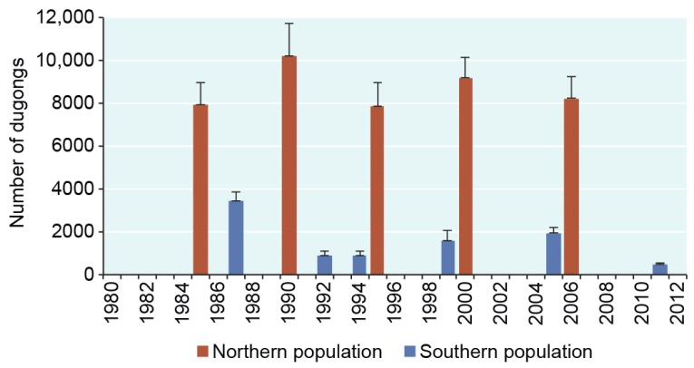
Figure 2.15 Dugong populations, 1985–2011
In 2009, the Region’s southern dugong population was thought to have stabilised after a long history of decline. However, recent surveys indicate further decline, principally as a result of deterioration in seagrass meadows. Surveys indicate the population north of Cooktown is stable. Some of the variation between surveys is due to animals moving between and within survey regions. The error bars represent standard error. Source: Marsh et al. (various years)^{3,262,264,265,266} and Sobtzick et al. 2012²⁶⁷

The southern, or urban coast, dugong population (south of Cooktown) has declined over many decades. Modelling indicates this occurred at an average rate of 8.7 per cent per year between 1962 and 1999, with most of the decline occurring in the early years.²⁶⁸ The Outlook Report 2009 reported that the southern population was thought to have stabilised. However, indirect impacts of declining seagrass abundance (see Section 2.3.4 and Section 2.4.2) — the primary food resource for dugongs — combined with direct human-related impacts such as drowning in commercial fishing set mesh nets, boat strike, marine debris and illegal poaching has caused the southern dugong population to decline again.^{267,269}
In 2011, there was an estimated population of only 600 animals between the Daintree River and the Region’s southern boundary^{3,267}, compared with an estimate of around 2000 from the previous survey in 2005.^{267,270} This estimate is a standardised relative index of dugong abundance and is less than the actual abundance. This is the lowest population estimate for this area since surveys began in 1987²⁶⁷ and coincided with significant seagrass losses (Section 2.3.4). The decline is likely to be explained by animals moving out of the survey area to seagrass meadows elsewhere and increased mortality.^{266,267} In 2011, an unprecedented number of stranded dugongs were found, reported and verified along the Region’s coast (Figure 2.16).

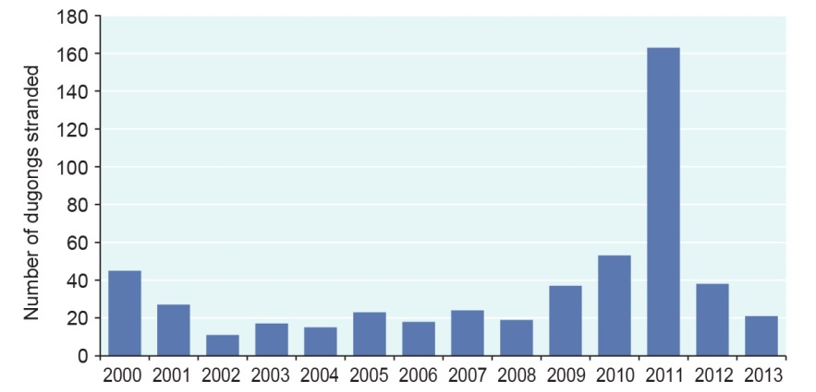
Figure 2.16 Dugong strandings, 2000–2013
There was a pronounced increase in stranded dugongs along the Region’s coast in 2011, principally as a result of declines in seagrass meadows — their main source of food. The graph represents the number of sick, injured, or dead dugongs that have been found, reported and verified and hence it generally is only for the urban coast south of Cooktown. Only cases confirmed in the field by a trained person and later verified by an expert are graphed. Source: Department of Environment and Heritage Protection (Qld)²¹³ and Department of Agriculture, Forestry and Fisheries (Qld) unpublished data²¹⁴

[Photograph of coral reef with fish. No caption]

Assessment summary — Biodiversity
Section 54(3)(b) of the Great Barrier Reef Marine Park Act 1975 requires ‘… an assessment of the current biodiversity within…’ the Great Barrier Reef Region. This assessment is based on two assessment criteria:
- habitats to support species
- populations of species and groups of species.

Habitats to support species
Outlook Report 2009: Assessment summary
For most of the Great Barrier Reef, habitats appear to be intact. Some inshore habitats (such as coral reefs) have deteriorated, caused mostly by reduced water quality and rising sea temperatures. This is likely to have affected species that rely on these habitats. Little is known about the soft seabed habitats of the lagoon, open waters or the deep habitats of the continental slope.

Assessment component | Assessment summary | 2009 grade | 2014 grade and trend | 2014 confidence
 |  |  |  | Grade | Trend
Islands | Some islands have been affected by recent extreme weather, invasive pests and weeds, marine debris, climate change and coastal development. | Good | Good, Deteriorated | Limited | Limited
Mainland beaches and coastlines | Some mainland beaches and coastlines have been modified especially around urban centres and ports. However most remain in a relatively natural state. | Good | Good, Stable | Limited | Limited
Mangrove forests | Mangrove forests remain relatively stable and abundance is being maintained. | Good | Good, Stable | Limited | Limited
Seagrass meadows | Many inshore seagrass meadows have declined since 2009, especially due to extreme weather events. Some meadows have shown early signs of recovery. | Good | Poor, Deteriorated | Limited | Limited
Coral reefs | A series of disturbances has reduced coral cover in the southern two-thirds of the Region. Some areas are not yet showing signs of recovery. There are few indications of recent damage to deeper reefs. | Good | Poor, Deteriorated | Adequate | Adequate
Lagoon floor | Recent reductions in trawling effort and better management have reduced the area of lagoon floor being affected by the fishery. There is likely to be localised damage from dredging, disposal of dredge material and anchoring. | Good | Good, Stable | Inferred | Inferred
Shoals | There is limited information about shoals. They are likely to be impacted by fishing and anchoring activities. | Good | Good, Stable | Limited | Inferred
Halimeda banks | There is limited information about Halimeda banks. Given the habitat is remote and in deep water it is isolated from land-based impacts and is likely to be undisturbed. | Very good | Very good, Stable | Inferred | Inferred
Continental slope | Much of the continental slope remains undisturbed and minimally impacted by human activities. In the south-east, an area is at high ecological risk because of sustained high levels of trawling. | Very good | Good, Deteriorated | Inferred | Inferred
Open waters | Inshore open water habitats are degraded in the southern two-thirds of the Region principally due to pollutants from land-based run-off. This habitat is thought to be minimally impacted in the remainder of the Region. | Good | Good, Deteriorated | Adequate | Adequate
Habitats to support species | Information on the condition and trend of habitats is highly variable with some well known (for example shallower coral reefs) and others poorly known, particularly habitats in remote areas or deep waters (for example Halimeda banks). The habitats of the northern third of the Region are believed to remain in very good condition and are able to support dependent species. Habitats in the southern two-thirds of the Region — especially those inshore — have deteriorated, particularly seagrass meadows and coral reefs. | Good | Good,  Deteriorated

Grading statements
Very good | All major habitats are essentially structurally and functionally intact and able to support all dependent species.
Good | There is some habitat loss, degradation or alteration in some small areas, leading to minimal degradation but no persistent, substantial effects on populations of dependent species.
Poor | Habitat loss, degradation or alteration has occurred in a number of areas leading to persistent substantial effects on populations of some dependent species.
Very poor | There is widespread habitat loss, degradation or alteration leading to persistent, substantial effects on many populations of dependent species.
Trend since 2009
Improved, Stable, Deteriorated, No consistent trend
Confidence in grade and trend
Adequate | Adequate high-quality evidence and high level of consensus
Limited | Limited evidence or limited consensus
Inferred | Inferred, very limited evidence

Populations of species and groups of species
Outlook Report 2009: Assessment summary
Populations of almost all known Great Barrier Reef species or groups of species appear to be intact, but some populations such as dugongs, as well as some species of sharks, seabirds and marine turtles, are known to have seriously declined, due mainly to human activities and declining environmental conditions. Many species are yet to be discovered and for many others, very little is known about their status. In time, more populations are likely to decline. Populations of some formally listed threatened species have stabilised but at very low numbers; other potentially threatened species continue to be identified.

Assessment Component | Assessment Summary | 2009 grade | 2014 grade and trend | 2014 confidence
 |  |  |  | Grade | Trend
Mangroves | The diversity and abundance of mangrove species are being maintained. | Very good | Very good, Stable | Limited | Inferred
Seagrasses | Seagrass abundance has declined and community composition has changed in central and southern inshore areas, mainly due to cyclones, flood events and extended periods of cloud cover, in addition to the longer term impacts of poor water quality. There is limited information on deep-water seagrasses. | Good | Poor, Deteriorated | Limited | Limited
Macroalgae | The diversity of macroalgae is being maintained and abundance has increased in some areas. Macroalgae is likely to have benefited from elevated levels of nutrients associated with human activity and increases in available habitat after cyclones. | Good | Good, Stable | Limited | Limited
Benthic microalgae | There is limited information about benthic microalgae. They are likely to have benefited from elevated nutrients and experienced some disturbances. | Very good | Very good, Deteriorated | Inferred | Inferred
Corals | Hard coral abundance has substantially decreased in the southern two-thirds of the Region. Soft coral cover in inshore areas is generally stable with some declines after severe cyclones and flooding. The community composition of inshore coral reefs has changed over the past century. | Good | Poor, Deteriorated | Adequate | Adequate
Other invertebrates | Little is known about most invertebrates. Changing environmental conditions in central and southern inshore areas, as well as some fishing activity, are likely to have affected invertebrates. Human-related impacts are implicated in outbreaks of crown-of-thorns starfish. | Very good | Good, Deteriorated | Inferred | Inferred
Plankton and microbes | Changes in water temperature and quality are likely to be altering plankton communities. | Very good | Very good, Deteriorated | Inferred | Inferred
Bony fishes | Little is known about the condition of most fish species; habitat declines are likely to have negatively affected them. The abundance of some fished species has declined. Fishing activities affect targeted and non-targeted species. | Good | Good, Deteriorated | Limited | Limited
Sharks and rays | The condition of most shark and ray species is unknown. Many are considered at risk. One species of shark is likely to be near extinction or extinct in the Region. | Poor | Poor, Deteriorated | Limited | Limited
Sea snakes | A large number of sea snakes are caught as bycatch. Reduction in effort and better management of trawl fisheries is likely to have reduced impacts on some sea snakes. | Poor | Poor, Stable | Limited | Inferred
Marine turtles | Nesting populations of most marine turtle populations are stable or increasing. Some are in decline and all are conservation dependent. Turtle populations are affected by threats both within and well beyond the Region. | Poor | Poor, No consistent trend | Adequate | Adequate
Estuarine crocodiles | The estuarine crocodile population continues to recover steadily after being protected under Queensland legislation in 1974. Recovery is limited primarily by the availability of nesting habitat. | Good | Good, Improved | Limited | Adequate
Seabirds | Trends in seabird populations are highly variable between different species and locations, and there are limited long-term data. Changes in key supporting resources and environmental conditions are affecting some seabirds. | Poor | Poor, No consistent trend | Limited | Limited
Shorebirds | There are no population estimates for the Region’s shorebirds; there are substantial declines Australia-wide, including for migratory populations that would move through the Region. | Not assessed | Poor | Inferred | Not assessed
Whales | There is little information on the condition of most whale populations; humpback whales are recovering strongly. | Good | Good, Improved | Limited | Limited
Dolphins | Two inshore dolphin species are considered at risk and likely to be in serious decline. The inshore bottlenose dolphin is also considered vulnerable. There is limited information available on trends in the other 15 dolphin species but they are likely to be less susceptible to pressure. | Good | Good, Deteriorated | Inferred | Inferred
Dugongs | While the northern dugong population remains stable, the population south of Cooktown has declined substantially due to a combination of seagrass loss and human-related impacts. | Poor | Poor, Deteriorated | Adequate | Adequate
Populations of species and groups of species | There is condition and trend information for only a limited number of species and species groups; hence the assessment of some components is highly uncertain. Of those for which there is information, there have been significant declines in many, especially in the inshore southern two-thirds of the Region, and some iconic and cultural keystone species. For example, significant declines have been recorded in most hard corals and seagrasses, some fishes and sharks, dugongs, plus some seabird populations. There are four examples of species showing good recovery after past serious declines: humpback whales, estuarine crocodiles, loggerhead turtles and green turtles (southern stock). However, even these species have not recovered to their original numbers. The overall condition of the Region’s species appears to have deteriorated significantly and the assessment of ‘good’ is considered borderline with ‘poor’. | Good | Good, Deteriorated

Grading statements
Very good | Only a few, if any, species populations have deteriorated as a result of human activities or declining environmental conditions.
Good | Populations of some species (but no species groups) have deteriorated significantly as a result of human activities or declining environmental conditions.
Poor | Populations of many species or some species groups have deteriorated significantly as a result of human activities or declining environmental conditions.
Very poor | Populations of a large number of species have deteriorated significantly.
Trend
Improved, Stable, Deteriorated, No consistent trend
Confidence in grade and trend
Adequate | Adequate high-quality evidence and high level of consensus
Limited | Limited evidence or limited consensus
Inferred | Inferred, very limited evidence

Overall summary of biodiversity
The Great Barrier Reef remains one of the world's most unique and biologically diverse ecosystems. At the scale of the whole Region, the majority of its habitats are assessed to be in good to very good condition, however an increasing number are assessed as being in poor condition. This includes the two key habitats of coral reefs and seagrass meadows in the southern two-thirds of the Region. The condition of a number of species has deteriorated since the assessment in the Outlook Report 2009, with some important species now assessed as being in poor condition.
On a regional scale, the habitats and species north of the Port Douglas–Cooktown area are in better condition than those further south. Also, habitats further offshore and in deeper water are typically subject to fewer threats and are therefore presumed to be in better condition, including the lagoon floor, shoals, Halimeda banks, deeper reefs and the continental slope.
A range of past and current threats, including pollutants in land-based run-off, crown-of-thorns starfish outbreaks, death of discarded species, incidental catch of species of conservation concern and recent extreme weather, have caused declines in the biodiversity values of the southern two-thirds of the Region, especially in inshore and mid-shelf areas.
For some species, such as sharks and rays, corals, some marine turtles and dugongs their condition is assessed as poor and deteriorated. Two species of inshore dolphins are also considered at high risk and in decline.
There are few examples of recovering populations. Those that are recovering are species that declined as a result of human-related impacts which are now eliminated or reduced, for example commercial whaling for humpback whales and incidental drowning of marine turtles in trawl nets. These populations have yet to recover to their original size and, as they tend to be long-lived species, full recovery is likely to take decades.
Biodiversity is critical to the outstanding universal value of the world heritage property. While both criteria are assessed as being in good condition, the current trends for 14 of the 27 components are assessed as deteriorated since 2009. This has meant that the grade of ‘good’ is borderline with ‘poor’ and is likely to deteriorate further in the future.
A lack of comprehensive information means the assessment of many habitats and species or groups of species is principally based on limited evidence and anecdotal information. Understanding of the less accessible habitats, such as the lagoon floor and continental slope, is poor and often based on one-off surveys — there is little or no trend information. Key gaps in knowledge include understanding of deeper reefs and deep-water seagrass meadows, islands, and identification of new biodiversity hotspots. Biological and ecological information is lacking on inshore dolphins and populations of seabirds that breed in the Great Barrier Reef as well as some targeted ‘at risk’ fishery species and populations of bycatch species. Sea snakes and some shark and ray populations are poorly understood as are turtle populations after migration out of the Marine Park.
[Photograph of an octopus. Copyright Matt Curnock. Caption: The Great Barrier Reef remains one of the world’s most diverse ecosystems.]

References
1. Daley, B. 2005, Changes in the Great Barrier Reef since European settlement: Implications for contemporary management, PhD thesis, James Cook University, Townsville.
2. Daley, B., Griggs, P. and Marsh, H. 2008, Exploiting marine wildlife in Queensland: the commercial dugong and marine turtle fisheries 1847-1969, Australian Economic History Review 48(3): 227-265.
3. Marsh, H., De'ath, G., Gribble, N.A. and Lane, B. 2005, Historical marine population estimates: triggers or targets for conservation? The dugong case study, Ecological Applications 15(2): 481-492.
4. Limpus, C.J. 2008, A biological review of Australian marine turtle species, 2 Green turtle, Chelonia mydas (Linnaeus), Environmental Protection Agency, Brisbane.
5. Limpus, C.J. 2009, A biological review of Australian marine turtle species, 3 Hawksbill turtle, Eretmochelys imbricata, Environmental Protection Agency, Brisbane.
6. Limpus, C.J. 2008, A biological review of Australian marine turtle species, 1 Loggerhead turtle, Caretta caretta (Linnaeus), Environmental Protection Agency, Brisbane.
7. Brewer, D., Heales, D., Milton, D., Dell, Q., Fry, G., Venables, B. and Jones, P. 2006, The impact of turtle excluder devices and bycatch reduction devices on diverse tropical marine communities in Australia's northern prawn trawl fishery, Fisheries Research 81(2-3): 176-188.
8. Great Barrier Reef Marine Park Authority 2009, Great Barrier Reef Outlook Report 2009, GBRMPA, Townsville.
9. Pears, R.J., Morison, A.K., Jebreen, E.J., Dunning, M.C., Pitcher, C.R., Courtney, A.J., Houlden, B. and Jacobsen, I.P. 2012, Ecological risk assessment of the East Coast Otter Trawl Fishery in the Great Barrier Reef Marine Park: Technical report, Great Barrier Reef Marine Park Authority, Townsville.
10. Robins, J.B. 1995, Estimated catch and mortality of sea turtles from the East Coast Otter Trawl Fishery of Queensland, Australia, Biological Conservation 74: 157-167.
11. Burridge, C.Y., Pitcher, C.R., Wassenberg, T.J., Poiner, I.R. and Hill, B.J. 2003, Measurement of the rate of depletion of benthic fauna by prawn (shrimp) otter trawls: An experiment in the Great Barrier Reef, Australia, Fisheries Research 60(2-3): 237-253.
12. Poiner, I.R., Glaister, J., Pitcher, C.R., Burridge, C.Y., Wassenberg, T.J., Gribble, N.A., Hill, B.J., Blaber, S.J.M., Milton, D., Brewer, D. and Ellis, N. 1998, Environmental effects of prawn trawling in the far northern section of the Great Barrier Reef: 1991-96, CSIRO Division of Marine Research, Cleveland.
13. Pitcher, C.R., Doherty, P., Arnold, P., Hooper, J., Gribble, N.A., Bartlett, C., Browne, M., Campbell, N., Cannard, T., Cappo, M., Carini, G., Chalmeres, S., Cheers, S., Chetwynd, D., Colegax, A., Coles, R., Cook, S., Davie, P., De'ath, G., Devereux, D., Done, B., Donovan, T., Ehrke, B., Ellis, N., Ericson, G., Fellegara, I., Forcey, K., Furey, M., Gledhill, D., Good, N., Gordon, S., Haywood, M., Hendricks, M., Jacobsen, I., Johnson, J., Jones, M., Kininmonth, S., Kistle, S., Last, P., Leite, A., Marks, S., McLeod, I., Oczkowicz, S., Robinson, M., Rose, C., Seabright, D., Sheils, J., Sherlock, M., Skelton, P., Smith, D., Smith, G., Speare, P., Stowar, M., Strickland, C., Van der Geest, C., Venables, W., Walsh, C., Wassenberg, T.J., Welna, A. and Yearsley, G. 2007, Seabed biodiversity on the continental shelf of the Great Barrier Reef World Heritage Area. AIMS/CSIRO/QM/QDPI CRC Reef Research Task final report, CSIRO Marine and Atmospheric Research, Hobart.
14. Daley, B. and Griggs, P. 2008, ʻLoved to Deathʼ: Coral collecting in the Great Barrier Reef, Australia, 1770–1970, Environment and History 14(1): 89-119.
15. Roelofs, A. 2004, Ecological assessment of the Queensland’s east coast bêche-de-mer fishery, Department of Primary Industries, Brisbane.
16. Knowlton, N. and Jackson, J.B.C. 2008, Shifting baselines, local impacts, and global change on coral reefs, PLoS Biology 6(2): e54.
17. Bellwood, D.R., Hughes, T.P., Folke, C. and Nyström, M. 2004, Confronting the coral reef crisis, Nature 429: 827-833.
18. De'ath, G., Fabricius, K.E., Sweatman, H. and Puotinen, M. 2012, The 27–year decline of coral cover on the Great Barrier Reef and its causes, Proceedings of the National Academy of Sciences 109(44): 17995-17999.
19. Fernbach, M. and Nairn, K. 2007, Reef recollections: An oral history of the Great Barrier Reef, Great Barrier Reef Marine Park Authority, Townsville.
20. Wachenfeld, D. 1997, Long-term trends in the status of coral reef-flat benthos: the use of historical photographs, in Proceedings of the State of the Great Barrier Reef World Heritage Area Workshop: 27-29 November 1995, Townsville, Queensland, eds. D. Wachenfeld, J. Oliver and K. Davis, Great Barrier Reef Marine Park Authority, Townsville, pp. 134-148.
21. McCook, L.J., Ayling, T., Cappo, M., Choat, J.H., Evans, R.D., DeFreitas, D.M., Heupel, M., Hughes, T.P., Jones, G.P., Mapstone, B., Marsh, H., Mills, M., Molloy, F.J., Pitcher, C.R., Pressey, R.L., Russ, G.R., Sutton, S., Sweatman, H., Tobin, R., Wachenfeld, D. and Williamson, D. 2010, Adaptive management of the Great Barrier Reef: A globally significant demonstration of the benefits of networks of marine reserves, Proceedings of the National Academy of Sciences 107(43): 18278-18285.
22. Done, T.J. 1982, Patterns in the distribution of coral communities across the central Great Barrier Reef, Coral Reefs 1: 95-107.
23. Department of Sustainability, Environment, Water, Population and Communities 2012, Statement of Outstanding Universal Value: Great Barrier Reef World Heritage Area, DSEWPaC, Canberra.
24. Walker, T.A. 1991, Pisonia islands of the Great Barrier Reef: Part I. Distribution, abundance and dispersal by seabirds of Pisonia grandis, Atoll Research Bulletin 350: 1-23.
25. Turner, M. and Batianoff, G.N. 2007, Vulnerability of island flora and fauna of the Great Barrier Reef to climate change, in Climate change and the Great Barrier Reef: a vulnerability assessment, ed. J.E. Johnson and P.A. Marshall, Great Barrier Reef Marine Park Authority and Australian Greenhouse Office, Townsville, pp. 621-666.
26. Congdon, B.C. 2008, Seabirds, in The Great Barrier Reef: biology, environment and management, ed. P.A. Hutchings, et al., CSIRO, Collingwood, pp. 359-368.
27. Great Barrier Reef Marine Park Authority 2011, Extreme weather and the Great Barrier Reef, GBRMPA, Townsville.
28. Burwell, C.J., Nakamura, A., McDougall, A. and Neldner, V.J. 2012, Invasive African big-headed ants, Pheidole megacephala, on coral cays of the southern Great Barrier Reef: distribution and impacts on other ants, Journal of Insect Conservation 16(5): 777-789.
29. Batianoff, G.N., Nelder, V.J., Naylor, G.C. and Olds, J.A. 2013, Mapping and evaluating Capricornia Cays vegetation and regional ecosystems, Department of Science, Information Technology, Innovation and the Arts, Brisbane.
30. Hopley, D., Smithers, S. and Parnell, K.E. 2007, The geomorphology of the Great Barrier Reef: development, diversity and change, Cambridge University Press, Cambridge, UK.
31. Smithers, S.G., Harvey, N., Hopley, D. and Woodroffe, C.D. 2007, Vulnerability of geomorphological features in the Great Barrier Reef to climate change, in Climate change and the Great Barrier Reef: a vunerability assessment, ed. J.E. Johnson and P.A. Marshall, Great Barrier Reef Marine Park Authority and Australian Greenhouse Office, Townsville, pp. 667-716.
32. Clemens, R.S., Haslem, A., Oldland, J., Shelley, L., Weston, M.A. and Abdullah Abu Diyan, M. 2008, Identification of significant shorebird areas in Australia: mapping, thresholds and criteria, Birds Australia, Carlton.
33. Hamann, M., Grech, A., Wolanski, E. and Lambrechts, J. 2011, Modelling the fate of marine turtle hatchlings, Ecological Modelling 222: 1515-1521.
34. Great Barrier Reef Marine Park Authority 2012, Informing the outlook for Great Barrier Reef coastal ecosystems, GBRMPA, Townsville.
35. Duke, N.C. and Larkum, A.W.D. 2008, Mangroves and seagrasses, in The Great Barrier Reef: biology, environment and management, ed. P. Hutchings, et al., CSIRO Publishing, Collingwood, pp. 156-170.
36. Lovelock, C. and Clarke, S. 1993, Field guide to the mangroves of Queensland, Australian Institute of Marine Science, Townsville.
37. Wolanski, E., Mazda, Y., Furukawa, K., Ridd, P., Kitheka, J., Spagnol, S. and Stieglitz, T. 2001, Water circulation in mangroves and its implications for biodiversity, in Oceanographic processes of coral reefs: physical and biological links in the Great Barrier Reef, ed. E. Wolanski, CRC Press, Boca Raton, Florida, USA, pp. 53-76.
38. Duke, N.C. 2006, Australia's mangroves: the authoritative guide to Australia's mangrove plants, University of Queensland, Brisbane.
39. Robertson, A. and Duke, N. 1987, Mangroves as nursery sites: comparisons of the abundance and species composition of fish and crustaceans in mangroves and other nearshore habitats in tropical Australia, Marine Biology 96(2): 193-205.
40. Duke, N. 1997, Mangroves in the Great Barrier Reef World Heritage Area: Current status, long-term trends, management implications and research, in Proceedings of the State of the Great Barrier Reef World Heritage Area Workshop: 27-29 November 1995, Townsville, Queensland, eds. D. Wachenfeld, J. K. Oliver and K. Davis, Great Barrier Reef Marine Park Authority, Townsville, pp. 288-299.
41. Goudkamp, K. and Chin, A. 2006, Mangroves and saltmarshes, in The state of the Great Barrier Reef, ed. A. Chin, Great Barrier Reef Marine Park Authority, Townsville.
42. Coles, R., Mellors, J., Bibby, J. and Squire, B. 1987, Seagrass beds and juvenile prawn nursery grounds between Bowen and Water Park Point: A report to the Great Barrier Reef Marine Park Authority, Department of Primary Industries, Brisbane.
43. Meynecke, J., Lee, S., Duke, N. and Warnken, J. 2007, Relationships between estuarine habitats and coastal fisheries in Queensland, Australia, Bulletin of Marine Science 80(3): 773-793.
44. Rasheed, M.A., Dew, K.R., McKenzie, L.J., Coles, R.G., Kerville, S.P. and Campbell, S.J. 2008, Productivity, carbon assimilation and intra-annual change in tropical reef platform seagrass communities of the Torres Strait, north-eastern Australia, Continental Shelf Research 28(16): 2292-2303.
45. Poiner, I.R. and Peterken, C. 1996, Seagrasses, in The State of the Marine Environment Report for Australia, Technical Annex 1, ed. L.P. Zann and P. Kailola, Department of the Environment, Sport and Territories, Canberra, pp. 40-45.
46. Conservation International 2008, Economic values of coral reefs, mangroves, and seagrasses: A global compilation, Conservation International, Arlington, Virginia.
47. Laffoley, D. and Grimsditch, G. 2009, The management of natural coastal carbon sinks, International Union for Conservation of Nature and Natural Resources (IUCN), Gland, Switzerland.
48. Lee Long, W.J. and Coles, R. 1996, Seagrass–sediment interactions in the Great Barrier Reef, in Great Barrier Reef: terrigenous sediment flux and human impacts, ed. P. Larcombe, et al., 2nd edn, CRC Reef Research Centre, Townsville, pp. 97-100.
49. Mellors, J., Marsh, H., Carruthers, T.J.B. and Waycott, M. 2002, Testing the sediment-trapping paradigm of seagrass: do seagrasses influence nutrient status and sediment structure in tropical intertidal environments? Bulletin of Marine Science 71(3): 1215-1226.
50. Costanza, R., D'Arge, R., DeGroot, R., Farber, S., Grasso, M., Hannon, B., Limburg, K., Naeem, S., O'Neil, R.V., Paruelo, J., Raskin, R.G., Sutton, P. and van den Belt, M. 1997, The value of the world's ecosystem services and natural capital, Nature 387: 253-260.
51. McKenzie, L.J., Unsworth, R. and Waycott, M. 2010, Reef Rescue Marine Monitoring Program: Intertidal seagrass annual report for sampling period 1 September 2009 - 31 May 2010, Fisheries Queensland, Cairns.
52. Fairweather, C.L., McKenna, S.A. and Rasheed, M.A. 2011, Long term seagrass monitoring in Cairns Harbour and Trinity Inlet: December 2009 and 2010, Fisheries Queensland, Cairns.
53. Waycott, M., Collier, C., McMahon, K., Ralph, P., McKenzie, L.J., Udy, J. and Grech, A. 2007, Vulnerability of seagrasses in the Great Barrier Reef to climate change, in Climate Change and the Great Barrier Reef: a vulnerability assessment, ed. J.E. Johnson and P.A. Marshall, Great Barrier Reef Marine Park Authority and Australian Greenhouse Office, Townsville, pp. 193-235.
54. Great Barrier Reef Marine Park Authority 2012, A vulnerability assessment for the Great Barrier Reef: Seagrass, GBRMPA, Townsville.
55. Coles, R.G., Lee Long, W.J., McKenzie, L.J., Short, M., Rasheed, M.A. and Vidler, K. 1995, Distribution of deep-water seagrass habitats between Cape Weymouth and Cape Tribulation, northeastern Queensland, Dept. of Primary Industries (Queensland), Cairns.
56. Coles, R., Lee Long, W., McKenzie, L.J., Roelofs, A. and De'ath, G. 2000, Stratification of seagrasses in the Great Barrier Reef World Heritage Area, northeastern Australia, and the implications for management, Biologia Marina Mediterranea 7(2): 345-348.
57. Collier, C. and Waycott, M. 2009, Drivers of change to seagrass distributions and communities on the Great Barrier Reef, literature review and gaps analysis. Report to the Marine and Tropical Sciences Research Facility, Reef and Rainforest Research Centre, Cairns.
58. Lee Long, W.J., Coles, R.G. and McKenzie, L.J. 1996, Deepwater seagrasses in northeastern Australia - how deep, how meaningful? in Proceedings of An International Workshop on Seagrass Biology, eds. J. Kuo, R. C. Phillips, D. I. Walker and H. Kirkman, University of Western Australia, Perth, pp. 41-50.
59. Lee Long, W.J., Coles, R.G., Helmke, S.A. and Bennett, R.E. 1989, Seagrass habitats in coastal, mid-shelf and reef waters from Lookout Point to Barrow Point in north-eastern Queensland, Department of Primary Industries (Queensland), Brisbane.
60. Coles, R.G., Lee Long, W.J. and Squire, L.C. 1985, Seagrass beds and prawn nursery grounds between Cape York and Cairns, Department of Primary Industries, Brisbane.
61. Fairweather, C., McKenna, S. and Rasheed, M. 2011, Long-term seagrass monitoring in the Port of Mourilyan: November 2010, Fisheries Queensland, Cairns.
62. Taylor, H.A. and Rasheed, M.A. 2010, Port of Townsville long-term seagrass monitoring: October 2010, Department of Employment, Economic Development and Innovation, Cairns.
63. McKenzie, L.J., Collier, C. and Waycott, M. 2012, Reef Rescue Marine Monitoring Program: Inshore seagrass. Annual report for the sampling period 1st July 2010 – 31st May 2011, Fisheries Queensland, Cairns.
64. Sankey, T.L. and Rasheed, M.A. 2011, Gladstone permanent transects seagrass monitoring sites - February and March 2011 update, Fisheries Queensland, Cairns.
65. McKenzie, L.J., Collier, C. and Waycott, M. 2014, Reef Rescue Marine Monitoring Program: Inshore seagrass. Annual report for the sampling period 1st July 2012 - 31st May 2013, TropWATER, James Cook University, Cairns.
66. McKenzie, L.J., Collier, C. and Waycott, M. 2014, Reef Rescue Marine Monitoring Program: Inshore seagras., Annual report for the sampling period 1st July 2011 – 31st May 2012, TropWATER, James Cook University, Cairns.
67. Birch, W.R. and Birch, M. 1984, Succession and pattern of tropical intertidal seagrases in Cockle Bay, Queensland, Australia: A decade of observations, Aquatic Botany 19: 343-367.
68. McKenzie, L.J. and Campbell, S.J. 2003, Seagrass resources of the Booral Wetlands and the Great Sandy Strait: February/March 2002. Information Series QI03016, Department of Primary Industries, Cairns.
69. McCormack, C., Chartrand, K., Thomas, R., Tol, S., Szabo, M. and Rasheed, M.A. 2013, Interim Report. Deepwater Seagrass Dynamics: Light requirements, seasonal change and mechanisms of recruitment for deepwater seagrasses, James Cook University, Cairns.
70. McKenna, S.A. and Rasheed, M.A. 2013, Port of Abbot Point Long-Term Seagrass Monitoring: Annual Report 2011-2012, James Cook University, Cairns.
71. Rasheed, M.A., McKenna, S.A., Carter, A. and Coles, R.G. 2014, Contrasting recovery of shallow and deep water seagrass communities following climate associated losses in tropical north Queensland, Australia, Marine Pollution Bulletin 83(2): 491-499.
72. Spalding, M.D., Ravilious, C. and Green, E.P. 2001, World atlas of coral reefs, University of California, Berkeley.
73. Thompson, A.A. and Dolman, A.M. 2010, Coral bleaching: one disturbance too many for near-shore reefs of the Great Barrier Reef, Coral Reefs 29(3): 637-648.
74. Fabricius, K.E., De'ath, G., McCook, L.J., Turak, E. and Williams, D.M. 2005, Changes in algal, coral and fish assemblages along water quality gradients on the inshore Great Barrier Reef, Marine Pollution Bulletin 51(1-4): 384-398.
75. Great Barrier Reef Marine Park Authority 2010, Water quality guidelines for the Great Barrier Reef Marine Park, GBRMPA, Townsville.
76. Roff, G., Clark, T.R., Reymond, C.E., Zhao, J., Feng, Y., McCook, L.J., Done, T.J. and Pandolfi, J.M. 2013, Palaeoecological evidence of a historical collapse of corals at Pelorus Island, inshore Great Barrier Reef, following European settlement, Proceedings of the Royal Society B: Biological Sciences 280(1750): 2012-2100.
77. Schaffelke, B., Anthony, K., Blake, J., Brodie, J., Collier, C., Devlin, M., Fabricius, K., Martin, K., McKenzie, L.J., Negri, A.P., Ronan, M., Thompson, A. and Warne, M. 2013, Marine and coastal ecosystem impacts, in Synthesis of evidence to support the Reef Water Quality Scientific Consensus Statement 2013, Reef Water Quality Protection Plan Secretariat, Brisbane.
78. Thompson, A., Schaffelke, B., Logan, M., Costello, P., Davidson, J., Doyle, J., Furnas, M., Gunn, K., Liddy, M., Skuza, M., Uthicke, S., Wright, M. and Zagorskis, I. 2014, Reef Rescue Monitoring Program. Draft final report of AIMS activities 2012 to 2013 - Inshore water quality and coral reef monitoring. Report for Great Barrier Reef Marine Park Authority, Australian Institute of Marine Science, Townsville.
79. Wooldridge, S.A. 2009, Water quality and coral bleaching thresholds: formalising the linkage for the inshore reefs of the Great Barrier Reef, Australia, Marine Pollution Bulletin 58(5): 745-751.
80. Wiedenmann, J., D’Angelo, C., Smith, E.G., Hunt, A.N., Legiret, F., Postle, A.D. and Achterberg, E.P. 2013, Nutrient enrichment can increase the susceptibility of reef corals to bleaching, Nature Climate Change 3: 160-164.
81. Bruno, J.F., Petes, L.E., Harvell, C.D. and Hettinger, A. 2003, Nutrient enrichment can increase the severity of coral diseases, Ecology Letters 6(12): 1056-1061.
82. Great Barrier Reef Marine Park Authority (Unpublished), Eye on the Reef, [database].
83. Thompson, A., Costello, P., Davidson, J., Schaffelke, B., Uthicke, S. and Liddy, M. 2013, Reef Rescue Marine Monitoring Program. Report of AIMS activities: inshore coral reef monitoring 2012. Report for Great Barrier Reef Marine Park Authority, Australian Institute of Marine Science, Townsville.
84. McCulloch, M., Fallon, S., Wyndham, T., Hendy, E., Lough, J.M. and Barnes, D. 2003, Coral record of increased sediment flux to the inner Great Barrier Reef since European settlement, Nature 421(6924): 727-730.
85. Mallela, J., Lewis, S.E. and Croke, B. 2013, Coral skeletons provide historical evidence of phosphorus runoff on the Great Barrier Reef, PLoS ONE 8(9): e75663.
86. Lewis, S.E., Shields, G.A., Kamber, B.S. and Lough, J.M. 2007, A multi-trace element coral record of land-use changes in the Burdekin River catchment, NE Australia, Palaeogeography, Palaeoclimatology, Palaeoecology 246(2): 471-487.
87. Jupiter, S., Roff, G., Marion, G., Henderson, M., Schrameyer, V., McCulloch, M. and Hoegh-Guldberg, O. 2008, Linkages between coral assemblages and coral proxies of terrestrial exposure along a cross-shelf gradient on the southern Great Barrier Reef, Coral Reefs 27(4): 887-903.
88. Bridge, T.C.L., Fabricius, K.E., Bongaerts, P., Wallace, C.C., Muir, P., Done, T.J. and Webster, J.M. 2012, Diversity of scleractinian and octocorallia in the mesophotic zone of the Great Barrier Reef, Australia, Coral Reefs 31(1): 179-189.
89. Hinderstein, L.M., Marr, J.C.A., Martinez, F.A., Dowgiallo, M.J., Puglise, K.A., Pyle, R.L., Zawada, D.G. and Appeldoorn, R. 2010, Theme section on “Mesophotic coral ecosystems: Characterization, ecology and management", Coral Reefs 29(2): 247-251.
90. Kahng, S.E., Garcia-Sais, J.R., Spalding, H.L., Brokovich, E., Wagner, D., Weil, E., Hinderstein, L. and Toonen, R.J. 2010, Community ecology of mesophotic coral reef ecosystems, Coral Reefs 29(2): 255-275.
91. Bridge, T.C.L. 2012, Habitats and sessile benthic megafaunal communities in the mesophotic zone of the Great Barrier Reef World Heritage Area, PhD thesis, James Cook University, Townsville.
92. Bridge, T.C.L., Done, T.J., Friedman, A., Beaman, R.J., Williams, S.B., Pizarro, O. and Webster, J.M. 2011, Variability in mesophotic coral reef communities along the Great Barrier Reef, Australia, Marine Ecology Progress Series 428: 63-75.
93. Harris, P.T., Bridge, T.C.L., Beaman, R.J., Webster, J.M., Nichol, S.L. and Brooke, B.P. 2013, Submerged banks in the Great Barrier Reef, Australia, greatly increase available coral reef habitat, ICES Journal of Marine Science 70(2): 284-293.
94. Freiwald, A. 2011, Cold-water coral reefs, in Encyclopedia of modern coral reefs: structure, form and process, ed. D. Hopley, Springer, Dordrecht, pp. 225-229.
95. Beaman, R. 2009, Understanding coldwater coral ecosystems on the Great Barrier Reef margin: Progress Report for AINGRA09006, Australian Institute of Nuclear Science and Engineering, New South Wales.
96. Davies, A.J. and Guinotte, J.M. 2011, Global habitat suitability for framework-forming cold-water corals, PLoS One 6(4): e18483.
97. Bridge, T. and Guinotte, J. 2013, Mesophotic coral reef ecosystems in the Great Barrier Reef World Heritage Area: Their potential disturbance and possible role as refugia from disturbance. Research Publication No.109, Great Barrier Reef Marine Park Authority, Townsville.
98. Bongaerts, P., Muir, P., Englebert, N., Bridge,T. C. L. and Hoegh-Guldberg, O. 2013, Cyclone damage at mesophotic depths on Myrmidon Reef (GBR), Coral Reefs 32(4): 935.
99. Great Barrier Reef Marine Park Authority 2013, Great Barrier Reef Region strategic assessment: Strategic Assessment Report. Draft for public comment, GBRMPA, Townsville.
100. Cappo, M. and Kelley, R. 2001, Connectivity in the Great Barrier Reef World Heritage Area: An overview of pathways and processes, in Oceanographic processes of coral reefs: Physical and biological links in the Great Barrier Reef, ed. E. Wolanski, CRC Press, Boca Raton, Florida, pp. 161-187.
101. Ponder, W., Hutchings, P. and Chapman, R. 2002, Overview of the conservation of Australian marine invertebrates: a report for Environment Australia, Australian Museum, Sydney.
102. Pitcher, C.R., Burridge, C.Y., Wassenberg, T.J., Hill, B.J. and Poiner, I.R. 2009, A large scale BACI experiment to test the effects of prawn trawling on seabed biota in a closed area of the Great Barrier Reef Marine Park, Australia, Fisheries Research 99(3): 168-183.
103. Cappo, M., De'ath, G. and Speare, P. 2007, Inter-reef vertebrate communities of the Great Barrier Reef Marine Park determined by baited remote underwater video stations, Marine Ecology Progress Series 350: 209-221.
104. Speare, P. and Stowar, M. 2007, Preliminary findings from the first baseline survey of the Magnetic Shoals, Reef and Rainforest Research Centre Ltd, Cairns.
105. Cappo, M., De'ath, G., Stowar, M.J., Johannson, C. and Doherty, P.J. 2009, The influence of zoning (closure to fishing) on fish communities of the deep shoals and reef bases of the southern Great Barrier Reef Marine Park. Part 2: development of protocols to improve accuracy in baited video techniques used to detect effects of zoning, Reef and Rainforest Research Centre, Cairns.
106. Cappo, M., MacNeil, A., Stowar, M.J. and Doherty, P.J. 2009, The influence of zoning (closure to fishing) on fish communities of the deep shoals and reef bases of the southern Great Barrier Reef. Part 1: Baited video surveys of the Pompey, Swain and Capricorn-Bunker groups of reefs off Mackay and Gladstone. Report to the Marine and Tropical Sciences Research Facility, Reef and Rainforest Research Centre, Cairns and Australian Institute of Marine Science, Townsville.
107. Cappo, M., Stowar, M. and MacNeil, A. 2010, The influence of zoning (closure to fishing) on fish communities of the shoals and reef bases of the Great Barrier Reef Marine Park. Results of repeated surveys of the southern banks and Cardwell shoals, and an overview with regional comparisons. Report to the Australian Government’s Marine and Tropical Sciences Research Facility (MTSRF), Australian Institute of Marine Science, Townsville.
108. Pitcher, C.R., Venables, B., Browne, M., Doherty, P. and De'ath, G. 2007, Indicators of protection levels for seabed habitats, species and assemblages on the continental shelf of the Great Barrier Reef World Heritage Area, Reef and Rainforest Research Centre, Cairns.
109. Guinotte, J.M. and Fabry, V.J. 2008, Ocean acidification and its potential effects on marine ecosystems, Annals of the New York Academy of Sciences 1134(1): 320-342.
110. Orme, G.R. and Salama, M.S. 1988, Form and seismic stratigraphy of Halimeda banks in part of the northern Great Barrier Reef Province, Coral Reefs 6(3-4): 131-137.
111. Rees, S.A., Opdyke, B.N., Wilson, P.A. and Henstock, T.J. 2007, Significance of Halimeda bioherms to the global carbonate budget based on a geological sediment budget for the Northern Great Barrier Reef, Australia, Coral Reefs 26(1): 177-188.
112. Sinutok, S., Hill, R., Doblin, M.A., Wuhrer, R. and Ralph, P.J. 2011, Warmer more acidic conditions cause decreased productivity and calcification in subtropical coral reef sediment-dwelling calcifiers, Limnology and Oceanography 56(4): 1200-1212.
113. Wolanski, E., Drew, E., Abel, K.M. and O'Brien, J. 1988, Tidal jets, nutrient upwelling and their influence on the productivity of the alga Halimeda in the Ribbon Reef, Great Barrier Reef, Estuarine Coastal and Shelf Science 26(2): 169-201.
114. Australian Institute of Marine Science 1988, Dataset - Halimeda banks, www.aims.gov.au.
115. Drew, E.A. and Abel, K.M. 1988, Studies on Halimeda. II. Reproduction, particularly the seasonality of gametangia formation, in a number of species from the Great Barrier province, Coral Reefs 6(3-4): 207-218.
116. Hurrey, L.P., Pitcher, C.R., Schmidt, S., Lovelock, C.E. and Schmidt, S. 2013, Macroalgal species richness and assemblage composition of the Great Barrier Reef seabed, Marine Ecology Progress Series 492: 69-83.
117. Beaman, R.J., Webster, J.M. and Wust, R.A.J. 2008, New evidence for drowned shelf edge reefs in the Great Barrier Reef, Australia, Marine Geology 247(1-2): 17-34.
118. Webster, J.M., Beaman, R.J., Bridge, T., Davies, P.J., Byrne, M., Williams, S., Manning, P., Pizarro, O., Thornborough, K., Woolsey, E., Thomas, A. and Tudhope, S. 2008, From corals to canyons: The Great Barrier Reef margin, EOS, Transactions, American Geophysical Union 89(24): 217-218.
119. Rigby, C. and Simpfendorfer, C.A. 2013, Patterns in life history traits of deep-water chondrichthyans, Deep Sea Research Part II: Topical Studies in Oceanography: 10.1016/j.dsr2.2013.09.004.
120. O’Neill, M.F., Leigh, G.M., Wang, Y., Braccini, J.M. and Ives, M.C. 2014, Linking spatial stock dynamics and economics: evaluation of indicators and fishery management for the travelling eastern king prawn (Melicertus plebejus), ICES Journal of Marine Science doi.10.1093/icesjms/fst218: 1-17.
121. Johnson, J.E. and Marshall, P.A. (eds) 2007, Climate change and the Great Barrier Reef: a vulnerability assessment, Great Barrier Reef Marine Park Authority and Australian Greenhouse Office, Townsville.
122. Brodie, J.E., Devlin, M., Haynes, D. and Waterhouse, J. 2011, Assessment of the eutrophication status of the Great Barrier Reef lagoon (Australia), Biogeochemistry 106(2): 281-302.
123. Pitcher, C.R., Austin, M., Burridge, C.Y., Bustamante, R.H., Cheers, S.J., Ellis, N., Jones, P.N., Koutsoukos, A.G., Moeseneder, C.H., Smith, G.P., Venables, W. and Wassenberg, T.J. 2008, Recovery of seabed habitat from the impact of trawling in the far northern section of the Great Barrier Reef Marine Park: CSIRO final report to GBRMPA, CSIRO Marine and Atmospheric Research, Cleveland, Queensland.
124. Hutchings, P., Kingsford, M. and Hoegh-Guldberg, O. 2008, The Great Barrier Reef: biology, environment and management, CSIRO Publishing, Collingwood.
125. Coles, R., McKenzie, L.J. and Campbell, S. 2003, The seagrasses of eastern Australia, in World Atlas of Seagrasses, ed. E.P. Green and T.S. Frederick, United Nations Environment Programme World Conservation Monitoring Centre and University of California Press, Berkeley, California.
126. Waycott, M., McMahon, K., Mellors, J., Calladine, A. and Kleine, D. 2004, A guide to tropical seagrasses of the Indo-West Pacific, James Cook University, Townsville.
127. Lanyon, J. 1986, Guide to the identification of seagrasses in the Great Barrier Reef region, Great Barrier Reef Marine Park Authority, Townsville.
128. McKenzie, L.J., Mellors, J. and Waycott, M. 2007, Great Barrier Reef Water Quality Protection Plan Marine Monitoring Program: Intertidal seagrass annual report for the sampling period 1 September 2006 - 31 May 2007, Department of Primary Industries and Fisheries, Cairns.
129. Fisk, D.A. and Harriott, V. 1989, The effects of increased sedimentation on the recruitment and population dynamics of juvenile corals at Cape Tribulation, north Queensland, September 1989, Great Barrier Reef Marine Park Authority, Townsville.
130. Diaz-Pulido, G. and McCook, L.J. 2008, Macroalgae (seaweeds), in State of the Great Barrier Reef online, ed. A. Chin, Great Barrier Reef Marine Park Authority, Townsville.
131. Cheshire, A.C., Collings, G.J., Edyvane, K.S. and Westphalen, G. 2000, Overview of the conservation status of Australian marine macroalgae: A report to Environment Australia, University of Adelaide, Adelaide.
132. De'ath, G. and Fabricius, K.E. 2010, Water quality as a regional driver of coral biodiversity and macroalgae on the Great Barrier Reef, Ecological Applications 20(3): 840-850.
133. Schaffelke, B., Mellors, J. and Duke, N.C. 2005, Water quality in the Great Barrier Reef region: responses of mangrove, seagrass and macroalgal communities, Marine Pollution Bulletin 51: 279-296.
134. McCook, L.J. 1999, Macroalgae, nutrients and phase shifts on coral reefs: scientific issues and management consequences for the Great Barrier Reef, Coral Reefs 18: 357-367.
135. Diaz-Pulido, G., McCook, L.J., Dove, S., Berkelmans, R., Roff, G., Kline, D.I., Weeks, S., Evans, R.D., Williamson, D.H. and Hoegh-Guldberg, O. 2009, Doom and boom on a resilient reef: Climate change, algal overgrowth and coral recovery, PLoS ONE 4(4): e5239.
136. Heil, C.A., Chaston, K., Jones, A., Bird, P., Longstaff, B., Costanzo, S. and Dennison, W.C. 2004, Benthic microalgae in coral reef sediments of the southern Great Barrier Reef, Australia, Coral Reefs 23: 336-343.
137. MacIntyre, H.L., Geider, R.J. and Miller, D.C. 1996, Microphytobenthos: the ecological role of the "Secret Garden" of unvegetated, shallow-water marine habitats. I. Distribution, abundance and primary production, Estuaries 19(2): 186-201.
138. Veron, J.E.N., DeVantier, L.M., Turak, E., Green, A.L., Kininmonth, S., Stafford-Smith, M. and Peterson, N. 2009, Delineating the Coral Triangle, Galaxea 11(2): 91-100.
139. Veron, J. 1986, Corals of Australia and the Indo-Pacific, Angus and Robertson, North Ryde, Australia.
140. Alderslade, P. and Fabricius, K.E. 2008, Octocorals, in The Great Barrier Reef: biology, environment and management, ed. P. Hutchings, et al., CSIRO Publishing, Collingwood, pp. 222-245.
141. Atherton, T. and Atherton, T.C. 1995, Power and the Glory: National Sovereignty and the World Heritage Convention, The Australian Law Journal 69: 631-649.
142. Department of Agriculture, Fisheries and Forestry 2013, Stock status of Queensland's fisheries resources 2012 summary, DAFF, Brisbane.
143. Eriksson, H. and Byrne, M. 2013, The sea cucumber fishery in Australia's Great Barrier Reef Marine Park follows global patterns of serial exploitation, Fish and Fisheries: 10.1111/faf.12059.
144. Skewes, T., Plaganyi, E., Murphy, N., Pascual, R. and Fischer, M. 2014, Evaluating rotational harvest strategies for sea cucumber fisheries: an MSE of the Qld east coast sea cucumber fishery. FRDC Project No. 2012/200, CSIRO, Brisbane.
145. Brodie, J., Fabricius, K.E., De'ath, G. and Okaji, K. 2005, Are increased nutrient inputs responsible for more outbreaks of crown-of-thorns starfish? An appraisal of the evidence, Marine Pollution Bulletin 51(1-4): 266-278.
146. Fabricius, K.E., Okaji, K. and De'ath, G. 2010, Three lines of evidence to link outbreaks of the crown-of-thorns seastar Acanthaster planci to the release of larval food limitation, Coral Reefs 29: 593-605.
147. Webster, N.S. and Bourne, D.G. 2012, Microbes, in A marine climate change impacts and adaptation report card for Australia 2012, ed. E.S. Poloczanska, et al., CSIRO, Canberra.
148. Richardson, A.J., McKinnon, A.D. and Swadling, K.M. 2012, Zooplankton, in Marine Climate Change Impacts and Adaptation Report Card for Australia 2012, ed. E.S. Poloczanska, et al., CSIRO, Canberra.
149. Furnas, M., Mitchell, A., Skuza, M. and Brodie, J.E. 2005, In the other 90%: Phytoplankton responses to enhanced nutrient availability in the Great Barrier Reef lagoon, Marine Pollution Bulletin 51: 253-265.
150. Brando, V.E., Schroeder, T. and Dekker, A.G. 2010, Reef Rescue Marine Monitoring Program: using remote sensing for GBR wide water quality. Final report for 2008/09 activities, CSIRO, Canberra.
151. Schaffelke, B. 2009, Reef Rescue Marine Monitoring Program: methods and quality assurance/quality control procedures, Australian Institute of Marine Science, Townsville.
152. Schaffelke, B., Carleton, J., Costello, P., Davidson, J., Doyle, J., Furnas, M., Gunn, K., Skuza, M., Wright, M. and Zagorskis, I. 2012, Reef Rescue Marine Monitoring Program. Final report of AIMS activities 2011/12: Inshore water quality monitoring. Produced for the Great Barrier Reef Marine Park Authority, Australian Institute of Marine Science, Townsville.
153. Schaffelke, B., Carleton, J., Doyle, J., Furnas, M., Gunn, K., Skuza, M., Wright, M. and Zagorskis, I. 2010, Reef Rescue Marine Monitoring Program: Final report of AIMS activities 2009/10: Inshore water quality monitoring, Australian Institute of Marine Science, Townsville.
154. Schaffelke, B., Carleton, J., Doyle, J., Furnas, M., Gunn, K., Skuza, M. and Zagorskis, I. 2011, Reef Rescue Marine Monitoring Program, Final report of AIMS Activities 2010/11: Inshore water quality monitoring, Report for the Great Barrier Reef Marine Park Authority, Australian Institute of Marine Science, Townsville.
155. Schaffelke, B., Thompson, A., Carleton, J., Cripps, E., Davidson, J., Doyle, J., Furnas, M., Gunn, K., Neale, S., Skuza, M., Uthicke, S., Wright, M. and Zagorskis, I. 2008, Water Quality and Ecosystem Monitoring Programme: Reef Water Quality Protection Plan: final report 2007/08, Australian Institute of Marine Science, Townsville.
156. Schaffelke, B., Thompson, A., Carleton, J., De'ath, G., Feather, G., Furnas, M., Neale, S., Skuza, M., Thompson, D., Sweatman, H. and Zagorskis, I. 2007, Water Quality and Ecosystem Monitoring Programme: Reef Water Quality Protection Plan: final report, Australian Institute of Marine Science, Townsville.
157. Devlin, M.J., Wenger, A., Petus, C., da Silva, E.T., DeBose, J. and Álvarez-Romero, J. 2012, Reef Rescue Marine Monitoring Program: final report of JCU activities 2011/12. Flood plumes and extreme weather monitoring for the Great Barrier Reef Marine Park Authority, James Cook University, Townsville.
158. Integrated Marine Observing System 2013, 2012-13 Annual Progress Report for National Collaborative Research Infrastructure Strategy: capability 5.12 and Education Investment Fund Super Science Initiative: marine and climate and Collaborative Research Infrastructure Scheme, University of Tasmania.
159. Integrated Marine Observing System 2013, Highlights 2012-13, University of Tasmania.
160. Sweatman, H. 2014, Australian Institute of Marine Science long term monitoring program, Latest surveys, Australian Institute of Marine Science, <http://www.aims.gov.au/docs/research/monitoring/reef/latest-surveys.html>.
161. Sweatman, H., Cheal, A.J., Coleman, G.J., Emslie, M.J., Johns, K., Jonker, M., Miller, I.R. and Osborne, K. 2008, Long-term monitoring of the Great Barrier Reef: Status Report 8, Australian Institute of Marine Science, Townsville.
162. Department of Employment, Economic Development and Innovation 2011, Stock status of Queensland's fisheries resources 2011, DEEDI, Brisbane.
163. Jones, G.P., McCormick, M.I., Srinivasan, M. and Eagle, J.V. 2004, Coral decline threatens fish biodiversity in marine reserves, Proceedings of the National Acadamy of Sciences of the United States of America 101(21): 8251-8253.
164. Pratchett, M., Coker, D., Jones, G. and Munday, P. 2012, Specialization in habitat use by coral reef damselfishes and their susceptibility to habitat loss, Ecology and Evolution 2(9): 2168-2180.
165. Williamson, D.H., Ceccarelli, D.M., Evans, R.D., Jones, G.P. and Russ, G.R. 2014, Habitat dynamics, marine reserve status, and the decline and recovery of coral reef fish communities, Ecology and Evolution 4: 337-354.
166. Department of Employment, Economic Development and Innovation 2011, Annual status report 2010 Coral Reef Fin Fish Fishery, DEEDI, Brisbane.
167. Francis, R.C., Hixon, M.A., Clarke, M.E., Murawski, S.A. and Ralston, S. 2007, Ten commandments for ecosystem-based fisheries scientists, Fisheries 32(5): 217-233.
168. Conover, D.O. and Munch, S.B. 2002, Sustaining fisheries yields over evolutionary time scales, Science 297: 94-96.
169. Russ, G.R., Cheal, A.J., Dolman, A.M., Emslie, M.J., Evans, R.D., Miller, I.R., Sweatman, H. and Williamson, D.H. 2008, Rapid increase in fish numbers follows creation of world's largest marine reserve network, Current Biology 18(12): R514-R515.
170. Evans, R.D., Williamson, D.H., Sweatman, H., Russ, G.R., Emslie, M.J., Cheal, A.J. and Miller, I.R. 2006, Surveys of the effects of rezoning of the GBR Marine Park in 2004 on some fish species: preliminary findings, Marine and Tropical Sciences Research Facility, Townsville.
171. McCook, L.J., Ayling, T., Cappo, M., Choat, H., Evans, R.D., De Freitas, D.M., Heupel, M., Hughes, T.P., Jones, G.P. and Mapstone, B. 2010, Adaptive management of the Great Barrier Reef: A globally significant demonstration of the benefits of networks of marine reserves, Proceedings of the National Academy of Sciences 107(43): 18278-18285.
172. Miller, I., Cheal, A.J., Emslie, M., Logan, M. and Sweatman, H. 2012, Ongoing effects of no-take marine reserves on commercially exploited coral trout populations on the Great Barrier Reef, Marine Environmental Research 79: 167-170.
173. Great Barrier Reef Marine Park Authority 2011, A vulnerability assessment for the Great Barrier Reef: threadfin salmon, GBRMPA, Townsville.
174. Great Barrier Reef Marine Park Authority 2011, A vulnerability assessment for the Great Barrier Reef: grey mackerel, GBRMPA, Townsville.
175. Campbell, A.B., O’Neill, M.F., Staunton-Smith, J., Atfield, J.C. and Kirkwood, J. 2012, Stock assessment of the Australian East Coast Spanish mackerel (Scomberomorus commerson) fishery, Department of Agriculture, Fisheries and Forestry, Brisbane.
176. Frisch, A. and Van Herwerden, L. 2006, Field and experimental studies of hybridization between coral trouts, Plectropomus leopardus and Plectropomus maculatus (Serranidae), on the Great Barrier Reef, Australia, Journal of Fish Biology 68(4): 1013-1025.
177. Great Barrier Reef Marine Park Authority 2004, Great Barrier Reef Marine Park Zoning Plan 2003, GBRMPA, Townsville.
178. Queensland Government 2004, Marine Parks (Great Barrier Reef Coast) Zoning Plan 2004, Queensland Government, Brisbane.
179. Fernandes, L., Day, J., Lewis, A., Slegers, S., Kerrigan, B., Breen, D., Cameron, D., Jago, B., Hall, J., Lowe, D., Innes, J., Tanzer, J., Chadwick, V., Thompson, L., Gorman, K., Simmons, M., Barnett, B., Sampson, K., De'ath, G., Mapstone, B., Marsh, H., Possingham, H., Ball, I., Ward, T., Dobbs, K., Aumend, J., Slater, D. and Stapleton, L. 2005, Establishing representative no take areas in the Great Barrier Reef: Large scale implementation of theory on marine protected areas, Conservation Biology 19(6): 1733-1744.
180. Hughes, T.P., Gunderson, L.H., Folke, C., Baird, A.H., Bellwood, D.R., Berkes, F., Crona, B., Helfgott, A., Leslie, H., Norberg, J., Nyström, M., Olsson, P., Osterblom, H., Scheffer, M., Schuttenberg, H., Steneck, R.S., Tengö, M., Troell, M., Walker, B., Wilson, J. and Worm, B. 2007, Adaptive management of the Great Barrier Reef and the Grand Canyon World Heritage Areas, Ambio 36(7): 586-592.
181. Mapstone, B.D., Little, L.R., Punt, A.E., Davies, C.R., Smith, A.D., Pantus, F., McDonald, A.D., Williams, A.J. and Jones, A. 2008, Management strategy evaluation for line fishing in the Great Barrier Reef: Balancing conservation and multi-sector fishery objectives, Fisheries Research 94(3): 315-329.
182. Harrison, H.B., Williamson, D.H., Evans, R.D., Almany, G.R., Thorrold, S.R., Russ, G.R., Feldheim, K.A., van Herwerden, L., Planes, S., Srinivasan, M., Berumen, M.L. and Jones, G.P. 2012, Larval export from marine reserves and the recruitment benefit for fish and fisheries, Current Biology 22(11): 1023-1028.
183. Almany, G.R., Connolly, S.R., Heath, D.D., Hogan, J.D., Jones, G.P., McCook, L.J., Mills, M., Pressey, R.L. and Williamson, D.H. 2009, Connectivity, biodiversity conservation, and the design of marine reserve networks for coral reefs, Coral Reefs 28: 339-351.
184. McCook, L.J., Almany, G.R., Berumen, M.L., Day, J.C., Green, A.L., Jones, G.P., Leis, J.M., Planes, P., Russ, G.R., Sale, P.F. and Thorrold, S.R. 2009, Management under uncertainty: guidelines for incorporating connectivity into the protection of coral reefs, Coral Reefs 28: 353-366.
185. Grech, A., Marsh, H. and Coles, R. 2008, A spatial assessment of the risk to a mobile marine mammal from bycatch, Aquatic Conservation: Marine and Freshwater Ecosystems 18(7): 1127-1139.
186. Grech, A. and Marsh, H. 2008, Rapid assessment of risks to a mobile marine mammal in an ecosystem‐scale marine protected area, Conservation Biology 22(3): 711-720.
187. Great Barrier Reef Marine Park Authority 2012, A vulnerability assessment for the Great Barrier Reef: Sharks and rays, GBRMPA, Townsville.
188. Stevens, J.D., Pillans, R.D. and Salini, J.P. 2005, Conservation assessment of Glyphis sp. A (speartooth shark), Glyphis sp. C (northern river shark), Pristis microdon (freshwater sawfish) and Pristis zijsron (green sawfish): final report to the Department of the Environment and Heritage, CSIRO Marine Research, Hobart.
189. Otway, N.M. and Ellis, M.T. 2011, Pop-up archival satellite tagging of Carcharias taurus: movements and depth/temperature-related use of south-eastern Australian waters, Marine and Freshwater Research 62(6): 607-620.
190. Harry, A.V. 2011, Life histories of commercially important tropical sharks from the Great Barrier Reef World Heritage Area, PhD thesis, James Cook University, Townsville.
191. Ceccarelli, D.M., Frisch, A.J., Graham, N.A.J., Ayling, A.M. and Beger, M. 2014, Habitat partitioning and vulnerability of sharks in the Great Barrier Reef Marine Park, Reviews in Fish Biology and Fisheries 24: 169-197.
192. Robbins, W.D., Hisano, M., Connolly, S.R. and Choat, J.H. 2006, Ongoing collapse of coral reef shark populations, Current Biology 16: 2314-2319.
193. Heupel, M.R., Williams, A.J., Welch, D.J., Ballagh, A., Mapstone, B.D., Carlos, G., Davies, C. and Simpfendorfer, C.A. 2009, Effects of fishing on tropical reef associated shark populations on the Great Barrier Reef, Fisheries Research 95(2-3): 350-361.
194. Harry, A.V., Macbeth, W.G., Gutteridge, A.N. and Simpfendorfer, C.A. 2011, The life histories of endangered hammerhead sharks (Carcharhiniformes, Sphyrnidae) from the east coast of Australia, Journal of Fish Biology 78(7):2026-2051.
195. Harry, A.V., Tobin, A.J., Simpfendorfer, C.A., Welch, D.J., Mapleston, A., White, J., Williams, A.J. and Stapley, J. 2011, Evaluating catch and mitigating risk in a multispecies, tropical, inshore shark fishery within the Great Barrier Reef World Heritage Area, Marine and Freshwater Research 62(6): 710-721.
196. Tobin, A.J., Simpfendorfer, C.A., Mapleston, A., Currey, L., Harry, A.V., Welch, D.J., Ballagh, A.C., Chin, A., Szczecinski, N., Schlaff, A., White, J. and Moore, B. 2010, A quantitative ecological risk assessment of sharks and finfish of the Great Barrier Reef World Heritage Area inshore waters: a tool for fisheries and marine park managers. Identifying species at risk and potential mitigation strategies, Marine and Tropical Sciences Research Facility, Cairns.
197. Knip, D.M., Heupel, M.R. and Simpfendorfer, C.A. 2010, Sharks in nearshore environments: models, importance, and consequences, Marine Ecology Progress Series 402: 1-11.
198. Chin, A., Tobin, A.J., Simpfendorfer, C. and Heupel, M. 2012, Reef sharks and inshore habitats: patterns of occurrence and implications for vulnerability, Marine Ecology Progress Series 460: 115-125.
199. Dulvy, N.K., Fowler, S.L., Musick, J.A., Cavanagh, R.D., Kyne, P.M., Harrison, L.R., Carlson, J.K., Davidson, L.N.K., Fordham, S.V., Francis, M.P., Pollock, C.M., Simpfendorfer, C.A., Burgess, G.H., Carpenter, K.E., Compagno, L.J.V., Ebert, D.A., Gibson, C., Heupel, M.R., Livingstone, S.R., Sanciangco, J.C., Stevens, J.D., Valenti, S. and White, W.T. 2014, Extinction risk and conservation of the world’s sharks and rays, eLife 3: e00590.
200. White, J., Heupel, M.R., Simpfendorfer, C.A. and Tobin, A.J. 2013, Shark-like batoids in Pacific fisheries: prevalence and conservation concerns, Endangered Species Research 19: 277-284.
201. Courtney, A.J., Haddy, J.A., Campbell, V., Roy, D.P., Tonks, M.L., Gaddes, S.W., Chilcott, K.E., O.Neill, M.F., Brown, I.W., McLennan, M., Jebreen, E.J., van der Geest, C., Rose, C., Kistle, S., Turnbull, C.T., Kyne, P.M., Bennett, M.B. and Taylor, J. 2007, Bycatch weight, composition and preliminary estimates of the impact of bycatch reduction devices in Queensland's trawl fishery, Department of Primary Industries and Fisheries, Brisbane.
202. Great Barrier Reef Marine Park Authority 2012, A vulnerability assessment for the Great Barrier Reef: Sea snakes, GBRMPA, Townsville.
203. Heatwole, H. and Lukoschek, V. 2008, Reptiles, in The Great Barrier Reef: biology, environment and management, ed. P. Hutchings, et al., CSIRO Publishing, Collingwood, pp. 343-349.
204. Courtney, A.J., Schemel, B.I., Wallace, R.M., Campbell, M.J. and Mayer, D.J. 2010, Reducing the impact of Queensland's trawl fisheries on protected sea snakes, Fisheries Research and Development Corporation and Department of Employment, Economic Development and Innovation, Brisbane.
205. Lukoschek, V., Heatwole, H., Grech, A., Burns, G. and Marsh, H. 2007, Distribution of two species of sea snakes, Aipysurus laevis and Emydocephalus annulatus, in the southern Great Barrier Reef: metapopulation dynamics, marine protected areas and conservation, Coral Reefs 26(2): 291-307.
206. Lucas, P.H.C., Webb, T., Valentine, P.S. and Marsh, H. 1997, The Outstanding Universal Value of the Great Barrier Reef World Heritage Area, Great Barrier Reef Marine Park Authority, Townsville.
207. Dobbs, K., Fernandes, L., Slegers, S., Jago, B., Thompson, L., Hall, J., Day, J., Cameron, D., Tanzer, J., Macdonald, F. and Limpus, C. 2007, Incorporating marine turtle habitats into the marine protected area design for the Great Barrier Reef Marine Park, Queensland, Australia, Pacific Conservation Biology 13(3): 293-302.
208. Limpus, C.J., Miller, J.D., Parmenter, C.J. and Limpus, D.J. 2003, The green turtle, Chelonia mydas, population of Raine Island and the northern Great Barrier Reef: 1843-2001, Memoirs of the Queensland Museum 49(1): 349-440.
209. Limpus, C.J. 2007, A biological review of Australian marine turtle species, 5 Flatback turtle, Natator depressus (Garman), Environmental Protection Agency, Brisbane.
210. Moritz, C., Broderick, D., Dethmers, K., Fitzsimmons, F. and Limpus, C.J. 2002, Population genetics of southeast Asian and western Pacific green turtles, Chelonia mydas: final report to UNEP/CMS.
211. Department of Environment and Heritage Protection 2012, Marine wildlife strandings, DEHP, Brisbane, <http://www.ehp.qld.gov.au/wildlife/caring-for-wildlife/marine_strandings.html>.
212. Meager, J.J. and Limpus, C.J. 2012, Marine wildlife stranding and mortality database annual report 2011, III Marine turtles, Conservation and Technical Data Report 3: 1-46.
213. Department of Environment and Heritage Protection 2014, StrandNet, DEHP, <https://www.derm.qld.gov.au/strandnet/application>.
214. Department of Agriculture, Fisheries and Forestry 2014, Shark control program: impact on other marine animals, DAFF, Brisbane, <http://www.daff.qld.gov.au/fisheries/services/shark-control-program/impact-on-other-marine-animals>.
215. Chaloupka, M.Y., Bjorndal, K.A., Balazs, G.H., Bolten, A.B., Ehrhart, L.M., Limpus, C.J., Suganuma, H., Troëng, S. and Yamaguchi, M. 2008, Encouraging outlook for recovery of a once severely exploited marine megaherbivore, Global Ecology and Biogeography 17(2): 297-304.
216. Miller, J.D., Limpus, C.J. and Bell, I.P. 2008, Nesting biology of Eretmochelys imbricata in the northern Great Barrier Reef, in Australian hawksbill turtle population dynamics project, ed. C.J. Limpus and J.D. Miller, Environmental Protection Agency, Brisbane, pp. 41-84.
217. Bell, I.P., Schwarzkopf, L. and Manicom, C. 2012, High survivorship of an annually decreasing aggregation of hawksbill turtles, Eretmochelys imbricata, found foraging in the northern Great Barrier Reef. Aquatic Conservation: Marine and Freshwater Ecosystems 22(5): 673-682.
218. Limpus, C.J. 2014, East Australian population trend and nesting census for the loggerhead turtle 2009 - 2012 (Personal communication).
219. Limpus, C.J. 2009, A biological review of Australian marine turtle species, 6 Leatherback turtle, Dermochelys coriacea (Vandelli), Environmental Protection Agency, Brisbane.
220. Limpus, C.J. 2008, A biological review of Australian marine turtle species, 4 Olive ridley turtle Lepidochelys olivacea (Eschscholtz), Environmental Protection Agency, Brisbane.
221. Read, M.A. 2012, Estuarine crocodile, in Queensland's Threatened Animals, ed. L.K. Curtis, et al., CSIRO Publishing, Collingwood, pp. 185-186.
222. Sullivan, S., Holden, J. and Williams, C. 2010, Report on the distribution and abundance of the estuarine crocodile, Crocodylus porosus, in Queensland. Waterways of the populated east coast area - research conducted September 2009 to February 2010, Department of Environment and Resource Management, Brisbane.
223. Read, M.A., Miller, J.D., Bell, I.P. and Felton, A. 2004, The distribution and abundance of the estuarine crocodile, Crocodylus porosus, in Queensland, Wildlife Research 31(5): 527-534.
224. Hulsman, K., O'Neill, P.O. and Stokes, T. 1997, Current status and trends of seabirds on the Great Barrier Reef, Great Barrier Reef Marine Park Authority, Townsville.
225. Batianoff, G.N. and Cornelius, N.J. 2005, Birds of Raine Island: population trends, breeding behaviour and nesting habitats, Proceedings of the Royal Society of Queensland 112: 1-29.
226. De'ath, G. 2001, 'Population changes from 1984-2001 in a seabird colony at Michaelmas Cay, Queensland, unpublished report to the Great Barrier Reef Marine Park Authority'.
227. Dyer, P.K., O'Neill, P. and Hulsman, K. 2005, Breeding numbers and population trends of wedge-tailed shearwater (Puffinus pacificus) and black noddy (Anous minutus) in the Capricorn Cays, southern Great Barrier Reef, Emu 105: 249-257.
228. Heatwole, H., O'Neill, P., Jones, M. and Preker, M. 1996, Long-term population trends of seabirds on the Swain Reefs, Great Barrier Reef, CRC Reef Research Centre, Townsville.
229. Fuller, R.A. and Dhanjal-Adams, K.L. 2012, 'Monitoring seabirds in the Great Barrier Reef: a power analysis. Report to Queensland Department of Environment and Resource Management'.
230. Queensland Government Unpublished data, 'Raine Island survey data 1979-2013: Lesser frigatebird counts'.
231. Department of Science, Information Technology, Innovation and the Arts 2014, Queensland coastal bird atlas. WildNet database, DSITIA, Brisbane.
232. Hemson, G. 2014, Report on the breeding population monitoring of wedge-tailed shearwater and black noddy in the Capricorn Cays National Park, 2013, Department of National Parks, Recreation, Sport and Racing, Brisbane.
233. Peck, D.R., Smithers, B.V., Krockenberger, A.K. and Congdon, B.C. 2004, Sea surface temperature constrains wedge-tailed shearwater foraging success within breeding seasons, Marine Ecology Progress Series 281: 259-266.
234. Devney, C.A., Short, M. and Congdon, B.C. 2009, Sensitivity of tropical seabirds to El Niño precursors, Ecology 90(5): 1175-1183.
235. Department of National Parks, Recreation, Sport and Racing 2013, Swain Reefs National Park and adjoining State Marine Park Management Statement 2013, DNPRSR, Brisbane.
236. Great Barrier Reef Marine Park Authority 2012, A vulnerability assessment for the Great Barrier Reef: Shorebirds, GBRMPA, Townsville.
237. Geering, A., Agnew, L. and Harding, S. 2007, Shorebirds of Australia, CSIRO Publishing, Collingwood.
238. Nebel, S., Porter, J.L. and Kingsford, R.T. 2008, Long-term trends of shorebird populations in eastern Australia and impacts of freshwater extraction, Biological Conservation 141: 971-980.
239. Lawler, I.R., Parra, G.J. and Noad, M.J. 2007, Vulnerability of marine mammals in the Great Barrier Reef to climate change, in Climate change and the Great Barrier Reef: a vulnerability assessment, ed. J.E. Johnson and P.A. Marshall, Great Barrier Reef Marine Park Authority and Australian Greenhouse Office, Townsville, pp. 497-513.
240. Noad, M.J., Dunlop, R.A., Cato, D. and Paton, D. 2008, Abundance estimates of the east Australian humpback whale population: Final report for the Australian Department of the Environment, Water, Heritage and the Arts, University of Queensland, Brisbane.
241. Noad, M.J., Dunlop, R.A., Paton, D. and Kniest, H. 2011, Abundance estimates of the east Australian humpback whale population: 2010 survey and update, University of Queensland, Brisbane.
242. Great Barrier Reef Marine Park Authority 2011, A vulnerability assessment for the Great Barrier Reef: Dwarf minke whales, Great Barrier Reef Marine Park Authority, Townsville.
243. Sobtzick, S. 2010, Dwarf minke whales in the northern Great Barrier Reef and implications for the sustainable management of the swim-with whales industry, PhD thesis, James Cook University, Townsville.
244. CRC Reef Research Centre 2002, Dwarf Minke whales in the Great Barrier Reef: current state of knowledge, CRC Reef Research Centre, Cairns.
245. Great Barrier Reef Marine Park Authority 2012, A vulnerability assessment for the Great Barrier Reef: Inshore dolphins, GBRMPA, Townsville.
246. Mendez, M., Jefferson, T.A., Kolokotronis, S., Krützen, M., Parra, G.J., Collins, T., Minton, G., Baldwin, R., Berggren, P., Särnblad, A., Amir, O.A., Peddemors, V.M., Karczmarski, L., Guissamulo, A., Smith, B., Sutaria, D., Amato, G. and Rosenbaum, H.C. 2013, Integrating multiple lines of evidence to better understand the evolutionary divergence of humpback dolphins along their entire distribution range: a new dolphin species in Australian waters? Molecular Ecology 22(23): 5936-5948.
247. Parra, G.J. 2005, Behavioural ecology of Irrawaddy, Orcaella brevirostris (Owen in Gray, 1866), and Indo-Pacific humpback dolphins, Sousa chinensis (Osbeck, 1765), in northeast Queensland, Australia: A comparative study, PhD thesis, James Cook University, Cairns.
248. Parra, G.J., Corkeron, P.J. and Marsh, H. 2006, Population sizes, site fidelity and residence patterns of Australian snubfin and Indo-Pacific humpback dolphins: Implications for conservation, Biological Conservation 129(2): 167-180.
249. Cagnazzi, D., Parra, G.J., Westley, S. and Harrison, P.L. 2013, At the heart of the industrial boom: Australian snubfin dolphins in the Capricorn Coast, Queensland, need urgent conservation action, PLoS ONE 8(2): e56729.
250. Cagnazzi, D. 2011, (Personal communication).
251. Cagnazzi, D. 2010, Conservation status of Australian snubfin dolphin, Orcaella heinsohni, and Indo-Pacific humpback dolphin, Sousa chinensis, in the Capricorn Coast, Central Queensland, Australia, Phd thesis, Southern Cross University, NSW.
252. Cagnazzi, D., Harrison, P.L., Ross, G.J.B. and Lynch, P. 2011, Abundance and site fidelity of Indo-Pacific humpback dolphins in the Great Sandy Strait, Queensland, Australia, Marine Mammal Science 27(2): 255-281.
253. Corkeron, P.J., Morissette, N.M., Porter, L. and Marsh, H. 1997, Distribution and status of hump-backed dolphins, Sousa chinensis, in Australian waters, Asian Marine Biology 14: 49-59.
254. Berg Soto, A. 2012, Evaluation of different management approaches to reduce the bycatch of the Indo-Pacific humpback dolphin (Sousa chinensis) and the Australian snubfin dolphin (Orcaella heinsohni) in Queensland, Australia, PhD thesis, James Cook University, Townsville, .
255. Fury, C.A. and Harrison, P.L. 2008, Abundance, site fidelity and range patterns of Indo-Pacific dolphins (Tursiops aduncus) in two Australian subtropical estuaries, Marine and Freshwater Research 59: 1015-1027.
256. Bryden, M.M., Marsh, H. and Shaughnessy, P.D. 1998, Dugongs, whales, dolphins and seals: a guide to the sea mammals of Australasia, Allen & Unwin, St Leonards, NSW.
257. Defran, R.H. and Weller, D.W. 1999, Occurrence, distribution, site fidelity, and school size of bottlenose dolphins (Tursiops truncatus) off San Diego, California, Marine Mammal Science 15(2): 366-380.
258. Chilvers, B.L. and Corkeron, P.J. 2003, Abundance of Indo-Pacific bottlenose dolphins, Tursiops aduncus, off Point Lookout, Queensland, Australia, Marine Mammal Science 19(1): 85-95.
259. Greenland, J.A. and Limpus, C.J. 2008, Marine wildlife stranding and mortality database annual report 2007, II Cetacean and Pinniped, Environmental Protection Agency, Brisbane.
260. Grech, A., Sheppard, J.K. and Marsh, H. 2011, Informing species conservation at multiple scales using data collected for marine mammal stock assessments, PLoS ONE 6(3): e17993.
261. Marsh, H., Hodgson, A., Lawler, I.R., Grech, A. and Delean, S. 2007, Condition, status and trends and projected futures of the dugong in the northern Great Barrier Reef and Torres Strait: Including identification and evaluation of the key threats and evaluation of available management options to improve its status, Report to the Marine and Tropical Sciences Research Facility, Reef and Rainforest Research Centre, Cairns.
262. Marsh, H. and Saalfeld, W.K. 1989, Distribution and abundance of dugongs in the northern Great Barrier Reef Marine Park, Australian Wildlife Research 16: 429-440.
263. Marsh, H. and Corkeron, P. 1997, The status of the dugong in the Great Barrier Reef Marine Park, in State of the Great Barrier Reef World Heritage Area Workshop: proceedings of a technical workshop held in Townsville, Queensland, Australia, 27-29 November 1995, ed. D. Wachenfeld, et al., Great Barrier Reef Marine Park Authority, Townsville, pp. 231-247.
264. Marsh, H. and Lawler, I.R. 2002, Dugong distribution and abundance in the northern Great Barrier Reef Marine Park - November 2000, Great Barrier Reef Marine Park Authority, Townsville.
265. Marsh, H. and Lawler, I.R. 2006, Dugong distribution and abundance on the urban coast of Queensland: A basis for management: Final report to Marine and Tropical Research Sciences Facility interim projects 2005-6, James Cook University, Townsville.
266. Marsh, H. and Lawler, I.R. 2001, Dugong distribution and abundance in the southern Great Barrier Reef Marine Park and Hervey Bay: Results of an aerial survey in October-December 1999, Great Barrier Reef Marine Park Authority, Townsville.
267. Sobtzick, S., Hagihara, R., Grech, A. and Marsh, H. 2012, Aerial survey of the urban coast of Queensland to evaluate the response of the dugong population to the widespread effects of the extreme weather events of the summer of 2010-11, Final report to the Australian Marine Mammal Centre and the National Environmental Research Program, James Cook University, Townsville.
268. Marsh, H., De'ath, G., Gribble, N.A. and Lane, B. 2001, Shark control records hindcast serious decline in dugong numbers off the urban coast of Queensland, Great Barrier Reef Marine Park Authority, Townsville.
269. Meager, J.J. and Limpus, C.J. 2012, Marine wildlife stranding and mortality database annual report 2011, I Dugong, Conservation and Technical Data Report 2011(1): 1-30.
270. Pollock, K.H., Marsh, H., Lawler, I.R. and Alldredge, M.W. 2006, Estimating animal abundance in heterogeneous environments: an application to aerial surveys for dugongs, Journal of Wildlife Management 70(1): 255-262.

