Long-term outlook
Chapter 10
‘an assessment of the long-term outlook for the ecosystem…’ within the Great Barrier Reef Region, Section 54(3)(h) of the Great Barrier Reef Marine Park Act 1975
‘an assessment of the long-term outlook for the heritage values…’ of the Great Barrier Reef Region, Section 116A(2)(f) of the Great Barrier Reef Marine Park Regulations 1983
< Photograph of a giant clam on a coral reef with a snorkeler swimming past above. Copyright Chris Jones.

2014 Summary of assessment
Outlook for the ecosystem | The Great Barrier Reef ecosystem is under pressure. Cumulative effects are diminishing the ecosystem’s ability to recover from disturbances. Some threats are increasing, driven mainly by climate change, economic growth and population growth. The emerging success of some initiatives (such as improving land-based run-off) means some threats may be reduced in the future. However, there are significant lags from when actions are taken to improvements being evident in the ecosystem. More than ever, a focus on building resilience by reducing all threats is important in protecting the Region’s ecosystem and its Outstanding Universal Value into the future. | Poor,  Deteriorated, Deteriorating
Outlook for heritage values | The close connection between the Region’s ecosystem and its heritage values means that many are deteriorating as ecosystem condition declines, for example Indigenous heritage values. Similarly, attributes that contribute to the outstanding universal value of the Great Barrier Reef are under pressure from a range of threats. The Region’s social significance, built around a history of personal experiences, will continue to shift as use changes. Underwater aesthetic values will likely continue to decline. The outlook for historic heritage values will be influenced by how well sites are recorded and maintained. Increasing recognition of the Region’s heritage values improves their likely outlook. | Good,  Deteriorating
Full assessment summary: see Section 10.5

Long-term outlook

Background
Outlook Report 2009: Overall summary of long-term outlook for the ecosystem
The outlook for the Great Barrier Reef ecosystem, along with most other coral reef ecosystems, is at a crossroad, and it is decisions made in the next few years that are likely to determine its long-term future. Unavoidably, future predictions of climate change dominate most aspects of the Great Barrier Reef’s outlook over the next few decades. The extent and persistence of the damage will depend to a large degree on the extent to which climate change is addressed worldwide and on the resilience of the ecosystem in the immediate future.
Many ecosystem components are already showing some effects from climate change (for example increased frequency and severity of coral bleaching and decreased density of coral structures). It is only with atmospheric concentrations of carbon dioxide between current levels and about 400ppm that the key groups of species and habitats of the Great Barrier Reef have low or moderate vulnerability to climate change. If the atmospheric concentration of carbon dioxide increases beyond these levels then there will be serious consequences for the Great Barrier Reef. At a concentration of 500ppm, it is predicted that many components of the Great Barrier Reef ecosystem would be highly vulnerable, including seabirds, fish, marine reptiles and plankton. At about this concentration of carbon dioxide, hard corals would likely become functionally extinct and coral reefs would be eroding rapidly.
Much is being done to reduce the local and regional pressures on the Great Barrier Reef and therefore improve its resilience, for example improvements in land management practices and careful management of use of the Region. Management initiatives that further improve the resilience of the Great Barrier Reef ecosystem will mean that the ecosystem is better able to cope with and recover from the impacts of climate change in coming years. This resilience will depend in large part on how effectively the risks of coastal development, catchment runoff and some extractive use are addressed into the future.
Variations in ecosystem response to the threats will occur along the length and width of the Great Barrier Reef. Such regional differences are now observable and are likely to become more obvious over time. Generally, the areas at most significant risk are those closest to already developed areas that have already deteriorated more because of catchment runoff and coastal development. For some of the threats related to climate change, southern areas of the Great Barrier Reef Region, especially inshore, are predicted to be the most vulnerable.
Ultimately, if changes to the world's climate become too severe, no management actions will be able to climate-proof the Great Barrier Reef ecosystem.
Key message: The future outlook is based on the report’s assessments and future initiatives.
The preceding chapters have assessed the current condition and trend of the ecological, economic, social and heritage values of the Great Barrier Reef Region (the Region) (Chapters 2, 3, 4 and 5), the factors affecting those values (Chapter 6), the effectiveness of protection and management measures (Chapter 7), the resultant resilience of the Region’s ecosystem and its heritage values (Chapter 8), and finally, the risks the ecosystem and heritage values are facing (Chapter 9). The outcomes of these assessments (Figure 10.1) — combined with consideration of the knowledge available for management, likely future trends and current and future management initiatives — can be used to build an updated picture of the predicted long–term outlook for the Region.
The Region’s ecosystem and its heritage values are many, diverse and inter-related as well as being socially, biophysically and jurisdictionally complex. This complicates assessing their likely long-term future as a multitude of influencing factors and current and future management initiatives must be considered.

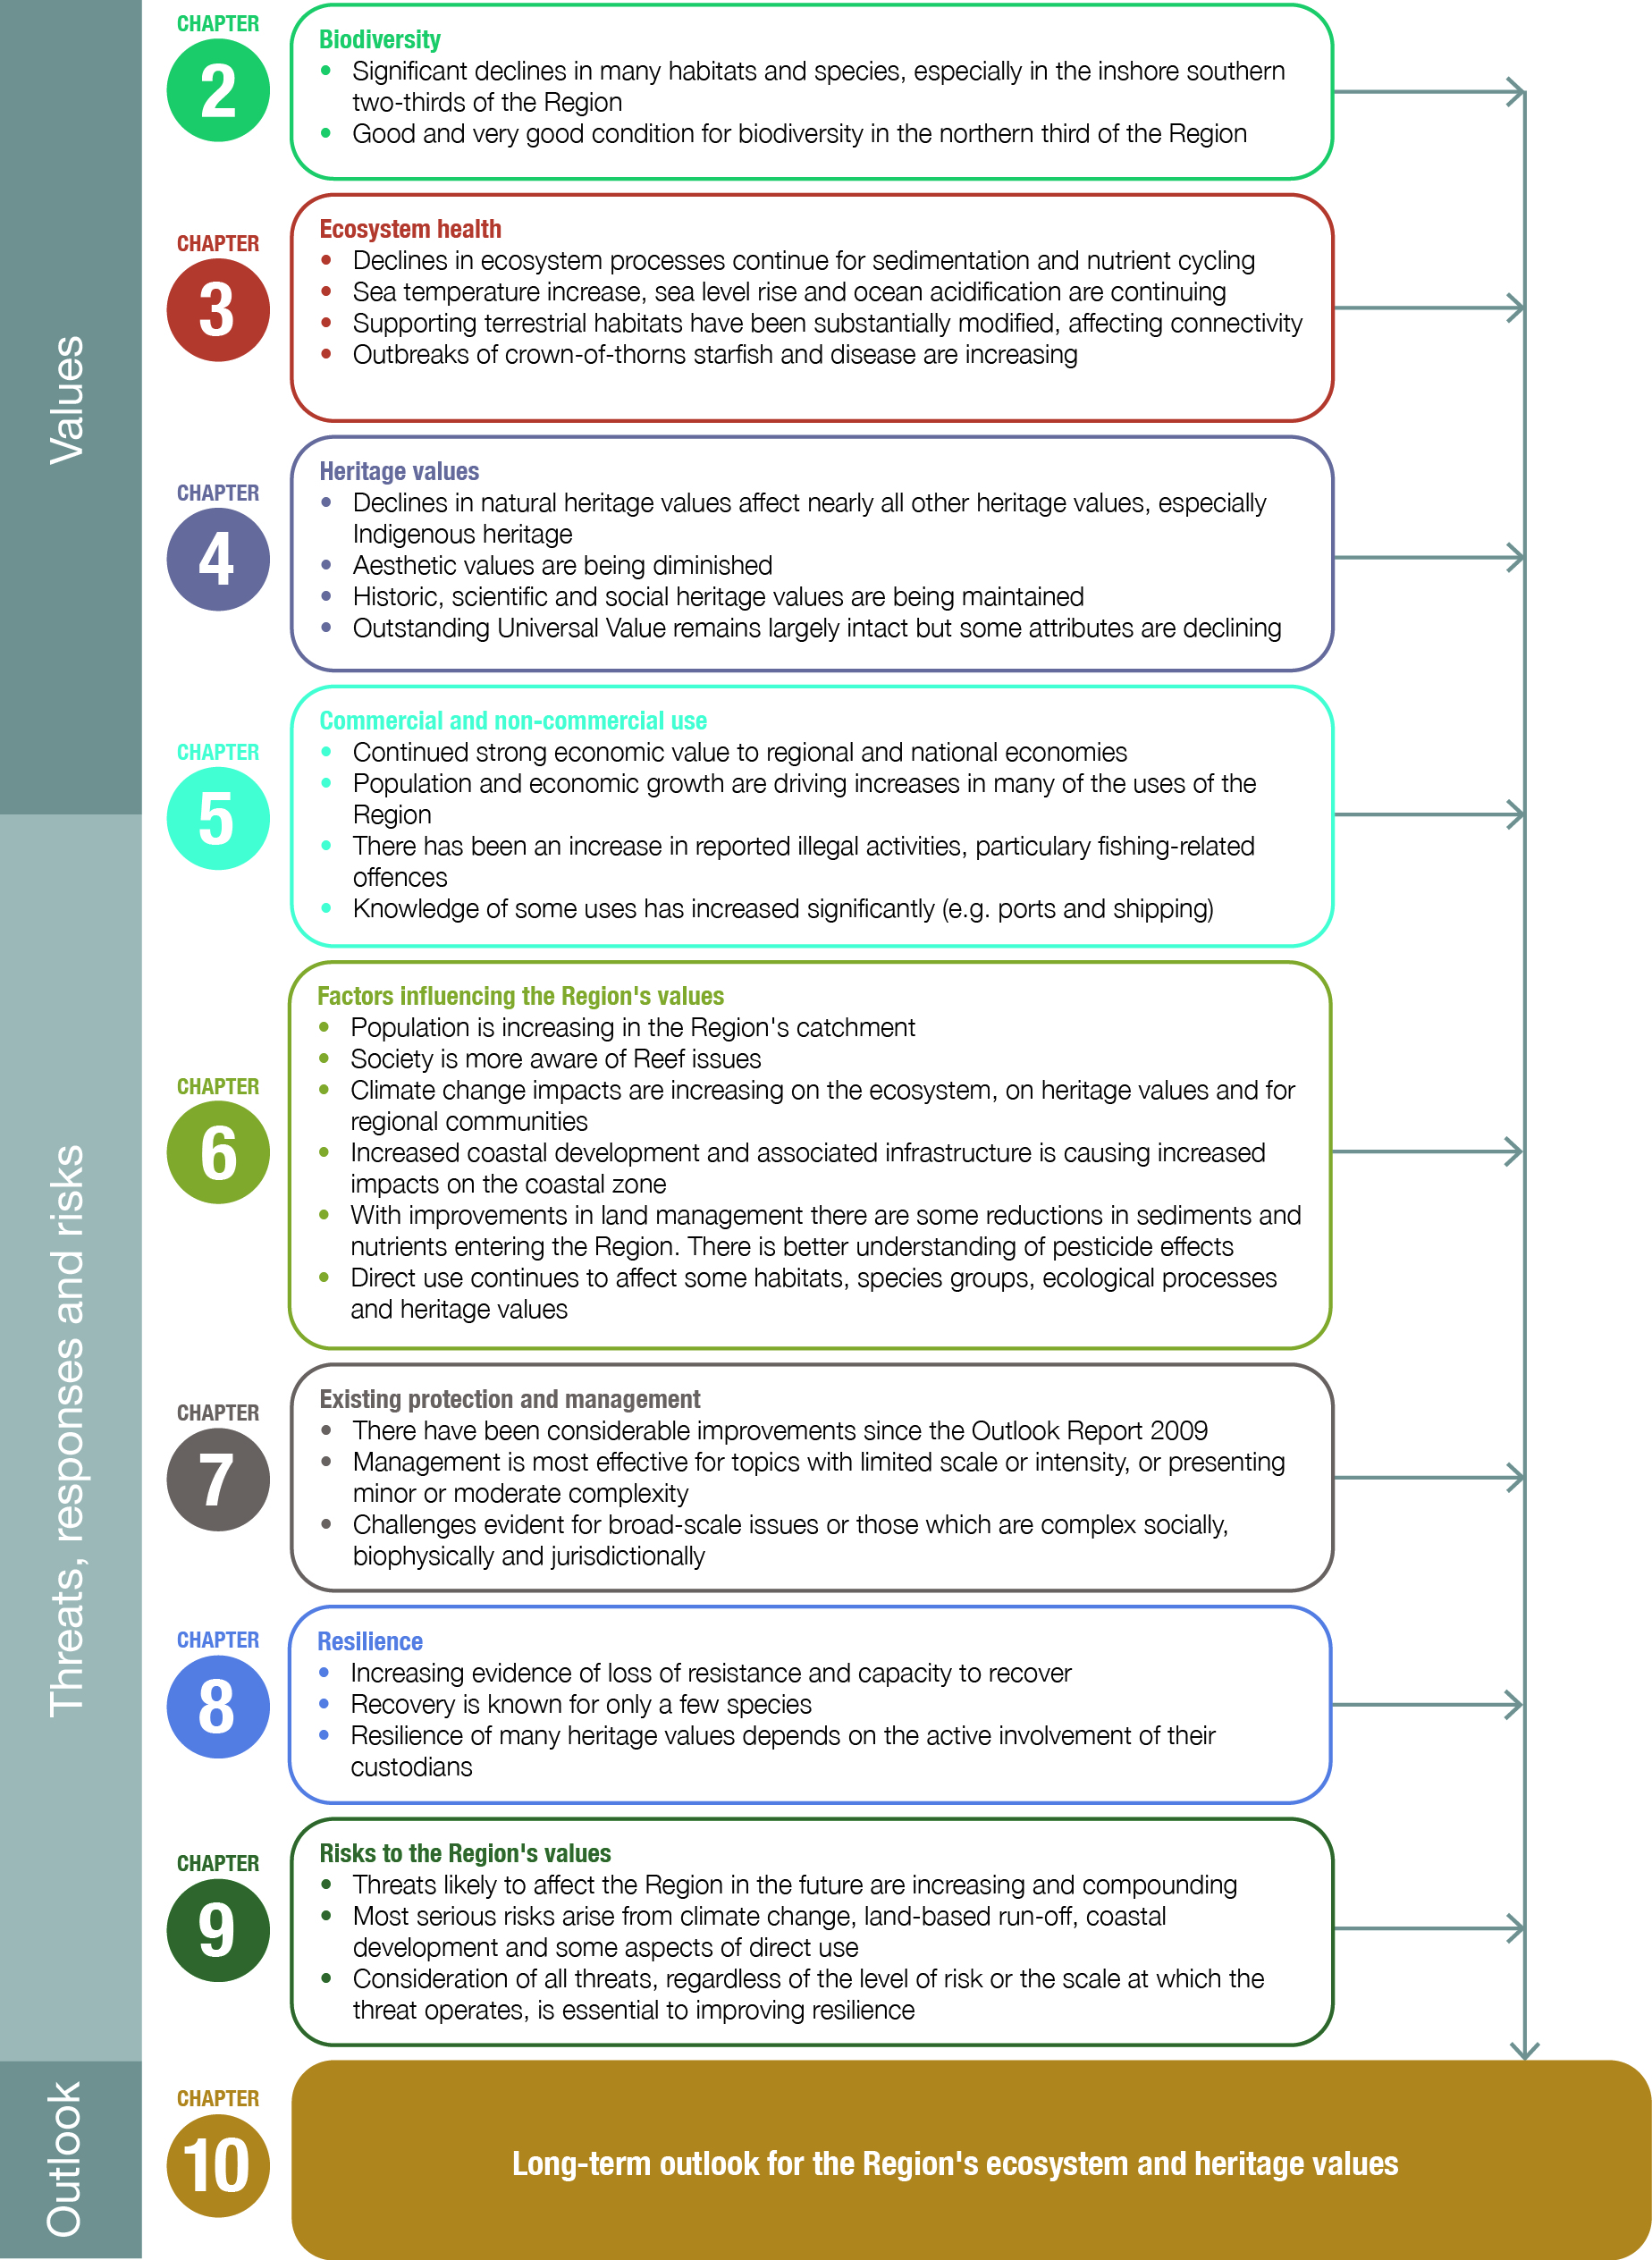
Figure 10.1 Building a picture of the long-term outlook for the Region’s ecosystem and heritage values
Combined, the conclusions from the preceding chapters build an up-to-date picture of the predicted long–term outlook for the Region’s ecosystem and heritage values.

Knowledge for management
Key message: Continually improving understanding is a key to securing the Reef’s future.
A comprehensive and up-to-date understanding of the Region’s values, the processes supporting them and the impacts affecting them is fundamental to their management. Knowledge and understanding is improved through the activities of a wide range of research providers such as the Australian Institute of Marine Science, CSIRO, government agencies and universities, as well as by commercial companies and consultants, stakeholders, Traditional Owners and community members.
A continually improving understanding of the Region’s values and the threats to them will play a major role in securing their long-term future. The amount of research conducted in the Region and the focus of that research is determined by a number of variables including: the priorities of funding bodies; the priorities of research users such as government agencies; and the research interests and capacities of scientists in universities and research institutions.
Following the Outlook Report 2009, there was a stocktake of the scientific and other knowledge available about the Region, with gaps identified. The subsequent report, Scientific Information Needs for the Management of the Great Barrier Reef Marine Park 2009–2014¹, guided investment in research to underpin management.

Improved understanding
Since 2009, understanding of recent trends in the condition of some ecosystem components has improved. For example, comprehensive data about key components relating to water quality in the Region are now collected and synthesised in annual report cards. There has also been pivotal analysis of the long-term dataset on coral reefs that has highlighted ongoing and significant declines. In addition, recent research has revealed what coral reefs were like long before current methods of scientific measurement. This is critical to understanding the baseline condition of reefs in the Region.
The importance of good connectivity, both within the Region and with its supporting terrestrial habitats, is increasingly recognised. The Paddock to Reef program continues to improve knowledge of how activities in the catchment affect the Reef ecosystem. There is also better understanding of connectivity within the ecosystem such as between fished and unfished reefs. Integrated marine observing infrastructure is allowing more robust and accurate hydrodynamic and other models to be developed for the Region.
Understanding of the impacts on the Region’s ecosystem caused by a loss of connectivity and ecosystem services as a result of clearing and modifying coastal habitats has improved considerably. As has understanding of the actions needed to protect and restore such habitats.
There has been increased recognition of the key factors relevant to the overall future of the Region’s ecosystem and its heritage values. As outlined in previous chapters, drivers, activities, past and current impacts and future risks do not operate independently, but are intertwined in a complex web causing cumulative effects. Recently, techniques for better conceptualising cumulative impacts within the context of the Region and its catchment have started to emerge.^{2,3} ‘SeaSim’, an ocean simulation facility at the Australian Institute of Marine Science which became operational in 2013, will enable an improved understanding of cumulative impacts.
Economic and population growth, technological developments, and societal attitudes are more explicitly recognised in this report (see Chapter 6) as key drivers for the Region’s values than in the Outlook Report 2009. Improved understanding of their trends provides context for proactive and appropriate management of the values and the influences on them, in a way that takes into account likely future changes. These social and economic drivers are being monitored through a recently established Social and Economic Long-term Monitoring Program.
Although heritage values were implicitly considered within some aspects of the Outlook Report 2009, a far more formal and comprehensive approach has now been established. The Region’s heritage values are now better defined, including through specific studies to scope aesthetic⁴ and geomorphological⁵ attributes, and there is greater recognition of the direct connections between heritage values and the Reef ecosystem.

Remaining information gaps
Key message: Understanding and responding to cumulative impacts is paramount.
Notwithstanding continuing improvements in knowledge, filling a number of key remaining gaps would greatly assist understanding of the Region and improve management.
The importance of developing ways to understand and respond to the effects of cumulative impacts on the Region’s values is paramount. The need to develop decision-support tools and methods for considering multiple direct, indirect and consequential impacts is now recognised as a requirement for management into the future.
There is a need to develop strategies and technologies for the restoration of degraded habitats and to improve the health and resilience of the ecosystem.
Information from research and monitoring will be critical to the development of thresholds for ecosystem health and targets for management actions, and to track the effectiveness of such actions. Research will also be needed to conceptualise and, in some cases, model how a system works and how the elements interact and respond to changing pressures.
[Photograph of anemone fish and anemones with other reef fish in the background. Copyright Matt Curnock. Caption: Improved modelling of the ecosystem will inform management actions]
Traditional ecological knowledge and local community knowledge shared by Traditional Owners, stakeholders and members of the community will play a central role in better understanding heritage values and informing adaptive management and decision making. Furthermore, integrating traditional and community knowledge with scientific knowledge can extend the time perspective of scientific knowledge and highlight potential subject areas for future studies.⁶
With regard to applying knowledge to management, key areas of focus include integrating knowledge, monitoring and reporting into adaptive management; improving alignment and coordination of research priorities; increasing emphasis on the use of modelling approaches; improving spatial mapping capabilities; supporting long-term monitoring programs; and standardising data collection and facilitating sharing.

Likely future trends
Trends in factors influencing the long-term outlook for the Region’s ecosystem and heritage values operate at large (globally for climate change) and local geographic scales and have varying social, biophysical and jurisdictional complexities. The future of the Region’s values will be largely determined by the cumulative effects of these factors, the effectiveness of management to increase resilience in the system and an ability to harness and integrate new information to inform future management responses.

Influencing factors
Key message: Trends in some key external factors will combine to affect the Region’s ecosystem and heritage values.
Key message: Many potential impacts of direct use are avoided under current management; some key risks remain.
Drivers Economic growth is projected to continue in Queensland with a large proportion of this growth occurring adjacent to the Region. Population in the Great Barrier Reef catchment is expected to continue to grow at rates well above the national average for the foreseeable future. Some of this growth is a result of economic growth, especially in the resources sector. Both these drivers change land-use patterns in the catchment, including expanding the urban footprint to accommodate an increasing number of residents and increasing demand for infrastructure to support the resources industries. They also drive increases in use of the Region, for example shipping and recreational activities.
Technological advances will continue and can provide positive outcomes for the Region and for management of the catchment (for example better navigational safety for ships and reduced fertiliser use). They can also increase some threats to the Region’s ecosystem and its heritage values (for example depth sounders and global positioning systems improving fishers’ ability to find, relocate and catch fish). Societal attitudes about the Great Barrier Reef will continue to be shaped by its iconic status as well as information about its condition and likely future. Such attitudes affect how people think about the Reef and the way they use it. This can enhance engagement in stewardship programs and uptake of best practice actions.
Climate change As well as indirectly driving change in factors that influence the Reef, climate change will directly influence the Region and continue to have far-reaching consequences. Future predictions indicate sea level rises and temperature increases will continue, ocean pH will gradually decline and weather will be more severe. These changes will have dramatic effects on the Region’s ecosystem and heritage values and the Reef-dependent industries that rely on them (for example commercial marine tourism and commercial fishing).
Coastal development Changes in land use over the last two centuries have determined the current extent and condition of natural ecosystems in the catchment. Continued modifications of terrestrial habitats that support the Great Barrier Reef are likely based on forecast changes in some agricultural sectors and projected increases in urban and industrial development, driven partly by economic growth. This in turn will drive increases in direct use of the Region.
Land-based run-off Although agricultural practices in the Great Barrier Reef catchment are improving, there is likely to be a significant lag time before water quality improvements in the Region are measured. Sediments, nutrients and pesticides will continue affecting the ecosystem and heritage values for decades to come.
There is increasing evidence that current trends for crown-of-thorns starfish outbreaks are likely to continue, contributing further to coral reef mortality, until such time that the Region’s water quality has improved.
Marine debris continues to enter the Region and will persist for decades. It will continue to affect the Region’s ecosystem and heritage values, especially species of conservation concern and aesthetic values.
Direct use The Region is expected to continue to be a significant contributor to regional and national economies through commercial and non-commercial uses. Past declines in tourism visitor numbers are reversing, but will continue to depend on global economic factors (such as monetary exchange rates).
The Great Barrier Reef continues to be valued well beyond its local communities, with strong national and international interest. It will continue to be of major importance to its Traditional Owners and the maintenance of their cultural values. People that visit the Region are expected to continue to enjoy their experiences.
Impacts from direct use of the Region are many and will continue to present varying degrees of risk to the ecosystem and heritage values. Continuation of current management arrangements should effectively avoid many impacts, for example those related to commercial marine tourism, defence activities and shipping. Improvements in Traditional Owner community compliance programs related to reporting and detection of illegal activities are expected to continue for at least the next few years.
Without effective mitigation devices and management arrangements, the death of incidentally caught species of conservation concern will almost certainly continue across all fisheries and the Queensland shark control program, with major consequences for their populations and Traditional Owner cultural values. Non-compliance with management arrangements, especially illegal fishing, is predicted to continue into the future, with the ongoing effect of compromising management outcomes for the Region’s ecosystem and its heritage values. Predicted increases in use of the Region may increase the risk of associated threats, such as incompatible uses at popular sites.

Management effectiveness
Since 2009, effectiveness has been assessed as improving for two areas of management focus: land-based run-off and traditional use of marine resources. These results illustrate the importance of strategic planning, research to inform management and significant commitment of resources.
There continues to be particular management challenges in consistency across jurisdictions, and in understanding the values and better incorporating their consideration in decision making, although progress is being made.
The difficulties in achieving positive outcomes on the ground are likely to continue — given the complexity of many issues, the spatial and temporal scales of the threats to the Region’s values and the diminishing resource base to implement actions. The lagging response in desired outcomes for the Region is largely a result of the time needed to effect change in the system.

Resilience
Key message: The Reef’s resilience is likely to decline further without major reductions in current threats.
There is increasing evidence of ongoing loss of resistance and recovery capacity in the Region’s ecosystem and heritage values, although the extent of loss varies considerably. As the effects of climate change worsen, it is likely that interactions between climate-related threats and other threats will have increasingly serious consequences. Given the only partial effectiveness of existing protection and management in addressing the most significant pressures on the ecosystem (principally arising from outside the Region), the loss of resilience is expected to continue. Maintaining the resilience of the Region’s ecosystem and heritage values will require major increases in effort to reduce local and global threats and to build understanding of the values themselves.

Risks to the Region’s values
The threats associated with the four factors influencing the Region’s values will continue to act cumulatively, dominated by those that present the highest risk, but added to by those of medium and low risk. Their effects will be amplified if there continues to be a decline in the resilience of the Region’s ecosystem.
Of the threats assessed, the risk of most has not changed since 2009. The assessed risk of nine threats has increased. This is largely as a result of increased understanding of the threats, their distribution and the likely severity of their consequences (see Chapter 9). Increased understanding of the effects and spatial extent of pesticides from land-based run-off has reduced its assessed risk — the only threat where the risk has decreased.

Prospects for the outstanding universal value of the Great Barrier Reef World Heritage Area
Key message: Future prospects for the Reef’s Outstanding Universal Value depend on concerted global and local actions.
Although many of the attributes contributing to the Great Barrier Reef World Heritage Area’s outstanding universal value remain in good or very good condition, the condition of many has declined since 1981.
Factors external to the area — climate change, land-based runoff and coastal development — are affecting the property’s integrity. These are the most complex and wide-ranging of the threats assessed. They are combining with other threats within the property to increase the cumulative risk to its future. Although management continues to be effective for many activities within and adjacent to the World Heritage Area, there remain difficulties in achieving positive outcomes on the ground.
That the Great Barrier Reef continues to be highly valued by the global, Australian and local communities provides evidence for societal support for the continued protection of its outstanding universal value.
Prospects for the future of the Great Barrier Reef’s outstanding universal value depend on global action to address the causes of climate change, and on coordinated, targeted and dedicated long-term commitments to continue to address the risks within and adjacent to the property. There is evidence that when there are concerted efforts to address damaging practices, impacts can be halted and reversed.
There is no short-term single action that will secure the outstanding universal value of the Great Barrier Reef. However, working at global, regional and local levels will be the best solution to preserving the world heritage area.

Current and future initiatives to improve resilience and protect values
The Outlook Report 2009 recognised that building on the existing management arrangements in the Region would help address the key threats to the Region and that these actions and the degree to which they were effectively implemented would strongly influence the resilience of the Reef ecosystem in the future.

Contributions to protection and management
Key message: Many partners continue to contribute to protection and management.
In addition to a range of Australian and Queensland government agencies, there are many other partners that continue to make significant contributions to protecting and managing the Region.
Marine Park users are continuing to adopt best practice standards during their activities in the Region. For example, through the High Standard Tourism program and voluntary actions, tourism operators are incorporating best practices into their activities.
In addition, many stakeholders and members of the community continue to participate in research and monitoring programs such as the Eye on the Reef program including the Reef Health and Impact Surveys, Tourism Weekly monitoring, Sightings Network and Rapid Monitoring survey program. The scientific community actively contributes by undertaking research to address key issues facing the Region.
A range of stewardship programs involve those who use and rely on the Region or its catchment for their recreation or business taking voluntary actions beyond what is required by law to ensure the environmental sustainability of the Region and to improve the economic sustainability of industries operating there. Activities include cleaning up marine debris, restoring habitats that support the Reef ecosystem, improving land management practices in the catchment, and undertaking targeted control of crown-of-thorns starfish.
Twelve Local Marine Advisory Committees, from Cooktown to Bundaberg and comprising 185 members across the range of industry and community interests, provide advice to management agencies on issues and policies relating to specific activities, conservation, environment, public information and public education concerning their local marine and coastal areas.

Future commitments
In assessing the long-term outlook for the Region’s ecosystem and its heritage values, current management arrangements plus relevant management initiatives identified but not yet fully implemented (Figure 10.2) are considered. The future commitments of both the Australian and Queensland governments identified in the program reports of the strategic assessments^{7,8} are part of these considerations. They recognise the need to implement a management framework that:
- establishes measurable ecosystem outcomes and is driven by specific measurable targets
- will either prevent or reduce cumulative impacts
- enables a net benefit approach to help achieve outcomes and targets, especially in areas requiring restoration
- is supported by a comprehensive integrated monitoring and reporting framework.
The reports recognise that, while avoiding, mitigating and offsetting impacts remain a very important focus of management efforts, these are not sufficient on their own because, in many areas, the system now needs policies of restoration, not simply prevention of damage. Additional interventions that deliver an overall positive effect (net benefit) are required to halt and reverse the decline in the Region’s ecosystem health and ensure the long-term protection and restoration of its values. Using ecosystem outcomes and targets as a guide, initiatives are foreshadowed in:

- environmental regulation
- engagement
- knowledge, integration and innovation.
Environmental regulation Through management tools such as regulations, zoning plans, plans of management, permits and compliance, management agencies will continue to set and refine the environmental standards necessary to achieve the desired goals, outcomes and targets for the Region’s values. The continued effectiveness of the zoning plans rely in part on the continued enforcement of zoning arrangements and ensuring Reef users are aware of the plans and their provisions.
Engagement Protection of the Great Barrier Reef requires local, national and international effort. A program of Reef Recovery — adopting regionalised and cooperative management approaches that support local communities and encourage cooperation between government agencies, the private sector and research institutions — will be developed to implement actions to protect and restore biodiversity hotspots and support sustainable use. Ongoing and collaborative working relationships will instil a sense of collective stewardship. This approach will provide a strong foundation for maintaining a balance between protecting the Region’s values, managing competing demands and supporting sustainable use.
Knowledge, integration and innovation Accessing the best available science from a network of science providers, both nationally and internationally, as well as drawing on traditional ecological knowledge and information from the wider community is essential for effective management. Building on existing programs, such as long-term coral and fish monitoring undertaken by the Australian Institute of Marine Science and marine monitoring managed by the Great Barrier Reef Marine Park Authority, monitoring will continue to provide evidence of changes in the ecosystem as well as the effectiveness of management actions. Filling key information gaps through targeted research will be critical, and monitoring will be used to assess the success of management measures. Implementing a Reef-wide integrated monitoring and reporting program which directly links to an outcomes-based management framework will underpin an adaptive management approach. The framework will guide the establishment of a standardised and integrated ecological, social and economic monitoring program for the Great Barrier Reef.

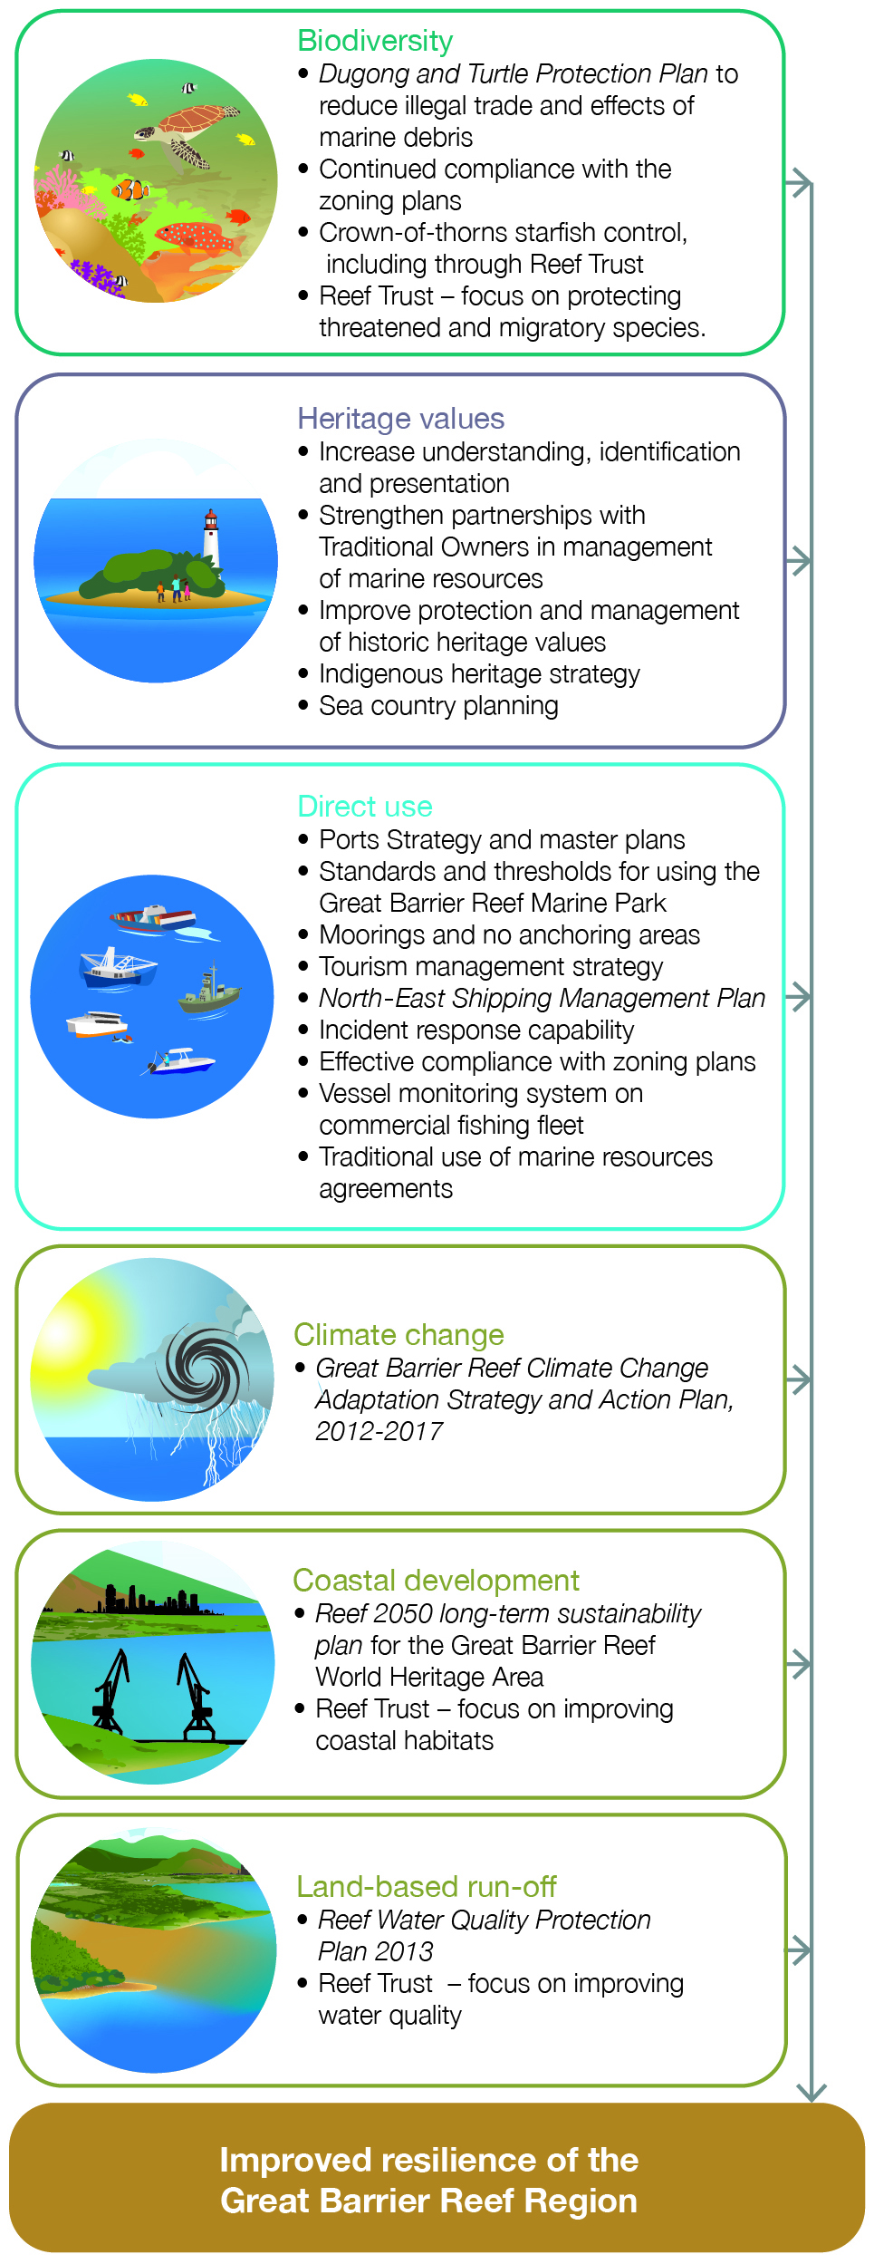
Figure 10.2 Current and future initiatives to improve the Region’s resilience

Assessment summary — Long-term outlook
Section 54(3)(h) of the Great Barrier Reef Marine Park Act 1975 requires ‘… an assessment of the long-term outlook for the ecosystem…’ within the Great Barrier Reef Region. Section 116A(2)(f) of the Great Barrier Reef Marine Park Regulations 1983 requires ‘… an assessment of the long-term outlook for the heritage values…’ of the Great Barrier Reef Region.

Outlook for the Region’s ecosystem
Outlook Report 2009: Assessment summary
Despite the introduction of significant protection and management initiatives, the overall outlook for the Great Barrier Reef is poor. Even with the recent initiatives to improve resilience, catastrophic damage to the Great Barrier Reef ecosystem may not be averted. Building the resilience of the Great Barrier Reef ecosystem will give it the best chance of adapting to and recovering from the serious threats ahead, especially from climate change. Given the strong management of the Great Barrier Reef, it is likely that the ecosystem will survive better than most other reef ecosystems around the world.

Assessment criterion | Assessment summary | Outlook 2009 | Outlook 2014 and trend since 2009 | Future trend | Confidence
 |  |  |  |  | Grade | Trends
Outlook for the ecosystem | The Great Barrier Reef ecosystem is under pressure. Cumulative effects are diminishing the ecosystem’s ability to recover from disturbances. Some threats are increasing, driven mainly by climate change, economic growth and population growth. The emerging success of some initiatives (such as improving land-based run-off) means some threats may be reduced in the future. However, there are significant lags from when actions are taken to improvements being evident in the ecosystem. More than ever, a focus on building resilience by reducing all threats is important in protecting the Region’s ecosystem and its outstanding universal value into the future. | Poor | Poor,  Deteriorated | Deteriorating | Adequate | Limited

Grading statement
Very good | The values are likely to remain healthy and resilient for the foreseeable future with strong recovery at damaged locations. Additional management intervention is not required to maintain the values.
Good | With only minor additional management intervention, the values are likely to remain generally healthy and resilient for the foreseeable future, with only some values showing signs of significant deterioration.
Poor | Without significant additional management intervention, some of the values will deteriorate in the next 25 years and only a few values are likely to be healthy and resilient in the longer term.
Very poor | Without urgent and effective additional management intervention, the values are likely to deteriorate rapidly with the loss of most values in the longer term.
Trend
Trend since 2009: Improved, Stable, Deteriorated, No consistent trend
Future trend: Improving, Stable, Deteriorating, No consistent trend
Confidence in impact and trend
Adequate | Adequate high-quality evidence and high level of consensus
Limited | Limited evidence or limited consensus
Inferred | Inferred, very limited evidence

Outlook for the Region’s heritage values
Outlook Report 2009: Not assessed
Assessment component | Assessment summary | Outlook 2009 | Outlook 2014 | Future trend | Confidence
 |  |  |  |  | Grade | Trend
Outlook for heritage values | The close connection between the Region’s ecosystem and its heritage values means that many are deteriorating as ecosystem condition declines, for example Indigenous heritage values. Similarly, attributes that contribute to the outstanding universal value of the Great Barrier Reef are under pressure from a range of threats. The Region’s social significance, built around a history of personal experiences, will continue to shift as use changes. Underwater aesthetic values will likely continue to decline. The outlook for historic heritage values will be influenced by how well sites are recorded and maintained. Increasing recognition of the Region’s heritage values improves their likely outlook. | Not assessed | Good | Deteriorating | Limited | Limited

Grading statement
Very good | The values are likely to remain healthy and resilient for the foreseeable future with strong recovery at damaged locations. Additional management intervention is not required to maintain the values.
Good | With only minor additional management intervention, the values are likely to remain resilient for the foreseeable future, with only some values showing signs of significant deterioration.
Poor | Without significant additional management intervention, some of the values will deteriorate in the next 25 years and only a few values are likely to be resilient in the longer term.
Very poor | Without urgent and effective additional management intervention, the values are likely to deteriorate rapidly with the loss of most values in the longer term.
Trend
Trend since 2009: New assessment for this report; no trend provided
Future trend: Improving, Stable, Deteriorating, No consistent trend
Confidence in impact and trend
Adequate | Adequate high-quality evidence and high level of consensus
Limited | Limited evidence or limited consensus
Inferred | Inferred, very limited evidence

Overall summary of long-term outlook
The Great Barrier Reef Region continues to face a combination of extremely serious challenges. The risks affecting the area’s ecosystem and heritage values arise from a number of sources, both within and beyond its boundaries. They are acting in combination to affect, sometimes significantly, the long-term outlook for the Region and the prospects for the outstanding universal value of the Great Barrier Reef World Heritage Area.
Management arrangements, combined with improvements in land management practices and voluntary behaviour change as a result of stewardship initiatives are beginning to effectively address some threats. However, more needs to be done at Reef-wide, regional and local scales.
Increased understanding of the ecosystem and heritage values, their trends and the factors affecting them will also be critical to improving the long-term outlook of the Region. Understanding the drivers of change is an essential step in providing a context for day-to-day decisions that influence the major trends in the system. There remain significant gaps, especially in understanding and modelling cumulative effects and in identifying thresholds for activities.
For some heritage values, their future largely depends on the condition of the natural ecosystem (for example Indigenous heritage, world heritage and national heritage values), while for others (for example historic heritage values) their future relies more on improving understanding and future management arrangements. Recognition of the importance of heritage values has increased in recent years, which provides a springboard for future management initiatives.
The cumulative effects of threats and the need to manage all of them to reduce stresses on the Region’s values and to improve its resilience to future pressures are recognised. A business as usual approach to managing threats will not be enough. Achieving a healthy and resilient Great Barrier Reef into the future will require continued focus and even more effective action. The multitude of small decisions, such as anchoring at a popular snorkelling site, and the fewer, larger decisions, such as expanding a port channel, should be consistent with achieving the targets identified for the protection of the property’s outstanding universal value. Without promptly reducing threats, there is a serious risk that resilience will not be improved and there will be irreversible declines in the Region’s values.
[Photograph of Heart Reef and the surrounding reef mosaic from the air. Copyright Chloe Schauble]
References
1. Great Barrier Reef Marine Park Authority 2009, Scientific information needs for the management of the Great Barrier Reef Marine Park 2009-2014, GBRMPA, Townsville.
2. Anthony, K., Beeden, R., Dambacher, J. M. and Walshe, T. Unpublished draft, A draft qualitative framework for understanding cumulative impacts on values in the Great Barrier Reef World Heritage Area, Great Barrier Reef Marine Park Authority and Australian Institute of Marine Science, Townsville.
3. Hedge, P., Molloy, F., Sweatman, H., Hayes, K., Dambacher, J., Chandler, J., Gooch, M., Chin, A., Bax, N. and Walshe, T. 2013, An integrated monitoring framework for the Great Barrier Reef World Heritage Area, Great Barrier Reef Marine Park Authority, Townsville.
4. Context Pty Ltd 2013, Defining the aesthetic values of the Great Barrier Reef, Department of Sustainability, Environment, Water, Population and Communities, Canberra.
5. Whiteway, T., Smithers, S., Potter, A. and Brooke, B. 2013, Geological and geomorphological features of outstanding universal value in the Great Barrier Reef World Heritage Area: Technical report prepared for the Department of Sustainability, Environment, Water, Population and Communities, Geoscience Australia and James Cook University, Townsville.
6. Fernbach, M. and Nairn, K. 2007, Reef recollections: An oral history of the Great Barrier Reef, Great Barrier Reef Marine Park Authority, Townsville.
7. Department of State Development, Infrastructure and Planning 2013, Great Barrier Reef coastal zone strategic assessment 2013: Strategic Assessment Report. Draft for consultation, DSDIP, Brisbane.
8. Great Barrier Reef Marine Park Authority 2013, Great Barrier Reef Region strategic assessment: Program Report. Draft for public comment, GBRMPA, Townsville.

