
Site Plan

Note: Information in this document may now be superseded. This includes the 2017 amendments to the Whitsundays Plan of Management 1998 such as updates to boundary descriptions to coordinate based descriptions.

Deloraine Island
(Prepared August 2007)

1. Background

1.1 Rationale
Site plans are an important management tool used jointly by the Great Barrier Reef Marine Park Authority (GBRMPA) and the Queensland Parks and Wildlife Service (QPWS). They identify the significant values and management arrangements at a particular site, concentrating on the specific use issues and cumulative impacts.
The waters surrounding Deloraine Island have been assigned to a Protected Setting in the Whitsundays Plan of Management 1998 (WPOM). Due to their protected setting, the WPOM requires that this site plan be developed to ensure protection of the natural, cultural and heritage values of the area and determine group size and vessel length limits.

1.2 Location
Deloraine Island (20-089) is a high continental island situated approximately 34 kilometres north-east of Shutehaven, on the eastern side of Border Island (20-087). Deloraine Island and Border Island are part of the Whitsunday Islands National Park, managed by the QPWS. For more information, refer to the Environmental Protection Agency website.

2. Natural, cultural and heritage values
The values described below are not exhaustive, but are indicative of the significance of the area covered by this site plan.

2.1 Fringing reef
Deloraine Island has a fringing reef covering an area of approximately 63 hectares. The reef is visible on the Eastern side of the island in the aerial photograph at Figure 1.

2.2 Rare sponge species
The fringing reef around Deloraine Island is home to a rare sponge species, Rhabderemia sorokinae.
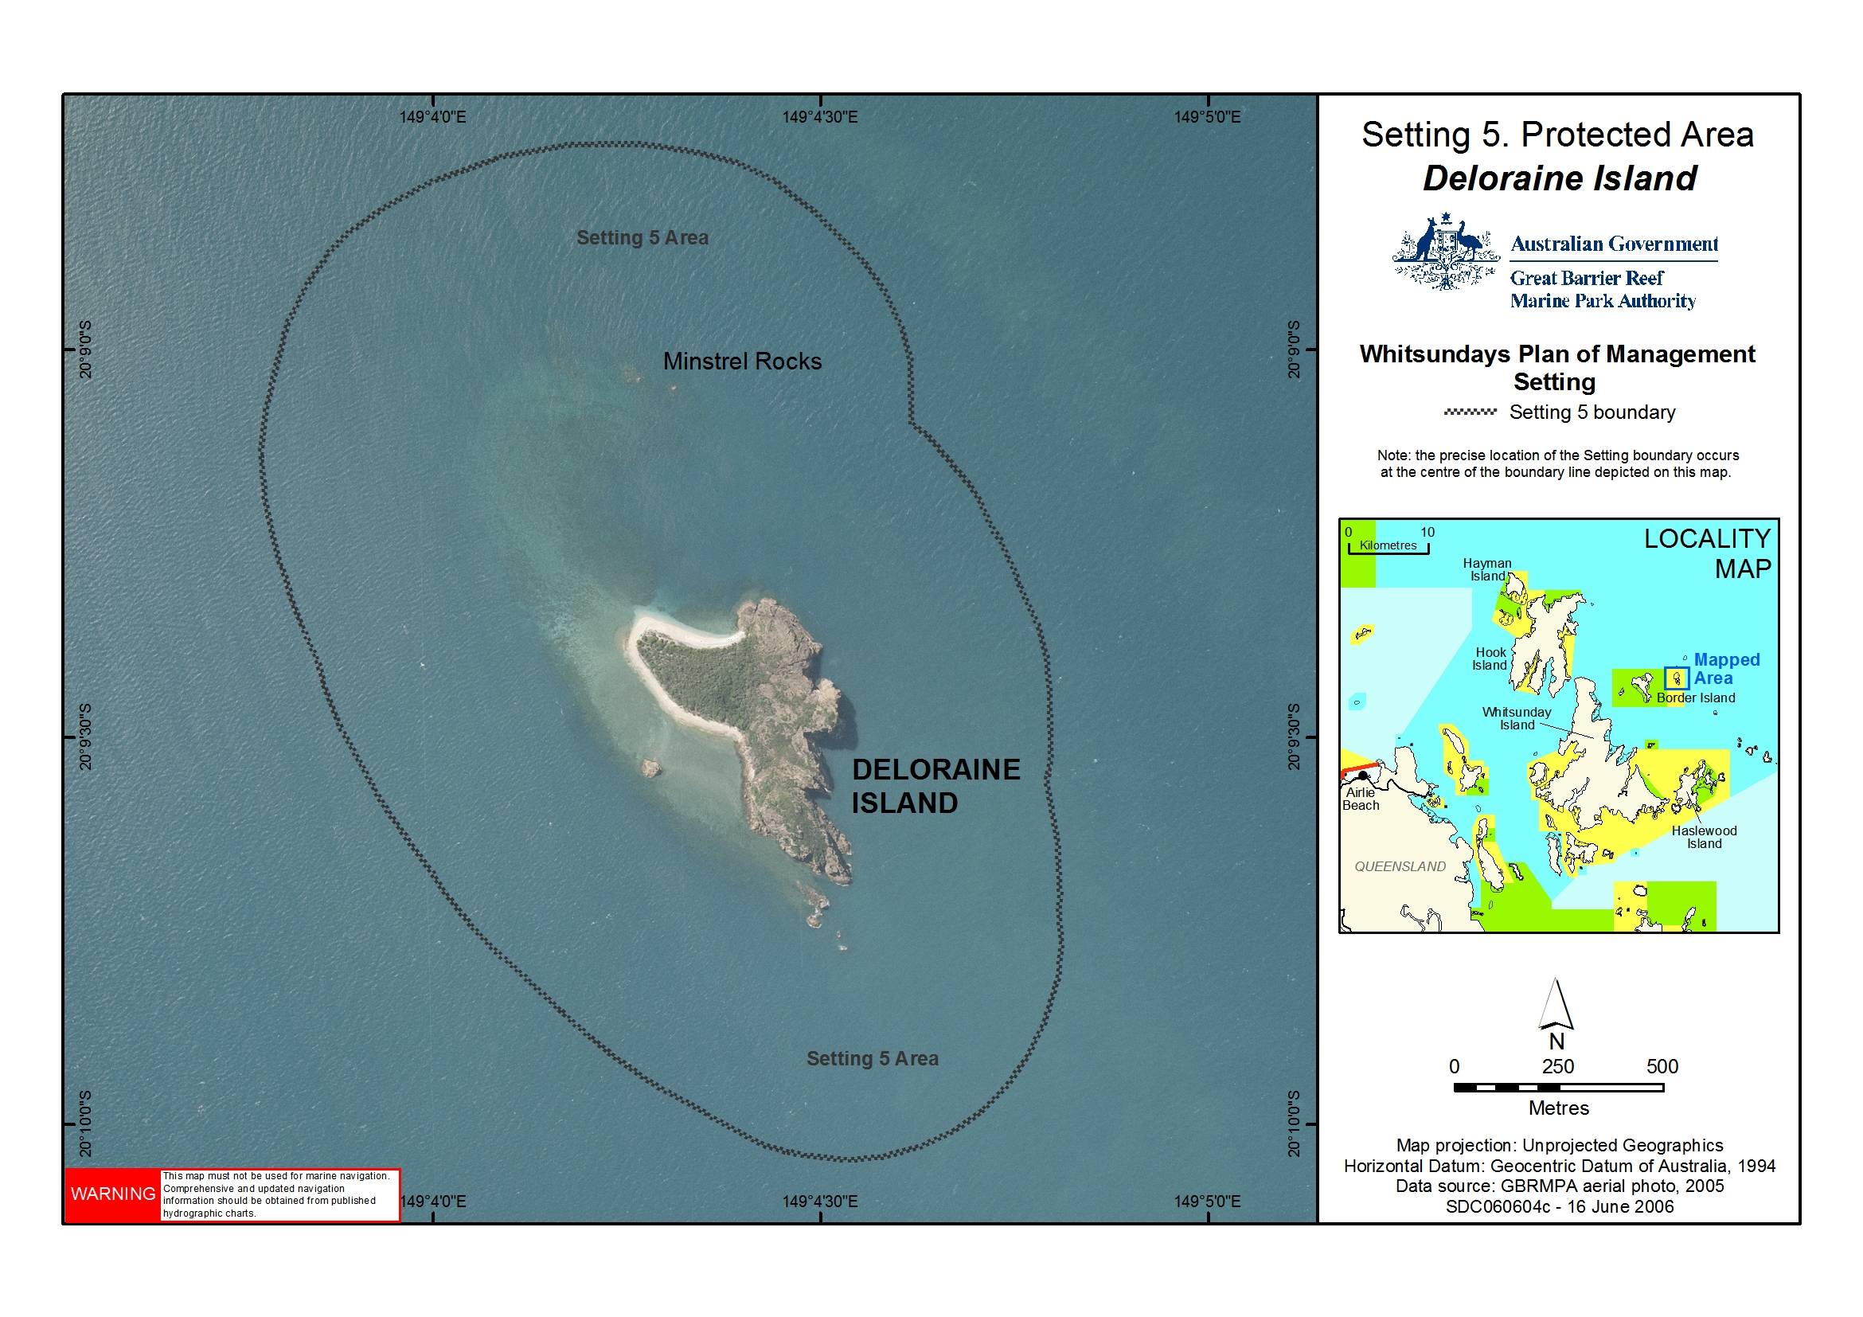
Figure 1: Location of Deloraine Island

2.3 Traditional Owners
The island and surrounding waters are culturally significant to the Ngaro Aboriginal Traditional Owner Group. The island, reefs and surrounding waters are part of the cultural landscape and are still the focus for traditional access and use of available resources. Spiritual connections are often associated with the natural and cultural resources.
The Central Queensland Land Council Aboriginal Corporation is the representative body for Traditional Owners whose estates are located in the Whitsunday region.

3. Current use
Colfelt (2004) notes that anchoring at Deloraine Island should only be attempted in light easterly or north-easterly winds. As the prevailing winds are south-easterly, the island is not a popular overnight anchorage. A small number of commercial tour operators have permissions to access the Setting 5 area surrounding the island, but not the island itself.

4. Management strategies

4.1 Current management

4.1.1 Zoning
The waters immediately surrounding Deloraine Island are within a Conservation Park (Yellow) Zone under both State and Commonwealth Zoning Plans. Marine Park Zoning Map 10 shows the zoning at Deloraine Island. The Conservation Park Zone allows for protection and conservation, while providing opportunities for reasonable use and enjoyment. Limited extractive activities are permitted in the Conservation Park Zone, with a range of restrictions applying to most fishing activities. For more information about fishing restrictions, refer to the Activities Guide.
The Zoning Plan is one of a range of management tools used for the waters surrounding Deloraine Island. Other management tools include the Whitsundays Plan of Management 1998, the Great Barrier Reef Marine Park Act 1975 and Great Barrier Reef Marine Park Regulations 1983.

4.1.2 Permits and the Whitsundays Plan of Management
A number of activities in the Great Barrier Reef Marine Park, including tourist operations, require a Marine Parks permit. Permits help the GBRMPA and the QPWS to manage impacts on sensitive areas, amongst other things. Further information on permits can be obtained on the GBRMPA website.
When the Whitsundays Plan of Management came into effect in 1998, permits allowing access to the Setting 5 area were capped. There are only a small number of permits with an endorsement allowing the conduct of commercial tour operations in the Setting 5 area surrounding Deloraine Island.

4.1.3 Whitsunday and Mackay Islands Visitor Management Strategy
The draft Whitsunday and Mackay Islands Visitor Management Strategy is a Queensland Parks and Wildlife Service initiative that will provide a framework for sustainable tourism and visitor use into the future for the islands and their beaches. Assessment by the QPWS suggests that Deloraine Island also be assigned to a protected setting, forming part of a natural area that has been set aside for conservation. The island is managed by the QPWS for nil to minimal use by visitors.

4.2 Proposed management

4.2.1 Permits
The number of permits allowing commercial tour operators to access the Setting 5 area will be maintained at the current level. If existing permits are revoked, surrendered or expire, they may be re-allocated in accordance with the GBRMPA’s policy for Managing Tourism Permissions to Operate in the Great Barrier Reef Marine Park (including Allocation, Latency and Tenure).
Access to the Setting 5 area will be allowed for cultural tours run by, or in collaboration with, Traditional Owners if the permittee has been granted a Commercial Activities Permit issued by the QPWS to access the national park on Deloraine Island.

4.2.2 Vessel length and group size limits
Group sizes will be limited to a maximum of 15 people (including crew) and vessel length will be limited to 20 metres. This will apply to recreational Marine Park users. Commercial access will continue to be determined by existing permissions. If an existing permission allows the operator to exceed the group size and vessel length limits, the operator will maintain their current permitted capacity.
An amendment to the Whitsundays Plan of Management 1998 will be required in order to bring these group size and vessel length limits into effect.

5. Community engagement
This site plan was developed in consultation with the Queensland Parks and Wildlife Service, the Whitsunday Local Marine Advisory Committee, the Tourism and Recreation Reef Advisory Committee, Traditional Owners and local users of the Marine Park. The site plan was available for public consultation from 14 February 2007 to 19 March 2007 and comments were incorporated prior to the site plan being finalised. For further information please contact the Authority on (07) 4750 0700 or email policyandplanning@gbrmpa.gov.au.

6. References
Colfelt, D. (2004). 100 Magic Miles of the Great Barrier Reef – the Whitsunday Islands. Windward Publications.

