Reef Rescue Marine Monitoring Program

Final Report of AIMS Activities 2010/11
Inshore Water Quality Monitoring

Britta Schaffelke
John Carleton, Jason Doyle, Miles Furnas, Kevin Gunn,
Michele Skuza, Margaret Wright, Irena Zagorskis

Produced for
The Great Barrier Reef Marine Park Authority



Townsville
September 2011

Australian Institute of Marine Science
PMB No 3
Townsville MC Qld 4810

This report should be cited as:

Schaffelke B, Carleton J, Doyle J, Furnas M, Gunn K, Skuza M, Wright M, Zagorskis I (2011) Reef Rescue Marine Monitoring Program. Final Report of AIMS Activities 2010/11– Inshore Water Quality Monitoring. Report for the Great Barrier Reef Marine Park Authority. Australian Institute of Marine Science, Townsville. (83 p.)

© Copyright Australian Institute of Marine Science (AIMS) 2011
All rights are reserved and no part of this document may be reproduced, stored or copied in any form or by any means whatsoever except with the prior written permission of AIMS.

DISCLAIMER
While reasonable efforts have been made to ensure that the contents of this document are factually correct, AIMS does not make any representation or give any warranty regarding the accuracy, completeness, currency or suitability for any particular purpose of the information or statements contained in this document. To the extent permitted by law AIMS shall not be liable for any loss, damage, cost or expense that may be occasioned directly or indirectly through the use of or reliance on the contents of this document.

Contents
List of Figures and Tables ii
Executive Summary v

1. Introduction to the Program 1

2. Introduction to the MMP Inshore Marine Water Quality Monitoring 3

3. Methods 6
Sample locations 6
Direct water sample collection, preparation and analyses 8
Autonomous Water Quality Loggers 9
Data analysis 10
Comparison with trigger values from the GBR Water Quality Guidelines 10
Summary statistics and data presentation 11
Temporal trend analysis of the Cairns Transect water quality data 12
Interim site-specific water quality index 13

4. Results and Discussion 15
4.1 Region Reports: Wet Tropics Region 15
Cairns long-term water quality transect 25
4.2 Region Reports: Burdekin Region 29
4.3 Region Reports: Mackay Whitsunday Region 37
4.4 Region Reports: Fitzroy Region 44

5. Conclusions 52
Acknowledgments 56

6. References 57

Appendix 1: Additional Information 64

Appendix 2: Method performance and QAQC information 76
Limits of detection 77
Precision 77
Accuracy 77
Procedural blanks 79
Validation by alternative methods 80

Appendix 3: Publications and Presentations from the Program in 2010/11 82

List of Figures and Tables
Figure 1 Sampling locations of the Reef Rescue MMP inshore marine water quality task. 7
Figure 2 Reef Rescue MMP water quality sampling sites (red symbols) in the Wet Tropics NRM Region. 15
Figure 3 Summary of concentrations of chlorophyll a, particulate nitrogen, particulate phosphorus (μg L⁻¹), suspended solids (mg L⁻¹) and Secchi depth (m) at reef locations in the Wet Tropics Region 18
Figure 4 Time series of daily means of chlorophyll (green line, µg L⁻¹) and turbidity (brown line, NTU) time-series collected by Eco FLNTUSB instruments at (a) Snapper and (b) Fitzroy islands in the Wet Tropics NRM Region. 21
Figure 5 Time series of daily means of chlorophyll (green line, µg L⁻¹) and turbidity (brown line, NTU) time-series collected by Eco FLNTUSB instruments at (a) High and (b) Russell islands in the Wet Tropics NRM Region. 22
Figure 6 Time series of daily means of chlorophyll (green line, µg L⁻¹) and turbidity (brown line, NTU) time-series collected by Eco FLNTUSB instruments at Dunk Island in the Wet Tropics NRM Region 23
Figure 7 Passage of Tropical Cyclone Yasi on 03 February 2011. Raw data records of chlorophyll (µg L⁻¹; green line) turbidity (NTU; purple line) and temperature (ºC, red line) collected by Eco FLNTUSB instruments at Fitzroy, High and Dunk islands in the Wet Tropics NRM Region 24
Figure 8 Cairns Long-Term Water Quality Transect. Smooth trends over sampling years from 1989 to 2011 (partial effects) for the water quality parameters dissolved organic nitrogen (µg L⁻¹), dissolved organic phosphorus (µg L⁻¹), particulate nitrogen (µg L⁻¹), particulate phosphorus (µg L⁻¹), suspended solids (mg L⁻¹) and chlorophyll a (µg L⁻¹). 26
Figure 9 Cairns Long-Term Water Quality Transect. Smooth trends over sampling months of data from 1989 to 2011 (partial effects) for the water quality parameters dissolved organic nitrogen (µg L⁻¹), dissolved organic phosphorus (µg L⁻¹), particulate nitrogen (µg L⁻¹), particulate phosphorus (µg L⁻¹), suspended solids (mg L⁻¹) and chlorophyll a (µg L⁻¹) 27
Figure 10 Reef Rescue MMP water quality sampling sites (blue squares) in the Burdekin NRM Region 29
Figure 11 Summary of concentrations of chlorophyll a, particulate phosphorus, particulate nitrogen (μg L⁻¹), suspended solids (mg L⁻¹) and Secchi depth (m) at sampling sites in the Burdekin Region. 32
Figure 12 Time series of daily means of chlorophyll (green line, µg L⁻¹) and turbidity (brown line, NTU) time-series collected by Eco FLNTUSB instruments at Pelorus Island (a) and Pandora Reef (b) in the Burdekin NRM Region. 34
Figure 13 Time series of daily means of chlorophyll (green line, µg L⁻¹) and turbidity (brown line, NTU) time-series collected by Eco FLNTUSB instruments at Magnetic Island in the Burdekin NRM Region 35
Figure 14 Passage of Tropical Cyclone Yasi on 03 February 2011. Raw data records of chlorophyll (µg L⁻¹; green line) turbidity (NTU; purple line) and temperature (ºC, red line) collected by Eco FLNTUSB instruments at Pelorus Is., Pandora Rf. and Magnetic Island in the Burdekin NRM Region. 36
Figure 15 Reef Rescue MMP water quality sampling sites (blue squares) in the Mackay Whitsunday NRM Region 37
Figure 16 Summary of concentrations of chlorophyll a, particulate phosphorus, particulate nitrogen (μg L⁻¹), suspended solids (mg L⁻¹) and Secchi depth (m) at sampling sites in the Mackay Whitsunday NRM Region 40
Figure 17 Time series of daily means of chlorophyll (green line, µg L⁻¹) and turbidity (brown line, NTU) time-series collected by Eco FLNTUSB instruments at (a) Double Cone and (b) Daydream islands in the Mackay Whitsunday NRM Region 42
Figure 18 Time series of daily means of chlorophyll (green line, µg L⁻¹) and turbidity (brown line, NTU) time-series collected by Eco FLNTUSB instruments at Pine Island in the Mackay Whitsunday NRM Region. 43
Figure 19 Passage of Tropical Cyclone Yasi on 03 February 2011. Raw data records of chlorophyll (µg L⁻¹; green line) turbidity (NTU; purple line) and temperature (ºC, red line) collected by Eco FLNTUSB instruments at Double Cone Island in the Mackay Whitsunday NRM Region. 43
Figure 20 Reef Rescue MMP water quality sampling sites (blue squares) in the Fitzroy NRM Region 44
Figure 21 Summary of concentrations of chlorophyll a, particulate phosphorus, particulate nitrogen (μg L⁻¹), suspended solids (mg L⁻¹) and Secchi depth (m) at sampling sites in the Fitzroy NRM Region 46
Figure 22 Time series of daily means of chlorophyll (green line, µg L⁻¹) and turbidity (brown line, NTU) time-series collected by Eco FLNTUSB instruments at (a) Barren and (b) Humpy islands in the Fitzroy NRM Region 48
Figure 23 Time series of daily means of chlorophyll (green line, µg L⁻¹) and turbidity (brown line, NTU) time-series collected by Eco FLNTUSB instruments at Pelican Island in the Fitzroy NRM Region 49

Appendix 2- Figure 1 Match-up of duplicate samples analysed for chlorophyll a by fluorometry and HPLC. 80
Appendix 2- Figure 2 Match-up of instrument readings of a) chlorophyll a (μg L-1) and b) turbidity (NTU) from field deployments of WET Labs Eco FLNTUSB Combination Fluorometer and Turbidity Sensors with values from standard laboratory analysis of concurrently collected water samples. 81

Table 1 Locations selected for inshore water quality monitoring (water sampling during research cruises in June/July 2010, September/October 2010 and February 2011 and continuous deployment of autonomous water quality instruments). 6
Table 2 Trigger values from the GBRMPA Water Quality Guidelines for the Great Barrier Reef Marine Park (GBRMPA 2009). 10
Table 3 Summary of concentrations of chlorophyll a (Chl a), particulate nitrogen (PN) particulate phosphorus (PP), all in μg L⁻¹; suspended solids (SS, mg L-1) and Secchi depth (m) at reef and open water (*) locations in the Wet Tropics Region 19
Table 4 Cairns Long-Term Water Quality Transect. Analyses of variance assessing the significance of trends over time, by years and months. 25
Table 5 Summary of concentrations of chlorophyll a (Chl a), particulate nitrogen (PN) particulate phosphorus (PP), all in μg L⁻¹; suspended solids (SS, mg L⁻¹) and Secchi depth (m) at reef locations in the Burdekin Region 33
Table 6 Summary of concentrations of chlorophyll a (Chl a), particulate nitrogen (PN) particulate phosphorus (PP), all in μg L⁻¹; suspended solids (SS, mg L⁻¹) and Secchi depth (m) at reef locations in the Mackay Whitsunday NRM Region 41
Table 7 Summary of concentrations of chlorophyll a (Chl a), particulate nitrogen (PN) particulate phosphorus (PP), all in μg L⁻¹; suspended solids (SS, mg L⁻¹) and Secchi depth (m) at reef locations in the Fitzroy Region 47
Table 8 Summary of chlorophyll (μg L⁻¹) data from deployments of WET Labs Eco FLNTUSB Combination Fluorometer and Turbidity Sensors at 14 inshore reef sites 50
Table 9 Summary of turbidity (NTU) data from deployments of WET Labs Eco FLNTUSB Combination Fluorometer and Turbidity Sensors at 14 inshore reef sites 51
Table 10 Interim site-specific water quality index. The index aggregates scores given to four indicators in comparison to the GBR Water Quality Guidelines (GBRMPA 2009) 53

Appendix 1-Table 1 Details of deployments of WETLabs ECO FLNTUSB instruments deployed at inshore reef locations for water quality monitoring. 65
Appendix 1-Table 2 Log of instrument issue and failures of WETLabs ECO FLNTUSB instruments deployed at inshore reef locations for water quality monitoring. 66
Appendix 1-Table 3 Annual freshwater discharge (ML) for the major GBR Catchment rivers. 67
Appendix 1-Table 4 Concentrations of dissolved inorganic nitrogen species (µg L⁻¹) at three sampling occasions in 2010/11. 68
Appendix 1-Table 5 Concentrations of total dissolved nitrogen and particulate nitrogen (µg L⁻¹) at three sampling occasions in 2010/11. 69
Appendix 1-Table 6 Concentrations of dissolved inorganic phosphorus (PO₄), total dissolved phosphorus (TDP) and particulate phosphorus (PP), all in µg L⁻¹, at three sampling occasions in 2010/11. 70
Appendix 1-Table 7 Concentrations of dissolved organic carbon (DOC), particulate organic carbon (POC), and silicate, all in µg L⁻¹, at three sampling occasions in 2010/11. 71
Appendix 1-Table 8 Concentrations of chlorophyll a (µg L⁻¹) at three sampling occasions in 2010/11. 72
Appendix 1-Table 9 Secchi depth (m), concentrations of total suspended solids (SS, mg L-1) and salinity (dimensionless) at three sampling occasions in 2010/11. 73
Appendix 1-Table 10 Interim water quality index: Summary of long-term means used to calculate the index 74
Appendix 1-Table 11 Interim water quality index: Summary of scores relative GBRMPA Water Quality Guidelines for the Great Barrier Reef Marine Park 75

Appendix 2-Table 1 Limit of detection (LOD) for analyses of marine water quality parameters. 77
Appendix 2-Table 2 Summary of coefficients of variation (CV, in %) of replicate measurements (N) of a standard or reference material. 78
Appendix 2-Table 3 Summary of average recovery of known analyte concentrations. 78
Appendix 2-Table 4 Summary of average Z-scores of replicate measurements (N) of a standard or reference material. 79
Appendix 2-Table 5 Comparison of instrument readings of wet filter blanks to actual sample readings 79

Executive Summary
Introduction
Scientists and managers have realised that ongoing management of human pressures on regional and local scales, such as enhanced nutrient runoff and overfishing, is vital to provide ecosystems, including coral reefs with the maximum resilience to cope with global stressors, such as climate change. The management of water quality remains an essential requirement to ensure the long-term protection of the coastal and inshore reefs of the Great Barrier Reef (GBR). The land management initiatives under the Australian and Queensland Government's Reef Water Quality Protection Plan 2009 (Reef Plan) are key tools to improve the water quality entering the GBR and will, in the long-term, improve coastal and inshore marine water quality. Sustained long-term monitoring of the coastal and inshore GBR lagoon is fundamental to determine the status of marine water quality and long-term trends related to Reef Plan. The AIMS monitoring activities in 2010/11, carried out by the Australian Institute of Marine Science as part of the Reef Rescue Marine Monitoring Program (MMP), were an extension of activities established under previous arrangements from 2005 to 2010.

Methods
Water quality monitoring in the inshore lagoon was carried out at 14 fixed coral reef locations in four NRM regions, the Wet Tropics (N=5), Burdekin (N=3), Mackay Whitsunday (N=3) and Fitzroy regions (N=3). This included direct water sampling and analyses of a comprehensive suite of dissolved and particulate nutrients and carbon, suspended solids, chlorophyll a and salinity, as well as using state of the art sensors with long-term data logging capacity for measurements of temperature, chlorophyll and turbidity. Sampling of the longest available time series of water quality data for the Great Barrier Reef (GBR) in coastal waters between Cape Tribulation and Cairns from 1989 to the present was also continued under the MMP (N=6 fixed open water sampling locations).
The Water Quality Guidelines for the Great Barrier Reef Marine Park (GBRMPA 2009; hereafter called “the Guidelines”) were used as a framework to interpret the water quality values obtained at the 20 sampling locations and to identify areas/locations with potential water quality issues. In addition to these indicator-specific assessments of compliance with or exceedances of the Guidelines, we proposed an interim water quality index. The index aggregates the assessments of compliance (score= 0) or exceedance (score =1), as compared to the Guidelines, for each of four indicators (chlorophyll; an indicator combining turbidity, suspended solids and Secchi depth; particulate nitrogen; particulate phosphorus; based on long-term means since the start of sampling each indicator to June 2011) into an overall rating for the water quality at the 20 fixed sampling sites (see Table below; 0 is the lowest overall score indicating full compliance of all indicators with the guidelines; 4 is the maximum score if all 4 indicators exceed guideline values, indicating impaired water quality). The colour scheme used is consistent with other marine condition reporting under the Paddock to Reef Monitoring, Modelling and Reporting Program and colours reflect the status of water quality: red (very poor), orange (poor), yellow (fair), light green (good), dark green (very good).

GBR-wide results
The MMP inshore water quality monitoring has now completed its 6th year and the results have improved our understanding of the spatial and temporal variability of biogeochemical and physical variables in the GBR inshore lagoon. The site-specific water quality in the inshore GBR generally shows clear gradients away from river mouths and is influenced by flood events and resuspension. Detailed results are presented for each site, grouped by NRM region.

Regional results
These assessments showed that the water quality index at eight out of the eleven Wet Tropics locations was rated as ‘good’ or ‘very good’; three of these are located in the midshelf water body. The remaining three locations were rated as “poor”. These were Dunk Island, Yorkey’s Knob and Fairlead Buoy, all locations close to river mouths that drain highly developed catchments. The “poor” score was due to long-term means of chlorophyll, turbidity-related values (combined SS, Secchi and turbidity data) and PP that exceeded the Guidelines.

Interim site-specific water quality index. The index aggregates scores given to four indicators in comparison to the GBR Water Quality Guidelines (GBRMPA 2009): A combined score for suspended solids concentrations in water samples, Secchi depth and turbidity measured by FLNTUSB instruments (where available); a combined chlorophyll score (measured in water samples and by FLNTUSB, where available); scores for particulate nitrogen (PN) and, particulate phosphorus (PP) concentrations in water samples. The six locations of the ‘AIMS Cairns Transect’ (open water sampling) are in italics. Underlined locations are in the “midshelf” water body, as designated by the GBR Water Quality Guidelines (GBRMPA 2009); all other locations are in the “open coastal” water body.
Region | Location | Combined chlorophyll- score | Combined Turbidity  score | PN score | PP score | Overall score
Wet Tropics | Cape Tribulation | 0 | 0.5 | 0 | 0 | 0.5
Wet Tropics | Snapper Island North | 0 | 0.7 | 0 | 0 | 0.7
Wet Tropics | Port Douglas | 0 | 0.5 | 0 | 0 | 0.5
Wet Tropics | Double Island | 0 | 0.5 | 0 | 0 | 0.5
Wet Tropics | Green Island | 0 | 0 | 0 | 0 | 0
Wet Tropics | Yorkey's Knob | 1.0 | 1.0 | 0 | 1.0 | 3.0
Wet Tropics | Fairlead Buoy | 1.0 | 1.0 | 0 | 1.0 | 3.0
Wet Tropics | Fitzroy Island | 0 | 0.3 | 0 | 0 | 0.3
Wet Tropics | High Island | 0.5 | 0.3 | 0 | 0 | 0.8
Wet Tropics | Russell Island (Franklands) | 0 | 0.3 | 0 | 0 | 0.3
Wet Tropics | Dunk Island | 0.5 | 1.0 | 0 | 1.0 | 2.5
Burdekin | Pelorus / Orpheus Island | 0.5 | 0.3 | 0 | 0 | 0.8
Burdekin | Pandora Reef | 0 | 0.3 | 0 | 0 | 0.3
Burdekin | Magnetic Island | 0.5 | 1.0 | 0 | 1.0 | 2.5
Mackay Whitsund. | Double Cone Island | 0.5 | 0.3 | 0 | 0 | 0.8
Mackay Whitsund. | Daydream/West Molle Island | 1.0 | 1.0 | 0 | 0 | 2.0
Mackay Whitsund. | Pine Island | 1.0 | 1.0 | 0 | 0 | 2.0
Fitzroy | Barren Island | 0 | 0 | 0 | 0 | 0
Fitzroy | Humpy Island | 1.0 | 0.3 | 0 | 1.0 | 2.3
Fitzroy | Pelican Island | 1.0 | 1.0 | 1.0 | 1.0 | 4.0

Of the three sites in the Burdekin Region, the water quality index of the two sites located in the midshelf water body was rated as ‘good’, while the Magnetic Island site that is closer to the mainland and to riverine influence had a ‘poor’ rating. Long-term mean turbidity (combined score of SS, Secchi and turbidity), chlorophyll and PP values exceeded the Guidelines.

The water quality index at Double Cone Island in the Mackay Whitsunday Region was rated as “good”, while the two other locations were rated as ‘fair’. The long-term means of chlorophyll and turbidity (combined scores) at these locations exceeded the Guidelines.

In the Fitzroy Region, the most inshore location, Pelican Island had a water quality index of “very poor”. The long-term means of all four indicators exceeded the Guidelines. The other two locations in this region, were rates as “good” and “very good”, in line with their increasing distance away from river influence.

Discussion and conclusions
The state of water quality in the inshore GBR shows clear gradients away from river mouths and is influenced over short time periods by flood events and sediment resuspension. Statistical analyses show significant year-to-year, seasonal and regional variability, which means that no single factor or process can be considered in isolation. The inherent seasonal differences and extreme difference in river discharges since the start of the MMP sampling are currently the main factors explaining the data variability. A longer time series will be required to extricate any influences of land management changes from the high temporal variability in the marine water quality data.

An analysis of data from the longest time series of water quality data for the GBR, the AIMS Cairns Transect (sampled since 1989) showed forthe first time a significant correlation between land-use change on the catchment (land clearing rate) and marine water quality. However, this required an acute large change on the catchment and a long water quality time series, spanning several cycles of wet, dry and average years in terms of river runoff.

The broad suite of manually-sampled water quality parameters are important when interpreted in conjunction with the continuous instrumental water quality monitoring at core reef sites. The instruments currently monitor only three variables (chlorophyll fluorescence, turbidity and temperature) but over long periods at a high frequency (every ten minutes). Chlorophyll fluorescence is considered to be a useful measure of phytoplankton biomass which, in turn, generally reflects nutrient availability. Turbidity and temperature are important physical water quality variables that influence the environmental suitability of a water body for marine biota, which in a GBR context is particularly relevant for coral reef development. Globally, all three indicators are widely used in water quality monitoring programs. At this time, we consider the instrument data to provide a good description of water quality at our 14 core coral reef sites. Continued instrumental and remotely sensed monitoring of chlorophyll and turbidity will deliver information essential for determining whether further management action may be required at individual locations or regions that continue to show high chlorophyll and turbidity levels relative to the Guidelines.

Effective management of coastal water quality has to consider ecosystem-wide responses, cascading effects and ecological feedbacks as well as interactions with other pressures on the coastal zone. Water quality, impacts of land runoff and eutrophication have to be considered as part of global change. We need to better understand the complex responses and thresholds of coastal ecosystems to anthropogenic pressures. Programs like the MMP will allow us to both measure the trajectories of change and to improve our ecosystem understanding of the coastal and inshore Great Barrier Reef.

1. Introduction to the Program
The Reef Rescue Marine Monitoring Program (MMP), formerly known as Reef Water Quality Protection Plan Marine Monitoring Programme (Reef Plan MMP), was designed and developed by the Great Barrier Reef Marine Park Authority (GBRMPA) and is now funded by the Australian Government’s Reef Rescue initiative. Since 2010, the MMP has been managed by the GBRMPA. A summary of the MMP’s overall goals and objectives and a description of the sub-programs is available at: http://www.gbrmpa.gov.au/about-the-reef/how-the-reefs-managed/science-and-research/our-monitoring-and-assessment-programs/reef-rescue-marine-monitoring-program
and at: http://e-atlas.org.au/content/rrmmp.

The MMP forms an integral part of the Paddock to Reef Integrated Monitoring, Modelling and Reporting Program, which is a key action of Reef Plan 2009 and is designed to evaluate the efficiency and effectiveness of implementation and report on progress towards the Reef Plan and Reef Rescue goals and targets. A key output of the Paddock to Reef Program is an annual report card, including an assessment of Reef water quality and ecosystem condition to which the MMP contributes assessments and information. The first Annual Report Card, which will serve as a baseline for future assessments, was released in August 2011 (available at www.reefplan.qld.gov.au).

The Australian Institute of Marine Science (AIMS) and the GBRMPA entered into a co-investment contract in May 2011 to provide water quality monitoring activities under the MMP for the period 2009/11.

The AIMS monitoring activities in the current contract period of the MMP are largely an extension of activities established under a previous arrangements from 2005 to 2009 and are grouped into two components:
- Inshore Marine Water Quality Monitoring
- Inshore coral reef monitoring

The first component, the Inshore Marine Water Quality Monitoring, is reported in this Final Report, presenting the results of AIMS water quality monitoring activities over the period 01 May 2010 to 30 April 2011, with inclusion of data from the previous MMP monitoring since 2005.

Outcomes from the Inshore Coral Reef Monitoring component were reported earlier in December 2010 (Thompson et al. 2011), with the next report due in December 2011.

2. Introduction to the MMP Inshore Marine Water Quality Monitoring
Coastal areas around the world are under increasing pressure from human population growth, intensifying land use and urban and industrial development. As a result, increased loads of suspended sediment, nutrients and pollutants, such as pesticides and other chemicals, invariably enter coastal waters and lead to a decline in estuarine and coastal marine water quality. This increase in sediment, nutrients and other pollutants results in eutrophication and increased turbidity. Many tropical coastal regions are considered to be at great risk because of strong economic and population growth paired with limited environmental management. However, after decades of decline, some areas along the coasts of wealthier countries, generally in the temperate northern hemisphere, are showing signs of water quality improvements due to significant regulatory and policy intervention over the last two decades (Cloern 2001, Nixon 2009).

It is well documented in the scientific literature that sediment and nutrient loads carried by land runoff into the coastal and inshore zones of the Great Barrier Reef (GBR) have increased since European settlement. This increase has been implicated in the decline of some coral reefs and seagrass meadows in these zones (reviewed in Brodie et al. 2008 and Brodie et al. in press). Concern about these negative effects of land runoff triggered the formulation of the Reef Water Quality Protection Plan (Reef Plan) for catchments adjacent to the GBR World Heritage Area by the Australian and Queensland governments in 2003 (Anon. 2003). The Reef Plan was revised and updated in 2009 (Anon. 2009) and has two primary goals:

- immediate goal - to halt and reverse the decline in quality of water entering the Reef
by 2013;
- long-term goal - to ensure that by 2020 the quality of water entering the Reef from adjacent catchments has no detrimental impact on the health and resilience of the Great Barrier Reef.

Reef Plan actions also include the establishment of water quality monitoring programs extending from the paddock to the Reef (Anon. 2010), to assess the effectiveness of the Reef Plan's implementation. The MMP is an integral part of this monitoring to provide reliable physicochemical and biological data to investigate the effects of changes in inputs from the GBR catchments on marine water quality and inshore ecosystems.

Interpretation of the MMP inshore reef water quality monitoring results is supported by an understanding of the ecosystems of the GBR, their underlying biological and chemical processes and their physical drivers. This knowledge is still developing and has improved greatly over the last decade. The water-quality-related processes in the costal and inshore GBR have to be viewed in the context of the whole system, including the GBR lagoon, the adjacent coast and the neighbouring Coral Sea.

The biological productivity of the Great Barrier Reef (GBR) is sustained by nutrients (e.g. nitrogen, phosphorus, silicate, iron), which are supplied by a number of processes and sources (Furnas et al. 1997; Furnas 2003, Furnas et al. 2011). These include upwelling of nutrient-enriched subsurface water from the Coral Sea, rainwater, fixation of gaseous nitrogen by (cyano-)bacteria and freshwater runoff from adjacent catchments. Land runoff is the largest source of new nutrients to the inshore GBR (Furnas 2003, Furnas et al. 2011), transported into the GBR lagoon especially during monsoonal flood events (Devlin and Brodie 2005, Devlin and Schaffelke 2009). However, most of the inorganic nutrients used by marine plants and bacteria on a day-to-day basis come from recycling of nutrients already within the GBR ecosystem (Furnas et al. 2005, Furnas et al. 2011).

To understand the effects of land runoff on GBR coastal and inshore waters and biota, it is important to understand the fundamental processes that control the fate and impact of freshwater, sediment, nutrients and pesticides delivered from catchments into the receiving waters of the GBR lagoon. Important are the water flows, exchange rates and residence times (=”flushing time“), which are influenced by large- to meso-scale oceanographic processes. Water residence times in the GBR lagoon are still debated as different approaches have delivered very different results. Hancock et al. (2006), Wang et al. (2007) and Choukroun et al. (2010) estimate residence times of weeks, indicating a well-flushed system, while Brinkman et al. (2002) and Luick et al. (2007) estimate much longer residence times of several months. However, water residence times may not accurately reflect the period of time materials, such as sediments, nutrients and pesticides, remain in the GBR lagoon. This time is not only determined by physical transport and flushing but also by other processes, such as biological uptake and transformation, sedimentation and burial, resuspension and remineralisation, which are not yet qualified on a whole-of-GBR scale although a recent comprehensive nutrient budget has been assembled by Furnas et al. (2011). Analysis of satellite imagery of flood plumes suggest residence times in the GBR coastal and inshore zones of several weeks (Schroeder et al. in revision) and rapid episodic transport of flood-borne material into the midshelf and outer shelf reef regions (Devlin and Schaffelke 2009). The whole-of-GBR hydrodynamic model, recently completed as a proof-of-concept, will in the future deliver improved estimates of residence times as well as resolve trajectories and spatial distribution of major freshwater inputs (Brinkman et al. 2011). This model will become the foundation for future sediment dynamics, biogeochemical and ecological modeling under the upcoming multi-agency project eReefs (led by the CSIRO), which will provide the capacity to predict changes in water quality in space and time in response to changing land use and runoff load scenarios.

The information gathered under the current MMP sampling program has improved our understanding of the spatial distribution and temporal variability of water quality in the coastal and inshore GBR. This includes detailed information about the site-specific state of water quality around inshore coral reefs (this report), wide-field spatial patterns in water quality measured by remote sensing (separate report by CSIRO, Brando et al. 2011), detailed information about water quality in flood plumes (separate report by JCU, Devlin et al. 2011) and information about herbicide levels in the inshore GBR (separate report by UQ, Kennedy et al. 2011).

Before the MMP, published information on water quality data in the coastal and inshore areas of the GBR lagoon was limited to a handful of local research studies (Walker and O’Donnell 1981, Schaffelke et al. 2003 and references therein, Cooper et al. 2007). However, extensive water sampling throughout the whole GBR lagoon over the last 25 years had established typical concentration ranges of nutrients, chlorophyll a and other water quality parameters and described the occurrence of persistent latitudinal, cross-shelf and seasonal variations in these concentrations (Furnas et al. 1997, Furnas 2005, Brodie et al. 2007, De’ath and Fabricius 2008). While concentrations of most nutrients, suspended particles and chlorophyll a are normally low, water quality conditions in the coastal and inshore zones can abruptly change and nutrient levels increase dramatically for short periods following disturbance events (wind-driven re-suspension, cyclonic mixing, river flood plumes; Furnas 1989, Schaffelke et al. 2009, Devlin and Schaffelke 2009, Brodie et al. 2010). However, nutrients introduced, released or mineralised into GBR lagoon waters during these events are generally rapidly taken up by pelagic and benthic algae and microbial communities (Alongi and McKinnon 2005), sometimes fuelling short-lived phytoplankton blooms and high levels of organic production (Furnas 1989, Furnas et al. 2005).

A detailed statistical analysis of the MMP inshore water quality data to February 2010 is soon to be published (Schaffelke et al., in press). This analysis provides a ‘base range’ of water quality conditions for the inshore GBR lagoon and illustrates the considerable temporal and spatial variability in this system. Most variation was explained by the temporal variables, highlighting the extremely variable climate of the Great Barrier Reef region. Geographical aspects explained a smaller, albeit still significant, amount of the variation in the data. For example, concentrations of particulate water quality constituents at sites near the dry tropical catchments (Burdekin and Fitzroy) were more variable, and were correlated with latitude, distance to the nearest river and the rate of vegetation clearing on the catchment.

The key objective of this component of the MMP– ‘Inshore Marine Water Quality Monitoring’ is to:

- describe spatial and temporal distributions of GBR marine water quality variables at permanent monitoring sites at selected inshore reefs and open water sites.

The data have various applications:

- As a baseline and start of a long-term time series against which future change can be measured, e.g. in response to land management changes as part of the Reef Plan and Reef Rescue initiatives, but also in response to climatic events or other long-term systemic changes.
- As environmental variables for correlative analyses with the biological indicators monitored as part of the MMP, such as the status of coral reef communities (see Thompson et al. 2010, Uthicke et al. 2010). The data have also supported complementary research (Fabricius et al. 2010, Fabricius et al. in press, Fabricius et al. in review). It is anticipated that these data will be more widely used in the future as they are developing into a valuable data resource.

3. Methods
In the following an overview is given of the sample collection, preparation and analytical methods. Detailed documentation of the AIMS methods used in the MMP can be found in a separate QAQC report (GBRMPA in press), outlining e. g., the objective and principles of analyses, step-by-step sample analysis procedures, instrument performance, data management and quality control.
.

Sample locations
The 14 fixed sampling locations, spanning four Natural Resource Management (NRM) regions, are congruent with the 14 ‘core’ sites of the inshore coral reef monitoring component of the MMP. At these sites, detailed manual and instrumental water sampling was undertaken (see below) as well as annual surveys of reef status, including assessments of coral recruitment (see Thompson et al. 2011). Sampling of the six open water stations of the ‘AIMS Cairns Transect’ was also continued (Table 1, Figure 1).

Table 1 Locations selected for inshore water quality monitoring (water sampling during research cruises in June/July 2010, September/October 2010 and February 2011 and continuous deployment of autonomous water quality instruments). The six locations of the ‘AIMS Cairns Transect’ (open water sampling) are in italics. Shaded cells indicate locations in the “midshelf” water body, as designated by the GBRMPA Water Quality Guidelines (GBRMPA 2009); all other locations are in the “open coastal” water body.
NRM region | Primary catchment | Water quality monitoring locations
Wet Tropics | Daintree, Barron | Cape Tribulation
Wet Tropics | Daintree, Barron | Snapper Island North
Wet Tropics | Daintree, Barron | Port Douglas
Wet Tropics | Daintree, Barron | Double Island
Wet Tropics | Daintree, Barron | Green Island
Wet Tropics | Daintree, Barron | Yorkey’s Knob
Wet Tropics | Daintree, Barron | Fairlead Buoy
Wet Tropics | Daintree, Barron | Fitzroy Island West
Wet Tropics | Russell-Mulgrave, Johnstone  Tully | High Island West
Wet Tropics | Russell-Mulgrave, Johnstone  Tully | Frankland Group West (Russell Is)
Wet Tropics | Russell-Mulgrave, Johnstone  Tully | Dunk Island North
Burdekin | Herbert, Burdekin  Burdekin | Pelorus & Orpheus Is West
Burdekin | Herbert, Burdekin  Burdekin | Pandora Reef
Burdekin | Herbert, Burdekin  Burdekin | Geoffrey Bay, Magnetic Island
Mackay Whitsunday | Proserpine,  Pioneer,  O’Connell | Double Cone Island
Mackay Whitsunday | Proserpine,  Pioneer,  O’Connell | Daydream Island
Mackay Whitsunday | Proserpine,  Pioneer,  O’Connell | Pine Island
Fitzroy | Fitzroy | Barren Island
Fitzroy | Fitzroy | Pelican Island
Fitzroy | Fitzroy | Humpy & Halfway Island

Figure 1 Sampling locations of the Reef Rescue MMP inshore marine water quality task. Red symbols indicate the 14 locations where autonomous water quality instruments (temperature, chlorophyll and turbidity) were deployed and regular water sampling was undertaken. Yellow symbols are the locations of the ‘Cairns Transect’, which have been sampled by AIMS since 1989. NRM region boundaries are represented by coloured catchment areas and the black line for marine boundaries.

Direct water sample collection, preparation and analyses
At each location, vertical profiles of water temperature and salinity were measured with a Conductivity Temperature Depth profiler (CTD) (Seabird SBE25 or SBE19). The CTD was fitted with a fluorometer (WET Labs) and a beam transmissometer (Sea Tech, 25cm, 660nm) for concurrent chlorophyll and turbidity measurements.

Immediately following the CTD cast, discrete water samples were collected from two to three depths through the water column with Niskin bottles. Sub-samples taken from the Niskin bottles were analysed for the following species of dissolved and particulate nutrients and carbon:
- ammonium= NH₄,
- nitrite= NO₂,
- nitrate= NO₃,
- phosphate /filterable reactive phosphorus=PO₄,
- silicate/filterable reactive silicon= Si(OH)₄),
- dissolved organic nitrogen=DON,
- dissolved organic phosphorus= DOP,
- dissolved organic carbon= DOC),
- particulate organic nitrogen= PN
- particulate phosphorus = PP
- particulate organic carbon= POC,
(note that +/- signs identifying the charge if the nutrient ions were omitted for brevity).

Subsamples were also taken for analyses of suspended solids (SS) and chlorophyll a and for laboratory salinity measurements using a Portasal Model 8410A Salinometer. Temperatures were measured with reversing thermometers from at least 2 depths.

In addition to the ship-based sampling, water samples were collected by diver-operated Niskin bottle sampling, i) close to the autonomous water quality instruments (see below) and ii) within the adjacent reef boundary layer. These water samples were processed in the same way as the ship-based samples.

The sub-samples for dissolved nutrients were immediately hand-filtered through a 0.45-µm filter cartridge (Sartorius Mini Sart N) into acid-washed screw-cap plastic test tubes and stored frozen (-18ºC) until later analysis ashore. Separate samples for DOC analysis were filtered, acidified with 100 μl of AR-grade HCl and stored at 4ºC until analysis. Separate sub-samples for Si(OH)₄ were filtered and stored at room temperature until analysis.

Inorganic dissolved nutrients (NH₄, NO₂, NO₃, PO₄, Si(OH)₄) concentrations were determined by standard wet chemical methods (Ryle et al. 1981) implemented on a segmented flow analyser (Anon. 1997) after return to the AIMS laboratories (Section 3). Analyses of total dissolved nutrients (TDN and TDP) were carried out using persulphate digestion of water samples (Valderrama 1981), which are then analysed for inorganic nutrients, as above. DON and DOP were calculated by subtracting the separately measured inorganic nutrient concentrations (above) from the TDN and TDP values.

To avoid potential contamination during transport and storage, analysis of ammonium concentrations in triplicate subsamples per Niskin bottle were also immediately carried out on board the vessel using a fluorometric method based on the reaction of ortho-phthal-dialdehyde (OPA) with ammonium (Holmes et al. 1999). These samples were analysed on fresh unfiltered seawater samples using specially cleaned glassware, because AIMS experience shows that the risk of contaminating ammonium samples by filtration, transport and storage is high. If available, the NH₄ values measured at sea were used for the calculation of DIN.

Dissolved organic carbon (DOC) concentrations were measured by high temperature combustion (680ºC) using a Shimadzu TOC-5000A carbon analyser. Prior to analysis, CO₂ remaining in the acidified sample water was removed by sparging with O₂ carrier gas.

The sub-samples for particulate nutrients and chlorophyll a determinations were collected by vacuum filtration on pre-combusted glass-fibre filters (Whatman GF/F). Filters were wrapped in pre-combusted aluminium foil envelopes and stored at -18ºC until analyses.

Particulate nitrogen (PN) was determined by high-temperature combustion of filtered particulate matter on glass-fibre filters using an ANTEK 9000 NS nitrogen analyser (Furnas et al. 1995). The analyser was calibrated using AR Grade EDTA for the standard curve and marine sediment BCSS-1 as a control standard.

Particulate phosphorus (PP) was determined spectrophotometrically as inorganic P (PO₄: Parsons et al. 1984) after digesting the particulate matter in 5% potassium persulphate (Furnas et al. 1995). The method was standardised using orthophosphoric acid and dissolved sugar phosphates as the primary standards.

The particulate organic carbon content (POC) of material collected on filters was determined by high temperature combustion (950ºC) using a Shimadzu TOC-V carbon analyser fitted with a SSM-5000A solid sample module. Filters containing sampled material were placed in pre-combusted (950ºC) ceramic sample boats. Inorganic C on the filters (e.g. CaCO₃) was removed by acidification of the sample with 2M hydrochloric acid. The filter was then introduced into the sample oven (950ºC), purged of atmospheric CO₂ and the remaining organic carbon was then combusted in an oxygen stream and quantified by IRGA. The analyses were standardised using certified reference materials (e.g. MESS-1).

Chlorophyll a concentrations were measured fluorometrically using a Turner Designs 10AU fluorometer after grinding the filters in 90% acetone (Parsons et al. 1984). The fluorometer was calibrated against chlorophyll a extracts from log-phase diatom cultures. The extract chlorophyll a concentrations were determined spectrophotometrically using the wavelengths and equation specified by Jeffrey and Humphrey (1975).

Sub-samples for suspended solids were collected on pre-weighed 0.4µm polycarbonate filters. SS concentrations are determined gravimetrically from the difference in weight between loaded and unloaded 0.4 µm polycarbonate filters (47mm diameter, GE Water & Process Technologies) after the filters had been dried overnight at 60ºC.

Details about method performance and QAQC procedures are given in Appendix 2.

Autonomous Water Quality Loggers
Instrumental water quality monitoring was undertaken using WETLabs Eco FLNTUSB Combination Fluorometer and Turbidity Sensors. Details about deployment periods and description of instrument failures that led to data losses are summarised in Appendix 1-Table 1 and
Appendix 1-Table 2.

The Eco FLNTUSB instruments used in the MMP inshore water quality monitoring perform simultaneous in situ measurements of chlorophyll fluorescence, turbidity and temperature. The fluorometer monitors chlorophyll concentration by directly measuring the amount of chlorophyll fluorescence emission, using blue LEDs (centred at 455 nm and modulated at 1 kHz) as the excitation source. The fluorometer measures fluorescence from a number of chlorophyll pigments and their degradation products which are collectively referred to as “chlorophyll”, in contrast to data from the direct water sampling which specifically measures “chlorophyll a”. Optical interference, and hence an overestimation of the true “chlorophyll” concentration, can occur if fluorescent compounds in dissolved organic matter are abundant (Wright and Jeffrey 2006), for example in waters affected by flood plumes (see also Appendix 2). In the following the instrument data are referred to as “chlorophyll”, in contrast to data from the direct water sampling which measures specifically “chlorophyll a”. A blue interference filter is used to reject the small amount of red light emitted by the LEDs. The blue light from the sources enters the water at an angle of approximately 55–60 degrees with respect to the end face of the unit. The red fluorescence emitted (683 nm) is detected by a silicon photodiode positioned where the acceptance angle forms a 140-degree intersection with the source beam. A red interference filter discriminates against the scattered blue excitation light.

Turbidity is measured simultaneously by detecting the scattered light from a red (700 nm) LED at 140 degrees to the same detector used for fluorescence. The instruments were used in ‘logging’ mode and recorded a data point every 10 minutes for each of the three parameters, which was a mean of 50 instantaneous readings.

Pre- and post-deployment checks of each instrument included measurements of the maximum fluorescence response, the dark count (instrument response with no external fluorescence, essentially the ‘zero’ point) and of a dilution series of a 4000 NTU Formazin turbidity standard in a custom-made calibration chamber (see Schaffelke et al. 2007 for details on the calibration procedure). After retrieval from the field locations, the instruments were cleaned and data downloaded and converted from raw instrumental records into actual measurement units (µg L⁻¹ for chlorophyll fluorescence, NTU for turbidity, ºC for temperature) according to standard procedures by the manufacturer. Deployment information and all raw and converted instrumental records were stored in an Oracle-based data management system developed by AIMS. Records are quality-checked using a time-series data editing software (WISKI©-TV, Kisters). Instrumental data were validated by comparison with chlorophyll and suspended solid concentration obtained by analyses of water samples collected close to the instruments, which was carried out at each change-over (see Appendix 2).

Data analysis

Comparison with trigger values from the GBR Water Quality Guidelines
The Water Quality Guidelines for the Great Barrier Reef Marine Park (GBRMPA 2009) provides a useful framework to interpret the water quality values obtained at the fourteen core sampling sites and to identify areas/locations with potential water quality issues. Table 2 gives a summary of the Guidelines for five water quality variables in four cross-shelf water bodies. The MMP inshore monitoring locations are mostly located in the open coastal water body, with four sites (Russell Is., Pelorus Is., Pandora Rf and Barren Is.) located in the Midshelf water body, which has the same Guidelines trigger values.

Table 2 Trigger values from the GBRMPA Water Quality Guidelines for the Great Barrier Reef Marine Park (GBRMPA 2009).
 | Water Body
Parameter | Enclosed coastal  (Wet Tropics/Central Coast) | Open coastal | Midshelf | Offshore
Chlorophyll a (μg L⁻¹) | 2.0 | 0.45 | 0.45 | 0.40
Secchi (m) | 1.0/1.5 | 10.0 | 10.0 | 17.0
Suspended solids (mg L⁻¹) | 5.0/15.0 | 2.0 | 2.0 | 0.7
Particulate nitrogen (μg L⁻¹) | n/a | 20.0 | 20.0 | 17.0
Particulate phosphorus (μg L⁻¹) | n/a | 2.8 | 2.8 | 1.9

Summary statistics and data presentation
Values for water quality parameters at each station were calculated as depth-weighted means by trapezoidal integration of the data from discrete sampling depths. This included the samples collected by divers directly above the reef surface and the depth-profile station collected from the research vessel. Summary statistics over all sampling years of these depth-weighted mean values are presented as box and whisker plots (see box below for definitions and details of the box plots used) for the water quality constituents for which Guideline trigger values (GBRMPA 2009 and Table 2) are available: chlorophyll a, particulate nitrogen (PN), particulate phosphorus (PP), suspended solids (SS) and Secchi depth. Available data are combined (2005/06 to 2010/11) for each of the 14 sampling locations and presented separately for dry and wet seasons. The dry season was defined as May to October, the wet season as November to April. The results are reported separately for each of four monitored NRM regions: the Wet Tropics, Burdekin, Mackay Whitsunday and Fitzroy NRM regions (using the marine boundaries of each NRM region, as provided by the GBRMPA). This allows the characterisation of the water quality at each site and a comparison along regional gradients, generally away from the coast. Complete water quality data for all variables (depth-weighted mean values for each station and sampling occasion) are reported in Appendix 1. At this stage of the program it is too early to analyse temporal trends of the data because the data series is too short and the direct water sampling too infrequent. A trend analysis is conducted for results of the “Cairns Transect’ (see below), which have been sampled since 1989.

Daily averages of the chlorophyll concentrations and turbidity levels measured by the Eco FLNTUSB instruments at each of 14 locations are presented as line graphs. Annual means and medians were also calculated for each site based on the DERM “water year” (01 October to 30 September) and compared with the Guidelines. The turbidity trigger value (1.54 NTU) was derived by transforming the suspended solids trigger value in the Guidelines (2 mg L⁻¹) using an equation based on a comparison between direct water samples and instrumental turbidity readings (see Schaffelke et al. 2009).

Note: Outliers are defined as: >1.5-times the IQR, extreme values as >3-times the IQR

Temporal trend analysis of the Cairns Transect water quality data
Data from the ‘Cairns Transect’, which has been regularly sampled by AIMS since 1989, is the only available long-term dataset for a comprehensive range of water quality parameters in the GBR lagoon (other than chlorophyll a, see below) with which to conduct temporal trend analyses. Water quality parameters were measured at eleven locations from 1989 – 2008. Each site was typically visited twice per year but sampling varied from none to four visits per year. From 2008/09 only six (see Figure 1) of the initial 11 sites were continued to be sampled after a statistical analysis indicated that this reduced number of stations would provide enough information for a robust time series analysis (E. Cripps, AIMS, pers. comm.).

The complete suite of water quality parameters (see above) were measured at the Cairns transect locations. For the analysis of temporal trends we have chosen a subset of six parameters, chlorophyll a (µgL⁻¹), particulate nitrogen (PN, µgL⁻¹), particulate phosphorus (PP, µgL⁻¹), suspended solids (SS, mgL⁻¹), dissolved organic nitrogen (DON, µgL⁻¹) and dissolved organic phosphorus (DOP, µgL⁻¹). These six parameters have shown temporal trends over sampling years in previous analysis (De’ath 2005, CRC Reef Consortium 2006, Schaffelke et al. 2007, 2008, 2009, 2010) and are the most likely parameters to show temporal trends because they are less variable over small spatial and temporal scales and are considered to integrate water column processes. The primary objective of this analysis was to assess the long-term trend of these six water quality parameters in the GBR lagoon over the observation period.

Initially, data were screened for outliers and for zero values (i.e. concentrations below the detection limit) that were subsequently replaced by their limit-of-detection values, defined here as half the smallest positive observed value. The data were then averaged across duplicates and depth because i) depth effects appeared to be small and sampling was well-balanced and ii) depth effects were not of interest in this study. Preliminary analysis of the variation between sites showed them to be also consistent over time. That is, the long-term trend for each water quality variable was similar at each site. Hence, the data were averaged over sites for subsequent analysis. Temporal trends in the six parameters were assessed using log-linear models (quasi-Poisson) with the temporal effects being decomposed into variation across years (thin plate regression splines) and within years by months (cyclical trends). The smoothness of the fitted trends was selected using cross-validation. The significance of the terms was based on F-tests. The analyses were carried out using the R statistical package (R_Development_Core_Team 2010).

Interim site-specific water quality index
We developed a simple water quality index to generate an overall assessment of water quality at each of the 20 water quality sampling locations (14 inshore reef locations with FLNTUSB instruments, 6 open water sites of the Cairns Water Quality Transect). This index is based on all available data to June 2011. We consider this index as “interim” as further research and data analyses need to be undertaken to refine, for example, the rating of exceedances beyond a simple binary compliance vs non-compliance assessments and the potential weighting of the water quality parameters.

The index aggregates scores given to four indicators, in comparison with the GBR Water Quality Guidelines (GBRMPA 2009). The four indicators (or indicators groups) were:

- Suspended solids concentration, SS, in water samples; Secchi depth; and turbidity measurements by FLNTUSB instruments, where available.
- Chlorophyll a concentration in water samples; and chlorophyll fluorescence measurements by FLNTUSB instruments, where available.
- Particulate nitrogen (PN) concentrations in water samples;
- Particulate phosphorus (PP) concentrations in water samples;

The indicators are a subset of the comprehensive suite of water quality variables measured in the MMP inshore water quality program. They have been selected because guideline trigger values (GBRMPA 2009) are available for these measures and they can be considered as relatively robust indicators, integrating a number of bio-physical processes. Suspended solids, turbidity and Secchi depth are indicators for the clarity of the water, which is influenced by a number of oceanographic factors, such as wind, waves and tides as well as by suspended solids carried into the coastal zone by rivers (Fabricius et al., in review). Chlorophyll a concentrations/chlorophyll fluorescence are widely used as proxies for phytoplankton biomass as a measure of the productivity of a system or its eutrophication status and are considered to indicate nutrient availability (Brodie et al. 2007). Particulate nutrients (PN, PP) are a useful indicator for nutrient stocks in the water column (predominantly bound in phytoplankton and detritus as well as adsorbed to fine sediment particles) but are less affected by small-scale variability in space and time than dissolved nutrients (Furnas et al. 2005, Furnas et al. 2011).

The overall mean values for each of these indicators, i.e. all values from the start of the respective sampling program to June 2011, were converted into scores using the following decision rules:

- Combined turbidity score
  - Suspended solids concentration: the overall mean from six years of sampling was used for this assessment.
-If the overall mean was below the Guidelines, a score of 0 was given;
-If the overall mean was above the Guidelines, a score of 1 was given
  - Turbidity measured by FLNTUSB instruments: long-term mean values from four years of sampling were used for this assessment.
-If the overall mean was below the Guidelines, a score of 0 was given;
-If the overall mean was above the Guidelines, a score of 1 was given
  - Secchi depth: the overall mean from six years of sampling was used for this assessment.
-If the overall mean was above the Guidelines, a score of 0 was given;
-If the overall mean was below the Guidelines, a score of 1 was given
Note: Secchi depth readings above the guidelines indicate clearer water, as the Secchi depth increases with increasing clarity of the water.
  - All individual indicators scores available for one site were averaged into a “combined turbidity score”.

- Combined chlorophyll score
  - Chlorophyll a concentrations : the overall mean from six years of sampling was used for this assessment.
-If the overall mean was below the Guidelines, a score of 0 was given;
-If the overall mean was above the Guidelines, a score of 1 was given
  - Chlorophyll measured by FLNTUSB instruments: long-term mean values from four years of sampling were used for this assessment.
-If the overall mean was below the Guidelines, a score of 0 was given;
-If the overall mean was above the Guidelines, a score of 1 was given
  - All individual indicators scores available for one site were averaged into a “combined chlorophyll score”.

- Particulate nitrogen (PN) concentrations in water samples: the overall mean from six years of sampling was used for this assessment.
-If the overall mean was below the Guidelines, a score of 0 was given;
-If the overall mean was above the Guidelines, a score of 1 was given

- Particulate phosphorus (PP) concentrations in water samples: the overall mean from six years of sampling was used for this assessment.
-If the overall mean was below the Guidelines, a score of 0 was given;
-If the overall mean was above the Guidelines, a score of 1 was given

The four individual indicator scores were added for each site to give an overall indicator score between 0 and 4 (i.e., 4 for the poorest water quality at sites where all four indicators returned the maximum score of 1, indicating non-compliance with the Guidelines).

In accordance with other GBR Report Card indicators and metric calculation processes (see Anon. 2011), the summed overall indicator score was standardised to a range from 0 to 100 such that zero is the lowest score and 100 is the highest using the equation:

Assessment score=100-(100/4*overall indicator score)

The proportional scores were converted to a “traffic light” colour scheme for reporting whereby:

- 0%-20% equates to “very poor” and is coloured red
- >20%-40% equates to “poor” and is coloured orange
- >40%-60% equates to “fair” and is coloured yellow
- >60%-80% equates to “good”, and is coloured light green
- >80% equates to “very good” and is coloured dark green.

4. Results and Discussion

4.1 Region Reports: Wet Tropics Region
The Wet Tropics NRM Region comprises the catchments of the Daintree, Mossman, Barron, Mulgrave- Russell, Johnstone, Tully, Murray and Herbert rivers. The primary land uses in the region are sugar cane, bananas, dairy, grazing, horticulture and forestry. The region has a higher proportion of forest and National Park area than the other three regions considered in this report (Brodie et al. 2003).

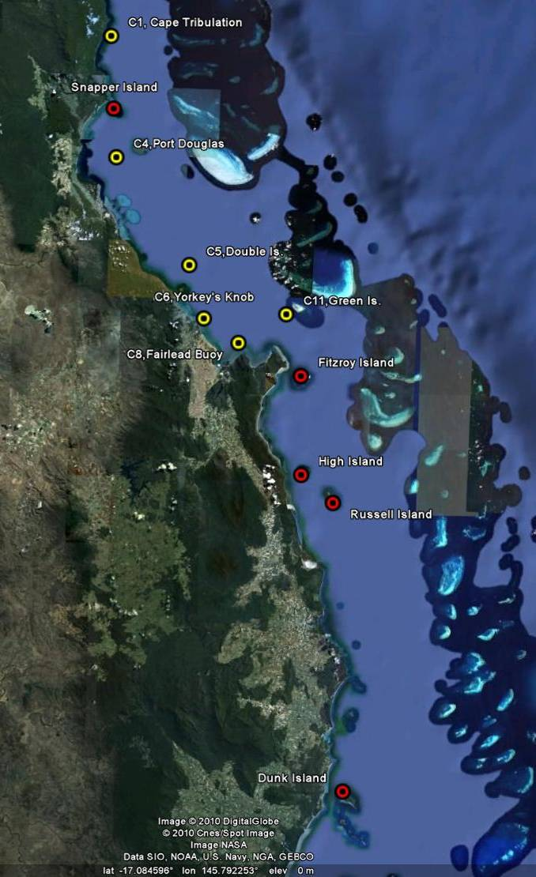©Google Earth 2009
Figure 2 Reef Rescue MMP water quality sampling sites (red symbols) in the Wet Tropics NRM Region at Snapper Island, Fitzroy Island, High Island, Russell Island and Dunk Island. Yellow symbols are the six sites of the AIMS Cairns Transect.

The five reef water quality sampling sites in the Wet Tropics Region are located along the coast to capture the influence of the main rivers in this region (Figure 2; see Table 1 for details). There are also six additional open water sampling locations along the Cairns Transect (Figure 2). Some of the major rivers in the Wet Tropics Region had annual flows above the long-term median since the start of the MMP monitoring from 2005/06 (Appendix 1-Table 3). Noteworthy were major flood events of the Barron in the “water years” of 2008 and 2011 and of the Herbert in 2009 and 2011. In 2011, all Wet Tropics rivers had above-median flow (Appendix 1-Table 3).

The results from the direct water sampling are presented as seasonal summary statistics over six years of monitoring for the water quality parameters for which Guideline trigger values were available (GBRMPA 2009) (Figure 3) and as overall summary statistics (Table 3) for comparison with the Guidelines. Detailed results for all water quality variables for the sampling year 2009/10 are in Appendix 1-Table 4 to Appendix 1-Table 9.

The direct water sampling results over six years show that the water quality at the inshore reef locations in the Wet Tropics Region was mostly good, when assessed in comparison with the Guidelines. Values of most parameters were generally higher during the wet season and at a number of sites are above Guidelines values (Figure 3). Long-term mean concentrations of chlorophyll a, particulate nitrogen (PN), particulate phosphorus (PP) and suspended solids (SS) were within the Guidelines at the sampling locations close to the fringing reefs of Snapper, Fitzroy, and Russell islands and at the open water sites Cape Tribulation, Port Douglas, Double Island and Green Island (Table 3). Long-term means of chlorophyll a, PP and SS exceeded the Guidelines at Dunk Island and at the open water sites Yorkey’s Knob and Fairlead Buoy; these three locations are relatively close to shore and to the influence of major rivers. High Island’s long-term chlorophyll a mean also exceeded the Guideline. All sampling locations had long-term mean Secchi depth values below the Guideline (Table 3), except for Green Island which is furthest away from the coast and from river influence and has generally clearer water. However, this indication of impaired water clarity is not supported by the generally compliant long-term means of SS at most sites. The mismatch of Secchi and SS values has been observed at most sites and requires further research. It is possible that either guideline value requires future adjustment. The formulation of the guideline trigger value for Secchi depth has a higher confidence as it was based on a larger dataset (De’ath and Fabricius 2008, 2010).

The instrumental water quality monitoring data confirm that the water quality at the five coral reef locations in the Wet Tropics Region was generally good, when compared to the Guidelines. The annual mean chlorophyll fluorescence values were below the Guidelines at all locations in the four sampling years since instrument-based monitoring began in October 2007 (Figure 4 to Figure 6, Table 8). At all locations, the time series show regular seasonal cycles of chlorophyll concentrations, with higher values during the summer (as described in Brodie et al. 2007). These high values are likely to be a combination of two factors, an inherent seasonal increase and the response to nutrient inputs by large flood events of the Wet Tropics rivers during the four years of instrumental monitoring (Figure 4 to Figure 6). Without a longer time series spanning wet and dry years, these two factors cannot be distinguished with any certainty.

Annual means of turbidity at Snapper and Dunk islands exceeded the turbidity Guidelines in all four years of instrumental monitoring (Table 9). Inspection of the turbidity time series at these two sites shows high variability of turbidity values throughout the year, not limited to periods of river floods (Figure 4 and Figure 6). 34-59% of the daily means in the years with sufficient data (ie. > 300 d) were above the Guidelines (Table 9). 10 and 12% of daily mean turbidity values over the whole time series at Snapper and Dunk islands, respectively, were also above the 5 NTU biological threshold suggested by Cooper et al. (2007, 2008), above which corals are likely to experience severe photo-physiological stress due to light limitation.

The exceedance of the turbidity Guidelines at High Island in 2011 (Table 9) is likely to be an artefact as data are only available to June 2010, hence biasing the annual “water year” mean (October to October) toward higher wet season values.

The high turbidity events are caused by resuspension of fine, clay/silt-sized, sediment particles throughout the year during strong winds. Resuspension is recognised as one of the major drivers of turbidity in the inshore GBR lagoon (e.g. Larcombe et al. 1995, Wolanski 2007). The turbidity at the reef sites is likely to be influenced by the regional oceanography, bathymetry and sediment quality. For example, Snapper Island is very close to the mouth of the Daintree River and Dunk Island is close to the very shallow area of Rockingham Bay, both areas that are influenced by river runoff and are prone to high turbidity due to sediment resuspension. However, it is interesting that the sediment quality directly at the reef locations is very different between these two high-turbidity sites. While Snapper Is. has a very high proportion of clay/silt sized particles with high organic carbon content, Dunk Is. has not (sediment quality data in Thompson et al. 2011). In contrast, Russell Is. has fine, organic-rich sediments (ibid.) but is a site with generally low water turbidity (Figure 5). Thompson et al. (2011) suggest that the complex topography of the abundant corals and sheltered nature of the site facilitates fine sediment accumulation but at the same time reduces the resuspension of these locally available fine sediments. This emphasises that local physical and oceanographic conditions will also influence the water quality around coral reefs.

The sampling locations in the Wet Tropics region were affected by the severe (category 5) Tropical Cyclone Yasi, which made landfall on 03 February 2011 in the Dunk Island/Mission Beach area. All five sites with instrumental monitoring showed a distinct spike in turbidity during the period when the cyclone was close to the coast as well as slightly elevated, variable turbidity for a few weeks after the cyclone (Figure 4 to Figure 7). The effect was most pronounced at Dunk Island, which was located in the path of destructive winds from TC Yasi (Figure 7). The chlorophyll concentrations, as measured by water quality instruments, also increased during the cyclone-affected period but were not appreciably higher compared to previously recorded values during summer seasons and after flood events.

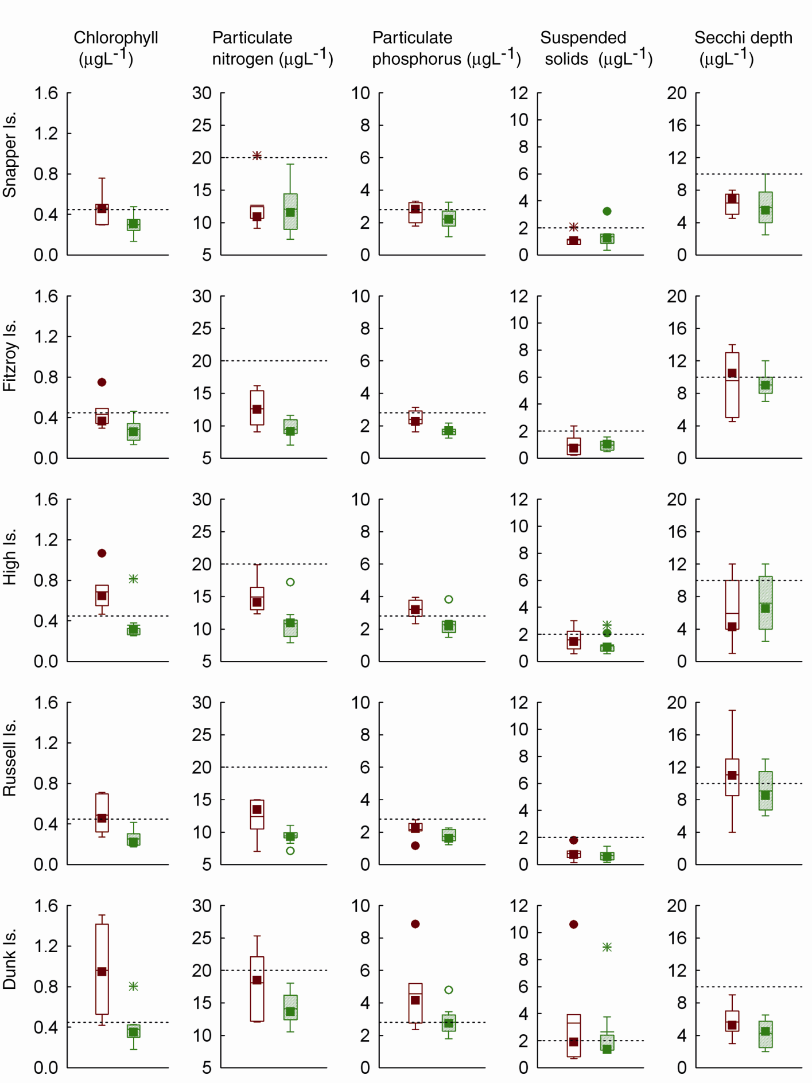
(m)

Figure 3 Summary of concentrations of chlorophyll a, particulate nitrogen, particulate phosphorus (μg L⁻¹), suspended solids (mg L⁻¹) and Secchi depth (m) at reef locations in the Wet Tropics Region collected by direct water sampling over six years (2005/06 to 2010/11). Dry season values (May- Oct) = shaded boxes, wet season (Nov-Apr) = white boxes. See page 11 for more details about the box plot presentation. Broken lines are the GBR Water Quality Guidelines values (GBRMPA 2009).
Table 3 Summary of concentrations of chlorophyll a (Chl a), particulate nitrogen (PN) particulate phosphorus (PP), all in μg L⁻¹; suspended solids (SS, mg L⁻¹) and Secchi depth (m) at reef and open water (*) locations in the Wet Tropics Region collected by direct water sampling over six sampling years (2005/06 to 2010/11). Red shading represents overall means that exceed the GBR Water Quality Guidelines values (GBRMPA 2009). N= number of sampling occasions (days).

Station | Variable | N | Mean | Median | Lower quartile | Upper quartile
Cape Tribulation* | Chl a (µg L⁻¹) | 14 | 0.42 | 0.34 | 0.30 | 0.54
Cape Tribulation* | PN (µg L⁻¹) | 14 | 13.30 | 12.67 | 10.70 | 14.96
Cape Tribulation* | PP (µg L⁻¹) | 14 | 2.64 | 2.46 | 2.00 | 3.16
Cape Tribulation* | Secchi (m) | 13 | 6.60 | 6.00 | 4.25 | 9.25
Cape Tribulation* | SS (mg L⁻¹) | 14 | 1.48 | 1.43 | 0.89 | 1.65
Snapper Island | Chl a (µg L⁻¹) | 13 | 0.36 | 0.32 | 0.28 | 0.47
Snapper Island | PN (µg L⁻¹) | 13 | 12.39 | 11.11 | 9.43 | 14.70
Snapper Island | PP (µg L⁻¹) | 13 | 2.40 | 2.32 | 1.93 | 3.18
Snapper Island | Secchi (m) | 14 | 6.07 | 6.00 | 4.50 | 7.50
Snapper Island | SS (mg L⁻¹) | 13 | 1.29 | 1.17 | 0.79 | 1.57
Port Douglas* | Chl a (µg L⁻¹) | 15 | 0.35 | 0.31 | 0.25 | 0.39
Port Douglas* | PN (µg L⁻¹) | 15 | 13.10 | 12.76 | 10.96 | 14.69
Port Douglas* | PP (µg L⁻¹) | 15 | 2.35 | 2.37 | 2.04 | 2.51
Port Douglas* | Secchi (m) | 16 | 6.97 | 7.00 | 5.00 | 9.00
Port Douglas* | SS (mg L⁻¹) | 15 | 1.28 | 1.22 | 0.94 | 1.59
Double Island* | Chl a (µg L⁻¹) | 14 | 0.37 | 0.34 | 0.28 | 0.49
Double Island* | PN (µg L⁻¹) | 14 | 11.69 | 12.70 | 9.59 | 13.18
Double Island* | PP (µg L⁻¹) | 14 | 2.17 | 2.18 | 1.90 | 2.48
Double Island* | Secchi (m) | 14 | 8.00 | 6.25 | 5.00 | 13.00
Double Island* | SS (mg L⁻¹) | 14 | 1.17 | 1.21 | 1.00 | 1.30
Green Island* | Chl a (µg L⁻¹) | 15 | 0.26 | 0.23 | 0.16 | 0.33
Green Island* | PN (µg L⁻¹) | 15 | 9.54 | 9.38 | 8.04 | 10.68
Green Island* | PP (µg L⁻¹) | 15 | 1.58 | 1.49 | 1.16 | 1.93
Green Island* | Secchi (m) | 16 | 13.63 | 13.00 | 11.25 | 16.00
Green Island* | SS (mg L⁻¹) | 15 | 0.44 | 0.35 | 0.14 | 0.72
Yorkey's Knob* | Chl a (µg L⁻¹) | 15 | 0.57 | 0.52 | 0.45 | 0.61
Yorkey's Knob* | PN (µg L⁻¹) | 15 | 16.29 | 15.55 | 13.61 | 17.61
Yorkey's Knob* | PP (µg L⁻¹) | 15 | 3.83 | 3.57 | 3.25 | 4.34
Yorkey's Knob* | Secchi (m) | 16 | 3.72 | 3.00 | 2.50 | 4.75
Yorkey's Knob* | SS (mg L⁻¹) | 15 | 3.16 | 2.48 | 2.04 | 3.48
Fairlead Buoy* | Chl a (µg L⁻¹) | 15 | 0.53 | 0.42 | 0.38 | 0.59
Fairlead Buoy* | PN (µg L⁻¹) | 15 | 16.31 | 16.60 | 14.30 | 18.18
Fairlead Buoy* | PP (µg L⁻¹) | 15 | 4.25 | 4.22 | 3.01 | 5.12
Fairlead Buoy* | Secchi (m) | 15 | 3.68 | 3.50 | 2.88 | 4.13
Fairlead Buoy* | SS (mg L⁻¹) | 15 | 4.11 | 2.84 | 2.08 | 5.70
Fitzroy Island | Chl a (µg L⁻¹) | 15 | 0.34 | 0.34 | 0.26 | 0.39
Fitzroy Island | PN (µg L⁻¹) | 15 | 10.73 | 10.16 | 9.02 | 11.50
Fitzroy Island | PP (µg L⁻¹) | 15 | 1.95 | 1.78 | 1.62 | 2.15
Fitzroy Island | Secchi (m) | 16 | 9.13 | 9.00 | 7.25 | 11.00
Fitzroy Island | SS (mg L⁻¹) | 15 | 0.99 | 1.02 | 0.53 | 1.25

Station | Variable | N | Mean | Median | Lower quartile | Upper quartile
High Island | Chl a (µg L⁻¹) | 15 | 0.49 | 0.38 | 0.31 | 0.60
High Island | PN (µg L⁻¹) | 15 | 12.47 | 12.21 | 10.53 | 13.60
High Island | PP (µg L⁻¹) | 15 | 2.63 | 2.49 | 2.14 | 3.03
High Island | Secchi (m) | 16 | 6.63 | 6.00 | 4.00 | 10.25
High Island | SS (mg L⁻¹) | 15 | 1.38 | 1.08 | 0.88 | 1.73
Russell Island | Chl a (µg L⁻¹) | 15 | 0.35 | 0.30 | 0.22 | 0.40
Russell Island | PN (µg L⁻¹) | 15 | 10.67 | 9.90 | 9.13 | 11.29
Russell Island | PP (µg L⁻¹) | 15 | 1.92 | 2.13 | 1.53 | 2.20
Russell Island | Secchi (m) | 15 | 9.87 | 9.00 | 7.00 | 12.25
Russell Island | SS (mg L⁻¹) | 15 | 0.75 | 0.74 | 0.48 | 0.92
Dunk Island | Chl a (µg L⁻¹) | 15 | 0.61 | 0.42 | 0.34 | 0.77
Dunk Island | PN (µg L⁻¹) | 15 | 15.76 | 14.48 | 12.35 | 17.58
Dunk Island | PP (µg L⁻¹) | 15 | 3.53 | 3.11 | 2.34 | 3.91
Dunk Island | Secchi (m) | 15 | 4.73 | 4.50 | 3.00 | 6.00
Dunk Island | SS (mg L⁻¹) | 15 | 2.91 | 1.47 | 1.30 | 2.76

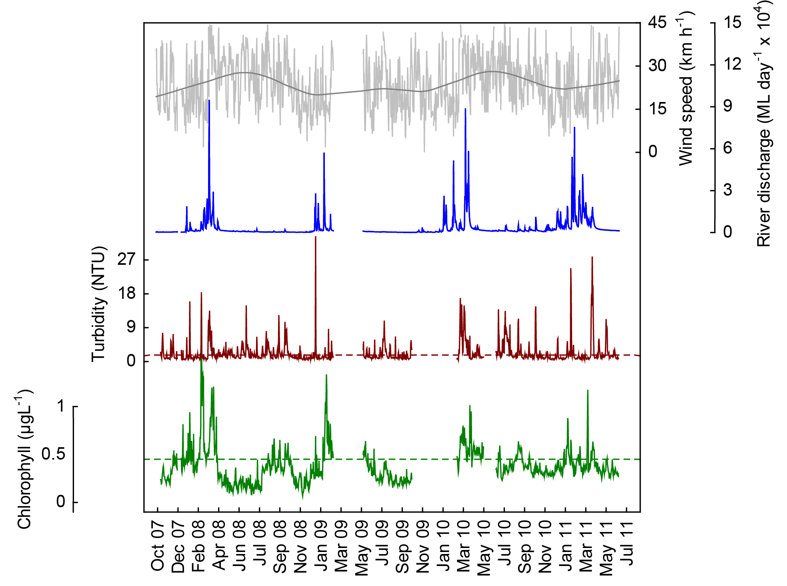
a
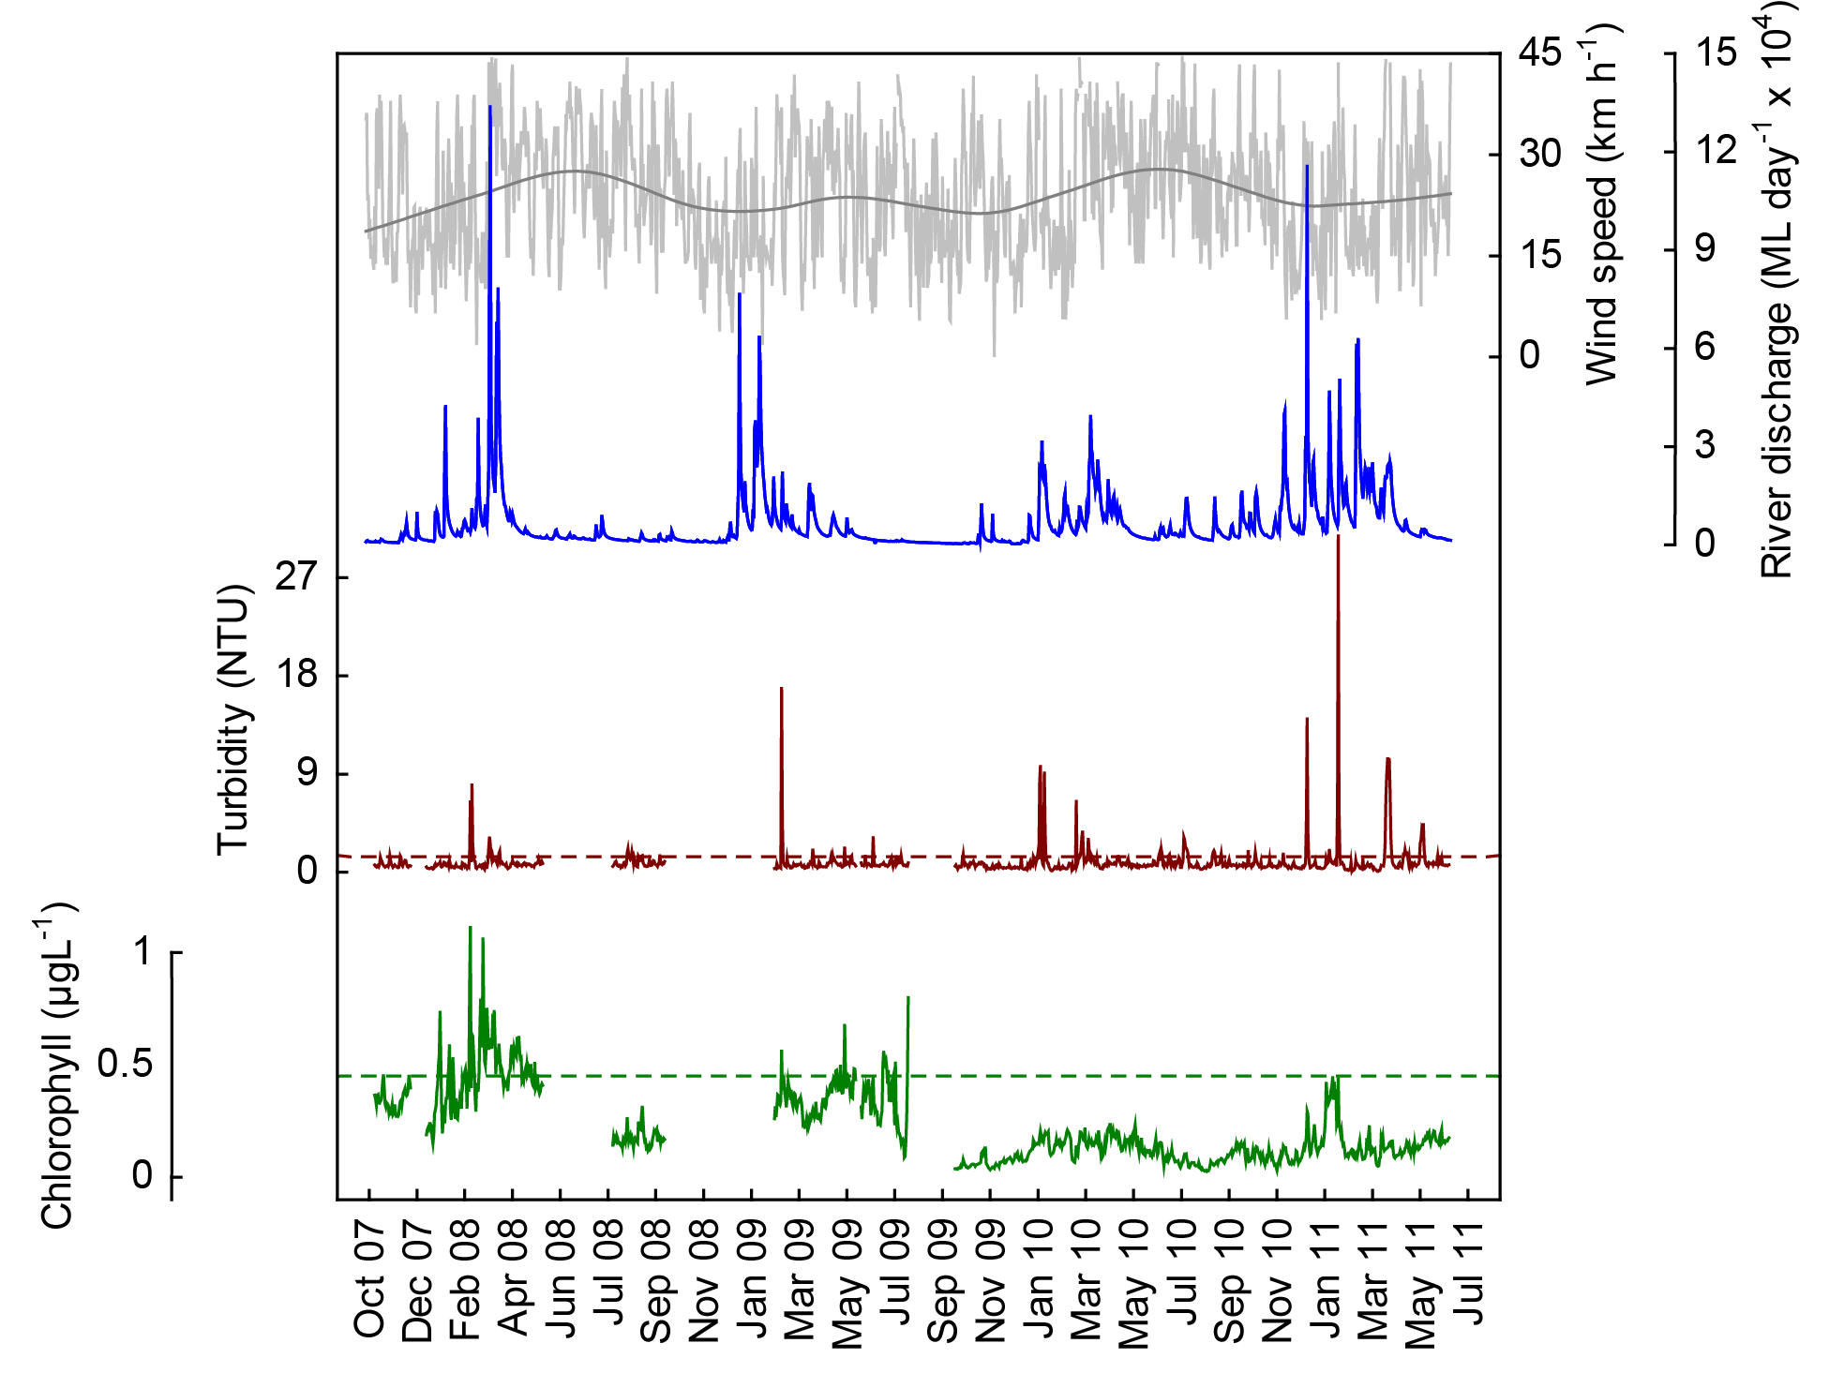
b

Figure 4 Time series of daily means of chlorophyll (green line, µg L⁻¹) and turbidity (brown line, NTU) time-series collected by Eco FLNTUSB instruments at (a) Snapper and (b) Fitzroy islands in the Wet Tropics NRM Region. Additional panels represent daily discharge from the Daintree (a) and Russell-Mulgrave (b) rivers (blue line, ML day⁻¹ x 10⁴) and daily wind speeds (grey line, km h⁻¹) from the Low Isles weather station. Horizontal green and red lines are the GBR Water Quality Guidelines values (GBRMPA 2009). Turbidity trigger value (red line) was derived by transforming the suspended solids trigger value (see Schaffelke et al. 2009).
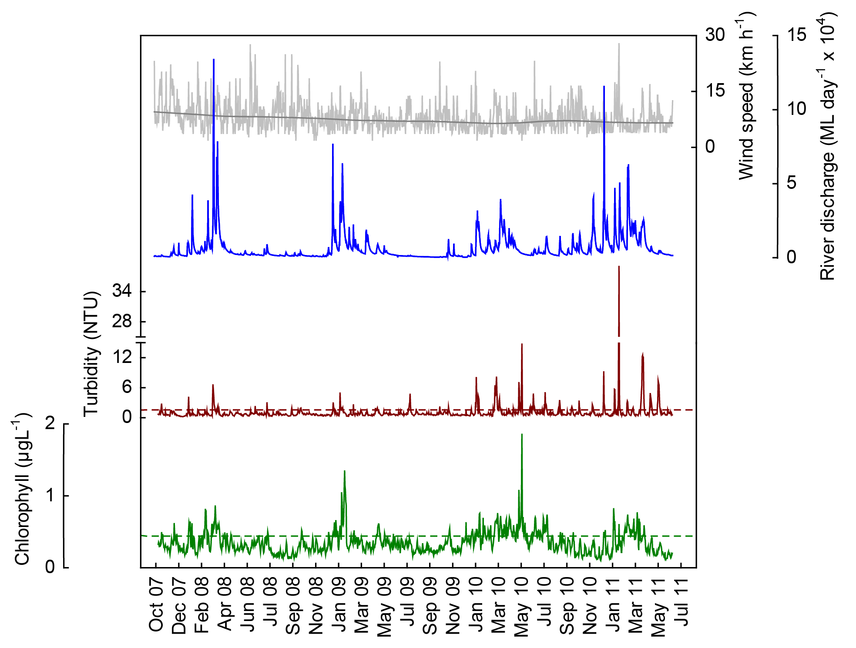
a
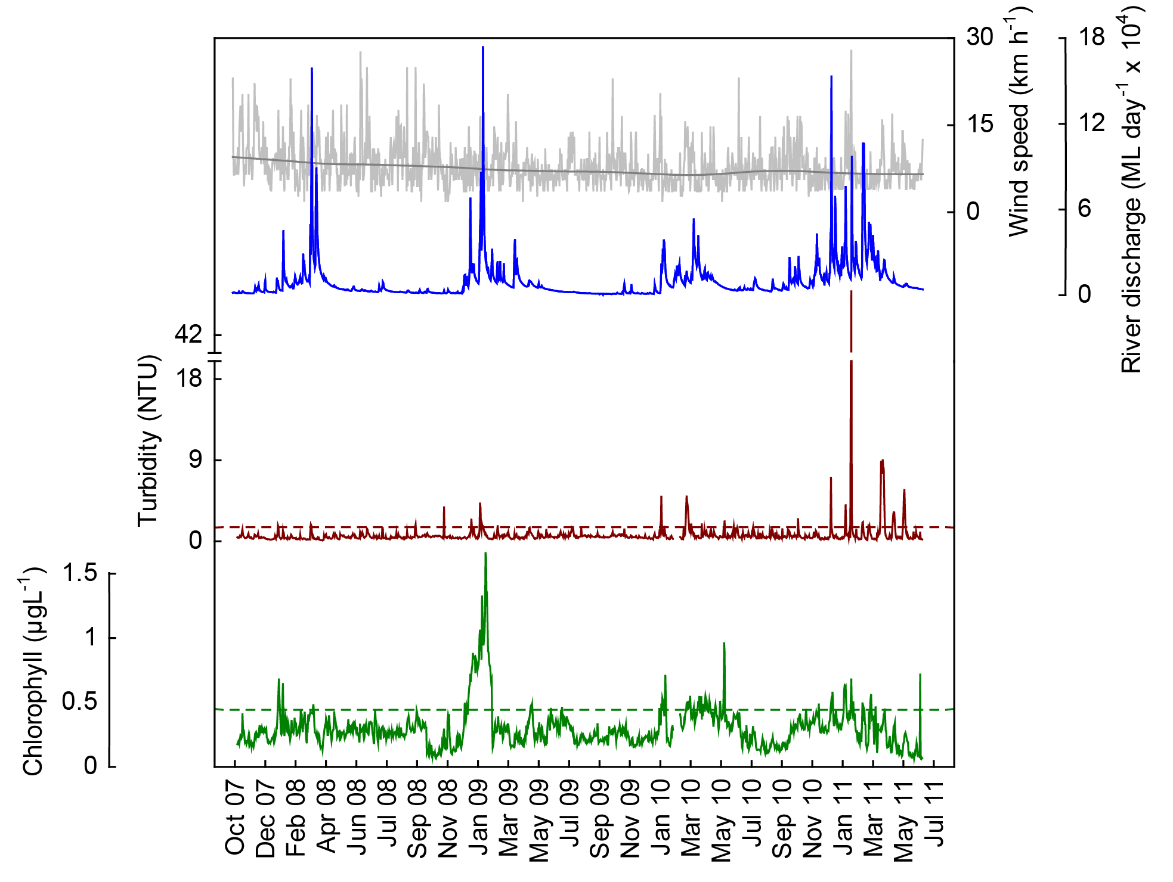
b
Figure 5 Time series of daily means of chlorophyll (green line, µg L⁻¹) and turbidity (brown line, NTU) time-series collected by Eco FLNTUSB instruments at (a) High and (b) Russell islands in the Wet Tropics NRM Region. Additional panels represent daily discharge from the Russell-Mulgrave (a) and Johnstone (b) rivers (blue line, ML day⁻¹ x 10⁴) and daily wind speeds (grey line, km h⁻¹) from the Innisfail weather station. Other details as in Fig. 4.
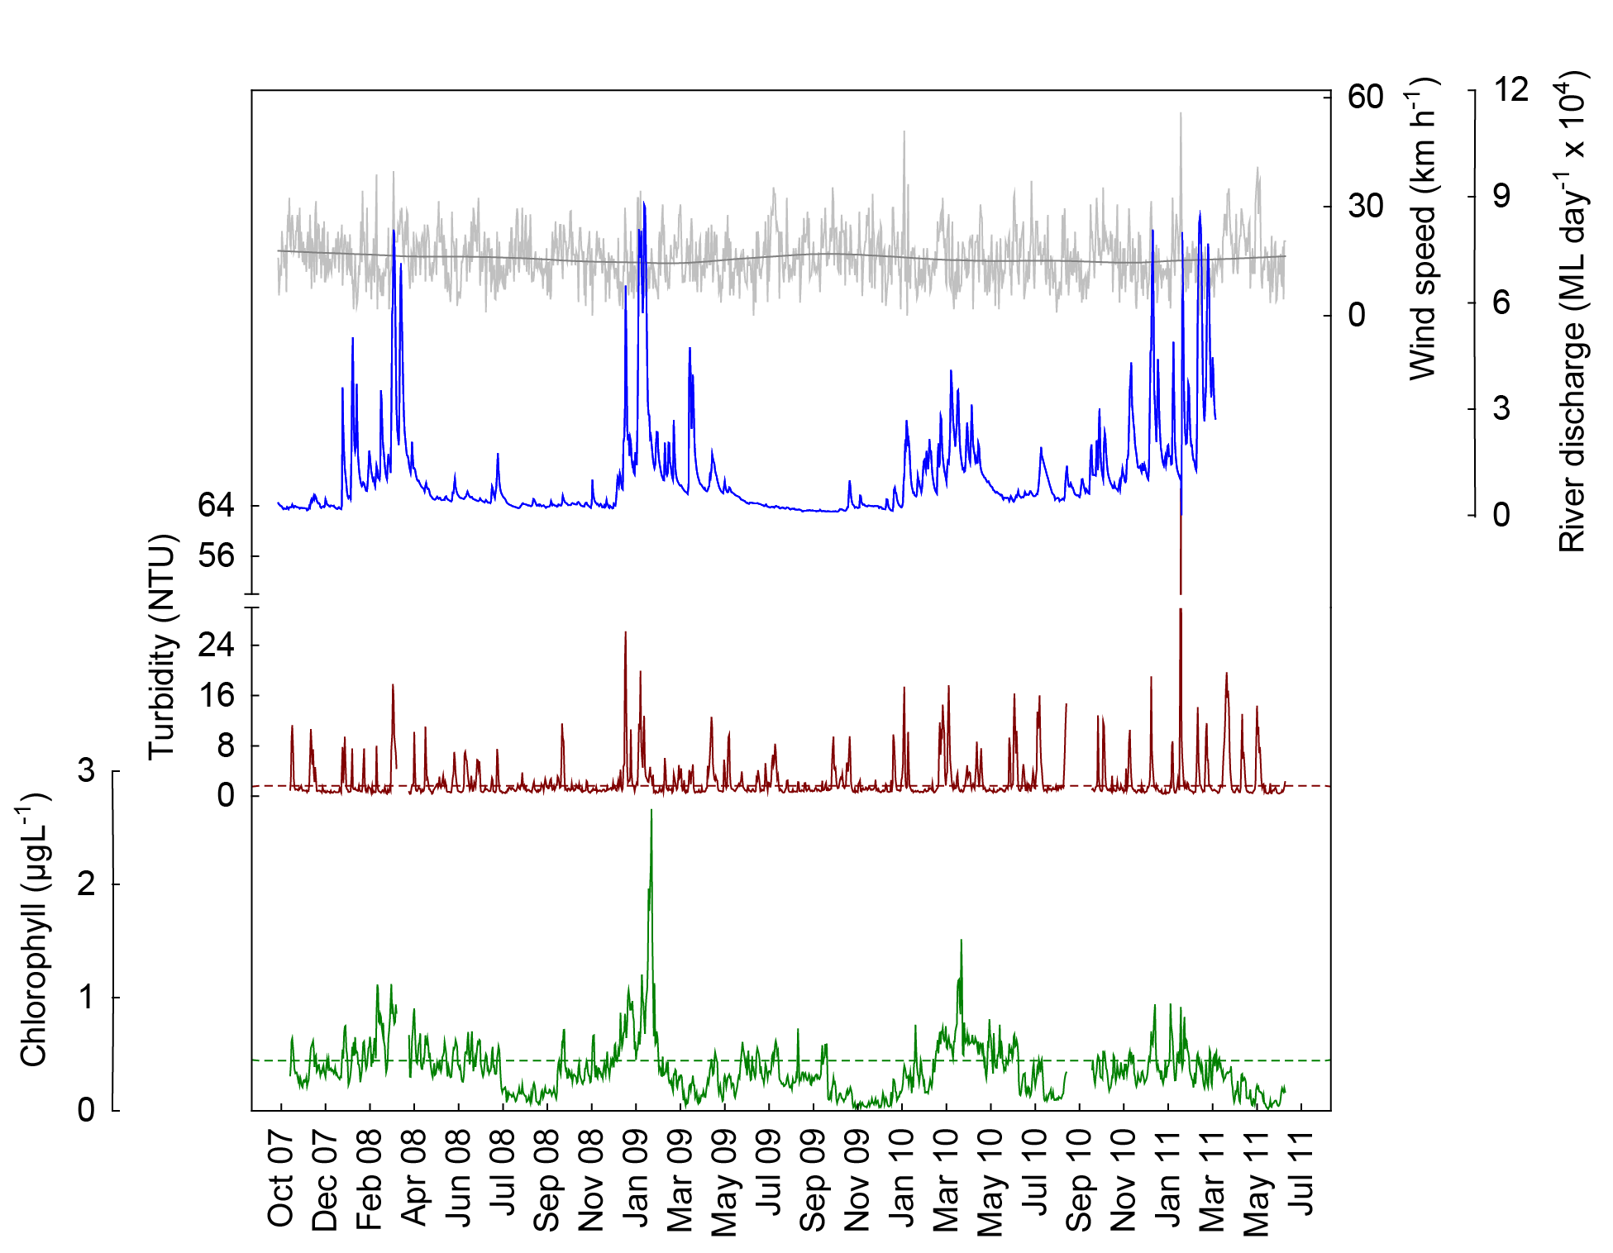

Figure 6 Time series of daily means of chlorophyll (green line, µg L⁻¹) and turbidity (brown line, NTU) time-series collected by Eco FLNTUSB instruments at Dunk Island in the Wet Tropics NRM Region. Additional panels represent daily discharge from the Tully River (blue line, ML day⁻¹ x 10⁴) and daily wind speeds (grey line, km h⁻¹) from the Cardwell weather station. Other details as in Fig. 4.

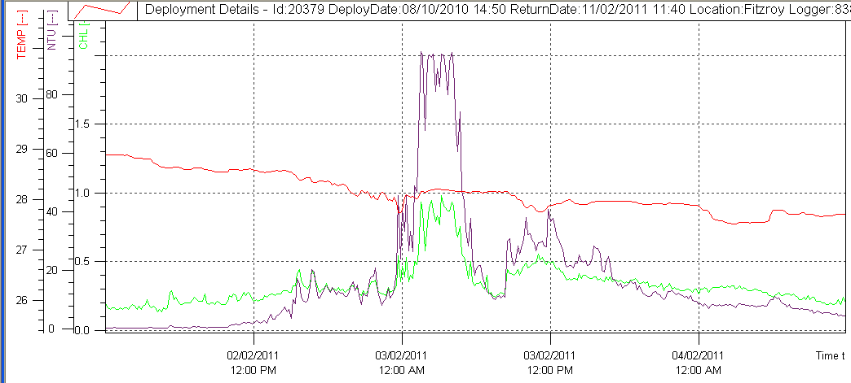

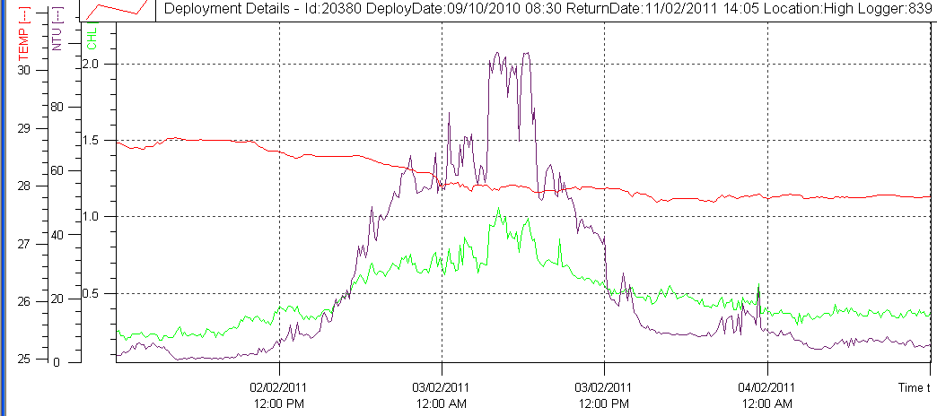

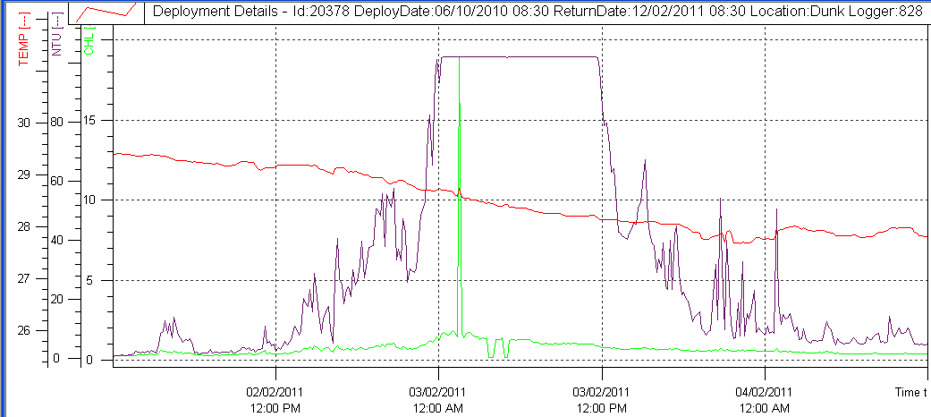

Figure 7 Passage of Tropical Cyclone Yasi on 03 February 2011. Raw data records of chlorophyll (µg L⁻¹; green line) turbidity (NTU; purple line) and temperature (ºC, red line) collected by Eco FLNTUSB instruments at Fitzroy, High and Dunk islands in the Wet Tropics NRM Region. Note different scale of chlorophyll records. Note that high chlorophyll spike and following zero readings at Dunk Is. are considered erroneous and caused by the extreme conditions during the cyclone.

Cairns long-term water quality transect
The long-term time series of water quality parameters sampled since 1989 along the ‘AIMS Cairns Transect’ (see Figure 1, Figure 2 and Table 1 for sampling locations) was continued and the updated data were reanalysed. All six parameters showed significant long-term patterns (Table 4, Figure 8). The partial effects for the factor “Year” showed long-term trends in particulate nitrogen (PN), suspended solids (SS), chlorophyll a, dissolved organic nitrogen (DON) and dissolved organic phosphorus (DOP) were non-linear, while particulate phosphorus (PP) showed a linear trend of declining values over time. SS concentrations increased in the early to late 1990s, peaked around 1999 and then declined. PN concentrations were also highest around 1999, then decreased, and increased again over the last few years. Concentrations of DON and DOP peaked around 2003 and have declined since. Chlorophyll a concentrations showed multi-year fluctuations with high values at the start of the time series and again around 1999.

In addition to the long-term trends, some variables had clear seasonal trends (Table 4, Figure 9). The partial effects for the factor “Months” over all sampling years showed that SS steadily increased from January to August/September and then declined. Chlorophyll a concentrations were highest during summer, from January to March/April, with a smaller secondary peak during spring, in September/October (see also Brodie et al. 2007). PN showed a similar pattern with two peaks, in late summer (March, April) and in spring (September, October). DON, DOP and PP concentrations showed no significant variation across months.

Table 4 Cairns Long-Term Water Quality Transect. Analyses of variance assessing the significance of trends over time, by years and months. Df= degrees of freedom, F= Variance ratio, P= probability.
Response variable | Source | df | F | Pr (>F) | Deviance explained (%)
Particulate nitrogen | Years | 6 | 6.609 | <0.001 | 60.7
 | Months | 3 | 2.645 | 0.061
 | Residuals | 45
Particulate phosphorus | Years | 1 | 5.387 | 0.012 | 24.5
 | Months | 3 | 2.164 | 0.104
 | Residuals | 49
Suspended solids | Years | 2 | 7.176 | 0.002 | 43.9
 | Months | 3 | 5.492 | 0.003
 | Residuals | 44
Chlorophyll a | Years | 7 | 2.501 | 0.025 | 50.4
 | Months | 3 | 6.516 | <0.001
 | Residuals | 44
Dissolved organic nitrogen | Years | 6 | 2.923 | 0.013 | 40.9
 | Months | 3 | 2.37 | 0.083
 | Residuals | 45
Dissolved organic phosphorus | Years | 4 | 7.764 | <0.001 | 50.7
 | Months | 3 | 1.758 | 0.168
 | Residuals | 47

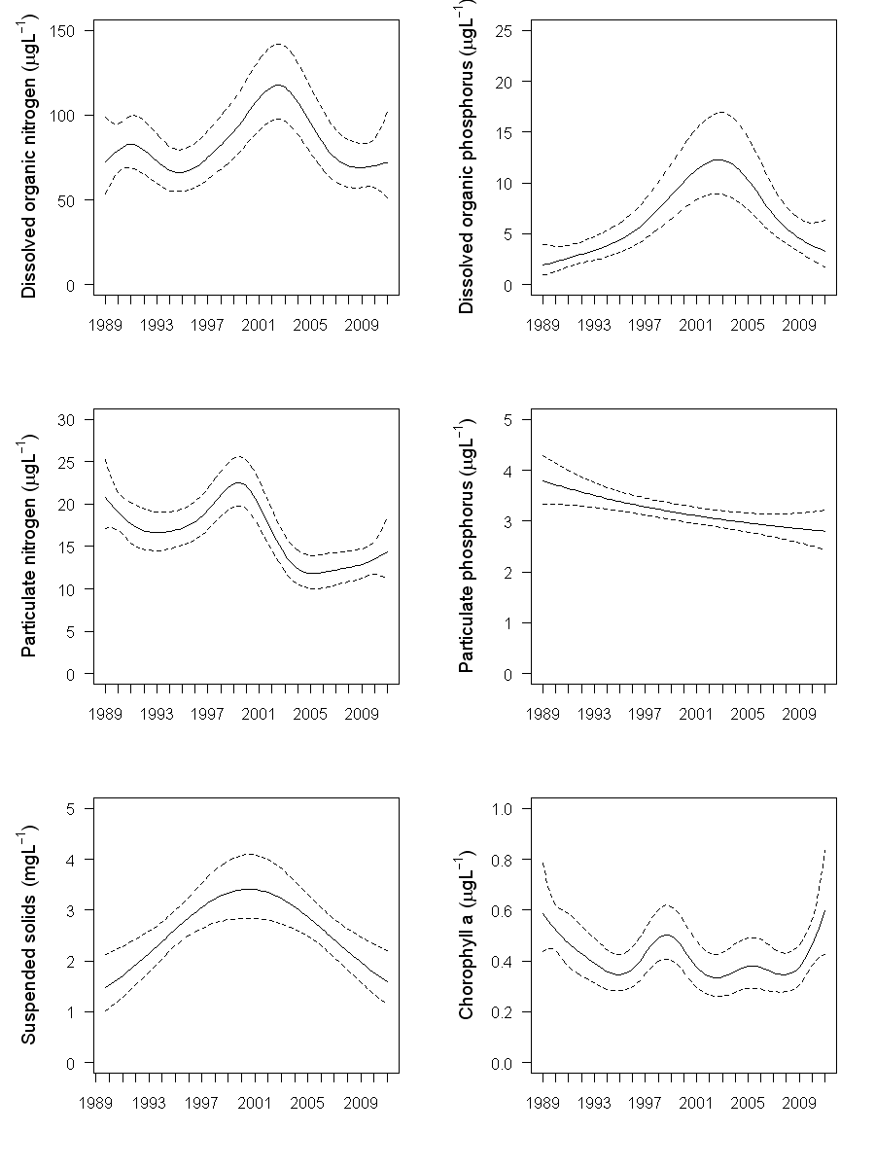
Figure 8 Cairns Long-Term Water Quality Transect. Smooth trends over sampling years from 1989 to 2011 (partial effects) for the water quality parameters dissolved organic nitrogen (µg L⁻¹), dissolved organic phosphorus (µg L⁻¹), particulate nitrogen (µg L⁻¹), particulate phosphorus (µg L⁻¹), suspended solids (mg L⁻¹) and chlorophyll a (µg L⁻¹). Broken lines are 95% confidence intervals.

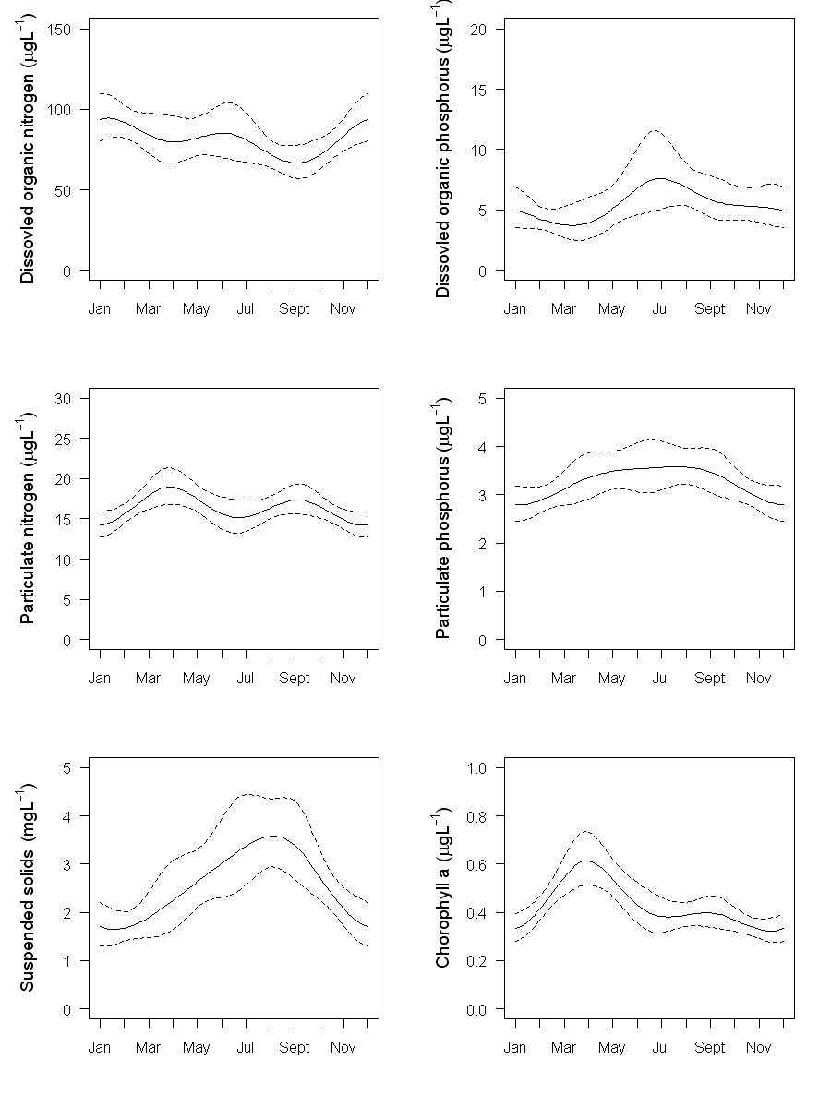
Figure 9 Cairns Long-Term Water Quality Transect. Smooth trends over sampling months of data from 1989 to 2011 (partial effects) for the water quality parameters dissolved organic nitrogen (µg L⁻¹), dissolved organic phosphorus (µg L⁻¹), particulate nitrogen (µg L⁻¹), particulate phosphorus (µg L⁻¹), suspended solids (mg L⁻¹) and chlorophyll a (µg L⁻¹). Broken lines are 95% confidence intervals.
An analysis of the factors influencing the inter-annual variation in water quality variables at sites along the Cairns Transect is now complete and prepared for peer-review publication (Carleton et al. in prep.). Interim results were presented in Schaffelke et al. (2010) and are not repeated here. In brief, the analysis showed relationships between concentrations of water quality variables and several human-related and natural environmental factors, including; vegetation clearing rates on the adjacent catchment, increased land area under crops and periods of high rainfall and episodes of strong winds. In this data set, most of the variation was explained by the factor of month, highlighting the clear difference of water quality parameters between wet and dry seasons. Proximity to a river mouth combined with its discharge and catchment clearing rates explained approximately 15% of total variation. High land clearing rates from 1996-2001 were associated with high concentrations in the adjacent marine waters of chlorophyll a, particulate nitrogen and phosphorus, silicate and suspended solids. After 2004, land clearing was relatively low and particulate concentrations in coastal waters remained relatively constant or decreased even though there was a steady increase in wind strength and river discharge.

4.2 Region Reports: Burdekin Region
The Burdekin Region is one of the two large dry tropical catchment regions adjacent to the GBR, with cattle grazing as the primary land use. There is also extensive irrigated planting of sugarcane on the floodplains of the Burdekin and Haughton rivers. Fluctuations in climate and cattle numbers greatly affect the state and nature of vegetation cover, and therefore, the susceptibility of soils to erosion, which leads to runoff of suspended sediments and associated nutrients.

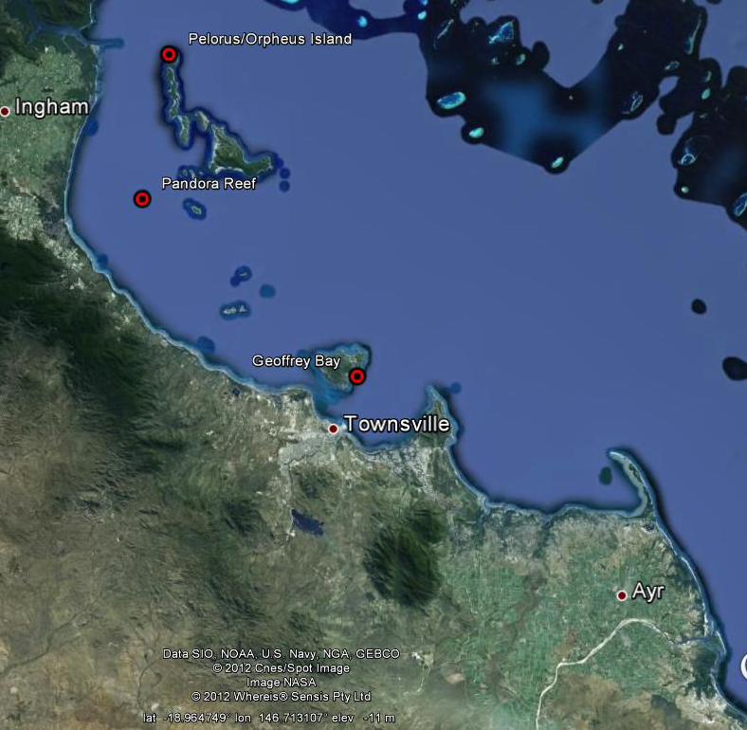
Figure 10 Reef Rescue MMP water quality sampling sites (large red symbols) in the Burdekin NRM Region at Pelorus Island, Pandora Reef and Magnetic Island (Geoffrey Bay). The Burdekin River is south of the town of Ayr. ©Google Earth 2012.

The three water quality sampling sites in the Burdekin Region are located on a gradient away from the Burdekin River mouth (Figure 10). There are no well-developed reefs closer to the river mouth. The Burdekin River had major flood events in 2008, 2009 and 2011, after annual flows had been below the long-term median from 2002 to 2006 (Appendix 1-Table 3). The 2011 event was the third biggest flood on record for this river, after 1974 and 1991. The sampling site at Magnetic Island is also influenced by local runoff and runoff from the Ross River and the sites at Pandora Reef and Pelorus Island by the Herbert River as well as the smaller creeks and rivers north of Townsville, i.e. the Bohle and Black rivers and Crystal Creek.

The Herbert River also had a major flood event in 2011, the biggest event on record for this river, with discharge of more than 3-times the long-term median (Appendix 1-Table 3). The Burdekin River had two major flood peaks, the first from mid December to mid January, the second in early February, associated with rainfalls after the TC Yasi. The Herbert River also started flowing significantly in early February. For more information about flood-specific monitoring and detailed hydrographs of the GBR priority rivers see Devlin et al. (2011).

The results from the direct water sampling over six years of monitoring are presented as seasonal summary statistics for the five water quality parameters for which Guideline trigger values were available (GBRMPA 2009) (Figure 11) and as overall summary data (Table 5) for comparison with the Guidelines. Detailed results for all water quality variables for the sampling year 2009/10 are in Appendix 1-Table 4 to Appendix 1-Table 9. The summary results show that the water quality at the inshore reef locations in the Burdekin Region is characterised by seasonally high chlorophyll a and particulate phosphorus concentrations (Figure 11). Long-term means of chlorophyll a, PP and SS exceeded the Guidelines at Magnetic Island (Table 5), and long-term Secchi depth readings did not comply with the Guidelines at all three locations. However, long-term means of the other four key water quality parameters were within the Guidelines at both Pelorus Island and Pandora Reef (Table 5).

The instrumental water quality monitoring of chlorophyll was inconclusive for the three Burdekin Region locations. Annual chlorophyll means at Pelorus Island exceeded the Guidelines during 2009, 2010 and 2011, while the annual means at the other two locations were within Guidelines for all years except 2008 (Table 8, Figure 12, Figure 13). Note that the data for the 2011 year are incomplete as records were only obtained to June 2010 hence biasing the annual “water year” mean (October to September) toward higher wet season values. At all three locations, the chlorophyll time series show some evidence of regular seasonal cycles (as described in Brodie et al. 2007), with high values during the summer; however this cycle was less pronounced during the 2010 summer (note data gaps at Geoffrey Bay). The discharge of the Burdekin River in 2010, while above the long-term median, was much less than during the significant flood events in 2008, 2009 and 2011. It is possible that the lower chlorophyll concentrations measured at all three locations were a response to this lower river inflow. A longer time series, including a few drier years would be required to verify this point.

The instrumental water quality monitoring data confirmed the high turbidity levels at Geoffrey Bay, Magnetic Island (Figure 13), with all annual means and 36-49% of the daily records in each year exceeding the Guidelines (Table 9). Eight percent of daily records over the whole period (October 2007 to June 2011) were above the suggested 5 NTU limit for severe coral photo-physiological stress due to light limitation (Cooper et al. 2007, 2008). Most of the high turbidity events (> 5 NTU) at all three sites were associated with strong winds events (January 2009), tropical Cyclone Yasi (February 2011) and flood influences, especially during the 2009 and 2011 wet seasons (Figure 12 and Figure 13).

The extreme variability of the turbidity record indicates that Geoffrey Bay and, to a lesser extent, Pandora Reef (Figure 12, Figure 13) are regularly experiencing wind-driven resuspension events, which lead to frequent spikes in turbidity outside the wet season. The Pelorus Island sampling location is more protected from prevailing winds and is characterised by generally lower turbidity. However, the relatively high chlorophyll concentrations at this site are surprising and may be driven by factors other than resuspension. We need a few drier years to establish the range of turbidity levels at reef sites in this region that are not in direct response to a flood event. A fine sediment budget for Cleveland Bay indicates that fine sediment imported into the bay during above-median river flows would accumulate, because resuspension and transport during strong trade winds only lead to some export (Lambrechts et al. 2010). Only the enhanced sediment remobilisation during cyclones leads to a net export of fine sediments. The sediment quality on the reefs at the three monitoring sites has not appreciably changed over the last five years (Thompson et al. 2011).

Like in the Wet Tropics Region, the effect of TC Yasi was clearly seen in the turbidity record at all three sites, with a clear spike during the time of land fall (Figure 12 to Figure 14) and relatively high turbidity during the following weeks, likely due to a combination of wind-driven resuspension that slowly settled out and turbidity created by flood waters from the Burdekin and Herbert rivers reaching the sampling locations (Figure 12, Figure 13).

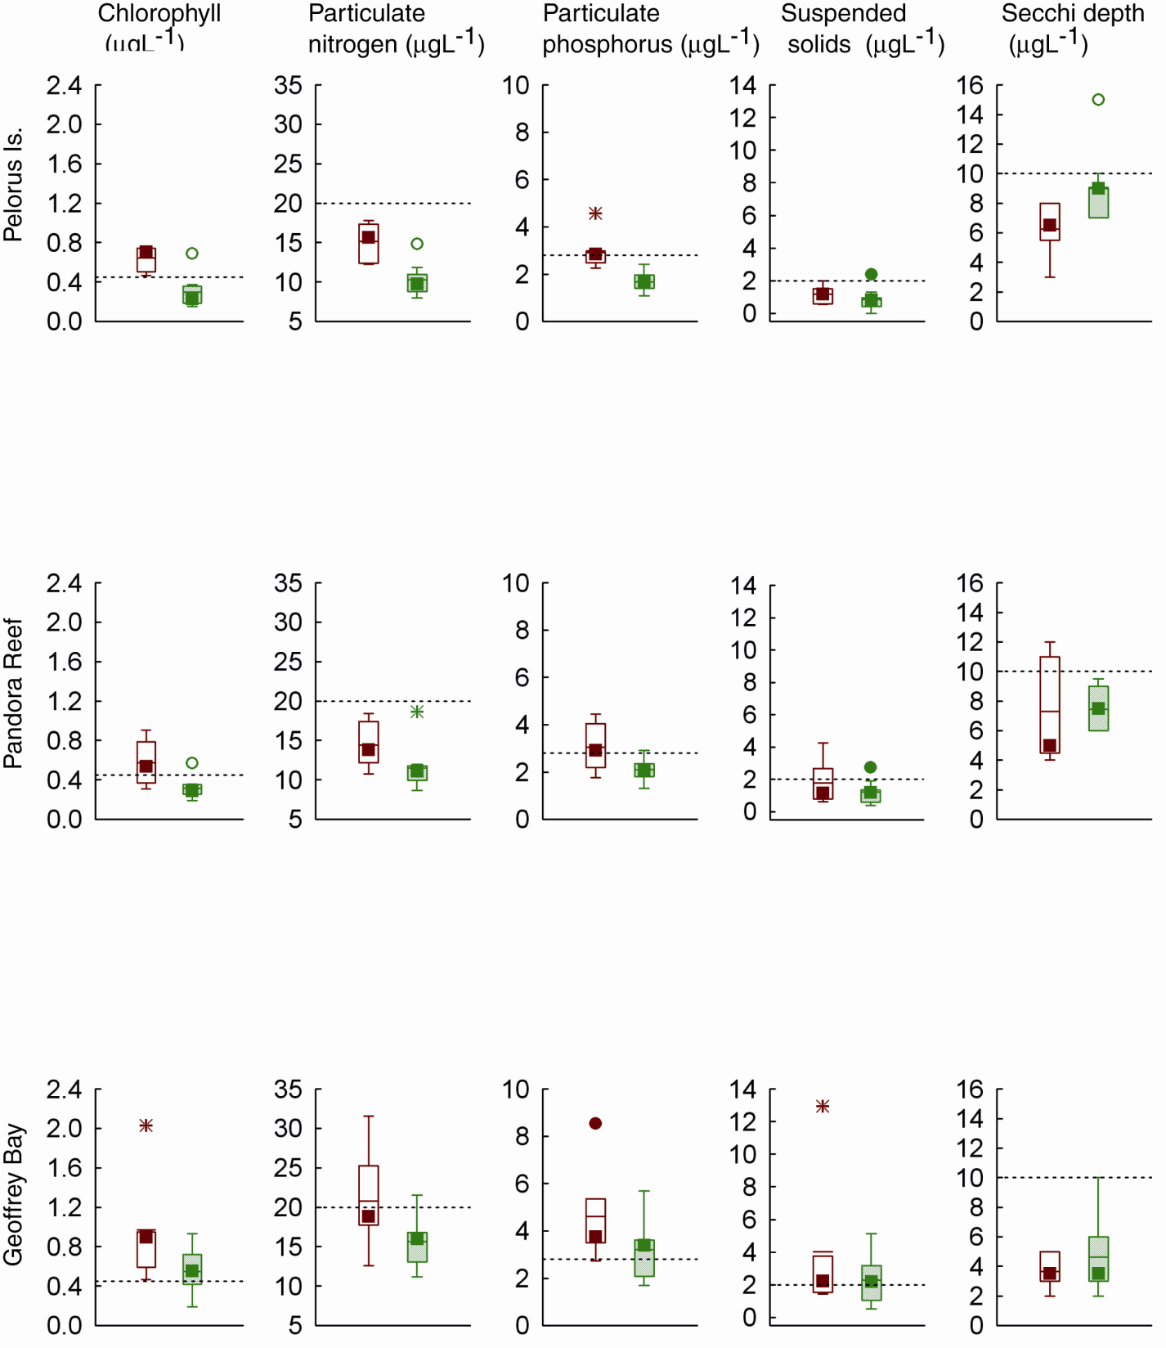
(m)

Figure 11 Summary of concentrations of chlorophyll a, particulate phosphorus, particulate nitrogen (μg L⁻¹), suspended solids (mg L⁻¹) and Secchi depth (m) at sampling sites in the Burdekin Region over five sampling years (2005/06 to 2010/11). Dry season values (May- Oct) = shaded boxes, wet season (Nov-Apr)= white boxes. See page 11 for more details about the box plot presentation. Broken lines are the GBR Water Quality Guidelines values (GBRMPA 2009).

Table 5 Summary of concentrations of chlorophyll a (Chl a), particulate nitrogen (PN) particulate phosphorus (PP), all in
μg L⁻¹; suspended solids (SS, mg L⁻¹) and Secchi depth (m) at reef locations in the Burdekin Region collected by direct water sampling over six sampling years (2005/06 to 2010/11). Red shading represents overall means that exceed the GBR Water Quality Guidelines values (GBRMPA 2009). N= number of sampling occasions (days).

Station | Variable | N | Mean | Median | Lower quartile | Upper quartile
Pelorus Island | Chl a (µg L⁻¹) | 15 | 0.44 | 0.37 | 0.22 | 0.69
Pelorus Island | PN (µg L⁻¹) | 15 | 12.31 | 11.87 | 9.75 | 14.76
Pelorus Island | PP (µg L⁻¹) | 15 | 2.22 | 2.24 | 1.64 | 2.57
Pelorus Island | Secchi (m) | 16 | 7.84 | 7.50 | 6.75 | 9.00
Pelorus Island | SS (mg L⁻¹) | 15 | 0.97 | 0.92 | 0.54 | 1.31
Pandora Reef | Chl a (µg L⁻¹) | 15 | 0.42 | 0.35 | 0.28 | 0.43
Pandora Reef | PN (µg L⁻¹) | 15 | 12.67 | 11.80 | 10.65 | 13.34
Pandora Reef | PP (µg L⁻¹) | 15 | 2.48 | 2.18 | 1.96 | 2.75
Pandora Reef | Secchi (m) | 15 | 7.50 | 7.50 | 6.00 | 9.00
Pandora Reef | SS (mg L⁻¹) | 15 | 1.44 | 1.17 | 0.77 | 1.48
Magnetic Island | Chl a (µg L⁻¹) | 15 | 0.71 | 0.70 | 0.46 | 0.89
Magnetic Island | PN (µg L⁻¹) | 15 | 17.92 | 16.81 | 15.33 | 18.70
Magnetic Island | PP (µg L⁻¹) | 15 | 3.84 | 3.56 | 2.95 | 4.31
Magnetic Island | Secchi (m) | 16 | 4.31 | 3.50 | 3.00 | 5.25
Magnetic Island | SS (mg L⁻¹) | 15 | 2.93 | 1.94 | 1.43 | 3.27

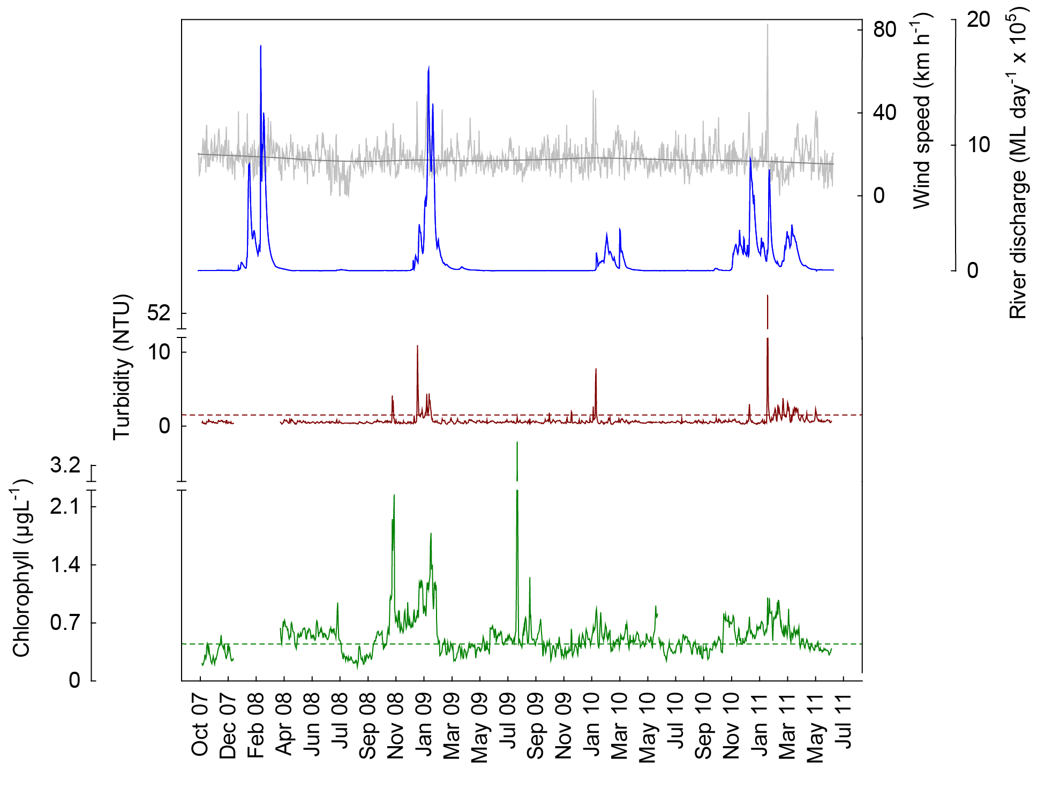
a
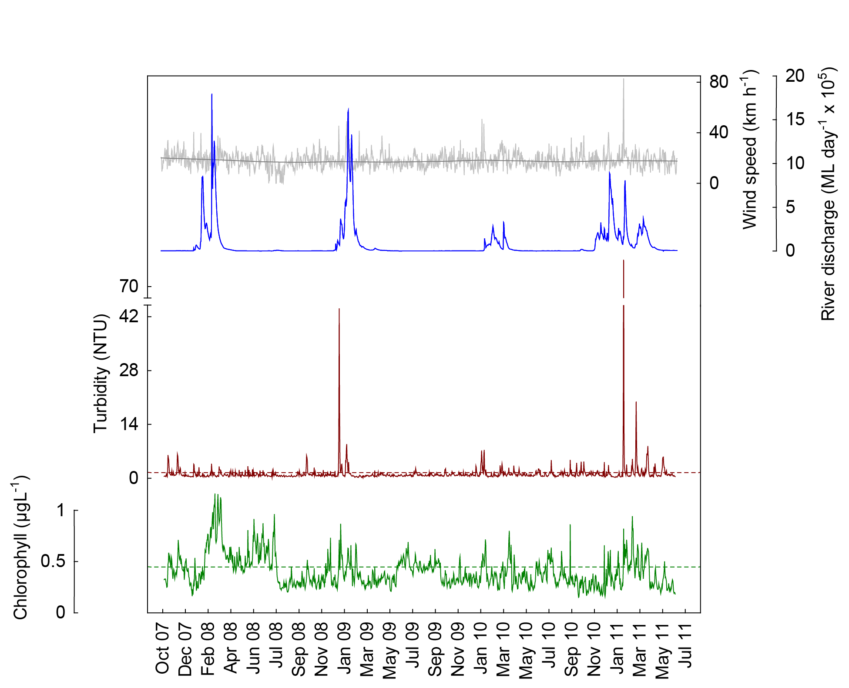
b

Figure 12 Time series of daily means of chlorophyll (green line, µg L⁻¹) and turbidity (brown line, NTU) time-series collected by Eco FLNTUSB instruments at Pelorus Island (a) and Pandora Reef (b) in the Burdekin NRM Region. Additional panels represent daily discharge from the Burdekin River (blue line, ML day⁻¹ x 10⁵) and daily wind speeds (grey line, km h⁻¹) from the Lucinda weather station. Other details as in Fig. 4.
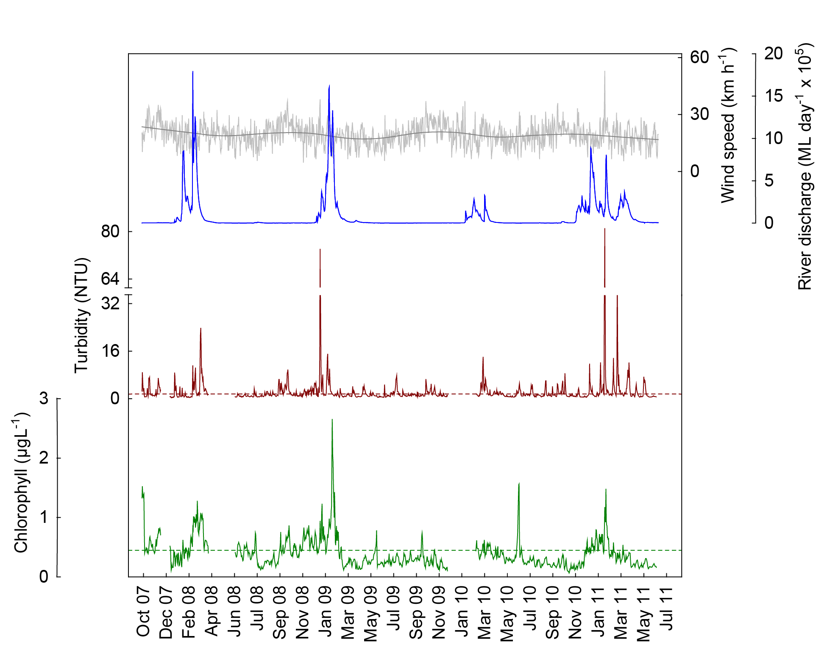

Figure 13 Time series of daily means of chlorophyll (green line, µg L⁻¹) and turbidity (brown line, NTU) time-series collected by Eco FLNTUSB instruments at Magnetic Island in the Burdekin NRM Region. Additional panels represent daily discharge from the Burdekin River (blue line, ML day⁻¹ x 10⁵) and daily wind speeds (grey line, km h⁻¹) from the Townsville Airport weather station. Other details as in Fig. 4.

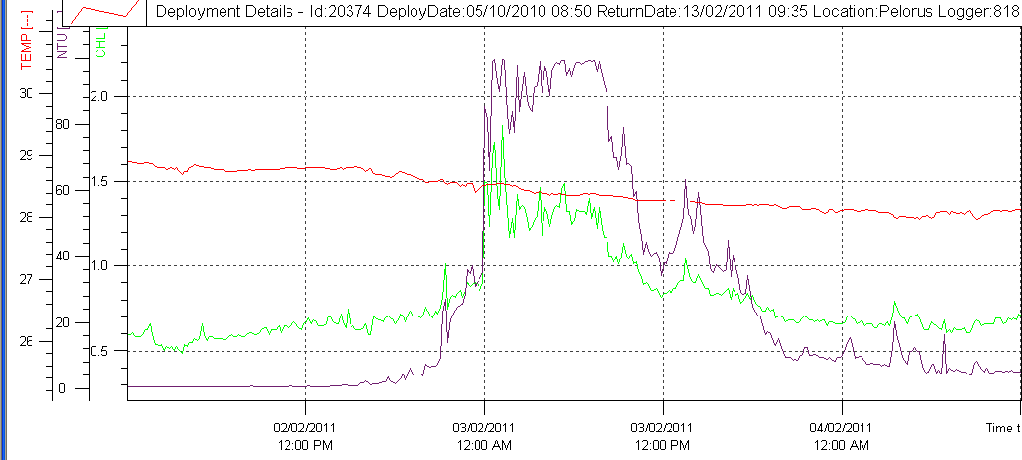

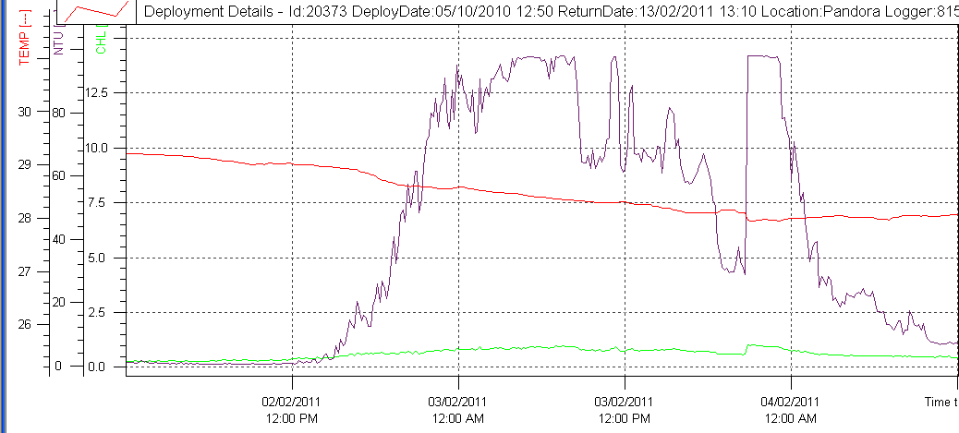

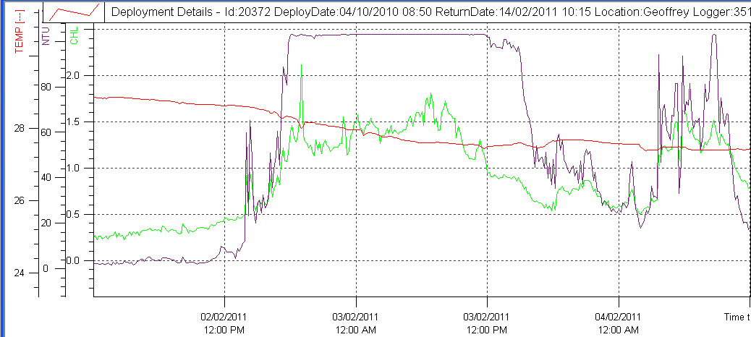

Figure 14 Passage of Tropical Cyclone Yasi on 03 February 2011. Raw data records of chlorophyll (µg L⁻¹; green line) turbidity (NTU; purple line) and temperature (ºC, red line) collected by Eco FLNTUSB instruments at Pelorus Is., Pandora Rf. and Magnetic Island in the Burdekin NRM Region. Note different scale of chlorophyll records.

4.3 Region Reports: Mackay Whitsunday Region
The Mackay Whitsunday Region is located in the central section of the GBR and comprises four major river catchments, the Proserpine, O’Connell (both flowing into Repulse Bay), Pioneer and Plane catchments. The climate in this region is wet or mixed wet and dry and the catchment land use is dominated by agriculture, such as cropping (mainly sugarcane on coastal plains), some grazing in the upper catchments and minor urbanisation along the coast (Furnas 2003). The adjacent coastal and inshore marine areas have a large number of high continental islands with well-developed fringing reefs. Tides in the Mackay Whitsunday Region are semidiurnal and the tidal range can exceed 4.0 m, which is higher than in most other inshore areas of the GBR.

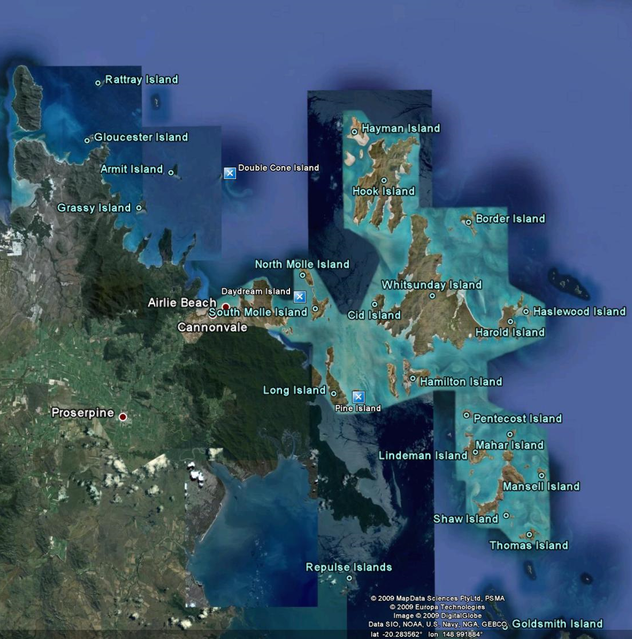

Figure 15 Reef Rescue MMP water quality sampling sites (blue squares) in the Mackay Whitsunday NRM Region at Double Cone Island, Daydream Island and Pine Island.

The three sampling locations in the Mackay Whitsunday Region are located away from direct riverine influence of the Proserpine and O’Connell rivers (Figure 15). The Pioneer River would influence the locations during major flood events. The Proserpine River had above long-term median flows during the past five years with major floods in 2008, 2009 and 2011 (Appendix 1-Table 3). The O’Connell and Pioneer rivers also had major floods during 2011 and the former river also above-median discharge in 2008 and 2010 (but note that long-term data are not available for the current gauging station in the lower Pioneer River).

The results from the direct water sampling over five years of monitoring are presented as seasonal summary statistics (Figure 16) for the water quality parameters for which Guidelines values were available (GBRMPA 2009) and as overall summaries to compare to the Guidelines (Table 6). Detailed results for all water quality variables for the sampling year 2009/10 are in Appendix 1-Table 4 to Appendix 1-Table 9. The direct water sampling results show that water quality at the inshore reef locations in the Mackay Whitsunday Region is characterized by high long-term mean chlorophyll a concentrations and low water clarity throughout the year, when compared to the Guidelines (Table 6). Chlorophyll a concentrations were especially high during the wet season (Figure 16). Long-term suspended solids means exceeded the Guideline trigger values at Pine Island, which is the site closest to the mouths of the O’Connell and Proserpine rivers. However, the values of the main five water quality variables do not differ much between the three sites along the selected gradient away from the river influence, which suggests that the factors influencing the water quality in the inner Whitsunday islands act on a regional not a local scale. Cooper et al. (2007) described a clear water quality gradient in the Whitsunday Region, however, that study included more sampling sites along a longer cross-self gradient, encompassing the outer Whitsunday Islands and some midshelf reefs.

The instrumental water quality monitoring data showed a similar pattern for chlorophyll and turbidity to the direct water sampling results (Figure 17, Figure 18). Annual chlorophyll means derived from instruments exceeded the Guidelines at Pine Island in all four years, at Daydream Island in 2008, 2009 and 2011 and at Double Cone Island only in 2008 (Table 8). Note that the 2009/10 year is incomplete as records were only obtained to June 2011 hence biasing the annual “water year” mean (October to September) toward higher wet season values. At Pine Island, between 65 and 100% of the daily records in each year were above the Guideline trigger value, which is higher than at any other monitoring location. At Daydream Island, the time series shows regular seasonal cycles of chlorophyll concentrations (as described in Brodie et al. 2007), with high values during the summer. This is less pronounced at Pine and Double Cone islands (Figure 17, Figure 18). The seasonal chlorophyll cycles do not appear to be directly correlated with annual discharge from the adjacent rivers but a longer time series with a few more wet and dry years is required to properly assess this.

The instrumental readings confirmed the weak gradient of turbidity at the three locations (Figure 17, Figure 18). Turbidity values were highest at Pine Island and lowest at Double Cone Island. Annual turbidity means for Pine and Daydream islands were above the Guidelines in all four years (Table 9). At Double Cone Island, only the annual mean in 2010 exceeded the Guidelines. At Pine and Daydream islands, 15% and 9%, respectively, of daily records over the whole period (October 2007 to June 2011) were above the suggested 5 NTU limit for severe coral photo-physiological stress due to light limitation (Cooper et al. 2007, 2008). At all three sites, the turbidity was generally higher during the summer and may be related to river discharge of the Proserpine and O’Connell rivers, which was mostly above median over the last four years (Appendix 1-Table 3). Sediment quality at the Whitsundays reef sites has changed over the last four years with steadily increasing proportions of silt and clay sized particles (Thompson et al. 2011), which may be easily resuspended. The detailed turbidity records, especially at Pine and Daydream islands, showed regular increases and decreases correlated with the strong tidal flows in this region, and high turbidity values were associated with the summer king tides (data not shown). In contrast to some sites in the Wet Tropics and the Burdekin regions (see above), wind-driven resuspension seems to have less influence on the turbidity at the three Mackay Whitsunday locations, even at the relatively exposed Double Cone Island site. A reason for this might be that these islands are surrounded by relatively deep water, which would result in less resuspension in the surrounding area that might affect turbidity more strongly than local resuspension caused by tidal currents.

The passage of TC Ului (Category 3, landfall 21 March 2010 at Airlie Beach) left a clear signal in the turbidity records at all three locations (Figures 17 and 18). TC Anthony (Category 2, landfall 30 January 2011 near Bowen) and TC Yasi (Category 5, landfall 03 February close to Dunk Island, Wet Tropics) caused a lesser response in the turbidity and chlorophyll records (Figure 19), even though top wind speeds of 67 and 75 km h⁻¹ were measured at the weather station at Hamilton Island on 30 January and 02 February 2011, respectively. The high turbidity during the 2011 wet season seems to be linked to the long period of high river flow in the region (Figure 17 and Figure 18)

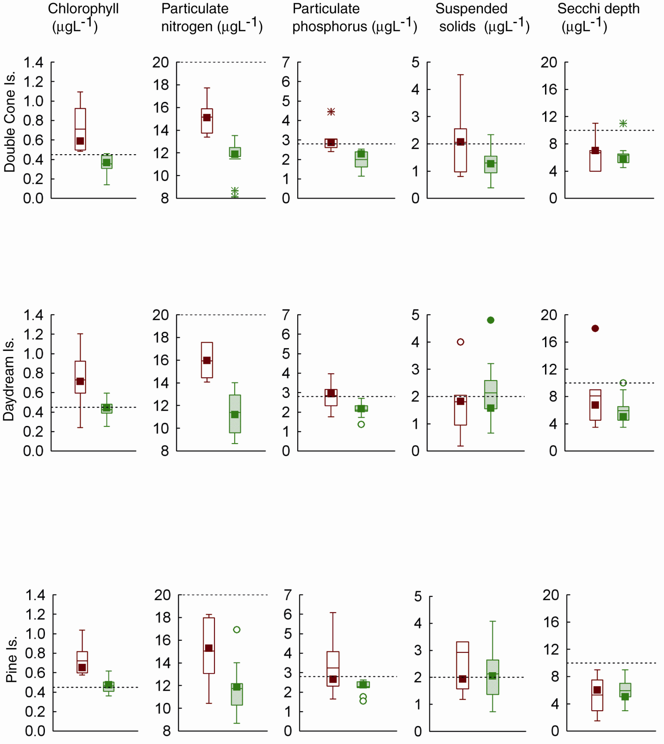
(m)

Figure 16 Summary of concentrations of chlorophyll a, particulate phosphorus, particulate nitrogen (μg L⁻¹), suspended solids (mg L⁻¹) and Secchi depth (m) at sampling sites in the Mackay Whitsunday NRM Region five sampling years (2005/06 to 2010/11). Dry season values (May- Oct) = shaded boxes, wet season (Nov-Apr) = white boxes.
See page 11 for more details about the box plot presentation. Broken lines are the GBR Water Quality Guidelines values (GBRMPA 2009).

Table 6 Summary of concentrations of chlorophyll a (Chl a), particulate nitrogen (PN) particulate phosphorus (PP), all in
μg L⁻¹; suspended solids (SS, mg L⁻¹) and Secchi depth (m) at reef locations in the Mackay Whitsunday NRM Region collected by direct water sampling over six sampling years (2005/06 to 2010/11). Red shading represents overall means that exceed the GBR Water Quality Guidelines values (GBRMPA 2009). N= number of sampling occasions (days).
Station | Variable | N | Mean | Median | Lower quartile | Upper quartile
Double Cone Island | Chl a (µg L⁻¹) | 15 | 0.51 | 0.44 | 0.36 | 0.54
 | PN (µg L⁻¹) | 15 | 13.03 | 12.63 | 11.85 | 13.93
 | PP (µg L⁻¹) | 15 | 2.44 | 2.41 | 2.19 | 2.76
 | Secchi (m) | 15 | 6.23 | 6.00 | 4.88 | 7.00
 | SS (mg L⁻¹) | 15 | 1.60 | 1.35 | 0.97 | 2.10
Daydream Island | Chl a (µg L⁻¹) | 15 | 0.55 | 0.48 | 0.42 | 0.62
 | PN (µg L⁻¹) | 15 | 13.28 | 13.00 | 11.14 | 14.78
 | PP (µg L⁻¹) | 15 | 2.43 | 2.33 | 2.11 | 2.72
 | Secchi (m) | 16 | 6.50 | 4.75 | 4.50 | 9.00
 | SS (mg L⁻¹) | 15 | 2.00 | 1.76 | 1.52 | 2.18
Pine Island | Chl a (µg L⁻¹) | 13 | 0.56 | 0.50 | 0.41 | 0.62
 | PN (µg L⁻¹) | 13 | 12.97 | 12.17 | 10.45 | 15.91
 | PP (µg L⁻¹) | 13 | 2.65 | 2.50 | 2.25 | 2.67
 | Secchi (m) | 15 | 5.45 | 5.00 | 4.13 | 7.13
 | SS (mg L⁻¹) | 13 | 2.43 | 2.03 | 1.23 | 3.13

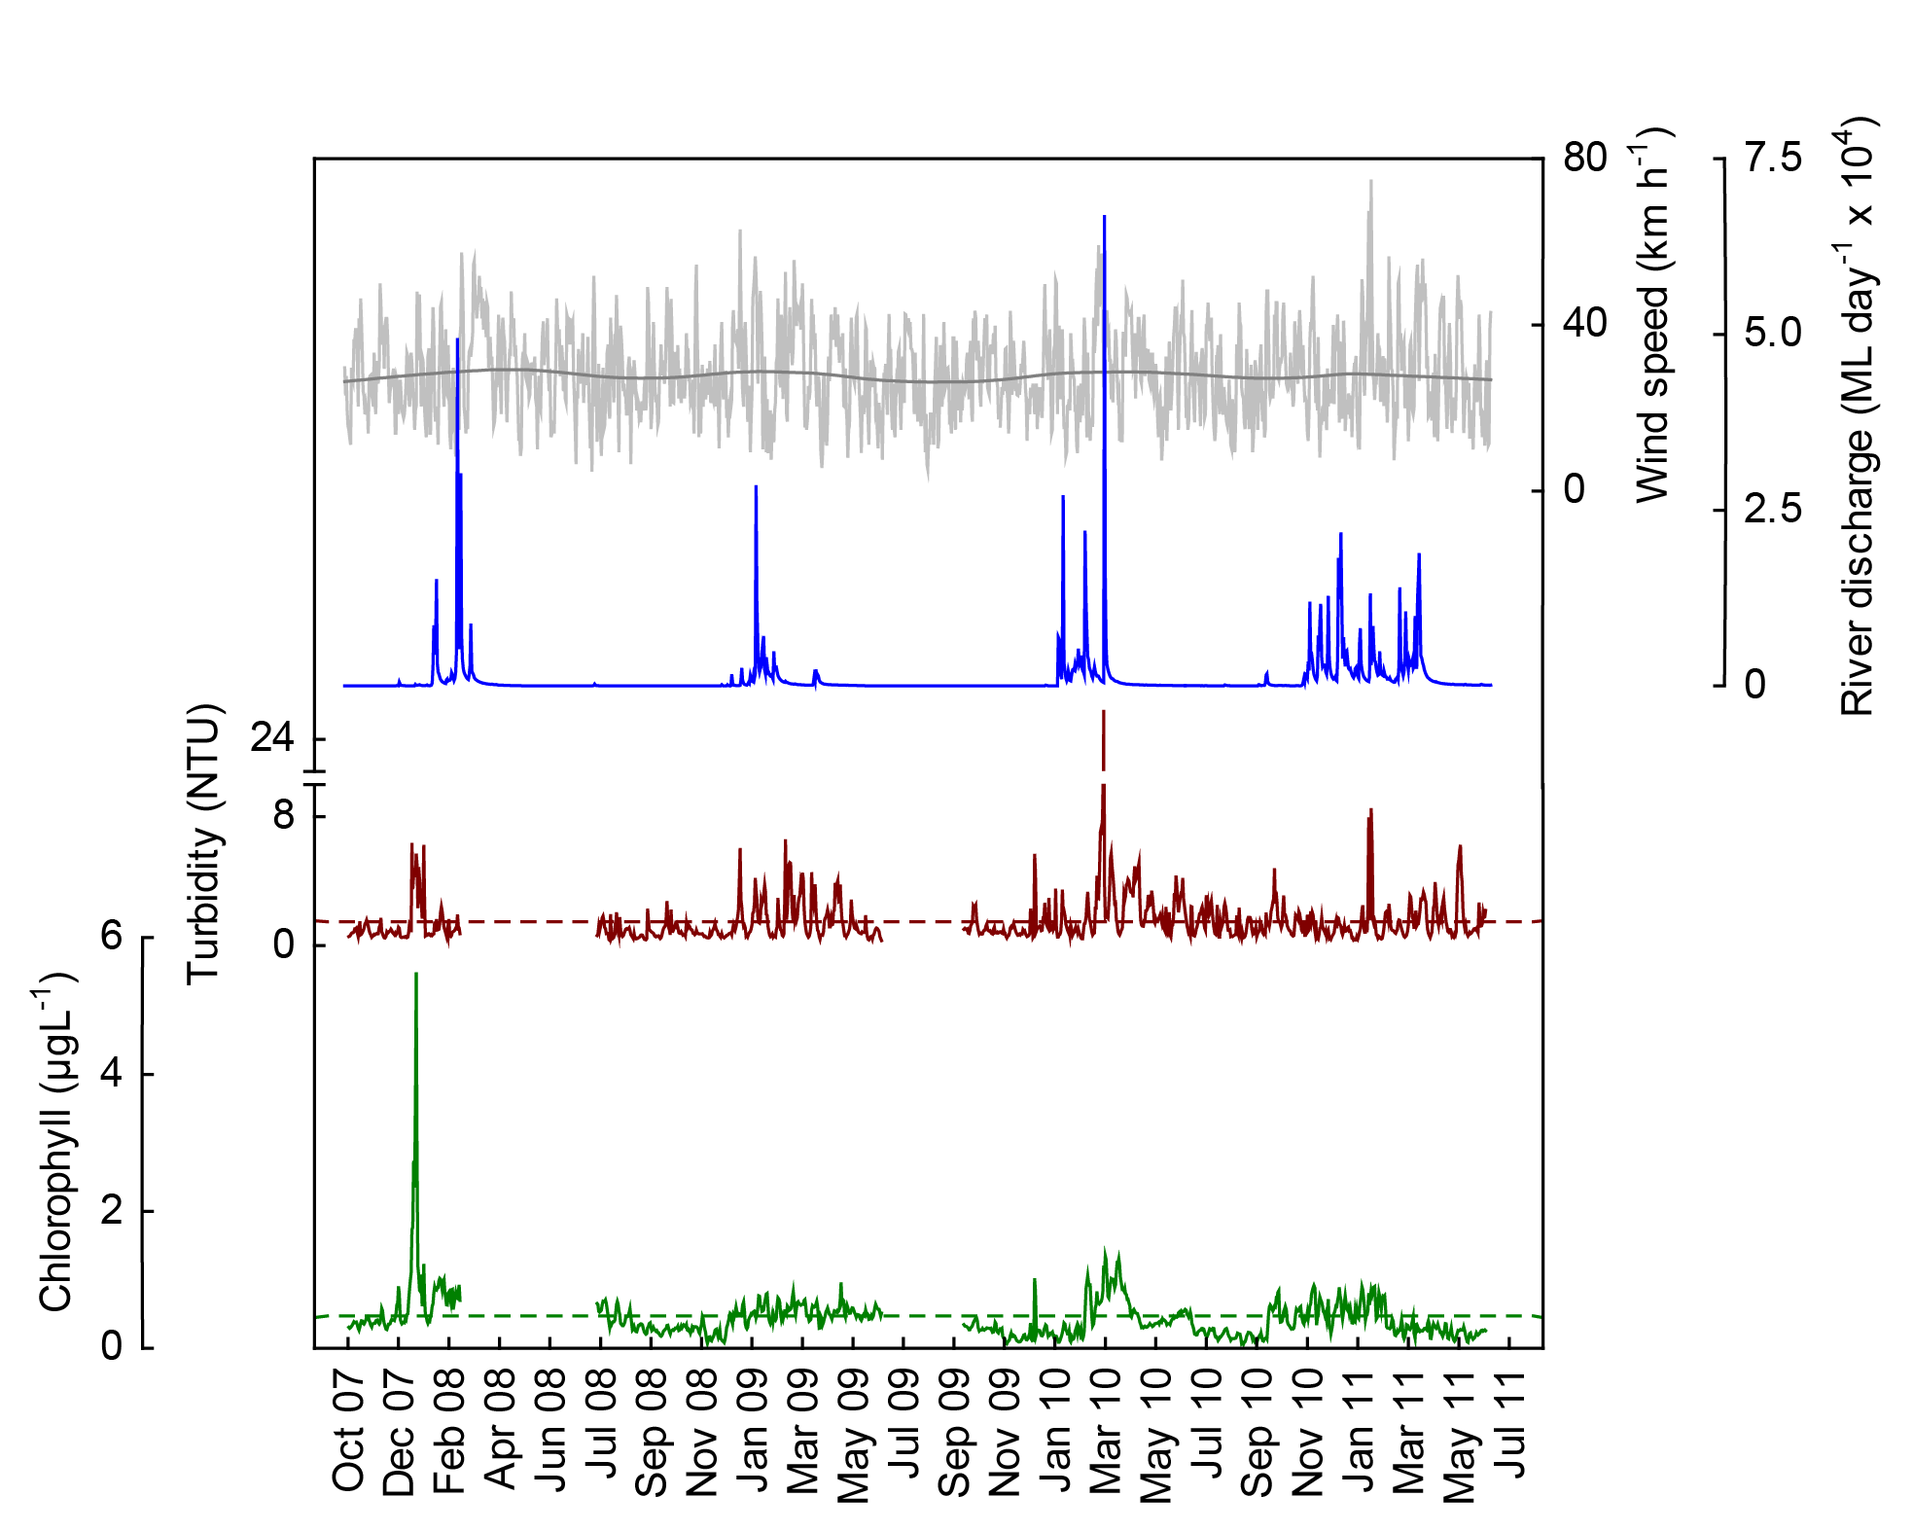
a
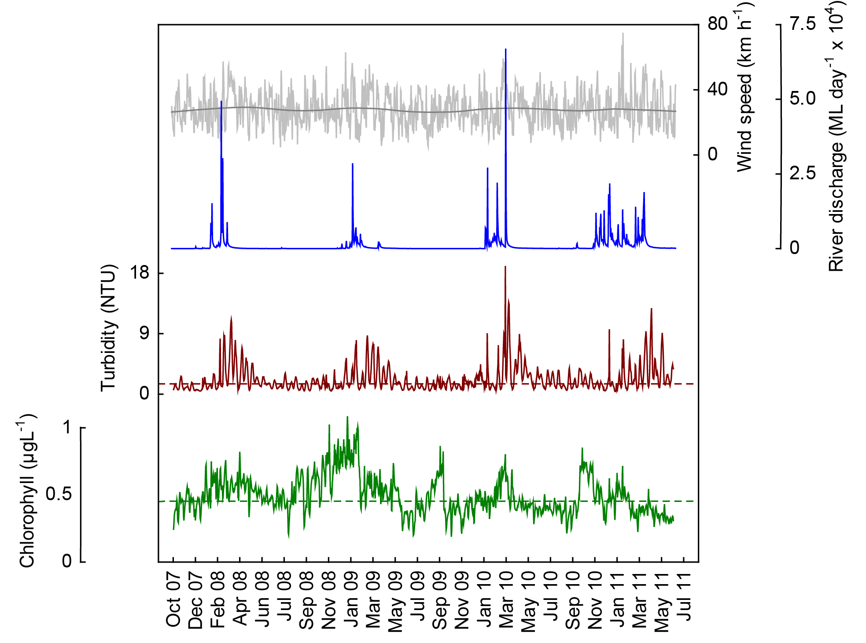
b

Figure 17 Time series of daily means of chlorophyll (green line, µg L⁻¹) and turbidity (brown line, NTU) time-series collected by Eco FLNTUSB instruments at (a) Double Cone and (b) Daydream islands in the Mackay Whitsunday NRM Region. Additional panels represent daily discharge from the O’Connell River (blue line, ML day⁻¹ x 10⁴) and daily wind speeds (grey line, km h⁻¹) from the Hamilton Is. Airport weather station. Other details as in Fig. 4.
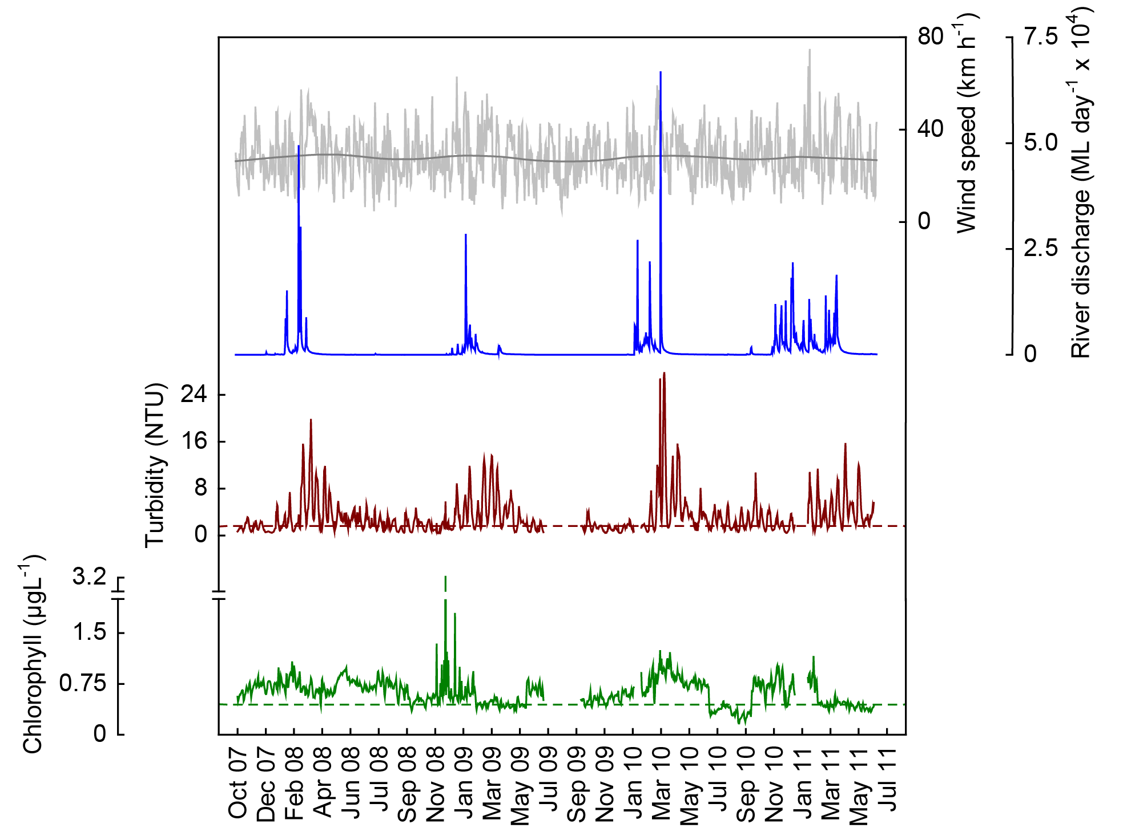
Figure 18 Time series of daily means of chlorophyll (green line, µg L⁻¹) and turbidity (brown line, NTU) time-series collected by Eco FLNTUSB instruments at Pine Island in the Mackay Whitsunday NRM Region. Additional panels represent daily discharge from the O’Connell River (blue line, ML day⁻¹ x 10⁴) and daily wind speeds (grey line, km h⁻¹) from the Hamilton Is. Airport weather station. Other details as in Fig. 4.

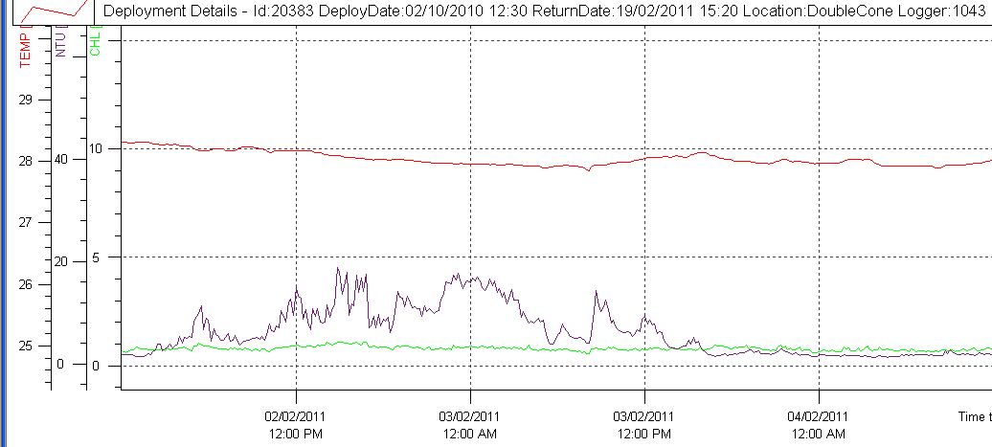

Figure 19 Passage of Tropical Cyclone Yasi on 03 February 2011. Raw data records of chlorophyll (µg L⁻¹; green line) turbidity (NTU; purple line) and temperature (ºC, red line) collected by Eco FLNTUSB instruments at Double Cone Island in the Mackay Whitsunday NRM Region. Very little effect of the cyclone was evident at this northernmost site in the Mackay Whitsunday Region.

4.4 Region Reports: Fitzroy Region
The Fitzroy NRM Region has the largest catchment area draining into the GBR. The climate is dry tropical with highly variable rainfall, high evaporation rates and prolonged dry periods, followed by infrequent major floods. By area, cattle grazing is the primary land use (Brodie et al. 2003). Fluctuations in climate and cattle numbers greatly affect the state and nature of vegetation cover, and therefore, the susceptibility of soils to erosion, which leads to runoff of suspended sediments and associated nutrients.

The three sampling locations in Keppel Bay are located on a gradient extending away from the Fitzroy River mouth (Figure 20). The Fitzroy River had three major flood events during the monitoring period; in 2008, 2010 and in 2011 which was the biggest flood on record (Appendix 1-Table 3). For most of the past 10 years, however, annual flows have been below the long-term median.

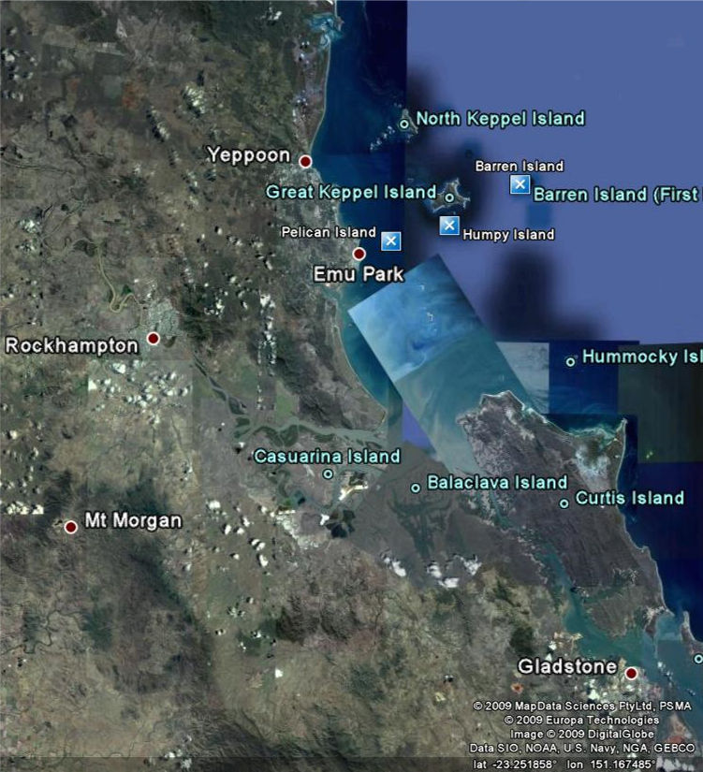

Figure 20 Reef Rescue MMP water quality sampling sites (blue squares) in the Fitzroy NRM Region at Pelican Island, Humpy Island and Barren Island.
The results from the direct water sampling over five years of monitoring are presented as seasonal summary statistics ( Figure 21) for the water quality parameters for which Guidelines trigger values were available (GBRMPA 2009) and as overall summaries to compare to the Guidelines (Table 7). Detailed results for all water quality variables in the sampling year 2009/10 are in Appendix 1-Table 4 to Appendix 1-Table 9. The direct water sampling results show that the water quality at the monitored inshore reef locations in the Fitzroy Region varied substantially along the gradient away from the coast and the river mouth. All water quality variables were distinctly higher, and Secchi depth lower, during the wet season (Figure 21, Appendix 1-Table 4 to Appendix 1-Table 9). The long-term means of all five key parameters at Pelican Island, the most inshore location, exceeded the Guideline values. In contrast, the water quality variables at Barren Island, the location furthest offshore, were within the Guidelines. At Humpy Island, long-term means of chlorophyll a, PP and Secchi depth exceeded the Guidelines.

The instrumental water quality monitoring data showed a similar pattern to the direct water sampling results (Figure 22, Figure 23). The instrumental readings confirm the clear gradient of water quality away from the Fitzroy River mouth. Annual means at Pelican Island exceeded the chlorophyll a and turbidity Guidelines in all years (Table 8, Table 9). In 2010/11 all three locations exceeded the chlorophyll Guidelines, but note that the 2010/11 record is incomplete as data were only obtained to June 2011, biasing the annual “water year” mean (October to September) toward higher wet season values.

The time series of chlorophyll concentrations measured by instruments at all three locations show regular seasonal cycles with high values during summer (as described in Brodie et al. 2007), albeit with some data gaps due to instrument failures at Humpy and Barren islands (Figure 22, Figure 23). The seasonal cycles, however, are not clearly associated with the amount of wet season discharge from the Fitzroy River, as they are as also pronounced in a relatively dry year (2009). Multi-year chlorophyll time series including both wet and dry years will be needed to distinguish between responses to land runoff and inherent seasonal cycles, most likely controlled by seasonality of temperatures and day lengths.

The turbidity time series at Barren Island showed that the water was generally very clear, especially during the dry seasons, but that spikes occur mostly during and after river flow events (Figure 22). The turbidity at Humpy Island appears to have increased over the monitoring period, especially the extreme values during the last two wet seasons (Figure 22). However, a formal analysis of this now emerging temporal pattern has not yet been completed. Pelican Island had the highest turbidity of all 14 inshore GBR monitoring locations (Figure 23). 30 % of daily records at Pelican Island over the whole instrumental monitoring period (October 2007 to June 2011) were above the suggested 5 NTU limit for severe coral photo-physiological stress (Cooper et al. 2007, 2008). While turbidity was generally higher during summer, and extreme during the three major flood events, Pelican Island also regularly experienced wind-driven resuspension events, leading to frequent spikes in turbidity (Figure 23). While all three sampling locations are relatively exposed to the prevailing winds, Humpy and Barren islands are further offshore and have reefal (carbonate-rich) sediments with a very low proportion of clay-silt-sized particles (see Thompson et al. 2011). This is likely to result in lower turbidity during wind-driven resuspension events. Sediment-laden flood plumes associated with the 2011 record flood of the Fitzroy River reached Humpy Island at various stages during the four month-long event, while Barren Island was not exposed to high SS-carrying flood plumes (see Brando et al. 2011 and Devlin et al. 2011 for detailed reporting of the 2011 flood events).

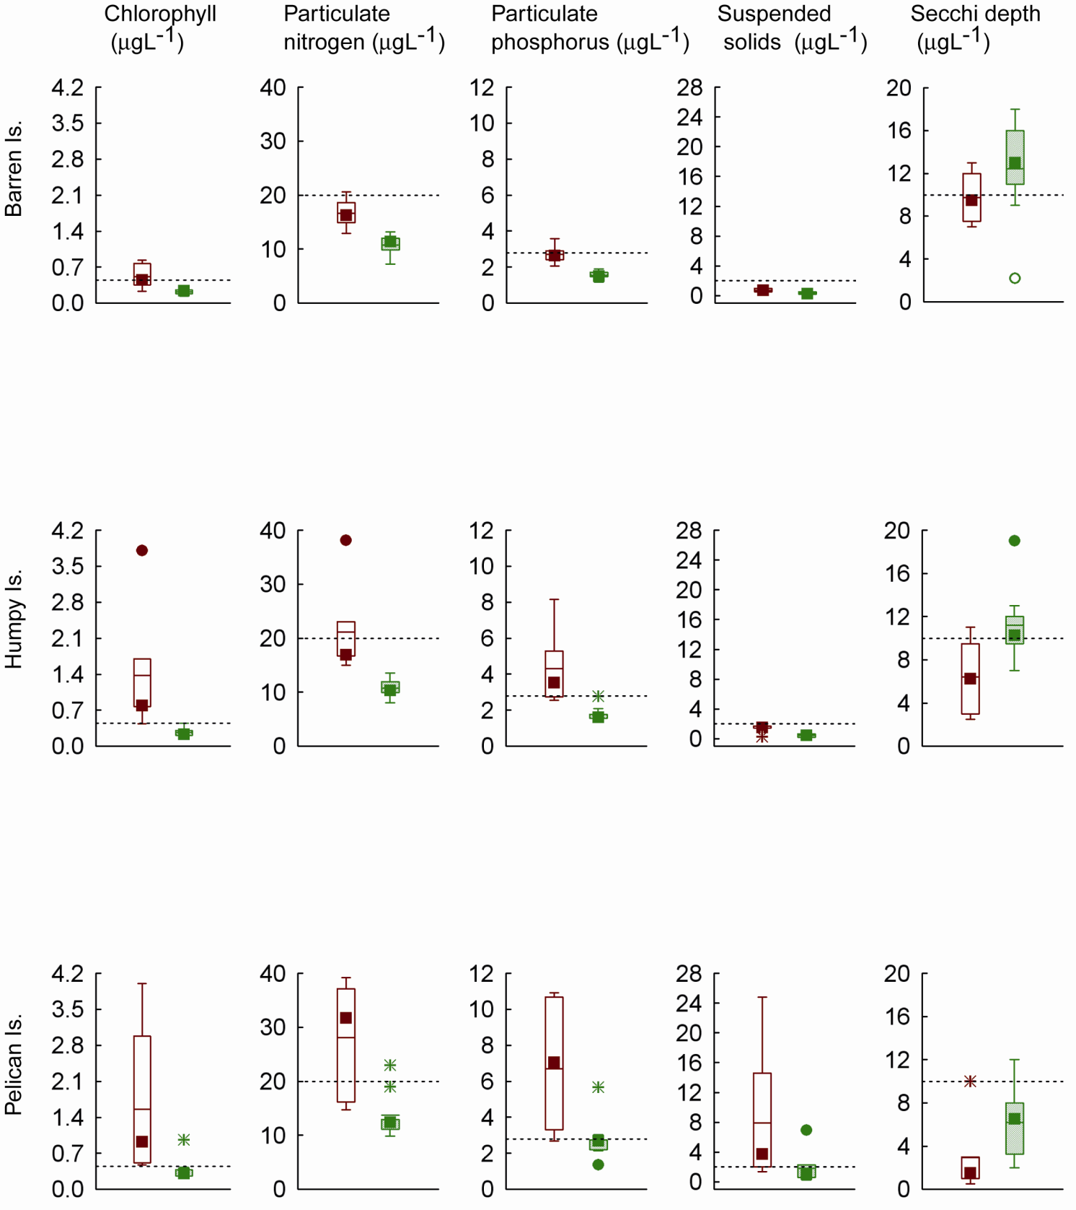
(m)

Figure 21 Summary of concentrations of chlorophyll a, particulate phosphorus, particulate nitrogen (μg L⁻¹), suspended solids (mg L⁻¹) and Secchi depth (m) at sampling sites in the Fitzroy NRM Region over five sampling years (2005/06 to 2010/11). Dry season values (May- Oct) = shaded boxes, wet season (Nov-Apr) = white boxes. See page 11 for more details about the box plot presentation. Broken lines are the GBR Water Quality Guidelines values (GBRMPA 2009).

Table 7 Summary of concentrations of chlorophyll a (Chl a), particulate nitrogen (PN) particulate phosphorus (PP), all in
μg L⁻¹; suspended solids (SS, mg L⁻¹) and Secchi depth (m) at reef locations in the Fitzroy Region collected by direct water sampling over six sampling years (2005/06 to 2010/11). Red shading represents overall means that exceed the GBR Water Quality Guidelines values (GBRMPA 2009).
Station | Variable | N | Mean | Median | Lower quartile | Upper quartile
Barren Island | Chl a (µg L⁻¹) | 15 | 0.34 | 0.26 | 0.22 | 0.37
Barren Island | PN (µg L⁻¹) | 15 | 13.24 | 12.37 | 10.99 | 15.02
Barren Island | PP (µg L⁻¹) | 15 | 2.04 | 1.86 | 1.55 | 2.43
Barren Island | Secchi (m) | 14 | 11.87 | 12.50 | 9.00 | 15.00
Barren Island | SS (mg L⁻¹) | 15 | 0.51 | 0.51 | 0.23 | 0.70
Humpy Island | Chl a (µg L⁻¹) | 15 | 0.71 | 0.38 | 0.22 | 0.77
Humpy Island | PN (µg L⁻¹) | 15 | 15.12 | 12.89 | 11.54 | 16.73
Humpy Island | PP (µg L⁻¹) | 15 | 2.82 | 2.54 | 1.60 | 2.94
Humpy Island | Secchi (m) | 15 | 9.33 | 9.50 | 7.75 | 11.00
Humpy Island | SS (mg L⁻¹) | 15 | 0.85 | 0.63 | 0.25 | 1.43
Pelican Island | Chl a (µg L⁻¹) | 15 | 0.92 | 0.43 | 0.30 | 0.93
Pelican Island | PN (µg L⁻¹) | 15 | 20.16 | 14.72 | 12.57 | 25.14
Pelican Island | PP (µg L⁻¹) | 15 | 4.56 | 3.04 | 2.58 | 6.01
Pelican Island | Secchi (m) | 15 | 4.73 | 3.50 | 1.88 | 7.00
Pelican Island | SS (mg L⁻¹) | 15 | 4.53 | 2.01 | 0.98 | 3.42

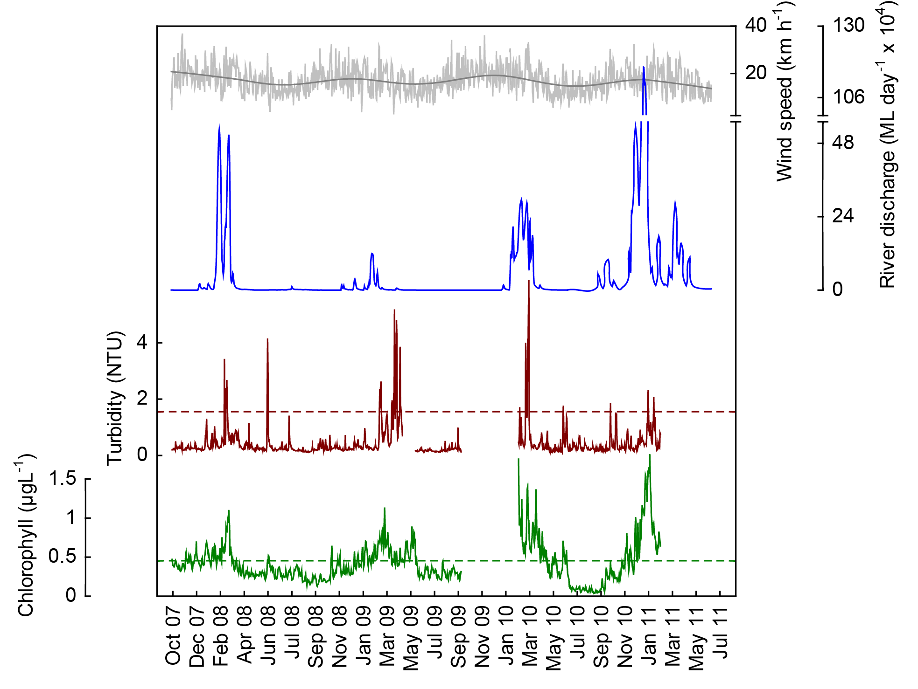
a
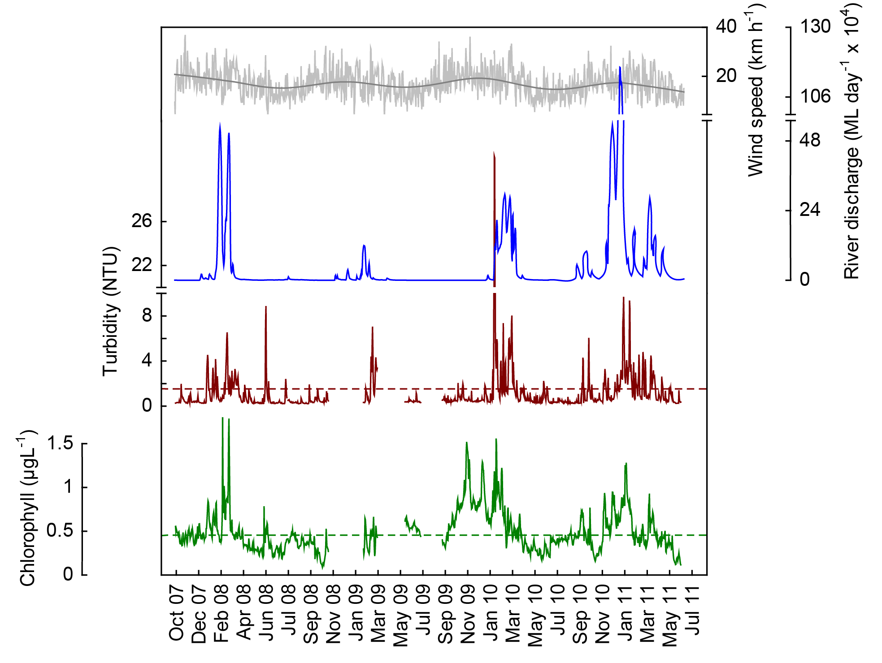
b

Figure 22 Time series of daily means of chlorophyll (green line, µg L⁻¹) and turbidity (brown line, NTU) time-series collected by Eco FLNTUSB instruments at (a) Barren and (b) Humpy islands in the Fitzroy NRM Region. Additional panels represent daily discharge from the Fitzroy River (blue line, ML day⁻¹ x 10⁴) and daily wind speeds (grey line, km h⁻¹) from the Yeppoon weather station. Other details as in Fig. 4.

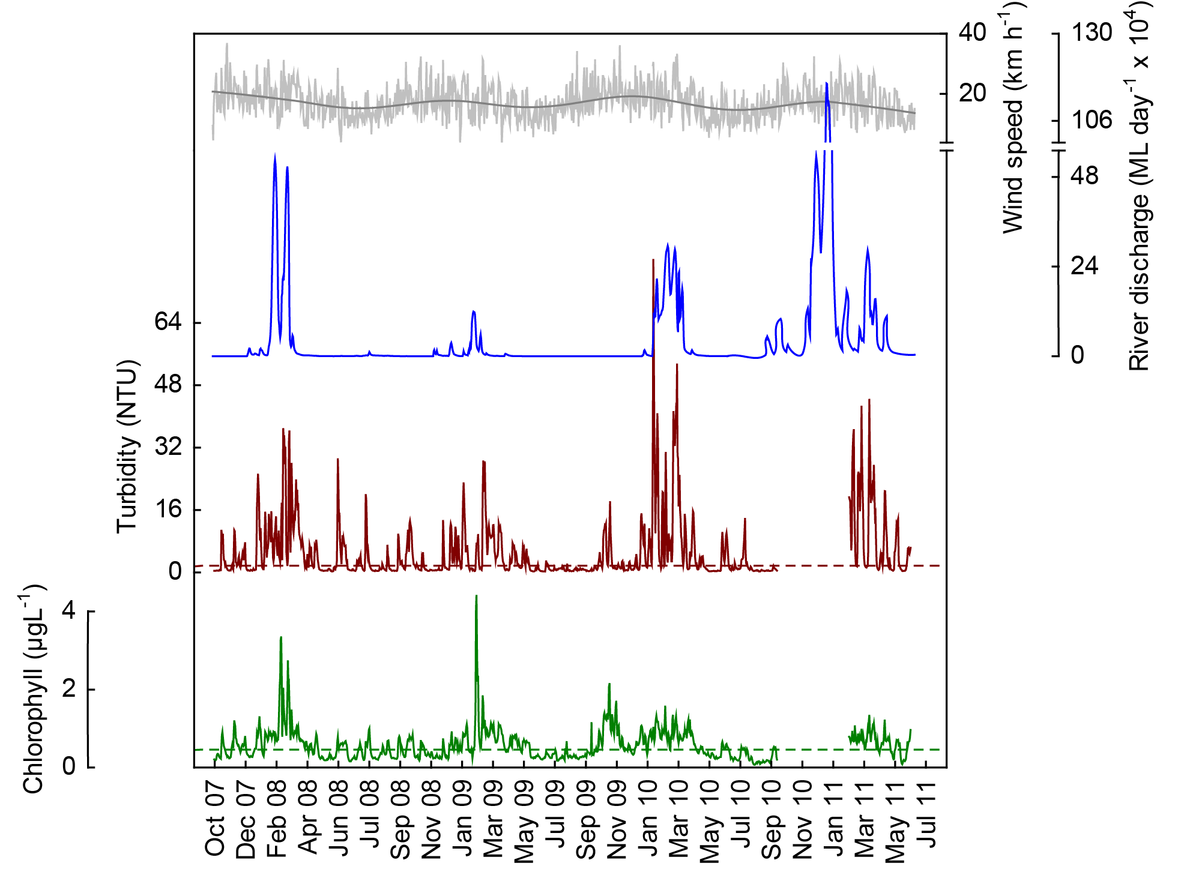

Figure 23 Time series of daily means of chlorophyll (green line, µg L⁻¹) and turbidity (brown line, NTU) time-series collected by Eco FLNTUSB instruments at Pelican Island in the Fitzroy NRM Region. Additional panels represent daily discharge from the Fitzroy River (blue line, ML day⁻¹ x 10⁴) and daily wind speeds (grey line, km h⁻¹) from the Yeppoon weather station. Other details as in Fig. 4.

Table 8 Summary of chlorophyll (μg L⁻¹) data from deployments of WET Labs Eco FLNTUSB Combination Fluorometer and Turbidity Sensors at 14 inshore reef sites. N= number of daily means in the annual time series (based on ‘water year’, October to October); SE= standard error; “% d> trigger” refers to the percentage of days within the annual record with mean values above the chlorophyll a trigger values in the GBRMPA Water Quality Guidelines for the Great Barrier Reef Marine Park (GBRMPA 2009). Red and green shading highlight the annual means that are above or below, respectively, the trigger values.

NRM region | Location | October 2007 to September 2008 |  |  |  |  | October 2008 to September 2009 |  |  |  |  | October 2009 to September 2010 |  |  |  |  | October 2010 to June 2011
 |  | N | Annual mean | SE | Annual median | %d >trigger | N | Annual mean | SE | Annual median | %d >trigger | N | Annual mean | SE | Annual median | %d >trigger | N | Annual mean | SE | Annual median | %d >trigger
Wet Tropics | Snapper Is | 353 | 0.38 | 0.01 | 0.33 | 26 | 365 | 0.39 | 0.01 | 0.35 | 37 | 197 | 0.44 | 0.01 | 0.44 | 48 | 265 | 0.38 | 0.01 | 0.34 | 17
Wet Tropics | Fitzroy Is | 249 | 0.37 | 0.01 | 0.37 | 29 | 173 | 0.34 | 0.01 | 0.34 | 11 | 356 | 0.11 | 0.00 | 0.10 | 0 | 265 | 0.14 | 0.00 | 0.12 | 0
Wet Tropics | High Is | 356 | 0.32 | 0.01 | 0.30 | 14 | 365 | 0.34 | 0.01 | 0.31 | 12 | 365 | 0.42 | 0.01 | 0.40 | 37 | 266 | 0.31 | 0.01 | 0.26 | 19
Wet Tropics | Russell Is | 357 | 0.28 | 0.00 | 0.27 | 2 | 365 | 0.33 | 0.01 | 0.27 | 15 | 352 | 0.29 | 0.01 | 0.26 | 12 | 266 | 0.29 | 0.01 | 0.30 | 9
Wet Tropics | Dunk Is | 334 | 0.41 | 0.01 | 0.39 | 38 | 365 | 0.41 | 0.02 | 0.32 | 26 | 336 | 0.33 | 0.01 | 0.28 | 32 | 262 | 0.32 | 0.01 | 0.32 | 19
Burdekin | Pelorus Is | 258 | 0.44 | 0.01 | 0.45 | 50 | 365 | 0.62 | 0.02 | 0.51 | 66 | 363 | 0.46 | 0.01 | 0.46 | 52 | 263 | 0.56 | 0.01 | 0.55 | 71
Burdekin | Pandora Rf | 358 | 0.50 | 0.01 | 0.47 | 56 | 365 | 0.39 | 0.01 | 0.37 | 29 | 365 | 0.36 | 0.01 | 0.34 | 17 | 262 | 0.35 | 0.01 | 0.31 | 22
Burdekin | Magnetic Is | 272 | 0.48 | 0.02 | 0.42 | 44 | 365 | 0.43 | 0.02 | 0.34 | 35 | 291 | 0.32 | 0.01 | 0.29 | 15 | 262 | 0.33 | 0.01 | 0.27 | 19
Mackay Whitsunday | Double Cone Is | 199 | 0.60 | 0.04 | 0.44 | 49 | 273 | 0.44 | 0.01 | 0.47 | 53 | 360 | 0.36 | 0.01 | 0.28 | 24 | 261 | 0.42 | 0.01 | 0.37 | 40
Mackay Whitsunday | Daydream Is | 359 | 0.50 | 0.01 | 0.49 | 71 | 365 | 0.58 | 0.01 | 0.56 | 76 | 365 | 0.43 | 0.01 | 0.41 | 31 | 261 | 0.46 | 0.01 | 0.43 | 46
Mackay Whitsunday | Pine Is | 362 | 0.72 | 0.01 | 0.72 | 100 | 289 | 0.56 | 0.01 | 0.52 | 75 | 347 | 0.60 | 0.01 | 0.58 | 72 | 234 | 0.58 | 0.01 | 0.48 | 65
Fitzroy | Barren Is | 364 | 0.38 | 0.01 | 0.35 | 26 | 365 | 0.41 | 0.01 | 0.37 | 33 | 221 | 0.39 | 0.02 | 0.31 | 38 | 139 | 0.64 | 0.03 | 0.54 | 58
Fitzroy | Humpy Is | 362 | 0.44 | 0.01 | 0.41 | 37 | 142 | 0.40 | 0.01 | 0.41 | 42 | 365 | 0.59 | 0.01 | 0.52 | 57 | 259 | 0.49 | 0.01 | 0.44 | 47
Fitzroy | Pelican Is | 363 | 0.58 | 0.02 | 0.49 | 54 | 363 | 0.54 | 0.02 | 0.41 | 47 | 365 | 0.59 | 0.02 | 0.51 | 59 | 120 | 0.64 | 0.02 | 0.68 | 78

Table 9 Summary of turbidity (NTU) data from deployments of WET Labs Eco FLNTUSB Combination Fluorometer and Turbidity Sensors at 14 inshore reef sites.
N= number of daily means in the annual time series (October to September); SE= standard error; “% d> trigger” refers to the percentage of days within the annual record with mean values above the trigger values in the GBRMPA Water Quality Guidelines for the Great Barrier Reef Marine Park (GBRMPA 2009). Red and green shading highlight the annual means that are above or below, respectively, the trigger values. The turbidity trigger value (1.54 NTU) was derived by transforming the suspended solids trigger value in the Guidelines (2 mg L⁻¹) using an equation based on a comparison between direct water samples and instrumental turbidity readings (see Schaffelke et al. 2009).

NRM region | Location | October 2007 to September 2008 |  |  |  |  | October 2008 to September 2009 |  |  |  |  | October 2009 to September 2010 |  |  |  |  | October 2010 to June 2011
 |  | N | Annual mean | SE | Annual median | %d >trigger | N | Annual mean | SE | Annual median | %d >trigger | N | Annual mean | SE | Annual median | %d >trigger | N | Annual mean | SE | Annual median | %d >trigger
Wet Tropics | Snapper Is | 353 | 2.21 | 0.12 | 1.38 | 46 | 365 | 1.87 | 0.12 | 1.26 | 37 | 197 | 3.20 | 0.23 | 1.91 | 59 | 265 | 2.27 | 0.23 | 1.18 | 33
Wet Tropics | Fitzroy Is | 249 | 0.85 | 0.05 | 0.70 | 6 | 173 | 0.89 | 0.10 | 0.70 | 6 | 356 | 0.88 | 0.05 | 0.67 | 9 | 265 | 1.18 | 0.15 | 0.65 | 12
Wet Tropics | High Is | 356 | 0.81 | 0.03 | 0.67 | 6 | 365 | 0.84 | 0.03 | 0.69 | 8 | 365 | 1.20 | 0.07 | 0.78 | 18 | 266 | 1.58 | 0.19 | 0.78 | 20
Wet Tropics | Russell Is | 357 | 0.49 | 0.01 | 0.42 | 2 | 365 | 0.63 | 0.02 | 0.54 | 4 | 352 | 0.71 | 0.03 | 0.52 | 6 | 266 | 1.19 | 0.20 | 0.51 | 13
Wet Tropics | Dunk Is | 334 | 2.02 | 0.13 | 1.09 | 34 | 365 | 2.31 | 0.15 | 1.27 | 40 | 336 | 2.67 | 0.17 | 1.29 | 41 | 262 | 2.94 | 0.34 | 1.10 | 35
Burdekin | Pelorus Is | 258 | 0.50 | 0.01 | 0.48 | 0 | 365 | 0.74 | 0.04 | 0.55 | 7 | 363 | 0.60 | 0.03 | 0.52 | 2 | 263 | 1.17 | 0.21 | 0.68 | 17
Burdekin | Pandora Rf | 358 | 0.97 | 0.04 | 0.71 | 13 | 365 | 1.17 | 0.14 | 0.74 | 10 | 365 | 1.10 | 0.05 | 0.85 | 17 | 262 | 1.85 | 0.32 | 0.91 | 29
Burdekin | Magnetic Is | 272 | 2.12 | 0.17 | 1.10 | 36 | 365 | 2.33 | 0.24 | 1.31 | 42 | 291 | 1.79 | 0.09 | 1.27 | 41 | 262 | 3.00 | 0.41 | 1.44 | 49
Mackay Whitsunday | Double Cone Is | 199 | 1.15 | 0.07 | 0.84 | 17 | 273 | 1.42 | 0.07 | 0.99 | 30 | 360 | 1.74 | 0.09 | 1.19 | 40 | 261 | 1.52 | 0.07 | 1.23 | 38
Mackay Whitsunday | Daydream Is | 359 | 2.01 | 0.10 | 1.40 | 45 | 365 | 1.99 | 0.08 | 1.48 | 49 | 365 | 2.42 | 0.11 | 1.82 | 59 | 261 | 2.64 | 0.13 | 1.87 | 65
Mackay Whitsunday | Pine Is | 362 | 2.87 | 0.15 | 2.07 | 66 | 289 | 3.11 | 0.17 | 2.18 | 66 | 347 | 3.20 | 0.21 | 1.86 | 63 | 234 | 3.68 | 0.18 | 2.81 | 82
Fitzroy | Barren Is | 364 | 0.37 | 0.02 | 0.25 | 2 | 333 | 0.46 | 0.03 | 0.25 | 6 | 221 | 0.47 | 0.05 | 0.27 | 4 | 139 | 0.52 | 0.03 | 0.38 | 4
Fitzroy | Humpy Is | 362 | 0.88 | 0.06 | 0.41 | 17 | 142 | 0.89 | 0.09 | 0.46 | 11 | 365 | 1.26 | 0.15 | 0.53 | 17 | 259 | 1.57 | 0.10 | 0.97 | 36
Fitzroy | Pelican Is | 363 | 5.08 | 0.36 | 2.15 | 55 | 363 | 3.42 | 0.24 | 1.21 | 44 | 365 | 5.50 | 0.50 | 1.60 | 52 | 120 | 9.80 | 0.96 | 5.12 | 77

Conclusions
Scientists and managers have realised that ongoing management of human pressures on regional and local scales, such as enhanced nutrient runoff and overfishing, is vital to provide corals and reef organisms with the maximum resilience to cope with global stressors, such as climate change (Bellwood et al. 2004, Marshall and Johnson 2007, Carpenter et al. 2008, Mora 2008). The management of water quality remains an essential requirement to ensure the long-term protection of the coastal and inshore reefs of the GBR. The Reef Plan and Reef Rescue initiatives are the key management tools to improve water quality entering the GBR and will, in the long-term, improve coastal and inshore marine water quality.

Sustained long-term monitoring of the coastal and inshore GBR lagoon is fundamental to determine the status of marine water quality and long-term trends related to changes in land use and Reef Plan and Reef Rescue actions. The MMP water quality monitoring has now completed its 6th year and the results have improved our understanding of the spatial and temporal variability of biogeochemical and physical variables in the GBR inshore lagoon. The state of water quality in the inshore GBR shows clear gradients away from river mouths (previously described in Cooper et al. 2007 and De’ath and Fabricius 2008, 2010) and is influenced over short time periods by flood events and sediment resuspension. A multivariate statistical analysis on 5 years of MMP water quality data showed significant year-to-year, seasonal and regional variability (Schaffelke et al. in press), which means that no single factor or process can be considered in isolation. A subsequent multivariate regression model (ibid.) showed that most variation was explained by temporal factors, highlighting the extremely variable climate of the Great Barrier Reef region (variation explained by factors used in the analysis: month of sampling (19.5%), river flow (5.2%), year of sampling (1.8%)). Regional aspects explained a smaller, albeit still significant, amount of the variation in the data (resuspension index (4.1%), latitude (4.0%), distance to closest river mouth (2.3%), catchment area under crop cultivation (1.1 %) and catchment area utilized for grazing (1.4%)). The inherent seasonal differences and extreme difference in river discharges since the start of the MMP sampling (see also Appendix 1-Table 3) are currently the main factors explaining the data variability. A longer time series will be required to extricate any influences of land management changes from the high temporal variability in the marine water quality data.

A similar analysis was carried out using data from the longest time series of water quality data for the GBR, the AIMS Cairns Transect, which has been sampled since 1989 (Carleton et al., in prep.). This analysis showed relationships between concentrations of water quality variables and several human-related and natural environmental factors, including; vegetation clearing rates on the adjacent catchment, increased land area under crops and periods of high rainfall and episodes of strong winds. In this data set, too, most variation was explained by the factor of month, highlighting the clear difference of water quality parameters between wet season and dry seasons. Proximity to a river mouth combined with its discharge and catchment clearing rates explained approximately 15% of total variation. High land clearing rates from 1996-2001 were associated with high concentrations in the adjacent marine waters of chlorophyll a, particulate nitrogen and phosphorus, silicate and suspended solids. After 2004, land clearing was relatively low and particulate concentrations in coastal waters remained relatively constant or decreased even though there was a steady increase in wind strength and river discharge. This is the first time that a significant correlation could be shown between land-use change on the catchment (land clearing rate) and marine water quality. However, this required an acute large change on the catchment and a long water quality time series, spanning several cycles of wet, dry and average years in terms of river runoff. To be able to show changes in inshore GBR marine water quality due to activities under Reef Plan and Reef Rescue it is pertinent that a multitude of approaches is applied, not just time series analysis of the data from the infrequent direct water sampling. The suggested approaches include analyses of the time series generated by the MMP water quality loggers and by remote sensing, which have more frequent data but use only two parameters, as well as scenario-testing using biogeochemical models to be developed as part of the multi-institutional project eReefs, which will commence in 2012.

The broad suite of directly-sampled water quality data remains important when interpreted in conjunction with the continuous instrumental water quality monitoring at core reef sites. The instruments currently monitor only three variables (chlorophyll fluorescence, turbidity and temperature) but over long periods at a high frequency (every ten minutes). Chlorophyll fluorescence is considered to be a useful measure of phytoplankton biomass which, in turn, generally reflects nutrient availability. Turbidity and temperature are important physical water quality variables that influence the environmental suitability of a water body for marine biota, which in a GBR context is particularly relevant for coral reef development. Globally, all three indicators are widely used in water quality monitoring programs (e.g. Bricker 2003, European Community 2005, OSPAR 2005, HELCOM 2009). In assessments of eutrophication in other parts of the world other indicators are usually included in addition e.g., phytoplankton productivity and species composition, oxygen concentration and abundance of benthic macrophytes (ibid.). The high-intensity sampling by the in situ loggers has greatly improved our understanding of the natural variability and range of physical and biological conditions at the 14 core reef sites. The time series produced by instrumental monitoring produce data of sufficient density to confidently apply the Guidelines (GBRMPA 2009), based on annual averages, for compliance/exceedance assessments.

In addition to these indicator-specific assessments, we propose here an interim water quality index that aggregates the compliance/exceedance assessments for each of five indicators or groups of indicators in the GBRMPA guidelines to give an overall rating for the water quality at each of the 20 fixed sampling locations (six Cairns Transect and 14 inshore reef locations; Table 10; detailed information in Appendix 1-Table 10 and Appendix 1-Table 11).

These assessments showed that the water quality index at eight out of the eleven Wet Tropics locations was rated as ‘good’ or ‘very good’; three of these are located in the midshelf water body. The remaining three locations were rated as “poor”. These were Dunk Island, Yorkey’s Knob and Fairlead Buoy, all locations close to river mouths that drain highly developed catchments. The “poor” score was due to long-term means of chlorophyll, turbidity-related values (combined SS, Secchi and turbidity data) and PP that exceeded the Guidelines. Of the three sites in the Burdekin Region, the water quality index of the two sites located in the midshelf water body was rated as ‘good’, while the Magnetic Island site that is closer to the mainland and to riverine influence had a ‘poor’ rating. Long-term mean turbidity (combined score of SS, Secchi and turbidity), chlorophyll and PP values exceeded the Guidelines. The water quality index at Double Cone Island in the Mackay Whitsunday Region was rated as “good”, while the two other locations were rated as ‘fair’. The long-term means of chlorophyll and turbidity (combined scores) at these locations exceeded the Guidelines. In the Fitzroy Region, the most inshore location, Pelican Island had a water quality index of “very poor”. The long-term means of all four indicators exceeded the Guidelines. The other two locations in this region, were rates as “good” and “very good”, in line with their increasing distance away from river influence.

Table 10 Interim site-specific water quality index. The index aggregates scores given to four indicators in comparison to the GBR Water Quality Guidelines (GBRMPA 2009): A combined score for suspended solids concentrations in water samples, Secchi depth and turbidity measured by FLNTUSB instruments (where available); a combined chlorophyll score (measured in water samples and by FLNTUSB, where available); scores for particulate nitrogen (PN) and, particulate phosphorus (PP) concentrations in water samples. The colour scheme used is consistent with Paddock to Reef Reporting and the assessment method is described in Section 2.2. In brief, colours reflect status of water quality: red (very poor), orange (poor), yellow (fair), light green (good), dark green (very good). The six locations of the ‘AIMS Cairns Transect’ (open water sampling) are in italics. Underlined locations are in the “midshelf” water body, as designated by the GBR Water Quality Guidelines (GBRMPA 2009); all other locations are in the “open coastal” water body. See Appendix 1-Table 10 and Appendix 1-Table 11 for detailed data.
Region | Location | Combined chlorophyll- score | Combined Turbidity  score | PN score | PP score | Overall score
Wet Tropics | Cape Tribulation | 0 | 0.5 | 0 | 0 | 0.5
Wet Tropics | Snapper Island North | 0 | 0.7 | 0 | 0 | 0.7
Wet Tropics | Port Douglas | 0 | 0.5 | 0 | 0 | 0.5
Wet Tropics | Double Island | 0 | 0.5 | 0 | 0 | 0.5
Wet Tropics | Green Island | 0 | 0 | 0 | 0 | 0
Wet Tropics | Yorkey's Knob | 1.0 | 1.0 | 0 | 1.0 | 3.0
Wet Tropics | Fairlead Buoy | 1.0 | 1.0 | 0 | 1.0 | 3.0
Wet Tropics | Fitzroy Island | 0 | 0.3 | 0 | 0 | 0.3
Wet Tropics | High Island | 0.5 | 0.3 | 0 | 0 | 0.8
Wet Tropics | Russell Island (Franklands) | 0 | 0.3 | 0 | 0 | 0.3
Wet Tropics | Dunk Island | 0.5 | 1.0 | 0 | 1.0 | 2.5
Burdekin | Pelorus / Orpheus Island | 0.5 | 0.3 | 0 | 0 | 0.8
Burdekin | Pandora Reef | 0 | 0.3 | 0 | 0 | 0.3
Burdekin | Magnetic Island | 0.5 | 1.0 | 0 | 1.0 | 2.5
Mackay Whitsund. | Double Cone Island | 0.5 | 0.3 | 0 | 0 | 0.8
Mackay Whitsund. | Daydream/West Molle Island | 1.0 | 1.0 | 0 | 0 | 2.0
Mackay Whitsund. | Pine Island | 1.0 | 1.0 | 0 | 0 | 2.0
Fitzroy | Barren Island | 0 | 0 | 0 | 0 | 0
Fitzroy | Humpy Island | 1.0 | 0.3 | 0 | 1.0 | 2.3
Fitzroy | Pelican Island | 1.0 | 1.0 | 1.0 | 1.0 | 4.0

At this stage, it is difficult to compare the results from the site-specific inshore water quality monitoring with other components of the MMP. For example, in the Wet Tropics Region the herbicide monitoring project has five sampling locations that are very close to the water quality sites reported here. However, the herbicide concentrations vary between sites, seasons and years (Kennedy et al. 2011). Highest concentrations were generally found at Fitzroy Island, which has a “very good” water quality rating in this report (see above); in contrast, Dunk Island has low herbicide concentrations while the general water quality is rated as “poor” (Kennedy et al. 2011). In the Burdekin Region, herbicide concentrations were generally higher at Magnetic Island than at Orpheus Island. In the Mackay-Whitsunday Region, herbicide concentrations have been relatively high at the outer Whitsundays sampling location (Hamilton Island, which further offshore than the Daydream and Pine islands site of the inshore water quality monitoring component) during the last two wet seasons compared to all other inshore reef sites monitored for herbicides (Kennedy et al. 2011).
MMP water quality compliance assessments for the first annual report card (Anon. 2011) have been based on broad-scale monitoring using ocean colour remote sensing imagery to cover a larger area than the 20 fixed sampling locations reported here (see Brando et al. 2011 for long-term compliance data). The above interim water quality index is useful for a more detailed assessment of specific locations abut also shows that it is difficult to compare assessments across measurement techniques. A comparison between methods shows some level of disagreement. To compensate for this, the interim water quality index used an average of variables measured by different methods (of chlorophyll a concentration and chlorophyll fluorescence, and of the three measures of water clarity: suspended solids, turbidity and Secchi depth, see Appendix 1-Table 11 for the detailed scores). However, the final ratings of the water quality index suggest a higher rate of compliance and, hence, better water quality compared to the results of the remote sensing based assessment (Brando et al. 2011). For example, the 2011 remote sensing assessment suggest that in 2010/11 annual means of chlorophyll a were above the guideline in 93% of the area of the open coastal and 31% of the midshelf water body in the Wet Tropics Region (Brando et al. 2011). This does not agree with the site-specific assessments where most sites are within the guidelines. At this early stage of the comparison process, the difference in outcomes is not surprising. While remote sensing data have a very high and broad spatial coverage it has less temporal resolution than the in situ loggers (1-2 vs 144 data points per day). Remote sensing data also measure mainly surface waters, whereas the MMP water quality instruments are deployed in 5-m depth (LAT) and the direct sampling data are collected along depth profiles. At this time, we consider the logger data to provide a better description of short-term changes in water quality at our 14 core coral reef sites, with the added advantage of coverage through wet season flood events when satellite images are often not available due to cloud cover. A combination of high frequency water quality data and remote sensing data will be used in the near future to update and improve the MMP analysis of coral community composition changes in response to environmental factors (Thompson et al. 2010).

Continued instrumental and remotely sensed monitoring of chlorophyll and turbidity will deliver information essential for determining whether further management action may be required at individual locations or regions that continue to show high chlorophyll and turbidity levels relative to the Guidelines. In the near future, an integrated assessment index for reporting of GBR lagoon water quality will permit a more confident and comprehensive evaluation of the overall status of coastal and inshore waters; this two-year project has recently received funding from the Reef Rescue R&D initiative and will be using MMP water quality data from the inshore water quality monitoring, flood monitoring and remote sensing components. .

There are still very few data available from long-term and broad-scale water quality monitoring programs in other coral reef systems to compare with GBR water quality data. Water column concentrations of dissolved nutrients are much lower at GBR inshore reef sites than in Florida Bay (Boyer et al. 1999), Biscayne Bay (Florida; Caccia and Boyre 2005), the Florida Keys (Lirman and Fong 2007), La Parguera (Puerto Rico, Hertler et al. 2009) and San Andrés Island, Caribbean Colombia (Gavio et al. 2010). Chlorophyll concentrations and turbidity/suspended solids levels at our sites were similar or higher compared to Biscayne Bay (Caccia and Boyer 2005) and the Florida Keys (Lirman and Fong 2007) but lower compared to Florida Bay (Boyer et al. 1999) and Puerto Rico (Hertler et al. 2009).

We have previously investigated ratios of nutrients and carbon in GBR coastal waters (Schaffelke et al. 2008, Schaffelke et al. in press). Low ratios of DIN to PO₄⁻³ indicate high levels of bioavailable dissolved phosphorus relative to dissolved nitrogen, especially during the dry season. Seasonal nitrogen inputs during summer flood events are a significant water quality issue, because they supports higher phytoplankton production (Furnas 2005), leading to increased chlorophyll levels. To date, it is unclear what the consequences of high PO₄⁻³ availability are, but it is possible that certain types of phytoplankton (e.g. N-fixing cyanobacteria, such as Trichodesmium spp.) may benefit from these conditions. Ratios of carbon-nitrogen-phosphorus (C:N:P) in the particulate fraction were slightly elevated compared to the Redfield ratio (C₁₀₆:N₁₆:P₁), which represents an average molecular ratio of carbon, nitrogen and phosphorus in oceanic phytoplankton (Redfield 1958). This indicates higher carbon concentrations than expected most likely as detritus particles and marine snow. Enhanced organic matter concentrations in marine systems can be a symptom of eutrophication (sensu Nixon 1995). Enhanced chlorophyll levels are also widely considered a symptom of eutrophication (e.g. Cloern 2001).

While persistent elevated chlorophyll values were only found at some of the core reef monitoring sites, the remote sensing results indicate that high values (relative to the Guidelines) occur widely throughout the inshore waters of the Wet Tropics and Burdekin regions. Very high levels of nutrients, chlorophyll and organic matter are measured during flood plume events and in these situations, GBR waters could be considered episodically eutrophic (Devlin and Schaffelke 2009, Devlin et al. 2011). However, organic matter accumulation is complex, dependent on both input and transformation processes as well as hydrodynamics. We can currently only speculate how long the influence of a flood event lasts and how it is perpetuated through the food web. A MTRSF research project has focused on the questions of how long fine particles from river discharge remain in the system and undergo re-suspension and if water clarity changes throughout the year (Fabricius et al. in review). Results to date indicate that flood-delivered fine sediment remains in the coastal zone for several months after a flood event, leading to recurring high turbidity events through wind-driven resuspension until the fine sediments are transported out of the coastal and inshore areas, which may take several years (Wolanski et al. 2008, Lambrechts et al. 2010). Some coastal and inshore reefs in the GBR and elsewhere show signs of degradation that are consistent with eutrophication and fine sediment accumulation (Fabricius 2005, 2011; Fabricius and De’ath 2004; Fabricius et al. 2005). Analyses of MMP data also indicated that the particulate components of water quality (suspended sediment and particulate nutrients and organic carbon) are the most important drivers of changes in inshore reef community composition (Thompson et al. 2010, Uthicke et al. 2010).

Effective management of coastal water quality has to consider ecosystem-wide responses, cascading effects and ecological feedbacks as well as interactions with other pressures on the coastal zone (Cloern 2001, Duarte 2009, Nixon 2009). Water quality, impacts of land runoff and eutrophication have to be considered as part of global change. We need to better understand the complex responses and thresholds of coastal ecosystems to anthropogenic pressures including their sometimes unpredictable responses to management actions, such as nutrient reduction (Duarte 2009). Programs like the MMP will allow us to both measure the trajectories of change and to improve our ecosystem understanding of the coastal and inshore Great Barrier Reef.

Acknowledgments
We thank the crew of the RV Cape Ferguson for their support during our sampling cruises and the team of the AIMS Analytical Technology laboratory for analyses of water samples for dissolved nutrients. We also thank Sam Talbot and Charlotte Johansson for valuable field assistance.

6. References
Alongi D M, McKinnon AD (2005) The cycling and fate of terrestrially-derived sediments and nutrients in the coastal zone of the Great Barrier Reef shelf. Marine Pollution Bulletin 51:239-252.
Anon. (1997) Directory of Autoanalyser Methods, Bran and Luebbe GmbH, Norderstedt, Germany.
Anon. (2003) Reef Water Quality Protection Plan for catchments adjacent to the Great Barrier Reef World Heritage Area. The State of Queensland and Commonwealth of Australia. Queensland Department of Premier and Cabinet, Brisbane. 43 pp
Anon. (2009) Reef Water Quality Protection Plan 2009. For the Great Barrier Reef World Heritage Area and adjacent catchments. The State of Queensland and Commonwealth of Australia. Queensland Department of Premier and Cabinet, Brisbane. 30 pp. Available at www.reefplan.qld.gov.au
Anon. (2010) Paddock to Reef Integrated Monitoring, Modelling and Reporting Program Design (DRAFT). Version 12 February 2010. The State of Queensland and Commonwealth of Australia. Queensland Department of Premier and Cabinet, Brisbane. 93p
Anon. (2011) Reef Water Quality Protection Plan . First Report 2009 Baseline. The State of Queensland and Commonwealth of Australia. Queensland Department of Premier and Cabinet, Brisbane. 140 pp. Available at www.reefplan.qld.gov.au
Bellwood DR, Hughes TP, Folke C, Nyström M (2004) Confronting the coral reef crisis. Nature 429:827-833
Boyer J, Fourqurean J, Jones R (1999) Seasonal and long-term trends in the water quality of Florida Bay (1989–1997). Estuaries and Coasts 22:417-430
Brando VE, Blondeau-Patissier D, Schroeder T, Dekker AG, Clementson L (2011) Reef Rescue Marine Monitoring Program: Assessment of terrestrial run-off entering the Reef and inshore marine water quality monitoring using earth observation data. Final Report for 2010/11 Activities. CSIRO, Canberra.
Bricker SB, Ferreira JG, Simas T (2003) An integrated methodology for assessment of estuarine trophic status. Ecological Modelling 169:39-60
Brinkman R, Wolanski E, Deleersnijder E, McAllister F, Skirving W (2002) Oceanic inflow from the Coral Sea into the Great Barrier Reef. Estuarine, Coastal and Shelf Science 54:655-668
Brinkman R, Herzfeld M, Andrewartha J, Rizwi F, Steinberg C, Spagnol S (2011) Hydrodynamics at the whole of GBR scale. AIMS Final Project Report MTSRF Project 2.5i.1, June 2011. Report to Reef and Rainforest Research Centre. Australian Institute of Marine Science, Townsville. 42 pp.
Brodie J, Binney J, Fabricius K, Gordon I, Hoegh-Guldberg O, Hunter H, O’Reagain P, Pearson R, Quirk M, Thorburn P, Waterhouse J, Webster I, Wilkinson S (2008) Synthesis of evidence to support the Scientific Consensus Statement on Water Quality in the Great Barrier Reef. The State of Queensland (Department of the Premier and Cabinet). Published by the Reef Water Quality Protection Plan Secretariat, Brisbane. 59pp
Brodie J, De’ath G, Devlin M, Furnas MJ, Wright M (2007) Spatial and temporal patterns of near-surface chlorophyll a in the Great Barrier Reef lagoon. Marine and Freshwater Research 58: 342-353.
Brodie JE, Kroon FJ, Schaffelke B, Wolanski E, Lewis SE, Devlin MJ, Bainbridge ZT, Waterhouse J, Davis AM (in press) Terrestrial pollutant runoff to the Great Barrier Reef: An update of issues, priorities and management responses. Marine Pollution Bulletin. DOI: 10.1016/j.marpolbul.2011.12.012
Brodie JE, McKergow LA, Prosser IP, Furnas MJ, Hughes AO, Hunter H (2003) Sources of sediment and nutrient exports to the Great Barrier Reef World Heritage Area. Australian Centre for Marine and Tropical Freshwater Research Report No. 03/11. James Cook University, Townsville
Brodie J, Schroeder T, Rohde K, Faithful J, Masters B, Dekker A, Brando V, Maughan M (2010) Dispersal of suspended sediments and nutrients in the Great Barrier Reef lagoon during river-discharge events: conclusions from satellite remote sensing and concurrent flood-plume sampling. Marine and Freshwater Research 61:651-664
Caccia VG, Boyer JN (2005) Spatial patterning of water quality in Biscayne Bay, Florida as a function of land use and water management. Marine Pollution Bulletin 50:1416-1429
Carpenter KE, Abrar M, Aeby G, Aronson RB, Banks S, Bruckner A, Chiriboga A, Cortes J, Delbeek JC, DeVantier L, Edgar GJ, Edwards AJ, Fenner D, Guzman HM, Hoeksema BW, Hodgson G, Johan O, Licuanan WY, Livingstone SR, Lovell ER, Moore JA, Obura DO, Ochavillo D, Polidoro BA, Precht WF, Quibilan MC, Reboton C, Richards ZT, Rogers AD, Sanciangco J, Sheppard A, Sheppard C, Smith J, Stuart S, Turak E, Veron JEN, Wallace C, Weil E, Wood E (2008) One-Third of Reef-Building Corals Face Elevated Extinction Risk from Climate Change and Local Impacts. Science 321:560-563
Choukroun S, Ridd PV, Brinkman R, McKinna LIW (2010) On the surface circulation in the western Coral Sea and residence times in the Great Barrier Reef. J. Geophys. Res. 115: C06013. doi:10.1029/2009JC005761.
Cloern JE (2001) Our evolving conceptual model of the coastal eutrophication problem. Marine Ecology Progress Series 210:223-253
Cooper TF, Uthicke S, Humphrey C, Fabricius KE (2007) Gradients in water column nutrients, sediment parameters, irradiance and coral reef development in the Whitsunday Region, central Great Barrier Reef. Estuarine, Coastal and Shelf Science 74:458-470.
Cooper, TF, Ridd PV, Ulstrup KE, C. Humphrey C, Slivkoff M, Fabricius KE (2008) Temporal dynamics in coral bioindicators for water quality on coastal coral reefs of the Great Barrier Reef. Marine and Freshwater Research 59:703-716.
CRC Reef Consortium (2006) Water Quality and Ecosystem Monitoring Programs–Reef Water Quality Protection Plan. Final Report August 2006 (revised November 2006). Unpublished report to the Great Barrier Reef Marine Park Authority, CRC Reef Research, Townsville. 361 p. (Appendix 138 p.)
De’ath, G. (2005). Water Quality Monitoring: from river to reef. Unpublished report to the Great Barrier Reef Marine Park Authority, CRC Reef Research, Townsville, 108 pp.
De'ath G, Fabricius KE (2008) Water Quality of the Great Barrier Reef: Distributions, Effects on Reef Biota and Trigger Values for the Protection of Ecosystem Health. Research Publication No. 89. Great Barrier Marine Park Authority, Townsville, p. 104 p
De'ath G, Fabricius KE (2010) Water quality as a regional driver of coral biodiversity and macroalgae on the Great Barrier Reef. Ecological Applications 20:840–850
Devlin M, Brodie J (2005) Terrestrial discharge into the Great Barrier Reef Lagoon: nutrient behaviour in coastal waters. Marine Pollution Bulletin 51:9-22
Devlin M, Schaffelke B (2009) Spatial extent of riverine flood plumes and exposure of marine ecosystems in the Tully coastal region, Great Barrier Reef. Marine and Freshwater Research 60:1109-1122
Devlin M, Wenger A, Waterhouse J, Romero J, Abbott B, Bainbridge Z, Lewis S (2011) Reef Rescue Marine Monitoring Program: Flood Plume Monitoring Annual Report. Incorporating results from the Extreme Weather Incident Response program, flood plume monitoring. Final Report for 2010/11 Activities. Catchment to Reef Research Group. ACTFR. James Cook University.
Duarte C (2009) Coastal eutrophication research: a new awareness. Hydrobiologia 629:263-269
European Community (2005) Water Framework Directive (WFD). Proposal for a Directive of the European Parliament and of the Council establishing a Framework for Community Action in the field of Marine Environmental Policy (Marine Strategy Directive) [SEC(2005) 1290], Brussels, 24.10.2005
Fabricius KE (2005) Effects of terrestrial runoff on the ecology of corals and coral reefs: Review and synthesis. Marine Pollution Bulletin 50:125-146.
Fabricius KE (2011) Factors determining the resilience of coral reefs to eutrophication: a review and conceptual model. In: Dubinsky Z, Stambler N (eds) Coral Reefs: An Ecosystem in Transition, Springer Press, pp 493-506
Fabricius KE, Cooper TF, Davidson J, Humphrey C, Uthicke S, LeGrand H, De’ath G, Thompson A, Schaffelke B. (2010) Bioindicators for changing water quality on inshore coral reefs of the Great Barrier Reef. Final Report for MTSRF 3.7.1.b: Marine and estuarine indicators and thresholds of concern. Report to the Marine and Tropical Sciences Research Facility. Reef and Rainforest Research Centre Limited, Cairns (40pp.).
Fabricius KE, Cooper TF, Humphrey C, Uthicke S, De'ath G, Davidson J, LeGrand H, Thompson A, Schaffelke B (in press) A bioindicator system for water quality on inshore coral reefs of the Great Barrier Reef. Marine Pollution Bulletin. DOI: 10.1016/j.marpolbul.2011.09.004
Fabricius KE, De’ath G (2004) Identifying ecological change and its causes: A case study on coral reefs. Ecological Applications 14:1448-1465
Fabricius KE, Death G, McCook L, Turak E, Williams DMcB (2005) Changes in algal, coral and fish assemblages along water quality gradients on the inshore Great Barrier Reef. Marine Pollution Bulletin 51:384-396
Fabricius KE, De'ath G, Humphrey C, Zagorskis I, Schaffelke B (in review) Intra-annual variation in turbidity in response to terrestrial runoff at near-shore coral reefs of the Great Barrier Reef. PLoS ONE
Furnas MJ (1989) Cyclonic disturbance and a phytoplankton bloom in a tropical shelf ecosystem. In: Okaichi T, Anderson DM, Nemoto T (eds) Red Tides: Biology, Environmental Science and Toxicology. Elsevier Science Publishing Co., p 273-276
Furnas MJ (2003) Catchments and Corals: Terrestrial Runoff to the Great Barrier Reef. Australian Institute of Marine Science and Reef CRC, Townsville. 353 p
Furnas MJ (2005) Water quality in the Great Barrier Reef Lagoon: A summary of current knowledge. Chapter 3. In: Schaffelke B, Furnas M (eds) Status and Trends of Water Quality and Ecosystem Health in the Great Barrier Reef World Heritage Area. (CRC Reef, AIMS, Townsville). Unpublished Report to GBRMPA pp. 32-53
Furnas M, Alongi D, McKinnon AD, Trott L, Skuza M (2011) Regional-scale nitrogen and phosphorus budgets for the northern (14ºS) and central (17ºS) Great Barrier Reef shelf ecosystem. Continental Shelf Research 31:1967-1990
Furnas MJ, Mitchell AW, Skuza M (1995) Nitrogen and Phosphorus Budgets for the Central Great Barrier Reef Shelf. Research Publication No. 36. Great Barrier Reef Marine Park Authority, Townsville.
Furnas MJ, Mitchell AW, Skuza M (1997) Shelf-scale nitrogen and phosphorus budgets from the central Great Barrier Reef (16-19ºS). Proceedings of the 8th International Coral Reef Symposium, Panama 1997; Vol. 1:809-814.
Furnas MJ, Mitchell AW, Skuza M, Brodie J (2005) In the other 90%: Phytoplankton responses to enhanced nutrient availability in the Great Barrier Reef lagoon. Marine Pollution Bulletin 51: 253-256.
Gavio B, Palmer-Cantillo S, Mancera JE (2010) Historical analysis (2000-2005) of the coastal water quality in San Andrés Island, SeaFlower Biosphere Reserve, Caribbean Colombia. Marine Pollution Bulletin 60:1018-1030
Great Barrier Reef Marine Park Authority (2009) Water Quality Guidelines for the Great Barrier Reef Marine Park. Great Barrier Reef Marine Park Authority, Townsville. 99 p.
Great Barrier Reef Marine Park Authority (in press) Reef Rescue Marine Monitoring Program: Quality Assurance/Quality Control Methods and Procedures. Great Barrier Reef Marine Park Authority, Townsville.
Hancock GJ, Webster IT, Stieglitz TC (2006) Horizontal mixing of Great Barrier Reef waters: Offshore diffusivity determined from radium isotope distribution. J. Geophys. Res. 111:C12019
HELCOM 2009 Eutrophication in the Baltic Sea – An integrated thematic assessment of the effects of nutrient enrichment and eutrophication in the Baltic Sea region: Executive Summary. Balt. Sea Environ. Proc. No. 115A. 19 p
Hertler H, Boettner AR, Ramírez-Toro GI, Minnigh H, Spotila J, Kreeger D (2009) Spatial variability associated with shifting land use: Water quality and sediment metals in La Parguera, Southwest Puerto Rico. Marine Pollution Bulletin 58:672-678
Holmes RM, Aminot A, Kérouel R, Hooker BA, Peterson BJ (1999) A simple and precise method for measuring ammonium in marine and freshwater ecosystems. Can. J. Fish. Aquat. Sci. 56, 1801-1808
Jeffrey, S.W., Humphrey, G.F. (1975). New spectrophotometric equations for determining chlorophylls a,b,b₁ and c₂ in higher plants, algae and natural phytoplankton. Biochem. Physiol. Pflanzen 167: 191-194.
Kennedy K, Devlin M, Bentley C, Paxman C, Chue KL, Mueller J (2011) Pesticide monitoring in inshore waters of the Great Barrier Reef using both time integrated and event monitoring techniques (2010 - 2011). The University of Queensland, The National Research Centre for Environmental Toxicology (Entox).
Lambrechts J, Humphrey C, McKinna L, Gourge O, Fabricius KE, Mehta AJ, Lewis S, Wolanski E (2010) Importance of wave-induced bed liquefaction in the fine sediment budget of Cleveland Bay, Great Barrier Reef. Estuarine, Coastal and Shelf Science 89:154-162
Larcombe P, Ridd PV, Prytz A, Wilson B (1995) Factors controlling suspended sediment on inner-shelf coral reefs. Townsville, Australia. Coral Reefs 14:163-171
Lirman D, Fong P (2007) Is proximity to land-based sources of coral stressors an appropriate measure of risk to coral reefs? An example from the Florida Reef Tract. Marine Pollution Bulletin 54:779-791
Luick JL, Mason L, Hardy T, Furnas MJ (2007) Circulation in the Great Barrier Reef Lagoon using numerical tracers and in situ data. Continental Shelf Research 27:757-778
Marshall PA, Johnson JE (2007) The Great Barrier Reef and climate change: vulnerability and management implications. In: Johnson JE, Marshall PA (eds) Climate change and the Great Barrier Reef. Great Barrier Reef Marine Park Authority and the Australian Greenhouse Office, Australia, pp 774-801
Mora C (2008) A clear human footprint in the coral reefs of the Caribbean. Proceedings of the Royal Society B 275:767-773
Nixon S (2009) Eutrophication and the macroscope. Hydrobiologia 629:5-19
Nixon SW (1995) Coastal marine eutrophication: A definition, social causes, and future concerns. Ophelia 41:199-219
OSPAR Commission, 2005. Common Procedure for the Identification of the Eutrophication Status of the OSPAR Maritime Area. (Reference number: 2005–3). EUC 05/13/1, Annex 5 as amended and endorsed by OSPAR 2005 Summary Record – OSPAR 05/21/1, §§ 6.2–6.5 and Annex 6: 36 pp.
Parsons, T.R., Maita, Y., Lalli, C.M. (1984). A Manual of Chemical and Biological Methods for Seawater Analysis. Oxford, Pergamon Press.
R_Development_Core_Team (2010) R: A language and environment for statistical computing. . R Foundation for Statistical Computing, Vienna, Austria
Redfield AC (1958) The biological control of chemical factors in the environment. American Scientist 46:205–221
Ryle, V. D., Mueller, H. R., Gentien, P. (1981). Automated analysis of nutrients in tropical sea waters. AIMS Technical Bulletin, Oceanography Series No. 3, Australian Institute of Marine Science, Townsville. 24 p
Schaffelke B, Carleton J, Doyle J, Furnas M, Gunn K, Skuza M, Wright M, Zagorskis I (2010) Reef Rescue Marine Monitoring Program. Annual Report of AIMS Activities – Inshore water quality monitoring 2009/10. Report for Reef and Rainforest Research Centre. Australian Institute of Marine Science, Townsville. (81 p.)
Schaffelke B, Carleton J, Skuza M, Zagorskis I, Furnas MJ (in press) Water quality in the inshore Great Barrier Reef lagoon: Implications for long-term monitoring and management. Marine Pollution Bulletin. DOI: 10.1016/j.marpolbul.2011.10.031
Schaffelke B, Thompson A, Carleton J, De’ath G, Doyle J, Feather G, Furnas M, Neale S, Skuza M, Thomson D, Sweatman H, Wright M, Zagorskis I (2007) Water Quality and Ecosystem Monitoring Programme – Reef Water Quality Protection Plan. Final Report to GBRMPA. Australian Institute of Marine Science, Townsville. 197 p
Schaffelke B, Thompson A, Carleton J, Cripps E, Davidson J, Doyle J, Furnas M, Gunn K, Neale S, Skuza M, Uthicke S, Wright M, Zagorskis I (2008) Water Quality and Ecosystem Monitoring Programme – Reef Water Quality Protection Plan. Final Report August 2008. Report to the Great Barrier Reef Marine Park Authority. Australian Institute of Marine Science, Townsville. 153 p
Schaffelke B, Thompson A, Carleton J, Davidson J, Doyle J, Furnas M, Gunn K, Skuza M, Wright M, Zagorskis I (2009) Reef Rescue Marine Monitoring Program. Final Report of AIMS Activities 2008/09. Report for Reef and Rainforest Research Centre. Australian Institute of Marine Science, Townsville. 146 p
Schaffelke B, Uthicke S, Klumpp DW (2003) Water quality, sediment an biological parameters at four nearshore reef flats in the Herbert River Region, Central Great Barrier Reef. Research Publication No. 82. Great Barrier Reef Marine Park Authority, Townsville. 64 pp.
Schroeder T, Devlin M, Brando V, Dekker AG, Brodie JE, Clementson LA, McKinna L (in revision) Inter-annual variability of wet season freshwater extent into the Great Barrier reef lagoon based on satellite coastal ocean colour observations. Marine Pollution Bulletin
Thompson A, Davidson J, Uthicke S, Schaffelke B, Patel F, Sweatman H (2011) Reef Rescue Marine Monitoring Program. Report of AIMS Activities – Inshore coral reef monitoring 2010. Report for Reef and Rainforest Research Centre. Australian Institute of Marine Science, Townsville. (122 pp.)
Thompson A, Schaffelke B, De’ath G, Cripps E, Sweatman H (2010) Water Quality and Ecosystem Monitoring Programme-Reef Water Quality Protection Plan. Synthesis and spatial analysis of inshore monitoring data 2005-08. Report to the Great Barrier Reef Marine Park Authority. Australian Institute of Marine Science, Townsville. 81 p
Uthicke S, Thompson A, Schaffelke B (2010) Effectiveness of benthic foraminiferal and coral assemblages as water quality indicators on inshore reefs of the Great Barrier Reef, Australia. Coral Reefs 29: 209-225
Valderrama, J.C. (1981). The simultaneous analysis of total nitrogen and total phosphorus in natural waters. Marine Chemistry 10: 109-122.
Walker TA, O' Donnell G (1981) Observations on Nitrate, Phosphate and Silicate in Cleveland Bay, Northern Queensland. Aust. J. Mar. Freshwat. Res. 32:877-887
Wang Y, Ridd PV, Heron ML, Stieglitz TC, Orpin AR (2007) Flushing time of solutes and pollutants in the central Great Barrier Reef lagoon, Australia. Marine and Freshwater Research 58:778-791
Wolanski E, Fabricius KE, Cooper TF, Humphrey C (2008) Wet season fine sediment dynamics on the inner shelf of the Great Barrier Reef. Estuarine, Coastal and Shelf Science 77:755-762
Wolanski EJ (2007) Estuarine Ecohydrology. Elsevier. 168 p.
Wright S, Jeffrey S (2006) Pigment Markers for Phytoplankton Production. In: The Handbook of Environmental Chemistry, Volume 2N/2006. Springer, Berlin Heidelberg, p 71-104

Appendix 1: Additional Information

Appendix 1-Table 1 Details of deployments of WETLabs ECO FLNTUSB instruments deployed at inshore reef locations for water quality monitoring.
Deployment number | Location | Logger ID | Deployment date | AIMS trip # | Match-up water sample | Retrieval date | AIMS trip # | Match-up water sample
20551 | Snapper | 837 | 09/02/2011 09:00 | 5154 | WQM455 | 22/06/2011 07:45 | 5161 | WQM523
20377 | Snapper | 827 | 08/10/2010 08:10 | 5141 | WQM445 | 09/02/2011 09:00 | 5154 | WQM455
20221 | Snapper | 837 | 27/06/2010 09:50 | 4926 | WQM377 | 08/10/2010 08:50 | 5141 | WQM446
19998 | Snapper | 827 | 04/03/2010 08:10 | 4916 | WQM354 | 27/06/2010 09:50 | 4926 | WQM377
20552 | High | 840 | 11/02/2011 14:05 | 5154 | WQM466 | 23/06/2011 08:30 | 5161 | WQM527
20380 | High | 839 | 09/10/2010 08:30 | 5141 | WQM451 | 11/02/2011 14:05 | 5154 | WQM466
20219 | High | 825 | 28/06/2010 11:50 | 4926 | WQM382 | 09/10/2010 09:20 | 5141 | WQM452
20000 | High | 839 | 02/03/2010 14:25 | 4916 | WQM345 | 28/06/2010 11:50 | 4926
20550 | Fitzroy | 826 | 11/02/2011 11:40 | 5154 | WQM465 | 22/06/2011 16:30 | 5161 | WQM525
20379 | Fitzroy | 838 | 08/10/2010 14:50 | 5141 | WQM448 | 11/02/2011 11:40 | 5154 | WQM465
20220 | Fitzroy | 826 | 28/06/2010 08:10 | 4926 | WQM380 | 08/10/2010 16:20 | 5141 | WQM449
20005 | Fitzroy | 838 | 03/03/2010 08:25 | 4916 | WQM347 | 28/06/2010 08:10 | 4926
20549 | Russell | 825 | 11/02/2011 17:20 | 5154 | WQM468 | 23/06/2011 12:20 | 5161 | WQM529
20376 | Russell | 824 | 06/10/2010 15:00 | 5141 | WQM435 | 11/02/2011 17:20 | 5154 | WQM468
20222 | Russell | 840 | 25/06/2010 15:25 | 4926 | WQM370 | 06/10/2010 15:40 | 5141 | WQM436
20004 | Russell | 824 | 02/03/2010 08:15 | 4916 | WQM342 | 25/06/2010 15:25 | 4926 | WQM370
20555 | Dunk | 1329 | 12/02/2011 08:30 | 5154 | WQM471 | 24/06/2011 10:50 | 5161 | WQM533
20378 | Dunk | 828 | 06/10/2010 08:30 | 5141 | WQM432 | 12/02/2011 08:30 | 5154 | WQM471
20226 | Dunk | 1329 | 29/06/2010 07:40 | 4926 | WQM384 | 06/10/2010 09:40 | 5141 | WQM433
19999 | Dunk | 828 | 05/03/2010 08:10 | 4916 | WQM358 | 29/06/2010 07:40 | 4926 | WQM384
20548 | Pelorus | 823 | 13/02/2011 09:35 | 5154 | WQM476 | 20/06/2011 08:15 | 5161 | WQM514
20374 | Pelorus | 818 | 05/10/2010 08:50 | 5141 | WQM426 | 13/02/2011 09:35 | 5154 | WQM476
20218 | Pelorus | 823 | 24/06/2010 13:55 | 4926 | WQM366 | 05/10/2010 09:20 | 5141 | WQM427
20003 | Pelorus | 818 | 01/03/2010 11:50 | 4916 | WQM338 | 24/06/2010 13:55 | 4926 | WQM366
20547 | Pandora | 822 | 13/02/2011 13:10 | 5154 | WQM477 | 19/06/2011 14:40 | 5161 | WQM512
20373 | Pandora | 815 | 05/10/2010 12:50 | 5141 | WQM429 | 13/02/2011 13:10 | 5154 | WQM478
20217 | Pandora | 822 | 29/06/2010 14:50 | 4926 | WQM385 | 05/10/2010 13:40 | 5141 | WQM430
20002 | Pandora | 815 | 06/03/2010 08:05 | 4916 | WQM364 | 29/06/2010 14:50 | 4926 | WQM385
20526 | Geoffrey | 352 | 14/02/2011 10:15 | 5154 | WQM480 | 19/06/2011 08:00 | 5161 | WQM510
20372 | Geoffrey | 351 | 04/10/2010 08:50 | 5141 | WQM423 | 14/02/2011 10:15 | 5154 | WQM480
20213 | Geoffrey | 352 | 04/07/2010 08:15 | 4926 | WQM399 | 04/10/2010 09:40 | 5141 | WQM424
19996 | Geoffrey | 351 | 28/02/2010 08:20 | 4916 | WQM336 | 04/07/2010 08:15 | 4926
20527 | DoubleCone | 353 | 19/02/2011 15:20 | 5154 | WQM493 | 18/06/2011 15:00 | 5161 | WQM507
20383 | DoubleCone | 1043 | 02/10/2010 12:30 | 5141 | WQM419 | 19/02/2011 15:20 | 5154 | WQM493
20214 | DoubleCone | 353 | 03/07/2010 15:40 | 4926 | WQM397 | 02/10/2010 13:50 | 5141 | WQM420
20008 | DoubleCone | 1043 | 27/02/2010 14:55 | 4916 | WQM334 | 03/07/2010 15:40 | 4926 | WQM397
20554 | Daydream | 843 | 19/02/2011 10:20 | 5154 | WQM491 | 18/06/2011 12:35 | 5161 | WQM505
20375 | Daydream | 819 | 02/10/2010 08:10 | 5141 | WQM416 | 19/02/2011 10:00 | 5154 | WQM491
20223 | Daydream | 842 | 03/07/2010 13:05 | 4926 | WQM395 | 02/10/2010 09:10 | 5141 | WQM417
19997 | Daydream | 819 | 26/02/2010 08:25 | 4916 | WQM330 | 03/07/2010 13:05 | 4926 | WQM395
20553 | Pine | 842 | 18/02/2011 14:15 | 5154 | WQM489 | 18/06/2011 08:10 | 5161 | WQM503
20384 | Pine | 1044 | 01/10/2010 13:40 | 5141 | WQM413 | 18/02/2011 14:15 | 5154 | WQM489
20224 | Pine | 843 | 03/07/2010 10:20 | 4926 | WQM393 | 01/10/2010 14:50 | 5141 | WQM414
20009 | Pine | 1044 | 25/02/2010 13:30 | 4916 | WQM328 | 03/07/2010 10:20 | 4926 | WQM393
20556 | Barren | 1729 | 16/02/2011 09:25 | 5154 | WQM483 | 16/06/2011 08:40 | 5161 | WQM496
20385 | Barren | 1091 | 30/09/2010 14:50 | 5141 | WQM409 | 16/02/2011 09:25 | 5154 | WQM483
20225 | Barren | 1729 | 01/07/2010 09:05 | 4926 | WQM387 | 30/09/2010 15:20 | 5141 | WQM410
20001 | Barren | 1091 | 23/02/2010 12:20 | 4916 | WQM321 | 01/07/2010 09:05 | 4926 | WQM387
20545 | Humpy | 816 | 16/02/2011 14:55 | 5154 | WQM486 | 16/06/2011 12:10 | 5161 | WQM498
20381 | Humpy | 844 | 30/09/2010 10:40 | 5141 | WQM406 | 16/02/2011 14:55 | 5154 | WQM486
20215 | Humpy | 816 | 02/07/2010 08:15 | 4926 | WQM391 | 30/09/2010 11:10 | 5141 | WQM407
20006 | Humpy | 844 | 24/02/2010 08:15 | 4916 | WQM325 | 02/07/2010 08:15 | 4926 | WQM391
20546 | Pelican | 817 | 17/02/2011 14:35 | 5154 | WQM487 | 16/06/2011 15:10 | 5161 | WQM501
20382 | Pelican | 846 | 30/09/2010 08:00 | 5141 | WQM403 | 17/02/2011 14:35 | 5154 | WQM487
20216 | Pelican | 817 | 01/07/2010 14:40 | 4926 | WQM389 | 30/09/2010 09:20 | 5141 | WQM404
20007 | Pelican | 846 | 24/02/2010 12:20 | 4916 | WQM324 | 01/07/2010 14:40 | 4926 | WQM389

Appendix 1-Table 2 Log of instrument issue and failures of WETLabs ECO FLNTUSB instruments deployed at inshore reef locations for water quality monitoring. Failure rate is 16% (9 out of 56 deployments showing problems or data losses).
Note that another nine instruments were returned to the manufacturer (WETLabs) for service, either because more than 18 months of in water time have elapsed since purchase (standard service due)or because problems were discovered during pre-deployment checks.

Logger serial no. | Deployment date | Retrieval date | Location: | Event Description:
827 | 04-Mar-10 | 27-Jun-10 | Snapper | Logger failed 28 May 2010. In water time since last calibration 65 weeks, sent to WetLabs for repair/service
1729 | 01-Jul-10 | 30-Sep-10 | Barren | Some negative Chl values. Chl records flagged as erroneous, sent to WetLabs for repair/service.
353 | 03-Jul-10 | 02-Oct-10 | Double Cone | Some negative Chl values. Chl records flagged as erroneous, sent to WetLabs for repair/service
1329 | 29-Jun-10 | 06-Oct-10 | Dunk | Failed during deployment. In water time since last calibration 36 weeks (failed on 2nd deployment). Sent to WetLabs for repair/service.
828 | 06-Oct-10 | 12-Feb-11 | Dunk | Tropical Cyclone Yasi : star picket bent to 45° angle. Logger still running but incorrectly positioned. Records look ok .
351 | 04-Oct-10 | 14-Feb-11 | Geoffrey | Some negative Chl values. Chl records flagged as erroneous, sent to WetLabs for repair/service
846 | 30-Sep-10 | 17-Feb-11 | Pelican | Logger not logging - operator error when set up. Record lost, instrument checked and ok.
1044 | 01-Oct-10 | 18-Feb-11 | Pine | No Chl & NTU readings during 01/01/2011 - 27/01/2011. In water time since last calibration 38 weeks. Sent to WET Labs: Replaced electronics with latest to eliminate instrument shutdown issues.
819 | 02-Oct-10 | 19-Feb-11 | Daydream | Starpicket ripped out (anchor damage?). 2 Jan 2011 coral divers moved logger 25 m along to picket 2 of same transect. Logger still running but incorrectly positioned. Records look ok.
1729 | 16-Feb-11 | 16-Jun-11 | Barren | Logging 'OFF' for deployment. Operator error.
817 | 17-Feb-11 | 16-Jun-11 | Pelican | Negative Chl values with factory cal file, records flagged as erroneous. Contacted WetLabs for solution.

Appendix 1-Table 3 Annual freshwater discharge (ML) for the major GBR Catchment rivers. Rivers marked with an asterisk are listed for information and are not in direct proximity to the sampling sites of the AIMS inshore reef water quality sampling. Shaded cells highlight years for which river flow exceeded the median annual flow as estimated from available long-term time series for each river (LT median; from earliest available records to 2000): yellow= 1.5-2-times LT median, orange= >2-times LT median, red= >3-times LT median.
Records for the 2011 water year are incomplete (Tully River to March 2011, all other rivers to June 2011).
Discharge data were supplied by the Queensland Department of the Environment and Natural Resource Management.

Region | River | Long-term median | 2002 | 2003 | 2004 | 2005 | 2006 | 2007 | 2008 | 2009 | 2010 | 2011
Cape York | Normanby* | n/a |  |  |  |  |  | 1,741,537 | 3,646,918 | 2,345,831 | 2,944,018 | 5,939,979
 | Daintree | 727,872 |  | 132,216 | 1,429,195 | 489,927 | 1,252,971 | 715,190 | 873,694 |  | 1,215,914 | 1,593,553
Wet Tropics | Barron | 604,729 | 165,896 | 113,639 | 950,207 | 383,440 | 745,781 | 413,328 | 1,606,907 | 772,722 | 500,756 | 1,834,871
Wet Tropics | Mulgrave | 751,149 | 183,890 | 333,262 | 1,132,755 |  | 937,024 | 738,709 | 930,657 | 670,019 | 680,091 | 1,323,291
Wet Tropics | Russell | 983,693 | 433,936 | 615,927 | 1,345,241 | 990,735 | 1,280,589 | 1,281,621 | 1,088,458 | 1,130,682 | 1,221,231 | 1,673,256
Wet Tropics | North Johnstone | 1,732,555 | 657,456 | 819,663 | 2,304,375 | 1,447,193 | 2,155,313 | 2,071,610 | 1,858,252 | 1,925,821 | 1,825,452 | 3,353,149
Wet Tropics | South Johnstone | 830,984 | 345,067 | 311,763 |  | 542,835 | 1,014,727 | 886,683 | 794,698 | 1,019,195 | 709,887 | 1,581,586
Wet Tropics | Tully | 3,056,169 | 1,208,802 | 1,442,044 | 3,283,940 | 2,200,706 | 3,624,289 | 3,949,123 | 3,195,153 | 3,596,264 | 3,087,403 | 4,179,395
Wet Tropics | Herbert | 3,067,947 | 929,944 | 688,778 | 3,303,805 | 1,186,808 | 3,990,498 | 3,985,721 | 3,337,660 | 9,468,229 | 3,167,698 | 11,166,521
Burdekin | Burdekin | 6,093,360 | 4,485,315 | 2,092,834 | 1,516,191 | 4,328,245 | 2,199,744 | 9,768,935 | 27,502,704 | 29,951,685 | 7,947,563 | 34,625,463
Mackay  Whitsunday | Proserpine | 17,140 | 19,969 | 18,583 | 10,350 | 23,782 | 20,393 | 44,740 | 76,447 | 65,556 | 52,341 | 347,978
Mackay  Whitsunday | O’Connell | 205,286 | 85,202 | 23,236 |  | 75,989 | 84,267 | 168,513 | 229,994 | 165,637 | 313,605 | 580,789
Mackay  Whitsunday | Pioneer* | n/a |  |  |  |  |  | 883,517 | 1,353,664 | 910,356 | 1,425,146 | 2,306,787
Fitzroy | Fitzroy | 2,754,600 | 581,373 |  |  | 921,670 | 680,627 | 1,057,441 | 12,046,873 | 2,028,795 | 11,666,996 | 38,058,960
Burnett Mary | Burnett* | n/a | 106,888 | 523,464 | 221,477 | 136,959 | 69,506 | 29,880 | 17,155 | 23,138 | 1,034,804 | 7,081,587

Appendix 1-Table 4 Concentrations of dissolved inorganic nitrogen species (µg L⁻¹) at three sampling occasions in 2010/11. Data are depth-weighted means.

Region | Location | Date | NH₄ | NO₂ | NO₃ | Date | NH₄ | NO₂ | NO₃ | Date | NH₄ | NO₂ | NO₃
Wet Tropics | Snapper Island | 27/06/2010 | 0.8 | 0.4 | 4.0 | 08/10/2010 | 0.5 | 0.3 | 0.8 | 09/02/2011 | 1.8 | 0.1 | 0.9
Wet Tropics | Fitzroy Island | 28/06/2010 | 0.1 | 0.1 | 0.4 | 08/10/2010 | 1.2 | 0.4 | 3.7 | 11/02/2011 | 0.1 | 0.1 | 1.2
Wet Tropics | High Island | 28/06/2010 | 1.0 | 0.1 | 1.6 | 09/10/2010 | 0.6 | 0.2 | 3.1 | 11/02/2011 | 0.6 | 1.0 | 1.6
Wet Tropics | Russell Island | 25/06/2010 | 0.5 | 0.1 | 0.6 | 06/10/2010 | 0.2 | 0.1 | 0.3 | 11/02/2011 | 0.4 | 1.2 | 0.9
Wet Tropics | Dunk Island | 25/06/2010 | 2.0 | 0.3 | 1.7 | 06/10/2010 | 0.3 | 0.2 | 0.8 | 12/02/2011 | 1.8 | 0.3 | 0.5
Burdekin | Pelorus/Orpheus Island | 24/06/2010 | 0.4 | 0.1 | 0.4 | 05/10/2010 | 0.1 | 0.1 | 0.2 | 13/02/2011 | 2.4 | 0.3 | 1.1
Burdekin | Pandora Reef | 29/06/2010 | 0.7 | 0.1 | 0.5 | 05/10/2010 | 0.5 | 0.2 | 1.5 | 13/02/2011 | 1.2 | 0.1 | 0.1
Burdekin | Geoffrey Bay | 04/07/2010 | 1.2 | 0.2 | 2.9 | 04/10/2010 | 0.4 | 0.4 | 1.9 | 14/02/2011 | 1.6 | 0.2 | 1.7
Mackay Whitsunday | Double Cone Island | 03/07/2010 | 0.3 | 0.1 | 0.9 | 02/10/2010 | 0.1 | 0.1 | 0.2 | 19/02/2011 | 1.6 | 0.8 | 0.8
Mackay Whitsunday | Daydream Island | 03/07/2010 | 0.4 | 0.9 | 0.6 | 02/10/2010 | 0.8 | 0.2 | 0.7 | 19/02/2011 | 2.3 | 2.1 | 2.8
Mackay Whitsunday | Pine Island | 03/07/2010 | 0.8 | 1.1 | 1.1 | 01/10/2010 | 0.1 | 0.1 | 0.6 | 18/02/2011 | 3.7 | 3.3 | 3.9
Fitzroy | Barren Island | 01/07/2010 | 1.3 | 0.1 | 1.2 | 30/09/2010 | 0.5 | 0.1 | 1.0 | 16/02/2011 | 4.0 | 0.1 | 3.2
Fitzroy | Humpy Island | 02/07/2010 | 1.2 | 0.1 | 1.3 | 30/09/2010 | 1.0 | 0.1 | 0.4 | 16/02/2011 | 1.1 | 0.1 | 1.1
Fitzroy | Pelican Island | 01/07/2010 | 0.6 | 0.1 | 0.4 | 30/09/2010 | 0.7 | 0.2 | 0.4 | 17/02/2011 | 3.3 | 1.5 | 4.2

Appendix 1-Table 5 Concentrations of total dissolved nitrogen and particulate nitrogen (µg L⁻¹) at three sampling occasions in 2010/11. Data are depth-weighted means.

Region | Location | Date | TDN | PN | Date | TDN | PN | Date | TDN | PN
Wet Tropics | Snapper Island | 27/06/2010 | 76.4 | 13.9 | 08/10/2010 | 76.5 | 7.5 | 09/02/2011 | 86.6 | 20.3
Wet Tropics | Fitzroy Island | 28/06/2010 | 72.2 | 11.5 | 08/10/2010 | 98.6 | 8.8 | 11/02/2011 | 85.0 | 13.6
Wet Tropics | High Island | 28/06/2010 | 77.8 | 17.2 | 09/10/2010 | 102.5 | 7.9 | 11/02/2011 | 87.8 | 13.1
Wet Tropics | Russell Island | 25/06/2010 | 67.4 | 11.0 | 06/10/2010 | 87.3 | 7.1 | 11/02/2011 | 86.6 | 12.1
Wet Tropics | Dunk Island | 25/06/2010 | 79.9 | 17.4 | 06/10/2010 | 91.8 | 10.6 | 12/02/2011 | 107.9 | 20.6
Burdekin | Pelorus/Orpheus Island | 24/06/2010 | 76.3 | 11.0 | 05/10/2010 | 85.7 | 8.6 | 13/02/2011 | 103.3 | 17.8
Burdekin | Pandora Reef | 29/06/2010 | 73.1 | 18.6 | 05/10/2010 | 108.9 | 8.7 | 13/02/2011 | 110.9 | 18.4
Burdekin | Geoffrey Bay* | 04/07/2010 | 81.2 | 15.4 | 04/10/2010 | 80.6 | 11.8 | 14/02/2011 | 109.7 | 18.1
Mackay Whitsunday | Double Cone Island | 03/07/2010 | 78.4 | 11.9 | 02/10/2010 | 91.2 | 8.1 | 19/02/2011 | 80.1 | 17.7
Mackay Whitsunday | Daydream Island | 03/07/2010 | 77.4 | 11.2 | 02/10/2010 | 89.1 | 8.6 | 19/02/2011 | 81.3 | 14.5
Mackay Whitsunday | Pine Island | 03/07/2010 | 77.5 | 10.3 | 01/10/2010 | 104.4 | 8.7 | 18/02/2011 | 100.9 | 16.5
Fitzroy | Barren Island | 01/07/2010 | 74.5 | 9.6 | 30/09/2010 | 80.8 | 7.3 | 16/02/2011 | 98.9 | 14.9
Fitzroy | Humpy Island | 02/07/2010 | 72.7 | 8.9 | 30/09/2010 | 71.6 | 10.0 | 16/02/2011 | 110.7 | 16.8
Fitzroy | Pelican Island | 01/07/2010 | 83.0 | 11.9 | 30/09/2010 | 71.0 | 10.6 | 17/02/2011 | 116.9 | 37.1

Appendix 1-Table 6 Concentrations of dissolved inorganic phosphorus (PO₄), total dissolved phosphorus (TDP) and particulate phosphorus (PP), all in µg L⁻¹, at three sampling occasions in 2010/11. Data are depth-weighted means.

Region | Location | Date | PO₄ | TDP | PP | Date | PO₄ | TDP | PP | Date | PO₄ | TDP | PP
Wet Tropics | Snapper Island | 27/06/2010 | 2.5 | 7.1 | 3.0 | 08/10/2010 | 3.2 | 8.6 | 1.6 | 09/02/2011 | 0.8 | 2.5 | 3.3
Wet Tropics | Fitzroy Island | 28/06/2010 | 1.6 | 6.5 | 2.2 | 08/10/2010 | 3.5 | 8.6 | 1.9 | 11/02/2011 | 1.3 | 4.6 | 2.4
Wet Tropics | High Island | 28/06/2010 | 1.7 | 6.1 | 3.8 | 09/10/2010 | 3.1 | 9.4 | 2.5 | 11/02/2011 | 1.4 | 6.6 | 2.9
Wet Tropics | Russell Island | 25/06/2010 | 2.7 | 4.9 | 2.2 | 06/10/2010 | 2.9 | 10.5 | 1.9 | 11/02/2011 | 1.4 | 5.9 | 2.5
Wet Tropics | Dunk Island | 25/06/2010 | 2.7 | 4.8 | 4.8 | 06/10/2010 | 2.8 | 7.4 | 2.8 | 12/02/2011 | 4.9 | 7.2 | 5.2
Burdekin | Pelorus/Orpheus Island | 24/06/2010 | 2.8 | 3.9 | 2.4 | 05/10/2010 | 2.5 | 5.7 | 2.0 | 13/02/2011 | 6.1 | 8.5 | 4.6
Burdekin | Pandora Reef | 29/06/2010 | 2.2 | 3.3 | 2.9 | 05/10/2010 | 3.0 | 8.4 | 2.6 | 13/02/2011 | 6.8 | 9.4 | 4.0
Burdekin | Geoffrey Bay* | 04/07/2010 | 3.0 | 6.2 | 3.6 | 04/10/2010 | 2.6 | 6.9 | 3.5 | 14/02/2011 | 7.6 | 10.1 | 4.0
Mackay Whitsunday | Double Cone Island | 03/07/2010 | 2.9 | 6.7 | 2.4 | 02/10/2010 | 2.7 | 4.0 | 2.4 | 19/02/2011 | 4.0 | 6.9 | 4.4
Mackay Whitsunday | Daydream Island | 03/07/2010 | 2.3 | 5.6 | 2.1 | 02/10/2010 | 2.7 | 5.8 | 2.2 | 19/02/2011 | 5.8 | 10.4 | 4.0
Mackay Whitsunday | Pine Island | 03/07/2010 | 2.9 | 6.9 | 2.2 | 01/10/2010 | 2.3 | 4.3 | 2.4 | 18/02/2011 | 6.9 | 10.8 | 6.1
Fitzroy | Barren Island | 01/07/2010 | 2.8 | 6.7 | 1.6 | 30/09/2010 | 2.8 | 4.1 | 1.5 | 16/02/2011 | 2.0 | 7.0 | 2.9
Fitzroy | Humpy Island | 02/07/2010 | 2.0 | 4.9 | 1.6 | 30/09/2010 | 2.3 | 3.9 | 2.1 | 16/02/2011 | 1.6 | 5.8 | 3.7
Fitzroy | Pelican Island | 01/07/2010 | 2.7 | 8.4 | 2.3 | 30/09/2010 | 3.1 | 4.5 | 2.7 | 17/02/2011 | 7.0 | 9.2 | 7.0

Appendix 1-Table 7 Concentrations of dissolved organic carbon (DOC), particulate organic carbon (POC), and silicate, all in µg L⁻¹, at three sampling occasions in 2010/11. Data are depth-weighted means.

Region | Location | Date | DOC | POC | Si | Date | DOC | POC | Si | Date | DOC | POC | Si
Wet Tropics | Snapper Island | 27/06/2010 | 788.4 | 172.2 | 133.5 | 08/10/2010 | 632.7 | 62.7 | 113.2 | 09/02/2011 | 1109.1 | 174.9 | 531.8
Wet Tropics | Fitzroy Island | 28/06/2010 | 841.8 | 88.5 | 107.5 | 08/10/2010 | 823.9 | 84.6 | 108.5 | 11/02/2011 | 910.0 | 73.4 | 223.5
Wet Tropics | High Island | 28/06/2010 | 861.8 | 139.3 | 73.2 | 09/10/2010 | 882.3 | 82.7 | 275.4 | 11/02/2011 | 997.1 | 94.4 | 380.9
Wet Tropics | Russell Island | 25/06/2010 | 781.1 | 101.2 | 161.9 | 06/10/2010 | 730.4 | 78.8 | 112.3 | 11/02/2011 | 900.4 | 87.3 | 250.3
Wet Tropics | Dunk Island | 25/06/2010 | 860.9 | 239.1 | 92.8 | 06/10/2010 | 758.7 | 95.2 | 131.8 | 12/02/2011 | 1361.0 | 162.8 | 1021.0
Burdekin | Pelorus/Orpheus Island | 24/06/2010 | 803.0 | 129.8 | 100.5 | 05/10/2010 | 722.4 | 62.8 | 68.0 | 13/02/2011 | 1035.0 | 127.1 | 511.2
Burdekin | Pandora Reef | 29/06/2010 | 869.8 | 158.3 | 124.9 | 05/10/2010 | 834.0 | 94.2 | 90.2 | 13/02/2011 | 1305.2 | 142.7 | 841.5
Burdekin | Geoffrey Bay* | 04/07/2010 | 811.6 | 106.2 | 129.6 | 04/10/2010 | 614.7 | 117.0 | 110.7 | 14/02/2011 | 1398.3 | 147.8 | 945.8
Mackay Whitsunday | Double Cone Island | 03/07/2010 | 832.8 | 104.2 | 106.8 | 02/10/2010 | 667.7 | 79.1 | 48.0 | 19/02/2011 | 938.4 | 131.9 | 135.7
Mackay Whitsunday | Daydream Island | 03/07/2010 | 897.9 | 81.6 | 98.5 | 02/10/2010 | 694.9 | 70.4 | 55.7 | 19/02/2011 | 942.3 | 112.3 | 157.8
Mackay Whitsunday | Pine Island | 03/07/2010 | 916.4 | 83.2 | 97.6 | 01/10/2010 | 689.4 | 85.2 | 51.9 | 18/02/2011 | 1020.2 | 162.7 | 233.1
Fitzroy | Barren Island | 01/07/2010 | 876.3 | 66.6 | 138.9 | 30/09/2010 | 621.6 | 68.2 | 13.1 | 16/02/2011 | 967.2 | 88.3 | 135.3
Fitzroy | Humpy Island | 02/07/2010 | 858.7 | 67.4 | 59.1 | 30/09/2010 | 631.9 | 87.5 | 12.3 | 16/02/2011 | 1109.6 | 158.2 | 137.7
Fitzroy | Pelican Island | 01/07/2010 | 940.2 | 94.5 | 125.0 | 30/09/2010 | 656.3 | 96.3 | 34.8 | 17/02/2011 | 1363.6 | 460.3 | 339.7

Appendix 1-Table 8 Concentrations of chlorophyll a (µg L⁻¹) at three sampling occasions in 2010/11. Data are depth-weighted means.

Region | Location | Date | Chlorophyll a | Date | Chlorophyll a | Date | Chlorophyll a
Wet Tropics | Snapper Island | 27/06/2010 | 0.48 | 08/10/2010 | 0.33 | 09/02/2011 | 0.76
Wet Tropics | Fitzroy Island | 28/06/2010 | 0.34 | 08/10/2010 | 0.46 | 11/02/2011 | 0.36
Wet Tropics | High Island | 28/06/2010 | 0.81 | 09/10/2010 | 0.32 | 11/02/2011 | 0.75
Wet Tropics | Russell Island | 25/06/2010 | 0.42 | 06/10/2010 | 0.30 | 11/02/2011 | 0.70
Wet Tropics | Dunk Island | 25/06/2010 | 0.80 | 06/10/2010 | 0.42 | 12/02/2011 | 1.42
Burdekin | Pelorus/Orpheus Island | 24/06/2010 | 0.69 | 05/10/2010 | 0.37 | 13/02/2011 | 0.74
Burdekin | Pandora Reef | 29/06/2010 | 0.57 | 05/10/2010 | 0.32 | 13/02/2011 | 0.69
Burdekin | Geoffrey Bay* | 04/07/2010 | 0.42 | 04/10/2010 | 0.72 | 14/02/2011 | 0.89
Mackay Whitsunday | Double Cone Island | 03/07/2010 | 0.44 | 02/10/2010 | 0.43 | 19/02/2011 | 0.88
Mackay Whitsunday | Daydream Island | 03/07/2010 | 0.59 | 02/10/2010 | 0.39 | 19/02/2011 | 0.70
Mackay Whitsunday | Pine Island | 03/07/2010 | 0.47 | 01/10/2010 | 0.49 | 18/02/2011 | 0.81
Fitzroy | Barren Island | 01/07/2010 | 0.21 | 30/09/2010 | 0.26 | 16/02/2011 | 0.51
Fitzroy | Humpy Island | 02/07/2010 | 0.21 | 30/09/2010 | 0.38 | 16/02/2011 | 0.77
Fitzroy | Pelican Island | 01/07/2010 | 0.43 | 30/09/2010 | 0.36 | 17/02/2011 | 1.49

Appendix 1-Table 9 Secchi depth (m), concentrations of total suspended solids (SS, mg L-1) and salinity (dimensionless) at three sampling occasions in 2010/11. Data (except for Secchi depth) are depth-weighted means.

Region | Location | Date | Secchi | SS | Salinity | Date | Secchi | SS | Salinity | Date | Secchi | SS | Salinity
Wet Tropics | Snapper Island | 27/06/2010 | 2.5 | 3.2 | 34.31 | 08/10/2010 | 4.0 | 1.6 | 25.59 | 09/02/2011 | 4.5 | 1.1 | 29.08
Wet Tropics | Fitzroy Island | 28/06/2010 | 9.0 | 1.2 | 34.91 | 08/10/2010 | 7.5 | 1.3 | 34.54 | 11/02/2011 | 10.0 | 0.3 | 32.48
Wet Tropics | High Island | 28/06/2010 | 3.0 | 2.7 | 34.33 | 09/10/2010 | 2.5 | 1.1 | 32.40 | 11/02/2011 | 4.0 | 0.9 | 31.49
Wet Tropics | Russell Island | 25/06/2010 | 7.0 | 1.3 | 34.89 | 06/10/2010 | 7.0 | 0.9 | 25.87 | 11/02/2011 | 8.5 | 0.7 | 32.36
Wet Tropics | Dunk Island | 25/06/2010 | 2.0 | 8.9 | 34.63 | 06/10/2010 | 3.0 | 2.2 | 32.01 | 12/02/2011 | 4.5 | 1.5 | 24.36
Burdekin | Pelorus/Orpheus Island | 24/06/2010 | 7.0 | 0.9 | 34.88 | 05/10/2010 | 7.0 | 1.3 | 26.29 | 13/02/2011 | 5.5 | 1.0 | 31.40
Burdekin | Pandora Reef | 29/06/2010 | 7.5 | 1.0 | 34.75 | 05/10/2010 | 9.0 | 1.9 | 35.12 | 13/02/2011 | 5.0 | 1.0 | 29.64
Burdekin | Geoffrey Bay* | 04/07/2010 | 3.0 | 2.4 | 34.84 | 04/10/2010 | 2.0 | 3.6 | 26.28 | 14/02/2011 | 3.5 | 1.4 | 28.89
Mackay Whitsunday | Double Cone Island | 03/07/2010 | 7.0 | 1.6 | 34.54 | 02/10/2010 | 4.5 | 2.3 | 26.35 | 19/02/2011 | 4.0 | 4.5 | 33.10
Mackay Whitsunday | Daydream Island | 03/07/2010 | 6.5 | 1.6 | 34.36 | 02/10/2010 | 5.0 | 1.6 | 26.29 | 19/02/2011 | 3.5 | 4.0 | 32.88
Mackay Whitsunday | Pine Island | 03/07/2010 | 7.0 | 1.7 | 34.41 | 01/10/2010 | 4.5 | 2.0 | 26.26 | 18/02/2011 | 1.5 | 7.6 | 32.32
Fitzroy | Barren Island | 01/07/2010 | 17.0 | 0.5 | 35.39 | 30/09/2010 | 12.0 | 0.2 | 26.46 | 16/02/2011 | 7.0 | 1.0 | 34.40
Fitzroy | Humpy Island | 02/07/2010 | 13.0 | 0.6 | 35.47 | 30/09/2010 | 10.5 | 0.5 | 26.21 | 16/02/2011 | 4.5 | 2.1 | 33.68
Fitzroy | Pelican Island | 01/07/2010 | 7.0 | 1.0 | 35.46 | 30/09/2010 | 7.0 | 0.9 | 26.18 | 17/02/2011 | 0.5 | 24.8 | 32.63

Appendix 1-Table 10 Interim water quality index: Summary of long-term means used to calculate the index (see Section 2.2 for further details). Data range = from start of the program (2005 for direct water sampling data or 2007 for water quality instruments) to available at 30 June 2011. Red cells are long-term means that did not comply with the GBRMPA Water Quality Guidelines for the Great Barrier Reef Marine Park (GBRMPA 2009, see also Table 2).

Location | Chlorophyll a (µg L⁻¹) | Chlorophyll fluorescence (µg ^{L-1}) | Suspended solids (mg L⁻¹) | Turbidity (NTU) | Secchi depth (m) | Particulate Nitrogen (µg L⁻¹) | Particulate Phosphorus (µg L⁻¹)
Snapper Island | 0.36 | 0.40 | 1.29 | 2.24 | 6.07 | 12.39 | 2.40
Fitzroy Island | 0.34 | 0.22 | 0.99 | 0.95 | 9.13 | 10.73 | 1.95
High Island | 0.49 | 0.35 | 1.38 | 1.08 | 6.63 | 12.47 | 2.63
Russell Island | 0.35 | 0.30 | 0.75 | 0.73 | 9.87 | 10.67 | 1.92
Dunk Island | 0.61 | 0.37 | 2.91 | 2.45 | 4.73 | 15.76 | 3.53
Pelorus Island | 0.44 | 0.52 | 0.97 | 0.74 | 7.84 | 12.31 | 2.22
Pandora Reef | 0.42 | 0.40 | 1.44 | 1.23 | 7.50 | 12.67 | 2.48
Geoffrey Bay | 0.71 | 0.39 | 2.93 | 2.29 | 4.31 | 17.92 | 3.84
Double Cone Island | 0.51 | 0.44 | 1.60 | 1.50 | 6.23 | 13.03 | 2.44
Daydream Island | 0.55 | 0.49 | 2.00 | 2.24 | 6.50 | 13.28 | 2.43
Pine Island | 0.56 | 0.62 | 2.43 | 3.18 | 5.45 | 12.97 | 2.65
Barren Island | 0.34 | 0.42 | 0.51 | 0.44 | 11.87 | 13.24 | 2.04
Humpy Island | 0.71 | 0.50 | 0.85 | 1.16 | 9.33 | 15.12 | 2.82
Pelican Island | 0.92 | 0.58 | 4.53 | 5.18 | 4.73 | 20.16 | 4.56
Cape Tribulation | 0.42 |  | 1.48 |  | 6.60 | 13.30 | 2.64
Port Douglas | 0.35 |  | 1.28 |  | 6.97 | 13.10 | 2.35
Double Island | 0.37 |  | 1.17 |  | 8.00 | 11.69 | 2.17
Yorkey's Knob | 0.57 |  | 3.16 |  | 3.72 | 16.29 | 3.83
Fairlead Buoy | 0.53 |  | 4.11 |  | 3.68 | 16.31 | 4.25
Green Island | 0.26 |  | 0.44 |  | 13.63 | 9.54 | 1.58

Appendix 1-Table 11 Interim water quality index: Summary of scores relative GBRMPA Water Quality Guidelines for the Great Barrier Reef Marine Park (GBRMPA 2009, see also Table 2) of long-term means of water quality indicators (see Appendix 1-Table 10). Values that did not comply with the Guidelines received a score of “1”, those that did comply were scored as “0”. The scores for chlorophyll a and chlorophyll fluorescence were averaged to form a “combined chlorophyll score”. The scores for suspended solids, turbidity and Secchi depth were averaged for a “combined turbidity score”. The sum of these combined scores and the scores for PN and PP yielded a total score per site. This total score was converted into a percentage rating and colour-coded (see Section 2.2. for detailed methods).

Location | Chlorophyll a (µg L⁻¹) | Chlorophyll fluorescence (µg ^{L-1}) | Combined chlorophyll score | Suspended solids (mg L⁻¹) | Turbidity (NTU) | Secchi depth (m) | Combined turbidity score | Particulate Nitrogen (µg L⁻¹) | Particulate Phosphorus (µg L⁻¹) | Total Score | Score in %
Snapper Island | 0 | 0 | 0.0 | 0 | 1 | 1 | 0.7 | 0 | 0 | 0.7 | 83
Fitzroy Island | 0 | 0 | 0.0 | 0 | 0 | 1 | 0.3 | 0 | 0 | 0.3 | 92
High Island | 1 | 0 | 0.5 | 0 | 0 | 1 | 0.3 | 0 | 0 | 0.8 | 79
Russell Island | 0 | 0 | 0.0 | 0 | 0 | 1 | 0.3 | 0 | 0 | 0.3 | 92
Dunk Island | 1 | 0 | 0.5 | 1 | 1 | 1 | 1.0 | 0 | 1 | 2.5 | 38
Pelorus Island | 0 | 1 | 0.5 | 0 | 0 | 1 | 0.3 | 0 | 0 | 0.8 | 79
Pandora Reef | 0 | 0 | 0.0 | 0 | 0 | 1 | 0.3 | 0 | 0 | 0.3 | 92
Geoffrey Bay | 1 | 0 | 0.5 | 1 | 1 | 1 | 1.0 | 0 | 1 | 2.5 | 38
Double Cone Island | 1 | 0 | 0.5 | 0 | 0 | 1 | 0.3 | 0 | 0 | 0.8 | 79
Daydream Island | 1 | 1 | 1.0 | 1 | 1 | 1 | 1.0 | 0 | 0 | 2.0 | 50
Pine Island | 1 | 1 | 1.0 | 1 | 1 | 1 | 1.0 | 0 | 0 | 2.0 | 50
Barren Island | 0 | 0 | 0.0 | 0 | 0 | 0 | 0.0 | 0 | 0 | 0.0 | 100
Humpy Island | 1 | 1 | 1.0 | 0 | 0 | 1 | 0.3 | 0 | 1 | 2.3 | 42
Pelican Island | 1 | 1 | 1.0 | 1 | 1 | 1 | 1.0 | 1 | 1 | 4.0 | 0
Cape Tribulation | 0 |  | 0.0 | 0 |  | 1 | 0.5 | 0 | 0 | 0.5 | 88
Port Douglas | 0 |  | 0.0 | 0 |  | 1 | 0.5 | 0 | 0 | 0.5 | 88
Double Island | 0 |  | 0.0 | 0 |  | 1 | 0.5 | 0 | 0 | 0.5 | 88
Yorkey's Knob | 1 |  | 1.0 | 1 |  | 1 | 1.0 | 0 | 1 | 3.0 | 25
Fairlead Buoy | 1 |  | 1.0 | 1 |  | 1 | 1.0 | 0 | 1 | 3.0 | 25
Green Island | 0 |  | 0.0 | 0 |  | 0 | 0.0 | 0 | 0 | 0.0 | 100

Appendix 2: Method performance and QAQC information

Information pertaining to quality control and assurance generally includes the assessment of the limit of detection (LOD), measurements of accuracy (e.g. using reference materials to assess recovery of known amount of analyte) and precision (the repeated analyses of the same concentration of analyte to check for reproducibility). Detailed QAQC data are contained as metadata in the data delivery DVD.

Limits of detection
Limit of Detection (LOD) or detection limit, is the lowest concentration level that can be determined to be statistically different from a blank (99% confidence). LOD of water quality parameters sampled under the Reef Rescue MMP inshore marine water quality monitoring are summarised below:

Appendix 2-Table 1 Limit of detection (LOD) for analyses of marine water quality parameters.
Parameter (analyte) | LOD
NO2 | 0.14 µg L⁻¹*
NO3+ NO2 | 0.28 µg L⁻¹*
NH4 | 0.28 - 0.56 µg L⁻¹*
TDN | 0.56 – 1.4 µg L⁻¹*
PN | 1.0 µg filter⁻¹
PO4 | 1.05 – 1.75 µg L⁻¹*
TDP | 1.05 – 2.1 µg L⁻¹*
PP | 0.09 µg L⁻¹
Si | 1.4 – 3.6 µg L⁻¹*
DOC | 0.1 mg L⁻¹
POC | 1.0 µg filter⁻¹
Chlorophyll a | 0.004 µg L⁻¹
SS | 0.15 mg filter⁻¹
Salinity | 0.03 PSU
*LOD for analysis of dissolved nutrients is estimated for each individual analytical batch, the range given is the range of LODs from batches analysed with samples collected in 2010/11.

Precision
The variation between results for replicate analyses of standards or reference material is used as a measure for the precision of an analysis. Reproducibility of samples was generally within a CV of 20%, with the majority of analyses delivering precision of results within 10% (Appendix 2-Table 2)

Accuracy
Analytical accuracy is measured as the recovery (in %) of a known concentration of a certified reference material or analyte standard (where no suitable reference material is available, e.g. for PP), which is usually analysed interspersed between samples in each analytical run.
The recovery of known amounts of reference material is expected to be within 90-110% (i.e. the percent difference should be ≤ 20%) of their expected (certified) value for results to be considered accurate. The accuracy of analytical results for PN, PP, POC, chlorophyll, SS and salinity was within this limit (Appendix 2-Table 3). Analytical results for PP are adjusted using a batch-specific recovery factor that is determined with each sample batch.
Appendix 2-Table 2 Summary of coefficients of variation (CV, in %) of replicate measurements (N) of a standard or reference material.
Parameter (analyte) | CV (%) | N
NO2 | 4-7* | 4-6
NO3+ NO2 | 6-18* | 4-6
NH4 | 3-5* | 4-6
TDN | 2-14* | 4-5
PN | 5-10 | 10-21
PO4 | 6-21* | 4-6
TDP | 10-22* | 4-5
PP | 7 | 6
Si | 3-31* | 4-6
DOC | 2* | 36-41
POC | 4-7** | 31-39
Chlorophyll a | 0.66 | 20
SS | n/a***
Salinity | <1 | 3-4

*Precision for analysis of dissolved nutrients is estimated for each individual analytical batch, the range given is the range of CVs from batches analysed with samples collected in 2010/11.
** two different reference materials used in each batch
***n/a= no suitable standard material available for analysis of this parameter

Appendix 2-Table 3 Summary of average recovery of known analyte concentrations.
Parameter (analyte) | Average recovery (%) | N
PN | 102-103 | 10-21
PP | 90* | 6
POC | 100 | 70
Chlorophyll a | 102 | 20
SS | n/a**
Salinity | 100 | 6
*PP: data are adjusted using a batch-specific efficiency factor (recovery)
**n/a= no suitable reference material available for analysis of this parameter

The accuracy of analytical results for dissolved nutrients is being assessed using z-scores of the results returned from analysis of NLLNCT certified reference material (National Low-Level Nutrient Collaborative Trials, run every year by the Queensland Health Forensic and Scientific Services, QHFSS- AIMS is a formal participant of these trials). According to the NLLNCT instructions, accuracy is deemed good if results are within 1 z-score and satisfactory if results are within 2 z-scores. In each analytical batch, two bottles with different concentrations were analysed. In 2010/11 we used bottles #5 and #7 from Round 14 of the NLLNCT. For the #5 bottle (lower concentrations) the majority of nutrient analyses z-scores were within 1 z-score (Appendix 2-Table 4) and, hence, accuracy was deemed good. One batch each out of three Si and NH4 batches returned a result within the acceptable range of 2 z. The z-scores for the #7 bottle (higher concentrations) were generally within 1z for all variables except TDN (Table A2-4) and therefore deemed good. One Si batch and all three TDN batches for bottle #7 returned z-scores between -1 and -2, deemed acceptable. To assure that the monitoring results were accurate, additional QAQC samples were included in all batches (e.g. in-house reference seawater that allows for batch to batch comparison, added nutrient spikes) which usually return acceptable results.

Appendix 2-Table 4 Summary of average Z-scores of replicate measurements (N) of a standard or reference material.
Parameter (analyte) | Z-score for  bottle #5 * | Z-score for  bottle #7 * | N
NOx | -0.56 to -0.16 | -0.93 to 1.75 | 3
NH4 | -1.09 to -0.28 | -0.32 to -0.19 | 3
TDN | -0.83 to 0.93 | -1.90 to -1.36 | 3
PO4 | 0.27 to 0.97 | 0.86 to 1.00 | 3
TDP | -0.06 to 0.44 | -0.96 to 0.89 | 3
Si | -0.66 to 1.16 | -0.65 to 0.33 | 3
* NLLNCT reference samples round 14, bottles #5 and #7 analysed with samples collected in 2010/11.
**Accuracy of analysis of dissolved nutrients is estimated for each individual analytical batch, the range given is the range of average Z-scores from batches analysed with samples collected in 2010/11.

Procedural blanks
Wet filter blanks (filter placed on filtration unit and wetted with filtered seawater, then further handled like samples) were prepared during the on-board sample preparation to measure contamination during the preparation procedure for PN, PP, POC and chlorophyll. The instrument readings (or actual readings, in case of chlorophyll) from these filters were compared to instrument readings from actual water samples. On average, the wet filter blank values were below 2% of the measured values for PN and chlorophyll a (Chl) (Appendix 2-Table 5) and we conclude that contamination due to handling was minimal. Wet filter blanks (as well as filter blanks using pre-combusted filters) for PP and POC generally returned measureable readings, which indicates that the filter material contains traces of phosphorus and organic carbon. The blank values are relatively constant and were subtracted from sample results to adjust for the inherent filter component.

Wet filter blanks for SS analysis (filter placed on filtration unit and wetted with filtered seawater, rinsed with distilled water, then further handled like samples) were prepared during the on-board sample preparation. The mean weight difference of these filter blanks (final weight - initial filter weight) was 0.00006 g (n=19). This value indicated the average amount of remnant salt in the filters (“salt blank”). The salt blank was about 3% of the average sample filter weight (Appendix 2-Table 5). This value was included in the calculation of the amount of suspended solids per litre of water by subtraction from the sample filter weight differences.

Appendix 2-Table 5 Comparison of instrument readings of wet filter blanks to actual sample readings
 | PP  (absorbance readings) | PN  (instrument readings) | Chl  (µg L⁻¹) | SS  (mg filter⁻¹) | POC  (µg filter⁻¹)
Average of blank readings | 0.009 | 700 | 0.004 | 0.06 | 6.06
N of blank readings | 18 | 12 | 14 | 19 | 18
Average of sample readings | 0.097 | 43236 | 0.537 | 2.37 | 38.8
N of sample readings | 481 | 304 | 541 | 531 | 463
Average of blanks as % of average sample readings | 9.5% | 1.6% | 0.8% | 2.6% | 16%

Validation by alternative methods
Chlorophyll a
To validate the results of the chlorophyll a analysis by fluorometry (which is the routinely applied standard method for samples collected under Reef Rescue MMP), a number of samples (collected separately from surface waters after the main Niskin cast) were analysed at AIMS by HPLC (a more elaborate technique yielding high resolution detection of various phytoplankton pigments) during the previous years of MMP monitoring. In 2010/11 this validation was not carried out for cost reasons. The previous results always showed a good agreement between the two standard methods, consistent for several years. However the fluorometry method showed values on average 10% lower than those obtained by the HPLC technique (Appendix 2- Figure 1). This small difference is most likely due to differences in extraction methods and hence, extraction efficiency. When the same extract was used for analysis by both instruments the agreement was very good (y=0.99x, R²=0.995, N=6). The differences in extraction efficiency between these two methods do not affect the reliability and usefulness of the results obtained by fluorometry, which applies the internationally accepted US EPA standard method and has been used at AIMS for about 20 years.

Appendix 2- Figure 1 Match-up of duplicate samples analysed for chlorophyll a by fluorometry and HPLC.

Validation of ECO FLNTUSB instrument data
Direct water samples were collected and analysed (see Chapter 2.2) for comparison to instrument data acquired at the time of manual sampling. The match-up of these data showed a relatively poor correlation for chlorophyll (Appendix 2- Figure 2a). The agreement between instrument-measured chlorophyll fluorescence and chlorophyll a concentrations in direct water samples was relatively good in the lower concentration range (~<0.6 µg L⁻¹), the range of the majority of the field samples. However, the values were very variable in the higher range, especially in samples collected during flood events but also during the dry season at locations that have generally high turbidity. This could be due to extreme patchiness in the water or to optical interference by fluorescent compounds in dissolved organic matter (Wright and Jeffrey 2006), which is abundant in flood-affected waters. High inter-instrument variability has also been observed and this is currently discussed with the manufacturer, WET Labs. A future adjustment of data, if required, is hopefully possible.
Turbidity was validated against suspended solids concentrations in the water column. The relationship between optically measured turbidity and total suspended solids analysed on filters was good, and the equation [TSS (mgL-1)] = 1.3 x FLNTUSB Turbidity (NTU)] has been used for conversion between these two variables. The equation has been the same in last three year’s estimates (Schaffelke et al. 2008, 2009).

b
a

Appendix 2- Figure 2 Match-up of instrument readings of a) chlorophyll a (μg L-1) and b) turbidity (NTU) from field deployments of WET Labs Eco FLNTUSB Combination Fluorometer and Turbidity Sensors with values from standard laboratory analysis of concurrently collected water samples.

Appendix 3: Publications and Presentations from the Program in 2010/11

Presentations:

Schaffelke, B, Devlin M, Brando V, Schroeder T. From measurements to metrics: a case for the development of an improved reporting system for tropical marine water quality. Challenges in Environmental Science and Engineering, CESE-2010, 26 September -1 October 2010, Cairns

Schaffelke B, Brinkman R, Zagorskis I, Carleton J, Devlin M. Water quality monitoring in the inshore GBR: a long-term view after a summer of extremes. ACRS 2011, 26-28 August 2011, Sunshine Coast

Publications:

Fabricius KE, Cooper TF, Humphrey C, Uthicke S, De'ath G, Davidson J, LeGrand H, Thompson A, Schaffelke B (in press) A bioindicator system for water quality on inshore coral reefs of the Great Barrier Reef. Marine Pollution Bulletin

Fabricius KE, De'ath G, Humphrey C, Zagorskis I, Schaffelke B (in review) Intra-annual variation in turbidity in response to terrestrial runoff at near-shore coral reefs of the Great Barrier Reef. PLoS ONE

Schaffelke B, Carleton J, Skuza M, Zagorskis I, Furnas MJ (in press) Water quality in the inshore Great Barrier Reef lagoon: Implications for long-term monitoring and management. Submitted to Marine Pollution Bulletin

