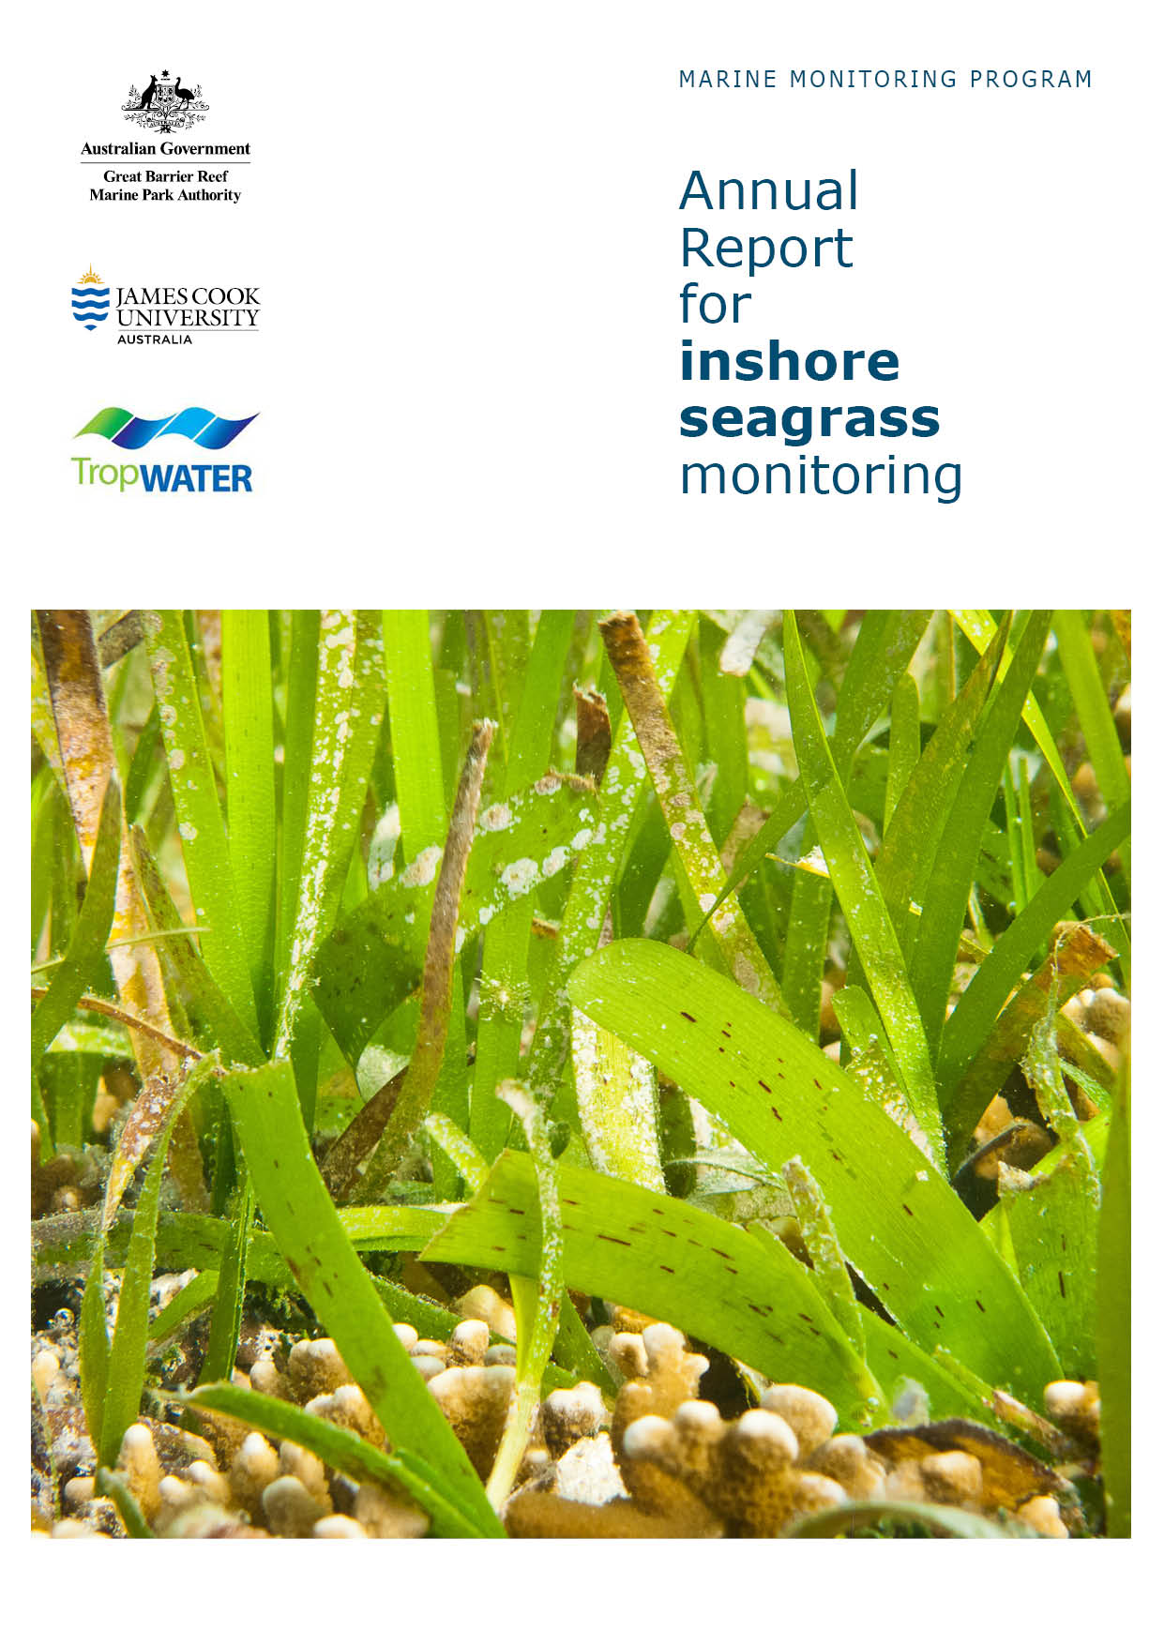
2 0 1 4 - 2 0 1 5 55151051 4
Len McKenzie, Catherine Collier, Lucas Langlois, Rudi Yoshida, Naomi Smith, & Michelle Waycott

TropWATER- Centre for Tropical Water and Aquatic Ecosystem Research
James Cook University
Townsville, Qld 4811

© Copyright JCU TropWATER 2016
All rights are reserved and no part of this document may be reproduced, stored or copied in any form or by any means whatsoever except with the prior written permission of AIMS.

ISBN
978-1-922126-94-8

This report should be cited as:
McKenzie, L.J., Collier, C.J, Langlois, L.A, Yoshida, R.L, Smith, N. and Waycott, M. (2016) Marine Monitoring Program. Annual Report for inshore seagrass monitoring: 2014 to 2015. Report for the Great Barrier Reef Marine Park Authority. TropWATER, James Cook University, Cairns. 236pp.

Front cover image: Close-up of seagrass (Cymodocea rotundata and Thalassia hemprichii) on the reef flat at Green Island. ©Dieter Tracey 2013

DISCLAIMER
While reasonable efforts have been made to ensure that the contents of this document are factually correct, JCU does not make any representation or give any warranty regarding the accuracy, completeness, currency or suitability for any particular purpose of the information or statements contained in this document. To the extent permitted by law JCU shall not be liable for any loss, damage, cost or expense that may be occasioned directly or indirectly through the use of or reliance on the contents of this document.

Direct Enquiries to –
Len McKenzie
Phone: +61 7 4232 2012
Email: len.mckenzie@jcu.edu.au
Web: https://research.jcu.edu.au/tropwater

Contents

Acronyms & Abbreviations Used In This Report xvii
Acknowledgements xviii
Executive summary 1
1 Preface 3
2 Introduction 4
3 Methods summary 9
3.1 Climate and environmental pressures 9
3.2 Sampling design & site selection 11
3.3 Seagrass condition monitoring 15
3.3.1 Seagrass abundance, composition and extent 15
3.3.2 Seagrass reproductive health 15
3.3.3 Seagrass tissue nutrients 15
3.4 Data analyses 16
3.5 Reporting Approach 17
3.6 Report card 17
3.6.1 Seagrass abundance 18
3.6.2 Seagrass reproductive effort 18
3.6.3 Seagrass nutrient status. 19
3.6.4 Seagrass index 19
4 Results & Discussion 20
4.1 GBR-wide Summary 21
4.1.1 Climate and environmental pressures 23
4.1.2 Indicators of seagrass condition 29
4.1.3 Indicators of environmental condition 34
4.2 Cape York 40
4.2.1 2014-15 Summary 40
4.2.2 Climate and environmental pressures 41
4.2.3 Indicators of seagrass condition 43
4.2.4 Indicators of environmental condition 46
4.2.5 Report card for inshore seagrass status 48
4.3 Wet Tropics 49
4.3.1 2014-15 Summary 49
4.3.2 Climate and environmental pressures 50
4.3.3 Indicators of seagrass condition 52
4.3.4 Indicators of environmental condition 56
4.3.5 Report card for inshore seagrass status 58
4.4 Burdekin 59
4.4.1 2014-15 Summary 59
4.4.2 Climate and environmental pressures 60
4.4.3 Indicators of seagrass condition 63
4.4.4 Indicators of environmental condition 66
4.4.5 Report card for inshore seagrass status 68
4.5 Mackay Whitsunday 69
4.5.1 2014-15 Summary 69
4.5.2 Climate and environmental pressures 70
4.5.3 Indicators of seagrass condition 72
4.5.4 Indicators of environmental condition 75
4.5.5 Report card for inshore seagrass status 77
4.6 Fitzroy 78
4.6.1 2014-15 Summary 78
4.6.2 Climate and environmental pressures 79
4.6.3 Indicators of seagrass condition 82
4.6.4 Indicators of environmental condition 84
4.6.5 Report card for inshore seagrass status 86
4.7 Burnett Mary 87
4.7.1 2014-15 Summary 87
4.7.2 Climate and environmental pressures 88
4.7.3 Indicators of seagrass condition 90
4.7.4 Indicators of environmental condition 92
4.7.5 Report card for inshore seagrass status 94
5 Conclusions 95
6 Case study 1. Using life history traits to classify seagrass species – a preliminary assessment. 101
7 Case study 2: progressing toward validated river plume risk maps 107
8 References 109
Appendix 1 Background to the NRMs, including conceptual models 123
A1.1 Cape York 124
A1.2 Wet Tropics 128
A1.3 Burdekin 130
A1.4 Mackay Whitsunday 132
A1.5 Fitzroy 135
A1.6 Burnett-Mary 138
Appendix 2 Materials and Methods 141
A2.1 Sampling design 142
A2.2 Climate and environmental pressures 144
A2.3 Seagrass status 147
Appendix 3 Report card methods and calculations 156
A3.1 Report card approach 157
A3.2 Seagrass abundance 157
A3.3 Seagrass reproductive effort 165
A3.4 Seagrass nutrient status. 167
A3.5 Seagrass index 169
Appendix 4 Detailed data 170
A4.1 Climate and environmental pressures 171
A4.1.1 River discharge 171
A4.1.2 Climate 174
A4.1.3 Tidal exposure 185
A4.1.4 Within canopy sea temperature 189
A4.1.5 Light at seagrass canopy 194
A4.1.6 Sediments composition 200
A4.2 Seagrass community and environment 210
A4.2.1 Epiphytes and macroalgae 210
A4.2.2 Seagrass extent 216
A4.2.3 Species composition and distribution 218
A4.2.4 Seagrass leaf tissue 224
Appendix 5 Results of statistical analysis 233

List of Figures
Figure 1. General conceptual model of seagrass habitats in north east Australia and the water quality impacts affecting the habitat (adapted from Carruthers et al., 2002, and Collier et al. 2014) 5
Figure 2. Climate, environmental, seagrass condition and seagrass resilience indicators reported as part of the MMP Inshore Seagrass monitoring 2014-15. 6
Figure 3. Illustration of seagrass recovery after loss and the categories of successional species over time. 8
Figure 4. Report card scores (NRM regional averages pooled) for each indicator and total seagrass index over the life of the MMP. 22
Figure 5. Report card of seagrass condition for each NRM region (averaged across indicators). 22
Figure 6. Plume exposure (colour classes 1 – 5, primary and secondary water) frequency in the GBR from December 2014 to April 2015 25
Figure 7. Number of days when inshore intertidal sea temperature exceeded 35°C, 38°C, 40°C and 43°C in each monitoring period in each NRM region. 26
Figure 8. Inshore intertidal sea temperature deviations from baseline for GBR seagrass habitats 2003 to 2014. 27
Figure 9. Number of days when inshore subtidal sea temperature exceeded 35°C, 38°C, 40°C and 43°C in each monitoring period in each NRM region. 27
Figure 10. Average daily light (left-hand panels) and thresholds exceeded (% days, right-hand panels) for coastal, estuarine, reef intertidal, and reef subtidal sites including the long-term average and the value for the 2014-15 reporting period. 28
Figure 11. Daily light for all sites combined and GBR-wide trend (GAM plot) in daily light for each habitat from 2008 to 2015. 28
Figure 12. Long-term GBR average seagrass abundance score (all sites and seasons pooled irrespective of NRM region) (±Standard Error) for each monitoring period from 1999 to 2015. 29
Figure 13. Regional report card scores for seagrass abundance over the life of the MMP 29
Figure 14. Seagrass percent cover measures per quadrat from meadows monitored from July 1999 to July 2015 (sites and habitats pooled). 30
Figure 15. Generalised trends in seagrass abundance for each habitat type (sites pooled) relative to the 95th percentile 31
Figure 16. Trends in seagrass abundance (% cover) for each habitat type across the GBR represented by a GAM plot. 32
Figure 17. Proportion of total seagrass abundance composed of species displaying colonising traits (e.g. Halophila ovalis) in a) estuary intertidal, b) coastal intertidal, c) reef intertidal and d) reef subtidal habitats (sites pooled) for the GBR (regions pooled) each monitoring period 32
Figure 18. Seagrass reproductive effort (number of reproductive structures produced by all seagrass species) during the late dry of each monitoring period, for a) estuary intertidal; b) coast intertidal; c) reef intertidal; d) reef subtidal. 33
Figure 19. Regional report card scores for seagrass reproductive effort over the life of the MMP 33
Figure 20. Average seeds banks (seeds per square metre of sediment surface, all sites and species pooled) in GBR seagrass habitats: a) estuary intertidal; b) coast intertidal; c) reef intertidal; d) reef subtidal. 34
Figure 21. Median tissue nutrient concentrations (±Standard Error) in seagrass leaves for each habitat type (species pooled) over the entire monitoring program. 35
Figure 22. Elemental ratios (atomic) of seagrass leaf tissue C:N for each habitat each year 35
Figure 23. Seagrass leaf tissue δ¹³C and δ¹⁵N concentrations from each GBR seagrass habitat (locations pooled) in the late dry from 2011 to 2014 36
Figure 24. Elemental ratios (atomic) of seagrass leaf tissue C:P and N:P for each habitat each year 36
Figure 25. Regional report card scores for seagrass leaf tissue nutrient status (C:N) over the life of the MMP 37
Figure 26. Proportion of sediment composed of mud (grain size <63µm) at GBR seagrass monitoring habitats from 1999-2015. 38
Figure 27. Epiphyte abundance (% cover) relative to the long-term average for each GBR seagrass habitat 38
Figure 28. Macroalgae abundance (% cover) relative to the long-term average for each inshore GBR seagrass habitat 39
Figure 29. Report card of seagrass condition (indicators and index) for the Cape York NRM region 40
Figure 30. Frequency of exposure to plume water in the Cape York NRM, wet season (December 2014 – April 2015) composite. 41
Figure 31. Daily light (mean) at Cape York sites with 28-d rolling average from 2012 to 2015 (left) and GAM plots (right) 42
Figure 32. Inshore within canopy sea temperature for intertidal seagrass habitats in the Cape York NRM region from April 2007 to June 2015 42
Figure 33. Seagrass abundance (% cover ± Standard Error) at inshore intertidal reef habitats (replicate sites pooled) in the Cape York NRM. 43
Figure 34. Seagrass abundance (% cover ± Standard Error) at inshore intertidal coastal habitats (sites pooled) in the Cape York NRM region. 44
Figure 35. Temporal trends in seagrass abundance for each location in the Cape York NRM region represented by a GAM plot. 44
Figure 36. Proportion of seagrass abundance composed of species displaying colonising traits at inshore habitats in the Cape York region. 45
Figure 37. Change in spatial extent of seagrass meadows within a 100m radius of monitoring sites for each habitat and monitoring period across the eastern Cape York NRM region. 45
Figure 38. Seed banks and reproductive effort at inshore intertidal coastal (a) and reef (b) habitats in the Cape York region 46
Figure 39. Elemental ratios (atomic) of seagrass leaf tissue C:N for the foundation species in inshore intertidal coastal (a) and reef (b) habitats in the Cape York region from 2005 to 2014 46
Figure 40. Elemental ratios (atomic) of seagrass leaf tissue N:P and C:P for the foundation species in inshore intertidal reef (a, c) and coastal (b, d) habitats in the Cape York region from 2005 to 2014 47
Figure 41. Long-term trend in mean epiphyte and macroalgae abundance (% cover) at monitoring sites in the Cape York region, relative to the long-term average for each inshore GBR intertidal seagrass habitat 48
Figure 42. Report card of seagrass status indicators and index for the Wet Tropics NRM region 49
Figure 43. Frequency of exposure to plume water in the Wet Tropics NRM, wet season (22 weeks from December 2014 – April 2015) composite. 50
Figure 44. Mean daily light at Wet Tropics sites with 28-d rolling average from 2008 to 2015 (left) and GAM plots (right) 51
Figure 45. Inshore sea temperature for intertidal seagrass habitats in the Wet Tropics NRM region from August 2001 to June 2015 51
Figure 465. Inshore sea temperature for subtidal seagrass habitats in the Wet Tropics NRM region from October 2008 to June 2015 52
Figure 47. Changes in seagrass abundance (% cover ±Standard Error) at inshore intertidal coastal habitats in the Wet Tropics region, 2000 - 2015. 52
Figure 48. Changes in seagrass abundance (% cover ±Standard Error) for inshore intertidal and subtidal reef habitats (left and right respectively) in the Wet Tropics region, 2001 - 2015 53
Figure 49. Temporal trends in seagrass abundance for each monitoring location in the Wet Tropics region represented by a GAM plot, 2001-2015. 54
Figure 50. Proportion of seagrass abundance composed of colonising species at inshore habitats in the Wet Tropics region, 2001 - 2015. 54
Figure 51. Change in spatial extent of seagrass meadows within a 100m radius of monitoring sites for each habitat and monitoring period across the Wet Tropics region. 55
Figure 52. Seed bank and late dry season reproductive effort for inshore intertidal coast and reef habitats in the Wet Tropics region, 2001 - 2015. 56
Figure 53. Elemental ratios (atomic) of seagrass leaf tissue C:N for the foundation seagrass species examined at each inshore habitat in the Wet Tropics region each year 56
Figure 54. Elemental ratios (atomic) of seagrass leaf tissue N:P and C:P for the foundation seagrass species examined at each inshore habitat in the Wet Tropics region 57
Figure 55. Long-term trend in mean epiphyte and macroalgae abundance (% cover) relative to the long-term average for each inshore seagrass habitat in the Wet Tropics region, 2001 - 2014 58
Figure 56. Report card of seagrass status indicators and index for the Burdekin NRM region 60
Figure 57. Frequency of exposure to plume water in the Burdekin NRM region, wet season (December 2014 – April 2015) composite. 61
Figure 58. Mean daily light at Burdekin sites with 28-d rolling average from 2012 to 2015 (left) and GAM plots (right) 62
Figure 59. Inshore sea temperature at intertidal seagrass habitats in the Burdekin region, January 2008 - May 2015 62
Figure 60. Inshore sea temperature at inshore subtidal seagrass habitat at Magnetic Island (Burdekin region), January 2008 - May 2015 63
Figure 61. Changes in mean seagrass abundance (% cover ±Standard Error) at inshore coastal intertidal (a, b), reef intertidal (c) and reef subtidal (d) meadows in the Burdekin region, 2001 - 2015. 64
Figure 62. Temporal trends in seagrass abundance for each location in the Burdekin region represented by a GAM plot. 64
Figure 63. Proportion of seagrass abundance composed of colonising species at inshore habitats in the Burdekin region, 2001 - 2015. 65
Figure 64. Change in spatial extent of seagrass meadows within a 100m radius of monitoring sites for each inshore intertidal habitat and monitoring period across the Burdekin region, 2005 - 2015. 65
Figure 65. Seed bank and late dry season reproductive effort at inshore intertidal coast and reef and subtidal reef habitats in the Burdekin region. 66
Figure 66. Elemental ratios (atomic) of seagrass leaf tissue C:N for the foundation seagrass species examined at each inshore habitat in the Burdekin region each year 66
Figure 67. Elemental ratios (atomic) of seagrass leaf tissue N:P and C:P for the foundation seagrass species examined at each inshore intertidal habitat in the Burdekin region each year 67
Figure 68. Long-term trend in mean epiphyte and macroalgae abundance (% cover) relative to the long-term GBR average for each inshore seagrass habitat in the Burdekin region 68
Figure 69. Report card of seagrass status indicators and index for the Mackay Whitsunday NRM region 69
Figure 70. Frequency of exposure to plume water in the Mackay Whitsunday NRM region, wet season (December 2014 – April 2015) composite. 70
Figure 71. Mean daily light at Mackay Whitsunday habitats with 28-d rolling average from 2012 to 2015 (left) and GAM plots (right) 71
Figure 72. Inshore sea temperatures within each intertidal seagrass habitat in the Mackay Whitsunday region, September 2003 - June 2015 71
Figure 73. Changes in seagrass abundance (% cover ±Standard Error) at inshore intertidal habitats in the Mackay Whitsunday region, 1999 - 2015 72
Figure 74. Temporal trends in seagrass abundance for each location in the Mackay Whitsunday region represented by a GAM plot. 73
Figure 75. Proportion of seagrass abundance composed of colonising species at inshore intertidal habitats in the Mackay Whitsunday region, 1999 - 2015. 73
Figure 76. Change in spatial extent of seagrass meadows within a 100m radius of monitoring sites for each inshore intertidal habitat and monitoring period across the Mackay Whitsunday NRM region. 74
Figure 77. Seed bank and late dry season reproductive effort at inshore intertidal coast, estuary, and reef habitats in the Mackay Whitsunday region, 2001 - 2015. 75
Figure 78. Elemental ratios (atomic) of seagrass leaf tissue C:N for the foundation seagrass species examined at inshore intertidal habitats in the Mackay Whitsunday region, 2006 - 2014 75
Figure 79. Elemental ratios (atomic) of seagrass leaf tissue N:P and C:P for the foundation seagrass species examined at inshore intertidal habitats in the Mackay Whitsunday region, 2006 - 2014 76
Figure 80. Long-term trend in mean epiphyte and macroalgae abundance (% cover) relative to the long-term average for each inshore intertidal habitat in the Mackay Whitsunday region, 1999 - 2015 77
Figure 81. Report card of seagrass status indicators and index for the Fitzroy NRM region 79
Figure 82. Frequency of exposure to plume water in the Fitzroy NRM, wet season (22 weeks from December 2014 – April 2015) composite. 80
Figure 83. Mean daily light at Fitzroy sites with 28-d rolling average from 2012 to 2015 (left) and GAM plots (right) 81
Figure 84. Inshore sea temperatures within each intertidal seagrass habitat in the Fitzroy region, May 2007 - June 2015 81
Figure 85. Changes in seagrass abundance (% cover ±Standard Error) in inshore intertidal habitats of the Fitzroy region, 2001 - 2015 82
Figure 86. Temporal trends in seagrass abundance for each habitat in the Fitzroy region, represented by a GAM plot 2001-2015. 82
Figure 87. Proportion of seagrass abundance composed of colonising species in inshore intertidal habitats of the Fitzroy region, 2001 - 2015. 83
Figure 88. Change in spatial extent of seagrass meadows within a 100m radius of monitoring sites for each inshore intertidal habitat across the Fitzroy NRM region, 2005 - 2015. 83
Figure 89. Seed bank and late dry season reproductive effort for inshore intertidal coastal, estuary and reef habitats in the Fitzroy region, 2005 - 2015. 84
Figure 90. Elemental ratios (atomic) of seagrass leaf tissue C:N for the foundation seagrass species examined at inshore intertidal habitats in the Fitzroy region, 2005 - 2014 85
Figure 91. Elemental ratios (atomic) of seagrass leaf tissue N:P and C:P for the foundation seagrass species examined at inshore intertidal habitats in the Fitzroy region, 2005 - 2014 85
Figure 92. Long-term trend in mean epiphyte and macroalgae abundance (% cover) relative to the long-term average for each inshore intertidal seagrass habitat in the Fitzroy region, 2005 - 2014 86
Figure 93. Report card of seagrass status indicators and index for the Fitzroy NRM region 87
Figure 94. Frequency of exposure to plume water in the Burnett Mary NRM, wet season (22 weeks from December 2014 – April 2015) composite 88
Figure 95. Daily light at Burnett Mary locations from 2010 to 2015 (left) and GAM plots (right) 89
Figure 96. Inshore sea temperature monitoring September 2005 to June 2015 for seagrass meadows in Burnett Mary NRM region 89
Figure 97. Changes in seagrass abundance (% cover ±Standard Error) at estuarine and coastal meadows in Burnett Mary region from 1999 to 2015. 90
Figure 98. Temporal trends in seagrass abundance at estuarine locations in the Burnett May region, represented by a GAM plot 1999-2015. 91
Figure 99. Proportion of seagrass abundance composed of colonising species at: a. estuary and b. coastal habitats in the Burnett Mary region, 1998-2015. 91
Figure 100. Change in spatial extent of seagrass meadows within a 100m radius of monitoring sites for each habitat and monitoring period across the Burnett Mary NRM region. 92
Figure 101. Burnett Mary estuary seed bank and reproductive effort. 92
Figure 102. Elemental ratios (atomic) of seagrass leaf tissue C:N, N:P and C:P for the foundation seagrass species examined at estuarine habitats in the Burnett Mary region each year 93
Figure 103. Long-term trend in mean epiphyte and macroalgae abundance (% cover) relative to the long-term average for each seagrass habitat in the Burnett Mary NRM region 94
Figure 104. Summary of GBR MMP inshore seagrass state illustrating abundance of foundation / colonising species, seed banks and reproductive effort from 2005 to 2015. 96
Figure 105. Plot of abundance of species displaying colonising, opportunistic or persistent life history traits relative to maximum: a. intertidal reef habitat (Cockle Bay) and b. subtidal reef habitat (Picnic Bay). 98
Figure 106. Model of species groupings based on life history traits, relating to meadow form during recovery and disturbance phases. 98
Figure 107. Species classification based on response to disturbance. Species can be classified as colonising, opportunistic or persistent depending on life history traits. (adapted from Kilminster et al. 2015) 102
Figure 108. Morphological traits, including internode length and leaf width have been routinely measured and have been used in a traits-based exploration of species classification. 103
Figure 109. MDS of Zostera muelleri morphological traits (leaf width and internode length) plotted by: a. habitat (estuarine, reef, coastal) within each NRM region (CY, WT, B, MW, F, BM) and; b. habitat only. 104
Figure 110. Zostera muelleri leaf width and internode length plotted over time using MDS (left), and a temporal dot plot for all data (right). 104
Figure 111. MDS of Zostera muelleri morphological traits for 2006 – 2011 by habitat (Estuarine, Reef, Coastal) within region (CY, WT, B, MW, F, BM). 104
Figure 112. MDS of Halodule uninervis morphological traits (leaf width and internode length) plotted by habitat within region. 105
Figure 113. Morphological traits of H. uninervis over time including MDS (left), and temporal plot (right). 105
Figure 114. Morphological traits of H. uninervis in 2015 only based on habitat within region. 105
Figure 115. Conceptual diagram of reef habitat in the Cape York region 125
Figure 116. Conceptual diagram of coastal habitat in the Cape York region 126
Figure 117. Conceptual diagram of coastal habitat (<15m) in the Wet Tropics region 128
Figure 118. Conceptual diagram of reef habitat (<15m) in the Wet Tropics region 129
Figure 119. Conceptual diagram of coastal habitat in the Burdekin region 131
Figure 120. Conceptual diagram of fringing reef habitat in the Burdekin region 131
Figure 121. Conceptual diagram of estuary habitat in the Mackay Whitsunday region 133
Figure 122. Conceptual diagram of coastal habitat in the Mackay Whitsunday region 133
Figure 123. Conceptual diagram of reef habitat in the Mackay Whitsunday region 134
Figure 124. Conceptual diagram of coastal habitat in the Fitzroy region 136
Figure 125. Conceptual diagram of reef habitat in the Fitzroy region 136
Figure 126. Conceptual diagram of estuary habitat in the Fitzroy region 137
Figure 127. Conceptual diagram of Estuary habitat in the GBR section of the Burnett Mary region 139
Figure 128. Key to symbols used for conceptual diagrams detailing drivers and pressures to seagrasses. 140
Figure 129. Inshore seagrass monitoring sites for the Reef Rescue Marine Monitoring Program. 148
Figure 130. Form and size of reproductive structure of the seagrasses collected: Halophila ovalis, Halodule uninervis and Zostera muelleri subsp. capricorni 154
Figure 131. Relationship between sample size and the error in estimation of percentile values for seagrass abundance (% cover) in coastal and reef seagrass habitats in the Wet Tropics NRM. 158
Figure 132. Median seagrass abundance (% cover) at Yule Point (left) and Green Island (right) plotted against the 50th and 20th percentiles for coastal and intertidal reef seagrass habitat in the Wet Tropics. 159
Figure 133. Average daily flow (ML day⁻¹) per month from the Normanby River at Kalpowar Crossing and Annan River at Beesbike 171
Figure 134. Average daily flow (ML day⁻¹) per month from the main rivers impacting the seagrass monitoring sites in the Wet Tropics 171
Figure 135. Average daily flow (ML day⁻¹) per month from the Burdekin River impacting the seagrass monitoring sites in the Burdekin region 172
Figure 136. Average daily flow (ML day⁻¹) per month from the main rivers impacting coastal and reef seagrass monitoring sites in the Mackay Whitsunday region 172
Figure 137. Average daily flow (ML day⁻¹) per month from the main river impacting estuarine seagrass monitoring sites in the Mackay Whitsunday region 172
Figure 138. Average daily flow (ML day⁻¹) per month from the main rivers which would impact seagrass monitoring sites in the Fitzroy region 173
Figure 139. Average daily flow (ML day⁻¹) per month from the Mary River which would impact estuarine seagrass monitoring sites at Urangan, southern Burnett Mary region 173
Figure 140. Mean monthly daily maximum air temperature (°C), total monthly rainfall (mm, bar graph), mean monthly cloud cover (quarts, heavier line), and mean monthly 3pm wind speed (km.hr⁻¹, lighter line) recorded at Lockhart River Airport (BOM station 028008, source www.bom.gov.au), located 108km from Shelburne Bay and 61km from Piper Reef monitoring sites. 174
Figure 141. Total monthly rainfall (mm, bar graph) recorded at Lotus Bird Lodge (BOM station 028035, source www.bom.gov.au), located approximately 73km and 84km from Bathurst Bay and Stanley Island monitoring sites, respectively 174
Figure 142. Mean monthly daily maximum air temperature (°C), total monthly rainfall (mm, bar graph), mean monthly cloud cover (quarts, heavier line), and mean monthly 3pm wind speed (km. hr⁻¹, lighter line) recorded at Cooktown airport (BOM station 031209, source www.bom.gov.au), located 16km from Archer Point monitoring sites. 175
Figure 143. Number of days wind speed is above 25 km. hr⁻¹ each monitoring period in the Cape York NRM region. 175
Figure 144. Total monthly rainfall (mm, bar graph) recorded at Port Douglas - Warner St (BOM station 31052, source www.bom.gov.au), located approximately 11km from Yule Point and 15 from Low Isles monitoring sites. 176
Figure 145. Mean monthly daily maximum air temperature (°C, black line), and mean monthly 3pm wind speed (km. hr⁻¹, grey line) pre-July 2010 from Green Island (BOM station 31192). 176
Figure 146. Total monthly rainfall (mm, bar graph), recorded at Dunk Island Resort (BOM station 32118, source www.bom.gov.au). 177
Figure 147. Number of days wind speed is above 25 km. hr⁻¹ each monitoring period in the Wet Tropics NRM region. 177
Figure 148. Mean monthly daily maximum temperature (°C, line), total monthly rainfall (grey bars), mean monthly cloud cover (quarts, black line), and mean monthly 3pm wind speed (km. hr⁻¹, grey line) recorded at Townsville Airport (BOM station 032040, source www.bom.gov.au). 178
Figure 149. Mean monthly daily maximum temperature (°C, line), total monthly rainfall (grey bars), and mean monthly 3pm wind speed (km. hr⁻¹, grey line) recorded at Ayr (BOM station 033002, source www.bom.gov.au), located approximately 26km from Jerona (Bowling Green Bay) monitoring sites. 178
Figure 150. Number of days wind speed is above 25 km. hr⁻¹ each monitoring period in the Burdekin NRM region. 179
Figure 151. Total monthly rainfall (grey bars) (post December 2004), mean monthly daily maximum temperature (°C, black line), mean monthly cloud cover (quarts, black line), and mean monthly 3pm wind speed (km. hr⁻¹, grey line) recorded at Proserpine Post Office 179
Figure 152. Mean monthly daily maximum temperature (°C), total monthly rainfall, mean monthly cloud cover (quarts), and mean monthly 3pm wind speed (km. hr⁻¹) recorded at Hamilton Island (BOM station 033106, source www.bom.gov.au), located 1.5km from Hamilton Island monitoring sites. 180
Figure 153. Total monthly rainfall (grey bars) recorded at Plane Creek Sugar Mill (BOM station 033059, source www.bom.gov.au), located 10km from Sarina Inlet monitoring sites. 180
Figure 154. Number of days wind speed is above 25 km. hr⁻¹ each monitoring period in the Mackay Whitsunday NRM region. 181
Figure 155. Total monthly rainfall (grey bar), mean monthly daily maximum temperature (°C) and mean monthly 3pm wind speed (km. hr⁻¹) post May 2005 recorded at Williamson, Shoalwater Bay (BOM station 033260, source www.bom.gov.au), located 10km from the monitoring sites 181
Figure 156. Total monthly rainfall (grey bar) recorded at Svendsen Beach, Great Keppel Island (BOM station 033260, source www.bom.gov.au), located 4.5km from the monitoring sites. 182
Figure 157. Total monthly rainfall (grey bars) recorded at Southend Curtis Island (BOM station 039241, source www.bom.gov.au), located 1km from monitoring sites. 182
Figure 158. Number of days wind speed is above 25 km. hr⁻¹ each monitoring period in the Fitzroy NRM region. 183
Figure 159. Mean monthly daily maximum temperature (°C) (black line), mean monthly cloud cover (quarts) (black line), and mean monthly 3pm wind speed (km. hr⁻¹) (grey line) recorded at Seventeen Seventy 183
Figure 160. Mean monthly daily maximum temperature (°C), total monthly rainfall, and mean monthly 3pm wind speed (km. hr⁻¹) recorded at Hervey Bay Airport (BOM station 040405, source www.bom.gov.au), approximately 3km from Urangan monitoring sites. 184
Figure 161. Number of days wind speed is above 25 km. hr⁻¹ each monitoring period in the Burnett Mary NRM region. 184
Figure 162. Annual daytime tidal exposure (total hours) and long-term median (dashed line) of intertidal reef seagrass meadows at Archer Point, Cape York NRM region; 2011 - 2015 186
Figure 163. Annual daytime tidal exposure (total hours) and long-term median (dashed line) of intertidal reef seagrass meadows in the Wet Tropics NRM region; 1999 - 2015. 186
Figure 164. Annual daytime tidal exposure (total hours) and long-term median (dashed line) of intertidal coastal seagrass meadows in Wet Tropics NRM region; 1999 - 2015. 186
Figure 165. Annual daytime tidal exposure (total hours) and long-term median (dashed line) of intertidal coastal seagrass meadows in Burdekin NRM region; 2000 - 2015. 187
Figure 166. Annual daytime tidal exposure (total hours) and long-term median (dashed line) of intertidal reef seagrass meadows in Burdekin NRM region; 2000 - 2015. 187
Figure 167. Annual daytime tidal exposure (total hours) and long-term median (dashed line) of intertidal estuarine (a, b) coastal (c, d) and reef (e, f) seagrass meadows in Mackay Whitsunday NRM region; 1999 - 2015. 187
Figure 168. Annual daytime tidal exposure (total hours) and long-term median (dashed line) of intertidal estuarine (a, b) coastal (c, d) and reef (e, f) seagrass meadows in the Fitzroy NRM region; 1999 - 2015. 188
Figure 169. Annual daytime tidal exposure (total hours) and long-term median (dashed line) of intertidal estuarine seagrass meadows in the Burnett Mary NRM region; 1999 - 2015. 188
Figure 170. Within seagrass canopy temperatures (°C) at intertidal monitoring locations in the Cape York NRM region 189
Figure 171. Within seagrass canopy temperatures (°C) at intertidal monitoring locations in Wet Tropics NRM region 190
Figure 172. Daily within seagrass canopy temperature (°C) over the 2013-15 monitoring period (left) and long-term monthly mean and maximum (right) at Low Isles (top), Green Island (middle) and Dunk Island (bottom) subtidal meadows within the Wet Tropics region. 190
Figure 173. Within seagrass canopy temperatures (°C) at intertidal monitoring locations in Burdekin NRM region 191
Figure 174. Within seagrass canopy temperatures (°C) at subtidal monitoring locations in Burdekin NRM region 191
Figure 175. Within seagrass canopy temperatures (°C) at intertidal monitoring locations in Mackay Whitsunday NRM region 192
Figure 176. Within seagrass canopy temperatures (°C) at monitoring locations in Fitzroy NRM region 192
Figure 177. Within seagrass canopy temperatures (°C) at monitoring locations in Burnett Mary NRM region 193
Figure 178. Daily light (28-day rolling average) at Cape York locations 194
Figure 179. Daily light (yellow line) and 28-day rolling average (orange, bold line) for locations in the northern Wet Tropics 195
Figure 180. Daily light (yellow line) and 28-day rolling average (orange, bold line) for locations in the southern Wet Tropics 196
Figure 181. Daily light (yellow line) and 28-day rolling average (orange, bold line) at locations in the Burdekin region 197
Figure 182. Daily light (yellow line) and 28-day rolling average (orange, bold line) at Mackay Whitsunday habitats. 198
Figure 183. Daily light (yellow line) and 28-day rolling average (orange, bold line) at monitoring locations in the Fitzroy NRM region 199
Figure 184. Daily light (yellow line) and 28-day rolling average (orange, bold line) at monitoring locations in the Burnett Mary NRM region 199
Figure 185. Sediment grain size composition at reef habitat monitoring sites in the Cape York region, 2003-2015. 200
Figure 186. Sediment grain size composition at coastal habitat monitoring sites in the Cape York region, 2013-2015. 201
Figure 187. Sediment grain size composition at intertidal coastal habitat monitoring sites in the Wet Tropics region, 2001-2015. 202
Figure 188. Sediment grain size composition at intertidal reef habitat monitoring sites in the Wet Tropics region, 2001-2015. 203
Figure 189. Sediment grain size composition at subtidal reef habitat monitoring sites in the Wet Tropics region, 2008-2015. 204
Figure 190. Sediment grain size composition at intertidal coastal habitat monitoring sites in the Burdekin region, 2001-2015. 205
Figure 191. Sediment grain size composition at intertidal reef habitat monitoring sites in the Burdekin region, 2004-2015. 205
Figure 192. Sediment grain size composition at subtidal reef habitat monitoring sites in the Burdekin region, 2010-2015. 206
Figure 193. Sediment grain size composition at intertidal estuary habitat monitoring sites in the Mackay Whitsunday region, 2005-2015. 206
Figure 194. Sediment grain size composition at intertidal coastal habitat monitoring sites in the Mackay Whitsunday region, 1999-2015. 207
Figure 195. Sediment grain size composition at intertidal reef habitat monitoring sites in the Mackay Whitsunday region, 2007-2015. 207
Figure 196. Sediment grain size composition at intertidal estuary habitat monitoring sites in the Fitzroy region, 2005-2015. 208
Figure 197. Sediment grain size composition at intertidal coastal habitat monitoring sites in the Fitzroy region, 2005-2015. 208
Figure 198. Sediment grain size composition at intertidal reef habitat monitoring sites in the Fitzroy region, 2007-2015. 209
Figure 199. Sediment grain size composition at intertidal estuary habitat monitoring sites in the Burnett Mary region, 1999-2015. 209
Figure 200. Long-term trend in mean abundance (% cover) (± Standard Error) of epiphytes and macroalgae at intertidal coastal habitats (sites pooled), Cape York NRM region 210
Figure 201. Long-term trend in mean abundance (% cover) (± Standard Error) of epiphytes and macroalgae at intertidal reef habitats (sites pooled), Cape York NRM region 210
Figure 202. Mean abundance (% cover) (± Standard Error) of epiphytes and macroalgae at intertidal reef seagrass monitoring locations (sites pooled) in the Wet Tropics NRM region 211
Figure 203. Mean abundance (% cover) (± Standard Error) of epiphytes and macroalgae at coastal intertidal seagrass monitoring locations (sites pooled) in the Wet Tropics NRM region 211
Figure 204. Mean abundance (% cover) (± Standard Error) of epiphytes and macroalgae at subtidal reef seagrass monitoring sites in the Wet Tropics NRM region 212
Figure 205. Mean abundance (% cover) (± Standard Error) of epiphytes and macroalgae at coastal intertidal seagrass monitoring locations (sites pooled) in the Burdekin NRM region 212
Figure 206. Mean abundance (% cover) (± Standard Error) of epiphytes and macroalgae at intertidal reef seagrass monitoring locations (sites pooled) in the Burdekin NRM region 213
Figure 207. Mean abundance (% cover) (± Standard Error) of epiphytes and macroalgae at subtidal reef monitoring sites in Picnic Bay, Burdekin NRM region 213
Figure 208. Mean abundance (% cover) (± Standard Error) of epiphytes and macroalgae at coastal intertidal seagrass monitoring locations (sites pooled) in the Mackay Whitsunday NRM region 213
Figure 209. Mean abundance (% cover) (± Standard Error) of epiphytes and macroalgae at estuarine seagrass monitoring locations (sites pooled) in the Mackay Whitsunday NRM region 214
Figure 210. Mean abundance (% cover) (± Standard Error) of epiphytes and macroalgae at reef seagrass monitoring locations (sites pooled) in the Mackay Whitsunday NRM region 214
Figure 211. Mean abundance (% cover) (± Standard Error) of epiphytes and macroalgae at coastal intertidal seagrass monitoring locations (sites pooled) in the Fitzroy NRM region 214
Figure 212. Mean abundance (% cover) (± Standard Error) of epiphytes and macroalgae at estuarine seagrass monitoring locations (sites pooled) in the Fitzroy NRM region 214
Figure 213. Mean abundance (% cover) (± Standard Error) of epiphytes and macroalgae at reef seagrass monitoring locations (sites pooled) in the Fitzroy NRM region 215
Figure 214. Mean abundance (% cover) (± Standard Error) of epiphytes and macroalgae at estuarine seagrass monitoring locations (sites pooled) in the Burnett Mary NRM region. 215
Figure 215. Location and species composition of each long-term seagrass monitoring site (MMP) in the Cape York region. 218
Figure 216. Location and species composition of each long-term seagrass monitoring site (MMP) in the Wet Tropics region. 219
Figure 217. Location and species composition of each long-term seagrass monitoring site (MMP) in the Burdekin region. 220
Figure 218. Location and species composition of each long-term seagrass monitoring site (MMP) in the Mackay Whitsunday region. 221
Figure 219. Location and species composition of each long-term seagrass monitoring site (MMP) in the Fitzroy region. 222
Figure 220. Location and species composition of each long-term seagrass monitoring site (MMP) in the Burnett Mary region. 223
Figure 221. Elemental ratios (atomic) of seagrass leaf tissue C:N, N:P and C:P for the foundation seagrass species examined at each coastal location in the Cape York region each year 224
Figure 222. Elemental ratios (atomic) of seagrass leaf tissue C:N, N:P and C:P for the foundation seagrass species examined at each reef location in the Cape York region each year 225
Figure 223. Elemental ratios (atomic) of seagrass leaf tissue C:N for the foundation seagrass species examined at each habitat and location in the Wet Tropics region each year 226
Figure 224. Elemental ratios (atomic) of seagrass leaf tissue C:P and N:P for the foundation seagrass species examined at intertidal coastal habitats in the Wet Tropics region each year 226
Figure 225. Elemental ratios (atomic) of seagrass leaf tissue C:P and N:P for the foundation seagrass species examined at intertidal reef habitats in the Wet Tropics region each year 227
Figure 226. Elemental ratios (atomic) of seagrass leaf tissue C:P and N:P for the foundation seagrass species examined at subtidal reef habitats in the Wet Tropics region each year 227
Figure 227. Elemental ratios (atomic) of seagrass leaf tissue C:N, N:P and C:P for the foundation seagrass species examined at each habitat and location in the Burdekin region each year 228
Figure 228. Elemental ratios (atomic) of seagrass leaf tissue C:N, N:P and C:P for the foundation seagrass species examined at coastal habitats in the Mackay Whitsunday region each year 228
Figure 229. Elemental ratios (atomic) of seagrass leaf tissue C:N for the foundation seagrass species examined at each habitat in the Burnett Mary region each year 229

List of Tables
Table 1. Report card for seagrass condition for the GBR and each NRM region: June 2014 - May 2015. 2
Table 2. Summary of climate and environment data included in this report 10
Table 3. MMP inshore seagrass long-term monitoring site details including presence of foundation () and other () seagrass species sampled for plant tissue and reproductive health. 13
Table 4. Details of additional inshore seagrass long-term monitoring sites from the Seagrass-Watch program, including presence of foundation () and other () seagrass species. 14
Table 5. Scoring threshold table to determine seagrass abundance status. 18
Table 6. Scores for late dry monitoring period reproductive effort average against long-term (2005-2010) GBR habitat average. NB: scores are unitless. 18
Table 7. Scores for leaf tissue C:N against guideline to determine light and nutrient availability. NB: scores are unitless. 19
Table 8. Area of seagrass shallower than 15m in each NRM region (from McKenzie, et al. 2010c) within the boundaries of the Great Barrier Reef World Heritage Area. 19
Table 9. Summary of environmental conditions at monitoring sites across the GBR in 2014-15 compared to the long-term average (range indicated for each data set). Regional and habitat-specific levels are provided in later sections. *intertidal only. 1969-1997 23
Table 10. Long term annual discharge (in megalitres) for the major GBR catchment rivers in proximity to the inshore seagrass monitoring sites (where data available) for the 2014-15 wet season 24
Table 11. Long-term average ( ±SE) sediment composition for each seagrass habitat (pooled across regions and time) monitoring within the GBR (1999-2015) 37
Table 12. Summary of environmental conditions at monitoring sites in Cape York region in 2014-15 compared to the long-term average (long-term range indicated for each data set). 41
Table 13. Water type at each site (Loc) derived from MODIS true colour images 41
Table 14. Long-term report card scores for seagrass abundance, reproductive and leaf tissue nutrient status for each habitat in the Cape York NRM region: June 2005 – May 2015. 48
Table 15. Summary of environmental conditions at monitoring sites in the Wet Tropics region in 2014-15 compared to the long-term average (long-term range indicated for each data set). 50
Table 16. Water type at each location (Loc) in the Wet Tropics region derived from MODIS true colour images 50
Table 17. Long-term report card scores for seagrass abundance, reproductive and leaf tissue nutrient status for each habitat in the Wet Tropics NRM region: June 2005 – May 2015. 58
Table 18. Summary of environmental conditions at monitoring sites in the Burdekin in 2014-15 compared to the long-term average (long-term range indicated for each data set) including climate, discharge, plume, and within seagrass canopy conditions. 60
Table 19. Water type at each seagrass monitoring site in the Burdekin NRM region, derived from MODIS true colour images 61
Table 20. Long-term report card scores for seagrass abundance, reproductive and leaf tissue nutrient status for each habitat in the Burdekin region: June 2005 – May 2015. 68
Table 21. Summary of environmental conditions at monitoring sites in Mackay Whitsunday region in 2014-15 compared to the long-term average (long-term range indicated for each data set). 70
Table 22. Water type at each location in the Mackay Whitsunday region derived from MODIS true colour images 70
Table 23. Long-term report card scores for seagrass abundance, reproductive and leaf tissue nutrient status for each habitat in the Mackay Whitsunday region: June 2005 – May 2015. 77
Table 24. Summary of environmental conditions at monitoring sites in the Fitzroy region in 2014-15 compared to the long-term average (long-term range indicated for each data set). 79
Table 25. Water type at each site (Loc) in the Fitzroy region derived from MODIS true colour images 80
Table 26. Long-term report card scores for seagrass abundance, reproductive and leaf tissue nutrient status for each habitat in the Fitzroy region: June 2005 – May 2015. 86
Table 27. Summary of environmental conditions at monitoring sites in the Burnett Mary in 2014-15 compared to the long-term average (long-term range indicated for each data set). 88
Table 28. Water type at each location in the Burnett Mary NRM derived from MODIS true colour images 88
Table 29. Long-term report card scores for seagrass abundance, reproductive and leaf tissue nutrient status for each habitat in the Burnett Mary region: June 2005 – May 2015. 94
Table 30. Samples collected at each MMP inshore monitoring site per parameter for each season. Activities include: SG = seagrass cover & composition, SM=seed monitoring, TN=tissue nutrients, EM=edge mapping, RH=reproductive health, TL=temperature loggers, LL=light loggers, SH=sediment herbicides. ^=subtidal. 143
Table 31. Minimum light requirements (MLR) derived from the literature (15-25%) were converted to daily irradiance from surface light at sites where surface light is also monitored. 146
Table 32. Long-term average proportion (±SE) of colonising species in each GBR seagrass habitat type. 149
Table 33. Seagrass percentage cover guidelines (“the seagrass guidelines”) for each site/location and the subregional guidelines (bold) for each NRM habitat. 160
Table 34. Scoring threshold table to determine seagrass abundance status. 161
Table 35. Mean and median seagrass % cover and report score for each long-term monitoring site within each Cape York NRM region habitat over the 2014-15 period. 161
Table 36. Mean and median seagrass % cover and report score for each long-term monitoring site within each Wet Tropics NRM region habitat over the 2014-15 period. 162
Table 37. Mean and median seagrass % cover and report score for each long-term monitoring site within each Burdekin NRM region habitat over the 2014-15 period. 163
Table 38. Mean and median seagrass % cover and report score for each long-term monitoring site within each Mackay Whitsunday NRM region habitat over the 2014-15 period. 163
Table 39. Mean and median seagrass % cover and report score for each long-term monitoring site within each Fitzroy NRM region habitat over the 2014-15 period. 164
Table 40. Mean and median seagrass % cover and report score for each long-term monitoring site within each Burnett Mary NRM region habitat over the 2014-15 period. 164
Table 41. Scores for late dry monitoring period reproductive effort average against long-term (2005-2010) GBR habitat average. NB: scores are unitless. 165
Table 42. Late dry season average seagrass reproductive effort (RE ±Standard Error) and report card scores for each monitoring site (species pooled) within each NRM region habitat. 166
Table 43. Scores for leaf tissue C:N against guideline to determine light and nutrient availability. NB: scores are unitless. 167
Table 44. Average seagrass leaf tissue C:N ratios and report scores for each monitoring site (species pooled) within each NRM region habitat. 168
Table 45. Area of seagrass shallower than 15m in each NRM region (from McKenzie, et al. 2010c) within the boundaries of the Great Barrier Reef World Heritage Area. 169
Table 46. Height of intertidal monitoring meadows/sites above Lowest Astronomical Tide (LAT) and annual daytime tidal exposure (total hours) when meadows become exposed at a low tide. 185
Table 47. Proportion of area (within 100m radius of each monitoring site) which is covered by seagrass in the Cape York and Wet Tropics NRM regions. 216
Table 48. Proportion of area (within 100m radius of each monitoring site) which is covered by seagrass in the Burdekin, Mackay Whitsunday, Fitzroy and Burnett Mary NRM regions. 217
Table 49. Seagrass leaf tissue nutrient, δ¹³C and δ¹⁵N concentrations from each NRM region in the late dry 2011 to 2014. 230
Table 50. Percent carbon in seagrass leaf tissue from published literature. 232
Table 51. Summary of GAMM for average cover vs time analysis for 2014-15. 234
Table 52. Summary of GAMM statistical output for light vs time analysis for 2014-15. 235

Acronyms & Abbreviations Used In This Report
CV coefficient of variation
DAFF Department of Agriculture, Fisheries and Forestry
DERM Department of Environment and Resource Management
Fisheries QLD Fisheries Queensland (DAFF)
GBR Great Barrier Reef
GBRMPA Great Barrier Reef Marine Park Authority
JCU James Cook University
km kilometre
m metre
MMP Marine Monitoring Program
NRM Natural Resource Management
Paddock to Reef Paddock to Reef Integrated Monitoring, Modelling and Reporting Program
SE Standard Error
TropWATER Centre for Tropical Water & Aquatic Ecosystem Research
QPSMP Queensland Ports Seagrass Monitoring Program

Acknowledgements
We thank Louise Johns and Christina Howley for their assistance with field collections. We also thank the volunteers who assisted with field monitoring in Townsville and Pioneer Bay, and Nicky Yoshida for assisting with the processing of laboratory samples. We thank Dieter Tracey for production of flood plume exposure maps included in this report.
We thank the Range Control Officer (Department of Defence) for providing support and access to the Shoalwater Bay Training Area to conduct biannual monitoring; Great Adventures (part of the Quicksilver Group) for providing discounted transfers to Green Island; and Steven “Fozzy” Foster and Nancy Lowe of Dunk Island Water Taxi for assistance with the maintenance of light loggers at Mission Beach. We also thank the Traditional Owners of the Sea Countries we visited to conduct our monitoring.
River discharge data provided by the State of Queensland (Department of Natural Resources and Mines) 2015. The conceptual diagram symbols are courtesy of the Integration and Application Network (ian.umces.edu/symbols/), University of Maryland Center for Environmental Science. Climate data courtesy of the Australian Bureau of Meteorology, and tide data courtesy Maritime Safety Queensland, Department of Transport and Main Roads.

Executive summary
The Marine Monitoring Program (herein referred to as the MMP) undertaken in the Great Barrier Reef (GBR) lagoon assesses the long-term effectiveness of the Australian and Queensland Government’s Reef Water Quality Protection Plan (Reef Plan) and the Australian Government’s initiative, formerly known as Reef Rescue. Established in 2005 to help assess the long-term status and health of GBR ecosystems, the MMP is a critical component in assessing improvements in regional water quality as land management practices are improved across Reef catchments. The program forms an integral part of the Reef Plan Paddock to Reef Integrated Monitoring, Modelling and Reporting Program (P2R program) supported through Reef Plan. This includes an annual report card summarising progress towards Reef Plan objectives. This report details the results of sampling that has occurred under the MMP to assess the condition of inshore seagrass ecosystems of the GBR and identify responses to the environmental drivers. It also summarises results as report card scores for inclusion in the GBR-wide report card.
The inshore seagrass monitoring component of the MMP assessed seagrass abundance (percentage cover), community structure, relative meadow extent, reproductive health, and nutrient status from inshore seagrass meadows at 21 locations throughout the GBR. Within each of the Natural Resource Management regions (Cape York, Wet Tropics, Burdekin, Mackay Whitsunday, Fitzroy and Burnett Mary), monitoring locations included each of the major seagrass habitat types where possible (estuarine, coastal, reef, subtidal reef). Locations were predominately lower littoral (only exposed to air at the lowest of low tides), hereafter referred to as intertidal, although four locations also included shallow subtidal meadows. Environmental pressures are also recorded including within-canopy water temperature, within-canopy light, sediment composition as well as macroalgae and epiphyte abundance, with further data obtained from the Australian Bureau of Meteorology and from the MMP inshore water quality subprogram.
Discharge from most GBR rivers in 2014-15 was at or below the long‐term median. Despite this, seagrass meadows in southern regions were exposed to turbid sediment laden waters for much of the wet season. Northern regions (Cape York to Burdekin) were exposed more frequently to green high nutrient waters; suggesting the possibility of some nutrient enrichment. Furthermore, elemental ratios within seagrass leaves (tissue nutrients) indicate some meadows in the Wet Tropics, Burdekin and Mackay Whitsunday regions have degraded water quality with an excess of nutrients. Daily light was slightly lower than the long‐term average at many locations, particularly those covered in green secondary waters. Within‐canopy seawater temperatures during 2014-15 were higher in the central and northern GBR than the long‐term (10 year) average; the warmest in 9 years. While these water temperatures were not excessive (>40°C), and may not impact photosynthetic efficiency in most GBR seagrass species, some species, such as Z. muelleri, are sensitive to prolonged exposure. The higher temperatures coupled with the lower light availability, may have restricted seagrass growth in some meadows in all GBR regions except the far north.
To summarise the environmental pressures: 64% of locations had lower than average daily light, particularly across the Wet Tropics, Burdekin, Mackay Whitsunday and Fitzroy NRM regions; seagrass in Mackay Whitsunday and Wet Tropics were exposed to high seawater temperatures for more than 15% of the year; increasing epiphyte loads resulted in above GBR average cover at 40% sites; and increasing nutrient enrichment at 39% sites and of these, 56% with either high or elevated nitrogen.
In the 2014-15 monitoring period, overall seagrass abundance improved relative to the previous year; however, 62% of sites remained classified as poor or very poor in abundance (below the guidelines). Seagrass abundance has generally been increasing since 2011 as meadows recover from widespread declines occurring from 2009 to 2011. This earlier decline was the result of multiple years of above average rainfall and climate-related impacts followed by extreme weather events in early 2011. The seagrass losses had significant flow-on effects for dugong and green turtle populations (Meager and Limpus 2012), which are highly dependent on certain seagrass species as their primary food supply.
Ecological resilience includes the capacity of an organism to resist disturbance (“resistance”) and the capacity to recover to a stable state (“recovery”), which determines the capacity of a system to maintain its function when affected by disturbances (Folke et al. 2004; Bernhardt and Leslie 2013; Unsworth et al. 2015). The attributes of seagrasses that are indicative of resistance include: abundance, species composition (in particular diversity of life history strategies including both colonising and persistent species), genetic diversity, and storage reserves, and continuity (or spatial extent) (Unsworth, et al. 2015). Recovery of seagrass meadows is facilitated by reproductive output, seed banks and seagrass species composition (noting that some attributes are vital to both).
In 2014-15, the indicators of seagrass resilience (resistance and recovery) continued to improve for meadows along the GBR developing coast, although meadows still remained in a vulnerable and poor/very poor state (particularly in the Wet Tropics and Fitzroy NRM regions). The key indicators of improvement in resistance were increasing abundance (% cover) at 36% of sites (predominately estuary and reef habitats) while 41% of sites remained stable. The region with the greatest improvement in abundance (% cover) during 2014-15 was the Burnett Mary NRM, where 83% of sites increased from the previous monitoring period, while the Wet Tropics experienced declines. Meadow area expanded or remained unchanged/at their maximum relative extent at 96% of sites. Furthermore, meadows continued to undergo a state change with increasing composition of foundation (opportunistic and persistent) species at 36% of sites replacing colonising species, which had been dominant since 2011.
Of notable concern, however, is that the capacity of seagrass to recover from the cumulative impacts of past disturbances continued to remain low. The proportion of seagrass displaying colonising life history traits remained above average (15% of sites had greater than GBR average composition of colonising species) and these species can facilitate recovery from disturbance. However, recovery from loss is dependent on presence of a seed bank. The indicators of low recovery capacity in 2014-15 were; the absence of seed banks at 49% of sites and declining seed banks at another 28% of sites; and below average reproductive effort at 80% of sites.
Across the GBR NRM regions, the seagrass report card scores improved during 2014-15 in the Cape York, Wet Tropics and Mackay Whitsunday, but declined slightly in the others. Seagrass across most of the regions is still recovering from multiple years of climate related impacts, which has likely left a legacy of reduced resilience. Overall, the condition of the inshore seagrass meadows of the GBR has changed little over the last 12 months (2014-15), remaining in a poor state (Table 1), despite generally favourable environmental conditions. Based on current rates of recovery, as well as examples taken from previous localised impacts (Birch and Birch 1984; Campbell and McKenzie 2004), a return to a moderate or good condition could occur within the next 1-2 years (i.e. >5 years from impact), as long as conditions remain favourable.
Table 1. Report card for seagrass condition for the GBR and each NRM region: June 2014 - May 2015.
Values are indexed scores scaled from 0-100; ■ = very good (81-100), ■ = good (61 - 80), ■ = moderate (41 - 60), ■ = poor (21 - 40), ■ = very poor (0 - 20).
Region | Seagrass  Abundance | Reproductive  Effort | Nutrient status  (C:N ratio) | Seagrass Index
Cape York | 43 | 10 | 35 | 30
Wet Tropics | 18 | 31 | 32 | 27
Burdekin | 57 | 40 | 62 | 53
Mackay Whitsunday | 30 | 33 | 31 | 32
Fitzroy | 25 | 0 | 35 | 20
Burnett Mary | 30 | 6 | 40 | 25
GBR | 42 | 17 | 40 | 33

Preface
The management of water quality remains a strategic priority for the Great Barrier Reef Marine Park Authority (GBRMPA) to ensure the long-term protection of the coastal and inshore ecosystems of the Reef (Great Barrier Reef Marine Park Authority 2014). A key management tool is the Reef Water Quality Protection Plan (Reef Plan; Anon 2013), with the actions being delivered through the Reef 2050 Plan1. The Reef 2050 Plan includes the Reef Trust, to which the Australian Government has committed continued funding to protect the Reef through improvements to the quality of water flowing into the Reef lagoon, and the Reef 2050 Long Term Sustainability Plan, which provides a framework for the integrated management of the GBRWHA.
Long-term water quality and ecosystem monitoring in the inshore Great Barrier Reef (GBR) lagoon is undertaken through the Marine Monitoring Program (MMP), which was formerly known as the Reef Plan MMP. The GBRMPA has responsibility for implementation of this program. Further information on the program objectives, and details on each sub-program are available on-line www.gbrmpa.gov.au/managing-the-reef/how-the-reefs-managed/reef-2050-marine-monitoring-program. The seagrass sub-program has been supported by Department of Agriculture, Fisheries and Forestry Queensland (DAFF) (monitoring of additional locations in Cape York and Burdekin regions in 2011-14), with contributions also from the Seagrass-Watch program (Cape York, Wet Tropics, Burdekin, Mackay Whitsunday and Burnett Mary 1998 - 2015). A key output of the Paddock to Reef Program is an annual report card, including an assessment of Reef water quality and ecosystem condition to which the MMP contributes assessments and information. The first Annual Reef Plan Report Card for 2009 (Reef Water Quality Protection Plan Secretariat 2011), serves as a baseline for future assessments, and report cards for 2010, 2011, 2012/13 and 2014 have since been released (available at www.reefplan.qld.gov.au).
James Cook University (JCU) was contracted to provide the inshore seagrass monitoring component. The program has adapted methods outlined in McKenzie et al. (2003) and those applied in Seagrass-Watch (a global seagrass assessment and monitoring program). The MMP inshore seagrass monitoring program design and reporting structure is an evolving process. Program providers developed the program in collaboration with GBRMPA in 2005, with assistance by expert working groups and AIMS (De’ath 2005). In 2008-09, subtidal sites in the Wet Tropics and Burdekin regions were included to improve the scope of the program. The program underwent an extensive external review in 2013-14, including a revision of program objectives, a statistical review (testing program design and indicator sensitivity), conceptual modelling of indicator selection, and a working group to prioritise changes (Kuhnert et al. 2014).
Each year a report summarising the condition and trend of inshore seagrass of the GBR over the past year is published on the GBRMPA website. The annual reports are peer-reviewed every year and program providers endeavour to incorporate reviewer comments. As a result, reporting is in an evolving format. This 2014-15 report has been restructured to fit within the DPSIR framework (Driving forces, Pressures, States, Impacts, Responses) as recommended by the GBRMPA Science Strategy (Great Barrier Reef Marine Park Authority 2014). Furthermore, the length of the report has been reduced and much of the detailed information (both methods and results) has been moved into appendices.
This report includes data on flood plume exposure from the inshore water quality monitoring subprogram, and a Case Study on the risk of seagrass meadows to plume exposure prepared by the water quality and seagrass sub-program providers (Lønborg et al. 2015). The report also incorporates the data and/or reported findings from related, but separately funded, seagrass monitoring programs Seagrass-Watch and Queensland Ports Seagrass Monitoring Program, respectively.

Introduction
Seagrasses are an important component of the marine ecosystem of the Great Barrier Reef. The ecosystem services provided by seagrass ecosystems makes them a high conservation priority (Cullen-Unsworth and Unsworth 2013). Certain seagrasses are the primary food for marine green turtles and dugongs, which are seagrass specialists (Read and Limpus 2002; Arthur et al. 2008; Marsh et al. 2011;). Seagrass form highly productive habitats for a large number of invertebrates, fish and algal species (Carruthers et al. 2002), which are of commercial (e.g. prawns) and subsistence (e.g. holothurians) fisheries importance (Coles et al. 1993; Cullen-Unsworth and Unsworth 2013). Nutrient cycling in seagrass meadows makes them one of the most economically valuable ecosystems in the world (Costanza et al. 1997) and the retention of carbon within their sediments contributes significantly to Blue Carbon sequestration (Fourqurean et al. 2012; Unsworth et al. 2012a).
Much of the connectivity in reef ecosystems depends on intact and healthy non-reef habitats, such as seagrass meadows (Waycott et al. 2011). These non-reef habitats are particularly important to the maintenance and regeneration of populations of reef fish such as Emperor fish (Lethrinus spp) and Tuskfish (Choerodon spp) (Cullen-Unsworth et al. 2014). In addition, the incorporation of carbon within seagrass tissues can affect local pH and increase calcification of coral reefs, thereby mitigating the effects of ocean acidification (Fourqurean, et al. 2012; Unsworth, et al. 2012a). Therefore, monitoring changes in seagrasses meadows not only provides an indication of coastal ecosystem health, but also improves our capacity to predict changes to adjacent reefs, mangroves and associated resources upon which coastal communities depend (Heck et al. 2008).
Chronic declines in inshore water quality in the GBR since European settlement have led to major ecological shifts in many GBR marine ecosystems (De'ath and Fabricius 2010; Roff et al. 2013). Multiple pressures are the cause of this decline, including intensive use of the GBR catchments for agriculture and grazing, and coastal development for urban centres and commercial ports (Brodie et al. 2013b). Flood waters deliver terrestrially sourced pollutants (e.g., sediments, nutrients, pesticides) into the GBR, dispersing them over the sensitive ecosystems including seagrass meadows (summarised in Schaffelke et al. 2013).
Tropical seagrass ecosystems of the GBR are a complex mosaic of different habitat types comprised of multiple seagrass species (Carruthers, et al. 2002). There are 15 species of seagrass in the GBR (Waycott et al. 2007) and high diversity of seagrass habitat types is provided by extensive bays, estuaries, rivers and the 2600 km length of the Great Barrier Reef with its reef platforms and inshore lagoon. They can be found on sand or muddy beaches, on reef platforms and in reef lagoons, and on sandy and muddy bottoms down to 60 metres or more below Mean Sea Level (MSL).
Approximately 3,063 km² of inshore seagrass meadows has been mapped in Great Barrier Reef World Heritage Area (GBRWHA) in waters shallower than 15m. Although this represents only 9% of the total seagrass area estimated within the GBRWHA (McKenzie et al. 2010c), the ecosystem services inshore seagrass meadows provide are of far greater importance than those provided by the offshore/deepwater seagrasses. Inshore seagrass meadows are structurally large, composed of foundational (opportunistic and persistent) species, store more carbon in their sediments, are of higher fisheries importance, and the main feeding pastures for dugong and green sea turtle (Watson et al. 1993; Sheppard et al. 2009 Lanyon et al. 1989; McKenzie, et al. 2010c; Lavery et al. 2013). It is these meadows that occur at the frontline of runoff and inshore water quality deterioration (McKenzie, et al. 2010c). The remaining extent (91% or 31,778 km²) of seagrass in the GBRWHA is located in the deeper waters (>15m) of the lagoon (Coles et al. 2009), however, these meadows are relatively sparse, structurally smaller, more dynamic, composed of colonising species, and not as productive as inshore seagrass meadows for fisheries resources (McKenzie, et al. 2010c; Derbyshire et al. 1995). Overall, the total estimated area of seagrass (34,841 km²) within the GBRWHA represents more than 50% of the total recorded area of seagrass in Australia (Green and Short 2003) and between 6% and 12% globally (Duarte et al. 2005), making the Great Barrier Reef’s seagrass resources globally significant.
Seagrasses in the GBR can be separated into four major habitat types: estuary/inlet, coastal, reef and deepwater (Carruthers, et al. 2002) (Figure 1). All but the outer reef habitats are significantly influenced by seasonal and episodic pulses of sediment-laden, nutrient-rich river flows, resulting from high volume summer rainfall. Cyclones, severe storms, wind and waves as well as macro grazers (fish, dugongs and turtles) influence all habitats in this region to varying degrees. The result is a series of dynamic, spatially and temporally variable seagrass meadows.
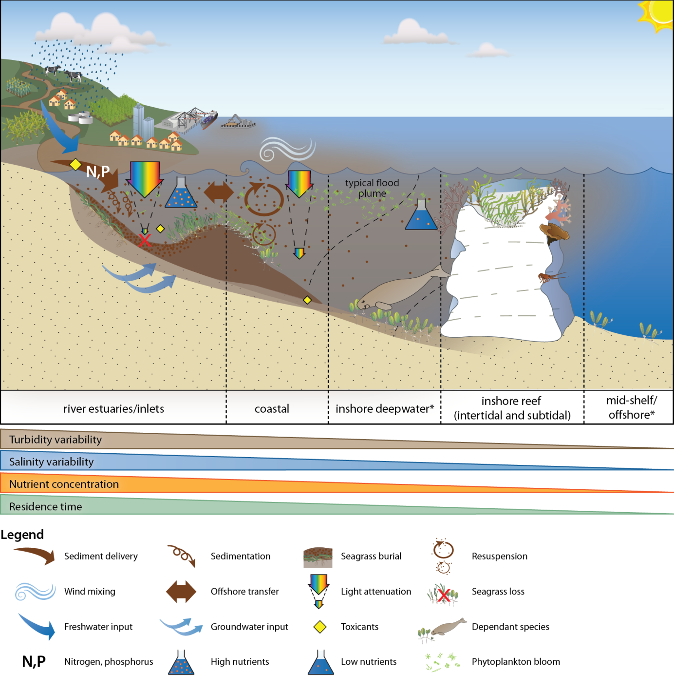
Figure 1. General conceptual model of seagrass habitats in north east Australia and the water quality impacts affecting the habitat (adapted from Carruthers et al., 2002, and Collier et al. 2014)
The seagrass ecosystems of the GBR, on a global scale, would be for the most part categorised as being dominated by disturbance-favouring colonising and opportunistic species (e.g. Halophila, Halodule and Zostera), which typically have low standing biomass and high turnover rates (Carruthers et al. 2002, Waycott et al. 2007). In more sheltered areas, including reef top or inshore areas in bays, more stable and persistent species are found, although these are still relatively responsive to disturbances (Carruthers, et al. 2002; Waycott, et al. 2007; Collier and Waycott 2009).
Conceptual basis for indicator selection
As seagrasses are well recognised as indicators of integrated environmental pressures, monitoring their condition and trend can provide insight into the condition of the surrounding environment (e.g. Dennison et al. 1997). We have developed a matrix of comparison for these indicators (Figure 2) and have evidence of seagrass responses in all categories. This framework provides a structure for acknowledging and interpreting the variety of indicators being used to detect different types of environmental change. Indicators are incorporated into the framework based on response time and indicator category.
Indicators include plant changes, meadow-scale changes and state change (Figure 2). These indicators also respond at different temporal scales, with sublethal indicators able to respond from seconds to months, while the meadow-scale effects usually take many months to be detectable.
A robust monitoring program benefits from having a suite of indicators that can indicate sub-lethal stress that forewarns of imminent loss, as well as indicators of meadow-scale changes, which are necessary for interpreting broad ecological changes. Indicators included in the MMP span this range of scales, in particular for indicators that respond from weeks (tissue nutrients, isotopes), through to months (abundance and reproduction), and even years (abundance and meadow extent). Furthermore, indicators are conceptually linked to each other, and to environmental drivers of concern, in particular, water quality (p 34, Kuhnert, et al. 2014).
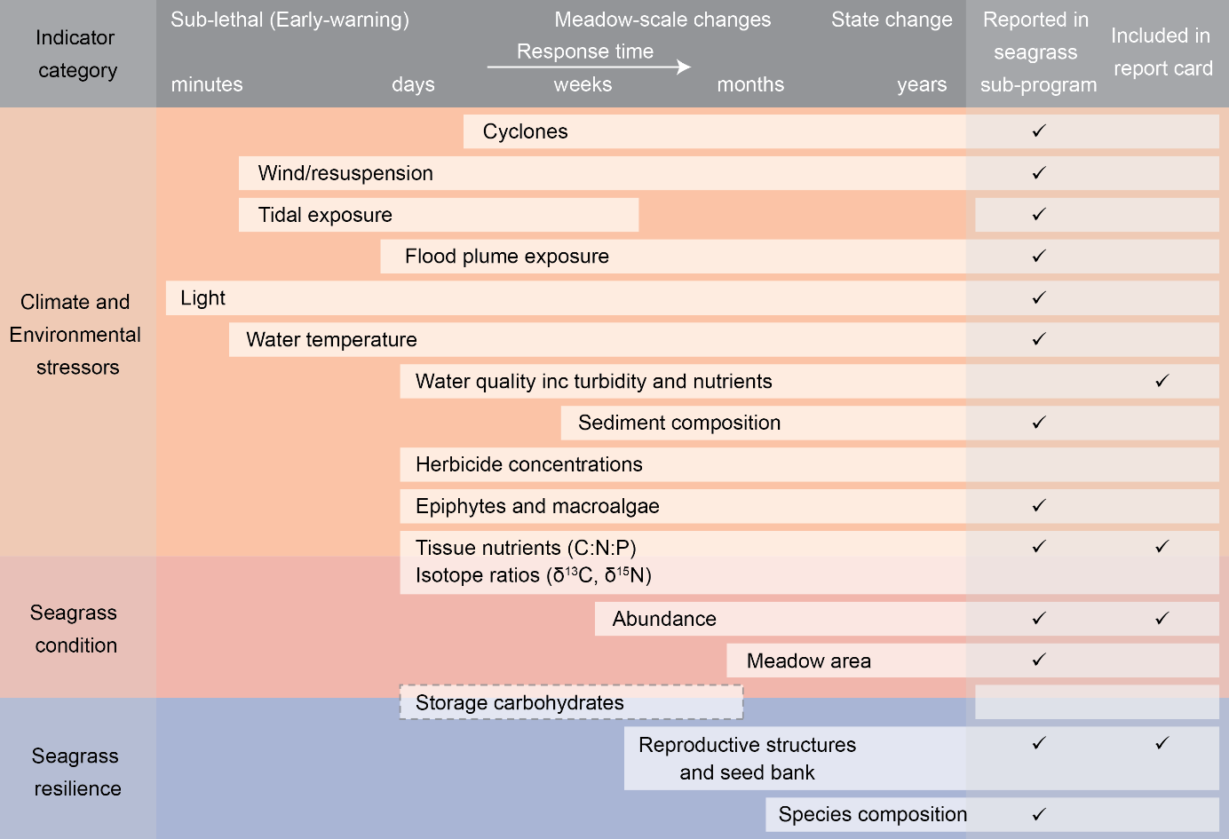
Figure 2. Climate, environmental, seagrass condition and seagrass resilience indicators reported as part of the MMP Inshore Seagrass monitoring 2014-15.
White boxes are indicators measured in the inshore seagrass program, white box with dashed line are indicators in development, and grey boxes are indicators collected in other programs or by other institutions (see Table 2 for details on suppliers). All indicators are shown against their response time which span from minutes to years.
Environment
Climate and environment stressors are aspects of the environment, either physico-chemical or biological that affect seagrass meadow condition. Some environmental stressors change rapidly (minutes/days/weeks/months) but can also undergo chronic shifts (years) (Figure 2). Stressors include:
- Climate (e.g. cyclones, seasonal temperature)
- Local and short-term weather (e.g. wind and tides)
- Water quality (e.g. river discharge, plume exposure)
- Biological (e.g. epiphytes and macroalgae)
- Substrate (e.g. grain size composition)
- Seagrass environmental integrators (e.g. tissue nutrients)
Indicators which respond more quickly (e.g. light) provide important early-warning of potentially more advanced ecological changes (as described below). However, a measured change in a fast-responding environmental indicator is not enough in isolation to predict whether there will be further ecological impacts, because the change could be short-term. However, these indicators provide critical supporting information to support interpretation of slower responding seagrass condition and resilience indicators.
Seagrass condition
Condition indicators such as meadow abundance and extent indicate the state of the plants/population and reflect the cumulative effects of past environmental conditions. Abundance can respond to changes in environment on time-scales ranging from weeks to months (depending on species), while meadow area generally tends to adjust over longer time-scales (months to years). Although these features are integrators of past conditions, and are vital indicators of meadow condition, these features can be affected by external factors such as grazing by megaherbivores, and therefore, are not suitable as stand-alone indicators of environmental change and do not demonstrate capacity to resist or recover from additional impacts (Unsworth, et al. 2015).
Seagrass resilience
Ecological resilience is “the capacity of an ecosystem to absorb repeated disturbances or shocks and adapt to change without fundamentally switching to an alternative stable state” (Holling 1973), and therefore it relates to the ability of a system to both resist and recover from disturbances (Unsworth, et al. 2015). Changes in resilience indicators show if the ecosystem is in transition (i.e. has already, or may undergo a state-change). Sexual reproduction (flowering, seed production and persistence of a seedbank) is an important feature of recovery (and therefore, of resilience) in tropical seagrass meadows, as it is well recognized that coastal seagrasses are prone to small scale disturbances that cause local losses (Collier and Waycott 2009). Community structure (species composition) is also an important feature conferring resilience, both resistance (as some species are more resistant to stress than others), and recovery (as some species may rapidly recover and pave the way for meadow development).

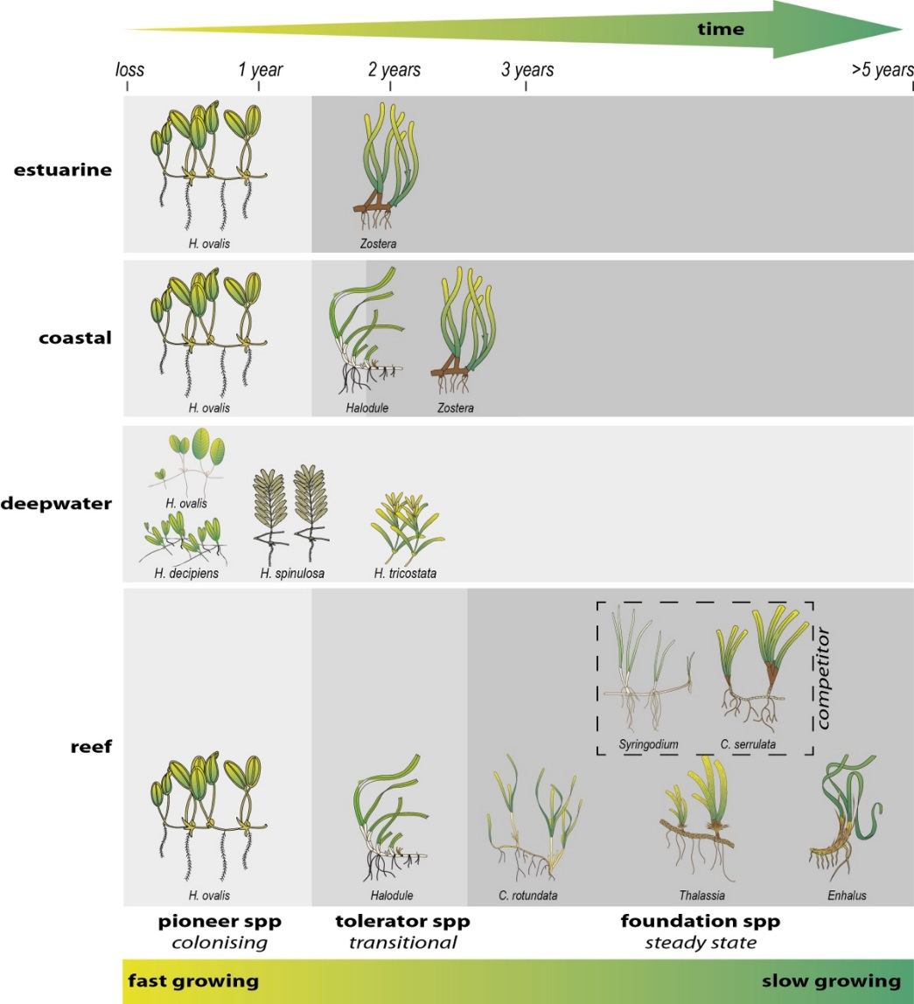
Figure 3. Illustration of seagrass recovery after loss and the categories of successional species over time.
This report presents data from the tenth period of monitoring inshore seagrass ecosystems of the Great Barrier Reef under the MMP (undertaken from June 2014 to May 2015; hereafter called “2014-15”). The key aims of the inshore seagrass monitoring sub-program of the Marine Monitoring Program (MMP) were to:
- Report on the abundance and species composition of seagrass (including edge mapping) in the late dry season of 2014 and the late monsoon season of 2015 at inshore intertidal and subtidal locations,
- Report on the reproductive health of the seagrass species present at inshore intertidal and subtidal locations,
- Report on tissue nutrient concentrations (carbon, nitrogen and phosphorus) and epiphyte loads of foundation seagrass species (genus Halodule, Zostera, Cymodocea) at each inshore intertidal and subtidal location,
- Report on spatial and temporal patterns in light, turbidity and temperature at sites where autonomous loggers are deployed,
- Report on seagrass community and environment condition and trends, and
- Integrate reporting on GBR seagrass condition including production of seagrass report card metrics for use in an annual Paddock to Reef report card.

Methods summary
In the following, an overview is given of the sample collection, preparation and analyses methods. Detailed documentation of the methods used in the MMP, including quality assurance and quality control procedures, is available in Appendix 2.

Climate and environmental pressures
Maximum daily air temperature, total daily rainfall, 3pm wind speed and average daily cloud cover (average of 9am and 3pm total cloud), and cyclone tracks were accessed from the Australian Bureau of Meteorology from meteorological stations which were proximal to monitoring locations (Table 2). As the height of locally produced, short-period wind-waves can be the dominant factor controlling suspended sediment on inner-shelf of the GBR (Larcombe et al. 1995; Whinney 2007), the number of days wind speed exceeded 25km hr⁻¹ was used as a surrogate for elevated resuspension pressure on inshore seagrass meadows. Moderate sea state with winds >25km hr⁻¹ can elevate turbidity by three orders of magnitude in the inshore coastal areas of the GBR (Orpin et al. 2004). To determine if the tidal exposure regime may be increasing stress on seagrass and driving decline, tidal height observations were accessed from Maritime Safety Queensland and duration of annual exposure (hours) was determined for each meadow (i.e. monitoring site) based on the meadows height relative to the Lowest Astronomical Tide (Appendix 2, Table 46).
The presence of inshore seagrass meadows along the GBR places them at high risk of exposure to waters from adjacent watersheds and exposure to flood plumes may be a significant factor in structuring inshore seagrass communities (Collier, et al. 2014; Petus et al. 2016). We have used river discharge volumes as well as frequency of exposure to inshore flood plumes as indicators of flood plume impacts to seagrasses. Plume exposure is generated by wet season monitoring under the MMP in the water quality sub-program (Lønborg, et al. 2015). The MMP inshore water quality sub-program includes a remote sensing component, which describes water quality characteristics for 22 weeks within wet season conditions (November – April). Water quality is described as colour classes of turbid, brown primary water (class 1 – 4), green secondary water (class 5), and waters influenced by flood plumes (salinity 30PSU, coloured dissolved organic matter (CDOM) threshold of 0.24 m⁻¹ class 6). Colour classes are derived from MODIS True colour satellite images. Exposure to flood plumes is described in this report as frequency of exposure to primary (turbid, sediment laden) or secondary (green, nutrient rich) water during the wet season. Methods are detailed in Devlin et al. (2015).
Autonomous iBTag™ submersible temperature loggers were deployed at all sites identified in Appendix 2, Table 35. The loggers recorded temperature (accuracy 0.0625°C) within the seagrass canopy every 30 – 90 minutes. iBCod™22L submersible temperature loggers were attached to the permanent marker at each site above the sediment-water interface.
Submersible Odyssey™ photosynthetic irradiance autonomous loggers were attached to permanent station markers at 20 intertidal and 4 subtidal seagrass locations from the Cape York region to the Burnett Mary region (Appendix 4, Table 30). Detailed methodology for the light monitoring can be found in Appendix 2. Measurements were recorded by the logger every 15 minutes and are reported as total daily light (mol m⁻² d⁻¹). Automatic wiper brushes cleaned the optical surface of the sensor every 15 minutes to prevent marine organisms fouling.
Sediment type was recorded in conjunction with seagrass abundance measures using a visual/tactile estimation of sediment grain size composition (0-2 cm below the sediment/water interface) as per standard protocols described in McKenzie et al. (2003). Qualitative field descriptions of sediment composition were converted to quantitative measures of grain size using the approach described by McKenzie (2007).

Table 2. Summary of climate and environment data included in this report
, showing historical data range, measurement technique, measurement frequency, and data source. Methodology for data collected in this program is further detailed below, and in Appendix 2. *=variable
 | Data range | Method | Measurement  frequency | Reporting units | Data source
Climate
Cyclones | 1968 - 2015 | remote sensing and observations at nearest weather station | yearly | No. yr⁻¹ | Bureau of Meteorology
Rainfall | 1889 - 2015* | rain gauges at nearest weather station | daily | mm mo⁻¹  mm yr⁻¹ | Bureau of Meteorology
Riverine discharge | 1970 – 2015 | water gauging stations at river mouth |  | L d⁻¹  L yr⁻¹ | DNR, compiled by Devlin et al In prep
Plume exposure | 2006 – 2015  wet season (Dec – Apr) | remote sensing and field validation | weekly | frequency of water type (1 – 6) | MMP inshore water quality program (Devlin et al)
Wind | 1997 – 2015* | anemometer at 10 m above the surface, averaged over 10 minutes, at nearest weather station | 3pm wind speed | days >25 km hr⁻¹ | Bureau of Meteorology
Tidal exposure | 1999 – 2015 | wave height buoys at station nearest to monitoring site | 3 – 10 min | hours exposed during daylight | Maritime Safety Queensland, calculated exposure by MMP Inshore Seagrass monitoring
Cloud cover | 1999 – 2015* | measured visually by estimating the fraction (in eighths or oktas) of the dome of the sky covered by cloud at nearest weather station | 9am & 3pm | ockta (daily average) | Bureau of Meteorology
Environment within seagrass canopy
Water temperature | 2002 – 2015 | iBTag | 30 – 90 min | ºC, Temperature anomalies,  exceedance of thresholds | MMP Inshore Seagrass monitoring
Light | 2008 – 2015 | Odyssey 2Pi PAR light loggers with wiper unit | 15 min | Daily light (I_{d}) mol m⁻² d⁻¹  Frequency of threshold exceedance (% days) | MMP Inshore Seagrass monitoring
Sediment grain size | 1999 – 2015 | Visual / tactile description of sediment grain size composition | 3 mo – 1yr | proportion mud | MMP Inshore Seagrass monitoring

Sampling design & site selection
The sampling design was selected to detect changes in inshore seagrass meadows in response to changes in water quality associated with specific catchments or groups of catchments (Region) and to disturbance events. The locations/meadows were selected by the GBRMPA, using advice from expert working groups in 2004. The selection of locations/meadows was based upon a number of competing factors:
- meadows were representative of seagrass habitats and seagrass communities across each region (based on Lee Long et al. 1993, Lee Long et al. 1997, Lee Long et al. 1998; McKenzie et al. 2000b; Rasheed et al. 2003; Campbell et al. 2002; Goldsworthy 1994)
- where possible include legacy sites (e.g. Seagrass-Watch, MTSRF) or former seagrass research sites (e.g. Dennison et al. 1995; Thorogood and Boggon 1999; Udy et al. 1999; Haynes et al. 2000; Inglis 2000; Campbell and McKenzie 2001; Mellors 2003; Campbell and McKenzie 2004; Limpus et al. 2005; McMahon et al. 2005; Mellors et al. 2005; Lobb 2006).
- a Minimum Detectable Difference (MDD) below 20% (at the 5% level of significance with 80% power) (Bros and Cowell 1987).
Sites were selected using mapping surveys across the regions prior to site establishment. Ideally mapping was conducted immediately prior to site positioning, however in most (60% of) cases it was based on historic (>5yr) information. Representative meadows were those which covered the greater extent within the inshore region, were generally the dominant seagrass community type and were within GBR baseline abundances (based on Coles et al. 2001a; Coles et al. 2001c, 2001b, 2001d). To account for spatial heterogeneity of meadows within habitats, two sites were selected at each location. If meadow overall extent was larger than ~15hecatres (0.15 km²), replicate sites were often located within the same meadow.
From the onset, inshore seagrass monitoring for the MMP was focused primarily on intertidal/lower littoral seagrass meadows due to:
- accessibility and cost effectiveness (limiting use of vessels and divers)
- Occupational Health and Safety due to dangerous marine animals (e.g., crocodiles, box jellyfish and irukandji)
- occurrence of meadows in estuarine, coastal and reef habitats across the entire GBR, and
- where possible, provides an opportunity for community involvement, ensuring broad acceptance and ownership of Reef Plan by the Queensland and Australian community.
Some of the restrictions for working in hazardous waters are overcome by using drop cameras and this technique is being explored for future abundance monitoring; however, that will not contribute to physical sampling (e.g. tissue nutrients, reproductive effort), and issues to do with different sampling protocols (e.g. transects) will need to be considered. Although considered intertidal within the MMP, the meadows chosen for monitoring were in fact lower littoral (rarely exposed to air). The long-term median annual daylight exposure (the time intertidal meadows are exposed to air during daylight hours) was 1.7% (all meadows pooled) (Table 46). This limited the time monitoring could be conducted to the very low spring tides within small tidal windows (mostly 1-4hrs per day for 3-6 days per month for 6-9 months of the year). Traditionally, approaches developed for monitoring seagrass to assess changes in water quality were developed for subtidal meadows typified by small tidal ranges (e.g., Florida = 0.7m, Chesapeake Bay = 0.6m) and clear waters where the seaward edges of meadows were only determined by light (EHMP 2008). Unfortunately, depth range monitoring in subtropical/tropical seagrass meadows has had limited success due to logistic/technical issues (e.g. accuracy defining deep edge of a fragmented meadow, and positional accuracy of the autoset level’s graduated staff with increasing horizontal distance) (B. Longstaff, pers. comm. 05 May 2004) and seagrass meadows within the Great Barrier Reef lagoon do not conform to traditional ecosystem models because of the systems complexity (Carruthers, et al. 2002), including:
- a variety of habitat types (estuarine, coastal, reef and deepwater);
- a large variety of seagrass species with differing life history traits and strategies;
- tidal amplitudes spanning 3.42m (Cairns) to 10.4m (Broad Sound) (www.msq.qld.gov.au; Maxwell 1968);
- a variety of sediment substrates, from terrigenous with high organic content, to oligotrophic calcium carbonate;
- turbid nearshore to clearer offshore waters;
- grazing dugongs and sea turtles influencing meadow community structure and landscapes;
- near absence of shallow subtidal meadows south of the Whitsundays due to the large tides which scour the seabed.
Subtidal meadows across the GBR are predominately dominated by Halophila species and are highly variable in abundance and distribution (Lee Long et al. 2000). Due to this high variability they are generally not recommended for monitoring as the MDD is very poor at the 5% level of significance with 80% power (McKenzie et al. 1998). Predominately stable lower littoral meadows of foundation species (e.g., Zostera) are best for determining significant change/impact (McKenzie et al. 1998). Nevertheless, where possible, shallow (>1.5m below Lowest Astronomical Tide) subtidal monitoring has been conducted since October 2009 at locations in the Burdekin and Wet Tropics regions. These sites were chosen as they were dominated by species similar to adjacent lower littoral meadows.
Due to the high diversity of seagrass species across the GBR, it was decided in consultation with GBRMPA to direct monitoring toward the foundation seagrass species across the seagrass habitats (Table 3). A foundation species is the dominant primary producer in an ecosystem both in terms of abundance and influence, playing central roles in sustaining ecosystem services (Angelini et al. 2011). The activities of foundation species physically modify the environment and produce and maintain habitats that benefit other organisms that use those habitats. For the seagrass habitats assessed in the MMP, the foundation seagrass species were those species which typified the habitats both in abundance and structure when the meadow was considered in its steady state (opportunistic or persistent) (Kilminster et al. 2015). The foundation species were all di-meristematic leaf-replacing forms from the following families: Cymodocea, Enhalus, Halodule, Thalassia and Zostera (Table 3).
The timing of the monitoring within the MMP was decided by the GBRMPA, using advice from expert working groups. As the major period of runoff from catchments and agricultural lands was the tropical wet season/monsoon (December to April), monitoring was focussed on the late dry (growing) season and late wet season to capture the condition of seagrass pre and post wet.
Seagrass monitoring methods were conducted as per McKenzie et al. (2010). Forty five sites at 21 locations were monitored during the 2014-15 monitoring period (Table 3). This included eight coastal, four estuarine and nine reef locations (i.e. two-three sites at each location). At the reef locations in the Burdekin and Wet Tropics, intertidal sites were paired with a subtidal site (Table 3). Data from an additional eight sites were included from the Seagrass-Watch program to improve the spatial resolution where possible (Table 4). A description of all data collected during the sampling period under the monitoring contract has been collated by Natural Resource Management (NRM) region, site, parameter, and the number of samples collected per sampling period is listed in Table 30. The seagrass species (including foundation) present at each monitoring site is listed Table 3.
In 2005 and 2014, the monitoring program received thorough independent statistical analysis and review (De’ath 2005; Kuhnert, et al. 2014). The development and any modifications of the program were evaluated by the Paddock to Reef Independent Science Panel. Program reports and results are reviewed annually by independent seagrass experts external to GBRMPA and MMP.

Table 3. MMP inshore seagrass long-term monitoring site details including presence of foundation () and other () seagrass species sampled for plant tissue and reproductive health.
NRM region from www.nrm.gov.au. * = intertidal, ^=subtidal.
GBR region | NRM region (Board) | Basin | Monitoring location | Site |  | Latitude |  | Longitude |  | CR | CS | EA | HD | HO | HS | HU | SI | TH | ZM
Far Northern | Cape York  (Cape York Natural Resource Management) | Jacky Jacky / Olive-Pascoe | Shelburne Bay  coastal | SR1* | Shelburne Bay | 11° | 53.233 | 142° | 54.851
 |  |  |  | SR2* | Shelburne Bay | 11° | 53.251 | 142° | 54.938
Far Northern | Cape York  (Cape York Natural Resource Management) | Jacky Jacky / Olive-Pascoe | Piper Reef  reef | FR1* | Farmer Is. | 12° | 15.352 | 143° | 14.020
 |  |  |  | FR2* | Farmer Is. | 12° | 15.448 | 143° | 14.185
Far Northern | Cape York  (Cape York Natural Resource Management) | Normanby | Stanley Island  reef | ST1* | Stanley Island | 14° | 8.576 | 144° | 14.680
 |  |  |  | ST2* | Stanley Island | 14° | 8.547 | 144° | 14.588
Far Northern | Cape York  (Cape York Natural Resource Management) | Normanby | Bathurst Bay  coastal | BY1* | Bathurst Bay | 14° | 16.082 | 144° | 13.961
 |  |  |  | BY2* | Bathurst Bay | 14° | 16.062 | 144° | 13.896
Far Northern | Cape York  (Cape York Natural Resource Management) | Endeavour | Cooktown  reef | AP1* | Archer Point | 15° | 36.500 | 145° | 19.143 |  |  |  |  |  |  |  |  |  | *
 |  |  |  | AP2* | Archer Point | 15° | 36.525 | 145° | 19.108
Northern | Wet Tropics  (Terrain NRM) | Daintree | Low Isles  reef | LI1* | Low Isles | 16° | 23.11 | 145° | 33.88
 |  |  |  | LI2^ | Low Isles | 16° | 22.97 | 145° | 33.85
Northern | Wet Tropics  (Terrain NRM) | Mossman  Barron  Russell -Mulgrave  Johnstone | Yule Point  coastal | YP1* | Yule Point | 16° | 34.159 | 145° | 30.744 |  |  |  |  |  |  |  |  |  | *
 |  |  |  | YP2* | Yule Point | 16° | 33.832 | 145° | 30.555
Northern | Wet Tropics  (Terrain NRM) | Mossman  Barron  Russell -Mulgrave  Johnstone | Green Island  reef | GI1* | Green Island | 16° | 45.789 | 145° | 58.31
 |  |  |  | GI2* | Green Island | 16° | 45.776 | 145° | 58.501
 |  |  |  | GI3^ | Green Island | 16° | 45.29 | 145° | 58.38
Northern | Wet Tropics  (Terrain NRM) | Tully | Mission Beach  coastal | LB1* | Lugger Bay | 17° | 57.645 | 146° | 5.61
 |  |  |  | LB2* | Lugger Bay | 17° | 57.674 | 146° | 5.612
Northern | Wet Tropics  (Terrain NRM) | Tully | Dunk Island  reef | DI1* | Dunk Island | 17° | 56.6496 | 146° | 8.4654
 |  |  |  | DI2* | Dunk Island | 17° | 56.7396 | 146° | 8.4624
 |  |  |  | DI3^ | Dunk Island | 17° | 55.91 | 146° | 08.42
Central | Burdekin  (NQ Dry Tropics) | Burdekin | Magnetic island  reef | MI1* | Picnic Bay | 19° | 10.734 | 146° | 50.468 |  |  |  |  |  |  |  |  |  | *
 |  |  |  | MI2* | Cockle Bay | 19° | 10.612 | 146° | 49.737
 |  |  |  | MI3^ | Picnic Bay | 19° | 10.734 | 146° | 50.468
Central | Burdekin  (NQ Dry Tropics) | Burdekin | Townsville  coastal | SB1* | Shelley Beach | 19° | 11.046 | 146° | 45.697
 |  |  |  | BB1* | Bushland Beach | 19° | 11.028 | 146° | 40.951
Central | Burdekin  (NQ Dry Tropics) | Burdekin | Bowling Green Bay  coastal | JR1* | Jerona (Barratta CK) | 19° | 25.380 | 147° | 14.480
 |  |  |  | JR2* | Jerona (Barratta CK) | 19° | 25.281 | 147° | 14.425
Central | Mackay Whitsunday  (Reef Catchments) | Proserpine | Whitsundays  coastal | PI2* | Pioneer Bay | 20° | 16.176 | 148° | 41.586
 |  |  |  | PI3* | Pioneer Bay | 20° | 16.248 | 148° | 41.844
Central | Mackay Whitsunday  (Reef Catchments) | Proserpine | Whitsundays  reef | HM1* | Hamilton Island | 20° | 20.7396 | 148° | 57.5658
 |  |  |  | HM2* | Hamilton Island | 20° | 20.802 | 148° | 58.246
Central | Mackay Whitsunday  (Reef Catchments) | Pioneer | Mackay  estuarine | SI1* | Sarina Inlet | 21° | 23.76 | 149° | 18.2
 |  |  |  | SI2* | Sarina Inlet | 21° | 23.712 | 149° | 18.276
Southern | Fitzroy  (Fitzroy Basin Association) | Fitzroy | Shoalwater Bay  coastal | RC1* | Ross Creek | 22° | 22.953 | 150° | 12.685
 |  |  |  | WH1* | Wheelans Hut | 22° | 23.926 | 150° | 16.366
Southern | Fitzroy  (Fitzroy Basin Association) | Fitzroy | Keppel Islands  reef | GK1* | Great Keppel Is. | 23° | 11.7834 | 150° | 56.3682
 |  |  |  | GK2* | Great Keppel Is. | 23° | 11.637 | 150° | 56.3778
Southern | Fitzroy  (Fitzroy Basin Association) | Boyne | Gladstone Harbour  estuarine | GH1* | Gladstone Hbr | 23° | 46.005 | 151° | 18.052 |  |  |  |  |  |  | *
 |  |  |  | GH2* | Gladstone Hbr | 23° | 45.874 | 151° | 18.224
Southern | Burnett Mary  (Burnett Mary Regional Group) | Burnett | Rodds Bay  estuarine | RD1* | Rodds Bay | 24° | 3.4812 | 151° | 39.3288
 |  |  |  | RD2* | Rodds Bay | 24° | 4.866 | 151° | 39.7584
Southern | Burnett Mary  (Burnett Mary Regional Group) | Mary | Hervey Bay  estuarine | UG1* | Urangan | 25° | 18.053 | 152° | 54.409
 |  |  |  | UG2* | Urangan | 25° | 18.197 | 152° | 54.364
* indicates presence adjacent, but not within, 50m x 50m site.
Zostera muelleri = Zostera muelleri subsp. capricorni, as revision of Zostera capricorni (Jacobs et al. 2006) resulted in classification to subspecies.

Table 4. Details of additional inshore seagrass long-term monitoring sites from the Seagrass-Watch program, including presence of foundation () and other () seagrass species.
NRM region from www.nrm.gov.au. * = intertidal
GBR region | NRM region (Board) | Basin | Monitoring location | Site |  | Latitude |  | Longitude |  | CR | CS | EA | HD | HO | HS | HU | SI | TH | ZM
Far Northern | Cape York  (Cape York Natural Resource Management) | Olive-Pascoe / Lockhart | Weymouth Bay  reef | YY1* | Yum Yum Beach | 12° | 34.260 | 143° | 21.635
Central | Burdekin  (NQ Dry Tropics) | Ross / Burdekin | Townsville  coastal | SB2* | Shelley Beach | 19° | 10.953 | 146° | 45.764
Central | Mackay Whitsunday  (Reef Catchments) | Proserpine | Whitsundays  reef | HB1* | Hydeaway Bay | 20° | 4.487 | 148° | 28.930
 |  |  |  | HB2* | Hydeaway Bay | 20° | 4.297 | 148° | 28.846
Central | Mackay Whitsunday  (Reef Catchments) | O'Connell | Repulse Bay  coastal | MP2* | Midge Point | 20° | 38.099 | 148° | 42.108
 |  |  |  | MP3* | Midge Point | 20° | 38.080 | 148° | 42.280
Southern | Burnett Mary  (Burnett Mary Regional Group) | Burrum | Hervey Bay  estuarine | BH1* | Burrum Heads | 25° | 11.290 | 152° | 37.532
 |  |  |  | BH3* | Burrum Heads | 25° | 12.620 | 152° | 38.359

Seagrass condition monitoring

Seagrass abundance, composition and extent
Field survey methodology followed standardised protocols (detailed in McKenzie et al. (2003) and Appendix 2). At each location, with the exception of subtidal sites, sampling included two sites nested (within 500m of each other) in a location. Subtidal sites were not replicated within locations. Intertidal sites were defined as a 50m x 50m area within a relatively homogenous section of a representative seagrass community/meadow (McKenzie et al., 2000). Monitoring at sites in the late dry (September/October 2014) and late monsoon (March/April 2015) of each year was conducted by a qualified and trained scientist. At each site, during each survey, observers recorded the percent seagrass cover within 33 quadrats (50 cm × 50 cm, placed every 5 m along three 50m transects, placed 25m apart). The sampling strategy for subtidal sites was modified to sample along 50m transects 2 – 3 m apart (aligned along the depth contour) due to logistics of SCUBA diving in waters of poor visibility. Mapping of the meadow landscape (including patches and scars) within 100m of each site (i.e. 5.5 hectares) was also conducted as part of the monitoring in both the late dry and late monsoon periods. Mapping followed standard methodologies (McKenzie et al. 2001) using a handheld GPS on foot. Where the seagrass landscape tended to grade from dense continuous cover to no cover over a continuum that included small patches and shoots of decreasing density, the edge was delineated where there was a gap with the distance of more than 3 metres (i.e. accuracy of the GPS).
Seagrass species were identified as per Waycott et al. (2004). Species were further categorised according to their life history traits and strategies and classified into colonising, opportunistic or persistent as broadly defined by Kilminister et al. (2015) (for detailed methods, see Appendix 2; also case study 1).

Seagrass reproductive health
Seagrass reproductive health was assessed from samples collected in the late dry 2014 and late monsoon 2015 at locations identified in Table 3. Samples were processed according to standard methodologies (see Appendix 2).
In the field, 15 haphazardly placed cores (100mm diameter x 100mm depth) of seagrass were collected from an area adjacent (of similar cover and species composition) to each monitoring site. In the laboratory, reproductive structures (spathes, fruits, female and male flowers) of plants from each core were identified and counted for each samples and species. Reproductive effort was calculated as number of reproductive structures (fruits, flowers, spathes; species pooled) per core for analysis.
Seeds banks and abundance of germinated seeds were sampled according to standard methods (McKenzie et al. 2010a) by sieving (2mm mesh) 30 cores (50mm diameter, 100mm depth) of sediment collected across each site and counting the seeds retained in each. For Zostera muelleri, where the seed are <1mm diameter, intact cores (18) were collected and returned to the laboratory where they were washed through a 710µm sieve and seeds identified using a hand lens/microscope.

Seagrass tissue nutrients
In the late dry season (October) 2014, leaf tissue samples from the foundational seagrass species were collected from each monitoring site for nutrient content analysis (Table 3). For nutrient status comparisons, collections were recommended during the growth season (e.g. late dry when nutrient contents are at a minimum) (Mellors, et al. 2005) and at the same time of the year and at the same depth at the different localities (Borum et al. 2004). Shoots from three haphazardly placed 0.25m² quadrats were collected from an area adjacent (of similar cover and species composition) to each monitoring site. Leaves were separated from the below ground material in the laboratory and epiphytic algae removed by gently scraping. Dried and milled samples were analysed according to McKenzie, et al. 2010a. Elemental ratios (C:N:P) were calculated on a mole:mole basis using atomic weights (i.e., C=12, N=14, P=31).
Analysis of tissue nutrient data was based upon the calculation of the atomic ratios and was pooled among foundational species. Changing C:N ratios have been found in a number of experiments and field surveys to be related to light levels, as leaves with an atomic C:N ratio of less than 20, may suggest reduced light availability when N is not in surplus (Abal et al. 1994; Grice et al. 1996; Cabaço and Santos 2007; Collier et al. 2009). The ratio of N:P is also a useful indicator as it is a reflection of the “Redfield” ratios (Redfield et al. 1963), and seagrass with an atomic N:P ratio of 25 to 30 can be determined to be ‘replete’ (well supplied and balanced macronutrients for growth) (Atkinson and Smith 1983; Fourqurean et al. 1997b; Fourqurean and Cai 2001). When N:P values are in excess of 30, this may indicate P-limitation and a ratio of less than 25 is considered to show N limitation (Atkinson and Smith 1983;Duarte 1990; Fourqurean et al. 1992b; Fourqurean and Cai 2001). The median seagrass tissue ratios of C:P is approximately 500 (Atkinson and Smith 1983), therefore deviation from this value is also likely to be indicative of some level of nutrient enriched or nutrient limited conditions. A combination of these ratios can indicate seagrass environments which are impacted by nutrient enrichment. Plant tissue which has both a high N:P and low C:P indicates an environment of elevated (saturated) nitrogen.
Further detail on methodology for nutrient sampling can be found in appendix 2.

Data analyses
In this report, results are presented to reveal temporal changes in seagrass community attributes and key environmental variables. Generalised additive models (GAMs) and generalised additive mixed effects models (GAMMs) were also fitted to seagrass attributes for each habitat, to identify the presence and consistency of trends, using the mgcv (Wood 2006;Wood 2014) package in R 3.2.1 (R Core Team 2014). GAMs and GAMMs (Wood 2006) were used to decompose the irregularly spaced time series into its trend cycles (long-term) and periodic (seasonal) components.
GAMMs are an extension of additive models (which allow flexible modelling of non-linear relationships by incorporating penalized regression spline types of smoothing functions into the estimation process), in which the degree of smoothing of each smooth term (and by extension, the estimated degrees of freedom of each smoother) is treated as a random effect and thus estimable via its variance as with other effects in a mixed modelling structure (Wood 2006).The results of these analyses are graphically presented in a consistent format: Predicted values from the model were plotted as bold black lines, the 95% confidence intervals of these trends delimited by grey shading.
Several GAMs and GAMMs were used on seagrass cover, light, epiphyte cover and macroalgae cover to tease out trends at the habitat, regional and location scale over time. When dealing with data where there are two replicate sites at a given location (e.g. YP1 and YP2 for Yule Point), site was incorporated as a random factor in the models to account for spatial correlation. However, as part of our regular model validation process, if the boxplot with Pearsons residuals plotted against Site showed very similar values for each site within each location then a GAM was used instead of a GAMM.
Percent cover data models were fitted using a quasibinomial distribution due to the proportional (bound between 0 and 1) nature of the data. Raw data at the quadrat level was used to provide the maximum resolution for modelling. However, this led to a very large proportion of 0 in some data sets causing high heterogeneity of variance for some models. For this reason, GAMMs for epiphyte and macroalgae cover are not presented and the inclusion in future reports of Zero inflated GAMMs is being investigated. Light data models were fitted using a gamma distribution due to the strictly positive continuous nature of the data. GAM were used in this instance as PAR loggers are deployed at one site per location and therefore site do not act as a random factor.
In addition of the GAMMs, non-linear regressions and polynomials were used (at the request of past reviewers) to show trends in seagrass abundance (% cover) over time; 95% confidence intervals and R-squared were used to indicate to level of variance is explained by the model.
The majority of meadows have been in a "recovery mode" since the losses, which has restricted multivariate analysis. Analysis is currently underway to more fully interrogate the temporal and covariate components of the data as the time series of observations lengthen. As this is continuing, results are not completed and are planned for inclusion in future reports.

Reporting Approach
The data is presented in a number of ways depending on the indicator and section of the report:
- Report card scores for seagrass condition are presented at the start of each section. These are a numerical summary of the condition within the region relative to a regional baseline (described further below),
- Climate and environmental pressures are presented as averages (daily, monthly or annual) and threshold exceedance,
- Seagrass community data such as seagrass abundance, leaf tissue nutrients are presented as averages (sampling event, season or monitoring period) and threshold exceedance data,
- Seagrass ecosystem data such as sediment composition, epiphyte and macroalgae are presented as averages (sampling event, season or monitoring period) and relative to the long-term,
- Trend analysis (GAMM plots) are also used to explore the long-term temporal trends in biological and environmental indicators.
Within each region, estuarine and coastal habitat boundaries were delineated based on the Queensland coastal waterways geomorphic habitat mapping, Version 2 (1:100 000 scale digital data) (Heap et al 2001). Reef habitat boundaries were determined using the AUSLIG (now the National Mapping Division of Geosciences Australia) geodata topographic basemap (1:100 000 scale digital data). Conceptual diagrams have been used to illustrate the general seagrass habitats type in each region and can be found in Appendix 1 with the background description of each NRM region. Symbols/icons have been used in the conceptual diagrams to illustrate major controls, processes and threats/impacts.

Report card
Three indicators (presented as unitless scores) were selected by the GBRMPA, using advice from expert working groups and the Paddock to Reef Integration Team, for the seagrass report card:
- seagrass abundance (cover)
- reproductive effort
- nutrient status (leaf tissue C:N ratio)
The methods for calculation of scores was chosen by the Paddock to Reef Integration Team (i.e. not the authors of this report) and all report card scores are transformed to a five point scale from 0 to 100 to allow integration with other components of the Paddock to Reef report card (Department of the Premier and Cabinet 2014). The methods are scoring system for the report card scores are detailed in Appendix 3. Please note that the scale from 0 to 100 is unitless and should not be interpreted as a proportion or ratio.

Seagrass abundance
The status of seagrass abundance (% cover) was determined using the seagrass abundance guidelines developed by McKenzie (2009). The seagrass abundance measure in the MMP is the average % cover of seagrass per monitoring site. Individual site and subregional (habitat type within each NRM region) seagrass abundance guidelines were developed based on % cover data collected from individual sites and/or reference sites (McKenzie 2009). Guidelines for individual sites were only applied if the conditions of the site aligned with reference site conditions.
After discussions with GBRMPA scientists and the Paddock to Reef integration team, the seagrass guidelines were further refined by allocating the additional categories of very good (median abundance at or above 75th percentile), and very poor (median abundance below 20th or 10th percentile and declined by >20% since previous sampling event). Seagrass state was then rescaled to a five point scale from 0 to 100 to allow integration with other components of the Paddock to Reef report card (Department of the Premier and Cabinet 2014). The percentage cover guidelines can be found in Appendix 3. Please note that the scale from 0 to 100 is unitless and should not be interpreted as a proportion or ratio.
Table 5. Scoring threshold table to determine seagrass abundance status.
low = 10th or 20th percentile guideline (Table 33). NB: scores are unitless.
description | category | score | status
very good | 75-100 | 100 | 81 - 100
good | 50-75 | 75 | 61 - 80
moderate | low-50 | 50 | 41 - 60
poor | <low | 25 | 21 - 40
very poor | <low by >20% | 0 | 0 - 20

Seagrass reproductive effort
Given the high diversity of seagrass species that occur in the GBR coastal zone (Waycott, et al. 2007), their variability in production of reproductive structures (e.g. Orth et al. 2006), a metric that incorporates all available information on the production of flowers and fruits per unit area is the most useful.
Using the annual mean of all species pooled in the late dry and comparing with the long-term (2005-2010) average for GBR habitat (coastal intertidal = 8.22±0.71, estuarine intertidal = 5.07±0.41, reef intertidal = 1.32±0.14), the reproductive effort was scored as the number of reproductive structures per core and the overall status determined (Table 6) as the ratio of the average number observed relative to the long term average.
Table 6. Scores for late dry monitoring period reproductive effort average against long-term (2005-2010) GBR habitat average. NB: scores are unitless.
description | Reproductive Effort  monitoring period / long-term | ratio | score | 0-100 score | status
very good | ≥4 | 4.0 | 4 | 100 | 81 - 100
good | 2 to <4 | 2.0 | 3 | 75 | 61 - 80
moderate | 1 to <2 | 1.0 | 2 | 50 | 41 - 60
poor | 0.5 to <1 | 0.5 | 1 | 25 | 21 - 40
very poor | <0.5 | 0.0 | 0 | 0 | 0 - 20

Seagrass nutrient status.
An atomic C:N ratio of less than 20, may suggest reduced light availability relative to nitrogen availability for Queensland seagrasses (Abal, et al. 1994; AM Grice, et al., 1996;). However, C:N must be interpreted with caution as the concentration of N can also influence the ratio in oligotrophic environments (Atkinson and Smith 1983; Fourqurean, et al. 1992b). Support for choosing the elemental C:N ratio as the indicator also comes from preliminary analysis of MMP data in 2009 which found that the C:N ratio was the only nutrient ratio that showed a significant relationship (positive) with seagrass cover at coastal and estuarine sites. Seagrass tissue C:N ratios explained 58% of the variance of the inter-site seagrass cover data (McKenzie and Unsworth 2009). Using the guideline ratio of 20:1 for the foundation seagrass species, C:N ratios were categorised on their departure from the guideline and transformed to a 0 to 100 score.
Table 7. Scores for leaf tissue C:N against guideline to determine light and nutrient availability. NB: scores are unitless.
description | C:N ratio range | value | Score () | status
very good | C:N ratio >30* | 30 | 100 | 81 - 100
good | C:N ratio 25-30 | 25 | 75 | 61 - 80
moderate | C:N ratio 20-25 | 20 | 50 | 41 - 60
poor | C:N ratio 15-20 | 15 | 25 | 21 - 40
very poor | C:N ratio <15* |  | 0 | 0 - 20

Seagrass index
The seagrass index is an average score (0-100) of the three seagrass status indicators chosen for the MMP. Each indicator is equally weighted as we have no preconception that it should be otherwise. To calculate the overall score for seagrass of the Great Barrier Reef (GBR), the regional scores were weighted on the percentage of GBRWHA seagrass (shallower than 15m) within that region (Table 8). Please note: Cape York omitted from the GBR score in P2R reporting prior to 2012 due to poor representation of inshore monitoring sites throughout region.
Table 8. Area of seagrass shallower than 15m in each NRM region (from McKenzie, et al. 2010c) within the boundaries of the Great Barrier Reef World Heritage Area.
NRM | Area of seagrass (km²) | % of GBRWHA
Cape York | 1,843 | 0.60
Wet Tropics | 201 | 0.07
Burdekin | 551 | 0.18
Mackay Whitsunday | 154 | 0.05
Fitzroy | 241 | 0.08
Burnett Mary | 73 | 0.02
GBRWHA | 3,063 | 1.00

Results & Discussion
The following results and discussion section provides detail on the overall climate, environmental pressures and seagrass responses for the 2014-15 monitoring period, in context of longer-term trends. It is structured as:
- GBR-wide summary: overall GBR-wide trends and trends for each habitat type represented separately
- A chapter on each NRM region starting with the most northern, Cape York.
- Case studies: 1. using life history traits to classify seagrass species, and; 2. highlighting the integration between the inshore water quality (Lønborg, et al. 2015) and inshore seagrass subprograms.
Each section (aside from the case studies) contains data on environmental pressures as well as the indicators that are used for calculating the report card score, or data that may be included in the report card in the future:
- A summary of the key findings from the overall section
- Climate, river discharge and flood plume exposure
- Within-canopy light threshold exceedance
- Within-canopy temperature threshold exceedance
- Report card score
- Seagrass abundance and extent
- Seagrass species composition based on life history traits
- Seagrass reproductive effort and seed banks
- Seagrass leaf tissue content (C:N, N:P and C:P ratios)
- Epiphyte and macroalgae abundance
- Seagrass meadows sediment characteristics
- Findings from other seagrass monitoring programs (e.g., QPSMP)
The following supporting data, identified as important in understanding the Results and discussion sections (including any long-term trends), is detailed within Appendix 4:
- climate (daily maximum air temperature, monthly rainfall, monthly cloud cover, and monthly 3pm wind speed) relevant to each monitoring location
- Annual daytime tidal exposure at each monitoring site
- Daily within canopy seawater temperature at each monitoring site
- Daily light each monitoring location
- Sediment grain size composition at each monitoring site
- Epiphyte and macroalgae abundance at each monitoring site
- Meadow extent within 100m of each monitoring site
- Location and seagrass species composition at each monitoring site
- Seagrass leaf tissue nutrient C:N, C:P, and N:P at each monitoring location
- Seagrass leaf tissue nutrient isotopic signature (δ¹³C, δ¹⁵N) concentrations, for each species at each monitoring habitat within each NRM region
- Tables detailing statistical analysis

GBR-wide Summary
Climate conditions were relatively moderate across the GBR inshore seagrass meadows during 2014-15. There were two cyclones, and one of these (TC Marcia) strongly affected the Fitzroy and Burnett Mary regions, bringing rainfall, destructive winds and tidal surge in February 2015. However, discharge from most GBR rivers was at or below the long-term median, which reduces exposure to turbid, sediment-laden water. In particular, flow from the second largest river, the Burdekin River was 5x lower than the long-term median. Exceptions to this were flows from some of the small rivers in the central and southern GBR (Mackay Whitsunday, Fitzroy, and Burnett Mary NRM regions), which were above the long-term median. Furthermore, wind exposure was at or around the long-term average, and therefore wind-driven re-suspension of fine sediments was unlikely to have been a particularly strong environmental pressure in the past year. Despite this, daily light, or irradiance (I_{d}), was slightly lower than the long-term average at many locations. Assessment of flood plume exposure (using remote sensing) by the MMP inshore water quality sub-program, demonstrates that many of these locations with low I_{d} were covered in secondary (green from phytoplankton) water for much of the wet season (December to April), and this is likely to have affected I_{d}.
Within-canopy seawater temperatures in the central and northern GBR were higher than the long-term (10 year) average over the 2014-15 monitoring period; temperature was the warmest in 9 years. Seagrasses in the Mackay Whitsunday NRM region experienced high (>35°C) seawater temperatures for the greatest number of days (62 days), followed by Wet Tropics, Burdekin and Cape York. While water temperature exceeding 35°C does not impact photosynthetic efficiency in most GBR seagrass species, some species, such as Z. muelleri, which occurs in the Mackay Whitsunday region, are sensitive to prolonged exposure to water temperatures >35°C (Campbell et al. 2006; Collier et al. 2011). Extreme water temperature (>40°C), which can reduce photosynthetic efficiency and induce mortality in all species (Campbell, et al. 2006; Collier and Waycott 2014), was rare (e.g. 1 day across 2 regions).
Seagrass abundance across the inshore GBR has continued to recover from the losses due to multiple years of above average rainfall and climate-related impacts followed by extreme cyclone and associated flooding events in early 2011. In 2014-15, abundance increased slightly (not significant) from the previous period to 15.7 ±1.8%, but remained below the GBR long‐term average (17.8 ±2.1%, Sep99‐Dec10) and GBR historical baseline (22.6 ±1.2% Nov84‐Nov88) (McKenzie et al. 2015). In the 2014-15 monitoring period, the GBR-wide seagrass abundance score increased to a moderate rating for the first time since 2008-09, due mostly to continued recovery at coastal and reef subtidal sites. 62% of the MMP sites examined in 2014-15 remained classified as poor or very poor in abundance, with an annual average abundance (all sites and sampling events) of 13.3 ±1.5% for estuarine, 13.0 ±1.5% for coastal, 15.2 ±1.7% for reef and 21.1 ±2.4% for subtidal reef. Seagrass species richness also differed between locations and habitats in the GBR Region, with inshore reef habitats more specious than meadows at coastal or estuarine habitats. However, since 2011, meadows monitored in the GBR have undergone a state change being firstly dominated by a greater than average proportion of seagrass species displaying colonising traits, until the current monitoring period when the foundation (opportunistic and persistent) seagrass species have become more dominant. Despite some ongoing recovery in seagrass abundance, the overall seagrass score was reduced and remained poor due to trends in the other two indicators.

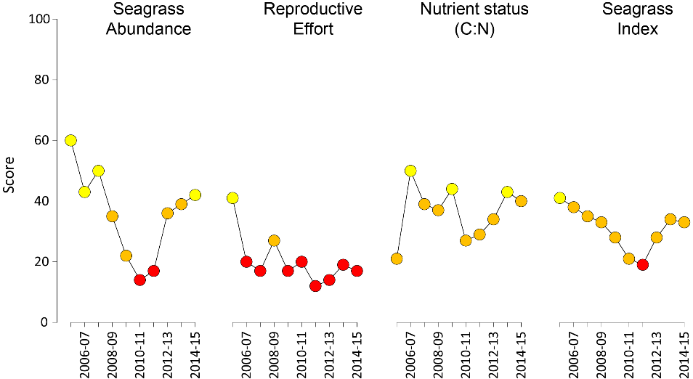
Figure 4. Report card scores (NRM regional averages pooled) for each indicator and total seagrass index over the life of the MMP.
Values are indexed scores scaled from 0-100; ■ = very good (81-100), ■ = good (61 - 80), ■ = moderate (41 - 60), ■ = poor (21 - 40), ■ = very poor (0 - 20). NB: Scores are unitless.
Reproductive effort increased at estuary and reef subtidal habitats, but declined in coastal and reef intertidal habitats in 2014-15 relative to the previous year, particularly in the Cape York and Fitzroy regions. Seed banks, which had shown some signs of improvement following 2011 extreme events, were reduced in all habitats in 2014-15. The reproductive effort score declined overall and remained very poor. This suggests that most meadows have limited capacity to recover from disturbances (low resilience) and may be considered vulnerable to further disturbances.
Seagrass leaf tissue nutrients for foundation species across the majority of GBR habitats and locations (late 2014) indicated that nitrogen (N) was in surplus relative to carbon (C:N reduced), and phosphorus (N:P increased). The most notable changes in C:N occurred in Fitzroy and Burnett Mary NRMs with a drop in score to low and moderate, respectively. This was associated with higher %N, but may also have been caused by lower photosynthetic C uptake associated with lower photosynthesis as a consequence of slightly reduced light at many sites.
Across the GBR NRM regions, the seagrass report card scores during 2014-15 were slightly improved but remained poor in the Cape York, Wet Tropics, and Mackay Whitsunday regions. In the Fitzroy and Burnett Mary, scores were reduced in 2014-15 and remained poor, which may have been affected by TC Marcia. The Burdekin was the only NRM to drop in rating from good to moderate (Figure 5,). The fluctuating scores across the GBR indicate a system that is recovering, with past climate impacts leaving a legacy of reduced resilience such that environmental perturbations in a relatively moderate climatic year have impacted overall condition.
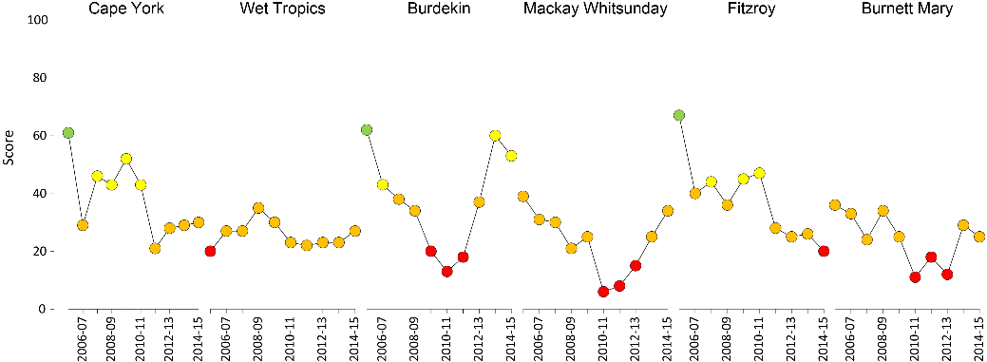
Figure 5. Report card of seagrass condition for each NRM region (averaged across indicators).
Values are indexed scores scaled from 0-100; ■ = very good (81-100), ■ = good (61 - 80), ■ = moderate (41 - 60), ■ = poor (21 - 40), ■ = very poor (0 - 20). NB: Scores are unitless.

Climate and environmental pressures
The reporting year 2014-2015 was relatively moderate (generally around long-term average conditions) in terms of within canopy conditions and the occurrence of extreme weather events (Table 9), with the only exception being above-average water temperature in central and northern GBR meadows.

Table 9. Summary of environmental conditions at monitoring sites across the GBR in 2014-15 compared to the long-term average (range indicated for each data set). Regional and habitat-specific levels are provided in later sections. *intertidal only. 1969-1997
 | Long-term average |  | 2014-15
Climate
Cyclones (1968-2015) | 2.76 |  | 2
Rainfall (1998-2015) | 1353.1 mm |  | 1039.5 mm
Riverine discharge (1970-2015) | 45,351,040 L yr⁻¹ |  | 33,074,908 L yr⁻¹
Plume exposure (2006-2015) | not available |  | 88.2%
Winds >25km hr⁻¹ (1998-2015) |  | 110.4 d yr⁻¹ |  | 105.2 d yr⁻¹
Within seagrass canopy
Within canopy temperature (2003-2015)* | 25.6 ±0.4°C (46.6°C) |  | 25.7 ±0.4°C (41°C)
Within canopy light (2008-2015) | 13.4 mol m⁻² d⁻¹ |  | 12.8 mol m⁻² d⁻¹
Proportion mud estuary intertidal (1999-2015)  coast intertidal (1999-2015)  reef intertidal (2001-2015)  reef subtidal (2008-2015) | 48.3 ±1.8%  27.7 ±2.1%  5.0 ±0.8%  3.5 ±1.0% |  | 50.5 ±2.7%  17.5 ±1.1%  2.0 ±0.3%  nil

Two tropical cyclones affected the Queensland coast in 2014-15, which is a reduction on numbers from previous years. TC Marcia was a category 5 cyclone that made landfall at its peak strength near Shoalwater Bay on 20th February 2015 and had destructive winds causing substantial damage in the local area, and generating flooding to the south. A few days earlier, a tropical depression crossed the Queensland coast in Cape York, and this was later classified as TC Lam as it tracked through the Gulf towards the Northern Territory. The second severe storm to impact the GBR was TC Nathan which made landfall between Cape Melville and Cape Flattery on the 20th March as a category four system, after menacing the far northern region of 10 days. Damage from destructive winds was localised, however, the system elevated rainfall levels in the southern Cape York and northern Wet Tropics regions.
River discharge was lower than average (<1.5 times lower than the long-term median), throughout much of the GBR (Table 10). However, some rivers in the central and southern GBR (e.g. Pioneer, Calliope, Burnett and Mary) had above-average discharge in 2014-15. Exposure of the inshore GBR to plume waters (Figure 6) was the lowest since 2003, and almost four times lower than in 2011 (Lønborg, et al. 2015).

Table 10. Long term annual discharge (in megalitres) for the major GBR catchment rivers in proximity to the inshore seagrass monitoring sites (where data available) for the 2014-15 wet season
(c.a., from Nov 1st to Apr 30th), compared against the previous wet seasons and long-term (LT) median. Colours indicate levels above LT median: yellow for 1.5 to 2 times; orange for 2 to 3 times, and red for greater than 3 times. Long term statistics were calculated based on the wet seasons from Nov 1st, 1949 to Apr 30th, 2000. (Data source: Queensland Department of Natural Resources and Mines on dnrm.qld.gov.au/water/water-monitoring-and-data/portal accessed 31 October 2014). Compiled by Devlin et al In prep
River | LT  median | 2006‐  2007 | 2007‐  2008 | 2008‐  2009 | 2009‐  2010 | 2010‐  2011 | 2011‐  2012 | 2012‐  2013 | 2013‐  2014 | 2014‐  2015
Pascoe | 3,758,926 | 1,904,267 | 1,984,563 | 1,909,050 | 4,604,083 | 5,918,996 | 2,275,527 | 2,483,531 | 4,738,541 | 1,872,672
Stewart | 1,261,346 | 1,002,841 | 576,106 | 655,502 | 1,093,462 | 2,180,850 | 616,070 | 523,353 | 1,311,775 | 298,816
Normanby | 4,311,761 | 3,311,243 | 6,930,433 | 4,457,729 | 5,597,116 | 11,333,284 | 2,181,990 | 3,462,238 | 5,059,657 | 2,914,859
Annan | 233,451 | 158,463 | 302,826 | 139,788 | 321,352 | 485,961 | 266,463 | 129,571 | 194,612 | 246,939
Daintree | 1,674,105 | 1,644,938 | 2,009,497 | 1,474,320 | 2,797,531 | 3,772,451 | 2,297,034 | 1,598,789 | 4,922,980 | 1,825,840
Mossman | 1,117,106 | 1,218,895 | 1,337,663 | 1,063,358 | 1,616,590 | 2,014,902 | 1,526,184 | 1,147,367 | 1,918,522 | 874,068
Barron | 582,000 | 454,661 | 1,767,598 | 849,997 | 550,257 | 2,119,801 | 852,055 | 328,260 | 663,966 | 380,395
Russell‐Mulgrave | 3,571,695 | 3,619,673 | 4,747,091 | 3,621,368 | 3,788,476 | 7,686,876 | 5,307,153 | 2,795,035 | 4,548,469 | 2,933,026
Johnstone | 8,747,438 | 10,321,785 | 9,254,951 | 10,826,942 | 8,792,076 | 18,204,766 | 10,523,254 | 7,108,439 | 10,286,870 | 5,587,911
Tully | 3,532,821 | 4,738,947 | 3,834,178 | 4,308,192 | 3,581,372 | 7,442,768 | 3,425,096 | 3,341,887 | 4,322,496 | 2,659,775
Murray | 1,048,599 | 1,353,402 | 1,271,771 | 1,893,451 | 961,533 | 4,267,125 | 2,062,103 | 1,006,286 | 1,531,172 | 366,212
Herbert | 3,345,584 | 4,384,322 | 3,671,428 | 10,329,363 | 3,478,592 | 12,593,674 | 4,545,193 | 3,189,804 | 4,281,607 | 1,095,372
Black | 319,427 | 974,687 | 1,264,706 | 2,093,840 | 1,045,240 | 2,431,703 | 1,275,927 | 321,774 | 715,861 | 30,141
Bohle | 182,256 | 1,158,781 | 1,380,736 | 1,985,663 | 1,248,524 | 2,092,684 | 1,324,707 | 276,584 | 1,177,255
Haughton | 444,761 | 1,343,344 | 1,853,345 | 2,561,844 | 1,148,893 | 2,415,758 | 1,755,712 | 517,069 | 573,976 | 120,674
Burdekin | 5,312,986 | 9,768,935 | 27,502,710 | 29,352,391 | 7,946,435 | 34,834,316 | 15,568,159 | 3,424,572 | 1,458,772 | 880,951
Don | 189,598 | 610,112 | 1,707,903 | 907,810 | 534,581 | 3,136,184 | 802,738 | 578,391 | 324,120 | 171,305
Proserpine | 100,962 | 308,713 | 527,688 | 452,517 | 360,895 | 2,389,111 | 358,294 | 258,887 | 24,437
O’Connell | 1,055,516 | 1,288,415 | 1,796,073 | 1,338,245 | 2,293,392 | 4,112,676 | 1,948,591 | 764,170 | 646,537 | 141,008
Pioneer | 391,142 | 980,774 | 1,507,449 | 997,098 | 1,575,469 | 3,630,422 | 1,567,684 | 1,162,871 | 635,315 | 2,028,936
Sandy | 919,275 | 1,305,970 | 2,852,589 | 1,478,753 | 2,932,049 | 4,809,239 | 2,854,703 | 1,948,929 | 737,580 | 241,254
Waterpark | 781,523 | 294,909 | 1,397,756 | 550,135 | 1,595,833 | 2,718,432 | 825,657 | 2,904,319 | 1,632,466 | 1,128,027
Fitzroy | 3,071,435 | 1,038,555 | 12,410,891 | 2,002,101 | 11,755,415 | 37,942,149 | 7,993,273 | 8,530,491 | 1,578,610 | 2,681,949
Calliope | 161,029 | 4,679 | 315,044 | 137,805 | 520,524 | 1,000,032 | 345,703 | 1,558,380 | 283,790 | 479,868
Baffle | 510,378 | 10,310 | 1,297,575 | 325,702 | 2,132,966 | 3,650,093 | 1,775,749 | 2,030,545 | 275,517 | 710,352
Kolan | 64,222 | 0 | 102,198 | 4,090 | 289,107 | 779,168 | 307,837 | 810,411 | 45,304 | 213,857
Burnett | 310,366 | 32,868 | 18,369 | 27,012 | 1,125,102 | 9,421,517 | 643,137 | 7,581,543 | 218,087 | 853,349
Burrum | 59,577 | 0 | 0 |  |  |  |  |  | 0
Mary | 975,227 | 621,459 | 2,146,131 | 1,493,129 | 2,696,672 | 8,719,106 | 4,340,275 | 7,654,320 | 594,612 | 1,651,901
GBR total  (from 1970) | 45,351,450 | 54,223,017 | 96,620,400 | 87,807,344 | 77,634,356 | 203,454,214 | 79,981,177 | 67,760,121 | 55,723,781 | 33,074,908

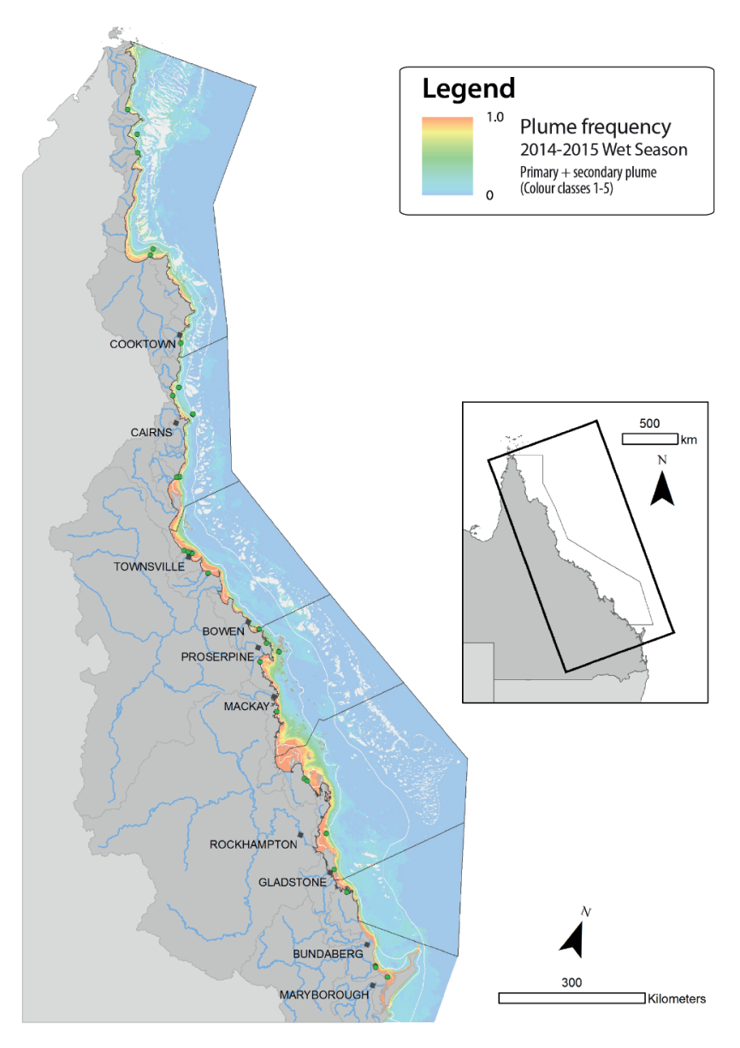
Figure 6. Plume exposure (colour classes 1 – 5, primary and secondary water) frequency in the GBR from December 2014 to April 2015
ranging from frequency of 1 (red, always exposed) to 0 (dark blue, never exposed). Green dots show seagrass monitoring locations.

Within canopy seawater temperature
Within seagrass canopy seawater temperature data were reported for the period of September 2003 to May 2015. Over the 2014-15 monitoring period, seagrasses in the Mackay Whitsundays NRM region (all locations pooled) experienced the greatest number of days (62 days) in the GBR where sea temperatures exceeded 35°C followed by the 3 most northern NRMs: Cape York, Wet Tropics and Burdekin (Figure 7). The only regions to experience extreme (>40°C) seawater temperatures in 2014-15 were the Wet Tropics (40.3°C) and Fitzroy (41.0°C) NRM regions on the 21 January 2015.
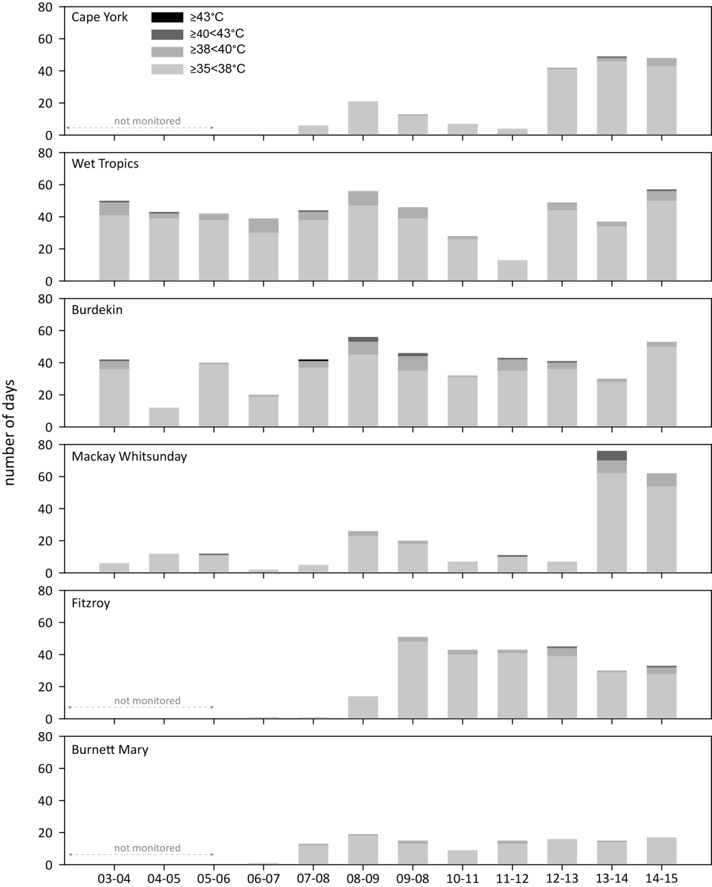
Figure 7. Number of days when inshore intertidal sea temperature exceeded 35°C, 38°C, 40°C and 43°C in each monitoring period in each NRM region.
Thresholds adapted from Campbell, et al. 2006; Collier et al. 2012b.
Within canopy seawater temperatures were higher than the long-term (10 year) average over the 2014-15 monitoring period (Figure 8); the warmest in 5 years. The warmest period since MMP monitoring commenced was 2005-06 and the coolest was 2011-12 (Figure 8).
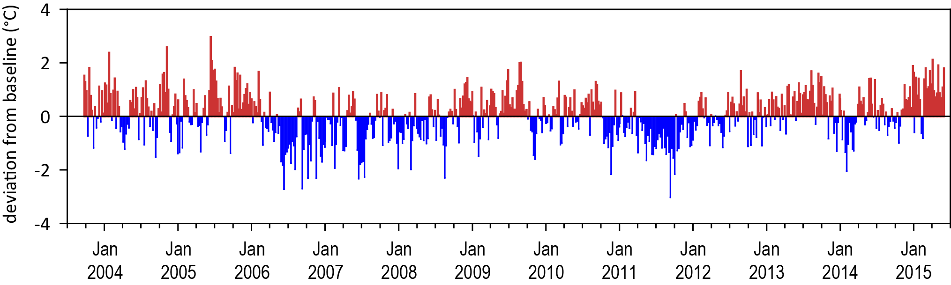
Figure 8. Inshore intertidal sea temperature deviations from baseline for GBR seagrass habitats 2003 to 2014.
Data presented are deviations from 10-year mean weekly temperature records (based on records from September 2003 to June 2015). Weeks above the long-term average are represented as red bars and the magnitude of their deviation from the mean represented by the length of the bars, bars are blue for weeks with temperatures lower than the average and are plotted as negative deviations.
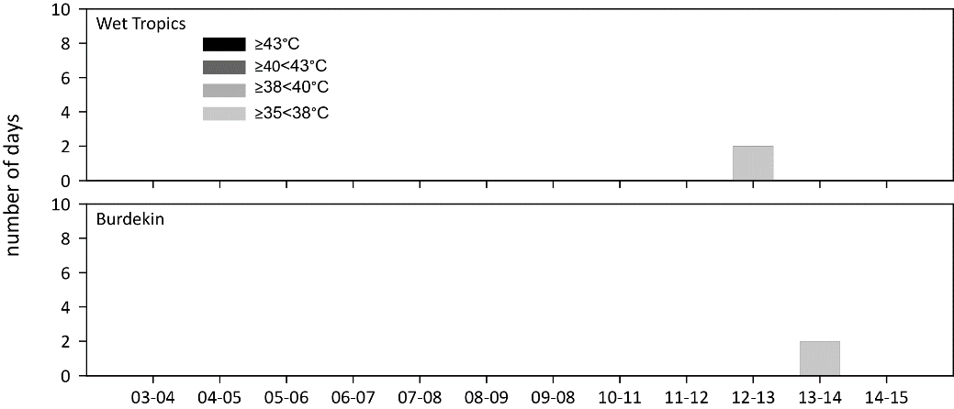
Figure 9. Number of days when inshore subtidal sea temperature exceeded 35°C, 38°C, 40°C and 43°C in each monitoring period in each NRM region.
Thresholds adapted from Campbell, et al. 2006; Collier, et al. 2012b.

Daily incident light
Daily incident light (I_{d}, mol m⁻² d⁻¹) reaching the top of the seagrass canopy in the GBR in 2014-15 (12.8 mol m⁻² d⁻¹ ) was slightly lower than the long-term average (13.4 mol m⁻² d⁻¹) (Figure 10). Cape York sites have the highest I_{d} (18.6 mol m⁻² d⁻¹), followed by Fitzroy (14.4 mol m⁻² d⁻¹), Burnett Mary (13.8 mol m⁻² d⁻¹) and Wet Tropics (13.0 mol m⁻² d⁻¹), with Burdekin sites having the lowest (9.8 mol m⁻² d⁻¹); however the Wet Tropics and Burdekin both have subtidal sites, with lower I_{d} than intertidal sites. With these excluded, I_{d} is second highest in the Wet Tropics (16.6 mol m⁻² d⁻¹), while the Burdekin remains lowest (10.8 mol m⁻² d⁻¹). Compared to the long-term average, in all regions I_{d} was lower than the long-term average, except in Cape York where loggers were only deployed for some of the 2014-15 year as site visitation was reduced to once per year and loggers recorded only from October-March, when I_{d} is highest. Daily light for each site is presented in Appendix 4.
Threshold exceedance (number of days less than 5mol m⁻² d⁻¹, for northern Halodule uninervis dominated meadows (Collier, et al. 2012b) and <6 mol m⁻² d⁻¹ for southern Zostera muelleri dominated meadows (Chartrand et al. 2016)) for 2014-15 (20.0% of days) was similar to the long-term average (17.6% of days). The thresholds were exceeded the most frequently in the Burdekin (36% of days) followed by Mackay Whitsunday (25.7%), Burnett Mary (18.5%), Fitzroy (17.2%), Wet Tropics (13.8%), and the least often in Cape York (11.3%).
Daily light in shallow habitats can be affected by water quality, cloudiness and the depth of the site, which affects the frequency and duration of exposure to full sunlight at low tide (Anthony et al. 2004; Fabricius et al. 2012); however, the differences in I_{d} among seagrass meadows is largely a reflection of site-specific differences in water quality as outlined in earlier reports (McKenzie, et al. 2015). Turbidity and chlorophyll monitoring is no longer in place at seagrass sites. However, flood plume mapping (Devlin, et al. 2015), is used to derive water type exposure at seagrass sites and frequency of exposure to flood plume waters can be a predictor of changes in seagrass abundance (see case study 2).
Figure 10. Average daily light (left-hand panels) and thresholds exceeded (% days, right-hand panels) for coastal, estuarine, reef intertidal, and reef subtidal sites including the long-term average and the value for the 2014-15 reporting period.
NRM regions: WT= Wet Tropics, BDT = Burdekin; M-W = Mackay Whitsunday; F = Fitzroy; BM = Burnett Mary.
Long-term trends demonstrate that the peak in canopy light occurs in September to December as incident solar irradiation reaches its maximum (Figure 11a). In 2014-15 the highest light levels were reached in October 2014. The lowest light levels occur in the wet season and through winter, in particular during January to April. The GAM model has an improved level of prediction with habitat (Figure 11b) (Appendix 5), and so further detail on I_{d} within each habitat and NRM region is given in the following sections.
a. b.
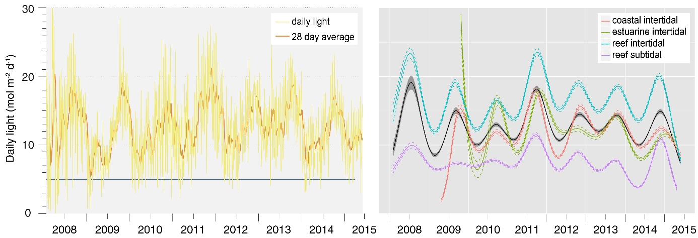
Figure 11. Daily light for all sites combined and GBR-wide trend (GAM plot) in daily light for each habitat from 2008 to 2015.

Indicators of seagrass condition
In the 2014-15 monitoring period, although the overall seagrass abundance score improved (Figure 4), 62% of the MMP sites examined remained classified as poor or very poor in abundance (below the guidelines) in 2014-15, with an annual average abundance (all sites and sampling events) of 13.3 ±1.5% for estuarine, 13.0 ±1.5% for coastal, 15.2 ±1.7% for reef and 21.1 ±2.4% for subtidal reef.
Seagrass abundance at meadows monitored in the MMP declined from 2005-06 until 2012-13, after which abundances increased (Figure 12). Based on the average score against the seagrass guidelines (determined at the site level), the abundance of inshore seagrass in the GBR over the 2014-15 period remained in a poor state (all sites and seasons pooled, unweighted) (Figure 12).
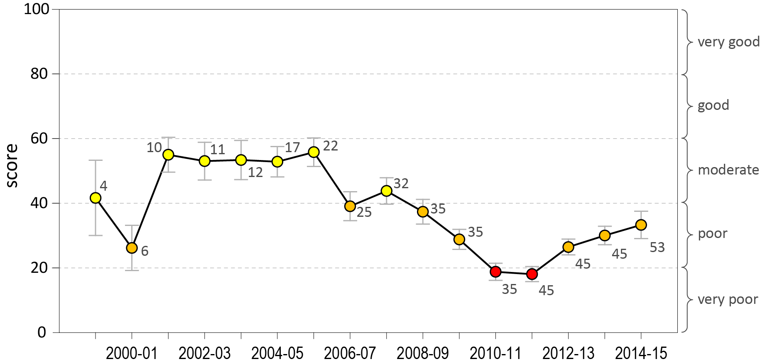
Figure 12. Long-term GBR average seagrass abundance score (all sites and seasons pooled irrespective of NRM region) (±Standard Error) for each monitoring period from 1999 to 2015.
Median percentage cover at a site for each monitoring event was scored relative to each site's guideline value, taking into account species and habitat. NB: score is unit less. Numbers indicate total sites contributing to the score.
The only region where the seagrass abundance score declined in 2014-15 from the previous monitoring period was the Wet Tropics NRM (Figure 13). All other regions had a small improvement, and the region with the greatest improvement in abundance score during 2014-15 was the Burnett Mary and the Mackay Whitsunday NRM, which both increased in score from poor to moderate (Figure 13).

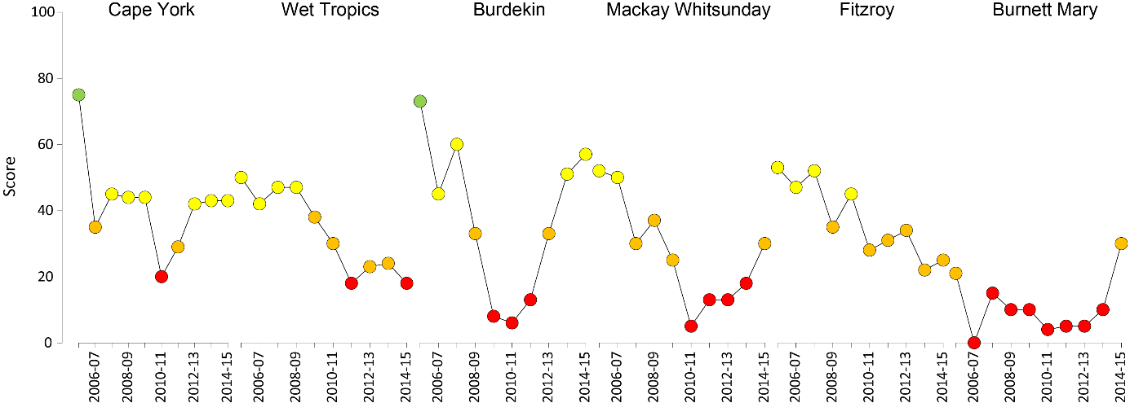
Figure 13. Regional report card scores for seagrass abundance over the life of the MMP
. For Paddock to Reef reporting scores are categorised in to a five point scale; ■ = very good (81-100), ■ = good (61 - 80), ■ = moderate (41 - 60), ■ = poor (21 - 40), ■ = very poor (0 - 20). NB: Scores are unitless.
Seagrass abundance scores have fluctuated within regions at habitats since monitoring was established. The most variable GBR seagrass habitat in abundance score (since 2005) was intertidal reef (CV=100.6%), followed closely by intertidal coast (CV=93.4%), subtidal reef (CV=83.1%) and lastly intertidal estuary (CV=68.4%).
The average seagrass % cover for the 2014-15 monitoring period was 15.7 ±1.8% (sites and habitats pooled). Although slightly higher than the previous period (13.6 ±1.6% in 2013-14), it remains below the GBR long-term average (17.8 ±2.1%, Sep99-Dec10) and the GBR historical baseline (22.6 ±1.2% Nov84‐Nov88) (McKenzie, et al. 2015). Since 1999, the percentage cover values for the GBR were mostly below 25% cover, and depending on habitat, only occasionally extend beyond 50% (Figure 14). These long-term percentage cover values were similar to the GBR historical baselines, where surveys from Cape York to Hervey Bay (between November 1984 and November 1988) reported most (three-quarters) of the percent cover values fell below 50% cover (Lee Long, et al. 1993). The findings negate the assumption that seagrass meadows of the GBR should have abundances closer to 100% before they are categorised as good.
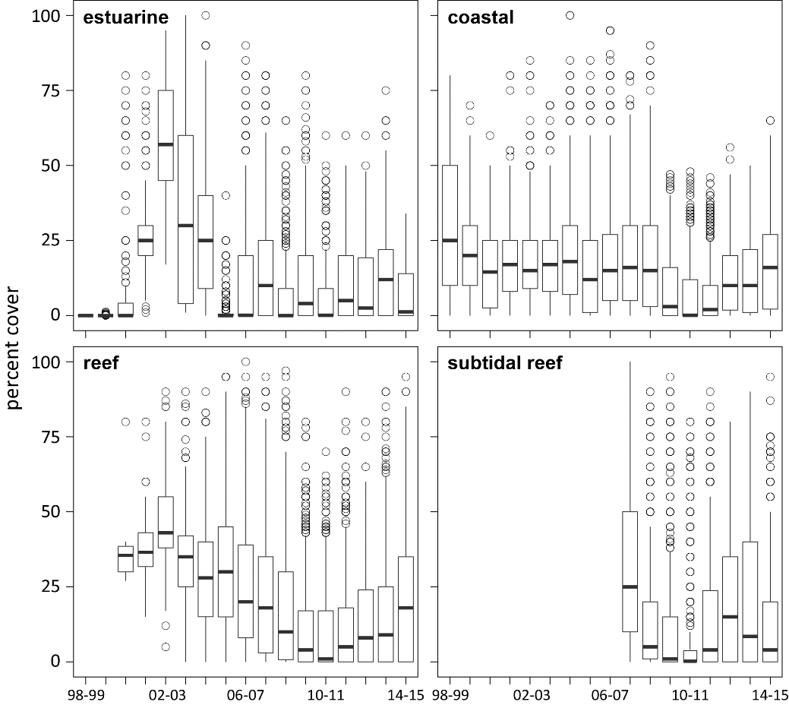
Figure 14. Seagrass percent cover measures per quadrat from meadows monitored from July 1999 to July 2015 (sites and habitats pooled).
The box represents the interquartile range of values, where the boundary of the box closest to zero indicates the 25th percentile, a line within the box marks the median, and the boundary of the box farthest from zero indicates the 75th percentile. Whiskers (error bars) above and below the box indicate the 90th and 10th percentiles, and the dots represent outlying points.
Long-term total seagrass abundance (percent cover) across the inshore GBR was generally higher in reef than coastal and estuarine habitats (Figure 14). Over the past decade, the patterns of seagrass abundance in each GBR habitat have differed (Figure 15, Figure 16), however both reef (including intertidal and subtidal) and coastal habitats show declining trajectories from 2009 to 2011. Note that Figure 15 illustrates seagrass abundance scored relative to the 95th percentile for each site, to enable a focus on GBR-wide trends. Since 2011, meadow abundance has been increasing in most habitats. However, seagrass trends have fluctuated in estuary habitats, most often at smaller localised scales where there have been some acute event related changes (McKenzie et al. 2012b).
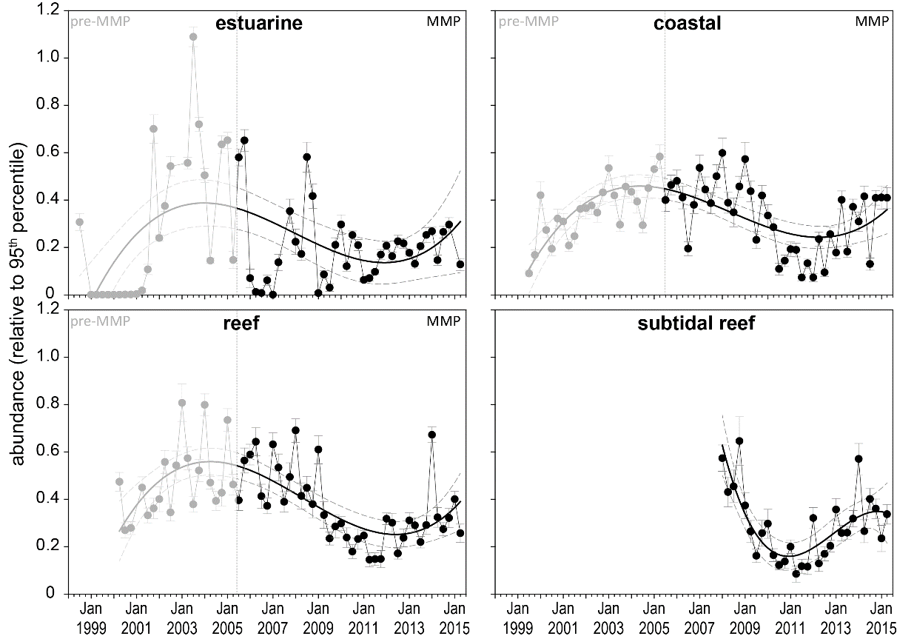
Figure 15. Generalised trends in seagrass abundance for each habitat type (sites pooled) relative to the 95th percentile
(equally scaled). The 95th percentile is calculated for each site across all data. Data prior and post implementation of the RRMMP displayed. Trendline is 3rd order polynomial, 95% confidence intervals displayed, estuarine (8 sites) r² = 0.32, coastal (16 sites) r² = 0.16, reef (17 sites) r² =0.63, subtidal reef (4 sites) r² =0.65.
An examination of the long term trends in seagrass abundance (% cover) across the Great Barrier Reef (habitats pooled) shows seagrass abundance gradually increased from 2001 to 2008 (with a mild depression in 2006-07 as a consequence of TC Larry)(Figure 16). From 2009, GBR seagrasses were in a declining trajectory as a result of multiple years of above average rainfall and climate‐related impacts, rendering them to a vulnerable condition. The extreme weather events of early 2011 resulted in further substantial decline in inshore seagrass meadows throughout much of the GBR. Post 2011, seagrasses have progressively recovered, although by 2014-15 still remained below the 2008 levels (Figure 16).
After the extreme weather events leading up to 2011, that caused widespread declines in seagrass area and abundance, recovery was primarily facilitated by the proliferation of species displaying colonising traits such as Halophila ovalis (Figure 17, Appendix 4). However, over the 2014-15 monitoring period, the proportion of species displaying colonising traits declined across all habitats in favour of species displaying opportunistic or persistent traits (sensu Kilminster, et al. 2015), with the most substantial changes occurring in coastal and reef subtidal habitats (Figure 17). The displacement of colonising species is a natural part of the meadow progression expected during the recovery of seagrass meadows. This pattern has been observed during past disturbance events (Birch and Birch 1984), but these results provide the most comprehensive evidence for meadow succession following substantial widespread disturbance events in tropical seagrass meadows that is known to the authors. Furthermore, this demonstrates the importance of species diversity, in particular diversity of species types, to overall resilience (Unsworth, et al. 2015). As such, species diversity is being considered for inclusion in the report card metric.

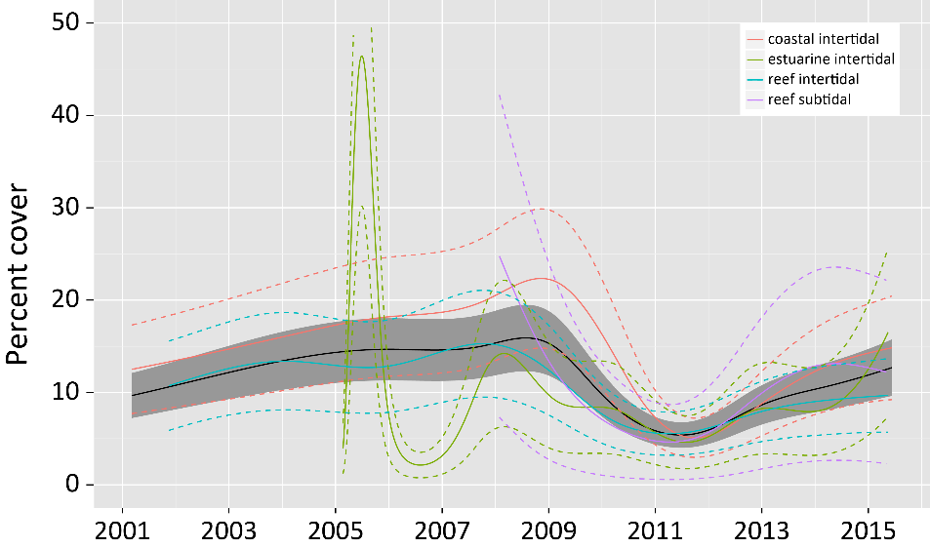
Figure 16. Trends in seagrass abundance (% cover) for each habitat type across the GBR represented by a GAM plot.
Trends are dark lines with shaded areas defining 95% confidence intervals of those trends.

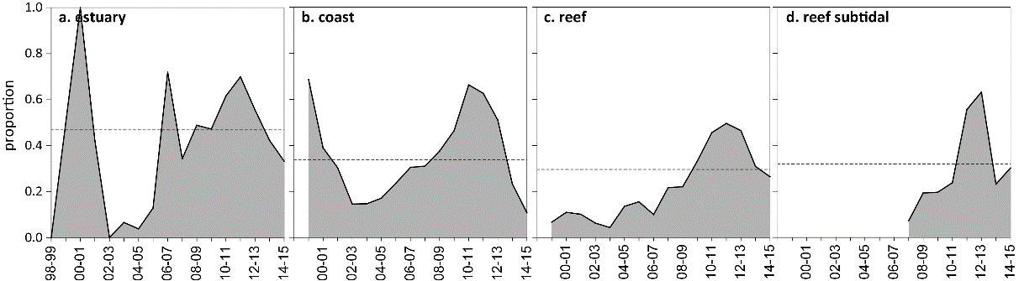
Figure 17. Proportion of total seagrass abundance composed of species displaying colonising traits (e.g. Halophila ovalis) in a) estuary intertidal, b) coastal intertidal, c) reef intertidal and d) reef subtidal habitats (sites pooled) for the GBR (regions pooled) each monitoring period
. Dashed line illustrates GBR average proportion of colonising species in each habitat type (Table 32).

Reproductive effort across the GBR, representing per area estimates of the number of reproductive structures (spathes, fruits, female and male flowers) produced by any seagrass species during the sampling period, was higher in estuary habitats over the long-term, than coastal and reef habitats (Figure 18). Reproductive effort has generally increased at all habitats since 2011; however, in 2014-15 there was a small decline in effort relative to the previous year in coastal and reef intertidal habitats (Figure 18).
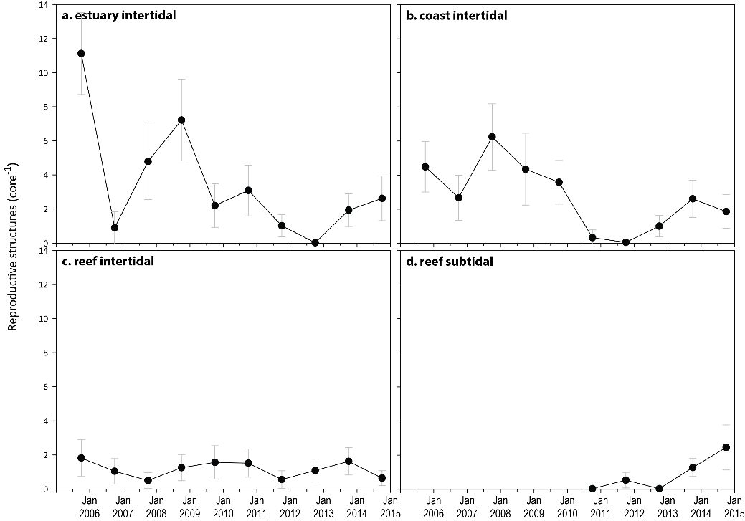
Figure 18. Seagrass reproductive effort (number of reproductive structures produced by all seagrass species) during the late dry of each monitoring period, for a) estuary intertidal; b) coast intertidal; c) reef intertidal; d) reef subtidal.
Reproductive effort across the GBR NRM regions during 2013-14 improved in the Wet Tropics, Mackay Whitsunday, Fitzroy and Burnett Mary (Figure 19). With the exception of the Burdekin and Mackay Whitsunday, reproductive efforts in all other regions was classified as very poor in 2013-14 (Figure 19).

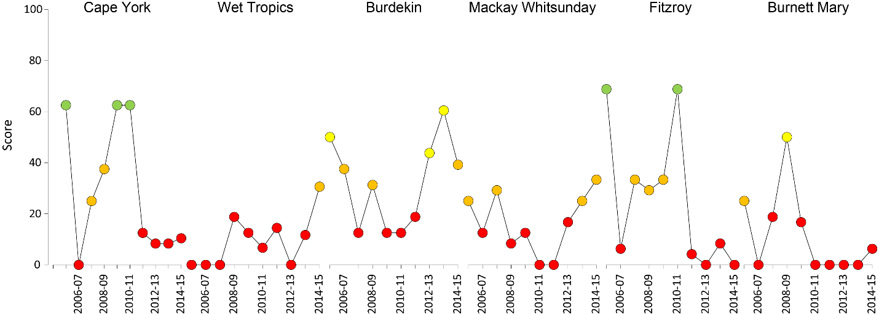
Figure 19. Regional report card scores for seagrass reproductive effort over the life of the MMP
. For Paddock to Reef reporting scores are categorised in to a five point scale; ■ = very good (81-100), ■ = good (61 - 80), ■ = moderate (41 - 60), ■ = poor (21 - 40), ■ = very poor (0 - 20). NB: Scores are unitless.

Seagrass reproductive effort scores have fluctuated across regions and habitats over the greater monitoring period. The most variable GBR seagrass habitat in reproductive effort score since monitoring was established was intertidal coast (CV=155.8%) and the least variable was subtidal (72.9%).
Seed banks across the inshore GBR meadows were higher in late dry and greater in coastal than reef or estuarine habitats over the long-term (8 years) (Figure 20). Coastal seed banks declined between 2008 and 2011, and subsequently increased (Figure 20b). However, in 2014-15 seed banks have declined in all habitats (Figure 20a), which have been caused by germination of seed banks, without subsequent replenishment. This suggests that have a reduced capacity to recover from disturbances in 2014-15, compared to the previous year. Seed banks are not currently included as a metric in the report card; however, given their importance as a feature of resilience in seagrasses of the GBR, they are being considered for future inclusion as an indicator in the reproduction metric.

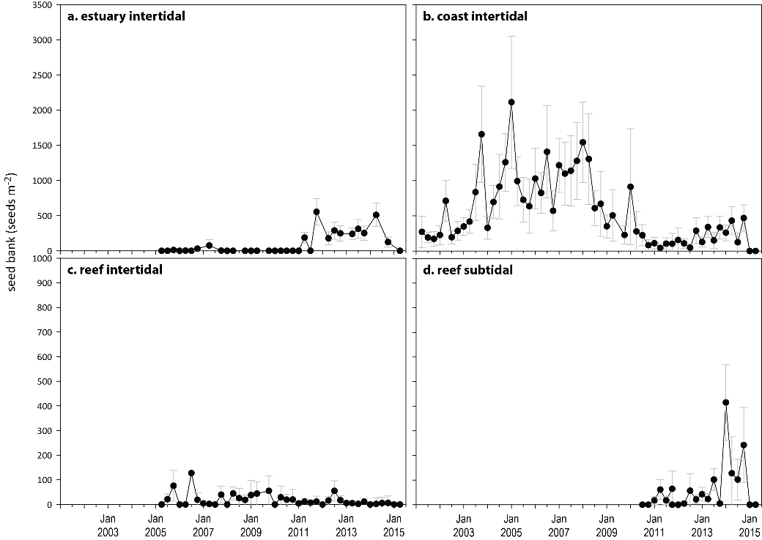
Figure 20. Average seeds banks (seeds per square metre of sediment surface, all sites and species pooled) in GBR seagrass habitats: a) estuary intertidal; b) coast intertidal; c) reef intertidal; d) reef subtidal.

Indicators of environmental condition

Seagrass tissue nutrients
Tissue nutrient concentrations are measured in the late dry (usually October) of the reporting period and differed both across and within habitats between years. It was necessary at some sites (see Table 3) to pool across foundation species as the presence of individual species has not remained constant over time at all locations since monitoring was established. As tissue nutrient ratios between co-occurring foundation species are not significantly different in this region (McKenzie, et al. 2012b), by pooling across species and habitat types, some trends are apparent.
Since 2005, median tissue nitrogen concentrations for all habitats have exceeded the global value of 1.8% (Duarte 1990; Schaffelke et al. 2005) (Figure 21). During 2014-15, seagrass leaf %N, with the exception of subtidal habitats, increased relative to the previous monitoring period (Figure 21). With the exception of estuarine seagrass, median leaf tissue phosphorus concentrations for all habitats either remained or increased above the global value of 0.2% (Duarte 1990; Schaffelke, et al. 2005) in 2014 (Figure 21). For the first time since 2009, leaf tissue %P fell below the global median at estuarine habitats (Figure 21).These findings indicate that nutrients were unlikely to be limiting seagrass growth, however, some concerns have been raised as to accuracy of the global tissue nutrient values (Schaffelke, et al. 2005). Furthermore, nutrient levels were unlikely to be physiologically “toxic”, as this tends to occur only at very high nutrient concentrations (Burkholder et al. 2007). For example, ammonium toxicity has been reported at concentrations greater than 25 µmol L⁻¹ (van Katwijk et al. 1997), however the GBR long-term (1989 to 2015) average ammonium concentration is 0.04 ±0.06 µmol L⁻¹ (Lønborg, et al. 2015).
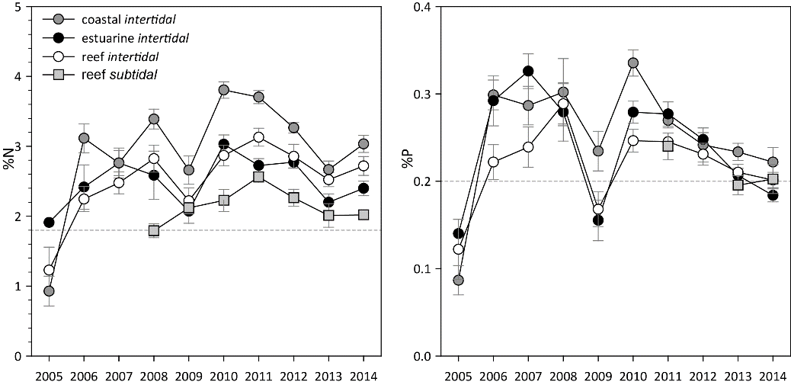
Figure 21. Median tissue nutrient concentrations (±Standard Error) in seagrass leaves for each habitat type (species pooled) over the entire monitoring program.
Dashed lines indicate global median values of 1.8% and 0.2% for tissue nitrogen and phosphorus, respectively (Duarte 1990).
Since 2007, all three intertidal habitat types (coast, reef and estuary) had C:N ratios <20, however, after 2011, the ratios have been gradually increasing (Figure 22) until 2014-15 when C:N either stabilised (reef subtidal), or declined (all other habitats). This C:N decline was associated with an increase in tissue N content (%N, see Appendix 4, Table 49) and may have resulted from slightly higher N availability; however, as annual discharge and plume exposure were generally low in 2014-15, this was unlikely to be a source of increased N. Average leaf tissue δ¹⁵N values increased at coast and reef subtidal in 2014-15, and across all habitats was between 0.6‰ and 3‰ (Figure 23), suggesting the primary source of N was influence by fertiliser and/or sewage (Udy and Dennison 1997b, see also Appendix A2.3). Below average daily light, which was found in most meadows (Figure 10), may also have contributed to lower C incorporation relative to N uptake. The less negative leaf tissue δ¹³C values also suggest lower C uptake (Grice, et al. 1996, see also Appendix A2.3), particularly in reef (intertidal and subtidal) habitats in 2014-15 (Figure 23).
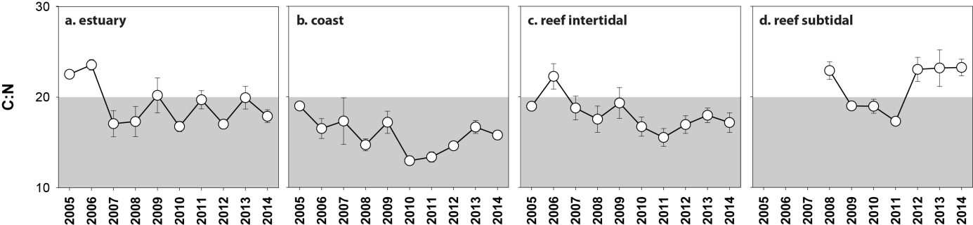
Figure 22. Elemental ratios (atomic) of seagrass leaf tissue C:N for each habitat each year
(foundation species pooled). Horizontal dashed line on the C:N ratio panel represents the accepted guideline seagrass “Redfield” ratio of 20:1 (Abal, et al. 1994; Grice, et al. 1996). C:N ratios below this line may indicate reduced light availability and/or N enrichment.

Intertidal seagrass habitats across the GBR were consistently improved in phosphorus (P) relative to carbon (C:P) and N relative to P (N:P) increasing (Figure 24), indicating a reduction in supply of P, relative to demand. Furthermore leaf tissue N:P ratios were around 30, which provides additional evidence of elevated N in the environment, the source of which is not apparent. Conversely, the leaf tissue molar N:P ratios remaining below 25 in reef subtidal habitats, suggests enrichment in P or N deficiency (Figure 24). The C:P and N:P ratios are important for describing changes in nutrient availability relative to growth requirements. Therefore, these ratios will be considered for future inclusion as part of the tissue nutrients metrics in the GBR report card.

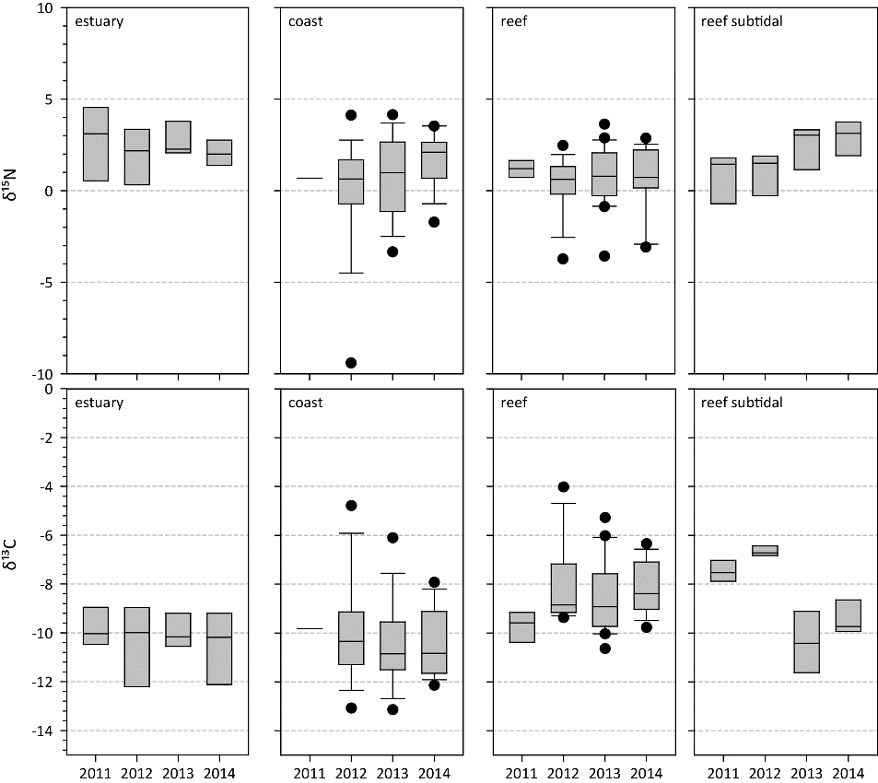
Figure 23. Seagrass leaf tissue δ¹³C and δ¹⁵N concentrations from each GBR seagrass habitat (locations pooled) in the late dry from 2011 to 2014
. The box represents the interquartile range of values, where the boundary of the box closest to zero indicates the 25th percentile, a line within the box marks the median, and the boundary of the box farthest from zero indicates the 75th percentile. Whiskers (error bars) above and below the box indicate the 90th and 10th percentiles, and the black dots represent outlying points.
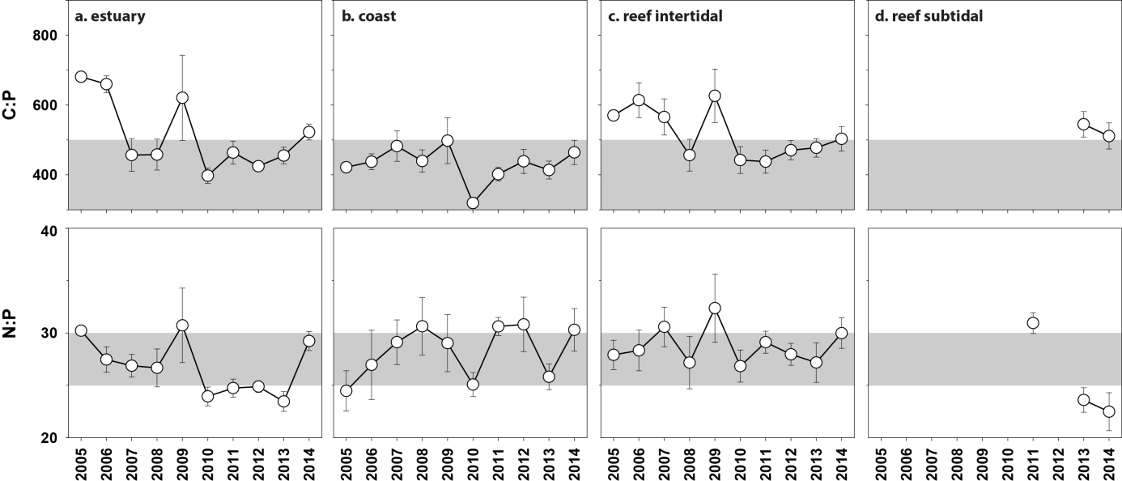
Figure 24. Elemental ratios (atomic) of seagrass leaf tissue C:P and N:P for each habitat each year
(foundation species pooled) (± Standard Error). Horizontal shaded band on the N:P ratio panel represents the range of value associated with N:P balance ratio in the plant tissues, i.e. a seagrass “Redfield” ratio (Atkinson and Smith 1983; Duarte 1990; Fourqurean, et al. 1992b; Fourqurean and Cai 2001). N:P ratio above this band indicates P limitation, below indicates N limitation and within indicates replete. Horizontal dashed line on the C:P panel at 500 represents the value associated with C:P balance ratio in the plant tissues, C:P values <500 may indicate nutrient rich habitats (large P pool).
Seagrass nutrient status scores (using only C:N) were reduced in most NRMs in the 2014-15 year, compared to previous years (Figure 25). In particular, the Fitzroy and Burnett Mary scores were decreased in category to poor and moderate, respectively. Nutrient status remained poor in Cape York, Wet Tropics and Mackay Whitsunday, and remained good in the Burdekin, despite small drops in the score (Figure 25).

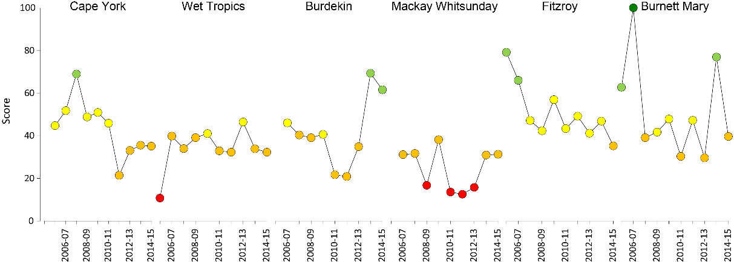
Figure 25. Regional report card scores for seagrass leaf tissue nutrient status (C:N) over the life of the MMP
. For Paddock to Reef reporting scores are categorised in to a five point scale; ■ = very good (81-100), ■ = good (61 - 80), ■ = moderate (41 - 60), ■ = poor (21 - 40), ■ = very poor (0 - 20).

Seagrass meadow sediments
Estuarine seagrass habitats across the GBR had a greater proportion of fine sediments (i.e. mud) than other habitats (Table 11). Sediments as coastal habitats were predominately medium and fine sands, while reef habitats (intertidal and subtidal) were dominated by medium sands (Table 11).
Table 11. Long-term average ( ±SE) sediment composition for each seagrass habitat (pooled across regions and time) monitoring within the GBR (1999-2015)
Habitat | Mud | Fine sand | Sand | Coarse sand | Gravel
estuarine intertidal | 51.2 ±7.5 | 19.6 ±5.6 | 26.3 ±6.3 | 0.2 ±0.6 | 2.8 ±2.4
coastal intertidal | 26.4 ±7.4 | 34.4 ±8.5 | 34.6 ±8.2 | 0.4 ±0.6 | 4.3 ±3.2
reef intertidal | 5.2 ±5.0 | 8.1 ±3.0 | 42.8 ±8.2 | 25.5 ±5.5 | 18.4 ±6.2
reef subtidal | 2.1 ±0.1 | 20.9 ±1.4 | 65.1 ±5.0 | 3.1 ±0.8 | 8.8 ±5.0

Since monitoring was established, the composition of sediments has fluctuated at all habitats, with the proportion of mud declining below the long-term average at estuary and coastal habitats immediately following periods of physical disturbance from storms (e.g. tropical cyclones) in 2006 and/or 2011. Conversely, the proportion of mud increased above the long-term average at reef (intertidal and subtidal) habitats during periods of extreme climatic events (e.g. tropical cyclones and/or flood events). During the 2014-15 monitoring period, the proportion mud increased at estuarine habitats, but decreased across all other habitats relative to the previous year (Figure 26).
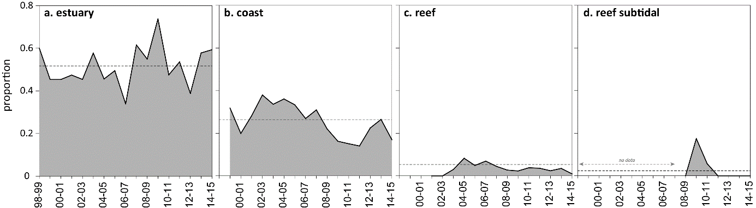
Figure 26. Proportion of sediment composed of mud (grain size <63µm) at GBR seagrass monitoring habitats from 1999-2015.

Epiphytes and macroalgae
Epiphyte cover on seagrass leaves across the GBR was higher in the wet than the dry season across all seagrass habitats in 2014-15. Epiphyte cover at intertidal estuary habitats decreased below the GBR long-term average in 2014-15 (Figure 27). Conversely, epiphyte cover increased at all other habitats in 2014-15, but remained close to the GBR long-term average (Figure 27).
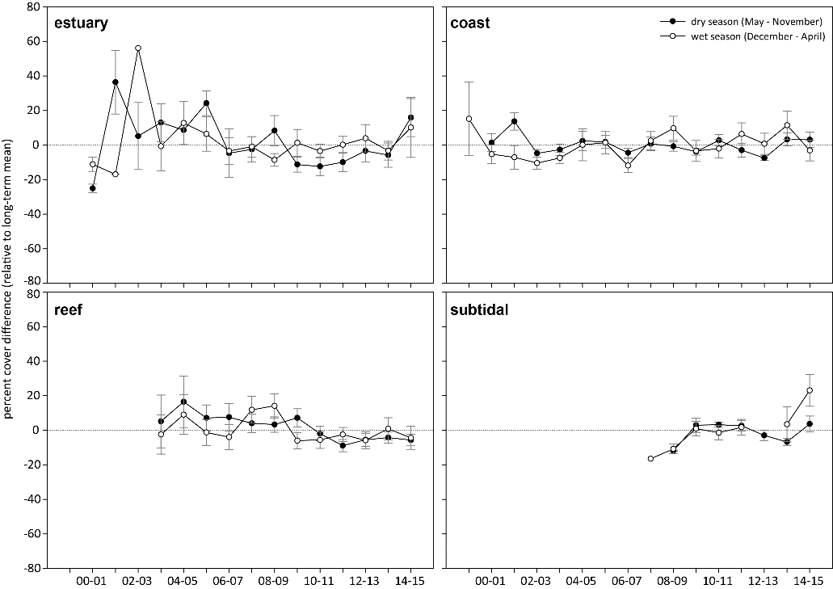
Figure 27. Epiphyte abundance (% cover) relative to the long-term average for each GBR seagrass habitat
(sites pooled, ±SE). GBR long-term average; estuarine = 16.2 ±8.4% coastal=15.1 ±3.1%, reef = 20.2 ±3.3%, subtidal= 7.7 ±1.6%.
Macroalgae abundance changed little and remained low either at or below the GBR long-term average during the 2014-15 monitoring period (Figure 28). A gradual increase at subtidal habitats during the late dry season over the last 3 years may suggest elevated nutrients at most sites.
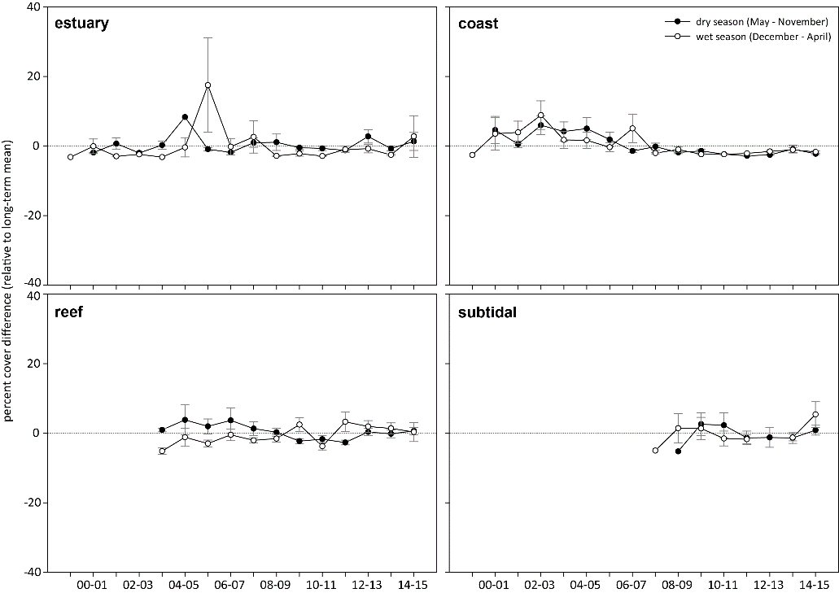
Figure 28. Macroalgae abundance (% cover) relative to the long-term average for each inshore GBR seagrass habitat
(sites pooled, ±SE). GBR long-term average; estuarine = 2.5 ±1.0%, coastal=3.2 ±1.4%, reef = 6.2 ±1.8%, subtidal = 4.7 ±2.0%.

Cape York

2014-15 Summary
Waters entering the GBR lagoon from Cape York catchments are perceived to be of a high quality, with low levels of suspended sediments, nutrients and pesticides. Seagrass growth on reef and coastal habitats in the region appears primarily controlled by physical disturbance from waves/swell and associated sediment movement, with pulsed terrigenous runoff from seasonal rains affecting some coastal regions. In February 2015, the tropical depression which later formed into TC Lam crossed the coast near Lockhart River; just south of the Piper Reef and Shelburne Bay sites. There was a high frequency of exposure to green secondary flood plume water at seagrass sites in 2014-15, which indicates the possibility of some nutrient enrichment. However, within-canopy daily light remained above average for the year (annual average), and amongst the highest in the GBR, though in early 2015, coastal locations (BY, SR) had low light levels, in particular after the crossing of TC Nathan in March. This was also a time of frequent temperature threshold exceedance, and the combination of low light levels and high temperatures can impair growth. No extreme (>40°C) within-canopy seawater temperatures were experienced over the monitoring period and annual daytime tidal exposure was the lowest in 3 years (below median).
One location in Cape York (Archer Point) has been monitored since 2005, while locations further north have only been monitored from 2011 (after the climatic events that caused declines throughout the developing GBR coast). This makes it difficult to assess long-term trends across Cape York. Seagrass abundance, as well as changes in abundance, varied among sites within the region in 2014-15. In general, seagrass abundance increased relative to the previous period, except at one reef (Piper Reef) and one coastal (Shelburne Bay) location; which were closer to the path of the tropical depression which strengthened into TC Lam, and may have been physically disturbed by the event. The low seed bank and very poor reproductive effort at reef sites further indicates that they have low capacity to recover following such disturbance. In contrast, coastal seagrass meadows may have greater resilience on account of their good abundance and dense seed banks. Seagrass leaf tissue nutrients (C:N) were below 20 and indicate high available N relative to C uptake. On account of their moderate abundance, it appears seagrass across the Cape York NRM region were able to resist the less than favourable environmental conditions of 2014-15, and rather than decline, the regional seagrass state improved slightly over the last 12 months, but remains poor (Figure 29).
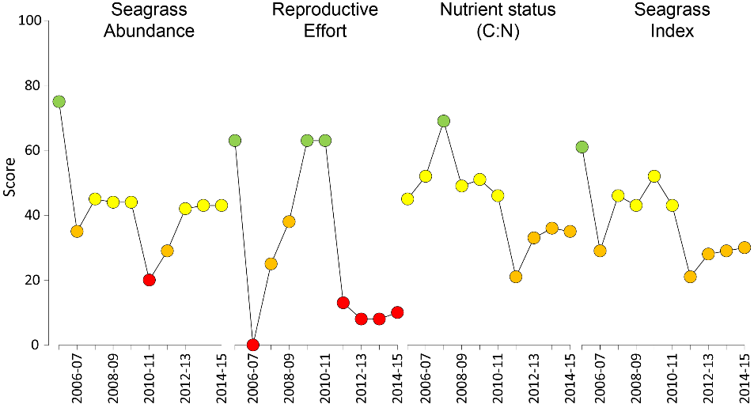
Figure 29. Report card of seagrass condition (indicators and index) for the Cape York NRM region
(averaged across habitats and sites). Values are indexed scores scaled from 0-100; ■ = very good (81-100), ■ = good (61 - 80), ■ = moderate (41 - 60), ■ = poor (21 - 40), ■ = very poor (0 - 20). NB: Scores are unitless.

Climate and environmental pressures
Rainfall was below the long-term average and river discharge in 2014-15 was less than half that of the previous year, with flows close to the long-term median (Table 12). However, wind was above the long-term average and may have continued to resuspend fine sediments with nutrients absorbed to their surface. The inshore waters of Cape York had predominantly secondary water type, and some primary type exposure through the wet season (December-April, Figure 30), resulting in a frequency of exposure to both (f_{(P+S)}) ranging from 33 to 100% of weeks at seagrass monitoring sites (Table 13).
Table 12. Summary of environmental conditions at monitoring sites in Cape York region in 2014-15 compared to the long-term average (long-term range indicated for each data set).
 | Long-term average | 2014-15
Rainfall (1956-2015) | 1,558 mm | 1,344 mm
River discharge (1970-2015) | 4,048,660 L yr⁻¹ | 2,349,470 L yr⁻¹
Flood plume exposure (2006-2015) | unavailable | 82.4%
Daytime tidal exposure (2011-2015) | 65.21 hrs yr⁻¹ | 49.67 hrs yr⁻¹
Wind (2002-2015) | 93.3 days yr⁻¹ | 144.7 days yr⁻¹
Within canopy temperature (2011-2015) | 26.6°C (40.5°C) | 27.2°C (39.1°C)
Within canopy light (2012-2015) | 18.6 mol m⁻² d⁻¹ | 19.3 mol m⁻² d⁻¹

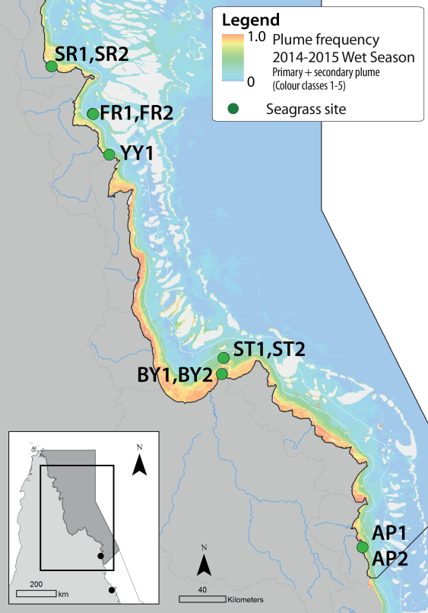
Figure 30. Frequency of exposure to plume water in the Cape York NRM, wet season (December 2014 – April 2015) composite.
Frequency calculated as number of weeks in wet season exposed to primary or secondary water (colour classes 1 – 5). Each colour class category is described by mean water quality values for TSS, CDOM, chlorophyll a and K_{d} (PAR) (Devlin, et al. 2015; Lønborg, et al. 2015). For site details, see Tables 3 & 4.

Table 13. Water type at each site (Loc) derived from MODIS true colour images
as colour classes of turbid primary water (class 1 – 4, red/brown), nutrient/chlorophyll-enriched secondary water (class 5, green), and tertiary (some freshwater/CDOM influence) or no plume influence (class 6 and 7 respectively, blue), for 22 weeks from December 2014 – April 2015. Also shown, median wet season colour class (Med), frequency of primary water as f_{(P)}, the frequency of secondary water as f_{(S)}, and the frequency of primary or secondary as f_{(P+S)}. *denotes data obtained from adjacent pixel.
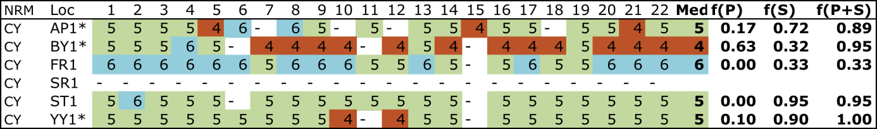
Daily light at Cape York locations has been monitored since October 2012 when sites were established. However, in the 2014-15 reporting year, sampling was reduced to once per year, and loggers record for just 5 – 6 months after deployment (i.e. Oct-Mar/Apr). Daily light is generally very high at all Cape York sites; however, the trends are highly variable among sites with no distinct pattern that characterises benthic light over the past three years (Figure 31).
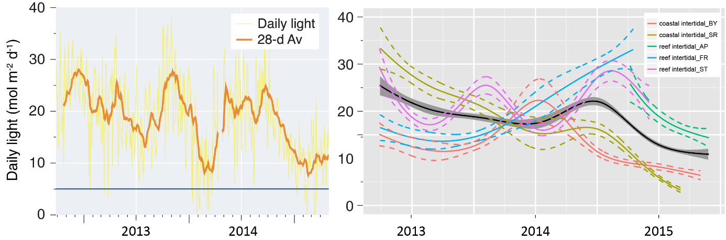
Figure 31. Daily light (mean) at Cape York sites with 28-d rolling average from 2012 to 2015 (left) and GAM plots (right)
with the black line showing mean trend for all sites (±95% confidence interval in grey shade) and coloured lines (with CI’s) for each location. Results of statistical analysis (GAM) and site-specific graphs (site-level daily light data plus 28-d rolling average) are shown in Appendix 5.
High temperatures (>35°C) were recorded from October to January 2015 across the region, with the highest temperature (39.1°C) recorded at 1:00pm on the 1st March 2015 at Bathurst Bay (Appendix 4). A greater number of days (5 days) where the sea water temperatures exceeded 38°C was experienced in 2014-15 (cf. 3 in 2013-14). Within canopy temperatures were slightly above the previous period and 0.6°C warmer on average than the long-term over the 2014-15 monitoring period.
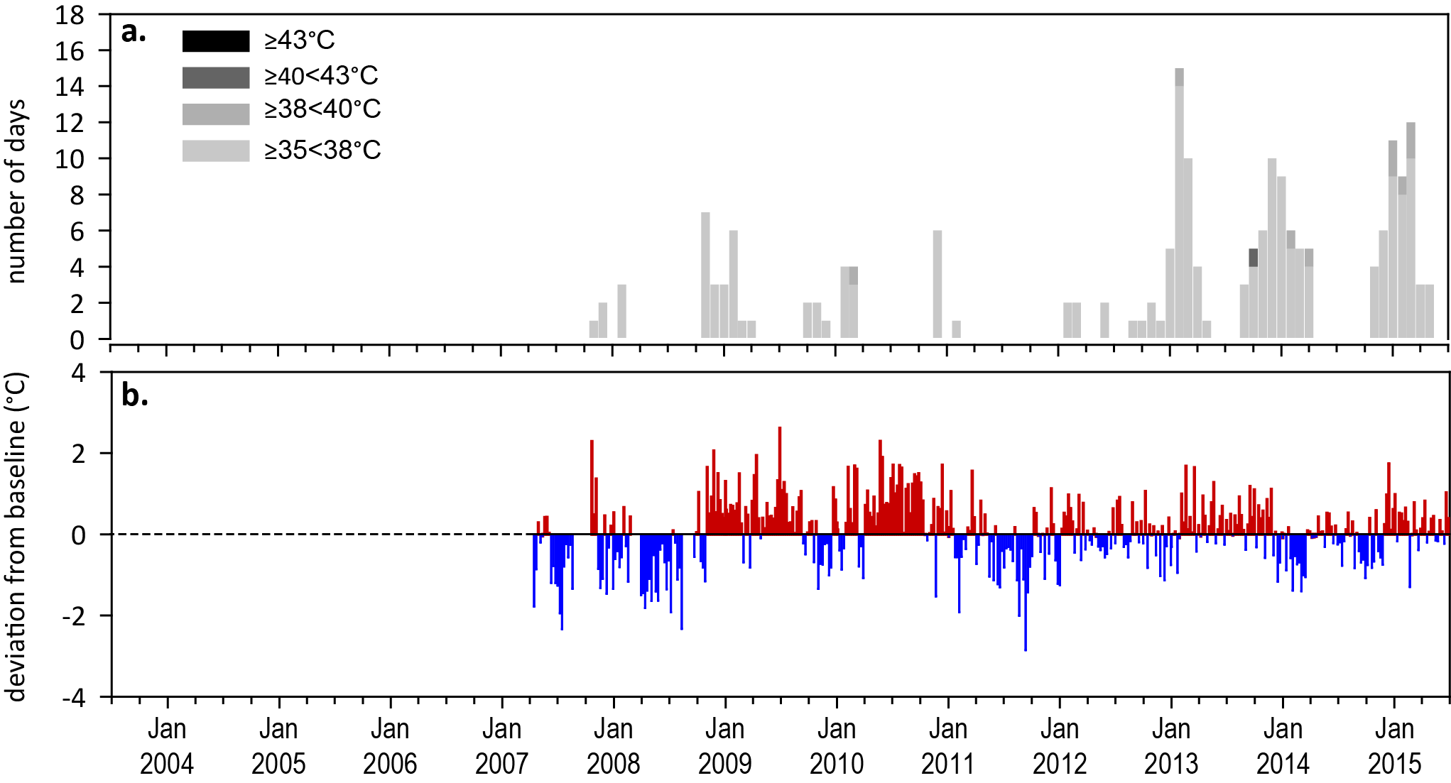
Figure 32. Inshore within canopy sea temperature for intertidal seagrass habitats in the Cape York NRM region from April 2007 to June 2015
: a) number of days when temperature exceeded 35°C, 38°C, 40°C and 43°C within each season (thresholds adapted from Campbell, et al. 2006); b) deviations at Archer Point from 7-year mean weekly temperature records (weeks above the long-term average are represented as red bars and the magnitude of their deviation from the mean represented by the length of the bars, bars are blue for weeks with temperatures lower than the average and are plotted as negative deviations). Dashed line represents period when monitoring not established.

Indicators of seagrass condition

Seagrass abundance, composition and extent
The seagrass abundance score across the region remained moderate in 2014-15 (Figure 29). Seagrass abundance at intertidal reef habitats declined from 2003 to 2012, and although has improved in cover since, remains in a poor state. Seagrass abundance at coastal habitats was in a very good state in 2012-13, however it declined to a good state in 2014-15. Meadows across the region were composed of a greater than average proportion of Halophila ovalis, a colonising species, which coupled with poor abundance may suggest weaker ecosystem resistance in some meadows.
The most southern location (Archer Point reef habitat) has been monitored for the greatest period of time in the region, while the other four locations were established in 2012 (Figure 33d). The long-term average seagrass cover at reef habitats in region varied little between seasons: 16.2% in the late dry and 15.9% in late monsoon season. Seagrass abundance in 2014-15 remained similar at the majority of sites, with the only considerable declines (>20% change) at Piper Reef (Figure 33a).
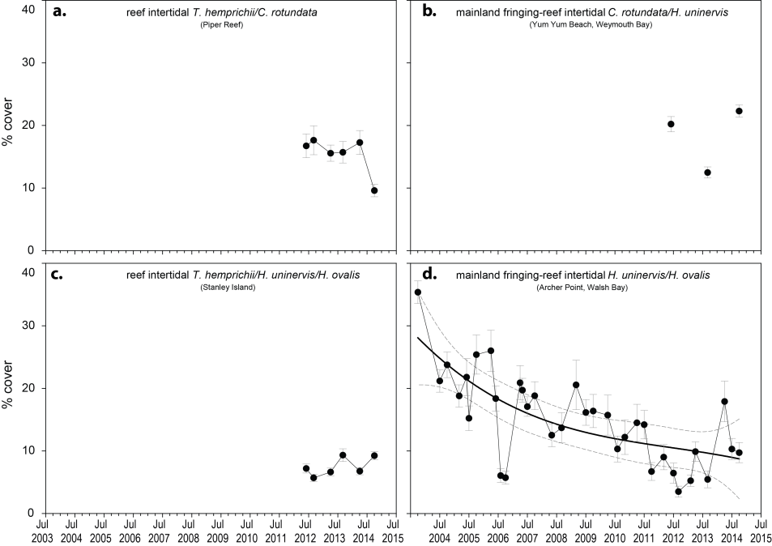
Figure 33. Seagrass abundance (% cover ± Standard Error) at inshore intertidal reef habitats (replicate sites pooled) in the Cape York NRM.
Trendline for Archer Point is 3rd order polynomial, 95% confidence intervals displayed, r² = 0.52.
In the late dry 2014, meadows in Cape York reef habitats had abundances of around 10% at all locations, except at Yum Yum Beach (Seagrass-Watch site), where it was 22.3 ±0.97%. Since monitoring was established at Archer Point (AP1) in 2003, seagrass cover has generally followed a seasonal trend with higher abundance in late dry period (McKenzie et al. 2012a). The seasonal trend at other meadows was less apparent (Figure 33). In 2014-15 seagrass abundance continued to increase at Archer Point from declines observed in 2011-12, while long-term trends are more difficult to elucidate for other sites with shorter monitoring history (Figure 34). Seagrass abundance at coastal habitats in the northern Cape York NRM region decreased slightly in 2014-15, and in central Cape York they increased considerably (Figure 34), although no long-term patterns were apparent due to the limited dataset.
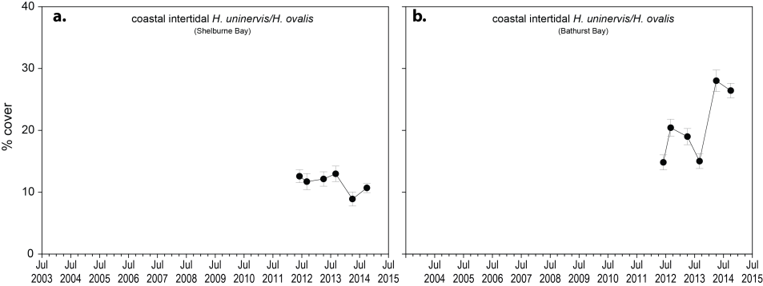
Figure 34. Seagrass abundance (% cover ± Standard Error) at inshore intertidal coastal habitats (sites pooled) in the Cape York NRM region.
An examination of the long term trends across the Cape York NRM region shows seagrass abundance (% cover) progressively decreased from 2003 to 2012, but has since remained low with a slight increase at coastal habitats (Figure 35).
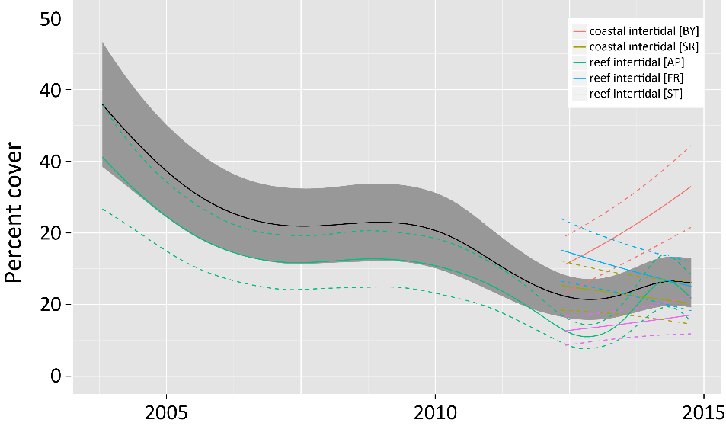
Figure 35. Temporal trends in seagrass abundance for each location in the Cape York NRM region represented by a GAM plot.
Regional trend (all locations pooled) represented by black line with grey shaded area defining 95% confidence intervals.
Cape York reef meadows were dominated by Thalassia hemprichii, Cymodocea rotundata, Halodule uninervis and Halophila ovalis with varying amounts of Syringodium isoetifolium and Enhalus acoroides (Appendix 4). At Archer Point (the location of the longest dataset), species composition has varied since sampling began in 2003 with the composition of H. ovalis fluctuating seasonally with increases in the late monsoon (Appendix 4). Seagrass at coastal habitats in the eastern Cape York NRM region were located on large shallow sand banks and dominated by H. ovalis/H. uninervis. At Bathurst Bay in the central section of Cape York, adjacent to Princess Charlotte Bay, meadows were dominated by Halodule uninervis (Appendix 4). Five seagrass species were present in the Bathurst Bay meadows, whereas only three species were present at Shelburne Bay (Appendix 4).

Seagrass meadows in the Cape York NRM region were composed of below GBR average proportion of species displaying colonising traits in 2014-15 (Figure 36). Fluctuations over the long-term suggests the meadows are dynamic in nature, however, this appears to have stabilised over the last 12-24 months.
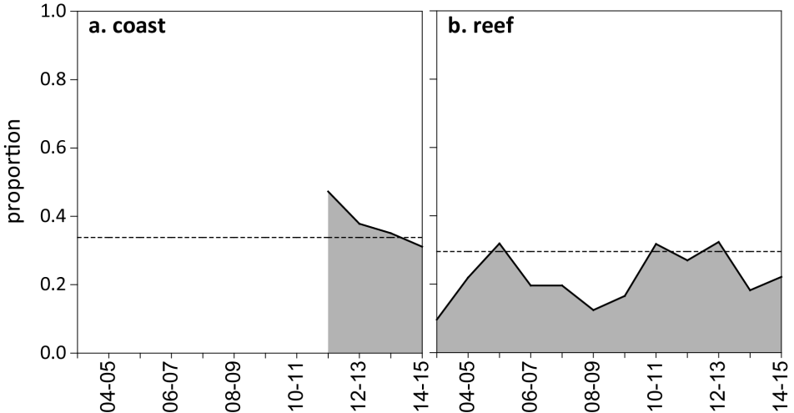
Figure 36. Proportion of seagrass abundance composed of species displaying colonising traits at inshore habitats in the Cape York region.
The dashed line represents GBR long-term average for each habitat type.
Seagrass meadow edge/landscape mapping was conducted within a 100m radius of all monitoring sites in October 2014 and April 2015 to determine if changes in abundance were a consequence of the meadow landscape changing and to indicate if plants were allocating resources to colonisation (asexual reproduction) (Appendix 4). Prior to 2012, the only meadow extent mapping in the Cape York NRM region was conducted at Archer Point. The meadows within 100m of the monitoring sites on the reef flat at Archer Point have fluctuated within and between years (Figure 37), primary due to changes in the landward edge and appearance of a drainage channel from an adjacent creek (data not presented). Post 2011, additional reef meadows and coastal meadows in the Cape York NRM region were included. Overall, meadow extent has continued to increase slightly over the last few years and continued throughout 2014-15 at all reef and coastal sites (Figure 37; Appendix 4).
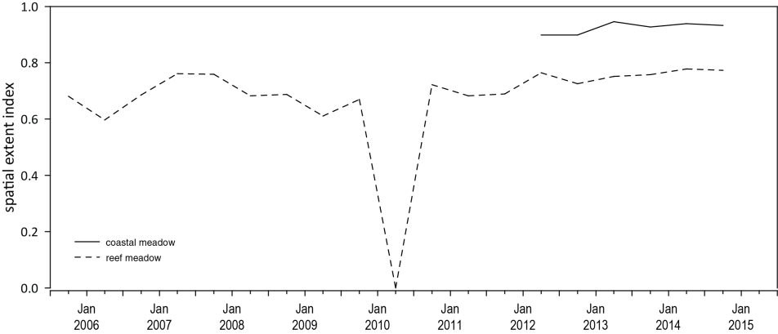
Figure 37. Change in spatial extent of seagrass meadows within a 100m radius of monitoring sites for each habitat and monitoring period across the eastern Cape York NRM region.

Seagrass reproductive status
Seagrass seed banks in Cape York meadows were often larger in the late dry than late monsoon (Figure 38). Seed banks were also higher at coastal than reef habitats (Figure 38). A seed bank of predominately Halodule uninervis persists at reef habitat meadows (Figure 38), however late dry abundances in 2014-15 were lower than the previous year. Although Cymodocea plants were present across reef meadows, no seeds have been found since monitoring commenced. Total reproductive effort across the region remains very poor, and was similar to the previous monitoring period; significantly below the 2009 peak (Figure 38). Low seed bank density and poor reproductive effort at reef meadows indicates a low capacity to recover following disturbance, while at coastal meadows, the greater seed bank density suggests a higher capacity to recover.
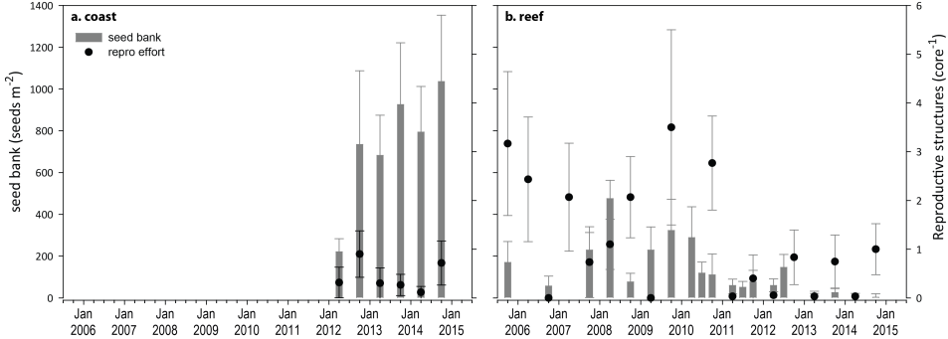
Figure 38. Seed banks and reproductive effort at inshore intertidal coastal (a) and reef (b) habitats in the Cape York region
(species and sites pooled). Seed banks (bars ± Standard Error) presented as the total number of seeds per m² sediment surface. Reproductive effort for late dry season (dots ± Standard Error) presented as the average number of reproductive structures per core.

Indicators of environmental condition

Seagrass tissue nutrients
Seagrass leaf molar C:N ratios were largely unchanged and remained below 20 at all Cape York habitats and locations in late dry season 2014 (Figure 39). Leaf molar C:P ratios in 2014 were just above 500, indicating that the plants were growing in a relatively moderate P pool that was slightly depleted (Figure 40; Appendix 4), while leaf molar N:P ratios indicate a slight enrichment of N, relative to P.

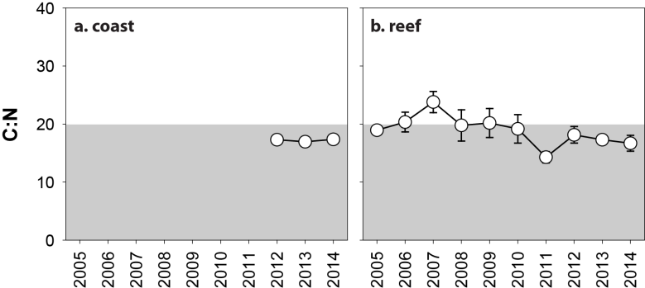
Figure 39. Elemental ratios (atomic) of seagrass leaf tissue C:N for the foundation species in inshore intertidal coastal (a) and reef (b) habitats in the Cape York region from 2005 to 2014
(species pooled) (mean and SE displayed). Horizontal shaded band on the C:N ratio panel represents the accepted guideline seagrass “Redfield” ratio of 20:1 (Abal, et al. 1994; Grice et al. 1996). C:N ratios below this line may indicate reduced light availability and/or N enrichment.
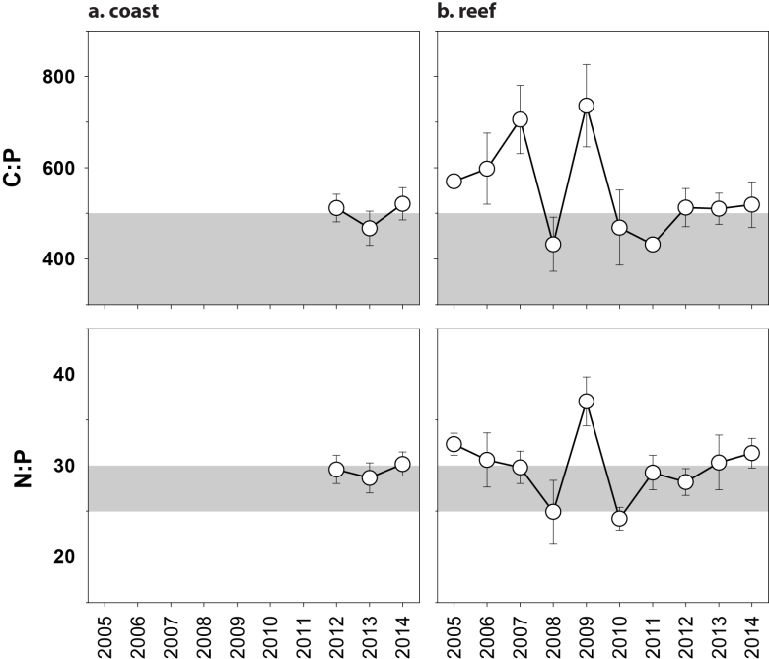
Figure 40. Elemental ratios (atomic) of seagrass leaf tissue N:P and C:P for the foundation species in inshore intertidal reef (a, c) and coastal (b, d) habitats in the Cape York region from 2005 to 2014
(species pooled) (mean ± Standard Error). Horizontal shaded band on the N:P ratio panel represents the range of value associated with N:P balance ratio in the plant tissues, i.e. a seagrass “Redfield” ratio (Atkinson and Smith 1983; Duarte 1990; Fourqurean, et al. 1992b; Fourqurean and Cai 2001). N:P ratio above this band indicates P limitation, below indicates N limitation and within indicates replete. Shaded portion on the C:P panel ≤500 represents the value associated with C:P balance ratio in the plant tissues, C:P values <500 may indicate nutrient rich habitats (large P pool).

Seagrass meadow sediments
Reef habitats were dominated by sands and coarser sediments, while coastal habitats contained a greater proportion of mud (Appendix 4). During the late monsoon each year, the proportion of finer sediments (i.e. mud) increases in reef habitats, relative to the late dry season. In 2014-15, the proportion of mud at reef habitats was similar to the previous monitoring period, and no long-term trends are apparent. Similarly at coastal habitats, no long term trends are apparent.

Epiphytes and macroalgae
Epiphyte cover on seagrass leaf blades over the long-term was generally higher in the wet season at coastal habitats and in the dry season at reef habitats (Figure 41). During the 2014-15 wet season, epiphyte abundances were 2-3 times the GBR long-term average at coastal habitats in the north of the region (i.e. Shelburne Bay), but well below the GBR long-term average in the central (Bathurst Bay) (Appendix 4, Figure 200). Epiphyte abundances at reef habitats were lower in 2014-15 than the GBR long-term average and the previous monitoring period (Figure 41; Appendix 4Figure 201).
Percentage cover of macroalgae was variable between locations, and appears to have changed little over the last few monitoring periods and remained above the GBR long-term average for reef habitats in the central and north of the region throughout 2014-15 (Figure 41; Appendix 4, Figure 201). Macroalgae cover varied in 2014-15 and briefly increased above the GBR long-term average at coastal habitats in the north of the region for the first time in 3 years (Figure 41).
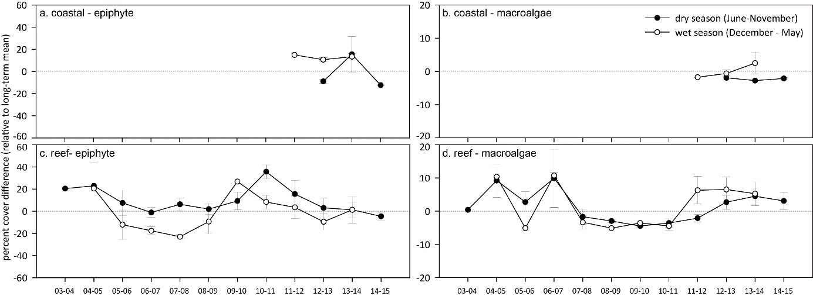
Figure 41. Long-term trend in mean epiphyte and macroalgae abundance (% cover) at monitoring sites in the Cape York region, relative to the long-term average for each inshore GBR intertidal seagrass habitat
(sites pooled, ±SE).

Report card for inshore seagrass status
In the 2014-15 monitoring period, the seagrass index for Cape York region is similar to the previous period. The slight improvement appears a consequence of improved abundance in coastal habitats and greater reproductive effort in reef habitats. Overall, the Cape York seagrass index is the highest since 2011-12, but remains well below the 2005-06 baseline.

Table 14. Long-term report card scores for seagrass abundance, reproductive and leaf tissue nutrient status for each habitat in the Cape York NRM region: June 2005 – May 2015.
Values are indexed scores scaled from 0-100; ■ = very good (81-100), ■ = good (61 - 80), ■ = moderate (41 - 60), ■ = poor (21 - 40), ■ = very poor (0 - 20). NB: Scores are unitless.
Report Card | Habitat | 2005-06 | 2006-07 | 2007-08 | 2008-09 | 2009-10 | 2010-11 | 2011-12 | 2012-13 | 2013-14 | 2014-15
Abundance | coastal intertidal |  |  |  |  |  |  | 63 | 81 | 63 | 75
Abundance | reef intertidal | 75 | 35 | 45 | 44 | 44 | 20 | 14 | 22 | 29 | 25
Reproductive  effort | coastal intertidal |  |  |  |  |  |  |  | 0 | 0 | 0
Reproductive  effort | reef intertidal | 63 | 0 | 25 | 38 | 63 | 63 | 13 | 17 | 17 | 21
Leaf tissue  nutrient | coastal intertidal |  |  |  |  |  |  |  | 30 | 36 | 37
Leaf tissue  nutrient | reef intertidal | 45 | 52 | 69 | 49 | 51 | 46 | 21 | 36 | 35 | 33
Seagrass Index |  | 61 | 29 | 46 | 43 | 52 | 43 | 21 | 28 | 29 | 30

Wet Tropics

2014-15 Summary
The Wet Tropics includes two World Heritage Areas, however increases in intensive agriculture, coastal development and declining water quality have been identified as significant across the region. In 2014-15 climate conditions exposed seagrass meadows to a range of stressors, which are likely to have had a cumulative impact on meadow condition and resilience. Rainfall and river discharge was below the long-term average (almost half); similarly wind exposure was below the long-term average and lower than the previous monitoring period. Coastal and more inshore reef sites were exposed to primary or secondary water type for almost 100% of the wet season (December 2014 to April 2015) and within canopy daily light was slightly lower than the long-term average, following very low light levels in early to mid-2014. Overall, seawater temperatures in 2014-15 were likely to have been more stressful to intertidal seagrass than in previous years. The number of days above 35°C was the highest since 2008-09, and extreme temperature (>40°C) occurred on only 1 day.
Seagrass meadows in the region remain in a vulnerable state in 2014-15 with a decline in abundance and an overall abundance rating of very poor. While abundance declined at some sites (e.g. Low Isles and Green Island subtidal), at others there was increasing abundance and a reduction in proportion of species displaying colonising traits in favour of colonising or persistent species (e.g. Yule Point). Persistent foundational species have greater capacity to resist environmental stress and therefore these few sites may be improving their resilience. Furthermore, although there were very large increases in reproductive effort at reef subtidal sites, the overall rating remained poor, which combined with low seed banks, suggests capacity to recover from major disturbances remains weak at most sites. Analysis of seagrass leaf tissue suggests an excess of nitrogen, relative photosynthetic C uptake (C:N <20), which is consistent with the high frequency of exposure to secondary water. Nutrient status therefore remained poor.
Overall, the status of seagrass condition in the Wet Tropics NRM region has remained poor in 2014-15 (Figure 42). On average, Wet Tropics seagrass meadows remain in a vulnerable condition with low resilience, however, some sites are showing signs of improvement, while others have deteriorated.
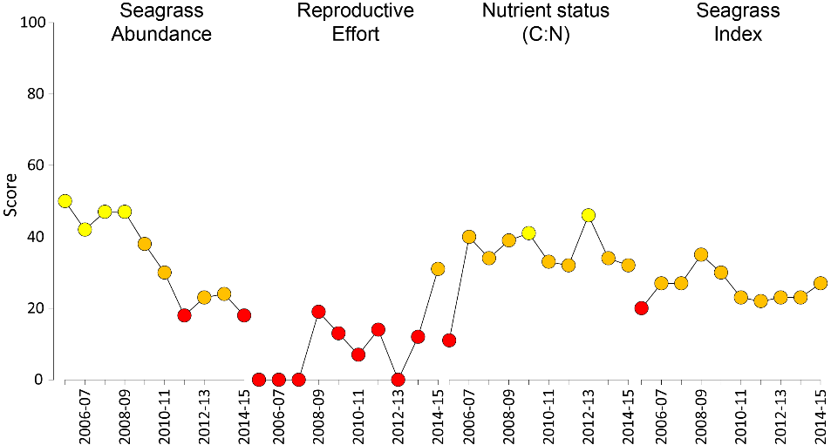
Figure 42. Report card of seagrass status indicators and index for the Wet Tropics NRM region
(averages across habitats and sites). Values are indexed scores scaled from 0-100; ■ = very good (81-100), ■ = good (61 - 80), ■ = moderate (41 - 60), ■ = poor (21 - 40), ■ = very poor (0 - 20). NB: Scores are unitless.

Climate and environmental pressures
Annual rainfall and river discharges were not only below the long-term average in 2014-15, but the lowest in over a decade. Wind speeds were similarly below the long-term average (Table 15). Exposure to plume water types was highly variable among Wet Tropics sites. Lugger Bay was largely exposed to primary water, most other sites to secondary water, and Green Island to oceanic water types (Figure 43, Table 16). Within canopy temperatures were slightly higher and low tide exposure during daylight hours was lower in 2014-15 than the long-term average and previous monitoring period.
Table 15. Summary of environmental conditions at monitoring sites in the Wet Tropics region in 2014-15 compared to the long-term average (long-term range indicated for each data set).
 | Long-term average | 2014-15
Rainfall (1887-2015) | 2,357 mm | 1,467 mm
River discharge (1970-2015) | 8,256,653 L yr⁻¹ | 4,368,819 L yr⁻¹
Flood plume exposure (2006-2015) | unavailable | 65%
Daytime tidal exposure (1999-2015) | 109.77 hrs yr⁻¹ | 87.89 hrs yr⁻¹
Wind (1998-2015) | 120.9 days yr⁻¹ | 113.7 days yr⁻¹
Within canopy temperature – intertidal (2003-2015)  subtidal (2008-2015) | 26.8°C (41.5°C)  26.0°C (35.7°C) | 27.0°C (40.3°C)  26.8°C (32.2°C)
Within canopy light (2012-2015) | 13.0 mol m⁻² d⁻¹ | 12.6 mol m⁻² d⁻¹

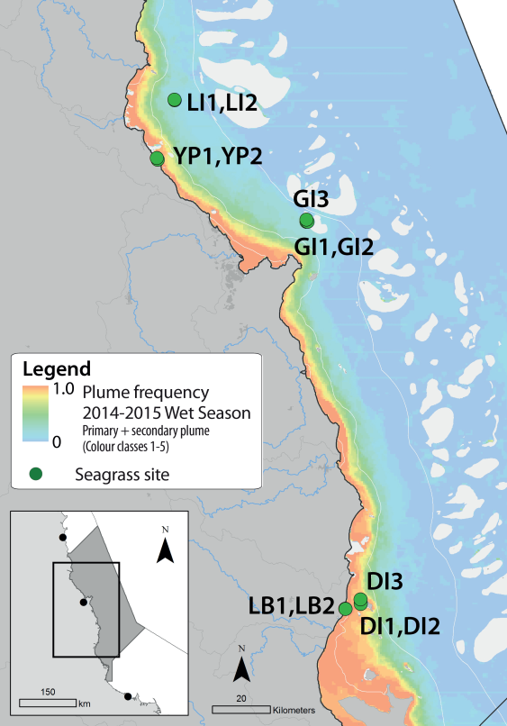
Figure 43. Frequency of exposure to plume water in the Wet Tropics NRM, wet season (22 weeks from December 2014 – April 2015) composite.
Frequency calculated as number of weeks in wet season exposed to primary or secondary water (colour classes 1 – 5). Each colour class category is described by mean water quality values for TSS, CDOM, chlorophyll a and K_{d} (PAR) (Devlin, et al. 2015; Lønborg, et al. 2015). For site details, see Tables 3 & 4.

Table 16. Water type at each location (Loc) in the Wet Tropics region derived from MODIS true colour images
as colour classes of turbid primary water (class 1 – 4, red/brown), nutrient/chlorophyll-enriched secondary water (class 5, green), and tertiary (some freshwater/CDOM influence) or no plume influence (class 6 and 7 respectively, blue), for 22 weeks from December 2014 – April 2015. Also shown, median wet season colour class (Med), frequency of primary water as f_{(P)}, the frequency of secondary water as f_{(S)}, and the frequency of primary or secondary as f_{(P+S)}. *denotes data obtained from adjacent pixel.
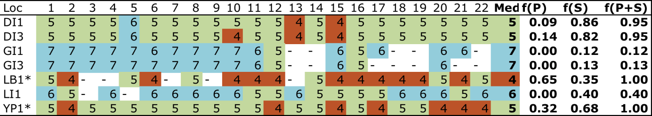
Daily light (I_{d}) at Wet Tropics sites has been monitored since 2008 or 2009. I_{d} in 2014-15 was lower than the long-term average, largely due to conditions at the northern most (Low Isles), and southern most (Dunk Island) sites. In contrast, the central sites (Yule Point and Green Island), had higher than average I_{d} in 2014-15 with particularly high light levels during the growing season (late 2014).
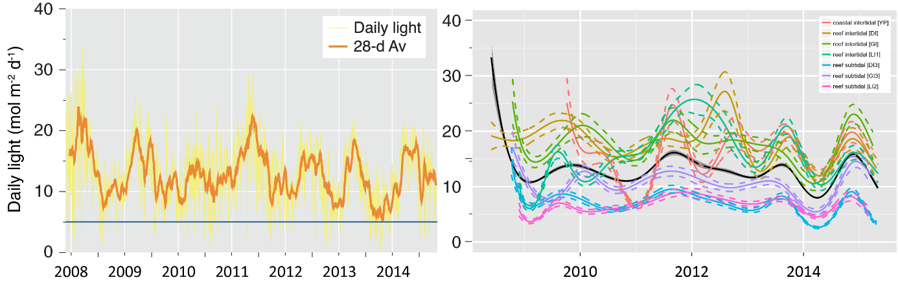
Figure 44. Mean daily light at Wet Tropics sites with 28-d rolling average from 2008 to 2015 (left) and GAM plots (right)
with the black line showing mean trend for all sites (±95% confidence interval in grey shade) and coloured lines (with CI’s) showing the trend for each site. Results of statistical analysis (GAM) and site-specific graphs (site-level daily light data plus 28-d rolling average) are shown in Appendix 4.
2014-15 was warmer than the long-term average at Wet Tropics seagrass sites. High temperatures (>35°C) were recorded from October 2014 to May 2015 across the region, with the highest temperature (40.3°C) recorded at 4:00pm on the 21 January 2015 at Yule Point. The greatest number of days (57 days) where the sea water temperatures exceeded 35°C since 2003 when monitoring was established was experienced in 2014-15. Furthermore, there was a greatest number of days exceeding 40°C since 2008.
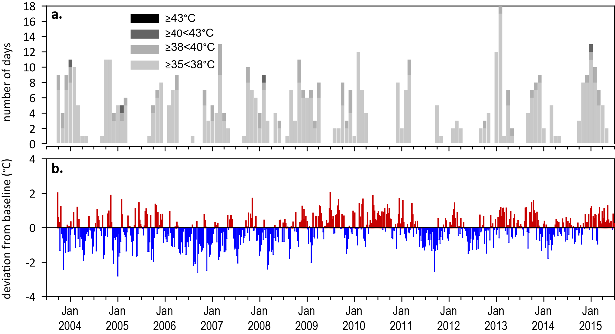
Figure 45. Inshore sea temperature for intertidal seagrass habitats in the Wet Tropics NRM region from August 2001 to June 2015
: a) number of days when temperature exceeded 35°C, 38°C, 40°C and 43°C within each season (thresholds adapted from Campbell, et al. 2006); b) deviations from 11-year mean weekly temperature records (weeks above the long-term average are represented as red bars and the magnitude of their deviation from the mean represented by the length of the bars, bars are blue for weeks with temperatures lower than the average and are plotted as negative deviations). Dashed line represents period when monitoring not established.
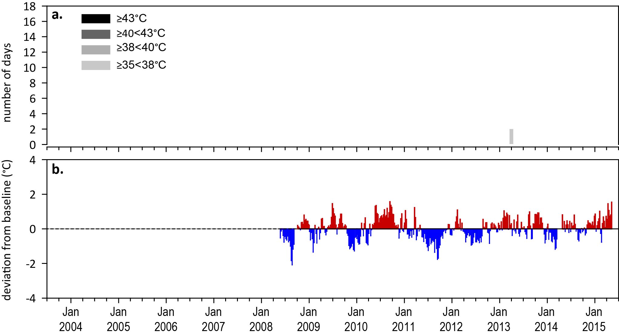
Figure 465. Inshore sea temperature for subtidal seagrass habitats in the Wet Tropics NRM region from October 2008 to June 2015
: a) number of days when temperature exceeded 35°C, 38°C, 40°C and 43°C within each season (thresholds adapted from Campbell, et al. 2006); b) deviations from 7-year mean weekly temperature records (weeks above the long-term average are represented as red bars and the magnitude of their deviation from the mean represented by the length of the bars, bars are blue for weeks with temperatures lower than the average and are plotted as negative deviations). Dashed line represents period when monitoring not established.

Indicators of seagrass condition

Seagrass abundance, composition and extent
The seagrass abundance score across the region was rated as very poor in 2014-15 (Figure 34). The long-term average seagrass cover at coastal habitats in the Wet Tropics NRM region varied greatly between seasons: 6.3 ±1.0% in the dry and 18.6 ±2.1% in the monsoon season. Changes in seagrass abundance were variable among sites, but generally, recovery rates stabilised or in some cases reversed. Seagrass abundance over the 2014-15 monitoring period remained on a recovering trajectory at Yule Point despite seasonal variations, but remained very poor at Lugger Bay (Figure 35). The seagrass meadows at Lugger Bay have fluctuated greatly since monitoring was established in late 2004, primarily from acute disturbances such as tropical cyclones. Seagrass cover declined in early 2010 and was completely lost in early 2011 following Tropical Cyclone Yasi. A few isolated shoots/plants established at Lugger Bay in late dry 2012, but they have failed to recolonise.
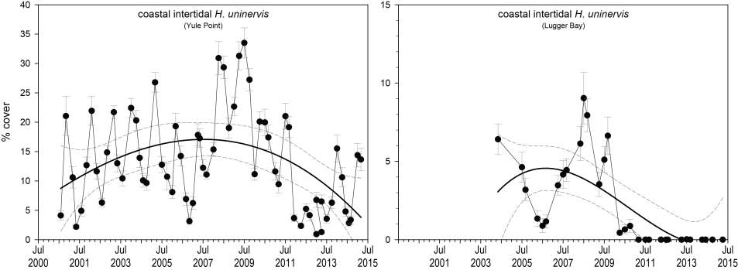
Figure 47. Changes in seagrass abundance (% cover ±Standard Error) at inshore intertidal coastal habitats in the Wet Tropics region, 2000 - 2015.
Trendline is 3rd order polynomial (95% confidence intervals displayed) where Yule Pt r² = 0.20 and Lugger Bay r² = 0.45).
Abundances at Low Isles are seasonally variable, but in 2014-15 dry season maxima did not reach the peak in density recorded in 2008 or 2012. Seagrass abundance (% cover) stabilised at Green Island reef platform (intertidal) sites, but reached the lowest recorded levels at the subtidal site in the dry of 2014 (Figure 36). At Dunk Island, seagrass abundance remained low (<6%), but showed signs of recovery at the subtidal sites with an increase in Halodule uninervis, while intertidal seagrass abundance remained <2%. Recovery at Dunk Island after the crossing of TC Yasi in 2011 has been limited by availability of recruits (e.g. seeds and propagules).
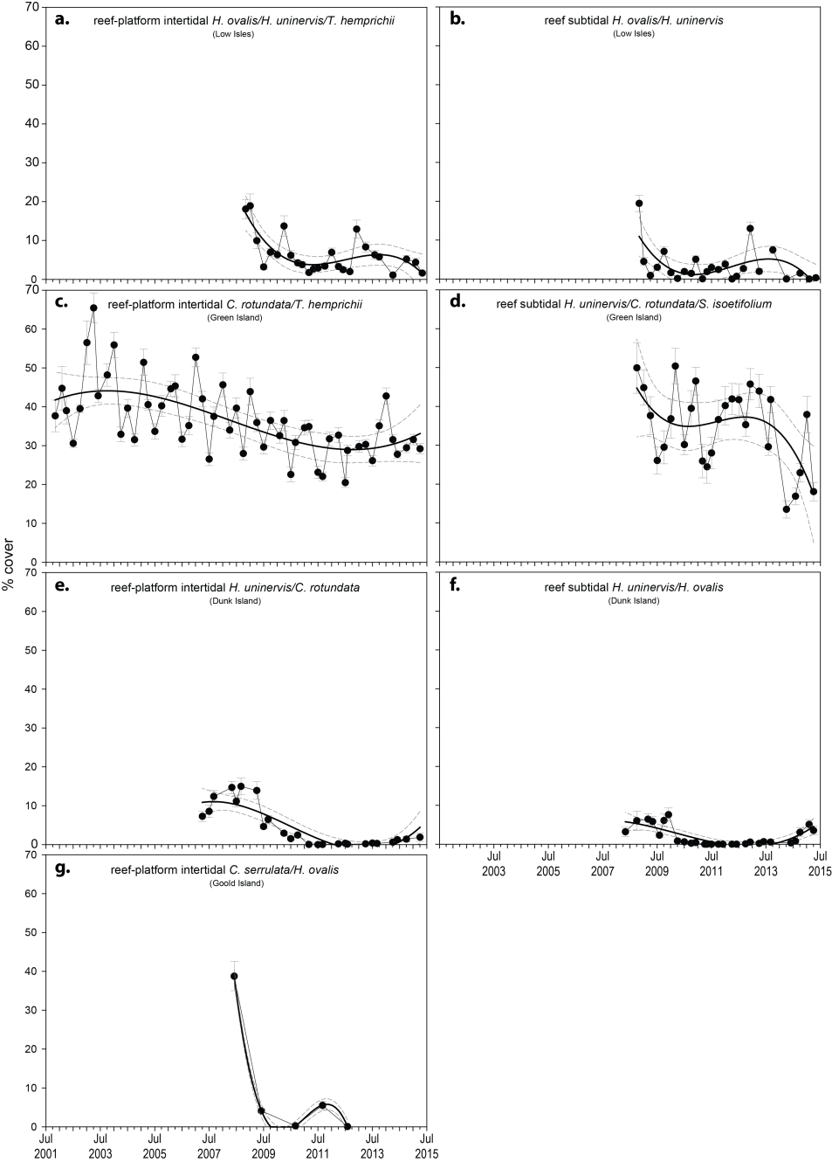
Figure 48. Changes in seagrass abundance (% cover ±Standard Error) for inshore intertidal and subtidal reef habitats (left and right respectively) in the Wet Tropics region, 2001 - 2015
: trendline is 3rd order polynomial (95% confidence intervals displayed), a-b) Low Isles, intertidal r² = 0.56 and subtidal r² = 0.38; c-d) Green Island, intertidal r² = 0.40 and subtidal r² = 0.31; and e-f) Dunk Island, intertidal r² = 0.77 and subtidal r² = 0.64. Subtidal sites not replicated.
An examination of the long term trends across the Wet Tropics NRM region suggests seagrass abundance (% cover) has improved little since declining in 2009 (Figure 49).
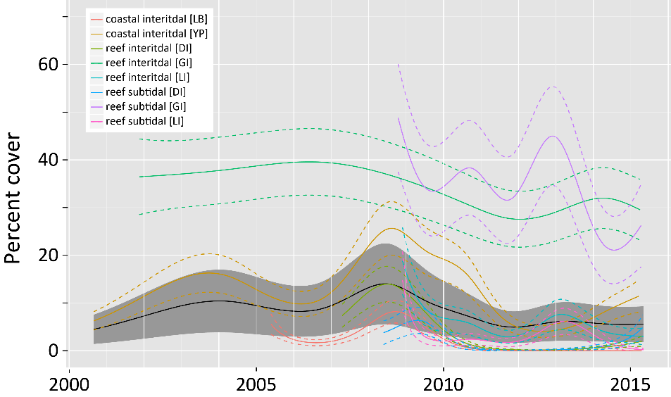
Figure 49. Temporal trends in seagrass abundance for each monitoring location in the Wet Tropics region represented by a GAM plot, 2001-2015.
Regional trend (all locations pooled) represented by black line with grey shaded area defining 95% confidence intervals.
The proportion of seagrass species displaying colonising traits at coastal habitats (Yule Point, Lugger Bay) had been above average for GBR coastal habitats following 2011 extreme events, however, the proportion declined in 2014-15; with colonising species replaced by opportunistic species (Halodule uninervis), as meadows recover (Figure 50). The reef subtidal habitats, in particular Low Isles and Dunk Island, have had greater than average proportion of colonising species from recent perturbations (Figure 50). While a similar trend (peak density of colonising species post 2011) occurred at reef intertidal sites, the magnitude of change was not as great in reefs compared to coastal habitats (Figure 50).
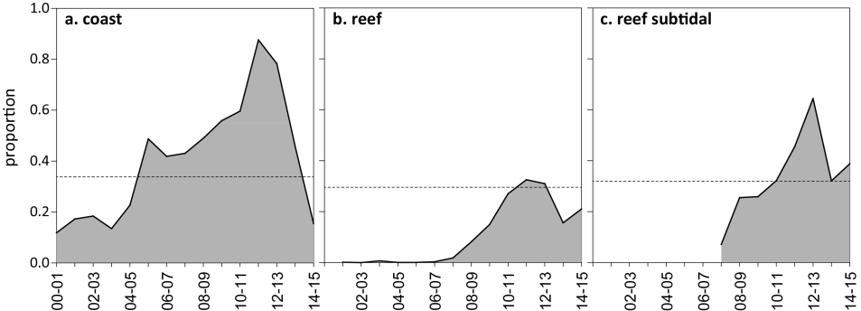
Figure 50. Proportion of seagrass abundance composed of colonising species at inshore habitats in the Wet Tropics region, 2001 - 2015.
The dashed line represents the GBR-wide average for each habitat type.
Seagrass meadow extent within a 100m radius of all intertidal monitoring sites has fluctuated within and between years (Figure 51), primarily due to losses and subsequent recolonisation. At coastal meadows, the extent has gradually improved since 2012, but still remains well below the greatest extent in 2008. Intertidal meadows on reef habitats similarly continued to improve (greater extent) over the last 3 years, however, subtidal meadows have only slight increase in extent over the past 18 months (Figure 51).
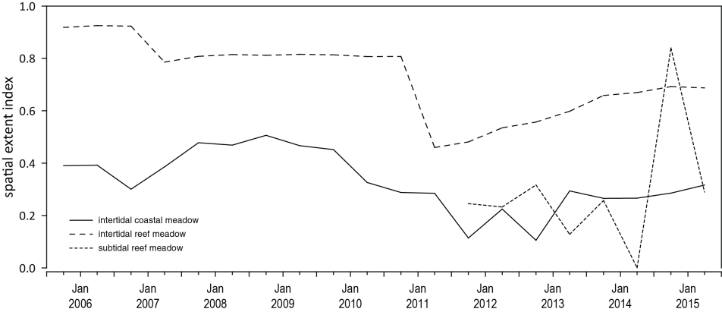
Figure 51. Change in spatial extent of seagrass meadows within a 100m radius of monitoring sites for each habitat and monitoring period across the Wet Tropics region.
Annual monitoring for Ports North reported that large scale declines in biomass and distribution of estuarine meadows in the Ports of Cairns and Mourilyan Harbours began in 2009 and continued through 2012 (Jarvis et al. 2014; York et al. 2014). However, recovery in the estuarine port habitats has been slower than observed in most coastal and reef habitats monitored across the region as part of the MMP. An assessment of 6 meadows (predominately aggregated patches) in Cairns Harbour and Trinity Inlet between November and December 2014, found that although seagrass extent increased ~33% from 2013 to 2014, the total area in 2014 remained <8% of the maximum extent reported since annual monitoring commenced in 2001. Similarly, seagrass abundance (visual estimate of above-ground biomass from a helicopter) increased ~45% from 2013 to 2014, but 2014 abundances (all monitoring meadows pooled) remained <17% of the maximum mean biomass reported since annual monitoring commenced in 2001. Additional quarterly sampling from June 2014 (including non-replicated site adjacent to the mouth of Saltwater Creek) showed a significant increase in the intertidal Esplanade meadow between November 2014 and February 2015, but still remaining 95% and 69% below the long-term (10 year) average in both visually estimated biomass and extent, respectively. A small seed bank reportedly persists, however, no sampled seeds were viable. Despite the onset of recovery, seagrasses in Cairns Harbour remain predominately as aggregates of small patches in a very poor state in 2014-15,
Similarly, an assessment of 5 seagrass meadows in Mourilyan Harbour in November-December 2014 reported seagrass in a very poor state with all 4 of the intertidal monitoring meadows absent (York et al. 2015). The only monitoring meadow remaining in 2014 was subtidal, and although seagrass abundance (visual estimate of above-ground biomass) and area (extent) had improved significantly since 2013, abundance was more than 80% below the long term average (York, et al. 2015). The low abundance was a consequence of the meadow being composed entirely of aggregated patches of colonising Halophila species. The foundation species (Zostera muelleri and Halodule uninervis) were absent for the fifth consecutive year. The authors attributed the lack of recovery, despite improved growing conditions in 2014-15, was likely due to a lack of seagrass propagules (e.g. high likelihood of remaining seeds being unviable) (York, et al. 2015).

Seagrass reproductive status
There was a large increase in reproductive effort in coastal intertidal and reef subtidal habitats during 2014-15. However, to date, this has not resulted in an increased seed bank; which remained very low across the region (Figure 52). The most notable changes in seed bank density were at coastal intertidal sites, particularly Yule Point where a Halodule uninervis seed bank substantially reduced following the 2010-11 disturbance events. Wet Tropics meadows may be at risk from further disturbances, as recovery potential remains very low without a substantial seed bank.

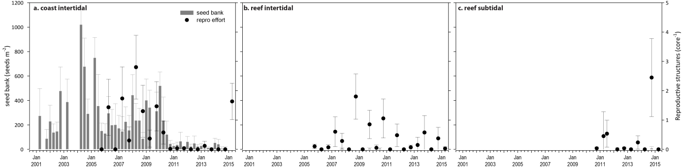
Figure 52. Seed bank and late dry season reproductive effort for inshore intertidal coast and reef habitats in the Wet Tropics region, 2001 - 2015.
Seed banks presented as the total number of seeds per m² sediment surface (bars ±SE), and reproductive effort presented as the average number of reproductive structures per core (species and sites pooled) (dots ±SE).

Indicators of environmental condition

Seagrass tissue nutrients
C:N ratios in the leaves of the foundation seagrass species (in the late dry season 2014) were below 20 at coast and reef intertidal habitats, and were marginal (around 20), at reef subtidal habitats (Figure 53; Appendix 4). Seagrasses in reef habitats (intertidal and subtidal) had higher leaf molar C:N ratios than those in coastal habitats (Figure 53), which has remained consistent across all years of monitoring. C:N ratios have remained relatively unchanged across all intertidal seagrass habitats over the last 2-3 years (Figure 53; Appendix 4), while at subtidal sites, other than a sharp increase at Green Island in 2012, C:N ratios at reef subtidal habitats have been relatively stable since monitoring commenced in 2008 (Appendix 4). C:N ratios at the coastal sites were particularly low compared to other sites throughout the GBR, and decreased in 2014-15. A further exploration of tissue nutrient content shows that C:P and N:P increased (Figure 54). This, taken together with the average light levels and isotopically depleted δ¹³C at Yule Point in 2014-15, indicate that increased availability of N is likely to be the principal cause of the low C:N ratios. Although river discharge was low in the past year, there was high exposure to secondary, and to a lesser extent primary water types at all sites, except Green Island, which further indicates availability of N.
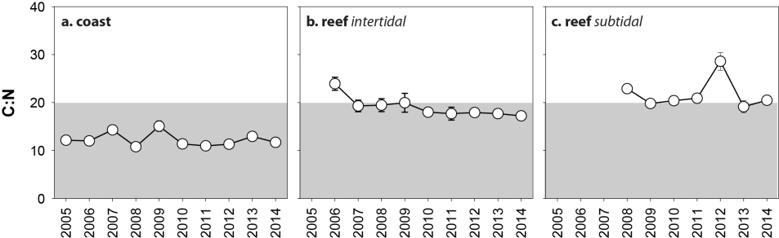
Figure 53. Elemental ratios (atomic) of seagrass leaf tissue C:N for the foundation seagrass species examined at each inshore habitat in the Wet Tropics region each year
(species pooled) (mean ± Standard Error). Horizontal shaded band on the C:N ratio panel represents the accepted guideline seagrass “Redfield” ratio of 20:1. C:N ratios below this line indicate reduced light availability and/or N enrichment.
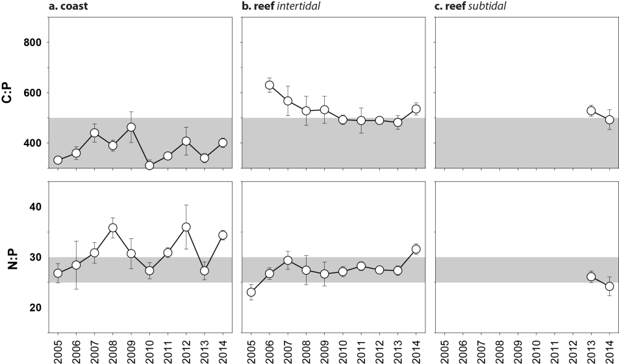
Figure 54. Elemental ratios (atomic) of seagrass leaf tissue N:P and C:P for the foundation seagrass species examined at each inshore habitat in the Wet Tropics region
(species pooled) (mean ± Standard Error). Horizontal shaded band on the N:P ratio panel represents the range of value associated with N:P balance ratio in the plant tissues. N:P ratio above this band indicates P limitation, below indicates N limitation and within indicates replete. Shaded portion on the C:P panel ≤500 represents the value associated with C:P balance ratio in the plant tissues, C:P values <500 may indicate nutrient rich habitats (large P pool).
The δ¹⁵N values in the leaf tissue of all foundation seagrass species across reef habitats (intertidal and subtidal) were similar or slight higher in 2014 than previous measured in the MMP, suggesting that their primary source of N was influenced by anthropogenic N sources such as fertiliser (i.e. δ¹⁵N >0<1%, Udy and Dennison 1997b, see also Appendix A2.3) (Appendix 4).

Seagrass meadow sediments
Coastal sediments were composed primarily of fine sand, while reef habitats were composed of sand and coarser sediments; although finer sediments have been observed on occasion during 2012 and 2013 (Appendix 4). In 2014-15, sediments appeared similar to the long-term and the proportion of fine sediments (i.e. mud) was well below the GBR long-term average.

Epiphytes and macroalgae
Epiphyte cover on seagrass leaf blades was generally higher in the wet season across all habitats in the Wet Tropics region (Figure 55). Epiphyte abundance varied across habitats and locations in 2014-15, but was much higher at reef habitats, in particular subtidal (e.g. Green Island and Dunk Island) (Appendix 2, Figure 202, Figure 203, Figure 204). With the exception of Low Isles and the subtidal habitats, percentage cover of macroalgae generally remained stable between years across both coastal and reef intertidal habitats, either below or at the GBR average (Figure 55; Appendix 2, Figure 202,Figure 203). At Low Isles, however, macroalgae abundances have continued to increase and abundances increased above the GBR average across all subtidal habitats over the 2014-15 period (Figure 55; Appendix 2, Figure 204).
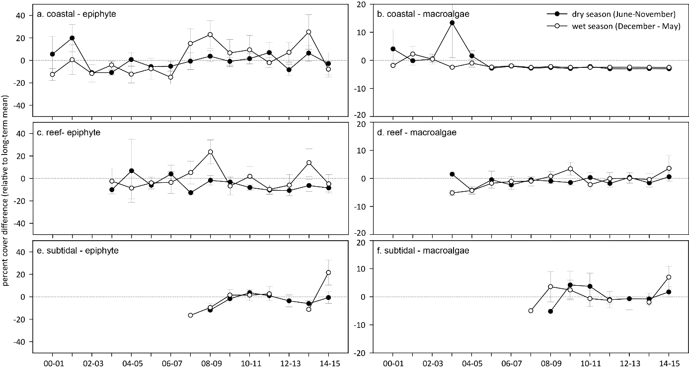
Figure 55. Long-term trend in mean epiphyte and macroalgae abundance (% cover) relative to the long-term average for each inshore seagrass habitat in the Wet Tropics region, 2001 - 2014
(sites pooled, ±SE).

Report card for inshore seagrass status
In the 2014-15 monitoring period, the seagrass index for the Wet Tropics region increased relative similar to the previous period (Table 17). The increase appears a consequence of improved reproductive effort and leaf tissue content in subtidal reef habitats, rather than abundance; which declined across all habitats. Overall, the Wet Tropics seagrass index in 2014-15 was the highest since 2010-11, but remains below the 2008-09 peak.

Table 17. Long-term report card scores for seagrass abundance, reproductive and leaf tissue nutrient status for each habitat in the Wet Tropics NRM region: June 2005 – May 2015.
Values are indexed scores scaled from 0-100; ■ = very good (81-100), ■ = good (61 - 80), ■ = moderate (41 - 60), ■ = poor (21 - 40), ■ = very poor (0 - 20). NB: Scores are unitless.
Report Card | Habitat | 2005-06 | 2006-07 | 2007-08 | 2008-09 | 2009-10 | 2010-11 | 2011-12 | 2012-13 | 2013-14 | 2014-15
Abundance | coastal intertidal | 38 | 30 | 55 | 70 | 54 | 46 | 7 | 13 | 21 | 19
Abundance | reef intertidal | 72 | 58 | 43 | 35 | 35 | 19 | 17 | 21 | 28 | 20
Abundance | reef subtidal |  |  | 0 | 33 | 23 | 27 | 34 | 37 | 22 | 15
Reproductive  effort | coastal intertidal | 0 | 0 | 0 | 0 | 6 | 0 | 0 | 0 | 0 | 0
Reproductive  effort | reef intertidal | 0 | 0 | 0 | 38 | 19 | 20 | 10 | 0 | 10 | 8
Reproductive  effort | reef subtidal |  |  |  |  |  | 0 | 33 | 0 | 25 | 83
Leaf tissue  nutrient | coastal intertidal | 11 | 10 | 21 | 6 | 25 | 7 | 4 | 7 | 16 | 8
Leaf tissue  nutrient | reef intertidal |  | 70 | 46 | 47 | 50 | 40 | 38 | 40 | 40 | 36
Leaf tissue  nutrient | reef subtidal |  |  |  | 64 | 48 | 52 | 54 | 93 | 46 | 52
Seagrass Index |  | 20 | 27 | 27 | 35 | 30 | 23 | 22 | 23 | 23 | 27

Burdekin

2014-15 Summary
Inshore seagrass meadows in the Burdekin region are primarily structured by wind-induced turbidity (re-suspension) in the short term and by episodic riverine delivery of nutrients and sediment in the medium term. 2014-15 was the driest year on record in the Burdekin, with well below median discharges from the major rivers. However, it was a period of average wind. Seagrass sites were covered in primary or secondary water types for 100% of the wet season (December 2014-April 2015), which would contribute to the below average daily light. Seagrasses across the region experienced average sea temperatures with no extreme temperatures (>40°C) and below median daytime tidal exposure in 2014-15 would also have limited heat and desiccation stress.
Seagrass meadows in the Burdekin NRM region continued to increase in abundance over 2014-15, similar to the previous monitoring period at all habitats. These were the highest abundances recorded in the last five years, with the greatest improvement in subtidal meadows to levels not previously recorded. The overall abundance score was marginally moderate and was close to the base limit for good. Seagrass extent similarly increased during 2014-15, and in early 2015 was at or above baseline values.
Annual monitoring as part of the Queensland Ports Seagrass Monitoring Program (QPSMP) in the Cleveland Bay region (Townsville) showed continued recovery in meadow area and biomass in October 2014, and biomass surpassed the long-term average in 8 out of 10 meadows (Davies et al. 2015). However, at the port of Abbot Point in the southern Burdekin region, the dynamic deep-water seagrass meadows increased in biomass (visual estimates), while inshore meadows showed little improvement (McKenna et al. 2015).
Reproductive effort was increased slightly at reef subtidal sites while the seed bank increased substantially. There was very high reproductive effort at coastal intertidal sites (October 2014), but the seed bank remained considerably lower than earlier records (2007). At reef intertidal sites, the seed bank and reproductive effort remains low. The overall score for reproductive effort has declined to moderate in 2014-15 after a good rating in 2013-14, with meadows remaining in a somewhat reduced state of resilience. The C:N ratio of seagrass leaves declined slightly in 2014-15 after increases in previous years. Light availability was not particularly high over the past year and there was a high exposure to both primary and secondary water types, suggests, an increase in N availability and potentially reduced photosynthesis.
Over the past decade, seagrass meadows of the Burdekin region have demonstrated high resilience particularly through their capacity for recovery. This may reflect a conditioning to disturbance (high seed bank, high species diversity), but also reflects the nature of the disturbances which are acute and episodic dominated by Burdekin River flows while in the adjacent Wet tropics, multiple and ongoing disturbances tend to occur. Burdekin regional seagrass state declined slightly from good in 2013-14 to moderate in 2014-15 due largely to reduced reproductive effort (Figure 56).
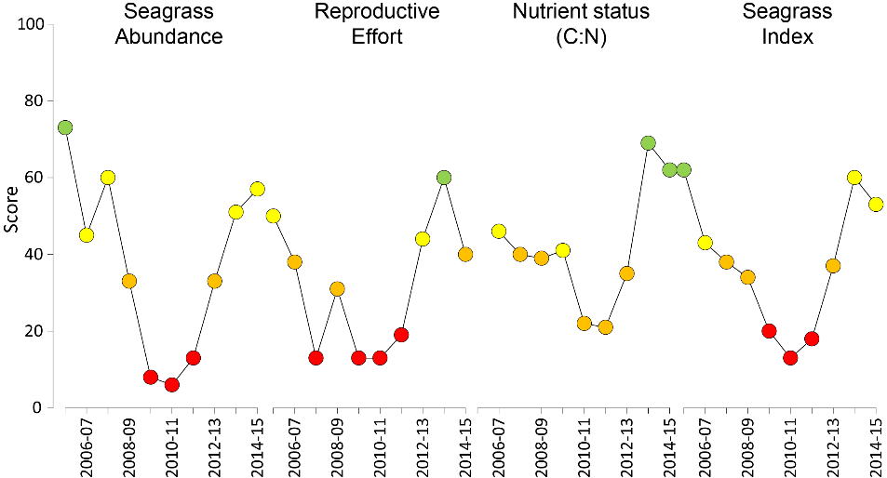
Figure 56. Report card of seagrass status indicators and index for the Burdekin NRM region
(averages across habitats and sites). Values are indexed scores scaled from 0-100; ■ = very good (81-100), ■ = good (61 - 80), ■ = moderate (41 - 60), ■ = poor (21 - 40), ■ = very poor (0 - 20). NB: Scores are unitless.

Climate and environmental pressures
Rainfall and river discharge were the lowest on record, with flows from the Burdekin Rivers being 14% of the long-term average (Table 18). However, wind was around the long-term average, and may have continued to resuspend fine sediments and nutrients adsorbed to their surface. Seagrass monitoring sites were exposed to primary or secondary water for 100% (F_{P+S} = 1.00) of the wet season. Coastal sites were exposed to turbid, sediment laden, primary waters, and reefs sites were exposed largely to high nutrient secondary waters, for the duration of the 2014-15 monsoon period (Figure 57, Table 19).

Table 18. Summary of environmental conditions at monitoring sites in the Burdekin in 2014-15 compared to the long-term average (long-term range indicated for each data set) including climate, discharge, plume, and within seagrass canopy conditions.
 | Long-term average | 2014-15
Rainfall (1940-2015) | 1,040 mm | 430 mm
River discharge (1970-2015) | 4,720,910 L yr⁻¹ | 665,616 L yr⁻¹
Flood plume exposure (2006-2015) | unavailable | 100%
Daytime tidal exposure 2000-2015) | 123.1 hrs yr⁻¹ | 57.63 hrs yr⁻¹
Wind (1998-2015) | 157.2days yr⁻¹ | 105.5 days yr⁻¹
Within canopy temperature – intertidal (2003-2015)  subtidal (2008-2015) | 26.5°C (46.6°C)  26.1°C (36.2°C) | 26.7°C (39.3°C)  25.7°C (32.7°C)
Within canopy light (2012-2015) | 9.8 mol m⁻² d⁻¹ | 8.4 mol m⁻² d⁻¹

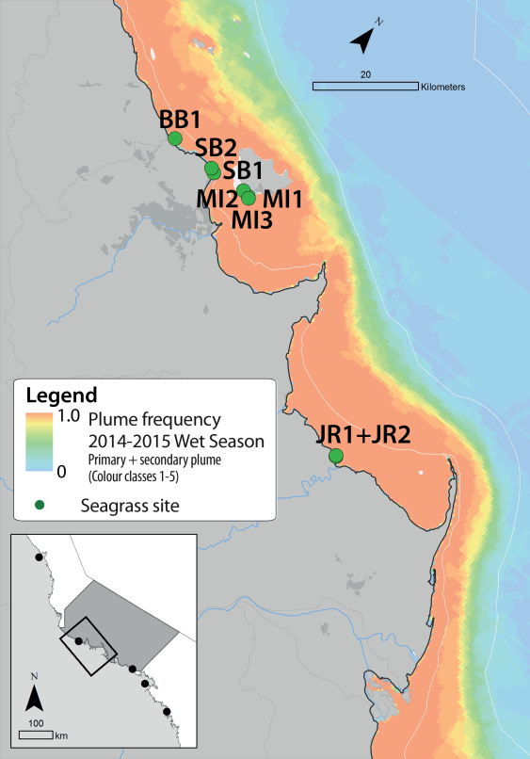
Figure 57. Frequency of exposure to plume water in the Burdekin NRM region, wet season (December 2014 – April 2015) composite.
Frequency calculated as number of weeks in wet season exposed to primary or secondary water (colour classes 1 – 5). Each colour class category is described by mean water quality values for TSS, CDOM, chlorophyll a and K_{d} (PAR) (Devlin, et al. 2015; Lønborg, et al. 2015). For site details, see Tables 3 & 4.

Table 19. Water type at each seagrass monitoring site in the Burdekin NRM region, derived from MODIS true colour images
as colour classes of turbid primary water (class 1 – 4, red/brown), nutrient/chlorophyll-enriched secondary water (class 5, green), and tertiary (some freshwater/CDOM influence) or no plume influence (class 6 and 7 respectively, blue), for 22 weeks from December 2014 – April 2015. Also shown, median wet season colour class (Med), frequency of primary water as f_{(P)}, the frequency of secondary water as f_{(S)}, and the frequency of primary or secondary as f_{(P+S)}.
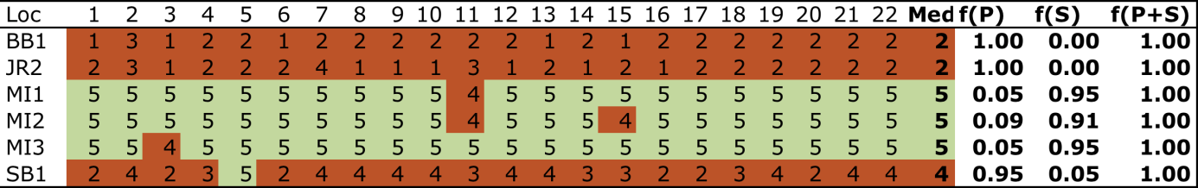

Daily light (I_{d}) has been monitored at some Burdekin Dry Tropics sites since 2008 (Figure 58). I_{d} is highly seasonal at some sites, with the peak occurring in the late dry season (usually October-December). The seasonal signal in I_{d} is not as pronounced at Picnic Bay intertidal (MI1) and subtidal (MI3) sites (Figure 58). In 2014-15, average I_{d} was lower than average due to particularly low I_{d} in the warmer months (December-April), and following low I_{d} in early-mid 2014 (Figure 58).
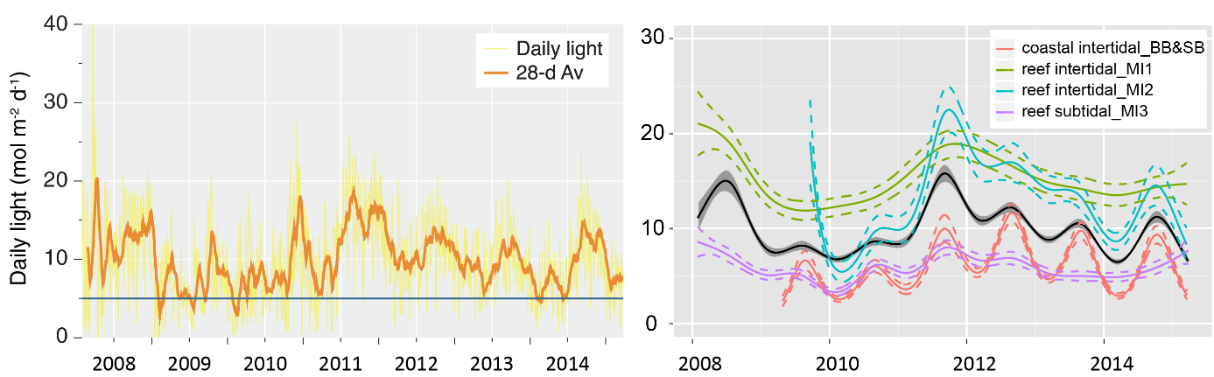
Figure 58. Mean daily light at Burdekin sites with 28-d rolling average from 2012 to 2015 (left) and GAM plots (right)
with the black line showing mean trend for all sites (±95% confidence interval in grey shade) and coloured lines (with CI’s) showing the trend for each site. Results of statistical analysis (GAM) and site-specific graphs (site-level daily light data plus 28-d rolling average) are shown in Appendix 4.

Water temperature was generally very warm, with the number of days above 35°C the highest since 2008-09 (Figure 59a) and a frequent deviation from the thermal baseline, even at subtidal sites (Figure 59b). These temperatures (<40°C) do not usually cause significant photoinhibition (Campbell, et al. 2006), however, prolonged exposure to warm temperatures can reduce growth in some species such as Zostera muelleri which occurs in the Burdekin region (Collier et al 2011). There was also below-average daily tidal exposure (Appendix 4) and no extreme heat days (>40°C), which can rapidly reduce photosynthetic rates and cause leaf “burn-off”.

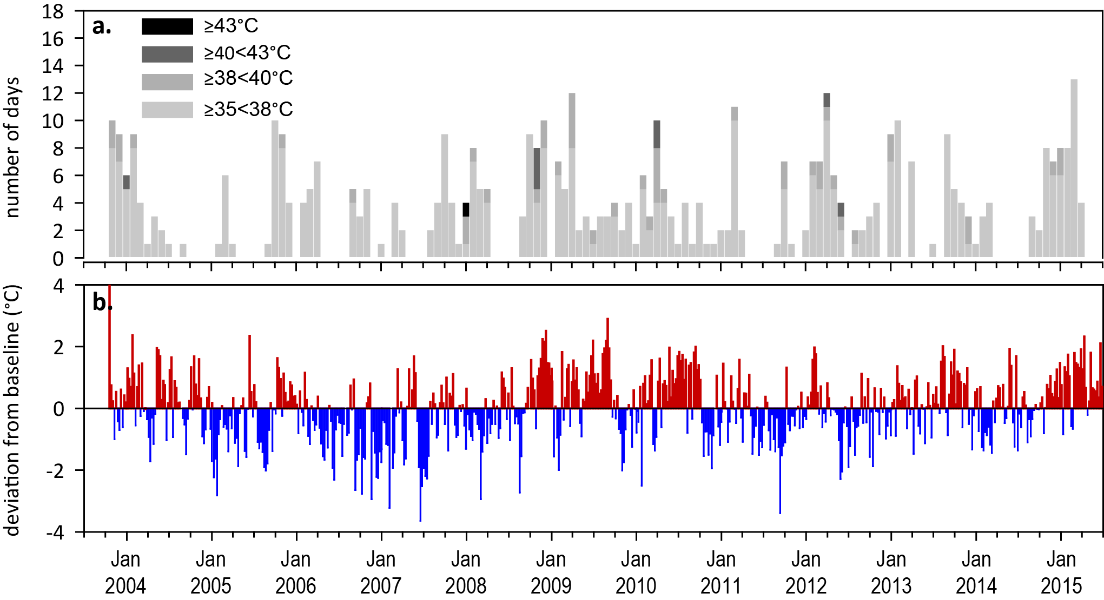
Figure 59. Inshore sea temperature at intertidal seagrass habitats in the Burdekin region, January 2008 - May 2015
: a) number of days when temperature exceeded 35°C, 38°C, 40°C and 43°C within each season (thresholds adapted from Campbell, et al. 2006); b) deviations from 11-year mean weekly temperature records (weeks above the long-term average are represented as red bars and the magnitude of their deviation from the mean represented by the length of the bars, bars are blue for weeks with temperatures lower than the average and are plotted as negative deviations).
Figure 60. Inshore sea temperature at inshore subtidal seagrass habitat at Magnetic Island (Burdekin region), January 2008 - May 2015
: a) number of days when temperature exceeded 35°C, 38°C, 40°C and 43°C within each season (thresholds adapted from Campbell, et al. 2006); b) deviations from 7-year mean weekly temperature records (weeks above the long-term average are represented as red bars and the magnitude of their deviation from the mean represented by the length of the bars, bars are blue for weeks with temperatures lower than the average and are plotted as negative deviations).

Indicators of seagrass condition

Seagrass abundance, composition and distribution
Seagrass abundance (% cover) continued to improve over the past 12 months and has near recovered to pre-2011 levels. The overall status for seagrass abundance has remained moderate in 2014-15 (Figure 56).
Seagrass meadows in the Burdekin NRM region continued to experience increases in abundance over the 2014-15 period, similar to the previous monitoring period, at coastal, reef and subtidal habitats (Figure 61). These increases resulted in the highest abundances in the last five years.
Since monitoring was established, coastal meadows in the region have displayed a seasonal pattern in abundance; high in monsoon and low in the dry season (McKenzie, et al. 2012a). This, however, was not apparent over the last 4 years, as seagrass has been recovering from losses experienced in early 2011. Long-term seagrass abundances were generally higher in reef than coastal habitats, however, the seasonal difference (highest abundances are late dry and early monsoon) for each was similar: coastal = 11 ±1.7% in the dry and 22.4 ±2.3% in monsoon season; reef = 27.1 ±2.6% in dry and 38.3 ±3.9% in late monsoon; subtidal 32.7 ±62.8% in the monsoon and 62.8 ±3.0% in dry season. In 2014-15, abundance continued to increase in all habitats, and in subtidal reef habitats surpassed previously recorded levels (Figure 61).
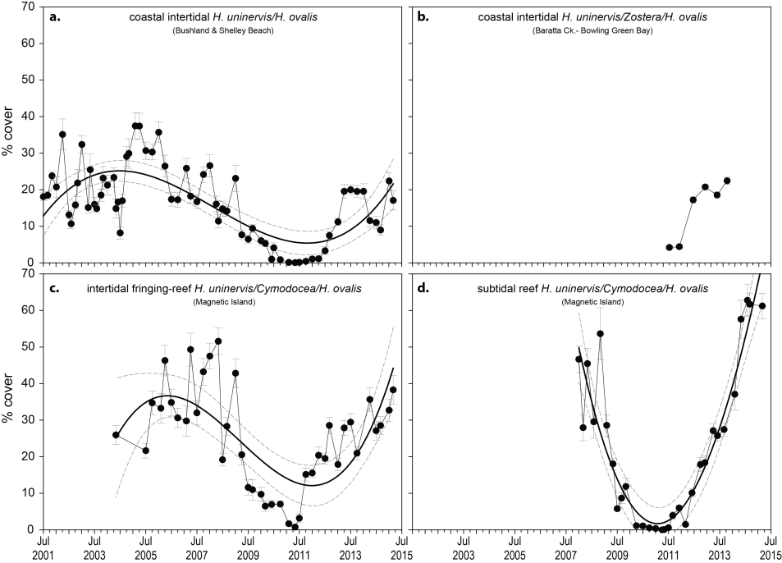
Figure 61. Changes in mean seagrass abundance (% cover ±Standard Error) at inshore coastal intertidal (a, b), reef intertidal (c) and reef subtidal (d) meadows in the Burdekin region, 2001 - 2015.
Trendline is 3rd order polynomial, 95% confidence intervals displayed, coastal intertidal r² = 0.52, reef intertidal r² = 0.50 and reef subtidal r² = 0.88.
An examination of the long term trends across the Burdekin NRM region suggests seagrass abundance (% cover) has recovered to pre-2011 levels (Figure 62).
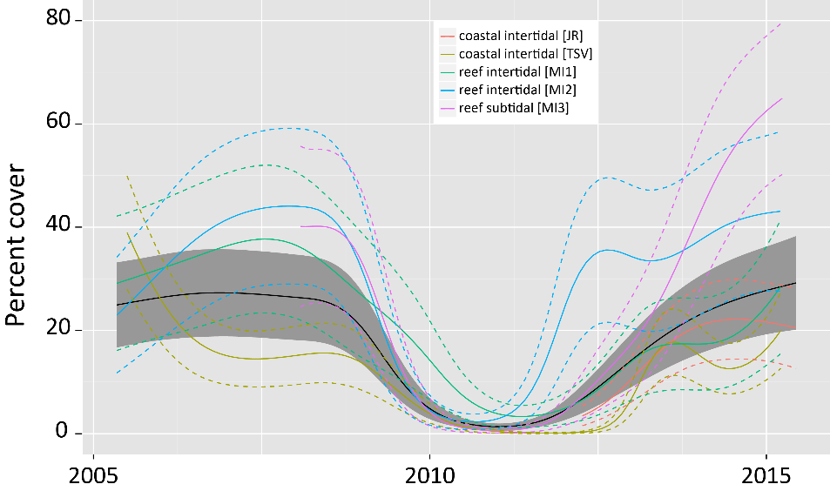
Figure 62. Temporal trends in seagrass abundance for each location in the Burdekin region represented by a GAM plot.
Regional trend (all habitats pooled) represented by black line with grey shaded areas defining 95% confidence intervals.
There has also been a lower proportion of species displaying colonising traits (Halophila ovalis), instead being dominated by opportunistic species (H. uninervis, Z. muelleri, C. serrulata) in coastal and reef sites or persistent species in intertidal reef habitat (T. hemprichii, though C. serrulata can also behave like a persistent species) in 2014-15 than in the previous 3 years (Figure 63; Appendix 4). This is a sign of meadow progression following near decimation after the events leading up to and including 2011. Opportunistic and persistent foundation species also have a capacity to resist stress (survive, through reallocation of resources) caused by acute disturbances (_ENREF_68Collier et al. 2012c), and therefore, current species composition provides greater overall resilience in Burdekin meadows.
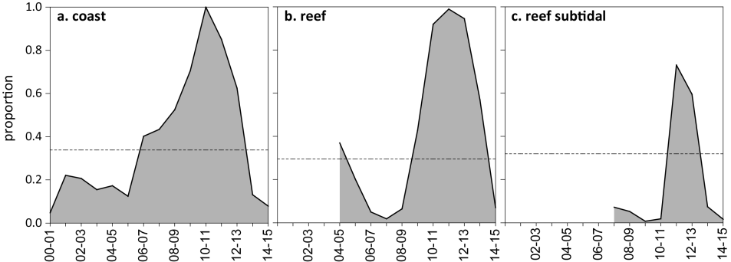
Figure 63. Proportion of seagrass abundance composed of colonising species at inshore habitats in the Burdekin region, 2001 - 2015.
Grey area represents GBR long-term average proportion of colonising species for each habitat type.
Seagrass meadow extent within a 100m radius of all intertidal monitoring sites has fluctuated within and between years (Figure 64), primarily due to losses and subsequent recolonisation. In the two to three years prior to 2011, significant changes occurred across the region with all seagrass meadows reducing in size and changing in landscape from continuous, to patchy, to isolated patches and finally to isolated shoots with the loss of meadow cohesion (Figure 64). This was caused by the high rainfall and riverine discharge that affected much of the GBR. Since 2011, meadow extents have increased in both coastal and reef habitats to pre-2009 levels (Figure 64). In early 2014, however, seagrass extent declined at the subtidal habitat, to the lowest in 2 years but subsequently recovered. By early 2015, seagrass extent at all monitoring sites had fully recovered and were at or above baseline values.
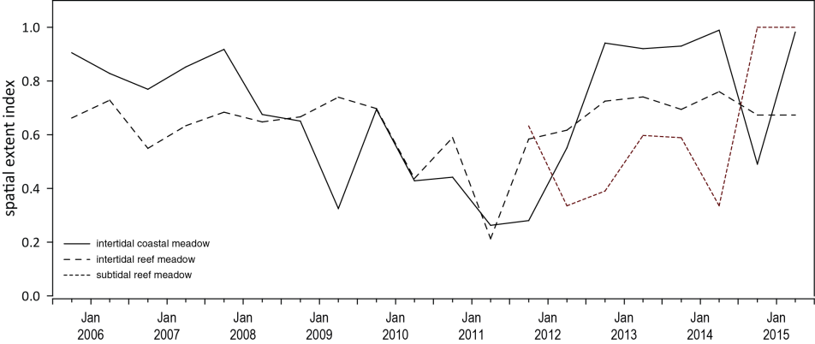
Figure 64. Change in spatial extent of seagrass meadows within a 100m radius of monitoring sites for each inshore intertidal habitat and monitoring period across the Burdekin region, 2005 - 2015.
Apart from the MMP, seagrass monitoring within the Burdekin NRM region is also conducted as part of the Queensland Ports Seagrass Monitoring Program (QPSMP). Annual monitoring of 10 seagrass meadows in the Port of Townsville reported the onset of recovery in October 2011, after unprecedented declines in biomass and distribution in 2010 (Davies, et al. 2015). Substantial recovery was reported in October 2014 with 8 out of 10 meadows having biomass that was above the long-term average, yet seagrass condition remained below the historical baseline (2007). Unfortunately, no comparison is made to the GBR historical baseline from 1987 (Coles et al. 1992; Coles, et al. 2001a). In the southern part of the Burdekin NRM region, the findings from quarterly monitoring for the North Queensland Bulk Ports Corporation in the Port of Abbot Point were less clear, as discerning seagrass state at the coastal and subtidal locations is challenged by the extremely dynamic nature of the meadows. The dynamic deeper water seagrass increased biomass in late 2014 following the impacts of Tropical Cyclone Oswald (January 2013) (McKenna, et al. 2015). The shallower coastal meadows in Abbott Point, unlike those in the remainder of the region, have shown fewer signs of recovery, which may be a limited due to the absence of seed banks or propagules (data not presented) (McKenna, et al. 2015).

Seagrass reproductive status
Reproductive effort in Burdekin region meadows had been on an increasing trajectory but the reproductive score declined to moderate in 2014-15, following a good rating in 2013-14. Reproductive effort at coastal and reef intertidal sites was lower than the previous year in late 2014, however, at coastal sites this improved in early 2015 (Figure 65). Reef subtidal sites had the highest recorded reproductive effort in late 2014, but it was subsequently reduced in early 2015. Seed banks are on an increasing trajectory, particularly at reef subtidal where the highest value for this site (>1000 seeds m⁻²) was recorded, and they are increasing at coastal intertidal sites, but are still well below the peaks observed in 2007 (Figure 65).
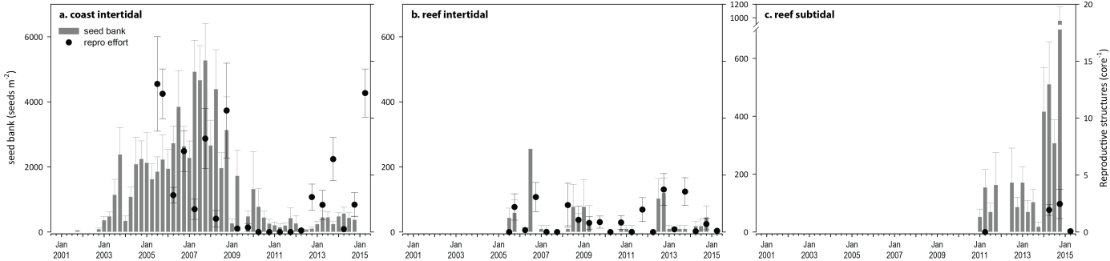
Figure 65. Seed bank and late dry season reproductive effort at inshore intertidal coast and reef and subtidal reef habitats in the Burdekin region.
Seed bank presented as the total number of seeds per m² sediment surface (bars ±SE), and late dry season reproductive effort presented as the average number of reproductive structures per core (species and sites pooled) (dots ±SE). NB: Y-axis scale for seed banks differs between habitats.

Indicators of environmental condition

Seagrass tissue nutrients
Seagrass leaf tissue molar C:N ratios reduced slightly after increases in the previous few years (Figure 66). The lowest values were below the threshold value (C:N <20) indicating light limitation/reduced carbon incorporation relative to N availability at coastal sites (Townsville) where high turbidity (primary water, Table 11) and low light conditions prevail; resulting in I_{d} being the lowest among all intertidal sites (Figure 58). However, an increase in N:P at coastal sites also suggest that increasing N may also have occurred (Figure 67). At reef sites, C:N in October 2014 remained above 20 which is a sign of good water quality where photosynthetic C incorporation is increased relative to N uptake.
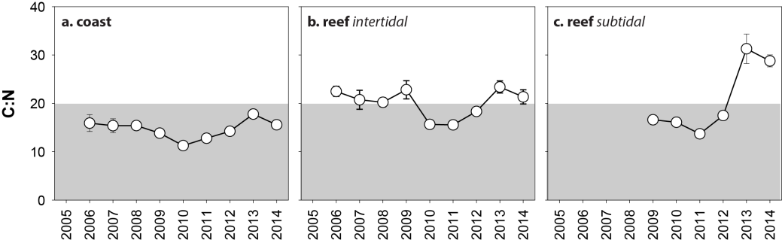
Figure 66. Elemental ratios (atomic) of seagrass leaf tissue C:N for the foundation seagrass species examined at each inshore habitat in the Burdekin region each year
(species pooled) (mean ± Standard Error). Horizontal shaded band on the C:N ratio panel represents the accepted guideline seagrass “Redfield” ratio of 20:1 (Abal, et al. 1994; Grice, et al. 1996). C:N ratios below this line indicate reduced light availability and/or N enrichment.
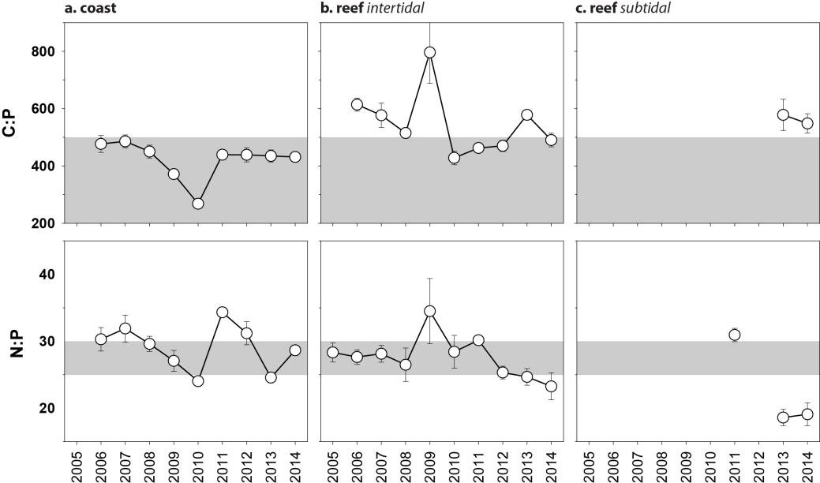
Figure 67. Elemental ratios (atomic) of seagrass leaf tissue N:P and C:P for the foundation seagrass species examined at each inshore intertidal habitat in the Burdekin region each year
(species pooled) (mean ± Standard Error). Horizontal shaded band on the N:P ratio panel represents the range of value associated with N:P balance ratio in the plant tissues. N:P ratio above this band indicates P limitation, below indicates N limitation and within indicates replete. Shaded portion on the C:P panel ≤500 represents the value associated with C:P balance ratio in the plant tissues, C:P values <500 may indicate nutrient rich habitats (large P pool).

Seagrass meadow sediments
The proportion of mud at Jerona (Barratta Creek) coastal habitat was much higher than Townsville sites (Bushland Beach and Shelley Beach) and has remained well above the GBR long-term average. Townsville sites were dominated by fine sediments, although the proportion of mud has declined post 2011. Conversely, reef habitats which were dominated by coarser sediment prior to 2009-10, having since gradually increased in composition of fine sand and mud. More fine sediments were present at the Cockle Bay than the Picnic Bay reef habitats meadows.

Epiphytes and macroalgae
Epiphyte cover on seagrass leaf blades at coastal meadows were higher in the dry rather than the wet season in 2014-15 and has fluctuated greatly over the long-term (Figure 68; Appendix 2, Figure 205). Epiphyte cover at intertidal reef habitats continued to increase from the previous monitoring periods, and in late 2014 was above the GBR long-term average (Figure 68c; Appendix 2). The greatest change in epiphyte cover was the increase at subtidal habitats over the 2014-15 period (Figure 68e) (Appendix 2). Percentage cover of macroalgae has changed little across all habitats over the last 4 years (Figure 68b) with location abundances remaining low and generally below the GBR long-term average (Appendix 2, Figure 205b, Figure 205d).
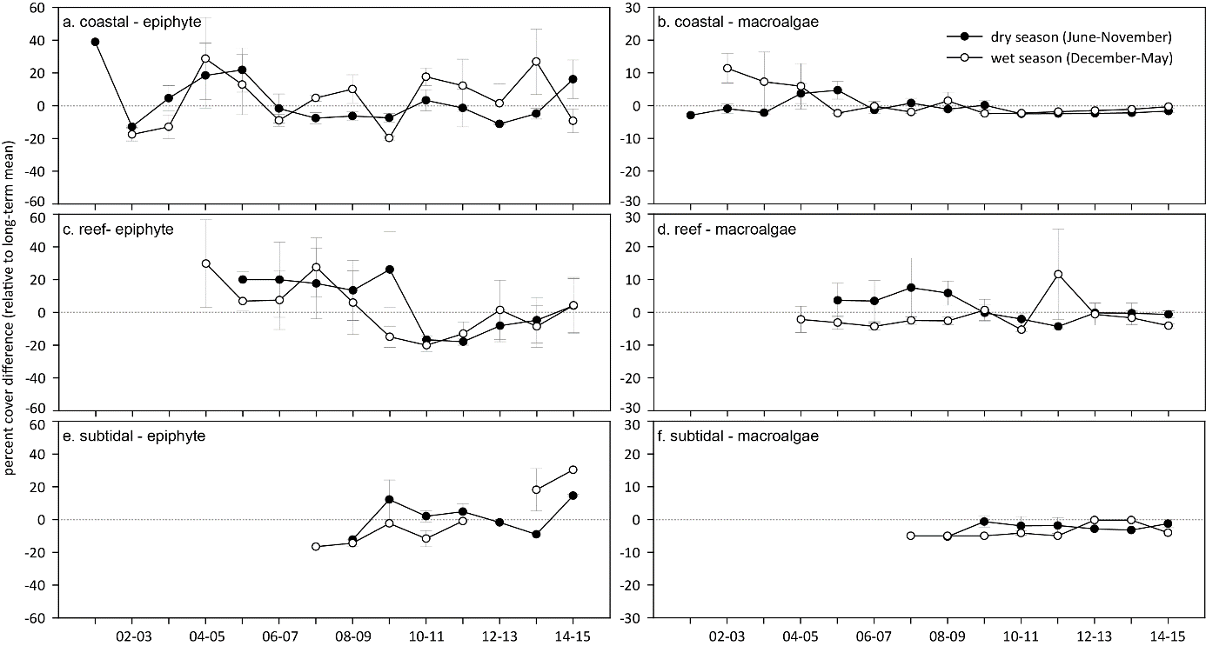
Figure 68. Long-term trend in mean epiphyte and macroalgae abundance (% cover) relative to the long-term GBR average for each inshore seagrass habitat in the Burdekin region
(sites pooled, ±SE).

Report card for inshore seagrass status
In the 2014-15 monitoring period, the seagrass index for the Burdekin region was lower than the previous period. The decrease appears primarily a consequence of reduced reproductive effort and leaf tissue nutrient in the intertidal coastal and reef habitats. Overall, abundances continued to improve across all habitats and the Burdekin seagrass index was the second highest since the 2005-06 baseline.

Table 20. Long-term report card scores for seagrass abundance, reproductive and leaf tissue nutrient status for each habitat in the Burdekin region: June 2005 – May 2015.
Values are indexed scores scaled from 0-100; ■ = very good (81-100), ■ = good (61 - 80), ■ = moderate (41 - 60), ■ = poor (21 - 40), ■ = very poor (0 - 20). NB: Scores are unitless.
Report Card | Habitat | 2005-06 | 2006-07 | 2007-08 | 2008-09 | 2009-10 | 2010-11 | 2011-12 | 2012-13 | 2013-14 | 2014-15
Abundance | coastal intertidal | 88 | 31 | 34 | 25 | 11 | 6 | 5 | 29 | 44 | 49
 | reef intertidal | 59 | 59 | 75 | 31 | 6 | 9 | 25 | 41 | 50 | 56
 | reef subtidal |  |  | 100 | 50 | 8 | 0 | 8 | 31 | 75 | 100
Reproductive | coastal intertidal | 50 | 25 | 25 | 38 | 0 | 0 | 0 | 13 | 19 | 6
effort | reef intertidal | 50 | 50 | 0 | 25 | 25 | 25 | 38 | 75 | 63 | 13
 | reef subtidal |  |  |  |  |  |  |  |  | 100 | 100
Leaf tissue | coastal intertidal |  | 30 | 27 | 27 | 19 | 6 | 14 | 26 | 39 | 28
nutrients | reef intertidal |  | 62 | 54 | 51 | 64 | 28 | 28 | 42 | 69 | 57
 | reef subtidal |  |  |  |  | 39 | 30 |  | 37 | 100 | 100
Seagrass Index |  | 62 | 43 | 38 | 34 | 20 | 13 | 18 | 37 | 60 | 53

Mackay Whitsunday

2014-15 Summary
The Mackay Whitsunday region is characterised by episodic flows from adjacent catchments, as well as urban and marina development, tourism and is also vulnerable to temperature extremes in shallow habitats. As in 2013-14, climatic conditions in 2014-15 were more conducive to seagrass growth than in previous years. There was low rainfall and below average river flows; however, average wind conditions provide risk of exposure to re-suspension of sediments and nutrients. Most meadows were exposed to primary or secondary water every week during December to April and within canopy daily light was below average. Above average seawater temperatures exposed meadows to warm conditions throughout the year, however these were unlikely to have been particularly stressful as no extreme temperatures (>40°C) were recorded.
During 2014-15 seagrass abundance continued to increase at coastal and estuarine habitats, and was stable at other sites increasing the score to poor, compared to very poor in 2013-14. Meadows continued to increase their extent across the region. Furthermore, at coastal and estuarine sites there was a large increase in the proportion of opportunistic species, which were displacing colonising species. These species changes coupled with increasing abundance and extent, improve resistance to disturbances.
Seagrass reproductive effort continued to recover but remained poor. This may have driven a slight increase in seed bank density, which enables them to recover from disturbances and contributes to an improvement in overall resilience. Leaf tissue C:N ratios were similar to previous years, but remain below 20 and are classed as poor. This, together with an increase in N:P indicate a surplus in availability of N, relative to demand from photosynthetic C incorporation and growth.
Mackay Whitsunday regional seagrass state improved but remained poor in 2014-15 (Figure 69). While the condition and resilience of these meadows show signs of improvement, they remain highly vulnerable to further disturbances.
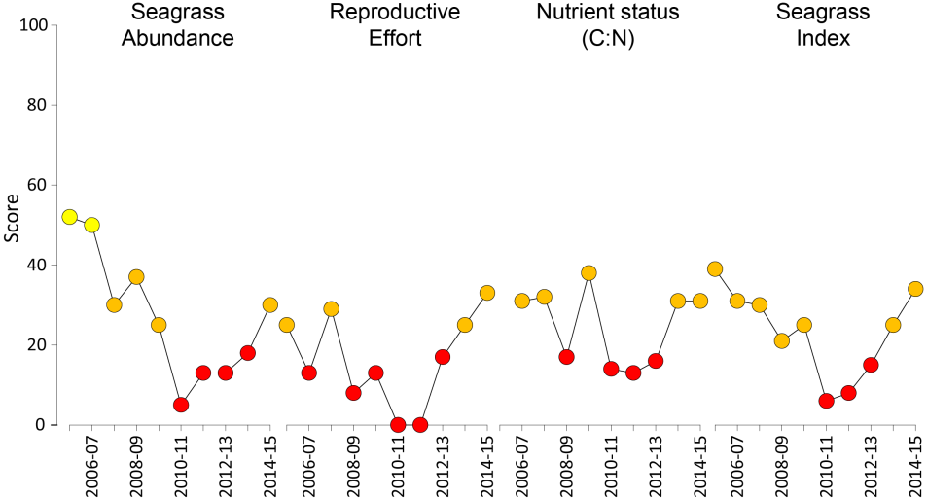
Figure 69. Report card of seagrass status indicators and index for the Mackay Whitsunday NRM region
(averages across habitats and sites). Values are indexed scores scaled from 0-100; ■ = very good (81-100), ■ = good (61 - 80), ■ = moderate (41 - 60), ■ = poor (21 - 40), ■ = very poor (0 - 20).

Climate and environmental pressures
Rainfall and river discharge was considerably lower than the long-term average in 2014-15 (Table 21). However wind speeds were above average, which increased risk of exposure to resuspension of sediments and nutrients delivered in previous flows (Fabricius, et al. 2012). The majority of sites were exposed to turbid primary water or green secondary water for 100% (f_{(P+S)} = 1.00) of the wet season (Figure 70, Table 22). The exception was at Hamilton Island (HM), where exposure was slightly lower (f_{(P+S)} = 0.77), although very high for a reef habitat.
Table 21. Summary of environmental conditions at monitoring sites in Mackay Whitsunday region in 2014-15 compared to the long-term average (long-term range indicated for each data set).
 | Long-term average | 2014-15
Rainfall (1910-2015) | 1,505 mm | 967 mm
River discharge (1970-2015) | 507,516 L yr⁻¹ | 143,011 L yr⁻¹
Flood plume exposure f_{(P+S)} (2006-2015) | not available | 95.4%
Daytime tidal exposure (1999-2015) | 50.11 hrs yr⁻¹ | 41.44 hrs yr⁻¹
Wind >25km hr⁻¹(1998-2015) | 124.2 days yr⁻¹ | 166.3 days yr⁻¹
Within canopy temperature (2003-2015) | 25.4°C (42.7°C) | 25.5°C (39.9°C)
Within canopy light (2012-2015) | 11.5 mol m⁻² d⁻¹ | 10.1 mol m⁻² d⁻¹

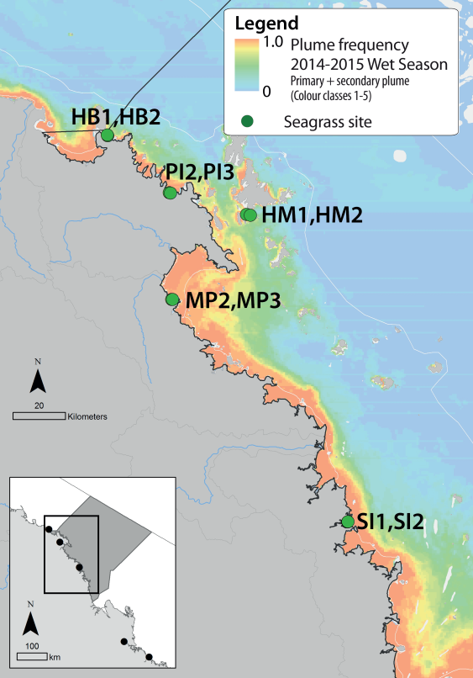
Figure 70. Frequency of exposure to plume water in the Mackay Whitsunday NRM region, wet season (December 2014 – April 2015) composite.
Frequency calculated as number of weeks in wet season exposed to primary or secondary water (colour classes 1 – 5). Each colour class category is described by mean water quality values for TSS, CDOM, chlorophyll a and K_{d} (PAR) (Devlin, et al. 2015; Lønborg, et al. 2015). For site details, see Tables 3 & 4.

Table 22. Water type at each location in the Mackay Whitsunday region derived from MODIS true colour images
as colour classes of turbid primary water (class 1 – 4, red/brown), nutrient/chlorophyll-enriched secondary water (class 5, green), and tertiary (some freshwater/CDOM influence) or no plume influence (class 6 and 7 respectively, blue), for 22 weeks from December 2014 – April 2015. Also shown, median wet season colour class (Med), frequency of primary water as f_{(P)}, the frequency of secondary water as f_{(S)}, and the frequency of primary or secondary as f_{(P+S)}. *denotes data obtained from adjacent pixel. Methods described in Devlin et al (2015), data from Lønborg et al (In review).
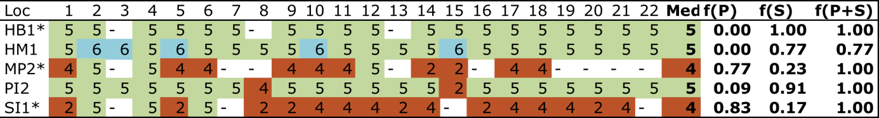

Daily light (I_{d}) at Mackay Whitsunday sites has been monitored since 2009 for some locations. In 2014-15, the typical late dry peak in I_{d} was truncated and relatively low light conditions (around 10 mol m⁻² d⁻¹) prevailed throughout late 2014 and into 2015 (Figure 71). On average, I_{d} was lower in 2014-15 than in previous years; a pattern consistently observed in other regions (Figure 71).
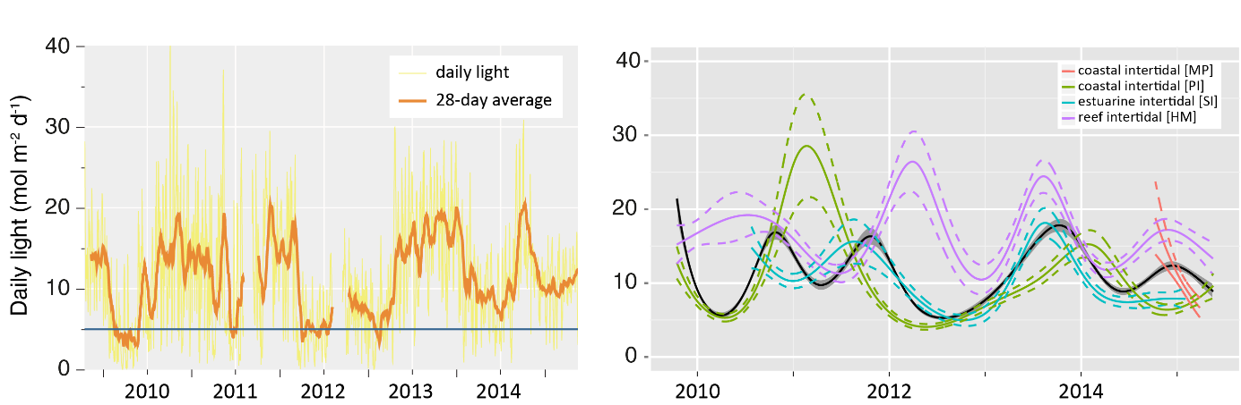
Figure 71. Mean daily light at Mackay Whitsunday habitats with 28-d rolling average from 2012 to 2015 (left) and GAM plots (right)
with the black line showing mean trend for all sites (±95% confidence interval in grey shade) and coloured lines (with CI’s) showing the trend for each site. Results of statistical analysis (GAM) and site-specific graphs (site-level daily light data plus 28-d rolling average) are shown in Appendix 4.
Water temperature was warm in the Mackay Whitsunday region in 2014-15 with a large number of days above 35°C (62 days) (Figure 72), and frequent warm deviation from the baseline. These temperatures do not usually cause significant photoinhibition (Campbell, et al. 2006), however, prolonged exposure to warm water can reduce growth in some species such as Zostera muelleri, while other species may increase their primary productivity from warm water temperatures >35°C (Collier, et al. 2011; Collier et al. 2016a). There was below-average daily tide exposure (Appendix 4) and no extreme heat days (>40°C), which can cause leaf “burn-off” (Figure 72).

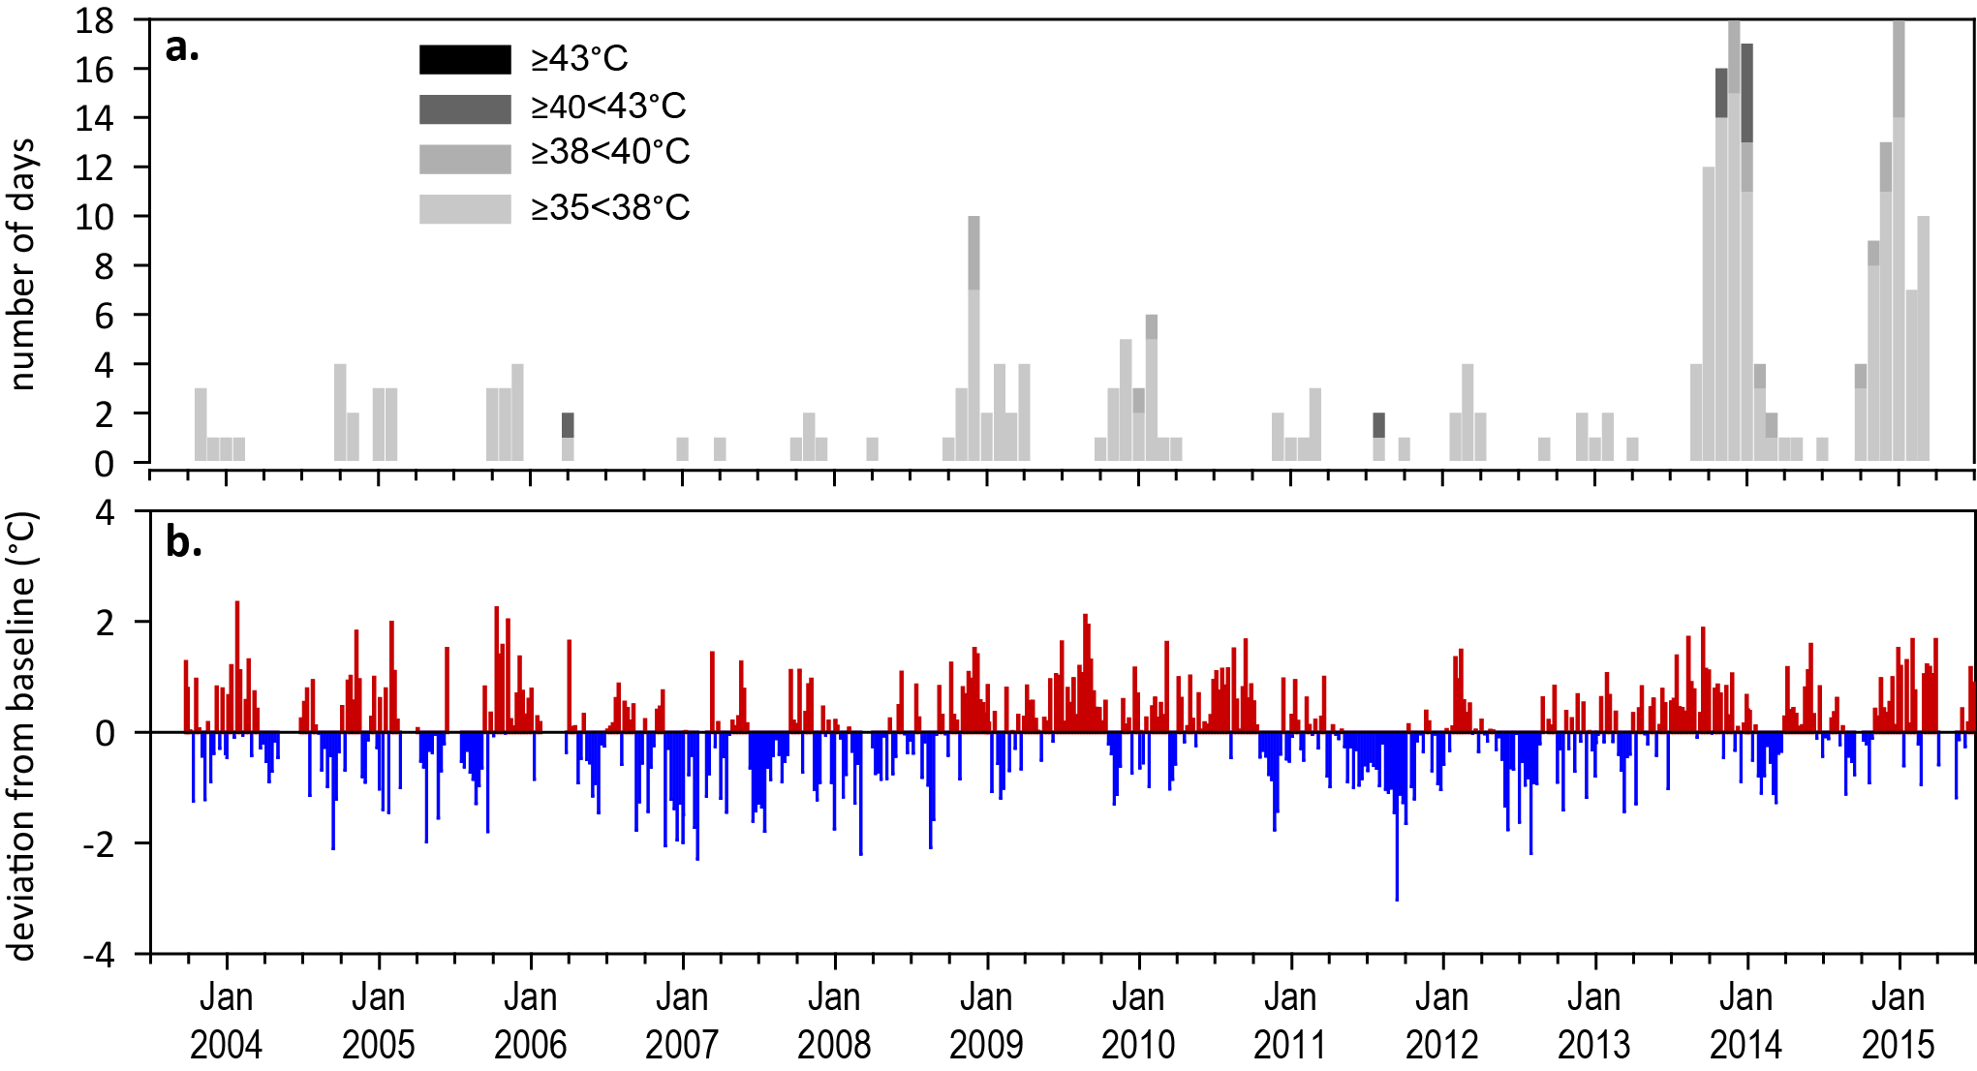
Figure 72. Inshore sea temperatures within each intertidal seagrass habitat in the Mackay Whitsunday region, September 2003 - June 2015
: a) number of days when temperature has exceeded 35°C, 38°C, 40°C and 43°C within each season (thresholds adapted from Campbell, et al. 2006); b) deviations from 11-year mean weekly temperature records (weeks above the long-term average are represented as red bars and the magnitude of their deviation from the mean represented by the length of the bars, bars are blue for weeks with temperatures lower than the average and are plotted as negative deviations).

Indicators of seagrass condition

Seagrass abundance, composition and distribution
Seagrass abundance continued to increase at coastal and estuarine habitats (Pioneer Bay, and Sarina Inlet) and remained stable at all other sites in the Mackay Whitsunday region in 2014-15 (Figure 74). However, abundance continues to remain considerably lower than historical peaks, particularly at Sarina Inlet and Hydeaway Bay (a Seagrass-Watch location). There was an overall increase in the seagrass abundance score to poor in 2014-15 after being very poor in the previous 4 years (Figure 73).
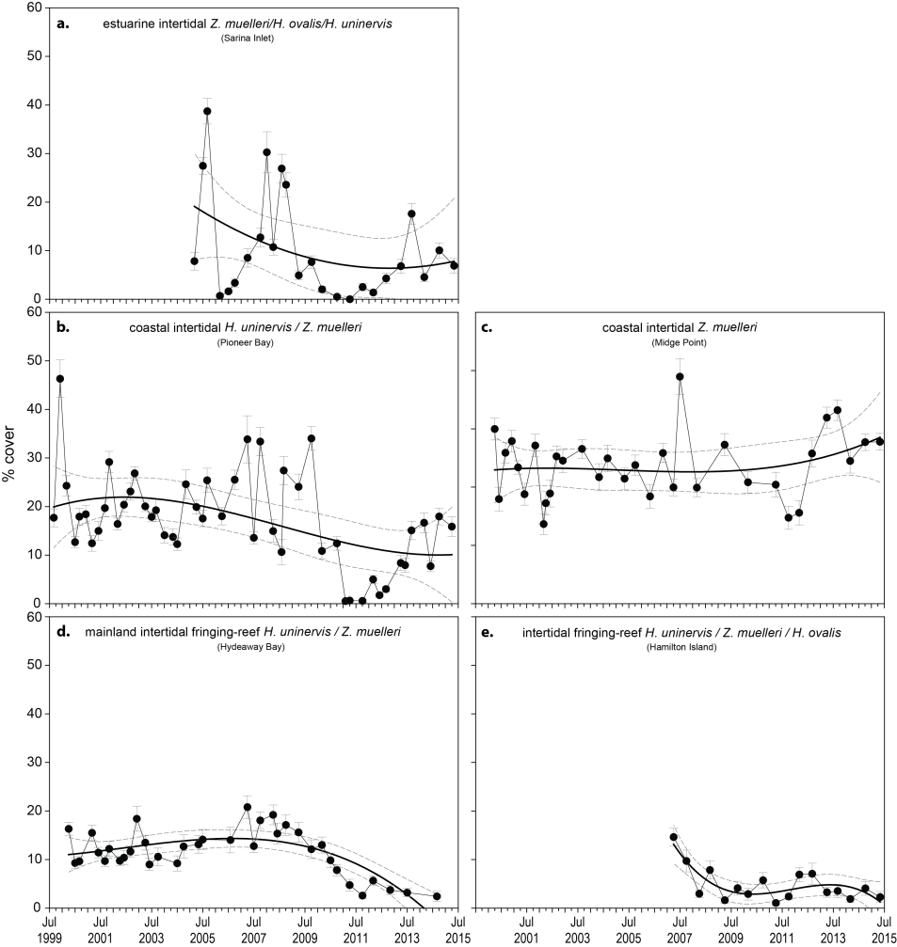
Figure 73. Changes in seagrass abundance (% cover ±Standard Error) at inshore intertidal habitats in the Mackay Whitsunday region, 1999 - 2015
: a). estuarine, b). coastal, and c). reef. Trendline is 3rd order polynomial, 95% confidence intervals displayed: estuarine r² = 0.15; coastal r² = 0.23 (PI) and 0.07 (MP); reef r² = 0.64 (HM) and 0.54 (HB).
An examination of the long term trends across the Mackay Whitsunday NRM region suggests seagrass abundance (% cover) continued to improve in 2014 from losses experienced in 2011 but remains below the pre-2009 levels (Figure 86). The slight decrease in early 2015 is most likely the natural seasonal decline.
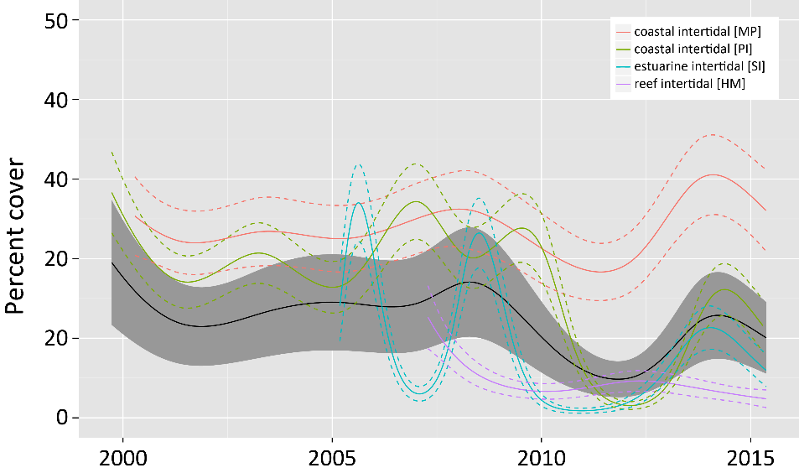
Figure 74. Temporal trends in seagrass abundance for each location in the Mackay Whitsunday region represented by a GAM plot.
Regional trend (all habitats pooled) represented by black line with grey shaded areas defining 95% confidence intervals.
The most common seagrass species across all habitats in the Mackay Whitsunday NRM region were Halodule uninervis and Zostera muelleri, mixed with the colonising species Halophila ovalis.
Colonising species have recently dominated in coastal meadows across the Mackay Whitsunday NRM following the extreme weather in 2011. As in other regions, during 2014-15 colonising species have been replaced by the opportunistic foundational species H. uninervis and Z. muelleri, which now dominate (Figure 75, Appendix 4). Estuarine habitats are typically dynamic and fluctuations in species composition are common, but a similar displacement of colonising species occurred in estuarine sites in 2014-15 in favour of other opportunistic foundational species. In contrast, in reef habitats (Hamilton Island), colonising species have steadily increased.The dominance of the foundational (opportunistic and persistent) species in meadows across all habitats in the Mackay Whitsunday NRM region continued to improve over the last 2 monitoring periods, suggesting meadows may have an improved ecosystem resistance to tolerate disturbances (Figure 75).
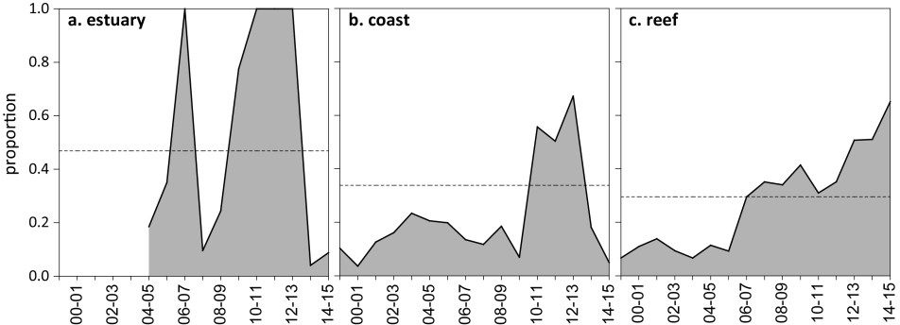
Figure 75. Proportion of seagrass abundance composed of colonising species at inshore intertidal habitats in the Mackay Whitsunday region, 1999 - 2015.
Grey area represents GBR long-term average proportion of colonising species for each habitat type.
Seagrass meadow edge mapping was conducted within a 100m radius of all monitoring sites in October 2014 and April 2015 to determine if changes in abundance were a consequence of the meadow edges changing and to indicate if plants were allocating resources to colonisation (asexual reproduction) (Appendix 4). Over the past 12 months, coastal and estuarine meadows have continued to expand across the region however reef meadows have gradually declined since late 2014 (Figure 76).
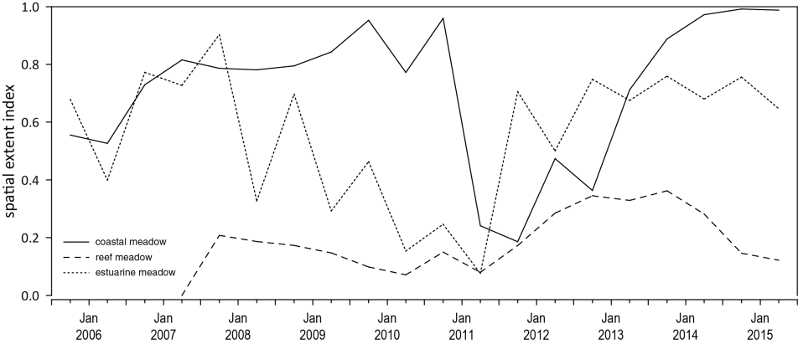
Figure 76. Change in spatial extent of seagrass meadows within a 100m radius of monitoring sites for each inshore intertidal habitat and monitoring period across the Mackay Whitsunday NRM region.
Benthic surveys for North Queensland Bulk Ports at the Port of Hay Point and Keswick Island group mapped 8,937.7 ±5,433.6 ha of seagrass meadows in October/November 2014 (McKenna and Rasheed 2015). There have been 5 surveys (2004, 2005, 2010, 2011, 2014) of the Port of Hay Point, and this was the largest area of seagrass recorded since the baseline assessments conducted in 2004, and a significant increase since the last survey in 2011 (McKenna and Rasheed 2015). The meadow abundance in 2014 was, however, significantly lower than the 2004 baseline, but higher than the 2011 minima (McKenna and Rasheed 2015). Seagrass was found to a depth of 19.9m in the open area off Hay Point and 29.7m in the lee of Keswick Island. The meadows consisted of aggregated to isolated patches dominated by the colonising species Halophila decipiens (off Hay Point) and Halophila tricostata (Keswick Island meadows). The 2014 survey also recorded isolated patches of opportunistic species such as a small (4.5ha) patch of Zostera muelleri on the large intertidal banks in Sandringham Bay, not previously recorded (Coles, et al. 2001b). 99.5% of the seagrass mapped was Halophila decipiens with a visually estimated above-ground biomass of 0.003 ±0.001g DW m⁻² (McKenna and Rasheed 2015); which equates to approximately 3-4 pairs of leaves per square metre, based on Mellors (1991) that the lowest rank is determined by the accuracy of the scientific scales used for calibration (i.e. 0.01g). Five offshore open seabed and two coastal areas in the Hay Point/Mackay region have been identified for long-term seagrass monitoring. An additional two reference areas in the Keswick Island group have also been identified, however, as these are within 2 n miles of a reef/island, judgements regarding the state of the broader region will need to be interpreted with caution due to effects of proximity or shelter from waves (see Coles, et al. 2009).

Seagrass reproductive status
Reproductive effort was highly variable in the Mackay Whitsunday region, but increased in 2014-15 at coastal and estuarine habitats compared to 2013-14 (Figure 77). In contrast, at the reef sites, there was a large peak in 2013-14, which subsequently declined in 2014-15. Banks of predominately Halodule uninervis and some Zostera muelleri seeds have varied greatly over the past decade, however, very few seeds have been found in reef habitat meadows (Figure 77). Seed banks increased slightly at coastal sites and were similar to the previous year at estuarine sites (Figure 77). The overall score for reproductive effort has increased but remains poor.

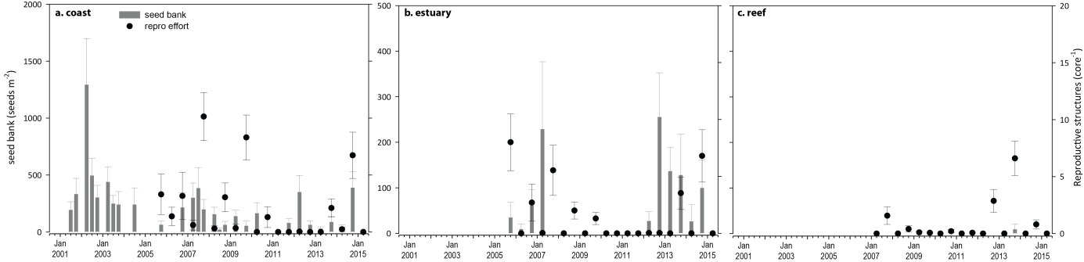
Figure 77. Seed bank and late dry season reproductive effort at inshore intertidal coast, estuary, and reef habitats in the Mackay Whitsunday region, 2001 - 2015.
Seed bank presented as the total number of seeds per m² sediment surface and late dry season reproductive effort presented as the average number of reproductive structures per core (species and sites pooled). NB: Y-axis scale for seed banks differs between habitats.

Indicators of environmental condition

Seagrass tissue nutrients
Seagrass leaf molar C:N ratios were similar to the previous year but slightly increased at coastal sites, and reduced at other habitats. C:N remains below 20 (Figure 78) indicating a surplus of N relative to photosynthetic C incorporation. N:P ratios increased to at or near 30, which when coupled with the large P pool, (C:P <500), indicates surplus availability of N driving C:N (Figure 79).Across all habitats, the δ15N values for the dominant species (Zostera muelleri) were above 2‰, suggesting the primary source of the elevated N was fertiliser or sewage.

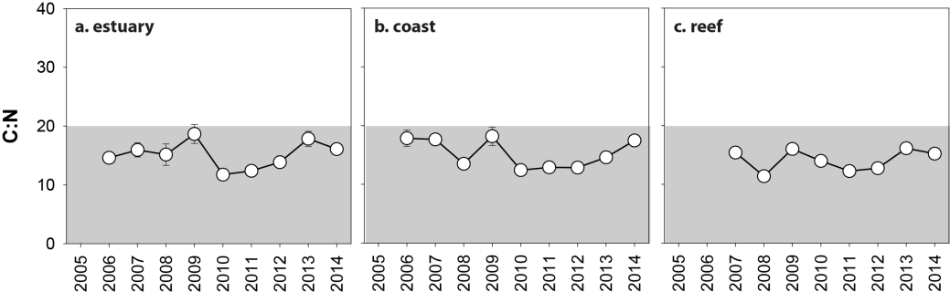
Figure 78. Elemental ratios (atomic) of seagrass leaf tissue C:N for the foundation seagrass species examined at inshore intertidal habitats in the Mackay Whitsunday region, 2006 - 2014
(species pooled) (mean ± Standard Error). Horizontal shaded band on the C:N ratio panel represents the accepted guideline seagrass “Redfield” ratio of 20:1 (Abal, et al. 1994; Grice, et al. 1996). C:N ratios below this line may indicate reduced light availability and/or N enrichment.

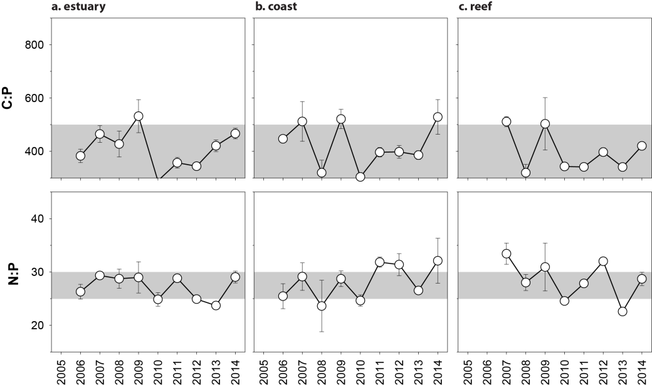
Figure 79. Elemental ratios (atomic) of seagrass leaf tissue N:P and C:P for the foundation seagrass species examined at inshore intertidal habitats in the Mackay Whitsunday region, 2006 - 2014
(species pooled) (mean ± Standard Error). Horizontal shaded band on the N:P ratio panel represents the range of value associated with N:P balance ratio in the plant tissues, i.e. a seagrass “Redfield” ratio (Atkinson and Smith 1983; Duarte 1990; Fourqurean, et al. 1992b; Fourqurean and Cai 2001). N:P ratio above this band indicates P limitation, below indicates N limitation and within indicates replete. Shaded portion on the C:P panel ≤500 represents the value associated with C:P balance ratio in the plant tissues, C:P values <500 may indicate nutrient rich habitats (large P pool).

Seagrass meadow sediments
The proportion of fine grain sizes decreases in the sediments of the seagrass monitoring sites/meadows with distance from the coast/river mouths in the Mackay Whitsunday region. Estuarine sediments were composed of greater proportion of finer sediments, and in 2014-15 the proportion of mud was similar to the GBR long-term average with little change over the last 6 years. Coastal habitat meadows had less mud than estuarine habitats, and the meadows at Midge Point had a higher proportion of mud than those in Pioneer Bay. Sediments at Midge Point have remained stable relative to the GBR long-term average since 2007, however, at Pioneer Bay they have fluctuated greatly between sites and between years; in 2014-15, the proportion mud increased at PI2 but decreased at PI3. Reef habitats were composed predominately of fine to medium sand, however, in 2014 they contained a proportion of mud, not observed since early 2012.

Epiphytes and macroalgae
Epiphyte cover on seagrass leaf blades was consistent with the long-term trend during 2014-15 with no seasonal difference apparent, except at reef habitats where it was higher in the dry season (Figure 80). At estuarine and reef habitats, epiphyte cover decreased below the GBR long-term average in 2014-15 (Appendix 2, Figure 208, Figure 209), but remained above at the coastal habitat of Pioneer Bay (Appendix 2, Figure 210). In coastal habitats, epiphyte abundances were higher at Pioneer Bay than Midge Point both in 2014-15 and in the long-term (Figure 80; Appendix 2, Figure 208). Percentage cover of macroalgae remained unchanged and below the GBR long-term average for all habitats throughout 2014-15 (Appendix 4, Figure 208, Figure 209, Figure 210).
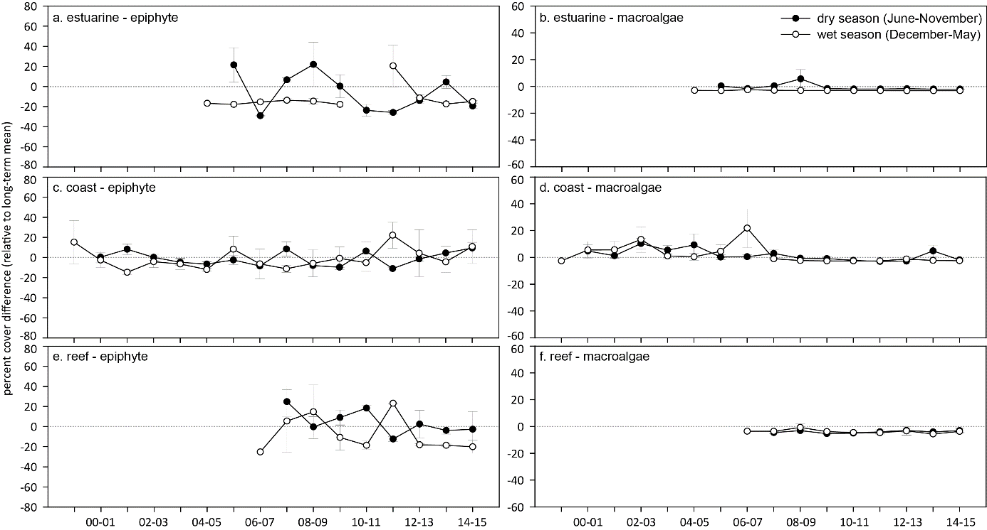
Figure 80. Long-term trend in mean epiphyte and macroalgae abundance (% cover) relative to the long-term average for each inshore intertidal habitat in the Mackay Whitsunday region, 1999 - 2015
(sites pooled, ±SE).

Report card for inshore seagrass status
In the 2014-15 monitoring period, the seagrass index for the Mackay Whitsunday region improved above the previous period and was the highest since 2006-07. The improvement appears a consequence of improved abundance and reproductive effort in coastal habitats. Overall, the Mackay Whitsunday seagrass index has continued to improve since 2010-11 when it reached its lowest level since monitoring commenced. In 2014-15 it was the highest since 2006-07.

Table 23. Long-term report card scores for seagrass abundance, reproductive and leaf tissue nutrient status for each habitat in the Mackay Whitsunday region: June 2005 – May 2015.
Values are indexed scores scaled from 0-100; ■ = very good (81-100), ■ = good (61 - 80), ■ = moderate (41 - 60), ■ = poor (21 - 40), ■ = very poor (0 - 20). NB: Scores are unitless.
NRM region | Habitat | 2005-06 | 2006-07 | 2007-08 | 2008-09 | 2009-10 | 2010-11 | 2011-12 | 2012-13 | 2013-14 | 2014-15
Abundance | estuarine intertidal | 40 | 25 | 20 | 25 | 6 | 0 | 13 | 25 | 13 | 13
Abundance | coastal intertidal | 63 | 88 | 54 | 63 | 63 | 8 | 13 | 13 | 33 | 67
Abundance | reef intertidal |  | 25 | 6 | 13 | 6 | 6 | 13 | 0 | 0 | 3
Reproductive  effort | estuarine intertidal | 50 | 13 | 25 | 0 | 0 | 0 | 0 | 0 | 25 | 50
Reproductive  effort | coastal intertidal | 0 | 13 | 38 | 13 | 38 | 0 | 0 | 0 | 0 | 25
Reproductive  effort | reef intertidal |  |  | 25 | 13 | 0 | 0 | 0 | 50 | 50 | 25
Leaf tissue  nutrients | estuarine intertidal |  | 23 | 30 | 26 | 43 | 9 | 12 | 19 | 39 | 30
Leaf tissue  nutrients | coastal intertidal |  | 39 | 38 | 18 | 41 | 12 | 14 | 14 | 23 | 37
Leaf tissue  nutrients | reef intertidal |  |  | 27 | 7 | 30 | 20 | 11 | 14 | 31 | 26
Seagrass Index |  | 39 | 31 | 30 | 21 | 25 | 6 | 8 | 15 | 25 | 32

Fitzroy

2014-15 Summary
The Fitzroy region has the largest catchment area draining into the GBR, and the inshore seagrass meadows are mainly located on the large shallow sand/mud banks in sheltered areas of the region’s estuaries and coasts, or on the fringing reef flat habitats of offshore islands. The seagrass meadows are primarily structured by infrequent plumes of sediment-laden floodwaters, high turbidity, desiccation and elevated temperatures.
In 2014-15 climatic conditions in the region were less conducive to seagrass growth than the previous year, and the impacts of TC Marcia possibly exposed seagrass to a range of acute stressors, which may have a cumulative impact of meadow condition and resilience. 2014-15 was slightly wetter than the long term average, and higher than the previous year. Despite the high river flow which exposed seagrass meadows to primary or secondary plume waters for the entire 2014-15 wet season, daily light was similar to the long-term average; except at the reef habitat. Seagrass also experienced above average seawater temperatures for the third consecutive year, with more days above 35°C (including extreme temperatures (>40°C)) which may have reduced growth in some species (e.g. Z. muelleri). However, below median annual daytime tidal exposure and less days of strong wind would have limited heat and desiccation stress at estuarine and coastal habitats.
Seagrass abundance varied across sites and habitats, with an overall decrease at estuarine habitats and a slight increased at both coastal and reef habitats. The regional seagrass abundance score increased only slightly in 2014-15. Seagrass extent remained stable at both coastal and estuarine meadows, but increased to the greatest in 4 years at the reef habitat. With the exception of reef habitats, the proportion of colonising species declined across the meadows in 2014-15 in favour of opportunistic species. Seed banks persisted in estuary and coast habitats, indicating a capacity to recover following disturbance, although poor reproductive effort may be a precursor to seed bank limitation in the near future. Seed banks remain absent from reef habitats and limits the capacity of opportunistic species to expand, as well as the meadow capacity to recover following further disturbance.
Seagrass leaf tissue nutrient concentrations and isotopic signatures across all habitats indicated a surplus in the uptake of N relative to the uptake and incorporation of carbon; suggesting either reduced light availability or elevated N. Declining light levels at reef habitats were likely to have affected carbon uptake, while increasing N:P at coast and reef sites indicated nitrogen enrichment. Leaf tissue δ¹⁵N values at coastal and estuarine habitats suggests either fertiliser and/or sewage influence in the primary source of N: possibly explaining the slight increase in epiphyte loads in estuary habitats.
Seagrass across the region remain in the early stages of recovering from multiple years of climate related impacts which has likely left a legacy of reduced resilience to impacts until they have further recovered. Overall, the Fitzroy regional seagrass state declined slightly in 2014-15 to very poor (Figure 81), the lowest since monitoring commenced.
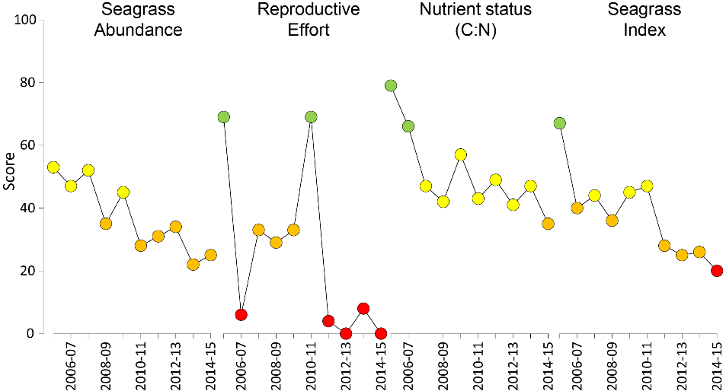
Figure 81. Report card of seagrass status indicators and index for the Fitzroy NRM region
(averages across habitats and sites). Values are indexed scores scaled from 0-100; ■ = very good (81-100), ■ = good (61 - 80), ■ = moderate (41 - 60), ■ = poor (21 - 40), ■ = very poor (0 - 20). NB: Scores are unitless.

Climate and environmental pressures
In the Fitzroy region, rainfall and river flow were similar to the long-term average (Table 24), making it considerably wetter than other NRMs in the GBR in 2014-15. This was due primarily to TC Marcia (a category 5 storm) in February 2015 that passed quickly but caused considerable damage from wind and tidal surge as well as elevated rainfall and river flow. Water quality effects, however, were not limited to this event, as seagrass sites in the Fitzroy region were exposed to primary or secondary water during 100% (f_{(P+S)}=1.00) of the wet season (December 2014 – April 2015) (Figure 82). Coastal and estuarine sites were exposed mostly to primary water including colour class 1 and 2, which is the most turbid primary water, and Great Keppel Island (reef habitat) was exposed to secondary water (Table 25).
Table 24. Summary of environmental conditions at monitoring sites in the Fitzroy region in 2014-15 compared to the long-term average (long-term range indicated for each data set).
 | Long-term average | 2014-15
Rainfall (1957-2015) | 942 mm | 997 mm
River discharge (1970-2015) | 2,691,509 L yr⁻¹ | 2,667,055 L yr⁻¹
Flood plume exposure (2006-2015) | unavailable | 100%
Daytime tidal exposure (2002-2015) | 104.23 hrs yr⁻¹ | 104.81 hrs yr⁻¹
Wind (1998-2015) | 83 days yr⁻¹ | 51.7 days yr⁻¹
Within canopy temperature (2006-2015) | 23.8°C (41°C) | 24.3°C (41°C)
Within canopy light (2012-2015) | 14.4 mol m⁻² d⁻¹ | 14.4 mol m⁻² d⁻¹
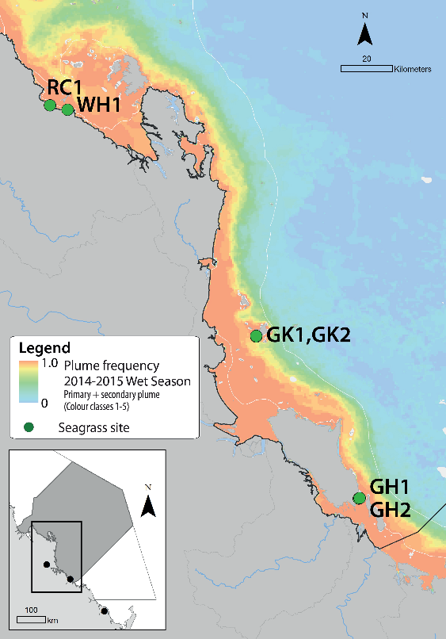
Figure 82. Frequency of exposure to plume water in the Fitzroy NRM, wet season (22 weeks from December 2014 – April 2015) composite.
Frequency calculated as number of weeks in wet season exposed to primary or secondary water (colour classes 1 – 5). Each colour class category is described by mean water quality values for TSS, CDOM, chlorophyll a and K_{d} (PAR) (Devlin, et al. 2015; Lønborg, et al. 2015). For site details, see Tables 3 & 4.

Table 25. Water type at each site (Loc) in the Fitzroy region derived from MODIS true colour images
as colour classes of turbid primary water (class 1 – 4, red/brown), nutrient/chlorophyll-enriched secondary water (class 5, green), and tertiary (some freshwater/CDOM influence) or no plume influence (class 6 and 7 respectively, blue), for 22 weeks from December 2014 – April 2015. Also shown, median wet season colour class (Med), frequency of primary water as f_{(P)}, the frequency of secondary water as f_{(S}), and the frequency of primary or secondary as f_{(P+S)}.
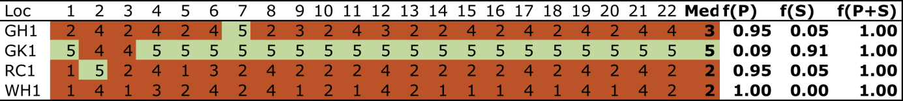

Despite the high river flow and water type exposure, within canopy daily light (I_{d}), was similar to the long-term average for the region, although highly variable among habitats (Figure 83). Shoalwater Bay (SWB) continued to have very high I_{d} owing to the frequency of daytime low tide exposure (Appendix 4). I_{d} in Gladstone Harbour (GH) was similar to the long-term average. In contrast, I_{d} declined at Great Keppel Island (GK) through 2014-15 as this location has very infrequent daytime low tide exposure (Appendix 4) and therefore I_{d} is highly sensitive to overlying water quality.
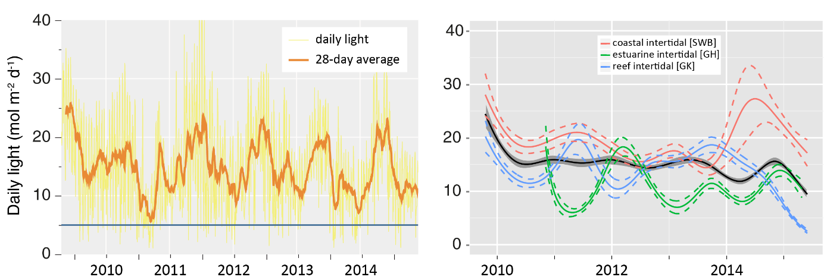
Figure 83. Mean daily light at Fitzroy sites with 28-d rolling average from 2012 to 2015 (left) and GAM plots (right)
with the black line showing mean trend for all sites (±95% confidence interval in grey shade) and coloured lines (with CI’s) showing the trend for each site. Results of statistical analysis (GAM) and site-specific graphs (site-level daily light data plus 28-d rolling average) are shown in Appendix 4.
Water temperature was slightly above the long-term average for this region (Figure 84). There were a large number of days (33) exceeding 35°C and frequent deviation (warm) from the baseline but these temperatures would not be expected to cause significant photoinhibition (Campbell, et al. 2006). However, prolonged exposure to warm water (>35°C) can reduce growth in some species (e.g. Z. muelleri), while other species are unlikely to be impacted (Collier, et al. 2011). There was average daily tide exposure and only one day where extreme (>40°C) water temperatures occurred (41°C at 5pm on 21 February 2015 at GH2).
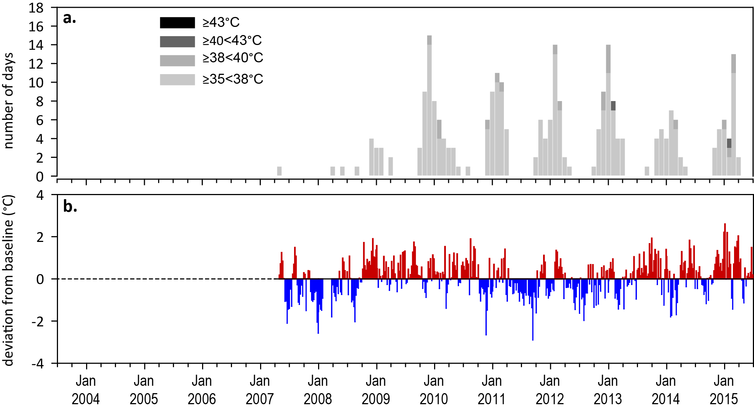
Figure 84. Inshore sea temperatures within each intertidal seagrass habitat in the Fitzroy region, May 2007 - June 2015
: a) number of days when temperature has exceeded 35°C, 38°C, 40°C and 43°C within each season (thresholds adapted from Campbell, et al. 2006); b) deviations from 11-year mean weekly temperature records (weeks above the long-term average are represented as red bars and the magnitude of their deviation from the mean represented by the length of the bars, bars are blue for weeks with temperatures lower than the average and are plotted as negative deviations).

Indicators of seagrass condition

Seagrass abundance, composition and extent
The regional seagrass abundance score increased slightly in 2014-15 but the state remained poor (Figure 81). Seagrass abundance declined at estuarine and coastal habitats, but remained unchanged at reef sites. The long-term average seagrass abundances at coastal habitats in the Fitzroy region were seasonally lower in the monsoon (16.7 ±1.1%) than the late dry (20.6 ±1.5%) (Figure 85). In 2014-15, coastal average abundances in the late dry were less than half the long-term (10 year) seasonal average. Estuarine abundances in late dry 2014-15 were near 40% lower than the long term average, while reef abundances were approximately 20% higher than the long term average.
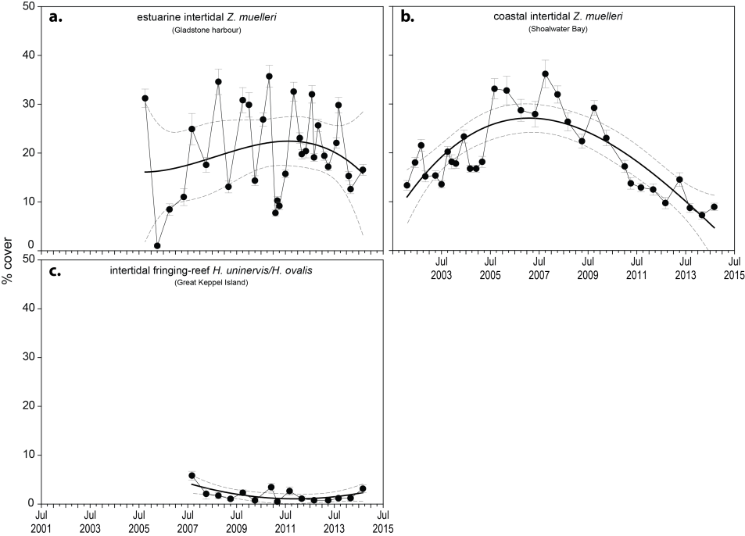
Figure 85. Changes in seagrass abundance (% cover ±Standard Error) in inshore intertidal habitats of the Fitzroy region, 2001 - 2015
: a) estuarine (Gladstone Harbour, b) coastal (Shoalwater Bay) and c) reef (Great Keppel Island). Trendline is 3rd order polynomial, 95% confidence intervals displayed, estuarine r² = 0.06, coastal r² = 0.66, and reef r² = 0.38.
An examination of the long term trends across the Fitzroy NRM region suggests seagrass abundance (% cover) slightly increased from 2002 to 2008, but has since progressively declined since (Figure 86).
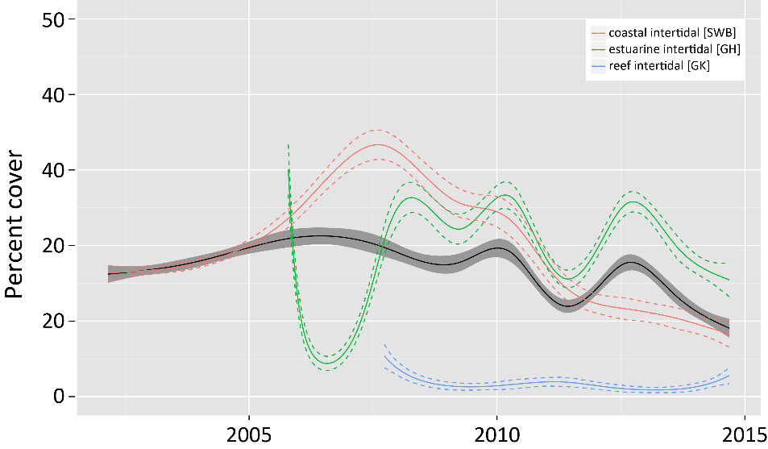
Figure 86. Temporal trends in seagrass abundance for each habitat in the Fitzroy region, represented by a GAM plot 2001-2015.
Regional trend (all habitats pooled) represented by black line with grey shaded areas defining 95% confidence intervals.
Coastal meadows in Shoalwater Bay (Ross Creek and Wheelans Hut) had an increased proportion of colonising species (H. ovalis) after 2011 but remained dominated (>0.5) by the opportunistic species Z. muelleri, and H. uninervis (Figure 87). In 2014-15, the proportion of these opportunistic species continued to increase as colonising species dominance declined. The proportion of colonising species at the estuarine habitat, has also declined in the past 2 years in favour of Z. muelleri. At the reef habitat, total abundance is very low and is dominated by colonising species.
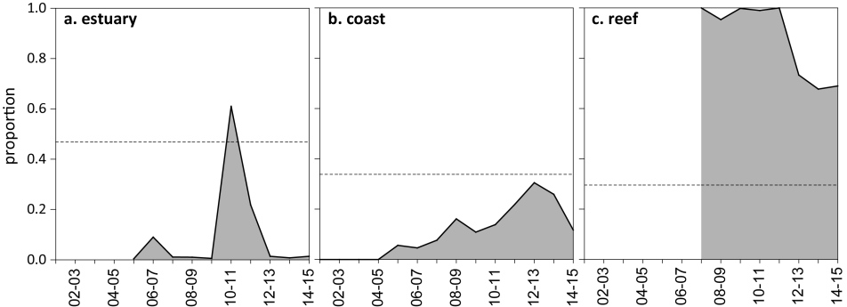
Figure 87. Proportion of seagrass abundance composed of colonising species in inshore intertidal habitats of the Fitzroy region, 2001 - 2015.
Grey area represents GBR long-term average proportion of colonising species for each habitat type.
The extent of the coastal meadows within a 100m radius of monitoring sites in Shoalwater Bay has remained stable at the maximum since monitoring commenced in 2005. The extent of the estuarine meadows has remained relatively stable over the past 8 monitoring periods, however, reef meadows have varied greatly. In late 2014, the extent of the reef meadows (Great Keppel Island), increased to their most extensive in 4 years (Figure 88).
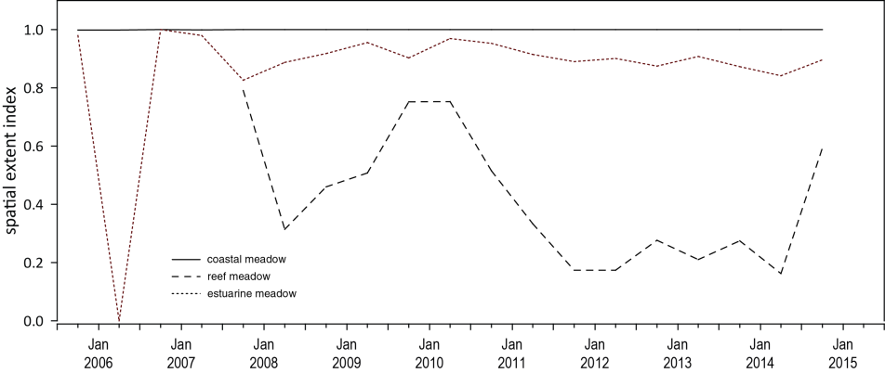
Figure 88. Change in spatial extent of seagrass meadows within a 100m radius of monitoring sites for each inshore intertidal habitat across the Fitzroy NRM region, 2005 - 2015.
Apart from the MMP, seagrass monitoring within the Fitzroy NRM region is also conducted for the Gladstone Ports Corporation Limited as part of the Queensland Ports Seagrass Monitoring Program (QPSMP). Two locations monitored (Pelican Banks north and Rodds Bay) for the Gladstone Ports Corporation Limited are also monitored as part of the MMP.
Long-term monitoring of 14 seagrass meadows within Gladstone Harbour reported variable recovery in 2014 from the losses which occurred in 2010-11 as a consequence of extreme weather events and associated flooding (Bryant et al. 2014a; Carter et al. 2015a). Abundance (visual estimate of above-ground biomass) remained low across all meadows and although total area of meadows monitored fluctuates within years (>50% between seasons), there appears little overall change since 2010 (i.e. estimates of reliability/mapping precision overlap between years). This appears in contrast with the November 2014 remapping of the broader Port Curtis region, which reported the greatest overall area of seagrass to date (Carter, et al. 2015).
In 2014, meadows were reported as predominately aggregated or isolated patches. The only meadow classed as having continuous seagrass cover in the entire Port Curtis region was the Z. muelleri meadow on Pelican Banks which is monitored in common with the MMP (meadow#43). This meadow also had the highest visually estimated above-ground biomass recorded (12.31 ±1.36 g DW m^{‐2}), which has remained relatively stable over the previous 3 annual monitoring events. Overall, indications are that seagrass area and biomass should continue to increase within Port Curtis over the next twelve months if climatic conditions are favourable (Carter, et al. 2015).

Seagrass reproductive status
Reproductive effort has remained very low throughout the Fitzroy region, however, seed banks have persisted in estuary and coast habitats over the last 3 – 4 monitoring periods (Figure 89). Seed banks of Zostera muelleri and Halodule uninervis at estuary and coast sites, respectively, indicate a capacity to recover following disturbance, although poor reproductive effort may be a precursor to seed bank limitation in the near future. In these sites, the reproductive score may underestimate the role of sexual reproduction and the seed bank. As such, seed banks are being considered for future inclusion in the report card metric. Seed banks remain absent from reef habitats in 2014-15 which limits the capacity of opportunistic species to expand, as well as the meadow capacity to recover following further disturbance.
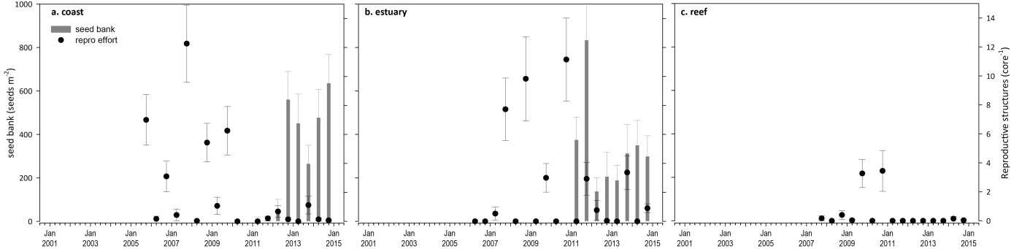
Figure 89. Seed bank and late dry season reproductive effort for inshore intertidal coastal, estuary and reef habitats in the Fitzroy region, 2005 - 2015.
Seed bank presented as the total number of seeds per m² sediment surface and late dry season reproductive effort presented as the average number of reproductive structures per core (species and sites pooled).

Indicators of environmental condition

Seagrass tissue nutrients
Seagrass growing in the Fitzroy region were similar in the relative compositions of carbon to nitrogen (C:N <20) among habitats in 2014-15 (Figure 90). At all habitats, the C:N was below 20, which is indicative of a surplus in the uptake of N, relative to the uptake and incorporation of carbon and may indicate either reduced light availability or elevated N. Leaf tissue δ¹³C remained stable and below global averages across all habitats, suggesting some light limitation which is consistent with the declining light levels measures at GK through 2014, which is likely to have affected carbon uptake. Increasing N:P at coast and reef sites further indicates nitrogen enrichment in 2014 (Figure 91), but as this was prior to the wet season, it cannot be attributed to TC Marcia and events associated with its passing. Leaf tissue δ¹³C values across habitats were similar or lower than previous, but the levels at coastal and estuarine habitats suggests either fertiliser and/or sewage influence in the primary source of N.
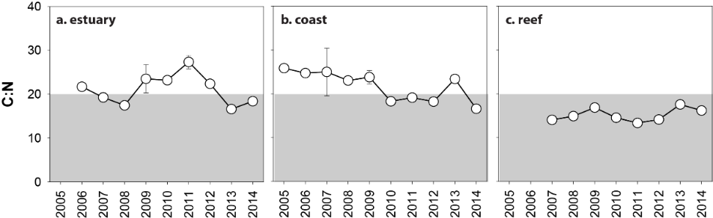
Figure 90. Elemental ratios (atomic) of seagrass leaf tissue C:N for the foundation seagrass species examined at inshore intertidal habitats in the Fitzroy region, 2005 - 2014
(species pooled) (mean ± Standard Error). Horizontal shaded band on the C:N ratio panel represents the accepted guideline seagrass “Redfield” ratio of 20:1 (Abal, et al. 1994; Grice, et al. 1996). C:N ratios below this line may indicate reduced light availability and/or N enrichment.
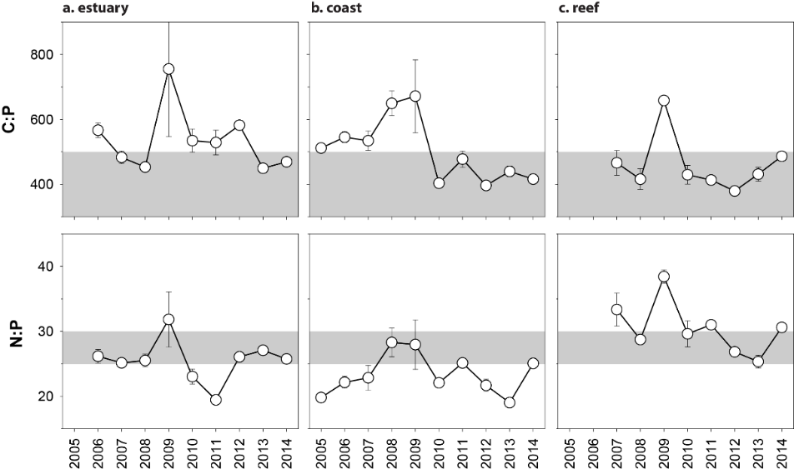
Figure 91. Elemental ratios (atomic) of seagrass leaf tissue N:P and C:P for the foundation seagrass species examined at inshore intertidal habitats in the Fitzroy region, 2005 - 2014
(species pooled) (mean ± Standard Error). Horizontal shaded band on the N:P ratio panel represents the range of value associated with N:P balance ratio in the plant tissues. N:P ratio above this band indicates P limitation, below indicates N limitation and within indicates replete. Shaded portion on the C:P panel ≤500 represents the value associated with C:P balance ratio in the plant tissues, C:P values <500 may indicate nutrient rich habitats (large P pool).

Seagrass meadow sediments
In the Fitzroy region, the proportion of fine grains in meadow sediments decreases with distance from the coast/river mouths and has remained stable over the last 5-6 years. Estuarine sediments were composed primarily of finer sediments, with the mud portion just below the GBR long-term average. Coastal and reef habitat sediments were dominated by fine sand/sand, but the proportion of mud in coastal habitats was higher than the GBR long-term average.

Epiphytes and Macroalgae
Epiphyte cover at coast and reef habitats either decreased or remained below the GBR long-term average over the 2014-15 monitoring period (Figure 92; Appendix 4, Figure 212, Figure 214). At estuary habitats, however, the seasonally fluctuating epiphyte cover remaining above the GBR long-term average (Appendix 2, Figure 213). Macroalgae cover remained unchanged at coastal and estuarine meadows in 2014-15, but continued to increase at reef sites (Figure 92; Appendix 4, Figure 214).
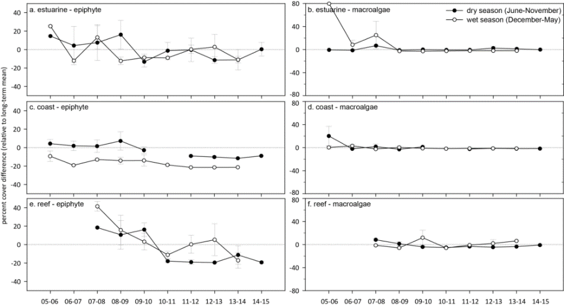
Figure 92. Long-term trend in mean epiphyte and macroalgae abundance (% cover) relative to the long-term average for each inshore intertidal seagrass habitat in the Fitzroy region, 2005 - 2014
(sites pooled, ±SE).

Report card for inshore seagrass status
The seagrass index for the Fitzroy region has fluctuated greatly since monitoring was established. In the 2014-15 monitoring period, the seagrass index declined to its lowest level ever, after the brief increase during the previous period. The decline appears primarily a consequence of poorer leaf tissue nutrients in the coastal and reef habitats. Declining abundance and reproductive effort in the estuarine habitats also contributed to the lower overall score in 2014-15.
Table 26. Long-term report card scores for seagrass abundance, reproductive and leaf tissue nutrient status for each habitat in the Fitzroy region: June 2005 – May 2015.
Values are indexed scores scaled from 0-100; ■ = very good (81-100), ■ = good (61 - 80), ■ = moderate (41 - 60), ■ = poor (21 - 40), ■ = very poor (0 - 20). NB: Scores are unitless.
Report Card | Habitat | 2005-06 | 2006-07 | 2007-08 | 2008-09 | 2009-10 | 2010-11 | 2011-12 | 2012-13 | 2013-14 | 2014-15
Abundance | estuarine intertidal | 25 | 13 | 44 | 25 | 42 | 34 | 47 | 53 | 34 | 25
Abundance | coastal intertidal | 81 | 81 | 100 | 75 | 81 | 31 | 25 | 25 | 8 | 25
Abundance | reef intertidal |  |  | 13 | 6 | 13 | 13 | 6 | 6 | 6 | 25
Reproductive  effort | estuarine intertidal | 100 | 0 | 50 | 63 | 25 | 75 | 13 | 0 | 25 | 0
Reproductive  effort | coastal intertidal | 38 | 13 | 50 | 25 | 25 |  | 0 | 0 | 0 | 0
Reproductive  effort | reef intertidal |  |  | 0 | 0 | 50 | 63 | 0 | 0 | 0 | 0
Leaf tissue  nutrients | estuarine intertidal |  | 58 | 46 | 37 | 67 | 66 | 85 | 62 | 33 | 42
Leaf tissue  nutrients | coastal intertidal | 79 | 74 | 75 | 65 | 69 | 41 | 46 | 41 | 67 | 33
Leaf tissue  nutrients | reef intertidal |  |  | 20 | 25 | 34 | 23 | 17 | 21 | 41 | 31
Seagrass Index |  | 67 | 40 | 44 | 36 | 45 | 47 | 28 | 25 | 26 | 20

Burnett Mary

2014-15 Summary
Only intertidal estuarine and coastal seagrass meadows located in bays protected from SE winds and wave action were monitored in the Burnett Mary NRM region. The main ecological drivers in these environments are exposure to wind waves, elevated temperature, flood runoff and turbidity. Seagrasses are monitored at locations in the north and south of the Burnett Mary Region. Since monitoring was established, the meadows have come and gone on an irregular basis.
Although rainfall at the monitoring sites was below the long-term average in 2014-15, above average river discharge from the large catchment area in the region resulted in inshore meadows being exposed to turbid primary water for nearly the entire wet season. As a consequence, the proportion of mud in sediments increased and daily light continued to decline in 2014-15 to well below the long-term average. Water temperatures were above average for most of the year, but the below average tidal exposure and strong winds in 2014-15 may have provided some respite from the elevated temperatures.
Seagrass abundance increased across the region in 2013-14, providing the highest score since 2005. Meadow extent also continued to recover at monitoring sites in 2014-15 and was aproximately half of when monitoring was established in 2005. The proportion of seagrass species displaying colonising traits declined in estuarine habitats, but remained stable below the GBR long-term average at coastal habitats. The reduced proportion of colonising species suggests greater ability to tolerate/resist major disturbances, particularly as meadow abundances improves. Zostera muelleri seeds persisted throughout the year in estuary meadows, but the late dry season seed banks were the smallest since 2010; indicating a reduced capacity to recover following disturbance. The improving reproductive effort, however, suggests seed bank recovery in the near future as a result of possible increased replenishment. Z. muelleri leaf tissue analysis in late 2014, suggested sufficient but possibly low carbon available for growth due to the reduced light availability, particularly in the southern meadows of the region. Leaf tissue δ¹⁵N value were lower in 2014 than the previous year, but still indicated either fertiliser and/or sewage influence as the primary N source. Epiphyte and macroalgae abundance continued to increase above the GBR long-term average in 2014-15, possibly a result of high available N.
In response to the environmental pressures over 2014-15, the seagrass state in the Burnett Mary region increased to the highest score in a decade, although overall remaining in a poor state (Figure 93).
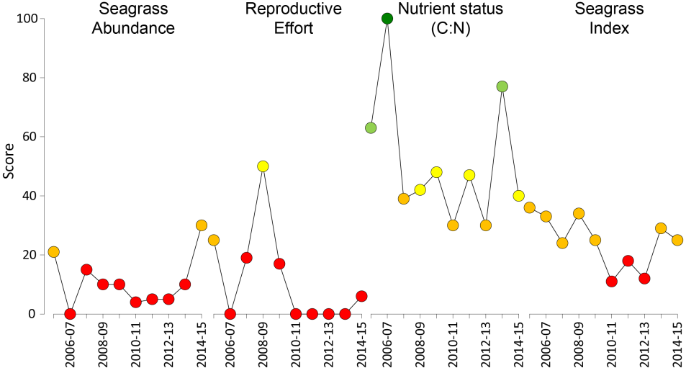
Figure 93. Report card of seagrass status indicators and index for the Fitzroy NRM region
(averages across habitats and sites). Values are indexed scores scaled from 0-100; ■ = very good (81-100), ■ = good (61 - 80), ■ = moderate (41 - 60), ■ = poor (21 - 40), ■ = very poor (0 - 20). NB: Scores are unitless.

Climate and environmental pressures
The Burnett Mary region was the only in the GBR to experience above average annual discharge in 2014-15 (Table 27) and this was related to TC Marcia which tracked down the coast bringing rainfall into the Mary River catchment. Burnett Mary seagrass meadows received below average rainfall and strong winds in 2014-15, but were exposed to almost exclusively primary water, often of very high turbidity (class 1 or 2, Figure 94 Table 28), from December 2014 to April 2015.
Table 27. Summary of environmental conditions at monitoring sites in the Burnett Mary in 2014-15 compared to the long-term average (long-term range indicated for each data set).
 | Long-term average | 2014-15
Rainfall (1986-2015) | 1098 mm | 1034 mm
River discharge (1970-2015) | 668,076 L yr⁻¹ | 1,622,222 L yr⁻¹
Flood plume exposure (2006-2015) | not available | 100%
Daytime tidal exposure (1999-2015) | 116.16 hrs yr⁻¹ | 82.63 hrs yr⁻¹
Wind (1998-2015) | 83.9 days yr⁻¹ | 49.5 days yr⁻¹
Within canopy temperature (2003-2015) | 23.0°C (39.5°C) | 23.7°C (37.7°C)
Within canopy light (2012-2015) | 13.8 mol m⁻² d⁻¹ | 10.3 mol m⁻² d⁻¹

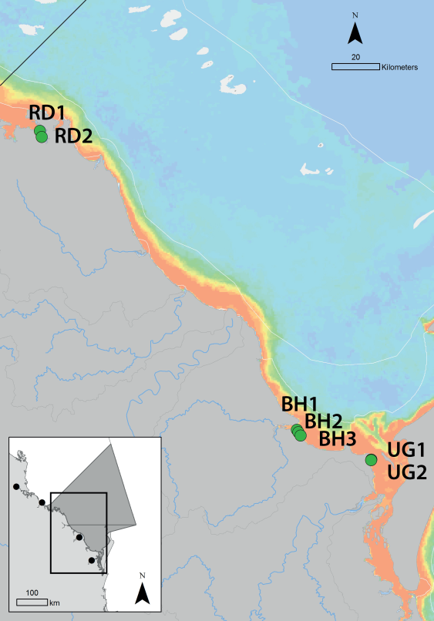
Figure 94. Frequency of exposure to plume water in the Burnett Mary NRM, wet season (22 weeks from December 2014 – April 2015) composite
. The frequency is calculated as the number of weeks out of 22 weeks that are exposed to primary or secondary water (colour classes 1 – 5). Each colour class category is described by mean water quality values for TSS, CDOM, chlorophyll a and K_{d} (PAR) (Devlin, et al. 2015; Lønborg, et al. 2015). For site details, see Tables 3 & 4.

Table 28. Water type at each location in the Burnett Mary NRM derived from MODIS true colour images
as colour classes of turbid primary water (class 1 – 4, red/brown), nutrient/chlorophyll-enriched secondary water (class 5, green), and tertiary (some freshwater/CDOM influence) or no plume influence (class 6 and 7 respectively, blue), for 22 weeks from December 2014 – April 2015. Also shown, median wet season colour class (Med), frequency of primary water as f_{(P)}, the frequency of secondary water as f_{(S)}, and the frequency of primary or secondary as f_{(P+S)}. *denotes data obtained from adjacent pixel.

Daily light (I_{d}) at Burnett-Mary sites sites has been monitored since 2010 at Rodds bay and since 2011 at Urangan (Figure 95). I_{d} has been on a declining trajectory since sites were established, and in 2014-15, was well below the long-term average (Figure 95). In particular, the late dry peak in I_{d} that typically occurs in GBR seagrass habitats was absent in 2014-15.
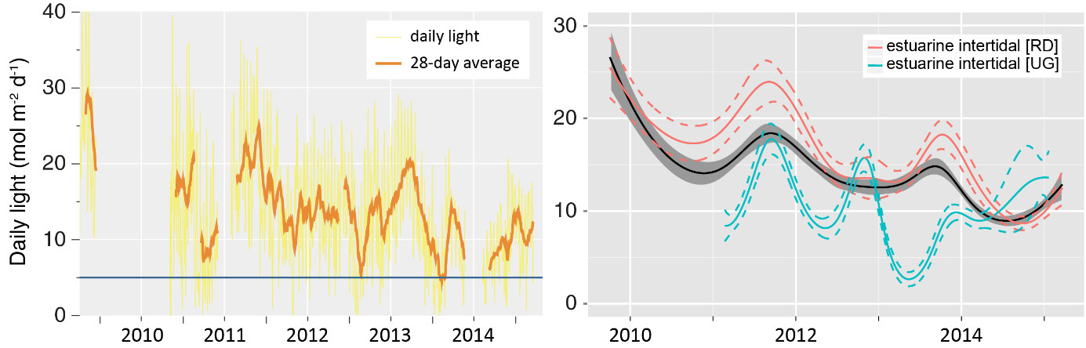
Figure 95. Daily light at Burnett Mary locations from 2010 to 2015 (left) and GAM plots (right)
with the black line showing mean trend for all sites (±95% confidence interval in grey shade) and coloured lines (with CI’s) showing the trend for each site. Results of statistical analysis (GAM) and site-specific graphs (raw daily light data plus 28-d rolling average) are shown in Appendix 4.
Burnett Mary, being the southern most NRM inherently has cooler temperatures than the more northern regions. As a consequence there were fewer exceedances of GBR-wide temperature thresholds (>35°C). However, deviation from the region-specific baseline demonstrates that 2014-15 was above average year for water temperature, and was above the local baseline for most of the year (Figure 96).
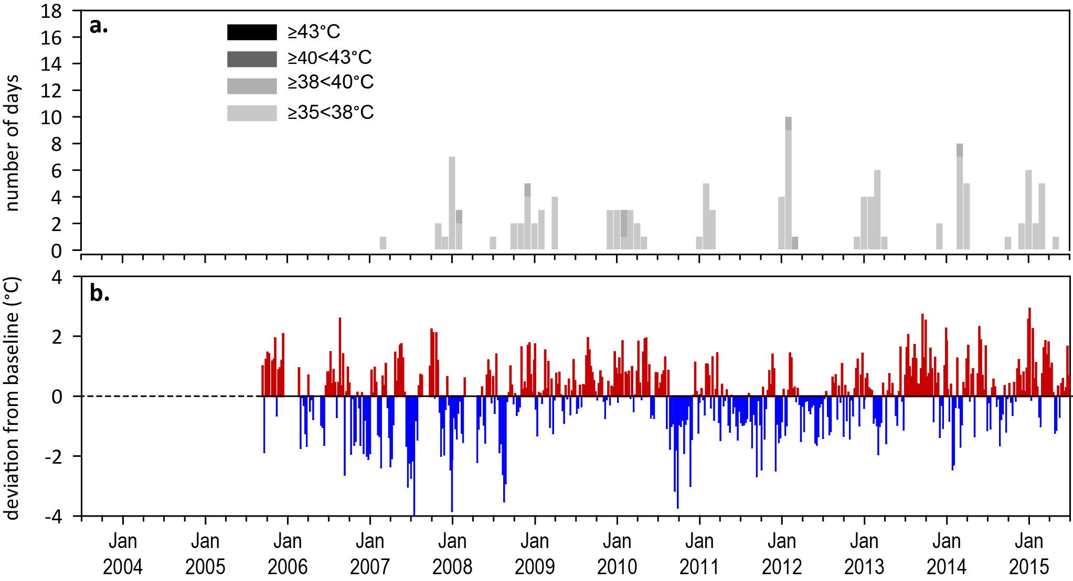
Figure 96. Inshore sea temperature monitoring September 2005 to June 2015 for seagrass meadows in Burnett Mary NRM region
: a) number of days when temperature has exceeded 35°C, 38°C, 40°C and 43°C within each season (thresholds adapted from SJ Campbell et al., 2006); b) deviations from 10-year mean weekly temperature records (weeks above the long-term average are represented as red bars and the magnitude of their deviation from the mean represented by the length of the bars, bars are blue for weeks with temperatures lower than the average and are plotted as negative deviations).

Indicators of seagrass condition

Seagrass abundance, composition and extent
Only estuarine and coastal habitats are monitored in the Burnett Mary NRM region. Since monitoring was established, the estuarine meadows have come and gone on an irregular basis. Seagrass abundance in 2014-15 increased across the region, albeit declining seasonally in early 2015. Nevertheless, abundances remained low and in a very poor state (Figure 93). When meadows are present, a seasonal pattern is apparent within years across with greater abundance in the late dry season (McKenzie et al. 2013) (Figure 97).
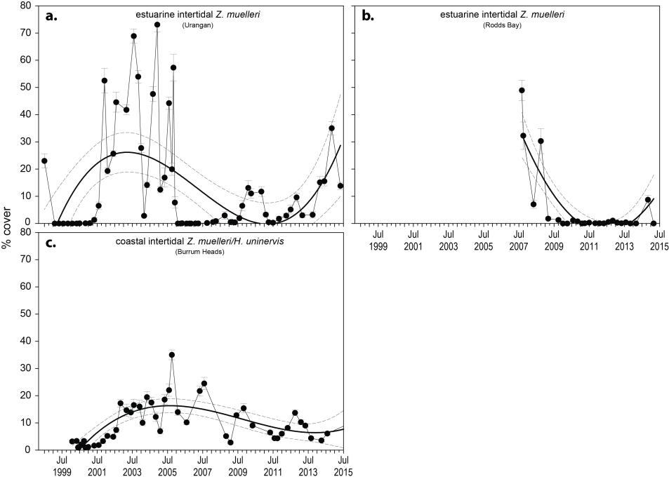
Figure 97. Changes in seagrass abundance (% cover ±Standard Error) at estuarine and coastal meadows in Burnett Mary region from 1999 to 2015.
Trendline is 3rd order polynomial (95% confidence intervals displayed) where Urangan r² = 0.27 and Burrum Heads r² = 0.51. Rodds Bay trendline is 2nd order polynomial, 95% confidence intervals displayed, r² = 0.71.

An examination of the long term trends across the Burnett Mary NRM region suggests seagrass abundance (% cover) has fluctuated greatly between years, but progressively decreased from 2004 to 2012; after which the decline appears to have abated with an increasing trajectory (Figure 98).
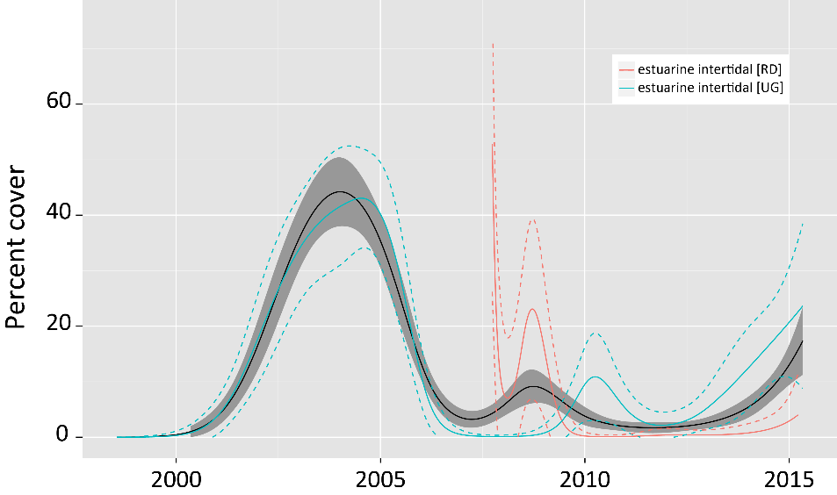
Figure 98. Temporal trends in seagrass abundance at estuarine locations in the Burnett May region, represented by a GAM plot 1999-2015.
Regional trend (all habitats pooled) represented by black line with grey shaded areas defining 95% confidence intervals.
The estuarine seagrass habitats were dominated by Zostera muelleri with varying components of Halophila ovalis over the monitoring period (Figure 99). In 2014-15, the proportion of colonising species declined in estuarine habitats and remained stable below the GBR long-term average at coastal habitats. The reducing proportion of colonising species in the meadows suggests greater ability to tolerate/resist major disturbances, particularly as the meadows improve abundance.
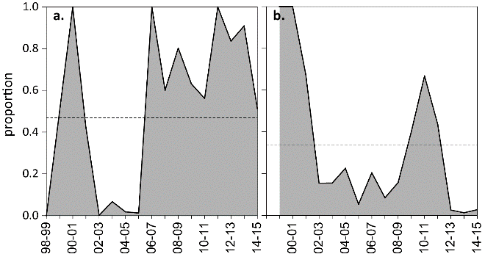
Figure 99. Proportion of seagrass abundance composed of colonising species at: a. estuary and b. coastal habitats in the Burnett Mary region, 1998-2015.
Grey area represents GBR long-term average proportion of colonising species for each habitat type.
Seagrass meadow edge mapping was conducted within a 100m radius of all monitoring sites in October 2014 and April 2015 (Appendix 4) to determine if changes in abundance were a consequence of the meadow edges changing and to indicate if plants were allocating resources to colonisation (asexual reproduction). Over the last 12 months the seagrass meadows at both locations increased (Figure 100), although seasonally declining slightly in early 2015. Overall, meadow extent across the monitoring sites continued to recover in 2014-15 and was around half the spatial extent of when monitoring was established in 2005.

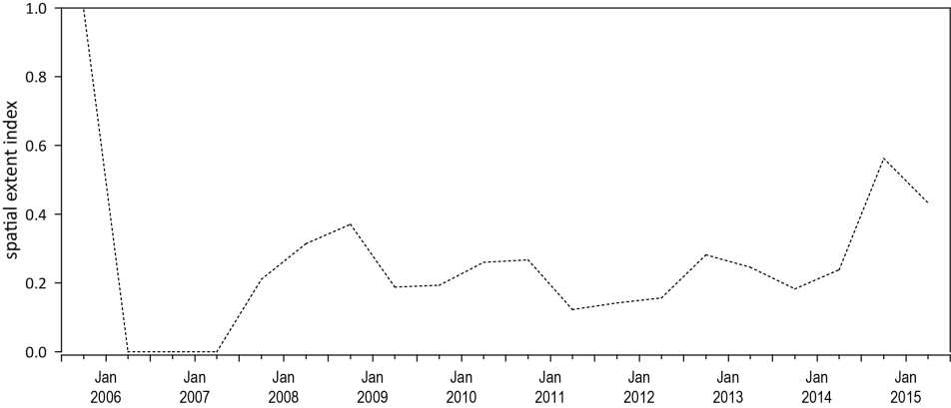
Figure 100. Change in spatial extent of seagrass meadows within a 100m radius of monitoring sites for each habitat and monitoring period across the Burnett Mary NRM region.

Seagrass reproductive status
Seagrass seed banks in Burnett Mary region meadows declined greatly between the 2013-14 and 2014-15 monitoring periods (Figure 101). A Zostera muelleri seed bank persisted throughout the year with the smallest late dry season seed banks since 2010 (Figure 101); indicating a reduced capacity to recover following disturbance. However, the improving reproductive effort suggests seed bank recovery in the near future due to increased replenishment.
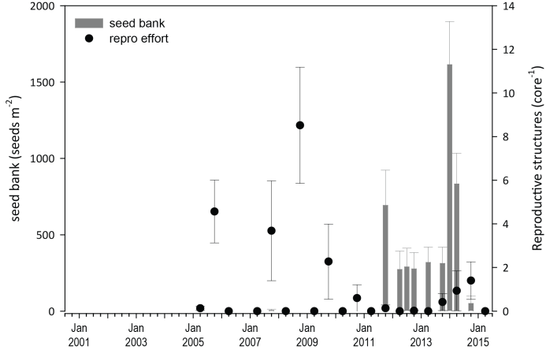
Figure 101. Burnett Mary estuary seed bank and reproductive effort.
Seed bank presented as the total number of seeds per m² sediment surface and reproductive effort presented as the average number of reproductive structures per core (species and sites pooled).

Indicators of environmental condition

Seagrass tissue nutrients
In 2014, Zostera muelleri leaf molar C:N ratios decreased below 20; after briefly increasing above in 2013 (the first time in 7 years) (Figure 102); primarily due to the lower C:N ratios at Urangan, rather than Rodds Bay (which remained <20) (Appendix 4, Figure 229). δ¹³C values were within global ranges (Appendix 4), suggesting sufficient but possibly low carbon available for growth.
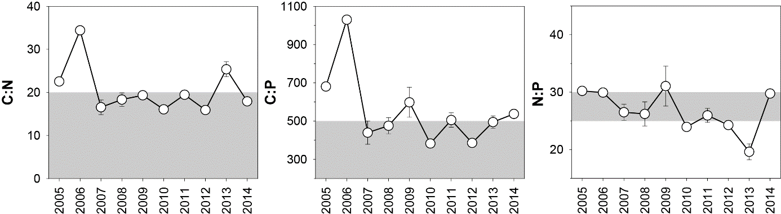
Figure 102. Elemental ratios (atomic) of seagrass leaf tissue C:N, N:P and C:P for the foundation seagrass species examined at estuarine habitats in the Burnett Mary region each year
(sites and species pooled) (mean ± Standard Error). Horizontal shaded band on the C:N ratio panel represents the accepted guideline seagrass “Redfield” ratio of 20:1 (Abal, et al. 1994; Grice, et al. 1996). C:N ratios below this line may indicate reduced light availability and/or N enrichment. Horizontal shaded band on the N:P ratio panel represents the range of value associated with N:P balance ratio in the plant tissues, i.e. a seagrass “Redfield” ratio (Atkinson and Smith 1983; Duarte 1990; Fourqurean, et al. 1992b; Fourqurean and Cai 2001). N:P ratio above this band indicates P limitation, below indicates N limitation and within indicates replete. Shaded portion on the C:P panel ≤500 represents the value associated with C:P balance ratio in the plant tissues, C:P values <500 may indicate nutrient rich habitats (large P pool).
Zostera muelleri leaf molar C:P ratios have gradually increased over the last 3 years, with the regional average exceeding 500 in 2014, indicating that the plants were growing in an environment with a relatively small P pool (Figure 102). C:P ratios increased at both locations, but the exceedance was a consequence of the much greater decrease in the concentration of P relative to C in the southern meadows (i.e. Urangan) (Appendix 4, Figure 229). N:P ratios for Zostera muelleri increased greatly since the previous monitoring period across the region, but mostly at the southern meadows (Appendix 4, Figure 229), indicating the plants remained replete (well supplied and balanced macronutrients for growth). Leaf tissue δ¹⁵N values were lower in 2014 than 2013 (Appendix 4), but still at levels which suggest either fertiliser and/or sewage influence in the primary source of N.

Seagrass meadow sediments
Sediments in the estuary seagrass habitats of the Burnett Mary region are dominated by mud, which increased across the region in 2014-15 (Appendix 4, Figure 199). In the previous monitoring periods, the proportion of mud has been lower, particularly at meadows in the south of the region.

Epiphytes and macroalgae
Epiphyte cover on seagrass leaf blades was high during both the wet and dry seasons and increased above the GBR long-term average in 2014-15 (Figure 103; Appendix 4, Figure 214). Percentage cover of macroalgae was higher in the dry season and similarly increased above the GBR long-term average in 2014-15 (Figure 103; Appendix 4, Figure 214).

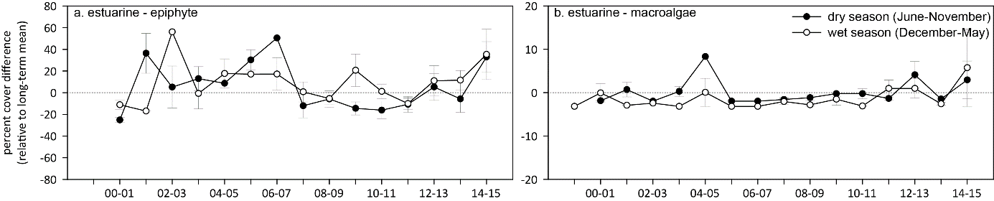
Figure 103. Long-term trend in mean epiphyte and macroalgae abundance (% cover) relative to the long-term average for each seagrass habitat in the Burnett Mary NRM region
(sites pooled, ±SE).

Report card for inshore seagrass status
Since reporting was established in 2005, the seagrass index score for the Burnett Mary has been poor or very poor. In the 2014-15 monitoring period, the seagrass index for the Burnett Mary region declined slightly after improving in the previous period. Although abundance and reproductive effort improved, the lower score was primarily a consequence of reduced nutrient quality in the leaf tissue. Overall, the Burnett Mary seagrass index remains poor and below the 2005-06 original score.

Table 29. Long-term report card scores for seagrass abundance, reproductive and leaf tissue nutrient status for each habitat in the Burnett Mary region: June 2005 – May 2015.
Values are indexed scores scaled from 0-100; ■ = very good (81-100), ■ = good (61 - 80), ■ = moderate (41 - 60), ■ = poor (21 - 40), ■ = very poor (0 - 20). NB: Scores are unitless.
Report Card | Habitat | 2005-06 | 2006-07 | 2007-08 | 2008-09 | 2009-10 | 2010-11 | 2011-12 | 2012-13 | 2013-14 | 2014-15
Abundance | estuarine intertidal | 21 | 0 | 15 | 10 | 10 | 4 | 5 | 5 | 10 | 26
Abundance | coastal intertidal |  |  |  |  |  |  |  |  |  | 38
Reproductive  effort | estuarine intertidal | 25 | 0 | 19 | 50 | 17 | 0 | 0 | 0 | 0 | 6
Leaf tissue  nutrients | estuarine intertidal | 63 | 100 | 39 | 42 | 48 | 30 | 47 | 30 | 77 | 40
Seagrass Index |  | 36 | 33 | 24 | 34 | 25 | 11 | 18 | 12 | 29 | 25

Conclusions
In 2014-15, inshore seagrass across the GBR remained in a vulnerable state, particularly in the Fitzroy and Wet Tropics, with weak resistance (low abundance and low diversity, or abundance dominated by colonising species) and a low capacity to recover (low seed bank and/or low reproductive effort). The relatively moderate climatic conditions during 2014-15 were more conducive for seagrass growth than in recent years. Discharge from most GBR rivers was at or below the long‐term median, however light availability was slightly lower at many locations; particularly those in northern regions covered in green secondary waters for much of the wet season (December to April). Also, higher within‐canopy seawater temperatures during 2014-15 coupled with the lower light availability, may have resulted in C limitation and less conducive conditions for seagrass growth in some meadows in central and northern GBR regions.
Long-term monitoring through the MMP and related programs(e.g. QPSMP) has demonstrated that the tropical seagrass ecosystems of the GBR are a mosaic of different habitat types comprised of multiple seagrass species in which timing and mechanisms that capture their dynamism (i.e. declines and subsequent recovery) are complex and spatially diverse. The report card of inshore seagrass state for the Great Barrier Reef shows that the declines occurring in 2006 and then from 2009 to 2012 (from Cooktown south) abated in late 2012 and seagrass state improved; but remained poor in 2014-15 (Figure 104). More specifically, although some locations in the Wet Tropics and Burdekin regions experienced declines in early 2006 as a consequence of TC Larry, most recovered within 1-2 years; with the exception of the coastal sites in southern Wet Tropics where recovery was protracted. In late 2008, locations in the northern Wet Tropics and Burdekin regions were in a moderate state of health with abundant seagrass and seed banks. In contrast, locations in the southern GBR in Mackay Whitsunday and Burnett Mary regions were in a poor state, with low abundance, reduced reproductive effort and small or absent seed banks. In 2009 with the onset of the La Niña, the decline in seagrass state steadily spread across the Burdekin region and to locations within the Fitzroy and Wet Tropics where discharges from large rivers and associated catchments occurred (McKenzie et al. 2010b; McKenzie, et al. 2012b). The only locations of better seagrass state were those with relatively little catchment input, such as Gladstone Harbour and Shoalwater Bay (Fitzroy region), Green Island (Wet Tropics), and Archer Point (Cape York) (McKenzie, et al. 2012b). By 2010, seagrasses of the GBR were in a poor state with declining trajectories in seagrass abundance, reduced meadow extent, limited or absent seed production and increased epiphyte loads at most locations. These factors would have made the seagrass populations particularly vulnerable to large episodic disturbances, as demonstrated by the widespread and substantial losses documented after the floods and cyclones of early 2011.
Following the extreme weather events of early 2011, seagrass habitats across the GBR further declined, with severe losses reported from the Wet Tropics, Burdekin, Mackay Whitsunday and Burnett Mary regions. By 2011-12, the onset of seagrass recovery was observed across some regions, however a state change had occurred and colonising species dominated many habitats. The majority of meadows appeared to allocate resources to vegetative growth rather than reproduction, indicated by the lower reproductive effort and seed banks. In 2014-15, recovery continued to progress across most of the regions, although some regions meadows recovery has stalled as a consequence of localised disturbances (e.g. tropical cyclones).
The meadows of the GBR have been in a highly fluctuating state over the past decade, and this disturbance regime is seemingly typical of the region and makes the meadows highly dynamic (e.g. Birch and Birch 1984; Preen et al. 1995; Campbell and McKenzie 2004; Waycott, et al. 2007). By contrast, the meadows to the north in the Torres Strait, and to the south in Moreton Bay remain relatively stable over similar time frames (Roelfsema et al. 2009; McKenzie, et al. 2010c; Roelfsema et al. 2013; Carter et al. 2014b; Carter et al. 2014a).
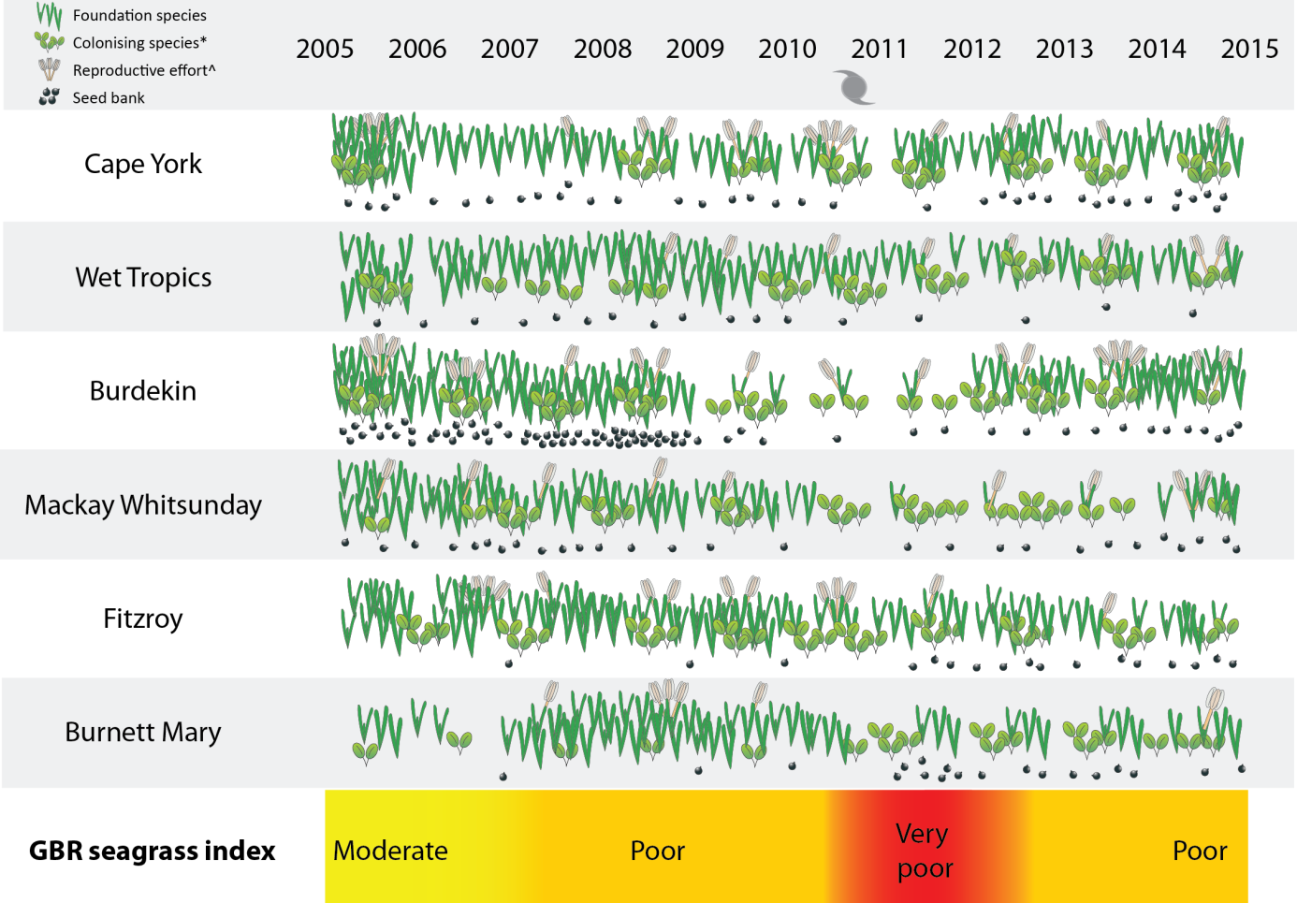
Figure 104. Summary of GBR MMP inshore seagrass state illustrating abundance of foundation / colonising species, seed banks and reproductive effort from 2005 to 2015.
* colonising species are represented by the genus Halophila, however, Zostera and Halodule can be both colonising and foundational species depending on meadow state. ^ not conducted in 2005.
There was increasing evidence that water quality degradation within the seagrass meadows of the inshore GBR prior to the episodic disturbances of 2011 may have reduced their resilience. Light availability is one of the primary driving factors in seagrass growth and persistence (Collier and Waycott 2009; Brodie, et al. 2013b; _ENREF_70Collier, et al. 2012c). Seagrasses can survive in highly turbid sites if restricted to shallow areas where light reaches the canopy around low tide (Petrou et al. 2013). Despite this, declines in abundance at intertidal habitats up to 2011 were also likely caused in part by low light levels (e.g. Petus et al. 2014). Low light impacts in intertidal habitats may result from infrequent low tide exposure occurring in summer months when water can be very turbid coincident with high water temperatures which drives faster rates of decline (Collier, et al. 2016a_ENREF_59). From 2009, reduced canopy light to low and limiting light levels was reported in seagrass meadows across the GBR, and, coincident with this, nutrients (N and P) increased relative to plant requirements
Water quality variables (e.g. turbidity, chlorophyll-a and CDOM) are the primary light attenuating factors and exposure of inshore seagrass meadows to these has been captured by plume exposure (as frequency of exposure to primary (brown, turbid), and secondary (green)) for each NRM (Lønborg, et al. 2015). Further, there is a correlation between frequency of exposure to primary or secondary water and changes in seagrass abundance (Petus, et al. 2014; Petus, et al. 2016, see also Chapter 6). Seagrasses are also sensitive to chronic exposure to low herbicide concentrations, which also enter the GBR with flood waters (Negri et al. 2015). The concentrations leading to measurable effects are rarely detected in the GBR (Brodie et al. 2013a), however cumulative impacts (e.g. reduced photosynthetic C uptake caused by herbicides and low light) may occur. Knowing the cause and source of environmental pressure enables targeted management to reduce impacts on seagrass meadows. Therefore, direct water quality measures (e.g. turbidity) and light are complimentary indicators, each with their own benefits to the interpretation of monitoring data, and management of water quality impacts. Direct measurement of water quality is not routinely incorporated into the inshore seagrass monitoring program, although turbidity monitoring had been undertaken at 3 sites in the past, but has been removed for cost-effectiveness.
The current monitoring program includes indicators that represent various stages of impact/stress, including early warning indicators (tissue nutrients) through to advanced levels of impact (changes in meadow area, or localised loss). Findings from the MMP have demonstrated a cascade of seagrass population responses, particularly between 2009 and 2011, to stressors analogous to the stress response model, including:
- leaf tissue N and P increasing above global averages (Duarte 1990) in all habitats from 2006 and 2010 respectively, and in surplus to C, possibly indicating N enrichment;
- variable reproductive effort and seed banks indicating low capacity to recover from loss;
- decreased abundance and extent from 2009 to 2011, when they reached minima;
- change in population state from foundation species to colonising species, possibly reducing ecosystem resistance.

Future improvements to inshore seagrass report card
As the data collected in the MMP and associated monitoring programs has accumulated, our understanding of environmental drivers and ecological responses is being continually refined. This expanding knowledge base can be used to make improvements to the MMP report card. Ongoing improvements in monitoring, reporting and management are central to successful adaptive management , which sits at the core of Reef 2050 Long term sustainability plan (Commonwealth of Australia, 2015)
Community structure (species composition) is an important feature conferring resilience, both resistance (as some species are more resistant to stress than others), and recovery (as some species may rapidly recover and pave the way for meadow development). This year (2014-15) was the first monitoring period grouping or classifying species based on their life-history traits was trialled to assist with interpreting species presence/absence and even changes in species composition in an ecologically meaningful way. The three groupings, in terms of disturbance response, are colonising, opportunistic and persistent. For this first year, a broad subjective approach was used to classify species at all sites at different stages of meadow recovery as displaying the attributes of a coloniser. Only the proportion of colonisers was presented in the results as the focus of discussions since 2011 has been on meadow recovery. However, as meadows across the GBR continue to recover, it is expected they will move to a more enduring state; except those in deeper waters (where only the colonising species Halophila inhabit). It is anticipated that using the traits-based approach to species composition, will provide an improved understanding of species diversity and ecosystem function. Once this is quantified, it may be possible to identify a “tipping point” or threshold indicative of a declining trajectory. The broad subjective approach to species classification was trialled at paired intertidal and subtidal reefs sites in the Burdekin region. These sites have declined and almost fully recovered within the decade of MMP monitoring (Figure 105).
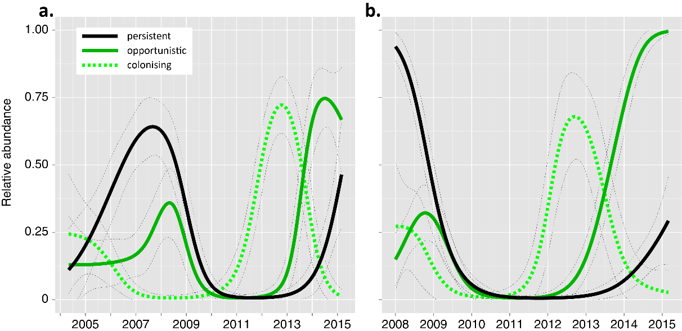
Figure 105. Plot of abundance of species displaying colonising, opportunistic or persistent life history traits relative to maximum: a. intertidal reef habitat (Cockle Bay) and b. subtidal reef habitat (Picnic Bay).
The temporal patterns in the relative abundance of each colonising, opportunistic and persistent species grouping show a clear progression during meadow recovery and more importantly during meadow deterioration while in a disturbance phase. This suggests a model where during recovery, each of the species groupings based on life history traits dominates from transitory to enduring meadow form, but during deterioration, each contributes varying amounts (Figure 106). In future, species composition may be one of the attributes used to identify meadow deterioration. Determining the contributions of species groups will be greatly assisted by using a more rigorous classification such as using morphological traits, particularly for species which display traits across a duality of groups (see case study 1, chapter 6). As morphological traits can depend on meadow phase (e.g. expansion/recovery after loss) or the environment within which they persist, classification could also be coupled with other environmental measures such as sediment grain size and level of sediment disturbance (i.e. rippling). For example, Zostera muelleri displays the morphological traits of a coloniser when in rippled sands, as opposed to an opportunist when in settled muds (personal observation).

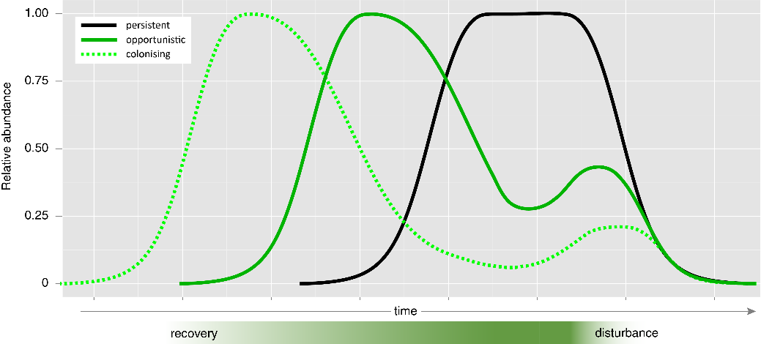
Figure 106. Model of species groupings based on life history traits, relating to meadow form during recovery and disturbance phases.
Other important attributes of seagrasses currently not included in the MMP report card that support resilience include: storage reserves (non-structural carbohydrates), continuity (or spatial extent), and genetic diversity (Unsworth, et al. 2015).
An analysis of storage reserves from 4 paired intertidal and subtidal MMP sites (8 sites in total) collected from 2008 to 2015 was recently undertaken for a NESP-funded project investigating complimentary indicators of resilience (Collier et al. 2016b). Storage reserves are the sugars and starches stored in rhizomes, which accumulate under favourable conditions (typically in spring/summer) and decline when plant carbon budgets are depleted (e.g. low light events) (Alcoverro et al. 2001; Collier, et al. 2009). Total storage reserve content of the plant was correlated to meadow abundance and condition. Therefore, as for species composition, storage reserves could also be used to identify meadow trajectory. This requires validation for other habitats and species, and ongoing investigation of reserves as a complimentary indicator will be facilitated by the application of more cost effective analysis protocols (e.g. NIR).
Spatial extent (within a 100m radius of monitoring sites ≈ 5.5 hectares) currently provides a narrative in the MMP regarding whether changes in abundance were a consequence of the meadow edges moving, giving rise to an increased area of bare substrate. Meadow extent also indicates if meadows are in expansion mode, and as for indicators described above, this provides information on meadow trajectory (decline vs recovery). Spatial extent data could be examined in further detail to determine a metrics for landscape structure, specifically as continuous, aggregated patches, isolated patches, or isolated shoots.
Genetic diversity investigations as part of the Great Barrier Reef Foundation project “Seagrass growth and diversity: attributes of a resilient GBR” are providing some insight with regard to clonal richness and gene flow among populations within the GBR (Collier et al. 2015). However, whether a metric for genetic diversity can be developed for inclusion in the report card is unclear, as it is early stages for such investigations. Other genetic techniques are being explored through gene expression analysis tools to identify chronic seagrass stress, particularly in response to eutrophication and low light (Macreadie et al. 2014).
Revision of metrics and indicators as described above are relatively incremental and do not require any substantial change to the overall approach or cost of undertaking monitoring. The seagrass team at JCU is engaged in a number of research programs investigating other potential indicators of GBR seagrass status and resilience. Furthermore, engagement with the wider scientific community provides the opportunity to keep up to date with latest scientific findings. Research outputs in conjunction with accumulating monitoring data provide the impetus for ongoing review of monitoring protocols in-keeping with the adaptive management framework. However, considerable changes to monitoring and reporting protocols can only happen at the discretion of the Intergovernmental Operational Committee, under advisement from the Independent Scientific panel, who provide implementation direction in Reef Plan.

Integration of other datasets.
2014-15 was the first year data from other seagrass monitoring in the GBR was integrated into the report card. Abundance data from 8 long-term Seagrass-Watch monitoring sites in the Cape York, Burdekin, Mackay Whitsunday and Burnett Mary regions were included. As the MMP and Seagrass-Watch programs use the same methodologies, data integration was seamless.
As the current MMP inshore seagrass monitoring locations are predominately lower littoral meadows (only exposed to air at the lowest of low tides), and only four locations to date are shallow subtidal meadows, in 2015-16 additional monitoring has been established with Queensland Parks & Wildlife Service (Department of National Parks, Sport and Racing) at 7 subtidal locations using drop-cameras. These will include locations in Cape York (Margaret Bay, Lloyd Bay, Flinders Group, Bathurst Bay), Wet Tropics (Missionary Bay), and Mackay Whitsunday (Tongue Bay, Newry Bay). If successful, additional sites are planned for Fitzroy and the Burnett Mary regions.
The only other seagrass monitoring program of significance in the Great Barrier Reef WHA is the QPSMP which monitors seagrass at a number of industrial ports from Cairns in the north to Gladstone in the south (Carter, et al. 2015a; Davies, et al. 2015; Jarvis et al. 2015; McKenna and Rasheed 2015; McKenna, et al. 2015; York, et al. 2015). The monitoring approach implemented through the QPSMP, however, differs from the MMP. The QPSMP uses a visual estimate of above ground biomass method to assess abundance and monitoring is focussed on representative meadows (Carter, et al. 2015a; Davies, et al. 2015; Jarvis, et al. 2015; McKenna and Rasheed 2015; McKenna, et al. 2015; York, et al. 2015). The program has also developed its own report card based on subjective conditions of three indicators (abundance, meadow area and species composition) (Bryant et al. 2014b; Carter et al. 2015b). Prior to any integration of abundance and species data with the MMP, the QPSMP data will require examination regarding: standardisation (e.g. calibration of % cover and transformed visual estimates of biomass); robustness of the methods (particularly in relation to any modifications), and; data confidence in relation to levels of uncertainty and sensitivity. Integration of the QPSMP data will fill critical information gaps on the status of seagrass within estuarine and coastal locations currently not covered by the MMP in the enclosed and open coastal water bodies in the Wet Tropics, Burdekin, and Mackay Whitsunday NRM regions.
Integration of other datasets may also improve the MMP report card by expanding reporting to all GBR water bodies. Current seagrass monitoring in the GBR is predominately within the enclosed coastal and open coastal water bodies. The only monitoring locations which fall within the midshelf water body are in the Wet Tropics NRM region (Low Isles and Green Island). It is estimated that 63% of the seagrass mapped in the GBRWHA occurs in the midshelf water body and 24% in the offshore (from McKenzie, et al. 2010c). Currently no existing programs monitor seagrass in the midshelf or offshore water bodies of Cape York, Burdekin, Fitzroy or Burnett Mary regions (NB: no seagrass has been mapped in the midself or offshore waters of Mackay Whitsunday). Integration with other programs such as “Eye on the Reef” (GBRMPA) may provide opportunities to collect critical data, particularly if subtidal drop-camera or similar approaches can be adopted.

Outlook
Recovery of seagrass populations from the declines experienced in 2011 may take many years and there are a number of factors that will facilitate recovery, including seed banks, connectivity and improvement in environmental conditions such as light available for photosynthesis. It was estimated that recovery of meadows may be slow (>5 years) in the southern Wet Tropics, moderate (2-5 years) in the Burdekin and fair (1-3 years) in the Fitzroy regions (McKenzie, et al. 2013). Current rates of recovery, as well as examples taken from previous localised impacts (Birch and Birch, 1984; Campbell and McKenzie 2004b) indicate that a return to a moderate or good condition could take slightly longer than initially predicted at some locations and could occur within 2 more years (i.e. > 5years from impact), providing conditions remain favourable.
The capacity of seagrass meadows to naturally recover community structure following disturbance will involve the maintenance of favourable environmental conditions including light availability, nutrient loads and the absence of major physical disturbances. For example, the low and variable light availability across the GBR habitats in 2014-15 may have slowed recovery, which in turn may reduce capacity to produce a viable seed banks in some locations (van Katwijk et al. 2010). Absence of a seed bank at some sites and poor reproductive effort across the GBR, has left most of the MMP meadows vulnerable to further environmental perturbations.

Case study 1. Using life history traits to classify seagrass species – a preliminary assessment.

Seagrasses are a collective group of submerged angiosperms from six distinct lineages, thus they are a biological group of species (~72 in total) rather than an evolutionary group (Les et al. 1997; Short et al. 2011). Within this grouping, species from different families can share similar traits, grow under similar conditions, and have similar ecological function, while taxonomically related species can have very different functional roles.
Plants have a range of adaptive features incorporated into life histories, which can be distinguished along a continuum of strategies (Gadgil and Solbrig 1972). At the extremes of the continuum are the species having either persistent or ephemeral traits along with an opportunistic, intermediate group as broadly defined by Kilminister (Kilminster, et al. 2015) (Figure 107). Plants species with the ephemeral traits that are thought to characterise colonists are the generalist species - ruderal species or weeds - colonise highly disturbed sites, common in abundance, relying on fast and adaptable clonal growth, regular and flexible sexual reproduction and a persistent, abundant seed bank (MacArthur and Wilson 1967; Grime 1979). Seagrass colonist species have rapidly fluctuating total standing abundance, ramets have short turnover times (< months), and they place a high level of reproductive effort into the production of seeds and the ability to build up a seed bank even a short-lived one (Kilminster, et al. 2015). In contrast, in stable or predictable environments, the ability to compete successfully for limited resources is crucial and more successful populations of organisms tend to be very constant and close to the maximum that the environment can bear. These species allocate resources to vegetative adaptation to resist stress or competition and are classified as persistent. Persistent seagrasses are characterised by long lived ramets (months-years) and clonality from long lived genets, stabilising and/or sediment trapping growth, high standing abundance/biomass, and reproductive effort for seed production does not compromise vegetative growth, i.e. seeds that typically do not form a seed bank (Kilminster, et al. 2015). Typical persistent seagrasses are members of the genera Thalassia and Enhalus. However, a number of groups of species combine core elements of both extremes of these strategies and these opportunistic seagrasses have both the ability to colonise, produce seeds or seedlings and also have the ability to gain significant, persisting biomass and clonality, while also rapidly recovering from seed (or new recruits) when necessary (Kilminster, et al. 2015).
Thalassia hemprichii and Enhalus acoroides are considered to be a persistent species, being perennial and using the carbohydrate reserve in their rhizomes for maintenance if their leaves are removed (Dawes 1981). Conversely, Halophila ovalis displays characteristics of a colonising species with high reproductive output and little investment in competition or maintenance (Rasheed 2004). However, Z. muelleri, and also H. uninervis, Cymodocea spp, and Syringodium can be classified into more than category, as they can acting as both colonising and opportunistic species during meadow expansion/recovery phase (after loss), or depending on the environment within which they persist (Harrison 1979).
Grouping or classifying species based on their life-history traits is a useful way of interpreting species presence/absence and even changes in species composition in an ecologically meaningful way. This is particularly useful in terms of disturbance response. However, for species which can be both colonising and opportunistic, or opportunistic and persistent, this classification duality presents a challenge when applying the scheme in monitoring and reporting as a category must be chosen for each species.
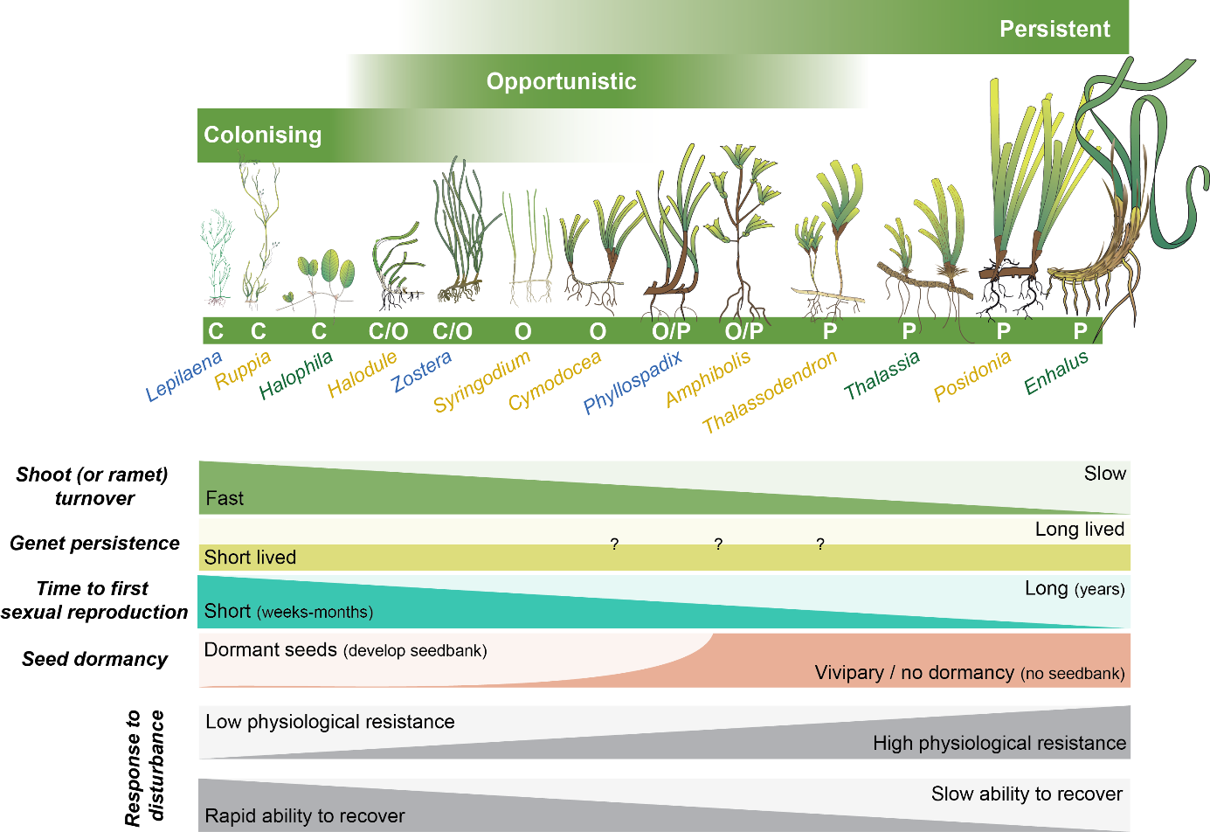
Figure 107. Species classification based on response to disturbance. Species can be classified as colonising, opportunistic or persistent depending on life history traits. (adapted from Kilminster et al. 2015)
The aim of this preliminary analysis was to determine whether morphological traits of seagrasses can be used as a means to classify species, in the context of their prevailing life history. If so, a traits-based approach to species classification could be used for species that can fall into more than one species category (colonising, opportunistic, or persistent), and the classification could change based on changing life history traits. Morphological traits including internode length and leaf width have been routinely measured during MMP sampling. Internode length is a measure of the space between leaf scars, and is therefore the length of rhizome that grows during the production of a new leaf (Figure 108). New leaf production occurs every 12 – 20 days under good growing conditions (Collier, et al. 2012c). A rapidly expanding, colonizing plant can have long internodes and fast rates of rhizome extension (Duarte and Sand-Jensen 1990; McMahon 2005). Wide leaves are generally expected for larger species that form established or persistent communities (McMahon 2005). These traits were measured once per year on samples that were routinely collected for the analysis of reproductive effort typically in the late dry and late monsoon season sampling. The following text outlines an initial exploration of this data for two of the dominant species in the GBR.

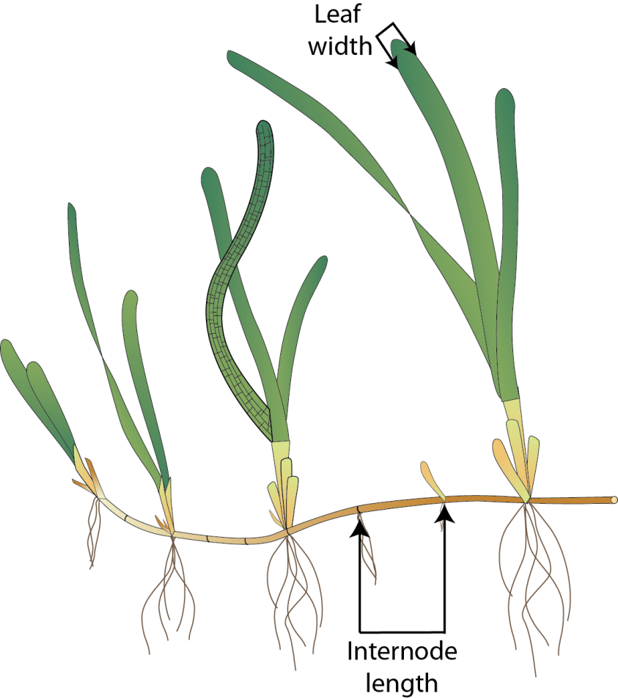
Figure 108. Morphological traits, including internode length and leaf width have been routinely measured and have been used in a traits-based exploration of species classification.

The morphology (internode length and leaf width) of Z. muelleri was tested for differences among sites, regions, habitats and year using Multi-dimensional Scaling (MDS) in Primer-e (v6). Morphology was not distinctly clustered based on habitat and/or NRM, as all habitats separating to the right of the MDS plot, were also contained in the cluster to the left (Figure 109). However, there was a clear separation based on year; the years before extreme climatic events (pre-2011) had considerably smaller morphological traits, while post-2011, internodes were longer and leaves were wider (Figure 109, Figure 110). This is consistent with the hypothesis that meadows were in a growth and meadow expansion phase post-2011 whereby they were spreading across the seascape, with large internode length. In recovering meadows at Hervey Bay, rhizome internode length was also largest in meadows that were recently disturbed, and therefore in early stages of recovery, while more mature meadows had shorter internodes (McMahon 2005). In contrast, in Hervey Bay, leaf width tended to increase with meadow development (McMahon 2005), which is the reverse of that reported here. The rapid appearance of wide-leaved Z. muelleri post-2011 may indicate that meadows went quickly into a transitory mode with long internode lengths and wide leaf widths similar to the intermediate meadows described in McMahon (2005). During the recovery phase, there has also been considerably greater variation in traits and the cause of this variability warrants further enquiry.

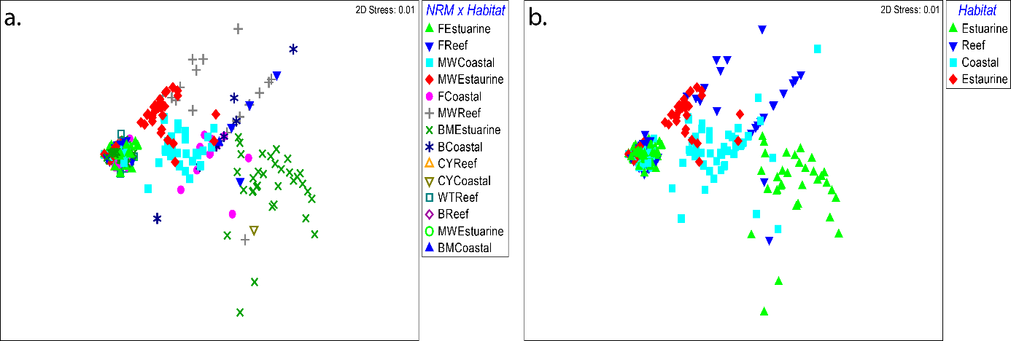
Figure 109. MDS of Zostera muelleri morphological traits (leaf width and internode length) plotted by: a. habitat (estuarine, reef, coastal) within each NRM region (CY, WT, B, MW, F, BM) and; b. habitat only.
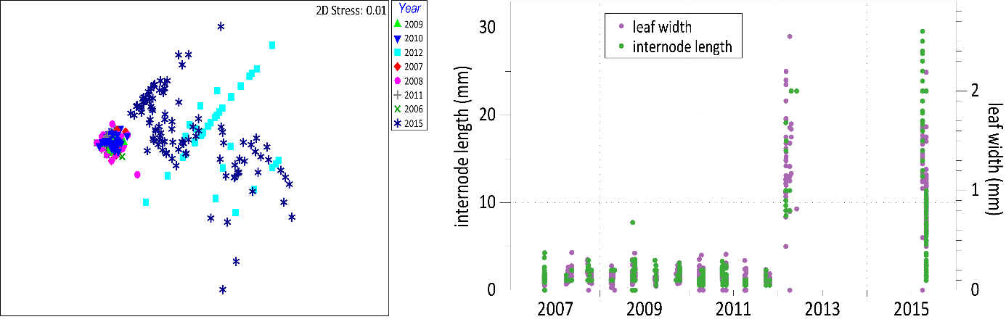
Figure 110. Zostera muelleri leaf width and internode length plotted over time using MDS (left), and a temporal dot plot for all data (right).

Focusing the analysis on pre-2011 samples only, demonstrates that at that time there were no distinct differences among populations of Z. muelleri based on NRM and habitat (Figure 111).

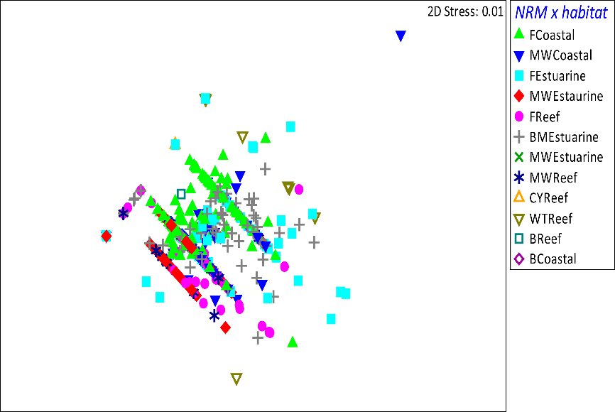
Figure 111. MDS of Zostera muelleri morphological traits for 2006 – 2011 by habitat (Estuarine, Reef, Coastal) within region (CY, WT, B, MW, F, BM).
Similarly, morphological traits of H. uninervis did not clearly separate based on habitat and/or region (Figure 112). However, there was a clear separation among years with pre-2011 morphology being smaller, than during recovery post 2011 (Figure 113). In the last sampling year included in this analysis (2015), some smaller leaf widths had started appearing again. At this time, there was a separation of morphological traits from subtidal sites in the Burdekin and Wet Tropics region although there was some overlap in traits from wet tropics intertidal reef sites (Figure 114).
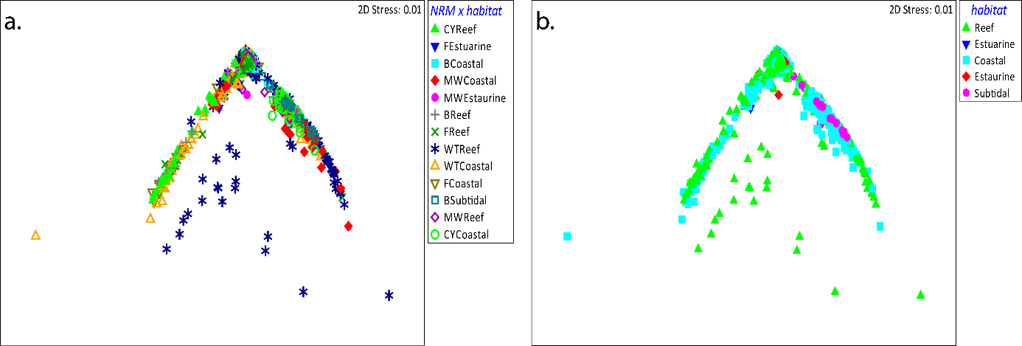
Figure 112. MDS of Halodule uninervis morphological traits (leaf width and internode length) plotted by habitat within region.
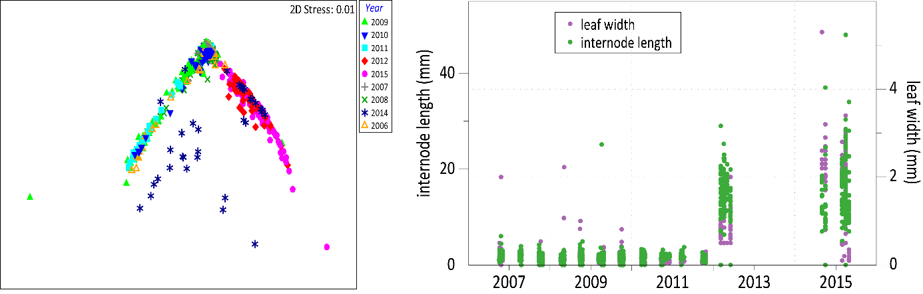
Figure 113. Morphological traits of H. uninervis over time including MDS (left), and temporal plot (right).

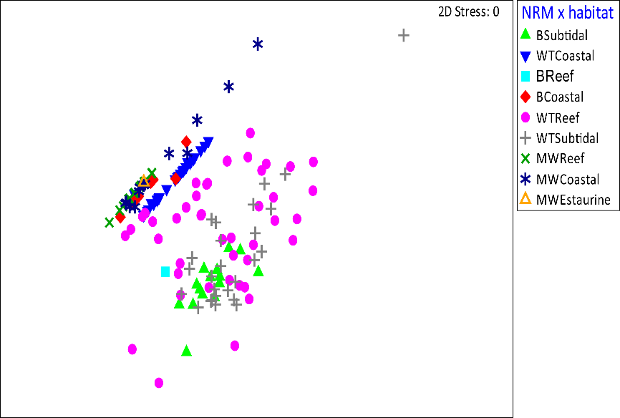
Figure 114. Morphological traits of H. uninervis in 2015 only based on habitat within region.
This preliminary exploration of data has been based on two morphological traits, which are routinely measured for two of the dominant species in the GBR. It has demonstrated that there is a separation of morphological traits based on the growth form or meadow condition (pre-2011 for stable or declining populations), and post-2011 when meadows were in a recovering form. This work can be expanded to include:
  - More traits, including traits where data already exists (e.g. canopy height, change in abundance), and those that are not yet measured but could also be useful in traits classification (e.g. biomass ratio or shoot turnover time).
  - More species (for samples already collected)
  - More times (through ongoing data collection )
  - An exploration of the increased variability in traits that was observed during recovery
Most importantly, this presents a very preliminary demonstration that morphological traits can be used to distinguish the prevailing life history traits of seagrasses. Therefore these traits could provide the basis for species classification and indicator of disturbance. However, we are yet to develop an actual classification scheme with numerical values (thresholds) that can be used to distinguish the classification for each species. Once this is finalized, a three-step successional analysis can be performed similar to that contained in Figure X . Furthermore, species composition (based on traits classification) could be incorporated as a metric into the annual GBR report card as an indicator of meadow trajectory or condition.

References
Collier, C. J., M. Waycott, and A. Giraldo-Ospina. 2012. Responses of four Indo-West Pacific seagrass species to shading. Mar. Pollut. Bull. 65: 342-354.
Duarte, C. M., and K. Sand-Jensen. 1990. Seagrass colonization: patch formation and patch growth in Cymodocea nodosa. Mar. Ecol. Prog. Ser. 65: 193-200.
Kilminster, K., K. McMahon, M. Waycott, G. A. Kendrick, P. Scanes, L. McKenzie, K. R. O'Brien, M. Lyons, A. Ferguson, P. Maxwell, T. Glasby, and J. Udy. 2015. Unravelling complexity in seagrass systems for management: Australia as a microcosm. Sci. Total Environ. 534: 97-109.
Les, D. H., M. A. Cleland, and M. Waycott. 1997. Phylogenetic studies in Alismatidae, II: Evolution of marine angiosperms (seagrasses) and hydrophily. Syst. Bot. 22: 443-463.
McMahon, K. M. 2005. Recovery of subtropical seagrasses from natural disturbance. The University of Queensland.
Short, F. T., B. Polidoro, S. R. Livingstone, K. E. Carpenter, S. Bandeira, J. S. Bujang, H. P. Calumpong, T. J. B. Carruthers, R. G. Coles, W. C. Dennison, P. L. A. Erftemeijer, M. D. Fortes, A. S. Freeman, T. G. Jagtap, A. H. M. Kamal, G. A. Kendrick, W. Judson Kenworthy, Y. A. La Nafie, I. M. Nasution, R. J. Orth, A. Prathep, J. C. Sanciangco, B. V. Tussenbroek, S. G. Vergara, M. Waycott, and J. C. Zieman. 2011. Extinction risk assessment of the world’s seagrass species. Biol. Conserv. 144: 1961-1971.

Case study 2: progressing toward validated river plume risk maps
http://www.mdpi.com/2072-4292/8/3/210 (open access)
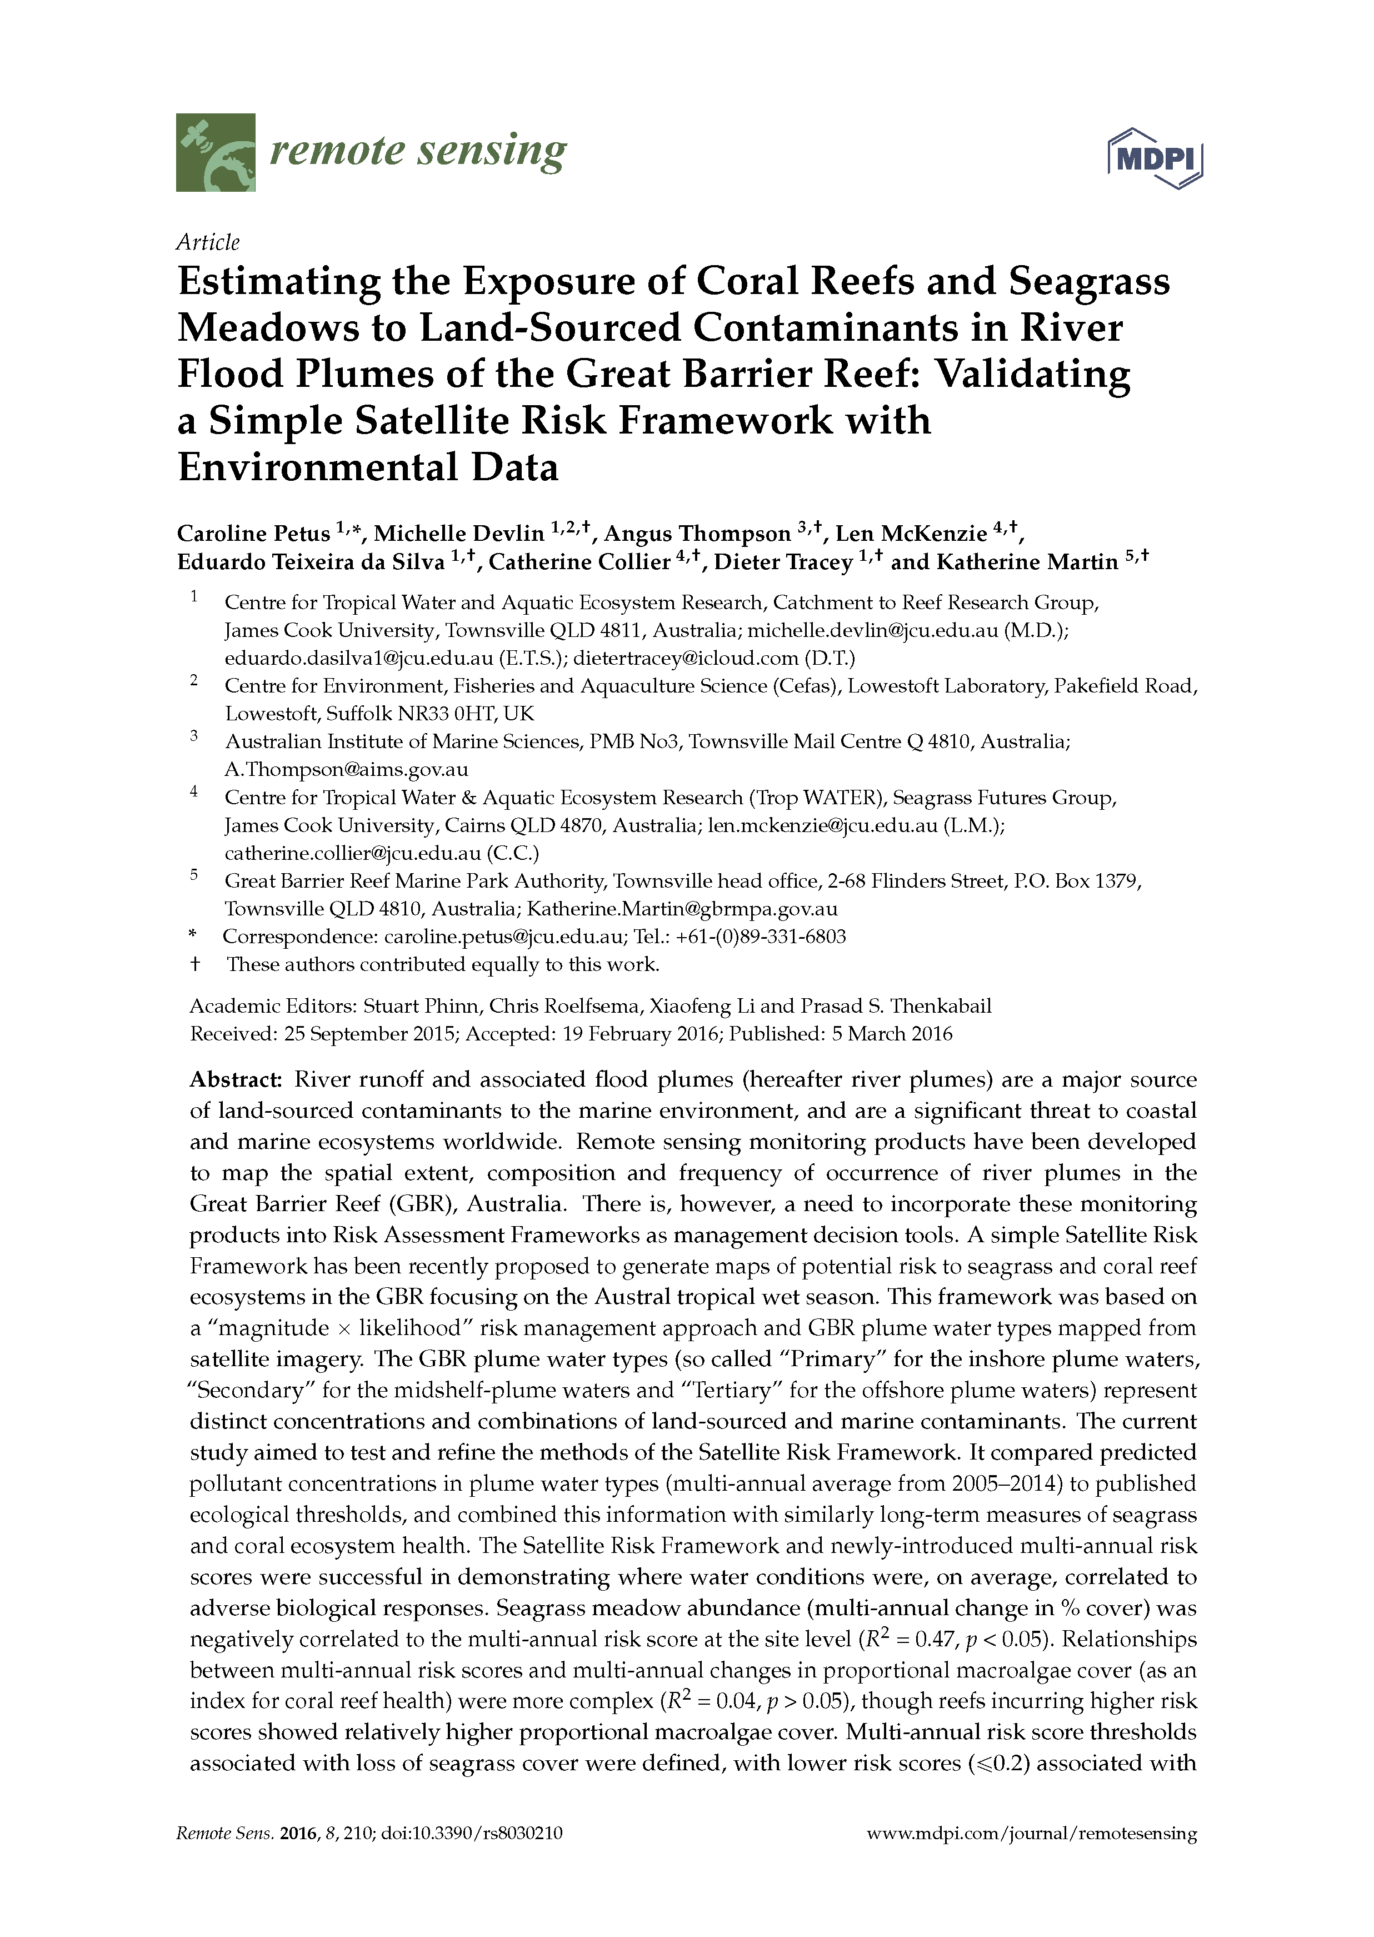

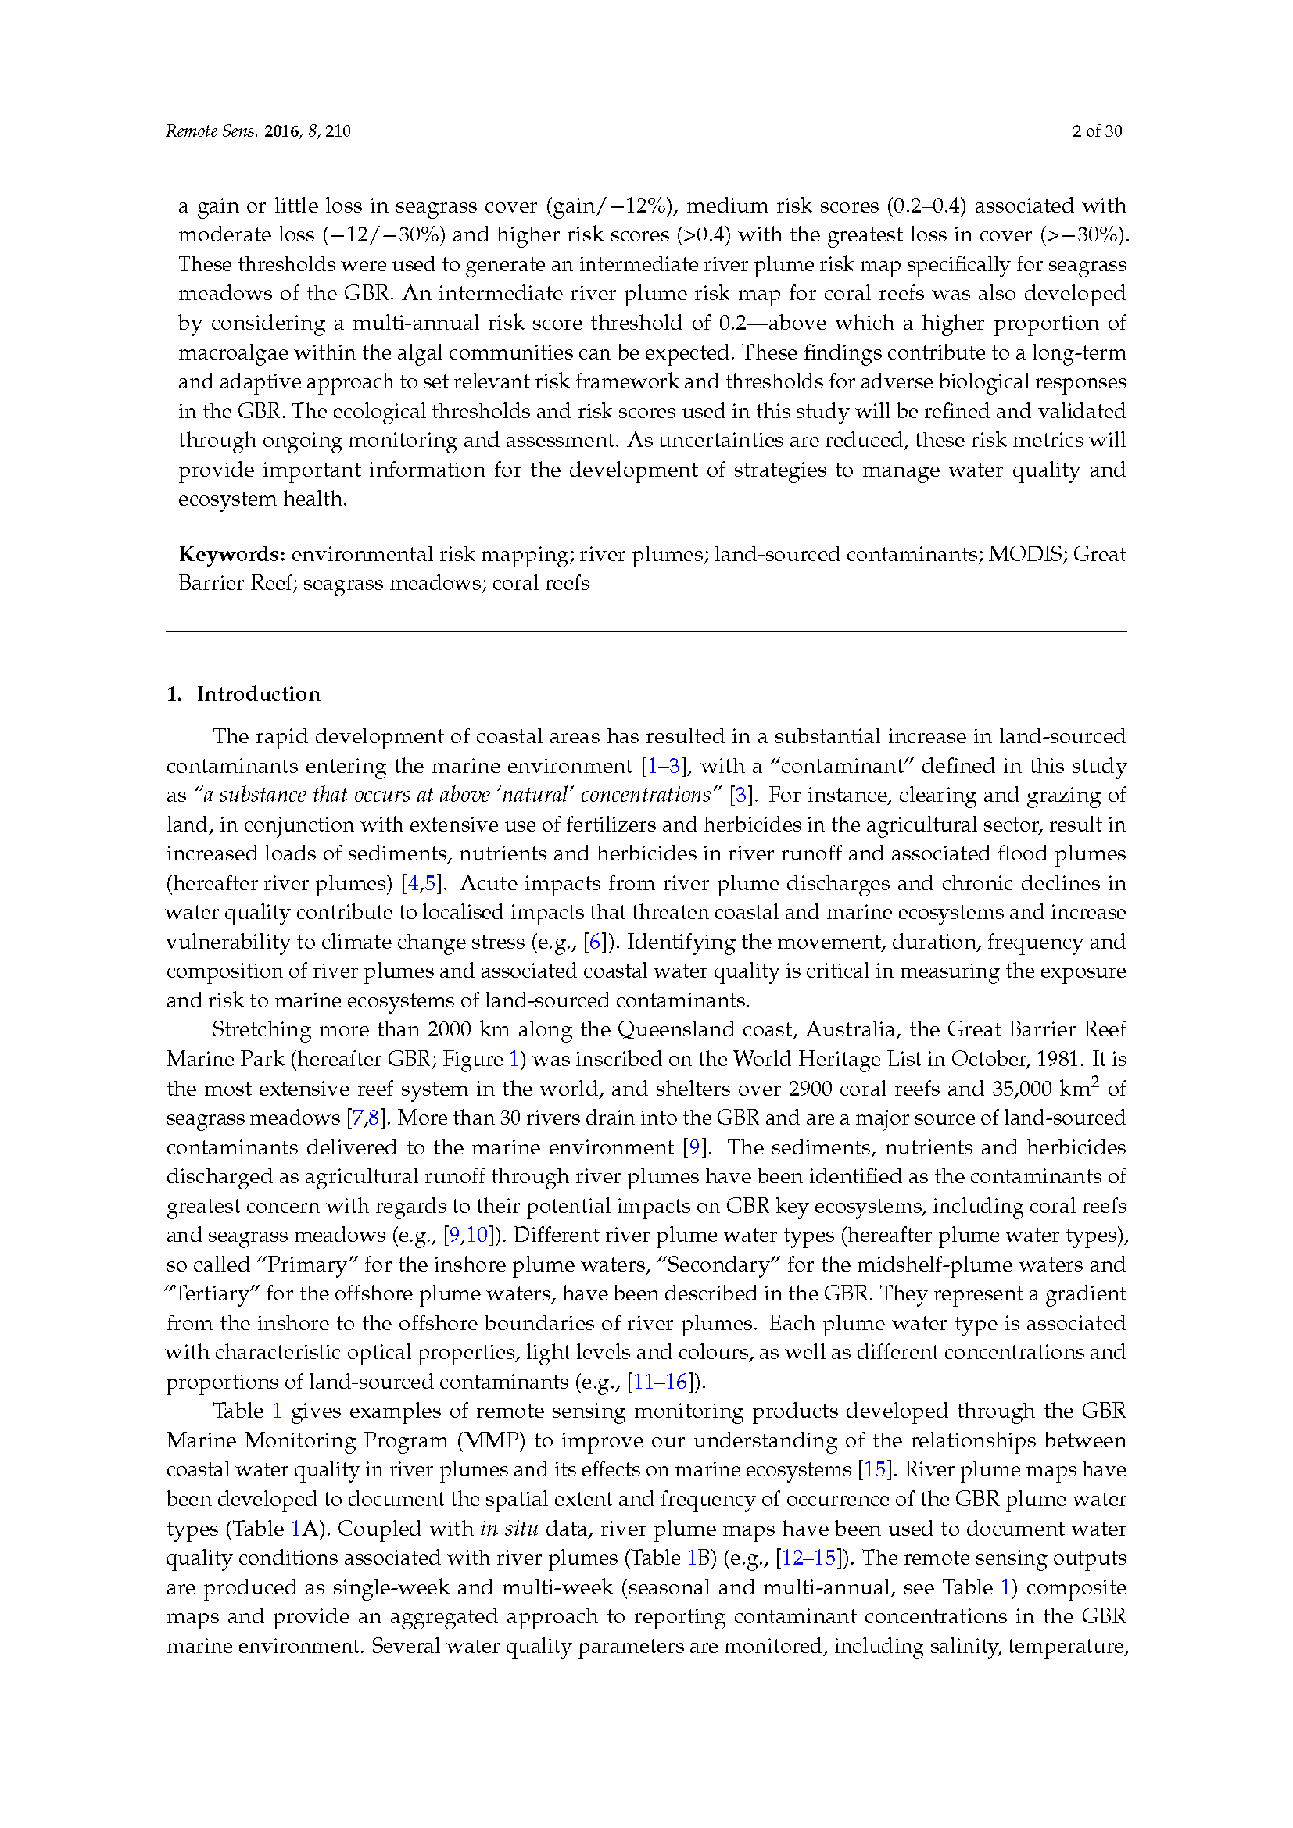

References
Abal, E.G., Dennison, W.C., and Greenfield, P.F. 2001, Managing the Brisbane River and Moreton Bay: An integrated research/management program to reduce impacts on an Australian estuary. Water Science and Technology, 43, 57-70.
Abal, E.G., Loneragan, N.R., Bowen, P., Perry, C.J., Udy, J.W., and Dennison, W.C. 1994, Physiological and morphological responses of the seagrass Zostera capricorni Aschers. to light intensity. Journal of Experimental Marine Biology and Ecology, 178(1), 113-129.
Alcoverro, T., Manzanera, M., and Romero, J. 2001, Annual metabolic carbon balance of the seagrass Posidonia oceanica: The importance of carbohydrate reserves. Marine Ecology Progress Series, 211, 105-116.
Angelini, C., Altieri, A.H., Silliman, B.R., and Bertness, M.D. 2011, Interactions among Foundation Species and their Consequences for Community Organization, Biodiversity, and Conservation. BioScience, 61(10), 782-789.
Anon. (2013). Reef Water Quality Protection Plan 2013.Securing the health and resilience of the Great Barrier Reef World Heritage Area and adjacent catchments. Brisbane: The State of Queensland. Reef Water Quality Protection Plan Secretariat.
Anthony, K.R.N., Ridd, P.V., Orpin, A.R., Larcombe, P., and Lough, J. 2004, Temporal variation in light availability in coastal benthic habitats: Effects of clouds, turbidity, and tides. Limnology and Oceanography, 49(6), 2201-2211.
ANZECC. 2000, Australian and New Zealand guidelines for fresh and marine water quality.
Arthur, K., Boyle, M., and Limpus, C. 2008, Ontogenetic changes in diet and habitat use in green sea turtle (Chelonia mydas) life history. Marine Ecology Progress Series, 362, 303-311.
Atkinson, M.J., and Smith, S.V. 1983, C:N:P ratios of benthic marine plants. Limnology and Oceanography, 28(3), 568-574.
Bainbridge, Z., Wolanski, E., Lewis, S., and Brodie, J. 2012, Fine sediment and nutrient dynamics related to particle size and floc formation in a Burdekin River flood plume, Australia. Marine Pollution Bulletin, 65, 236-248.
Balata, D., Bertocci, I., Piazzi, L., and Nesti, U. 2008, Comparison between epiphyte assemblages of leaves and rhizomes of the seagrass Posidonia oceanica subjected to different levels of anthropogenic eutrophication. Estuarine, Coastal and Shelf Science, 79(3), 533-540. doi: http://dx.doi.org/10.1016/j.ecss.2008.05.009
Bernhardt, J.R., and Leslie, H.M. 2013, Resilience to climate change in coastal marine ecosystems. Annual Review of Marine Science, 5, 371-392.
Birch, W., and Birch, M. 1984, Succession and pattern of tropical intertidal seagrasses in Cockle Bay, Queensland, Australia: a decade of observations. Aquatic Botany, 19, 343-367.
Björk, M., Uka, J., Weil, A., and Beer, S. 1999, Photosynthetic tolerances to desiccation of tropical intertidal seagrasses. Marine Ecology Progress Series, 191, 121-126.
Borowitzka, M.A., Lavery, P.S., and van Keulen, M. (2006). Epiphytes of seagrasses. In WD Larkum, RJ Orth & CM Duarte (Eds.), Seagrasses: Biology, Ecology and Conservation. Dordrecht: Springer.
Borum, J. 1985, Development of epiphytic communities on eelgrass (Zostra marina) along a nutrient gradient in a Danish estuary. Marine Biology, 87, 211–218.
Borum, J., Duarte, C.M., Krause-Jensen, D., and Greve, T.M. (2004). European seagrasses: an introduction to monitoring and management. Copenhagen: The M&MS project.
Brodie, J. (2004). Mackay Whitsunday Region: State of the Waterways Report 2004 ACTFR Report No. 02/03 for the Mackay Whitsunday Natural Resource Management Group. Yownsville: ACTFR, James Cook University.
Brodie, J., Waterhouse, J., Schaffelke, B., Furnas, M., Maynard, J., Collier, C., Lewis, S., Warne, M., Fabricius, K., Devlin, M., McKenzie, L.J., Yorkston, H., Randall, L., and Bennett, J. (2013a). Relative risks to the Great Barrier Reef from degraded water quality Synthesis of evidence to support the Reef Water Quality Scientific Consensus Statement 2013 (pp. 58). Brisbane: Department of the Premier and Cabinet, Queensland Government.
Brodie, J., Waterhouse, J., Schaffelke, B., Johnson, J., Kroon, F., Thorburn, P., Rolfe, J., Lewis, S., Warne, M., Fabricius, K., McKenzie, L.J., and Devlin, M. (2013b). Reef Water Quality Scientific Consensus Statement 2013. Brisbane: Department of the Premier and Cabinet, Queensland Government.
Brodie, J.E., Kroon, F.J., Schaffelke, B., Wolanski, E.C., Lewis, S.E., Devlin, M.J., Bohnet, I.C., Bainbridge, Z.T., Waterhouse, J., and Davis, A.M. 2012, Terrestrial pollutant runoff to the Great Barrier Reef: An update of issues, priorities and management responses. Marine Pollution Bulletin, 65(4–9), 81-100.
Bros, W.E., and Cowell, B.C. 1987, A technique for optimising sample size (replication). Journal of Experimental Marine Biology and Ecology, 114, 63-71.
Bryant, C., Davies, J., Sankey, T., Jarvis, J., and Rasheed, M. (2014a). Long Term Seagrass Monitoring in Port Curtis: Quarterly Seagrass Assessments & Permanent Transect Monitoring Progress Report 2009 to 2013. TropWATER Publication 14/18. Cairns: Centre for Tropical Water & Aquatic Ecosystem Research, James Cook University.
Bryant, C., Jarvis, J., York, P., and Rasheed, M. (2014b). Gladstone Healthy Harbour Partnership Pilot Report Card: ISP011 Seagrass Final Report – October 2014, TropWATER Report No. 14/53. Cairns: Centre for Tropical Water & Aquatic Ecosystem Research, James Cook University.
Burkholder, J.M., Tomasko, D.A., and Touchette, B.W. 2007, Seagrasses and eutrophication. Journal of Experimental Marine Biology and Ecology, 350, 46–72.
Burnett Mary Regional Group. (2005). Country to Coast – A Healthy Sustainable Future Volume 1a Background Report. Bundaberg, Qld: Burnett Mary Regional Group.
Burnett Mary Regional Group. (2010). Burnett-Baffle Water Quality Improvement Plan. Bundaberg: Burnett Mary Regional Group.
Burnett Mary Regional Group. (2013). Wide Bay Burnett, Environment and Natural Resource Management Plan 2012-2031 - Regional targets to support the environment and sustainability framework of the Wide Bay Burnett Regional Plan. Bundaberg: Burnett Mary Regional Group.
Cabaço, S., and Santos, R. 2007, Effects of burial and erosion on the seagrass Zostera noltii. Journal of Experimental Marine Biology and Ecology, 340, 204-212.
Cambridge, M.L., Chiffings, A.W., Brittan, C., Moore, L., and McComb, A.J. 1986, The loss of seagrass in Cockburn Sound, Western Australia. II. Possible causes of seagrass decline. Aquatic Botany, 24, 269-285.
Campbell, S.J., and McKenzie, L.J. (2001). Seagrass and algal abundance in the Whitsundays region. Status Report. Cairns: Department of Primary Industries.
Campbell, S.J., and McKenzie, L.J. 2004, Flood related loss and recovery of intertidal seagrass meadows in southern Queensland, Australia. Estuarine, Coastal and Shelf Science, 60(3), 477-490.
Campbell, S.J., McKenzie, L.J., and Kerville, S.P. 2006, Photosynthetic responses of seven tropical seagrasses to elevated seawater temperature. Journal of Experimental Marine Biology and Ecology, 330, 455-468.
Campbell, S.J., Roder, C.A., McKenzie, L.J., and Lee Long, W.J. 2002, Seagrass resources in the Whitsunday region 1999 and 2000. DPI Information Series QI02043, 50.
Carruthers, T., Dennison, W., Longstaff, B., Waycott, M., Abal, E.G., McKenzie, L.J., and Lee Long, W. 2002, Seagrass habitats of north east Australia: models of key processes and controls. Bulletin of Marine Science, 71(3), 1153-1169.
Carter, A., Chartrand, K., and Rasheed, M. (2012). Critical marine habitats in high risk areas, Princess Charlotte Bay region - 2011 Atlas. Northern Fisheries Centre, Cairns: DAFF Publication.
Carter, A., Davies, J., Bryant, C., Jarvis, J., McKenna, S., and Rasheed, M. (2015a). Seagrasses in Port Curtis and Rodds Bay 2014: Annual long-term monitoring, biannual Western Basin, and updated baseline survey. Cairns: Centre for Tropical Water & Aquatic Ecosystem Research, James Cook University.
Carter, A., Jarvis, J., Bryant, C., and Rasheed, M. (2015b). Development of seagrass indicators for the Gladstone Healthy Harbour Partnership Report Card, ISP011: Seagrass. TropWATER Report No 15/29. Cairns: Centre for Tropical Water & Aquatic Ecosystem Research, James Cook University.
Carter, A., and Rasheed, M. (2013). Critical marine habitats in high risk areas, Bathurst Bay region - 2012 Atlas. (Vol. Report No. 13/19). Cairns: JCU Publication, Centre for Tropical Water & Aquatic Ecosystem Research.
Carter, A., Taylor, H., and Rasheed, M. (2014a). Torres Strait Dugong Sanctuary – Deepwater Seagrass Monitoring 2010 – 2014, TropWATER Report no. 14/21. Cairns: Centre for Tropical Water & Aquatic Ecosystem Research, James Cook University.
Carter, A., Taylor, H., and Rasheed, M. (2014b). Torres Strait Mapping: Seagrass Consolidation, 2002 – 2014”, TropWATER Report no. 14/55. Cairns: Centre for Tropical Water & Aquatic Ecosystem Research, James Cook University.
Carter, A.B., and Rasheed, M.A. (2014). Critical marine habitats in high risk areas, South Warden Reef to Howick Group - 2013 Atlas. Centre for Tropical Water & Aquatic Ecosystem Research Report no. 13/56. Cairns: James Cook University.
Carter, A.B., and Rasheed, M.A. (2015). Critical marine habitats in high risk areas, Crescent Reef to Cape Flattery - 2014 Atlas. JCU Publication no. 15/13. Cairns: Centre for Tropical Water & Aquatic Ecosystem Research.
Chartrand, K.M., Bryant, C.V., Carter, A.B., Ralph, P.J., and Rasheed, M.A. 2016, Light thresholds to prevent dredging impacts on the Great Barrier Reef seagrass, Zostera muelleri ssp. capricorni. [Original Research]. Frontiers in Marine Science, 3. doi: 10.3389/fmars.2016.00106
Chartrand, K.M., Ralph, P.J., Petrou, K., and Rasheed, M.A. 2012, Development of a light-based seagrass management approach for the Gladstone Western basin dredging program. 126.
Christensen, S., Rodgers, C., and Fitzroy Basin Association, I. (2006). Central Queensland strategy for sustainability : 2004 and beyond. . Rockhampton, Qld: Fitzroy Basin Association.
Coles, R., McKenzie, L., Rasheed, M.A., Mellors, J., Taylor, H., Dew, K., McKenna, S., Sankey, T., Carter, A., and Grech, A. 2007, Status and trends of seagrass habitats in the Great Barrier Reef World Heritage Area. Unpublished report to the Marine and Tropical Sciences Research Facility, 122.
Coles, R., McKenzie, L.J., and Campbell, S. (2003). The seagrasses of Eastern Australia. In EP Green & FT Short (Eds.), The World Atlas of Seagrasses: present status and future conservation. (pp. 119-133). Los Angeles, USA: University of California Press.
Coles, R., McKenzie, L.J., De'ath, G., Roelofs, A., and Lee Long, W.J. 2009, Spatial distribution of deepwater seagrass in the inter-reef lagoon of the Great Barrier Reef World Heritage Area. Marine Ecology Progress Series, 392, 57-68. doi: 10.3354/meps08197
Coles, R.G., Lee Long, W.J., Helmke, S.A., Bennett, R.E., Miller, K.J., and Derbyshire, K.J. (1992). Seagrass beds and juvenile prawn and fish nursery grounds: Cairns to Bowen (Vol. QI92012). Brisbane: Queensland Department of Primary Industries.
Coles, R.G., Lee Long, W.J., McKenzie, L.J., and Roder, C.A. (Eds.). (2002). Seagrass and Marine Resources in the Dugong Protection Areas of Upstart Bay, Newry Region, Sand Bay, Llewellyn Bay, Ince Bay and the Clairview Region, April/May 1999 and October 1999. Townsville: Great Barrier Reef Marine Park Authority.
Coles, R.G., Lee Long, W.J., Squire, B.A., Squire, L.C., and Bibby, J.M. 1987, Distribution of seagrass and associated juvenile commercial penaeid prawns in North-Eastern Queensland waters. Australian Journal of Marine and Freshwater Research, 38(1), 103-119.
Coles, R.G., Lee Long, W.J., and Squire, L.C. (1985). Seagrass beds and prawn nursery grounds between Cape York and Cairns. Brisbane: QDPI.
Coles, R.G., Lee Long, W.J., Watson, R.A., and Derbyshire, K.J. 1993, Distribution of seagrasses, and their fish and penaeid prawn communities, in Cairns Harbour, a tropical estuary, northern Queensland, Australia. Australian Journal of Marine and Freshwater Research, 44, 193-210.
Coles, R.G., McKenzie, L.J., Mellors, J.E., and Yoshida, R.L. 2001a, Validation and GIS of seagrass surveys between Cairns and Bowen – October/November 1987. CD Rom.
Coles, R.G., McKenzie, L.J., and Yoshida, R.L. 2001b, Validation and GIS of seagrass surveys between Bowen and Water Park Point– March/April 1987. CD Rom.
Coles, R.G., McKenzie, L.J., and Yoshida, R.L. 2001c, Validation and GIS of seagrass surveys between Cape York and Cairns - November 1984. CD Rom.
Coles, R.G., McKenzie, L.J., and Yoshida, R.L. 2001d, Validation and GIS of seagrass surveys between Water Park Point and Hervey Bay – October/November 1988. CD Rom.
Collier, C., Devlin, M., Langlois, L., Petus, C., McKenzie, L.J., Texeira da Silva, E., McMahon, K., Adams, M., O’Brien, K., Statton, J., and Waycott, M. (2014). Thresholds and indicators of declining water quality as tools for tropical seagrass management. Report to the National Environmental Research Program. Cairns: Reef and Rainforest Research Centre Limited.
Collier, C., van Dijk, J., Adams, M., O’Brien, K., Waycott, M., McKenzie, L., Uthicke, S., Johansson, C., Xiang, Y.O., Langlois, L., Phinn, S., and Roelfsema, C. (2015). Seagrass growth and diversity: attributes of a resilient GBR. Annual Report 2015 to the Great Barrier Reef Foundation. Brisbane: Great Barrier Reef Foundation.
Collier, C., and Waycott, M. 2009, Drivers of change to seagrass distributions and communities on the Great Barrier Reef: Literature review and gaps analysis. Report to the Marine and Tropical Sciences Research Facility.
Collier, C.J., Adams, M.P., Langlois, L., Waycott, M., O’Brien, K.R., Maxwell, P.S., and McKenzie, L. 2016a, Thresholds for morphological response to light reduction for four tropical seagrass species. Ecological Indicators, 67, 358-366. doi: http://dx.doi.org/10.1016/j.ecolind.2016.02.050
Collier, C.J., Langlois, L., Zemoi, R., Martin, K., and McKenzie, L.J. (2016b). Developing and refining biological indicators for condition assessments in an integrated monitoring program. Report to the National Environmental Science Programme. Cairns: Reef and Rainforest Research Centre Limited.
Collier, C.J., Lavery, P.S., Ralph, P.J., and Masini, R.J. 2009, Shade-induced response and recovery of the seagrass Posidonia sinuosa. Journal of Experimental Marine Biology and Ecology, 370(1–2), 89-103. doi: http://dx.doi.org/10.1016/j.jembe.2008.12.003
Collier, C.J., Uthicke, S., and Waycott, M. 2011, Thermal tolerance of two seagrass species at contrasting light levels: Implications for future distribution in the Great Barrier Reef. Limnology & Oceanography, 56(6), 2200-2210.
Collier, C.J., and Waycott, M. 2014, Temperature extremes reduce seagrass growth and induce mortality. Marine Pollution Bulletin, 83(2), 483-490. doi: http://dx.doi.org/10.1016/j.marpolbul.2014.03.050
Collier, C.J., Waycott, M., and Giraldo-Ospina, A. 2012a, Responses of four Indo-West Pacific seagrass species to shading. Marine Pollution Bulletin, 65(4-9), 342-354.
Collier, C.J., Waycott, M., and McKenzie, L.J. 2012b, Light thresholds derived from seagrass loss in the coastal zone of the northern Great Barrier Reef, Australia. Ecological Indicators, 23(0), 211-219. doi: 10.1016/j.ecolind.2012.04.005
Collier, C.J., Waycott, M., and Ospina, A.G. 2012c, Responses of four Indo-West Pacific seagrass species to shading. Marine Pollution Bulletin, 65(4-9), 342-354. doi: 10.1016/j.marpolbul.2011.06.017
Commonwealth of Australia. (2013a). Burdekin Natural Resource Management region, http://www.nrm.gov.au/about/nrm/regions/qld-burd.html Retrieved 18 February 2014, from http://www.nrm.gov.au/about/nrm/regions/qld-burd.html
Commonwealth of Australia. (2013b). Burnett Mary Natural Resource Management region, http://www.nrm.gov.au/about/nrm/regions/qld-bmar.html Retrieved 18 February 2014, from http://www.nrm.gov.au/about/nrm/regions/qld-fitz.html
Commonwealth of Australia. (2013c). Fitzroy Natural Resource Management region, http://www.nrm.gov.au/about/nrm/regions/qld-fitz.html Retrieved 18 February 2014, from http://www.nrm.gov.au/about/nrm/regions/qld-fitz.html
Commonwealth of Australia. (2013d). Mackay Whitsunday Natural Resource Management region, http://www.nrm.gov.au/about/nrm/regions/qld-mwhs.html Retrieved 18 February 2014, from http://www.nrm.gov.au/about/nrm/regions/qld-mwhs.html
Commonwealth of Australia. (2013e). Wet Tropics Natural Resource Management region Retrieved 18 February 2014, from http://www.nrm.gov.au/about/nrm/regions/qld-wetr.html
Costanza, R., d'Arge, R., de Groot, R., Farber, S., Grasso, M., Hannon, B., Limburg, K., Naeem, S., O'Neil, R.V., Paruelo, J., Raskin, R.G., Sutton, P., and van der Belt, M. 1997, The Value of the world's ecosystem services and natural capital. Nature, 387(15), 253-260.
Costanzo, S.D. (2001). Development of indicators for assessing and monitoring nutrient influences in coastal waters. PhD University of Queensland, Brisbane, Australia.
Costanzo, S.D., O'Donohue, M.J., Dennison, W.C., Loneragan, N.R., and Thomas, M. 2001, A new approach for detecting and mapping sewage impacts. Marine Pollution Bulletin, 42(2), 149-156.
Cotter, G.F. (1995). A study of the pastoral industry of Cape York Peninsula. Cape York Peninsula Land Use Strategy (CYPLUS), Natural Resources Analysis Program. Brisbane: Department of Primary Industries and Queensland Department of Lands.
Cullen-Unsworth, L., and Unsworth, R. 2013, Seagrass Meadows, Ecosystem Services, and Sustainability. Environment: Science and Policy for Sustainable Development, 55(3), 14-28. doi: 10.1080/00139157.2013.785864
Cullen-Unsworth, L.C., Nordlund, L.M., Paddock, J., Baker, S., McKenzie, L.J., and Unsworth, R.K.F. 2014, Seagrass meadows globally as a coupled social–ecological system: Implications for human wellbeing. Marine Pollution Bulletin, 83(2), 387-397. doi: http://dx.doi.org/10.1016/j.marpolbul.2013.06.001
Davies, J., Tol, S., and Rasheed, M. (2015). Port of Townsville Annual Monitoring Survey: October 2014. Cairns: JCU Publication, Centre for Tropical Water & Aquatic Ecosystem Research.
Dawes, C.J. (1981). Marine botany. New York, NY: John Wiley & Sons, Inc.
De'ath, G., and Fabricius, K. 2010, Water quality as a regional driver of coral biodiversity and macroalgae on the Great Barrier Reef. Ecological Applications, 20(3), 840-850. doi: 10.1890/08-2023.1
De’ath, G. (2005). Water Quality Monitoring: From River to Reef. Townsville: AIMS.
De’ath, G., Coles, R., McKenzie, L.J., and Pitcher, R. (2007). Spatial Distributions and temporal change in distributions of deep water seagrasses in the GRR region. QDPI&F report to MTSRF Cairns: QDPIF.
Dennison, W.C. 1987, Effects of light on seagrass photosynthesis, growth and depth distribution. Aquatic Botany, 27(1), 15-26. doi: http://dx.doi.org/10.1016/0304-3770(87)90083-0
Dennison, W.C., and Abal, E.G. (1999). Moreton Bay Study: a scientific basis for the healthy waterways campaign. Brisbane: South East Queensland Regional Water Quality Management Team.
Dennison, W.C., Longstaff, B.J., and O'Donohue, M.J. (1997). Seagrasses as Bio-indicators. In S Hillman & S Raaymakers (Eds.), Karumba dredging 1996 - Environmental Monitoring Report. EcoPorts Monograph Series No.6 (pp. 255). Brisbane: Ports Corporation of Queensland.
Dennison, W.C., O'Donnohue, M.K., and Abal, E.G. (1995). An assessment of nutrient bioindicators using marine plants in the region of Pioneer Bay, Airlie Beach, Queensland. Dry season sampling, September 1995. Brisbane: Marine Botany Section, Department of Botany, University of Queensland.
Department of Environment and Resource Management. (2009). Queensland Water Quality Guidelines, Version 3. ISBN 978-0-9806986-0-2. Brisbane: State of Queensland (Department of Environment and Resource Management).
Department of the Premier and Cabinet. (2014). Great Barrier Reef report card 2012 and 2013, Reef Water Quality Protection Plan, Scoring system. Retrieved 14/11/2014, from http://www.reefplan.qld.gov.au/measuring-success/methods/scoring-system.aspx
Derbyshire, K.J., Willoughby, S.R., McColl, A.L., and Hocroft, D.M. (1995). Small prawn habitat and recruitment study : final report to the Fisheries Research and Development Corporation and the Queensland Fisheries Management Authority. Cairns: Department of Primary Industries.
DeRose, R.C., Prosser, I.P., Wilkinson, L.J., Hughes, A.O., and Young, W.J. (2002). Regional Patterns of Erosion and Sediment and Nutrient Transport in the Mary River Catchment, Queensland. Technical Report 37/02, August 2002. Canberra: CSIRO Land and Water.
Devlin, M., Petus, C., da Silva, E., Tracey, D., Wolff, N., Waterhouse, J., and Brodie, J. 2015, Water Quality and River Plume Monitoring in the Great Barrier Reef: An Overview of Methods Based on Ocean Colour Satellite Data. Remote Sensing, 7(10), 12909.
Duarte, C., Borum, J., Short, F., and Walker, D. (2005). Seagrass Ecosystems: Their Global Status and Prospects. In N Polunin (Ed.), Aquatic Ecosystems: Trends and Global Prospects: Cambridge Univ. Press.
Duarte, C.M. 1990, Seagrass nutrient content. Marine Ecology Progress Series, 67(1), 201-207.
Duarte, C.M., and Sand-Jensen, K. 1990, Seagrass colonization: Patch formation and patch growth in Cymodocea nodosa. Marine Ecology Progress Series, 65(2), 193-200.
Earth Tech. (2005). Cape York Peninsula Natural Resource Management Plan: Cape York Interim Advisory Group (February 2005).
EHMP. (2008). Ecosystem Health Monitoring Program 2006-07: Annual Technical Report. Brisbane: South East Queensland Healthy Waterways Partnership.
Erftemeijer, P.L., and Herman, P.M. 1994, Seasonal changes in environmental variables, biomass, production and nutrient contents in two contrasting tropical intertidal seagrass beds in South Sulawesi, Indonesia. Oecologia, 99, 45-59.
Erftemeijer, P.L.A., and Middelburg, J.J. 1993, Sediment-nutrient interactions in tropical seagrass beds - a comparison between a terrigenous and a carbonate sedimentary environment in South Sulawesi (Indonesia). Marine Ecology Progress Series, 102(1-2), 187-198.
Esslemont, G., Fentie, B., Negus, P., and Marsh, N. (2006). Burnett, Mary Regional Water Quality Summary. Water Quality State-Level Project, Brisbane.
Fabricius, K., De'Ath, G., Humphrey, C., Zagorskis, I., and Schaffelke, B. 2012, Intr-annual variation in turbidity in response to terrestrial runoff on near-shore coral reefs of the Great Barrier Reef. Estuarine, Coastal and Shelf Science, 3, 458-470.
Folke, C., Carpenter, S., Walker, B., Scheffer, M., Elmqvist, T., Gunderson, L., and Holling, C.S. 2004, Regime shifts, resilience, and biodiversity in ecosystem management. Annual Review of Ecology, Evolution, and Systematics, 35(1), 557-581. doi: doi:10.1146/annurev.ecolsys.35.021103.105711
Ford, G.I. (2004). Colosseum Inlet - Rodds Bay - QLD129. Directory of Important Wetlands in Australia - Information sheet, from http://www.environment.gov.au/node/25064
Fourqurean, J.W., and Cai, Y. 2001, Arsenic and phosphorus in seagrass leaves from the Gulf of Mexico. Aquatic Botany, 71(4), 247-258. doi: http://dx.doi.org/10.1016/S0304-3770(01)00193-0
Fourqurean, J.W., Duarte, C.M., Kennedy, H., Marba, N., Holmer, M., Mateo, M.A., Apostolaki, E.T., Kendrick, G.A., Krause-Jensen, D., McGlathery, K.J., and Serrano, O. 2012, Seagrass ecosystems as a globally significant carbon stock. Nature Geoscience, 5(7), 505-509. doi: 10.1038/ngeo1477
Fourqurean, J.W., Escorcia, S.P., Anderson, W.T., and Zieman, J.C. 2005, Spatial and seasonal variability in elemental content, delta C-13, and delta N-15 of Thalassia testudinum from South Florida and its implications for ecosystem studies. Estuaries, 28(3), 447-461.
Fourqurean, J.W., Moore, T.O., Fry, B., and Hollibaugh, J.T. 1997a, Spatial and temporal variation in C:N:P Ratios, Delta¹⁵N and Delta¹³C of eelgrass Zostera marina as indicators of ecosystem processes, Tomales Bay, California, USA. Marine Ecology Progress Series, 157, 147-157.
Fourqurean, J.W., Moore, T.O., Fry, B., and Hollibaugh, J.T. 1997b, Spatial and temporal variation in C:N:P ratios, Î´15N, and Î´13C of eelgrass Zostera marina as indicators of ecosystem processes, Tomales Bay, California, USA. Marine Ecology Progress Series, 157, 147-157. doi: 10.3354/meps157147
Fourqurean, J.W., Zieman, J.C., and Powell, G.V.N. 1992a, Phosphorus limitation of primary production in Florida Bay: Evidence from C:N:P ratios of the dominant seagrass Thalassia testudinum. Limnology & Oceanography, 37(1), 162-171.
Fourqurean, J.W., Zieman, J.C., and Powell, G.V.N. 1992b, Relationships between porewater nutrients and seagrasses in a subtropical carbonate environment. Marine Biology, 114(1), 57-65. doi: 10.1007/bf00350856
Frankovich, T.A., and Fourqurean, J.W. 1997, Seagrass epiphyte loads along a nutrient availability gradient, Florida Bay, USA. Marine Ecology Progress Series, 159, 37-50.
Gadgil, M., and Solbrig, O.T. 1972, The concept of r- and K-selection: evidence from wild flowers and some theoretical considerations. American Naturalist, 106, 14-31.
Goldsworthy, P.M. (1994). Seagrasses. In L Benson, P Goldsworthy, R Butler & J Oliver (Eds.), Townsville Port Authority Capital Dredging Works 1993: Environmental Monitoring Program (pp. 89-115). Townsville: Townsville Port Authority.
Great Barrier Reef Marine Park Authority. (2014). Great Barrier Reef Marine Park Authority Science Strategy and Information Needs 2014-2019. Townsville: Great Barrier Reef Marine Park Authority.
Green, E., and Short, F. (Eds.). (2003). World Atlas of Seagrasses. Berkeley. USA: University of California Press,.
Grice, A., Loneragan, N., and Dennison, W. 1996, Light intensity and the interactions between physiology, morphology and stable isotope ratios in five species of seagrass. Journal of Experimental Marine Biology and Ecology, 195, 91-110.
Grime, J.P. (1979). Plant Strategies and Vegetation Processes. Chichester. UK.: John Wiley.
Harrison, P.G. 1979, Reproductive strategies in intertidal populations of two co-occurring seagrasses (Zostera spp.). Canadian Journal of Botany, 57, 2635-2638.
Haynes, D., Müller, J., and Carter, S. 2000, Pesticide and Herbicide Residues in Sediments and Seagrasses from the Great Barrier Reef World Heritage Area and Queensland Coast. Marine Pollution Bulletin, 41(7-12), 279-287.
Heaton, T.H.E. 1986, Isotopic studies of nitrogen pollution in the hydrosphere and atmosphere: a review. Chemical Geology, 59, 87-102.
Heck, K.L.J., Carruthers, T.J.B., Duarte, C.M., Hughes, A.R., Kendrick, G., Orth, R.J., and Williams, S.W. 2008, Trophic transfers from seagrass meadows subsidize diverse marine and terrestrial consumers. [review]. Ecosystems, 11(7), 1198-1210. doi: 10.1007/s10021-008-9155-y
Heidelbaugh, W.S., and Nelson, W.G. 1996, A power analysis of methods for assessment of change in seagrass cover. Aquatic Botany, 53(3-4), 227-243.
Hemminga, M.A., and Mateo, M.A. 1996, Stable carbon isotopes in seagrasses: variability in ratios and use in ecological studies. Marine Ecology Progress Series, 140, 285-298.
Holling, C.S. 1973, Resilience and stability of ecological systems. Annual Review of Ecology and Systematics, 4, 1-23.
Hortle, K., and Person, R. 1990, Fauna of the Annan River System, far North Queensland, with reference to the Impact of Tin Mining. I. Fishes. Marine and Freshwater Research, 41(6), 677-694. doi: http://dx.doi.org/10.1071/MF9900677
Inglis, G.J. 2000, Variation in the recruitment behaviour of seagrass seeds: implications for population dynamics and resource management. Pacific Conservation Biology, 5, 251-259.
Jacobs, S.W.L., Les, D.H., and Moody, M.L. 2006, New combinations in Australasian Zostera (Zosteraceae). Telopea, 11(2), 127-128.
Jarvis, J., Rasheed, M., and Sankey, T. (2015). Seagrass habitat of Cairns Harbour and Trinity Inlet: Annual and Quarterly Monitoring Report. TropWATER Publication 15/10. Cairns: Centre for Tropical Water & Aquatic Ecosystem Research, James Cook University.
Jarvis, J.C., Rasheed, M.A., McKenna, S.A., and Sankey, T. (2014). Seagrass habitat of Cairns Harbour and Trinity Inlet: Annual and Quarterly Monitoring Report. JCU Publication, Centre for Tropical Water & Aquatic Ecosystem Research Publication 14/09. Cairns: James Cook University.
Jones, A.B., O'Donohue, M.J., Udy, J., and Dennison, W.C. 2001, Assessing ecological impacts of shrimp and sewage effluent: Biological indicators with standard water quality analyses. Estuarine Coastal And Shelf Science, 52(1), 91-109.
Kilminster, K., McMahon, K., Waycott, M., Kendrick, G.A., Scanes, P., McKenzie, L., O'Brien, K.R., Lyons, M., Ferguson, A., Maxwell, P., Glasby, T., and Udy, J. 2015, Unravelling complexity in seagrass systems for management: Australia as a microcosm. Science of The Total Environment, 534, 97-109. doi: http://dx.doi.org/10.1016/j.scitotenv.2015.04.061
Koch, E.W. (2001). What can sediments tell us about seagrass habitats? In LJ McKenzie, S Campbell, C Roder, J Bité & R Coles (Eds.), Local Eyes: Global Wise, Proceedings of the 1st International Seagrass-Watch volunteers Forum, Hervey Bay 12th-15th October 2001 (Vol. 1, pp. 59-62). Cairns: Marine Plant Ecology Group, DPI.
Kuhnert, P.M., Liu, Y., Henderson, B.L., Dambacher, J., Lawrence, E., and Kroon, F.J. (2014). Review of the Marine Monitoring Program (MMP), Final Report for the Great Barrier Reef Marine Park Authority (GBRMPA). Adelaide: CSIRO.
Lajtha, K., and Marshall, J. (1994). Sources of variation in the stable isotope composition of plants. In K Lajtha & R Michener (Eds.), Stable Isotopes in Ecology and Environmental Sciences (pp. 1–21). Oxford: Blackwell Scientific Publications.
Lanyon, J., Limpus, C.J., and Marsh, H. (1989). Dugongs and turtles: grazers in the seagrass system. In AWD Larkum, AJ McComb & SA Shepherd (Eds.), Biology of Seagrasses: A treatise on the biology of seagrasses with special reference to the Australian region (pp. 610-634). New York: Elsevier.
Larcombe, P., Ridd, P.V., Prytz, A., and Wilson, B. 1995, Factors controlling suspended sediment on inner-shelf coral reefs, Townsville, Australia. Coral Reefs, 14(3), 163-171. doi: 10.1007/bf00367235
Lavery, P.S., Mateo, M.-Á., Serrano, O., and Rozaimi, M. 2013, Variability in the Carbon Storage of Seagrass Habitats and Its Implications for Global Estimates of Blue Carbon Ecosystem Service. Plos One, 8(9), e73748. doi: 10.1371/journal.pone.0073748
Lee, K.-S., Park, S.R., and Kim, Y.K. 2007, Effects of irradiance, temperature, and nutrients on growth dynamics of seagrasses: A review. Journal of Experimental Marine Biology and Ecology, 350, 144–175.
Lee Long, W.J., Coles, R.G., and McKenzie, L.J. (1996a). Deepwater seagrasses in northeastern Australia - how deep, how meaningful? In J Kuo, RC Phillips, DI Walker & H Kirkman (Eds.), Seagrass Biology: Proceedings of an International Workshop, Rottnest Island, Western Australia 25-29 January, 1996 (pp. 41-50). Perth: Faculty of Sceinces, The University of Western Australia.
Lee Long, W.J., Coles, R.G., and McKenzie, L.J. 2000, Issues for Seagrass conservation management in Queensland. Pacific Conservation Biology, 5(4), 321-328.
Lee Long, W.J., Coles, R.G., Miller, K.J., Vidler, K.P., and Derbyshire, K.J. (1992). Seagrass beds and juvenile prawn and fish nursery grounds: Water Park Point to Hervey Bay, Queensland. Brisbane: Queensland Department of Primary Industries.
Lee Long, W.J., McKenzie, L.J., and Coles, R.G. (1996b). Distribution of seagrasses in Shoalwater Bay, Queensland - September 1995. Cairns: QDPI: NFC.
Lee Long, W.J., McKenzie, L.J., and Coles, R.G. 1997, Seagrass Communities in the Shoalwater Bay Region, Queensland; Spring (September) 1995 & Autumn (April) 1996. [Information Series]. Queensland Department of Primary Industries Information Series QI96042, 38.
Lee Long, W.J., McKenzie, L.J., Roelofs, A.J., Makey, L.J., Coles, R.G., and C.A., R. 1998, Baseline Survey of Hinchinbrook Region Seagrasses - October (Spring) 1996. Research publication No. 51. 26.
Lee Long, W.J., Mellors, J.E., and Coles, R.G. 1993, Seagrasses between Cape York and Hervey Bay, Queensland, Australia. Australian Journal of Marine and Freshwater Research, 44, 19-32.
Les, D.H., Cleland, M.A., and Waycott, M. 1997, Phylogenetic studies in Alismatidae, II: evolution of marine angiosperms (seagrasses) and hydrophily. Systematic Botany, 22(3), 443-463.
Limpus, C.J., Limpus, D.J., Arthur, K.E., and Parmenter, C.J. (2005). Monitoring Green Turtle Population Dynamics in Shoalwater Bay:2000 - 2004. GBRMPA Research Publication No 83 Townsville: Great Barrier Reef Marine Park Authority.
Lobb, K.F. (2006). Broad scale coastal nutrient assessment of the inshore Great Barrier Reef using carbon and nitrogen in marine plants and sediments. Bachelor of Science with Honours, The University of Queensland, Brisbane.
Lønborg, C., Devlin, M., Brinkman, R., Costello, P., da Silva, E., Davidson, J., Gunn, K., Logan, M., Petus, C., Schaffelke, B., Skuza, M., Tonin, H., Tracey, D., Wright, M., and Zagorskis, I. (2015). Reef Rescue Marine Monitoring Program. Annual Report of AIMS and JCU Activities 2014 to 2015– Inshore water quality monitoring. Report for the Great Barrier Reef Marine Park Authority. Townsville: Australian Institute of Marine Science and JCU TropWATER.
MacArthur, R.H., and Wilson, E.O. (1967). The theory of island biogeography. Princeton, NJ USA: Princeton University Press.
Mackay Whitsunday Natural Resource Management Group Inc. (2005). Mackay Whitsunday Natural Resource Management Plan. http://nrmonline.nrm.gov.au/catalog/mql:2229 Retrieved 18 February 2014
Macreadie, P.I., Schliep, M.T., Rasheed, M.A., Chartrand, K.M., and Ralph, P.J. 2014, Molecular indicators of chronic seagrass stress: A new era in the management of seagrass ecosystems? Ecological Indicators, 38, 279-281. doi: http://dx.doi.org/10.1016/j.ecolind.2013.11.017
Marsh, H., O'Shea, T.J., and Reynolds III, J. (2011). Ecology and conservation of the sirenia: dugongs and manatees. New York: Cambridge University Press.
Marsh, H.D., and R, L.I. (2002). Dugong distribution and abundance in the northern Great Barrier Reef Marine Park - November 2000. Research Publication No 77. Townsville: Great Barrier Reef Marine Park Authority.
Maxwell, W.G.H. (1968). Atlas of the Great Barrier Reef. Amsterdam: Elsevier Publishing Company.
McCulloch, M., Pailles, C., Moody, P., and Martin, C.E. 2003, Tracing the source of sediment and phosphorus into the Great Barrier Reef lagoon. Earth and Planetary Science Letters, 210, 249-258.
McKenna, S., and Rasheed, M. (2015). Port of Hay Point & Keswick Island Seagrass & Benthic Habitat: baseline survey – 2014. Cairns: JCU Publication, Centre for Tropical Water & Aquatic Ecosystem Research Publication.
McKenna, S., Sozou, A., Scott, E., and Rasheed, M. (2015). Port of Abbot Point Long-Term Seagrass Monitoring: Annual Report 2013-2014. Cairns: JCU Publication, Centre for Tropical Water & Aquatic Ecosystem Research.
McKenzie, L., Waycott, M., Unsworth, R., and Collier, C. (2014a). Inshore seagrass monitoring. In Great Barrier Reef Marine Park Authority (Ed.), Reef rescue marine monitoring program quality assurance and quality control manual. 2013/14 (pp. 75-90). Townsville: GBRMPA.
McKenzie, L.J. (2007). Relationships between seagrass communities and sediment properties along the Queensland coast. Progress report to the Marine and Tropical Sciences Research Facility. Cairns Reef and Rainforest Research Centre Ltd.
McKenzie, L.J. (2008). Relationships between seagrass communities and epiphyte assemblages along the Queensland coast. Marine and Tropical Sciences Research Facility Milestone Report, Project 3.7.1c Progress Report #3, 11th June 2008. Cairns: RRRC.
McKenzie, L.J. (2009). Observing change in seagrass habitats of the GBR– Seagrass-Watch monitoring: Deriving seagrass abundance indicators for regional habitat guidelines,. In LJ McKenzie & M Waycott (Eds.), Marine and Tropical Sciences Research Facility Milestone and Progress Report #3, 2008-2009 (ARP 3) Project 1.1.3 Report 3, 11th June 2000. http://www.rrrc.org.au/publications/downloads/113-QDPIF-McKenzie-L-2009-June-Milestone-Report.pdf accessed 27 August 2010. (pp. 7-1). Cairns: RRRC.
McKenzie, L.J., Campbell, S.J., and Roder, C.A. (2003). Seagrass-Watch: Manual for Mapping & Monitoring Seagrass Resources (2nd ed.). Cairns: QFS, NFC.
McKenzie, L.J., Collier, C., Langlois, L., Yoshida, R., Smith, N., and Waycott, M. (2015). Reef Rescue Marine Monitoring Program - Inshore Seagrass, Annual Report for the sampling period 1st June 2013 – 31st May 2014. Cairns: TropWATER, James Cook University.
McKenzie, L.J., Collier, C., and Waycott, M. (2013). Reef Rescue Marine Monitoring Program - Inshore Seagrass, Annual Report for the sampling period 1st July 2011 – 31st May 2012. Cairns: TropWATER, James Cook University.
McKenzie, L.J., Collier, C., Waycott, M., Unsworth, R., Yoshida, R., and Smith, N. (2012a). Monitoring inshore seagrasses of the GBR and responses to water quality. In D Yellowlees & TP Hughes (Eds.), Proceedings of the 12th International Coral Reef Symposium, Cairns, Australia, 9-13 July 2012. Mini-Symposium 15b – Seagrasses and seagrass ecosystems (pp. 5). Townsville, Queensland: James Cook University.
McKenzie, L.J., Collier, C.J., and Waycott, M. 2012b, Reef Rescue Marine Monitoring Program: Inshore seagrass, annual report for the sampling period 1st September 2010-31st May 2011. 230pp.
McKenzie, L.J., Finkbeiner, M.A., and Kirkman, H. (2001). Methods for mapping seagrass distribution. In FT Short & RG Coles (Eds.), Global Seagrass Research Methods (pp. 101-121). Amsterdam: Elsevier Science B.V.
McKenzie, L.J., Lee Long, W.J., Coles, R.G., and Roder, C.A. 2000a, Seagrass-Watch: Community based monitoring of seagrass resources. Biologia marina mediterranea, 7(2), 393-396.
McKenzie, L.J., Lee Long, W.J., Roelofs, A., Roder, C.A., and Coles, R. (1998). Port of Mourilyin seagrass monitoring - first four years. EcoPorts Monograph Serie No. 15. Brisbane: Ports Corporation of Queensland.
McKenzie, L.J., Mellors, J., Waycott, M., Unsworth, R., and Collier, C. (2010a). Intertidal seagrass monitoring. In RRRC Ltd. (Ed.), Reef Rescue Marine Monitoring Program: Quality Assurance/Quality Control Methods and Procedures Manual. Report prepared for the Great Barrier Reef Marine Park Authority. (pp. 42-56). Cairns: Reef & Rainforest Research Centre Ltd.
McKenzie, L.J., Rasheed, M.A., Lee Long, W.J., and Coles, R.G. (1996). Port of Mourilyan Seagrass monitoring, Baseline Surveys - Summer (December) 1993 and Winter (July) 1994. Brisbane: PCQ.
McKenzie, L.J., Roder, C.A., Roelofs, A.J., and Lee Long, W.J. 2000b, Post-flood monitoring of seagrasses in Hervey Bay and the Great Sandy Strait, 1999: Implications for dugong, turtle and fisheries management. [DPI Information Series]. Department of Primary Industries Information Series QI00059, 46.
McKenzie, L.J., and Unsworth, R.K.F. (2009). [Reef Rescue Marine Monitoring Program: Intertidal Seagrass, Final Report 2008/2009].
McKenzie, L.J., Unsworth, R.K.F., and Waycott, M. 2010b, Reef Rescue Marine Monitoring Program: Intertidal Seagrass, Annual Report for the sampling period 1st September 2009 – 31st May 2010. 136.
McKenzie, L.J., and Yoshida, R.L. (2008). Seagrass-Watch: Proceedings of a Workshop for Monitoring Seagrass Habitats in Hervey Bay and the Great Sandy Strait, Queensland. Urangan Community Centre, Hervey Bay Botanic Gardens, Hervey Bay, Queensland, 17th – 18th May 2008. . Cairns: Seagrass-Watch HQ.
McKenzie, L.J., and Yoshida, R.L. (2012). Seagrass-Watch: Proceedings of a Workshop for Monitoring Seagrass Habitats in the Mackay Whitsunday Region, Queensland, Australia. QPWS Whitsunday Information Centre, Jubilee Pocket, Airlie Beach, 13-14 October 2012. Cairns: Seagrass-Watch HQ.
McKenzie, L.J., Yoshida, R.L., Grech, A., and Coles, R. (2010c). Queensland seagrasses. Status 2010 - Torres Strait and East Coast. Cairns: Fisheries Queensland (DEEDI).
McKenzie, L.J., Yoshida, R.L., Grech, A., and Coles, R. 2014b, Composite of coastal seagrass meadows in Queensland, Australia - November 1984 to June 2010. . PANGAEA, http://doi.pangaea.de/10.1594/PANGAEA.826368.
McMahon, K. (2005). Recovery of subtropical seagrasses from natural disturbance. PhD, University of Queensland, Bribane.
McMahon, K.M., Bengston-Nash, S., Eaglesham, G.K., Mueller, J., Duke, N.C., and Winderlich, S. 2005, Herbicide contamination and the potential impact to seagrass meadows in Hervey Bay, Queensland, Australia. Marine Pollution Bulletin, 51, 325-334.
Meager, J.J., and Limpus, C.J. 2012, Marine wildlife stranding and mortality database annual report 2011. III. Marine Turtle. Conservation Technical and Data Report, 2012(3), 1-46.
Mellors, J., Waycott, M., and Marsh, H. 2005, Variation in biogeochemical parameters across intertidal seagrass meadows in the central Great Barrier Reef region. Marine Pollution Bulletin, 51(1-4), 335-342. doi: 10.1016/j.marpolbul.2004.10.046
Mellors, J.E. 1991, An evaluation of a rapid visual technique for estimating seagrass biomass. Aquatic Botany, 42, 67-73.
Mellors, J.E. (2003). Sediment and nutrient dynamics in coastal intertidal seagrass of north eastern tropical Australia. PhD Thesis. School of Tropical Environment Studies and Geography: James Cook University, Townsville.
Monitoring River Health Initiative. (1994). River Bioassessment Manual, National River Processes and Management Program, Tasmania. http://www.environment.gov.au/water/publications/environmental/rivers/nrhp/bioassess.html, accessed 10 February 2014.
Neckles, H., Koepfler, E., Haas, L., Wetzel, R., and Orth, R. 1994, Dynamics of epiphytic photoautotrophs and heterotrophs in Zostera marina (eelgrass) microcosms: Responses to nutrient enrichment and grazing. Estuaries, 17, 597–605.
Negri, A.P., Flores, F., Mercurio, P., Mueller, J.F., and Collier, C.J. 2015, Lethal and sub-lethal chronic effects of the herbicide diuron on seagrass. Aquatic Toxicology, 165, 73–83. doi: http://dx.doi.org/10.1016/j.aquatox.2015.05.007
Orpin, A.R., Ridd, P.V., Thomas, S., Anthony, K.R.N., Marshall, P., and Oliver, J. 2004, Natural turbidity variability and weather forecasts in risk management of anthropogenic sediment discharge near sensitive environments. Marine Pollution Bulletin, 49(7–8), 602-612. doi: http://dx.doi.org/10.1016/j.marpolbul.2004.03.020
Orth, R.J., Harwell, M.C., and Inglis, G.J. (2006). Ecology of seagrass seeds and dispersal strategies. In AWD Larkum, RJ Orth & CM Duarte (Eds.), Seagrasses: Biology, Ecology and Conservation (pp. 113-133). Dordrecht: Springer.
Orth, R.J., and Moore, K.A. 1983, Chesapaeke Bay: An unprecedented decline in submerged aquatic vegetation. Science, 222, 51-53.
Petrou, K., Jimenez-Denness, I., Chartrand, K., McCormack, C., Rasheed, M., and Ralph, P. 2013, Seasonal heterogeneity in the photophysiological response to air exposure in two tropical intertidal seagrass species. Marine Ecology Progress Series, 482, 93-106. doi: 10.3354/meps10229
Petus, C., da Silva, E.T., Devlin, M., Wenger, A.S., and Álvarez-Romero, J.G. 2014, Using MODIS data for mapping of water types within river plumes in the Great Barrier Reef, Australia: Towards the production of river plume risk maps for reef and seagrass ecosystems. Journal of Environmental Management, 137(0), 163-177. doi: http://dx.doi.org/10.1016/j.jenvman.2013.11.050
Petus, C., Devlin, M., Thompson, A., McKenzie, L., Teixeira da Silva, E., Collier, C., Tracey, D., and Martin, K. 2016, Estimating the Exposure of Coral Reefs and Seagrass Meadows to Land-Sourced Contaminants in River Flood Plumes of the Great Barrier Reef: Validating a Simple Satellite Risk Framework with Environmental Data. Remote Sensing, 8(3), 210.
Pitcher, R., Doherty, P., Arnold, P., Hooper, J., Gribble, N., Bartlett, C., Browne, M., Campbell, N., Cannard, T., Cappo, M., Carini, G., Chalmers, S., Cheers, S., Chetwynd, D., Colefax, A., Coles, R., Cook, S., Davie, P., De'ath, G., Devereux, D., Done, B., Donovan, T., Ehrke, B., Ellis, N., Ericson, G., Fellegara, I., Forcey, K., Furey, M., Gledhill, D., Gordon, S., Haywood, M., Jacobsen, I., Johnson, J., Jones, M., Kinninmoth, S., Kistle, S., Last, P., Leite, A., Marks, S., McLeod, I., Oczkowicz, S., Rose, C., Seabright, D., Sheils, J., Sherlock, M., Skelton, P., Smith, D., Smith, G., Speare, P., Stowar, M., Strickland, C., Sutcliffe, P., Van der Geest, C., Venables, B., Walsh, C., Wassenberg, T., Welna, A., and Yearsley, G. (2007). Seabed Biodiversity on the Continental Shelf of the Great Barrier Reef World Heritage Area. CRC Reef Research Task Final Report. Brisbane: CSIRO.
Pollard, P.C., and Greenway, M. 1993, Photosynthetic characteristics of seagrasses (Cymodocea serrulata, Thalassia hemprichii and Zostera capricorni) in a low-light environment, with a comparison of leaf-marking and lucunal-gas measurements of productivity. Australian Journal of Marine and Freshwater Research, 44, 127-140.
Prange, J.A., and Duke, N.C. (2004). Burnett Mary Regional Assessment: Estuarine and Marine Water Quality and Wetland Habitats of the Burnett Mary Region. Report to Burnett Mary Regional Group for Natural Resource Management. Brisbane: Centre for Marine Studies, The University of Queensland.
Preen, A.R., Lee Long, W.J., and Coles, R.G. 1995, Flood and cyclone related loss, and partial recovery, of more than 1,000 km² of seagrass in Hervey Bay, Queensland, Australia. Aquatic Botany, 52, 3-17.
R Core Team. (2014). R: A language and environment for statistical computing. Retrieved from http://www.R-project.org/.
Ralph, P.J., and Gademann, R. (1999). Photosynthesis of the seagrass Posidonia australis Hook. f and associated epiphytes, measured by in situ fluorescence analysis. In D Walker & F Wells (Eds.), The seagrass flora and fauna of Rottnest Island, Western Australia (pp. 63–71). Perth: West Australian Museum.
Rasheed, M., Thomas, R., Roelofs, A., and McKenna, S. (2005). Critical marine habitats adjacent to the high risk Inner Shipping Route in the Shelburne, Margaret and Indian Bays Region, Far North Queensland, Australia - 2005 Atlas. QDPI&F Information Series QI04048. Cairns: Northern Fisheries Centre.
Rasheed, M.A. 2004, Recovery and succession in a multi-species tropical seagrass meadow following experimental disturbance: the role of sexual and asexual reproduction. Journal of Experimental Marine Biology and Ecology, 310, 13-45.
Rasheed, M.A., Thomas, R., Roelofs, A.J., Neil, K.M., and Kerville, S.P. (2003). Port Curtis and Rodds Bay seagrass and benthic macro-invertebrate community baseline survey, November/December 2002. DPI Information Series QI03058. Cairns: DPI.
Read, M.A., and Limpus, C.J. 2002, The green turtle (Chelonia mydas) in Queensland: Feeding ecology of immature turtles in a temperate feeding area. Memoirs of the Queensland Museum - Nature, 48(1), 207-214.
Redfield, A.C., Ketchum, B.H., and Richards, F.A. (Eds.). (1963). The influence of organisms on the composition of seawater. New York: Wiley Interscience.
Reef Water Quality Protection Plan Secretariat. (2011). Great Barrier Reef, First Report Card, 2009 Baseline. Brisbane, Australia: The State of Queensland (Department of the Premier and Cabinet),.
Roelfsema, C., Kovacs, E.M., Saunders, M.I., Phinn, S., Lyons, M., and Maxwell, P. 2013, Challenges of remote sensing for quantifying changes in large complex seagrass environments. Estuarine, Coastal and Shelf Science, 133, 161-171. doi: http://dx.doi.org/10.1016/j.ecss.2013.08.026
Roelfsema, C.M., Phinn, S.R., N. Udy, N., and Maxwell, P. 2009, An integrated field and remote sensing approach for mapping seagrass cover, Moreton Bay, Australia. Journal of Spatial Science, 54(1), 45-62.
Roff, G., Clark, T.R., Reymond, C.E., Zhao, J.-x., Feng, Y., McCook, L.J., Done, T.J., and Pandolfi, J.M. 2013, Palaeoecological evidence of a historical collapse of corals at Pelorus Island, inshore Great Barrier Reef, following European settlement. Proceedings of the Royal Society of London B: Biological Sciences, 280(1750). doi: 10.1098/rspb.2012.2100
Sand-Jensen, K. 1977, Effects of epiphytes on eelgrass photsynthesis. Aquatic Botany, 3, 55-63.
Saunders, M.I., Bayraktarov, E., Roelfsema, C.M., Leona, J.X., Samper-Villarreal, J., Phinn, S.R., Lovelock, C.E., and Mumby, P.J. 2015, Spatial and temporal variability of seagrass at Lizard Island, Great Barrier Reef. Botanica Marina, 58(1), 35–49.
Schaffelke, B., Anthony, K., Blake, J., Brodie, J., Collier, C., Devlin, M., Fabricius, K., Martin, K., McKenzie, L.J., Negri, A., Ronan, M., Thompson, A., and Warne, M. (2013). Marine and coastal ecosystem impacts Synthesis of evidence to support the Reef Water Quality Scientific Consensus Statement 2013 (pp. 47). Brisbane: Department of the Premier and Cabinet, Queensland Government.
Schaffelke, B., Mellors, J., and Duke, N.C. 2005, Water quality in the Great Barrier Reef region: responses of mangrove, seagrass and macroalgal communities. Marine Pollution Bulletin, 51(1-4), 279-296. doi: 10.1016/j.marpolbul.2004.10.025
Scheltinga, D.M., and Heydon, L. (Eds.). (2005). Report on the Condition of Estuarine, Coastal and Marine Resources of the Burdekin Dry Tropics Region, Commissioned by the Burdekin Dry Tropics Board. . Townsville: Cooperative Research Centre for Coastal Zone, Estuary and Waterway Management.
Sheppard, J.K., Jones, R.E., Marsh, H., and Lawler, I.R. 2009, Effects of Tidal and Diel Cycles on Dugong Habitat Use. The Journal of Wildlife Management, 73(1), 45-59. doi: 10.2193/2007-468
Short, F.T., Dennison, W.C., and Capone, D.G. 1990, Phosphorus-limited growth of the tropical seagrass Syringodium filiforme in carbonate sediments. Marine Ecology Progress Series, 62(1-2), 169-174.
Short, F.T., Polidoro, B., Livingstone, S.R., Carpenter, K.E., Bandeira, S., Bujang, J.S., Calumpong, H.P., Carruthers, T.J.B., Coles, R.G., Dennison, W.C., Erftemeijer, P.L.A., Fortes, M.D., Freeman, A.S., Jagtap, T.G., Kamal, A.H.M., Kendrick, G.A., Kenworthy, W.J., La Nafie, Y.A., Nasution, I.M., Orth, R.J., Prathep, A., Sanciangco, J.C., van Tussenbroek, B., Vergara, S.G., Waycott, M., and Zieman, J.C. 2011, Extinction risk assessment of the world's seagrass species. Biological Conservation, 144(7), 1961-1971. doi: 10.1016/j.biocon.2011.04.010
Silberstein, K., Chiffings, A.W., and McComb, A.J. 1986, The loss of seagrass in Cockburn Sound, Western Australia. III. The effect of epiphytes on productivity of {IPosidonia australis} Hook.F. Aquatic Botany, 24, 355-371.
Stapel, J., Manuntun, R., and Hemminga, M.A. 1997, Biomass loss and nutrient redistribution in an Indonesian Thalassia hemprichii seagrass bed following seasonal low tide exposure during daylight. Marine Ecology Progress Series, 148, 251-262.
Stieglitz, T. 2005, Submarine groundwater discharge into the near-shore zone of the Great Barrier Reef, Australia. Marine Pollution Bulletin, 51(1-4), 51-59.
Thorogood, J., and Boggon, T. (1999). Pioneer Bay environmental monitoring program. Fourth monitoring event, November 1999. Wellington Point, Brisbane: FRC Coastal Resource & Environmental.
Tomasko, D.A., Dawes, C.J., and Hall, M.O. 1996, The effects of anthropogenic nutrient enrichment on turtle grass (Thalassia testudinum) in Sarasota Bay, Florida. Estuaries And Coasts, 19, 448–456.
Tomasko, D.A., and Lapointe, B.E. 1991, Productivity and biomass of Thalassia Testudinum as related to the water column nutrient availability and epiphyte levels: Field observations and experimental studies. Marine Ecology Progress Series, 75, 9-17.
Touchette, B.W. 2000, Review of nitrogen and phosphorous metabolism in seagrasses. Journal of Experimental Marine Biology and Ecology, 250, 133-167.
Udy, J.W., and Dennison, W.C. 1997a, Growth and physiological responses of three Seagrass species to elevated sediment nutrients in Moreton Bay, Australia. Journal of Experimental Marine Biology and Ecology, 217(2), 253-277.
Udy, J.W., and Dennison, W.C. 1997b, Physiological responses of seagrasses used to identify anthropogenic nutrient inputs. Marine and Freshwater Research, 48(7), 605-614. doi: http://dx.doi.org/10.1071/MF97001
Udy, J.W., Dennison, W.C., Lee Long, W.J., and McKenzie, L.J. 1999, Responses of seagrass to nutrients in the Great Barrier Reef, Australia. Marine Ecology Progress Series, 185, 257-271.
Unsworth, R.K., Collier, C.J., Henderson, G.M., and McKenzie, L.J. 2012a, Tropical seagrass meadows modify seawater carbon chemistry: implications for coral reefs impacted by ocean acidification. Environmental Research Letters, 7(2), 024026.
Unsworth, R.K.F., Collier, C.J., Waycott, M., McKenzie, L.J., and Cullen-Unsworth, L.C. 2015, A framework for the resilience of seagrass ecosystems. Marine Pollution Bulletin, 100(1), 34-46. doi: http://dx.doi.org/10.1016/j.marpolbul.2015.08.016
Unsworth, R.K.F., Rasheed, M.A., Chartrand, K.M., and Roelofs, A.J. 2012b, Solar radiation and tidal exposure as environmental drivers of Enhalus acoroides dominated seagrass meadows. Plos One, 7(3). doi: 10.1371/journal.pone.0034133
van Katwijk, M.M., Bos, A.R., Hermus, D.C.R., and Suykerbuyk, W. 2010, Sediment modification by seagrass beds: Muddification and sandification induced by plant cover and environmental conditions. Estuarine Coastal And Shelf Science, 89(2), 175-181. doi: 10.1016/j.ecss.2010.06.008
van Katwijk, M.M., Vergeer, L.H.T., Schmitz, G.H.W., and Roelofs, J.G.M. 1997, Ammonium toxicity in eelgrass Zostera marina. Marine Ecology Progress Series, 157, 159-173.
Walker, D.I., and McComb, A.J. 1992, Seagrass degradation in Australian coastal waters. Marine Pollution Bulletin, 25, 191-195.
Walker, M., and Esslemont, G. (2008). Mary Water Quality Improvement Plan, Draft Version 1.2. Bundaberg: Wide Bay Water Corporation and Burnett Mary Regional Group for Natural Resource Management.
Watson, R.A., Coles, R.G., and Lee Long, W.J. 1993, Simulation estimates of annual yield and landed value for commercial penaeid prawns from a tropical seagrass habitat, northern Queensland, Australia. Australian Journal of Marine and Freshwater Research, 44(1), 211-220.
Waycott, M., Collier, C., McMahon, K., Ralph, P.J., McKenzie, L.J., Udy, J.W., and Grech, A. (2007). Vulnerability of seagrasses in the Great Barrier Reef to climate change - Chapter 8: . In JE Johnson & PA Marshall (Eds.), Climate Change and the Great Barrier Reef: A Vulnerability Assessment, Part II: Species and species groups (pp. 193-236). Townsville: Great Barrier Reef Marine Park Authority
Waycott, M., McKenzie, L.J., Mellors, J.E., Ellison, J.C., Sheaves, M.T., Collier, C., Schwarz, A.-M., Webb, A., Johnson, J., and Payri, C.E. (2011). Vulnerability of mangroves, seagrasses and intertidal flats in the tropical Pacific to climate change. In JD Bell, JE Johnson & AJ Hobday (Eds.), Vulnerability of fisheries and aquaculture in the Pacific to climate change (pp. 97-168). Noumea, New Caledonia: Secretariat of the Pacific Community.
Waycott, M., McMahon, K.M., Mellors, J.E., Calladine, A., and Kleine, D. (2004). A guide to tropical seagrasses of the Indo-West Pacific. Townsville: James Cook University.
Webster, I., and Ford, P. 2010, Delivery, deposition and redistribution of fine sediments within macrotidal Fitzroy Estuary/Keppel Bay: southern Great Barrier Reef, Australia. Continental Shelf Research, 30, 793–805.
Whinney, J. (2007). Physical conditions on marginal coral reefs. PhD, James Cook University, Townsville.
Womersley, H. (Ed.). (1981). Marine Ecology and zonation of temperate coasts. Melbourne: Longman Chieshire.
Wood, S. 2014, Mixed GAM Computation Vehicle with GCV/AIC/REML Smoothness Estimation, version 1.8-9. Comprehensive R Archive Network(cran.r-project.org), 10.
Wood, S.N. (2006). Generalized Additive Models: An Introduction with R: Chapman & Hall/CRC.
York, P., Scott, E., and Rasheed, M. (2015). Long-term seagrass monitoring in the Port of Mourilyan – 2014. Cairns: JCU Publication, Centre for Tropical Water & Aquatic Ecosystem Research.
York, P.H., Davies, J.N., and Rasheed, M.A. (2014). Long-term seagrass monitoring in the Port of Mourilyan – 2013, JCU Publication, Centre for Tropical Water & Aquatic Ecosystem Research report 14/06. Cairns: James Cook University.

Background to the NRMs, including conceptual models

Results and discussion of monitoring are presented firstly in a GBR general overview and then by the NRM regions identified in the GBR area. These discrete regions have been used for stratifying issues of land and catchment based resource management and used to report downstream impacts on the reef environment such as from the effect of water quality. There are 56 NRM regions identified in Australia, 15 are in Queensland and six are part of the coastal processes of the GBR. These regions are mostly based on catchments or bioregions using assessments from the National Land and Water Resources Audit. Regional plans have been developed for each of these setting out the means for identifying and achieving natural resource management targets and detailing catchment-wide activities addressing natural resource management issues including land and water management, biodiversity and agricultural practices. Seagrass habitat data forms part of these targets and activities.

Cape York
Cape York Peninsula is the northernmost extremity of Australia. From its tip at Cape York it extends southward in Queensland for about 800 km, widening to its base, which spans 650 km from Cairns (east) to the Gilbert River (west). The largest rivers empty into the Gulf of Carpentaria on the west, however there are several significant catchments which empty into the GBR. Major catchments of the region include the Macmillian, Olive, Pascoe, Lockhart, Stewart, Normanby, Jeannie, and Annan Rivers (Figure 215).
The region has a monsoonal climate with distinct wet and dry seasons with mean annual rainfall ranging from 1715 mm (Starke region) to 2159 mm (Lockhart River airport). Most rain falls between December and April. Mean daily air temperatures in the area range between 19.2 – 32.1°C. The prevailing winds are from the south east and persist throughout the year (Earth Tech 2005).
Cape York Peninsula is an area of exceptional conservation value and has cultural value of great significance to both Indigenous and non-Indigenous communities. The majority of the land is relatively undeveloped, therefore water entering the GBR lagoon is perceived to be of a high quality. Cattle station leases occupy about 52% of the total area, mostly located in central Cape York Peninsula but only around 33% are active leases. Indigenous land comprises about 22%, with a significant area of the West coast being held under Native title and other areas being under native title claim. The remainder is mostly declared as National Park including joint management areas with local traditional owners or under other conservations tenures e.g. nature refuges, conservation areas, wildlife reserves. Mining, agriculture, and commercial and recreational fishing are the major economic activities. All these activities have the potential to expand in this region and with this expansion the risk of increased pollutants.
Extensive seagrass meadows are present in the GBRWHA waters of the Cape York NRM region. The seagrass historical baseline for the region was established in October-November 1984 (Coles et al. 1987), when the nearshore seagrasses (shallower than 15m depth) were mapped as part of a multi year mapping project for the entire Queensland coast (Lee Long, et al. 1993). Initial mapping results from the Cape York region were first published in 1985, however in 2001, this data was entered into a relational database, validated and migrated to GIS format (Coles, et al. 2001c). To complement the nearshore mapping, the seagrass historical baseline for deeper water (15m and deeper) seagrass meadows was established in November 1994 (south of Cape Weymouth) and November 1998 (north of Cape Weymouth) (Coles, et al. 2009).
Since the historical baselines, there have been several issued focussed fine-scale mapping surveys and the establishment of monitoring sites for the MMP. Seagrass meadows have been found from intertidal regions to depths of 61m near Lizard Island (Coles, et al. 2009). Approximately 1,887 km² of seagrass meadows have been mapped in the inshore waters of the Cape York region to 15m bMSL (McKenzie, et al. 2010c; C. Howley, Unpublished data; Carter et al. 2012; Carter and Rasheed 2013; Carter and Rasheed 2014, 2015; Saunders et al. 2015) and an additional 10,878 km² in offshore waters (>15m depth) (McKenzie, et al. 2010c). Approximately 60% of the mapped seagrass area in the shallow waters (<15m) of the GBRWHA occurs in the Cape York NRM (McKenzie, et al. 2010c). Seagrass meadows in the Cape York region were characterized by high diversity and relatively small total biomass (Lee Long, et al. 1993). Fifteen species of seagrass have been identified in the region (Coles et al. 1985; Coles, et al. 1987; Lee Long, et al. 1993; Rasheed et al. 2005): Enhalus acoroides, Halodule pinifolia, Halodule uninervis, Halophila capricorni, Halophila decipiens, Halophila minor, Halophila ovalis, Halophila spinulosa, Halophila tricostata, Cymodocea rotundata, Cymodocea serrulata, Syringodium isoetifolium, Thalassia hemprichii, Thalassodendron ciliatum and Zostera muelleri ssp. capricorni. Areas notable as species rich include Barrow Point to Murdoch Point (12 species), Flinders Island and Princess Charlotte Bay (9 species), Weymouth Bay, Cape Direction, Murdoch Point - Lookout Point and Bedford Bay - Cedar Bay (8 species) and Escape River Margaret Bay, Bathurst Bay, Ninian River and Cape Flattery (7 species).
Halodule uninervis and Halophila ovalis are the most common species in coastal intertidal areas. Cymodocea serrulata and Syringodium isoetifolium are found in shallow subtidal areas that are sheltered from the south-east winds in a variety of habitats including estuaries and muddy bays and reef tops (Coles, et al. 1987; Lee Long, et al. 1993). Subtidal meadows of Halophila ovalis and Halophila spinulosa are also quite extensive (Lee Long, et al. 1993). Species common on coral reef platforms include Thalassia hemprichii and Cymodocea rotundata, generally around islands and on vegetated cays (Coles et al. 2007). Enhalus acoroides is usually found as small isolated patches in sheltered embayments (Womersley 1981; Coles et al. 2003). Sites that have been revisited since the broadscale surveys in the mid 1980s show that seagrasses generally occurred in similar areas but when surveyed at a finer scale were more extensive (Coles, et al. 2007).
Seagrasses in the deeper waters (>15m) have been assessed twice; once between 1994 and 1999 (Coles, et al. 2009) and again between 2003 and 2006 (Pitcher et al. 2007). The modelled distribution of seagrass species for both time periods shows spatial discontinuities in deep water seagrass meadows along the north-south axis with a low probability of seagrass being present north of Princess Charlotte Bay and extensive seagrass areas in the south of the region extending out from the coast in the Lizard Island region (De’ath et al. 2007; Coles, et al. 2009). Halophila ovalis, Halophila spinulosa, Halophila tricostata, Halophila decipiens and Halophila capricorni dominated the meadows in both surveys. The distribution of deepwater seagrasses appears to be mainly influenced by water clarity and a combination of propagule dispersal, nutrient supply, and current stress. Unfortunately monitoring in the deeper waters is beyond the scope of the MMP funds and only intertidal reef and coastal seagrass habitats are currently monitored.
Reef habitats in the Cape York region support diverse seagrass assemblages. Approximately 3% of all mapped seagrass meadows in the Cape York region are located on fringing-reefs (Coles, et al. 2007). In these environments, physical disturbance from waves and swell and associated sediment movement primarily control seagrass growth (Figure 115). Shallow unstable sediment, fluctuating temperature, and variable salinity also characterize these habitats. Sediment movement due to bioturbation and prevalent wave exposure creates an unstable environment where it is difficult for seagrass seedlings to establish or persist.

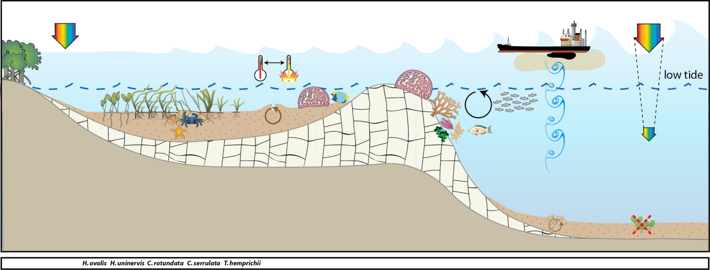
Figure 115. Conceptual diagram of reef habitat in the Cape York region
– major control is pulsed physical disturbance, salinity and temperature extremes: general habitat and seagrass meadow processes (see Figure 128 for icon explanation).

Seagrass meadows on inshore reef habitats were monitored at 3 locations, from the north of the region (12.25°S), to the south (15.6°S) (Table 3). The most southern location (Archer Point) includes a legacy site which has been monitored over the longest time period for the region. The sites at Archer Point were located in a sheltered section of bay adjacent to Archer Point, fringed by mangroves, approximately 15km south of Cooktown (Figure 215). There are two major rivers within the immediate area: the Endeavour and the Annan River. The Endeavour River is the larger of the two river systems and has a catchment area of approximately 992 km². The Annan River is located approximately 5 km south of Cooktown and extends inland from Walker Bay. The Annan River catchment area is approximately 850 km² (Hortle and Person 1990).
The other two reef habitat locations were included for monitoring from early 2012: Stanley Island and Piper Reef. Stanley Island is within the Flinders Island group north of Bathurst Bay (Figure 215). The site is a fringing reef site also fringed with mangroves. The islands are influenced by the Princess Charlotte Bay catchment which has four river systems, the Normanby, Marrett, Bizant and North Kennedy Rivers. Piper Reef is approximately 45km north west of Portland Roads, 15 km off the mainland coast (Figure 215). It is influenced by coastal waters from the Olive and Pascoe Rivers along with the Temple Bay catchment. There are minor land use activities in these catchments with some small level housing on the Pascoe River at the Wattle Hills settlement.
Most inshore seagrass meadows in the Cape York region are within coastal habitats. The majority of these meadows are in the shallow subtidal waters of large bays sheltered from the prevailing trade winds. These seagrass meadows are also highly productive and provide important nursery grounds for fisheries (Coles, et al. 1987). The meadows are also of important to the large dugong population within the region (Marsh and R 2002). In early 2012, coastal seagrass habitat locations paired with the new reef habitat locations, were also included for monitoring, they included: Bathurst Head (paired with Stanley Island) and Shelburne Bay (paired with Piper Reef). The coastal seagrass meadows at Bathurst Head and Shelburne Bay are located on naturally dynamic sand banks. These meadows are dominated by Halodule uninervis with some Halophila ovalis and are often exposed to regular periods of disturbance from wave action and consequent sediment movement. A dominant influence to these coastal meadows is exposure to wind/wave disturbance and terrigenous runoff from seasonal rains (Carruthers, et al. 2002) (Figure 116).
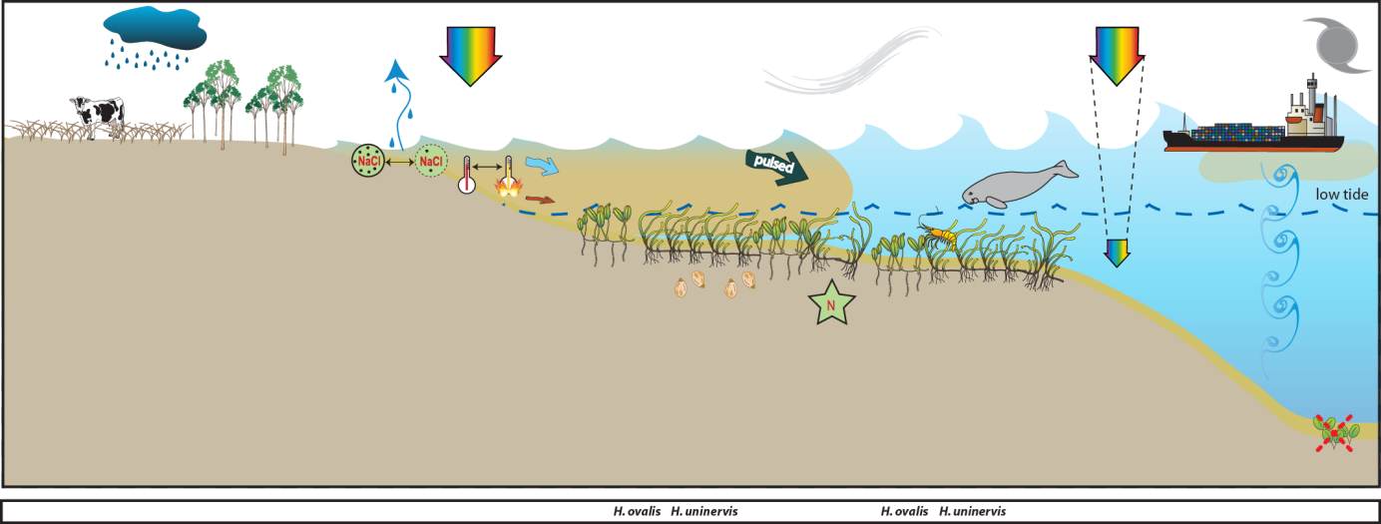
Figure 116. Conceptual diagram of coastal habitat in the Cape York region
– major control is pulsed terrigenous runoff, salinity and temperature extremes: general habitat, seagrass meadow processes and threats/impacts (see Figure 128 for icon explanation).

Bathurst Head is located just east of Combe Point in the Bathurst Bay area to the east of Princess Charlotte Bay (Figure 215). It is a coastal location fringed by mangroves on the eastern edge of the bay. The sites are within 20km of the mouths of the Normanby and Margaret Rivers. The Normanby River is the fourth largest river system flowing into the Great Barrier Reef. The catchment area covers 24,228 km² and consists of one of Queensland’s largest conservation areas, extensive cattle grazing country (75% of the catchment), and rich agricultural land at Lakeland Downs (Reef Water Quality Protection Plan Secretariat 2011). Less than 5% of the catchment has been cleared Reef Water Quality Protection Plan Secretariat 2011). Grazing densities are generally low on Cape York Peninsula (~1 beast/40 ha), however, the productive pastures in the Normanby catchment can have densities from ~1 beast/20 ha to >1 beast/5 ha (Cotter 1995).
Shelburne Bay is located 112 km north of Lockhart River and 122 km southeast of Bamaga on the east coast of the GBR. The bay has a limited catchment with only Harmer Creek discharging directly into it, and the MacMillan River discharging into the adjacent Margaret Bay. The catchment contains one of the least disturbed parabolic sand dunes areas in the world and is made up of seasonal wetlands and sand ridges. There are no current land use activities occurring in this catchment. The area is prone to extreme weather with the cyclone database stating that 47 cyclones have tracked within 200km of Shelburne Bay between 1906 and 2007. The monitoring site at Shelburne Bay is approximately 5 km west of the mouth of Harmer Creek mouth.

Wet Tropics
The Wet Tropics region covers 22,000 km² and land use practices include primary production such as cane and banana farming, dairying, beef, cropping and tropical horticulture (Commonwealth of Australia 2013e). Approximately 6.5% of the seagrass area mapped in the shallow waters (<15m) of the GBR occurs in the Wet Tropics region (McKenzie, et al. 2010c). The most extensive areas of seagrass in this region occur around Low Isles, Cairns Harbour, Green Island, Mourilyan Harbour and the Hinchinbrook Island area (between Dunk Island and Lucinda) (Coles, et al. 2007). Thirteen seagrass species have been recognised for this region (Lee Long, et al. 1993). Nearshore seagrass meadows are situated on sand and mud banks and mostly dominated by Halodule uninervis with some Halophila in the northern and southern areas. Intertidal meadows in Cairns Harbour and southern Hinchinbrook channel are dominated by Zostera muelleri. Shallow subtidal coastal meadows consist of Halodule uninervis and Halophila communities mostly along sheltered coasts and harbours (e.g. Cairns Harbour and Mourilyan Harbour). Cymodocea spp., Thalassia and a suite of Halophila species tend to dominate island habitats in the region (e.g. Dunk Island and northern Hinchinbrook Island). Only reef (subtidal and intertidal) and coastal seagrass habitats are currently monitored in the Wet Tropics region.
Coastal seagrass habitats were monitored at Yule Point in the north and Lugger Bay in the south of the region. The seagrass meadows at Yule Point and Lugger Bay occur on shallow sand banks, protected by fringing reefs. Coastal seagrass meadows are dominated by Halodule uninervis with some Halophila ovalis and are often exposed to regular periods of disturbance from wave action and consequent sediment movement. The sediments in these habitats are relatively unstable restricting seagrass growth and distribution. A dominant influence of these meadows is terrigenous runoff from seasonal rains (Figure 117). The Barron, Tully and Hull Rivers are a major source of pulsed sediment and nutrient input to these coastal meadows.
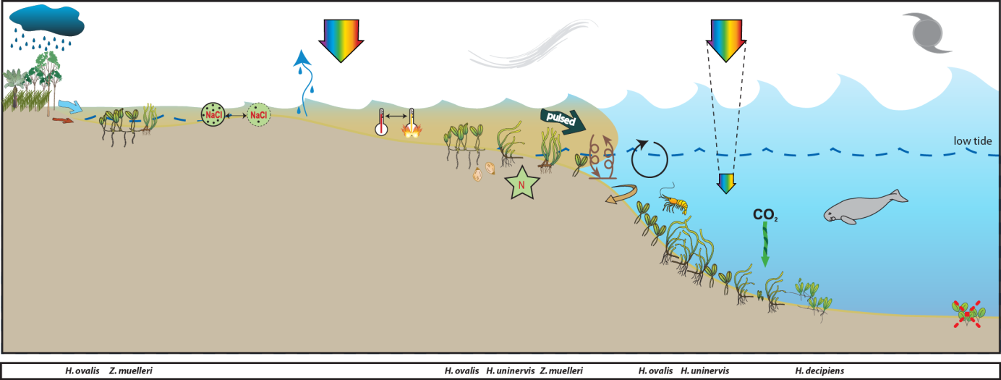
Figure 117. Conceptual diagram of coastal habitat (<15m) in the Wet Tropics region
– major control is pulsed terrigenous runoff, salinity and temperature extremes: general habitat, seagrass meadow processes and threats/impacts (see Figure 128 for icon explanation).
Reef seagrass habitats were monitored at Low Isles, Green Island and Dunk Island. Low Isles is located in the north of the region and the monitoring sites were paired intertidal and subtidal (not replicated) (Figure 216). Low Isles is an inshore reef located 15km south east of the Daintree River mouth. Low Isles refers to the two islets of Low Isles reef: Low Island (the cay) and Woody Island (predominantly Rhizophora forest). The intertidal site was located near the northern edge of the reef platform between Low Island and Woody Island. This area is dominated by Halodule uninervis and Halophila ovalis. The subtidal site was approximately 250 north of the intertidal site, in the eastern edge of the anchorage (Low Isles lagoon), and was dominated by Halophila ovalis and Halodule uninervis.
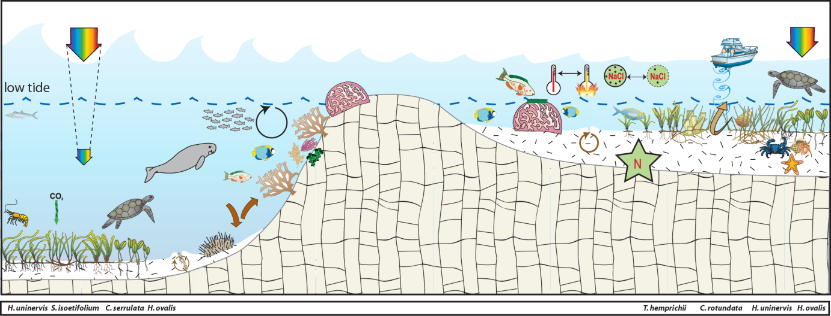
Figure 118. Conceptual diagram of reef habitat (<15m) in the Wet Tropics region
– major control is nutrient limitation, temperature extremes, light and grazing: general habitat, seagrass meadow processes and threats/impacts (see Figure 128 for icon explanation).
Green Island is a mid shelf reef located 26km north east of Cairns and the Barron River mouth, in approximately the centre of the Wet Tropics region (Figure 216). Monitoring at Green Island occurs on the large reef-platform and in the shallow lagoon to the south west and north west of the cay, respectively. The meadows are dominated by Cymodocea rotundata and Thalassia hemprichii with some Halodule uninervis and Halophila ovalis. The seagrass meadows at Green Island have been the focus of research since the 1980's and monitoring includes a legacy site (GI1).
Dunk Island is an inshore continental island located in the southern section of the region (Figure 216). Intertidal monitoring sites are located on the sand spit between the main island and Kumboola Island. The subtidal site is located in the lee of the island, in front of the former Dunk Island resort.
Shallow unstable sediment, fluctuating temperature, and variable salinity in shallow regions characterise reef habitats. Physical disturbance from waves and swell and associated sediment movement primary forcing factors which control seagrass growing in these habitats (Figure 118). Reef seagrass habitats in the region are often adjacent to areas of high tourism use and boating activity with propeller and anchor scarring impacts. Globally, nutrient concentrations are generally low in reef habitats due to the coarse nature of the coral sand sediments. In these carbonate sediments the primary limiting nutrient for seagrass growth is generally phosphate (Short et al. 1990; Fourqurean et al. 1992a; Erftemeijer and Middelburg 1993). This is due to the sequestering of the phosphate by the calcium carbonate. In this region seagrass meadows inhabiting the near shore inner reefs and fringing reefs of coastal islands inhabit a mixture of terrigenous and carbonate sediments, such as Green Island. Seagrasses at this location in the 1990’s were shown to be nitrogen limited (Udy, et al. 1999).

Burdekin
The Burdekin region, includes an aggregation of the Burdekin, Don, Haughton and Ross River catchments and several smaller coastal catchments, all of which empty into the Great Barrier Reef lagoon (Commonwealth of Australia 2013a). Rainfall is lower than other regions within tropical Queensland with an annual average of approximately 1,150 mm from on average 91 rain days. There is, however, considerable year-to-year variation due to the sporadic nature of tropical lows and storms. Approximately 75% of the average annual rainfall is received during December to March (Scheltinga and Heydon 2005).
Approximately 18% of the seagrass area mapped in the shallow waters (<15m) of the GBR occurs in the Burdekin NRM region (McKenzie, et al. 2010c). Intertidal seagrasses and shallow subtidal seagrasses dominate in this region, the majority of which are within coastal habitats (Coles, et al. 2007). Extensive seagrass meadows occur in Upstart, Cleveland, and Bowling Green Bays and off Magnetic Island. Twelve species have been found within this region (Lee Long, et al. 1993; Lee Long et al. 1996a). Deep water (>15m) seagrasses occur in this region but are not as common or dense as occurs in regions further north (Coles, et al. 2009). Most fringing reefs associated with continental islands support moderately dense mixed species meadows (especially Cymodocea serrulata), which are not restricted to the confines of fringing reefs, but are also found in sheltered bays at continental islands or coastal localities (Coles, et al. 2007).
Major threats to seagrass meadows in the region include: coastal development (reclamation); changes to hydrology; water quality declines (particularly nutrient enrichment or increased turbidity); downstream effects from agricultural (including sugarcane, horticultural, beef), industrial (including refineries) and urban centres (Scheltinga and Heydon 2005; (Haynes et al. 2001)). All four generalised seagrass habitats are present within the Burdekin region, and MMP monitoring occurs at coastal and reef seagrass habitat locations.
The coastal monitoring sites are located on naturally dynamic shallow sand banks and are subject to sand waves and erosion blowouts moving through the meadows. The Townsville (Bushland Beach and Shelley Beach) area is a sediment deposition zone, so the meadow must also cope with incursions of sediment carried by long shore drift. The Bowling Green Bay (Jerona) location is adjacent to the mouth of Barratta Creek. Sediments within this habitat are mud and sand that have been delivered to the coast during the episodic peak flows of the creeks and rivers (notably the Burdekin) in this area. While episodic riverine delivery of freshwater nutrients and sediment is a medium time scale factor in structuring these coastal seagrass meadows, it is the wind induced turbidity of the costal zone that is likely to be a major short term driver (Figure 119). In these shallow coastal areas waves generated by the prevailing SE trade winds are greater than the depth of water, maintaining elevated levels of suspended sediments, limiting the amount of light availability for photosynthesis during the trade season. Another significant feature in this region is the influence of ground water (Stieglitz 2005). The meadows are also frequented by dugongs and turtles as witnessed by abundant grazing trails and patches of cropping .
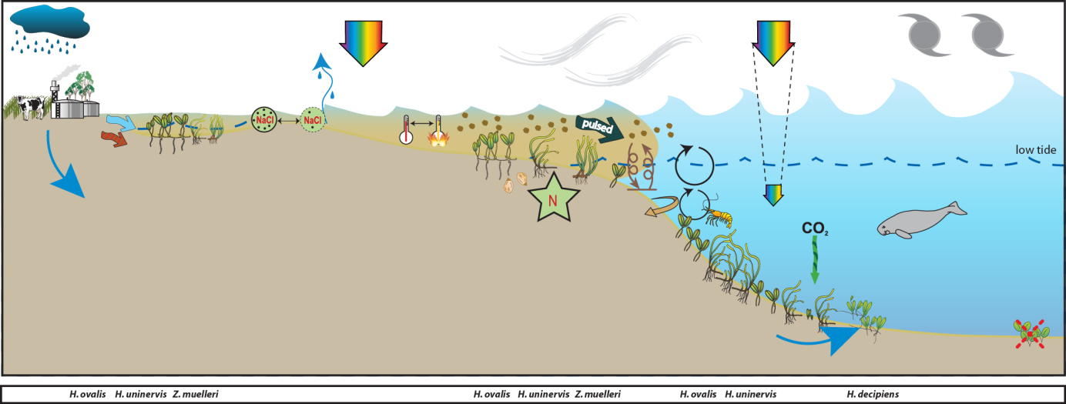
Figure 119. Conceptual diagram of coastal habitat in the Burdekin region
- major control is wind and temperature extremes, general habitat, seagrass meadow processes and threats/impacts (see Figure 128 for icon explanation).

The reef habitats are mainly represented by fringing reefs on the many continental islands within this area. Most fringing reefs have seagrass meadows growing on their shallow banks. Nutrient supply to these meadows is by terrestrial inputs via riverine discharge, re-suspension of sediments and groundwater supply (Figure 120). The meadows are typically composed of zones of seagrasses: Cymodocea serrulata, Thalassia hemprichii and Halodule uninervis (wide leaf) often occupy the lower littoral/subtidal area, blending with Halodule uninervis (narrow leaved) and Halophila ovalis in the upper intertidal zone. Phosphate is often the nutrient most limiting to reefal seagrasses (Short, et al. 1990; Fourqurean, et al. 1992a). Experimental studies on reef top seagrasses in this region however, have shown seagrasses to be nitrogen limited primarily with secondary phosphate limitation, once the plants have started to increase in biomass (Mellors 2003). In these fringing reef top environments fine sediments are easily resuspended by tidal and wind generated currents making light availability a driver of meadow structure.

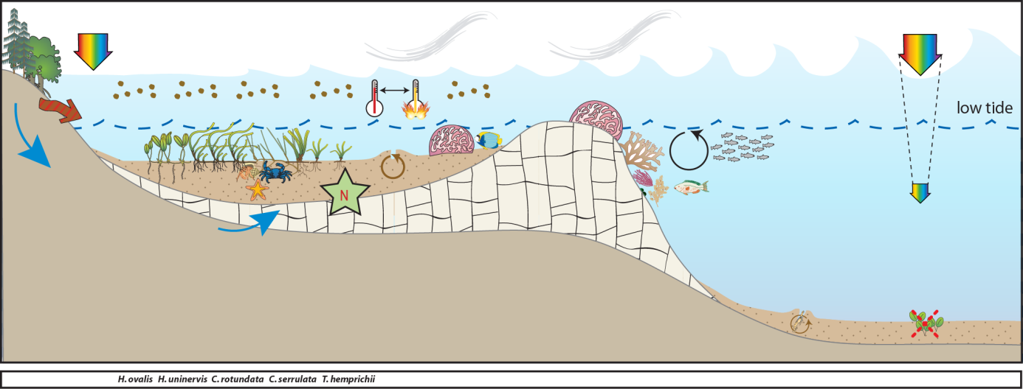
Figure 120. Conceptual diagram of fringing reef habitat in the Burdekin region
- major control is nutrient supply (groundwater), light and shelter: general habitat and seagrass meadow processes (see Figure 128 for icon explanation).

Mackay Whitsunday
The Mackay Whitsunday region comprises an area of almost 940,000 ha and extends from Bowen (Queens Beach) in the north to Clairview (Clairview Bluff) in the south and includes several large continental islands. The region includes the major population centres of Mackay, Proserpine, Airlie Beach and Sarina; encompassing the Proserpine, O’Connell, Pioneer and Plane Creek river systems (Commonwealth of Australia 2013d).
The Great Barrier Reef protects the coastline from predominantly south-easterly winds which often accompany a light south-easterly ocean swell (Mackay Whitsunday Natural Resource Management Group Inc 2005). Coastal waters adjacent to the large rivers and mangrove-lined inlets are generally very turbid and shallow, with predominantly mud sediments. Tidal range in the south of the region is large, and in some places has the effect of creating extensive tidal banks. The region receive rainfall between 500-3000 mm annually, which falls mostly (~70%) from December to March. Average daily temperatures for Mackay range between 23 31°C in January and 11-22°C in July. The major land use of each catchment is livestock grazing, and crops such as sugar cane.
Extensive seagrass meadows occur both on shallow banks and in nearshore subtidal areas in the region. Approximately 448 km² of seagrass habitat has been mapped in the Mackay Whitsunday region over the past 3 decades, with 154 km² in shallow waters and 293 km² in deeper (>15m) waters (McKenzie, et al. 2010c). In 1999/2000, 5553 ±1182 hectares of seagrass was mapped from Midge Point in the south to Hydeaway Bay in the north (Campbell, et al. 2002). This represented a 40% increase in overall seagrass habitat compared to the 1987 baseline, however losses had occurred at some localities. For a detailed description of seagrass meadows and habitats across the region (see McKenzie and Yoshida 2012).
Twelve species of seagrass have been recorded in the Mackay Whitsundays, representing 80% of the known species found in Queensland waters (McKenzie and Yoshida 2012). The wide range of physical habitats where seagrasses were found undoubtedly contributes to the high species diversity. Habitats include intertidal and subtidal areas of estuary, coastal fringing reef environments and deepwater environments. MMP sites are located on three of the generalised seagrass habitats represented in the region, including estuarine, coastal and reef.
Estuarine seagrass habitats in the Mackay Whitsunday region tend to be intertidal on the large sand/mud banks of sheltered estuaries. Run-off through the catchments connected to these estuaries is variable, though the degrees of variability is moderate compared to the high variability of the Burdekin and the low variability of the Tully (Brodie 2004). Seagrass in this habitat must cope with extremes of flow, associated sediment and freshwater loads from December to April when 80% of the annual discharge occurs (Figure 121).

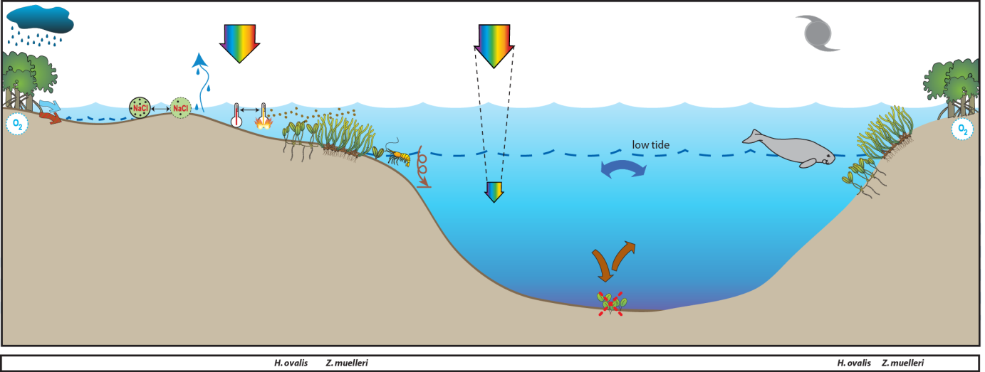
Figure 121. Conceptual diagram of estuary habitat in the Mackay Whitsunday region
: general habitat and seagrass meadow processes (see Figure 128 for icon explanation).
Coastal seagrass habitats are found in areas such as the leeward side of inshore continental islands and in north opening bays. These areas offer protection from the south-easterly trade winds. Potential impacts to these habitats are issues of water quality associated with urban, marina development and agricultural land use (Figure 122). Monitoring sites of coastal seagrass habitat were located on the sand/mud flats adjacent to Cannonvale in southern Pioneer Bay.
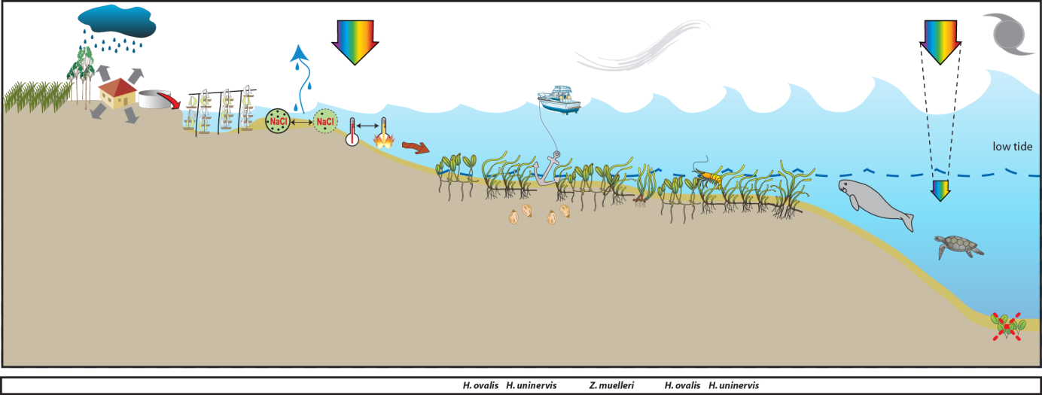
Figure 122. Conceptual diagram of coastal habitat in the Mackay Whitsunday region
– major control is shelter and temperature extremes: general habitat, seagrass meadow processes and threats/impacts (see Figure 128 for icon explanation).
Reef habitat seagrass meadows are found on the shallow fringing reefs adjacent to the mainlands or associated with the many islands in this region. The drivers of these habitats is exposure to waves and temperature extremes (Figure 123). Major threats would be increased tourism activities including marina and coastal developments.
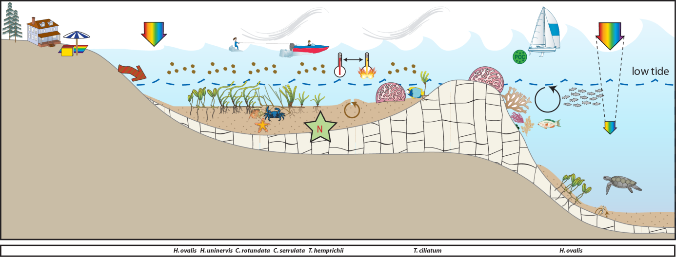
Figure 123. Conceptual diagram of reef habitat in the Mackay Whitsunday region
- major control is light and temperature extremes: general habitat, seagrass meadow processes and threats/impacts (see Figure 128 for icon explanation).

Fitzroy
The Fitzroy region covers an area of nearly 300,000 km². It extends from Nebo in the north to Wandoan in the south, and encompasses the major systems of the Fitzroy, Boyne, and Calliope rivers as well as the catchments of the smaller coastal streams of the Capricorn and Curtis Coasts (Commonwealth of Australia 2013c). The Fitzroy River is the largest river system running to the east coast of Australia. The Boyne and Calliope Rivers drain the southern part of the region, entering the GBR lagoon at Gladstone. The region covers ten percent of Queensland’s land area and is home to approximately 200,000 people. It is one of the richest areas in the state in terms of land, mineral and water resources and supports grazing, irrigated and dryland agriculture, mining, forestry and tourism land uses (Christensen et al. 2006). Agricultural production constitutes the largest land use in Central Queensland, with nearly 90% of the land under agricultural production. Concomitant with this land use is concern of the quality of the water that is entering the GBR lagoon.
The Fitzroy region experiences a tropical to subtropical humid to semi arid climate. Annual median rainfall throughout the region is highly variable, ranging from about 800 mm to over 1000mm. Most rain falls in the summer, with many winters experiencing no rain at all. Because of the tropical influence on rainfall patterns, heavy storms can trigger flash flooding, and occasional cyclones wreak havoc.
The first broad scale survey of seagrass habitat in this region occurred in 1987, followed by more fine scale surveys of Shoalwater Bay (Lee Long et al. 1996b), the Dugong Protection Areas of Llewellyn Bay, Ince Bay and the Clairview Region (Coles et al. 2002) and Port Curtis to Rodds Bay (Rasheed, et al. 2003). Ten species of seagrass have been recorded from this region ranging from the intertidal to a depth of 48m (Coles, et al. 2007; McKenzie, et al. 2010c). The majority of seagrass in this region exist on large shallow banks flats. Expansive meadows exist on the coastal intertidal flats of Ince Bay, Clairview, Shoalwater Bay and Rodds Bay. The area of shallow subtidal coastal seagrass habitat in this region is small, as most of the coastline is exposed to south-east winds (Coles, et al. 2007). A significant factor contributing to the lack of suitable coastal habitat is the scouring tidal currents and associated high water turbidity in this region which limits light penetration and therefore the depth to which seagrasses can grow. Deepwater seagrasses were generally not found in the central and northern parts of this region, apart from occasional sites in the lee of islands or reefs (Coles, et al. 2009).
MMP sites within this region are located in coastal, estuarine or fringing-reef seagrass habitats. Coastal sites are monitored in Shoalwater Bay and are located on the large shallow banks of the north western shores of Shoalwater Bay. The remoteness of this area (due to its zoning as a military exclusion zone) represents a near pristine environment, removed form anthropogenic influence. In contrast, the estuarine sites are located within Gladstone Harbour: a heavily industrialized port. Offshore reef sites are located at Monkey Beach, Great Keppel Island.
The Shoalwater Bay monitoring sites are located in a bay which is a continuation of a coastal meadow that is protected by headlands. A feature of the region is the large tidal amplitudes and consequent strong tidal currents (Figure 124). As part of this tidal regime, large intertidal banks are formed which are left exposed for many hours. Pooling of water in the high intertidal, results in small isolated seagrass patches 1-2m above Mean Sea Level (MSL).

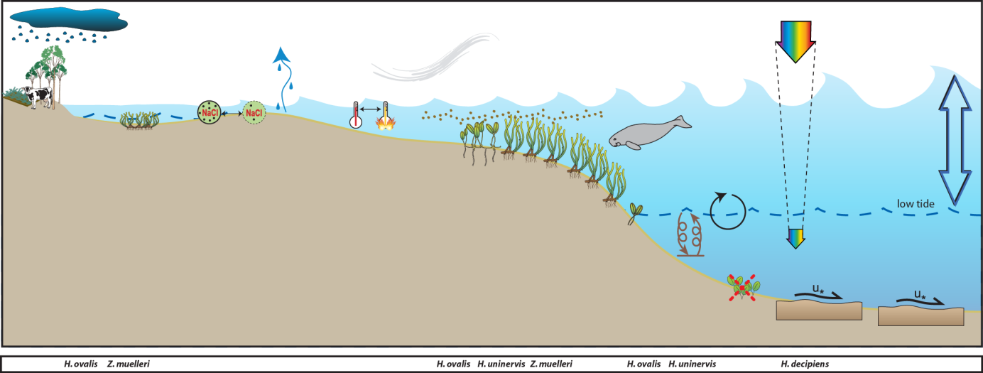
Figure 124. Conceptual diagram of coastal habitat in the Fitzroy region
– major control is pulsed light, salinity and temperature extremes: general habitat, seagrass meadow processes and threats/impacts (see Figure 128 for icon explanation).
Reef habitat seagrass meadows are found intertidally on the top of the fringing reefs associated with the Keppel Isles and Cannibal Island groups, however many of the reefs in the north of the region have not been surveyed. The drivers of these habitats are exposure and desiccation (intertidal meadows) and light limitation associated with wind driven resuspension (Figure 125).
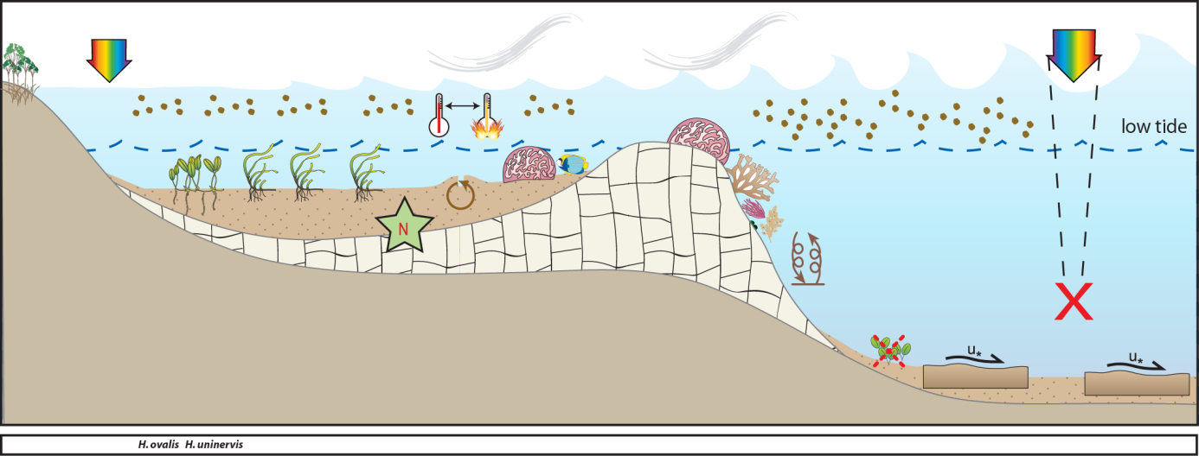
Figure 125. Conceptual diagram of reef habitat in the Fitzroy region
- major control is light and temperature extremes and benthic shear from tidal currents: general habitat, seagrass meadow processes and threats/impacts (see Figure 128 for icon explanation).
Estuarine seagrass habitats in the southern Fitzroy region tend to be intertidal, on the large sand/mud banks in sheltered areas of the estuaries. Tidal amplitude is not as great as in the north and estuaries that are protected by coastal islands and headlands support meadows of seagrass. These habitats feature scouring, high turbidity and desiccation (linked to this large tide regime), and are the main drivers of distribution and composition of seagrass meadows in this area (Figure 126). These southern estuary seagrasses (Gladstone, Port Curtis) are highly susceptible to impacts from local industry and inputs from the Calliope River. Port Curtis is highly industrial with the world’s largest alumina refinery, Australia’s largest aluminium smelter and Queensland’s biggest power station. In addition, Port Curtis contains Queensland’s largest multi-cargo port (Port of Gladstone) with 50 million tonnes of coal passing through the port annually.
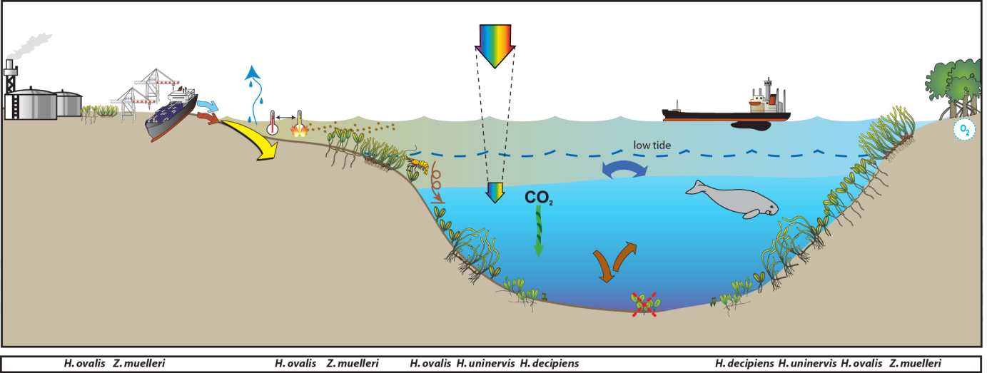
Figure 126. Conceptual diagram of estuary habitat in the Fitzroy region
– major control variable rainfall and tidal regime: general habitat, seagrass meadow processes and threats/impacts (see Figure 2 for icon explanation).

Burnett-Mary
The Burnett Mary Region encompasses a land area of more than 56,000 km², a marine area of almost 10,000 km² and supports a population of over 200,000 people. The region is comprised of a number of catchments including the Baffle Creek, Kolan, Burnett, Burrum and Mary Rivers (Commonwealth of Australia 2013b). Only the northern most catchment of the Burnett Mary region, the Baffle Basin, is within the GBR and includes the tidal mudflats and mangroves in Rodds Peninsula/Turkey Beach considered ‘near pristine’ (Burnett Mary Regional Group 2005).
Principal land uses in the Burnett-Baffle area are beef cattle grazing (the largest though currently declining), small crop growers, forestry (including plantations), tourism and fishing (Burnett Mary Regional Group 2010). Other significant land uses include conservation, rural and urban residential development (Prange and Duke 2004). Located in the northern section of the region is Rodds Bay, where freshwater input is minor from seasonal flows in small catchments, and water quality generally good - little organic/inorganic pollution even though Rodds Harbour has elevated natural turbidity and minor increases in sediment loads from grazing and development (Ford 2004). The southern region includes the Mary River catchment (9181km²) and although outside the GBR Marine Park, is highly connected through oceanographic processes and plays a major driver of southern GBR ecosystems (Burnett Mary Regional Group 2013). Grazing predominates and utilises 42% of the land area of the Mary catchment. High rainfall areas to the south and east host the majority of residential development, horticulture, and intensive livestock. Forestry and nature conservation, each of which occupies 18% of the catchment, are the second largest land uses, with intensive anthropogenic uses (residential, manufacturing, services, waste treatment, transport, and services) occupying 13% of the catchment area (Walker and Esslemont 2008). Sediment, total nitrogen and total phosphorus exports from the Mary catchment to the coastal receiving waters are estimated to be 455 kt.yr⁻¹, 1.541 kt.yr⁻¹ and 0.344 kt.yr⁻¹, respectively (DeRose et al. 2002). Since European settlement, relative erosion rates in some sections of the Western Mary have increased 2 to 7 fold, and 4 to more than 14 fold in the Upper Mary (Esslemont et al. 2006).
Seagrass in the region were first broadly surveyed in 1988 (Lee Long et al. 1992) with the section north of Rodds Peninsula resurveyed at a finescale in 2002 (Rasheed, et al. 2003). Seven seagrass species have been reported in the Burnett Mary NRM region (McKenzie and Yoshida 2008), five within the marine park boundary (Coles, et al. 2007). Meadows have been reported throughout the inlets protected from the south easterly winds and oceanic swell, and throughout Hervey Bay and the Great Sandy Strait. Very little seagrass has been mapped on the exposed coastline between Bustard Head to just north of Hervey Bay. Within the GBRWHA boundaries, the majority of seagrass meadows are within coastal and estuary habitats. South of the GBRWHA boundary in one of the largest single areas of seagrass resources on the eastern Australian seaboard (McKenzie and Yoshida 2008). The southern marine area of the Burnett Mary NRM region includes large meadows in deepwater, coastal (including intertidal and shallow subtidal) and estuarine habitats (McKenzie and Yoshida 2008).
Meadows in the north of the Burnett Mary region generally face low levels of anthropogenic threat, and monitoring sites are located within Rodd’s Bay. The only other location that is monitored within this region is in the south, at Urangan (Hervey Bay). This location is adjacent to the Urangan marina and in close proximity to the mouth of the Mary River.
Estuarine habitats occur in bays that are protected from the south easterly-winds and consequent wave action. The seagrasses in this area must survive pulsed events of terrestrial run-off, sediment turbidity and drops in salinity. Estuary seagrasses in the region are susceptible to temperature related threats and desiccation due to the majority being intertidal (Figure 127).
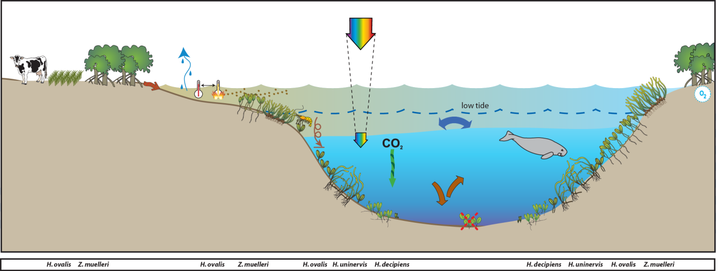
Figure 127. Conceptual diagram of Estuary habitat in the GBR section of the Burnett Mary region
– major control is shelter from winds and physical disturbance: general habitat and seagrass meadow processes (see Figure 128 for icon explanation).

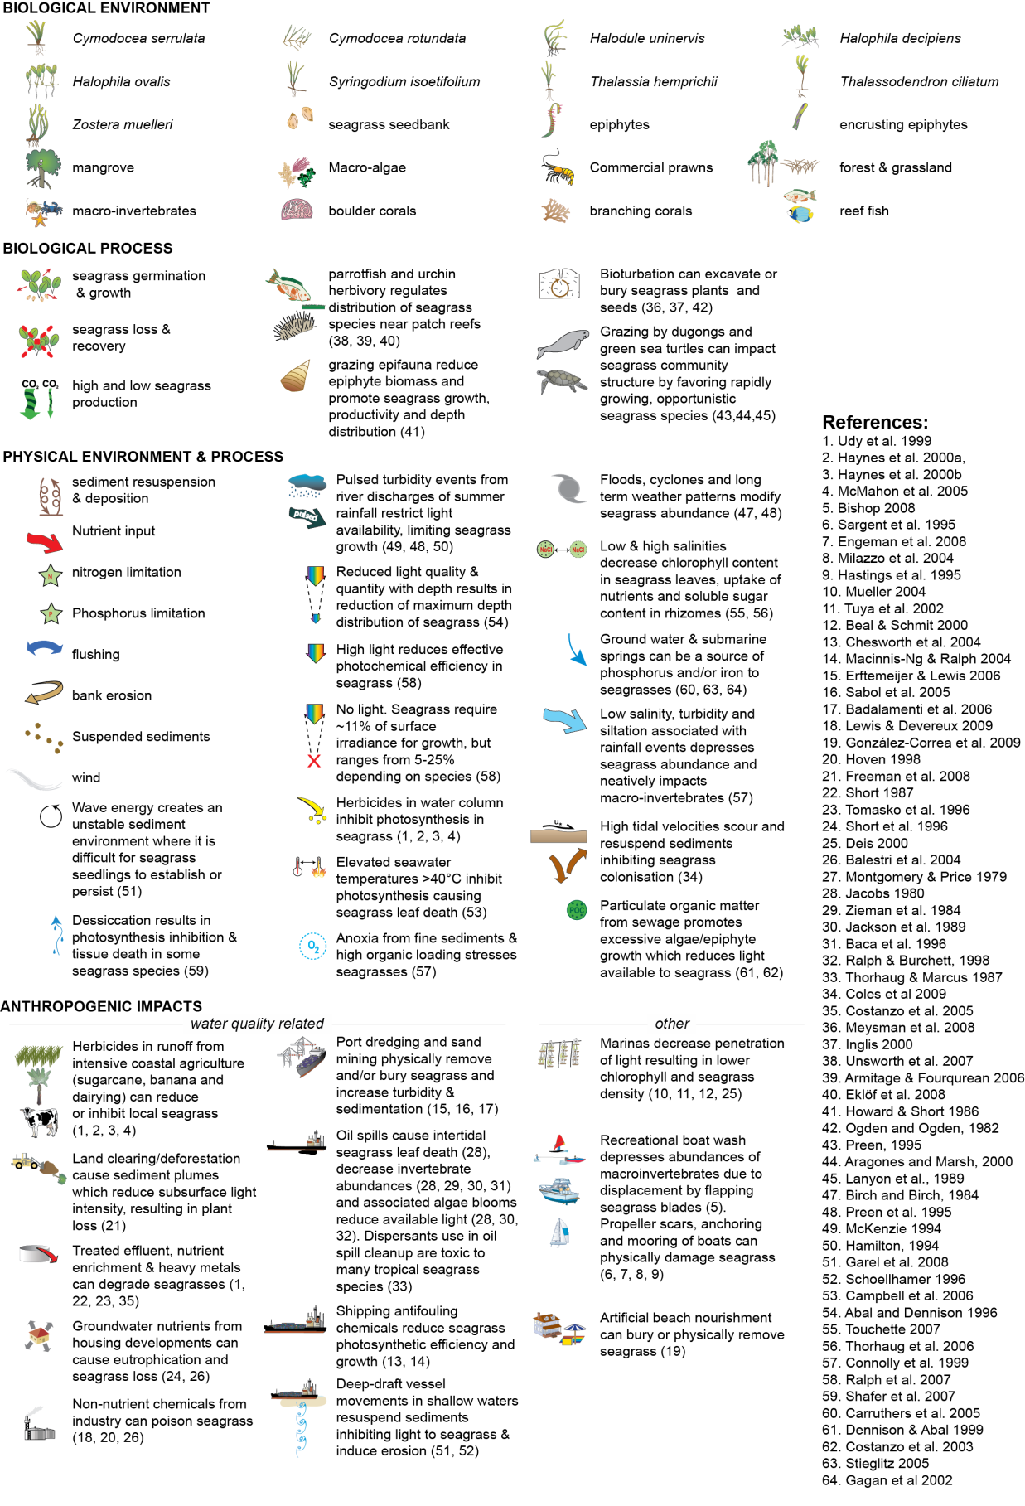
Figure 128. Key to symbols used for conceptual diagrams detailing drivers and pressures to seagrasses.

Materials and Methods

The following section includes excerpts from McKenzie et al. (2014a).

Sampling design
In late 2004 all data collected within the GBR region as part of existing monitoring programs were supplied to a Senior Statistician at AIMS for independent review (De’ath 2005) examined the available datasets to estimate expected performance with regard to detecting long-term changes (including estimates of precision for annual mean, differences in means and linear trends) of the monitoring program. Seagrass data included in the analyses was collected from 2000–2004 and across 63 sites in 29 locations from Cooktown to Hervey Bay. Results concluded that the existing spatial and temporal coverage of monitoring was providing valuable information about long-term trends and spatial differences, with changes in seagrass cover occurring at various spatial and temporal scales. The report recommended that the value of the monitoring would be greatly enhanced by adding more widely spread locations. Therefore additional meadows were added according to criteria listed in materials and methods.
The sampling design was selected to detect change in inshore seagrass community status to compare with seagrass environmental status (water quality) in relation to specific catchments or groups of catchments (NRM region). Within each region, a relatively homogenous section of a representative seagrass meadow is selected to represent each of the seagrass habitats present (estuarine, coastal, reef) (Habitat(Region)). To account for spatial heterogeneity, two sites were selected within each location (Site[Habitat(Region)]). Subtidal sites were not replicated within locations. Within each site, finer scale variability is accounted for by using three 50 m transects nested in each site. An intertidal site is defined as a 50mx50m area. The sampling strategy for subtidal sites was modified to sample along 50m transects 2-3 m apart (aligned along the depth contour) due to logistical purposes of SCUBA diving in often poor visibility. At each site, monitoring is conducted during the late-monsoon (April) and late-dry (October) periods each year; additional sampling is conducted at more accessible locations in the dry (July) and monsoon (January).

Table 30. Samples collected at each MMP inshore monitoring site per parameter for each season. Activities include: SG = seagrass cover & composition, SM=seed monitoring, TN=tissue nutrients, EM=edge mapping, RH=reproductive health, TL=temperature loggers, LL=light loggers, SH=sediment herbicides. ^=subtidal.
Sector | Region | Catchment | Monitoring location |  | late dry Season (2013) |  |  |  |  |  |  | late monsoon Season (2014)
 |  |  |  |  | SG | SM | TN | EM | RH | TL | LL | SG | SM | EM | RH | SH | TL | LL
Far Northern | Cape York |  | Shelburne Bay | SR1 | 33 | 30 | 3 |  | 15 |  |  | 33 | 30 |  | 15
 |  |  |  | SR2 | 33 | 30 | 3 |  | 15 |  |  | 33 | 30 |  | 15
Far Northern | Cape York |  | Piper Reef | FR1 | 33 | 30 | 3 |  | 15 |  |  | 33 | 30 |  | 15
 |  |  |  | FR2 | 33 | 30 | 3 |  | 15 |  |  | 33 | 30 |  | 15
Far Northern | Cape York | Normanby | Stanley Island | ST1 | 33 | 30 | 3 |  | 15 |  |  | 33 | 30 |  | 15
 |  |  |  | ST2 | 33 | 30 | 3 |  | 15 |  |  | 33 | 30 |  | 15
Far Northern | Cape York | Normanby | Bathurst Bay | BY1 | 33 | 30 | 3 |  | 15 |  |  | 33 | 30 |  | 15
 |  |  |  | BY2 | 33 | 30 | 3 |  | 15 |  |  | 33 | 30 |  | 15
Far Northern | Cape York | Annan | Cooktown | AP1 | 33 | 30 | 3 |  | 15 |  |  | 33 | 30 |  | 15
 |  |  |  | AP2 | 33 | 30 | 3 |  | 15 |  |  | 33 | 30 |  | 15
Northern | Wet Tropics | Daintree | Low Isles | LI1 | 33 | 30 | 3 |  | 15 |  |  | 33 | 30 |  | 15
 |  |  |  | LI2^ | 33 | 30 | 3 |  |  |  |  | 33 | 30 |  | 15
Northern | Wet Tropics | Barron | Cairns | YP1 | 33 | 30 | 3 |  | 15 |  |  | 33 | 30 |  | 15
 |  |  |  | YP2 | 33 | 30 | 3 |  | 15 |  |  | 33 | 30 |  | 15
Northern | Wet Tropics | Russell - Mulgrave, Johnstone | Green Island | GI1 | 33 | 30 | 3 |  | 15 |  |  | 33 | 30 |  | 15
 |  |  |  | GI2 | 33 | 30 | 3 |  | 15 |  |  | 33 | 30 |  | 15
 |  |  |  | GI3^ | 33 | 30 | 3 |  | 15 |  |  | 33 | 30 |  | 15
Northern | Wet Tropics | Tully | Mission Beach | LB1 | 33 | 30 | 3 |  | 15 |  |  | 33 | 30 |  | 15
 |  |  |  | LB2 | 33 | 30 |  |  | 15 |  |  | 33 | 30 |  | 15
Northern | Wet Tropics | Tully | Dunk Island | DI1 | 33 | 30 | 3 |  | 15 |  |  | 33 | 30 |  | 15
 |  |  |  | DI2 | 33 | 30 | 3 |  | 15 |  |  | 33 | 30 |  | 15
 |  |  |  | DI3^ | 33 | 30 | 3 |  | 15 |  |  | 33 | 30 |  | 15
Central | Burdekin | Burdekin | Magnetic Island | MI1 | 33 | 30 | 3 |  | 15 |  |  | 33 | 30 |  | 15
 |  |  |  | MI2 | 33 | 30 | 3 |  | 15 |  |  | 33 | 30 |  | 15
 |  |  |  | MI3^ | 33 | 30 | 3 |  | 15 |  |  | 33 | 30 |  | 15
Central | Burdekin | Burdekin | Townsville | SB1 | 33 | 30 | 3 |  | 15 |  |  | 33 | 30 |  | 15
 |  |  |  | BB1 | 33 | 30 | 3 |  | 15 |  |  | 33 | 30 |  | 15
Central | Burdekin | Burdekin | Bowling Green Bay | JR1 | 33 | 30 | 3 |  | 15 |  |  | 33 | 30 |  | 15
 |  |  |  | JR2 | 33 | 30 | 3 |  | 15 |  |  | 33 | 30 |  | 15
Central | Mackay  Whitsunday | Proserpine | Whitsundays | PI2 | 33 | 30 | 3 |  | 15 |  |  | 33 | 30 |  | 15
 |  |  |  | PI3 | 33 | 30 | 3 |  | 15 |  |  | 33 | 30 |  | 15
Central | Mackay  Whitsunday | Proserpine | Hamilton Is. | HM1 | 33 | 30 | 3 |  | 15 |  |  | 33 | 30 |  | 15
 |  |  |  | HM2 | 33 | 30 | 3 |  | 15 |  |  | 33 | 30 |  | 15
Central | Mackay  Whitsunday | Pioneer | Mackay | SI1 | 33 | 30 | 3 |  | 15 |  |  | 33 | 30 |  | 15
 |  |  |  | SI2 | 33 | 30 | 3 |  | 15 |  |  | 33 | 30 |  | 15
Southern | Fitzroy | Fitzroy | Shoalwater Bay | RC1 | 33 | 30 | 3 |  | 15
 |  |  |  | WH1 | 33 | 30 | 3 |  | 15 |  |  | 33 | 30 |  | 15
Southern | Fitzroy | Fitzroy | Great Keppel . | GK1 | 33 | 30 | 3 |  | 15 |  |  | 33 | 30 |  | 15
 |  |  |  | GK2 | 33 | 30 |  |  | 15 |  |  | 33 | 30 |  | 15
Southern | Fitzroy | Boyne | Gladstone | GH1 | 33 | 30 | 3 |  | 15 |  |  | 33* | 30* |  | 15
 |  |  |  | GH2 | 33 | 30 | 3 |  | 15 |  |  | 33* | 30* |  | 15
Southern | Burnett Mary | Burnett | Rodds Bay | RD1 | 33 | 30 |  |  | 15 |  |  | 33 | 30 |  | 15
 |  |  |  | RD2 | 33 | 30 |  |  | 15 |  |  | 33 | 30 |  | 15
Southern | Burnett Mary | Mary | Hervey Bay | UG1 | 33 | 30 | 3 |  | 15 |  |  | 33 | 30 |  | 15
 |  |  |  | UG2 | 33 | 30 | 3 |  | 15 |  |  | 33 | 30 |  | 15

Climate and environmental pressures

Tidal exposure
The majority of meadows monitored within the MMP are located in shallow turbid waters where the duration of emersion and exposure has been shown to be important environmental drivers of seagrass change (Unsworth et al. 2012b). In the inshore waters of the GBR, where turbidity is naturally high, seagrasses are often restricted exclusively to the intertidal zone, as the periods around and even during exposure may provide critical windows of sufficient light for positive net photosynthesis (Pollard and Greenway 1993). However, during tidal exposure, these intertidal seagrasses are susceptible to high irradiance, potentially high UV-A and UV-B, thermal stress and desiccation (Erftemeijer and Herman 1994; Stapel et al. 1997; Björk et al. 1999; Campbell, et al. 2006). Research on upper intertidal Enhalus acoroides meadows in the northern Gulf of Carpentaria (Weipa), reported strong correlative evidence that long-term tidal cycles coinciding with daylight and high solar radiation are linked to this long-term variability and seagrass decline (Unsworth, et al. 2012b). Actual tidal data was provided by Maritime Safety Queensland and exposure times calculated for each site based on measured height relative to the Lowest Astronomical Tide.

Light loggers
Submersible Odyssey™ photosynthetic irradiance autonomous loggers were attached to permanent station markers at 20 intertidal and 4 subtidal seagrass locations from the Cape York region to the Burnett Mary region (Table 30). Measurements were recorded by the logger every 15 - 30 minutes and are reported as total daily light (mol m⁻² d⁻¹). Automatic wiper brushes cleaned the optical surface of the sensor every 15 minutes to prevent marine organisms fouling.
The deployment durations were variable, with some deployed since 2008 under a different program (e.g. MTSRF); however the light monitoring was expanded and incorporated into the MMP in late 2009. Data were patchy for a number of intertidal sites because visitation frequency was low (3- 6 months), which increases the risk of light logger or wiper unit failure and increases the gap in data if loggers do fail. Furthermore, there are some sites that are frequently accessed by the public and tampering is suspected in the disappearance of some loggers. For subtidal sites, and their associated intertidal sites (Picnic Bay, Dunk Island, Green Island and Low Isles, 8 sites in total), the logger replacement time was every 6 weeks so data gaps were reduced.
Odyssey™ data loggers (Odyssey, Christchurch, New Zealand) record Photosynthetically Active Radiation (400-1100nm) and store data in an inbuilt memory which is retrieved every three to six months, depending on the site. Each logger has the following technical specifications:
- Cosine corrected photosynthetic irradiance sensor 400-700 nm
- Cosine corrected solar irradiance sensor 400-1100 nm
- Integrated count output recorded by Odyssey data recorder
- User defined integration period
- Submersible to 20m water depth
- 64k memory.
The logger is self-contained in a pressure-housing with batteries providing sufficient power for deployments of longer than six months. For field deployment, loggers are attached to a permanent station marker using cable ties; this is above the sediment-water interface at the bottom of the seagrass canopy. This location ensures that the sensors are not exposed to air unless the seagrass meadow is almost completely drained and places them out of sight of curious people. At subtidal sites, the loggers are deployed on the sediment surface (attached to a permanent marker) with the sensor at seagrass canopy height. Two loggers are deployed at subtidal sites as there is an increased chance of logger fouling, and the dual logger set-up offers a redundant data set in the instance that one logger fouls completely. Where possible, additional light loggers are deployed at subtidal sites 80 cm from the sediment surface. Data from this logger, together with data from the logger at canopy height, is used for calculation of the light attenuation co-efficient. Furthermore, another logger is deployed above the water surface at each of the subtidal monitoring stations. These additional loggers (surface and subtidal higher in the water column) allow comparison of water quality indices for some of the time.
Each light logger has a unique serial number which is recorded within a central secure database. The logger number is recorded on the monitoring site datasheet with the time of deployment and collection. At each monitoring event (every three to six months) the light loggers are removed and replaced with a ‘fresh’ logger. At subtidal monitoring sites, the loggers are checked by SCUBA (and replaced if fouled) every six weeks due to the increased fouling rates at permanently submerged sites. After collection, details of the logger number, field datasheet (with date and time) and logger are returned to JCU for downloading.
Photographs of the light sensor and/or notes on the condition of the sensor are recorded at logger collection. If fouling is major (e.g. wiper failure), the data are truncated to included only that data before fouling began – usually one to two weeks. If fouling was minor (up to ~25% of the senor covered), back corrections to the data are made to allow for a linear rate of fouling (linear because with minor fouling it is assumed that the wiper was retarding algal growth rates, but not fully inhibiting them).
Loggers were calibrated against a certified reference Photosynthetically Active Radiation (PAR) sensor (LI-COR™ LI-192SB Underwater Quantum Sensor) using a stable light source (LiCor) enclosed in a casing that holds both the sensor and light source at a constant distance. Calibration is repeated after each deployment period of 6 weeks to 6 months.
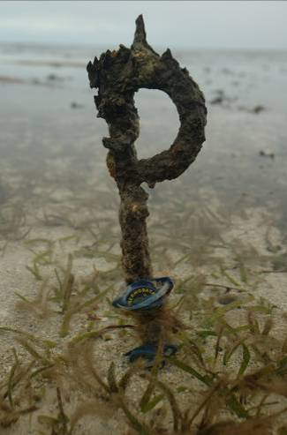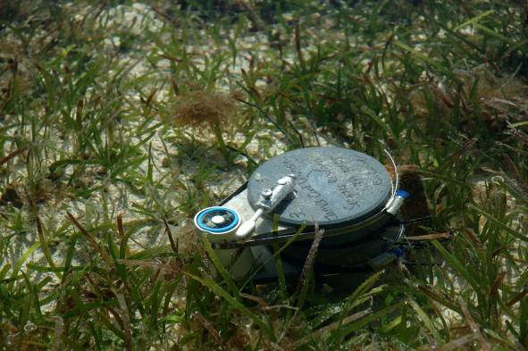
Autonomous iBTag™ submersible temperature loggers and submersible Odyssey™ photosynthetic irradiance autonomous logger deployed at Green Island.
Light data measured as instantaneous irradiance (µmol m⁻² s⁻¹) was converted to daily irradiance (I_{d}, mol m⁻² d⁻¹). I_{d} is highly variable in shallow coastal systems, being affected by incoming irradiance, the tidal cycle as well as water quality (Anthony, et al. 2004). This high variability makes it difficult to ascertain trends in data. To aid with the visual interpretation of trends, I_{d} was averaged over a 28-day period (complete tidal cycle). 28 days is also biologically meaningful, as it corresponds to the approximate duration over which leaves on a shoot are fully replaced by new leaves and it is the approximate time over which shoot density and biomass starts to decline following reductions in light (Collier et al. 2012a). 28-day averaged I_{d} are presented graphically against draft thresholds with different values for northern and southern communities as the dominant species and habitat types vary from north to south. Thresholds applied in the northern GBR (5 mol m⁻² s⁻¹) were developed for Halodule uninervis-dominated communities during episodic seagrass loss (Collier, et al. 2012b). The threshold applied to southern GBR communities were developed for Zostera muelleri dominated communities over a 2-week rolling average using a range of experimental and monitoring approaches (Chartrand et al. 2012). These working thresholds describe light levels associated with short-term changes in seagrass abundance.
Also discussed, I_{d} is relative to estimated minimum light requirements (MLR). MLR describes the light required for the long-term survival of seagrass meadows (Dennison 1987). It is frequently calculated from measurement of annual light availability at the deepest edge of seagrass meadow, beyond which seagrasses cannot survive. MLR is difficult to determine in the dynamic seagrass meadows of the GBR, which often have poorly defined meadow boundaries, and these boundaries vary over intra-annual cycles. Therefore, MLR were estimated based on the average range in MLR for other ‘blady’ tropical species from the same genera (e.g. Halodule, Thalassia). MLR are usually reported as percent of surface irradiance (SI), even though this not the most meaningful representation of light requirements. The average MLR of 15-25% SI for tropical blady species (summarized in Lee et al. 2007) was converted to I_{d} using surface light data from Magnetic Island, Dunk Island, Green Island and Low Isles, which has been recorded at these sites since 2008. From this we estimate that the MLR equivalent to 15-25% SI is 4.7 to 7.9 mol photons m⁻² d⁻¹. Halophila species typically have a much lower MLR, around 5-10% SI (Lee, et al. 2007), which is equivalent to 1.5 to 2.9 mol m⁻² d⁻¹ at the monitoring sites for which we have surface light data. There are other species that possibly have higher MLR than the range given here; for example, Zostera muelleri is thought to have an MLR greater than 30% (Carruthers, et al. 2002). There is similarity between the working light thresholds and the MLR, reflecting the sensitivity of the dominant coastal seagrasses, to perturbations in their light environment.
Table 31. Minimum light requirements (MLR) derived from the literature (15-25%) were converted to daily irradiance from surface light at sites where surface light is also monitored.
Site | Average daily irradiance (mol m⁻² d⁻¹)
Site | 15% SI | 25% SI
Low Isles | 4.5 | 7.4
Green Island | 4.9 | 8.2
Dunk Island | 4.9 | 8.1
Magnetic Island | 4.6 | 7.7
AVERAGE | 4.7 | 7.9

Within seagrass canopy temperature loggers
Autonomous iBTag™ submersible temperature loggers are deployed at all sites identified in Table 30. The loggers record temperature (degrees Celsius) within the seagrass canopy every 30 to 90 minutes (depending on duration of deployment and logger storage capacity) and store data in an inbuilt memory which is downloaded every three to six months, depending on the site.
iBCod 22L model of iBTag™ loggers are used as they can withstand prolonged immersion in salt water to a depth of 600 metres. It is reinforced with solid titanium plates and over molded in a tough polyurethane casing that can take a lot of rough handling.
Main features of the iBCod 22L include:
- Operating temperature range: -40 to +85°C
- Resolution of readings: 0.5°C or 0.0625°C
- Accuracy: ±0.5°C from -10°C to +65°C
- Sampling Rate: 1 second to 273 hours
- Number of readings: 4,096 or 8,192 depending on configuration
- Password protection, with separate passwords for read only and full access.
The large capacity of this logger allows the collection of 171 days of readings at 30 minute intervals.
iBCod 22L submersible temperature loggers are placed at the permanent marker at each site for three to six months (depending on monitoring frequency). Loggers are attached to the permanent station marker using cable ties, above the sediment-water interface. This location ensures that the sensors are not exposed to air unless the seagrass meadow is completely drained and places them out of sight of curious people.
Each logger has a unique serial number which is recorded within a central secure database. The logger number is recorded on the monitoring site datasheet with the time of deployment and collection. At each monitoring event (every three to six months) the iBTag™ temperature loggers are removed and replaced with a fresh logger (these are dispatched close to the monitoring visit). After collection, details of the logger number, field datasheet (with date and time) and logger are returned for downloading.
Logger deployment and data retrieval is carried out by JCU professional and technical personnel who have been trained in the applied methods. Methods and procedures documents are available to relevant staff and are collectively kept up-to-date. Changes to procedures are developed and discussed and recorded in metadata records.

Seagrass status

Field survey methods

Inshore seagrass meadow abundance, community structure and reproductive health
Site marking
Each selected inshore seagrass site is permanently marked with plastic star pickets at the 0 m and 50 m points of the centre transect. Labels identifying the sites and contact details for the program are attached to these pickets. Positions of 0 m and 50 m points for all three transects at a site are also noted using GPS (accuracy ±3 m). This ensures that the same site is monitored each event.

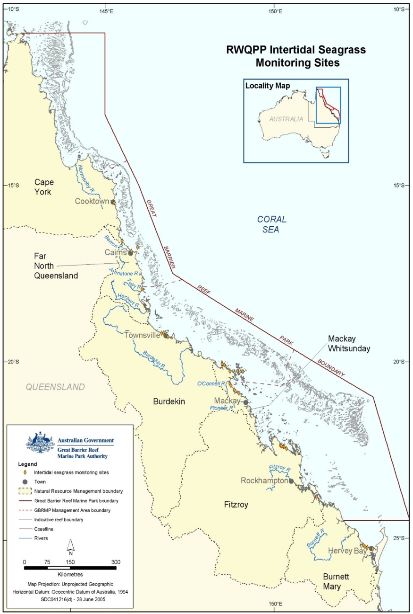
Figure 129. Inshore seagrass monitoring sites for the Reef Rescue Marine Monitoring Program.
Seagrass cover and species composition
Survey methodology follows globally standard methodologies, originally developed for the Seagrass-Watch program (McKenzie, et al. 2003). A site is defined as an area within a relatively homogenous section of a representative seagrass community/meadow (McKenzie et al. 2000a).
Monitoring at the 45 sites identified for the MMP long-term inshore monitoring in late-monsoon (April) and late dry season (October) of each year is conducted by qualified and trained scientists who have demonstrated competency in the methods. Monitoring conducted outside these periods is conducted by a trained scientist assisted by volunteers.
At each site, during each survey, observers record the percent seagrass cover within a total of 33 quadrats (50 cm × 50 cm quadrat placed every 5 m along three 50m transects, 25m apart). Seagrass abundance (% cover) was visually estimated as the fraction of the seabed (substrate) obscured by the seagrass species when submerged and viewed from above. This method was used because the technique has wider application and is very quick, requiring only minutes at each quadrat; yet it is robust and highly repeatable, thereby minimising among-observer differences. Quadrat percent cover measurements have also been found to be far more efficient in detecting differences in seagrass abundance than seagrass blade counts or measures of above- or below-ground biomass (Heidelbaugh and Nelson 1996). To improve resolution and allow greater differentiation at very low percentage covers (e.g. <3%), shoot counts based on global species density maxima were used. For example: 1 pair of Halophila ovalis leaves in a quadrat = 0.1%; 1 shoot/ramet of Zostera in a quadrat = 0.2%. Additional information was collected at the quadrat level, although only included as narrative in this report, including: seagrass canopy height of the dominant strap leaved species; macrofaunal abundance; abundance of burrows, as an measure of bioturbation; presence of herbivory (e.g. dugong and sea turtle); a visual/tactile assessment of sediment composition (see McKenzie 2007); and observations on the presence of superficial sediment structures such as ripples and sand waves to provide evidence of physical processes in the area (see Koch 2001).
Seagrass species were identified as per Waycott et al. (2004). Species were further classified into colonising, opportunistic or persistent as broadly defined by Kilminister (2015). For species which display characteristics across the range of strategies (e.g. Zostera can be colonising or opportunistic) as a consequence of community type, meadow status (e.g. expansion/recovery phase after loss), or the environment within which they persist (Harrison 1979), classification was assisted by expert elucidation until such time as a rigorous traits-based method can be developed (see case study 1). Opportunistic species were classified as colonising during the following periods:
- the period of time when meadows underwent major decline i.e. >80% loss of cover (or below abundance 20th percentile);
- the period after meadow loss (absence) when a meadow was in recovery mode:
  - <12-24 months post estuary or coastal meadow loss, (Campbell and McKenzie 2004; McKenzie, et al. 2010b);
  - <2-5 years post reef meadow loss (Birch and Birch 1984).

The proportion of colonising species contributing to the total seagrass abundance is then calculated for each site for each monitoring event. To aid with the visual interpretation of trends, the proportion of colonising species are presented graphically against the long-term average proportion of colonist species contributing to the total seagrass abundance for each GBR habitat.

Table 32. Long-term average proportion (±SE) of colonising species in each GBR seagrass habitat type.
Seagrass habitat | average proportion colonist species
estuary | 0.47 ±0.047
coast | 0.34 ±0.045
reef - intertidal | 0.30 ±0.05
reef - subtidal | 0.32 ±0.049

Seagrass reproductive health
An assessment of seagrass reproductive health at locations identified in Table 3 via flower and fruit production is conducted in late-dry season (October) of each year at each site. Additional collections are also conducted in late-monsoon (April) where possible.
In the field, 15 haphazardly placed cores (100mm diameter x 100mm depth) of seagrass are collected from an area adjacent, of similar cover and species composition, to each monitoring site. All samples collected are given a unique sample code/identifier providing a custodial trail from the field sample to the analytical outcome.
Seeds banks and abundance of germinated seeds were sampled according to standard methods (McKenzie, et al. 2003) by sieving (2mm mesh) 30 cores (50mm diameter, 100mm depth) of sediment collected across each site and counting the seeds retained in each. For Zostera muelleri subsp. capricorni, where the seeds are <1mm diameter, intact cores (18) were collected and returned to the laboratory where they were washed through a 710µm sieve and seeds identified using a hand lens/microscope.

Seagrass leaf tissue nutrients
In late dry season (October) 2013, foundational seagrass (opportunistic and persistent species that are dominant at the site) species leaf tissue nutrient samples were collected from each monitoring site (Table 3). For nutrient status comparisons, collections were recommended during the growth season (e.g. late dry when nutrient contents are at a minimum) (Mellors, et al. 2005) and at the same time of the year and at the same depth at the different localities (Borum, et al. 2004). Shoots from three haphazardly placed 0.25m² quadrats were collected from an area adjacent (of similar cover and species composition) to each monitoring site. Leaves were separated from the below ground material in the laboratory and epiphytic algae removed by gently scraping. Dried and milled samples were analysed according to (McKenzie, et al. 2014a). Elemental ratios (C:N:P) were calculated on a mole:mole basis using atomic weights (i.e., C=12, N=14, P=31).
Analysis of tissue nutrient data was based upon the calculation of the atomic ratios of C:N:P. The ratios of the most common macronutrients required for plant growth has been used widely as an indicator of growth status, in phytoplankton cultures this known as the familiar “Redfield” ratio of 106C:16N:P (Redfield, et al. 1963). Seagrass and other benthic marine plants possess large quantities of structural carbon, resulting in ‘‘seagrass Redfield ratios’’ estimated to be between 550:30:1 (Atkinson and Smith 1983) and 474:24:1 (Duarte 1990). The magnitude of these ratios and their temporal changes allow for a broad level understanding of the physical environment of seagrass meadows. Like phytoplankton, seagrasses growing in eutrophic waters have C:N:P ratios that reflect elevated nitrogen and phosphorus levels (Duarte 1990). Plants residing in nutrient poor waters show significantly lower N:P ratios than those from nutrient rich conditions (Atkinson and Smith 1983). Comparing deviations in the ratios of carbon, nitrogen and phosphorous (C:N:P) retained within plant tissue has been used extensively as an alternative means of evaluating the nutrient status of coastal waters (Duarte 1990).
Changing C:N ratios have been found in a number of experiments and field surveys to be related to light levels, as leaves with an atomic C:N ratio of less than 20, may suggest reduced light availability when N is not in surplus (Abal, et al. 1994; Grice, et al. 1996; Cabaço and Santos 2007; Collier, et al. 2009). The ratio of N:P is also a useful indicator as it is a reflection of the “Redfield” ratios (Redfield, et al. 1963), and seagrass with an atomic N:P ratio of 25 to 30 can be determined to be ‘replete’ (well supplied and balanced macronutrients for growth) (Atkinson and Smith 1983; Fourqurean et al. 1997a; Fourqurean and Cai 2001). When N:P values are in excess of 30, this may indicate P-limitation and a ratio of less than 25 is considered to show N limitation (Atkinson and Smith 1983; Duarte 1990; Fourqurean, et al. 1992b; Fourqurean and Cai 2001). The median seagrass tissue ratios of C:P is approximately 500 (Atkinson and Smith 1983), therefore deviation from this value is also likely to be indicative of some level of nutrient enriched or nutrient limited conditions. A combination of these ratios can indicate seagrass environments which are impacted by nutrient enrichment. Plant tissue which has a high N:P and low C:P indicates an environment of elevated (saturated) nitrogen.
Investigations of the differences in each individual tissue ratio within each of the species revealed that although tissue nutrient concentrations were extremely variable between locations and between years, by pooling species within habitat types trends were apparent (McKenzie and Unsworth 2009). As seagrass tissue nutrient ratios of the foundation species were generally not significantly different from each other at a site within each sampling period (McKenzie and Unsworth 2009), the tissue nutrient ratios were pooled at the request of the GBRMPA to assist with interpretation of the findings.
To identify the sources of the nitrogen and provide insight into the occurrence of carbon limitation associated with light limitation, leaf tissue were also analysed for nitrogen and carbon stable isotope ratios (δ¹⁵N and δ¹³C). There are two naturally occurring atomic forms of nitrogen (N). The common form that contains seven protons and seven neutrons is referred to as ¹⁴N, and a heavier form that contains an extra neutron is called ¹⁵N: with 0.3663% of atmospheric N in the heavy form. Plants and animals assimilate both forms of nitrogen, and the ratio of ¹⁴N to ¹⁵N compared to an atmospheric standard (δ¹⁵N) can be determined by analysis of tissue on a stable isotope mass spectrometer using the following equation:
Seagrasses are passive indicators of δ¹⁵N enrichment, as they integrated the signature of their environment over time throughout their growth cycle. The various sources of nitrogen pollution to coastal ecosystems often have distinguishable ¹⁵N/¹⁴N ratios (Heaton 1986), and in regions subject to anthropogenic inputs of nitrogen, changes in the δ¹⁵N signature can be used to identify the source and distribution of the nitrogen (Costanzo 2001). Nitrogen fertilizer, produced by industrial fixation of atmospheric nitrogen results in low to negative δ¹⁵N signatures (i.e. δ¹⁵N ~0 - 1‰) (Udy and Dennison 1997a). In animal or sewage waste, nitrogen is excreted mainly in the form of urea, which favours conversion to ammonia and enables volatilization to the atmosphere. Resultant fractionation during this process leaves the remaining ammonium enriched in ¹⁵N. Further biological fractionation results in sewage nitrogen having a δ¹⁵N signature greater than 9 or ~10‰ ((Lajtha and Marshall 1994; Udy and Dennison 1997b; Dennison and Abal 1999; Abal et al. 2001; Costanzo et al. 2001). Septic and aquaculture discharge undergo less biological treatment and are likely to have a signature closer to that of raw waste (δ¹⁵N ~5‰) (Jones et al. 2001).
Similar to N, there are two naturally occurring atomic forms of carbon (C), ¹³C and ¹²C, which are taken up during photosynthesis where ¹²C is the more abundant of the two, accounting for 98.89% of carbon. The ratio that ¹³C is taken up relative to ¹²C varies in time as a function of productivity, organic carbon burial and vegetation type. A measure of the ratio of stable isotopes ¹³C:¹²C (i.e. δ¹³C) is known as the isotopic signature, and reported in parts per thousand (per mil, ‰):
where the standard is an established reference material.
Experimental work has confirmed that seagrasses from high light, high productivity environments demonstrate (less negative) isotopic enrichment: i.e. low %C, low C:N, in contrast, more negative δ¹³C, may indicate that light is limited (Grice, et al. 1996; Fourqurean et al. 2005).
Collection of seagrass leaf tissue (targeted foundation genus include Halodule, Zostera and Cymodocea) for analysis of tissue nutrients (C, N, P, δ¹⁵N, δ¹³C) is conducted in the late-dry season (October) sampling period at regions identified in Table 3. Approximately 5 to 10 grams wet weight of seagrass leaves is harvested from three to six haphazardly chosen plots (2 to 3 m apart) in an area adjacent, of similar cover and species composition, to each monitoring site. All samples collected are given a unique sample code/identifier providing a custodial trail from the field sample to the analytical outcome.

Epiphyte and macroalgae abundance
Epiphyte and macroalgae cover were measured according to standard methods (McKenzie, et al. 2010a). The total percentage of leaf surface area (both sides, all species pooled) covered by epiphytes and percentage of quadrat area covered by macroalgae, were measured each monitoring event. Values were compared against the GBR long-term average (1999-2010) calculated for each habitat type.
Increased epiphyte (the plants growing on the surfaces of slower-growing seagrass leaves (Borowitzka et al. 2006) loads may result in shading of seagrass leaves by up to 65%, reducing photosynthetic rate and leaf densities of the seagrasses (Sand-Jensen 1977; Tomasko and Lapointe 1991; Walker and McComb 1992; Tomasko et al. 1996; Frankovich and Fourqurean 1997; Ralph and Gademann 1999; Touchette 2000). In seagrass meadows, increases in the abundance of epiphytes are stimulated by nutrient loading (e.g. Borum 1985; Silberstein et al. 1986; Neckles et al. 1994; Balata et al. 2008) and these increases in abundance have been implicated as the cause for declines of seagrasses during eutrophication, because of the associated decrease in light reaching the seagrass blade (e.g. Orth and Moore 1983; Cambridge et al. 1986).
Given the observed relationships between nutrient loading and the abundance of epiphytes observed in seagrass ecosystems from around the world, and the perceived threat to water quality owing to human population, the abundance of epiphytes in seagrass meadows may prove to be a valuable indicator for assessing both the current status and trends of the GBR seagrass meadows. However, preliminary analysis of the relationship between seagrass abundance and epiphyte cover collected by the RRMMP and MTSRF did not identify threshold levels beyond which loss of abundance occurred (McKenzie 2008) suggesting further research and analysis.

Inshore seagrass meadow boundary mapping
Mapping the edge of the seagrass meadow within 100 metres of each monitoring site is conducted in both the late dry (October) and late monsoon (April) monitoring periods at all sites identified in Table 3. Training and equipment (GPS) are provided to personnel involved in the edge mapping.
Mapping methodology follows standard methodology (McKenzie, et al. 2001). Edges are recorded as tracks (1 second polling) or a series of waypoints in the field using a portable Global Positioning System receiver (i.e. Garmin GPSmap® 60CSx or 62s). Accuracy in the field is dependent on the portable GPS receiver (Garmin GPSmap® 60CSx is <15m RMS95% (DGPS (USCG) accuracy: 3-5m, 95% typical) and how well the edge of the meadow is defined. Generally accuracy is within that of the GPS (i.e. 3 to 5 metres) and datum used is WGS84. Tracks and waypoints are downloaded from the GPS to portable computer using MapSource or BaseCamp software as soon as practicable (preferably on returning from the day’s activity) and exported as *.dxf files to ESRI® ArcGIS™. Subtidal edge mapping data has yet to be plotted.
Mapping is conducted by trained and experienced scientists using ESRI® ArcMap™ 10.3 (Environmental Systems Research Institute, ArcGIS™ Desktop 10.3). Boundaries of meadows are determined based on the positions of survey Tracks and/or Waypoints and the presence of seagrass. Edges are mapped using the polyline feature to create a polyline (i.e. ‘join the dots’) which is then smoothed using the B-spline algorithm. The smoothed polyline is then converted to a polygon and saved as a shapefile. Coordinate system (map datum) used for projecting shapefile is AGD94.
In certain cases seagrass meadows form very distinct edges that remain consistent over many growing seasons. However, in other cases the seagrass landscape tends to grade from dense continuous cover to no cover over a continuum that includes small patches and shoots of decreasing density. Boundary edges in patchy meadows are vulnerable to interpreter variation, but the general rule is that a boundary edge is determined where there is a gap with the distance of more than 3 metres (i.e. accuracy of the GPS). Final shapefiles are then overlayed with aerial photographs and base maps (AusLig™) to assist with illustration/presentation.
The expected accuracy of the map product gives some level of confidence in using the data. Using the GIS, meadow boundaries are assigned a quality value based on the type and range of mapping information available for each site and determined by the distance between waypoints and GPS position fixing error. These meadow boundary errors are used to estimate the likely range of area for each meadow mapped (see McKenzie et al. 1996; Lee Long, et al. 1997; McKenzie, et al. 1998).
Mapping at subtidal sites has been altered to suit the low visibility conditions and the requirement to map by SCUBA. From the central picket (deployment location of light and turbidity loggers) straight lines of 50m length are swum at an angle of 45 degrees from each other. The locations where the edges of the seagrass meadows/patches intercept the line are recorded. A GPS is attached to a flotation device at the surface of the water and fastened to the SCUBA diver to record travelling distance and transect orientation. Eight lines at 45 degrees are performed, with the first following the orientation of the monitoring transects; the others are undertaken at 45 degree angles from the first.

Observer training
The JCU personnel collecting data in association with this project are without exception highly experienced in the collection of seagrass monitoring data. The majority of observers have been involved in seagrass monitoring for at least a decade and were employed specifically for their skills associated with the tasks required.
All observers have successfully completed at Level 1 Seagrass-Watch training course (seagrasswatch.org/training.html) and have demonstrated competency across 7 core units: achieved 80% of formal assessment (classroom and laboratory) (5 units); and demonstrated competency in the field both during the workshop (1 unit) and post workshop (1 unit = successful completion of 3 monitoring events/periods within 12 months). Volunteers who assist JCU scientists have also successfully completed a Level 1 training course.
Technical issues concerning quality control of data are important and are resolved by: using standard methods which ensure completeness in the field (the comparison between the amounts of valid or useable data originally planned to collect, versus how much was collected); using standard seagrass cover calibration sheets to ensure precision (the degree of agreement among repeated measurements of the same characteristic at the same place and the same time) and consistency between observers and across sites at monitoring times. Ongoing standardisation of observers is achieved through routine comparisons during sampling events. Any discrepancy is used to identify and subsequently mitigate bias. For the most part however uncertainties in percentage cover or species identification are mitigated in the field via direct communication, or the collection of voucher specimens (to be checked under microscope and pressed in herbarium) and the use of a digital camera to record images (every quadrat is photographed) for later identification and validation. Evidence of competency is securely filed on a secure server in Cairns at James Cook University.
Howley Consulting was responsible for surveys in the Cooktown region. The Howley Consulting observer, Christina Howley, has been assessing seagrass resources in the Cape York region for over a decade and has successfully completed a Level 1 training course.

Laboratory analysis

Inshore seagrass meadow abundance, community structure and reproductive health
Seagrass reproductive health
In the laboratory, reproductive structures (spathes, fruit, female flower or male flowers; Figure 130) of plants from each core are identified and counted for each sample and species. If Halodule uninervis seeds (brown green colour) are still attached to the rhizome, they are counted as fruits. Seed estimates are not recorded for Halophila ovalis due to time constraints (if time is available post this first pass of the samples, fruits will be dissected and seeds counted). For Zostera muelleri subsp. capricorni, the number of spathes is recorded, male and female flowers and seeds counted during dissection, if there is time after the initial pass of the samples. Apical meristems are counted if possible, however, most are not recorded as they were too damaged by the collection process to be able to be identified correctly. The number of nodes for each species is counted, and for each species present in the sample, 10 random internode lengths and 10 random leaf widths are measured. Approximately 5% of samples are cross-calibrated between technicians (preferable from another centre). All samples, including flowers and spathes and fruits/fruiting bodies are kept and re-frozen in the site bags for approximately 2 years for revalidation if required. Reproductive effort is calculated as the number of reproductive structures per core.

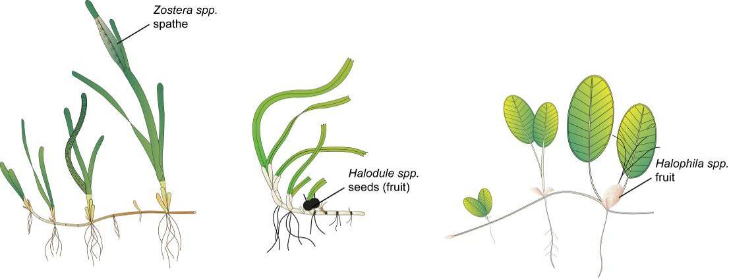
Figure 130. Form and size of reproductive structure of the seagrasses collected: Halophila ovalis, Halodule uninervis and Zostera muelleri subsp. capricorni

Seagrass tissue nutrients
Leaves are separated in the laboratory into seagrass species and epiphytic algae removed by gently scraping the leaf surface. Samples are oven dried at 60°C to weight constancy. Dried biomass samples of leaves are then homogenised by milling to fine powders prior to nutrient analyses and stored in sealed vials.
The ground tissue samples are sent to Chemcentre (Western Australia) for analysis. The Chemcentre holds NATA accreditation for constituents of the environment including soil, sediments, waters and wastewaters. (Note that details of Chemcentre accreditation can be found at the NATA website: www.nata.asn.au). The NATA accreditation held by the ChemCentre includes a wide variety of QA/QC procedures covering the registration and identification of samples with unique codes and the regular calibration of all quantitative laboratory equipment required for the analysis. The ChemCentre has developed appropriate analytical techniques including QA/QC procedures and detection of nutrients. These procedures include blanks, duplicates where practical, and internal use of standards. In 2010, QA/QC also included an inter-lab comparison (using Queensland Health and Scientific Services – an additional NATA accredited laboratory) and an additional blind internal comparison.
Nitrogen and phosphorus are extracted using a standardized selenium Kjeldahl digest and the concentrations determined with an automatic analyser using standard techniques at Chemcentre in Western Australia (a NATA certified laboratory). Percent C was determined using atomic absorption, also at Chemcentre. Elemental ratios (C:N:P) are then calculated on a mole:mole basis using atomic weights (i.e., C=12, N=14, P=31). Analysis of all seagrass tissue nutrient data is based upon the calculation of the atomic ratios of C:N:P.
To determine percent carbon, dried and milled seagrass leaf tissue material is combusted at 1400°C in a controlled atmosphere (e.g. Leco). This converts all carbon containing compounds to carbon dioxide. Water and oxygen is then removed from the system and the gaseous product is determined spectrophotometrically.
Total nitrogen and phosphorus content of dried and milled homogenous seagrass tissue material is determined by Chemcentre using a standardized selenium Kjeldahl digest. Samples are digested in a mixture of sulphuric acid, potassium sulphate and a copper sulphate catalyst (cf. Kjeldahl). This converts all forms of nitrogen to the ammonium form and all forms of phosphorus to the orthophosphate form. The digest is diluted and any potentially interfering metals present are complexed with citrate and tartrate. For the nitrogen determination an aliquot is taken and the ammonium ions are determined colorimetrically following reduction with hydrazine to the nitrate ion, followed by diazotisation of 1-naphthylenediamine and subsequent coupling with sulphanilamide. For total phosphorus an aliquot of the digest solution is diluted and the P determined as the phosphomolybdenum blue complex (modified Murphy and Riley¹¹⁷ procedure).
Seagrass leaf isotopes
A subset of each ground tissue sample was sent to Natural Isotopes (Western Australia) for δ¹⁵N and δ¹³C analysis. The samples were weighed into tin capsules and combusted by elemental analyser (ANCA-SL, SerCon Limited, Crewe, United Kingdom) to N₂ and CO₂. The N₂ and CO₂ was purified by gas chromatography and the nitrogen and carbon elemental composition and isotope ratios were determined by continuous flow isotope ratio mass spectrometry (20-22 IRMS, SerCon Limited, Crewe, United Kingdom). Reference materials of know elemental composition and isotopic ratios were interspaced with the samples for calibration.
Raw nitrogen and carbon elemental composition and isotope ratio data were corrected for instrument drift and blank contribution using Callisto software SerCon Limited, Crewe, United Kingdom). A standard analysed at variable weights corrects for instrument linearity, IAEA-N-2 and IAEA-N-1 used to normalise the nitrogen isotope ratio, IAEA-CH-6 and IAEA-CH-7 to normalise the carbon isotope ratio, such that IAEA-N-2 (δ¹⁵N = 20.32‰), IAEA-N-1 (δ¹⁵N = 0.43‰), IAEA-CH-6 (δ¹³C = -10.45‰) and IAEA-CH-7 δ¹³C = -32.15‰).
Nitrogen isotope ratios were reported in parts per thousand (per mil) relative to N₂ in air. The nitrogen bearing internationally distributed isotope reference material N₂ in air had a given value of 0‰ (exactly). Carbon isotope ratios were reported in parts per thousand (per millilitre) relative to V-PDB. The carbon bearing internationally distributed isotope reference materials NBS19 and L-SVEC, had a given value of +1.95‰ (exactly) and -46.6‰ (exactly). Compositional values were reported as percent nitrogen and percent carbon present in the sample analysed.

Report card methods and calculations

Report card approach
Three indicators (presented as unitless scores) were selected by the GBRMPA, using advice from expert working groups and the Paddock to Reef Integration Team, for the seagrass report card:
- seagrass abundance (cover)
- reproductive effort
- nutrient status (seagrass tissue C:N ratio)
The methods for calculation of scores was chosen by the Paddock to Reef Integration Team (i.e. not the authors of this report) and all report card scores are transformed to a five point scale from 0 to 100 as directed to allow integration with other components of the Paddock to Reef report card (Department of the Premier and Cabinet 2014). Please note that the scale from 0 to 100 is unitless and should not be interpreted as a proportion or ratio.

Seagrass abundance
Seagrass abundance (% cover) is used to indicate the state of the seagrass to resist stressors, reproductive effort to indicate the potential for the seagrass to recover from loss, and the nutrient status to indicate the condition of the environment in which the seagrass are growing in recognition of seagrass' role as a bioindicator of environmental (including water quality) health.
The status of seagrass abundance (% cover) was determined using the seagrass abundance guidelines developed by McKenzie (2009). The seagrass abundance measure in the MMP is the average % cover of seagrass per monitoring site. Individual site and subregional (habitat type within each NRM region) seagrass abundance guidelines were developed based on % cover data collected from individual sites and/or reference sites (McKenzie 2009). Guidelines for individual sites were only applied if the conditions of the site aligned with reference site conditions.
A reference site is a site whose condition is considered to be a suitable baseline or benchmark for assessment and management of sites in similar habitats. Ideally, seagrass meadows in near pristine condition with a long-term abundance database would have priority as reference sites. However, as near-pristine meadows are not available, sites which have received less intense impacts can justifiably be used. In such situations, reference sites are those where the condition of the site has been subject to minimal/limited disturbance for 3-5 years. The duration of 3-5 years is based on recovery from impact times (Campbell and McKenzie 2004).
There is no set/established protocol for the selection of reference sites and the process is ultimately iterative. The criteria for defining a minimally/least disturbed seagrass reference site is based on Monitoring River Health Initiative 1994) and includes some or all of the following:
- beyond 10km of a major river: as most suspended solids and particulate nutrients are deposited within a few kilometres of river mouths (McCulloch et al. 2003; Webster and Ford 2010; Bainbridge et al. 2012; Brodie et al. 2012).
- no major urban area/development (>5000 population) within 10km upstream (prevailing current)
- no significant point source wastewater discharge within the estuary
- has not been impacted by an event (anthropogenic or extreme climate) in the last 3-5 years
- where the species composition is dominated by the foundation species expected for the habitats (Carruthers, et al. 2002), and
- does not suggest the meadow is in recovery (i.e. dominated by early colonising).
The 80th, 50th and 20th percentiles were used to define the guideline values as these are recommended for water quality guidelines (Department of Environment and Resource Management 2009), and there is no evidence that this approach would not be appropriate for seagrass meadows in the GBR. At the request of the Paddock to Reef Integration Team, the 80th percentile was changed to 75th to align with other Paddock to Reef report card components. By plotting the percentile estimates with increasing sample size, the reduction in error becomes apparent as it moves towards the true value (e.g. Figure 131).
Across the majority of reference sites, variance for the 50th and 20th percentiles was found to level off at around 15–20 samples (i.e. sampling events), suggesting this number of samples was sufficient to provide a reasonable estimate of the true percentile value. This sample size is reasonably close to the ANZECC 2000 Guidelines recommendation of 24 data values.
Nonlinear regressions (exponential rise to maximum, two parameter) were then fitted to percent cover percentile values at each number of sampling events using the following model:
where y is the seagrass cover percentile at each number of sampling events (x), a is the asymptotic average of the seagrass cover percentile, and b is the rate coefficient that determines how quickly (or slowly) the maximum is attained (i.e., the slope). The asymptotic average was then used as the guideline value for each percentile (Table 33).
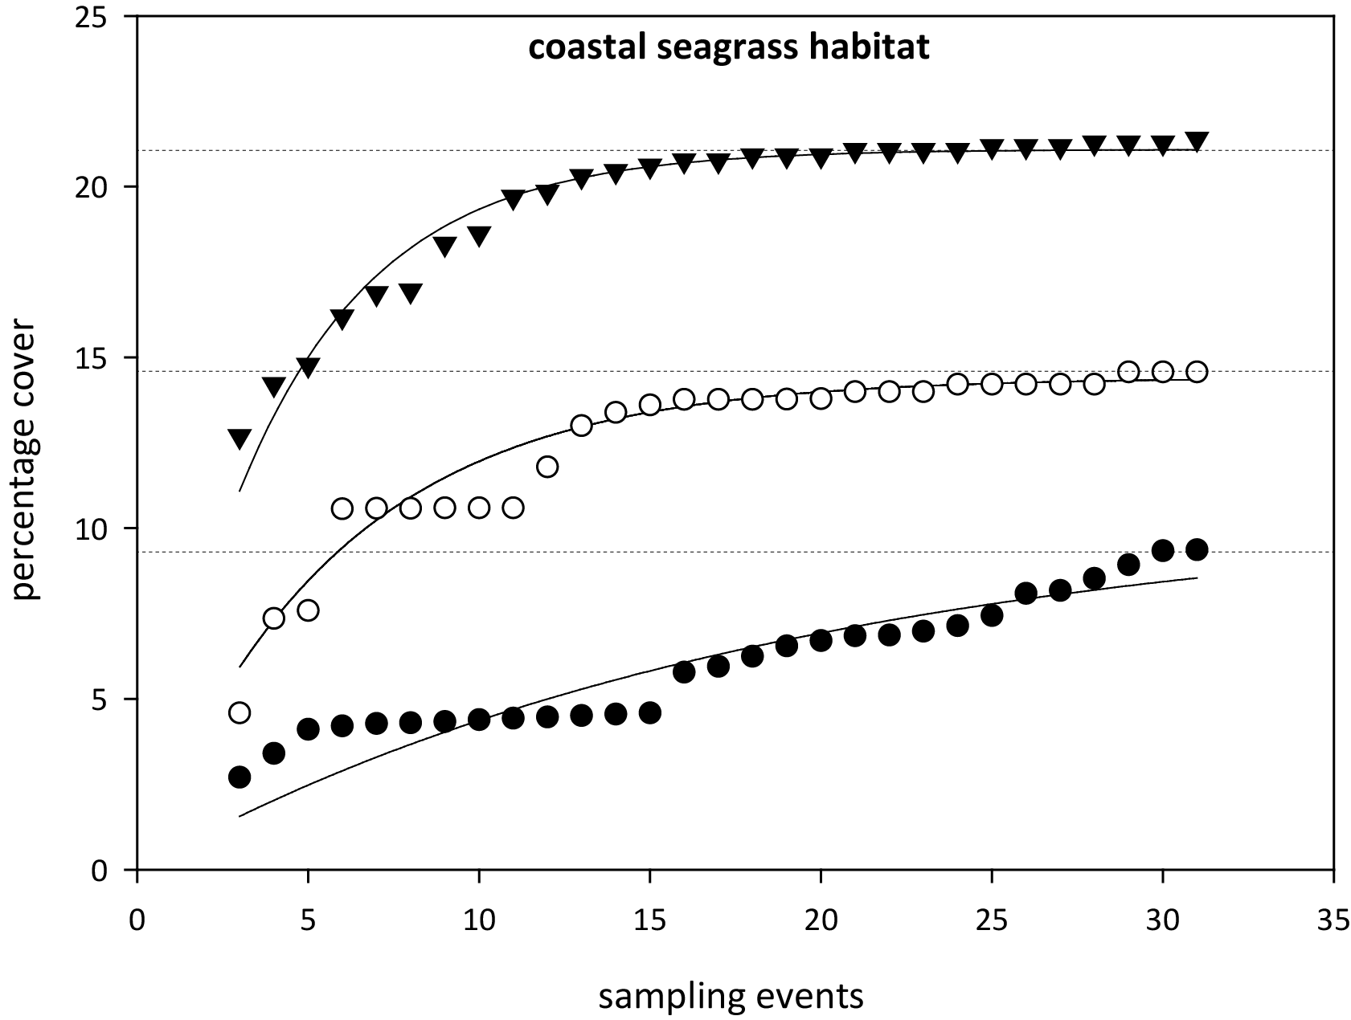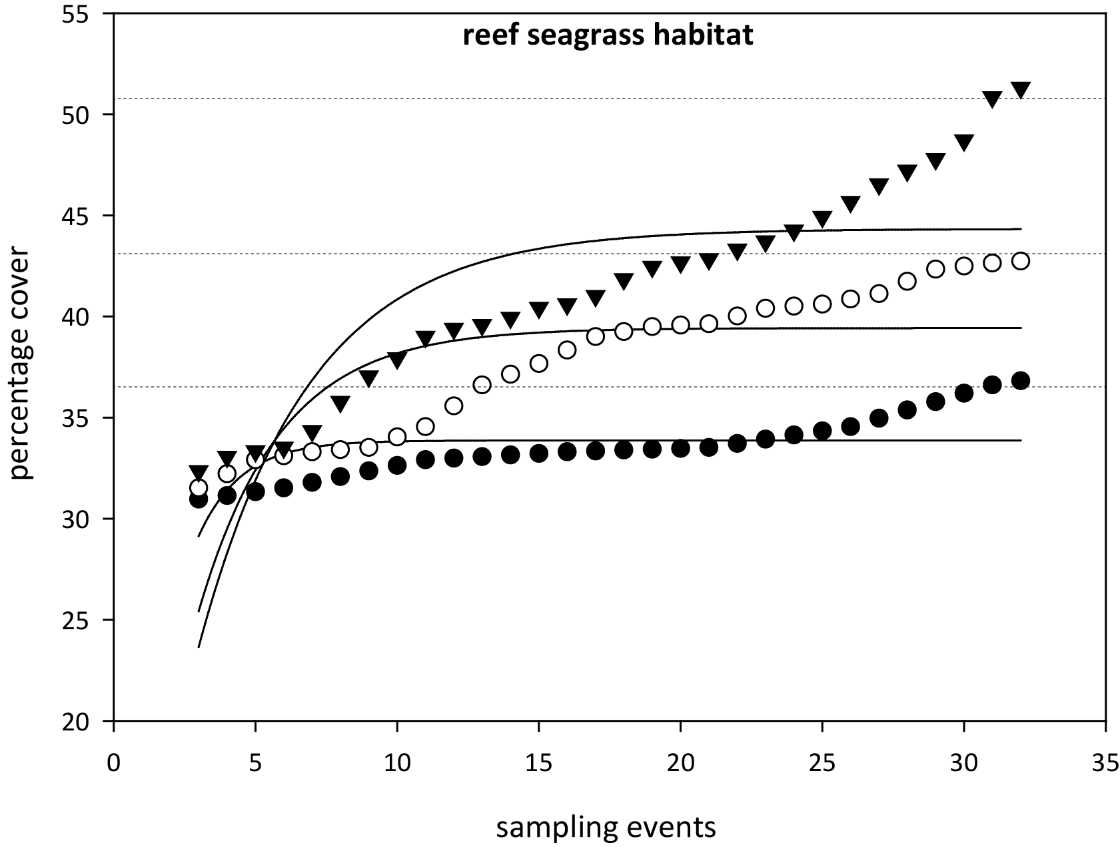
Figure 131. Relationship between sample size and the error in estimation of percentile values for seagrass abundance (% cover) in coastal and reef seagrass habitats in the Wet Tropics NRM.
= 75th percentile, ○ = 50th percentile,● = 20th percentile. Dashed lines are asymptotic averages for each percentile plot.
As sampling events occur every 3-6 months depending on the site, this is equivalent to 3-10 years of monitoring to establish percentile values. Based on the analyses, it was recommended that estimates of the 20th percentile at a reference site should be based on a minimum of 18 samples collected over at least three years. For the 50th percentile a smaller minimum number of samples (approximately 10–12) would be adequate but in most situations it would be necessary to collect sufficient data for the 20th percentile anyway. For seagrass habitats with low variability, a more appropriate guideline was the 10th percentile primarily the result of seasonal fluctuations (as nearly every seasonal low would fall below the 20th percentile). Percentile variability was further reduced within a habitat type of each region by pooling at least two (preferably more) reference sites to derive guidelines. The subregional guideline is calculated from the mean of all reference sites within a habitat type within a region.
Using the seagrass guidelines, seagrass state can be determined for each monitoring event at each site and allocated as good (median abundance at or above 50th percentile), moderate (median abundance below 50th percentile and at or above 20th percentile), poor (median abundance below 20th or 10th percentile). For example, when the median seagrass abundance for Yule Point is plotted against the 20th and 50th percentiles for coastal habitats in the Wet Tropics (Figure 132), it indicates that the meadows were in a poor condition in mid 2000, mid 2001 and mid 2006 (based on abundance).
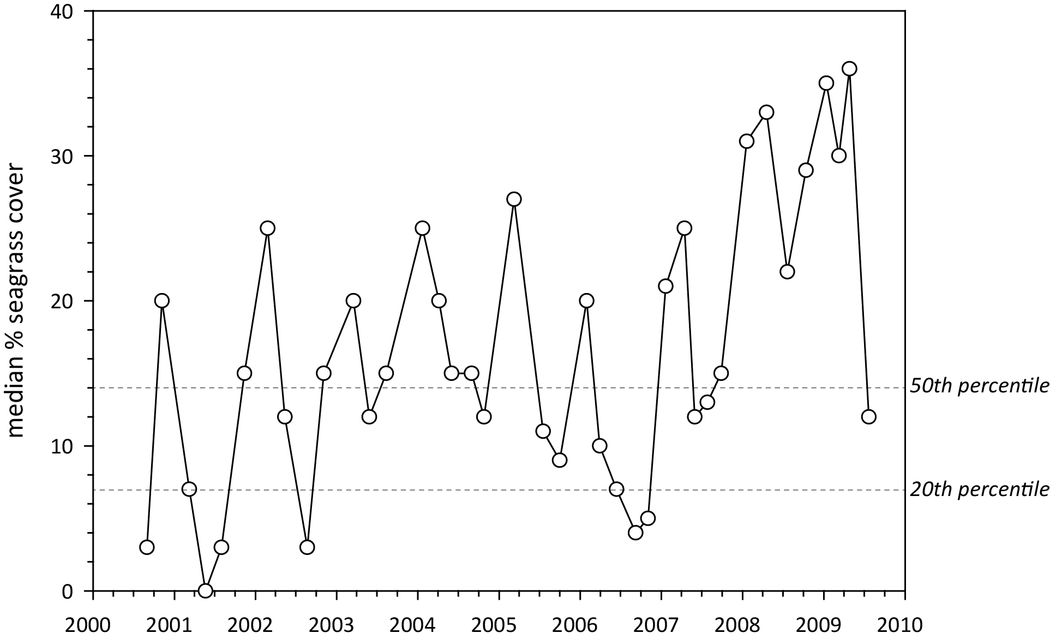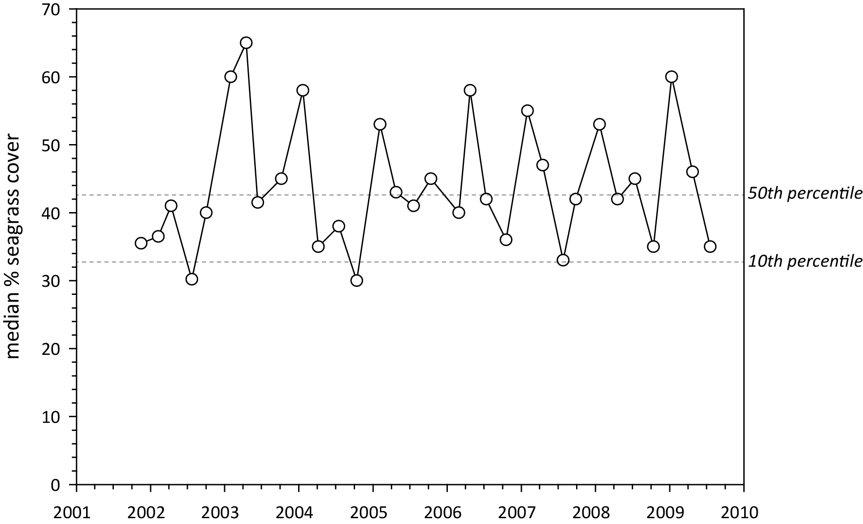
Figure 132. Median seagrass abundance (% cover) at Yule Point (left) and Green Island (right) plotted against the 50th and 20th percentiles for coastal and intertidal reef seagrass habitat in the Wet Tropics.
Similarly, when the median seagrass abundance for Green Island is plotted against the 20th and 50th percentiles for intertidal reef habitats in the Wet Tropics, it indicates that the meadows were in a poor condition in the middle of most years (based on abundance). However, the poor rating is most likely a consequence of seasonal lows in abundance. Therefore, in this instance, it was more appropriate to set the guideline at the 10th rather than the 20th percentile.
Using this approach, subregional seagrass abundance guidelines (hereafter known as “the seagrass guidelines”) were developed for each seagrass habitat types where possible (Table 33). If an individual site had 18 or more sampling events and no identified impacts (e.g., major loss from cyclone), an abundance guideline was determined at the site or location level rather than using the subregional guideline from the reference sites (i.e. as more guidelines are developed at the site level, they contribute to the subregional guideline).
After discussions with GBRMPA scientists and the Paddock to Reef integration team, the seagrass guidelines were further refined by allocating the additional categories of very good (median abundance at or above 75th percentile), and very poor (median abundance below 20th or 10th percentile and declined by >20% since previous sampling event). Seagrass state was then rescaled to a five point scale from 0 to 100 to allow integration with other components of the Paddock to Reef report card (Department of the Premier and Cabinet 2014). Please note that the scale from 0 to 100 is unitless and should not be interpreted as a proportion or ratio.

Table 33. Seagrass percentage cover guidelines (“the seagrass guidelines”) for each site/location and the subregional guidelines (bold) for each NRM habitat.
Values in light grey not used. ^ denotes regional reference site, * from nearest adjacent region. For site details, see Tables 3 & 4.
NRM region | site/  location | Habitat | percentile guideline
NRM region | site/  location | Habitat | 10th | 20th | 50th | 75th
Cape York | AP1^ | reef intertidal | 11 | 16.8 | 18.9 | 23.7
 | AP2 | reef intertidal | 11 |  | 18.9 | 23.7
 | FR | reef intertidal |  | 16.8 | 18.9 | 23.7
 | ST | reef intertidal |  | 16.8 | 18.9 | 23.7
 | YY | reef intertidal |  | 16.8 | 18.9 | 23.7
 | NRM | reef intertidal | 11 | 16.8 | 18.9 | 23.7
 | SR* | coastal intertidal |  | 6.6 | 12.9 | 14.8
 | BY* | coastal intertidal |  | 6.6 | 12.9 | 14.8
 | NRM | coastal intertidal* | 5 | 6.6 | 12.9 | 14.8
Wet Tropics | LB | coastal intertidal |  | 6.6 | 12.9 | 14.8
 | YP1^ | coastal intertidal | 4.3 | 7 | 14 | 15.4
 | YP2^ | coastal intertidal | 5.7 | 6.2 | 11.8 | 14.2
 | NRM | coastal intertidal | 5 | 6.6 | 12.9 | 14.8
 | DI | reef intertidal | 27.5 |  | 37.7 | 41
 | GI1^ | reef intertidal | 32.5 | 38.2 | 42.7 | 45.5
 | GI2^ | reef intertidal | 22.5 | 25.6 | 32.7 | 36.7
 | LI1 | reef intertidal | 27.5 |  | 37.7 | 41
 | NRM | reef intertidal | 27.5 | 31.9 | 37.7 | 41.1
 | DI3 | reef subtidal | 22 | 26 | 33 | 39.2
 | GI3^ | reef subtidal | 22 | 26 | 33 | 39.2
 | LI2 | reef subtidal | 22 | 26 | 33 | 39.2
 | NRM | reef subtidal | 22 | 26 | 33 | 39.2
Burdekin | BB1^ | coastal intertidal | 16.3 | 21.4 | 25.4 | 35.2
 | SB1^ | coastal intertidal | 7.5 | 10 | 16.8 | 22
 | SB2 | coastal intertidal |  | 10 | 16.8 | 22
 | JR | coastal intertidal |  | 15.7 | 21.1 | 28.6
 | NRM | coastal intertidal | 11.9 | 15.7 | 21.1 | 28.6
 | MI1^ | reef intertidal | 23 | 26 | 33.4 | 37
 | MI2^ | reef intertidal | 21.3 | 26.5 | 35.6 | 41
 | NRM | reef intertidal | 22.2 | 26.3 | 34.5 | 39
 | MI3 | reef subtidal | 22 | 26 | 33 | 39.2
 | NRM | reef subtidal | 22* | 26* | 33* | 39.2*
Mackay Whitsunday | SI | estuarine intertidal |  | 18 | 34.1 | 54
 | NRM | estuarine intertidal | 10.8* | 18* | 34.1* | 54*
 | PI2^ | coastal intertidal | 18.1 | 18.7 | 25.1 | 27.6
 | PI3^ | coastal intertidal | 6.1 | 7.6 | 13.1 | 16.8
 | MP2 | coastal intertidal |  | 18.9 | 22.8 | 25.4
 | MP3 | coastal intertidal |  | 17.9 | 20 | 22.3
 | NRM | coastal intertidal | 12.1 | 13.15 | 19.1 | 22.2
 | HB1 | reef intertidal |  | 10.53 | 12.9 | 14.2
 | HB2 | reef intertidal |  | 7.95 | 11.59 | 13.4
 | HM | reef intertidal | 22.2 | 26.2 | 34.5 | 39
 | NRM | reef intertidal | 22.2* | 26.2* | 34.5* | 39*
Fitzroy | GH | estuarine intertidal |  | 18 | 34.1 | 54
 | NRM | estuarine intertidal | 10.8* | 18* | 34.1* | 54*
 | RC1^ | coastal intertidal | 18.6 | 20.6 | 24.4 | 34.5
 | WH1^ | coastal intertidal | 13.1 | 14.4 | 18.8 | 22.3
 | NRM | coastal intertidal | 15.85 | 17.5 | 21.6 | 28.4
 | GK | reef intertidal | 22.2 |  | 34.5 | 39
 | NRM | reef intertidal | 22.2* | 26.2* | 34.5* | 39*
Burnett Mary | RD | estuarine intertidal |  | 18 | 34.1 | 54
 | UG1^ | estuarine intertidal | 10.8 | 18 | 34.1 | 54
 | UG2 | estuarine intertidal |  | 18 | 34.1 | 54
 | NRM | estuarine intertidal | 10.8 | 18 | 34.1 | 54
 | BH1 | coastal intertidal |  | 7.8 | 11.9 | 21.6
 | NRM | coastal intertidal |  | 7.8 | 11.9 | 21.6

Table 34. Scoring threshold table to determine seagrass abundance status.
low = 10th or 20th percentile guideline (Table 33). NB: scores are unitless.
description | category | score | status
very good | 75-100 | 100 | 81 - 100
good | 50-75 | 75 | 61 - 80
moderate | low-50 | 50 | 41 - 60
poor | <low | 25 | 21 - 40
very poor | <low by >20% | 0 | 0 - 20

Table 35. Mean and median seagrass % cover and report score for each long-term monitoring site within each Cape York NRM region habitat over the 2014-15 period.
Scores calculated as per Table 33. ^denotes Seagrass-Watch site. NB: scores do not have units.
Habitat | Location | Site | Seasonal  date | mean  % cover | median  % cover | Low  percentile | 50th  percentile | 75th  percentile | score
coastal intertidal | Bathurst Bay | BY1 | 01-Oct-14 | 29.2 | 30 | 6.6 | 12.9 | 14.8 | 100
 |  | BY2 | 01-Oct-14 | 23.6 | 23 | 6.6 | 12.9 | 14.8 | 100
 | Shelburne Bay | SR1 | 01-Oct-14 | 12.0 | 12 | 6.6 | 12.9 | 14.8 | 50
 |  | SR2 | 01-Oct-14 | 9.3 | 10 | 6.6 | 12.9 | 14.8 | 50
reef intertidal | Archer Point | AP1 | 01-Jul-14 | 10.3 | 6 | 11 | 18.9 | 23.7 | 0
 |  | AP1 | 01-Oct-14 | 6.9 | 3 | 11 | 18.9 | 23.7 | 0
 |  | AP2 | 01-Oct-14 | 12.6 | 12 | 11 | 18.9 | 23.7 | 50
 | Piper Reef | FR1 | 01-Oct-14 | 7.2 | 6 | 16.8 | 18.9 | 23.7 | 0
 |  | FR2 | 01-Oct-14 | 11.9 | 12 | 16.8 | 18.9 | 23.7 | 0
 | Stanley Island | ST1 | 01-Oct-14 | 10.8 | 10 | 16.8 | 18.9 | 23.7 | 25
 |  | ST2 | 01-Oct-14 | 7.6 | 8 | 16.8 | 18.9 | 23.7 | 25
 | Yum Yum Bch | YY1^ | 01-Oct-14 | 22.3 | 22 | 16.8 | 18.9 | 23.7 | 75
NRM region |  |  |  |  |  |  |  |  | 43

Table 36. Mean and median seagrass % cover and report score for each long-term monitoring site within each Wet Tropics NRM region habitat over the 2014-15 period.
Scores calculated as per Table 33. NB: scores do not have units.
Habitat | Location | Site | Seasonal  date | Mean  % cover | Median  % cover | Low  percentile | 50th  percentile | 75th  percentile | score
coastal intertidal | Lugger Bay | LB1 | 01-Jul-14 | 0.0 | 0 | 6.6 | 12.9 | 14.8 | 0
 |  | LB1 | 01-Oct-14 | 0.0 | 0 | 6.6 | 12.9 | 14.8 | 0
 |  | LB1 | 01-Apr-15 | 0.0 | 0 | 6.6 | 12.9 | 14.8 | 0
 |  | LB2 | 01-Jul-14 | 0.0 | 0 | 6.6 | 12.9 | 14.8 | 0
 |  | LB2 | 01-Oct-14 | 0.0 | 0 | 6.6 | 12.9 | 14.8 | 0
 |  | LB2 | 01-Apr-15 | 0.0 | 0 | 6.6 | 12.9 | 14.8 | 0
 | Yule Point | YP1 | 01-Jul-14 | 4.3 | 3 | 7 | 14 | 15.4 | 0
 |  | YP1 | 01-Oct-14 | 2.1 | 0 | 7 | 14 | 15.4 | 0
 |  | YP1 | 01-Jan-15 | 14.6 | 13 | 7 | 14 | 15.4 | 50
 |  | YP1 | 01-Apr-15 | 16.2 | 15 | 7 | 14 | 15.4 | 75
 |  | YP2 | 01-Jul-14 | 3.9 | 2.3 | 6.2 | 11.8 | 14.2 | 0
 |  | YP2 | 01-Oct-14 | 4.6 | 6 | 6.2 | 11.8 | 14.2 | 25
 |  | YP2 | 01-Jan-15 | 14.1 | 17 | 6.2 | 11.8 | 14.2 | 100
 |  | YP2 | 01-Apr-15 | 11.1 | 9 | 6.2 | 11.8 | 14.2 | 50
reef intertidal | Dunk Island | DI1 | 01-Jul-14 | 0.6 | 0 | 27.5 | 37.7 | 41 | 0
 |  | DI1 | 01-Oct-14 | 0.7 | 0 | 27.5 | 37.7 | 41 | 0
 |  | DI1 | 01-Apr-15 | 1.7 | 0 | 27.5 | 37.7 | 41 | 0
 |  | DI2 | 01-Jul-14 | 1.9 | 0 | 27.5 | 37.7 | 41 | 0
 |  | DI2 | 01-Oct-14 | 2.1 | 0 | 27.5 | 37.7 | 41 | 0
 |  | DI2 | 01-Apr-15 | 2.1 | 0 | 27.5 | 37.7 | 41 | 0
 | Green Island | GI1 | 01-Jul-14 | 34.6 | 36 | 32.5 | 42.7 | 45.5 | 50
 |  | GI1 | 01-Oct-14 | 33.2 | 33 | 32.5 | 42.7 | 45.5 | 50
 |  | GI1 | 01-Jan-15 | 36.9 | 38 | 32.5 | 42.7 | 45.5 | 50
 |  | GI1 | 01-Apr-15 | 31.2 | 32 | 32.5 | 42.7 | 45.5 | 25
 |  | GI2 | 01-Jul-14 | 20.9 | 20 | 22.5 | 32.7 | 36.7 | 0
 |  | GI2 | 01-Oct-14 | 25.7 | 26 | 22.5 | 32.7 | 36.7 | 50
 |  | GI2 | 01-Jan-15 | 26.2 | 25 | 22.5 | 32.7 | 36.7 | 50
 |  | GI2 | 01-Apr-15 | 27.2 | 27 | 22.5 | 32.7 | 36.7 | 50
 | Low Isles | LI1 | 01-Oct-14 | 5.2 | 4 | 22.5 | 32.7 | 36.7 | 25
 |  | LI1 | 01-Jan-15 | 4.4 | 0.7 | 22.5 | 32.7 | 36.7 | 0
 |  | LI1 | 01-Apr-15 | 1.6 | 0.8 | 22.5 | 32.7 | 36.7 | 25
reef subtidal | Dunk Island | DI3 | 01-Jul-14 | 0.8 | 0 | 26 | 33 | 39.2 | 0
 |  | DI3 | 01-Oct-14 | 3.1 | 0 | 26 | 33 | 39.2 | 0
 |  | DI3 | 01-Jan-15 | 5.1 | 3 | 26 | 33 | 39.2 | 25
 |  | DI3 | 01-Apr-15 | 3.5 | 0 | 26 | 33 | 39.2 | 0
 | Green Island | GI3 | 01-Jul-14 | 16.9 | 15 | 26 | 33 | 39.2 | 25
 |  | GI3 | 01-Oct-14 | 22.9 | 20 | 26 | 33 | 39.2 | 25
 |  | GI3 | 01-Jan-15 | 37.9 | 33 | 26 | 33 | 39.2 | 75
 |  | GI3 | 01-Apr-15 | 18.1 | 15 | 26 | 33 | 39.2 | 0
 | Low Isles | LI2 | 01-Oct-14 | 1.5 | 0.6 | 22.5 | 32.7 | 36.7 | 25
 |  | LI2 | 01-Jan-15 | 0.0 | 0 | 22.5 | 32.7 | 36.7 | 0
 |  | LI2 | 01-Apr-15 | 0.3 | 0 | 22.5 | 32.7 | 36.7 | 0
NRM region |  |  |  |  |  |  |  |  | 18

Table 37. Mean and median seagrass % cover and report score for each long-term monitoring site within each Burdekin NRM region habitat over the 2014-15 period.
Scores calculated as per Table 33. ^denotes Seagrass-Watch site. NB: scores do not have units.
Habitat | Location | Site | Seasonal  date | Mean  % cover | Median  % cover | Low  percentile | 50th  percentile | 75th  percentile | score
coastal intertidal | Townsville | BB1 | 01-Jul-14 | 12.7 | 8 | 21.4 | 25.4 | 35.2 | 0
 |  | BB1 | 01-Oct-14 | 13.6 | 10 | 21.4 | 25.4 | 35.2 | 25
 |  | BB1 | 01-Jan-15 | 27.2 | 22 | 21.4 | 25.4 | 35.2 | 50
 |  | BB1 | 01-Apr-15 | 30.3 | 35 | 21.4 | 25.4 | 35.2 | 75
 |  | SB1 | 01-Jul-14 | 12.8 | 12 | 10 | 16.8 | 22 | 50
 |  | SB1 | 01-Oct-14 | 10.8 | 10 | 10 | 16.8 | 22 | 50
 |  | SB1 | 01-Jan-15 | 17.6 | 22 | 10 | 16.8 | 22 | 100
 |  | SB1 | 01-Apr-15 | 8.9 | 5 | 10 | 16.8 | 22 | 0
 |  | SB2^ | 01-Jul-14 | 7.6 | 5 | 10 | 16.8 | 22 | 0
 |  | SB2^ | 01-Oct-14 | 2.6 | 2 | 10 | 16.8 | 22 | 0
 |  | SB2^ | 01-Jan-15 | 12.0 | 8 | 10 | 16.8 | 22 | 25
 |  | SB2^ | 01-Apr-15 | 10.7 | 8 | 10 | 16.8 | 22 | 25
 | Bowling Green Bay | JR1 | 01-Oct-14 | 25.8 | 25 | 15.7 | 21.1 | 28.6 | 75
 |  | JR1 | 01-Apr-15 | 19.8 | 20 | 15.7 | 21.1 | 28.6 | 50
 |  | JR2 | 01-Oct-14 | 23.4 | 25 | 15.7 | 21.1 | 28.6 | 75
 |  | JR2 | 01-Apr-15 | 20.7 | 21 | 15.7 | 21.1 | 28.6 | 50
reef intertidal | Magnetic Island | MI1 | 01-Jul-14 | 19.5 | 26 | 26 | 33.4 | 37 | 50
 |  | MI1 | 01-Oct-14 | 14.9 | 17 | 26 | 33.4 | 37 | 0
 |  | MI1 | 01-Jan-15 | 27.5 | 35 | 26 | 33.4 | 37 | 75
 |  | MI1 | 01-Apr-15 | 29.3 | 30 | 26 | 33.4 | 37 | 50
 |  | MI2 | 01-Jul-14 | 34.7 | 32 | 21.3 | 35.6 | 41 | 50
 |  | MI2 | 01-Oct-14 | 42.1 | 40 | 21.3 | 35.6 | 41 | 75
 |  | MI2 | 01-Jan-15 | 38.0 | 35 | 21.3 | 35.6 | 41 | 50
 |  | MI2 | 01-Apr-15 | 47.3 | 42 | 21.3 | 35.6 | 41 | 100
reef subtidal | Magnetic Island | MI3 | 01-Jul-14 | 62.8 | 75 | 22.5 | 32.7 | 36.7 | 100
 |  | MI3 | 01-Oct-14 | 61.7 | 60 | 22.5 | 32.7 | 36.7 | 100
 |  | MI3 | 01-Apr-15 | 61.2 | 70 | 22.5 | 32.7 | 36.7 | 100
NRM region |  |  |  |  |  |  |  |  | 57

Table 38. Mean and median seagrass % cover and report score for each long-term monitoring site within each Mackay Whitsunday NRM region habitat over the 2014-15 period.
Scores calculated as per Table 33. ^denotes Seagrass-Watch site. NB: scores do not have units.
Habitat | Location | Site | Seasonal  date | Mean  % cover | Median  % cover | Low  percentile | 50th  percentile | 75th  percentile | score
estuarine intertidal | Sarina Inlet | SI1 | 01-Oct-14 | 13.1 | 11 | 18 | 34.1 | 54 | 25
 |  | SI1 | 01-Apr-15 | 9.0 | 7 | 18 | 34.1 | 54 | 0
 |  | SI2 | 01-Oct-14 | 7.0 | 6 | 18 | 34.1 | 54 | 25
 |  | SI2 | 01-Apr-15 | 4.7 | 1.3 | 18 | 34.1 | 54 | 0
coastal intertidal | Midge Point | MP2^ | 01-Oct-14 | 32.6 | 34 | 18.9 | 22.8 | 25.4 | 100
 |  | MP2^ | 01-Apr-15 | 29.4 | 31 | 18.9 | 22.8 | 25.4 | 100
 |  | MP3^ | 01-Oct-14 | 22.8 | 23 | 17.9 | 20 | 22.3 | 100
 |  | MP3^ | 01-Apr-15 | 26.2 | 30 | 17.9 | 20 | 22.3 | 100
 | Pioneer Bay | PI2 | 01-Jul-14 | 8.2 | 7 | 18.7 | 25.1 | 27.6 | 0
 |  | PI2 | 01-Oct-14 | 19.6 | 19 | 18.7 | 25.1 | 27.6 | 50
 |  | PI2 | 01-Apr-15 | 13.5 | 15 | 18.7 | 25.1 | 27.6 | 0
 |  | PI2 | 01-Jul-14 | 7.2 | 7 | 7.6 | 13.1 | 16.8 | 0
 |  | PI3 | 01-Oct-14 | 16.3 | 15 | 7.6 | 13.1 | 16.8 | 75
 |  | PI3 | 01-Apr-15 | 12.1 | 15 | 7.6 | 13.1 | 16.8 | 75
 |  | PI3 | 01-Jul-14 | 8.2 | 7 | 18.7 | 25.1 | 27.6 | 0
reef intertidal | Hamilton Island | HB1^ | 01-Oct-14 | 4.2 | 1 | 10.53 | 12.9 | 14.2 | 0
 |  | HB2^ | 01-Oct-14 | 2.4 | 1 | 7.95 | 11.59 | 13.4 | 0
 |  | HM1 | 01-Oct-14 | 1.4 | 0 | 22.15 | 34.5 | 39 | 0
 |  | HM1 | 01-Apr-15 | 1.8 | 0 | 22.15 | 34.5 | 39 | 0
 |  | HM2 | 01-Oct-14 | 6.7 | 1.2 | 22.15 | 34.5 | 39 | 25
 |  | HM2 | 01-Apr-15 | 2.7 | 0 | 22.15 | 34.5 | 39 | 0
NRM region |  |  |  |  |  |  |  |  | 30

Table 39. Mean and median seagrass % cover and report score for each long-term monitoring site within each Fitzroy NRM region habitat over the 2014-15 period.
Scores calculated as per Table 33. NB: scores do not have units.
Habitat | Location | Site | Seasonal  date | Mean  % cover | Median  % cover | Low  percentile | 50th  percentile | 75th  percentile | score
estuarine intertidal | Gladstone Harbour | GH1 | 01-Oct-14 | 4.8 | 2 | 18 | 34.1 | 54 | 0
 |  | GH2 | 01-Oct-14 | 28.3 | 28 | 18 | 34.1 | 54 | 50
coastal intertidal | Shoalwater Bay | RC1 | 01-Oct-14 | 10.7 | 10 | 17.3 | 21.8 | 34.5 | 25
 |  | WH1 | 01-Oct-14 | 7.2 | 7 | 14.4 | 18.8 | 22.3 | 25
reef intertidal | Great Keppel Island | GK1 | 01-Oct-14 | 3.9 | 1 | 22.15 | 34.5 | 39 | 25
 |  | GK2 | 01-Oct-14 | 2.4 | 0.2 | 22.15 | 34.5 | 39 | 25
NRM region |  |  |  |  |  |  |  |  | 25

Table 40. Mean and median seagrass % cover and report score for each long-term monitoring site within each Burnett Mary NRM region habitat over the 2014-15 period.
Scores calculated as per Table 33. ^denotes Seagrass-Watch site. NB: scores do not have units.
Habitat | Location | Site | Seasonal  date | Mean  % cover | Median  % cover | Low  percentile | 50th  percentile | 75th  percentile | score
estuarine intertidal | Rodds Bay | RD1 | 01-Oct-14 | 13.0 | 12.5 | 18 | 34.1 | 54 | 25
 |  | RD1 | 01-Apr-15 | 0.0 | 0 | 18 | 34.1 | 54 | 0
 |  | RD2 | 01-Oct-14 | 4.5 | 1 | 18 | 34.1 | 54 | 25
 |  | RD2 | 01-Apr-15 | 0.0 | 1 | 18 | 34.1 | 54 | 25
 | Urangan | UG1 | 01-Jul-14 | 7.0 | 0 | 18 | 34.1 | 54 | 0
 |  | UG1 | 01-Oct-14 | 37.0 | 34 | 18 | 34.1 | 54 | 50
 |  | UG1 | 01-Apr-15 | 10.1 | 12 | 18 | 34.1 | 54 | 0
 |  | UG2 | 01-Jul-14 | 24.1 | 23 | 18 | 34.1 | 54 | 50
 |  | UG2 | 01-Oct-14 | 33.0 | 33 | 18 | 34.1 | 54 | 50
 |  | UG2 | 01-Apr-15 | 17.5 | 18 | 18 | 34.1 | 54 | 50
coastal intertidal | Burrum Heads | BH1 | 01-Apr-15 | 11.5 | 12 | 7.8 | 11.9 | 21.6 | 75
 |  | BH3 | 01-Apr-15 | 6.8 | 6 | 7.8 | 11.9 | 21.6 | 0
NRM region |  |  |  |  |  |  |  |  | 30

Seagrass reproductive effort
The reproductive effort of seagrasses provides an indication of the capacity of seagrasses to recover from the loss of an area of seagrass through the recruitment of new plants, i.e. the resilience of the population (Collier and Waycott 2009). Given the high diversity of seagrass species that occur in the GBR coastal zone (Waycott, et al. 2007), their variability in production of reproductive structures (e.g. Orth, et al. 2006), a metric that incorporates all available information on the production of flowers and fruits per unit area is the most useful.
The production of seeds also reflects a simple measure of the capacity of a seagrass meadow to recover following large scale impacts (Collier and Waycott 2009). As it is well recognized that coastal seagrasses are prone to small scale disturbances that cause local losses (Collier and Waycott 2009) and then recover in relatively short periods of time, the need for a local seed source is considerable. In the GBR, the production of seeds comes in numerous forms and seed banks examined at MMP sites are limited to foundational seagrass species (seeds >0.5mm diameter). At this time, seed banks have not been included in the metric for reproductive effort, but methods for future incorporation are currently being explored.
Using the annual mean of all species pooled in the late dry and comparing with the long-term (2005-2010) average for GBR habitat (coastal intertidal = 8.22±0.71, estuarine intertidal = 5.07±0.41, reef intertidal = 1.32±0.14), the reproductive effort was scored as the number of reproductive structures per core and the overall status determined (Table 6) as the ratio of the average number observed divided by the long term average.

Table 41. Scores for late dry monitoring period reproductive effort average against long-term (2005-2010) GBR habitat average. NB: scores are unitless.
description | Reproductive Effort  monitoring period / long-term | ratio | score | 0-100 score | status
very good | ≥4 | 4.0 | 4 | 100 | 81 - 100
good | 2 to <4 | 2.0 | 3 | 75 | 61 - 80
moderate | 1 to <2 | 1.0 | 2 | 50 | 41 - 60
poor | 0.5 to <1 | 0.5 | 1 | 25 | 21 - 40
very poor | <0.5 | 0.0 | 0 | 0 | 0 - 20

Table 42. Late dry season average seagrass reproductive effort (RE ±Standard Error) and report card scores for each monitoring site (species pooled) within each NRM region habitat.
Scores calculated as per Table 6. NB: scores do not have units.
NRM region | habitat | site | RE ±SE | GBR RE (2005-10) | ratio | score
Cape York | coastal intertidal | BY1 | 2.20 ±0.82 | 8.22 | 0.27 | 0
 |  | BY2 | 0.27 ±0.18 | 8.22 | 0.03 | 0
 |  | SR1 | 0.40 ±0.34 | 8.22 | 0.05 | 0
 |  | SR2 | 0 | 8.22 | 0 | 0
 |  |  |  |  |  | 0
 | reef intertidal | AP1 | 0.73 ±0.41 | 1.32 | 0.56 | 25
 |  | AP2 | 2.40 ±0.80 | 1.32 | 1.82 | 50
 |  | FR1 | 0 | 1.32 | 0 | 0
 |  | FR2 | 0 | 1.32 | 0 | 0
 |  | ST1 | 0.27 ±0.15 | 1.32 | 0.2 | 0
 |  | ST2 | 2.60 ±0.90 | 1.32 | 1.97 | 50
 |  |  |  |  |  | 21
 | region |  |  |  |  | 10
Wet Tropics | coastal intertidal | LB1 | 0 | 8.22 | 0 | 0
 |  | LB2 | 0 | 8.22 | 0 | 0
 |  | YP1 | 0 | 8.22 | 0 | 0
 |  | YP2 | 0 | 8.22 | 0 | 0
 |  |  |  |  |  | 0
 | reef intertidal | DI1 | 0.73 ±0.52 | 1.32 | 0.56 | 25
 |  | DI2 | 1.00 ±0.66 | 1.32 | 0.76 | 25
 |  | GI1 | 0.07 ±0.07 | 1.32 | 0.05 | 0
 |  | GI2 | 0.07 ±0.07 | 1.32 | 0.05 | 0
 |  | LI1 | 0 | 1.32 | 0 | 0
 |  |  |  |  |  | 8
 | reef subtidal | DI3 | 2.13 ±1.86 | 0.24 | 8.85 | 100
 |  | GI3 | 0.40 ±0.27 | 0.24 | 1.67 | 50
 |  | LI2 | 4.82 ±1.33 | 0.24 | 20.08 | 100
 |  |  |  |  |  | 83
 | region |  |  |  |  | 31
Burdekin | coastal intertidal | BB1 | 6.20 ±1.93 | 8.22 | 0.75 | 25
 |  | SB1 | 0.67 ±0.39 | 8.22 | 0.08 | 0
 |  | JR1 | 1.93 ±0.69 | 8.22 | 0.24 | 0
 |  | JR2 | 0.80 ±0.34 | 8.22 | 0.1 | 0
 |  |  |  |  |  | 6
 | reef intertidal | MI1 | 1.27 ±0.69 | 1.32 | 0.96 | 25
 |  | MI2 | 0.13 ±0.13 | 1.32 | 0.10 | 0
 |  |  |  |  |  | 13
 | reef subtidal | MI3 | 2.47 ±1.29 | 0.24 | 10.28 | 100
 |  |  |  |  |  | 100
 | region |  |  |  |  | 40
Mackay Whitsunday | estuarine intertidal | SI1 | 8.27 ±2.34 | 5.07 | 1.63 | 50
 |  | SI2 | 5.33 ±2.25 | 5.07 | 1.05 | 50
 |  |  |  |  |  | 50
 | coastal intertidal | PI2 | 6.07 ±2.17 | 8.22 | 0.74 | 25
 |  | PI3 | 7.40 ±1.88 | 8.22 | 0.90 | 25
 |  |  |  |  |  | 25
 | reef intertidal | HM1 | 0 | 1.32 | 0 | 0
 |  | HM2 | 1.60 ±0.58 | 1.32 | 1.21 | 50
 |  |  |  |  |  | 25
 | region |  |  |  |  | 33
Fitzroy | estuarine intertidal | GH1 | 0 | 5.07 | 0 | 0
 |  | GH2 | 1.80 ±0.44 | 5.07 | 0.36 | 0
 |  |  |  |  |  | 0
 | coastal intertidal | RC1 | 0 | 8.22 | 0 | 0
 |  | WH1 | 0.13 ±0.09 | 8.22 | 0.02 | 0
 |  |  |  |  |  | 0
 | reef intertidal | GK1 | 0.07 ±0.07 | 1.32 | 0.05 | 0
 |  | GK2 | 0 | 1.32 | 0 | 0
 |  |  |  |  |  | 0
 | region |  |  |  |  | 0
Burnett Mary | estuarine intertidal | RD1 | 0 | 5.07 | 0 | 0
 |  | RD2 | 0 | 5.07 | 0 | 0
 |  | UG1 | 3.40 ±1.36 | 5.07 | 0.67 | 25
 |  | UG2 | 2.20 ±1.05 | 5.07 | 0.43 | 0
 |  |  |  |  |  | 6
 | region |  |  |  |  | 6

Seagrass nutrient status.
The molar ratios of seagrass tissue carbon relative to nitrogen (C:N) were chosen as the indicator for seagrass nutrient status as an atomic C:N ratio of less than 20, may suggest either reduced light availability or nitrogen enrichment. Both of these deviations may indicate reduced water quality. Examination of the molar ratios of seagrass tissue carbon relative to nitrogen (C:N) between 2005 and 2008 explained 58% of the variance of the inter-site seagrass cover/abundance (McKenzie and Unsworth 2009).
As changing leaf C:N ratios have been found in a number of experiments and field surveys to be related to available nutrient and light levels (Abal, et al. 1994; Grice, et al. 1996; Cabaço and Santos 2007; Collier, et al. 2009) they can be used as an indicator of the light that the plant is receiving relative to nitrogen availability or N surplus to light. With light limitation, seagrass plants are unable to build structure, hence the proportion of carbon in the leaves decreases relative to nitrogen. Experiments on seagrasses in Queensland have reported that at an atomic C:N ratio of less than 20, may suggest reduced light availability relative to nitrogen availability (Abal, et al. 1994; AM Grice, et al., 1996;). The light availability to seagrass is not necessarily an indicator of light in the water column, but an indicator of the light that the plant is receiving as available light can be highly impacted by epiphytic growth or sediment smothering photosynthetic leaf tissue. However, C:N must be interpreted with caution as the level of N can also influence the ratio in oligotrophic environments (Atkinson and Smith 1983; Fourqurean, et al. 1992b). Support for choosing the elemental C:N ratio as the indicator also comes from preliminary analysis of MMP data in 2009 which found that the C:N ratio was the only nutrient ratio that showed a significant relationship (positive) with seagrass cover at coastal and estuarine sites. Seagrass tissue C:N ratios explained 58% of the variance of the inter-site seagrass cover data (McKenzie and Unsworth 2009). Using the guideline ratio of 20:1 for the foundation seagrass species, C:N ratios were categorised on their departure from the guideline and transformed to a 0 to 100 score using:
Equation 1
NB: C:N ratios >35 scored as 100, C:N ratios <10 scored as 0
The score was then used to represent the status to allow integration with other components of the report card (Table 7).
Table 43. Scores for leaf tissue C:N against guideline to determine light and nutrient availability. NB: scores are unitless.
description | C:N ratio range | value | Score () | status
very good | C:N ratio >30* | 30 | 100 | 81 - 100
good | C:N ratio 25-30 | 25 | 75 | 61 - 80
moderate | C:N ratio 20-25 | 20 | 50 | 41 - 60
poor | C:N ratio 15-20 | 15 | 25 | 21 - 40
very poor | C:N ratio <15* |  | 0 | 0 - 20

Table 44. Average seagrass leaf tissue C:N ratios and report scores for each monitoring site (species pooled) within each NRM region habitat.
C:N ratios transformed to a 0 to 100 score using Equation 1. NB: scores do not have units. *insufficient sample
NRM region | habitat | site | C:N ±SE | score
Cape York | coastal intertidal | BY1 | 18.98 ±0.77 | 44.92
 |  | BY2 | 20.01 ±0.40 | 50.06
 |  | SR1 | 14.96 ±0.91 | 24.82
 |  | SR2 | 15.50 ±0.20 | 27.48
 |  |  |  | 37
 | reef intertidal | AP1 | 16.72 ±0.14 | 33.58
 |  | AP2 | 17.09 ±2.43 | 35.44
 |  | FR1 | 15.53 ±1.02 | 27.64
 |  | FR2 | 14.76 ±0.39 | 23.79
 |  | ST1 | 19.28 ±1.96 | 46.42
 |  | ST2 | 16.74 ±0.40 | 33.72
 |  |  |  | 33
 | region |  |  | 35
Wet Tropics | coastal intertidal | LB1 | *
 |  | LB2 | 12.50 ±0.48 | 12.48
 |  | YP1 | 10.98 ±0.15 | 4.88
 |  | YP2 | 11.60 ±0.28 | 8.01
 |  |  |  | 8
 | reef intertidal | DI1 | 15.50 ±0.26 | 27.51
 |  | DI2 | 15.47 ±0.48 | 27.35
 |  | GI1 | 20.09 ±0.37 | 50.46
 |  | GI2 | 17.77 ±0.95 | 38.86
 |  | LI1 | *
 |  |  |  | 36
 | reef subtidal | DI3 | 20.07 ±0.56 | 50.34
 |  | GI3 | 20.86 ±0.82 | 54.31
 |  | LI2 | *
 |  |  |  | 52
 | region |  |  | 32
Burdekin | coastal intertidal | BB1 | 12.53 ±0.41 | 12.64
 |  | SB1 | 11.90 ±0.32 | 9.49
 |  | JR1 | 19.20 ±0.14 | 46.02
 |  | JR2 | 18.68 ±0.33 | 43.42
 |  |  |  | 28
 | reef intertidal | MI1 | 20.90 ±1.93 | 54.49
 |  | MI2 | 21.79 ±0.77 | 58.95
 |  |  |  | 57
 | reef subtidal | MI3 | 28.78 ±1.25 | 100
 |  |  |  | 100
 | region |  |  | 62
Mackay Whitsunday | estuarine intertidal | SI1 | 15.97 ±0.71 | 29.86
 |  | SI2 | 16.18 ±0.42 | 30.89
 |  |  |  | 30
 | coastal intertidal | PI2 | 17.56 ±0.98 | 37.78
 |  | PI3 | 12.55 ±0.44 | 12.74
 |  | MP2 | *
 |  | MP3 | 22.28 ±0.60 | 61.42
 |  |  |  | 37
 | reef intertidal | HM1 | 11.46 ±0.25 | 7.30
 |  | HM2 | 18.99 ±0.71 | 44.94
 |  |  |  | 26
 | region |  |  | 31
Fitzroy | estuarine intertidal | GH1 | 16.53 ±0.72 | 32.67
 |  | GH2 | 20.23 ±0.42 | 51.13
 |  |  |  | 42
 | coastal intertidal | RC1 | 16.60 ±0.35 | 33.00
 |  | WH1 | 16.57 ±0.34 | 32.83
 |  |  |  | 33
 | reef intertidal | GK1 | 14.66 ±0.05 | 23.29
 |  | GK2 | *
 |  |  |  | 31
 | region |  |  | 35
Burnett Mary | estuarine intertidal | RD1 | 15.29 ±0.08 | 26.43
 |  | RD2 | 18.00 ±0.21 | 39.98
 |  | UG1 | 19.53 ±0.70 | 47.67
 |  | UG2 | 18.89 ±1.10 | 44.46
 |  |  |  | 40
 | region |  |  | 40

Seagrass index
The seagrass index is average score (0-100) of the three seagrass status indicators chosen for the MMP. Each indicator is equally weighted as we have no preconception that it should be otherwise. To calculate the overall score for seagrass of the Great Barrier Reef (GBR), the regional scores were weighted on the percentage of GBRWHA seagrass (shallower than 15m) within that region (Table 45). Please note: Cape York omitted from the GBR score in P2R reporting prior to 2012 due to poor representation of inshore monitoring sites throughout region.
Table 45. Area of seagrass shallower than 15m in each NRM region (from McKenzie, et al. 2010c) within the boundaries of the Great Barrier Reef World Heritage Area.
NRM | Area of seagrass (km²) | % of GBRWHA
Cape York | 1,843 | 0.60
Wet Tropics | 201 | 0.07
Burdekin | 551 | 0.18
Mackay Whitsunday | 154 | 0.05
Fitzroy | 241 | 0.08
Burnett Mary | 73 | 0.02
GBRWHA | 1,220 | 1.00

Detailed data

Climate and environmental pressures

River discharge

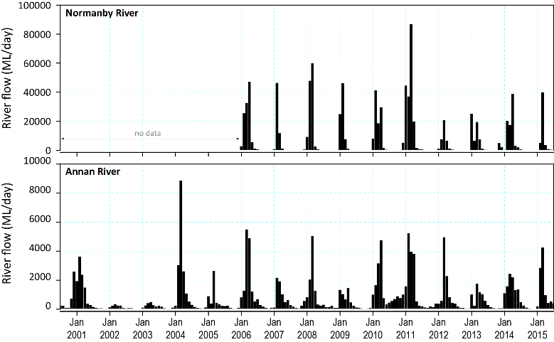
Figure 133. Average daily flow (ML day⁻¹) per month from the Normanby River at Kalpowar Crossing and Annan River at Beesbike
(stations 105107A - Normanby River at Kalpowar Crossing 14.91683°S 144.211279°E, Elev:21.3m and 107003A, 15.68773°S, 145.2085°E, Elev: 115m) (source ©The State of Queensland (DNRM) 2015, dnrm.qld.gov.au/water/water-monitoring-and-data/portal).
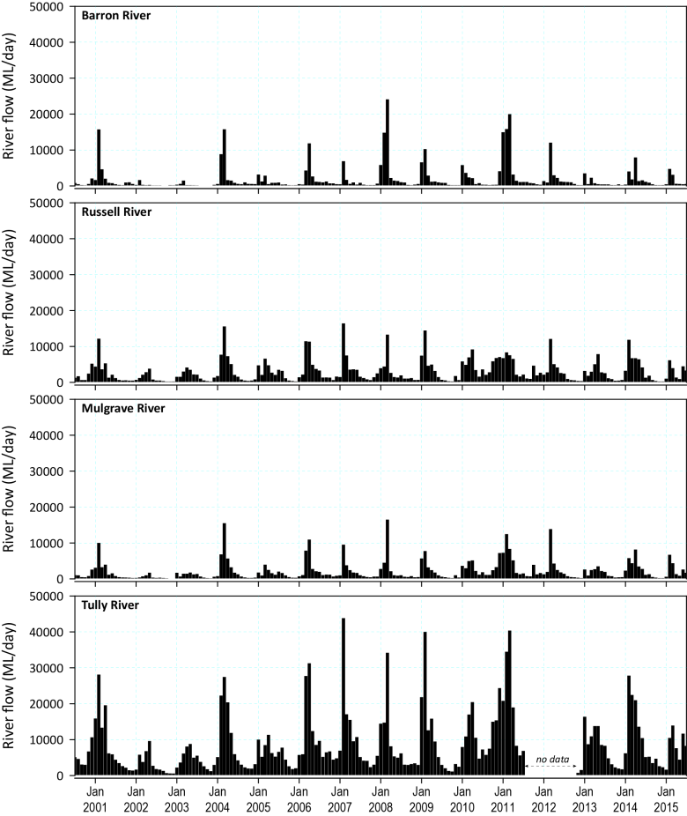
Figure 134. Average daily flow (ML day⁻¹) per month from the main rivers impacting the seagrass monitoring sites in the Wet Tropics
(stations 110001D - Barron River at Myola, 16.79983333°S 145.61211111°E, Elev 345m; 111007A - Mulgrave River at Peets Bridge, 17.13336111°S 145.76455556°E, Elev 27.1m; 111101D - Russell River at Bucklands 17.38595°S 145.96726667°E, Elev10m; 113006A - Tully River at Euramo, 17.99213889°S 145.94247222°E, Elev 8.76m) (source ©The State of Queensland (DNRM) 2015, dnrm.qld.gov.au/water/water-monitoring-and-data/portal).

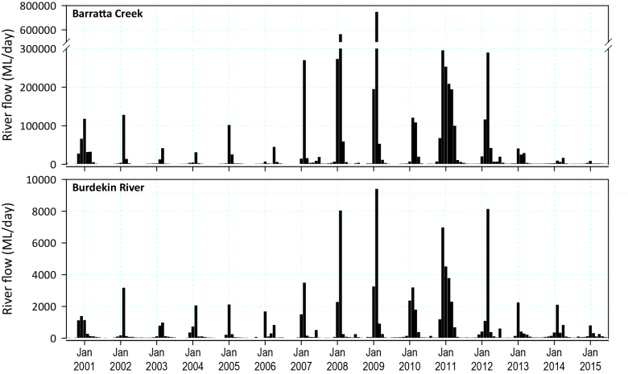
Figure 135. Average daily flow (ML day⁻¹) per month from the Burdekin River impacting the seagrass monitoring sites in the Burdekin region
(stations 120006B - Burdekin River at Clare, 19.75856°S 147.24362°E, Elev 29m; 119101A - Barratta Creek at Northcote Lat:-19.69072778 Long:147.169825 Elev: 17.3m) (source ©The State of Queensland (DNRM) 2015).

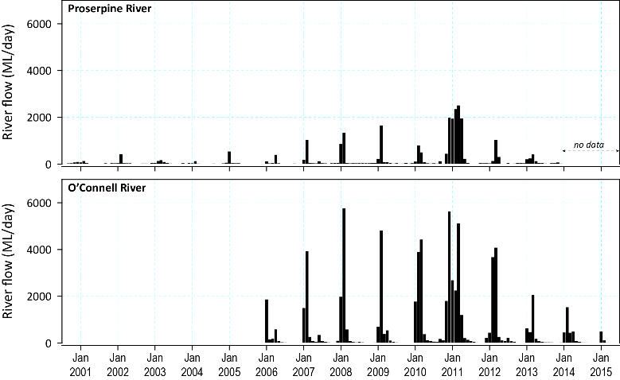
Figure 136. Average daily flow (ML day⁻¹) per month from the main rivers impacting coastal and reef seagrass monitoring sites in the Mackay Whitsunday region
(stations 122005A - Proserpine River at Proserpine, 20.39166667°S 148.59833333°E, Elev 7m; 124001B - O'Connell River at Stafford's Crossing 20.65255556°S 148.573°E, Elev:0m) (source ©The State of Queensland (DNRM) 2015).
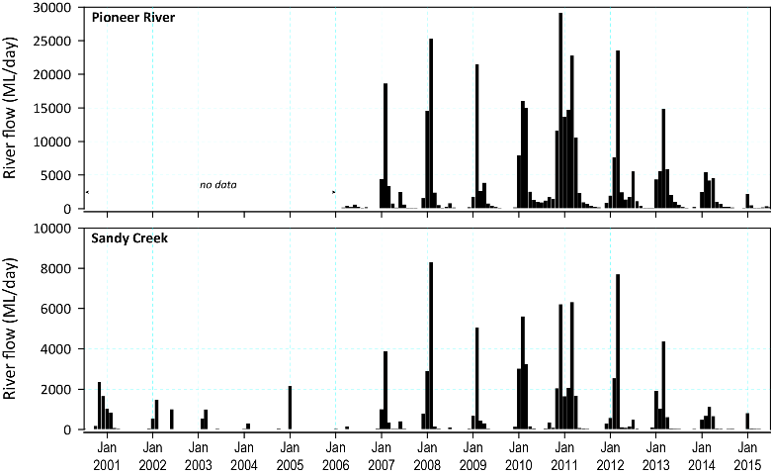
Figure 137. Average daily flow (ML day⁻¹) per month from the main river impacting estuarine seagrass monitoring sites in the Mackay Whitsunday region
(stations 125016A - Pioneer River at Dumbleton Weir T/W 21.14236111°S 149.07625°E, Elev 10m; 126001A - Sandy Creek at Homebush Lat:-21.2832888 Long:149.0225055, Elev 62m) (source ©The State of Queensland (DNRM) 2015).

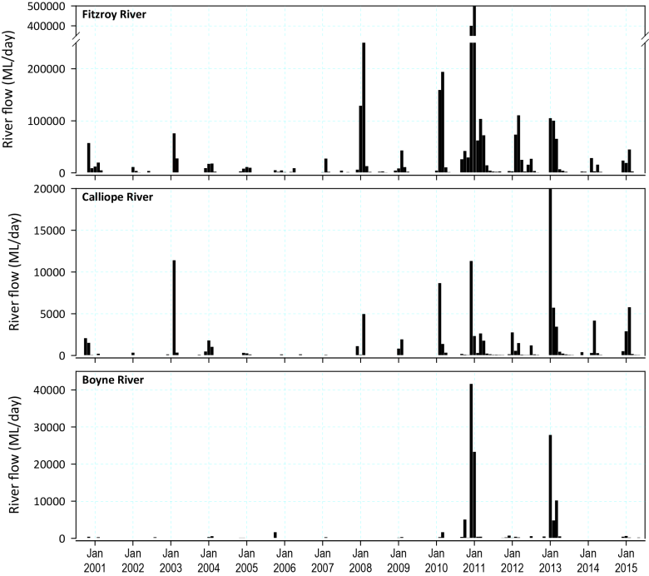
Figure 138. Average daily flow (ML day⁻¹) per month from the main rivers which would impact seagrass monitoring sites in the Fitzroy region
(stations 130005A - Fitzroy River at The Gap, 23.08897222°S 150.10713889°E, Elev 0m; 132001A - Calliope River at Castlehope 23.98498333°S 151.09756389°E, Elev:21m; 136319A - Boyne River at Cooranga 25.78592226°S 151.33283673°E, Elev:0)(source ©The State of Queensland (DNRM) 2015, dnrm.qld.gov.au/water/water-monitoring-and-data/portal).

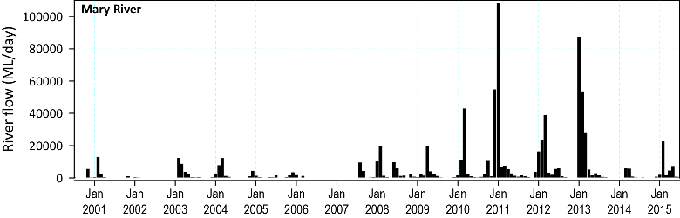
Figure 139. Average daily flow (ML day⁻¹) per month from the Mary River which would impact estuarine seagrass monitoring sites at Urangan, southern Burnett Mary region
(station 138001A - Mary River at Miva Lat:25.95332924°S:152.4956601 °E, Elev 0m) (source ©The State of Queensland (DNRM) 2015, dnrm.qld.gov.au/water/water-monitoring-and-data/portal).

Climate
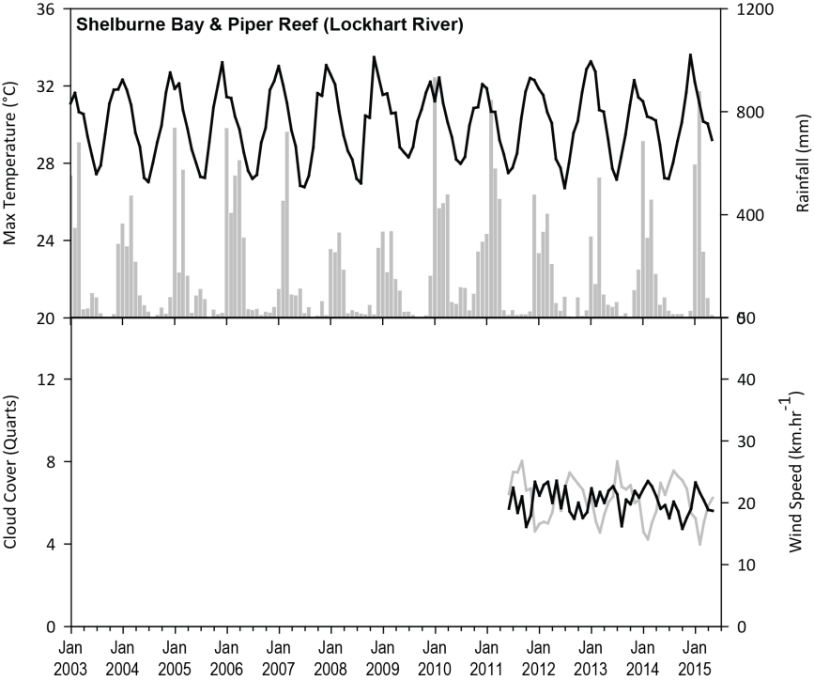
Figure 140. Mean monthly daily maximum air temperature (°C), total monthly rainfall (mm, bar graph), mean monthly cloud cover (quarts, heavier line), and mean monthly 3pm wind speed (km.hr⁻¹, lighter line) recorded at Lockhart River Airport (BOM station 028008, source www.bom.gov.au), located 108km from Shelburne Bay and 61km from Piper Reef monitoring sites.
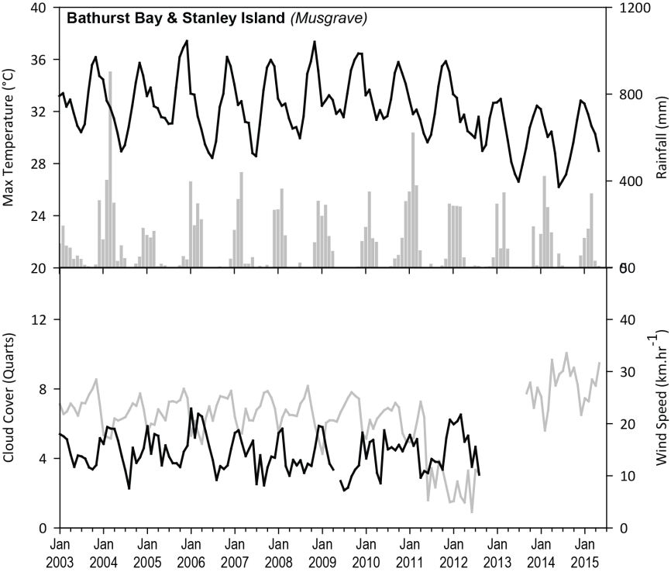
Figure 141. Total monthly rainfall (mm, bar graph) recorded at Lotus Bird Lodge (BOM station 028035, source www.bom.gov.au), located approximately 73km and 84km from Bathurst Bay and Stanley Island monitoring sites, respectively
. Mean monthly daily maximum air temperature (°C, black line), mean monthly cloud cover (quarts, black line), and mean monthly 3pm wind speed (km. hr⁻¹, grey line) pre-August 2012 from Musgrave (BOM station 028007) located approximately 97km and 107km from Bathurst Bay and Stanley Island monitoring sites, respectively, and post-August 2012, from Cape Flattery (BOM station 031213), located approximately 139km and 144km from Bathurst Bay and Stanley Island monitoring sites, respectively (source www.bom.gov.au).

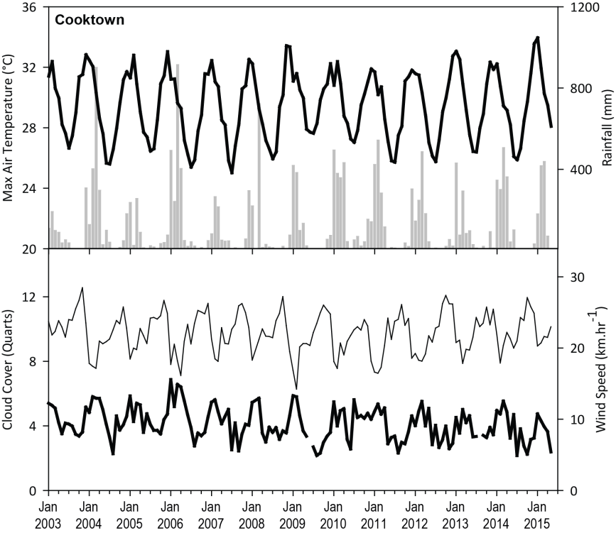
Figure 142. Mean monthly daily maximum air temperature (°C), total monthly rainfall (mm, bar graph), mean monthly cloud cover (quarts, heavier line), and mean monthly 3pm wind speed (km. hr⁻¹, lighter line) recorded at Cooktown airport (BOM station 031209, source www.bom.gov.au), located 16km from Archer Point monitoring sites.

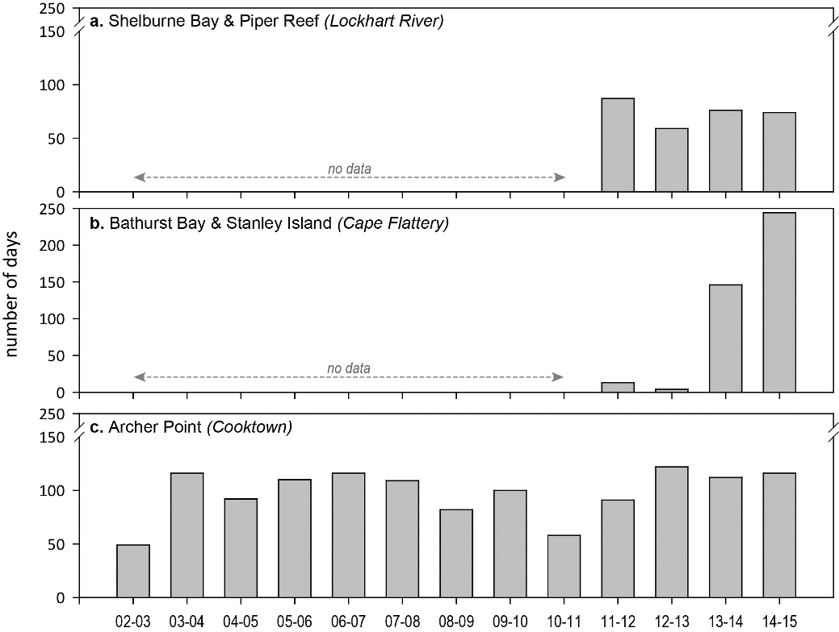
Figure 143. Number of days wind speed is above 25 km. hr⁻¹ each monitoring period in the Cape York NRM region.
Daily 3pm wind speed from: a) from Lockhart River Airport (BOM station 028008, source www.bom.gov.au), located 108km from Shelburne Bay and 61km from Piper Reef monitoring sites; b) Cape Flattery (BOM station 031213), located approximately 139km and 144km from Bathurst Bay and Stanley Island monitoring sites, respectively and; c) Cooktown airport (BOM station 031209), located 16km from Archer Point monitoring sites.

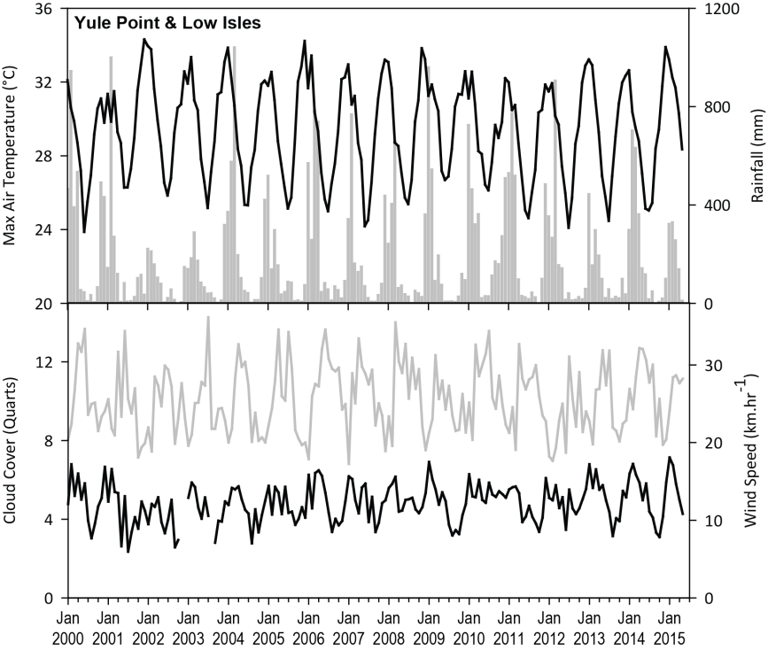
Figure 144. Total monthly rainfall (mm, bar graph) recorded at Port Douglas - Warner St (BOM station 31052, source www.bom.gov.au), located approximately 11km from Yule Point and 15 from Low Isles monitoring sites.
Mean monthly daily maximum air temperature (°C, black line), mean monthly cloud cover (quarts, black line), and mean monthly 3pm wind speed (km. hr⁻¹, grey line) from Low Isles (BOM station 31037, source www.bom.gov.au), located approximately 21km from Yule Point monitoring sites.
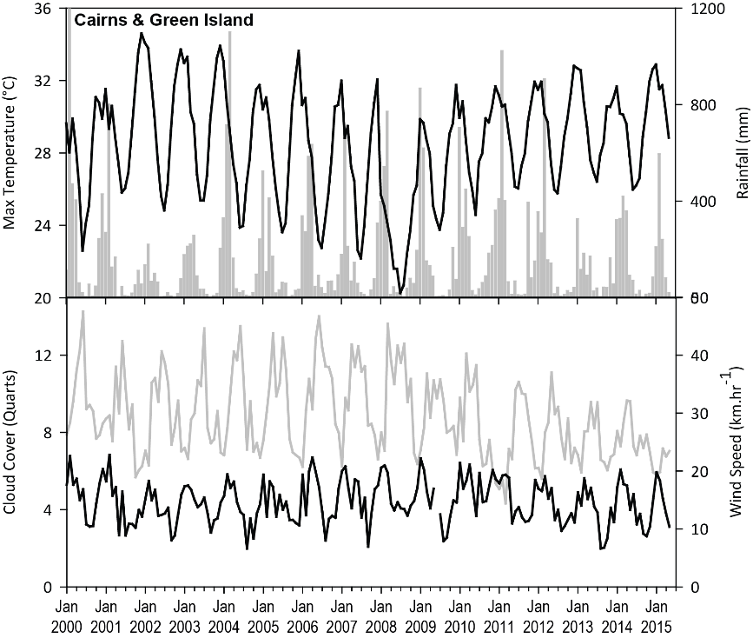
Figure 145. Mean monthly daily maximum air temperature (°C, black line), and mean monthly 3pm wind speed (km. hr⁻¹, grey line) pre-July 2010 from Green Island (BOM station 31192).
Mean monthly daily maximum air temperature (°C), total monthly rainfall post-Jun 2010 (mm, bar graph), and mean monthly cloud cover (quarts, black line), recorded at Cairns airport (BOM station 031011), located approximately 26km from Green Island monitoring sites. Mean monthly 3pm wind speed (km. hr⁻¹, grey line) post-July 2010 from Low Isles (BOM station 31037) (source www.bom.gov.au).

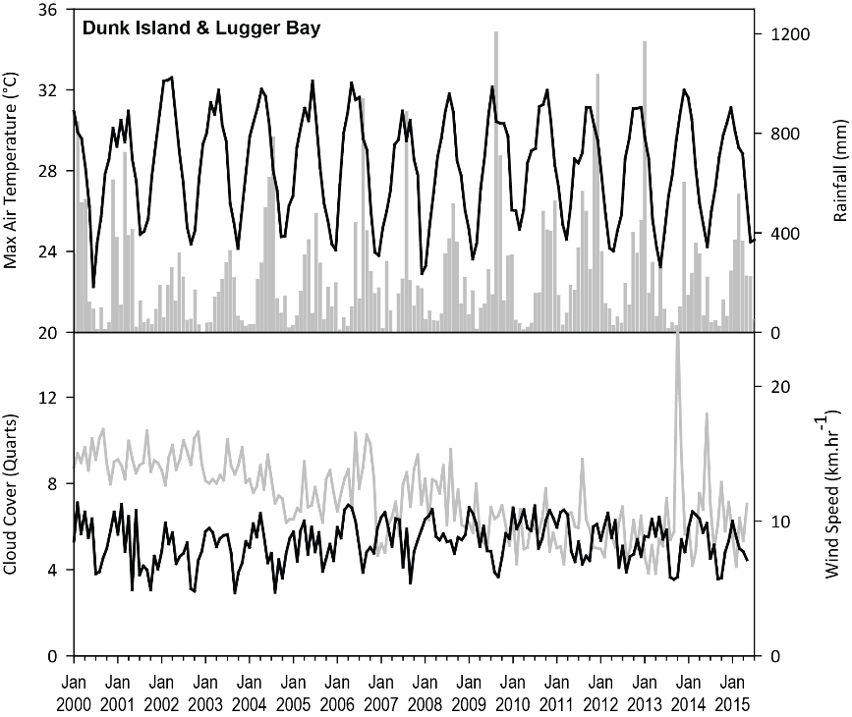
Figure 146. Total monthly rainfall (mm, bar graph), recorded at Dunk Island Resort (BOM station 32118, source www.bom.gov.au).
Mean monthly daily maximum air temperature (°C), mean monthly cloud cover (quarts, heavier line), and mean monthly 3pm wind speed (km.hr⁻¹, lighter line) recorded at Innisfail (BOM station 032025, source www.bom.gov.au), located approximately 48km from monitoring sites at Lugger Bay and Dunk Island.

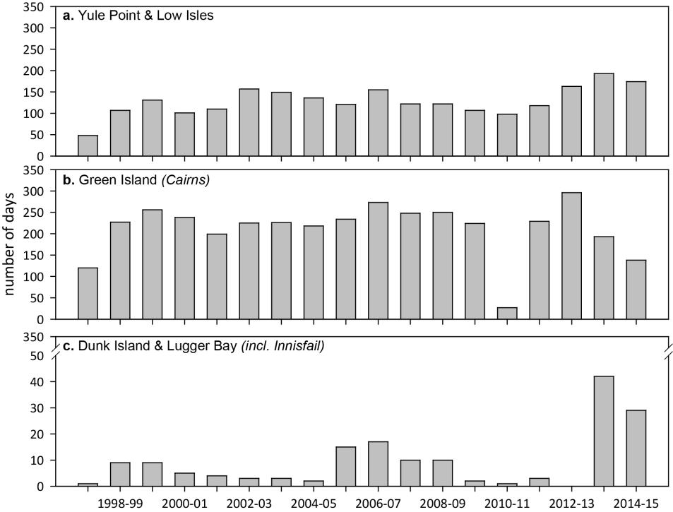
Figure 147. Number of days wind speed is above 25 km. hr⁻¹ each monitoring period in the Wet Tropics NRM region.
Daily 3pm wind speed from: a) Low Isles (BOM station 31037), located approximately 21km from Yule Point monitoring sites; b) Green Island (BOM station 31192); and C) Innisfail (BOM station 032025), located approximately 48km from monitoring sites at Lugger Bay and Dunk Island.

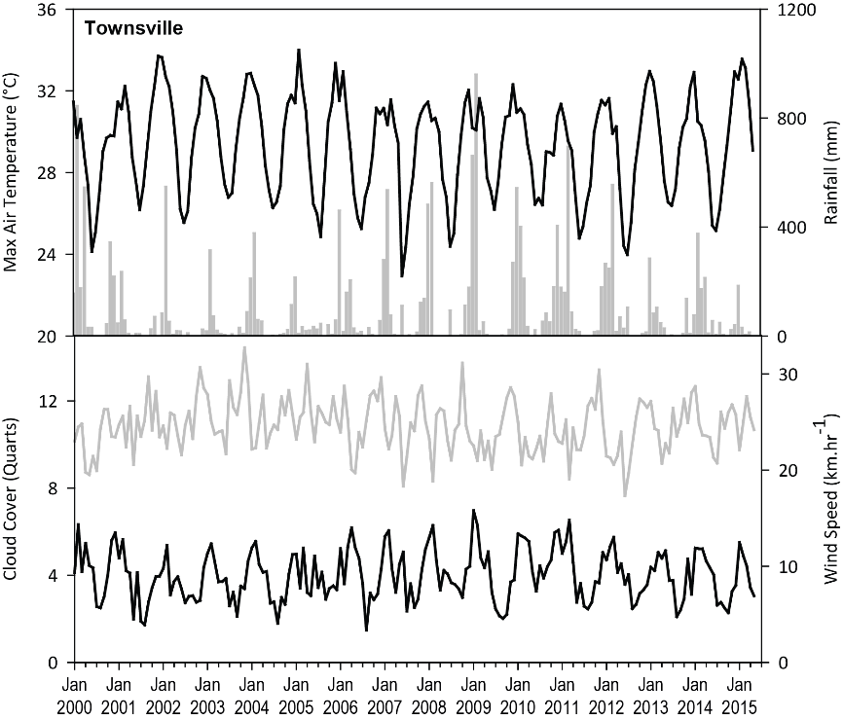
Figure 148. Mean monthly daily maximum temperature (°C, line), total monthly rainfall (grey bars), mean monthly cloud cover (quarts, black line), and mean monthly 3pm wind speed (km. hr⁻¹, grey line) recorded at Townsville Airport (BOM station 032040, source www.bom.gov.au).
Townsville Airport is located approximately 11km from coastal (Townsville) and reef (Magnetic Island) monitoring site.

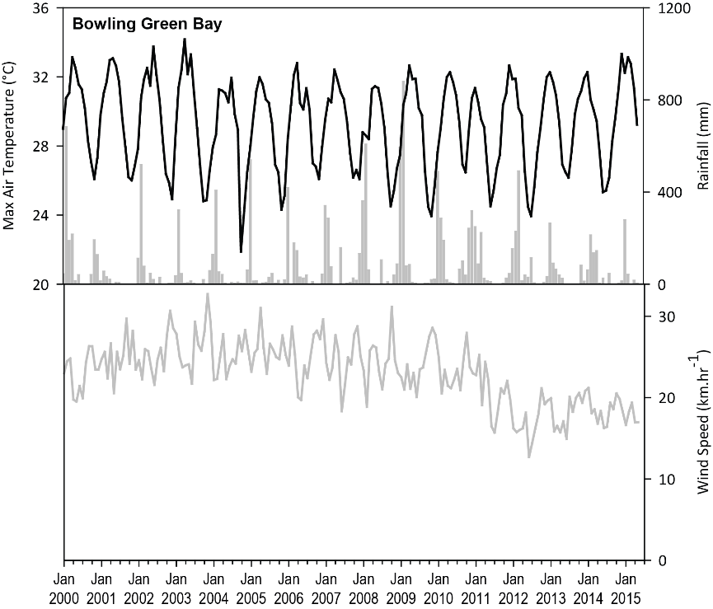
Figure 149. Mean monthly daily maximum temperature (°C, line), total monthly rainfall (grey bars), and mean monthly 3pm wind speed (km. hr⁻¹, grey line) recorded at Ayr (BOM station 033002, source www.bom.gov.au), located approximately 26km from Jerona (Bowling Green Bay) monitoring sites.

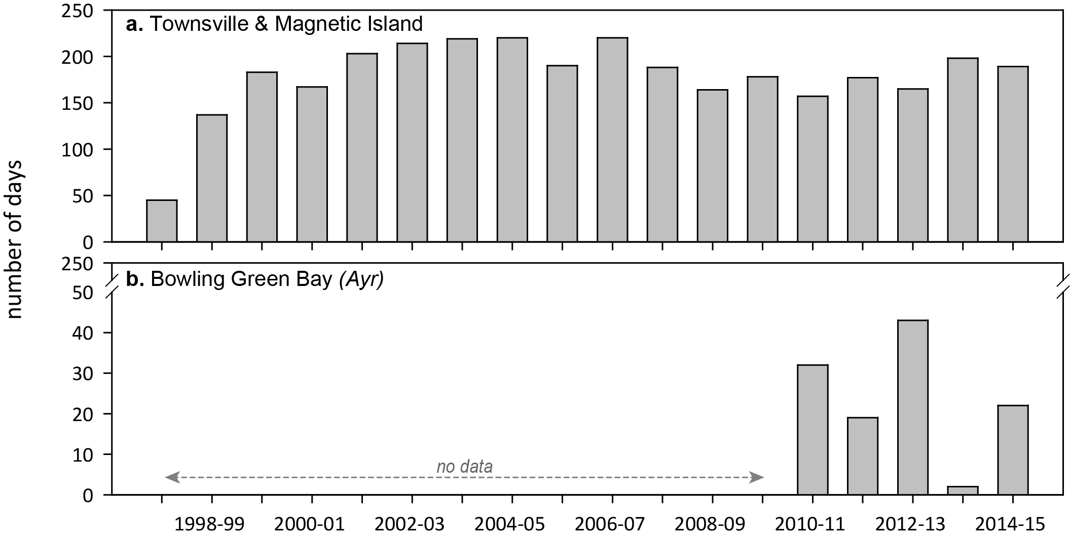
Figure 150. Number of days wind speed is above 25 km. hr⁻¹ each monitoring period in the Burdekin NRM region.
Daily 3pm wind speed from: a) Townsville Airport (BOM station 032040) located approximately 11km from coastal (Townsville) and reef (Magnetic Island) monitoring sites, and 53km from Jerona (Bowling Green Bay) monitoring sites; and b) Ayr (BOM station 033002), located approximately 26km from from Jerona (Bowling Green Bay) monitoring sites.

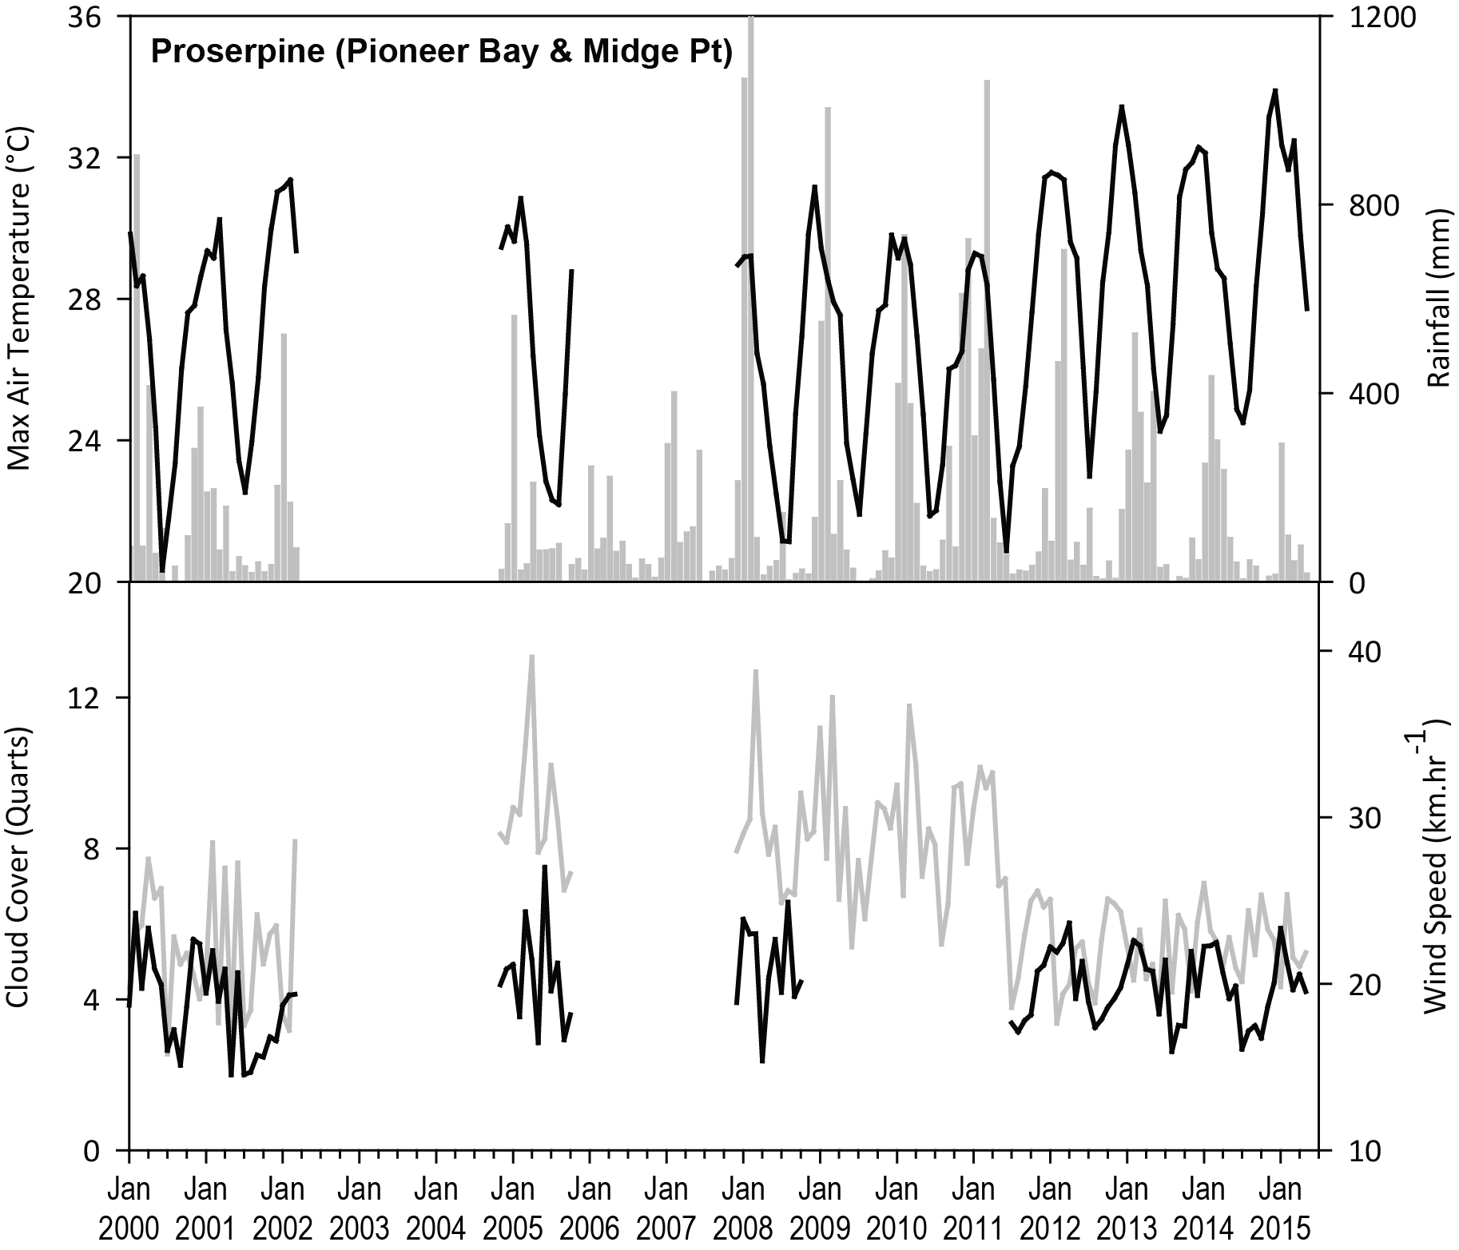
Figure 151. Total monthly rainfall (grey bars) (post December 2004), mean monthly daily maximum temperature (°C, black line), mean monthly cloud cover (quarts, black line), and mean monthly 3pm wind speed (km. hr⁻¹, grey line) recorded at Proserpine Post Office
(BOM station 33316, source www.bom.gov.au) (post June 2011), located 18km from Pioneer Bay monitoring sites. All other recordings from Hamilton Island (BOM station 033106, source www.bom.gov.au), approximately 28km from Pioneer Bay monitoring sites.

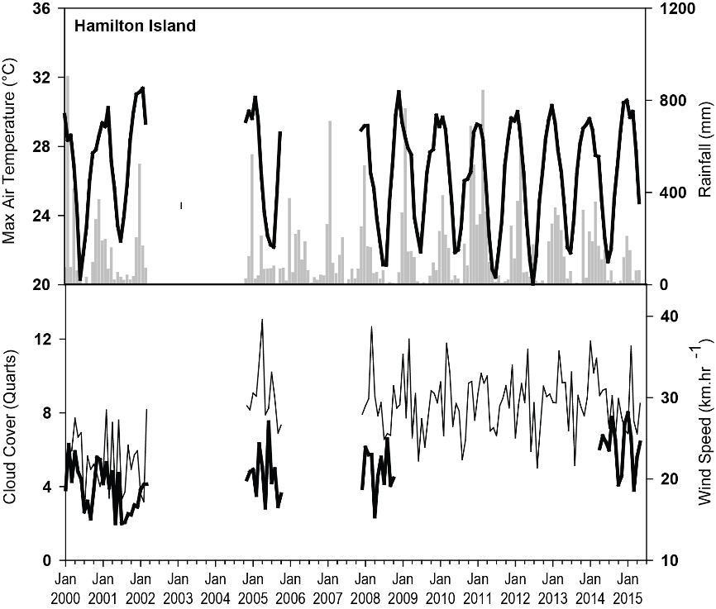
Figure 152. Mean monthly daily maximum temperature (°C), total monthly rainfall, mean monthly cloud cover (quarts), and mean monthly 3pm wind speed (km. hr⁻¹) recorded at Hamilton Island (BOM station 033106, source www.bom.gov.au), located 1.5km from Hamilton Island monitoring sites.

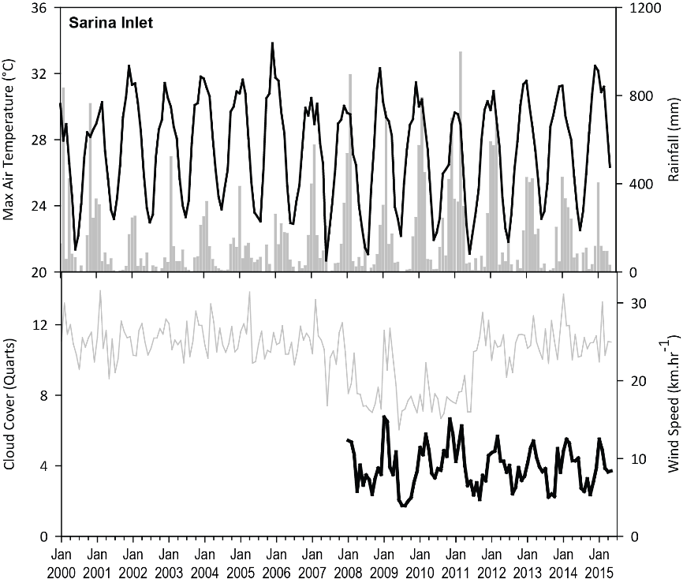
Figure 153. Total monthly rainfall (grey bars) recorded at Plane Creek Sugar Mill (BOM station 033059, source www.bom.gov.au), located 10km from Sarina Inlet monitoring sites.
Mean monthly daily maximum temperature (°C, black line), mean monthly cloud cover (quarts, black line), and mean monthly 3pm wind speed (km. hr⁻¹, grey line) recorded at Mackay Airport (BOM station 033045, source www.bom.gov.au), approximately 28km from Sarina Inlet monitoring sites.

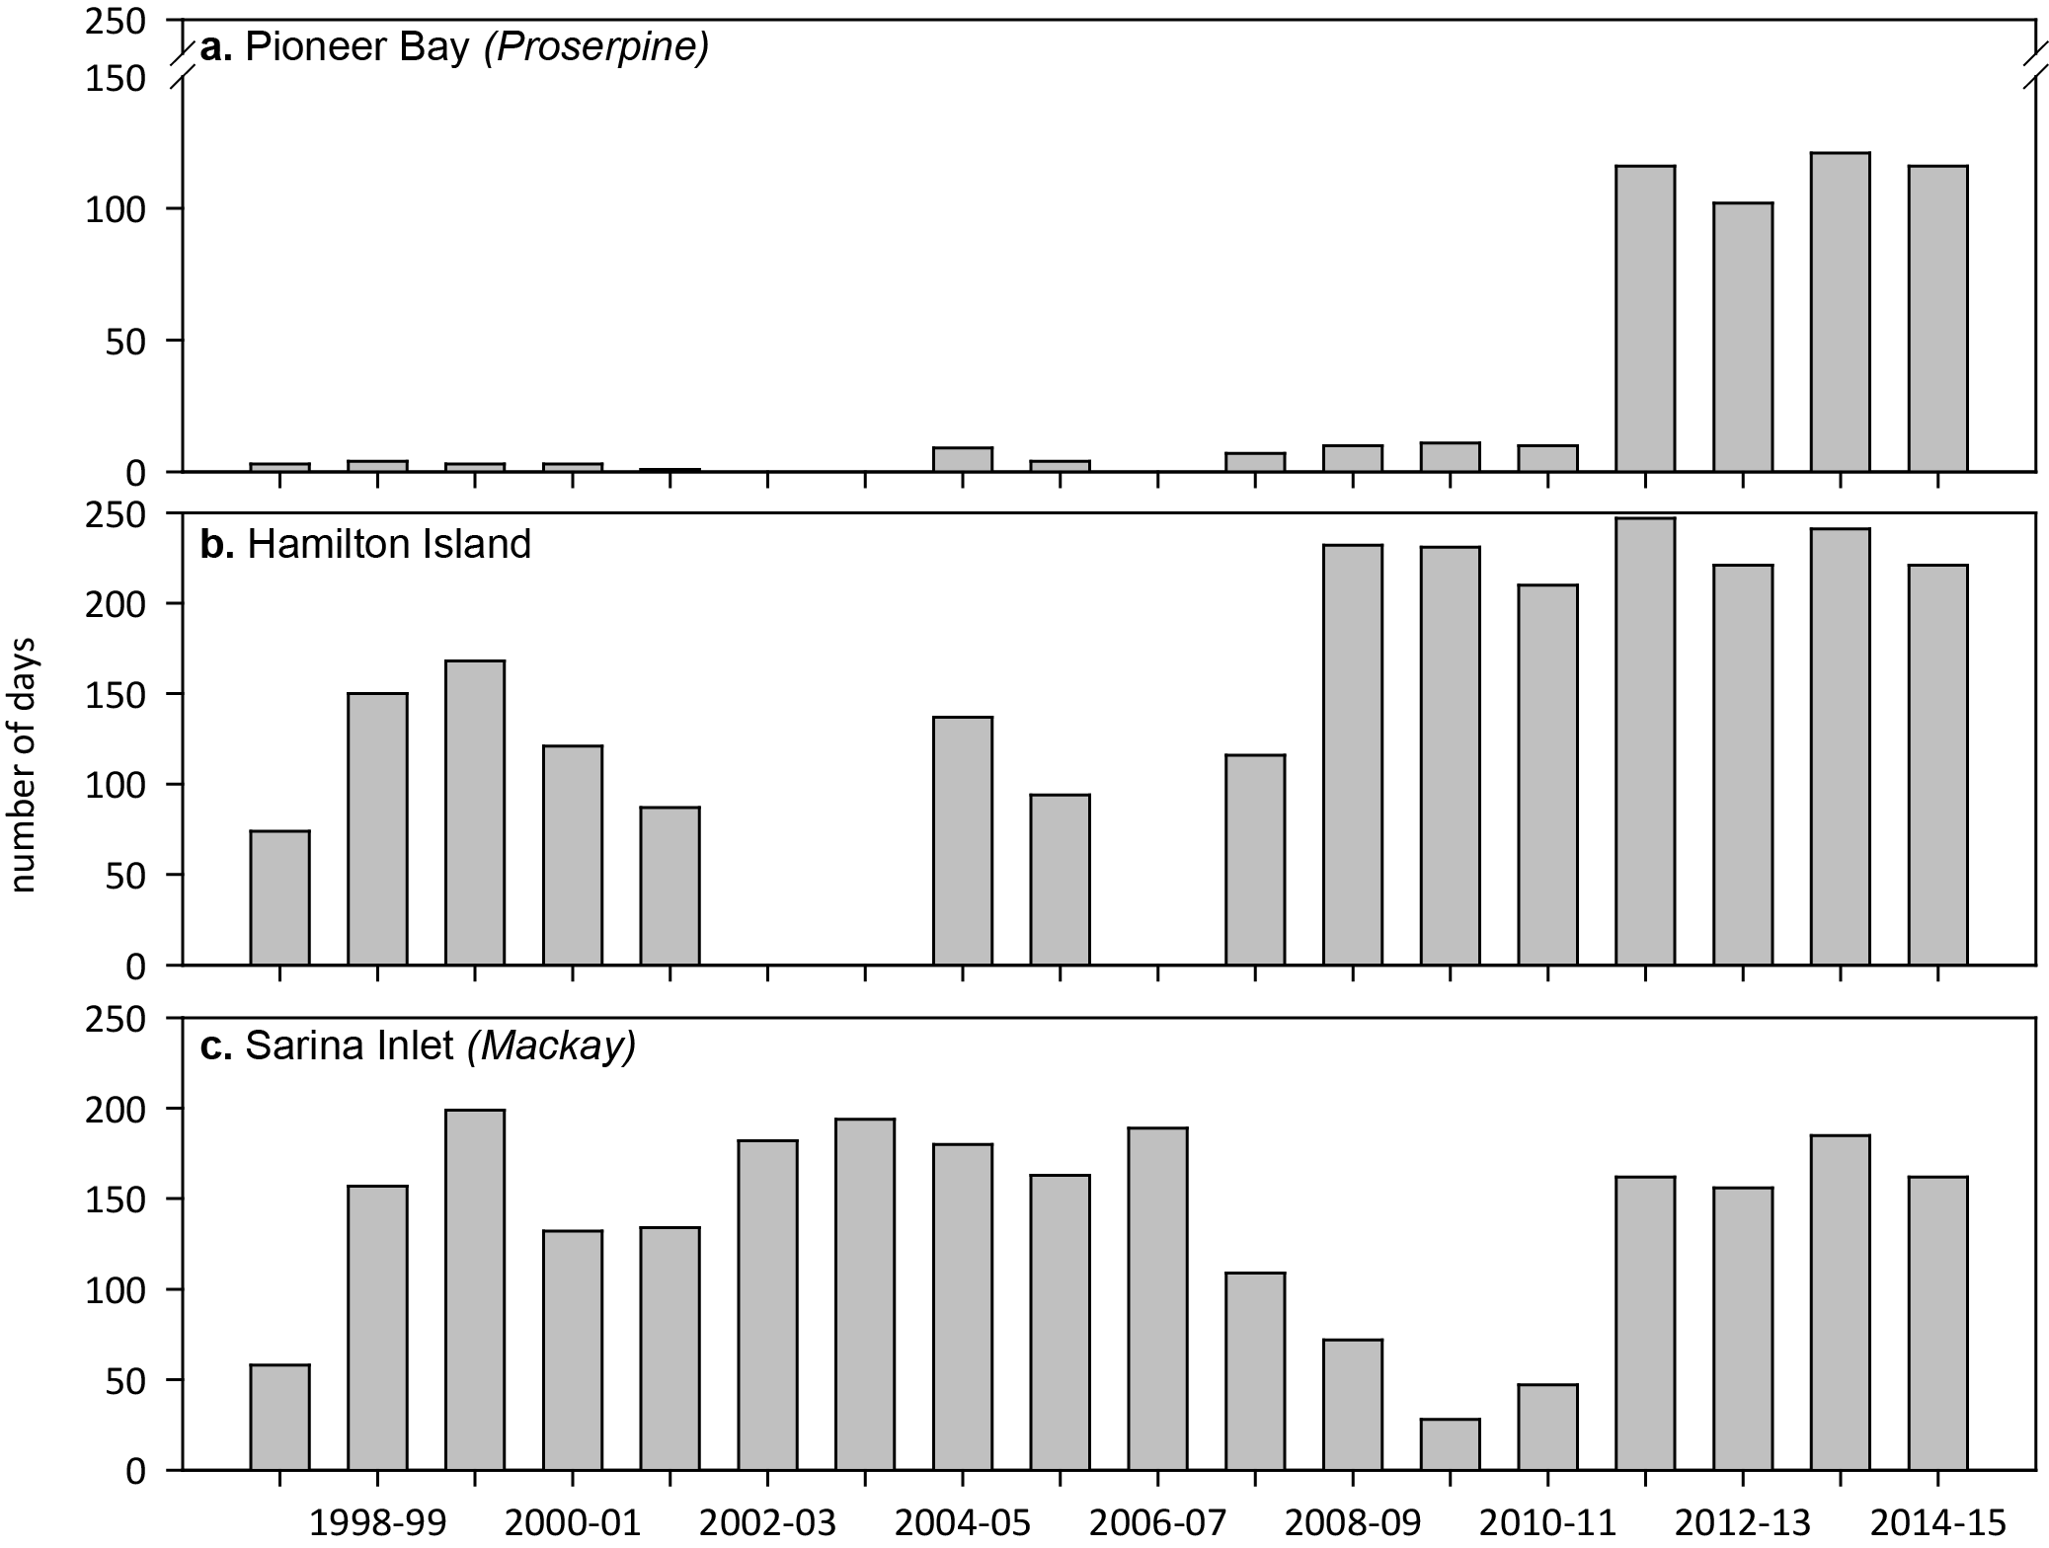
Figure 154. Number of days wind speed is above 25 km. hr⁻¹ each monitoring period in the Mackay Whitsunday NRM region.
Daily 3pm wind speed from: a) Proserpine Post Office (BOM station 33316) (post June 2011), located 18km from Pioneer Bay monitoring sites; b) Hamilton Island (BOM station 033106), located 1.5km from Hamilton Island monitoring sites; and c) Mackay Airport (BOM station 033045, source www.bom.gov.au), approximately 28km from Sarina Inlet monitoring sites.

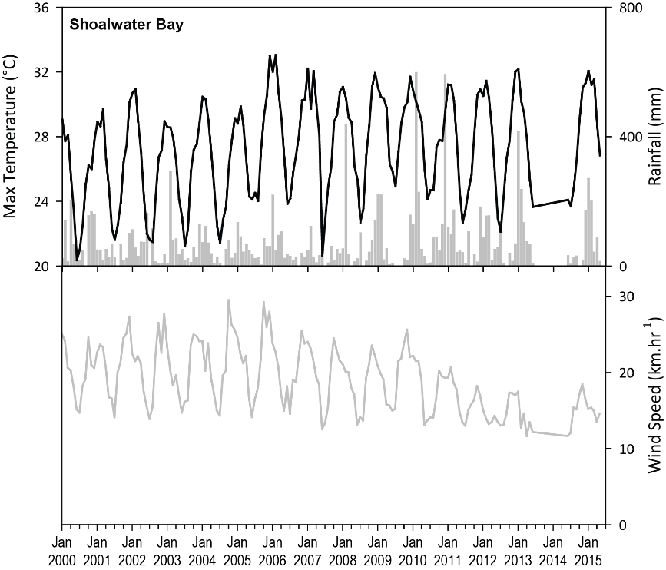
Figure 155. Total monthly rainfall (grey bar), mean monthly daily maximum temperature (°C) and mean monthly 3pm wind speed (km. hr⁻¹) post May 2005 recorded at Williamson, Shoalwater Bay (BOM station 033260, source www.bom.gov.au), located 10km from the monitoring sites
. Prior to May 2005, observations recorded at Yeppoon (BOM station 033106, source www.bom.gov.au), approximately 96km from monitoring sites.

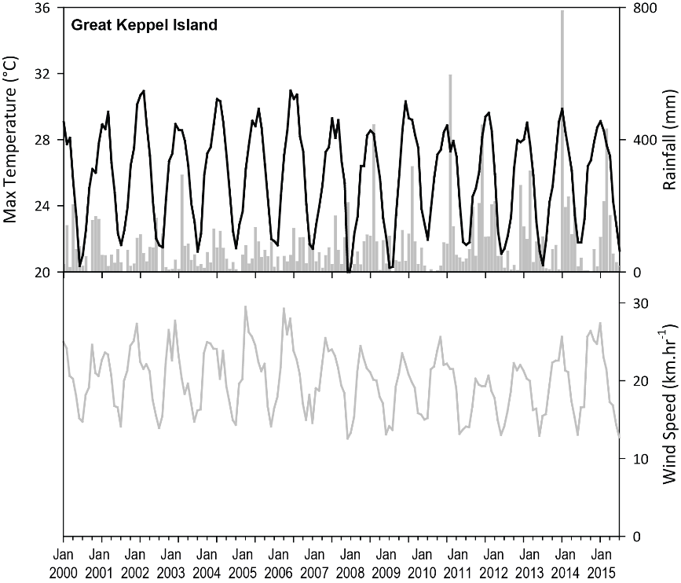
Figure 156. Total monthly rainfall (grey bar) recorded at Svendsen Beach, Great Keppel Island (BOM station 033260, source www.bom.gov.au), located 4.5km from the monitoring sites.
Mean monthly daily maximum temperature (°C) and mean monthly 3pm wind speed (km. hr⁻¹) recorded at Yeppoon (BOM station 033106, source www.bom.gov.au), approximately 22km from monitoring sites.

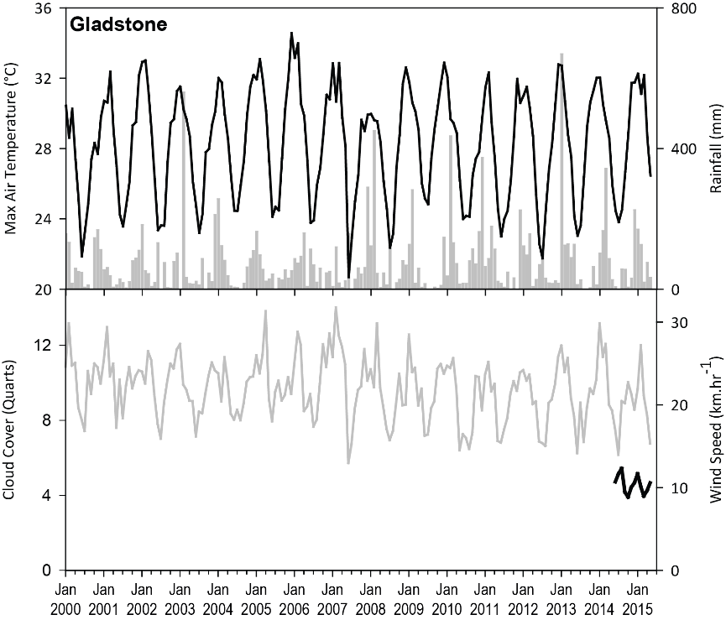
Figure 157. Total monthly rainfall (grey bars) recorded at Southend Curtis Island (BOM station 039241, source www.bom.gov.au), located 1km from monitoring sites.
Mean monthly daily maximum temperature (°C), and mean monthly 3pm wind speed (km. hr⁻¹) recorded at Gladstone Airport (BOM station 039123, source www.bom.gov.au), located approximately 13km from monitoring sites.

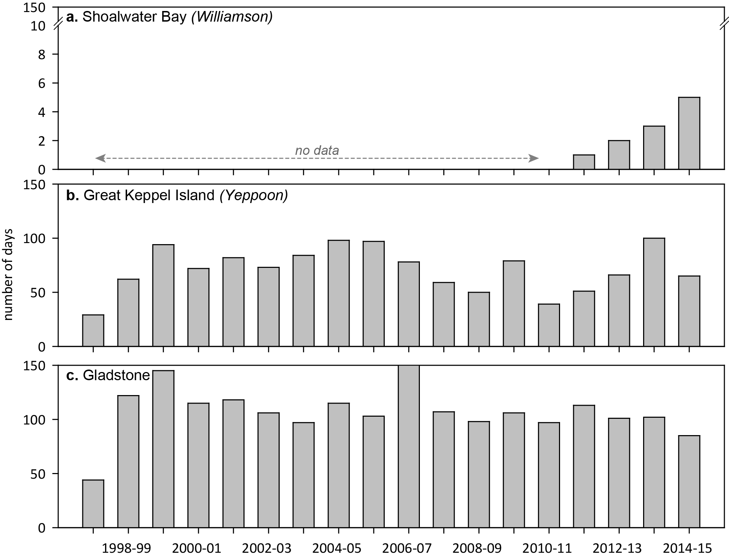
Figure 158. Number of days wind speed is above 25 km. hr⁻¹ each monitoring period in the Fitzroy NRM region.
Daily 3pm wind speed from: a) Williamson, Shoalwater Bay (BOM station 033260), located 10km from the monitoring sites; b) Yeppoon (BOM station 033106), approximately 22km from monitoring sites; and c) Gladstone Airport (BOM station 039123), located approximately 13km from monitoring sites.

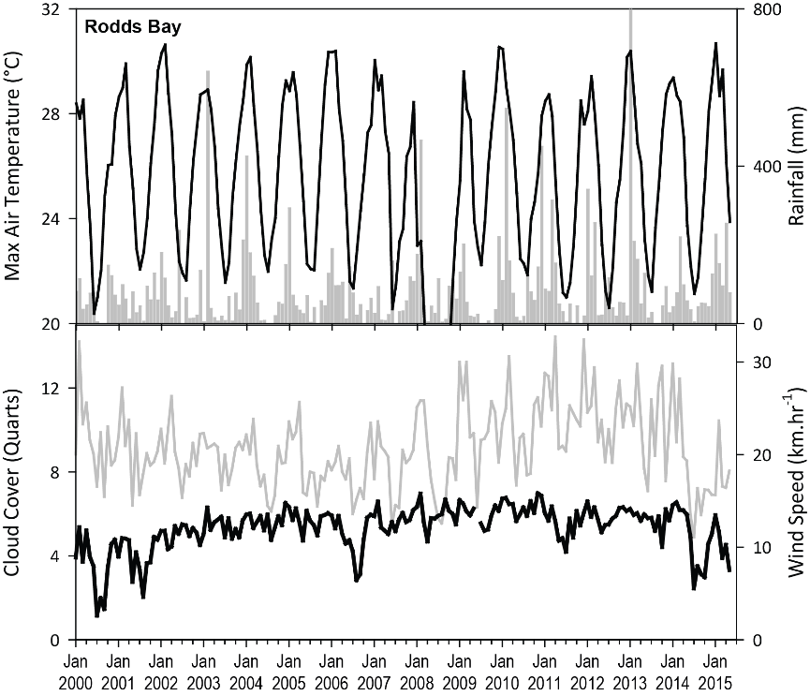
Figure 159. Mean monthly daily maximum temperature (°C) (black line), mean monthly cloud cover (quarts) (black line), and mean monthly 3pm wind speed (km. hr⁻¹) (grey line) recorded at Seventeen Seventy
(BOM station 039314, source www.bom.gov.au), approximately 27km from Rodds Bay monitoring sites. Total monthly rainfall (grey bar), recorded at Turkey station (BOM station 039261) pre-2014 and Bustard Head Lighthouse (BOM station 039018), approximately 12km from Rodds Bay monitoring sites. (source www.bom.gov.au).

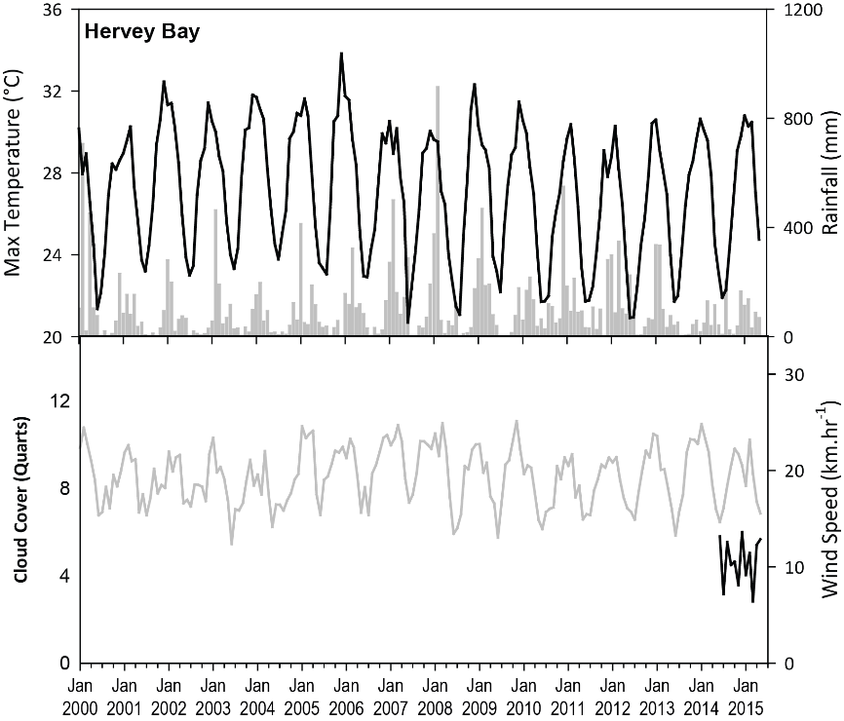
Figure 160. Mean monthly daily maximum temperature (°C), total monthly rainfall, and mean monthly 3pm wind speed (km. hr⁻¹) recorded at Hervey Bay Airport (BOM station 040405, source www.bom.gov.au), approximately 3km from Urangan monitoring sites.

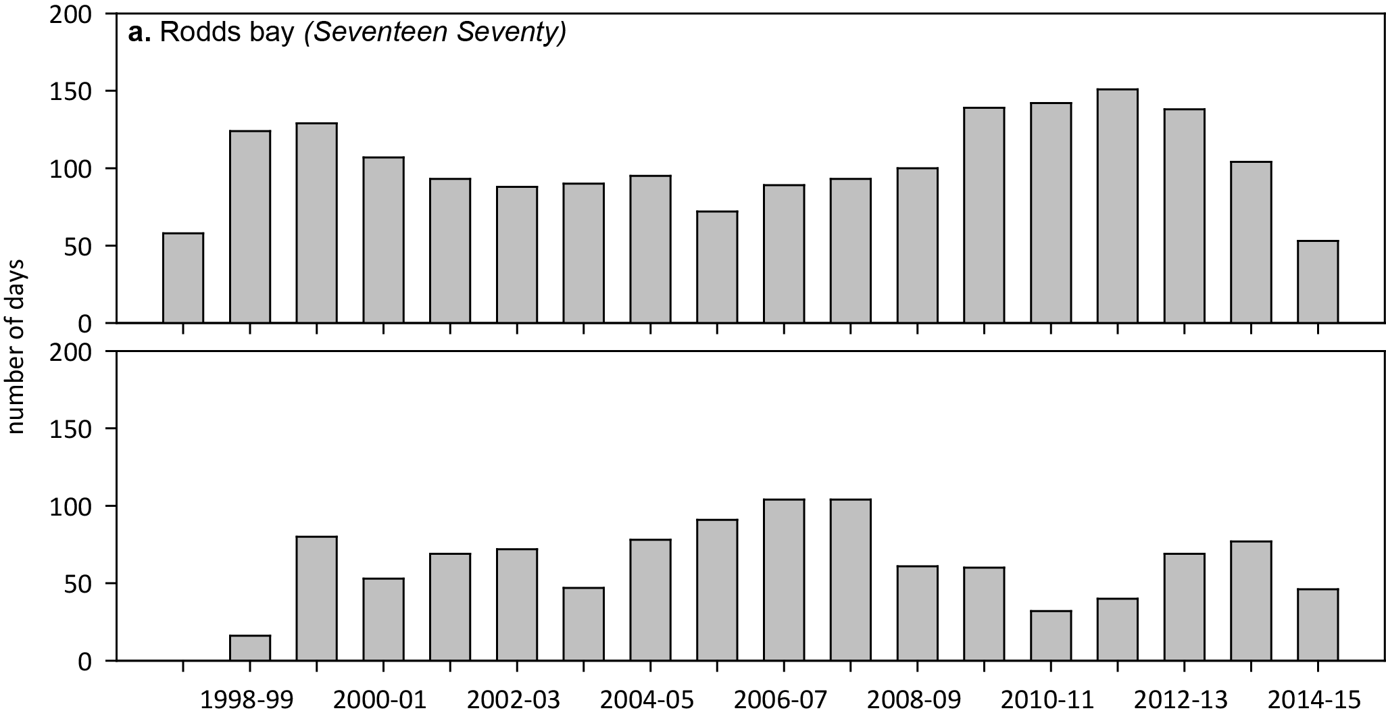
Figure 161. Number of days wind speed is above 25 km. hr⁻¹ each monitoring period in the Burnett Mary NRM region.
Daily 3pm wind speed from: a) Seventeen Seventy (BOM station 039314), approximately 27km from Rodds Bay monitoring sites; and b) Hervey Bay Airport (BOM station 040405), approximately 3km from Urangan monitoring sites.

Tidal exposure

Table 46. Height of intertidal monitoring meadows/sites above Lowest Astronomical Tide (LAT) and annual daytime tidal exposure (total hours) when meadows become exposed at a low tide.
Year is June - May. Observed tidal heights courtesy Maritime Safety Queensland, 2015. NB: Meadow heights have not yet been determined in the far northern Cape York.
NRM | Site | Meadow  height  (above LAT) | Site depth  (bMSL) | Meadow height  (above LAT)  relative to  Standard Port | Annual median  hours exposed  during daylight  (long-term) | % of annual daylight  hours meadow  is exposed  (long-term) | Annual daytime  exposure  2014-15 (hrs)
Cape York | AP1 | 0.46 | 1.02 | 0.46 | 65.21 | 1.49% | 49.67
Cape York | AP2 | 0.46 | 1.02 | 0.46 | 65.21 | 1.49% | 49.67
Wet Tropics | LI1 | 0.65 | 0.90 | 0.65 | 174.31 | 4.21% | 153.67
Wet Tropics | YP1 | 0.64 | 0.94 | 0.64 | 166.46 | 4.02% | 147.67
Wet Tropics | YP2 | 0.52 | 1.06 | 0.52 | 94.06 | 2.27% | 79
Wet Tropics | GI1 | 0.51 | 1.03 | 0.61 | 111.98 | 2.72% | 128.83
Wet Tropics | GI2 | 0.57 | 0.97 | 0.67 | 148.92 | 3.62 | 164
Wet Tropics | DI1 | 0.65 | 1.14 | 0.54 | 71.27 | 1.76% | 53.8
Wet Tropics | DI2 | 0.55 | 1.24 | 0.44 | 42.27 | 1.04% | 31
Wet Tropics | LB1 | 0.42 | 1.37 | 0.31 | 17.33 | 0.4% | 15
Wet Tropics | LB2 | 0.46 | 1.33 | 0.35 | 21.77 | 0.52% | 18
Burdekin | BB1 | 0.58 | 1.30 | 0.58 | 85.14 | 2.06% | 53.17
Burdekin | SB1 | 0.57 | 1.31 | 0.57 | 68.64 | 1.66% | 51.67
Burdekin | MI1 | 0.65 | 1.19 | 0.67 | 180.61 | 4.39% | 80.83
Burdekin | MI2 | 0.54 | 1.30 | 0.56 | 164.5 | 4.0% | 49.17
Burdekin | JR1 | 0.47 | 1.32 | 0.47 | 62.13 | 1.42% | 53.3
Burdekin | JR2 | 0.47 | 1.32 | 0.47 | 62.13 | 1.42% | 53.3
Mackay Whitsunday | PI2 | 0.28 | 1.47 | 0.44 | 79.68 | 1.92% | 71.83
Mackay Whitsunday | PI3 | 0.17 | 1.58 | 0.33 | 41.35 | 1.0% | 33.5
Mackay Whitsunday | HM1 | 0.68 | 1.52 | 0.38 | 55.76 | 1.35% | 46.5
Mackay Whitsunday | HM2 | 0.68 | 1.52 | 0.38 | 55.76 | 1.35% | 46.5
Mackay Whitsunday | SI1 | 0.60 | 2.80 | 0.54 | 21.59 | 0.55% | 25.16
Mackay Whitsunday | SI2 | 0.60 | 2.80 | 0.54 | 21.59 | 0.55% | 25.16
Fitzroy | RC1 | 2.03 | 1.30 | 1.06 | 160.71 | 4.01% | 149.17
Fitzroy | WH1 | 2.16 | 1.17 | 1.19 | 233.26 | 5.82% | 227
Fitzroy | GK1 | 0.52 | 1.93 | 0.43 | 36.42 | 0.88% | 40
Fitzroy | GK2 | 0.58 | 1.87 | 0.49 | 53.05 | 1.28% | 50.5
Fitzroy | GH1 | 0.80 | 1.57 | 0.69 | 99.33 | 2.49% | 94.83
Fitzroy | GH2 | 0.80 | 1.57 | 0.69 | 96.83 | 2.43% | 67.33
Burnett Mary | RD1 | 0.56 | 1.48 | 0.56 | 66.06 | 1.7% | 63.3
Burnett Mary | RD2 | 0.63 | 1.41 | 0.63 | 94.28 | 2.42% | 90
Burnett Mary | UG1 | 0.70 | 1.41 | 0.70 | 144.76 | 3.38% | 102.83
Burnett Mary | UG2 | 0.64 | 1.47 | 0.64 | 105.43 | 2.46% | 74.33

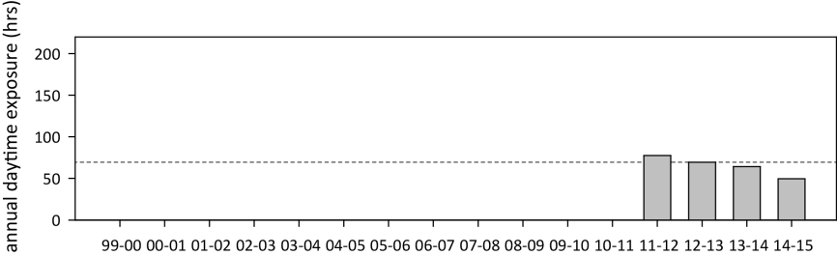
Figure 162. Annual daytime tidal exposure (total hours) and long-term median (dashed line) of intertidal reef seagrass meadows at Archer Point, Cape York NRM region; 2011 - 2015
. Year is June - May. For tidal exposure (when intertidal banks become exposed at a low tide) height at each site, see Table 46. Observed tidal heights courtesy Maritime Safety Queensland, 2015. NB: Meadow heights have not yet been determined in the far northern Cape York sites.

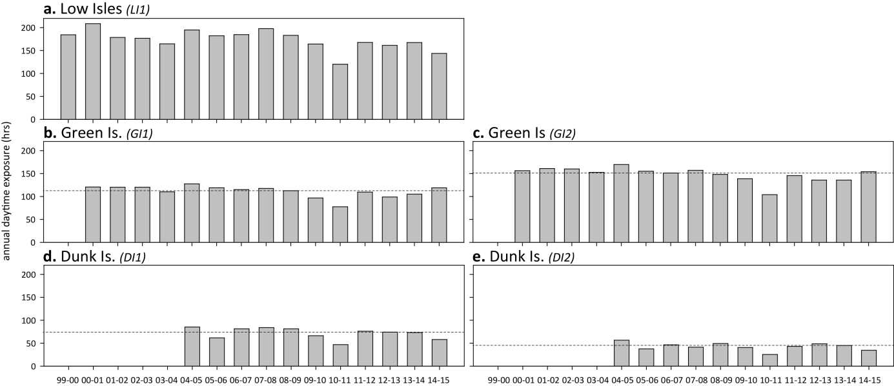
Figure 163. Annual daytime tidal exposure (total hours) and long-term median (dashed line) of intertidal reef seagrass meadows in the Wet Tropics NRM region; 1999 - 2015.
Year is June - May. For tidal exposure (when intertidal banks become exposed at a low tide) height at each site, see Table 46. Observed tidal heights courtesy Maritime Safety Queensland, 2015.

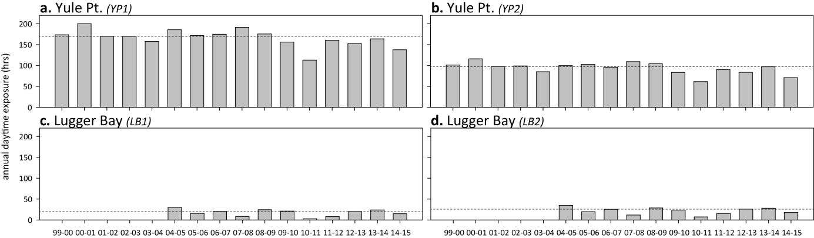
Figure 164. Annual daytime tidal exposure (total hours) and long-term median (dashed line) of intertidal coastal seagrass meadows in Wet Tropics NRM region; 1999 - 2015.
Year is June - May. For tidal exposure (when intertidal banks become exposed at a low tide) height at each site, see Table 46. Observed tidal heights courtesy Maritime Safety Queensland, 2015.

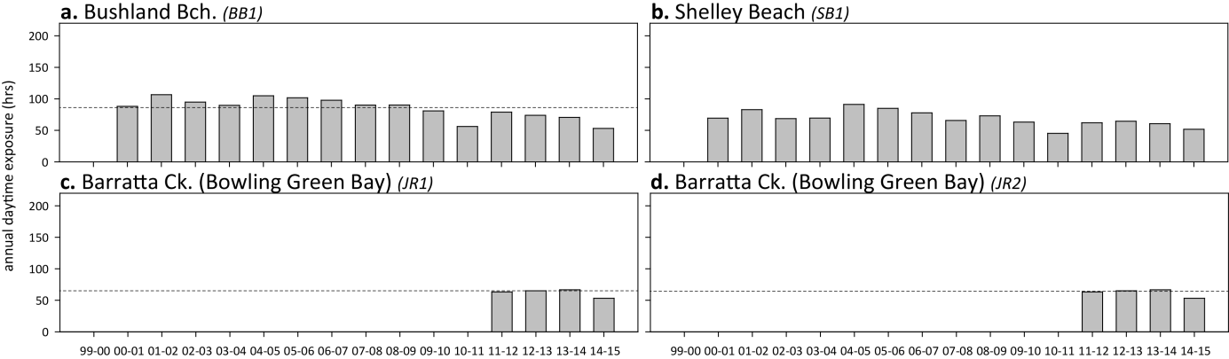
Figure 165. Annual daytime tidal exposure (total hours) and long-term median (dashed line) of intertidal coastal seagrass meadows in Burdekin NRM region; 2000 - 2015.
Year is June - May. For tidal exposure (when intertidal banks become exposed at a low tide) height at each site, see Table 46. Observed tidal heights courtesy Maritime Safety Queensland, 2015.

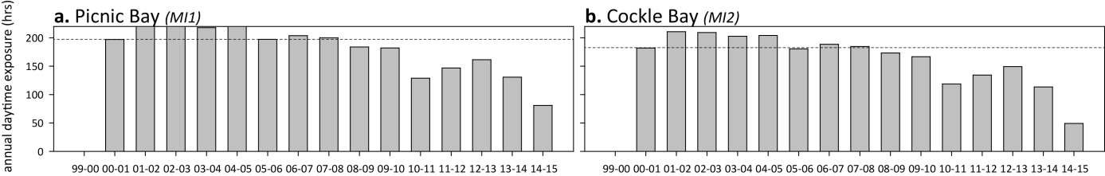
Figure 166. Annual daytime tidal exposure (total hours) and long-term median (dashed line) of intertidal reef seagrass meadows in Burdekin NRM region; 2000 - 2015.
Year is June - May. For tidal exposure (when intertidal banks become exposed at a low tide) height at each site, see Table 46. Observed tidal heights courtesy Maritime Safety Queensland, 2015.

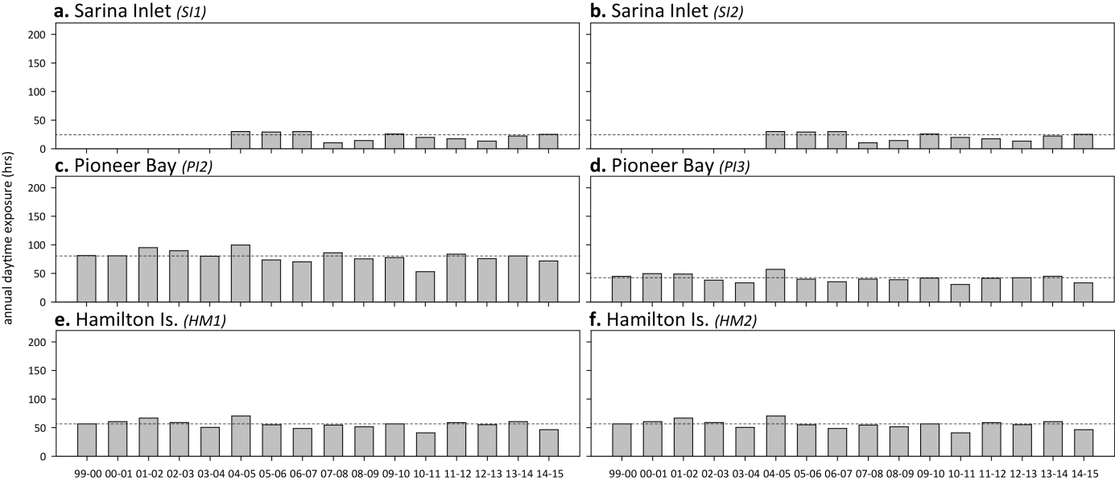
Figure 167. Annual daytime tidal exposure (total hours) and long-term median (dashed line) of intertidal estuarine (a, b) coastal (c, d) and reef (e, f) seagrass meadows in Mackay Whitsunday NRM region; 1999 - 2015.
Year is June - May. For tidal exposure (when intertidal banks become exposed at a low tide) height at each site, see Table 46. Observed tidal heights courtesy Maritime Safety Queensland, 2015.

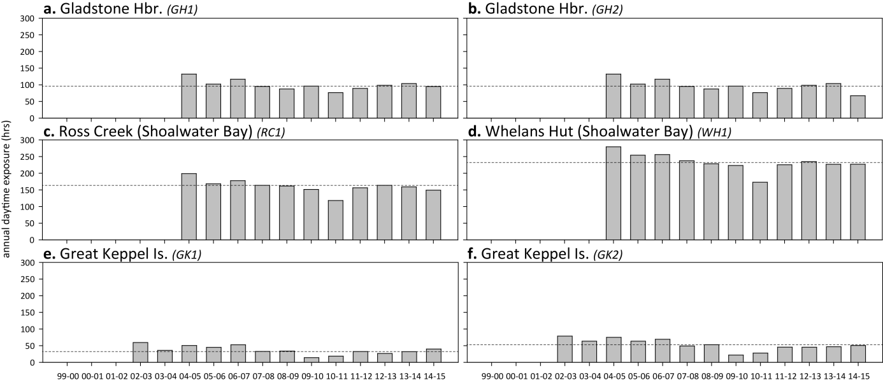
Figure 168. Annual daytime tidal exposure (total hours) and long-term median (dashed line) of intertidal estuarine (a, b) coastal (c, d) and reef (e, f) seagrass meadows in the Fitzroy NRM region; 1999 - 2015.
Year is June - May. For tidal exposure (when intertidal banks become exposed at a low tide) height at each site, see Table 46. Observed tidal heights courtesy Maritime Safety Queensland, 2015.

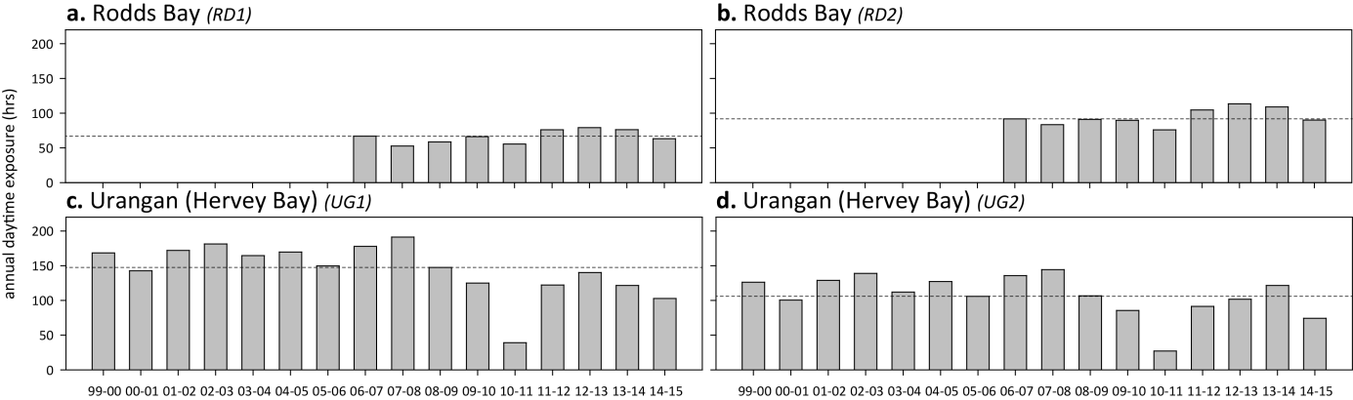
Figure 169. Annual daytime tidal exposure (total hours) and long-term median (dashed line) of intertidal estuarine seagrass meadows in the Burnett Mary NRM region; 1999 - 2015.
Year is June - May. For tidal exposure (when intertidal banks become exposed at a low tide) height at each site, see Table 46. Observed tidal heights courtesy Maritime Safety Queensland, 2015.

Within canopy sea temperature
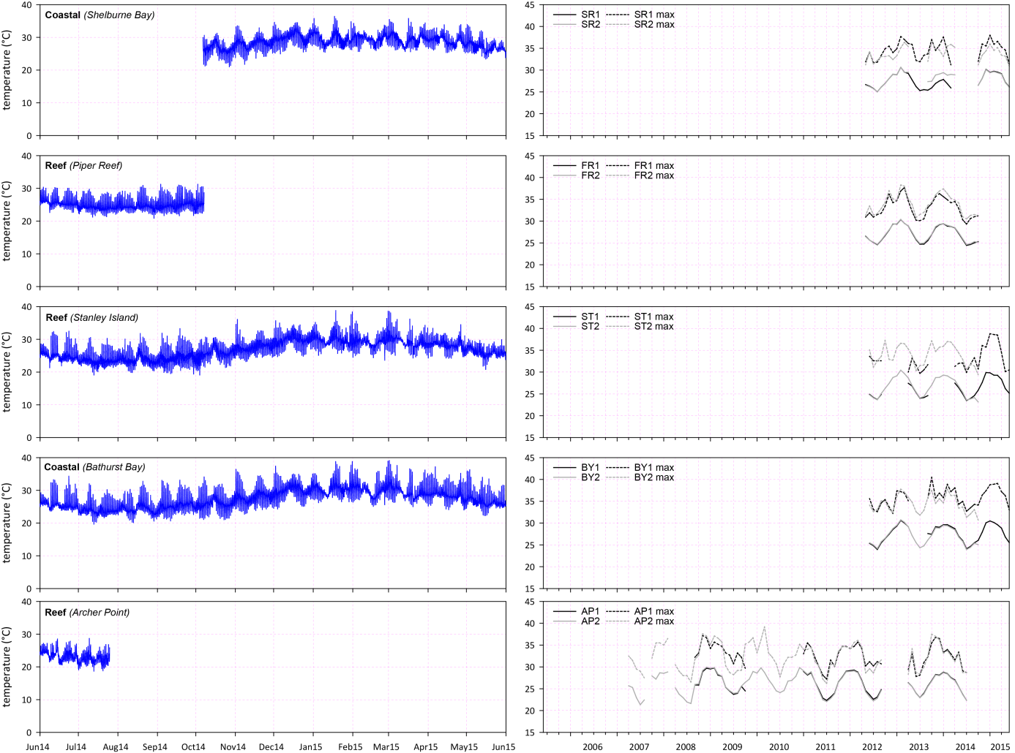
Figure 170. Within seagrass canopy temperatures (°C) at intertidal monitoring locations in the Cape York NRM region
: daily mean (sites pooled) over 2014-15 monitoring period (left); and long-term monthly mean and maximum within seagrass canopy temperature at each site (right).

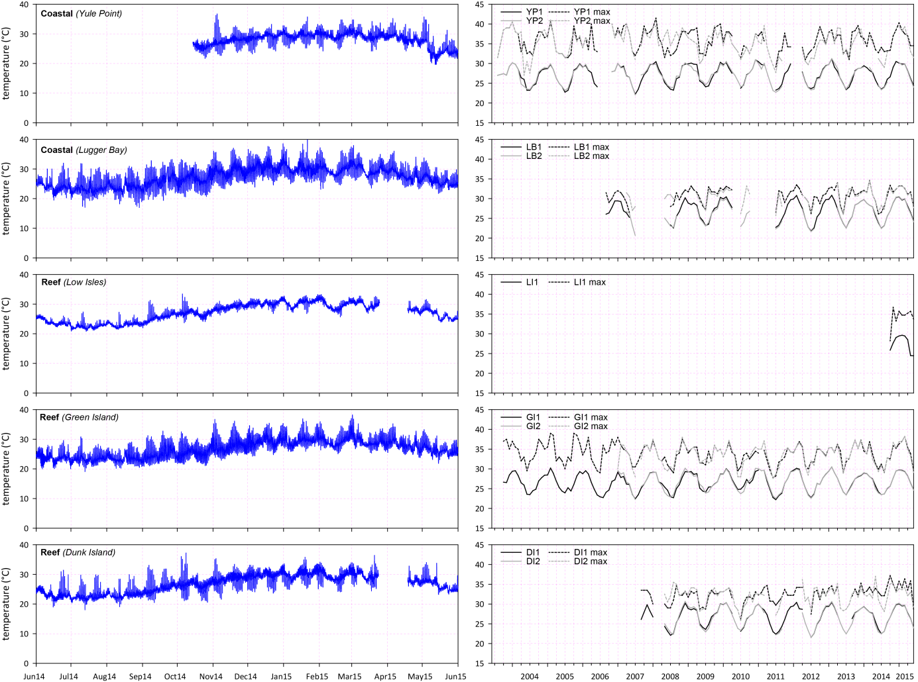
Figure 171. Within seagrass canopy temperatures (°C) at intertidal monitoring locations in Wet Tropics NRM region
: daily mean (sites pooled) over 2014-15 monitoring period (left); and long-term monthly mean and maximum within seagrass canopy temperature at each site (right).

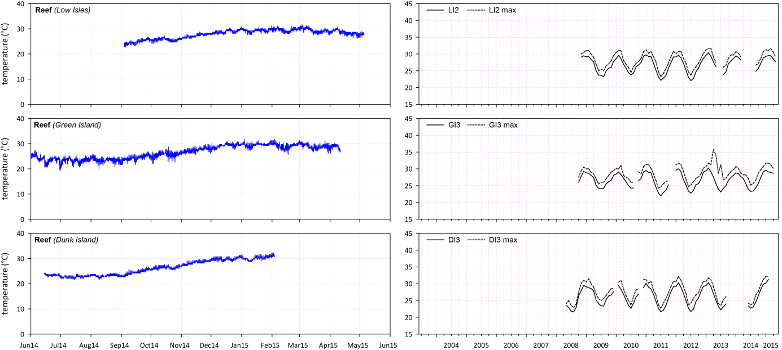
Figure 172. Daily within seagrass canopy temperature (°C) over the 2013-15 monitoring period (left) and long-term monthly mean and maximum (right) at Low Isles (top), Green Island (middle) and Dunk Island (bottom) subtidal meadows within the Wet Tropics region.
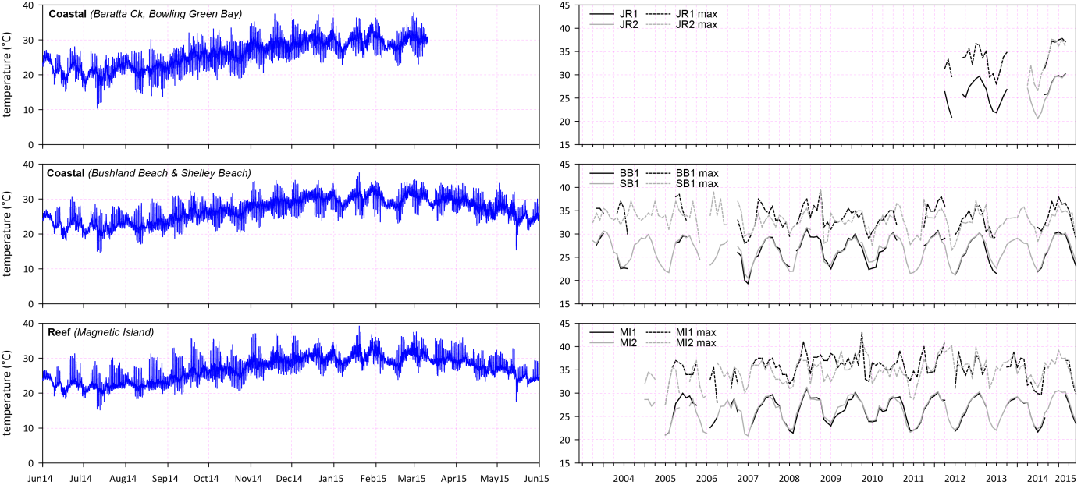
Figure 173. Within seagrass canopy temperatures (°C) at intertidal monitoring locations in Burdekin NRM region
: daily mean (sites pooled) over 2014-15 monitoring period (left); and long-term monthly mean and maximum within seagrass canopy temperature at each site (right).

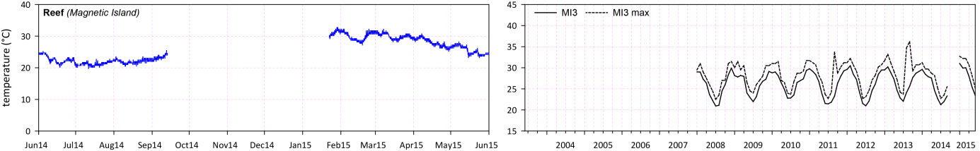
Figure 174. Within seagrass canopy temperatures (°C) at subtidal monitoring locations in Burdekin NRM region
: daily mean (sites pooled) over 2014-15 monitoring period (left); and long-term monthly mean and maximum within seagrass canopy temperature at each site (right).

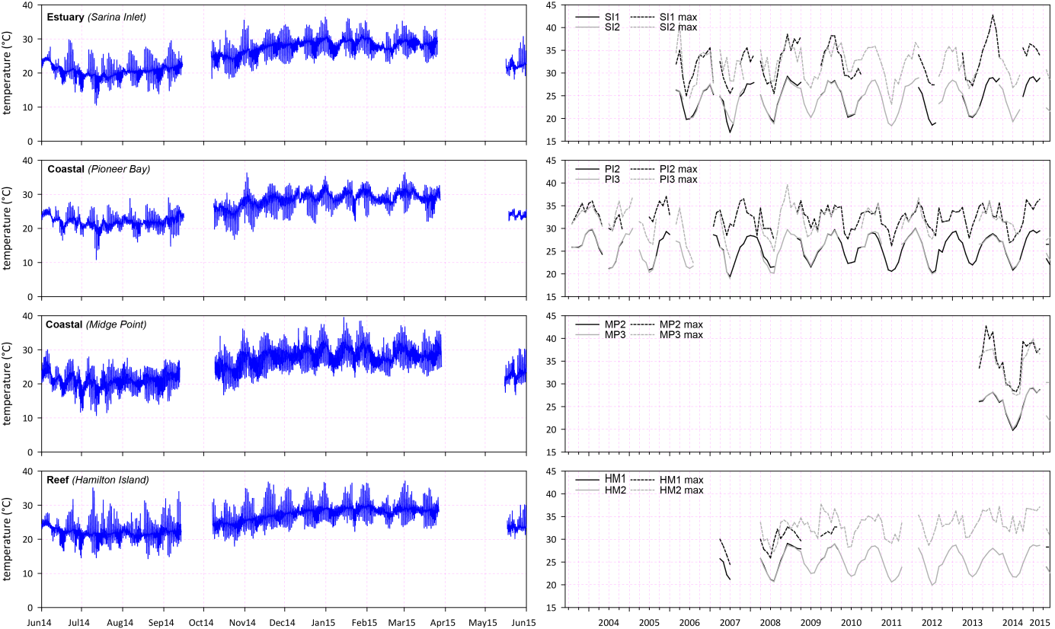
Figure 175. Within seagrass canopy temperatures (°C) at intertidal monitoring locations in Mackay Whitsunday NRM region
: daily mean (sites pooled) over 2014-15 monitoring period (left); and long-term monthly mean and maximum within seagrass canopy temperature at each site (right).

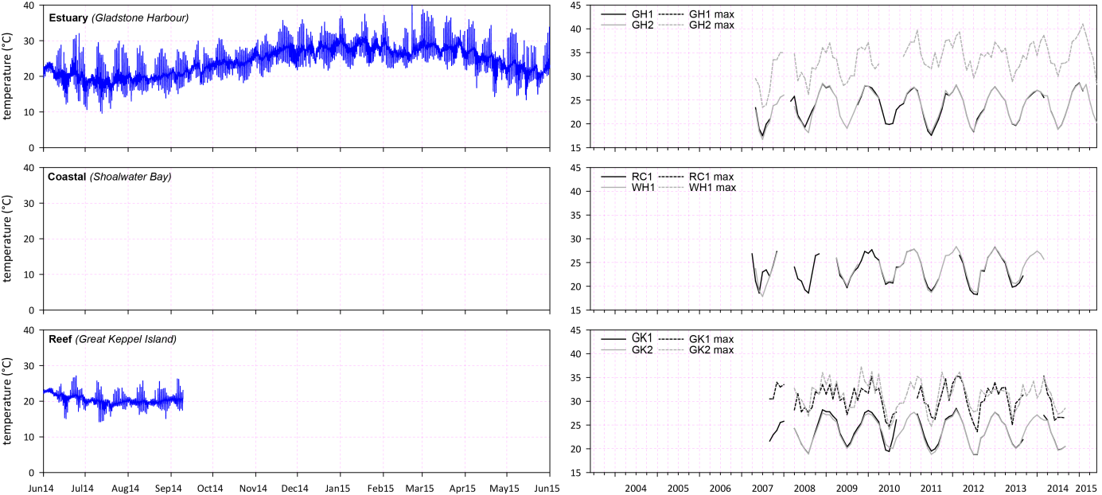
Figure 176. Within seagrass canopy temperatures (°C) at monitoring locations in Fitzroy NRM region
: daily mean (sites pooled) over 2014-15 monitoring period (left); and long-term monthly mean and maximum within seagrass canopy temperature at each site (right).

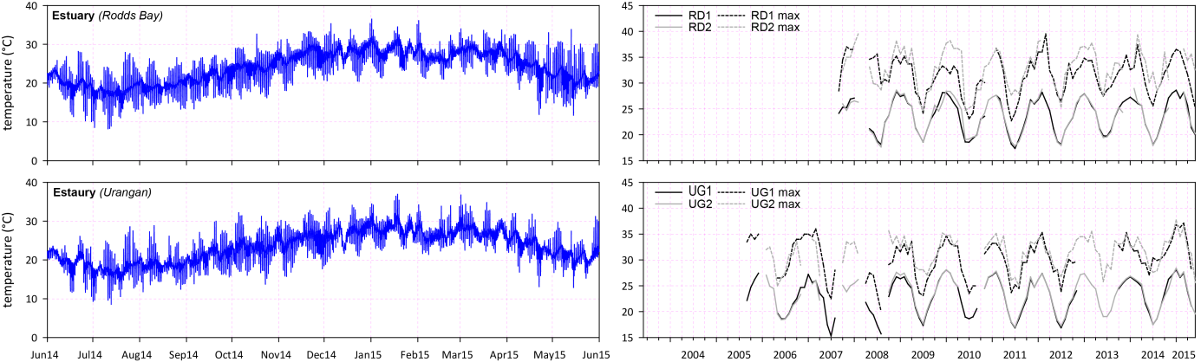
Figure 177. Within seagrass canopy temperatures (°C) at monitoring locations in Burnett Mary NRM region
: daily mean (sites pooled) over 2014-15 monitoring period (left); and long-term monthly mean and maximum within seagrass canopy temperature at each site (right).

Light at seagrass canopy
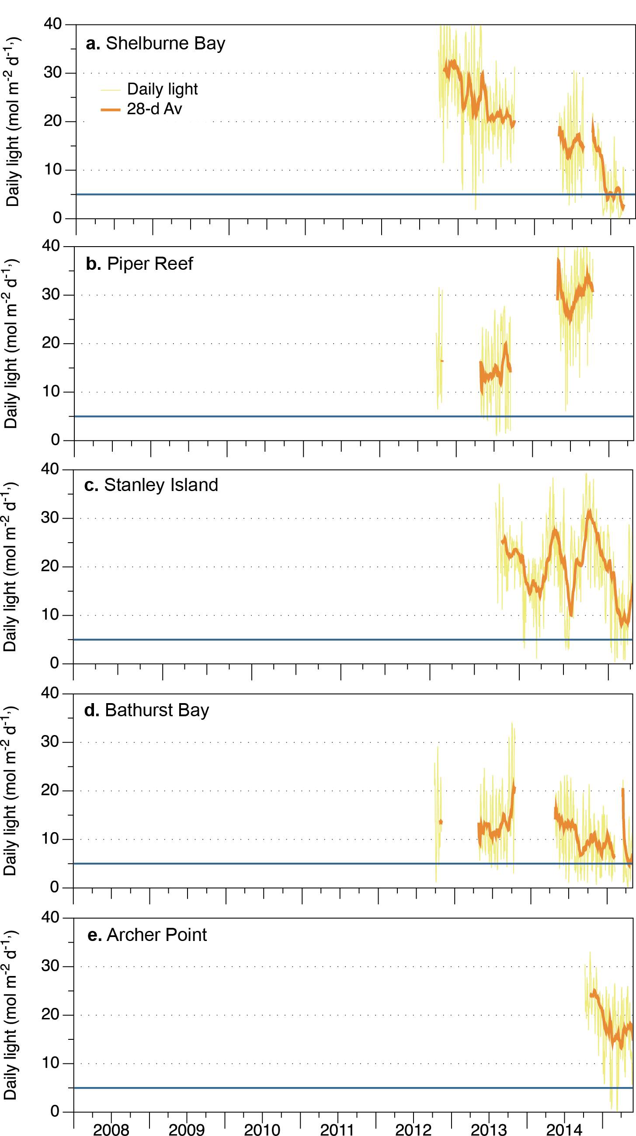
Figure 178. Daily light (28-day rolling average) at Cape York locations
, also showing approximate light threshold required for positive growth in Halodule uninervis dominated communities (5 mol m⁻² d⁻¹) Collier, et al. 2012b NB threshold is based on 90-day average.

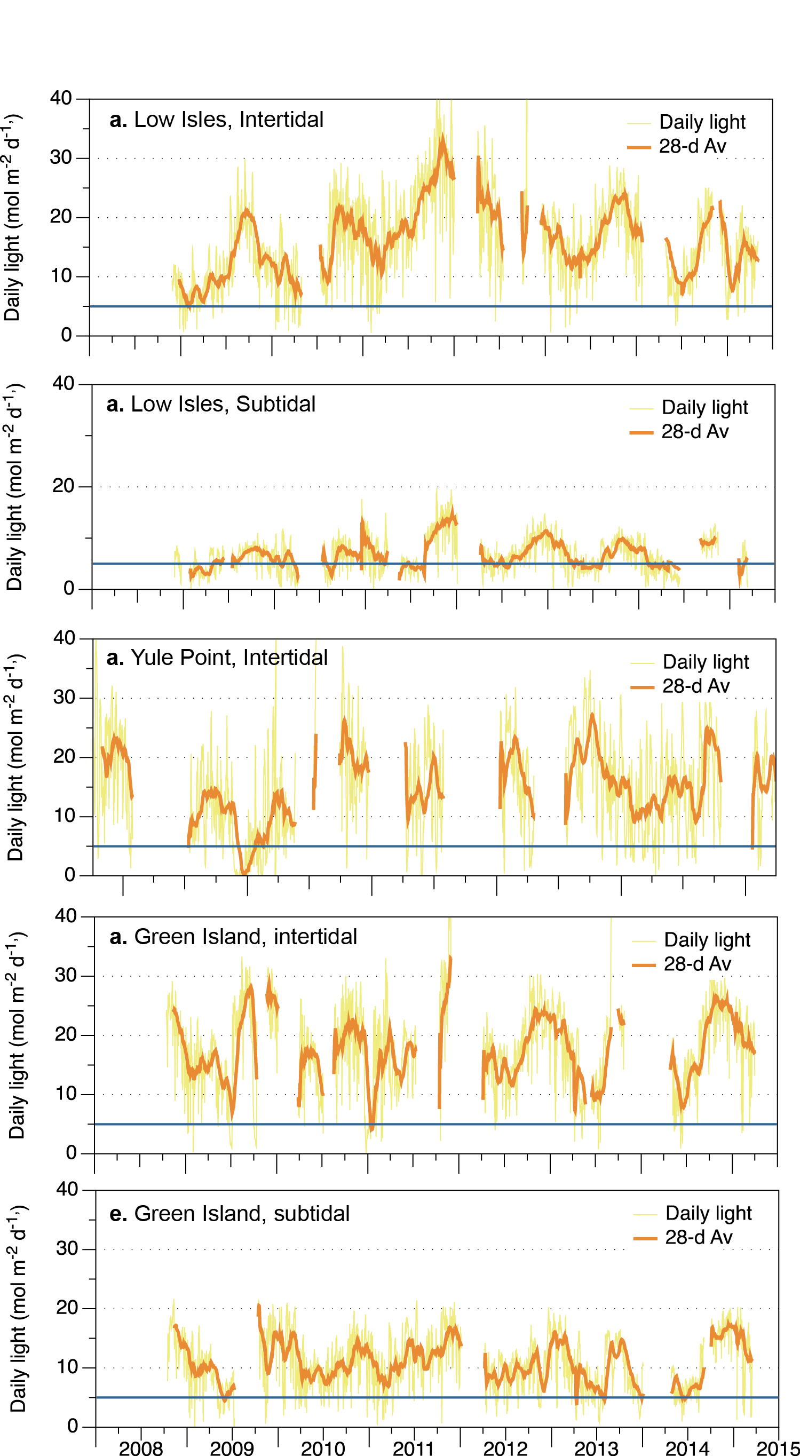
Figure 179. Daily light (yellow line) and 28-day rolling average (orange, bold line) for locations in the northern Wet Tropics
. Also shown is an event-based light threshold (5 mol m⁻² d⁻¹) for H. uninervis (Collier, et al. 2012b)

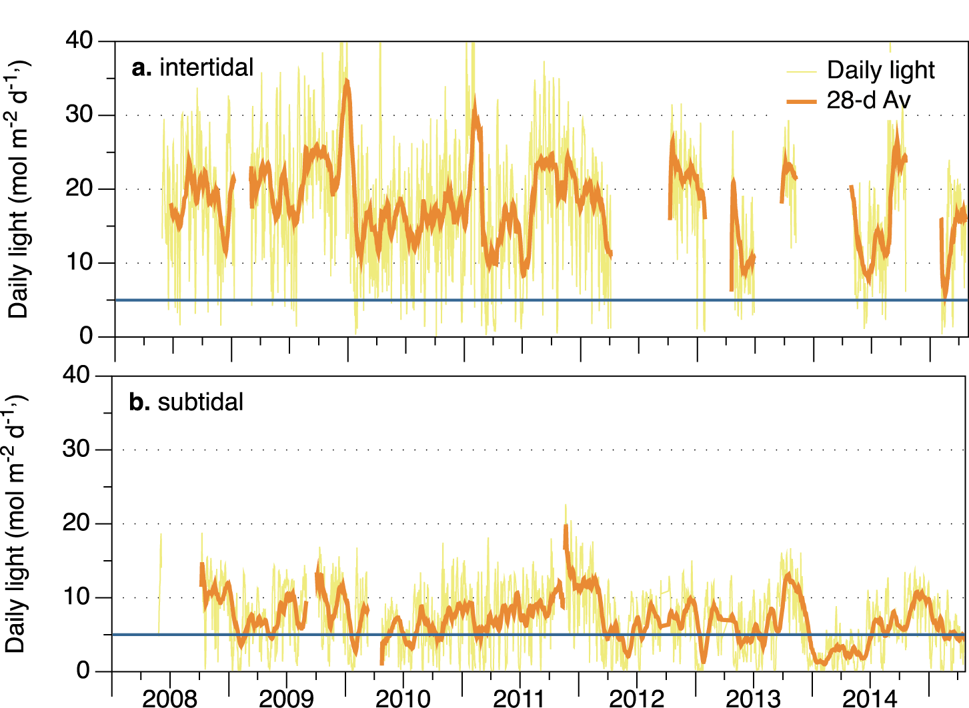
Figure 180. Daily light (yellow line) and 28-day rolling average (orange, bold line) for locations in the southern Wet Tropics
. Also shown is an event-based light threshold (5 mol m⁻² d⁻¹) for H. uninervis (Collier, et al. 2012b)

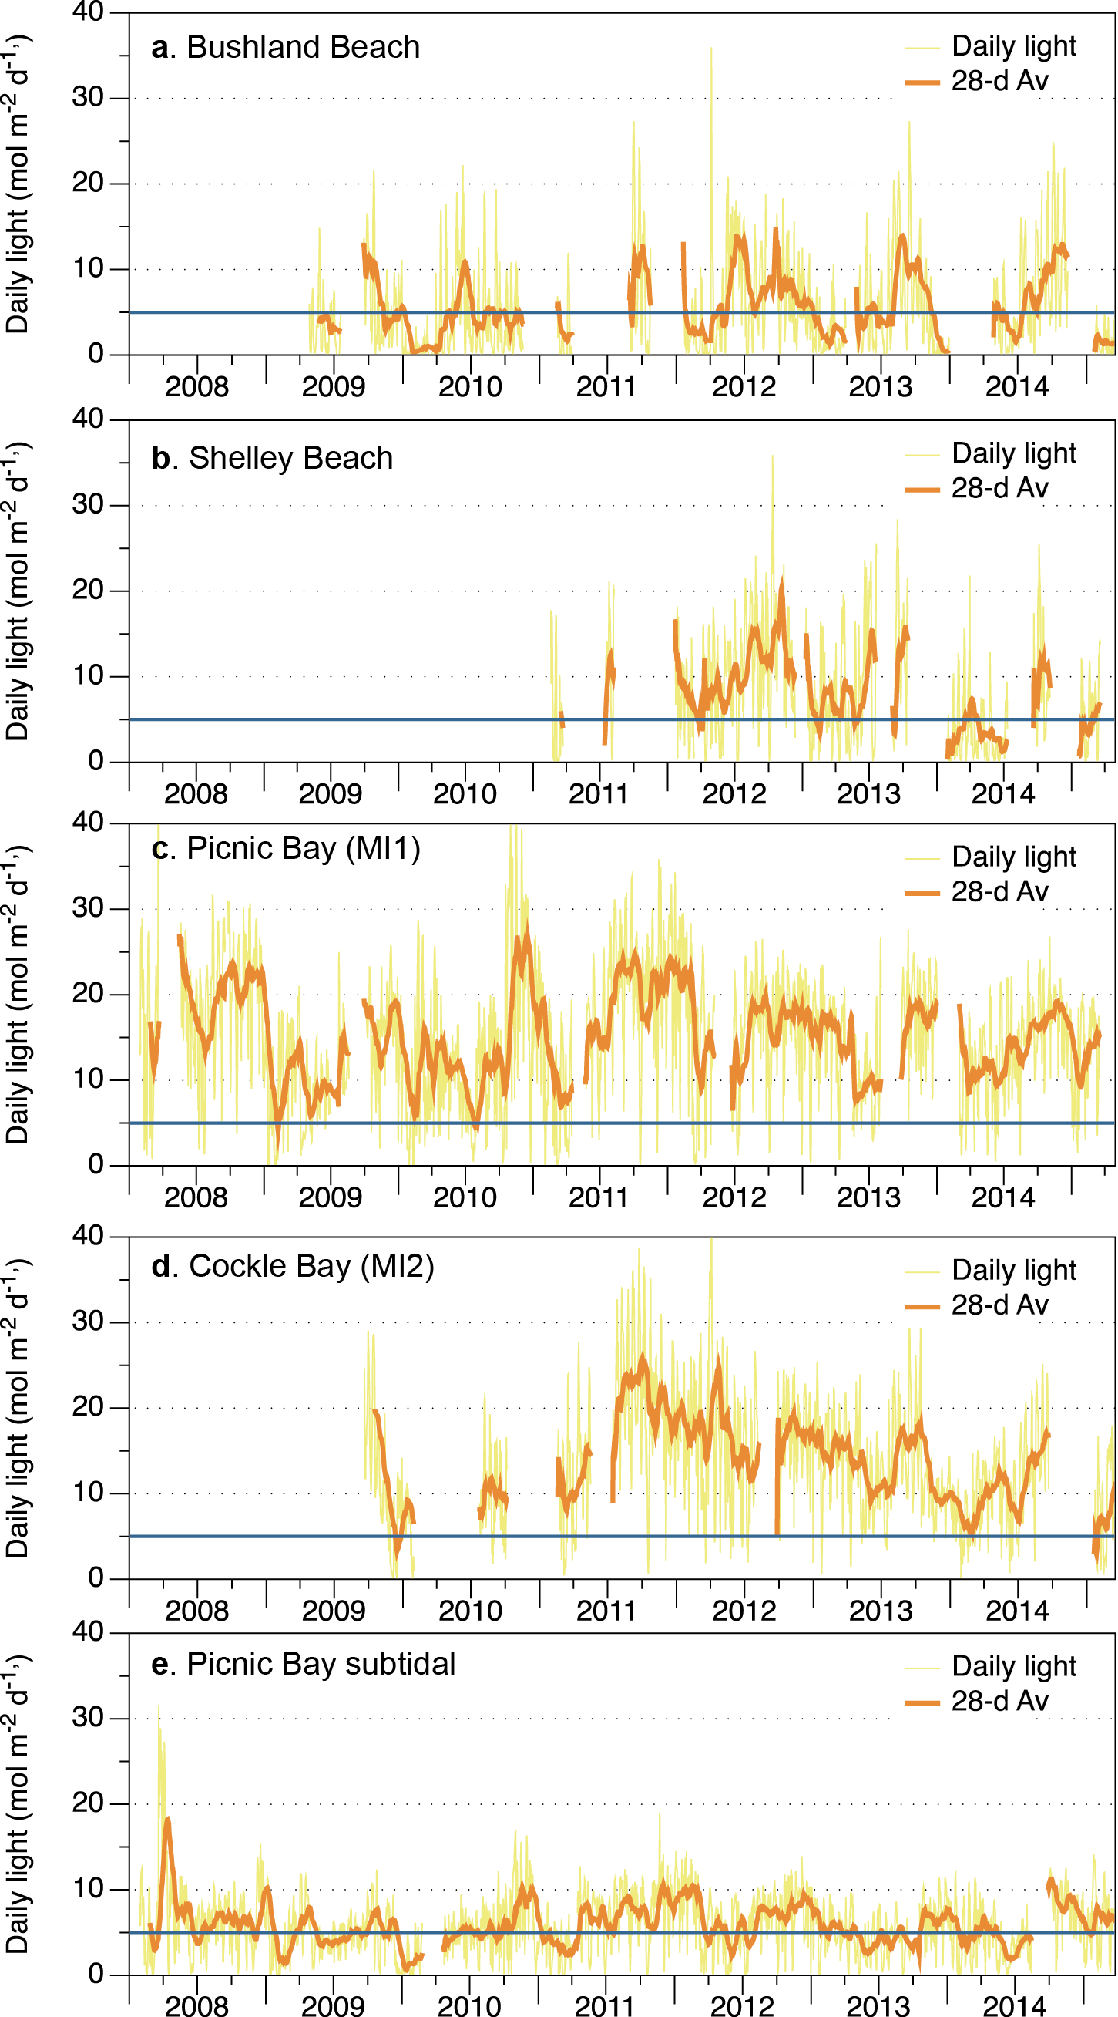
Figure 181. Daily light (yellow line) and 28-day rolling average (orange, bold line) at locations in the Burdekin region
. Also shown is an event-based light threshold (5 mol m⁻² d⁻¹) for H. uninervis (Collier, et al. 2012b).

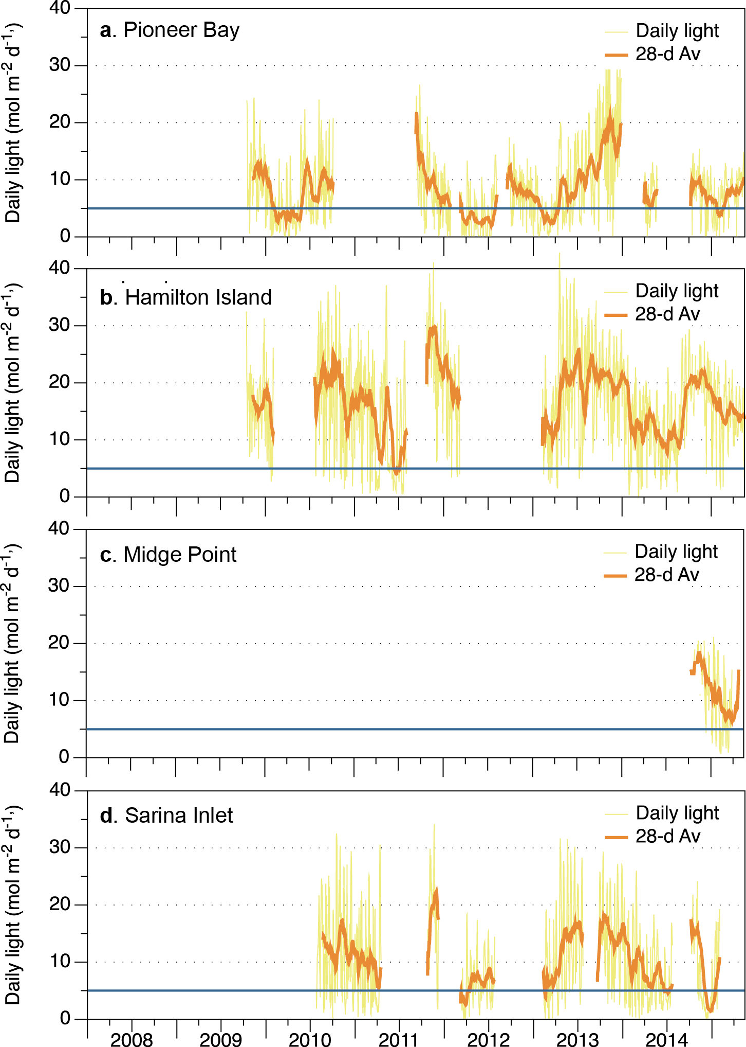
Figure 182. Daily light (yellow line) and 28-day rolling average (orange, bold line) at Mackay Whitsunday habitats.
Also shown is an event-based light threshold (5 mol m⁻² d⁻¹) for H. uninervis (Collier, et al. 2012b).

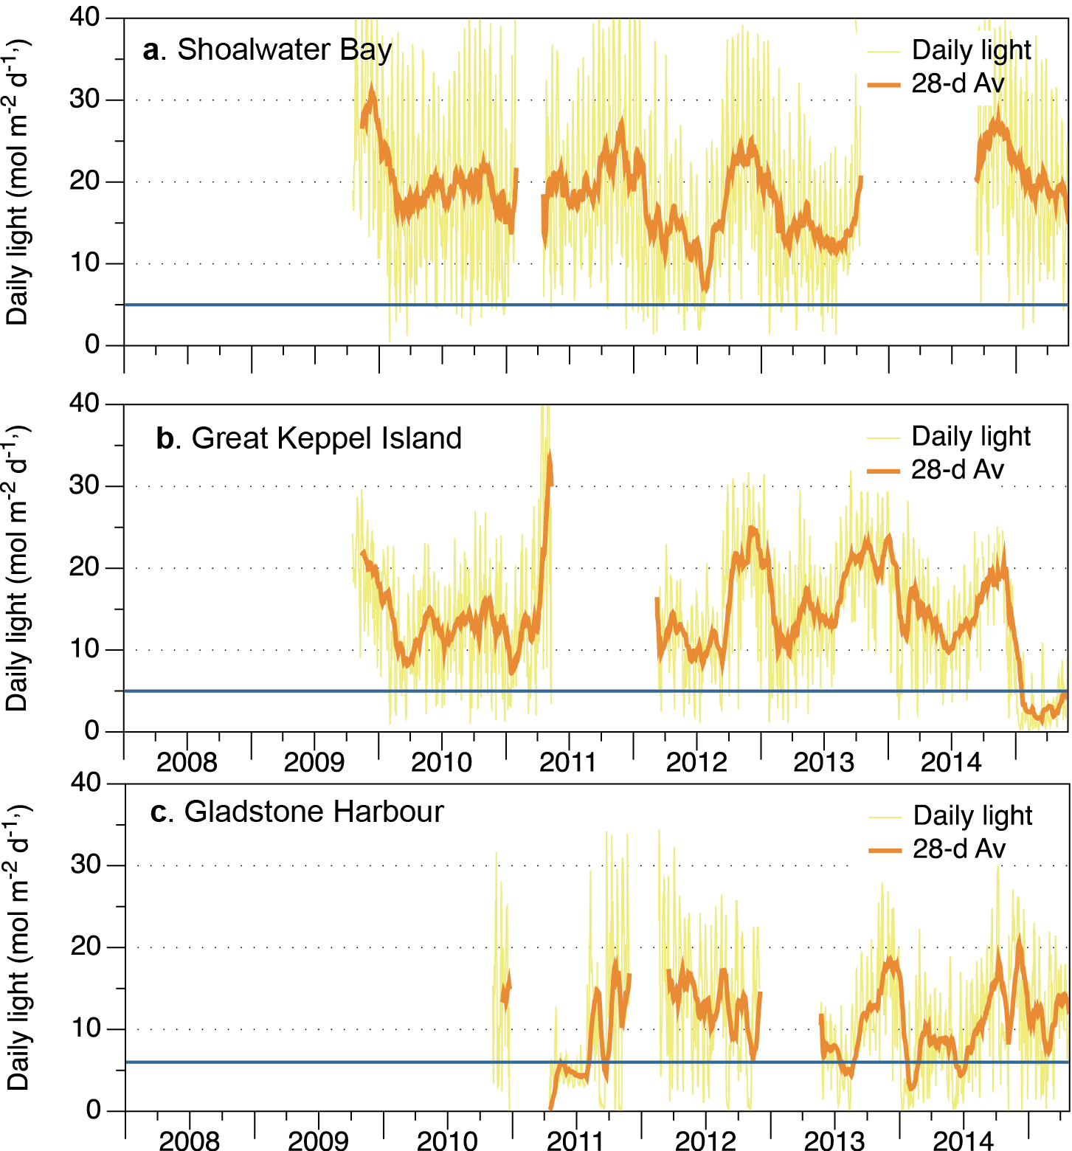
Figure 183. Daily light (yellow line) and 28-day rolling average (orange, bold line) at monitoring locations in the Fitzroy NRM region
. Also displayed is an event based light threshold (5 mol m⁻² d⁻¹) for Halodule uninervis (Collier, et al. 2012b) or for Zostera muelleri (6 mol m⁻² d⁻¹) (Chartrand, et al. 2016).
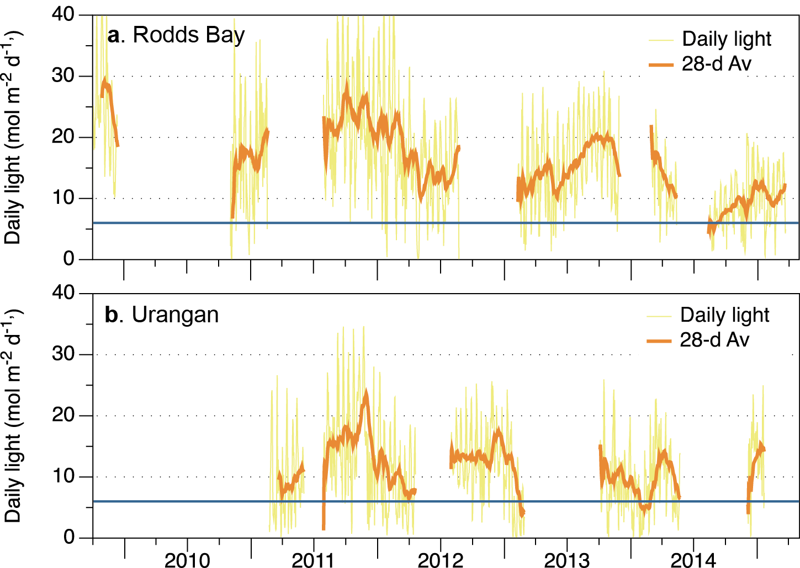
Figure 184. Daily light (yellow line) and 28-day rolling average (orange, bold line) at monitoring locations in the Burnett Mary NRM region
. Also displayed is an event based light threshold (5 mol m⁻² d⁻¹) for Halodule uninervis (Collier, et al. 2012b) or for Zostera muelleri (6 mol m⁻² d⁻¹) (Chartrand, et al. 2016).

Sediments composition
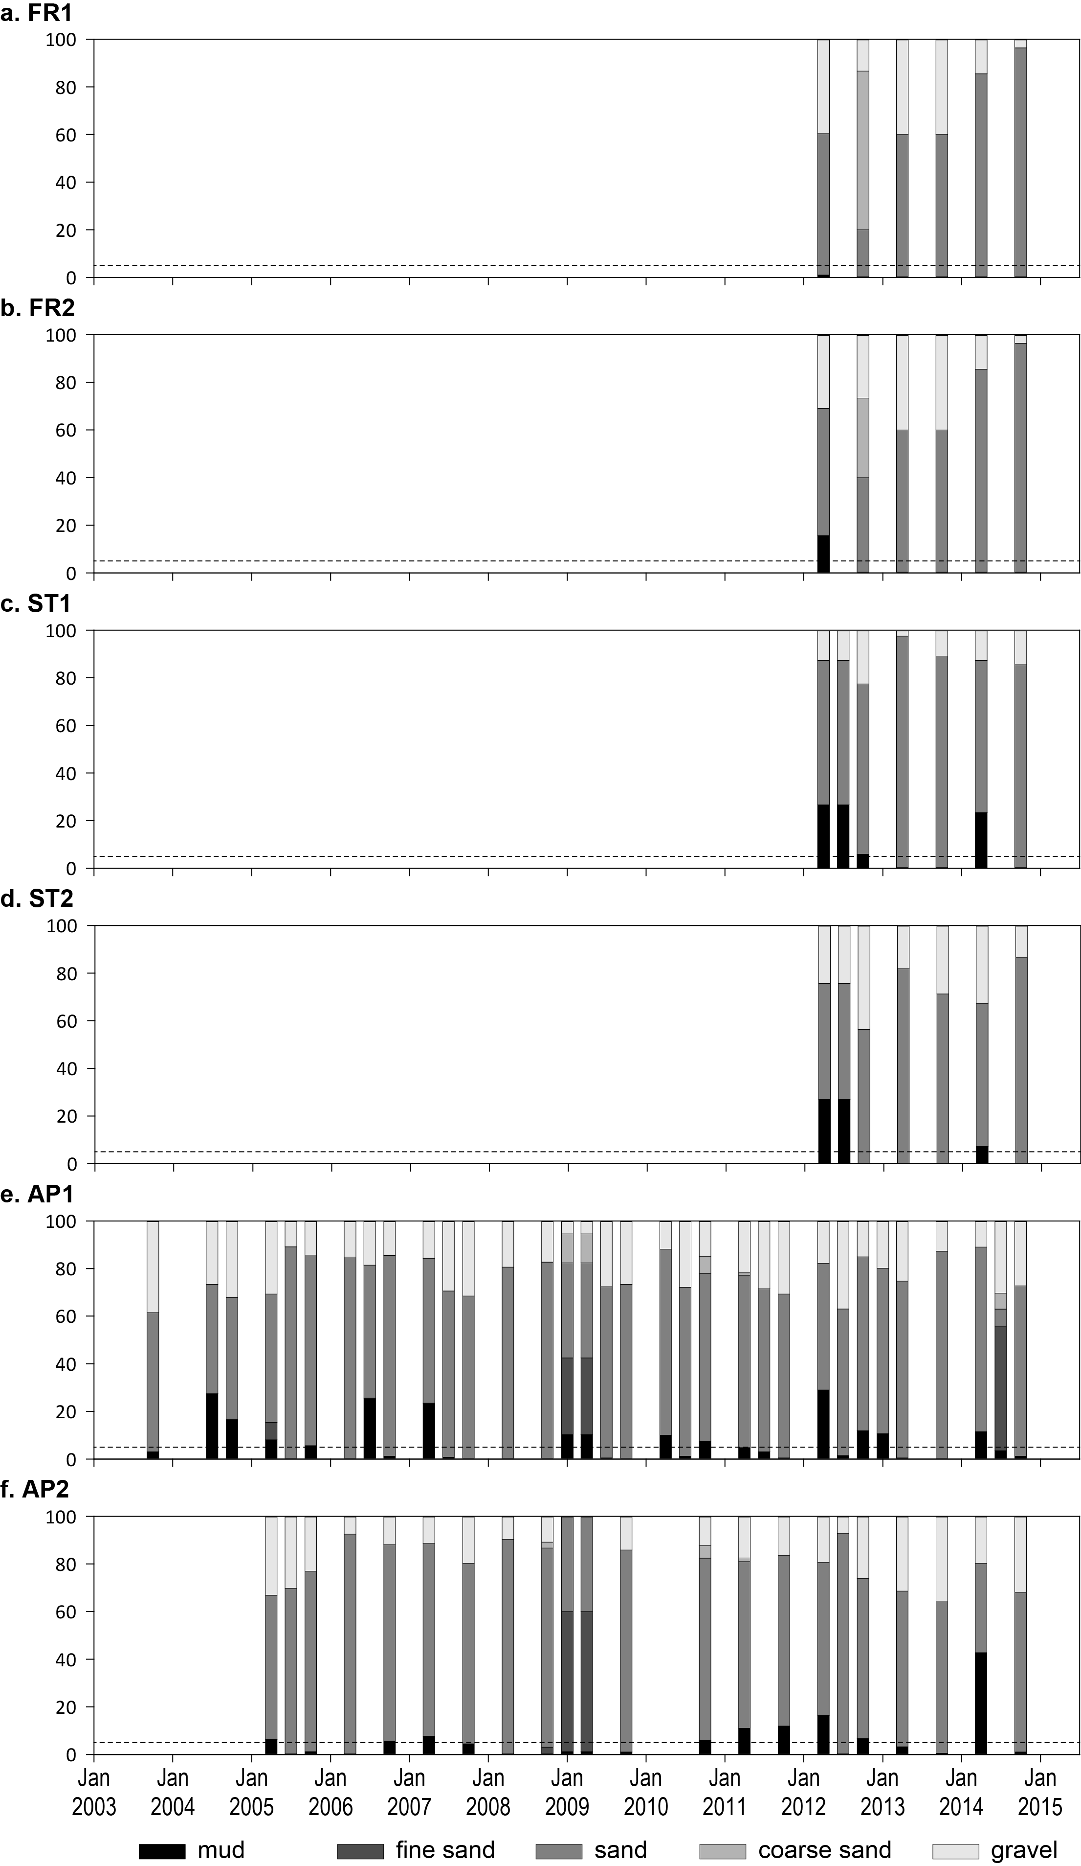
Figure 185. Sediment grain size composition at reef habitat monitoring sites in the Cape York region, 2003-2015.
Dashed line is the GBR long-term average proportion of mud.

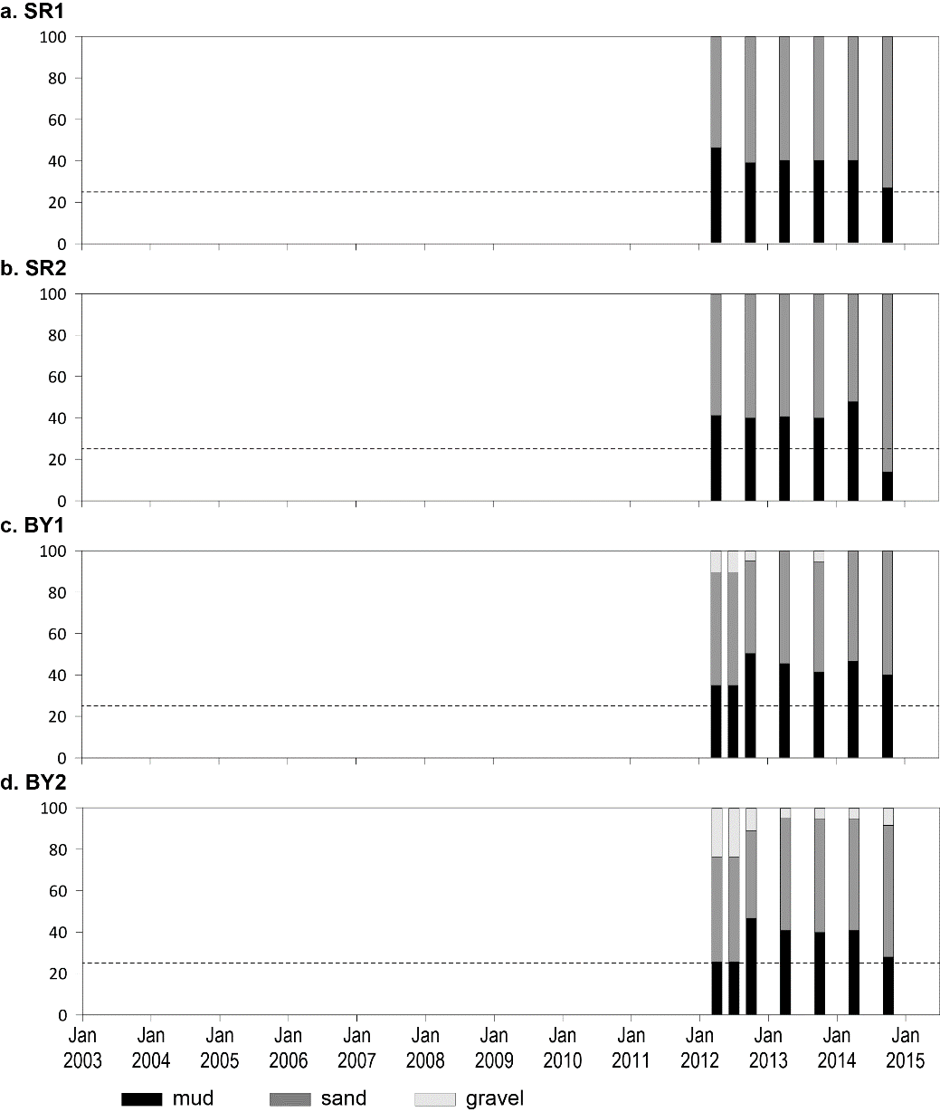
Figure 186. Sediment grain size composition at coastal habitat monitoring sites in the Cape York region, 2013-2015.
Dashed line is the GBR long-term average proportion of mud.

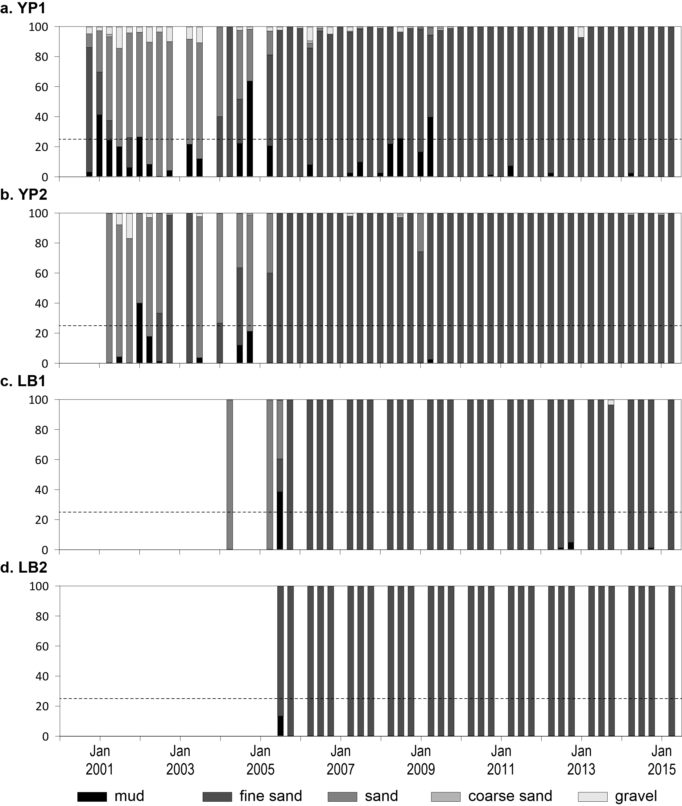
Figure 187. Sediment grain size composition at intertidal coastal habitat monitoring sites in the Wet Tropics region, 2001-2015.
Dashed line is the GBR long-term average proportion of mud.

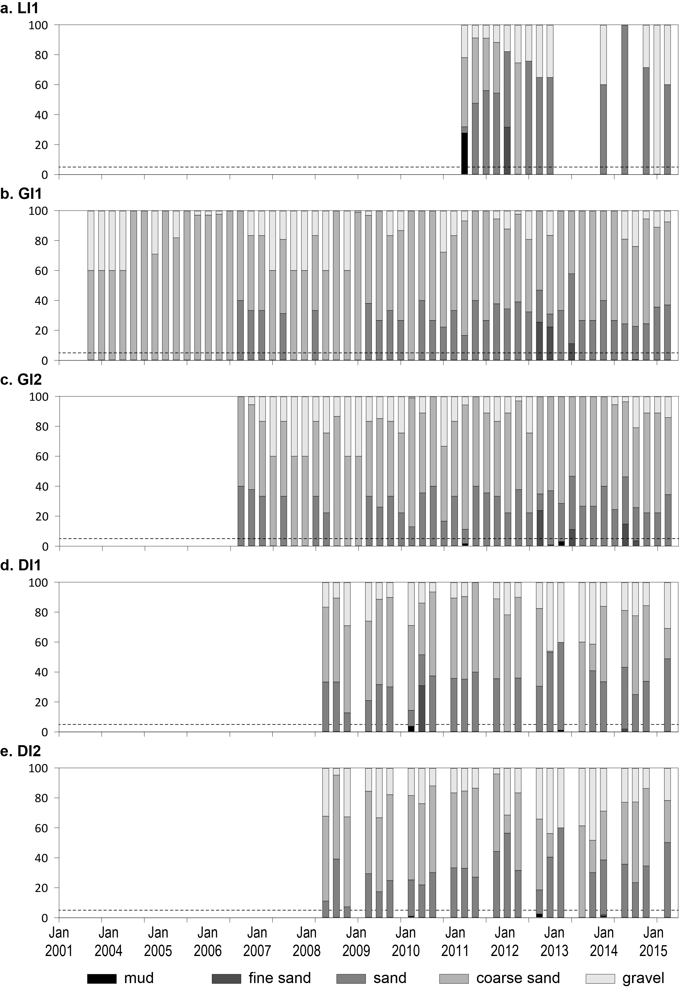
Figure 188. Sediment grain size composition at intertidal reef habitat monitoring sites in the Wet Tropics region, 2001-2015.
Dashed line is the GBR long-term average proportion of mud.

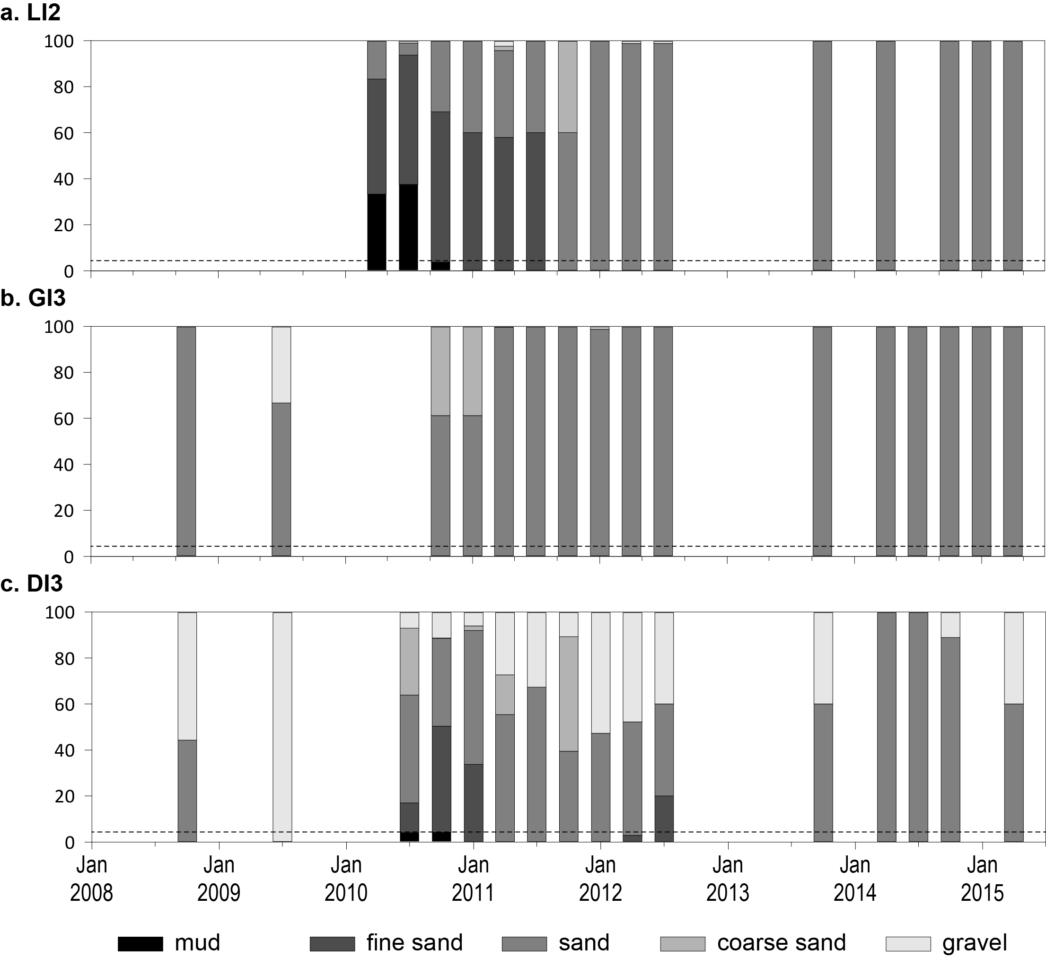
Figure 189. Sediment grain size composition at subtidal reef habitat monitoring sites in the Wet Tropics region, 2008-2015.
Dashed line is the GBR long-term average proportion of mud.

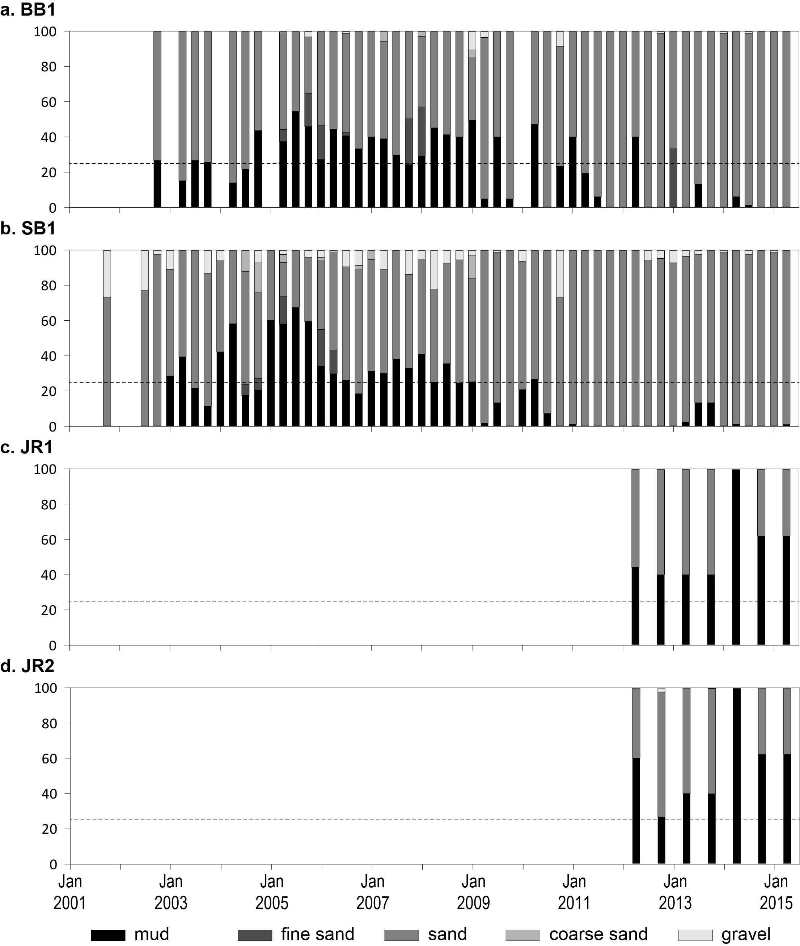
Figure 190. Sediment grain size composition at intertidal coastal habitat monitoring sites in the Burdekin region, 2001-2015.
Dashed line is the GBR long-term average proportion of mud.
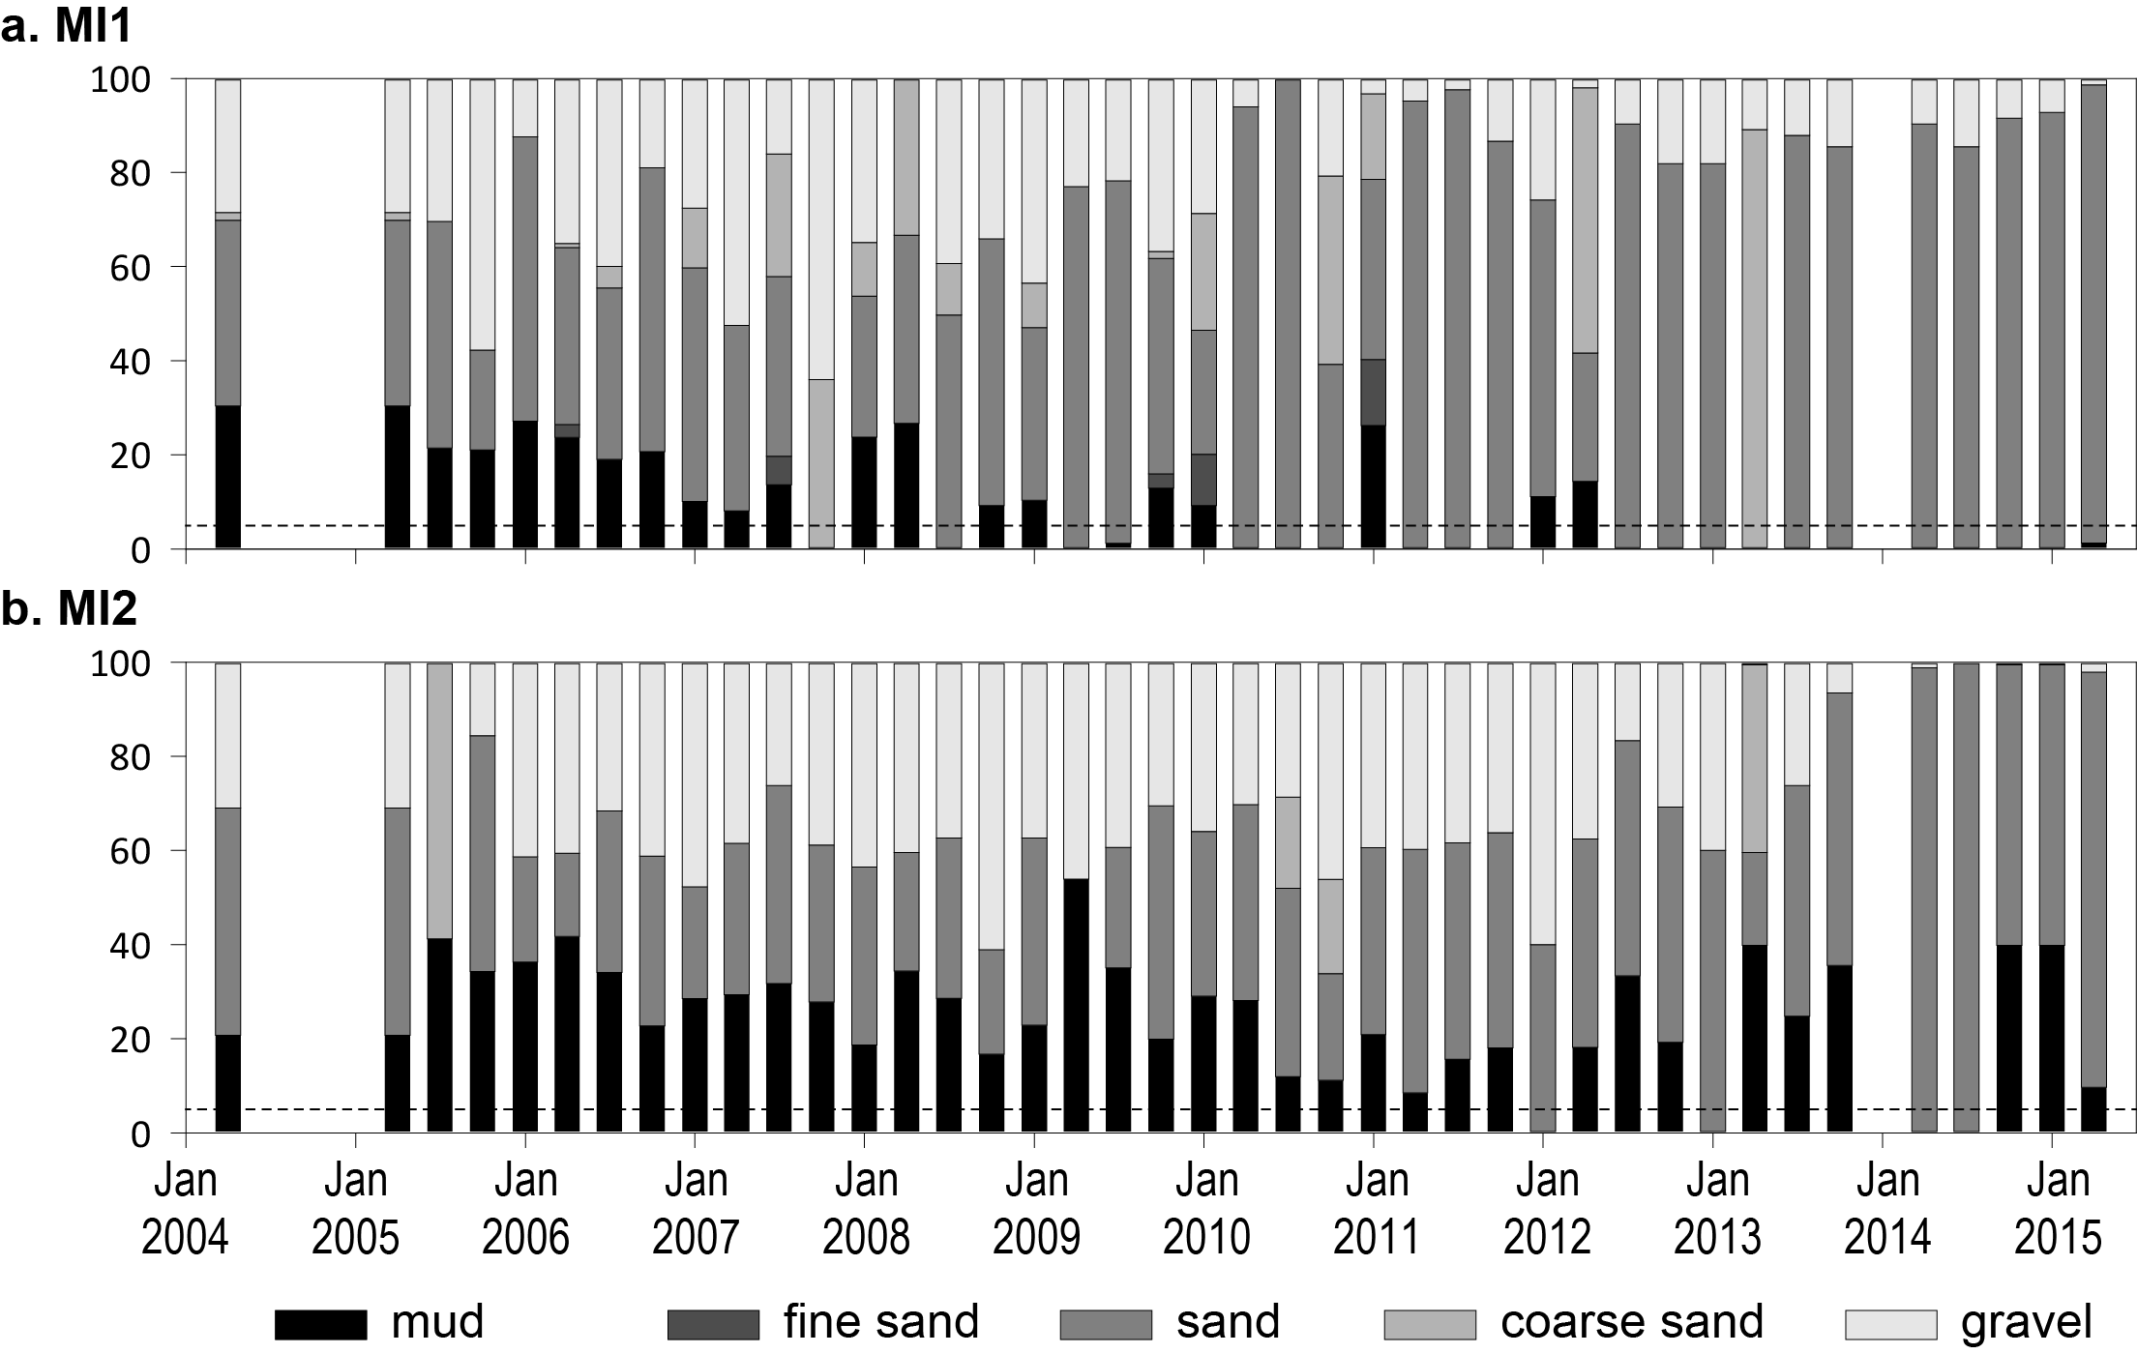
Figure 191. Sediment grain size composition at intertidal reef habitat monitoring sites in the Burdekin region, 2004-2015.
Dashed line is the GBR long-term average proportion of mud.

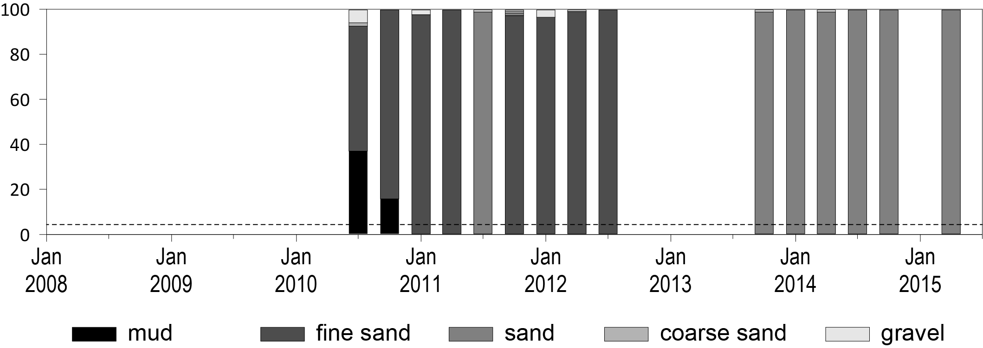
Figure 192. Sediment grain size composition at subtidal reef habitat monitoring sites in the Burdekin region, 2010-2015.
Dashed line is the GBR long-term average proportion of mud.

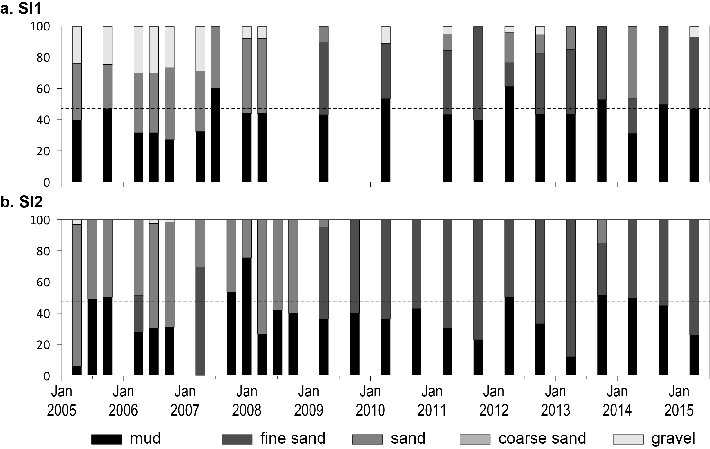
Figure 193. Sediment grain size composition at intertidal estuary habitat monitoring sites in the Mackay Whitsunday region, 2005-2015.
Dashed line is the GBR long-term average proportion of mud.

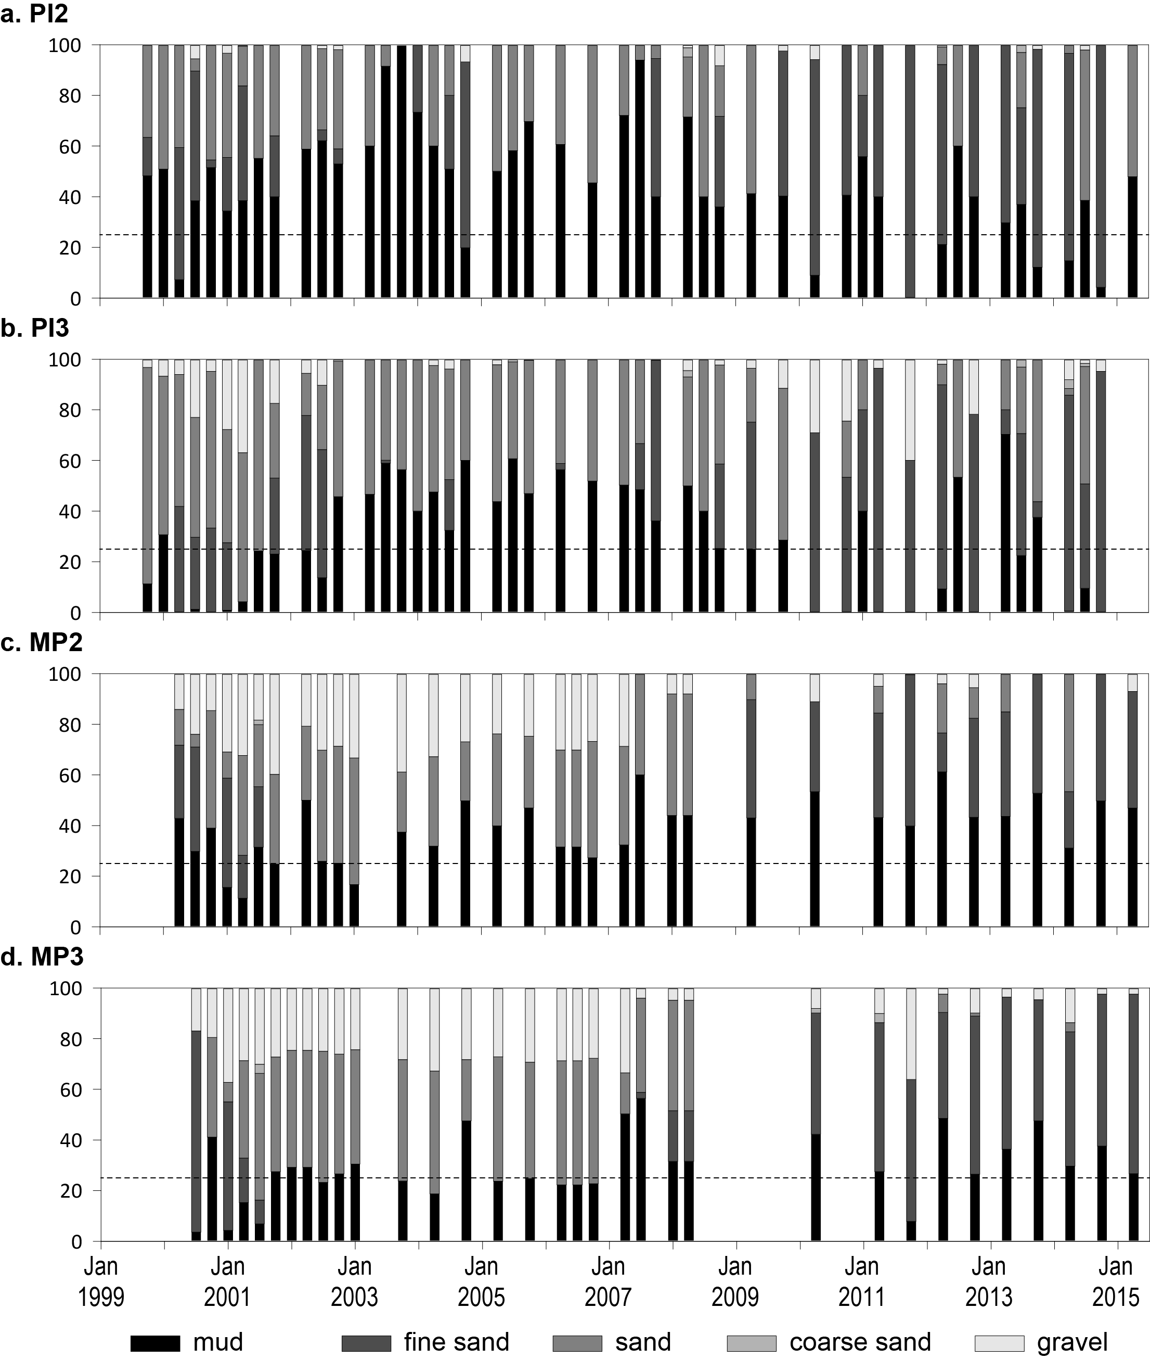
Figure 194. Sediment grain size composition at intertidal coastal habitat monitoring sites in the Mackay Whitsunday region, 1999-2015.
Dashed line is the GBR long-term average proportion of mud.
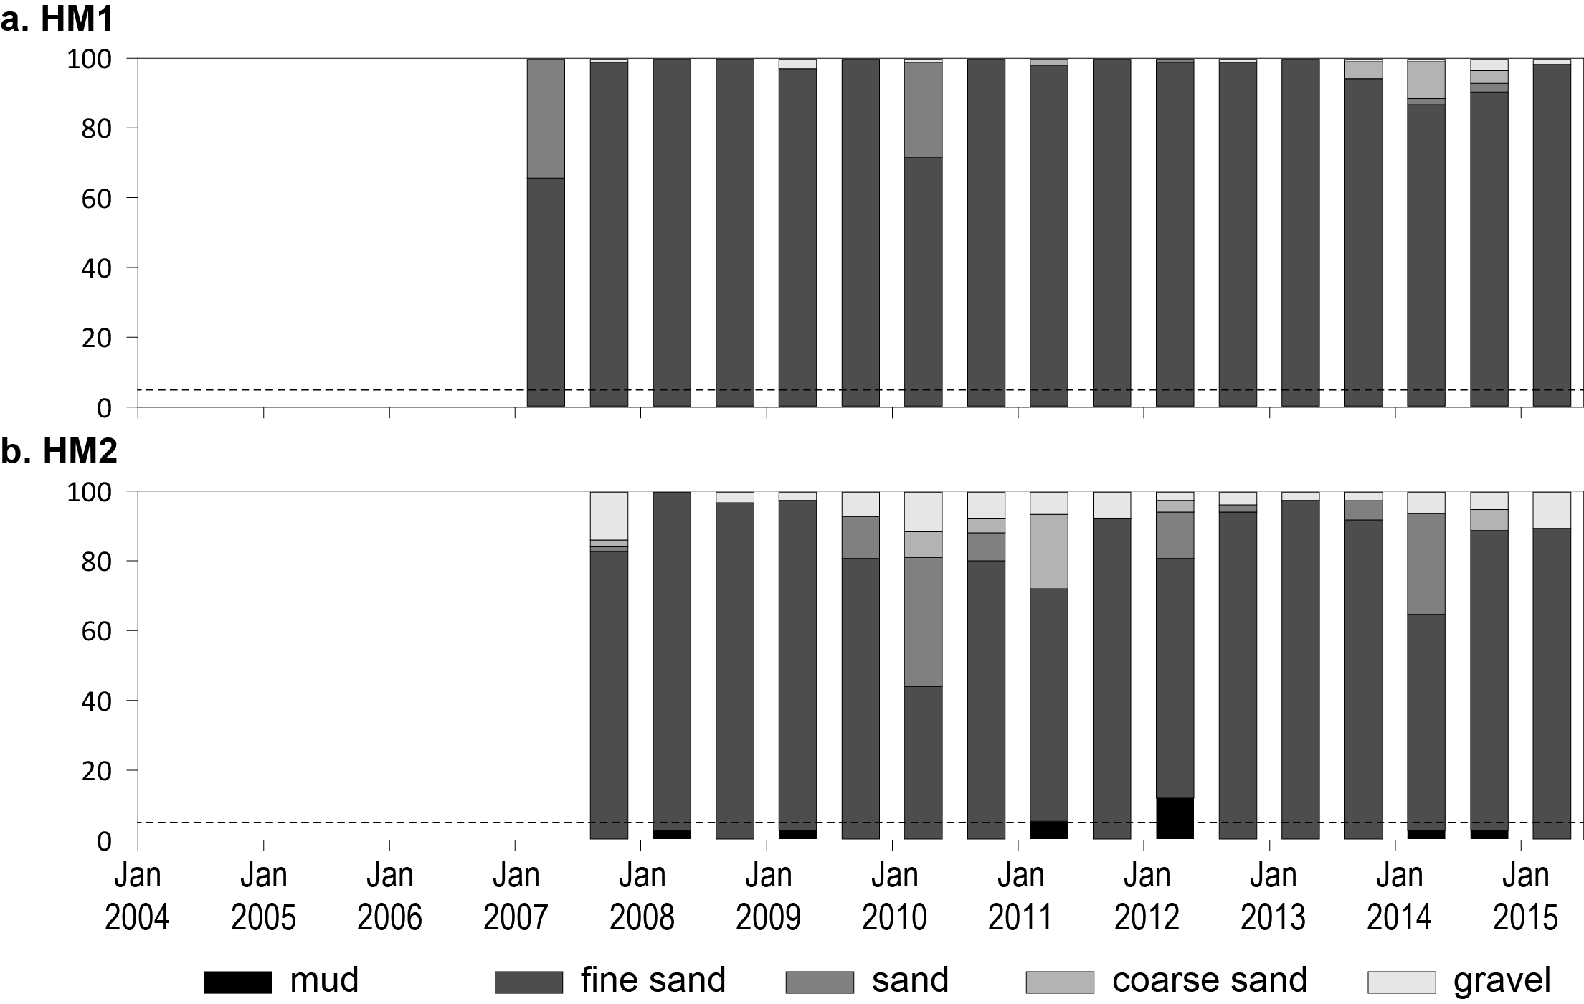
Figure 195. Sediment grain size composition at intertidal reef habitat monitoring sites in the Mackay Whitsunday region, 2007-2015.
Dashed line is the GBR long-term average proportion of mud.

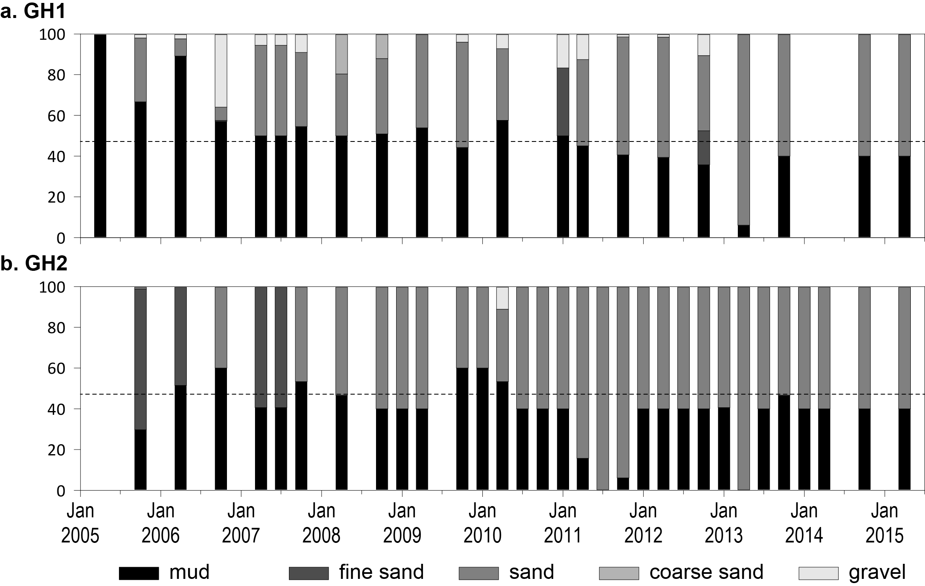
Figure 196. Sediment grain size composition at intertidal estuary habitat monitoring sites in the Fitzroy region, 2005-2015.
Dashed line is the GBR long-term average proportion of mud.

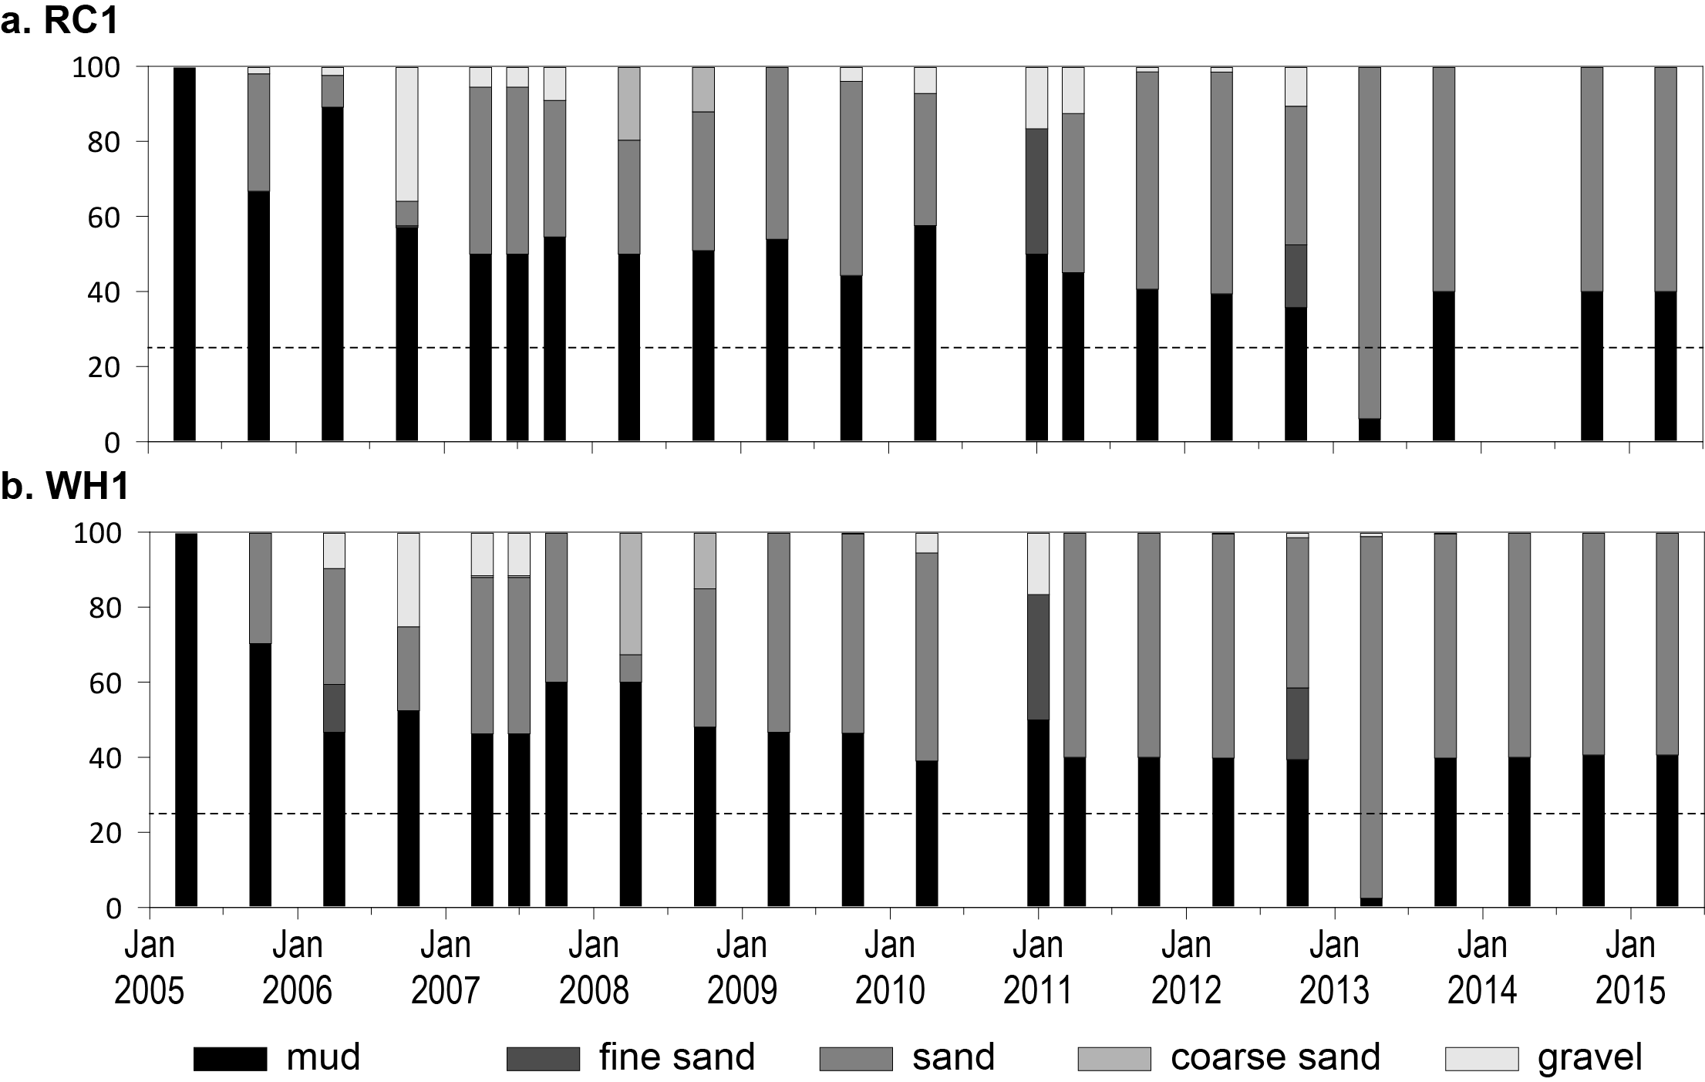
Figure 197. Sediment grain size composition at intertidal coastal habitat monitoring sites in the Fitzroy region, 2005-2015.
Dashed line is the GBR long-term average proportion of mud.

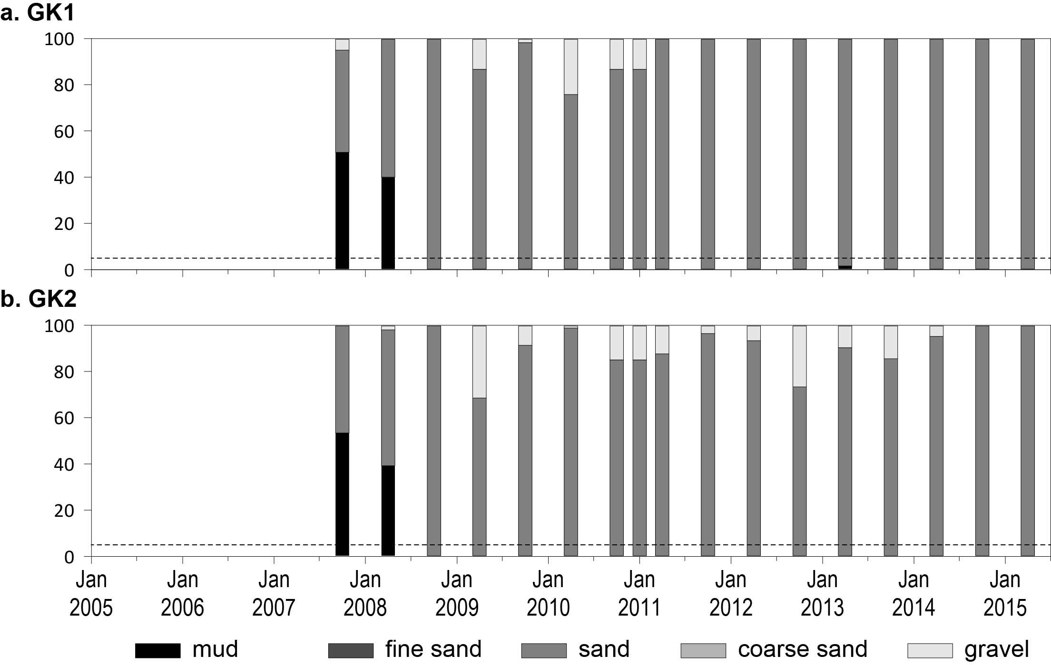
Figure 198. Sediment grain size composition at intertidal reef habitat monitoring sites in the Fitzroy region, 2007-2015.
Dashed line is the GBR long-term average proportion of mud.
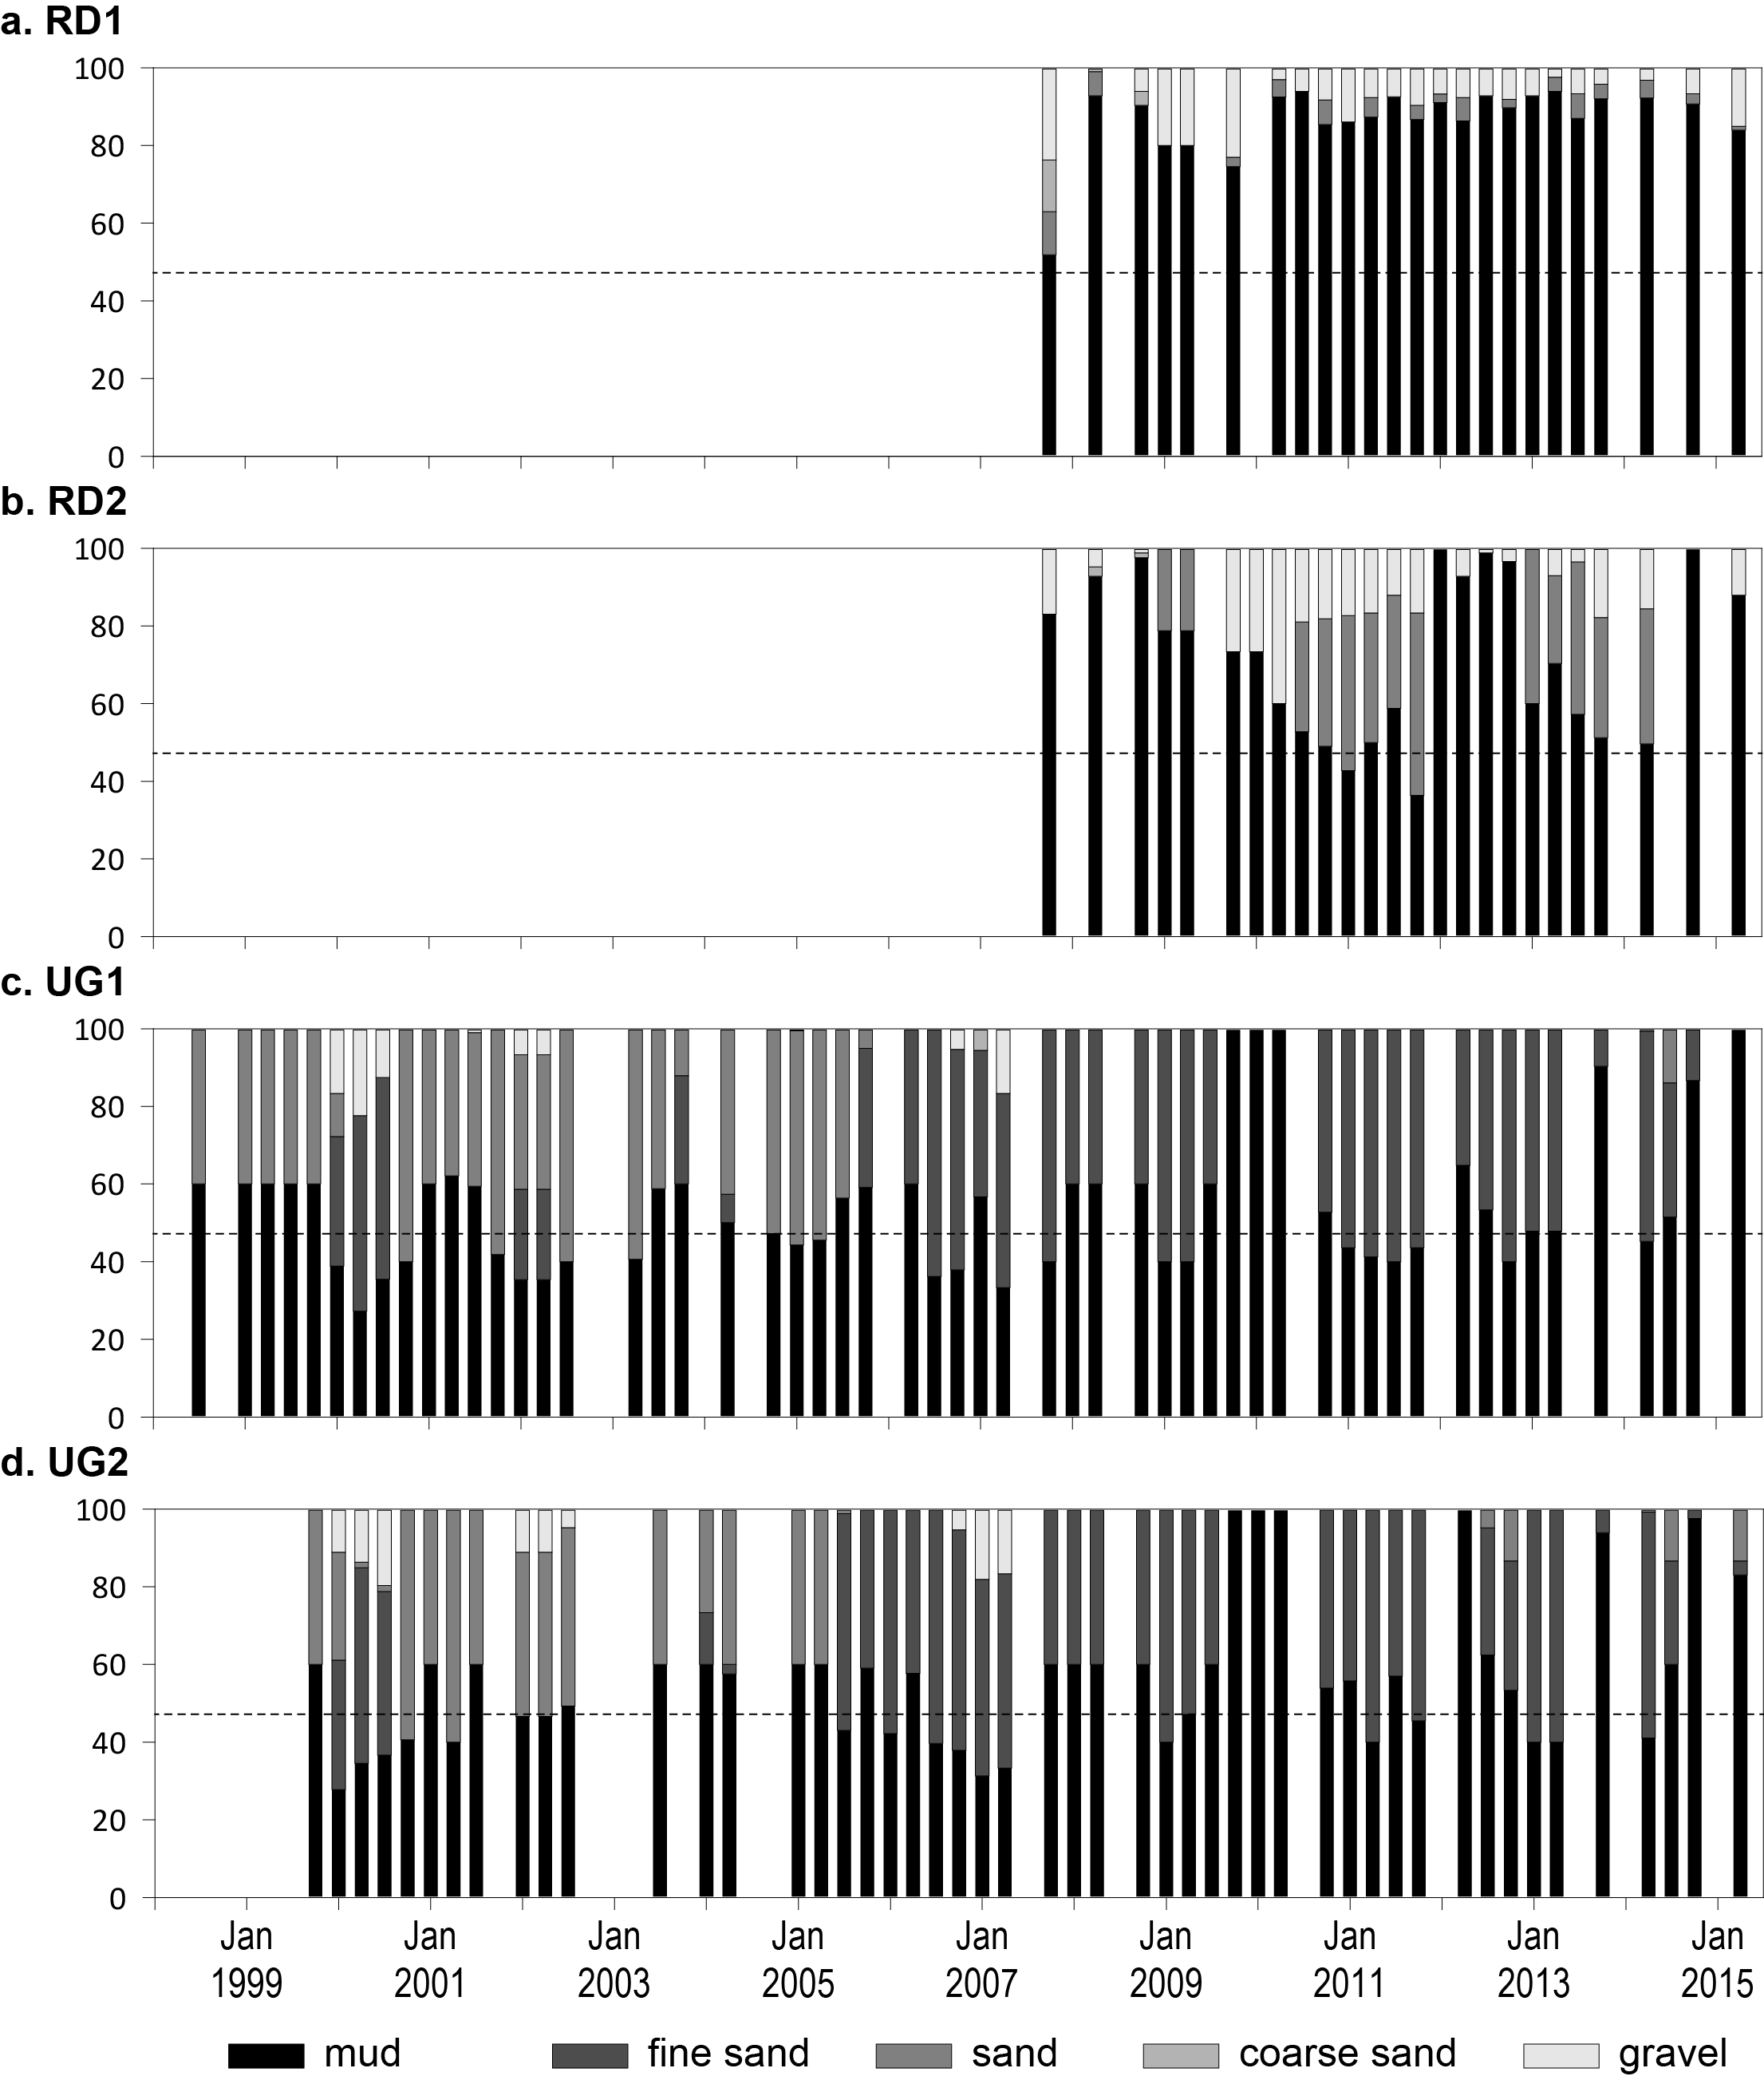
Figure 199. Sediment grain size composition at intertidal estuary habitat monitoring sites in the Burnett Mary region, 1999-2015.
Dashed line is the GBR long-term average proportion of mud.

Seagrass community and environment

Epiphytes and macroalgae
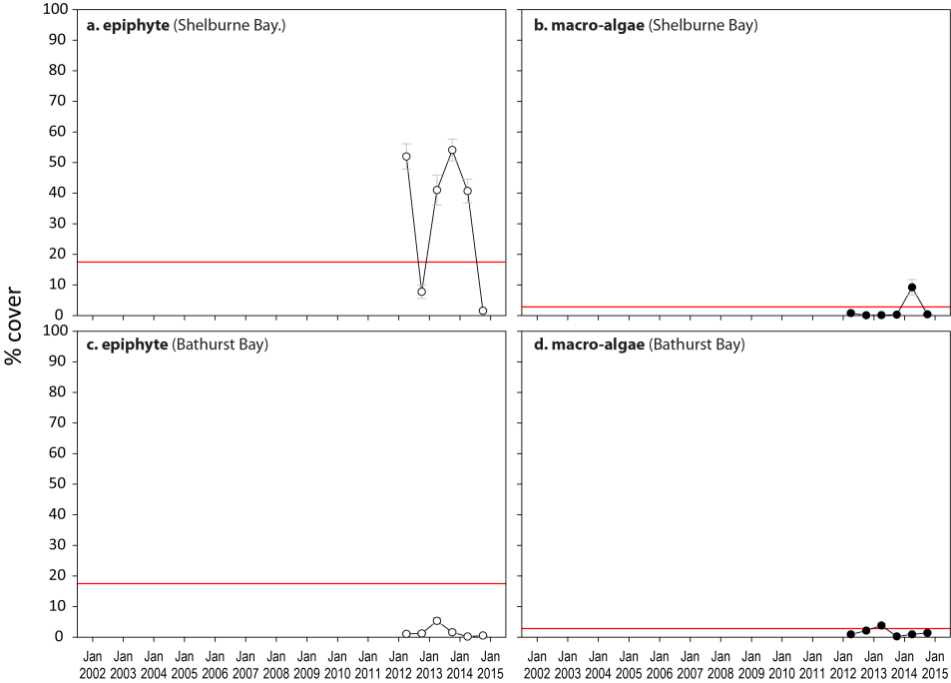
Figure 200. Long-term trend in mean abundance (% cover) (± Standard Error) of epiphytes and macroalgae at intertidal coastal habitats (sites pooled), Cape York NRM region
. Red line = GBR long-term average; epiphytes=15.0%, macroalgae=3.2%.

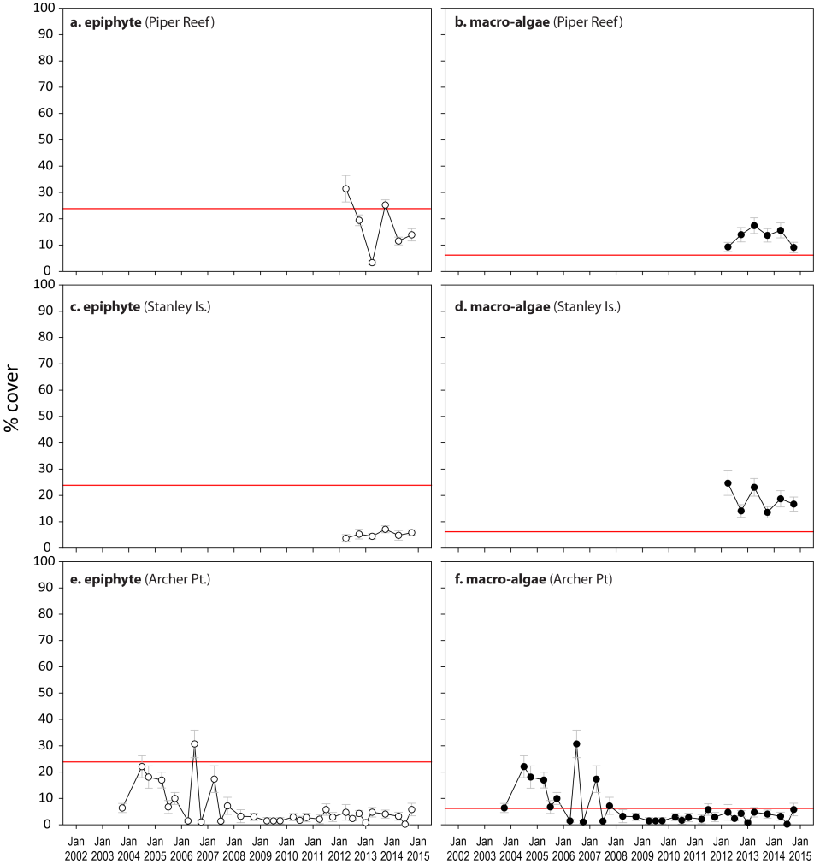
Figure 201. Long-term trend in mean abundance (% cover) (± Standard Error) of epiphytes and macroalgae at intertidal reef habitats (sites pooled), Cape York NRM region
. Red line = GBR long-term average; epiphytes=20.2%, macroalgae=6.1%.
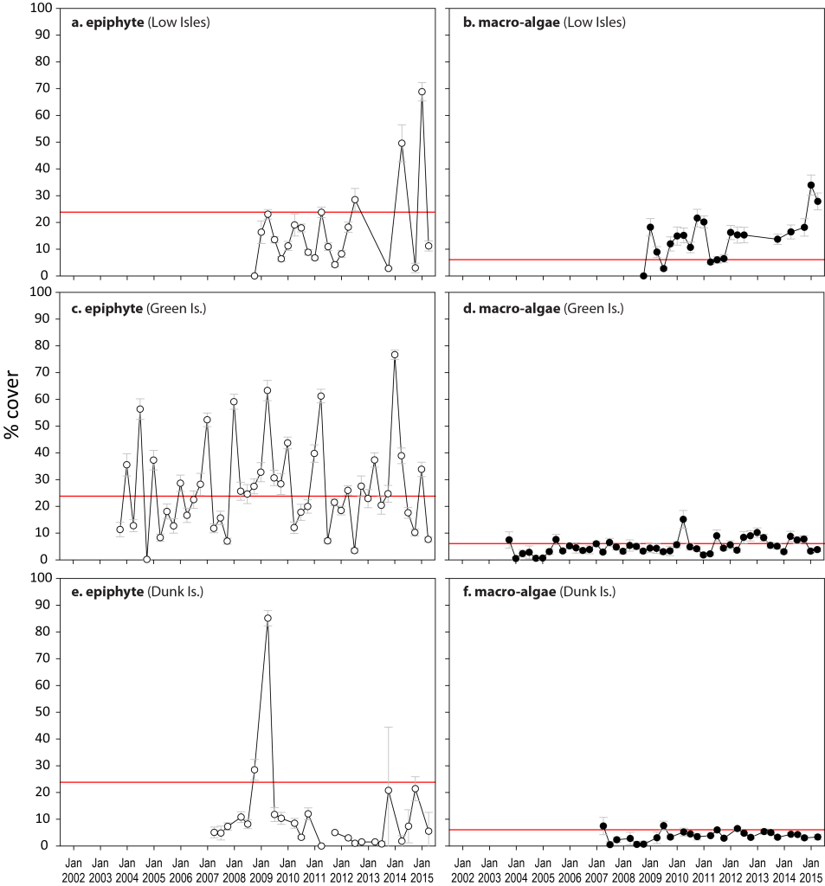
Figure 202. Mean abundance (% cover) (± Standard Error) of epiphytes and macroalgae at intertidal reef seagrass monitoring locations (sites pooled) in the Wet Tropics NRM region
. Red line = GBR long-term average; epiphytes=20.2%, macroalgae=6.1%.
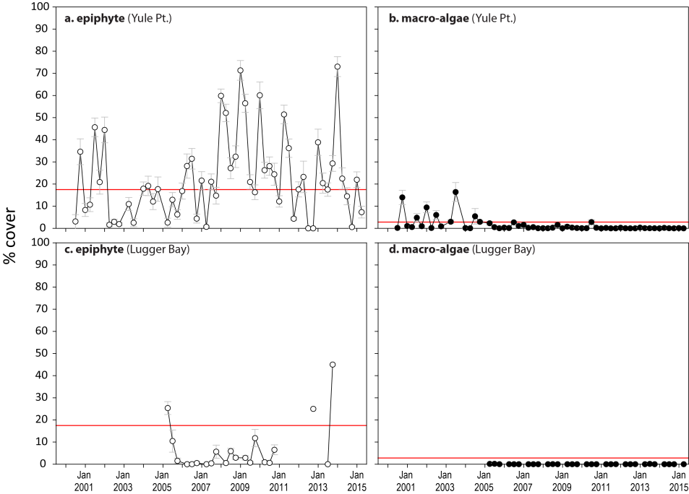
Figure 203. Mean abundance (% cover) (± Standard Error) of epiphytes and macroalgae at coastal intertidal seagrass monitoring locations (sites pooled) in the Wet Tropics NRM region
. Red line = GBR long-term average; epiphytes=15%, macroalgae=3.2%.
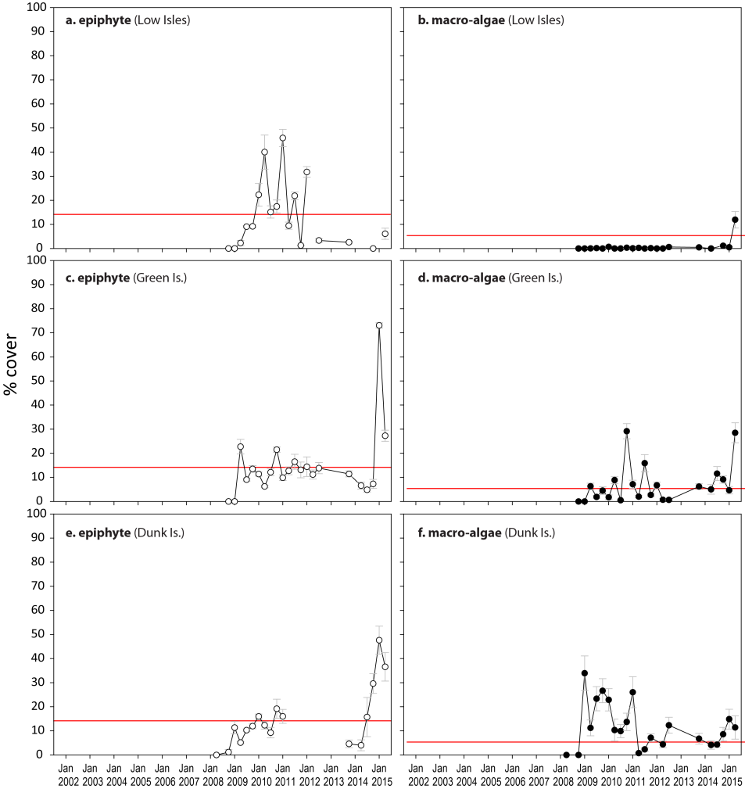
Figure 204. Mean abundance (% cover) (± Standard Error) of epiphytes and macroalgae at subtidal reef seagrass monitoring sites in the Wet Tropics NRM region
. Red line = GBR long-term average for subtidal sites; epiphytes=7.5%, macroalgae=4.9%.

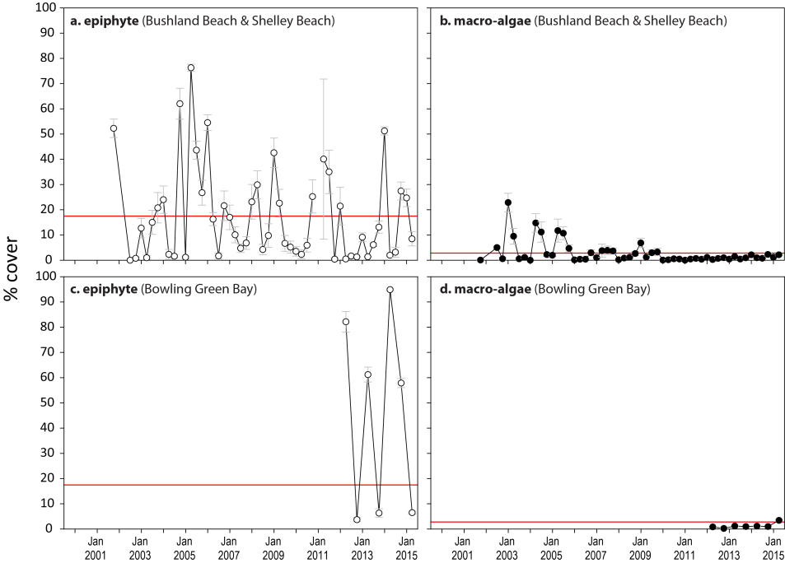
Figure 205. Mean abundance (% cover) (± Standard Error) of epiphytes and macroalgae at coastal intertidal seagrass monitoring locations (sites pooled) in the Burdekin NRM region
. Red line = GBR long-term average; epiphytes=15%, macroalgae=3.2%.

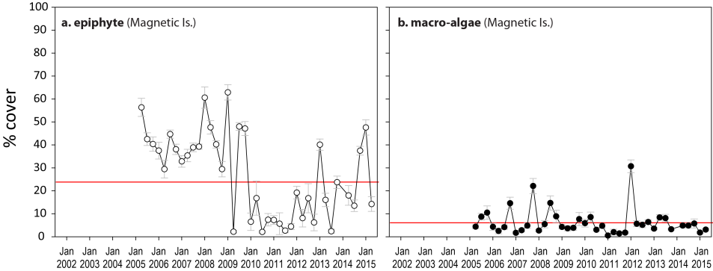
Figure 206. Mean abundance (% cover) (± Standard Error) of epiphytes and macroalgae at intertidal reef seagrass monitoring locations (sites pooled) in the Burdekin NRM region
. Red line = GBR long-term average; epiphytes=20.2%, macroalgae=6.1%.
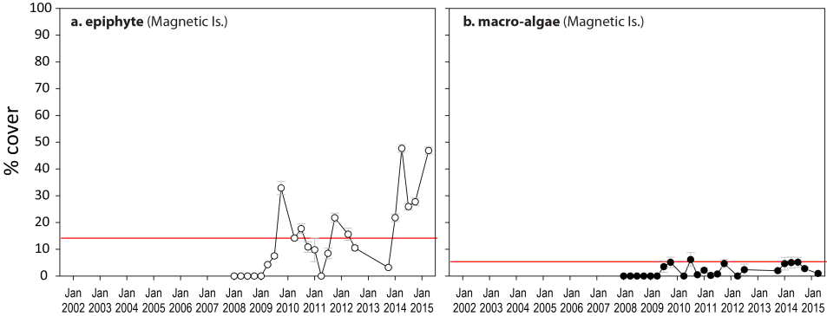
Figure 207. Mean abundance (% cover) (± Standard Error) of epiphytes and macroalgae at subtidal reef monitoring sites in Picnic Bay, Burdekin NRM region
. Red line = GBR long-term average; epiphytes=7.5%, macroalgae=4.9%.
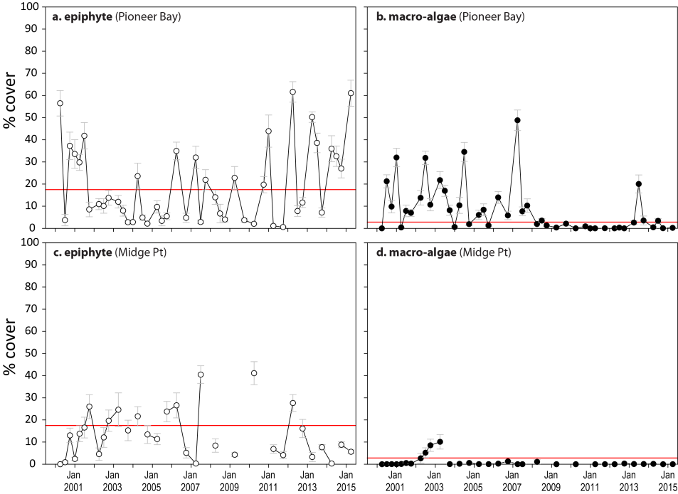
Figure 208. Mean abundance (% cover) (± Standard Error) of epiphytes and macroalgae at coastal intertidal seagrass monitoring locations (sites pooled) in the Mackay Whitsunday NRM region
. Red line = GBR long-term average; epiphytes=15%, macroalgae=3.2%.
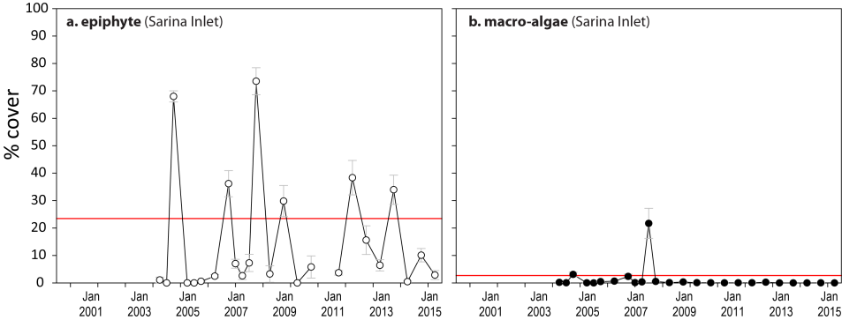
Figure 209. Mean abundance (% cover) (± Standard Error) of epiphytes and macroalgae at estuarine seagrass monitoring locations (sites pooled) in the Mackay Whitsunday NRM region
. Red line = GBR long-term average; epiphytes=15.4%, macroalgae=2.6%.
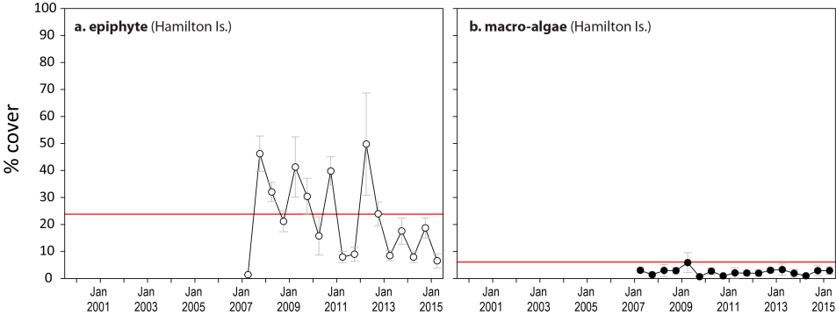
Figure 210. Mean abundance (% cover) (± Standard Error) of epiphytes and macroalgae at reef seagrass monitoring locations (sites pooled) in the Mackay Whitsunday NRM region
. Red line = GBR long-term average; epiphytes=20.2%, macroalgae=6.1%.
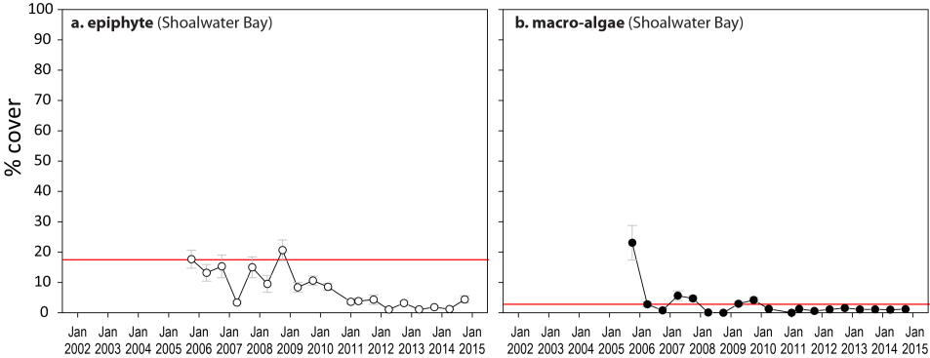
Figure 211. Mean abundance (% cover) (± Standard Error) of epiphytes and macroalgae at coastal intertidal seagrass monitoring locations (sites pooled) in the Fitzroy NRM region
. Red line = GBR long-term average; epiphytes=15%, macroalgae=3.2%.
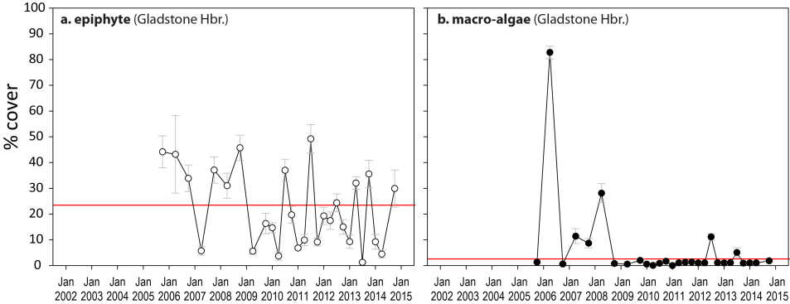
Figure 212. Mean abundance (% cover) (± Standard Error) of epiphytes and macroalgae at estuarine seagrass monitoring locations (sites pooled) in the Fitzroy NRM region
. Red line = GBR long-term average; epiphytes=15.4%, macroalgae=2.6%.

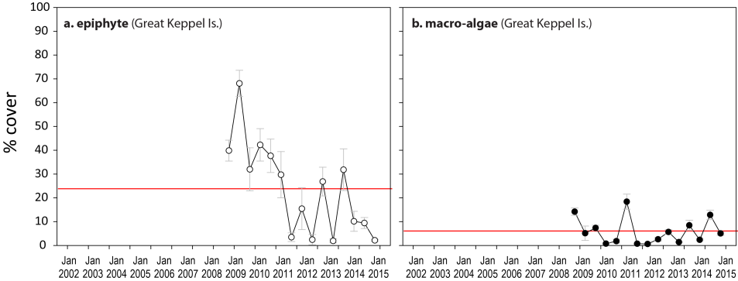
Figure 213. Mean abundance (% cover) (± Standard Error) of epiphytes and macroalgae at reef seagrass monitoring locations (sites pooled) in the Fitzroy NRM region
. Red line = GBR long-term average; epiphytes=20.2%, macroalgae=6.1%.

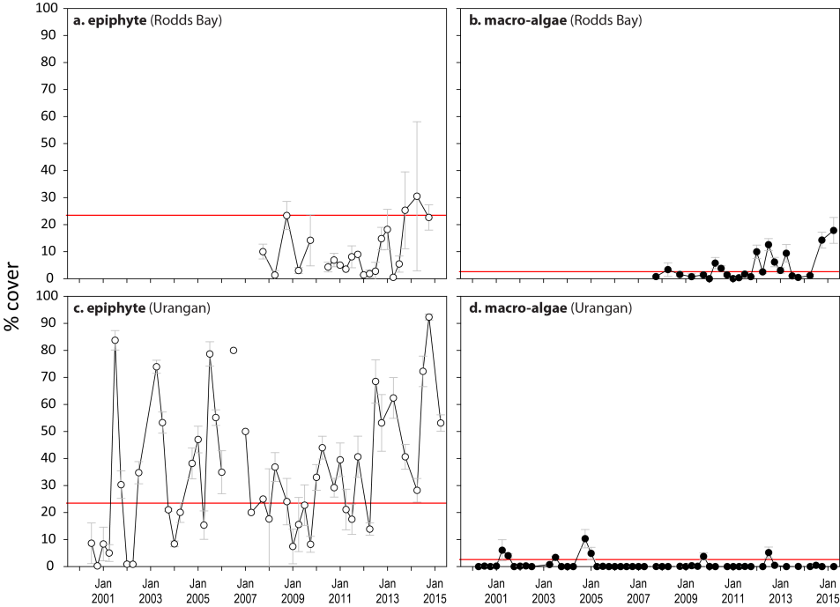
Figure 214. Mean abundance (% cover) (± Standard Error) of epiphytes and macroalgae at estuarine seagrass monitoring locations (sites pooled) in the Burnett Mary NRM region.
Red line = GBR long-term average; epiphytes=15.4%, macroalgae=2.6%.

Seagrass extent

Table 47. Proportion of area (within 100m radius of each monitoring site) which is covered by seagrass in the Cape York and Wet Tropics NRM regions.
For sites codes, see Table 5. Shading indicates area of seagrass declined >5% (or absent) from previous assessment.

Date | SR1 | SR2 | FR1 | FR2 | ST1 | ST2 | BY1 | BY2 | AP1 | AP2 | LI1 | LI2 | YP1 | YP2 | GI1 | GI2 | GI3 | LB1 | LB2 | DI1 | DI2 | DI3
Oct-05 |  |  |  |  |  |  |  |  | 0.68 | 0.68 |  |  | 0.25 | 0.67 | 0.98 | 0.86 |  | 0.31 | 0.34
Apr-06 |  |  |  |  |  |  |  |  | 0.61 | 0.58 |  |  | 0.33 | 0.76 | 0.99 | 0.86 |  | 0.2 | 0.27
Oct-06 |  |  |  |  |  |  |  |  | 0.71 | 0.66 |  |  | 0.33 | 0.69 | 0.98 | 0.878 |  | 0.08 | 0.1
Apr-07 |  |  |  |  |  |  |  |  | 0.78 | 0.75 |  |  | 0.45 | 0.69 | 0.98 | 0.86 |  | 0.18 | 0.22 | 0.59 | 0.72
Oct-07 |  |  |  |  |  |  |  |  | 0.77 | 0.75 |  |  | 0.57 | 0.82 | 0.98 | 0.87 |  | 0.22 | 0.3 | 0.63 | 0.76
Apr-08 |  |  |  |  |  |  |  |  | 0.72 | 0.64 |  |  | 0.53 | 0.88 | 0.99 | 0.87 |  | 0.2 | 0.27 | 0.61 | 0.8
Oct-08 |  |  |  |  |  |  |  |  | 0.72 | 0.66 |  |  | 0.54 | 0.82 | 0.98 | 0.87 |  | 0.3 | 0.36 | 0.61 | 0.78
Apr-09 |  |  |  |  |  |  |  |  | 0.62 | 0.6 |  |  | 0.46 | 0.87 | 0.99 | 0.87 |  | 0.23 | 0.31 | 0.60 | 0.8
Oct-09 |  |  |  |  |  |  |  |  | 0.68 | 0.66 |  |  | 0.42 | 0.86 | 0.98 | 0.87 |  | 0.23 | 0.29 | 0.62 | 0.79
Apr-10 |  |  |  |  |  |  |  |  |  |  |  |  | 0.3 | 0.83 | 0.99 | 0.87 |  | 0.09 | 0.09 | 0.61 | 0.75
Oct-10 |  |  |  |  |  |  |  |  | 0.73 | 0.71 |  |  | 0.31 | 0.79 | 0.98 | 0.86 |  | 0.03 | 0.03 | 0.62 | 0.77
Apr-11 |  |  |  |  |  |  |  |  | 0.72 | 0.65 |  |  | 0.33 | 0.81 | 0.98 | 0.86 |  | 0 | 0 | 0 | 0.002
Oct-11 |  |  |  |  |  |  |  |  | 0.71 | 0.67 |  | 0.48 | 0.08 | 0.38 | 0.99 | 0.87 | 0.26 | 0 | 0 | 0.01 | 0.05 | 0
Apr-12 | 1 | 0.94 | 0.72 | 0.91 | 0.69 | 0.94 | 0.75 | 0.9 | 0.69 | 0.65 | 0.78 | 0 | 0.23 | 0.67 | 0.99 | 0.88 | 0.7 | 0 | 0 | 0.003 | 0.03 | 0
Oct-12 | 1 | 0.93 | 0.7 | 0.91 | 0.63 | 0.96 | 0.77 | 0.9 | 0.58 | 0.58 | 0.88 | 0.01 | 0.11 | 0.31 | 0.98 | 0.87 | 0.94 | 0 | 0.01 | 0.01 | 0.05 | 0
Apr-13 | 1 | 0.94 | 0.7 | 0.89 | 0.71 | 0.95 | 0.85 | 1 | 0.63 | 0.64 | 0.97 | 0.001 | 0.46 | 0.72 | 0.99 | 0.87 | 0.38 | 0 | 0.01 | 0.04 | 0.12 | 0
Oct-13 | 1 | 0.92 | 0.7 | 0.91 | 0.72 | 0.96 | 0.83 | 0.96 | 0.64 | 0.63 | 1 | 0.002 | 0.41 | 0.65 | 0.98 | 0.86 | 0.77 | 0.01 | 0.015 | 0.24 | 0.21 | 0
Apr-14 | 1 | 0.92 | 0.75 | 0.93 | 0.72 | 0.96 | 0.88 | 0.96 | 0.67 | 0.64 | 1 | 0.002 | 0.46 | 0.61 | 0.97 | 0.85 | 0 | 0 | 0.001 | 0.28 | 0.24 | 0
Oct-14 | 1 | 0.91 | 0.75 | 0.90 | 0.70 | 0.95 | 0.88 | 0.94 | 0.68 | 0.66 | 1.68 | 0.68 | 0.36 | 0.78 | 0.98 | 0.86 |  | 0.001 | 0.001 | 0.32 | 0.31 | 1.00
Apr-15 |  |  |  |  |  |  |  |  |  |  | 0.93 | 0.29 | 0.49 | 0.77 | 0.97 | 0.85 |  | 0.001 | 0.001 | 0.31 | 0.37

Table 48. Proportion of area (within 100m radius of each monitoring site) which is covered by seagrass in the Burdekin, Mackay Whitsunday, Fitzroy and Burnett Mary NRM regions.
For sites codes, see Table 5. Shading indicates area of seagrass declined >5% (or absent) from previous assessment

Date | BB1 | SB1 | MI1 | MI2 | MI3 | JR1 | JR2 | PI2 | PI3 | HM1 | HM2 | MP2 | MP3 | SI1 | SI2 | RC1 | WH1 | GH1 | GH2 | GK1 | GK2 | RD1 | RD2 | UG1 | UG2
Oct-05 | 1 | 0.81 | 0.55 | 0.77 |  |  |  | 0.65 | 0.46 |  |  |  |  | 0.64 | 0.71 | 1 | 1 | 1 | 0.96 |  |  |  |  | 0.99 | 1
Apr-06 | 1 | 0.66 | 0.64 | 0.82 |  |  |  | 0.67 | 0.38 |  |  |  |  | 0.33 | 0.47 | 1 | 1 | 0 | 0 |  |  |  |  | 0 | 0
Oct-06 | 1 | 0.54 | 0.32 | 0.77 |  |  |  | 0.72 | 0.74 |  |  |  |  | 0.84 | 0.7 | 1 | 1 | 1 | 1 |  |  |  |  | 0 | 0
Apr-07 | 0.96 | 0.74 | 0.49 | 0.78 |  |  |  | 0.79 | 0.84 |  |  |  |  | 0.78 | 0.67 | 1 | 1 | 1 | 0.96 |  |  |  |  | 0 | 0
Oct-07 | 0.98 | 0.85 | 0.59 | 0.78 |  |  |  | 0.8 | 0.8 | 0.3 | 0.12 |  |  | 0.9 | 0.9 | 1 | 1 | 0.77 | 0.88 | 0.81 | 0.78 | 0.18 | 0.66 | 0.001 | 0
Apr-08 | 0.96 | 0.39 | 0.51 | 0.79 |  |  |  | 0.77 | 0.79 | 0.34 | 0.04 |  |  | 0.32 | 0.35 | 1 | 1 | 0.83 | 0.94 | 0.17 | 0.46 | 0.24 | 0.65 | 0.07 | 0.29
Oct-08 | 0.99 | 0.31 | 0.52 | 0.81 |  |  |  | 0.78 | 0.81 | 0.28 | 0.07 |  |  | 0.68 | 0.71 | 1 | 1 | 0.94 | 0.9 | 0.3 | 0.62 | 0.22 | 0.67 | 0.06 | 0.52
Apr-09 | 0.43 | 0.22 | 0.5 | 0.98 |  |  |  | 0.85 | 0.84 | 0.25 | 0.04 |  |  | 0.33 | 0.27 | 1 | 1 | 0.93 | 0.98 | 0.58 | 0.43 | 0 | 0.66 | 0.01 | 0.09
Oct-09 | 0.87 | 0.51 | 0.73 | 0.66 |  |  |  | 0.99 | 0.91 | 0.18 | 0.02 |  |  | 0.47 | 0.46 | 1 | 1 | 0.88 | 0.93 | 0.78 | 0.72 | 0.01 | 0.51 | 0.06 | 0.19
Apr-10 | 0.47 | 0.39 | 0.48 | 0.39 |  |  |  | 0.87 | 0.67 | 0.13 | 0.01 |  |  | 0.13 | 0.17 | 1 | 1 | 0.96 | 0.98 | 0.76 | 0.74 | 0 | 0 | 0.34 | 0.7
Oct-10 | 0.21 | 0.67 | 0.43 | 0.75 |  |  |  | 0.96 | 0.96 | 0.26 | 0.04 |  |  | 0.27 | 0.23 | 1 | 1 | 0.96 | 0.95 | 0.3 | 0.73 | 0.1 | 0 | 0.27 | 0.7
Apr-11 | 0.48 | 0.05 | 0.21 | 0.22 |  |  |  | 0.29 | 0.19 | 0.15 | 0.01 |  |  | 0.12 | 0.05 | 1 | 1 | 0.92 | 0.91 | 0.12 | 0.54 | 0.04 | 0.02 | 0.06 | 0.38
Oct-11 | 0.4 | 0.16 | 0.42 | 0.75 | 0.63 |  |  | 0.22 | 0.16 | 0.32 | 0.03 |  |  | 0.73 | 0.69 | 1 | 1 | 0.88 | 0.9 | 0.09 | 0.25 | 0.05 | 0.01 | 0.07 | 0.43
Apr-12 | 0.21 | 0.16 | 0.46 | 0.77 | 0.34 | 1 | 0.83 | 0.46 | 0.49 | 0.54 | 0.03 |  |  | 0.5 | 0.5 | 1 | 1 | 0.89 | 0.91 | 0.09 | 0.25 | 0 | 0 | 0.09 | 0.54
Oct-12 | 1 | 0.94 | 0.48 | 0.97 | 0.39 | 1 | 0.83 | 0.33 | 0.4 | 0.64 | 0.05 |  |  | 0.8 | 0.7 | 1 | 1 | 0.88 | 0.87 | 0.38 | 0.18 | 0.22 | 0.03 | 0.2 | 0.67
Apr-13 | 0.98 | 0.87 | 0.49 | 0.99 | 0.6 | 1 | 0.83 | 0.7 | 0.72 | 0.62 | 0.04 |  |  | 0.65 | 0.7 | 1 | 1 | 0.88 | 0.94 | 0.2 | 0.22 | 0.17 | 0 | 0.21 | 0.61
Oct-13 | 1 | 0.72 | 0.48 | 0.9 | 0.59 | 1 | 1 | 0.83 | 0.95 | 0.67 | 0.06 |  |  | 0.76 | 0.76 | 1 | 1 | 0.89 | 0.86 | 0.4 | 0.15 | 0 | 0 | 0.2 | 0.53
Apr-14 | 1 | 0.96 | 0.53 | 0.99 | 0.34 | 1 | 1 | 0.97 | 0.97 | 0.53 | 0.04 |  |  | 0.67 | 0.69 | 1 | 1 | 0.85 | 0.83 | 0.28 | 0.04 | 0.02 | 0.02 | 0.27 | 0.64
Oct-14 | 1 | 0.96 | 0.55 | 0.80 | 1 | 1 | 1 | 0.98 | 1 | 0.21 | 0.08 | 0.99 | 1 | 0.71 | 0.80 | 1 | 1 | 0.92 | 0.88 | 0.50 | 0.69 | 0.28 | 0.45 | 0.71 | 0.81
Apr-15 | 1 | 0.96 | 0.55 | 0.80 | 1 |  |  |  |  | 0.21 | 0.03 | 0.99 | 0.99 | 0.58 | 0.72 |  |  |  |  |  |  | 0 | 0 | 0.93 | 0.81

Species composition and distribution

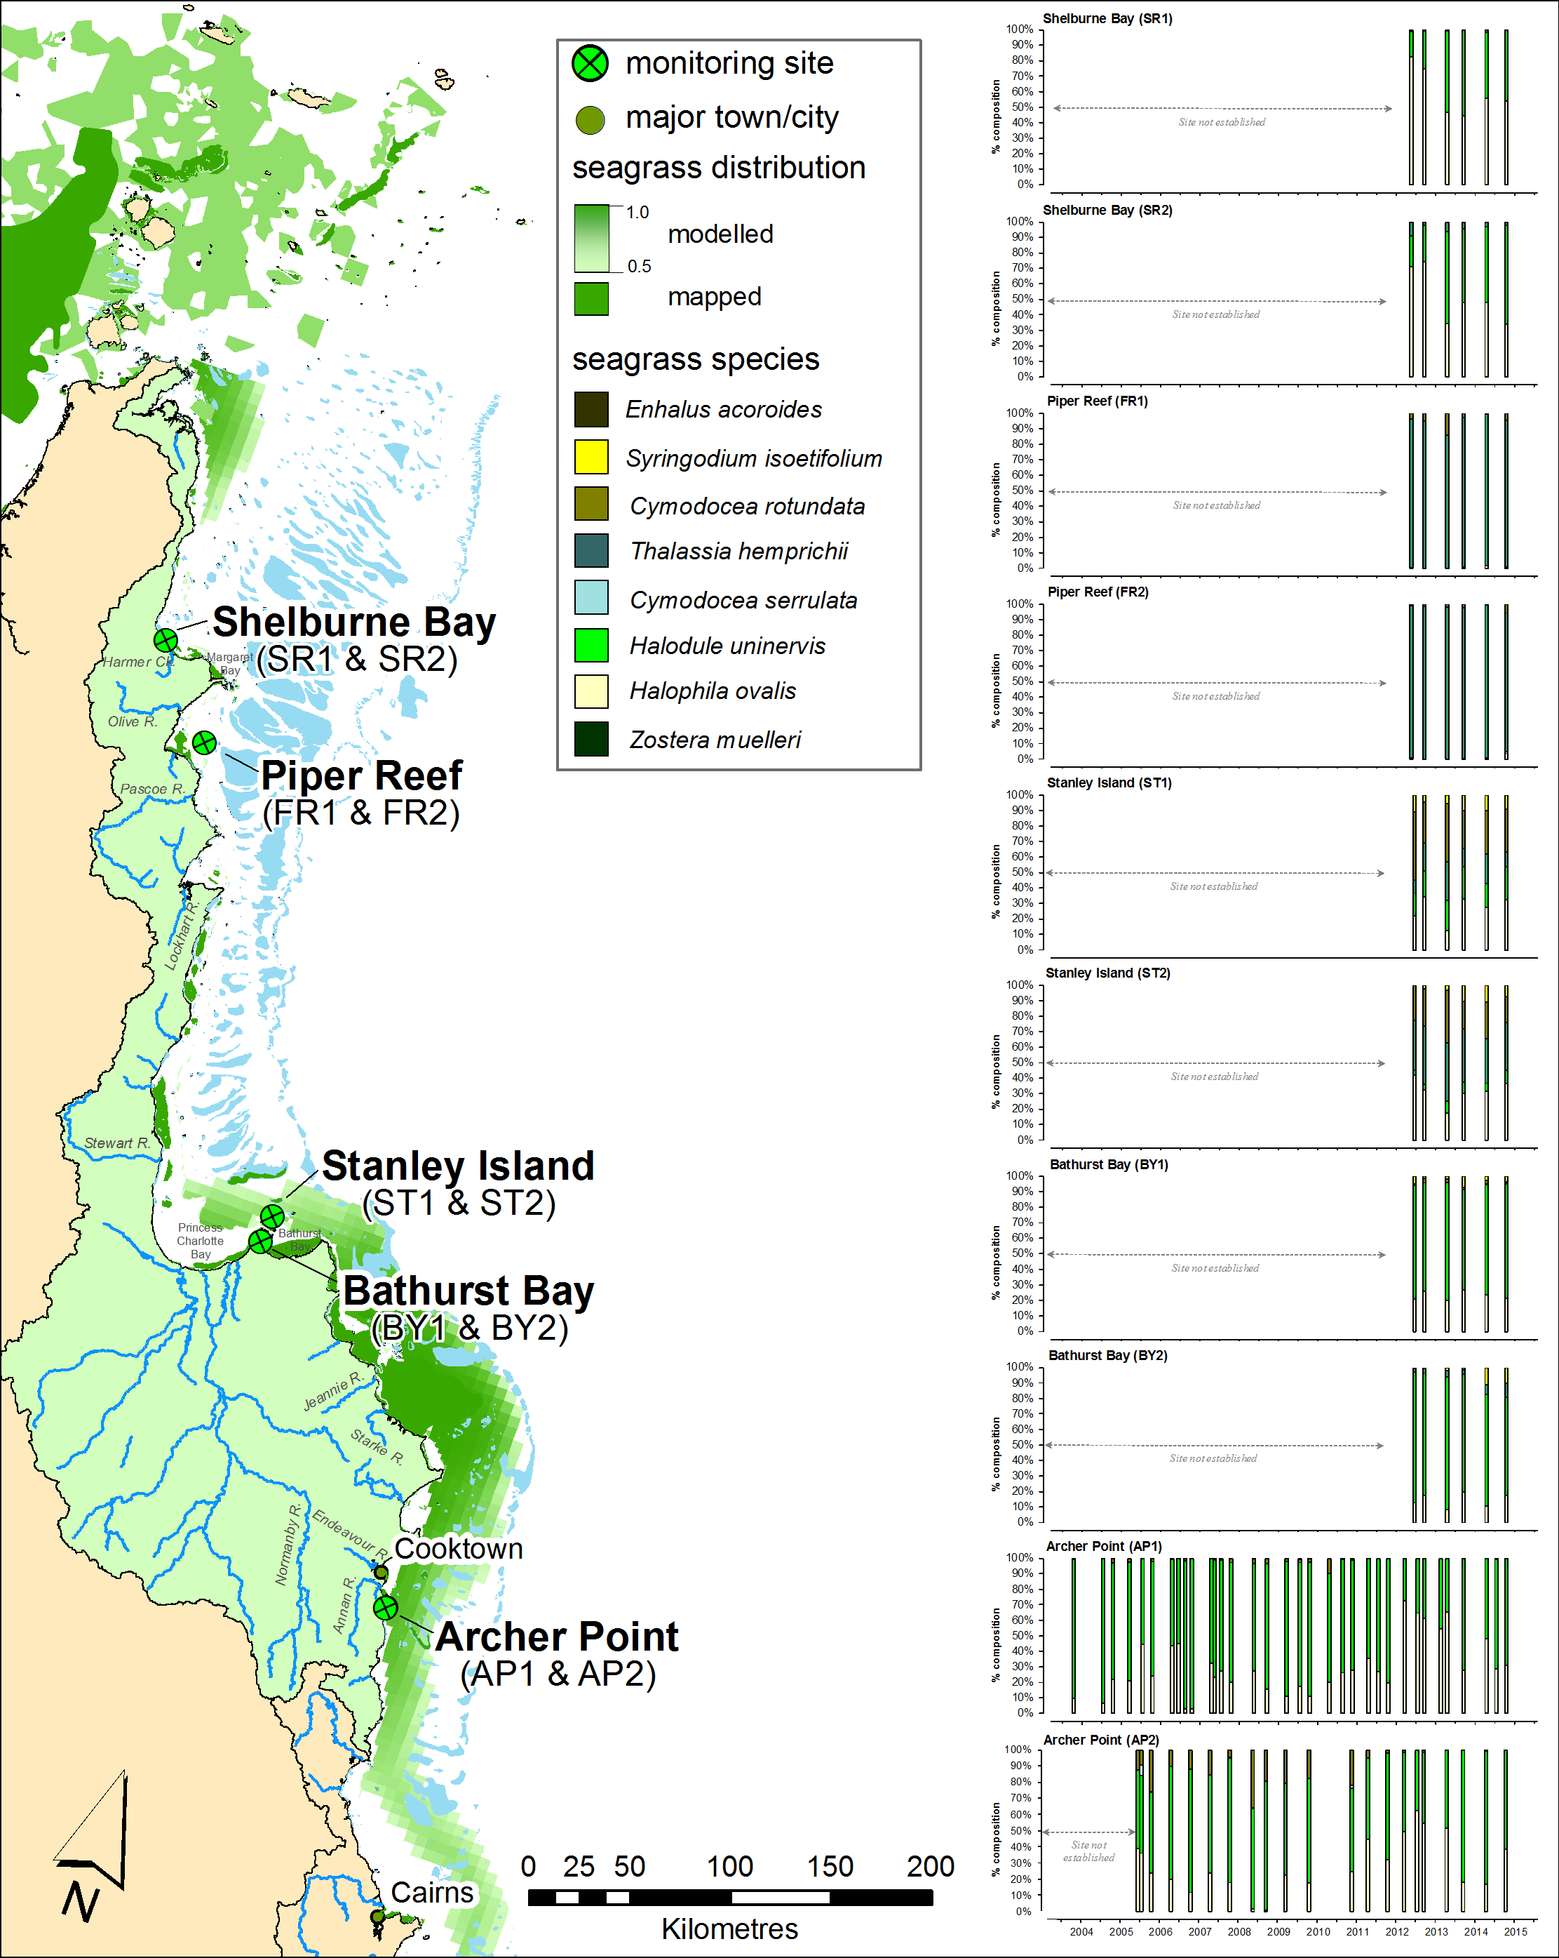
Figure 215. Location and species composition of each long-term seagrass monitoring site (MMP) in the Cape York region.
Please note: replicate sites within 500m of each other. Also shown is distribution of seagrass as the modelled distribution (including likelihood of presence from 0.5-1.0 McKenzie, et al. 2010c) and composite of mapped distribution (McKenzie et al. 2014b).

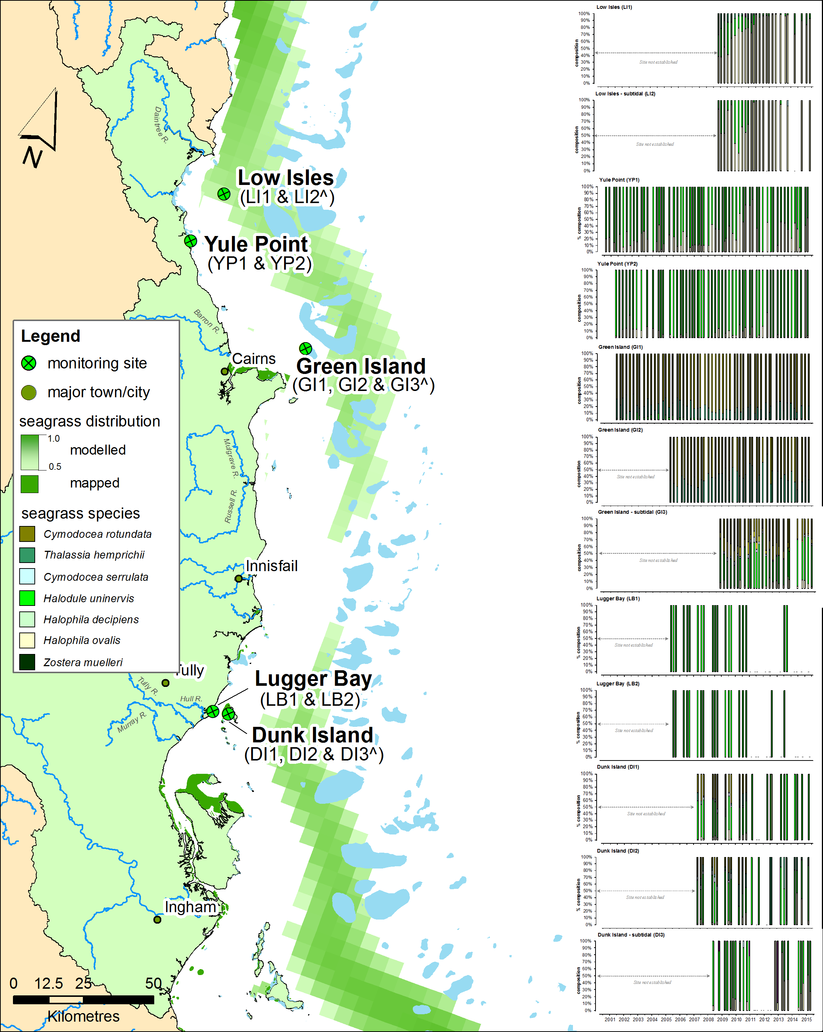
Figure 216. Location and species composition of each long-term seagrass monitoring site (MMP) in the Wet Tropics region.
Please note: replicate sites within 500m of each other. Also shown is distribution of seagrass as the modelled distribution (including likelihood of presence from 0.5-1.0 McKenzie, et al. 2010c) and composite of mapped distribution (McKenzie, et al. 2014b).

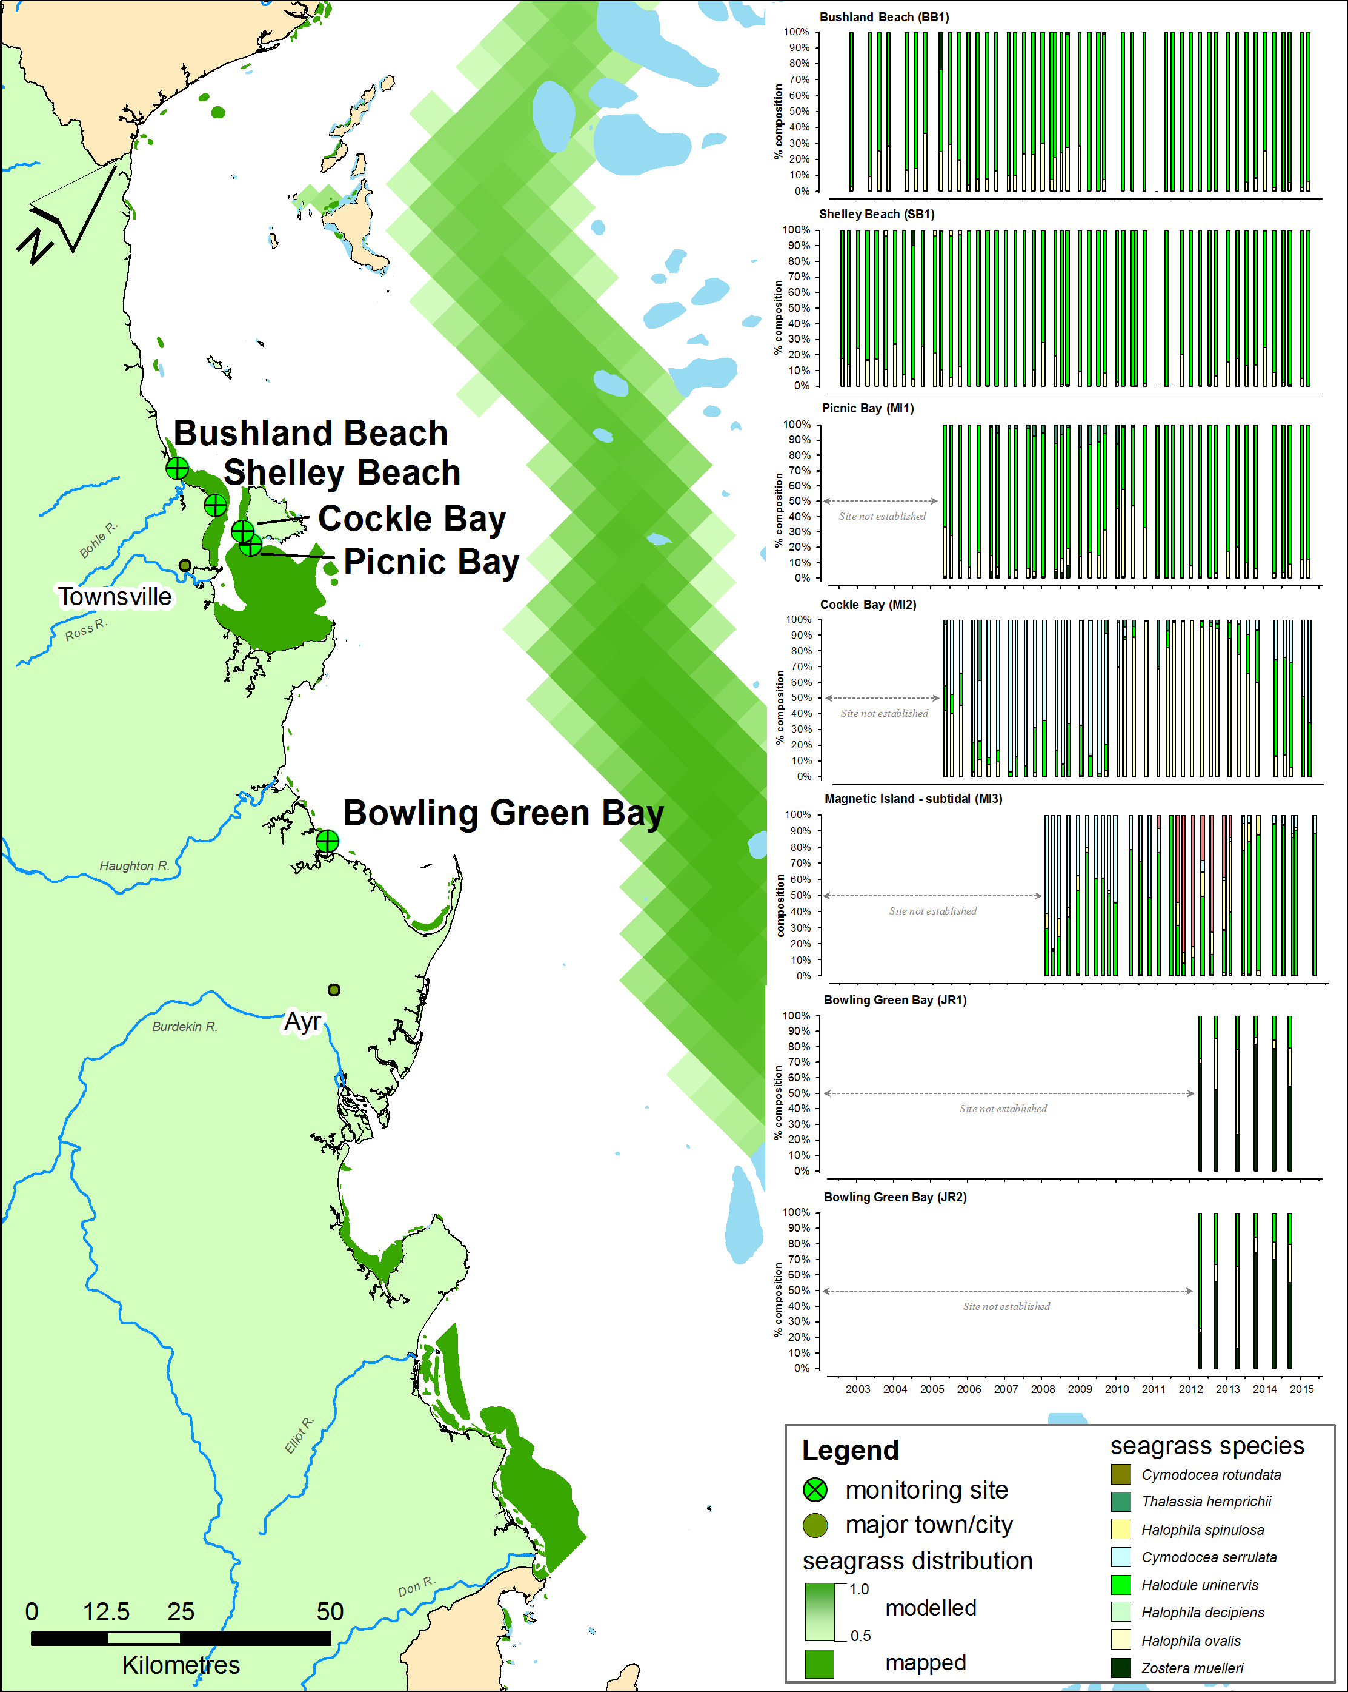
Figure 217. Location and species composition of each long-term seagrass monitoring site (MMP) in the Burdekin region.
Please note: replicate sites within 500m of each other. Also shown is distribution of seagrass as the modelled distribution (including likelihood of presence from 0.5-1.0 McKenzie, et al. 2010c) and composite of mapped distribution (McKenzie, et al. 2014b).

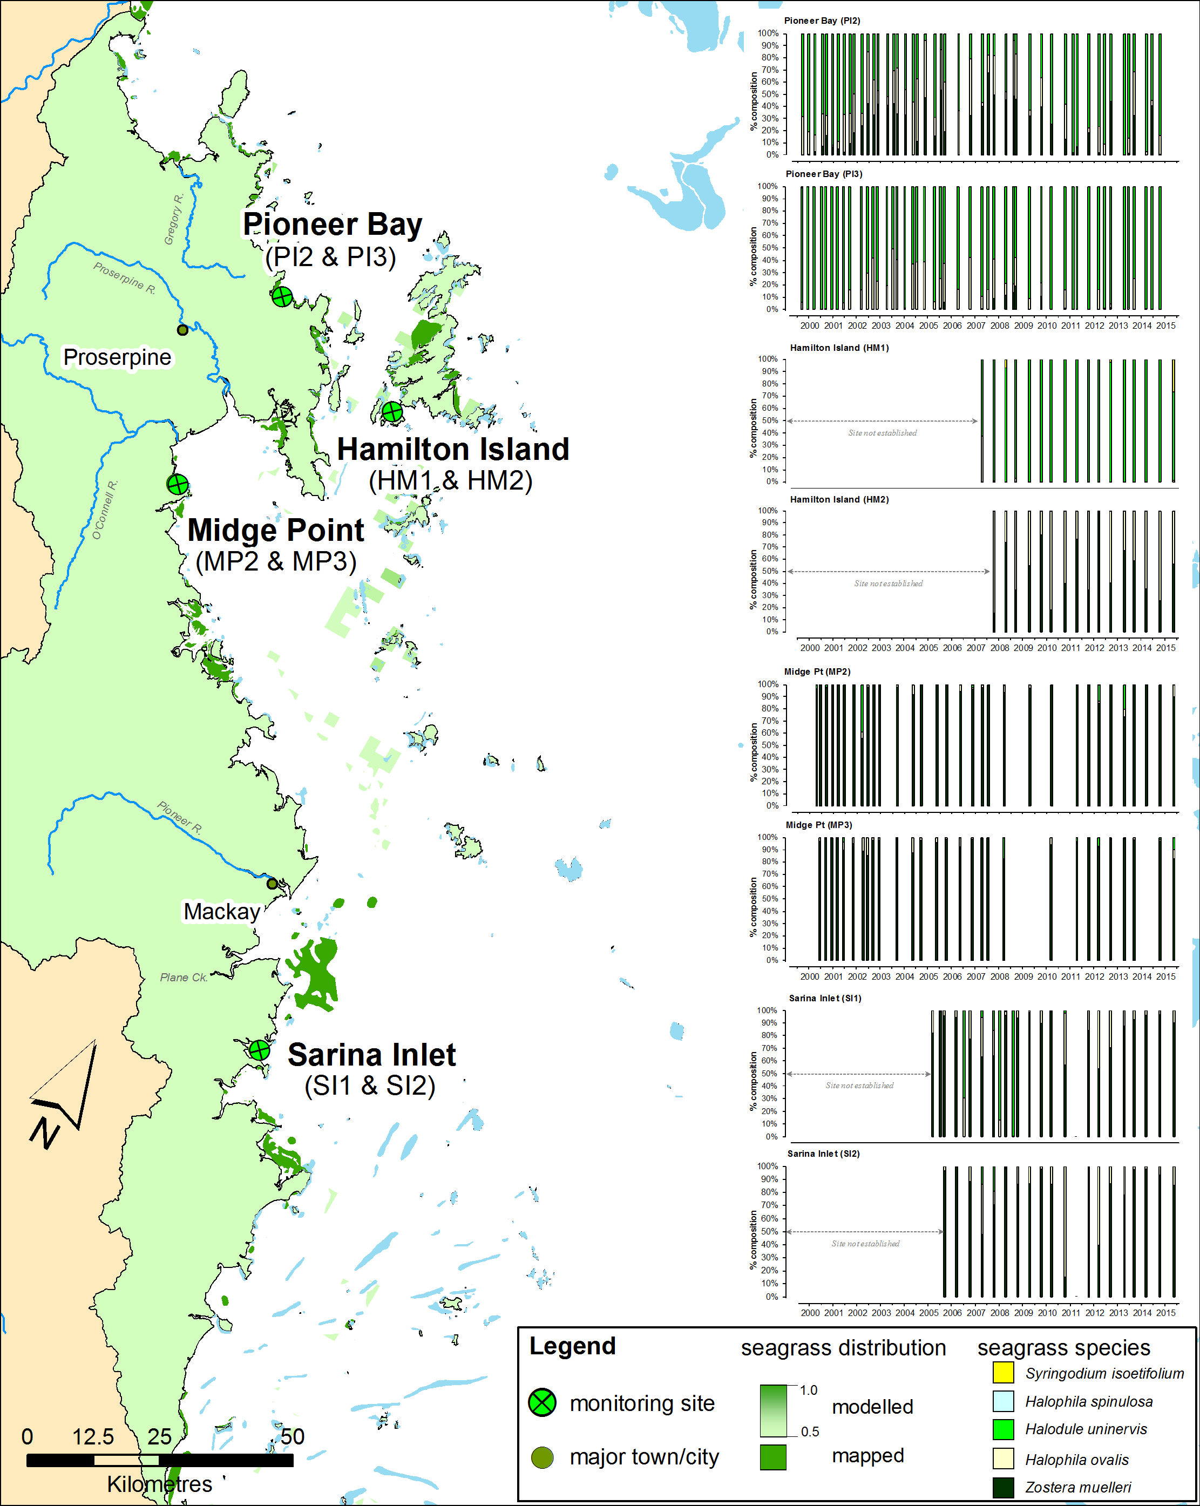
Figure 218. Location and species composition of each long-term seagrass monitoring site (MMP) in the Mackay Whitsunday region.
Please note: replicate sites within 500m of each other. Also shown is distribution of seagrass as the modelled distribution (including likelihood of presence from 0.5-1.0 McKenzie, et al. 2010c) and composite of mapped distribution (McKenzie, et al. 2014b).
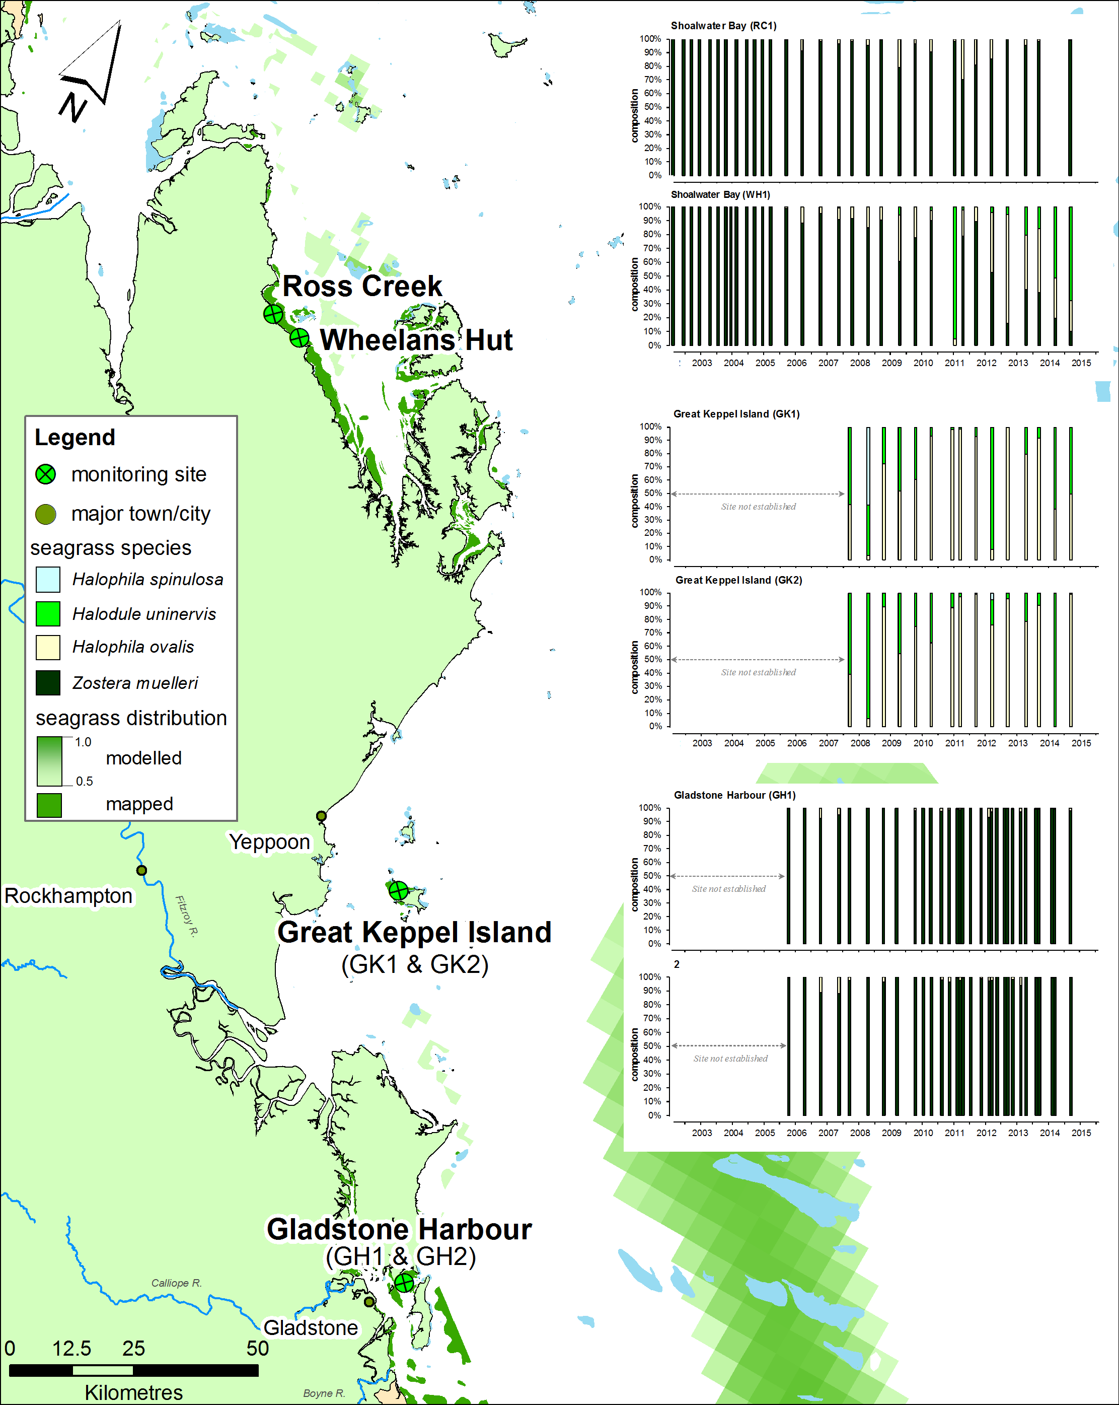
Figure 219. Location and species composition of each long-term seagrass monitoring site (MMP) in the Fitzroy region.
Please note: replicate sites within 500m of each other. Also shown is distribution of seagrass as the modelled distribution (including likelihood of presence from 0.5-1.0 McKenzie, et al. 2010c) and composite of mapped distribution (McKenzie, et al. 2014b).

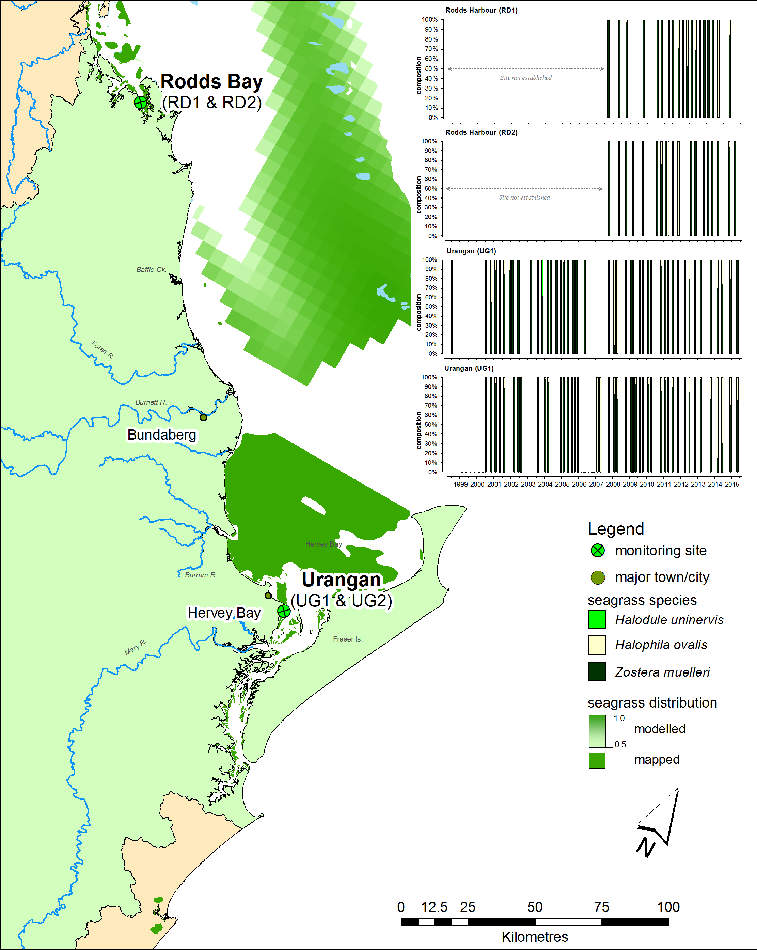
Figure 220. Location and species composition of each long-term seagrass monitoring site (MMP) in the Burnett Mary region.
Please note: replicate sites within 500m of each other. Also shown is distribution of seagrass as the modelled distribution (including likelihood of presence from 0.5-1.0 McKenzie, et al. 2010c) and composite of mapped distribution (McKenzie, et al. 2014b).

Seagrass leaf tissue
The following graphs display the elemental ratios (atomic) of seagrass leaf tissue C:N, N:P and C:P for the foundation seagrass species examined at each habitat or location in the NRM regions of the Great Barrier Reef. The horizontal shaded band on the C:N ratio panels represent the accepted guideline seagrass “Redfield” ratio of 20:1 (Abal, et al. 1994; Grice, et al. 1996). C:N ratios below this line may indicate reduced light availability and/or N enrichment. The horizontal shaded band on the N:P ratio panels represent the range of value associated with N:P balance ratio in the plant tissues, i.e. a seagrass “Redfield” ratio (Atkinson and Smith 1983; Duarte 1990; Fourqurean, et al. 1992b; Fourqurean and Cai 2001). N:P ratio above this band indicates P limitation, below indicates N limitation and within indicates replete. Shaded portion on the C:P panel ≤500 represents the value associated with C:P balance ratio in the plant tissues, C:P values <500 may indicate nutrient rich habitats (large P pool).

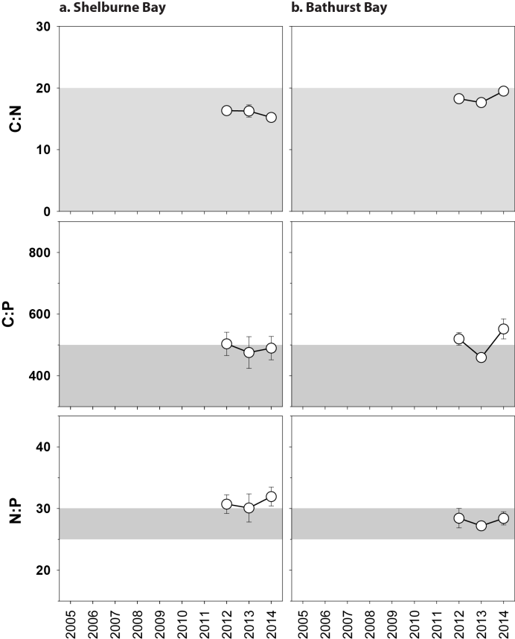
Figure 221. Elemental ratios (atomic) of seagrass leaf tissue C:N, N:P and C:P for the foundation seagrass species examined at each coastal location in the Cape York region each year
(species pooled) (mean ± Standard Error).

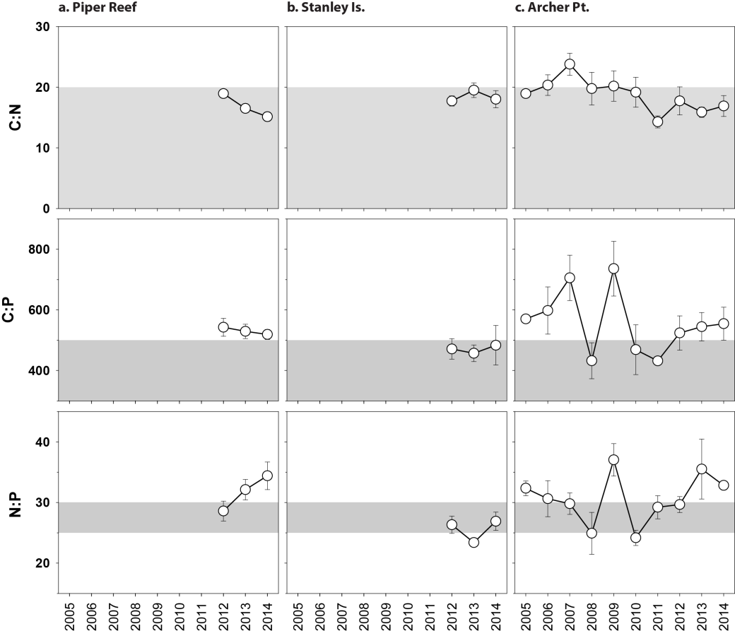
Figure 222. Elemental ratios (atomic) of seagrass leaf tissue C:N, N:P and C:P for the foundation seagrass species examined at each reef location in the Cape York region each year
(species pooled) (mean ± Standard Error).

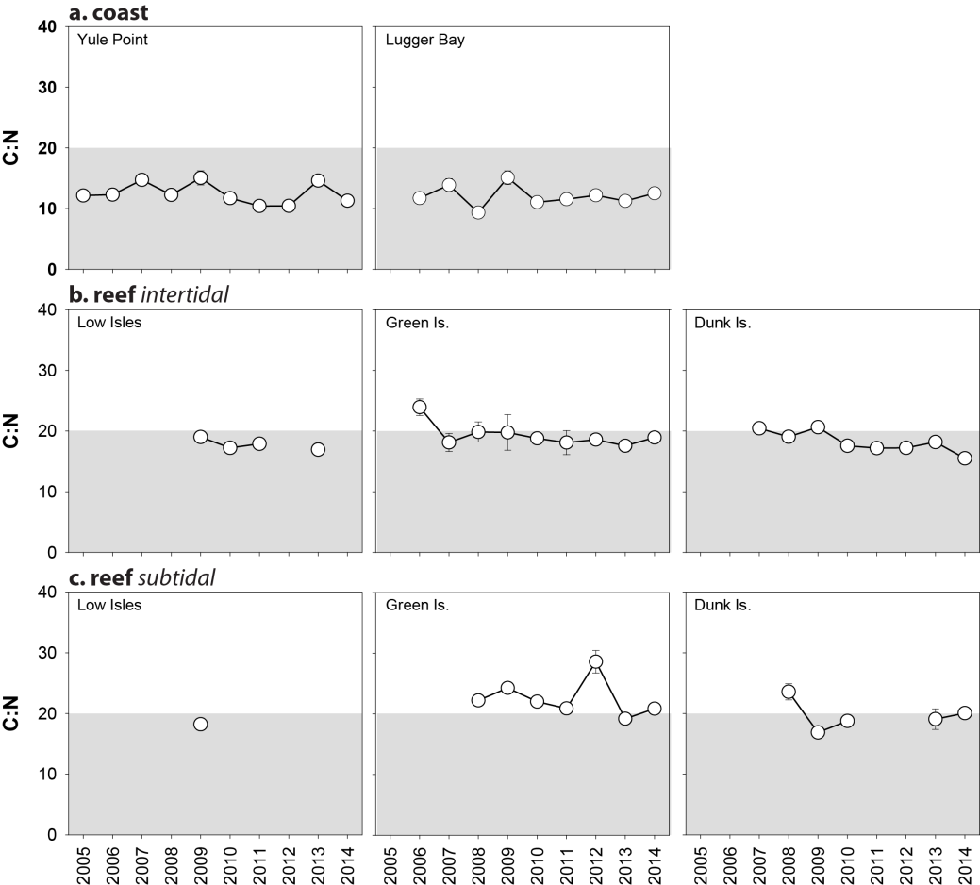
Figure 223. Elemental ratios (atomic) of seagrass leaf tissue C:N for the foundation seagrass species examined at each habitat and location in the Wet Tropics region each year
(species pooled) (mean ± Standard Error).

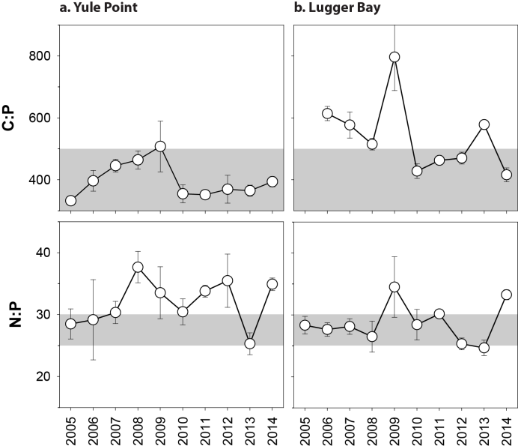
Figure 224. Elemental ratios (atomic) of seagrass leaf tissue C:P and N:P for the foundation seagrass species examined at intertidal coastal habitats in the Wet Tropics region each year
(species pooled) (mean ± Standard Error).
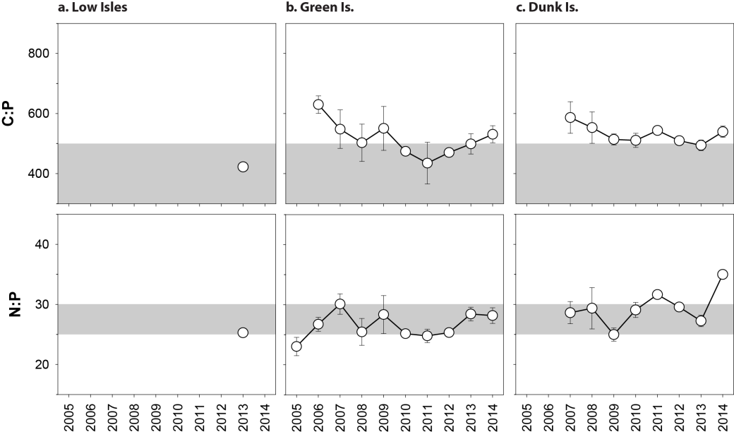
Figure 225. Elemental ratios (atomic) of seagrass leaf tissue C:P and N:P for the foundation seagrass species examined at intertidal reef habitats in the Wet Tropics region each year
(species pooled) (mean ± Standard Error).

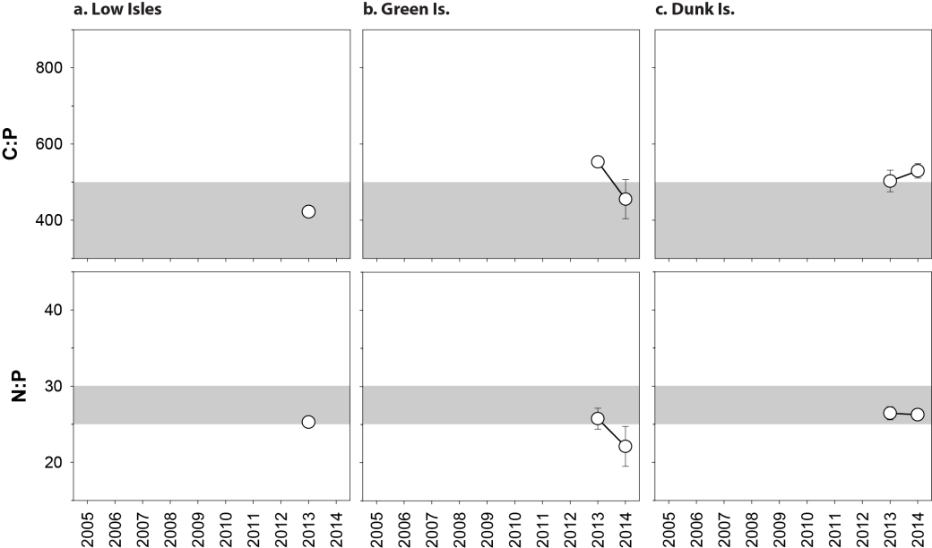
Figure 226. Elemental ratios (atomic) of seagrass leaf tissue C:P and N:P for the foundation seagrass species examined at subtidal reef habitats in the Wet Tropics region each year
(species pooled) (mean ± Standard Error).

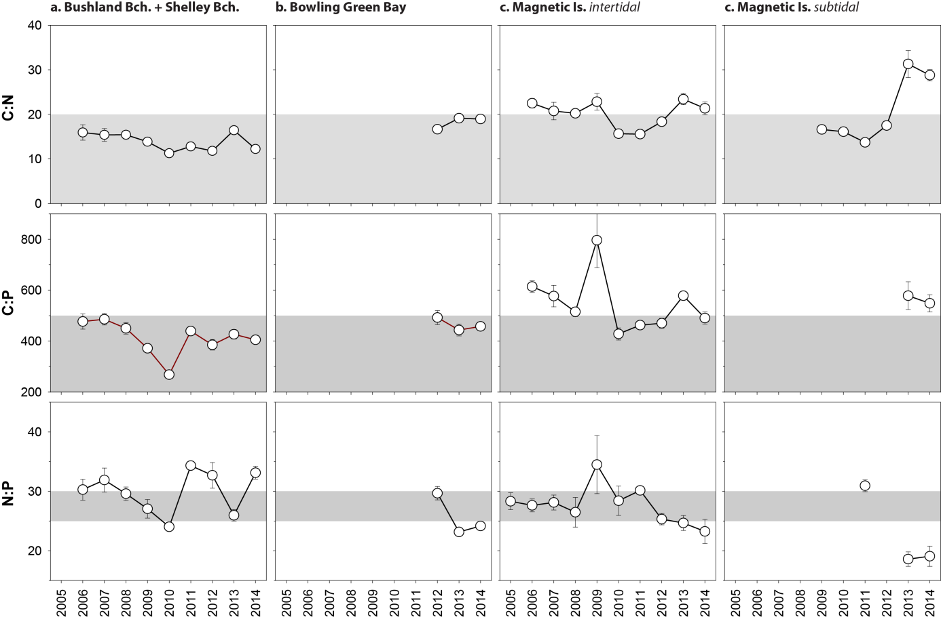
Figure 227. Elemental ratios (atomic) of seagrass leaf tissue C:N, N:P and C:P for the foundation seagrass species examined at each habitat and location in the Burdekin region each year
(species pooled) (mean ± Standard Error).

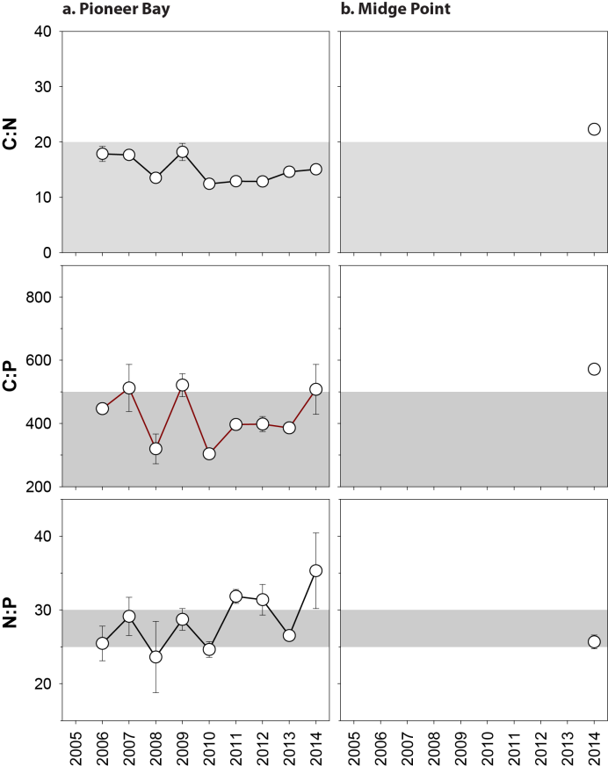
Figure 228. Elemental ratios (atomic) of seagrass leaf tissue C:N, N:P and C:P for the foundation seagrass species examined at coastal habitats in the Mackay Whitsunday region each year
(species pooled) (mean ± Standard Error).

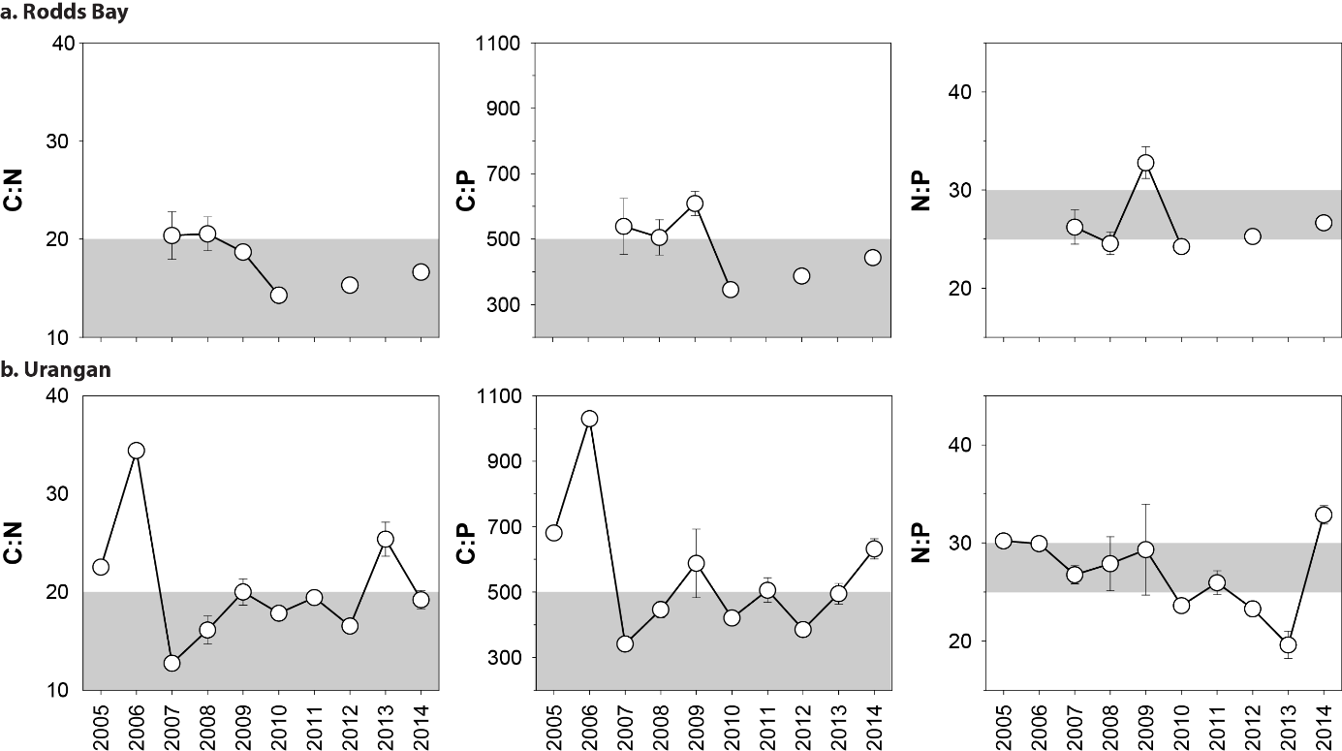
Figure 229. Elemental ratios (atomic) of seagrass leaf tissue C:N for the foundation seagrass species examined at each habitat in the Burnett Mary region each year
(species pooled) (mean ± Standard Error).

Table 49. Seagrass leaf tissue nutrient, δ¹³C and δ¹⁵N concentrations from each NRM region in the late dry 2011 to 2014.
Leaf tissues with low %C (see Table 38), low C:N (<20:1), and isotopically depleted δ¹³C may indicate that growth is light limited (Grice et al. 1996; Fourqurean et al. 2005). Global δ¹³C averages from Hemminga and Mateo 1996). Shading indicates values lower than literature. CR=Cymodocea rotundata, EA=Enhalus acoroides, HO=Halophila ovalis, HS=Halophila spinulosa, HU=Halodule uninervis, TH=Thalassia hemprichii, ZM=Zostera muelleri.
NRM | Habitat | Species | Year | %C | C:N | δ¹³C ‰ | δ¹⁵N ‰ | %C lit  median | δ¹³C ‰  global average
Cape York | coastal | EA | 2012 | 36.68 | 14.72 | -13.07 | -9.41 | 38.3 | -5.8 (-6.7 to -4.9)
 |  | HU | 2012 | 40.61 | 15.92 | -11.00 ±0.46 | 0.06 ±0.26 | 38.5 | -11.2 (-13.0 to -7.8)
 |  |  | 2013 | 39.86 | 15.74 | -11.71 ±0.25 | -1.77 ±0.93
 |  |  | 2014 | 40.62 | 19.15 | -11.22 ±0.12 | -0.08 ±0.51
 |  | SI | 2012 | 36.74 | 16.52 | -4.78 | 0.35 | 28 | -6.0 (-8.3 to -3.6)
 |  |  | 2013 | 36.34 | 18.07 | -6.10 ±0.09 | -0.58 ±0.34
 |  |  | 2014 | 36.69 | 24.00 | -4.28 ±0.25 | 0.20 ±0.1
 |  | TH | 2012 | 35.74 | 15.37 | -9.97 ±0.22 | -1.28 ±0.60 | 35.6 | -6.9 (-8.1 to -5.2)
 |  |  | 2013 | 36.15 | 17.97 | -10.50 ±0.15 | -1.33 ±0.47
 |  |  | 2014 | 37.68 | 16.78 | -10.21 ±0.18 | -0.37 ±0.18
 |  | ZM | 2012 | 38.94 | 17.28 | -10.23 | 1.84 | 32 | -10.8 (-12.4 to -9.2)
 |  |  | 2014 | 38.08 | 26.47 | -9.38 ±0.20 | 1.39 ±0.05
 | reef | CR | 2012 | 39.65 | 18.03 | -7.96 ±0.25 | -2.44 ±0.61 | 39 | -8.1 (-8.9 to -7.4)
 |  |  | 2013 | 36.89 | 24.16 | -8.32 | -0.83
 |  |  | 2014 | 37.42 | 18.66 | -7.95 ±0.12 | -1.87 ±0.32
 |  | CS | 2012 | 40.34 | 19.12 | -8.57 | 0.37 | 40.4 | -10.7 (-12.4 to -8.0)
 |  | HU | 2011 | 42.48 | 15.50 | -8.78 ±0.30 | 0.72 ±0.44 | 38.5 | -11.2 (-13.0 to -7.8)
 |  |  | 2012 | 41.22 | 16.13 | -8.74 ±0.22 | 0.15 ±1.34
 |  |  | 2013 | 41.93 | 16.86 | -8.97 ±0.04 | -1.58 ±0.51
 |  |  | 2014 | 39.53 | 17.89 | -8.82 ±0.19 | -1.71 ±0.69
 |  | SI | 2012 | 22.27 | 19.83 | -4.01 ±0.24 | 1.11 ±0.94 | 28 | -6.0 (-8.3 to -3.6)
 |  |  | 2013 | 37.52 | 19.46 | -5.27 | 0.24
 |  |  | 2014 | 34.75 | 20.24 | -3.15 | 0.66
 |  | TH | 2012 | 37.42 | 15.91 | -6.26 ±0.27 | 0.65 ±0.84 | 35.6 | -6.9 (-8.1 to -5.2)
 |  |  | 2013 | 37.61 | 16.79 | -6.99 ±0.12 | 0.42 ±0.59
 |  |  | 2014 | 36.02 | 17.54 | -7.11 ±0.13 | -0.24 ±0.55
 |  | ZM | 2011 | 39.70 | 22.27 | -9.27 | 1.57 | 32 | -10.8 (-12.4 to -9.2)
 |  |  | 2013 | 36.86 | 20.08 | -9.03 ±0.08 | -0.66 ±0.38
Wet Tropics | coastal | HU | 2011 | 44.90 | 10.65 | -10.35 | 0.64 | 38.5 | -11.2 (-13.0 to -7.8)
 |  |  | 2012 | 42.08 | 11.13 | -9.59 ±0.16 | 0.85 ±0.27
 |  |  | 2013 | 41.29 | 11.82 | -10.12 ±0.25 | 0.42 ±0.19
 |  |  | 2014 | 43.64 | 11.59 | -9.76 ±0.18 | 1.73 ±0.38
 | reef | CR | 2011 | 42.38 | 18.17 | -7.88 ±0.27 | -0.71 ±0.31 | 39 | -8.1 (-8.9 to -7.4)
 | intertidal |  | 2012 | 40.83 | 17.64 | -6.71 ±0.11 | -0.27 ±0.36
 |  |  | 2013 | 39.96 | 18.35 | -7.67 ±0.34 | 0.76 ±0.89
 |  |  | 2014 | 42.10 | 20.27 | -7.59 ±0.13 | 0.22 ±0.31
 |  | CS | 2013 | 41.81 | 22.61 | -10.63 ±0.07 | 3.64 ±0.22 | 40.4 | -10.7 (-12.4 to -8.0)
 |  |  | 2014 | 42.15 | 21.61 | -9.10 ±0.02 | 1.97 ±0.09
 |  | HU | 2009 | 34.29 | 19.45 | -11.05 ±0.14 | 0.23 ±1.08 | 38.5 | -11.2 (-13.0 to -7.8)
 |  |  | 2010 | 34.34 | 17.22 | -12.86 ±1.14 | 1.75 ±0.17
 |  |  | 2011 | 39.84 | 19.02 | -9.32 ±0.43 | 1.66 ±0.35
 |  |  | 2012 | 41.74 | 17.08 | -7.83 ±0.23 | 1.76 ±0.66
 |  |  | 2013 | 41.41 | 19.38 | -9.01 ±0.22 | 1.78 ±0.54
 |  |  | 2014 | 42.02 | 17.58 | -8.68 ±0.26 | 2.35 ±0.19
 |  | TH | 2009 | 30.41 | 18.55 | -8.66 ±0.24 | 1.22 ±0.17 | 35.6 | -6.9 (-8.1 to -5.2)
 |  |  | 2011 | 40.43 | 17.29 | -7.02 ±0.11 | 1.80 ±0.24
 |  |  | 2012 | 38.71 | 15.97 | -7.40 ±0.21 | 1.24 ±0.15
 |  |  | 2013 | 37.95 | 17.12 | -6.34 ±0.18 | 2.88 ±0.47
 |  |  | 2014 | 40.29 | 17.36 | -6.80 ±0.19 | 1.84 ±0.28
 | reef subtidal | CR | 2013 | 40.91 | 16.77 | -9.50 ±0.20 | -0.37 ±0.37 | 39 | -8.1 (-8.9 to -7.4)
 |  |  | 2014 | 41.73 | 17.00 | -9.85 ±0.16 | 1.09 ±0.23
 |  | CS | 2008 | 33.35 | 22.74 | -9.65 ±0.26 | 1.91 ±0.33 | 40.4 | -10.7 (-12.4 to -8.0)
 |  |  | 2009 | 33.69 | 24.27 | -9.87 ±0.03 | 2.19 ±0.15
 |  |  | 2010 | 32.70 | 22.87 | -9.78 ±0.24 | 1.34 ±0.36
 |  |  | 2011 | 37.88 | 22.89 | -9.91 ±0.13 | 2.79 ±0.29
 |  |  | 2012 | 40.60 | 28.58 | -9.73 ±0.13 | 2.11 ±0.35
 |  |  | 2013 | 38.59 | 22.56 | -10.11 ±0.43 | 3.04 ±0.44
 |  |  | 2014 | 39.65 | 21.72 | -9.46 ±0.22 | 3.47 ±0.13
 |  | HU | 2008 | 35.25 | 22.63 | -10.62 ±0.17 | 2.19 ±0.23 | 38.5 | -11.2 (-13.0 to -7.8)
 |  |  | 2009 | 34.46 | 17.24 | -11.25 ±0.36 | 0.95 ±0.15
 |  |  | 2010 | 33.50 | 19.96 | -11.69 ±1.11 | 2.23 ±0.48
 |  |  | 2011 | 38.94 | 18.88 | -9.64 ±0.04 | 1.82 ±0.23
 |  |  | 2013 | 39.19 | 19.58 | -9.85 ±0.17 | 2.71 ±0.29
 |  |  | 2014 | 41.26 | 18.96 | -10.10 ±0.15 | 2.82 ±0.19
 |  | SI | 2013 | 37.10 | 20.92 | -4.71 ±0.14 | 0.86 ±0.34 | 28 | -6.0 (-8.3 to -3.6)
 |  |  | 2014 | 35.53 | 22.30 | -5.03 ±0.20 | 1.47 ±0.19
Burdekin | coastal | HU | 2012 | 40.30 | 12.82 | -11.23 ±0.13 | 1.22v0.19 | 38.5 | -11.2 (-13.0 to -7.8)
 |  |  | 2013 | 38.81 | 15.75 | -11.49 ±0.03 | 2.34 ±0.17
 |  |  | 2014 | 40.56 | 12.74 | -11.64 ±0.25 | 2.82 ±0.16
 |  | ZM | 2012 | 36.33 | 17.76 | -10.44 ±0.23 | 2.18 ±0.39 | 32 | -10.8 (-12.4 to -9.2)
 |  |  | 2013 | 35.75 | 18.56 | -10.75 ±0.06 | 2.59 ±0.15
 |  |  | 2014 | 34.85 | 20.12 | -11.71 ±0.17 | 2.80 ±0.06
 | reef | CS | 2012 | 40.47 | 21.91 | -9.07 ±0.02 | 1.54 ±0.60 | 40.4 | -10.7 (-12.4 to -8.0)
 | intertidal |  | 2013 | 40.71 | 19.46 | -10.00 ±0.09 | 2.06 ±0.04
 |  | HO | 2011 | 39.50 | 13.44 | -10.79 | 1.88 | 30.5 | -10 (-15.5 to -6.4)
 |  | HU | 2011 | 44.57 | 12.62 | -9.84 ±0.18 | 0.96 ±0.04 | 38.5 | -11.2 (-13.0 to -7.8)
 |  |  | 2012 | 41.63 | 16.53 | -9.11 ±0.07 | 1.32 ±0.50
 |  |  | 2013 | 39.50 | 20.04 | -10.03 ±0.17 | 2.23 ±0.13
 |  |  | 2014 | 38.02 | 22.11 | -9.40 ±0.30 | 2.32 ±0.20
 |  | TH | 2012 | 39.61 | 15.14 | -8.31 | 0.09 ±0.45 | 35.6 | -6.9 (-8.1 to -5.2)
 |  |  | 2013 | 36.48 | 15.65 | -8.85 ±0.05 | 1.58 ±0.09
 | reef | CS | 2009 | 35.10 | 18.83 | -10.96 ±0.18 | 1.03 ±0.38 | 40.4 | -10.7 (-12.4 to -8.0)
 | subtidal |  | 2013 | 40.28 | 24.21 | -11.59 ±0.24 | 3.39 ±0.22
 |  |  | 2014 | 41.99 | 28.24 | -10.38 ±0.46 | 3.08 ±0.22
 |  | HS | 2013 | 37.35 | 31.12 | -12.32 | 3.11
 |  | HU | 2009 | 38.29 | 16.60 | -10.69 ±1.00 | 1.05 ±0.48 | 38.5 | -11.2 (-13.0 to -7.8)
 |  |  | 2010 | 30.12 | 16.10 | -12.35 ±0.40 | -0.16 ±0.13
 |  |  | 2011 | 40.31 | 13.70 | -10.88 ±0.03 | 0.20 ±0.24
 |  |  | 2012 | 42.78 | 17.47 | -11.16 ±0.06 | 1.82 ±0.10
 |  |  | 2013 | 40.41 | 22.55 | -11.62 ±0.15 | 3.02 ±0.04
 |  |  | 2014 | 41.01 | 23.26 | -9.47 ±0.14 | 3.17 ±0.07
Mackay | estuarine | ZM | 2011 | 43.22 | 12.13 | -10.02 ±0.12 | 0.53 ±0.47 | 32 | -10.8 (-12.4 to -9.2)
Whitsunday |  |  | 2012 | 40.47 | 12.92 | -10.45 ±0.19 | 2.08 ±0.22
 |  |  | 2013 | 38.77 | 15.66 | -10.16 ±0.24 | 2.06 ±0.22
 |  |  | 2014 | 37.55 | 18.16 | -11.12 ±0.26 | 2.15 ±0.03
 | coastal | HU | 2012 | 43.02 | 10.84 | -11.42 ±0.06 | -0.98 ±0.15 | 38.5 | -11.2 (-13.0 to -7.8)
 |  |  | 2013 | 42.31 | 12.84 | -10.93 ±0.19 | 3.25 ±0.10
 |  |  | 2014 | 40.88 | 13.86 | -11.56 ±0.15 | 2.20 ±0.24
 |  | ZM | 2012 | 40.00 | 12.85 | -11.10 ±0.13 | 4.13 ±0.33 | 32 | -10.8 (-12.4 to -9.2)
 |  |  | 2013 | 41.05 | 13.56 | -11.47 ±0.14 | 4.15 ±0.55
 |  |  | 2014 | 39.53 | 19.60 | -10.16 ±0.22 | 2.97 ±0.13
 | reef | HU | 2011 | 45.40 | 9.81 | -10.23 | 1.44 | 38.5 | -11.2 (-13.0 to -7.8)
 |  |  | 2012 | 42.80 | 10.04 | -9.22 ±0.03 | -0.20 ±0.19
 |  |  | 2013 | 42.19 | 10.67 | -8.91 ±0.08 | 0.80 ±0.72
 |  |  | 2014 | 43.89 | 11.24 | -8.79 ±0.09 | 0.89 ±0.25
 |  | ZM | 2011 | 42.50 | 13.77 | -9.3 | 0.74 | 32 | -10.8 (-12.4 to -9.2)
 |  |  | 2012 | 39.80 | 14.35 | -9.15 ±0.05 | 2.47 ±0.34
 |  |  | 2013 | 36.06 | 19.49 | -9.94 ±0.08 | 2.34 ±0.19
 |  |  | 2014 | 38.90 | 20.28 | -9.30 ±0.22 | 2.87 ±0.11
Fitzroy | estuarine | ZM | 2012 | 39.56 | 22.70 | -9.51 ±0.23 | 2.27 ±0.13 | 32 | -10.8 (-12.4 to -9.2)
 |  |  | 2013 | 36.53 | 18.45 | -9.19 ±0.25 | 2.27 ±0.28
 |  |  | 2014 | 35.59 | 20.27 | -9.27 ±0.17 | 1.84 ±0.13
 | coastal | HU | 2013 | 40.34 | 20.40 | -11.17 | 1.07 | 38.5 | -11.2 (-13.0 to -7.8)
 |  | ZM | 2011 | 40.08 | 18.36 | -9.28 ±0.07 | 0.72 ±0.10 | 32 | -10.8 (-12.4 to -9.2)
 |  |  | 2012 | 37.64 | 16.57 | -8.24 ±0.17 | 0.94 ±0.35
 |  |  | 2013 | 36.59 | 18.26 | -9.58 ±0.16 | 0.90 ±0.12
 |  |  | 2014 | 33.38 | 17.31 | -8.49 ±0.15 | 1.03 ±0.17
 | reef | HU | 2013 | 41.22 | 17.15 | -9.40 | -0.72 | 38.5 | -11.2 (-13.0 to -7.8)
 |  |  | 2014 | 40.66 | 16.07 | -7.14 ±0.10 | 0.56 ±0.12
 |  | ZM | 2012 | 39.88 | 13.38 | -6.39 ±0.19 | -0.47 ±0.29 | 32 | -10.8 (-12.4 to -9.2)
 |  |  | 2013 | 39.79 | 16.05 | -7.36 ±0.15 | 0.92 ±0.37
 |  |  | 2014 | 36.19 | 21.48 | -7.43 ±0.00 | -0.08 ±0.00
Burnett | estuarine | HO | 2011 | 36.90 | 15.89 | -10.46 ± | 4.55 | 30.5 | -10 (-15.5 to -6.4)
Mary |  | ZM | 2011 | 41.03 | 17.80 | -8.94 ±0.21 | 3.11 ±0.42 | 32 | -10.8 (-12.4 to -9.2)
 |  |  | 2012 | 39.48 | 15.75 | -10.78 ±0.05 | 1.72 ±0.33
 |  |  | 2013 | 35.02 | 18.92 | -10.540.08 | 3.79 ±0.30
 |  |  | 2014 | 37.86 | 18.67 | -10.75 ±0.24 | 2.26 ±0.10

Table 50. Percent carbon in seagrass leaf tissue from published literature.
Species | %C | Citation | Location
Cymodocea rotundata | 38.9 | Yamamuro & Chirapart 2005 | Trang, Thailand
Cymodocea serrulata | 42.7 | Grice et al. (1996) | Green Island
 | 38 | Atkinson & Smith (1984) | Cockle Bay
 | 40.4 | median
Enhalus acoroides | 38.3 | Duarte (1990) | Palau
Halophila ovalis | 32 ± 0.5 | McMahon (2005) | Moreton Bay - Aug
 | 29 ± 0.4 | McMahon (2005) | Moreton Bay - Jan
 | 30.5 | median
Halophila spinulosa
Halodule uninervis | 40.9 | Grice et al. 1996 | Green Island
 | 36 | Atkinson & Smith (1984) | N Queensland
 | 38.5 | median
Syringodium isoetifolium | 28 | Grice et al. 1996 | Green Island
Thalassia hemprichii | 32..61 | Erftemeijer and Herman 1994 | Kudingareng, Indonesia
 | 35.58 | Erftemeijer and Herman 1994 | Barang Lompo, South Sulawesi, Indonesia
 | 37.4 | Koike et al (1987) | Port Moresby, PNG
 | 40.4 | Koike et al (1987) | Port Moresby, PNG
 | 33 | Atkinson & Smith (1984) | Cockle Bay
 | 33.5 | Yamamuro & Chirapart 2005
 | 35.6 | median
Zostera muelleri (capricorni) | 32 | Atkinson & Smith (1984) | Pallerenda
 | 32 ±04 | McMahon (2005) | Urangan - April
 | 25 ±1.8 | McMahon (2005) | Urangan -Dec
 | 32 | median
Global | 33.6 ±0.31 | Duarte 1990

Results of statistical analysis

Table 51. Summary of GAMM for average cover vs time analysis for 2014-15.
For site/location details, see Tables 3 & 4. n = number of data points analysed, EDF = array of estimated degrees of freedom for the model terms.
Models | n | Edf | F | p-value | R-sq (adj)
GBR-wide
% cover = s(date) + random(site) | 42871 | 8.878 | 402.1 | <2e-16 | 0.0612
% cover = s(date) + habitat + random(site) | 42871 |  |  |  | 0.0618
Coastal intertidal |  | 8.842 | 218.0 | <2e-16
Estuarine intertidal |  | 8.989 | 211.4 | <2e-16
Reef intertidal |  | 8.463 | 165.7 | <2e-16
Reef subtidal |  | 5.535 | 107.7 | <2e-16
% cover = s(date) + NRM region + random(site) | 42871 |  |  |  | 0.1
Cape York |  | 6.381 | 40.74 | <2e-16
Wet Tropics |  | 8.583 | 150.72 | <2e-16
Burdekin |  | 8.912 | 335.05 | <2e-16
Mackay Whitsunday |  | 8.766 | 76.88 | <2e-16
Fitzroy |  | 8.338 | 32.54 | <2e-16
Burnett Mary |  | 8.979 | 153.80 | <2e-16
Cape York
% cover = s(date) + random(site) | 3383 | 6.866 | 45.68 | <2e-16 | 0.026
% cover = s(date) + habitat + random(site) | 3383 |  |  |  | 0.092
Coastal intertidal |  | 1.000 | 11.37 | 7.56e-4
Reef intertidal |  | 7.447 | 42.12 | <2e-16
% cover = s(date) + Location + random(site) | 3383 |  |  |  | 0.431
Coastal intertidal [SR] |  | 1.000 | 2.694 | 0.10084
Reef intertidal [FR] |  | 1.000 | 8.980 | 0.00275
Reef intertidal [ST] |  | 1.000 | 3.206 | 0.07344
Coastal intertidal [BY] |  | 1.000 | 32.406 | 1.35e-08
Reef intertidal [AP] |  | 8.023 | 41.535 | <2e-16
Wet Tropics
% cover = s(date) + random(site) | 14023 | 8.733 | 188.8 | <2e-16 | 0.0467
% cover = s(date) + habitat + random(site) | 14023 |  |  |  | 0.138
Coastal intertidal |  | 8.557 | 158.40 | <2e-16
Reef intertidal |  | 7.786 | 79.88 | <2e-16
Reef subtidal |  | 6.173 | 33.37 | <2e-16
% cover = s(date) + Location + random(site) | 14023 |  |  |  | 0.608
Reef intertidal [LI1] |  | 5.484 | 31.34 | <2e-16
Reef subtidal [LI2] |  | 5.536 | 30.07 | <2e-16
Coastal intertidal [YP] |  | 8.605 | 134.90 | <2e-16
Reef intertidal [GI] |  | 6.924 | 37.14 | <2e-16
Reef subtidal [GI3] |  | 5.917 | 25.27 | <2e-16
Coastal intertidal [LB] |  | 4.645 | 34.78 | <2e-16
Reef intertidal [DI] |  | 5.787 | 91.50 | <2e-16
Reef subtidal [DI3] |  | 5.119 | 23.87 | <2e-16
Burdekin
% cover = s(date) + random(site) | 6646 | 8.802 | 264.8 | <2e-16 | 0.253
% cover = s(date) + habitat + random(site) | 6646 |  |  |  | 0.425
Coastal intertidal |  | 8.656 | 95.02 | <2e-16
Reef intertidal |  | 8.744 | 123.30 | <2e-16
Reef subtidal |  | 6.983 | 135.38 | <2e-16
% cover = s(date) + Location + random(site) | 6646 |  |  |  | 0.468
Coastal intertidal [JR] |  | 2.674 | 43.30 | <2e-16
Coastal intertidal [TSV] |  | 8.774 | 80.89 | <2e-16
Reef intertidal [MI1] |  | 8.245 | 77.16 | <2e-16
Reef intertidal [MI2] |  | 8.757 | 74.23 | <2e-16
reef subtidal [MI3] |  | 7.013 | 140.69 | <2e-16
Mackay Whitsunday
% cover = s(date) + random(site) | 7659 | 8.829 | 82.07 | <2e-16 | 0.0947
% cover = s(date) + habitat + random(site) | 7659 |  |  |  | 0.29
Coastal intertidal |  | 8.865 | 61.98 | <2e-16
Estuarine intertidal |  | 7.905 | 106.25 | <2e-16
Reef intertidal |  | 3.867 | 16.18 | 1.33e-12
% cover = s(date) + Location + random(site) | 7659 |  |  |  | 0.357
Coastal intertidal [MP] |  | 7.865 | 10.33 | 3.74e-14
Coastal intertidal [PI] |  | 8.942 | 79.08 | < 2e-16
Reef intertidal [HM] |  | 3.883 | 17.25 | 1.60e-13
Estuarine intertidal [SI] |  | 6.951 | 79.40 | < 2e-16
Fitzroy
% cover = s(date) | 7192 | 8.735 | 38.48 | <2e-16 | 0.0451
% cover = s(date) + Location | 7192 |  |  |  | 0.316
Coastal intertidal [SWB] |  | 7.726 | 83.32 | < 2e-16
Reef intertidal [GK] |  | 4.915 | 11.19 | 1.16e-11
Estuarine intertidal [GH] |  | 7.962 | 26.11 | < 2e-16
Burnett Mary
% cover = s(date) | 5127 | 8.844 | 49.8 | <2e-16 | 0.362
% cover = s(date) + Location | 5127 |  |  |  | 0.472
Estuarine intertidal [RD] |  | 5.959 | 4.934 | 4.85e-05
Estuarine intertidal [UG] |  | 8.917 | 12.04 | < 2e-16

Table 52. Summary of GAMM statistical output for light vs time analysis for 2014-15.
For site/location details, see Tables 3 & 4. n = number of data points analysed, EDF = array of estimated degrees of freedom for the model terms.
models | n | Edf | F | p-value | R-sq (adj)
GBR-wide
Light = s(date) | 34485 | 13.95 | 140.6 | <2e-16 | 0.0579
Light = s(date) + habitat | 34485 |  |  |  | 0.258
Coastal intertidal |  | 12.01 | 65.01 | <2e-16
Estuarine intertidal |  | 10.87 | 46.32 | <2e-16
Reef intertidal |  | 13.90 | 79.67 | <2e-16
Reef subtidal |  | 13.89 | 84.13 | <2e-16
Light = s(date) + NRM region | 34485 |  |  |  | 0.183
Cape York |  | 4.625 | 49.33 | <2e-16
Wet Tropics |  | 13.88 | 97.75 | <2e-16
Burdekin |  | 13.86 | 92.01 | <2e-16
Mackay Whitsunday |  | 11.53 | 84.44 | <2e-16
Fitzroy |  | 10.81 | 25.58 | <2e-16
Burnett Mary |  | 9.931 | 27.24 | <2e-16
Cape York
Light = s(date) | 2503 | 5.659 | 71.88 | <2e-16 | 0.122
Light = s(date) + habitat | 2503 |  |  |  | 0.403
Coastal intertidal |  | 5.083 | 226.57 | <2e-16
Reef intertidal |  | 5.805 | 42.61 | <2e-16
Light = s(date) + Location | 2503 |  |  |  | 0.5
Coastal intertidal [SR] |  | 5.044 | 218.36 | <2e-16
Reef intertidal [FR] |  | 3.087 | 63.37 | <2e-16
Reef intertidal [ST] |  | 5.141 | 23.75 | <2e-16
Coastal intertidal [BY] |  | 5.275 | 38.29 | <2e-16
Reef intertidal [AP] |  | 1.599 | 13.20 | 6.77e-06
Wet Tropics
Light = s(date) | 12803 | 12.83 | 67.66 | <2e-16 | 0.0559
Light = s(date) + habitat | 12803 |  |  |  | 0.391
Coastal intertidal |  | 10.62 | 48.73 | <2e-16
Reef intertidal |  | 12.67 | 34.96 | <2e-16
Reef subtidal |  | 12.82 | 102.20 | <2e-16
Light = s(date) + Location | 12803 |  |  |  | 0.479
Reef intertidal [LI1] |  | 12.76 | 74.85 | <2e-16
Reef subtidal [LI2] |  | 12.57 | 30.02 | <2e-16
Coastal intertidal [YP] |  | 10.67 | 55.72 | <2e-16
Reef intertidal [GI] |  | 11.99 | 14.05 | <2e-16
Reef subtidal [GI3] |  | 12.12 | 29.11 | <2e-16
Reef intertidal [DI] |  | 12.36 | 15.00 | <2e-16
Reef subtidal [DI3] |  | 12.75 | 77.96 | <2e-16
Burdekin
Light = s(date) | 8568 | 13.66 | 60.7 | <2e-16 | 0.0952
Light = s(date) + habitat | 8568 |  |  |  | 0.435
Coastal intertidal |  | 11.94 | 61.40 | <2e-16
Reef intertidal |  | 12.75 | 24.68 | <2e-16
Reef subtidal |  | 12.60 | 16.11 | <2e-16
Light = s(date) + Location | 8568 |  |  |  | 0.446
Coastal intertidal [TSV] |  | 11.95 | 62.29 | <2e-16
Reef intertidal [MI1] |  | 8.158 | 13.20 | <2e-16
Reef intertidal [MI2] |  | 10.42 | 24.64 | <2e-16
reef subtidal [MI3] |  | 12.62 | 16.38 | <2e-16
Mackay Whitsunday
Light = s(date) | 3992 | 10.89 | 90.52 | <2e-16 | 0.17
Light = s(date) + habitat | 3992 |  |  |  | 0.328
Coastal intertidal |  | 8.732 | 52.10 | <2e-16
Estuarine intertidal |  | 7.639 | 28.96 | <2e-16
Reef intertidal |  | 8.742 | 23.07 | <2e-16
Light = s(date) + Location | 3992 |  |  |  | 0.338
Coastal intertidal [MP] |  | 1.001 | 18.99 | 1.33e-05
Coastal intertidal [PI] |  | 8.766 | 52.74 | <2e-16
Reef intertidal [HM] |  | 8.744 | 20.50 | <2e-16
Estuarine intertidal [SI] |  | 7.644 | 29.37 | <2e-16
Fitzroy
Light = s(date) | 4615 | 9.894 | 22.58 | <2e-16 | 0.0533
Light = s(date) + Location | 4615 |  |  |  | 0.264
Coastal intertidal [SWB] |  | 8.539 | 14.74 | <2e-16
Reef intertidal [GK] |  | 9.354 | 94.89 | <2e-16
Estuarine intertidal [GH] |  | 8.331 | 38.33 | <2e-16
Burnett Mary
Light = s(date) | 2004 | 8.596 | 41.73 | <2e-16 | 0.177
Light = s(date) + Location | 2004 |  |  |  | 0.339
Estuarine intertidal [RD] |  | 8.628 | 48.74 | <2e-16
Estuarine intertidal [UG] |  | 9.291 | 28.50 | <2e-16

