
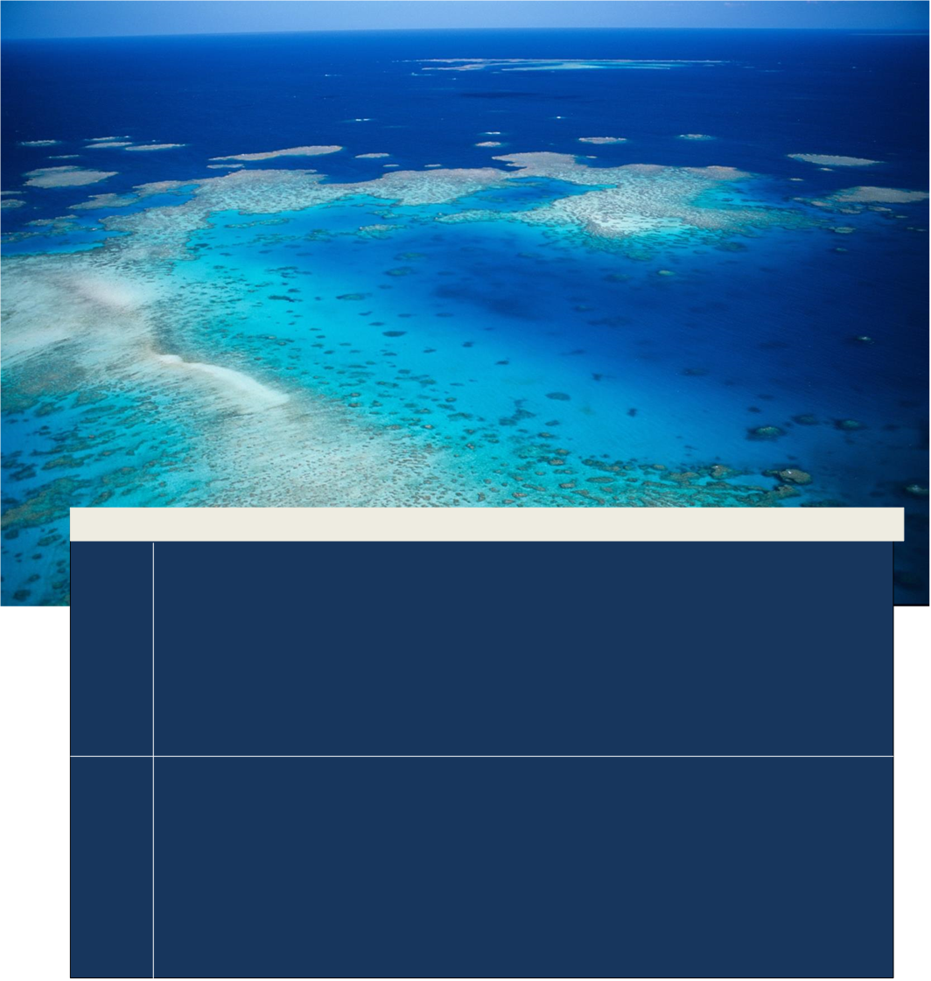
A method for identifying and prioritising coastal ecosystem functional connections to the Great Barrier Reef World Heritage Area and Great Barrier Reef Marine Park
Page intentionally left blank for printing double-sided.

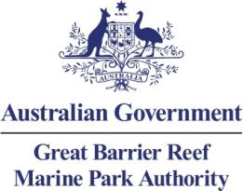
A method for identifying and prioritising coastal ecosystem functional connections to the Great Barrier Reef World Heritage Area and Great Barrier Reef Marine Park
© Commonwealth of Australia 2017
Published by the Great Barrier Reef Marine Park Authority 2017
ISBN 978 1 922126 21 4 (ebook)

A method for identifying and prioritising coastal ecosystem functional connections to the Great Barrier Reef World Heritage Area and Great Barrier Reef Marine Park is licensed by the Commonwealth of Australia for use under a Creative Commons By Attribution 4.0 International licence with the exception of the Coat of Arms of the Commonwealth of Australia, the logo of the Great Barrier Reef Marine Park Authority, any other material protected by a trademark, content supplied by third parties and any photographs. For licence conditions see: http://creativecommons.org/licences/by/4.0


Disclaimer
The views and opinions expressed in this publication are those of the authors and do not necessarily reflect those of the Australian Government.

While reasonable efforts have been made to ensure that the contents of this publication are factually correct, the Great Barrier Reef Marine Park Authority does not accept responsibility for the accuracy or completeness of the contents, and shall not be liable for any loss or damage that may be occasioned directly or indirectly through the use of, or reliance on, the contents of this publication.

National Library of Australia Cataloguing-in-Publication entry
A method for identifying and prioritising coastal ecosystem functional connections to the Great Barrier Reef World Heritage Area and Great Barrier Reef Marine Park /
ISBN 978 1 922126 21 4 (ebook)
Coastal ecology--Queensland--Great Barrier Reef.
Coastal ecosystem health--Queensland--Great Barrier Reef.
Coastal zone management--Queensland--Great Barrier Reef.
Great Barrier Reef Region (Qld.)--Management.
Great Barrier Reef Marine Park Authority.
577.5109943
This publication should be cited as:
Great Barrier Reef Marine Park Authority 2017, A method for identifying and prioritising coastal ecosystem functional connections to the Great Barrier Reef World Heritage Area and Great Barrier Reef Marine Park, GBRMPA, Townsville.
Acknowledgements
This report was prepared by the Great Barrier Reef Marine Park Authority, and acknowledges the contributions of Donna-marie Audas, Jason Vains, Sarina Arfuso, Ben Palmer, Paul Groves, Emily Smart and Hugh Yorkston.

Requests and enquiries concerning reproduction and rights should be addressed to:

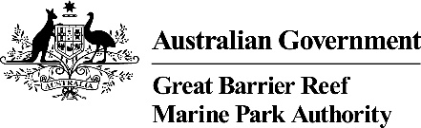 | Great Barrier Reef Marine Park Authority  2–68 Flinders Street  (PO Box 1379)  Townsville QLD 4810, Australia  Phone: (07) 4750 0700  Fax: (07) 4772 6093  Email: info@gbrmpa.gov.au  www.gbrmpa.gov.au

Table of Contents

1 Background 6
2 Purpose 9

3 Methodology 9
3.1 Data layers and analysis 9
3.1.1 Assessment for the Cape York region 11

4 Discussion 11
4.1 Data layer 11
4.1.1 QRA floodplain 11
4.1.2 Highest astronomical tide 11
4.1.3 Queensland wetlands 12
4.1.4 Storm surge 12
4.1.5 Wet signatures 12
4.2 Interpreting the mapped ‘blue score’ methodology 13

5 Next steps 13

6 References 14

Background
One of the most significant threats to the health of the Great Barrier Reef World Heritage Area (World Heritage Area) is the impacts of clearing or modification of coastal habitats (such as wetlands and the connected networks in which they exist) for coastal development.¹ The Great Barrier Reef catchment adjacent to the World Heritage Area and Great Barrier Reef Marine Park (Marine Park) encompasses 424,000 km² and contains a diverse range of coastal ecosystems supporting the health and resilience of ecosystems in the World Heritage Area and Marine Park.
Through a series of expert workshops, the Great Barrier Reef Marine Park Authority (the Authority) has developed a framework to categorise catchment, coastal and inshore ecosystems into 14 distinct components based on the services and functions provided to the World Heritage Area and Marine Park.² These coastal ecosystems are coral reefs, lagoon floor, islands, water column (pelagic), seagrass, coastline, estuaries, freshwater wetlands, forested floodplains, heath and shrublands, grass and sedgelands, woodlands, forests and rainforests (Figure 1). The ecological functions provided by coastal ecosystems include physical processes (such as sediment and water distribution and cycling), biogeochemical processes (such as nutrient and chemical cycling) and biological processes (such as habitat and food provisioning).¹Coastal ecosystems, their functions and processes are discussed further in the Informing the outlook for Great Barrier Reef coastal ecosystems².
This report describes a methodology that extends the work of the Authority. It builds on the Informing the outlook for Great Barrier Reef coastal ecosystems report² and the Coastal Ecosystem Assessment Framework³ by mapping catchment coastal ecosystem areas most important for supporting the biodiversity and ecological processes of the World Heritage Area and Marine Park.

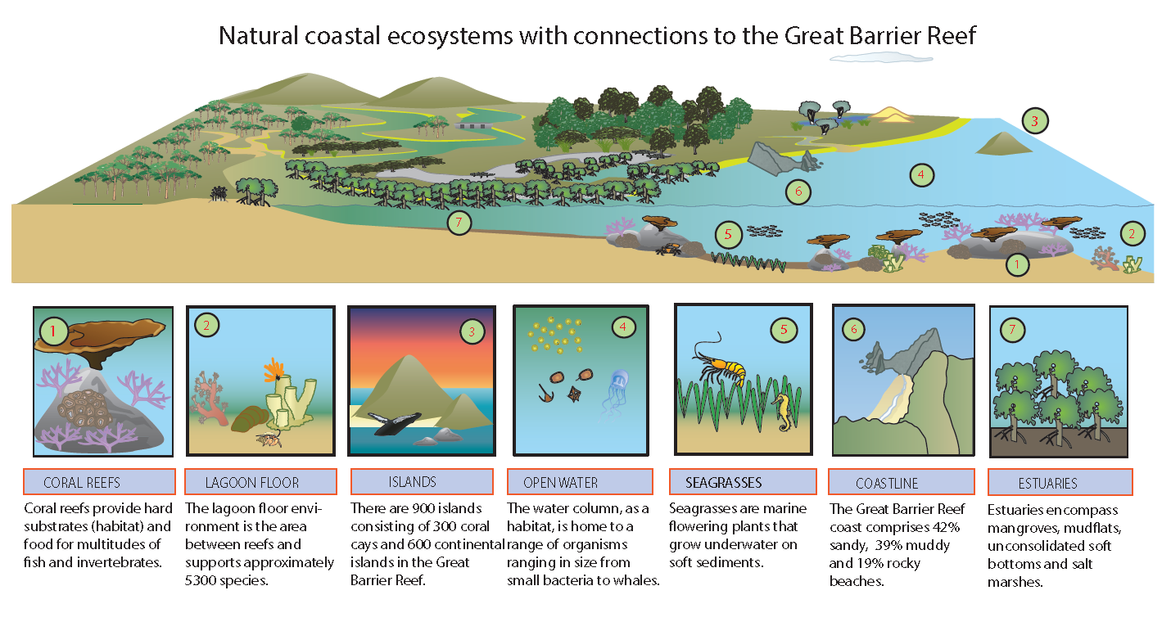
Figure 1: Conceptual diagram of coastal ecosystems – marine, estuarine and islands (Outlook Report 2009)
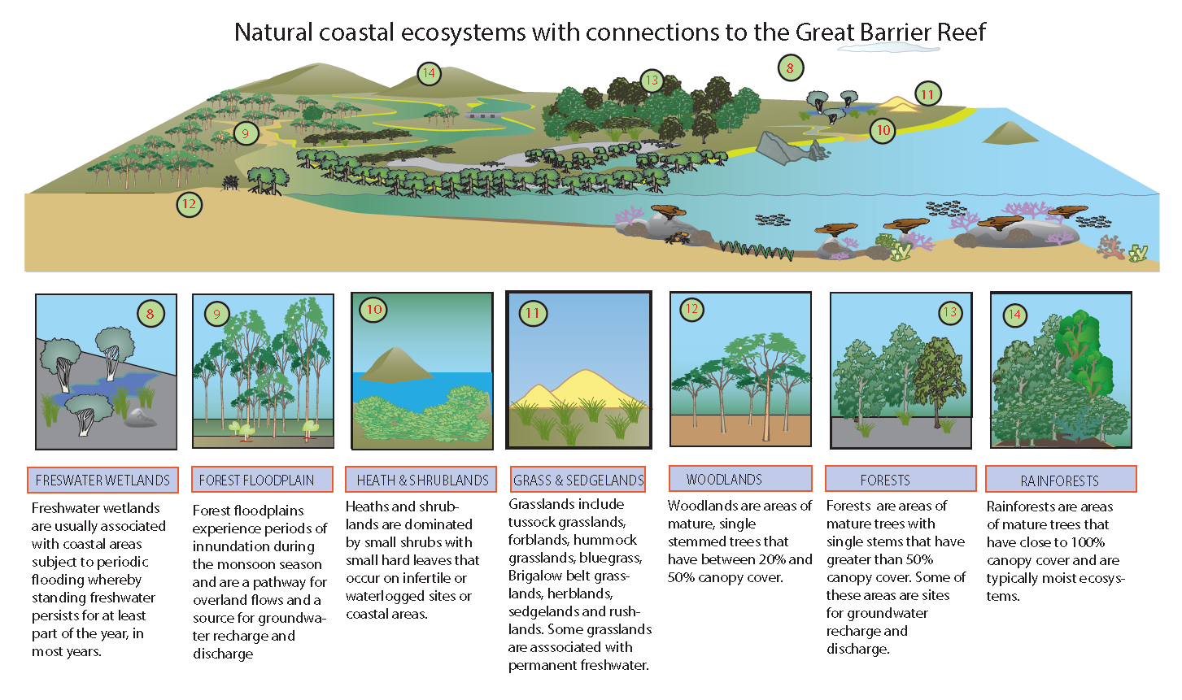
Figure 2: Conceptual diagram of coastal ecosystems - terrestrial (Outlook Report 2009)

Purpose
The purpose of this document is to describe a method to identify areas in the Great Barrier Reef catchment that hydrologically connect coastal ecosystem functions to the Great Barrier Reef World Heritage Area and Marine Park. The method is intended to guide further work on assessing coastal ecosystem functions, and prioritising areas for improved management, restoration and enhancement.

Methodology
The consideration of coastal ecosystems and their relationship to the World Heritage Area and Marine Park, and the selection of datasets used in this methodology, is based on the assessment of the following landscape elements and related data sources⁵:
- Coastal ecosystems in the catchment identified using the Great Barrier Reef Marine Park Authority’s Coastal Ecosystem Assessment Framework³
- The described relationship between coastal ecosystems to adjacent and downstream coastal ecosystems
- Environmental assets and characteristics, together with biophysical, ecological and hydrological processes
- Considerations of surface and groundwater recharge and discharge, and areas of high biodiversity value
- Land use constraints, natural hazards, important ecosystem types, waterways and stream orders
- Areas that provide long-term and viable contributions to the persistence of values and attributes that underpin matters of national environmental significance and the conservation of biodiversity and ecological processes. This includes riparian corridors, buffers, habitats for listed species, under the Environment Protection and Biodiversity Conservation Act 1999 and areas containing native vegetation.
Using this information, existing datasets were identified that represent the spatial and temporal hydrological connection of catchment coastal ecosystems to the World Heritage Area and Marine Park.

Data layers and analysis
The data layers selected for this analysis (as at June 2013) include:
- The Queensland Reconstruction Authority (QRA) Floodplain,
- The Queensland Wetlands Program ‘wetclass’ (a grouping of soil type, regional ecosystem etc.),
- Wet ecosystem signatures (regional ecosystems identifying vegetation types that have a wet or moist footprint),
- Storm surge and
- Highest astronomical tide.
A hydrological connectivity frequency analysis was conducted on these selected datasets. Datasets were weighted and mapped to form a graduated scale ‘blue score’ (refer to Figure 2 and Appendix A for further information on this analysis).
The blue score ranges from 0 to 3, with 0 representing areas that have infrequent connectivity to a score of 3 representing areas that are very frequently connected to the Great Barrier Reef World Heritage Area and Marine Park.
Based on the data available (Appendix A) the catchment has been analysed to identify areas and level of hydrological connectivity (see table below).
Table 1: Summary table of hydrological connectivity classification decriptions
Very Frequently Connected | Direct connections with the Great Barrier Reef occur on a diurnal basis.
Frequently Connected | Direct connections with the Great Barrier Reef occur on at least a monthly basis.
Intermittently Connected | Direct connections with the Great Barrier Reef occur for extended periods during seasonal tidal and flood events.
Infrequently Connected | Direct connections with the Great Barrier Reef occur through groundwater and overland flows during rain events.

The graduated scale represents the level of potential influence and connection, in time and space, of marine and freshwater over coastal ecosystems. The marine and freshwater influences provide an indication of the areas in the catchment most temporally connected to the World Heritage Area, and the area most likely to provide direct significant ecosystem functions and services to the World Heritage Area and Marine Park. The analysis is based on large scale data grouping, and will be continued to be refined at the local scale as data becomes available.

Figure 3: Conceptual diagram of the components used to develop the ‘blue value’ score

Assessment for the Cape York region
In areas where selected datasets are unavailable, such as storm surge and highest astronomical tide data in Cape York, the analysis has been conducted on available datasets only.
Figure 4: Conceptual diagram of the components used to develop the ‘blue score’ score for Cape York

Discussion

Data layers
In developing the graduated scale ‘blue score’, the Authority considered the relationship of coastal ecosystems to natural, geological and hydrological values in the landscape. It identified the existing map layers that best represent the ecosystem functions and process connections. Below is a list of the data layers selected (as at June 2013) and the purpose for including them in the analysis.

QRA floodplain
This data layer was developed through a process of drainage sub-basin analysis using data sources including 10 metre contours, historical flood records, vegetation, soils mapping and satellite imagery. These are areas most connected to the marine environments during flooding events.
QRA Floodplain data correlation to coastal ecosystem ecological function: Freshwater inflow is one of the most influential coastal processes affecting biological community structure and function in coastal lagoons, estuaries and deltas of the world. Forested floodplains and wetlands support physical, biogeochemical and biological processes for the World Heritage Area and in most catchments represent the ecosystem that most closely connects large areas of the catchment to the World Heritage Area and Marine Park.

Highest astronomical tide
This data layer provides information on areas inundated at some time by tidal fluctuations and potentially at risk of adverse coastal hazard impacts such as temporary and permanent sea inundation, and areas subject to coastal erosion. These are areas connected to the marine environment by marine water interactions.
Highest astronomical tide (H.A.T) and storm surge data correlation to coastal ecosystem ecological function: Beaches, estuarine (mangroves and saltmarsh), rivers and brackish wetland areas that are affected by H.A.T provide significant physical, biogeochemical and biological processes for the Great Barrier Reef, in most catchments represent the ecosystems that most regularly connect the landscape to the World Heritage Area and Marine Park.

Queensland wetlands
The Queensland Wetlands Program provides mapping of the extent and type of wetlands across the state. The mapping identifies wetland types and buffer areas. Wetland mapping provides specific recognition of the extent of this ecosystems functional role for the World Heritage Area and Marine Park.
Wetlands correlation to coastal ecosystem ecological function: Wetlands represent identified areas in the landscape that have specific ecological function for supporting aquatic habitat and ecosystem service for the Great Barrier Reef. Wetland areas play an important role as productivity hotspots in the landscape, as refuges in dry times, in capturing and filtering nutrients, sediments and other chemicals, and protecting nearby waterways and sensitive ecosystems by slowing and dispersing water flows. Wetland vegetation growing on the banks of streams or rivers (riparian ecosystems) provides transitional areas between terrestrial and aquatic ecosystems. Wetlands are important energy and nutrient sources for stream ecosystems, and provide food, habitat and shade for both terrestrial and aquatic organisms. Riparian wetlands are important for stream bank stability, guarding against excessive erosion and protecting water bodies from pollutants travelling overland in runoff. Riparian ecosystems provide refuge for plants and animals in times of environmental stress including providing shade to regulate water temperature.¹

Storm surge
Storm surge mapping is based on mapping derived from Landsat imagery, comparing regional ecosystems with landform and topology. The data layer provides information on areas potentially at risk of adverse coastal hazard impacts such as temporary and permanent sea inundation, and areas subject to coastal erosion. This mapping can also correlate strongly with areas predicted to be permanently inundated due to sea level rise.
Storm surge correlation to coastal ecosystem ecological function: Coastal dune and wetlands, beach and estuarine systems, and coastal ecosystems in coastal floodplain areas are all located in this area of influence, and provide significant physical, biogeochemical and biological processes for the Great Barrier Reef.

Wet signatures
The data layer is based on soil properties and vegetation that has a known wet footprint. The information was derived from the pre-clear regional ecosystem mapping which includes soil property mapping. Due to the lack of information on groundwater dependant ecosystems, this layer is also being used to identify where these ecosystems are most likely to be in the landscape.
Wet signatures correlation to coastal ecosystem ecological function: Similar to wetlands and the floodplain, wet signature regional ecosystems represent those areas that have a specific ecological role for supporting aquatic habitat and ecosystem functions for inshore waters of the World Heritage Area that may not be identified in floodplain and wetland mapping areas. Potential acid sulphate soils are also often closely associated with these low lying wet soil signatures. Acid sulphate soils exposed by landuse modification can degrade water quality through acidic runoff and leaching of metals, reducing the health of ecosystems in the World Heritage Area and Marine Park.

Interpreting the mapped ‘blue score’ methodology
This methodology has been applied and mapped in the Great Barrier Reef catchment (Appendix B). The darker the mapped area, the more the area is spatially and temporally connected (by water) to the World Heritage Area and Marine Park. The lighter shaded areas on the map are still important for the World Heritage Area and Marine Park. These areas require planners and managers to prioritise maintenance or return of ecosystem function, rather than return natural coastal ecosystems to an already often significantly modified landscape. For the management of ecosystem function and service, the darker blue areas suggest that these areas would be a priority for management effort to ensure these areas continue to provide the functions necessary to maintain the health of the ecosystems in the World Heritage Area and Marine Park.

Next steps
Coastal ecosystems and their functional relationships to the World Heritage Area and Marine Park is complex. Due to this complexity, it is recommended that functions and processes should wherever possible be further validated at the site scale. There is also a great deal of uncertainty over the relative importance of one coastal ecosystem/function over another or the absolute measure of the functions provided by a coastal ecosystem in a particular area.
Significant opportunities exist for the improved recognition, management and protection of coastal ecosystems and their functions in planning. In assessing the coastal ecosystems and functions that have been modified, the identification and validation of coastal ecosystem extent, integrity and values, changes in hydrological regimes and any increase in movement of sediment, nutrients and other chemicals, are issues that need to be considered further.
A changing climate also presents challenges with modelling catchment peak flow conditions and future rainfall intensity. Both of these factors will influence how overland flows, stormwater and in-stream flows must be managed to protect ecosystem health in the World Heritage Area and Marine Park.
A number of potential management actions exist for planning and managing the Great Barrier Reef catchment area. Stakeholder engagement through information dissemination, knowledge capture and collaboration is essential for holistic management of the World Heritage Area and Marine Park.

References
1. Great Barrier Reef Marine Park Authority 2009, Great Barrier Reef Outlook Report 2009, GBRMPA, Townsville.
2. Great Barrier Reef Marine Park Authority 2012, Informing the outlook for Great Barrier Reef coastal ecosystems, GBRMPA, Townsville.
3. Great Barrier Reef Marine Park Authority 2012, Great Barrier Reef Coastal Ecosystems Assessment Framework, GBRMPA, Townsville.

Appendix A: Workflow diagram for developing the ‘blue score’ mapping
Appendix B: Great Barrier Reef Hydrological Connectivity Map
