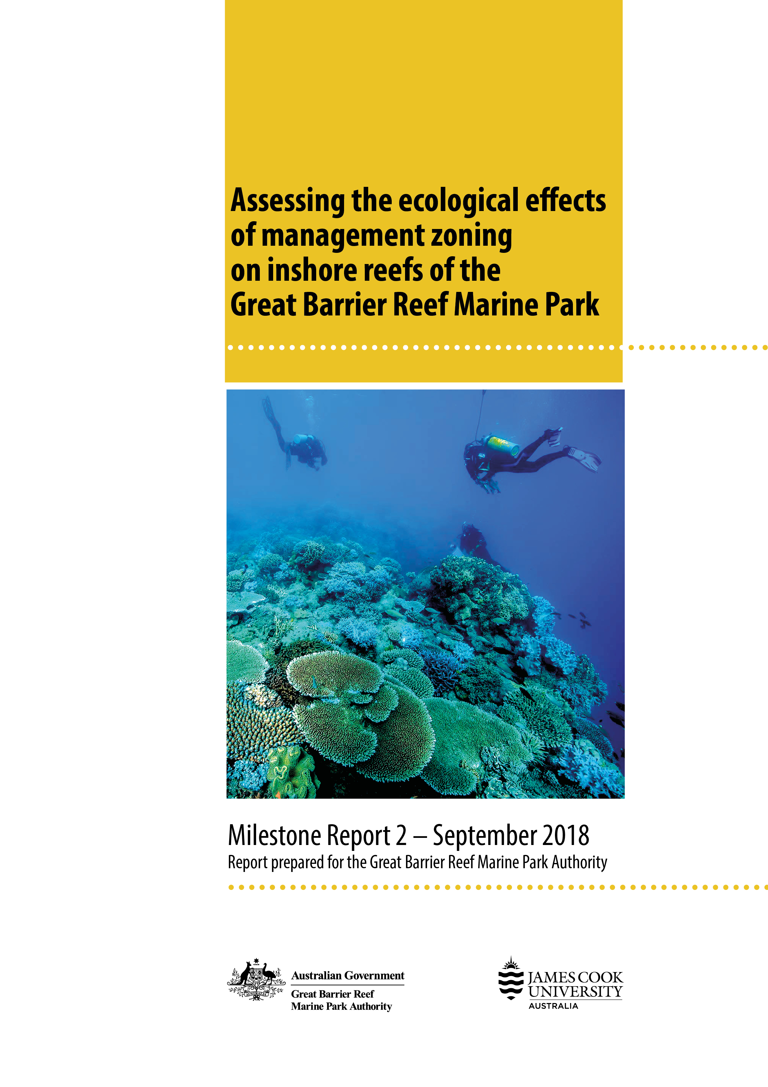

The Great Barrier Reef Marine Park Authority acknowledges the continuing sea country management and custodianship of the Great Barrier Reef by Aboriginal and Torres Strait Islander Traditional Owners whose rich cultures, heritage values, enduring connections and shared efforts protect the Reef for future generations.

© James Cook University and Commonwealth of Australia (Great Barrier Reef Marine Park Authority)
ISBN 9780648357162

This document is licensed by the Commonwealth of Australia for use under a Creative Commons By Attribution 4.0 International licence with the exception of the Coat of Arms of the Commonwealth of Australia, the logo of the Great Barrier Reef Marine Park Authority, the logo of James Cook University, any other material protected by a trademark, content supplied by third parties and any photographs. For licence conditions see: http://creativecommons.org/licences/by/4.0


A catalogue record for this publication is available from the National Library of Australia

This publication should be cited as:
Williamson, D.H., Ceccarelli, D.M., Jones, G.P. and Russ, G.R. 2019, Assessing the Ecological Effects of Management Zoning on Inshore Reefs of the Great Barrier Reef Marine Park. Reef 2050 Integrated Monitoring and Reporting Program Milestone Report 2, Great Barrier Reef Marine Park Authority, Townsville, Australia (76pp.)

Front cover photograph: Healthy coral community and reef monitoring team on the fringing reef at the eastern side of Hook Island, Whitsunday Island group in September 2016. © David Williamson, James Cook University.
While reasonable effort has been made to ensure that the contents of this publication are factually correct, the Commonwealth does not accept responsibility for the accuracy or completeness of the contents, and shall not be liable for any loss or damage that may be occasioned directly or indirectly through the use of, or reliance on, the contents of this publication.

Table of Contents
Acknowledgements 1
Summary 2
Introduction 4
Methods 6
Surveys of fish, benthos and reef habitat complexity 6
Data handling and analyses 7
Mapping of fringing reef habitats 7
Results & Discussion 9
Live coral cover and benthic community structure 9
Fish community dynamics 42
Coral trout (Plectropomus spp.) population dynamics and GBRMP zoning effects 53
References 61
Appendix 1. Fish species list and assigned functional groups 65
Appendix 2: Coral reef habitat maps for focal GBRMP island groups 70
Appendix 3: Project publication list 74

List of Figures

Figure 1: Composite map of study locations and monitoring sites 8
Figure 2: Temporal dynamics of live hard coral cover on Palm Islands reefs 11
Figure 3: Map - Palm Islands, change in hard coral cover 2009 to 2016 12
Figure 4: Map - Palm Islands, 2016 estimates of live hard coral cover 13
Figure 5: Map - Palm Islands, change in coral morphological diversity 2009 to 2016 14
Figure 6: Map - Palm Islands, 2016 estimates of coral morphological diversity 15
Figure 7: Temporal dynamics of benthic community structure on Palm Islands reefs 16
Figure 8: Temporal dynamics of live hard coral cover on Magnetic Island reefs 18
Figure 9: Map - Magnetic Island, change in hard coral cover 2009 to 2016 19
Figure 10: Map - Magnetic Island, 2016 estimates of live hard coral cover 20
Figure 11: Map - Magnetic Island, change in coral morphological diversity 2009 to 2016 21
Figure 12: Map - Magnetic Island, 2016 estimates of coral morphological diversity 22
Figure 13: Temporal dynamics of benthic community structure on Magnetic Island reefs 23
Figure 14: Temporal dynamics of live hard coral cover on Whitsunday Islands reefs 26
Figure 15: Map - Whitsunday Islands, change in hard coral cover 2009 to 2017 27
Figure 16: Map - Whitsunday Islands, 2017 estimates of live hard coral cover 28
Figure 17: Map - Whitsunday Islands, change in coral morphological diversity 2009 to 2017 29
Figure 18: Map - Whitsunday Islands, 2017 estimates of coral morphological diversity 30
Figure 19: Photographic time series, Hayman Island reef 2014, 2016 and 2017 31
Figure 20: Temporal dynamics of benthic community structure on Whitsunday Islands reefs 32
Figure 21: Temporal dynamics of live hard coral cover on Keppel Islands reefs 36
Figure 22: Map - Keppel Islands, change in hard coral cover 2009 to 2017 37
Figure 23: Map - Keppel Islands, 2017 estimates of live hard coral cover 38
Figure 24: Map - Keppel Islands, 2017 estimates of coral morphological diversity 39
Figure 25: Map - Keppel Islands, 2017 estimates of coral morphological diversity 40
Figure 26: Temporal dynamics of benthic community structure on Keppel Islands reefs 41
Figure 27: Temporal dynamics of total fish density on Palm Islands reefs 43
Figure 28: Temporal dynamics of fish community structure on Palm Islands reefs 44
Figure 29: Temporal dynamics of total fish density on Magnetic Island reefs 45
Figure 30: Temporal dynamics of fish community structure on Magnetic Island reefs 46
Figure 31: Temporal dynamics of total fish density on Whitsunday Islands reefs 48
Figure 32: Temporal dynamics of fish community structure on Whitsunday Islands reefs. 49
Figure 33: Temporal dynamics of total fish density on Keppel Islands reefs 51
Figure 34: Temporal dynamics of fish community structure on Keppel Islands reefs 52
Figure 35: Temporal dynamics of coral trout density on Palm Islands reefs 55
Figure 36: Temporal dynamics of coral trout density on Magnetic Island reefs 56
Figure 37: Temporal dynamics of coral trout density on Whitsunday Islands reefs 58
Figure 38: Temporal dynamics of coral trout density on Keppel Islands reefs 60

Acknowledgements
Funding for this monitoring program was provided by the Australian Research Council (ARC); the CRC Reef Research Centre; and the Australian Government Department of Environment and Energy through the Marine and Tropical Sciences Research Facility (MTSRF), the National Environmental Research Program (NERP), the National Environmental Science Program (NESP), and the Reef 2050 Integrated Monitoring and Reporting Program (RIMReP). We wish to thank the following people for assistance with field work and data collection; Rene Abesamis, Kris Boody, Lisa Bostrom-Einarsson, Andrew Cole, Paul Costello, Richard Evans, Jody Kreuger, Mike Emslie, David Feary, Hugo Harrison, Jean-Paul Hobbs, Tom Holmes, Jake Lowe, Tom Mannering, Philippa Mantel, Will Robbins, Niklas Taylor, Rebecca Weeks, Colin Wen and Michelle White. For assistance with field operations we also wish to thank the staff at Explore Group Hamilton Island, Keppel Reef Scuba Adventures, Mars Charters and the Orpheus Island Research Station. Additional thanks to the ARC Centre of Excellence for Coral Reef Studies for their administrative support of the project.

Summary
This RIMReP project builds upon a long-term monitoring program that assesses the ecological effects of management zoning on high-use and high-value inshore coral reefs of the Great Barrier Reef Marine Park (GBRMP). The monitoring program aims to track the status and condition of benthic (coral and algae) and fish communities and quantify the ecological effects of no-take marine reserves (green zones, NTRs). It is one of the few systematic long-term monitoring projects conducted on GBRMP reefs that specifically assesses temporal dynamics in reef communities and the ecological effects of zoning management.
Underwater visual census is used to provide a spatially and temporally replicated assessment of fish and benthic communities on NTR and fished reefs at 112 monitoring sites in the Palm, Magnetic, Whitsunday and Keppel Island groups. The majority of the monitoring sites in the Palm and Whitsunday Islands were first surveyed between1998 and 2000, while monitoring sites were first established in the Keppel Islands in 2002. In order to increase spatial resolution and provide a baseline for assessing the ecological effects of new NTRs implemented in the 2004 GBRMP Zoning Plan, additional monitoring sites were established in all four island groups during 2003 and 2004.
Acute climatic disturbances (e.g. cyclones, coral bleaching, flood plumes) and underlying chronic stressors (e.g. reduced water quality, sedimentation), rather than marine park zoning, have been the primary drivers of change in benthic communities on monitored inshore GBRMP reefs. Throughout the monitoring period, numerous disturbance events have impacted these reefs and multiple periods of coral loss and recovery have been recorded. Although coral reefs are naturally dynamic ecosystems, the high-frequency of disturbance events, compounded upon the chronic stressors of poor water quality and high sedimentation rates, has resulted in overall declines in live coral cover on most monitored reefs. Furthermore, on many of these reefs, benthic community structure has also shifted toward a state of reduced coral diversity, with increasing dominance of robust, stress-tolerant and predominantly slow-growing species (e.g. Porites sp.) and the loss of faster growing, more fragile species (e.g. Acropora spp. and Pocilopora spp.). On several highly-impacted reefs we have recorded dramatic shifts in benthic community structure from coral-dominated to macroalgae-dominated states. On some reefs this benthic community phase shift has persisted for extended periods (5 – 10 years).
Coral reef fish abundances and assemblage structure are intrinsically linked to live coral cover, macroalgal cover and reef habitat complexity. Declines in live coral cover and habitat complexity on inshore GBRMP reefs have had profound impacts on the abundance of a broad range of fish species, including large predatory species such as coral trout (Plectropomus spp.). However, this project has also provided convincing evidence that GBRMP management zoning, and more specifically, the network of green zones, has generated significant positive benefits for fishery-targeted species. Increases in population density, body size, biomass and reproductive potential of exploited species have been broadly demonstrated through this monitoring program.
Inshore GBRMP reefs are subject to a broad range of acute and chronic stressors, yet many of these reefs remain astoundingly resilient. This monitoring program has established a long-term, robust baseline for tracking current and future changes in the ecology, health and productivity of these reefs. It provides the basis for assessing the effects of GBRMP zoning, the Reef 2050 Water Quality Improvement Plan, and a range of other management actions, in protecting coral reef biodiversity, sustaining ecosystem goods and services, and mitigating against the escalating effects of climate change.

Introduction
Cycles of disturbance and recovery are a key feature of coral reef ecosystems, and occasional acute disturbances are considered integral to maintaining high species diversity (Rogers 1993). However, if the intensity and frequency of disturbance exceeds certain thresholds, communities may not be able to fully recover between disturbance events and the overall diversity, function and health of coral reef assemblages will progressively decline (Aronson et al. 2005; Thompson and Dolman 2010). In some cases, this has led to a ‘phase shift’, where previously coral-dominated reefs shift to alternative stable states dominated by other less desirable organisms, usually macroalgae (Bellwood et al. 2004). Cycles of habitat change and long-term habitat degradation have major flow-on effects on the structure of reef fish communities (Jones and Syms 1998; Jones et al. 2004; Wilson et al. 2008).
The response of coral reef benthic communities to disturbance and the subsequent recovery trajectories depends not only on the type, frequency and severity of disturbances, but also on the pre-disturbance condition and composition of coral assemblages. For instance, branching and plate-forming corals (Acropora spp.) are relatively vulnerable to damage, but they also tend to be fast-growing and quick to recover (Carpenter et al. 2008). Furthermore, local acclimation and/or adaptation within genera and species may be critically important in determining the degree to which coral reef communities are impacted by disturbances. Corals living on near-shore reefs may be more resistant to sedimentation, turbidity and fluctuations in salinity and temperature than those accustomed to the conditions on offshore reefs (Fabricius 2011; Flores et al. 2012; van Woesik et al. 2012). Multiple physical drivers have been shown to influence the composition and dynamics of coral assemblages on inshore GBR reefs (Lam et al. 2018). These acute and chronic drivers have clear implications for both benthic and fish assemblage structure and the ecological effects of zoning management.
The response of reef fishes to habitat change is highly variable depending on the ecology and life history of the species. Coral-feeders and small habitat specialists are generally much more vulnerable to declining coral cover, or the loss of certain types of corals, than generalist species (Munday 2004; Berumen and Pratchett 2008). Larger bodied reef fishes are more likely to fluctuate in response to changes in prey abundance or the structural complexity of the substratum, rather than simply the abundance of live coral (Wilson et al. 2009). However, in areas with low underlying habitat complexity of the coral reef matrix, corals provide structure at a scale that is relevant for most fish species (MacNeil et al. 2009). The loss of individual species in response to habitat loss may have little functional consequence in highly diverse systems such as coral reefs, where many species can perform the same ecological role (Bellwood and Hughes 2001). Therefore, assessing reef fish community responses to disturbance at the level of functional groups may provide greater insight into the magnitude and consequences of the impact than assessing species-specific changes.
No-take marine reserves (NTRs, green zones) are widely advocated and increasingly implemented for conserving marine biodiversity and enhancing fishery sustainability (Russ 2002; Sale et al. 2014). Populations of targeted reef fish and invertebrate species can build rapidly within adequately protected NTRs (Russ et al. 2008; Babcock et al. 2010; Emslie et al. 2015), however in some systems population gains have been shown to accrue over decadal time scales (Russ and Alcala 2010). It has also been shown that effective NTR networks can enhance the persistence of populations of targeted reef fishes, such as coral trout (Plectropomus spp.) and tropical snappers (Lutjanidae), by protecting spawning stock biomass and providing important sources of juvenile recruitment to both NTR and fished reefs (Harrison et al. 2012a; Almany et al. 2013).
Networks of NTRs have also been promoted for increasing the resilience of coral reef ecosystems through the enhanced capacity of protected reefs to resist declines and augment recovery from disturbance events (Almany et al. 2009; Graham et al. 2011). However, the empirical evidence for such effects has been contradictory (Jones et al. 2004; Claudet et al. 2011; Williamson et al. 2014). Disturbance events often impact communities indiscriminately in both NTRs and fished areas, and the degree to which reserves may maintain high densities and biomass of exploited fishes following severe disturbance to the benthos is scarcely known. NTRs may play a critical role in population and community recovery following disturbances, but only if they can provide effective refuges in times of disturbance.
Cyclone Debbie was a severe category 4 storm that made landfall at Airlie Beach in March 2017. The cyclone generated wind gusts in excess of 250 km/h and wave heights of at least 8 m (BOM). Cyclone Debbie heavily impacted reefs in the Whitsunday Islands, and subsequently delivered rainfall totals exceeding 600 mm in the Pioneer and Fitzroy River catchments causing major flood levels. The resulting flood plumes engulfed most islands in both the Whitsunday and Keppel Island groups for several weeks, increasing water turbidity and depositing sediment on reefs.
Data collected through the inshore reefs monitoring program in 2017 were integrated into the complete temporal data series for all monitored reefs. Further analyses and interpretation of these data are ongoing, and manuscripts are being produced for publication. This report provides an overview of broad patterns and temporal trends in benthic and fish communities on fringing coral reefs in the Palm, Magnetic, Whitsunday and Keppel Island groups.

Methods

Surveys of fish, benthos and reef habitat complexity
Underwater visual census (UVC) is used to survey reef fish and benthic communities at long-term monitoring sites on fringing coral reefs of the Palm Islands (30 sites), Magnetic Island (8 sites), Whitsunday Islands (43 sites) and Keppel Islands (28 sites). Within each island group, sites are evenly distributed among reefs that are open to fishing (General Use and Conservation Park zones) and no-take marine reserves (Marine National Park zones) that were closed to fishing in either 1987 (referred to here as old NTR or NTR 1987) or 2004 (new NTR or NTR 2004) (Error! Reference source not found.).
At each site, UVC surveys of fishes are conducted using 5 replicate transects (50m x 6m, 300m² survey area per transect, 1500m² per site). Transects are deployed on reef slopes along a depth contour between 4m and 12m. Using SCUBA, two observers survey approximately 190 species of fish from 15 Families (Acanthuridae, Balistidae, Chaetodontidae, Haemulidae, Labridae, Lethrinidae, Lutjanidae, Mullidae, Nemipteridae, Pomacanthidae, Pomacentridae, Scaridae, Serranidae, Siganidae and Zanclidae). A third diver (observer 3) swims directly behind observers one and two, deploying the transect tapes. This UVC technique reduces diver avoidance or attraction behaviour of the surveyed fish species. To increase accuracy of the fish counts, the species list is divided between the two fish observers. Observer one surveys the fish families Haemulidae, Lethrinidae, Lutjanidae, Mullidae, Nemipteridae, Serranidae and the larger species of Labridae. Observer one also records all derelict (discarded or lost) fishing tackle (predominantly fishing line, hooks and sinkers) present on each transect. Observer two surveys the families Acanthuridae, Balistidae, Chaetodontidae, Pomacanthidae, Pomacentridae, Scaridae, Siganidae, Zanclidae and small ‘non-targeted’ species of Labridae. Pomacentrids and small labrids are recorded by observer two during return transect swims within a 2m band (1m either side of the tape, 100m² survey area). The total length of all fish species surveyed by observer one are recorded in 5cm length categories.
The benthic community is surveyed using a standard point-intercept survey method. A single benthic point sample is recorded for every 1m graduation along each transect tape (50 samples per transect). Benthic biota were classified and recorded into one of the following categories; live and dead hard coral with further subdivision into morphological categories (branching, tabular, digitate, solitary, massive, foliose, encrusting), soft coral, sponge, clams (Tridacna spp.), other invertebrates (such as ascidians and anemones), macro-algae, coral reef pavement, rock, rubble and sand. Additionally, for the live hard coral categories branching, tabular and digitate, each colony is further classified as ‘Acropora sp.' or ‘other’ genus. Structural complexity of the reef habitat at each site is estimated by observer one using a simple method that applies a rank (1-5) to both the angle of the reef slope and the rugosity for each ten-meter section of each transect.

Data handling and analyses
Raw counts of benthic variables were converted to percent cover estimates. All hard corals were pooled into a live hard coral (LHC) group. All live corals were also pooled into twelve morphological groupings (massive, branching, tabular, digitate, encrusting, foliose, solitary, soft coral, gorgonian, black coral, blue coral, Millepora). A coral morphological diversity index (score out of 12) was used to quantify and assess morphological diversity.
For all fish species, raw counts were converted to density (individuals per 1000 m²). Fish species were assigned to functional groups for analysis (Appendix 1). Three species of coral trout were recorded during UVC surveys, Plectropomus maculatus, P. leopardus and P. laevis. These species were pooled into a coral trout (Plectropomus spp.) group.
Multivariate analyses were applied to assess variability in benthic communities and fish assemblages among management zones and years. We used nonmetric multidimensional scaling analysis (MDS, Clarke and Gorley 2006) on the Bray–Curtis resemblance matrix of log (x + 1) transformed percent cover estimates of benthic categories and square root-transformed density estimates of fish functional groups to partition variability in benthic and fish communities among management zones (new NTR, old NTR, and fished) and among years (1999/2000 to 2017 for benthos, 2007 to 2017 for fishes), separately for each island group. We then conducted permutational multivariate analysis of variance (PERMANOVA) among the groups, and a SIMPER analysis (Clarke and Warwick 2001) to determine the species or groups that most strongly accounted for the similarities and differences among zones and years. To determine the relative contribution of the original variables (i.e., benthic categories or fish functional groups) to the final MDS solutions, each variable was projected onto the ordination space. Vectors were calculated using the partial regression coefficients of the original variables within the two dimensions of the MDS, and the lengths of the vectors were set proportional to the squared multiple correlation coefficients.

Mapping of fringing reef habitats
Due to inaccuracies in currently available reef habitat maps for inshore reefs in the GBRMP, it was necessary to produce new, geographically accurate habitat maps of reefs in the Palm, Magnetic, Whitsunday and Keppel Island groups. Data from high resolution satellite imagery and ground-truthed coordinates for the depth limit of reef slope habitats at each monitoring site were used to re-draw reef flat and reef slope habitats in ArcGIS (ESRI, Redlands, CA, USA). These new reef habitat data will provide the basis for detailed spatial analyses of benthic and fish communities on inshore GBR fringing reefs. We recommend that the new spatial reef habitat data for these focal inshore reefs be integrated into the ‘GBR Features’ layer of GBRMPAs GIS database. Broad scale maps of reef habitats in the four island groups are presented in Appendix 2.
Figure 1: Map of study locations and reef monitoring sites in the Palm Islands (A), Magnetic Island (B), the Whitsunday Islands (C) and the Keppel Islands (D). Colour shaded areas represent the configuration of post-2004 GBRMP management zones. General Use (light blue), Habitat Protection (dark blue) and Conservation Park (yellow) zones are open to fishing. Marine National Park (green) zones are no-take marine reserves. White markers indicate the position of reef monitoring sites within each island group.

Results & Discussion

Live coral cover and benthic community structure
Acute climatic disturbances (e.g. cyclones, coral bleaching, flood plumes) and underlying chronic stressors (e.g. reduced water quality, sedimentation) have been the primary drivers of change in benthic communities on the surveyed reefs. Previous findings from this project suggest that management zoning has not been a significant driver of temporal changes in live coral cover on inshore reefs of the GBRMP (Williamson et al. 2004; Williamson et al. 2014; Emslie et al. 2015).
Live coral cover, macroalgal cover and habitat complexity are intrinsically linked to the abundance of many coral reef fish species and to the structure of fish assemblages. Disturbance-driven declines in live coral cover and habitat complexity on inshore GBRMP reefs have been shown to have profound impacts on the abundance of a broad range of fish species, including large predatory species such as coral trout (Plectropomus spp.) (Williamson et al. 2014). However, management zoning has provided significant benefit to the density and biomass of targeted fishes (Williamson et al. 2004; Williamson et al. 2014; Emslie et al. 2015).

Palm Islands
In the Palm Islands, live hard coral (LHC) cover fluctuated in response to coral bleaching and storm damage, with the largest shifts recorded following cyclone Yasi in 2011. LHC cover declined significantly on all reefs from 2000 to 2002, predominantly due to coral bleaching in early 2002, before recovering to a peak of approximately 30% cover in 2009 (Figure 2a). Cyclone Yasi impacted the Palm Islands in February 2011, and resulted in a ~50% relative decline in LHC cover at exposed (eastern) sites at Pelorus Island (fished) and Orpheus Island (old NTR) between 2009 and 2012 (Figure 2b). Sheltered (western) fringing reefs at Orpheus and Pelorus Islands were also subject to declines in LHC cover following cyclone Yasi, however the losses were not as severe as those recorded on exposed reefs throughout the Island group. Furthermore, there was no decline in LHC cover recorded at sheltered (new NTR) sites at Curacoa Island (Figure 2b, Figure 3).
Recovery of LHC cover was recorded on fished reefs from 2012 to 2016, while NTR reefs were stable or recovered slightly from 2012 to 2014, before again declining between 2014 and 2016 (Figure 2b). The observed recovery trajectory on fished reefs (2012 to 2016) and NTR reefs (2012 to 2014) was primarily facilitated by the recruitment of new coral colonies during 2012 and 2013, particularly to the exposed (eastern) reefs of Orpheus and Pelorus Islands. It is also apparent that the flood plume that resulted from the passing of cyclone Ita in April 2014 did not seriously impact LHC cover in the Palm Islands prior to sampling in October 2014 (Figure 2). Although the declines recorded on NTR reefs at Orpheus and Curacoa Islands from 2014 to 2016 may be partially attributed to lag effects from the flood plume associated with cyclone Ita, we expect that the vast majority of these declines were the result of the 2016 coral bleaching event (Hughes et al. 2017). Between 2009 and 2016, LHC cover declined by at least 5% at three-quarters (23 out of 30) of the reef monitoring sites in the Palm Islands, while it remained stable or increased at the remaining sites (Figure 3). Sites at which LHC cover remained stable or increased were relatively evenly distributed among NTR and fished reefs (Figure 3). In August 2016, mean LHC cover across all monitored sites in the Palm Islands was approximately 20% (± 1% SE) (Figure 2, Figure 4).
In addition to the overall effects on LHC cover, coral morphological diversity and benthic community structure were also impacted by the series of disturbance events (Figure 5, Figure 6, Figure 7). Between 2000 and 2004, the benthic community was dominated by dead corals, almost certainly as a result of the 1998 and 2002 coral bleaching events. Significant recovery occurred between 2004 and 2009, with a shift on both NTR and fished reefs from dead corals toward a mix of LHC forms and soft coral (Figure 7). Cyclone Yasi (2011) caused significant coral loss and shifted benthic community composition towards abiotic substrata (pavement) and macroalgae, particularly on exposed reefs. In the three years following cyclone Yasi (2012 to 2014), this community shift reached its peak, particularly at the exposed sites at Orpheus Island (old NTR) and Pelorus Island (fished), which remained dominated by pavement and macroalgae through to 2014. In August 2016, the benthic community at these impacted sites had begun a transition from algal dominance toward coral dominance. This was primarily driven by a reduction in the cover of macroalgae and recruitment of new coral colonies (predominantly Acropora spp.) from 2014 to 2016 (Figure 7).
There was no significant overall variation in benthic community composition among NTR and fished reefs between 2000 and 2016 (PERMANOVA, Pseudo-F = 1.38, p = 0.17). However, benthic community temporal trajectories did vary significantly among NTR and fished reefs (PERMANOVA, Pseudo-F = 1.37, p = 0.02). This difference was predominantly driven by the new NTR reef at Curacoa Island which sustained higher cover of LHC and lower cover of macroalgae than NTR and fished reefs at Orpheus and Pelorus Islands (Figure 7). Reefs surrounding Orpheus and Pelorus Islands displayed similar benthic community structure and almost identical temporal trajectories throughout the monitoring period (Figure 7).
It is apparent that the coral bleaching event in early 2016 limited the extent of recovery in the coral community between 2012 and 2016. Significant coral bleaching was also reported in the Palm Islands in March 2017. The most recent monitoring surveys were conducted on Palm Island group reefs during August 2018. The 2018 data is not included in this report, however it was evident that recovery of the coral community was continuing at that time, particularly on exposed (east-oriented) reefs. The vast majority of sighted tabular, branching and corymbose Acropora spp. colonies were alive and seemingly healthy, however nearly all sighted Pocilopora spp. colonies were dead. Although these observations are preliminary at this stage, it is evident that the 2016 and 2017 bleaching events resulted in very high mortality of shallow (< 10m) Pocilopora spp. colonies, while most Acropora spp. colonies appear to have recovered from the bleaching events.

Figure 2: Temporal dynamics of mean live hard coral cover on reefs in the Palm Island group from 2000 - 2016. (a) Live hard coral cover across all monitoring sites pooled. (b) Live hard coral cover in fished zones (HPZ, CPZ), old (1987) no-take marine reserve zones (MNPZ), and new (2004) no-take marine reserve zones (MNPZ). Error bars are ± 1 standard error. Blue dashed lines and annotations indicate the timing and nature of major climatic disturbances during the monitoring period.

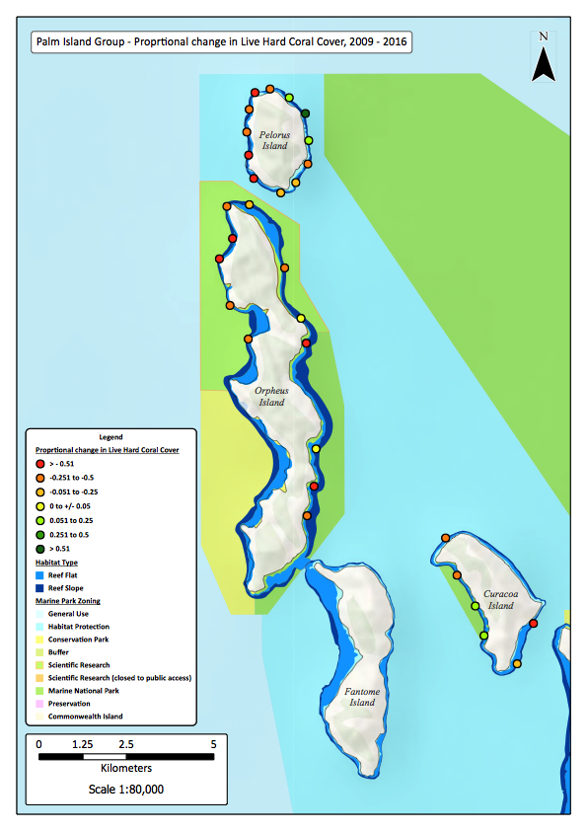
Figure 3: Map of the Palm Island group colour coded monitoring site markers corresponding to the estimated proportional change in mean percent cover of live hard coral at each site between 2009 and 2016.

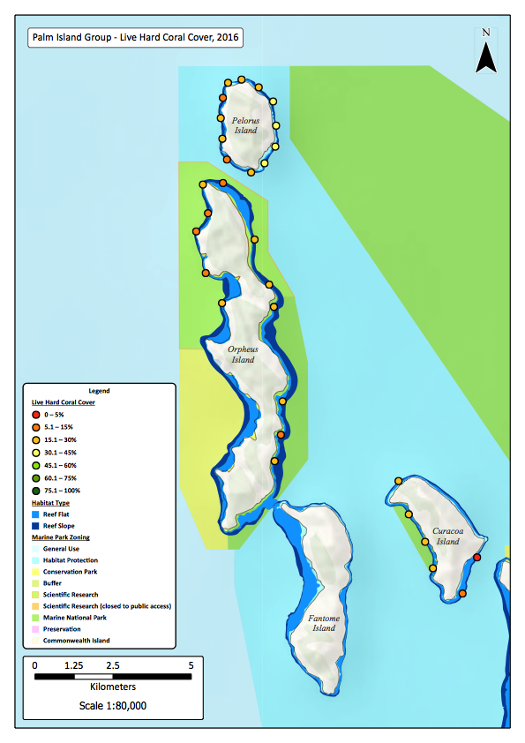
Figure 4: Map of the Palm Island group colour coded monitoring site markers corresponding to the estimated mean percent cover of live hard coral at each site during 2016.

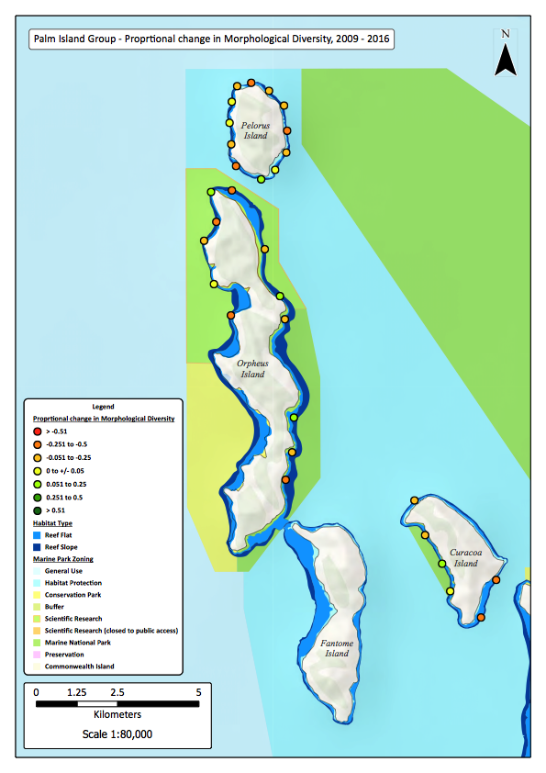
Figure 5: Map of the Palm Island group with colour coded monitoring site markers corresponding to the estimated proportional change in mean morphological diversity of hard and soft corals at each site between 2009 and 2016.

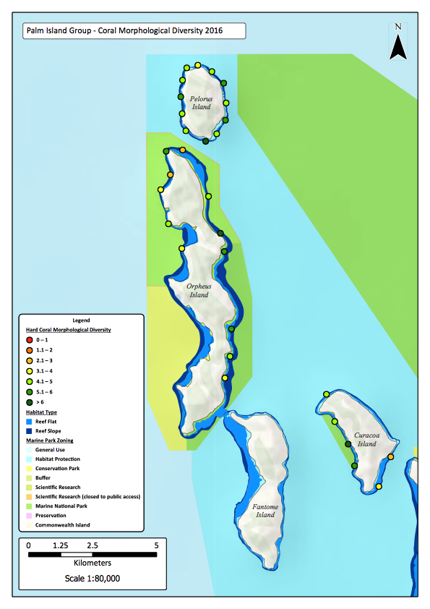
Figure 6: Map of the Palm Island group with colour coded monitoring site markers corresponding to the estimated mean morphological diversity of hard and soft corals at each site during 2016.

Figure 7: Non-metric MDS plot of benthic community structure on reefs in the Palm Island group for the 2000 to 2016 temporal series. Site-level multivariate means were used for all survey years. Sites are partitioned by GBRMP management zone; fished zones (HPZ, CPZ), old (1987) no-take marine reserve zones (MNPZ), and new (2004) no-take marine reserve zones (MNPZ).

Magnetic Island
Fringing reefs at Magnetic Island typically support a range of hard coral and macroalgae species, with dramatic seasonal fluctuations in the relative cover of large fleshy macroalgae (predominantly Sargassum sp.) typical of many inshore GBR reefs (Ceccarelli et al. 2005). During the Summer months, Sargassum and other macroalgae species have rapid vegetative growth and dominate benthic cover on the reefs. Although the alga’s holdfasts remain in place through the winter months, much of the fleshy portion of the plant breaks away. It is often during these periods that corals, both live and dead, dominate the composition of the benthic community.
Magnetic Island reefs were impacted in January 2002 by a widespread coral bleaching event (Berkelmans et al. 2004). Following the bleaching, LHC recovered and reached a peak of approximately 40% cover in 2004 (Figure 8a). Cyclone Yasi (2011) subsequently led to declines in LHC cover and a steady increase in macroalgae cover through to 2012. The trajectories of change in LHC cover were similar among NTR and fished reefs throughout the monitoring period (Figure 8b). However, LHC cover increased on new NTR reefs at Florence and Gowrie Bays between 2004 and 2007, while it decreased on fished reefs at Arthur and Nelly Bays and on the Geoffrey Bay reef (old NTR). Unsurprisingly, the most highly exposed new NTR reefs at Florence and Gowrie Bays also experienced the greatest declines in LHC cover following cyclone Yasi in 2011 (Figure 8b). Since 2012, LHC cover remained relatively stable on fished and new NTR reefs, and increased on the Geoffrey Bay reef (old NTR) (Figure 8b). There was no indication that the 2016 coral bleaching event resulted in significant additional coral mortality at Magnetic Island.
Between 2004 and 2016, LHC cover declined by a minimum of 5% at all monitored reefs at Magnetic Island, and relative declines in excess of 50% were recorded at over half (5 out of 8) of the monitoring sites (Figure 9Error! Reference source not found.). In November 2016, overall mean LHC cover on Magnetic Island reefs was approximately 22% (± 2% SE) (Figure 8a, Figure 10).
Coral morphological diversity also declined on most monitored reefs at Magnetic Island between 2004 and 2016 (Figure 11). However, morphological diversity increased on the reefs at Nelly Bay (fished) and Geoffrey Bay (old NTR) throughout the monitoring period (Figure 11). Furthermore, in November 2016, the highest coral morphological diversity scores were recorded on reefs at Nelly and Geoffrey Bays (Figure 12).
The coral community at all surveyed sites shifted from a dominance of plate-forming corals in 2004 to foliose corals in 2012 (Figure 13). Gorgonians also became more prevalent at most sites in 2012. In the following years, cumulative stressors drove the community towards a greater cover of dead corals, macroalgae and abiotic components. The temporal trajectory of benthic community structure on the Geoffrey Bay reef (old NTR) differed from the similar trajectories on new NTR and fished reefs, with more direct shift towards macroalgae in 2012, and a further shift towards the original (2004) community composition in 2016. However, this variation among zones was marginally non-significant (PERMANOVA, Pseudo-F = 1.64, p = 0.06, Figure 13).
Despite recent impacts and overall declines in LHC cover and coral diversity, it is apparent that Magnetic Island reefs are capable of recovery if given adequate time between disturbance events. However, chronic stressors such as sediment deposition and elevated nutrient loads in coastal waters of the GBRMP are likely to remain a serious impediment to the long-term recovery of coral communities at Magnetic Island. A long-term shift from coral dominance to macroalgae dominance has been observed on these reefs, and current water quality conditions may exacerbate this shift (Fabricius 2005; Thompson et al. 2017; Lam et al. 2018). Efforts to restore reef condition through active removal of macroalgae, may contribute to reversing the shift toward stable algal dominance on some reefs at limited spatial scales (Ceccarelli et al. 2018), however improvements in water quality and a reprieve from major disturbances are required for long-term, sustained coral recovery of these reefs.
Figure 8: Temporal dynamics of mean live hard coral cover on Magnetic Island reefs from 2004 - 2016. (a) Live hard coral cover across all monitoring sites pooled. (b) Live hard coral cover in fished zones (HPZ, CPZ), old (1987) no-take marine reserve zones (MNPZ), and new (2004) no-take marine reserve zones (MNPZ). Error bars are ± 1 standard error. Blue dashed lines and annotations indicate the timing and nature of major climatic disturbances during the monitoring period.
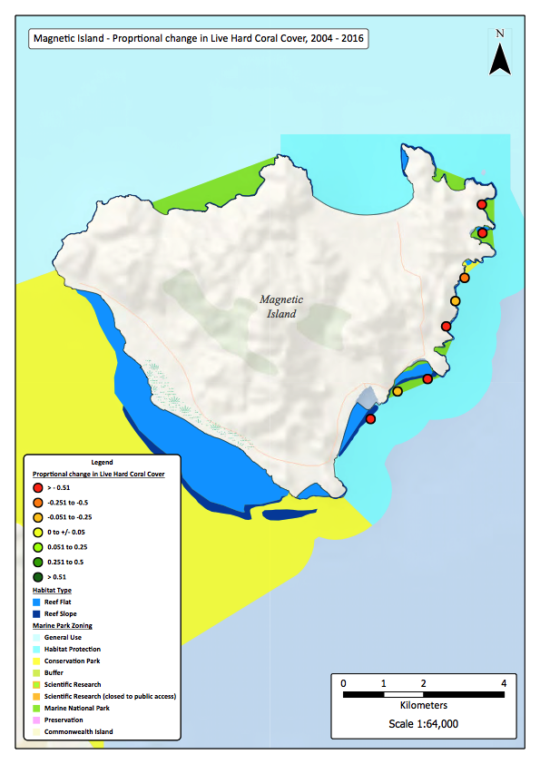
Figure 9: Map of Magnetic Island with colour coded monitoring site markers corresponding to the estimated proportional change in mean percent cover of live hard coral at each site between 2009 and 2016.
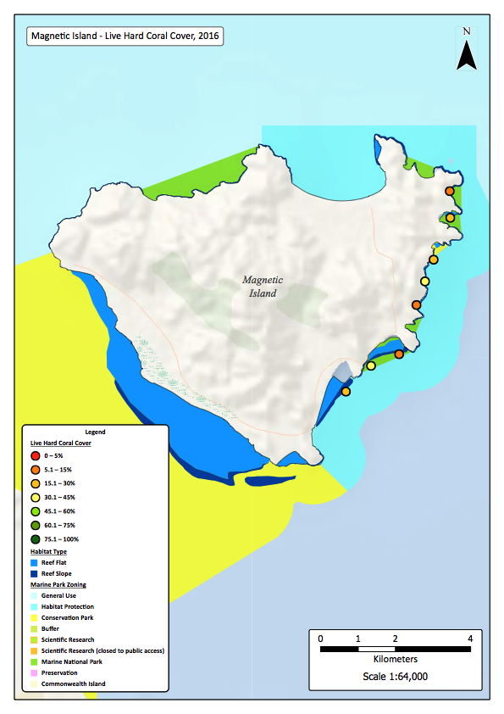
Figure 10: Map of Magnetic Island with colour coded monitoring site markers corresponding to the estimated mean percent cover of live hard coral at each site during 2016.

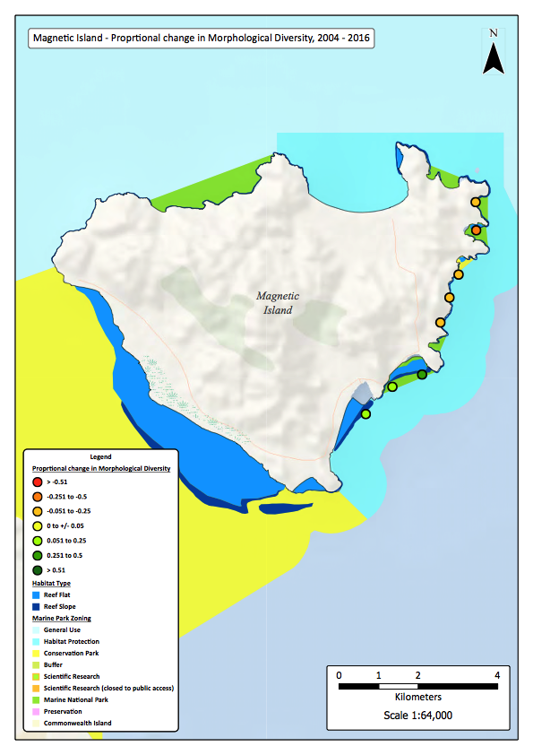
Figure 11: Map of Magnetic Island with colour coded monitoring site markers corresponding to the estimated proportional change in mean morphological diversity of hard and soft corals at each site between 2009 and 2016.

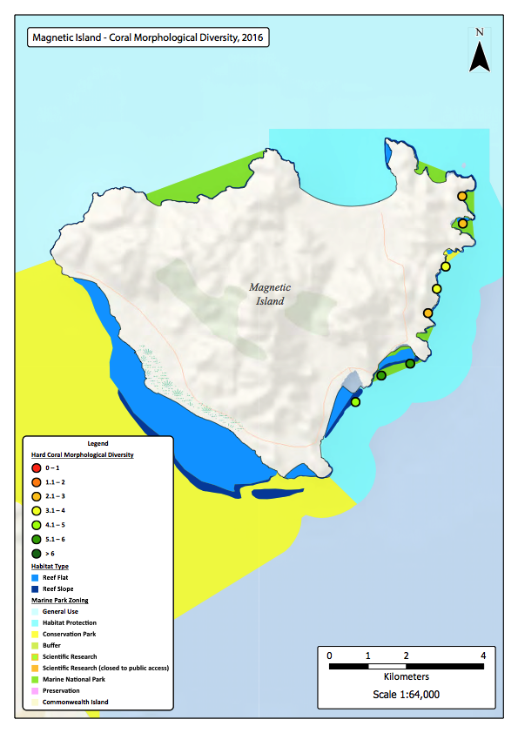
Figure 12: Map of Magnetic Island with colour coded monitoring site markers corresponding to the estimated mean morphological diversity of hard and soft corals at each site during 2016.

Figure 13: Non-metric MDS plot of benthic community structure on reefs at Magnetic Island for the 2004 to 2016 temporal series. Site-level multivariate means were used for all survey years. Sites are partitioned by GBRMP management zone; fished zones (HPZ, CPZ), old (1987) no-take marine reserve zones (MNPZ), and new (2004) no-take marine reserve zones (MNPZ).

Whitsunday Islands
Fringing coral reefs in the Whitsunday Island group were subjected to several climatic disturbance events throughout the monitoring period, including coral bleaching in 2002, 2016 and 2017 (Berkelmans et al. 2004; Hughes et al. 2017), cyclone Ului (category 5, 2010) and cyclone Debbie (category 4, 2017). Despite these disturbances, LHC cover remained remarkably stable on Whitsunday reefs between 1999 and 2016, and only declined significantly in 2017 as a result of cyclone Debbie (Figure 14a).
Although there was some evidence that the 2002 and 2016 coral bleaching events led to increased mortality of some coral species (predominantly Acropora spp.), there was no significant reduction in overall LHC cover following either of the bleaching events. It is not possible to estimate the level of coral mortality that resulted from the 2017 coral bleaching event from this dataset. The 2017 monitoring surveys were conducted in November 2017 and although some dead ‘standing’ coral was recorded at several sheltered (leeward) sites, most monitored reefs had been heavily impacted by cyclone Debbie (March 2017). Therefore, corals that may have bleached and subsequently died in early 2017 would have been torn from the reef and converted to rubble.
Cyclone Ului generated a small and non-significant decline in relative LHC cover of approximately 5% across all monitored reefs in the Whitsunday Islands. Despite being a powerful (category 5) storm, the predominant wind and wave direction was from the south to southeast, and many of the monitored reefs were at least partially sheltered from the storm. Cyclone Ului was also fast-moving and crossed the Whitsunday Islands within a few hours (Bureau of Meteorology – BoM, www.bom.gov.au). We presume that cyclone Ului would have had a greater impact on south and southeast-oriented reefs, particularly those toward the southern end of the Whitsunday Island group, and those further south in the Northumberland Island group.
Cyclone Debbie (category 4) struck the Whitsunday Islands in late March 2017 and directly impacted the majority of the monitored reefs. The cyclone was extremely powerful, slow moving, and remained almost stationary off the northern end of the Whitsunday Island group for upwards of 18 hours (BoM). The majority of the monitored reefs are oriented toward the east and north and were therefore heavily impacted by cyclone Debbie. Overall, cyclone Debbie resulted in a relative decline in LHC cover of approximately 55% across all monitored reefs (Figure 14). In November 2017, average LHC cover across all reefs was just below 19% (± 1% SE). In contrast, the highest estimate of LHC cover recorded during the monitoring period was just below 42% (± 1% SE) in September 2016 (Figure 14a).
Live hard coral cover generally remained at similar levels on both NTR and fished reefs, however significantly higher cover was recorded on NTR reefs in both 1999 and 2017 (Figure 14b). Interestingly, the 1999 survey was conducted approximately 18 months after the Whitsunday reefs had been impacted by the 1998 mass coral bleaching, and the 2017 survey was conducted 8 months after cyclone Debbie. Although this could only be considered weak evidence for NTRs partially mitigating the negative effects of climatic disturbance events, these findings suggest that the existing GBRMP zoning for the Whitsunday Islands has assigned NTR protection to several reefs that are inherently more resistant to major climatic disturbance events than nearby reefs that remain open to fishing (Figure 14b).
More than half of the monitoring sites (23 out of 42) were subject to relative declines in LHC cover of at least 50% between 2009 and 2017 (Figure 15). As a result, approximately half of the monitoring sites supported less than 15% LHC cover in November 2017 (Figure 16). The primary driver of these declines was cyclone Debbie.
Coral morphological diversity decreased at all but two of the monitored Whitsunday reefs between 2009 and 2017 (Figure 17). However, several relatively sheltered reefs retained moderate to high levels of coral morphological diversity following cyclone Debbie (Figure 18). These areas included the NTR reefs fringing Black Island and Butterfly Bay (Hook Island), and the fished reef that adjoins the north-western corner of Hook Island (Figure 18). A time series of photos captured in 2014, 2016 and 2017 at site HE1 on the eastern, exposed reef at Hayman Island, provides some insight into the severity of coral loss following cyclone Debbie on many of the highly exposed Whitsunday reefs (Figure 19).
Benthic community structure varied significantly among NTR and fished reefs between 1999 and 2017 (PERMANOVA, Pseudo-F = 1.38, p = 0.01). Fished reefs consistently supported higher proportional cover of macroalgae than NTR reefs (Figure 20). This was predominantly driven by sites located on the eastern (exposed) side of Whitsunday Island, where macroalgae cover was consistently highest throughout the monitoring period. Reefs within new NTR zones maintained higher relative cover of soft coral than either old NTR or fished reefs (Figure 20). There is some evidence that the relative cover of branching, tabular and digitate corals was reduced between 2014 and 2016, and this was likely a result of the 2016 coral bleaching event (Figure 20). Cyclone Debbie resulted in a significant shift in benthic community structure from 2016 to 2017, with a large reduction in live coral, dead coral and all other biotic benthic categories. In November 2017, benthic community structure remained similar among NTR and fished reefs, with most sites being dominated by expanses of consolidated reef pavement covered in algal turf, with sparse cover of robust coral forms (predominantly species with massive and encrusting morphology) (Figure 20).
The underlying drivers of the observed differences in benthic community structure among management zones are not clearly apparent. It is likely that site position, exposure and fine-scale hydrodynamics are major contributing factors (Lam et al. 2018). Additionally, it has previously been demonstrated that the incidence of coral diseases can be significantly greater on fished reefs than on NTR reefs in the Whitsunday Islands (Lamb et al. 2015; Lamb et al. 2016). Given that these inner-shelf reefs are easily accessible and relatively heavily fished, it is possible that physical damage from fishing and other recreational activities has contributed to reduced coral cover and increased macroalgal cover on some fished reefs. It is imperative that Whitsunday reefs that currently continue to support relatively high cover and diversity of live coral are carefully managed during the next few years. There is a risk that overuse from both recreational fishers and tourism operators will place additional stress onto the currently remaining local reef biodiversity refuges.
Figure 14: Temporal dynamics of mean live hard coral cover on Whitsunday Island group reefs from 1999 - 2017. (a) Live hard coral cover across all monitoring sites pooled. (b) Live hard coral cover in fished zones (HPZ, CPZ), old (1987) no-take marine reserve zones (MNPZ), and new (2004) no-take marine reserve zones (MNPZ). Error bars are ± 1 standard error. Blue dashed lines and annotations indicate the timing and nature of major climatic disturbances during the monitoring period.

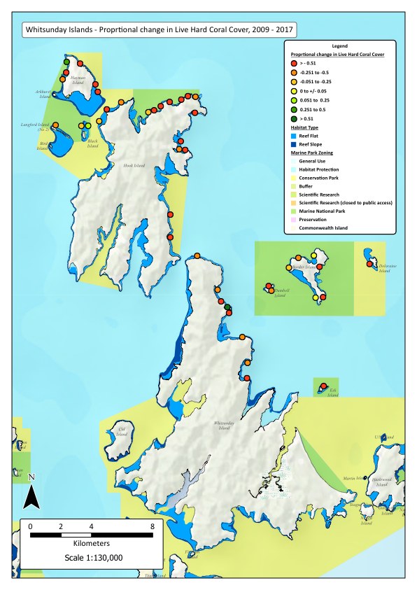
Figure 15: Map of the Whitsunday Island group with colour coded monitoring site markers corresponding to the estimated proportional change in mean percent cover of live hard coral at each site between November 2009 and November 2017.
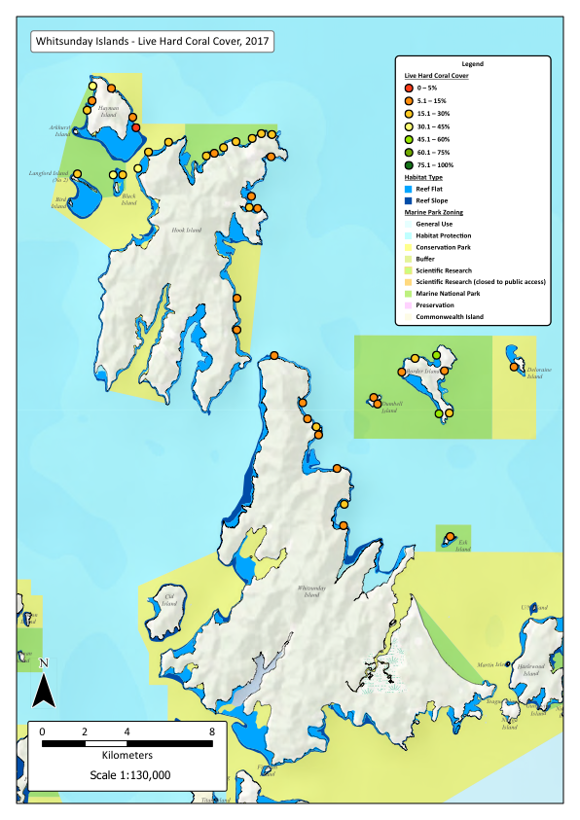
Figure 16: Map of the Whitsunday Island group with colour coded monitoring site markers corresponding to the estimated mean percent cover of live hard coral at each site during November 2017.
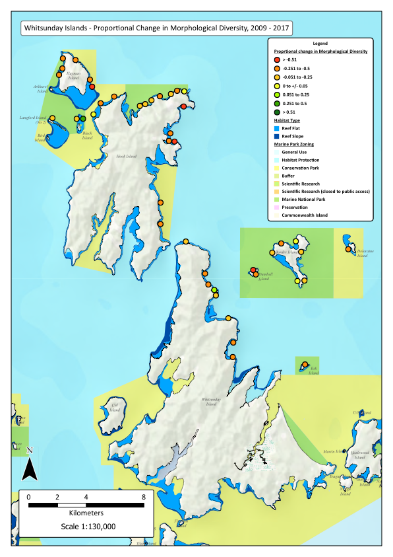
Figure 17: Map of the Whitsunday Island group with colour coded monitoring site markers corresponding to the estimated proportional change in mean morphological diversity of hard and soft corals at each site between November 2009 and November 2017.
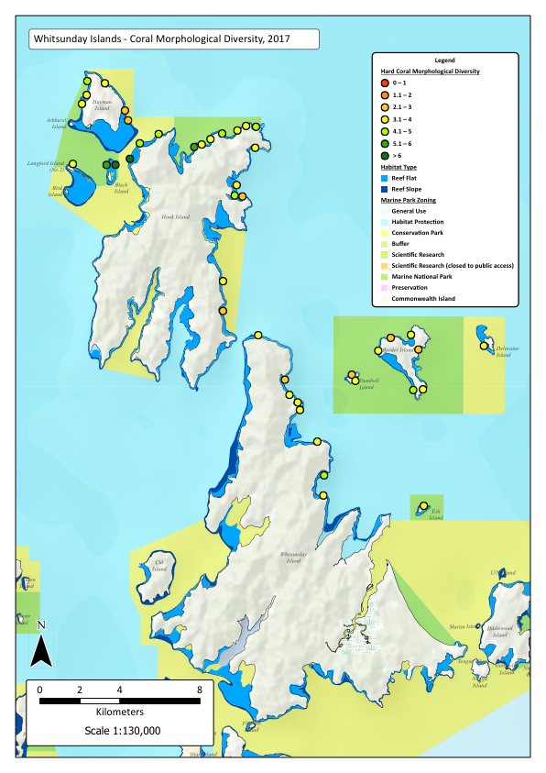
Figure 18: Map of the Whitsunday Island group with colour coded monitoring site markers corresponding to the estimated mean morphological diversity of hard and soft corals at each site during November 2017.
Figure 19: Time series of photographs captured in September 2014, September 2016 and November 2017 at the same location of site HE1 on the eastern reef of Hayman Island in the Whitsunday Island group. This reef was severely impacted by Cyclone Debbie in March 2017.

Figure 20: Non-metric MDS plot of benthic community structure on reefs in the Whitsunday Island group for the 1999 to 2017 temporal series. Site-level multivariate means were used for all survey years. Sites are partitioned by GBRMP management zone; fished zones (HPZ, CPZ), old (1987) no-take marine reserve zones (MNPZ), and new (2004) no-take marine reserve zones (MNPZ).

Keppel Islands
Successive severe climatic disturbance events resulted in a long-term, significant decline in LHC cover on Keppel Island reefs between 2004 and 2013 (Figure 21a). The decline in coral cover was recorded on both NTR and fished reefs (Figure 21b). Despite the passing of cyclone Marcia (category 5) in 2015, coral bleaching in early 2016 (Kennedy et al. 2018), and a major flood event in the Fitzroy River catchment and an associated flood plume in April 2017 (rain depression following cyclone Debbie), LHC cover increased on Keppel reefs from 2013 to 2017 (Figure 21a). This recent recovery in LHC cover was predominantly driven by fished reefs, as LHC cover remained stable or only marginally increased on NTR reefs (Figure 21b). In October 2017, overall mean LHC cover across all monitored reefs in the Keppel Islands was just below 36% (± 3% SE) (Figure 21a).
Although the 2006 coral bleaching event had a significant short-term impact on LHC cover, corals on old NTR and fished reefs recovered rapidly, returning to pre-disturbance (2004) levels by 2009 (Figure 21b). The primary mechanism of the rapid recovery on these reefs was regrowth of remnant surviving Acropora spp. coral tissue over dead coral branches (Diaz-Pulido et al. 2009). However, negligible recovery from the 2006 bleaching event was recorded on new NTR reefs, particularly at North Keppel Island, where mean LHC cover has remained below 35% since 2006 (Figure 21b). It is likely that the failure of these reefs to recover is related to their geographic location, limited larval supply and infestation by several species of macroalgae (predominantly Lobophora variegata, Sargassum sp., Padina sp. and Asparagopsis sp.). We do not consider that the zoning of these reefs within the new NTRs influenced the lack of post-bleaching recovery at these sites (Williamson et al. 2014).
The 2011 and 2013 freshwater flood plumes from the Fitzroy River inflicted the greatest damage on Keppel reefs during the monitoring period, with the lowest ebb of LHC cover (26%) recorded in late 2013 (Figure 21a). Mean LHC cover declined in all zones following both flood events, and there was no significant difference in mean cover recorded between NTR and fished zones in either 2011 or 2013 (Figure 21b). Both the 2011 and 2013 flood events were among the largest recorded floods of the Fitzroy River (Wenger et al. 2016); almost all reefs in the Keppel Islands were impacted to some degree and the impact on some reefs was catastrophic (Jones and Berkelmans 2014; Williamson et al. 2014; Wenger et al. 2016). Although several reefs retained LHC below a depth of approximately 8m, most shallow reef slopes and all reef flat habitats were severely impacted (Jones and Berkelmans 2014).
The additional impacts of Cyclone Marcia in March 2015, the coral bleaching event in early 2016, and the major flood plume event of April 2017 were not as severe as expected (Kennedy et al. 2018) (Figure 21). However, reefs that are oriented toward the north and east were exposed to the full force of the storm swells generated during cyclone Marcia and there were obvious signs of cyclone damage at several monitoring sites during 2015. Despite the localised and spatially patchy impacts of the cyclone, LHC cover increased from approximately 26% in 2013 to 30% in 2015. LHC cover continued to increase through 2016 and 2017 and had reached almost 36% by October 2017 (Figure 21a). In 2017 mean LHC cover was higher on fished reefs than on NTR reefs (Figure 21b). However, we consider it unlikely that marine park zoning influenced the degree of coral retention or loss at individual reefs.
Almost half (9 out of 22) of the monitored reefs in the Keppel Islands experienced relative declines in LHC cover of at least 50% between 2009 and 2017 (Figure 22), primarily following the 2011 and 2013 flood events. Of the 9 most heavily impacted sites, 5 are located on NTR reefs and 4 are located on fished reefs (Figure 22). Of the two sites that experienced increases in mean LHC cover between 2009 and 2017, one is located on an NTR reef and the other is located on a fished reef (Figure 22). The geographical position of the sites and their relative exposure to the various disturbances appeared to be the primary determinant of reef condition in October 2017. East-oriented and further offshore reefs of the Keppel Islands generally supported higher LHC cover than more sheltered, inshore reefs during October 2017 (Figure 23).
The exposed reefs surrounding Barron Island, Egg Rock, Outer Rocks, the south-eastern corner of North Keppel Island and the eastern sides of Great Keppel and Halfway Islands generally continued to support above 50% LHC cover and higher than average coral morphological diversity in October 2017 (Figure 23, Figure 25). Interestingly, the sheltered reef at Monkey Point at the south-western corner of Great Keppel Island has proven to be a highly resilient site, with approximately 70% LHC cover in October 2017 (Figure 23). Although hard coral cover remains high at this site, it is dominated by a mono-specific stand of branching Acropora sp. coral and morphological diversity is lower on this reef than on east-oriented reefs and on those located further offshore (Figure 25).
Community-level analysis of benthic categories revealed that macroalgal cover and the cover of live or dead Acropora sp. corals were the predominant drivers of significant temporal change on Keppel reefs (PERMANOVA, Pseudo-F = 19.23, p < 0.001, Figure 26). Furthermore, sites were split between a predominance of branching and foliose corals, and a higher cover of massive coral and bare substratum (sand and pavement). The general temporal trend across all Keppel reefs was from a dominance of live branching coral in 2004, towards macroalgae dominance in 2006, coral recovery through to 2009, a dramatic shift towards dead coral and rubble in 2011 and 2013, dominance by macroalgae in 2015, and slight recovery of live hard coral from 2015 to 2017 (Figure 26). Benthic communities on old NTR and fished reefs had very similar temporal trajectories throughout the monitoring period, and community structure remained almost identical in October 2017 (Figure 26). The observed temporal shift toward macroalgae dominance was most pronounced on new NTR reefs, where hard coral recovery was limited and benthic community composition remained distinct from old NTR and fished reefs throughout the monitoring period (PERMANOVA, Pseudo-F = 1.49, p = 0.01, Figure 26).
Several reefs in the Keppel Islands have undergone a persistent phase shift from hard coral dominance to macroalgae dominance (Williamson et al. 2014; Wenger et al. 2016). These degraded reefs currently support very low biodiversity and the prospects for recovery are limited in the short- to medium-term. Active restoration through the removal of macroalgae and transplantation of live coral may assist in ‘kick starting’ recovery at these degraded reefs. However, any attempts to restore these reefs should establish a robust experimental design that can be used to test the cost and benefit of such restoration actions at broader scales.
The identified local refuges for live coral (predominantly Acropora spp.) include high-use sites for tourism operators, recreational fishers and other marine park users. Several of these highly resilient reefs, particularly Monkey Point, Big Peninsula (Great Keppel Island) and Barron Island, will need to be carefully managed if they are to maintain their current relatively healthy condition in the long-term (Figure 23, Figure 25). These coral refuge sites also provide local refuges for fish populations, and they may contribute valuable sources of larvae for the replenishment of degraded reefs within the Keppel Islands and further afield (Harrison et al. 2012; Williamson et al. 2016).

Figure 21: Temporal dynamics of mean live hard coral cover on Keppel Island group reefs from 2004 - 2017. (a) Live hard coral cover across all monitoring sites pooled. (b) Live hard coral cover in fished zones (HPZ, CPZ), old (1987) no-take marine reserve zones (MNPZ), and new (2004) no-take marine reserve zones (MNPZ). Error bars are ± 1 standard error. Blue dashed lines and annotations indicate the timing and nature of major climatic disturbances during the monitoring period.

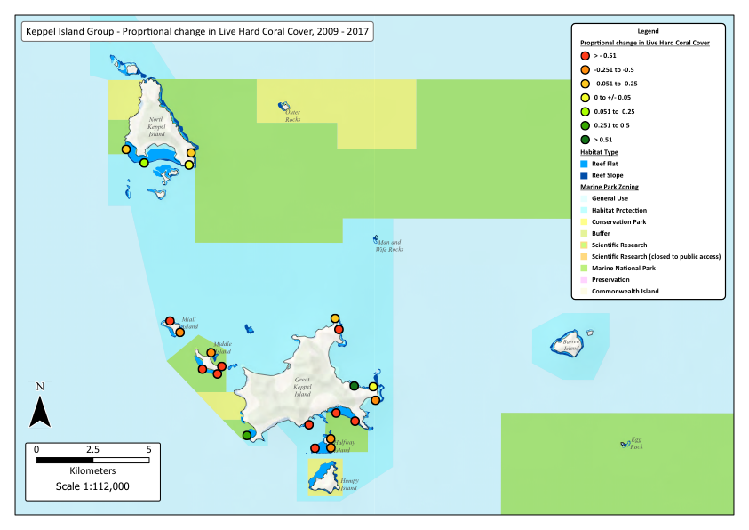
Figure 22: Map of the Keppel Island group with colour coded monitoring site markers corresponding to the estimated proportional change in mean percent cover of live hard coral at each site between February 2009 and October 2017.

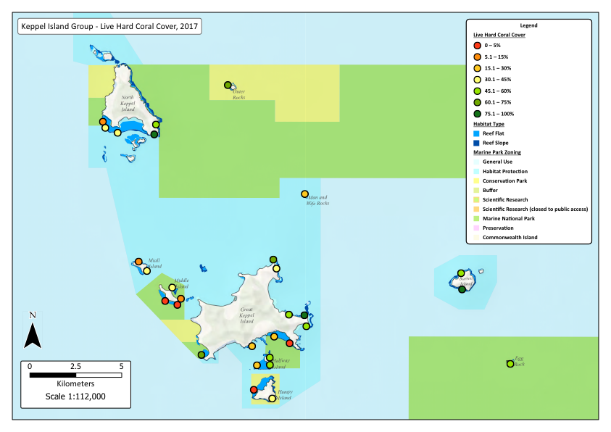
Figure 23: Map of the Keppel Island group with colour coded monitoring site markers corresponding to the estimated mean percent cover of live hard coral at each site during October 2017.

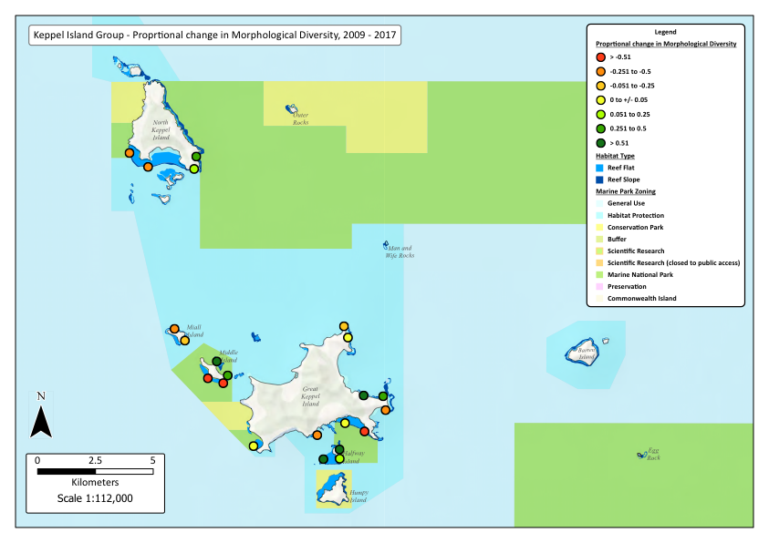
Figure 24: Map of the Keppel Island group with colour coded monitoring site markers corresponding to the estimated proportional change in mean morphological diversity of hard coral at each site between February 2009 and October 2017.

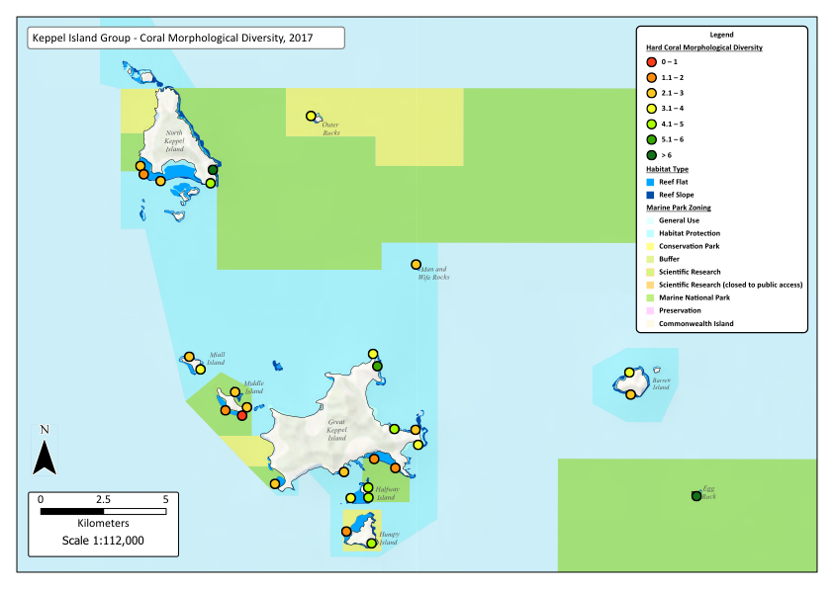
Figure 25: Map of the Keppel Island group with colour coded monitoring site markers corresponding to the estimated mean morphological diversity of hard coral at each site during October 2017.

Figure 26: Non-metric MDS plot of benthic community structure on reefs in the Keppel Island group for the 2004 to 2017 temporal series. Site-level multivariate means were used for all survey years. Sites are partitioned by GBRMP management zone; fished zones (HPZ, CPZ), old (1987) no-take marine reserve zones (MNPZ), and new (2004) no-take marine reserve zones (MNPZ).

Fish community dynamics
Fish species were partitioned into functional groups for multivariate analyses of community structure and dynamics. Appendix 1 presents a list of surveyed fish species and their associated functional groups.

Palm Islands
Throughout the monitoring period total fish density remained consistently higher on new NTR reefs than on old NTR and fished reefs in the Palm Islands (Figure 27). Furthermore, fish density was relatively stable on fished and old NTR reefs throughout the period following cyclone Yasi (2012 – 2016), while it increased 1.5-fold on new NTR reefs over the same period (Figure 27b). This finding suggests that the reef within the new NTR at Curacoa Island provided a local refuge for reef fishes following cyclone Yasi and that strong recruitment of reef fishes occurred in 2012 and 2013. Reef fishes are variably sensitive to coral loss and habitat degradation (Wilson et al. 2009). Our findings suggest that the cyclone and bleaching events had pronounced negative effects on several highly coral-dependent fish species, while facilitating increases in the local abundance of less coral-dependent species, particularly grazers.
Zoning management had a significant effect on fish community structure in the Palm Islands throughout the monitoring period (PERMANOVA, Pseudo-F = 1.65, p = 0.03, Figure 28). In 2016, old NTR reefs tended to support higher proportions of piscivores and other large predators, while new NTR reefs were dominated by planktivores, omnivores and corallivores, and fished reefs had a more even representation of all groups. Exposed eastern sites were characteristically dominated by farming damselfishes, grazers and benthic invertivores, while sheltered sites supported higher abundances of planktivores, omnivores, corallivores and piscivores (Figure 28).
Differences in fish community structure among old and new NTRs were observed throughout the monitoring period (Figure 28). Shifts toward higher abundances of piscivores, farming damselfishes and grazers were evident on both old and new NTR reefs between 2007 and 2012. However, fish community structure remained distinctly different between old and new NTR reefs, as new NTRs maintained higher densities of planktivores and omnivores. Between 2012 and 2016, the impact of cyclone Yasi was evident in the fish community on both NTR and fished reefs. Old NTR and fished reefs experienced declines in the relative abundance of corallivores (predominantly Chaetodontidae) and benthic invertivores, while the abundances of farming damselfishes and grazing herbivores increased. On new NTR reefs, the relative abundance of planktivores, piscivores, benthic invertivores and carnivores increased markedly following cyclone Yasi (Figure 28). These findings further support the assertion that the new NTR reef at Curacoa Island provided an important local refuge for both corals and fishes following cyclone Yasi.

Figure 27: Temporal dynamics of total fish density on Palm Island group reefs from 2007 - 2016. (a) Total density across all monitoring sites pooled. (b) Total density in fished zones (HPZ, CPZ), old (1987) no-take marine reserve zones (MNPZ), and new (2004) no-take marine reserve zones (MNPZ). Error bars are ± 1 standard error. Blue dashed lines and annotations indicate the timing and nature of major climatic disturbances during the monitoring period.

Figure 28: Non-metric MDS plots of fish community structure on reefs in the Palm Island group for the 2007 to 2016 temporal series. Site-level multivariate means were used for all survey years. Sites are partitioned by GBRMP management zone; fished zones (HPZ, CPZ), old (1987) no-take marine reserve zones (MNPZ), and new (2004) no-take marine reserve zones (MNPZ).

Magnetic Island
No significant differences were recorded in total fish density between NTR and fished reefs at Magnetic Island between 2004 and 2016 (Figure 29). Total fish density increased to varying degrees on both NTR and fished reefs between 2004 and 2007, declined between 2007 and 2012, and increased again between 2012 and 2016. It is apparent that fish community dynamics closely tracked the dynamics of LHC cover, with clear impacts from both the 2002 coral bleaching event (2004 to 2007 recovery phase) and cyclone Yasi (2007 to 2012 declines, and post-2012 recovery phase); the entire assemblage oscillated from a state of higher diversity of functional groups to a relatively depauperate state (Figure 30).

Figure 29: Temporal dynamics of total fish density on Magnetic Island reefs from 2004 - 2016. (a) Total density across all monitoring sites pooled. (b) Total density in fished zones (HPZ, CPZ), old (1987) no-take marine reserve zones (MNPZ), and new (2004) no-take marine reserve zones (MNPZ). Error bars are ± 1 standard error. Blue dashed lines and annotations indicate the timing and nature of major climatic disturbances during the monitoring period.
Figure 30: Non-metric MDS plot of fish community structure on Magnetic Island reefs for the 2007 to 2016 temporal series. Site-level multivariate means were used for all survey years. Sites are partitioned by GBRMP management zone; fished zones (HPZ, CPZ), old (1987) no-take marine reserve zones (MNPZ), and new (2004) no-take marine reserve zones (MNPZ).

Whitsunday Islands
Total fish density gradually declined on Whitsunday reefs throughout the monitoring period in response to disturbance events, and especially following cyclone Debbie in 2017. Total fish density declined by approximately 50% between 2007 and 2017 (Figure 31). This decline occurred on both NTR and fished reefs, as the cyclone indiscriminately reduced live coral cover and degraded habitat structure. Fish community structure did not vary significantly between old and new NTR reefs, however fished reefs consistently supported significantly lower relative abundances of predators, coralivores and planktivores, and higher abundances of omnivores, carnivores and farming damselfishes than NTR reefs (PERMANOVA, Pseudo-F = 1.48, p = 0.02, Figure 32). It is evident that the key drivers of these patterns were benthic cover, reef habitat quality and marine park zoning. Analyses are currently underway to resolve the relative contribution of various ecological and physical drivers on the structure and dynamics of inshore reef benthic and fish assemblages.
Although the fish community shifted at most sites between 2016 and 2017 in response to the effects of cyclone Debbie, the shift was not as extreme as expected. On fished and new NTR reefs, the relative abundance of planktivores declined, while farming damselfishes, carnivores and omnivores increased. Planktivore abundances also declined on old NTR reefs, while the relative abundance of grazers increased (Figure 32). Given the extent of damage from cyclone Debbie on benthic communities and habitat structure, it is likely that the fish community on Whitsunday reefs is currently in a transition phase. We expect that abundances of most planktivorous damselfish and coral-feeding butterflyfishes will continue to decline throughout 2018, and that this may extend to declines in the abundances of large piscivores such as coral trout (Graham et al. 2007; Williamson et al. 2014a). Recovery of these populations in the longer term will undoubtedly be preceded by recovery of the benthic community. Ongoing monitoring of these high-use and high value inshore reefs will yield considerable insight into the long-term impacts of extreme disturbance events, recreational usage and the effects of marine park zoning management.

Figure 31: Temporal dynamics of total fish density on Whitsunday Island group reefs from 2007 - 2017. (a) Total density across all monitoring sites pooled. (b) Total density in fished zones (HPZ, CPZ), old (1987) no-take marine reserve zones (MNPZ), and new (2004) no-take marine reserve zones (MNPZ). Error bars are ± 1 standard error. Blue dashed lines and annotations indicate the timing and nature of major climatic disturbances during the monitoring period.

Figure 32: Non-metric MDS plots of fish community structure on reefs in the Whitsunday Island group for the 2007 to 2017 temporal series. Site-level multivariate means were used for all survey years. Sites are partitioned by GBRMP management zone; fished zones (HPZ, CPZ), old (1987) no-take marine reserve zones (MNPZ), and new (2004) no-take marine reserve zones (MNPZ).
Keppel Islands
Dramatic changes in fish community structure were observed throughout the monitoring period, with high densities of most fish groups recorded in 2007 and 2009, before large declines in abundance between 2011 and 2013 due to reef degradation from successive flood plume disturbances (PERMANOVA, Pseudo-F = 11.84, p = 0.001, Figure 33). Fish community structure did not vary significantly between NTR and fished reefs, and temporal trajectories were similar among zones (Figure 33, Figure 34). Despite the impacts of cyclone Marcia (February 2015), partial recovery of most fish groups was recorded on Keppel reefs in October 2015. The fish community then remained relatively stable until October 2017, despite the major flood plume event that followed cyclone Debbie in April 2017 (Figure 34). The 2013 to 2017 trajectory suggested a community shift towards higher abundances of piscivores and farming damselfishes, particularly on old and new NTR reefs. This was predominantly driven by two fish species, the farming damselfish Pomacentrus wardi, and the coral trout Plectropomus maculatus, both species that appear to be highly adapted to inshore reef conditions. Although fish diversity is currently relatively low on Keppel reefs, the species that are present generally remain at very high abundances (Williamson et al. 2014). Recent evidence from Keppel reefs suggests that coral trout will switch prey selectivity during periods when reefs are in a degraded state, becoming more opportunistic and effectively shortening the food chain (Hempson et al. 2017). This may ultimately have consequences for their physiological condition, growth, reproductive potential and longevity, as well as influencing the structure of fish assemblages on these reefs.
Figure 33: Temporal dynamics of total fish density on Keppel Island group reefs from 2007 - 2017. (a) Total density across all monitoring sites pooled. (b) Total density in fished zones (HPZ, CPZ), old (1987) no-take marine reserve zones (MNPZ), and new (2004) no-take marine reserve zones (MNPZ). Error bars are ± 1 standard error. Blue dashed lines and annotations indicate the timing and nature of major climatic disturbances during the monitoring period.

Figure 34: Non-metric MDS plots of fish community structure on reefs in the Keppel Island group for the 2007 to 2017 temporal series. Site-level multivariate means were used for all survey years. Sites are partitioned by GBRMP management zone; fished zones (HPZ, CPZ), old (1987) no-take marine reserve zones (MNPZ), and new (2004) no-take marine reserve zones (MNPZ).

Coral trout (Plectropomus spp.) population dynamics and GBRMP zoning effects
Coral trout (Plectropomus spp.) are highly targeted by commercial and recreational fishers on GBRMP reefs. Three Plectropomus species are commonly recorded on inshore GBR reefs, Plectropomus maculatus, P. leopardus and P. laevis. The three species are pooled into a single Plectropomus spp. group for the majority of the analyses conducted within this monitoring program. The relative composition of Plectropomus species varies regionally among the island groups, with generally very low numbers of P. laevis at all locations, approximately even densities of P. maculatus and P. leopardus in the Palm and Whitsunday Islands, and an overwhelming dominance of P. maculatus in the Keppel Islands (Williamson et al. 2004; Williamson et al. 2014).
UVC data collected in the Palm and Whitsunday Islands during the early 1980s, prior to the introduction of GBRMP management zoning (supplied by A. Ayling), demonstrated that coral trout populations were already locally depleted on those reefs (Williamson et al. 2004). Since the establishment of systematic monitoring in the Palm and Whitsunday Islands in 1999/2000, coral trout densities on fished reefs have consistently remained above the baseline, pre-zoning densities recorded in the 1980s. Conversely, significant increases in coral trout densities have been recorded on NTR reefs, and this has led to an overall net increase in the abundance of coral trout on all inshore GBRMP reefs since the 1980s (Williamson et al. 2004).
In the Palm, Whitsunday and Keppel Island groups, NTR reefs have consistently supported higher densities of larger (adult) coral trout than fished reefs (Evans and Russ 2004; Williamson et al. 2004; McCook et al. 2010; Williamson et al. 2014). Furthermore, coral trout density, mean size and biomass increased rapidly (usually within ~3 years) on reefs designated as NTRs in 2004 (new NTRs) and elevated abundances have generally been maintained since (Emslie et al. 2015). There is no evidence that the establishment of NTRs and the associated displacement and concentration of fishing effort on these inshore GBRMP reefs has led to a ‘squeeze-effect’, where populations would be reduced on reefs that have remained open to fishing (Williamson et al. 2004; Emslie et al. 2015). We have previously demonstrated that coral trout populations on inshore GBRMP reefs can be heavily impacted by the loss of live hard coral, erosion of reef habitat structure and reductions in the abundance of prey species (Williamson et al. 2014).

Palm Islands
Pre-zoning (1983) data demonstrate that coral trout were locally depleted on reefs of the Palm Island group prior to the implementation of the first GBRMP zoning plans in the late 1980s (Williamson et al. 2004). Despite temporal fluctuations throughout the monitoring period, the mean density of coral trout remained consistently higher on NTR reefs than on fished reefs, especially on old NTR reefs (Figure 35).
Coral trout density increased significantly on fished reefs between 1983 and 2000, declined between 2000 and 2001, then increased steadily through to 2007, before decreasing again between 2007 and 2014. Despite a bleaching event in early 2016, mean coral trout density had increased again by the middle of 2016 (Figure 35). On old NTR reefs, coral trout density increased significantly between 1983 and 2000, temporarily declined in 2001, before recovering by 2003 and remaining relatively stable through to 2012 (Figure 35). There was another decline in mean density on old NTR reefs between 2012 and 2014 before a significant increase through to 2016 (Figure 35). On new NTR reefs, there was a significant and rapid increase in coral trout density from 2004 to 2007, before declining significantly to 2009, and general recovery through to 2016 (Figure 35).
The severe impacts of cyclone Yasi (2011) on benthic and fish communities in the Palm Islands also affected the mean density of coral trout on both NTR and fished reefs, with a steady decline, indicating a possible lag effect between 2011 and 2014 (Figure 35b). However, the density of coral trout recovered on all reefs between 2014 and 2016, despite the 2016 bleaching event, which appeared not to cause substantial damage to these reefs. The magnitude and timing of further changes to coral trout populations on Palm Islands reefs is dependent on the future disturbance regime and the degree of recovery attained by reef communities over the next several years. As experienced by the coral community at some sites, there is potential for rapid recovery of some Palm Islands reefs. The most recent monitoring surveys were conducted on Palm Island reefs during August 2018, these new data have been incorporated into the dataset and further analyses are currently underway.

Figure 35: Temporal dynamics of coral trout (Plectropomus spp.) population density (no. 1000m²) on reefs of the Palm Island group in (a) all monitoring sites pooled (b) sites pooled to management zones (fished zones (HPZ, CPZ), old (1987) no-take marine reserve zones (MNPZ), and new (2004) no-take marine reserve zones (MNPZ). Error bars are ± 1 standard error.
Magnetic Island
The temporal dynamics and effects of zoning on coral trout on Magnetic Island reefs were not as pronounced as in other island groups (Figure 36). This is probably due to a combination of factors, such as low habitat complexity and prey abundance leading to lower coral trout densities, and a suspected high prevalence of poaching by recreational fishers in NTRs. Coral trout densities were highest in 2007 at approximately 6 individuals per 1000 m²; in more recent years densities have declined by more than 50% (Figure 36). Old NTR reefs tended to support slightly higher densities, while new NTR reefs had slightly lower densities than fished zones (Figure 36). These are trends rather than significant differences, and may point to a need for increased surveillance and enforcement to ensure improved zoning compliance.

Figure 36: Temporal dynamics of coral trout (Plectropomus spp.) population density (no. 1000m²) on reefs at Magnetic Island in (a) all monitoring sites pooled (b) sites pooled to management zones (fished zones (HPZ, CPZ), old (1987) no-take marine reserve zones (MNPZ), and new (2004) no-take marine reserve zones (MNPZ). Error bars are ± 1 standard error.

Whitsunday Islands
Pre-zoning (1983) data demonstrate that coral trout were locally depleted on reefs of the Whitsunday Island group prior to the implementation of the first GBRMP zoning plans in the late 1980s (Williamson et al. 2004). Although coral trout abundances varied on all Whitsunday reefs throughout the monitoring period (Figure 37a), the mean density of coral trout remained consistently higher, and in most years significantly higher, on NTR reefs than on fished reefs (Figure 37b).
Coral trout density increased significantly on fished reefs between 1983 and 2004, declined between 2004 and 2007, then remained relatively stable through to 2016, before increasing again between 2016 and 2017 (Figure 37b). On old NTR reefs, coral trout density increased significantly between 1983 and 2001, temporarily declined in 2002, before recovering by 2003 and remaining relatively stable through to 2009 (Figure 37b). There was another decline in mean density on old NTR reefs between 2009 and 2012 before a significant increase through to 2017. On new NTR reefs, there was a significant and rapid increase in coral trout density from 2004 to 2007, before declining slightly to 2009, and relative stability through to 2017 (Figure 37b).
Despite the severe impacts of cyclone Debbie (March 2017) on Whitsunday benthic and fish communities, the mean density of coral trout increased on both NTR and fished reefs between September 2016 and November 2017 (Figure 37). Although the coral community on many Whitsunday reefs was decimated by cyclone Debbie, underlying reef structure and habitat complexity remains intact at most locations. Previous evidence suggests that in the absence of live coral, the abundance of prey fish species, and ultimately large predatory species such as coral trout, will decline over several years following major disturbance events (Graham et al. 2007; Williamson et al. 2014). The magnitude and timing of further changes to coral trout populations on Whitsunday reefs is dependent on the future disturbance regime and the degree of recovery attained by reef communities over the next several years. We consider that there is potential for rapid recovery of many currently degraded Whitsunday reefs. There is extensive reef substratum available for coral larval settlement and colony growth, local refuges for fish and coral remain, and there are extensive sources of larval supply on mid and outer-shelf reefs offshore from the Whitsunday Islands. Monitoring surveys will next be conducted on Whitsunday reefs during October 2018.

Figure 37: Temporal dynamics of coral trout (Plectropomus spp.) population density (no. 1000m²) on reefs of the Whitsunday Island group in (a) all monitoring sites pooled (b) sites pooled to management zones (fished zones (HPZ, CPZ), old (1987) no-take marine reserve zones (MNPZ), and new (2004) no-take marine reserve zones (MNPZ). Error bars are ± 1 standard error.

Keppel Islands
Mean coral trout density was highly variable on reefs of the Keppel Island group throughout the monitoring period, however a general decline was recorded from 2004 to 2017 (Figure 38a). Coral trout density declined in 2006, 2011 and 2013, with phases of recovery from 2007 to 2009 and from 2013 to 2017 (Figure 38a). The magnitude of the 2009 to 2013 decline was much larger than the decline from 2004 to 2006. This large decline reflected the dramatic declines in coral cover, habitat structural complexity and the abundance of prey fish species following the flood plume disturbances of 2011 and 2013 (Williamson et al. 2014). Early stages of population recovery were evident between 2013 and 2017, however coral trout densities had only increased in NTRs, and the majority of those new fishes were sub-adults (< 30cm TL) (Figure 38b). Coral trout densities were consistently higher on NTR reefs than on fished reefs in all survey years except for 2002 and 2013, when densities were similar between NTR and fished reefs (Figure 38b).
Post-disturbance refuge reefs have previously been identified in the Keppel Islands (Williamson et al. 2014). Egg Rock (NTR since 1987) has also been identified as an extremely important source reef for the supply of juvenile coral trout to reefs in the Keppel Islands (Harrison et al. 2012; Williamson et al. 2016). Furthermore, above average coral trout density was also recorded on the reef within the new NTR at Clam Bay, Great Keppel Island. Clam Bay has previously been identified as a recruitment hotspot for coral trout, with consistently high densities of juvenile and sub-adult fishes (Evans and Russ 2004; Wen et al. 2013).
Unfortunately, several of the post-disturbance refuge reefs defined in 2011 were undermined by the cumulative impacts of the 2013 flood plume event, cyclone Marcia in 2015, the 2016 coral bleaching event and the 2017 flood. Between 2013 and 2017, the majority of Keppel reefs were in a relatively degraded state, and most of the previously identified refuge reefs were no longer supporting above average abundances of coral trout. It appears that a lag phase occurred in the decline of coral trout, particularly between 2011 and 2013. Similar effects have previously been documented in coral reef systems (Graham et al. 2007). Evidently, repeated severe disturbances degraded reef communities, reduced productivity, and led to significant declines in coral trout density on both NTR and fished reefs. It is encouraging that despite the impacts of the 2015 cyclone, 2016 coral bleaching, and 2017 flood plume, coral trout populations are currently in the early stages of recovery on NTR reefs in the Keppel Islands. Limited coral loss from these recent disturbances has facilitated recovery of the fish community since 2013. Despite this recent recovery trend, these findings present compelling evidence that severe and frequent disturbance events can undermine many of the accrued benefits of NTRs (Williamson et al. 2014). There is considerable capacity for coral trout populations to recover in the Keppel Islands, however the recovery of hard coral will be a precursor for the recovery of the entire fish community.

Figure 38: Temporal dynamics of coral trout (Plectropomus spp.) population density (no. 1000m²) on reefs of the Keppel Island group in (a) all monitoring sites pooled (b) sites pooled to management zones (fished zones (HPZ, CPZ), old (1987) no-take marine reserve zones (MNPZ), and new (2004) no-take marine reserve zones (MNPZ). Error bars are ± 1 standard error.

References

Almany GR, Connolly SR, Heath DD, Hogan JD, Jones GP, McCook LJ, Mills M, Pressey RL, Williamson DH (2009) Connectivity, biodiversity conservation and the design of marine reserve networks for coral reefs. Coral Reefs 28:339-351
Almany GR, Hamilton RJ, Bode M, Matawai M, Potuku T, Saenz-Agudelo P, Planes S, Berumen ML, Rhodes KL, Thorrold SR, Russ GR, Jones GP (2013) Dispersal of Grouper Larvae Drives Local Resource Sharing in a Coral Reef Fishery. Current biology : CB 23:626-630
Aronson RB, MacIntyre IG, Lewis SA, Hilbun NL (2005) Emergent zonation and geographic convergence of coral reefs. Ecology 86:2586-2600
Babcock RC, Shears NT, Alcala AC, Barrett NS, Edgar GJ, Lafferty KD, McClanahan TR, Russ GR (2010) Decadal trends in marine reserves reveal differential rates of change in direct and indirect effects. Proceedings of the National Academy of Sciences 107:18256-18261
Bellwood DR, Hughes TP (2001) Regional-Scale Assembly Rules and Biodiversity of Coral Reefs. Science 292:1532-1535
Bellwood DR, Hughes TP, Folke C, Nystrom M (2004) Confronting the coral reef crisis. Nature 429:827-833
Berkelmans R, De'ath G, Kininmonth S, Skirving WJ (2004) A comparison of the 1998 and 2002 coral bleaching events on the Great Barrier Reef: spatial correlation, patterns, and predictions. Coral Reefs 23:74-83
Berumen M, Pratchett M (2008) Trade-offs associated with dietary specialization in corallivorous butterflyfishes (Chaetodontidae: Chaetodon). Behav Ecol Sociobiol 62:989-994
Carpenter KE, Abrar M, Aeby G, Aronson RB, Banks S, Bruckner A, Chiriboga A, Cortes J, Delbeek JC, Devantier L, Edgar GJ, Edwards AJ, Fenner D, Guzman HM, Hoeksema BW, Hodgson G, Johan O, Licuanan WY, Livingstone SR, Lovell ER, Moore JA, Obura DO, Ochavillo D, Polidoro BA, Precht WF, Quibilan MC, Reboton C, Richards ZT, Rogers AD, Sanciangco J, Sheppard A, Sheppard C, Smith J, Stuart S, Turak E, Veron JE, Wallace C, Weil E, Wood E (2008) One-third of reef-building corals face elevated extinction risk from climate change and local impacts. Science 321:560-563
Ceccarelli DM, Jones GP, McCook LJ (2005) Effects of territorial damselfish on an algal-dominated coastal coral reef. Coral Reefs 24:606-620
Ceccarelli DM, Loffler Z, Bourne DG, Al Moajil-Cole GS, Boström-Einarsson L, Evans-Illidge E, Fabricius K, Glasl B, Marshall P, McLeod I, Read M, Schaffelke B, Smith AK, Torras Jorda G, Williamson DH, Bay L (2018) Rehabilitation of coral reefs through removal of macroalgae: State of knowledge and considerations for management and implementation. Restoration Ecology 26:827-838
Clarke KR, Warwick RM (2001) Change in marine communities: an approach to statistical analysis and interpretation. 2nd edition. PRIMER-E, Plymouth
Clarke KR, Gorley RN (2006) PRIMER v6: User Manual / Tutorial. PRIMER-E, Plymouth
Claudet J, Garcia-Charton JA, Lenfant P (2011) Combined Effects of Levels of Protection and Environmental Variables at Different Spatial Resolutions on Fish Assemblages in a Marine Protected Area. Conservation Biology 25:105-114
Diaz-Pulido G, McCook LJ, Dove S, Berkelmans R, Roff G, Kline DI, Weeks S, Evans RD, Williamson DH, Hoegh-Guldberg O (2009) Doom and boom on a resilient reef: Climate change, algal overgrowth and coral recovery. Public Library of Science 4:1-9
Emslie MJ, Logan M, Williamson DH, Ayling AM, MacNeil MA, Ceccarelli D, Cheal AJ, Evans RD, Johns KA, Jonker MJ, Miller IR, Osborne K, Russ GR, Sweatman HPA (2015) Expectations and outcomes of reserve network performance following re-zoning of the Great Barrier Reef Marine Park. Current Biology 25:983-992
Evans RD, Russ GR (2004) Larger biomass of targeted reef fish in no-take marine reserves on the Great Barrier Reef, Australia. Aquatic Conservation: Marine and Freshwater Ecosystems 14:505-519
Fabricius KE (2005) Effects of terrestrial runoff on the ecology of corals and coral reefs: review and synthesis. Marine Pollution Bulletin 50:125-146
Fabricius KE (2011) Factors Determining the Resilience of Coral Reefs to Eutrophication: A Review and Conceptual Model. In: Dubinsky Z, Stambler N (eds) Coral Reefs: An Ecosystem in Transition. Springer Netherlands, Dordrecht, pp493-505
Flores F, Hoogenboom MO, Smith LD, Cooper TF, Abrego D, Negri AP (2012) Chronic Exposure of Corals to Fine Sediments: Lethal and Sub-Lethal Impacts. PLOS ONE 7:e37795
Graham NAJ, Wilson SK, Jennings S, Polunin NVC, Robinson J, Bijoux JP, M. DT (2007) Lag effects in the impacts of mass coral bleaching on coral reef fish, fisheries, and ecosystems. Conservation Biology 21:1291-1300
Graham NAJ, Ainsworth TD, Baird AH, Ban NC, Bay LK, Cinner JE, De Freitas DM, Diaz-Pulido G, Dornelas M, Dunn SR, Fidelman PIJ, Foret S, Good TC, Kool J, Mallela J, Penin L, Pratchett MS, Williamson DH (2011) From Microbes to People: Tractable Benefits of No-Take Areas for Coral Reefs. Oceanogr Mar Biol 49:105-135
Harrison HB, Williamson DH, Evans RD, Almany GR, Thorrold SR, Russ GR, Feldheim KA, van Herwerden L, Planes S, Srinivasan M, Berumen ML, Jones GP (2012b) Larval export from marine reserves and the recruitment benefit for fish and fisheries. Current Biology 22:1023-1028
Hempson TN, Graham NAJ, Macneil MA, Williamson DH, Jones GP, Almany GR (2017) Coral reef mesopredators switch prey, shortening food chains, in response to habitat degradation. Ecology and Evolution 7:2626–2635
Hughes TP, Kerry JT, Álvarez-Noriega M, Álvarez-Romero JG, Anderson KD, Baird AH, Babcock RC, Beger M, Bellwood DR, Berkelmans R, Bridge TC, Butler IR, Byrne M, Cantin NE, Comeau S, Connolly SR, Cumming GS, Dalton SJ, Diaz-Pulido G, Eakin CM, Figueira WF, Gilmour JP, Harrison HB, Heron SF, Hoey AS, Hobbs JPA, Hoogenboom MO, Kennedy EV, Kuo C-Y, Lough JM, Lowe RJ, Liu G, McCulloch MT, Malcolm HA, McWilliam MJ, Pandolfi JM, Pears RJ, Pratchett MS, Schoepf V, Simpson T, Skirving WJ, Sommer B, Torda G, Wachenfeld DR, Willis BL, Wilson SK (2017) Global warming and recurrent mass bleaching of corals. Nature 543:373-377
Jones AM, Berkelmans R (2014) Flood impacts in Keppel Bay, southern Great Barrier Reef in the aftermath of cyclonic rainfall. PLoS ONE 9:e84739
Jones GP, Syms C (1998) Disturbance, habitat structure and the ecology of fishes on coral reefs. Aust J Ecol 23:287-297
Jones GP, McCormick MI, Srinivasan M, Eagle JV (2004) Coral decline threatens fish biodiversity in marine reserves. Proceedings of the National Academy of Sciences of the United States of America 101:8251-8253
Kennedy EV, Ordoñez A, Diaz-Pulido G (2018) Coral bleaching in the southern inshore Great Barrier Reef: a case study from the Keppel Islands. Marine and Freshwater Research 69:191-197
Kulbicki M, Guillemot N, Amand M (2005) A general approach to length-weight relationships for New Caledonian lagoon fishes. Cybium 29:235-252
Lam VYY, Chaloupka M, Thompson A, Doropoulos C, Mumby PJ (2018) Acute drivers influence recent inshore Great Barrier Reef dynamics. Proceedings of the Royal Society B: Biological Sciences 285:20182063
Lamb JB, Williamson DH, Russ GR, Willis BL (2015) Protected areas mitigate diseases of reef-building corals by reducing damage from fishing. Ecology 96:2555–2567
Lamb JB, Wenger AS, Devlin MJ, Ceccarelli DM, Williamson DH, Willis BL (2016) Reserves as tools for alleviating impacts of marine disease. Philosophical Transactions of the Royal Society B 371:DOI: 10.1098/rstb.2015.0210.
MacNeil MA, Graham NAJ, Polunin NVC, Kulbicki M, Galzin R, Harmelin-Vivien M, Rushton SP (2009) Hierarchical drivers of reef-fish metacommunity structure. Ecology 90:252-264
McCook LJ, Ayling T, Cappo M, Choat JH, Evans RD, De Freitas DM, Heupel M, Hughes TP, Jones GP, Mapstone B, Marsh H, Mills M, Molloy FJ, Pitcher CR, Pressey RL, Russ GR, Sutton S, Sweatman H, Tobin R, Wachenfeld DR, Williamson DH (2010) Adaptive management of the Great Barrier Reef: A globally significant demonstration of the benefits of networks of marine reserves. Proceedings of the National Academy of Sciences 107:18278-18285
Munday PL (2004) Habitat loss, resource specialization, and extinction on coral reefs. Global Change Biology 10:1642-1647
Rogers CS (1993) Hurricanes and coral reefs: the intermediate disturbance hypothesis revisited Coral Reefs 12:127-137
Russ GR (2002) Yet another review of marine reserves as reef fisheries management tools. In: Sale PF (ed) Coral Reef Fishes: Dynamics and Diversity in a Complex Ecosystem. Academic Press, San Diego, pp421 - 443
Russ GR, Alcala AC (2010) Decadal-scale rebuilding of predator biomass in Philippine marine reserves. Oecologia 163:1103-1106
Russ GR, Cheal AJ, Dolman AM, Emslie MJ, Evans RD, Miller I, Sweatman H, Williamson DH (2008) Rapid increase in fish numbers follows creation of world's largest marine reserve network. Curr Biol 18 514-515
Sale PF, Agardy T, Ainsworth CH, Feist BE, Bell JD, Christie P, Hoegh-Guldberg O, Mumby PJ, Feary DA, Saunders MI, Daw TM, Foale SJ, Levin PS, Lindeman KC, Lorenzen K, Pomeroy RS, Allison EH, Bradbury RH, Corrin J, Edwards AJ, Obura DO, Sadovy de Mitcheson YJ, Samoilys MA, Sheppard CRC (2014) Transforming management of tropical coastal seas to cope with challenges of the 21st century. Marine Pollution Bulletin 85:8-23
Thompson A, Costello P, Davidson J, Logan M, Coleman G, Gunn K, Schaffelke B (2017) Marine Monitoring Program. Annual Report for inshore coral reef monitoring: 2015 to 2016. Report for the Great Barrier Reef Marine Park Authority, Great Barrier Reef Marine Park Authority, Townsville 133 pp.
Thompson AA, Dolman AM (2010) Coral bleaching: one disturbance too many for near-shore reefs of the Great Barrier Reef. Coral Reefs 29:637-648
van Woesik R, Houk P, Isechal AL, Idechong JW, Victor S, Golbuu Y (2012) Climate-change refugia in the sheltered bays of Palau: analogs of future reefs. Ecology and Evolution 2:2474-2484
Wen CK, Almany GR, Williamson DH, Pratchett MS, Mannering TD, Evans RD, Leis JM, Srinivasan M, Jones GP (2013) Recruitment hotspots boost the effectiveness of no-­‐take marine reserves. Biological Conservation 166:124-131
Wenger AS, Williamson DH, da Silva ET, Ceccarelli DM, Browne N, Petus C, Devlin MJ (2016) The limitations of no-take marine reserves in protecting coral reefs from reduced water quality. Conservation Biology 30:142-153
Williamson DH, Russ GR, Ayling AM (2004) No-take marine reserves increase abundance and biomass of reef fish on inshore fringing reefs of the Great Barrier Reef. Environmental Conservation 31:149-159
Williamson DH, Ceccarelli DM, Evans RD, Jones GP, Russ GR (2014) Habitat dynamics, marine reserve status, and the decline and recovery of coral reef fish communities. Ecology and Evolution 4:337-354
Williamson DH, Harrison HB, Almany GR, Berumen ML, Bode M, Bonin MC, Choukroun S, Doherty PJ, Frisch AJ, Saenz-Agudelo P, Jones GP (2016) Large-scale, multi-directional larval connectivity among coral reef fish populations in the Great Barrier Reef Marine Park. Molecular Ecology 25:6039-6054
Wilson S, Dolman A, Cheal A, Emslie M, Pratchett M, Sweatman H (2009) Maintenance of fish diversity on disturbed coral reefs. Coral Reefs 28:3-14
Wilson SK, Fisher R, Pratchett MS, Graham NAJ, Dulvy NK, Turner RA, Cakacaka A, Polunin NVC, Rushton SP (2008) Exploitation and habitat degradation as agents of change within coral reef fish communities. Global Change Biology 14:2796-2809

Appendix 1. Fish species list and assigned functional groups

Species | Functional Group
Abudefduf spp | Omnivore
Acanthochromis polyacanthus | Omnivore
Acanthurus blochii | Grazer
Acanthurus dussumieri | Grazer
Acanthurus grammoptilus | Grazer
Acanthurus lineatus | Grazer
Acanthurus nigricans | Grazer
Acanthurus nigricauda | Grazer
Acanthurus nigrofuscus | Grazer
Acanthurus thompsoni | Planktivore
Acanthurus xanthopterus | Grazer
Aethaloperca rogga | Piscivore
Amblyglyphidodon aureus | Planktivore
Amblyglyphidodon curacao | Planktivore
Amblyglyphidodon leucogaster | Planktivore
Amphiprion spp | Omnivore
Anampses spp. | Benthic invertivore
Anyperodon leucogrammicus | Piscivore
Bodianus spp. | Benthic invertivore
Bolbometapon muricatum | Grazer
Calotomus carolinus | Grazer
Centropyge bicolor | Grazer
Centropyge bispinosus | Grazer
Centropyge nox | Grazer
Centropyge tibicen | Grazer
Centropyge vrolikii | Grazer
Cephalopholis argus | Carnivore
Cephalopholis boenak | Carnivore
Cephalopholis cyanostigma | Carnivore
Cephalopholis microprion | Carnivore
Cetoscarus bicolor | Grazer
Chaetodon aureofasciatus | Corallivore
Chaetodon auriga | Corallivore
Chaetodon baronessa | Corallivore
Chaetodon bennetti | Corallivore
Chaetodon citrinellus | Corallivore
Chaetodon ephippium | Corallivore
Chaetodon flavirostris | Corallivore
Chaetodon lineolatus | Corallivore
Chaetodon lunula | Corallivore
Chaetodon lunulatus | Corallivore
Chaetodon melannotus | Corallivore
Chaetodon ocellicaudus | Corallivore
Chaetodon ornatissimus | Corallivore
Chaetodon plebeius | Corallivore
Chaetodon rafflesi | Corallivore

Appendix 1 (cont.)

Species | Functional Group
Chaetodon rainfordi | Corallivore
Chaetodon semeion | Corallivore
Chaetodon speculum | Corallivore
Chaetodon trifascialis | Corallivore
Chaetodon ulietensis | Corallivore
Chaetodon vagabundus | Corallivore
Chaetodontoplus douboulayi | Benthic invertivore
Chaetodontoplus meredithi | Benthic invertivore
Cheilinus chlorurus | Benthic invertivore
Cheilinus fasciatus | Benthic invertivore
Cheilinus trilobatus | Benthic invertivore
Cheilinus undulatus | Benthic invertivore
Chaeloprion labiatus | Corallivore
Chelmon rostratus | Corallivore
Chlorurus bleekeri | Grazer
Chlorurus microrhinus | Grazer
Chlorurus sordidus | Grazer
Choerodon anchorago | Benthic invertivore
Choerodon cephalotes | Benthic invertivore
Choerodon cyanodus | Benthic invertivore
Choerodon fasciatus | Benthic invertivore
Choerodon graphicus | Benthic invertivore
Choerodon monostigma | Benthic invertivore
Choerodon schoenleinii | Benthic invertivore
Choerodon vitta | Benthic invertivore
Chromis amboinensis | Planktivore
Chromis atripectoralis | Planktivore
Chromis atripes | Planktivore
Chromis margaritifer | Planktivore
Chromis nitida | Planktivore
Chromis retrofasciatus | Planktivore
Chromis ternatensis | Planktivore
Chromis weberi | Planktivore
Chrysiptera flavipinnis | Planktivore
Chrysiptera rollandi | Planktivore
Chrysiptera talboti | Planktivore
Cirrhilabrus spp. | Planktivore
Coradion altivelis | Corallivore
Coradion chrysostomus | Corallivore
Coris spp. | Benthic invertivore
Cromileptes altivelis | Carnivore
Ctenochaetus binotatus | Grazer
Ctenochaetus striatus | Grazer
Dascyllus spp | Planktivore
Diagramma pictum | Carnivore
Diploprion bifasciatus | Piscivore
Dischistodus spp | Farmer
Epibulus insidiator | Benthic invertivore
Appendix 1 (cont.)

Species | Functional Group
Epinephelis coioides | Piscivore
Epinephelus caerulopunctatus | Piscivore
Epionephelus corallicola | Carnivore
Epinephelus fasciatus | Piscivore
Epinephelus fuscoguttatus | Piscivore
Epinephelus hexagonatus | Carnivore
Epinephelus howlandi | Carnivore
Epinephelus lanceolatus | Piscivore
Epinephelus merra | Carnivore
Epinephelus ongus | Carnivore
Epinephelus quoyanus | Carnivore
Epinephelus sexfasciatus | Carnivore
Gomphosus varius | Benthic invertivore
Gymnocranius spp. | Carnivore
Gymnothorax spp. | Carnivore
Halichoeres spp. | Benthic invertivore
Hemiglyphidodon plagiometapon | Farmer
Hemigymnus fasciatus | Benthic invertivore
Hemigymnus melapterus | Benthic invertivore
Heniochus acuminatus | Benthic invertivore
Heniochus monoceros | Benthic invertivore
Heniochus varius | Benthic invertivore
Hipposcarus longiceps | Grazer
Kyphosus spp. | Grazer
Labrichthys spp. | Corallivore
Labroides spp. | Benthic invertivore
Labropsis spp. | Corallivore
Lethrinus atkinsoni | Carnivore
Lethrinus harak | Carnivore
Lethrinus laticaudis | Carnivore
Lethrinus lentjan | Carnivore
Lethrinus miniatus | Carnivore
Lethrinus nebulosus | Carnivore
Lethrinus obsoletus | Carnivore
Lethrinus olivaceus | Carnivore
Lethrinus ornatus | Carnivore
Lutjanus argentimaculatus | Carnivore
Lutjanus carponotatus | Carnivore
Lutjanus fulviflamma | Carnivore
Lutjanus fulvus | Carnivore
Lutjanus lemniscatus | Piscivore
Lutjanus lutjanus | Piscivore
Lutjanus monostigma | Piscivore
Lutjanus quinquelineatus | Carnivore
Lutjanus rivulatus | Carnivore
Lutjanus russelli | Carnivore
Lutjanus sebae | Carnivore
Lutjanus vitta | Carnivore
Appendix 1 (cont.)

Species | Functional Group
Macolor macularis | Planktivore
Microcanthus strigatus | Benthic invertivore
Monotaxis spp. | Planktivore
Naso annulatus | Planktivore
Naso brachycentron | Grazer
Naso brevirostris | Planktivore
Naso lituratus | Grazer
Naso tonganus | Grazer
Naso unicornis | Grazer
Neoglyphidodon melas | Omnivore
Neoglyphidodon nigroris | Omnivore
Oxycheilinus diagramma | Benthic invertivore
Oxymonacanthus longirostris | Corallivore
Parachaetodon ocellatus | Benthic invertivore
Parupeneus barberinus | Benthic invertivore
Parupeneus barnerinoides | Benthic invertivore
Parupeneus bifasciatus | Benthic invertivore
Parupeneus ciliatus | Benthic invertivore
Parupeneus indicus | Benthic invertivore
Parupeneus multifasciatus | Benthic invertivore
Platax spp. | Omnivore
Plectorhinchus chaetodontoides | Carnivore
Plectorhinchus flavomaculatus | Carnivore
Plectorhinchus gibbosus | Carnivore
Plectorhinchus lessonii | Carnivore
Plectorhinchus unicolor | Carnivore
Plectroglyphidodon dickii | Farmer
Plectroglyphidodon lacrymatus | Farmer
Plectropomus laevis | Piscivore
Plectropomus leopardus | Piscivore
Plectropomus maculatus | Piscivore
Pomacanthus imperator | Benthic invertivore
Pomacanthus semicirculatus | Benthic invertivore
Pomacanthus sexstriatus | Benthic invertivore
Pomacanthus xanthometapon | Benthic invertivore
Pomacentrus adelus | Farmer
Pomacentrus amboinensis | Omnivore
Pomacentrus australis | Omnivore
Pomacentrus bankanensis | Farmer
Pomacentrus brachialis | Omnivore
Pomacentrus chrysurus | Farmer
Pomacentrus coelestis | Planktivore
Pomacentrus lepidogenys | Planktivore
Pomacentrus moluccensis | Omnivore
Pomacentrus nagasakiensis | Omnivore
Pomacentrus philippinus | Omnivore
Pomacentrus reidi | Omnivore
Pomacentrus vaiuli | Farmer
Appendix 1 (cont.)

Species | Functional Group
Pomacentrus wardi | Farmer
Premnas spp. | Omnivore
Prionurus sp | Grazer
Psuedolabrus guentheri | Benthic invertivore
Pygoplites diacanthus | Benthic invertivore
Scarus altipinnis | Grazer
Scarus chamaeleon | Grazer
Scarus dimidiatus | Grazer
Scarus flavipectoralis | Grazer
Scarus forsteni | Grazer
Scarus frenatus | Grazer
Scarus ghobban | Grazer
Scarus globiceps | Grazer
Scarus niger | Grazer
Scarus oviceps | Grazer
Scarus psittacus | Grazer
Scarus rivulatus | Grazer
Scarus rubroviolaceus | Grazer
Scarus schlegeli | Grazer
Scarus spinus | Grazer
Scarus tricolor | Grazer
Scolopsis bilineatus | Carnivore
Scolopsis lineatus | Carnivore
Scolopsis margaritifer | Carnivore
Scolopsis monogramma | Carnivore
Siganus argenteus | Grazer
Siganus corallinus | Grazer
Siganus doliatus | Grazer
Siganus fuscescens | Grazer
Siganus javus | Grazer
Siganus lineatus | Grazer
Siganus puellus | Grazer
Siganus punctatissimus | Grazer
Siganus punctatus | Grazer
Siganus stellatus | Grazer
Siganus vulpinus | Grazer
Stegastes apicalis | Farmer
Stegastes fasciolatus | Farmer
Stethojoulis spp. | Benthic invertivore
Symphorus nematophorus | Piscivore
Thalassoma spp. | Benthic invertivore
Zanclus cornutus | Benthic invertivore
Zebrasoma scopas | Grazer
Zebrasoma veliferum | Grazer

Appendix 2: Coral reef habitat maps for focal GBRMP island groups
Figure A2-1: Map of the Palm Island group showing the extent of reef flat and reef slope habitats and the position of long-term monitoring sites. Site markers are colour coded to the GBRMP management zone at each site location.

Figure A2-2: Map of Magnetic Island showing the extent of reef flat and reef slope habitats and the position of long-term monitoring sites. Site markers are colour coded to the GBRMP management zone at each site location.

Figure A2-3: Map of the Whitsunday Island group showing the extent of reef flat and reef slope habitats and the position of long-term monitoring sites. Site markers are colour coded to the GBRMP management zone at each site location.
Figure A2-4: Map of the Keppel Island group showing the extent of reef flat and reef slope habitats and the position of long-term monitoring sites. Site markers are colour coded to the GBRMP management zone at each site location.

Appendix 3: Project publication list

Scientific Publications

- Bergseth B.J., Williamson D.H., Russ G.R., Sutton S.G., Cinner J.E. (2017). Prevalence of poaching by recreational fishers in the Great Barrier Reef Marine Park, Australia. Frontiers in Ecology and the Environment, 15: 67-73.
- Hempson T.N., Graham N.A.J., Macneil M.A., Williamson D.H., Jones G.P., Almany G.R. (2017). Coral reef mesopredators switch prey, shortening food chains, in response to habitat degradation. Ecology & Evolution, 7: 2626–2635.
- Bergseth B.J., Williamson D.H., Frisch A.J., Russ G.R. (2016). Protected areas preserve natural behaviour of a targeted fish species on coral reefs. Biological Conservation, 198: 202-209.
- Bode M., Williamson D.H., Weeks R., Jones G.P., Almany G.R., Harrison H.B., Hopf J.K., Pressey R.L. (2016). Planning marine reserve networks for both feature representation and demographic persistence using connectivity patterns. PLoS ONE, 11: e0154272.
- Bonin M. C., Harrison H. B., Williamson D.H., Frisch A. J., Saenz-Agudelo P., Berumen M. L., Jones G.P. (2016). The role of marine reserves in the replenishment of a locally impacted population of anemonefish on the Great Barrier Reef. Molecular Ecology, 25: 487–499.
- Hopf J.K., Jones G.P., Williamson D.H., Connolly S.R. (2016). Synergistic effects of marine reserves and harvest controls on the abundance and catch dynamics of a coral reef fishery. Current Biology, 26: 1543-1548.
- Hopf J.K., Jones G.P., Williamson D.H., Connolly S.R. (2016). Fishery consequences of marine reserves: short-term pain for longer-term gain. Ecological Applications, 26(3): 818–829.
- Lamb J.B., Wenger A.S., Devlin M.J., Ceccarelli D.M., Williamson D.H., Willis B.L. (2016). Reserves as tools for alleviating impacts of marine disease. Philosophical Transactions of the Royal Society B. 371(1689), DOI: 10.1098/rstb.2015.0210.
- Wen C.K., Bonin M.C., Harrison H.B., Williamson D.H., Jones G.P. (2016). Dietary shift in juvenile coral trout (Plectropomus maculatus) following coral reef degradation from a flood plume disturbance. Coral Reefs, 35: 451-455.
- Wenger AS, Williamson DH, da Silva ET, Ceccarelli DM, Browne NK, Petus C, Devlin MJ (2016). Effects of reduced water quality on coral reefs in and out of no-take marine reserves. Conservation Biology, 30: 142-153.
- Williamson D.H., Harrison H.B., Almany G.R., Berumen M.L., Bode M., Bonin M.C., Choukroun S., Doherty P.J., Frisch A.J., Saenz-Agudelo P., Jones G.P. (2016). Large-scale, multi-directional larval connectivity among coral reef fish populations in the Great Barrier Reef Marine Park. Molecular Ecology, 25: 6039 – 6054.
- Emslie M.J., Logan M., Williamson D.H., Ayling A., MacNeil M.A., Ceccarelli D.M., Cheal A.J., Evans R.D., Johns K.A., Jonker M.J., Miller I.R., Osborne K., Russ G.R., Sweatman H.P.A. (2015). Expectations and outcomes of reserve network performance following re-zoning of the Great Barrier Reef Marine Park. Current Biology 25: 983–992.
- Lamb J.B., Williamson D.H., Russ G.R., Willis B.L. (2015). Protected areas mitigate diseases of reef-building corals by reducing damage from fishing. Ecology, 96(9): 2555–2567.
- Wenger A.S., Williamson D.H., da Silva E.T., Ceccarelli D.M., Browne N., Petus C., Devlin M.J. (2015). The limitations of no-take marine reserves in protecting coral reefs from reduced water quality. Conservation Biology 30(1): 142 – 53.
- Williamson D.H., Ceccarelli D.M., Evans R.D., Hill J.K., Russ G.R (2014). Derelict fishing line provides a useful proxy for estimating levels of non-compliance with no-take marine reserves. PLoS ONE 9(12): e114395.
- Williamson D.H., Ceccarelli D.M., Evans R.D., Jones G.P., Russ G.R. (2014). Habitat dynamics, marine reserve status, and the decline and recovery of coral reef fish communities. Ecology & Evolution 4: 337-354.
- Hassell N.S., Williamson D.H., Evans R.D., Russ G.R. (2013). Reliability of non-expert observer estimates of the magnitude of marine reserve effects. Coastal Management 41(4): 361-380.
- Wen C.K., Almany G.R., Williamson D.H., Pratchett M.S., Mannering T.D., Evans R.D., Leis J.M., Srinivasan M., Jones G.P. (2013). Recruitment hotspots boost the effectiveness of no-take marine reserves. Biological Conservation 166: 124-131.
- Cvitanovic C, Wilson S.K., Fulton C.J., Almany G.R., Anderson P., Babcock R.C., Ban N.C., Beedon R., Beger M., Cinner J., Dobbs K., Evans L.S., Farnham A., Friedman K., Gale K., Gladstone W., Grafton Q., Graham N.A.J., Gudge S., Harrison P., Holmes T.H., Johnstone N., Jones G.P., Jordan A., Kendrick A., Kerr I., Klein C.J., Little L.R., Malcolm H., Morris D., Possingham H.P., Prescott J., Pressey R.L., Skilleter G.A., Simpson C., Waples K., Wilson D., Williamson D.H. (2013). Critical research needs for managing coral reef Marine Protected Areas: perspectives of academics and managers. Journal of Environmental Management 114: 84-91.
- Wen C.K., Almany G.R., Williamson D.H., Pratchett M.S., Jones G.P. (2012). Evaluating the effects of marine reserves on diet, prey availability and prey selection by juvenile predatory fishes. Marine Ecology Progress Series 469: 133-144.
- Harrison H.B., Williamson D.H., Evans R.D., Almany G.R., Thorrold S.R., Russ G.R., Feldheim K.A., van Herwerden L., Planes S., Srinivasan M., Berumen M.L., Jones G.P. (2012). Larval export from marine reserves and the recruitment benefit for fish and fisheries. Current Biology 22: 1023-1028.
- Ceccarelli D.M., Williamson D.H. (2012). Sharks that eat sharks: Opportunistic predation by wobbegongs. Coral Reefs 31: 471.
- McCook L.J., Ayling A.M., Cappo M., Choat J.H., Evans R.D., De Freitas D.M., Heupel M., Hughes T.P., Jones G.P., Mapstone B., Marsh H., Mills M., Molloy F., Pitcher C.R., Pressey R.L., Russ G.R., Sutton S., Sweatman H., Tobin R., Wachenfeld D.R., Williamson D.H. (2010). Adaptive management of the Great Barrier Reef: A globally significant demonstration of the benefits of networks of marine reserves. Proceedings of the National Academy of Science 107: 18278-18285.
- Diaz-Pulido G., McCook L.J., Dove S., Berkelmans R., Roff G., Kline D.I., Weeks S., Evans R., Williamson D.H., Hoegh-Guldberg O. (2009). Doom and Boom on a resilient reef: Climate change, algal overgrowth and coral recovery. PLoS ONE 4: e5239.
- Chin A., Sweatman H., Forbes S., Perks H., Walker R., Jones G.P., Williamson D.H., Evans R.D., Hartley F., Armstrong S., Malcolm H., Edgar G.J. (2008). Status of coral reefs in Australia and Papua New Guinea. In: Status of the coral reefs of the world: 2008 (ed. Wilkinson, C.), Global Coral Reef Monitoring Network and Reef and Rainforest Research Centre, Townsville (296pp.).
- Russ G.R., Cheal A.J., Dolman A.M., Emslie M.J., Evans R.D., Miller I., Sweatman H., Williamson D.H. (2008). Rapid increase in fish numbers follows creation of world's largest marine reserve network. Current Biology 18: 514-515.
- Williamson D.H., Evans R.D., Russ G.R. (2006). Monitoring the ecological effects of management zoning: Initial surveys of reef fish and benthic communities on reefs in the Townsville and Cairns regions of the Great Barrier Reef Marine Park. Report to the Great Barrier Reef Marine Park Authority (67pp.).
- Davis K.L.F., Russ G.R., Williamson D.H., Evans R.D. (2004). Surveillance and poaching on inshore reefs of the Great Barrier Reef Marine Park. Coastal Management 32: 373-387.
- Evans RD, Russ GR (2004). Larger biomass of targeted reef fish in no-take marine reserves on the Great Barrier Reef, Australia. Aquatic Conservation: Marine and Freshwater Ecosystems, 14: 505-519.
- Williamson D.H., Russ G.R., Ayling A.M. (2004). No-take marine reserves increase abundance and biomass of reef fish on inshore fringing reefs of the Great Barrier Reef. Environmental Conservation 31: 149-159.

Research & Consultancy Reports

- Williamson, D.H., Ceccarelli, D.M., Rossetti, G., Russ, G.R. and Jones, G.P. (2016). Assessing the cumulative impacts of climatic disturbances on coral reefs in the Keppel Islands, Great Barrier Reef Marine Park. Report to the National Environmental Science Programme (NESP). Reef and Rainforest Research Centre Limited, Cairns (65pp.).
- Williamson D.H. (2009). Results of 2009 monitoring surveys of common coral trout (Plectropomus leopardus) spawning aggregations on Scott Reef and Elford Reef, Great Barrier Reef Marine Park (GBRMP). Report to the Great Barrier Reef Marine Park Authority (GBRMPA). James Cook University (7pp.).
- Evans R.D., Williamson D.H., Sweatman H., Russ G.R., Emslie M., Cheal A., Miller I. (2006). Surveys of the effects of rezoning of the GBR Marine Park in 2004 on some fish species: preliminary findings. Report to the Australian Government Department of Environment and Heritage. James Cook University and the Australian Institute of Marine Science (18pp.).

