


Improved Dredge Material Management for the Great Barrier Reef Region

APPENDIX C
Modelling of Bed Shear-Stress in the Vicinity of Queensland Trading Ports in the Great Barrier Reef Region

Sinclair Knight Merz Pty Ltd (SKM)

Asia-Pacific Applied Science Associates (APASA)

Revision 1.2
10 July 2013

© Commonwealth of Australia 2013
Published by the Great Barrier Reef Marine Park Authority 2013

ISBN 978 1 922126 14 6 (ebook)

This work is copyright. You may download, display, print and reproduce this material in unaltered form only (appropriately acknowledging this source) for your personal, non-commercial use or use within your organisation. Apart from any use as permitted under the Copyright Act 1968, all other rights are reserved.

Disclaimer
The views and opinions expressed in this publication are those of the authors and do not necessarily reflect those of the Australian Government or the Minister for Sustainability, Environment, Water, Population and Communities.

While reasonable efforts have been made to ensure that the contents of this publication are factually correct, the Australian Government does not accept responsibility for the accuracy or completeness of the contents, and shall not be liable for any loss or damage that may be occasioned directly or indirectly through the use of, or reliance on, the contents of this publication.

National Library of Australia Cataloguing-in-Publication entry

Sinclair Knight Merz (Firm).

Improved dredge material management for the Great Barrier Reef Region / Sinclair Knight Merz Pty Ltd (SKM); Asia-Pacific Applied Science Associates (APASA).

ISBN 978 1 922126 14 6 (ebook)

Dredging spoil--Environmental aspects--Queensland--Great Barrier Reef.
Dredging spoil--Queensland--Great Barrier Reef--Management.
Spoil banks--Environmental aspects--Queensland--Great Barrier Reef.
Spoil banks--Queensland--Great Barrier Reef--Management.
Dredging--Environmental aspects--Queensland--Great Barrier Reef.
Dredging--Risk management--Queensland--Great Barrier Reef.
Water quality management--Queensland--Great Barrier Reef.
Hydrodynamic receptors.

Asia-Pacific Applied Science Associates.
Great Barrier Reef Marine Park Authority.

363.7284

This publication should be cited as:
SKM 2013, Improved dredge material management for the Great Barrier Reef Region, Great Barrier Reef Marine Park Authority, Townsville.

Acknowledgement
This report was supported with funding from the Department of Sustainability, Environment, Water, Population, and Communities through the Sustainable Regional Development Program.


Requests and enquiries concerning reproduction and rights should be addressed to:

Great Barrier Reef Marine Park Authority
2-68 Flinders Street (PO Box 1379)
Townsville QLD 4810, Australia
Phone: (07) 4750 0700
Fax: (07) 4772 6093
Email: info@gbrmpa.gov.au
www.gbrmpa.gov.au

DOCUMENT HISTORY AND STATUS
Revision | Date issued | Author(s) | Reviewed by | Approved by | Date approved | Revision type
Prelim | 22/10/12 | Dr S Zigic  Dr R Dunn | Dr S Zigic  S Langtry | Dr S Zigic | 22/10/12 | Preliminary draft for SKM review
0 | 22/10/12 | Dr S Zigic  Dr R Dunn | Dr M Huber | Dr M Huber | 22/10/12 | Issued to client for review
1 | 12/11/12 | Dr S Zigic  Dr R Dunn | M. Yeates | Dr M Huber | 12/11/12 | Final
1.1 | 28/06/13 | Dr S Zigic  Dr R Dunn | M. Yeates | M Yeates | 28/06/13 | Revised final
1.1 | 03/07/11 | Dr S Zigic  Dr R Dunn | M. Yeates | M Yeates | 03/07/13 | Revised final
1.2 | 10/07/13 | Dr S Zigic  Dr R Dunn | M. Yeates | M Yeates | 10/07/13 | Revised final

Contents
Acronyms ix
glossary x
Acknowledgments xiii
RELIANCE STATEMENT 1
Summary 2
Introduction 6
Methods 9
Modelling of Coastal and Ocean Currents 9
Representation of oceanic drift currents 10
Coastal currents 13
Modelling of Wave Conditions 31
Validation of Wave Conditions 35
Bed Shear-stress Calculations 41
Results AND DISCUSSION 43
Port of Gladstone 44
Rosslyn Bay State Boat Harbour 47
Port of Hay Point 50
Port of Mackay 53
Port of Abbot Point 55
Port of Townsville 58
Port of Lucinda 60
Port of Mourilyan 63
Port of Cairns 66
Port of Cooktown 69
Port of Cape Flattery 72
Port of Quintell Beach 74
CONCLUSIONs 78
REFERENCES 79

FIGURES
Figure 1. Monthly values of the Southern Oscillation Index (SOI) 2004 - 2011. Sustained positive values indicate La Nina conditions, while sustained negative values indicate El Nino conditions (Source: Australian Bureau of Meteorology 2012). 11
Figure 2. Comparative surface current roses for three years adjacent to (from top to bottom) Port of Gladstone, Port of Hay Point, Port of Abbot Point, Port of Townsville and Port of Cairns. The roses cover El Niño (2004), La Niña (2011) and neutral (2007) conditions and are for locations adjacent to the existing material placement sites. 12
Figure 3. Extent of the southern GBR coastal model grid. Note the smaller grid cells along the coastline and around islands to better resolve the complex flows around these features. The inset shows the smaller grid cells neighbouring the Port of Gladstone with the yellow box defining the location of the existing dredge material placement site. 14
Figure 4. Extent of the southern GBR coastal model grid. Note the smaller grid cells along the coastline and around islands to recreate the complex flows. The inset shows the smaller grid cells neighbouring Rosslyn Bay State Boat Harbour with the yellow box defining the location of the existing dredge material placement site. 15
Figure 5. Extent of the southern GBR coastal model grid. Note the smaller grid cells along the coastline and around islands to recreate the complex flows. The inset shows the smaller grid cells neighbouring Port of Hay Point with the yellow box defining the location of the existing dredge material placement site. 16
Figure 6. Extent of the central GBR coastal model grid. Note the smaller grid cells along the coastline and around islands to recreate the complex flows. The inset shows the smaller grid cells neighbouring Port of Abbot Point with the yellow box defining the location of the existing dredge material placement site. 17
Figure 7. Extent of the central GBR coastal model grid. Note the smaller grid cells along the coastline and around islands to recreate the complex flows. The inset shows the smaller grid cells neighbouring Port of Townsville with the yellow box defining the location of the existing dredge material placement site. 18
Figure 8. Extent of the central GBR coastal model grid. Note the smaller grid cells along the coastline and around islands to recreate the complex flows. The inset shows the smaller grid cells neighbouring Port of Cairns with the yellow box defining the location of the existing dredge material placement site. 19
Figure 9. Extent of the northern GBR coastal model grid. Note the smaller grid cells along the coastline and around islands to recreate the complex flows. The inset shows the smaller grid cells neighbouring Port of Cooktown with the yellow box defining the location of the existing dredge material placement site. 20
Figure 10. Comparison between the predicted (red line) and observed (blue line) water elevations at Gladstone (upper image), Rosslyn Bay (middle image) and Hay Point (lower image), 1-30 November 2011. 23
Figure 11. Comparison between the predicted (red line) and observed (blue line) water elevations at Abbot Point (upper image), Townsville (middle image) and Cairns (lower image), 1-30 November 2011. 24
Figure 12. Comparison between the predicted (red line) and observed (blue line) water elevations at Cooktown (upper image), Pipon Island (middle image) and Night Island (lower image), 1-30 November 2011. 25
Figure 13. Locations of the bottom mounted Acoustic Doppler Current Profilers (ADCPs) instruments used to measure currents throughout water column adjacent to the Townsville and Hay Point existing material placement sites in January and November 2011, respectively. 26
Figure 14. Comparison of the predicted and measured surface and bottom current speeds (upper images) and directions (lower images) and water elevations adjacent to the existing Hay Point disposal site (1-30 November 2011). 29
Figure 15. Comparison of the predicted and measured surface and bottom current speeds (upper panels) and directions (lower images) and water elevations adjacent to the existing Townsville disposal site (1-29 January 2011). 30
Figure 16. Extent of the southern GBR wave model grid. The size of the individual triangles represent the varying mesh resolution and the colour coding the water depth (m). 32
Figure 17. Extent of the southern central GBR wave model grid. The size of the individual triangles represent the varying mesh resolution and the colour coding the water depth (m). 33
Figure 18. Extent of the northern central GBR wave model grid. The size of the individual triangles represent the varying mesh resolution and the colour coding the water depth (m). 34
Figure 19. Extent of the northern GBR wave model grid. The size of the individual triangles represent the varying mesh resolution and the colour coding the water depth (m). 35
Figure 20. Locations of the waverider buoys used to measure wave climate by the Department of Environment and Heritage Protection. 36
Figure 21. Comparison of predicted (blue) and measured (green) waves at the Gladstone waverider buoy, January to March 2011. The top panel shows the significant wave height, the middle panel shows the peak wave period and the bottom panel shows the peak wave direction comparisons. The histograms provide an inter-comparison of the frequency distributions between the observed and predicted. 37
Figure 22. Comparison of predicted (blue) and measured (green) waves at the Emu Park waverider buoy, January to March 2011. The top panel shows the significant wave height, the middle panel shows the peak wave period and the bottom panel shows the peak wave direction comparisons. The histograms provide an inter-comparison of the frequency distributions between the observed and predicted. 38
Figure 23. Comparison of predicted (blue) and measured (green) waves at the Mackay waverider buoy, January to March 2011. The top panel shows the significant wave height, the middle panel shows the peak wave period and the bottom panel shows the peak wave direction comparisons. The histograms provide an inter-comparison of the frequency distributions between the observed and predicted. 39
Figure 24. Comparison of predicted (blue) and measured (green) waves at the Townsville waverider buoy, January to February 2011. The top panel shows the significant wave height, the middle panel shows the peak wave period and the bottom panel shows the peak wave direction comparisons. The histograms provide an inter-comparison of the frequency distributions between the observed and predicted. 40
Figure 25. Comparison of predicted (blue) and measured (green) waves at the Cairns waverider buoy, January to February 2011. The top panel shows the significant wave height and the bottom panel shows the peak wave period. The histograms provide an inter-comparison of the frequency distributions between the observed and predicted. 41
Figure 26. Location of the 3000 samples collected within the Great Barrier Reef Marine Park, excluding within port limits (source: Mathews et al. 2007). 44
Figure 27. Distribution of the 50th (upper image) and 95th (lower image) percentile bed shear-stress estimates within 50 km from the Port of Gladstone. The estimates were calculated at hourly steps for each grid cell during 2011 current and wave conditions. The insets show a close-up view of the bed shear-stress estimates adjacent to the existing disposal site. 45
Figure 28. Percentage of clay-silt (upper image) and sand (lower image) content in surface sediments within 50 km from the Port of Gladstone (source: Geoscience Australia marine samples database 2007). 46
Figure 29. Distribution of the 50th (upper) and 95th (lower image) percentile bed shear-stress estimates within 50 km from Rosslyn Bay State Boat Harbour. The estimates were calculated at hourly steps for each grid cell during 2011 current and wave conditions. The insets show a close-up view of the bed shear-stress estimates adjacent to the existing disposal site. 48
Figure 30. Percentage for clay-silt (upper image) and sand (lower image) content in surface sediments within 50 km from Rosslyn Bay State Boat Harbour (source: Geoscience Australia marine samples database 2007). 49
Figure 31. Distribution of the 50th (upper) and 95th (lower image) percentile bed shear-stress estimates within 50 km from the Port of Hay Point. The estimates were calculated at hourly steps for each grid cell during 2011 current and wave conditions. The insets show a close-up view of the bed shear-stress estimates adjacent to the existing disposal site. 51
Figure 32. Percentage for clay-silt (upper image) and sand (lower image) content in surface sediments within 50 km from the Port of Hay Point (source: Geoscience Australia marine samples database 2007). 52
Figure 33. Distribution of the 50th (upper) and 95th (lower image) percentile bed shear-stress estimates within 50 km from the Port of Mackay. The estimates were calculated at hourly steps for each grid cell during 2011 current and wave conditions. The insets show a close-up view of the bed shear-stress estimates adjacent to the existing disposal site. 54
Figure 34. Percentage for clay-silt (upper image) and sand (lower image) content in surface sediments within 50 km from the Port of Mackay (source: Geoscience Australia marine samples database 2007). 55
Figure 35. Distribution of the 50th (upper) and 95th (lower image) percentile bed shear-stress estimates within 50 km from the Port of Abbot Point. The estimates were calculated at hourly steps for each grid cell during 2011 current and wave conditions. The insets show a close-up view of the bed shear-stress estimates adjacent to the existing disposal site. 56
Figure 36. Percentage for clay-silt (upper image) and sand (lower image) content in surface sediments within 50 km from the Port of Abbot Point (source Geoscience Australia marine samples database 2007). 57
Figure 37. Distribution of the 50th (upper) and 95th (lower image) percentile bed shear-stress estimates within 50 km from the Port of Townsville. The estimates were calculated at hourly steps for each grid cell during 2011 current and wave conditions. The insets show a close-up view of the bed shear-stress estimates adjacent to the existing disposal site. 59
Figure 38. Percentage for clay-silt (upper image) and sand (lower image) content in surface sediments within 50 km from the Port of Townsville (source Geoscience Australia marine samples database 2007). 60
Figure 39. Distribution of the 50th (upper image) and 95th (lower image) percentile bed shear-stress estimates within 50 km from the Port of Lucinda. The estimates were calculated at hourly steps for each grid cell during 2011 current and wave conditions. The insets show a close-up view of the bed shear-stress estimates adjacent to the existing disposal site. 62
Figure 40. Percentage clay-silt (upper image) and sand (lower image) content in surface sediments within 50 km from the Port of Lucinda (source: Geoscience Australia marine samples database 2007). 63
Figure 41. Distribution of the 50th (upper image) and 95th (lower image) percentile bed shear-stress estimates within 50 km from the Port of Mourilyan. The estimates were calculated at hourly steps for each grid cell during 2011 current and wave conditions. The insets show a close-up view of the bed shear-stress estimates adjacent to the existing disposal site. 65
Figure 42. Percentage clay-silt (upper image) and sand (lower image) content in surface sediments within 50 km from the Port of Mourilyan (source: Geoscience Australia marine samples database 2007). 66
Figure 43. Distribution of the 50th (upper image) and 95th (lower image) percentile bed shear-stress estimates within 50 km from the Port of Cairns. The estimates were calculated at hourly steps for each grid cell during 2011 current and wave conditions. The insets show a close-up view of the bed shear-stress estimates adjacent to the existing disposal site. 68
Figure 44. Percentage clay-silt (upper image) and sand (lower image) content in surface sediments within 50 km from the Port of Cairns (source: Geoscience Australia marine samples database 2007). 69
Figure 45. Distribution of the 50th (upper image) and 95th (lower image) percentile bed shear-stress estimates within 50 km from the Port of Cooktown. The estimates were calculated at hourly steps for each grid cell during 2011 current and wave conditions. The insets show a close-up view of the bed shear-stress estimates adjacent to the existing disposal site. 71
Figure 46. Percentage clay-silt (upper image) and sand (lower image) content in surface sediments within 50 km from the Port of Cooktown (source: Geoscience Australia marine samples database 2007). 72
Figure 47. Distribution of the 50th (upper image) and 95th (lower image) percentile bed shear-stress estimates within 50 km from the Port of Cape Flattery. The estimates were calculated at hourly steps for each grid cell during 2011 current and wave conditions. The insets show a close-up view of the bed shear-stress estimates adjacent to the existing disposal site. 73
Figure 48. Percentage clay-silt (upper image) and sand (lower image) content in surface sediments within 50 km from the Port of Cape Flattery (source: Geoscience Australia marine samples database 2007). 74
Figure 49. Distribution of the 50th (upper image) and 95th (lower image) percentile bed shear-stress estimates within 50 km from the Port of Quintell Beach. The estimates were calculated at hourly steps for each grid cell during 2011 current and wave conditions. The insets show a close-up view of the bed shear-stress estimates adjacent to the existing disposal site. 76
Figure 50. Percentage clay-silt (upper image) and sand (lower image) content in surface sediments within 50 km from the Port of Quintell Beach (source: Geoscience Australia marine samples database 2007). 77

Tables
Table 1 Statistical comparison between the measured and predicted water elevation at Gladstone, Rosslyn Bay and Hay Point from 1 to 30 November 2011. 22
Table 2 Statistical comparison between the measured and predicted water elevation at Abbott Point, Townsville and Cairns from 1 to 30 November 2011. 22
Table 3 Statistical comparison between the measured and predicted water elevation at Cooktown, Pipon Island and Night Island from 1 to 30 November 2011. 22
Table 4 Statistical comparison between measured and predicted surface and bottom currents adjacent to the Port of Hay Point material placement site from 1 to 30 November 2011. 28
Table 5 Statistical comparison between measured and predicted surface and bottom currents adjacent to the Port of Townsville material placement site from 1 to 29 January 2011. 28
Table 6 Bed shear-stress levels sufficient to start mobilising unconsolidated sediments of different grain size categories from the bottom. 42

Acronyms
ADCP | Acoustic Doppler Current Profiler
APASA | Asia–Pacific Applied Science Associates
BOM | Bureau of Meteorology
CSIRO | Commonwealth Scientific and Industrial Research Organisation
DSEWPaC | Department of Sustainability, Environment, Water, Population and Communities
EAC | East Australian Current
EIA | Environmental Impact Assessment
GBRMPA | Great Barrier Reef Marine Park Authority
GFS | Global Forecast System
GODAE | Global Ocean Data Assimilation Experiment
HYCOM | HYbrid Coordinate Ocean Model
LAT | Lowest Astronomical tide
MAE | Mean absolute error
NASA | United States National Aeronautics and Space Administration
NCEP | National Centre for Environmental Prediction
NOAA | National Oceanographic and Atmospheric Association
Reef | Great Barrier Reef
SKM | Sinclair Knight Merz
SOI | Southern Oscillation Index
TSS | Total Suspended Solid
WW3 | WAVEWATCH III

glossary
A priori Decisions, knowledge, or statistical analyses made before an event.
Bathymetry The study of underwater depth of ocean floors. Bathymetric (or hydrographic) charts are typically produced to support safety of surface or sub-surface navigation, and usually show seafloor relief or terrain as contour lines (called depth contours or isobaths) and selected depths (soundings), and typically also provide surface navigational information.
Bed-shear stress Forces exerted by the ocean on bed sediments (at rest). When bed shear stress exceeds the critical shear stress for the bed sediments, the sediments will become transported by the ocean.
Beneficial re-use of dredge material Is the practice of using dredge material for another purpose that provides social, economic or environmental benefits.
Non-beneficial re-use Dredge material placement that does not provide a concurrent benefit, such as disposal at a landfill site or dedicated permanent disposal facility.
Bioturbated Bioturbated sediment is sediment that has been reworked by animals or plants. Its effects include changing texture of sediments and displacement of microorganisms and non-living particles. Faunal activities displace sediment grains and mix the sediment matrix. The process leads to an increase in sediment-water interface, which facilitates particle exchange between the sediment and water column.
Cumulative impacts Impacts resulting from the effects of one or more impacts, and the interactions between those impacts, added to other past, present, and reasonably foreseeable future pressures.
Dredging- Capital Dredging for navigation, to create new or enlarge existing channel, port, marina and boat harbour areas. Dredging for engineering purposes, to create trenches for pipes, cables, immersed tube tunnels, to remove material unsuitable for foundations and to remove overburden for aggregate.
Dredging- Maintenance Dredging to ensure that previously dredged channels, berths or construction works are maintained at their designated dimensions.
Entrainment Where suspended sediment is carried along by a current.
Hydrodynamics The movement (dynamics) of water due to the action of tides, waves, winds and other influences.
Hydrographic The physical and chemical features of the oceans.
Hydrodynamic models Hydrodynamic models are generated by computer softwares. A two-dimensional hydrodynamic model, although useful in many situations, is limited to depth-averaged equations and therefore unable to resolve stratification or vertical gradients. A three-dimensional model can determine the vertical distribution of currents. It provides the most complete solution for any hydrodynamic system including the formulation for the effects of bottom shear stress and surface wind shear stress. A 3D hydrodynamic model is highly recommended as best practice because it provides realistic simulation of the marine environment.
Littoral sediment Sediment that is derived from the intertidal (littoral) coastal zone.
Mesoscale circulation Ocean circulation with horizontal dimensions generally ranging from around 5 kilometres to several hundred kilometres.
Parametric spectral inputs Using directional spectra (both speed and direction) wave and wind data for modelling wave conditions.
Scour changes on the bed of the ocean. The frequent movement of water can lead to a scouring effect.
Sedimentation The deposition or accumulation of sediment either on the seabed or in the water column. Deposition on the seabed is calculated as a probability function of the prevailing bottom stress, local sediment concentration and size class. Sediment that is deposited may subsequently be resuspended into the lower water column if critical levels of bottom stress are exceeded.
Sediment transport The movement of solid particles (sediment), typically due to a combination of the force of gravity acting on the sediment, and the movement of the fluid in which the sediment is entrained. Sediment transport is affected by a range of oceanographic factors including waves, currents and tides.
Sediment plume spatial extents For this project spatial extents of sediment plumes associated with dredge material placement are modelled and expressed as median (50th percentile) and 95th percentile contours of a range of values of TSS (mg/L) and sedimentation rate (mg/cm²/d).
Median (50th percentile) contours represent “average” conditions, for example a 5 mg/L TSS median contour shows locations where 5 mg/L is predicted to occur 50 per cent of the time during the modelling period. Areas enclosed by the contour are predicted to experience TSS concentrations ≥ 5 mg/L more than half the time. Areas outside the contour are predicted to experience 5 mg/L TSS less than half the time during the modelling period.
The 95th percentile contours represent conditions 5 per cent of the time. For example, areas outside the 95th percentile contour for 10 mg/cm²/d sedimentation rate are predicted to experience sedimentation of this intensity less than 5 per cent of the time during the dredge material placement campaign.
Shoaling The bottom effect which influences the height of waves moving from deep to shallow water.
Surface current roses A diagrammatic representation of the proportion and rate range (in metres/second) of daily current records flowing to a given direction.
Tidal forcing The term tidal force is used to describe the forces due to tidal acceleration. Tidal forcings are one component driving hydrodynamic and hydrographic conditions.
Total sedimentation (mg/cm²) The amount of dredge material deposited on the seabed in milligrams per square centimetre. For example, total sedimentation of 5 mg/cm² equates to a sediment thickness of 0.05 mm.
White-capping coefficient The coefficient for determining the rate of white-capping dissipation used to appropriately represent the energy loss due to white-capping. White-capping or top breaking is steepness-induced wave-breaking, which occurs in water depths where the wave height becomes too large compared to the wavelength.
Wind forcing (wind load) The speed of the wind or wind velocity acts as pressure when it meets with a structure. The intensity of that pressure is the wind load. Wind load (force) is calculated with the general formula:
Windload (force) = Area x Wind Pressure x drag coefficient.

Acknowledgments
The Department of Sustainability, Environment, Water, Population and Communities (DSEWPaC) funded the research contained in this report and the Great Barrier Reef Marine Part Authority is gratefully acknowledged for commissioning and defining the scope of the work. We would also like to thank all of the attendees at the recent risk assessment workshops for the six port locations (Cairns, Townsville, Abbot Point, Hay Point, Gladstone and Rosslyn Bay that the Port of Hay Point) for their input, provision of data and prompt feedback. We would like to provide additional thanks to BMT WBM staff for swiftly providing current measurements from the ports to be used in this assessment.

RELIANCE STATEMENT
This report has been prepared pursuant to the Contract between Sinclair Knight Merz Pty Limited (SKM) and the Great Barrier Reef Marine Park Authority (the Client) dated 18 September 2012 as varied on 21 November 2012, 14 March 2013 and 17 June 2013 (the Contract). The scope of this report and associated services performed by SKM was developed with the Client to meet the specific needs of the project.
In preparing this report, SKM has relied upon, and presumed accurate, information (or confirmation of the absence thereof) provided by the Client and/or other sources including port authorities. Except as otherwise stated in the report, SKM has not attempted to verify the accuracy or completeness of such information. If the information relied upon by SKM as at the date of issue of this report is subsequently determined to be false, inaccurate or incomplete, then it is possible that the accuracy of SKM’s observations and conclusions expressed in this report may be affected.
SKM warrant that it has prepared this report in accordance with the usual care and thoroughness of the consulting profession, by reference to applicable standards, guidelines, procedures and practices and information sourced at the date of issue of this report. No other warranty or guarantee, whether expressed or implied, is made as to the data, observations, and findings expressed in this report, to the extent permitted by law except as provided for in the Contract between SKM and the Client.
SKM strongly recommends that this report should be read in full and no excerpts be interpreted as representative of the findings. Except as provided for in the Contract, no responsibility is accepted by SKM for use of any part of this report in any other context.
This report has been prepared on behalf of, SKM’s Client, and is subject to, and issued in accordance with, the provisions of the Contract between SKM and the Client. SKM accepts no liability or responsibility whatsoever for any use of, or reliance upon, this report by any third party but this does not affect the obligation on SKM to indemnify the Client in accordance with the terms of the Contract.

Summary
The Great Barrier Reef World Heritage Area (GBRWHA) has had a rapid increase in the number of proposed new ports and port expansions, which has prompted the Australian and Queensland governments to undertake a strategic review to help identify, plan for, and manage existing and emerging risks. This review was in part a response to the World Heritage Committee’s request to Australia to undertake a strategic assessment of future developments that could affect the GBRWHA and adjacent coastal zone in accordance with section 146 of the Environment Protection and Biodiversity Conservation Act 1999.
The strategic assessment will consider direct, indirect and cumulative impacts on matters of national environmental significance from existing, planned and potential future coastal development activities, including those associated with increased shipping and port infrastructure development. The comprehensive strategic assessment comprises two elements: the Great Barrier Reef Coastal Zone Strategic Assessment to be undertaken by the Queensland Government; and the Great Barrier Reef Region Strategic Assessment to be undertaken by the Great Barrier Reef Marine Park Authority (GBRMPA).
To assist GBRMPA and DSEWPaC with tools to improve decision making with regards to dredge material disposal in the Great Barrier Reef Region (includes the World Heritage Area and the Marine Park), Sinclair Knight Merz (SKM) and Asia-Pacific Applied Science Associates (APASA) were commissioned to complete the ‘Improved Dredge Material Management for the Great Barrier Reef Region’ screening study, which comprises 3 desktop tasks:
Task 1. Undertake a literature review and cost-benefit analysis that synthesises the available literature on the environmental and financial costs associated with land-based re-use and land-based disposal options for dredge material at six locations (Port of Gladstone, Rosslyn Bay Boat Harbour, the Port of Hay Point, the Port of Abbot Point, the Port of Townsville, and the Port of Cairns).
Task 2. Develop a generic water quality monitoring framework that can be applied to any dredge material disposal site.
Task 3. Identify 13 potential alternative dredge material placement areas based on environmental, economic, operational, and social considerations and hydrodynamic modelling. Conduct hydrodynamic sediment migration and plume modelling for 12 model placement sites to assess risks to environmental values.
This report presents the findings of the bed shear-stress modelling, which is a sub-task of the third task of the project. Modelling the bed shear-stress within a 50 km radius of the 12 Queensland trading ports is important in determining whether the combined forces are sufficient to mobilise unconsolidated sediments of different grain size categories on the seafloor and in turn the relative stability of dredge spoil. The findings from the bed shear-stress modelling, together with various other site selection constraints that have been independently defined (i.e. operational, economic, social, cultural and environmental considerations), will be used to identify three alternative dredge material placement sites at Port of Gladstone, and two at each of the other five ports (Ports of Cairns, Townsville, Abbot Point, Hay Point, and Rosslyn Bay State Boat Harbour). All sites will be within a 50 km radius of their respective ports for further modelling and assessment.
The bed shear-stress modelling study was carried out in a number of independent yet, integrated stages. Firstly, as the oceanographic conditions fluctuate from one year to the next, an analysis was carried out representative of El Niño (2004), La Niña (2011) and neutral (2007) years, which was used to verify which year represents high-energy conditions. Based on this analysis, the 2011 period was identified as the year with the strongest predicted currents. Secondly, a dataset was established that incorporates the three-dimensional effects of the oceanic currents (i.e. effects from the prevailing south-east trade winds and East Australian Current) and tide-driven and wind-driven coastal currents. The data was validated against tide data from the National Tidal Facility and current data adjacent to the Hay Point and Townsville existing material disposal sites. The third step involved modelling the wave climate for the period corresponding to the current data and confirming the model accuracy using measured data at five locations (Gladstone, Emu Park, Mackay, Townsville and Cairns). The final step was to estimate the 50th (or average conditions) and 95th (or extreme conditions) percentile bed shear-stress levels due to the combined current and wave forces, using the empirical formulation described in Soulsby (1997), which assumes non-cohesive rough (i.e. bioturbated) sediments under non-breaking waves.
It is important to note that this study will not replace the need for a detailed Environmental Impact Assessment (EIA) associated with any future dredge spoil disposal operations. A detailed EIA would be required since there is a need to understand the composition of any future dredge spoil disposal operation. Each disposal operation potentially delivers a different grain size mix to the selected spoil grounds. Future dredging operations would also cause modification to the bathymetry which, for future operations, is unforeseen. Consequently, the study herein helps define the scour potential for the existing historical material placement sites and other locations within the region as a decision support tool and for comparative purposes to guide such detailed studies in the future.
Key findings for the 12 ports were:
- Port of Gladstone: The modelling indicates high shear-stress levels (or more dispersive zones) for the majority of the study area, with the potential to mobilise unconsolidated material up to coarse sand under average conditions. Select inshore areas east and west of the existing material placement site show lower bed shear-stresses (i.e. more retentive zones).
- Rosslyn Bay State Boat Harbour: The 50th percentile results indicate that the bed shear-stresses at the existing material placement site suggest a reasonably retentive environment and will be stable for sediments larger than fine silt. By moving offshore the stress levels increase significantly and would have the potential to mobilise unconsolidated fine and coarse sand. The 95th percentile stress distributions show that sediments as large as coarse sand could be periodically mobilised for any location offshore from the port and that there would be no locations where dredged deposits would remain stable.
- Port of Hay Point: The results showed that under average conditions the majority of the study area is energetic enough to mobilise unconsolidated material up to coarse sands. However, the areas south-west of the existing material placement sites are more retentive, where recently settled sediments larger than coarse silt are unlikely to mobilise.
- Port of Mackay: Similar to the Port of Hay Point, even under average conditions the majority of the study area is energetic enough to mobilise unconsolidated material up to coarse sands. At the existing material placement site, the stresses are a slightly reduced but still show the potential for remobilisation of recently deposited sediments up to fine sand.
- Port of Abbot Point: The study area is a relatively low-energy and retentive environment under average (50th percentile) conditions. The predicted shear-stresses are sufficient to mobilise unconsolidated sediments only up to fine silts, and peripheral areas up to coarse silts.
- Port of Townsville: Much of the study area has a relatively low-energy seabed environment, with shear-stress sufficient to potentially mobilise unconsolidated sediments up to coarse silts during average conditions. Modelled shear-stress in the north-eastern zone of the study area is sufficient to mobilise fine sands. Additionally, there is a small zone north of Magnetic Island with lower predicted shear-stress values (more retentive environment), sufficient to mobilise material only up to fine silt.
- Port of Lucinda: Modelling results indicate that most of the areas are retentive under average (50th percentile) conditions, with the northern and southern regions having a predicted shear-stress sufficient to mobilise unconsolidated sediments typically up to coarse silts. However a more dispersive environment is predicted adjacent the port of Lucinda with predicted bed shear-stress values high enough to mobilise sediments up to coarse sand. Dispersive zones are also predicted north of Hinchinbrook Island, in the outer reefs north-east of Lucinda and south-west of Palm Island.
- Port of Mourilyan: The study area is a relatively low-energy retentive environment under average (50th percentile) conditions, with the bed shear-stress values indicate potential mobilisation of clays along the near-shore region and up to fine and coarse silts in the deeper offshore regions.
- Port of Cairns: The 50th percentile modelling predicts relatively low sediment mobility (mostly retentive areas) within the Cairns study area, with shear-stress sufficient only to mobilise unconsolidated clays along the immediate coastline, grading into shear-stresses sufficient to potentially mobilise fine and coarse silts further offshore. Only a few reef-associated areas have predicted shear stresses sufficient to mobilise fine to coarse sands.
- Port of Cooktown: Similar to the Cairns study region, under average conditions the bed shear-stress is relatively low, sufficient only to mobilise unconsolidated clays along much of the immediate coastline and coarse silts moving offshore. Offshore reef-associated areas have predicted shear stresses sufficient to mobilise sediments up to coarse sands.
- Port of Cape Flattery: The study area is a low-energetic retentive environment under average (50th percentile) conditions. The stress values are sufficient to mobilise unconsolidated clays along immediate near-shore regions and fine and coarse silts in adjacent waters.
- Port of Quintell Beach: Similar to the Port of Cape Flattery, the study area is a low-energetic retentive environment under average (50th percentile) conditions, with stress values sufficient to mobilise unconsolidated clays along immediate near-shore regions and fine and coarse silts in adjacent waters.
An assessment of the 95th percentile bed shear stress levels showed that for all of the 12 Queensland trading ports, the majority of the study areas would become highly energetic (i.e. more dispersive) with the potential to mobilise unconsolidated sediments as large as coarse sand.

Introduction
The Great Barrier Reef (GBR) is recognised globally as an iconic natural resource, comprising over 2900 reefs, which are known collectively as one of the greatest natural ecosystems on the planet. The Great Barrier Reef Marine Park (GBRMP) was declared in 1975 and is widely recognised as one of the best-managed marine protected areas in the world (Great Barrier Reef Marine Park Authority 2009). However, management of the reef ecosystem is being increasingly challenged by a range of complex factors, many of which have their origin outside of the Marine Park’s boundaries.
As such, the Australian and Queensland governments have agreed to undertake a comprehensive strategic assessment of the Great Barrier Reef World Heritage Area (GBRWHA) and adjacent coastal zone in accordance with section 146 of the Environment Protection and Biodiversity Conservation Act 1999. The strategic assessment will consider direct, indirect and cumulative impacts on matters of national environmental significance from existing, planned and potential future coastal development activities including those associated with increased shipping and port infrastructure development. The comprehensive strategic assessment comprises two elements: the Great Barrier Reef Coastal Zone Strategic Assessment to be undertaken by the Queensland Government; and the Great Barrier Reef Region Strategic Assessment to be undertaken by the Great Barrier Reef Marine Park Authority (GBRMPA). These studies will be focussed on assessing potential impacts resulting from existing and proposed coastal developments in the region; assessing the effectiveness of existing management arrangements; and developing strategies for improved management measures to protect the values of the Great Barrier Reef Region.
Sinclair Knight Merz (SKM) and Asia-Pacific Applied Science Associates (APASA) were commissioned to complete the study ‘Improved Dredge Material Management for the Great Barrier Reef Region’ to provide tools to improve decision making with regards to dredge material disposal in the Great Barrier Reef Region (includes the World Heritage Area and Marine Park). The study encompasses three desktop tasks:
Task 1. Undertake a literature review and cost-benefit analysis that synthesises the available literature on the environmental and financial costs associated with land-based re-use and land-based disposal options for dredge material at six locations (Port of Gladstone, Rosslyn Bay Boat Harbour, the Port of Hay Point, the Port of Abbot Point, the Port of Townsville, and the Port of Cairns).
Task 2. Develop a generic water quality monitoring framework that can be applied to any dredge material disposal site
Task 3. Identify 13 potential alternative dredge material placement areas based on environmental, economic, operational, and social considerations and hydrodynamic modelling, and conduct hydrodynamic sediment migration and plume modelling for 12 model placement sites to assess risks to environmental values. Task 3 comprised two sub-tasks:
- Mapping the bed shear-stress, under the ambient wave and current regime, within 50 km of 12 Queensland trading ports (Map 1). This information is important in determining whether the combined forces are sufficient to mobilise unconsolidated sediments of different grain size categories from the bottom and in turn the relative stability of dredged material. The findings from the bed-shear-stress modelling along with various other site selection constraints (i.e. operational, economic, social, cultural and environmental considerations), will be used to identify three alternative dredge material placement sites at Gladstone, and two at the other five ports (Ports of Cairns, Townsville, Abbot Point, Hay Point, and Rosslyn Bay State Boat Harbour) within a 50 km radius of each port for further modelling and assessment;
- Model the sediment migration after disposal and sediment plumes generated by disposal during a representative dredging scenario from the alternative sites identified, for each port.

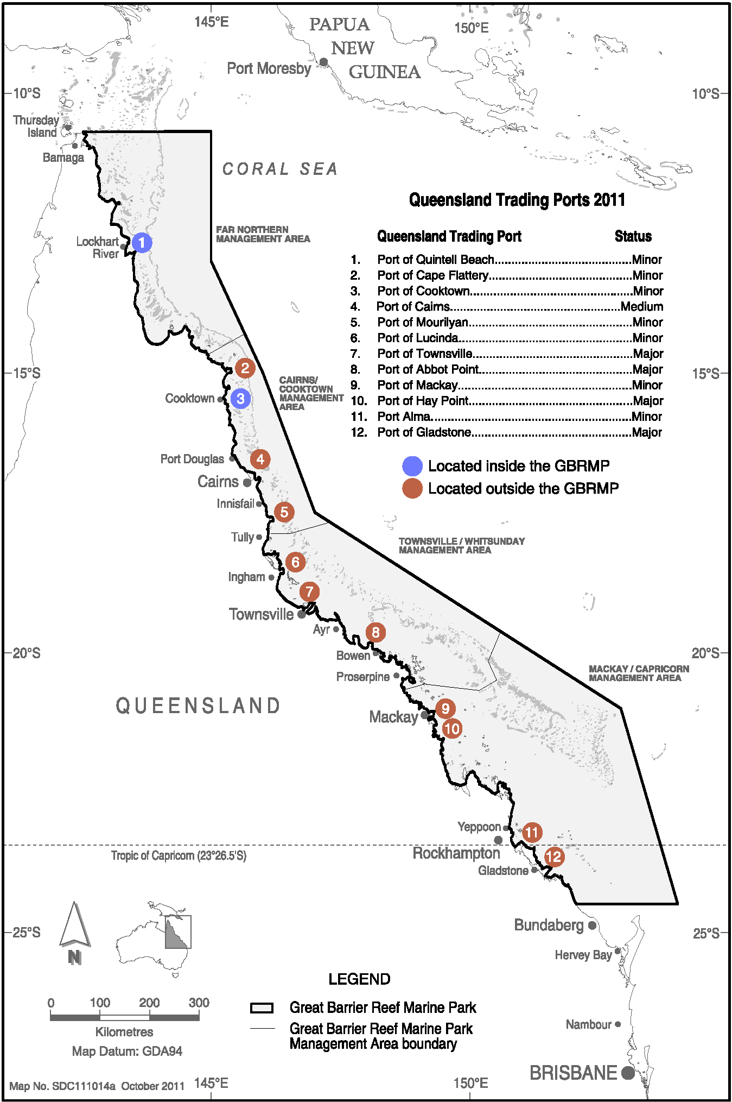
Map 1. Locations of the 12 Queensland trading ports for which contour maps of the ambient bed shear-stress were created to identify the stability of sediments and hence, whether locations are likely to be dispersive or non-dispersive for dredged sediments. (Map courtesy of the Spatial Data Centre, Great Barrier Reef Marine Park Authority 2012 ©).

Methods
The desktop screening study comprised of the following key tasks:
- Select representative El Niño, La Niña and neutral years from a oceanic current dataset (2004 to 2011) operating over the continental shelf off Queensland
- Generate surface current roses for the three year-long (2004, 2007, 2011) datasets to verify the year which represents high energy conditions (i.e. strongest predicted current speeds)
- Incorporate the effects of oceanic currents, i.e. the East Australian Current, together with tide- and wind-driven currents
- Model the wave climate for the same period as the current data
- Calculate the bed shear-stress due to combined forces of the currents and waves, within 50 km of the 12 Queensland ports
- Generate 50th and 95th percentile bed shear-stress maps to identify areas that are likely to be more dispersive and more retentive.

Modelling of Coastal and Ocean Currents
Wolanski (1994) describes the important processes influencing the oceanography of the Great Barrier Reef region. Of particular importance to this study is the near coastal zone, which is characterised by large-scale, wind-driven flows and tidal dynamics that vary significantly across this region. Offshore of the Great Barrier Reef are deep-water currents that result from the South Equatorial Current flowing into the Coral Sea where it splits into northward and southward arms as it approaches the north-east Australian shelf. The southern arm flows south, whereby it is often trapped against the continental slope, to form the East Australian Current (EAC). The northern arm flows along the shelf edge offshore of the northern GBR to form a semi-closed cyclonic eddy in the Coral Sea, centred in the Gulf of Papua (Wolanski 1994).
While the EAC influences the net drifts along the Great Barrier Reef shelf, its influence near the coast is weaker and non-existent in the enclosed bays and estuaries along the coast (King & Wolanski 1990). More importantly, the prevailing south-east trade winds (which can be moderate to strong during the months of May to October) often halt the deep water drift currents on the shelf and particularly in shallow waters for even weak south-east winds. Due to the persistence of these trade winds from the south-east, a strong northward drift within the near coastal waters develops and can be seen in the littoral sediment profiling of inshore waters (inferred from longshore variation of sediment composition along the 10 m isobath as detailed by Lambeck & Woolfe (2000). Indeed, during the passing of Tropical Cyclone Hamish in 2009, the currents inshore in Cleveland Bay off Townsville were measured to flow alongshore northward at a velocity peaking at 0.7 m/s (Lambrechts et al. 2010).
With regard to tidal forcing, Wolanski (1994) demonstrated that tidal flow dynamics vary significantly from region to region, though generally show a semi-diurnal beat. In the northern section of the Great Barrier Reef, the tides are relatively weak and run parallel to the coast inshore. In the central section of the Great Barrier Reef, tidal currents are strong and flow in a cross-shelf direction (King & Wolanski 1996). Additionally, in the southern section, the tides are very strong during spring tides and flow alongshore (Griffin et al. 1987).
Hence, Wolanski (1994) details that the net current forcing can be variably influenced by the wind-driven, tidal and oceanic currents. Therefore, to accurately describe the variability in currents of this study region, both horizontally and vertically, year-long oceanic currents were combined with coastal currents.
Below is a summary of how the combined forces were estimated.

Representation of oceanic drift currents
The influence from oceanic drift currents was represented by the output from HYCOM (Hybrid Coordinate Ocean Model, see Wallcraft et al. 2003; Chassignet et al. 2007). HYCOM calculates ocean currents globally and is operated by the HYCOM Consortium, sponsored by the Global Ocean Data Assimilation Experiment (GODAE). HYCOM is a data-assimilative, three-dimensional ocean model that is run as a hind-cast model (i.e. for a past period), assimilating time-varying observations of sea-surface height, sea-surface temperature and in-situ temperature and salinity measurements (Chassignet et al. 2009). The HYCOM predictions for ocean currents are produced in three-dimensions (depth-layered) at a horizontal spatial resolution of approximately 8.25 km over the region, at a frequency of once per day. Hence, the HYCOM model data provides estimates of meso-scale circulation, with horizontal resolution suitable to resolve eddies of a few 10’s of kilometres diameter, as well as connecting stream currents of similar spatial scale. HYCOM provides for a very time-comprehensive ocean current dataset spanning decades with increasing data quality over more recent years with increased availability of ocean observations from satellite and sensor data. Data between 2004 and 2011 (inclusive) were targeted for the study.
The HYCOM model data were selected for this study because it was found to better reproduce flows adjacent to the 12 Queensland ports when compared with the CSIRO BRAN 2.1 ocean model.
As the oceanographic conditions fluctuate from one year to the next, it was important to identify inter-annual trends using the Southern Oscillation Index (SOI). The SOI broadly defines neutral, El Niño (strongly negative SOI) and La Niña (strongly positive SOI) conditions based on differences in the surface air-pressure between Tahiti on the eastern side of the Pacific Ocean and Darwin (Australia), on the western side. The El Niño episodes are usually accompanied by sustained warming of the central and eastern tropical Pacific Ocean and a decrease in the strength of the Pacific trade winds. La Niña episodes are usually associated with converse trends.
Figure 1 shows the monthly values for the SOI from 2004 to 2011 (corresponding to the HYCOM ocean current dataset that was targeted for assessment). Based on the SOI, 2007 was selected as a representative mixed (neutral) SOI year, 2011 as a strong La Niña and 2004 as a moderate El Niño year.
To verify the selection of years, current roses for each of the three year-long oceanic current datasets were generated to assess the variability and patterns of the oceanographic drift currents adjacent to the existing material placement sites for five key ports along the Queensland coastline (Ports of Cairns, Townsville, Abbot Point, Hay Point and Gladstone).

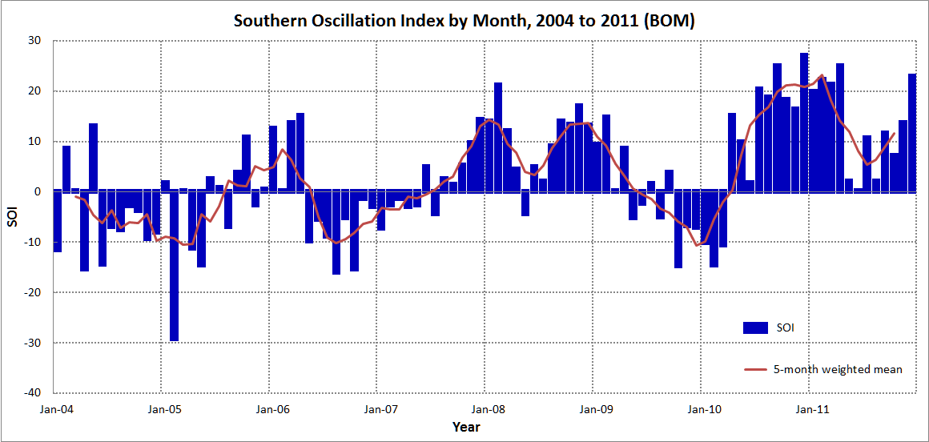
Figure 1. Monthly values of the Southern Oscillation Index (SOI) 2004 - 2011. Sustained positive values indicate La Nina conditions, while sustained negative values indicate El Nino conditions (Source: Australian Bureau of Meteorology 2012).

Note that the convention for defining current direction is to show the direction that the current flows toward, which is used to reference current direction throughout this report. Each sector of the rose represents the proportion of (daily) current records flowing to that direction, with north to the top of the diagram. Sixteen directions are used. The sectors are divided into segments of different colour, which represent the current speed ranges for each direction. Speed intervals of 0.2 m/s are used in these current roses. The length of each coloured segment is relative to the proportion of currents flowing within the corresponding speed and direction.
It is interesting to note that, for all 5 ports, the data showed general trends in the daily current directions that were similar between the neutral (2007) and La Niña (2011) years, being a net flow towards the west-north-west. However, stronger currents were hind-casted for 2011. The weakest and most variable currents were predicted during the El Niño conditions of 2004. Based on these findings, 2011 was selected to be the representative year for the study on the basis that currents during this year would exert the greatest forces.

Figure 2. Comparative surface current roses for three years adjacent to (from top to bottom) Port of Gladstone, Port of Hay Point, Port of Abbot Point, Port of Townsville and Port of Cairns. The roses cover El Niño (2004), La Niña (2011) and neutral (2007) conditions and are for locations adjacent to the existing material placement sites.

Coastal currents
The tide and wind-driven currents over the coastal bathymetry has been resolved by applying a three-dimensional barotropic ocean model, HYDROMAP. The hydrodynamic model, as described by Isaji & Spaulding (1984) is a three-dimensional model that uses continuous profiles to represent the velocity, temperature, and salinity in the vertical structure. The basis of the model is formed by the three-dimensional conservation equations in spherical coordinates for water mass, density, and momentum with the Boussinesq and hydrostatic assumptions.
HYDROMAP simulates the flow of ocean currents within a model region due to forcing by astronomical tides, wind stress and bottom friction. The model employs a sophisticated nested-gridding strategy, supporting up to six levels of spatial resolution. This unique feature allowed for currents to be generated at a much higher resolution within 50 km from each of the 12 ports (~700 m spacing), necessary to resolve nearby reefs, complex passages through the islands and coastal flows while allowing for a larger domain that extended further seaward to capture the influence of wider forces using cells that were much larger (space increasing to ~11 km). The variable grid resolution allows for a balance between the requirement to include important bathymetric influences and ensuring efficient computational time. It is important to note that the datasets created and used in this study could not be to the standard of a detailed Environmental Impact Assessment as the focus was on the navigable waters of the GBR including inshore waters and within Port limits. The resolution of the datasets (700 m) for quantifying the bed shear-stresses over this vast and complex region is similar to or better than other peer-reviewed models of the region. For example, modelling by Andutta et al. (2011) presented variable resolution from 300 m to several kilometres in size. Luick et al (2007) and King & Wolanski (1992, 1996) demonstrated that grid dimensions of 2 km or less were sufficient to resolve shelf scale features within the Central Section of the Great Barrier Reef. The modelled dataset created for the GBR and inshore waters as part of this study covered a one year period and hence would be a suitable dataset for boundary forcing conditions of any detailed high resolution model as per GBRMPA Hydrodynamic Modelling Guidelines (2012).
The model bathymetry was a compilation of the latest hydrographic charts and digital elevation data (sourced from Geoscience Australia).
Due to the vast extent of the study region (approximately 1500 km north to south), three separate overlapping grids were generated for the southern, central and northern GBR regions. Consequently, the grids are referred to as southern, central and northern GBR.
Figure 3 to figure 8 show the extent of the southern and central GBR coastal current model grids, along with insets of the smaller grid cells neighbouring the six ports and the existing material placement sites. Figure 9 shows the extent of the northern GBR coastal model grid.

Figure 3. Extent of the southern GBR coastal model grid. Note the smaller grid cells along the coastline and around islands to better resolve the complex flows around these features. The inset shows the smaller grid cells neighbouring the Port of Gladstone with the yellow box defining the location of the existing dredge material placement site.
Figure 4. Extent of the southern GBR coastal model grid. Note the smaller grid cells along the coastline and around islands to recreate the complex flows. The inset shows the smaller grid cells neighbouring Rosslyn Bay State Boat Harbour with the yellow box defining the location of the existing dredge material placement site.
Figure 5. Extent of the southern GBR coastal model grid. Note the smaller grid cells along the coastline and around islands to recreate the complex flows. The inset shows the smaller grid cells neighbouring Port of Hay Point with the yellow box defining the location of the existing dredge material placement site.
Figure 6. Extent of the central GBR coastal model grid. Note the smaller grid cells along the coastline and around islands to recreate the complex flows. The inset shows the smaller grid cells neighbouring Port of Abbot Point with the yellow box defining the location of the existing dredge material placement site.
Figure 7. Extent of the central GBR coastal model grid. Note the smaller grid cells along the coastline and around islands to recreate the complex flows. The inset shows the smaller grid cells neighbouring Port of Townsville with the yellow box defining the location of the existing dredge material placement site.
Figure 8. Extent of the central GBR coastal model grid. Note the smaller grid cells along the coastline and around islands to recreate the complex flows. The inset shows the smaller grid cells neighbouring Port of Cairns with the yellow box defining the location of the existing dredge material placement site.
Figure 9. Extent of the northern GBR coastal model grid. Note the smaller grid cells along the coastline and around islands to recreate the complex flows. The inset shows the smaller grid cells neighbouring Port of Cooktown with the yellow box defining the location of the existing dredge material placement site.

Tidal and Wind Forcing
Tidal forcing data (amplitude and phase records) along the southern, eastern and northern boundaries ocean boundaries of the coastal current grids were extracted from the Topex/Poseidon global tidal database (TPX07.1). The data is derived from long-term measurements taken by the Topex/Poseidon satellites collected over a 13 year period (1992-2005), during which time the planet was orbited 62,000 times. It has a resolution of 0.25 degrees (465 m) globally, and is produced and quality controlled by the United States National Aeronautics and Space Administration (NASA). The satellites were equipped with two highly accurate altimeters, capable of taking sea level measurements at an accuracy of less than ± 1 cm ("Ocean Surface Topography from Space" NASA/JPL). The Topex/Poseidon tidal data have been widely used amongst the oceanographic and scientific community and is considered suitably accurate (e.g. Ludicone et al. 1998; Kostianoy et al. 2003; Yaremchuk & Tangdong 2004; Qiu & Chen 2010).
To account for the tidal forcing over each grid, the eight largest and most significant tidal constituents for the area (M₂, S₂, K₁, O₁, N₂, P₁, K₂, and Q₁) were selected at a resolution of 0.25° and spatially interpolated across the cells forming the coastal boundaries. The HYDROMAP model used this data to calculate the relative elevation of the ocean along the boundaries the slope and hence propagation of the tide into the domains.
To ensure the model was accurately predicting the propagation of the tidal elevations over the grid, which includes the effects of the numerous reefs (over 2,900) and continental islands (600), water elevations predicted by the model were compared with observed data at nine tide stations located along the Queensland coastline over a randomly selected month within 2011 (1 to 30 November 2011). Figure 10 to figure 12 show the model accurately reproduced the phase and amplitudes throughout the spring and neap tidal cycles at all tide stations, including the inequalities in the semidiurnal and mixed phase tidal patterns.
Table 1 to table 3 provide summaries of the comparisons between the measured and predicted water elevations between 1 and 30 November 2011 at nine locations (Gladstone, Rosslyn Bay, Hay Point, Abbot Point, Townsville, Cairns, Cooktown, Pipon Island and Night Island).
The tables show the maximum, average and minimum predicted water elevations are comparable to the measured water elevations at all nine locations. The MAE values ranged from 0.07 m (Cairns) to 0.49 m (Hay Point).

Table 1 Statistical comparison between the measured and predicted water elevation at Gladstone, Rosslyn Bay and Hay Point from 1 to 30 November 2011.
Variable | Water elevation (m LAT) for port locations
Variable | Gladstone |  | Rosslyn Bay |  | Hay Point
Variable | Observed | Predicted | Observed | Predicted | Observed | Predicted
Maximum | 4.65 | 4.37 | 4.78 | 4.89 | 6.68 | 6.06
Average | 2.34 | 2.38 | 2.42 | 2.46 | 3.37 | 3.43
Minimum | 0.37 | 0.61 | 0.43 | 0.19 | 0.45 | 0.90
Mean absolute error (MAE) | 0.12 |  | 0.28 |  | 0.49

Table 2 Statistical comparison between the measured and predicted water elevation at Abbott Point, Townsville and Cairns from 1 to 30 November 2011.
Variable | Water elevation (m LAT) for port locations
Variable | Abbot Point |  | Townsville |  | Cairns
Variable | Observed | Predicted | Observed | Predicted | Observed | Predicted
Maximum | 3.27 | 3.18 | 3.72 | 3.73 | 3.05 | 3.00
Average | 1.69 | 1.73 | 1.94 | 2.00 | 1.70 | 1.72
Minimum | 0.22 | 0.29 | 0.27 | 0.23 | 0.26 | 0.39
Mean absolute error (MAE) | 0.22 |  | 0.11 |  | 0.07

Table 3 Statistical comparison between the measured and predicted water elevation at Cooktown, Pipon Island and Night Island from 1 to 30 November 2011.
Variable | Water elevation (m LAT) for port locations
Variable | Cooktown |  | Pipon Island |  | Night Island
Variable | Observed | Predicted | Observed | Predicted | Observed | Predicted
Maximum | 2.77 | 2.80 | 2.71 | 2.72 | 2.75 | 2.69
Average | 1.49 | 1.55 | 1.48 | 1.51 | 1.50 | 1.51
Minimum | 0.20 | 0.25 | 0.53 | 0.23 | 0.44 | 0.27
Mean absolute error (MAE) | 0.08 |  | 0.17 |  | 0.15

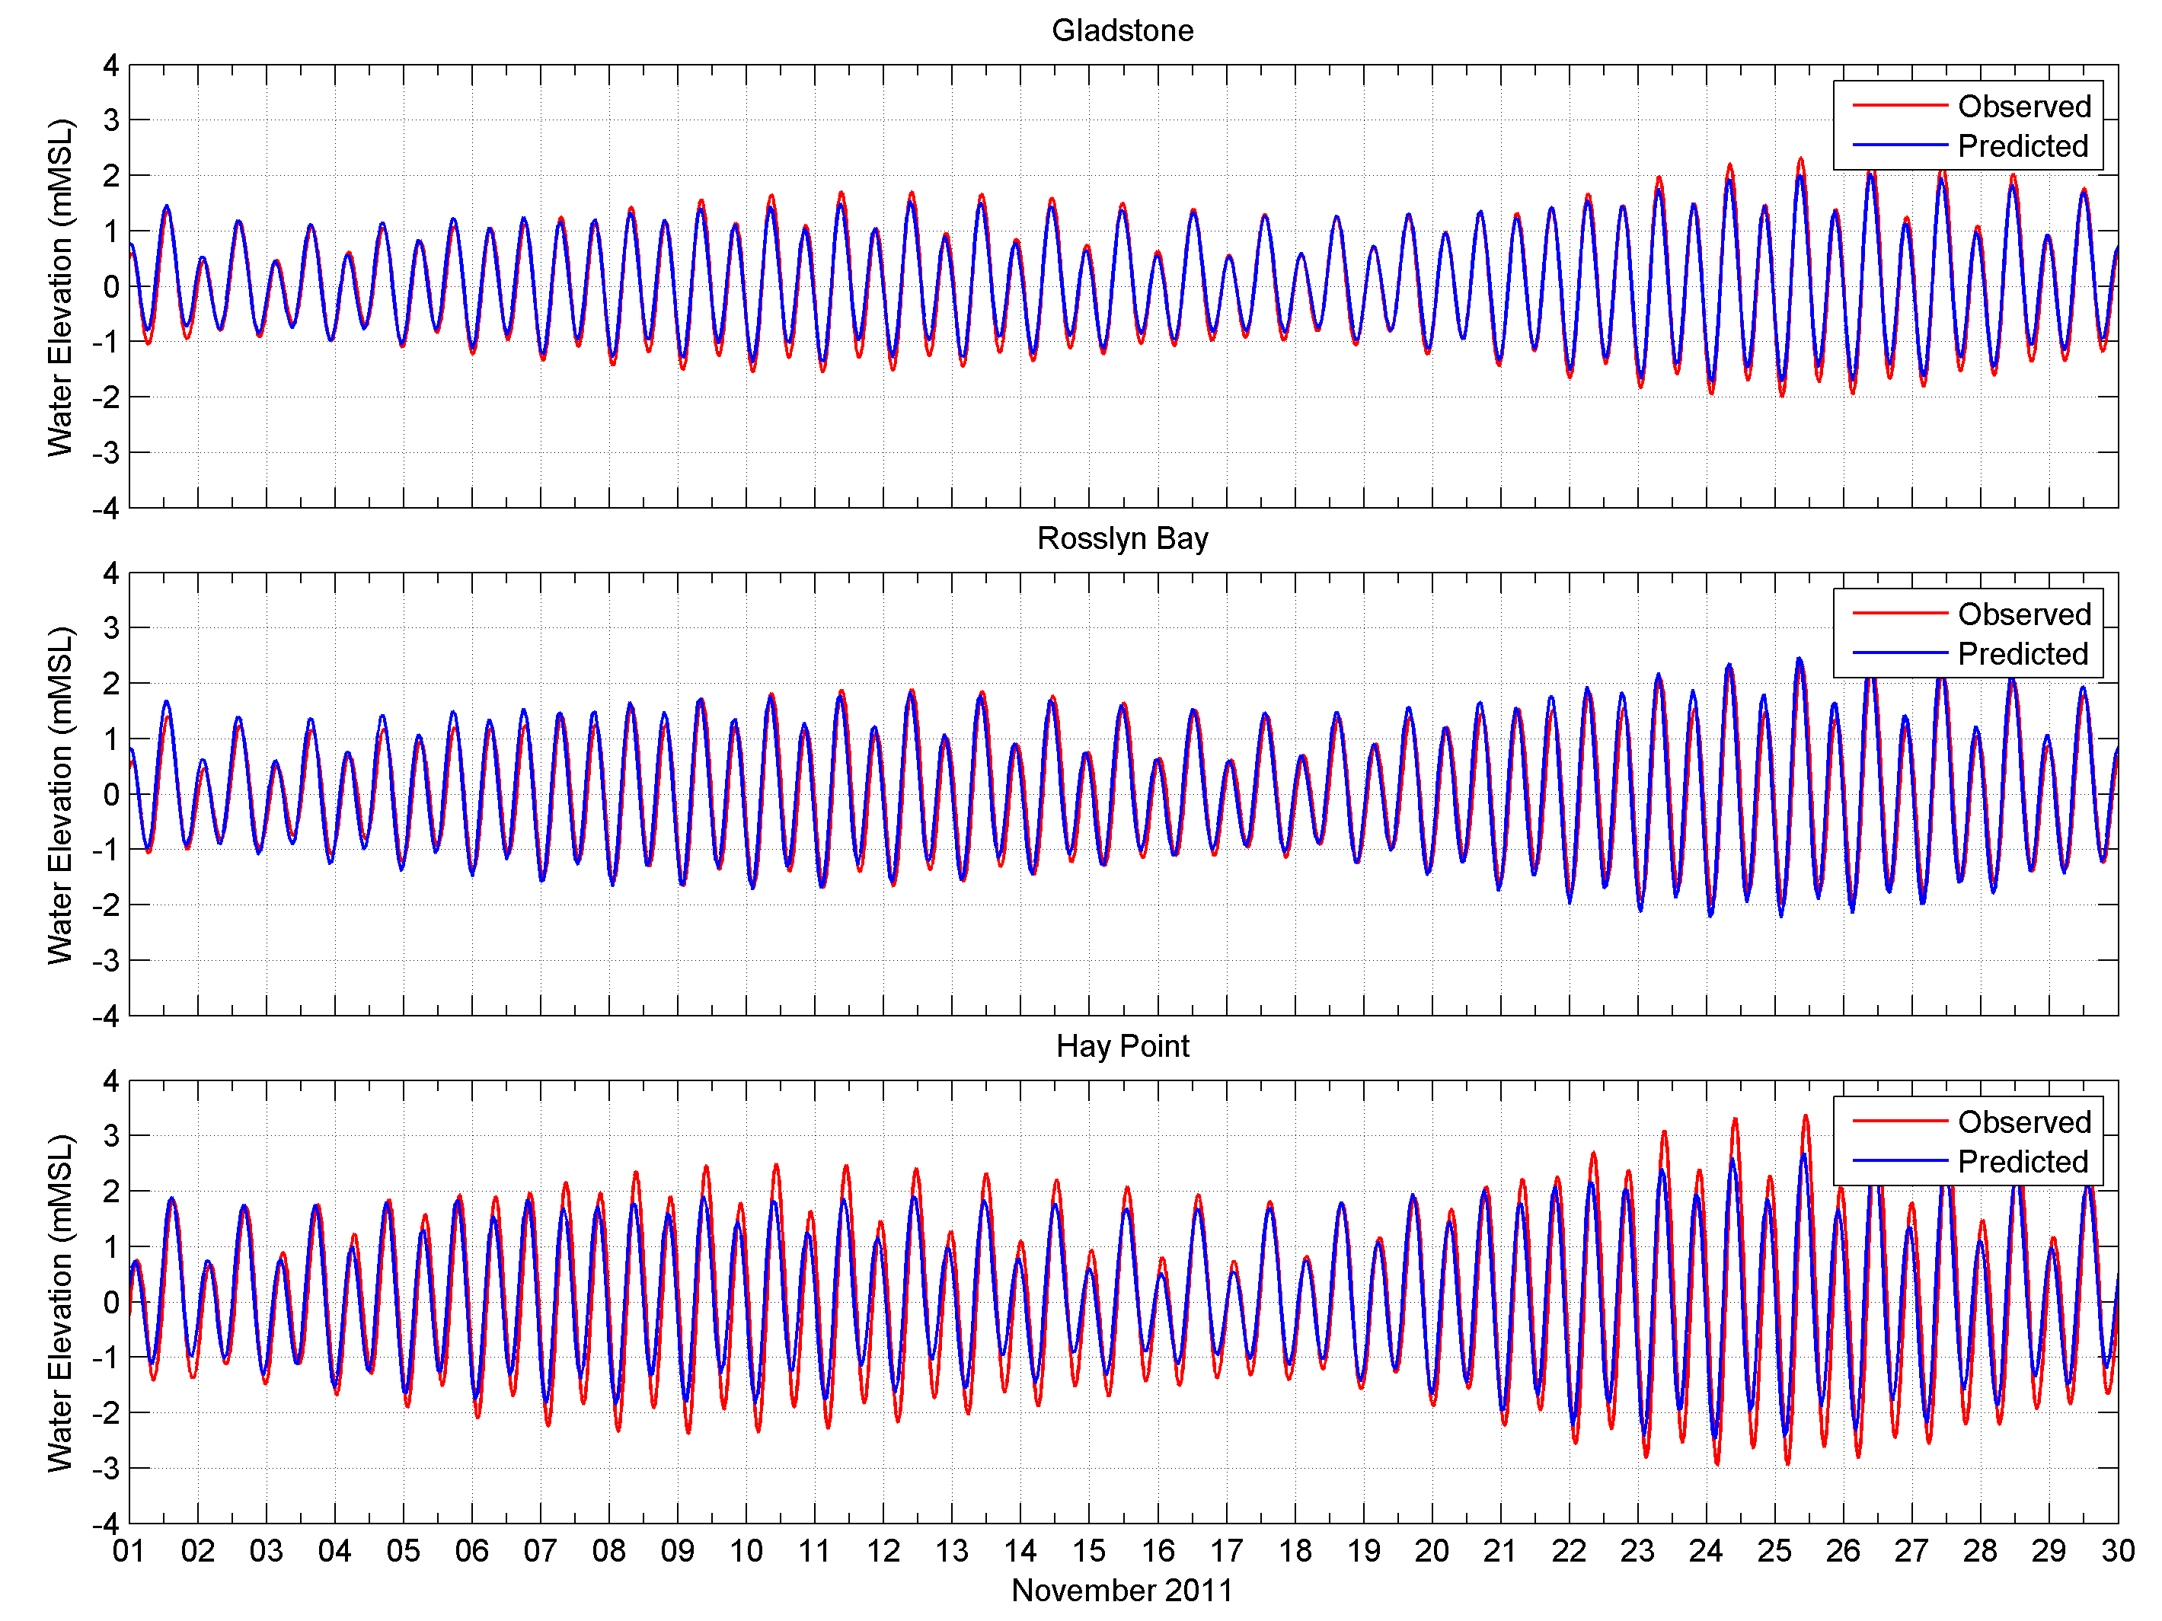
Figure 10. Comparison between the predicted (red line) and observed (blue line) water elevations at Gladstone (upper image), Rosslyn Bay (middle image) and Hay Point (lower image), 1-30 November 2011.

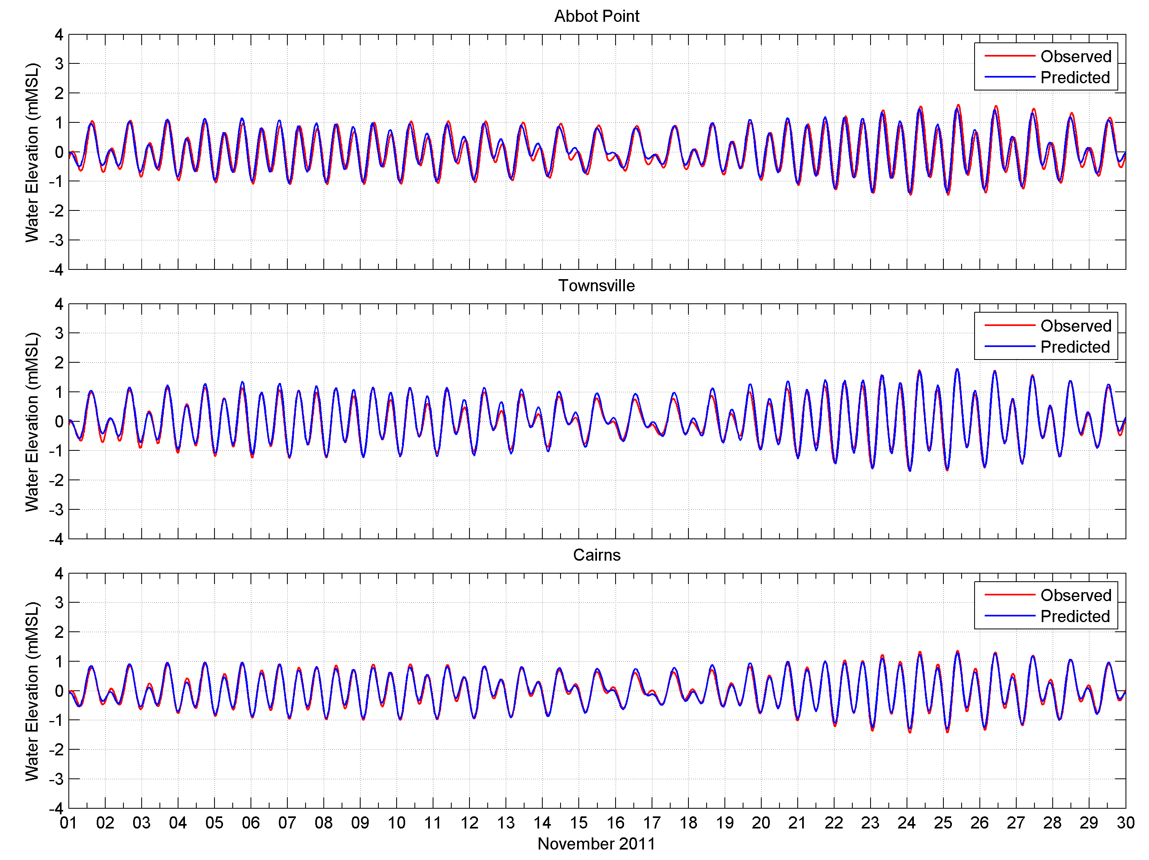
Figure 11. Comparison between the predicted (red line) and observed (blue line) water elevations at Abbot Point (upper image), Townsville (middle image) and Cairns (lower image), 1-30 November 2011.
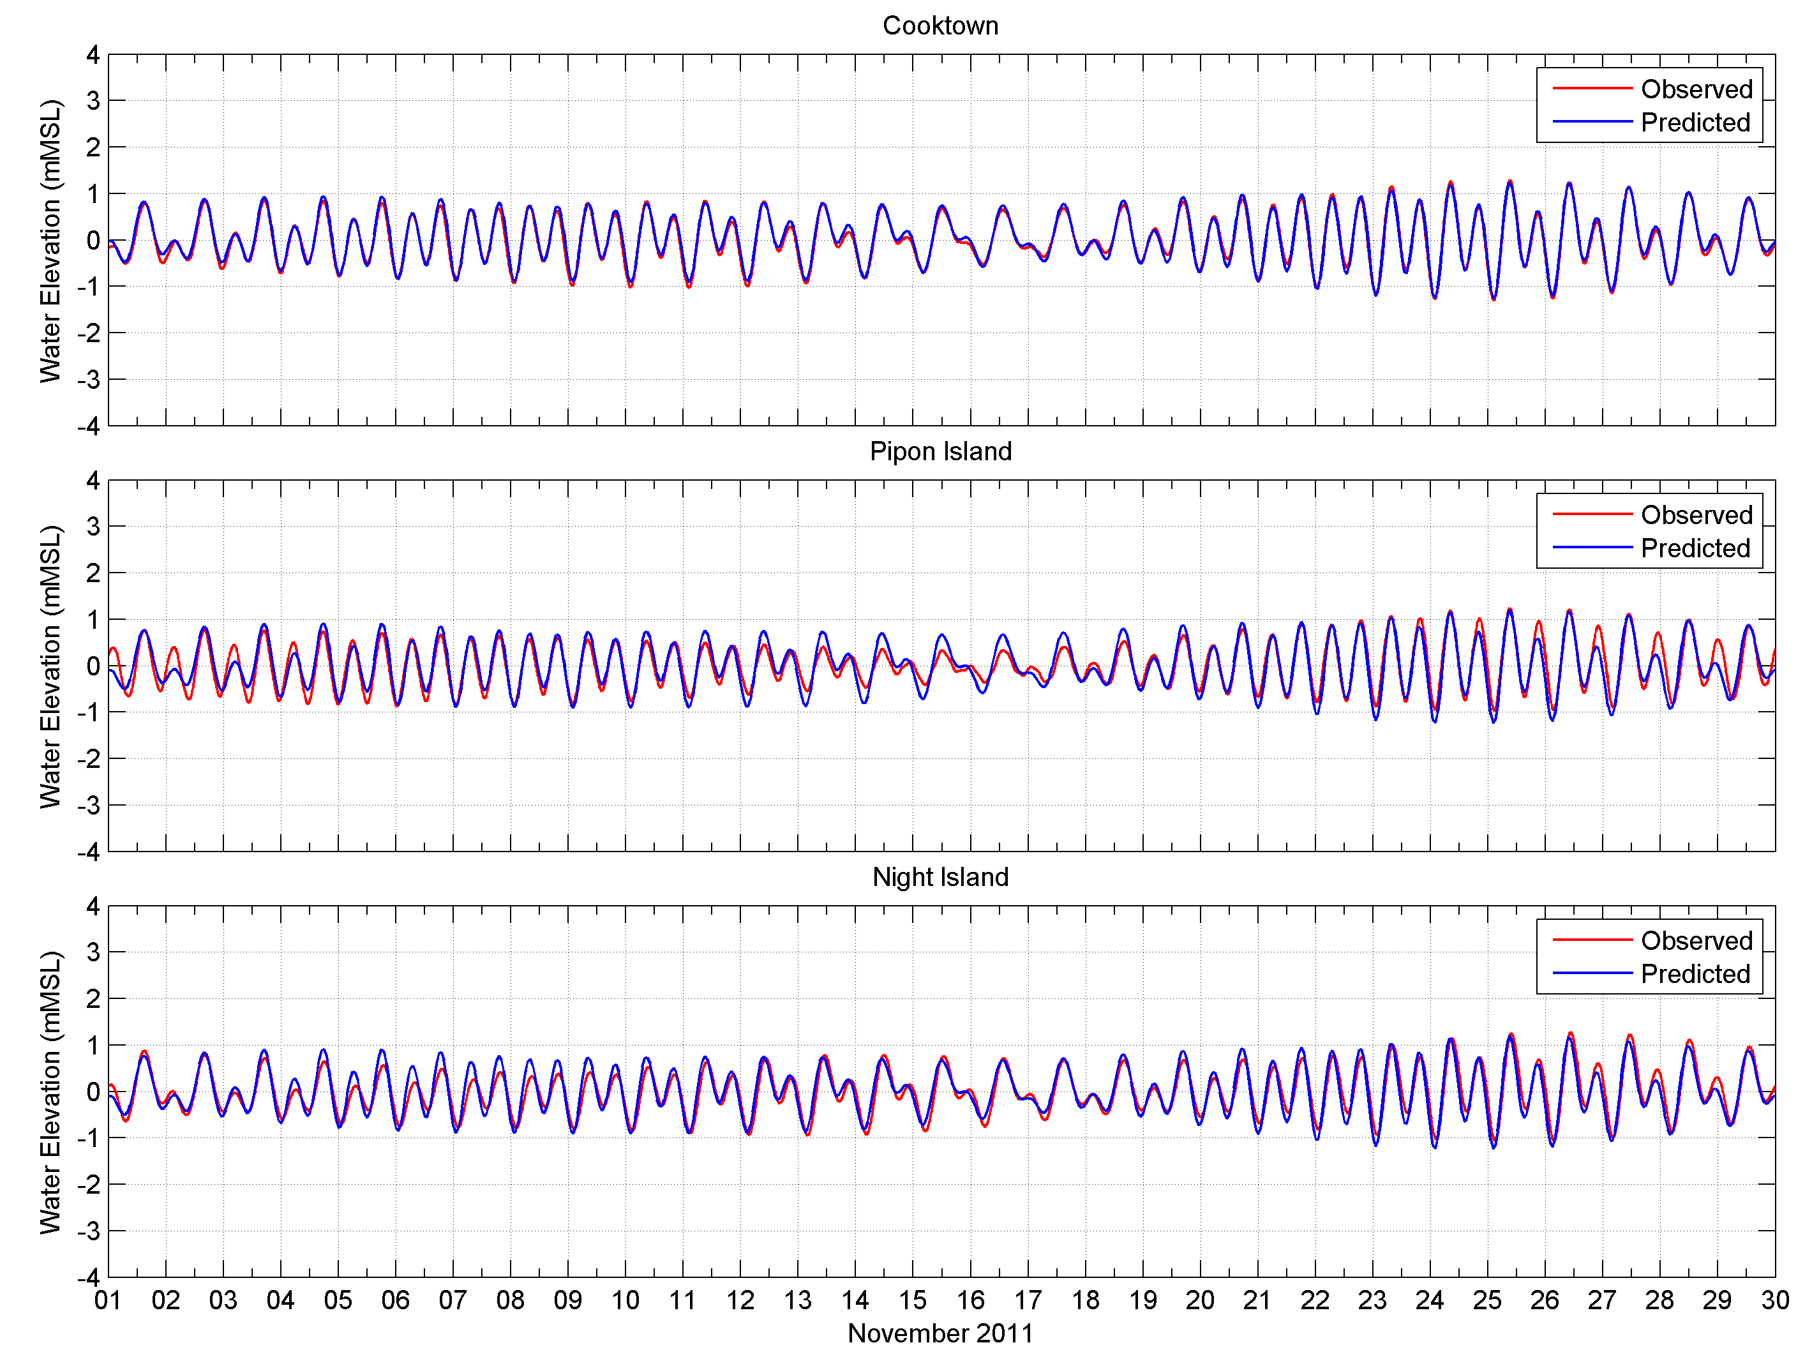
Figure 12. Comparison between the predicted (red line) and observed (blue line) water elevations at Cooktown (upper image), Pipon Island (middle image) and Night Island (lower image), 1-30 November 2011.

To account for the wind influence on coastal circulation, measurements made along the coastline by the Bureau of Meteorology (BOM) were combined with reanalysed data sourced from the atmospheric model Global Forecast System (GFS) run by the National Centre for Environmental Predictions (NCEP). The GFS wind data integrates extensive atmospheric data measurements using state-of-the-art modelling and is available at three hourly time steps for stations spaced at ~ 55 km apart. Data from 2011 were extracted for the same extent as the coastal current model grids.

Validation of combined current estimates
The HYCOM daily oceanic currents were combined with the hourly HYDROMAP coastal currents by addition of the vectors calculated from each source: (HYCOM and HYDROMAP) after temporal interpolation of the HYCOM drift current data at an hourly scale.
To confirm the suitability of the combined currents, the predictions were compared with actual measurements collected adjacent to the existing material placement sites at Townsville (January 2011) and Hay Point (November 2011; figure 13). The data throughout the water column were collected using bottom mounted Acoustic Doppler Current Profilers (ADCPs). Comparisons were made between the predicted and measured currents in the surface and bottom layers. Depths of water at the measurement sites were 11.5 m (LAT) and 14.5 m (LAT) at Hay Point and Townsville, respectively. Additionally, the model results were compared with measured water elevations at both sites.
Figure 13. Locations of the bottom mounted Acoustic Doppler Current Profilers (ADCPs) instruments used to measure currents throughout water column adjacent to the Townsville and Hay Point existing material placement sites in January and November 2011, respectively.
Figure 14 and figure 15 show the comparisons between the measured and predicted currents in the surface and bottom layers at Hay Point and Townsville, respectively. Comparisons at both locations show a good agreement between the model predictions and measurements for both the surface and bottom layers. For the surface layer, both tidal-scale and large-scale fluctuations in currents were well reproduced at a similar magnitude and timing at both sites. Analysis of the Townsville measured data indicated persistently strong surface currents and that tidal variations were less significant between 9-16 and 21-24 January 2011. This would be attributable to sustained south-easterly trade winds. The model predictions agreed well with the measured data. Of greater importance for the study is the close comparison between the measured and predicted current data for the bottom layer at both sites, as these would have a larger influence on the transportation of sediments that are mobilized from the seabed. Lastly, Figure 14 and figure 15 show that the model was also capable of accurately predicting the water elevations at both sites. It is important to note also that the tidal range at Hay Point is up to eight metres (peak to trough) compared with four metres at Townsville.
Table 4 and table 5 provide an indication of the agreement between the measured and predicted surface and bottom currents at the Port of Hay Point and the Port of Townsville, respectively. Both tables illustrate that the maximum, average and minimum predicted current speeds are comparable to the measured currents at the two locations, respectively.
As shown in table 4, the measured surface current speeds at Hay Point reached a maximum of 0.59 m/s compared with 0.53 m/s for the predicted current speed. The bottom maximum measured and predicted currents were 0.31 m/s and 0.26 m/s, respectively. The maximum measured water elevation was 6.73 m and the predicted was 6.05 m.
While at Townsville, the measured surface currents peaked at 0.99 m/s with the model results indicated a maximum speed of 1.12 m/s). The average measured and predicted bottom currents speeds were near identical (0.10 m/s and 0.11 m/s, respectively).
The surface current speeds at Port of Hay Point and Townsville were characterised by mean absolute errors (MAE) of 0.07 m/s and 0.16 m/s, respectively, while bottom currents at both locations demonstrated MAE values of 0.04 m/s.

Table 4 Statistical comparison between measured and predicted surface and bottom currents adjacent to the Port of Hay Point material placement site from 1 to 30 November 2011.
Variable | Surface current speed (m/s) |  | Bottom current speed (m/s) |  | Water elevation  (m LAT)
Variable | Measured | Predicted | Measured | Predicted | Measured | Predicted
Maximum | 0.59 | 0.53 | 0.31 | 0.26 | 6.73 | 6.05
Average | 0.30 | 0.30 | 0.15 | 0.17 | 3.38 | 3.43
Minimum | 0.10 | 0.08 | 0.05 | 0.06 | 0.24 | 0.90
Mean absolute error (MAE) | 0.07 |  | 0.04 |  | 0.32

Table 5 Statistical comparison between measured and predicted surface and bottom currents adjacent to the Port of Townsville material placement site from 1 to 29 January 2011.
Variable | Surface current speed (m/s) |  | Bottom current speed (m/s) |  | Water elevation  (m LAT)
Variable | Measured | Predicted | Measured | Predicted | Measured | Predicted
Maximum | 0.99 | 1.12 | 0.43 | 0.27 | 3.76 | 3.67
Average | 0.25 | 0.35 | 0.10 | 0.11 | 1.91 | 1.99
Minimum | 0.00 | 0.01 | 0.01 | 0.00 | 0.15 | 0.34
Mean absolute error (MAE) | 0.16 |  | 0.04 |  | 0.16

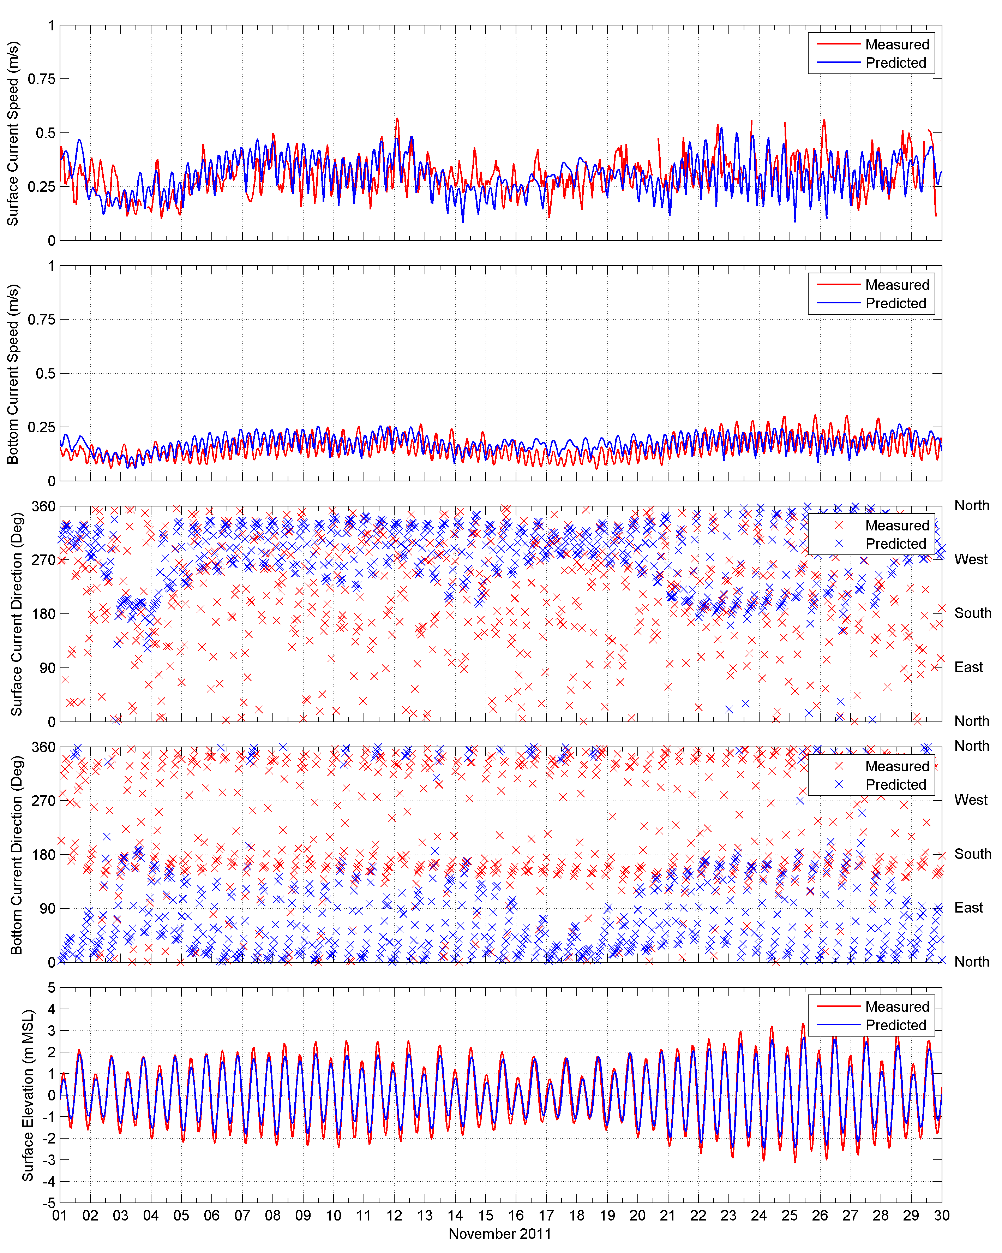
Figure 14. Comparison of the predicted and measured surface and bottom current speeds (upper images) and directions (lower images) and water elevations adjacent to the existing Hay Point disposal site (1-30 November 2011).

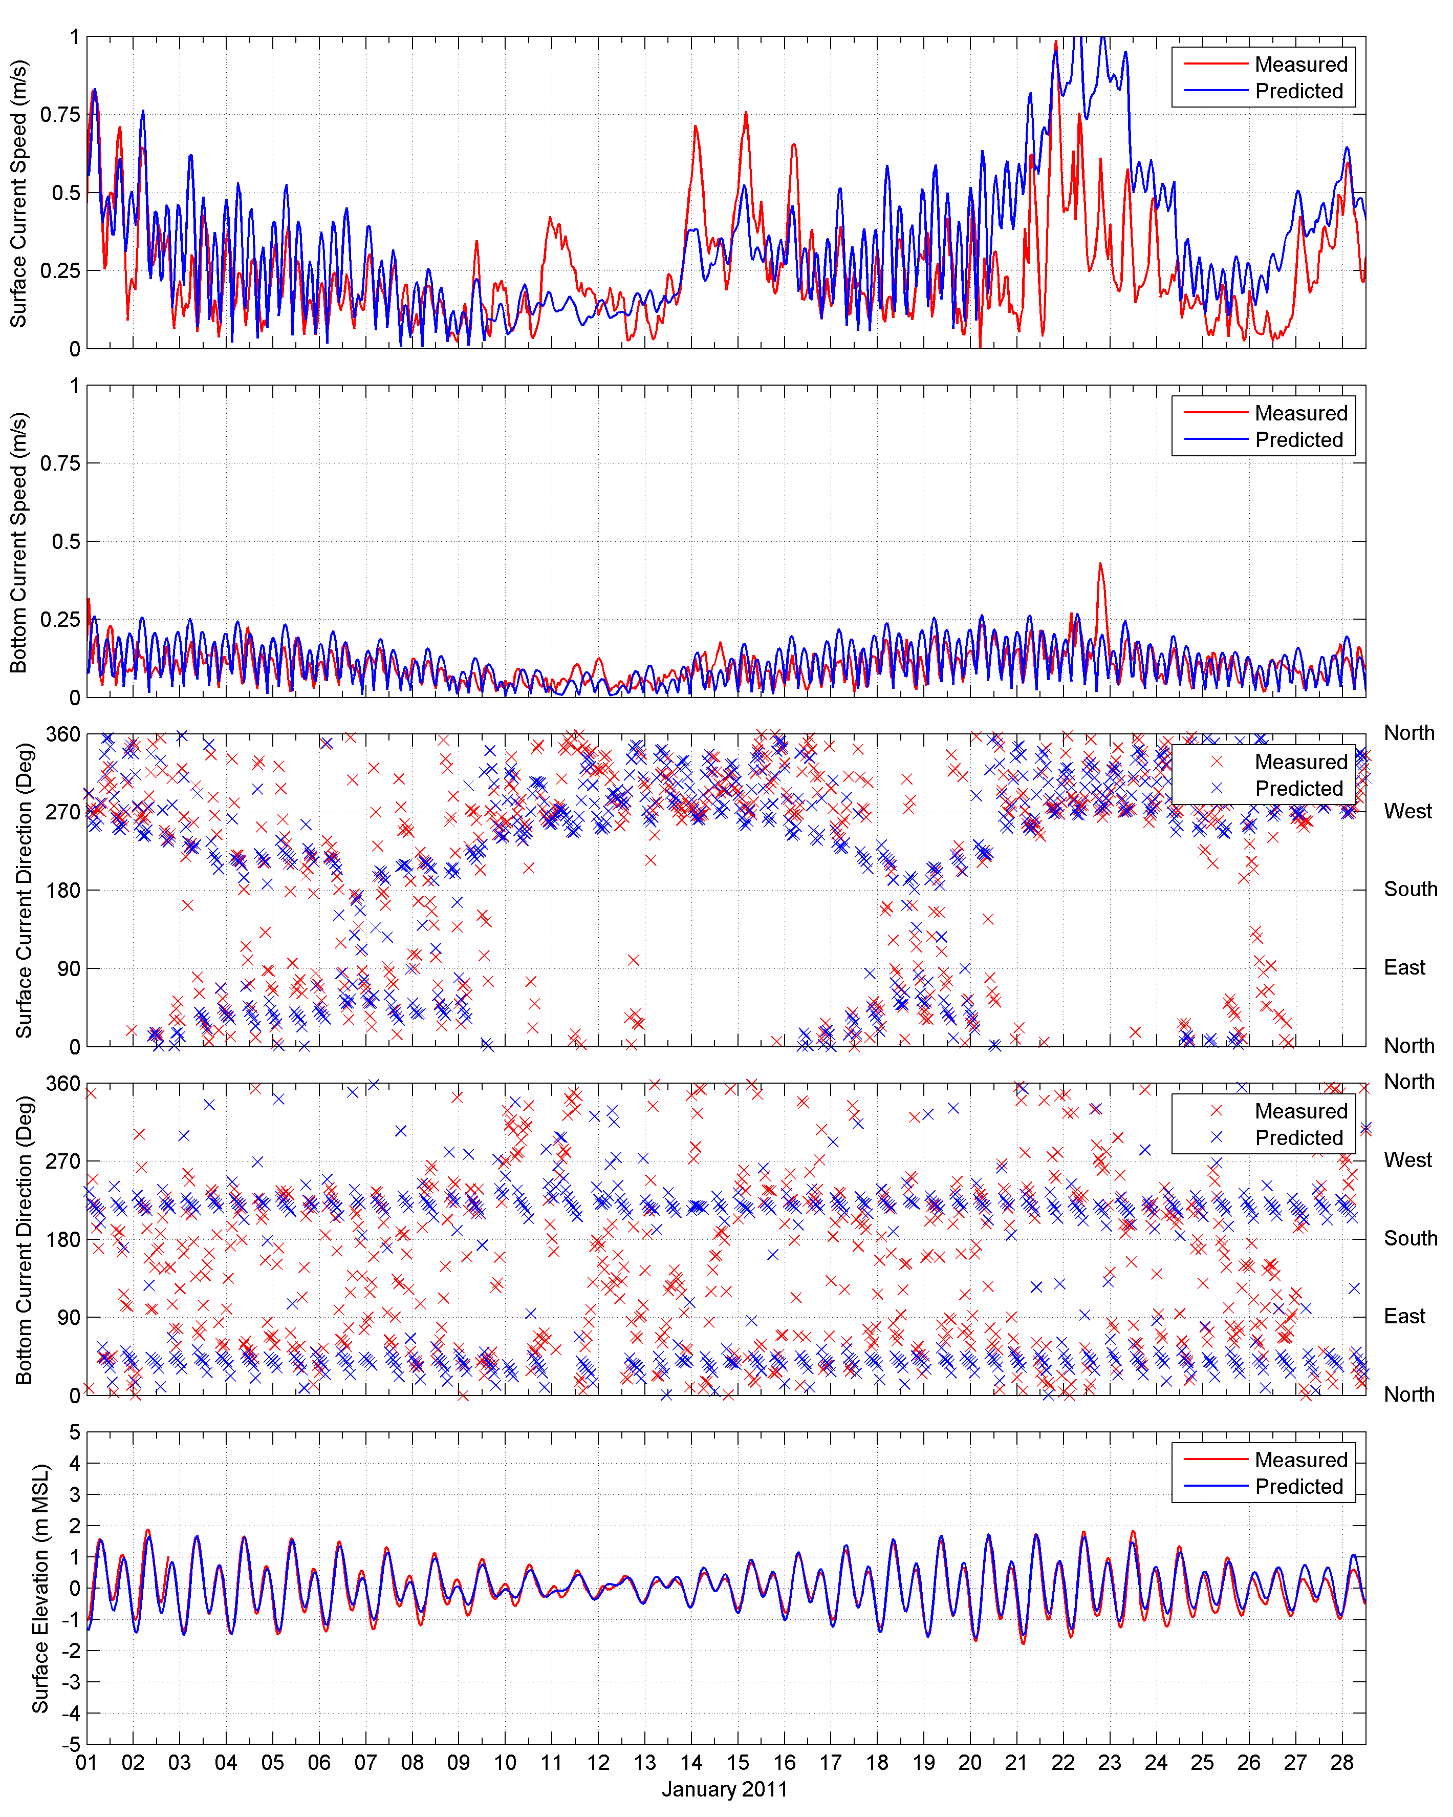
Figure 15. Comparison of the predicted and measured surface and bottom current speeds (upper panels) and directions (lower images) and water elevations adjacent to the existing Townsville disposal site (1-29 January 2011).

Modelling of Wave Conditions
The wave climate was reproduced using a spectral phase-averaging wave model, SWAN, developed by the Delft University of Technology (Booij et al. 1996, 1999; Holthuijsen et al. 1997). The SWAN model is a numerical model for simulating realistic estimates of wave parameters in coastal areas for given wind, bottom and current conditions. The model is a third-generation model based on the energy balance equation (Holthuijsen et al. 1997).
The SWAN model includes algorithms for the following wave propagation processes: propagation through geographic space, refraction due to bottom and current variations, shoaling due to bottom and current variations, blocking and reflections by opposing currents, and transmission through or blockage by obstacles. The model also accounts for the dissipation effects due to white-capping, bottom friction and wave breaking as well as non-linear wave-wave interactions. The model is fully spectral (in all directions and frequencies) and computes the evolution of wind waves in coastal regions with shallow water depths and ambient currents.
Four separate overlapping wave model grids were generated, referred to as southern GBR, southern central GBR, northern central GBR and northern GBR grids (see figure 16 to figure 19). The model grid requirements included a higher spatial resolution (~700 m) within 50 km of the ports to appropriately represent local variations. Again, it is important to point out that the datasets created and used in this study could not be to the standard of a detailed Environmental Impact Assessment, as the focus was on the navigable waters of the GBR including inshore waters and within Port limits.
Active offshore boundary conditions were assigned to the southern, eastern and northern boundaries of each model domain. Parametric spectral inputs (offshore boundary condition) were generated using a standard JONSWAP spectrum. The wave parameters that govern the spectral shape of the JONSWAP spectrum applied at the open boundary are significant wave height (H_{s}), peak wave period (T_{p}), peak wave direction (Dir) and the directional spreading of waves (i.e. how ‘focussed’ the swell conditions are).
Regionally specific boundary conditions were defined by using deep-water wave parameters obtained from the National Centre for Environmental Prediction (NCEP/NOAA) WAVEWATCH III (WW3) global wave model (Chu et al. 2004; Tolman 2009). Hind-cast wave data is available on a 3-hour time step over a global ocean grid over the range 77°S to 77°N with a longitude x latitude resolution of 1.25° x 1°. Care was taken to test the boundaries to avoid the propagation of any errors into the area of interest.
To account for the wind influence, hourly measured winds by BOM along the coastline were combined with reanalysed wind data sourced from the GFS model. The GFS model data were at three hourly intervals for stations spaced 125 km apart. For each grid, up to 20 wind stations were used to represent the regional wind patterns, and thus influences on the wave climate.
The model bathymetry was a compilation of the latest hydrographic charts and Geoscience Australia digital elevation data were spatially interpolated to fill the entire model domain.
Figure 16. Extent of the southern GBR wave model grid. The size of the individual triangles represent the varying mesh resolution and the colour coding the water depth (m).

Figure 17. Extent of the southern central GBR wave model grid. The size of the individual triangles represent the varying mesh resolution and the colour coding the water depth (m).

Figure 18. Extent of the northern central GBR wave model grid. The size of the individual triangles represent the varying mesh resolution and the colour coding the water depth (m).

Figure 19. Extent of the northern GBR wave model grid. The size of the individual triangles represent the varying mesh resolution and the colour coding the water depth (m).

Validation of Wave Conditions
Following the establishment of each model grid and accompanying boundary and spatial wind input data, a series of simulations was completed using a variety of input parameters, as a sensitivity analysis approach. This initial trialling phase focussed primarily on determining the physical parameters and formulations (e.g. bottom friction, white-capping coefficients) that best represent the regional wave climate.
The model accuracy was verified using wave data measured by the Department of Environment and Heritage Protection (as part of the Waverider system) between January and March 2011, at five waverider buoy locations (Gladstone, Emu Park, Mackay, Townsville and Cairns; see figure 20). Note that the waverider buoy at Cairns is non-directional, hence only significant wave heights and peak wave period are shown.
Comparison between the model and measured validation results are shown below (figure 21 to figure 25) as both (i) time series plots and (ii) histograms. The comparisons demonstrate that the model was capable of capturing the trend of increasing and decreasing wave heights, and frequency of the peak wave conditions (significant wave height) in addition to peak wave period and direction at the five locations.

Figure 20. Locations of the waverider buoys used to measure wave climate by the Department of Environment and Heritage Protection.

Figure 21. Comparison of predicted (blue) and measured (green) waves at the Gladstone waverider buoy, January to March 2011. The top panel shows the significant wave height, the middle panel shows the peak wave period and the bottom panel shows the peak wave direction comparisons. The histograms provide an inter-comparison of the frequency distributions between the observed and predicted.

Figure 22. Comparison of predicted (blue) and measured (green) waves at the Emu Park waverider buoy, January to March 2011. The top panel shows the significant wave height, the middle panel shows the peak wave period and the bottom panel shows the peak wave direction comparisons. The histograms provide an inter-comparison of the frequency distributions between the observed and predicted.

Figure 23. Comparison of predicted (blue) and measured (green) waves at the Mackay waverider buoy, January to March 2011. The top panel shows the significant wave height, the middle panel shows the peak wave period and the bottom panel shows the peak wave direction comparisons. The histograms provide an inter-comparison of the frequency distributions between the observed and predicted.

Figure 24. Comparison of predicted (blue) and measured (green) waves at the Townsville waverider buoy, January to February 2011. The top panel shows the significant wave height, the middle panel shows the peak wave period and the bottom panel shows the peak wave direction comparisons. The histograms provide an inter-comparison of the frequency distributions between the observed and predicted.

Figure 25. Comparison of predicted (blue) and measured (green) waves at the Cairns waverider buoy, January to February 2011. The top panel shows the significant wave height and the bottom panel shows the peak wave period. The histograms provide an inter-comparison of the frequency distributions between the observed and predicted.

Bed Shear-stress Calculations
Estimates of bed shear-stress (or bottom stress) were calculated for each grid cell at hourly time steps for both current and wave forces using the empirical formulation described in Soulsby (1997). This method is appropriate for estimating combined shear-stresses at the seabed due to current and wave components acting over non-cohesive, rough (e.g. bioturbated) sediments under non-breaking waves.
The calculations required the input of time and space – varying current speeds and directions at seabed level, which were derived from the combined current data, as well as time and space – varying wave variables including significant wave heights, mean wave periods, mean wave directions and maximum bottom orbital velocities, which were derived from the wave modelling results. Allowances for seabed roughness assumed fine sediments over the inshore regions extending offshore to coarse sand affected by wave ripples, following empirical observations (e.g. King & Wolanski 1992; Wolanski et al. 1992; Lambrechts et al. 2010).
Estimates for the combined shear-stress at each grid cell were analysed to define the 50th (median) and the 95th percentile levels over the full year of the data. The median results provide an indication of the average conditions, while the 95th percentile results were used to portray the more extreme conditions. The estimates were then mapped out over the full extents of the coastal model grids (see Coastal currents). These maps provide a visual interpretation to varying levels of exposure from the combined current and wave forcing over time, hence are useful screening process for denoting the retentive and dispersive areas.
Furthermore, the bed shear-stress maps can be used in determining whether the combined forces are sufficient to start mobilising unconsolidated sediments of different grain size categories from the bottom (see table 6). As part of the study it was assumed that the bed shear-stress levels were indicative of sediments that had recently been disposed by dredging, hence would be lower than those for consolidated sediments (Wolanski et. al. 1992; Lambrechts et. al. 2010).
Table 6 Bed shear-stress levels sufficient to start mobilising unconsolidated sediments of different grain size categories from the bottom.
Bed shear-stress (Pa) | Unconsolidated sediments subject to potential mobilisation
0 to 0.0018 | Clays [Most retentive areas]
0.0019 to 0.0091 | Up to fine silt
0.0092 to 0.019 | Up to coarse silt
0.020 to 0.034 | Up to fine sand
0.035 to 0.259 | Up to coarse sand
Greater than 0.259 | Coarse sand and larger [Most dispersive areas]

We point out that the shear-stress estimates are not applied to estimate rates of horizontal transport of surface sediments because entrainment of sediments will not necessarily result in the net lateral movement of the sediments and such an assessment would require additional analysis and simulation to estimate appropriately. However, it can be assumed that increased rates of entrainment would increase the potential for horizontal transport if the ambient currents exert net horizontal motion over time.

Results AND DISCUSSION
The predicted bed shear-stress estimates are presented below for each of the 12 Queensland trading ports arranged in a south to north order.
Geoscience Australia has collected 3000 surface sediment samples in the GBRMP since 1984, but nearly half of the samples were collected between 2003 and 2005 (figure 26) to ascertain the percentage contribution of different particle size fractions in surface sediments over the large study region (Mathews et al. 2007). To support the validity of the bed shear-stress estimates, the Geoscience Australia surface sediment maps are presented as spatial comparisons. The Geoscience Australia maps present distributions of mud and sand surface sediments, where mud combines the clay and silt-sized particles. Regions characterised by higher contributions of mud (clay and silt) are expected to have low shear-stress over time, and/or high inputs of fine sediments. In contrast, regions characterised by greater sand contributions would likely depict increased bed shear-stress, with the higher sand content resulting from both increased sorting and increased dispersion of finer sediments through suspended load transport (Soulsby 1997), although again the bottom sediment composition will be determined by sediment sources as well as transport processes. We note that the sediment maps have been generated by sampling in a different period to the period assessed by modelling and that the observed patterns would likely result from a combination of long-term processes and short-term processes; hence, some discrepancy can be expected. It should also be noted that Geoscience Australia did not collect samples or map sediment type within port limits.
Each of the bed shear-stress maps includes General Use zones, non-General Use zones, shipping exclusion areas within the GBR, and existing material placement sites.
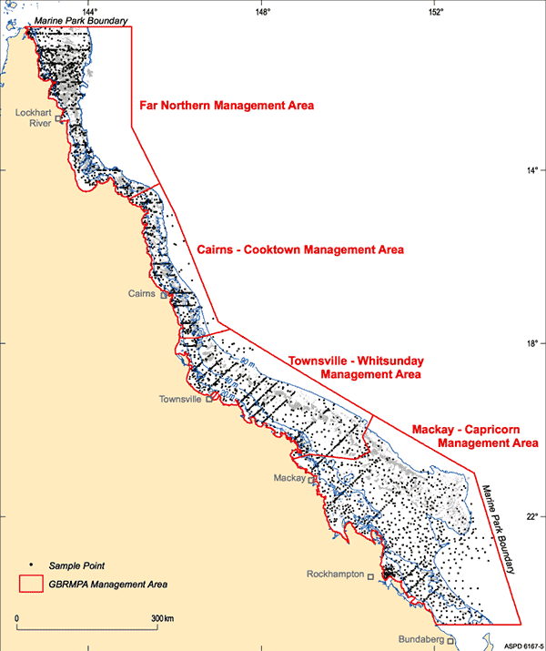
Figure 26. Location of the 3000 samples collected within the Great Barrier Reef Marine Park, excluding within port limits (source: Mathews et al. 2007).

Port of Gladstone
Figure 27 shows the 50th (average conditions) and 95th percentile bed shear-stress modelling results for the Gladstone study area. The modelling indicates high shear-stress levels (up to 0.259 Pa) for the majority of the Gladstone study area, which would have the potential to mobilise unconsolidated material up to coarse sand under average conditions (figure 27). Inshore areas east and west of the existing material placement site show lower bed shear-stresses (i.e. more retentive zones; figure 27). The findings from the modelling correspond well with the Geoscience Australia surface sediment maps, with sand contributions greater than 70 per cent (figure 28).
During the extreme conditions (95th percentile estimates) the bed shear-stress levels indicate that the entire study area becomes highly dispersive and that material up to coarse sand would be mobilised periodically.
The higher shear-stress levels over the deeper offshore waters are attributed primarily to current speeds, related to both tidal and drift currents. Note that the 95th percentile levels over the deeper offshore sections do not increase appreciably compared with the 50th percentiles as these areas are too deep to be affected by swells. The net sediment transport is to the north-west.

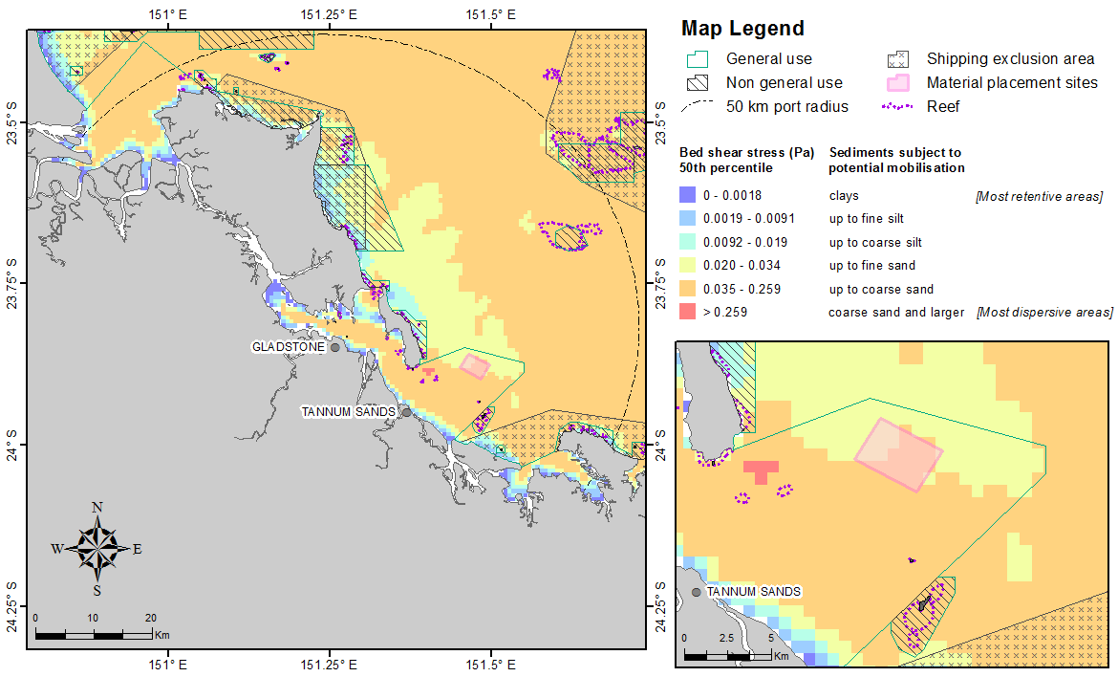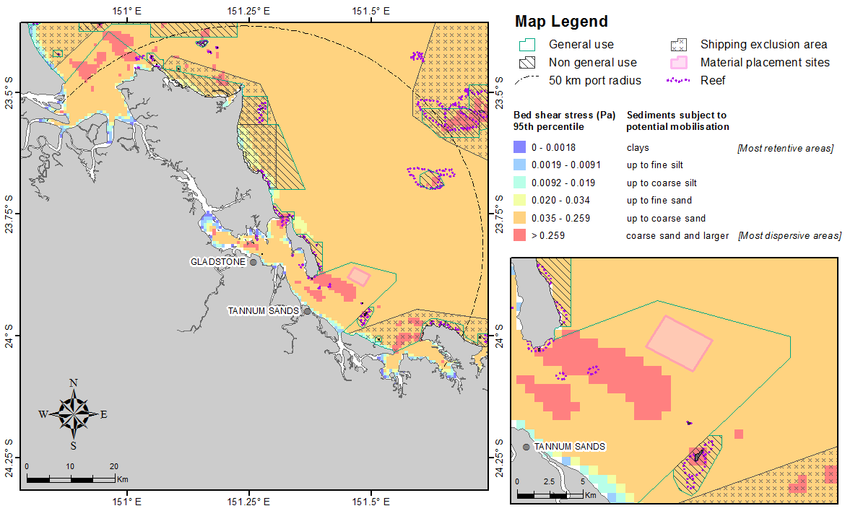
Figure 27. Distribution of the 50th (upper image) and 95th (lower image) percentile bed shear-stress estimates within 50 km from the Port of Gladstone. The estimates were calculated at hourly steps for each grid cell during 2011 current and wave conditions. The insets show a close-up view of the bed shear-stress estimates adjacent to the existing disposal site.
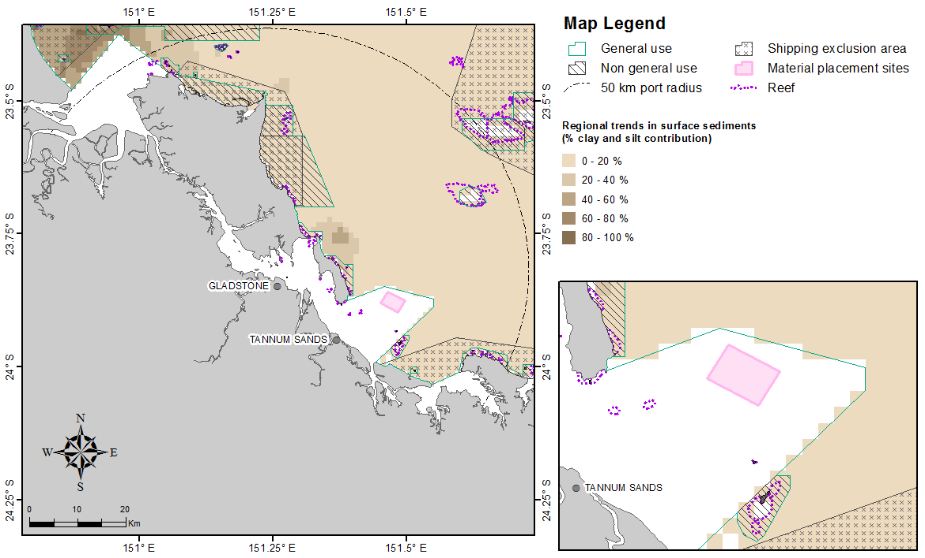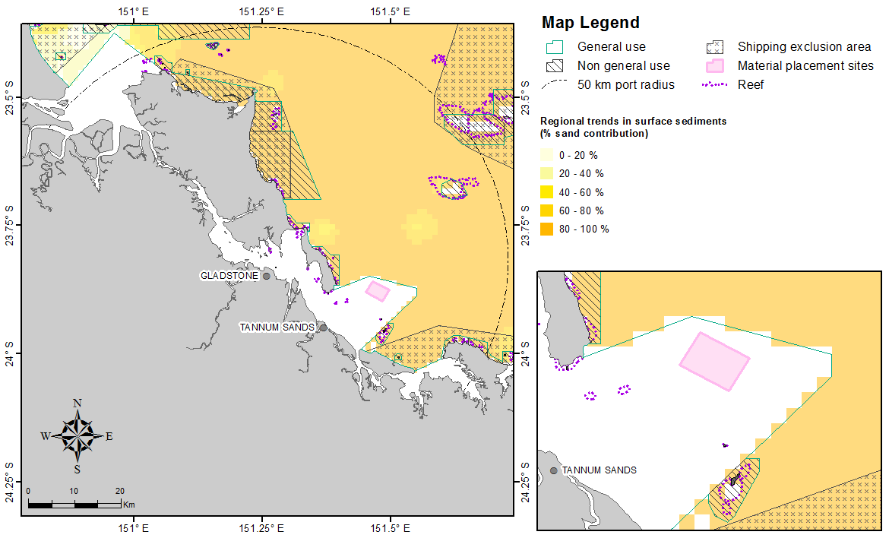
Figure 28. Percentage of clay-silt (upper image) and sand (lower image) content in surface sediments within 50 km from the Port of Gladstone (source: Geoscience Australia marine samples database 2007).

Rosslyn Bay State Boat Harbour
The 50th and 95th percentile shear-stress calculations within 50 km from Rosslyn Bay State Boat Harbour are presented in figure 29. The 50th percentile map indicates that the bed shear-stress at the existing material placement site is reasonably retentive (up to 0.0091 Pa) and will be stable for sediments larger than fine silt. By moving offshore the levels increase significantly and would have the potential to mobilise unconsolidated fine and coarse sand.
These findings correspond well with the Geoscience Australia surface sediment maps which show sand contributions greater than 85 per cent of surface sediments (figure 30), indicating that the surface is periodically re-sorted. Net sediment transport within the region is in a north-western direction.
An assessment of the 95th percentile stress distributions indicates that sediments as large as coarse sand could be periodically mobilised over any location offshore from the port and that there would be no locations where dredged deposits would remain stable under the range of ambient conditions that are likely to occur.

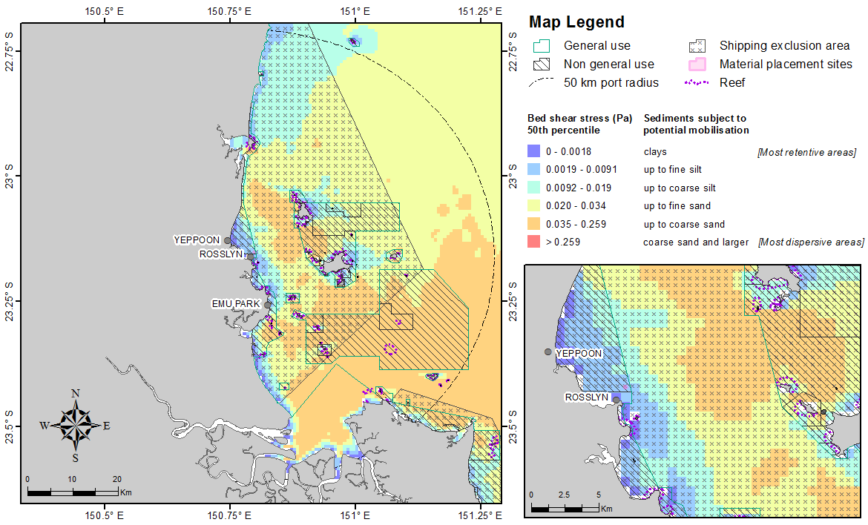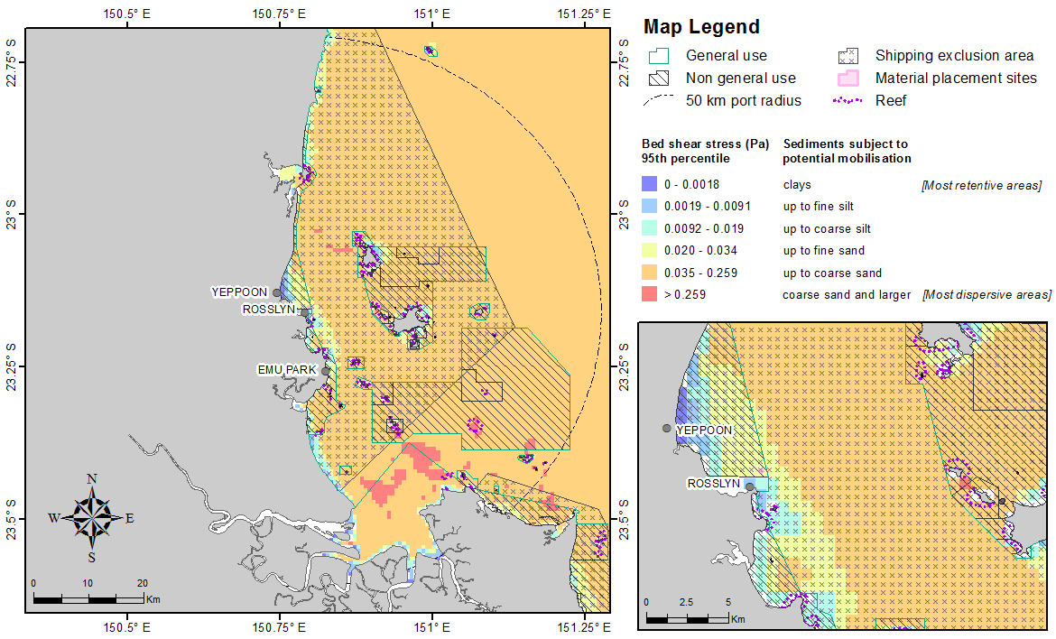
Figure 29. Distribution of the 50th (upper) and 95th (lower image) percentile bed shear-stress estimates within 50 km from Rosslyn Bay State Boat Harbour. The estimates were calculated at hourly steps for each grid cell during 2011 current and wave conditions. The insets show a close-up view of the bed shear-stress estimates adjacent to the existing disposal site.

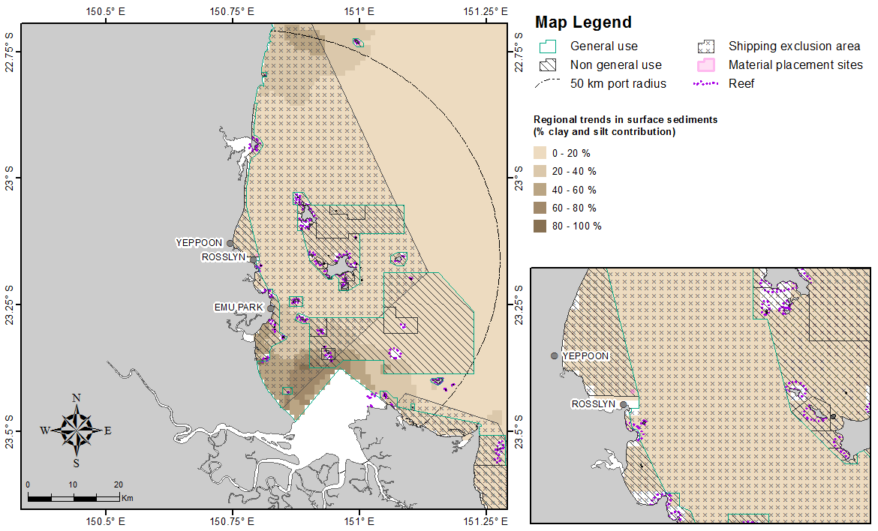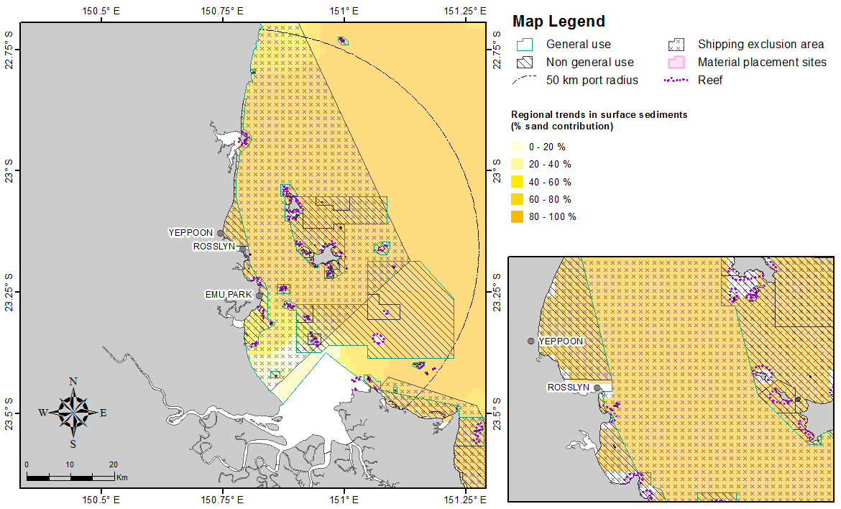
Figure 30. Percentage for clay-silt (upper image) and sand (lower image) content in surface sediments within 50 km from Rosslyn Bay State Boat Harbour (source: Geoscience Australia marine samples database 2007).

Port of Hay Point
Figure 31 shows the 50th and 95th percentile distributions of shear-stress over time at the seabed calculated for locations within 50 km of the Port of Hay Point. The 50th percentile map indicates that majority of the study area is energetic enough to mobilise unconsolidated material up to coarse sands (up to 0.259 Pa). The area south-west of the existing material placement sites are more retentive, where recently settled sediments larger than coarse silt are unlikely to mobilise. Directly north-east and south-east (up to 15 km) the 50th percentile map indicates zones with median bottom stress levels up 0.034 Pa potentially mobilising recently settled sediments up to fine sand.
The sediment composition mapped by Geoscience Australia showed most of the study area comprising of high sand contribution which is consistent with the shear-stress modelling, although the Geoscience Australia mapping does show an area with high clay-silt content within the north-east region of the study area (figure 32).

The 95th percentile plot indicate that under the more extreme current and wave conditions, the levels of bed shear-stress would increase significantly enough to mobilise unconsolidated sediments up to coarse sand. In some areas, the potential shear-stress levels are calculated to potentially mobilise even larger sediments.

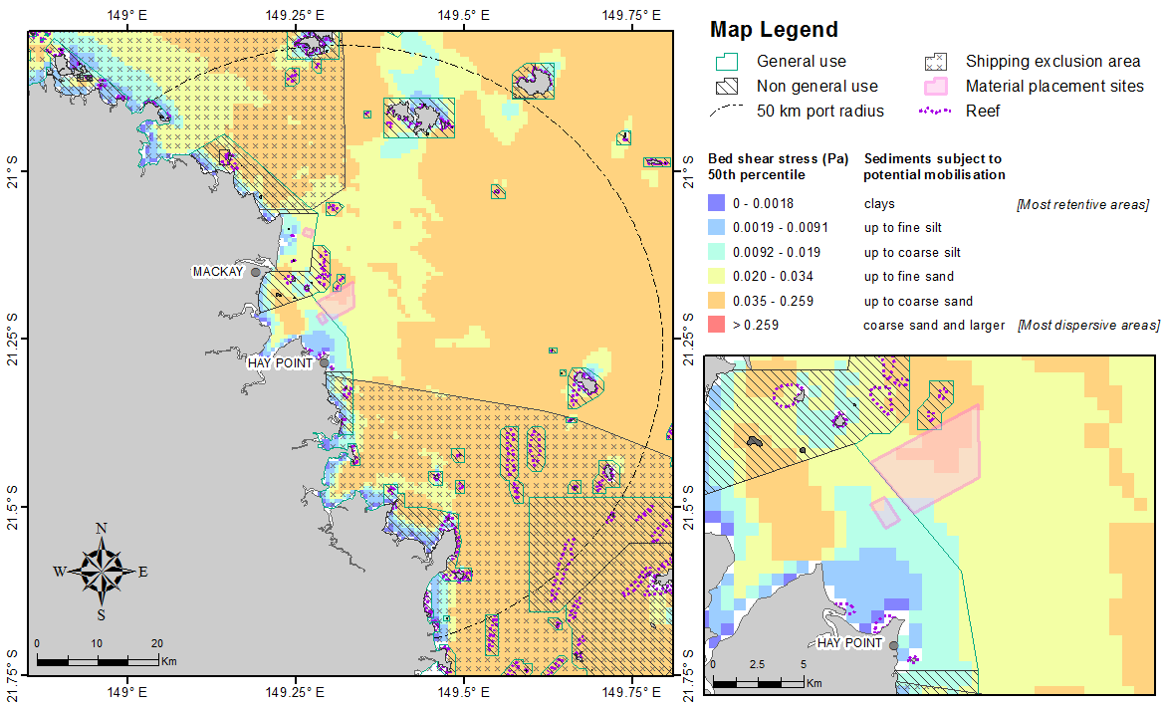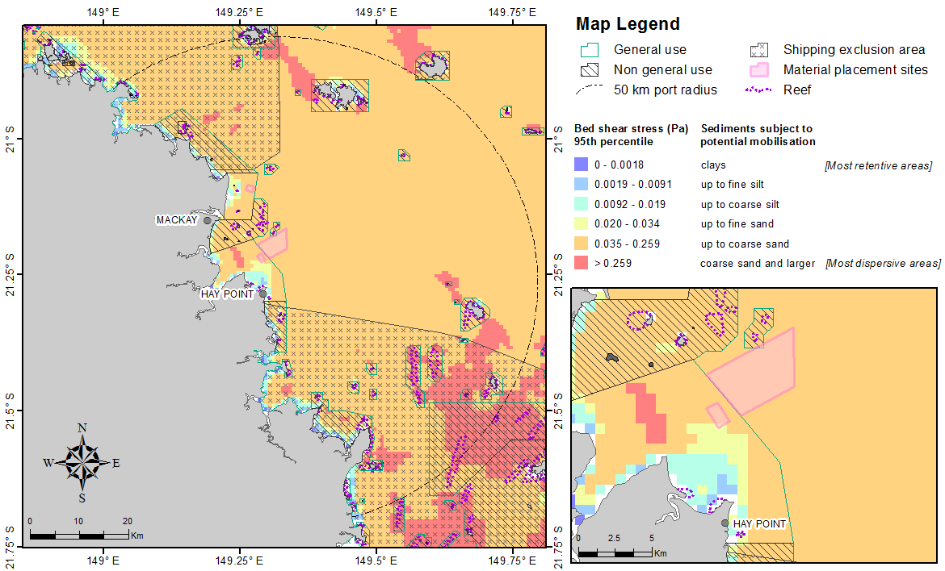
Figure 31. Distribution of the 50th (upper) and 95th (lower image) percentile bed shear-stress estimates within 50 km from the Port of Hay Point. The estimates were calculated at hourly steps for each grid cell during 2011 current and wave conditions. The insets show a close-up view of the bed shear-stress estimates adjacent to the existing disposal site.

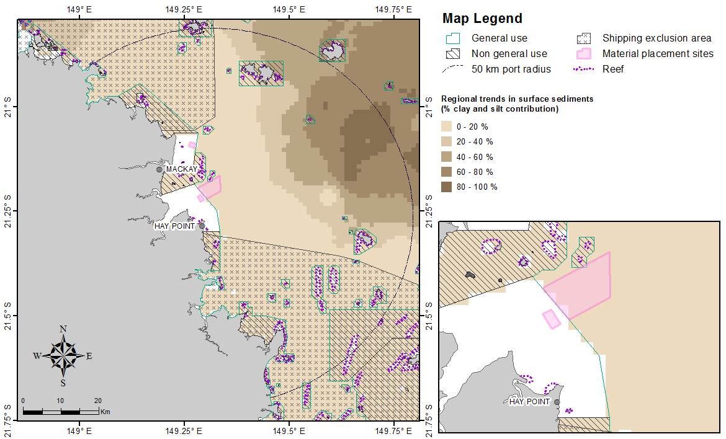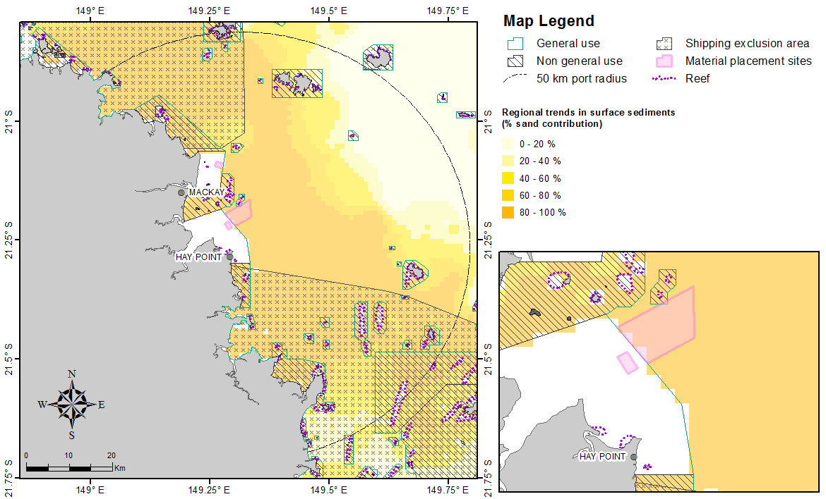
Figure 32. Percentage for clay-silt (upper image) and sand (lower image) content in surface sediments within 50 km from the Port of Hay Point (source: Geoscience Australia marine samples database 2007).

Port of Mackay
The median and extreme levels of shear-stress at the seabed within 50 km of the Port of Mackay are represented by the 50th and 95th percentile contour plots in figure 33. Similar to Port of Hay Point, the bed shear-stress predictions demonstrate the majority of the study area is energetic enough to mobilise unconsolidated material up to coarse sands. At the existing dredged material placement site, the median bed shear-stress map shows the potential for mobilising recently deposited sediments up to fine sand, although a more retentive region is indicated immediately to the west of the dredged material placement site. The region to the east of the dredged material placement site is calculated to receive the same median shear-stress levels as the existing dredged material placement site. Further offshore again, the shear-stress levels are indicated to rise, probably due to greater exposure to current forces rather than waves.
The sediment composition mapped by Geoscience Australia over most of the study area is consistent with the shear-stress modelling, although the Geoscience Australia mapping does show an area with high clay-silt content within the north-east region of the study area (figure 34).
The 95th percentile estimate indicates that most locations off the port are periodically exposed to bed shear that could mobilise recently deposited sediments up to coarse sand, although in some patches, larger sediment grains may be mobilised. Thus, no locations would always remain retentive.
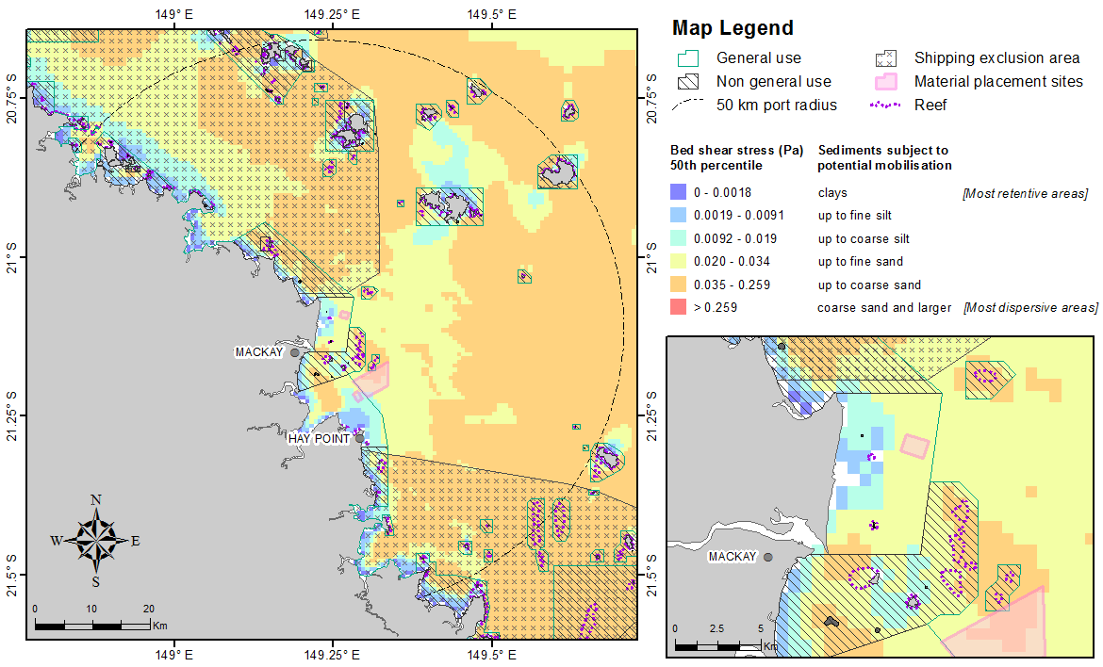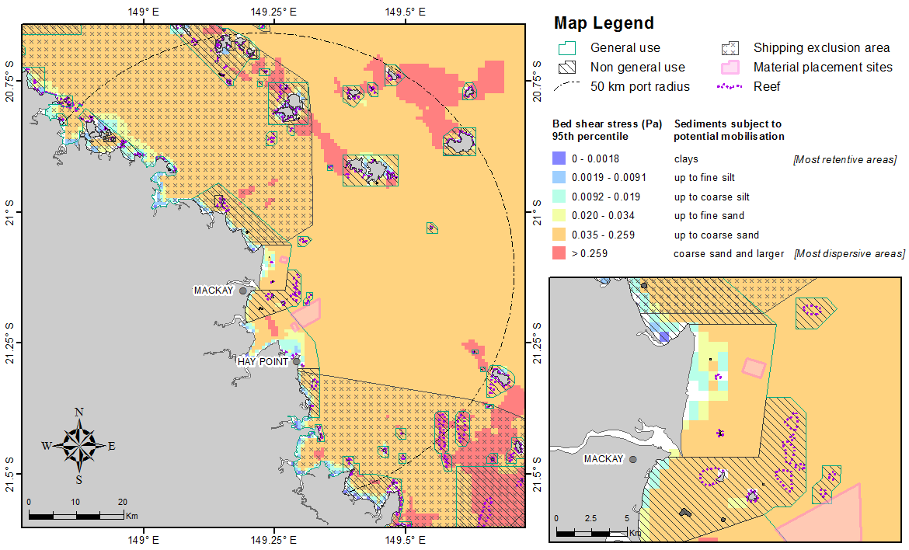
Figure 33. Distribution of the 50th (upper) and 95th (lower image) percentile bed shear-stress estimates within 50 km from the Port of Mackay. The estimates were calculated at hourly steps for each grid cell during 2011 current and wave conditions. The insets show a close-up view of the bed shear-stress estimates adjacent to the existing disposal site.
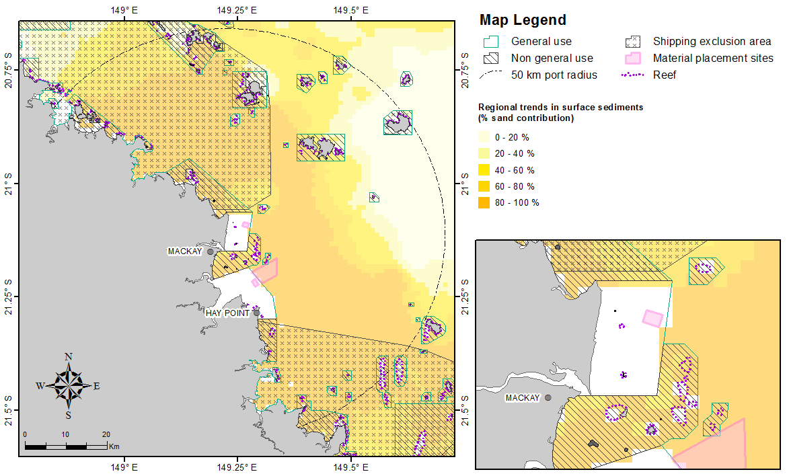
Figure 34. Percentage for clay-silt (upper image) and sand (lower image) content in surface sediments within 50 km from the Port of Mackay (source: Geoscience Australia marine samples database 2007).

Port of Abbot Point
Figure 35 shows the 50th and 95th percentile plots calculated for bed shear-stress within 50 km of the Port of Abbot Point. In general, the bed shear-stress modelling predicts that the study area is a relatively low-energy retentive environment under average (50th percentile) conditions, with the central portion extending to the east, having a predicted shear-stress sufficient to mobilise unconsolidated sediments only up to fine silts, and peripheral areas up to coarse silts.
Sediment mapping by Geoscience Australia (figure 36) is consistent with the shear-stress modelling, with much of the study area, particularly to the east, having a clay-silt bottom. Even under 95th percentile conditions, the central area has a predicted shear-stress sufficient to mobilise only up to fine sands.

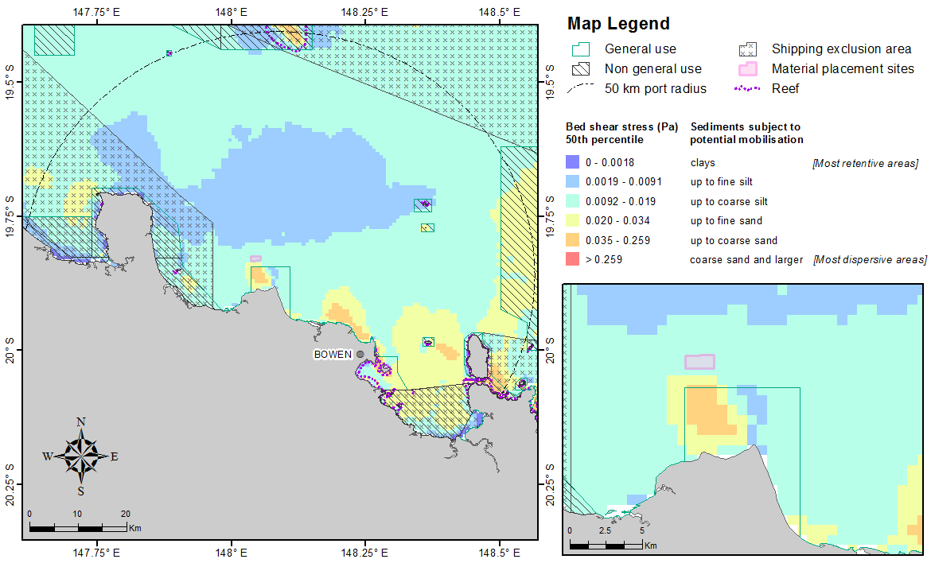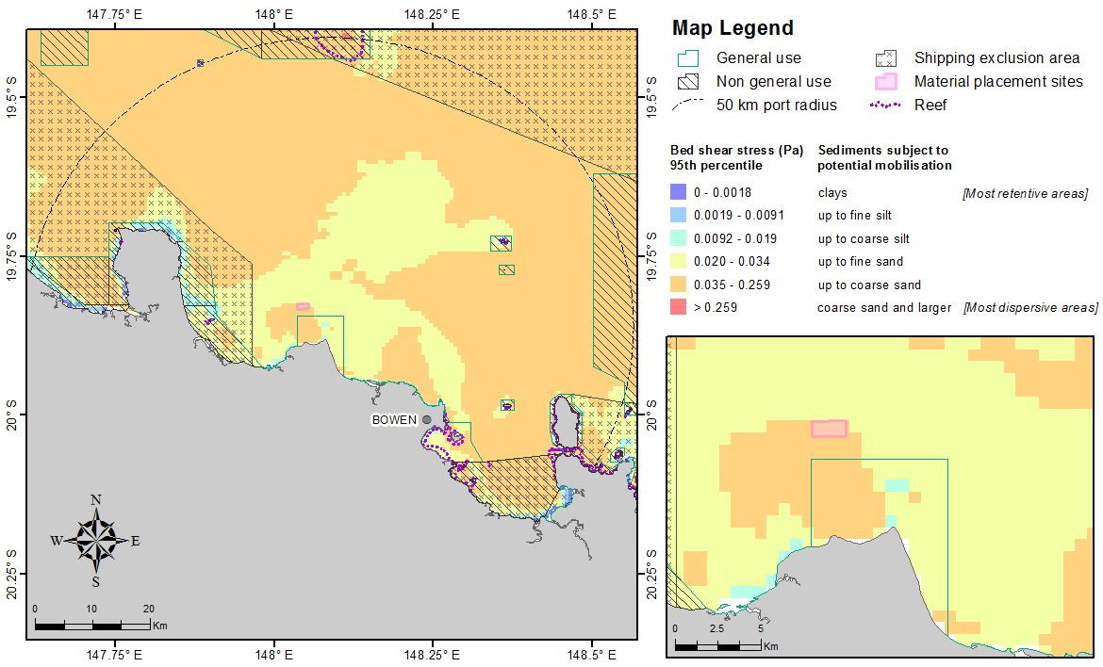
Figure 35. Distribution of the 50th (upper) and 95th (lower image) percentile bed shear-stress estimates within 50 km from the Port of Abbot Point. The estimates were calculated at hourly steps for each grid cell during 2011 current and wave conditions. The insets show a close-up view of the bed shear-stress estimates adjacent to the existing disposal site.

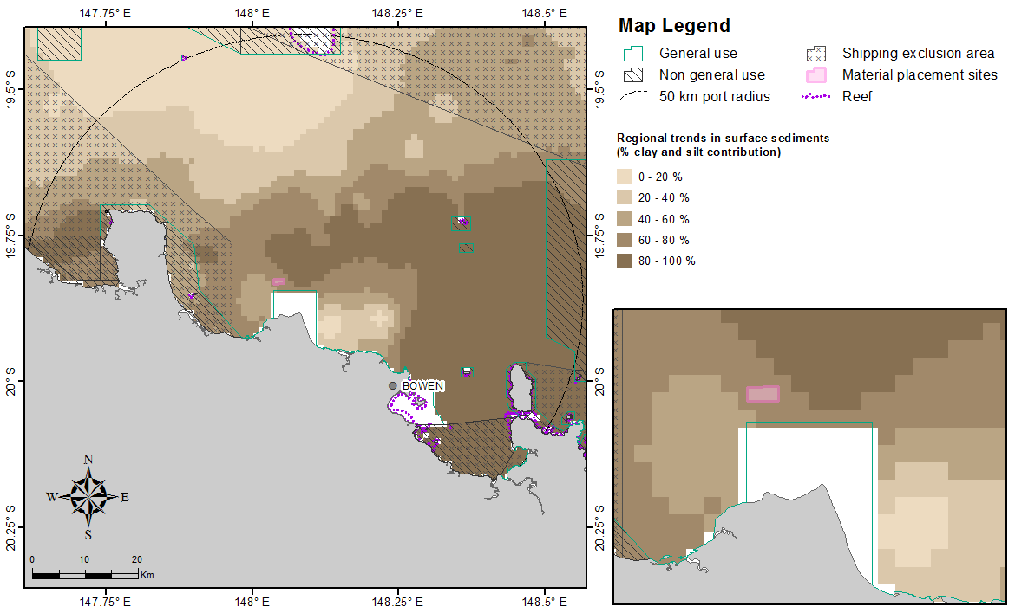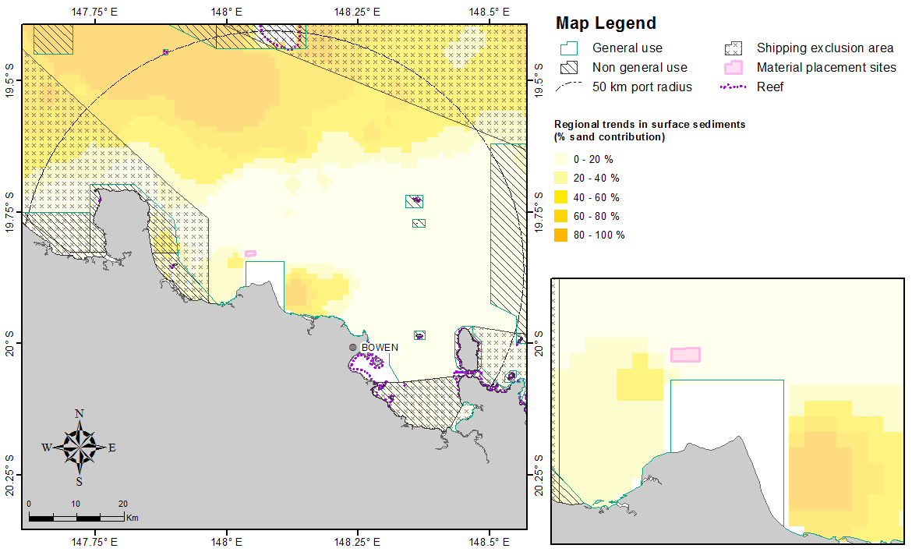
Figure 36. Percentage for clay-silt (upper image) and sand (lower image) content in surface sediments within 50 km from the Port of Abbot Point (source Geoscience Australia marine samples database 2007).

Port of Townsville
Figure 37 shows the 50th percentile and more extreme levels (95th percentile) of bed shear-stress at the seabed within 50 km from the Port of Townsville. Overall, the modelled bed shear-stress values indicate that much of the study area has a relatively low-energy seabed environment, with shear-stress sufficient to potentially mobilise unconsolidated sediments up to coarse silts. Modelled shear-stress in the north-eastern zone of the study area is sufficient to mobilise fine sands, and the central portion of Cleveland Bay, and the far eastern portion of Bowling Green Bay, have predicted shear-stress values indicative of the potential mobilisation of coarse sands under average conditions. Additionally, there is a small zone north of Magnetic Island with lower predicted shear-stress values (more retentive environment), sufficient to mobilise material only up to fine silt.
Sediment mapping by Geoscience Australia is generally consistent with the shear-stress modelling, showing clay-silt sediments in the eastern part of the study area and north of Magnetic Island, and sandier sediments to the north and east. The sediment mapping shows a clay-silt bottom in the eastern part of Bowling Green Bay, an area predicted to have relatively high shear-stress. This could reflect significant inputs and consolidation of fine material from the creeks draining into Bowling Green Bay and diversion of the longshore transport of sand by Cape Bowling Green.
The Geoscience Australia spatial maps show a decreased clay-silt content in the region near the existing disposal ground extending inshore, which is also indicative that this region is subject to greater levels of sorting than other areas further south (figure 38).
The 95th percentile map reveals that the majority of the Townsville study area becomes more dispersive and with shear-stress levels capable of mobilising recently deposited sediments as large as coarse sand.

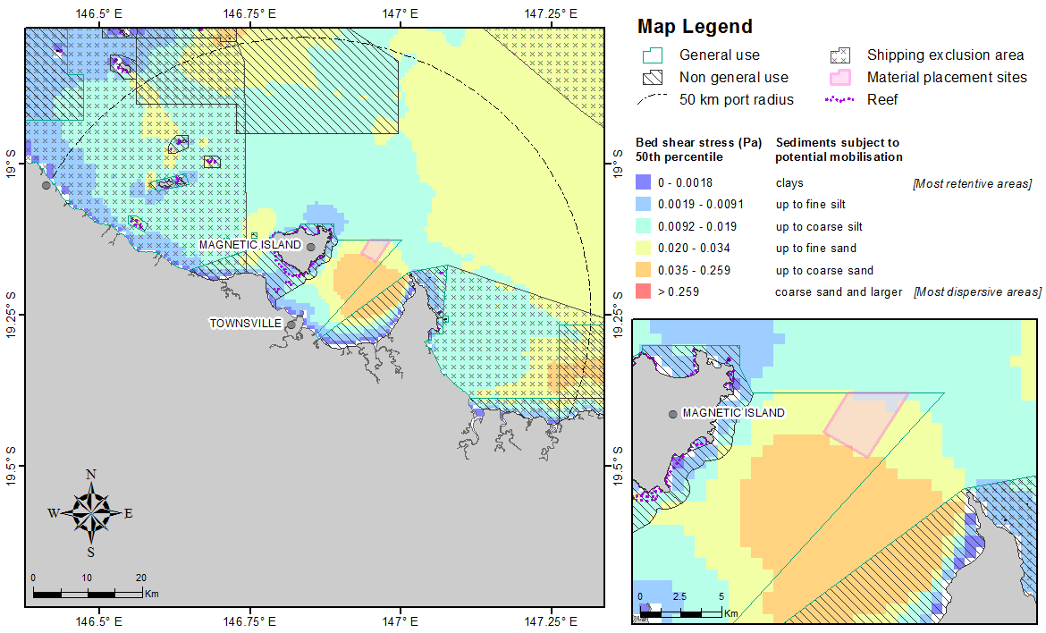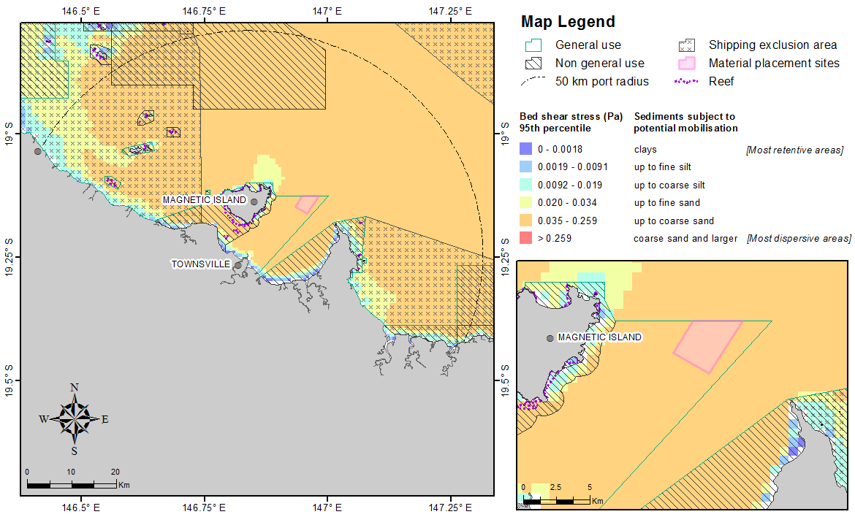
Figure 37. Distribution of the 50th (upper) and 95th (lower image) percentile bed shear-stress estimates within 50 km from the Port of Townsville. The estimates were calculated at hourly steps for each grid cell during 2011 current and wave conditions. The insets show a close-up view of the bed shear-stress estimates adjacent to the existing disposal site.

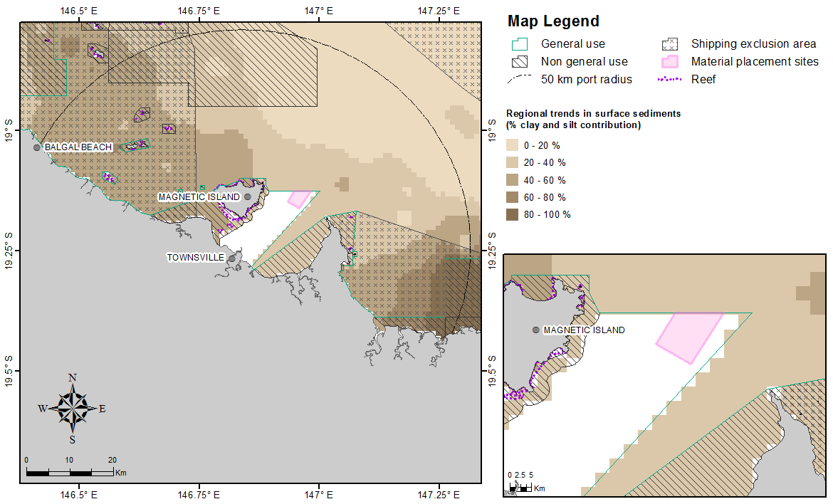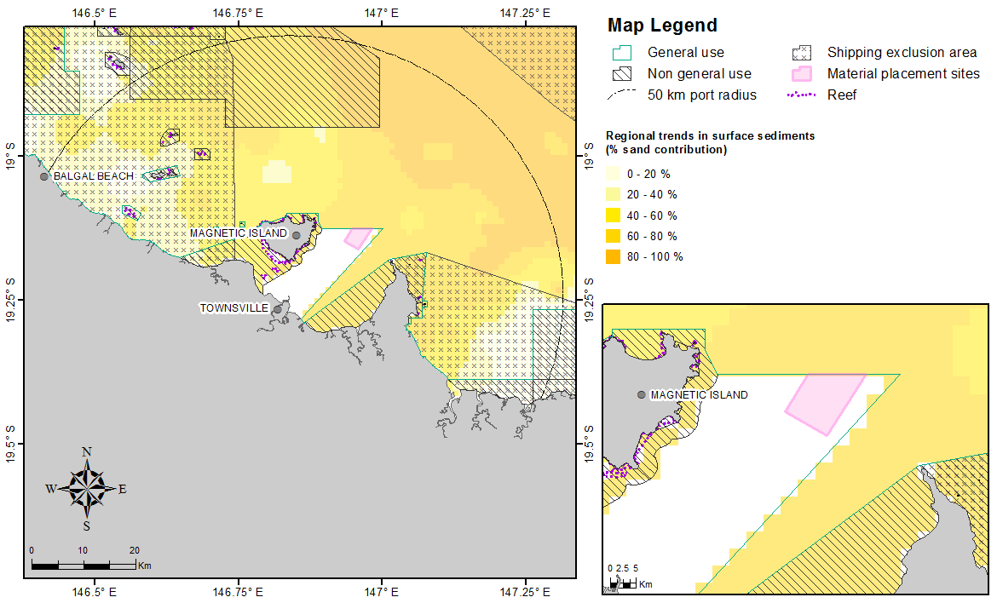
Figure 38. Percentage for clay-silt (upper image) and sand (lower image) content in surface sediments within 50 km from the Port of Townsville (source Geoscience Australia marine samples database 2007).

Port of Lucinda
Figure 39 shows the distributions calculated for the 50th and 95th percentile bed shear-stress within 50 km from the Port of Lucinda. Overall, the model results indicate that the study area is a relatively low-energy environment under average (50th percentile) conditions, with the northern and southern regions having a predicted shear-stress sufficient to mobilise unconsolidated sediments typically up to coarse silts. However a more dispersive environment is predicted adjacent the Port of Lucinda with predicted bed shear-stress values high enough to mobilise sediments up to coarse sand. Additional other more dispersive zones are predicted north of Hinchinbrook Island, in the outer reefs north-east of Lucinda and south-west of Palm Island.
The Geoscience Australia map (figure 40) shows a lower clay-silt content in the region near the existing disposal ground extending inshore, which is also indicative that this region is subject to greater levels of sorting than other areas further south.
The 95th percentile shear-stress levels indicate that most of the offshore region would be subject to periodically higher stress levels that would mobilise recently deposited sediment as large as coarse sand, except where sheltered by the offshore islands.

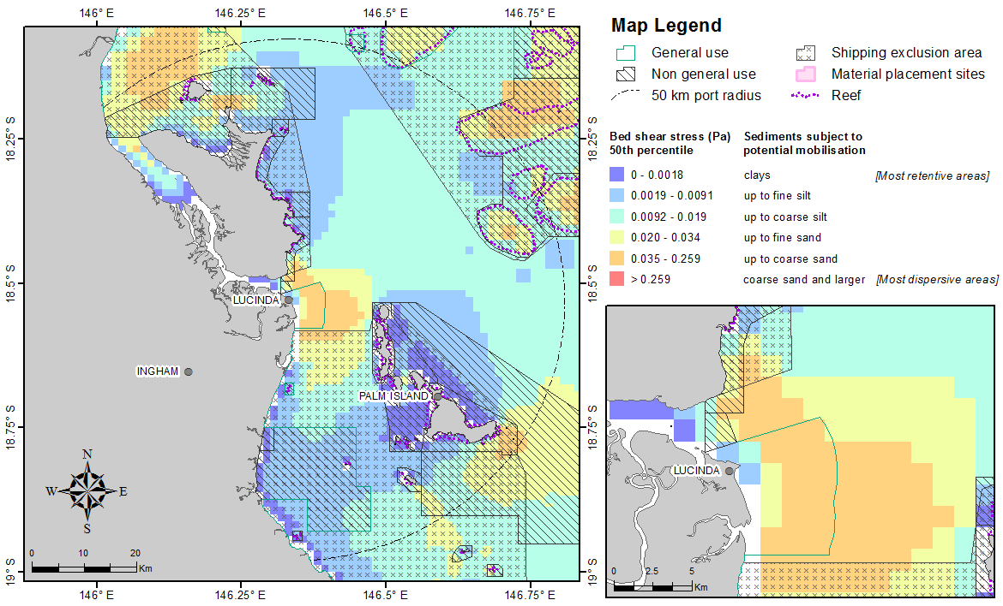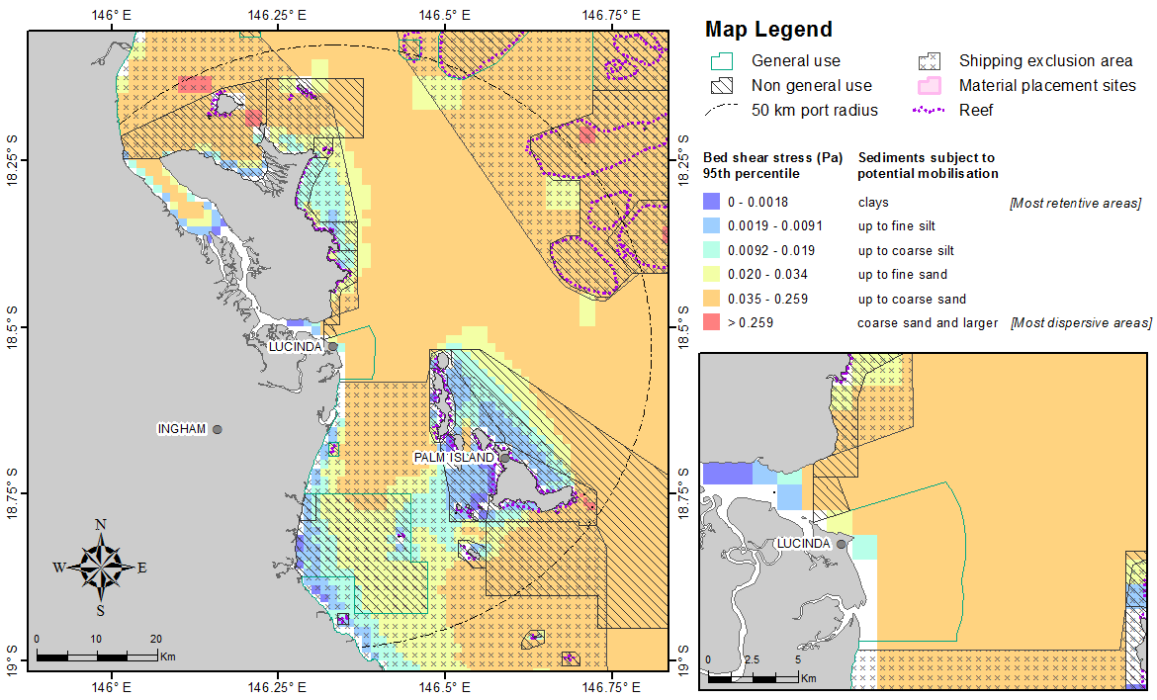
Figure 39. Distribution of the 50th (upper image) and 95th (lower image) percentile bed shear-stress estimates within 50 km from the Port of Lucinda. The estimates were calculated at hourly steps for each grid cell during 2011 current and wave conditions. The insets show a close-up view of the bed shear-stress estimates adjacent to the existing disposal site.
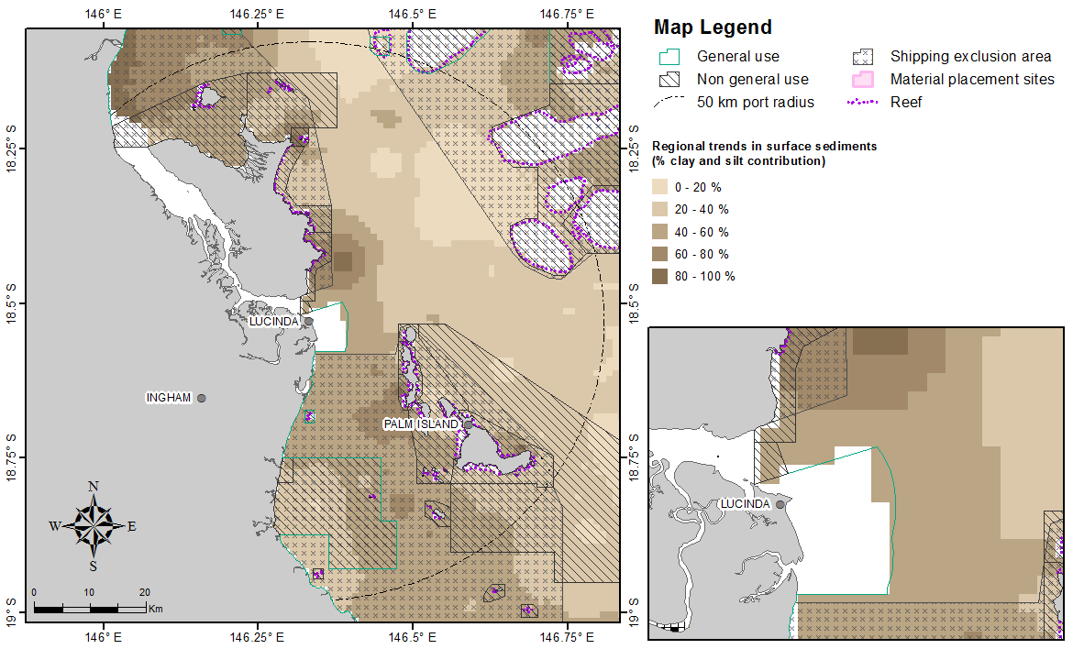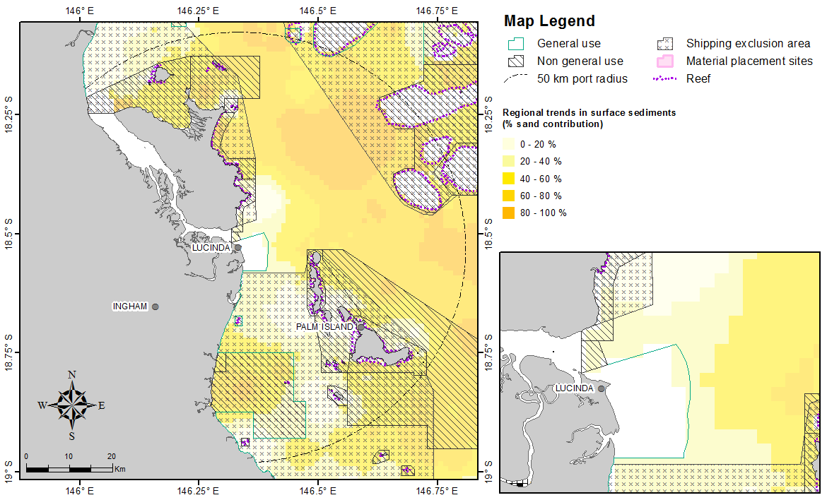
Figure 40. Percentage clay-silt (upper image) and sand (lower image) content in surface sediments within 50 km from the Port of Lucinda (source: Geoscience Australia marine samples database 2007).

Port of Mourilyan
Figure 41 shows the distribution of the estimated shear-stress at the seabed based on 50th and 95th percentile calculations within 50 km from the Port of Mourilyan. In general, bed shear-stress modelling predicts that the study area is a relatively low-energy retentive environment under average (50th percentile) conditions, with most of the study area being characterised by low bed shear-stress values (< 0.019 Pa). The predicted bed shear-stress values indicate potential mobilisation of up to clays along the near-shore region and up to fine and coarse silts in the deeper offshore regions.

The estimated bed shear-stress maps showing increasing stresses with distance from the coastline, with the exception of the northern area which shows a decrease east of the large coral reef structures, corresponded well with the Geoscience Australia measured sediment contribution data. The extents of the nearshore and offshore low estimated shear-stress zones showing potential mobilisation of (figure 41) are similar to the extents of the increased contribution of clay-silts to the bottom surface sediments (figure 42).
Under 95th percentile conditions, the predicted shear-stress values typically increased with distance from the coastline, with sediments potentially mobilised as large as coarse sand offshore Mourilyan.

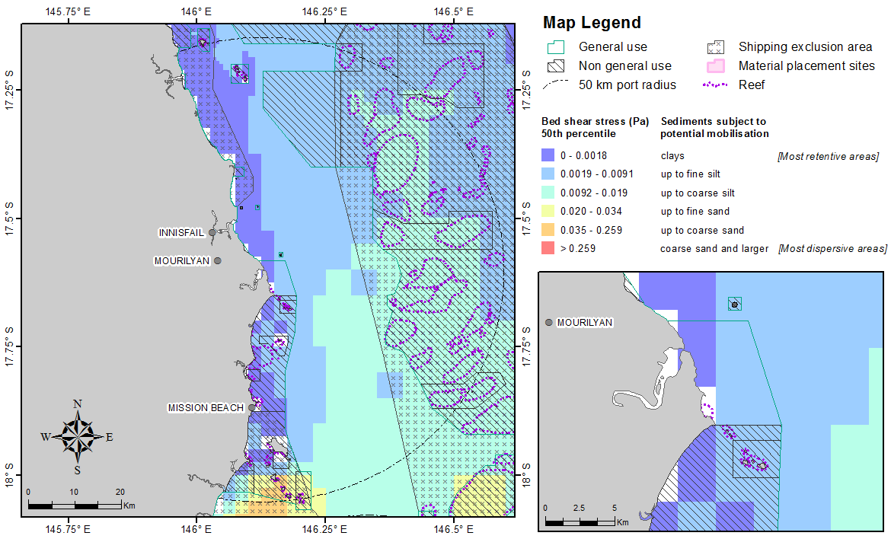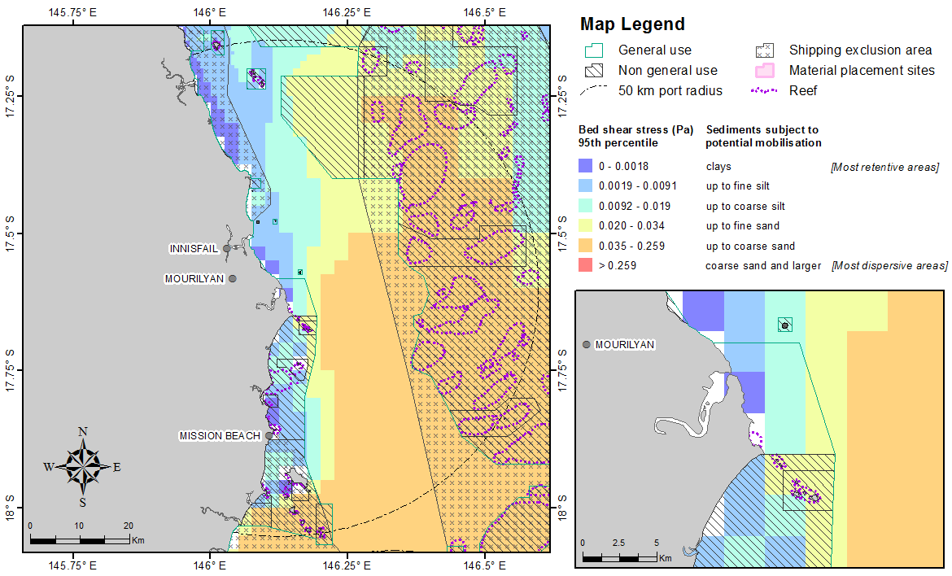
Figure 41. Distribution of the 50th (upper image) and 95th (lower image) percentile bed shear-stress estimates within 50 km from the Port of Mourilyan. The estimates were calculated at hourly steps for each grid cell during 2011 current and wave conditions. The insets show a close-up view of the bed shear-stress estimates adjacent to the existing disposal site.

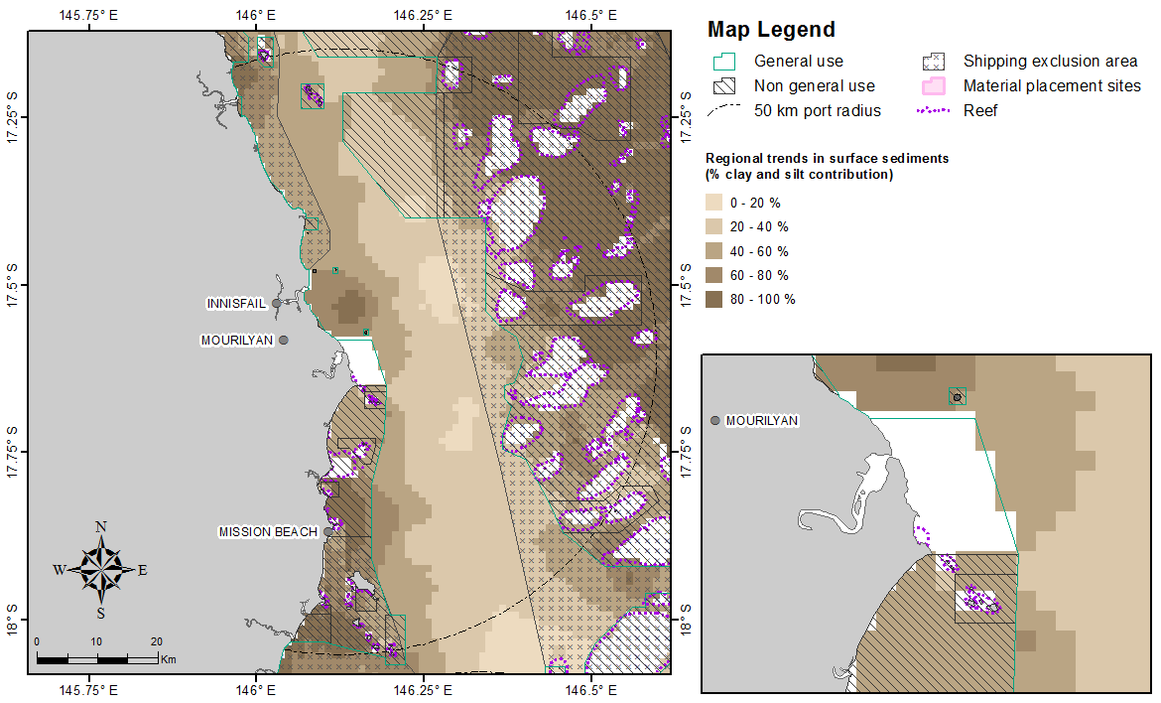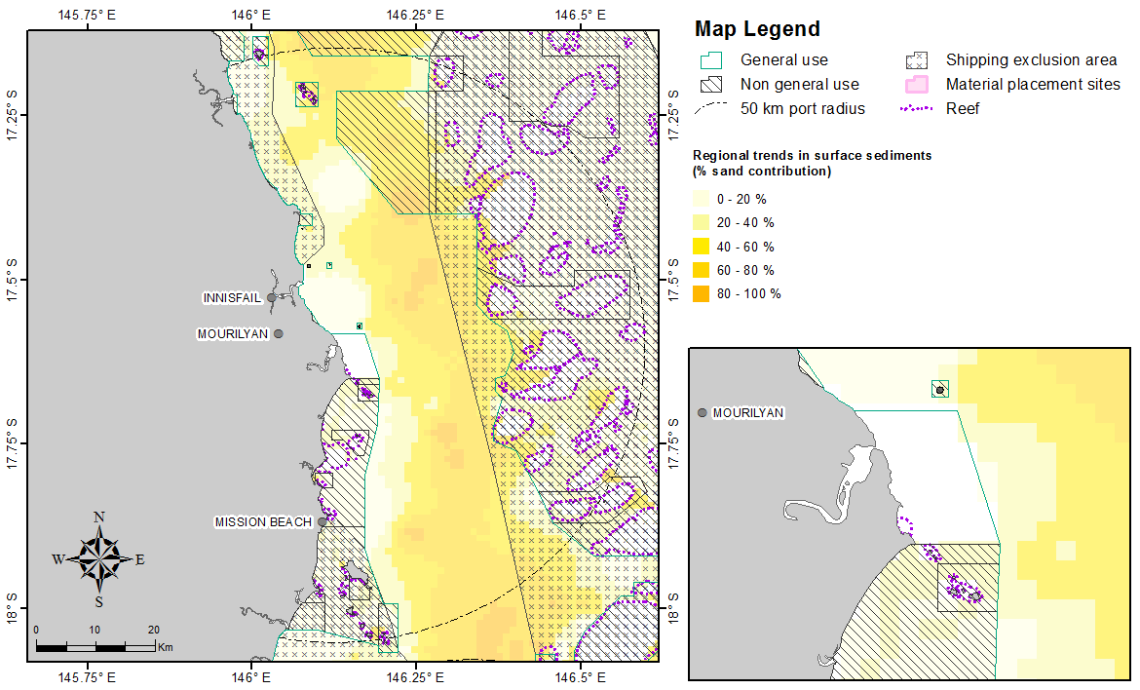
Figure 42. Percentage clay-silt (upper image) and sand (lower image) content in surface sediments within 50 km from the Port of Mourilyan (source: Geoscience Australia marine samples database 2007).

Port of Cairns
Figure 43 shows the distribution of the estimated shear-stress at the seabed calculated as the 50th and 95th percentile over time for locations within 50 km from the Port of Cairns.
Bed shear-stress modelling predicts relatively low sediment mobility (retentive areas) within the Cairns study area, with shear-stress sufficient only to mobilise unconsolidated clays along much of the immediate coastline, grading into shear-stresses sufficient to potentially mobilise fine and coarse silts moving offshore. Only a few reef-associated areas have predicted shear-stresses sufficient to mobilise sands (figure 43).
Sediment mapping by Geoscience Australia is consistent with the shear-stress modelling; with majority of the consisting of clay-silt sediments and areas with a somewhat higher sand component than might be expected are mainly in proximity to reefs, which are sources of carbonate sands (figure 44).
The 95th percentile estimates indicate that the existing dredged material placement site will tend to remain more sheltered compared with other ports but might experience shear-stress levels that would mobilise recently deposited sediments up to fine sand. However, locations within a few kilometres of the site, to both the east and west, are indicated to typically experience lower shear-stress which should be retentive for recently deposited sediments larger than coarse silt.

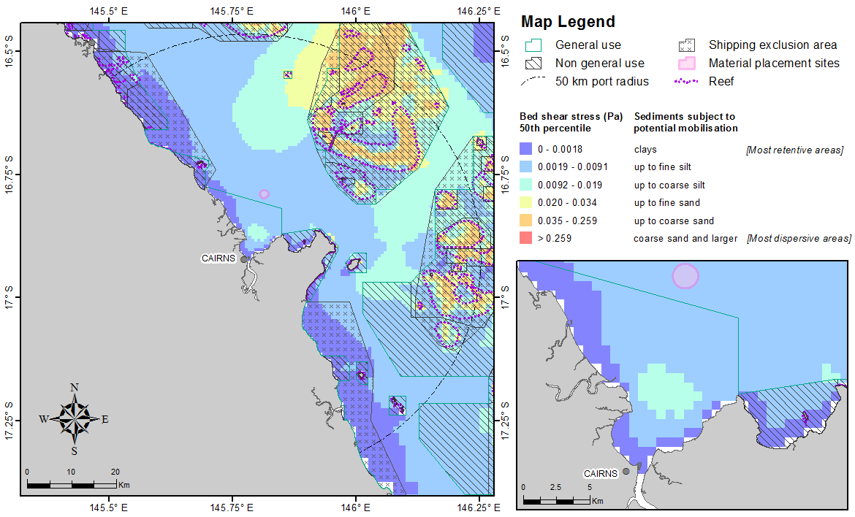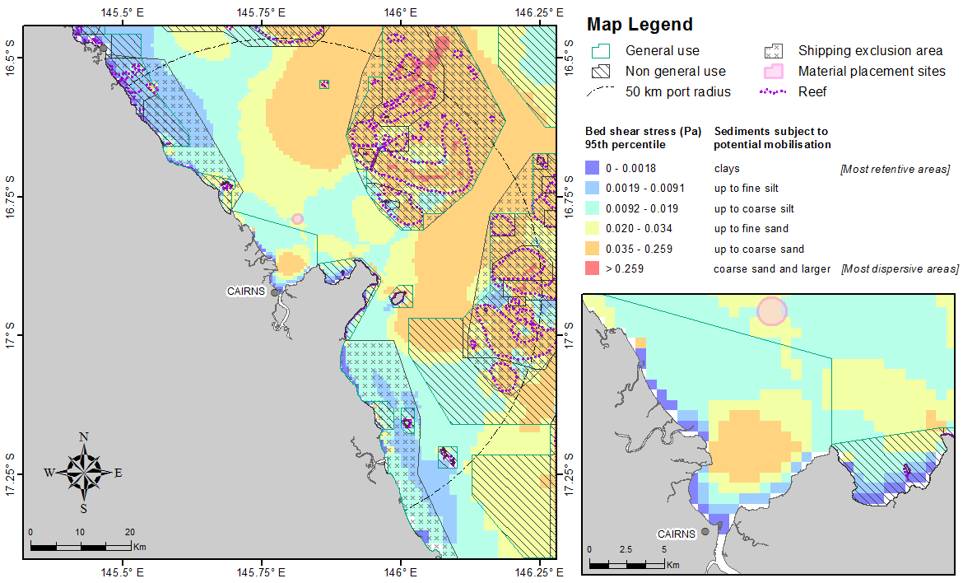
Figure 43. Distribution of the 50th (upper image) and 95th (lower image) percentile bed shear-stress estimates within 50 km from the Port of Cairns. The estimates were calculated at hourly steps for each grid cell during 2011 current and wave conditions. The insets show a close-up view of the bed shear-stress estimates adjacent to the existing disposal site.
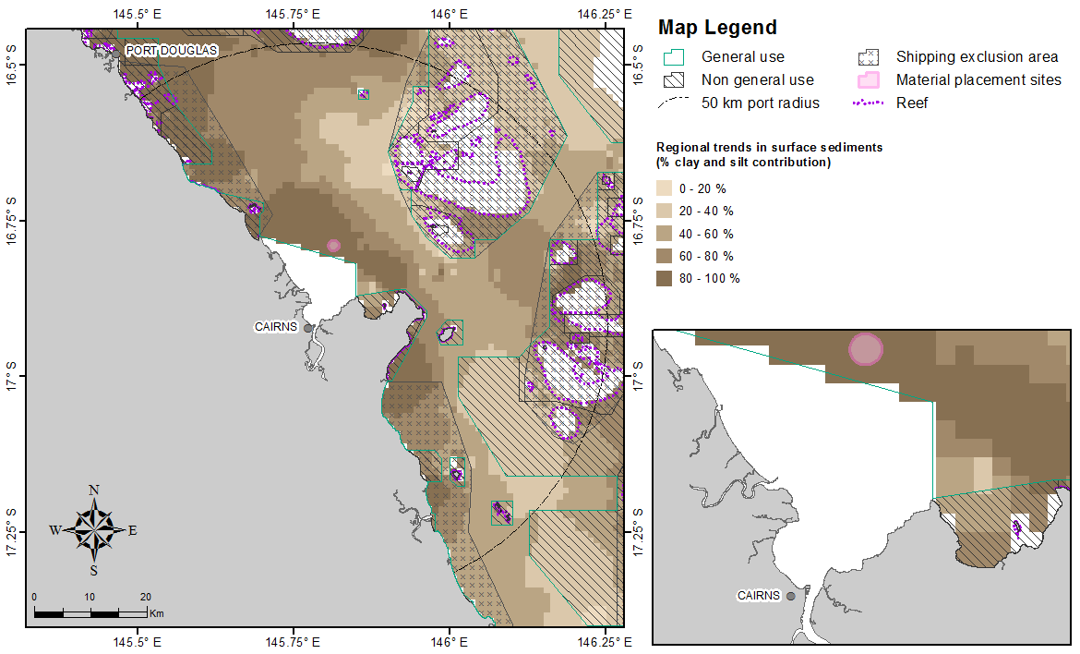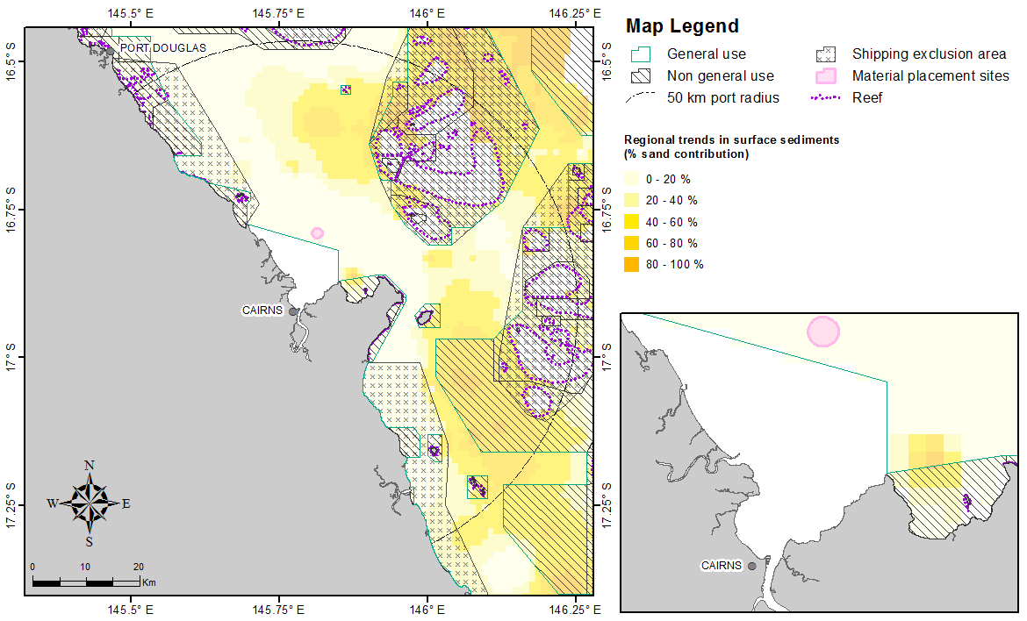
Figure 44. Percentage clay-silt (upper image) and sand (lower image) content in surface sediments within 50 km from the Port of Cairns (source: Geoscience Australia marine samples database 2007).

Port of Cooktown
Figure 45 shows the distribution of the estimated shear-stress at the seabed based on 50th and 95th percentile calculations within 50 km from the Port of Cooktown. Similar to the Cairns study region, bed shear-stress modelling predicts relatively low sediment mobility within the Cooktown study area, with shear-stress sufficient only to mobilise unconsolidated clays along much of the immediate coastline, grading into shear-stresses sufficient to potentially mobilise fine and coarse silts moving offshore. Offshore reef-associated areas have predicted shear-stresses sufficient to mobilise coarse sands (figure 45).
Sediment mapping by Geoscience Australia is consistent with the shear-stress modelling; with majority of the sediments consisting of clay-silts (figure 46).
The 95th percentile estimates indicate that the inshore margin tends to remain sheltered from the more extreme shear-stress levels during periodic storms and thus are indicated to remain retentive.
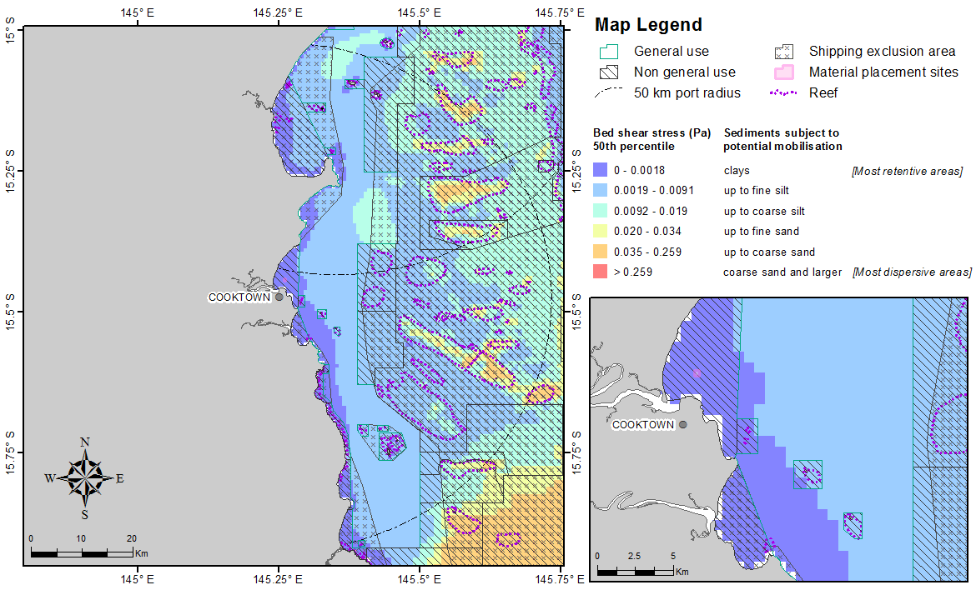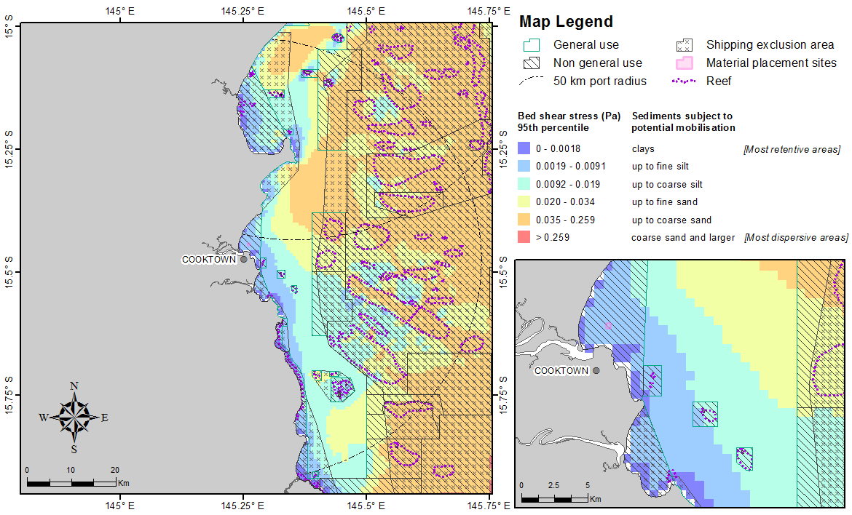
Figure 45. Distribution of the 50th (upper image) and 95th (lower image) percentile bed shear-stress estimates within 50 km from the Port of Cooktown. The estimates were calculated at hourly steps for each grid cell during 2011 current and wave conditions. The insets show a close-up view of the bed shear-stress estimates adjacent to the existing disposal site.
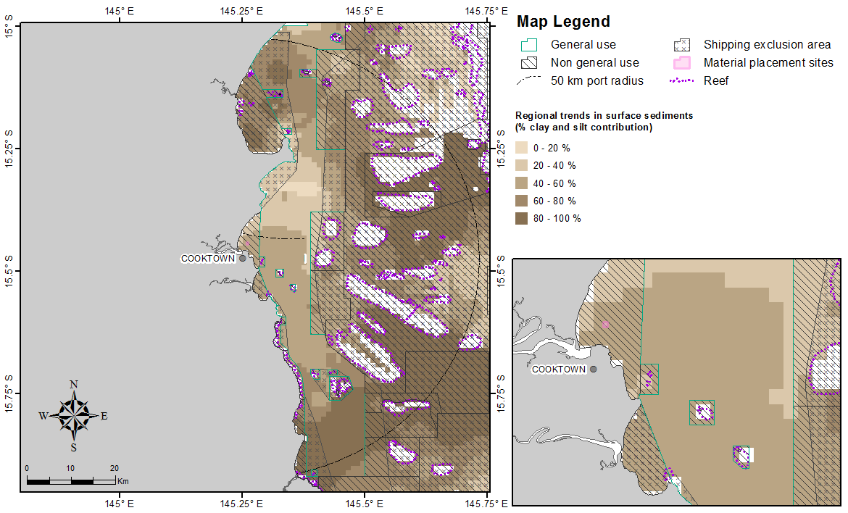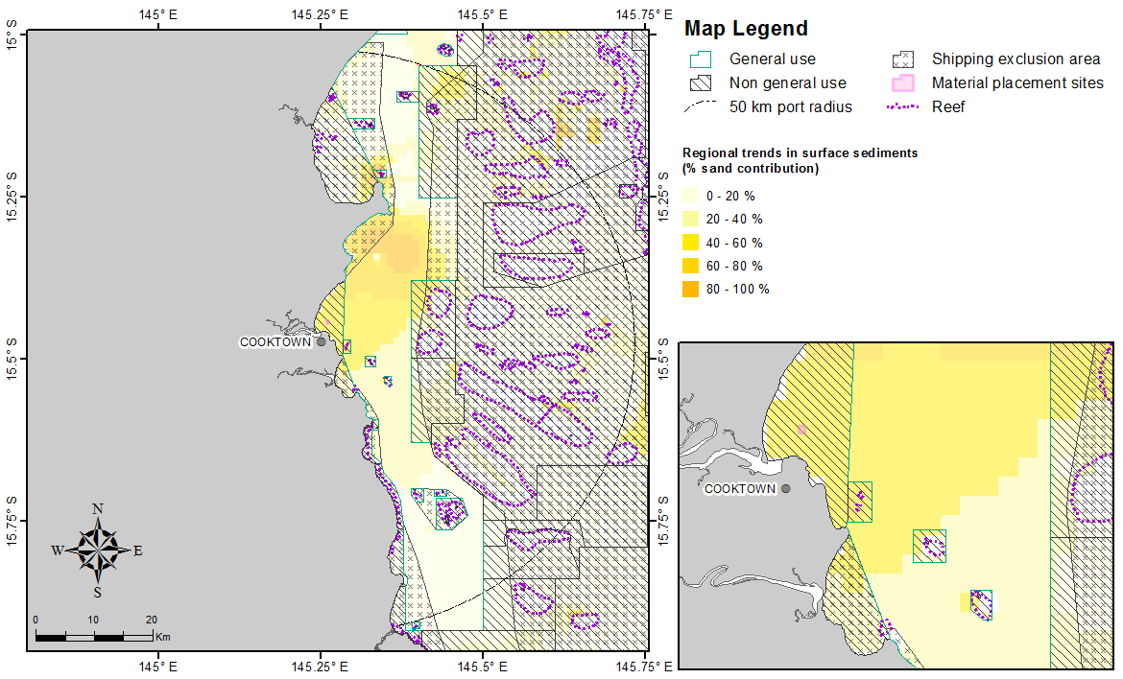
Figure 46. Percentage clay-silt (upper image) and sand (lower image) content in surface sediments within 50 km from the Port of Cooktown (source: Geoscience Australia marine samples database 2007).

Port of Cape Flattery
Figure 47 shows the distribution of the estimated shear-stress at the seabed based on 50th and 95th percentile calculations within 50 km from the Port of Cape Flattery. In general, the model results indicate a low-energetic retentive environment under average (50th percentile) conditions. The majority of the study region is predicted to have stress values sufficient to mobilise unconsolidated clays along immediate near-shore regions and fine and coarse silts in adjacent waters.
Sediment mapping by Geoscience Australia is consistent with the shear-stress modelling; with majority of the sediments consisting of clay-silts north of Cape Flattery figure 48.
Even under 95th percentile conditions, the immediate coastal waters are still classed as retentive with predicted shear-stress values only great enough to mobile clays and silts.
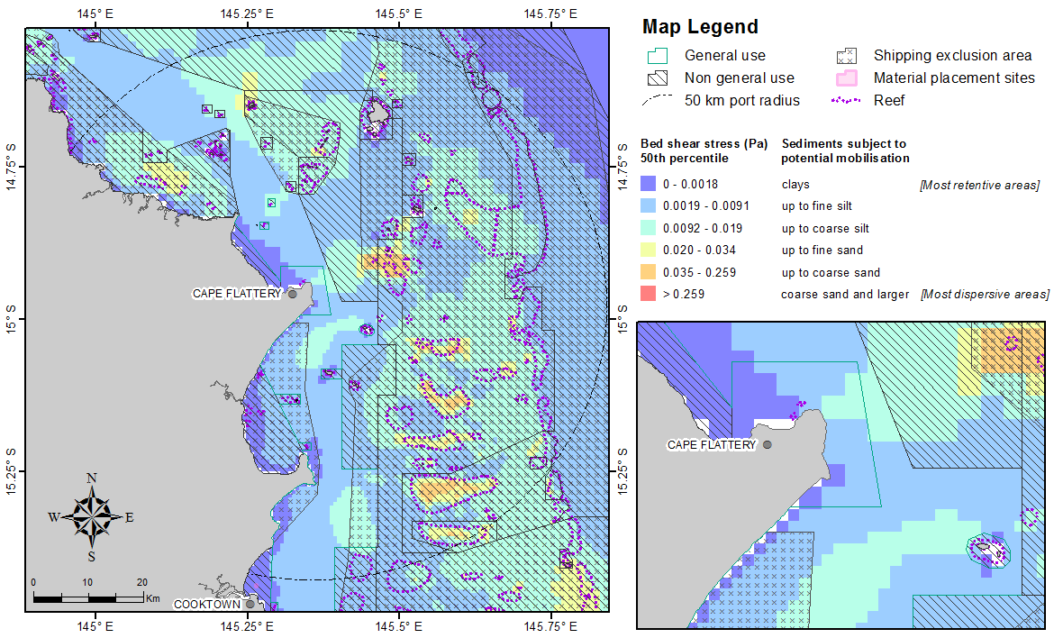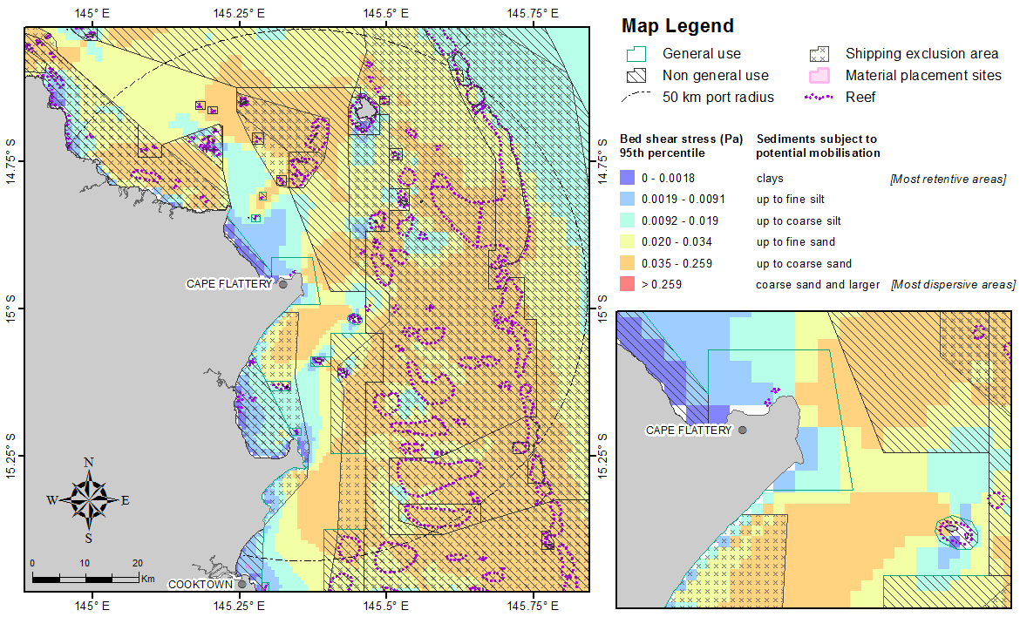
Figure 47. Distribution of the 50th (upper image) and 95th (lower image) percentile bed shear-stress estimates within 50 km from the Port of Cape Flattery. The estimates were calculated at hourly steps for each grid cell during 2011 current and wave conditions. The insets show a close-up view of the bed shear-stress estimates adjacent to the existing disposal site.

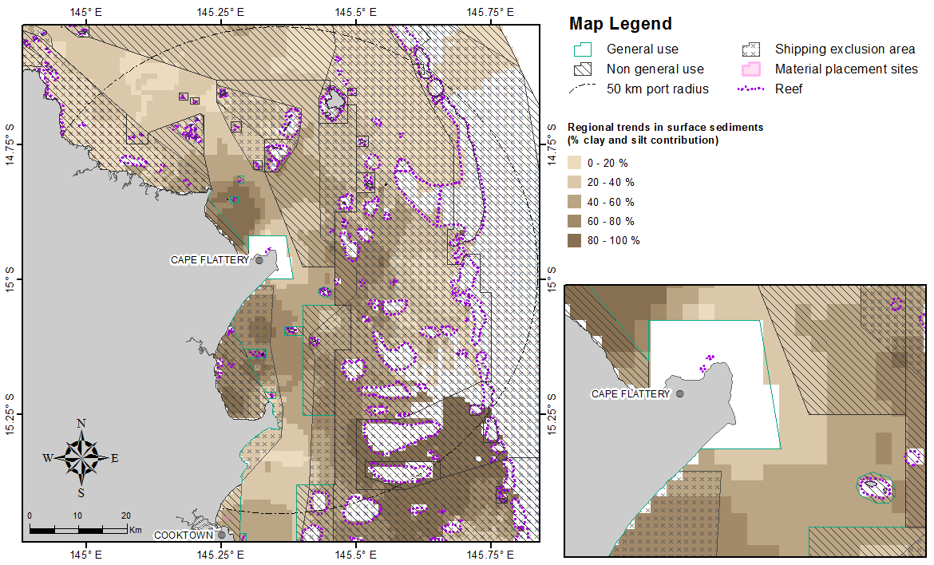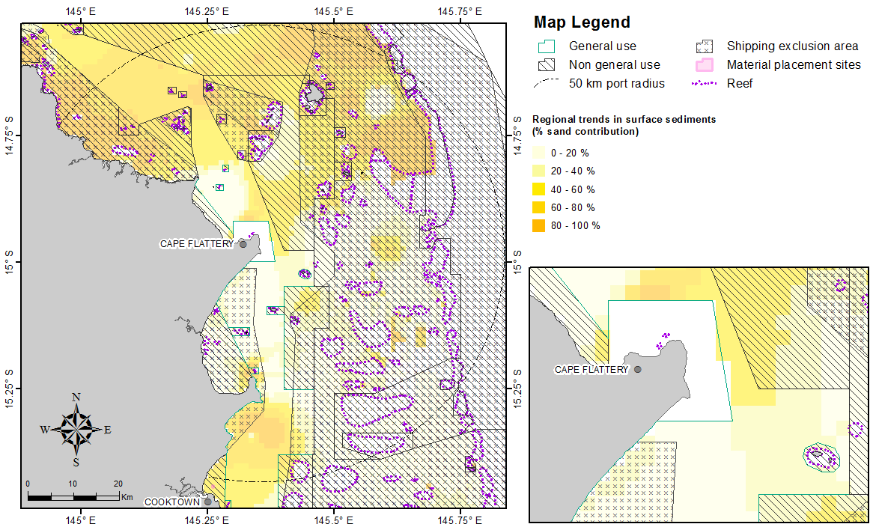
Figure 48. Percentage clay-silt (upper image) and sand (lower image) content in surface sediments within 50 km from the Port of Cape Flattery (source: Geoscience Australia marine samples database 2007).

Port of Quintell Beach
Figure 49 shows the distribution of the estimated shear-stress at the seabed based on 50th and 95th percentile calculations within 50 km from the Port of Quintell Beach.
Similar to the Port of Cape Flattery, the model results for the Port of Quintell Beach indicate a low-energetic retentive environment under average (50th percentile) conditions, with stress values sufficient to mobilise unconsolidated clays along immediate near-shore regions and fine and coarse silts in adjacent waters.
Sediment mapping by Geoscience Australia is consistent with the shear-stress modelling; with majority of the sediments consisting of clay-silts (figure 50).
Even under 95th percentile conditions, the immediate coastal waters are still classed as retentive with predicted shear-stress values only great enough to mobile clays and silts. However the majority of the study area is characterised by predicted bed shear-stress values sufficient to mobilise sediments up to coarse sand.
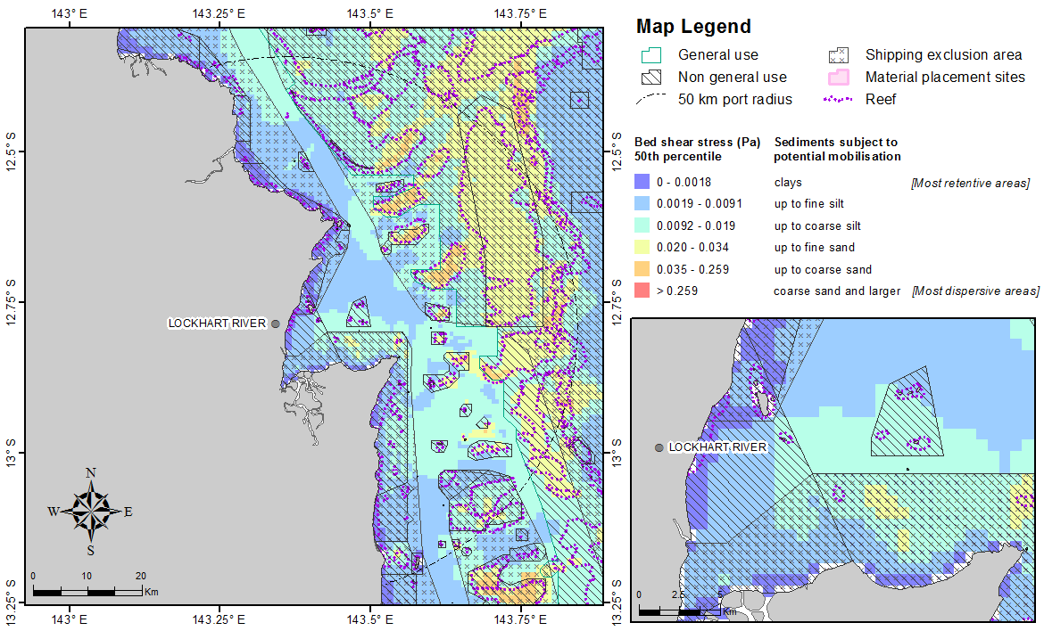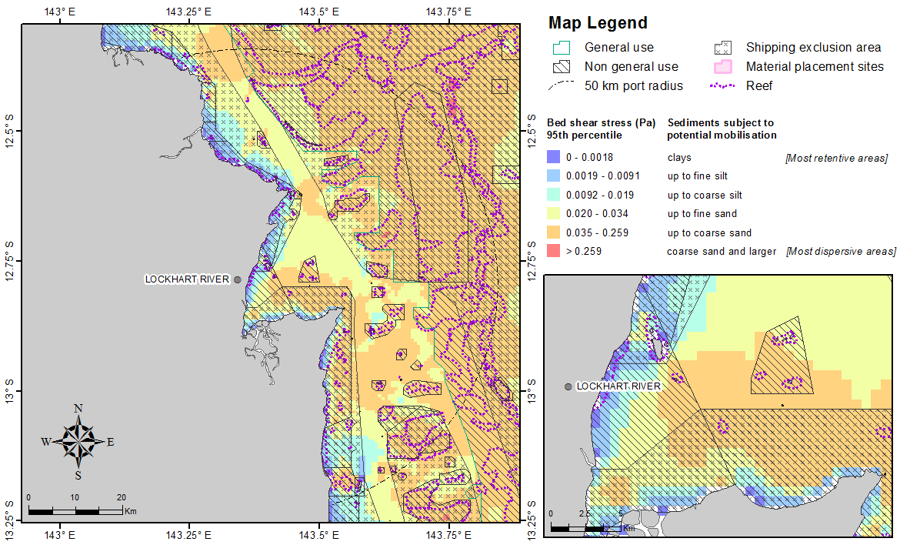
Figure 49. Distribution of the 50th (upper image) and 95th (lower image) percentile bed shear-stress estimates within 50 km from the Port of Quintell Beach. The estimates were calculated at hourly steps for each grid cell during 2011 current and wave conditions. The insets show a close-up view of the bed shear-stress estimates adjacent to the existing disposal site.
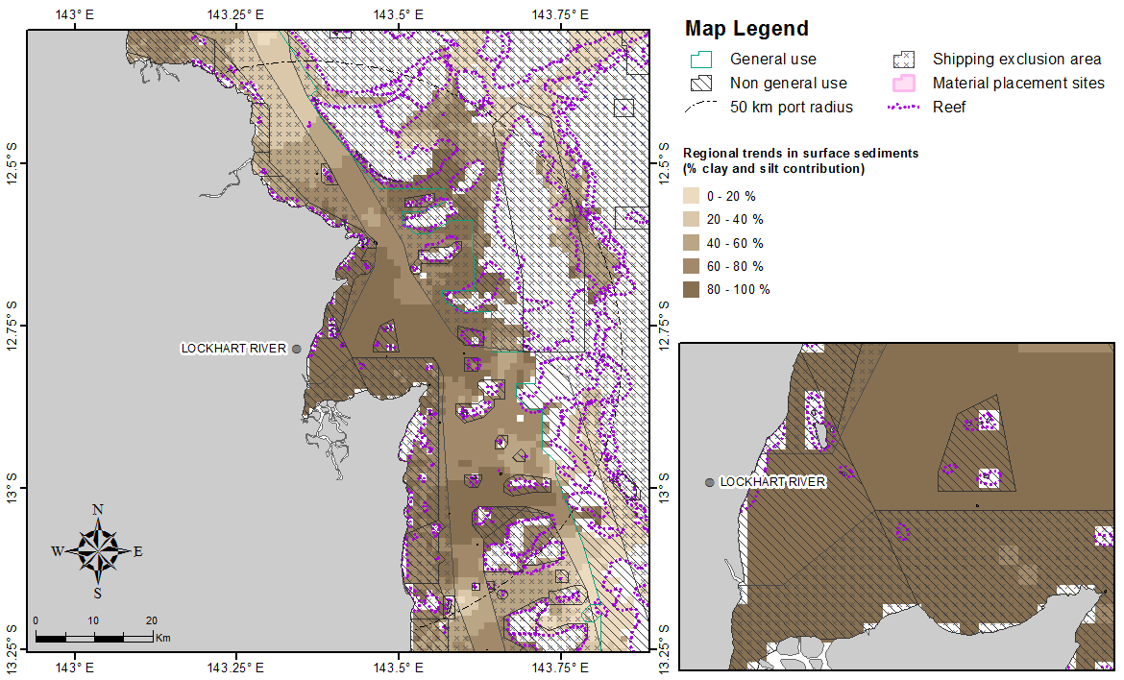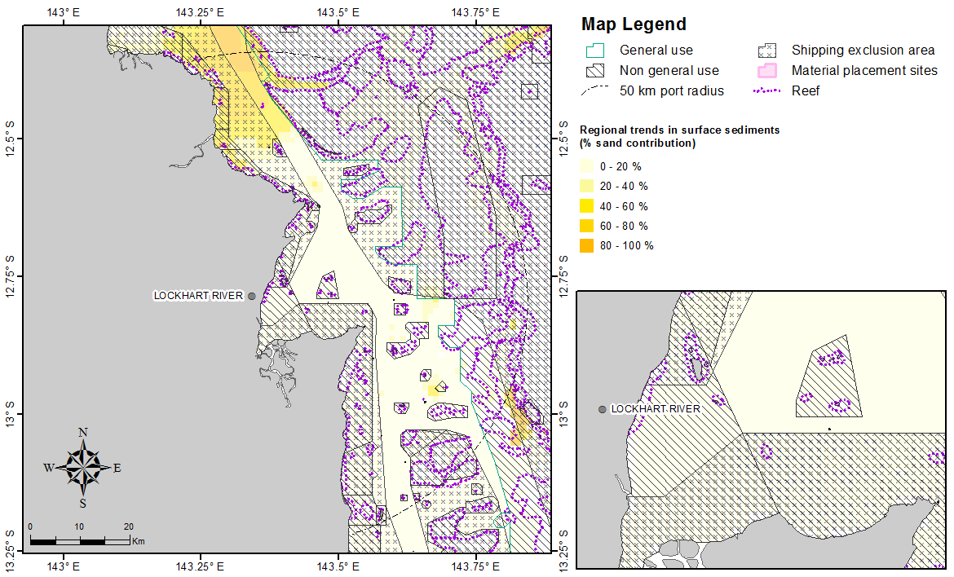
Figure 50. Percentage clay-silt (upper image) and sand (lower image) content in surface sediments within 50 km from the Port of Quintell Beach (source: Geoscience Australia marine samples database 2007).

CONCLUSIONs
A bed shear-stress modelling study was undertaken to provide the Australian and Queensland governments with tools to improve decision making with regards to dredge material placement sites for 12 Queensland trading ports on the Great Barrier Reef.
This study is not intended to replace the need for a detailed EIA associated with any future dredging project, but is rather a screening study. Predictions of bed shear-stresses help identify areas that are likely to be dispersive or retentive of different sediment particle size fractions within a 50 km radius of each port. The predictions are based on the analysis of year-long current and wave data (2011), and summarised statistically as 50th and the 95th percentile (extreme conditions only exceeded 5 per cent of the time) estimates.
An assessment of the 50th percentile bed shear-stress levels showed that ports between Gladstone to Hay Point are energetic (i.e. dispersive), with the potential to mobilise unconsolidated material up to coarse sand under average conditions. The ports between Abbot Point and Quintell Beach typically exhibit relatively low-energy and retentive environments under average (50th percentile) conditions. Bed shear-stresses were predicted to mobilise unconsolidated clays along the immediate coastline, grading into shear-stresses sufficient to potentially mobilise fine and coarse silts further offshore. Only a few reef-associated areas have predicted shear-stresses sufficient to mobilise fine to coarse sands. The findings from the modelling were found to generally correspond well with the Geoscience Australia surface sediment maps.
Modelling results for the 95th percentile bed shear-stress levels showed that for all of the 12 Queensland trading ports, the majority of the study areas would become highly energetic (i.e. more dispersive), with the potential to mobilise unconsolidated sediments as large as coarse sand.

REFERENCES
Andutta, F.P., Ridd, P.V. & Wolanski, E. 2011. Dynamics of a hypersaline coastal waters in the Great Barrier Reef. Estuarine, Coastal and Shelf Science, 94, 299-305.

Australian Bureau of Meteorology. 2012, ‘The Southern Oscillation Index’, Available from: <http://www.bom.gov.au/climate/glossary/soi.shtml>

Booij, N., Holthuijsen, L.H. & Ris. R.C. 1996, ‘The “SWAN" wave model for shallow water’, Proceedings Coastal Engineering Conference, American Society of Civil Engineers, vol. 1 668–676.
Booij, N., Ris, R.C. & Holthuijsen, L.H. 1999, ‘A third-generation wave model for coastal regions: 1. Model description and validation’, Journal of Geophysical Research, 104, 7649–7666.

Chassignet, E.P., Harley, E.H., Smedstad, O.M., Halliwell, G.R., Hogan, P.J., Wallcraft, A.J., Baraille, R. & Bleck, R. 2007, ‘The HYCOM (hybrid coordinate ocean model) data assimilative system’, Journal of Marine Systems, 65, 60–83.
Chassignet, E.P., Hurlburt, H.E., Metzger, E.J., Smedstad, O.M., Cummings, J.A., Halliwell, G.R., Bleck, R., Baraille, R., Wallcraft, A.J., Lozano, C., Tolman, H.L., Srinivasan, A., Hankin, S., Cornillon, P., Weisberg, R., Barth, A., He, R., Werner, F. & Wilkin, J. 2009, ‘US GODAE Global Ocean Prediction with the Hybrid Coordinate Ocean Model (HYCMOM)’, Oceanography, 22, 64–75.

Chu, P.C., Qi, Y., Chen, Y., Shi, P. & Mao, Q. 2004, ‘South China Sea Wind-Wave Characteristics. Part I: Validation of Wavewatch-III Using TOPEX/Poseidon Data’, Journal of atmospheric and oceanic technology, 21, 1718–1733.

Great Barrier Reef Marine Park Authority. 2009, ‘Great Barrier Reef outlook report 2009’, Great Barrier Reef Marine Park Authority, Townsville

Great Barrier Reef Marine Park Authority. 2012, ‘The use of hydrodynamic numerical modelling for dredging projects in the Great barrier Reef Marine Park’, Great Barrier Reef Marine Park Authority, Townsville

Griffin, D.A., Middleton, J.H. & Bode, L. 1987, "The tidal and longer-period circulation of Capricornia, Southern Great Barrier Reef’, Marine and Freshwater Research, 38, 461–474.
Holthuijsen, L.H., Booij, N., Ris, R., Andorka Gal, J.H. & de Jong, J.C.M. 1997, ‘A verification of the third-generation wave model "SWAN" along the southern North Sea coast’, Proceedings 3rd International Symposium on Ocean Wave Measurement and Analysis, WAVES '97, American Society of Civil Engineers, 49–63.
Isaji, T. & Spaulding, M. 1984, ‘A Model of the Tidally Induced Residual Circulation in the Gulf of Maine and Georges Bank’, Journal of Physical Oceanography, Notes and Correspondence, 1119–1126.
King, B. & Wolanski, E. 1992, ‘Coastal dynamics along a rugged coastline’. pp 577–598 in, Dynamics and exchanges in estuaries and the coastal zone, ed. D. Prandle, Coastal and Estuarine Studies, Volume 40, New York.
King, B. & Wolanski, E. 1996, ‘Tidal mixing in the Central Great Barrier Reef’, Journal of Marine Systems, 9, 187–202.
Kostianoy, A.G., Ginzburg, A.I., Lebedev, S.A., Frankignoulle, M. & Delille, B. 2003, ‘Fronts and mesoscale variability in the southern Indian Ocean as inferred from the TOPEX/POSEIDON and ERS-2 Altimetry data’, Oceanology 43: 632–642.

Lambeck, A. & Woolfe, K.J. 2000, ‘Composition and textural variability along the 10 m isobath, Great Barrier Reef: evidence for pervasive northward sediment transport’, Australian Journal of Earth Sciences, 47, 327–335.

Lambrechts, J., Humphrey, C., McKinna, L., Gourge, O., Fabricius, K.E., Mehta, A.J., Lewis, S. & Wolanski, E. 2010, ‘Importance of wave-induced bed liquefaction in the fine sediment budget of Cleveland Bay, Great Barrier Reef’ Estuarine, Coastal and Shelf Science, 89, 154–162.
Ludicone, D., Santoleri, R., Marullo, S. & Gerosa, P. 1998, ‘Sea level variability and surface eddy statistics in the Mediterranean Sea from TOPEX/POSEIDON data’, Journal of Geophysical Research, 103, 2995–3011.
Luick, J.L., Mason, L., Hardy, T. & Furnas, M.J. 2007. Circulations in the Great reef barrier lagoon using numerical tracers and in situ data. Continental Shelf Research, 27, 757-778.
Mathews, El., Heap., & Woods, P. 2007, ‘Inter-reefal seabed sediments and geomorphology of the Great Barrier Reef, a spatial analysis’, An Australian Government report, Geoscience Australia, 2007/09.
Qiu, B. & Chen, S. 2010, ‘Eddy-mean flow interaction in the decadally modulating Kuroshio Extension system’, Deep-Sea Research II, 57, 1098–1110
Soulsby, R. 1997, Dynamics of marine sands - A manual for practical applications, London, Thomas Telford Publications.
Tolman, H.L. 2009, ‘User manual and system documentation of WAVEWATCH III version 3.14’, National Oceanic and Atmospheric Administration (National Centers for Environmental Prediction).
Wallcraft, A., Carroll, S.N., Kelly, K.A. & Rushing, K.V. 2003, ‘Hybrid Coordinate Ocean Model (HYCOM), version 2.1 User’s Guide’, Available from <panoramix.rsmas.miami. edu/hycom/documentation. html.>

Wolanski, E., Gibbs, R., Ridd, P., & Mehta, A. 1992, ‘Settling of ocean-dumped dredged material, Townsville, Australia’, Estuarine, Coastal and Shelf Science, 35, 473-489.
Wolanski, E. 1994, Oceanographic Processes of the Great Barrier Reef, CRC Press, Boca Raton, Florida.
Yaremchuk, M. & Tangdong, Q. 2004, ‘Seasonal Variability of the Large-Scale Currents near the Coast of the Philippines’, Journal of Physical Oceanography, 34, 844–855.

Mean absolute error equation: $MAE=\frac{1}{n}\sum_{i=1}^{n}{|modelled{}_{i}-}measured_{i}|$

