O’Connell Basin Assessment
Mackay Whitsunday Natural Resource Management Region

Assessment of ecosystem functions within the O’Connell basin focusing on understanding and improving the health and resilience of the Great Barrier Reef

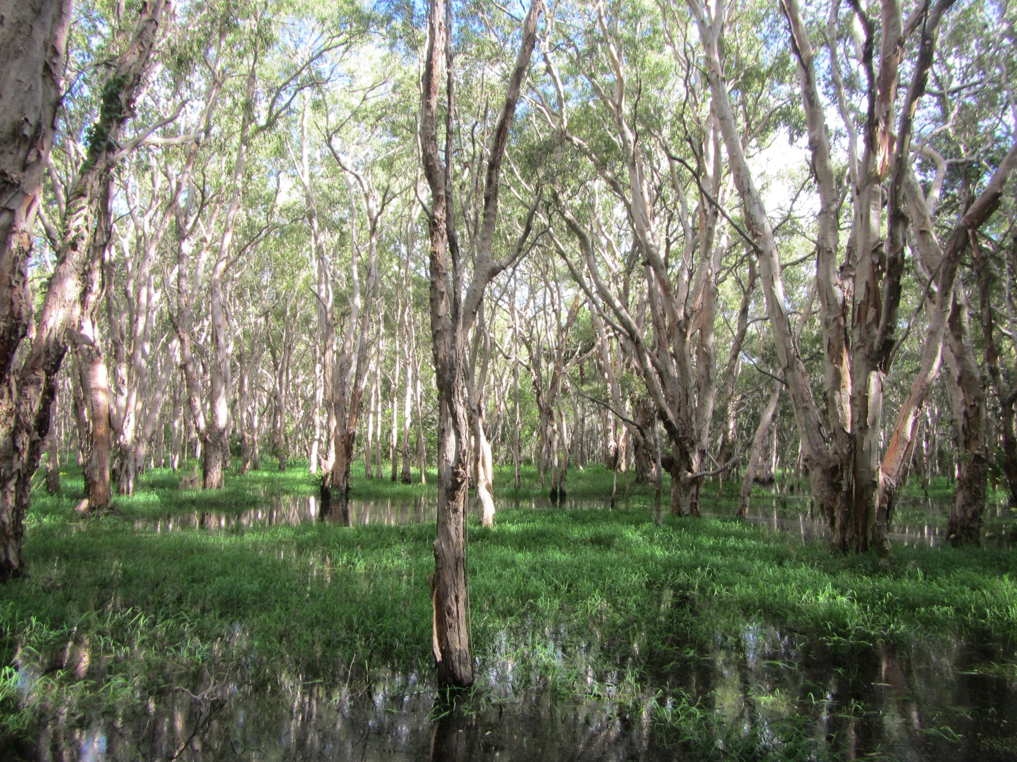

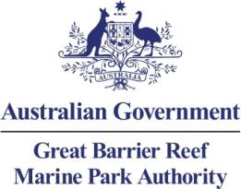

O’Connell Basin Assessment – Mackay Whitsunday Natural Resource Management Region
Assessment of ecological functions within the O’Connell basin focusing on understanding and improving the health and resilience of the Great Barrier Reef

© Commonwealth of Australia 2013

Published by the Great Barrier Reef Marine Park Authority 2013

This work is copyright. You may download, display, print and reproduce this material in unaltered form only (appropriately acknowledging this source) for your personal, non-commercial use or use within your organisation. Apart from any use as permitted under the Copyright Act 1968, all other rights are reserved.

Disclaimer
The views and opinions expressed in this publication are those of the authors and do not necessarily reflect those of the Australian Government or the Minister for Sustainability, Environment, Water, Population and Communities.

While reasonable efforts have been made to ensure that the contents of this publication are factually correct, the Australian Government does not accept responsibility for the accuracy or completeness of the contents, and shall not be liable for any loss or damage that may be occasioned directly or indirectly through the use of, or reliance on, the contents of this publication.

National Library of Australia Cataloguing-in-Publication entry
O'Connell basin assessment : Mackay-Whitsunday Natural Resource Management region / Great
Barrier Reef Marine Park Authority.
ISBN 978 1 922126 10 8 (ebook)
Ecosystem management--Queensland--Great Barrier Reef.
Ecosystem health--Queensland--Great Barrier Reef.
Natural resources management areas--Queensland--Great Barrier Reef.
Great Barrier Reef (Qld.)--Environmental conditions.
Great Barrier Reef Marine Park Authority, issuing body.
577.09943
This publication should be cited as:
Great Barrier Reef Marine Park Authority 2013, O'Connell basin assessment : Mackay-Whitsunday
Natural Resource Management region, GBRMPA, Townsville.

Acknowledgements
This report was supported through funding from the Australian Government Department of Sustainability, Environment, Water, Population and Communities.

The Great Barrier Reef Marine Park Authority (GBRMPA) would like to thank Reef Catchments (Natural Resource Management (NRM); Mackay, Whitsunday, and Isaac), and our consultant, Jim Tait from Econcern Environmental Consulting for his invaluable assistance with ecological knowledge in the O’Connell basin. Water Quality information was provided by TropWATER Townsville. The GBRMPA also acknowledges the contributions of Hugh Yorkston, Donna-marie Audas, Jason Vains, Paul Groves, Carol Marshall, Melissa Evans, Ben Palmer, Rose Dunstan, Emily Smart and Sara Dunstan.

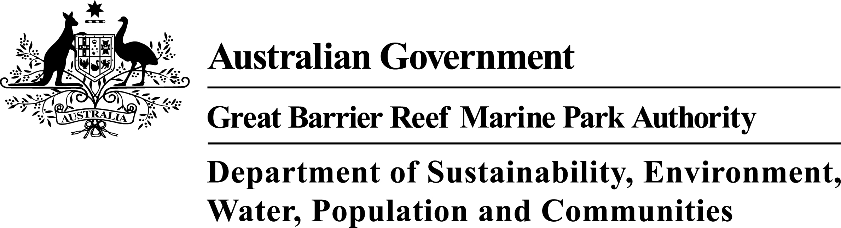

Requests and enquiries concerning reproduction and rights should be addressed to:

Great Barrier Reef Marine Park Authority
2-68 Flinders Street (PO Box 1379)
Townsville QLD 4810, Australia

Phone: (07) 4750 0700
Fax: (07) 4772 6093
Email: info@gbrmpa.gov.au

www.gbrmpa.gov.au

EXECUTIVE SUMMARY 1
Context 1
The O’Connell basin 1
Key issues 2
Potential management actions 3
INTRODUCTION 5
Background 5
Purpose 5
Methodology 7
PART A: VALUES OF THE GREAT BARRIER REEF REGION – O’CONNELL BASIN 10
Chapter 1: O’Connell basin – background to changes affecting matters of national environmental significance 10
1.1 Background and history of the O’Connell Basin 10
Chapter 2: Values and their current condition and trend 12
2.1 Matters of National Environmental Significance in the basin 14
2.2 Other matters or values that may underpin Matters of National Environmental Significance 16
2.3 Coastal Ecosystems 20
2.4 Ecosystem processes 36
2.5 Connectivity 41
Chapter 3: Impacts on the values 48
3.1 Drivers of change 48
3.2 Activities and impacts 49
3.3 Actual and potential impacts 53
PART B: OUTCOMES OF BASIN ASSESSMENT 64
Chapter 4: Projected condition of Great Barrier Reef catchment values 64
4.1 Summary of current state of coastal ecosystems 64
4.2 Outline of key current and likely future pressures and impacts on coastal ecosystems in the O’Connell basin 65
4.3 Current and likely future impacts on coastal ecosystems and likely resultant impacts on the World Heritage Area 68
4.4 Priorities for conservation and restoration 78
4.5 Potential management actions 81
4.6 Knowledge gaps 81
REFERENCES 83
Appendix A – Field Assessment Template 88
Appendix B – Key terminology used in this report 89
Appendix C – Values and their elements that underpin matters of national environmental significance 90
Appendix D – Threatened species of the O’Connell basin 94
Appendix E – Migratory species of the O’Connell basin 95
Appendix F – Ecological processes 97
Appendix G – O’Connell basin water quality report 101

EXECUTIVE SUMMARY

Context
A healthy and resilient Great Barrier Reef World Heritage Area (the World Heritage Area) is reliant upon the ecological integrity of the adjacent Great Barrier Reef catchment and its coastal ecosystems.

The O’Connell basin provides habitat for many important marine, estuarine, freshwater and terrestrial species with lifecycles that have connections to the World Heritage Area. The coastal ecosystems in the basin also provide a range of ecological functions that support the health and resilience of the marine environment.

Within the marine environment, coastal waters provide high value marine areas including around islands and inshore coral reefs. To protect representations of these areas, there are many coastal and inshore Marine National Park Zones adjacent to this basin.

This Report is part of a series of similar reports investigating the nature, condition, connectivity and management of coastal ecosystems within basins that form the catchment of the World Heritage Area. The purpose of this Report on the O’Connell basin is to:

- Review coastal ecosystems in the basin, assess their state and consider the pressures that they are facing now, and into the future.
- Understand the connections between coastal ecosystems and the World Heritage Area, and how changes to these connections are impacting on the ecological functions they provide to the Marine Park.
- Provide information to support future planning and management decisions, including identifying areas important for protection or potential offsets.
- Empower communities and stakeholders by providing information that can support on-ground actions.

Maps shown in this basin assessment were derived from a range of data sources, and should only be used as a guide.

The O’Connell basin
The O’Connell basin covers an area of 238,699 hectares and is situated in the Mackay Whitsunday region. It has significant natural assets and is home to (and used by) many important marine, estuarine, freshwater and terrestrial species with connections to the World Heritage Area. The World Heritage Area includes dugong habitat (protected under extensive dugong protection areas) and also high value marine areas including islands and inshore coral reefs. There are many coastal and inshore Marine National Park Zones adjacent to this basin. The basin estuaries also make up three per cent of the extent of estuaries in the Great Barrier Reef catchment (the catchment). This amounts to an estimated $2.5 million worth of annual recreational and commercial fisheries catch*.

Key issues
The O’Connell basin has been used for farming since the late 1800s. This was mostly grazing and sugar cane production. Widespread expansion of irrigated sugar cane farming in the area has been constrained by the limited availability of water for irrigation in the area. Today, the land use in the basin consists mostly of grazing, urban areas and intensive irrigated agriculture (primarily sugar).

Around 50 per cent of the O’Connell basin’s vegetation is classified by the Queensland Government as non-remnant (cleared or significantly modified) and a further 25 per cent of the remnant areas are currently used for grazing. Most of this clearing occurred on leasehold land under different government policies aimed at promoting economic development in the 1950s and continued until the early 1990s.¹ Only 25 per cent of remnant vegetation is protected from development within National Parks, Conservation Parks or State Reserves (however weeds and feral pigs are still having an impact in these areas). Most protection is afforded to elevated areas (42 per cent) with 34 per cent of the coastal zone and 24 per cent of the floodplain currently protected.

The O’Connell basin consists of four main and several smaller sub-basins. Land use and water quality vary between these sub-basins and this report, where possible, considers the variability between these sub-basins. Based on ratings of ecosystem health indicators developed for the Mackay Whitsunday Water Quality Improvement Plan, the O’Connell River sub-basin was rated the worst waterway in the O’Connell River basin with regards to its freshwater and estuarine conditions compared with the other main waterways (Andromache River, St Helens Creek and Blackrock Creek).² Overall, the O’Connell basin has experienced significant wetland loss since pre-European settlement. The dominant source of sediments in the Mackay Whitsunday region comes from hill slope erosion and the majority (80 per cent) of this sediment is transported to the Great Barrier Reef lagoon. Sediment loss from this modified landscape has increased by more than 100 kilo-tonnes per annum³ and field investigations as part of this assessment suggest that this is causing some rivers to fill with sand. This sediment is reducing river depth, filling former deep water refugia for species with connections to the World Heritage Area, and in some areas is leading to a widening of the river that may potentially lead to an increased frequency of flooding of the adjacent low-lying areas. These sediments pose a direct threat to coastal coral reefs and seagrass meadows with flow on effects to dependant species, such as dugong and green turtles.

A high number of pesticides were detected in the O’Connell River. Tebuthiuron residues (a broad spectrum herbicide) exceeded the locally derived ecological protection trigger value (Appendix F). Current levels of herbicides in river water plumes could reach levels that present a risk to the World Heritage Area. The inshore coastal areas situated near the mouth of the O’Connell River may also be impacted by the discharge of the Proserpine River therefore management must include water quality data from both rivers in order to develop the most suitable action plans.

In recent years, population growth as a result of the mining boom has led to an increase of urban and peri-urban development in the O’Connell basin. Infilling of the low lying floodplain and wetland areas is continuing to accommodate an expanding Mackay city (Figure 1). Stormwater management observed in some urban developments (such as Beaconsfield and Eimeo) appeared to not consider Water Sensitive Urban Design (WSUD). The developments are designed to shed water rapidly, with stormwater channelled into point source discharges which flow into local estuaries. This has the potential for dire consequences on some keystone species such as grapsid crabs.⁴ The Mackay Regional Council is preparing guidelines to encourage WSUD in the region.⁵

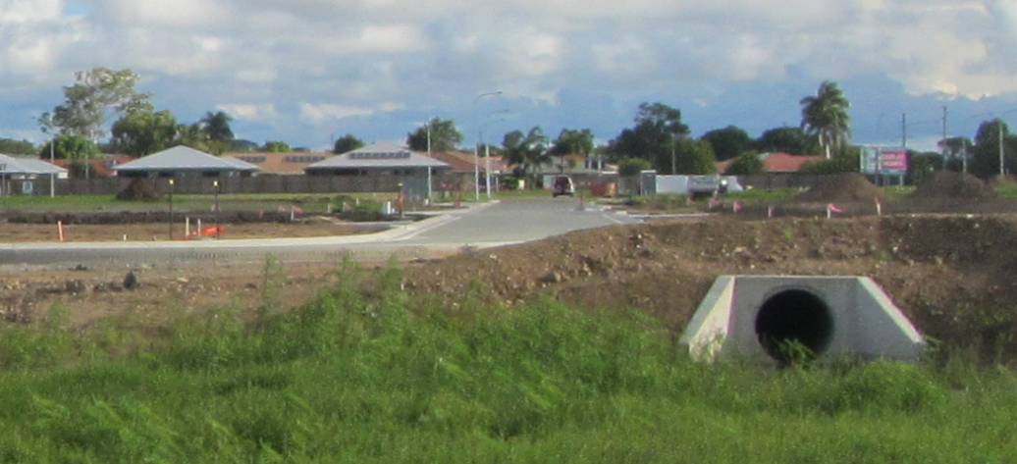
Figure 1: Stormwater management in a new urban development in Mackay

Increased urban expansion has also led to increased frequency of other indirect damage to matters of national environmental significance. Off road vehicle use in coastal areas has impacted turtle nesting and seabird habitats. Recently, the Mackay Regional Council purchased the high value ‘spit’ area north of Mackay and erected fencing to manage these impacts.

One of the social shifts as a result of the mining boom in the Surat and Bowen basins has been the increase in fly-in fly-out and drive-in drive-out workers. These workers often have longer periods of time off and this has seen an increase in boat registrations for the region, 8000 in 2002 increasing to 13,500 by December 2012. If not managed well, this increase in recreational boat traffic and recreational fishing has the potential to impact of the values of the World Heritage Area.

Potential management actions
This report has been developed as a baseline for the O’Connell basin. In order to ensure that the basin is best represented, consideration of additional finer scale data, local knowledge and information will further enhance this assessment.

Coastal ecosystems located in the floodplain and coastal zone are those that have experienced the greatest changes and those most at risk of further decline in processes and functions into the future. Future conservation measures need to protect these ecosystems from further decline in ecological service provision and restoration efforts should focus on these areas. These areas are also the areas at greatest risk from flooding, storm and climate change impacts so high value infrastructure, such as residential and industrial development should be avoided in these areas. Current infrastructure in these areas needs to be managed to current best practice.

Ensuring the long-term health of the Reef requires greater protection of, and restoration of important ecological processes and functions provided by Fitzroy basin coastal ecosystems. Actions that would increase protection and restore processes and function include:

- Review of siting of urban developments. If possible, new urban subdivisions should be located above the floodplain with water sensitive urban design implemented (including wetland detention areas).
- All remaining coastal ecosystems within the floodplain and coastal zone should be retained and protected to prevent any further decline in ecological functions provided to the World Heritage Area.
- Introduction of a comprehensive water quality and seagrass monitoring program to ensure long-term health and resilience of seagrass in the area.
- Management of vehicle access to the coastline and wetland coastal ecosystems may assist in minimising impacts to species (such as birds and turtles) that are matters of national environmental significance.
- Cleared and eroding hill slopes require urgent management intervention. These sites may be suitable for appropriately designed urban development (in lieu of low lying floodplain areas) if built to current best practice.
- Low levels of well managed grazing should be considered for riparian areas where introduced grasses dominate and where these grasses either pose a fire risk to well established riparian forests or where these grasses are choking waterways and removing oxygen from them.
- Improve agricultural practices to current best practice standards including a shift from furrow irrigation to trickle irrigation and the use of tailwater retention, recycle and treatment ponds.

The coastal ecosystems in the O’Connell basin have changed significantly over the last century. These changes are mostly irreversible and future management needs to be adaptive and innovative. The changes to hydrology and the establishment of African and South American weeds have altered the coastal ecosystems in much of this basin. Strategic whole-of-landscape scale management is required to adapt to the changed hydrology and more intense fire regimes.

*This figure was derived from the annual catch in the Great Barrier Reef of fish and invertebrate species that use estuaries for part or all of their life histories. This amounted to approximately $20,000 per square kilometre of estuary (assuming all estuaries are equally productive and using Gross Value of Production figures from the east coast inshore finfish fishery, mud crab fishery and other trawl fishery).⁶

INTRODUCTION

Background
The Great Barrier Reef Marine Park (Marine Park) covers an area of approximately 348,000 km² and extends from Cape York in the north to Bundaberg in the south. The Great Barrier Reef World Heritage Area was accepted in 1981 for inclusion in the World Heritage List, meeting all four of the natural heritage criteria (aesthetics and natural phenomena; geological processes and significant geomorphic features representing major stages of earth’s history; ecological and biological processes; and habitats for the conservation of biological diversity, including threatened species). The World Heritage Area includes additional areas outside of the Marine Park. The World Heritage Area extends from the low water mark on the Queensland coast to up to 250 km offshore past the edge of the continental shelf and includes coastal and island ecosystems, as well as some port and tidal areas, outside of the Marine Park.

The adjacent Great Barrier Reef catchment encompasses an area of 424,000 km² with all water flowing from the catchment into the World Heritage Area. The catchment contains a diverse range of terrestrial, freshwater and estuarine ecosystems. These coastal ecosystems include rainforests, forests, woodlands, forested floodplains, freshwater wetlands, heath and shrublands, grass and sedgelands, and estuaries.

Coastal ecosystems support the health and resilience of the World Heritage Area. The ecological functions provided by coastal ecosystems include physical processes (such as sediment and water distribution and cycling), biogeochemical processes (such as nutrient and chemical cycling) and biological processes (such as habitat and food provisioning).

This report assesses the O’Connell basin’s current land use, remaining extent and pressures on coastal ecosystems, and how this basin supports and maintains the health and resilience of the World Heritage Area.

Purpose
The purpose of a basin assessment is to assess at the landscape scale the ecological functions, the risks to these functions and the cumulative impacts that are affecting the long-term health of the World Heritage Area. The focus area for this report is the O’Connell basin, which includes ecosystems extending from the inshore areas of the Marine Park to the upper extent of the O’Connell basin. The information collected, collated and analysed provides a rapid summary of the state of the basin’s ecological assets and highlights pressures and threats, ecological condition, and social response to threats and pressures that are influencing the health of the World Heritage Area. More influencing factors – and consequently more pressures – are at work at finer scales of analysis and should be considered when planning or managing these areas.

The Great Barrier Reef catchment is made up of 35 basins draining directly into the World Heritage Area (Table 1).
Table 1: Basins in the Great Barrier Reef catchment
Great Barrier Reef catchment | NRM regions | Basins | Coastal zone as defined by Queensland State Coastal Management Plan 2011
Great Barrier Reef catchment | Cape York NRM region  (managed by Cape York NRM) | Jacky Jacky
Great Barrier Reef catchment | Cape York NRM region  (managed by Cape York NRM) | Olive-Pascoe
Great Barrier Reef catchment | Cape York NRM region  (managed by Cape York NRM) | Lockhart
Great Barrier Reef catchment | Cape York NRM region  (managed by Cape York NRM) | Stewart
Great Barrier Reef catchment | Cape York NRM region  (managed by Cape York NRM) | Normanby
Great Barrier Reef catchment | Cape York NRM region  (managed by Cape York NRM) | Jeanie
Great Barrier Reef catchment | Cape York NRM region  (managed by Cape York NRM) | Endeavour
Great Barrier Reef catchment | Wet Tropics NRM region (managed by Terrain) | Daintree
Great Barrier Reef catchment | Wet Tropics NRM region (managed by Terrain) | Mossman
Great Barrier Reef catchment | Wet Tropics NRM region (managed by Terrain) | Barron
Great Barrier Reef catchment | Wet Tropics NRM region (managed by Terrain) | Mulgrave-Russell
Great Barrier Reef catchment | Wet Tropics NRM region (managed by Terrain) | Johnstone
Great Barrier Reef catchment | Wet Tropics NRM region (managed by Terrain) | Tully
Great Barrier Reef catchment | Wet Tropics NRM region (managed by Terrain) | Murray
Great Barrier Reef catchment | Wet Tropics NRM region (managed by Terrain) | Herbert
Great Barrier Reef catchment | Burdekin Dry Tropics NRM region  (managed by NQ Dry Tropics) | Black
Great Barrier Reef catchment | Burdekin Dry Tropics NRM region  (managed by NQ Dry Tropics) | Ross
Great Barrier Reef catchment | Burdekin Dry Tropics NRM region  (managed by NQ Dry Tropics) | Haughton
Great Barrier Reef catchment | Burdekin Dry Tropics NRM region  (managed by NQ Dry Tropics) | Burdekin
Great Barrier Reef catchment | Burdekin Dry Tropics NRM region  (managed by NQ Dry Tropics) | Don
Great Barrier Reef catchment | Mackay Whitsunday NRM region  (managed by Reef Catchments) | Proserpine
Great Barrier Reef catchment | Mackay Whitsunday NRM region  (managed by Reef Catchments) | O'Connell
Great Barrier Reef catchment | Mackay Whitsunday NRM region  (managed by Reef Catchments) | Pioneer
Great Barrier Reef catchment | Mackay Whitsunday NRM region  (managed by Reef Catchments) | Plane
Great Barrier Reef catchment | Fitzroy NRM region  (managed by Fitzroy Basin Association) | Styx
Great Barrier Reef catchment | Fitzroy NRM region  (managed by Fitzroy Basin Association) | Shoalwater
Great Barrier Reef catchment | Fitzroy NRM region  (managed by Fitzroy Basin Association) | Waterpark
Great Barrier Reef catchment | Fitzroy NRM region  (managed by Fitzroy Basin Association) | Fitzroy
Great Barrier Reef catchment | Fitzroy NRM region  (managed by Fitzroy Basin Association) | Calliope
Great Barrier Reef catchment | Fitzroy NRM region  (managed by Fitzroy Basin Association) | Boyne
Great Barrier Reef catchment | Burnett-Mary NRM region  (managed by Burnett Mary Regional Group) | Baffle
Great Barrier Reef catchment |  | Kolan
Great Barrier Reef catchment |  | Burnett
Great Barrier Reef catchment |  | Burrum
Great Barrier Reef catchment |  | Mary

Methodology
The methods underpinning this basin assessment are detailed in the Coastal Ecosystems Assessment Framework⁷, a tool developed in partnership with the Queensland Government (available at www.gbrmpa.gov.au). The Coastal Ecosystems Assessment Framework was developed and used as the basis of the Informing the Outlook for Great Barrier Reef coastal ecosystems⁸ report and provides a holistic approach to assessing and understanding ecological functions provided by coastal ecosystems and the pressures affecting them.

The catchment in its current state is a mosaic of natural and modified ecosystems with a suite of values and functions of importance to the World Heritage Area. The methodology used to understand the values and functions provided by natural and modified coastal ecosystems are outlined in the Coastal Ecosystem Assessment Framework⁷ and have been used as a basis to assess the O’Connell basin assessment. Figure 2 below describes the methodology used to rapidly assess the ecological functions and values to conduct the O’Connell basin assessment.

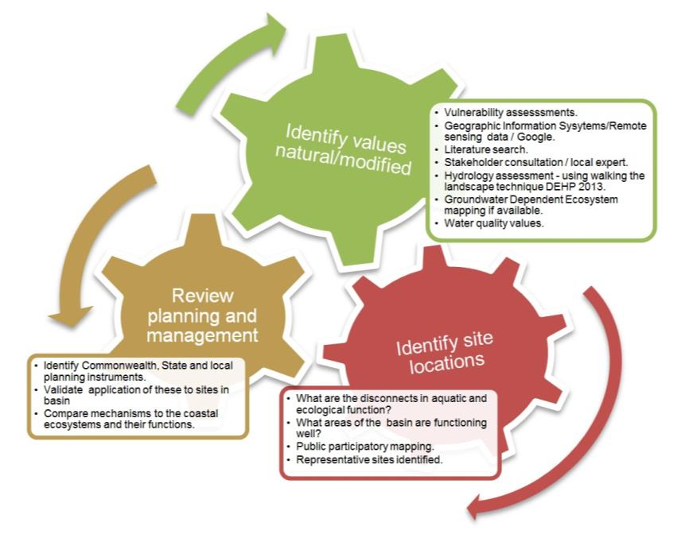
Figure 2: Summary of the methodology for conducting a rapid basin scale assessment

Stakeholder engagement and verification of assessment information has been crucial to the development of this basin assessment. Building on the information collected and collated for the Informing the Outlook for coastal ecosystems⁸ report, the methodology for preparing this Report incorporated the following steps:
- Local experts were consulted to identify areas of interest to visit in the field as part of a ‘rapid assessment’.
- Research was conducted on the basin using available information.
- Sites of interest were identified using coastal ecosystem maps and Google earth (GPS identification for sites to be visited for field work).
- Collaboration with local stakeholders (i.e. consultants, natural resource management bodies, local land owners) helped to verify the issues affecting the basin, as well as additional field sites.
- Field investigations were conducted using the field site assessment template forms (Appendix A) to capture site locations and reference photos at basin sites (Figure 3).
- GPS coordinates from field assessments were imported into Google earth to assist with report preparation.
- Preliminary basin assessments were compiled to facilitate stakeholder input.
- Workshops were conducted to bring stakeholders together to present information and incorporate feedback into the basin assessment.
- Draft basin assessments were prepared as a basis to further stakeholder input.
- Basin assessments finalised and published.

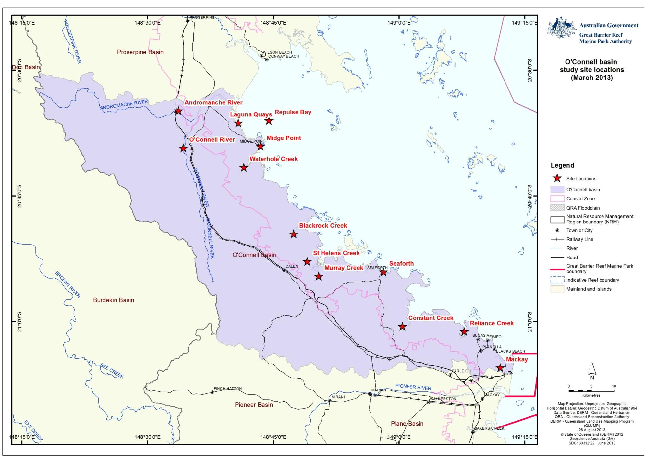
Figure 3: Key study sites for the O’Connell basin assessment

PART A: VALUES OF THE GREAT BARRIER REEF REGION – O’CONNELL BASIN
- O’Connell basin – background to changes affecting matters of national environmental significance

Background and history of the O’Connell Basin
The O’Connell basin (as mapped by the Queensland Government) is located north of Mackay and south of Proserpine and covers an area of 238,699 hectares (Figure 1.1.1). The O’Connell basin consists of the O’Connell and Andromache rivers and numerous adjacent smaller watercourses that all flow into the World Heritage Area between Mackay and Repulse Bay. These include the freshwater and estuarine reaches of Waterhole, Blackrock, St Helens, Murray, Constant and Reliance creeks.

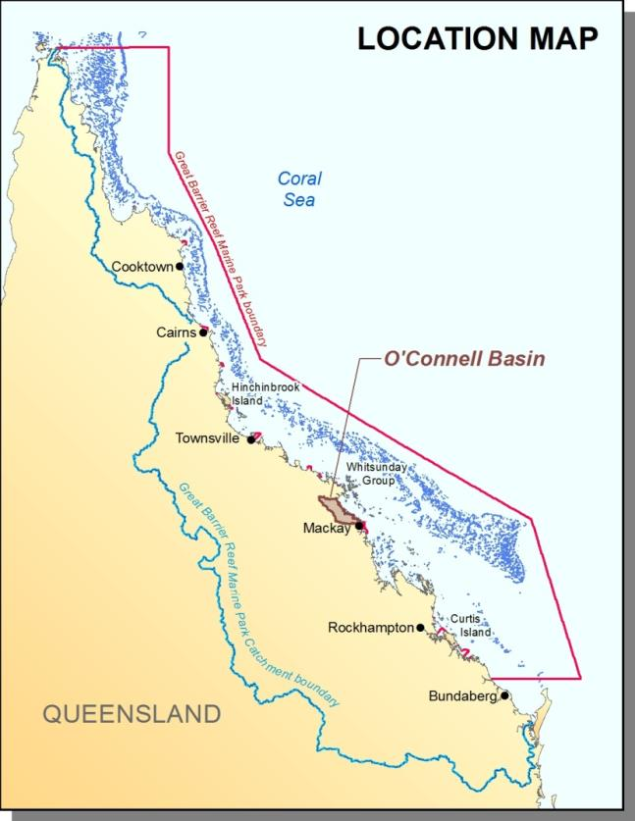
Figure 1.1.1: Map of the O’Connell basin and its proximity to the Great Barrier Reef catchment and the Great Barrier Reef Marine Park

Social values of the O’Connell basin waterways include recreation (swimming, boating, fishing and tourism), agricultural irrigation, industry, stock watering, human consumption of aquatic food and potable water supply. There are also extensive cultural and spiritual values for the Traditional Owners in this basin. Any proposed activity should seek to consult with the local Traditional Owners.

Adjacent waters are also home to some of the Whitsunday Islands which are recognised as a high value site for the local tourism industry, with over 600,000 visitors annually.⁹ In December 2012, 13,000 vessels were registered for recreational use with the Mackay Regional Council.¹⁰

Results from the Reef Plan Marine Monitoring Program noted that the inshore water quality for the Mackay Whitsunday region has declined sharply, having been relatively stable since 2005/2006.¹¹ Pesticides including diuron, atrazine, hexazinone, simazine and tebuthiuron were all detected during the 2010/11 wet season.¹² Herbicides were present at biologically relevant concentrations at all monitoring sites in the region although concentrations were lower than in 2009/10.¹² Chlorophyll a, an indicator of nutrient levels, exceeded the Great Barrier Reef Marine Park Authority assessment Water Quality Guidelines at this time around the mouth of the O’Connell River during both the wet and dry season.¹¹

Inshore seagrass meadows have declined to a very poor state since 2005/06 and plant tissue analysis has identified poor water quality as a contributing cause of failed recovery. Inshore coral reefs remain in moderate condition with very poor recovery evident from past disturbances.¹¹

The O’Connell basin has a long history of development that has altered coastal ecosystems (Table 1.1.1). The dominant land uses in 2013 are grazing and urban infrastructure. The main settlements in the O’Connell basin are Mackay, Seaforth, Midge Point and Laguna Quays.

Table 1.1.1: Historical timeline for the O’Connell basin
Year | Event
1880s | Farm allocations occurred in the Kuttabul (formerly Hampden) area.
1896 | Cane tramway to Marian sugar mill constructed prompting an expansion of the cane industry in this area.
1950s | Government policy supports and funds widespread clearing and development of agriculture.
1960 | In 1962 The Brigalow and Other Lands Development Act was passed. The Brigalow scheme introduced by State and Federal governments gave returning soldiers land to clear and establish agriculture.
1992 | Laguna Quays golf course and development opened north of Midge Point.
2000- | Mining and resources industry gains momentum.
2013 | Urban expansion ongoing in Mackay.

- Values and their current condition and trend
The values that are considered in this report include:

- Inshore marine ecosystems that underpin the outstanding universal value of the Great Barrier Reef World Heritage Area (such as coral reefs, seagrasses and associated species).
- Terrestrial coastal ecosystems that provide ecological functions to the Great Barrier Reef World Heritage Area and other matters of national environmental significance.

A conceptual model of these ecosystems and the functions they provide is shown in Figure 2.1.

The ecosystems examined in this report also provide habitat for a range of other matters of national environmental significance. The matters of national environmental significance in the O’Connell basin are outlined in Section 2.1 below and the values and their elements that underpin matters of national environmental significance for the O’Connell basin and adjacent waters are shown in Appendix C.

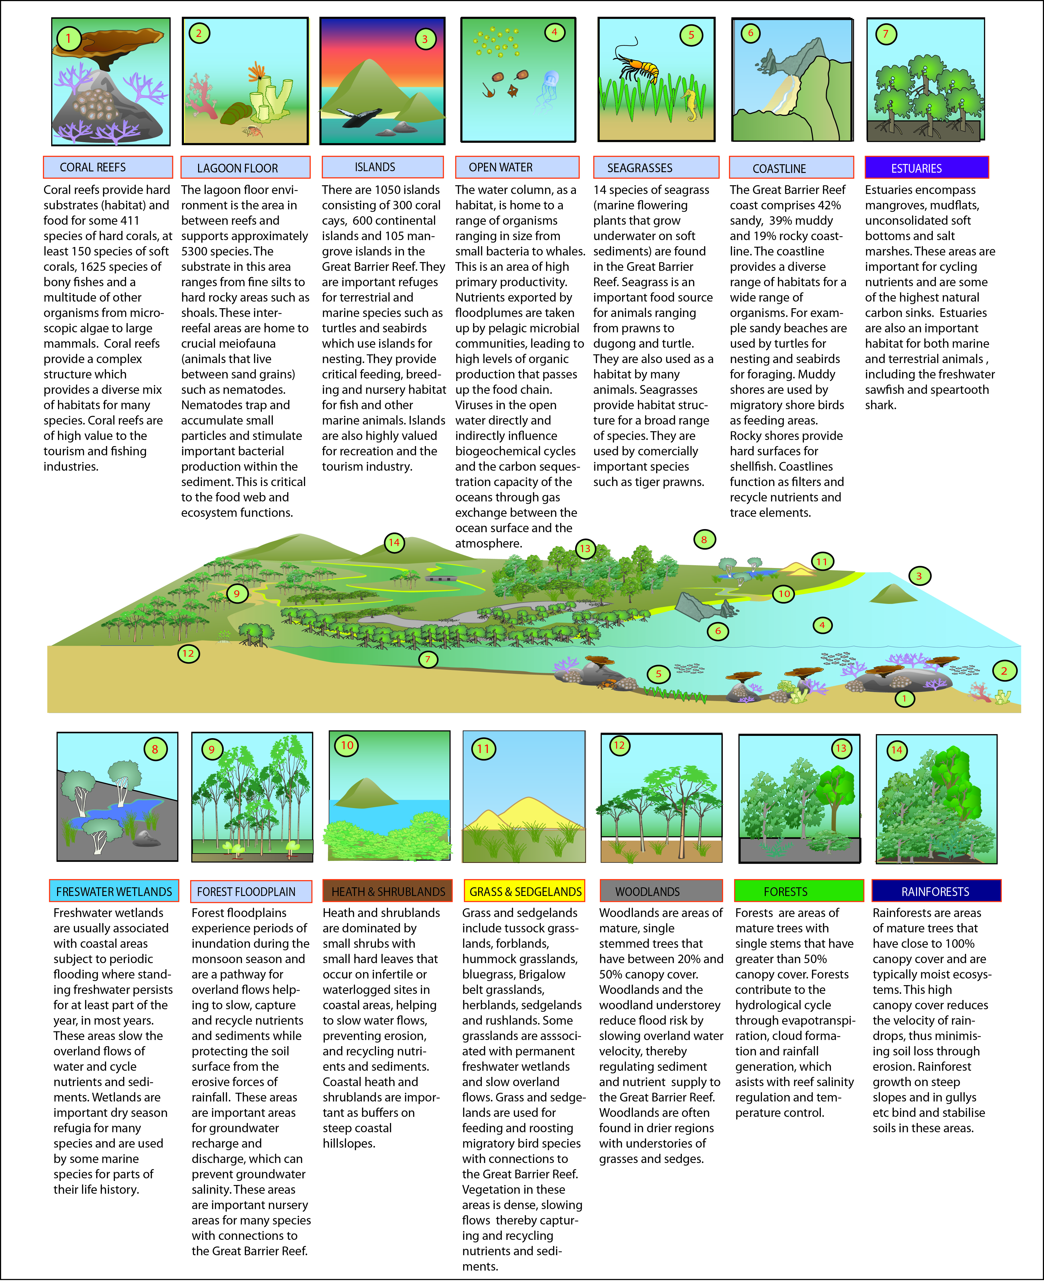
Figure 2.1: Conceptual model for categorizing the Great Barrier Reef coastal, catchment and inshore ecosystems and assessing the ecological functions and services of those ecosystems to the cumulative impacts of development

Matters of National Environmental Significance in the basin
Under the Environment Protection and Biodiversity Conservation Act 1999 (EPBC Act), actions that have, or are likely to have, a significant impact on a matter of national environmental significance require referral to the Australian Government Environment Minister. The Minister will decide whether assessment and approval may be required under the EPBC Act. There are eight matters of national environmental significance protected under the EPBC Act. These are:
- World Heritage properties
- National Heritage places
- Wetlands of international importance (listed under the Ramsar Convention)
- Listed threatened species and ecological communities
- Migratory species protected under international agreements
- Commonwealth marine areas
- The Great Barrier Reef Marine Park
- Nuclear actions (including uranium mines).

World heritage properties
The Great Barrier Reef was inscribed in the World Heritage List in 1981 and meets all four natural criteria. Parts of the O’Connell basin and all of the adjacent marine areas fall within the World Heritage Area.

National heritage properties
The EPBC Act provides for the listing of natural, historic or Indigenous places that are of outstanding national heritage value. Within the O’Connell basin only the Great Barrier Reef is listed as a National Heritage Property (for its natural values).

Wetlands of international importance (declared Ramsar wetlands)
There are currently no Ramsar listed wetlands in the O’Connell basin.

Listed threatened species
Five species of birds, one species of frog, six species of mammal, eight species of plant, six species of reptiles, and one species of cycad have been identified as listed threatened species that occur within the O’Connell basin and adjacent waters (Appendix D). These included turtle nesting and migratory bird feeding sites such as Blacks Beach (Figure 2.1.1).

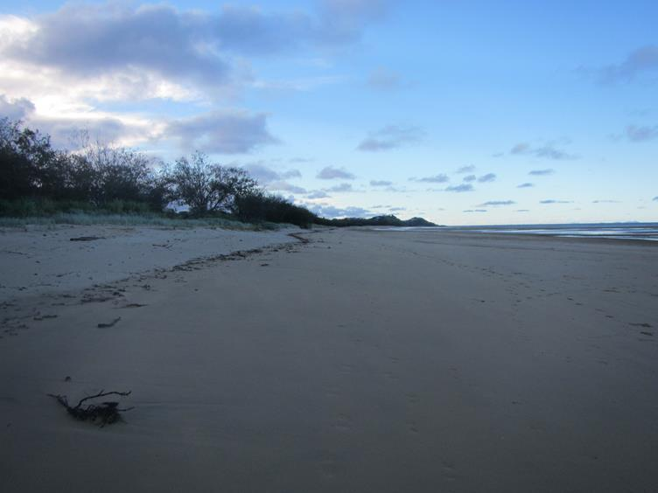
Figure 2.1.1: Blacks Beach is used for turtle nesting and migratory bird feeding. Mackay Regional Council recently purchased an area of coastal land known as ‘the spit’ which has been fenced off by the council to exclude off road vehicles from impacting upon matters of national environmental significance

Ecological communities
There are two listed Threatened Ecological Communities that occur in this basin. These are the Littoral Rainforest and Coastal Vine Thickets of Eastern Australia (Critically Endangered) and the Broad leaf tea tree (Melaleuca viridiflora) woodlands (Endangered).

Listed migratory species
The EPBC Act lists migratory species which includes those species listed in the:
- Convention on the Conservation of Migratory Species of Wild Animals (Bonn Convention)
- China-Australia Migratory Bird Agreement (CAMBA)
- Japan-Australia Migratory Bird Agreement (JAMBA)
- Listed international agreement for this purpose if satisfied that it is an agreement relevant to the conservation of migratory species.

There are 33 migratory bird species, two species of migratory mammals and seven migratory reptiles that occur in the O’Connell basin (Appendix E).

The Great Barrier Reef Marine Park
The Marine Park is recognised as a matter of national environmental significance under the EPBC Act to enhance the management and protection of the ecosystems in the Great Barrier Reef Region. The Great Barrier Reef Marine Park Zoning Plan 2003 (the Zoning Plan) is the overarching plan that provides for a range of ecologically sustainable recreational, commercial, and research opportunities and for the continuation of traditional activities. Each zone has different rules for the activities that are allowed (as of right), prohibited, and those that require permission. Zones may also place restrictions on how some activities are conducted.

Other matters or values that may underpin Matters of National Environmental Significance
Although not matters of national environmental significance, there are other areas within the O’Connell basin that have intrinsic values and may also have significance for the long-term health and resilience of the World Heritage Area.

Dugong Protection Areas
Dugong Protection Areas A and B occur in the coastal waters of the O’Connell basin (Figure 2.2.1).

Zone 'A' Dugong Protection Areas include significant dugong habitats in the southern half of the World Heritage Area (consistently contain over 50 per cent of dugong numbers). In these areas, the use of offshore set, foreshore set and drift nets is prohibited. The use of river set nets is allowed with modifications in Zone 'A' Dugong Protection Areas. Other netting practices such as ring, seine, tunnel and set pocket netting, which are not considered to pose a serious threat to dugong, are unaffected. The Zone ‘A’ Dugong Protection Area receives water from the Blackrock, St Helens, Murray and Constant creek sub-basins.

The Dugong Protection Area B is located adjacent to the Constant Creek sub-basin and is the closest to Mackay. In Zone ‘B' Dugong Protection Areas, mesh netting practices are allowed to continue but with more rigorous safeguards and restrictions than before. Zone ‘B’ Dugong Protection Areas have been shown to contain about 22 per cent of dugongs in the southern Reef. These measures are being kept under review to ensure protection of dugongs in these areas.

Nationally important wetlands (Directory of Important Wetlands in Australia)
Nationally important wetlands in the O’Connell basin include:
- The Great Barrier Reef Marine Park
- Proserpine - Goorganga Plain
- Sand Bay
- St Helens Bay Area.

These are shown in Figure 2.2.1. All of these wetlands are of high value for the health and resilience of the World Heritage Area.

Conservation parks, national parks and forest reserves
There are 22 protected areas within the O’Connell basin:
- Andromache Conservation Park
- Andromache Forest Reserve
- Andromache State Forest
- Bloomsbury Conservation Park
- Bluff Hill Forest Reserve 2
- Bluff Hill National Park
- Bluff Hill State Forest
- Cape Hillsborough National Park
- Cathu State Forest
- Eungella National Park
- Macartney State Forest
- Mount Martin National Park
- Mount Ossa National Park
- Mount Toby State Forest
- Pelion Forest Reserve
- Pelion State Forest
- Pioneer Peaks National Park
- Proserpine State Forest
- Reliance Creek National Park
- Skull Knob Conservation Park
- St Helens Gap Conservation Park
- St Helens State Forest.

These are shown in Figure 2.2.1.

Fish Habitat Areas
Declared fish habitat areas (FHA) are areas protected under the Fisheries Act 1994 (Qld) against physical disturbance associated with coastal development and are selected on the basis of their respective values. These areas have been afforded protection due to their high value as a fisheries habitat. Many of the fish species that use these areas for parts of their life history have connections to the World Heritage Area. There are three fish habitat areas in the O’Connell basin - Midge, Repulse and Sand Bay (Figure 2.2.1 and Table 2.2.1).
Table 2.2.1 Fish Habitat Areas located in the O’Connell basin
FHA | Location | Habitat Values | Fisheries Values | Other benefits
Midge | Dempster and Hervey Creek and the foreshore/ coastal waters south to Dewars Point, 45 km south-east of Proserpine. | Closed Rhizophora forests along estuary fringed by saltmarsh areas; seagrass beds towards mouth of Blackrock Creek; inshore reefs. | Recreational and Indigenous fisheries; barramundi; blue salmon; bream; estuary cod; flathead; grey mackerel; grunter; mangrove jack; queenfish; school mackerel; sweetlip; various emperor species; banana and blue-legged king prawns. | Marine turtle habitat. ¹³
Repulse | Cape Conway to Seaforth, 40 km south-east of Proserpine. | Mangrove-dominated floodplain with Rhizophora, Acanthus, Acrostichum, Avicennia and Ceriops common; mangrove-lined creeks; intertidal flats; seagrass beds around the mouth of Repulse Creek. | Commercial, recreational and Indigenous fishing; barramundi; blue salmon; bream; estuary cod; flathead; grey mackerel; grunter; mangrove jack; queenfish; school mackerel; whiting; banana prawns. | Protection of dugong and marine turtle habitat.
Sand Bay | Sand Bay is located 25 km north-west of Mackay. | Mangrove-lined creeks with Aegiceras, Avicennia, Ceriops, Excoecaria and Rhizophora; intertidal flats and seagrass areas. | Commercial, recreational and Indigenous fishing; barramundi; blue salmon; bream; estuary cod; flathead; grey mackerel; grunter; mangrove jack; queenfish; school mackerel; whiting. | Protection of dugong habitat; flatback and green turtle nesting area.

Nature refuges
A nature refuge is a class of protected area, under the Nature Conservation Act 1992, that acknowledges a commitment to manage and preserve land with recognised significant conservation values while allowing compatible and sustainable land uses to continue. Although a nature refuge agreement may be entered into voluntarily a nature refuge agreement is legally binding. There are ten nature refuges in the O’Connell basin. These are listed below and shown in Figure 2.2.1.

- Eagle Nest Farm Nature Refuge
- Echidna Nature Refuge
- Hermitage Nature Refuge
- June's Land Nature Refuge
- Mount Jukes Nature Refuge
- Pandanus Nature Refuge
- Reliance Creek Nature Refuge
- The Cedars Nature Refuge
- The Dome Nature Refuge
- Valley Views Nature Refuge.

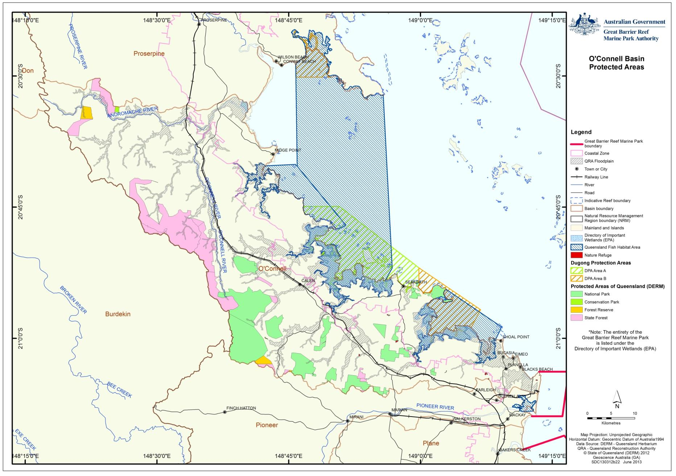
Figure 2.2.1: This map shows the spatial extent of some values in the O’Connell basin that may underpin matters of national environmental significance, including Nationally Important wetlands, National Parks, Conservation Parks, forest reserves, Fish Habitat Areas, Dugong Protection Areas and Nature Refuges

Coastal Ecosystems
The Great Barrier Reef inshore ecosystems are made up of many complex components, including estuarine and marine ecosystems such as mangroves, seagrasses and inshore coral reefs, which are closely linked to adjacent coastal ecosystems. These include coastal freshwater wetlands, coastlines and forested floodplains (Figure 2.3.1). These coastal ecosystems are interconnected and reliant on one another for their ongoing health and resilience. Species that form part of the amazing biodiversity of the Marine Park live in and move between these ecosystems throughout their life cycles.

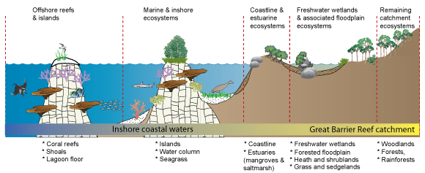
Figure 2.3.1 Broad groupings of coastal ecosystems illustrating the general level of importance for the ongoing health and resilience of the Great Barrier Reef

Coastal ecosystems are not easily separated and defined, as functionally they are all connected one way or another. Each component provides specific ecological functions that together make up and support the health and resilience of the ecosystem as a whole.

Inshore marine ecosystems
The inshore coastal waters adjacent to the O’Connell basin are home to a range of marine flora and fauna, many of which are of conservation concern. Figure 2.3.2 shows the reefal and non-reefal bioregions in the area that were used as the basis for the Great Barrier Reef Marine Park Authority assessment zoning plan. Figure 2.3.3 shows the Marine Park zoning plan.
The species richness of hard corals in the waters adjacent to the O’Connell basin is low and ranges from 21 to 43 species, with richness increasing towards the north.

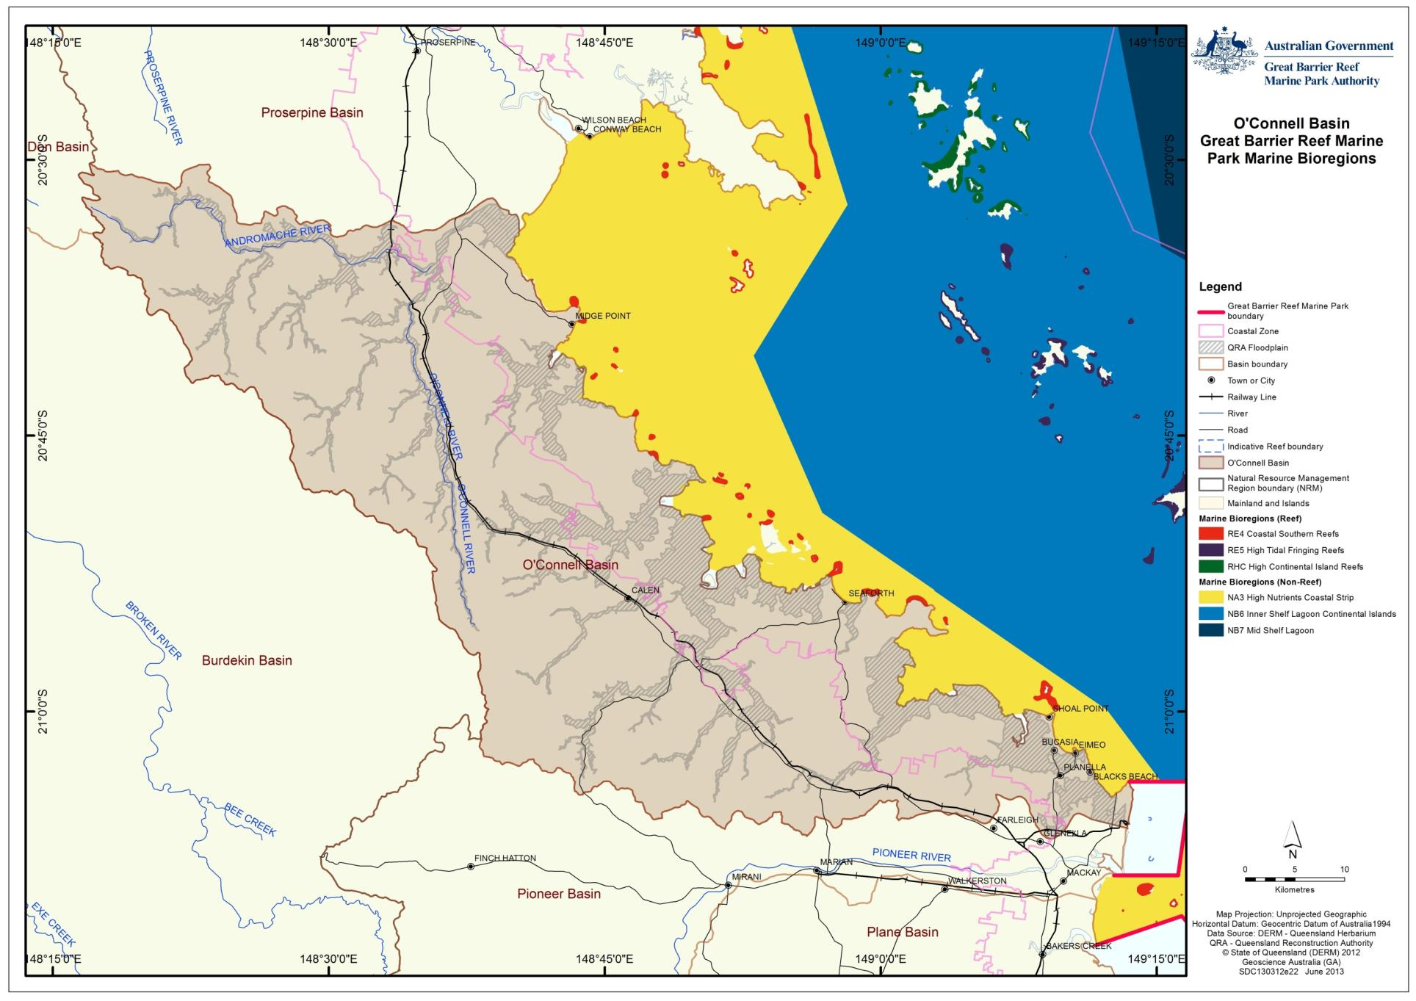
Figure 2.3.2: Marine bioregions adjacent to the O’Connell basin
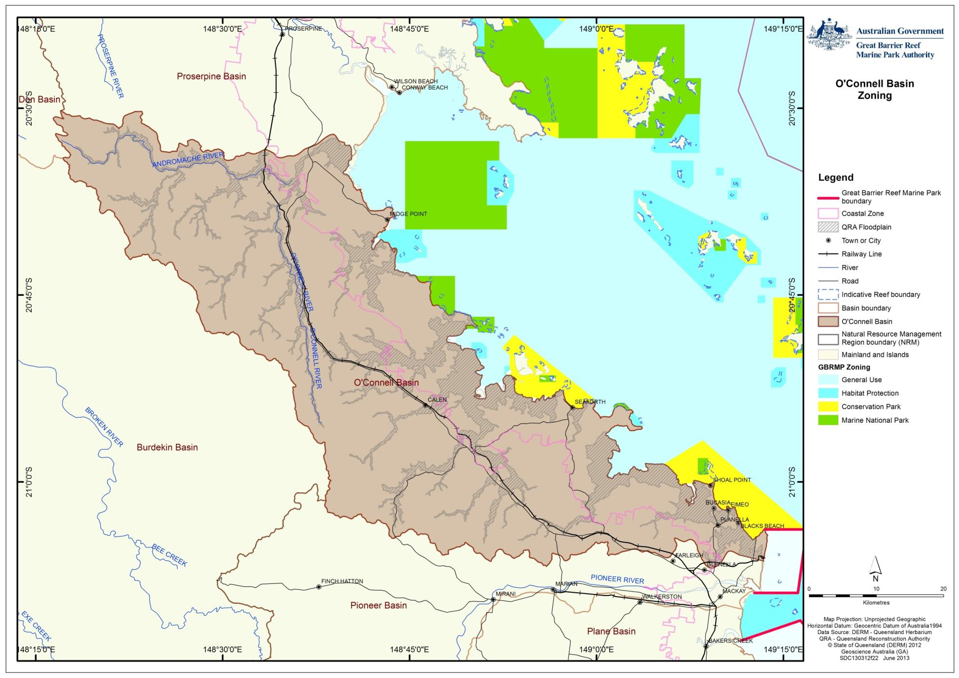
Figure 2.3.3: Zoning within the Marine Park adjacent to the O’Connell basin

Flood plumes from the O’Connell and adjacent basins in this region have been shown to extend beyond the World Heritage Area. Approximately 250 km of coastline, 74 offshore islands, 211 coral reefs (covering an area of 1906 km²), 71 seagrass beds (covering an area of 186km²) and 31,760km² of seabed is at risk of exposure to one or more water quality concerns (sediments, nutrients or pesticides).

Seagrass meadows occur in the waters adjacent to the O’Connell basin. Due to the poor water clarity of coastal waters in this region, seagrass monitoring is limited. Intertidal seagrass mapping is conducted under the Reef Plan Marine Monitoring Program (MMP).
Intermittent seagrass mapping has also been undertaken by the Queensland Government over 30 years and a cumulative map is shown in Figure 2.3.4. Seagrass extent and health (reproductive effort) has been in decline over the last five years.³

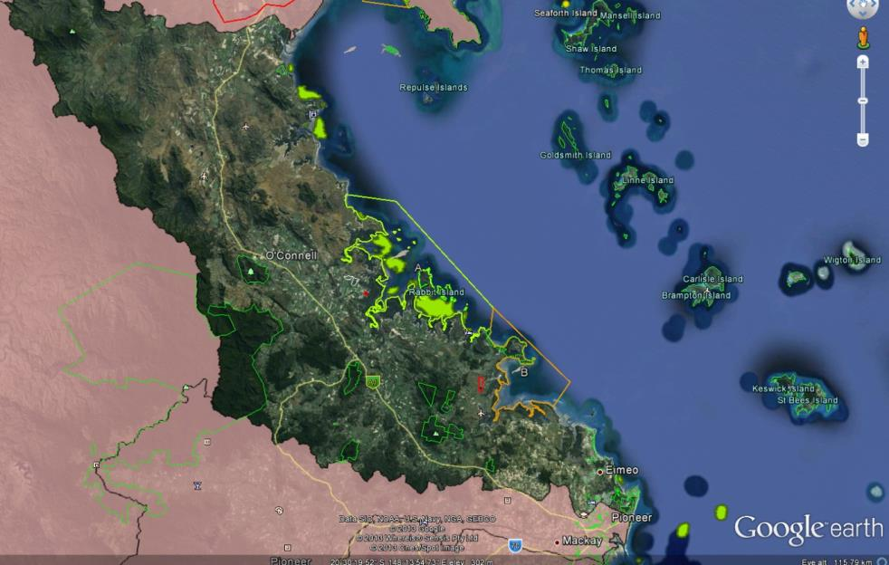
Figure 2.3.4: Map showing the extent of seagrass (shown in green) in the O’Connell basin, as mapped by the Queensland Government from 1988 to 2012

In 2009, the Reef Water Quality Protection Plan baseline report stated that the inshore reefs in the Mackay Whitsunday region were in moderate condition.¹⁴ There was concern about the lack of recovery of these reefs as there had been no obvious natural disturbances since they were impacted by coral bleaching in 2002. Settlement of coral larvae was good in 2009 although recent data shows signs of decline and the numbers of juvenile corals are also in decline, which may have been due to low coral cover limiting the availability of coral larvae.⁸ Since then, these reefs have been impacted by Tropical Cyclones Hamish (March 2009), Ului (March 2010) and Yasi (February 2011).

Coastal ecosystems
Coastal ecosystems in the O’Connell basin have been substantially modified or cleared. Significant changes include:
- Broadscale clearing of forests, woodlands and lowland grass, and sedgelands.
- Introduction of pasture grasses that have forever changed the flora biodiversity and the fire regime. These African and South American grasses burn hotter causing significant changes to biodiversity (such as the loss of native riparian vegetation) and lead to loss of soils.
- Aquatic biodiversity and in-stream habitat has declined in many parts of the basin as a result of landscape changes and land use. Irrigated cropping, grazing and urban infrastructure are the dominant land uses on the floodplain which have had the greatest impacts on biodiversity.
- Introduced fauna – feral pigs, fish and introduced flora – hyacinth, hymenachne and other aquatic and terrestrial weeds are impacting on the remaining coastal ecosystems.
Changes in land use have left ongoing legacy issues (such as ponded pastures), which continue to impact on the life history of local aquatic and terrestrial species with connections to the World Heritage Area (such as migratory birds and fish) leading to an ongoing decline in local species diversity. The risk to biodiversity can be reduced through sustainable grazing management.

In pre-European times, the O’Connell basin was dominated by forests and woodlands (Figure 2.3.5). Since European settlement, these forested areas have been thinned for grazing and later cleared (in some areas) (Figure 2.3.6).

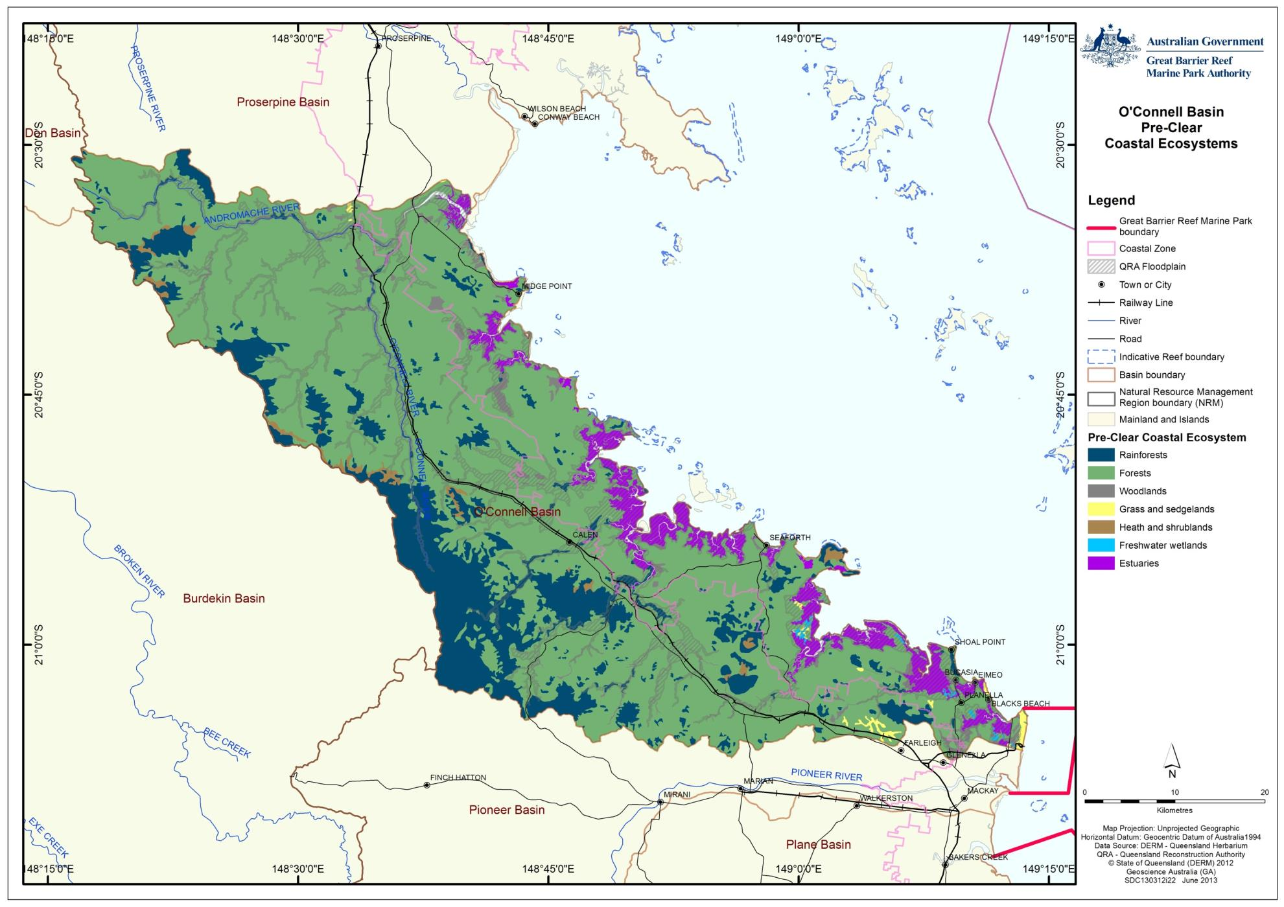
Figure 2.3.5: This map shows the pre-clear coastal ecosystems in the O’Connell basin
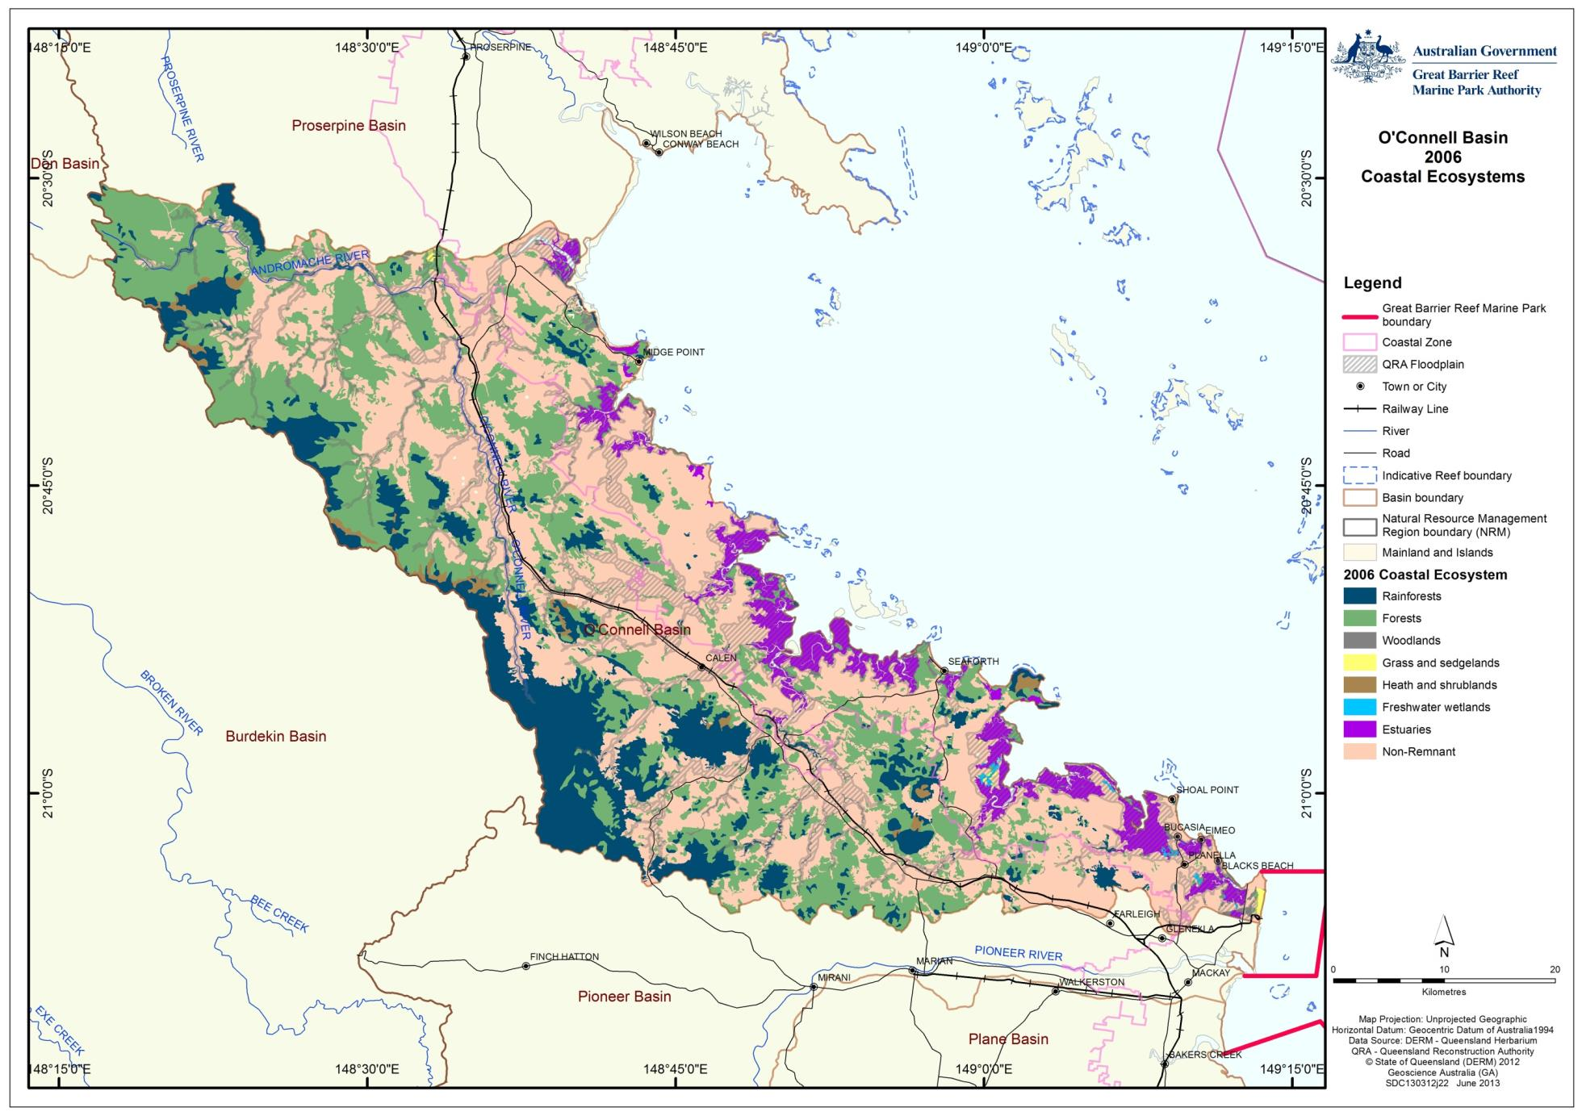
Figure 2.3.6: This map shows the post-clear coastal ecosystem assemblages in the O’Connell basin (derived from 2006 Queensland government Regional Ecosystem data)

The changes to coastal ecosystems (Table 2.3.1) show that the greatest proportion of modification to terrestrial biodiversity has occurred to woodlands (loss of 64 per cent), grass and sedgelands (loss of 71 per cent) and forests (loss of 59 per cent). Between 2006 and 2009, 408 hectares of coastal ecosystems were modified, those being 381 hectares of forest, 10 hectares of rainforest and 17 hectares of woodlands.

Table 2.3.1: Area (ha) of pre-clear and post-clear coastal ecosystems based upon Queensland Government Regional Ecosystem mapping

 | Ecosystem | Pre-clear | 2006 | 2009 | % remaining
 | Rainforests | 40,112 | 34,094 | 34,084 | 85
 | Forests | 175,522 | 72,498 | 72,117 | 41
 | Woodlands | 5,291 | 1,916 | 1,899 | 36
 | Forested floodplain | 0 | 0 | 0 | N/A
 | Grass and sedgelands | 893 | 261 | 261 | 29
 | Heath and shrublands | 2,072 | 2,060 | 2,060 | 99
 | Freshwater wetlands | 329 | 256 | 256 | 78
 | Estuaries | 13,004 | 12,681 | 12,682 | 98
 | Non Remnant | 0 | 113,368 | 113,775 | N/A
 | Not Mapped | 1,475 | 1,565 | 1,565 | N/A

Coastline and estuarine coastal ecosystems
The coastal zone within the O’Connell basin covers 71,760 hectares, 20,337 hectares of which is afforded protection in National Parks, Conservation Parks and Protected Areas.

Estuaries are highly productive fish nursery areas and provide a range of ecological functions for species with connections to the World Heritage Area. Animals such as prawns, crabs and many popular commercially and recreationally fished species (such as barramundi and mangrove jack) use estuaries for part of their life history. Approximately three per cent of the estuaries in the World Heritage Area occur in the O’Connell basin which equates to $2.6 million of gross value of production of fisheries harvest per year.

The extent of estuaries in the O’Connell basin has remained relatively unchanged (loss of three per cent) according to Queensland Government Regional Ecosystem mapping (Table 2.3.1). There are six estuarine ecosystems in the O’Connell basin that experience a tidal range of around four metres. The condition of the 11 estuaries in the O’Connell basin was assessed by the Australian Natural Resources Atlas in 2000 (Table 2.3.2).¹⁵

Table 2.3.2: Australian Natural Resource Atlas (ANRA) classification of estuaries for the O’Connell basin
Name of estuary | Class | Sub-class | Condition
O'Connell River | River Dominated | Tide-Dominated Delta | Largely Unmodified
Dempster Creek | Tide Dominated | Tidal Flat/Creek | Near Pristine
Hervey Creek | Tide Dominated | Tidal Flat/Creek | Largely Unmodified
Blackrock Creek | Tide Dominated | Tide-Dominated Estuary | Largely Unmodified
Murray Creek | Tide Dominated | Tide-Dominated Estuary | Largely Unmodified
Victor Creek | Tide Dominated | Tidal Flat/Creek | Largely Unmodified
Plantation Creek | Wave Dominated | Strandplain | Largely Unmodified
Estuary Q221 | Tide Dominated | Tidal Flat/Creek | Largely Unmodified
Constant Creek | Tide Dominated | Tide Dominated-Estuary | Largely Unmodified
Reliance / Leila Creek | Tide Dominated | Tidal Flat/Creek | Largely Unmodified
Estuary Q223 | Tide Dominated | Tidal Flat/Creek | Modified

The Healthy Waterway Mackay Whitsunday Water Quality Improvement Plan for the Mackay Whitsunday region assessed estuary health in 2008 considering fish community, water quality, flow, estuary modification and mangroves and saltmarsh as indicators.²

Midge Point, a coastal settlement (Figure 2.3.7) south of Laguna Quays was assessed to be in relatively good condition. To the south is a good example of remnant swale forest, presently on freehold land.

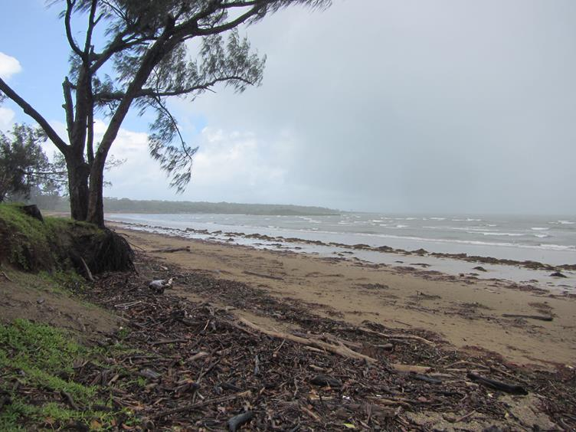
Figure 2.3.7: The beach at Midge Point coastal settlement

The Waterhole Creek estuary is a heavily grazed sub-basin and vegetation has been cleared to the coast/waterfront in many areas. Lack of dune stabilisation provided by vegetation is exacerbating coastal erosion.

The beach at the southern end of this clearing, St Helens Beach (Figure 2.3.8), is an important site for shorebirds including pied oyster catchers, stone curlews and international migratory species including bar-tailed godwit, eastern curlew, great knot and grey-tailed tattier. These birds are recognised as matters of national environmental significance.

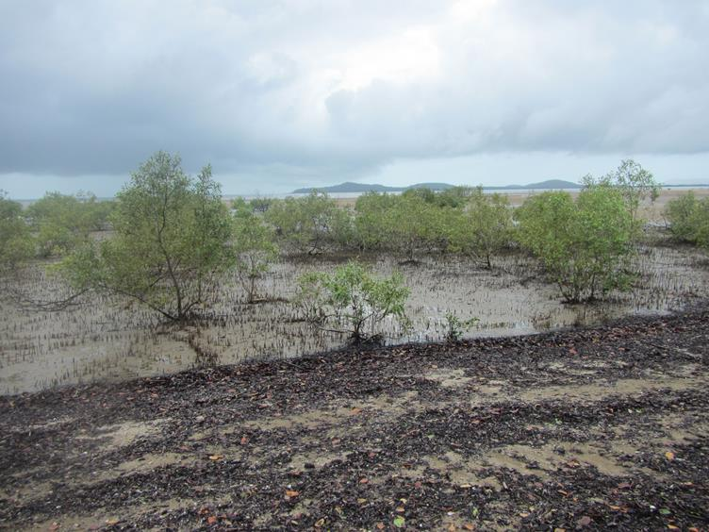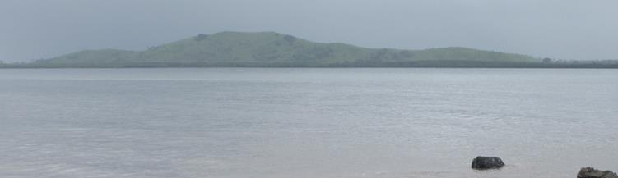
Figure 2.3.8: St Helens Beach is an important breeding and nesting ground for local shorebirds and international migratory bird species (top). North of St Helens Beach the coastal land is relatively devoid of trees (including coastal vegetation in places) (bottom)

Inland from St Helens Beach are where good representative examples of near pristine, well connected saltmarsh-woodland interfaces remain (Figure 2.3.9). These coastal ecosystems are currently afforded protection within the National Park.

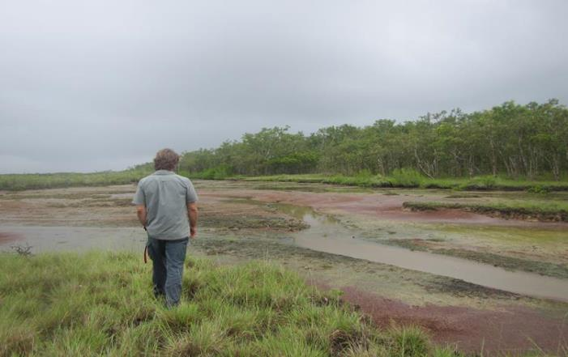
Figure 2.3.9: Interface between saltmarsh and woodlands near St Helens Beach is a good example of relatively natural estuary in this region

Freshwater wetlands and associated floodplain coastal ecosystems
Approximately 41,876 hectares of the O’Connell basin is located on the floodplain (0.5 per cent of the floodplain extent in the Reef catchment). Within this sensitive environment only 14,600 hectares is afforded protection through conservation areas in this basin (36 per cent).

Around 67 per cent of grass and sedgelands have been highly modified or removed in the O’Connell basin. During the Great Barrier Reef Marine Park Authority assessment in February 2013, remnant grass and sedgelands were being cleared to accommodate the expansion of urban sub-divisions. Freshwater wetlands in the basin assessed under the coastal ecosystems mapping showed no change in extent however ponded pastures (bunded tidal areas that retain freshwater) may have offset some of the loss of extent of freshwater wetlands.

The Queensland and Australian governments through the Queensland Wetlands Program have mapped wetlands within the O’Connell basin at a finer scale than the current regional ecosystem mapping (Table 2.3.3).¹⁶ Through this mapping, approximately 170 lacustrine/palustrine wetlands were identified in this basin in 2009. Reef Plan reporting showed a loss of 0.03 per cent of wetlands between 2001 and 2005. Many of the wetlands observed remain amongst cane fields (Figure 2.3.10).

Table 2.3.3: Queensland Wetlands Program data for the freshwater and estuarine wetlands of the O’Connell basin
System as defined by the Queensland Wetlands Program | Area (km²) | Wetlands area (%) | Total area of basin (%)
Artificial and highly modified | 5.08 | 3.0 | 0.2
Estuarine (wetland vegetation only) | 128.29 | 75.2 | 5.4
Lacustrine | 0.14 | 0.1 | 0.0
Palustrine | 6.79 | 4.0 | 0.3
Riverine | 30.25 | 17.7 | 1.3
Total | 170.55 | 100.0% | 7.1&

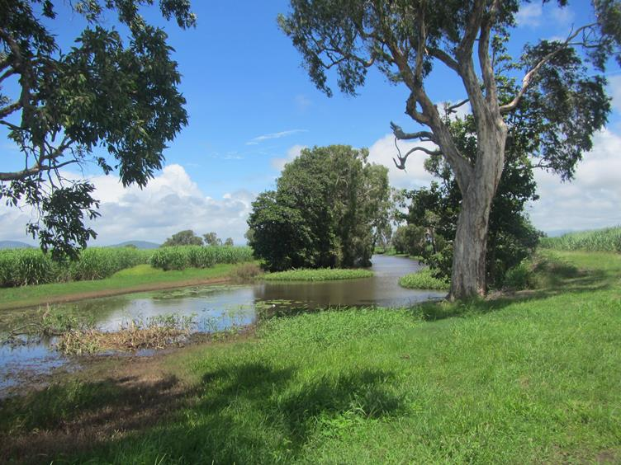
Figure 2.3.10: Remnant lagoon in the lower O’Connell River floodplain set amongst cane fields

Nindaroo wetland complex

Nindaroo is a high value remnant wetland close to Mackay (Figure 2.3.11). Coastal development is encroaching on this site and the Reliance Creek estuary. This wetland offers high value habitat for species such as barramundi.
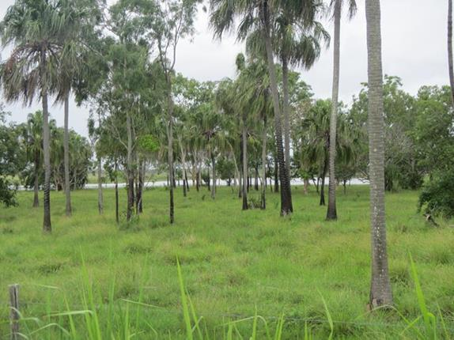
Figure 2.3.11: Nindaroo, a high value remnant wetland containing Melaleuca and palm forests

St Helens Creek sub-basin

The St Helens Creek sub-basin is a granite-dominated basin with good base flow from the National Park located in the upper sub-basin. During the field assessment, water clarity cleared quickly after the first flush and migratory fish (Mugil cephalis) were observed in the middle reaches of the creek. The banks in the middle reach were lacking riparian vegetation and established introduced grasses were observed (Figure 2.3.12). Sand and cobble build up (possibly from observed bank erosion) appears to be making the creek shallower, which in turn is widening the creek causing further bank erosion.

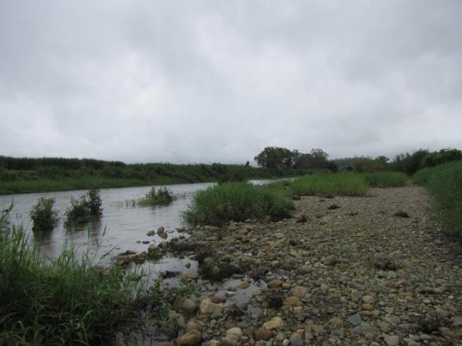
Figure 2.3.12: St Helens Creek middle reaches, showing a build-up of sand and cobble (foreground) and cane growing above the eroding bank (background)

Jolimont Creek, a tributary of Murray Creek, drains a large area of alluvial flats consisting mostly of cane land. On this tributary there are many impediments to flow and evidence of bank erosion due to lack of riparian vegetation was observed (Figure 2.3.13).
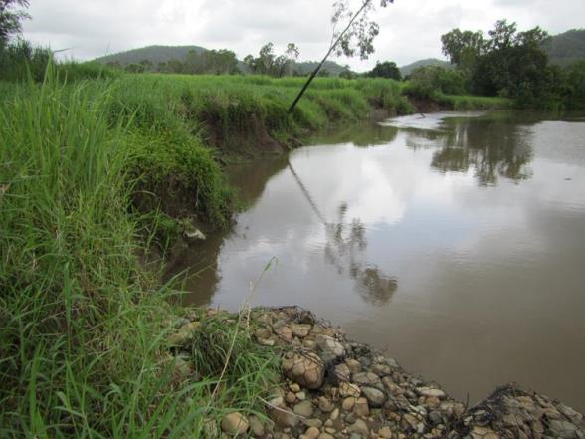
Figure 2.3.13: Jolimont Creek - tributary of Murray Creek

Forested coastal ecosystems
Forests and woodlands have experienced the greatest losses within the O’Connell basin (59 and 64 per cent or 103,024 hectares and 3375 hectares respectively). Some 15 per cent (or 6019 hectares) of rainforests have been lost (from an initial area of 40,112 hectares). Between 2006 and 2009 mapping, forest ecosystems declined by a further 381 hectares. All other terrestrial coastal ecosystems were unchanged.

In some areas, there has been complete removal of riparian vegetation and this has resulted in severe bank erosion (Figure 2.3.14).
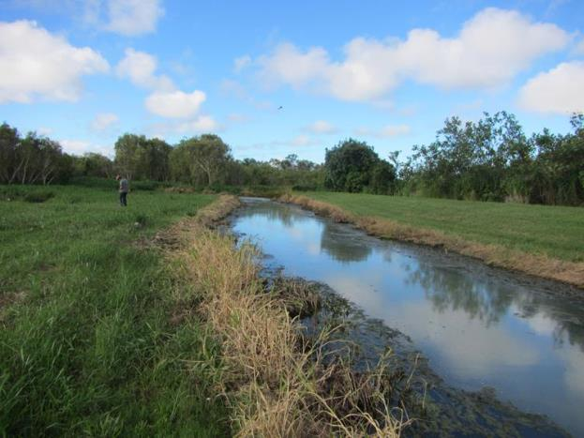
Figure 2.3.14: The riparian vegetation has been totally removed from this creek in the O’Connell basin

Widespread clearing of hill slopes in the northern part of the O’Connell basin was observed during the Great Barrier Reef Marine Park Authority field assessment (Figure 2.3.15). This loss of vegetation in the basin has added to the sediment load in many of the sub-basins.

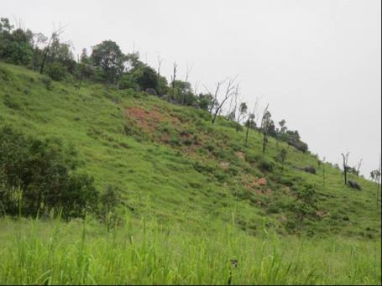
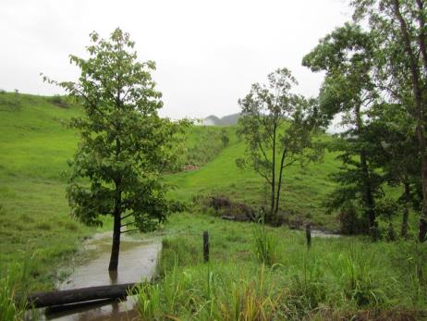
Figure 2.3.15: Hillside erosion is due to clearing of terrestrial forested ecosystems. The image on the left shows the high level of suspended sediments in the run-off

The Queensland Government has assigned regional ecosystems a conservation status which is based on its current remnant extent (how much of it remains) in a bioregion. Regional ecosystems were originally defined by Sattler and Williams as vegetation communities in a bioregion that are consistently associated with a particular combination of geology, landform and soil.¹⁷ Vegetation that is classified as endangered is afforded most protection in Queensland; however some industries such as mining, transport, electricity and community infrastructure may be exempt. Lesser protection is afforded by the other categories.

These have been mapped for the O’Connell basin (Figure 2.3.16). Information on regional ecosystems provides the basis for the development of coastal ecosystem functional groups identified in the Coastal Ecosystem Assessment Framework.⁷ However regional ecosystem conservation classification is based on terrestrial distribution, and does not assess their functional linkage to the World Heritage Area. Regional ecosystem conservation classifications most likely do not protect coastal ecosystems most important to maintaining the health and resilience of the World Heritage Area.

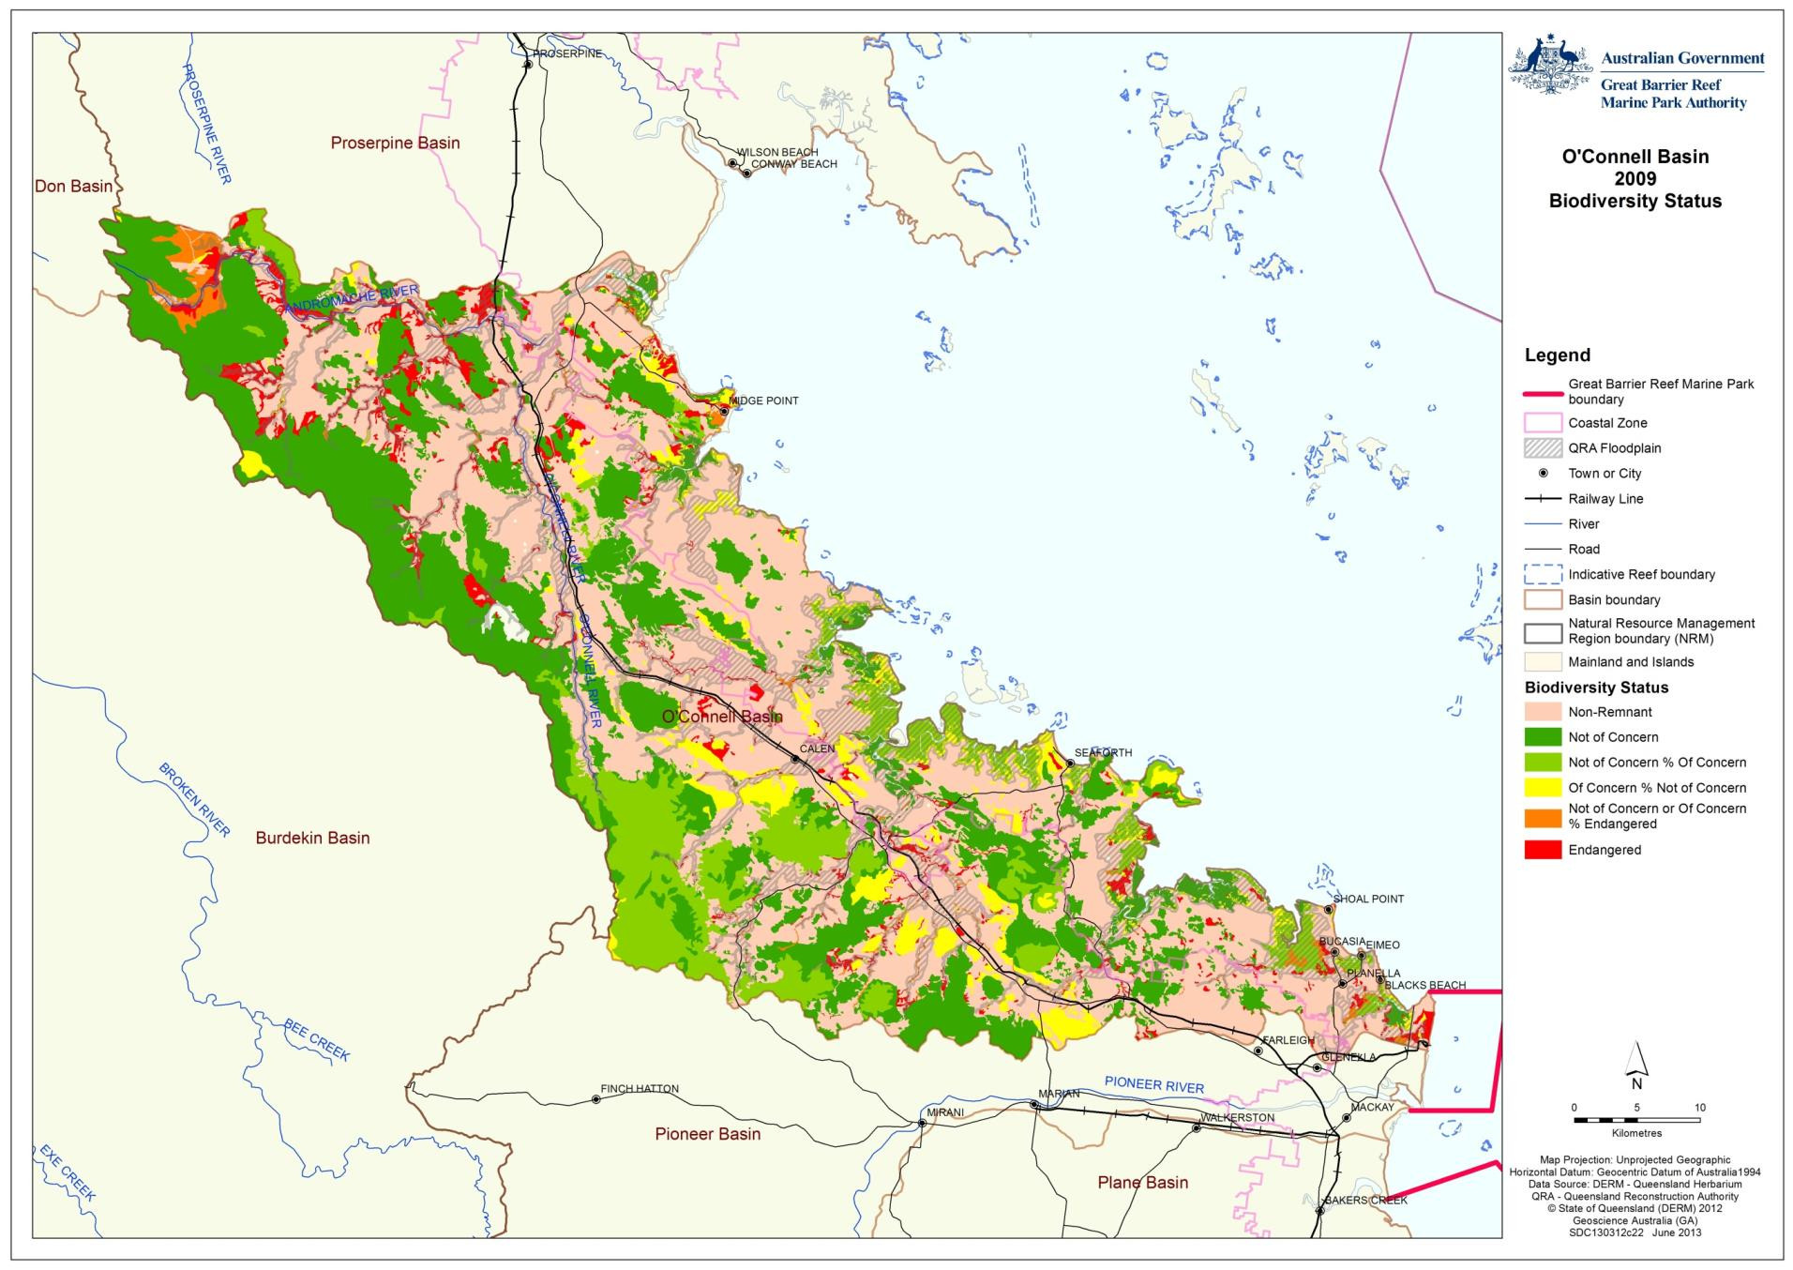
Figure 2.3.16 Regional ecosystem conservation status for the O’Connell basin

Ecosystem processes
The condition of ecosystem processes in the O’Connell basin varies both spatially and temporally. Areas that have been highly modified from the natural coastal ecosystems that were once there show the greatest degree of change in processes. For example rivers that have been modified into water distribution channels offer limited capacity for biological processes for fish species such as reproduction, dispersal recruitment and migration and are often nutrient enriched.

Appendix F contains a list of coastal ecosystems and some of the ecological processes they deliver for the health and resilience of the World Heritage Area.

Physical processes
Physical processes are those that transport and mobilise elements such as water, sediments and minerals. They include groundwater recharge/discharge, sedimentation/erosion of soils and deposition and mobilisation processes.⁸ All coastal ecosystems provide these functions, some more than others. Declines in delivery of physical processes that retain sediments are generally reflected by an increase in total suspended solids.

Changes in hydrology have occurred as a result of land use change (such as land clearing, grazing and urbanisation, leading to surface compaction and reducing soil porosity, and increased sediment loss to erosion in streams), barriers (such as dams, weirs and road/rail crossings), groundwater extraction, floodplain drainage networks and changing rainfall patterns as a result of climate change. These actions have irreversibly altered run-off quality, quantity and seasonality of flows, and sediment build up in river beds. Storm intensity in recent years has delivered sudden large pulsed flows of freshwater into the World Heritage Area. These flows often have reduced residence times in the basin and the supporting coastal ecosystems sufficient for many ecological processes to occur. As a result, freshwater induced coral bleaching and smothering of corals and seagrass by sediments is occurring more frequently.¹⁸ Water extraction has reduced flows and also resulted in increasing sedimentation of rivers. Reduced high velocity flows inhibit sediment movement along these watercourses. As these rivers fill with sediment (sand) they become shallower and wider. This changed hydrology results in scouring and erosion of banks during pulses from storm events, which impacts on World Heritage Area inshore ecosystems by increasing turbidity.

Elevated levels of sediment (fine and coarser sediments) have been reported in all of the sub-basins in the O’Connell basin.² These elevated levels of sediments are being delivered to the Great Barrier Reef lagoon in pulsed flows. Coarser sediments are building up in river beds. This build-up of coarse sediments fills the waterholes, making the waterway shallower, which in turn can cause a widening of the river (further eroding the adjacent banks, adding more sediment to the system).

The Reliance Creek sub-basin is dominated by cane fields (38 per cent of the area) with a further 32 per cent used for grazing.² During the site visit high levels of suspended sediments were observed (Figure 2.4.1).
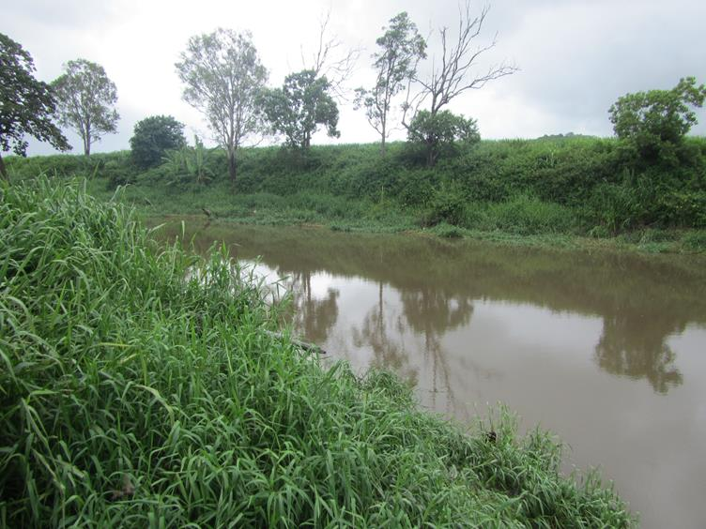
Figure 2.4.1: High levels of fine sediments in the Reliance Creek sub-basin following heavy rain

In other systems where substantial modifications have occurred, the lack of ecological processes can sometimes be obvious. Figure 2.4.2 shows the progression of Murray Creek from upland areas with minor modifications, to the estuaries where the cumulative impacts are more apparent.
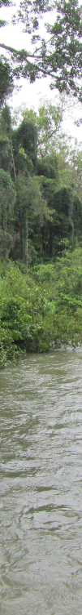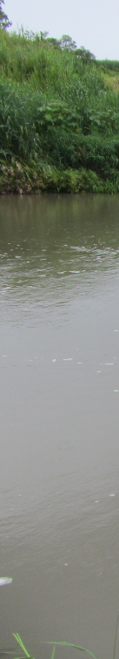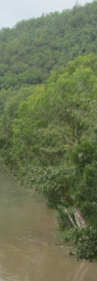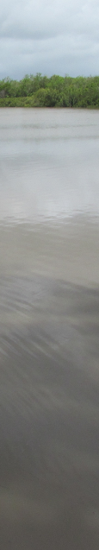
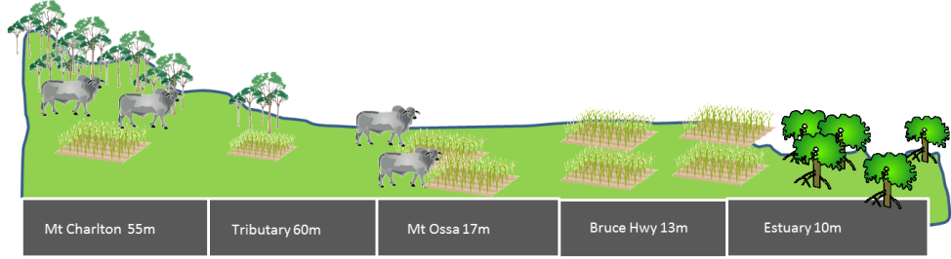
Figure 2.4.2: Murray Creek transects from the upper sub-basin (top) to the estuary (bottom) showing the increases in sediment load as water progresses towards the marine park. The diagram beneath the photos show the location in the sub-basin and elevation above mean sea level (approximate)

The dominant source of sediments (85 per cent) supplied to streams within the Mackay Whitsunday region is from hill slope erosion.¹⁹ The majority (80 per cent) of this sediment is then exported to the Great Barrier Reef lagoon, while the remainder is deposited in major water storages (16 per cent) and floodplains (three per cent). The relative proportion of bank erosion is high (14 per cent) in the O’Connell basin due to large contributing areas and increased stream bank height.¹⁹ Due to the absence of water storages in the O’Connell basin, very little (three per cent) of the supplied sediment is stored in the stream channel in comparison to the floodplain (76 per cent).¹⁹

Biogeochemical processes
Biogeochemical processes revolve around energy and nutrient dynamics. Biogeochemical processes include production, nutrient cycling, carbon cycling, decomposition, oxidation-reduction, regulation processes and chemical/heavy metal modification. Wetland and associated floodplain ecosystems offer the greatest capacity for maintaining biogeochemical processes as these ecosystems slow the flow of water and allow the processes to occur, or in the case of groundwater utilise the slow processes of water flow to recycle water and nutrients.

During large flood events biogeochemical processes in coastal ecosystems often do not occur as water flows at high speed directly into inshore coastal waters. In more developed basins, the volume of nutrients is often higher as a result of fertiliser use and point source discharges. These processes are thus transferred to inshore coastal waters. Impacts of elevated nutrients on the marine environment are outlined in Table 2.4.1.

Elevated nutrients in inshore coastal waters indicate that the coastal ecosystems are not able to regulate the biogeochemical processes. This is likely due to increased run-off and elevated inorganic nutrients from agricultural and urban sources which often discharge directly into waterways.
Table 2.4.1: Forms of nutrients and their impact on the aquatic environment
Term | Description/source | Impact on aquatic environment
Particulate organic matter | Large particles of organic matter (e.g. dead plants and animals) that get broken down by decomposers into smaller dissolved organic matter. | Not available for uptake by plants and animals.
Dissolved organic matter (DOM) | Large molecules of organic matter (nitrogen, carbon, phosphorus etc.) produced as a result of decomposition. | Not biologically available until broken down by bacteria.
Dissolved inorganic matter | By-product of bacterial decomposition of DOM or applied in this form as fertilisers. | Nutrients such as nitrogen and phosphorus are freely available in this form for uptake by cyanobacteria, plants and animals.

In areas where healthy coastal ecosystems remain intact and are in locations where very few impacts are occurring, the biogeochemical processes listed above are occurring as expected. Figure 2.4.3 shows healthy microphytobenthos on the tidal saltflats near St Helens Beach, these salt flats are tidal and receive minimal run-off from adjacent lands. The microphytobenthos growing here are very efficient nutrient cyclers.

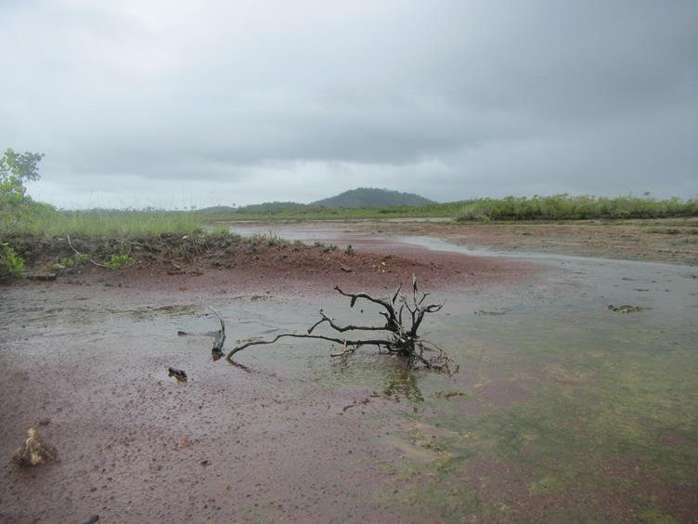
Figure 2.4.3: Saltmarsh environment at St Helens Beach has a healthy population of microphytobenthos (cyanobacteria) that provide important ecological functions to the World Heritage Area

Biological processes
Biological processes are those that maintain animal and plant populations. These include survival/reproduction mechanisms, dispersal/migration/regeneration, pollination and recruitment. Wetland and associated floodplain ecosystems offer the greatest capacity for maintaining biological processes.

The lower O’Connell River is an older sugar cane growing area consisting of small holdings with extensive networks of cane drains. In some places sugar cane is grown on the marginal land up to the estuary which may be impacting on biological processes. Small, unconnected lagoons remain in the areas and these appear to be in reasonable condition.

The Healthy Waterways Water Quality Improvement Plan for the Mackay Whitsunday region assessed fish community and in-stream habitat for each sub-basin in the region (Table 2.4.2).² Great variability between sub-basins in the O’Connell basin is apparent.

Table 2.4.2: Reef Catchments NRM group assessment of fish community and in-stream habitat, used as proxies for biological processes. Assessment is ranked highest condition (A) to lowest condition (E)
 | Freshwater rating |  | Estuarine rating
 | Fish community | In-stream habitat | Fish community
Andromache River | B | B | N/A
O’Connell River | C | C | C
Waterhole Creek | B | C | B
Blackrock Creek | D | C | B
St Helens Creek | B | C | B
Murray Creek | D | C | B
Constant Creek | D | C | C
Reliance Creek | D | C | E
Mackay city | E | D | B

Connectivity
Aquatic ecosystem connectivity looks at how ecosystem components link up, whether through air, water or overland. Disruptions to connectivity between different areas where fish breed and grow can lead to a reduction in population resilience, or even localised extinctions of some species. Figure 2.5.1 shows the sub-basin waterways that were considered by this assessment. Figure 2.5.2 shows the stream orders (classification system where waterways are given an ‘order’ according to the number of additional tributaries associated with each
waterway) combined with land zones and elevation. These tools were used to assess connectivity.

Surface hydrology
There have been no extensive hydrological modifications (such as major dams) in the O’Connell basin. However smaller barriers such as road crossings are common and act as barriers to fish migrations (Figure 2.5.3). Work was recently undertaken to install fish ladders at Seaforth Creek Bridge by the Queensland Government and Reef Catchments NRM group to allow fish passage in areas where fish passage was previously impeded. This has resulted in movement of fish with connections to the World Heritage Area further upstream, theoretically improving fish productivity.

Increasing heavy sediment loads delivered into waterways as a result of land modifications can fill deepwater pools leading to a widening and shallowing of waterways. This was observed during field assessments in St Helens Creek and is likely to be occurring elsewhere. Shallowing and widening of waterways increases the likelihood of overbank flows and flooding of adjacent land whilst reducing habitat and connectivity (through loss of deep water pools for fish passage and refugia).

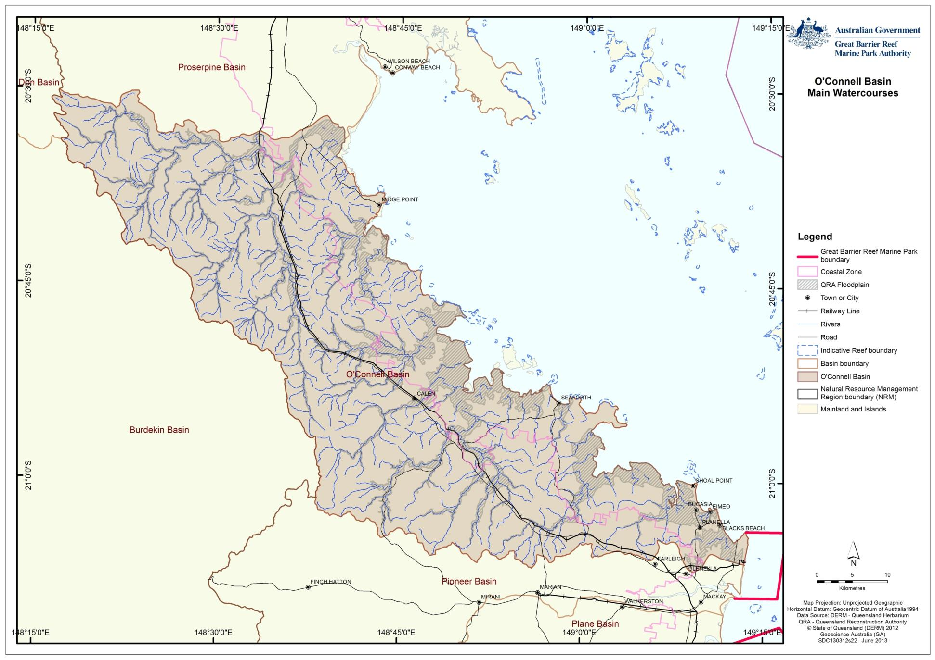
Figure 2.5.1: Major waterways in the O’Connell basin considered in this assessment

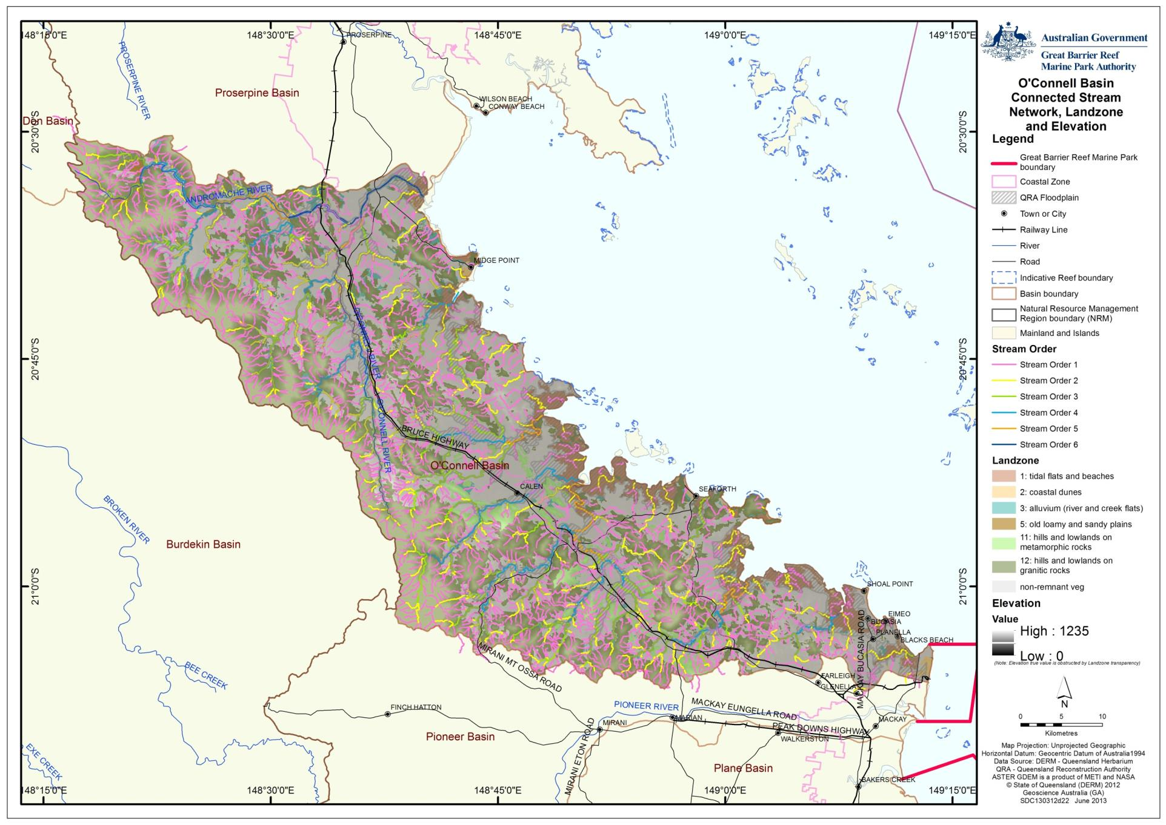
Figure 2.5.2: Stream order and elevation map showing the floodplain in the O’Connell basin

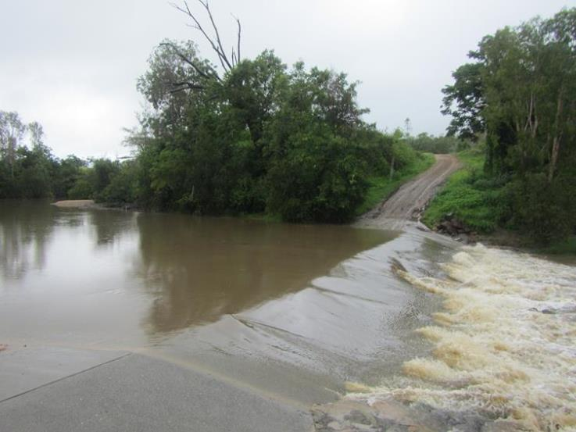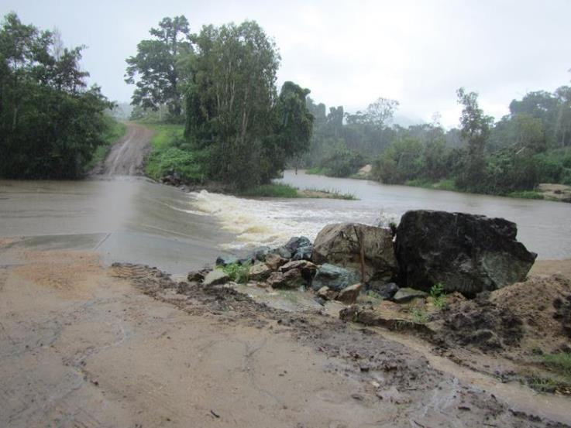
Figure 2.5.3: Road crossing (fish barrier) in the Andromache River during heavy wet season flows. The high rate of flow is impassable by slow moving native fishes

Road crossings, such as Figure 2.5.4 in the Reliance sub-basin, with wide openings and submerged rocks allow for greater fish passage. Unfortunately high turbidity and a lack of riparian vegetation is likely to reduce the suitability of this system for fish to migrate.

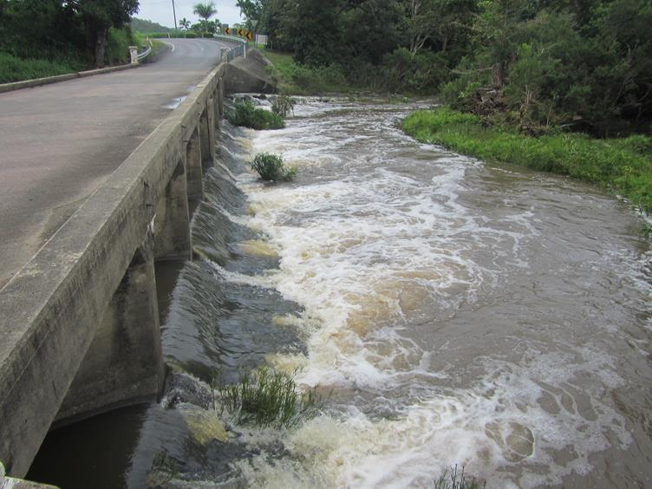
Figure 2.5.4: Reliance Creek sub basin – road crossing with fish ladder and fish friendly design
The urban development footprint around Mackay has significantly modified overland hydrology. Urban developments are designed to shed water quickly. Where urban developments are situated adjacent to mangroves (such as in the suburbs to the north of Mackay) water is often channeled directly into the mangroves (Figure 2.5.5). Such direct input of freshwater can impact on local populations of keystone mangrove species such as grapsid crabs (Figure 2.5.6).

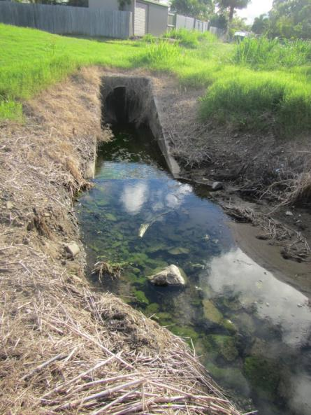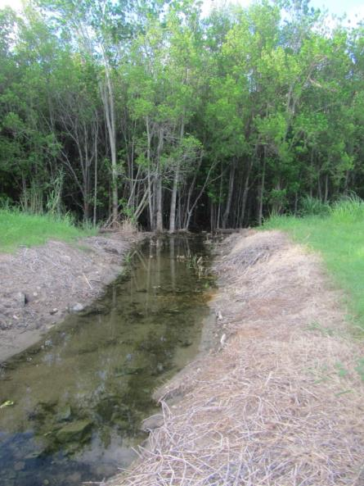
Figure 2.5.5: One of many stormwater drains in urban areas that flow directly into adjacent mangroves

Figure 2.5.6: Conceptual model showing the role crabs play in maintaining the health and resilience of mangroves

Groundwater hydrology
There were 299 licensed bores operating in the O’Connell basin in 2006, used mostly by irrigated sugar cane production.²⁰ These may be impacting on the dry season base flow of the Andromache River and therefore impacting on biological processes (such as fish reproduction and refugia) and on biogeochemical processes (such as aquatic cycling of nutrients).

- Impacts on the values

Drivers of change
The primary drivers of change for the O’Connell basin include vegetation cover and pattern, land use pattern and practices, hydrological modification, climate change, economic growth, population growth and technical development.

Climate change
The greatest impact from climate change will likely be to the coastal suburbs to the north of Mackay. Some of these suburbs have been built on low-lying in-filled wetlands and marsh areas situated on the floodplain adjacent to coastal estuaries. These will likely be impacted by sea-level rise in the long-term and storm surge associated with less frequent more intense cyclones in the short to medium term.

Remnant forests and low-lying rainforests in the O’Connell basin will be most affected by invasive plants and animals, changed fire regimes and extreme weather events that will become more commonplace as a result of climate change. Coastal wetland ecosystems will be impacted by sea-level rise, extreme weather events and changes in the water balance and hydrology as the demand for water increases.²¹ Table 3.1.1 shows the regional climate change predictions that will apply to temperature, rainfall, evaporation and extreme events.²²

Table 3.1.1: Regional climate change predictions for the Mackay Whitsunday region for temperature, rainfall, evaporation and extreme events
Element | Prediction
Temperature | Average annual temperature in the region has increased by 0.3ºC over the last decade (from 22.7ºC to 23.0ºC).  Projections indicate an increase of up to 4.2ºC by 2070, leading to annual temperatures well beyond those experienced over the last 50 years.  By 2070, Mackay may have twelve times the number of hot days over 35 º C (increasing from an average of one per year to an average of 12 per year by 2070).
Rainfall | Average annual rainfall in the last decade fell nearly 14 per cent compared with the previous 30 years. This is generally consistent with natural variability experienced over the last 110 years, which makes it difficult to detect any influence of climate change at this stage.  Models have projected a range of rainfall impacts from an annual increase of 17 per cent to a decrease of 35 per cent by 2070. A decrease in rainfall is expected.
Evaporation | Projections indicate annual potential evaporation could increase 7-15 per cent by 2070.
Extreme events | The 1-in-100-year storm tide event is projected to increase by 36 cm in Mackay if certain conditions eventuate. These conditions are a  30 cm sea-level rise, a 10 per cent increase in cyclone intensity and frequency, as well as a 130 km shift southwards in cyclone tracks.

Economic growth
Economic growth (from mining activity) has been the driver for much of the land use change that has occurred in the O’Connell basin. In recent times the collapse of the live cattle trade and rising economic value of sugar has driven a change in land use from grazing natural areas to irrigated sugar production.

Population growth
The Mackay region of Queensland is projected to grow strongly between 2006 and 2031. The Queensland Government forecast for Mackay is for an average annual population increase of 2.3 per cent, one of the highest rates of increase in Queensland.²³

Technological development
Technological developments such as the availability of low-cost heavy earthmoving equipment have forever changed the O’Connell basin. In more recent times, improvements to harvest and fertilising machinery have improved land management practices that are leading to reductions in sediments, nutrients and pesticide losses from agricultural land.

Activities and impacts
Historically, the dominant land use in the O’Connell basin was grazing. As irrigation practices improved in the early 20th Century, a shift towards irrigated sugar cane plantations emerged. Today the dominant land uses within the O’Connell basin remain as irrigated sugar and grazing and urban. Land use for 1999 and 2009 is shown in Table 3.2.1 and Figures 3.2.1 and 3.2.2. Note that the appearance of water-marsh/wetland production is a result of the recognition of this land use in 2009. These areas were previously classified as grazing natural areas or natural environments and do not reflect a shift to this land use.
Table 3.2.1: Major land use categories (hectares) for the O’Connell basin in 1999 and 2009 based on Queensland Land Use Mapping Program data
 | Land use area (ha) - O'Connell basin | 1999 | 2009
 | Conservation, natural environments (inc. wetlands) | 57,799 | 60,319
 | Forestry - production | 18,520 | 18,522
 | Grazing natural vegetation | 117,496 | 112,490
 | Intensive animal production | 619 | 60
 | Intensive commercial | 1,174 | 1,234
 | Intensive mining | 130 | 138
 | Intensive urban residential | 3,564 | 4,466
 | Production - dryland | 260 | 1,307
 | Production - irrigated | 37,329 | 37,042
 | Water - production ponded pastures | 0 | 613
 | Water storage and transport | 1,748 | 2,475
 | Not Mapped | 61 | 33
 | Total Area (h) | 238,699 | 238,699

Land use in the O’Connell basin has not changed significantly between 1999 and 2009. Some landholders of grazing, irrigated and non-irrigated properties have shifted from one to another however these changes are not widespread practices. From Figure 3.2.1 and Figure 3.2.2 the extent of irrigated sugar cane in the floodplain is obvious, with grazing occurring mostly in the northern part of the basin and greater protection of areas in the southern part of the O’Connell basin.

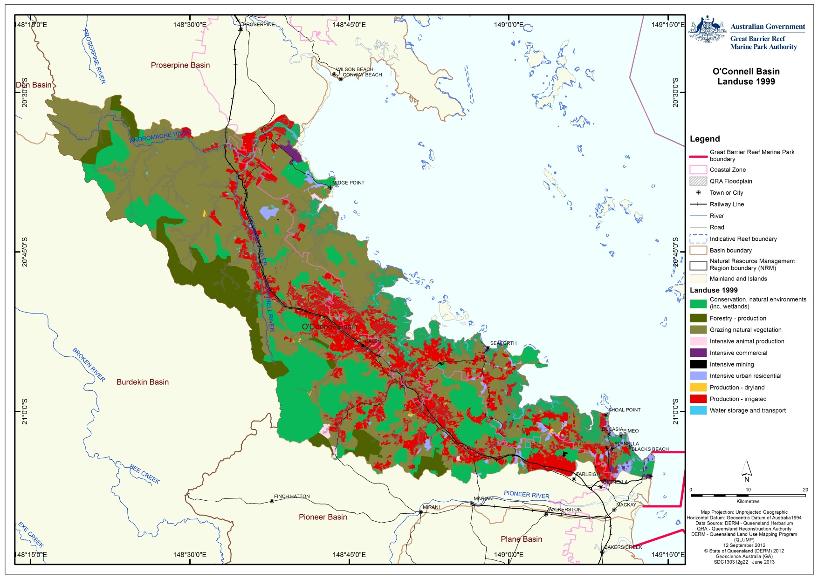
Figure 3.2.1: Map of land use for the O’Connell basin based on 1999 QLUMP data

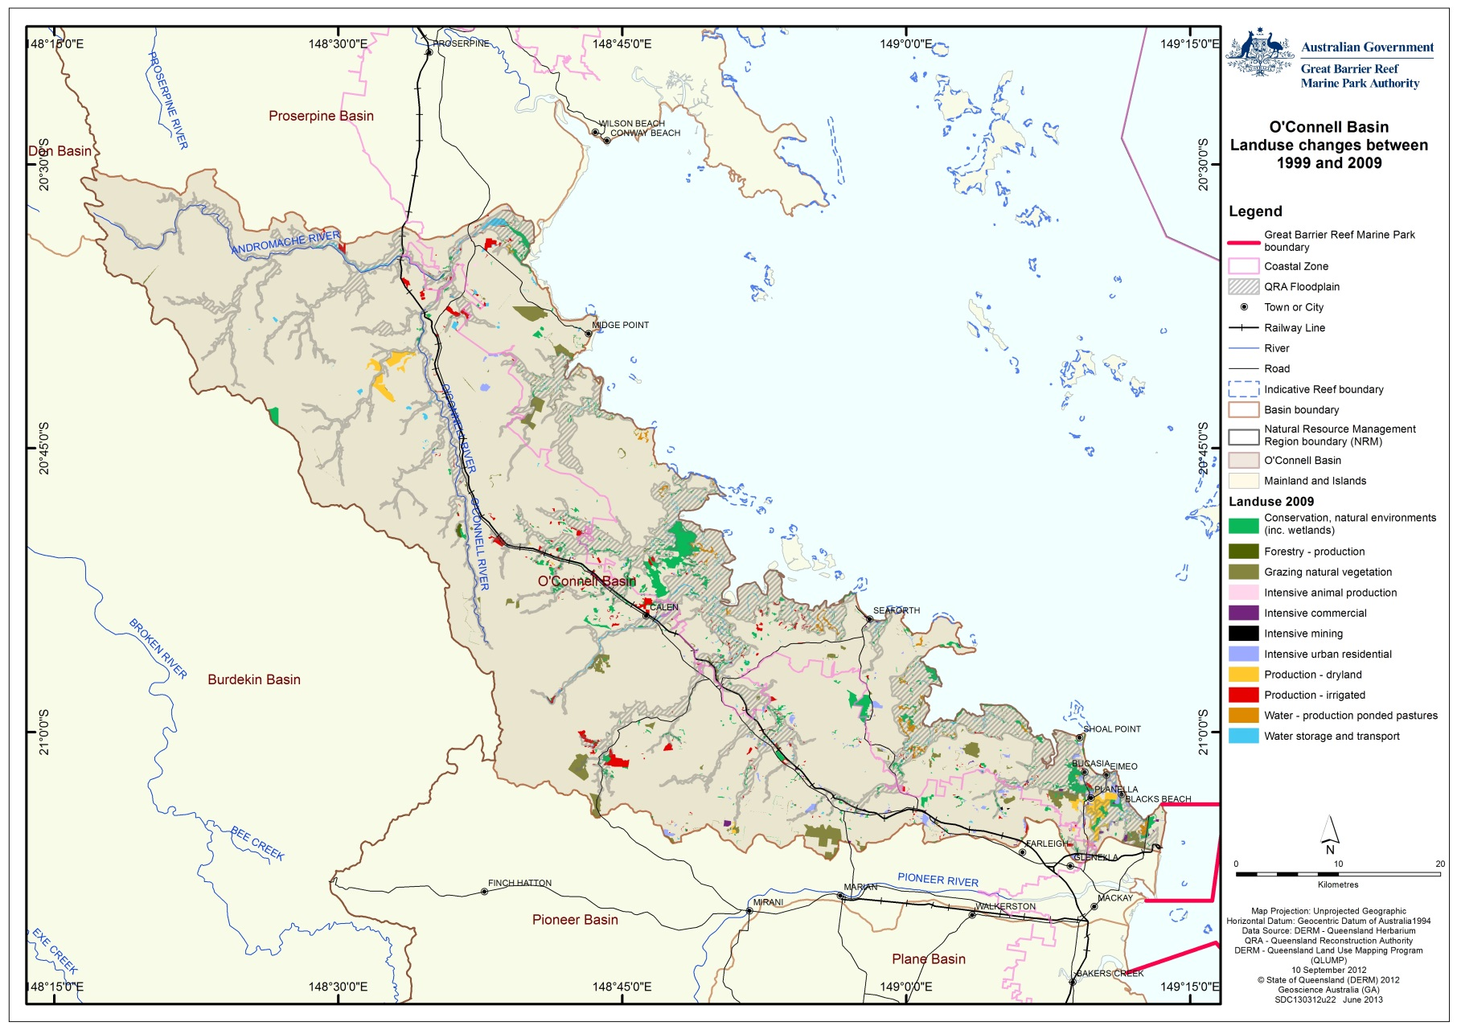
Figure 3.2.2: Map showing areas of changed land use in the O’Connell basin based on 1999 and 2009 QLUMP data

Land use within the coastal zone
Land use adjacent to the coast (the coastal zone) can have the greatest impact on the World Heritage Area’s inshore waters. The coastal zone includes Queensland’s coastal waters (which extend three nautical miles out to sea), coastal islands and land below 10 meters Australian Height Datum or within five kilometers of the coastline, whichever is greater. The land use occurring within the coastal zone for 1999 and 2009 is shown in Table 3.2.2.

The most prevalent land use in this region (outside of protected areas) is grazing of natural areas (600 hectares of which has been modified into ponded pastures), irrigated sugar plantations and urban residential.
Table 3.2.2: Major land use categories (hectares) for the O’Connell basin coastal zone in 1999 and 2009 based on Queensland Land Use Mapping Program data. Note the decline in Conservation, natural environments is due to greater resolution of mapping which has delineated the water-marsh/wetland production areas (ponded pastures)

 | Land use area (ha) - O'Connell Coastal Zone | 1999 | 2009
 | Conservation, natural environments (inc. wetlands) | 18,580 | 20,337
 | Forestry - production | 0 | 0
 | Grazing natural vegetation | 33,784 | 31,052
 | Intensive animal production | 137 | 15
 | Intensive commercial | 1,019 | 1,043
 | Intensive mining | 72 | 69
 | Intensive urban residential | 2,190 | 2,527
 | Production - dryland | 86 | 607
 | Production - irrigated | 14,544 | 13,822
 | Water - production ponded pastures | 0 | 613
 | Water storage and transport | 1,288 | 1,643
 | Not Mapped | 61 | 33

Actual and potential impacts
There have been some major landscape scale changes within the O’Connell basin which have been shown to impact on the receiving marine environment. Other developments in the basin may be relatively small in area, however may contribute significantly to the cumulative impacts on the World Heritage Area.

Forestry
There is 18,522 hectares of forestry in the O’Connell basin, 500 hectares of which is dryland plantation forestry and the rest is natural production forestry. The majority of this is located in the central west of the basin, with only 400 hectares located on the floodplain and none in the coastal zone. Impacts from forestry only become apparent at the time of harvest. The status of the forestry in the O’Connell basin was not assessed.

Grazing natural vegetation
In 2009, grazing of natural areas covered around 112,490 hectares of the O’Connell basin. This is a net decline in area of 5,006 hectares from 1999. This occurs mostly in much of the northern O’Connell basin (in the O’Connell and Andromache River and Waterhole, Constant and Murray Creek sub-basins). Grazing of natural areas occurs on 31,052 hectares of the floodplain (a reduction of 2,900 hectares from 1999) and 31,052 within the coastal zone (a decline of 2,500 hectares from 1999). Impacts vary according to the level of uptake of best management practice. The main impact is loss of topsoil as a result of over-clearing of hill slope vegetation (Figure 3.3.1). This widespread clearing is commonplace in the northern part of the O’Connell basin and substantial suspended sediments were observed in the waterways during the field assessment.

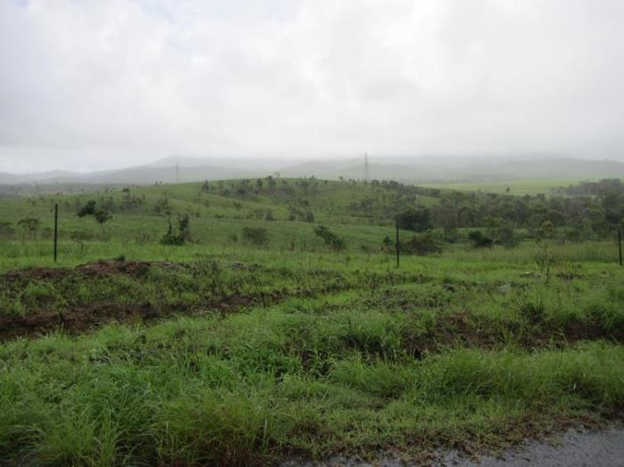
Figure 3.3.1: Cleared hill slopes used for grazing. Despite the good groundcover as a result of the wet season, erosion scars are evident

Highly flammable introduced pasture grasses (such as para grass and guinea grass) occur throughout the forest and woodland coastal ecosystems in many areas. Extremely hot fires are generated when these areas burn because of the elevated fire fuel load of these introduced grasses, which generally results in the loss of native vegetation and ground cover in these areas. Fires late in the dry season leave bare-scorched ground vulnerable to erosion at the commencement of the wet season. In areas where well managed grazing occurs, fire loads are often greatly reduced.

In some areas, low-level grazing of introduced grasses in the riparian zone was observed and this was having a positive effect on the maintenance of in-stream health (Figure 3.3.2). Where introduced grasses have become established, low-levels of grazing have been observed to have positive outcomes.

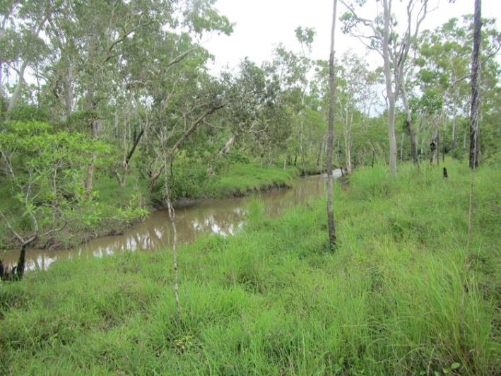
Figure 3.3.2: Grazing of the riparian zone can help maintain in-stream health in modified landscapes where introduced grasses have become established. This site had deep-water lagoons that provide good fish habitat although bank erosion was obvious in some areas

Overall, grazing natural areas declined by 5,006 hectares between 1999 and 2009 in the O’Connell basin. This land shifted towards dryland production, irrigated production, protected area estate and urban (rural residential) land use. Some of this land was also reclassified as ponded pasture.

Intensive animal production
A small area of coastal floodplain was used as an aquaculture facility for prawns but this has since closed. Overall intensive animal production declined by 60 hectares, with most of this shifting towards grazing land. These changes are unlikely to have any significant impact on the World Heritage Area.

Intensive commercial
There are many small fish barriers (primarily road crossings) located across the O’Connell basin. Many of these have had fish ladders installed recently by the Queensland Government to aid fish migrations. Some, like the road crossings (Figure 3.3.3) are still impassable by most native fish species.
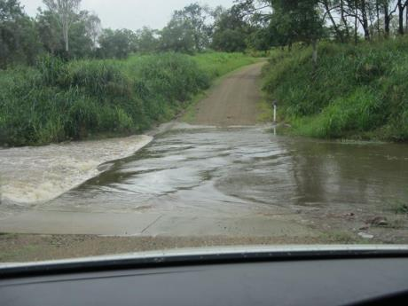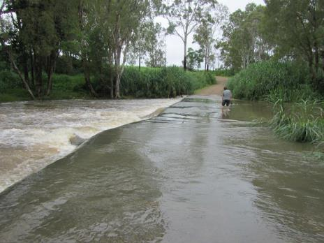
Figure 3.3.3: Examples of road crossings that act as barriers to slow moving native migratory fish

Intensive mining
Mining is limited in the O’Connell to a 100 hectare stone quarry which is unlikely to have any significant impact on the World Heritage Area.

Intensive urban residential
New intensive urban residential development was apparent during Great Barrier Reef Marine Park Authority assessment fieldwork in February 2013 (Figure 3.3.4). Between 1999 and 2009 urban areas had increased by 902 hectares in the O’Connell basin. Around 47 per cent of urban residential is located in the coastal zone.

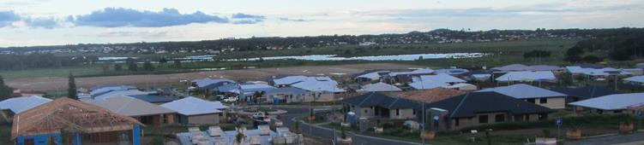Figure 3.3.4: Urban development encroaching on low-lying grass and sedgelands

The residents of the O’Connell basin are located primarily within the outlying suburbs of Mackay (Beaconsfield, Bucasia and Slade Point) and Kuttabul. The coastal settlements of Seaforth and Midge Point are home to a mix of residential and holiday homes.¹
Laguna Quays Resort (Figure 3.3.5) is a 500 hectare, $250 million resort, residential and golf course development that was built in the late 1990s for the Japanese market. The development failed to establish and is now in a state of disrepair in parts. Adjacent freehold land to the south of Laguna Quays has some clearing of remnant hillside vegetation that has areas shown as Endangered Regional Ecosystems under Queensland’s Vegetation Management Act 1999.

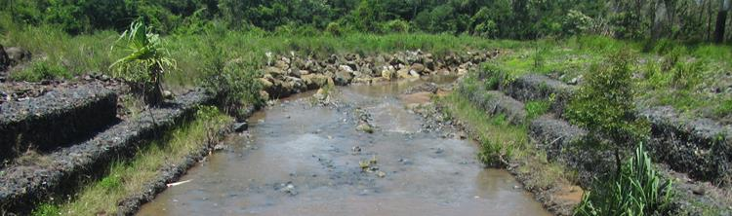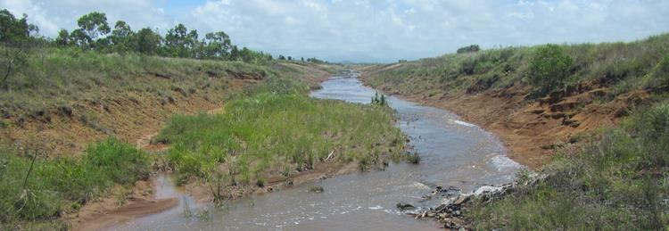
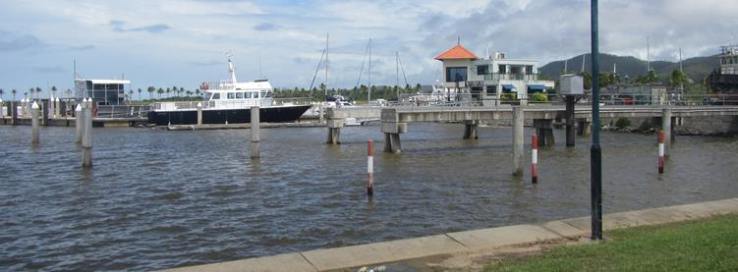
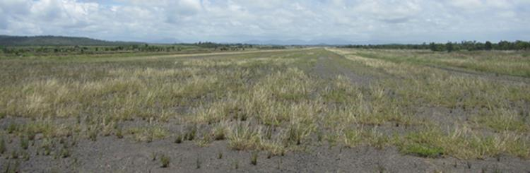
Figure 3.3.5: Laguna Quays’ development today. Modified creek bank (top), stormwater management (middle top), marina and disused airport (bottom)

St Helens Beach is a small coastal settlement with some elevated properties on the beachfront. Some of these houses have removed coastal vegetation and now have lawn to the beach (Figure 3.3.6)

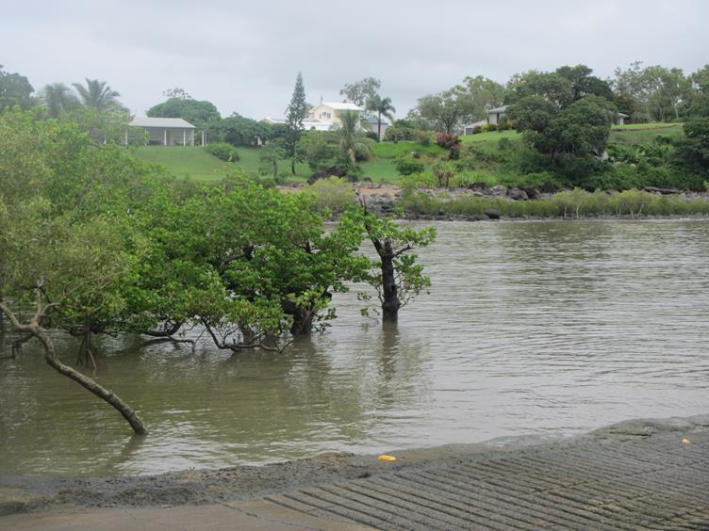
Figure 3.3.6: Housing on the waterfront at St Helens Beach

In the estuary at St Helens Beach the saltmarsh environments were showing the impacts of off-road vehicle use. In Figure 3.3.7, the wheel ruts from vehicles had created deeper pools in which freshwater wetland sedges had become established.

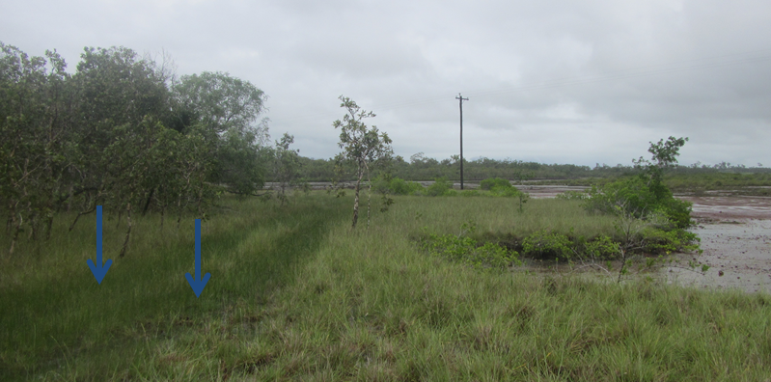
Figure 3.3.7: Wheel rut impacts adjacent to St Helens Beach

Between Bloomsbury and Midge Point a large area of freehold land has been sub-divided for rural residential. Most of this land is sloping woodland allotments within the Waterhole Creek sub-basin and is ‘Not of Concern’ vegetation under Regional Ecosystem mapping.

Seaforth is a small coastal seafront settlement in a north facing bay south west of Rabbit Island. Housing is situated on the beachfront and may be within storm surge, erosion prone and sea level rise areas identified by the Queensland Government (Figure 3.3.8). Coastal vegetation has also been cleared, removing protection from storms. The coastal settlements of Ball Bay, Haliday, Shoal Point, Bucasia and Black’s Beach are also reported to have the same issues. Vehicle use on beaches, in and adjacent to these areas, is also contributing to coastal erosion and may impact on turtle and seabird nesting and foraging habitat and impact upon interstitial fauna (between sand grain animals) that in turn provide food for larval fish.

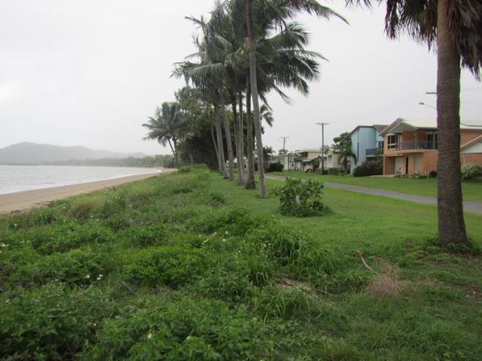
Figure 3.3.8: Seaforth houses are located in close proximity to the coast. Coastal vegetation has been removed from the beachfront and replaced with coconut palms

Production – dryland
Around 1307 hectares of dryland production occurs in the O’Connell basin, located on the O’Connell River and north-west of Mackay, and consisting of fruit trees such as mangoes. This has increased from 260 hectares in 1999, with 354 hectares occurring in the floodplain and 600 hectares (an increase of 500 hectares) converted from grazing into dryland production in the coastal zone.

Production – irrigated
Irrigated sugar cane cropping represents the second largest land use in the O’Connell basin, with an area of 37,042 hectares in 2009. Of this, 13,822 hectares occurs within the coastal zone (a drop of 722 hectares from 1999) and 9777 hectares on the floodplain (unchanged from 1999). Irrigated sugar cane uses 90 per cent (146 GL per annum) of used water in the O’Connell basin.²⁰

In the O’Connell River and Murray Creek sub-basins, cane fields have been established up against the estuaries, often occurring in marginal saltmarsh areas (Figure 3.3.9).

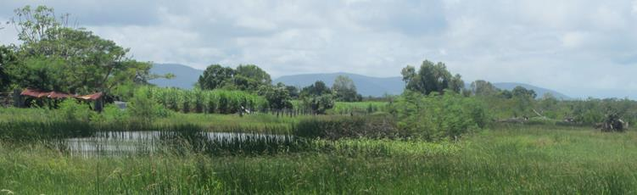
Figure 3.3.9: In the O'Connell River estuary cane is grown in marginal land (left) against saltpan (middle) and mangroves (right)

During the field assessment it was noted that the vegetation in the cane drains at some locations appeared to have been chemically sprayed with herbicides (Figure 3.3.10). This had removed much of the groundcover exposing the fine soils which were being washed into the drains (along with herbicide residue) and eventually into the World Heritage Area.

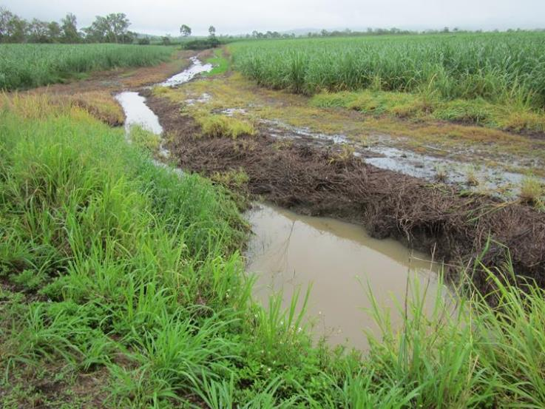
Figure 3.3.10: Cane drain on sloping land that has groundcover removed through chemical spraying. Note the high level of fine sediments in the water

In some places, such as St Helens Creek sub-basin, riparian vegetation has been cleared and cane is grown up to the creek banks (Figure 3.3.11). Where this has occurred, bank erosion (and revetment works) could be seen.
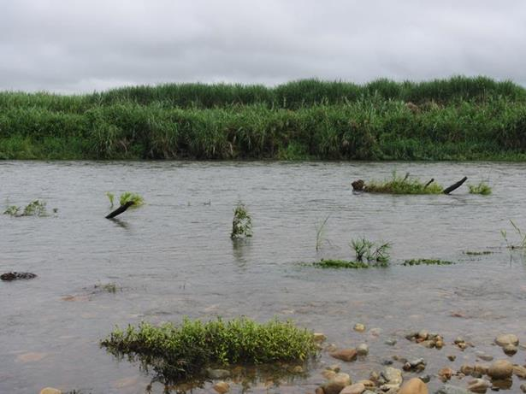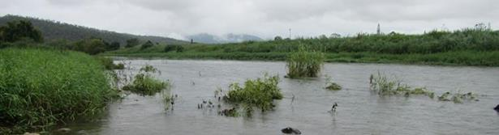
Figure 3.3.11: Sugar cane growing along the bank of St Helens Creek with no riparian vegetation. A rock wall has been added to the bank to stop the erosion occurring as a result of lost vegetation

The bad management practice of burning cane prior to harvest was not evident in this basin. However it appeared that the trash blankets (cane mulch used to retain soil after harvest) were being burnt prior to establishment of new cane (Figure 3.3.12). This allows the use of furrow irrigation which is commonly used in the catchment and which can result in soil and nutrient loss from the property.
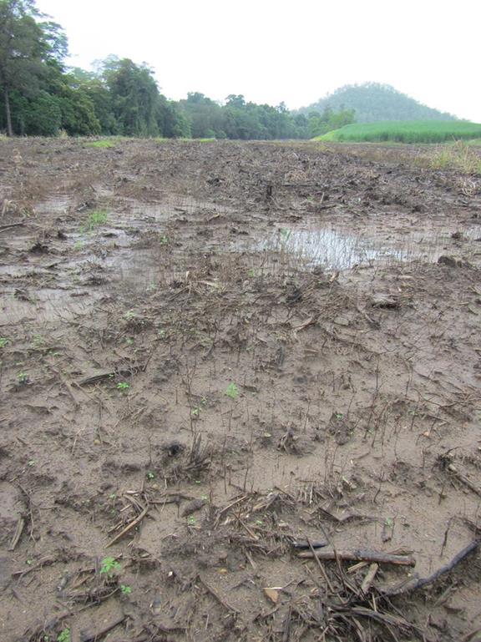
Figure 3.3.12: Burning of old trash blanketing prior to replanting appears to be a common practice in the basin that is contributing to in-stream sediment loads

Water – marsh/wetland production
Historical management sought to increase the extent of grazing land in many parts of the catchment. This involved the bunding of coastal salt pan areas to prevent tidal ingress, allowing pasture grasses to become established. These areas, known as ponded pastures, are mapped as 'wetland production' under the Queensland Land Use Mapping Project classification. Areas of ponded pasture prevent the exchange of tidal waters into freshwater wetlands, a process which historically reduced the extent of grass and sedgelands seasonally. This in turn reduces the areas of natural production for inshore coastal waters, leading to likely declines in inshore fish and invertebrate productivity. According to QLUMP, there was 613 hectares of ponded pastures in the O’Connell basin (Table 3.2.1). These bunded areas are located in St Helens Beach and Murray Creek estuaries.

Water – intensive use and water-storage and treatment
Sewage discharge is limited to the Mackay North Sewage Treatment Plant. The other smaller settlements are currently unsewered and impacts on the World Heritage Area are not known. Table 3.3.2 outlines the status of wastewater treatment in the main urban centres in the O’Connell basin.

Table 3.3.2: Status of wastewater treatment in the O’Connell basin
Urban centre | Wastewater treatment
Mackay North | Upgraded in 2008, the Mackay North wastewater plant services Shoal Point, Bucasia, Rural View, Blacks Beach and Eimeo. Treated water is discharged into Reliance Creek.
Seaforth | Unknown. Most likely unsewered.
Midge Point | Unknown. Most likely unsewered.
Laguna Keys | Unknown. Most likely unsewered.

PART B: OUTCOMES OF BASIN ASSESSMENT
- Projected condition of Great Barrier Reef catchment values

Summary of current state of coastal ecosystems
The coastal ecosystems of the O’Connell basin have changed significantly and are unlikely to ever return to their former state and condition. Coastal ecosystems most affected are rainforests, forests, woodlands, grass and sedgelands, and freshwater wetlands (Table 4.1.1). In the coastal zone, estuaries (saltmarsh and saltpan) in some areas have been bunded for the purposes of ponded pastures which increase the extent of freshwater wetlands. Likewise grazing also occurs in much of the remaining coastal ecosystems.
Table 4.1.1: Percentage of remaining coastal ecosystems in the O’Connell basin, O’Connell basin coastal zone and the O’Connell basin floodplain. Orange cells indicate areas with 10-30 per cent remaining; yellow 31-50 per cent and green greater than 50 per cent. Note these figures provide no information about ecosystem condition or functionality
Percentage remaining of coastal ecosystems in the O'Connell basin | Rainforests | Forests | Woodlands | Forested floodplain | Grass and sedgelands | Heath and shrublands | Freshwater wetlands | Estuaries
Basin wide | 85 | 41 | 36 | N/A | 29 | 99 | 78 | 98
Floodplain | 29 | 20 | 39 | N/A | 66 | 100 | 79 | 98
Coastal Zone | 61 | 23 | 26 | N/A | 40 | 100 | 78 | 98

The current state of coastal ecosystems in the O’Connell basin is summarised in Table 4.1.2.
Table 4.1.2: Summary of the current state of coastal ecosystems in the O’Connell basin
 | Coastal ecosystem | Current condition
 | Rainforests | Greatly reduced in the floodplain.
 | Forests | Heavily impacted with 59 per cent modified more used for grazing. Only 30 per cent of forests on the floodplain and 23 per cent of forests in the coastal zone remain.
 | Woodlands | Reduced in extent by 64 per cent with much of the remainder under grazing regimes. Greater loss in the coastal zone.
 | Forested floodplain | Not present in this basin.
 | Grass and sedgelands | Extensively modified with only 29 per cent remaining. Greatest losses occurred outside of the floodplain.
 | Heath and shrublands | Good state.
 | Freshwater wetlands | Losses of 22 per cent across the basin.
 | Estuaries | Mangrove systems mostly intact. Saltmarsh/saltpans which have been modified with bund walls for ponded pastures are not reflected in these figures.

Outline of key current and likely future pressures and impacts on coastal ecosystems in the O’Connell basin
Table 4.2.1 provides a brief summary of the current pressures and future outlook for coastal ecosystems in the O’Connell basin. Pressures include agriculture, urban areas, aquaculture and changes to hydrology.

Agriculture
Due to the lack of water availability in this region, there is only a small possibility to increase sugar croplands, and no significant extensive land use changes are expected. Assessment of the 1999-2009 land use show only minor shifts between cropping and grazing activities.

Urban residential
If the mining boom continues and population continues to expand as predicted, Mackay city will likely expand further northwards into the basin. Ongoing urban expansion in low-lying coastal floodplain areas will likely cause further localised impacts on the health of the coastal estuaries unless developed to best management practice guidelines.

Intensive animal production
There is the possibility of new coastal aquaculture facilities. Aquaculture facilities can alter coastal foreshore, estuarine, mangrove, salt marsh and marine and other aquatic environments.²⁴ Environmental impacts associated with aquaculture are water pollution, pest species, strain placed on wild fish populations for feeding and brooding, as well as the culling of natural predators.²⁴

Water storage and transport
Groundwater-dependent ecosystems are affected by a range of natural and anthropogenic related drivers. Changes in rainfall patterns, evaporation and temperature can all impact on groundwater recharge. Declines in groundwater recharge can lead to seawater incursion in coastal aquifers, affecting coastal wetland ecosystems. Such seawater incursion can also be amplified by sea-level rise, storm surge and over-extraction of groundwater. In some areas (such as the Haughton basin), groundwater is now intensively managed through groundwater replenishment infrastructure. Climate change will also exacerbate these impacts, especially in low-lying coastal areas although the true impacts in the O’Connell basin are not known.

Vegetation removal
The introduction of the Vegetation Management Act 1999 and the Sustainable Planning Act 2009 now regulates vegetation clearing on approximately 95 per cent of Queensland by triggering assessment and applying penalties for non-approved clearing. The Vegetation Management Act 1999 also provides mapping of areas of conservation significance through regional ecosystems. Regrowth vegetation (especially riparian) is also provided some protection in some instances. However, this legislation does not afford protection to mangroves, grasses, non-woody vegetation or plants within some grassland ecosystems. Marine plants such as mangroves, saltmarsh and saltcouch are provided protection under the Queensland Fisheries Act 1994. Other legislation also applies depending on the tenure of the land.

Hydrological changes
Changes in hydrology have occurred as a result of land use change (such as surface compaction/urbanisation reducing soil porosity), barriers (such as weirs and road/rail crossings), groundwater extraction, floodplain drainage networks and changing rainfall patterns as a result of climate change. These have forever changed run-off quality, quantity and seasonality of flows. Increasing storm intensity in recent years has delivered sudden large-pulsed flows of freshwater into the World Heritage Area. These flows do not have sufficient residence times in coastal ecosystems to allow for ecological processes to occur. As a result freshwater induced coral bleaching and smothering of corals and seagrass by sediments is occurring more frequently.

Climate change
The impacts of climate change will vary across the basin, with the highest threats to low-lying coastal areas and the floodplain. Future development planning needs to map and consider the risks of sea-level rise, storm surge and flooding before allowing for development in the coastal zone and floodplain. The interaction of rising sea temperatures and ocean acidification will exacerbate the impacts from catchment run-off on inshore coral reef ecosystems.

Future high temperatures as a consequence of climate change will likely see a decline in intertidal, coastal and estuarine seagrass meadows in the World Heritage Area.²⁵ Ocean acidification as a result of increasing CO₂ on the other hand is expected to enhance seagrass production.²⁶

Table 4.2.1: Summary of the current pressures and future outlook for coastal ecosystems in the O’Connell basin
Pressure | Current status (1999-2009) | Description | Future outlook | Description
Urban development | Increase | Urban residential increased by 20 per cent (and by almost 23 per cent for the coastal zone) between 1999 and 2009. Around 47 per cent of urban development in the basin is in the coastal zone. | Increase | Urban centres are expected increase further with as a result of mining expansion outside of the basin.
Agriculture (production) | Increase | Agriculture production (dryland and irrigated) has increased by two per cent between 1999 and 2009. | Uncertain | No data
Grazing | Decrease | Grazing has decreased by four per cent between 1999 and 2009. | Uncertain | Subject to market demands.
Introduced species | Uncertain | Established throughout the basin. | Uncertain | Ongoing control programs for weed management in place however climate change impacts are uncertain and may encourage proliferation of some weed species.
Climate Change | Uncertain | Not assessed. | Increase | Increasing intensity of episodic events, droughts and changes in rainfall patterns all likely to impact on coastal ecosystems.
Vegetation removal | Cover reduced by 408 hectares | The introduction of the Vegetation Management Act 1999 provided a regulatory framework for broad-scale land clearing across Queensland. Since its introduction, the rate of vegetation clearance in the basin has significantly declined. | Uncertain | Amendments proposed for the Vegetation Management Act 1999.

Current and likely future impacts on coastal ecosystems and likely resultant impacts on the World Heritage Area
The O’Connell basin has changed, and any management actions to improve the condition of the adjacent World Heritage Area need to consider this system as a whole. The key current and likely future impacts on coastal ecosystems and likely resultant impacts on the World Heritage Area are summarised in Table 4.3.1.

Actions are being taken to improve the condition of the O’Connell basin. Natural Resource Management Group Reef Catchments has been working closely with local government and landholders to make improvements. One example of the initiatives introduced by Reef Catchments is the use of engineered log jams. These log jams reduce the velocity of river flows which in turn reduce bank erosion and also provide additional fish habitat. These structures change the behaviour of the water flow over time creating deep water pools, flow velocity changes and channel re-alignment. These works should improve fish productivity and improve water quality.

The Reef Water Quality Protection Plan (Reef Plan) is a collaborative program of coordinated projects and partnerships designed to improve the quality of water in the World Heritage Area though improved land management in Great Barrier Reef catchments. Reef Plan is a joint Australian and Queensland Government initiative that specifically focuses on non-point-source pollution. This is where irrigation or rainfall carries pollutants such as sediments, nutrients and pesticides into waterways and the Reef lagoon. Reef Plan sets targets for water quality and land management improvement, and identifies actions to improve the quality of water entering the World Heritage Area. Initially established in 2003, Reef Plan was updated in 2009 and 2013.

Table 4.3.1: Key current impacts and likely future impacts in the O’Connell basin and likely consequences for the World Heritage Area
Current impacts on Coastal Ecosystems | Trend 1999-2009 | Current likely impacts as a result on the World Heritage Area | Future likely impacts on Coastal Ecosystems | Future likely impacts on the World Heritage Area
Broadscale clearing of coastal ecosystems for agriculture, urban or industry | Rates of clearing have declined as a result of the Vegetation Management Act 1999. | Loss of ecological process and connectivity, replacement of some ecological processes depending on the nature of the modified system. Many hillslopes cleared poses a high risk of soil loss. | Coastal ecosystems unlikely to be returned to their former state, however no further losses expected. | No change likely to occur.
Farm run-off | Improvements as a result of increasing rates of Best Management Practice uptake. | Improvements to water quality expected, although delayed due to lag effects. | Dependant on extent of new horticulture and uptake of best management practice. | Water quality expected to improve.
Stream/river bank erosion | Increasing as a result of extreme weather events. Legacy issues from historical clearing, bank stabilisation projects. | Increase in suspended sediments and turbidity in coastal waters; increase in sand build up in waterways. | Management actions (e.g. Reef Plan) underway to restore riparian areas. | Likely to improve under uptake of Best Management Practice and restoration projects.
Declining water quality | Improvements in recent years. | Decline in inshore ecosystem health and resilience. | Likely to improve as a result of management actions targeted at improving water quality. | Improvements expected but will take time to take effect.
Barriers to fish migrations | Many smaller barriers, mostly road culverts throughout basin. Sand build up in waterways. | Reduction/loss of connectivity and fish passage. | Management intervention has improved fish passage in some areas. | Increase in fish and invertebrate abundance.
Introduced terrestrial weeds | Established throughout the basin (mostly in modified landscapes). | Introduced grasses generate hotter fires that can destroy forest canopies and expose soil which can be eroded, especially when fires occur late in the dry season. | Eradication to date has been ineffective and many grasses are still used for fodder. Management actions are needed to manage spread and growth of introduced weeds. | Likely to lead to increases in erosion and therefore more suspended sediments in the GBRWHA unless management actions implemented.
Changed overland hydrology | Most development/modification has occurred on the floodplain and coastal zone. | Changes to connectivity and water retention which has impacted on all ecological processes. | Development continues to occur on the floodplain and coastal zone. | Likely decline in water quality and aquatic biodiversity in the World Heritage Area.
Ponded pasture/wetland production | Became illegal to establish new ponded pastures in the coastal zone in 2001 (policy for development and use of ponded pasture). | Loss of connectivity and declines in fish productivity, blackwater, and the potential release of acid sulphate soils. | Plans to modify ponded pastures to improve ecosystem health. | Improved productivity, ecosystem health and resilience.
Infilling of wetlands and drainage for urban development | Almost 47 per cent of urban development has occurred in the coastal zone. | Impacts upon estuarine flora and fauna, loss of wetland, wetland function and connectivity. | Management interventions to protect this infrastructure from sea-level rise and storm surge may result in changes to the coast and coastal processes. | Reduction in coastal and wetland functions in these areas.

Water quality
Water quality remains the greatest current and future risk to the World Heritage Area from the O’Connell basin. The loss of coastal ecosystems and changes to connectivity has reduced the capacity to provide ecological functions for the World Heritage Area. In addition, the extent of habitat for species with connection to the World Heritage Area has been reduced and, if this continues, will reduce the gross value of production of commercial and recreational species.

Figure 4.3.1 provides an example of the relationships between pressures, state and impact from increased pollutants being delivered to the Great Barrier Reef.²⁷ Note that these sequential impacts are linked primarily to nutrient loading scenarios, and do not define the cumulative impacts from increasing temperature and nutrients, or from other pollutants such as suspended sediment and pesticides. Recent work^{28,29,30} indicates that the combined impacts of rising temperatures and increasing nutrients, particularly dissolved inorganic nitrogen (DIN), will result in reduced resilience of coral reefs to recover from more frequent bleaching events.²⁷

Figure 4.3.1: Pathway from nutrient enrichment to biological impact from total suspended solids (TSS); dissolved inorganic nitrogen (DIN); photosynthesis inhibiting herbicides (PSII); and crown-of-thorns starfish (COTS)

The impacts of increasing sediments and nutrients on coral reefs (Figure 4.3.2) and seagrass (Figure 4.3.3) include shading, reduced resilience and reduced recruitment. ²⁷ Abundances of a range of other reef associated organisms have also been shown to change along the water quality gradient.²⁷
Reduced coral settlement
SEDIMENTS
Juvenile mortality
Physiological impacts
Reduced abundance
NUTRIENTS
Increased filter feeders
Physiological impacts
Increased organic matter
COTS
Increased competition

Figure 4.3.2: Potential and known impacts of increasing nutrients and sediments on coral reefs²⁷
NUTRIENTS
Increased shading
Increase in nutrient loads
Physiological impacts
Reduced biomass
Habitat loss
Increase in sediment loads
SEDIMENTS
Increased shading
Physiological impacts
Reduced biomass
Habitat loss
Figure 4.3.3: Potential and known impacts of increasing nutrients and sediments on seagrass beds²⁷

Water quality in the receiving waters adjacent to the O’Connell River has been shown to regularly exceed Great Barrier Reef Marine Park Authority water quality guidelines and the condition of many indicator species (such as seagrass, coral cover and coral recruitment) has been reported as of moderate to low condition.^{31,32,33,34,35}

The water quality discharged from the many sub-basins of the O’Connell basin varies spatially and over time. Most exceedences of water quality guideline values occur during episodic flood events and may last from a period of days to weeks. The level of nutrients, sediments, pesticides and herbicides carried into inshore coastal waters at these times will vary according to the land use occurring within the sub-basin. The impacts on the World Heritage Area will also vary depending on the water quality, the size of the flood plumes, the flow duration, levels of mixing with coastal marine waters and the exposure time of organisms to the plume water.

The levels of herbicides found in a 2009 study³⁶ suggest that current levels of herbicide residues in river water plumes could reach levels that present a risk to World Heritage Area ecosystems. Studies have shown that marine photosynthetic organisms such as macroalgae,^{37,38} mangroves,³⁹ seagrass,⁴⁰ and corals^{41,42,43,44,45,46} are at risk from herbicide exposure.

Devlin et al.⁴⁷ scaled pollutant exposures from high to low with the highest exposure related to the highest flood plume extents (greater than 10 km) and highest pollution loads. The O’Connell River basin was scaled as low for total suspended solids (TSS), moderate for dissolved inorganic nitrogen (DIN) and high in nearshore areas for PSII herbicides. Mapping of PSII herbicide exposure within the Mackay Whitsunday region has shown that up to 569,000 hectares (12 per cent) of marine areas in this region are classified as very high.⁴⁷ Additionally, the Mackay Whitsunday region was found to have the highest number of reefs (415) and seagrass beds (173) ranked within high to very high range for PSII exposure.⁴⁷ The distance and direction of ecosystems from the catchments of concern are important factors influencing the level of exposure received.^{48,49}

The Mackay Whitsunday Healthy Waterways Baseline Monitoring has monitored water quality at 13 sites throughout the Mackay Whitsunday region in areas where the dominant land uses varied. The indicators sampled included water temperature, pH, dissolved oxygen (DO), electrical conductivity (EC), total suspended solids (TSS), nitrogen species, phosphorus species and herbicides.⁵⁰ The Andromache River and O’Connell River were within the guideline range at least 50 per cent of the time for dissolved oxygen (DO) levels, and on occasion measurements were much higher (134.8 per cent and 144.4 per cent, respectively) than the upper guideline limit. Pesticides have also been detected at some monitoring locations. The main pesticides of interest are herbicides, in particular residual herbicides that inhibit photosynthesis, referred to as PSII herbicides (for example atrazine, diuron). More details can be found in Appendix F.

The Mackay Whitsunday Water Quality Improvement Plan (WQIP) provides freshwater and estuarine water quality and ecosystem health monitoring within the O’Connell basin.². Specific water quality values were rated A-E (A = excellent, E = poor) and the conditions from 2008 are presented in Tables 4.3.2 and 4.3.3.²

Table 4.3.2: Ratings of the current freshwater conditions of various water quality parameters within waterways of the O’Connell basin (A = excellent, E = poor)
 | Fish Community | Water Quality | Flow | Barriers to Migration | In-stream Habitat | Riparian Vegetation
O’Connell River | C | C | D | C | C | D
Andromache River | B | A | B | B | B | B
Blackrock Creek | D | D | B | C | C | A
St Helens Creek | B | D | C | A | C | D

Table 4.3.3: Ratings of the current estuarine conditions of various water quality parameters within waterways of the O’Connell basin (A = excellent, E = poor)
 | Fish Community | Water Quality | Flow | Estuary Modification | Mangroves and Saltmarsh
O’Connell River | C | D | D | B | D
Blackrock | B | C | C | B | C
St Helens Creek | B | A | C | B | A

During the basin field assessment many of the waterways were experiencing ‘first flush’ flows from the first significant heavy rainfall in many months. Much debris was observed flowing downstream at many sites (such as Alligator Creek, Blackrock sub-basin – Figure 4.3.4) along with highly turbid water.

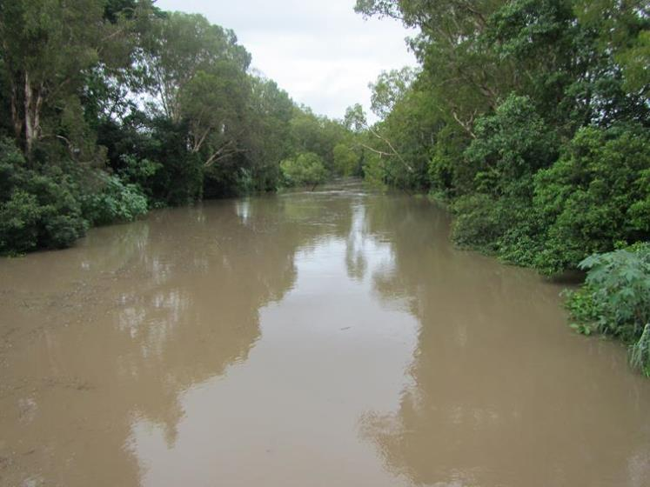
Figure 4.3.4: High turbidity in Alligator Creek, Blackrock sub-basin

The water quality discharged from the O’Connell basin into inshore waters of the World Heritage Area varies between the sub-basins and changes seasonally. Higher concentrations are generally detected in the wet season compared to the dry season when flood plumes transport pesticides from the sub-basins into the marine environment. Herbicides that inhibit photosynthesis, in particular diuron, were frequently detected in inshore waters of the Reef. At times these herbicides were found up to 15 kilometres from the shore at concentrations that, when considered together, have the potential to affect marine organisms, such as seagrass and corals.

Most exceedences of water quality guideline values occur during episodic flood events and may last from a period of days to weeks. The level of nutrients, sediments pesticides and herbicides carried into inshore coastal waters at these times will vary according to the land use occurring within the sub-basin. The impacts on the World Heritage Area will also vary depending on the water quality, the size of the flood plumes, the flow duration, levels of mixing with coastal marine waters and the exposure time of organisms to the plume water.

Looking at the Mackay Whitsunday region, inshore waters had concentrations of suspended solids above Great Barrier Reef Marine Park Water Quality Guidelines in 2008-2009. A range of pesticides including diuron, atrazine and tebuthiuron were detected in inshore waters of the region.⁵¹

The current best estimates of modelled loads leaving the O’Connell River basin are provided in Table 4.3.4.¹¹ Pre-development loads were substantially lower than current values for all parameters measured. After the implementation of the Reef Rescue program in 2008, an improvement in load values was observed for most elements. For example, modeled PSII herbicide export values from the O’Connell River basin (Table 4.3.4) showed that the total export in 2008/2009 (423 kg/yr) had increased compared to pre-development loads (0 kg/yr). However, after the implementation of the Reef Rescue program (2009/2010) values decreased to 338 kg/yr, which is a 20.2 per cent improvement.

Table 4.3.4: Best estimates of modelled total pre-development values, current values, and anthropogenic changes in water quality parameters. Reef Rescue values represent the values after the commencement of the Reef Rescue Program and Reef Rescue change represents the improvement (%) after implementation. TSS = total suspended solids, DIN = dissolved inorganic nitrogen, DON = dissolved organic nitrogen, PN = particulate nitrogen, TN = total nitrogen, PSII = photosynthesis Inhibiting herbicides, DIP = dissolved inorganic phosphorus, DOP = dissolved organic phosphorus, PP = particulate phosphorus, TP = total phosphorus
 | Pre-development | Current (2008 -2009) | Current (2009 -2010) | Anthropogenic  Increase | Reef Rescue change (%) | Total change  (%)
TSS  (kt/yr) | 48 | 150 | 147 | 103 | 3.2 | 3.3
DIN  (t/yr) | 75 | 222 | 207 | 147 | 10.6 | 10.6
DON  (kt/yr) | 119 | 399 | 399 | 280 | 0 | 0
PN  (t/yr) | 119 | 173 | 170 | 53 | 5.3 | 5.3
TN  (t/yr) | 314 | 793 | 775 | 480 | 3.8 | 3.8
PSII  (kg/yr) | 0 | 423 | 338 | 423 | 20.2 | 20.2
DIP  (t/yr) | 14 | 75 | 75 | 61 | 0 | 0
DOP  (t/yr) | 4 | 20 | 20 | 16 | 0 | 0
PP  (t/yr) | 39 | 77 | 76 | 39 | 4.5 | 4.6
TP  (t/yr) | 57 | 172 | 171 | 116 | 1.5 | 1.5

For further information on water quality monitoring and impacts refer to Appendix G.

The Reef Water Quality Protection Plan (Reef Plan) was designed to accelerate the improvement of water quality flowing to the World Heritage Area from agricultural lands. The plan includes regulatory and incentive programs, extension activities and research and monitoring. The Reef Plan First Report Card was released in 2011⁵¹ and provides an important baseline for which future loads will be compared. Progress will be assessed over time to determine the outcomes of Reef Plan initiatives. Certain Reef Plan goals include a minimum of 50 per cent reduction in nitrogen and phosphorus loads at the end of the catchment by 2013 and a minimum of 20 per cent reduction in sediment loads at the end of the catchment by 2020.⁵²

Priorities for conservation and restoration
Coastal ecosystems located in the floodplain and coastal zone are those that have experienced the greatest losses and those most at risk in the future. Future conservation measures should include protection of these ecosystems from further loss and impacts and restoration efforts should focus on these areas. These areas are also at greatest risk from flooding, storm and climate change impacts. New high value infrastructure, such as residential and industrial development, should be avoided in these areas. Current infrastructure in these areas needs to be constructed and managed to current best practice for minimising impacts on the area’s hydrological processes.

Coastal ecosystems outside of these zones should be retained where possible. As it stands today, the O’Connell basin can no longer afford to lose any more coastal ecosystems. There is a strong need to restore ecological processes through improvements to land use management, ecologically sustainable design and ecosystem restoration. The floodplain coastal ecosystems are currently at greatest risk.

Coastal zone
Coastal ecosystems in the coastal zone generally have the closest connections to the World Heritage Area and generally have a higher capacity to provide physical, biological and biogeochemical processes to the World Heritage Area. Some coastal ecosystems in the coastal zone also fall within the World Heritage Area. The coastal zone is also the area at greatest risk from the impacts of climate change. Actions that could be taken to reduce pressure on the coastal zone in the O’Connell basin include:

- Limit further loss of remaining coastal ecosystems.
- Increased protection afforded to remaining coastal ecosystems.
- Restore riparian corridors to a standard that provides effective ecological functions. Any re-vegetation should consider the appropriateness of using species adapted for future climate scenarios.
- Improving agricultural practices to current best practice standards including a shift from furrow irrigation to trickle irrigation. The practice of burning trash blankets on cane lands should be discouraged to prevent exposure of topsoil prior to the wet season.
- Limit further intensive development in the coastal zone, particularly in intact areas. This will not only reduce environmental impacts, but may also reduce the risk of economic impacts resulting from future climate change, as scenarios predict that the coastal zone will be at greatest risk from sea-level rise and storm surge.
- Low levels of well managed grazing should be considered for riparian areas where introduced grasses dominate and where these grasses either pose a fire risk to well established riparian forests or where these grasses are choking waterways and removing oxygen from them.
- Introduce a comprehensive water quality and seagrass monitoring program to ensure long-term health and resilience of seagrass in the area.
- Manage vehicle access to the coastline and wetland coastal ecosystems to minimise impacts to species (such as birds and turtles) that are matters of national environmental significance.
- Lower the height of ponded pasture bund walls distributed throughout the coastal zone to a height that allows king tides to flow over the bunds, providing for fish passage and natural weed control. Seawater has been shown to be an effective tool for preventing overgrowth of native sedges and introduced pasture grasses such as Hymenachne.
- Reinstate coastal (beachfront) vegetation in those areas (especially the Waterhole Creek sub-basin).

Floodplain
Floodplains support particularly rich coastal ecosystems, especially in terms of diversity and abundance. These areas are important for the physical, biological and biogeochemical processes they provide for the long-term health and resilience of the World Heritage Area. The floodplain in the O’Connell basin has been heavily modified. Actions that can be taken to reduce pressure on the floodplain include:

- Limit further loss of remaining coastal ecosystems.
- Increased protection afforded to remaining coastal ecosystems.
- Restore riparian corridors in this area to a standard that provides effective ecological functions. Any re-vegetation should consider the appropriateness of using species adapted for future climate scenarios.
- Improve connectivity between remnant coastal ecosystems within the floodplain.
- Improve agricultural practices to current best practice standards including a shift from furrow irrigation to trickle irrigation and the use of tailwater retention, recycle and treatment ponds.
- Limit future intensive development in the floodplain. This will not only reduce environmental impacts, but may also reduce the risk of economic impacts resulting from future climate change, as scenarios predict that the floodplain will be at increased risk from flooding.
- Consistent with Queensland planning provisions, future urban developments that cannot be sited outside of the floodplain should be constructed to current best practice, employing principles such as water sensitive urban design, gross pollutant traps and tertiary sewage treatment.
- Low levels of well managed grazing should be considered for riparian areas where introduced grasses dominate and where these grasses either pose a fire risk to well established riparian forests or where these grasses are choking waterways and removing oxygen from them.

Riparian areas
Riparian vegetation provides important physical, biological and biogeochemical processes essential for the long-term health and resilience of the World Heritage Area. Riparian vegetation slows water velocity and provides areas of nutrient cycling, fish habitat and pathways for fish passage and connectivity across the basin. Actions that can be taken to reduce pressure on the riparian zones include:
- Restore riparian corridors to a standard that provides effective ecological functions. Any re-vegetation should consider the appropriateness of using species adapted for future climate scenarios and should consider adjacent land use.
- Seek to protect or reinstate in-stream habitat to provide improved flow regulation and fish habitat structure.
- Low levels of well managed grazing should be considered for riparian areas where introduced grasses dominate and where these grasses either pose a fire risk to well established riparian forests or where these grasses are choking waterways and removing oxygen from them.
- Limit future construction of dams and weirs in this basin where they might impact on coastal ecosystems or the Marine Park, and consider the modification of road and rail crossings to improve connectivity and fish passage.
- Further development adjacent to waterways should not increase point and non-point source pollutants entering waterways.

Wetlands
Wetlands provide habitat for many species with connections to the World Heritage Area and are often referred to as the ‘kidneys of the Reef’. Wetlands provide important physical, biological and biogeochemical processes that support the long-term health and resilience of the World Heritage Area. Actions that can be taken to reduced pressure on wetlands include:
- Limit further loss of wetlands.
- Increased protection of remaining wetlands.
- Restoration of wetlands where possible.
- Improve connectivity between wetlands and the World Heritage Area, including maintaining or restoring environmental flows where appropriate.
- Control and manage introduced species that compromise wetland health.

Hydrological Connectivity
The hydrological processes within catchments set the backbone of all ecological functions and water quality outcomes. These catchment ecosystems and water quality outcomes in turn provide the direct connection with the health of the marine environment to which they drain. Change to these processes is therefore of increasing concern for the long-term health of the Marine Park.⁵³ Actions that could be taken include:
- Accurately assessing and modifying barriers and ponded pastures to promote hydrological connectivity.
- Appropriate modification of fish barriers to improve fish populations through increased access and opportunity for species migration.
- Restore stream, river and waterway connectivity to achieve effective fish passage.

Other areas
Areas outside of the coastal zone and floodplain still provide some physical, biological and biogeochemical processes to the World Heritage Area. Potential management actions for these areas include:
- Appropriate restoration of riparian corridors to a standard that provides effective ecological functions.
- Encourage best practice management of agricultural activities, particularly in areas where riparian buffers are minimal or non-existent.
- Cleared and eroding hill slopes require urgent management intervention. These sites may be suitable for appropriately designed urban development (in lieu of low lying floodplain areas) if built to current best practice.

Potential management actions
This report has been developed as a baseline for the O’Connell basin. In order to ensure that the basin is best represented, consideration of additional finer scale data, local knowledge and information will further enhance this assessment.

Ensuring the long-term health and resilience of the World Heritage Area requires greater protection of, and restoration of important ecological processes and functions provided by the O’Connell basin coastal ecosystems. Actions that would increase protection and restore processes and function include:
- Review of siting of urban developments. If possible, new urban subdivisions should be located above the floodplain with water sensitive urban design implemented (including wetland detention areas).
- All remaining coastal ecosystems within the floodplain and coastal zone should be retained and protected to prevent any further decline in ecological functions provided to the World Heritage Area.
- Introduction of a comprehensive water quality and seagrass monitoring program to ensure long-term health and resilience of seagrass in the area.
- Management of vehicle access to the coastline and wetland coastal ecosystems may assist in minimising impacts to species (such as birds and turtles) that are matters of national environmental significance.
- Cleared and eroding hill slopes require urgent management intervention. These sites may be suitable for appropriately designed urban development (in lieu of low lying floodplain areas) if built to current best practice.
- Low levels of well managed grazing should be considered for riparian areas where introduced grasses dominate and where these grasses either pose a fire risk to well established riparian forests or where these grasses are choking waterways and removing oxygen from them.
- Improve agricultural practices to current best practice standards including a shift from furrow irrigation to trickle irrigation and the use of tailwater retention, recycle and treatment ponds.

Knowledge gaps
In assessing the O’Connell basin, a number of knowledge gaps were identified. These included:
- Reef Plan focuses on sediments, nutrients and pesticides, but further water quality research is required that relates to pollutants that are not covered by Reef Plan, such as microplastics, pharmaceuticals etc., and their effects on the World Heritage Area.
- Implications of agricultural chemicals on the marine environment.
- Effectiveness of current marine monitoring sites. Current sites in this basin are limited to locations that provide ease of access and do not necessarily reflect monitoring at specific river mouths. Integrated monitoring of in-stream and river mouth water quality and ecosystem health would provide more pertinent information on the ability of remaining coastal ecosystems to provide functions to maintain the health and resilience of the World Heritage Area.
- The impacts of climate change and groundwater extraction on coastal ecosystems (and their interactions).
- The impacts of land use changes on groundwater water quality and groundwater dependent ecosystems.
- The impacts of groundwater extraction on ground water movement and consequences for ‘downstream ecosystems’.

REFERENCES
1. The Wilderness Society 2011, Land Clearing in Queensland, viewed 30/06/2013, <http://www.wilderness.org.au/campaigns/land-clearing/land-clearing-in-queensland>.
2. Drewry, J., Higham, W. and Mitchell, C. 2008, Water quality improvement plan, Final report for the Mackay Whitsunday region, Mackay Whitsunday Natural Resource Management Group, Mackay Whitsunday Natural Resource Management Group, Mackay.
3. Department of the Premier and Cabinet 2013a, Great Barrier Reef Second Report Card 2010, Reef Water Quality Protection Plan, Reef Water Quality Protection Plan Secretariat, DPC, Brisbane.
4. Ball, M.C. 2012, Grapsid crabs and freshwater impacts. Personal communications.
5. Mackay Regional Council The Water Sensitive Urban Design (WSUD) deemed to comply solutions for the Mackay region, Mackay Regional Council, viewed 30/06/2013, <http://www.mackay.qld.gov.au/business/planning_and_development/strategic_planning/open_space_and_waterways/the_water_sensitive_urban_design_wsud_deemed_to_comply_solutions_for_the_mackay_region-_stormwater_quality_management>.
6. Fishery Status Report - Department of Agriculture, Fisheries and Forestry, a, viewed 30/06/2013, <http://www.daff.gov.au/abares/publications_remote_content/publication_series/fishery_status_report?sq_content_src=+dXJsPWh0dHAlM0ElMkYlMkYxNDMuMTg4LjE3LjIwJTJGYW5yZGwlMkZEQUZGU2VydmljZSUyRmRpc3BsYXkucGhwJTNGZmlkJTNEcGJfZnNyMTFkOWFibV8wMDIyMDExXzExYS54bWwmYWxsPTE=>.
7. Great Barrier Reef Marine Park Authority 2012a, Great Barrier Reef Coastal Ecosystems Assessment Framework, GBRMPA, Townsville.
8. Great Barrier Reef Marine Park Authority 2012b, Informing the outlook for Great Barrier Reef coastal ecosystems, GBRMPA, Townsville.
9. Tourist visits to the Whitsunday planning area - GBRMPA, b, viewed 30/06/2013, <http://www.gbrmpa.gov.au/visit-the-reef/visitor-contributions/gbr_visitation/numbers/tourist-visits-to-the-whitsunday-planning-area>.
10. Great Barrier Reef Marine Park Authority Vessel Registration Levels for Great Barrier Reef Coastal Communities, Great Barrier Reef Marine Park Authority, viewed 30/06/2013, <http://www.gbrmpa.gov.au/visit-the-reef/visitor-contributions/gbr_visitation/vessel-registration-levels-for-great-barrier-reef-coastal-communities>.
11. Schaffelke, B., Carleton, J., Doyle, J., Furnas, M., Gunn, K., Skuza, M. and Zagorskis, I. 2011, Reef Rescue Marine Monitoring Program, Final report of AIMS Activities 2010/11 - Inshore water quality monitoring, Report for the Great Barrier Reef Marine Park Authority, Australian Institute of Marine Science, Townsville.
12. Department of the Premier and Cabinet 2013b, Reef Plan Second Report Card, Queensland Government, viewed 30/06/2013, <http://www.reefplan.qld.gov.au/measuring-success/report-cards/second-report-card.aspx>.
13. Department of National Parks, Recreation, Sport & Racing viewed 30/06/2013, <http://www.nprsr.qld.gov.au>.
14. Department of the Premier and Cabinet 2009, Great Barrier Reef First Report Card (2009 Baseline), Reef Water Quality Protection Plan, Reef Water Quality Protection Plan Secretariat, Brisbane, viewed 30/06/2013, <http://www.reefplanqld.gov.au/measuring-success/report-cards/first-report-card.aspx>.
15. Australian Natural Resources Atlas 2000, Coasts: Understanding Condition. Estuary Assessment 2000, viewed 30/06/2013, <http://www.anra.gov.au/topics/coasts/condition/index.html>.
16. Department of Environment and Resource Management Queensland Wetlands Program (Department of Environment and Resource Management), Department of Environment and Resource Management, viewed 30/06/2013, <http://wetlandinfo.derm.qld.gov.au/wetlands/PPL/QldWetlandProgramme.html>.
17. Sattler, P. and Williams, R. (eds) 1999, The conservation status of Queensland's bioregional ecosystems, Environmental Protection Agency, Queensland Government, Brisbane.
18. Great Barrier Reef Marine Park Authority 2011a, Impacts of Tropical Cyclone Yasi on the Great Barrier Reef: A report on the findings of a rapid ecological impact assessment, GBRMPA, Townsville, viewed 30/06/2013, <http://www.gbrmpa.gov.au/media-room/feature/cyclone-yasi-report-released>.
19. Rohde, K., Masters, B., Fries, N., Noble, R., Carroll, C., Brodie, J. and Faithful, J. 2008, Fresh and marine water quality in the Mackay Whitsunday region, 2004/05 to 2006/07, Department of Natural Resources and Water, Brisbane.
20. CSIRO, Australian Government, Bureau of Rural Sciences, Bureau of Meteorology O'Connell River - River Basin Summary, Bureau of Rural Sciences.
21. Laurance, W.F., Dell, B., Turton, S.M., Lawes, M.J., Hutley, L.B., McCallum, H., Dale, P., Bird, M., Hardy, G., Prideaux, G., Gawne, B., McMahon, C.R., Yu, R., Hero, J.-., Schwarzkopf, L., Krockenberger, A., Setterfield, S.A., Douglas, M., Silvester, E., Mahony, M., Vella, K., Saikia, U., Wahren, C., Xu, Z., Smith, B. and Cocklin, C. 2011, The 10 Australian ecosystems most vulnerable to tipping points, Biological Conservation 144(5): 1472-1480.
22. The State of Queensland, (Department of Environment and Heritage Protection). 2012, Climate change impacts in Queensland's regions, The State of Queensland (Department of Environment and Heritage Protection), viewed 30/06/2013, <http://www.ehp.qld.gov.au/climatechange/regional-summaries.html>.
23. The State of Queensland 2011, Queensland Government population projections to 2056: Queensland and statistical divisions, 2011 edition, State of Queensland, Brisbane.
24. Australian Bureau of Statistics 2006, Aquaculture and the Environment, ABS, viewed 30/06/2013, <http://www.abs.gov.au/ausstats/abs@.nsf/Previousproducts/1301.0Feature%20Article212003?opendocument&tabname=Summary&prodno=1301.0&issue=2003&num=&view=>.
25. Rasheed, M. and Unsworth, R. 2011, Long-term climate-associated dynamics of a tropical seagrass meadow: implications for the future, Marine Ecology Progress Series 422: 93-103.
26. Johnson, J.E. and Marshall, P.A. (eds) 2007, Climate change and the Great Barrier Reef: a vulnerability assessment, Great Barrier Reef Marine Park Authority and Australian Greenhouse Office, Townsville.
27. Devlin, M., Harkness, P., McKinna, L. and Waterhouse, J. 2010, Mapping the surface exposure of terrestrial pollutants in the Great Barrier Reef. Report to the Great Barrier Reef Marine Park Authority, Australian Centre for Tropical Freshwater Research, James Cook University, Townsville.
28. Wooldridge, S.A. and Done, T.J. 2009, Improved water quality can ameliorate effects of climate change on corals, Ecological Applications 19: 1492-1499.
29. Negri, A.P., Flores, F., Rothig, T. and Uthicke, S. 2011, Herbicides increase the vulnerability of corals to rising sea surface temperature, Limnology and Oceanography 56(2): 471-485.
30. Shaw, M., Negri, A.P., Fabricius, K. and Mueller, J.F. 2009, Predicting water toxicity: Pairing passive sampling with bioassays on the Great Barrier Reef, Aquatic Toxicology 95(2): 108-116.
31. Devlin, M., Wenger, A., Waterhouse, J., Alvarez-Romero, J., Abbott, B. and Teixeira da Silva, E. 2011, Reef Rescue Marine Monitoring Program: flood plume monitoring annual report 2010-11, Incorporating results from the Extreme Weather Response Program flood plume monitoring, Report for the Great Barrier Reef Marine Park Authority, Australian Centre for Tropical Freshwater Research, James Cook University, Townsville.
32. Thompson, A., Costello, P., Davidson, J., Logan, M., Schaffelke, B., Uthicke, S. and Takahashi, M. 2011, Reef Rescue Marine Monitoring Program, Report of AIMS Activities – Inshore coral reef monitoring 2011, Report for Great Barrier Reef Marine Park Authority, Australian Institute of Marine Science, Townsville.
33. Smith, R., Middlebrook, R., Turner, R., Huggins, R., Vardy, S. and Warne, M. 2012, Large-scale pesticide monitoring across Great Barrier Reef catchments–Paddock to Reef Integrated Monitoring, Modelling and Reporting Program, Marine Pollution Bulletin 65(4-9): 117-127.
34. Abrego, D., Ulstrup, K.E., Willis, B.L. and van Oppen, M.J.H. 2008, Species-specific interactions between algal endosymbionts and coral hosts define their bleaching response to heat and light stress, Proceedings of the Royal Society B-Biological Sciences 275(1648): 2273-2282.
35. Johnson, J.E., Brando, V.E., Devlin, M.J., Kennedy, K., McKenzie, L., Morris, S., Schaffelke, B., Thompson, A., Waterhouse, J. and Waycott, M. 2011, Reef Rescue Marine Monitoring Program: 2009/2010 synthesis report, Reef and Rainforest Research Centre, Cairns.
36. Lewis, S.E., Brodie, J.E., Bainbridge, Z.T., Rohde, K.W., Davis, A.M., Masters, B.L., Maughan, M., Devlin, M.J., Mueller, J.F. and Schaffelke, B. 2009, Herbicides: A new threat to the Great Barrier Reef, Environmental Pollution 157(8-9): 2470-2484.
37. Seery, C.R., Gunthorpe, L. and Ralph, P.J. 2006, Herbicide impact on Hormosira banksii gametes measured by fluorescence and germination bioassays, Environmental Pollution 140(2): 43-51.
38. Magnusson, M., Heimann, K. and Negri, A.P. 2008, Comparative effects of herbicides on photosynthesis and growth of tropical estuarine microalgae, Marine Pollution Bulletin 56: 1545-1552.
39. Bell, A.M. and Duke, N.C. 2005, Effects of Photosystem II inhibiting herbicides on mangroves; preliminary toxicology trials, Marine Pollution Bulletin 51(1-4): 297-307.
40. Haynes, D., Ralph, P., Muller, J., Prange, J., Michalek-Wagner, K. and Waterhouse, J. 2000, The occurrence and impact of herbicides in the Great Barrier Reef, Australia, Reef Research 10(2-4): 3-5.
41. Owen, R., Knap, A., Ostrander, N. and Carbery, K. 2003, Comparative acute toxicity of herbicides to photosynthesis of coral zooxanthellae, Bulletin of Environmental Contamination and Toxicology 70(3): 541-548.
42. Negri, A.P., Vollhardt, C., Humphrey, C., Heyward, A., Jones, R., Eaglesham, G. and Fabricius, K. 2005, Effects of herbicide diuron on the early life history stages of coral, Marine Pollution Bulletin 51: 370-383.
43. Jones, R.J., Muller, J., Haynes, D. and Schreiber, U. 2003, Effects of herbicides diuron and atrazine on corals of the Great Barrier Reef, Australia, Marine Ecology Progress Series 251: 153-167.
44. Jones, R.J. and Kerswell, A.P. 2003, Phytotoxicity of Photosystem II (PSII) herbicides to coral, Marine Ecology Progress Series 261: 149-159.
45. Jones, R. 2005, The ecotoxicological effects of Photosystem II herbicides on corals, Marine Pollution Bulletin 51(5-7): 495-506.
46. Cantin, N.E., Negri, A.P. and Willis, B. 2007, Photoinhibition from chronic herbicide exposure reduces reproductive output of reef-building corals, Marine Ecology Progress Series 344: 81-93.
47. Devlin, M.J., McKinna, L.I.W., Alvarez-Romero, J.G., Abbott, B., Harkness, P. and Brodie, J. 2012, Mapping the pollutants in surface river plume waters in the Great Barrier Reef, Australia, Marine Pollution Bulletin 65: 224-235.
48. Maughan, M. and Brodie, J. 2009, Reef exposure to river-borne contaminants: a spatial model, Marine and Freshwater Research 60(11): 1132-1140.
49. Maughan, M., Brodie, J. and Waterhouse, J. 2008, Reef exposure model for the Great Barrier Reef lagoon, Australian Centre for Tropical Freshwater Research, James Cook University, Townsville.
50. Galea, L., Pepplinkhouse, D., Loft, F. and Folkers, A. 2008, Mackay Whitsunday Healthy Waterways Baseline Monitoring Program Regional Report 2008. Queensland Department of Natural Resources and Water for the Mackay Whitsunday Natural Resource Management Group, Australia.
51. Department of the Premier and Cabinet 2011a, Great Barrier Reef First Report Card (2009 Baseline), Reef Water Quality Protection Plan, Reef Water Quality Protection Plan Secretariat, Brisbane.
52. Department of the Premier and Cabinet 2011b, Reef Water Quality Protection Plan technical report baseline 2009, Reef Water Quality Protection Plan Secretariat DPC, Brisbane.
53. Larsen, J., Leon, J., McGrath, C. and Trancoso, R. 2013, Review of the catchment processes relevant to the Great Barrier Reef Region, Great Barrier Reef Marine Park Authority, Townsville.
54. Millennium Ecosystem Assessment 2005, Ecosystems and human well-being: wetlands and water synthesis, World Resources Institute, Washington DC.
55. Great Barrier Reef Marine Park Authority 2010, Water quality guidelines for the Great Barrier Reef Marine Park, GBRMPA, Townsville.
56. Great Barrier Reef Marine Park Authority 2011b, Catchment to Reef Ecological Expert Advisory Workshop, Great Barrier Reef Marine Park Authority, Townsville.

Appendix A – Field Assessment Template
Date | Basin Name | Latitude (-18.861499) | Camera No | Photo No
Time | Way Point | Longitude (145.865234) | Photo no.
Team Members

Experts

Site Name

Site Description

Site Condition (circle): Excellent Good Average Poor Very poor Unknown
Coastal Ecosystems: Coral Reef Open Water Lagoon Floor Seagrass Coastline Estuaries
Freshwater Wetlands Mangroves Saltmarshes Heath and Shrublands
Grass and sedgelands Forested Floodplain Woodlands Forests Rainforests
Condition: intact fragmented cleared other
Landuse: Conservation and natural environments (inc wetlands), Forestry: dryland or irrigated plantation, Grazing: dryland, irrigates or natural vegetation Intensive: commercial, mining, animal production, urban residential Production: dryland or dryland sugar, Production forestry, Water: marsh wetland production or intensive use, water storage and treatment, uncertain
Direct Impacts (threats):

Direct Impacts (threats):

Indirect Impacts / Threats:

MNES or threatened species

Other Information

Appendix B – Key terminology used in this report
Basins: | An extent or an area of land where surface water channels to a hydrological network and discharges at a single point i.e. river, stream, creek. Defined by Queensland Government and may include many sub-basins.
Coastal zone: | Area of coast as defined by the Coastal Protection and Management Act 1995 (Queensland)
Coastal Ecosystem: | Marine, estuarine, freshwater and terrestrial ecosystems that connect the land and sea and have the potential to influence the health and resilience of the Great Barrier Reef. For this study, this includes the Great Barrier Reef catchment and 10% of the Reef waters seawards of the coastline.
Ecosystem: | A dynamic complex of plant, animal and micro-organism communities and the non-living environment interacting as a functional unit. Source: Millenium Ecosystem Assessment 2005.⁵⁴
Ecosystem function: | The interactions between organisms and the physical environment, such as nutrient cycling, soil development and water budgeting.
Inshore marine areas: | Include (but not limited to) those areas extending up to 20 km offshore from the coast and which correspond to enclosed coastal and open coastal water bodies as described in the Water Quality Guidelines for the Great Barrier Reef Marine Park (2010).⁵⁵
Great Barrier Reef catchment (catchment): | The 35 river basins in Queensland which drain into the Great Barrier Reef (Table 1).
Natural Resource Management (NRM) regions: | A group of basins managed by non-government organisations (NRM bodies) within Queensland (Table 1).
Natural Resource Management (NRM) bodies: | Non-government organisations focused on environmental and sustainable agriculture programs and activities.
Non Remnant: | Vegetation that does not meet the criteria of remnant vegetation as defined under the Vegetation Management Act 1999.
Pre-clear: | Queensland Government reconstruction of regional ecosystems to represent vegetation pre-European settlement.
Post-clear: | Queensland Government mapping of the state of regional ecosystems that occurred in 1999 and 2009.
Remnant vegetation: | Vegetation that meets all of following criteria:  - 50 per cent of the predominant canopy cover that would exist if the vegetation community were undisturbed.  - 70 per cent of the height of the predominant canopy that would exist if the vegetation community were undisturbed.  - Composed of the same floristic species that would exist if the vegetation community were undisturbed.
Regional ecosystem: | Regional ecosystems (REs) are vegetation communities that are consistently associated with a particular combination of geology, land form and soil in a bioregion. The Queensland Herbarium has mapped the remnant extent of regional ecosystems for much of the State using a combination of satellite imagery, aerial photography and on-ground studies. Each regional ecosystem has been assigned a conservation status which is based on its current remnant extent (how much of it remains) in a bioregion. Some areas of Cape York have not been mapped.
Sub-basin | Smaller catchment area situated within a basin.
Vulnerability: | The degree to which a system or species is susceptible to, or unable to cope with, adverse effects of pressures. Vulnerability is a function of the character, magnitude, and rate of variation or change to which a system or species is exposed, its sensitivity, and its adaptive capacity.

Appendix C – Values and their elements that underpin matters of national environmental significance
Values and their elements that underpin matters of environmental significance | Matters of national environmental significance
 | World Heritage Properties | National heritage places | Wetlands of international importance | Listed threatened species and ecological communities | Listed migratory species | Commonwealth marine areas | Great Barrier Reef Marine Park
Biodiversity - Habitats
Islands
Beaches and coastlines
Mangroves
Seagrass meadows
Coral reefs (<30m)
Mesophotic (deep water) corals
Lagoon floor
Shoals
Halimeda banks
Continental slope
Open waters
Saltmarshes
Freshwater wetlands*
Forest floodplain*
Heath and shrublands*
Grass and sedgelands*
Woodlands*
Forests*
Rainforests*
Biodiversity - Species
Dune & saltmarsh plants*
Mangroves
Seagrasses
Macroalgae
Benthic microalgae
Corals
Seahorses and allies
Other invertebrates
Plankton and microbes
Bony fish
Sharks and rays
Sea snakes
Marine turtles
Estuarine crocodile
Seabirds
Shorebirds
Whales
Dolphins
Dugongs
Ecosystem Processes – Physical processes
Ocean currents
Cyclones & wind
Freshwater inflow
Sedimentation
Sediment re-suspension
Sea level
Sea temperature
Light
Aquatic connectivity
Ecosystem Processes – Geomorphological processes
To be determined (SEWPaC advice)
Ecosystem Processes – Chemical processes
Nutrient cycling
Pesticide accumulation
Ocean acidity
Ocean salinity
Ecosystem Processes – Ecological processes
Microbial processes
Particle feeding
Primary production
Herbivory
Predation
Symbiosis
Bioturbation
Reef building
Competition
Ecological connectivity
Recruitment
Heritage – Outstanding Universal Value
Superlative natural phenomena, exceptional natural beauty and aesthetic importance (Criterion VII)
Geological processes and geomorphic features (Criterion VII)
Ecological and biological processes (Criterion IX)
See Ecosystem Processes
Natural habitats for conservation of biodiversity (Criterion X)
See Biodiversity - Habitats
Integrity
Heritage – Natural
See Biodiversity and Ecosystem Processes above
Heritage – Indigenous
Cultural practices, observances and customs
Sacred sites, sites of significance, places for cultural tradition
Stories, song lines and marine totems
Indigenous structures, tools and archaeology
Places of historic significance - Indigenous
Places of aesthetic value - Indigenous
Heritage – Non-Indigenous
Places of historic significance – historic shipwrecks
Places of historic significance - World War II features and sites
Places of historic significance - lighthouses
Places of historic significance – other
Places of scientific significance (research stations, expedition sites)
Places of aesthetic value
See OUV - Criterion VII
Places of social significance – iconic sites
Community benefits derived from the Great Barrier Reef Region
Income
Employment
Understanding and appreciation
Enjoyment
Access to Reef resources
Personal attachment
Social relationships
Health benefits

Appendix D – Threatened species of the O’Connell basin
Birds
Erythrotriorchis radiatus
Fregetta grallaria grallaria
Geophaps scripta scripta
Neochmia ruficauda ruficauda
Rostratula benghalensis (sensu lato)
Frogs
Taudactylus eungellensis
Mammals
Dasyurus hallucatus
Megaptera novaeangliae
Petrogale persephone
Phascolarctos cinereus (combined populations of QLD, NSW and the ACT)
Rhinolophus philippinensis (large form)
Xeromys myoides
Other
Cycas ophiolitica
Plants
Eucalyptus raveretiana
Graptophyllum ilicifolium
Leucopogon cuspidatus
Neisosperma kilneri
Omphalea celata
Ozothamnus eriocephalus
Streblus pendulinus
Trigonostemon inopinatus
Reptiles
Caretta caretta
Chelonia mydas
Dermochelys coriacea
Eretmochelys imbricata
Lepidochelys olivacea
Natator depressus

Appendix E – Migratory species of the O’Connell basin

Aves (Birds)
Bar-tailed Godwit
Black-faced Monarch
Black-tailed Godwit
Cattle Egret
Common Sandpiper
Curlew Sandpiper
Double-banded Plover
Eastern Curlew
Fork-tailed Swift
Great Egret, White Egret
Great Knot
Greater Sand Plover, Large Sand Plover
Grey Plover
Grey-tailed Tattler
Lesser Sand Plover, Mongolian Plover
Little Curlew, Little Whimbrel
Marsh Sandpiper, Little Greenshank
Oriental Plover, Oriental Dotterel
Pacific Golden Plover
Painted Snipe
Red Knot, Knot
Red-necked Stint
Ruddy Turnstone
Rufous Fantail
Sanderling
Satin Flycatcher
Sharp-tailed Sandpiper
Spectacled Monarch
Terek Sandpiper
Whimbrel
White-bellied Sea-Eagle
White-throated Needletail
Wood Sandpiper
Mammalia (Mammals)
Dugong
Humpback Whale
Reptilia (Reptiles)
Flatback Turtle
Green Turtle
Hawksbill Turtle
Leatherback Turtle, Leathery Turtle, Lute Turtle
Loggerhead Turtle
Olive Ridley Turtle, Pacific Ridley Turtle
Salt-water Crocodile, Estuarine Crocodile

Appendix F – Ecological processes
Ecological processes of natural coastal ecosystems linked to the health and resilience of the Great Barrier Reef. Islands have been excluded as they vary considerably between island types.

Process | Ecological Service | Coral Reefs | Lagoon floor | Open water | Seagrass | Coastline | Estuaries | Freshwater wetlands | Forest floodplain | Heath and shrublands | Grass and sedgelands | Woodlands | Forests | Rainforests
 | Physical processes- transport and mobilisation
Recharge/discharge | Detains water |  |  |  |  |  | MH | H
Recharge/discharge | Flood mitigation |  |  |  |  |  | M |  | H |  | L
Recharge/discharge | Connects ecosystems |  |  |  |  |  |  | H | H
Recharge/discharge | Regulates water flow (groundwater, overland flows) | H | L |  |  |  | MH | H |  |  | L | MH | MH | H
Sedimentation/ erosion | Traps sediment | M | MH | ML | M |  | H | H |  |  | L | MH | MH | MH
Sedimentation/ erosion | Stabilises sediment from erosion |  |  |  | M | H |  |  |  |  | L | MH | MH | M
Sedimentation/ erosion | Assimilates sediment |  |  |  |  |  |  | H |  |  |  | MH | MH | H
Sedimentation/ erosion | Is a source of sediment |  |  |  |  |  |  | M |  |  |  | MH | MH
Deposition and mobilisation processes | Particulate deposition & transport (sed/nutr/chem. etc.) |  |  |  |  |  |  | H
Deposition and mobilisation processes | Material deposition & transport (debris, DOM, rock etc.) |  |  |  |  |  |  | H
Deposition and mobilisation processes | Transports material for coastal processes |  |  |  |  |  |  | H
 | Biogeochemical Processes – energy and nutrient dynamics
Production | Primary production |  |  | H | H |  | H | H |  |  |  | M | M | H
Production | Secondary production |  |  |  | H |  | H
Nutrient cycling (N, P) | Detains water, regulates flow of nutrients |  |  |  |  |  |  | H
Nutrient cycling (N, P) | Source of (N,P) |  |  |  | M | L | H |  |  |  |  | M | M | H
Nutrient cycling (N, P) | Cycles and uptakes nutrients | L | H | H | M | L | H | MH
Nutrient cycling (N, P) | Regulates nutrient supply to the reef |  |  |  | M | L | H | M | H |  |  | M | M | H
Carbon cycling | Carbon source |  |  |  | M | L | H | H |  |  |  |  |  | H
Carbon cycling | Sequesters carbon |  | H | L | M | L | H | H
Carbon cycling | Cycles carbon | L | H | H | M | L | H |  |  |  |  | H | H | H
Decomposition | Source of Dissolved Organic Matter |  |  |  |  |  | H | H |  |  |  |  |  | H
Oxidation-reduction | Biochar source |  |  |  |  |  |  |  |  |  |  | H | H
Oxidation-reduction | Oxygenates water |  | H | H |  | L
Oxidation-reduction | Oxygenates sediments |  |  |  | M | L
Regulation processes | pH regulation |  |  |  | M |  |  | H
Regulation processes | PASS management |  |  |  |  |  | H | H
Regulation processes | Salinity regulation
Regulation processes | Hardness regulation |  |  |  |  |  |  | H
Regulation processes | Regulates temperature |  |  |  |  |  |  |  |  |  |  |  |  | ML
Chemicals/heavy metal modification | Biogeochemically modifies chemicals/heavy metals | L |  |  | M |  |  | H
Chemicals/heavy metal modification | Flocculates heavy metals |  |  |  |  |  |  | H
 | Biological processes (processes that maintain animal/plant populations)
Survival/reproduction | Habitat/refugia for aquatic species with reef connections | H | M | L |  | H | H | H
Survival/reproduction | Habitat for terrestrial species with connections to the reef | H |  |  |  |  |  | H
Survival/reproduction | Food source |  |  |  | H |  |  |  |  | H
Survival/reproduction | Habitat for ecologically important animals | H |  |  | H | L | H
Dispersal/ migration/ regeneration | Replenishment of ecosystems – colonisation (source/sink) | H |  |  | H | M | H | H
Dispersal/ migration/ regeneration | Pathway for migratory fish |  |  |  |  |  |  | H
Pollination
Recruitment | Habitat contributes significantly to recruitment | H |  |  | H | H | H | H |  | H

Capacity of natural coastal ecosystems to provide ecological functions for the Great Barrier Reef⁵⁶
H – high capacity for this system to provide this service, M – medium capacity for this system to provide this service, L – low capacity for this system to provide this service, N – no capacity for this system to provide this service, X – not applicable, – service is provided but capacity unknown. Boxes with no data indicate a lack of information available. Note that the capacity shown for modified systems assumes periods of low hydrological flow.

Ecological processes of modified systems linked to the health and resilience of the Great Barrier Reef. Islands have been excluded as they vary considerably between island types.

Process | Ecological Service | Groundwater Ecosystems | Irrigated agriculture | Non-irrigated agriculture | Dams & Weirs | Urban | Mining – operational open cut | Forestry Plantation | Extensive agriculture | Ponded pastures
 | Physical processes- transport & mobilisation
Recharge/Discharge | Detains water | ₁ | M |  |  | L | M |  | H
Recharge/Discharge | Flood mitigation |  | N |  |  | L | X |  | X
Recharge/Discharge | Connects ecosystems | H | L |  |  | L | N |  | L
Recharge/Discharge | Regulates water flow (groundwater, overland flows) | H | M |  |  | L | L |  | M
Sedimentation/ erosion | Traps sediment | N | M₄ |  |  | L | M |  | H
Sedimentation/ erosion | Stabilises sediment from erosion |  | M₄ |  |  | H | N |  | H
Sedimentation/ erosion | Assimilates sediment |  | M |  |  | L | N |  | H
Sedimentation/ erosion | Is a source of sediment |  | L |  |  | L₁₁ | M |  | L
Deposition & mobilisation processes | Particulate deposition & transport (sed/nutr/chem. etc.) | ₂ | L |  |  | L | L |  | H
Deposition & mobilisation processes | Material deposition & transport (debris, DOM, rock etc.) |  | L |  |  | L | L |  | L
Deposition & mobilisation processes | Transports material for coastal processes |  | N |  |  | M | L
 | Biogeochemical Processes – energy & nutrient dynamics
Production | Primary production | N |  |  |  |  |  |  | M
Production | Secondary production | ₃ |  |  |  |  |  |  | H
Nutrient cycling (N, P) | Detains water, regulates flow of nutrients |  |  |  |  |  |  |  | M₁₃
Nutrient cycling (N, P) | Source of (N,P) |  |  |  |  |  |  |  | M
Nutrient cycling (N, P) | Cycles and uptakes nutrients |  |  |  |  |  |  |  | H
Nutrient cycling (N, P) | Regulates nutrient supply to the reef |  |  |  |  |  |  |  | H
Carbon cycling | Carbon source |  |  |  |  |  |  |  | M
Carbon cycling | Sequesters carbon |  |  |  |  |  |  |  | MH
Carbon cycling | Cycles carbon |  |  |  |  |  |  |  | H
Decomposition | Source of Dissolved Organic Matter |  |  |  |  |  |  |  | L₁₄
Oxidation-reduction | Biochar source |  |  |  |  |  |  |  | X
Oxidation-reduction | Oxygenates water | N |  |  |  |  |  |  | L
Oxidation-reduction | Oxygenates sediments | N |  |  |  |  |  |  | ₁₅
Regulation processes | pH regulation |  |  |  |  |  |  |  | ₁₅
Regulation processes | PASS management |  |  |  |  |  |  |  | L
Regulation processes | Salinity regulation |  |  |  |  |  |  |  | ₁₅
Regulation processes | Hardness regulation |  |  |  |  |  |  |  | ₁₅
Regulation processes | Regulates temperature |  |  |  |  |  |  |  | L₁₆
Chemicals/heavy metal modification | Biogeochemically modifies chemicals/heavy metals |  |  |  |  |  |  |  | X₁₇
Chemicals/heavy metal modification | Flocculates heavy metals |  |  |  |  |  |  |  | L
 | Biological processes (processes that maintain animal/plant populations)
Survival/reproduction | Habitat/refugia for aquatic species with reef connections | N | L₅ | L₅ | L₈ | L₁₂ | N | N | L | M₁₈
Survival/reproduction | Habitat for terrestrial species with connections to the reef | N | L | L | H₉ | L | N | N | L | L₁₉
Survival/reproduction | Food source | N | N | N | M | L | N | L | M | L
Survival/reproduction | Habitat for ecologically important animals |  | N | N | L₁₀ | N | N | N | M | L₁₉
Dispersal/ migration/ regeneration | Replenishment of ecosystems – colonisation (source/sink) | N | N | N | L | N | N | N | M | L₂₀
Dispersal/ migration/ regeneration | Pathway for migratory fish | - | N₆ | N₆ | L₈ | N | N | N | ₁₅ | L₂₁
Pollination |  | - | L₇ | L₇ | N |  | N
Recruitment | Habitat contributes significantly to recruitment |  | N | N | L | N | N | N | M | N

Capacity of natural coastal ecosystems to provide ecological functions for the Great Barrier Reef⁵⁶
H – high capacity for this system to provide this service, M – medium capacity for this system to provide this service, L – low capacity for this system to provide this service, N – no capacity for this system to provide this service, X – not applicable, – service is provided but capacity unknown. Boxes with no data indicate a lack of information available. Note that the capacity shown for modified systems assumes periods of low hydrological flow. End-notes 1 – capacity depends on hydraulic characteristics of the aquifer (porosity, permeability); 2 - particulate transport occurs sometimes in subterranean systems; 3 - secondary production is variable; 4 - dependent upon crop cycle; 5 - habitat for crocodiles and turtles; 6 - especially in channels, but is dependent on water quality; 7 - depends upon crop; 8 - only where fish passage mechanisms exist; 9 - especially water & shorebirds; 10 - particularly aquatic species (though may lack connectivity); 11 - refers to new developments; 12 - impoundments, ornamental lakes and stormwater channels; 13 - hoof compaction of soil increases run-off; 14 - particulate organic carbon is high, dissolved is low; 15 - unchanged from natural ecosystem capacity; 16 - relates more to extent of vegetation clearance of riparian zone; 17 - contaminant; 18 – in the dry season amongst Hymenachne; 19 - particularly for birds; 20 - sink biologically as species move into areas but reduced water quality can affect badly; 21 - subject to water quality and grazing regime.

Appendix G – O’Connell basin water quality report
O’Connell basin (provided by TropWATER)

1. Summary
The O’Connell basin is situated in the Mackay Whitsunday region and consists of four main waterways. Based on ratings of ecosystem health indicators, the O’Connell River was rated the worst waterway in the O’Connell River basin with regards to its freshwater and estuarine conditions compared to the other waterways (Andromache River, St Helens Creek, Blackrock Creek). Overall, the O’Connell basin has had significant wetland loss since pre-European times. The dominant source of sediments in the Mackay Whitsunday region comes from hill slope erosion and the majority (80%) of this sediment is transported to the Great Barrier Reef lagoon. A higher number of pesticides were detected in the O’Connell River compared to the Andromache River and tebuthiuron residues exceeded the locally derived ecological protection trigger values. Current levels of herbicides in river water plumes could reach levels that present a risk to the Great Barrier Reef. The inshore coastal areas situated near the mouth of the O’Connell River will also be impacted by the discharge of the Proserpine River (nearby), therefore management must include water quality information from both rivers in order to develop the most suitable action plans.

2. Hydrology and drainage
There has been no extensive hydrological modifications in the O’Connell basin. There are currently no dams or weirs.

3. Basin water quality

a) Water quality
1) Status of monitoring in basin and rivers
The Whitsunday River Catchments Coastal Water Monitoring Study 2000 focused on providing scientifically accurate data to document the effects of catchment activities and land use on downstream environments such as estuarine and marine zones. The major rivers and creeks within the O’Connell basin were monitored (Andromache and O’Connell rivers and St Helens Creek) as part of the region-wide Fresh and Marine Water Quality Monitoring in the Mackay Whitsunday region. This monitoring took place from 2004/2005 to 2006/2007. In 2008, the Mackay Whitsunday Healthy Waterways conducted a baseline monitoring program, which included the Andromache and O’Connell rivers and St Helens Creek.

2) Water quality data
The Mackay Whitsunday Healthy Waterways Baseline Monitoring took place at 13 sites throughout the Mackay Whitsunday region in areas where the dominant land uses consisted of bushland (St Helens Creek), grazing (Andromache River), mixed grazing/intensive cropping (O’Connell River), intensive cropping/grazing and intensive cropping. The indicators sampled included water temperature, pH, dissolved oxygen (DO), electrical conductivity (EC), total suspended solids (TSS), nitrogen species, phosphorus species and herbicides.¹

The Andromache River and O’Connell River were within the guideline range at least 50% of the time for dissolved oxygen (DO) levels, and on occasion measurements were much higher (134.8% and 144.4%, respectively) than the upper guideline limit. The authors suggested these high readings could have been related to the sampling occurring at 3pm on 30ºC+ days when macrophyte oxygen production is at its peak. The consistent display of high DO concentrations at the Andromache River can be attributed to photosynthetic and respiratory processes from the extensive abundance of macrophytes present in this river. Oxygen concentrations that are extremely high can be harmful to aquatic biota, causing narcosis and air bubbles within a fish’s bloodstream.¹ The results are presented below.

The Andromache River contained pH levels that were consistently high on every sampling with measurements ranging from 7.8-8.8 and a median value of 8.2. The Andromache River has had high pH values (>8) over the past 27 years (Faithful 2003), which has been caused by high calcium carbonate concentrations that percolate into groundwater from soils. Extensive macrophyte coverage and photosynthetic processes may also contribute to the high readings.¹ The Andromache River site had relatively low and consistent particulate nitrogen (PN) concentrations, which may be due to the consistently good ground cover.

Low concentrations of nitrate and NO_{x} were found at bushland and grazing sites. The maximum concentration at a bushland site (46 µg N/L for both) was measured at St Helens Creek.

The mean concentration of dissolved organic phosphorus (DOP) was higher at Andromache River (median = 24.9 µg N/L) than intensively cropped sites within the Mackay Whitsunday region. Throughout the 12 month monitoring period, the DOP was consistently variable with higher concentrations measured after prevalent rainfall. The Andromache River catchment headwaters have been known to exhibit naturally high P concentrations.²

The Andromache River level (median = 21.5 µg N/L) of dissolved filterable phosphorus (DFP) was above guideline values.

Atrazine concentrations within the O’Connell River ranged from <0.01-0.03 µg/L and was not detected at St Helens Creek or Andromache River. The O’Connell River exhibited a low concentration of 0.01 µg/L. Desethyl atrazine and desisopropyl atrazine and hexazinone were not detected at bushland or grazing sites, while the median concentrations in O’Connell River were <0.01 µg/L and 0.01 µg/L, respectively. Hexazinone concentrations in the O’Connell River ranged from <0.01-0.04 µg/L.

Tebuthiuron was not detected in any bushland (St Helens Creek) or grazing/intensive cropping (O’Connell) sites and grazing sites ranged from <0.01-0.02 µg/L with the maximum reading only occurring on one occasion at the Andromache River. The O’Connell River showed 3 detections (0.05 µg/L, 0.02 µg/L, 0.01 µg/L) of simazine.

The Mackay Whitsunday Water Quality Improvement Plan (WQIP) aims to provide water quality that is suitable for aquatic ecosystem protection and human uses.³ The ecological health of waterways, estuaries and the Great Barrier Reef within the Mackay Whitsunday region are priority areas within the plan. Ecosystem health objectives and targets were developed for both riverine and estuarine ecosystems as well as indices of relative ecological condition for freshwater management areas and estuaries using ecosystem health indicators. Specific water quality values were rated A-E (A = excellent, E = poor) and the conditions from 2008 are presented in Table 1 and Table 2. Overall, the O’Connell River was rated as the worst out of the 4 waterways with regards to its freshwater conditions. Blackrock Creek was rated low for fish community, water quality, in stream habitat and barriers to migration; however had good flow and excellent riparian vegetation. With regards to estuarine conditions, the O’Connell River was rated the worst followed by Blackrock Creek. No ranking was available for the estuarine conditions within the Andromache River. The current condition of ambient and event freshwater values are presented in Tables 3-6 for the O’Connell River, Andromache River, St Helens Creek and Blackrock Creek. The tables show that greater action is required to reach the targets set for event freshwater.

Table 1: Ratings of the current freshwater conditions of various water quality parameters within waterways of the O’Connell basin. (A = excellent, E = poor) Source: ³
Waterway | Fish Community | Water Quality | Flow | Barriers to Migration | In stream Habitat | Riparian Vegetation
O’Connell River | C | C | D | C | C | D
Andromache River | B | A | B | B | B | B
Blackrock Creek | D | D | B | C | C | A
St Helens Creek | B | D | C | A | C | D

Table 2: Ratings of the current estuarine conditions of various water quality parameters within waterways of the O’Connell basin. (A = excellent, E = poor) Source:³
Waterway | Fish Community | Water Quality | Flow | Estuary Modification | Mangroves and Saltmarsh
O’Connell River | C | D | D | B | D
Andromache River | No data | No data | No data | No data | No data
Blackrock Creek | B | C | C | B | C
St Helens Creek | B | A | C | B | A

Table 3: Current condition report of ambient and event freshwater values for St Helens Creek. Abbreviations: CC = Current condition; LOD = is limit of detection which is currently 0.01 µg/L for all herbicides; G = Grazing and forestry; C = Cropland, I = Intensive uses; U = urban. Source:³
 | Ambient Freshwater Quality Values |  |  |  | Event Freshwater Quality Values
Key Pollutant | Objective 2050 | Current Condition 2007 | Target 2014 | Action | Objective 2050 | Current Condition 2007 | Target 2014 | Action | Pollutant Source
Dissolved Inorganic Nitrogen µg/L | CC | 10 | CC | L | 300 | 369 | 266 | M | C, I, U
Particulate Nitrogen µg/L | CC | 142 | CC | L | CC | 121 | 121 | L | C, I, U, G
Filterable Reactive Phosphorus µg/L | CC | 6 | CC | L | 30 | 32 | 23 | M | C, I, U
Particulate Phosphorus µg/L | 20 | 22 | 20 | M | CC | 33 | CC | L | C, I, U, G
Total Suspended Ssolids mg/L | CC | 4 | CC | L | CC | 45 | CC | L | C, I, U, G
Ametryn µg/L | CC | 0.02 | CC | L | CC | < LOD | CC | L | C, I, U
Atrazine µg/L | CC | < LOD | CC | L | 0.04 | 0.06 | 0.04 | M | C, I, U
Diuron µg/L | CC | 0.07 | CC | L | 0.46 | 0.61 | 0.46 | M | C, I, U
Hexazinone µg/L | CC | 0.13 | CC | L | 0.23 | 0.31 | 0.23 | M | C, I, U
Tebuthiuron µg/L | CC | < LOD | CC | L | CC | <LOD | CC | L | G
Dissolved Oxygen % saturation | CC | 65-77 | CC | L
pH | CC | 7.6-7.9 | CC | L
Electrical Conductivity µS/cm | CC | 697 | CC | L

Table 4: Current condition report of ambient and event freshwater values for the O’Connell River. Abbreviations: CC = Current condition; LOD = is limit of detection which is currently 0.01 µg/L for all herbicides; G = Grazing and forestry; C = Crop land, I = Intensive uses; U = urban. Source:³
 | Ambient Freshwater Quality Values |  |  |  | Event Freshwater Quality Values
Key Pollutant | Objective 2050 | Current Condition 2007 | Target 2014 | Action | Objective 2050 | Current Condition 2007 | Target 2014 | Action | Pollutant Source
Dissolved Inorganic Nitrogen µg/L | 30 | 89 | 45 | H | 300 | 380 | 300 | M | C, I, U
Particulate Nitrogen µg/L | CC | 43 | CC | L | 340 | 371 | 314 | M | C, I, U, G
Filterable Reactive Phosphorus µg/L | CC | 6 | CC | L | 30 | 46 | 37 | M | C, I, U
Particulate Phosphorus µg/L | CC | 6 | 20 | L | 70 | 127 | 108 | M | C, I, U, G
Total Suspended Solids mg/L | CC | 2 | CC | L | CC | 158 | CC | L | C, I, U, G
Ametryn µg/L | CC | < LOD | CC | L | CC | < LOD | CC | L | C, I, U
Atrazine µg/L | CC | < LOD | CC | L | 0.06 | 0.08 | 0.06 | M | C, I, U
Diuron µg/L | CC | < LOD | CC | L | 0.28 | 0.38 | 0.28 | M | C, I, U
Hexazinone µg/L | CC | < LOD | CC | L | 0.04 | 0.06 | 0.04 | M | C, I, U
Tebuthiuron µg/L | CC | < LOD | CC | L | 0.16 | 0.22 | 0.16 | M | G
Dissolved Oxygen % saturation | 85-120 | 82-124 | 85-120 | L
pH | CC | 7.2-8.1 | CC | L
Electrical Conductivity µS/cm | CC | 580 | CC | L

Table 5: Current condition report of ambient and event freshwater values for the Andromache River. Abbreviations: CC = Current condition; LOD = is limit of detection which is currently 0.01 µg/L for all herbicides; G = Grazing and forestry; C = Crop land, I = Intensive uses; U = urban. Source:³
 | Ambient Freshwater Quality Values |  |  |  | Event Freshwater Quality Values
Key Pollutant | Objective 2050 | Current Condition 2007 | Target 2014 | Action | Objective 2050 | Current Condition 2007 | Target 2014 | Action | Pollutant Source
Dissolved Inorganic Nitrogen µg/L | CC | 18 | CC | L | 300 | 337 | 295 | M | C, I, U
Particulate Nitrogen µg/L | CC | 39 | CC | L | 340 | 384 | 331 | M | C, I, U, G
Filterable Reactive Phosphorus µg/L | CC | 22 | CC | L | CC | 0 | CC | L | C, I, U
Particulate Phosphorus µg/L | CC | 9 | CC | L | 70 | 203 | 175 | H | C, I, U, G
Total Suspended Solids mg/L | CC | 1 | CC | L | 200 | 252 | 217 | M | C, I, U, G
Ametryn µg/L | CC | < LOD | CC | L | CC | < LOD | CC | L | C, I, U
Atrazine µg/L | CC | < LOD | CC | L | 0.02 | 0.03 | 0.02 | M | C, I, U
Diuron µg/L | CC | < LOD | CC | L | CC | < LOD | CC | L | C, I, U
Hexazinone µg/L | CC | < LOD | CC | L | CC | < LOD | CC | L | C, I, U
Tebuthiuron µg/L | CC | < LOD | CC | L | CC | < LOD | CC | L | G
Dissolved Oxygen % saturation | CC | 93-125 | CC | M
pH | CC | 8.0-8.3 | CC | L
Electrical Conductivity µS/cm | CC | 483 | CC | L
Table 6: Current condition report of ambient and event freshwater values for Blackrock Creek. Abbreviations: CC = Current condition; LOD = is limit of detection which is currently 0.01 µg/L for all herbicides; G = Grazing and forestry; C = Crop land, I = Intensive uses; U = urban. Source:³
 | Ambient Freshwater Quality Values |  |  |  | Event Freshwater Quality Values
Key Pollutant | Objective 2050 | Current Condition 2007 | Target 2014 | Action | Objective 2050 | Current Condition 2007 | Target 2014 | Action | Pollutant Source
Dissolved Inorganic Nitrogen µg/L | CC | 10 | CC | L | 300 | 469 | 313 | M | C, I, U
Particulate Nitrogen µg/L | CC | 142 | CC | L | CC | 263 | CC | L | C, I, U, G
Filterable Reactive Phosphorus µg/L | CC | 6 | CC | L | 30 | 135 | 90 | H | C, I, U
Particulate Phosphorus µg/L | 20 | 22 | 20 | M | 70 | 93 | 82 | M | C, I, U, G
Total Suspended Solids mg/L | CC | 4 | CC | L | CC | 33 | CC | L | C, I, U, G
Ametryn µg/L | CC | 0.02 | CC | L | 0.06 | 0.07 | 0.06 | M | C, I, U
Atrazine µg/L | CC | < LOD | CC | L | 0.55 | 0.73 | 0.55 | M | C, I, U
Diuron µg/L | CC | 0.07 | CC | L | 0.91 | 2.44 | 0.91 | M | C, I, U
Hexazinone µg/L | CC | 0.13 | CC | L | 0.37 | 0.49 | 0.37 | M | C, I, U
Tebuthiuron µg/L | CC | < LOD | CC | L | CC | < LOD | CC | L | G
Dissolved Oxygen % saturation | CC | 65-77 | CC | L
pH | CC | 7.6-7.9 | CC | L
Electrical Conductivity µS/cm | CC | 697 | CC | L

b) Ecological effects of water quality and hydrological changes in basin
Since pre-European times the O’Connell basin has significantly lost its wetland area by 62%.⁴ From 2001 to 2005 the O’Connell catchment lost 0.28% of its vegetated freshwater swamps.⁴

4. Coastal water quality
a) Water quality
1) Status of monitoring in coastal areas
Many studies have been conducted along a transect gradient that starts close to the O’Connell and Proserpine River mouths and stretches north towards the Whitsunday Islands. Many of these studies have focused on ecological changes that can be linked with changes in water quality resulting from land run-off inputs from the O’Connell and Proserpine rivers. Studies have looked at the disturbance of elevated land run-off to foraminifera assemblages⁵, herbicide loads that are reaching the Great Barrier Reef lagoon⁶, water column nutrients and their influence on symbiont-bearing benthic foraminifera⁷, growth inhibition in benthic foraminifera⁸ and microbial diversity in marine biofilms along the water quality gradient.⁹

2) Water quality data
The dominant source of sediments (85%) supplied to streams within the Mackay Whitsunday region comes from hill slope erosion.¹⁰ The majority (80%) of this sediment is then exported to the Great Barrier Reef lagoon, while the remainder is deposited in major water storages (16%) and floodplains (3%). The relative proportion of bank erosion is high (14%) in the O’Connell basin due to large contributing areas and increased stream bank height.¹⁰ Due to the absence of water storages in the O’Connell basin very little (3%) of the supplied sediment is stored in the stream channel in comparison to the floodplain (76%). Rhode et al. (2006) estimated the contribution of certain land uses to the amount of suspended sediment transported to the coast.¹⁰ Grazing and cropping contributed the highest amounts and they were also the dominant land uses of the modelled area, covering 47% and 20%, respectively.

From 2005-2006 a large scale sampling took place in order to analyse pesticides in water samples from 76 sites in three geographical regions (Tully-Murray, Burdekin, Mackay Whitsunday) of the Great Barrier Reef.⁶ Water samples were collected from rivers and creeks in the Mackay Whitsunday region during flood events as well as along coastal transects (heading from inshore to offshore) after high rainfall events that triggered stream flow. The O’Connell River was monitored as well as offshore sites in 2005 and 2007. Within the O’Connell basin, the upstream portion of Andromache River contained atrazine and hexazinone, while the lower portion contained diuron. The pesticides detected in the three sections monitored in the O’Connell River showed traces of atrazine, diuron, hexazinone, desethyl-atrazine, desisopropyl atrazine and simazine. Some of the tebuthiuron residues detected offshore (> 20 km offshore) from the O’Connell River exceeded the locally derived ecological protection trigger value for the Great Barrier Reef.¹¹ Diuron, atrazine and tebuthiuron exceeded known effect concentrations^{12,13} and/or locally derived ecological protection trigger values for the Great Barrier Reef.¹¹ The measured herbicide concentrations pose not only a risk for the inshore areas of the Great Barrier Reef lagoon, but may extend to more offshore areas due to the combination of these photosystem II-inhibiting residues in the river water plumes.⁶

Table 7: Herbicide loads (kg) and event mean concentrations (EMC: µg L⁻¹) exported from the O’Connell River. Source: ⁶
Year | Flow (ML) | Diuron (kg) | Diuron EMC (µg L⁻¹) | Atrazine (kg) | Atrazine EMC (µg L⁻¹) | Hexazinone (kg) | Hexazinone EMC (µg L⁻¹)
2004/05 | 65,000 | 17 | 0.26 | 3.7 | 0.06 | 2.5 | 0.04
2005/06 | 61,000 | 30 | 0.49 | 6.6 | 0.11 | 4.9 | 0.08
2006/07 | 27,000 | 31 | 1.15 | 20 | 0.74 | 2.5 | 0.09

The spatial distribution of various water quality variables were predicted and mapped across 6 regions and 3 cross-shelf (coastal, inner shelf and outer shelf) positions in the Great Barrier Reef using measurements from 1985-2006.¹⁴ The values predicted for the Mackay Whitsunday region are provided in Table 8. All variables generally decreased with increased distance from the coast with the exception of Secchi depth, which increased at more offshore sites. Compared to the other 5 analysed regions (Cape York, Burdekin, Wet Tropics, Fitzroy, Burnett Mary), the Mackay Whitsundays contained the second lowest Secchi depth and chlorophyll a values. All other variables were generally in the middle of high-low variable rankings between regions.

Table 8: Mean annual values of water quality variables predicted in 3 cross-shelf regions of the Mackay Whitsunday region
Variable | Coastal | Inner Shelf | Outer Shelf | Across all zones
Secchi depth (m) | 4.4 ± 0.8 | 8.7 ± 0.7 | 17.0 ± 0.9 | 13.2 ± 0.8
Chl a (µg L⁻¹) | 0.6 ± 0.06 | 0.5 ± 0.05 | 0.5 ± 0.05 | 0.5 ± 0.05
SS (mg L⁻¹) | 3.1 ± 0.3 | 1.8 ± 0.2 | 0.8 ± 0.1 | 1.4 ± 0.2
PN (µmol L⁻¹) | 1.7 ± 0.1 | 1.6 ± 0.1 | 1.2 ± 0.1 | 1.4 ± 0.1
PP (µmol L⁻¹) | 0.11 ± 0.01 | 0.07 ± 0.01 | 0.06 ± 0.01 | 0.07 ± 0.01
TDN (µmol L⁻¹) | 5.8 ± 0.3 | 5.7 ± 0.3 | 5.1 ± 0.3 | 5.4 ± 0.3
TDP (µmol L⁻¹) | 0.36 ± 0.04 | 0.33 ± 0.04 | 0.20 ± 0.03 | 0.26 ± 0.03
TN (µmol L⁻¹) | 7.3 ± 0.4 | 7.4 ± 0.4 | 7.4 ± 0.5 | 7.4 ± 0.5
TP (µmol L⁻¹) | 0.48 ± 0.06 | 0.42 ± 0.05 | 0.37 ± 0.06 | 0.40 ± 0.06

A novel approach to model the exposure of coastal marine ecosystems to land-based pollution has recently been improved using MODIS-Aqua true-color satellite imagery, which maps flood plumes and assesses the dispersal of pollutants within the plume qualitatively.¹⁵ Exposure of coral reefs and seagrass beds to dissolved inorganic nitrogen (DIN) and total suspended solids (TSS) were mapped for the 2011 wet season and showed inshore ecosystems to have a mild exposure to DIN and a low to moderate exposure to TSS loads. However, the inshore area of the O’Connell basin currently contains very few coral reefs, with the majority located in more offshore sites where the exposures to both DIN and TSS were low.

Devlin et al. (2012) scaled pollutant exposures from high to low with the highest exposure related to the highest flood plume extents (>10 km) and highest pollution loads.¹⁶ The O’Connell River basin was scaled as low for TSS, moderate for DIN and high in nearshore areas for PSII herbicides. Mapping of PSII exposure within the Mackay Whitsunday region has shown that up to 5,690 km² (12 per cent) of marine areas in this region are classified as very high.¹⁶ Additionally, the Mackay Whitsunday region was found to have the highest number of reefs (415) and seagrass beds (173) ranked within high to very high for PSII exposure.¹⁶ The distance and direction of ecosystems from the catchments of concern are important factors influencing the level of exposure received.^{17,18}

Studies that have analysed fertiliser use, potential for loss and transportation have identified fertilised agricultural areas of the Mackay Whitsunday region as a hot spot for nutrient run-off (mainly nitrogen), which could negatively impact near-shore Great Barrier Reef ecosystems.^{16,19,20} Although flood plumes generally move in a lateral movement from the river mouth, plumes are then carried by currents across regional boundaries and into corresponding catchment boundaries.¹⁶

The current best estimates of modelled loads leaving the O’Connell River basin are provided in Table 9. Pre-development loads were substantially lower than current values for all parameters measured. DOP levels have increased the least (16 t/yr) over time, while total nitrogen (480 t/yr) and PSII herbicides (423 kg/yr) have increased the most. After the implementation of the Reef Rescue program in 2008, an improvement in load values was observed for TSS, DIN, PN, TN, PSII herbicides, PP and TP. For example, modelled PSII herbicide export values from the O’Connell River basin (Table 9) showed that the total export in 2008/2009 (423 kg/yr) had increased compared to pre-development loads (0 kg/yr). However, after the implementation of the Reef Rescue program (2009/2010) values decreased to 338 kg/yr, which is a 20.2% improvement. Improvements for DON, DIP and DOP loads have not yet been measured.

Table 9: Best estimates of modelled total pre-development values, current values, and anthropogenic changes in water quality parameters. Reef Rescue values represent the values after the commencement of the Reef Rescue Program and Reef Rescue change represents the improvement (%) after implementation
 | Pre-development | Current (2008/2009) | Current (2009/2010) | Anthropogenic  Increase | Reef Rescue (2009/2010) | Reef Rescue change (%) | Total change (%)
TSS  (kt/yr) | 48 | 150 | 147 | 103 | 147 | 3.2 | 3.3
DIN  (t/yr) | 75 | 222 | 207 | 147 | 207 | 10.6 | 10.6
DON  (kt/yr) | 119 | 399 | 399 | 280 | 399 | 0 | 0
PN  (t/yr) | 119 | 173 | 170 | 53 | 170 | 5.3 | 5.3
TN  (t/yr) | 314 | 793 | 775 | 480 | 775 | 3.8 | 3.8
PSII  (kg/yr) | 0 | 423 | 338 | 423 | 338 | 20.2 | 20.2
DIP  (t/yr) | 14 | 75 | 75 | 61 | 750 | 0 | 0
DOP  (t/yr) | 4 | 20 | 20 | 16 | 20 | 0 | 0
PP  (t/yr) | 39 | 77 | 76 | 39 | 76 | 4.5 | 4.6
TP  (t/yr) | 57 | 172 | 171 | 116 | 171 | 1.5 | 1.5
Source:²¹

b) Ecological effects of water quality and hydrological changes in coastal areas
The levels of herbicides found in the 2009 study by Lewis et al. suggest that current levels of herbicide residues in river water plumes could reach levels that present a risk to Great Barrier Reef ecosystems. Studies have shown that marine photosynthetic organisms such as macroalgae^{22,23}; mangroves²⁴; seagrass¹² and corals^{13,25,26,27,28,29} are at risk from herbicide exposure.

Many studies have been conducted along a gradient of exposure to river discharge from the O’Connell and Proserpine rivers in order to determine whether a decrease in water quality has impacted this marine ecosystem. Uthicke and Altenrath (2010) conducted five experiments over a two year period to compare growth rates of foraminifera at inshore coral reefs (exposed to terrestrial run-off) with foraminifera at offshore reefs.⁷ They found that growth was generally significantly lower on inshore reefs than offshore reefs, although growth of both species was reduced during the wet season. Depth transplantations determined that light was not an important factor for growth and it was suggested that increased nutrient availability (measured at inshore sites) results in the release of foraminiferal symbionts from nutrient limitation, which results in the translocation of organic carbon to the host and reduced growth to the host. Another study conducted by Uthicke et al. (2012) examined benthic foraminiferal assemblages in sediment cores from inner and outer reefs.⁵ The results showed that assemblages from outer reef areas were unaffected from increased land run-off and persisted until present times. However, assemblages < 55 years old from intermediate reefs were significantly different compared to assemblages older than 150 years. The authors concluded that agricultural run-off since European settlement has altered foraminiferal assemblages. A study conducted by Kriwy and Uthicke (2011) examined microbial biofilm communities from two offshore compared to two inshore islands subjected to poor water quality.⁹ Results showed that high values of 5 out of 13 water quality parameters (DIN, Chl a, POP, TSS and POC) were associated with inshore bacterial communities and explained a significant amount of the variation between microbial communities. Cyanobacteria, Bacteroidetes and to some extent Alphaproteobacteria were significantly more abundant in offshore biofilm communities compared to inshore communities. Lewis et al. (2012) took coral cores from 3 sites along an environmental and water quality gradient moving offshore from the O’Connell and Proserpine rivers.³⁰ The results showed the Y/Ca ratio to be the only proxy to record a decreasing terrestrial influence along the gradient and Ba/Ca and Y/Ca ratios showed historical changes to the gradient shortly after European settlement in the O’Connell and Proserpine catchments.

5. Additional pollutants
There are no studies to date examining the occurrence or impacts of micropollutants such as microplastics and pharmaceutical wastes in this basin.

6. Management

- In basin for basin
The Integrated Catchment Management (ICM) is a Queensland Government Initiative for the management of natural resources. This is accomplished through the coordination of and assistance from various stakeholders within catchment areas and consists of landholders, government agencies and the wider community working together with a “whole-of-catchment” approach.³¹ Areas of focus include land use planning, land management, values and management practices, marine environment and biodiversity.

- In basin for Great Barrier Reef
The Reef Water Quality Protection Plan (Reef Plan) was designed to accelerate the improvement of water quality flowing to the GBR from agricultural lands. The plan includes regulatory and incentive programs, extension activities and research and monitoring. The Reef Plan First Report Card was released in 2011 and provides an important baseline for which future loads will be compared. Progress will be assessed over time to determine the outcomes of Reef Plan initiatives. Certain Reef Plan goals include a minimum of 50% reduction in nitrogen and phosphorus loads at the end of the catchment by 2013 and a minimum of 20% reduction in sediment loads at the end of the catchment by 2020.⁴

7. Potential future impacts
Due to the lack of water availability in this region, there is only a small possibility to increase sugar croplands and no major land use changes are expected. However, as in all basins there is a possibility of new coastal aquaculture facilities. Aquaculture facilities can alter coastal foreshore, estuarine, mangrove, salt marsh and marine and other aquatic environments.³² Environmental impacts associated with aquaculture are water pollution, pest species, strain placed on wild fish populations for feeding and brooding, as well as the culling of natural predators.³²

8. Knowledge gaps
There are currently large knowledge gaps in areas of research related to micropollutants. Many of the studies that focus on water quality examine the implications of agricultural chemicals on the marine environment.

REFERENCES:

1. Galea, L., Pepplinkhouse, D., Loft, F. and Folkers, A. 2008, Mackay Whitsunday Healthy Waterways Baseline Monitoring Program Regional Report 2008. Queensland Department of Natural Resources and Water for the Mackay Whitsunday Natural Resource Management Group, Australia.
2. Faithful, J.W. 2003, Water Quality in the Whitsunday rivers catchments. Surface water quality - December 2000 to August 2002. Volume 1 and 2, Australian Centre for Tropical Freshwater Research, James Cook University, Townsville.
3. Drewry, J., Higham, W. and Mitchell, C. 2008, Water quality improvement plan. Final report for the Mackay Whitsunday region, Mackay Whitsunday Natural Resource Management Group, Mackay Whitsunday Natural Resource Management Group, Mackay.
4. Department of Premier and Cabinet, State of Queensland 2011, Great Barrier Reef First Report Card (2009 Baseline), Reef Water Quality Protection Plan, Reef Water Quality Protection Plan Secretariat, Brisbane.
5. Uthicke, S., Patel, F. and Ditchburn, R. 2012, Elevated land run-off after European settlement perturbs persistent foraminiferal assemblages on the Great Barrier Reef, Ecology 93(1): 111-121.
6. Lewis, S.E., Brodie, J.E., Bainbridge, Z.T., Rohde, K.W., Davis, A.M., Masters, B.L., Maughan, M., Devlin, M.J., Mueller, J.F. and Schaffelke, B. 2009, Herbicides: a new threat to the Great Barrier Reef, Environmental Pollution 157(8-9): 2470-2484.
7. Uthicke, S. and Altenrath, C. 2010, Water column nutrients control growth and C: N ratios of symbiont-bearing benthic foraminifera on the Great Barrier Reef, Australia, Limnol.Oceanogr 55(4): 1681-1696.
8. Reymond, C.E., Uthicke, S. and Pandolfi, J.M. 2011, Inhibited growth in the photosymbiont-bearing foraminiferMarginopora vertebralis from the nearshore Great Barrier Reef, Australia. Marine Ecology Progress Series 435: 97-109.
9. Kriwy, P. and Uthicke, S. 2011, Microbial diversity in marine biofilms along a water quality gradient on the Great Barrier Reef, Systematic and applied microbiology 34(2): 116-126.
10. Rohde, K., Masters, B., Fries, N., Noble, R., Carroll, C., Brodie, J. and Faithful, J. 2008, Fresh and marine water quality in the Mackay Whitsunday region, 2004/05 to 2006/07<br />, Department of natural Resources and Water, Brisbane.
11. The Water Quality Guidelines for the Great Barrier Reef Marine Park, 2008, The Great Barrier Reef Marine Park Authority, Townsville.
12. Haynes, D., Ralph, P., Prange, J. and Dennison, W. 2000, The impact of the herbicide diuron on photosynthesis in three species of tropical seagrass, Marine Pollution Bulletin 41(7-12): 288-293.
13. Jones, R.J. and Kerswell, A.P. 2003, Phytotoxicity of Photosystem II (PSII) herbicides to coral, Marine Ecology Progress Series 261: 149-159.
14. De'ath, G. and Fabricius, K.E. 2008, Water quality of the Great Barrier Reef: distributions, effects on reef biota and trigger values for the protection of ecosystem health, Great Barrier Reef Marine Park Authority, Townsville.
15. Devlin, M., Petus, C., Teixeira da Silva, E., Alvarez-Romero, J., Zeh, D., Waterhouse, J. and Brodie, J. In Press, Mapping of exposure to pollutant (DIN,TSS) and water types within flood plumes in the Great Barrier Reef: toward the production of operational risk maps for the World's most iconic marine ecosystem.
16. Devlin, M.J., McKinna, L.I.W., Alvarez-Romero, J.G., Abbott, B., Harkness, P. and Brodie, J. 2012, Mapping the pollutants in surface river plume waters in the Great Barrier Reef, Australia, Marine Pollution Bulletin 65: 224-235.
17. Maughan, M., Brodie, J. and Waterhouse, J. 2008, Reef exposure model for the Great Barrier Reef lagoon, Australian Centre for Tropical Freshwater Research, Townsville.
18. Maughan, M. and Brodie, J. 2009, Reef exposure to river-borne contaminants: a spatial model, Marine and Freshwater Research 60(11): 1132-1140.
19. Brodie, J.E. and Waterhouse, J. 2009, Assessment of relative risks of the impacts of broad-scale agriculture on the Great Barrier Reef and priorities for investment under the Reef Protection Package. Stage 1, Australian Centre for Tropical and Freshwater Research, Townsville.
20. Waterhouse, J., Brodie, J., Lewis, S. and Mitchell, A. 2012, Quantifying the sources of pollutants in the Great Barrier Reef catchments and the relative risk to reef ecosystems, Marine Pollution Bulletin in press.
21. Department of Premier and Cabinet, State of Queensland 2013, Great Barrier Reef Second Report Card 2010, Reef Water Quality Protection Plan, Reef Water Quality Protection Plan Secretariat, Brisbane, Australia.
22. Magnusson, M., Heimann, K. and Negri, A.P. 2008, Comparative effects of herbicides on photosynthesis and growth of tropical estuarine microalgae, Marine Pollution Bulletin 56: 1545-1552.
23. Seery, C.R., Gunthorpe, L. and Ralph, P.J. 2006, Herbicide impact onHormosira banksiigametes measured by fluorescence and germination bioassays, Environmental Pollution 140(2): 43-51.
24. Bell, A.M. and Duke, N.C. 2005, Effects of Photosystem II inhibiting herbicides on mangroves; preliminary toxicology trials, Marine Pollution Bulletin 51(1-4): 297-307.
25. Cantin, N.E., Negri, A.P. and Willis, B. 2007, Photoinhibition from chronic herbicide exposure reduces reproductive output of reef-building corals, Marine Ecology Progress Series 344: 81-93.
26. Jones, R. 2005, The ecotoxicological effects of Photosystem II herbicides on corals, Marine Pollution Bulletin 51(5-7): 495-506.
27. Jones, R.J., Muller, J., Haynes, D. and Schreiber, U. 2003, Effects of herbicides diuron and atrazine on corals of the Great Barrier Reef, Australia, Marine Ecology Progress Series 251: 153-167.
28. Negri, A.P., Vollhardt, C., Humphrey, C., Heyward, A., Jones, R., Eaglesham, G. and Fabricius, K. 2005, Effects of herbicide diuron on the early life history stages of coral, Marine Pollution Bulletin 51: 370-383.
29. Owen, R., Knap, A., Ostrander, N. and Carbery, K. 2003, Comparative acute toxicity of herbicides to photosynthesis of coral zooxanthellae, Bulletin of Environmental Contamination and Toxicology 70(3): 541-548.
30. Lewis, S.E., Brodie, J.E., McCulloch, M.T., Mallela, J., Jupiter, S.D., Stuart Williams, H., Lough, J.M. and Matson, E.G. 2012, An assessment of an environmental gradient using coral geochemical records, Whitsunday Islands, Great Barrier Reef, Australia. Marine Pollution Bulletin 65: 306-319.
31. Whitsunday Rivers Integrated Catchment management Association. Strategy Report, pp. 105, 1999.
32. Australian Bureau of Statistics 2006, Aquaculture and the Environment, ABS, viewed 30/06/2013, <http://www.abs.gov.au/ausstats/abs@.nsf/Previousproducts/1301.0Feature%20Article212003?opendocument&tabname=Summary&prodno=1301.0&issue=2003&num=&view=> .

