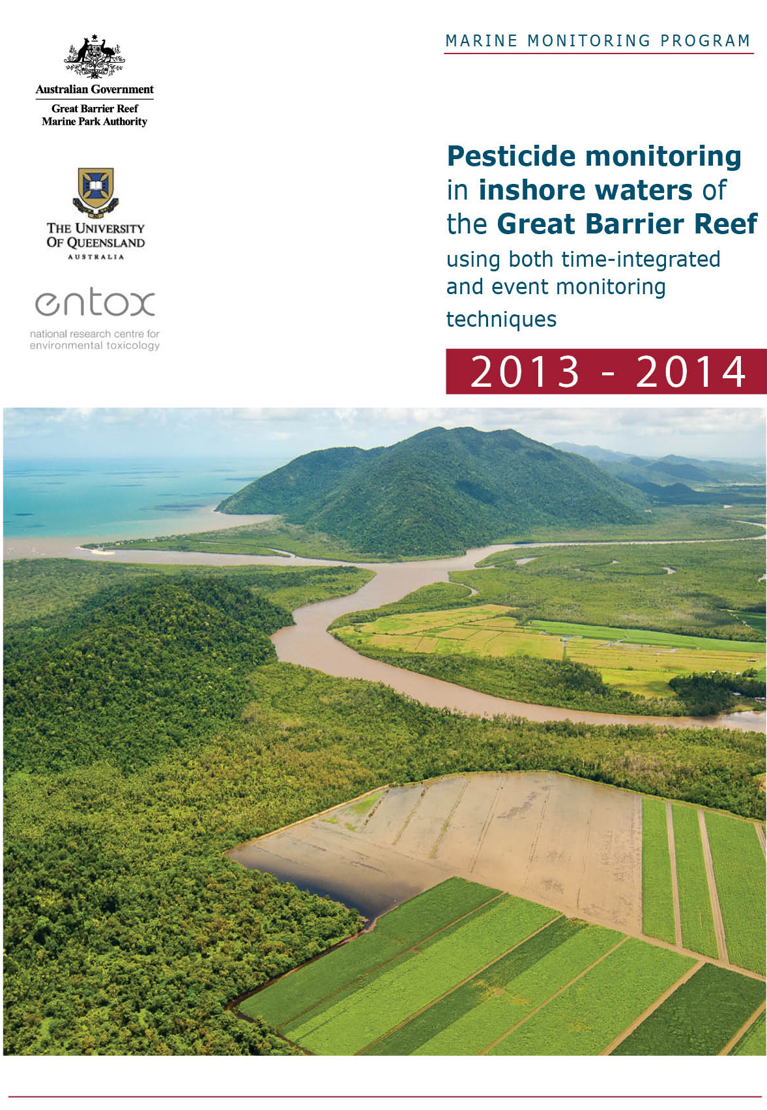
Authors - Gallen, C., Devlin, M., Thompson, K., Paxman, C., Mueller, J.
Project Teams –
- Inshore Marine Water Quality Monitoring
Christie Gallen¹, Chris Paxman¹, Kristie Thompson, Jochen Mueller¹
- Assessment of Terrestrial Run-off Entering the Reef
Christie Gallen¹, Kristie Thompson¹, Chris Paxman¹, Jochen Mueller¹, Eduardo Da Silva², Dieter Tracey², Caroline Petus², Michelle Devlin²

¹The University of Queensland, The National Research Centre for Environmental Toxicology (Entox)
² The Centre for Tropical Water & Aquatic Ecosystem Research (TropWATER), Catchment to Reef Processes Research Group, James Cook University

Report should be cited as –
Gallen, C., Devlin, M., Thompson, K., Paxman, C., Mueller, J. (2014) Pesticide monitoring in inshore waters of the Great Barrier Reef using both time-integrated and event monitoring techniques (2013 - 2014). The University of Queensland, The National Research Centre for Environmental Toxicology (Entox).

Direct Enquiries to –
Professor Jochen Mueller
Phone: +61 7 3000 9197
Fax: +61 7 3274 9003
Email: j.mueller@uq.edu.au
Web: Entox Homepage

The University of Queensland
The National Research Centre for Environmental Toxicology (Entox)
39 Kessels Rd
Coopers Plains QLD 4108

Table of Contents
List of Figures iv
1 EXECUTIVE SUMMARY 1
1.1 Key findings for the 2013-2014 monitoring year 6
2 INTRODUCTION 10
3 METHODOLOGY 11
3.1 Sources of uncertainty 12
3.2 Target Chemicals and Limits of Reporting 13
3.3 Sampling Sites 13
3.4 Sampling Periods 15
3.5 Passive sampler types 16
3.6 Sampling for the Assessment of Terrestrial Run-Off in the Wet Season 16
3.7 Mapping the frequency and extent of flood plumes 17
3.8 Water Quality Guideline Trigger Values 18
3.9 Calculation of PSII-Herbicide Equivalent Concentrations (PSII-HEq) 18
3.10 PSII Herbicide Index 20
4 RESULTS 22
4.1 GBR-wide Summary 2013 -2014 22
4.2 Wet Tropics Region 26
4.2.1 Fixed monitoring sites 26
4.2.2 Russell-Mulgrave River transect 29
4.2.3 Tully River transect 32
4.3 Burdekin Region 35
4.3.1 Fixed monitoring sites 35
4.3.2 Herbert River transect 37
4.4 Mackay Whitsunday Region 39
4.4.1 Fixed monitoring sites 39
4.5 Fitzroy Region 42
4.5.1 Fixed monitoring sites 42
5 DISCUSSION 45
6 SUMMARY 52
7 FUTURE OUTLOOK AND RECOMMENDATIONS 53
8 REFERENCES 54
9 APPENDIX A: Complete analyte list for LCMS and GCMS analysis 59
10 APPENDIX B – Supporing literature for the development of the PSII-HEq Index 63
11 APPENDIX C - Annual freshwater discharge (ML) for rivers influencing fixed monitoring sites 67
12 APPENDIX D – Fixed monitoring – Individual site results 70
13 APPENDIX E – Terrestrial run-off assesment- Results 80
14 APPENDIX F – Mean flow rates in major rivers vs PSII-HEq of passive samplers 83
15 APPENDIX G – Historical concentration profiles at fixed monitoring sites 88
16 APPENDIX H - Land and herbicide use in the GBR catchments adjacent to fixed monitoring sites 98

List of Figures
Figure 1 The temporal trends in PSII-HEq Max at fixed monitoring sites in inshore waters of the GBR determined using time-integrative sampling 3
Figure 2 Locations of current inshore GBR fixed monitoring sites where time-integrated sampling of pesticides occurred in 2013-2014 14
Figure 3 Maximum concentrations of individual herbicides at fixed monitoring sites from the commencement of sampling to 2013-2014 24
Figure 4 PSII-HEq Max at each fixed monitoring site since monitoring commenced to 2013-2014 26
Figure 5 Location of fixed monitoring sites in the Wet Tropics region and the frequency of flood plume waters from 2003-2014. 27
Figure 6 Seasonal average PSII-HEq for Wet Tropics sites since monitoring commenced 29
Figure 7 Locations of grab and passive samplers collected on the Russell-Mulgrave River transect and frequency of flood plume waters in the 2013-2014 wet season. 30
Figure 8 Timing and location of grab (top) and passive (bottom) samples collected on the Russell-Mulgrave River transect, Wet Tropics, during 2013-2014 31
Figure 9 Locations of grab and passive samplers collected on the Tully River transect and the frequency of flood plume waters in the 2013-2014 wet season. 32
Figure 10 Timing and location of grab (top) and passive (bottom) samples taken on the Tully River transect, Wet Tropics, during 2013-2014 34
Figure 11 Location of fixed monitoring sites in the Burdekin region and the frequency of flood plume waters in the 2003- 2014 wet seasons. 35
Figure 12 Seasonal average PSII-HEq for Burdekin sites since monitoring commenced 37
Figure 13 Location of grab samples taken on the Herbert River transect and the frequency of flood plume waters in the 2013-2014 wet season. 38
Figure 14 Timing and location of grab samples taken on the Herbert River transect, Wet Tropics, during 2013-2014 39
Figure 15 Location of fixed monitoring sites in the Mackay Whitsunday region and the frequency of flood plumes during the wet seasons from 2003 - 2014. 40
Figure 16 Seasonal average PSII-HEq for Mackay Whitsunday sites since monitoring commenced 41
Figure 17 Location of the fixed monitoring site in the Fitzroy region and the frequency of flood plumes during the wet seasons from 2003 - 2014. 42
Figure 18 Seasonal average PSII-HEq for North Keppel Island in the Fitzroy region since monitoring commenced 44
Figure 19 Total annual discharge of major rivers into the inshore waters of the GBR (ML) 46
Figure 20 PSII-HEq Max (ng L⁻¹) with the PSII-HEq Index of each value indicated for each fixed monitoring site in 2013-2014 48
Figure 21 Rainfall decile ranges for the dry season May 2013 - Oct 2013 (left) and wet season 1 Nov 2013 – 30 April 2014 (right). 68
Figure 22 One year inter-annual rainfall difference between the previous monitoring year (2012-13) and the current monitoring year (2013-14). 69
Figure 23 Temporal trends in PSII-HEq with respect to flow rate of rivers influencing passive sampler sites in the Wet Tropics region since monitoring commenced 83
Figure 24 Temporal trends in PSII-HEq with respect to flow rate of rivers influencing passive sampler sites in the Wet Tropics region since monitoring commenced 84
Figure 25 Temporal trends in PSII-HEq with respect to flow rate of rivers influencing passive sampler sites in the Burdekin region since monitoring commenced. 85
Figure 26 Temporal trends in PSII-HEq with respect to flow rate of rivers influencing passive sampler sites in the Mackay Whitsunday region since monitoring commenced 86
Figure 27 Temporal trends in PSII-HEq with respect to flow rate of rivers influencing passive sampler sites in the Fitzroy region since monitoring commenced 87
Figure 28 Temporal concentration profiles of individual herbicides at Low Isles in the Wet Tropics region 88
Figure 29 Temporal concentration profiles of individual herbicides at Green Island in the Wet Tropics region 89
Figure 30 Temporal concentration profiles of individual herbicides at Fitzroy Island in the Wet Tropics region 90
Figure 31 Temporal concentration profiles of individual herbicides at Dunk Island in the Wet Tropics region 91
Figure 32 Temporal concentration profiles of individual herbicides at Orepheus Island in the Burdekin region 92
Figure 33 Temporal concentration profiles of individual herbicides at Magnetic Island in the Burdekin region 93
Figure 34 Temporal concentration profiles of individual herbicides at Cape Cleveland in the Burdekin region 94
Figure 35 Temporal concentration profiles of individual herbicides at Outer Whitsunday in the Mackay Whitsunday region 95
Figure 36 Temporal concentration profiles of individual herbicides at Sarina Inlet in the Mackay Whitsunday region 96
Figure 37 Temporal concentration profiles of individual herbicides at North Keppel Island in the Fitzroy region 97
Figure 38 Land Use Map of the GBR catchment – 2009. 98
Figure 39 Net change in land area used for Livestock Grazing between 2009 – 2013 (left) and percentage net change in land area used for agriculture cropping between 2009 – 2013 (right).99
Figure 40 Percentage of land holdings in 28 GBR catchments that apply herbicides in 2008-2009. 100

List of Tables
Table 1 Key findings of the fixed site monitoring in 2013-2014 4
Table 2 Key findings of the terrestrial run-off component in 2013-2014 5
Table 3 Sampling return record for the 2013-2014 monitoring year 15
Table 4 The types of passive samplers deployed at each fixed monitoring site in 2013-2014 16
Table 5 Relative potency factors (RPF) for PSII herbicides and selected transformation products 19
Table 6 PSII-Herbicide Equivalent Index developed as an indicator for reporting of PSII herbicides across the Marine Monitoring Program 20
Table 7 Comparison of long-term median flows in major rivers with total discharge of 2013-2014 22
Table 8 Summary statistics for the PSII-HEq Max and Wet Season Average (ng L⁻¹) since the commencement of monitoring until 2013-2014 in the Wet Tropics. 28
Table 9 Summary statistics for the PSII-HEq Max and Wet Season Average (ng L⁻¹) since the commencement of monitoring until 2013-2014 in the Burdekin region. 36
Table 10 Summary statistics for the PSII-HEq Max and Wet Season Average (ng L⁻¹) since the commencement of monitoring until 2013-2014 in the Mackay Whitsunday region 41
Table 11 Summary statistics for the PSII-HEq Max and Wet Season Average (ng L⁻¹) since the commencement of monitoring until 2013-2014 in the Fitzroy region 44
Table 12 Land area (ha) of catchments adjacent to fixed monitoring sites over which herbicides were applied by NRM region, 2008-2009 50
Table 13 Major land uses of NRM regions within the GBR catchment 51
Table 14. Pesticides specified under the MMP for analysis with different sampling techniques together with the limits of reporting (ng L⁻¹) 59
Table 15 Entox LCMS Analyte List for Positive Mode 60
Table 16 GCMS analyte list for PDMS extracts 61
Table 17 Water quality guideline trigger valuesavailable for specific pesticides (ng L⁻¹) 62
Table 18 Scientific publications indicating the effect concentrations and the end-points for the reference PSII herbicide diuron used to define specific PSII-HEq Index categories as an indicator for reporting purposes 63
Table 19 Preliminary effects of diuron in marine organisms 66
Table 20 Annual freshwater discharge of rivers influencing fixed monitoring sites (ML) and long-term median discharge 67
Table 21 Low Isles, Wet Tropics region – Concentration in water (ng L⁻¹) 70
Table 22 Green Island, Wet Tropics region – Concentration in water (ng L⁻¹) 71
Table 23 Fitzroy Island, Wet Tropics region – Concentration in water (ng L⁻¹) 72
Table 24 Dunk Island, Wet Tropics region – Concentrations in water (ng L⁻¹) 73
Table 25 Orpheus Island, Burdekin region – Concentrations in water (ng L⁻¹) 74
Table 26 Magnetic Island, Burdekin Region – Concentrations in water (ng L⁻¹) 75
Table 27 Cape Cleveland, Burdekin Region – Concentrations in water (ng L⁻¹) 76
Table 28 Outer Whitsunday, Mackay Whitsunday region – Concentrations in water (ng L⁻¹) 77
Table 29 Sarina Inlet, Mackay Whitsunday region – Concentrations in water (ng L⁻¹) 78
Table 30 North Keppel Island, Fitzroy Region – Concentrations in water (ng L⁻¹) 79
Table 31 Concentrations in water (ng L⁻¹) measured along the Russell-Mulgrave transect using 1 L grab samples during run-off events during the wet season 80
Table 32 Concentrations in water (ng L⁻¹) measured at various locations alon the Tully River transect using 1 L grab samples during terrestrial run-off events during the wet season 81
Table 33 Concentrations in water (ng L⁻¹) measured at various locations along the Tully River and Russell-Mulgrave River transects using passive samplers during terrestrial run-off events during the wet season 82
Acronyms

ANZECC | Australian and New Zealand Environment and Conservation Council
APVMA | Australian Pesticides and Veterinary Medicines Authority
ARMCANZ | Agriculture and Resource Management Council of Australia and New Zealand
C_{W} | Concentration in water
DEET  EC₂₀  EC₅₀ | N,N-Diethyl-meta-toluamide  20 % maximal effective concentration is observed  50 % maximal effective concentration is observed
ED | Empore DiskTM passive sampler
Entox | National Research Centre for Environmental Toxicology
ENSO  GBR | El-Nińo Southern Oscillation  Great Barrier Reef
GBRMP | Great Barrier Reef Marine Park
GBRMPA | Great Barrier Reef Marine Park Authority
GC-MS | Gas Chromatography-Mass Spectrometry
GPC | Gel Permeation Chromatography
IWL | Interim working level
K_{OW} | Octanol-water partition coefficient
LC-MS | Liquid Chromatography-Mass Spectrometry
LOD | Limit of Detection
LOR | Limit of Reporting
MMP | Marine Monitoring Program
NATA | National Association of Testing Authorities
PDMS | Polydimethylsiloxane passive sampler
PFM | Passive/Plaster Flow Monitor
PSII-HEq | Photosystem II -Herbicide Equivalent Concentration
PTFE | Polytetrafluoroethylene : Common brand name - Teflon
QHFSS  RPF | Queensland Health Forensic & Scientific Services  Relative Potency Factor
RWQPP | Reef Water Quality Protection Plan
SDB-RPS | Poly(styrenedivinylbenzene) copolymer – reverse phase sulfonated

EXECUTIVE SUMMARY
In 2013-2014, Entox carried out monitoring activities utilising a combination of passive sampling and grab sampling techniques in the Great Barrier Reef Marine Park (GBRMP) as part of the Marine Monitoring Program (MMP). The key objectives of the MMP are to assess the temporal and spatial trends in water quality (i.e. pesticides) at inshore GBR sites and the extent of exposure to organic pollutants delivered to the Reef lagoon during flood events in the wet season. Trends in pesticide exposure were monitored using passive sampling techniques at ten fixed sites located in four Natural Resource Management (NRM) regions (the Wet Tropics, Burdekin, Mackay Whitsunday and Fitzroy). Exposure to pesticides from terrestrial run-off entering the Reef lagoon was assessed using grab samples and passive samplers collected in the Wet Tropics/ Upper Burdekin region, along transects extending from three major rivers during the wet season.

Photosystem II (PSII) herbicides inhibit photosynthesis and have been identified as priority chemicals for monitoring in the GBR due to their heavy usage in GBR catchments in the sugar cane, horticulture and grazing industries. Exposure to these herbicides poses a risk to non-target photosynthetic organisms such as seagrass, corals, algae and aquatic plant life. The concentrations of these herbicides are expressed both as water concentrations (ng L⁻¹) and PSII herbicide equivalent concentrations (PSII-HEq) (also in ng L⁻¹), which incorporate both the potency and abundance of individual PS-II herbicides relative to the reference PSII herbicide diuron. The PSII-HEq Index was developed as an indicator of the potential for PSII inhibition caused by the additive effects of mixtures of herbicides (Figure 1). Additional reporting parameters are the maximum PSII-HEq concentration (PSII-HEq Max) within each monitoring year at each site and the average PSII-HEq during the wet season (PSII-HEq Wet Avg) at each site (Tables 1 and 2).

In this current monitoring year and since monitoring commenced, the PSII herbicide diuron was again the dominant contributor to the PSII-HEq concentrations at all sites due to its abundance and potency as a PSII inhibitor (Figure 1). In this current monitoring year, the PSII-HEq Max for each of the fixed passive sampling sites were low, ranging from Category 4 to 5 (Table 1). The PSII-HEq Max of grab samples collected in the terrestrial run-off assessment at sites located in the Wet Tropics ranged from Category 2 to 5 (Table 2), and for passive samplers ranged from Category 2 to 4. Other non-PSII herbicides (i.e. metolachlor, imidacloprid) and industrial chemicals (galaxolide) were also detected in passive samplers at fixed sites, typically at low ng L⁻¹ concentrations, and also during periods of river discharge in the wet season in both grab and passive samplers.

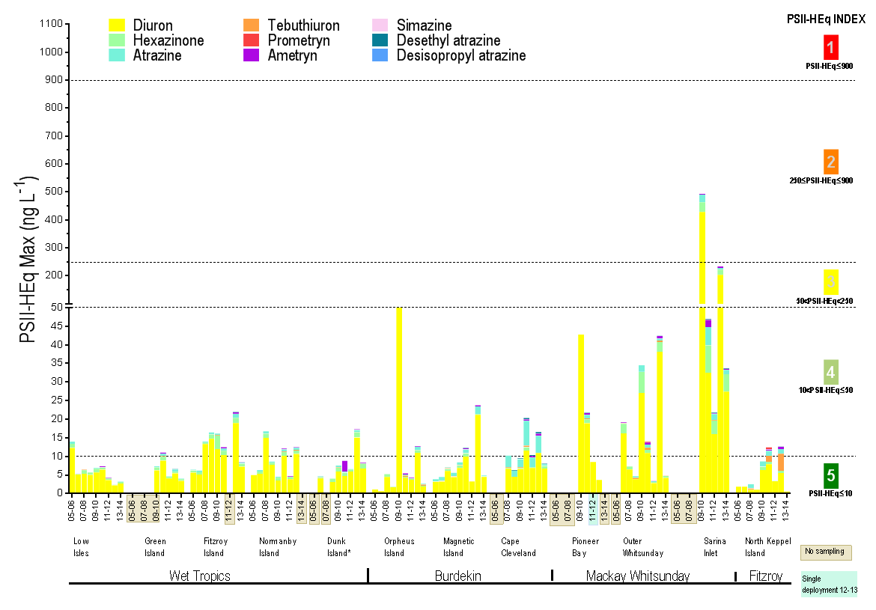
Figure 1 The temporal trends in PSII-HEq Max at fixed monitoring sites in inshore waters of the GBR determined using time-integrative sampling
Table 1 Key findings of the fixed site monitoring in 2013-2014
TI = Time Integrated sampling; E = Equlibrium phase sampling; The reporting parameters PSII-HEq Max and Wet Avg are colour coded according to PSII-HEq Index Categories (refer Figure 1); Note that only one wet season sampling period was successful at Magnetic Island, and results are therefor unreliable

Table 2 Key findings of the terrestrial run-off component in 2013-2014
Max concentrations correspond to the most abundant ‘other pesticide’ highlighted in bold.

Key findings for the 2013-2014 monitoring year

- Fixed site monitoring sites:
A wide range of PSII herbicides, other pesticides and industrial chemicals were frequently detected at pesticide monitoring sites in 2013-2014 using passive sampling techniques, however none of the chemicals detected were at concentrations that exceeded Water Quality Guidelines (ANZECC and ARMCANZ 2000; GBRMPA 2010). The most abundant and frequently detected PSII herbicides in each region were:

- Wet Tropics – diuron (maximum concentration of 7.3 ng L⁻¹ at Fitzroy Island), atrazine (maximum concentration of 2.1 ng L⁻¹ maximum at Fitzroy Island) and hexazinone (maximum concentration of 3.4 ng L⁻¹ at Dunk Island)

- Burdekin – diuron (maximum concentration of 6.8 ng L⁻¹), atrazine (maximum concentration of 2.9 ng L⁻¹ maximum), and hexazinone (maximum concentration of 1.9 ng L⁻¹), all detected at Cape Cleveland

- Mackay Whitsunday – diuron (maximum concentration of 27 ng L⁻¹), hexazinone (maximum concentration of 12 ng L⁻¹) and atrazine (maximum concentration of 7 ng L⁻¹), all detected at Sarina Inlet

- Fitzroy – diuron (maximum of 0.57 ng L⁻¹) and atrazine (maximum concentration of 0.14 ng L⁻¹) at North Keppel Island.

Other non PSII herbicides were also detected at fixed monitoring sites (terbutryn, imidacloprid, imazapic and metolachlor), with metolachlor regularly detected at all sites.

The trends in the reporting parameters PSII-HEq Max and PSII-HEq Wet Avg during the 2013-2014 monitoring year were:

- Wet Tropics –Low Isles and Green Island were the only sites where the PSII-HEq Max remained a Category 5 from the previous monitoring year, whereas Fitzroy Island and Dunk Island improved from a Category 4 to 5 (note that no sampling occurred at Normanby Island in 2013-14). PSII-HEq Max values of sites continued to be either low Category 4, or Category 5 since monitoring commenced. The PSII-HEq Wet Avg of all sites remained Category 5 for all sites from the previous monitoring year, except for Fitzroy Island which improved from a Category 4 to a Category 5.

- Burdekin – The PSII-HEq Max values of all sites improved from a Category 4 to Category 5 from the previous year. PSII-HEq Wet Avg also decreased, with all sites now a Category 5 (note that Magnetic Island only had one successful deployment during this current wet season).

- Mackay Whitsunday – Both the PSII-HEq Max and PSII-HEq Wet Avg decreased substantially at both Outer Whitsunday and Sarina Inlet from the previous monitoring year to a Category 5 and Category 4 respectively. Note that no deployments occurred at Pioneer Bay this year.

- Fitzroy – Both PSII-HEq Max and the PSII-HEq Wet Avg at North Keppel Island have decreased this year (now both a Category 5). Both values are at their lowest since monitoring commenced.

- Terrestrial Run-Off (flood plumes)
A range of PSII herbicides were detected in both passive and grab samples collected along transects extending from the Tully, Russell-Mulgrave and Herbert Rivers, located in the Wet Tropics/ Upper Burdekin regions. Two grab samples collected at the Tully and Russell-Mulgrave River mouths, had concentrations of diuron and metolachlor that exceeded Interim Working Levels of the ANZECC and ARMCANZ Guidelines of 200 ng L⁻¹and 20 ng L⁻¹ respectively.

- On a transect extending approximately 12 km from the Herbert River in the Wet Tropics region, diuron (maximum concentration 10 ng L⁻¹), atrazine (maximum concentration 10 ng L⁻¹) and hexazinone (maximum concentration 3.3 ng L⁻¹), were detected in all four grab samples collected.

- On a transect extending approximately 30 km north of the Tully River in the Wet Tropics region, diuron (maximum concentration 290 ng L⁻¹), atrazine (maximum concentration 340 ng L⁻¹) and hexazinone (maximum concentration 93 ng L⁻¹) were detected in grab samples collected at all four transect locations with the highest concentrations detected in samples from the river mouth. Other non-PSII herbicides such as metolachlor, imidacloprid, metribuzin were also regularly detected. Passive samplers deployed at all four locations detected a larger number of different PSII and non-PSII herbicides than grab samples taken at the same locations, with diuron, atrazine and hexazinone also detected at the highest concentrations at the location closest to the river mouth.

- On a transect extending approximately 21 km from the Russell-Mulgrave River in the Wet Tropics region, diuron (maximum concentration 270 ng L⁻¹), atrazine (maximum concentration 52 ng L⁻¹) and hexazinone (maximum concentration 85 ng L⁻¹) were detected at all three locations with the highest concentrations detected in samples collected at the river junction. Other non-PSII herbicides such as imidacloprid, metribuzin were also regularly detected. Passive samplers deployed at one location along the transect also detected diuron, atrazine and hexazinone in the highest concentrations.
Acknowledgements
Other contributors to this work include-
- Carol Honchin of the GBRMPA for her work on the PSII-HEq Index in 2010.
- Britta Schaffelke and staff of the Australian Institute of Marine Sciences for the assessment of long term discharge data.
- Steve Carter and Vince Alberts of Queensland Health Forensic and Scientific Services for the analysis and reporting of pesticide data for the project.
- Adam Thom and Alex Shanahan of the School of Geography, Planning and Environmental Management, University of Queensland for mapping project support (mapping).
- The early work of David Haynes, Joelle Prange and Deb Bass of the GBRMPA in establishing and managing this monitoring program.

These monitoring activities have been undertaken in some form since 2005. Entox therefore acknowledges the significant contribution of past staff–
Dr Karen Kennedy, Andrew Dunn, Dr Michael Bartkow, Dr Tatiana Komarova, Dr Melanie Shaw, Anita Kapernick, Jake O’Brien, Andrew Banks

The assistance of the numerous volunteers who have deployed passive samplers is gratefully acknowledged –
Whitsunday Moorings | Hamilton Island Enterprises | Great Barrier Reef Marine Park Authority
Mission Beach/ Dunk Island Water Taxi | Ingham Travel | Australian Centre for Tropical and Freshwater Research
Sarina Bait Supplies | Frankland Island Cruise & Dive | North Keppel Island Environmental Education Centre
Jace Services | Magnetic Dive | Cairns Dive Centre (Fitzroy Island)
Reef Fleet Terminal | Orpheus Island Research Station | Australian Institute of Marine Science
Quicksilver Connections | Big Cat Green Island | CSIRO Land and Water

In particular Entox thanks the GBRMPA Program Manager Katherine Martin and the GBRMPA Regional coordinators for the role they have played in managing and facilitating this monitoring program throughout the years: -
Carolyn Thompson, Cath McLean, Phil Laycock, Warwick Sheldon

About the Marine Monitoring Program –
The Marine Monitoring Program is a water quality and ecosystem health long-term monitoring program in the Great Barrier Reef lagoon to track the effectiveness of the Reef Plan. This project is supported by the Great Barrier Reef Marine Park Authority, through funding from the Australian Government Reef Programme.

INTRODUCTION
The World Heritage Great Barrier Reef Marine Park covers an area of 344,400 km² and spans 2,300 km along the Queensland coast in Eastern Australia. The Reef is the largest living structure on Earth, and it supports a rich and diverse ecosystem of marine organisms, including many endangered species. Coral reefs worldwide are exposed to multiple simultaneous stressors including shipping, destructive fishing practices, destructive weather, effects of climate change and the delivery of anthropogenic pollutants (sediments, nutrients, pesticides and other chemicals) from sewerage, aquaculture, urban and agricultural sources (Brodie et al. 2012).

The declining quality of water entering the Great Barrier Reef (GBR) lagoon has been identified as a key threat to the Reef’s continued ability to adapt to change and withstand these multiple stressors, whether they be local (e.g. a cyclone) or the global impacts of climate change (such as ocean acidification and rising sea temperature) (Furnas, 2003; Hoegh-Guldberg et al 2007; Brodie et al 2008; Brodie and Waterhouse 2009; De’ath et al 2009; Packett et al 2009; van Dam et al 2010). The goal of the updated 2013 Reef Plan is to ensure that by 2020 the quality of water entering the Reef from broadscale land-use has no detrimental impact on the health and resilience of the GBR. Further specific water quality targets to meet this goal include a minimum reduction in end-of-catchment pesticide loads of 60 % by 2018 (Anon, 2013). The MMP was implemented under the Reef Water Quality Protection Plan (RWQPP) 2003 (which was further updated as Reef Plan in 2009 and 2013) to evaluate trends in water quality status in the GBR and the long-term impacts on key ecosystems (inshore coral reefs and seagrass).

Approximately 76 % of the land in the GBR catchment area (adjacent to the Reef) is used for agricultural activities (including sugar cane, beef grazing, horticulture, cropping, pastures and cotton) (Smith et al 2012). Nutrients, sediments and agricultural chemicals from these adjacent catchments are introduced into the inshore waters of the Reef in river run-off during the wet season, and are often at elevated concentrations for extended periods of time (Devlin and Scaffelke, 2009). Unlike other water quality indicators such as chlorophyll a and turbidity that are present naturally in the environment at low levels and can be enhanced by anthropogenic activities, the presence of pesticides in inshore waters is a direct indicator of the influence of human activities, such as agricultural practices, on this world heritage ecosystem.

The objective of the fixed site pesticide monitoring component of the MMP is to monitor long-term temporal and spatial trends in pesticide concentrations across four Natural Resource Management (NRM) regions – the Wet Tropics, Burdekin, Mackay Whitsunday and Fitzroy. This monitoring has been conducted for between five to nine years at these locations.

The focus of the terrestrial run-off component in 2013-2014 was to chemically profile the pollutants delivered by flood plumes in the Wet Tropics region, and the extent of their influence on water quality using transects extending from river mouths. Data from the terrestrial run-off component also serves to develop and validate models describing the movement of water and transport of land-based pollutants throughout the inshore marine environment

Under Reef Plan, governments are working with farmers and graziers to halt and reverse the decline in the quality of water entering the GBR by improving land management practices. Information from the MMP is combined with data collected at the paddock and catchment level to produce an annual report card that summarises the health of the Reef and its catchments, actions being taken to reduce the loads of pollutants, and assesses progress towards Reef Plan’s long-term goal by 2020.
.

METHODOLOGY
Water quality monitoring at fixed sites was conducted using passive sampling techniques. These samplers accumulate chemicals into a sorbing material from water via passive diffusion. The passive sampling techniques which are utilized in this component of the MMP include:

- SDB-RPS EmporeTM Disk (ED) based polar passive samplers for relatively hydrophilic organic chemicals with relatively low octanol-water partition coefficients (logK_{OW}) such as the PSII herbicides (e.g. diuron).

- Polydimethylsiloxane (PDMS) non-polar passive samplers for organic chemicals which are relatively more hydrophobic (higher log K_{OW}) such as chlorpyrifos.

Terrestrial run-off assessments conducted during the wet season used both 1 L grab water sampling and passive sampling techniques. Full details regarding these methodologies have been described in the Marine monitoring program quality assurance and quality control manual 2013/2014 (GBRMPA, 2014) and in previous reports (Kennedy et al. 2010a; Kennedy et al. 2011a).

The participation of volunteers from various community groups, agencies and tourist operations is a key feature of the fixed site pesticide monitoring program and integral to the success of maintaining the program in often remote locations. These volunteers assist by receiving, deploying, retrieving and returning the passive samplers to Entox for subsequent extraction and analysis. This active participation of volunteers within the program is made possible by training from GBRMPA and/or Entox staff in Standard Operating Procedures to ensure a high level of continuous sampling and high quality usable data is obtained from these deployments. Passive samplers and grab samples collected as part of the terrestrial run-off assesments are serviced by Michelle Devlin and team from James Cook University.

Sources of uncertainty
In order to interpret both trends in the long-term data and true changes in concentrations year to year, there must be an understanding of the inherent variability of the data. Possible sources of uncertainity when using the passive samplers may include (but are not limited to) the effects of salinity and water temperature on chemical uptake into the sampler, accurate measurement of exposure time, the integrity of the flow-limiting membrane over the deployment period, degree of biofouling on the surface of the sampler and its effect on the sampling area, analytical error and variability in the dissolution of the PFM used to approximate water flow (and sampling rates).

Salinity (ionic strength) has been found to have a very small effect on the solubility of the gypsum contained in the PFM, which is subsequently used to estimate sampling rates with respect to the water flow at a given site (O’Brien et al. 2011). The effect of salinity on a hypothetical calculation of water concentration from an ED, found that a change in salinity from 5 g L⁻¹ (freshwater) to 35 g L⁻¹ (marine water) did not change the estimated flow rate (to two significant figures) under either low or high dissolution rate conditions. The effect of water temperature on the dissolution of the PFM is not well understood, but as water temperature remains relatively constant between the wet and dry seasons (20 – 25 degrees) (CSIRO, 2014) it is assumed to have a negligible effect.

Replicate PFMs are deployed at each passive sampler site, and the mass lost per day is used to estimate the sampling rate of chemicals. Normalised difference percentages between duplicate PFMs deployed at each site this monitoring year ranged between <1 and 35 % (mean of 6%), showing good agreement (this excludes 15 sampler sets where PFM duplicates were both empty upon retrieval).

A small number of ED extracts were selected for comparative analysis between Entox and QHFSS (Marine monitoring program quality assurance and quality control manual 2013/2014 (GBRMPA 2014)) to compare the analytical accuracy of Entox methods. Results showed that the analytical results produced by the two methods was within an acceptable range with %CVs ranging from 1.9 % - 36 %. Variability was highest for the two atrazine breakdown products, however the three most frequently and abundantly detected herbicides (diuron, atrazine and hexazinone) had lower analytical variability of 15, 2 and 15 % respectively.

Duplicate EDs are deployed at each sampling site, and approximately one in every 10 samples has a duplicate sampler also analysed to determine the variability in the overall performance (chemical uptake) of the EDs.This monitoring year, ten ED sampler sets were analysed in duplicate, with 41 herbicide detections in both duplicates and 8 herbicide detections in only one of the duplicates. Mean %CVs for each chemical that was detected in both duplicates, ranged from 11 % (hexazinone) to 97 % (desisopropyl atrazine). Variability in the estimated water concentrations of diuron and atrazine was 15 % and 30 % respectively.
Considering the various analytical and duplicate variabilities, it is advisable that a factor > 2 must be reached in order to exceed the inherent uncertainties and report a true change in temporal concentrations of herbicides.

Target Chemicals and Limits of Reporting
The list of target chemicals (Appendix A, Table 14) was derived at the commencement of the MMP through consultation with GBRMPA based on the following criteria: pesticides detected in recent studies, those recognised as a potential risk, analytical affordability, pesticides within the current analytical capabilities of Queensland Health Forensic and Scientific Services (QHFSS) and those likely to be accumulated within one of the passive sampling techniques (i.e. that exist as neutral species and are not too polar).

Empore disc sampler extracts and grab samples were analysed by Entox using liquid chromatography mass spectrometry run in positive analysis mode (Appendix A, Table 15). Several grab samples were analysed by QHFSS as per previous monitoring years, prior to the method being transferred to Entox. These particular samples have been highlighted in Appendix E, Table 31 - 32. PDMS sampler extracts were analysed for pesticides using gas chromatography mass spectrometry (GCMS). While priority chemicals are targeted using PDMS in this MMP, a broader suite of organic chemicals including other pesticides and industrial chemicals are also simultaneously measured (Appendix A, Table 16). Pesticide analysis by GCMS was still undertaken by QHFSS.

Sampling Sites
Passive samplers were deployed at ten inshore GBR sites in 2013 – 2014 (Figure 2). Of these, Low Isles, Green Island, Dunk Island, Magnetic Island, Outer Whitsunday and Sarina Inlet are also seagrass monitoring sites within the MMP.

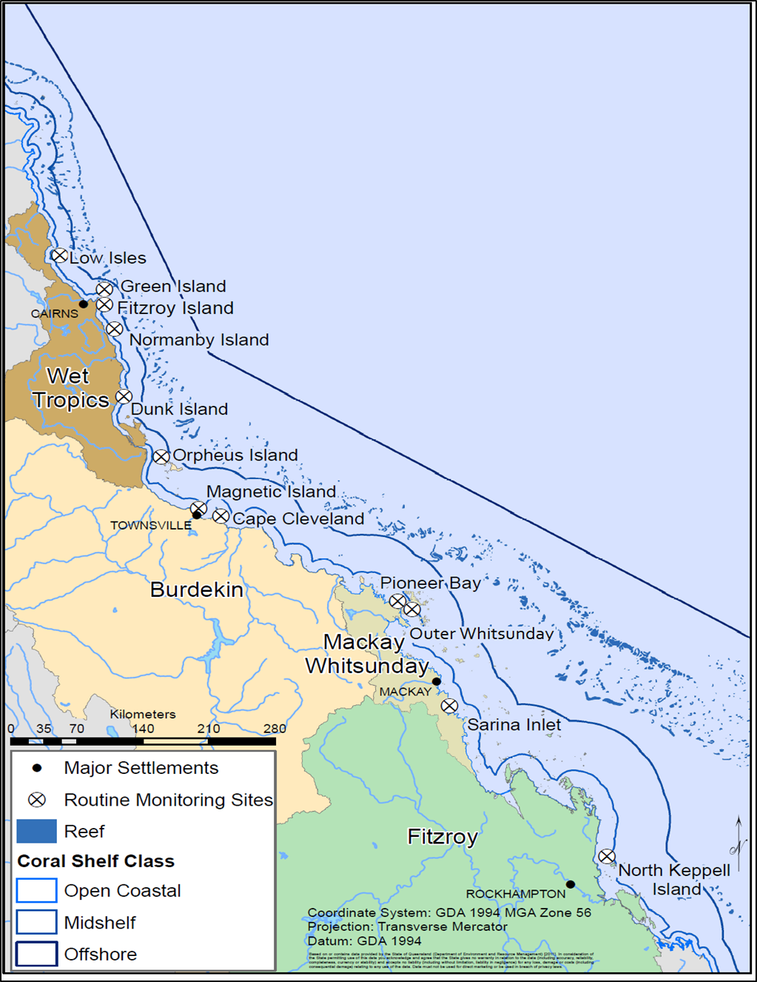
Figure 2 Locations of current inshore GBR fixed monitoring sites where time-integrated sampling of pesticides occurred in 2013-2014
(Source – Adam Thom and Alex Shanahan, School of Geography, Planning and Environmental Management, the University of Queensland)

Sampling Periods
The monitoring year for pesticide sampling is from May 2013 to April 2014. The year is arbitrarily divided into “Dry 13” (May 2013 to October 2013) and “Wet 13-14” (November 2013 – April 2014) sampling periods for reporting purposes. Within each dry season deployment period, samplers are typically deployed for two months (maximum of three deployment periods each monitoring year) and within each wet season deployment period, samplers are typically deployed for one month (maximum of six deployment periods within each monitoring year). The maximum number of samples which should be obtained from each location within each monitoring year is nine (Table 3).

Table 3 Sampling return record for the 2013-2014 monitoring year
NRM Region | Site Name | No of samplers sent | No of samplers deployed and returned | Comments
Wet Tropics | Low Isles | 9 | 8 | 1 sampler set lost or stolen from mooring
Wet Tropics | Green Is | 9 | 9 | No issues
Wet Tropics | Fitzroy Is | 9 | 8 | Samplers from April co-deployed with July set
Wet Tropics | Normanby Island | 6 | 0 | Original volunteer left, but not advised until several months later. Replacement volunteer also left. Company advised they would investigate a replacement, but none found. Stopped sending samplers in February
Wet Tropics | Dunk Is | 8 | 4 | Losses due to bad weather. Mooring out of action for several months.
Burdekin | Orpheus Is | 9 | 9 | No issues
Burdekin | Magnetic Is | 9 | 3 | Issues included volunteer change, and loss of mooring due to weather. 2 sampler sets believed lost after lodgement with courier company.
Burdekin | Cape Cleveland | 9 | 9 | No issues apart from 1 over-deployment.
Mackay Whitsunday | Pioneer Bay | 4 | 0 | Continued communication issues with the volunteer, all samplers sent were returned unused
Mackay Whitsunday | Outer Whitsunday | 9 | 8 | 1 sampler set not deployed
Mackay Whitsunday | Sarina Inlet | 7 | 7 | A few late deployments and over-deployments. 1 sampler set deployed late in sampling year and will be included in 2014/15 data.
Fitzroy | North Keppel Island | 9 | 8 | 1 set not deployed due to late deployments.
TOTAL |  | 97 | 73

Passive sampler types
Fixed sites are monitored in both the dry and wet periods using EDs (Table 4), while six of these sites have additional PDMS samplers deployed during the wet season (three sites located in the Wet Tropics region, two in the Burdekin region and one in the the Mackay Whitsunday region). Normanby Island (located in the Wet Tropics) is the only site which is normally monitored year-round using PDMS in both the dry and wet period. SPMDs (another type of non-polar passive sampler) are also deployed at this site only. Unfortunately, no sampling occurred at this site in 2013-14 due to volunteer issues at the site. Similarly, all sampler sets sent to Pioneer Bay in the Mackay Whitsunday region were returned unused. The sampling records and results for each fixed monitoring site are provided in Appendix D, Tables 21-30.

Table 4 The types of passive samplers deployed at each fixed monitoring site in 2013-2014
Region | Site | EDs (polar) |  | PDMS (non-polar) |  | SPMD (non-polar)
Region | Site | Dry | Wet | Dry | Wet | Dry | Wet
Wet Tropics | Low Isles
Wet Tropics | Green Island
Wet Tropics | Fitzroy Island
Wet Tropics | Normanby Island (no successful sampling occurred)
Wet Tropics | Dunk Island
Burdekin | Orpheus Island
Burdekin | Magnetic Island
Burdekin | Cape Cleveland
Mackay - Whitsunday | Pioneer Bay (no successful sampling occurred)
Mackay - Whitsunday | Outer Whitsunday*
Mackay - Whitsunday | Sarina Inlet*
Fitzroy | North Keppel Island
*PDMS were deployed at these sites for this monitoring year only.

Sampling for the Assessment of Terrestrial Run-Off in the Wet Season
A total of fifty five 1 L grab samples were collected to monitor terrestrial run-off from three rivers using three transects in one NRM region (the Wet Tropics/ Upper Burdekin) during flood plume events in the 2013-2014 wet season. Passive samplers were deployed at one location extending from the Russell-Mulgrave River, and at four locations extending from the Tully River. Further details for these samples including the date and time of collection, co-ordinates and results for individual herbicides detected are provided in Appendix E, Tables 31-33.

Mapping the frequency and extent of flood plumes
River flood plumes are the primary vehicles that deliver catchment-derived pollutants to the GBR lagoon. Mapping the frequency, spatial extent and duration of these flood events is essential when developing risk models that can inform management about the areas that may be the most at risk to acute or chronic effects of pollutant exposure resulting from river discharge. Additionally, these maps can provide an indication of the frequency in which a fixed monitoring site was influenced by plume waters, and potentially exposed to elevated levels of pollutants.

One of the outputs of the Inshore Marine Water Quality component of the MMP is mapping the frequency and extent of (surface) flood plumes using ocean colour collected via satellite imagery that exploits differences in colour of plume waters from ambient marine waters in 1km² ‘pixels’ (Devlin et al. 2012a). Six colour classes have been defined that correspond to three water types – primary, secondary and tertiary. Each water type is associated with different levels and combination of pollutants which will impact on different components of the GBR ecosystems (Alvarez-Romero et al. 2013; Devlin et al., 2012b).

The annual frequency of occurrence for each water type was calculated (by first overlaying weekly composite maps) as the number of weeks that a pixel was retrieved as either primary, secondary or tertiary water type, divided by the maximum number of weeks in a wet season (i.e., 22 weeks taken from the 1st of December to the 30th of April). Annual exposure maps are useful to identify the year to year variation of the surface water types but can also be useful to develop a long-term surface exposure map that can identify areas that are at higher risk of exposure to surface pollutants over a longer temporal scale. To create multi-annual exposure maps, the annual frequency maps were overlaid and the water type category for each pixel was reclassified using the median pixel value.

The frequency of occurrence of flood plumes is aggregated into frequency classes of low risk (frequency of 0.1) to high risk (frequency of 1) to create frequency maps for primary and secondary water types for the whole GBR. Multi-annual wet season frequency maps of fixed monitoring sites from 2003 – 2014 are provided in this report for each region (see Sections 4.2 – 4.5), in addition to the 2014 annual frequency maps for the sites monitoring terrestrial run-off in the Wet Tropics region during the wet season (see Sections 4.2 and 4.3).

Water Quality Guideline Trigger Values
Measured concentrations of pesticides and other chemicals were compared to trigger values (Guidelines) developed by the GBRMPA (GBRMPA 2010) and ANZECC and ARMCANZ (2000), e.g. see Appendix A, Tables 17. The trigger values chosen are conservative and protective of 99 % of species. This level of protection was judged the most suitable for the GBR World Heritage Area, which is classified as having outstanding natural value and no change in the indicators of biological diversity beyond the natural variation is recommended (ANZECC and ARMCANZ 2000; GBRMPA 2010). In certain cases, only freshwater guidelines (ANZECC and ARMCANZ) or “low reliability” Guidelines or “interim working levels” (IWLs) were available for assessing the concentrations of specific chemicals. In many cases, no Guideline values are available to assess the concentrations of specific chemicals detected in this current monitoring year.

Calculation of PSII-Herbicide Equivalent Concentrations (PSII-HEq)
In this report, PSII herbicide concentrations (ng L⁻¹) are also expressed as PSII herbicide equivalent concentrations (PSII-HEq) (also in ng L⁻¹). PSII-HEq values were derived using relative potency factors (RPF) for each individual PSII herbicide with respect to a reference PSII herbicide diuron. The risk of PSII inhibition may be underestimated when concentrations of herbicides are considered individually rather than as part of a more complex mixture.

A given PSII herbicide with an RPF of 1 is equally as potent as diuron. If it is more potent than diuron it will have an RPF of >1, while if it is less potent than diuron it will have an RPF of <1. To calculate the PSII-HEq concentration of a given grab or passive sample, it is assumed that these herbicides act additively (Escher et al. 2006; Muller et al. 2008; Magnusson et al. 2010). The PSII-HEq (ng L⁻¹) is therefore the sum of the individual RPF-corrected concentrations of each individual PSII herbicide (Ci, ng L⁻¹) detected in each sample using Equation 1.

PSII-HEq = ∑ C_{i} x RPF_{i} Equation 1

RPF values for the chemicals of interest were obtained from relevant laboratory studies (Table 5). For the initial determination of RPF consensus values, average values from studies obtained using corals, Phaeodactylum and Chlorella were used (different organisms were not weighted). The PSII-HEq concentrations in this report were then predicted using these mean preliminary consensus RPF values giving equal weight to EC₅₀ and EC₂₀ values. These initial consensus values were developed and applied to determine PSII-HEq since the baseline reporting year 2008-09 and have not been updated for the sake of consistency. However it should be acknowledged that as more data continues to be published (Magnusson et al. 2010), it is likely that these values would benefit from review and updating in the future to include not only more data for these chemicals but also additional PSII herbicides that are detected in GBR waters such as bromacil and terbutryn.

Table 5 Relative potency factors (RPF) for PSII herbicides and selected transformation products
PSII  Herbicides | Relative potency (range) |  | Relative potency (mean based on various EC values)
PSII  Herbicides | Zooxanthellae (Corals) ª | P.  tricornutum^{bcd} |  | C. vulgaris^{bde} | Zooxanthellae (Corals) ª | P. tricornutum^{bcd} | C. vulgaris^{bde} | Mean/  Preliminary consensus ª  RPF
Diuron (reference) | 1 | 1 |  | 1 | 1 | 1 | 1 | 1
Ametryn | 1.2-1.35 | 0.94 |  | 0.9 -2.7 | 1.28 | 0.94 | 1.71 | 1.31
Atrazine | 0.05-0.06 | 0.1-0.4 |  | 0.15 -0.3 | 0.05 | 0.22 | 0.21 | 0.16
Desethyl-atrazine |  |  |  | 0.01-0.2 |  |  | 0.105 | 0.11
Desisopropyl- atrazine |  |  |  | 0.003 |  |  | 0.003 | 0.003
Flumeturon |  |  |  | 0.04 |  |  | 0.04 | 0.04
Hexazinone | 0.2-0.26 | 0.27-0.82 |  | 0.17-0.95 | 0.23 | 0.46 | 0.44 | 0.38
Prometryn |  |  |  | 1-1.1 |  |  | 1.05 | 1.05
Simazine | 0.02 | 0.03-0.05 |  | 0.02-0.26 | 0.02 | 0.04 | 0.14 | 0.07
Tebuthiuron | 0.01 | 0.07 |  | 0.11-0.2 | 0.01 | 0.07 | 0.15 | 0.08
Terbuthylazine |  |  |  | 0.3 |  |  | 0.3 | 0.3
ª(Jones and Kerswell 2003);^{b} (Muller et al. 2008); ^{c} (Bengtson-Nash et al. 2005); ^{d} (Schmidt 2005); ^{e} Macova et al., unpublished data (Entox); ^{f}Based on a preliminary summary of available data when derived in 2009 - it should be noted that bromacil (routinely analysed for since 2009-2010) and terbutryn (beginning to be routinely analysed for from the end of 2010-2011) are also PSII herbicides and not currently incorporated into PSII-HEq estimates (no RPF). Similarly while terbuthylazine does have a RPF it is not a target chemical in the analysis of EDs, but is part of the GCMS pesticide screen for PDMS. The herbicides which contribute to PSII-HEq in this report are shaded.

PSII Herbicide Index
To interprete the PSII-herbicide data reported as PSII-HEq, the PSII Herbicide Index has been compiled (with the GBRMPA) as an indicator of PSII inhibition to report against across the MMP (Table 6). This index uses published scientific evidence with respect to the effects of the reference PSII herbicide diuron (summarized for each index category in Appendix, Table 18-19). These index criteria have been slightly modified from those indicated in the baseline reporting year 2008-2009 (Kennedy et al. 2010b). Note that an increase in the concentrations of herbicides detected, which translates to an increase in PSII-HEq, can subsequently result in a decline in Index category (for e.g. Category 5 to Category 4).

The Index consists of five Categories which range from Category 1 (> 900 ng L⁻¹), which represents the highest risk of exposure (above the 99 % species protection trigger value derived for the reference PSII herbicide diuron (GBRMPA 2010), to Category 5 (≤10 ng L⁻¹), which represents concentrations below which no published PSII inhibition effects have been observed.

Table 6 PSII-Herbicide Equivalent Index developed as an indicator for reporting of PSII herbicides across the Marine Monitoring Program
Category | Concentration  (ng L⁻¹) | Description
5 | PSII-HEq ≤ 10 | No published scientific papers that demonstrate any effects on plants or animals based on toxicity or a reduction in photosynthesis. The upper limit of this category is also the detection limit for pesticide concentrations determined in field collected water samples
4 | 10 < PSII-HEq ≤ 50 | Published scientific observations of reduced photosynthesis for two diatoms.
3 | 50 < PSII-HEq < 250 | Published scientific observations of reduced photosynthesis for two seagrass species and three diatoms.
2 | 250 ≤ PSII-HEq ≤ 900 | Published scientific observations of reduced photosynthesis for three coral species.
1 | PSII-HEq > 900 | Published scientific papers that demonstrate effects on the growth and death of aquatic plants and animals exposed to the pesticide. This concentration represents a level at which 99 per cent of tropical marine plants and animals are protected, using diuron as the reference chemical.

For categories 2 – 4:
- The published scientific papers indicate that this reduction in photosynthesis is reversible when the organism is no longer exposed to the pesticide;

- Detecting a pesticide at these concentrations does not necessarily mean that there will be an ecological effect on the plants and animals present;

- These categories have been included as they indicate an additional level of stress that plants and animals may be exposed to in the Marine Park. In combination with a range of other stressors (e.g. sediment, temperature, salinity, pH, storm damage, and elevated nutrient concentrations) the ability of these plant and animal species to recover from impacts may be reduced.

Classifying the data generated in this MMP into Index categories provides an indication of the additive effects of PSII herbicides on plants, animals or algae, based on the concentrations and relative potencies of the individual herbicides detected. The Index can quickly indicate the extent of PSII inhibition encountered at a given site (and its potential consequences), and a rapid indication of the duration (i.e. length of deployment periods) and/or frequency that a site is exposed to elevated levels of PSII herbicides.

RESULTS

GBR-wide Summary 2013 -2014
The 2013-2014 monitoring year was characterised by below average rainfall and discharge of the major rivers of the four NRM regions (Table 7). The ratio of freshwater discharge in 2013-2014 to the long-term median ranged from 0.2 – 3.3 compared to 0.5 – 3.1 in the previous monitoring year (Table 7; Bentley et al, 2012). Notably, only the Daintree River had a ratio of 3.3, whereas all others ranged from 0.2 – 1.3.

Table 7 Comparison of long-term median flows in major rivers with total discharge of 2013-2014
*River discharge data compiled by Michelle Devlin. (Data Source Department of Environment and Resource Management, Stream Gauging Network). Long-term median flow data was provided by Shaffelke et al 2011, and determined from the commencement of river monitoring up to the year 2000. Long-term median water year is from October 1st to September 30th the following year.

Overall, the PSII-HEqs of deployed samplers were lower than the previous monitoring year (2012-2013), as periods of high river flow typically coincide with increased PSII-HEq concentrations (see Appendix F, Figures 23 – 27). The PSII herbicides detected at inshore reef locations in the current monitoring year were ametryn, atrazine, bromacil (detected three times only), desethyl atrazine, desisopropyl atrazine, diuron, hexazinone, prometryn (detected once only), simazine and tebuthiuron. The most frequently detected and highest concentration herbicides in this current monitoring year were diuron (maximum concentration of 27 ng L⁻¹ at Sarina Inlet in the Mackay Whitsunday region), atrazine (maximum concentration of 7 ng L⁻¹ at Sarina Inlet) and hexazinone (maximum concentration of 12 ng L⁻¹ at Sarina Inlet). Metolachlor and imidacloprid were also detected frequently although at relatively low concentrations (maximum concentrations of 1.3 and 1.6 ng L⁻¹ in EDs, respectively). At fixed monitoring sites, no herbicides with an individual Guideline to assess against exceeded its Guideline value (Figure 3).
Diuron was the dominant contributor to the PSII-HEq Max at every fixed monitoring site due to its potency as a PSII inhibitor and its relatively higher concentrations (Figure 3). Diuron contributed an average of 84 % to the PSII-Max in the Wet Tropics (excluding Normanby Island), 82 % in the Burdekin, 84 % in the Mackay Whitsundays (excluding Pioneer Bay) and 97 % at North Keppel Island in the Fitzroy. The contribution of diuron remained relatively consistent between the sites within the Wet Tropics (80 % - 85 %) and Mackay Whitsunday region (81 % - 85 %) but varied more widely within the Burdekin region (72 % at Orpheus Island to 91 % at Magnetic Island).

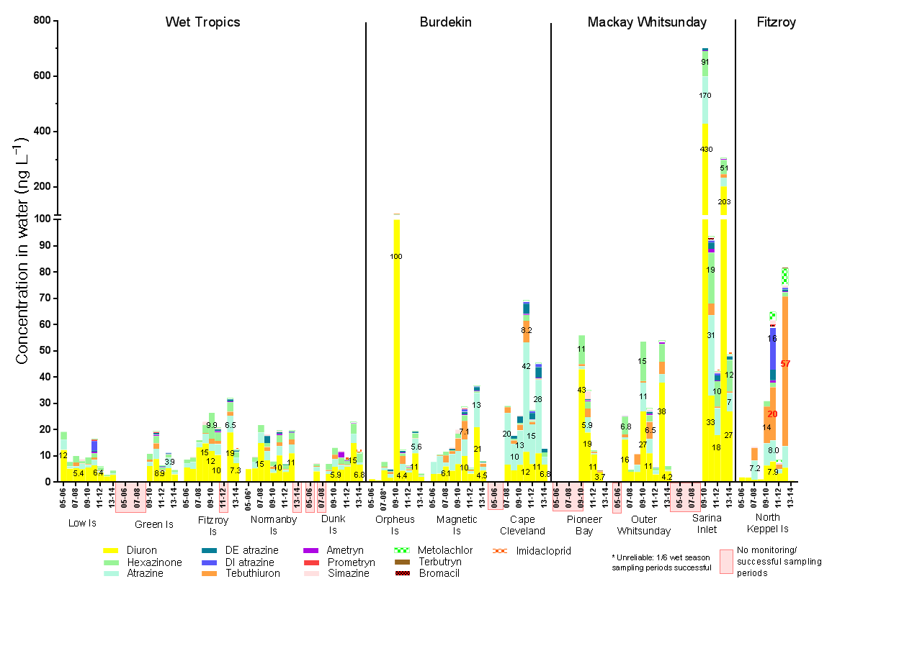
Figure 3 Maximum concentrations of individual herbicides at fixed monitoring sites from the commencement of sampling to 2013-2014

There was a possible decrease in the maximum concentrations of herbicides detected at all sites (with the exception of Low Isles) when compared to the previous monitoring year (Figure 3). The greatest decrease was observed in the Mackay Whitsundays region, with the maximum concentration of diuron decreasing by almost 10 times.

Since monitoring commenced, 73 % of PSII-HEq Max values in the Wet Tropics have been Category 5, and 27% have been Category 4 (Figure 4). As observed in the Wet Tropics, atrazine and diuron concentrations were lower than the previous year, by an average 4.1 and 2.2 times respectively (excluding Low Isles and Normanby Island). The frequency of detection of ametryn, desethyl atrazine and simazine decreased (concentrations remain low) by a factor of 2 or more, when compared to the previous monitoring year (Bentley et al, 2012).

Since monitoring commenced in the Burdekin region, 68 % of PSII-HEq Max values have been Category 5, 28 % of PSII-HEq Max values have been Category 4 on the PSII-HEq Index with a single instance of a Category 3 (Figure 4). Decreases in the maximum concentrations of herbicides were detected at all sites, with the most significant decreases observed at Magnetic Island and Cape Cleveland. Similarly to the Wet Tropics, the abundance of atrazine and diuron decreased when compared to the previous monitoring year by average factors of 12 and 5.8 respectively. For the previous four years, Cape Cleveland has had the highest maximum concentration of herbicides in this region.

Since monitoring commenced, 29 % of PSII-HEq Max values in the Mackay Whitsunday region have been classified as Category 5, 59 % of values have been Category 4 and a further 12 % as either Category 2 or 3 (Figure 4). Sarina Inlet and Outer Whitsunday showed the most significant decrease in PSII-HEq Max values of any site when compared to the previous monitoring year. Despite this decrease, Sarina Inlet remains the most ‘at risk’ site with the most frequent detections of herbicides (atrazine, desethyl atrazine, diuron, hexazinone and tebuthiuron detected in 100 % of samplers) and the highest PSII-HEq Max (34 ng L⁻¹) of all fixed monitoring sites.

Since monitoring commenced, 78 % of PSII-HEq Max values at North Keppel Island have been Category 5 and 22% have been Category 4 on the PSII-HEq Index (Figure 4). The PSII-HEq Max for this current monitoring year was the lowest of all fixed sites since monitoring commenced. Two deployment periods (November 2013 and March 2014) were found to have no detectable levels of PSII herbicides. Following the spike in tebuthiuron detected in the previous year (57 ng L⁻¹), concentrations did not exceed 1 ng L⁻¹ in this current monitoring year.

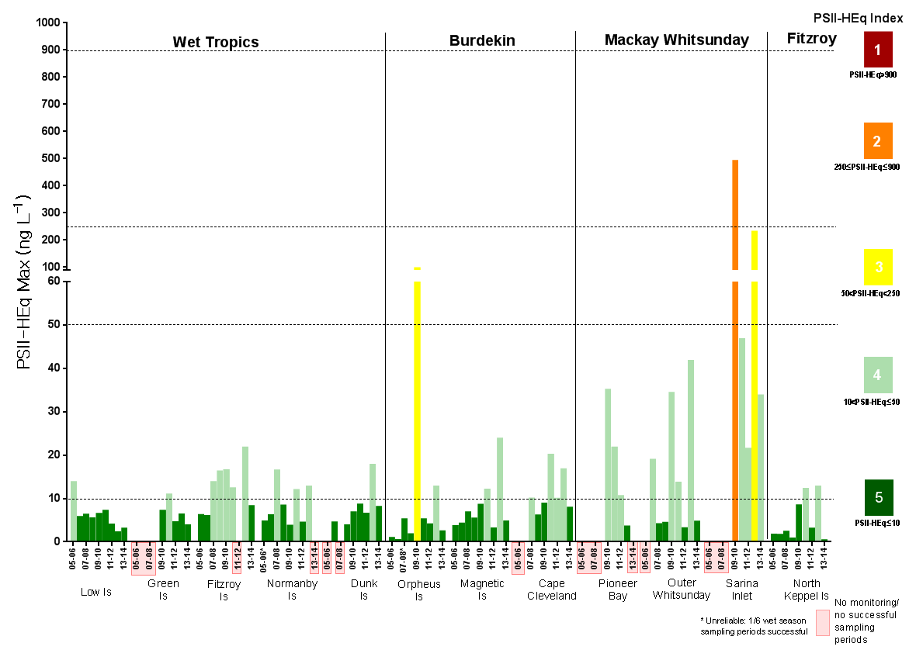
Figure 4 PSII-HEq Max at each fixed monitoring site since monitoring commenced to 2013-2014

In 2013-2014, the PSII-HEq Max for the regions ranged from 3.3 – 8.5 ng L⁻¹ in the Wet Tropics (excluding Normanby Island), 2.7 – 8.1 ng L⁻¹ in the Burdekin Region, 4.9 – 34 ng L⁻¹ in the Mackay Whitsunday (excluding Pioneer Bay) and was 0.60 ng L⁻¹ in the Fitzroy region. These values indicate maximum PSII-HEq Index Categories of 5 for the Wet Tropics, Burdekin and Fitzroy regions, and Category 4 and 5 in the Mackay Whitsunday region. The majority of sites in all regions showed a decrease in PSII-HEq Max values compared to the previous monitoring year, with the decrease the most apparent in the Mackay Whitsunday region. Sarina Inlet in the Mackay Whitsunday region, for the fifth consecutive year (since monitoring at Sarina Inlet commenced) had the highest PSII-HEq Max value.

Wet Tropics Region

Fixed monitoring sites
The Wet Tropics region encompasses eight catchment areas, covering approximately 2.2 million hectares (ABS, 2013). Approximately 44 % of land is set aside as conservation and natural environment areas, however beef cattle grazing (30 % of total land use) and sugar cane (7% of total land use) are the primary agricultural activities (DSITIA, 2012b). Fixed sampling sites in the Wet Tropics region in 2013-2014 were at Low Isles, Green Island, Fitzroy Island and Dunk Island (Figure 5). Low Isles and Fitzroy Island have been monitored since 2005 while Dunk Island has been monitored since 2008 (once in 2007) and Green Island since 2009. Due to various staffing and weather issues, Dunk Island had only two successful deployments in the wet season and two in the dry season. All samplers were successfully deployed at both Green Island and Fitzroy Island. No successfully deployed samplers from Normanby Island were returned.

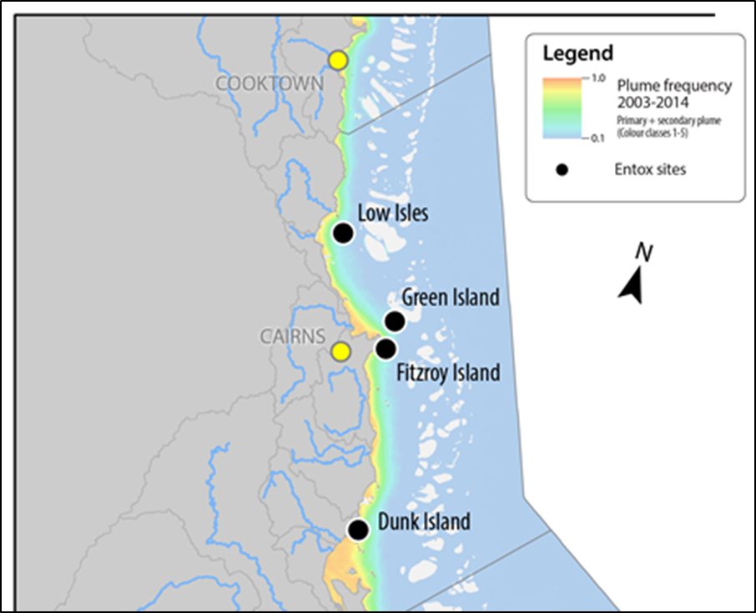
Figure 5 Location of fixed monitoring sites in the Wet Tropics region and the frequency of flood plume waters from 2003-2014. Maps provided by Dieter Tracey, James Cook University

In 2013-2014, concentrations of PSII herbicides during the wet season were generally equal to or lower than concentrations detected in the previous monitoring year (Table 8; for historical data, see Appendix G, Figures 28 – 31). During the dry season, all sites were characterised by an increase in the concentration of tebuthiuron when compared to all previous dry season monitoring. The overall decreased concentrations of herbicides coincided with flows of major rivers influencing the passive samplers that were below the long-term median.

PSII herbicides (and transformation products) sampled by the EDs in the Wet Tropics region in 2013-2014 include ametryn, atrazine, desethyl atrazine, desisopropyl atrazine, bromacil (single detection only), diuron, hexazinone, simazine (two detections only) and tebuthiuron (for ranges and frequencies of detection, see Appendix D, Table 21 – 24). The most frequently detected PSII herbicides in the Wet Tropics were diuron (detected in 100 % of samplers; maximum concentration 7.3 ng L⁻¹ at Fitzroy Island), atrazine (detected in 81 % of samplers; 2.1 ng L⁻¹ at Fitzroy Island) and hexazinone (detected in 72 % of samplers; 3.4 ng L⁻¹ at Dunk Island). Metolachlor and imidacloprid were also frequently detected in the region at low concentrations (<2.0 ng L⁻¹).

The Low Isles and Green Island encountered very low frequencies (blue colour) of primary and secondary flood plume waters from 2003 – 2014, suggesting minimal impacts from the rivers on the adjacent catchment area (Figure 5). Both of these sites have had consistently low PSII-HEq Max values of Category 5, with only one occurrence of a low Category 4 since monitoring commenced (Figure 4). Fitzroy Island encountered a low to moderate frequency (green colour) of plume waters which appears to be reflected in the increased numbers of Category 4 detections when compared to Low Isles and Green Island. Dunk Island encountered flood plumes waters with high frequency (orange colour), however the PSII herbicide profiles (Figure 5) and PSII-Max values (Table 8) did not differ significantly from the other fixed Wet Tropics monitoring sites.

Table 8 Summary statistics for the PSII-HEq Max and Wet Season Average (ng L⁻¹) since the commencement of monitoring until 2013-2014 in the Wet Tropics.
Wet Avg are the averages indicated for PSII-HEq for the wet season sampling periods only. Block colours indicate the maximum PSII-Heq Index category for that year. Values in italics indicate a single measurement for that year

The PSII-HEq Max values in 2013-2014 ranged from Category 4 - 5 on the PSII-HEq Index, with no clear trend apparent since monitoring commenced (Table 8). Average wet season PSII-HEqs also ranged from Category 4 - 5, and whilst average PSII-HEqs were typically greater in the wet season compared to the dry season, the difference was not significant (Figure 6).

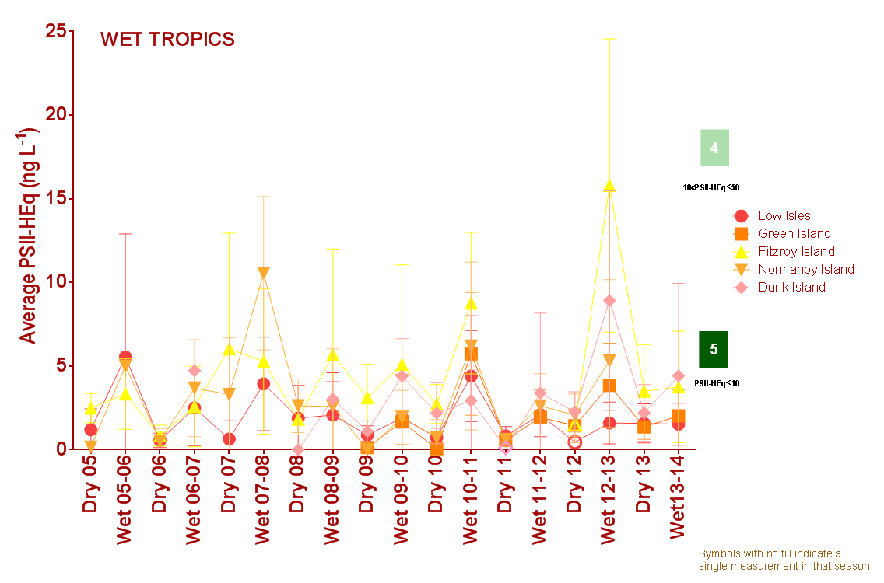
Figure 6 Seasonal average PSII-HEq for Wet Tropics sites since monitoring commenced

Other non PSII herbicides imidacloprid, imazapic, terbutryn and metolachlor were also analysed in passive samplers. Imazapic was detected only once at Low Isles, whilst metolachor and imidacloprid were detected most frequently at Dunk Island (75 % and 50 % of samplers respectively).

The chemicals detected using PDMS samplers were metolachlor, the polycyclic musks galaxolide and tonalide, and the insecticide diazinon (once only). All were detected at concentrations <1 ng L⁻¹ (data summarised in Appendix D, Tables 21 – 24). The metolachlor results represent equilibrium concentration estimates and are typically higher than the time-averaged estimates obtained using EDs. No pesticides or herbicides exceeded the GBRMPA Guidelines (GBRMPA 2010) at any of the Wet Tropics monitoring sites.

Russell-Mulgrave River transect
Twenty grab samples were collected along a transect extending from the Russell-Mulgrave River junction between the 21st of November 2013 and the 25th of March 2014. Passive samplers were deployed at a single location on the transect (High Island West) (Figure 7).

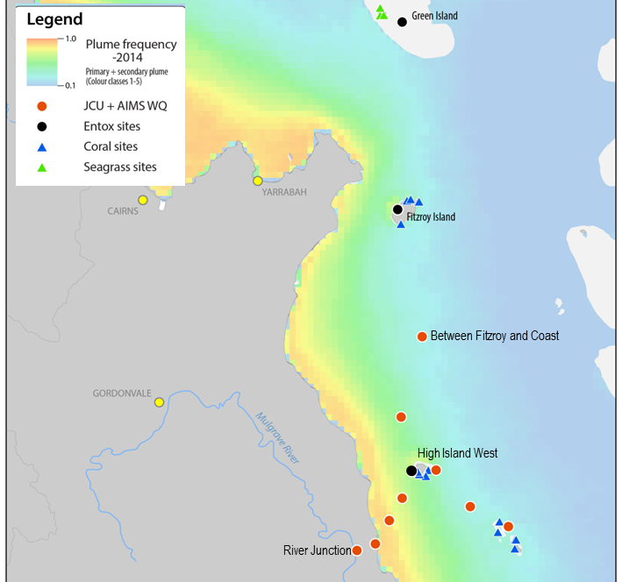
Figure 7 Locations of grab and passive samplers collected on the Russell-Mulgrave River transect and frequency of flood plume waters in the 2013-2014 wet season. Black circles indicate locations where passive samplers were deployed. Unlabelled red circles indicate the locations where grab samples were collected as part of the Inshore Marine Water Quality Component. Maps provided by Dieter Tracey, James Cook University

PSII herbicides (and other chemicals) were detected in 14 of the 20 grab samples, with PSII-HEq values ranging from 1.7 ng L⁻¹ – 306 ng L⁻¹, and PSII-HEq Index Categories ranging from Category 5 to Category 2 (a single occurrence) (Figure 8; data summarised in Appendix E, Table 31). Grab samples collected at the junction of the rivers had the highest concentrations of herbicides detected, with 57 % of samples either a Category 2 or 3 on the PSII-HEq Index. PSII-HEqs detected by the EDs at High Island reached 35 ng L⁻¹ following the first major flow event of the wet season, with diuron, hexazinone, atrazine and imidacloprid detected in the highest concentrations (see Appendix E, Table 33).

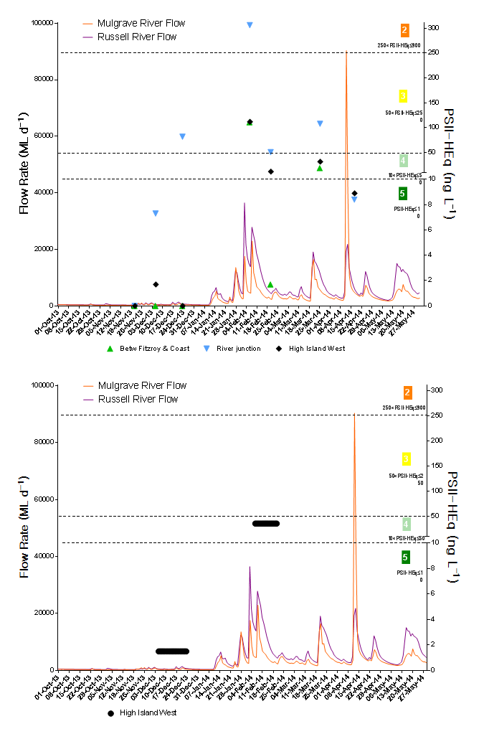
Figure 8 Timing and location of grab (top) and passive (bottom) samples collected on the Russell-Mulgrave River transect, Wet Tropics, during 2013-2014

Tully River transect
A total of 31 grab samples were collected at four sites (Tully River mouth, Bedarra Island, Sisters Island and Dunk Island North) on a transect which extended up to 30 km from the Tully River mouth between 8th November 2013 and 16th April 2014 (Figure 9; Appendix E, Table 32). Passive samplers (EDs) were also deployed at all transect locations for four time periods (Appendix E, Table 33).

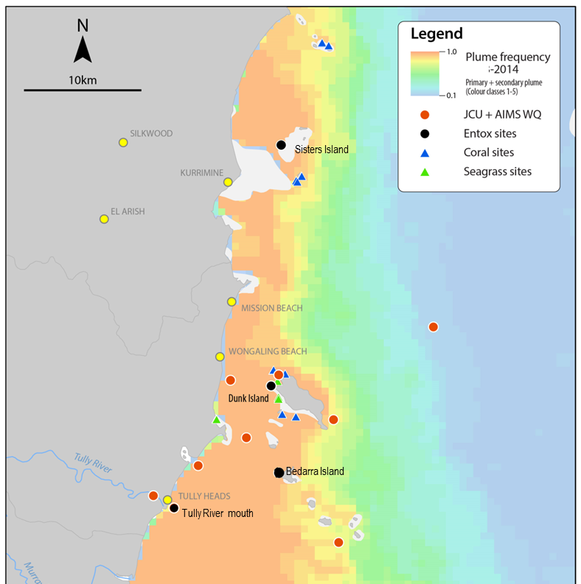
Figure 9 Locations of grab and passive samplers collected on the Tully River transect and the frequency of flood plume waters in the 2013-2014 wet season. Black circles indicate locations where passive samplers and grab samples were collected. Unlabelled red circles indicate the locations where grab samples were collected as part of the Inshore Marine Water Quality Component. Map provided by Dieter Tracey, James Cook University

PSII herbicides were detected in grab samples collected at all four locations, with the highest PSII-HEq concentration of 390 ng L⁻¹ detected at the Tully River mouth (Figure 10). PSII-HEq Categories ranged from Category 5 to Category 2 (there were two instances each of Category 3 and 2). The concentration of diuron detected at this site was the highest of all grab samples collected in the terrestrial run-off component and indicated a Category 2 on the PSII-HEq Index. Other non-PSII indexed herbicides were also frequently detected including metolachlor, imidacloprid and metribuzin. Both diuron and metolachlor exceeded the low reliability Interim Working Guidelines for marine waters in one sample collected at the Tully River mouth (ANZECC and ARMCANZ 2000)

PSII herbicides were also detected at all four transect locations using passive samplers with the highest concentrations at all sites detected following the first major flow event (Figure 10). PSII-HEq concentrations ranged from 0.47 ng L⁻¹ (Category 5) – 238 ng L⁻¹ (Category 3). PSII-HEq concentrations reached 131 ng L⁻¹ at Sisters Island, the most distant location on the transect. Other non-PSII indexed herbicides were also frequently detected including bromacil, metolachlor, imidacloprid and metribuzin.
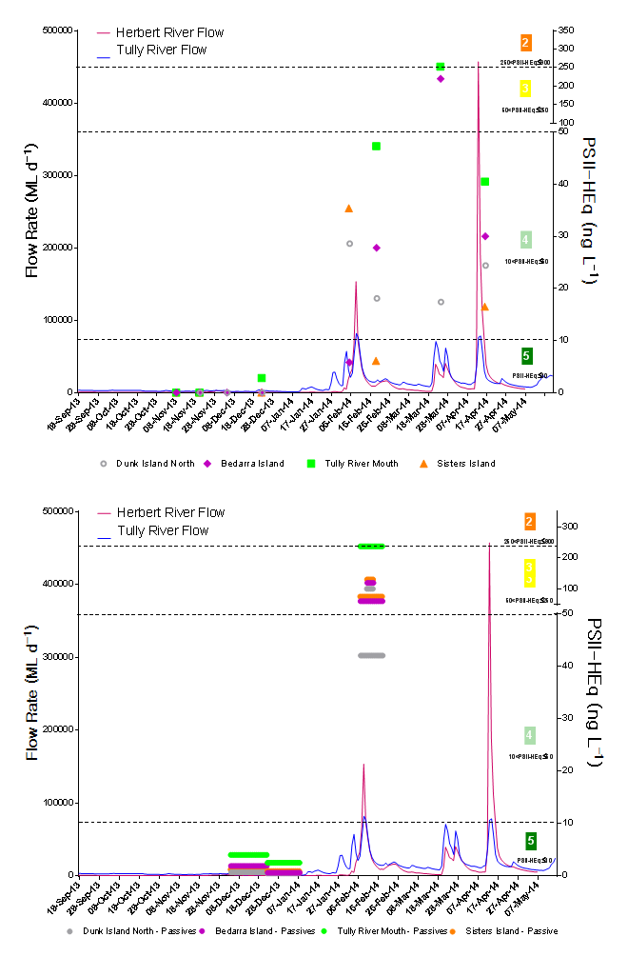
Figure 10 Timing and location of grab (top) and passive (bottom) samples taken on the Tully River transect, Wet Tropics, during 2013-2014

Burdekin Region

Fixed monitoring sites
The Burdekin region spans five catchments and covers 14 million hectares, of which 90 % is used for agricultural purposes, with grazing primarily inland and some sugar cane and horticulture along the coast (ABS, 2013; DSITIA, 2012c). Sampling sites in the Burdekin region in 2013-2014 were Orpheus Island, Magnetic Island and Cape Cleveland (Figure 11). Orpheus and Magnetic Island have been monitored since 2005, while Cape Cleveland has been monitored since 2007 (see Appendix G, Figure 32 – 34 for historical data). Orpheus Island and Cape Cleveland had an excellent sampling record in 2013-2014 with no missed deployments, whilst only three successful deployments occurred at Magnetic Island.
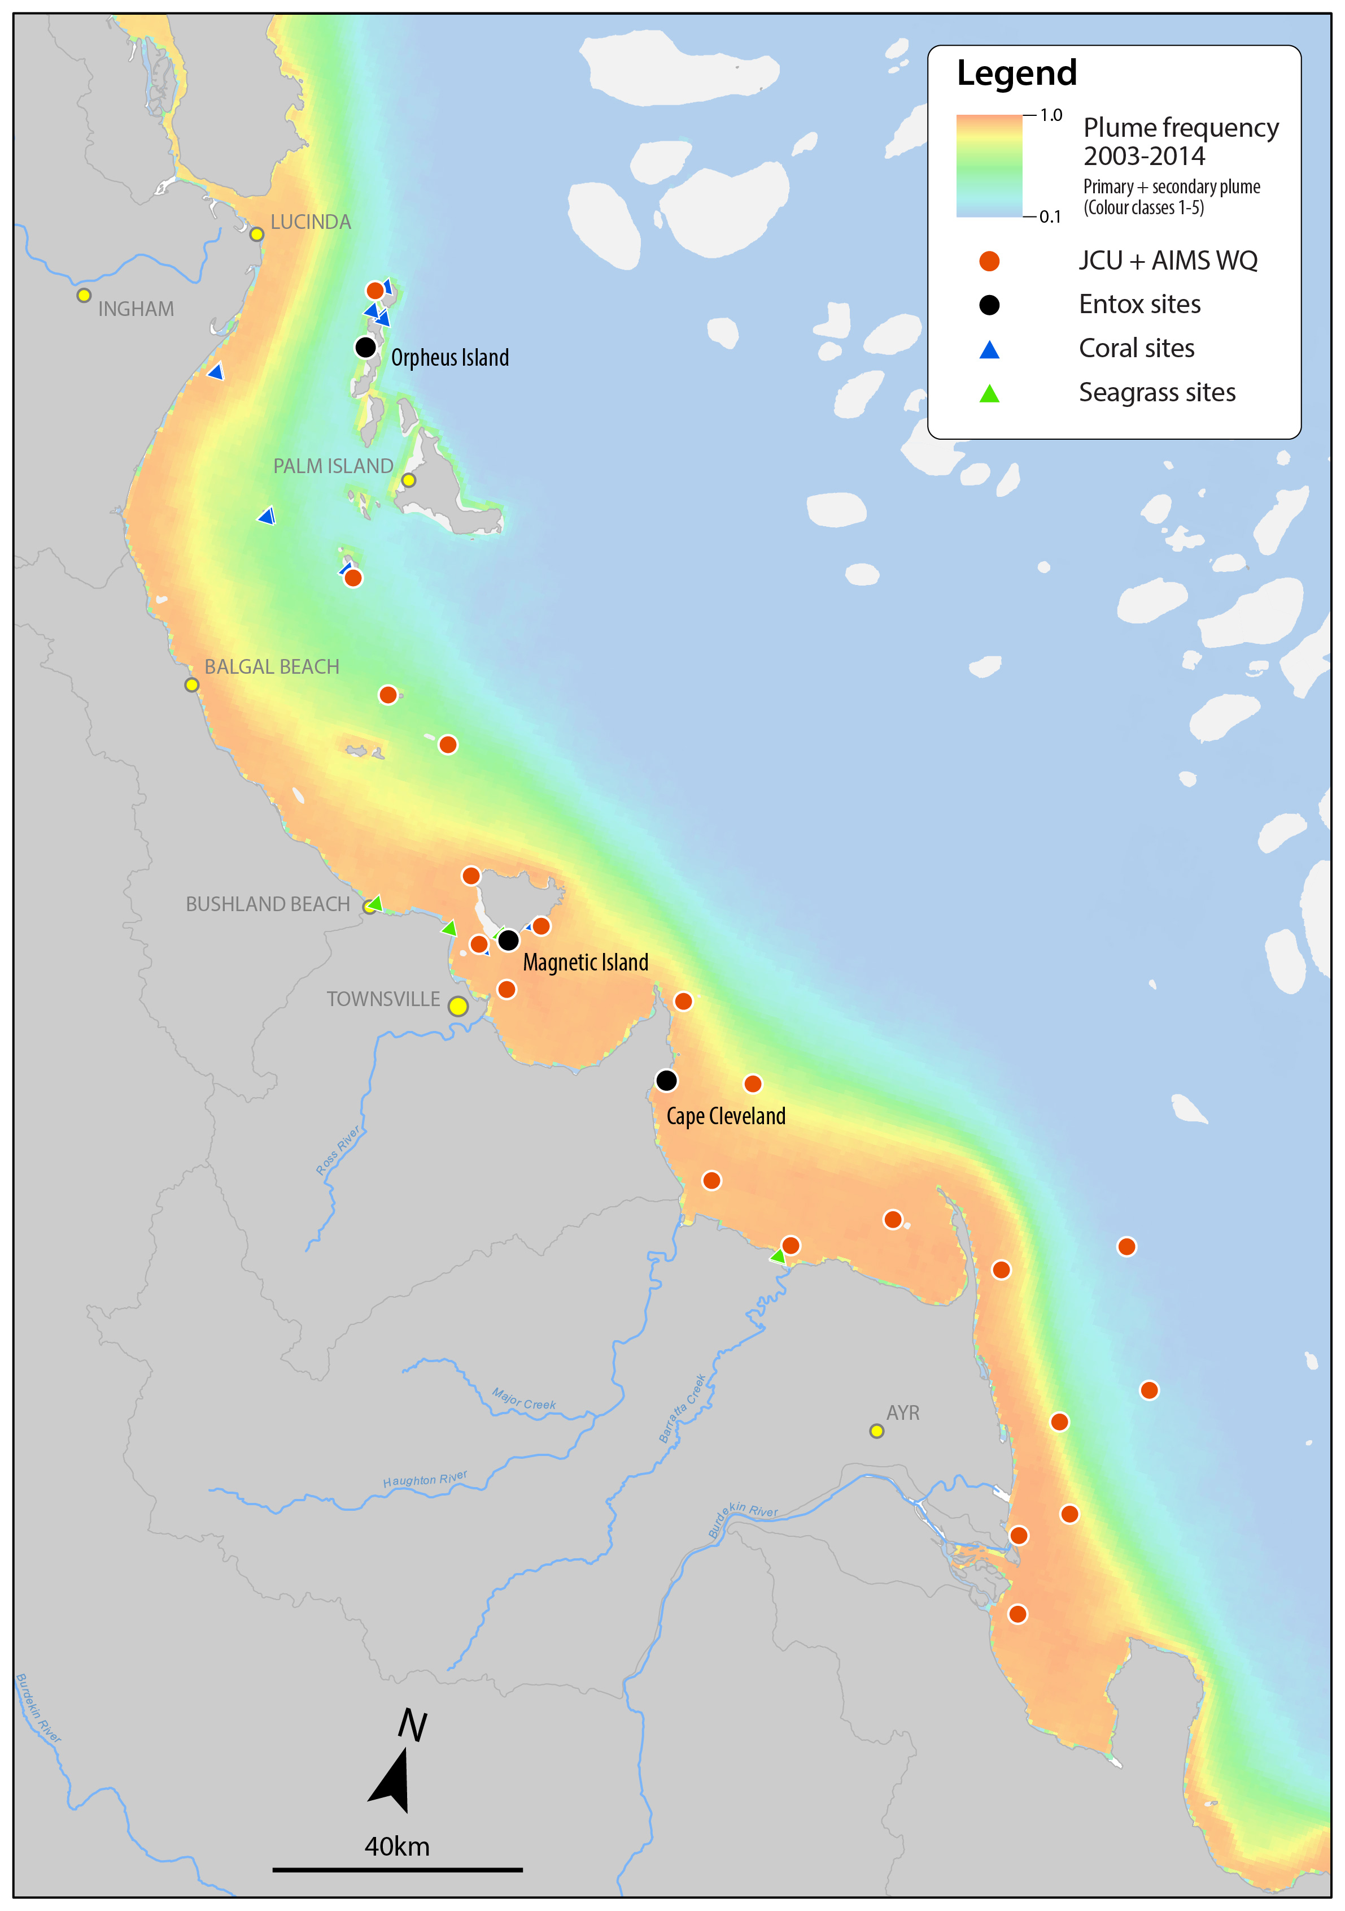
Figure 11 Location of fixed monitoring sites in the Burdekin region and the frequency of flood plume waters in the 2003- 2014 wet seasons. Black circles indicate locations where passive samplers were deployed. Unlabelled red circles indicate the locations where grab samples were collected as part of the Inshore Marine Water Quality Component. Map provided by Dieter Tracey, James Cook University

The PSII herbicides (and transformation products) detected at sites in this region include ametryn, atrazine, desethyl atrazine, desisopropyl atrazine, diuron, hexazinone, simazine (three detections only) and tebuthiruon. The non PSII herbicide metolachlor was frequently detected at all sites (for ranges and frequencies of detection see Appendix D, Tables 25 -27). As with the Wet Tropics region, there appears to be an increase in the concentration of tebuthiuron as well as atrazine, relative to diuron during the dry season, at all three sites.

The most frequently detected PSII herbicides in this region were (on average) atrazine (93 % detection; maximum concentration 7.7 ng L⁻¹ at Cape Cleveland), diuron (detected in 93 % of samplers; maximum concentration 6.8 ng L⁻¹ at Cape Cleveland), desethyl atrazine (detected in 70 % of samplers; maximum concentration 2.7 ng L⁻¹ at Cape Cleveland). Atrazine and atrazine breakdown products typically dominate the herbicide profile at Magnetic Island and Cape Cleveland.

Historically, Orpheus Island has been minimally impacted by flood plumes from either the Herbert or Burdekin Rivers (Figure 11). The elevated PSII-Max value seen in 2009 – 10 was likely a result of a point source contamination, and should be regarded as an outlier but typically; PSII-Max values are Category 5. Magnetic Island and Cape Cleveland are both highly impacted by flood plumes during the wet season, and whilst their PSII-HEq Wet Avg values were in some instances higher than those of Orpheus Island, they were not significantly higher (Table 9; Figure 12). It must be noted that Magnetic Island is adjacent from the major urban centre of Townsville, and thus not all contaminates detected in the passive sampler may be a direct result of agricultural activities.

The PSII-HEq Max values improved at all sites from Category 4 to Category 5, when compared to the previous monitoring year (by 2 to 5 times; Table 9). When compared to the year sampling commenced, there was a two-fold increase at Orpheus Island, and no real change at both Magnetic Island and Cape Cleveland.

Table 9 Summary statistics for the PSII-HEq Max and Wet Season Average (ng L⁻¹) since the commencement of monitoring until 2013-2014 in the Burdekin region.
Wet Avg are the averages indicated for PSII-HEq for the wet season sampling periods only. Block colours indicate the maximum PSII-Heq Index category for that year.

Average wet season PSII-HEq decreased at all sites by 2 to 7 times when compared to the previous monitoring year (Table 10). Since monitoring commenced, Wet Avg values have remained predominantly Category 5 on the PSII-Index at all sites (Figure 12).

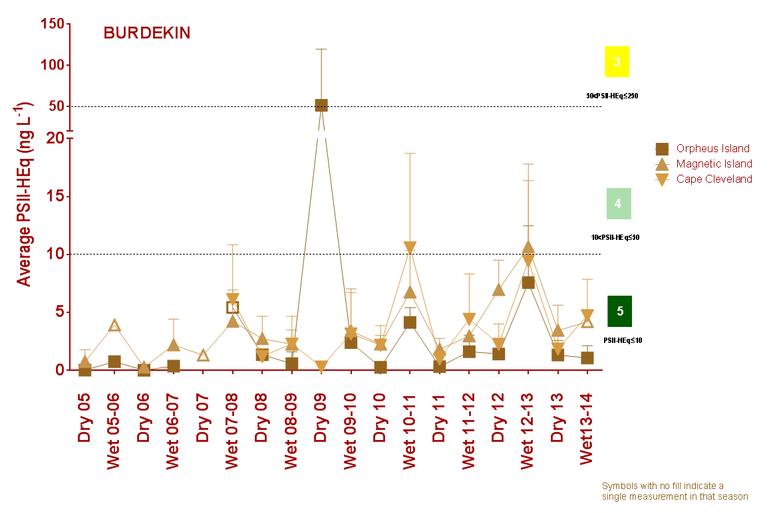
Figure 12 Seasonal average PSII-HEq for Burdekin sites since monitoring commenced

Metolachlor was detected using EDs at all sites, however the maximum concentration was < 1ng L⁻¹ (Appendix D, Table 25 – 27). Imidacloprid was frequently during several deployments at Cape Cleveland and Orpheus Island (maximum concentration of 1.3 ng L⁻¹), and imazapic was detected once only at Orpheus Island. Metolachlor was the only pesticide detected detected at both Cape Cleveland and Magnetic Island using PDMS samplers, and the musks tonalide and galaxolodie were also detected at low concentrations (Appendix D, Table 25 – 27). No herbicides or pesticides were detected in concentrations that met or exceeded GBRMPA Guidelines.

Herbert River transect
Four grab samples were collected on the 18th April 2014 located on two transects extending approximately 12 km north-east and 8 km south-east from the Herbert River mouth (Figure 13).

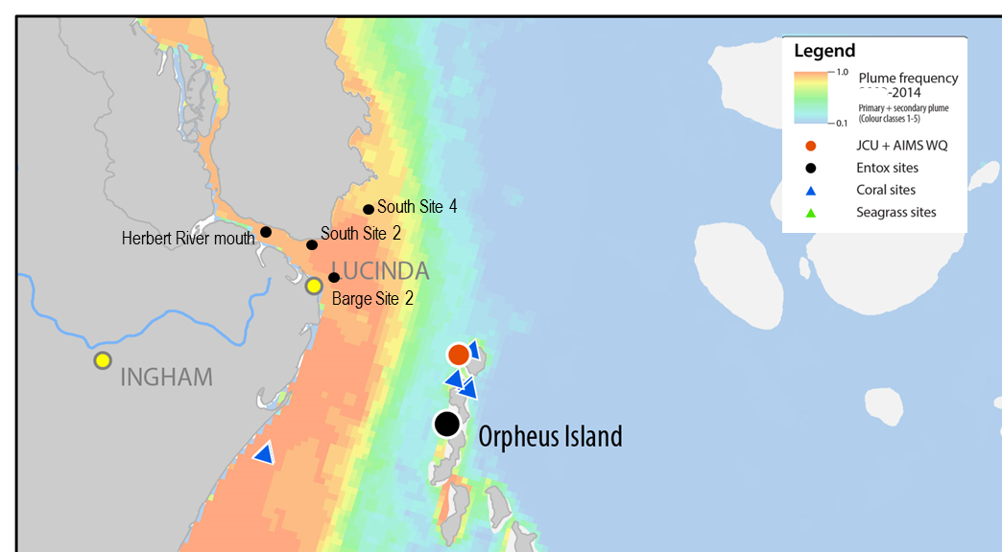
Figure 13 Location of grab samples taken on the Herbert River transect and the frequency of flood plume waters in the 2013-2014 wet season. Small black circles indicate locations where grab samples were collected. Unlabelled red circles indicate the locations where grab samples were collected as part of the Inshore Marine Water Quality Component. Maps provided by Dieter Tracey, James Cook University

PSII herbicides were detected at all four locations, with PSII-HEq concentrations ranging from 11 – 13 ng L⁻¹ (Figure 14). Diuron was the herbicide detected in the highest concentration at all locations (maximum concentration of 10 ng L⁻¹), followed by atrazine (maximum concentration of 10 ng L⁻¹) and hexazinone (maximum concentration of 3.3 ng L⁻¹). Metolachlor and imidacloprid were detected only in the sample collected at the Herbert River mouth.

All four locations were impacted by high to very high frequencies of flood plumes during 2014 (although samples were only collected following one event).
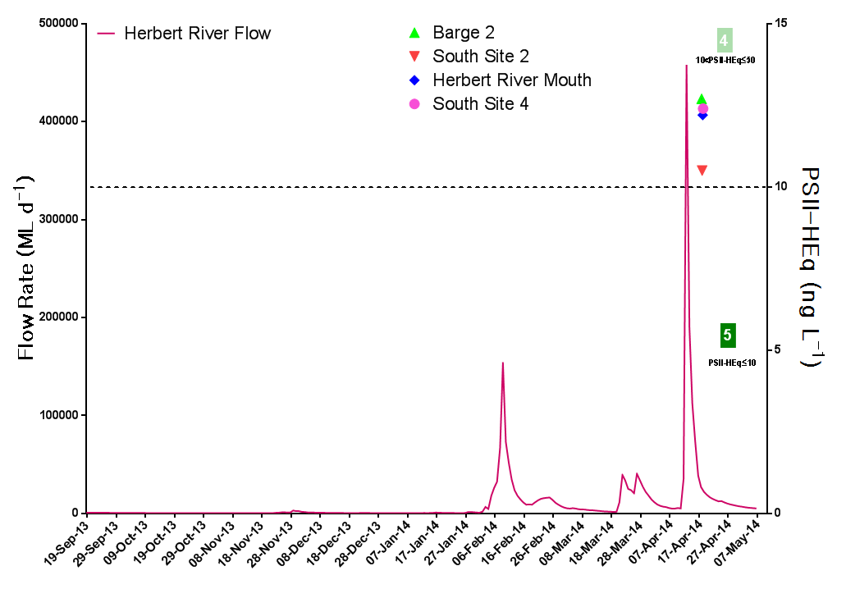
Figure 14 Timing and location of grab samples taken on the Herbert River transect, Wet Tropics, during 2013-2014

Mackay Whitsunday Region

Fixed monitoring sites
The Mackay Whitsunday region is the smallest NRM region, spanning four catchments at an area of approximately 900,000 hectares (ABS, 2013). This region is dominated by the sugar cane industry, which comprises 18% of the region’s land use (DSITIA, 2012d). Sampling sites in the Mackay Whitsunday region in 2013-2014 were Outer Whitsunday and Sarina Inlet (Figure 15) (no sampling was carried out at Pioneer Bay this monitoring year). Outer Whitsunday has been monitored since 2006 while Sarina Inlet site was established in 2009 (see Appendix G, Figures 35 – 36 for historical data). Both Outer Whitsunday and Sarina Inlet had relatively successful sampling periods, with only one over-deployment at Sarina Inlet.

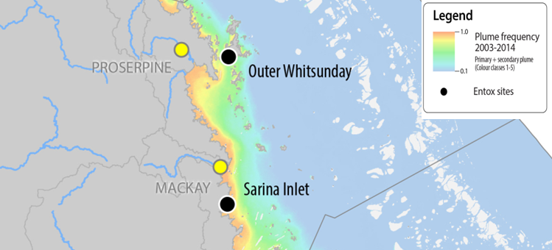
Figure 15 Location of fixed monitoring sites in the Mackay Whitsunday region and the frequency of flood plumes during the wet seasons from 2003 - 2014. Map provided by Dieter Tracey, James Cook University

PSII herbicides (and transformation products) detected at sites in this region include ametryn, atrazine, desethyl atrazine, desisopropyl atrazine, diuron, hexazinone, simazine and tebuthiuron (for ranges and frequencies of detections see Appendix D, Tables 28 – 29). The most abundant and frequently detected PSII herbicides in this region are diuron (detected in 94 % of samplers; maximum concentration 27 ng L⁻¹ at Sarina Inlet), atrazine (detected in 88 % of samplers; maximum concentration 7 ng L⁻¹ at Sarina Inlet) and tebuthiuron (detected in 88 % of samplers; maximum concentration 2 ng L⁻¹ at Outer Whitsunday).

The Outer Whitsunday site encountered medium frequencies of flood plumes during 2003 – 2014, whilst plume waters at Sarina Inlet were highly frequent, likely due to its proximity to Plane Creek (Figure 15). PSII-Max and Wet Avg values at Sarina Inlet exceed those of Outer Whitsunday on all sampling occasions (Table 10). PSII-Max values for both sites have been consistently higher than fixed sites located in other regions, which may reflect both the pesticide usage and land management practices of the adjacent catchment as well as their ideal positioning to intercept flood plumes from nearby rivers.

Sarina Inlet has the highest concentration of diuron of any other site and subsequently, it also has the highest PSII-HEq Max of 34 ng L⁻¹, which is a Category 4 risk of herbicide exposure on the PSII-HEq Index (Table 10). The PSII-HEq Max values at both Outer Whitsunday and Sarina Inlet decreased significantly by 7 and 9 times respectively from the previous monitoring year. Since monitoring began, the PSII-HEq Max value at both sites has decreased, however the Mackay Whitsunday region historically has recorded the highest PSII-HEq Max values ranging from Category 5 to Category 2.
Table 10 Summary statistics for the PSII-HEq Max and Wet Season Average (ng L⁻¹) since the commencement of monitoring until 2013-2014 in the Mackay Whitsunday region
Wet Avg are the averages indicated for PSII-HEq for the wet season sampling periods only. Block colours indicate the maximum PSII-Heq Index category for that year

The PSII-HEq Wet Avgs for both sites have decreased by one Index Category, when compared to the previous monitoring year to a Category 4 or 5 (Figure 16). The seasonal differences in PSII-HEqs are most pronounced at Sarina Inlet.

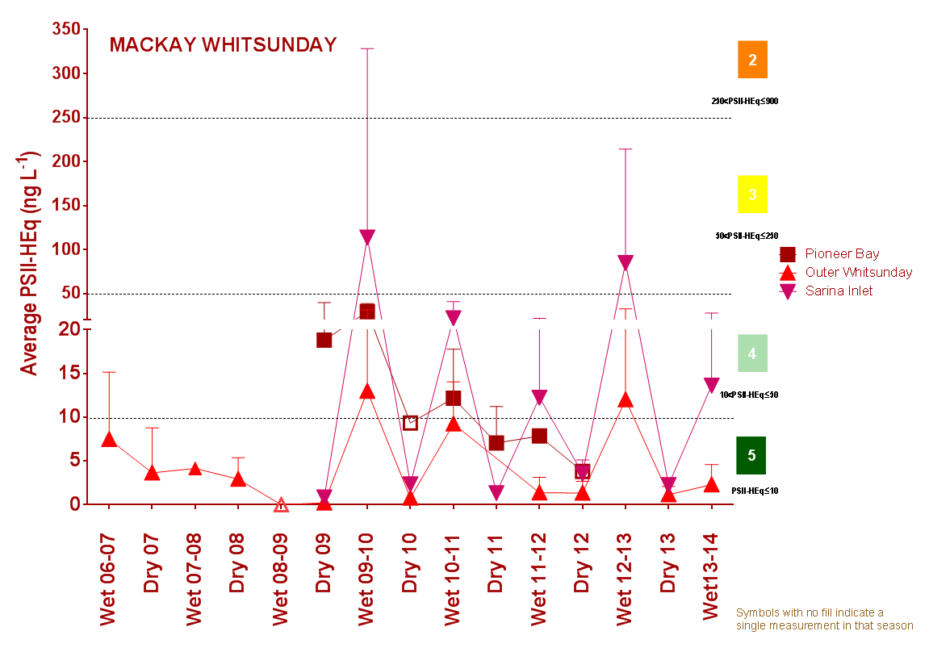
Figure 16 Seasonal average PSII-HEq for Mackay Whitsunday sites since monitoring commenced

Metolachlor, imazapic and imidacloprid were also detected using EDs at both sites at concentrations <1 ng L⁻¹. Bromacil and terbutryn were detected once each at Sarina Inlet, also at low concentrations. Galaxolide and tonalide were detected using PDMS samplers at both sites, with chlopyrifos and diazinon only detected at Sarina Inlet (Appendix D, Tables 28 – 29). This is the first monitoring year in which Sarina Inlet received PDMS samplers. There were no exceedances of GBRMPA Guidelines (GBRMPA 2010) for any herbicides detected in the Mackay Whitsunday region in 2013-2014.

Fitzroy Region

Fixed monitoring sites
The Fitzroy region spans six catchments and covers an area of 15.6 million hectares (ABS, 2013). Cattle grazing is the most prevalent industry (78 % of the land use), with broad acre cropping (5 % of the land use) and cotton also present (DSITIA, 2012e). The only monitoring site in the Fitzroy region is at North Keppel Island (Figure 17). This site has been monitored since 2005 although it has had broken periods of sampling throughout some years (see Appendix G, Figure 37 for historical data).

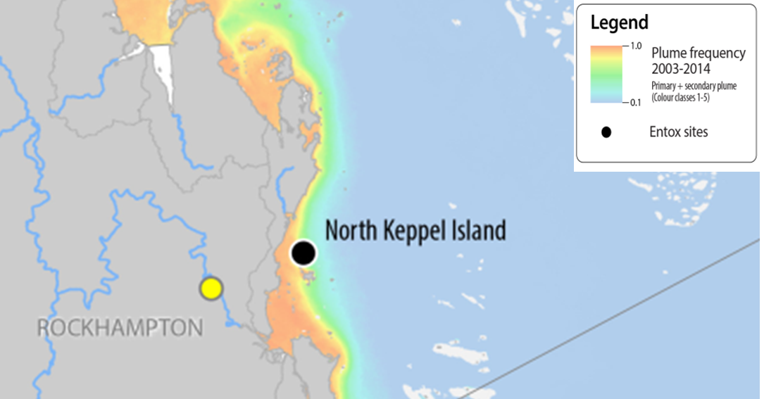
Figure 17 Location of the fixed monitoring site in the Fitzroy region and the frequency of flood plumes during the wet seasons from 2003 - 2014. Map provided by Dieter Tracey, James Cook University

PSII herbicides (and transformation products) detected at this site in 2013-2014 include atrazine, diuron, hexazinone (detected once only) and tebuthiuron (Appendix D, Table 30). The PSII herbicides detected with the greatest frequency were atrazine (detected in 75 % of samplers; maximum concentration 0.3 ng L⁻¹), diuron (detected in 75 % of samplers; maximum concentration 0.57 ng L⁻¹) and tebuthiuron (detected in 63 % of samplers; maximum concentration 0.53 ng L⁻¹) (for ranges and frequencies see Appendix D, Table 30). Tebuthurion and atrazine typically dominate the PSII herbicide profile at this site which is similar to sites in the Burdekin region such as Cape Cleveland and Magnetic Island.

North Keppel Island encountered medium frequencies of flood plumes originating from the Fitzroy River from 2003 – 2014, however has had consistently low Category 4 and 5 PSII-Max values since monitoring commenced in 2005 (Table 11). The Island is situated approximately 50 km north of the Fitzroy River mouth and thus a significant flood event (such as in 2010-11) may be required to deliver pollutants the distance to the sampler location.

The PSII-HEq Max for 2013-2014 at North Keppel Island was 0.6 ng L⁻¹ indicating a Category 5 on the PSII-HEq Index, and is the lowest detected at any monitoring site since sampling commenced (Table 11). This is an improvement by a factor of 20 when compared to the the previous monitoring year.

Table 11 Summary statistics for the PSII-HEq Max and Wet Season Average (ng L⁻¹) since the commencement of monitoring until 2013-2014 in the Fitzroy region
Wet Avg are the averages indicated for PSII-HEq for the wet season sampling periods only; In 2008-2009 North Keppel Island PSII HEq maximum was derived from 4 dry season sampling periods and 2 wet season sampling period, the average for the wet season is therefore from only two sampling periods. Block colours indicate the maximum PSII-Heq Index category for that year.

The PSII-HEq Wet Avg has been consistently Category 5 since monitoring commenced (Figure 18), with no significant seasonal differences in concentrations.

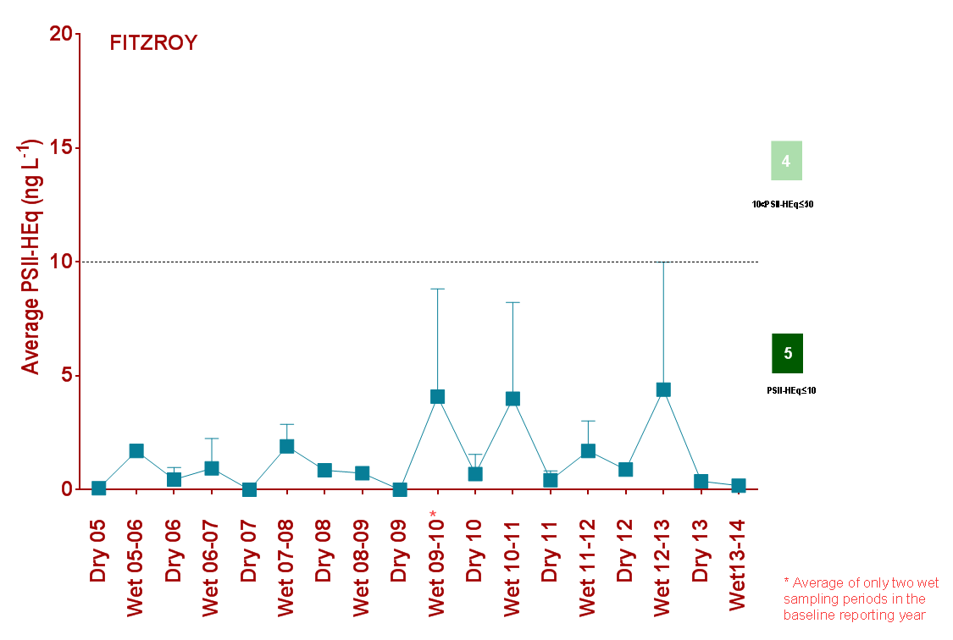
Figure 18 Seasonal average PSII-HEq for North Keppel Island in the Fitzroy region since monitoring commenced

Metolachlor, imazapic and imidacloprid were also detected at North Keppel Island, although these detections were sporadic and at very low concentrations. No PDMS sampling is undertaken at North Keppel Island.

DISCUSSION
Key drivers of elevated pesticide and herbicide concentrations in the GBR lagoon include pesticide application quantites, agricultural land use area, rainfall and volume of water discharged from rivers in areas used for agricultural purposes and the rate of adoption of best management practices for land management (including chemical use, surface and irrigation water management). It can be difficult to ellucidate meaningful trends and assess the progress of Reef Plan (Anon 2009) when concurrent changes to these drivers occur simultaneously. Quite often, the necessary data needed to interpret these changes (such as pesticide usage and application rates) are either not available or only updated periodically. For example, an increase in the concentration of a pesticide detected at a monitoring site may not necessarily reflect that greater amounts of pesticides were applied, but perhaps are a result of rainfall that closely followed the pesticide application, flushing a greater proportion of the applied pesticide into waterways. Additionally, the locations of samplers are at varying proximity to river mouths, and thusly some may be influenced by flood plumes from more than one river. All of these factors make it difficult to quantitatively assess the link between improved land management practises as a direct result of Reef Plan initiatives and changes in water quality to gain a true understanding of the input of herbicides into the system.

In the 2013-2014 monitoring year overall, GBR catchment areas adjacent to fixed monitoring sites experienced average or below average rainfall levels during both the wet and dry season (Appendix C, Figure 21). When the total rainfall of the current monitoring year was compared to the total rainfall in the previous monitoring year (May 2012 - April 2013), much of the Burdekin, Mackay Whitsunday and Fitzroy region received significantly less rainfall while the Wet Tropics was wetter than the previous year (Appendix C, Figure 22). As a result of the generally drier conditions, there was a small decrease in the total discharge of freshwater from major GBR rivers influencing passive sampler sites to 0.2 – 1.4 the long-term median discharge (Figure 19; Table 7). Ratios to long-term median discharge of rivers located in the Wet Tropics were typically higher (0.9 – 1.3) than the other regions.

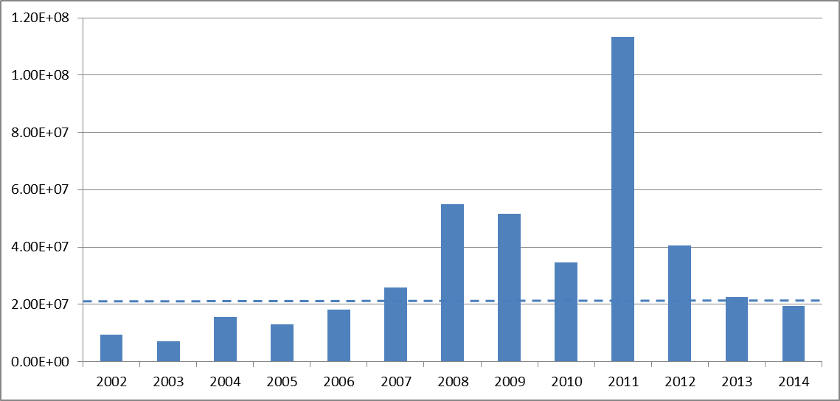
Figure 19 Total annual discharge of major rivers into the inshore waters of the GBR (ML) Data provided by Michelle Devlin (unpublished). The water year is considered October 1st to September 30th the following year. The discharge data provided for the current year is complete. Dotted line represents the long-term median discharge.

The drier conditions and decreased river discharge in most regions during this wet season coincided with a decrease in the maximum concentrations and PSII-HEq Max values at almost all sites (Appendix F, Figures 23 – 27). There was also a decrease in the frequency of detection of many PSII herbicides at almost all sites when compared to the previous monitoring year. Notably, at several sites in the Wet Tropics and Burdekin regions, there was an increase in the concentration of tebuthiuron relative to other PSII herbicides detected during the dry season (see Appendix G). This recent emergence of tebuthiuron in the Wet Tropics (particularly in Green, Fitzroy and Dunk Islands) is of note as tebuthiruon is typically associated with grazing land use, which makes up a large proportion of the land use in the Burdekin and Fitzroy regions (DSITIA, 2012b,c,e), rather than the Wet Tropics region. The annual loads of tebuthiuron in 2010-2011 in several Wet Tropics rivers (the Tully, North Johnstone and Herbert Rivers) were below detection, and increased to only 4.7 kg in 2011-2012, suggesting neglible usage in the Wet Tropics region (Turner et al. 2013; Wallace et al. 2014). However, over 6800 kg was discharged from the Fitzroy and Burdekin Rivers in the flood events of 2010-2011, reducing to 1200 kg in 2011-2012, suggesting long-range transport, long residence time and slow degradation of herbicides may be occurring in the GBR lagoon.

At all fixed monitoring sites since monitoring commenced, PSII herbicides have been consistently detected during the dry season (see Appendix G). The year-round detection of PSII herbicides may be attributed to the slow rate of degradation in plume waters. The persistence of herbicides in the marine environment has until recently, been poorly understood but is a key factor in their ability to be transported from the paddock to the Reef, move long distances within the GBR lagoon, and is essential to parameterize predictive risk models. Half-lives of several commonly detected PSII herbicides under environmentally relevant conditions (in the presence of light and sediments) ranged from 32 days (metolachlor) to over 900 days (tebuthiuron), suggesting that land-based pollutants may remain present in the marine environment from months to years following a discharge event (Negri et al. 2014). This extended persistence (particularly of tebuthiuron) may explain how herbicides are detected far from their land-based origin (e.g. tebuthiuron in the Wet Tropics region). Detection of herbicides in locations that are not frequently impacted by flood plume waters may suggest that a point source of herbicides may be contributing to low level contamination of the samplers or, herbicides are persisting in waters for longer than expected periods, until well after flood plumes have dissipated and that relatively ‘pristine’ locations are now exposed to chronic low levels of PSII herbicides.

The PSII herbicide profiles detected with the passive samplers match those detected during loads sampling that has been undertaken by other agencies. The most recent annual PSII herbicide loads (of ametryn, atrazine, diuron, hexazinone and tebuthiruon only) have been estimated for 11 GBR catchments for 2011-2012, with an estimated 4.2 tonnes of PSII herbicides entering the GBR lagoon (Wallace et al, 2014). Total loads of PSII herbicides were estimated to be 2100 kg of total atrazine (includes breakdown products), 1100 kg of tebuthiuron, 770 kg diuron, 200 kg of hexazinone and 48 kg of ametryn (Wallace et al, 2014). Of the total number of passive samplers deployed in the fixed site monitoring program (73), atrazine was detected in 81 %, tebuthiuron was detected in 58 %, diuron was detected in 92 %, hexazinone was detected in 60 % and ametryn was detected in 25 %.

Variation in PSII herbicide profiles between regions (such as the atrazine dominance seen in the Burdekin region, and the tebuthiuron dominance in the Fitzroy region) and also within regions (such as Orpheus Island and Cape Cleveland in the Burdekin region) is apparent (Appendix G, Figures 28 – 37). The variation in the PSII herbicide profiles between sites and regions reflects differences in land use on the adjacent catchment area with concentrations influenced by factors such as surface run-off, rainfall, land clearing and urban development. Such regional variability can also be affected by the proximity of samplers to major rivers (and the frequency of impact from river run-off) and whether the deployment of samplers captured peaks in concentrations during the wet season. Sites within the same region can also be influenced by the run-off delivered by different major rivers, and thus their profiles can vary dramatically (as seen at the diuron-dominated site Orpheus Island (likely more influenced by the Herbert River) and the atrazine-dominated site Cape Cleveland (likely more influenced by the Haughton River and Barratta Creek), both of which are located in the Burdekin region.

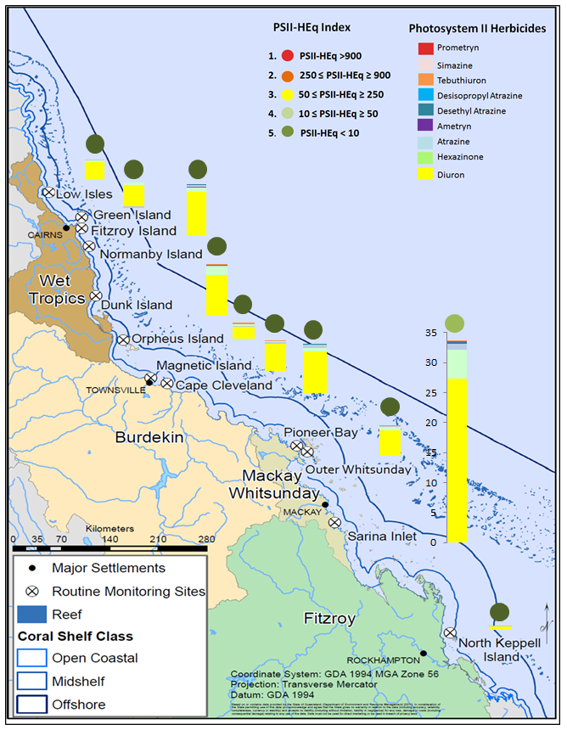
Figure 20 PSII-HEq Max (ng L⁻¹) with the PSII-HEq Index of each value indicated for each fixed monitoring site in 2013-2014
(Source – Modification of original map provided by Adam Donovan and Alex Shanahan, School of Geography, Planning and Environmental Management, The University of Queensland). Note that no successful sampling occurred at Pioneer Bay and Normanby Island this year.

The sites located in the Mackay Whitsundays region have encountered the greatest risk of exposure to PSII herbicides in this current year (Figure 20), with concentrations detected in previous years that have been shown to inhibit photosynthesis in some species of coral and seagrass (Category 2 and 3 on the PSII Herbicide Index) (Flores et al. 2013). Sarina Inlet has consistently had the highest frequencies and concentrations of PSII herbicides detected, most likely related to the density of sugarcane farming in such proximity to the coast (Appendix H, Figure 38), and the high frequency of primary flood plume waters impacting the sampling site. Furthermore, 34% of the Plane Creek catchment land area (adjacent to the Sarina Inlet site) is used for sugarcane farming (ABS, 2013). Based on a risk assessment of the six most dominant PSII herbicides, the Mackay Whitsundays region has been identified as having the highest risk of toxic effects to coral reefs and seagrasses and the reduction of pesticides in this region is a management priority (Brodie et al. 2013b).

The major land uses within the GBR catchment are agricultural cropping, livestock grazing and other primary production (such as forestry) (Appendix H, Figure 38) (ABS, 2014; DSITIA, 2012a; Brodie et al, 2001). Sugar cane farming is clustered heavily along the Tully River (Wet Tropics region), Burdekin River (Burdekin region) and Pioneer River (Mackay-Whitsunday region) (Lewis et al, 2008), with 18 % of the Mackay Whitsunday region alone used for sugar cane farming (DSITIA, 2012b; DSITIA, 2012c). The herbicide residues detected in the greatest abundance in this MMP (diuron, atrazine and hexazinone) are consistent with the applications of the sugar cane industry (Bainbridge et al, 2009) with atrazine additionally used in grain cropping and horticulture (Lewis et al, 2009).

Land in the GBR catchments continues to change (ABS, 2014; DSITIA, 2012a), and thus the impacts of these activities on the surrounding environment are also changing (Appendix H, Figure 39). Between 2009 and 2013, the Mackay Whitsunday and the Fitzroy regions both saw an increase in the amount of land that was used for lifestock grazing, while the Wet Tropics and Burdekin both saw a decrease. All regions saw a decrease in the amount of land classified for cropping activities, with Wet Tropics region showing the largest decrease of between 10 – 15 % of land area. With changing land use, it is likely that changes in both the amounts and types of agricultural chemicals being used, as well as their methods of application will influence environmental levels and the level of a risk to aquatic marine life. End-of-catchment loads data will be a useful resource in identifying changes in pesticide usage.

Another major driver of PSII concentrations is the application amounts of herbicides in the GBR catchments. There are no figures available for the current usage of agricultural chemicals in the GBR, however estimates from 2008 – 2009 showed that between 45 – 80 % of land holdings in the four NRM regions applied agricultural chemicals to control weeds, pests and disease (ABS, 2009a). For the four NRM regions, this equates to between 99 000 hectares (Mackay Whitsunday region) and 530 000 hectares (Fitzroy region) of estimated total land upon which herbicides are applied (Table 12; ABS, 2009a).

Table 12 Land area (ha) of catchments adjacent to fixed monitoring sites over which herbicides were applied by NRM region, 2008-2009
ª Data Source is 4619.0 - Land Management Practices in the Great Barrier Reef Catchments, Preliminary, 2008-09; ABS

Of the 28 GBR catchments, over 90 % of land holdings in the Herbert River catchment applied herbicides (Appendix H, Figure 40; ABS, 2009a). In the same survey, it was found that cropping land holdings of larger size (>150 ha) were more likely to adopt land management practises with regard to pesticide application, surface water management and other pest control strategies, however grazing land holdings did not show appreciable differences in land management practises with holding size (ABS, 2009b).

Table 13 Major land uses of NRM regions within the GBR catchment
Reproduced from DSITIA, 2013a-e; ^ Cape York Land uses were obtained from 2009 Regional Report Card (Anon, 2011); * Excludes Cape York.

Overall, there appears to be an increased risk of exposure to PSII herbicides at fixed monitoring sites located in the Burdekin – Fitzroy regions in comparison to the Wet Tropics. This may be due to the proportion of land that is set aside as conservation and protected areas (Table 13) (44% in the Wet Tropics compared to an average of 11% for the Burdekin - Fitzroy regions (DSITIA, 2012b-e)), and the proportion that is used for agricultural purposes (only 37 % of the land in the Wet Tropics region is utlilised for agriculture, compared to 56 % - 87 % in the other regions (ABS, 2013)).

However, it is evident from the sampling conducted as part of the Terrestrial Run-off component, that localised areas of elevated PSII herbicide concentrations can occur near river mouths within regions where fixed site monitoring indicates low risk to PSII herbicides (i.e. the Wet Tropics). PSII-HEq concentrations of passive samplers deployed at fixed sites in the Wet Tropics did not exceed Category 5, however passive samplers and grab samples collected in locations intercepting flood plumes indicated significantly higher risk of effects of PSII herbicide exposure (reaching a Category 2). It must be noted that these passive samplers were deployed between 3 – 14 days to specifically target peaks in concentration, and thus the averaging effect seen in the fixed site samplers is decreased. Grab samples collected following flow events (particularly the first flush of the wet season) suggest that PSII concentrations may remain elevated for several weeks, and that while a dilution effect can clearly be seen in PSII concentrations with increasing distance from a river mouth, concentrations at even the most distant sites (up to 30 km in the case of Sisters Island on the Tully River transect) are clearly increased when compared to pre-event concentrations (Table 2; Figure 10). Relocating passive samplers to positions closer to the point of discharge into the GBR lagoon and intercepting river plumes may provide a more sensitive tool to monitoring changes in PSII herbicide concentration (and thus land management practices), and provide a more accurate assessment of the true risk of PSII inhibition to aquatic marine life following discharge events in the wet season.

SUMMARY
Pesticide monitoring activities in four Natural Resource Management regions undertaken in 2013-2014 have included monitoring at ten fixed sites using polar passive samplers (at all sites) and non-polar passive samplers (at selected sites). Terrestrial run-off from three major rivers was monitored during the wet season in the Wet Tropics region utilising both grab and passive sampling techniques.

Passive sampling in the fixed site monitoring component of the program showed that diuron continued to be the dominant PSII herbicide detected in all four NRM regions. Due to its potency, it was also the major contributing PSII herbicide to the PSII-HEq Max concentrations at each site. The PSII-HEq Max values of nine of the ten monitoring sites decreased by approximately 2 to 20 times when compared to the previous monitoring year (with the exception of Low Isles). Similarly, the Wet Avg values of the same nine sites sites also decreased by factors of approximately 2 to 7 when compared to the previous monitoring year, indicating that in general, the risk of exposure to PSII herbicides was decreased across this wet season. Below average rainfall in most areas of the four NRM regions, and below-median discharge of major GBR rivers was a likely contributing factor to this observed decrease.

PSII-HEq Max values indicated by passive samplers deployed at fixed sites were Category 4 or 5 on the PSII-HEq Index in all regions, with Sarina Inlet having the highest value, similar to previous monitoring years. No PSII herbicides with a GBRMPA guideline exceeded its guideline value in the fixed site monitoring component. The PSII herbicides diuron, atrazine and hexazinone were the most frequently detected and abundant herbicides in polar passive samplers, however there were frequent detections of non-PSII herbicides such as metolachlor, imazapic and imidacloprid (albeit at low concentrations).

Diuron, atrazine and hexazinone were also the dominant herbicides detected in both grab and passive samplers collected along transects extending from rivers to monitor terrestrial run off in the Wet Tropics. PSII-HEq values ranged from 0 (Category 5) to 390 ng L⁻¹ (Category 2). Diuron and metolachlor exceeded their ANZECC & ARMCANZ marine Interim Working Levels at two sites, both located close to river mouths. Passive samplers deployed along these transects frequently detected more chemicals than the grab samples including prometryn, simazine, metolachlor, imidacloprid and metribuzin.
Despite most sites detecting relatively low levels of PSII herbicides, low level chronic exposure to PSII herbicides may still have a profound effect on this fragile ecosystem (Pennington et al, 2001; Cantin et al, 2007). In particular, the compound effects of simultaneous stressors on key organisms on the Reef including the effects of global climate change (increasing sea temperatures, ocean acidification), an increase in the severity and frequency of damaging weather events such as cyclones, and increases in the frequency of flood events are not fully understood. In view of these multiple driving factors for change, interpreting trends remains difficult, but is essential when ascertaining whether improving or declining water quality is driven by land management practices or is an artefact of weather conditions. Further access to data of potential drivers (land use, pesticide usage patterns and feedback regarding the uptake of land management practices) would be useful in beginning to interpreting these trends. The long-term data sets collected are of significant depth to provide insight into impacts on ecosystem health, and assist in prioritising management action.

FUTURE OUTLOOK AND RECOMMENDATIONS
The 2013 review of the MMP is in its final stages, with the purpose of the review to assist in determining whether the current program design delivers relevant results that help to address the goals of the Reef Plan. The review process presents the opportunity to incorporate knowledge gained since the inception of the MMP into the future of the program, and assist in identifying new research priorities. A statistical review of the long-term data sets collected from each sub-program over the past 9 years tested the appropriateness and sensitivity of measured water quality indicators to describe condition and trend, highlight relationships between environmental drivers and coral/ seagrass and water quality data, illuminate knowledge gaps and evaluate uncertainties.

The draft outcomes of the statistical review and the independent science panel review provided a number of recommendations to the design of the MMP to ensure that the future program design is fit for purpose and delivers scientifically robust information in the most cost-effective manner. Recommendations include (but are not limited to): the relocation of current monitoring sites to positions that are more sensitive to changes in pesticide types and concentrations (such as closer to river mouths or intercepting flood plumes); prioritising sampling during the wet season rather than the dry season – the periods of the year that are most sensitive to changing pesticide profiles; and aligning pesticide monitoring sites with seagrass and/ or coral monitoring sites to provide links to ecological impacts. Alignment to other programs (such as the Paddock to Reef and End-of-Catment Loads) will provide a more holistic view of management practice adoption, paddock scale monitoring, catchment monitoring and marine monitoring that will improve information on the impacts of key pollutants on critical ecosystems. Greater spatial coverage in high risk regions for pesticide (PSII herbicide) loads (Mackay Whitsunday and the lower Burdekin) as identified by the recent GBR risk assessment and Scientific Concensus Statement (Brodie et al. 2013) will also be beneficial in better understanding spatial variability within regions and also identifying ‘hot spots’.
Unfortunately, monitoring occurred at only 10 of the 12 original fixed monitoring sites this year due to difficulties with volunteers. Allocation of further funding for either dedicated personnel to deploy or oversee the deployment of samplers is critical to the continuation of several sites, and the improvement in sampler returns and communication at several others. Having unbroken time-integrated sampling is most desirable and is arguably the most valuable aspect of this monitoring program. Monitoring an area as vast and complex as the GBR remains a challenge however, long-term monitoring programs such as the MMP are essential in protecting such a valuable ecosystem.

REFERENCES
ABS (2009a), Australian Bureau of Statistics. 4619.0 - Land Management Practices in the Great Barrier Reef Catchments, Preliminary, 2008-09. Released 22 December 2009. Accessed 6 November 2014. Available from: http://www.abs.gov.au/AUSSTATS/abs@.nsf/Latestproducts/4619.0Main%20Features302008-09?opendocument&tabname=Summary&prodno=4619.0&issue=2008-09&num=&view=
ABS (2009b), Australian Bureau of Statistics. 4619.0.55.002 - Land Management Practices in the Great Barrier Reef Catchments, Experimental Estimates, 2008-09. Released 23 April 2010. Accessed 7 November 2014. Avail from: http://www.abs.gov.au/AUSSTATS/abs@.nsf/Latestproducts/4619.0.55.002Main%20Features42008-09?opendocument&tabname=Summary&prodno=4619.0.55.002&issue=2008-09&num=&view=
ABS (2013). Australian Bureau of Statistics. 4619.0.55.001 - Land Management Practices in the Great Barrier Reef Catchments, Final, 2008-09. Released 30 April 2010. Accessed 17 September, 2013. Available from: http://www.abs.gov.au/AUSSTATS/abs@.nsf/Lookup/4619.0.55.001Main+Features42008-09
ABS (2014). Australian Bureau of Statistics. 4609.0.55.001 - Land Account: Great Barrier Reef Region, Experimental Estimates, 2014. Released 18 July 2014. Accessed 7 November 2014. Available from: http://www.abs.gov.au/ausstats/abs@.nsf/mf/4609.0.55.001
Álvarez-Romero, J. G., Devlin, M., Teixeira da Silva, E., Petus, C., Ban, N. C., Pressey, R. L., Kool, J., Roberts, J., Cerdeira, S., Wenger, A., and Brodie, J. (2013). A novel approach to model exposure of coastal-marine ecosystems to riverine flood plumes based on remote sensing techniques. Journal of Environmental Management 119, 194-207
Anon (2009). Reef Water Quality Protection Plan 2009. For the Great Barrier Reef World Heritage Area and adjacent catchments. Brisbane, Australian Government, Queensland Government, Reef Water Quality Plan Protection Secretariat.
Anon (2011). Cape York region First Report Card 2009 Baseline. Reef Water Quality Protection Plan. Brisbane, Australian Government, Queensland Government, Reef Water Quality Plan Protection Secretariat.
Anon (2013a). Reef Water Quality Protection Plan 2013. Securing the health and resilience of the Great Barrier Reef World Heritage Area and adjacent catchments. Brisbane, Australian Government, Queensland Government, Reef Water Quality Plan Protection Secretariat.
ANZECC and ARMCANZ (2000). Australian and New Zealand Guidelines for Fresh and Marine Water Quality. Volumes 1 (& 2) The Guidelines. National Water Quality Management Strategy No. 4., Australian & New Zealand Environment & Conservation Council and the Agriculture & Resource Management Council of Australia & New Zealand.
Bainbridge, Z.T., Brodie, J.E., Faithful, J.W., Sydes, D.A., Lewis, S.E., 2009. Identifying the land-based sources of suspended sediments, nutrients and pesticides discharged to the Great Barrier Reef from the Tully-Murray Basin, Queensland, Australia. Mar. Freshwat. Res. 60, 1081–1090.
Bengtson-Nash, S. M., K. McMahon, G. Eaglesham and J. F. Müller (2005). "Application of a novel phytotoxicity assay for the detection of herbicides in Hervey Bay & the Great Sandy Straits." Marine Pollution Bulletin 51: 351-360.
Bentley, C., Devlin, M., Paxman, C., Chue, K.L., Mueller, J. (2012) Pesticide monitoring in inshore waters of the Great Barrier Reef using both time-integrated and event monitoring techniques (2011 - 2012). The University of Queensland, The National Research Centre for Environmental Toxicology (Entox).
Brodie, J., J. Binney, F. Fabricius, I. Gordon, O. Hoegh-Guldberg, H. Hunter, P. O'Reagain, R. Pearson, M. Quirk, P. Thorburn, J. Waterhouse, I. Webster and S. Wilkinson (2008). Synthesis of evidence to support the scientific consensus statement on water quality in the Great Barrier Reef.
Brodie, J. and J. Waterhouse (2009). Assessment of relative risk of the impacts of broad-scale agriculture on the Great Barrier Reef and priorities for investment under the Reef Protection Package. Stage 1 Report April 2009., Australian Centre for Tropical and Freshwater Research,C2O Consulting.
Brodie, J., Christie, C., Devlin, M., Morris, S., Ramsay, M., Waterhouse, J and Yorkston, H. (2001) "Catchment management and the Great Barrier Reef" Water Science and Technology 43 (9): 203-211
Brodie, J, Waterhouse, J., Schaffelke, B., Kroon, F., Thorburn, P., Rolfe, J, Johnson, J., Fabricius, K., Lewis, S., Devlin, M., Warne, M., McKenzie, L. 2013 Scientific Consensus Statement. Land use impacts on Great Barrier Reef water quality and ecosystem condition. The State of Queensland, Reef Water Quality Protection Plan Secretariat.
Brodie, J, Waterhouse, J., Schaffelke, B., Kroon, F., Thorburn, P., Rolfe, J, Johnson, J., Fabricius, K., Lewis, S., Devlin, M., Warne, M., McKenzie, L. (2013b) Scientific Consensus Statement. Chapter 3 Relative risks to the Great Barrier Reef from degraded water quality. The State of Queensland, Reef Water Quality Protection Plan Secretariat.
Cantin, N., Negri, A and Willis, B. (2007). "Photoinhibition from chronic herbicide exposure reduces reproductive output of reef-building corals." Marine Ecology Progress Series 344: 81-93
CSIRO (2014) ReefTemp http://www.cmar.csiro.au/remotesensing/reeftemp/web/
Davis, A., S. Lewis, Z. Bainbridge, J. Brodie and E. Shannon (2008). "Pesticide residues in waterways of the Lower Burdekin Region: Challenges in ecotoxicological intepetation of monitoring data. ." Australasian Journal of Ecotoxicology 14: 89-108.
Davis, A., Thorburn, P., Lewis, S., Bainbridge, Z., Attard, S., Milla, R., Brodie, J. (2013). Environmental impacts of irrigated sugarcane production: Herbicide run-off. Agriculture, Ecosystems and Environment. 180: 123–135
dynamics from farms and associated drainage systems
De'ath, G., Lough, J., Fabricius, K. (2009). Declining coral calcification on the Great Barrier Reef. Science 323 (5910): 116-119.
Devlin, M. and B. Schaffelke (2009). "Spatial extent of riverine flood plumes and exposure of marine ecosystems in the Tully coastal region, Great Barrier Reef." Marine and Freshwater Research 60: 1109-1122.
Devlin, M.J., Wenger, A., Petus, C., da Silva, E.T., DeBose, J., Álvarez-Romero, J (2012a) Reef Rescue Marine Monitoring Program. Final Report of JCU Activities 2011/12– Flood Plumes and Extreme weather monitoring for the Great Barrier Reef Marine Park Authority. James Cook University. Townsville. (148 pp.)
Devlin, M.J., McKinna, L. I. W., Álvarez-Romero, J. G., Abott, B., Harkness, P., Brodie, J.,(2012b). Mapping the pollutants in surface river plume waters in the Great Barrier Reef, Australia. Mar. Pollut. Bull. 65, 224–235.
DSITIA (2012a) Department of Science, Information Technology, Innovation and the Arts. Land use summary 1999–2009 for the Great Barrier Reef catchments. Prepared June 2012 as part of the Queensland Land Use Mapping Program (QLUMP)
DSITIA (2012b) Department of Science, Information Technology, Innovation and the Arts. Land use summary 1999–2009: Wet Tropics Region. Prepared June 2012 as part of the Queensland Land Use Mapping Program (QLUMP)
DSITIA (2012c) Department of Science, Information Technology, Innovation and the Arts. Land use summary 1999–2009: Burdekin Region. Prepared June 2012 as part of the Queensland Land Use Mapping Program (QLUMP)
DSITIA (2012d) Department of Science, Information Technology, Innovation and the Arts. Land use summary 1999–2009: Mackay Whitsunday Region. Prepared June 2012 as part of the Queensland Land Use Mapping Program (QLUMP)
DSITIA (2012e) Department of Science, Information Technology, Innovation and the Arts. Land use summary 1999–2009: Fitzroy Region. Prepared June 2012 as part of the Queensland Land Use Mapping Program (QLUMP)
Turner. R, Huggins. R, Wallace. R, Smith. R, Warne. M St. J. (2013) Total suspended solids, nutrient and pesticide loads (2010-2011) for rivers that discharge to the Great Barrier Reef Great Barrier Reef Catchment Loads Monitoring 2010-2011 Department of Science, Information Technology, Innovation and the Arts, Brisbane
Escher, B. I., P. Quayle, R. Muller, U. Schreiber and J. F. Müller (2006). "Passive sampling of herbicides combined with effect analysis in algae using a novel high-throughput phytotoxicity assay (Maxi-Imaging-PAM)." Journal of Environmental Monitoring 8: 456-464.
Flores, F., Collier CJ, Mercurio P, Negri AP (2013) Phytotoxicity of Four Photosystem II Herbicides to Tropical Seagrasses. PLoS ONE 8(9): e75798. doi:10.1371/journal.pone.0075798
Furnas, M. (2003). Catchments and Corals: Terrestrial Runoff to the Great Barrier Reef. Townsville, Australian Institute of Marine Science and CRC Reef Research Centre.
GBRMPA (2010). Water Quality Guidelines for the Great Barrier Reef Marine Park. Revised Edition 2010. Townsville, Great Barrier Reef Marine Park Authority.
GBRMPA (2013) Reef Water Quality Protection Plan 2013. Reef Water Quality Protection Plan Secretariat, July 2013.Great Barrier Reef Marine Park Authority, Townsville.
GBRMPA (2014). Reef Rescue Marine Monitoring Program: Quality Assurance/Quality Control Methods and Proceedures Manual. Report prepared for the Great Barrier Reef Marine Park Authority., Great Barrier Reef Marine Park Authority, Townsville.Hoegh-Guldberg, O., Mumby, P., Hooten, A., Steneck, R., Greenfield, P., Gomez., Harvell, S., Sale, P., Edwards, A., Caldeira, K., Knowlton, N., Eakin, C., Iglesias-Prieto, R., Muthiga, N., Bradbury, R., Dubi, A., Hatziolos, M. (2007). Coral reefs under rapid climate change and ocean acidification. Science 318 (5857): 1737-1742.
Jones, R. J. and A. P. Kerswell (2003). "Phytotoxicity of Photosystem II (PS II) herbicides to coral." Marine Ecology Progress Series 261: 149-159.
Kennedy, K., C. Bentley, C. Paxman, A. Heffernan, A. Dunn, S. Kaserzon and J. Mueller (2010a). Final Report - Monitoring of organic chemicals in the Great Barrier Reef Marine Park using time integrated monitoring tools (2009-2010), The University of Queensland, The National Research Centre for Environmental Toxicology (Entox).
Kennedy, K., C. Paxman, A. Dunn, J. O'Brien and J. F. Mueller (2010b). Monitoring of organic chemicals in the Great Barrier Reef Marine Park and selected tributaries using time integrated monitoring tools (2008-2009), The National Research Centre for Environmental Toxicology, The University of Queensland.
Kennedy, K., Bentley, C., Devlin, M., Paxman, C., Chue, K.L., Mueller, J. (2011a) Pesticide monitoring in inshorewaters of the Great Barrier Reef using both time-integrated and event monitoring techniques (2010 - 2011). The University of Queensland, The National Research Centre for Environmental Toxicology (Entox).
Lewis, S. E., Brodie, J.E., Bainbridge, Z.T., Rohde, K.W., Davis, A.M., Masters, B.L. Maughan, M., Devlin, M.J., Mueller, J.F., and Schaffelke, B. (2008) Pesticide runoff to the Great Barrier Reef. Assessing the risks. Report to the Marine and Tropical Sciences Research Facility. Reef and Rainforest Research Centre Limited, Cairns (26 pp.).
Lewis, S., Brodie, J., Bainbridge, Z., Rohde, K., Davis, A., Masters, B., Maughan, M., Devlin, M., Mueller, J. and Scaffelke, B (2009). "Herbicides: A new threat to the Great Barrier Reef." Environmental Pollution. doi:10.1016/j.envpol.2009.03.006
Magnusson, M., K. Heimann, P. Quayle and A. Negri (2010). "Additive toxicity of herbicide mixtures and comparative sensitivity of tropical benthic microalgae." Marine Pollution Bulletin IN PRESS doi:10.1016/j.marpolbul.2010.07.031.
Muller, R., S. U., B. I. Escher, P. Quayle, S. M. Bengtson Nash and J. F. Müller (2008). "Rapid exposure assessment of PSII herbicides in surface water using a novel chlorophyll a fluorescence imaging assay." Science of the Total Environment 401(1-3): 51-59.
Negri, A.P., Mercurio, P., Flores, F., Mueller, J.F. (2014) Pesticide dynamics in the Great Barrier Reef catchment
and lagoon: grazing, bananas and grain. Herbicide persistence in the marine environment. Report to the Reef
Rescue Water Quality Research & Development Program. Reef and Rainforest Research Centre Limited, Cairns
(26pp.). ISBN 978-1-925088-06-9
O'Brien, Dominique S., Booij, Kees, Hawker, Darryl W., and Mueller, Jochen F. (2011) Method for the in situ calibration of a passive phosphate sampler in estuarine and marine waters. Environmental Science and Technology, 45 (7). pp. 2871-2877.
Packett, R., C. Dougall, K. Rohde and R. Noble (2009). "Agricultural lands are hot-spots for annual runoff polluting the southern Great Barrier Reef lagoon." Marine Pollution Bulletin 58: 976-986.
Pennington, P. and Scott, G. (2001) "Toxicity of atrazine to the esturarine phytoplankter pavlova sp. (prymnesiophyceae): Increased sensitivity after long-term, low-level population exposure" Environmental Toxicology and Chemistry (20) 10: 2237-2242
Schaffelke B, Carleton J, Doyle J, Furnas M, Gunn K, Skuza M, Wright M, Zagorskis I (2011) Reef Rescue Marine Monitoring Program. Final Report of AIMS Activities 2010/11– Inshore Water Quality Monitoring. Report for the Great Barrier Reef Marine Park Authority. Australian Institute of Marine Science, Townsville. (84 p.)
Schmidt, S. (2005). Development and evaluation of the Maxi-Imaging-PAM algae assay using 96 well plates, The National Research Centre for Environmental Toxicology.
Schroeder, T., M. J. Devlin, V. E. Brando, A. G. Dekker, J. E. Brodie, L. A. Clementson and L. McKinna (2012). "Inter-annual variability of wet season freshwater plume extent into the Great Barrier Reef lagoon based on satellite ocean colour observations." Marine Pollution Bulletin, Special Issue The Catchment to Reef Continuum.
Smith, R., Middlebrook, R., Turner, R., Huggins, R., Vardy, S., Warne, M. (2012) "Large-scale pesticide monitoring across Great Barrier Reef catchments – Paddock to Reef Integrated Monitoring, Modelling and Reporting Program." Marine Pollution Bulletin 65: 117-127
Turner. R, Huggins. R, Wallace. R, Smith. R, Warne. M St. J. 2013, Total suspended solids, nutrient and pesticide loads (2010-2011) for rivers that discharge to the Great Barrier Reef Great Barrier Reef Catchment Loads Monitoring 2010-2011 Department of Science, Information Technology, Innovation and the Arts, Brisbane
van Dam, J. W., A. P. Negri, S. Uthicke and J. F. Mueller (2010). Chemical Pollution on Coral Reefs: Exposure and Ecological Effects. Ecological Impacts of Toxic Chemicals. F. Sanchez-Bayo, P. J. van den Brink and R. M. Mann, Bentham Science Publishers Ltd.
Wallace, R., Huggins, R., Smith, R., Turner, R., Vardy, S., Warne, M. St. J. Total suspended solids, nutrient and pesticide loads (2011 – 2012) for rivers that discharge to the Great Barrier Reef – Great Barrier Reef Catchment Loads Monitoring Program. Department of Science, Information Technology, Innovation and the Arts. Brisbane

APPENDIX A: Complete analyte list for LCMS and GCMS analysis
The limits of reporting (LOR) for the LCMS and GCMS instrument data have been defined by Queensland Health Forensic and Scientific Services laboratory as follows: The LORs are determined by adding a very low level of analyte to a matrix and injecting 6-7 times into the analytical instrument. The standard deviation of the resultant signals is obtained and a multiplication factor of 10 is applied to obtain the LOR. From this monitoring year onwards, Entox has undertaken all herbicide analysis using LCMS/MS. Interlaboratory comparisons between QHFSS and Entox were completed and were reported in the latest QAQC report.
Table 14. Pesticides specified under the MMP for analysis with different sampling techniques together with the limits of reporting (ng L⁻¹)
Pesticide | Description | LOR
 |  | SPMD | PDMS | EDª | GRAB*
Bifenthrin | Pyrethroid insecticide |  | <1
Fenvalerate | Pyrethroid insecticide |  | <0.5
Bromacil^{b} | PSII herbicide-uracil |  |  | <0.04 - 2 | <10
Tebuthiuron | PSII herbicide-thiadazolurea |  | <25 | <0.04 - 2 | <10
Terbutryn | PSII herbicides-methylthiotriazine |  |  | <0.04 – 0.4 | <10
Flumeturon | PSII herbicide-phenylurea |  | <30 | <0.08 - 2 | <10
Ametryn | PSII herbicide-methylthiotriazine |  | <10 | <0.04 – 2 | <10
Prometryn | PSII herbicide-methylthiotriazine |  | <5 | <0.04 - 2 | <10
Atrazine | PSII herbicide-chlorotriazine |  | <10 | <0.04 - 2 | <10
Propazine | PSII herbicide-chlorotriazine |  | <10
Simazine | PSII herbicide-chlorotriazine |  | <30 | <0.04 - 2 | <10
Hexazinone | PSII herbicide- triazinone |  | <25 | <0.04 - 2 | <10
Desethylatrazine | PSII herbicide breakdown product (also active) |  |  | <0.04 - 2 | <10
Desisopropylatrazine | PSII herbicide breakdown product (also active) |  | <25 | <0.08 - 2 | <10
Diuron | PSII herbicide - pheynylurea |  | <25 | <0.04 - 2 | <10
Oxadiazon | Oxadiazolone herbicide |  | <0.5
Chlorfenvinphos | Organophosphate insecticide |  | <2
Chlorpyrifos | Organophosphate insecticide | <0.03 | <0.5
Diazinon | Organophosphate insecticide | <5 | <5
Fenamiphos | Organophosphate insecticide |  | <5
Prothiophos | Organophosphate insecticide | <0.09 | <0.5
Chlordane | Organochlorine insecticide | <0.1 | <0.5
DDT | Organochlorine insecticide | <0.08 | <0.5
Dieldrin | Organochlorine insecticide | <0.2 | <0.5
Endosulphan | Organochlorine insecticide | <1.9 | <5
Heptachlor | Organochlorine insecticide | <0.07 | <0.5
Lindane | Organochlorine insecticide | <0.5 | <5
Hexachlorobenzene | Organochlorine fungicide | <0.09 | <0.5
Imidacloprid | Nicotinoid insecticide |  |  | <0.04 - 4 | <10
Trifluralin | Dintiroaniline |  | <0.5
Pendimethalin | Dinitroaniline herbicide | <0.4 | <0.5
Propiconazole | Conazole fungicide |  | <2
Tebuconazole | Conazole fungicide |  | <5
Metolachlor | Chloracetanilide herbicide |  | <10 | <0.04 - 2 | <10
Propoxur | Carbamate insecticide |  | <25
ª Prior to 2011-2012, ED sample extracts were routinely analysed on the API 300 LCMS, LOR ranges reflect both changes in sampling rates under event (no membrane) and routine configurations (with membrane) and differences in sensitivities on the different instruments for an assumed 30-day deployment period; ^{b}Bromacil was included in the list of target analytes from 2009-2010; *LORs for SPE method by QHFSS and online SPE method by Entox are approximately the same, however concentrations exceeding the limit of quantitation (typically from 1 ng L⁻¹) and three times the level detected in the blank, are reported in Entox data

Analysis of Empore Disk samplers and grab samples was using the AB Sciex QTRAP 5500 mass spectrometer (AB Sciex, Concord, Ontario, Canada) equipped with an electrospray (TurboV) interface coupled to a Shimadzu Nexera HPLC system (Shimadzu Corp., Kyoto, Japan). The mass spectrometer was operated in positive ion multiple reaction-monitoring mode, using nitrogen as the collision gas. Separation was achieved using a 3 micron 150 x 2.0mm Phenomenex Luna C18 column (Phenomenex, Torrance, CA) run in positive analysis mode (Appendix A, Table 15). This excludes the analysis of several hydrophilic pesticides such as 2,4-D, MCPA, mecoprop, and picloram, detected in negative analysis mode only. Positive samples were confirmed by retention time and by comparing transition intensity ratios between the sample and an appropriate concentration standard from the same run. Samples were reported as positive if the two transitions were present, retention time was within 0.15 minutes of the standard and the relative intensity of the confirmation transition was within 20% of the expected value. The value reported was that for the quantitation transition.

Table 15 Entox LCMS Analyte List for Positive Mode
Asulam
Ametryn
Atrazine
Bromacil
Clopyralid
3,4 Dichloroaniline
Desethyl Atrazine
Desisopropyl Atrazine
Diuron
Flumeturon
Hexazinone
Imazapicª
Imazethapyrª
Imidacloprid
Metolachlor
Mesosulfuron methylª
Metribuzin
Picloram
Prometryn
Simazine
Tebuthiuron
Terbuthylazineª
Terbuthylazine desethylª
Terbutryn
Trifluoxysulfuron
ª Not routinely analysed in 2011-2012

Table 16 GCMS analyte list for PDMS extracts (correct as of August 2014) with cells shaded grey to indicate chemicals which are not calibrated within the fraction collected during gel permeation (size exclusion) chromatography of extracts and cells shaded blue to indicated industrial chemicals/personal care products which may be detected but are not routinely reported along with pesticides in the MMP results

Table 17 Water quality guideline trigger values available for specific pesticides (ng L⁻¹)
Chemical | GBRMPAª |  | ANZECC and ARMCANZ^{b}
Chemical | Trigger Values | Notes | Trigger Values | Notes
Dinitroaniline Herbicides
Trifluralin |  |  | 2600 | 99% species protection; Freshwater
Organophosphate Pesticides
Chlorpyrifos | 0.5 | 99% species protection; High reliability | 0.5 | 99% species protection; Marine water
 | 9 | 95% species protection; High reliability | 9 | 95% species protection; Marine water
 |  |  | 0.04 | 99% species protection; Fresh water
 |  |  | 10 | 95% species protection; Fresh water
Choracetanilide herbicides
Metolachlor |  |  | 20* | Low reliability; Fresh water
 |  |  | 20* | Low reliability; Marine water
Triazine or Triazinone Herbicides
Atrazine | 600 | 99% species protection; Moderate reliability | 700 | 99% species protection; Fresh water
 | 1400 | 95% species protection; Moderate reliability | 1300 | 95% species protection; Fresh water
Hexazinone | 1200 | Low reliability
Simazine | 200 | 99% species protection; Low reliability | 200 | 99% species protection; Fresh water
 |  |  | 3200 | 95% species protection; Fresh water
Ametryn | 500 | 99% species protection; Moderate reliability
 | 1000 | 95% species protection; Moderate reliability
Urea Herbicides
Diuron | 900 | 99% species protection; Moderate reliability | 200 * | Low reliability ; Fresh water
 | 1600 | 95% species protection; Moderate reliability | 200 * | Low reliability ; Marine water
Tebuthiuron | 20 | 99% species protection; Low reliability | 20 | 99% species protection; Fresh water
 |  |  | 2200 | 95% species protection; Fresh water
Transformation Product
3,4-dichloroaniline |  |  | 85000 | 99% species protection; Marine water

ª Sourced from Table 26 & Table 27 of the Water Quality Guidelines for the Great Barrier Reef Marine Park 2010 (GBRMPA 2010) ; ^{b} Sourced from Table 3.4-1 of the ANZECC and ARMCANZ Guidelines (ANZECC and ARMCANZ 2000); “*” indicates values which are Interim Working Levels rather than Guidelines as indicated in Chapter 8.3.7 Volume 2 of the ANZECC and ARMCANZ Guidelines.

APPENDIX B – Supporing literature for the development of the PSII-HEq Index
Table 18 Scientific publications indicating the effect concentrations and the end-points for the reference PSII herbicide diuron used to define specific PSII-HEq Index categories as an indicator for reporting purposes
Category | PSII-HEq Range  (ng L⁻¹) |  | Supporting Literature with Respect to the Reference Chemical Diuron
Category | PSII-HEq Range  (ng L⁻¹) | Description | Species | Effects Concentration (ng L⁻¹) | Endpoint | Toxicity measure | Reference
5 | HEq ≤ 10 | No published scientific papers that demonstrate any effects on plants or animals based on toxicity or a reduction in photosynthesis. The upper limit of this category is also the detection limit for pesticide concentrations determined in field collected water samples.
4 | 10 < HEq ≤ 50 | Published scientific observations of reduced photosynthesis for two diatoms. | Diatoms
4 | 10 < HEq ≤ 50 |  | D. tertiolecta | 50 | ↓photosynthesis | LOEC | Bengston Nash et al 2005
4 | 10 < HEq ≤ 50 |  | N. closterium | 50 | Sensitivity | LOEC | Bengston Nash et al 2005
3 | 50 < HEq < 250 | Published scientific observations of reduced photosynthesis for two seagrass species and three diatoms. | Seagrass
3 | 50 < HEq < 250 |  | H. ovalis | 100 | ↓photosynthesis | LOEC | Haynes et al 2000
3 | 50 < HEq < 250 |  | Z. capriconi | 100 | ↓photosynthesis | LOEC | Haynes et al 2000
3 | 50 < HEq < 250 |  | Diatoms
3 | 50 < HEq < 250 |  | N. closterium | 100 | Sensitivity | IC10 | Bengston Nash et al 2005
3 | 50 < HEq < 250 |  | P. tricornutum | 100 | Sensitivity | IC10 | Bengston Nash et al 2005
3 | 50 < HEq < 250 |  | D. tertiolecta | 110 | ↓photosynthesis | IC10 | Bengston Nash et al 2005
2 | 250≤ HEq ≤ 900 | Published scientific observations of reduced photosynthesis for three coral species. | Coral - Isolated zooxanthellae
2 | 250≤ HEq ≤ 900 |  | S. pistillata | 250 | ↓photosynthesis | LOEC | Jones et al 2003
2 | 250≤ HEq ≤ 900 |  | Coral - Adult colonies
2 | 250≤ HEq ≤ 900 |  | A. formosa | 300 | ↓photosynthesis | LOEC | Jones & Kerswell, 2003
2 | 250≤ HEq ≤ 900 |  | S. hystrix | 300 | ↓photosynthesis | LOEC | Jones et al 2003
2 | 250≤ HEq ≤ 900 |  | S. hystrix | 300 | ↓photosynthesis | LOEC | Jones & Kerswell, 2003
1 | HEq > 900 | Published scientific papers that demonstrate effects on the growth and death of aquatic plants and animals exposed to the pesticide. This concentration represents a level at which 99 per cent of tropical marine plants and animals are protected, using diuron as the reference chemical. | Seagrass
1 | HEq > 900 |  | Z. capriconi | 1000 | ↓photosynthesis | LOEC | Chesworth et al 2004
1 | HEq > 900 |  | Z. capriconi | 5000 | ↓growth | LOEC | Chesworth et al 2004
1 | HEq > 900 |  | Z. capriconi | 10000 | ↓photosynthesis | LOEC | Macinnis-Ng & Ralph, 2004
1 | HEq > 900 |  | C. serrulata | 10000 | ↓photosynthesis | LOEC | Haynes et al 2000b
1 | HEq > 900 |  | Coral - Isolated zooxanthellae
1 | HEq > 900 |  | M. mirabilis | 1000 | ↓C¹⁴ incorporation | LOEC | Owen et al 2003
1 | HEq > 900 |  | F. fragum | 2000 | ↓C¹⁴ incorporation | LOEC | Owen et al 2003
1 | HEq > 900 |  | D. strigosa | 2000 | ↓C¹⁴ incorporation | LOEC | Owen et al 2003
1 | HEq > 900 |  | Larvae
1 | HEq > 900 |  | A. millepora | 300 | ↓ Metamorphosis | LOEC | Negri et al 2005
1 | HEq > 900 |  | Coral recruits
1 | HEq > 900 |  | P. damicornis | 1000 | ↓ photosynthesis | LOEC | Negri et al 2005
1 | HEq > 900 |  | P. damicornis | 10000 | Loss of algae | LOEC | Negri et al 2005
1 | HEq > 900 |  | Coral - Adult colonies
1 | HEq > 900 |  | A. formosa | 1000 | ↓ photosynthesis | LOEC | Jones et al 2003
1 | HEq > 900 |  | P. cylindrica | 1000 | ↓ photosynthesis | LOEC | Jones et al 2003
1 | HEq > 900 |  | M. digitata | 1000 | ↓ photosynthesis | LOEC | Jones et al 2003
1 | HEq > 900 |  | S. hystrix | 1000 | ↓ photosynthesis | LOEC | Jones et al 2003, Jones 2004
1 | HEq > 900 |  | A. millepora | 1000 | ↓ photosynthesis | LOEC | Negri et al 2005
1 | HEq > 900 |  | P. damicornis | 1000 | ↓ photosynthesis | LOEC | Negri et al 2005
1 | HEq > 900 |  | S. hystrix | 2300 | ↓ photosynthesis | EC50 | Jones et al 2003
1 | HEq > 900 |  | A. formosa | 2700 | ↓ photosynthesis | EC50 | Jones & Kerswell, 2003
1 | HEq > 900 |  | M. digitata | 10000 | Loss of algae | LOEC | Jones et al 2003
1 | HEq > 900 |  | P. damicornis | 10000 | Loss of algae | LOEC | Negri et al 2005
1 | HEq > 900 |  | S. hystrix | 10000 | Loss of algae | LOEC | Jones 2004
1 | HEq > 900 |  | P. cylindrica | 10000 | GPP* rate, GPP to respiration ration, effective quantum yield | LOEC | Råberg et al 2003
1 | HEq > 900 |  | Macro Algae
1 | HEq > 900 |  | H. banksii | 1650 | ↓ photosynthesis | EC50 | Seery et al 2006
1 | HEq > 900 |  | Red Algae
1 | HEq > 900 |  | P. onkodes | 2900 | ↓ photosynthesis | LOEC | Harrington et al 2005
1 | HEq > 900 |  | Diatoms
1 | HEq > 900 |  | Navicula sp | 2900 | ↓ photosynthesis | IC50  Acute, 6 m | Magnusson et al 2006
1 | HEq > 900 |  | P. tricornutum | 3300 | ↓ photosynthesis | I50 | Schreiber et al 2002
1 | HEq > 900 |  | Mangroves
1 | HEq > 900 |  | A. marina | 1100 | Health | NOEC | Duke et al 2003, 2005
1 | HEq > 900 |  | A. marina | 1500 | Reduced health | LOEC | Duke et al 2003, Bell & Duke 2005
1 | HEq > 900 |  | A. marina | 2000 | Dieback/ absence | Mortality | Duke et al 2003, Bell & Duke 2005
1 | HEq > 900 |  | A. marina | 1500 | Reduced health | LOEC | Duke et al 2003, Bell & Duke 2005
ANZECC (Australian and New Zealand Environment and Conservation Council) and ARMCANZ (Agriculture and Resource Management Council of Australia and New Zealand) (2000). Australian and New Zealand guidelines for fresh and marine water quality. National Water Quality Management Strategy. Australian and New Zealand Environment and Conservation Council and Agriculture and Resource Management Council of Australia and New Zealand, Canberra.
APVMA (Australian Pesticides and Veterinary Medicines Authority (2005). The Reconsideration of Approvals of the Active Constituent Diuron, Registration of Products containing Diuron and their Associated Labels. Preliminary Review Findings. Volume I and II.
Bell A and Duke N (2005). Effects of Photosystem II inhibiting herbicides on mangroves – preliminary toxicology trials. Marine Pollution Bulletin 51(1-4):297-307.
Bengston-Nash S, Quayle PA, Schreiber U and Muller JF (2005).The selection of a model microalgal species as biomaterial for a novel aquatic phytotoxicity assay. Aquatic Toxicology72:315-326.
Chesworth JC, Donkin ME and Brown DT (2004). The interactive effects of the antifouling herbicides Irgarol 1051 and Diuron in the seagrass Zostera marina (L.). Aquatic Toxicology 66:293-305.
Duke N, Bell A, Pederson D, Roelfsema CM, Nash SB, Godson LM, Zahmel KN and Mackenzie J (2003). Mackay mangrove dieback. (Investigations in 2002 with recommendations for further research, monitoring and management).
Duke N, Bell A, Pederson D, Roelfsema CM, Nash SB (2005). Herbicides implicated as the cause of severe mangrove dieback in the Mackay region, NE Australia: consequences for marine plant habitats o the Great Barrier Reef World Heritage Area. Marine Pollution Bulletin 51(1-4):308-324.
Harrington L, Fabricius K, Eaglesham G, Negri A (2005). Synergistic effects of diuron and sedimentation on photosynthesis and survival of crustose coralline algae. Marine Pollution Bulletin 51:415-427.
Haynes D, Ralph P, Prange J and Dennison B (2000). The impact of the Herbicide Diuron on Photosynthesis in Three Species of Tropical Seagrass. Marine Pollution Bulletin 41(7-12):288-293.
Jones RJ (2004). Testing the ‘photoinhibition’ model of coral bleaching using chemical inhibitors. Marine Ecology Progress Series 284:133-145.
Jones RJ (2005). The ecotoxicological effects of Photosystem II herbicides on corals. Marine Pollution Bulletin 51(5-7):495-506.
Jones RJ and Kerswell AP (2003). Phytotoxicity of Photosystem II (PSII) herbicides to coral. Marine Ecology Progress Series 261 (October 17):149-159.
Jones R, Muller J, Haynes D, Schreiber U (2003). Effects of herbicides diuron and atrazine on corals of the Great Barrier Reef, Australia. Marine Ecology Progress Series 251:153-167.
Macinnis-Ng CMO and Ralph PJ (2003). Short term response and recovery of Zostera capricorni photosynthesis after herbicide exposure. Aquatic Botany 76:1-15.
Magnusson M, Heimann K, Negri A, Ridd M (2006). Pesticide Toxicity to estuarine benthic microflora in tropical Queensland. Oral Presentation, Australian Marine Sciences Association, 9-13 July 2006, Cairns Convention Centre, Queensland, Australia.
Negri A , Vollhardt C, Humphrey C, Heyward A, Jones R, Eaglesham G and Fabricius K (2005). Effects of the herbicide diuron on the early life history stages of coral. Marine Pollution Bulletin 51:370-383.
Owen R, Knap A, Ostrander N and Carbery K (2003). Comparative acute toxicity of herbicides to photosynthesis of Coral Zooxanthellae. Bulletin of Environmental Contamination and Toxicology 70:541-548.
Råberg S, Nystrom M, Eros M and Plantman P (2003). Impact of the herbicides 2,4-D and diuron on the metabolism of the coral Porites cylindrical. Marine Environmental Research 503-514.
Schreiber U, Muller JF, Haugg A and Gademann R (2002). New type of dual-channel PAM chlorophyll fluorometer for highly sensitive water toxicity biotests. Photosynthesis Research 74:317-330.
Seery CR, Gunthorpe L and Ralph PJ (2006). Herbicide impact on Hormosira banksii gametes measured by fluorescence and germination bioassays. Environmental pollution 140:43-51.
Sunsderam RIM, Warne MSJ, Chapman JC, Pablo F, Hawkins J, Rose RM, Patra RW (2000). The ANZECC and ARMCANZ water quality guideline database for toxicants. Supplied as a CD-rom in the ANZECC and ARMCANZ (2000) Australian and New Zealand Guidelines for Fresh and Marine Water Quality.

Additionally the following marine data is an excerpt from the Australian Pesticides and Veterinary Medicines Authority (APVMA 2005), Volume I and II as preliminary findings for diuron. Effects concentrations are reported in µg.L⁻¹. This data set has also been used in the derivation of Category 1 of the PSII-HEq Index.
Table 19 Preliminary effects of diuron in marine organisms
Organisms and comments | Toxicity (ug.L⁻¹) test substance (95% CL) | Year reported | US EPA category
Fish
M. cephalus (striped mullet) tech. (95%) static | 6300 (NR)  48h, acute | 1986 | S
C. variegates (Sheephead minnow) 99% active constituent; static | 6700 (NR)  96h, acute  NOEC = 3600 | 1986 | Core
Invertebrates
M. bahia (Mysid shrimp) 99% active constituent; static | LC50 = 110  96h, acute  NOEC = 1000 | 1987 | Core
M. bahia (Mysid shrimp) 96.8% active constituent; early life stage; static | 28d LOEC = 110  560  NOEC = 270 | 1992 | Core
P. aztecus (Brown shrimp) 95% active constituent; flow through | LC50 = 1000  48h acute | 1986 | S
C. virginica (Eastern oyster) 96.8% active constituent; flow through | EC50 = 4800  96h, acute  NOEC = 2400 | 1991 | Core
C. virginica (Eastern oyster) 96.8% active constituent; flow through | EC50 = 3200  96h acute | 1986 | Core
Algae
D. tertiolecta 95% active constituent; static | EC50 = 20  240h chronic | 1986 | S
Platmonas sp 95% active constituent; static | EC50 = 17  72h chronic | 1986 | S
P. cruentum (red algae) 95% active constituent; static | EC50 = 24  72h chronic | 1986 | S
M. lutheri 95% active constituent; static | EC50 = 18  72h chronic | 1986 | S
I. galbana 95% active constituent; static | EC50 = 10  72h chronic | 1986 | S
Marine diatoms
N. incerta 95% active constituent; static | EC50 = 93  72h chronic | 1986 | S
N. closterium 95% active constituent; static | EC50 = 50  72h chronic | 1986 | S
P. tricornutum 95% active constituent; static | EC50 = 10  240h chronic | 1986 | S
S. amphoroides 95% active constituent; static | EC50 = 31  72h chronic | 1986 | S
T. fluviatilis 95% active constituent; static | EC50 = 95  72h chronic | 1986 | S
C.nana 95% active constituent; static | EC50 = 39  72h chronic | 1986 | S
A. exigua 95% active constituent; static | EC50 = 31  72h chronic | 1986 | S

APPENDIX C - Annual freshwater discharge (ML) for rivers influencing fixed monitoring sites
Table 20 Annual freshwater discharge of rivers influencing fixed monitoring sites (ML) and long-term median discharge
Table provided by Schaffelke, B. Shaded cells highlight years for which river flow exceeded the median annual flow as estimated from available long-term time series for each river (LT median; from earliest available records to September 2000): yellow= 1.5 to 2-times LT median, orange= 2 to 3-times LT median, red= >3-times LT median. Discharge data were supplied by the Queensland Department of Natural Resources and Mines (gauging station codes given after river names). Missing values represent years for which >15% of daily flow estimates were not available.
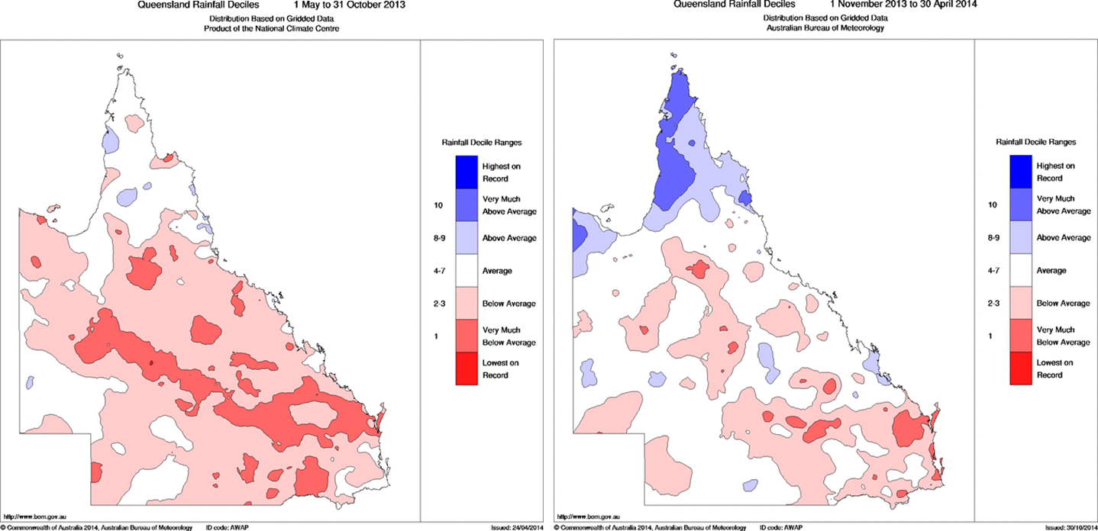
Figure 21 Rainfall decile ranges for the dry season May 2013 - Oct 2013 (left) and wet season 1 Nov 2013 – 30 April 2014 (right). Figures provided by Bureau of Meteorology

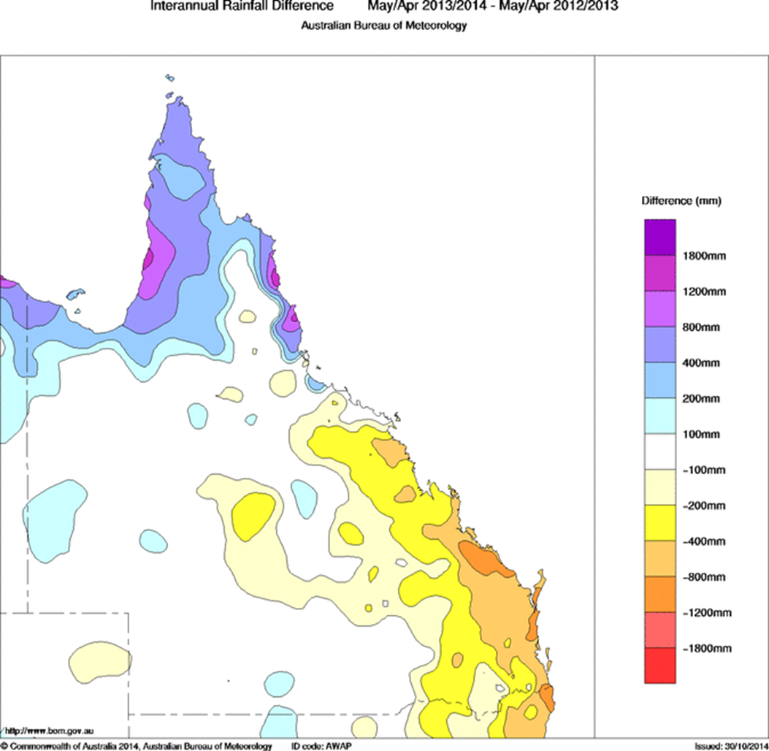
Figure 22 One year inter-annual rainfall difference between the previous monitoring year (2012-13) and the current monitoring year (2013-14). Figure provided by Bureau of Meteorology

APPENDIX D – Fixed monitoring – Individual site results
Table 21 Low Isles, Wet Tropics region – Concentration in water (ng L⁻¹)
ª Photosystem II herbicides but not currently included in the index *Galaxolide and tonalid are detected in non-polar samplers only. Concentrations are time-integrated estimates. When calculating average concentrations, n.d. were assigned a value of zero

Table 22 Green Island, Wet Tropics region – Concentration in water (ng L⁻¹)
ª Photosystem II herbicides but not currently included in the index; *Galaxolide and tonalid are detected in non-polar samplers only. Concentrations are time-integrated estimates. Metolachlor detected in PDMS samplers is an equilibrium estimate, and is not time-integrated. When calculating average concentrations, n.d. were assigned a value of zero
Table 23 Fitzroy Island, Wet Tropics region – Concentration in water (ng L⁻¹)
ª Photosystem II herbicides but not included in the index at this stage; **Galaxolide and tonalid are detected in non-polar samplers only. Concentrations are time-integrated estimates. Metolachlor detected in PDMS samplers is an equilibrium estimate, and is not time-integrated. When calculating average concentrations, n.d. were assigned a value of zero
Table 24 Dunk Island, Wet Tropics region – Concentrations in water (ng L⁻¹)
ª Photosystem II herbicides but not included in the index at this stage; **Galaxolide and tonalid are detected in non-polar samplers only and concentrations are time-integrated estimates. Metolachlor detected in PDMS samplers is an equilibrium estimate, and is not time-integrated. When calculating average concentrations, n.d. were assigned a value of zero
Table 25 Orpheus Island, Burdekin region – Concentrations in water (ng L⁻¹)
ª Photosystem II herbicides but not included in the index at this stage. **Galaxolide and tonalid are detected in non-polar samplers only and concentrations are are time-integrated estimates. When calculating average concentrations, n.d. were assigned a value of zero

Table 26 Magnetic Island, Burdekin Region – Concentrations in water (ng L⁻¹)
ª Photosystem II herbicides but not included in the index at this stage; **Galaxolide and tonalid are detected in non-polar samplers only and concentrations are time-integrated estimates. Metolachlor detected in PDMS samplers is an equilibrium estimate, and is not time-integrated. When calculating average concentrations, n.d. were assigned a value of zero

Table 27 Cape Cleveland, Burdekin Region – Concentrations in water (ng L⁻¹)
ª Photosystem II herbicides but not included in the index at this stage; **Galaxolide and tonalid are detected in non-polar samplers only and concentrations are are time-integrated estimates. Metolachlor detected in PDMS samplers is an equilibrium estimate, and is not time-integrated. When calculating average concentrations, n.d. were assigned a value of zero
Table 28 Outer Whitsunday, Mackay Whitsunday region – Concentrations in water (ng L⁻¹)
ª Photosystem II herbicides but not included in the index at this stage; **Galaxolide and tonalid are detected in non-polar samplers only and concentrations are are time-integrated estimates. Metolachlor detected in PDMS samplers is an equilibrium estimate, and is not time-integrated. When calculating average concentrations, n.d. were assigned a value of zero

Table 29 Sarina Inlet, Mackay Whitsunday region – Concentrations in water (ng L⁻¹)
ª Photosystem II herbicides but not included in the index at this stage; **Galaxolide and tonalid are detected in non-polar samplers only and concentrations are are time-integrated estimates. Metolachlor detected in PDMS samplers is an equilibrium estimate, and is not time-integrated. When calculating average concentrations, n.d. were assigned a value of zero

Table 30 North Keppel Island, Fitzroy Region – Concentrations in water (ng L⁻¹)
ª Photosystem II herbicides but not included in the index at this stage; **Galaxolide and tonalid are detected in non-polar samplers only and concentrations are are time-integrated estimates. When calculating average concentrations, n.d. were assigned a value of zero

APPENDIX E – Terrestrial run-off assesment- Results
Table 31 Concentrations in water (ng L⁻¹) measured along the Russell-Mulgrave transect using 1 L grab samples during run-off events during the wet season
^ Indicates that samples were extracted and analysed by QHFSS
Table 32 Concentrations in water (ng L⁻¹) measured at various locations alon the Tully River transect using 1 L grab samples during terrestrial run-off events during the wet season
^ Indicates that samples were extracted and analysed by QHFSS
Table 33 Concentrations in water (ng L⁻¹) measured at various locations along the Tully River and Russell-Mulgrave River transects using passive samplers during terrestrial run-off events during the wet season

APPENDIX F – Mean flow rates in major rivers vs PSII-HEq of passive samplers
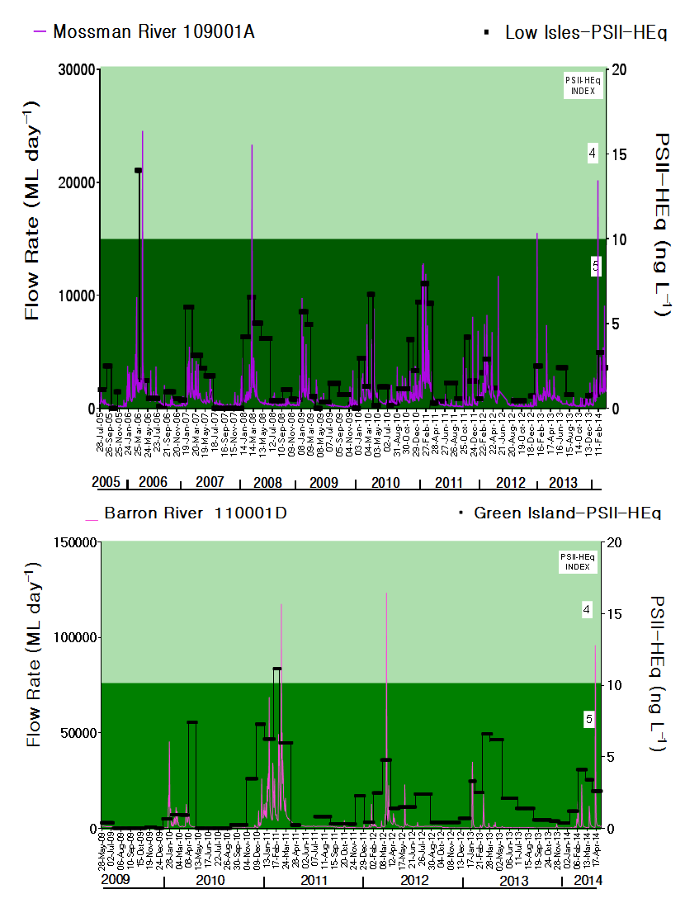
Figure 23 Temporal trends in PSII-HEq with respect to flow rate of rivers influencing passive sampler sites in the Wet Tropics region since monitoring commenced (Flow data provided by Department of Environment and Resource Management, Stream Gauging Network)

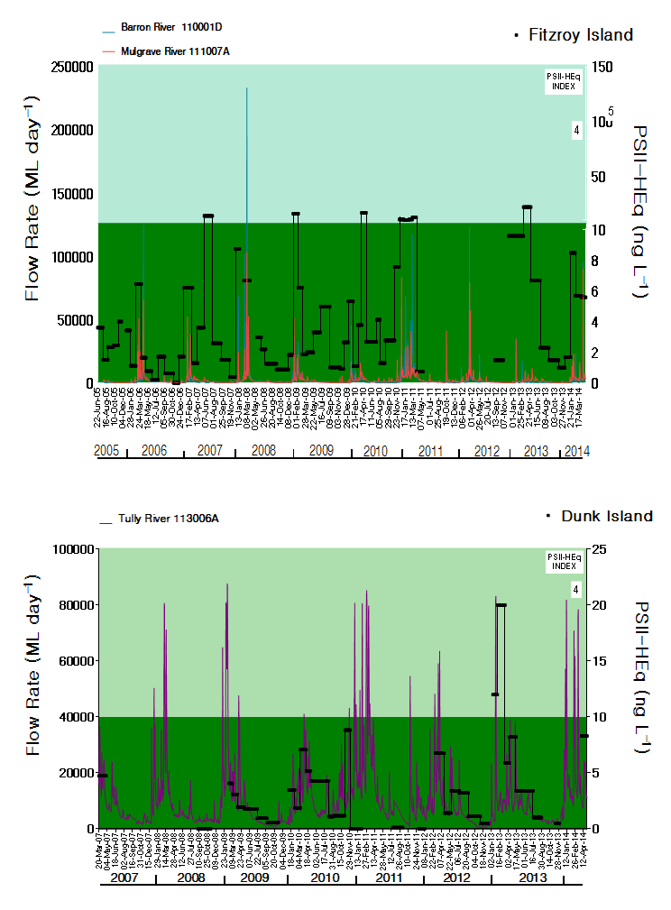
Figure 24 Temporal trends in PSII-HEq with respect to flow rate of rivers influencing passive sampler sites in the Wet Tropics region since monitoring commenced
(Flow data provided by Department of Environment and Resource Management, Stream Gauging Network)

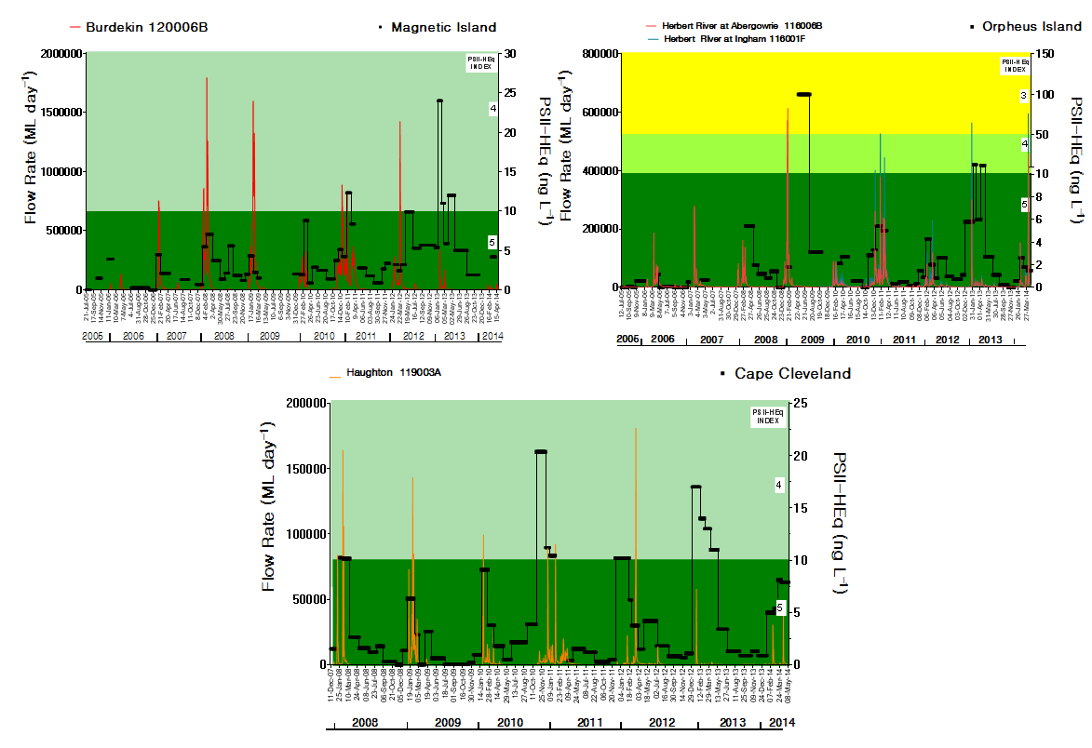
Figure 25 Temporal trends in PSII-HEq with respect to flow rate of rivers influencing passive sampler sites in the Burdekin region since monitoring commenced.
(Flow data provided by Department of Environment and Resource Management, Stream Gauging Network)
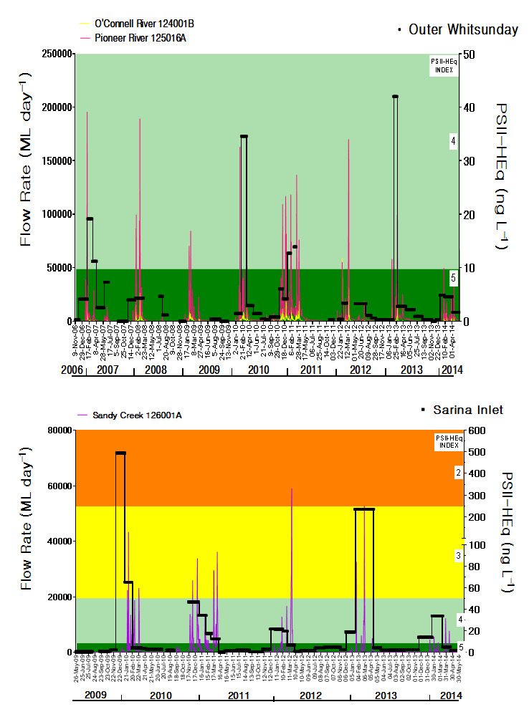
Figure 26 Temporal trends in PSII-HEq with respect to flow rate of rivers influencing passive sampler sites in the Mackay Whitsunday region since monitoring commenced (Flow data provided by Department of Environment and Resource Management, Stream Gauging Network)

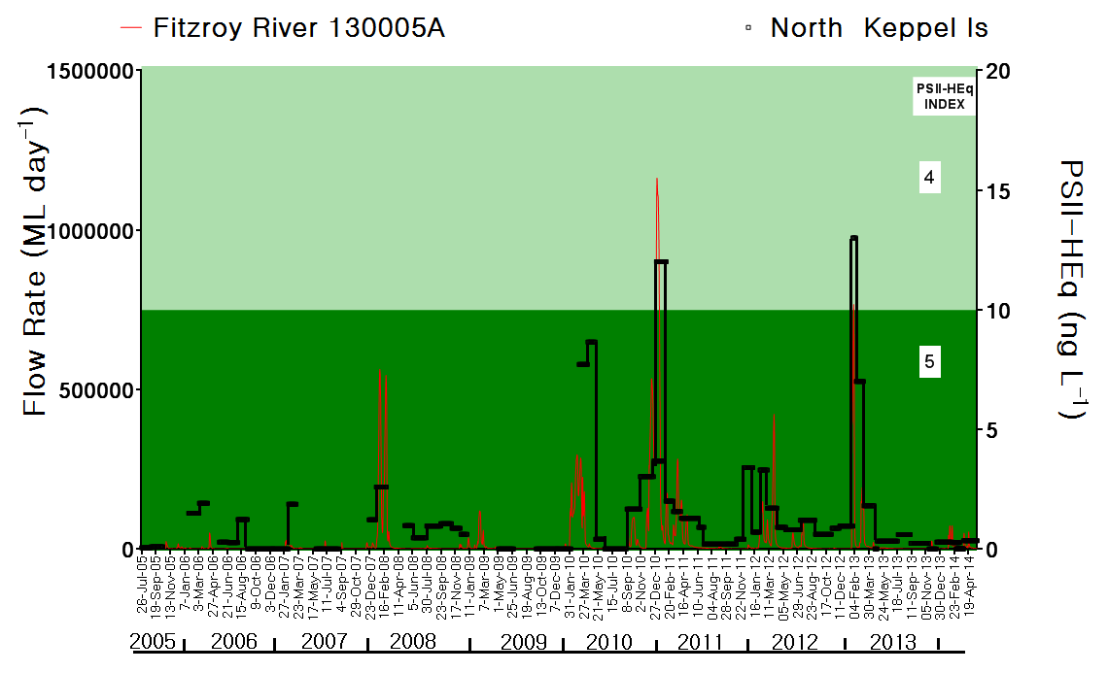
Figure 27 Temporal trends in PSII-HEq with respect to flow rate of rivers influencing passive sampler sites in the Fitzroy region since monitoring commenced
(Flow data provided by Department of Environment and Resource Management, Stream Gauging Network)

APPENDIX G – Historical concentration profiles at fixed monitoring sites
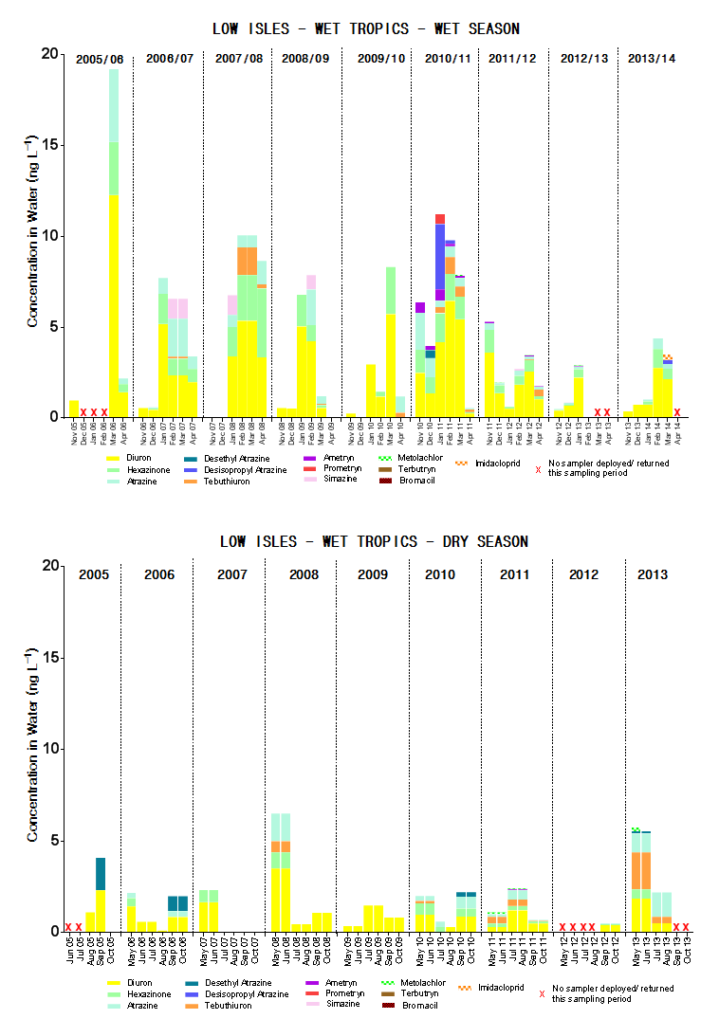
Figure 28 Temporal concentration profiles of individual herbicides at Low Isles in the Wet Tropics region
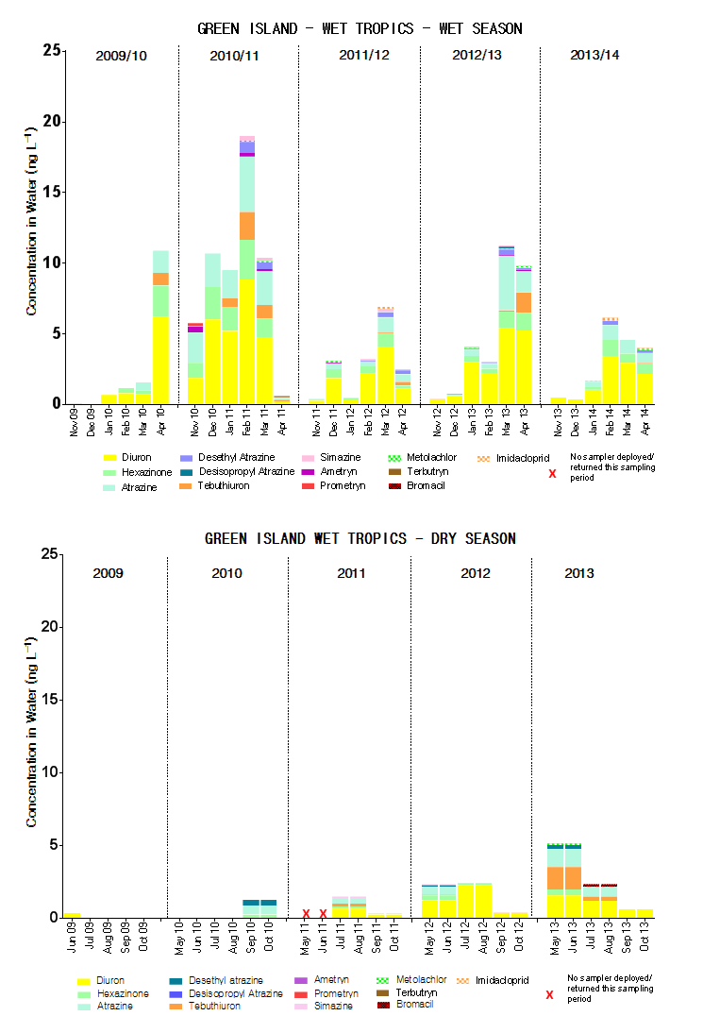
Figure 29 Temporal concentration profiles of individual herbicides at Green Island in the Wet Tropics region
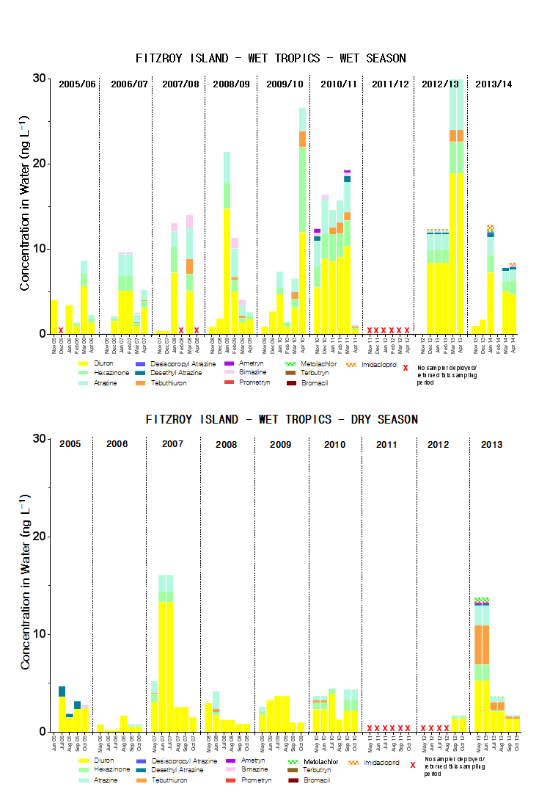
Figure 30 Temporal concentration profiles of individual herbicides at Fitzroy Island in the Wet Tropics region
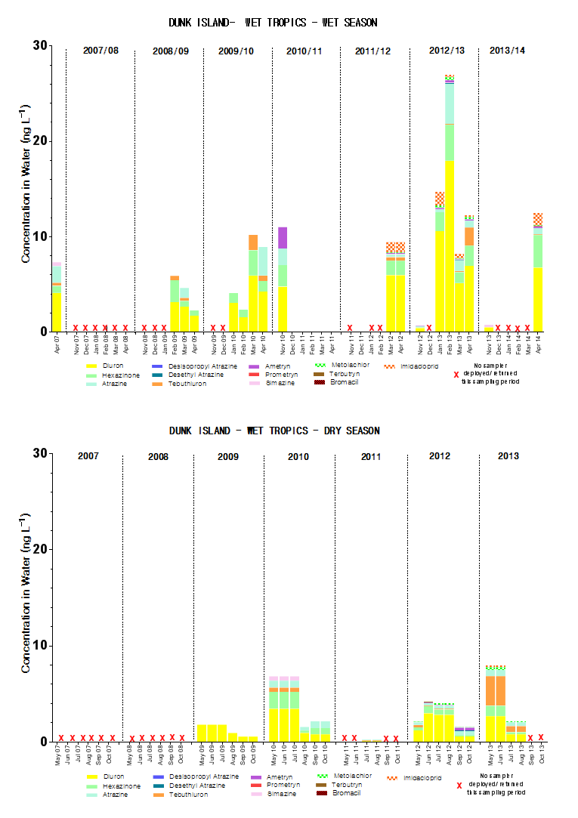
Figure 31 Temporal concentration profiles of individual herbicides at Dunk Island in the Wet Tropics region
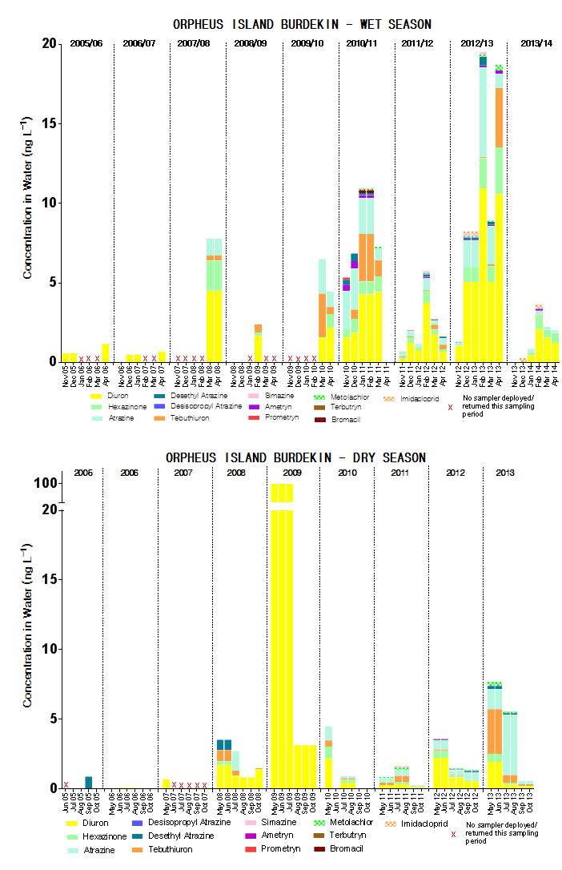
Figure 32 Temporal concentration profiles of individual herbicides at Orepheus Island in the Burdekin region
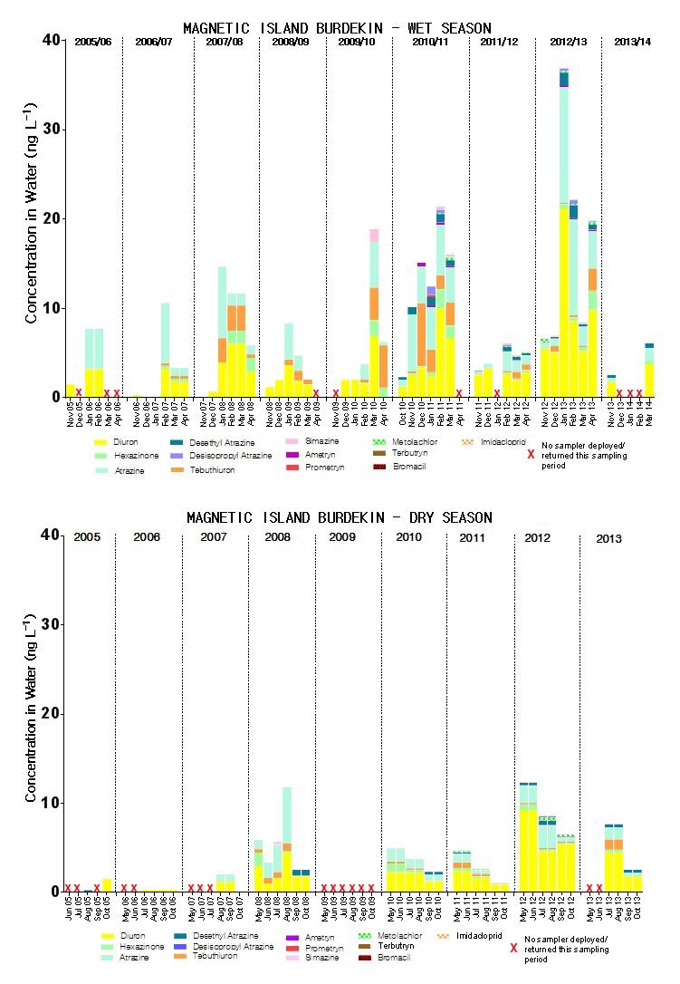
Figure 33 Temporal concentration profiles of individual herbicides at Magnetic Island in the Burdekin region
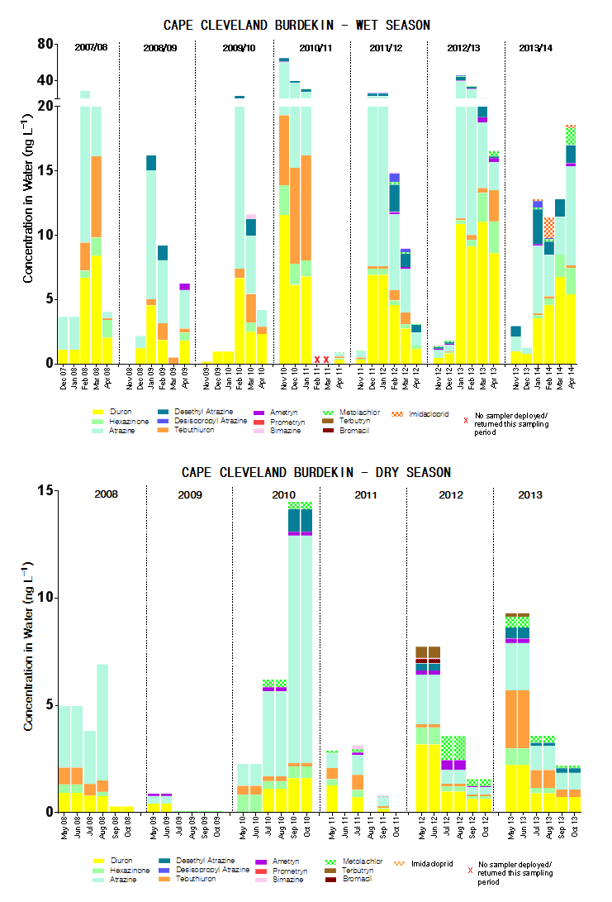
Figure 34 Temporal concentration profiles of individual herbicides at Cape Cleveland in the Burdekin region
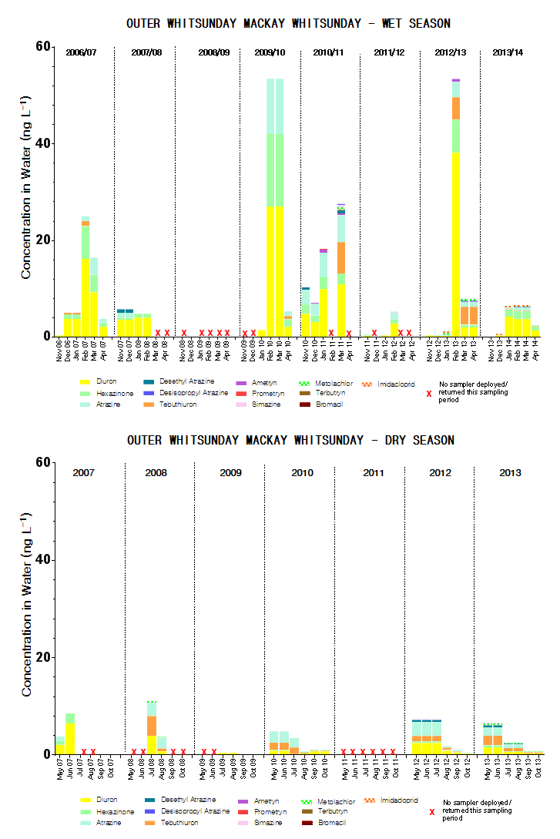
Figure 35 Temporal concentration profiles of individual herbicides at Outer Whitsunday in the Mackay Whitsunday region
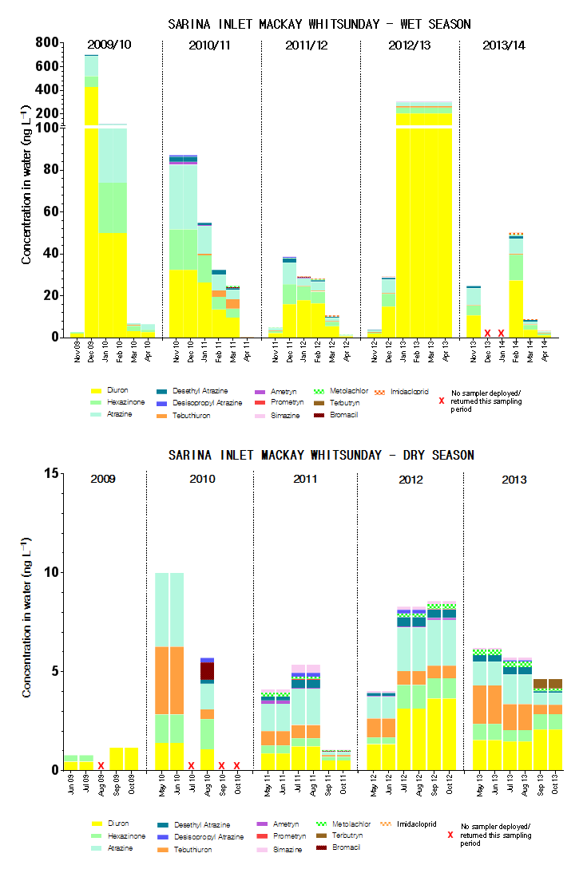
Figure 36 Temporal concentration profiles of individual herbicides at Sarina Inlet in the Mackay Whitsunday region
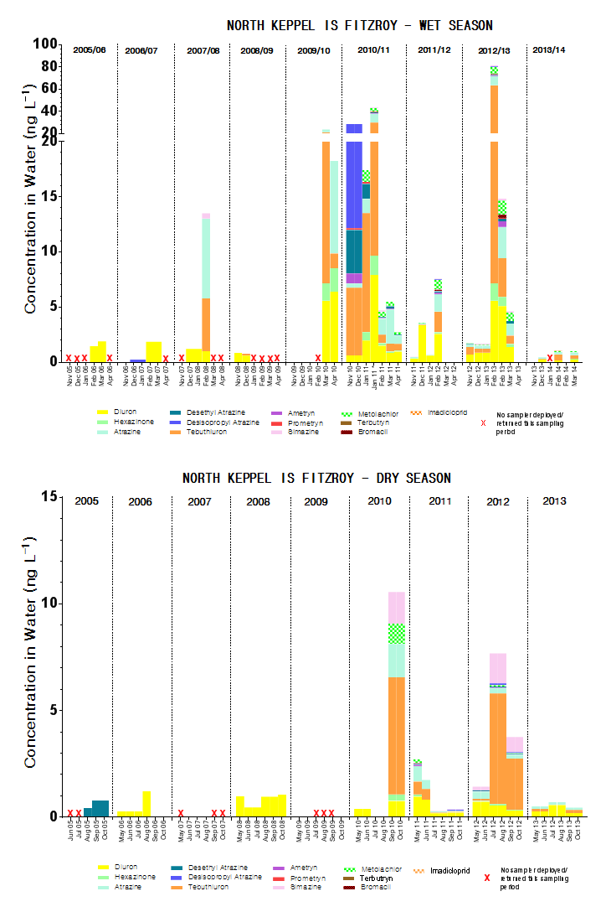
Figure 37 Temporal concentration profiles of individual herbicides at North Keppel Island in the Fitzroy region

APPENDIX H - Land and herbicide use in the GBR catchments adjacent to fixed monitoring sites
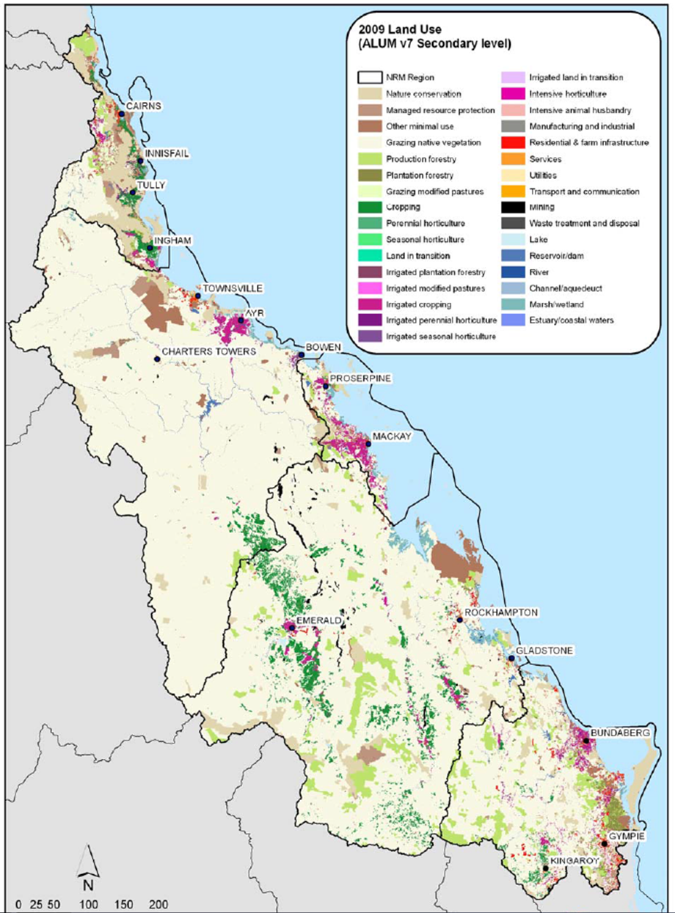
Figure 38 Land Use Map of the GBR catchment – 2009.
Map obtained from DSITIA, 2012a
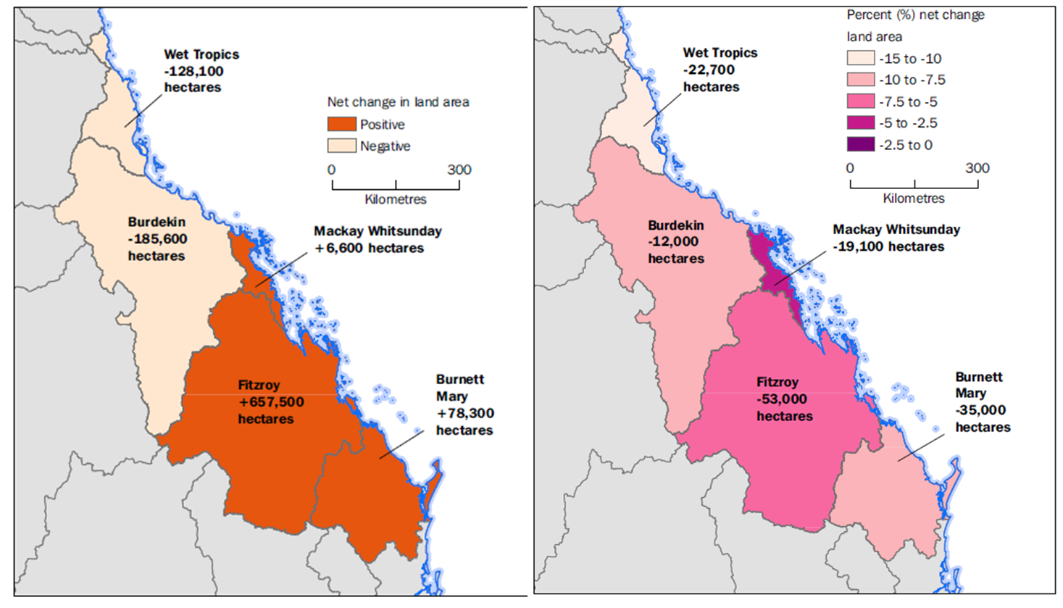
Figure 39 Net change in land area used for Livestock Grazing between 2009 – 2013 (left) and percentage net change in land area used for agriculture cropping between 2009 – 2013 (right). Source: Australian Bureau of Statistics 4609.0.55.001 - Land Account: Great Barrier Reef Region, Experimental Estimates, 2014

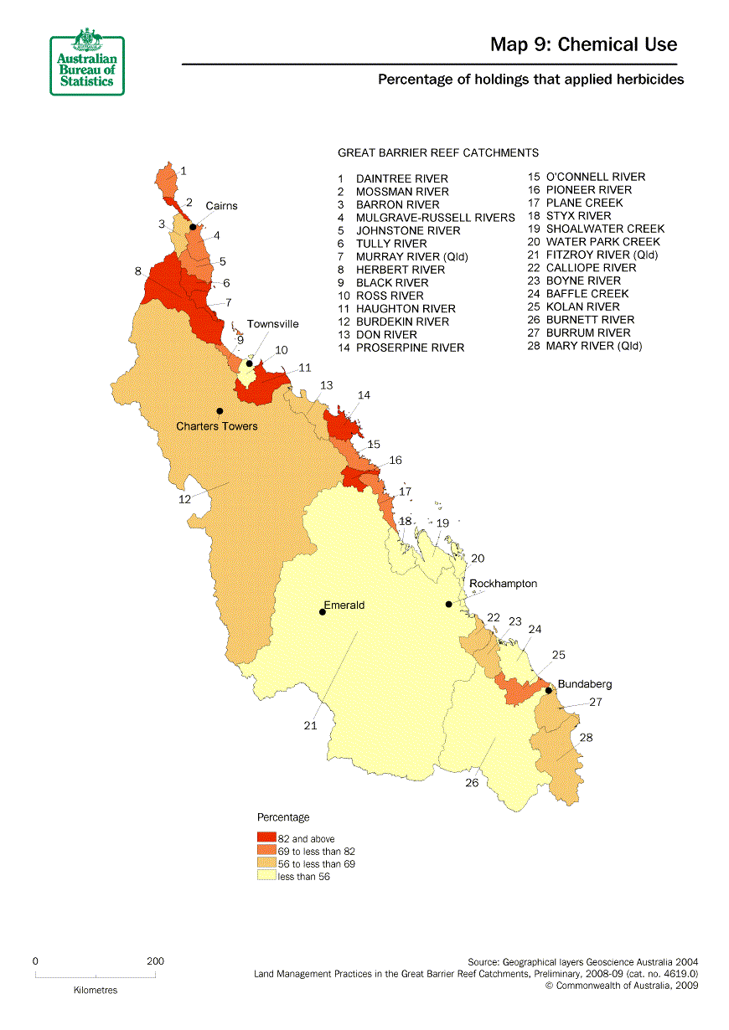
Figure 40 Percentage of land holdings in 28 GBR catchments that apply herbicides in 2008-2009.
Source: Australian Bureau of Statistics 4619.0 - Land Management Practices in the Great Barrier Reef Catchments, Preliminary, 2008-09

