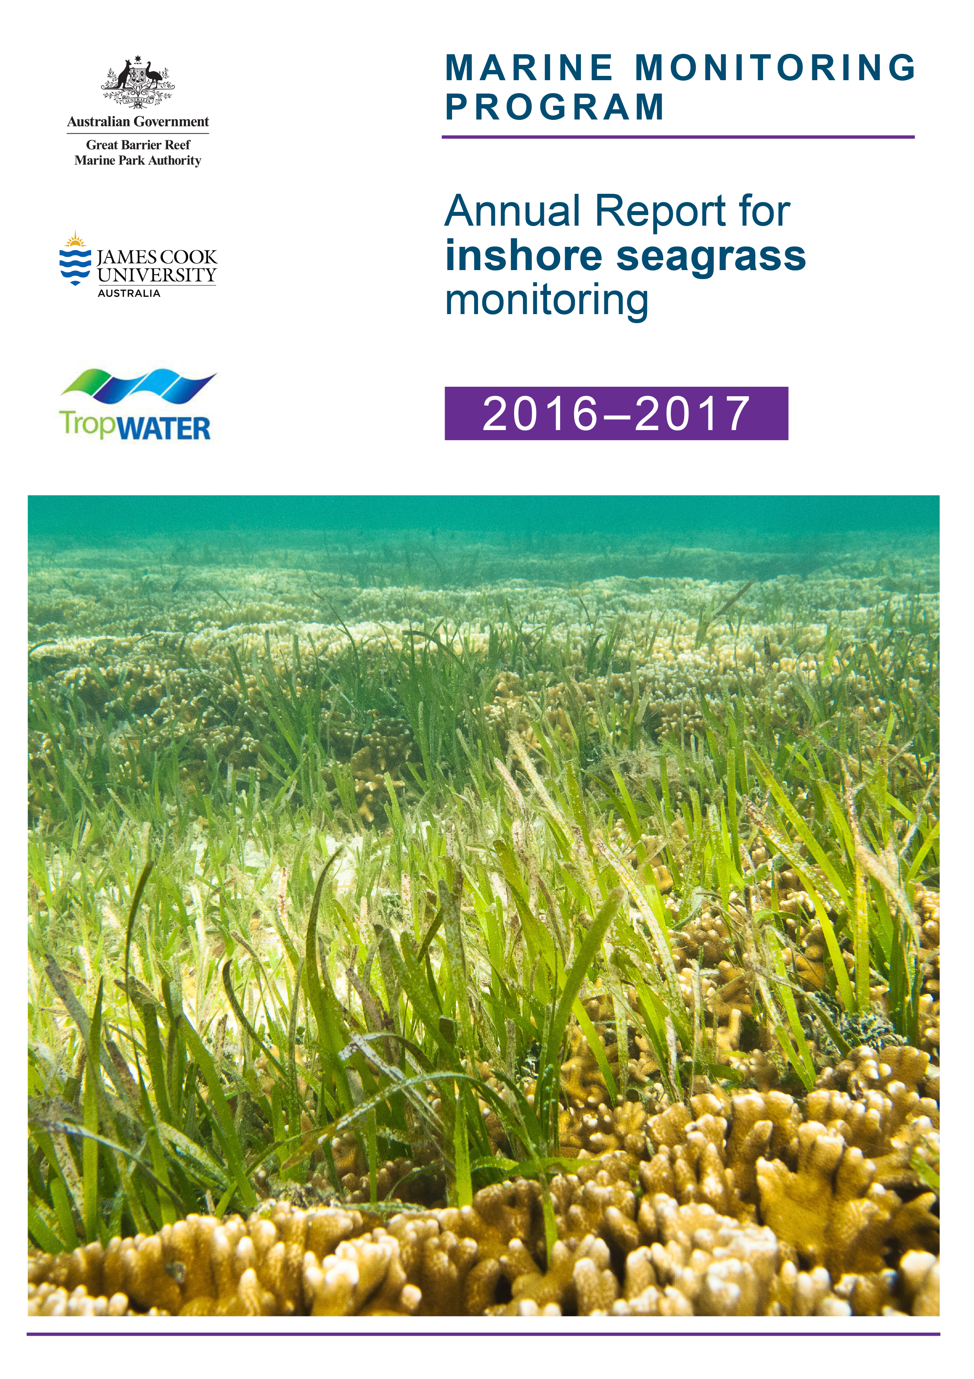
© James Cook University (TropWATER), 2018
Published by the Great Barrier Reef Marine Park Authority
ISSN: 2208-4037

Marine Monitoring Program: Annual Report for inshore seagrass monitoring 2016-2017 is licensed for use under a Creative Commons By Attribution 4.0 International licence with the exception of the Coat of Arms of the Commonwealth of Australia, the logos of the Great Barrier Reef Marine Park Authority, James Cook University and TropWATER, any other material protected by a trademark, content supplied by third parties and any photographs. For licence conditions see: http://creativecommons.org/licences/by/4.0


This publication should be cited as:
McKenzie, L.J., Collier, C.J, Langlois, L.A., Yoshida, R.L., Smith, N. and Waycott, M. 2018, Marine Monitoring Program: Annual Report for inshore seagrass monitoring 2016-2017. Report for the Great Barrier Reef Marine Park Authority, Great Barrier Reef Marine Park Authority, Townsville, 248pp.

A catalogue record for this publication is available from the National Library of Australia

Front cover image: Seagrass (mainly Cymodocea spp.) on the reef flat at Green Island ©Dieter Tracey 2013.

DISCLAIMER
While reasonable efforts have been made to ensure that the contents of this document are factually correct, JCU and TropWater do not make any representation or give any warranty regarding the accuracy, completeness, currency or suitability for any particular purpose of the information or statements contained in this document. To the extent permitted by law JCU and TropWater shall not be liable for any loss, damage, cost or expense that may be occasioned directly or indirectly through the use of or reliance on the contents of this document.

Comments and questions regarding this document are welcome and should be addressed to:

TropWATER- Centre for Tropical Water and Aquatic Ecosystem Research
James Cook University
Townsville, Qld 4811
Tropwater@jcu.edu.au

This project is supported by the Great Barrier Reef Marine Park Authority through funding from the Australian Government Reef Program, the Reef 2050 Integrated Monitoring and Reporting Program, Austalian Institute of Marine Science and James Cook University.

Contents

Acronyms & Abbreviations Used In This Report xvi
Acknowledgements xvii
Executive summary 1
1 Preface 4
2 Introduction 5
3 Methods summary 11
3.1 Climate and environmental pressures 11
3.2 Sampling design & site selection 14
3.3 Seagrass condition monitoring 19
3.3.1 Seagrass abundance, composition and extent 19
3.3.2 Seagrass reproductive health 19
3.3.3 Seagrass tissue nutrients 19
3.4 Data analyses 20
3.5 Reporting Approach 21
3.6 Calculating scores for the Report card 22
3.6.1 Seagrass abundance 22
3.6.2 Seagrass reproductive effort 23
3.6.3 Seagrass nutrient status. 23
3.6.4 Seagrass index 24
4 Results & Discussion 25
4.1 GBR-wide Summary 26
4.1.1 Climate and environmental pressures 28
4.1.2 Indicators of seagrass condition 36
4.1.3 Indicators of environmental condition 41
4.2 Cape York 47
4.2.1 2016–17 Summary 47
4.2.2 Climate and environmental pressures 48
4.2.3 Indicators of seagrass condition 50
4.2.4 Indicators of environmental condition 54
4.2.5 Report card for inshore seagrass status 56
5.1 Wet Tropics 58
5.1.1 2016–17 Summary 58
5.1.2 Climate and environmental pressures 59
5.1.3 Indicators of seagrass condition 61
5.1.4 Indicators of environmental condition 67
5.1.5 Report card for inshore seagrass status 69
5.2 Burdekin 71
5.2.1 2016–17 Summary 71
5.2.2 Climate and environmental pressures 72
5.2.3 Indicators of seagrass condition 75
5.2.4 Indicators of environmental condition 80
5.2.5 Report card for inshore seagrass status 82
5.3 Mackay Whitsunday 83
5.3.1 2016–17 Summary 83
5.3.2 Climate and environmental pressures 84
5.3.3 Indicators of seagrass condition 86
5.3.4 Indicators of environmental condition 91
5.3.5 Report card for inshore seagrass status 93
5.4 Fitzroy 94
5.4.1 2016–17 Summary 94
5.4.2 Climate and environmental pressures 95
5.4.3 Indicators of seagrass condition 97
5.4.4 Indicators of environmental condition 101
5.4.5 Report card for inshore seagrass status 103
5.5 Burnett Mary 104
5.5.1 2016–17 Summary 104
5.5.2 Climate and environmental pressures 105
5.5.3 Indicators of seagrass condition 107
5.5.4 Indicators of environmental condition 111
5.5.5 Report card for inshore seagrass status 113
6 Conclusions 114
7 References 128
Appendix 1 Background to the NRMs, including conceptual models 142
A1.1 Cape York 143
A1.2 Wet Tropics 147
A1.3 Burdekin 149
A1.4 Mackay Whitsunday 151
A1.5 Fitzroy 154
A1.6 Burnett-Mary 157
Appendix 2 Materials and Methods 160
A2.1 Sampling design 161
A2.2 Climate and environmental pressures 164
A2.2.1 Tidal exposure 164
A2.2.2 Light loggers 164
A2.2.3 Within seagrass canopy temperature loggers 166
A2.3 Seagrass status 167
A2.3.1 Field survey methods 167
A2.3.2 Observer training 172
A2.3.3 Laboratory analysis 172
Appendix 3 Report card methods and calculations 175
A3.1 Report card approach 176
A3.2 Seagrass abundance 176
A3.3 Seagrass reproductive effort 184
A3.4 Seagrass nutrient status. 186
A3.5 Seagrass index 188
Appendix 4 Detailed data 189
A4.1 Climate and environmental pressures 190
A4.1.1 Climate 190
A4.1.2 Tidal exposure 193
A4.1.3 Light at seagrass canopy 197
A4.2 Seagrass community and environment 203
A4.2.1 Seagrass abundance 203
A4.2.2 Sediments composition 206
A4.2.3 Epiphytes and macroalgae 217
A4.2.4 Seagrass extent 224
A4.2.5 Species composition and distribution 226
A4.2.6 Seagrass leaf tissue 232
Appendix 5 Results of statistical analysis 244

List of figures
Figure 1. The Great Barrier Reef Marine Park, major marine ecosystems (coral reefs and surveyed seagrass meadows), NRM regions and marine NRM regions 6
Figure 2. General conceptual model of seagrass habitats in north east Australia and the water quality impacts affecting the habitat 7
Figure 3. Climate, environmental, seagrass condition and seagrass resilience indicators reported as part of the MMP Inshore Seagrass monitoring 2016–17. 8
Figure 4. Illustration of seagrass recovery after loss and the categories of successional species over time. 10
Figure 5. Illustration showing how foundational species can include species display colonising, opportunist or persistent life history traits depending on disturbance regime. 15
Figure 6. Report card scores (NRM regional averages pooled) for each indicator and total seagrass index over the life of the MMP. 26
Figure 7. Report card of seagrass condition for each NRM region (averaged across indicators). 27
Figure 8. Annual average wet season rainfall (December 2016–April 2017) compared to the long-term wet season rainfall average (1961–1990). 29
Figure 9. Turbid water exposure (colour classes 1 – 5, primary and secondary water) frequency in the GBR from December 2016 to April 2017 31
Figure 10. Difference in the frequency of exposure to water colour classes (CC) 1 to 4 (left) and 1 to 5 (right) at seagrass monitoring sites during the wet season (December 2016 – April 2017) compared to the long-term multiannual exposure (2003–2017). 32
Figure 11. Average daily light (left-hand panel) and thresholds exceeded (per cent days, right-hand panel) for coastal, estuarine, reef intertidal, and reef subtidal sites including the long-term average and the value for the 2016–17 reporting period. 33
Figure 12. Daily light for all sites combined (a.) and GBR-wide trend (GAM plot) in daily light for each habitat (b.) from 2008 to 2017. 34
Figure 13. Number of days when inshore intertidal sea temperature exceeded 35°C, 38°C, 40°C and 43°C in each monitoring period in each NRM region. 35
Figure 14. Inshore intertidal sea temperature deviations from baseline for GBR seagrass habitats 2003 to 2017. 35
Figure 15. Number of days when inshore subtidal sea temperature exceeded 35°C, 38°C, 40°C and 43°C in each monitoring period in each NRM region. 36
Figure 16. Regional report card scores for seagrass abundance over the life of the MMP 36
Figure 17. Seagrass percent cover measures per quadrat from meadows monitored from June 1999 to May 2017 (sites and habitats pooled). 37
Figure 18. Trends in seagrass abundance ( per cent cover) for each habitat type across the GBR represented by a GAM plot. 38
Figure 19. Proportion of total seagrass abundance composed of species displaying colonising traits (e.g. Halophila ovalis) in a) estuary intertidal, b) coastal intertidal, c) coast subtidal, d) reef intertidal and e) reef subtidal habitats (sites pooled) for the GBR (regions pooled) each monitoring period 38
Figure 20. Seagrass reproductive effort (number of reproductive structures produced by all seagrass species) during the late dry of each monitoring period, for a) estuary intertidal; b) coast intertidal; c) reef intertidal; d) reef subtidal. 39
Figure 21. Regional report card scores for seagrass reproductive effort over the life of the MMP 40
Figure 22. Average seeds banks (seeds per square metre of sediment surface, all sites and species pooled) in GBR seagrass habitats: a) estuary intertidal; b) coast intertidal; c) reef intertidal; d) reef subtidal. 40
Figure 23. Median tissue nutrient concentrations (± SE) in seagrass leaves for each habitat type (species pooled) over the entire monitoring program 41
Figure 24. Elemental ratios (atomic) of seagrass leaf tissue C:N for each habitat each year 42
Figure 25. Seagrass leaf tissue δ¹³C and δ¹⁵N concentrations from each GBR seagrass habitat (locations pooled) in the late dry from 2011 to 2016 43
Figure 26. Elemental ratios (atomic) of seagrass leaf tissue C:P and N:P for each habitat each year 43
Figure 27. Regional report card scores for seagrass leaf tissue nutrient status (C:N) over the life of the MMP 44
Figure 28. Proportion of sediment composed of mud (grain size <63µm) at GBR seagrass monitoring habitats from 1999-2017. 45
Figure 29. Epiphyte abundance (per cent cover) relative to the long-term average (the zero axis) for each GBR seagrass habitat 45
Figure 30. Macroalgae abundance (per cent cover) relative to the long-term average for each inshore GBR seagrass habitat 46
Figure 31. Report card of seagrass condition (indicators and index) for the Cape York NRM region 47
Figure 32. Frequency of exposure to turbid water (colour classes 1-5) in the Cape York NRM, wet season (December 2016 – April 2017) composite 48
Figure 33. Daily light (mean) at Cape York sites with 28-d rolling average from 2012 to 2017 (left) and GAM plots (right) 49
Figure 34. Inshore within canopy sea temperature for intertidal seagrass habitats in the Cape York NRM region from April 2007 to June 2017 50
Figure 35. Seagrass abundance (per cent cover ± SE) at inshore intertidal reef habitats (replicate sites pooled) in the Cape York NRM. 51
Figure 36. Seagrass abundance ( per cent cover ± SE) at inshore intertidal coastal habitats (sites pooled) in the Cape York NRM region. 52
Figure 37. Regional and location temporal trend in seagrass abundance in the Cape York NRM region from 2003 to 2016 represented by a GAM plot. 52
Figure 38. Temporal trends in seagrass abundance for each habitat in the Cape York NRM region represented by a GAM plot. 53
Figure 39. Proportion of seagrass abundance composed of species displaying colonising traits at inshore habitats in the Cape York region 53
Figure 40. Change in spatial extent of seagrass meadows within monitoring sites for each habitat and monitoring period across the eastern Cape York NRM region. 54
Figure 41. Seed banks and reproductive effort at inshore intertidal coastal (a) and reef (b) habitats in the Cape York region 54
Figure 42. Elemental ratios (atomic) of seagrass leaf tissue C:N for the foundation species in inshore intertidal coastal (a) and reef (b) habitats in the Cape York region from 2005 to 2016 55
Figure 43. Elemental ratios (atomic) of seagrass leaf tissue N:P and C:P for the foundation species in inshore intertidal reef (a, c) and coastal (b, d) habitats in the Cape York region from 2005 to 2016 55
Figure 44. Long-term trend in mean epiphyte and macroalgae abundance ( per cent cover) at monitoring sites in the Cape York region, relative to the long-term average for each inshore GBR intertidal seagrass habitat 56
Figure 45. Report card of seagrass indicators and index for the Wet Tropics NRM region 58
Figure 46. Frequency of exposure to turbid water (colour classes 1-5) in the Wet Tropics NRM, wet season (22 weeks from December 2016 – April 2017) composite. 59
Figure 47. Mean daily light at Wet Tropics sites with 28-d rolling average from 2008 to 2017 (left) and GAM plots (right) 60
Figure 48. Inshore sea temperature for intertidal seagrass habitats in the Wet Tropics NRM region from August 2001 to June 2017 60
Figure 49. Inshore sea temperature for subtidal seagrass habitats in the Wet Tropics NRM region from October 2008 to June 2017 61
Figure 50. Changes in seagrass abundance (per cent cover ± SE) at inshore intertidal coastal habitats in the Wet Tropics NRM region, 2000 - 2017. 62
Figure 51. Changes in seagrass abundance (per cent cover ± SE) for inshore intertidal and subtidal reef habitats (left and right respectively) in the Wet Tropics NRM region, 2001 – 2017. 63
Figure 52. Temporal trends in seagrass abundance for each monitoring location in the northern (a) and southern (b) Wet Tropics region represented by a GAM plot, 2001-2017. 64
Figure 53. Temporal trends in seagrass abundance for seagrass habitat in the northern Wet Tropics region represented by a GAM plot, 2001-2017. 64
Figure 54. Temporal trends in seagrass abundance for seagrass habitat in the southern Wet Tropics region represented by a GAM plot, 2001-2017. 64
Figure 55. Proportion of seagrass abundance composed of colonising species at inshore habitats in the Wet Tropics region, from the 2000-01 to the 2016-2017 reporting periods. 65
Figure 56. Change in relative spatial extent (±SE) of seagrass meadows within monitoring sites for each habitat and monitoring period across the Wet Tropics NRM region. 65
Figure 57. Change in visually estimated above-ground biomass (a.) and total extent (b.) of all monitoring meadows combined in Cairns Harbour and Trinity Inlet from 2001 – 2016 66
Figure 58. Change in visually estimated above-ground biomass (a.) and total extent (b.) of all monitoring meadows combined in Mourilyan Harbour from 1993 – 2016 66
Figure 59. Seed bank and late dry season reproductive effort for inshore intertidal coast and reef habitats in the Wet Tropics region, 2001 - 2017. 67
Figure 60. Elemental ratios (atomic) of seagrass leaf tissue C:N for the foundation seagrass species examined at each inshore habitat in the Wet Tropics region each year 68
Figure 61. Elemental ratios (atomic) of seagrass leaf tissue N:P and C:P for the foundation seagrass species examined at each inshore habitat in the Wet Tropics region 68
Figure 62. Long-term trend in mean epiphyte and macroalgae abundance (per cent cover) relative to the long-term average for each inshore seagrass habitat in the Wet Tropics region, 2001 - 2017 69
Figure 63. Report card of seagrass status indicators and index for the Burdekin NRM region 72
Figure 64. Frequency of exposure to turbid water (colour classes 1-5) in the Burdekin NRM region, wet season (December 2016 – April 2017) composite. 73
Figure 65. Mean daily light at Burdekin sites with 28-d rolling average from 2008 to 2017 (left) and GAM plots (right) 74
Figure 66. Inshore sea temperature at intertidal seagrass habitats in the Burdekin region, January 2008 - May 2017 74
Figure 67. Inshore sea temperature at inshore subtidal seagrass habitat at Magnetic Island (Burdekin region), January 2008 - May 2017 75
Figure 68. Changes in mean seagrass abundance (per cent cover ± SE) at inshore coastal intertidal (a, b), reef intertidal (c) and reef subtidal (d) meadows in the Burdekin region, 2001 - 2017. 76
Figure 69. Temporal trends in seagrass abundance for each location in the Burdekin region represented by a GAM plot. 77
Figure 70. Temporal trends in seagrass abundance for each habitat in the Burdekin region represented by GAM plots. 77
Figure 71. Proportion of seagrass abundance composed of colonising species at inshore habitats in the Burdekin region, 2001 - 2017. 78
Figure 72. Change in spatial extent of seagrass meadows within monitoring sites for each inshore intertidal habitat and monitoring period across the Burdekin region, 2005 - 2017. 78
Figure 73. Change in total extent of all monitoring meadows combined in Port of Townsville from 2007 – 2016 79
Figure 74. Change in visually estimated above-ground biomass at offshore monitoring sites adjacent to Abbot Point from 2005 – 2016 79
Figure 75. Seed bank and late dry season reproductive effort at inshore intertidal coast and reef and subtidal reef habitats in the Burdekin region. 80
Figure 76. Elemental ratios (atomic) of seagrass leaf tissue C:N for the foundation seagrass species examined at each inshore habitat in the Burdekin region each year 80
Figure 77. Elemental ratios (atomic) of seagrass leaf tissue N:P and C:P for the foundation seagrass species examined at each inshore intertidal habitat in the Burdekin region each year 81
Figure 78. Long-term trend in mean epiphyte and macroalgae abundance (per cent cover) relative to the long-term GBR average for each inshore seagrass habitat in the Burdekin region 82
Figure 79. Report card of seagrass status indicators and index for the Mackay Whitsunday NRM region 83
Figure 80. Frequency of exposure to turbid water (colour classes 1-5) in the Mackay Whitsunday NRM region, wet season (December 2016 – April 2017) composite. 84
Figure 81 . Mean daily light at Mackay Whitsunday habitats with 28-d rolling average from 2009 to 2017 (left) and GAM plots (right) 85
Figure 82. Inshore sea temperatures within each intertidal seagrass habitat in the Mackay Whitsunday region, September 2003 - May 2017 85
Figure 83. Changes in seagrass abundance (per cent cover ± SE) at inshore intertidal habitats in the Mackay Whitsunday region, 1999 - 2017 87
Figure 84. Temporal trends in seagrass abundance for each location in the Mackay Whitsunday region represented by a GAM plot. 87
Figure 85. Temporal trends in seagrass abundance for each habitat in the Mackay Whitsunday region represented by GAM plots. 88
Figure 86. Proportion of seagrass abundance composed of colonising species at inshore intertidal habitats in the Mackay Whitsunday region, 1999 - 2017. 89
Figure 87. Change in spatial extent of seagrass meadows within monitoring sites for each inshore intertidal habitat and monitoring period across the Mackay Whitsunday NRM region. 89
Figure 88. Change in visually estimated above-ground biomass at Hay Point offshore monitoring sites from 2005 to 2016 90
Figure 89. Seed bank and late dry season reproductive effort at inshore intertidal coast, estuary, and reef habitats in the Mackay Whitsunday region, 2001 - 2017. 91
Figure 90. Elemental ratios (atomic) of seagrass leaf tissue C:N for the foundation seagrass species examined at inshore intertidal habitats in the Mackay Whitsunday region, 2006 - 2016 91
Figure 91. Elemental ratios (atomic) of seagrass leaf tissue N:P and C:P for the foundation seagrass species examined at inshore intertidal habitats in the Mackay Whitsunday region, 2006 - 2016 92
Figure 92. Long-term trend in mean epiphyte and macroalgae abundance (per cent cover) relative to the long-term average for each inshore intertidal habitat in the Mackay Whitsunday region, 1999 - 2017 93
Figure 93. Report card of seagrass status indicators and index for the Fitzroy NRM region 94
Figure 94. Frequency of exposure to turbid water (colour classes 1-5) in the Fitzroy NRM, wet season (22 weeks from December 2016 – April 2017) composite. 95
Figure 95. Mean daily light at Fitzroy sites with 28-d rolling average from 2009 to 2017 (left) and GAM plots (right) 96
Figure 96. Inshore sea temperatures within each intertidal seagrass habitat in the Fitzroy region, June 2007 - May 2017 96
Figure 97. Changes in seagrass abundance (per cent cover ± SE) in inshore intertidal habitats of the Fitzroy region, 2001 - 2017 98
Figure 98. Temporal trends in seagrass abundance for each habitat in the Fitzroy region, represented by a GAM plot 2001-2017. 98
Figure 99. Temporal trends in seagrass abundance for seagrass habitat in the Fitzroy region represented by a GAM plot, 2001-2017. 99
Figure 100. Proportion of seagrass abundance composed of colonising species in inshore intertidal habitats of the Fitzroy region, 2001 - 2017. 99
Figure 101. Change in spatial extent of seagrass meadows within monitoring sites for each inshore intertidal habitat across the Fitzroy NRM region, 2005 - 2017. 100
Figure 102. Change total extent of all monitoring meadows combined in Port Curtis from 2009 – 2016 (from Rasheed et al 2017) 100
Figure 103. Seed bank and late dry season reproductive effort for inshore intertidal coastal, estuary and reef habitats in the Fitzroy region, 2005 - 2017. 101
Figure 104. Elemental ratios (atomic) of seagrass leaf tissue C:N for the foundation seagrass species examined at inshore intertidal habitats in the Fitzroy region, 2005 - 2016 101
Figure 105. Elemental ratios (atomic) of seagrass leaf tissue N:P and C:P for the foundation seagrass species examined at inshore intertidal habitats in the Fitzroy region, 2005 - 2016 102
Figure 106. Long-term trend in mean epiphyte and macroalgae abundance (per cent cover) relative to the long-term average for each inshore intertidal seagrass habitat in the Fitzroy region, 2005 - 2017 103
Figure 107. Report card of seagrass status indicators and index for the Fitzroy region 104
Figure 108. Frequency of exposure to turbid water (colour classes 1-5) in the Burnett Mary NRM, wet season (22 weeks from December 2016 – April 2017) composite. 105
Figure 109. Daily light at Burnett Mary locations from 2010 to 2017 (left) and GAM plots (right) 106
Figure 110. Inshore sea temperature monitoring September 2005 to May 2017 for seagrass meadows in Burnett Mary NRM region 106
Figure 111. Changes in seagrass abundance (per cent cover ± SE) at estuarine and coastal meadows in Burnett Mary region from 1999 to 2017. 108
Figure 112. Temporal trends in seagrass abundance at estuarine locations in the Burnett May region, represented by a GAM plot 1999-2017. 108
Figure 113. Temporal trends in seagrass abundance for seagrass habitat in the Burnett Mary region represented by a GAM plot, 1998-2017. 109
Figure 114. Proportion of seagrass abundance composed of colonising species at: a. estuary and b. coastal habitats in the Burnett Mary region, 1998-2017. 109
Figure 115. Change in spatial extent of estuary seagrass meadows within monitoring sites for each habitat and monitoring period across the Burnett Mary NRM region. 110
Figure 116. Burnett Mary estuary seed bank and reproductive effort. 110
Figure 117. Elemental ratios (atomic) of seagrass leaf tissue C:N for the foundation seagrass species examined at inshore intertidal habitats in the Burnett Mary region, 2005 - 2016 111
Figure 118. Elemental ratios (atomic) of seagrass leaf tissue N:P and C:P for the foundation seagrass species examined at inshore intertidal habitats in the Burnett Mary region, 2005 - 2016 112
Figure 119. Long-term trend in mean epiphyte and macroalgae abundance (per cent cover) relative to the long-term average for each seagrass habitat in the Burnett Mary NRM region 113
Figure 120. Summary of GBR MMP inshore seagrass state illustrating abundance of foundation / colonising species, seed banks and reproductive effort from 2005 to 2017 116
Figure 121. Trajectories of tropical cyclones affecting the Great Barrier Reef in 2016–17 and in previous years 119
Figure 122. Conceptual diagram of reef habitat in the Cape York region 144
Figure 123. Conceptual diagram of coastal habitat in the Cape York region 145
Figure 124. Conceptual diagram of coastal habitat (<15m) in the Wet Tropics region 147
Figure 125. Conceptual diagram of reef habitat (<15m) in the Wet Tropics region 148
Figure 126. Conceptual diagram of coastal habitat in the Burdekin region 150
Figure 127. Conceptual diagram of fringing reef habitat in the Burdekin region 150
Figure 128. Conceptual diagram of estuary habitat in the Mackay Whitsunday region 152
Figure 129. Conceptual diagram of coastal habitat in the Mackay Whitsunday region 152
Figure 130. Conceptual diagram of reef habitat in the Mackay Whitsunday region 153
Figure 131. Conceptual diagram of coastal habitat in the Fitzroy region 155
Figure 132. Conceptual diagram of reef habitat in the Fitzroy region 155
Figure 133. Conceptual diagram of estuary habitat in the Fitzroy region 156
Figure 134. Conceptual diagram of Estuary habitat in the GBR section of the Burnett Mary region 158
Figure 135. Conceptual diagram of Coastal habitat in the Burnett Mary region 158
Figure 136. Key to symbols used for conceptual diagrams detailing drivers and pressures to seagrasses. 159
Figure 137. Inshore seagrass monitoring sites for the Reef Rescue Marine Monitoring Program. 167
Figure 138. Form and size of reproductive structure of the seagrasses collected: Halophila ovalis, Halodule uninervis and Zostera muelleri subsp. capricorni 173
Figure 139. Relationship between sample size and the error in estimation of percentile values for seagrass abundance ( per cent cover) in coastal and reef seagrass habitats in the Wet Tropics NRM. 177
Figure 140. Median seagrass abundance ( per cent cover) at Yule Point (left) and Green Island (right) plotted against the 50th and 20th percentiles for coastal and intertidal reef seagrass habitat in the Wet Tropics. 178
Figure 141. Number of days wind speed is above 25 km. hr⁻¹ each monitoring period in the Cape York NRM region. 190
Figure 142. Number of days wind speed is above 25 km. hr⁻¹ each monitoring period in the Wet Tropics NRM region. 190
Figure 143. Number of days wind speed is above 25 km. hr⁻¹ each monitoring period in the Burdekin NRM region. 191
Figure 144. Number of days wind speed is above 25 km. hr⁻¹ each monitoring period in the Mackay Whitsunday NRM region. 191
Figure 145. Number of days wind speed is above 25 km. hr⁻¹ each monitoring period in the Fitzroy NRM region. 192
Figure 146. Number of days wind speed is above 25 km. hr⁻¹ each monitoring period in the Burnett Mary NRM region. 192
Figure 147. Annual daytime tidal exposure (total hours) and long-term median (dashed line) of intertidal reef seagrass meadows at Archer Point, Cape York NRM region; 2011 - 2016 194
Figure 148. Annual daytime tidal exposure (total hours) and long-term median (dashed line) of intertidal reef seagrass meadows in the Wet Tropics NRM region; 1999 - 2016. 194
Figure 149. Annual daytime tidal exposure (total hours) and long-term median (dashed line) of intertidal coastal seagrass meadows in Wet Tropics NRM region; 1999 - 2016. 194
Figure 150. Annual daytime tidal exposure (total hours) and long-term median (dashed line) of intertidal coastal seagrass meadows in Burdekin NRM region; 2000 - 2016. 195
Figure 151. Annual daytime tidal exposure (total hours) and long-term median (dashed line) of intertidal reef seagrass meadows in Burdekin NRM region; 2000 - 2016. 195
Figure 152. Annual daytime tidal exposure (total hours) and long-term median (dashed line) of intertidal estuarine (a, b) coastal (c, d) and reef (e, f) seagrass meadows in Mackay Whitsunday NRM region; 1999 - 2016. 195
Figure 153. Annual daytime tidal exposure (total hours) and long-term median (dashed line) of intertidal estuarine (a, b) coastal (c, d) and reef (e, f) seagrass meadows in the Fitzroy NRM region; 1999 - 2016. 196
Figure 154. Annual daytime tidal exposure (total hours) and long-term median (dashed line) of intertidal estuarine seagrass meadows in the Burnett Mary NRM region; 1999 - 2016. 196
Figure 155. Daily light (28-day rolling average) at Cape York locations 197
Figure 156. Daily light (yellow line) and 28-day rolling average (orange, bold line) for locations in the northern Wet Tropics 198
Figure 157. Daily light (yellow line) and 28-day rolling average (orange, bold line) for locations in the southern Wet Tropics 199
Figure 158. Daily light (yellow line) and 28-day rolling average (orange, bold line) at locations in the Burdekin region 200
Figure 159. Daily light (yellow line) and 28-day rolling average (orange, bold line) at Mackay Whitsunday habitats. 201
Figure 160. Daily light (yellow line) and 28-day rolling average (orange, bold line) at monitoring locations in the Fitzroy NRM region 202
Figure 161. Daily light (yellow line) and 28-day rolling average (orange, bold line) at monitoring locations in the Burnett Mary NRM region 202
Figure 162. Temporal trends in seagrass abundance for each location in the Cape York NRM region represented by a GAM plot. 203
Figure 163. Temporal trends in seagrass abundance for each location in the northern Wet Tropics NRM region represented by a GAM plot. 203
Figure 164. Temporal trends in seagrass abundance for each location in the southern Wet Tropics NRM region represented by a GAM plot. 204
Figure 165. Temporal trends in seagrass abundance for each location in the Burdekin NRM region represented by a GAM plot. 204
Figure 166. Temporal trends in seagrass abundance for each location in the Mackay Whitsunday NRM region represented by a GAM plot. 205
Figure 167. Temporal trends in seagrass abundance for each location in the Burnett Mary NRM region represented by a GAM plot. 205
Figure 168. Sediment grain size composition at reef habitat monitoring sites in the Cape York region, 2003-2017. 206
Figure 169. Sediment grain size composition at coastal habitat monitoring sites in the Cape York region, 2013-2017. 207
Figure 170. Sediment grain size composition at intertidal coastal habitat monitoring sites in the Wet Tropics region, 2001-2017. 208
Figure 171. Sediment grain size composition at intertidal reef habitat monitoring sites in the Wet Tropics region, 2001-2017. 209
Figure 172. Sediment grain size composition at subtidal reef habitat monitoring sites in the Wet Tropics region, 2008-2017. 210
Figure 173. Sediment grain size composition at intertidal coastal habitat monitoring sites in the Burdekin region, 2001-2017. 211
Figure 174. Sediment grain size composition at intertidal reef habitat monitoring sites in the Burdekin region, 2004-2017. 211
Figure 175. Sediment grain size composition at subtidal reef habitat monitoring sites in the Burdekin region, 2010-2017. 212
Figure 176. Sediment grain size composition at intertidal estuary habitat monitoring sites in the Mackay Whitsunday region, 2005-2017. 212
Figure 177. Sediment grain size composition at intertidal coastal habitat monitoring sites in the Mackay Whitsunday region, 1999-2017. 213
Figure 178. Sediment grain size composition at intertidal reef habitat monitoring sites in the Mackay Whitsunday region, 2007-2017. 213
Figure 179. Sediment grain size composition at intertidal estuary habitat monitoring sites in the Fitzroy region, 2005-2017. 214
Figure 180. Sediment grain size composition at intertidal coastal habitat monitoring sites in the Fitzroy region, 2005-2017. 214
Figure 181. Sediment grain size composition at intertidal reef habitat monitoring sites in the Fitzroy region, 2007-2017. 215
Figure 182. Sediment grain size composition at intertidal estuary habitat monitoring sites in the Burnett Mary region, 1999-2017. 216
Figure 183. Sediment grain size composition at intertidal coastal habitat monitoring sites in the Burnett Mary region, 1999-2017. 216
Figure 184. Long-term trend in mean abundance (per cent cover) (± SE) of epiphytes and macroalgae at intertidal coastal habitats (sites pooled), Cape York NRM region 217
Figure 185. Long-term trend in mean abundance (per cent cover) (± SE) of epiphytes and macroalgae at intertidal reef habitats (sites pooled), Cape York NRM region 217
Figure 186. Mean abundance (per cent cover) (± SE) of epiphytes and macroalgae at intertidal reef seagrass monitoring locations (sites pooled) in the Wet Tropics NRM region 218
Figure 187. Mean abundance (per cent cover) (± SE) of epiphytes and macroalgae at coastal intertidal seagrass monitoring locations (sites pooled) in the Wet Tropics NRM region 219
Figure 188. Mean abundance (per cent cover) (± SE) of epiphytes and macroalgae at subtidal reef seagrass monitoring sites in the Wet Tropics NRM region 219
Figure 189. Mean abundance (per cent cover) (± SE) of epiphytes and macroalgae at coastal intertidal seagrass monitoring locations (sites pooled) in the Burdekin NRM region 220
Figure 190. Mean abundance (per cent cover) (± SE) of epiphytes and macroalgae at intertidal reef seagrass monitoring locations (sites pooled) in the Burdekin NRM region 220
Figure 191. Mean abundance (per cent cover) (± SE) of epiphytes and macroalgae at subtidal reef monitoring sites in Picnic Bay, Burdekin NRM region 220
Figure 192. Mean abundance (per cent cover) (± SE) of epiphytes and macroalgae at coastal intertidal seagrass monitoring locations (sites pooled) in the Mackay Whitsunday NRM region 221
Figure 193. Mean abundance (per cent cover) (± SE) of epiphytes and macroalgae at estuarine seagrass monitoring locations (sites pooled) in the Mackay Whitsunday NRM region 221
Figure 194. Mean abundance (per cent cover) (± SE) of epiphytes and macroalgae at reef seagrass monitoring locations (sites pooled) in the Mackay Whitsunday NRM region 221
Figure 195. Mean abundance (per cent cover) (± SE) of epiphytes and macroalgae at coastal intertidal seagrass monitoring locations (sites pooled) in the Fitzroy NRM region 222
Figure 196. Mean abundance (per cent cover) (± SE) of epiphytes and macroalgae at estuarine seagrass monitoring locations (sites pooled) in the Fitzroy NRM region 222
Figure 197. Mean abundance (per cent cover) (± SE) of epiphytes and macroalgae at reef seagrass monitoring locations (sites pooled) in the Fitzroy NRM region 222
Figure 198. Mean abundance (per cent cover) (± SE) of epiphytes and macroalgae at estuarine seagrass monitoring locations (sites pooled) in the Burnett Mary NRM region. 223
Figure 199. Mean abundance (per cent cover) (± SE) of epiphytes and macroalgae at coastal seagrass monitoring locations (sites pooled) in the Burnett Mary NRM region. 223
Figure 200. Location and species composition of each long-term seagrass monitoring site (MMP) in the Cape York region. 226
Figure 201. Location and species composition of each long-term seagrass monitoring site (MMP) in the Wet Tropics region. 227
Figure 202. Location and species composition of each long-term seagrass monitoring site (MMP) in the Burdekin region. 228
Figure 203. Location and species composition of each long-term seagrass monitoring site (MMP) in the Mackay Whitsunday region. 229
Figure 204. Location and species composition of each long-term seagrass monitoring site (MMP) in the Fitzroy region. 230
Figure 205. Location and species composition of each long-term seagrass monitoring site (MMP) in the Burnett Mary region. 231
Figure 206. Elemental ratios (atomic) of seagrass leaf tissue C:N, N:P and C:P for the foundation seagrass species examined at each coastal location in the Cape York region each year 232
Figure 207. Elemental ratios (atomic) of seagrass leaf tissue C:N, N:P and C:P for the foundation seagrass species examined at each reef location in the Cape York region each year 233
Figure 208. Elemental ratios (atomic) of seagrass leaf tissue C:N for the foundation seagrass species examined at each habitat and location in the Wet Tropics region each year 234
Figure 209. Elemental ratios (atomic) of seagrass leaf tissue C:P and N:P for the foundation seagrass species examined at intertidal coastal habitats in the Wet Tropics region each year 235
Figure 210. Elemental ratios (atomic) of seagrass leaf tissue C:P and N:P for the foundation seagrass species examined at intertidal reef habitats in the Wet Tropics region each year 235
Figure 211. Elemental ratios (atomic) of seagrass leaf tissue C:P and N:P for the foundation seagrass species examined at subtidal reef habitats in the Wet Tropics region each year 236
Figure 212. Elemental ratios (atomic) of seagrass leaf tissue C:N, N:P and C:P for the foundation seagrass species examined at each habitat and location in the Burdekin region each year 237
Figure 213. Elemental ratios (atomic) of seagrass leaf tissue C:N, N:P and C:P for the foundation seagrass species examined at coastal habitats in the Mackay Whitsunday region each year 237
Figure 214. Elemental ratios (atomic) of seagrass leaf tissue C:N for the foundation seagrass species examined at each habitat in the Burnett Mary region each year 238

List of tables
Table 1. Report card for seagrass condition for each NRM region and the GBR: June 2016 - May 2017. 1
Table 2. Summary of climate and environment data included in this report 13
Table 3. MMP inshore seagrass long-term monitoring site details including presence of foundation () and other () seagrass species sampled for plant tissue and reproductive health. 17
Table 4. Details of additional inshore seagrass long-term monitoring sites from the Seagrass-Watch and QPWS drop-camera programs, including presence of foundation () and other () seagrass species. 18
Table 5. Scoring threshold table to determine seagrass abundance status. 22
Table 6. Scores for late dry monitoring period reproductive effort average against long-term (2005-2010) GBR habitat average. NB: scores are unitless. 23
Table 7. Scores for leaf tissue C:N against guideline to determine light and nutrient availability. NB: scores are unitless. 23
Table 8. Area of seagrass shallower than 15m in each NRM region within the boundaries of the Great Barrier Reef World Heritage Area. 24
Table 9. Summary of environmental conditions at monitoring sites across the GBR in 2016–17 compared to the long-term average 28
Table 10. Long term annual discharge (in megalitres) for the major GBR catchment rivers in proximity to the inshore seagrass monitoring sites (where data available) for the 2016–17 wet season 30
Table 11. Long-term average (±SE) sediment composition for each seagrass habitat (pooled across regions and time) monitoring within the GBR (1999–2017) 44
Table 12. Summary of environmental conditions at monitoring sites in Cape York region in 2016–17 compared to the long-term average (long-term range indicated for each data set). 48
Table 13. Water type at each site derived from MODIS true colour images 48
Table 14. List of data sources of seagrass and environmental condition indicators for each seagrass habitat type in the Cape York NRM region 50
Table 15. Long-term report card scores for seagrass abundance, reproductive and leaf tissue nutrient status for each habitat in the Cape York NRM region: June 2005 – May 2017. 57
Table 16. Summary of environmental conditions at monitoring sites in the Wet Tropics region in 2014-15 compared to the long-term average (long-term range indicated for each data set). 59
Table 17. Water type at each location in the Wet Tropics region derived from MODIS true colour images 59
Table 18. List of data sources of seagrass and environmental condition indicators for each seagrass habitat type in the Wet Tropics NRM region. 61
Table 19. Long-term report card scores for seagrass abundance, reproductive and leaf tissue nutrient status for each habitat in the Wet Tropics NRM region: June 2005 – May 2017. 70
Table 20. Summary of environmental conditions at monitoring sites in the Burdekin in 2016–17 compared to the long-term average 72
Table 21. Water type at each seagrass monitoring site in the Burdekin NRM region, derived from MODIS true colour images 73
Table 22. List of data sources of seagrass and environmental condition indicators for each seagrass habitat type in the Burdekin NRM region. 75
Table 23. Long-term report card scores for seagrass abundance, reproductive and leaf tissue nutrient status for each habitat in the Burdekin region: June 2016 – May 2017. 82
Table 24. Summary of environmental conditions at monitoring sites in Mackay Whitsunday region in 2016–17 compared to the long-term average (long-term range indicated for each data set). 84
Table 25. Water type at each location in the Mackay Whitsunday region derived from MODIS true colour images 84
Table 26. List of data sources of seagrass and environmental condition indicators for each seagrass habitat type in the Mackay Whitsunday NRM region. 86
Table 27. Long-term report card scores for seagrass abundance, reproductive and leaf tissue nutrient status for each habitat in the Mackay Whitsunday region: June 2016 – May 2017. 93
Table 28. Summary of environmental conditions at monitoring sites in the Fitzroy region in 2016–17 compared to the long-term average (long-term range indicated for each data set). 95
Table 29. Water type at each site in the Fitzroy region derived from MODIS true colour images 95
Table 30. List of data sources of seagrass and environmental condition indicators for each seagrass habitat type in the Fitzroy NRM region. 97
Table 31. Long-term report card scores for seagrass abundance, reproductive and leaf tissue nutrient status for each habitat in the Fitzroy region: June 2005 – May 2017. 103
Table 32. Summary of environmental conditions at monitoring sites in the Burnett Mary in 2016–17 compared to the long-term average (long-term range indicated for each data set). 105
Table 33. Water type at each location in the Burnett Mary NRM derived from MODIS true colour images 105
Table 34. List of data sources of seagrass and environmental condition indicators for each seagrass habitat type in the Burnett Mary NRM region. 107
Table 35. Long-term report card scores for seagrass abundance, reproductive and leaf tissue nutrient status for each habitat in the Burnett Mary region: June 2005 – May 2017. 113
Table 36. Samples collected at each MMP inshore monitoring site per parameter for each season 162
Table 37. Long-term average proportion (±SE) of colonising species in each GBR seagrass habitat type. 168
Table 38. Seagrass percentage cover guidelines (“the seagrass guidelines”) for each site/location and the subregional guidelines (bold) for each NRM habitat. 179
Table 39. Scoring threshold table to determine seagrass abundance status. 180
Table 40. Mean and median seagrass per cent cover and report score for each long-term monitoring site within each Cape York NRM region habitat over the 2016–17 period. 180
Table 41. Mean and median seagrass per cent cover and report score for each long-term monitoring site within each Wet Tropics NRM region habitat over the 2016–17 period. 181
Table 42. Mean and median seagrass per cent cover and report score for each long-term monitoring site within each Burdekin NRM region habitat over the 2016–17 period. 182
Table 43. Mean and median seagrass per cent cover and report score for each long-term monitoring site within each Mackay Whitsunday NRM region habitat over the 2016–17 period. 182
Table 44. Mean and median seagrass per cent cover and report score for each long-term monitoring site within each Fitzroy NRM region habitat over the 2016–17 period. 183
Table 45. Mean and median seagrass per cent cover and report score for each long-term monitoring site within each Burnett Mary NRM region habitat over the 2016–17 period. 183
Table 46. Scores for late dry monitoring period reproductive effort average against long-term (2005-2010) GBR habitat average. NB: scores are unitless. 184
Table 47. Average seagrass reproductive effort (number of reproductive structures per core, RE ± SE) and report card scores for each monitoring site (species pooled) within each NRM region habitat, 2016–17 185
Table 48. Scores for leaf tissue C:N against guideline to determine light and nutrient availability. NB: scores are unitless. 186
Table 49. Average seagrass leaf tissue C:N ratios and report scores for each monitoring site (species pooled) within each NRM region habitat. 187
Table 50. Area of seagrass shallower than 15m in each NRM region (fromMcKenzie et al. 2014c; McKenzie et al. 2014d; Carter et al. 2016; Waterhouse et al. 2016) within the boundaries of the Great Barrier Reef World Heritage Area. 188
Table 51. Height of intertidal monitoring meadows/sites above Lowest Astronomical Tide (LAT) and annual daytime tidal exposure (total hours) when meadows become exposed at a low tide. 193
Table 52. Proportion of area (within 100m radius of each monitoring site) which is covered by seagrass in the Cape York and Wet Tropics NRM regions. 224
Table 53. Proportion of area (within 100m radius of each monitoring site) which is covered by seagrass in the Burdekin, Mackay Whitsunday, Fitzroy and Burnett Mary NRM regions. 225
Table 54. Seagrass leaf tissue nutrient and δ¹³C and δ¹⁵N concentrations measured in the late dry from 2011 to 2014 in each fo the NRMs. 239
Table 55. Percent carbon (± SE) in seagrass leaf tissue from published literature. 243
Table 56. Summary of GAMM for average cover vs time analysis for 2016–17. 245
Table 57. Summary of GAMM statistical output for light vs time analysis for 2016–17. 246
Table 58. Results of Mann­Kendall analysis to assess if there was a significant trend (decline or increase) over time in seagrass abundance (per cent cover). 248

Acronyms & Abbreviations Used In This Report
CV coefficient of variation
DERM Department of Environment and Resource Management
GBR Great Barrier Reef
GBRMPA Great Barrier Reef Marine Park Authority
JCU James Cook University
km kilometre
m metre
MMP Marine Monitoring Program
MTSRF Marine and Tropical Sciences Research Facility
NRM Natural Resource Management
P2R Paddock to Reef Integrated Monitoring, Modelling and Reporting Program
SE Standard Error
TropWATER Centre for Tropical Water & Aquatic Ecosystem Research
QPSMP Queensland Ports Seagrass Monitoring Program

Acknowledgements
We thank Louise Johns, Alice White, and Cassie Peters who assisted with field monitoring. We thank Mark Connell and the QPWS rangers who conducted the subtidal drop camera field monitoring. We also thank Nicky Yoshida for assisting with the processing of laboratory samples and the many Seagrass-Watch volunteers who assisted and shared their data with us from Archer Point (Yuku Baja Muliku), Shelley Beach, Pioneer Bay, Hydeaway Bay and Goold Island (Girringun). We thank the water quality team at TropWATER (Waterhouse et al. 2018) for climate data including rainfall, river discharge and turbid water exposure maps included in this report. We also thank the Traditional Owners of the Sea Countries we visited to conduct our monitoring.
We thank the Range Control Officer (Department of Defence) for providing support and access to the Shoalwater Bay Training Area to conduct biannual monitoring; Great Adventures (part of the Quicksilver Group) for providing discounted transfers to Green Island; and Nancy Lowe and the late Steven “Fozzy” Foster of Dunk Island Water Taxi for assistance with the maintenance of light loggers at Mission Beach.
River discharge data provided by the State of Queensland (Department of Natural Resources and Mines) 2016. The conceptual diagram symbols are courtesy of the Integration and Application Network (ian.umces.edu/symbols/), University of Maryland Center for Environmental Science. Climate data courtesy of the Australian Bureau of Meteorology, and tide data courtesy Maritime Safety Queensland, Department of Transport and Main Roads.

Executive summary
The Marine Monitoring Program (MMP) undertaken in the Great Barrier Reef (the Reef) lagoon, assesses the long-term effectiveness of the Australian and Queensland government’s Reef Water Quality Protection Plan (Reef Plan). The MMP, established in 2005, is a critical component in the Paddock to Reef Integrated Monitoring Modelling and Reporting Program (P2R) that tracks changes in regional water quality and its impact on the Reef as land management practices are improved across Reef catchments. The inshore seagrass component of the MMP assessed seagrass abundance (per cent cover), reproductive effort, and leaf tissue nutrients from inshore seagrass meadows at, 29 locations (with duplicate sites nested within most locations) across the GBR. These three indicators are scored for each of the six Natural Resource Management regions for the annual Reef Plan report card, and therefore discussions in this report centre around these three indicators.
Additional indicators of seagrass condition and resilience are assessed and used to assist with the interpretation of the Report Card score, including: seagrass species composition, relative meadow extent and density of seeds in the seed bank. Environmental pressures are also recorded including within-canopy water temperature, within-canopy benthic light, sediment composition as well as macroalgae and epiphyte abundance. There is further data on climate and water quality obtained from the Australian Bureau of Meteorology and from the MMP inshore water quality subprogram. Sites were predominately lower littoral (only exposed to air at the lowest of low tides), hereafter referred to as intertidal, although eight locations also included shallow subtidal meadows. Each of the major seagrass habitat types (estuarine, coastal, reef, subtidal) were assessed in each NRM where possible.
In the 2016–17 monitoring period, the overall seagrass score was unchanged from the previous monitoring period (2015–16), remaining in a poor condition. Seagrass abundance has been increasing at most locations since 2010–11. Prior to that, there were widespread declines (in 2008–09, 2009–10 and 2010–11) in seagrass abundance, which were the result of above average rainfall and climate-related impacts. The average score in 2010–11 was very poor, and the seagrass losses had significant flow-on negative effects to dugong and green turtle populations (Meager and Limpus 2012), which are highly dependent on seagrasses as their primary food supply. The condition and resilience of inshore seagrass meadows in 2016–17 is reported in the context of meadows recovering from these previous events.
Table 1. Report card for seagrass condition for each NRM region and the GBR: June 2016 - May 2017.
Values are indexed scores scaled from 0-100; ■ = very good (81-100), ■ = good (61 - 80), ■ = moderate (41 - 60), ■ = poor (21 - 40), ■ = very poor (0 - 20).
 | Region | Seagrass  Abundance | Reproductive  Effort | Nutrient status  (C:N ratio) | Seagrass Index
 | Cape York | 46 | 10 | 41 | 32
 | Wet Tropics | 28 | 2 | 35 | 22
NRM | Burdekin | 70 | 38 | 54 | 54
 | Mackay Whitsunday | 36 | 33 | 34 | 34
 | Fitzroy | 27 | 0 | 44 | 24
 | Burnett Mary | 29 | 0 | 33 | 21
GBR | Average | 46 | 15 | 43 | 35

In 2016–17, the most significant environmental conditions affecting inshore seagrasses were tropical cyclone Debbie, which crossed the coast near Airlie Beach in the Mackay Whitsunday region and a marine heatwave that affected all inshore seagrass meadows. Tropical cyclone Debbie directly impacted the shallow meadows of Mackay Whitsunday through bed shear stress (physical disturbance), and from high and pulsed rainfall and river discharge in the Mackay Whitsunday basins, and the smaller rivers to the south in the Fitzroy and Burnett Mary regions. In the northern regions, discharge was below average. Despite this, seagrass meadows were exposed to turbid sediment laden waters for 90 per cent of weeks (equivalent to the long-term average) in December to April. Daily benthic light (I_{d}) was lower than the long-term average at 17 out of 26 locations spanning all regions and habitats.
A marine heatwave in 2017 affected meadows of the inshore GBR resulting in within-canopy temperatures that were above the long-term (11-year) average in all regions. Furthermore, high water temperatures (>35°C) were exceeded for a record number of days in all regions except the Burnett–Mary, which had the second highest number of high water temperature days (the highest being in the previous year). The region most severely affected was the Fitzroy, which was 2.1°C above the long-term average within seagrass meadows, and with 70 days of high water temperature. This is the second year in a row that a marine heatwave has affected the inshore GBR. These high and sustained water temperatures were likely to have a chronic impact on seagrass meadow condition, particularly in meadows dominated by the heat sensitive Z. muelleri or meadows that are at risk of light limitation including subtidal habitats and estuarine habitats.
Seagrass abundance (per cent cover) was rated as being in a poor condition in all regions except the Burdekin where abundance increased to good. Abundance scores recovered to pre-2009 levels in 2015–16 in Cape York, Mackay Whitsunday and Burnett Mary regions but the rating declined slightly from moderate to poor in 2016–17. In the Burdekin, the score increased to a good rating for the first time since 2005. By contrast, the Wet Tropics and Fitzroy regions have displayed protracted recovery of abundance and remain in poor condition. Notable increases occurred at coastal habitat in the Wet Tropics (Yule Point and Lugger Bay), Burdekin (Bushland Beach and Shelley beach, and Barratta Creek) and the Fitzroy (Shoalwater Bay), while Midge Point in the Mackay Whitsunday declined immediately after tropical cyclone Debbie. Reef intertidal habitats were relatively unchanged throughout the GBR, but declined in the Mackay Whitsunday region at Hamilton Island as a consequence of tropical cyclone Debbie. By contrast, abundance declined in the estuarine habitat (due to large losses at Sarina Inlet and Gladstone Harbour) and reef subtidal habitats (due to losses in all Wet Tropics sites). While abundance has declined overall in 2016–17, the proportion of colonising species and the relative extent of the seagrass meadows has remained relatively unchanged (with some exceptions) indicating that these losses of abundance could be within the range of inter-annual perturbations.
Seagrass resilience includes its capacity to resist disturbance (‘resistance’) and to recover to a stable state (‘recovery’), in other words, to maintain function when affected by disturbances (Folke et al. 2004; Bernhardt and Leslie 2013; Unsworth et al. 2015). Reproductive effort is a measure of resilience where the production of new seeds or fruits by a meadow in each season provides the basis of new propagules for recruitment in the following year. As such, the likelihood that the meadows are able to ‘recover’ will be informed by the measure of reproductive effort. In addition, sexual reproduction is likely to enhance meadow scale genetic diversity through sexual reproduction and thus increasing ‘resistance’ of the meadow to disturbance. Reproductive effort (measured at present as the production of flowers and fruits) is currently included in the report card, but an expansion of this to include seed banks is being considered for a revised metric and therefore they are discussed together. Reproductive effort was rated as very poor in all but the Burdekin and Mackay Whitsunday regions where it was rated as poor. There were very large reductions in the score in the Wet Tropics and the Burnett Mary regions in 2016–17. Reef sites have had consistently low reproductive effort (with zero effort in Mackay Whitsunday and Fitzroy habitats), and this declined further in 2016–17. Furthermore, the only reef habitats with seed banks were in the Burdekin region. This places reef habitats in a highly vulnerable state. By contrast reproductive effort and density of seeds in the seed bank has been relatively stable in coast and estuarine habitats, but remains low in some regions including the Burnett Mary.
Seagrass tissue nutrients are measured as an indicator of how changing water quality affects seagrass. The tissue nutrient indicator is the ratio of carbon to nitrogen in leaf tissue, which indicates the availability of nitrogen relative to growth demand (i.e. carbon fixation). Leaf tissue nutrients were the only indicator to show small signs of improvement in 2016–17 increasing from poor to moderate. The largest improvements were in Cape York and Burdekin regions, which reached record high levels in coastal habitat. These improvements probably reflect the multiple previous years of below average rainfall and river discharge.
In 2016–17, tropical cyclone Debbie and a second marine heatwave have contributed to conditions that stalled recovery of seagrass condition and resilience. Initial predictions of recovery were for a return to a moderate or good condition after more than 5 years from impact (2010–11). It has been six years, and five out of the six regions have an overall rating of poor condition. Of particular concern is that reproductive effort remains well below historical levels in Cape York, Wet Tropics, Fitzroy and Burnett Mary regions. Furthermore, most reef sites have no seed banks making them highly vulnerable to future disturbances. The Great Barrier Reef is characterised by ongoing cumulative impacts and dynamic seagrass meadows. Intensifying pressures are slowing recovery but also increasing the need for meadow resilience. Water quality improvements that can be gained by land management initiatives (such as P2R), will help to relieve the pressure from these impacts and improve meadow resilience. It may also be necessary to consider the implementation of strategies to directly enhance seagrass resilience (e.g. increasing the density and diversity of seeds in seed banks) so that the meadows can resist or recover from future disturbances.

Preface
The management of water quality remains a strategic priority for the Great Barrier Reef Marine Park Authority to ensure the long-term protection of the coastal and inshore ecosystems of the Reef (Great Barrier Reef Marine Park Authority 2014). A key management tool is the Reef Water Quality Protection Plan (Reef Plan; Anon 2013), with the actions being delivered through the Reef 2050 Plan. The Reef 2050 Plan includes the Reef Trust, to which the Australian Government has committed continued funding to protect the Reef through improvements to the quality of water flowing into the Reef lagoon, and the Reef 2050 Long Term Sustainability Plan, which provides a framework for the integrated management of the Great Barrier Reef World Herritage Area.
Long-term water quality and ecosystem monitoring in the inshore Great Barrier Reef lagoon is undertaken through the Marine Monitoring Program (MMP), which was formerly known as the Reef Plan MMP. The Authority has responsibility for implementation of this program. Further information on the program objectives, and details on each sub-program are available on-line http://bit.ly/2mbB8bE. The seagrass sub-program in 2016–17 was also supported by contributions from the Seagrass-Watch program (Wet Tropics, Burdekin, Mackay Whitsunday and Burnett Mary) and Queensland Park and Wildlife Service (QPWS). A key output of the Paddock to Reef Program is an annual report card, including an assessment of Reef water quality and ecosystem condition to which the MMP contributes assessments and information. The first Annual Reef Plan Report Card for 2009 (Reef Water Quality Protection Plan Secretariat 2011), serves as a baseline for future assessments. Report cards for 2010, 2011, 2012/13, 2014, 2015 and 2016 have been released (available at www.reefplan.qld.gov.au).
James Cook University (JCU) was contracted to provide the inshore seagrass monitoring component. The program has adapted methods outlined in McKenzie et al. (2003) and those applied in Seagrass-Watch (a global seagrass assessment and monitoring program). The MMP inshore seagrass monitoring program design and reporting structure is an evolving process. Program providers developed the program in collaboration with the Marine Park Authority in 2005, with assistance by expert working groups and AIMS (De’ath 2005). In 2008–09, subtidal sites in the Wet Tropics and Burdekin regions were included to improve the scope of the program. The program underwent an extensive external review in 2013–14, including a revision of program objectives, a statistical review (testing program design and indicator sensitivity), conceptual modelling of indicator selection, and a working group to prioritise changes (Kuhnert et al. 2014). In 2015, additional subtidal monitoring sites (assessed using real time underwater closed circuit drop-camera) were included in Cape York, Wet Tropics and Mackay Whitsunday region with the support of QPWS. In the same year, validated data from the Seagrass-Watch program was integrated into the reporting, further broadening the spatial coverage of the MMP.
Each year a report summarising the condition and trend of inshore seagrass of the GBR over the past year is published on the Marine Park Authority’s website. The annual reports are peer-reviewed every year and the authors endeavour to incorporate reviewer comments.
This report also includes data on flood plume exposure from the inshore water quality monitoring subprogram, a Case Study on developing an energetic status model to predict environmental risk to seagrass based on temperature and light and findings from the separately funded Queensland Ports Seagrass Monitoring Program.

Introduction
Seagrasses are an important component of the marine ecosystem of the Great Barrier Reef. The ecosystem services provided by seagrass ecosystems makes them a high conservation priority (Cullen-Unsworth and Unsworth 2013). Certain seagrasses are the primary food for marine green turtles and dugongs, which are seagrass specialists (Read and Limpus 2002; Arthur et al. 2008; Marsh et al. 2011;). Seagrass form highly productive habitats for a large number of invertebrates, fish and algal species (Carruthers et al. 2002), which important to commercial (e.g. prawns) and subsistence fisheries (Coles et al. 1993; Cullen-Unsworth and Unsworth 2013). Seagrass also produce natural biocides and improve water quality by controlling pathogenic bacteria to the benefit of humans, fishes, and marine invertebrates such as coral (Lamb et al. 2017). Nutrient cycling in seagrass meadows makes them one of the most economically valuable ecosystems in the world (Costanza et al. 1997) and the retention of carbon within their sediments contributes significantly to Blue Carbon sequestration (Fourqurean et al. 2012; Unsworth et al. 2012a; Duarte and Krause-Jensen 2017; Macreadie et al. 2017).
Much of the connectivity in reef ecosystems depends on intact and healthy non-reef habitats, such as seagrass meadows (Waycott et al. 2011). These non-reef habitats are particularly important to the maintenance and regeneration of populations of reef fish such as Emperor fish (Lethrinus spp) and Tuskfish (Choerodon spp) (Cullen-Unsworth et al. 2014). In addition, the incorporation of carbon within seagrass tissues can affect local pH and increase calcification of coral reefs, thereby mitigating the effects of ocean acidification (Fourqurean et al. 2012; Unsworth et al. 2012a). Therefore, monitoring changes in seagrasses meadows not only provides an indication of coastal ecosystem health, but also improves our capacity to predict changes to adjacent reefs, mangroves and associated resources upon which coastal communities depend (Heck et al. 2008).
Chronic declines in inshore water quality in the Reef since European settlement have led to major ecological shifts in many GBR marine ecosystems (De'ath and Fabricius 2010; Roff et al. 2013). Multiple pressures are the cause of this decline, including intensive use of the GBR catchments for agriculture and grazing, and coastal development for urban centres and commercial ports (Brodie et al. 2013). Flood waters deliver terrestrially sourced pollutants (e.g. sediments, nutrients, pesticides) into the GBR, dispersing them over the sensitive ecosystems including seagrass meadows (summarised in Schaffelke et al. 2013).
Tropical seagrass ecosystems of the Reef are a complex mosaic of different habitat types comprised of multiple seagrass species (Carruthers et al. 2002). There are 15 species of seagrass in the GBR (Waycott et al. 2007) and high diversity of seagrass habitat types is provided by extensive bays, estuaries, rivers and the 2600 km length of the Great Barrier Reef with its reef platforms and inshore lagoon. They can be found on sand or muddy beaches, on reef platforms and in reef lagoons, and on sandy and muddy bottoms down to 60 metres or more below Mean Sea Level (MSL).
Approximately 3,464 km² of inshore seagrass meadows has been mapped in Great Barrier Reef World Heritage Area (the World Herritage Area) in waters shallower than 15m (McKenzie et al. 2014d; Saunders et al. 2015; Carter et al. 2016; McKenzie et al. 2016; C. Howley, Unpublished data) (Figure 1). Although this represents only 10 per cent of the total seagrass area estimated within the the World Herritage Area (McKenzie et al. 2010c), the ecosystem services inshore seagrass meadows provide are of far greater importance than those provided by the offshore/deepwater seagrasses. Inshore seagrass meadows can be composed of foundational (opportunistic and persistent) species that are structurally large (McKenzie et al. 2010c). Inshore meadows also store more carbon in their sediments (Lavery et al. 2013), are of higher fisheries importance (Watson et al. 1993), and the main feeding pastures for dugong and green sea turtle (Lanyon et al. 1989; Sheppard et al. 2009). It is these meadows that occur at the frontline of runoff and inshore water quality deterioration (McKenzie et al. 2010c). The remaining modelled extent (90 per cent or 32,335 km²) of seagrass in the GBRWHA is located in the deeper waters (>15m) of the lagoon (Coles et al. 2009; Carter et al. 2016), however, these meadows are relatively sparse, structurally smaller, highly dynamic, composed of colonising species, and not as productive as inshore seagrass meadows for fisheries resources (McKenzie et al. 2010c; Derbyshire et al. 1995). Overall, the total estimated area of seagrass (34,841 km²) within the GBRWHA represents more than 50 per cent of the total recorded area of seagrass in Australia (Green and Short 2003) and between 6 per cent and 12 per cent globally (Duarte et al. 2005), making the Great Barrier Reef’s seagrass resources globally significant.
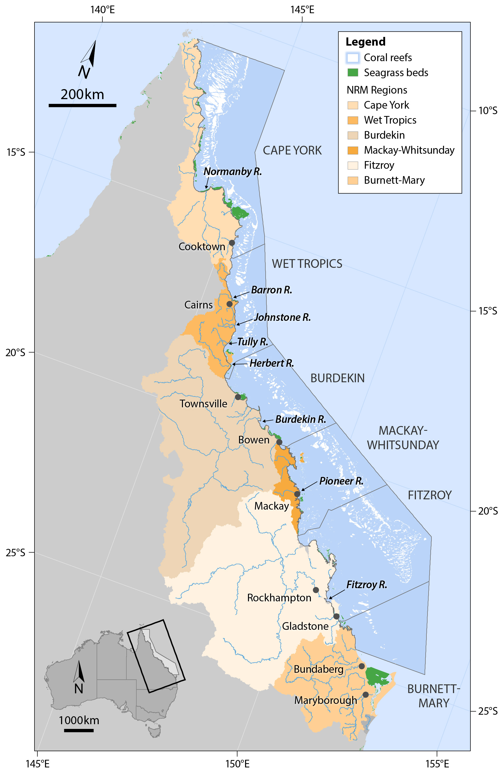
Figure 1. The Great Barrier Reef Marine Park, major marine ecosystems (coral reefs and surveyed seagrass meadows), NRM regions and marine NRM regions
(delineated by dark grey lines) and major rivers (Waterhouse et al. 2018).
Seagrasses in the Great Barrier Reef can be separated into four major habitat types: estuary/inlet, coastal, reef and deepwater (Carruthers et al. 2002) (Figure 2). All but the outer reef habitats are significantly influenced by seasonal and episodic pulses of sediment-laden, nutrient-rich river flows, resulting from high volume summer rainfall. Cyclones, severe storms, wind and waves as well as macro grazers (e.g. fish, dugongs and turtles) influence all habitats in this region to varying degrees. The result is a series of dynamic, spatially and temporally variable seagrass meadows.
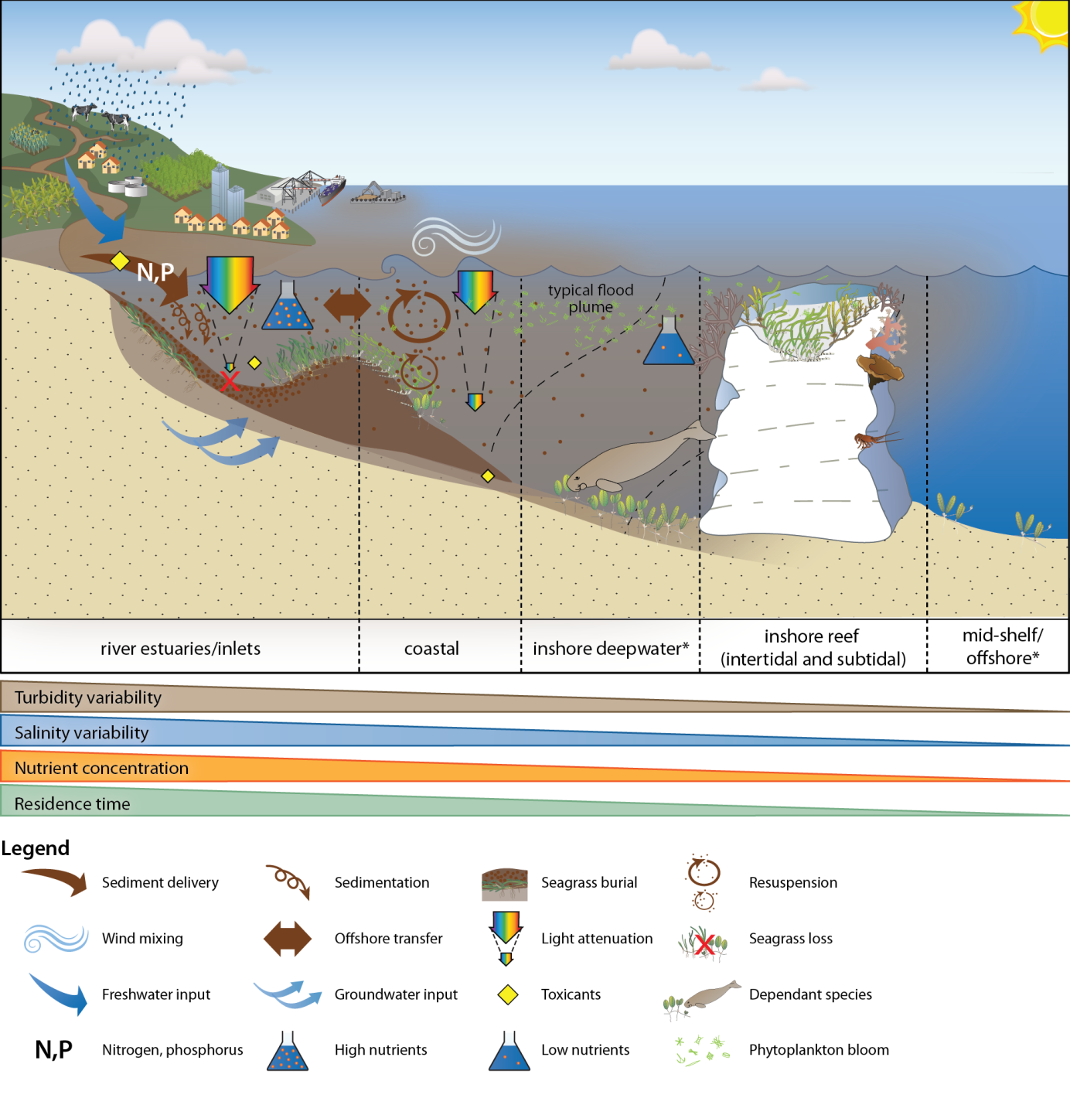
Figure 2. General conceptual model of seagrass habitats in north east Australia and the water quality impacts affecting the habitat
(adapted from Carruthers et al., 2002, and Collier et al. 2014)
The seagrass ecosystems of the GBR, on a global scale, would be for the most part categorised as being dominated by disturbance-favouring colonising and opportunistic species (e.g. Halophila, Halodule and Zostera), which typically have low standing biomass and high turnover rates (Carruthers et al. 2002, Waycott et al. 2007). In more sheltered areas, including reef top or inshore areas in bays, more stable and persistent species are found, although these are still relatively responsive to disturbances (Carruthers et al. 2002; Waycott et al. 2007; Collier and Waycott 2009).
Conceptual basis for indicator selection
As seagrasses are well recognised as indicators of integrated environmental pressures, monitoring their condition and trend can provide insight into the condition of the surrounding environment (e.g. Dennison et al. 1997). There are a number of measures of seagrass condition and resilience that can be used to assess how they respond to environmental pressures, and these measures are referred to here as indicators. We have developed a matrix of indicators that respond on different temporal scales (Figure 3). Indicators include plant changes, meadow-scale changes and state change (Figure 3). These indicators also respond at different temporal scales, with sub-lethal indicators able to respond from seconds to months, while the meadow-scale effects usually take many months to be detectable.
A robust monitoring program benefits from having a suite of indicators that can indicate sub-lethal stress that forewarns of imminent loss, as well as indicators of meadow-scale changes, which are necessary for interpreting broad ecological changes. Indicators included in the MMP span this range of scales, in particular for indicators that respond from weeks (tissue nutrients, isotopes), through to months (abundance and reproduction), and even years (abundance and meadow extent). Furthermore, indicators are conceptually linked to each other and to environmental drivers of concern, in particular, water quality (p 34, Kuhnert et al. 2014).
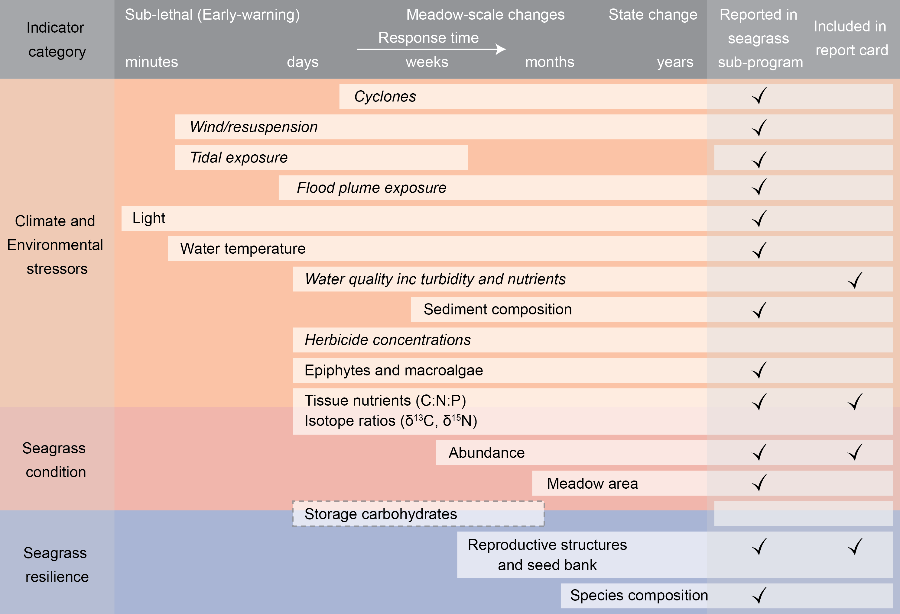
Figure 3. Climate, environmental, seagrass condition and seagrass resilience indicators reported as part of the MMP Inshore Seagrass monitoring 2016–17.
Regular text are indicators measured in the inshore seagrass program, white box with dashed line are indicators in development, and italicised text are indicators collected in other programs or by other institutions (see Table 2 for details on data source). All indicators are shown against their response time which span from minutes to years.
Measures of Environmental stressors
Climate and environment stressors are aspects of the environment, either physico-chemical or biological that affect seagrass meadow condition (Figure 3). Some environmental stressors change rapidly (minutes/days/weeks/months) but can also undergo chronic shifts (years) (Figure 2). Stressors include:
- Climate (e.g. cyclones, seasonal temperature)
- Local and short-term weather (e.g. wind and tides)
- Water quality (e.g. river discharge, plume exposure, nutrient concentrations, suspended sediments, herbicides)
- Biological (e.g. epiphytes and macroalgae)
- Substrate (e.g. grain size composition)
- Seagrass environmental integrators (e.g. tissue nutrients).
Indicators which respond more quickly (e.g. light) provide important early-warning of potentially more advanced ecological changes (as described below). However, a measured change in a fast-responding environmental indicator is not enough in isolation to predict whether there will be further ecological impacts, because the change could be short-term. These indicators provide critical supporting information to support interpretation of slower responding seagrass condition and resilience indicators.
Measures of seagrass condition
Condition indicators such as meadow abundance and extent indicate the state of the plants/population and reflect the cumulative effects of past environmental conditions (Figure 3). Abundance can respond to changes in environment on time-scales ranging from weeks to months (depending on species) in the Great Barrier Reef, while meadow area generally tends to adjust over longer time-scales (months to years). Seagrass area and abundance are integrators of past conditions, and are vital indicators of meadow condition; however, these indicators can also be affected by external factors such as grazing by megaherbivores including dugongs and turtles. Therefore, they are not suitable as stand-alone indicators of environmental change they require indicators that can be linked more directly to specific pressures. These condition indicators also do not demonstrate capacity to resist or recover from additional impacts (Unsworth et al. 2015).
Measures of seagrass resilience
Ecological resilience is “the capacity of an ecosystem to absorb repeated disturbances or shocks and adapt to change without fundamentally switching to an alternative stable state” (Holling 1973), and therefore it relates to the ability of a system to both resist and recover from disturbances (Unsworth et al. 2015) (Figure 3). Changes in resilience indicators show if the ecosystem is in transition (i.e. has already, or may undergo a state-change). Sexual reproduction (flowering, seed production and persistence of a seedbank) is an important feature of recovery (and therefore, of resilience) in seagrass meadows of the Great Barrier Reef. Coastal seagrasses are prone to small scale disturbances that cause local losses (Collier and Waycott 2009), and therefore disturbance-specialist species (i.e. colonisers) tend to dominate throughout the Great Barrier Reef. Community structure (species composition) is also an important feature conferring resilience, both resistance (as some species are more resistant to stress than others), and recovery (as some species may rapidly recover and pave the way for meadow development) (Figure 4).

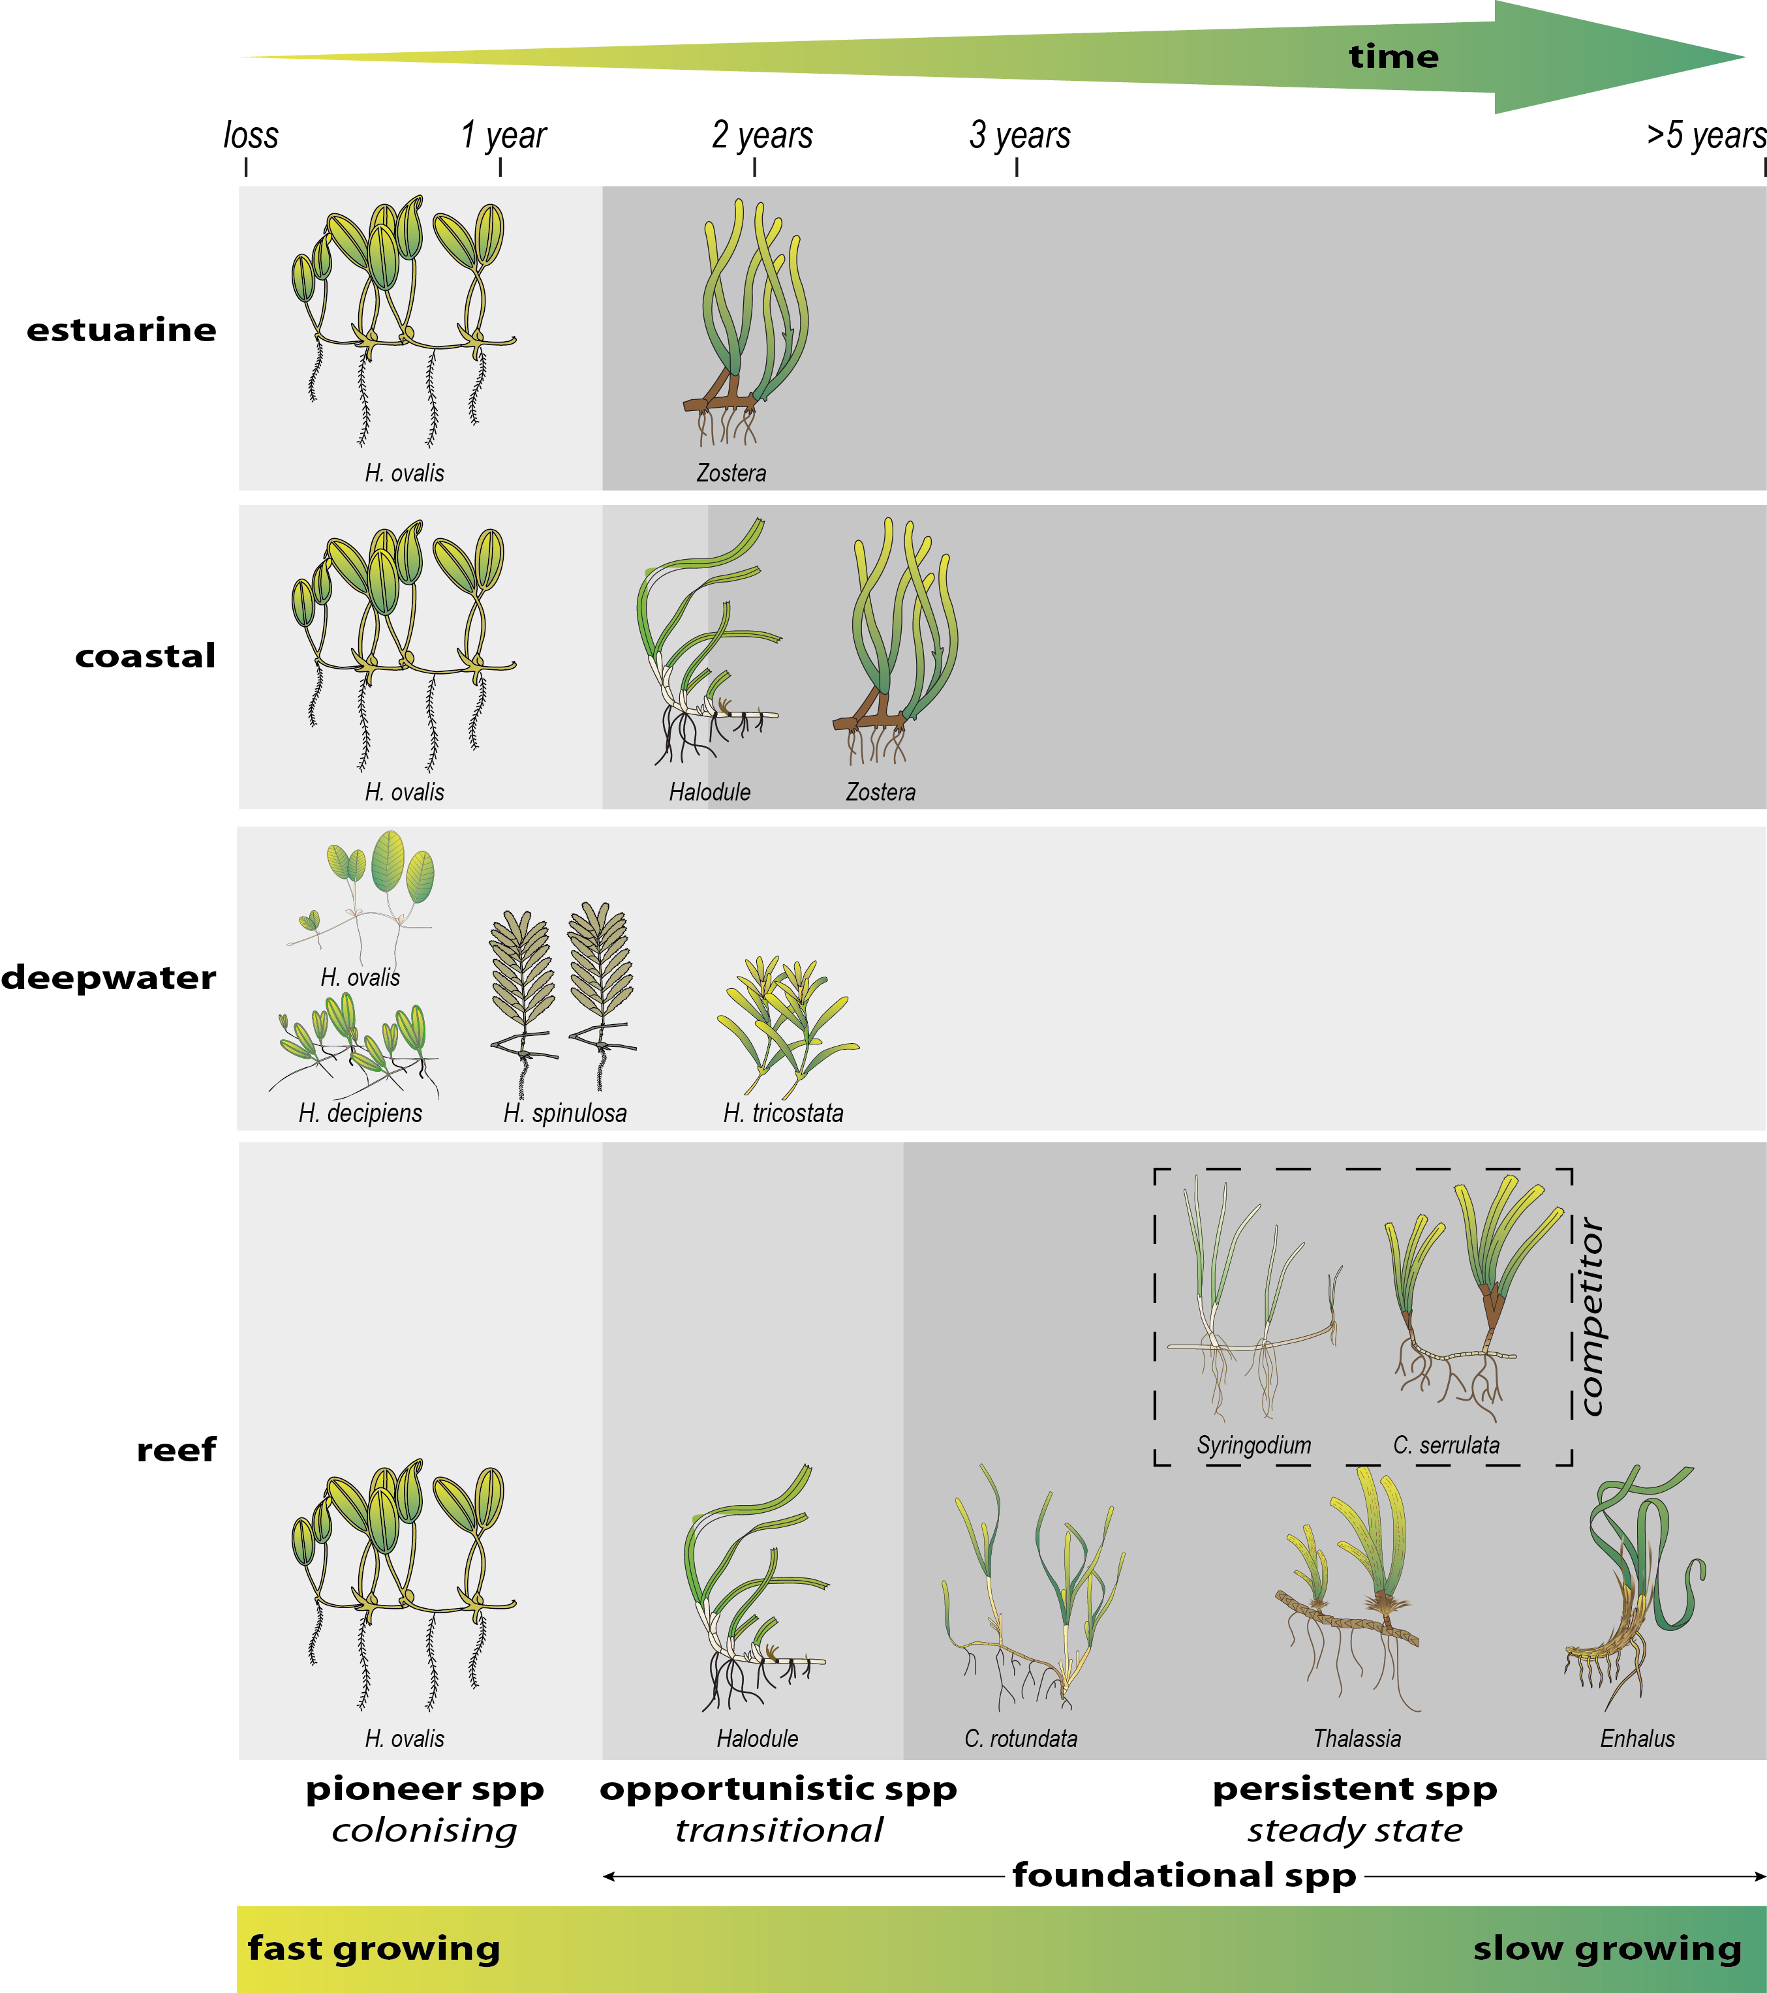
Figure 4. Illustration of seagrass recovery after loss and the categories of successional species over time.
Figure developed from recovery dynamics observed during monitoring since the 1980’s throughout the Great Barrier Reef (Birch and Birch 1984; Preen et al. 1995; McKenzie and Campbell 2002; Campbell and McKenzie 2004; McKenzie et al. 2014a; Rasheed et al. 2014).
This report presents data from the twelfth period of monitoring inshore seagrass ecosystems of the Great Barrier Reef under the MMP (undertaken from June 2016 to May 2017; hereafter called “2016–17”). The key aims of the inshore seagrass monitoring sub-program of the MMP were to report on:
- the abundance and species composition of seagrass (including landscape mapping) in the late dry season of 2016 and the late wet season of 2017 at inshore intertidal and subtidal locations,
- the reproductive health of the seagrass species present at inshore intertidal and subtidal locations,
- tissue nutrient concentrations (carbon, nitrogen and phosphorus) and epiphyte loads of foundation seagrass species (e.g. genus Halodule, Zostera, Cymodocea) at each inshore intertidal and subtidal location,
- spatial and temporal patterns in light, turbidity and temperature at sites where autonomous loggers are deployed,
- trends in seagrass condition
- seagrass community in relation to environment condition and trends, and
- seagrass report card metrics for use in the annual Paddock to Reef report card.

Methods summary
In the following, an overview is given of the sample collection, preparation and analyses methods. Detailed documentation of the methods used in the MMP, including quality assurance and quality control procedures, is available in Appendix 2.

Climate and environmental pressures
Climate and environmental pressures affect seagrass condition and resilience (Figure 2). The pressures of greatest concern are: physical disturbance (cyclones and benthic sheer stress) water quality (turbidity/light and nutrients), water temperature, low tide exposure and sediment type. The measures are either climate variables, that are generally not collected at a site-specific level, and within-canopy measures, that are recorded at each site. The data source and sampling frequency is summarised in Table 2.
Climate
Total daily rainfall, 3pm wind speed, and cyclone tracks were accessed from the Australian Bureau of Meteorology from meteorological stations which were proximal to monitoring locations (Table 2). As the height of locally produced, short-period wind-waves can be the dominant factor controlling suspended sediment on inner-shelf of the Great Barrier Reef (Larcombe et al. 1995; Whinney 2007), the number of days wind speed exceeded 25km hr⁻¹ was used as a surrogate for elevated resuspension pressure on inshore seagrass meadows. Moderate sea state with winds >25km hr⁻¹ can elevate turbidity by three orders of magnitude in the inshore coastal areas of the Great Barrier Reef (Orpin et al. 2004). To determine if the tidal exposure regime may be increasing stress on seagrass and hence drive decline, tidal height observations were accessed from Maritime Safety Queensland and duration of annual exposure (hours) was determined for each meadow (i.e. monitoring site), based on the meadows height relative to the Lowest Astronomical Tide (Appendix 2, Table 51).
The presence of inshore seagrass meadows along the Great Barrier Reef places them at high risk of exposure to waters from adjacent watersheds and exposure to flood plumes is likely to be a significant factor in structuring inshore seagrass communities (Collier et al. 2014; Petus et al. 2016). Hence we used river discharge volumes as well as frequency of exposure to inshore flood plumes as indicators of flood plume impacts to seagrasses. Plume exposure is generated by wet season monitoring under the MMP in the water quality sub-program (Waterhouse et al. 2018). The MMP inshore water quality sub-program includes a remote sensing component, which describes water quality characteristics for 22 weeks of the wet season (November – April). Water quality is described as colour classes of turbid, brown primary water (class 1 – 4), green secondary water (class 5), and waters influenced by flood plumes (salinity <30PSU, coloured dissolved organic matter (CDOM) threshold of 0.24 m⁻¹ class 6). Colour classes are derived from MODIS True colour satellite images. Exposure to flood plumes is described in this report as frequency of exposure to primary (turbid, sediment laden) or secondary (green, nutrient rich) water during the wet season. Methods are detailed in Devlin et al. (2015).
Environment within seagrass canopy
Autonomous iBTag™ submersible temperature loggers were deployed at all sites identified in Appendix A2.1, Table 36. The loggers recorded temperature (accuracy 0.0625°C) within the seagrass canopy every 30 – 90 minutes (Table 2). iBCod™22L submersible temperature loggers were attached to the permanent marker at each site above the sediment-water interface.
Submersible Odyssey™ photosynthetic irradiance autonomous loggers were attached to permanent station markers at 20 intertidal and 4 subtidal seagrass locations from the Cape York region to the Burnett Mary region (Appendix A2.1, Table 36). Detailed methodology for the light monitoring can be found in Appendix A2.2.2. Measurements were recorded by the logger every 15 minutes and are reported as total daily light (mol m⁻² d⁻¹). Automatic wiper brushes cleaned the optical surface of the sensor every 15 minutes to prevent marine organisms fouling.
Sediment type was recorded at the 33 quadrats at each site in conjunction with seagrass abundance measures using a visual/tactile estimation of sediment grain size composition (0-2 cm below the sediment/water interface) as per standard protocols described in McKenzie et al. (2003). Qualitative field descriptions of sediment composition were differentiated according to the Udden-Wentworth grade scale as this approach has previously been shown to provide an equivalent measure to sieve-derived datasets (Hamilton, 1999; McKenzie 2007).

Table 2. Summary of climate and environment data included in this report
, showing historical data range, measurement technique, measurement frequency, and data source. Methodology for data collected in this program is further detailed below, and in Appendix 2. *=variable duration of data availability depending on site
 | Data range | Method | Measurement  frequency | Reporting units | Data source
Climate
Cyclones | 1968 - 2017 | remote sensing and observations at nearest weather station | yearly | No. yr⁻¹ | Bureau of Meteorology
Rainfall | 1889 - 2017* | rain gauges at nearest weather station | daily | mm mo⁻¹  mm yr⁻¹ | Bureau of Meteorology
Riverine discharge | 1970 – 2017 | water gauging stations at river mouth |  | L d⁻¹  L yr⁻¹ | DSITI#, compiled by Waterhouse et al. 2018
Plume exposure | 2006 – 2017  wet season (Dec – Apr) | remote sensing and field validation | weekly | frequency of water type (1 – 6) at the site | MMP inshore water quality program (Waterhouse et al. 2018)
Wind | 1997 – 2017* | anemometer at 10 m above the surface, averaged over 10 minutes, at nearest weather station | 3pm wind speed | days >25 km hr⁻¹ | Bureau of Meteorology
Tidal exposure | 1999 – 2017 | wave height buoys at station nearest to monitoring site | 3 – 10 min | hours exposed during daylight | Maritime Safety Queensland, calculated exposure by MMP Inshore Seagrass monitoring
Environment within seagrass canopy
Water temperature | 2002 – 2017 | iBTag | 30 – 90 min | ºC, Temperature anomalies,  exceedance of thresholds | MMP Inshore Seagrass monitoring
Light | 2008 – 2017 | Odyssey 2Pi PAR light loggers with wiper unit | 15 min | Daily light (I_{d}) mol m⁻² d⁻¹  Frequency of threshold exceedance ( per cent days) | MMP Inshore Seagrass monitoring
Sediment grain size | 1999 – 2017 | Visual / tactile description of sediment grain size composition | 3 mo – 1yr | proportion mud | MMP Inshore Seagrass monitoring
# Department of Science, Information Technology and Innovation

Sampling design and site selection
The sampling design was selected to detect changes in inshore seagrass meadows in response to changes in water quality associated with specific catchments or groups of catchments (Region) and to disturbance events. The locations/meadows were selected by the Marine Park Authority, using advice from expert working groups in 2004. The selection of locations/meadows was based upon a number of competing factors:
- meadows were representative of inshore seagrass habitats and seagrass communities across each region (based on Lee Long et al. 1993, Lee Long et al. 1997, Lee Long et al. 1998; McKenzie et al. 2000b; Rasheed et al. 2003; Campbell et al. 2002; Goldsworthy 1994)
- where possible include legacy sites (e.g. Seagrass-Watch, MTSRF) or former seagrass research sites (e.g. Dennison et al. 1995; Inglis 1999; Thorogood and Boggon 1999; Udy et al. 1999; Haynes et al. 2000; Campbell and McKenzie 2001; Mellors 2003; Campbell and McKenzie 2004; Limpus et al. 2005; McMahon et al. 2005; Mellors et al. 2005; Lobb 2006).
- a Minimum Detectable Difference (MDD) below 20 per cent (at the 5 per cent level of significance with 80 per cent power) (Bros and Cowell 1987).
Sites were selected using mapping surveys across the regions prior to site establishment. Ideally mapping was conducted immediately prior to site positioning, however in most (60 per cent of) cases it was based on historic (>5yr) information. Representative meadows were those which covered the greater extent within the inshore region, were generally the dominant seagrass community type and were within Great Barrier Reef baseline abundances (based on Coles et al. 2001a; Coles et al. 2001c, 2001b, 2001d). To account for spatial heterogeneity of meadows within habitats, at least two sites were selected at each location. If meadow overall extent was larger than ~15hecatres (0.15 km²), replicate sites were often located within the same meadow (a greater number of sites was desirable with increasing meadow size , however not possible due to funding constraints).
From the onset, inshore seagrass monitoring for the MMP was focused primarily on intertidal/lower littoral seagrass meadows due to:
- accessibility and cost effectiveness (limiting use of vessels and divers)
- Occupational Health and Safety due to dangerous marine animals (e.g. crocodiles, box jellyfish and irukandji)
- occurrence of meadows in estuarine, coastal and reef habitats across the entire Great Barrier Reef, and
- where possible, provides an opportunity for citizen involvement, ensuring broad acceptance and ownership of Reef Plan by the Queensland and Australian community.
Some of the restrictions for working in hazardous waters are overcome by using drop cameras, however, drop cameras only provide abundance measures and do not contribute to the other metrics (e.g. tissue nutrients, reproductive effort). Although considered intertidal within the MMP, the meadows chosen for monitoring were in fact lower littoral (rarely exposed to air). The long-term median annual daylight exposure (the time intertidal meadows are exposed to air during daylight hours) was 1.7 per cent (all meadows pooled) (Table 51). This limited the time monitoring could be conducted to the very low spring tides within small tidal windows (mostly 1-4 hrs per day for 3-6 days per month for 6-9 months of the year). Traditionally, approaches developed for monitoring seagrass to assess changes in water quality were developed for subtidal meadows typified by small tidal ranges (e.g. Florida = 0.7m, Chesapeake Bay = 0.6m) and clear waters where the seaward edges of meadows were only determined by light (EHMP 2008). Unfortunately, depth range monitoring in subtropical/tropical seagrass meadows has had limited success due to logistic/technical issues (e.g. accuracy defining deep edge of a fragmented meadow, and positional accuracy of the autoset level’s graduated staff with increasing horizontal distance) (B. Longstaff, pers. comm. 05 May 2004) and seagrass meadows within the Great Barrier Reef lagoon do not conform to traditional ecosystem models because of the systems complexity (Carruthers et al. 2002), including:
- a variety of habitat types (estuarine, coastal, reef and deepwater);
- a large variety of seagrass species with differing life history traits and strategies;
- tidal amplitudes spanning 3.42m (Cairns) to 10.4m (Broad Sound) (www.msq.qld.gov.au; Maxwell 1968);
- a variety of sediment substrates, from terrigenous with high organic content, to oligotrophic calcium carbonate;
- turbid nearshore to clearer offshore waters;
- grazing dugongs and sea turtles influencing meadow community structure and landscapes;
- near-absence of shallow subtidal meadows south of the Whitsundays due to the large tides which scour the seabed.
Deepwater (>15m) meadows across the Great Barrier Reef are comprised of only Halophila species and are highly variable in abundance and distribution (Lee Long et al. 1999). Due to this high variability they do not meet the current criteria for monitoring, as the MDD is very poor at the 5 per cent level of significance with 80 per cent power (McKenzie et al. 1998), and will require a different approach if to be included in future monitoring. Predominately stable lower littoral and shallow (>1.5m below Lowest Astronomical Tide) subtidal meadows of foundation species (e.g. Zostera, Halodule) are best for determining significant change/impact (McKenzie et al. 1998). Where possible, shallow subtidal and lower littoral monitoring sites were paired when dominated by similar species.
Due to the high diversity of seagrass species across the Great Barrier Reef, it was decided in consultation with the Marine Park Authority to direct monitoring toward the foundation seagrass species across the seagrass habitats (Figure 5). A foundation species is the dominant primary producer in an ecosystem both in terms of abundance and influence, playing central roles in sustaining ecosystem services (Angelini et al. 2011). The activities of foundation species physically modify the environment and produce and maintain habitats that benefit other organisms that use those habitats.
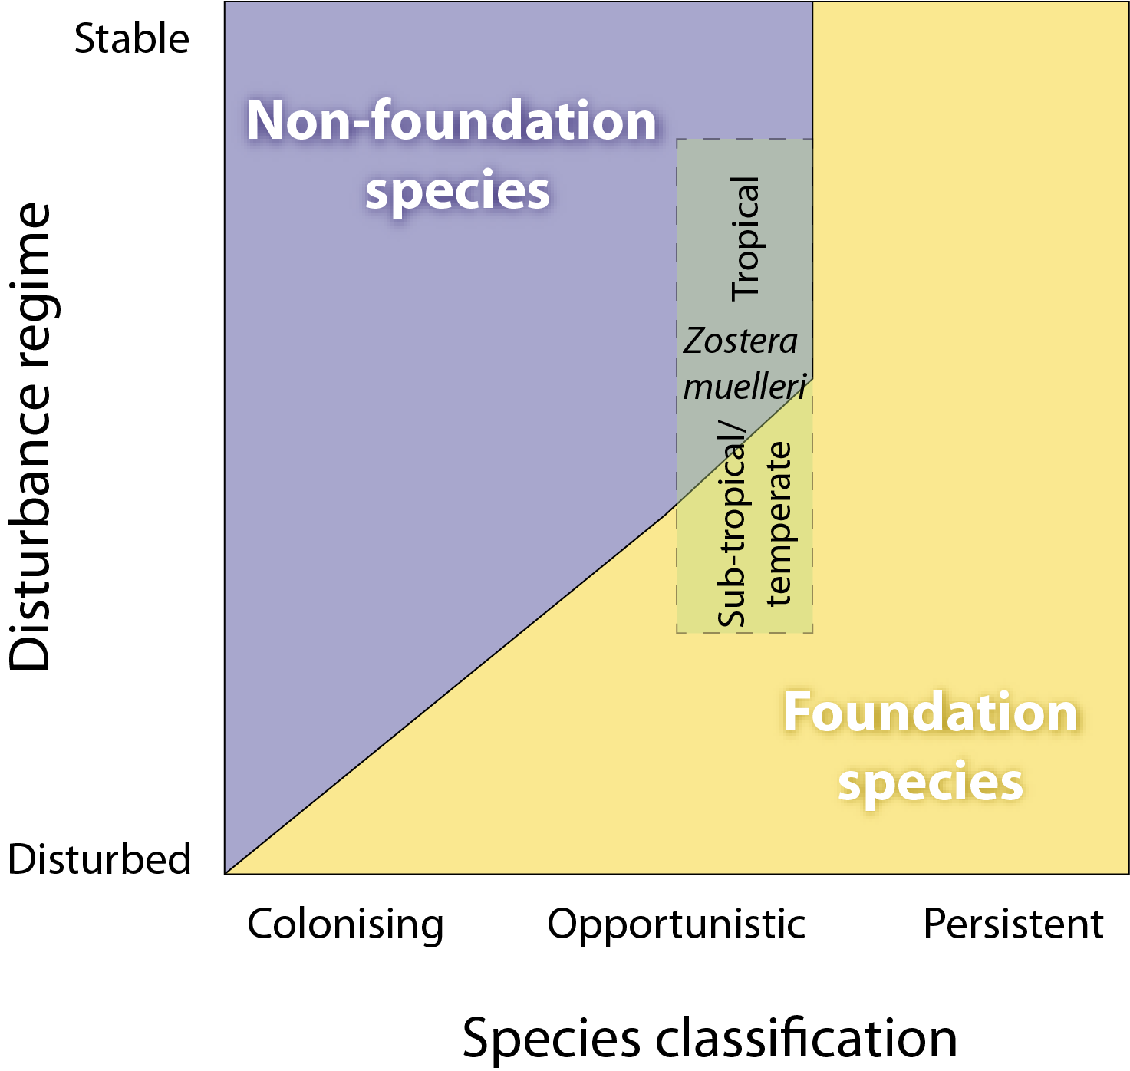
Figure 5. Illustration showing how foundational species can include species display colonising, opportunist or persistent life history traits depending on disturbance regime.

Foundation species are the species types that are at the pinnacle of meadow succession. A highly disturbed meadow (due to wave/wind exposure, or low light regime) might always only ever have colonising species as the foundational species, while a less disturbed meadow can have persistent species form the foundation. Also, whether Zostera muelleri is a foundation species is influenced by whether it grows in the tropics or in the sub-tropics, as it is more likely to form a foundation species in the sub-tropics even if it is disturbed.For the seagrass habitats assessed in the MMP, the foundation seagrass species were those species which typified the habitats both in abundance and structure when the meadow was considered in its steady state (opportunistic or persistent) (Kilminster et al. 2015). The foundation species were all di-meristematic leaf-replacing forms from the following families: Cymodocea, Enhalus, Halodule, Thalassia and Zostera (Table 3).
The timing of the monitoring within the MMP was decided by the Marine Park Authority, using advice from expert working groups. As the major period of runoff from catchments and agricultural lands was the tropical wet season/monsoon (December to April), monitoring was focussed on the late dry (growing) season and late wet season to capture the condition of seagrass pre and post wet.
Fifty eight sites at 29 locations were assessed during the 2016–2017 monitoring period (Appendix A2.1, Table 36). This covered nine coastal, four estuarine and twelve reef locations (i.e. two or three sites at each location). At the reef locations in the Burdekin and Wet Tropics, intertidal sites were paired with a subtidal site (Table 3). Apart from the 42 MMP long-term monitoring sites, data included eight sites from Seagrass-Watch and eight sites from QPWS to improve the spatial resolution and additional subtidal habitats where possible (Table 4). A description of all data collected during the sampling period under the monitoring contract has been collated by Natural Resource Management (NRM) region, site, parameter, and the number of samples collected per sampling period is listed in Table 36. The seagrass species (including foundation) present at each monitoring site is listed Table 3 and Table 4.

Table 3. MMP inshore seagrass long-term monitoring site details including presence of foundation () and other () seagrass species sampled for plant tissue and reproductive health.
NRM region from www.nrm.gov.au. * = intertidal, ^=subtidal. CR = Cymodocea rotundata, CS = Cymodocea serrulata, EA = Enhalus acoroides, HD = Halophila decipiens, HO = Halophila ovalis, HS = Halophila spinulosa, HU = Halodule uninervis, SI = Syringodium isoetifolium, TH = Thalassia hemprichii, ZM = Zostera muelleri
GBR region | NRM region (Board) | Basin | Monitoring location | Site |  | Latitude |  | Longitude |  | CR | CS | EA | HD | HO | HS | HU | SI | TH | ZM
Far Northern | Cape York  (Cape York Natural Resource Management) | Jacky Jacky / Olive-Pascoe | Shelburne Bay  coastal | SR1* | Shelburne Bay | 11° | 53.220 | 142° | 54.853
 |  |  |  | SR2* | Shelburne Bay | 11° | 53.238 | 142° | 54.940
Far Northern | Cape York  (Cape York Natural Resource Management) | Jacky Jacky / Olive-Pascoe | Piper Reef  reef | FR1* | Farmer Is. | 12° | 15.339 | 143° | 14.021
 |  |  |  | FR2* | Farmer Is. | 12° | 15.433 | 143° | 14.186
Far Northern | Cape York  (Cape York Natural Resource Management) | Normanby / Jeannie | Flinders Group  reef | ST1* | Stanley Island | 14° | 8.563 | 144° | 14.682
 |  |  |  | ST2* | Stanley Island | 14° | 8.533 | 144° | 14.590
Far Northern | Cape York  (Cape York Natural Resource Management) | Normanby / Jeannie | Bathurst Bay  coastal | BY1* | Bathurst Bay | 14° | 16.068 | 144° | 13.963
 |  |  |  | BY2* | Bathurst Bay | 14° | 16.049 | 144° | 13.897
Far Northern | Cape York  (Cape York Natural Resource Management) | Endeavour | Archer Point  reef | AP1* | Archer Point | 15° | 36.508 | 145° | 19.147 |  |  |  |  |  |  |  |  |  | *
 |  |  |  | AP2* | Archer Point | 15° | 36.533 | 145° | 19.118
Northern | Wet Tropics  (Terrain NRM) | Daintree | Low Isles  reef | LI1* | Low Isles | 16° | 23.110 | 145° | 33.884
 |  |  |  | LI2^ | Low Isles | 16° | 22.973 | 145° | 33.854
Northern | Wet Tropics  (Terrain NRM) | Mossman /  Barron /  Mulgrave-Russell /  Johnstone | Yule Point  coastal | YP1* | Yule Point | 16° | 34.149 | 145° | 30.756 |  |  |  |  |  |  |  |  |  | *
 |  |  |  | YP2* | Yule Point | 16° | 33.825 | 145° | 30.568
Northern | Wet Tropics  (Terrain NRM) | Mossman /  Barron /  Mulgrave-Russell /  Johnstone | Green Island  reef | GI1* | Green Island | 16° | 45.709 | 145° | 58.372
 |  |  |  | GI2* | Green Island | 16° | 45.696 | 145° | 58.566
 |  |  |  | GI3^ | Green Island | 16° | 45.294 | 145° | 58.379
Northern | Wet Tropics  (Terrain NRM) | Tully / Murray / Herbert | Mission Beach  coastal | LB1* | Lugger Bay | 17° | 57.645 | 146° | 5.603
 |  |  |  | LB2* | Lugger Bay | 17° | 57.672 | 146° | 5.626
Northern | Wet Tropics  (Terrain NRM) | Tully / Murray / Herbert | Dunk Island  reef | DI1* | Pallon Beach | 17° | 56.646 | 146° | 8.452
 |  |  |  | DI2* | Pallon Beach | 17° | 56.734 | 146° | 8.450
 |  |  |  | DI3^ | Brammo Bay | 17° | 55.910 | 146° | 8.417
Central | Burdekin  (NQ Dry Tropics) | Ross / Burdekin | Magnetic island  reef | MI1* | Picnic Bay | 19° | 10.752 | 146° | 50.480 |  |  |  |  |  |  |  |  |  | *
 |  |  |  | MI2* | Cockle Bay | 19° | 10.621 | 146° | 49.730
 |  |  |  | MI3^ | Picnic Bay | 19° | 10.888 | 146° | 50.634
Central | Burdekin  (NQ Dry Tropics) | Ross / Burdekin | Townsville  coastal | SB1* | Shelley Beach | 19° | 11.166 | 146° | 46.272
 |  |  |  | BB1* | Bushland Beach | 19° | 11.016 | 146° | 40.951
Central | Burdekin  (NQ Dry Tropics) | Ross / Burdekin | Bowling Green Bay  coastal | JR1* | Jerona (Barratta CK) | 19° | 25.369 | 147° | 14.487
 |  |  |  | JR2* | Jerona (Barratta CK) | 19° | 25.272 | 147° | 14.435
Central | Mackay Whitsunday  (Reef Catchments) | Proserpine / O'Connell | Repulse Bay  coastal | MP2* | Midge Point | 20° | 38.084 | 148° | 42.107
 |  |  |  | MP3* | Midge Point | 20° | 38.067 | 148° | 42.282
Central | Mackay Whitsunday  (Reef Catchments) | Proserpine / O'Connell | Hamilton Island  reef | HM1* | Catseye Bay - west | 20° | 20.636 | 148° | 57.439
 |  |  |  | HM2* | Catseye Bay - east | 20° | 20.797 | 148° | 58.234
Central | Mackay Whitsunday  (Reef Catchments) | Plane | Sarina Inlet  estuarine | SI1* | Point Salisbury | 21° | 23.770 | 149° | 18.248
 |  |  |  | SI2* | Point Salisbury | 21° | 23.719 | 149° | 18.288
Southern | Fitzroy  (Fitzroy Basin Association) | Shoalwater / Fitzroy | Shoalwater Bay  coastal | RC1* | Ross Creek | 22° | 22.912 | 150° | 12.810
 |  |  |  | WH1* | Wheelans Hut | 22° | 23.829 | 150° | 16.520
Southern | Fitzroy  (Fitzroy Basin Association) | Shoalwater / Fitzroy | Keppel Islands  reef | GK1* | Great Keppel Is. | 23° | 11.776 | 150° | 56.356
 |  |  |  | GK2* | Great Keppel Is. | 23° | 11.638 | 150° | 56.364
Southern | Fitzroy  (Fitzroy Basin Association) | Calliope / Boyne | Gladstone Harbour  estuarine | GH1* | Belican Banks | 23° | 46.015 | 151° | 18.059 |  |  |  |  |  |  | *
 |  |  |  | GH2* | Belican Banks | 23° | 45.884 | 151° | 18.233
Southern | Burnett Mary  (Burnett Mary Regional Group) | Baffle | Rodds Bay  estuarine | RD1* | Cay Bank | 24° | 3.467 | 151° | 39.333
 |  |  |  | RD2* | Turkey Beach | 24° | 4.854 | 151° | 39.752
Southern | Burnett Mary  (Burnett Mary Regional Group) | Mary | Hervey Bay  estuarine | UG1* | Urangan | 25° | 18.053 | 152° | 54.409
 |  |  |  | UG2* | Urangan | 25° | 18.197 | 152° | 54.364
* indicates presence adjacent, but not within, 50m x 50m site. Zostera muelleri = Zostera muelleri subsp. capricorni, as revision of Zostera capricorni (Jacobs et al. 2006) resulted in classification to subspecies.

Table 4. Details of additional inshore seagrass long-term monitoring sites from the Seagrass-Watch and QPWS drop-camera programs, including presence of foundation () and other () seagrass species.
NRM region from www.nrm.gov.au. * = intertidal, ^=subtidal.
GBR region | NRM region (Board) | Basin | Monitoring location | Site |  | Latitude |  | Longitude |  | CR | CS | EA | HD | HO | HS | HU | SI | TH | ZM
Far Northern | Cape York  (Cape York Nat Res Manage) | Lockhart | Weymouth Bay  reef | YY1* | Yum Yum Beach | 12° | 34.247 | 143° | 21.639
Far Northern | Cape York  (Cape York Nat Res Manage) | Lockhart | Lloyd Bay  coastal | LR1^ | Lloyd Bay | 12° | 47.792 | 143° | 29.118
 |  |  |  | LR2^ | Lloyd Bay | 12° | 49.502 | 143° | 28.488
Far Northern | Cape York  (Cape York Nat Res Manage) | Normanby / Jeannie | Flinders Group  reef | FG1^ | Flinders Island | 14° | 10.9464 | 144° | 13.522
 |  |  |  | FG2^ | Flinders Island | 14° | 10.932 | 144° | 13.522
Northern | Wet Tropics | Tully / Murray / Herbert | Rockingham Bay  reef | GO1 | Goold Island | 18° | 10.428 | 146° | 9.186
Northern | Wet Tropics | Tully / Murray / Herbert | Missionary Bay  coastal | MS1^ | Cape Richards | 18° | 12.950 | 146° | 12.753
 |  |  |  | MS2^ | Macushla | 18° | 12.316 | 146° | 13.010
Central | Burdekin  (NQ Dry Tropics) | Ross / Burdekin | Townsville  coastal | SB2* | Shelley Beach | 19° | 10.939 | 146° | 45.767
Central | Mackay Whitsunday  (Reef Catchments) | Don | Shoal Bay  reef | HB1* | Hydeaway Bay | 20° | 4.481 | 148° | 28.943
 |  |  |  | HB2* | Hydeaway Bay | 20° | 4.292 | 148° | 28.861
Central | Mackay Whitsunday  (Reef Catchments) | Proserpine | Pioneer Bay  coastal | PI2* | Pigeon Island | 20° | 16.163 | 148° | 41.585
 |  |  |  | PI3* | Pigeon Island | 20° | 16.232 | 148° | 41.850
Central | Mackay Whitsunday  (Reef Catchments) | Proserpine / O'Connell | Whitsunday Island  reef | TO1^ | Tongue Bay | 20° | 14.399 | 149° | 0.934
 |  |  |  | TO2^ | Tongue Bay | 20° | 14.495 | 149° | 0.697
Central | Mackay Whitsunday  (Reef Catchments) | O'Connell | Newry Islands  coastal | NB1^ | Newry Bay | 20° | 52.057 | 148° | 55.531
 |  |  |  | NB2^ | Newry Bay | 20° | 52.325 | 148° | 55.423
Southern | Burnett Mary  (Burnett Mary Regional Group) | Burrum | Burrum Heads  coastal | BH1* | Burrum Heads | 25° | 11.290 | 152° | 37.532
 |  |  |  | BH3* | Burrum Heads | 25° | 12.620 | 152° | 38.359

Seagrass condition monitoring

Seagrass abundance, composition and extent
Field survey methodology followed globally standardised protocols (detailed in McKenzie et al. (2003) and Appendix A2.3.1). At each location, with the exception of subtidal sites, sampling included two sites nested (within 500m of each other) in a location. Subtidal sites were not always replicated within locations. Intertidal sites were defined as a 5.5 hectare area within a relatively homogenous section of a representative seagrass community/meadow (McKenzie et al., 2000). Monitoring at sites in the late dry (September/October 2016) and late wet (March/April 2017) of each year was conducted by a qualified scientist who was trained in the monitoring protocols. In the centre of each site, during each survey, observers recorded the per cent seagrass cover within 33 quadrats (50cm × 50cm, placed every 5m along three 50m transects, located 25m apart). The sampling strategy for subtidal sites was modified to sample along 50m transects 2 - 3 m apart (aligned along the depth contour) due to logistics of SCUBA diving in waters of poor visibility. Mapping of the meadow landscape (including patches and scars) within each site was also conducted as part of the monitoring in both the late dry and late wet periods. Mapping followed standard methodologies (McKenzie et al. 2001) using a handheld GPS on foot. Where the seagrass landscape tended to grade from dense continuous cover to no cover over a continuum that included small patches and shoots of decreasing density, the meadow edge was delineated where there was a gap with the distance of more than 3 metres (i.e. accuracy of the GPS). Therefore the entire 5.5 hectare site was mapped (seagrass and no seagrass).
Seagrass species were identified as per Waycott et al. (2004). Species were further categorised according to their life history traits and strategies and classified into colonising, opportunistic or persistent as broadly defined by Kilminister et al. (2015) (for detailed methods, see Appendix 2).

Seagrass reproductive health
Seagrass reproductive health was assessed from samples collected in the late dry 2016 and late wet 2017 at locations identified in Table 3. Samples were processed according to standard methodologies (see Appendix A2.3.1).
In the field, 15 haphazardly placed cores (100mm diameter x 100mm depth) of seagrass were collected within each site from an area adjacent (of similar cover and species composition) to the monitoring transects. In the laboratory, reproductive structures (spathes, fruits, female and male flowers) of plants from each core were identified and counted for each samples and species. Reproductive effort was calculated as number of reproductive structures (fruits, flowers, spathes; species pooled) per core for analysis.
Seeds banks and abundance of germinated seeds were sampled according to standard methods (McKenzie et al. 2010a) by sieving (2mm mesh) 30 cores (50mm diameter, 100mm depth) of sediment collected across each site and counting the seeds retained in each. For Zostera muelleri, where the seed are <1mm diameter, intact cores (18) were collected and returned to the laboratory where they were washed through a 710µm sieve and seeds identified using a hand lens/microscope.

Seagrass tissue nutrients
In the late dry season (October) 2016, leaf tissue samples from the foundational seagrass species were collected from each monitoring site for nutrient content analysis (Table 3). For nutrient status comparisons, collections were recommended during the growth season (e.g. late dry when nutrient contents are at a minimum) (Mellors et al. 2005) and at the same time of the year and at the same depth at the different localities (Borum et al. 2004). Shoots from three haphazardly placed 0.25m² quadrats were collected from an area adjacent (of similar cover and species composition) to the monitoring transects. Species within the sample are separated, and all species (except Halophila spp.) were analysed for tissue nutrient content. All leaves within the sample were separated from the below ground material in the laboratory and epiphytic algae removed by gently scraping. Dried and milled leaf samples were analysed according to McKenzie et al. 2010a. Elemental ratios (C:N:P) were calculated on a mole:mole basis using atomic weights (i.e. C=12, N=14, P=31).
The ratios for each species are presented in the appendix of this report (Table 1). As an overview of results, and for the calculation of report card score, ratio values are pooled among the foundational species at each site. Changing C:N ratios have been found in a number of experiments and field surveys to be related to light levels, as leaves with an atomic C:N ratio of less than 20, may suggest reduced light availability when N is not in surplus (Abal et al. 1994; Grice et al. 1996; Cabaço and Santos 2007; Collier et al. 2009). The ratio of N:P is also a useful indicator as it is a reflection of the “Redfield” ratios (Redfield et al. 1963), and seagrass with an atomic N:P ratio of 25 to 30 can be determined to be ‘replete’ (well supplied and balanced macronutrients for growth) (Atkinson and Smith 1983; Fourqurean et al. 1997b; Fourqurean and Cai 2001). When N:P values are in excess of 30, this may indicate P-limitation and a ratio of less than 25 is considered to show N limitation (Atkinson and Smith 1983;Duarte 1990; Fourqurean et al. 1992b; Fourqurean and Cai 2001). The median seagrass tissue ratios of C:P is approximately 500 (Atkinson and Smith 1983), therefore deviation from this value is also likely to be indicative of some level of nutrient enriched or nutrient limited conditions. A combination of these ratios can indicate seagrass environments which are impacted by nutrient enrichment. Plant tissue which has both a high N:P and low C:P indicates an environment of elevated (saturated) nitrogen.
Further detail on methodology for nutrient sampling can be found in appendix 2.

Data analyses
In this report, results are presented to reveal temporal changes in seagrass community attributes and key environmental variables. Generalised additive models (GAMs) and generalised additive mixed effects models (GAMMs) were also fitted to seagrass attributes for each habitat, to identify the presence and consistency of trends, using the mgcv (Wood 2006;Wood 2014) package in R 3.2.1 (R Core Team 2014). GAMs and GAMMs (Wood 2006) were used to decompose the irregularly spaced time series into its trend cycles (long-term) and periodic (seasonal) components.
GAMMs are an extension of additive models, which allow flexible modelling of non-linear relationships by incorporating penalized regression spline types of smoothing functions into the estimation process. The degree of smoothing of each smooth term (and by extension, the estimated degrees of freedom of each smoother) is treated as a random effect and thus estimable via its variance as with other effects in a mixed modelling structure (Wood 2006).The results of these analyses are graphically presented in a consistent format: predicted values from the model were plotted as bold black lines, the 95 per cent confidence intervals of these trends delimited by grey shading. If an r² for a trend line was less than 0.5 no line of best fit was shown.
Several GAMs and GAMMs were used on seagrass cover, light, epiphyte cover and macroalgae cover to tease out trends at the habitat, regional and location scale over time. When dealing with data where there are two replicate sites at a given location (e.g. YP1 and YP2 for Yule Point), site was incorporated as a random factor in the models to account for spatial correlation. However, as part of our regular model validation process, if the boxplot with Pearson’s residuals plotted against Site showed very similar values for each site within each location then a GAM was used instead of a GAMM.
Per cent cover data models were fitted using a quasi-binomial distribution due to the proportional (bound between 0 and 1) nature of the data. Raw data at the quadrat level was used to provide the maximum resolution for modelling. However, this led to a very large proportion of 0 in some data sets causing high heterogeneity of variance for some models. For this reason, GAMMs for epiphyte and macroalgae cover are not presented and the inclusion in future reports of zero-inflated GAMMs is being investigated. Light data models were fitted using a gamma distribution due to the strictly positive continuous nature of the data. GAM were used in this instance as PAR loggers are deployed at one site per location and therefore site do not act as a random factor. In addition of the GAMMs, non-linear regressions and polynomials were used (at the request of past reviewers) to show trends in seagrass abundance (per cent cover) over time; 95 per cent confidence intervals are displayed.
Trend analysis was conducted to determine if there was a significant trend (reduction or increase) in seagrass abundance (per cent cover) at a particular site (averaged by sampling event) over all time periods. A Mann-Kendall test was performed using the “fume” package in R 3.2.1 (R Core Team, 2014). Mann-Kendall is a common non-parametric test used to detect overall trends over time. The measure of the ranked correlation is the Kendall’s tau coefficient (Kendall-τ), which is the proportion of up-movements against time vs the proportion of down-movements, looking at all possible pairwise time-differences. As the test assumes independence between observations, data was checked for autocorrelation and if present the test was repeated on the un-correlated observations only and the corrected p-value used.
The majority of meadows have been in a "recovery mode" since losses during the periods 2008-09 to 2010-11. As such, there have been periods of limited sample availability (e.g. for tissue nutrients), and the absence of data has restricted whether multivariate analysis can be undertaken routinely. Analysis is currently underway to more fully interrogate the temporal and covariate components of the data as the time series of observations lengthen.

Reporting Approach
The data is presented in a number of ways depending on the indicator and section of the report:
- Report card scores for seagrass condition are presented at the start of each section. These are a numerical summary of the condition within the region relative to a regional baseline (described further below),
- Climate and environmental pressures are presented as averages (daily, monthly or annual) and threshold exceedance,
- Seagrass community data such as seagrass abundance, leaf tissue nutrients are presented as averages (sampling event, season or monitoring period with SE) and threshold exceedance data,
- Seagrass ecosystem data such as sediment composition, epiphyte and macroalgae are presented as averages (sampling event, season or monitoring period) and relative to the long-term,
- Trend analysis (GAMM plots) are also used to explore the long-term temporal trends in biological and environmental indicators.
Within each region, estuarine and coastal habitat boundaries were delineated based on the Queensland coastal waterways geomorphic habitat mapping, Version 2 (1:100 000 scale digital data) (Heap et al. 2015). Reef habitat boundaries were determined using the AUSLIG (now the National Mapping Division of Geosciences Australia) geodata topographic basemap (1:100 000 scale digital data). Conceptual diagrams have been used to illustrate the general seagrass habitats type in each region and can be found in Appendix 1 with the background description of each NRM region. Symbols/icons have been used in the conceptual diagrams to illustrate major controls, processes and threats/impacts.

Calculating scores for the Report card
Three indicators (presented as unitless scores) were selected by the Marine Park Authority, using advice from expert working groups and the Paddock to Reef Integration Team, for the seagrass report card:
- seagrass abundance (per cent cover)
- reproductive effort
- nutrient status (leaf tissue C:N ratio)
A seagrass condition index (score) is reported for each monitoring site based on changes in each of the indicators relative to a baseline. The methods for score calculation were chosen by the Paddock to Reef Integration Team and all report card scores are transformed to a five point scale from 0 to 100 to allow integration with other components of the Paddock to Reef report card (Department of the Premier and Cabinet 2014). The methods and scoring system for the report card are detailed in Appendix 3. Please note that the scale from 0 to 100 is unitless and should not be interpreted as a proportion or ratio.

Seagrass abundance
Seagrass abundance state in the MMP is measured using the median seagrass per cent cover relative to the site or reference (habitat type within each NRM region) guideline. Abundance guidelines (threshold levels) were determined using the long-term (>4 years) baseline where the percentile variance plateaued (generally 15-20 sampling events), thereby providing an estimate of the true percentile value (McKenzie 2009). Guidelines for individual sites were only applied if the conditions of the site aligned with reference conditions and the site had been subject to minimal/limited disturbance for 3‐5 years (see Appendix A3.2, Table 38).
Abundance state at each site for each monitoring event was allocated a grade: very good, median per cent cover at or above 75th percentile; good, median per cent cover at or above 50th percentile; moderate, median per cent cover below 50th percentile and at or above low guideline; poor, median per cent cover below low guideline; and very poor, median per cent cover below low guideline and declined by >20 per cent since previous sampling event). The choice of whether the 20th or 10th percentile was used for the low guideline depended on the within-site variability; generally the 20th percentile is used, unless within-site variability was low (e.g. CV<0.6), whereby the 10th percentile was more appropriate as the variance would primarily be the result of natural seasonal fluctuations (i.e. nearly every seasonal low would fall below the 20th percentile). Details on the percent cover guidelines can be found in Appendix A3.2.
A grade score from 0 to 100 (Table 5) was then assigned to enable integration with other seagrass indicators and other components of the P2R report card (Department of the Premier and Cabinet 2014). Annual seagrass abundance scores were calculate using the average grade score for each site (including all sampling events per year), each habitat and each NRM. Please note that the scores are unitless and should not be interpreted as a proportion or ratio.
Table 5. Scoring threshold table to determine seagrass abundance status.
low = 10th or 20th percentile guideline (see Appendix 3, Table 38). NB: scores are unitless.
grade | percentile category | score | status
very good | 75-100 | 100 | 81 - 100
good | 50-75 | 75 | 61 - 80
moderate | low-50 | 50 | 41 - 60
poor | <low | 25 | 21 - 40
very poor | <low by >20 per cent | 0 | 0 - 20

Seagrass reproductive effort
Most seagrass species of the Great Barrier Reef produce flowers in the late dry season, so reproductive effort is sampled during the late dry season to capture the sexual reproductive peak. However, the timing of peak flowering density and the mode of reproduction is variable among species (Waycott et al. 2007). In order to incorporate all available information on reproduction, including recent past reproduction (as evidenced by seeds and fruits) and current reproduction (flowers and inflorescences), all reproductive structures are measured.
The average density of reproductive structures over a 5 year baseline period (2005-2010) was used to determine a guideline value for a combination of all reproductive structures for all species, in each habitat type, across the Great Barrier Reef during the late dry (coastal intertidal = 8.22±0.71, estuarine intertidal = 5.07±0.41, reef intertidal = 1.32±0.14). The total number of reproductive structures per core measured during the current monitoring event (Sept/October 2016) was normalised using this GBR average, with the ratio then being ranked from very good to very poor (Table 6, Table 47).
Table 6. Scores for late dry monitoring period reproductive effort average against long-term (2005-2010) GBR habitat average. NB: scores are unitless.
grade | Reproductive Effort  monitoring period / long-term | ratio | score | 0-100 score | status
very good | ≥4 | 4.0 | 4 | 100 | 81 - 100
good | 2 to <4 | 2.0 | 3 | 75 | 61 - 80
moderate | 1 to <2 | 1.0 | 2 | 50 | 41 - 60
poor | 0.5 to <1 | 0.5 | 1 | 25 | 21 - 40
very poor | <0.5 | 0.0 | 0 | 0 | 0 - 20

Seagrass nutrient status.
Tissue nutrient content of seagrass leaves including carbon (C), nitrogen (N) and phosphorus (P) were measured annualy. Tissue nutrients are indicators of integrated recent (‘recent’ being defined by leaf life-span and ranging from days to months prior to sampling) environmental conditions. The absolute tissue nutrient concentrations (%C, %N and %P) are used to calculate the atomic ratio of nutrients in seagrass leaves. The C:N ratio was chosen for the purpose of the report card score as it is the ratio that indicates a change in either light or nitrogen availability at the meadow scale. C:N ratios were compared to a global average value of 20:1 (Atkinson and Smith 1983; Fourqurean et al. 1992b), with values less than 20:1 indicating either reduced light or excess N is available to the seagrass. Values higher than 20:1 suggest light saturation and low nitrogen availability (Abal et al. 1994; AM Grice, et al., 1996; Udy & Dennison 1997). C:N ratios from the late dry sampling (Sept/Oct 2015) were categorised on their departure from the guideline and transformed to a 0 to 100 score as shown in Table 7 (see also Table 49).
Table 7. Scores for leaf tissue C:N against guideline to determine light and nutrient availability. NB: scores are unitless.
grade | C:N ratio range | Score () range and status
very good | C:N ratio >30* | 81 - 100
good | C:N ratio 25-30 | 61 - 80
moderate | C:N ratio 20-25 | 41 - 60
poor | C:N ratio 15-20 | 21 - 40
very poor | C:N ratio <15* | 0 - 20

Seagrass index
The seagrass index is an average score (0-100) of the three seagrass status indicators chosen for the MMP. Each indicator is equally weighted as we have no preconception that it should be otherwise. To calculate the overall score for seagrass of the Great Barrier Reef, the regional scores were weighted on the percentage of Great Barrier Reef World Herritage Area seagrass (shallower than 15m) within that region (Table 8). Please note: Cape York omitted from the GBR score in P2R reporting prior to 2012 due to poor representation of inshore monitoring sites throughout region.

Table 8. Area of seagrass shallower than 15m in each NRM region within the boundaries of the Great Barrier Reef World Heritage Area.
(from McKenzie et al. 2014c; McKenzie et al. 2014d; Carter et al. 2016; Waterhouse et al. 2016).
NRM | Area of seagrass (km²) | per cent of GBRWHA
Cape York | 2,078 | 0.60
Wet Tropics | 207 | 0.06
Burdekin | 587 | 0.17
Mackay Whitsunday | 215 | 0.06
Fitzroy | 257 | 0.07
Burnett Mary | 120 | 0.03
GBRWHA | 3,464 | 1.00

Results and discussion
The following results and discussion section provides detail on the overall climate, environmental pressures and seagrass responses for the 2016–17 monitoring period, in context of longer-term trends. It is structured as:
- Great Barrier Reef-wide summary: overall Great Barrier Reef-wide trends and trends for each habitat type represented separately
- a chapter on each NRM region starting with the most northern, Cape York
- Case study: Assessing the effects of light and temperature on seagrass abundance
Each section (aside from the case studies) contains data on environmental pressures as well as the indicators that are used for calculating the report card score, or data that may be included in the report card in the future:
- A summary of the key findings from the overall section including a summary of the report card score
- Climate, river discharge and flood plume exposure
- Within-canopy light
- Within-canopy temperature threshold exceedance
- Seagrass abundance and extent
- Seagrass species composition based on life history traits
- Seagrass reproductive effort and seed banks
- Seagrass leaf tissue content (C:N, N:P and C:P ratios)
- Epiphyte and macroalgae abundance
- Seagrass meadows sediment characteristics
- Findings from other seagrass monitoring programs (e.g. QPSMP)
- Report card score
The following supporting data, identified as important in understanding the Results and discussion sections (including any long-term trends), is detailed within Appendix 4:
- Climate (monthly rainfall and monthly 3pm wind speed) relevant to each monitoring location
- Annual daytime tidal exposure at each monitoring site
- Daily within canopy seawater temperature at each monitoring site
- Daily light each monitoring location
- Sediment grain size composition at each monitoring site
- Epiphyte and macroalgae abundance at each monitoring site
- Meadow extent within each monitoring site (5.5 ha)
- Location and seagrass species composition at each monitoring site
- Seagrass leaf tissue nutrient C:N, C:P, and N:P at each monitoring location
- Seagrass leaf tissue nutrient isotopic signature (δ¹³C, δ¹⁵N) concentrations, for each species at each monitoring habitat within each NRM region
- Tables detailing statistical analysis

Great Barrier Reef-wide summary
In 2016–17 there was a category 4 tropical cyclone ‘Debbie’ that crossed the coast near Airlie Beach in the Mackay Whitsunday region on the 28th March 2017. This, and rainfall events earlier in March resulted in above-average rainfall to Mackay Whitsunday catchments, and to the small rivers in the Fitzroy region (but not to the Fitzroy River). In addition, riverine discharge was above average throughout the south and central Great Barrier Reef (from the Don River in the Burdekin to the Burrum River in the Burnett Mary). Exposure of the seagrass sites to ‘brown’ and ‘green’ turbid water (assessed using remote sensing by the MMP inshore water quality sub-program) was similar to the long-term average across the Great Barrier Reef as a whole (seagrass sites exposed to turbid water for 90 per cent of wet season weeks). However, consistent with patterns in river discharge, turbid water exposure was elevated in the southern NRMs, and reduced in the northern NRMs relative to the long-term average for each region. Daily light, or irradiance (I_{d}), was also lower (11.6 mol m⁻² d⁻¹) than the long-term average (13.4 mol m⁻² d⁻¹). Reductions in I_{d} occurred in all NRMs and habitat types. Acute light thresholds were exceeded more frequently at subtidal, coastal and reef sites in the Burdekin region and at sites in the Mackay-Whitsunday during the wet season when they were affected by TC Debbie.
A marine heatwave that caused coral bleaching in the northern and central GBR, also affected seagrass sites across all NRMs. Within canopy temperatures were above average in all regions during 2016–17. High water temperatures (>35°C) were also exceeded for a record number of days in all regions except the Burnett Mary, which had the second highest number of days (the highest being the previous year) exceeding 35°C since records began. These elevated temperatures may have affected seagrass photosynthesis and respiration, and hampered recovery from previous flood-related losses in combination with lower than average light levels in 2016–17.
Seagrass abundance (per cent cover) across the shallow inshore Great Barrier Reef had been recovering from the losses caused by multiple years of above average rainfall followed by an extreme cyclone and associated flooding events since early 2011. However in 2016–17, abundance (all meadows and sampling events pooled) decreased but remained moderate (Figure 6). There were, however, differences among regions: declines in the status occurred in Cape York, Mackay Whitsunday and Burnett Mary NRMs and all NRMs had a poor rating, except for the Burdekin, which increased to good.
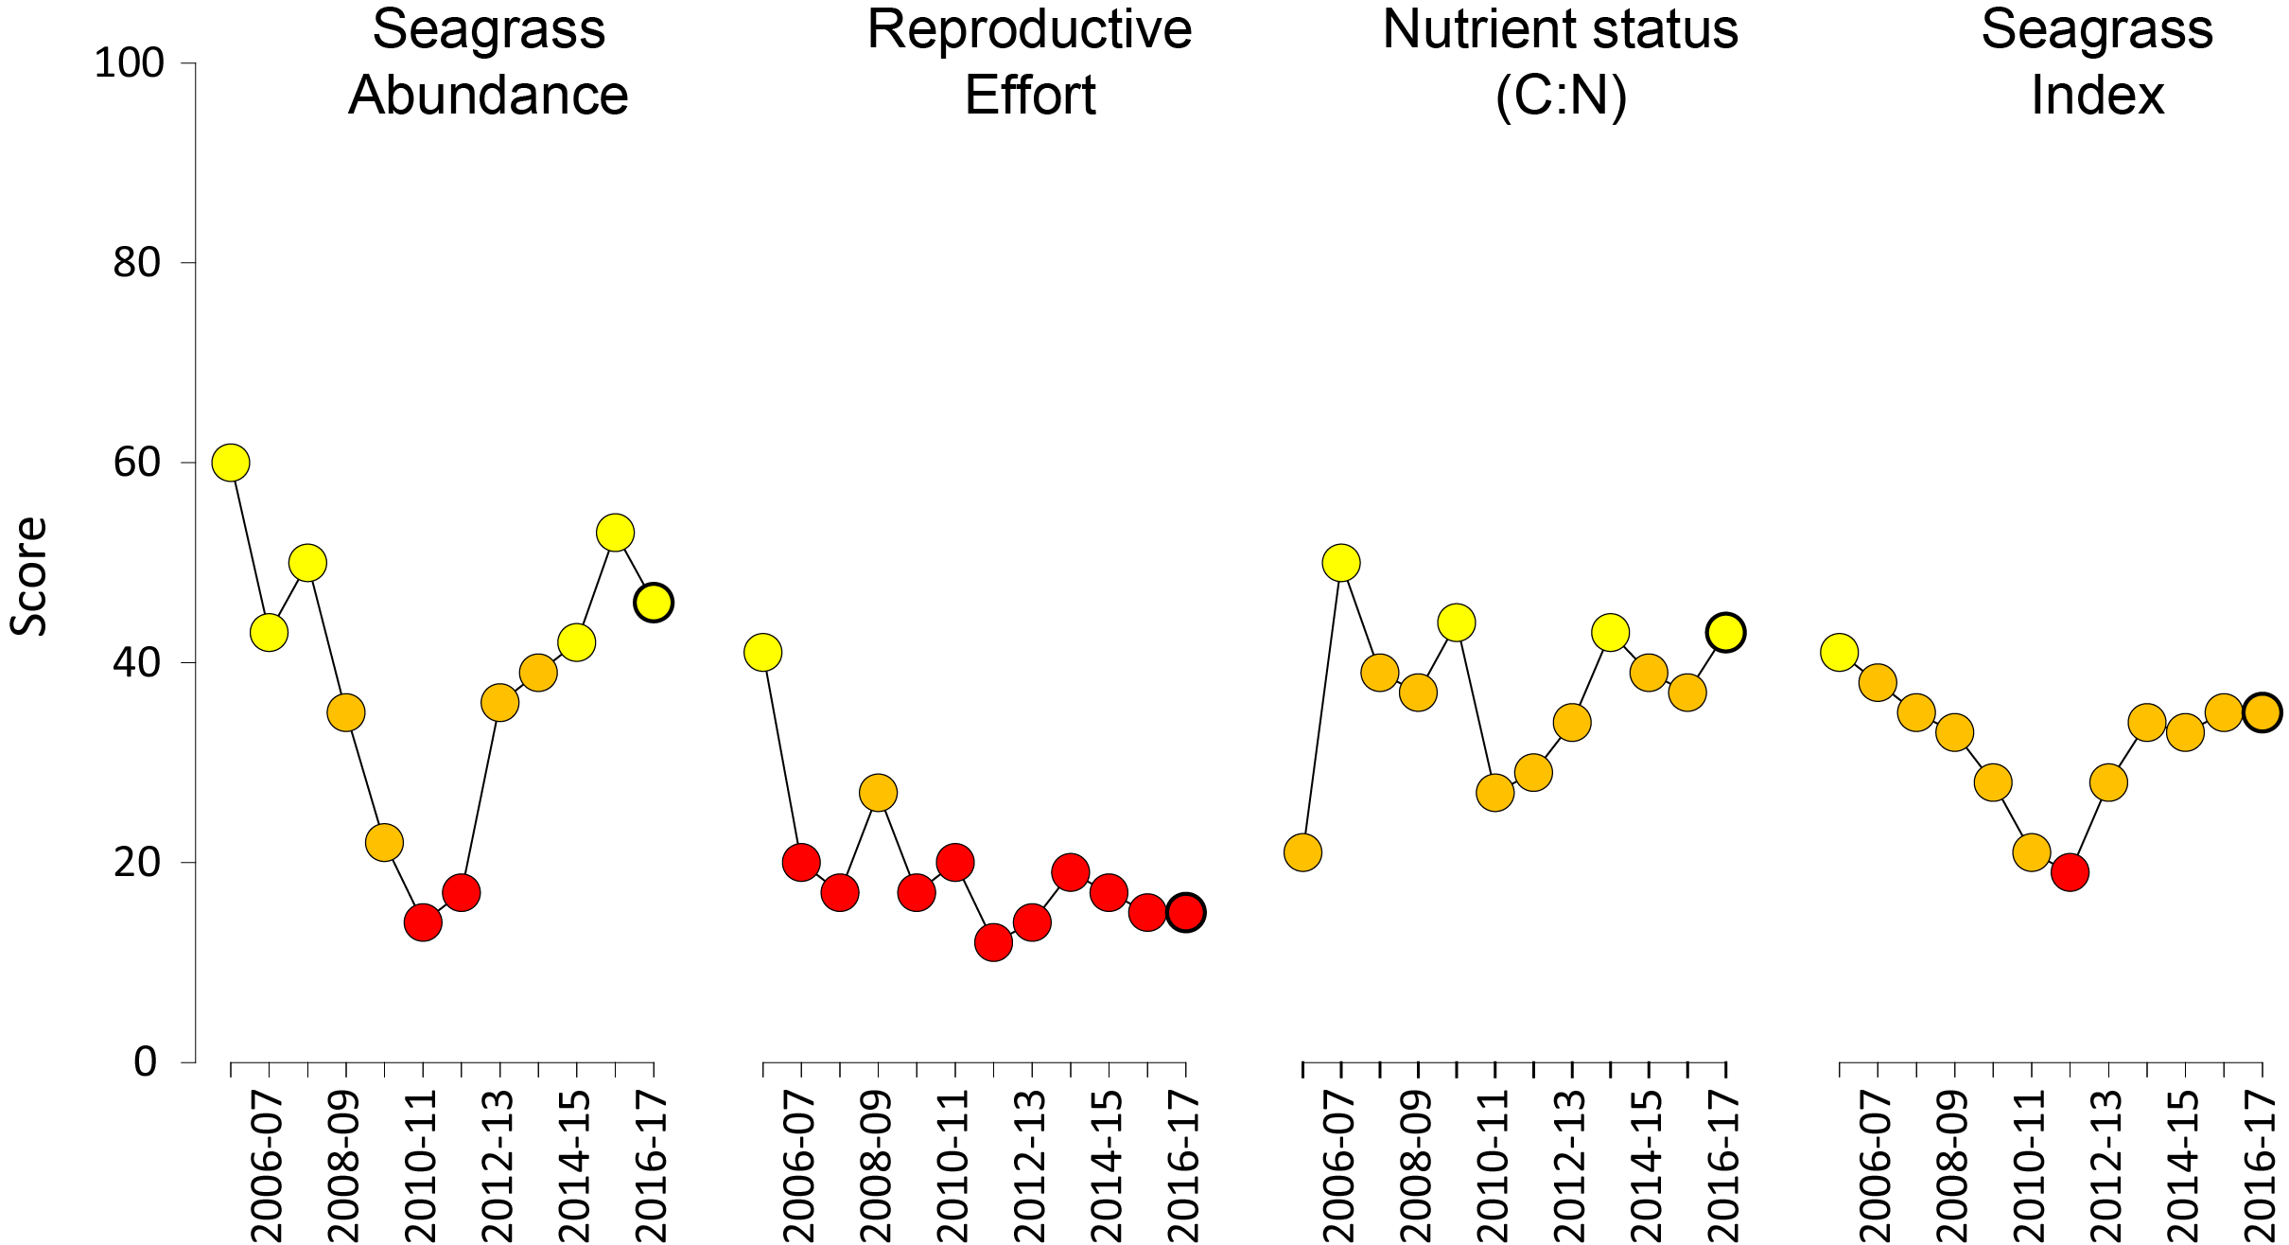
Figure 6. Report card scores (NRM regional averages pooled) for each indicator and total seagrass index over the life of the MMP.
Bold symbol = 2016–17 monitoring period. Values are indexed scores scaled from 0-100; ■ = very good (81-100), ■ = good (61 - 80), ■ = moderate (41 - 60), ■ = poor (21 - 40), ■ = very poor (0 - 20). NB: Scores are unitless.
Reproductive effort in 2016–17 remained very poor. Reproductive effort was relatively stable at estuary and coastal habitats, but declined in reef intertidal and reef subtidal habitats in 2016–17, relative to the previous year. Reproductive effort was poor in the Burdekin and Mackay Whitsunday regions, and very poor in all others. A large decline in reproductive effort has occurred in the Wet Tropics and Burnett Mary regions, but the scores remained very poor as per the previous year.
The density of seeds in the seed bank, which had shown some signs of improvement following 2011 extreme events, were very low in reef intertidal habitats and reduced to very low in estuarine habitats. In contrast, the density of seeds in the seed bank of coast and reef subtidal sites, was moderate. Low reproductive effort will hinder replenishment of the depauperate seed banks in reef habitats, and seed banks are therefore likely to remain low in coming years. Most meadows can be considered vulnerable to further disturbances because of their limited capacity to recover from seed (i.e. low resilience).
The seagrass leaf tissue nutrient indicator of foundation species is the ratio of carbon (C) to nitrogen (N) expressed as C:N. The C:N ratio increased to moderate in late 2016 for only the fourth year out of the 12 years sampled (Figure 6). The ratio of nitrogen to phosphorus (N:P) in seagrass tissue also declined at some sites, but was unchanged in others. Both of these results, indicate a reduction in the availability of nitrogen, relative to the rate at which the leaves are growing and incorporating carbon. This has coincided with lower dissolved inorganic nitrogen concentration measured in parts of the Brudekin and Wet Tropics regions in the MMP Water Quality sub-program. There was a moderate score in Cape York, Burdekin and Fitzroy regions, but the score remained poor in the other three regions. The score reduced at Burnett Mary and Burdekin sites, increased in the Fitzroy and remained within the same category in other regions. As a result of declines in abundance in some regions, and improvements in the seagrass tissue nutrient indicator, the overall seagrass score remained poor.
Across the Great Barrier Reef NRM regions, the seagrass report card scores in 2016–17 did not change substantially, and were poor in all regions except the Burdekin which remained moderate (Figure 7). The largest change was in the Burnett Mary, where the score reduced, but remained poor.
Condition scores across the Great Barrier Reef indicate a system that is impacted, with past anthropogenic impacts leaving a legacy of reduced resilience. In each of the past few years new pressures have hampered recovery, including heatwaves, cyclones, and elevated discharge from rivers. Trends in seagrass abudance and tissue nutrients demonstrate that the system is on a recovering trajectory, despite the poor condition. However, very low reproductive effort throughout most of the Great Barrier Reef signals that the seed banks are at risk of not being repleneished, and recovery processes may be hampered following future disturbances.
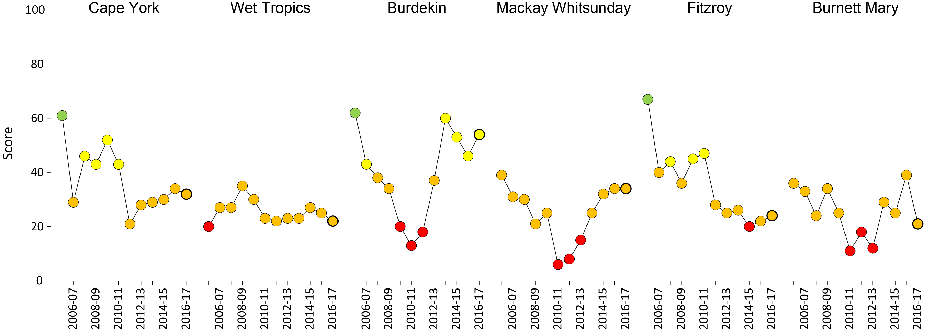
Figure 7. Report card of seagrass condition for each NRM region (averaged across indicators).
Bold symbol = 2016–17 monitoring period. Values are indexed scores scaled from 0-100; ■ = very good (81-100), ■ = good (61 - 80), ■ = moderate (41 - 60), ■ = poor (21 - 40), ■ = very poor (0 - 20). NB: Scores are unitless.

Climate and environmental pressures
Environmental stressors from cyclones, river discharge, wind and water quality in 2016–17 were relatively moderate in the inshore Great Barrier Reef (Table 9), except in the Mackay Whitsunday region which was affected by tropical cyclone Debbie crossing the coast near Airlie beach on the 28th March 2017. This led to above-average rainfall within the Mackay Whitsunday catchments (Figure 8), elevated discharge from from the rivers in the Mackay Whitsunday, Fitzroy and Burnett Mary rivers as the cyclone moved south, and subsequently a greater frequency of exposure to turbid water (colour classes 1-4) compared to multi-annual conditions (Figure 9, Figure 10). There was also low light levels reaching the seagrass canopy, particularly at some of the sites in the Mackay Whitsunday. On average throughout the Great Barrier Reef, light levels were lower in 2016–17 compared to the long-term average (2008-2017), but this trend was not consistently observed at all sites, as, even within the same NRM some sites were lower than average while others were at or above long-term light levels. Within canopy water temperature was above average throughout the Great Barrier Reef, with meadows in the northern, central and southern Great Barrier Reef experiencing a record number of high temperature (>35°C) days, with the exception of the Burnett Mary and Mackay Whitsunday which had the second and third highest number of high temperature days in 2016–17 compared to long-term conditions. Despite this, there were few extreme high temperature (>40°C) days.
Table 9. Summary of environmental conditions at monitoring sites across the Great Barrier Reef in 2016–17 compared to the long-term average
(range indicated for each data set). Regional and habitat-specific levels are provided in later sections. *intertidal only.
Environmental condition | Long-term average | 2016–17
Climate
Cyclones (1968-2017) | 4 | 1
Daily Rainfall (1960 - 1991) | 7.2 mm d⁻¹ | 6.9 mm d⁻¹
Riverine discharge (1970-2017) | 49,689,993 L yr⁻¹ | 55,825,149 L yr⁻¹
Wet season turbid water exposure (2003-2017) | 90 per cent | 90 per cent
Within seagrass canopy
Within canopy temperature (±) (2003-2017)* | 25.8 ±0.1°C (46.6°C) | 26.3 ±0.1°C (43.5°C)
Within canopy light (±) (2008-2017) | 12.7 mol m⁻² d⁻¹ | 11.9 mol m⁻² d⁻¹
Proportion mud estuary intertidal (1999-2017)  coast intertidal (1999-2017)  coast subtidal (2015-2017)  reef intertidal (2001-2017)  reef subtidal (2008-2017) | 49.2 ±2.1%  28.5 ±2.1%  51.2 ±2.3%  5.2 ±1.2%  6.0 ±0.4% | 50.1 ±12.4%  16.9 ±21.3%  61.7%  5.8 ±6.6%  12.9 ±1.2%
Water quality at the seagrass monitoring sites is assessed from water type exposure (turbid primary water and green secondary water) derived from remote sensing (Waterhouse et al. 2018). During 2016–17, most seagrass sites experienced high frequency of exposure to either primary or secondary water (f_{(P+S)}) because they are located in the near-shore margin which maintains poor water quality even during low flow conditions (Figure 9). All sites within the Burdekin and Burnett Mary regions were exposed to ‘brown’ or ‘green’ turbid water for 100 per cent of wet season weeks (December to April), including the sites on reef habitats at Magnetic Island. Exposure was second highest in the Fitzroy and Mackay Whitsunday regions ranging from 70 to 100 per cent of wet season weeks (including Hamilton Island). The Wet Tropics and Cape York regions had sites with the lowest levels of exposure, due mostly to the number of offshore reef sites (e.g. Green Island 9 per cent, Piper Reef 22 per cent, Low Isles 23 per cent), but all other sites in the two northern regions also had a high exposure to ‘brown’ or ‘green’ turbid water (80-100 per cent).

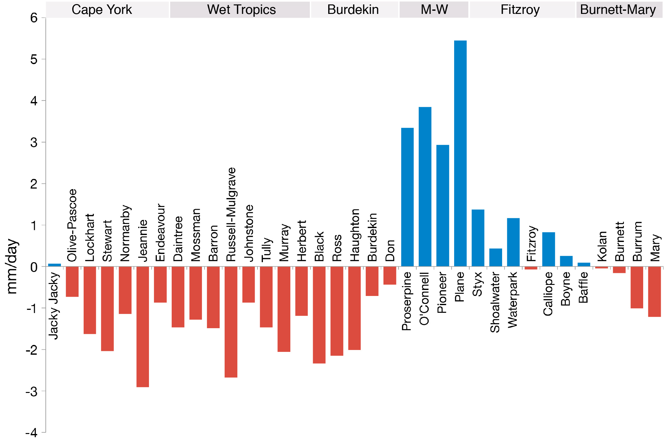
Figure 8. Annual average wet season rainfall (December 2016–April 2017) compared to the long-term wet season rainfall average (1961–1990).
Red and blue bars denote catchments with rainfall below and above the long-term average, respectively. Note that the catchments are ordered from north to south (left to right). Compiled by Waterhouse et al. 2018.
Table 10. Long term annual discharge (in megalitres) for the major Great Barrier Reef catchment rivers in proximity to the inshore seagrass monitoring sites (where data available) for the 2016–17 wet season
(c.a., from Nov 1st to Apr 30th), compared against the previous wet seasons and long-term (LT) median. Colours indicate levels above LT median: yellow for 1.5 to 2 times; orange for 2 to 3 times, and red for greater than 3 times. Long term statistics were calculated based on the wet seasons from Nov 1st, 1949 to Apr 30th, 2000. Compiled by Waterhouse et al. 2018.
 | Basin | LT median | 2010-2011 | 2011-2012 | 2012-2013 | 2013-2014 | 2014-2015 | 2015-2016 | 2016-2017
Cape York | Jacky Jacky Ck | 2,056,151 | 4,735,197 | 1,820,422 | 1,986,825 | 3,790,832 | 1,498,138 | 630,787 | 2,383,057
Cape York | Olive Pascoe R | 2,570,189 | 5,918,996 | 2,275,527 | 2,483,531 | 4,738,541 | 3,931,758 | 788,484 | 2,978,821
Cape York | Lockhart R | 1,627,786 | 3,748,697 | 1,441,167 | 1,572,903 | 3,001,076 | 1,186,026 | 499,373 | 1,886,587
Cape York | Stewart R | 685,263 | 2,180,850 | 616,070 | 523,353 | 1,311,775 | 298,816 | 311,901 | 685,263
Cape York | Normanby R | 3,860,395 | 11,333,284 | 2,181,990 | 3,462,238 | 5,059,657 | 2,914,859 | 3,407,359 | 3,780,651
Cape York | Jeannie R | 1,434,447 | 2,824,817 | 1,048,269 | 695,195 | 1,869,982 | 1,434,447 | 1,581,015 | 1,746,929
Cape York | Endeavour R | 932,391 | 1,836,131 | 681,375 | 451,877 | 1,215,488 | 932,391 | 1,027,660 | 1,135,504
Wet Tropics | Daintree R | 1,729,411 | 3,936,470 | 2,396,905 | 1,668,302 | 5,137,023 | 1,905,224 | 1,623,478 | 1,931,878
Wet Tropics | Mossman R | 1,195,130 | 2,014,902 | 1,526,184 | 1,147,367 | 1,918,522 | 874,068 | 1,245,275 | 1,142,698
Wet Tropics | Barron R | 516,958 | 2,119,801 | 852,055 | 328,260 | 663,966 | 380,395 | 182,999 | 287,790
Wet Tropics | Mulgrave-Russell R | 4,415,631 | 7,892,713 | 5,696,594 | 3,529,862 | 5,420,678 | 3,145,787 | 3,253,825 | 3,015,734
Wet Tropics | Johnstone R | 4,712,497 | 9,276,874 | 5,338,591 | 3,720,020 | 5,403,534 | 3,044,680 | 3,416,331 | 4,017,617
Wet Tropics | Tully R | 3,490,736 | 7,442,768 | 3,425,096 | 3,341,887 | 4,322,496 | 2,659,775 | 2,942,770 | 3,098,701
Wet Tropics | Murray R | 1,216,289 | 4,267,125 | 2,062,103 | 1,006,286 | 1,531,172 | 366,212 | 974,244 | 947,985
Wet Tropics | Herbert R | 3,478,592 | 12,593,674 | 4,545,193 | 3,189,804 | 4,281,607 | 1,095,372 | 1,895,526 | 2,248,436
Burdekin | Black R | 219,909 | 1,424,283 | 747,328 | 188,468 | 419,290 | 17,654 | 129,783 | 64,873
Burdekin | Ross R | 445,106 | 2,092,684 | 1,324,707 | 276,584 | 1,177,255 | 3,229 | 23,741 | 11,867
Burdekin | Haughton R | 535,930 | 2,415,758 | 1,755,712 | 517,069 | 573,976 | 120,674 | 267,986 | 338,245
Burdekin | Burdekin R | 4,328,245 | 34,834,316 | 15,568,159 | 3,424,572 | 1,458,772 | 880,951 | 1,807,104 | 4,165,129
Burdekin | Don R | 360,394 | 3,136,184 | 802,738 | 578,391 | 324,120 | 171,305 | 101,562 | 920,610
Mackay  Whitsundays | Proserpine R | 924,039 | 4,582,697 | 2,171,287 | 851,504 | 720,427 | 157,123 | 316,648 | 1,683,894
Mackay  Whitsundays | O'Connell R | 829,266 | 4,112,676 | 1,948,591 | 764,170 | 646,537 | 141,008 | 284,171 | 1,511,187
Mackay  Whitsundays | Pioneer R | 804,599 | 3,630,422 | 1,567,684 | 1,162,871 | 635,315 | 2,028,936 | 597,117 | 1,388,687
Mackay  Whitsundays | Plane Ck | 1,273,154 | 4,809,239 | 2,854,703 | 1,948,929 | 737,580 | 241,254 | 832,508 | 2,613,261
Fitzroy | Styx R | 191,279 | 906,144 | 275,219 | 968,106 | 544,155 | 376,009 | 343,877 | 507,927
Fitzroy | Shoalwater Ck | 217,663 | 1,031,129 | 313,180 | 1,101,638 | 619,211 | 427,872 | 391,308 | 577,985
Fitzroy | Water Park Ck | 573,838 | 2,718,432 | 825,657 | 2,904,319 | 1,632,466 | 1,128,027 | 1,031,630 | 1,523,780
Fitzroy | Fitzroy R | 2,996,149 | 37,942,149 | 7,993,273 | 8,530,491 | 1,578,610 | 2,681,949 | 3,589,342 | 6,170,044
Fitzroy | Calliope R | 157,383 | 1,000,032 | 345,703 | 1,558,380 | 283,790 | 479,868 | 148,547 | 406,321
Fitzroy | Boyne R | 39,809 | 252,949 | 87,443 | 394,178 | 71,782 | 121,378 | 37,574 | 102,775
Burnett-Mary | Baffle Ck | 409,347 | 3,650,093 | 1,775,749 | 2,030,545 | 275,517 | 710,352 | 257,093 | 829,460
Burnett-Mary | Kolan R | 50,429 | 779,168 | 307,837 | 810,411 | 45,304 | 213,857 | 111,172 | 146,154
Burnett-Mary | Burnett R | 250,839 | 9,421,517 | 643,137 | 7,581,543 | 218,087 | 853,349 | 381,054 | 536,242
Burnett-Mary | Burrum R | 64,940 | 114,492 | 117,762 | 90,921 | 62,188 | 150,113 | 334,681 | 456,549
Burnett-Mary | Mary R | 1,095,811 | 8,719,106 | 4,340,275 | 7,654,320 | 594,612 | 1,651,901 | 480,854 | 582,510

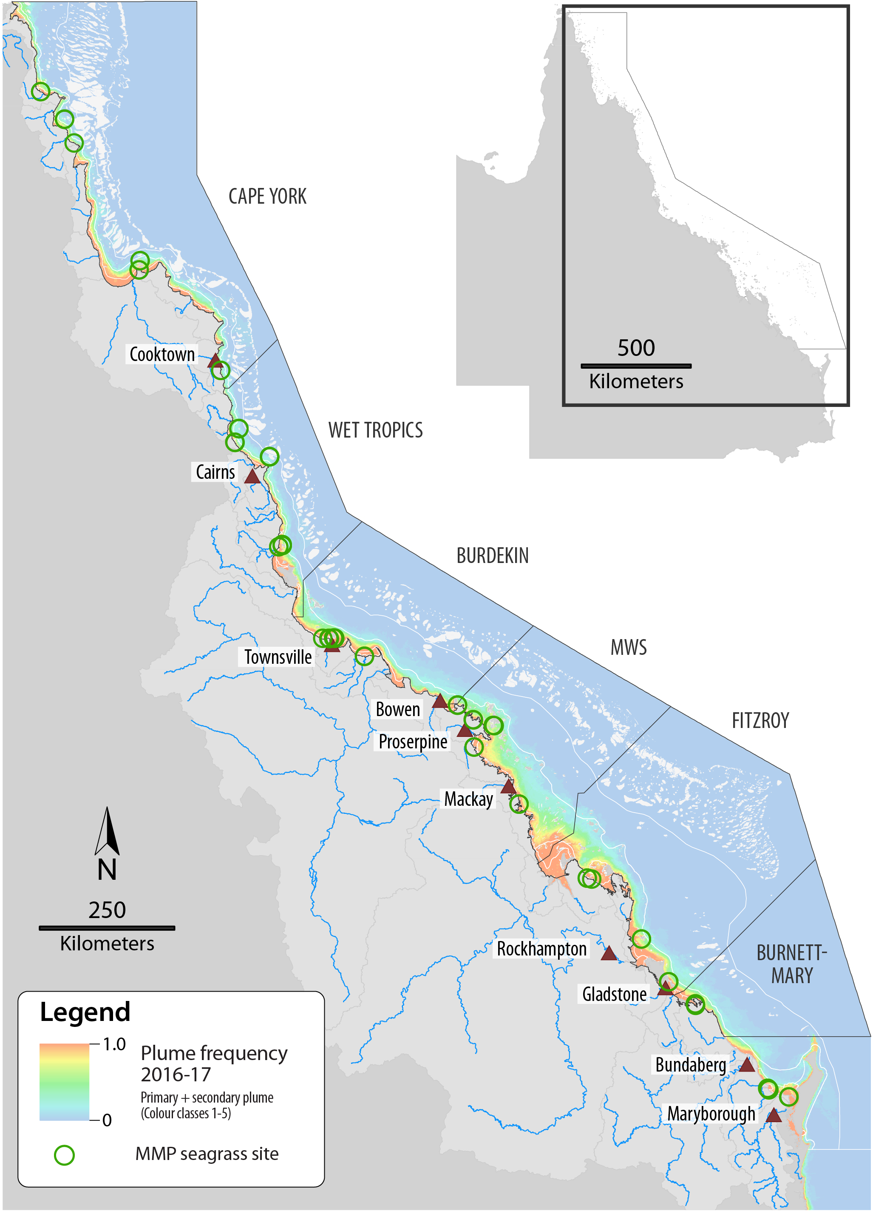
Figure 9. Turbid water exposure (colour classes 1 – 5, primary and secondary water) frequency in the Great Barrier Reef from December 2016 to April 2017
ranging from frequency of 1 (red, always exposed) to 0 (dark blue, never exposed). Green circles show seagrass monitoring sites. From Waterhouse et al. 2018.

The frequency of exposure to colour classes 1 to 4 (‘brown’ turbid water) during the wet season weeks (December 2016 - April 2017) was lower than multiannual annual conditions in all NRMs except the Mackay Whitsunday (Figure 10). The frequency of exposure to colour classes 1 to 5 also including ‘green’ turbid water, shows that the frequency was elevated in 2016–17 in the Burdekin, Fitzroy, and Burnett Mary catchments, but was lower than the multi-annual conditions in the Mackay Whitsunday.
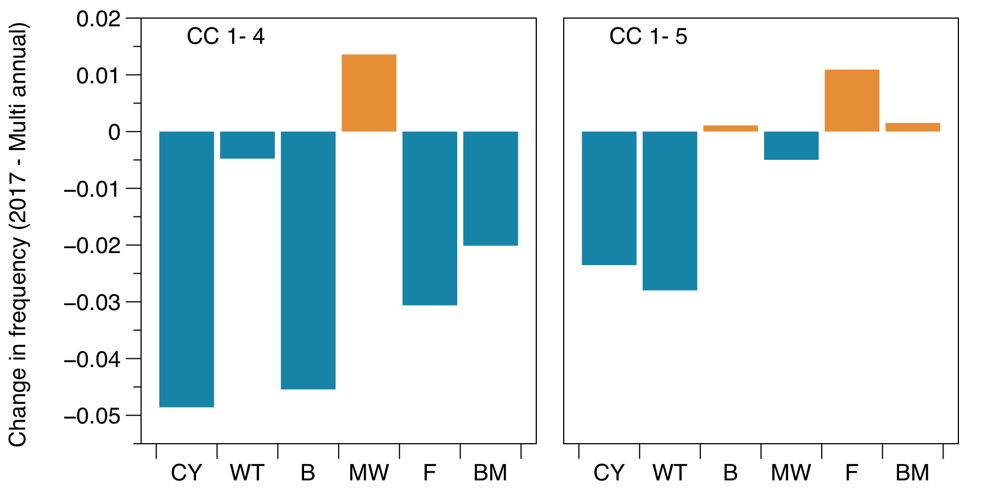
Figure 10. Difference in the frequency of exposure to water colour classes (CC) 1 to 4 (left) and 1 to 5 (right) at seagrass monitoring sites during the wet season (December 2016 – April 2017) compared to the long-term multiannual exposure (2003-2017).
From Waterhouse et al. 2018.

Daily incident light
Daily incident light (I_{d}, mol m⁻² d⁻¹) reaching the top of the seagrass canopy in the Great Barrier Reef in 2016–17 (11.6 mol m⁻² d⁻¹ ) was below the long-term average (13.4 mol m⁻² d⁻¹) (Figure 11). Cape York sites had the highest I_{d} (17.3 mol m⁻² d⁻¹), followed by Fitzroy (14.3 mol m⁻² d⁻¹), Mackay Whitsunday (13.8 mol m⁻² d⁻¹), Burenett-Mary (13.2 mol m⁻² d⁻¹), Wet Tropics (12.7 mol m⁻² d⁻¹), and, Burdekin sites had the lowest (9.6 mol m⁻² d⁻¹). Both the Wet Tropics and Burdekin have subtidal sites, with lower I_{d} than intertidal sites, and these lowered their regional average. With these excluded, I_{d} in 2016–17 was second highest in the Wet Tropics (15.3 mol m⁻² d⁻¹), while the Burdekin remained the lowest (10.0 mol m⁻² d⁻¹). The I_{d} at Wet Tropics subtidal sites was 7.6 mol m⁻² d⁻¹ on average compared to 8.1 mol m⁻² d⁻¹ long-term average and 6.0 mol m⁻² d⁻¹ at the Burdekin subtidal site, compared to 5.7 mol m⁻² d⁻¹ long-term. Compared to the long-term average, in all regions I_{d} was lower than the long-term average, particularly in the Mackay Whitsunday region which had very low light levels at the new Lindeman Island site following TC Debbie. Light loggers were only deployed for some of the 2016–17 year at Fitzroy and Cape York sites as monitoring was reduced to once per year and loggers recorded only from October-March. The amount of light data captured at each site and the daily light for each site is presented in Appendix 4.
On average, daily light in 2016–17 was similar among the intertidal habitats including: reef intertidal habitat (14.6 mol m⁻² d⁻¹), followed by the coastal intertidal sites (12.6 mol m⁻² d⁻¹), estuarine sites (10.6 mol m⁻² d⁻¹) and and lowest at the reef subtidal sites (7.2 mol m⁻² d⁻¹). Daily light was lower than the long-term average in all habitats including estuarine sites (long-term average = 10.6 mol m⁻² d⁻¹), reef intertidal sites (long-term average = 16.5 mol m⁻² d⁻¹), while at coastal (long-term averages = 12.7) and reef subtidal sites (long-term average = 7.3 mol m⁻² d⁻¹). The only sites where I_{d} was slightly higher than average I_{d} were at some of the coastal and reef sites in the Wet Tropics and Burdekin.

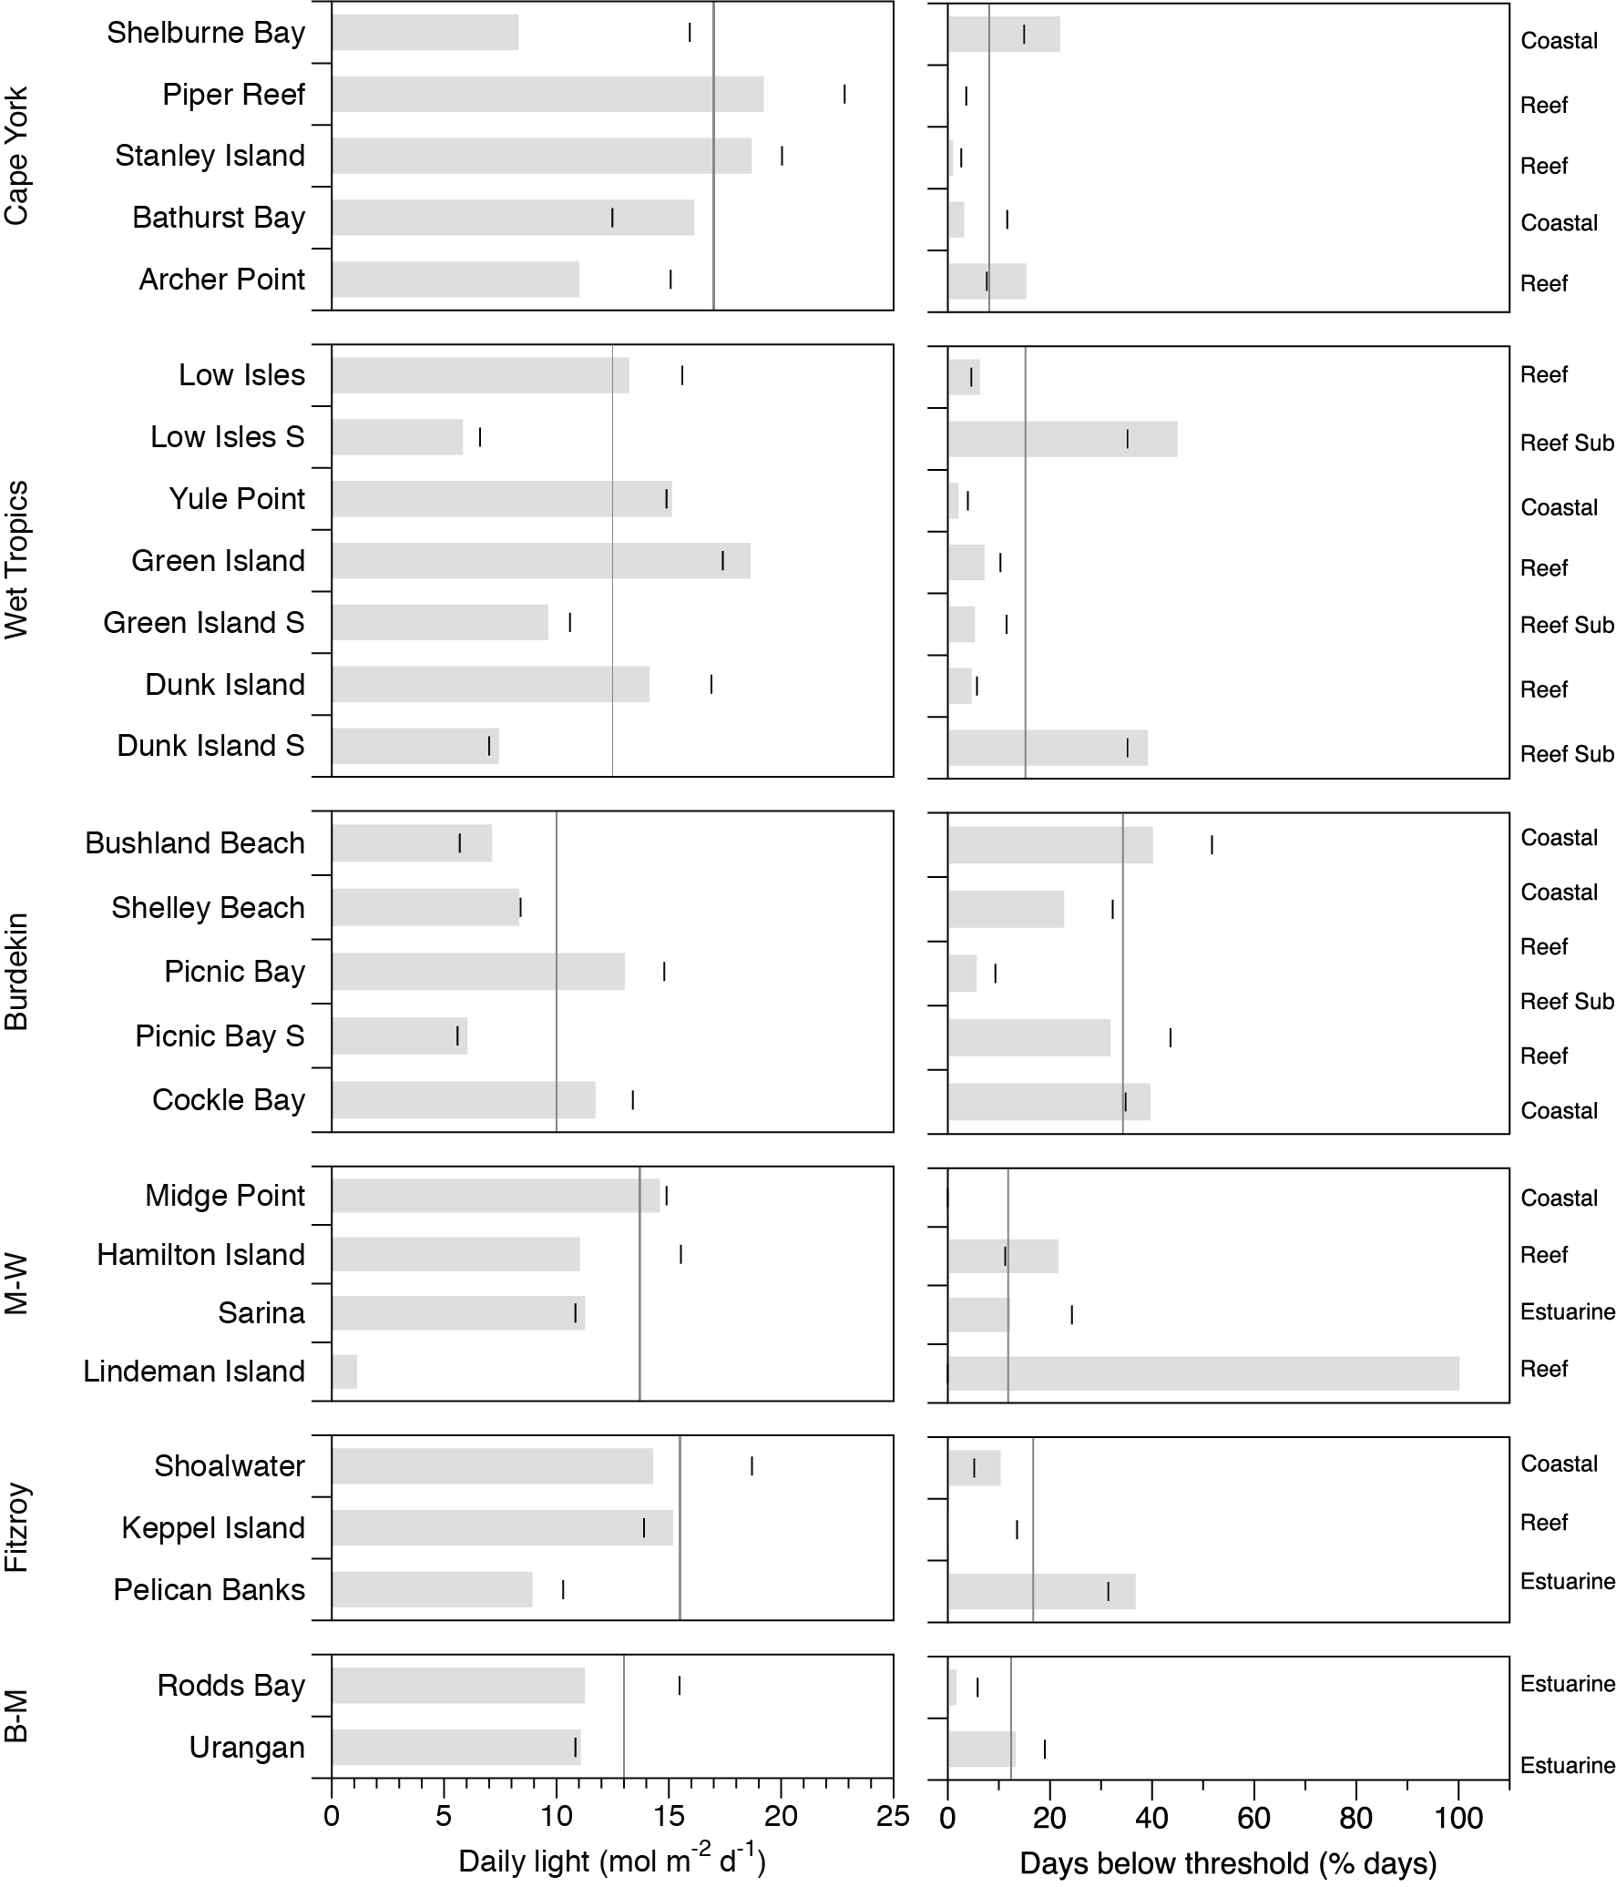
Figure 11. Average daily light (left-hand panel) and thresholds exceeded (per cent days, right-hand panel) for coastal, estuarine, reef intertidal, and reef subtidal sites including the long-term average and the value for the 2016–17 reporting period.
Grey bar = 2016–17, small lines represent long-term average of the site, and long-lines represent long-term average for the NRM region. NRM regions: WT= Wet Tropics, BDT = Burdekin; M-W = Mackay Whitsunday; F = Fitzroy; B-M = Burnett Mary.

Threshold exceedance (number of days less than 5 mol m⁻² d⁻¹, for northern Halodule uninervis dominated meadows (Collier et al. 2012b) and <6 mol m⁻² d⁻¹ for southern Zostera muelleri dominated meadows (Chartrand et al. 2016) for 2016–17 (18.6 per cent of days) was slightly higher than the long-term average (17.2 per cent of days). The thresholds were exceeded the most frequently in the Burdekin (27.9 per cent of days) followed by Fitzroy (15.6 per cent), Wet Tropics (15.5 per cent), Mackay Whitsunday (11.2 per cent), Cape York (8.2 per cent) and the least often in the Burnett Mary (7.3 per cent). The greatest level of exceedance was at the recently established subtidal Lindeman Island site (100 per cent of the deployment ime), at which loggers were deployed only during the wet season, when the site was affected by TC Debbie.
Daily light in shallow habitats can be affected by water quality, cloudiness and the depth of the site, which affects the frequency and duration of exposure to full sunlight at low tide (Anthony et al. 2004; Fabricius et al. 2012); however, the differences in I_{d} among seagrass meadows is largely a reflection of site-specific differences in water quality as outlined in earlier reports (McKenzie et al. 2015). Turbidity and chlorophyll monitoring is no longer in place at seagrass sites. However, flood plume mapping (Devlin et al. 2015), is used to derive water type exposure at seagrass sites and frequency of exposure to these water types can be a predictor of changes in seagrass abundance (see case study 2, in McKenzie et al. 2016).
Long-term trends demonstrate that the peak in canopy light occurs in September to December as incident solar irradiation reaches its maximum and prior to wet season conditions (Figure 12a). The lowest light levels typically occur in the wet season in particular, in January to April, but in 2016–17 the lowest levels were sustained from March through to September 2016, and then the spring peak in I_{d} was lower than is typical particularly at reef intertidal sites. The GAM model shows the long-term trends in within-canopy I_{d} and its level of prediction is improved with habitat included (Figure 12) and so further detail on I_{d} within each habitat and NRM region is given in the following sections.
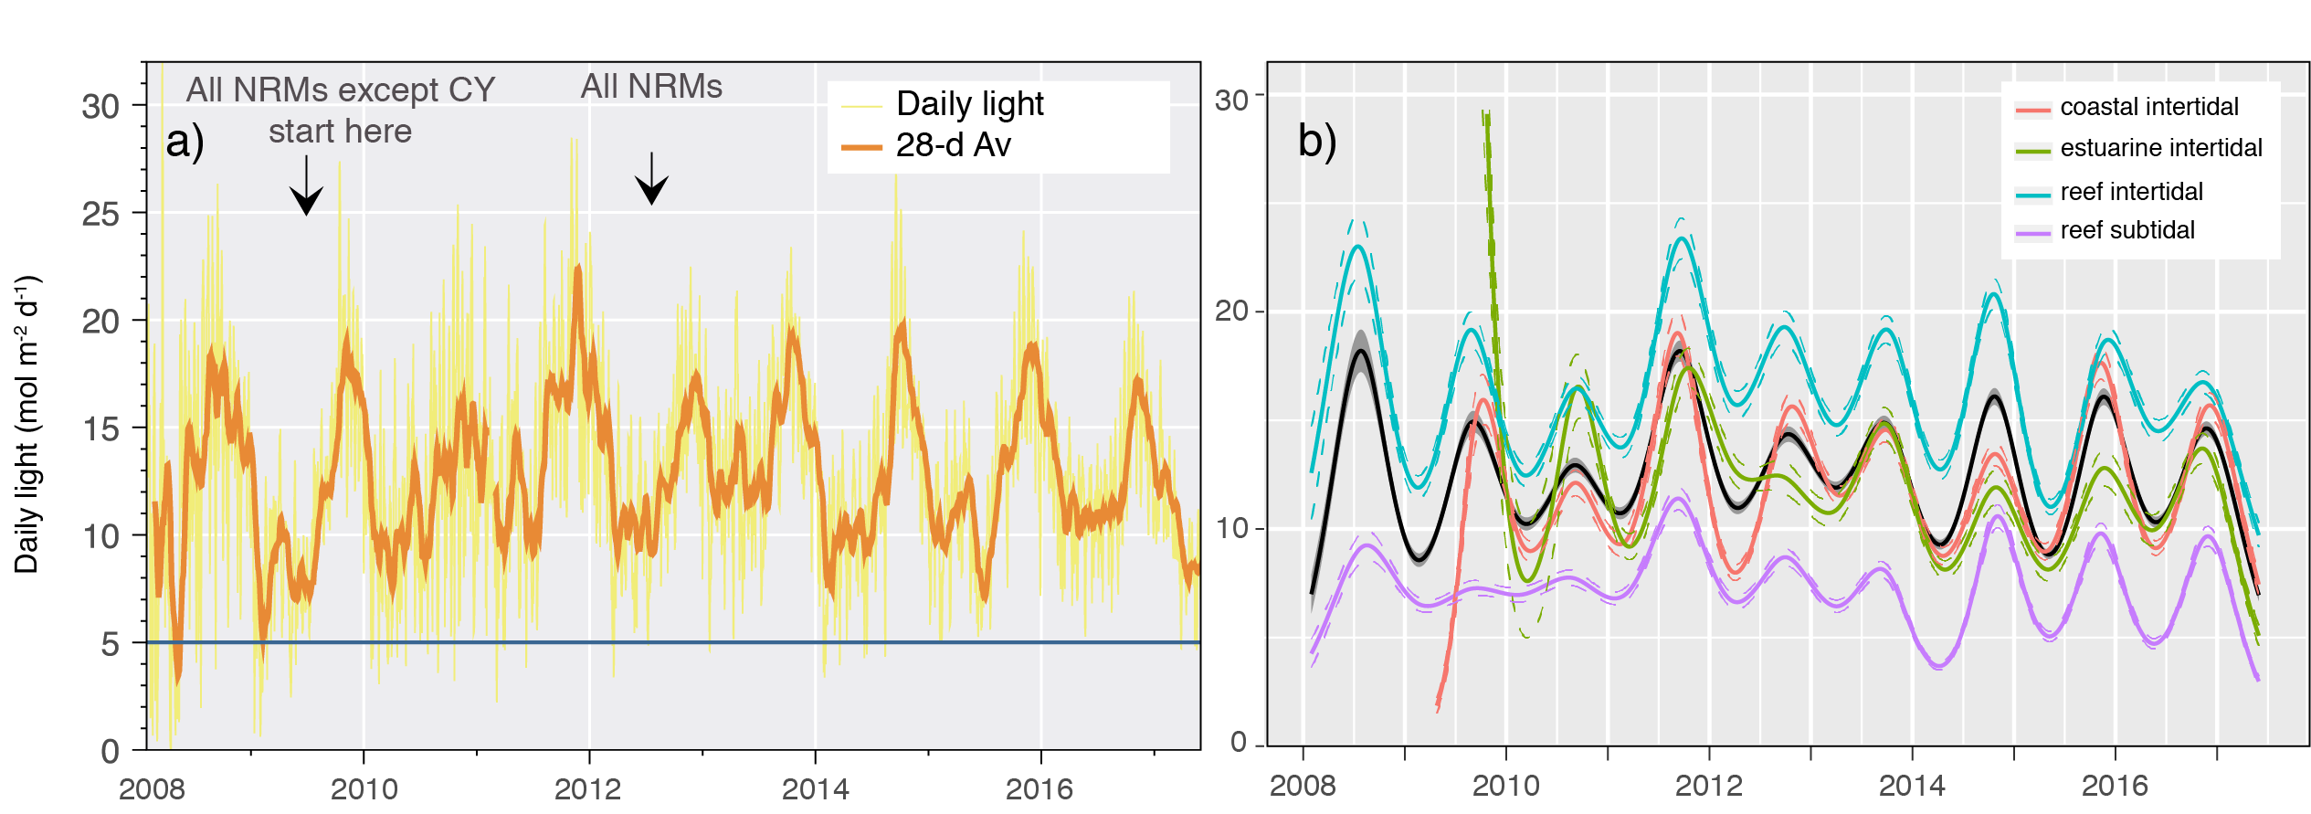
Figure 12. Daily light for all sites combined (a.) and Great Barrier Reef-wide trend (GAM plot) in daily light for each habitat (b.) from 2008 to 2017.
Also shown is the start date for inclusion of regions in the plot. In 2008-09, light data is from the Burdekin and Wet Tropics regions, while other regions (except Cape York) were included in 2009-10, but Cape York light monitoring was added for the 2012-13 reporting period.

Within canopy seawater temperature
Within seagrass canopy seawater temperature data were collected from September 2003 to May 2017. The 2016–17 monitoring period included a marine heatwave causing wide-spread coral bleaching and mortality that affected Cape York, the Wet Tropics and the Burdekin region for a second year in a row (Great Barrier Reef Marine Park Authority 29 June 2017; http://www.gbrmpa.gov.au/about-the-reef/reef-health). Within seagrass canopy water temperatures were also above average at inshore seagrass monitoring sites of Great Barrier Reef (Table 9). The Burnett Mary NRM was the only region in the Great Barrier Reef in which average temperature was not the highest on record, while in all other NRMs the average temperature exceeded all previous years since 2005-06. Within canopy water temperature in Cape York exceeded 35°C for a record number of days in one reporting year (58d), but it did not exceed 40°C, a critical threshold for photoinhibition and mortality risk (Figure 13). Water temperature exceeded 35°C for 70d in the Wet Tropics and Fitzroy NRM’s followed by Cape York (58d), the Mackay Whitsunday (56d), and the Burnett Mary NRMs (19 d). Furthermore, temperature exceeded 40°C in the Wet Tropics, Burdekin, Mackay Whitsunday and Fitzroy NRMs. The hottest seawater temperature recorded at inshore seagrass sites along the Great Barrier Reef during 2016–17 was 41.4°C, which was at Yule Point (YP1) on 7 March 2017. These extreme temperature days (>40°C) that can cause photoinhibition were relatively low in frequency (max 4 d per year in the Mackay Whitsunday) and were unlikely to cause burning or mortality, but elevated water temperature possibly had a chronic and cumulative impact on seagrass condition.
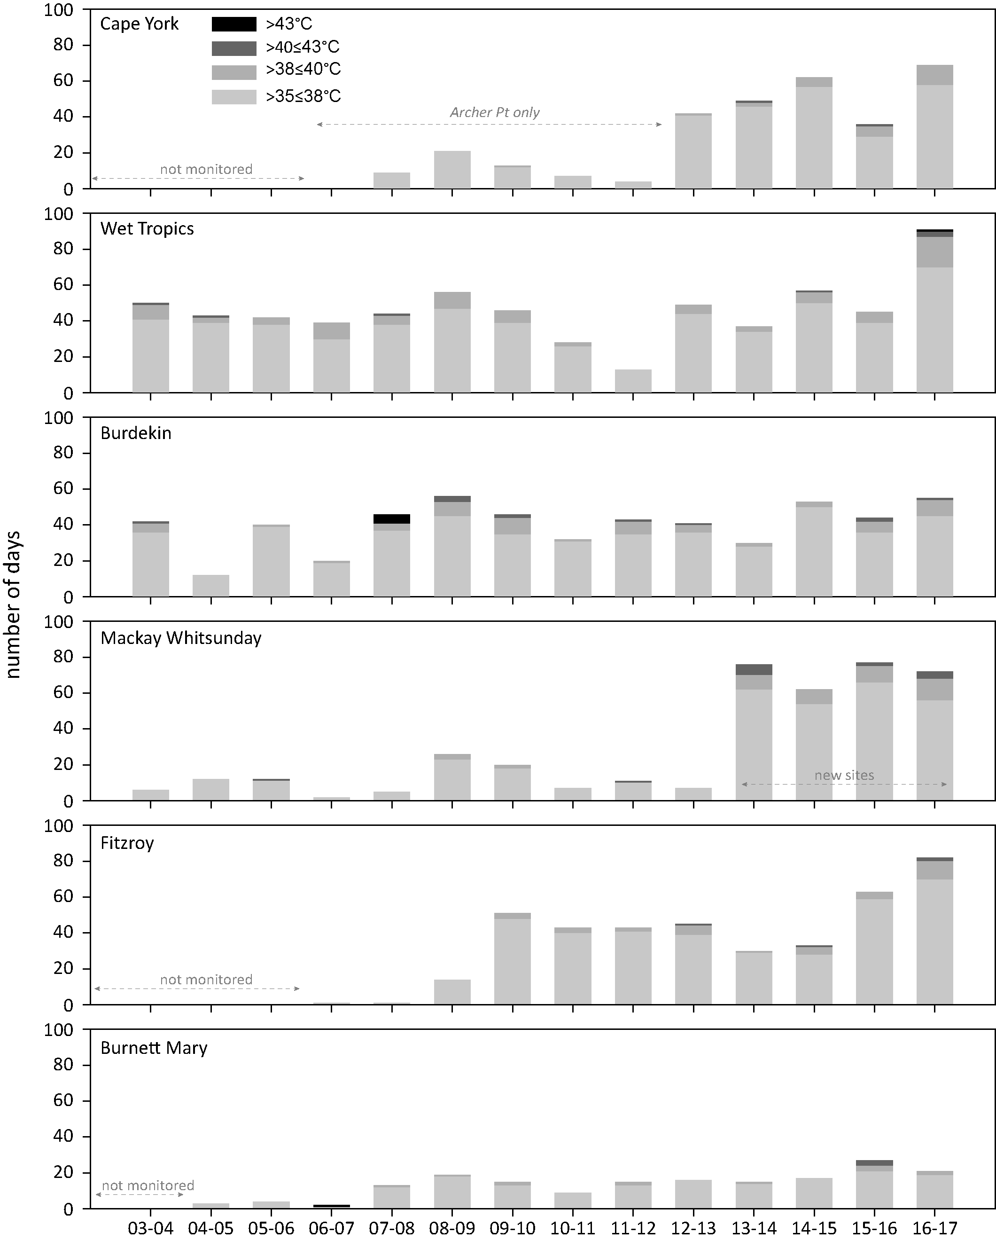
Figure 13. Number of days when inshore intertidal sea temperature exceeded 35°C, 38°C, 40°C and 43°C in each monitoring period in each NRM region.
Thresholds adapted from Campbell et al. 2006; Collier et al. 2012b.
Within canopy seawater temperatures across the Great Barrier Reef over the 2016–17 monitoring period were the highest recorded since MMP monitoring commenced in 2005-06 (Figure 14). Estuarine habitats were the only habitats that did not reach the highest recorded in since 2005-06, but they were none-the-less above the long-term average.
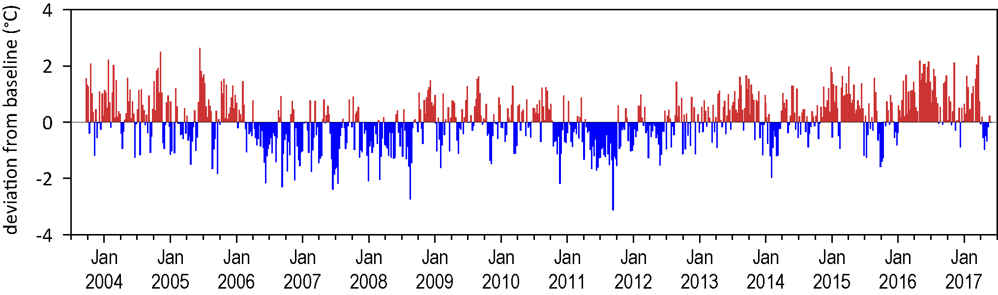
Figure 14. Inshore intertidal sea temperature deviations from baseline for Great Barrier Reef seagrass habitats 2003 to 2017.
Data presented are deviations from 13-year mean weekly temperature records (based on records from September 2003 to June 2017). Weeks above the long-term average are represented as red bars and the magnitude of their deviation from the mean represented by the length of the bars, blue bars represent weeks with temperatures lower than the average and are plotted as negative deviations.
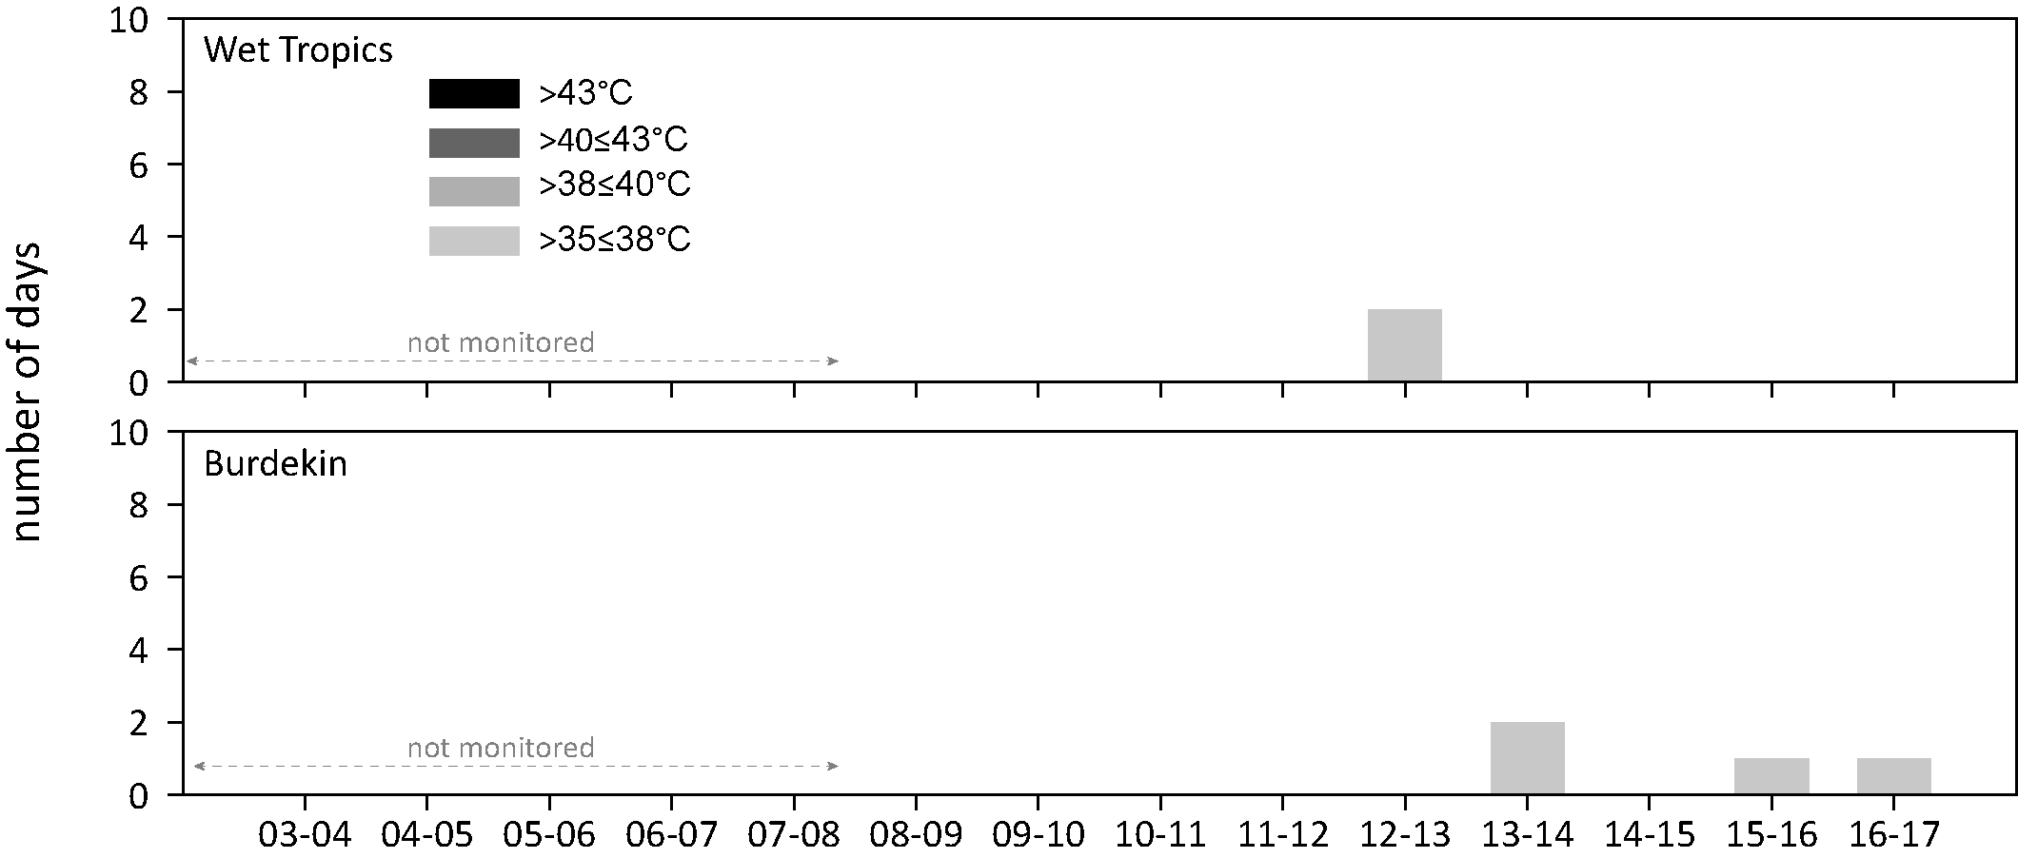
Figure 15. Number of days when inshore subtidal sea temperature exceeded 35°C, 38°C, 40°C and 43°C in each monitoring period in each NRM region.
Thresholds adapted from Campbell et al. 2006; Collier et al. 2012b.

Indicators of seagrass condition
In the 2016–17 monitoring period, the seagrass abundance score was poor in all regions except the Cape York and Burdekin regions (Figure 16). Furthermore, the score declined from moderate in Mackay Whitsunday and Burnett Mary regions. Increases in the abundance score in 2016–17 compared to the previous monitoring occurred in the Wet Tropics, Burdekin and Fitzroy NRMs, but the Burdekin was the only region wich improved in grade (from moderate to good) (Figure 16).
Seagrass abundance (per cent cover) at meadows monitored in the MMP declined from 2005-06 until 2012-13, after which abundances increased. Based on the average score against the seagrass guidelines (determined at the site level), the abundance of inshore seagrass in the Great Barrier Reef over the 2016–17 period reduced but remained in a moderate state (Figure 6).

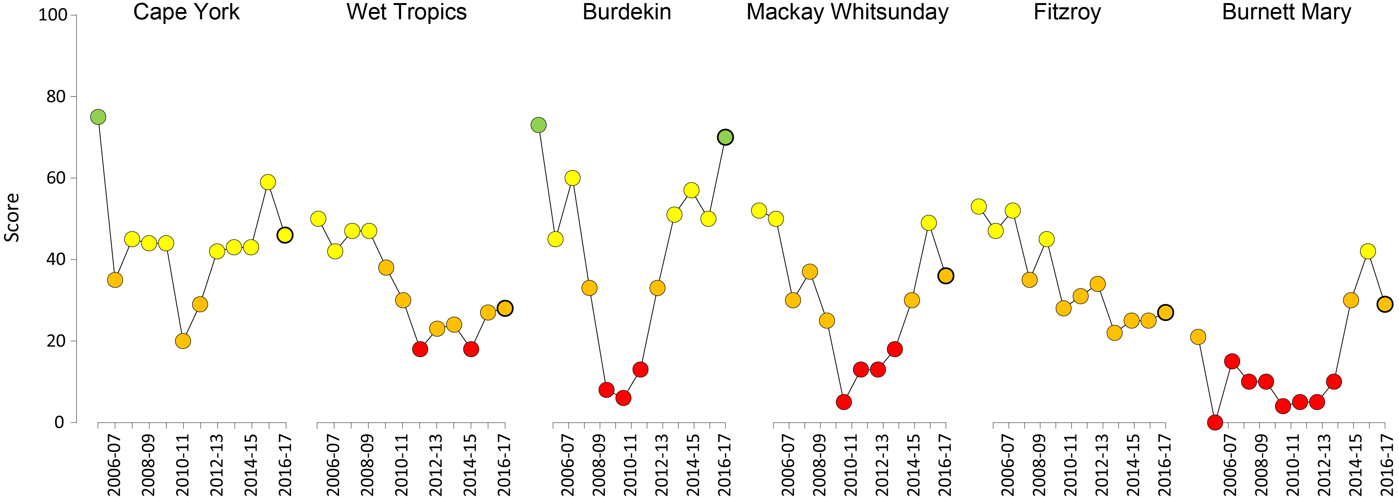
Figure 16. Regional report card scores for seagrass abundance over the life of the MMP
. Bold symbol = 2016–17 monitoring period. For Paddock to Reef reporting scores are categorised in to a five point scale; ■ = very good (81-100), ■ = good (61 - 80), ■ = moderate (41 - 60), ■ = poor (21 - 40), ■ = very poor (0 - 20). NB: Scores are unitless.
Seagrass abundance scores have fluctuated since monitoring was established. The most variable Great Barrier Reef seagrass habitat in abundance score (since 2005) was subtidal reef (CV=87 per cent), followed closely by intertidal reef (CV=73.6 per cent), estuary (CV=66.5 per cent) and lastly intertidal coast (CV=57.9 per cent).
Since 1999, the median percentage cover values for the Great Barrier Reef were mostly below 25 per cent cover, and depending on habitat, the 75th percentile occasionally extended beyond 50 per cent cover (Figure 17). These long-term percentage cover values were similar to the Great Barrier Reef historical baselines, where surveys from Cape York to Hervey Bay (between November 1984 and November 1988) reported most (three-quarters) of the percent cover values fell below 50 per cent cover (Lee Long et al. 1993). The findings negate the assumption that seagrass meadows of the Great Barrier Reef should have abundances closer to 100 per cent before they are categorised as good.
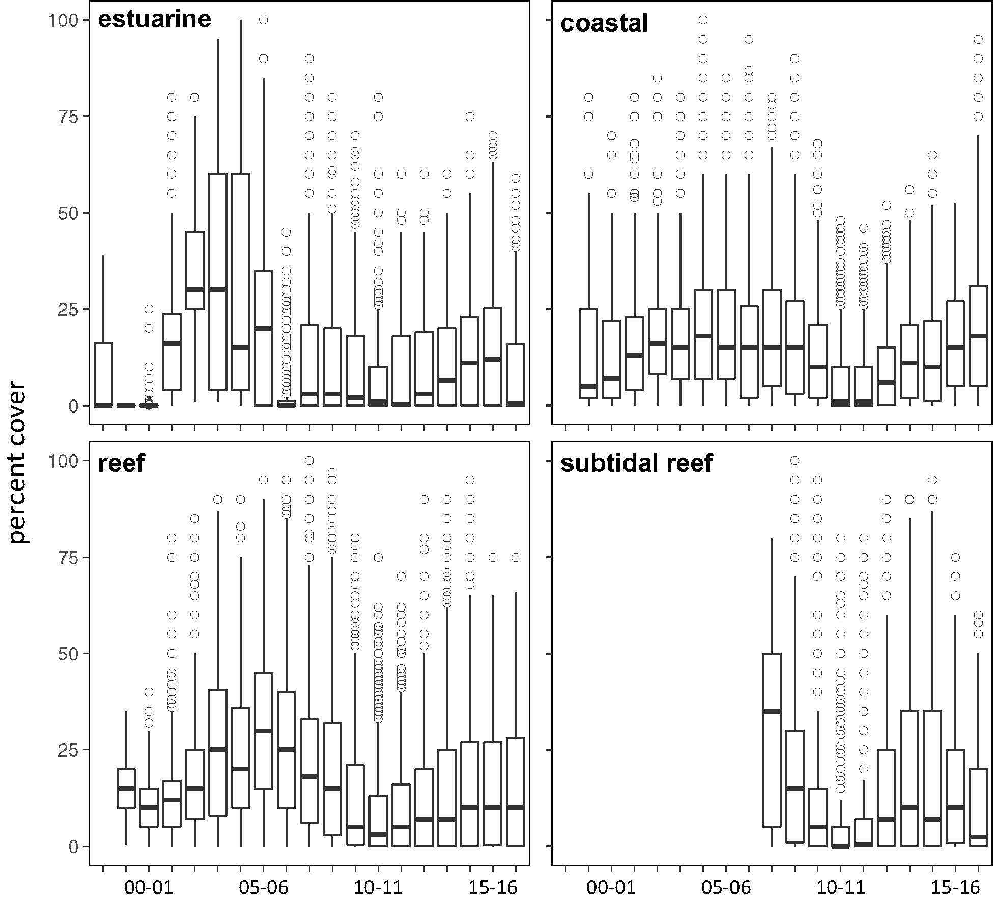
Figure 17. Seagrass percent cover measures per quadrat from meadows monitored from June 1999 to May 2017 (sites and habitats pooled).
The box represents the interquartile range of values, where the boundary of the box closest to zero indicates the 25th percentile, a line within the box marks the median, and the boundary of the box farthest from zero indicates the 75th percentile. Whiskers (error bars) above and below the box indicate the 90th and 10th percentiles, and the dots represent outlying points.

In 2016–17 coastal sites had the highest average abundance (Figure 17). Over the past decade, the patterns of seagrass abundance in each Great Barrier Reef habitat have been similar in coastal and reef sites, gradually increasing from 2001 to 2008 (with a mild depression in 2006-07 as a consequence of TC Larry). Meadow abundance then declined in the period from 2009 to 2011 due to above average rainfall and river discharge (Figure 18). The extreme weather events of early 2011 (TC Yasi) resulted in further substantial decline in inshore seagrass meadows throughout much of the Great Barrier Reef. Estaurine habitats, which are monitored only in the south of the Great Barrier Reef, reached record percent cover in 2002 to 2003, but have remained low since 2005-06. However, seagrass trends have fluctuated at a site level in estuary habitats, most often at smaller localised scales where there have been some acute event related changes (McKenzie et al. 2012b). Post 2011, seagrasses have progressively recovered, although by 2016–17 still remained below the 2008 levels, except in coastal sites which have recovered (Figure 18).

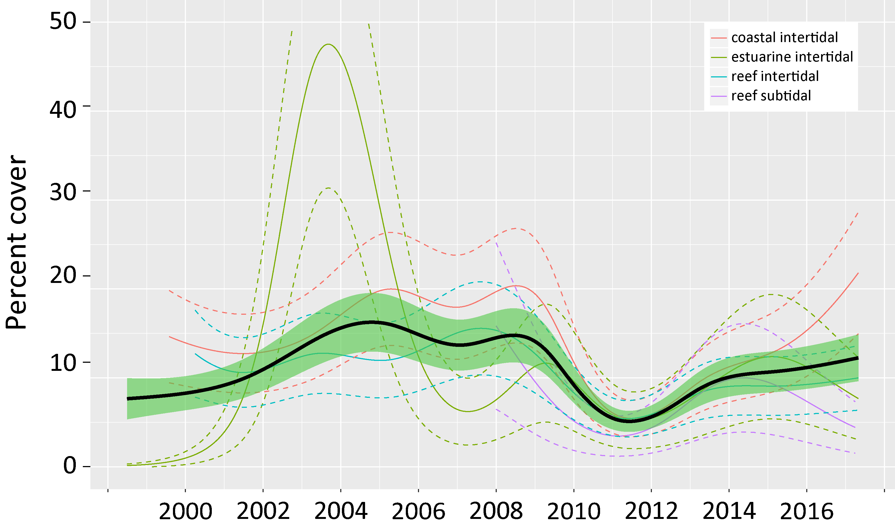
Figure 18. Trends in seagrass abundance ( per cent cover) for each habitat type across the Great Barrier Reef represented by a GAM plot.
Trends are dark lines with shaded areas defining 95 per cent confidence intervals of those trends.
Trend analysis of seagrass abundance (mean per cent cover) across the Great Barrier Reef showed no significant long-term trend (Mann-Kendall, τ = -0.09, p =0.062); which is to be expected due to the variability between sites, locations, habitats, and seasons. Although most (67%) of sites monitored had no significant long-term trend, significant negative trends were revealed in 22% of sites, the majority of which had been monitored for a decade or more (Appendix 5, Table 58). Only three long-term (>10 yrs) monitoring sites showed significant increasing trends and these sites were in the Burnett Mary (BH3 coast and UG2 estuary) and Burdekin (MI3 subtidal) regions (Appendix 5, Table 58). The trend analysis also revealed significant declines over the long-term for the Cape York, Wet Tropics, Mackay Whitsunday and Fitzroy NRM regions, with no detectable trends for the remaining Burdekin and Burnett Mary regions (Appendix 5, Table 58).
After the extreme weather events in 2009 to 2011 that caused widespread declines in seagrass area and abundance, there was increasing proliferation of species displaying colonising traits such as Halophila ovalis at coast and reef sites (Figure 19, Appendix 4). However, over the 2016–17 monitoring period, the proportion of species displaying colonising traits remained around or lower than the Great Barrier Reef-wide average for each habitat type in coastal and estuarine habitats in favour of species displaying opportunistic or persistent traits (sensu Kilminster et al. 2015). In reef intertidal and reef subtidal habitats, there small increases in the proportion of colonising species in the previous reporting year were reversed in 2016–17 (Figure 19).The displacement of colonising species is a natural part of the meadow progression expected during the recovery of seagrass meadows.

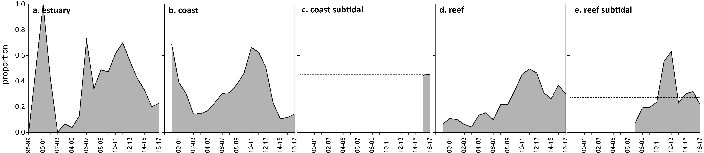
Figure 19. Proportion of total seagrass abundance composed of species displaying colonising traits (e.g. Halophila ovalis) in a) estuary intertidal, b) coastal intertidal, c) coast subtidal, d) reef intertidal and e) reef subtidal habitats (sites pooled) for the Great Barrier Reef (regions pooled) each monitoring period
. Dashed line illustrates Great Barrier Reef average proportion of colonising species in each habitat type (Table 37).

Reproductive effort across the Great Barrier Reef was measured as per area estimates of the number of reproductive structures (spathes, fruits, female and male flowers) produced by any seagrass species during the sampling period. Reef habitats, both intertidal and subtidal reef sites, have the lowest reproductive effort and seed density within seed banks (Figure 20). Reproductive effort has been historically higher in estuary and reef habitats particularly between 2006 and 2008. Reproductive effort generally increased in all habitats after 2011. Declines have since followed with the timing of its onset varying among habitat type: in estuary and coastal habitats, reproductive effirt was lower in 2016–17, but due to the large variability among sites, this does not appear to be a significant reduction. By contrast, at reef intertidal and subtidal sites, reproductive effort declined in 2014 and 2015, respectively, and has remained low in 2016–17. There was low reproductive effort and low density of seeds in the seed bank in reef habitat in all NRMs (except Burnett mary, where no reef sites are monitored), which signals a low seed production rate and vulnerability of these habitats to future disturbances, as recovery may be hampered.

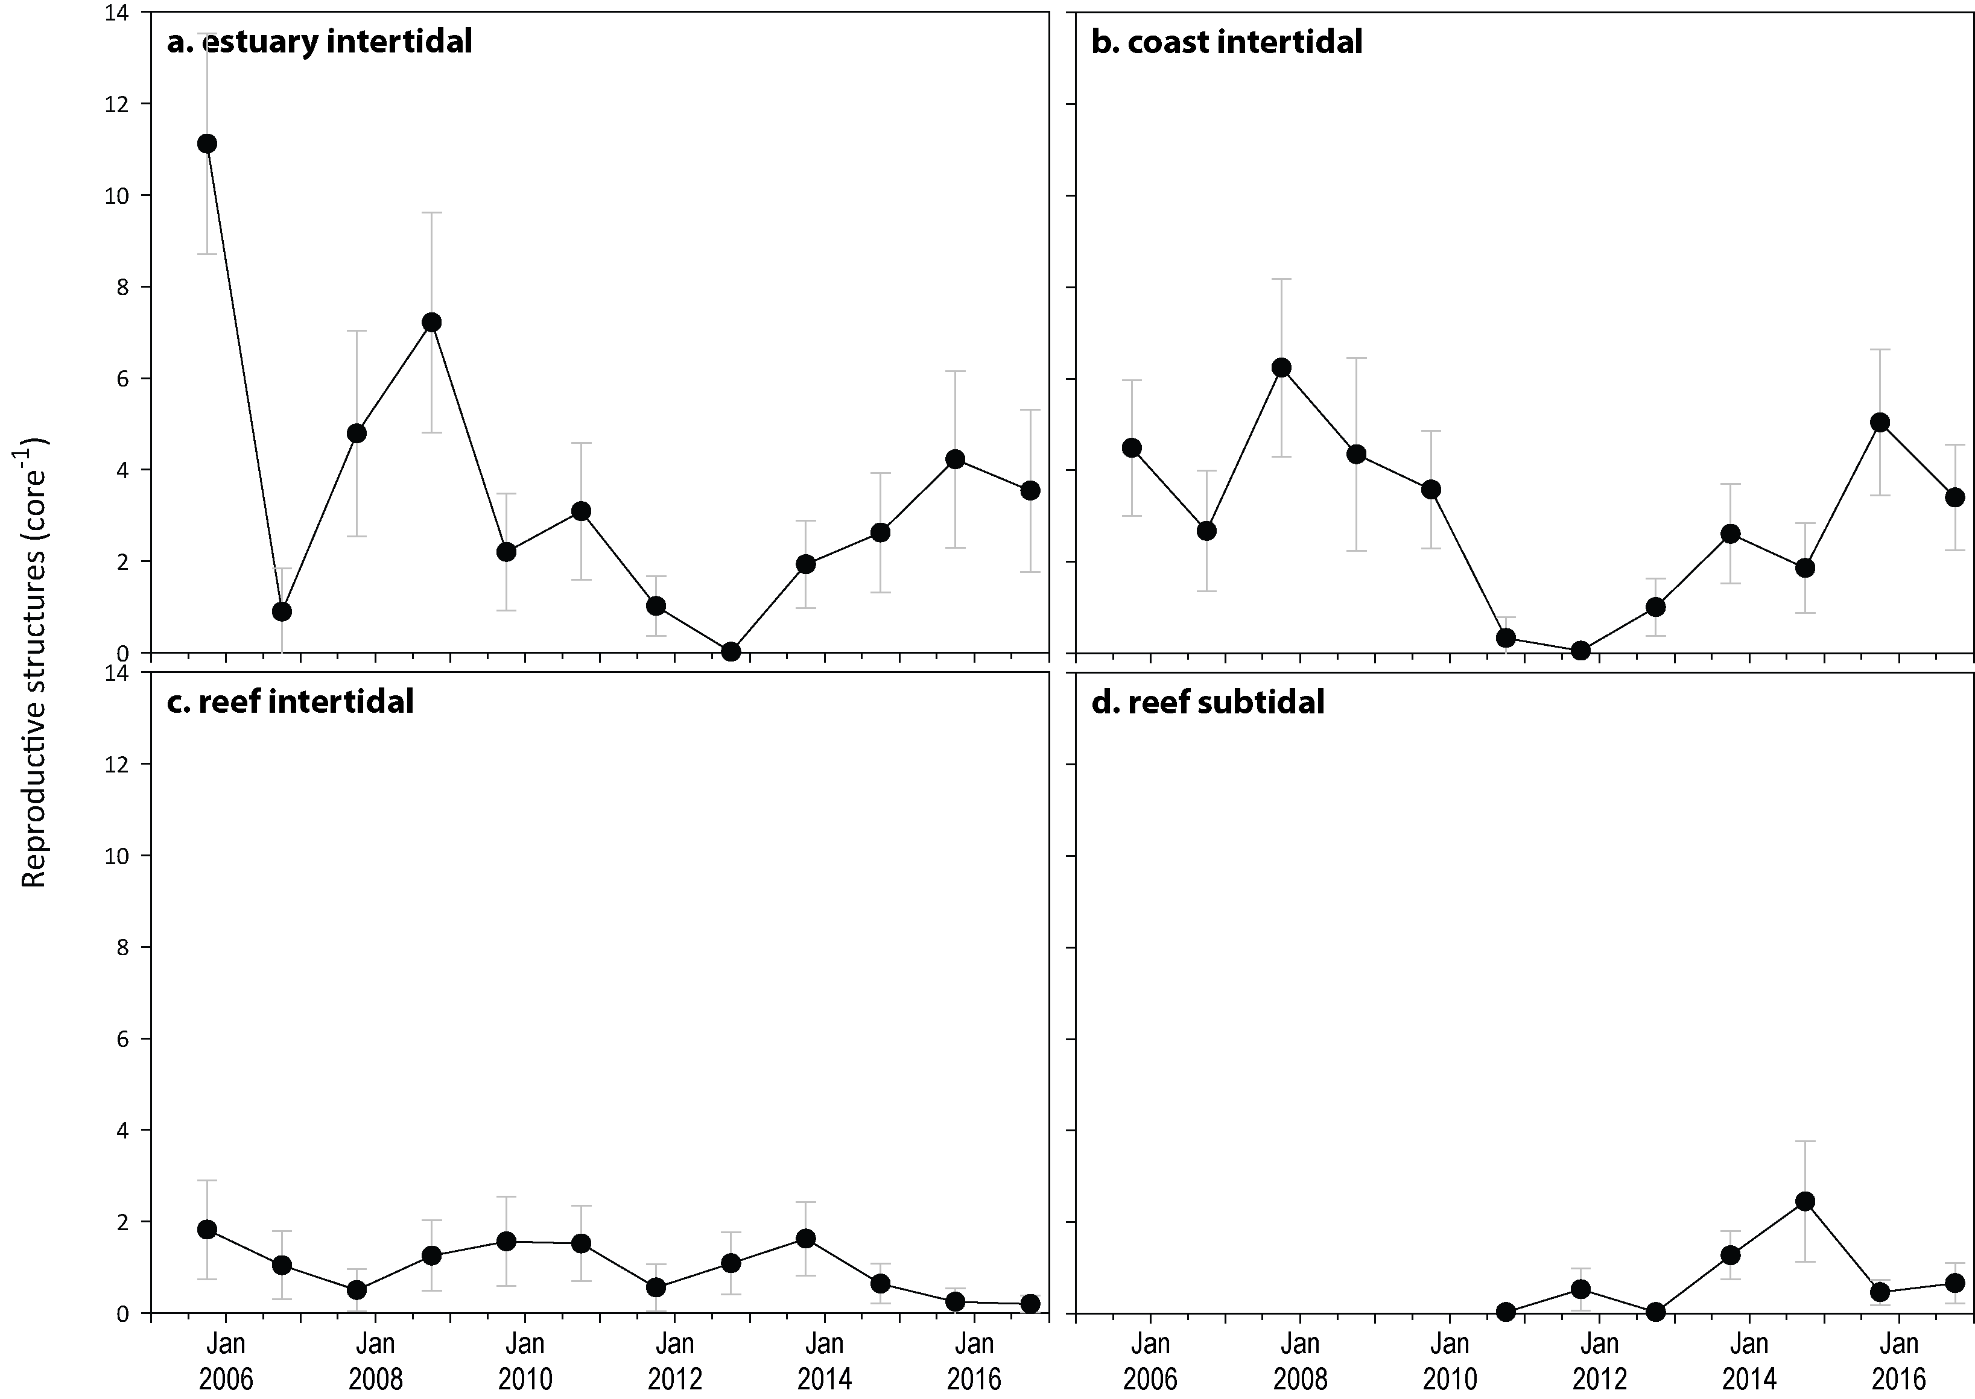
Figure 20. Seagrass reproductive effort (number of reproductive structures produced by all seagrass species) during the late dry of each monitoring period, for a) estuary intertidal; b) coast intertidal; c) reef intertidal; d) reef subtidal.
Reproductive scores were poor in the Burdekin and Mackay Whitsunday NRMs in 2016–17, and very poor in the other four NRMs (Figure 21). Reproductive effort across the Great Barrier Reef NRM regions during 2016–17 improved slightly in Cape York and Mackay Whitsunday NRMs (Figure 21), but declined in all other NRMs.

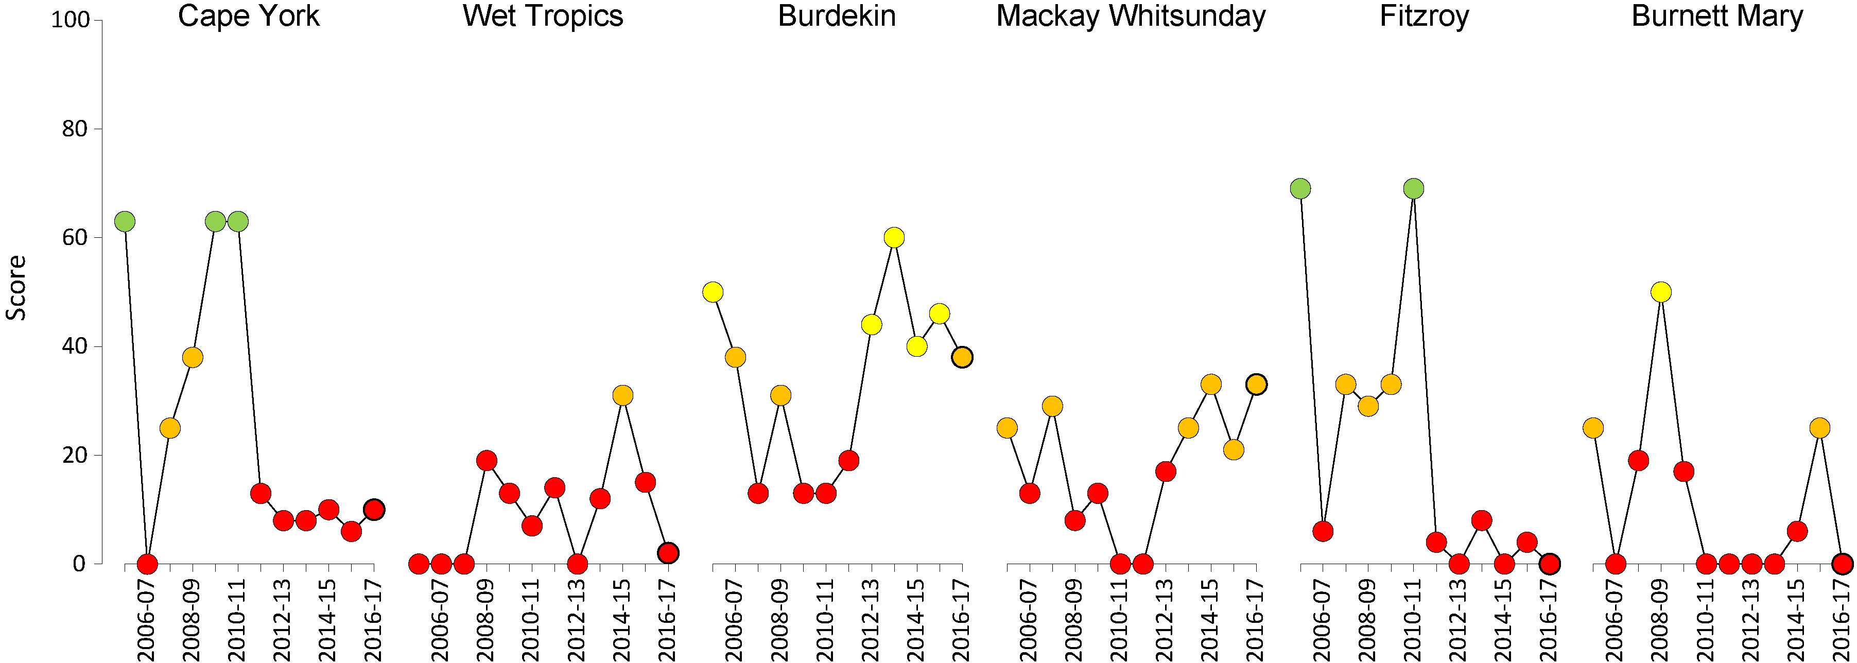
Figure 21. Regional report card scores for seagrass reproductive effort over the life of the MMP
. Bold symbol = 2016–17 monitoring period. For Paddock to Reef reporting scores are categorised in to a five point scale; ■ = very good (81-100), ■ = good (61 - 80), ■ = moderate (41 - 60), ■ = poor (21 - 40), ■ = very poor (0 - 20). NB: Scores are unitless.
Seed banks across the inshore Great Barrier Reef meadows were higher in late dry and greater in coastal than reef or estuarine habitats over the long-term (>10 years) (Figure 22). Coastal seed banks declined between 2008 and 2011, and have subsequently increased, but remain below the 2007-2008 levels. However, in 2016–17 seed banks in other habitats have declined, which could have been caused by poor reproductive success (failure to form seeds) or loss of seed bank (germination or grazing). Seed bank density remains very low at estuary and reef intertidal habitats suggesting a reduced capacity to recover from disturbances. Seed banks are not currently included as a metric in the report card; however, given their importance as a feature of resilience in seagrasses of the Great Barrier Reef, they are being considered for future inclusion as an indicator in the reproduction metric.
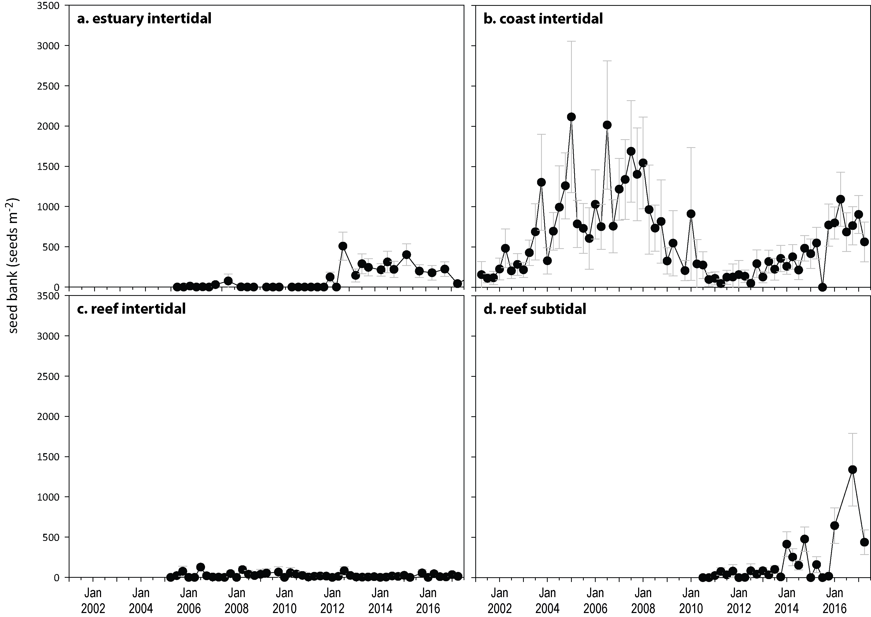
Figure 22. Average seeds banks (seeds per square metre of sediment surface, all sites and species pooled) in Great Barrier Reef seagrass habitats: a) estuary intertidal; b) coast intertidal; c) reef intertidal; d) reef subtidal.

Indicators of environmental condition

Seagrass tissue nutrients
Tissue nutrient concentrations are measured in the late dry (usually October) of the reporting period and differed both across and within habitats between years. It was necessary at some sites (see Table 3) to pool across foundation species as the presence of individual species has not remained constant over time at all locations since monitoring was established. As tissue nutrient ratios between co-occurring foundation species are not significantly different within regions (McKenzie et al. 2012b), by pooling across species and habitat types, some trends are apparent.
Since 2005, median tissue nitrogen concentrations (per cent N) for all habitats have exceeded the global value of 1.8 per cent (Duarte 1990; Schaffelke et al. 2005) (Figure 23). During 2016–17, seagrass leaf per cent N, remained stable relative to the previous monitoring period (Figure 23). Similarly, median leaf tissue phosphorus concentrations (per cent P) remained stabke in all habitats relative to the previous reporting year. All habitats had per cent P values that were very close to the global value of 0.2 per cent (Duarte 1990; Schaffelke et al. 2005) in 2016 (Figure 23). In 2014, leaf tissue per cent P fell below the global median at estuarine habitats for the first time since 2009 (Figure 23).These findings and the low values in 2015 indicate that nutrients were unlikely to be limiting seagrass growth, however, some concerns have been raised as to relevance of the global tissue nutrient values in the Great Barrier Reef because the global tissue nutrient values were derived mainly from temperate and structurally large species (Schaffelke et al. 2005).
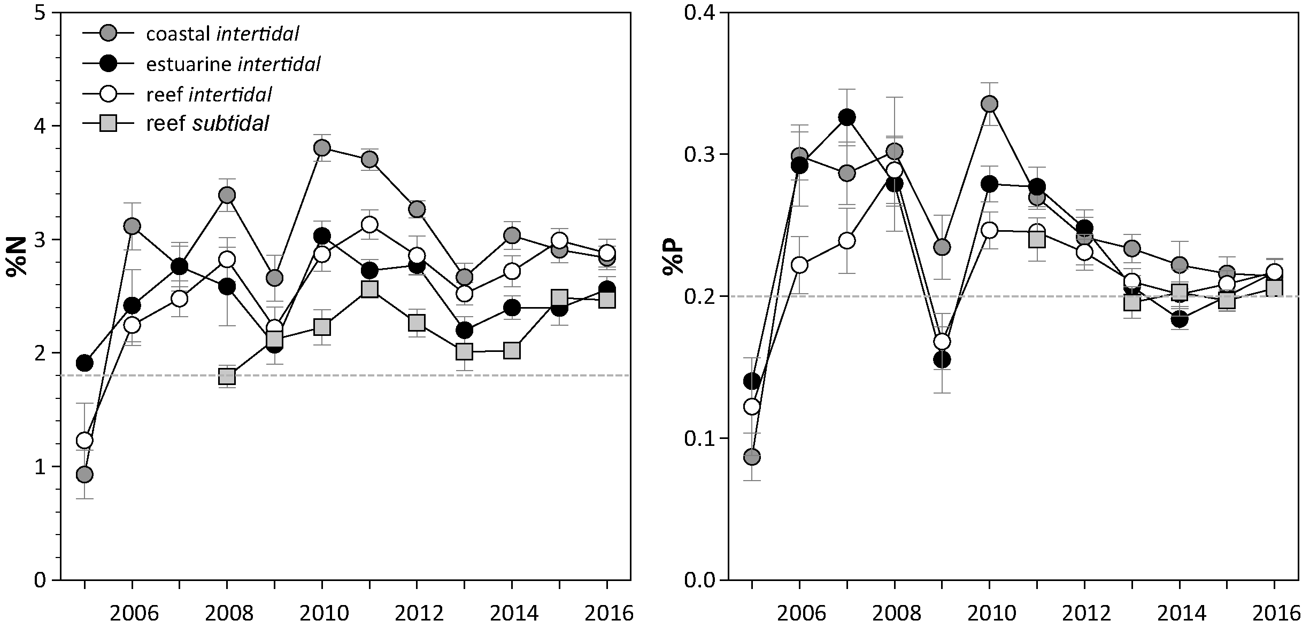
Figure 23. Median tissue nutrient concentrations (± SE) in seagrass leaves for each habitat type (species pooled) over the entire monitoring program
. Dashed lines indicate global median values of 1.8 per cent and 0.2 per cent for tissue nitrogen and phosphorus, respectively (Duarte 1990).
There has been a trend for increasing C:N since 2010 – 2011 in coast and reef intertidal habitats. C:N values further increased at coast and reef intertidal habitats, and increased slightly in reef subtidal habitats after a large drop from 2014 to 2015 (Figure 24). The lowest C:N values were at Hamilton Island (11.9), Yule Point (12.6), and Burrum Heads (14.8). However, most sites in the Great Barrier Reef had increases in the C:N ratio of seagrass leaves, and there was a record number of sites exceeding the threshold of 20. This coincided with reduced N:P ratios. These findings indicate that N has been in lower supply to seagrasses Multiple years of below average rainfall (Table 10) have also been associated with small declines in dissolved inorganic nitrogen concentrations (NOx) particularly since 2014 in some of the subcatchments of the Wet Tropics and Burdekin regions. However, nitrogen availability remains considerably elevated relative to 2006 (Waterhouse et al. 2018).
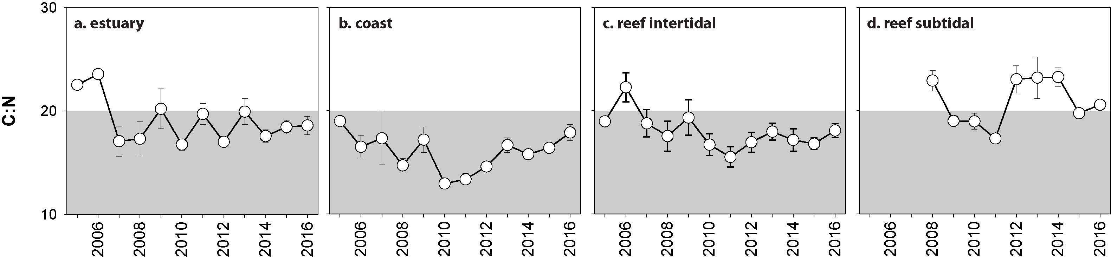
Figure 24. Elemental ratios (atomic) of seagrass leaf tissue C:N for each habitat each year
(± SE) (foundation species pooled). Shaded band represents the accepted guideline seagrass “Redfield” ratio of 20:1 (Abal et al. 1994; Grice et al. 1996). C:N ratios below this line may indicate reduced light availability and/or N enrichment.
Average leaf tissue δ¹⁵N values increased in all habitat types in 2016–17, except at reef intertidal sites in which H. uninervis and C. rotundata decreased their δ¹⁵N (Figure 25). Negative δ¹⁵N values were found in some species at the Cape York reef (C. rotundata and H. uninervis) and coastal sites (T. hemprichii), Wet Tropics coastal (H. uninervis) and reef subtidal sites (C. rotundata), Mackay Whitsunday reef sites (H. uninervis), and the Fitzroy coastal (H. uninervis) and reef (H. uninervis and Z. muelleri) sites (Table 54). Very low or negative values of δ¹⁵N can indicate nitrogen sourced from nitrogen fixation (Peterson and Fry 1987; Owens 1988), which can supply one third to one half of seagrass demand (O'Donohue et al. 1991). Moderate values indicate internal sources from remineralisation (Peterson and Fry 1987; Owens 1988) and higher values (>3‰) can indicate anthropogenic sources (e.g. sewage (Costanzo et al. 2001) or from fertiliser (Udy et al. 1999)). Most seagrasses of the Great Barrier Reef are at the lower to middle range of the global δ¹⁵N for seagrasses (-2 – 11‰) (Fourqurean et al. 1997a; Schubert et al. 2013) between 0.6‰ and 3‰ (Figure 25), suggesting the primary source of N was influence by fertiliser, N fixation and/or sewage (Udy and Dennison 1997b, see also Appendix A2.3). The less negative leaf tissue δ¹³C values at reef sites (Figure 25) suggest lower C uptake (and therefore greater fractionation) (Grice et al. 1996, see also Appendix A2.3), while at coastal sites the more negative values suggest increased C uptake in 2016–17 (Figure 25). The degree of fractionation can be used as an estimate of photosynthetic rate (Grice et al 1996), hence these data suggest the seagrass on the coast and reef intertidal habitats receive more light and photosynthesize at a faster rate.
Phosphorus relative to carbon (C:P) has been relatively stable in 2016–17 compared to the previous two years, with some improvement in coastal habitat only (Figure 26). The increasing C:P indicates a reduction in supply of P, relative to demand and is consistent with reducing per cent P in seagrass tissue and also increased per cent C in some sites and species (Figure 23)(see also Appendix A4.2.6). At a Great Barrier Reef-wide scale, the ratio of N relative to P (N:P) was highly variable within habitat, owing to large variability in trends among regions. In 2016–17 there was a greater number of sites that improved in N:P (i.e. N:P declined), than those that increased. All reef sites improved in N:P except Hamilton Island and Piper Reef (which had a marginal <1 increase in N:P), but there is a wide variation in N:P among sites so this trend for improving N:P is not apparent at the Great Barrier Reef-wide scale. In coastal and reef habitats, there were some sites that improved, and others that declined, depending on NRM. Locations with the highest N:P were at Burrum heads (49.6), Yule Point (36.9), Hamilton Island (36.2), Shelburne Bay (33.3) and Archer Point (32.8) and the ratios were <30 at all other locations.

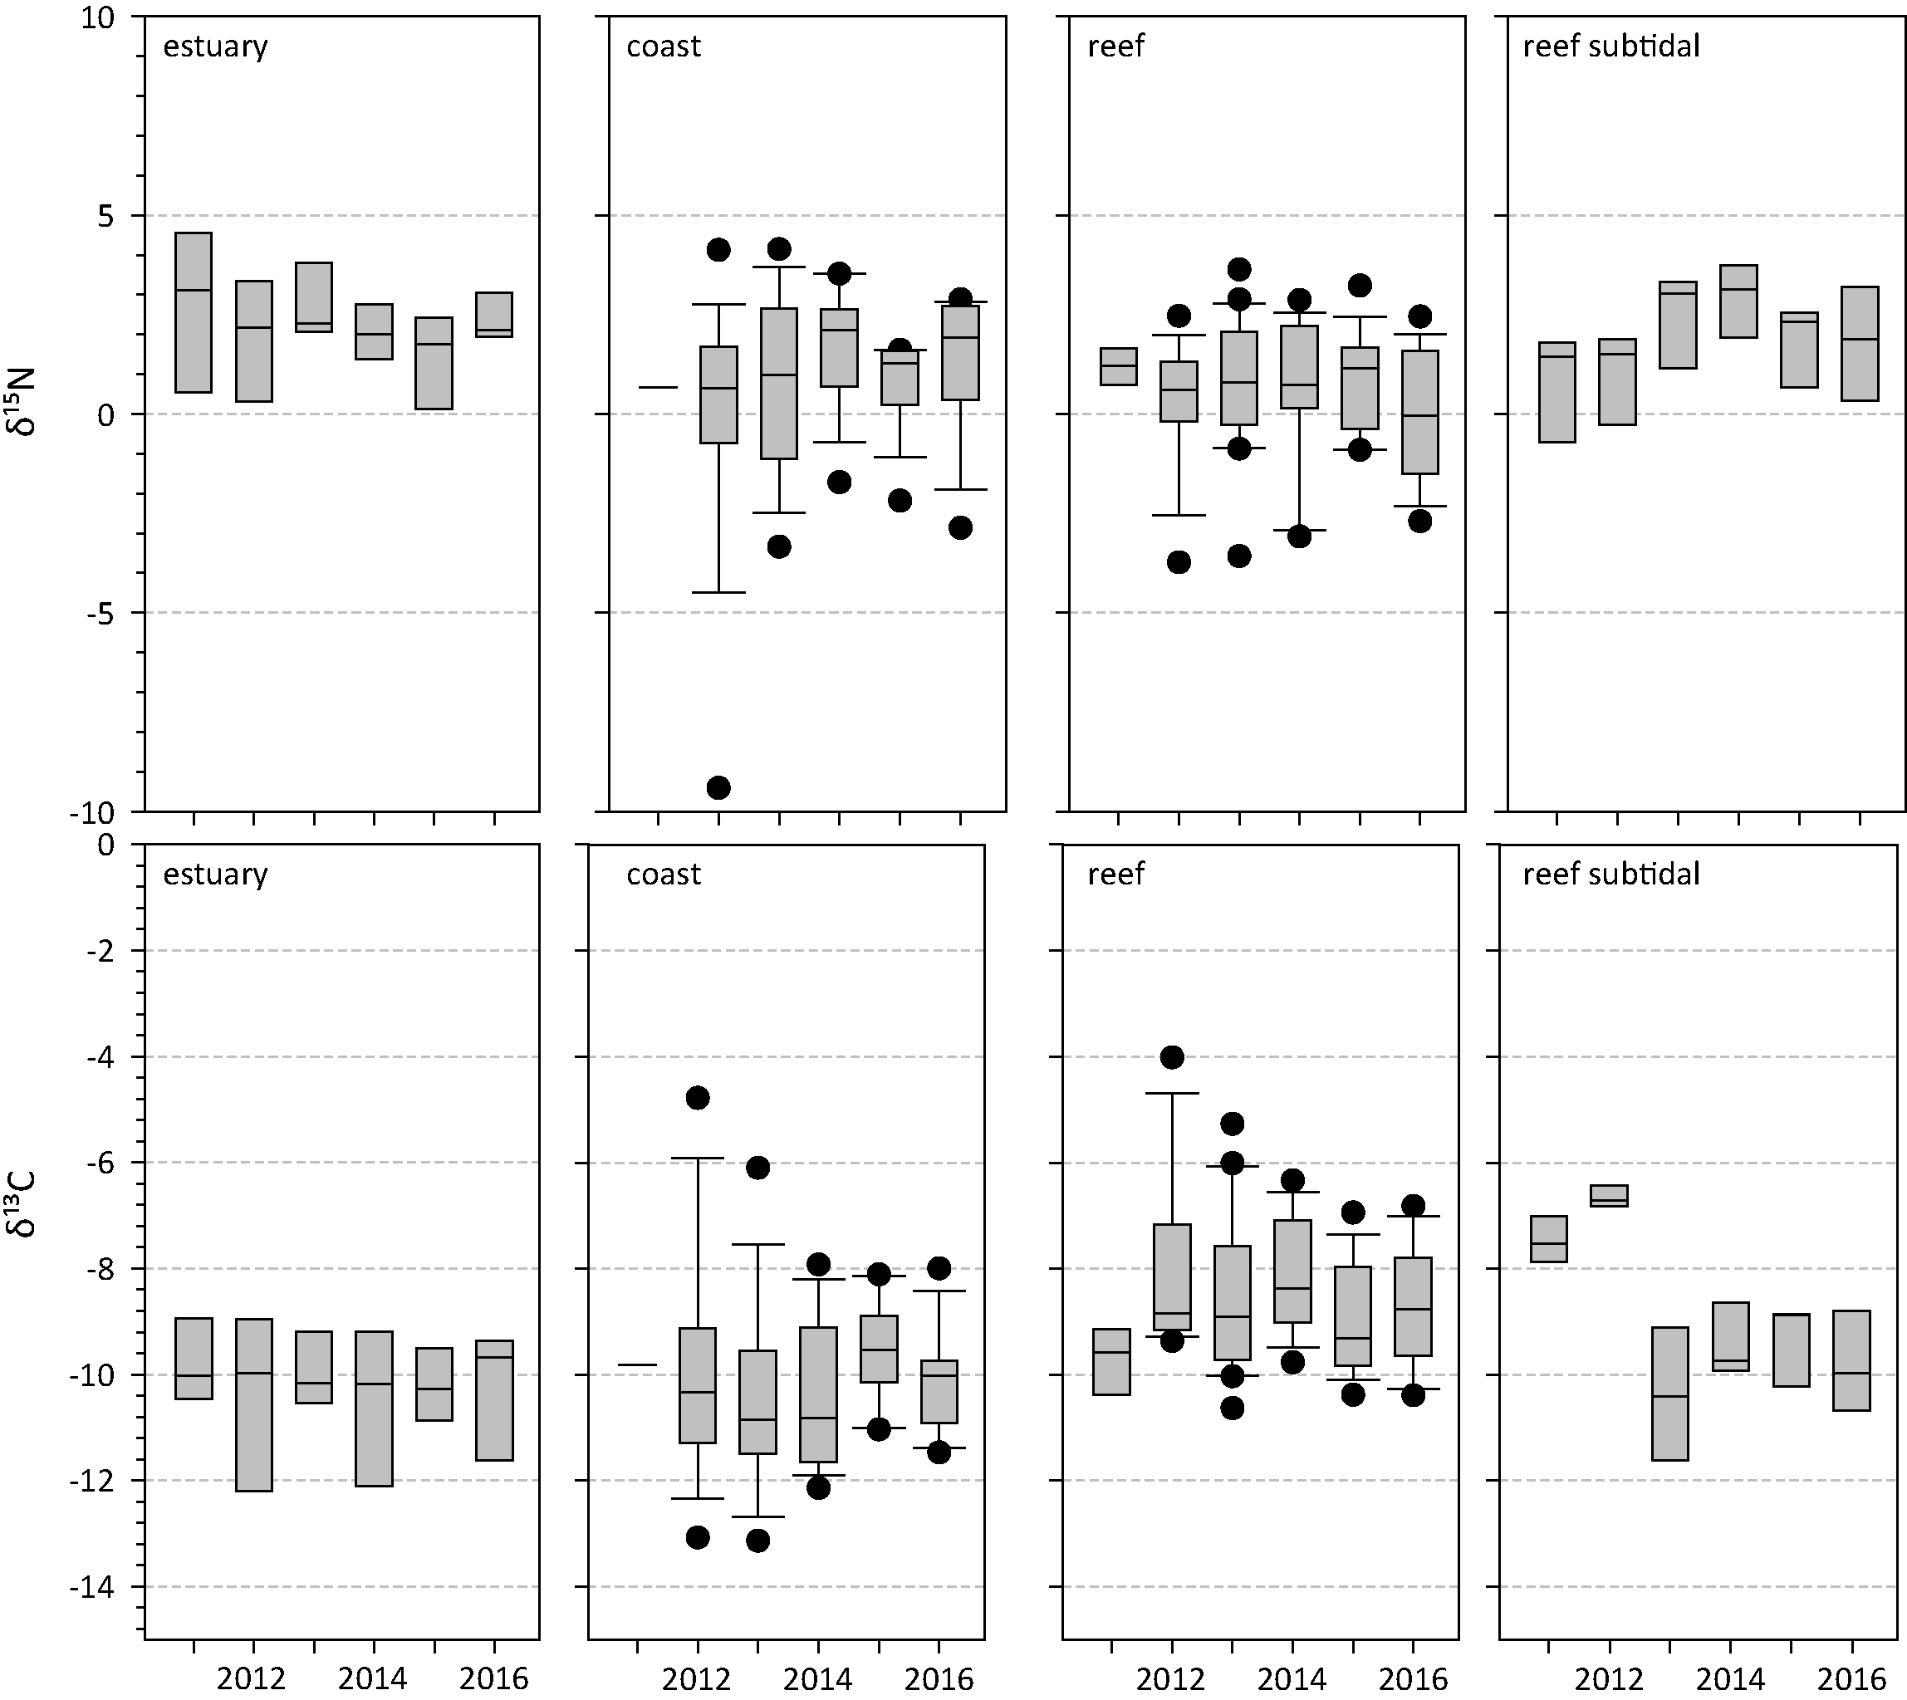
Figure 25. Seagrass leaf tissue δ¹³C and δ¹⁵N concentrations from each Great Barrier Reef seagrass habitat (locations pooled) in the late dry from 2011 to 2016
(± SE). The box represents the interquartile range of values, where the boundary of the box closest to zero indicates the 25th percentile, a line within the box marks the median, and the boundary of the box farthest from zero indicates the 75th percentile. Whiskers (error bars) above and below the box indicate the 90th and 10th percentiles, and the black dots represent outlying points.

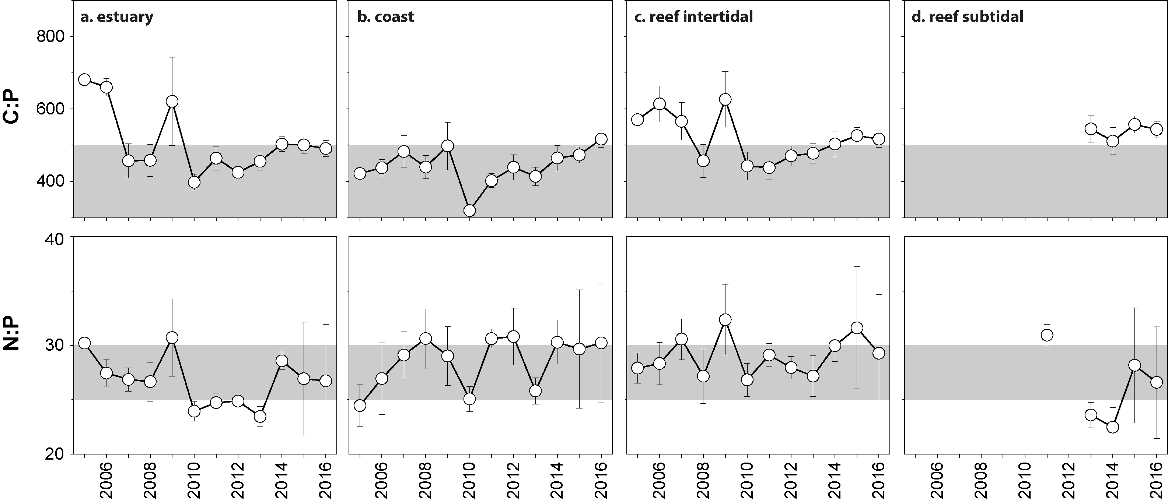
Figure 26. Elemental ratios (atomic) of seagrass leaf tissue C:P and N:P for each habitat each year
(foundation species pooled) (± SE). Horizontal shaded band on the N:P ratio panel is the range over which these nutrients are considered to be in balance in plant tissues, similar to a seagrass “Redfield” ratio (Atkinson and Smith 1983; Duarte 1990; Fourqurean et al. 1992b; Fourqurean and Cai 2001). N:P ratio above this band indicates P limitation, below indicates N limitation and within indicates replete. Horizontal dashed line on the C:P panel at 500 represents the value associated with C:P balance ratio in the plant tissues, C:P values <500 may indicate nutrient rich habitats (large P pool).
Seagrass nutrient status scores (using only C:N) were reduced in the Burnett Mary (from moderate to poor), improved in the Cape York and Fitzroy (from poor to moderate), and remained relatively stable in all other regions in 2016–17 (Figure 27).

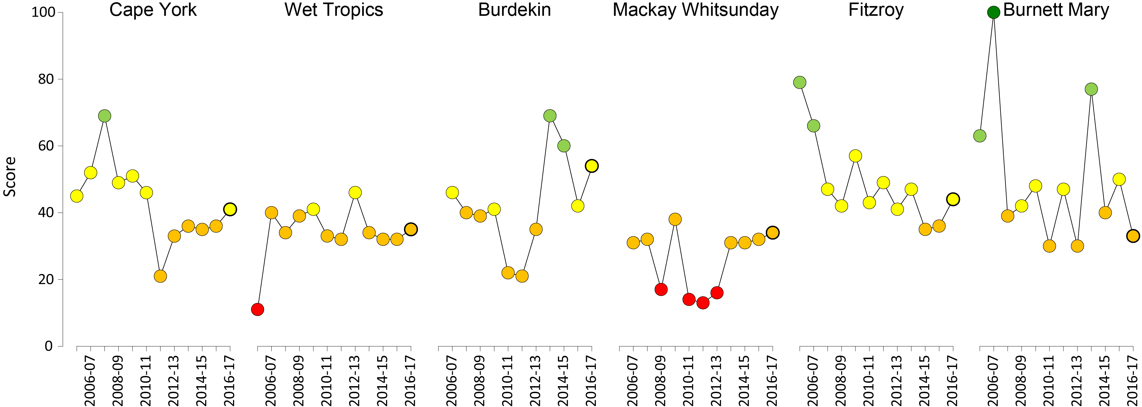
Figure 27. Regional report card scores for seagrass leaf tissue nutrient status (C:N) over the life of the MMP
. Bold symbol = 2016–17 monitoring period. For Paddock to Reef reporting scores are categorised in to a five point scale; ■ = very good (81-100), ■ = good (61 - 80), ■ = moderate (41 - 60), ■ = poor (21 - 40), ■ = very poor (0 - 20).

Seagrass meadow sediments
Coastal subtidal and estuarine seagrass habitats across the Great Barrier Reef had a greater proportion of fine sediments (i.e. mud) than other habitats (Table 11). Sediments at coastal habitats were predominately medium and fine sands, while reef habitats (intertidal and subtidal) were dominated by medium sands (Table 11).
Table 11. Long-term average (±SE) sediment composition for each seagrass habitat (pooled across regions and time) monitoring within the Great Barrier Reef (1999-2017)
Habitat | Mud | Fine sand | Sand | Coarse sand | Gravel
estuarine intertidal | 49.2 ±2.1 | 19.2 ±2.0 | 28.7 ±1.9 | 0.2 ±0.5 | 2.7 ±1.1
coastal intertidal | 28.5 ±2.1 | 31.6 ±2.4 | 34.7 ±2.6 | 0.3 ±0.5 | 4.8 ±1.2
coastal subtidal | 51.2 ±2.3 | 19.0 ±0.6 | 17.2 ±2.7 | 12.6 ±1.6 | 0
reef intertidal | 5.2 ±1.2 | 7.1 ±1.7 | 47.9 ±2.8 | 17.2 ±1.7 | 22.0 ±2.3
reef subtidal | 6.0 ±0.4 | 10.1 ±1.2 | 58.1 ±7.3 | 1.9 ±0.7 | 12.9 ±7.2

Since monitoring was established, the composition of sediments has fluctuated at all habitats, with the proportion of mud declining below the long-term average at estuary and coastal habitats immediately following periods of physical disturbance from storms (e.g. tropical cyclones in 2006 and 2011). Conversely, the proportion of mud increased above the long-term average at reef (intertidal and subtidal) habitats during periods of extreme climatic events (e.g. tropical cyclones and/or flood events). During the 2016–17 monitoring period, the proportion mud decreased at coastal intertidal habitats, but increased across all other habitats relative to the previous year (Figure 28).

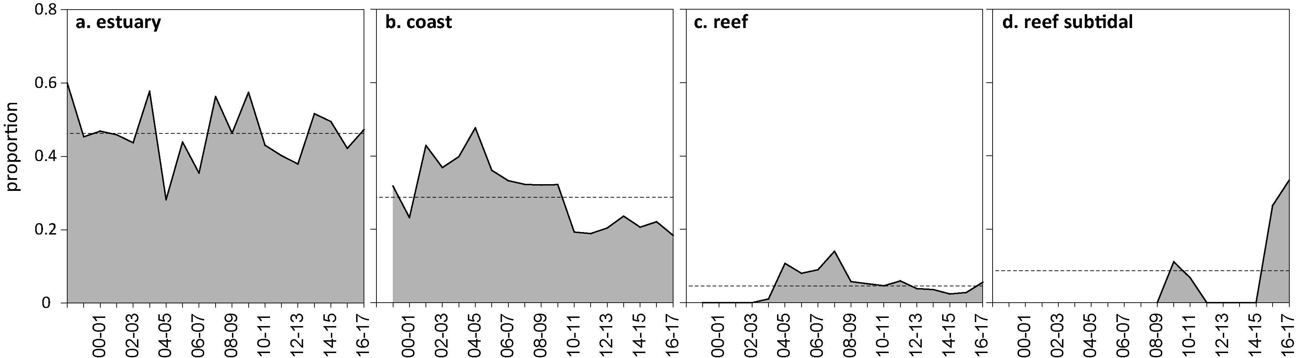
Figure 28. Proportion of sediment composed of mud (grain size <63µm) at Great Barrier Reef seagrass monitoring habitats from 1999-2017.

Epiphytes and macroalgae
Epiphyte cover on seagrass leaves across the Great Barrier Reef was lower in the wet than the dry season in coast and estuary habitats, and similar in the wet and dry in reef habitats in 2016–17, except at reef subtidal sites. Epiphyte cover was around the Great Barrier Reef long-term mean in all habitats except the reef subtidal, where it was above average due to high epiphyte cover at all sites (Figure 29).
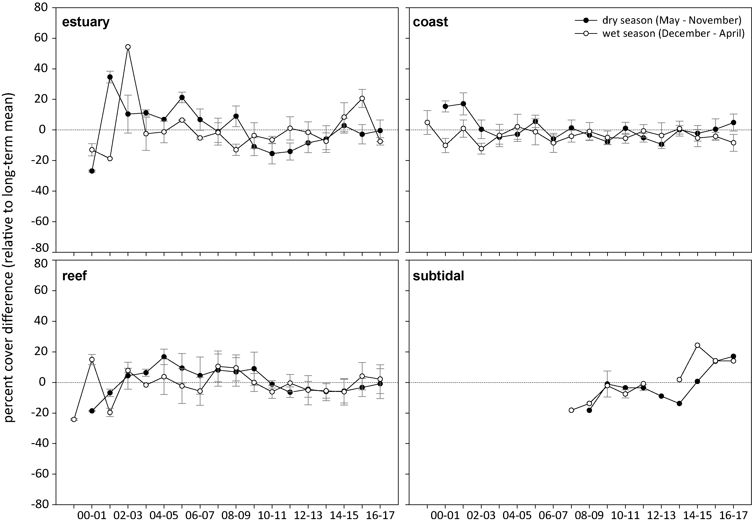
Figure 29. Epiphyte abundance (per cent cover) relative to the long-term average (the zero axis) for each Great Barrier Reef seagrass habitat
(sites pooled, ± SE). Great Barrier Reef long-term average; estuarine = 18.1±3.8 per cent coastal=25.5±5.5 per cent, reef = 23.1±4.2 per cent, subtidal= 18.4±2.7 per cent.
Macroalgae abundance is generally low and stable in the Great Barrier Reef seagrass habitats and there was again little change in 2016–17 (Figure 30). A gradual increase at reef subtidal habitats during the late dry season and the wet season has occurred at all sites over the last 3 years.
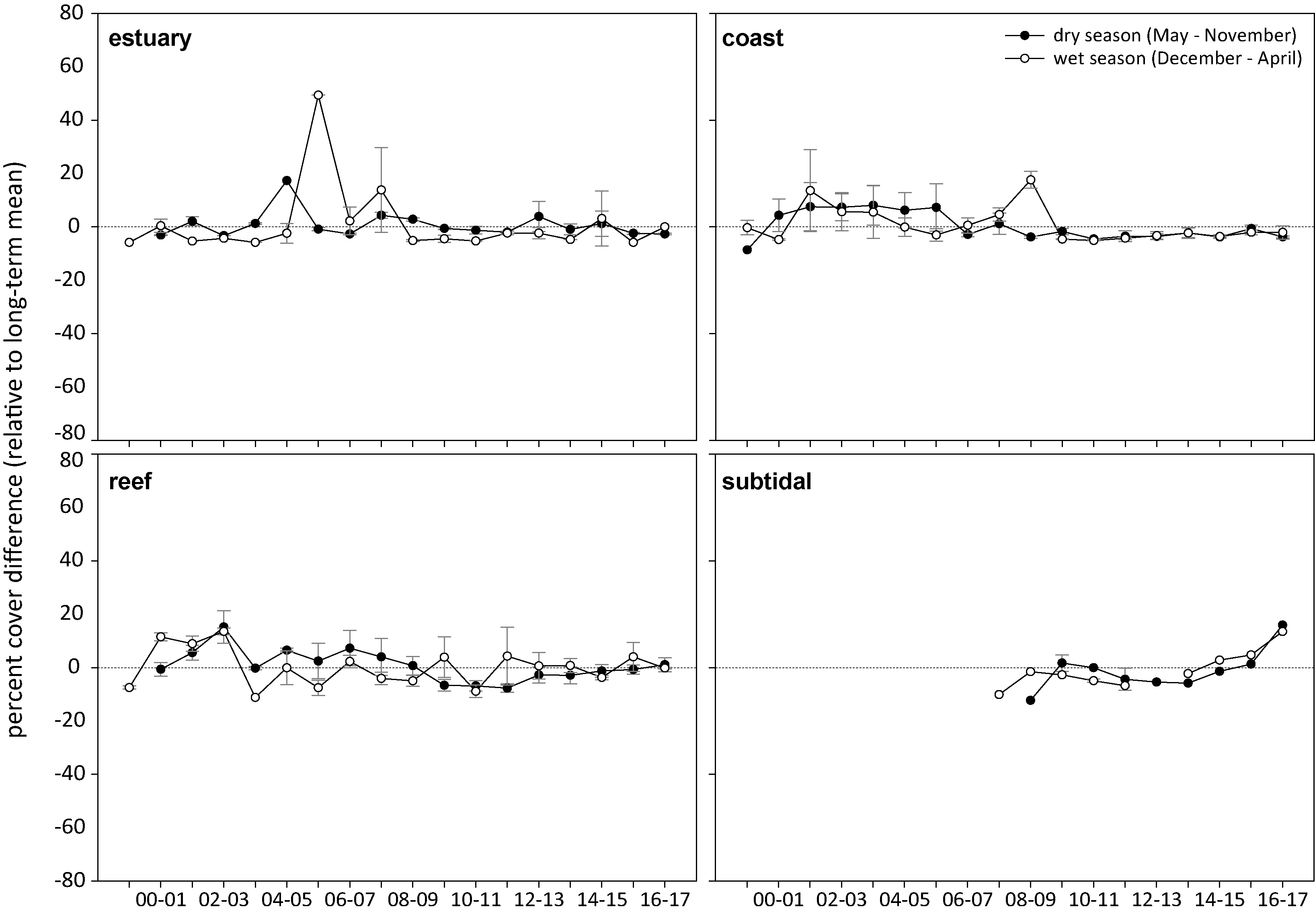
Figure 30. Macroalgae abundance (per cent cover) relative to the long-term average for each inshore Great Barrier Reef seagrass habitat
. (sites pooled, ± SE). Great Barrier Reef long-term average; estuarine = 2.3±1.1 per cent, coastal=2.8±1.3 per cent, reef = 6.8±2.0 per cent, subtidal = 5.6±2.1 per cent.

Cape York

2016–17 summary
Waters entering the Great Barrier Reef lagoon from Cape York catchments are perceived to be of a high quality, with low levels of suspended sediments, nutrients and pesticides. Seagrass growth on reef and coastal habitats in the region appears primarily controlled by physical disturbance from waves/swell and associated sediment movement, with pulsed terrigenous runoff from seasonal rains affecting some coastal regions. In the past 2 years, extreme marine heatwaves have also affected the region. Rainfall in 2016–17 was below the long-term average, but river discharge was slightly increased, due to above-average discharge from the small rivers of Cape York. There was a high frequency of exposure to ‘green’ secondary water at seagrass sites in 2016–17, indicating the possibility of some nutrient enrichment and light limitation. Within-canopy daily light was below the long-term average but was the highest in the Great Barrier Reef; however light data was only recorded from October – March, as monitoring has been reduced to once per year. A heatwave swept through the Great Barrier Reef, and also affected Cape York for 58 days, and temperature was above the long-term median for the whole year except in July 2016.
One location in Cape York (Archer Point) has been monitored since 2005, while locations further north have only been monitored from 2011. This makes it difficult to assess long-term trends across Cape York. On average, seagrass abundance decreased relative to the previous period at all sites, except at Bathurst Bay and Piper Reef, but long-term trends (GAM plots), indicate that conditions have been relatively stable throughout the region since 2011. Reproductive effort and seed bank density at coastal sites reached record high levels in 2016–17, while reef sites had negligible seeds in the seed bank and low reproductive effort with a very poor rating at both coastal and reef sites. Seagrass leaf tissue nutrients (C:N) increased at all sites and just exceeded the threshold (C:N = 20) indicating nitrogen limitation for the first time since monitoring began, but remained just below the threshold at reef sites. Due to the reduction in seagrass abundance, possibly due to thermal stress, the regional seagrass index reduced slightly over the last 12 months, but remains poor (Figure 31).
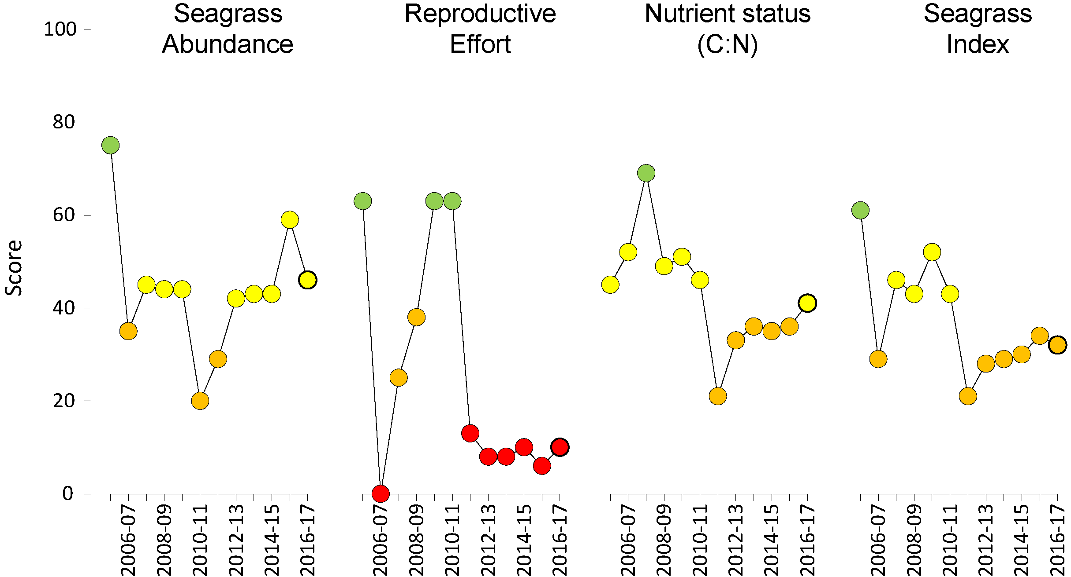
Figure 31. Report card of seagrass condition (indicators and index) for the Cape York NRM region
(averaged across habitats and sites). Bold symbol = 2016–17 monitoring period. Values are indexed scores scaled from 0-100; ■ = very good (81-100), ■ = good (61 - 80), ■ = moderate (41 - 60), ■ = poor (21 - 40), ■ = very poor (0 - 20). NB: Scores are unitless.

Climate and environmental pressures
Rainfall during the wet season was below the long-term average in 2016–17 particularly in the largest basin within the region, the Normanby River. Discharge was slightly above-average for the region as a whole, except in the Normanby and Stewart River basins in which discharge was similar to the long-term median (Table 12). Wind was below the long-term average following two previous years of windy conditions. The inshore waters of Cape York had predominantly secondary water type (‘green’, phytoplankton rich water), and some ‘brown’ turbid water exposure through the wet season (December-April; Table 13, Figure 32). Shellburne Bay had the highest exposure to turbid primary water (f_{P} = 79 per cent weeks). The frequency of exposure to both ‘brown’ and ‘green’ water (f_{(P+S)}) ranged from 21 per cent to 94 per cent of weeks at seagrass monitoring sites (Table 13).
Table 12. Summary of environmental conditions at monitoring sites in Cape York region in 2016–17 compared to the long-term average (long-term range indicated for each data set).
 | Long-term average | 2016–17
Rainfall (1965-2017) | 8.1 mm d⁻¹ | 6.9 mm d⁻¹
River discharge (1970-2017) | 13,166,623 L yr⁻¹ | 14,596,810L yr⁻¹
Turbid water exposure (2006-2017) | 83 per cent | 81 per cent
Daytime tidal exposure (2011-2017) | 70 hr yr⁻¹ | 86 hr yr⁻¹
Wind (2002-2017) | 126 days yr⁻¹ | 101 days yr⁻¹
Within canopy temperature (2011-2017) | 26.9°C (41.6°C) | 27.8°C (39.86°C)
Within canopy light (2012-2017) | 17.3 mol m⁻² d⁻¹ | 14.6 mol m⁻² d⁻¹

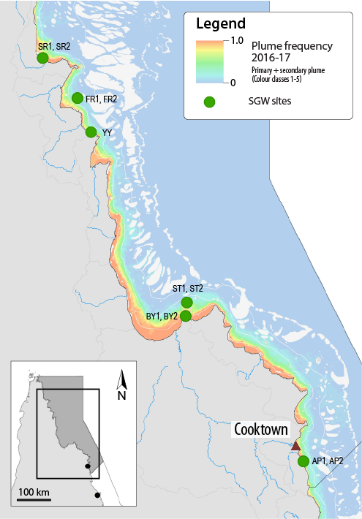
Figure 32. Frequency of exposure to turbid water (colour classes 1-5) in the Cape York NRM, wet season (December 2016 – April 2017) composite
. Frequency calculated as number of weeks in wet season exposed to primary or secondary water (colour classes 1 – 5). Each colour class category is described by mean water quality values for TSS, CDOM, chlorophyll a and K_{d} (PAR) (Devlin et al. 2015; Waterhouse et al. 2018). For site details, see Tables 3 & 4.
Table 13. Water type at each site derived from MODIS true colour images
as colour classes of turbid primary water (class 1 – 4 red/brown), nutrient/chlorophyll-enriched secondary water (class 5, green), and tertiary (some freshwater/CDOM influence) or no plume influence (class 6 and 7 respectively, blue), for 22 weeks from December 2016 – April 2017. Also shown, median wet season colour class (Med), frequency of primary water as f_{(P)}, the frequency of secondary water as f_{(S)}, and the frequency of primary or secondary as f_{(P+S)}. *denotes data obtained from adjacent pixel.

Site | 1 | 2 | 3 | 4 | 5 | 6 | 7 | 8 | 9 | 10 | 11 | 12 | 13 | 14 | 15 | 16 | 17 | 18 | 19 | 20 | 21 | 22 | f_{(P)} | f_{(S)} | f_{(P+S)}
SR1, SR2 | 4 | 4 | 4 | 2 |  |  | 5 |  | 2 | 4 |  |  | 1 | 4 | 5 |  | 5 | 2 | 1 |  |  | 1 | 0.79 | 0.21 | 1.00
FR1, FR2 | 6 | 6 | 6 | 6 |  |  | 6 | 6 | 6 | 6 |  | 6 | 5 | 6 | 5 | 6 | 6 | 5 | 6 | 5 |  | 6 | 0.00 | 0.22 | 0.22
YY1* | 5 | 5 | 5 | 5 |  |  | 5 | 5 | 5 |  | 5 | 6 | 5 | 5 | 5 | 5 | 5 | 5 |  | 5 |  | 5 | 0.00 | 0.94 | 0.94
ST1, ST2 | 5 | 5 | 5 | 6 | 5 | 6 |  | 5 | 5 |  | 5 | 5 | 5 | 5 | 5 | 5 | 5 | 5 | 5 | 5 | 5 | 5 | 0.00 | 0.90 | 0.90
BY1, BY2* | 5 | 5 | 5 | 5 | 5 | 5 |  | 4 | 5 |  | 5 | 5 | 2 | 5 | 4 | 5 | 4 | 4 | 5 | 2 | 4 | 4 | 0.40 | 0.60 | 1.00
AP1, AP2* | 5 | 5 | 5 | 5 | 6 | 6 |  | 5 | 5 |  | 5 | 5 | 5 | 5 | 5 | 6 | 6 | 5 | 4 | 4 | 4 | 5 | 0.15 | 0.65 | 0.80
Daily light at Cape York locations has been monitored since October 2012 when sites were established. However, in the 2014-15 reporting year, sampling was reduced to once per year, and loggers record for just 5 – 6 months after deployment, and after sampling (i.e. Oct-Mar/Apr). Furthermore, in these remote locations, missed sampling events caused by weather and logistics cause prolonged gaps in data (e.g. at SR in 2016–17). However, in 2016, there was a thermal anomaly that affected Cape York, and this led to an additional survey in June to two of the sites (Stanley Island and Bathurst Bay) to assess the effects of the heatwave on the condition of the seagrass. This provided an opportunity to replace the light loggers leading to very high level of light data retrieval (100 and 99% per cent, respectively) in 2016–17. Daily light is generally very high at all Cape York sites (long-term average, 17.0 mol m⁻² d⁻¹, Great Barrier Reef-wide , 13.6 mol m⁻² d⁻¹); however, the trends are highly variable among sites with no distinct seasonal pattern that characterises benthic light over the past four years (Figure 33). In 2016–17, I_{d} was lower than the long-term average due to low light levels at Archer Point and Piper Reef, but the reason for these low light levels is not apparent.
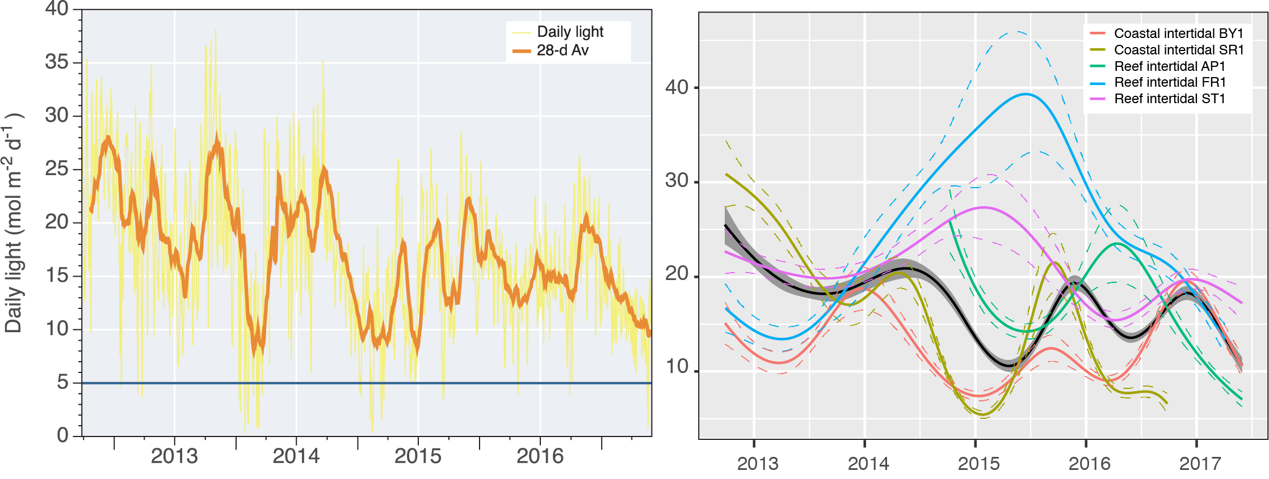
Figure 33. Daily light (mean) at Cape York sites with 28-d rolling average from 2012 to 2017 (left) and GAM plots (right)
. with the black line showing mean trend for all sites (±95 per cent confidence interval in grey shade) and coloured lines (with CI’s) for each location. Results of statistical analysis (GAM) and site-specific graphs (site-level daily light data plus 28-d rolling average) are shown in Appendix 5.
Coastal and reef seagrass meadows of Cape York are frequently exposed to high temperatures; however, a heatwave again swept across Cape York in the 2016–17 summer. In the summer of 2016–17 within-canopy temperature exceeded 35°C in all months except July 2016, which is the longest sustained period of elevated temperature recorded, and the greatest number of days exceeding 35°C (58 d) at the Cape York seagrass sites. The hottest months were in March (> 35°C for 14 days) and in January (> 35°C for 13 days) (Figure 34a). Of these, there were 11 days that exceeded 38°C, but no days > 40°C, which is the critical threshold leading to photoinhibition and mortality in some species (Campbell et al 2007, Collier et al 2014). Temperature exceeded the median for 41 weeks of the year (Figure 34b) and average annual within canopy temperatures in 2016–17 were almost 1°C above the long-term average (Table 12).
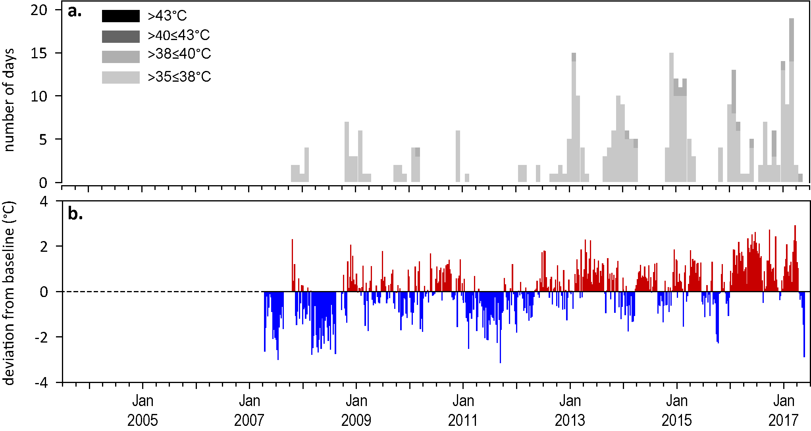
Figure 34. Inshore within canopy sea temperature for intertidal seagrass habitats in the Cape York NRM region from April 2007 to June 2017
: a) number of days when temperature exceeded 35°C, 38°C, 40°C and 43°C within each season (thresholds adapted from Campbell et al. 2006); b) deviations at Archer Point from 7-year mean weekly temperature records (weeks above the long-term average are represented as red bars and the magnitude of their deviation from the mean represented by the length of the bars, bars are blue for weeks with temperatures lower than the average and are plotted as negative deviations). Dashed line represents period when monitoring not established.

Indicators of seagrass condition
Three seagrass habitat types were assessed across the Cape York region in 2016–17, with data from 12 of the 15 long-term monitoring sites (Table 14).
Table 14. List of data sources of seagrass and environmental condition indicators for each seagrass habitat type in the Cape York NRM region
. For site details see Table 3 and Table 4. Open square indicates not measured in 2016–17. drop camera sampling (QPWS), *Seagrass-Watch.
Habitat | Site |  | abundance | composition | distribution | Reproductive effort | seed banks | Leaf tissue nutrients | Meadow sediments | Epiphytes | Macroalgae
coastal intertidal | BY1 | Bathurst Bay
coastal intertidal | BY2 | Bathurst Bay
coastal intertidal | SR1 | Shelburne Bay
coastal intertidal | SR2 | Shelburne Bay
coastal subtidal | LR1 | Lloyd Bay
coastal subtidal | LR2 | Lloyd Bay
reef intertidal | AP1 | Archer Point
reef intertidal | AP2 | Archer Point
reef intertidal | FR1 | Farmer Is. (Piper Reef)
reef intertidal | FR2 | Farmer Is. (Piper Reef)
reef intertidal | ST1 | Stanley Island (Flinders Group)
reef intertidal | ST2 | Stanley Island (Flinders Group)
reef intertidal | YY1* | Yum Yum Beach (Weymouth Bay)
Reef subtidal | FG1 | Flinders Island (Flinders Group)
Reef subtidal | FG2 | Flinders Island (Flinders Group)

Seagrass abundance, composition and extent
The seagrass abundance score reduced in the Cape York region in 2016–17, but remained moderate (Figure 31). The decline in seagrass abundance in 2016–17 was attributed to reductions in cover at all sites and habitats, except in the coastal intertidal habitat at Bathurst Bay (Figure 35, Figure 36).
The most southern location (Archer Point reef habitat) has been monitored for the greatest period of time in the region, while the other four locations were established in 2012 (Figure 36). Since monitoring was established at Archer Point (AP1) in 2003, seagrass cover has generally followed a seasonal trend with higher abundance in late dry period (McKenzie et al. 2012a). Previous analysis (reported in 2014-15) at all locations in Cape York has shown that variation in seagrass cover at reef habitats does not follow a seasonal pattern at most locations: 16.2 per cent in the late dry and 15.9 per cent in late wet season. Seasonality can no longer be interpreted as sites are visited just once per year in the late dry.
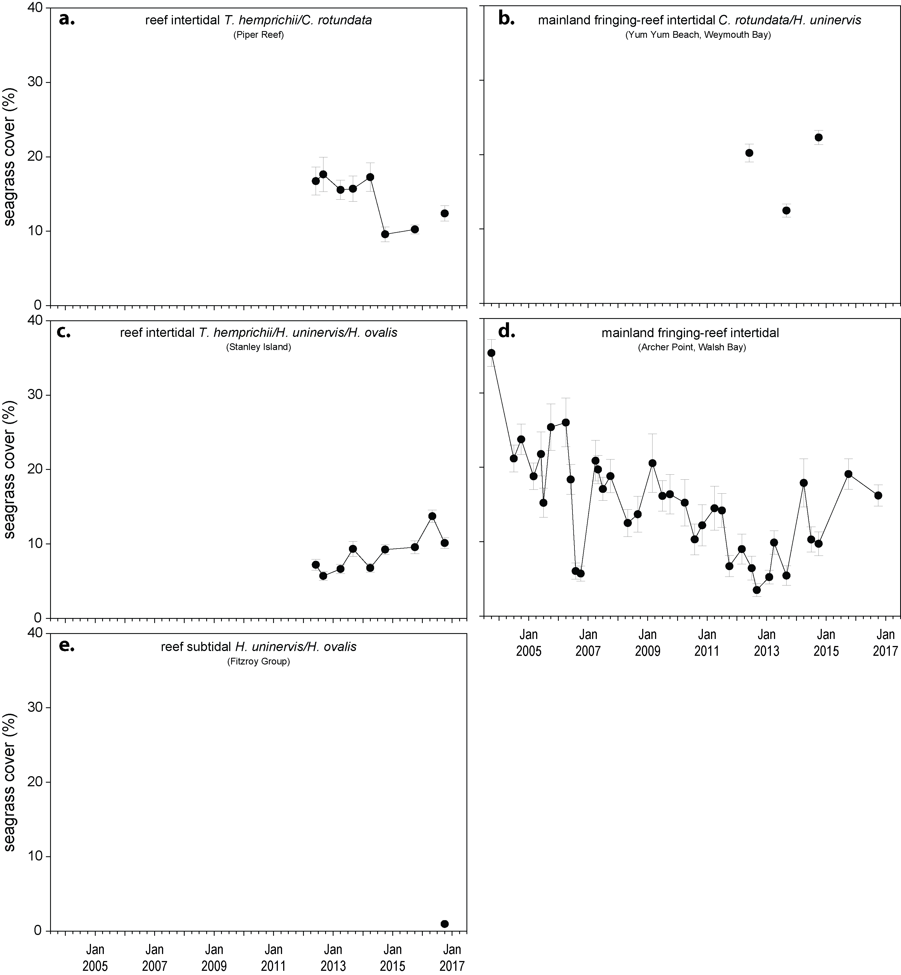
Figure 35. Seagrass abundance (per cent cover ± SE) at inshore intertidal reef habitats (replicate sites pooled) in the Cape York NRM.

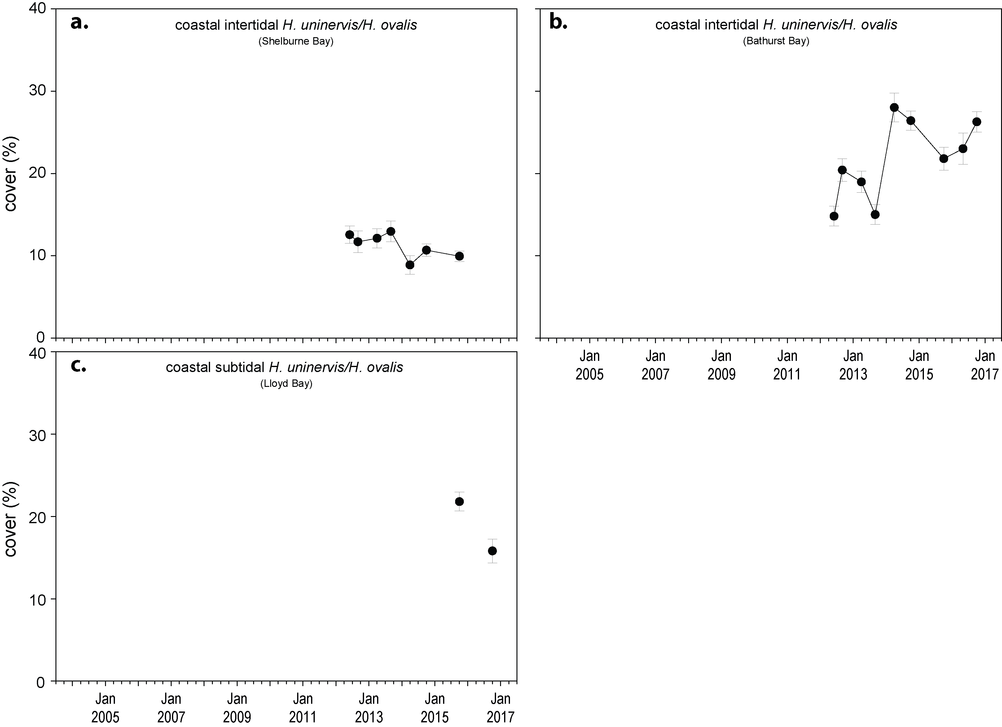
Figure 36. Seagrass abundance ( per cent cover ± SE) at inshore intertidal coastal habitats (sites pooled) in the Cape York NRM region.
An examination of the long term trend across the Cape York NRM region shows seagrass per cent cover progressively decreased from 2003 to 2012, but has remained relatively stable in coastal and reef habitats since 2011 (Figure 37, Figure 38).
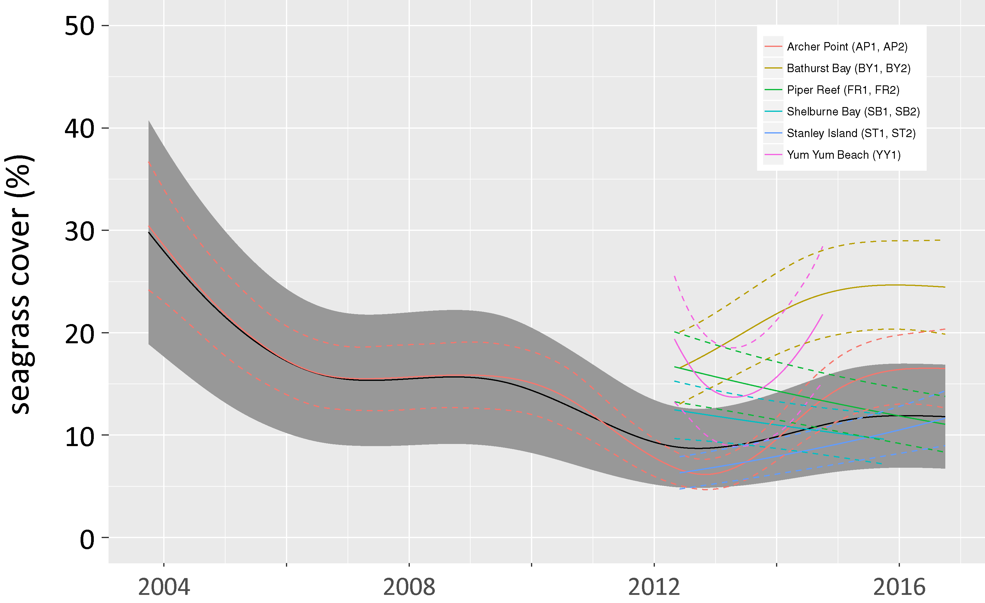
Figure 37. Regional and location temporal trend in seagrass abundance in the Cape York NRM region from 2003 to 2016 represented by a GAM plot.
Regional trend (all locations pooled) represented by black line with grey shaded area defining 95 per cent confidence intervals.
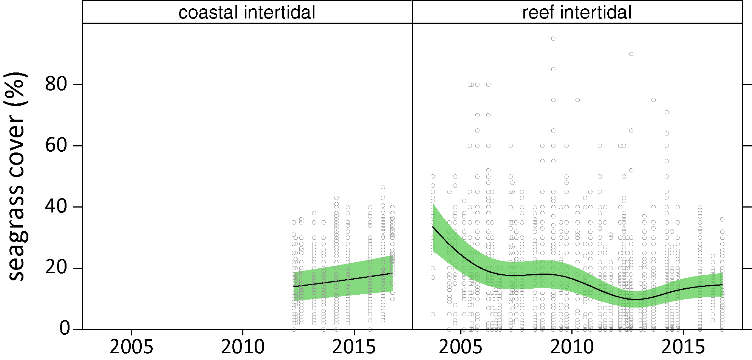
Figure 38. Temporal trends in seagrass abundance for each habitat in the Cape York NRM region represented by a GAM plot.
Regional trend (all locations pooled) represented by black line with green shaded area defining 95 per cent confidence intervals and quadrat measures represented by grey circles.

Seagrass meadows in the Cape York NRM region were composed of below Great Barrier Reef average (MMP sites) proportion of species displaying colonising traits in 2016–17, except at the newly established coastal subtidal site (Figure 39). Fluctuations over the long-term suggests the meadows are dynamic in nature.
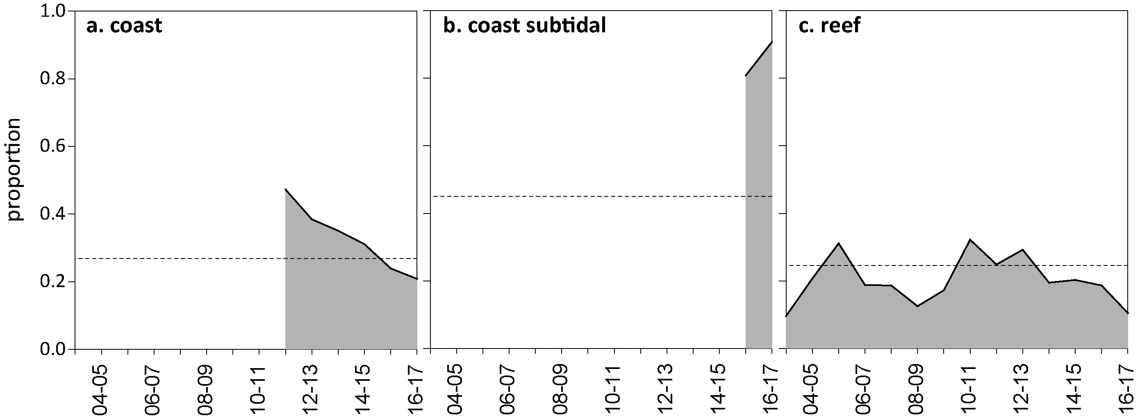
Figure 39. Proportion of seagrass abundance composed of species displaying colonising traits at inshore habitats in the Cape York region
.The dashed line represents Great Barrier Reef long-term average for each habitat type.
Seagrass spatial extent mapping was conducted within all monitoring sites to determine if changes in abundance were a consequence of the meadow landscape changing and to indicate if plants were allocating resources to colonisation (asexual reproduction) (Appendix A4.2.4). Prior to 2012, the only meadow extent mapping in the Cape York NRM region was conducted at Archer Point. The meadows within monitoring sites on the reef flat at Archer Point have fluctuated within and between years (Figure 40), primarily due to changes in the landward edge and appearance of a drainage channel from an adjacent creek (data not presented). Post 2011, additional reef meadows and coastal meadows in the Cape York NRM region were included. Overall, meadow extent has been relatively stable in reef meadows, but there has been significant but small decline in coastal meadows since 2015 (Figure 40; Appendix A4.2.4).
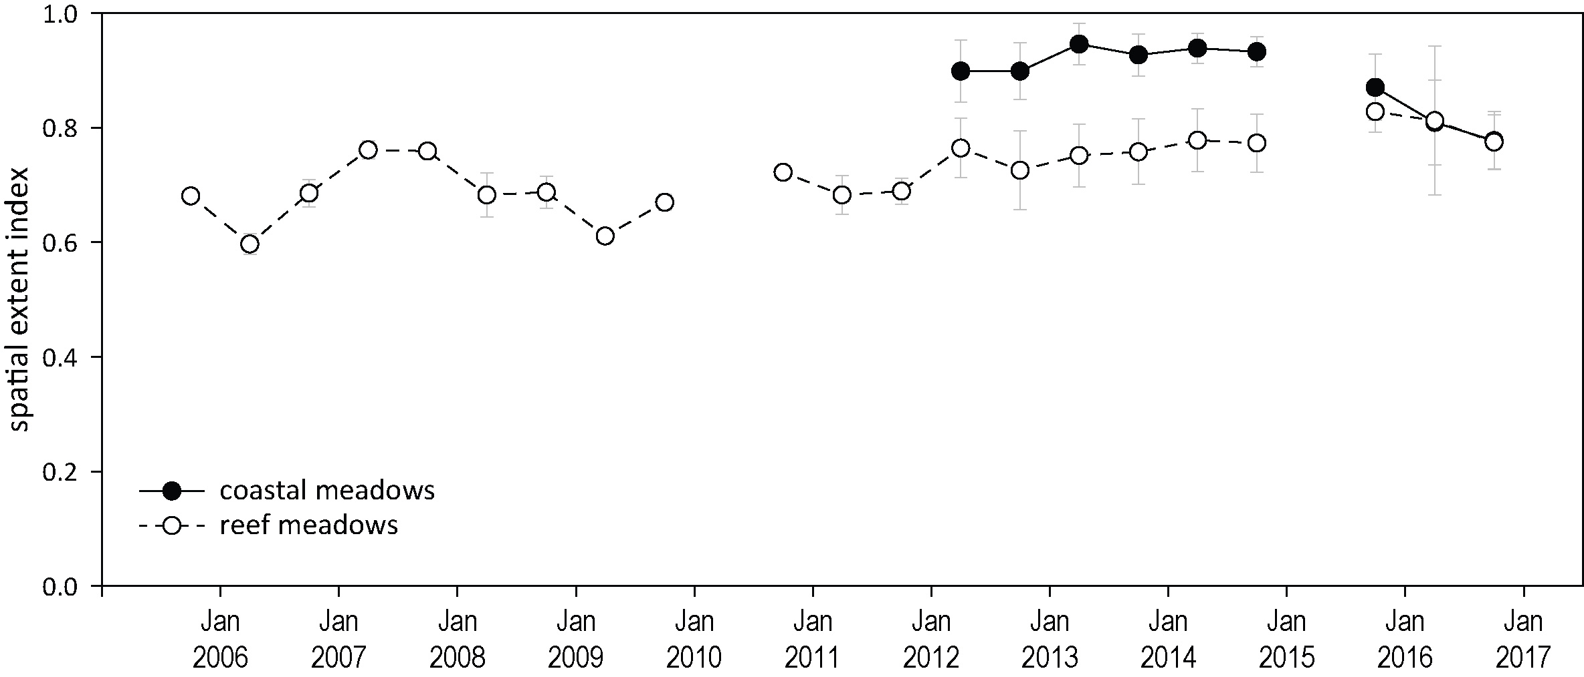
Figure 40. Change in spatial extent of seagrass meadows within monitoring sites for each habitat and monitoring period across the eastern Cape York NRM region.

Seagrass reproductive status
The seed bank is dominated by Halodule uninervis in Cape York sites. Although Cymodocea plants were present across reef meadows, no seeds have been found since monitoring commenced. Seagrass seed banks in Cape York meadows were often larger in the late dry than late wet (Figure 41). Seed density has been increasing and was considerably higher at coastal sites than at reef sites in 2016–17. At reef sites, there has been few or no seeds recorded since 2013, and these meadows may have poor recovery rates from seeds if there is substantial decline in seagrass abudance. Total reproductive effort across the region remains low with a report card rating of very poor (Figure 31), despite significant increases in reproductive effort in coastal habitats (Figure 41).
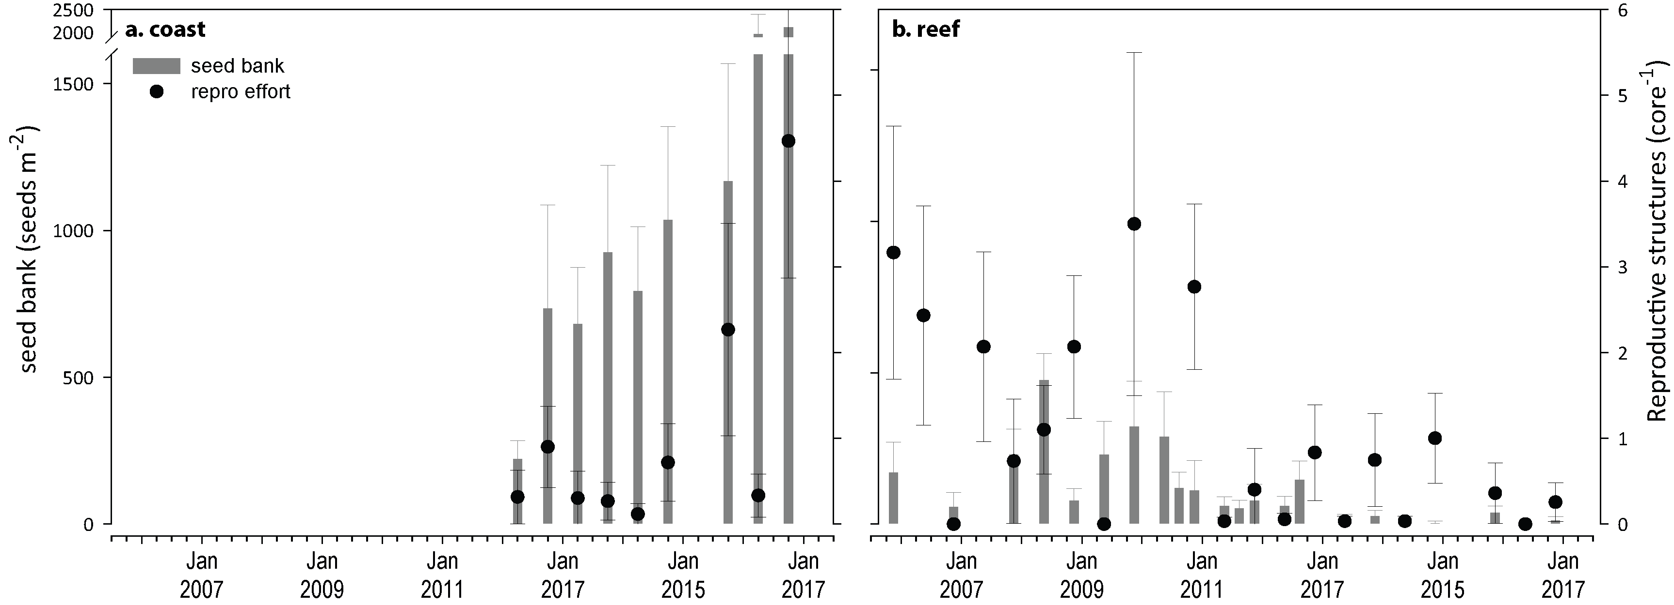
Figure 41. Seed banks and reproductive effort at inshore intertidal coastal (a) and reef (b) habitats in the Cape York region
(species and sites pooled). Seed banks (bars ± SE) presented as the total number of seeds per m² sediment surface. Reproductive effort for late dry season (dots ± SE) presented as the average number of reproductive structures per core.

Indicators of environmental condition

Seagrass tissue nutrients
Seagrass leaf molar C:N ratios increased significantly in 2016–17, with the largest increase occurring at coastal habitats (Figure 42). The increase occurred at all Cape York habitats and locations in late dry season 2016, but the largest increases occurred at the more southern coast and reef sites (AP, ST, BY) (Appendix 4). This indicates that the availability of nitrogen (N) was reduced relative the demand for growth. Furthermore, leaf N:P ratios were reduced (Figure 43), providing further evidence that nitrogen has been reduced in the seagrass habitats of Cape York. Leaf molar C:P ratios increased slightly in 2016 were just above 500, indicating that the plants were growing in a relatively moderately depleted P pool (Figure 43; Appendix 4).
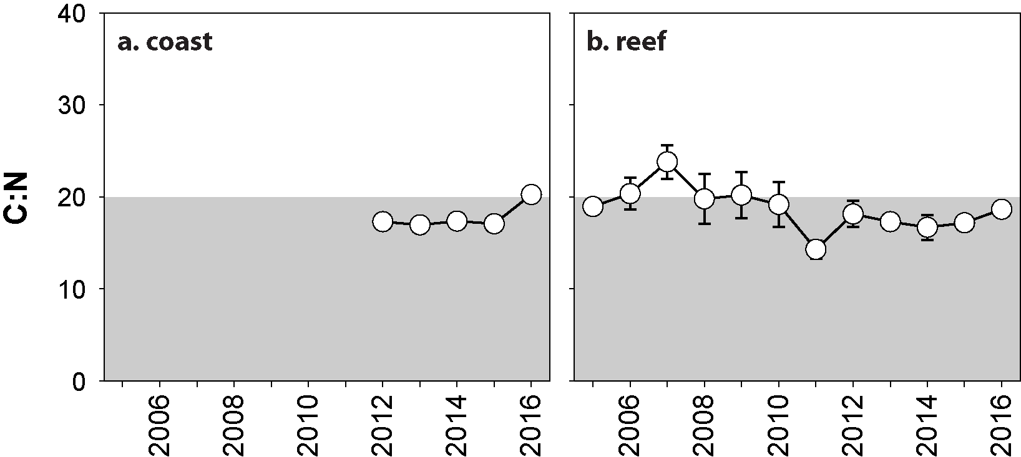
Figure 42. Elemental ratios (atomic) of seagrass leaf tissue C:N for the foundation species in inshore intertidal coastal (a) and reef (b) habitats in the Cape York region from 2005 to 2016
(species pooled) (mean and SE displayed). Horizontal shaded band on the C:N ratio panel represents the accepted guideline seagrass “Redfield” ratio of 20:1 (Abal et al. 1994; Grice et al. 1996). C:N ratios below this line may indicate reduced light availability and/or N enrichment.
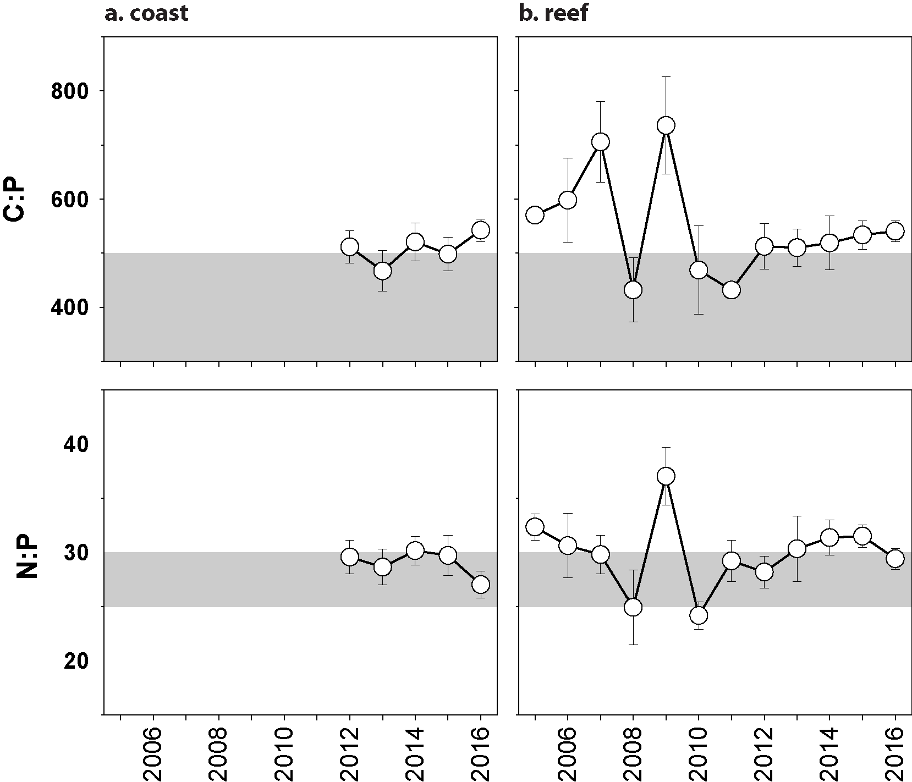
Figure 43. Elemental ratios (atomic) of seagrass leaf tissue N:P and C:P for the foundation species in inshore intertidal reef (a, c) and coastal (b, d) habitats in the Cape York region from 2005 to 2016
(species pooled) (mean ± SE). Horizontal shaded band on the N:P ratio panel represents the range of value associated with N:P balance ratio in the plant tissues, i.e. a seagrass “Redfield” ratio (Atkinson and Smith 1983; Duarte 1990; Fourqurean et al. 1992b; Fourqurean and Cai 2001). N:P ratio above this band indicates P limitation, below indicates N limitation and within indicates replete. Shaded portion on the C:P panel ≤500 represents the value associated with C:P balance ratio in the plant tissues, C:P values <500 may indicate nutrient rich habitats (large P pool).

Seagrass meadow sediments
In the Cape York NRM region, reef habitats were dominated by sands and coarser sediments, while coastal habitats contained a greater proportion of mud (Appendix A4.2.2). In 2016–17, the proportion of mud in the sediments of reef and coastal habitats (e.g. Stanley Island and Bathurst Bay) adjacent to the Normanby River mouth continued to increase above the Great Barrier Reef long-term average; conversely, reef and coastal habitats to the north and south of the region have negligible mud content (Figure 168, Figure 169).

Epiphytes and macroalgae
Epiphyte cover on seagrass leaf blades over the long-term was generally higher in the wet season at coastal habitats and in the dry season at reef habitats (Figure 44). During the 2016–17 dry season, epiphyte abundances at reef and coastal habitats were similar to the Great Barrier Reef long-term average, and considerably lower than in 2009-2012 (Figure 44; Appendix 4, Figure 185). Percentage cover of macroalgae was variable between locations, and remained above the Great Barrier Reef long-term average for reef habitats in the central and north of the region throughout 2016–17 (Figure 44; Appendix 4, Figure 185). Macroalgae cover at coastal sites has varied little and in 2016–17 it remained near to the Great Barrier Reef long-term average (Figure 44).

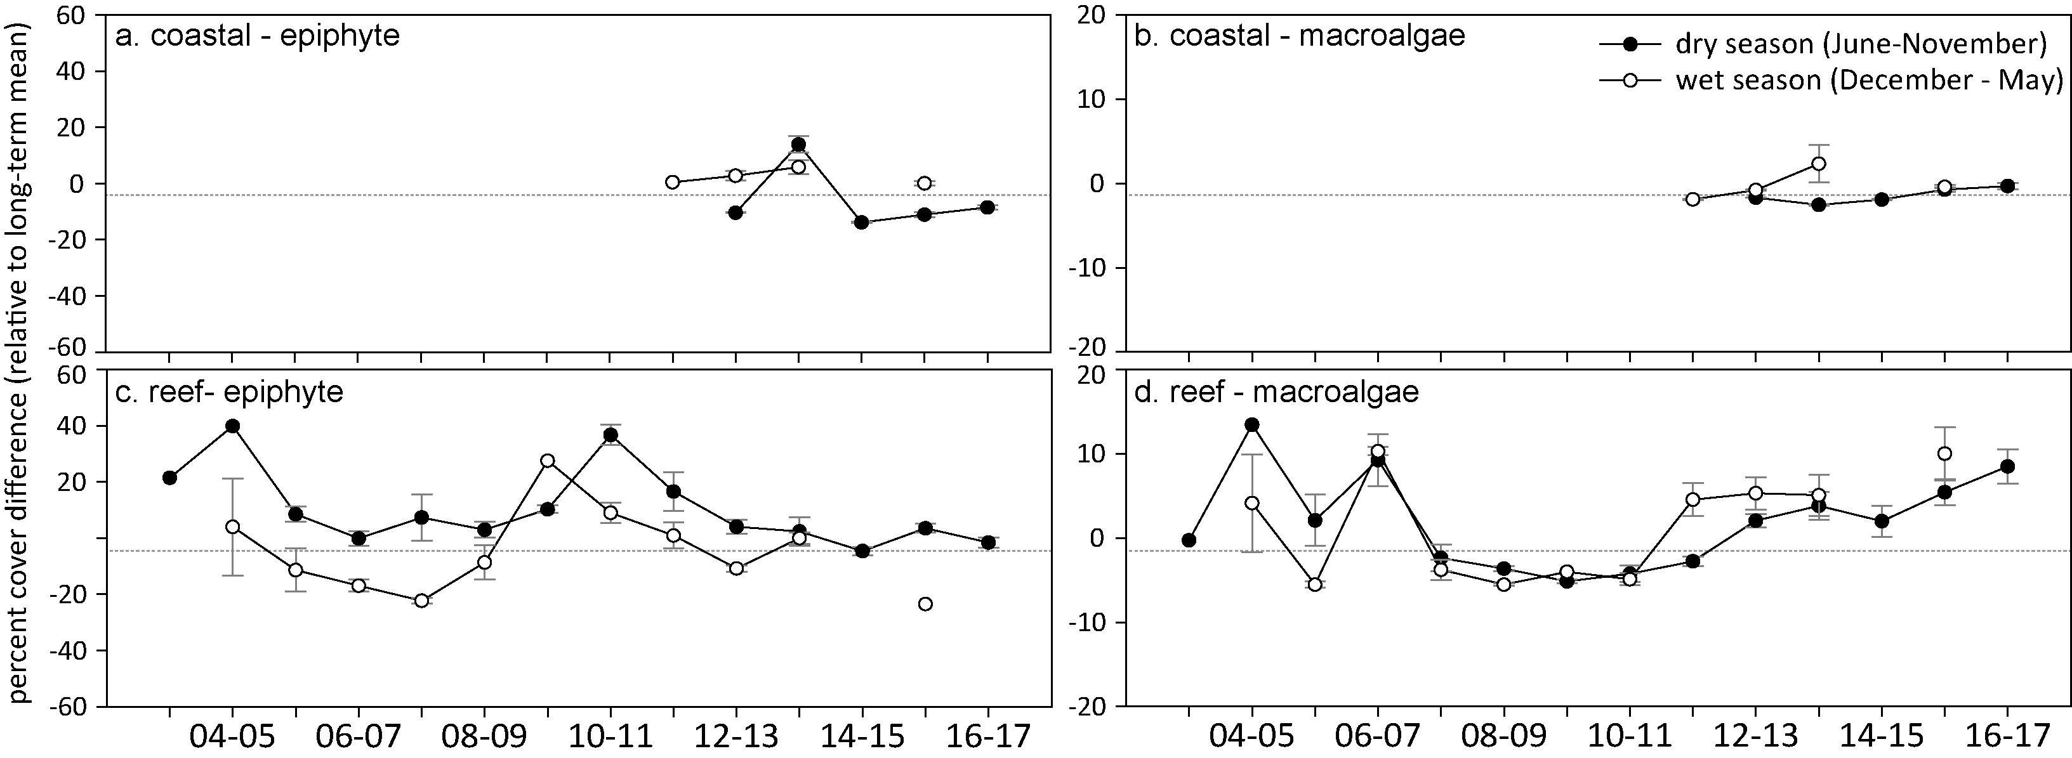
Figure 44. Long-term trend in mean epiphyte and macroalgae abundance ( per cent cover) at monitoring sites in the Cape York region, relative to the long-term average for each inshore Great Barrier Reef intertidal seagrass habitat
(sites pooled, ±SE).

Report card for inshore seagrass status
In the 2016–17 monitoring period, the seagrass index for Cape York region has reduced slightly since the previous monitoring period but remains moderate overall (Table 15). The reduction is due lower abundance at coastal subtidal and reef intertidal sites, but this was offset to a degree by improvements in leaf tissue nutrients. Overall, the Cape York seagrass index remains well below the 2005-06 baseline but has the second highest score since the addition of new sites in 2012 and 2013.

Table 15. Long-term report card scores for seagrass abundance, reproductive and leaf tissue nutrient status for each habitat in the Cape York NRM region: June 2005 – May 2017.
- Values are indexed scores scaled from 0-100; ■ = very good (81-100), ■ = good (61 - 80), ■ = moderate (41 - 60), ■ = poor (21 - 40), ■ = very poor (0 - 20). NB: Scores are unitless.
Indicator | Habitat | 2005-06 | 2006-07 | 2007-08 | 2008-09 | 2009-10 | 2010-11 | 2011-12 | 2012-13 | 2013-14 | 2014-15 | 2015-16 | 2016–17
Abundance | coastal intertidal |  |  |  |  |  |  | 63 | 81 | 63 | 75 | 75 | 100
Abundance | coastal subtidal |  |  |  |  |  |  |  |  |  |  | 75 | 63
Abundance | reef intertidal | 75 | 35 | 45 | 44 | 44 | 20 | 14 | 22 | 29 | 25 | 40 | 29
Reproductive  effort | coastal intertidal |  |  |  |  |  |  |  | 0 | 0 | 0 | 6 | 13
Reproductive  effort | reef intertidal | 63 | 0 | 25 | 38 | 63 | 63 | 13 | 17 | 17 | 21 | 5 | 8
Leaf tissue  nutrient | coastal intertidal |  |  |  |  |  |  |  | 30 | 36 | 37 | 35 | 51
Leaf tissue  nutrient | reef intertidal | 45 | 52 | 69 | 49 | 51 | 46 | 21 | 36 | 35 | 33 | 37 | 32
Seagrass Index |  | 61 | 29 | 46 | 43 | 52 | 43 | 21 | 28 | 29 | 30 | 34 | 32

Wet Tropics

2016–17 summary
The Wet Tropics includes two World Heritage Areas, however increases in intensive agriculture, coastal development and declining water quality have been identified as significant across the region. In 2016–17 rainfall and river discharge were again below the long-term average. Despite this, coastal sites and Dunk Island (which is the reef site closest to shore) were exposed to ‘brown’ or ‘green’ turbid water tfor 95-100 per cent of the wet season (December 2016 to April 2017) and canopy daily light was slightly lower than the long-term average across the entire region. Due to a widespread seawater thermal anaomaly, water temperature exceeded the long-term average by almost 1°C on average throughout the year. The number of days that seawater temperature was above 35°C (70 d) exceeded the thermal stress event in the previous year (50 d). But extreme heat stress days (>40°C), only occurred on 3 days.
Seagrass meadows in the region remain in a vulnerable state in 2016–17 with an overall abundance rating of poor. The trends in abundance vary among locations reflecting a complex range of environmental and biological processes affecting recovery rates. Abundance continued to decline at the Green Island subtidal site and previous trends for increasing abundance at the other subtidal sites reversed. Despite this, the proportion of colonising species reduced at the reef intertidal and subtidal sites in 2016–17. The overall rating for reproductive effort further declined and remained very poor, due to very low reproductive effort at reef sites, and a reduction at the coastal sites in 2016–17. The density of seeds in the seed banks also remained very low at reef sites, but above the long-term average at Yule Point. Leaf tissue nutrients (C:N), have remained unchanged for a number of years, and suggest an excess of nitrogen relative photosynthetic C uptake (C:N <20), which is consistent with the high frequency of exposure to secondary water. Nutrient status therefore remained poor.
Overall, the status of seagrass condition in the Wet Tropics NRM region has remained poor in 2016–17 (Figure 45). On average, Wet Tropics seagrass meadows remain in a vulnerable condition with low resilience, however, some sites have shown recent signs of improving, while others have deteriorated in 2016–17.
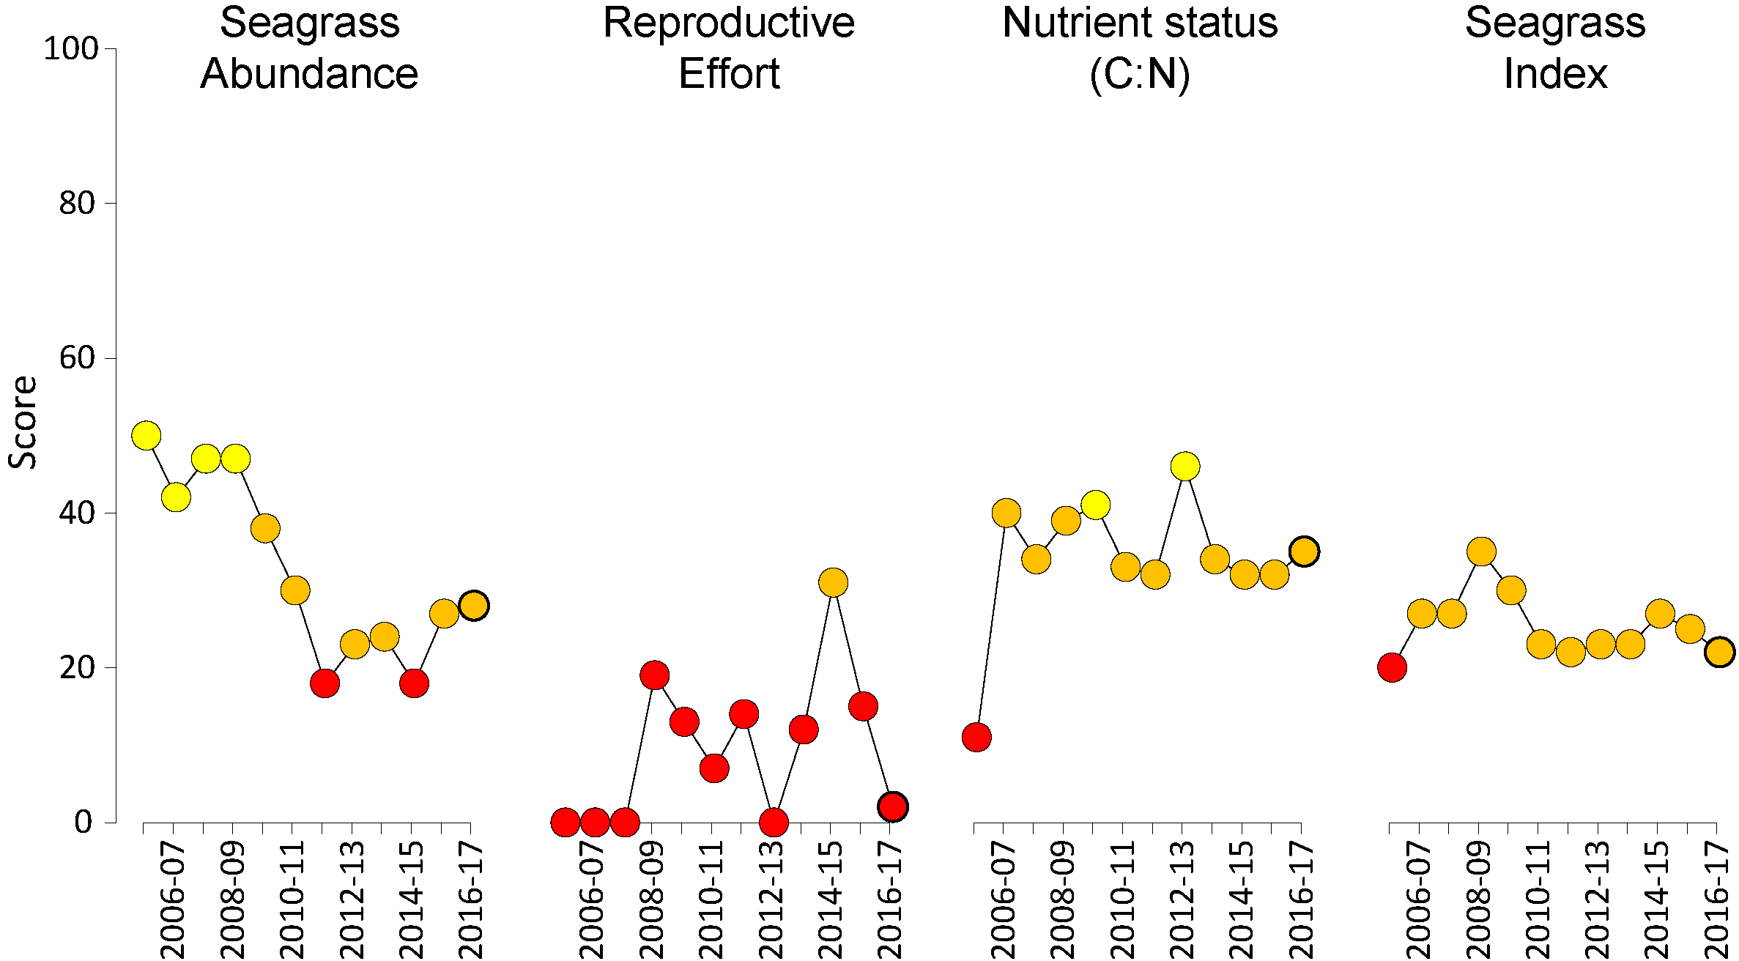
Figure 45. Report card of seagrass indicators and index for the Wet Tropics NRM region
(average across habitats and sites). Bold symbol = 2016–17 monitoring period. Values are indexed scores scaled 0-100; ■ = very good (81-100), ■ = good (61 - 80), ■ = moderate (41 - 60), ■ = poor (21 - 40), ■ = very poor (0 - 20). NB: Scores are unitless.

Climate and environmental pressures
Annual rainfall was below average in the Wet Tropics in 2016–17 with the largest anomaly occurring in the Herbert River (Figure 8; Table 16). This was also associated with below-average river discharge and higher than average number of days in which wind speeds exceeded 25 km hr⁻¹. Exposure to ‘brown’ or ‘green’ turbid water was highly variable among sites (Figure 46, Table 17). Coastal sites had the greatest level of exposure to ‘brown’ turbid water, particularly at Lugger Bay (90 percent of wet season weeks) compared to Yule Point (14 per cent), which was more frequently exposed to ‘green’ water (f_{S+P} = 95 per cent). Reef sites were exposed primarily to ‘green’ turbid water, with the highest frequency at Dunk Island (95 per cent) and lowest at Green Island (9 per cent).
Table 16. Summary of environmental conditions at monitoring sites in the Wet Tropics region in 2014-15 compared to the long-term average (long-term range indicated for each data set).
 | Long-term average | 2016–17
Rainfall (1961-1990) | 9.4 mm d⁻¹ | 8.0 mm d⁻¹
River discharge (1970-2017) | 20,755,244 L yr⁻¹ | 14,442,402 L yr⁻¹
Turbid water exposure (2006-2017) | 67 per cent | 65 per cent
Daytime tidal exposure (1999-2017) | 97 hr yr⁻¹ | 110 hr yr⁻¹
Wind (1998-2017) | 88 days yr⁻¹ | 117 days yr⁻¹
Within canopy temperature – intertidal (2003-2017)  subtidal (2008-2017) | 26.9°C (41.5°C)  26.6°C (35.7°C) | 27.7°C (41.4°C)  27.4°C (32.4°C)
Within canopy light (2012-2017) | 12.7 mol m⁻² d⁻¹ | 12.0 mol m⁻² d⁻¹

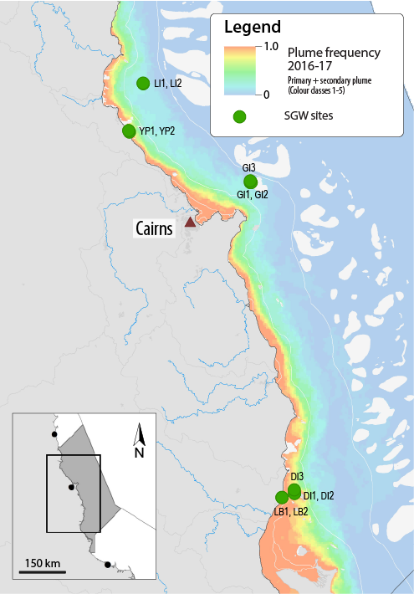
Figure 46. Frequency of exposure to turbid water (colour classes 1-5) in the Wet Tropics NRM, wet season (22 weeks from December 2016 – April 2017) composite.
Frequency calculated as number of weeks in wet season exposed to primary or secondary water (colour classes 1 – 5). Each colour class category is described by mean water quality values for TSS, CDOM, chlorophyll a and K_{d} (PAR) (Devlin et al. 2015; Waterhouse et al. 2018). For site details, see Table 18.
Table 17. Water type at each location in the Wet Tropics region derived from MODIS true colour images
as colour classes of turbid primary water (class 1 – 4, red/brown), nutrient/chlorophyll-enriched secondary water (class 5, green), and tertiary (some freshwater/CDOM influence) or no plume influence (class 6 and 7 respectively, blue), for 22 weeks from December 2016 – April 2017. Also shown, median wet season colour class (Med), frequency of primary water as f_{(P)}, the frequency of secondary water as f_{(S)}, and the frequency of primary or secondary as f_{(P+S)}. *denotes data obtained from adjacent pixel.
Site | 1 | 2 | 3 | 4 | 5 | 6 | 7 | 8 | 9 | 10 | 11 | 12 | 13 | 14 | 15 | 16 | 17 | 18 | 19 | 20 | 21 | 22 | f_{(P)} | f_{(S)} | f_{(P+S)}
LI1, LI2 | 6 | 6 | 6 | 6 | 6 | 7 | 6 | 6 | 6 | 6 | 5 | 6 | 6 | 6 | 6 | 6 | 6 | 6 | 5 | 5 | 5 | 5 | 0 | 0.23 | 0.23
YP1, YP2* | 5 | 5 | 5 | 5 | 5 | 5 | 5 | 5 | 5 | 5 | 5 | 5 | 5 | 5 | 5 | 5 | 5 | 6 | 5 | 4 | 4 | 4 | 0.14 | 0.82 | 0.95
GI3 | 7 | 7 | 7 | 7 | 7 | 5 | 7 | 7 | 6 | 6 | 6 | 6 | 6 | 6 | 6 | 7 | 7 | 6 | 5 | 6 | 6 | 6 | 0 | 0.09 | 0.09
GI1, GI2 | 7 | 7 | 7 | 7 | 7 | 5 | 7 | 7 | 6 | 6 | 6 | 6 | 6 | 6 | 6 | 7 | 7 | 6 | 5 | 6 | 6 | 6 | 0 | 0.09 | 0.09
DI3 | 5 | 5 | 5 | 5 | 5 | 6 | 5 | 5 | 5 | 5 | 5 | 5 | 5 | 5 | 5 | 5 | 5 | 5 | 5 | 5 | 5 | 5 | 0 | 0.95 | 0.95
DI1, DI2 | 5 | 5 | 5 | 5 | 5 | 6 | 5 | 5 | 5 | 5 | 4 | 5 | 5 | 5 | 5 | 5 | 5 | 5 | 5 | 5 | 5 | 5 | 0.05 | 0.91 | 0.95
LB1, LB2* | 4 | 4 | 4 | 4 | 4 |  | 4 | 4 | 4 | 4 | 4 | 4 | 4 | 4 | 4 | 5 | 4 | 4 | 4 | 3 | 5 | 4 | 0.9 | 0.1 | 1
Daily light (I_{d}) at Wet Tropics sites has been monitored since 2008 or 2009. I_{d} in 2016–17 (12.0 mol m⁻² d⁻¹) was slightly lower than the long-term average (12.7 mol m⁻² d⁻¹), largely due to conditions in the southern Wet Tropics (at Dunk Island, loggers not deployed at Lugger Bay) and at Low Isles. Other sites in the Wet Tropics were at or around the long-term average in 2016–17. The lowest light levels occurred at the Low Isles (5.8 mol m⁻² d⁻¹), Dunk Island (7.4 mol m⁻² d⁻¹) and Green Island subtidal sites (9.6 mol m⁻² d⁻¹), which were below the long-term average at the Low Isles and Green Island sites. Daily light levels have been highly seasonal for the past three years (Figure 47).
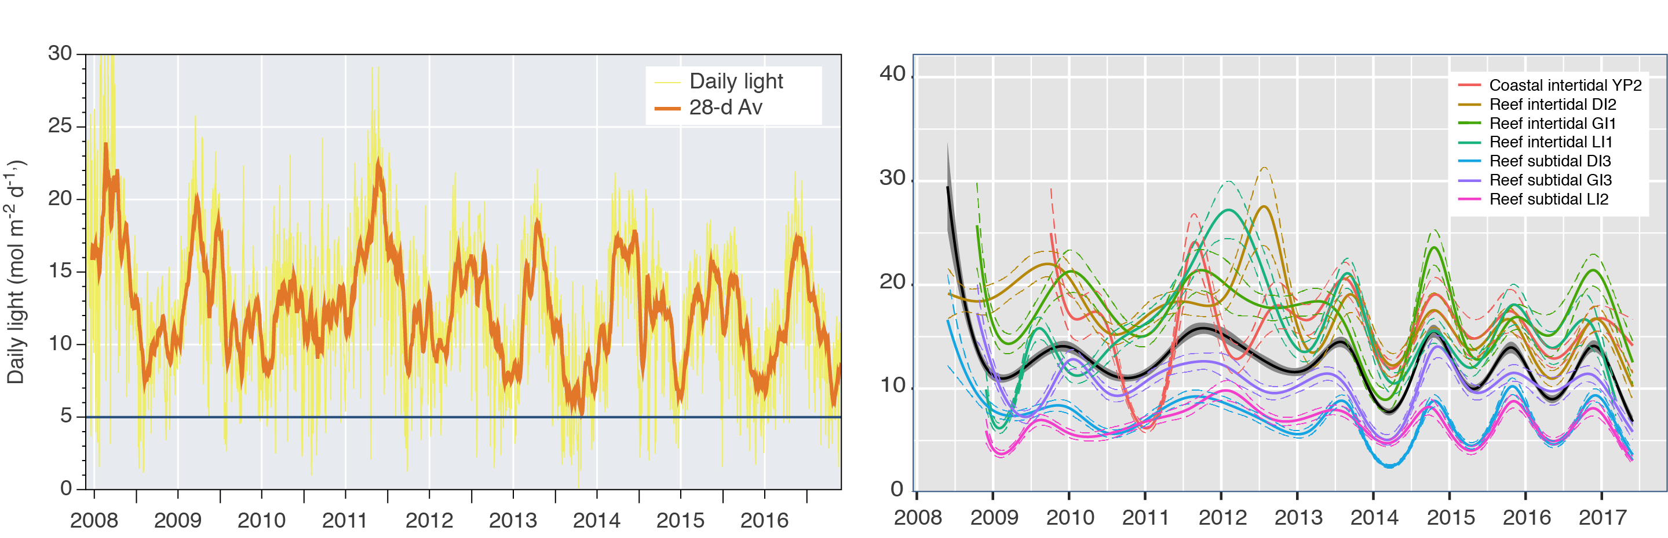
Figure 47. Mean daily light at Wet Tropics sites with 28-d rolling average from 2008 to 2017 (left) and GAM plots (right)
with the black line showing mean trend for all sites (±95 per cent confidence interval in grey shade) and coloured lines (with CI’s) showing the trend for each site. Results of statistical analysis (GAM) and site-specific graphs (site-level daily light data plus 28-d rolling average) are shown in Appendix 4.
The 2016–17 year was the hottest year on average at Wet Tropics seagrass sites since monitoring began. High temperatures (>35°C) had been sustained for 2 years from mid-2015 to June 2017 across the region, with the highest temperature at intertidal sites (41.4°C) recorded in March (Figure 48). Within canopy water temperatures exceeded 35°C for 70 d, which is well above the median level (44 d) since 2003 when monitoring was established. Water temperature at subtidal sites rarely exceeds thresholds (Figure 49); however, there were only a few weeks that were cooler than the baseline (Figure 49).
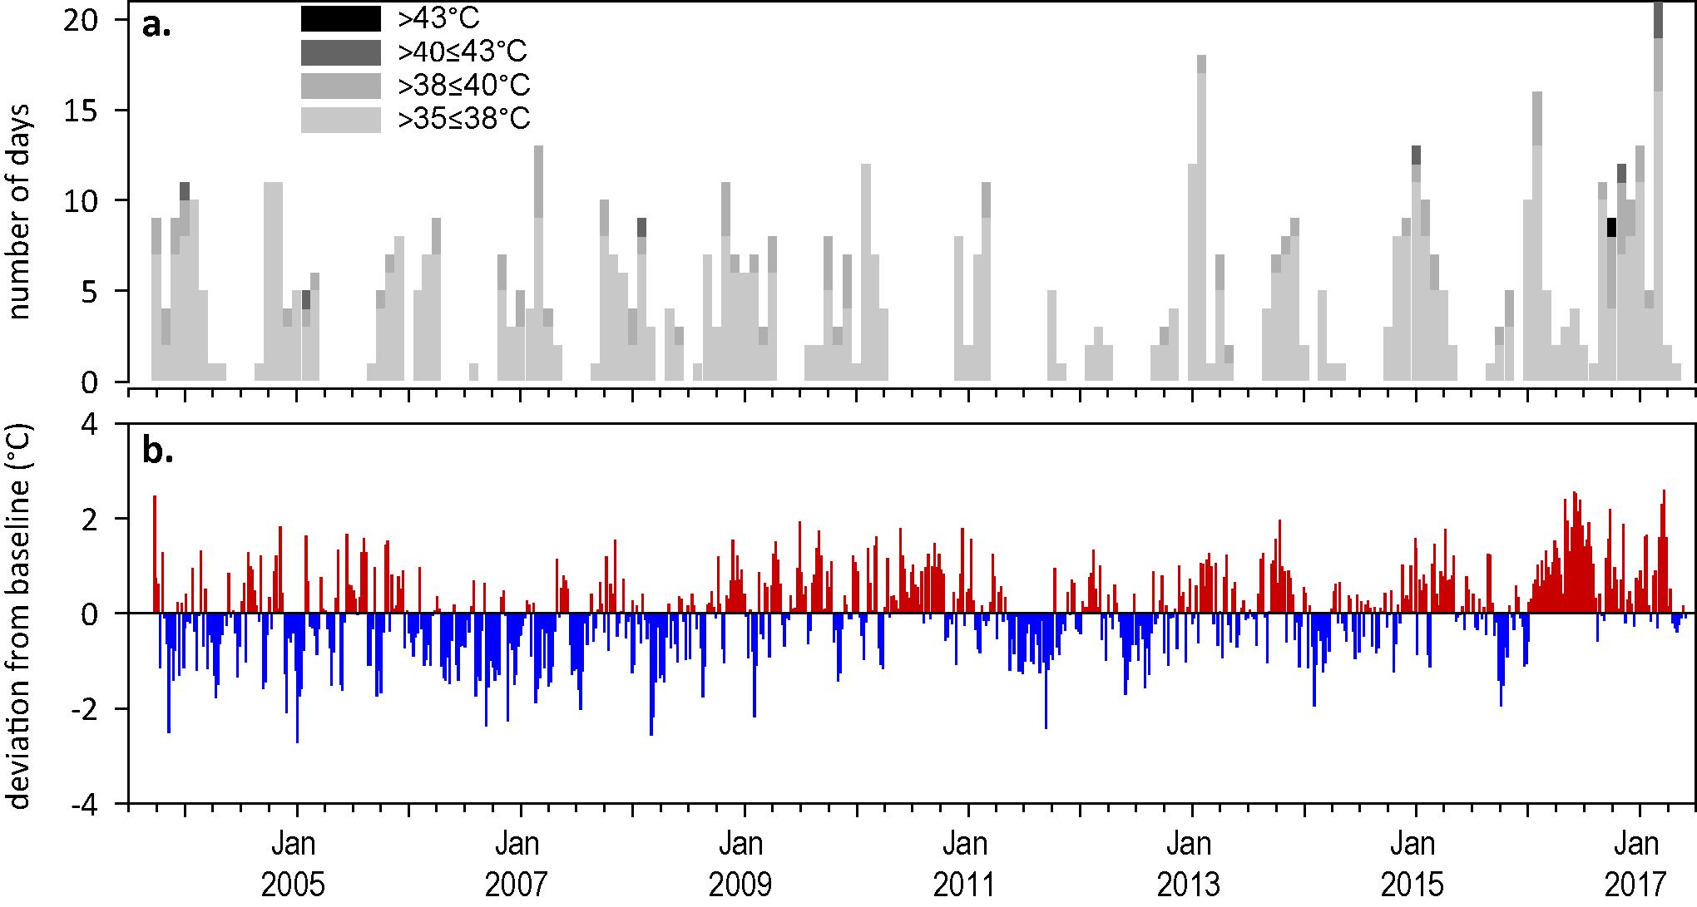
Figure 48. Inshore sea temperature for intertidal seagrass habitats in the Wet Tropics NRM region from August 2001 to June 2017
: a) number of days when temperature exceeded 35°C, 38°C, 40°C and 43°C within each season (thresholds adapted from Campbell et al. 2006); b) deviations from 13-year mean weekly temperature records (weeks above the long-term average are represented as red bars and the magnitude of their deviation from the mean represented by the length of the bars, bars are blue for weeks with temperatures lower than the average and are plotted as negative deviations). Dashed line represents period when monitoring not established.
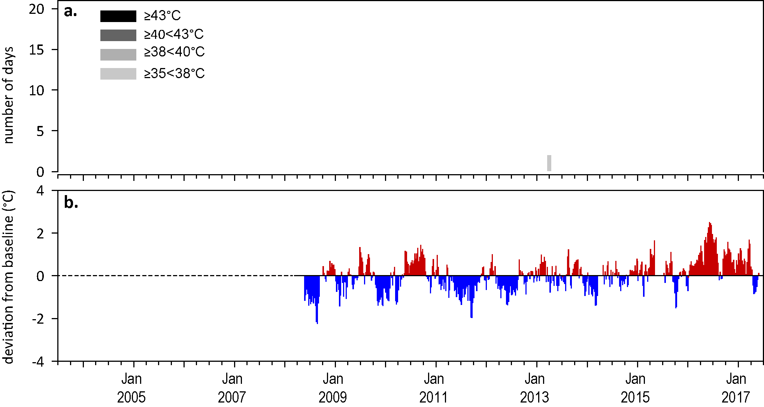
Figure 49. Inshore sea temperature for subtidal seagrass habitats in the Wet Tropics NRM region from October 2008 to June 2017
: a) number of days when temperature exceeded 35°C, 38°C, 40°C and 43°C within each season (thresholds adapted from Campbell et al. 2006); b) deviations from 7-year mean weekly temperature records (weeks above the long-term average are represented as red bars and the magnitude of their deviation from the mean represented by the length of the bars, bars are blue for weeks with temperatures lower than the average and are plotted as negative deviations). Dashed line represents period when monitoring not established or no data available.

Indicators of seagrass condition
Three seagrass habitat types were assessed across the Wet Tropics region in 2016–17, with data from 12 sites (Table 18).
Table 18. List of data sources of seagrass and environmental condition indicators for each seagrass habitat type in the Wet Tropics NRM region.
drop camera sampling (QPWS), *Seagrass-Watch. For site details see Table 3 and Table 4.
Habitat | Site |  | abundance | composition | distribution | Reproductive effort | seed banks | Leaf tissue nutrients | Meadow sediments | Epiphytes | Macroalgae
coastal intertidal | LB1 | Lugger Bay
coastal intertidal | LB2 | Lugger Bay
coastal intertidal | YP1 | Yule Point
coastal intertidal | YP2 | Yule Point
coastal subtidal | MS1 | Missionary Bay
coastal subtidal | MS2 | Missionary Bay
reef intertidal | DI1 | Dunk Island
reef intertidal | DI2 | Dunk Island
reef intertidal | GI1 | Green Island
reef intertidal | GI2 | Green Island
reef intertidal | GO1* | Goold Island
reef subtidal | LI1 | Low Isles
reef subtidal | DI3 | Dunk Island
reef subtidal | GI3 | Green Island
reef subtidal | LI2 | Low Isles

Seagrass abundance, composition and extent
The seagrass abundance score across the region was graded as poor in 2016–17 (Figure 45). The long-term average seagrass cover at coastal habitats in the Wet Tropics NRM region varied greatly between seasons: 6.2 ±0.7 per cent in the dry and 18.8 ±0.7 per cent in the wet season. Changes in seagrass abundance were variable among habitats, increasing or stabilising at reef intertidal and coastal habitats, but declining in reef subtidal habitat. After six years, seagrass has appeared at the Lugger Bay site following complete loss in 2011 (Figure 50). The largest declines occurred at the Dunk Island subtidal site, where recovery over the previous two years were reversed in 2016–17, and at Green Island where declines have continued since 2012 (Figure 51).
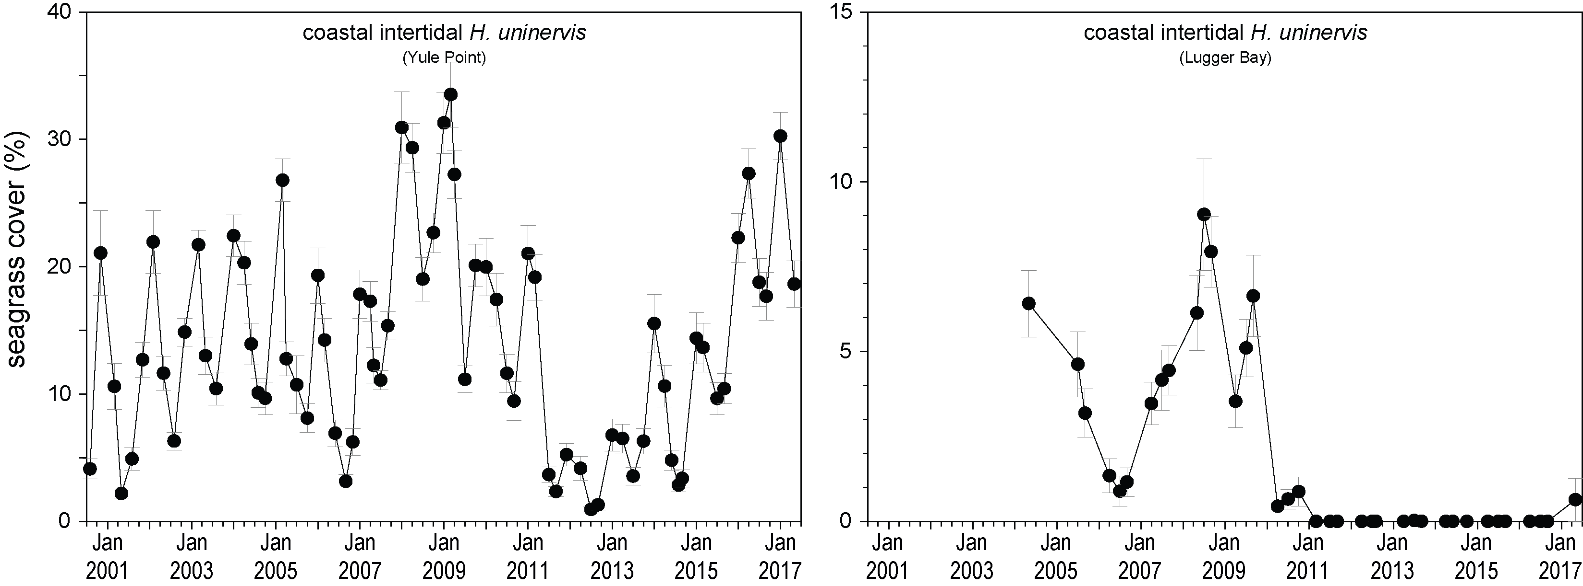
Figure 50. Changes in seagrass abundance (per cent cover ± SE) at inshore intertidal coastal habitats in the Wet Tropics NRM region, 2000 - 2017.
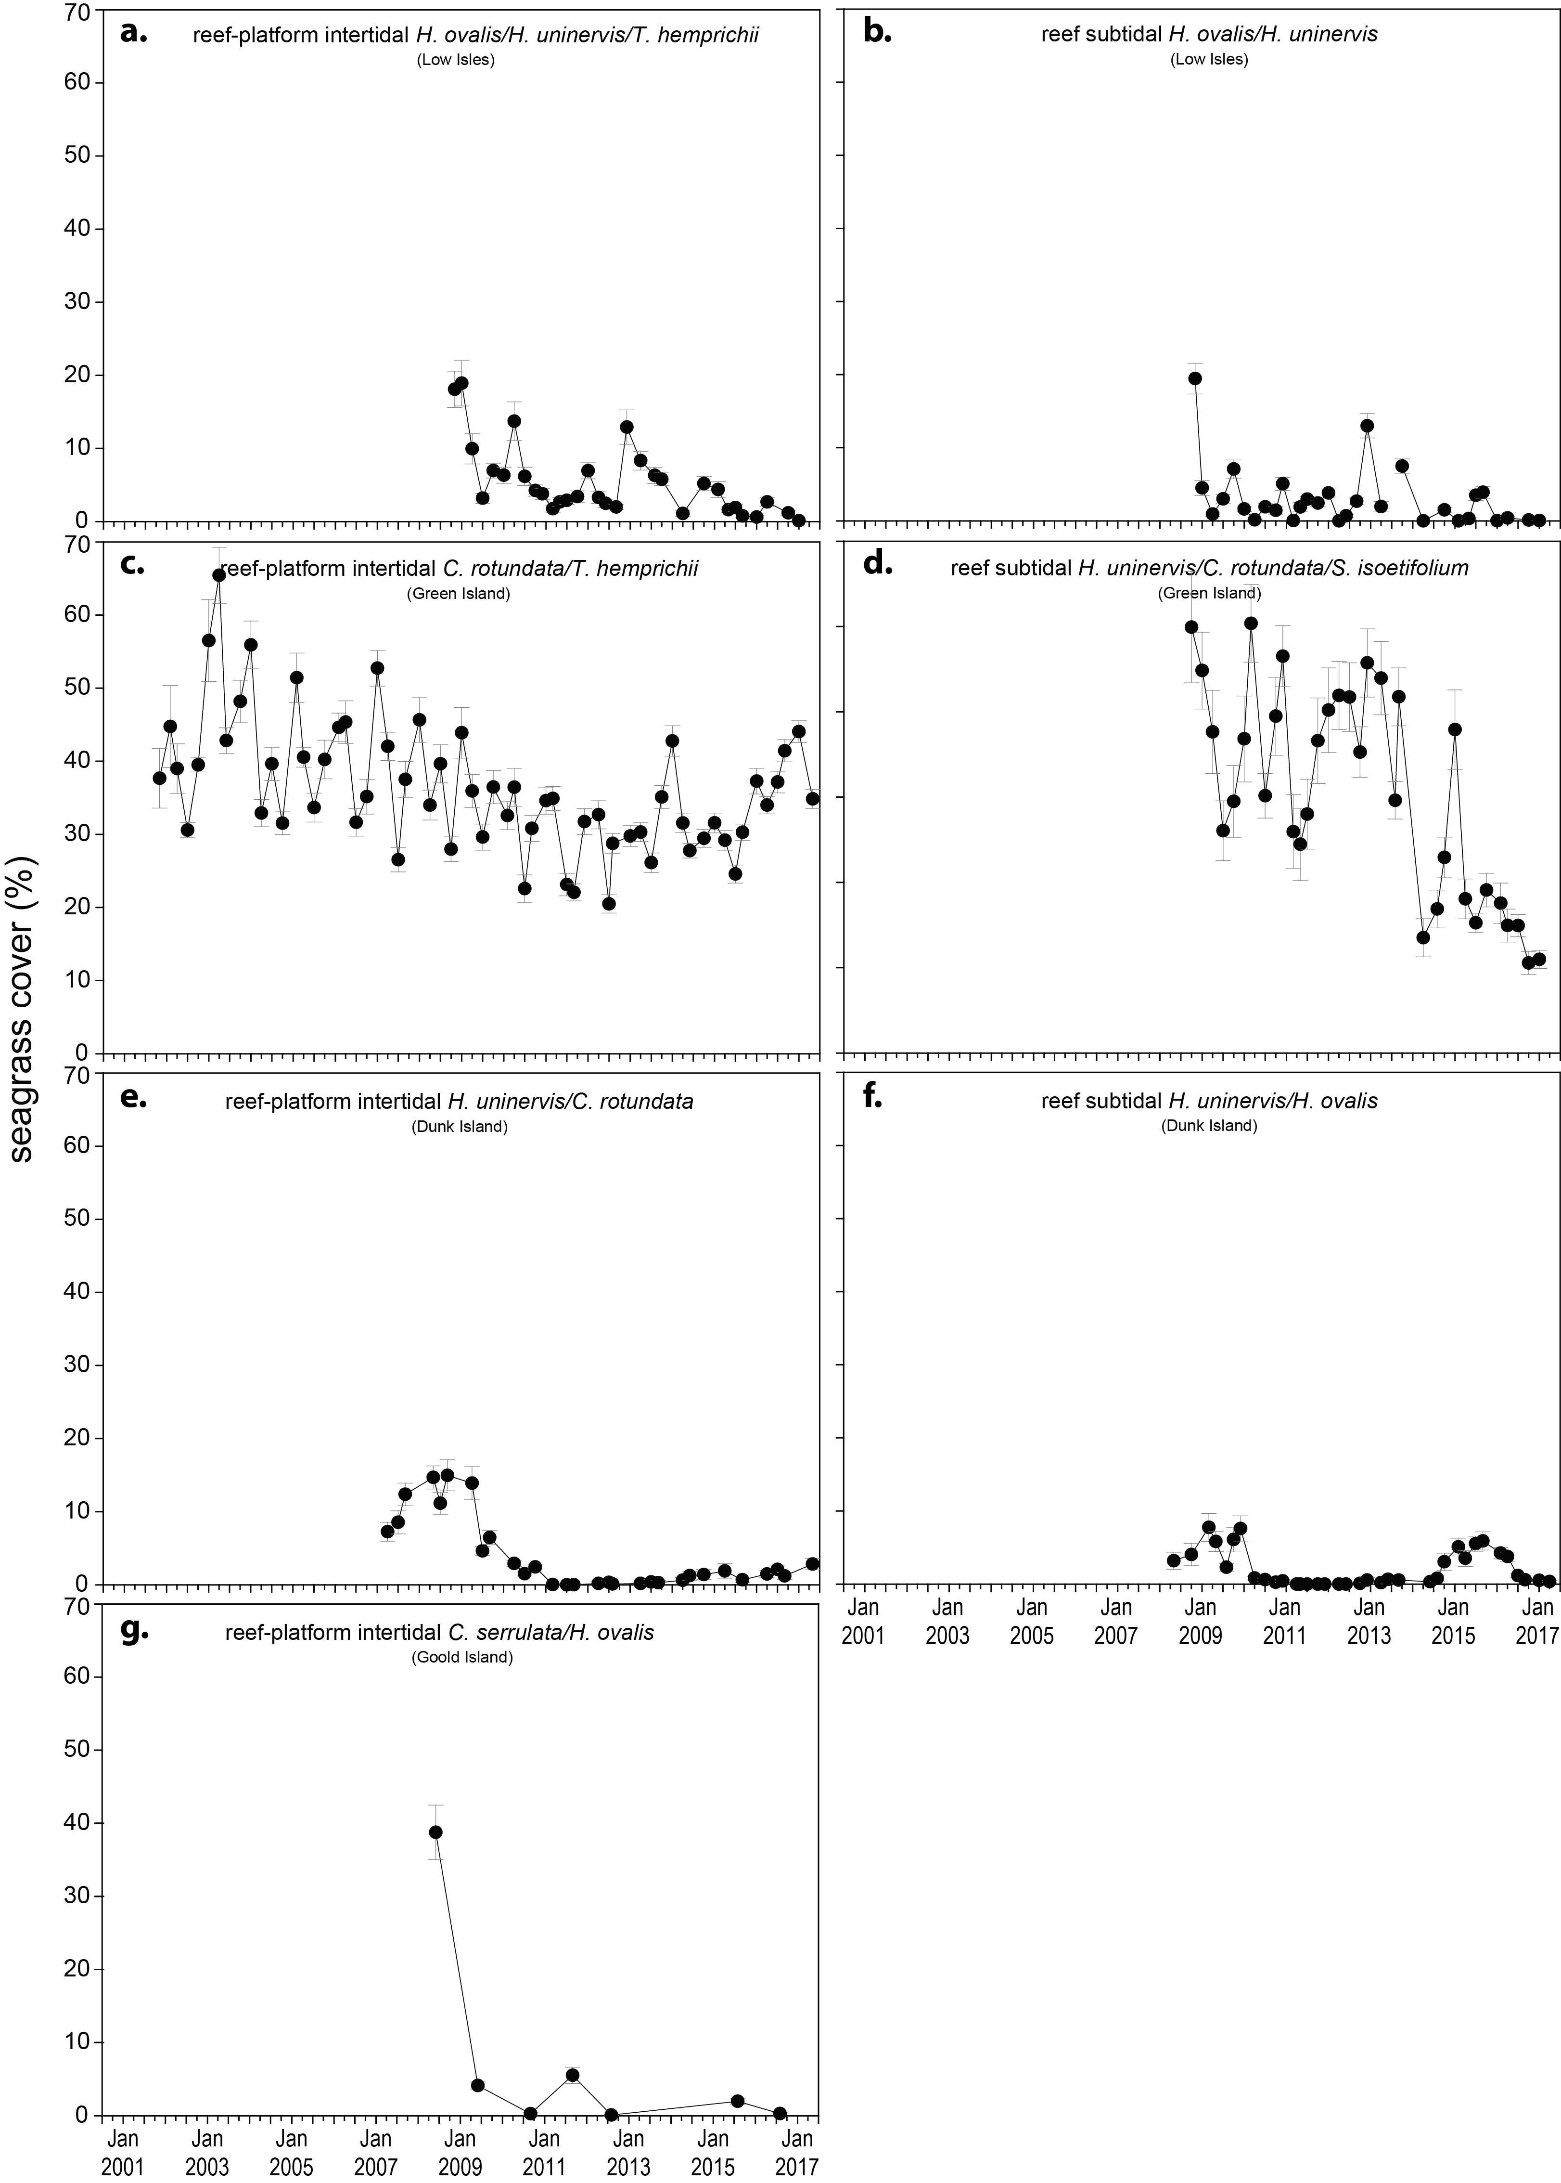
Figure 51. Changes in seagrass abundance (per cent cover ± SE) for inshore intertidal and subtidal reef habitats (left and right respectively) in the Wet Tropics NRM region, 2001 – 2017.
An examination of the long term trends across the Wet Tropics NRM region suggests seagrass abundance (per cent cover) has remained relatively stable in the northern section (with variable trajectories among habitats leading to large variation) (Figure 52, Figure 53). In the southern Wet Tropics, although recovery is very slow and abundances are in very poor condition, there have been small increases since 2011 at the intertidal coastal and reef site (Figure 54) but abundance remains well below historical levels.
a. b.
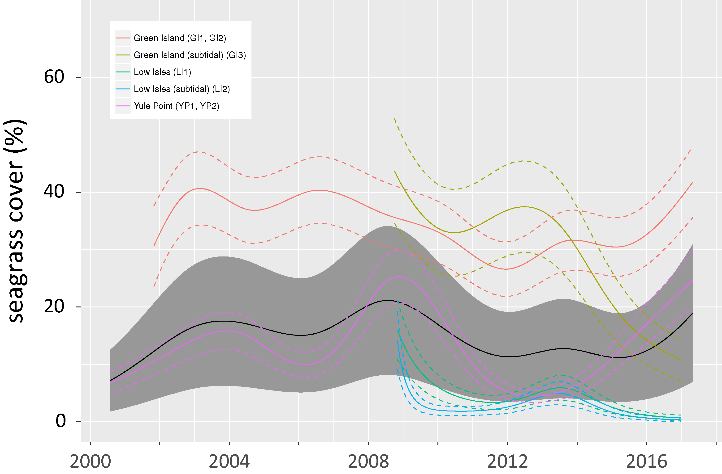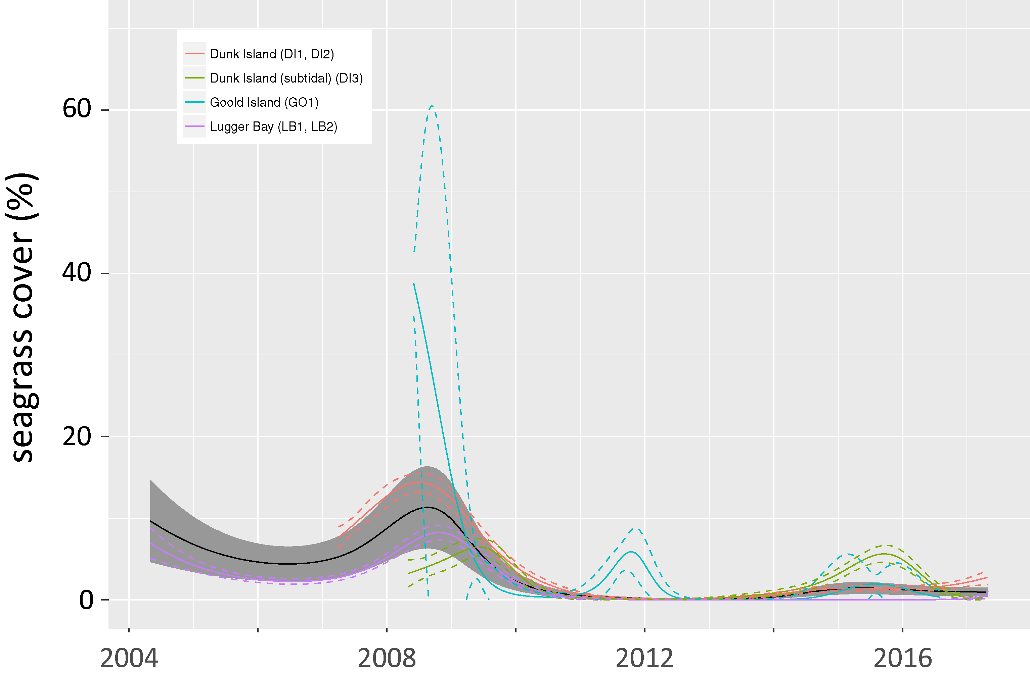
Figure 52. Temporal trends in seagrass abundance for each monitoring location in the northern (a) and southern (b) Wet Tropics region represented by a GAM plot, 2001-2017.
Northern and southern section trends (locations pooled) represented by black line with grey shaded area defining 95 per cent confidence intervals.
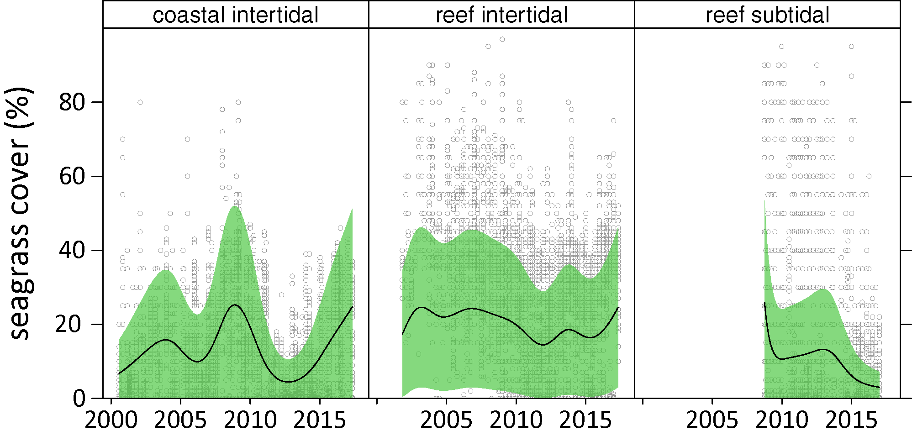
Figure 53. Temporal trends in seagrass abundance for seagrass habitat in the northern Wet Tropics region represented by a GAM plot, 2001-2017.
Trends (locations pooled) represented by black line with green shaded area defining 95 per cent confidence intervals, and quadrat data displayed as grey circles.
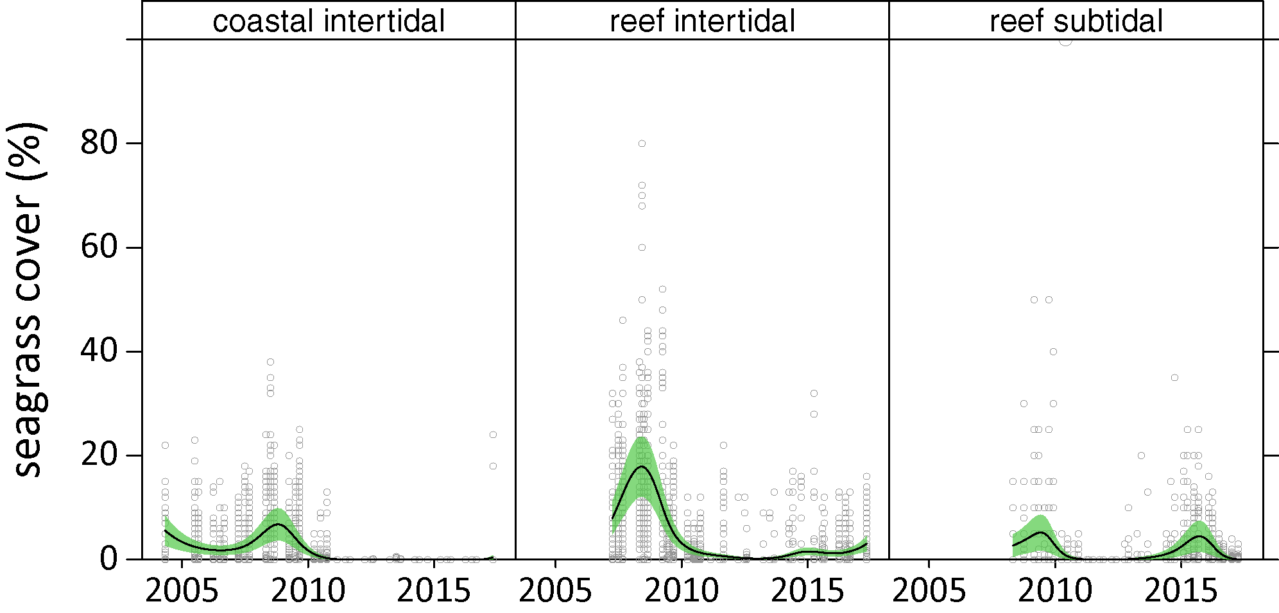
Figure 54. Temporal trends in seagrass abundance for seagrass habitat in the southern Wet Tropics region represented by a GAM plot, 2001-2017.
Trends (locations pooled) represented by black line with green shaded area defining 95 per cent confidence intervals, and quadrat data displayed as grey circles.
The proportion of seagrass species displaying colonising traits at coastal habitats (Yule Point, Lugger Bay) was above the Great Barrier Reef average from 2004 to 2014, however, since 2014 the proportion declined below the Great Barrier Reef-wide long-term average (due to trends predominately at Yule Point); with colonising species replaced by opportunistic species (Halodule uninervis) (Figure 55). Coastal meadows were the only habitats to increase in the proportion of colonising species over the last 12 months. At reef habitats (intertidal and subtidal), the 2016–17 was the first period since the extreme weather events of 2011 where the average proportion of colonising species declined below the Great Barrier Reef-wide long-term average (Figure 55).
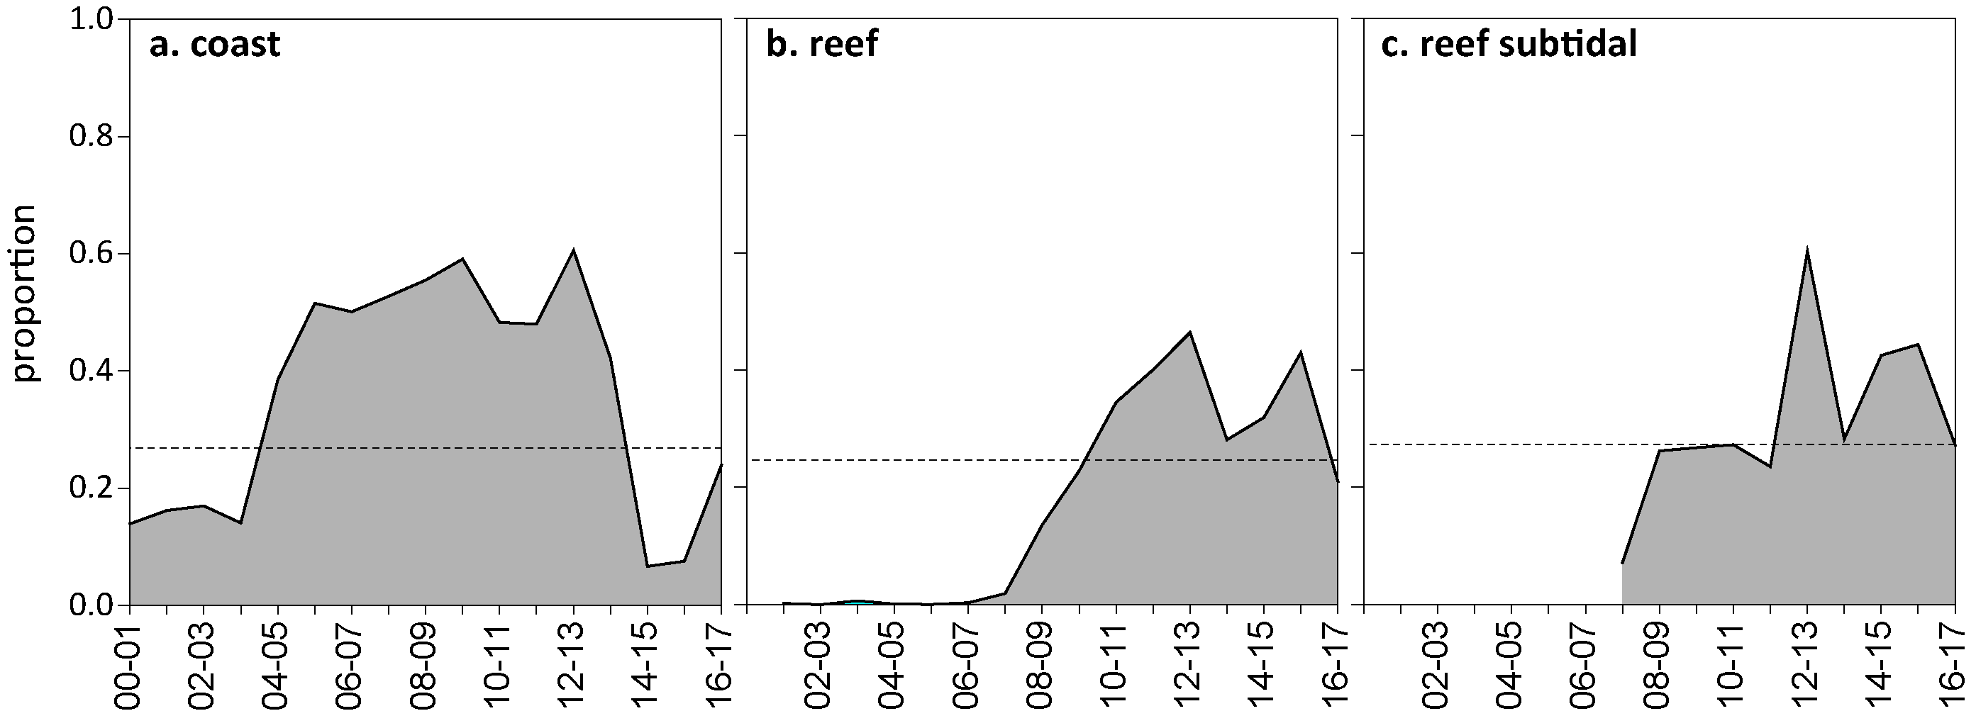
Figure 55. Proportion of seagrass abundance composed of colonising species at inshore habitats in the Wet Tropics region, from the 2000-01 to the 2016-2017 reporting periods.
The dashed line represents the Great Barrier Reef-wide average for each habitat type.
Seagrass meadow extent within all intertidal monitoring sites has fluctuated within and between years (Figure 56), primarily due to losses and subsequent recolonisation. At intertidal coastal and reef meadows, the extent has gradually improved since 2011 and has remained relatively stable since 2015, but still remains below the greatest extent in 2009 (Appendix A4.2.4).
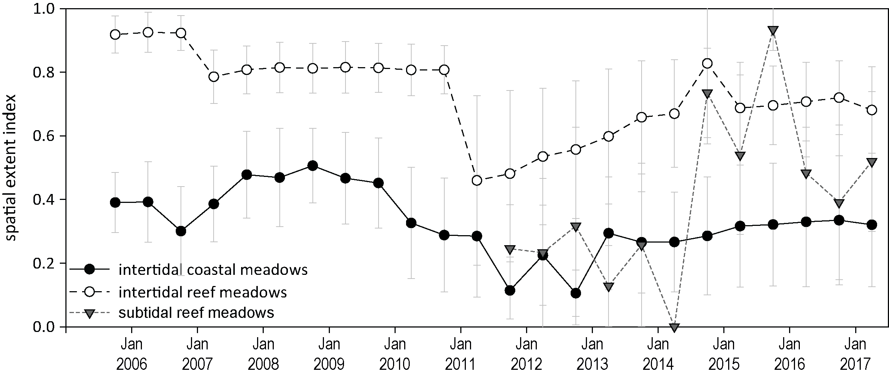
Figure 56. Change in relative spatial extent (±SE) of seagrass meadows within monitoring sites for each habitat and monitoring period across the Wet Tropics NRM region.
Long-term monitoring in places where cumulative anthropogenic impacts to seagrass are highest (e.g. Ports) (Grech et al. 2011) reported similar trends to the northern coastal intertidal habitats of the MMP (i.e. Yule Point) during 2016–17. An assessment of 6 meadows (predominately isolated or aggregated patches) in Cairns Harbour and Trinity Inlet between September and December 2016, reported above-ground biomass (visually estimated from a helicopter or CCTV) and extent more than doubled since 2015 (York and Rasheed 2017). Despite the positive signs of recovery in Cairns Harbour, mean above-ground biomass for the majority of monitoring meadows remains below 10 year baseline averages (Figure 57), and therefore recovery is lagging behind that of the Yule Point coastal habitat.
Figure 57. Change in visually estimated above-ground biomass (a.) and total extent (b.) of all monitoring meadows combined in Cairns Harbour and Trinity Inlet from 2001 – 2016
(from York and Rasheed 2017). Error bars are SE for g DW m² and “R” reliability estimate for ha. Dashed line indicates 10 year average from 2000 - 2010.

Conversely, an assessment of 5 seagrass meadows in Mourilyan Harbour in October-November 2016 reported seagrass has changed little relative to the previous year (Reason et al. 2017). The subtidal meadow was less aggregated in the channel and a few isolated patches of seagrass had colonised one of the intertidal banks in 2016. Similar to 2015, above-ground biomass (visually estimated from helicopter or CCTV) and extent remained very poor (Figure 58), with foundation species (Zostera muelleri and Halodule uninervis) absent from the monitoring meadows for the sixth consecutive year (Reason et al. 2017). Although the authors attributed the lack of recovery of the foundational species to an absent seed bank, they were unable to explain the slow recovery of the remaining meadows when the three year period preceeding the 2016 survey were favourable for seagrass growth (Reason et al. 2017).
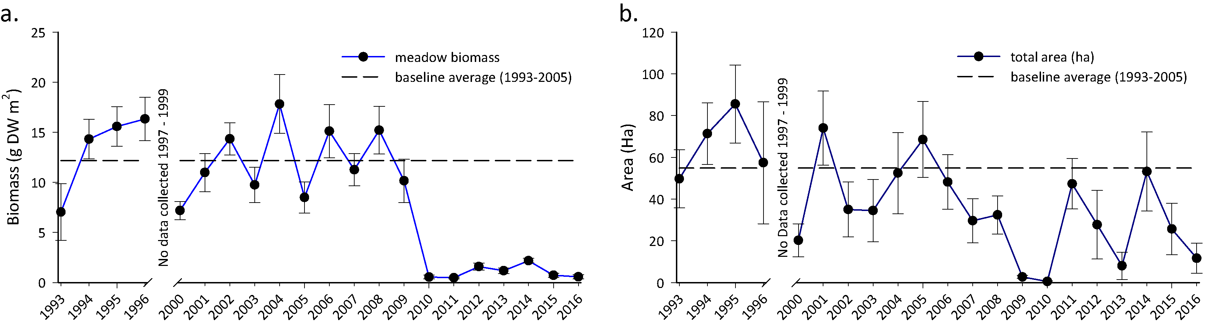
Figure 58. Change in visually estimated above-ground biomass (a.) and total extent (b.) of all monitoring meadows combined in Mourilyan Harbour from 1993 – 2016
(from Reason et al. 2017). Error bars are SE for g DW m² and “R” reliability estimate for ha. Dashed line indicates long-term average.

Seagrass reproductive status
Reproductive effort declined in coastal intertidal habitats (at Yule Point) during 2016–17 relative to the 2015-16. The density of seeds in the seedbank remained higher on average than it has been since 2011; however seed density remains well below historical peaks. Reef intertidal and subtidal habitats maintained low reproductive effort, following a slight increase at subtidal habitats in 2014-15. To date, seed banks remained very low across the region in reef habitat (Figure 59). Some possible explanations for the low seed bank include failure to set seed, particularly in low density dioecious species (Shelton 2008), or rapid loss of seeds after release from germination or grazing (Heck and Orth 2006). Wet Tropics meadows may be at risk from further disturbances, as recovery potential remains very low without a substantial seed bank.
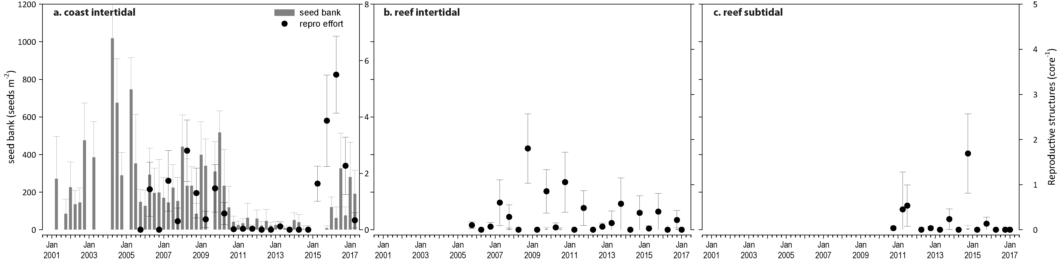
Figure 59. Seed bank and late dry season reproductive effort for inshore intertidal coast and reef habitats in the Wet Tropics region, 2001 - 2017.
Seed banks presented as the total number of seeds per m² sediment surface (bars ±SE), and reproductive effort presented as the average number of reproductive structures per core (species and sites pooled) (dots ±SE).
York et al. (2017) reported that some seeds of Zostera muelleri were present in the late dry (November 2016) but were absent from Ellie Point in Cairns Harbour in March 2017 for the first time since quarterly monitoring for Ports North was established in June 2014. This is most likely due to their germination in the favourable growing conditions, but the meadows are developmentally young, and not yet replenishing seeds to form seed banks. This places the meadows of Cairns harbour in a highly vulnerable state if further impacts were to affect the region.

Indicators of environmental condition

Seagrass tissue nutrients
C:N ratio in the leaves of the foundation seagrass species (in the late dry season 2016) at the coastal sites remaned very low (Figure 60; Appendix 4), and well below the guideline value (20) and C:N ratios at the coastal sites were particularly low compared to other sites throughout the Great Barrier Reef. This indicates that nitrogen loads are in excess of growth requirements, due possibly to light limitation. Although river discharge was below average in the past year, there was high exposure to secondary water at some sites, which indicates availability of N in overlying waters, and light reducing effects from phytoplankton. High N:P ratios in coastal habitats (Figure 61) also provides evidence of excess nitrogen loads at this site. Seagrasses in reef habitats (intertidal and subtidal) had higher leaf molar C:N ratios than those in coastal habitats (Figure 60), and higher leaf C:P ratios (Figure 61), which has remained consistent across all years of monitoring. C:N ratios have remained relatively unchanged across all intertidal seagrass habitats over the last 7 years (Figure 60; Appendix 4), while at subtidal sites, other than a sharp increase at Green Island in 2012, C:N ratios at reef subtidal habitats have been relatively stable since monitoring commenced in 2008 (Appendix 4).
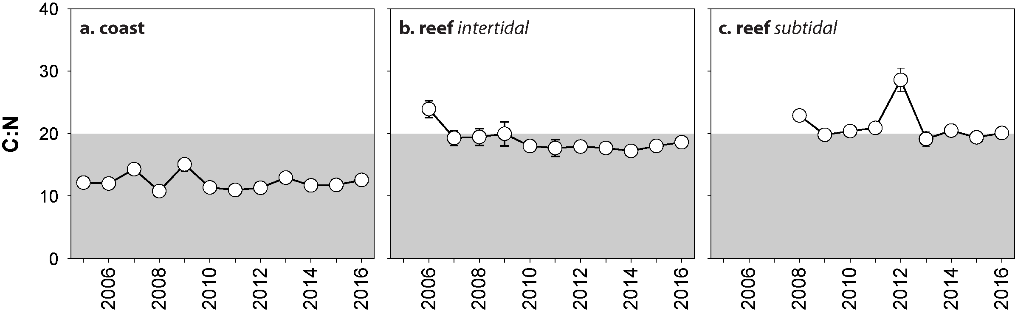
Figure 60. Elemental ratios (atomic) of seagrass leaf tissue C:N for the foundation seagrass species examined at each inshore habitat in the Wet Tropics region each year
(species pooled) (mean ± SE). Horizontal shaded band on the C:N ratio panel represents the accepted guideline seagrass “Redfield” ratio of 20:1. C:N ratios below this line indicate reduced light availability and/or N enrichment.
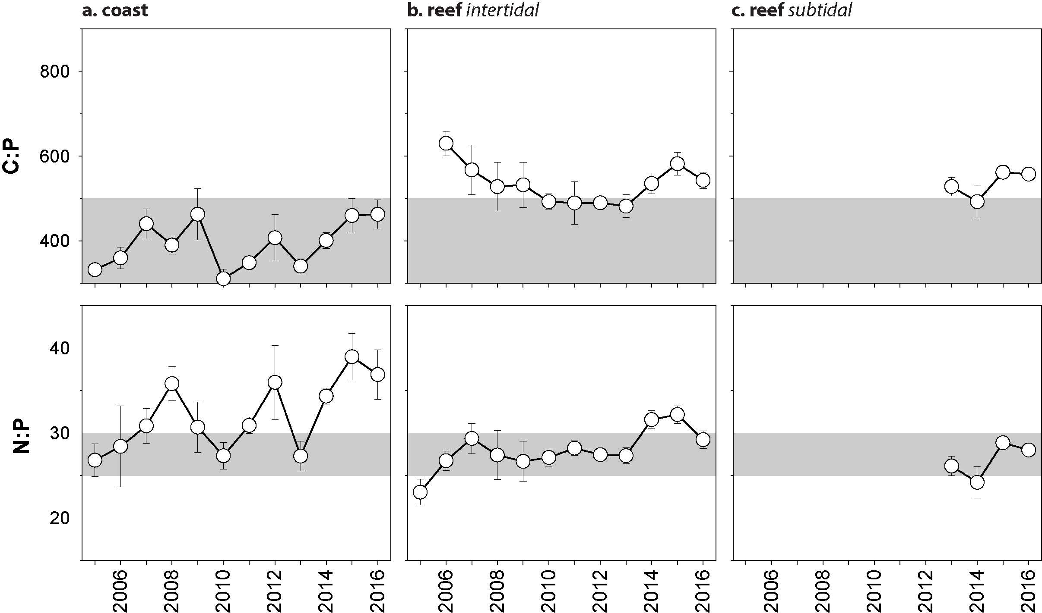
Figure 61. Elemental ratios (atomic) of seagrass leaf tissue N:P and C:P for the foundation seagrass species examined at each inshore habitat in the Wet Tropics region
(species pooled) (mean ± SE). Horizontal shaded band on the N:P ratio panel represents the range of value associated with N:P balance ratio in the plant tissues. N:P ratio above this band indicates P limitation, below indicates N limitation and within indicates replete. Shaded portion on the C:P panel ≤500 represents the value associated with C:P balance ratio in the plant tissues, C:P values <500 may indicate nutrient rich habitats (large P pool).

Seagrass meadow sediments
In the Wet Tropics NRM region, coastal sediments were composed primarily of fine sand, while reef habitats were composed of sand and coarser sediments; although finer sediments have been observed on occasion during 2012 and 2013 (Appendix A4.2.2). In 2016–17, sediments appeared similar to the long-term and the proportion of fine sediments (i.e. mud) was well below the Great Barrier Reef long-term average (Figure 170, Figure 171, Figure 172).

Epiphytes and macroalgae
Epiphyte cover on seagrass leaf blades has historically been higher in the wet season across all habitats in the Wet Tropics region (Figure 62); however, in 2016–17 epiphyte loads were reduced in the wet season at reef subtidal and intertidal habitats. Epiphyte abundance varied little across reef habitats and locations in the past two years and remain similar to the Great Barrier Reef-wide average, but epiphytes vary greatly at reef subtidal habitats, in particular at Green Island and Dunk Island (Appendix A4.2.3, Figure 186, Figure 187, Figure 188). Percentage cover of macroalgae generally remained around the Great Barrier Reef average at coastal and reef intertidal habitats while at subtidal habitats, 2016–17 had the highest macroalgae cover observed since 2008 (Figure 62; Appendix A4.2.3, Figure 186, Figure 187).

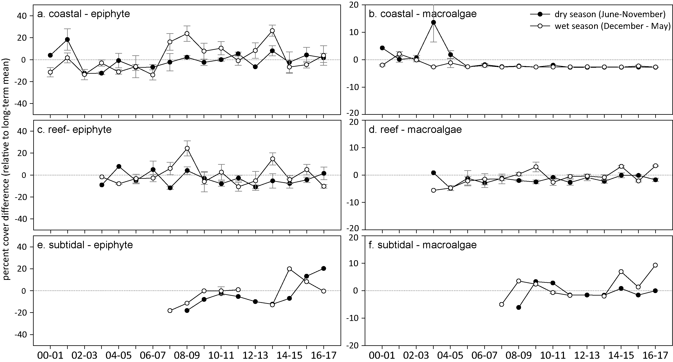
Figure 62. Long-term trend in mean epiphyte and macroalgae abundance (per cent cover) relative to the long-term average for each inshore seagrass habitat in the Wet Tropics region, 2001 - 2017
(sites pooled, ±SE).

Report card for inshore seagrass status
In the 2016–17 monitoring period, the seagrass index for the Wet Tropics region decreased slightly relative similar to the previous period (Table 19). The decrease is due primarily to the very poor reproductive effort particularly at reef intertidal and subtidal habitats and the reduction in reproductive effort at coastal sites. Overall, the Wet Tropics seagrass index in 2016–17 remained in a poor state, below the 2008-09 peak.

Table 19. Long-term report card scores for seagrass abundance, reproductive and leaf tissue nutrient status for each habitat in the Wet Tropics NRM region: June 2005 – May 2017.
Values are indexed scores scaled from 0-100; ■ = very good (81-100), ■ = good (61 - 80), ■ = moderate (41 - 60), ■ = poor (21 - 40), ■ = very poor (0 - 20). NB: Scores are unitless.
Indicator | Habitat | 2005-06 | 2006-07 | 2007-08 | 2008-09 | 2009-10 | 2010-11 | 2011-12 | 2012-13 | 2013-14 | 2014-15 | 2015-16 | 2016–17
Abundance | coastal intertidal | 38 | 30 | 55 | 70 | 54 | 46 | 7 | 13 | 21 | 19 | 38 | 48
Abundance | coastal subtidal |  |  |  |  |  |  |  |  |  |  | 33
Abundance | reef intertidal | 72 | 58 | 43 | 35 | 35 | 19 | 17 | 21 | 28 | 20 | 20 | 26
Abundance | reef subtidal |  |  | 0 | 33 | 23 | 27 | 34 | 37 | 21 | 15 | 17 | 6
Reproductive  effort | coastal intertidal | 0 | 0 | 0 | 0 | 6 | 0 | 0 | 0 | 0 | 0 | 19 | 0
Reproductive  effort | reef intertidal | 0 | 0 | 0 | 38 | 19 | 20 | 10 | 0 | 10 | 8 | 10 | 5
Reproductive  effort | reef subtidal |  |  |  |  |  | 0 | 33 | 0 | 25 | 83 | 17 | 0
Leaf tissue  nutrient | coastal intertidal | 11 | 10 | 21 | 6 | 25 | 7 | 4 | 7 | 16 | 8 | 9 | 13
Leaf tissue  nutrient | reef intertidal |  | 70 | 46 | 47 | 50 | 40 | 38 | 40 | 40 | 36 | 40 | 43
Leaf tissue  nutrient | reef subtidal |  |  |  | 64 | 48 | 52 | 54 | 93 | 46 | 52 | 47 | 50
Seagrass Index |  | 20 | 27 | 27 | 35 | 30 | 23 | 22 | 23 | 23 | 27 | 25 | 22

Burdekin

2016–17 summary
Inshore seagrass meadows in the Burdekin region are primarily structured by wind-induced turbidity (re-suspension) in the short term and by episodic riverine delivery of nutrients and sediment in the medium term. 2016–17 was an average year for rainfall and river discharge, yet seagrass sites were exposed to ‘brown’ or ‘green’ turbid water for 100 per cent of the wet season (December 2016-April 2017), and daily light was below average. Due to the marine heatwave, water temperature was 0.7°C and 1.2°C higher than average in intertidal and subtidal habitats, respectively. Furthermore, the total number of days exceeding 35°C (45 d) was the highest on record, and this thermal anomaly may have had a chronic effect on seagrass condition and resilience, particularly in combination with below-average light levels.
Seagrass meadows in the Burdekin NRM increased in abundance in some habitats in 2016–17, leading to an increase in the overall score to good. Coastal habitats had the largest increase in abundance relative to the previous reporting year, while reef habitats were unchanged. The long-term trend for the region (GAM plots), indicate a trend for declining abundance in reef subtidal habitat and an increase in coastal habitats over the past few years years. Annual monitoring as part of the Queensland Ports Seagrass Monitoring Program (QPSMP) in the Cleveland Bay region reported increased visually estimated biomass in 2016, but relatively stable meadow extent (Wells and Rasheed 2017). However, at the port of Abbot Point in the southern Burdekin region, the dynamic deep-water seagrass meadows descreased in visually estimated biomass, due to unusual climatic conditions (dry season rainfall) having critical impacts on the light-sensitive deepwater populations during their growing season (McKenna et al. 2015).
The overall score for reproductive effort reduced to poor in 2016–17. Reproductive effort has remained moderately high at coastal sites, and the seed bank has the highest densities among all Great Barrier Reef sites; however, seed density remains lower than the historical peaks observed in 2004-2008. The reduction in category was due to reproductive effort at the reef intertidal and subtidal sites. Despite this, seed density in the seed bank of the reef subtidal habitat is at historical peaks, and it is the only subtidal reef habitat to maintain a seed bank. The C:N ratio of seagrass leaves increased in 2016–17 in all habitats, reaching the greatest level observed in coastal habitats of the region since monitoring began. At reef sites, C:N remains above 20, indicating that nitrogen is not in excess relative to growth requirements. Reductions in N:P ratios in all habitats further indicate a reduction in nitrogen in the region
Over the past decade, seagrass meadows of the Burdekin region have demonstrated high resilience particularly through their capacity for recovery. This may reflect a conditioning to disturbance (high seed bank, high species diversity), but also reflects the nature of the disturbances which are episodic and dominated by Burdekin River flows. Burdekin regional seagrass state increased slightly in 2016–17 and remains moderate due largely to reduced reproductive effort (Figure 63).
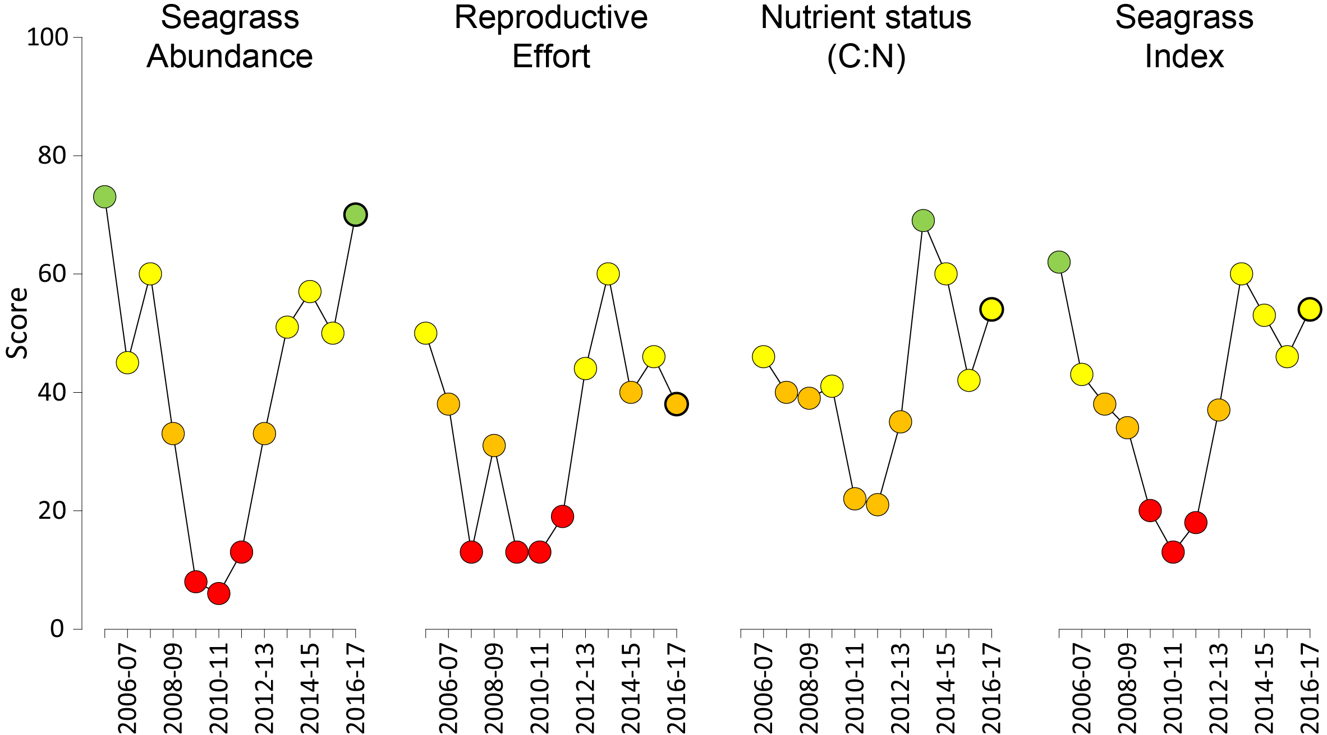
Figure 63. Report card of seagrass status indicators and index for the Burdekin NRM region
(averages across habitats and sites). Values are indexed scores scaled from 0-100; ■ = very good (81-100), ■ = good (61 - 80), ■ = moderate (41 - 60), ■ = poor (21 - 40), ■ = very poor (0 - 20). NB: Scores are unitless.

Climate and environmental pressures
Rainfall and river discharge were below the long-term average in the Burdekin region (Table 20). However, the largest river, the Burdekin River, had a discharge that was around the long-term average, while discharge from the Don River was more than double the long-term median (Table 10). Wind, which can resuspend fine sediments and nutrients adsorbed to their surface, exceeded the long-term average and seagrass monitoring sites were exposed to ‘brown’ or ‘green’ turbid water for 100 per cent (f_{P+S} = 1.00) of the wet season. Coastal sites were exposed to turbid, sediment laden, primary waters, and reefs sites were exposed largely to ‘green’ turbid water, for the duration of the 2016–17 wet period (Figure 64, Table 21).

Table 20. Summary of environmental conditions at monitoring sites in the Burdekin in 2016–17 compared to the long-term average
(long-term range indicated for each data set) including climate, discharge, plume, and within seagrass canopy conditions.
 | Long-term average | 2016–17
Wet Season rainfall (1961-1990) | 3.3 mm d⁻¹ | 2.6 mm d⁻¹
Wet Season river discharge (1961-1990) | 5,889,584 L yr⁻¹ | 5,500,724 L yr⁻¹
Turbid water exposure (2006-2017) | 99 per cent | 100 per cent
Daytime tidal exposure 2000-2017) | 109 hr yr⁻¹ | 85 hr yr⁻¹
Wind (1998-2017) | 97 days yr⁻¹ | 139 days yr⁻¹
Within canopy temperature – intertidal (2003-2017)  subtidal (2008-2017) | 26.4°C (46.6°C)  26.3°C (36.2°C) | 27.1°C (40.1°C)  27.5°C (35.2°C)
Within canopy light (2012-2017) | 9.6 mol m⁻² d⁻¹ | 9.2 mol m⁻² d⁻¹

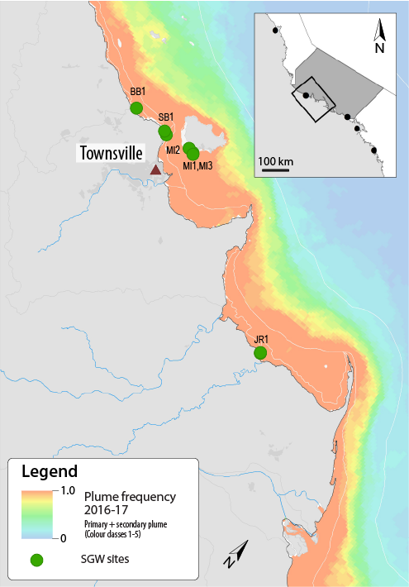
Figure 64. Frequency of exposure to turbid water (colour classes 1-5) in the Burdekin NRM region, wet season (December 2016 – April 2017) composite.
Frequency calculated as number of weeks in wet season exposed to primary or secondary water (colour classes 1 – 5). Each colour class category is described by mean water quality values for TSS, CDOM, chlorophyll a and K_{d} (PAR) (Devlin et al. 2015;Waterhouse et al. 2017). For site details, see Table 22.

Table 21. Water type at each seagrass monitoring site in the Burdekin NRM region, derived from MODIS true colour images
as colour classes of turbid primary water (class 1 – 4, red/brown), nutrient/chlorophyll-enriched secondary water (class 5, green), and tertiary (some freshwater/CDOM influence) or no plume influence (class 6 and 7 respectively, blue), for 22 weeks from December 2015 – April 2017. Also shown, median wet season colour class (Med), frequency of primary water as f_{(P)}, the frequency of secondary water as f_{(S)}, and the frequency of primary or secondary as f_{(P+S)}.
Site | 1 | 2 | 3 | 4 | 5 | 6 | 7 | 8 | 9 | 10 | 11 | 12 | 13 | 14 | 15 | 16 | 17 | 18 | 19 | 20 | 21 | 22 | f_{(P)} | f_{(S)} | f_{(P+S)}
MI1, MI2 | 5 | 5 | 5 | 5 | 5 | 5 | 5 | 5 | 5 | 5 | 4 | 5 | 5 | 5 | 5 | 5 | 5 | 5 | 5 | 5 | 5 | 5 | 0.05 | 0.95 | 1.00
MI3 | 5 | 5 | 5 | 5 | 5 | 5 | 5 | 5 | 5 | 5 | 5 | 5 | 5 | 5 | 5 | 5 | 5 | 5 | 5 | 5 | 5 | 5 | 0.00 | 1.00 | 1.00
SB2* | 1 | 1 | 1 | 1 | 1 | 3 | 2 | 1 | 1 | 2 | 2 | 4 | 3 | 2 | 2 | 2 |  | 1 | 1 | 2 | 2 | 2 | 1.00 | 0.00 | 1.00
BB1 | 3 | 2 | 4 | 2 | 1 | 4 | 4 | 3 | 1 | 3 | 2 | 4 | 3 | 2 | 2 | 2 | 4 | 4 | 2 | 2 | 2 | 2 | 1.00 | 0.00 | 1.00
SB1 | 1 | 1 | 3 | 2 | 4 | 2 | 3 | 2 | 2 | 2 | 3 | 4 | 4 | 4 | 4 | 4 | 4 | 3 | 3 | 3 | 2 | 3 | 1.00 | 0.00 | 1.00
JR1, JR2 | 4 | 2 | 2 | 2 | 4 | 5 | 4 | 3 | 2 | 2 | 1 | 4 | 1 | 2 | 1 | 4 | 5 | 2 | 1 | 2 | 2 | 2 | 0.91 | 0.09 | 1.00

Daily light (I_{d}) has been monitored at some Burdekin NRM sites since 2008 (Figure 65). I_{d} is highly seasonal at some sites, with the peak occurring in the late dry season (usually October-December). The seasonal signal in I_{d} is most pronounced at Picnic Bay intertidal (MI1) and subtidal (MI3) sites (Figure 65). In 2016–17, average I_{d} was lower than average due to conditions at the Magnetic Island sites (Figure 65). Bushland Beach intertidal and the Magnetic Island subtidal sites have the most frequent exceedance of light thresholds, and the region as a whole has the greatest exceedance of light thresholds within the Great Barrier Reef. Despite this, in 2016–17, I_{d} was above light thresholds during the peak growth season (September to November) at all sites, as typically occurs in the region at this time of year.
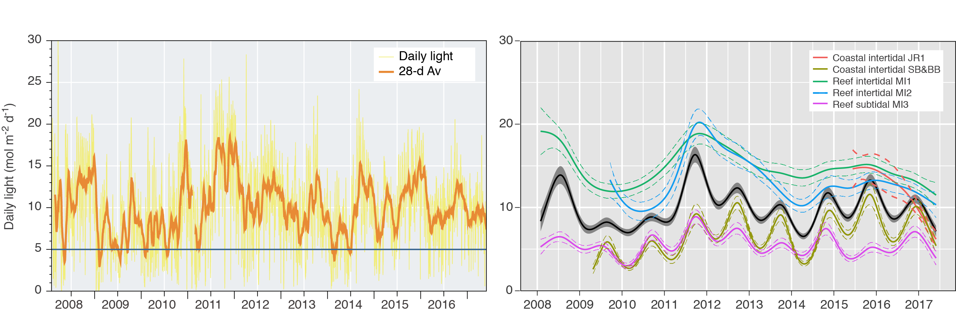
Figure 65. Mean daily light at Burdekin sites with 28-d rolling average from 2008 to 2017 (left) and GAM plots (right)
with the black line showing mean trend for all sites (±95 per cent confidence interval in grey shade) and coloured lines (with CI’s) showing the trend for each site. Results of statistical analysis (GAM) and site-specific graphs (site-level daily light data plus 28-d rolling average) are shown in Appendix 4.

Water temperature was generally very warm, and was the highest average temperature since monitoring began. Despite that, there was a similar number of days above 35°C in 2016–17 (45d) as in 2015-16 (44d), which was fewer than in 2014-15 (53 d) (Figure 66a). For a third year in a row there was frequent deviation from the thermal baseline, even at subtidal sites (Figure 66b). There were also 1 day of extreme temperature (>40°C) in November 2016 at a coastal Townsville site.

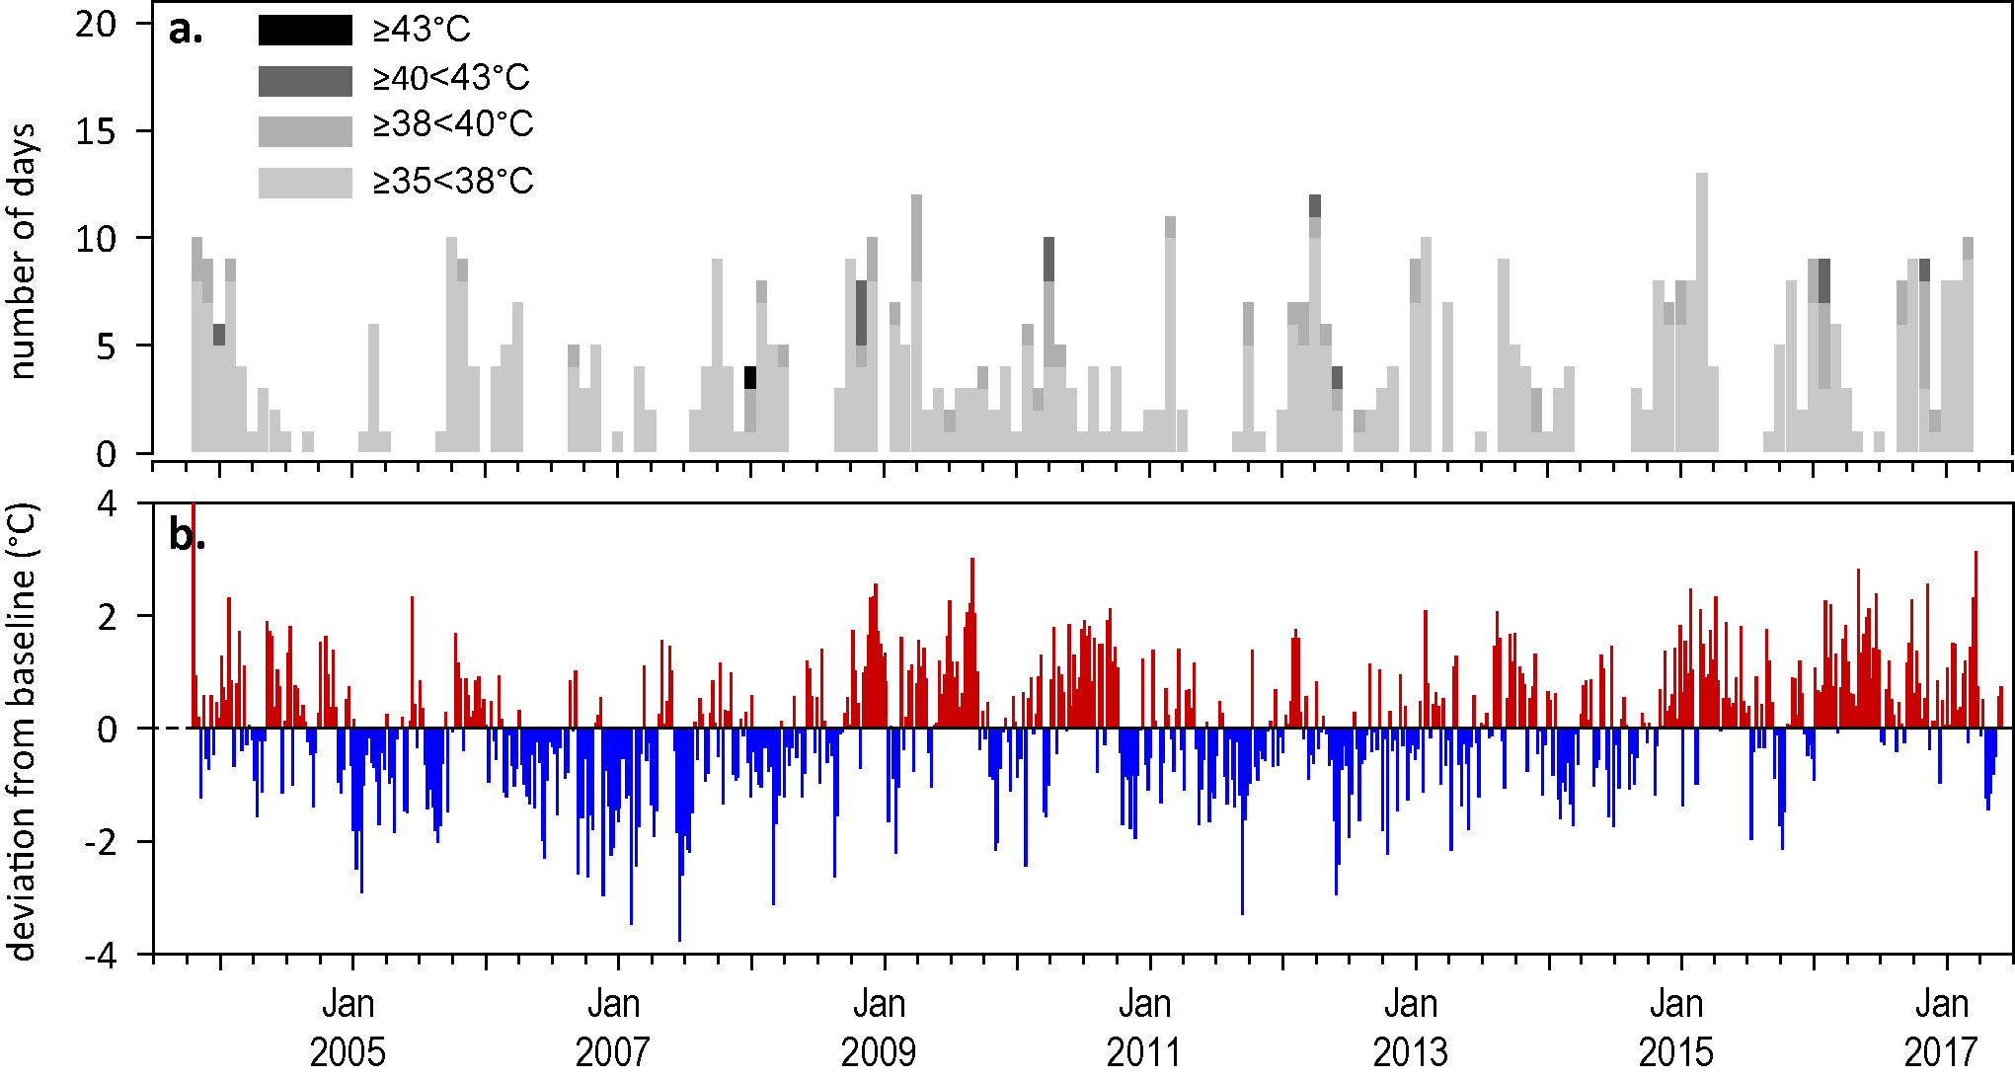
Figure 66. Inshore sea temperature at intertidal seagrass habitats in the Burdekin region, January 2008 - May 2017
: a) number of days when temperature exceeded 35°C, 38°C, 40°C and 43°C within each season (thresholds adapted from Campbell et al. 2006); b) deviations from 11-year mean weekly temperature records (weeks above the long-term average are represented as red bars and the magnitude of their deviation from the mean represented by the length of the bars, bars are blue for weeks with temperatures lower than the average and are plotted as negative deviations).
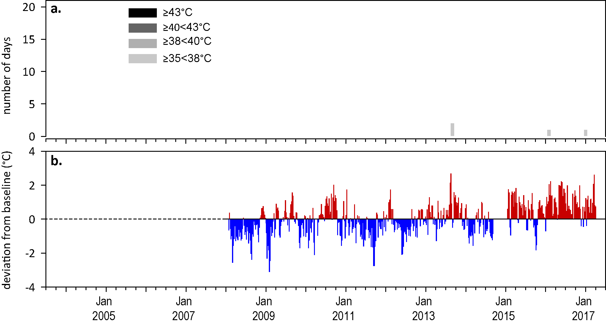
Figure 67. Inshore sea temperature at inshore subtidal seagrass habitat at Magnetic Island (Burdekin region), January 2008 - May 2017
: a) number of days when temperature exceeded 35°C, 38°C, 40°C and 43°C within each season (thresholds adapted from Campbell et al. 2006); b) deviations from 7-year mean weekly temperature records (weeks above the long-term average are represented as red bars and the magnitude of their deviation from the mean represented by the length of the bars, bars are blue for weeks with temperatures lower than the average and are plotted as negative deviations). Dashed line represents no data.

Indicators of seagrass condition
Three seagrass habitat types were assessed across the Burdekin region in 2016–17, with data from 8 sites (Table 22).

Table 22. List of data sources of seagrass and environmental condition indicators for each seagrass habitat type in the Burdekin NRM region.
*Seagrass-Watch. For site details see Table 3 and Table 4.
Habitat | Site  code and location |  | Seagrass abundance | Seagrass composition | Seagrass distribution | Reproductive effort | seed banks | Leaf tissue nutrients | Meadow sediments | Epiphytes & macroalgae
coastal intertidal | SB1 | Shelley Beach (Townsville)
coastal intertidal | SB2* | Shelley Beach (Townsville)
coastal intertidal | BB1 | Bushland Beach (Townsville)
coastal intertidal | JR1 | Jerona (Barratta CK, Bowling Green Bay)
coastal intertidal | JR2 | Jerona (Barratta CK, Bowling Green Bay)
reef intertidal | MI1 | Picnic Bay (Magnetic Island)
reef intertidal | MI2 | Cockle Bay (Magnetic Island)
reef subtidal | MI3 | Picnic Bay (Magnetic Island)

Seagrass abundance, composition and distribution
The overall status for seagrass abundance increased to good in 2016–17 (Figure 63), due to increases in percent cover at the coastal sites (Figure 68).
Since monitoring was established, coastal and reef intertidal meadows in the region have displayed a seasonal pattern in abundance; high in wet and low in the dry season (McKenzie et al. 2012a). This, however, was not apparent over the last five years, as variability has not followed typical seasonal trends while seagrass has been recovering from losses experienced in early 2011. Recovery has proceeded rapidly in the Burdekin Region after severe weather in 2009-2011, and this recovery has occurred despite the frequent exceedance of light thresholds at some of the sites. This might have been due to the timing of when light is received (highest in September to November) or because threshold exceedance is short lived (typically for days only), thus highlighting the need to identify seasonal and annual light thresholds, and not just event thresholds which are reported against in this report. Seagrass abundances in 2016–17 were highest at the Barrata Creek coastal intertidal habitat followed by the reef subtidal habitats (Figure 68).
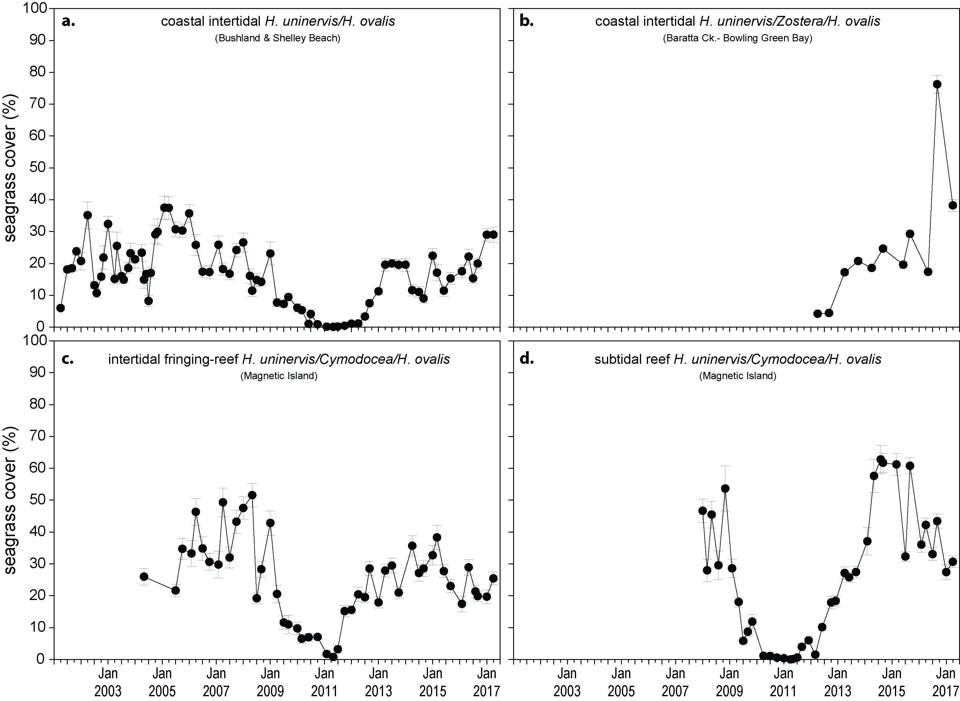
Figure 68. Changes in mean seagrass abundance (per cent cover ± SE) at inshore coastal intertidal (a, b), reef intertidal (c) and reef subtidal (d) meadows in the Burdekin region, 2001 - 2017.
An examination of the long term trends across the Burdekin NRM habitats suggests seagrass abundance (per cent cover) has been relatively stable for the region as a whole since 2013 (Figure 70). Long-term trends of the habitats, however, indicates that there have been declines at the subtidal habitas and increases at coastal habitats.
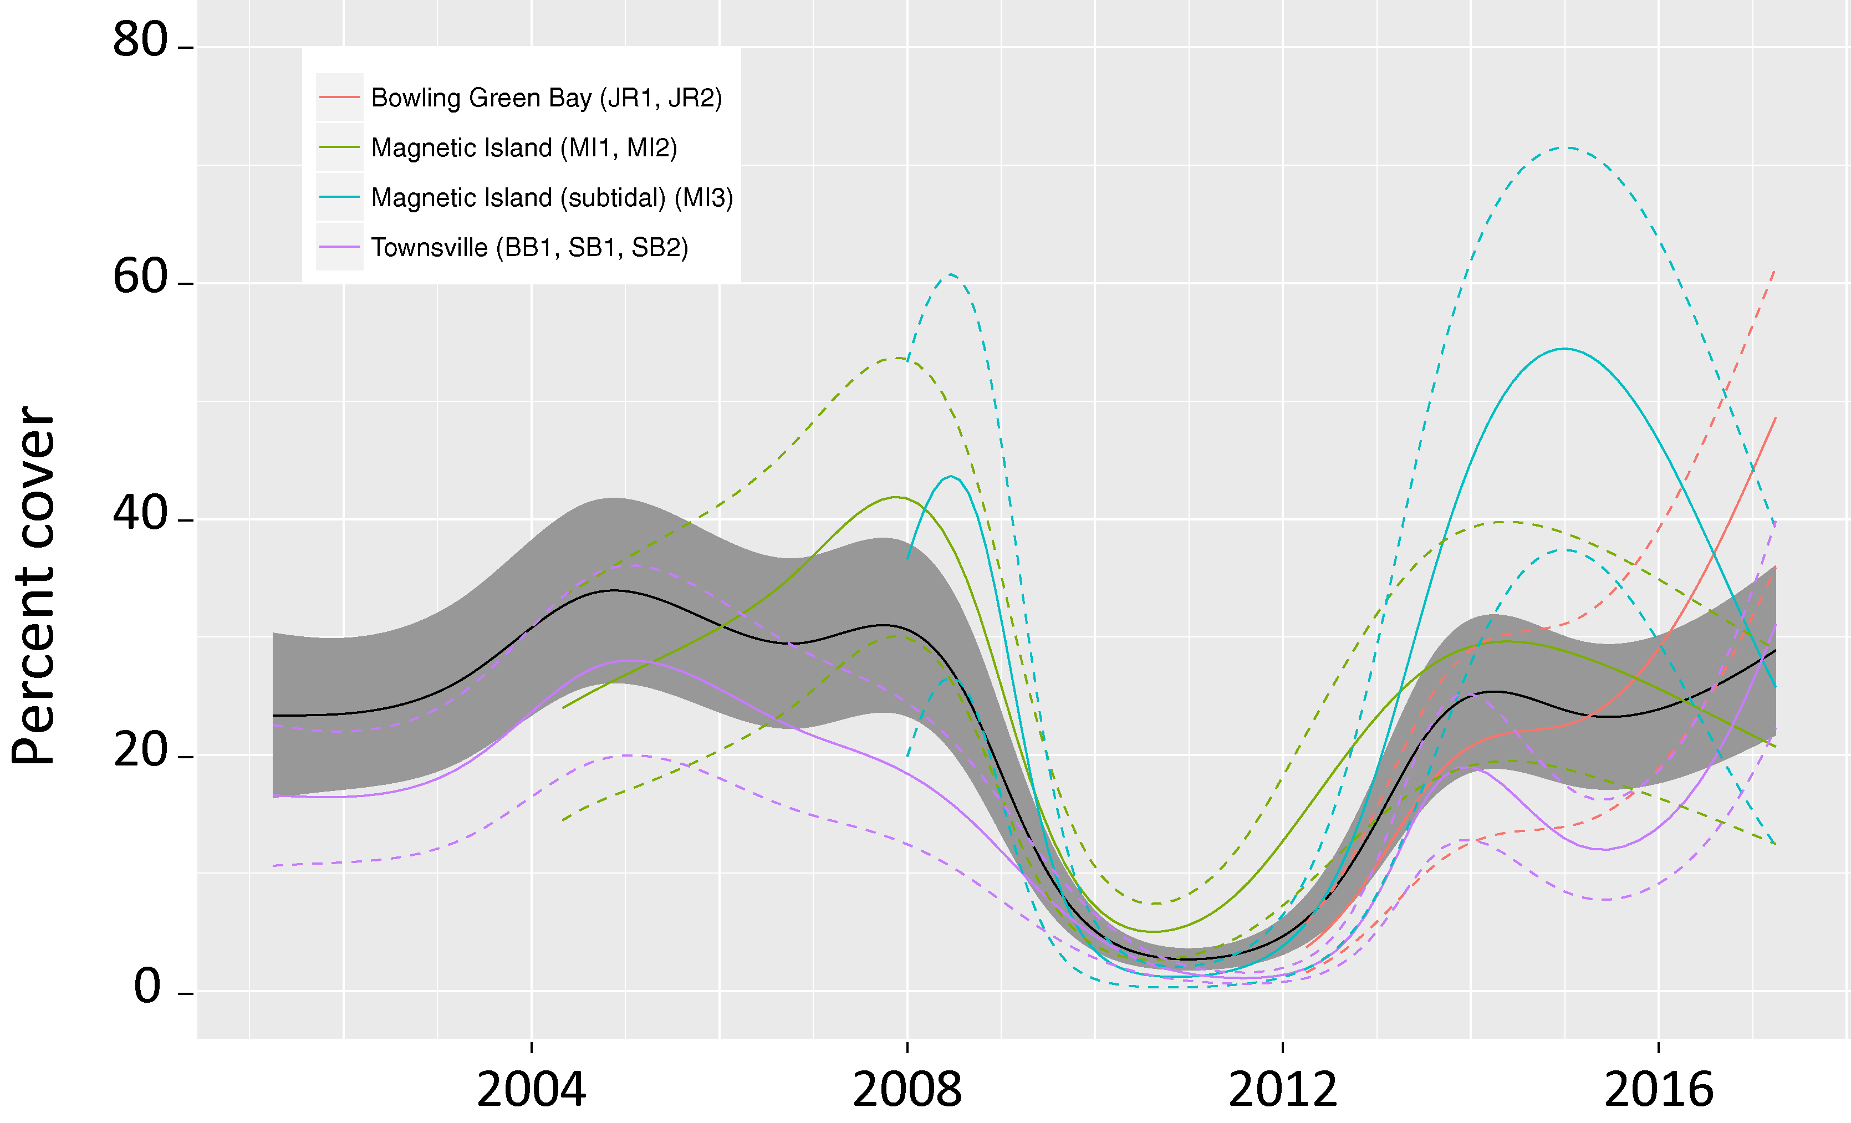
Figure 69. Temporal trends in seagrass abundance for each location in the Burdekin region represented by a GAM plot.
Regional trend (all habitats pooled) represented by black line with grey shaded areas defining 95 per cent confidence intervals.

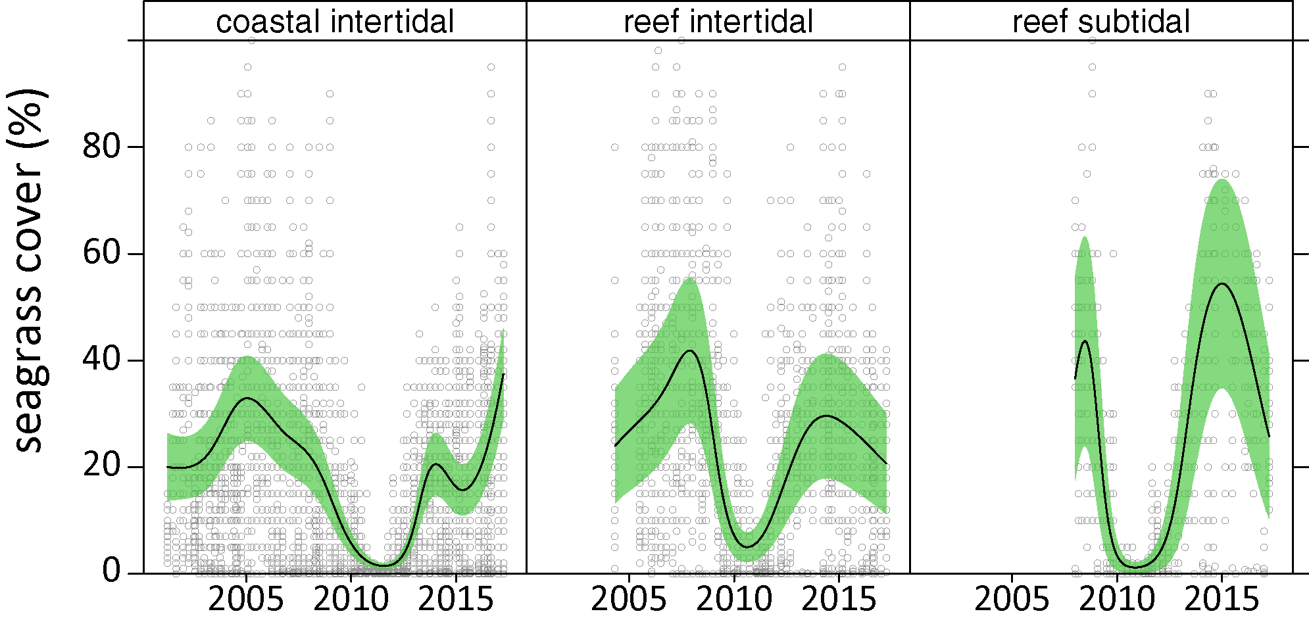
Figure 70. Temporal trends in seagrass abundance for each habitat in the Burdekin region represented by GAM plots.
Trends (locations pooled) represented by black line with green shaded area defining 95 per cent confidence intervals, and quadrat data displayed as grey circles.
There has also been a low proportion of species displaying colonising traits (Halophila ovalis) since 2014-15 in all habitats. Instead these habitats are dominated by opportunistic species (H. uninervis, Z. muelleri, C. serrulata) in coastal and reef sites or persistent species in intertidal reef habitat (T. hemprichii) in 2016–17 than in the previous 4 years (Figure 71; Appendix 4). This is a sign of meadow progression following near decimation after the events leading up to and including 2011. Opportunistic and persistent foundation species also have a capacity to resist stress (survive, through reallocation of resources) caused by acute disturbances (Collier et al. 2012c), and therefore, current species composition provides greater overall resilience in Burdekin meadows.
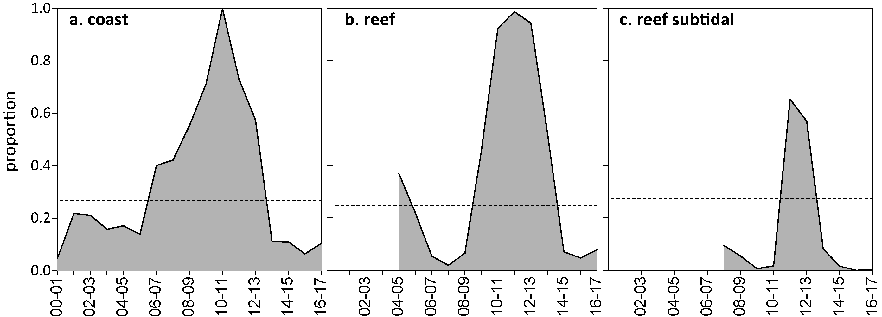
Figure 71. Proportion of seagrass abundance composed of colonising species at inshore habitats in the Burdekin region, 2001 - 2017.
Grey area represents Great Barrier Reef long-term average proportion of colonising species for each habitat type.
Seagrass meadow extent within all intertidal monitoring sites has fluctuated within and between years (Figure 72), primarily due to short-term losses and subsequent recolonisation. In the two to three years prior to 2011, significant changes occurred across the region with all seagrass meadows reducing in size and changing in landscape from continuous, to patchy, to isolated patches and finally to isolated shoots with the loss of meadow cohesion (Figure 72). That trend was also replicated at the Bay-wide scale in Cleveland Bay, with considerable loss of meadow area and meadow fragmentation (Petus et al. 2014a). This was caused by the high rainfall and riverine discharge that affected much of the Great Barrier Reef. Since 2011, meadow extents have increased in both coastal and reef habitats to pre-2009 levels (Figure 72) and have remained stable. In early 2014, however, seagrass extent declined at the subtidal habitat, to the lowest in 2 years but subsequently recovered within 6 months to it’s maximum extent. Little change has occurred in the extent of seagrass meadows in all habitats over the last 2-3 years.
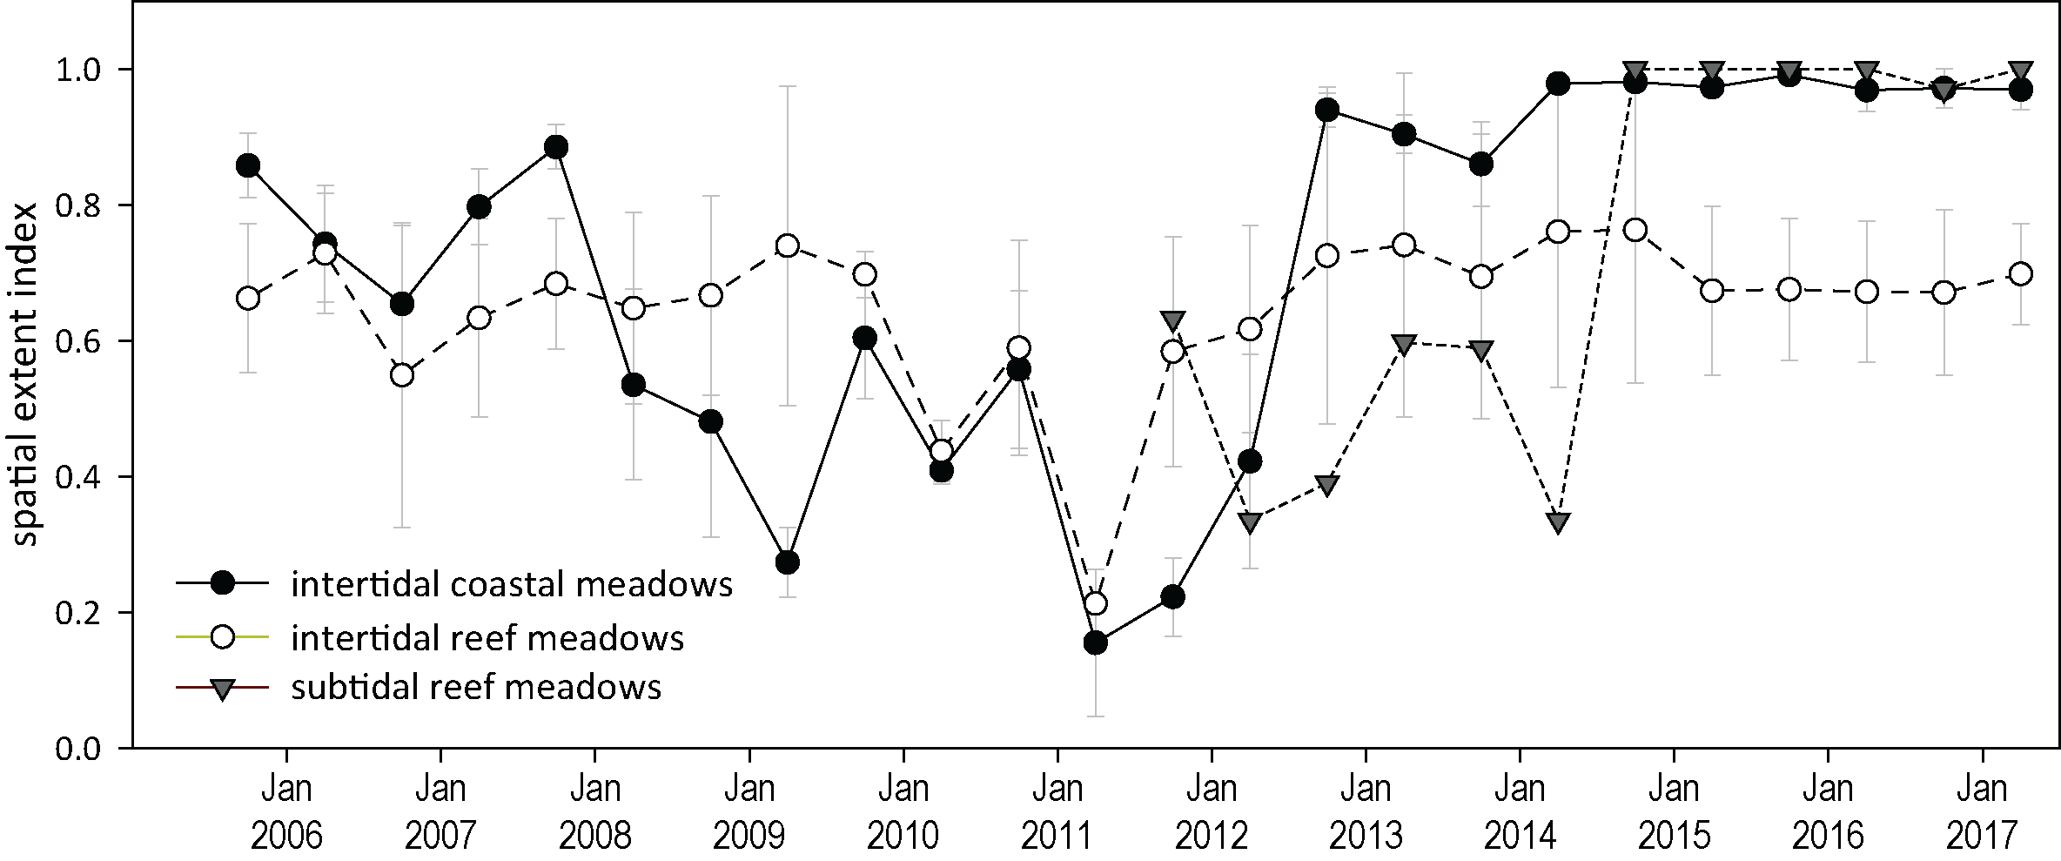
Figure 72. Change in spatial extent of seagrass meadows within monitoring sites for each inshore intertidal habitat and monitoring period across the Burdekin region, 2005 - 2017.
The trends observed at the inshore MMP sites, broadly reflect the overall trends observed in complimentary monitoring programs. Apart from the MMP, seagrass monitoring within the Burdekin NRM region is also conducted in places where cumulative anthropogenic impacts to seagrass are highest as part of the Queensland Ports Seagrass Monitoring Program (QPSMP). Annual monitoring in September and October 2016 of 10 seagrass meadows in the Port of Townsville reported minor, but not significant, increases in overall extent (Wells and Rasheed 2017, Figure 73). The increased extent was largely due to the expansion of a subtidal Halodule uninervis and Halophila spinulosa dominated meadows adjacent to Cape Pallarenda (meadows 12 and 14) and the large H. uninervis and C. serrulata-dominated meadows in southern Cleveland Bay (meadow 17-18), while there were small declines in the extent of smaller meadows around Magnetic Island. These changes in extent were not statistically significant in most meadows as they were within the estimates of reliability (see Appendix 2 in Wells and Rasheed 2017). There was, however, large and significant increases in mean visually-estimated biomass of all meadows except meadow 6, a small Z. muelleri-dominated meadow around Magnetic Island (Davies and Rasheed 2016).
Figure 73. Change in total extent of all monitoring meadows combined in Port of Townsville from 2007 – 2016
(from Wells and Rasheed 2017). Error bars are SE for g DW m⁻² and “R” reliability estimate for ha. Dashed line indicates long-term average.
In the southern part of the Burdekin NRM region, the findings from annual monitoring for the North Queensland Bulk Ports Corporation in the Port of Abbot Point remain less clear, as discerning seagrass state at the coastal and subtidal locations is challenged by the extremely dynamic nature of the meadows. The Port is positioned in a highly weather (e.g. wind and wave action) exposed area which place substantial environmental pressures on the seagrass and benthic communities (Rasheed et al. 2005a). The dynamic deeper water seagrass declined in biomass (visually estimated from boat based free diving and CCTV surveys) in late 2016 due to a reduction in the proportion of H. spinulosa which has a larger biomass than other deepwater species (McKenna et al. 2017 ) (Figure 74). While there was relatively good growing conditions on an annual basis, light availability was below critical light thresholds for deepwater species in the months preceding the surveys, which is the peak growing season for deepwater seagrass species. The low levels were caused by dry season rainfall that reduced total incoming solar radiation (McKenna et al. 2017 ). It also resulted in very small discharges from the Don River that may have affected water quality. By contrast, biomass increased in three out of five of the inshore coastal meadows, and area increased in two out of five meadows leading to an overall increase in the biomass score. The dry season conditions affecting the deepwater communities do not appear to have impacted the inshore communities (McKenna et al. 2017 ).
Figure 74. Change in visually estimated above-ground biomass at offshore monitoring sites adjacent to Abbot Point from 2005 – 2016
(from McKenna et al. 2017 ). Error bars are SE for g DW m².

Seagrass reproductive status
Reproductive effort in meadows of the Burdekin region had been on an increasing trajectory but the reproductive score declined to poor in 2016–17, after reaching moderate in the previous reporting year. This decline in reproductive effort was observed in all habitats to some extent. Reproductive effort and density of seeds in the seed bank at coastal sites has been highly variable since monitoring began. In 2016–17 both reproductive effort and seed density were higher than in other habitat types, but they did not reach historical peaks observed in the period 2005 to 2008. At reef intertidal sites, reproductive effort has remained low in 2016–17, and previous increases in seed density had reversed and were again very low. By contrast, although reproductive effort is typically low at reef subtidal sites, a seed bank has built up from 2011, and was maintained in 2016–17 (Figure 75).
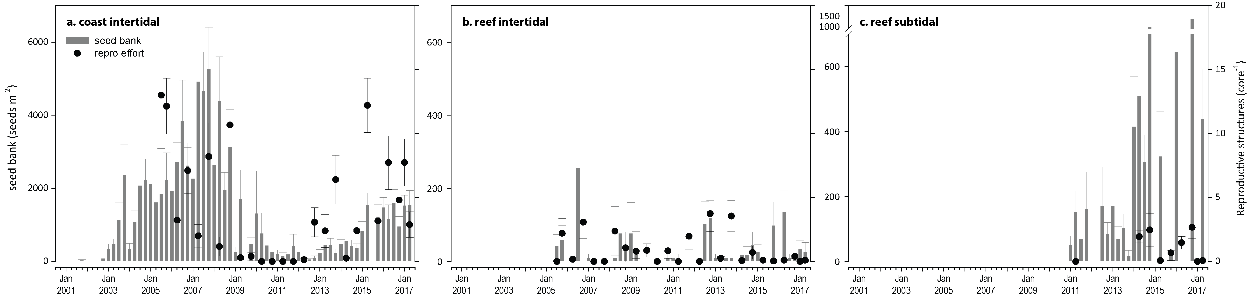
Figure 75. Seed bank and late dry season reproductive effort at inshore intertidal coast and reef and subtidal reef habitats in the Burdekin region.
Seed bank presented as the total number of seeds per m² sediment surface (bars ±SE), and late dry season reproductive effort presented as the average number of reproductive structures per core (species and sites pooled) (dots ±SE). NB: Y-axis scale for seed banks differs between habitats.

Indicators of environmental condition

Seagrass tissue nutrients
Seagrass leaf tissue molar C:N ratios increased in coastal habitats in 2016–17 reaching historical maxima (Figure 76). There were also small increases at reef habitat, where the values were above the threshold value (C:N <20) that indicates that nitrogen is not in supply at a rate in excess of growth requirements (i.e. N limited). The reduction in N:P at all sites also suggests that reduced N-availability is likely to be contributing to the rising C:N ratios (Figure 77); and this may be attributed to the multiple years of below average river discharge.
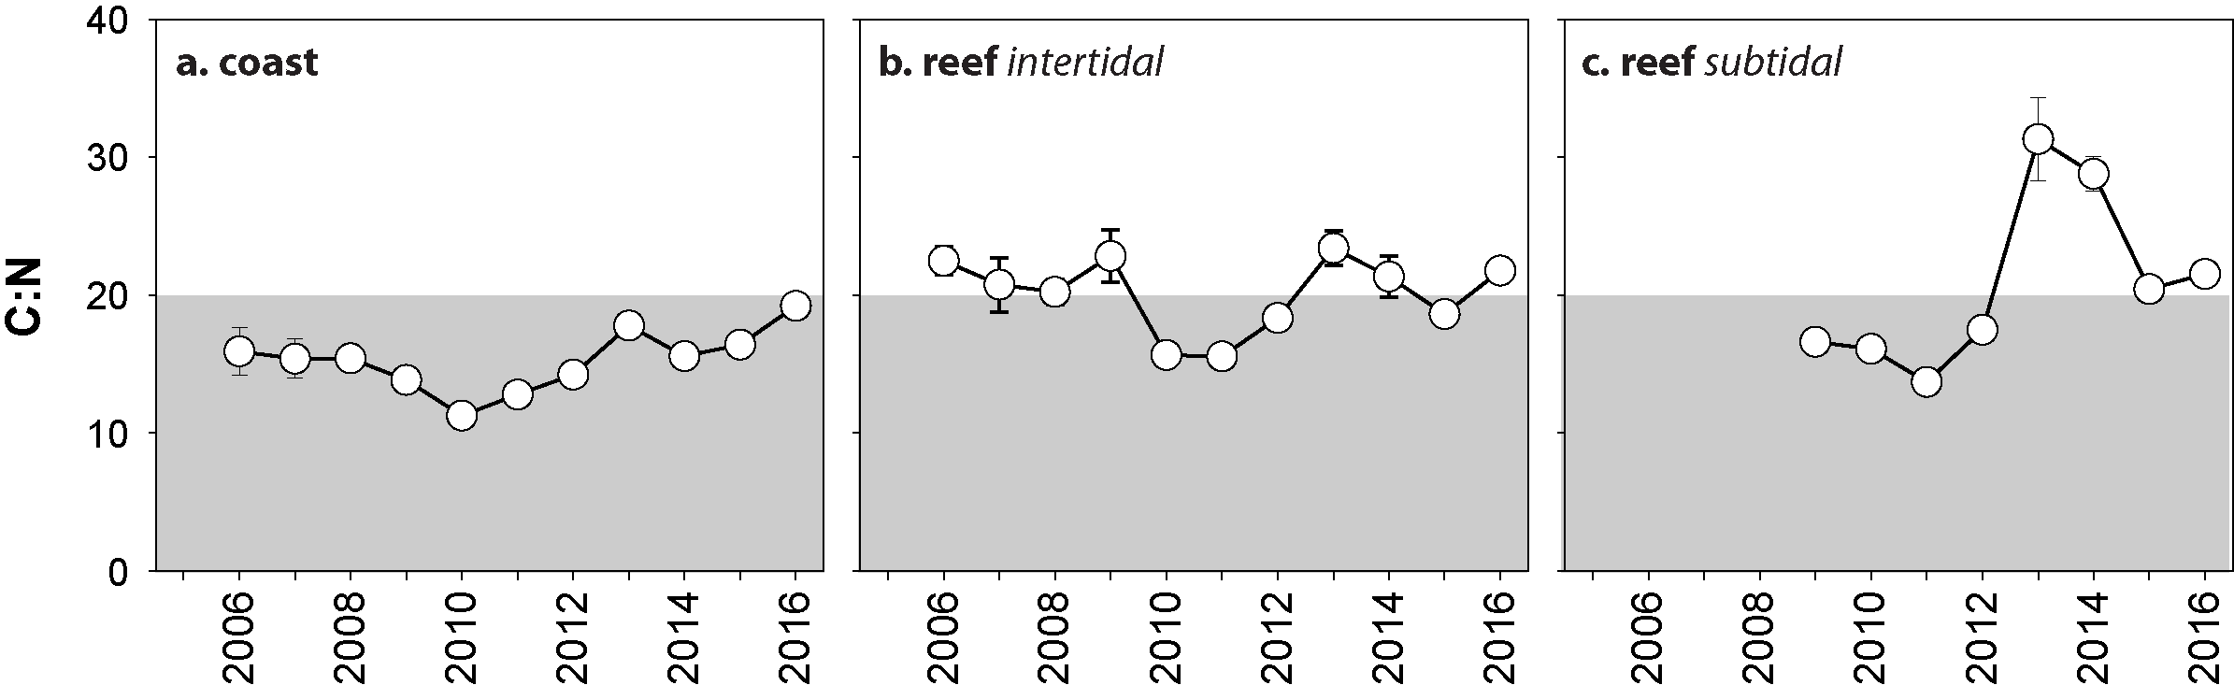
Figure 76. Elemental ratios (atomic) of seagrass leaf tissue C:N for the foundation seagrass species examined at each inshore habitat in the Burdekin region each year
(species pooled) (mean ± SE). Horizontal shaded band on the C:N ratio panel represents the accepted guideline seagrass “Redfield” ratio of 20:1 (Abal et al. 1994; Grice et al. 1996). C:N ratios below this line indicate reduced light availability and/or N enrichment.
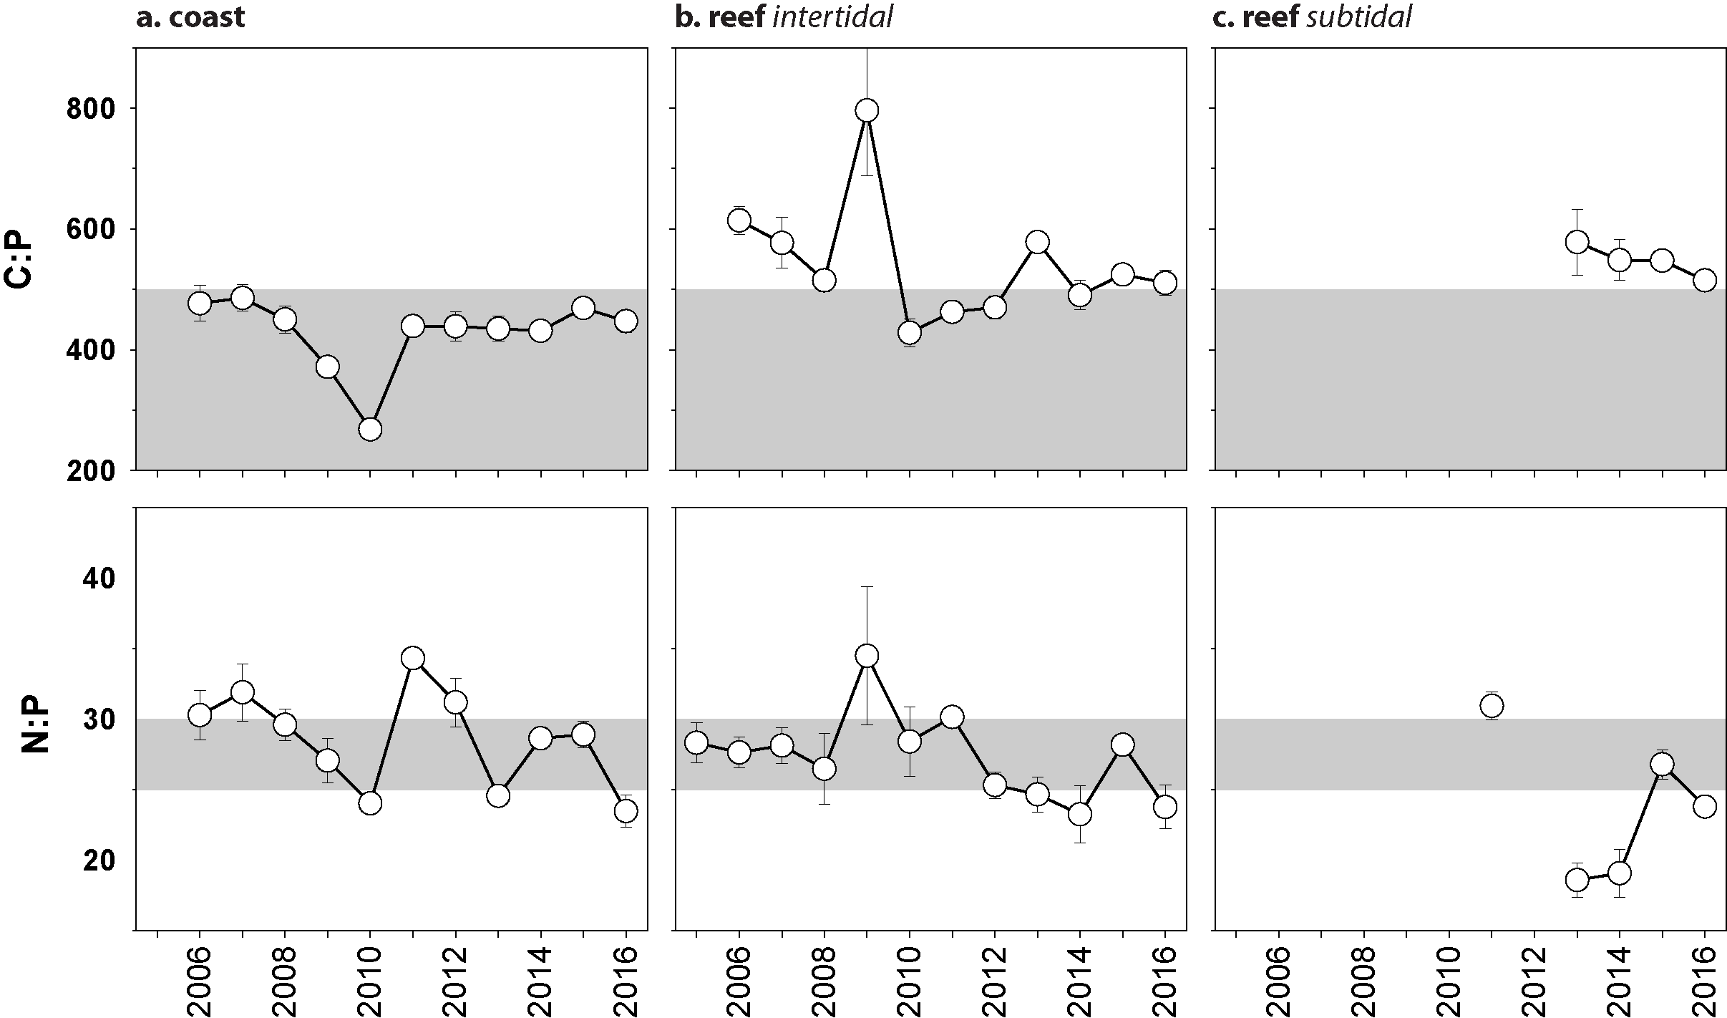
Figure 77. Elemental ratios (atomic) of seagrass leaf tissue N:P and C:P for the foundation seagrass species examined at each inshore intertidal habitat in the Burdekin region each year
(species pooled) (mean ± SE). Horizontal shaded band on the N:P ratio panel represents the range of value associated with N:P balance ratio in the plant tissues. N:P ratio above this band indicates P limitation, below indicates N limitation and within indicates replete. Shaded portion on the C:P panel ≤500 represents the value associated with C:P balance ratio in the plant tissues, C:P values <500 may indicate nutrient rich habitats (large P pool).

Seagrass meadow sediments
The proportion of mud at Jerona (Barratta Creek) coastal meadows was much higher than Townsville meadows (Bushland Beach and Shelley Beach) and has remained well above the Great Barrier Reef long-term average (Appendix A4.2.2). Townsville coastal meadows were dominated by fine sediments, although the proportion of mud has remained low post 2011 (Figure 173). Conversely, reef habitats which were dominated by coarser sediment prior to 2009-10, having since gradually increased in composition of fine sand and mud. More fine sediments were present at the Cockle Bay (MI2) than the Picnic Bay (MI1) reef habitat meadows (Figure 174, Figure 175).

Epiphytes and macroalgae
Epiphyte cover on seagrass leaf blades are generally higher in the wet- than the dry-season at coastal sites, but there is not a strong seasonal trend in other habitats. (Figure 78; Appendix 2, Figure 189. There was no significant change in epiphyte or macroalgae cover at intertidal coastal and reef habitats in 2016–17 compared ot the previous reporting year. However, at the reef subtidal site, there was an increase in wet season epiphyte cover and dry season macroalgae cover. Both epiphytes and macroalgae cover can increase following nutrient enrichment (Cabaço et al. 2013; Nelson 2017); however, due to complex ecological and biological factors (e.g. grazing Heck and Valentine 2006), their abundance may not necessarily correlate to nutrient loading. Elevated water temperature in 2016–17 may have also driven faster rates of epiphyte and macroalgae cover in subtidal sites, as they can be highly responsive to temperature.
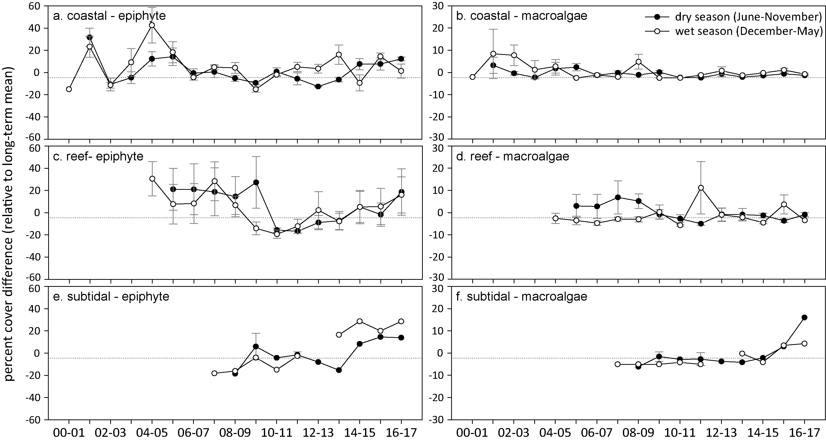
Figure 78. Long-term trend in mean epiphyte and macroalgae abundance (per cent cover) relative to the long-term Great Barrier Reef average for each inshore seagrass habitat in the Burdekin region
(sites pooled, ±SE).

Report card for inshore seagrass status
In the 2016–17 monitoring period, the seagrass index for the Burdekin region improved but remained moderate. Gains in abundance at coastal intertidal meadows were offset by declining abundance at reef sites and very poor reproductive effort at coastal and reef intertidal sites. Changes in the score for tissue nutrients rekative to the previous varied among habitats, and it was moderate in all habitats.
Table 23. Long-term report card scores for seagrass abundance, reproductive and leaf tissue nutrient status for each habitat in the Burdekin region: June 2016 – May 2017.
Values are indexed scores scaled from 0-100; ■ = very good (81-100), ■ = good (61 - 80), ■ = moderate (41 - 60), ■ = poor (21 - 40), ■ = very poor (0 - 20). NB: Scores are unitless.
Indicator | Habitat | 2005-06 | 2006-07 | 2007-08 | 2008-09 | 2009-10 | 2010-11 | 2011-12 | 2012-13 | 2013-14 | 2014-15 | 2015-16 | 2016–17
Abundance | coastal intertidal | 88 | 31 | 34 | 25 | 11 | 6 | 5 | 29 | 44 | 49 | 47 | 85
 | reef intertidal | 59 | 59 | 75 | 31 | 6 | 9 | 25 | 41 | 50 | 56 | 38 | 34
 | reef subtidal |  |  | 100 | 50 | 8 | 0 | 8 | 31 | 75 | 100 | 88 | 69
Reproductive | coastal intertidal | 50 | 25 | 25 | 38 | 0 | 0 | 0 | 13 | 19 | 6 | 38 | 13
effort | reef intertidal | 50 | 50 | 0 | 25 | 25 | 25 | 38 | 75 | 63 | 13 | 0 | 0
 | reef subtidal |  |  |  |  |  |  |  |  | 100 | 100 | 100 | 100
Leaf tissue | coastal intertidal |  | 30 | 27 | 27 | 19 | 6 | 14 | 26 | 39 | 28 | 32 | 46
nutrients | reef intertidal |  | 62 | 54 | 51 | 64 | 28 | 28 | 42 | 69 | 57 | 43 | 59
 | reef subtidal |  |  |  |  | 39 | 30 |  | 37 | 100 | 94 | 52 | 58
Seagrass Index |  | 62 | 43 | 38 | 34 | 20 | 13 | 18 | 37 | 60 | 53 | 46 | 54

Mackay Whitsunday

2016–17 summary
The Mackay Whitsunday region is characterised by episodic flows from adjacent catchments, as well as urban and marina development, tourism and is also vulnerable to temperature extremes in shallow habitats. In 2016–17, the region was affected by tropical cyclone Debbie, which crossed the coast near Airlie Beach on the 28th March 2017 as a category four cyclone, then tracked down the coast leaving a path of heavy rainfall. Rainfall and river discharge were elevated but the frequency of exposure to ‘brown’ and ‘green’ water (f_{P+S}) combined was average for the region (94 per cent of wet season weeks). Similarly, light levels were average in most sites of the region, except that when the Lindeman Island reef subtidal site was added in 2017, very low light levels reduced the regional average. Water temperature within the canopy of the seagrass meadows was 0.6°C above average. The number of high temperature days (>35°C) was similar to the previous four years.
Seagrass abundance was affected by TC Debbie at sites near and south of Airlie Beach, leading to a reduction in the overall score to poor. The reef intertidal and estuarine habitats were the most severly affected with abundance delining to nearly zero. Meadow extent was also substantially reduced in all habitats. The proportion of colonising species remained stable and low in most habitats, except in the reef habitat which is dominated by the colonising H. ovalis.
Seagrass reproductive effort remained elevated at coastal and estuarine sites, even reaching record high densities of reproductive structures in the estuarine habitat. However, due to very low reproductive effort in reef habitat, the score remained poor. In addition, there are no seeds in the seed bank in the reef habitat and therefore recovery from near decimation of seagrass at Hamilton Island, will be very slow. Leaf tissue C:N ratios were unchanged and remained poor overall.
Mackay Whitsunday regional seagrass state remained poor in 2016–17 (Figure 79). While an increase in reproductive effort and stable seed density in seed banks indicate that the coastal and estuarine sites will recover from the disturbances of the passed year, the reef habitat is in an extremely vulnerable state.
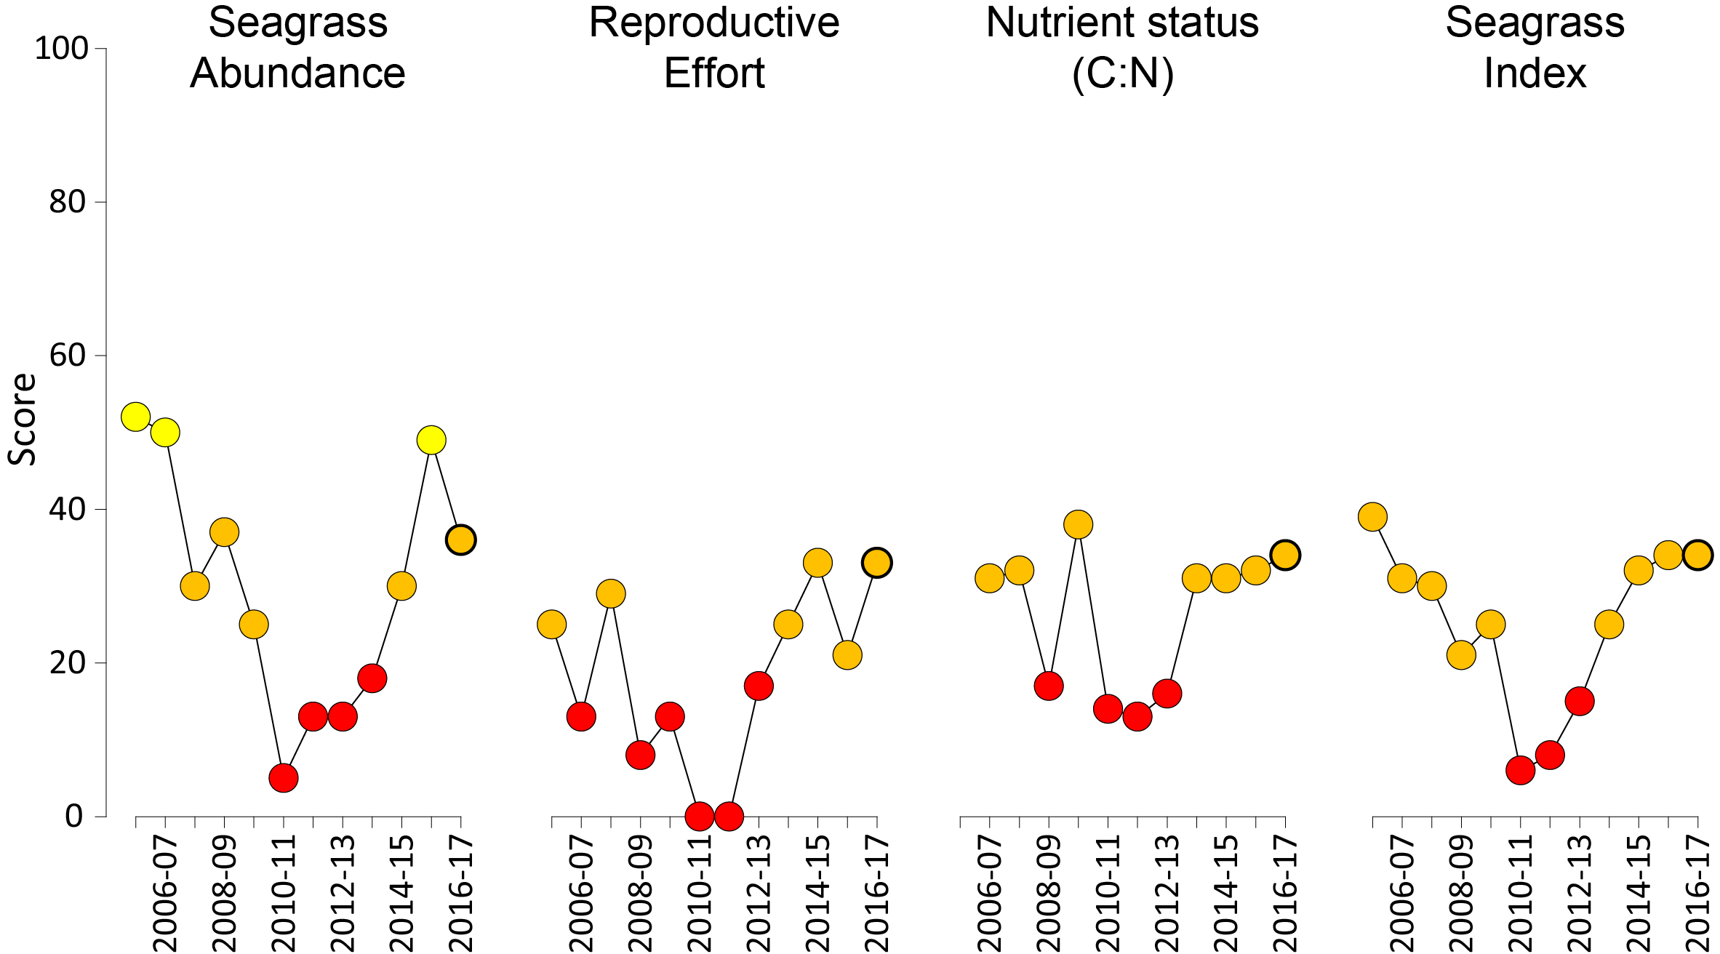
Figure 79. Report card of seagrass status indicators and index for the Mackay Whitsunday NRM region
(averages across habitats and sites). Bold symbol = 2016–17 monitoring period. Values are indexed scores scaled from 0-100; ■ = very good (81-100), ■ = good (61 - 80), ■ = moderate (41 - 60), ■ = poor (21 - 40), ■ = very poor (0 - 20).

Climate and environmental pressures
Rainfall and river discharge were considerably above the long-term average in 2016–17 due to above average rainfall in January 2017 and March 2017 when TC Debbie made landfall near Airlie Beach (Table 24). Despite this, the number of strong wind days was below average. Exposed to ‘brown’ or ‘green’ turbid water was the same in 2016–17, with 94 per cent (f_{P+S} = 0.94) of the wet season weeks experiencing turbid water. However, in 2016–17, there was a greater frequency of exposure to the ‘brown’ turbid water (Colour class 1-4, f_{P}) compared to previous years (Figure 10).
Table 24. Summary of environmental conditions at monitoring sites in Mackay Whitsunday region in 2016–17 compared to the long-term average (long-term range indicated for each data set).
 | Long-term average | 2016–17
Rainfall (1910-2017) | 7.7 mm d⁻¹ | 11.7 mm d⁻¹
River discharge (1970-2017) | 3,831,058 L yr⁻¹ | 7,197,028 L yr⁻¹
Turbid water exposure f_{(P+S)} (2006-2017) | 94 per cent | 94 per cent
Daytime tidal exposure (1999-2017) | 47 hr yr⁻¹ | 57 hr yr⁻¹
Wind >25km hr⁻¹(1998-2017) | 153 days yr⁻¹ | 122 days yr⁻¹
Within canopy temperature (2003-2017) | 25.3°C (42.7°C) | 25.9°C (40.8°C)
Within canopy light (2012-2017) | 13.8 mol m⁻² d⁻¹ | 9.5 mol m⁻² d⁻¹

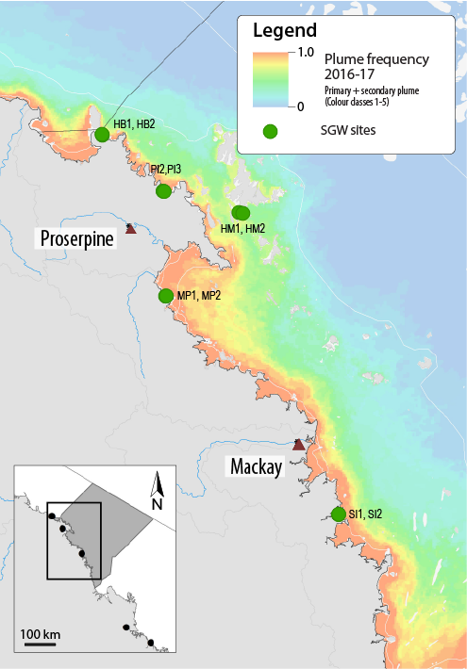
Figure 80. Frequency of exposure to turbid water (colour classes 1-5) in the Mackay Whitsunday NRM region, wet season (December 2016 – April 2017) composite.
Frequency calculated as number of weeks in wet season exposed to primary or secondary water (colour classes 1 – 5). Each colour class category is described by mean water quality values for TSS, CDOM, chlorophyll a and K_{d} (PAR) (Devlin et al. 2015; Waterhouse et al. 2018). For site details, see Tables 3 & 4.
Table 25. Water type at each location in the Mackay Whitsunday region derived from MODIS true colour images
as colour classes of turbid primary water (class 1 – 4, red/brown), nutrient/chlorophyll-enriched secondary water (class 5, green), and tertiary (some freshwater/CDOM influence) or no plume influence (class 6 and 7 respectively, blue), for 22 weeks from December 2065 – April 2017. Also shown, median wet season colour class (Med), frequency of primary water as f_{(P)}, the frequency of secondary water as f_{(S)}, and the frequency of primary or secondary as f_{(P+S)}. *denotes data obtained from adjacent pixel.

Site | 1 | 2 | 3 | 4 | 5 | 6 | 7 | 8 | 9 | 10 | 11 | 12 | 13 | 14 | 15 | 16 | 17 | 18 | 19 | 20 | 21 | 22 | f_{(P)} | f_{(S)} | f_{(P+S)}
HB1, HB2* | 5 | 5 | 5 | 5 | 5 |  | 5 | 5 | 5 | 5 | 5 | 5 | 5 | 6 | 5 | 5 | 5 | 5 | 5 | 5 | 5 | 5 | 0.00 | 0.95 | 0.95
PI2, PI3 | 2 | 4 | 4 | 4 | 5 |  | 4 | 2 | 4 | 4 | 4 | 4 | 4 |  | 4 | 4 |  | 4 | 2 | 1 | 2 | 1 | 0.95 | 0.05 | 1.00
HM1, HM2 | 6 | 6 | 5 | 5 | 6 |  | 5 | 6 | 5 | 5 | 5 | 6 | 5 | 5 | 5 | 6 |  | 5 | 5 | 5 | 5 | 5 | 0.00 | 0.70 | 0.70
MP2, MP3 | 5 | 4 | 4 | 4 | 5 | 2 | 4 | 1 | 4 | 1 | 1 | 2 | 3 | 4 | 4 | 5 |  | 1 | 1 | 2 | 2 | 4 | 0.86 | 0.14 | 1.00
SI1, SI2 | 5 | 4 | 4 | 3 | 4 | 2 | 5 | 3 | 5 | 3 | 4 | 2 | 2 | 1 | 4 | 1 | 1 | 3 | 1 | 4 | 2 | 4 | 0.86 | 0.14 | 1.00

Daily light (I_{d}) at Mackay Whitsunday sites has been monitored since 2009 for some locations. In 2016–17 (11.7 mol m⁻² d⁻¹), I_{d} was lower than the long-term average (13.7 mol m⁻² d⁻¹, excluding the retired Pioneer Bay site), due in part to the ongoing effects of TC Debbie on water clarity, particularly at the newly introduced Lindeman Island site. Without the Lindeman Island site, I_{d} was still below average at 12.3 mol m⁻² d⁻¹ (Figure 81).
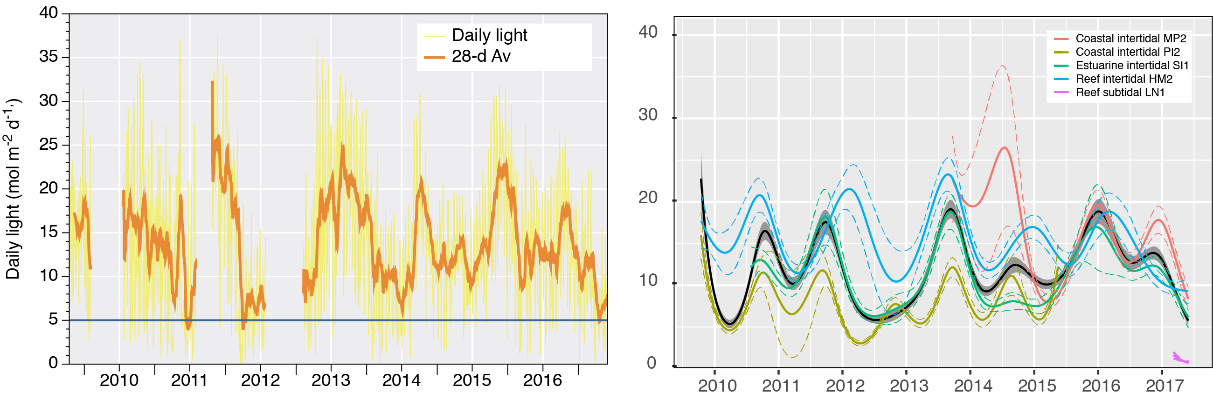
Figure 81 . Mean daily light at Mackay Whitsunday habitats with 28-d rolling average from 2009 to 2017 (left) and GAM plots (right)
with the black line showing mean trend for all sites (±95 per cent confidence interval in grey shade) and coloured lines (with CI’s) showing the trend for each site. Results of statistical analysis (GAM) and site-specific graphs (site-level daily light data plus 28-d rolling average) are shown in Appendix 4.
Water temperature was the highest recorded (annual average) in the inshore seagrass habitats in the Mackay Whitsunday region in 2016–17. There were fewer days above 35°C (56d) compared to the previous year (77 days), but there was frequent warm deviation from the baseline (Figure 82). In addition, there were 12 days that were 35-38°C and 4 days that were >40°C (3 of them in January 2017), which is the greatest number recorded in the region since monitoring began. These temperatures can cause significant photoinhibition and acute temperature stress (Campbell et al. 2006), and prolonged exposure to warm water can reduce growth in some species such as Zostera muelleri (Collier et al. 2011; Collier et al. 2016).
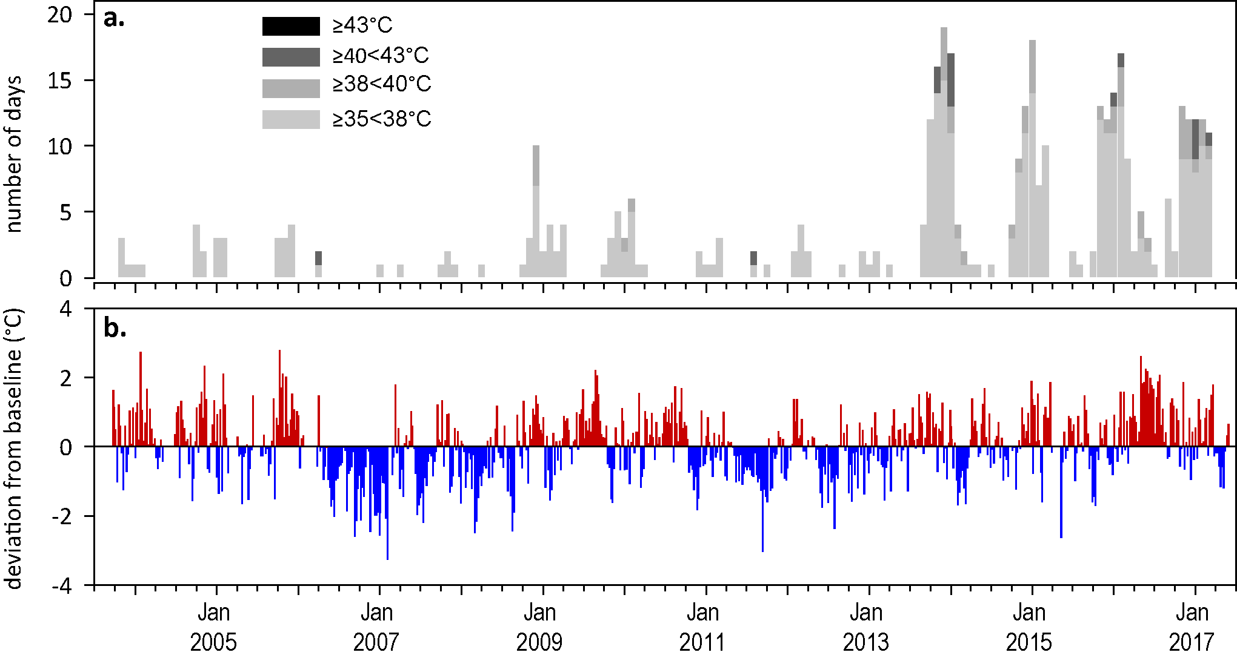
Figure 82. Inshore sea temperatures within each intertidal seagrass habitat in the Mackay Whitsunday region, September 2003 - May 2017
: a) number of days when temperature has exceeded 35°C, 38°C, 40°C and 43°C within each season (thresholds adapted from Campbell et al. 2006); b) deviations from 11-year mean weekly temperature records (weeks above the long-term average are represented as red bars and the magnitude of their deviation from the mean represented by the length of the bars, bars are blue for weeks with temperatures lower than the average and are plotted as negative deviations).

Indicators of seagrass condition
Five seagrass habitat types were assessed across the Mackay Whitsunday region in 2016–17, with data from 14 sites (Table 26).
Table 26. List of data sources of seagrass and environmental condition indicators for each seagrass habitat type in the Mackay Whitsunday NRM region.
drop camera sampling (QPWS), *Seagrass-Watch. For site details see Table 3 and Table 4.
Habitat | Site |  | abundance | composition | distribution | Reproductive effort | seed banks | Leaf tissue nutrients | Meadow sediments | Epiphytes | Macroalgae
estuary intertidal | SI1 | Sarina Inlet
estuary intertidal | SI2 | Sarina Inlet
coastal intertidal | MP2 | Midge Point
coastal intertidal | MP3 | Midge Point
coastal intertidal | PI2* | Pioneer Bay
coastal intertidal | PI3* | Pioneer Bay
coastal subtidal | NB1 | Newry Bay
coastal subtidal | NB2 | Newry Bay
reef intertidal | HM1 | Hamilton Island
reef intertidal | HM2 | Hamilton Island
reef intertidal | HB1* | Hydeaway Bay
reef intertidal | HB2* | Hydeaway Bay
reef subtidal | TO1 | Tongue Bay
reef subtidal | TO2 | Tongue Bay

Seagrass abundance, composition and distribution
The seagrass abundance score was reduced to poor in 2016–17 (Figure 79), but the changes in abundance depended on the location of the sites relative to the site of landfall (Airlie Beach) of TC Debbie. The sites north of Airlie Beach increased slightly to achieve record high abundances since 2011 at one point in the year (Figure 83). Sites south of Airlie Beach reduced in abundance, as a consequence of the destructive winds, sheer stress, and turbid water conditions. The most concerning losses were at Hamilton island and Sarina Inlet, where seagrass cover was reduced to almost zero. The exception were the shallow meadows at Newry Bay near Cape Hillsborough, which appeared to escape the effects of the cyclone as there was an increase in cover since the previous year, but as there are only two years of data available for this site so the intrinsic site variability is as yet unknown.
An examination of the long term trends across the Mackay Whitsunday NRM region using GAM plots suggests seagrass abundance (per cent cover) has not changed significantly since 2011 (Figure 84, Figure 85).

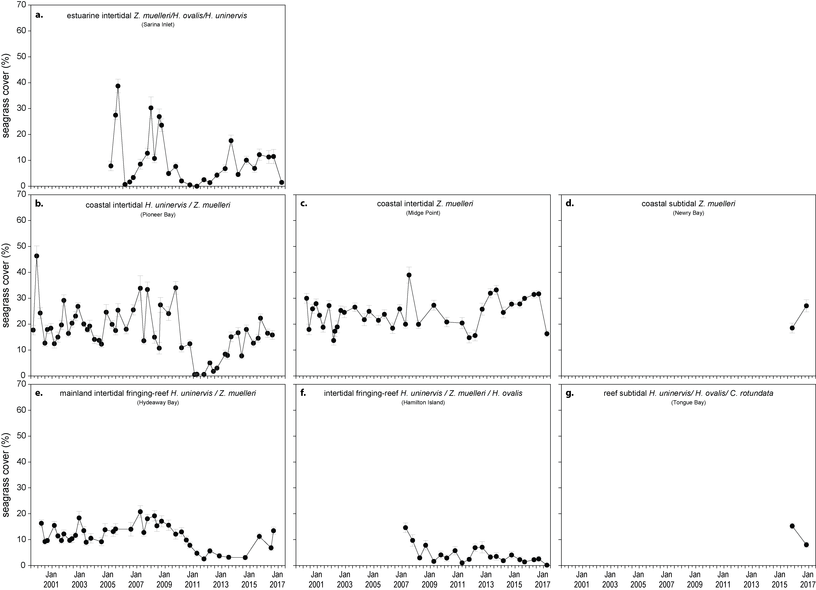
Figure 83. Changes in seagrass abundance (per cent cover ± SE) at inshore intertidal habitats in the Mackay Whitsunday region, 1999 - 2017
: a). estuarine, b). coastal, and c). reef.
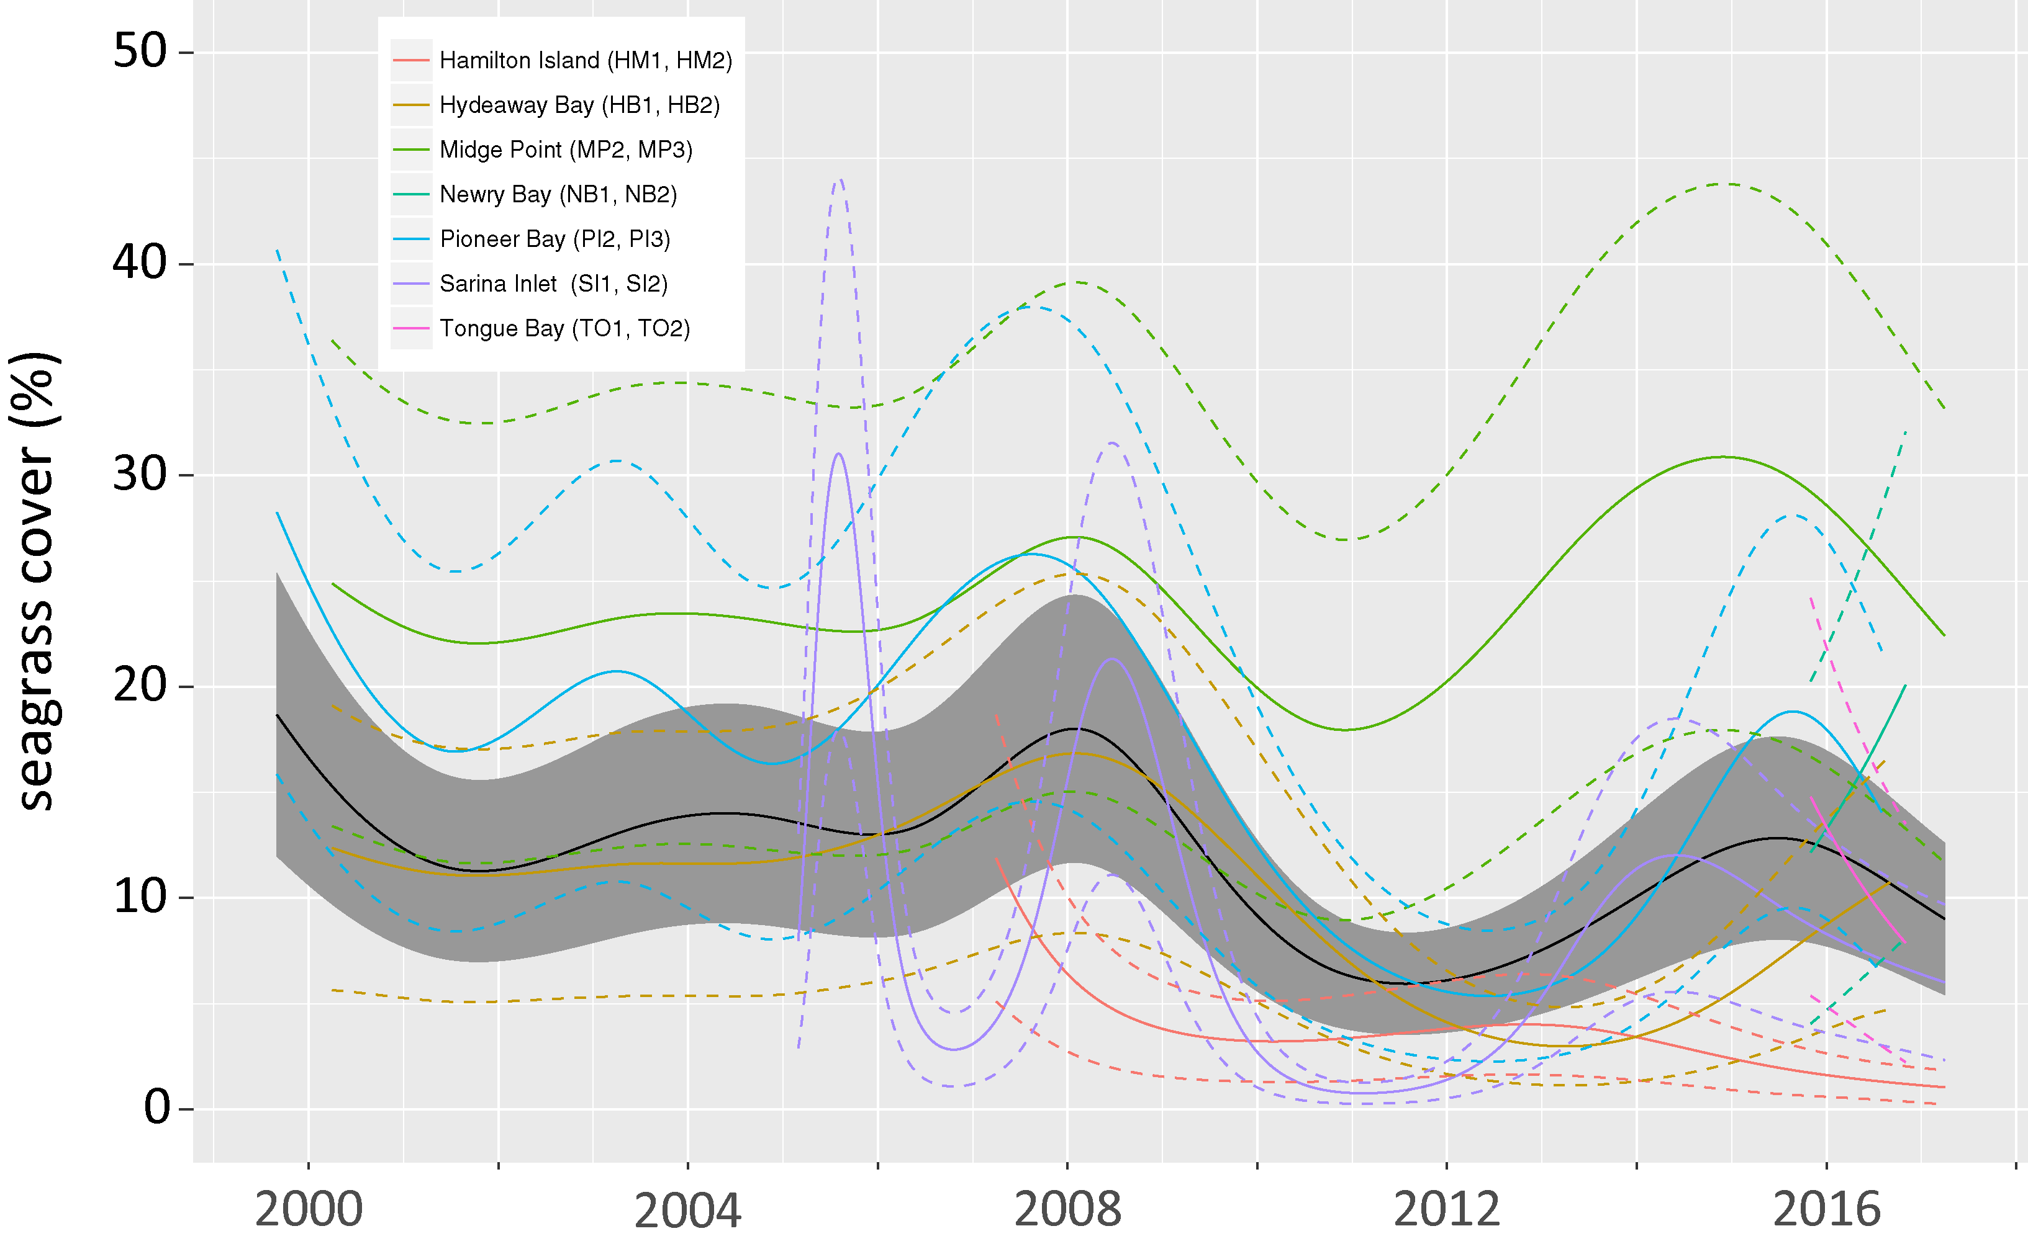
Figure 84. Temporal trends in seagrass abundance for each location in the Mackay Whitsunday region represented by a GAM plot.
Regional trend (all habitats pooled) represented by black line with grey shaded areas defining 95 per cent confidence intervals.
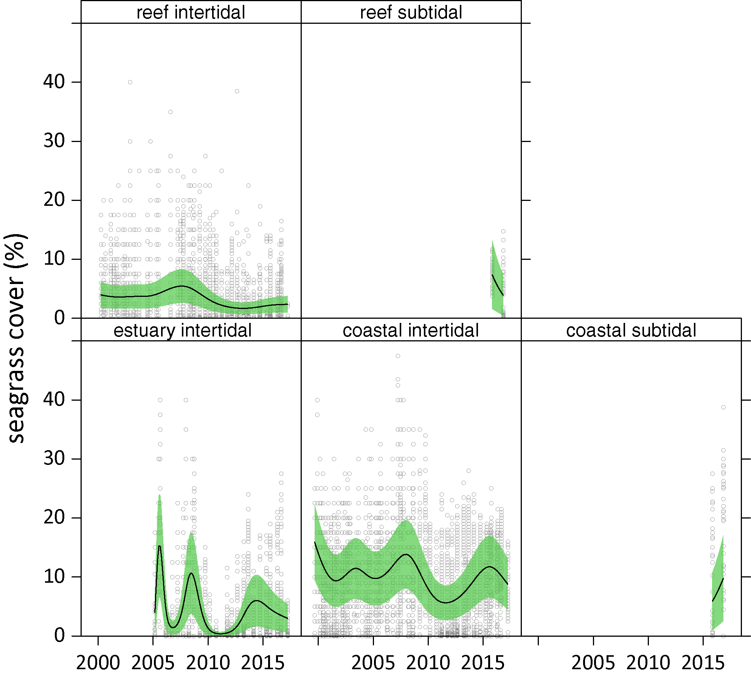
Figure 85. Temporal trends in seagrass abundance for each habitat in the Mackay Whitsunday region represented by GAM plots.
Trends (locations pooled) represented by black line with green shaded area defining 95 per cent confidence intervals, and quadrat data displayed as grey circles.
The most common seagrass species across all habitats in the Mackay Whitsunday NRM region were Halodule uninervis and Zostera muelleri, mixed with the colonising species Halophila ovalis.
Colonising species have recently dominated in intertidal meadows across the Mackay Whitsunday NRM following the extreme weather in 2011. In the previous two years, there has been a dramatic reduction in colonising species in estuarine and coastal intertidal habitats. In all habitats except the reef intertidal habitats, opportunistic foundational species (H. uninervis and Z. muelleri) now dominate (Figure 86, Appendix 4), suggesting meadows may have an improved ecosystem resistance to tolerate disturbances (Figure 86). In contrast, in reef habitats (Hamilton Island), colonising species have been steadily increasing since 2006.
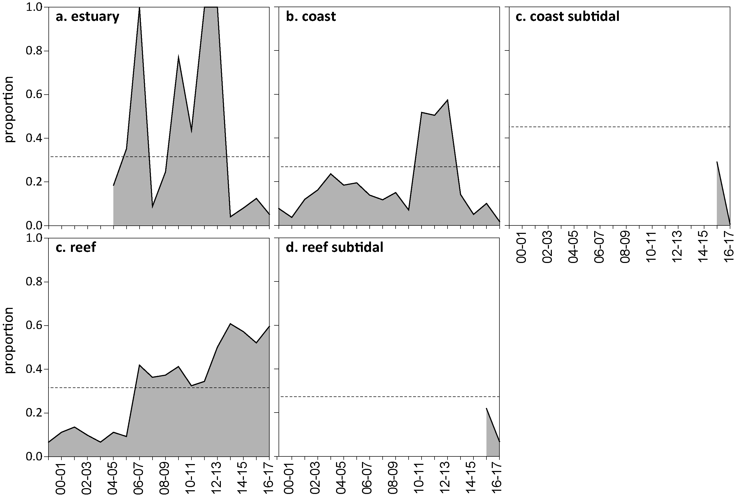
Figure 86. Proportion of seagrass abundance composed of colonising species at inshore intertidal habitats in the Mackay Whitsunday region, 1999 - 2017.
Grey area represents Great Barrier Reef long-term average proportion of colonising species for each habitat type.
Seagrass meadow edge mapping was conducted within all monitoring sites in October 2016 and April 2017 to determine if changes in abundance were a consequence of the meadow edges changing and to indicate if plants were allocating resources to colonisation (asexual reproduction) (Appendix A4.2.4). Over the past 12 months, spatial extent declined dramatically (by more than 50%), in all habitats. In the estuarine and reef meadows, the reduction in extent appears to be the results of the destructive effects of TC Debbie. However in the coastal meadows, spatial extent was reduced prior to the cyclone and the cause is uknown (Figure 87).
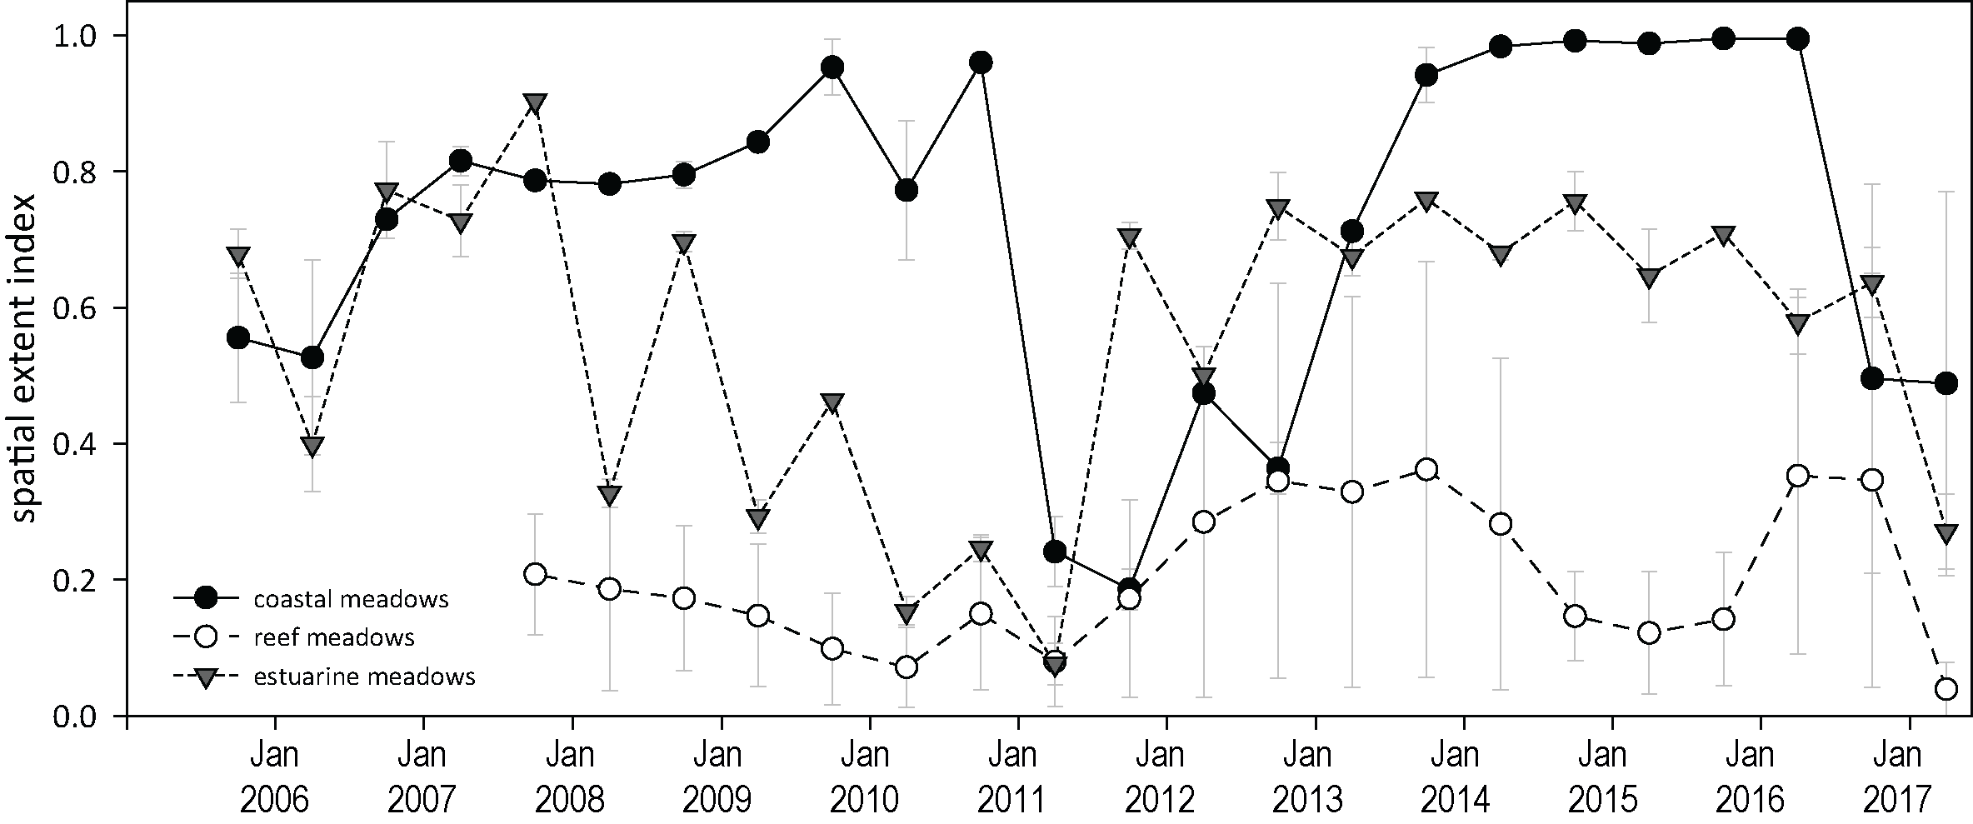
Figure 87. Change in spatial extent of seagrass meadows within monitoring sites for each inshore intertidal habitat and monitoring period across the Mackay Whitsunday NRM region.
Apart from the MMP, seagrass monitoring within the Mackay Whitsunday NRM region is also conducted as part of the Queensland Ports Seagrass Monitoring Program (QPSMP) in places where cumulative anthropogenic impacts to seagrass are highest. Annual monitoring in October 2016 of five offshore monitoring areas between Mackay and Hay Point, an inshore region between Dudgeon Point and Hay Point, and two subtidal meadows at the Keswick Island group for North Queensland Bulk Ports reported a substantial decline in condition October/November 2016 (i.e. before TC Debbie) (McKenna and Rasheed 2017 ). Above-ground biomass (visually estimated from boat based CCTV) was significantly reduced in 2016 compared to 2015, and was only found in one out of 12 monitoring blocks at Hay Point (Figure 88). Similarly, visually estimated biomass of the deepwater meadow near the Mackay Marina was half the previous reporting year, but only two years of data are available for comparison (McKenna and Rasheed 2017 ). There was a minor and non-significant (i.e. estimates of reliability/mapping precision overlap between years) decrease in area of the small inshore seagrass meadows of Dalrymple Bay (between Hay Point and Dudgeon Point), with no seagrass present in one of the monitoring meadows. In the Keswick Island group, the monitoring meadows were similar in extent, however abundances were higher in 2016 relative to 2015 (McKenna and Rasheed 2017 ). While annual rainfall was average for the year leading up to the 2016 surveys, unusually high rainfall and discharge in winter and the early growth season when the ephemeral deepwater populations are establishing, is likely to have limited the recruitment success in 2016 (McKenna and Rasheed 2017 ).
Figure 88. Change in visually estimated above-ground biomass at Hay Point offshore monitoring sites from 2005 to 2016
(from (McKenna and Rasheed 2017 )). Error bars are SE for g DW m⁻².

Seagrass reproductive status
Reproductive effort was highly variable and highly seasonal in the Mackay Whitsunday region (Figure 89). Reproductive effort remained elevated in coastal habitats, although the density of seeds in the seedbank declined in the late wet sampling of 2017 after TC Debbie, which may have been due to scouring of the seed bank. At the estuary site (Sarina Inlet), the highest reproductive effort ever recorded, was observed in the late dry of 2016 but the seed bank remained unchanged relative to the previous year. In contrast, at the reef sites reproductive effort and the density of seeds in the seed bank remained very low in 2016–17, which is typical for in the reef habitat meadows (Figure 89). The overall score for reproductive effort increased slightly but remained poor, mostly due to conditions at the reef habitat.

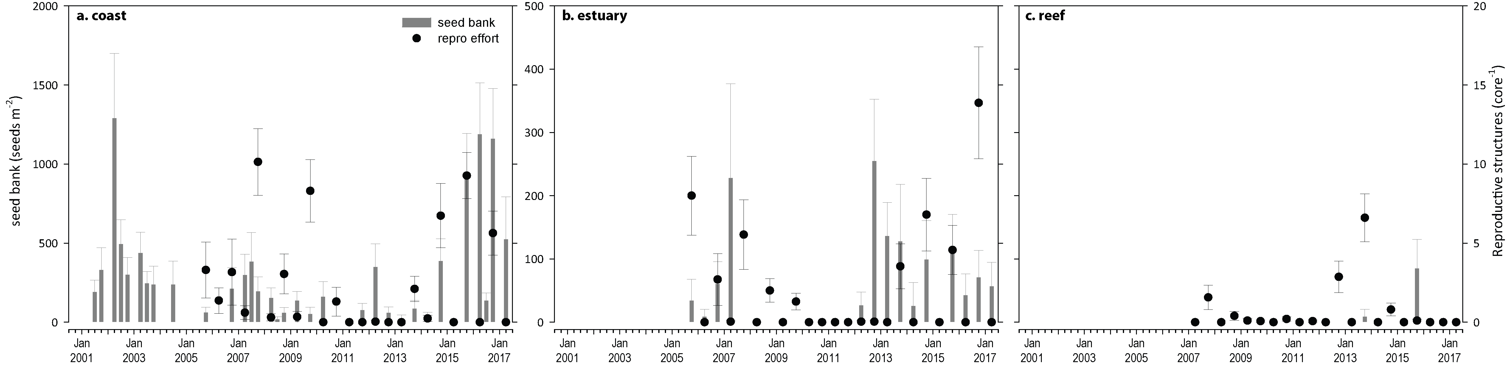
Figure 89. Seed bank and late dry season reproductive effort at inshore intertidal coast, estuary, and reef habitats in the Mackay Whitsunday region, 2001 - 2017.
Seed bank presented as the total number of seeds per m² sediment surface and late dry season reproductive effort presented as the average number of reproductive structures per core (species and sites pooled). NB: Y-axis scale for seed banks differs between habitats.

Indicators of environmental condition

Seagrass tissue nutrients
Seagrass leaf molar C:N ratios were unchanged compared to the previous year. C:N remained below 20 (Figure 90) at reef and estuarine habitat indicating a surplus of N relative to photosynthetic C incorporation. N:P ratios increased in estuarine and coastal habitats, which indicates surplus availability of N influencing the C:N score (Figure 91).
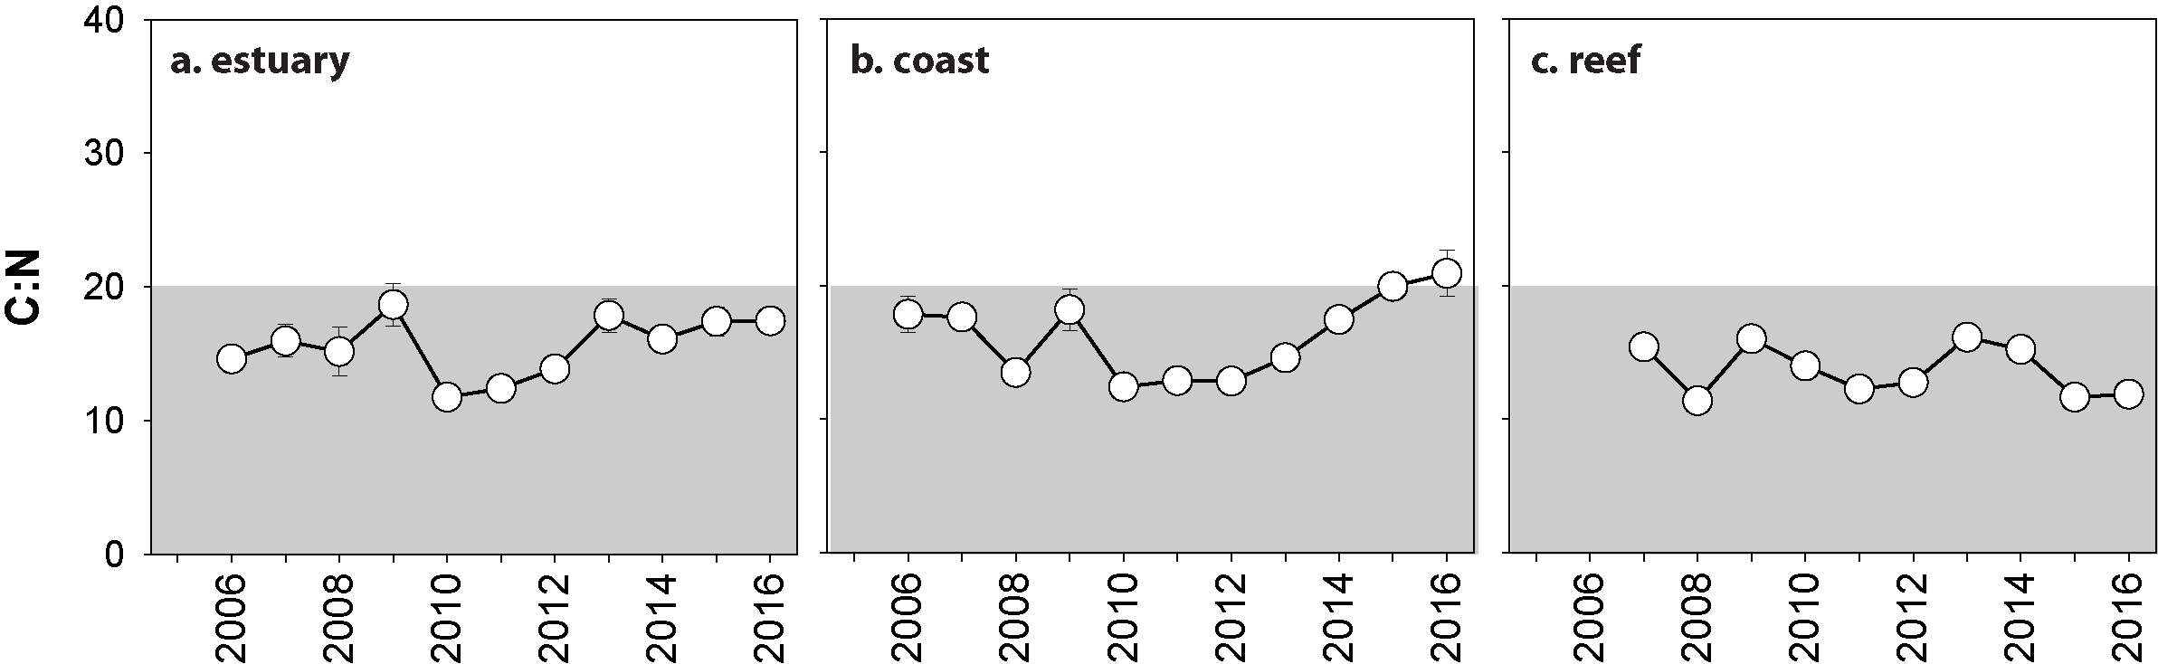
Figure 90. Elemental ratios (atomic) of seagrass leaf tissue C:N for the foundation seagrass species examined at inshore intertidal habitats in the Mackay Whitsunday region, 2006 - 2016
(species pooled) (mean ± SE). Horizontal shaded band on the C:N ratio panel represents the accepted guideline seagrass “Redfield” ratio of 20:1 (Abal et al. 1994; Grice et al. 1996). C:N ratios below this line may indicate reduced light availability and/or N enrichment.
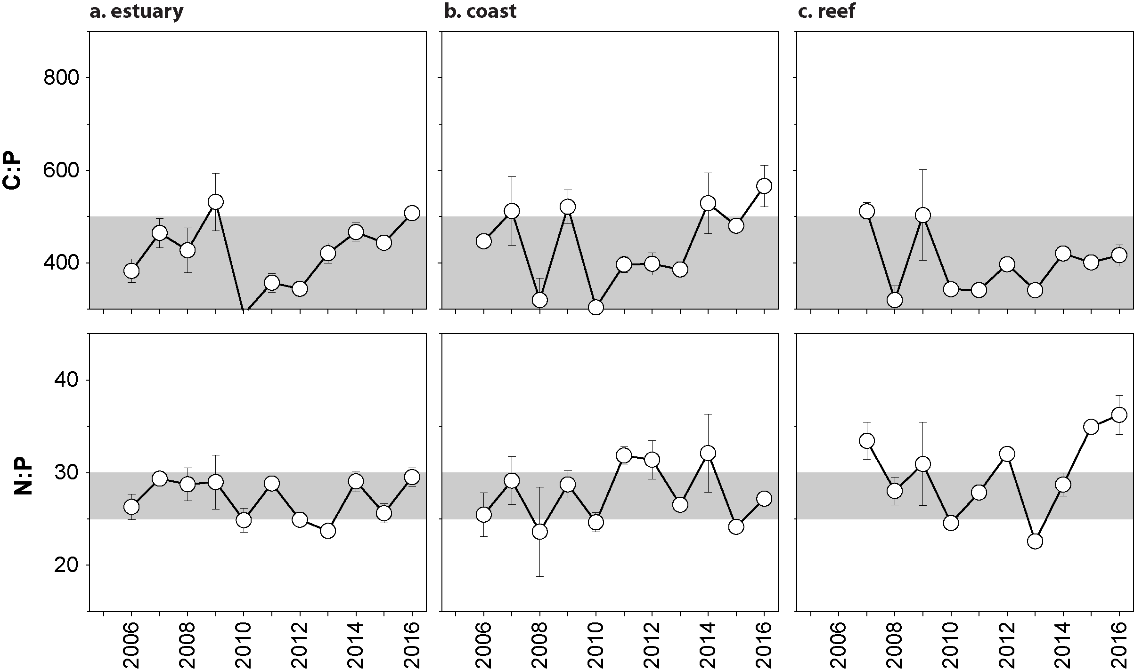
Figure 91. Elemental ratios (atomic) of seagrass leaf tissue N:P and C:P for the foundation seagrass species examined at inshore intertidal habitats in the Mackay Whitsunday region, 2006 - 2016
(species pooled) (mean ± SE). Horizontal shaded band on the N:P ratio panel represents the range of value associated with N:P balance ratio in the plant tissues, i.e. a seagrass “Redfield” ratio (Atkinson and Smith 1983; Duarte 1990; Fourqurean et al. 1992b; Fourqurean and Cai 2001). N:P ratio above this band indicates P limitation, below indicates N limitation and within indicates replete. Shaded portion on the C:P panel ≤500 represents the value associated with C:P balance ratio in the plant tissues, C:P values <500 may indicate nutrient rich habitats (large P pool).

Seagrass meadow sediments
The proportion of fine grain sizes decreases in the sediments of the seagrass monitoring sites/meadows with distance from the coast/river mouths in the Mackay Whitsunday region. Estuarine sediments were composed of greater proportion of finer sediments, and in 2016–17 the proportion of mud was similar to the Great Barrier Reef long-term average with little change over the last 6 years (Figure 176). Coastal habitat meadows had less mud than estuarine habitats, and the meadows at Midge Point had a higher proportion of mud than those in Pioneer Bay. Sediments at coastal habitats are generally above the Great Barrier Reef long-term average, but fluctuate within and between both meadows and years (Figure 177). Reef habitats were composed predominately of fine to medium sand, and in 2016–17 they contained a proportion of mud above the Great Barrier Reef long-term average (Figure 178).

Epiphytes and macroalgae
Epiphyte cover on seagrass leaf blades increased in the dry season (2016) in estuarine habitat compared to the dry season of the previous reporting year, but was unchanged in reef and coastal habitat. In the wet season (2017) epiphyte cover reduced in all habitats compared to the previous wet season (Figure 92 Appendix A4.2.3, Figure 192). Percentage cover of macroalgae remained unchanged and at or below the Great Barrier Reef long-term average for all habitats throughout 2016–17 (Appendix A4.2.3, Figure 192, Figure 193, Figure 194).
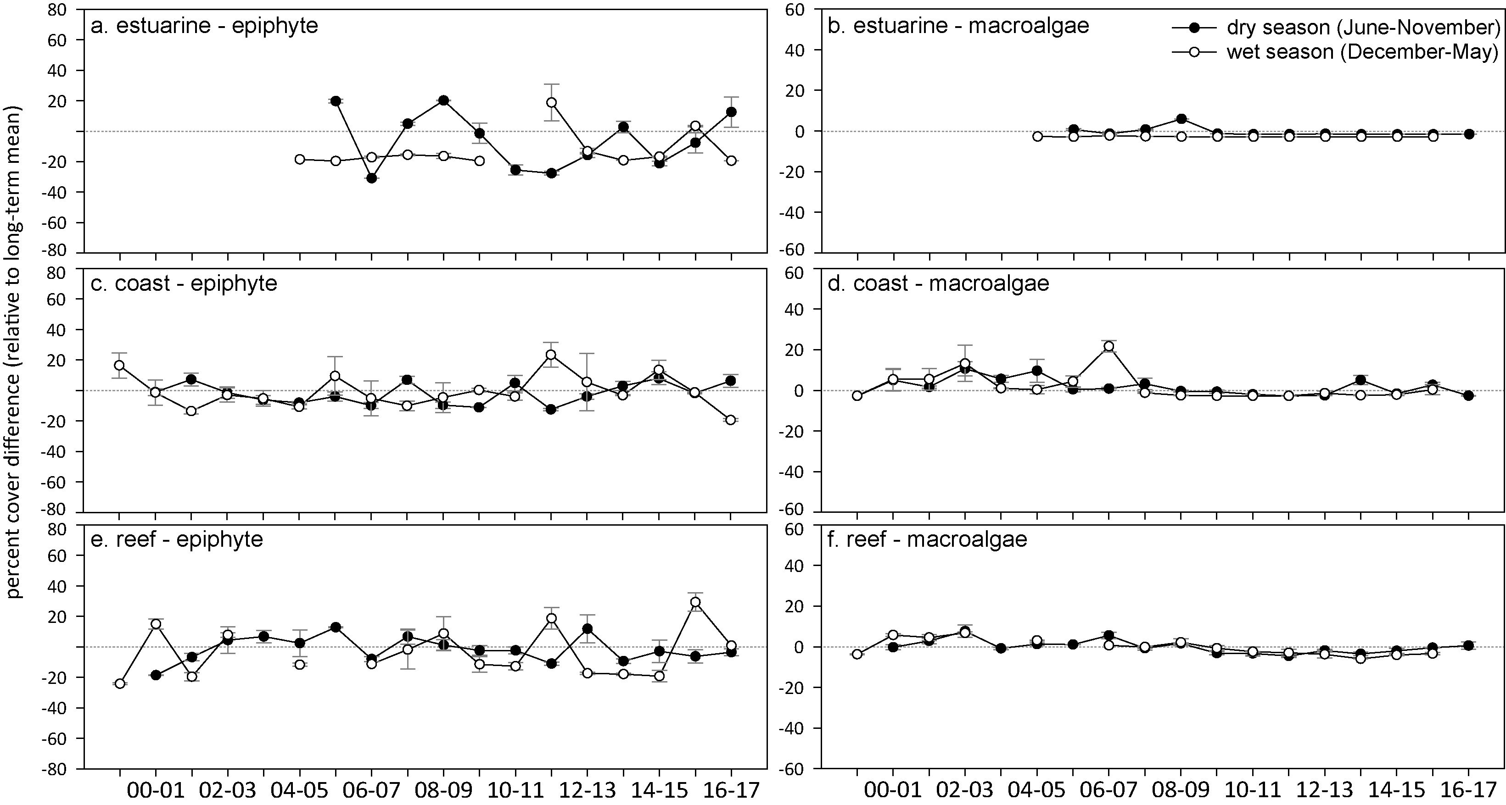
Figure 92. Long-term trend in mean epiphyte and macroalgae abundance (per cent cover) relative to the long-term average for each inshore intertidal habitat in the Mackay Whitsunday region, 1999 - 2017
(sites pooled, ±SE).

Report card for inshore seagrass status
In the 2016–17 monitoring period, the seagrass index for the Mackay Whitsunday region was poor, which was the same as the previous period, the highest since 2006-07 and the second highest since monitoring began (Table 27). The most notable changes were the decline in abundance in all habitats (the result of TC Debbie), an increase in reproductive effort at estuarine sites and an improvement in tissue nutrients at coastal sites. Overall, the Mackay Whitsunday seagrass index had been improving since 2010-11 when it reached its lowest level since monitoring commenced, but appears to have stablisied at poor.
Table 27. Long-term report card scores for seagrass abundance, reproductive and leaf tissue nutrient status for each habitat in the Mackay Whitsunday region: June 2016 – May 2017.
Values are indexed scores scaled from 0-100; ■ = very good (81-100), ■ = good (61 - 80), ■ = moderate (41 - 60), ■ = poor (21 - 40), ■ = very poor (0 - 20). NB: Scores are unitless.
Indicator | Habitat | 2005-06 | 2006-07 | 2007-08 | 2008-09 | 2009-10 | 2010-11 | 2011-12 | 2012-13 | 2013-14 | 2014-15 | 2015-16 | 2016–17
Abundance | estuarine intertidal | 40 | 25 | 20 | 25 | 6 | 0 | 13 | 25 | 13 | 13 | 13 | 13
Abundance | coastal intertidal | 63 | 88 | 54 | 63 | 63 | 8 | 13 | 13 | 33 | 67 | 83 | 63
Abundance | coastal subtidal |  |  |  |  |  |  |  |  |  |  | 63 | 50
Abundance | reef intertidal |  | 25 | 6 | 13 | 6 | 6 | 13 | 0 | 0 | 3 | 38 | 25
 | reef subtidal |  |  |  |  |  |  |  |  |  |  | 25 | 13
Reproductive  effort | estuarine intertidal | 50 | 13 | 25 | 0 | 0 | 0 | 0 | 0 | 25 | 50 | 25 | 75
Reproductive  effort | coastal intertidal | 0 | 13 | 38 | 13 | 38 | 0 | 0 | 0 | 0 | 25 | 38 | 25
Reproductive  effort | reef intertidal |  |  | 25 | 13 | 0 | 0 | 0 | 50 | 50 | 25 | 0 | 0
Leaf tissue  nutrients | estuarine intertidal |  | 23 | 30 | 26 | 43 | 9 | 12 | 19 | 39 | 30 | 37 | 37
Leaf tissue  nutrients | coastal intertidal |  | 39 | 38 | 18 | 41 | 12 | 14 | 14 | 23 | 37 | 50 | 55
Leaf tissue  nutrients | reef intertidal |  |  | 27 | 7 | 30 | 20 | 11 | 14 | 31 | 26 | 8 | 9
Seagrass Index |  | 39 | 31 | 30 | 21 | 25 | 6 | 8 | 15 | 25 | 32 | 34 | 34

Fitzroy

2016–17 summary
The Fitzroy region has the largest catchment area draining into the Great Barrier Reef, and the inshore seagrass meadows are mainly located on the large shallow sand/mud banks in sheltered areas of the region’s estuaries and coasts, or on the fringing reef flat habitats of offshore islands. In 2016–17, although rainfall was similar to the long-term annual average, it fell episodically, and was associated with increased river discharge. Seagrass meadows were exposed to ‘brown’ or ‘green’ turbid water 99 per cent of wet season weeks (November 2015 to April 2016). However, the most distinguishing environmental extremes in 2016–17 were thermal anomalies, whereby meadows were exposed to average temperature that was 2.1°C above average. In addition, there was a record number of warm water (>35°C) days (70 d). This was the fourth year in a row of above-average temperatures which could have a chronic impact on seagrass condition.
The regional seagrass abundance score was unchanged and remained poor. Trends in seagrass abundance varied across habitats in 2016–17, with an overall increase at coastal sites, a decrease at estuarine sites while reef sites remained stable and low. Annual assessment of the seagrass area in Gladstone Harbour by the QPSMP also confirms that the losses in abundance at the Gladstone estuarine sites reflect a trend of reduced meadow area of the large Pelican Banks meadow. Deteriorating condition of the estuarine and reef habitats is also evident from reduction in spatial extent and an increase in the proportion of colonising species in both habitats. Furthermore, reproductive effort remained very low in both reef and estuarine habitats. Despite this, estuarine and coastal habitats maintained a small seedbank, while the reef habitat has no persistent seeds within the sediments, making them highly vulnerable. Seagrass leaf tissue nutrient concentrations showed signs that environmental conditions for maintaining healthy seagrass habitat had improved. The ratio of carbon to nitrogen increased in estuarine and coastal habitat. This was most likely due to a reduction in the availability of nitrogen, as there were also large reductions in the N:P ratios within seagrass leaf tissue. Leaf tissue nutrients are sampled in the late dry, before TC Debbie affected the region. As for other regions, a number of years with below average rainfall appears to have led to lower nitrogen availability.
Seagrass across the region remain in the early stages of recovering from multiple years of climate related impacts which are more recent than in other regions. The coastal habitats have been improving in all indicators, while other habitats demonstrate a legacy of reduced resilience. Overall, the Fitzroy regional seagrass state remained poor in 2016–17 (Figure 93).
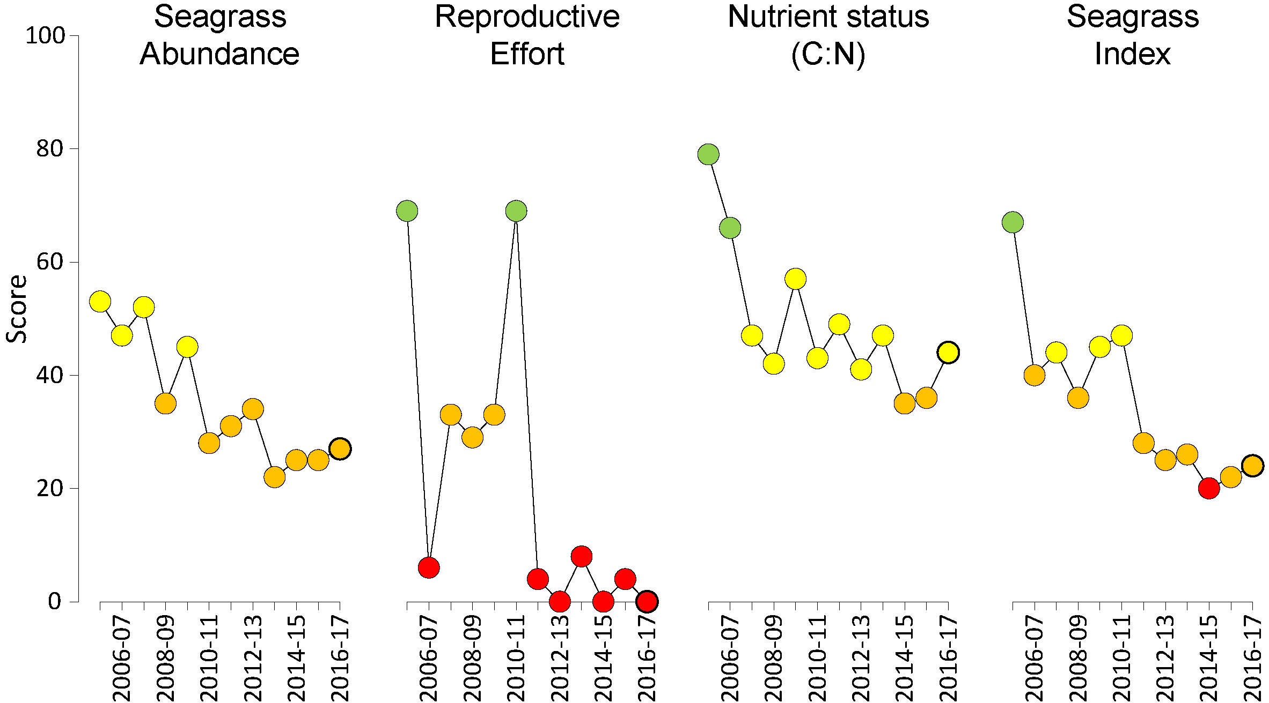
Figure 93. Report card of seagrass status indicators and index for the Fitzroy NRM region
(averages across habitats and sites). Bold symbol = 2016–17 monitoring period. Values are indexed scores scaled from 0-100; ■ = very good (81-100), ■ = good (61 - 80), ■ = moderate (41 - 60), ■ = poor (21 - 40), ■ = very poor (0 - 20). NB: Scores are unitless.

Climate and environmental pressures
In the Fitzroy region, rainfall in the catchment was equivalent to the long-term average in 2016–17 with most falling in March, both before and after TC Debbie moved down the coast (Table 28). This episodic rainfall event resulted in river discharge that was double the long-term median. Water quality effects, however, were not limited to this event, as seagrass sites in the Fitzroy region were exposed to mostly ‘brown’ turbid water for 99 per cent (f_{(P+S)}=0.99) of the wet season (November 2015 – April 2016), which was exposed to ‘green’ turbid water (Figure 94, Table 29).
Table 28. Summary of environmental conditions at monitoring sites in the Fitzroy region in 2016–17 compared to the long-term average (long-term range indicated for each data set).
 | Long-term average | 2016–17
Rainfall (1961-1990) | 2.9 mm d⁻¹ | 2.9 mm d⁻¹
River discharge (1970-2017) | 4,176,120 L yr⁻¹ | 9,288,832 L yr⁻¹
Turbid water exposure (2006-2017) | 98 per cent | 99 per cent
Daytime tidal exposure (2002-2017) | 112 hr yr⁻¹ | 129 hr yr⁻¹
Wind (1998-2017) | 80 days yr⁻¹ | 68 days yr⁻¹
Within canopy temperature (2006-2017) | 24.1°C (41°C) | 26.2°C (40.2°C)
Within canopy light (2012-2017) | 15.5 mol m⁻² d⁻¹ | 12.7 mol m⁻² d⁻¹
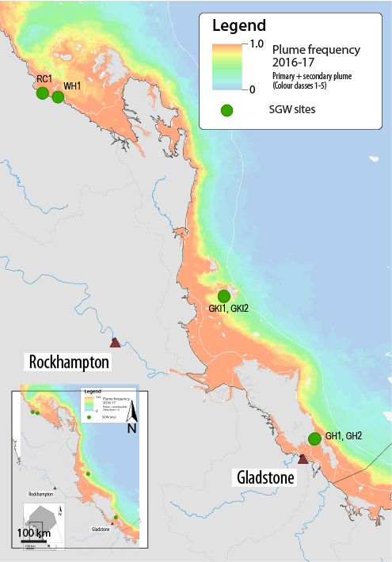
Figure 94. Frequency of exposure to turbid water (colour classes 1-5) in the Fitzroy NRM, wet season (22 weeks from December 2016 – April 2017) composite.
Frequency calculated as number of weeks in wet season exposed to primary or secondary water (colour classes 1 – 5). Each colour class category is described by mean water quality values for TSS, CDOM, chlorophyll a and K_{d} (PAR) (Devlin et al. 2015;Waterhouse et al. 2017). For site details, see Tables 3 & 4.
Table 29. Water type at each site in the Fitzroy region derived from MODIS true colour images
as colour classes of turbid primary water (class 1 – 4, red/brown), nutrient/chlorophyll-enriched secondary water (class 5, green), and tertiary (some freshwater/CDOM influence) or no plume influence (class 6 and 7 respectively, blue), for 22 weeks from December 2016 – April 2017. Also shown, median wet season colour class (Med), frequency of primary water as f_{(P)}, the frequency of secondary water as f_{(S}), and the frequency of primary or secondary as f_{(P+S)}.

Site | 1 | 2 | 3 | 4 | 5 | 6 | 7 | 8 | 9 | 10 | 11 | 12 | 13 | 14 | 15 | 16 | 17 | 18 | 19 | 20 | 21 | 22 | f_{(P)} | f_{(S)} | f_{(P+S)}
RC1 | 4 | 2 | 3 | 2 |  | 1 | 4 | 2 | 1 | 1 | 2 | 2 | 2 | 1 | 2 | 5 | 1 | 4 | 1 | 4 | 1 | 4 | 0.95 | 0.05 | 1.00
WH1 | 5 | 1 | 4 | 2 |  | 1 | 5 | 1 | 2 | 1 | 2 | 1 | 1 | 1 | 1 | 5 | 1 | 4 | 1 | 1 | 1 | 4 | 0.86 | 0.14 | 1.00
GK1, GK2 | 5 | 5 | 5 | 5 | 5 | 5 | 5 | 5 | 5 | 5 | 5 | 5 | 5 | 6 | 5 | 5 | 5 | 4 | 5 | 5 | 5 | 5 | 0.05 | 0.91 | 0.95
GH1, GH2 | 4 | 2 | 4 | 4 | 4 | 2 | 4 | 3 | 2 | 2 | 1 | 5 | 2 | 5 | 2 | 5 | 2 | 2 | 1 | 4 | 2 | 2 | 0.86 | 0.14 | 1.00

Within canopy daily light (I_{d}), was lower in 2016–17 than the long-term average for the region, due largely to very low light levels at all sites following TC Debbie in March (Figure 95, Figure 160). Data retrieval has reduced at two of the three sites because they are now monitored only once per year but despite this, data was recorded on 67% of days at all sites.
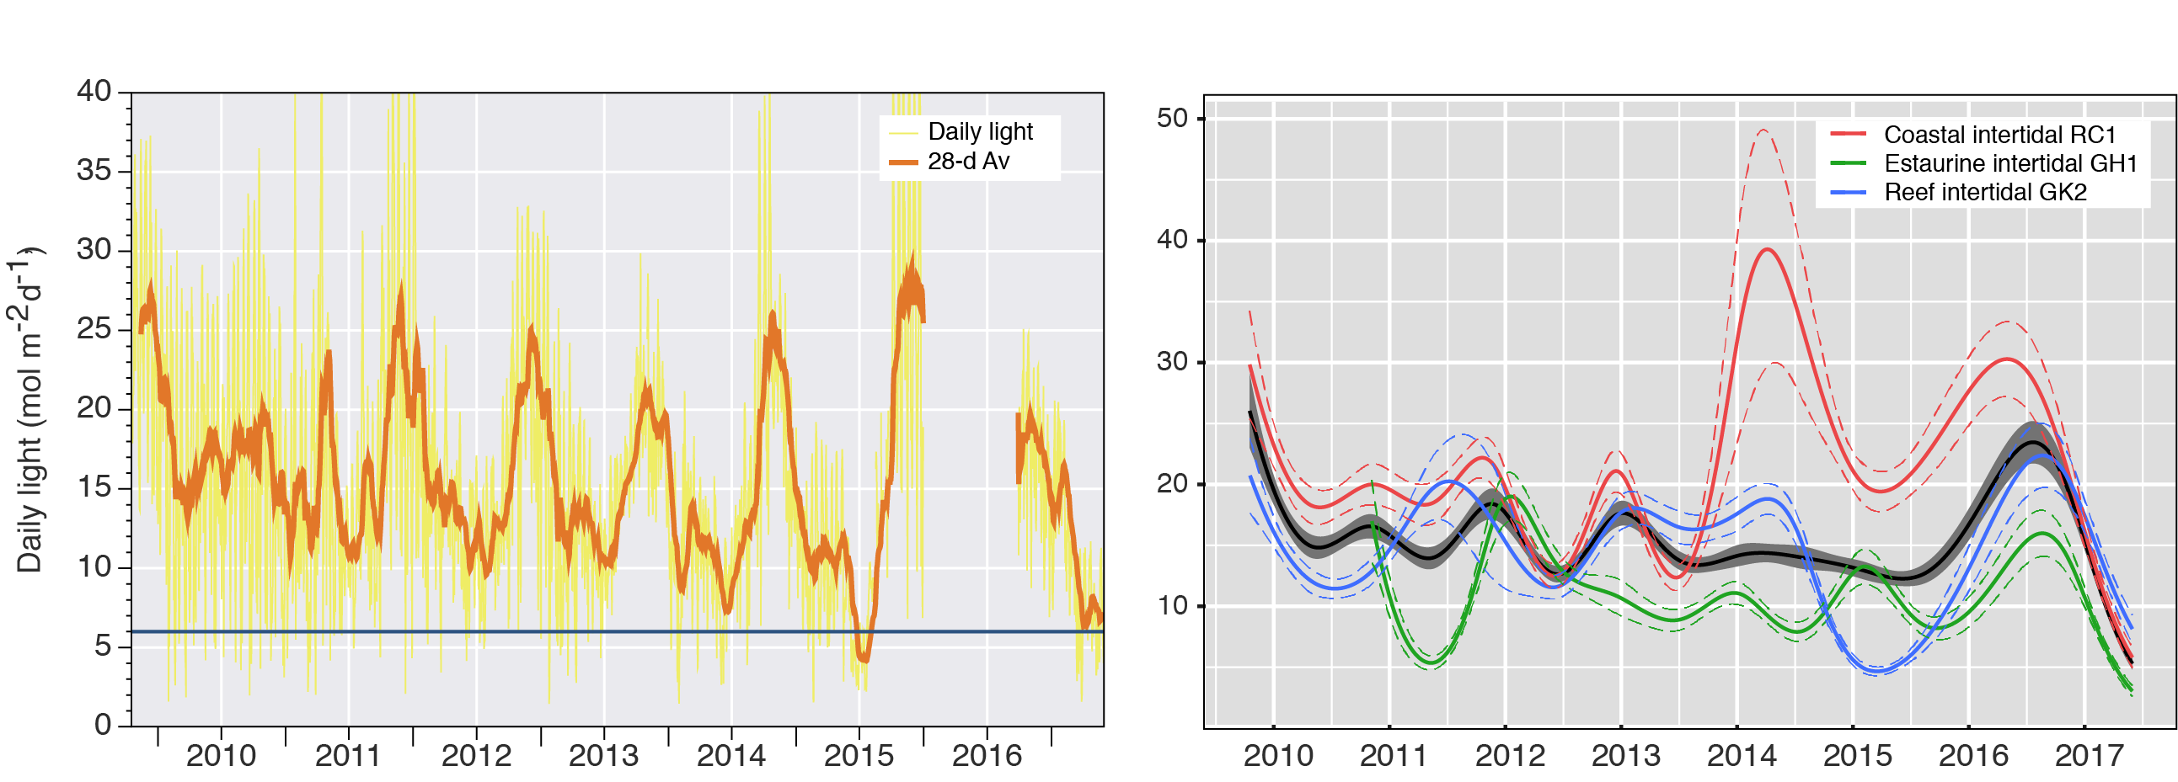
Figure 95. Mean daily light at Fitzroy sites with 28-d rolling average from 2009 to 2017 (left) and GAM plots (right)
with the black line showing mean trend for all sites (±95 per cent confidence interval in grey shade) and coloured lines (with CI’s) showing the trend for each site. Results of statistical analysis (GAM) and site-specific graphs (site-level daily light data plus 28-d rolling average) are shown in Appendix 4.
Water temperature was >2°C higher in 2016–17 on average than the long-term average (since 2005-06) for this region (Figure 96). There were a record number of days (70) exceeding 35°C, and 2 days where water temperature exceeded extreme thresholds (>40°C) in December 2016 and january 2017 in Shoalwater Bay. There was also frequent warm deviation from the baseline. These temperatures would not be expected to cause significant photoinhibition because the extreme temperatures were exceeded only twice (Campbell et al. 2006), but the record number of days deviating from the baseline may cause chronic cumulative stress (Collier et al. 2011). Daily tide exposure was also greater than the long-term average, most likely contributing to the anomalously warm conditions.
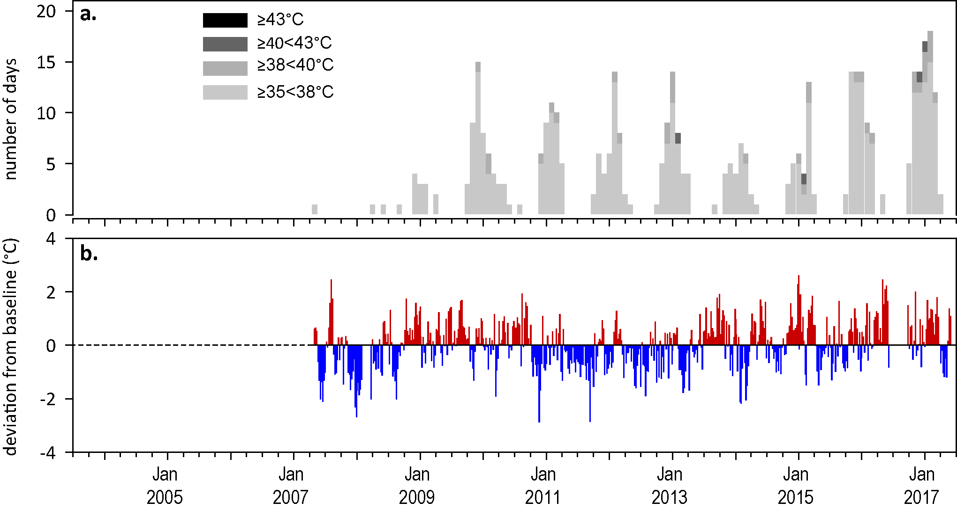
Figure 96. Inshore sea temperatures within each intertidal seagrass habitat in the Fitzroy region, June 2007 - May 2017
: a) number of days when temperature has exceeded 35°C, 38°C, 40°C and 43°C within each season (thresholds adapted from Campbell et al. 2006); b) deviations from 11-year mean weekly temperature records (weeks above the long-term average are represented as red bars and the magnitude of their deviation from the mean represented by the length of the bars, bars are blue for weeks with temperatures lower than the average and are plotted as negative deviations).

Indicators of seagrass condition
Three seagrass habitat types were assessed across the Fitzroy region in 2016–17, with data from 6 sites (Table 30).
Table 30. List of data sources of seagrass and environmental condition indicators for each seagrass habitat type in the Fitzroy NRM region.
For site details see Table 3 and Table 4.
Habitat | Site |  | abundance | composition | distribution | Reproductive effort | seed banks | Leaf tissue nutrients | Meadow sediments | Epiphytes | Macroalgae
estuary intertidal | GH1 | Gladstone Hbr
 | GH2 | Gladstone Hbr
coastal subtidal | RC1 | Ross Creek (Shoalwater Bay)
 | WH1 | Wheelans Hut (Shoalwater Bay)
reef intertidal | GK1 | Great Keppel Is.
 | GK2 | Great Keppel Is.

Seagrass abundance, composition and extent
The regional seagrass abundance score was poor 2016–17 unchanged from previous years (Figure 93). Monitoring of habitats in the Fitzroy region has been reduced to once per year in the dry season since 2014. Seagrass abundance reduced in estuarine habitat which appears to be due to the movement of fine mud through one of the sites in Gladstone Harbour, but the source of this fine mud this is unknown (Figure 97, Figure 98, Figure 99). In addition, the region was affected by above average river discharge, lower than average light levels and extremely high temperatures (mean temperature was >2°C above average for the region). The high temperatures are particularly stressful for Z. muelleri communities as it has a thermal optima for overall net primary productivity of 24°C and above 35°C net productivity goes into deficit i.e. it loses energy (Collier et al 2017). This is in stark contrast to other tropical species (H. uninervis and C. serrulata), which must exceed 40°C for respiration rates and photoinhibition to cause the plants to lose energy for pulsed exposure (Collier et al 2017). In 2016–17 water temperature exceeded 35°C on 70 days of the year and this is likely to have placed a substantial stress on these Z. muelleri dominated communities at Pelican banks in Gladstone Harbour. By contrast, abundance has increased in coastal habitat of Shoalwater Bay, doubling in the previous two years and the greatest they have been since 2011, and remained stable in the reef habitat. These habitats are also comprised of the thermally tolerant H. uninervis, which may even have benefitted from the above-average water temperature. Due to the large variability in trends among the habitats, there has been no significant change in sites combined within the region (Figure 98).

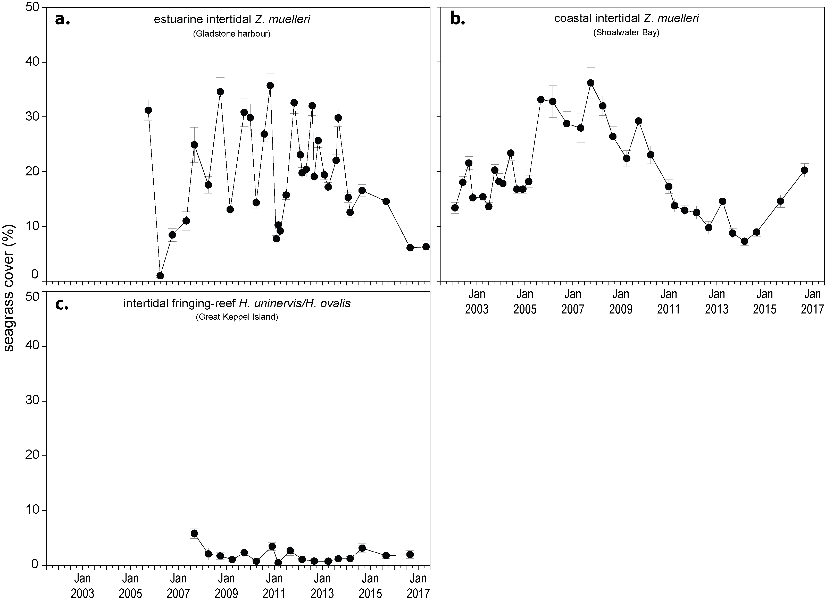
Figure 97. Changes in seagrass abundance (per cent cover ± SE) in inshore intertidal habitats of the Fitzroy region, 2001 - 2017
: a) estuarine (Gladstone Harbour, b) coastal (Shoalwater Bay) and c) reef (Great Keppel Island).

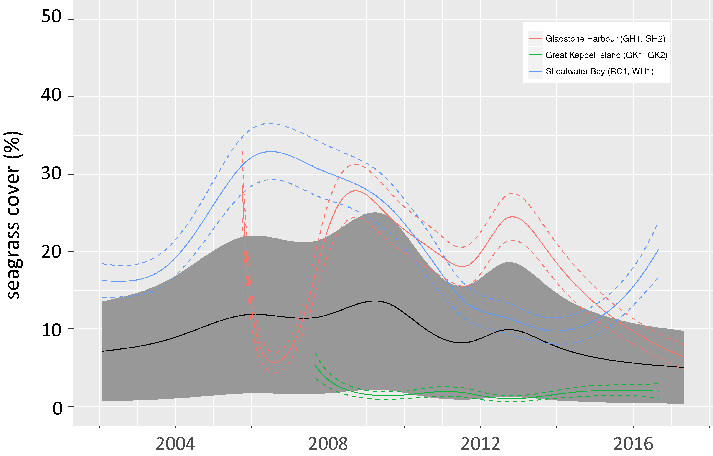
Figure 98. Temporal trends in seagrass abundance for each habitat in the Fitzroy region, represented by a GAM plot 2001-2017.
Regional trend (all habitats pooled) represented by black line with grey shaded areas defining 95 per cent confidence intervals.
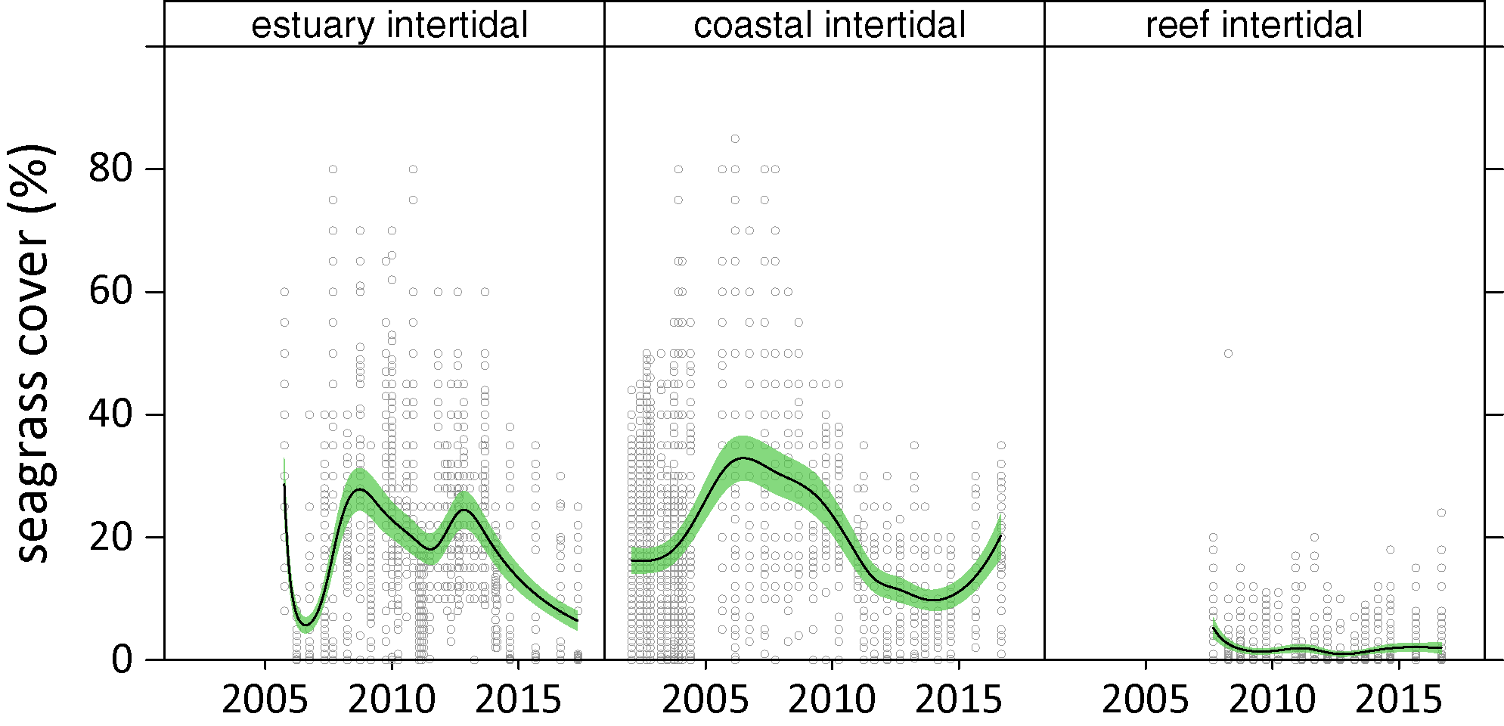
Figure 99. Temporal trends in seagrass abundance for seagrass habitat in the Fitzroy region represented by a GAM plot, 2001-2017.
Trends (locations pooled) represented by black line with green shaded area defining 95 per cent confidence intervals, and quadrat data displayed as grey circles.
Coastal meadows in Shoalwater Bay (Ross Creek and Wheelans Hut) had an increased proportion of colonising species (H. ovalis) after 2011 but remained dominated (>0.5) by the opportunistic species Z. muelleri and H. uninervis (Figure 100). In 2016–17, the proportion of these opportunistic species were unchanged. There was an increase in colonising species at the reef sites and estuarine sites, but the estuarine sites (Gladstone Harbour) continued to be dominated by the opportunistic foundational species Zostera muelleri in 2016–17.
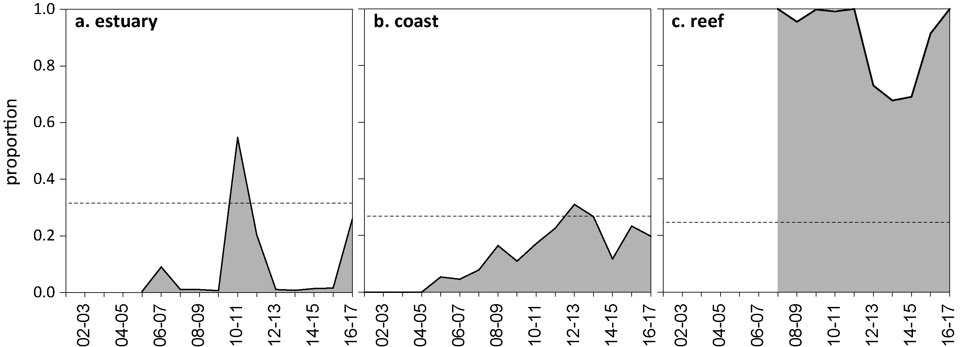
Figure 100. Proportion of seagrass abundance composed of colonising species in inshore intertidal habitats of the Fitzroy region, 2001 - 2017.
Grey area represents Great Barrier Reef long-term average proportion of colonising species for each habitat type.
The extent of the coastal meadows within monitoring sites in Shoalwater Bay has remained stable at the maximum since monitoring commenced in 2005. The extent of the estuarine meadows has remained relatively stable over the past 8 monitoring periods, until 2016, when there was a large reduction in extent of one of the sites. In late 2014, the extent of the reef meadows (Great Keppel Island), increased to their most extensive in 4 years, but there was a large decline in the dry season in 2016 at both sites (Figure 101).
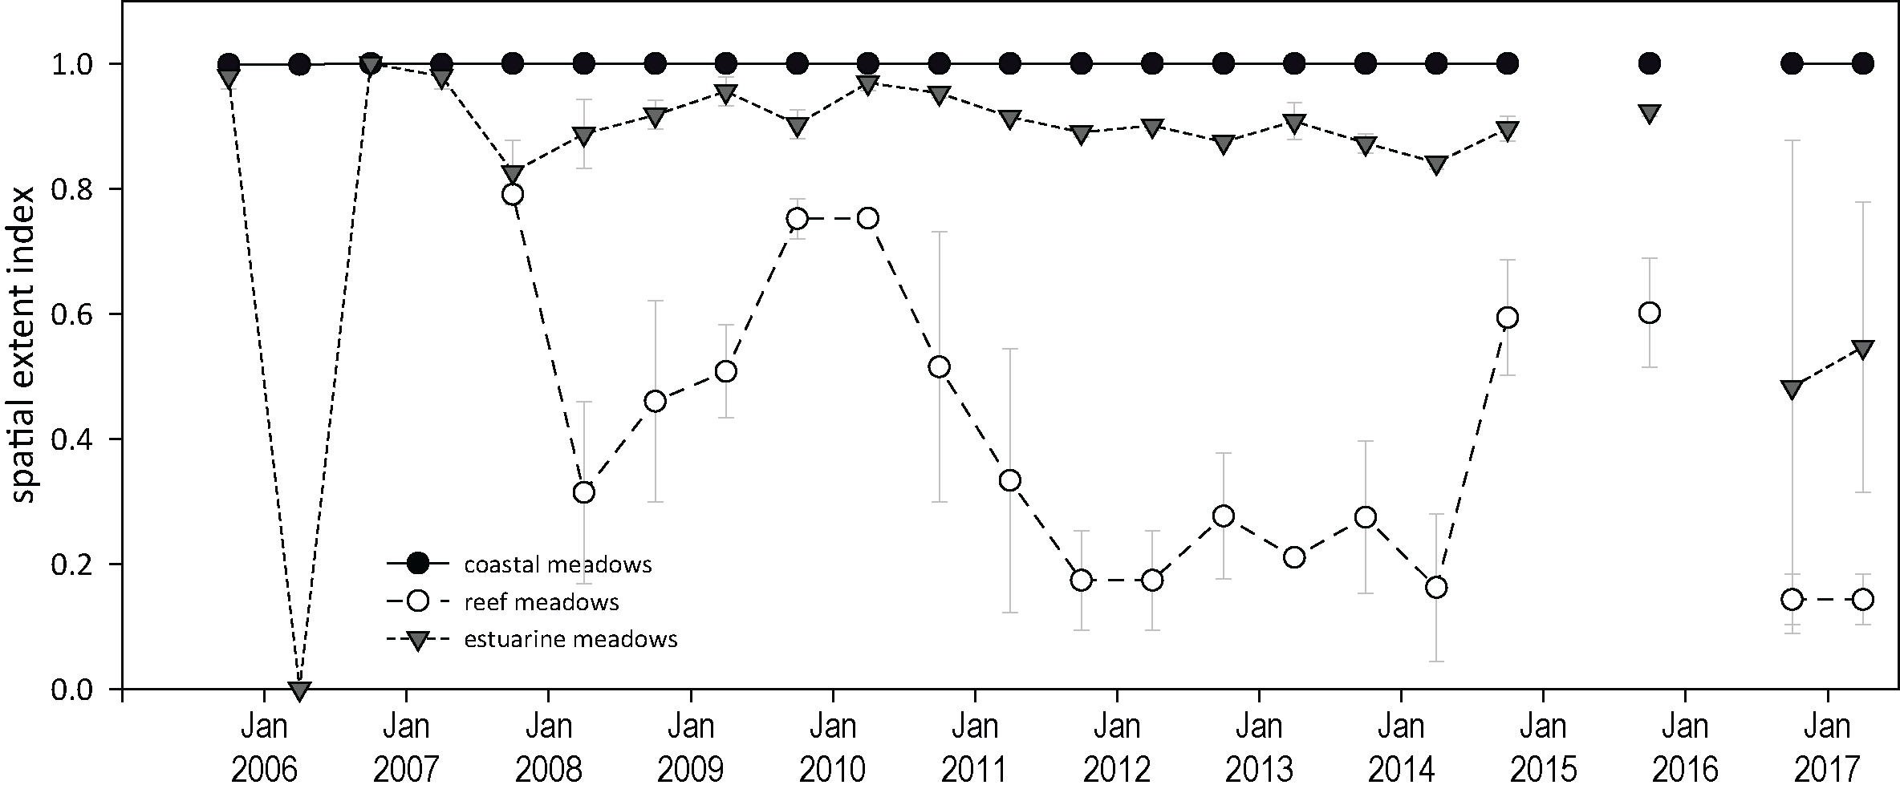
Figure 101. Change in spatial extent of seagrass meadows within monitoring sites for each inshore intertidal habitat across the Fitzroy NRM region, 2005 - 2017.
Apart from the MMP, seagrass monitoring within the Fitzroy NRM region is also conducted in places where cumulative anthropogenic impacts to seagrass are highest as part of the Queensland Ports Seagrass Monitoring Program (QPSMP). Annual monitoring of 14 seagrass meadows within Gladstone Harbour in November 2016 reported a significant decline in total seagrass area, but remained around the long-term average (Figure 102). In general, the meadows in the inner harbour and mid harbour of Gladtsone Harbour declined the most (Rasheed et al 2017). However, average meadow above-ground biomass (visually estimated using helicopter and boat-based free diving/grab) increased in most meadows and exceeding the long-term average in five out of 11 monitored meadows.
Of greatest concern were the trends in the large meadow at Pelican Banks, the trends of which are consistent with those observed in the MMP monitoring sites GH1 and GH2 (which are also located in Pelican Banks). The Pelican Banks meadow declined to its lowest area and visually estimated biomass ever recorded, and there was an increase in the proportion of colonizing species. Associated seed bank density and biannually (February and May) also reported a reduced proportion of seeds. The authors note that, although environmental conditions were generally favourable in the twelve months preceding the survey (e.g. below average rainfall and light levels well above threshold for maintenance and growth), the decline in area and biomass may have been driven by a legacy of past conditions, including substantial floods in 2014 and 2015, and high temperatures in 2015 (NB. The 2016–17 heatwave in early 2017 was not included in the monitoring period for this study). There is also a high level of herbivory in the region, but it is unknown whether this level has changed (Rasheed et al 2017).
Figure 102. Change total extent of all monitoring meadows combined in Port Curtis from 2009 – 2016 (from Rasheed et al 2017)
. Error bars are “R” reliability estimate for ha.

Seagrass reproductive status
Reproductive effort remains very poor in the Fitzroy region, but reproductive effort has varied inconsistently among habitats. Reproductive effort increased at coastal sites in 2016–17, but there was a concurrent reduction in the density of seeds in the seed bank. At these sites, the reproductive score may underestimate the role of sexual reproduction and the seed bank. As such, seed banks are being considered for future inclusion in the report card metric. Reproductive effort has remained very low at estuary and reef sites, however, seed banks have persisted in estuarine habitats, but not at reef sites (Figure 103). This limits the capacity of opportunistic species to expand in reef habitats, as well as the meadow capacity to recover following further disturbance.
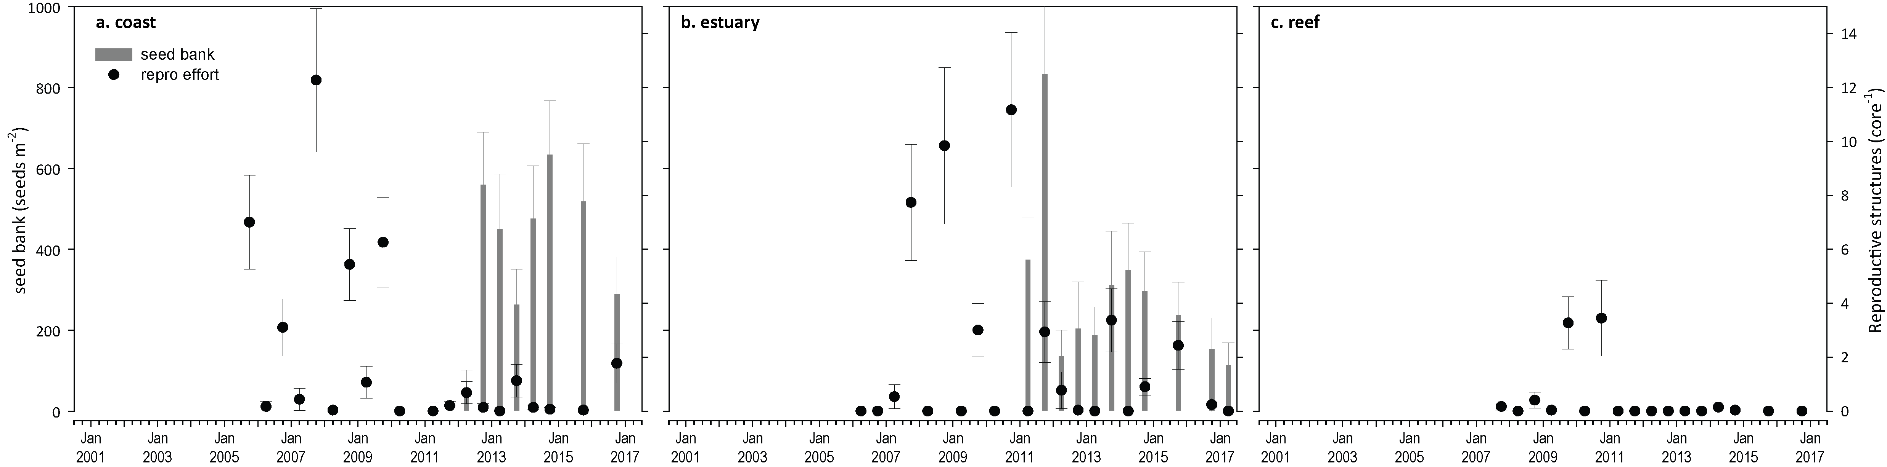
Figure 103. Seed bank and late dry season reproductive effort for inshore intertidal coastal, estuary and reef habitats in the Fitzroy region, 2005 - 2017.
Seed bank presented as the total number of seeds per m² sediment surface and late dry season reproductive effort presented as the average number of reproductive structures per core (species and sites pooled).

Indicators of environmental condition

Seagrass tissue nutrients
Seagrass leaf tissue C:N ratios increased in rating to moderate in 2016–17. The largest increase in the C:N score occurred at the coastal sites, such that both coastal and estuarine sites had scores around 20 (Figure 104). C:N below 20, is indicative of a surplus in the uptake of nitrogen, relative to the uptake and incorporation of carbon. In a trend that parallels all other regions in the Great Barrier Reef, there have also been reductions in the N:P ratios in 2016–17. Both increases in C:N and reductions in N:P (Figure 105) demonstrate a reduction nitrogen availability relative to growth requirements.
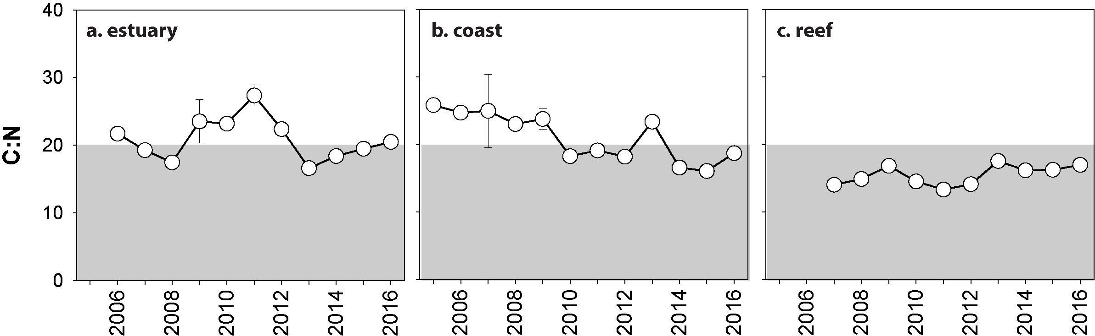
Figure 104. Elemental ratios (atomic) of seagrass leaf tissue C:N for the foundation seagrass species examined at inshore intertidal habitats in the Fitzroy region, 2005 - 2016
(species pooled) (mean ± SE). Horizontal shaded band on the C:N ratio panel represents the accepted guideline seagrass “Redfield” ratio of 20:1 (Abal et al. 1994; Grice et al. 1996). C:N ratios below this line may indicate reduced light availability and/or N enrichment.
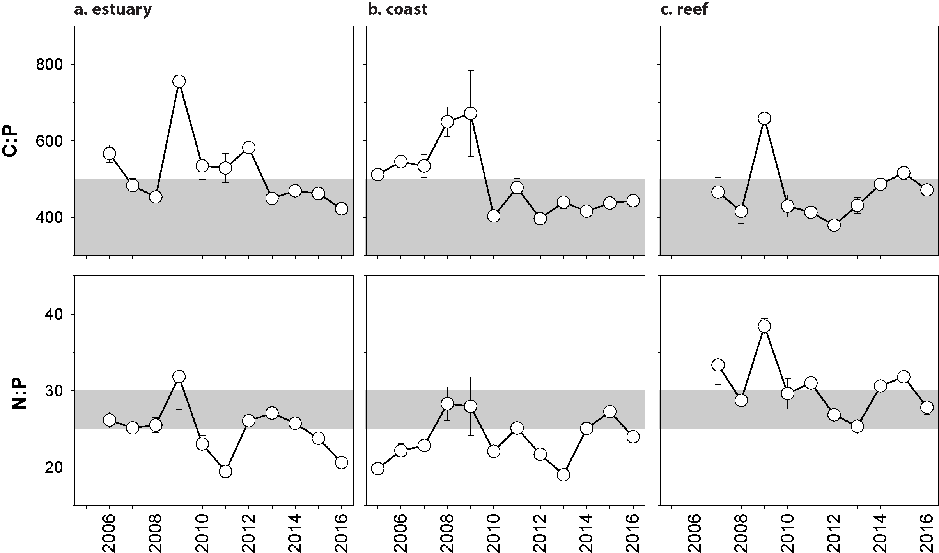
Figure 105. Elemental ratios (atomic) of seagrass leaf tissue N:P and C:P for the foundation seagrass species examined at inshore intertidal habitats in the Fitzroy region, 2005 - 2016
(species pooled) (mean ± SE). Horizontal shaded band on the N:P ratio panel represents the range of value associated with N:P balance ratio in the plant tissues. N:P ratio above this band indicates P limitation, below indicates N limitation and within indicates replete. Shaded portion on the C:P panel ≤500 represents the value associated with C:P balance ratio in the plant tissues, C:P values <500 may indicate nutrient rich habitats (large P pool).

Seagrass meadow sediments
In the Fitzroy region, the proportion of fine grains in meadow sediments decreases with distance from the coast/river mouths. Estuarine sediments were composed primarily of finer sediments, with the mud portion around the Great Barrier Reef long-term average, although one site (GH1) was much sandier in 2016–17 (Figure 179). Coastal and reef habitat sediments were dominated by fine sand/sand, but the proportion of mud in coastal habitats decreased greatly in 2016–17 to below the Great Barrier Reef long-term average (Figure 180, Figure 181).

Epiphytes and Macroalgae
Epiphyte cover on the leaves of seagrass declined at estuary and reef habitats in the late dry compared to the previous reporting year, and remained below the Great Barrier Reef long-term average over the 2016–17 monitoring period (Figure 106; Appendix 4, Figure 196, Figure 198). In coastal habitat the epiphyte coverage was unchanged (Appendix 2, Figure 197). Macroalgae cover remained unchanged at all habitats in the Fitzroy region (Figure 106; Appendix 4, Figure 198).
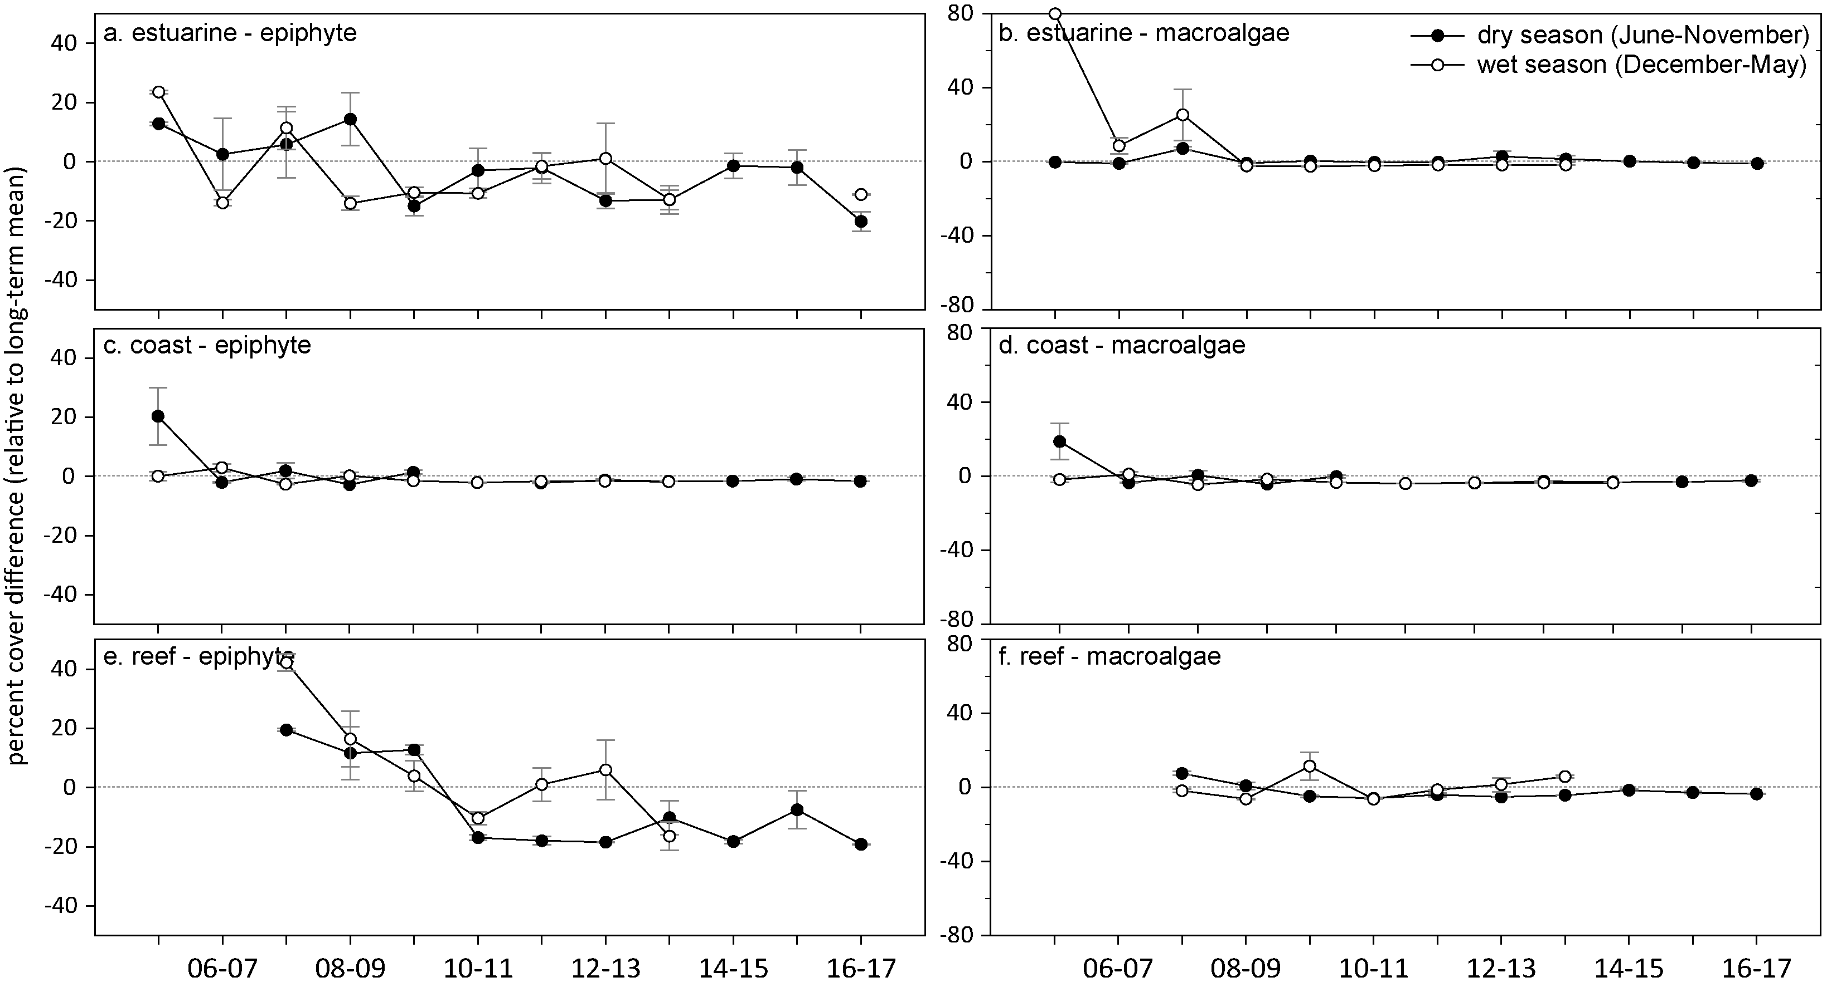
Figure 106. Long-term trend in mean epiphyte and macroalgae abundance (per cent cover) relative to the long-term average for each inshore intertidal seagrass habitat in the Fitzroy region, 2005 - 2017
(sites pooled, ±SE).

Report card for inshore seagrass status
In the 2016–17 monitoring period, the seagrass index increased slightly but remained poor. Although there were large improvements in the abundance score at coastal sites, there was a decline in estiarine sites. While the tissue nutrients score improved in all habitats, the reproductive effort score was zero in all habitats and these meadows remain in a highly vulnerable state.
Table 31. Long-term report card scores for seagrass abundance, reproductive and leaf tissue nutrient status for each habitat in the Fitzroy region: June 2005 – May 2017.
Values are indexed scores scaled from 0-100; ■ = very good (81-100), ■ = good (61 - 80), ■ = moderate (41 - 60), ■ = poor (21 - 40), ■ = very poor (0 - 20). NB: Scores are unitless.
Indicator | Habitat | 2005-06 | 2006-07 | 2007-08 | 2008-09 | 2009-10 | 2010-11 | 2011-12 | 2012-13 | 2013-14 | 2014-15 | 2015-16 | 2016–17
Abundance | estuarine intertidal | 25 | 13 | 44 | 25 | 42 | 34 | 47 | 53 | 34 | 25 | 25 | 6
Abundance | coastal intertidal | 81 | 81 | 100 | 75 | 81 | 31 | 25 | 25 | 8 | 25 | 38 | 63
Abundance | reef intertidal |  |  | 13 | 6 | 13 | 13 | 6 | 6 | 6 | 25 | 13 | 13
Reproductive  effort | estuarine intertidal | 100 | 0 | 50 | 63 | 25 | 75 | 13 | 0 | 25 | 0 | 13 | 0
Reproductive  effort | coastal intertidal | 38 | 13 | 50 | 25 | 25 |  | 0 | 0 | 0 | 0 | 0 | 0
Reproductive  effort | reef intertidal |  |  | 0 | 0 | 50 | 63 | 0 | 0 | 0 | 0 | 0 | 0
Leaf tissue  nutrients | estuarine intertidal |  | 58 | 46 | 37 | 67 | 66 | 85 | 62 | 33 | 42 | 47 | 52
Leaf tissue  nutrients | coastal intertidal | 79 | 74 | 75 | 65 | 69 | 41 | 46 | 41 | 67 | 33 | 30 | 44
Leaf tissue  nutrients | reef intertidal |  |  | 20 | 25 | 34 | 23 | 17 | 21 | 41 | 31 | 31 | 35
Seagrass Index |  | 67 | 40 | 44 | 36 | 45 | 47 | 28 | 25 | 26 | 20 | 22 | 24

Burnett Mary

2016–17 summary
Only intertidal estuarine and coastal seagrass meadows located in bays protected from SE winds and wave action were monitored in the Burnett Mary NRM region. The main ecological drivers in these environments are exposure to wind waves, elevated temperature, flood runoff and turbidity. Seagrasses are monitored at locations in the north and south of the Burnett Mary Region. Since monitoring was established, the meadows have come and gone on an irregular basis.
Rainfall, river discharge and turbid water exposure were similar to the long-term average for the seagrass sites within the region. Daily light reaching the seagrass canopy was lower than average in 2016–17 due in part to a prolonged period of low light in 2016, but there was also a period with no data recorded that may affected the regional average. Water temperatures were slightly above average; and there was the second highest number of days exceeding 35°C recorded during the year. However, the thermal anomaly was less extreme than in other regions (only 0.4°C above average), but this could none-the-less have a significant impact in these southern communities that are adapted to cooler temperatures.
Seagrass abundance returned to a poor rating in 2016–17 after reaching moderate in the previous monitoring period due to a reduction at Rodds Bay and Burrum Heads, whereas abundance increased at the estuarine Urangan site. The proportion of seagrass species displaying colonising traits was relatively stable in both habitats. The reproductive effort score also decreased to a very poor rating, due to reductions in effort at the estuarine site, and very low reproductive effort at the coastal site. Despite this, a moderate seedbank remains at the estuarine sites. Z. muelleri leaf tissue analysis in late 2016, showed a reduction in C:N and C:P in estuarine habitat, due to a reduction at Urangan which may have been affected by low light and/or elevated temperature.
In response to the environmental pressures over 2016–17, the seagrass state in the Burnett Mary region decreased but remained poor (Figure 107).
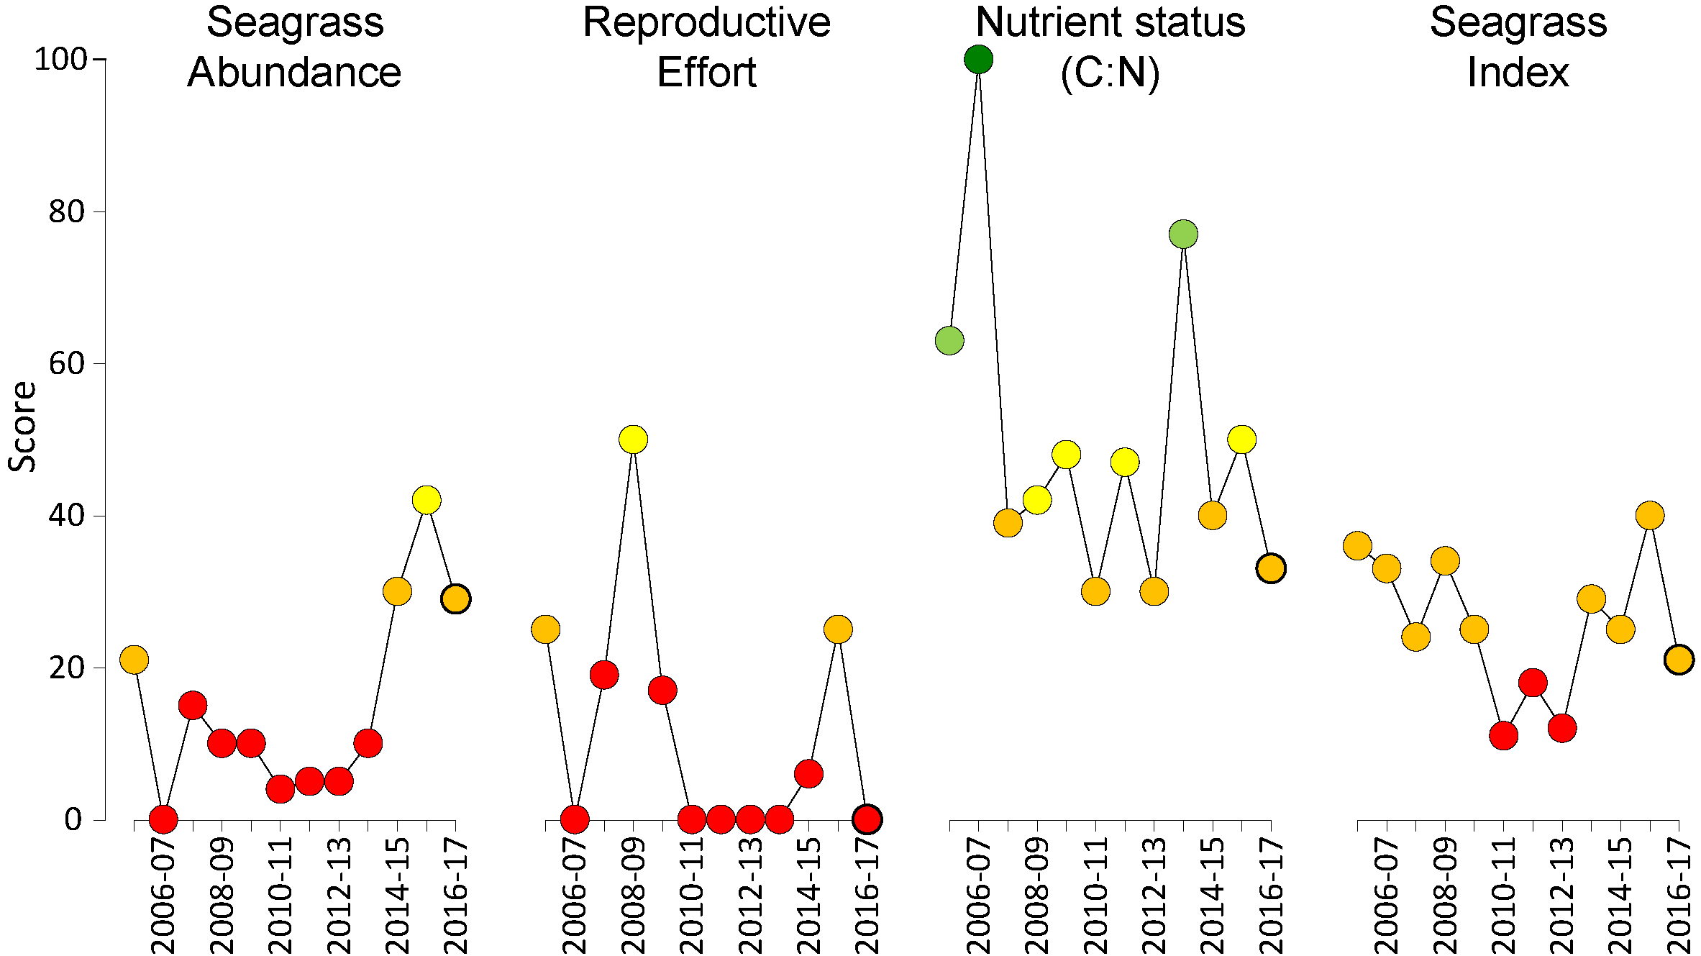
Figure 107. Report card of seagrass status indicators and index for the Fitzroy region
(averages across habitats and sites). Bold symbol = 2016–17 monitoring period. Values are indexed scores scaled from 0-100; ■ = very good (81-100), ■ = good (61 - 80), ■ = moderate (41 - 60), ■ = poor (21 - 40), ■ = very poor (0 - 20). NB: Scores are unitless.

Climate and environmental pressures
Rainfall in the Burnett-Mary catchment was below average, but river discharge was at around the average in 2016–17 (Table 32) due to discharge from all rivers in the region having above average discharge other than the Mary River. Burnett Mary seagrass meadows were exposed to almost exclusively primary water, often of very high turbidity (class 1 or 2 for 50% of the wet season,Figure 108, Table 33), from December 2016 to April 2017.
Table 32. Summary of environmental conditions at monitoring sites in the Burnett Mary in 2016–17 compared to the long-term average (long-term range indicated for each data set).
 | Long-term average | 2016–17
Rainfall (1986-2017) | 3.3 mm d⁻¹ | 3.0 mm d⁻¹
River discharge (1970-2017) | 1,462,017 L yr⁻¹ | 1,721,455 L yr⁻¹
Turbid water exposure (2006-2017) | 100 per cent | 100 per cent
Daytime tidal exposure (1999-2017) | 103 hr yr⁻¹ | 123 hr yr⁻¹
Wind (1998-2017) | 61 days yr⁻¹ | 63 days yr⁻¹
Within canopy temperature (2003-2017) | 23.4°C (46.5°C) | 23.8°C (39.8°C)
Within canopy light (2012-2017) | 13.0 mol m⁻² d⁻¹ | 10.8 mol m⁻² d⁻¹

Figure 108. Frequency of exposure to turbid water (colour classes 1-5) in the Burnett Mary NRM, wet season (22 weeks from December 2016 – April 2017) composite.
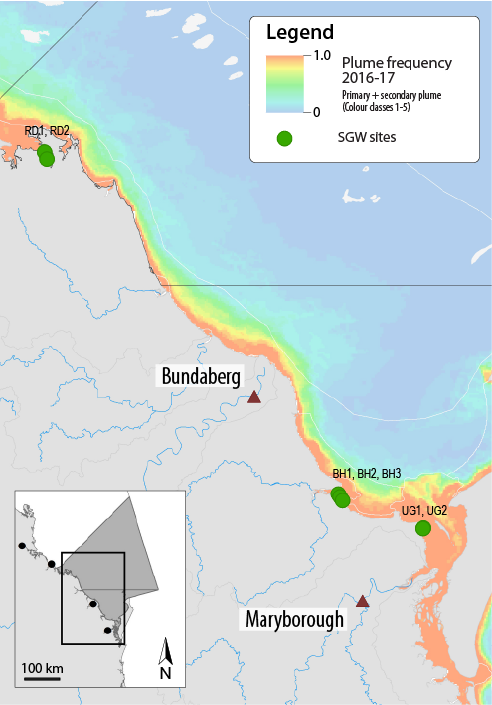
The frequency is calculated as the number of weeks out of 22 weeks that are exposed to primary or secondary water (colour classes 1 – 5). Each colour class category is described by mean water quality values for TSS, CDOM, chlorophyll a and K_{d} (PAR) (Devlin et al. 2015; Waterhouse et al. 2018). For site details,
see Table 34.

Table 33. Water type at each location in the Burnett Mary NRM derived from MODIS true colour images
as colour classes of turbid primary water (class 1 – 4, red/brown), nutrient/chlorophyll-enriched secondary water (class 5, green), and tertiary (some freshwater/CDOM influence) or no plume influence (class 6 and 7 respectively, blue), for 22 weeks from December 2016 – April 2017. Also shown, median wet season colour class (Med), frequency of primary water as f_{(P)}, the frequency of secondary water as f_{(S)}, and the frequency of primary or secondary as f_{(P+S)}. *denotes data obtained from adjacent pixel.

Site | 1 | 2 | 3 | 4 | 5 | 6 | 7 | 8 | 9 | 10 | 11 | 12 | 13 | 14 | 15 | 16 | 17 | 18 | 19 | 20 | 21 | 22 | f_{(P)} | f_{(S)} | f_{(P+S)}
RD1, RD2 | 2 | 1 | 2 | 1 | 3 | 1 | 4 | 3 | 1 | 4 | 1 | 4 | 1 | 4 | 4 | 5 |  | 1 | 3 | 4 | 1 | 4 | 0.95 | 0.05 | 1.00
BH1, BH2 | 4 | 1 | 2 | 4 | 4 | 1 | 4 | 3 | 4 | 4 | 1 | 5 | 2 | 5 | 1 | 5 | 2 | 1 | 1 | 4 | 1 | 2 | 0.86 | 0.14 | 1.00
BH3 | 1 | 1 | 1 | 1 | 2 | 1 | 1 | 1 | 1 | 1 | 1 | 2 | 1 | 2 | 1 | 1 |  | 1 | 1 | 4 | 1 | 1 | 1.00 | 0.00 | 1.00
UG1, UG2 | 3 | 3 | 3 | 2 | 3 | 2 | 4 | 2 | 4 | 3 | 2 | 4 | 2 | 5 | 2 | 5 | 2 | 1 | 1 | 4 | 2 | 3 | 0.91 | 0.09 | 1.00
Within canopy daily light (I_{d}) in 2016–17 (10.8 mol m⁻² s⁻¹), was lower than the long-term average (13.0 mol m⁻² s⁻¹) for the region (Figure 95, Table 32). This was attributed to considerably reduced light levels late in the senescent season after TC Debbie brought heavy rainfall to the region. Despite this, the low light threshold (6 mol m⁻² d⁻¹) was exceeded less than the long-term average for the region indicating that light levels were sufficient to support growth throughout the year.
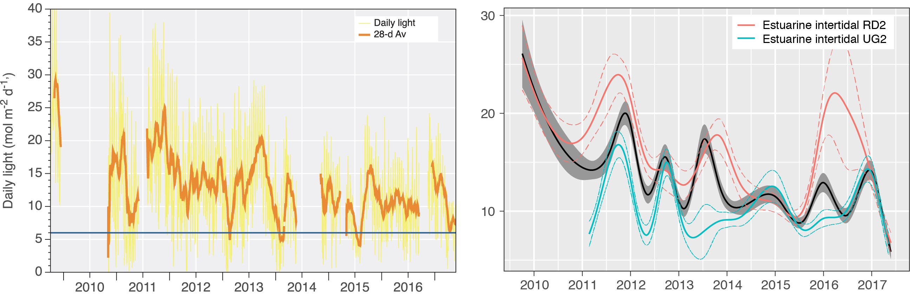
Figure 109. Daily light at Burnett Mary locations from 2010 to 2017 (left) and GAM plots (right)
with the black line showing mean trend for all sites (±95 per cent confidence interval in grey shade) and coloured lines (with CI’s) showing the trend for each site. Results of statistical analysis (GAM) and site-specific graphs (raw daily light data plus 28-d rolling average) are shown in Appendix 4.
Burnett Mary, being the southern most NRM, inherently has cooler temperatures than the more northern regions. As a consequence there were fewer exceedances of Great Barrier Reef-wide temperature thresholds with 19 days >35°C. However, deviation from the region-specific baseline demonstrates that 2016–17 was an above average year for water temperature, and was above the local baseline for most of the year (Figure 110).
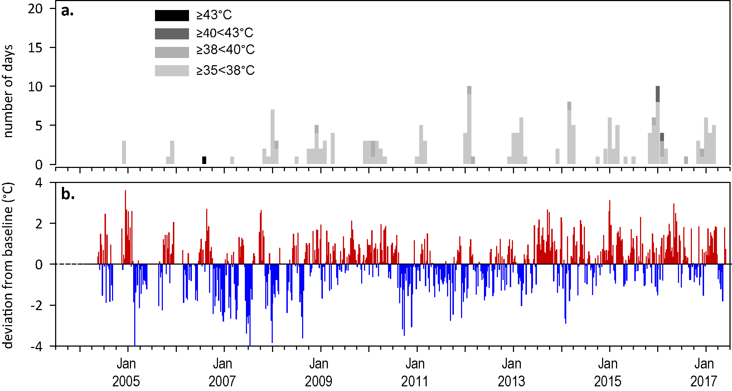
Figure 110. Inshore sea temperature monitoring September 2005 to May 2017 for seagrass meadows in Burnett Mary NRM region
: a) number of days when temperature has exceeded 35°C, 38°C, 40°C and 43°C within each season (thresholds adapted from SJ Campbell et al., 2006); b) deviations from 10-year mean weekly temperature records (weeks above the long-term average are represented as red bars and the magnitude of their deviation from the mean represented by the length of the bars, bars are blue for weeks with temperatures lower than the average and are plotted as negative deviations).

Indicators of seagrass condition
Two seagrass habitat types were assessed across the Burnett Mary region in 2016–17, with data from 6 sites (Table 34).
Table 34. List of data sources of seagrass and environmental condition indicators for each seagrass habitat type in the Burnett Mary NRM region.
*Seagrass-Watch. For site details see Table 3 and Table 4.
Habitat | Site |  | abundance | composition | distribution | Reproductive effort | seed banks | Leaf tissue nutrients | Meadow sediments | Epiphytes & macroalgae
estuary intertidal | RD1 | Rodds Bay
estuary intertidal | RD2 | Rodds Bay
estuary intertidal | UG1 | Urangan
estuary intertidal | UG2 | Urangan
coastal intertidal | BH1* | Burrum Heads
coastal intertidal | BH3* | Burrum Heads

Seagrass abundance, composition and extent
Only estuarine and coastal habitats are monitored in the Burnett Mary NRM region. Since monitoring was established, the estuarine meadows have come and gone on an irregular basis. Seagrass abundance at Urangan increased in 2016–17 compared to the late wet abundance in the previous monitoring year. However, percent cover in the late dry was lower than it had been in the previous two late dry sampling periods and well below the high abdundances observed in 2001 to 2005. Abundance declined in 2016–17 at both the Burrum Heads and Rodds Bay monitoring sites. On average, abundances decreased to a low rating after reaching moderate in the previous year (Figure 107).
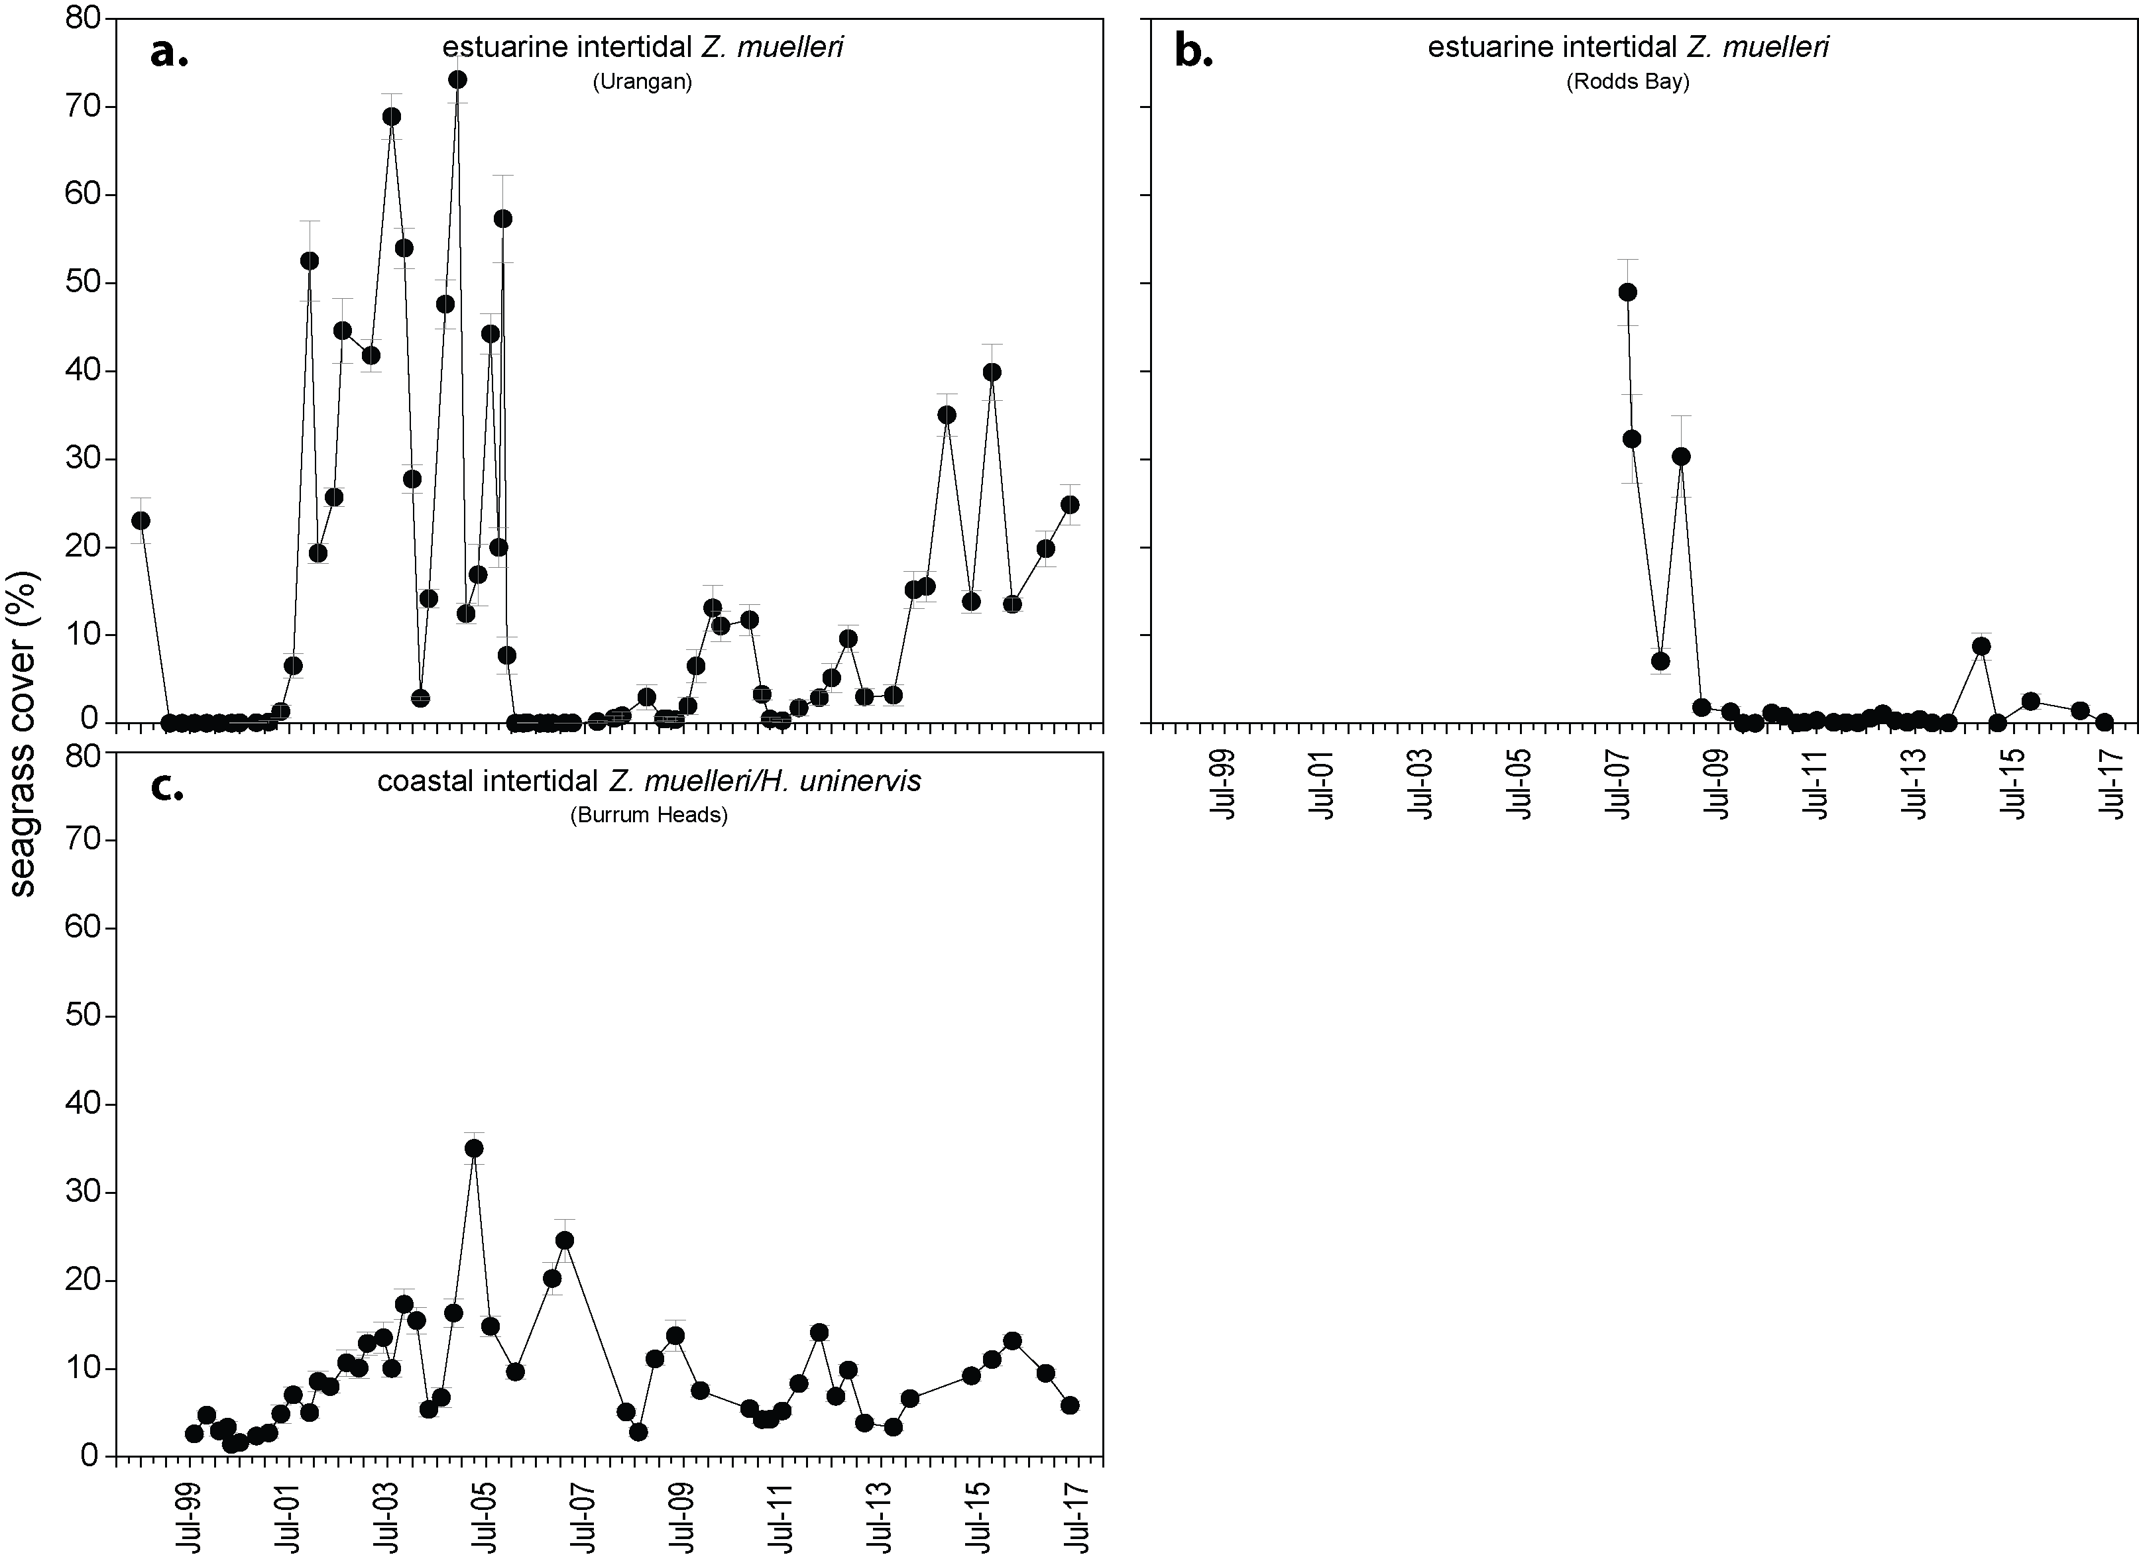
Figure 111. Changes in seagrass abundance (per cent cover ± SE) at estuarine and coastal meadows in Burnett Mary region from 1999 to 2017.

An examination of the long term trends across the Burnett Mary NRM region suggests seagrass abundance (per cent cover) has fluctuated greatly between years, but progressively decreased from 2004 to 2012. Increases since 2012 have placed the meadows on a pathway towards recovery. This long-term trends suggest that the losses observed in 2016–17 are not part of a declining trend, despite reduction in the abundance score (Figure 112, Figure 113).
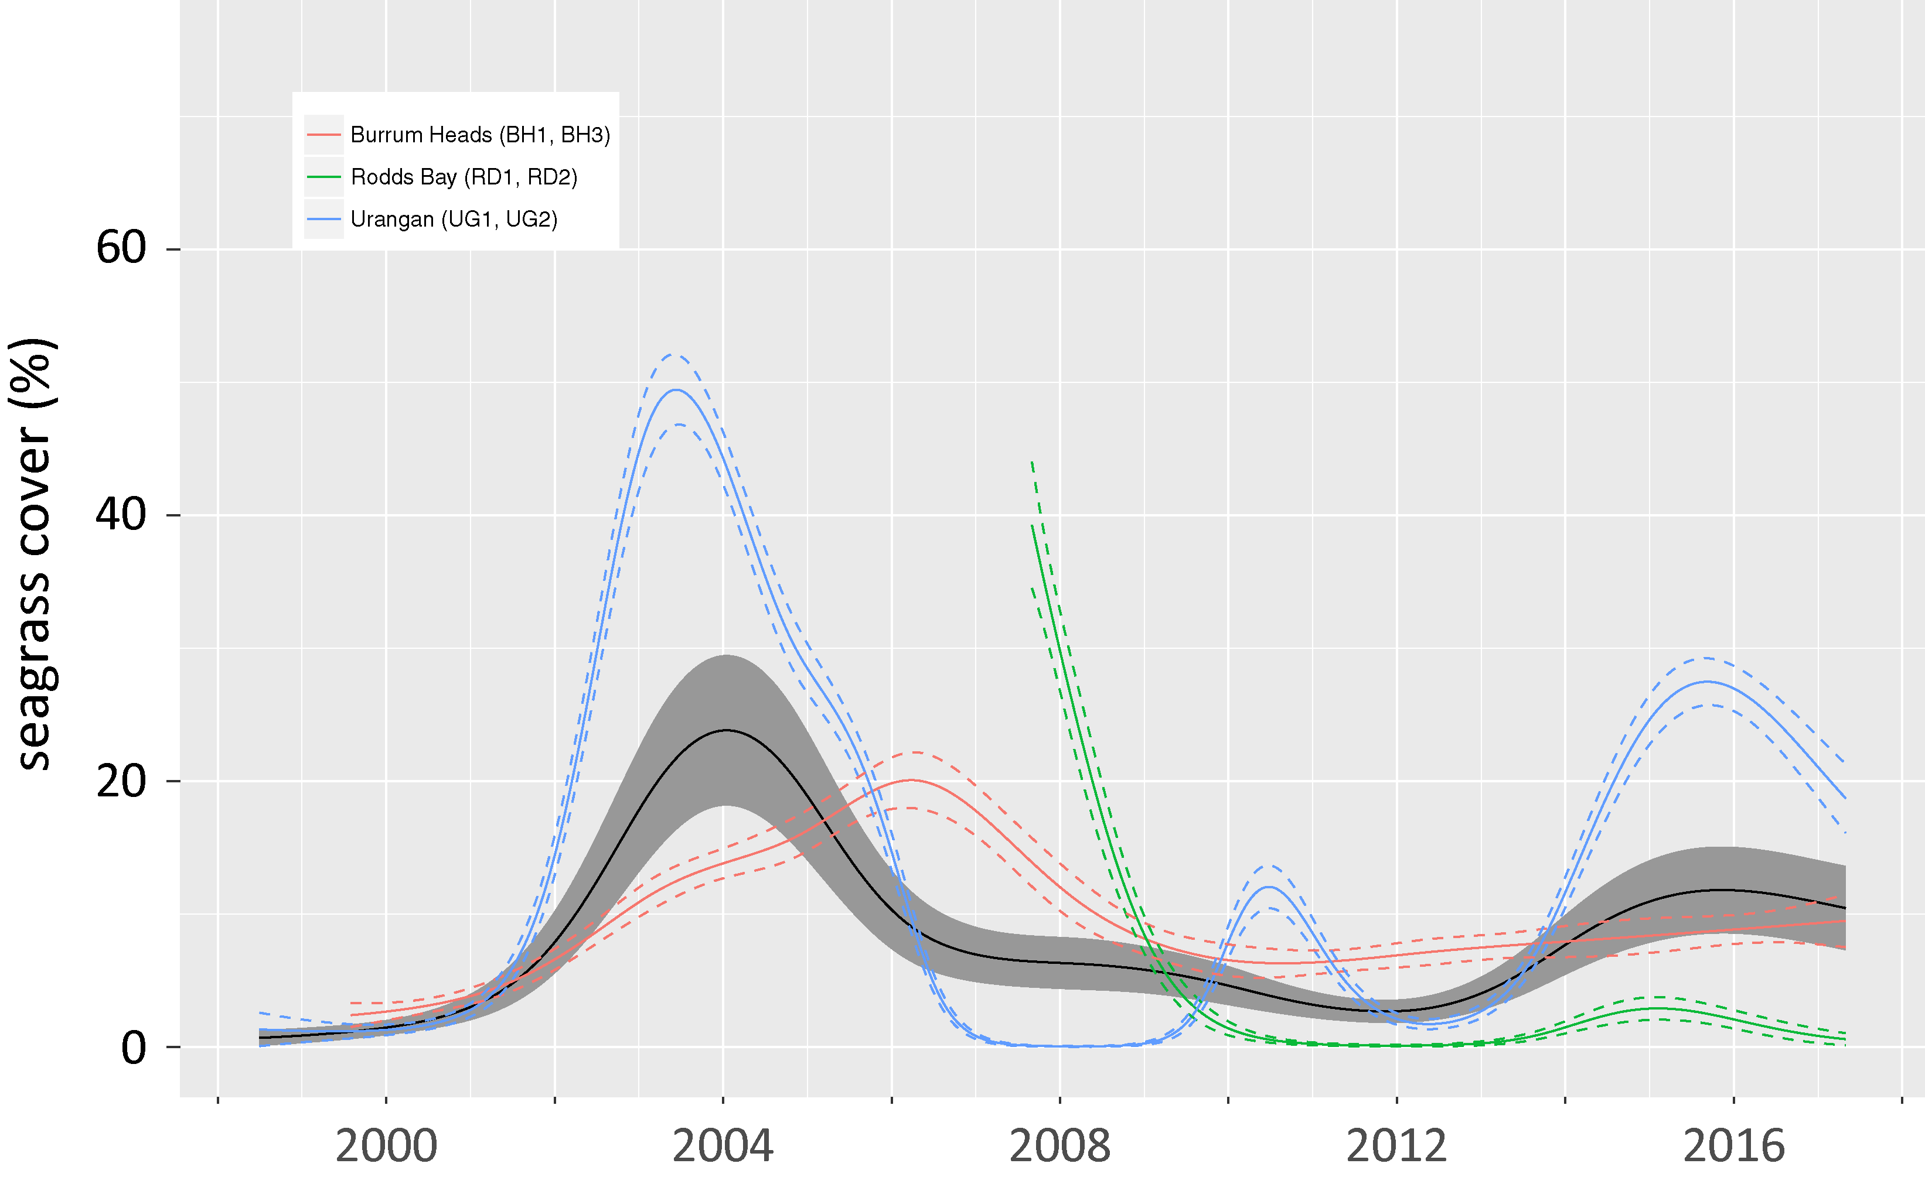
Figure 112. Temporal trends in seagrass abundance at estuarine locations in the Burnett May region, represented by a GAM plot 1999-2017.
Regional trend (all habitats pooled) represented by black line with grey shaded areas defining 95 per cent confidence intervals.
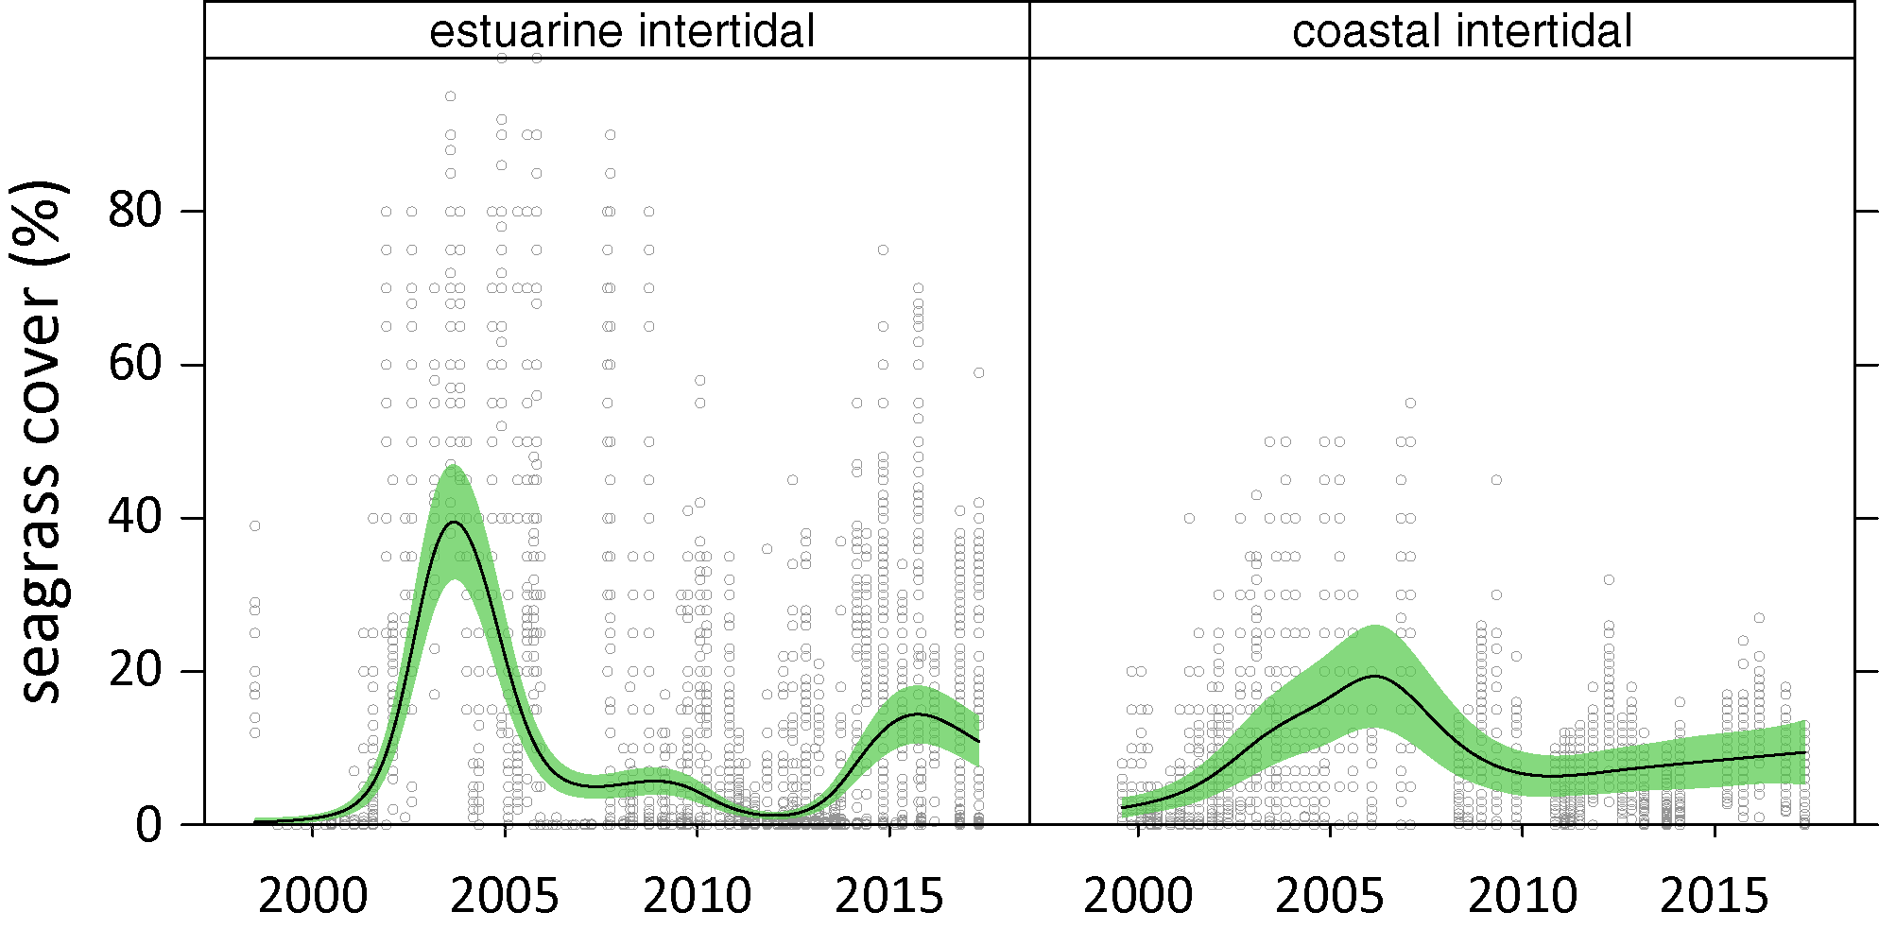
Figure 113. Temporal trends in seagrass abundance for seagrass habitat in the Burnett Mary region represented by a GAM plot, 1998-2017.
Trends (locations pooled) represented by black line with green shaded area defining 95 per cent confidence intervals, and quadrat data displayed as grey circles.
The estuarine and coastal seagrass habitats have been dominated by Zostera muelleri with varying components of Halophila ovalis (Figure 114). In 2016–17, the proportion of colonising species was relatively unchanged compared to the previous monitoring year, but it has been lower in recent years compared to 2011 when habitats were completely dominated by colonising species. In estuarine habitats the proportion of colonising species was similar to the Great Barrier Reef average, but coastal habitats had small proportion of colonising species. The reducing proportion of colonising species in the meadows suggests greater ability to tolerate/resist major disturbances, particularly as the meadows improve abundance.
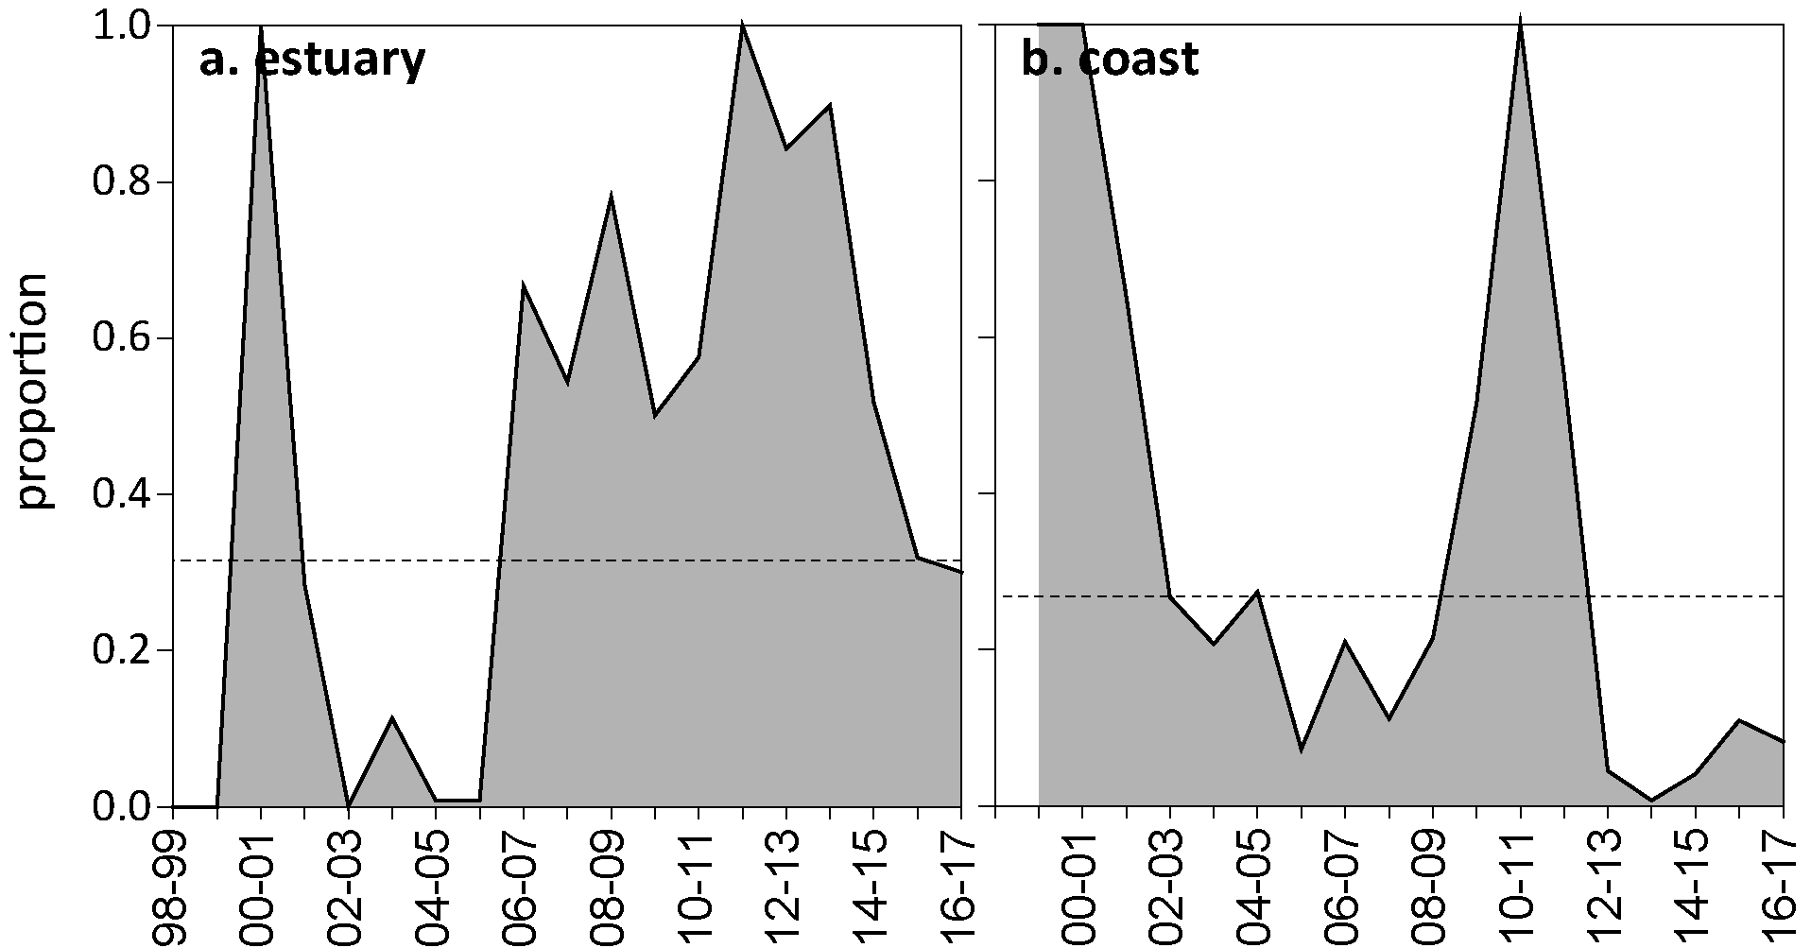
Figure 114. Proportion of seagrass abundance composed of colonising species at: a. estuary and b. coastal habitats in the Burnett Mary region, 1998-2017.
Grey area represents Great Barrier Reef long-term average proportion of colonising species for each habitat type.
Seagrass meadow edge mapping was conducted at all monitoring sites in October 2016 and April 2017 (Appendix 4) to determine if changes in abundance were a consequence of the meadow edges changing and to indicate if plants were allocating resources to colonisation (asexual reproduction). Over the last 12 months meadow extent has declined relative to the previous two years (Figure 115).

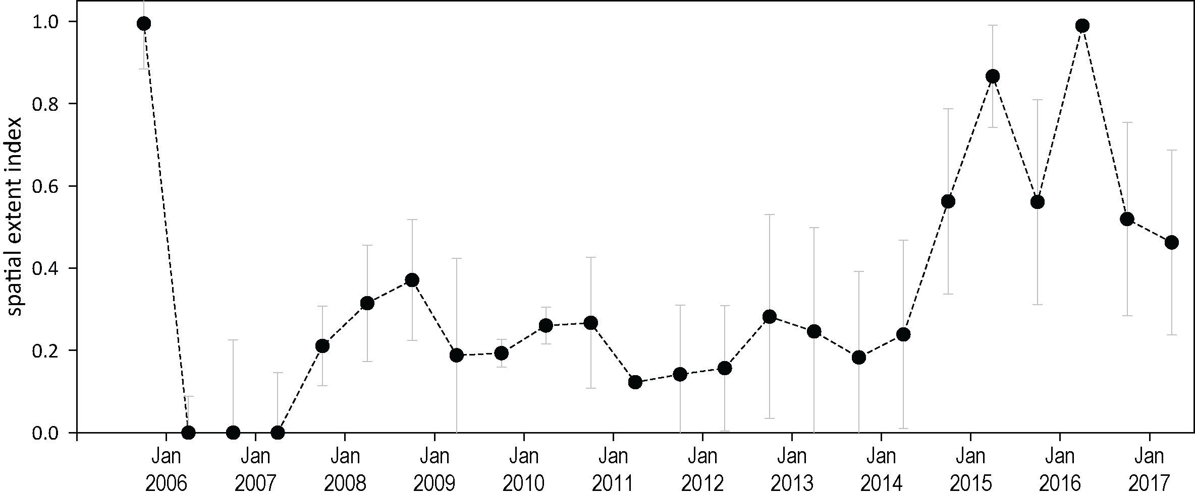
Figure 115. Change in spatial extent of estuary seagrass meadows within monitoring sites for each habitat and monitoring period across the Burnett Mary NRM region.
These observed trends are consistent with those measured in complimentary monitoring prograns. Apart from the MMP, seagrass monitoring within the Burnett Mary NRM region is also conducted in the northern section where cumulative anthropogenic impacts to seagrass are highest as part of the Queensland Ports Seagrass Monitoring Program (QPSMP). Annual monitoring of 3 seagrass meadows within Rodds Bay is conducted as a reference (low impact) comparison to the Port Curtis (Gladstone Harbour) meadows for the Gladstone Ports Corporation Limited. The MMP monitoring sites RD1 and RD2 are located within two of the meadows monitored (meadows #96 and #104, respectively). QPSMP monitoring in November 2016 reported a significant (based on estimates of reliability/mapping precision) decline in area of both of the Rodds Bay meadows. In addition, average meadow above-ground biomass (visually estimated using helicopter and boat-based free diving/grab) remained well below the long term average (Rasheed et al 2017). This was consistent with trends observed at the nearby Port Curtis (Gladstone Harbour). The cause of the declines were not clear, but disturbances from floods, cyclones and anthropogenic activities may have contributed. There are also high elevels of herbivory in the region (Rasheed et al 2017).

Seagrass reproductive status
Seagrass reproductive effort had increased to the second highest levels recorded in the previous monitoring period in estuarine habitat, but in 2016–17, reproductive effort declined to almost zero. Zostera muelleri seed banks in Burnett Mary region esdtuarine meadows have remained relatively stable but are below the highest levels observed (Figure 116). In 2016–17, the Burrum Heads coastal site had no seeds present but it is not known whether this has been typical in these meadows in recent years because seed banks have not been assessed since 2008.
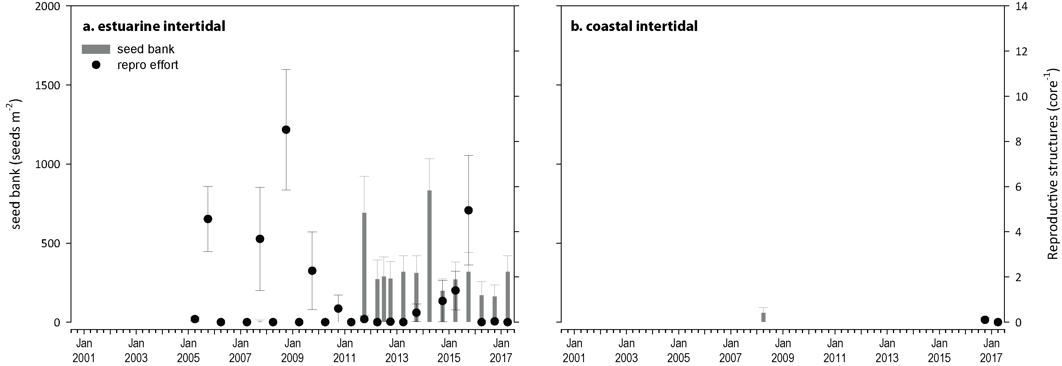
Figure 116. Burnett Mary estuary seed bank and reproductive effort.
Seed bank presented as the total number of seeds per m² sediment surface and reproductive effort presented as the average number of reproductive structures per core (species and sites pooled).

Indicators of environmental condition

Seagrass tissue nutrients
In 2016, Zostera muelleri leaf molar C:N ratios were unchanged at the estuary sites compared to the previous two years (Figure 117); due to a reduction at Urangan and an increase at Rodds Bay (Table 54). The C:P ratio declined more substantially overall at estuarine sites, due to a large reduction at Urangan. The reduced C:N and C:P ratios could reflect lower than average light conditions at the site; in late 2016 there had been a prolonged period of low and deteriorating light levels, which subsequently improved but the light data record is not continuous at the site (Figure 161) making it difficult to assess trends. Although there was a small reduction in C:N at Urangan, it remained above 20 at that site, while the Rodds Bay site increased, but was only 15.8. At the Burrum Heads coastal site, C:N was 14.3, which was the third lowest out of all sites measured in the Great Barrier Reef. There was also a very high tissue N content relative to phosphorus (P), suggesting a local source of nitrogen to this meadow. There have not been previous analyses from this site against which to assess the trend (Appendix 4, Figure 214).
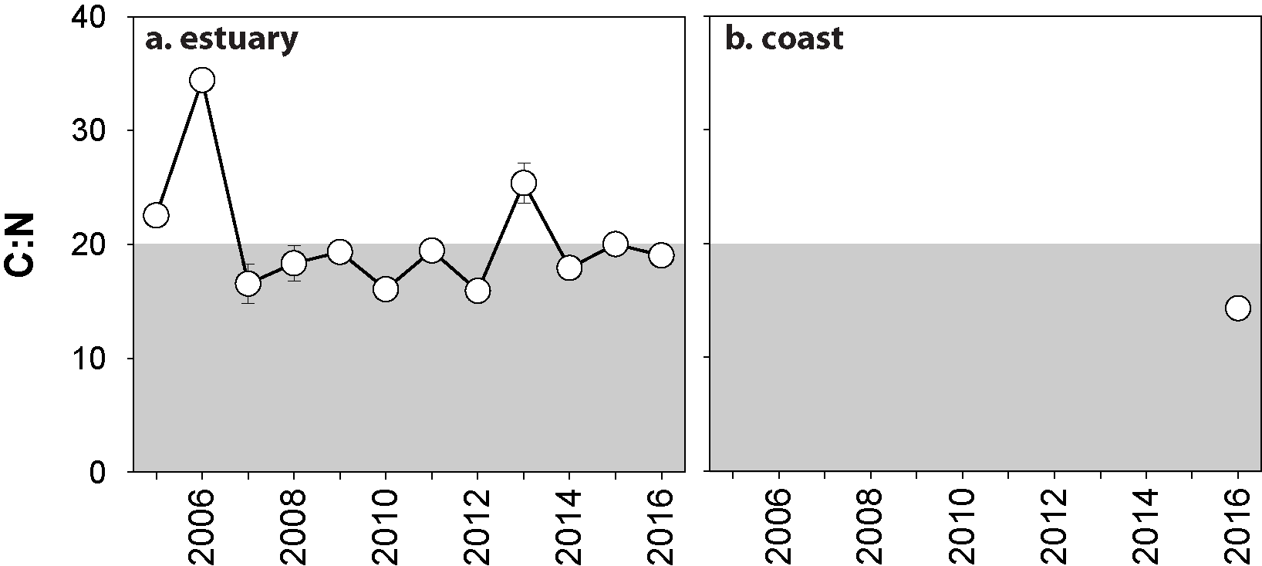
Figure 117. Elemental ratios (atomic) of seagrass leaf tissue C:N for the foundation seagrass species examined at inshore intertidal habitats in the Burnett Mary region, 2005 - 2016
(species pooled) (mean ± SE). Horizontal shaded band on the C:N ratio panel represents the accepted guideline seagrass “Redfield” ratio of 20:1 (Abal et al. 1994; Grice et al. 1996). C:N ratios below this line may indicate reduced light availability and/or N enrichment.

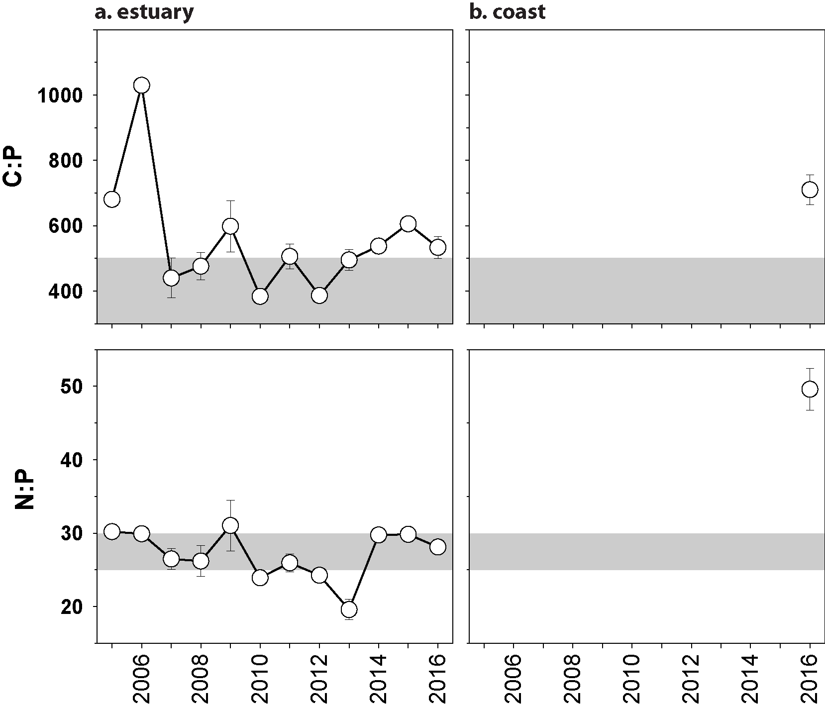
Figure 118. Elemental ratios (atomic) of seagrass leaf tissue N:P and C:P for the foundation seagrass species examined at inshore intertidal habitats in the Burnett Mary region, 2005 - 2016
(species pooled) (mean ± SE). Horizontal shaded band on the N:P ratio panel represents the range of value associated with N:P balance ratio in the plant tissues. N:P ratio above this band indicates P limitation, below indicates N limitation and within indicates replete. Shaded portion on the C:P panel ≤500 represents the value associated with C:P balance ratio in the plant tissues, C:P values <500 may indicate nutrient rich habitats (large P pool).

Seagrass meadow sediments
Sediments in the estuary seagrass habitats of the Burnett Mary region are dominated by mud, and in 2016–17, this has remained relatively stable, albeit with seasonal variability (Figure 182). Coastal meadows in 2016–17 continued to be dominated by fine sand with little change from the previous year (Figure 183).

Epiphytes and macroalgae
Epiphyte cover on seagrass leaf blades was similar in the wet and dry seasons, lower on average than the past 2 years, and was similar to the Great Barrier Reef long-term average in 2016–17 (Figure 119; Appendix 4, Figure 198). Percentage cover of macroalgae was similar to the Great Barrier Reef average in 2016–17 (Figure 119; Appendix 4, Figure 198).
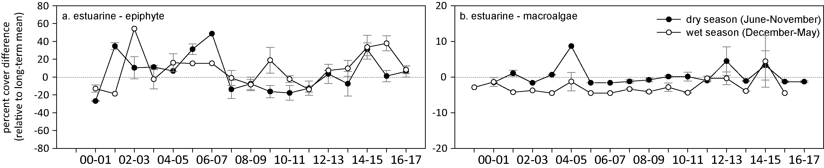
Figure 119. Long-term trend in mean epiphyte and macroalgae abundance (per cent cover) relative to the long-term average for each seagrass habitat in the Burnett Mary NRM region
(sites pooled, ±SE).

Report card for inshore seagrass status
Since reporting was established in 2005, the seagrass index score for the Burnett Mary has been poor or very poor. In the 2016–17 monitoring period, the seagrass index for the Burnett Mary region stayed poor, but reduced following the highest since reported in the previous monitoring period. Declines occurred in all indicators and habitats, with the largest decline in reproductive effort, however, some seeds do remain.

Table 35. Long-term report card scores for seagrass abundance, reproductive and leaf tissue nutrient status for each habitat in the Burnett Mary region: June 2005 – May 2017.
Values are indexed scores scaled from 0-100; ■ = very good (81-100), ■ = good (61 - 80), ■ = moderate (41 - 60), ■ = poor (21 - 40), ■ = very poor (0 - 20). NB: Scores are unitless.
Indicator | Habitat | 2005-06 | 2006-07 | 2007-08 | 2008-09 | 2009-10 | 2010-11 | 2011-12 | 2012-13 | 2013-14 | 2014-15 | 2015-16 | 2016–17
Abundance | estuarine intertidal | 21 | 0 | 15 | 10 | 10 | 4 | 5 | 5 | 10 | 26 | 34 | 22
Abundance | coastal intertidal |  |  |  |  |  |  |  |  |  | 38 | 69 | 44
Reproductive  effort | estuarine intertidal | 25 | 0 | 19 | 50 | 17 | 0 | 0 | 0 | 0 | 6 | 25 | 0
Reproductive  effort | coastal intertidal |  |  |  |  |  |  |  |  |  |  |  | 0
Leaf tissue  nutrients | estuarine intertidal | 63 | 100 | 39 | 42 | 48 | 30 | 47 | 30 | 77 | 40 | 50 | 45
Leaf tissue  nutrients | coastal intertidal |  |  |  |  |  |  |  |  |  |  |  | 22
Seagrass Index |  | 36 | 33 | 24 | 34 | 25 | 11 | 18 | 12 | 29 | 25 | 39 | 21

Conclusions
In 2016–17, the inshore seagrass of the Great Barrier Reef was rated in a poor condition in all NRM regions, except the Burdekin region which was rated moderate. The seagrass condition in the Fitzroy and southern Wet Tropics has maintained low overall condition including abundance and reproduction. Seagrass in these regions continue to be highly vulnerable in some habitats. These trends have also been observed in meadows assessed annually in the Queensland Ports Seagrass Monitoring program (QPSMP). At a habitat level, the habitats in poorest condition were reef habitats: intertidal and subtidal reef habitats have consistently had very poor reproductive effort and low or no seeds in the seed banks, while the subtidal reef habitats have shown little sign of recovery in abundance following 2011 (except Magnetic Island in the Burdekin NRM region).
The only indicator showing overall improvements in 2016–17 were seagrass leaf tissue nutrients which were in an improved state in Cape York, Burdekin and Fitzroy regions, and relatively stable in other regions. This probably reflects the multiple years of lower than average river discharge and lower nitrogen availability (Table 10). This also appears to correlate to reducing dissolved inorganic nutrients concentrations that have been recorded in the Wet Tropics and Burdekin regions (Waterhouse et al 2018). Light levels and photosynthetic carbon uptake can also affect C:N ratios in seagrass leaves, but the recent improvements appear to reflect changes in nitrogen availability because light levels have not been considerably improved in 2016–17 or in previous years.
Influential climatic conditions in 2016–17 included tropical cyclone Debbie (category 4), which crossed the coast near Airlie Beach in the Mackay Whitsunday region and tracked down the coast resulting in high rainfall and pulsed river discharge in the Mackay Whitsunday, Fitzroy and Burnett Mary regions. In other regions, rainfall, river discharge and exposure to ‘brown’ or ‘green’ turbid water was at or below average (indicating less turbid water). Despite this, within canopy daily light were at or below the long-term averages (indicating more turbid water) for many sites and regions. The discrepancies between daily light and the other indicators, suggests that there are site-scale processes impacting benthic light that are not necessarily detected in the broad-scale analysis of water quality.
In 2016–17 there was a marine heatwave affecting the inshore seagrass meadows in all regions of the Great Barrier Reef, resulting in the largest number of high temperature days (>35°C) on record in each region, except in the Burnett Mary, which had the second highest number of high temperature days. This is the second year in a row of heatwave conditions to affect the Great Barrier Reef. In both years, there were only very few extreme high temperature days (>40°C) and so direct temperature stress on photosystems was unlikely. The temperature thresholds reported (35°C, 38°C, 40°C, 43°C) are based on photoinhibition of photosystem II, and were tested and developed because these temperatures are reached in intertidal habitats (Campbel et al 2006a, Collier et al 2014b). These temperatures are not reached in subtidal habitats where mixing prevents extreme temperature rise. By contrast, intertidal habitats rarely expose (Table 51), but frequently have very low water levels when heat transfer and poor mixing leads to temperature extremes of the surrounding water (Anthony and Kerswell 2007). However, we now know that warm temperatures (>30°C), while not impacting photosystem II, can place a respiratory burden on seagrasses, particularly more temperate-adapted seagrasses such as Z. muelleri (see Case study 2; Adams et al 2017, Collier et al 2017). Furthermore, above 35°C the net productivity (photosynthesis – respiration) goes into deficit (i.e. they lose energy due to respiratory losses) (Collier et al 2017). The combination of temperature and light stress compounds both impacts (Case study 1) and the lower than average light conditions in 2016–17, combined with above-average temperatures may have created chronic stress conditions in some meadows of both intertidal and subtidal habitats and hampered recovery rates. We will explore inclusion of a lower temperature threshold (>30°C) in future reports to account for this lower level chronic temperature stress. In addition, we will explore an indicator of temperature stress that accounts for accumulated low level stress, analogous to degree heating weeks.
Tropical seagrasses of the Great Barrier Reef are a mosaic of different habitat types with multiple seagrass species assemblages. The Great Barrier Reef occurs in a climate belt where variable rainfall patterns and cyclones, and increasingly in recent years - marine heatwaves - creates frequent disturbances moving up and down the 2,300km coastline creating complex and varied environmental conditions. Seagrass meadows exposed to these conditions are also dynamic, with large changes in abundance being seemingly typical for the Great Barrier Reef (e.g. Birch and Birch 1984; Preen et al. 1995; Campbell and McKenzie 2004; Waycott et al. 2007), but the timing and mechanisms that cause their dynamism (i.e. declines and subsequent recovery) are complex.
Declines in seagrass abundance occurring in 2006 and then from 2009 to 2012 (from Cooktown south) abated in late 2012 and seagrass state improved slightly; but remained poor in 2016–17 (Figure 120). More specifically, although some locations in the Wet Tropics and Burdekin regions experienced declines in early 2006 as a consequence of TC Larry, most recovered within 1-2 years; with the exception of the coastal sites in southern Wet Tropics where recovery was protracted. In late 2008, locations in the northern Wet Tropics and Burdekin regions were in a moderate state of health with abundant seagrass and seed banks. In contrast, locations in the southern Great Barrier Reef in Mackay Whitsunday and Burnett Mary regions were in a poor state, with low abundance, reduced reproductive effort and small or absent seed banks. In 2009 with the onset of the La Niña, the decline in seagrass state steadily spread across the Burdekin region and to locations within the Fitzroy and Wet Tropics where discharges from large rivers and associated catchments occurred (McKenzie et al. 2010b; McKenzie et al. 2012b). The only locations of better seagrass state were those with relatively little catchment input, such as Gladstone Harbour and Shoalwater Bay (Fitzroy region), Green Island (Wet Tropics), and Archer Point (Cape York) (McKenzie et al. 2012b). By 2010, seagrasses of the Great Barrier Reef were in a poor state with declining trajectories in seagrass abundance, reduced meadow extent, limited or absent seed production and increased epiphyte loads at most locations. These factors would have made the seagrass populations particularly vulnerable to large episodic disturbances, as demonstrated by the widespread and substantial losses documented after the floods and cyclones of early 2011.
Following the extreme weather events of early 2011, seagrass habitats across the Great Barrier Reef further declined, with severe losses reported from the Wet Tropics, Burdekin, Mackay Whitsunday and Burnett Mary regions. By 2011-12, the onset of seagrass recovery was observed across some regions, however a change had occurred in which colonising species dominated many habitats. The majority of meadows appeared to allocate resources to vegetative growth rather than reproduction, indicated by the lower reproductive effort and seed banks. In 2016–17, recovery has slowed or stalled across most of the regions. The Wet Tropics and Fitzroy regions have shown the most protracted recovery rates, though the causes for this differ between the regions. In the Fitzroy region declines up to early 2011 were more moderate than in other regions, but the estuarine intertidal and coastal intertidal habitats declined further in 2013-15, and recovery has since been slow except in coastal habitats. Abundance in the Wet Tropics declined in early 2011, and recovery has been delayed. In the southern Wet Tropics, it appears that sediment scouring caused by TC Yasi in 2011 altered bed elevation and substrate composition, however the growth substrate is not routinely measured. By contrast, slow recovery in the northern Wet Tropics reef sites (Low Isles intertidal and subtidal and Green Island subtidal) may be affected by water quality.
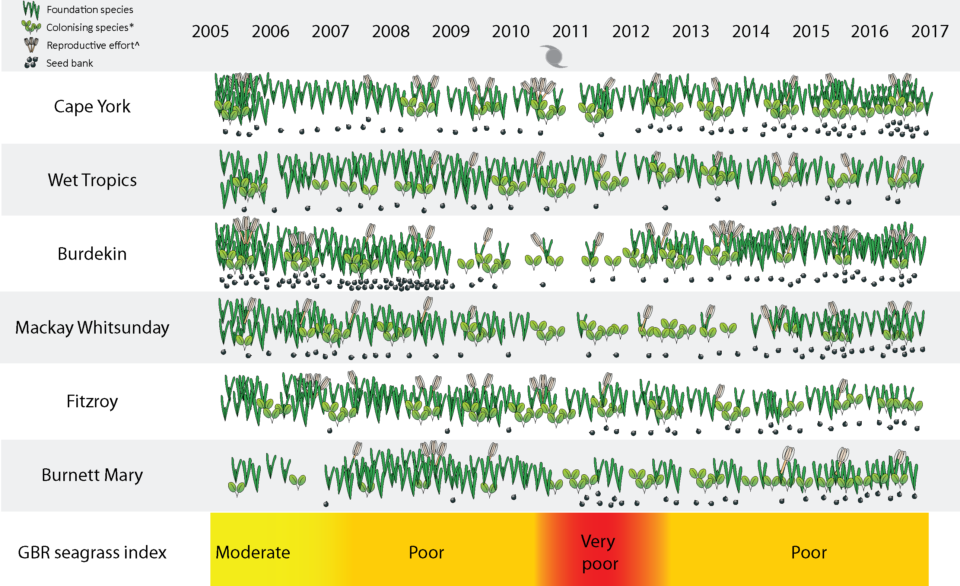
Figure 120. Summary of Great Barrier Reef MMP inshore seagrass state illustrating abundance of foundation / colonising species, seed banks and reproductive effort from 2005 to 2017
. * colonising species are represented by the genus Halophila, however, Zostera and Halodule can be both colonising and foundational species depending on meadow state. ^ not conducted in 2005.

There was increasing evidence that water quality degradation within the seagrass meadows of the inshore Great Barrier Reef prior to the episodic disturbances of 2011 may have reduced their resilience. Light availability is one of the primary driving factors in seagrass growth and persistence (Collier and Waycott 2009; Brodie et al. 2013;Collier et al. 2012c). Seagrasses can survive in highly turbid sites if restricted to shallow areas where light reaches the canopy around low tide (Petrou et al. 2013). Despite this, declines in abundance at intertidal habitats up to 2011 were also likely caused in part by low light levels (e.g. Petus et al. 2014b). Low light impacts in intertidal habitats may result from infrequent low tide exposure occurring in summer months when water can be very turbid coincident with high water temperatures which drives faster rates of decline (Collier et al. 2016). From 2009, reduced canopy light to low and limiting light levels was reported in seagrass meadows across the Great Barrier Reef, and, coincident with this, nutrients (N and P) increased relative to plant requirements. However, these conditions in the years leading up to 2011 were extremely turbid and were correlated with seagrass decline (e.g. Petus et al 2014, Collier et al 2012c). Since then, there have been periods of low light and exceedance of light thresholds, but the low light levels have not been as extreme (as low light, or for as long). In addition, the meadows have been in recovery mode, and the biological processes of recovery appear to complicate the response to environmental stressors. This makes it more difficult to identify the effect of light levels using statistical approaches, given the range of other disturbances occurring (See Case study 2, McKenzie et al 2017).

Outlook
While seagrass meadows of the Great Barrier Reef are inherently dynamic, poor recovery rates at many sites and poor resilience (e.g. seed density), suggest that capacity to recover from future impacts is compromised. This, coupled with intensifying disturbances such as marine heatwaves, present a concerning outlook. Throughout the inshore Great Barrier Reef, the rate of seagrass recovery since 2011 has been slower than expected in some locations and habitats compared to previous reports (e.g. Birch and Birch, 1984; Campbell and McKenzie 2004b), particularly at reef locations. Low reproductive effort may be a contributing factor. At some of the reef sites reproductive structures are never observed for some species, while at others there is some reproductive effort but seed banks are not forming or persisting either because no seeds are being produced, or seeds are lost through other processes, such as predation (Orth et al. 2006). The presence of seeds is fundamental to building resilience at reef sites, as without them the meadows remain vulnerable to large disturbances and would need to rely on recruitment of propagules from other meadows. This external recruitment process may operate at timescales ranging up to centuries or millennia depending on whether the propagules are reproductive or through clonal expansion (Grech et al. 2016, McMahon et al. 2014). Absence of a seed bank at some sites and poor reproductive effort across the Great Barrier Reef, has left most of the MMP meadows vulnerable to further environmental perturbations.
The basis of poor reproductive effort should be investigated as a matter of priority. For example, are there technical reasons for the lack of flowers, fruits and seeds being found in reefal communities such as inadequate sampling or timing of collecting samples. Alternatively, are these communities unable to reproduce due to their effective population size being reduced to a critical threshold. This is known to have happened for Cymodocea serrulata on Green Island where the meadows are made up of a single clone (and therefore a single sex as this species is dioecious) leading to their inability to set seed. If such factors are known, improved management strategies can be developed to accommodate processes that enhance seed bank formation (e.g. adjusting light or nutrient thresholds), or enhancement of resilience (e.g. introduction of new clones or seeds in the seed bank).
Recovery of seagrass meadows proceeding slower than expected might also be due to the frequent and repeated disturbances occurring over the past decade. The capacity of seagrass meadows to naturally recover requires environmental conditions that will enable patch expansion, sexual reproduction and seed bank formation. The environmental requirements for these recovery processes are not quantitatively described (by contrast thresholds leading to loss, such as light thresholds have been quantified for a number of species) and represent a research priority so that accurate recovery models can be developed. The high energy demands of seagrass meadow recovery processes are likely to require optimum conditions of light and nutrient availability and the absence of major physical disturbances such as cyclones or even excessive sediment resuspension. For example, the low and variable light availability across the Great Barrier Reef habitats in 2014-15 and 2016–17 may have slowed recovery, which in turn may reduce capacity to produce a viable seed banks in some locations (van Katwijk et al. 2010).
The most promising Great Barrier Reef-wide trend in inshore seagrass meadows has been the steady increase in the ratio of carbon to nitrogen (C:N) at most sites. This trend may provide an early indication of future improvement in the condition of meadows. Continued strategic monitoring through programs such as the MMP, as well as integration with complementary monitoring programs through the RIMReP, will enable continued assessment of their trajectories.
Increasingly we recognize that active restoration or enhancement of resilience may be required in the Great Barrier Reef (van Oppen et al. 2017). Implementing strategies to improve recovery and ultimately resilience of seagrass ecosystems across the Great Barrier Reef will need to account for rising temperatures and changing disturbance regimes to avert any future losses. The current focus of restoration is sharply on reef restoration, as reefs have suffered severe mortality from marine heatwaves. However, the poor signs of seagrass recovery, in combination with increasing numbers of seagrass restoration success stories from elsewhere including examples from Australia (e.g. http://seagrassrestoration.net/seed-based-restoration-1), indicates that restoration strategies to enhance resilience and promote recovery could be a viable option to enhance recovery rates in the Great Barrier Reef if trajectories do not improve. However, these restoration options have not yet been investigated and would require research and feasibility analysis.

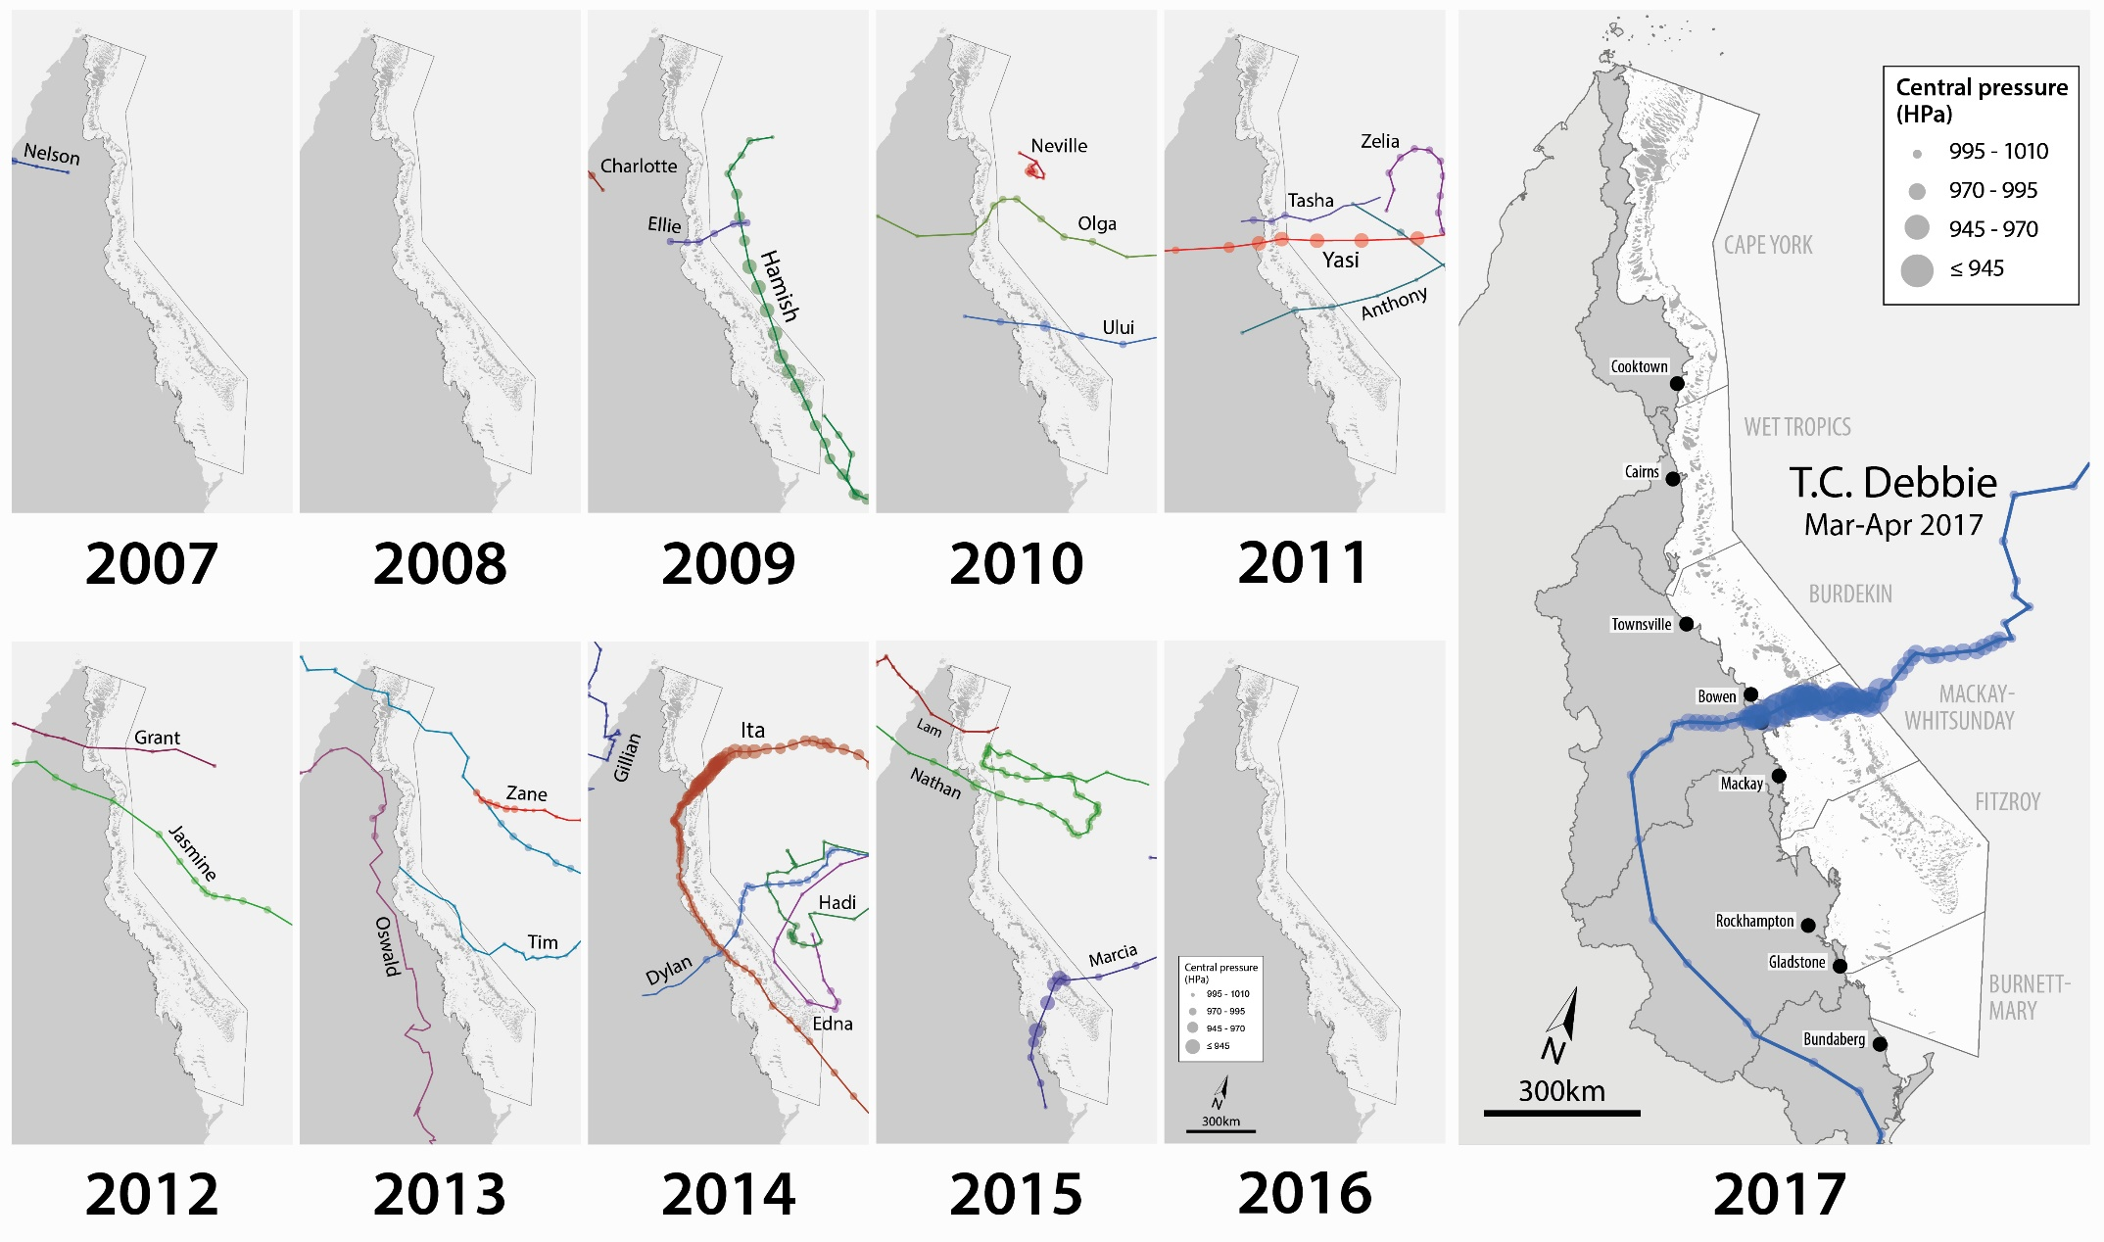
Figure 121. Trajectories of tropical cyclones affecting the Great Barrier Reef in 2016–17 and in previous years
(from Waterhouse et al. 2018).

Case study #1: Developing a model of energetic status for seagrass based on light and temperature, to predict future declines
Matthew P. Adams¹, Edwin J. Y. Koh¹, Maria P. Vilas¹, Catherine J. Collier², Len J. McKenzie², Kate R. O’Brien¹
¹School of Chemical Engineering, The University of Queensland, Brisbane, Australia
²Centre for Tropical Water & Aquatic Ecosystem Research (TropWATER), James Cook University, Cairns, Australia

Introduction
Seagrass growth and decline, in response to environmental factors such as light and temperature, is difficult to predict. Quantitative models based on plant carbon budgets are proposed as a useful tool to consider the cumulative impact of environmental stressors on plant survival (Poorter et al. 2013). Seagrass carbon budget can be expressed as a balance of photosynthesis, respiration and other carbon losses (Kaldy 2012). Whilst the balance of photosynthesis and respiration has been measured in a number of seagrass studies (e.g. Lee et al. 2007; Collier et al. 2017), the connection between seagrass carbon balance (physiology) and growth/decline (morphology) has not yet been established.
The aim of this preliminary analysis is to integrate laboratory measurements of photosynthesis-irradiance relationships (a proxy for carbon balance), and the dependence of these relationships on temperature, with laboratory observations of changes in seagrass abundance in response to light and temperature, using a mathematical model. This analysis is used to answer the following three questions:
- Can photosynthesis-irradiance curves be used to predict seagrass growth and decline?
- How does the time until complete shoot density loss depend on cumulative stresses of light and temperature?
- What additional data is needed to parameterise a predictive model of seagrass growth and decline?

Methods
The analysis is conceptually similar to a previously published model of energetic status in corals (Anthony et al. 2009), applied to seagrass data. Here, energetic status is hypothesised to predict seagrass decline as follows: instantaneous total carbon balance consists of photosynthesis, respiration and other carbon losses. A daily estimate of energetic status for seagrass, is calculated from the average carbon balance over the entire day-night cycle. If the energetic status is too low, then a reduction in shoot density of seagrass occurs, and this reduction proceeds at a rate proportional to the deficit in energetic status. The energetic status model is first calibrated to laboratory data and then used to generate predictions of seagrass responses to cumulative light and temperature stress.
The model developed here is a complement to the seagrass dynamic model (Baird et al. 2016a) used in the CSIRO Environmental Modelling Suite (EMS) that is used to predict hydrodynamics and biogeochemistry of the Great Barrier Reef (Baird et al. 2016b). These two models aim to accomplish different goals. The seagrass model in EMS aims to predict growth and decline in biomass of multiple species simultaneously, informed by as many biologically meaningful parameters (Adams et al. 2017) as possible. To accomplish this, growth of seagrass is assumed to depend physically on the number of photons hitting the seagrass leaves, the light absorbance properties of the seagrass leaves, and self-shading (Baird et al. 2016a). In contrast, the energetic status model reported here is based entirely on empirical data obtained from laboratory studies; so if only decline has been measured in the laboratory, the energetic status model can only predict decline. The aim of the energetic status model is to identify what can and cannot be predicted currently from laboratory data. Hence, it is hoped that the gaps in experimental research identified by the energetic status model will spark further laboratory investigations. In the future, if the data obtained from these additional laboratory studies is sufficiently comprehensive, this data could be incorporated in an updated energetic status model that could be directly compared with the seagrass model in EMS, to perform a robust validation of the physical assumptions underlying the seagrass model in EMS.
To calibrate the energetic status model, laboratory data is obtained from Collier et al. (2016) and unpublished data. The unpublished data consists of net leaf productivity vs irradiance curves for three tropical seagrass species (Cymodocea serrulata, Halodule uninervis, and Zostera muelleri) at temperatures ranging from 20°C to 35°C and is used to predict the balance of above-ground photosynthesis and respiration as a function of irradiance and temperature. The model is then calibrated to shoot density trajectories of seagrass for the three tropical species mentioned above (C. serrulata, H. uninervis, and Z. muelleri). These shoot density trajectories were measured in laboratory-conditions over a 14 week period for various light levels and two temperature levels, which correspond to mean daily temperatures of ~22.7°C and ~27.7°C (Collier et al. 2016).

Results
Model calibration to laboratory data
Figures 1-3 shows the calibration of the seagrass energetic status model to the shoot density data for C. serrulata, H. uninervis, and Z. muelleri, respectively. The model fits Z. muelleri the best (R² = 0.80), most likely because the change in shoot density vs time and light/temperature treatment was greater than for the other two species. From fitting the model to the data, non-respiratory carbon losses were predicted to generally increase with temperature, possibly up to two-fold between the two calibrated temperatures (~22.7°C and ~27.7°C). This indicates that the temperature-dependence of net leaf productivity vs irradiance is not sufficient to predict the dependence of seagrass shoot density changes on temperature, and that temperature-dependence of non-respiratory carbon losses possibly provides an important contribution to light deprivation-driven changes in seagrass morphology.
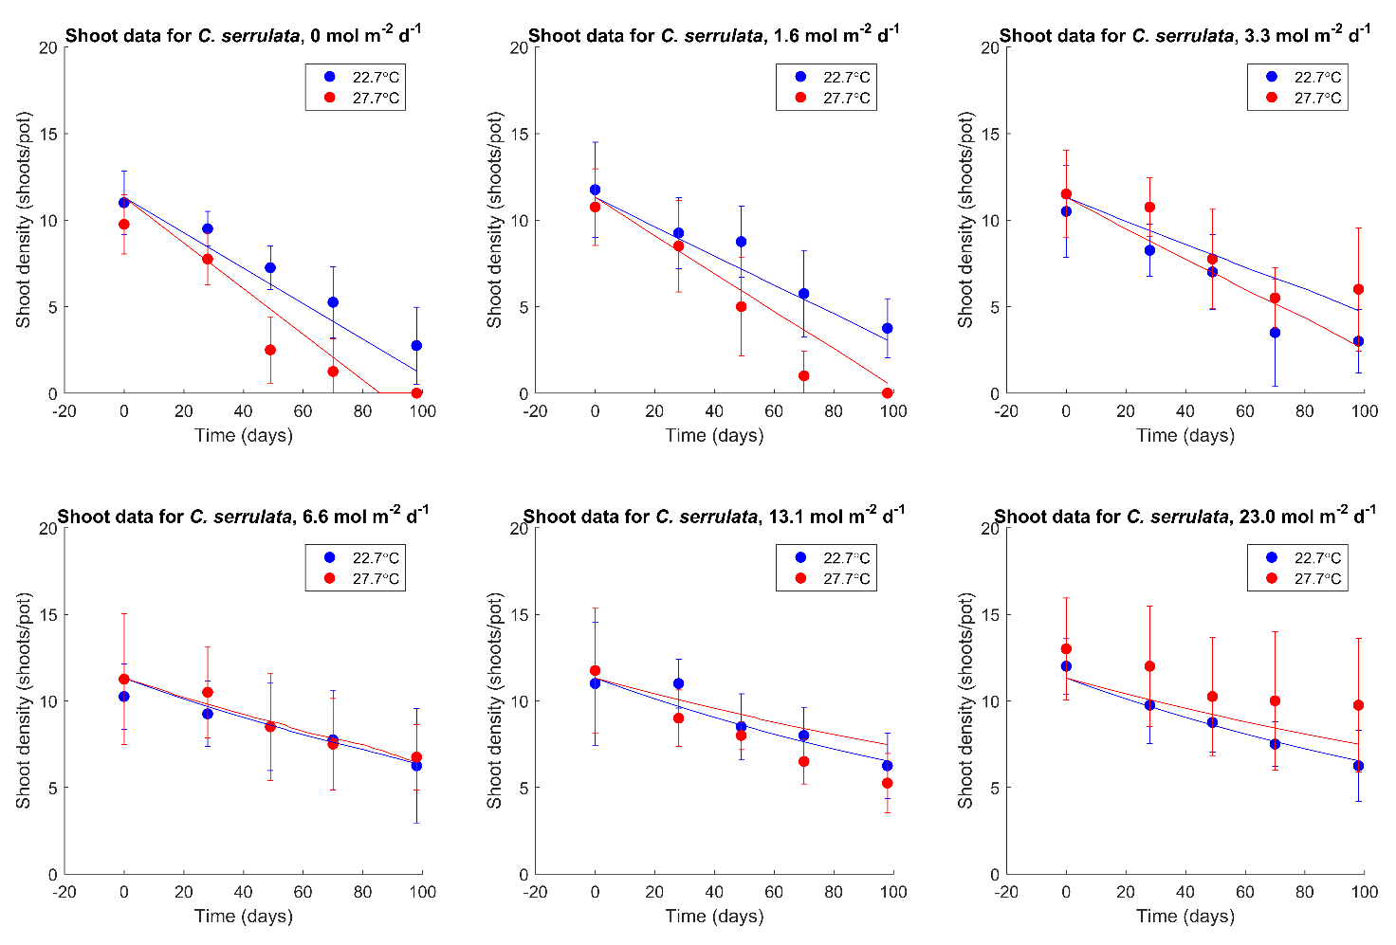
Figure 1. Calibration of the energetic status model (lines) to the data (dots with error bars) for shoot density of the seagrass species C. serrulata vs time, for various light levels and two temperature levels (adjusted R² = 0.59).

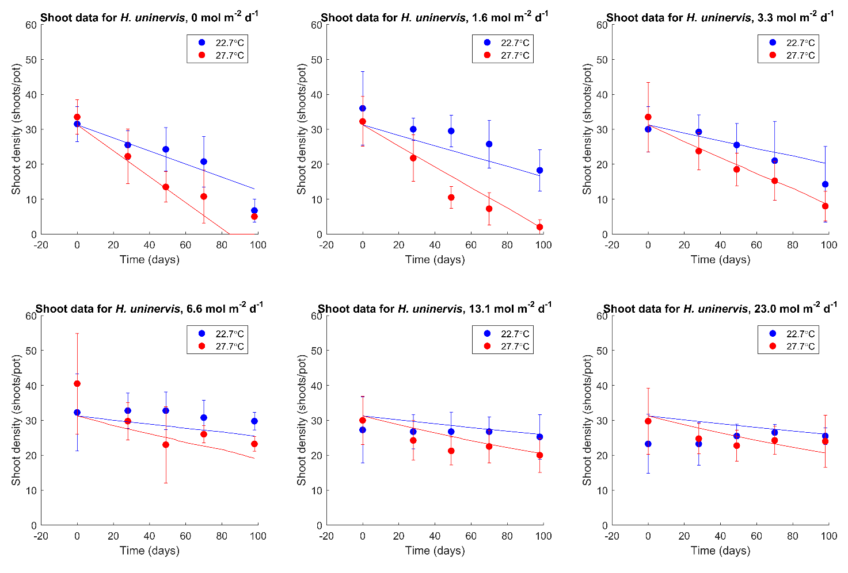
Figure 2. Calibration of the energetic status model (lines) to the data (dots with error bars) for shoot density of the seagrass species H. uninervis vs time, for various light levels and two temperature levels (adjusted R² = 0.54).
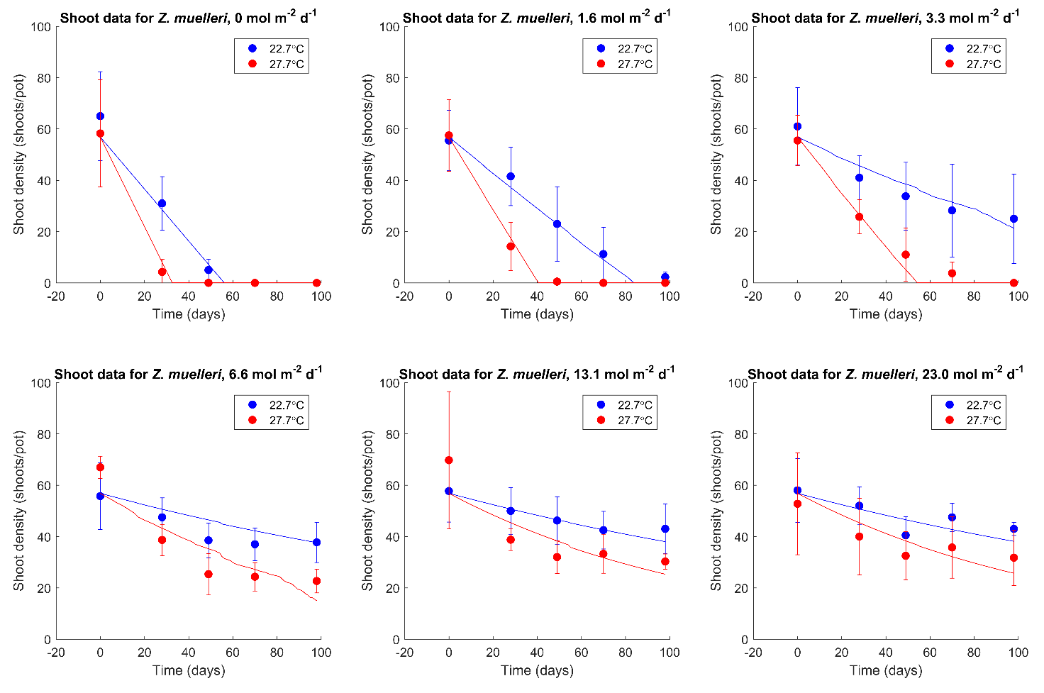
Figure 3. Calibration of the energetic status model (lines) to the data (dots with error bars) for shoot density of the seagrass species Z. muelleri vs time, for various light levels and two temperature levels (adjusted R² = 0.80).

Model predictions of seagrass decline due to cumulative light and temperature stress
The energetic status model can be used to predict time to complete shoot loss for several light levels and mean daily temperatures (Figure 4). The energetic status model outputs shown in Figure 4 assume a day length of 12 hours, with cloudless days.
Exponential curves fitted to these model predictions yield high correlation (R²≥0.98). Thus it is possible to write simple equations t_{loss} = t₀ exp(k I) that predict the time to complete shoot loss for the three seagrass species assessed (Table 1) as an output of the energetic status model. In this equation, t_{loss} is the number of days until complete shoot loss, t₀ is the number of days until complete shoot loss at zero light, k is a scaling factor with units of (mol m⁻² d⁻¹)⁻¹, and I is the daily PAR light dose (mol m⁻² d⁻¹). We emphasise that this equation, together with the parameters in Table 1, provides only a preliminary estimate of the time to complete shoot loss. Especially for light levels outside of those tested (e.g. I > 3 mol m⁻² d⁻¹ for C. serrulata at a mean daily temperature of 22.7°C), these estimates should be used particularly cautiously.
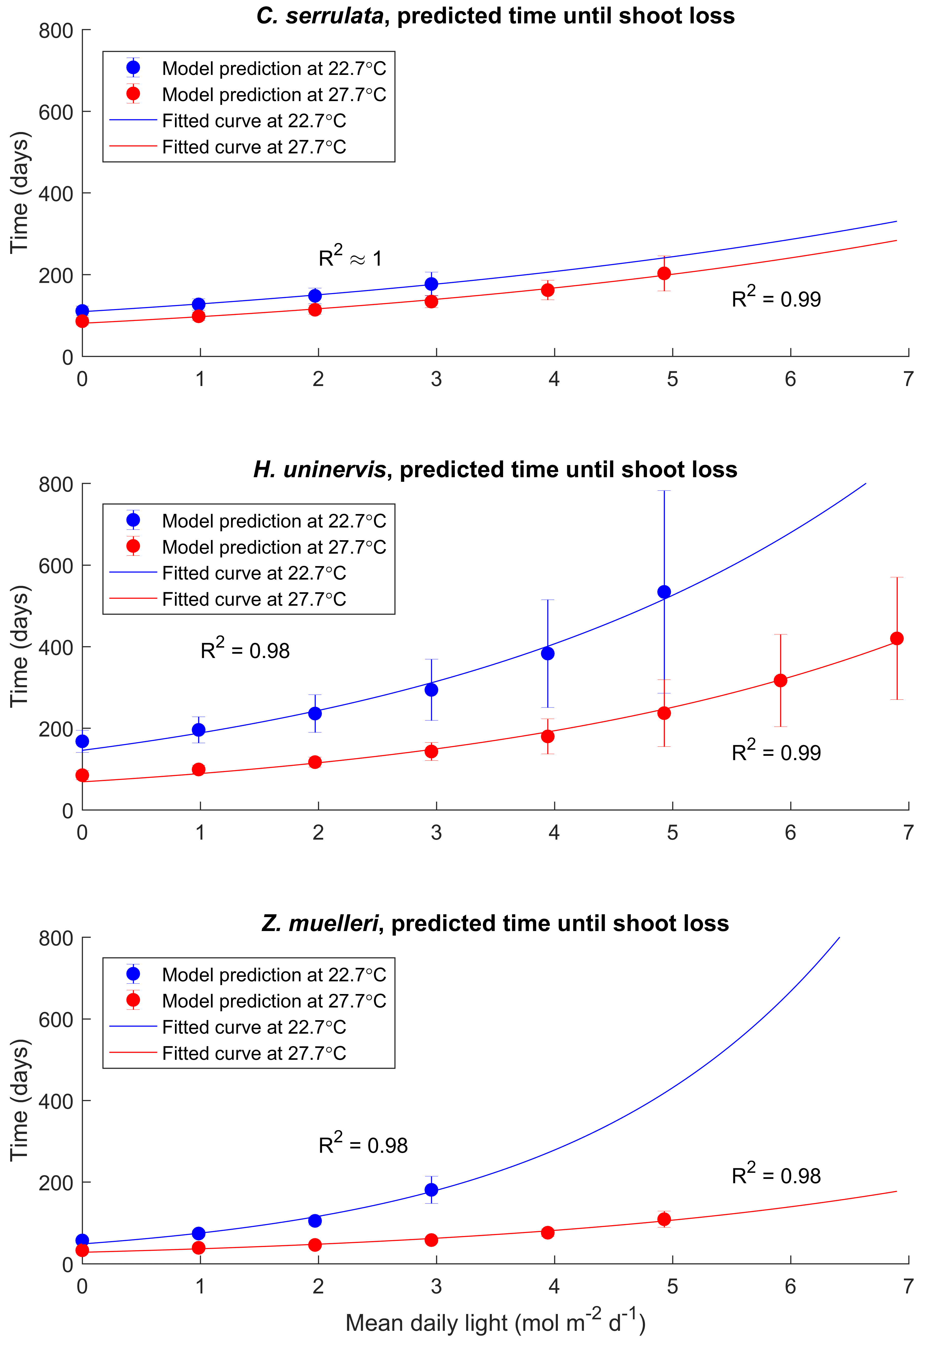
Figure 4. Energetic status model predictions of the time to complete shoot loss (closed circles) and fitted exponential curves through these predictions (lines), for three seagrass species, two temperatures, and up to eight light levels.

Table 1. Parameters of the exponential curves t_{loss} = t₀ exp(k I) fitted to the energetic status model predictions shown in Figure 4. These parameterised equations can be used to predict the time to complete shoot loss for seagrass.
Species | Mean Daily Temperature | t₀ | k | R²
C. serrulata | 22.7 °C | 109.3 ± 1.7 | 0.1604 ± 0.0073 | 1.00
C. serrulata | 27.7 °C | 80.9 ± 2.8 | 0.1818 ± 0.0091 | 0.99
H. uninervis | 22.7 °C | 146 ± 10 | 0.256 ± 0.018 | 0.98
H. uninervis | 27.7 °C | 68.7 ± 4.1 | 0.259 ± 0.010 | 0.99
Z. muelleri | 22.7 °C | 48.5 ± 6.2 | 0.437 ± 0.051 | 0.98
Z. muelleri | 27.7 °C | 28.1 ± 2.4 | 0.267 ± 0.022 | 0.98

Conclusions
Based on the results of this analysis, the answer to the three questions posed in the Introduction are:
- Photosynthesis-irradiance curves can potentially be used to predict seagrass growth and decline, if the growth and decline is temperature- and light-dependent. However, temperature-dependence of other carbon losses by seagrass may also need to be accounted for.
- A preliminary estimate of the time to complete shoot loss for the three seagrass species tested, for several light and two temperature values, can be predicted used the equation t_{loss} = t₀ exp(k I) and the parameters shown in Table 1.
- Most experiments investigating seagrass responses to light, including the experiments used to calibrate the model presented here, focus on decline but rarely consider recovery (McMahon et al. 2011 is a notable field-based exception). Thus measurements of recovery trajectories of seagrass shoot density and/or biomass are needed in order to parameterise a predictive model of seagrass growth and decline.
Future laboratory experiments that investigate recovery trajectories for the three tropical seagrass species investigated here (C. serrulata, H. uninervis, and Z. muelleri) may expand the capabilities of the presented model to predict growth trajectories, in addition to decline trajectories.

References
Adams, M. P., Collier. C. J., Uthicke, S., Ow, Y. X., Langlois, L., O’Brien, K. R. (2017): Model fit versus biological relevance: Evaluating photosynthesis-temperature models for three tropical seagrass species. Scientific Reports 7:39930.
Anthony, K. R. N., Hoogenboom, M. O., Maynard, J. A., Grottoli, A. G., Middlebrook, R. (2009): Energetics approach to predicting mortality risk from environmental stress: a case study of coral bleaching. Functional Ecology 23: 539-550.
Baird, M. E., Adams, M. P., Babcock, R. C., Oubelkheir, K., Mongin, M., Wild-Allen, K. A., Skerratt, J., Robson, B. J., Petrou, K., Ralph, P. J., O’Brien, K. R., Carter, A. B., Jarvis, J. C., Rasheed, M. A. (2016a): A biophysical representation of seagrass growth for application in a complex shallow-water biogeochemical model. Ecological Modelling 325: 13-27.
Baird, M. E., Cherukuru, N., Jones, E., Margvelashvili, N., Mongin, M., Oubelkheir, K., Ralph, P. J., Rizwi, F., Robson, B. J., Schroeder, T., Skerratt, J., Steven, A. D. L., Wild-Allen, K. A. (2016): Remote-sensing reflectance and true colour produced by a coupled hydrodynamic, optical, sediment, biogeochemical model of the Great Barrier Reef, Australia: Comparison with satellite data. Environmental Modelling and Software 78: 79-96.
Collier, C. J., Adams, M. P., Langlois, L., Waycott, M., O’Brien, K. R., Maxwell, P. S., McKenzie, L. (2016): Thresholds for morphological response to light reduction for four tropical seagrass species. Ecological Indicators 67: 358-366.
Collier, C. J., Ow, Y. X., Langlois, L., Uthicke, S., Johansson, C. L., O’Brien, K. R., Hrebien, V., Adams, M. P. (2017): Optimum temperatures for net primary productivity of three tropical seagrass species. Frontiers in Plant Science 8:1446.
Collier, C. J., Waycott, M., McKenzie, L. J. (2012): Light thresholds derived from seagrass loss in the coastal zone of the northern Great Barrier Reef, Australia. Ecological Indicators 23:211-219.
Kaldy, J. (2012): Influence of light, temperature and salinity on dissolved organic carbon exudation rates in Zostera marina L. Aquatic Biosystems 8:19.
Lee, K.-S., Park, S. R., Kim, Y. K. (2007): Effects of irradiance, temperature, and nutrients on growth dynamics of seagrass: A review. Journal of Experimental Marine Biology and Ecology 350: 144-175.
McKenzie, L., Collier, C., Langlois, L., Yoshida, R., Smith, N., Waycott, M. (2016): Marine Monitoring Program. Annual Report for inshore seagrass monitoring: 2014 to 2015. Report for the Great Barrier Reef Marine Park Authority. TropWATER, James Cook University, Cairns (236pp.).
McMahon, K., Lavery, P. S., Mulligan, M. (2011): Recovery from the impact of light reduction on the seagrass Amphibolis griffithii, insights for dredging management. Marine Pollution Bulletin 62: 270-283.
Poorter, H., Anten, N. P. R., Marcelis, L. F. M. (2013): Physiological mechanisms in plant growth models: do we need a supra-cellular systems biology approach? Plant, Cell & Environment 36: 1673-1690.

Case study #2: Evaluating temperature thresholds for risk of seagrass decline
Matthew P. Adams¹, Catherine J. Collier², Len J. McKenzie², Kate R. O’Brien¹
¹School of Chemical Engineering, The University of Queensland, Brisbane, Australia
²Centre for Tropical Water & Aquatic Ecosystem Research (TropWATER), James Cook University, Cairns, Australia

Introduction
Elevated temperatures represent an increasing threat to seagrass survival in the Great Barrier Reef (Collier et al. 2011). Even if light levels are sufficient for seagrass survival (reviewed in Collier et al. 2016), elevated temperatures can cause irreparable damage to seagrass (Campbell et al. 2006) and lead to complete mortality within days (Collier and Waycott 2014). Since elevated temperatures pose a threat to seagrass in the Great Barrier Reef, the MMP Annual Report for Inshore Seagrass Monitoring (e.g. McKenzie et al. 2016) reports the number of days each year that inshore seawater temperatures exceed 35°C, 38°C, 40°C and 43°C in each NRM region. These temperature thresholds are adapted from two studies (Campbell et al. 2006; Collier et al. 2014), each of which investigated seagrass photosynthetic yield and morphological responses at four temperature levels. More recently, optimum and maximum temperatures for Great Barrier Reef seagrasses have been calculated from measurements of their productivity at a wide range of temperatures (Adams et al. 2017; Collier et al. 2017).
Aim and Results
The purpose of this case study is to evaluate the temperature thresholds that are most relevant for assessing risk of seagrass decline in the Great Barrier Reef due to elevated temperatures, based on the most up-to-date research. The results are presented in Table 1 for five different temperature thresholds ranging from physiological measures on the left (e.g. photosynthetic yield) to morphological measures on the right (e.g. changes in leaf density).
Table 1. Summary of temperature thresholds published for Great Barrier Reef seagrasses. From left to right, temperature thresholds change from physiological to morphological. ¹Campbell et al. 2006; ²Adams et al. 2017 (Table 4); ³Collier et al. 2017 (Supplementary Table S1.2); ⁴Collier et al. 2011 (Figure 4); ⁵Collier & Waycott 2014 (Figure 3).
Species | Maximum temperature for no detrimental effect on photosynthetic yield¹ | Optimum temperature for photosynthesis² | Optimum temperature for net productivity³ | Optimum temperature for net shoot production⁴ | Temperature which reduces seagrass leaf density⁵
C. rotundata | 40-45°C |  |  |  | 35-40°C
C. serrulata | 40-45°C | 35-36°C | 34-36°C
H. ovalis | 35-40°C |  |  |  | 35-40°C
S. isoetifolium | 35-40°C
T. hemprichii | 40-45°C |  |  |  | 35-40°C
H. uninervis | 40-45°C | 35-36°C | 33-35°C | >30°C | 35-40°C
Z. muelleri | 35-40°C | ~31°C | 20-30°C | <33°C

Conclusions
The main recommendation of this work is to include an additional threshold for a temperature of 30°C, since three of the five studies consulted in Table 1 suggest that temperatures below 33°C may induce thermal stress for Zostera muelleri, a species found commonly in the Great Barrier Reef, and 30°C is an upper limit on the optimum temperature for net productivity of this species (Collier et al. 2017). Temperatures above 40°C will likely lead to decline of all seagrass species investigated, whilst seawater temperatures above 35°C are sufficient to have negative impact on most of these species. The three thresholds of 30°C, 35°C and 40°C may be the most informative for evaluating the risk of seagrass decline due to elevated seawater temperatures in the Great Barrier Reef.
References
Adams, M. P., Collier. C. J., Uthicke, S., Ow, Y. X., Langlois, L., O’Brien, K. R. (2017): Model fit versus biological relevance: Evaluating photosynthesis-temperature models for three tropical seagrass species. Scientific Reports 7:39930.
Campbell, S. J., McKenzie, L. J., Kerville, S. P. (2006): Photosynthetic responses of seven tropical seagrasses to elevated seawater temperature. Journal of Experimental Marine Biology and Ecology 330: 455-468.
Collier, C. J., Chartrand, K., Honchin, C., Fletcher, A., Rasheed, M. (2016): Light thresholds for seagrasses of the GBR: a synthesis and guiding document. Including knowledge gaps and future priorities. Report to the National Environmental Science Programme. Reef and Rainforest Research Centre Limited, Cairns (41pp.).
Collier, C. J., Ow, Y. X., Langlois, L., Uthicke, S., Johansson, C. L., O’Brien, K. R., Hrebien, V., Adams, M. P. (2017): Optimum temperatures for net primary productivity of three tropical seagrass species. Frontiers in Plant Science 8:1446.
Collier, C. J., Uthicke, S., Waycott, M. (2011): Thermal tolerance of two seagrass species at contrasting light levels: Implications for future distribution in the Great Barrier Reef. Limnology and Oceanography 56:2200-2210.
Collier, C. J., Waycott, M. (2014): Temperature extremes reduce seagrass growth and induce mortality. Marine Pollution Bulletin 83:483-490.
McKenzie, L., Collier, C., Langlois, L., Yoshida, R., Smith, N., Waycott, M. (2016): Marine Monitoring Program. Annual Report for inshore seagrass monitoring: 2014 to 2015. Report for the Great Barrier Reef Marine Park Authority. TropWATER, James Cook University, Cairns (236pp.).

References
Abal, E.G., Dennison, W.C., and Greenfield, P.F. 2001, Managing the Brisbane River and Moreton Bay: An integrated research/management program to reduce impacts on an Australian estuary. Water Science and Technology, 43, 57-70.
Abal, E.G., Loneragan, N.R., Bowen, P., Perry, C.J., Udy, J.W., and Dennison, W.C. 1994, Physiological and morphological responses of the seagrass Zostera capricorni Aschers. to light intensity. Journal of Experimental Marine Biology and Ecology, 178(1), 113-129.
Angelini, C., Altieri, A.H., Silliman, B.R., and Bertness, M.D. 2011, Interactions among Foundation Species and their Consequences for Community Organization, Biodiversity, and Conservation. BioScience, 61(10), 782-789.
Anon. (2013). Reef Water Quality Protection Plan 2013.Securing the health and resilience of the Great Barrier Reef World Heritage Area and adjacent catchments. Brisbane: The State of Queensland. Reef Water Quality Protection Plan Secretariat.
Anthony, K., and Kerswell, A. 2007, Coral mortality following extreme low tides and high solar radiation. Marine Biology, 151, 1623-1631.
Anthony, K.R.N., Ridd, P.V., Orpin, A.R., Larcombe, P., and Lough, J. 2004, Temporal variation in light availability in coastal benthic habitats: Effects of clouds, turbidity, and tides. Limnology and Oceanography, 49(6), 2201-2211.
ANZECC. 2000, Australian and New Zealand guidelines for fresh and marine water quality.
Arthur, K., Boyle, M., and Limpus, C. 2008, Ontogenetic changes in diet and habitat use in green sea turtle (Chelonia mydas) life history. Marine Ecology Progress Series, 362, 303-311.
Atkinson, M.J., and Smith, S.V. 1983, C:N:P ratios of benthic marine plants. Limnology and Oceanography, 28(3), 568-574.
Bainbridge, Z., Wolanski, E., Lewis, S., and Brodie, J. 2012, Fine sediment and nutrient dynamics related to particle size and floc formation in a Burdekin River flood plume, Australia. Marine Pollution Bulletin, 65, 236-248.
Balata, D., Bertocci, I., Piazzi, L., and Nesti, U. 2008, Comparison between epiphyte assemblages of leaves and rhizomes of the seagrass Posidonia oceanica subjected to different levels of anthropogenic eutrophication. Estuarine, Coastal and Shelf Science, 79(3), 533-540. doi: http://dx.doi.org/10.1016/j.ecss.2008.05.009
Bernhardt, J.R., and Leslie, H.M. 2013, Resilience to climate change in coastal marine ecosystems. Annual Review of Marine Science, 5, 371-392.
Birch, W., and Birch, M. 1984, Succession and pattern of tropical intertidal seagrasses in Cockle Bay, Queensland, Australia: a decade of observations. Aquatic Botany, 19, 343-367.
Björk, M., Uka, J., Weil, A., and Beer, S. 1999, Photosynthetic tolerances to desiccation of tropical intertidal seagrasses. Marine Ecology Progress Series, 191, 121-126.
Borowitzka, M.A., Lavery, P.S., and van Keulen, M. (2006). Epiphytes of seagrasses. In WD Larkum, RJ Orth & CM Duarte (Eds.), Seagrasses: Biology, Ecology and Conservation. Dordrecht: Springer.
Borum, J. 1985, Development of epiphytic communities on eelgrass (Zostra marina) along a nutrient gradient in a Danish estuary. Marine Biology, 87, 211–218.
Borum, J., Duarte, C.M., Krause-Jensen, D., and Greve, T.M. (2004). European seagrasses: an introduction to monitoring and management. Copenhagen: The M&MS project.
Brodie, J. (2004). Mackay Whitsunday Region: State of the Waterways Report 2004 ACTFR Report No. 02/03 for the Mackay Whitsunday Natural Resource Management Group. Yownsville: ACTFR, James Cook University.
Brodie, J., Waterhouse, J., Schaffelke, B., Johnson, J., Kroon, F., Thorburn, P., Rolfe, J., Lewis, S., Warne, M., Fabricius, K., McKenzie, L.J., and Devlin, M. (2013). Reef Water Quality Scientific Consensus Statement 2013. Brisbane: Department of the Premier and Cabinet, Queensland Government.
Brodie, J.E., Kroon, F.J., Schaffelke, B., Wolanski, E.C., Lewis, S.E., Devlin, M.J., Bohnet, I.C., Bainbridge, Z.T., Waterhouse, J., and Davis, A.M. 2012, Terrestrial pollutant runoff to the Great Barrier Reef: An update of issues, priorities and management responses. Marine Pollution Bulletin, 65(4–9), 81-100.
Bros, W.E., and Cowell, B.C. 1987, A technique for optimising sample size (replication). Journal of Experimental Marine Biology and Ecology, 114, 63-71.
Burnett Mary Regional Group. (2005). Country to Coast – A Healthy Sustainable Future Volume 1a Background Report. Bundaberg, Qld: Burnett Mary Regional Group.
Burnett Mary Regional Group. (2010). Burnett-Baffle Water Quality Improvement Plan. Bundaberg: Burnett Mary Regional Group.
Burnett Mary Regional Group. (2013). Wide Bay Burnett, Environment and Natural Resource Management Plan 2012-2031 - Regional targets to support the environment and sustainability framework of the Wide Bay Burnett Regional Plan. Bundaberg: Burnett Mary Regional Group.
Cabaço, S., Apostolaki, E.T., García-Marín, P., Gruber, R., Hernández, I., Martínez-Crego, B., Mascaró, O., Pérez, M., Prathep, A., Robinson, C., Romero, J., Schmidt, A.L., Short, F.T., van Tussenbroek, B.I., and Santos, R. 2013, Effects of nutrient enrichment on seagrass population dynamics: evidence and synthesis from the biomass–density relationships. Journal of Ecology, 101(6), 1552-1562. doi: 10.1111/1365-2745.12134
Cabaço, S., and Santos, R. 2007, Effects of burial and erosion on the seagrass Zostera noltii. Journal of Experimental Marine Biology and Ecology, 340, 204-212.
Cambridge, M.L., Chiffings, A.W., Brittan, C., Moore, L., and McComb, A.J. 1986, The loss of seagrass in Cockburn Sound, Western Australia. II. Possible causes of seagrass decline. Aquatic Botany, 24, 269-285.
Campbell, S.J., and McKenzie, L.J. 2001, Seagrass and algal abundance in the Whitsundays region. Status Report.
Campbell, S.J., and McKenzie, L.J. 2004, Flood related loss and recovery of intertidal seagrass meadows in southern Queensland, Australia. Estuarine, Coastal and Shelf Science, 60(3), 477-490.
Campbell, S.J., McKenzie, L.J., and Kerville, S.P. 2006, Photosynthetic responses of seven tropical seagrasses to elevated seawater temperature. Journal of Experimental Marine Biology and Ecology, 330, 455-468.
Campbell, S.J., Roder, C.A., McKenzie, L.J., and Lee Long, W.J. 2002, Seagrass resources in the Whitsunday region 1999 and 2000. DPI Information Series QI02043, 50.
Carruthers, T., Dennison, W., Longstaff, B., Waycott, M., Abal, E.G., McKenzie, L.J., and Lee Long, W. 2002, Seagrass habitats of north east Australia: models of key processes and controls. Bulletin of Marine Science, 71(3), 1153-1169.
Carter, A., Chartrand, K., and Rasheed, M. (2012). Critical marine habitats in high risk areas, Princess Charlotte Bay region - 2011 Atlas. Northern Fisheries Centre, Cairns: DAFF Publication.
Carter, A., and Rasheed, M. (2013). Critical marine habitats in high risk areas, Bathurst Bay region - 2012 Atlas. (Vol. Report No. 13/19). Cairns: JCU Publication, Centre for Tropical Water & Aquatic Ecosystem Research.
Carter, A.B., McKenna, S.A., Rasheed, M.A., McKenzie, L.J., and Coles, R.G. (2016). Seagrass mapping synthesis: A resource for coastal management in the Great Barrier Reef World Heritage Area. Report to the National Environmental Science Programme. Cairns: Reef and Rainforest Research Centre Limited.
Carter, A.B., and Rasheed, M.A. (2014). Critical marine habitats in high risk areas, South Warden Reef to Howick Group - 2013 Atlas. Centre for Tropical Water & Aquatic Ecosystem Research Report no. 13/56. Cairns: James Cook University.
Carter, A.B., and Rasheed, M.A. (2015). Critical marine habitats in high risk areas, Crescent Reef to Cape Flattery - 2014 Atlas. JCU Publication no. 15/13. Cairns: Centre for Tropical Water & Aquatic Ecosystem Research.
Chartrand, K.M., Bryant, C.V., Carter, A.B., Ralph, P.J., and Rasheed, M.A. 2016, Light thresholds to prevent dredging impacts on the Great Barrier Reef seagrass, Zostera muelleri ssp. capricorni. [Original Research]. Frontiers in Marine Science, 3. doi: 10.3389/fmars.2016.00106
Chartrand, K.M., Ralph, P.J., Petrou, K., and Rasheed, M.A. 2012, Development of a light-based seagrass management approach for the Gladstone Western basin dredging program. 126.
Christensen, S., Rodgers, C., and Fitzroy Basin Association, I. (2006). Central Queensland strategy for sustainability : 2004 and beyond. . Rockhampton, Qld: Fitzroy Basin Association.
Coles, R., McKenzie, L., Rasheed, M.A., Mellors, J., Taylor, H., Dew, K., McKenna, S., Sankey, T., Carter, A., and Grech, A. 2007, Status and trends of seagrass habitats in the Great Barrier Reef World Heritage Area. Unpublished report to the Marine and Tropical Sciences Research Facility, 122.
Coles, R., McKenzie, L.J., and Campbell, S. (2003). The seagrasses of Eastern Australia. In EP Green & FT Short (Eds.), The World Atlas of Seagrasses: present status and future conservation. (pp. 119-133). Los Angeles, USA: University of California Press.
Coles, R., McKenzie, L.J., De'ath, G., Roelofs, A., and Lee Long, W.J. 2009, Spatial distribution of deepwater seagrass in the inter-reef lagoon of the Great Barrier Reef World Heritage Area. Marine Ecology Progress Series, 392, 57-68. doi: 10.3354/meps08197
Coles, R.G., Lee Long, W.J., McKenzie, L.J., and Roder, C.A. (Eds.). (2002). Seagrass and Marine Resources in the Dugong Protection Areas of Upstart Bay, Newry Region, Sand Bay, Llewellyn Bay, Ince Bay and the Clairview Region, April/May 1999 and October 1999. Townsville: Great Barrier Reef Marine Park Authority.
Coles, R.G., Lee Long, W.J., Squire, B.A., Squire, L.C., and Bibby, J.M. 1987, Distribution of seagrass and associated juvenile commercial penaeid prawns in North-Eastern Queensland waters. Australian Journal of Marine and Freshwater Research, 38(1), 103-119.
Coles, R.G., Lee Long, W.J., and Squire, L.C. (1985). Seagrass beds and prawn nursery grounds between Cape York and Cairns. Brisbane: QDPI.
Coles, R.G., Lee Long, W.J., Watson, R.A., and Derbyshire, K.J. 1993, Distribution of seagrasses, and their fish and penaeid prawn communities, in Cairns Harbour, a tropical estuary, northern Queensland, Australia. Australian Journal of Marine and Freshwater Research, 44, 193-210.
Coles, R.G., McKenzie, L.J., Mellors, J.E., and Yoshida, R.L. 2001a, Validation and GIS of seagrass surveys between Cairns and Bowen – October/November 1987. CD Rom.
Coles, R.G., McKenzie, L.J., and Yoshida, R.L. 2001b, Validation and GIS of seagrass surveys between Bowen and Water Park Point– March/April 1987. CD Rom.
Coles, R.G., McKenzie, L.J., and Yoshida, R.L. 2001c, Validation and GIS of seagrass surveys between Cape York and Cairns - November 1984. CD Rom.
Coles, R.G., McKenzie, L.J., and Yoshida, R.L. 2001d, Validation and GIS of seagrass surveys between Water Park Point and Hervey Bay – October/November 1988. CD Rom.
Collier, C., Devlin, M., Langlois, L., Petus, C., McKenzie, L.J., Texeira da Silva, E., McMahon, K., Adams, M., O’Brien, K., Statton, J., and Waycott, M. (2014). Thresholds and indicators of declining water quality as tools for tropical seagrass management. Report to the National Environmental Research Program. Cairns: Reef and Rainforest Research Centre Limited.
Collier, C., and Waycott, M. 2009, Drivers of change to seagrass distributions and communities on the Great Barrier Reef: Literature review and gaps analysis. Report to the Marine and Tropical Sciences Research Facility.
Collier, C.J., Adams, M.P., Langlois, L., Waycott, M., O’Brien, K.R., Maxwell, P.S., and McKenzie, L. 2016, Thresholds for morphological response to light reduction for four tropical seagrass species. Ecological Indicators, 67, 358-366. doi: http://dx.doi.org/10.1016/j.ecolind.2016.02.050
Collier, C.J., Lavery, P.S., Ralph, P.J., and Masini, R.J. 2009, Shade-induced response and recovery of the seagrass Posidonia sinuosa. Journal of Experimental Marine Biology and Ecology, 370(1–2), 89-103. doi: http://dx.doi.org/10.1016/j.jembe.2008.12.003
Collier, C.J., Uthicke, S., and Waycott, M. 2011, Thermal tolerance of two seagrass species at contrasting light levels: Implications for future distribution in the Great Barrier Reef. Limnology & Oceanography, 56(6), 2200-2210.
Collier, C.J., Waycott, M., and Giraldo-Ospina, A. 2012a, Responses of four Indo-West Pacific seagrass species to shading. Marine Pollution Bulletin, 65(4-9), 342-354.
Collier, C.J., Waycott, M., and McKenzie, L.J. 2012b, Light thresholds derived from seagrass loss in the coastal zone of the northern Great Barrier Reef, Australia. Ecological Indicators, 23(0), 211-219. doi: 10.1016/j.ecolind.2012.04.005
Collier, C.J., Waycott, M., and Ospina, A.G. 2012c, Responses of four Indo-West Pacific seagrass species to shading. Marine Pollution Bulletin, 65(4-9), 342-354. doi: 10.1016/j.marpolbul.2011.06.017
Commonwealth of Australia. (2013a). Burdekin Natural Resource Management region, http://www.nrm.gov.au/about/nrm/regions/qld-burd.html Retrieved 18 February 2014, from http://www.nrm.gov.au/about/nrm/regions/qld-burd.html
Commonwealth of Australia. (2013b). Burnett Mary Natural Resource Management region, http://www.nrm.gov.au/about/nrm/regions/qld-bmar.html Retrieved 18 February 2014, from http://www.nrm.gov.au/about/nrm/regions/qld-fitz.html
Commonwealth of Australia. (2013c). Fitzroy Natural Resource Management region, http://www.nrm.gov.au/about/nrm/regions/qld-fitz.html Retrieved 18 February 2014, from http://www.nrm.gov.au/about/nrm/regions/qld-fitz.html
Commonwealth of Australia. (2013d). Mackay Whitsunday Natural Resource Management region, http://www.nrm.gov.au/about/nrm/regions/qld-mwhs.html Retrieved 18 February 2014, from http://www.nrm.gov.au/about/nrm/regions/qld-mwhs.html
Commonwealth of Australia. (2013e). Wet Tropics Natural Resource Management region Retrieved 18 February 2014, from http://www.nrm.gov.au/about/nrm/regions/qld-wetr.html
Costanza, R., d'Arge, R., de Groot, R., Farber, S., Grasso, M., Hannon, B., Limburg, K., Naeem, S., O'Neil, R.V., Paruelo, J., Raskin, R.G., Sutton, P., and van der Belt, M. 1997, The Value of the world's ecosystem services and natural capital. Nature, 387(15), 253-260.
Costanzo, S.D. (2001). Development of indicators for assessing and monitoring nutrient influences in coastal waters. PhD University of Queensland, Brisbane, Australia.
Costanzo, S.D., O'Donohue, M.J., Dennison, W.C., Loneragan, N.R., and Thomas, M. 2001, A new approach for detecting and mapping sewage impacts. Marine Pollution Bulletin, 42(2), 149-156.
Cotter, G.F. (1995). A study of the pastoral industry of Cape York Peninsula. Cape York Peninsula Land Use Strategy (CYPLUS), Natural Resources Analysis Program. Brisbane: Department of Primary Industries and Queensland Department of Lands.
Cullen-Unsworth, L., and Unsworth, R. 2013, Seagrass Meadows, Ecosystem Services, and Sustainability. Environment: Science and Policy for Sustainable Development, 55(3), 14-28. doi: 10.1080/00139157.2013.785864
Cullen-Unsworth, L.C., Nordlund, L.M., Paddock, J., Baker, S., McKenzie, L.J., and Unsworth, R.K.F. 2014, Seagrass meadows globally as a coupled social–ecological system: Implications for human wellbeing. Marine Pollution Bulletin, 83(2), 387-397. doi: http://dx.doi.org/10.1016/j.marpolbul.2013.06.001
Davies, J.N., and Rasheed, M.A. (2016). Port of Townsville Annual Seagrass Monitoring: September 2015. Cairns: James Cook University Publication, Centre for Tropical Water & Aquatic Ecosystem Research (TropWATER).
De'ath, G., and Fabricius, K. 2010, Water quality as a regional driver of coral biodiversity and macroalgae on the Great Barrier Reef. Ecological Applications, 20(3), 840-850. doi: 10.1890/08-2023.1
De’ath, G. (2005). Water Quality Monitoring: From River to Reef. Townsville: AIMS.
De’ath, G., Coles, R., McKenzie, L.J., and Pitcher, R. (2007). Spatial Distributions and temporal change in distributions of deep water seagrasses in the GRR region. QDPI&F report to MTSRF Cairns: QDPIF.
Dennison, W.C., and Abal, E.G. (1999). Moreton Bay Study: a scientific basis for the healthy waterways campaign. Brisbane: South East Queensland Regional Water Quality Management Team.
Dennison, W.C., Longstaff, B.J., and O'Donohue, M.J. (1997). Seagrasses as Bio-indicators. In S Hillman & S Raaymakers (Eds.), Karumba dredging 1996 - Environmental Monitoring Report. EcoPorts Monograph Series No.6 (pp. 255). Brisbane: Ports Corporation of Queensland.
Dennison, W.C., O'Donnohue, M.K., and Abal, E.G. (1995). An assessment of nutrient bioindicators using marine plants in the region of Pioneer Bay, Airlie Beach, Queensland. Dry season sampling, September 1995. Brisbane: Marine Botany Section, Department of Botany, University of Queensland.
Department of Environment and Resource Management. (2009). Queensland Water Quality Guidelines, Version 3. ISBN 978-0-9806986-0-2. Brisbane: State of Queensland (Department of Environment and Resource Management).
Department of the Premier and Cabinet. (2014). Great Barrier Reef report card 2012 and 2013, Reef Water Quality Protection Plan, Scoring system. Retrieved 14/11/2014, from http://www.reefplan.qld.gov.au/measuring-success/methods/scoring-system.aspx
Derbyshire, K.J., Willoughby, S.R., McColl, A.L., and Hocroft, D.M. (1995). Small prawn habitat and recruitment study : final report to the Fisheries Research and Development Corporation and the Queensland Fisheries Management Authority. Cairns: Department of Primary Industries.
DeRose, R.C., Prosser, I.P., Wilkinson, L.J., Hughes, A.O., and Young, W.J. (2002). Regional Patterns of Erosion and Sediment and Nutrient Transport in the Mary River Catchment, Queensland. Technical Report 37/02, August 2002. Canberra: CSIRO Land and Water.
Devlin, M., Petus, C., da Silva, E., Tracey, D., Wolff, N., Waterhouse, J., and Brodie, J. 2015, Water Quality and River Plume Monitoring in the Great Barrier Reef: An Overview of Methods Based on Ocean Colour Satellite Data. Remote Sensing, 7(10), 12909.
Duarte, C., Borum, J., Short, F., and Walker, D. (2005). Seagrass Ecosystems: Their Global Status and Prospects. In N Polunin (Ed.), Aquatic Ecosystems: Trends and Global Prospects: Cambridge Univ. Press.
Duarte, C.M. 1990, Seagrass nutrient content. Marine Ecology Progress Series, 67(1), 201-207.
Duarte, C.M., and Krause-Jensen, D. 2017, Export from Seagrass Meadows Contributes to Marine Carbon Sequestration. [Review]. Frontiers in Marine Science, 4(13). doi: 10.3389/fmars.2017.00013
Earth Tech. (2005). Cape York Peninsula Natural Resource Management Plan: Cape York Interim Advisory Group (February 2005).
EHMP. (2008). Ecosystem Health Monitoring Program 2006-07: Annual Technical Report. Brisbane: South East Queensland Healthy Waterways Partnership.
Erftemeijer, P.L., and Herman, P.M. 1994, Seasonal changes in environmental variables, biomass, production and nutrient contents in two contrasting tropical intertidal seagrass beds in South Sulawesi, Indonesia. Oecologia, 99, 45-59.
Erftemeijer, P.L.A., and Middelburg, J.J. 1993, Sediment-nutrient interactions in tropical seagrass beds - a comparison between a terrigenous and a carbonate sedimentary environment in South Sulawesi (Indonesia). Marine Ecology Progress Series, 102(1-2), 187-198.
Esslemont, G., Fentie, B., Negus, P., and Marsh, N. (2006). Burnett, Mary Regional Water Quality Summary. Water Quality State-Level Project, Brisbane.
Fabricius, K., De'Ath, G., Humphrey, C., Zagorskis, I., and Schaffelke, B. 2012, Intr-annual variation in turbidity in response to terrestrial runoff on near-shore coral reefs of the Great Barrier Reef. Estuarine, Coastal and Shelf Science, 3, 458-470.
Folke, C., Carpenter, S., Walker, B., Scheffer, M., Elmqvist, T., Gunderson, L., and Holling, C.S. 2004, Regime shifts, resilience, and biodiversity in ecosystem management. Annual Review of Ecology, Evolution, and Systematics, 35(1), 557-581. doi: doi:10.1146/annurev.ecolsys.35.021103.105711
Ford, G.I. (2004). Colosseum Inlet - Rodds Bay - QLD129. Directory of Important Wetlands in Australia - Information sheet, from http://www.environment.gov.au/node/25064
Fourqurean, J.W., and Cai, Y. 2001, Arsenic and phosphorus in seagrass leaves from the Gulf of Mexico. Aquatic Botany, 71(4), 247-258. doi: http://dx.doi.org/10.1016/S0304-3770(01)00193-0
Fourqurean, J.W., Duarte, C.M., Kennedy, H., Marba, N., Holmer, M., Mateo, M.A., Apostolaki, E.T., Kendrick, G.A., Krause-Jensen, D., McGlathery, K.J., and Serrano, O. 2012, Seagrass ecosystems as a globally significant carbon stock. Nature Geoscience, 5(7), 505-509. doi: 10.1038/ngeo1477
Fourqurean, J.W., Escorcia, S.P., Anderson, W.T., and Zieman, J.C. 2005, Spatial and seasonal variability in elemental content, delta C-13, and delta N-15 of Thalassia testudinum from South Florida and its implications for ecosystem studies. Estuaries, 28(3), 447-461.
Fourqurean, J.W., Moore, T.O., Fry, B., and Hollibaugh, J.T. 1997a, Spatial and temporal variation in C:N:P Ratios, Delta¹⁵N and Delta¹³C of eelgrass Zostera marina as indicators of ecosystem processes, Tomales Bay, California, USA. Marine Ecology Progress Series, 157, 147-157.
Fourqurean, J.W., Moore, T.O., Fry, B., and Hollibaugh, J.T. 1997b, Spatial and temporal variation in C:N:P ratios, Î´15N, and Î´13C of eelgrass Zostera marina as indicators of ecosystem processes, Tomales Bay, California, USA. Marine Ecology Progress Series, 157, 147-157. doi: 10.3354/meps157147
Fourqurean, J.W., Zieman, J.C., and Powell, G.V.N. 1992a, Phosphorus limitation of primary production in Florida Bay: Evidence from C:N:P ratios of the dominant seagrass Thalassia testudinum. Limnology & Oceanography, 37(1), 162-171.
Fourqurean, J.W., Zieman, J.C., and Powell, G.V.N. 1992b, Relationships between porewater nutrients and seagrasses in a subtropical carbonate environment. Marine Biology, 114(1), 57-65. doi: 10.1007/bf00350856
Frankovich, T.A., and Fourqurean, J.W. 1997, Seagrass epiphyte loads along a nutrient availability gradient, Florida Bay, USA. Marine Ecology Progress Series, 159, 37-50.
Goldsworthy, P.M. (1994). Seagrasses. In L Benson, P Goldsworthy, R Butler & J Oliver (Eds.), Townsville Port Authority Capital Dredging Works 1993: Environmental Monitoring Program (pp. 89-115). Townsville: Townsville Port Authority.
Great Barrier Reef Marine Park Authority. (2014). Great Barrier Reef Marine Park Authority Science Strategy and Information Needs 2014-2019. Townsville: Great Barrier Reef Marine Park Authority.
Grech, A., Coles, R.G., and March, H. 2011, A broad-scale assessment of the risk to coastal seagrasses from cumulative threats. Marine Policy, 35, 560-567.
Grech, A., Wolter, J., Coles, R., McKenzie, L., Rasheed, M., Thomas, C., Waycott, M., and Hanert, E. 2016, Spatial patterns of seagrass dispersal and settlement. Diversity and Distributions, n/a-n/a. doi: 10.1111/ddi.12479
Green, E., and Short, F. (Eds.). (2003). World Atlas of Seagrasses. Berkeley. USA: University of California Press,.
Grice, A., Loneragan, N., and Dennison, W. 1996, Light intensity and the interactions between physiology, morphology and stable isotope ratios in five species of seagrass. Journal of Experimental Marine Biology and Ecology, 195, 91-110.
Harrison, P.G. 1979, Reproductive strategies in intertidal populations of two co-occurring seagrasses (Zostera spp.). Canadian Journal of Botany, 57, 2635-2638.
Haynes, D., Müller, J., and Carter, S. 2000, Pesticide and Herbicide Residues in Sediments and Seagrasses from the Great Barrier Reef World Heritage Area and Queensland Coast. Marine Pollution Bulletin, 41(7-12), 279-287.
Heap, A.D., Murray, E., Ryan, D.A., Gallagher, J., Tobin, G., Creasey, J., and Dyall, A. 2015, Queensland Coastal Waterways Geomorphic Habitat Mapping, Version 2 (1:100 000 scale digital data). [northlimit=-10.6; southlimit=-28.2; westlimit=137.8; eastLimit=153.2; projection=WGS84].
Heaton, T.H.E. 1986, Isotopic studies of nitrogen pollution in the hydrosphere and atmosphere: a review. Chemical Geology, 59, 87-102.
Heck, K.L., and Orth, R.J. (2006). Predation in seagrass beds. In WD Larkum, RJ Orth & CM Duarte (Eds.), Seagrasses: Biology, Ecology and Conservation. Dordrecht: Springer.
Heck, K.L., and Valentine, J.F. 2006, Plant-herbivore interactions in seagrass meadows. Journal of Experimental Marine Biology and Ecology, 330(1), 420-436.
Heck, K.L.J., Carruthers, T.J.B., Duarte, C.M., Hughes, A.R., Kendrick, G., Orth, R.J., and Williams, S.W. 2008, Trophic transfers from seagrass meadows subsidize diverse marine and terrestrial consumers. [review]. Ecosystems, 11(7), 1198-1210. doi: 10.1007/s10021-008-9155-y
Heidelbaugh, W.S., and Nelson, W.G. 1996, A power analysis of methods for assessment of change in seagrass cover. Aquatic Botany, 53(3-4), 227-243.
Hemminga, M.A., and Mateo, M.A. 1996, Stable carbon isotopes in seagrasses: variability in ratios and use in ecological studies. Marine Ecology Progress Series, 140, 285-298.
Holling, C.S. 1973, Resilience and stability of ecological systems. Annual Review of Ecology and Systematics, 4, 1-23.
Hortle, K., and Person, R. 1990, Fauna of the Annan River System, far North Queensland, with reference to the Impact of Tin Mining. I. Fishes. Marine and Freshwater Research, 41(6), 677-694. doi: http://dx.doi.org/10.1071/MF9900677
Inglis, G.J. 1999, Variation in the recruitment behaviour of seagrass seeds: implications for population dynamics and resource management. Pacific Conservation Biology, 5, 251-259.
Jacobs, S.W.L., Les, D.H., and Moody, M.L. 2006, New combinations in Australasian Zostera (Zosteraceae). Telopea, 11(2), 127-128.
Jones, A.B., O'Donohue, M.J., Udy, J., and Dennison, W.C. 2001, Assessing ecological impacts of shrimp and sewage effluent: Biological indicators with standard water quality analyses. Estuarine Coastal And Shelf Science, 52(1), 91-109.
Kilminster, K., McMahon, K., Waycott, M., Kendrick, G.A., Scanes, P., McKenzie, L., O'Brien, K.R., Lyons, M., Ferguson, A., Maxwell, P., Glasby, T., and Udy, J. 2015, Unravelling complexity in seagrass systems for management: Australia as a microcosm. Science of The Total Environment, 534, 97-109. doi: http://dx.doi.org/10.1016/j.scitotenv.2015.04.061
Koch, E.W. (2001). What can sediments tell us about seagrass habitats? In LJ McKenzie, S Campbell, C Roder, J Bité & R Coles (Eds.), Local Eyes: Global Wise, Proceedings of the 1st International Seagrass-Watch volunteers Forum, Hervey Bay 12th-15th October 2001 (Vol. 1, pp. 59-62). Cairns: Marine Plant Ecology Group, DPI.
Kuhnert, P.M., Liu, Y., Henderson, B.L., Dambacher, J., Lawrence, E., and Kroon, F.J. (2014). Review of the Marine Monitoring Program (MMP), Final Report for the Great Barrier Reef Marine Park Authority (GBRMPA). Adelaide: CSIRO.
Lajtha, K., and Marshall, J. (1994). Sources of variation in the stable isotope composition of plants. In K Lajtha & R Michener (Eds.), Stable Isotopes in Ecology and Environmental Sciences (pp. 1–21). Oxford: Blackwell Scientific Publications.
Lamb, J.B., van de Water, J.A.J.M., Bourne, D.G., Altier, C., Hein, M.Y., Fiorenza, E.A., Abu, N., Jompa, J., and Harvell, C.D. 2017, Seagrass ecosystems reduce exposure to bacterial pathogens of humans, fishes, and invertebrates. Science, 355(6326), 731-733. doi: 10.1126/science.aal1956
Lanyon, J., Limpus, C.J., and Marsh, H. (1989). Dugongs and turtles: grazers in the seagrass system. In AWD Larkum, AJ McComb & SA Shepherd (Eds.), Biology of Seagrasses: A treatise on the biology of seagrasses with special reference to the Australian region (pp. 610-634). New York: Elsevier.
Larcombe, P., Ridd, P.V., Prytz, A., and Wilson, B. 1995, Factors controlling suspended sediment on inner-shelf coral reefs, Townsville, Australia. Coral Reefs, 14(3), 163-171. doi: 10.1007/bf00367235
Lavery, P.S., Mateo, M.-Á., Serrano, O., and Rozaimi, M. 2013, Variability in the Carbon Storage of Seagrass Habitats and Its Implications for Global Estimates of Blue Carbon Ecosystem Service. Plos One, 8(9), e73748. doi: 10.1371/journal.pone.0073748
Lee Long, W.J., Coles, R.G., and McKenzie, L.J. (1996a). Deepwater seagrasses in northeastern Australia - how deep, how meaningful? In J Kuo, RC Phillips, DI Walker & H Kirkman (Eds.), Seagrass Biology: Proceedings of an International Workshop, Rottnest Island, Western Australia 25-29 January, 1996 (pp. 41-50). Perth: Faculty of Sceinces, The University of Western Australia.
Lee Long, W.J., Coles, R.G., and McKenzie, L.J. 1999, Issues for Seagrass conservation management in Queensland. Pacific Conservation Biology, 5(4), 321-328.
Lee Long, W.J., Coles, R.G., Miller, K.J., Vidler, K.P., and Derbyshire, K.J. (1992). Seagrass beds and juvenile prawn and fish nursery grounds: Water Park Point to Hervey Bay, Queensland. Brisbane: Queensland Department of Primary Industries.
Lee Long, W.J., McKenzie, L.J., and Coles, R.G. (1996b). Distribution of seagrasses in Shoalwater Bay, Queensland - September 1995. Cairns: QDPI: NFC.
Lee Long, W.J., McKenzie, L.J., and Coles, R.G. 1997, Seagrass Communities in the Shoalwater Bay Region, Queensland; Spring (September) 1995 & Autumn (April) 1996. [Information Series]. Queensland Department of Primary Industries Information Series QI96042, 38.
Lee Long, W.J., McKenzie, L.J., Roelofs, A.J., Makey, L.J., Coles, R.G., and C.A., R. 1998, Baseline Survey of Hinchinbrook Region Seagrasses - October (Spring) 1996. Research publication No. 51. 26.
Lee Long, W.J., Mellors, J.E., and Coles, R.G. 1993, Seagrasses between Cape York and Hervey Bay, Queensland, Australia. Australian Journal of Marine and Freshwater Research, 44, 19-32.
Limpus, C.J., Limpus, D.J., Arthur, K.E., and Parmenter, C.J. (2005). Monitoring Green Turtle Population Dynamics in Shoalwater Bay:2000 - 2004. GBRMPA Research Publication No 83 Townsville: Great Barrier Reef Marine Park Authority.
Lobb, K.F. (2006). Broad scale coastal nutrient assessment of the inshore Great Barrier Reef using carbon and nitrogen in marine plants and sediments. Bachelor of Science with Honours, The University of Queensland, Brisbane.
Mackay Whitsunday Natural Resource Management Group Inc. (2005). Mackay Whitsunday Natural Resource Management Plan. http://nrmonline.nrm.gov.au/catalog/mql:2229 Retrieved 18 February 2014
Macreadie, P.I., Serrano, O., Maher, D.T., Duarte, C.M., and Beardall, J. 2017, Addressing calcium carbonate cycling in blue carbon accounting. Limnology and Oceanography Letters, 2(6), 195-201. doi: doi:10.1002/lol2.10052
Marsh, H., O'Shea, T.J., and Reynolds III, J. (2011). Ecology and conservation of the sirenia: dugongs and manatees. New York: Cambridge University Press.
Marsh, H.D., and R, L.I. (2002). Dugong distribution and abundance in the northern Great Barrier Reef Marine Park - November 2000. Research Publication No 77. Townsville: Great Barrier Reef Marine Park Authority.
Maxwell, W.G.H. (1968). Atlas of the Great Barrier Reef. Amsterdam: Elsevier Publishing Company.
McCulloch, M., Pailles, C., Moody, P., and Martin, C.E. 2003, Tracing the source of sediment and phosphorus into the Great Barrier Reef lagoon. Earth and Planetary Science Letters, 210, 249-258.
McKenna, S., Scott, E., and Rasheed, M. (2017 ). Port of Abbot Point long-term seagrass monitoring program: annual report 2015-16. Cairns: JCU Publication, centre for Tropical Water & Aquatic Ecosystem Research.
McKenna, S., Sozou, A., Scott, E., and Rasheed, M. (2015). Port of Abbot Point Long-Term Seagrass Monitoring: Annual Report 2013-2014. Cairns: JCU Publication, Centre for Tropical Water & Aquatic Ecosystem Research.
McKenna, S.A., and Rasheed, M. (2017 ). Annual seagrass monitoring in the Mackay-Hay Point Region 2016. Cains: Centre for Tropical Water & Aquatic Ecosystem Research (TropWATER), James Cook University.
McKenzie, L.J. (2007). Relationships between seagrass communities and sediment properties along the Queensland coast. Progress report to the Marine and Tropical Sciences Research Facility. Cairns Reef and Rainforest Research Centre Ltd.
McKenzie, L.J. (2008). Relationships between seagrass communities and epiphyte assemblages along the Queensland coast. Marine and Tropical Sciences Research Facility Milestone Report, Project 3.7.1c Progress Report #3, 11th June 2008. Cairns: RRRC.
McKenzie, L.J. (2009). Observing change in seagrass habitats of the GBR– Seagrass-Watch monitoring: Deriving seagrass abundance indicators for regional habitat guidelines,. In LJ McKenzie & M Waycott (Eds.), Marine and Tropical Sciences Research Facility Milestone and Progress Report #3, 2008-2009 (ARP 3) Project 1.1.3 Report 3, 11th June 2000. http://rrrc.org.au/wp-content/uploads/2014/06/113-QDPIF-McKenzie-L-2009-June-Milestone-Report.pdf accessed 23 February 2017. (pp. 7-1). Cairns: RRRC.
McKenzie, L.J., and Campbell, S.J. (2002). Seagrass resources of the Booral Wetlands and the Great Sandy Strait: February/March 2002. DPI Information Series QI03016. Cairns: The State of Queensland, Department of Primary Industries.
McKenzie, L.J., Campbell, S.J., and Roder, C.A. (2003). Seagrass-Watch: Manual for Mapping & Monitoring Seagrass Resources (2nd ed.). Cairns: QFS, NFC.
McKenzie, L.J., Collier, C., Langlois, L., Yoshida, R., Smith, N., and Waycott, M. (2015). Reef Rescue Marine Monitoring Program - Inshore Seagrass, Annual Report for the sampling period 1st June 2013 – 31st May 2014. Cairns: TropWATER, James Cook University.
McKenzie, L.J., Collier, C., and Waycott, M. 2014a, Reef Rescue Marine Monitoring Program - Inshore Seagrass, Annual Report for the sampling period 1st July 2011 – 31st May 2012. 176.
McKenzie, L.J., Collier, C., Waycott, M., Unsworth, R., Yoshida, R., and Smith, N. (2012a). Monitoring inshore seagrasses of the GBR and responses to water quality. In D Yellowlees & TP Hughes (Eds.), Proceedings of the 12th International Coral Reef Symposium, Cairns, Australia, 9-13 July 2012. Mini-Symposium 15b – Seagrasses and seagrass ecosystems (pp. 5). Townsville, Queensland: James Cook University.
McKenzie, L.J., Collier, C.J., and Waycott, M. 2012b, Reef Rescue Marine Monitoring Program: Inshore seagrass, annual report for the sampling period 1st September 2010-31st May 2011. 230pp.
McKenzie, L.J., Finkbeiner, M.A., and Kirkman, H. (2001). Methods for mapping seagrass distribution. In FT Short & RG Coles (Eds.), Global Seagrass Research Methods (pp. 101-121). Amsterdam: Elsevier Science B.V.
McKenzie, L.J., Lee Long, W.J., Coles, R.G., and Roder, C.A. 2000a, Seagrass-Watch: Community based monitoring of seagrass resources. Biologia marina mediterranea, 7(2), 393-396.
McKenzie, L.J., Lee Long, W.J., Roelofs, A., Roder, C.A., and Coles, R. (1998). Port of Mourilyin seagrass monitoring - first four years. EcoPorts Monograph Serie No. 15. Brisbane: Ports Corporation of Queensland.
McKenzie, L.J., Mellors, J., Waycott, M., Unsworth, R., and Collier, C. (2010a). Intertidal seagrass monitoring. In RRRC Ltd. (Ed.), Reef Rescue Marine Monitoring Program: Quality Assurance/Quality Control Methods and Procedures Manual. Report prepared for the Great Barrier Reef Marine Park Authority. (pp. 42-56). Cairns: Reef & Rainforest Research Centre Ltd.
McKenzie, L.J., Rasheed, M.A., Lee Long, W.J., and Coles, R.G. (1996). Port of Mourilyan Seagrass monitoring, Baseline Surveys - Summer (December) 1993 and Winter (July) 1994. Brisbane: PCQ.
McKenzie, L.J., Roder, C.A., Roelofs, A.J., and Lee Long, W.J. 2000b, Post-flood monitoring of seagrasses in Hervey Bay and the Great Sandy Strait, 1999: Implications for dugong, turtle and fisheries management. [DPI Information Series]. Department of Primary Industries Information Series QI00059, 46.
McKenzie, L.J., Roder, C.A., and Yoshida, R.L. 2016, Seagrass and associated benthic community data derived from field surveys at Low Isles, Great Barrier Reef, conducted July-August, 1997. PANGAEA, doi:10.1594/PANGAEA.858945. doi: 10.1594/PANGAEA.858945
McKenzie, L.J., and Unsworth, R.K.F. (2009). [Reef Rescue Marine Monitoring Program: Intertidal Seagrass, Final Report 2008/2009].
McKenzie, L.J., Unsworth, R.K.F., and Waycott, M. 2010b, Reef Rescue Marine Monitoring Program: Intertidal Seagrass, Annual Report for the sampling period 1st September 2009 – 31st May 2010. 136.
McKenzie, L.J., Waycott, M., Unsworth, R., and Collier, C. (2014b). Inshore seagrass monitoring. In Great Barrier Reef Marine Park Authority (Ed.), Reef rescue marine monitoring program quality assurance and quality control manual. 2013/14 (pp. 75-90). Townsville: GBRMPA.
McKenzie, L.J., and Yoshida, R.L. (2008). Seagrass-Watch: Proceedings of a Workshop for Monitoring Seagrass Habitats in Hervey Bay and the Great Sandy Strait, Queensland. Urangan Community Centre, Hervey Bay Botanic Gardens, Hervey Bay, Queensland, 17th – 18th May 2008. . Cairns: Seagrass-Watch HQ.
McKenzie, L.J., and Yoshida, R.L. (2012). Seagrass-Watch: Proceedings of a Workshop for Monitoring Seagrass Habitats in the Mackay Whitsunday Region, Queensland, Australia. QPWS Whitsunday Information Centre, Jubilee Pocket, Airlie Beach, 13-14 October 2012. Cairns: Seagrass-Watch HQ.
McKenzie, L.J., Yoshida, R.L., Grech, A., and Coles, R. (2010c). Queensland seagrasses. Status 2010 - Torres Strait and East Coast. Cairns: Fisheries Queensland (DEEDI).
McKenzie, L.J., Yoshida, R.L., Grech, A., and Coles, R. 2014c, Composite of coastal seagrass meadows in Queensland, Australia - November 1984 to June 2010. . PANGAEA, http://doi.pangaea.de/10.1594/PANGAEA.826368.
McKenzie, L.J., Yoshida, R.L., and Unsworth, R.K.F. 2014d, Disturbance influences the invasion of a seagrass into an existing meadow. Marine Pollution Bulletin, 86(1–2), 186-196. doi: http://dx.doi.org/10.1016/j.marpolbul.2014.07.019
McMahon, K., van Dijk, K.-j., Ruiz-Montoya, L., Kendrick, G.A., Krauss, S.L., Waycott, M., Verduin, J., Lowe, R., Statton, J., Brown, E., and Duarte, C. 2014, The movement ecology of seagrasses. Proceedings of the Royal Society of London B: Biological Sciences, 281(1795). doi: 10.1098/rspb.2014.0878
McMahon, K.M., Bengston-Nash, S., Eaglesham, G.K., Mueller, J., Duke, N.C., and Winderlich, S. 2005, Herbicide contamination and the potential impact to seagrass meadows in Hervey Bay, Queensland, Australia. Marine Pollution Bulletin, 51, 325-334.
Meager, J.J., and Limpus, C.J. 2012, Marine wildlife stranding and mortality database annual report 2011. III. Marine Turtle. Conservation Technical and Data Report, 2012(3), 1-46.
Mellors, J., Waycott, M., and Marsh, H. 2005, Variation in biogeochemical parameters across intertidal seagrass meadows in the central Great Barrier Reef region. Marine Pollution Bulletin, 51(1-4), 335-342. doi: 10.1016/j.marpolbul.2004.10.046
Mellors, J.E. (2003). Sediment and nutrient dynamics in coastal intertidal seagrass of north eastern tropical Australia. PhD Thesis. School of Tropical Environment Studies and Geography: James Cook University, Townsville.
Monitoring River Health Initiative. (1994). River Bioassessment Manual, National River Processes and Management Program, Tasmania. http://www.environment.gov.au/water/publications/environmental/rivers/nrhp/bioassess.html, accessed 10 February 2014.
Neckles, H., Koepfler, E., Haas, L., Wetzel, R., and Orth, R. 1994, Dynamics of epiphytic photoautotrophs and heterotrophs in Zostera marina (eelgrass) microcosms: Responses to nutrient enrichment and grazing. Estuaries, 17, 597–605.
Nelson, W.G. 2017, Development of an epiphyte indicator of nutrient enrichment: Threshold values for seagrass epiphyte load. Ecological Indicators, 74, 343-356. doi: http://dx.doi.org/10.1016/j.ecolind.2016.11.035
O'Donohue, M.J., Moriarty, D.J.W., and Mac Rae, I.C. 1991, Nitrogen fixation in sediments and the rhizosphere of the seagrass Zostera capricorni. Microbial Ecology, 22(1), 53-64.
Orpin, A.R., Ridd, P.V., Thomas, S., Anthony, K.R.N., Marshall, P., and Oliver, J. 2004, Natural turbidity variability and weather forecasts in risk management of anthropogenic sediment discharge near sensitive environments. Marine Pollution Bulletin, 49(7–8), 602-612. doi: http://dx.doi.org/10.1016/j.marpolbul.2004.03.020
Orth, R.J., Harwell, M.C., and Inglis, G.J. (2006). Ecology of seagrass seeds and dispersal strategies. In AWD Larkum, RJ Orth & CM Duarte (Eds.), Seagrasses: Biology, Ecology and Conservation (pp. 113-133). Dordrecht: Springer.
Orth, R.J., and Moore, K.A. 1983, Chesapaeke Bay: An unprecedented decline in submerged aquatic vegetation. Science, 222, 51-53.
Owens, N.J.P. (1988). Natural Variations in 15N in the Marine Environment. In JHS Blaxter & AJ Southward (Eds.), Advances in Marine Biology (pp. 389-451): Academic Press.
Peterson, B.J., and Fry, B. 1987, Stable Isotopes in Ecostystem Studies. Annual Reveiw of Ecological Systematics, 18, 293-320.
Petrou, K., Jimenez-Denness, I., Chartrand, K., McCormack, C., Rasheed, M., and Ralph, P. 2013, Seasonal heterogeneity in the photophysiological response to air exposure in two tropical intertidal seagrass species. Marine Ecology Progress Series, 482, 93-106. doi: 10.3354/meps10229
Petus, C., Collier, C., Devlin, M., Rasheed, M., and McKenna, S. 2014a, Using MODIS data for understanding changes in seagrass meadow health: A case study in the Great Barrier Reef (Australia). Marine Environmental Research, 98, 68-85. doi: http://dx.doi.org/10.1016/j.marenvres.2014.03.006
Petus, C., da Silva, E.T., Devlin, M., Wenger, A.S., and Álvarez-Romero, J.G. 2014b, Using MODIS data for mapping of water types within river plumes in the Great Barrier Reef, Australia: Towards the production of river plume risk maps for reef and seagrass ecosystems. Journal of Environmental Management, 137(0), 163-177. doi: http://dx.doi.org/10.1016/j.jenvman.2013.11.050
Petus, C., Devlin, M., Thompson, A., McKenzie, L., Teixeira da Silva, E., Collier, C., Tracey, D., and Martin, K. 2016, Estimating the Exposure of Coral Reefs and Seagrass Meadows to Land-Sourced Contaminants in River Flood Plumes of the Great Barrier Reef: Validating a Simple Satellite Risk Framework with Environmental Data. Remote Sensing, 8(3), 210.
Pitcher, R., Doherty, P., Arnold, P., Hooper, J., Gribble, N., Bartlett, C., Browne, M., Campbell, N., Cannard, T., Cappo, M., Carini, G., Chalmers, S., Cheers, S., Chetwynd, D., Colefax, A., Coles, R., Cook, S., Davie, P., De'ath, G., Devereux, D., Done, B., Donovan, T., Ehrke, B., Ellis, N., Ericson, G., Fellegara, I., Forcey, K., Furey, M., Gledhill, D., Gordon, S., Haywood, M., Jacobsen, I., Johnson, J., Jones, M., Kinninmoth, S., Kistle, S., Last, P., Leite, A., Marks, S., McLeod, I., Oczkowicz, S., Rose, C., Seabright, D., Sheils, J., Sherlock, M., Skelton, P., Smith, D., Smith, G., Speare, P., Stowar, M., Strickland, C., Sutcliffe, P., Van der Geest, C., Venables, B., Walsh, C., Wassenberg, T., Welna, A., and Yearsley, G. (2007). Seabed Biodiversity on the Continental Shelf of the Great Barrier Reef World Heritage Area. CRC Reef Research Task Final Report. Brisbane: CSIRO.
Pollard, P.C., and Greenway, M. 1993, Photosynthetic characteristics of seagrasses (Cymodocea serrulata, Thalassia hemprichii and Zostera capricorni) in a low-light environment, with a comparison of leaf-marking and lucunal-gas measurements of productivity. Australian Journal of Marine and Freshwater Research, 44, 127-140.
Prange, J.A., and Duke, N.C. (2004). Burnett Mary Regional Assessment: Estuarine and Marine Water Quality and Wetland Habitats of the Burnett Mary Region. Report to Burnett Mary Regional Group for Natural Resource Management. Brisbane: Centre for Marine Studies, The University of Queensland.
Preen, A.R., Lee Long, W.J., and Coles, R.G. 1995, Flood and cyclone related loss, and partial recovery, of more than 1,000 km² of seagrass in Hervey Bay, Queensland, Australia. Aquatic Botany, 52, 3-17.
R Core Team. (2014). R: A language and environment for statistical computing. Retrieved from http://www.R-project.org/.
Ralph, P.J., and Gademann, R. (1999). Photosynthesis of the seagrass Posidonia australis Hook. f and associated epiphytes, measured by in situ fluorescence analysis. In D Walker & F Wells (Eds.), The seagrass flora and fauna of Rottnest Island, Western Australia (pp. 63–71). Perth: West Australian Museum.
Rasheed, M., Thomas, R., and McKenna, S. (2005a). Port of Abbot Point seagrass, algae and benthic macroinvertebrate community survey - March 2005. DPI&F Information Series QI05044. Cairns: Primary Industries & Fisheries, QLD Government.
Rasheed, M., Thomas, R., Roelofs, A., and McKenna, S. (2005b). Critical marine habitats adjacent to the high risk Inner Shipping Route in the Shelburne, Margaret and Indian Bays Region, Far North Queensland, Australia - 2005 Atlas. QDPI&F Information Series QI04048. Cairns: Northern Fisheries Centre.
Rasheed, M.A., McKenna, S.A., Carter, A.B., and Coles, R.G. 2014, Contrasting recovery of shallow and deep water seagrass communities following climate associated losses in tropical north Queensland, Australia. Marine Pollution Bulletin, 83(2), 491-499. doi: http://dx.doi.org/10.1016/j.marpolbul.2014.02.013
Rasheed, M.A., Thomas, R., Roelofs, A.J., Neil, K.M., and Kerville, S.P. (2003). Port Curtis and Rodds Bay seagrass and benthic macro-invertebrate community baseline survey, November/December 2002. DPI Information Series QI03058. Cairns: DPI.
Read, M.A., and Limpus, C.J. 2002, The green turtle (Chelonia mydas) in Queensland: Feeding ecology of immature turtles in a temperate feeding area. Memoirs of the Queensland Museum - Nature, 48(1), 207-214.
Reason, C., Sozou, A., York, P., and Rasheed, M. (2017). Seagrass habitat of Mourilyan Harbour: Annual Monitoring Report – 2016. TropWATER report 17/28. Cairns: JCU Publication, Centre for Tropical Water & Aquatic Ecosystem Research.
Redfield, A.C., Ketchum, B.H., and Richards, F.A. (Eds.). (1963). The influence of organisms on the composition of seawater. New York: Wiley Interscience.
Reef Water Quality Protection Plan Secretariat. (2011). Great Barrier Reef, First Report Card, 2009 Baseline. Brisbane, Australia: The State of Queensland (Department of the Premier and Cabinet),.
Roff, G., Clark, T.R., Reymond, C.E., Zhao, J.-x., Feng, Y., McCook, L.J., Done, T.J., and Pandolfi, J.M. 2013, Palaeoecological evidence of a historical collapse of corals at Pelorus Island, inshore Great Barrier Reef, following European settlement. Proceedings of the Royal Society of London B: Biological Sciences, 280(1750). doi: 10.1098/rspb.2012.2100
Sand-Jensen, K. 1977, Effects of epiphytes on eelgrass photsynthesis. Aquatic Botany, 3, 55-63.
Saunders, M.I., Bayraktarov, E., Roelfsema, C.M., Leona, J.X., Samper-Villarreal, J., Phinn, S.R., Lovelock, C.E., and Mumby, P.J. 2015, Spatial and temporal variability of seagrass at Lizard Island, Great Barrier Reef. Botanica Marina, 58(1), 35–49.
Schaffelke, B., Anthony, K., Blake, J., Brodie, J., Collier, C., Devlin, M., Fabricius, K., Martin, K., McKenzie, L.J., Negri, A., Ronan, M., Thompson, A., and Warne, M. (2013). Marine and coastal ecosystem impacts Synthesis of evidence to support the Reef Water Quality Scientific Consensus Statement 2013 (pp. 47). Brisbane: Department of the Premier and Cabinet, Queensland Government.
Schaffelke, B., Mellors, J., and Duke, N.C. 2005, Water quality in the Great Barrier Reef region: responses of mangrove, seagrass and macroalgal communities. Marine Pollution Bulletin, 51(1-4), 279-296. doi: 10.1016/j.marpolbul.2004.10.025
Scheltinga, D.M., and Heydon, L. (Eds.). (2005). Report on the Condition of Estuarine, Coastal and Marine Resources of the Burdekin Dry Tropics Region, Commissioned by the Burdekin Dry Tropics Board. . Townsville: Cooperative Research Centre for Coastal Zone, Estuary and Waterway Management.
Schubert, P.R., Karez, R., Reusch, T.B.H., and Dierking, J. 2013, Isotopic signatures of eelgrass (Zostera marina L.) as bioindicator of anthropogenic nutrient input in the western Baltic Sea. Marine Pollution Bulletin, 72, 64-70.
Shelton, A.O. 2008, Skewed sex ratios, pollen limitation, and reproductive failure in the dioecious seagrass Phyllospadix. Ecology, 89, 3020-3029.
Sheppard, J.K., Jones, R.E., Marsh, H., and Lawler, I.R. 2009, Effects of Tidal and Diel Cycles on Dugong Habitat Use. The Journal of Wildlife Management, 73(1), 45-59. doi: 10.2193/2007-468
Short, F.T., Dennison, W.C., and Capone, D.G. 1990, Phosphorus-limited growth of the tropical seagrass Syringodium filiforme in carbonate sediments. Marine Ecology Progress Series, 62(1-2), 169-174.
Silberstein, K., Chiffings, A.W., and McComb, A.J. 1986, The loss of seagrass in Cockburn Sound, Western Australia. III. The effect of epiphytes on productivity of {IPosidonia australis} Hook.F. Aquatic Botany, 24, 355-371.
Stapel, J., Manuntun, R., and Hemminga, M.A. 1997, Biomass loss and nutrient redistribution in an Indonesian Thalassia hemprichii seagrass bed following seasonal low tide exposure during daylight. Marine Ecology Progress Series, 148, 251-262.
Stieglitz, T. 2005, Submarine groundwater discharge into the near-shore zone of the Great Barrier Reef, Australia. Marine Pollution Bulletin, 51(1-4), 51-59.
Thorogood, J., and Boggon, T. (1999). Pioneer Bay environmental monitoring program. Fourth monitoring event, November 1999. Wellington Point, Brisbane: FRC Coastal Resource & Environmental.
Tomasko, D.A., Dawes, C.J., and Hall, M.O. 1996, The effects of anthropogenic nutrient enrichment on turtle grass (Thalassia testudinum) in Sarasota Bay, Florida. Estuaries And Coasts, 19, 448–456.
Tomasko, D.A., and Lapointe, B.E. 1991, Productivity and biomass of Thalassia Testudinum as related to the water column nutrient availability and epiphyte levels: Field observations and experimental studies. Marine Ecology Progress Series, 75, 9-17.
Touchette, B.W. 2000, Review of nitrogen and phosphorous metabolism in seagrasses. Journal of Experimental Marine Biology and Ecology, 250, 133-167.
Udy, J.W., and Dennison, W.C. 1997a, Growth and physiological responses of three Seagrass species to elevated sediment nutrients in Moreton Bay, Australia. Journal of Experimental Marine Biology and Ecology, 217(2), 253-277.
Udy, J.W., and Dennison, W.C. 1997b, Physiological responses of seagrasses used to identify anthropogenic nutrient inputs. Marine and Freshwater Research, 48(7), 605-614. doi: http://dx.doi.org/10.1071/MF97001
Udy, J.W., Dennison, W.C., Lee Long, W.J., and McKenzie, L.J. 1999, Responses of seagrass to nutrients in the Great Barrier Reef, Australia. Marine Ecology Progress Series, 185, 257-271.
Unsworth, R.K., Collier, C.J., Henderson, G.M., and McKenzie, L.J. 2012a, Tropical seagrass meadows modify seawater carbon chemistry: implications for coral reefs impacted by ocean acidification. Environmental Research Letters, 7(2), 024026.
Unsworth, R.K.F., Collier, C.J., Waycott, M., McKenzie, L.J., and Cullen-Unsworth, L.C. 2015, A framework for the resilience of seagrass ecosystems. Marine Pollution Bulletin, 100(1), 34-46. doi: http://dx.doi.org/10.1016/j.marpolbul.2015.08.016
Unsworth, R.K.F., Rasheed, M.A., Chartrand, K.M., and Roelofs, A.J. 2012b, Solar radiation and tidal exposure as environmental drivers of Enhalus acoroides dominated seagrass meadows. Plos One, 7(3). doi: 10.1371/journal.pone.0034133
van Katwijk, M.M., Bos, A.R., Hermus, D.C.R., and Suykerbuyk, W. 2010, Sediment modification by seagrass beds: Muddification and sandification induced by plant cover and environmental conditions. Estuarine Coastal And Shelf Science, 89(2), 175-181. doi: 10.1016/j.ecss.2010.06.008
van Oppen, M., Gates, R.D., Blackall, L.L., Cantin, N., Chakravarti, L.J., Chan, W.Y., Cormick, C., Crean, A., Damjanovic, K., Epstein, H., Harrison, P.L., Jones, T.A., Miller, M., Pears, R.J., Peplow, L.M., Raftos, D.A., Schaffelke, B., Stewart, K., Torda, G., Wachenfeld, D., Weeks, A.R., and Putnam, H.M. 2017, Shifting paradigms in restoration of the world's coral reefs. Global Change Biology, 23, 3437-3448.
Walker, D.I., and McComb, A.J. 1992, Seagrass degradation in Australian coastal waters. Marine Pollution Bulletin, 25, 191-195.
Walker, M., and Esslemont, G. (2008). Mary Water Quality Improvement Plan, Draft Version 1.2. Bundaberg: Wide Bay Water Corporation and Burnett Mary Regional Group for Natural Resource Management.
Waterhouse, J., Brodie, J., Coppo, C., Tracey, D., da Silva, E., Howley, C., Petus, C., McKenzie, L., Lewis, S., McCloskey, G., and Higham, W. (2016). Assessment of the relative risk of water quality to ecosystems of the eastern Cape York NRM Region, Great Barrier Reef. A report to South Cape York Catchments. TropWATER Report 16/24, . Townsville, Australia.: TropWATER (JCU).
Waterhouse, J., Lønborg, C., Brinkman, R., Carreira, C., Costello, P., da Silva, E., Davidson, J., Gunn, K., Lewis, S., Logan, M., Petus, C., Schaffelke, B., Skuza, M., Tonin, H., Tracey, D., Wright, M., and Zagorskis, I. (2017). Marine Monitoring Program: Annual Report for inshore water quality monitoring, 2015-2016. Report for the Great Barrier Reef Marine Park Authority. Townsville: Australian Institute of Marine Science and JCU TropWATER.
Waterhouse, J., Lønborg, C., Logan, M., Petus, C., Tracey, D., Howley, C., Harper, E., Tonin, H., Skuza, M., Doyle, J., Costello, P., Davidson, J., Gunn, K., Wright, M., Zagorskis, I., and F, K. (2018). Marine Monitoring Program: Annual Report for inshore water quality monitoring 2016-2017. Report for the Great Barrier Reef Marine Park Authority. Townsville: Great Barrier Reef Marine Park Authority.
Watson, R.A., Coles, R.G., and Lee Long, W.J. 1993, Simulation estimates of annual yield and landed value for commercial penaeid prawns from a tropical seagrass habitat, northern Queensland, Australia. Australian Journal of Marine and Freshwater Research, 44(1), 211-220.
Waycott, M., Collier, C., McMahon, K., Ralph, P.J., McKenzie, L.J., Udy, J.W., and Grech, A. (2007). Vulnerability of seagrasses in the Great Barrier Reef to climate change - Chapter 8: . In JE Johnson & PA Marshall (Eds.), Climate Change and the Great Barrier Reef: A Vulnerability Assessment, Part II: Species and species groups (pp. 193-236). Townsville: Great Barrier Reef Marine Park Authority
Waycott, M., McKenzie, L.J., Mellors, J.E., Ellison, J.C., Sheaves, M.T., Collier, C., Schwarz, A.-M., Webb, A., Johnson, J., and Payri, C.E. (2011). Vulnerability of mangroves, seagrasses and intertidal flats in the tropical Pacific to climate change. In JD Bell, JE Johnson & AJ Hobday (Eds.), Vulnerability of fisheries and aquaculture in the Pacific to climate change (pp. 97-168). Noumea, New Caledonia: Secretariat of the Pacific Community.
Waycott, M., McMahon, K.M., Mellors, J.E., Calladine, A., and Kleine, D. (2004). A guide to tropical seagrasses of the Indo-West Pacific. Townsville: James Cook University.
Webster, I., and Ford, P. 2010, Delivery, deposition and redistribution of fine sediments within macrotidal Fitzroy Estuary/Keppel Bay: southern Great Barrier Reef, Australia. Continental Shelf Research, 30, 793–805.
Wells, J.N., and Rasheed, M.A. (2017). Port of Townsville Annual Seagrass Monitoring and Baseline Survey: September - October 2016. TropWATER report 17/01. Cairns: James Cook University Publication, Centre for Tropical Water & Aquatic Ecosystem Research (TropWATER).
Whinney, J. (2007). Physical conditions on marginal coral reefs. PhD, James Cook University, Townsville.
Womersley, H. (Ed.). (1981). Marine Ecology and zonation of temperate coasts. Melbourne: Longman Chieshire.
Wood, S. 2014, Mixed GAM Computation Vehicle with GCV/AIC/REML Smoothness Estimation, version 1.8-9. Comprehensive R Archive Network(cran.r-project.org), 10.
Wood, S.N. (2006). Generalized Additive Models: An Introduction with R: Chapman & Hall/CRC.
York, P.H., and Rasheed, M. (2017). Seagrass habitat of Cairns Harbour and Trinity Inlet: Annual Monitoring Report 2016. TropWATER Publication 17/27. Cairns: Centre for Tropical Water & Aquatic Ecosystem Research, James Cook University.
York, P.H., Reason, C.L., Scott, E., Sankey, T., and Rasheed, M. (2016). Seagrass habitat of Cairns Harbour and Trinity Inlet: Annual Monitoring Report 2015. Cairns: Centre for Tropical Water & Aquatic Ecosystem Research Publication, JCU.

Background to the NRMs, including conceptual models

Results and discussion of monitoring are presented firstly in a GBR general overview and then by the NRM regions identified in the GBR area. These discrete regions have been used for stratifying issues of land and catchment based resource management and used to report downstream impacts on the reef environment such as from the effect of water quality. There are 56 NRM regions identified in Australia, 15 are in Queensland and six are part of the coastal processes of the GBR. These regions are mostly based on catchments or bioregions using assessments from the National Land and Water Resources Audit. Regional plans have been developed for each of these setting out the means for identifying and achieving natural resource management targets and detailing catchment-wide activities addressing natural resource management issues including land and water management, biodiversity and agricultural practices. Seagrass habitat data forms part of these targets and activities.

Cape York
Cape York Peninsula is the northernmost extremity of Australia. From its tip at Cape York it extends southward in Queensland for about 800 km, widening to its base, which spans 650 km from Cairns (east) to the Gilbert River (west). The largest rivers empty into the Gulf of Carpentaria on the west, however there are several significant catchments which empty into the GBR. Major catchments of the region include the Macmillian, Olive, Pascoe, Lockhart, Stewart, Normanby, Jeannie, and Annan Rivers (Figure 200).
The region has a monsoonal climate with distinct wet and dry seasons with mean annual rainfall ranging from 1715 mm (Starke region) to 2159 mm (Lockhart River airport). Most rain falls between December and April. Mean daily air temperatures in the area range between 19.2 – 32.1°C. The prevailing winds are from the south east and persist throughout the year (Earth Tech 2005).
Cape York Peninsula is an area of exceptional conservation value and has cultural value of great significance to both Indigenous and non-Indigenous communities. The majority of the land is relatively undeveloped, therefore water entering the GBR lagoon is perceived to be of a high quality. Cattle station leases occupy about 52 per cent of the total area, mostly located in central Cape York Peninsula but only around 33 per cent are active leases. Indigenous land comprises about 22 per cent, with a significant area of the West coast being held under Native title and other areas being under native title claim. The remainder is mostly declared as National Park including joint management areas with local traditional owners or under other conservations tenures e.g. nature refuges, conservation areas, wildlife reserves. Mining, agriculture, and commercial and recreational fishing are the major economic activities. All these activities have the potential to expand in this region and with this expansion the risk of increased pollutants.
Extensive seagrass meadows are present in the GBRWHA waters of the Cape York NRM region. The seagrass historical baseline for the region was established in October-November 1984 (Coles et al. 1987), when the nearshore seagrasses (shallower than 15m depth) were mapped as part of a multi year mapping project for the entire Queensland coast (Lee Long et al. 1993). Initial mapping results from the Cape York region were first published in 1985, however in 2001, this data was entered into a relational database, validated and migrated to GIS format (Coles et al. 2001c). To complement the nearshore mapping, the seagrass historical baseline for deeper water (15m and deeper) seagrass meadows was established in November 1994 (south of Cape Weymouth) and November 1998 (north of Cape Weymouth) (Coles et al. 2009).
Since the historical baselines, there have been several issued focussed fine-scale mapping surveys and the establishment of monitoring sites for the MMP. Seagrass meadows have been found from intertidal regions to depths of 61m near Lizard Island (Coles et al. 2009). Approximately 1,887 km² of seagrass meadows have been mapped in the inshore waters of the Cape York region to 15m bMSL (McKenzie et al. 2010c; C. Howley, Unpublished data; Carter et al. 2012; Carter and Rasheed 2013; Carter and Rasheed 2014, 2015; Saunders et al. 2015) and an additional 10,878 km² in offshore waters (>15m depth) (McKenzie et al. 2010c). Approximately 60 per cent of the mapped seagrass area in the shallow waters (<15m) of the GBRWHA occurs in the Cape York NRM (McKenzie et al. 2010c). Seagrass meadows in the Cape York region were characterized by high diversity and relatively small total biomass (Lee Long et al. 1993). Fifteen species of seagrass have been identified in the region (Coles et al. 1985; Coles et al. 1987; Lee Long et al. 1993; Rasheed et al. 2005b): Enhalus acoroides, Halodule pinifolia, Halodule uninervis, Halophila capricorni, Halophila decipiens, Halophila minor, Halophila ovalis, Halophila spinulosa, Halophila tricostata, Cymodocea rotundata, Cymodocea serrulata, Syringodium isoetifolium, Thalassia hemprichii, Thalassodendron ciliatum and Zostera muelleri ssp. capricorni. Areas notable as species rich include Barrow Point to Murdoch Point (12 species), Flinders Island and Princess Charlotte Bay (9 species), Weymouth Bay, Cape Direction, Murdoch Point - Lookout Point and Bedford Bay - Cedar Bay (8 species) and Escape River Margaret Bay, Bathurst Bay, Ninian River and Cape Flattery (7 species).
Halodule uninervis and Halophila ovalis are the most common species in coastal intertidal areas. Cymodocea serrulata and Syringodium isoetifolium are found in shallow subtidal areas that are sheltered from the south-east winds in a variety of habitats including estuaries and muddy bays and reef tops (Coles et al. 1987; Lee Long et al. 1993). Subtidal meadows of Halophila ovalis and Halophila spinulosa are also quite extensive (Lee Long et al. 1993). Species common on coral reef platforms include Thalassia hemprichii and Cymodocea rotundata, generally around islands and on vegetated cays (Coles et al. 2007). Enhalus acoroides is usually found as small isolated patches in sheltered embayments (Womersley 1981; Coles et al. 2003). Sites that have been revisited since the broadscale surveys in the mid 1980s show that seagrasses generally occurred in similar areas but when surveyed at a finer scale were more extensive (Coles et al. 2007).
Seagrasses in the deeper waters (>15m) have been assessed twice; once between 1994 and 1999 (Coles et al. 2009) and again between 2003 and 2006 (Pitcher et al. 2007). The modelled distribution of seagrass species for both time periods shows spatial discontinuities in deep water seagrass meadows along the north-south axis with a low probability of seagrass being present north of Princess Charlotte Bay and extensive seagrass areas in the south of the region extending out from the coast in the Lizard Island region (De’ath et al. 2007; Coles et al. 2009). Halophila ovalis, Halophila spinulosa, Halophila tricostata, Halophila decipiens and Halophila capricorni dominated the meadows in both surveys. The distribution of deepwater seagrasses appears to be mainly influenced by water clarity and a combination of propagule dispersal, nutrient supply, and current stress. Unfortunately monitoring in the deeper waters is beyond the scope of the MMP funds and only intertidal reef and coastal seagrass habitats are currently monitored.
Reef habitats in the Cape York region support diverse seagrass assemblages. Approximately 3 per cent of all mapped seagrass meadows in the Cape York region are located on fringing-reefs (Coles et al. 2007). In these environments, physical disturbance from waves and swell and associated sediment movement primarily control seagrass growth (Figure 122). Shallow unstable sediment, fluctuating temperature, and variable salinity also characterize these habitats. Sediment movement due to bioturbation and prevalent wave exposure creates an unstable environment where it is difficult for seagrass seedlings to establish or persist.

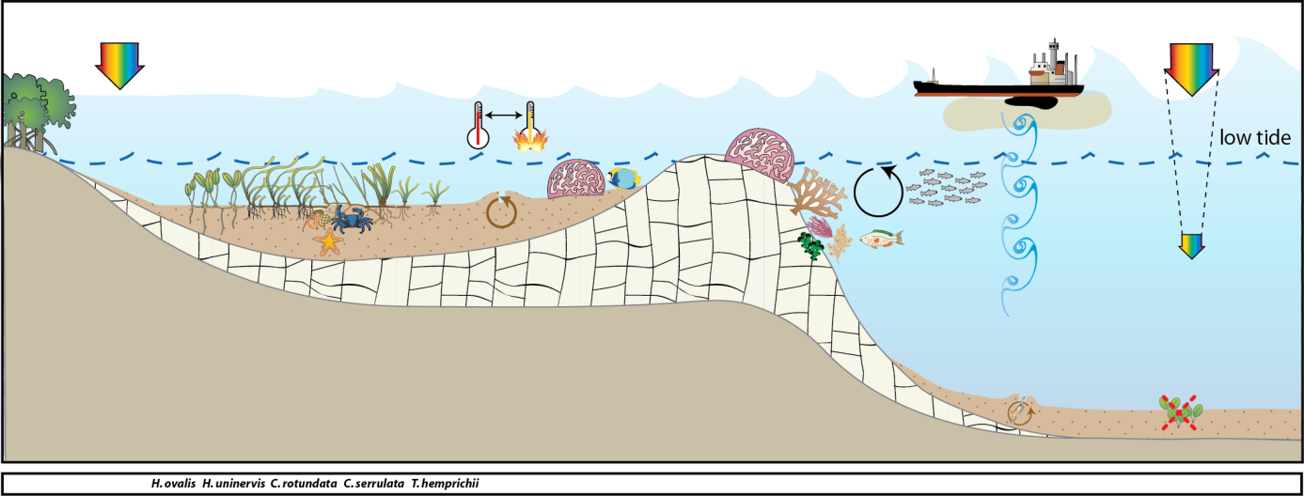
Figure 122. Conceptual diagram of reef habitat in the Cape York region
– major control is pulsed physical disturbance, salinity and temperature extremes: general habitat and seagrass meadow processes (see Figure 136 for icon explanation).

Seagrass meadows on inshore reef habitats were monitored at 3 locations, from the north of the region (12.25°S), to the south (15.6°S) (Table 3). The most southern location (Archer Point) includes a legacy site which has been monitored over the longest time period for the region. The sites at Archer Point were located in a sheltered section of bay adjacent to Archer Point, fringed by mangroves, approximately 15km south of Cooktown (Figure 200). There are two major rivers within the immediate area: the Endeavour and the Annan River. The Endeavour River is the larger of the two river systems and has a catchment area of approximately 992 km². The Annan River is located approximately 5 km south of Cooktown and extends inland from Walker Bay. The Annan River catchment area is approximately 850 km² (Hortle and Person 1990).
The other two reef habitat locations were included for monitoring from early 2012: Stanley Island and Piper Reef. Stanley Island is within the Flinders Island group north of Bathurst Bay (Figure 200). The site is a fringing reef site also fringed with mangroves. The islands are influenced by the Princess Charlotte Bay catchment which has four river systems, the Normanby, Marrett, Bizant and North Kennedy Rivers. Piper Reef is approximately 45km north west of Portland Roads, 15 km off the mainland coast (Figure 200). It is influenced by coastal waters from the Olive and Pascoe Rivers along with the Temple Bay catchment. There are minor land use activities in these catchments with some small level housing on the Pascoe River at the Wattle Hills settlement.
Most inshore seagrass meadows in the Cape York region are within coastal habitats. The majority of these meadows are in the shallow subtidal waters of large bays sheltered from the prevailing trade winds. These seagrass meadows are also highly productive and provide important nursery grounds for fisheries (Coles et al. 1987). The meadows are also of important to the large dugong population within the region (Marsh and R 2002). In early 2012, coastal seagrass habitat locations paired with the new reef habitat locations, were also included for monitoring, they included: Bathurst Head (paired with Stanley Island) and Shelburne Bay (paired with Piper Reef). The coastal seagrass meadows at Bathurst Head and Shelburne Bay are located on naturally dynamic sand banks. These meadows are dominated by Halodule uninervis with some Halophila ovalis and are often exposed to regular periods of disturbance from wave action and consequent sediment movement. A dominant influence to these coastal meadows is exposure to wind/wave disturbance and terrigenous runoff from seasonal rains (Carruthers et al. 2002) (Figure 123).
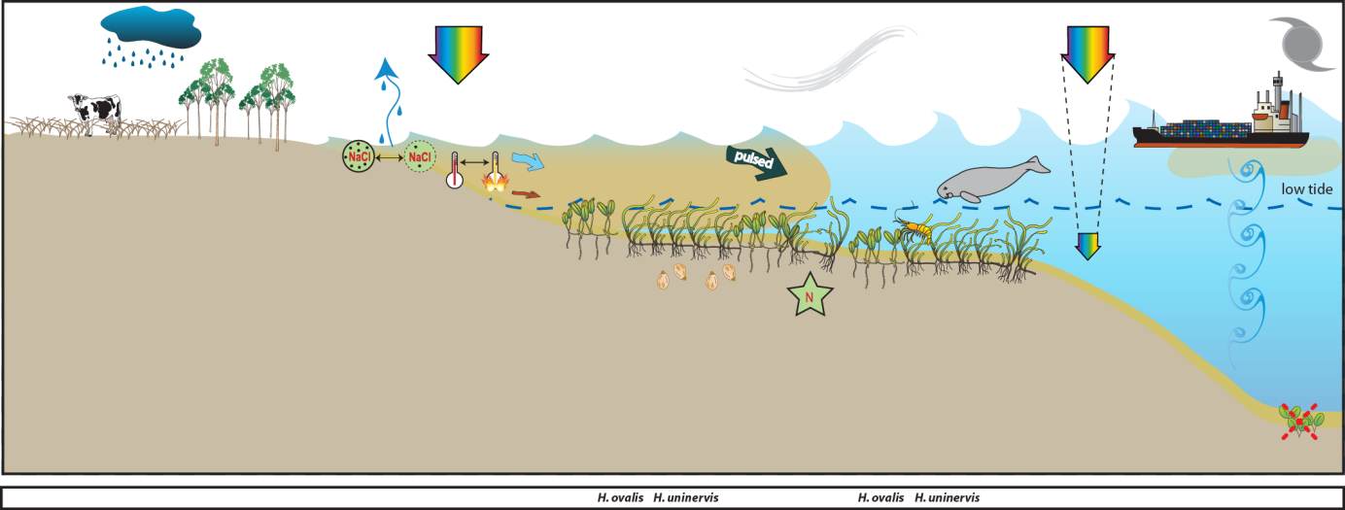
Figure 123. Conceptual diagram of coastal habitat in the Cape York region
– major control is pulsed terrigenous runoff, salinity and temperature extremes: general habitat, seagrass meadow processes and threats/impacts (see Figure 136 for icon explanation).

Bathurst Head is located just east of Combe Point in the Bathurst Bay area to the east of Princess Charlotte Bay (Figure 200). It is a coastal location fringed by mangroves on the eastern edge of the bay. The sites are within 20km of the mouths of the Normanby and Margaret Rivers. The Normanby River is the fourth largest river system flowing into the Great Barrier Reef. The catchment area covers 24,228 km² and consists of one of Queensland’s largest conservation areas, extensive cattle grazing country (75 per cent of the catchment), and rich agricultural land at Lakeland Downs (Reef Water Quality Protection Plan Secretariat 2011). Less than 5 per cent of the catchment has been cleared Reef Water Quality Protection Plan Secretariat 2011). Grazing densities are generally low on Cape York Peninsula (~1 beast/40 ha), however, the productive pastures in the Normanby catchment can have densities from ~1 beast/20 ha to >1 beast/5 ha (Cotter 1995).
Shelburne Bay is located 112 km north of Lockhart River and 122 km southeast of Bamaga on the east coast of the GBR. The bay has a limited catchment with only Harmer Creek discharging directly into it, and the MacMillan River discharging into the adjacent Margaret Bay. The catchment contains one of the least disturbed parabolic sand dunes areas in the world and is made up of seasonal wetlands and sand ridges. There are no current land use activities occurring in this catchment. The area is prone to extreme weather with the cyclone database stating that 47 cyclones have tracked within 200km of Shelburne Bay between 1906 and 2007. The monitoring site at Shelburne Bay is approximately 5 km west of the mouth of Harmer Creek mouth.

Wet Tropics
The Wet Tropics region covers 22,000 km² and land use practices include primary production such as cane and banana farming, dairying, beef, cropping and tropical horticulture (Commonwealth of Australia 2013e). Approximately 6.5 per cent of the seagrass area mapped in the shallow waters (<15m) of the GBR occurs in the Wet Tropics region (McKenzie et al. 2010c). The most extensive areas of seagrass in this region occur around Low Isles, Cairns Harbour, Green Island, Mourilyan Harbour and the Hinchinbrook Island area (between Dunk Island and Lucinda) (Coles et al. 2007). Thirteen seagrass species have been recognised for this region (Lee Long et al. 1993). Nearshore seagrass meadows are situated on sand and mud banks and mostly dominated by Halodule uninervis with some Halophila in the northern and southern areas. Intertidal meadows in Cairns Harbour and southern Hinchinbrook channel are dominated by Zostera muelleri. Shallow subtidal coastal meadows consist of Halodule uninervis and Halophila communities mostly along sheltered coasts and harbours (e.g. Cairns Harbour and Mourilyan Harbour). Cymodocea spp., Thalassia and a suite of Halophila species tend to dominate island habitats in the region (e.g. Dunk Island and northern Hinchinbrook Island). Only reef (subtidal and intertidal) and coastal seagrass habitats are currently monitored in the Wet Tropics region.
Coastal seagrass habitats were monitored at Yule Point in the north and Lugger Bay in the south of the region. The seagrass meadows at Yule Point and Lugger Bay occur on shallow sand banks, protected by fringing reefs. Coastal seagrass meadows are dominated by Halodule uninervis with some Halophila ovalis and are often exposed to regular periods of disturbance from wave action and consequent sediment movement. The sediments in these habitats are relatively unstable restricting seagrass growth and distribution. A dominant influence of these meadows is terrigenous runoff from seasonal rains (Figure 124). The Barron, Tully and Hull Rivers are a major source of pulsed sediment and nutrient input to these coastal meadows.
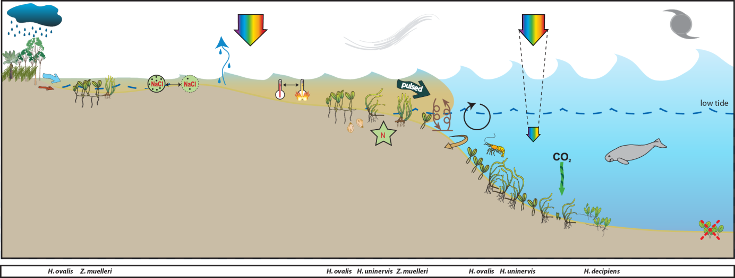
Figure 124. Conceptual diagram of coastal habitat (<15m) in the Wet Tropics region
– major control is pulsed terrigenous runoff, salinity and temperature extremes: general habitat, seagrass meadow processes and threats/impacts (see Figure 136 for icon explanation).
Reef seagrass habitats were monitored at Low Isles, Green Island and Dunk Island. Low Isles is located in the north of the region and the monitoring sites were paired intertidal and subtidal (not replicated) (Figure 201). Low Isles is an inshore reef located 15km south east of the Daintree River mouth. Low Isles refers to the two islets of Low Isles reef: Low Island (the cay) and Woody Island (predominantly Rhizophora forest). The intertidal site was located near the northern edge of the reef platform between Low Island and Woody Island. This area is dominated by Halodule uninervis and Halophila ovalis. The subtidal site was approximately 250 north of the intertidal site, in the eastern edge of the anchorage (Low Isles lagoon), and was dominated by Halophila ovalis and Halodule uninervis.
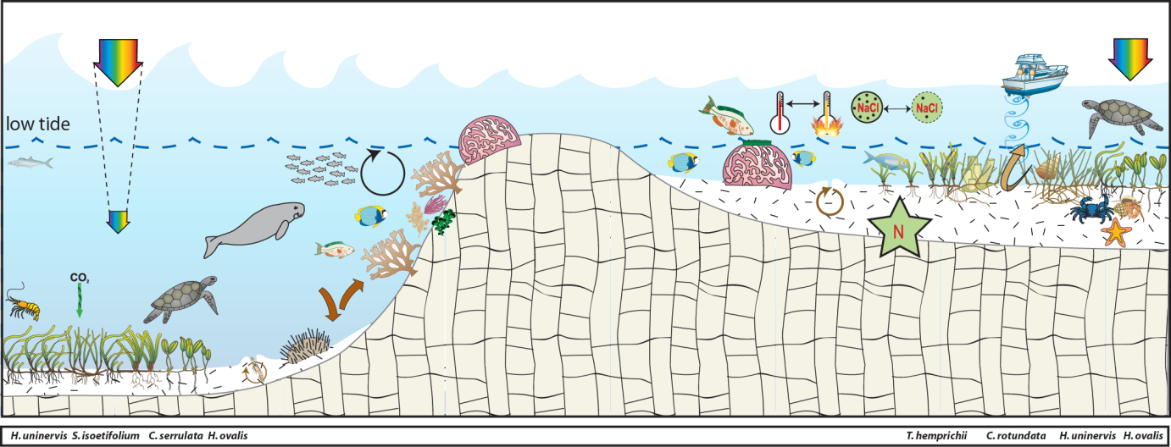
Figure 125. Conceptual diagram of reef habitat (<15m) in the Wet Tropics region
– major control is nutrient limitation, temperature extremes, light and grazing: general habitat, seagrass meadow processes and threats/impacts (see Figure 136 for icon explanation).
Green Island is a mid shelf reef located 26km north east of Cairns and the Barron River mouth, in approximately the centre of the Wet Tropics region (Figure 201). Monitoring at Green Island occurs on the large reef-platform and in the shallow lagoon to the south west and north west of the cay, respectively. The meadows are dominated by Cymodocea rotundata and Thalassia hemprichii with some Halodule uninervis and Halophila ovalis. The seagrass meadows at Green Island have been the focus of research since the 1980's and monitoring includes a legacy site (GI1).
Dunk Island is an inshore continental island located in the southern section of the region (Figure 201). Intertidal monitoring sites are located on the sand spit between the main island and Kumboola Island. The subtidal site is located in the lee of the island, in front of the former Dunk Island resort.
Shallow unstable sediment, fluctuating temperature, and variable salinity in shallow regions characterise reef habitats. Physical disturbance from waves and swell and associated sediment movement primary forcing factors which control seagrass growing in these habitats (Figure 125). Reef seagrass habitats in the region are often adjacent to areas of high tourism use and boating activity with propeller and anchor scarring impacts. Globally, nutrient concentrations are generally low in reef habitats due to the coarse nature of the coral sand sediments. In these carbonate sediments the primary limiting nutrient for seagrass growth is generally phosphate (Short et al. 1990; Fourqurean et al. 1992a; Erftemeijer and Middelburg 1993). This is due to the sequestering of the phosphate by the calcium carbonate. In this region seagrass meadows inhabiting the near shore inner reefs and fringing reefs of coastal islands inhabit a mixture of terrigenous and carbonate sediments, such as Green Island. Seagrasses at this location in the 1990’s were shown to be nitrogen limited (Udy et al. 1999).

Burdekin
The Burdekin region, includes an aggregation of the Burdekin, Don, Haughton and Ross River catchments and several smaller coastal catchments, all of which empty into the Great Barrier Reef lagoon (Commonwealth of Australia 2013a). Rainfall is lower than other regions within tropical Queensland with an annual average of approximately 1,150 mm from on average 91 rain days. There is, however, considerable year-to-year variation due to the sporadic nature of tropical lows and storms. Approximately 75 per cent of the average annual rainfall is received during December to March (Scheltinga and Heydon 2005).
Approximately 18 per cent of the seagrass area mapped in the shallow waters (<15m) of the GBR occurs in the Burdekin NRM region (McKenzie et al. 2010c). Intertidal seagrasses and shallow subtidal seagrasses dominate in this region, the majority of which are within coastal habitats (Coles et al. 2007). Extensive seagrass meadows occur in Upstart, Cleveland, and Bowling Green Bays and off Magnetic Island. Twelve species have been found within this region (Lee Long et al. 1993; Lee Long et al. 1996a). Deep water (>15m) seagrasses occur in this region but are not as common or dense as occurs in regions further north (Coles et al. 2009). Most fringing reefs associated with continental islands support moderately dense mixed species meadows (especially Cymodocea serrulata), which are not restricted to the confines of fringing reefs, but are also found in sheltered bays at continental islands or coastal localities (Coles et al. 2007).
Major threats to seagrass meadows in the region include: coastal development (reclamation); changes to hydrology; water quality declines (particularly nutrient enrichment or increased turbidity); downstream effects from agricultural (including sugarcane, horticultural, beef), industrial (including refineries) and urban centres (Scheltinga and Heydon 2005; (Haynes et al. 2001)). All four generalised seagrass habitats are present within the Burdekin region, and MMP monitoring occurs at coastal and reef seagrass habitat locations.
The coastal monitoring sites are located on naturally dynamic shallow sand banks and are subject to sand waves and erosion blowouts moving through the meadows. The Townsville (Bushland Beach and Shelley Beach) area is a sediment deposition zone, so the meadow must also cope with incursions of sediment carried by long shore drift. The Bowling Green Bay (Jerona) location is adjacent to the mouth of Barratta Creek. Sediments within this habitat are mud and sand that have been delivered to the coast during the episodic peak flows of the creeks and rivers (notably the Burdekin) in this area. While episodic riverine delivery of freshwater nutrients and sediment is a medium time scale factor in structuring these coastal seagrass meadows, it is the wind induced turbidity of the costal zone that is likely to be a major short term driver (Figure 126). In these shallow coastal areas waves generated by the prevailing SE trade winds are greater than the depth of water, maintaining elevated levels of suspended sediments, limiting the amount of light availability for photosynthesis during the trade season. Another significant feature in this region is the influence of ground water (Stieglitz 2005). The meadows are also frequented by dugongs and turtles as witnessed by abundant grazing trails and patches of cropping .
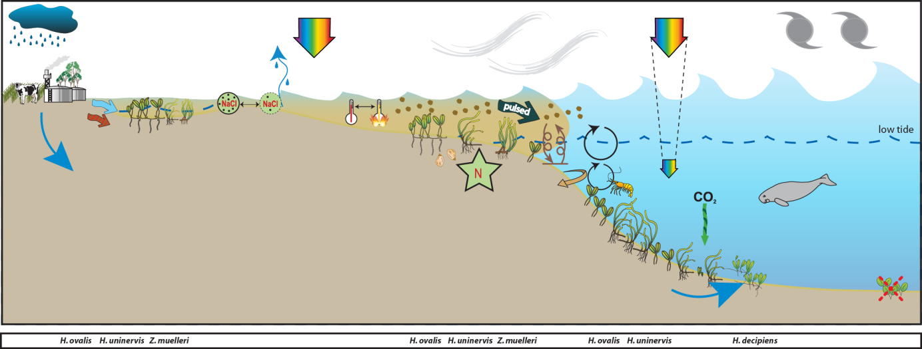
Figure 126. Conceptual diagram of coastal habitat in the Burdekin region
- major control is wind and temperature extremes, general habitat, seagrass meadow processes and threats/impacts (see Figure 136 for icon explanation).

The reef habitats are mainly represented by fringing reefs on the many continental islands within this area. Most fringing reefs have seagrass meadows growing on their shallow banks. Nutrient supply to these meadows is by terrestrial inputs via riverine discharge, re-suspension of sediments and groundwater supply (Figure 127). The meadows are typically composed of zones of seagrasses: Cymodocea serrulata, Thalassia hemprichii and Halodule uninervis (wide leaf) often occupy the lower littoral/subtidal area, blending with Halodule uninervis (narrow leaved) and Halophila ovalis in the upper intertidal zone. Phosphate is often the nutrient most limiting to reefal seagrasses (Short et al. 1990; Fourqurean et al. 1992a). Experimental studies on reef top seagrasses in this region however, have shown seagrasses to be nitrogen limited primarily with secondary phosphate limitation, once the plants have started to increase in biomass (Mellors 2003). In these fringing reef top environments fine sediments are easily resuspended by tidal and wind generated currents making light availability a driver of meadow structure.

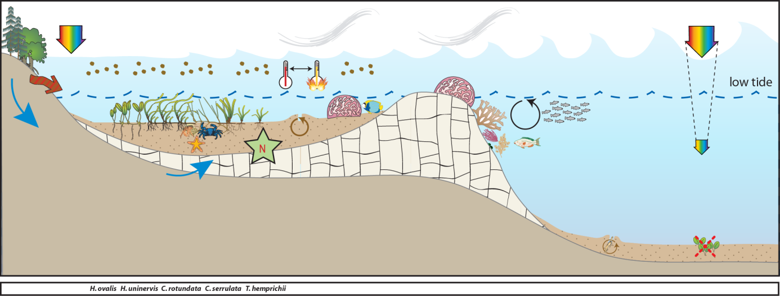
Figure 127. Conceptual diagram of fringing reef habitat in the Burdekin region
- major control is nutrient supply (groundwater), light and shelter: general habitat and seagrass meadow processes (see Figure 136 for icon explanation).

Mackay Whitsunday
The Mackay Whitsunday region comprises an area of almost 940,000 ha and extends from Bowen (Queens Beach) in the north to Clairview (Clairview Bluff) in the south and includes several large continental islands. The region includes the major population centres of Mackay, Proserpine, Airlie Beach and Sarina; encompassing the Proserpine, O’Connell, Pioneer and Plane Creek river systems (Commonwealth of Australia 2013d).
The Great Barrier Reef protects the coastline from predominantly south-easterly winds which often accompany a light south-easterly ocean swell (Mackay Whitsunday Natural Resource Management Group Inc 2005). Coastal waters adjacent to the large rivers and mangrove-lined inlets are generally very turbid and shallow, with predominantly mud sediments. Tidal range in the south of the region is large, and in some places has the effect of creating extensive tidal banks. The region receive rainfall between 500-3000 mm annually, which falls mostly (~70 per cent) from December to March. Average daily temperatures for Mackay range between 23 31°C in January and 11-22°C in July. The major land use of each catchment is livestock grazing, and crops such as sugar cane.
Extensive seagrass meadows occur both on shallow banks and in nearshore subtidal areas in the region. Approximately 448 km² of seagrass habitat has been mapped in the Mackay Whitsunday region over the past 3 decades, with 154 km² in shallow waters and 293 km² in deeper (>15m) waters (McKenzie et al. 2010c). In 1999/2000, 5553 ±1182 hectares of seagrass was mapped from Midge Point in the south to Hydeaway Bay in the north (Campbell et al. 2002). This represented a 40 per cent increase in overall seagrass habitat compared to the 1987 baseline, however losses had occurred at some localities. For a detailed description of seagrass meadows and habitats across the region (see McKenzie and Yoshida 2012).
Twelve species of seagrass have been recorded in the Mackay Whitsunday, representing 80 per cent of the known species found in Queensland waters (McKenzie and Yoshida 2012). The wide range of physical habitats where seagrasses were found undoubtedly contributes to the high species diversity. Habitats include intertidal and subtidal areas of estuary, coastal fringing reef environments and deepwater environments. MMP sites are located on three of the generalised seagrass habitats represented in the region, including estuarine, coastal and reef.
Estuarine seagrass habitats in the Mackay Whitsunday region tend to be intertidal on the large sand/mud banks of sheltered estuaries. Run-off through the catchments connected to these estuaries is variable, though the degrees of variability is moderate compared to the high variability of the Burdekin and the low variability of the Tully (Brodie 2004). Seagrass in this habitat must cope with extremes of flow, associated sediment and freshwater loads from December to April when 80 per cent of the annual discharge occurs (Figure 128).

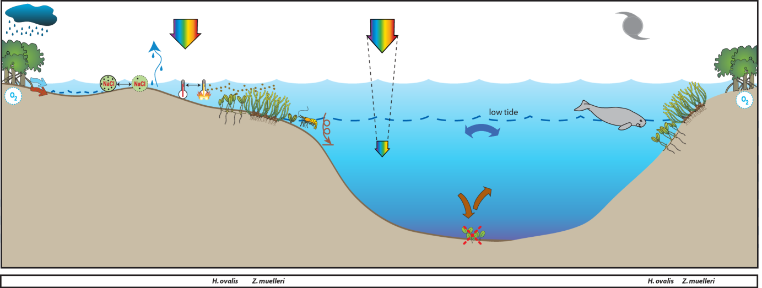
Figure 128. Conceptual diagram of estuary habitat in the Mackay Whitsunday region
: general habitat and seagrass meadow processes (see Figure 136 for icon explanation).
Coastal seagrass habitats are found in areas such as the leeward side of inshore continental islands and in north opening bays. These areas offer protection from the south-easterly trade winds. Potential impacts to these habitats are issues of water quality associated with urban, marina development and agricultural land use (Figure 129). Monitoring sites of coastal seagrass habitat were located on the sand/mud flats adjacent to Cannonvale in southern Pioneer Bay.
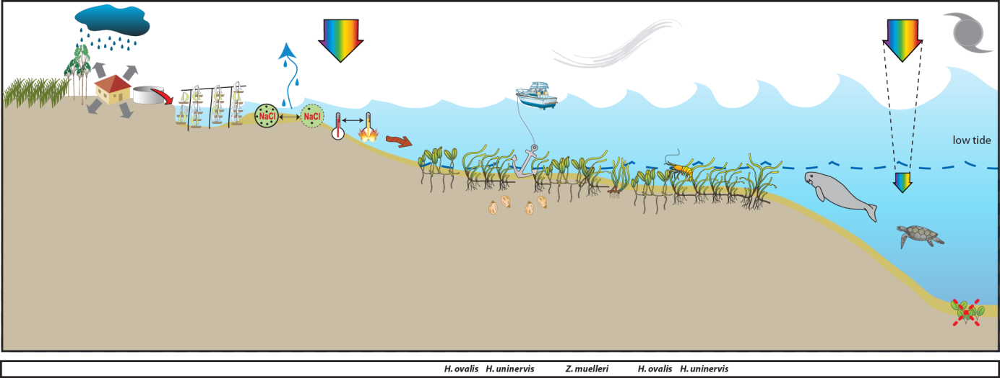
Figure 129. Conceptual diagram of coastal habitat in the Mackay Whitsunday region
– major control is shelter and temperature extremes: general habitat, seagrass meadow processes and threats/impacts (see Figure 136 for icon explanation).
Reef habitat seagrass meadows are found on the shallow fringing reefs adjacent to the mainlands or associated with the many islands in this region. The drivers of these habitats is exposure to waves and temperature extremes (Figure 130). Major threats would be increased tourism activities including marina and coastal developments.
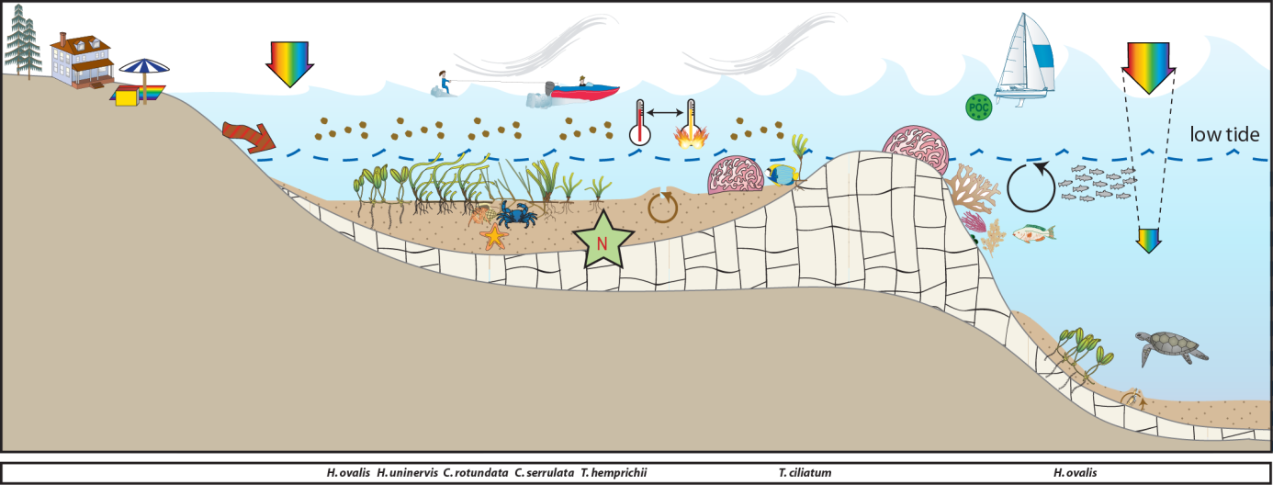
Figure 130. Conceptual diagram of reef habitat in the Mackay Whitsunday region
- major control is light and temperature extremes: general habitat, seagrass meadow processes and threats/impacts (see Figure 136 for icon explanation).

Fitzroy
The Fitzroy region covers an area of nearly 300,000 km². It extends from Nebo in the north to Wandoan in the south, and encompasses the major systems of the Fitzroy, Boyne, and Calliope rivers as well as the catchments of the smaller coastal streams of the Capricorn and Curtis Coasts (Commonwealth of Australia 2013c). The Fitzroy River is the largest river system running to the east coast of Australia. The Boyne and Calliope Rivers drain the southern part of the region, entering the GBR lagoon at Gladstone. The region covers ten percent of Queensland’s land area and is home to approximately 200,000 people. It is one of the richest areas in the state in terms of land, mineral and water resources and supports grazing, irrigated and dryland agriculture, mining, forestry and tourism land uses (Christensen et al. 2006). Agricultural production constitutes the largest land use in Central Queensland, with nearly 90 per cent of the land under agricultural production. Concomitant with this land use is concern of the quality of the water that is entering the GBR lagoon.
The Fitzroy region experiences a tropical to subtropical humid to semi arid climate. Annual median rainfall throughout the region is highly variable, ranging from about 800 mm to over 1000mm. Most rain falls in the summer, with many winters experiencing no rain at all. Because of the tropical influence on rainfall patterns, heavy storms can trigger flash flooding, and occasional cyclones wreak havoc.
The first broad scale survey of seagrass habitat in this region occurred in 1987, followed by more fine scale surveys of Shoalwater Bay (Lee Long et al. 1996b), the Dugong Protection Areas of Llewellyn Bay, Ince Bay and the Clairview Region (Coles et al. 2002) and Port Curtis to Rodds Bay (Rasheed et al. 2003). Ten species of seagrass have been recorded from this region ranging from the intertidal to a depth of 48m (Coles et al. 2007; McKenzie et al. 2010c). The majority of seagrass in this region exist on large shallow banks flats. Expansive meadows exist on the coastal intertidal flats of Ince Bay, Clairview, Shoalwater Bay and Rodds Bay. The area of shallow subtidal coastal seagrass habitat in this region is small, as most of the coastline is exposed to south-east winds (Coles et al. 2007). A significant factor contributing to the lack of suitable coastal habitat is the scouring tidal currents and associated high water turbidity in this region which limits light penetration and therefore the depth to which seagrasses can grow. Deepwater seagrasses were generally not found in the central and northern parts of this region, apart from occasional sites in the lee of islands or reefs (Coles et al. 2009).
MMP sites within this region are located in coastal, estuarine or fringing-reef seagrass habitats. Coastal sites are monitored in Shoalwater Bay and are located on the large shallow banks of the north western shores of Shoalwater Bay. The remoteness of this area (due to its zoning as a military exclusion zone) represents a near pristine environment, removed form anthropogenic influence. In contrast, the estuarine sites are located within Gladstone Harbour: a heavily industrialized port. Offshore reef sites are located at Monkey Beach, Great Keppel Island.
The Shoalwater Bay monitoring sites are located in a bay which is a continuation of a coastal meadow that is protected by headlands. A feature of the region is the large tidal amplitudes and consequent strong tidal currents (Figure 131). As part of this tidal regime, large intertidal banks are formed which are left exposed for many hours. Pooling of water in the high intertidal, results in small isolated seagrass patches 1-2m above Mean Sea Level (MSL).

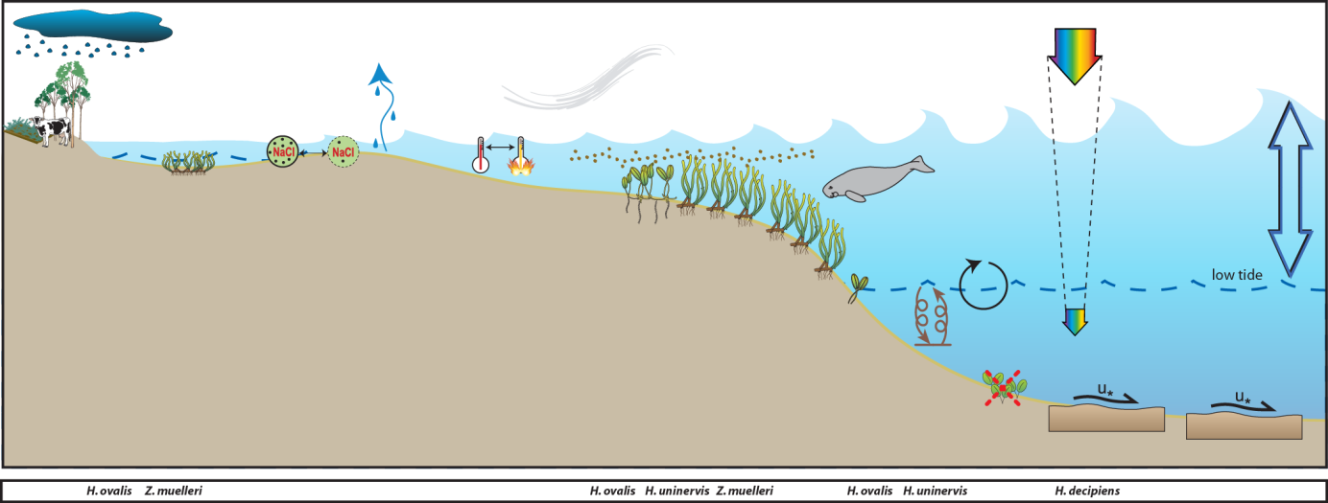
Figure 131. Conceptual diagram of coastal habitat in the Fitzroy region
– major control is pulsed light, salinity and temperature extremes: general habitat, seagrass meadow processes and threats/impacts (see Figure 136 for icon explanation).
Reef habitat seagrass meadows are found intertidally on the top of the fringing reefs associated with the Keppel Isles and Cannibal Island groups, however many of the reefs in the north of the region have not been surveyed. The drivers of these habitats are exposure and desiccation (intertidal meadows) and light limitation associated with wind driven resuspension (Figure 132).
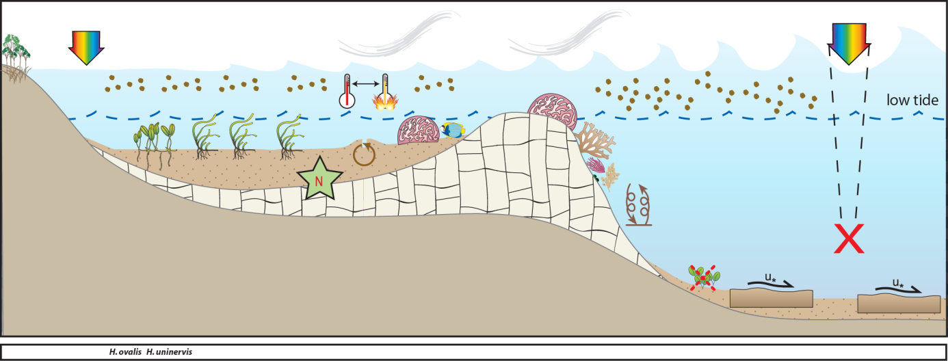
Figure 132. Conceptual diagram of reef habitat in the Fitzroy region
- major control is light and temperature extremes and benthic shear from tidal currents: general habitat, seagrass meadow processes and threats/impacts (see Figure 136 for icon explanation).
Estuarine seagrass habitats in the southern Fitzroy region tend to be intertidal, on the large sand/mud banks in sheltered areas of the estuaries. Tidal amplitude is not as great as in the north and estuaries that are protected by coastal islands and headlands support meadows of seagrass. These habitats feature scouring, high turbidity and desiccation (linked to this large tide regime), and are the main drivers of distribution and composition of seagrass meadows in this area (Figure 133). These southern estuary seagrasses (Gladstone, Port Curtis) are highly susceptible to impacts from local industry and inputs from the Calliope River. Port Curtis is highly industrial with the world’s largest alumina refinery, Australia’s largest aluminium smelter and Queensland’s biggest power station. In addition, Port Curtis contains Queensland’s largest multi-cargo port (Port of Gladstone) with 50 million tonnes of coal passing through the port annually.
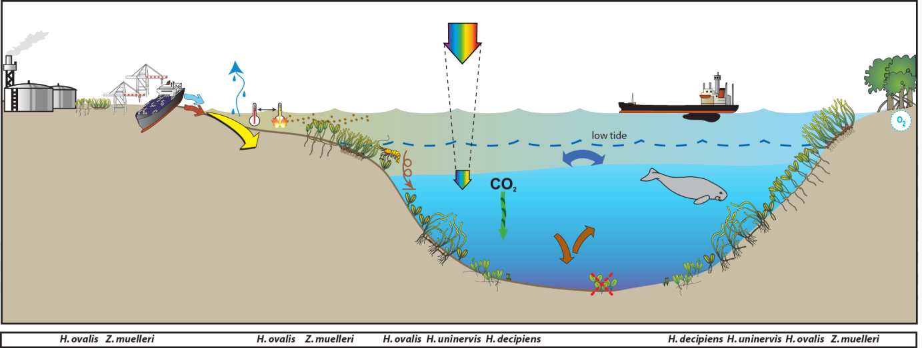
Figure 133. Conceptual diagram of estuary habitat in the Fitzroy region
– major control variable rainfall and tidal regime: general habitat, seagrass meadow processes and threats/impacts (see Figure 2 for icon explanation).

Burnett–Mary
The Burnett Mary Region encompasses a land area of more than 56,000 km², a marine area of almost 10,000 km² and supports a population of over 200,000 people. The region is comprised of a number of catchments including the Baffle Creek, Kolan, Burnett, Burrum and Mary Rivers (Commonwealth of Australia 2013b). Only the northern most catchment of the Burnett Mary region, the Baffle Basin, is within the GBR and includes the tidal mudflats and mangroves in Rodds Peninsula/Turkey Beach considered ‘near pristine’ (Burnett Mary Regional Group 2005).
Principal land uses in the Burnett-Baffle area are beef cattle grazing (the largest though currently declining), small crop growers, forestry (including plantations), tourism and fishing (Burnett Mary Regional Group 2010). Other significant land uses include conservation, rural and urban residential development (Prange and Duke 2004). Located in the northern section of the region is Rodds Bay, where freshwater input is minor from seasonal flows in small catchments, and water quality generally good - little organic/inorganic pollution even though Rodds Harbour has elevated natural turbidity and minor increases in sediment loads from grazing and development (Ford 2004). The southern region includes the Mary River catchment (9181km²) and although outside the GBR Marine Park, is highly connected through oceanographic processes and plays a major driver of southern GBR ecosystems (Burnett Mary Regional Group 2013). Grazing predominates and utilises 42 per cent of the land area of the Mary catchment. High rainfall areas to the south and east host the majority of residential development, horticulture, and intensive livestock. Forestry and nature conservation, each of which occupies 18 per cent of the catchment, are the second largest land uses, with intensive anthropogenic uses (residential, manufacturing, services, waste treatment, transport, and services) occupying 13 per cent of the catchment area (Walker and Esslemont 2008). Sediment, total nitrogen and total phosphorus exports from the Mary catchment to the coastal receiving waters are estimated to be 455 kt.yr⁻¹, 1.541 kt.yr⁻¹ and 0.344 kt.yr⁻¹, respectively (DeRose et al. 2002). Since European settlement, relative erosion rates in some sections of the Western Mary have increased 2 to 7 fold, and 4 to more than 14 fold in the Upper Mary (Esslemont et al. 2006).
Seagrass in the region were first broadly surveyed in 1988 (Lee Long et al. 1992) with the section north of Rodds Peninsula resurveyed at a finescale in 2002 (Rasheed et al. 2003). Seven seagrass species have been reported in the Burnett Mary NRM region (McKenzie and Yoshida 2008), five within the marine park boundary (Coles et al. 2007). Meadows have been reported throughout the inlets protected from the south easterly winds and oceanic swell, and throughout Hervey Bay and the Great Sandy Strait. Very little seagrass has been mapped on the exposed coastline between Bustard Head to just north of Hervey Bay. Within the GBRWHA boundaries, the majority of seagrass meadows are within coastal and estuary habitats. South of the GBRWHA boundary in one of the largest single areas of seagrass resources on the eastern Australian seaboard (McKenzie and Yoshida 2008). The southern marine area of the Burnett Mary NRM region includes large meadows in deepwater, coastal (including intertidal and shallow subtidal) and estuarine habitats (McKenzie and Yoshida 2008).
Meadows in the north of the Burnett Mary region generally face low levels of anthropogenic threat, and monitoring sites are located within Rodd’s Bay. The only other location that is monitored within this region is in the south, at Urangan (Hervey Bay). This location is adjacent to the Urangan marina and in close proximity to the mouth of the Mary River.
Estuarine habitats occur in bays that are protected from the south easterly-winds and consequent wave action. The seagrasses in this area must survive pulsed events of terrestrial run-off, sediment turbidity and drops in salinity. Estuary seagrasses in the region are susceptible to temperature related threats and desiccation due to the majority being intertidal (Figure 134).
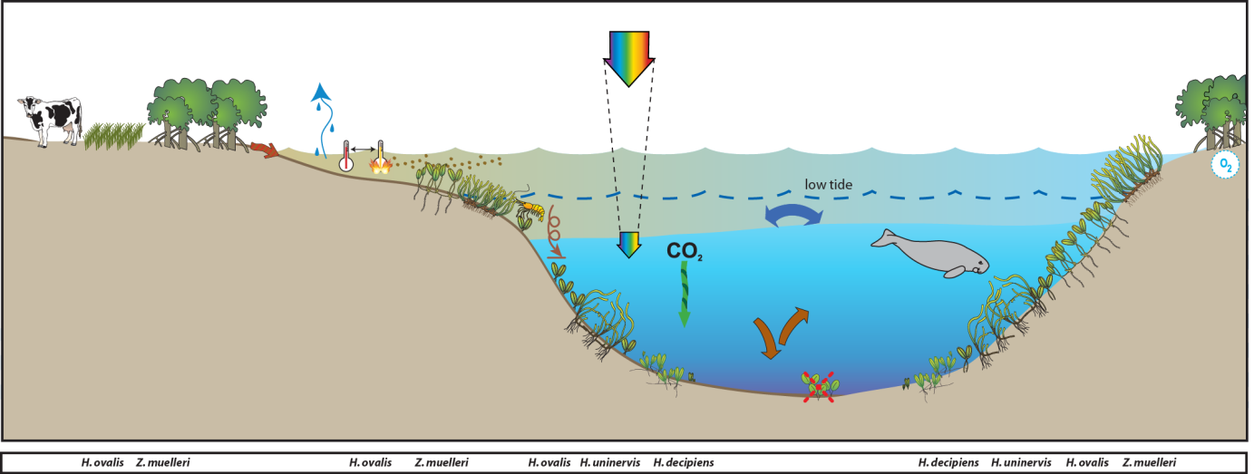
Figure 134. Conceptual diagram of Estuary habitat in the GBR section of the Burnett Mary region
– major control is shelter from winds and physical disturbance: general habitat and seagrass meadow processes (see Figure 136 for icon explanation).

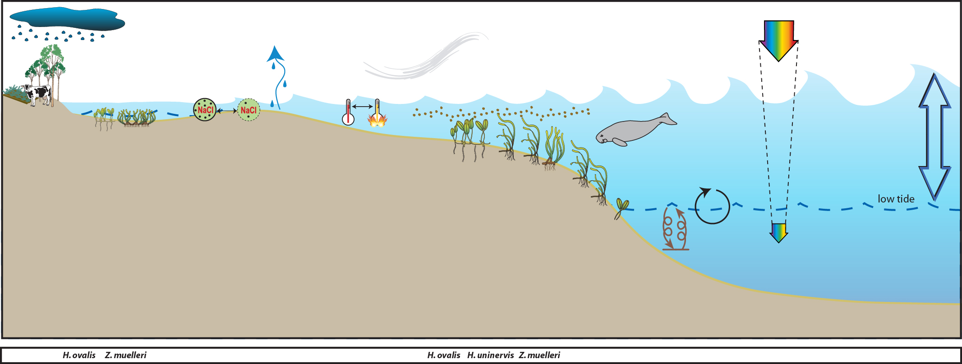
Figure 135. Conceptual diagram of Coastal habitat in the Burnett Mary region
– major control is shelter from winds / physical disturbance, and temperature extremes: general habitat and seagrass meadow processes (see Figure 136 for icon explanation).

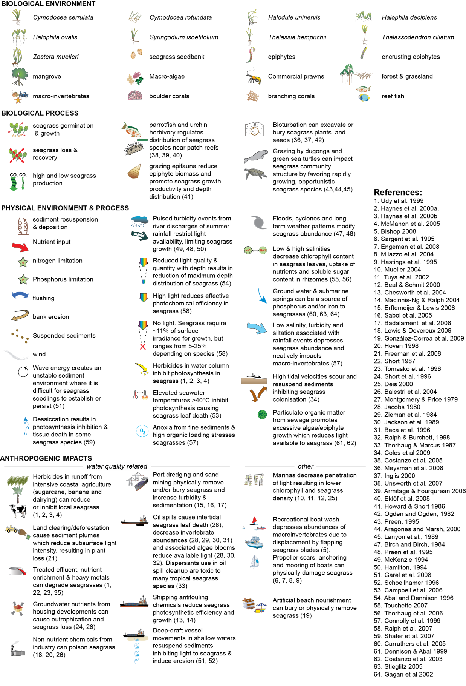
Figure 136. Key to symbols used for conceptual diagrams detailing drivers and pressures to seagrasses.

Materials and methods

The following section includes excerpts from McKenzie et al. (2014b).

Sampling design
In late 2004 all data collected within the GBR region as part of existing monitoring programs were supplied to a Senior Statistician at AIMS for independent review (De’ath 2005) who examined the available datasets to estimate expected performance with regard to detecting long-term changes (including estimates of precision for annual mean, differences in means and linear trends). Seagrass data included in the analyses was collected from 2000–2004 and across 63 sites in 29 locations from Cooktown to Hervey Bay. Results concluded that the existing spatial and temporal coverage of monitoring was providing valuable information about long-term trends and spatial differences, with changes in seagrass cover occurring at various spatial and temporal scales. The report recommended that the value of the monitoring would be greatly enhanced by adding more widely spread locations. Therefore additional meadows were added according to criteria listed in materials and methods.
The final/current MMP sampling design was selected to detect change in inshore seagrass community status to compare with seagrass environmental status (water quality) in relation to specific catchments or groups of catchments (NRM region). Within each region, a relatively homogenous section of a representative seagrass meadow is selected to represent each of the seagrass habitats present (estuarine, coastal, reef, intertidal and subtidal) (Habitat(Region)). To account for spatial heterogeneity, two sites were selected within each location (Site[Habitat(Region)]). Subtidal sites were not replicated within locations. Within each site, finer scale variability is accounted for by using three 50 m transects nested in each site. An intertidal site is defined as a 5.5 hectare area and in the centre of each site a 50 mx50 m area is examined using 33 quadrats (50 cm x 50 cm), placed every 5 m along each of the 50 m transects, placed 25 m apart. The sampling strategy for subtidal sites was modified to sample along 50 m transects 2-3 m apart (aligned along the depth contour) due to logistical purposes of SCUBA diving in often poor visibility. At each site, monitoring is conducted during the late-wet (April) and late-dry (October) periods each year; additional sampling is conducted at more accessible locations in the dry (July) and wet (January).

Table 36. Samples collected at each MMP inshore monitoring site per parameter for each season
. Activities include: SG = seagrass cover & composition, SM=seed monitoring, TN=tissue nutrients, EM=edge mapping, RH=reproductive health, TL=temperature loggers, LL=light loggers, SH=sediment herbicides. ^=subtidal.
GBR region | NRM region | Basin | Monitoring location |  | late dry Season (2016) |  |  |  |  |  |  | late wet Season (2017)
 |  |  |  |  | SG | SM | TN | EM | RH | TL | LL | SG | SM | EM | RH | TL | LL
Far Northern | Cape York | Jacky Jacky / Olive Pascoe | Shelburne Bay | SR1
 |  |  |  | SR2
Far Northern | Cape York | Jacky Jacky / Olive Pascoe | Piper Reef | FR1 | 33 | 30 | 3 |  | 15
 |  |  |  | FR2 | 33 | 30 | 3 |  | 15
Far Northern | Cape York | Lockhart | Weymouth Bay | YY1
Far Northern | Cape York | Lockhart | Lloyd Bay | LR1^ | 19
 |  |  |  | LR2^ | 10
Far Northern | Cape York | Normanby / Jeanie | Flinders Group | ST1 | 33 | 30 | 3 |  | 15
 |  |  |  | ST2 | 33 | 30 | 3 |  | 15
 |  |  |  | FG1^ | 20
 |  |  |  | FG2^ | 23
Far Northern | Cape York | Normanby / Jeanie | Bathurst Bay | BY1 | 33 | 30 | 3 |  | 15
 |  |  |  | BY2 | 33 | 30 | 3 |  | 15
Far Northern | Cape York | Endeavour | Archer Point | AP1 | 33 | 30 | 3 |  | 15
 |  |  |  | AP2 | 33 | 30 | 3 |  | 15
Northern | Wet Tropics | Daintree | Low Isles | LI1 | 33 | 30 | 3 |  | 15 |  |  | 33 | 30 |  | 15
 |  |  |  | LI2^ | 33 | 30 |  |  |  |  |  | 33 | 30 |  | 15
Northern | Wet Tropics | Mossman / Barron / Mulgrave - Russell / Johnstone | Yule Point | YP1 | 33 | 30 | 3 |  | 15 |  |  | 33 | 30 |  | 15
 |  |  |  | YP2 | 33 | 30 | 3 |  | 15 |  |  | 33 | 30 |  | 15
Northern | Wet Tropics | Mossman / Barron / Mulgrave - Russell / Johnstone | Green Island | GI1 | 33 | 30 | 3 |  | 15 |  |  | 33 | 30 |  | 15
 |  |  |  | GI2 | 33 | 30 | 3 |  | 15 |  |  | 33 | 30 |  | 15
 |  |  |  | GI3^ | 33 | 30 | 3 |  | 15 |  |  | 33 | 30 |  | 15
Northern | Wet Tropics | Tully / Murray / Herbert | Mission Beach | LB1 | 33 | 30 | 3 |  |  |  |  | 33 | 30
 |  |  |  | LB2 | 33 | 30 |  |  |  |  |  | 33 | 30
Northern | Wet Tropics | Tully / Murray / Herbert | Dunk Island | DI1 | 33 | 30 | 3 |  | 15 |  |  | 33 | 30 |  | 15
 |  |  |  | DI2 | 33 | 30 | 3 |  | 15 |  |  | 33 | 30 |  | 15
 |  |  |  | DI3^ | 33 | 30 | 3 |  | 15 |  |  | 33 | 30 |  | 15
Northern | Wet Tropics | Tully / Murray / Herbert | Rockingham Bay | GO1 | 11
Northern | Wet Tropics | Tully / Murray / Herbert | Missionary Bay | MS1^
 |  |  |  | MS2^
Central | Burdekin | Ross / Burdekin | Magnetic Island | MI1 | 33 | 30 | 3 |  | 15 |  |  | 33 | 30 |  | 15
 |  |  |  | MI2 | 33 | 30 | 3 |  | 15 |  |  | 33 | 30 |  | 15
 |  |  |  | MI3^ | 33 | 30 | 3 |  | 15 |  |  | 33 | 30 |  | 15
Central | Burdekin | Ross / Burdekin | Townsville | SB1 | 33 | 30 | 3 |  | 15 |  |  | 33 | 30 |  | 15
 |  |  |  | SB2 | 33 | 30 |  |  |  |  |  | 33 | 30
 |  |  |  | BB1 | 33 | 30 | 3 |  | 15 |  |  | 33 | 30 |  | 15
Central | Burdekin | Ross / Burdekin | Bowling Green Bay | JR1 | 33 | 30 | 3 |  | 15 |  |  | 33 | 30 |  | 15
 |  |  |  | JR2 | 33 | 30 | 3 |  | 15 |  |  | 33 | 30 |  | 15
Central | Mackay  Whitsunday | Don | Shoal Bay | HB1 | 33 | 30
 |  |  |  | HB2 | 33 | 30
Central | Mackay  Whitsunday | Proserpine | Pioneer Bay | PI2 | 33 | 30 |  |  |  |  |  | 33 | 30
 |  |  |  | PI3 | 33 | 30 |  |  |  |  |  | 33 | 30
Central | Mackay  Whitsunday | Proserpine / O’Connell | Repulse Bay | MP2 | 33 | 30 | 3 |  | 15 |  |  | 33 | 30 |  | 15
 |  |  |  | MP3 | 33 | 30 | 3 |  | 15 |  |  | 33 | 30 |  | 15
Central | Mackay  Whitsunday | Proserpine / O’Connell | Hamilton Is. | HM1 | 33 | 30 | 3 |  | 15 |  |  | 33 | 30 |  | 15
 |  |  |  | HM2 | 33 | 30 | 3 |  | 15 |  |  | 33 | 30 |  | 15
Central | Mackay  Whitsunday | Proserpine / O’Connell | Whitsunday Island | TO1^ | 22
 |  |  |  | TO2^ | 20
Central | Mackay  Whitsunday | O’Connell | Newry Islands | NB1^ | 22
 |  |  |  | NB2^ | 21
Central | Mackay  Whitsunday | Plane | Sarina Inlet | SI1 | 33 | 30 | 3 |  | 15 |  |  | 33 | 30 |  | 15
 |  |  |  | SI2 | 33 | 30 | 3 |  | 15 |  |  | 33 | 30 |  | 15
Southern | Fitzroy | Fitzroy | Shoalwater Bay | RC1 | 33 | 30 | 3 |  | 15
 |  |  |  | WH1 | 33 | 30 | 3 |  | 15
Southern | Fitzroy | Fitzroy | Great Keppel Island | GK1 | 33 | 30 | 3 |  | 15
 |  |  |  | GK2 | 33 | 30 | 3 |  | 15
Southern | Fitzroy | Boyne | Gladstone Harbour | GH1 | 33 | 30 | 3 |  | 15
 |  |  |  | GH2 | 33 | 30 | 3 |  | 15
Southern | Burnett Mary | Burnett | Rodds Bay | RD1 | 33 | 30 | 3 |  | 15
 |  |  |  | RD2 | 33 | 30 |  |  | 15
Southern | Burnett Mary | Burrum | Burrum Heads | BH1 | 33 | 30 | 3 |  | 15 |  |  | 33 | 30
 |  |  |  | BH3 | 33 | 30 | 3 |  | 15 |  |  | 33 | 30
Southern | Burnett Mary | Mary | Hervey Bay | UG1 | 33 | 30 | 3 |  | 15 |  |  | 33 | 30 |  | 15
 |  |  |  | UG2 | 33 | 30 | 3 |  | 15 |  |  | 33 | 30 |  | 15

Climate and environmental pressures

Tidal exposure
The majority of meadows monitored within the MMP are located in shallow turbid waters where the duration of emersion and exposure has been shown to be important environmental drivers of seagrass change (Unsworth et al. 2012b). In the inshore waters of the GBR, where turbidity is naturally high, seagrasses are often restricted exclusively to the intertidal zone, as the periods around and even during exposure may provide critical windows of sufficient light for positive net photosynthesis (Pollard and Greenway 1993). However, during tidal exposure, these intertidal seagrasses are susceptible to high irradiance, potentially high UV-A and UV-B, thermal stress and desiccation (Erftemeijer and Herman 1994; Stapel et al. 1997; Björk et al. 1999; Campbell et al. 2006). Research on upper intertidal Enhalus acoroides meadows in the northern Gulf of Carpentaria (Weipa), reported strong correlative evidence that long-term tidal cycles coinciding with daylight and high solar radiation are linked to this long-term variability and seagrass decline (Unsworth et al. 2012b). Actual tidal data was provided by Maritime Safety Queensland and exposure times calculated for each site based on measured height relative to the Lowest Astronomical Tide.

Light loggers
Submersible Odyssey™ photosynthetic irradiance autonomous loggers were attached to permanent station markers at 20 intertidal and 4 subtidal seagrass locations from the Cape York region to the Burnett Mary region. Measurements were recorded by the logger every 15 - 30 minutes and are reported as total daily light (mol m⁻² d⁻¹). Automatic wiper brushes cleaned the optical surface of the sensor every 15 minutes to prevent marine organisms fouling.
Data were patchy for a number of intertidal sites because visitation frequency was low (3- 6 months), which increases the risk of light logger or wiper unit failure and increases the gap in data if loggers do fail. Furthermore, there are some sites that are frequently accessed by the public and tampering is suspected in the disappearance of some loggers. For subtidal sites, and their associated intertidal sites (Picnic Bay, Dunk Island, Green Island and Low Isles, 8 sites in total), the logger replacement time was every 6 weeks so data gaps were reduced.
Odyssey™ data loggers (Odyssey, Christchurch, New Zealand) record Photosynthetically Active Radiation (400-1100nm) and store data in an inbuilt memory which is retrieved every three to six months, depending on the site. Each logger has the following technical specifications:
- Cosine corrected photosynthetic irradiance sensor 400-700 nm
- Cosine corrected solar irradiance sensor 400-1100 nm
- Integrated count output recorded by Odyssey data recorder
- User defined integration period
- Submersible to 20m water depth
- 64k memory.
The logger is self-contained in a pressure-housing with batteries providing sufficient power for deployments of longer than six months. For field deployment, loggers are attached to a permanent station marker using cable ties; this is above the sediment-water interface at the bottom of the seagrass canopy. This location ensures that the sensors are not exposed to air unless the seagrass meadow is almost completely drained and places them out of sight of curious people. At subtidal sites, the loggers are deployed on the sediment surface (attached to a permanent marker) with the sensor at seagrass canopy height. Two loggers are deployed at subtidal sites as there is an increased chance of logger fouling, and the dual logger set-up offers a redundant data set in the instance that one logger fouls completely. Where possible, additional light loggers are deployed at subtidal sites 80 cm from the sediment surface. Data from this logger, together with data from the logger at canopy height, is used for calculation of the light attenuation co-efficient. Furthermore, another logger is deployed above the water surface at each of the subtidal monitoring stations. These additional loggers (surface and subtidal higher in the water column) allow comparison of water quality indices for some of the time.
Each light logger has a unique serial number which is recorded within a central secure database. The logger number is recorded on the monitoring site datasheet with the time of deployment and collection. At each monitoring event (every three to six months) the light loggers are removed and replaced with a ‘fresh’ logger. At subtidal monitoring sites, the loggers are checked by SCUBA (and replaced if fouled) every six weeks due to the increased fouling rates at permanently submerged sites. After collection, details of the logger number, field datasheet (with date and time) and logger are returned to JCU for downloading.
Photographs of the light sensor and/or notes on the condition of the sensor are recorded at logger collection. If fouling is major (e.g. wiper failure), the data are truncated to included only that data before fouling began – usually one to two weeks. If fouling was minor (up to ~25 per cent of the senor covered), back corrections to the data are made to allow for a linear rate of fouling (linear because with minor fouling it is assumed that the wiper was retarding algal growth rates, but not fully inhibiting them).
Loggers were calibrated against a certified reference Photosynthetically Active Radiation (PAR) sensor (LI-COR™ LI-192SB Underwater Quantum Sensor) using a stable light source (LiCor) enclosed in a casing that holds both the sensor and light source at a constant distance. Calibration is repeated after each deployment period of 6 weeks to 6 months. When the loggers are immersed in water (i.e. most fo the deployment time), a multiplication of 1.33 is used to adjust for in-water changes in absorption by the sensor, as the calibration is conducted in the air. This is not applied when the loggers emerge from the water (i.e. at low tide).
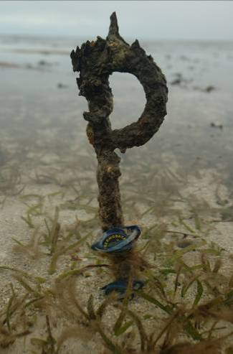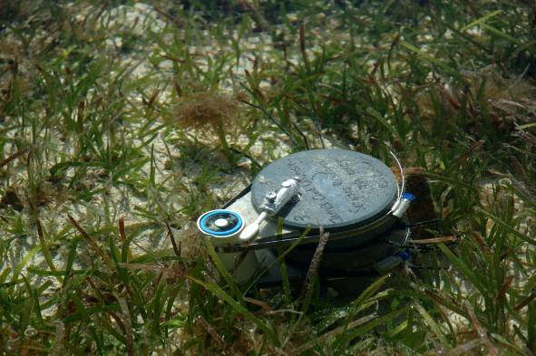
Autonomous iBTag™ submersible temperature loggers and submersible Odyssey™ photosynthetic irradiance autonomous logger deployed at Green Island.
Light data measured as instantaneous irradiance (µmol m⁻² s⁻¹) was converted to daily irradiance (I_{d}, mol m⁻² d⁻¹). I_{d} is highly variable in shallow coastal systems, being affected by incoming irradiance, the tidal cycle as well as water quality (Anthony et al. 2004). This high variability makes it difficult to ascertain trends in data. To aid with the visual interpretation of trends, I_{d} was averaged over a 28-day period (complete tidal cycle). 28 days is also biologically meaningful, as it corresponds to the approximate duration over which leaves on a shoot are fully replaced by new leaves and it is the approximate time over which shoot density and biomass starts to decline following reductions in light (Collier et al. 2012a). 28-day averaged I_{d} are presented graphically against draft thresholds with different values for northern and southern communities as the dominant species and habitat types vary from north to south. Thresholds applied in the northern GBR (5 mol m⁻² s⁻¹) were developed for Halodule uninervis-dominated communities during episodic seagrass loss (Collier et al. 2012b). The threshold applied to southern GBR communities (6 mol m⁻² s⁻¹) were developed for Zostera muelleri dominated communities over a 2-week rolling average using a range of experimental and monitoring approaches (Chartrand et al. 2012). These working thresholds describe light levels associated with short-term changes in seagrass abundance.

Within seagrass canopy temperature loggers
Autonomous iBTag™ submersible temperature loggers are deployed at all sites identified in deployed at all sites identified in Table 36. The loggers record temperature (degrees Celsius) within the seagrass canopy every 30 to 90 minutes (depending on duration of deployment and logger storage capacity) and store data in an inbuilt memory which is downloaded every three to six months, depending on the site.
iBCod 22L model of iBTag™ loggers are used as they can withstand prolonged immersion in salt water to a depth of 600 metres. It is reinforced with solid titanium plates and over molded in a tough polyurethane casing that can take a lot of rough handling.
Main features of the iBCod 22L include:
- Operating temperature range: -40 to +85°C
- Resolution of readings: 0.5°C or 0.0625°C
- Accuracy: ±0.5°C from -10°C to +65°C
- Sampling Rate: 1 second to 273 hours
- Number of readings: 4,096 or 8,192 depending on configuration
- Password protection, with separate passwords for read only and full access.
The large capacity of this logger allows the collection of 171 days of readings at 30 minute intervals.
iBCod 22L submersible temperature loggers are placed at the permanent marker at each site for three to six months (depending on monitoring frequency). Loggers are attached to the permanent station marker using cable ties, above the sediment-water interface. This location ensures that the sensors are not exposed to air unless the seagrass meadow is completely drained and places them out of sight of curious people.
Each logger has a unique serial number which is recorded within a central secure database. The logger number is recorded on the monitoring site datasheet with the time of deployment and collection. At each monitoring event (every three to six months) the iBTag™ temperature loggers are removed and replaced with a fresh logger (these are dispatched close to the monitoring visit). After collection, details of the logger number, field datasheet (with date and time) and logger are returned for downloading.
Logger deployment and data retrieval is carried out by JCU professional and technical personnel who have been trained in the applied methods. Methods and procedures documents are available to relevant staff and are collectively kept up-to-date. Changes to procedures are developed and discussed and recorded in metadata records.

Seagrass status

Field survey methods

Inshore seagrass meadow abundance, community structure and reproductive health
Site marking
Each selected inshore seagrass site is permanently marked with plastic star pickets at the 0 m point of the centre transect. Labels identifying the sites and contact details for the program are attached to these pickets. Positions of 0 m and 50 m points for all three transects within a site are also recorded using GPS (accuracy ±3 m). This ensures that the same site is monitored each event.

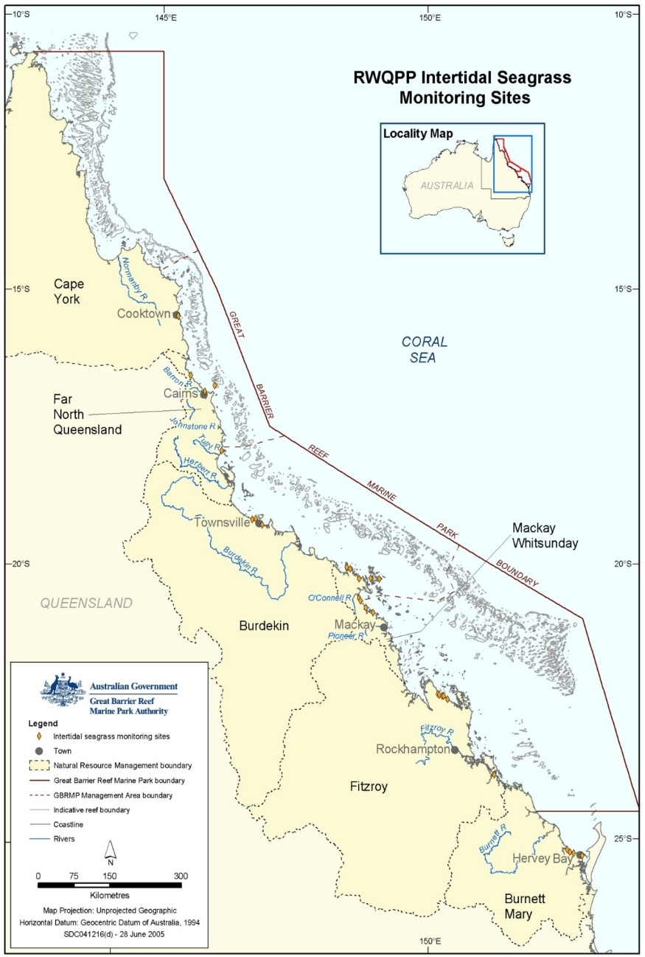
Figure 137. Inshore seagrass monitoring sites for the Reef Rescue Marine Monitoring Program.
Seagrass cover and species composition
Survey methodology follows globally standard methodologies, originally developed for the Seagrass-Watch program (McKenzie et al. 2003). A site is defined as an area within a relatively homogenous section of a representative seagrass community/meadow (McKenzie et al. 2000a).
Monitoring at the 42 sites identified for the MMP long-term inshore monitoring in late-wet (April) and late dry season (October) of each year is conducted by qualified and trained scientists who have demonstrated competency in the methods. Monitoring conducted outside these periods is conducted by a trained scientist assisted by volunteers.
At each site, during each survey, observers record the percent seagrass cover within a total of 33 quadrats (50 cm × 50 cm quadrat placed every 5 m along three 50m transects, 25m apart). Seagrass abundance (per cent cover) was visually estimated as the fraction of the seabed (substrate) obscured by the seagrass species when submerged and viewed from above. This method was used because the technique has wider application and is very quick, requiring only minutes at each quadrat; yet it is robust and highly repeatable, thereby minimising among-observer differences. Quadrat per cent cover measurements have also been found to be far more efficient in detecting differences in seagrass abundance than seagrass blade counts or measures of above- or below-ground biomass (Heidelbaugh and Nelson 1996). To improve resolution and allow greater differentiation at very low percentage covers (e.g. <3 per cent), shoot counts based on global species density maxima were used. For example: 1 pair of Halophila ovalis leaves in a quadrat = 0.1 per cent; 1 shoot/ramet of Zostera in a quadrat = 0.2 per cent. Additional information was collected at the quadrat level, although only included as narrative in this report, including: seagrass canopy height of the dominant strap leaved species; macrofaunal abundance; abundance of burrows, as an measure of bioturbation; presence of herbivory (e.g. dugong and sea turtle); a visual/tactile assessment of sediment composition (see McKenzie 2007); and observations on the presence of superficial sediment structures such as ripples and sand waves to provide evidence of physical processes in the area (see Koch 2001).
Seagrass species were identified as per Waycott et al. (2004). Species were further classified into colonising, opportunistic or persistent as broadly defined by Kilminister (2015). For species which display characteristics across the range of strategies (e.g. Zostera can be colonising or opportunistic) as a consequence of community type, meadow status (e.g. expansion/recovery phase after loss), or the environment within which they persist (Harrison 1979), classification was assisted by expert elucidation until such time as a rigorous traits-based method can be developed. Opportunistic species were classified as colonising during the period of time when meadows underwent major decline i.e. >80 per cent loss of cover (or below abundance 20th percentile).
The proportion of colonising species contributing to the total seagrass abundance is then calculated for each site for each monitoring event. To aid with the visual interpretation of trends, the proportion of colonising species are presented graphically against the long-term average proportion of colonist species contributing to the total seagrass abundance for each GBR habitat.

Table 37. Long-term average proportion (±SE) of colonising species in each GBR seagrass habitat type.
Seagrass habitat | average proportion colonist species
estuary | 0.47 ±0.047
coast | 0.34 ±0.045
reef - intertidal | 0.30 ±0.05
reef - subtidal | 0.32 ±0.049

Seagrass reproductive health
An assessment of seagrass reproductive health at locations identified in Table 3 via flower and fruit production is conducted in late-dry season (October) of each year at each site. Additional collections are also conducted in late-wet (April) where possible.
In the field, 15 haphazardly placed cores (100mm diameter x 100mm depth) of seagrass are collected from within the 5.5 hectares site in an area adjacent to the monitoring transects. All samples collected are given a unique sample code/identifier providing a custodial trail from the field sample to the analytical outcome.
Seeds banks and abundance of germinated seeds were sampled according to standard methods (McKenzie et al. 2003) by sieving (2mm mesh) 30 cores (50mm diameter, 100mm depth) of sediment collected across the central 50 m x 50 m area of each site and counting the seeds retained in each. This mesh size will retain seeds of Halodule uninervis and Cymodocea spp. For Zostera muelleri subsp. capricorni, where the seeds are <1mm diameter, intact cores (18) were collected and returned to the laboratory where they were washed through a 710µm sieve and seeds identified using a hand lens/microscope.

Seagrass leaf tissue nutrients
In late dry season (October) 2016, foundational seagrass (opportunistic and persistent species that are dominant at the site) species leaf tissue nutrient samples were collected from each monitoring site (Table 3). For nutrient status comparisons, collections were recommended during the growth season (e.g. late dry when nutrient contents are at a minimum) (Mellors et al. 2005) and at the same time of the year and at the same depth at the different localities (Borum et al. 2004). Shoots from three haphazardly placed 0.25m² quadrats were collected from an position adjacent to the central 50 m x 50 m area (of similar cover and species composition) of each site. Leaves were separated from the below ground material in the laboratory and epiphytic algae removed by gently scraping. Dried (60°C) and milled samples were analysed according to (McKenzie et al. 2014b). Elemental ratios (C:N:P) were calculated on a mole:mole basis using atomic weights (i.e. C=12, N=14, P=31).
Analysis of tissue nutrient data was based upon the calculation of the atomic ratios of C:N:P. The ratios of the most common macronutrients required for plant growth has been used widely as an indicator of growth status, in phytoplankton cultures this known as the familiar “Redfield” ratio of 106C:16N:P (Redfield et al. 1963). Seagrass and other benthic marine plants possess large quantities of structural carbon, resulting in ‘‘seagrass Redfield ratios’’ estimated to be between 550:30:1 (Atkinson and Smith 1983) and 474:24:1 (Duarte 1990). The magnitude of these ratios and their temporal changes allow for a broad level understanding of the physical environment of seagrass meadows. Like phytoplankton, seagrasses growing in eutrophic waters have C:N:P ratios that reflect elevated nitrogen and phosphorus levels (Duarte 1990). Plants residing in nutrient poor waters show significantly lower N:P ratios than those from nutrient rich conditions (Atkinson and Smith 1983). Comparing deviations in the ratios of carbon, nitrogen and phosphorous (C:N:P) retained within plant tissue has been used extensively as an alternative means of evaluating the nutrient status of coastal waters (Duarte 1990).
Changing C:N ratios have been found in a number of experiments and field surveys to be related to light levels, as leaves with an atomic C:N ratio of less than 20, may suggest reduced light availability when N is not in surplus (Abal et al. 1994; Grice et al. 1996; Cabaço and Santos 2007; Collier et al. 2009). The ratio of N:P is also a useful indicator as it is a reflection of the “Redfield” ratios (Redfield et al. 1963), and seagrass with an atomic N:P ratio of 25 to 30 can be determined to be ‘replete’ (well supplied and balanced macronutrients for growth) (Atkinson and Smith 1983; Fourqurean et al. 1997a; Fourqurean and Cai 2001). When N:P values are in excess of 30, this may indicate P-limitation and a ratio of less than 25 is considered to show N limitation (Atkinson and Smith 1983; Duarte 1990; Fourqurean et al. 1992b; Fourqurean and Cai 2001). The median seagrass tissue ratios of C:P is approximately 500 (Atkinson and Smith 1983), therefore deviation from this value is also likely to be indicative of some level of nutrient enriched or nutrient limited conditions. A combination of these ratios can indicate seagrass environments which are impacted by nutrient enrichment. Plant tissue which has a high N:P and low C:P indicates an environment of elevated (saturated) nitrogen.
Investigations of the differences in each individual tissue ratio within each of the species revealed that although tissue nutrient concentrations were extremely variable between locations and between years, by pooling species within habitat types trends were apparent (McKenzie and Unsworth 2009). As seagrass tissue nutrient ratios of the foundation species were generally not significantly different from each other at a site within each sampling period (McKenzie and Unsworth 2009), the tissue nutrient ratios were pooled at the request of the GBRMPA to assist with interpretation of the findings.
To identify the sources of the nitrogen and provide insight into the occurrence of carbon limitation associated with light limitation, leaf tissue were also analysed for nitrogen and carbon stable isotope ratios (δ¹⁵N and δ¹³C). There are two naturally occurring atomic forms of nitrogen (N). The common form that contains seven protons and seven neutrons is referred to as ¹⁴N, and a heavier form that contains an extra neutron is called ¹⁵N: with 0.3663 per cent of atmospheric N in the heavy form. Plants and animals assimilate both forms of nitrogen, and the ratio of ¹⁴N to ¹⁵N compared to an atmospheric standard (δ¹⁵N) can be determined by analysis of tissue on a stable isotope mass spectrometer using the following equation:
Seagrasses are passive indicators of δ¹⁵N enrichment, as they integrated the signature of their environment over time throughout their growth cycle. The various sources of nitrogen pollution to coastal ecosystems often have distinguishable ¹⁵N/¹⁴N ratios (Heaton 1986), and in regions subject to anthropogenic inputs of nitrogen, changes in the δ¹⁵N signature can be used to identify the source and distribution of the nitrogen (Costanzo 2001). Nitrogen fertilizer, produced by industrial fixation of atmospheric nitrogen results in low to negative δ¹⁵N signatures (i.e. δ¹⁵N ~0 - 1‰) (Udy and Dennison 1997a). In animal or sewage waste, nitrogen is excreted mainly in the form of urea, which favours conversion to ammonia and enables volatilization to the atmosphere. Resultant fractionation during this process leaves the remaining ammonium enriched in ¹⁵N. Further biological fractionation results in sewage nitrogen having a δ¹⁵N signature greater than 9 or ~10‰ ((Lajtha and Marshall 1994; Udy and Dennison 1997b; Dennison and Abal 1999; Abal et al. 2001; Costanzo et al. 2001). Septic and aquaculture discharge undergo less biological treatment and are likely to have a signature closer to that of raw waste (δ¹⁵N ~5‰) (Jones et al. 2001).
Similar to N, there are two naturally occurring atomic forms of carbon (C), ¹³C and ¹²C, which are taken up during photosynthesis where ¹²C is the more abundant of the two, accounting for 98.89 per cent of carbon. The ratio that ¹³C is taken up relative to ¹²C varies in time as a function of productivity, organic carbon burial and vegetation type. A measure of the ratio of stable isotopes ¹³C:¹²C (i.e. δ¹³C) is known as the isotopic signature, and reported in parts per thousand (per mil, ‰):
where the standard is an established reference material.
Experimental work has confirmed that seagrasses from high light, high productivity environments demonstrate (less negative) isotopic enrichment: i.e. low per centC, low C:N, in contrast, more negative δ¹³C, may indicate that light is limited (Grice et al. 1996; Fourqurean et al. 2005).

Epiphyte and macroalgae abundance
Epiphyte and macroalgae cover were measured according to standard methods (McKenzie et al. 2010a). The total percentage of leaf surface area (both sides, all species pooled) covered by epiphytes and percentage of quadrat area covered by macroalgae, were measured each monitoring event. Values were compared against the GBR long-term average (1999-2010) calculated for each habitat type.
Increased epiphyte (the plants growing on the surfaces of slower-growing seagrass leaves (Borowitzka et al. 2006) loads may result in shading of seagrass leaves by up to 65 per cent, reducing photosynthetic rate and leaf densities of the seagrasses (Sand-Jensen 1977; Tomasko and Lapointe 1991; Walker and McComb 1992; Tomasko et al. 1996; Frankovich and Fourqurean 1997; Ralph and Gademann 1999; Touchette 2000). In seagrass meadows, increases in the abundance of epiphytes are stimulated by nutrient loading (e.g. Borum 1985; Silberstein et al. 1986; Neckles et al. 1994; Balata et al. 2008) and these increases in abundance have been implicated as the cause for declines of seagrasses during eutrophication, because of the associated decrease in light reaching the seagrass blade (e.g. Orth and Moore 1983; Cambridge et al. 1986).
Given the observed relationships between nutrient loading and the abundance of epiphytes observed in seagrass ecosystems from around the world, and the perceived threat to water quality owing to human population, the abundance of epiphytes in seagrass meadows may prove to be a valuable indicator for assessing both the current status and trends of the GBR seagrass meadows. However, preliminary analysis of the relationship between seagrass abundance and epiphyte cover collected by the RRMMP and MTSRF did not identify threshold levels beyond which loss of abundance occurred (McKenzie 2008) suggesting further research and analysis.

Inshore seagrass meadow boundary mapping
Mapping the edge of the seagrass meadow/patches within each 5.5 hectare monitoring site is conducted in both the late dry (October) and late wet (April) monitoring periods at all sites identified in Table 3. Training and equipment (GPS) are provided to personnel involved in the edge mapping.
Mapping methodology follows standard methodology (McKenzie et al. 2001). Edges are recorded as tracks (1 second polling) or a series of waypoints in the field using a portable Global Positioning System receiver (e.g. Garmin GPSmap® 60CSx or 62s). Accuracy in the field is dependent on the portable GPS receiver (e.g. Garmin GPSmap® 60CSx is <15m RMS95 per cent (DGPS (USCG) accuracy: 3-5m, 95 per cent typical) and how well the edge of the meadow is defined. Generally accuracy is within that of the GPS (i.e. 3 to 5 metres) and datum used is WGS84. Tracks and waypoints are downloaded from the GPS to portable computer using MapSource or BaseCamp software as soon as practicable (preferably on returning from the day’s activity) and exported as *.dxf files to ESRI® ArcGIS™. Subtidal edge mapping data has yet to be plotted.
Mapping is conducted by trained and experienced scientists using ESRI® ArcMap™ 10.3 (Environmental Systems Research Institute, ArcGIS™ Desktop 10.3). Boundaries of meadows are determined based on the positions of survey Tracks and/or Waypoints and the presence of seagrass. Edges are mapped using the polyline feature to create a polyline (i.e. ‘join the dots’) which is then smoothed using the B-spline algorithm. The smoothed polyline is then converted to a polygon and saved as a shapefile. Coordinate system (map datum) used for projecting shapefile is AGD94.
In certain cases seagrass meadows form very distinct edges that remain consistent over many growing seasons. However, in other cases the seagrass landscape tends to grade from dense continuous cover to no cover over a continuum that includes small patches and shoots of decreasing density. Boundary edges in patchy meadows are vulnerable to interpreter variation, but the general rule is that a boundary edge is determined where there is a gap with the distance of more than 3 metres (i.e. accuracy of the GPS). Final shapefiles are then overlayed with aerial photographs and base maps (AusLig™) to assist with illustration/presentation.
The expected accuracy of the map product gives some level of confidence in using the data. Using the GIS, meadow boundaries are assigned a quality value based on the type and range of mapping information available for each site and determined by the distance between waypoints and GPS position fixing error. These meadow boundary errors are used to estimate the likely range of area for each meadow mapped (see McKenzie et al. 1996; Lee Long et al. 1997; McKenzie et al. 1998).
Mapping at subtidal sites has been altered to suit the low visibility conditions and the requirement to map by SCUBA. From the central picket (deployment location of light and turbidity loggers) straight lines of 50m length are swum at an angle of 45 degrees from each other. The locations where the edges of the seagrass meadows/patches intercept the line are recorded. A GPS is attached to a flotation device at the surface of the water and fastened to the SCUBA diver to record travelling distance and transect orientation. Eight lines at 45 degrees are performed, with the first following the orientation of the monitoring transects; the others are undertaken at 45 degree angles from the first.

Observer training
The JCU personnel collecting data in association with this project are without exception highly experienced in the collection of seagrass monitoring data. The majority of observers have been involved in seagrass monitoring for at least a decade and were employed specifically for their skills associated with the tasks required.
All observers have successfully completed at Level 1 Seagrass-Watch training course (seagrasswatch.org/training.html) and have demonstrated competency across 7 core units: achieved 80 per cent of formal assessment (classroom and laboratory) (5 units); and demonstrated competency in the field both during the workshop (1 unit) and post workshop (1 unit = successful completion of 3 monitoring events/periods within 12 months). Volunteers who assist JCU scientists have also successfully completed a Level 1 training course.
Technical issues concerning quality control of data are important and are resolved by: using standard methods which ensure completeness in the field (the comparison between the amounts of valid or useable data originally planned to collect, versus how much was collected); using standard seagrass cover calibration sheets to ensure precision (the degree of agreement among repeated measurements of the same characteristic at the same place and the same time) and consistency between observers and across sites at monitoring times. Ongoing standardisation of observers is achieved through routine comparisons during sampling events. Any discrepancy is used to identify and subsequently mitigate bias. For the most part however uncertainties in percentage cover or species identification are mitigated in the field via direct communication, or the collection of voucher specimens (to be checked under microscope and pressed in herbarium) and the use of a digital camera to record images (every quadrat is photographed) for later identification and validation. Evidence of competency is securely filed on a secure server in Cairns at James Cook University.

Laboratory analysis

Inshore seagrass meadow abundance, community structure and reproductive health
Seagrass reproductive health
In the laboratory, reproductive structures (spathes, fruit, female flower or male flowers; Figure 138) of plants from each core are identified and counted for each sample and species. If Halodule uninervis seeds (brown green colour) are still attached to the rhizome, they are counted as fruits. Seed estimates are not recorded for Halophila ovalis due to time constraints (if time is available post this first pass of the samples, fruits will be dissected and seeds counted). For Zostera muelleri subsp. capricorni, the number of spathes is recorded, male and female flowers and seeds counted during dissection, if there is time after the initial pass of the samples. Apical meristems are counted if possible, however, most are not recorded as they were too damaged by the collection process to be able to be identified correctly. The number of nodes for each species is counted, and for each species present in the sample, 10 random internode lengths and 10 random leaf widths are measured. Approximately 5 per cent of samples are cross-calibrated between technicians (preferable from another centre). All samples, including flowers and spathes and fruits/fruiting bodies are kept and re-frozen in the site bags for approximately 2 years for revalidation if required. Reproductive effort is calculated as the number of reproductive structures per core.

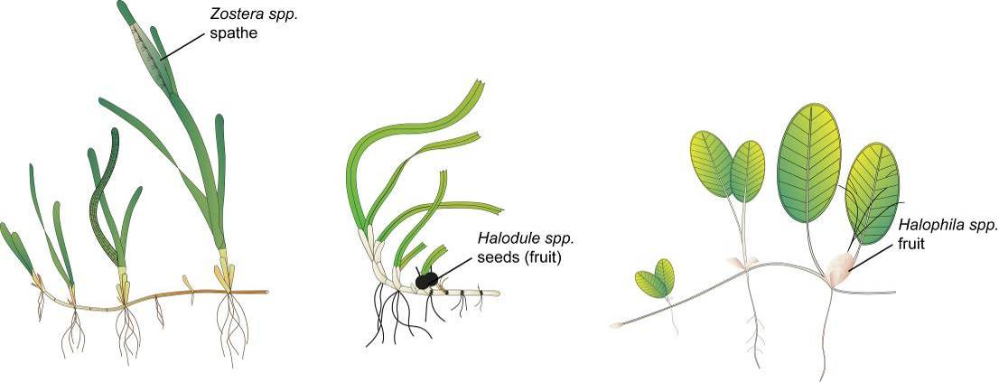
Figure 138. Form and size of reproductive structure of the seagrasses collected: Halophila ovalis, Halodule uninervis and Zostera muelleri subsp. capricorni

Seagrass leaf tissue nutrients
Leaves are separated in the laboratory into seagrass species. Only the younger leaves of a shoot area retained and epiphytic algae removed by gently scraping the leaf surface. Samples are oven dried at 60°C to weight constancy. Dried biomass samples of leaves are then homogenised by milling to fine powders prior to nutrient analyses and stored in sealed vials.
The ground tissue samples are sent to Chemcentre (Western Australia) for analysis. The Chemcentre holds NATA accreditation for constituents of the environment including soil, sediments, waters and wastewaters. (Note that details of Chemcentre accreditation can be found at the NATA website: www.nata.asn.au). The NATA accreditation held by the ChemCentre includes a wide variety of QA/QC procedures covering the registration and identification of samples with unique codes and the regular calibration of all quantitative laboratory equipment required for the analysis. The ChemCentre has developed appropriate analytical techniques including QA/QC procedures and detection of nutrients. These procedures include blanks, duplicates where practical, and internal use of standards. In 2010, QA/QC also included an inter-lab comparison (using Queensland Health and Scientific Services – an additional NATA accredited laboratory) and an additional blind internal comparison.
Nitrogen and phosphorus are extracted using a standardized selenium Kjeldahl digest and the concentrations determined with an automatic analyser using standard techniques at Chemcentre in Western Australia (a NATA certified laboratory). Percent C was determined using atomic absorption, also at Chemcentre. Elemental ratios (C:N:P) are then calculated on a mole:mole basis using atomic weights (i.e. C=12, N=14, P=31). Analysis of all seagrass tissue nutrient data is based upon the calculation of the atomic ratios of C:N:P.
To determine percent carbon, dried and milled seagrass leaf tissue material is combusted at 1400°C in a controlled atmosphere (e.g. Leco). This converts all carbon containing compounds to carbon dioxide. Water and oxygen is then removed from the system and the gaseous product is determined spectrophotometrically.
Total nitrogen and phosphorus content of dried and milled homogenous seagrass tissue material is determined by Chemcentre using a standardized selenium Kjeldahl digest. Samples are digested in a mixture of sulphuric acid, potassium sulphate and a copper sulphate catalyst (cf. Kjeldahl). This converts all forms of nitrogen to the ammonium form and all forms of phosphorus to the orthophosphate form. The digest is diluted and any potentially interfering metals present are complexed with citrate and tartrate. For the nitrogen determination an aliquot is taken and the ammonium ions are determined colorimetrically following reduction with hydrazine to the nitrate ion, followed by diazotisation of 1-naphthylenediamine and subsequent coupling with sulphanilamide. For total phosphorus an aliquot of the digest solution is diluted and the P determined as the phosphomolybdenum blue complex (modified Murphy and Riley¹¹⁷ procedure).
Seagrass leaf isotopes
A subset of each ground tissue sample was sent to Natural Isotopes (Western Australia) for δ¹⁵N and δ¹³C analysis. The samples were weighed into tin capsules and combusted by elemental analyser (ANCA-SL, SerCon Limited, Crewe, United Kingdom) to N₂ and CO₂. The N₂ and CO₂ was purified by gas chromatography and the nitrogen and carbon elemental composition and isotope ratios were determined by continuous flow isotope ratio mass spectrometry (20-22 IRMS, SerCon Limited, Crewe, United Kingdom). Reference materials of known elemental composition and isotopic ratios were interspaced with the samples for calibration.
Raw nitrogen and carbon elemental composition and isotope ratio data were corrected for instrument drift and blank contribution using Callisto software SerCon Limited, Crewe, United Kingdom). A standard analysed at variable weights corrects for instrument linearity, IAEA-N-2 and IAEA-N-1 used to normalise the nitrogen isotope ratio, IAEA-CH-6 and IAEA-CH-7 to normalise the carbon isotope ratio, such that IAEA-N-2 (δ¹⁵N = 20.32‰), IAEA-N-1 (δ¹⁵N = 0.43‰), IAEA-CH-6 (δ¹³C = -10.45‰) and IAEA-CH-7 δ¹³C = -32.15‰).
Nitrogen isotope ratios were reported in parts per thousand (per mil) relative to N₂ in air. The nitrogen bearing internationally distributed isotope reference material N₂ in air had a given value of 0‰ (exactly). Carbon isotope ratios were reported in parts per thousand (per millilitre) relative to V-PDB. The carbon bearing internationally distributed isotope reference materials NBS19 and L-SVEC, had a given value of +1.95‰ (exactly) and -46.6‰ (exactly). Compositional values were reported as percent nitrogen and percent carbon present in the sample analysed.

Report card methods and calculations

Report card approach
Three indicators (presented as unitless scores) were selected by the GBRMPA, using advice from expert working groups and the Paddock to Reef Integration Team, for the seagrass report card:
- seagrass abundance (per cent cover)
- reproductive effort
- nutrient status (seagrass tissue C:N ratio)
The methods for calculation of scores was chosen by the Paddock to Reef Integration Team and all report card scores are transformed to a five point scale from 0 to 100 as directed to allow integration with other components of the Paddock to Reef report card (Department of the Premier and Cabinet 2014). Please note that the scale from 0 to 100 is unitless and should not be interpreted as a proportion or ratio.
Seagrass abundance (per cent cover) is used to indicate the state of the seagrass to resist stressors, reproductive effort to indicate the potential for the seagrass to recover from loss, and the nutrient status to indicate the condition of the environment in which the seagrass are growing in recognition of seagrass as a bioindicator of environmental (including water quality) health.

Seagrass abundance
The status of seagrass abundance (per cent cover) was determined using the seagrass abundance guidelines developed by McKenzie (2009). The seagrass abundance measure in the MMP is the average per cent cover of seagrass per monitoring site. Individual site and subregional (habitat type within each NRM region) seagrass abundance guidelines were developed based on per cent cover data collected from individual sites and/or reference sites (McKenzie 2009). Guidelines for individual sites were only applied if the conditions of the site aligned with reference site conditions.
A reference site is a site whose condition is considered to be a suitable baseline or benchmark for assessment and management of sites in similar habitats. Ideally, seagrass meadows in near pristine condition with a long-term abundance database would have priority as reference sites. However, as near-pristine meadows are not available, sites which have received less intense impacts can justifiably be used. In such situations, reference sites are those where the condition of the site has been subject to minimal/limited disturbance for 3-5 years. The duration of 3-5 years is based on recovery from impact times (Campbell and McKenzie 2004).
There is no set/established protocol for the selection of reference sites and the process is ultimately iterative. The criteria for defining a minimally/least disturbed seagrass reference site is based on Monitoring River Health Initiative 1994) and includes some or all of the following:
- beyond 10km of a major river: as most suspended solids and particulate nutrients are deposited within a few kilometres of river mouths (McCulloch et al. 2003; Webster and Ford 2010; Bainbridge et al. 2012; Brodie et al. 2012).
- no major urban area/development (>5000 population) within 10km upstream (prevailing current)
- no significant point source wastewater discharge within the estuary
- has not been impacted by an event (anthropogenic or extreme climate) in the last 3-5 years
- where the species composition is dominated by the foundation species expected for the habitats (Carruthers et al. 2002), and
- does not suggest the meadow is in recovery (i.e. dominated by early colonising).
The 80th, 50th and 20th percentiles were used to define the guideline values as these are recommended for water quality guidelines (Department of Environment and Resource Management 2009), and there is no evidence that this approach would not be appropriate for seagrass meadows in the GBR. At the request of the Paddock to Reef Integration Team, the 80th percentile was changed to 75th to align with other Paddock to Reef report card components. By plotting the percentile estimates with increasing sample size, the reduction in error becomes apparent as it moves towards the true value (e.g. Figure 139).
Across the majority of reference sites, variance for the 50th and 20th percentiles was found to level off at around 15–20 samples (i.e. sampling events), suggesting this number of samples was sufficient to provide a reasonable estimate of the true percentile value. This sample size is reasonably close to the ANZECC 2000 Guidelines recommendation of 24 data values.
Nonlinear regressions (exponential rise to maximum, two parameter) were then fitted to percent cover percentile values at each number of sampling events using the following model:
where y is the seagrass cover percentile at each number of sampling events (x), a is the asymptotic average of the seagrass cover percentile, and b is the rate coefficient that determines how quickly (or slowly) the maximum is attained (i.e. the slope). The asymptotic average was then used as the guideline value for each percentile (Table 38).
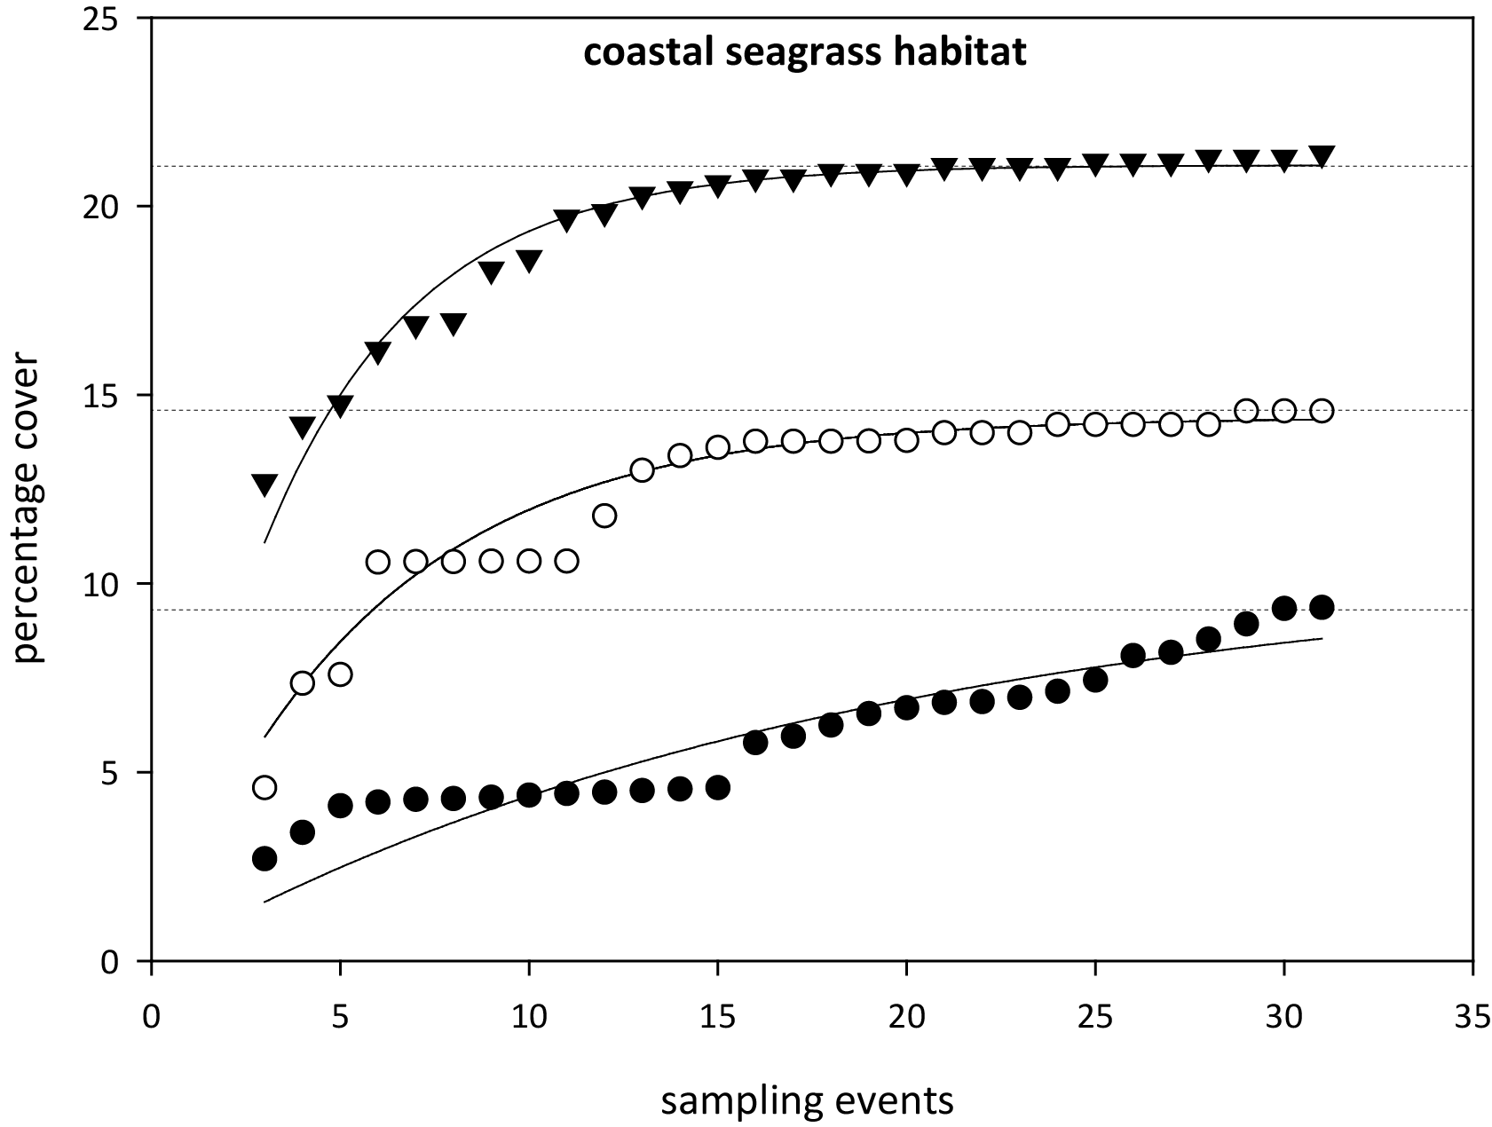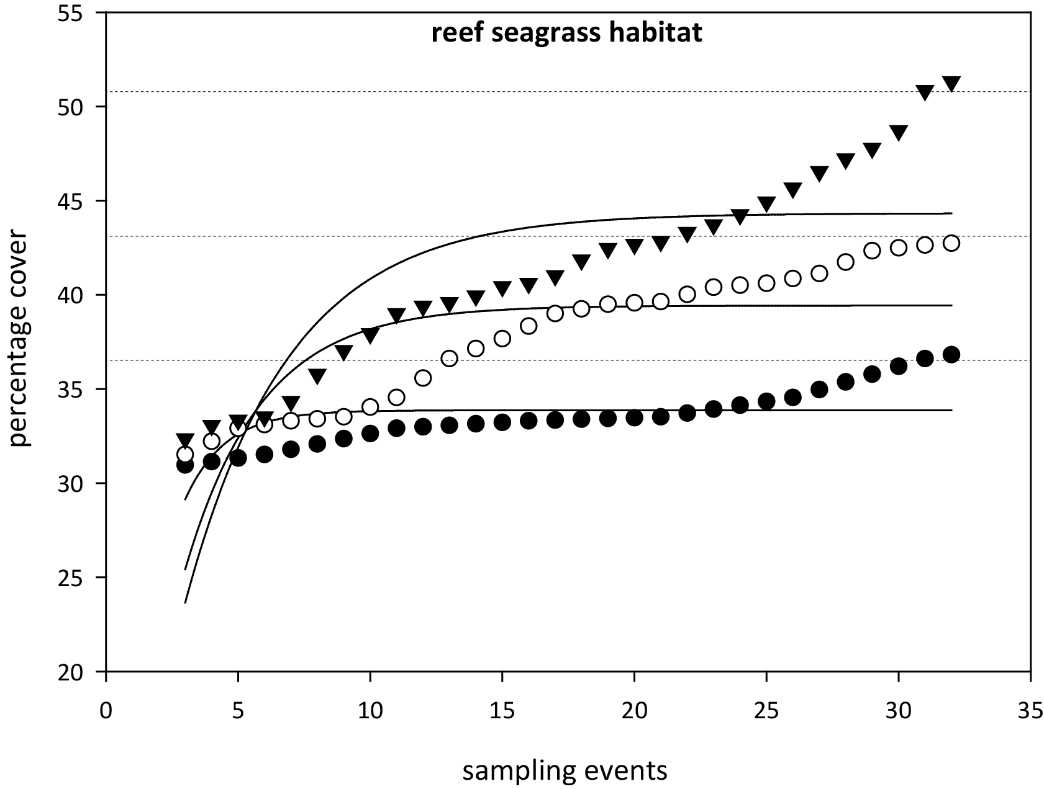
Figure 139. Relationship between sample size and the error in estimation of percentile values for seagrass abundance ( per cent cover) in coastal and reef seagrass habitats in the Wet Tropics NRM.
= 75th percentile, ○ = 50th percentile,● = 20th percentile. Horizontal lines are asymptotic averages for each percentile plot.
As sampling events occur every 3-6 months depending on the site, this is equivalent to 3-10 years of monitoring to establish percentile values. Based on the analyses, it was recommended that estimates of the 20th percentile at a reference site should be based on a minimum of 18 samples collected over at least three years. For the 50th percentile a smaller minimum number of samples (approximately 10–12) would be adequate but in most situations it would be necessary to collect sufficient data for the 20th percentile anyway. For seagrass habitats with low variability, a more appropriate guideline was the 10th percentile primarily the result of seasonal fluctuations (as nearly every seasonal low would fall below the 20th percentile). Percentile variability was further reduced within a habitat type of each region by pooling at least two (preferably more) reference sites to derive guidelines. The subregional guideline is calculated from the mean of all reference sites within a habitat type within a region.
Using the seagrass guidelines, seagrass state can be determined for each monitoring event at each site and allocated as good (median abundance at or above 50th percentile), moderate (median abundance below 50th percentile and at or above 20th percentile), poor (median abundance below 20th or 10th percentile). For example, when the median seagrass abundance for Yule Point is plotted against the 20th and 50th percentiles for coastal habitats in the Wet Tropics (Figure 140), it indicates that the meadows were in a poor condition in mid 2000, mid 2001 and mid 2006 (based on abundance).
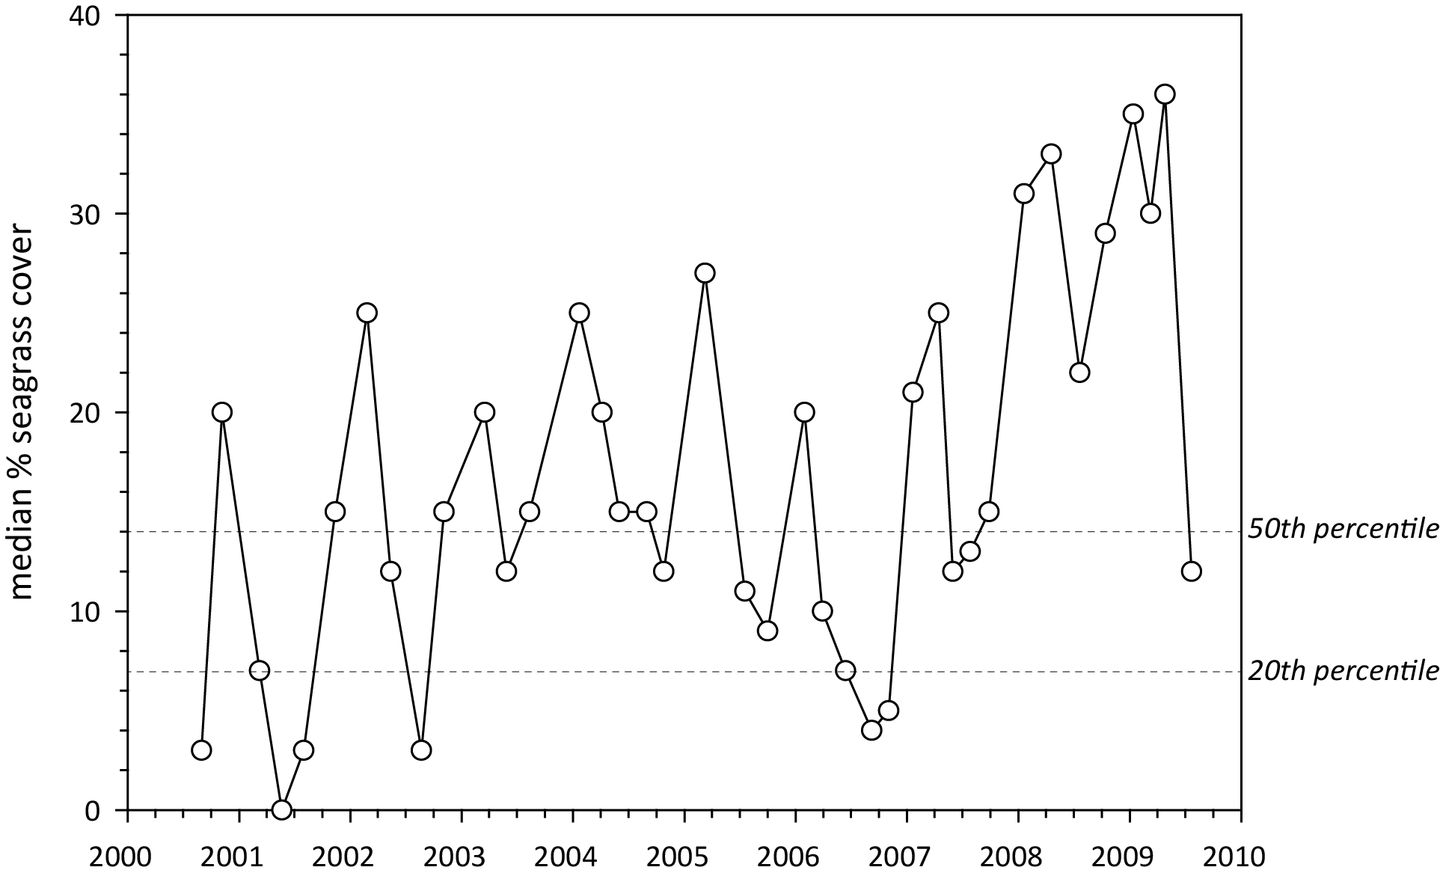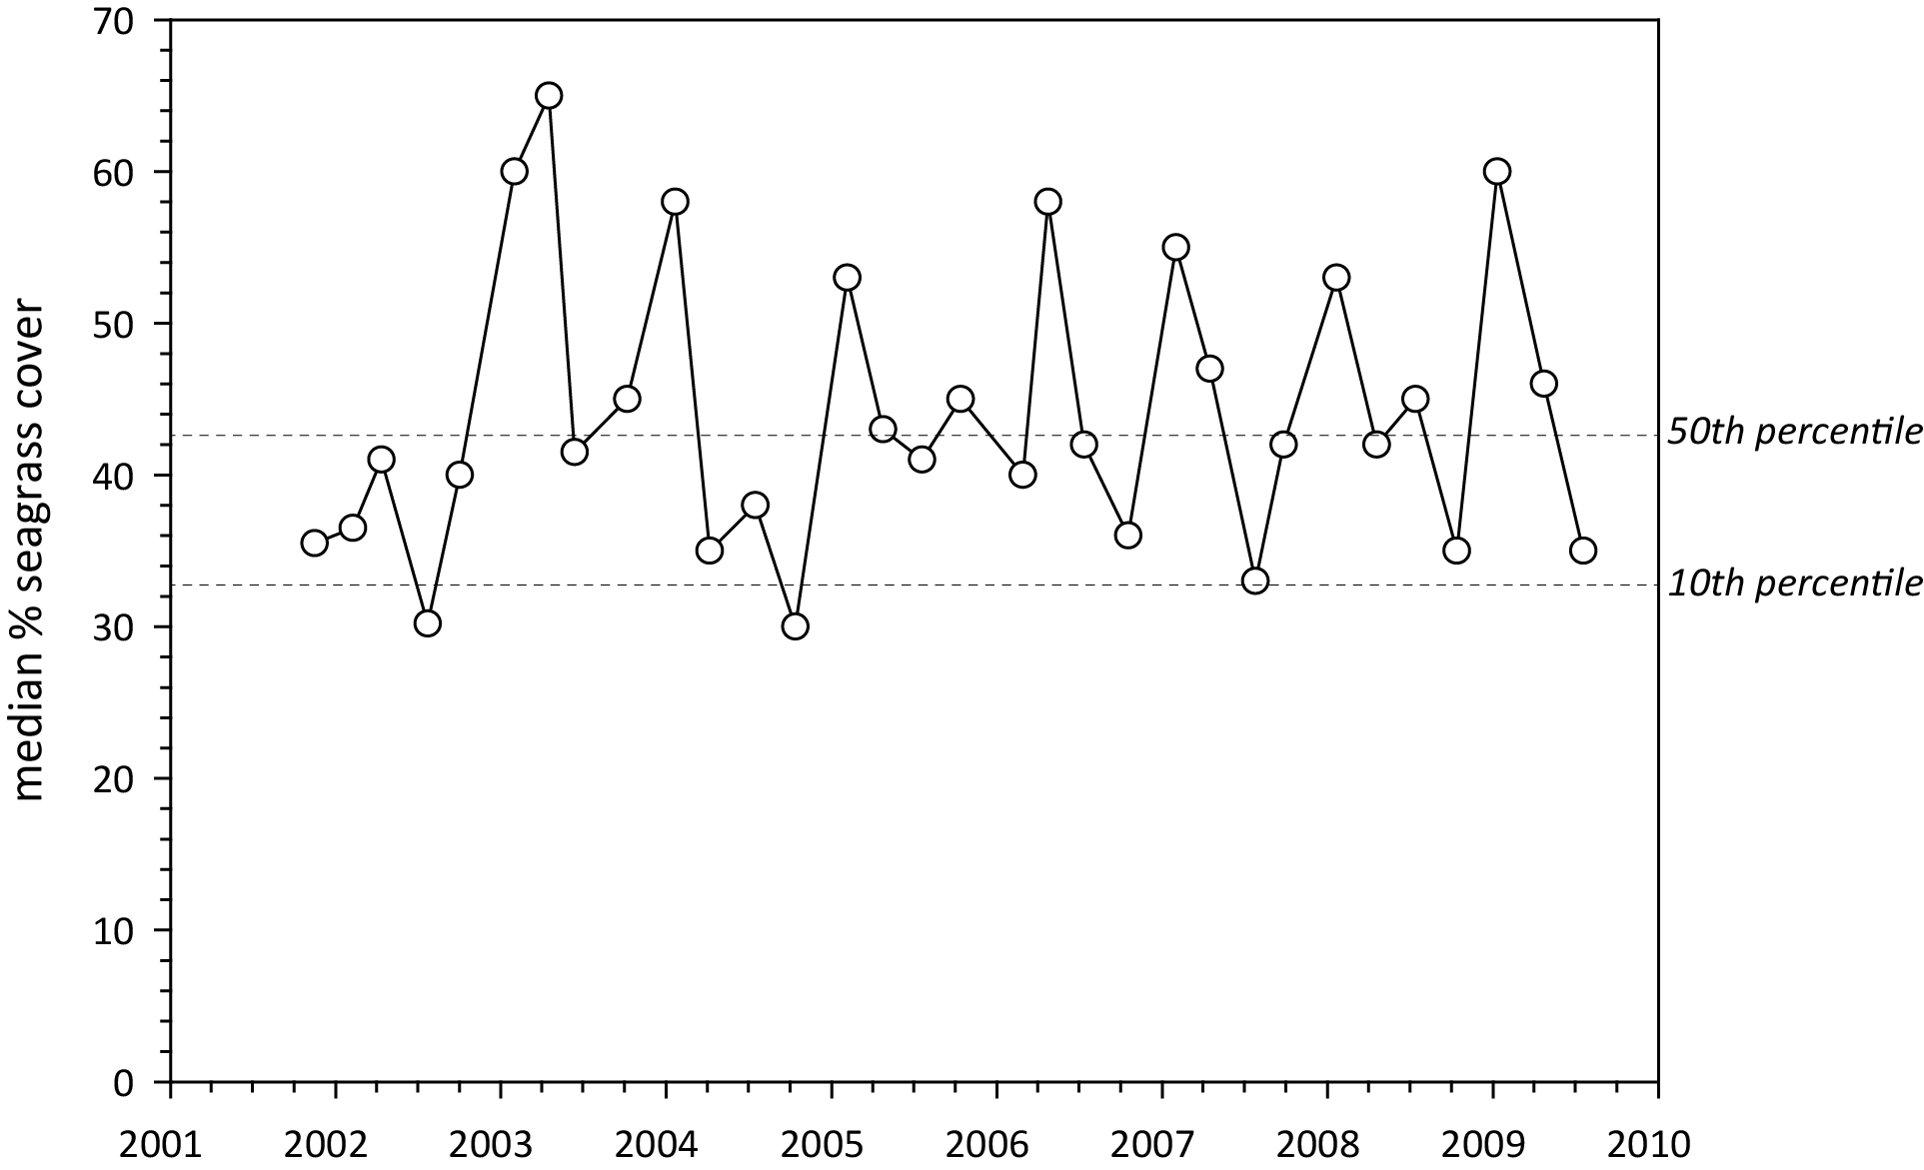
Figure 140. Median seagrass abundance ( per cent cover) at Yule Point (left) and Green Island (right) plotted against the 50th and 20th percentiles for coastal and intertidal reef seagrass habitat in the Wet Tropics.
Similarly, when the median seagrass abundance for Green Island is plotted against the 20th and 50th percentiles for intertidal reef habitats in the Wet Tropics, it indicates that the meadows were in a poor condition in the middle of most years (based on abundance). However, the poor rating is most likely a consequence of seasonal lows in abundance. Therefore, in this instance, it was more appropriate to set the guideline at the 10th rather than the 20th percentile.
Using this approach, subregional seagrass abundance guidelines (hereafter known as “the seagrass guidelines”) were developed for each seagrass habitat types where possible (Table 38). If an individual site had 18 or more sampling events and no identified impacts (e.g. major loss from cyclone), an abundance guideline was determined at the site or location level rather than using the subregional guideline from the reference sites (i.e. as more guidelines are developed at the site level, they contribute to the subregional guideline).
After discussions with GBRMPA scientists and the Paddock to Reef integration team, the seagrass guidelines were further refined by allocating the additional categories of very good (median abundance at or above 75th percentile), and very poor (median abundance below 20th or 10th percentile and declined by >20 per cent since previous sampling event). Seagrass state was then rescaled to a five point scale from 0 to 100 to allow integration with other components of the Paddock to Reef report card (Department of the Premier and Cabinet 2014). Please note that the scale from 0 to 100 is unitless and should not be interpreted as a proportion or ratio.

Table 38. Seagrass percentage cover guidelines (“the seagrass guidelines”) for each site/location and the subregional guidelines (bold) for each NRM habitat.
Values in light grey not used. ^ denotes regional reference site, * from nearest adjacent region. For site details, see Tables 3 & 4.
NRM region | site/  location | Habitat | percentile guideline
NRM region | site/  location | Habitat | 10th | 20th | 50th | 75th
Cape York | AP1^ | reef intertidal | 11 | 16.8 | 18.9 | 23.7
 | AP2 | reef intertidal | 11 |  | 18.9 | 23.7
 | FR | reef intertidal |  | 16.8 | 18.9 | 23.7
 | ST | reef intertidal |  | 16.8 | 18.9 | 23.7
 | YY | reef intertidal |  | 16.8 | 18.9 | 23.7
 | NRM | reef intertidal | 11 | 16.8 | 18.9 | 23.7
 | SR* | coastal intertidal |  | 6.6 | 12.9 | 14.8
 | BY* | coastal intertidal |  | 6.6 | 12.9 | 14.8
 | NRM | coastal intertidal* | 5 | 6.6 | 12.9 | 14.8
 | LR | coastal subtidal |  | 6.6 | 12.9 | 14.8
 | NRM | coastal subtidal |  | 6.6 | 12.9 | 14.8
Wet Tropics | LB | coastal intertidal |  | 6.6 | 12.9 | 14.8
 | YP1^ | coastal intertidal | 4.3 | 7 | 14 | 15.4
 | YP2^ | coastal intertidal | 5.7 | 6.2 | 11.8 | 14.2
 | NRM | coastal intertidal | 5 | 6.6 | 12.9 | 14.8
 | MS | coastal subtidal |  | 6.6 | 12.9 | 14.8
 | NRM | coastal subtidal |  | 6.6 | 12.9 | 14.8
 | DI | reef intertidal | 27.5 |  | 37.7 | 41
 | GI1^ | reef intertidal | 32.5 | 38.2 | 42.7 | 45.5
 | GI2^ | reef intertidal | 22.5 | 25.6 | 32.7 | 36.7
 | LI1 | reef intertidal | 27.5 |  | 37.7 | 41
 | GO1 | reef intertidal | 27.5 |  | 37.7 | 41
 | NRM | reef intertidal | 27.5 | 31.9 | 37.7 | 41
 | DI3 | reef subtidal | 22 | 26 | 33 | 39.2
 | GI3^ | reef subtidal | 22 | 26 | 33 | 39.2
 | LI2 | reef subtidal | 22 | 26 | 33 | 39.2
 | NRM | reef subtidal | 22 | 26 | 33 | 39.2
Burdekin | BB1^ | coastal intertidal | 16.3 | 21.4 | 25.4 | 35.2
 | SB1^ | coastal intertidal | 7.5 | 10 | 16.8 | 22
 | SB2 | coastal intertidal |  | 10 | 16.8 | 22
 | JR | coastal intertidal |  | 15.7 | 21.1 | 28.6
 | NRM | coastal intertidal | 11.9 | 15.7 | 21.1 | 28.6
 | MI1^ | reef intertidal | 23 | 26 | 33.4 | 37
 | MI2^ | reef intertidal | 21.3 | 26.5 | 35.6 | 41
 | NRM | reef intertidal | 22.2 | 26.3 | 34.5 | 39
 | MI3^ | reef subtidal | 18 | 22.5 | 32.7 | 36.7
 | NRM | reef subtidal | 18 | 22.5 | 32.7 | 36.7
Mackay Whitsunday | SI | estuarine intertidal |  | 18 | 34.1 | 54
 | NRM | estuarine intertidal | 10.8* | 18* | 34.1* | 54*
 | PI2^ | coastal intertidal | 18.1 | 18.7 | 25.1 | 27.6
 | PI3^ | coastal intertidal | 6.1 | 7.6 | 13.1 | 16.8
 | MP2 | coastal intertidal |  | 18.9 | 22.8 | 25.4
 | MP3 | coastal intertidal |  | 17.9 | 20 | 22.3
 | NRM | coastal intertidal | 12.1 | 13.2 | 19.1 | 22.2
 | NB | coastal subtidal |  | 13.2 | 19.1 | 22.2
 | NRM | coastal subtidal | 12.1 | 13.2 | 19.1 | 22.2
 | HB1^ | reef intertidal |  | 10.53 | 12.9 | 14.2
 | HB2^ | reef intertidal |  | 7.95 | 11.59 | 13.4
 | HM | reef intertidal |  | 9.2 | 12.2 | 13.8
 | NRM | reef intertidal |  | 9.2 | 12.2 | 13.8
 | TO | reef subtidal |  | 22.5 | 32.7 | 36.7
 | NRM | reef subtidal* | 18* | 22.5* | 32.7* | 36.7*
Fitzroy | GH | estuarine intertidal |  | 18 | 34.1 | 54
 | NRM | estuarine intertidal | 10.8* | 18* | 34.1* | 54*
 | RC1^ | coastal intertidal | 18.6 | 20.6 | 24.4 | 34.5
 | WH1^ | coastal intertidal | 13.1 | 14.4 | 18.8 | 22.3
 | NRM | coastal intertidal | 15.85 | 17.5 | 21.6 | 28.4
 | GK | reef intertidal |  | 9.2 | 12.2 | 13.8
 | NRM | reef intertidal |  | 9.2* | 12.2* | 13.8*
Burnett Mary | RD | estuarine intertidal |  | 18 | 34.1 | 54
 | UG1^ | estuarine intertidal | 10.8 | 18 | 34.1 | 54
 | UG2 | estuarine intertidal |  | 18 | 34.1 | 54
 | NRM | estuarine intertidal | 10.8 | 18 | 34.1 | 54
 | BH1^ | coastal intertidal |  | 7.8 | 11.9 | 21.6
 | BH3 | coastal intertidal |  | 7.8 | 11.9 | 21.6
 | NRM | coastal intertidal |  | 7.8 | 11.9 | 21.6

Table 39. Scoring threshold table to determine seagrass abundance status.
low = 10th or 20th percentile guideline (Table 38). NB: scores are unitless.
description | category | score | status
very good | 75-100 | 100 | 81 - 100
good | 50-75 | 75 | 61 - 80
moderate | low-50 | 50 | 41 - 60
poor | <low | 25 | 21 - 40
very poor | <low by >20 per cent | 0 | 0 - 20

Table 40. Mean and median seagrass per cent cover and report score for each long-term monitoring site within each Cape York NRM region habitat over the 2016–17 period.
Scores calculated as per Table 38 and Table 39. ^denotes QPWS drop-camera site. NB: scores do not have units.
Habitat | Location | Site | Seasonal  date | mean  per cent cover | median  per cent cover | Low  percentile | 50th  percentile | 75th  percentile | score
coastal intertidal | Bathurst Bay | BY1 | 01-Oct-16 | 27.6 | 30 | 6.6 | 12.9 | 14.8 | 100
 |  | BY2 | 01-Oct-16 | 24.9 | 24.5 | 6.6 | 12.9 | 14.8 | 100
 | Shelburne Bay | SR1 | 01-Oct-16
 |  | SR2 | 01-Oct-16
coastal subtidal | Lockhart River | LR1^ | 01-Oct-16 | 1.1 | 0.7 | 6.6 | 12.9 | 14.8 | 25
 |  | LR2^ | 01-Oct-16 | 30.6 | 28.5 | 6.6 | 12.9 | 14.8 | 100
reef intertidal | Archer Point | AP1 | 01-Oct-16 | 16.4 | 15 | 11 | 18.9 | 23.7 | 50
 |  | AP2 | 01-Oct-16 | 16.1 | 15 | 11 | 18.9 | 23.7 | 50
 | Piper Reef | FR1 | 01-Oct-16 | 11.0 | 11 | 16.8 | 18.9 | 23.7 | 25
 |  | FR2 | 01-Oct-16 | 13.8 | 12 | 16.8 | 18.9 | 23.7 | 25
 | Stanley Island | ST1 | 01-Oct-16 | 10.5 | 10 | 16.8 | 18.9 | 23.7 | 0
 |  | ST2 | 01-Oct-16 | 9.8 | 10 | 16.8 | 18.9 | 23.7 | 25
reef subtidal | Flinders Group | FG1^ | 01-Oct-16 | 1.6 | 1.05 | 26 | 33 | 39.2 | 25
 |  | FG2^ | 01-Oct-16 | 0.3 | 0.2 | 26 | 33 | 39.2 | 25
NRM region |  |  |  |  |  |  |  |  | 46

Table 41. Mean and median seagrass per cent cover and report score for each long-term monitoring site within each Wet Tropics NRM region habitat over the 2016–17 period.
Scores calculated as per Table 38. ^denotes Seagrass-Watch or QPWS drop-camera site. NB: scores do not have units.
Habitat | Location | Site | Seasonal  date | Mean  per cent cover | Median  per cent cover | Low  percentile | 50th  percentile | 75th  percentile | score
coastal intertidal | Lugger Bay | LB1 | 01-Jul-16 | 0.0 | 0 | 6.6 | 12.9 | 14.8 | 0
 |  | LB1 | 01-Oct-16 | 0.0 | 0 | 6.6 | 12.9 | 14.8 | 0
 |  | LB1 | 01-Apr-17 | 0.0 | 0 | 6.6 | 12.9 | 14.8 | 0
 |  | LB2 | 01-Jul-16 | 0.0 | 0 | 6.6 | 12.9 | 14.8 | 0
 |  | LB2 | 01-Oct-16 | 0.0 | 0 | 6.6 | 12.9 | 14.8 | 0
 |  | LB2 | 01-Apr-17 | 1.3 | 0 | 6.6 | 12.9 | 14.8 | 0
 | Yule Point | YP1 | 01-Jul-16 | 20.3 | 23 | 7 | 14 | 15.4 | 100
 |  | YP1 | 01-Oct-16 | 17.9 | 15 | 7 | 14 | 15.4 | 75
 |  | YP1 | 01-Jan-17 | 32.2 | 34 | 7 | 14 | 15.4 | 100
 |  | YP1 | 01-Apr-17 | 21.5 | 23 | 7 | 14 | 15.4 | 100
 |  | YP2 | 01-Jul-16 | 17.3 | 15 | 6.2 | 11.8 | 14.2 | 100
 |  | YP2 | 01-Oct-16 | 17.5 | 20 | 6.2 | 11.8 | 14.2 | 100
 |  | YP2 | 01-Jan-17 | 28.3 | 35 | 6.2 | 11.8 | 14.2 | 100
 |  | YP2 | 01-Apr-17 | 15.7 | 16 | 6.2 | 11.8 | 14.2 | 100
coastal subtidal | Missionary | MS1^ | 01-Oct-16
 | Bay | MS2^ | 01-Oct-16
reef intertidal | Dunk Island | DI1 | 01-Jul-16 | 2.2 | 0 | 27.5 | 37.7 | 41 | 0
 |  | DI1 | 01-Oct-16 | 0.8 | 0 | 27.5 | 37.7 | 41 | 0
 |  | DI1 | 01-Apr-17 | 2.1 | 0 | 27.5 | 37.7 | 41 | 0
 |  | DI2 | 01-Jul-16 | 2.0 | 0 | 27.5 | 37.7 | 41 | 0
 |  | DI2 | 01-Oct-16 | 1.6 | 0 | 27.5 | 37.7 | 41 | 0
 |  | DI2 | 01-Apr-17 | 3.6 | 0 | 27.5 | 37.7 | 41 | 0
 | Green Island | GI1 | 01-Jul-16 | 39.6 | 40 | 32.5 | 42.7 | 45.5 | 50
 |  | GI1 | 01-Oct-16 | 46.0 | 43 | 32.5 | 42.7 | 45.5 | 75
 |  | GI1 | 01-Jan-17 | 47.1 | 46 | 32.5 | 42.7 | 45.5 | 100
 |  | GI1 | 01-Apr-17 | 39.8 | 41 | 32.5 | 42.7 | 45.5 | 50
 |  | GI2 | 01-Jul-16 | 34.7 | 34 | 22.5 | 32.7 | 36.7 | 75
 |  | GI2 | 01-Oct-16 | 36.8 | 37 | 22.5 | 32.7 | 36.7 | 100
 |  | GI2 | 01-Jan-17 | 41.0 | 37 | 22.5 | 32.7 | 36.7 | 100
 |  | GI2 | 01-Apr-17 | 29.9 | 33 | 22.5 | 32.7 | 36.7 | 75
 | Low Isles | LI1 | 01-Oct-16 | 1.2 | 0.5 | 27.5 | 37.7 | 41 | 0
 |  | LI1 | 01-Jan-17 | 0.1 | 0 | 27.5 | 37.7 | 41 | 0
 | Goold Is | GO1^ | 01-Oct-16 | 0.3 | 0 | 27.5 | 37.7 | 41 | 0
reef subtidal | Dunk Island | DI3 | 01-Jul-16 | 1.2 | 0.6 | 26 | 33 | 39.2 | 0
 |  | DI3 | 01-Oct-16 | 0.6 | 0.1 | 26 | 33 | 39.2 | 0
 |  | DI3 | 01-Jan-17 | 0.5 | 0 | 26 | 33 | 39.2 | 0
 |  | DI3 | 01-Apr-17 | 0.3 | 0 | 26 | 33 | 39.2 | 0
 | Green Island | GI3 | 01-Jul-16 | 14.9 | 16 | 26 | 33 | 39.2 | 25
 |  | GI3 | 01-Oct-16 | 10.5 | 9 | 26 | 33 | 39.2 | 0
 |  | GI3 | 01-Jan-17 | 11.0 | 10 | 26 | 33 | 39.2 | 25
 | Low Isles | LI2 | 01-Oct-16 | 0.1 | 0 | 26 | 33 | 39.2 | 0
 |  | LI2 | 01-Jan-17 | 0.0 | 0 | 26 | 33 | 39.2 | 0
NRM region |  |  |  |  |  |  |  |  | 28
`

Table 42. Mean and median seagrass per cent cover and report score for each long-term monitoring site within each Burdekin NRM region habitat over the 2016–17 period.
Scores calculated as per Table 38. ^denotes Seagrass-Watch site. NB: scores do not have units.
Habitat | Location | Site | Seasonal  date | Mean  per cent cover | Median  per cent cover | Low  percentile | 50th  percentile | 75th  percentile | score
coastal intertidal | Townsville | BB1 | 01-Jul-16 | 24.2 | 25 | 21.4 | 25.4 | 35.2 | 50
 |  | BB1 | 01-Oct-16 | 28.9 | 30 | 21.4 | 25.4 | 35.2 | 75
 |  | BB1 | 01-Jan-17 | 38.5 | 38 | 21.4 | 25.4 | 35.2 | 100
 |  | BB1 | 01-Apr-17 | 40.2 | 45 | 21.4 | 25.4 | 35.2 | 100
 |  | SB1 | 01-Jul-16 | 4.8 | 2 | 10 | 16.8 | 22 | 0
 |  | SB1 | 01-Oct-16 | 7.5 | 5 | 10 | 16.8 | 22 | 25
 |  | SB1 | 01-Jan-17 | 19.5 | 20 | 10 | 16.8 | 22 | 75
 |  | SB1 | 01-Apr-17 | 20.0 | 28 | 10 | 16.8 | 22 | 100
 |  | SB2^ | 01-Jul-16 | 16.8 | 19 | 10 | 16.8 | 22 | 75
 |  | SB2^ | 01-Oct-16 | 23.3 | 28 | 10 | 16.8 | 22 | 100
 |  | SB2^ | 01-Apr-17 | 26.9 | 30 | 10 | 16.8 | 22 | 100
 | Bowling Green Bay | JR1 | 01-Oct-16 | 82.4 | 85 | 15.7 | 21.1 | 28.6 | 100
 |  | JR1 | 01-Apr-17 | 40.1 | 40 | 15.7 | 21.1 | 28.6 | 100
 |  | JR2 | 01-Oct-16 | 70.0 | 65 | 15.7 | 21.1 | 28.6 | 100
 |  | JR2 | 01-Apr-17 | 36.3 | 37.5 | 15.7 | 21.1 | 28.6 | 100
reef intertidal | Magnetic Island | MI1 | 01-Jul-16 | 17.0 | 20 | 26 | 33.4 | 37 | 0
 |  | MI1 | 01-Oct-16 | 14.2 | 15 | 26 | 33.4 | 37 | 0
 |  | MI1 | 01-Jan-17 | 19.7 | 18 | 26 | 33.4 | 37 | 25
 |  | MI1 | 01-Apr-17 | 23.2 | 28 | 26 | 33.4 | 37 | 50
 |  | MI2 | 01-Jul-16 | 25.7 | 28 | 21.3 | 35.6 | 41 | 50
 |  | MI2 | 01-Oct-16 | 25.5 | 25 | 21.3 | 35.6 | 41 | 50
 |  | MI2 | 01-Apr-17 | 27.6 | 30 | 21.3 | 35.6 | 41 | 50
reef subtidal | Magnetic Island | MI3 | 01-Jul-16 | 33.0 | 35 | 22.5 | 32.7 | 36.7 | 75
 |  | MI3 | 01-Oct-16 | 43.4 | 45 | 22.5 | 32.7 | 36.7 | 100
 |  | MI3 | 01-Jan-17 | 27.4 | 30 | 22.5 | 32.7 | 36.7 | 50
 |  | MI3 | 01-Apr-17 | 30.6 | 32 | 22.5 | 32.7 | 36.7 | 50
NRM region |  |  |  |  |  |  |  |  | 70

Table 43. Mean and median seagrass per cent cover and report score for each long-term monitoring site within each Mackay Whitsunday NRM region habitat over the 2016–17 period.
Scores calculated as per Table 38. ^denotes Seagrass-Watch or QPWS drop-camera site. NB: scores do not have units.
Habitat | Location | Site | Seasonal  date | Mean  per cent cover | Median  per cent cover | Low  percentile | 50th  percentile | 75th  percentile | score
estuarine intertidal | Sarina Inlet | SI1 | 01-Oct-16 | 12.4 | 6 | 18 | 34.1 | 54 | 25
 |  | SI1 | 01-Apr-17 | 2.0 | 0 | 18 | 34.1 | 54 | 0
 |  | SI2 | 01-Oct-16 | 10.6 | 2.9 | 18 | 34.1 | 54 | 25
 |  | SI2 | 01-Apr-17 | 0.9 | 0 | 18 | 34.1 | 54 | 0
coastal intertidal | Midge Point | MP2 | 01-Oct-16 | 35.5 | 35 | 18.9 | 22.8 | 25.4 | 100
 |  | MP2 | 01-Apr-17 | 21.8 | 23 | 18.9 | 22.8 | 25.4 | 75
 |  | MP3 | 01-Oct-16 | 27.8 | 31 | 17.9 | 20 | 22.3 | 100
 |  | MP3 | 01-Apr-17 | 10.7 | 12 | 17.9 | 20 | 22.3 | 25
 | Pioneer Bay | PI2^ | 01-Oct-16 | 17.8 | 15.5 | 18.7 | 25.1 | 27.6 | 25
 |  | PI3^ | 01-Oct-16 | 13.8 | 16 | 7.6 | 13.1 | 16.8 | 75
coastal subtidal | Newry Bay | NB1^ | 01-Oct-16 | 47.8 | 48.25 | 13.2 | 19.1 | 22.2 | 100
 |  | NB2^ | 01-Oct-16 | 6.4 | 0 | 13.2 | 19.1 | 22.2 | 0
reef intertidal | Hydeaway Bay | HB1^ | 01-Jul-16 | 6.8 | 5 | 10.53 | 12.9 | 14.2 | 25
 |  | HB1^ | 01-Oct-16 | 15.0 | 13.5 | 10.53 | 12.9 | 14.2 | 75
 |  | HB2^ | 01-Jul-16 | 6.9 | 7 | 7.95 | 11.59 | 13.4 | 25
 |  | HB2^ | 01-Oct-16 | 11.9 | 13 | 7.95 | 11.59 | 13.4 | 75
 | Hamilton Island | HM1 | 01-Oct-16 | 2.4 | 0 | 9.2 | 12.2 | 13.8 | 0
 |  | HM1 | 01-Apr-17 | 0.3 | 0 | 9.2 | 12.2 | 13.8 | 0
 |  | HM2 | 01-Oct-16 | 2.7 | 0 | 9.2 | 12.2 | 13.8 | 0
 |  | HM2 | 01-Apr-17 | 0.0 | 0 | 9.2 | 12.2 | 13.8 | 0
reef subtidal | Tongue Bay | TO1^ | 01-Oct-16 | 15.1 | 12.5 | 22.5 | 32.7 | 36.7 | 25
 |  | TO2^ | 01-Oct-16 | 0.9 | 0.75 | 22.5 | 32.7 | 36.7 | 0
NRM region |  |  |  |  |  |  |  |  | 36

Table 44. Mean and median seagrass per cent cover and report score for each long-term monitoring site within each Fitzroy NRM region habitat over the 2016–17 period.
Scores calculated as per Table 38. NB: scores do not have units.
Habitat | Location | Site | Seasonal  date | Mean  per cent cover | Median  per cent cover | Low  percentile | 50th  percentile | 75th  percentile | score
estuarine intertidal | Gladstone Harbour | GH1 | 01-Oct-16 | 0.1 | 0 | 18 | 34.1 | 54 | 0
 |  | GH1 | 01-Apr-17 | 0.1 | 0 | 18 | 34.1 | 54 | 0
 |  | GH2 | 01-Oct-16 | 12.1 | 15 | 18 | 34.1 | 54 | 25
 |  | GH2 | 01-Apr-17 | 12.4 | 12 | 18 | 34.1 | 54 | 0
coastal intertidal | Shoalwater Bay | RC1 | 01-Oct-16 | 24.2 | 22 | 17.3 | 21.8 | 34.5 | 75
 |  | WH1 | 01-Oct-16 | 16.3 | 16.5 | 14.4 | 18.8 | 22.3 | 50
reef intertidal | Great Keppel Island | GK1 | 01-Oct-16 | 0.3 | 0 | 9.2 | 12.2 | 13.8 | 0
 |  | GK2 | 01-Oct-16 | 3.6 | 0.8 | 9.2 | 12.2 | 13.8 | 25
NRM region |  |  |  |  |  |  |  |  | 27

Table 45. Mean and median seagrass per cent cover and report score for each long-term monitoring site within each Burnett Mary NRM region habitat over the 2016–17 period.
Scores calculated as per Table 38. ^denotes Seagrass-Watch site. NB: scores do not have units.
Habitat | Location | Site | Seasonal  date | Mean  per cent cover | Median  per cent cover | Low  percentile | 50th  percentile | 75th  percentile | score
estuarine intertidal | Rodds Bay | RD1 | 01-Oct-16 | 2.8 | 1 | 18 | 34.1 | 54 | 0
 |  | RD1 | 01-Apr-17 | 0.1 | 0.1 | 18 | 34.1 | 54 | 0
 |  | RD2 | 01-Oct-16 | 0.0 | 0 | 18 | 34.1 | 54 | 0
 |  | RD2 | 01-Apr-17 | 0.0 | 0 | 18 | 34.1 | 54 | 0
 | Urangan | UG1 | 01-Oct-16 | 17.2 | 14 | 18 | 34.1 | 54 | 25
 |  | UG1 | 01-Apr-17 | 23.2 | 25 | 18 | 34.1 | 54 | 50
 |  | UG2 | 01-Oct-16 | 22.5 | 26 | 18 | 34.1 | 54 | 50
 |  | UG2 | 01-Apr-17 | 26.5 | 31 | 18 | 34.1 | 54 | 50
coastal intertidal | Burrum Heads | BH1^ | 01-Oct-16 | 7.3 | 8 | 7.8 | 11.9 | 21.6 | 50
 |  | BH1^ | 01-Apr-17 | 6.5 | 6 | 7.8 | 11.9 | 21.6 | 25
 |  | BH3^ | 01-Oct-16 | 11.6 | 12 | 7.8 | 11.9 | 21.6 | 75
 |  | BH3^ | 01-Apr-17 | 5.0 | 5 | 7.8 | 11.9 | 21.6 | 25
NRM region |  |  |  |  |  |  |  |  | 29

Seagrass reproductive effort
The reproductive effort is the number of reproductive structures (inflorescence, fruit, spathe, seed) per core and provides an indication of the capacity of seagrasses to recover from the loss of an area of seagrass through the recruitment of new plants at each site (Collier and Waycott 2009). Given the high diversity of seagrass species that occur in the GBR coastal zone (Waycott et al. 2007), their variability in production of reproductive structures (e.g. Orth et al. 2006), a metric that incorporates all available information on the production of flowers and fruits per unit area is the most useful.
The production of seeds also reflects a simple measure of the capacity of a seagrass meadow to recover following large scale impacts (Collier and Waycott 2009). As it is well recognized that coastal seagrasses are prone to small scale disturbances that cause local losses (Collier and Waycott 2009) and then recover in relatively short periods of time, the need for a local seed source is considerable. In the GBR, the production of seeds comes in numerous forms and seed banks examined at MMP sites are limited to foundational seagrass species (seeds >0.5mm diameter). At this time, seed banks have not been included in the metric for reproductive effort, but methods for future incorporation are currently being explored.
Using the annual mean of all species pooled in the late dry and comparing with the long-term (2005-2010) average for GBR habitat (coastal intertidal = 8.22±0.71, estuarine intertidal = 5.07±0.41, reef intertidal = 1.32±0.14), the reproductive effort was scored as the number of reproductive structures per core and the overall status determined (Table 6) as the ratio of the average number observed divided by the long term average.

Table 46. Scores for late dry monitoring period reproductive effort average against long-term (2005-2010) GBR habitat average. NB: scores are unitless.
description | Reproductive Effort  monitoring period / long-term | ratio | score | 0-100 score | status
very good | ≥4 | 4.0 | 4 | 100 | 81 - 100
good | 2 to <4 | 2.0 | 3 | 75 | 61 - 80
moderate | 1 to <2 | 1.0 | 2 | 50 | 41 - 60
poor | 0.5 to <1 | 0.5 | 1 | 25 | 21 - 40
very poor | <0.5 | 0.0 | 0 | 0 | 0 - 20

Table 47. Average seagrass reproductive effort (number of reproductive structures per core, RE ± SE) and report card scores for each monitoring site (species pooled) within each NRM region habitat, 2016–17
. Scores calculated as per Table 6. NB: scores do not have units.
NRM region | habitat | site | RE ±SE | GBR RE (2005-10) | ratio | score | habitat score
Cape York | coastal intertidal | BY1 | 6.13 ±1.61 | 8.22 | 0.75 | 25 | 13
 |  | BY2 | 2.80 ±1.58 | 8.22 | 0.34 | 0 | 13
 |  | SR1 |  | 8.22 |  |  | 13
 |  | SR2 |  | 8.22 |  |  | 13
 | reef intertidal | AP1 | 0.73 ±0.37 | 1.32 | 0.56 | 25 | 8
 |  | AP2 | 0.73 ±0.41 | 1.32 | 0.56 | 25 | 8
 |  | FR1 | 0 | 1.32 | 0 | 0 | 8
 |  | FR2 | 0 | 1.32 | 0 | 0 | 8
 |  | ST1 | 0 | 1.32 | 0 | 0 | 8
 |  | ST2 | 0.07 ±0.07 | 1.32 | 0.05 | 0 | 8
 | total |  |  |  |  | 10
Wet Tropics | coastal intertidal | LB1 |  | 8.22 |  |  | 0
 |  | LB2 |  | 8.22 |  |  | 0
 |  | YP1 | 1.67 ±0.61 | 8.22 | 0.2 | 0 | 0
 |  | YP2 | 2.87 ±1.30 | 8.22 | 0.35 | 0 | 0
 | reef intertidal | DI1 | 0 | 1.32 | 0 | 0 | 5
 |  | DI2 | 0.87 ±0.47 | 1.32 | 0.66 | 25 | 5
 |  | GI1 | 0.07 ±0.07 | 1.32 | 0.05 | 0 | 5
 |  | GI2 | 0.13 ±0.09 | 1.32 | 0.1 | 0 | 5
 |  | LI1 | 0 | 1.32 | 0 | 0 | 5
 | reef subtidal | DI3 | 0 | 0.24 | 0 | 0 | 0
 |  | GI3 | 0 | 0.24 | 0 | 0 | 0
 |  | LI2 | 0 | 0.24 | 0 | 0 | 0
 | total |  |  |  |  | 2
Burdekin | coastal intertidal | BB1 | 15.00 ±2.11 | 8.22 | 1.82 | 50 | 13
 |  | SB1 | 1.60 ±0.79 | 8.22 | 0.19 | 0 | 13
 |  | JR1 | 1.00 ±0.68 | 8.22 | 0.12 | 0 | 13
 |  | JR2 | 1.60 ±0.87 | 8.22 | 0.19 | 0 | 13
 | reef intertidal | MI1 | 0.53 ±0.19 | 1.32 | 0.4 | 0 | 0
 |  | MI2 | 0.27 ±0.15 | 1.32 | 0.2 | 0 | 0
 | reef subtidal | MI3 | 2.67 ±0.89 | 0.24 | 11.11 | 100 | 100
 | total |  |  |  |  | 38
Mackay Whitsunday | estuarine intertidal | SI1 | 12.47 ±3.39 | 5.07 | 2.46 | 75 | 75
 |  | SI2 | 15.27 ±3.67 | 5.07 | 3.01 | 75 | 75
 | coastal intertidal | MP2 | 8.53 ±1.65 | 8.22 | 1.04 | 50 | 25
 |  | MP3 | 2.73 ±1.08 | 8.22 | 0.33 | 0 | 25
 | reef intertidal | HM1 | 0 | 1.32 | 0 | 0 | 0
 |  | HM2 | 0 | 1.32 | 0 | 0 | 0
 | total |  |  |  |  | 33
Fitzroy | estuarine intertidal | GH1 | 0.33 ±0.33 | 5.07 | 0.07 | 0 | 0
 |  | GH2 | 0.13 ±0.13 | 5.07 | 0.03 | 0 | 0
 | coastal intertidal | RC1 | 1.53 ±0.76 | 8.22 | 0.19 | 0 | 0
 |  | WH1 | 2.00 ±0.70 | 8.22 | 0.24 | 0 | 0
 | reef intertidal | GK1 | 0 | 1.32 | 0 | 0 | 0
 |  | GK2 | 0 | 1.32 | 0 | 0 | 0
 | region |  |  |  |  | 0
Burnett Mary | estuarine intertidal | RD1 | 0 | 5.07 | 0 | 0 | 0
 |  | RD2 | 0 | 5.07 | 0 | 0 | 0
 |  | UG1 | 0 | 5.07 | 0 | 0 | 0
 |  | UG2 | 0.13 ±0.13 | 5.07 | 0.03 | 0 | 0
 | coastal intertidal | BH1 | 0.20 ±0.14 | 8.22 | 0.02 | 0 | 0
 |  | BH3 | 0 | 8.22 | 0 | 0 | 0
 | region |  |  |  |  | 0

Seagrass nutrient status.
The molar ratios of seagrass tissue carbon relative to nitrogen (C:N) were chosen as the indicator for seagrass nutrient status as an atomic C:N ratio of less than 20, may suggest either reduced light availability or nitrogen enrichment. Both of these deviations may indicate reduced water quality. Examination of the molar ratios of seagrass tissue carbon relative to nitrogen (C:N) between 2005 and 2008 explained 58 per cent of the variance of the inter-site seagrass cover/abundance (McKenzie and Unsworth 2009).
As changing leaf C:N ratios have been found in a number of experiments and field surveys to be related to available nutrient and light levels (Abal et al. 1994; Grice et al. 1996; Cabaço and Santos 2007; Collier et al. 2009) they can be used as an indicator of the light that the plant is receiving relative to nitrogen availability or N surplus to light. With light limitation, seagrass plants are unable to build structure, hence the proportion of carbon in the leaves decreases relative to nitrogen. Experiments on seagrasses in Queensland have reported that at an atomic C:N ratio of less than 20, may suggest reduced light availability relative to nitrogen availability (Abal et al. 1994; AM Grice, et al., 1996;). The light availability to seagrass is not necessarily an indicator of light in the water column, but an indicator of the light that the plant is receiving as available light can be highly impacted by epiphytic growth or sediment smothering photosynthetic leaf tissue. However, C:N must be interpreted with caution as the level of N can also influence the ratio in oligotrophic environments (Atkinson and Smith 1983; Fourqurean et al. 1992b). Support for choosing the elemental C:N ratio as the indicator also comes from preliminary analysis of MMP data in 2009 which found that the C:N ratio was the only nutrient ratio that showed a significant relationship (positive) with seagrass cover at coastal and estuarine sites. Seagrass tissue C:N ratios explained 58 per cent of the variance of the inter-site seagrass cover data (McKenzie and Unsworth 2009). Using the guideline ratio of 20:1 for the foundation seagrass species, C:N ratios were categorised on their departure from the guideline and transformed to a 0 to 100 score using:
Equation 1
NB: C:N ratios >35 scored as 100, C:N ratios <10 scored as 0
The score was then used to represent the status to allow integration with other components of the report card (Table 7).
Table 48. Scores for leaf tissue C:N against guideline to determine light and nutrient availability. NB: scores are unitless.
description | C:N ratio range | Score () status
very good | C:N ratio >30* | 81 - 100
good | C:N ratio 25-30 | 61 - 80
moderate | C:N ratio 20-25 | 41 - 60
poor | C:N ratio 15-20 | 21 - 40
very poor | C:N ratio <15* | 0 - 20

Table 49. Average seagrass leaf tissue C:N ratios and report scores for each monitoring site (species pooled) within each NRM region habitat.
C:N ratios transformed to a 0 to 100 score using Equation 1. NB: scores do not have units. *insufficient sample
NRM region | habitat | site | C:N ±SE | score | habitat score
Cape York | coastal intertidal | BY1 | 23.04 ±1.03 | 65.22 | 51
 |  | BY2 | 17.45 ±0.32 | 37.24 | 51
 |  | SR1 |  |  | 51
 |  | SR2 |  |  | 51
 | reef intertidal | AP1 | 15.41 ±1.45 | 27.07 | 32
 |  | AP2 | 24.09 ±0.45 | 0.45 | 32
 |  | FR1 | 17.97 ±0.97 | 39.85 | 32
 |  | FR2 | 16.58 ±0.24 | 32.9 | 32
 |  | ST1 | 18.94 ±0.67 | 44.68 | 32
 |  | ST2 | 18.81 ±0.36 | 44.06 | 32
 | total |  |  | 41
Wet Tropics | coastal intertidal | LB1 |  |  | 13
 |  | LB2 |  |  | 13
 |  | YP1 | 12.09 ±0.14 | 10.45 | 13
 |  | YP2 | 13.04 ±0.09 | 15.18 | 13
 | reef intertidal | DI1 | 18.90 ±0.45 | 44.51 | 43
 |  | DI2 | 19.82 ±0.31 | 49.08 | 43
 |  | GI1 | 17.86 ±0.39 | 39.31 | 43
 |  | GI2 | 17.35 ±0.70 | 36.74 | 43
 |  | LI1 | 19.10 ±0.42 | 45.49 | 43
 | reef subtidal | DI3 | 17.09 ±0.15 | 35.43 | 50
 |  | GI3 | 23.07 ±0.62 | 65.34 | 50
 |  | LI2 |  |  | 50
 | total |  |  | 35
Burdekin | coastal intertidal | BB1 | 16.90 ±0.34 | 34.49 | 46
 |  | SB1 | 19.49 ±0.78 | 47.47 | 46
 |  | JR1 | 19.98 ±0.35 | 49.88 | 46
 |  | JR2 | 20.45 ±0.21 | 52.23 | 46
 | reef intertidal | MI1 | 23.19 ±0.76 | 65.95 | 59
 |  | MI2 | 20.33 ±0.62 | 51.64 | 59
 | reef subtidal | MI3 | 21.52 ±0.24 | 57.59 | 58
 | total |  |  | 54
Mackay Whitsunday | estuarine intertidal | SI1 | 15.18 ±0.23 | 25.9 | 37
 |  | SI2 | 19.71 ±1.40 | 48.56 | 37
 | coastal intertidal | MP2 | 21.17 ±0.54 | 55.84 | 55
 |  | MP3 | 20.67 ±2.39 | 53.34 | 55
 | reef intertidal | HM1 | 10.04 ±0.08 | 0.2 | 9
 |  | HM2 | 13.70 ±0.45 | 18.52 | 9
 | total |  |  | 34
Fitzroy | estuarine intertidal | GH1 | 19.73 ±1.04 | 48.66 | 52
 |  | GH2 | 21.20 ±0.73 | 56 | 52
 | coastal intertidal | RC1 | 20.47 ±0.69 | 52.33 | 44
 |  | WH1 | 16.99 ±0.44 | 34.96 | 44
 | reef intertidal | GK1 | 17.23 ±1.13 | 36.16 | 35
 |  | GK2 | 16.76 ±0.49 | 33.78 | 35
 | total |  |  | 44
Burnett Mary | estuarine intertidal | RD1 | 15.83 ±0.62 | 29.15 | 45
 |  | RD2 |  |  | 45
 |  | UG1 | 20.62 ±0.88 | 53.11 | 45
 |  | UG2 | 20.65 ±0.89 | 53.24 | 45
 | coastal intertidal | BH1 | 14.34 ±0.12 | 21.68 | 22
 |  | BH3 | 14.29 ±0.13 | 21.44 | 22
 | total |  |  | 33

Seagrass index
The seagrass index is average score (0-100) of the three seagrass status indicators chosen for the MMP. Each indicator is equally weighted as we have no preconception that it should be otherwise. To calculate the overall score for seagrass of the Great Barrier Reef (GBR), the regional scores were weighted on the percentage of GBRWHA seagrass (shallower than 15m) within that region (Table 50). Please note: Cape York omitted from the GBR score in P2R reporting prior to 2012 due to poor representation of inshore monitoring sites throughout region.
Table 50. Area of seagrass shallower than 15m in each NRM region (fromMcKenzie et al. 2014c; McKenzie et al. 2014d; Carter et al. 2016; Waterhouse et al. 2016) within the boundaries of the Great Barrier Reef World Heritage Area.
NRM | Area of seagrass (km²) | per cent of GBRWHA
Cape York | 2,078 | 0.60
Wet Tropics | 207 | 0.06
Burdekin | 587 | 0.17
Mackay Whitsunday | 215 | 0.06
Fitzroy | 257 | 0.07
Burnett Mary | 120 | 0.03
GBRWHA | 3,464 | 1.00

Detailed data

Climate and environmental pressures

Climate

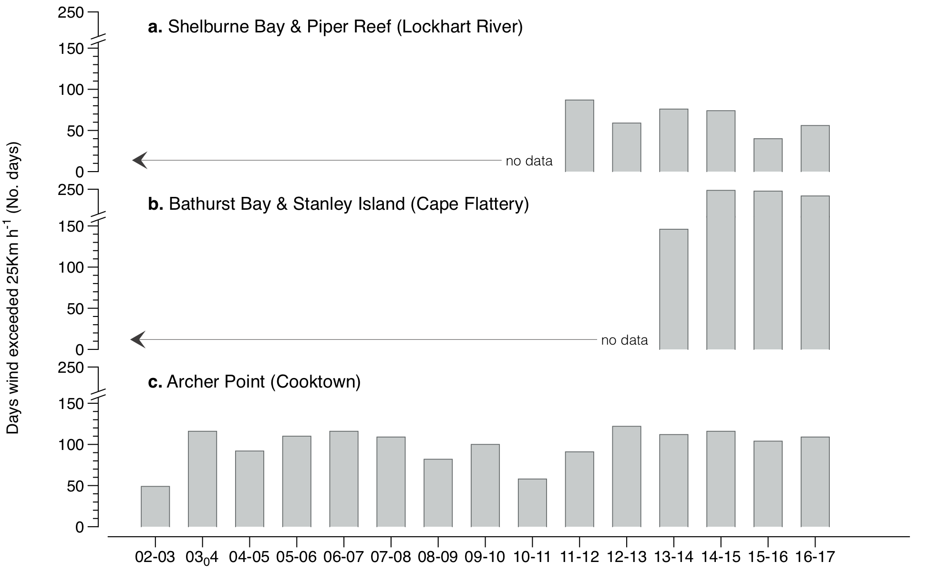
Figure 141. Number of days wind speed is above 25 km. hr⁻¹ each monitoring period in the Cape York NRM region.
Daily 3pm wind speed from: a) from Lockhart River Airport (BOM station 028008, source www.bom.gov.au), located 108km from Shelburne Bay and 61km from Piper Reef monitoring sites; b) Cape Flattery (BOM station 031213), located approximately 139km and 144km from Bathurst Bay and Stanley Island monitoring sites, respectively and; c) Cooktown airport (BOM station 031209), located 16km from Archer Point monitoring sites.

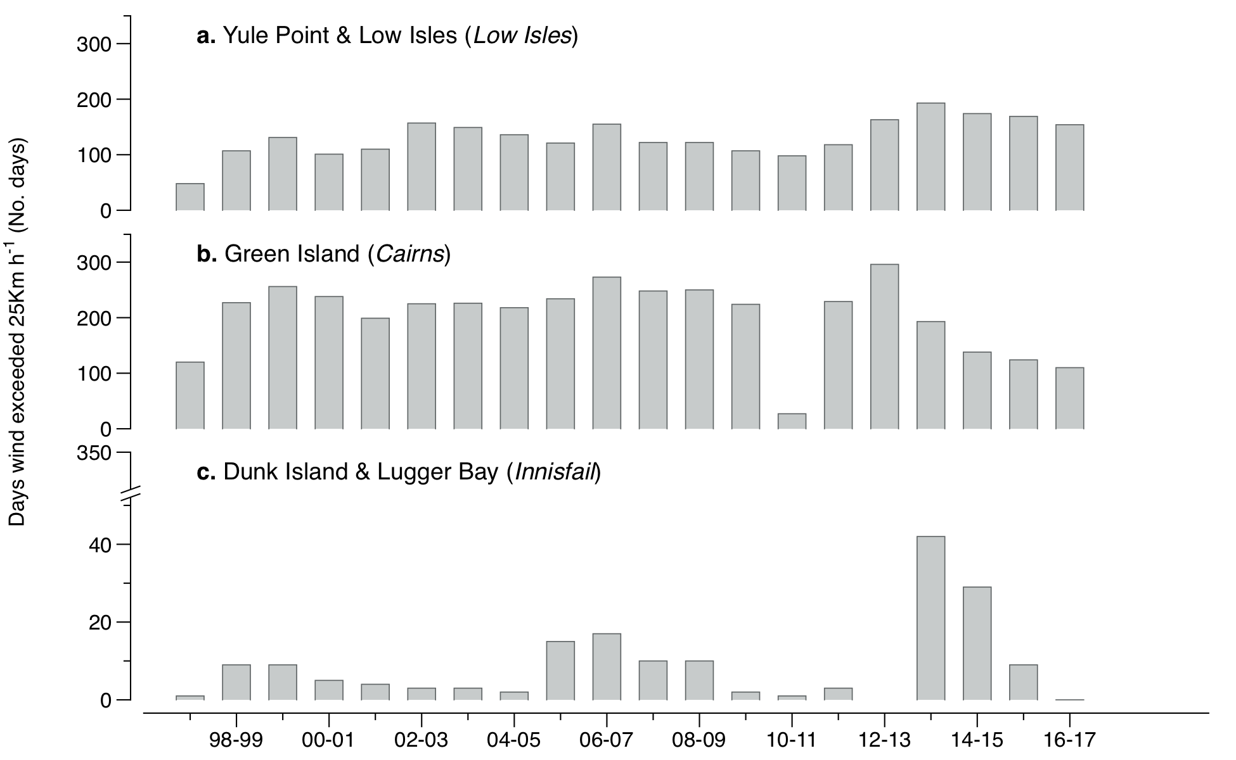
Figure 142. Number of days wind speed is above 25 km. hr⁻¹ each monitoring period in the Wet Tropics NRM region.
Daily 3pm wind speed from: a) Low Isles (BOM station 31037), located approximately 21km from Yule Point monitoring sites; b) Green Island (BOM station 31192); and C) Innisfail (BOM station 032025), located approximately 48km from monitoring sites at Lugger Bay and Dunk Island.

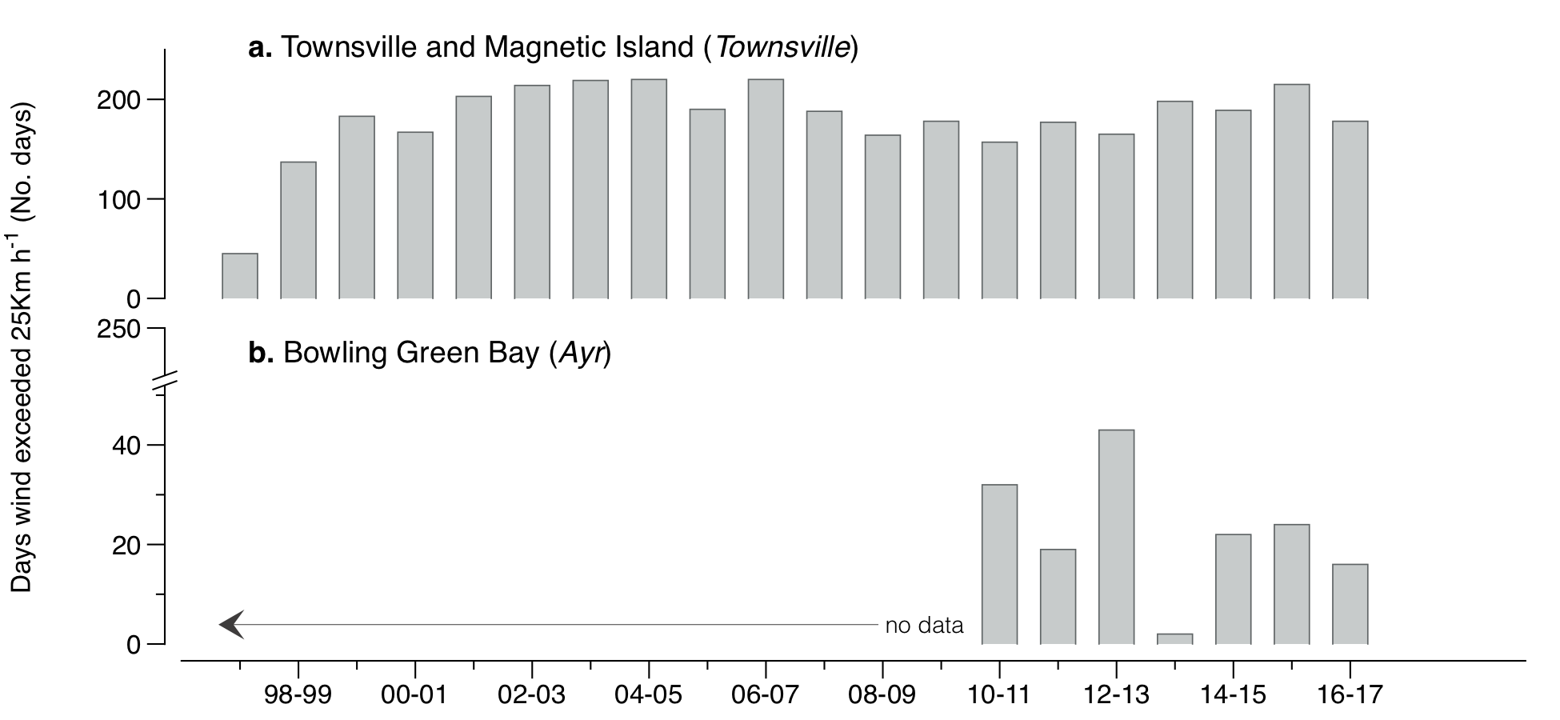
Figure 143. Number of days wind speed is above 25 km. hr⁻¹ each monitoring period in the Burdekin NRM region.
Daily 3pm wind speed from: a) Townsville Airport (BOM station 032040) located approximately 11km from coastal (Townsville) and reef (Magnetic Island) monitoring sites, and 53km from Jerona (Bowling Green Bay) monitoring sites; and b) Ayr (BOM station 033002), located approximately 26km from from Jerona (Bowling Green Bay) monitoring sites.

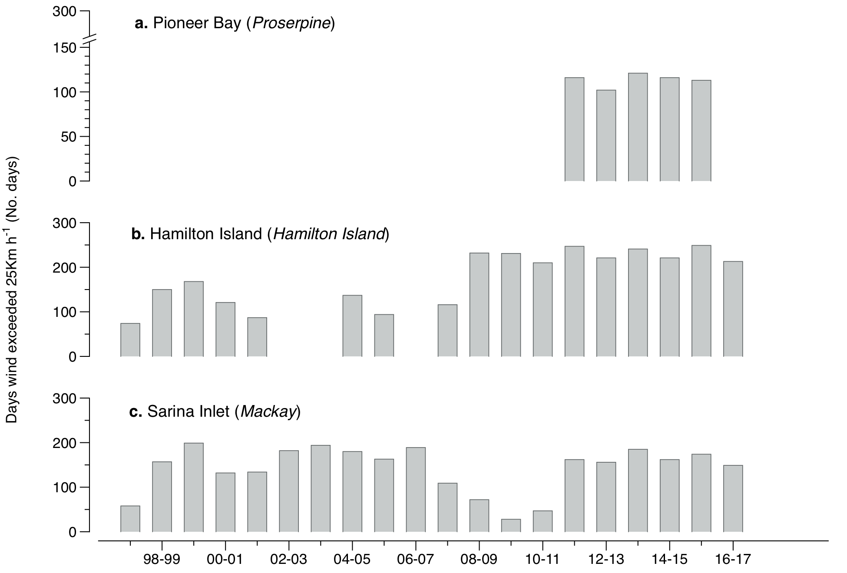
Figure 144. Number of days wind speed is above 25 km. hr⁻¹ each monitoring period in the Mackay Whitsunday NRM region.
Daily 3pm wind speed from: a) Proserpine Post Office (BOM station 33316) (post June 2011), located 18km from Midge Point monitoring sites; b) Hamilton Island (BOM station 033106), located 1.5km from Hamilton Island monitoring sites; and c) Mackay Airport (BOM station 033045, source www.bom.gov.au), approximately 28km from Sarina Inlet monitoring sites.

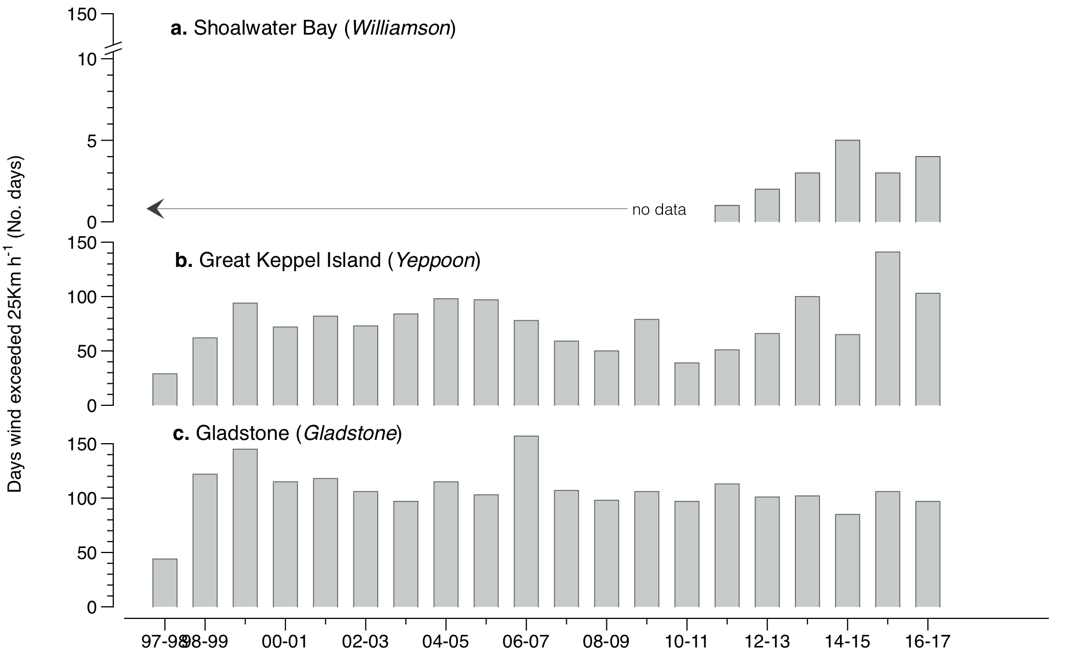
Figure 145. Number of days wind speed is above 25 km. hr⁻¹ each monitoring period in the Fitzroy NRM region.
Daily 3pm wind speed from: a) Williamson, Shoalwater Bay (BOM station 033260), located 10km from the monitoring sites; b) Yeppoon (BOM station 033106), approximately 22km from monitoring sites; and c) Gladstone Airport (BOM station 039123), located approximately 13km from monitoring sites.

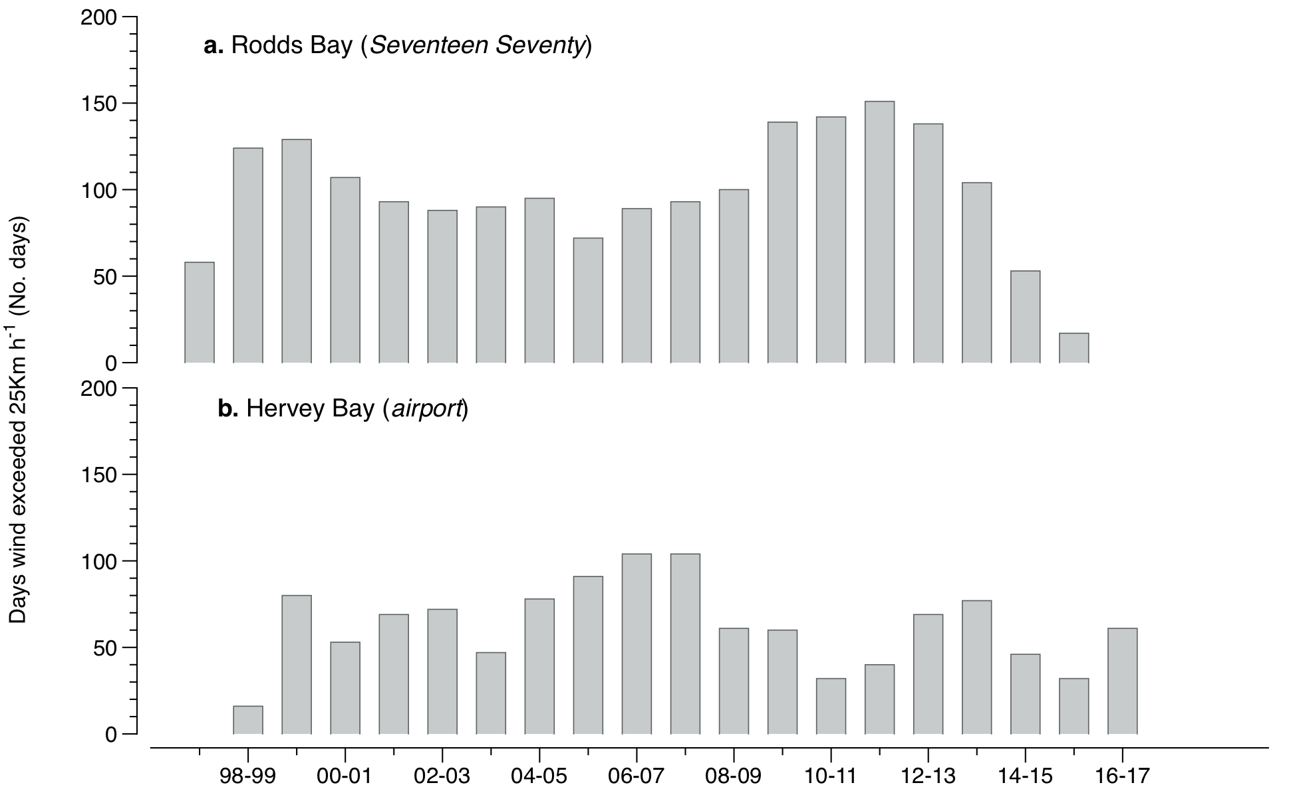
Figure 146. Number of days wind speed is above 25 km. hr⁻¹ each monitoring period in the Burnett Mary NRM region.
Daily 3pm wind speed from: a) Seventeen Seventy (BOM station 039314), approximately 27km from Rodds Bay monitoring sites; and b) Hervey Bay Airport (BOM station 040405), approximately 3km from Urangan monitoring sites.

Tidal exposure

Table 51. Height of intertidal monitoring meadows/sites above Lowest Astronomical Tide (LAT) and annual daytime tidal exposure (total hours) when meadows become exposed at a low tide.
Year is June - May. Observed tidal heights courtesy Maritime Safety Queensland, 2016. NB: Meadow heights have not yet been determined in the far northern Cape York.
NRM | Site | Meadow  height  (above LAT) | Site depth  (bMSL) | Meadow height  (above LAT)  relative to  Standard Port | Annual median  hours exposed  during daylight  (long-term) | Per cent of  annual daylight  hours meadow  is exposed  (long-term) | Annual  daytime  exposure  2016–17 (hrs) | Per cent of  annual daylight  hours meadow  is exposed  (2016–17)
Cape York | AP1 | 0.46 | 1.02 | 0.46 | 66.83 | 1.58 | 41.67 | 0.95
Cape York | AP2 | 0.46 | 1.02 | 0.46 | 66.83 | 1.58 | 41.67 | 0.95
Wet Tropics | LI1 | 0.65 | 0.90 | 0.65 | 178.50 | 3.96 | 152.83 | 3.49
Wet Tropics | YP1 | 0.64 | 0.94 | 0.64 | 169.83 | 3.78 | 147.50 | 3.37
Wet Tropics | YP2 | 0.52 | 1.06 | 0.52 | 97.33 | 2.15 | 83.00 | 1.89
Wet Tropics | GI1 | 0.51 | 1.03 | 0.61 | 116.33 | 2.60 | 129.83 | 2.96
Wet Tropics | GI2 | 0.57 | 0.97 | 0.67 | 153.25 | 3.44 | 165.17 | 3.77
Wet Tropics | DI1 | 0.65 | 1.14 | 0.54 | 75.08 | 1.65 | 61.17 | 1.40
Wet Tropics | DI2 | 0.55 | 1.24 | 0.44 | 43.83 | 0.97 | 26.50 | 0.61
Wet Tropics | LB1 | 0.42 | 1.37 | 0.31 | 18.08 | 0.39 | 7.17 | 0.16
Wet Tropics | LB2 | 0.46 | 1.33 | 0.35 | 21.75 | 0.48 | 6.50 | 0.15
Burdekin | BB1 | 0.58 | 1.30 | 0.58 | 88.92 | 1.94 | 49.00 | 1.12
Burdekin | SB1 | 0.57 | 1.31 | 0.57 | 68.92 | 1.58 | 46.33 | 1.06
Burdekin | MI1 | 0.65 | 1.19 | 0.67 | 190.42 | 4.04 | 81.83 | 1.87
Burdekin | MI2 | 0.54 | 1.30 | 0.56 | 176.92 | 3.62 | 42.67 | 0.97
Burdekin | JR1 | 0.47 | 1.32 | 0.47 | 65.17 | 1.48 | 54.33 | 1.24
Burdekin | JR2 | 0.47 | 1.32 | 0.47 | 65.17 | 1.48 | 54.33 | 1.24
Mackay Whitsunday | PI2 | 0.28 | 1.47 | 0.44 | 80.67 | 1.85 | 75.17 | 1.72
Mackay Whitsunday | PI3 | 0.17 | 1.58 | 0.33 | 41.50 | 0.95 | 32.17 | 0.73
Mackay Whitsunday | HM1 | 0.68 | 1.52 | 0.38 | 56.67 | 1.29 | 46.50 | 1.06
Mackay Whitsunday | HM2 | 0.68 | 1.52 | 0.38 | 56.67 | 1.29 | 46.50 | 1.06
Mackay Whitsunday | SI1 | 0.60 | 2.80 | 0.54 | 23.75 | 0.51 | 31.17 | 0.71
Mackay Whitsunday | SI2 | 0.60 | 2.80 | 0.54 | 23.75 | 0.51 | 31.17 | 0.71
Fitzroy | RC1 | 2.03 | 1.30 | 1.06 | 162.67 | 3.69 | 219.17 | 5.00
Fitzroy | WH1 | 2.16 | 1.17 | 1.19 | 231.75 | 5.35 | 294.67 | 6.73
Fitzroy | GK1 | 0.52 | 1.93 | 0.43 | 34.92 | 0.85 | 27.17 | 0.62
Fitzroy | GK2 | 0.58 | 1.87 | 0.49 | 51.67 | 1.22 | 43.33 | 0.99
Fitzroy | GH1 | 0.80 | 1.57 | 0.69 | 97.33 | 2.31 | 107.50 | 2.45
Fitzroy | GH2 | 0.80 | 1.57 | 0.69 | 91.58 | 2.15 | 107.50 | 2.45
Burnett Mary | RD1 | 0.56 | 1.48 | 0.56 | 66.58 | 1.59 | 91.83 | 2.10
Burnett Mary | RD2 | 0.63 | 1.41 | 0.63 | 91.42 | 2.25 | 127.50 | 2.91
Burnett Mary | UG1 | 0.70 | 1.41 | 0.70 | 147.50 | 3.30 | 119.67 | 2.73
Burnett Mary | UG2 | 0.64 | 1.47 | 0.64 | 106.67 | 2.41 | 64.83 | 1.48

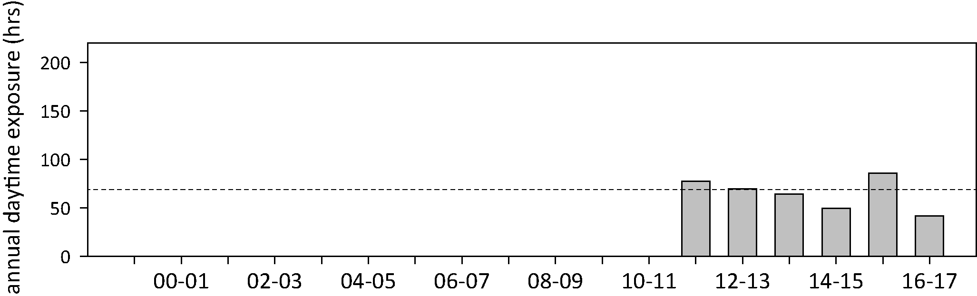
Figure 147. Annual daytime tidal exposure (total hours) and long-term median (dashed line) of intertidal reef seagrass meadows at Archer Point, Cape York NRM region; 2011 - 2016
. Year is June - May. For tidal exposure (when intertidal banks become exposed at a low tide) height at each site, see Table 51. Observed tidal heights courtesy Maritime Safety Queensland, 2016. NB: Meadow heights have not yet been determined in the far northern Cape York sites.

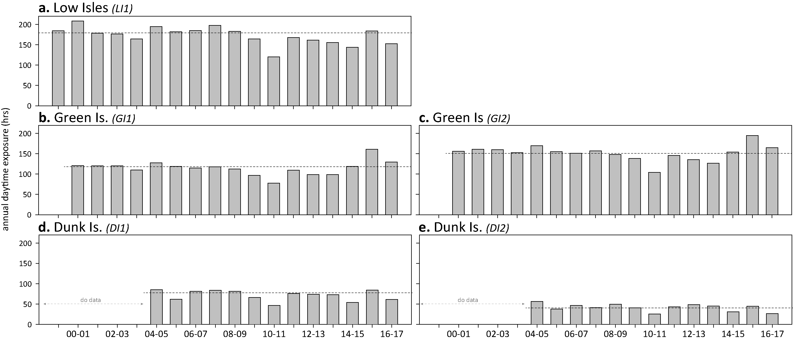
Figure 148. Annual daytime tidal exposure (total hours) and long-term median (dashed line) of intertidal reef seagrass meadows in the Wet Tropics NRM region; 1999 - 2016.
Year is June - May. For tidal exposure (when intertidal banks become exposed at a low tide) height at each site, see Table 51. Observed tidal heights courtesy Maritime Safety Queensland, 2016.

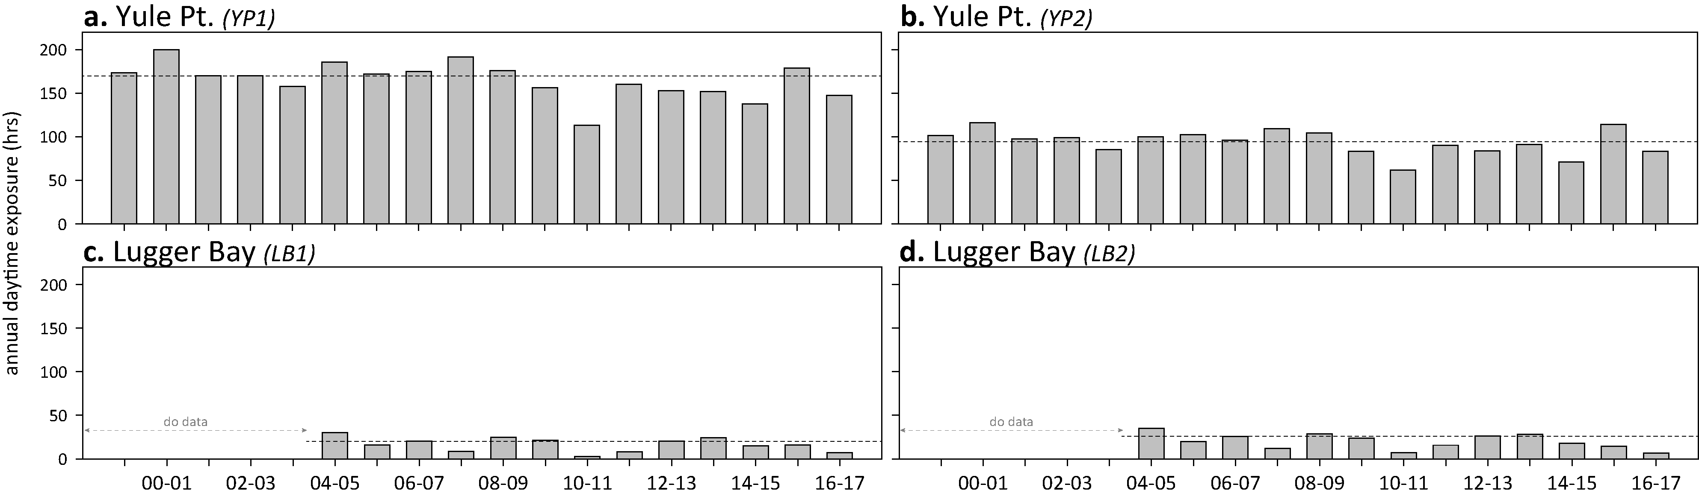
Figure 149. Annual daytime tidal exposure (total hours) and long-term median (dashed line) of intertidal coastal seagrass meadows in Wet Tropics NRM region; 1999 - 2016.
Year is June - May. For tidal exposure (when intertidal banks become exposed at a low tide) height at each site, see Table 51. Observed tidal heights courtesy Maritime Safety Queensland, 2016.

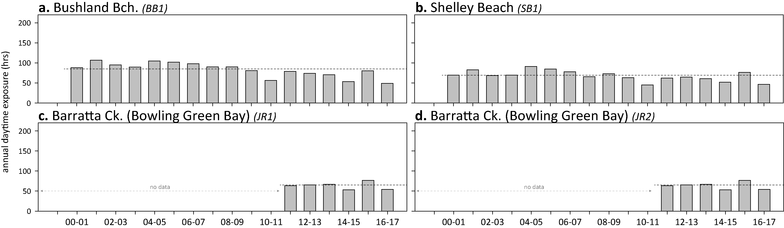
Figure 150. Annual daytime tidal exposure (total hours) and long-term median (dashed line) of intertidal coastal seagrass meadows in Burdekin NRM region; 2000 - 2016.
Year is June - May. For tidal exposure (when intertidal banks become exposed at a low tide) height at each site, see Table 51. Observed tidal heights courtesy Maritime Safety Queensland, 2016.

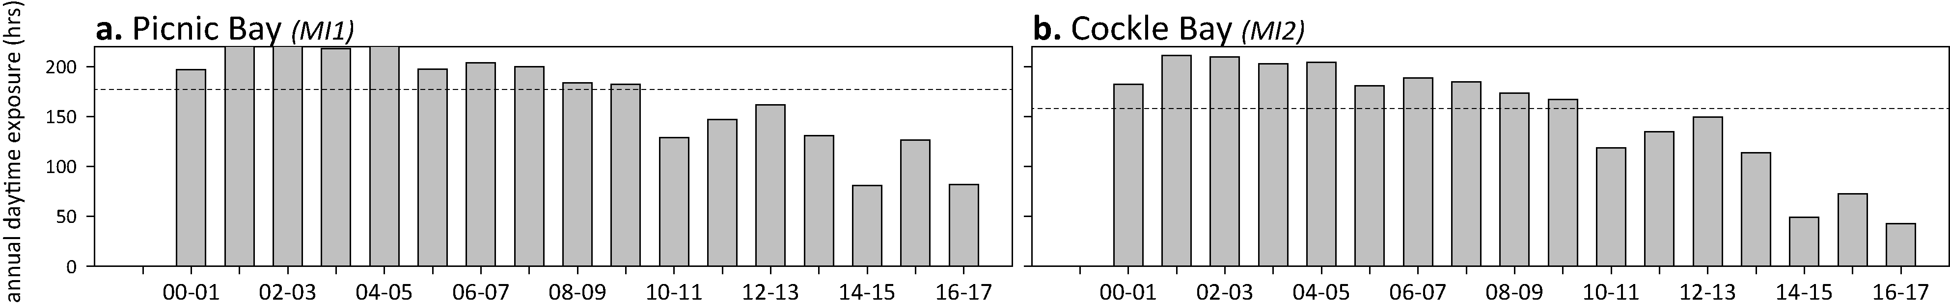
Figure 151. Annual daytime tidal exposure (total hours) and long-term median (dashed line) of intertidal reef seagrass meadows in Burdekin NRM region; 2000 - 2016.
Year is June - May. For tidal exposure (when intertidal banks become exposed at a low tide) height at each site, see Table 51. Observed tidal heights courtesy Maritime Safety Queensland, 2016.

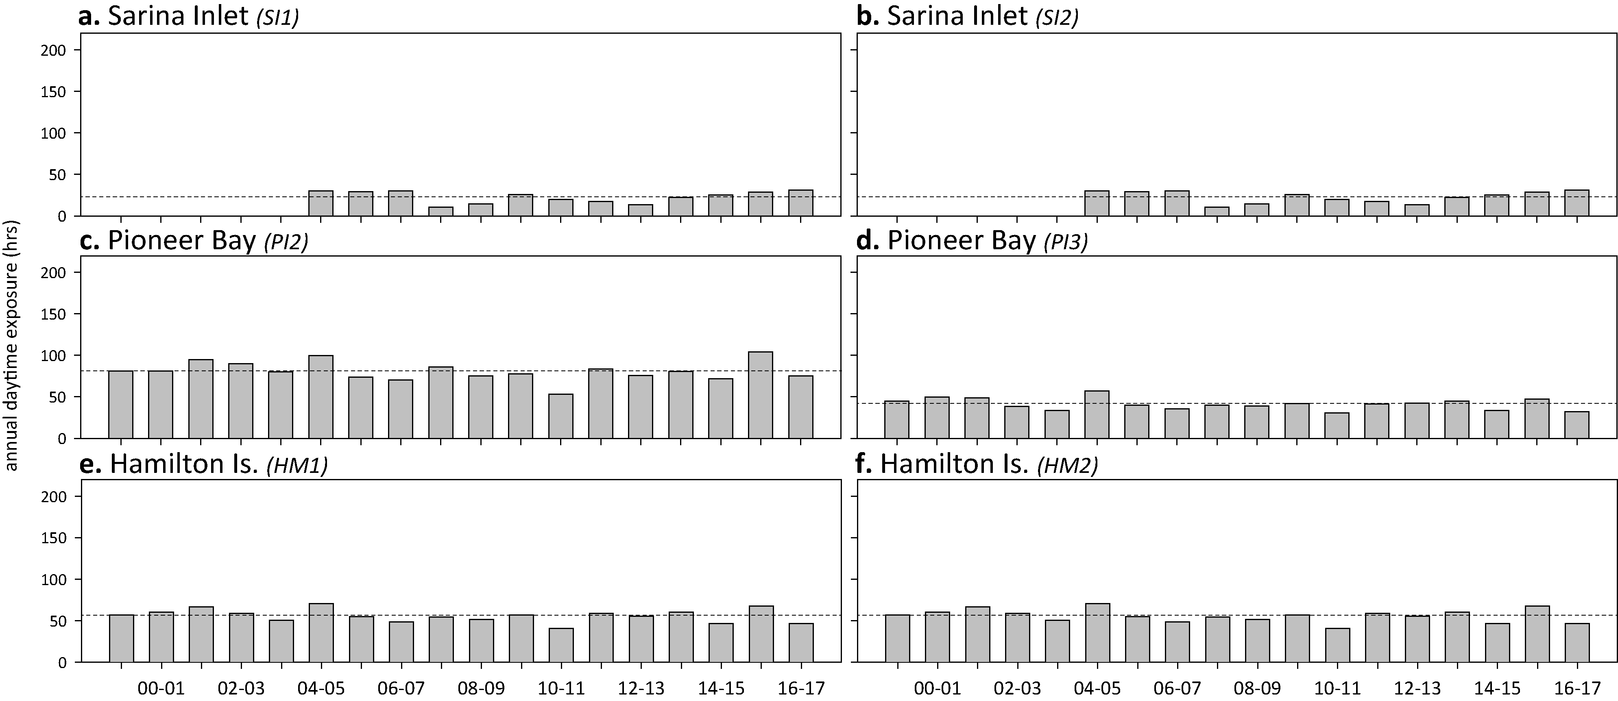
Figure 152. Annual daytime tidal exposure (total hours) and long-term median (dashed line) of intertidal estuarine (a, b) coastal (c, d) and reef (e, f) seagrass meadows in Mackay Whitsunday NRM region; 1999 - 2016.
Year is June - May. For tidal exposure (when intertidal banks become exposed at a low tide) height at each site, see Table 51. Observed tidal heights courtesy Maritime Safety Queensland, 2016.

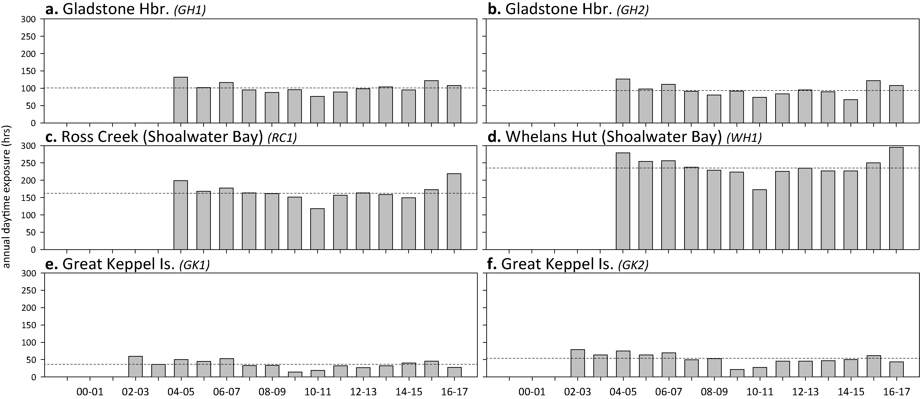
Figure 153. Annual daytime tidal exposure (total hours) and long-term median (dashed line) of intertidal estuarine (a, b) coastal (c, d) and reef (e, f) seagrass meadows in the Fitzroy NRM region; 1999 - 2016.
Year is June - May. For tidal exposure (when intertidal banks become exposed at a low tide) height at each site, see Table 51. Observed tidal heights courtesy Maritime Safety Queensland, 2016.

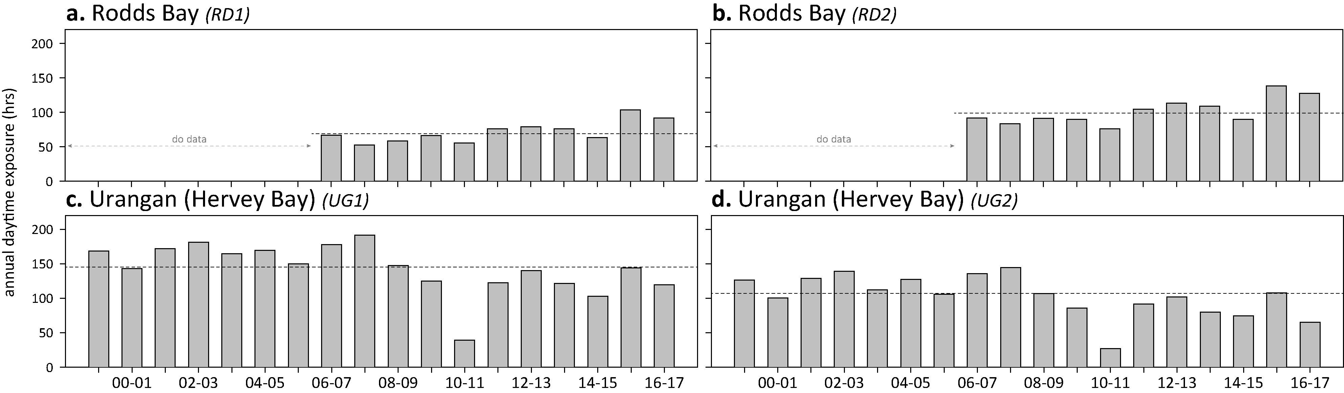
Figure 154. Annual daytime tidal exposure (total hours) and long-term median (dashed line) of intertidal estuarine seagrass meadows in the Burnett Mary NRM region; 1999 - 2016.
Year is June - May. For tidal exposure (when intertidal banks become exposed at a low tide) height at each site, see Table 51. Observed tidal heights courtesy Maritime Safety Queensland, 2016.

Light at seagrass canopy

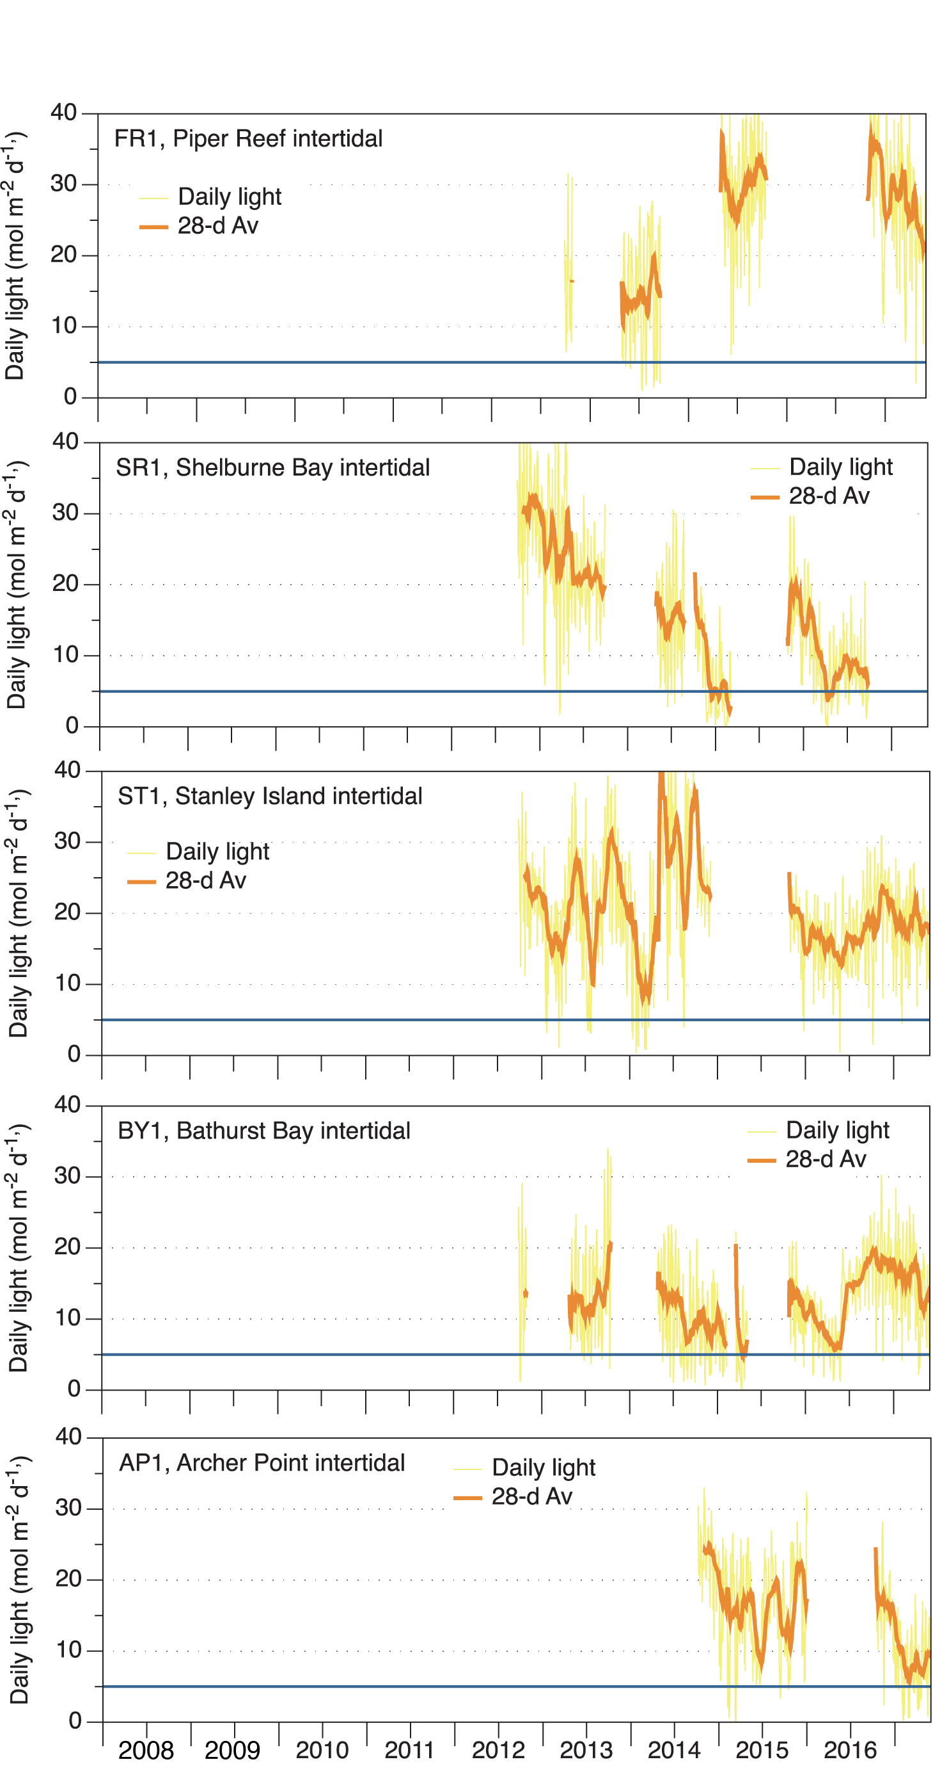
Figure 155. Daily light (28-day rolling average) at Cape York locations
, also showing approximate light threshold required for positive growth in Halodule uninervis dominated communities (5 mol m⁻² d⁻¹) Collier et al. 2012b NB threshold is based on 90-day average.

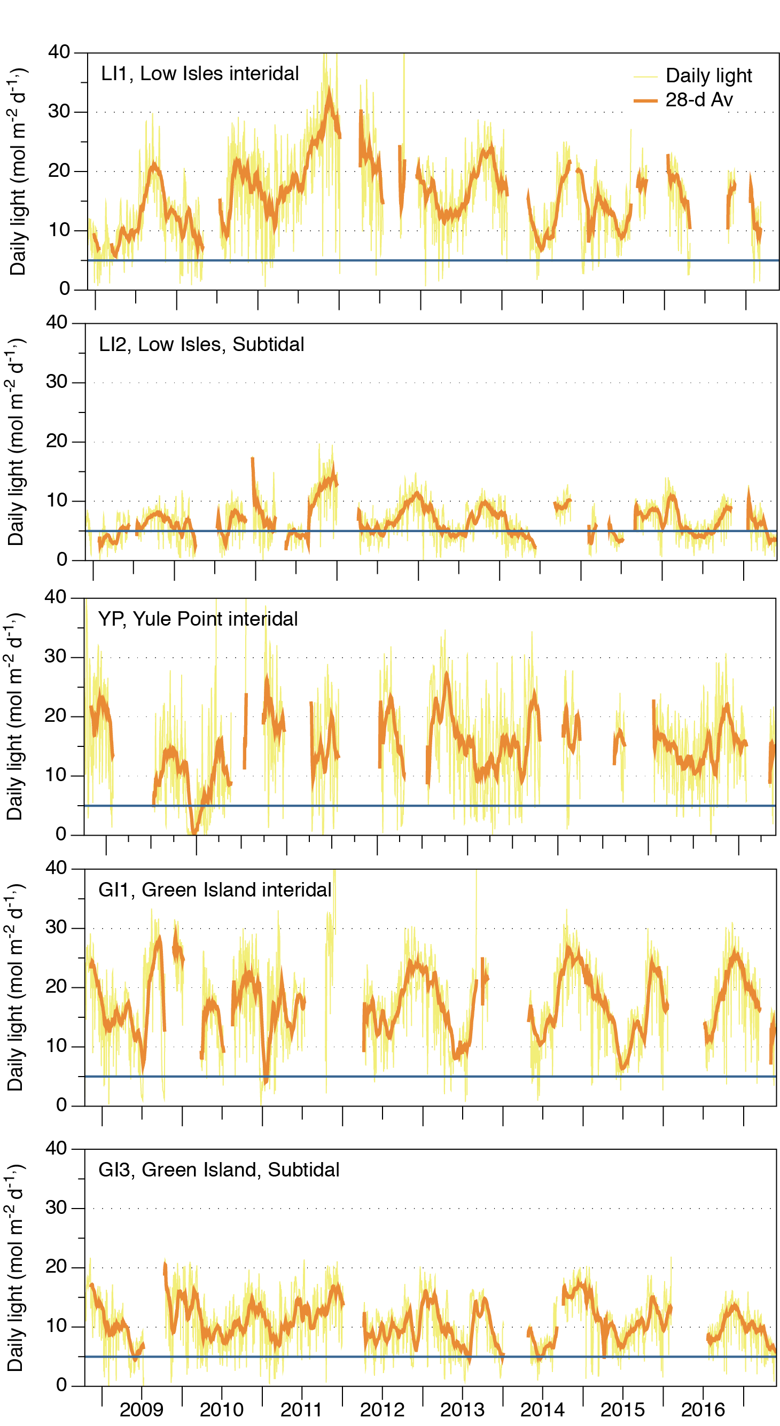
Figure 156. Daily light (yellow line) and 28-day rolling average (orange, bold line) for locations in the northern Wet Tropics
. Also shown is an event-based light threshold (5 mol m⁻² d⁻¹) for H. uninervis (Collier et al. 2012b)

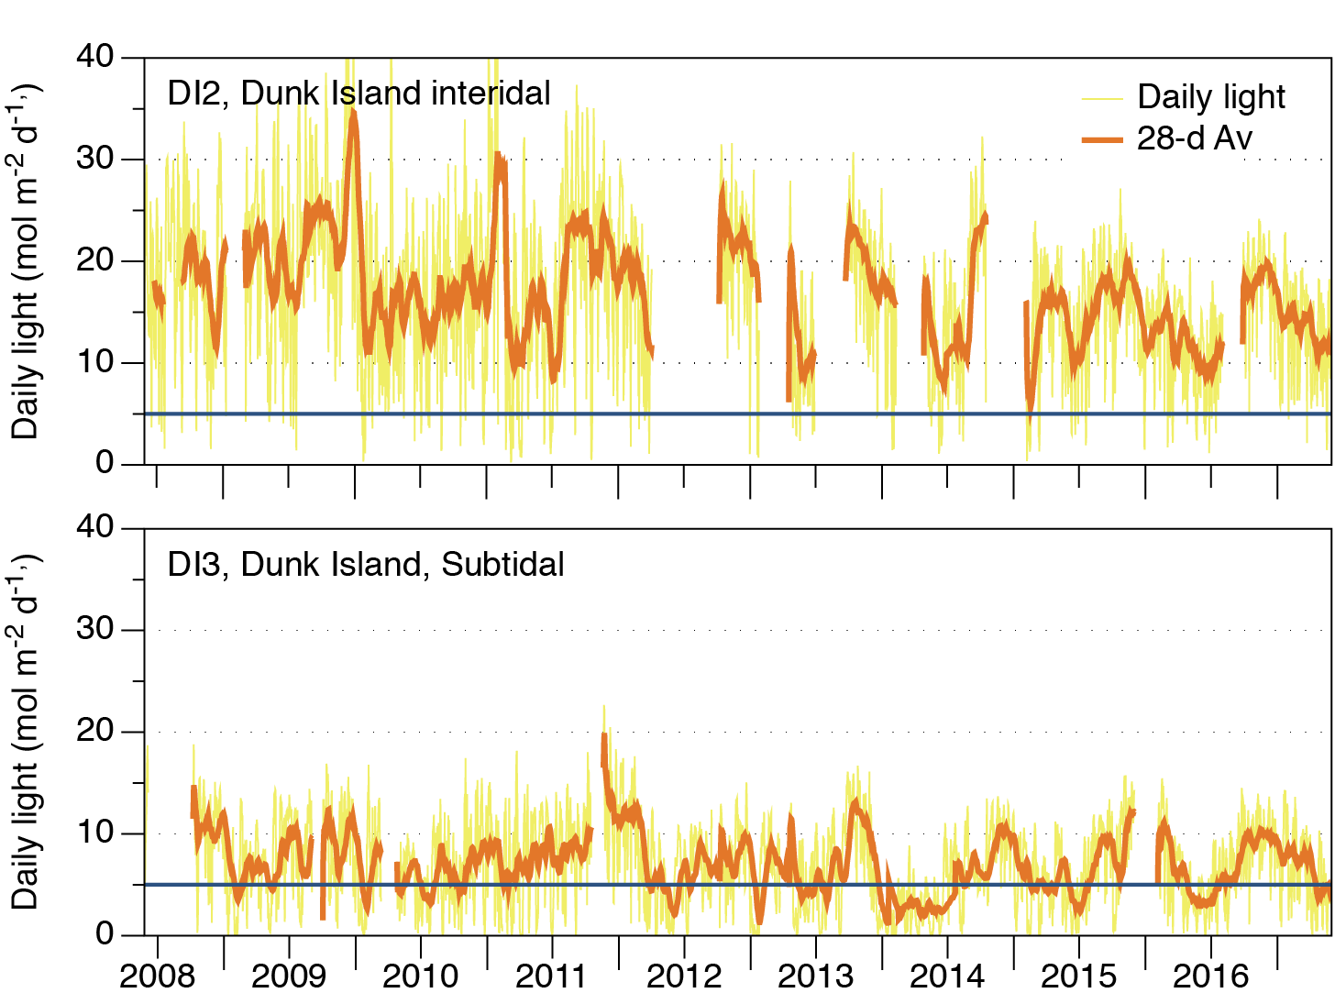
Figure 157. Daily light (yellow line) and 28-day rolling average (orange, bold line) for locations in the southern Wet Tropics
. Also shown is an event-based light threshold (5 mol m⁻² d⁻¹) for H. uninervis (Collier et al. 2012b)

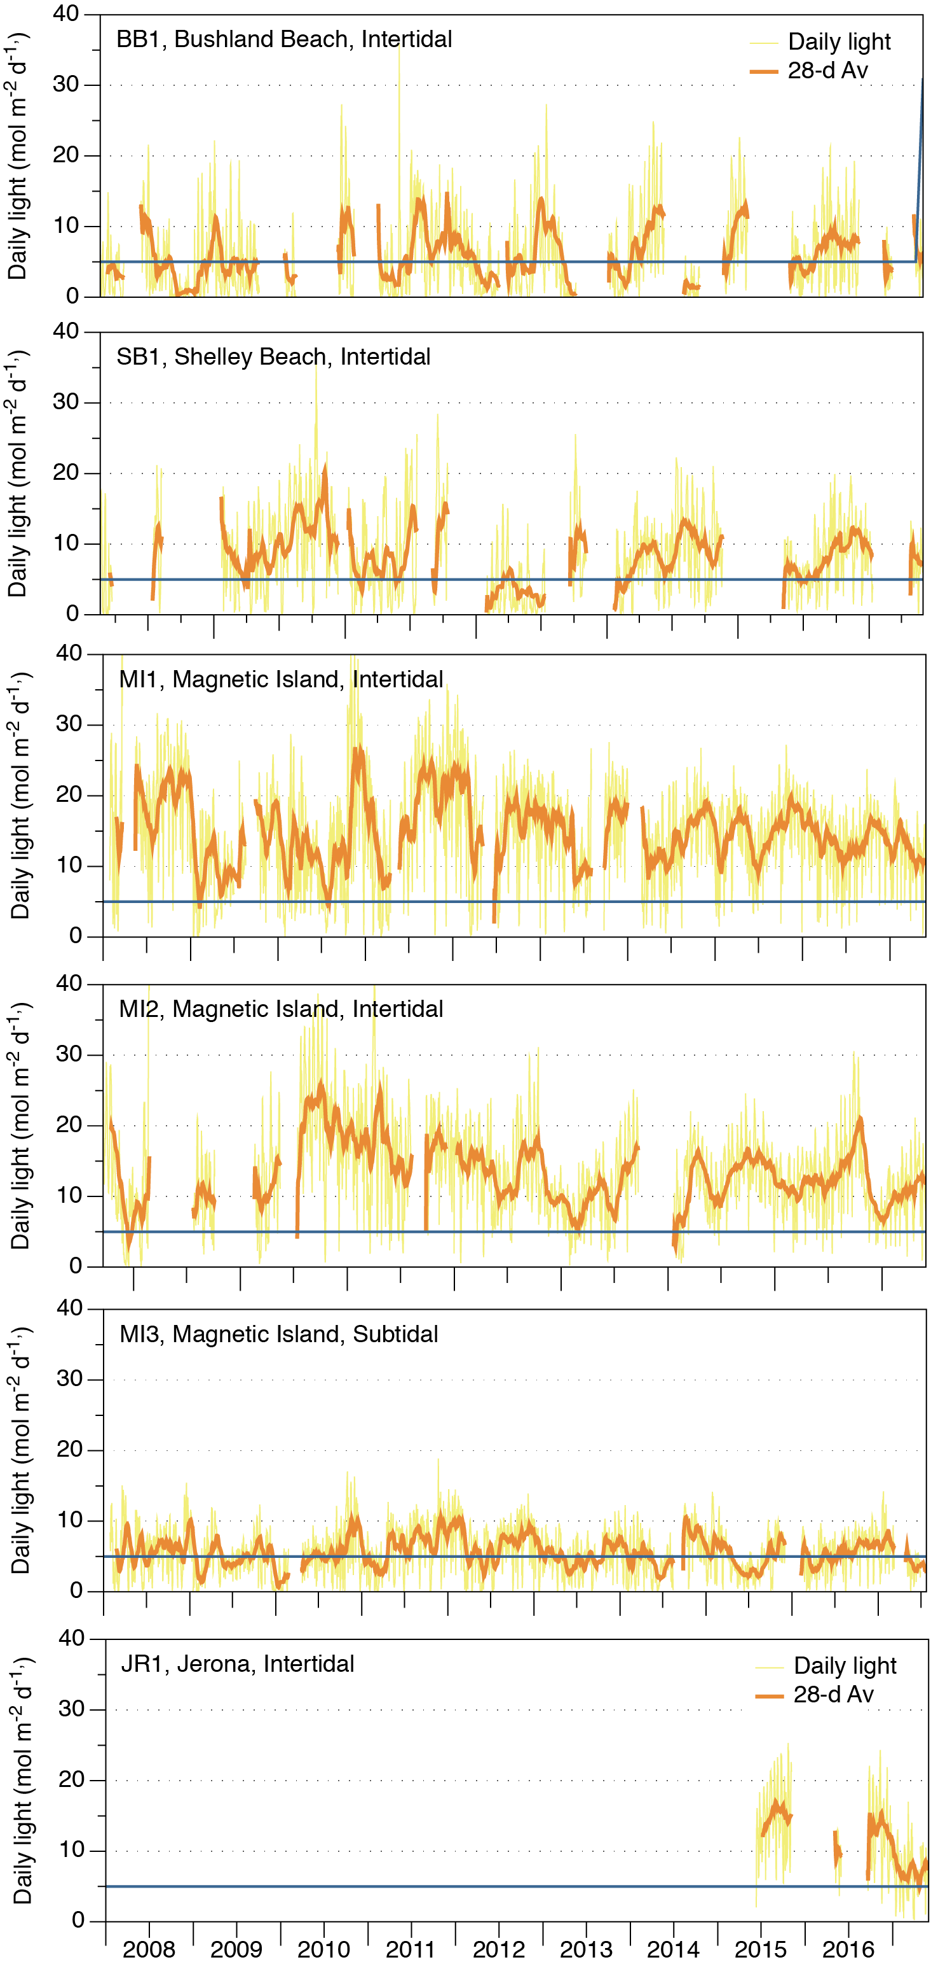
Figure 158. Daily light (yellow line) and 28-day rolling average (orange, bold line) at locations in the Burdekin region
. Also shown is an event-based light threshold (5 mol m⁻² d⁻¹) for H. uninervis (Collier et al. 2012b).

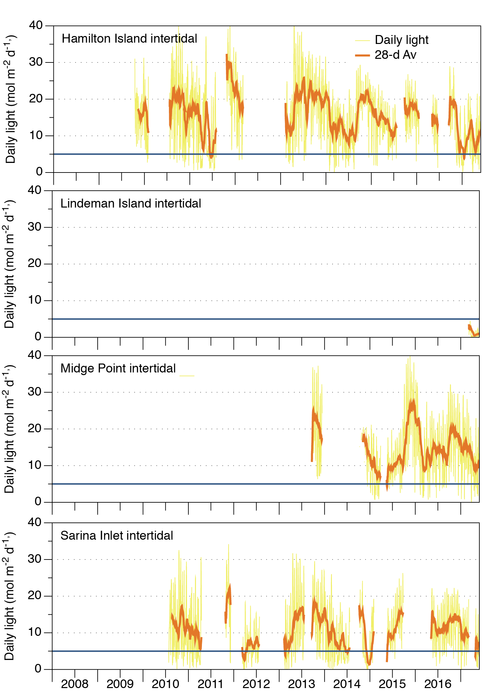
Figure 159. Daily light (yellow line) and 28-day rolling average (orange, bold line) at Mackay Whitsunday habitats.
Also shown is an event-based light threshold (5 mol m⁻² d⁻¹) for H. uninervis (Collier et al. 2012b).

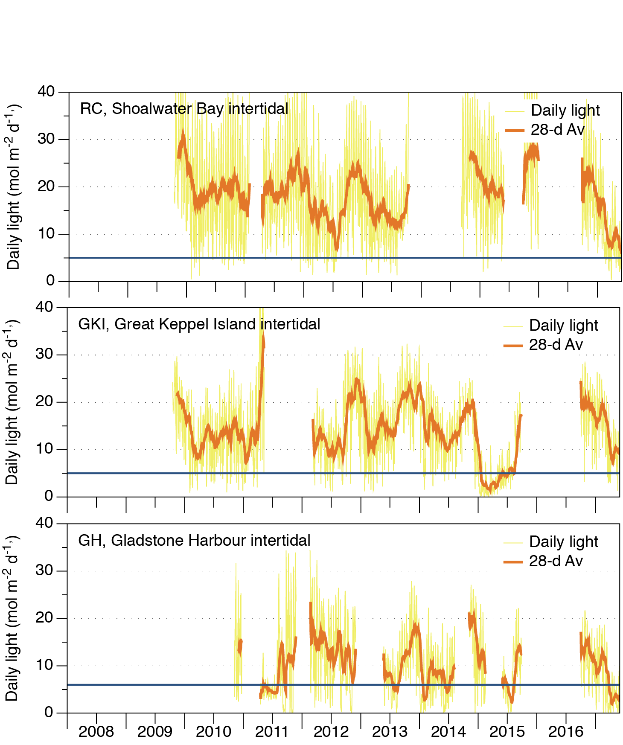
Figure 160. Daily light (yellow line) and 28-day rolling average (orange, bold line) at monitoring locations in the Fitzroy NRM region
. Also displayed is an event based light threshold (5 mol m⁻² d⁻¹) for Halodule uninervis (Collier et al. 2012b) or for Zostera muelleri (6 mol m⁻² d⁻¹) (Chartrand et al. 2016).
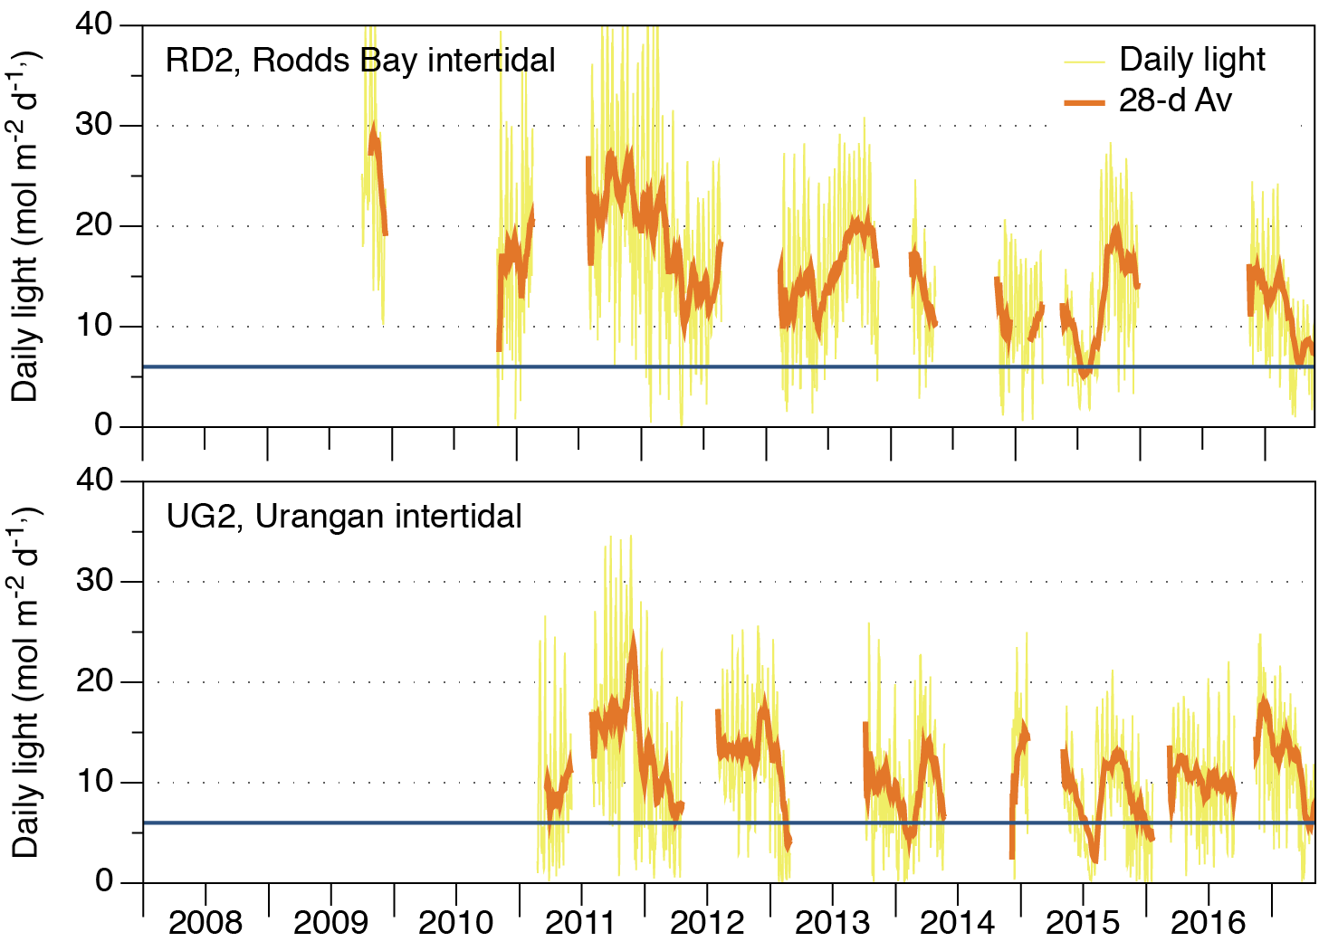
Figure 161. Daily light (yellow line) and 28-day rolling average (orange, bold line) at monitoring locations in the Burnett Mary NRM region
. Also displayed is an event based light threshold (5 mol m⁻² d⁻¹) for Halodule uninervis (Collier et al. 2012b) or for Zostera muelleri (6 mol m⁻² d⁻¹) (Chartrand et al. 2016).

Seagrass community and environment

Seagrass abundance
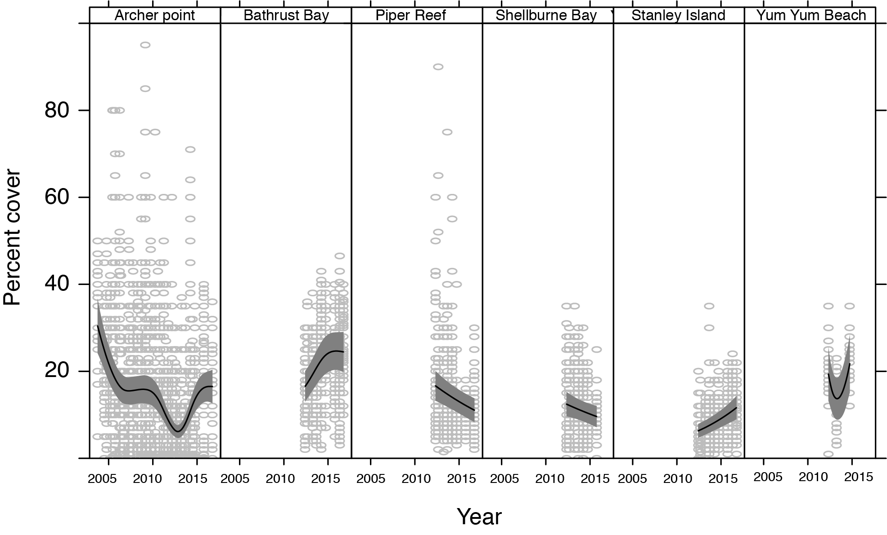
Figure 162. Temporal trends in seagrass abundance for each location in the Cape York NRM region represented by a GAM plot.
Location trend (all sites pooled) represented by black line with grey shaded areas defining 95 per cent confidence intervals and quadrat data represented by grey circles.
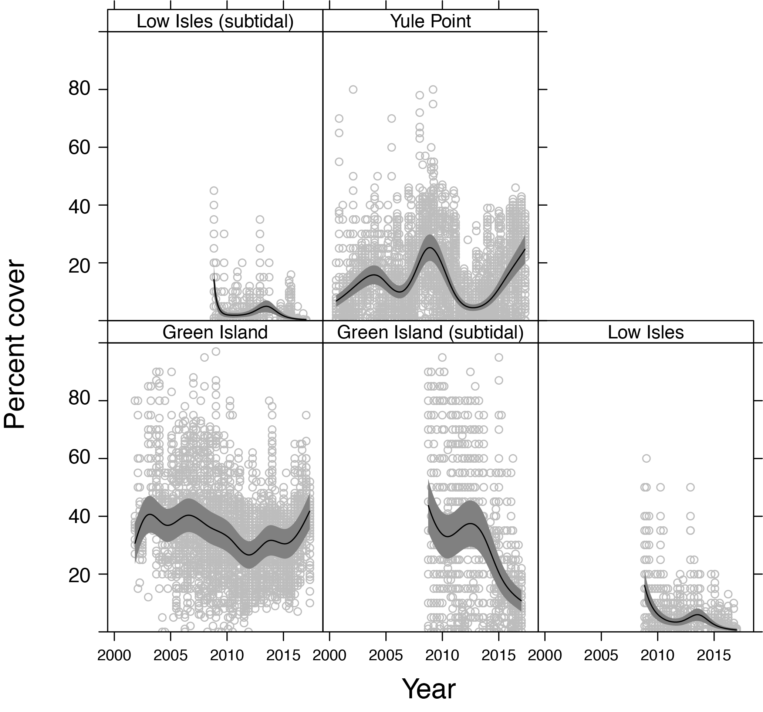
Figure 163. Temporal trends in seagrass abundance for each location in the northern Wet Tropics NRM region represented by a GAM plot.
Location trend (all sites pooled) represented by black line with grey shaded areas defining 95 per cent confidence intervals and quadrat data represented by grey circles

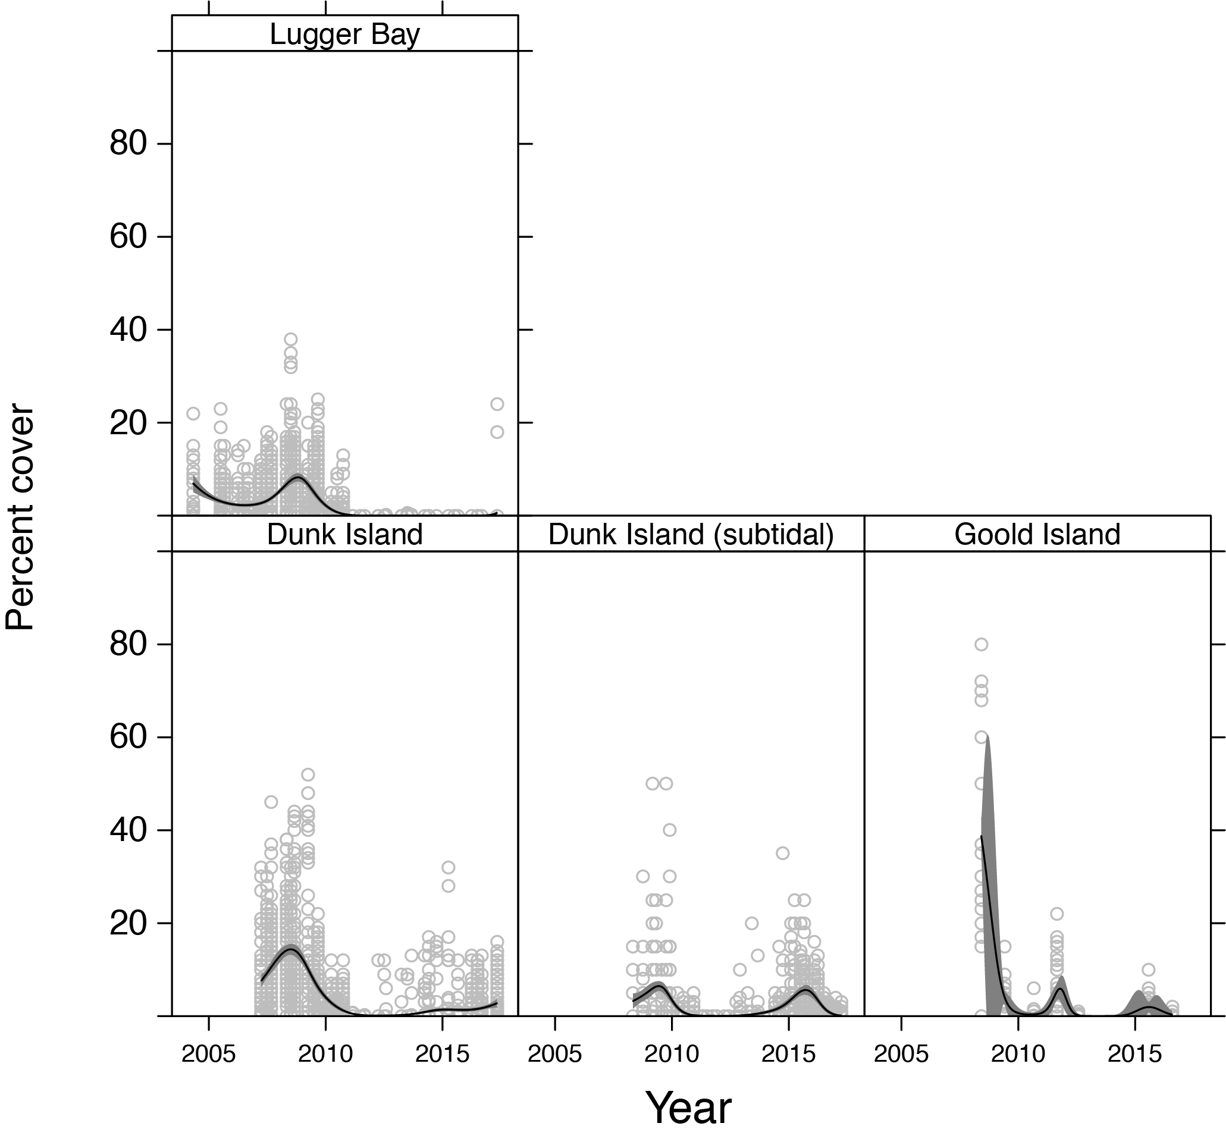
Figure 164. Temporal trends in seagrass abundance for each location in the southern Wet Tropics NRM region represented by a GAM plot.
Location trend (all sites pooled) represented by black line with grey shaded areas defining 95 per cent confidence intervals and quadrat data represented by grey circles
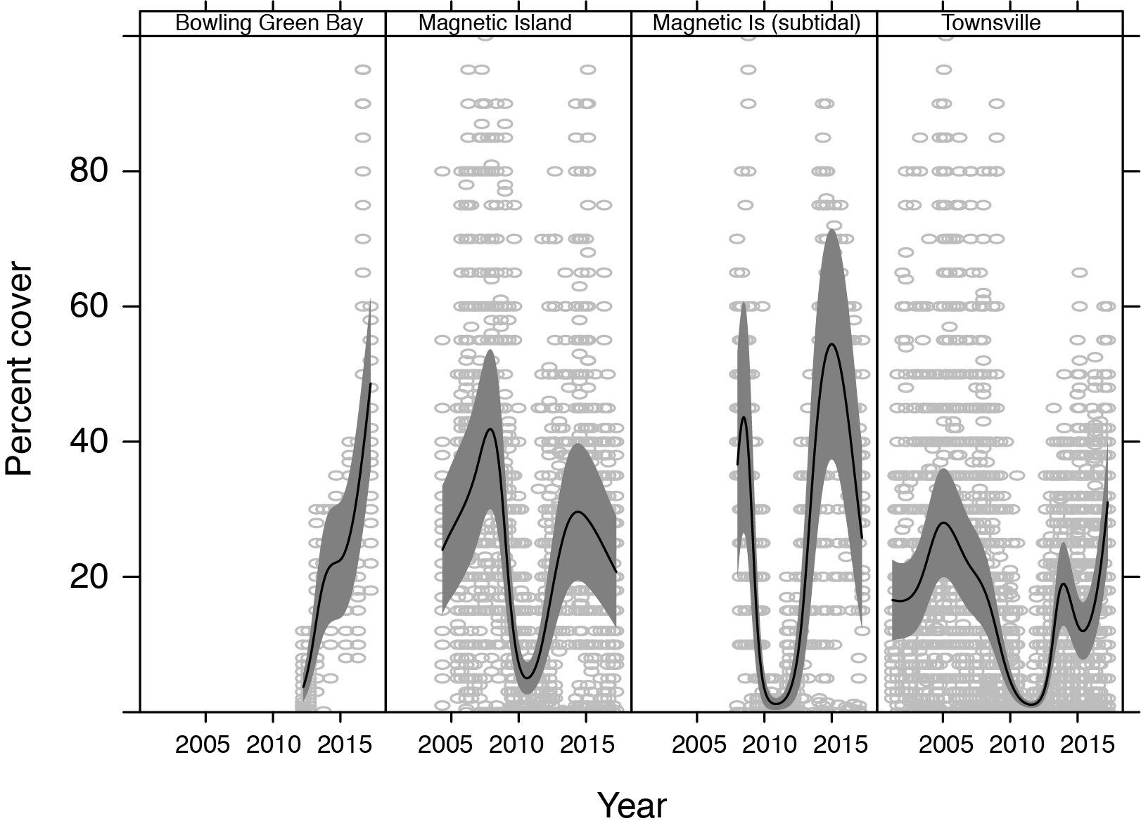
Figure 165. Temporal trends in seagrass abundance for each location in the Burdekin NRM region represented by a GAM plot.
Location trend (all sites pooled) represented by black line with grey shaded areas defining 95 per cent confidence intervals and quadrat data represented by grey circles .

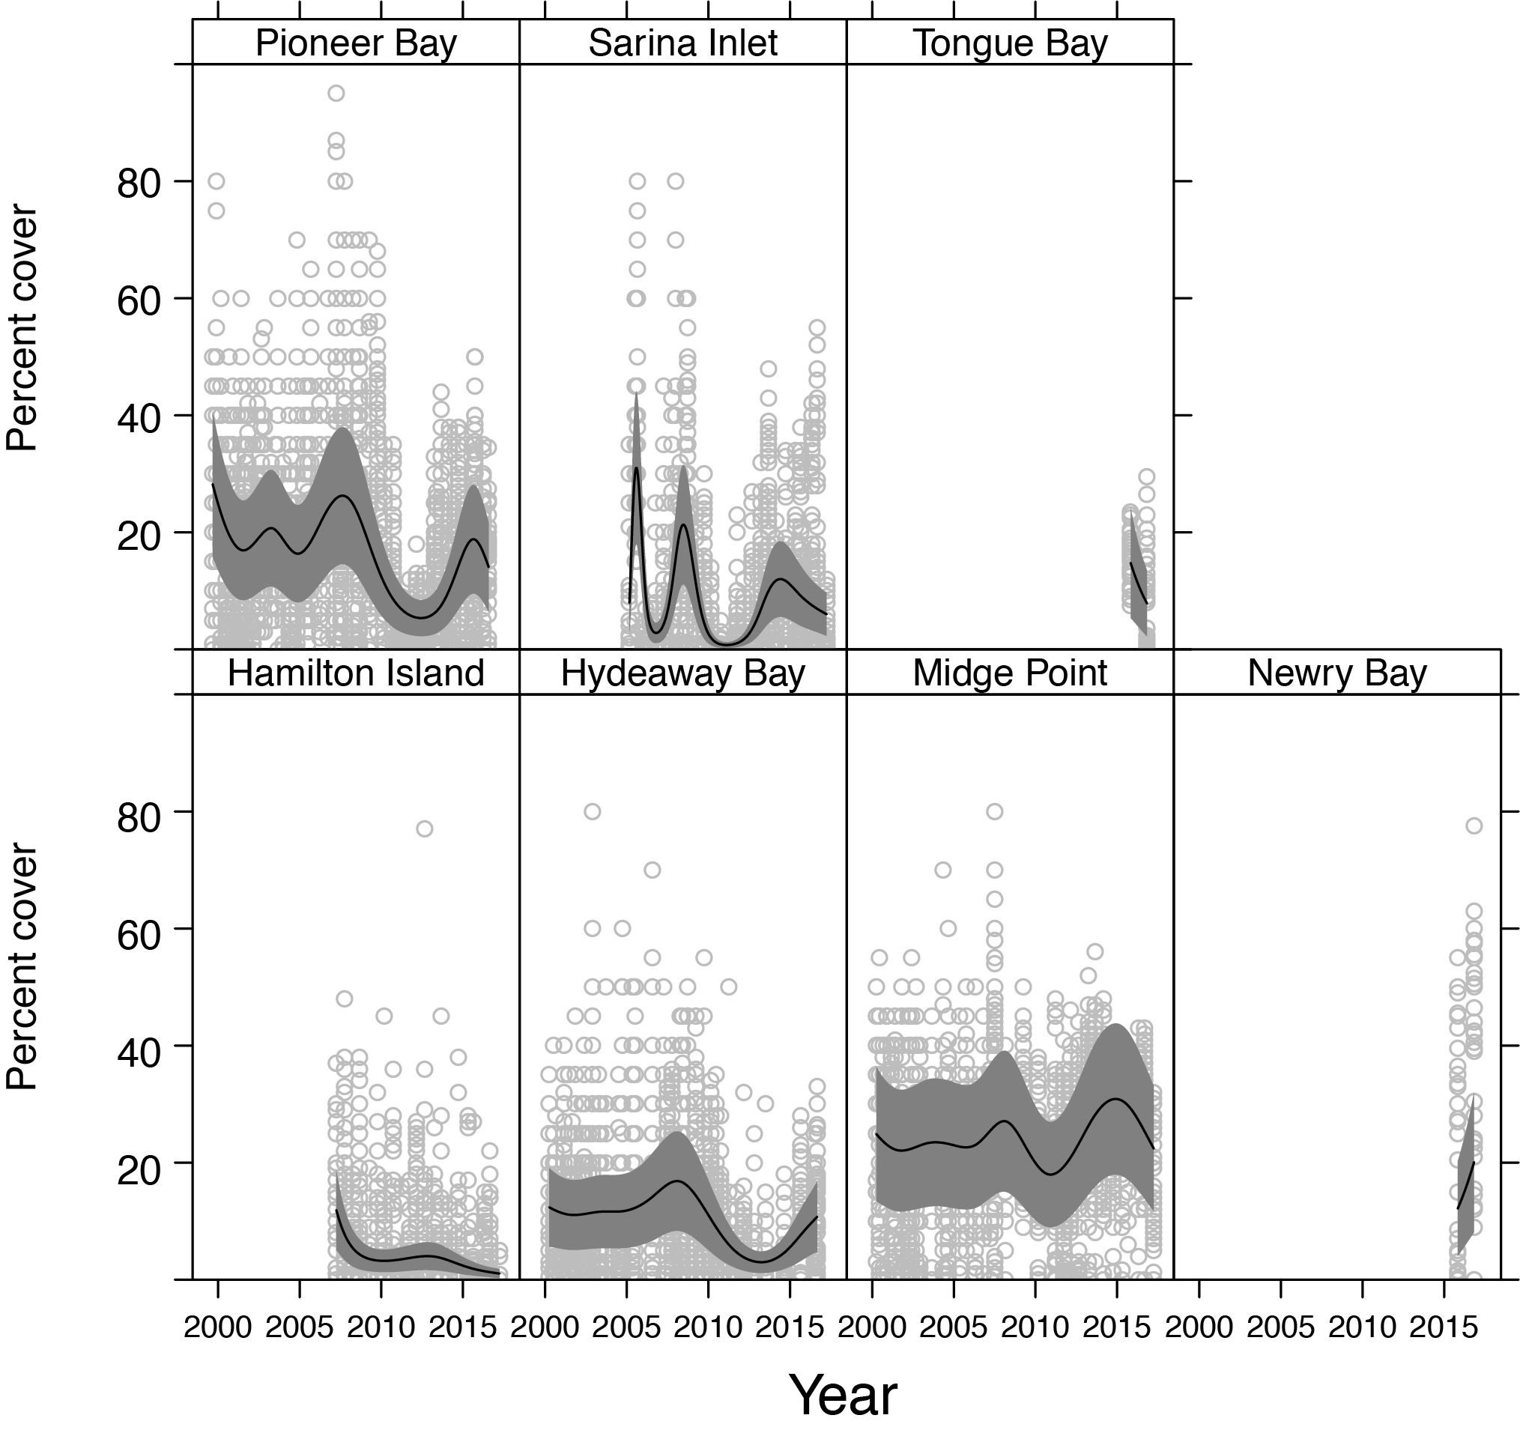
Figure 166. Temporal trends in seagrass abundance for each location in the Mackay Whitsunday NRM region represented by a GAM plot.
Location trend (all sites pooled) represented by black line with grey shaded areas defining 95 per cent confidence intervals and quadrat data represented by grey circles.
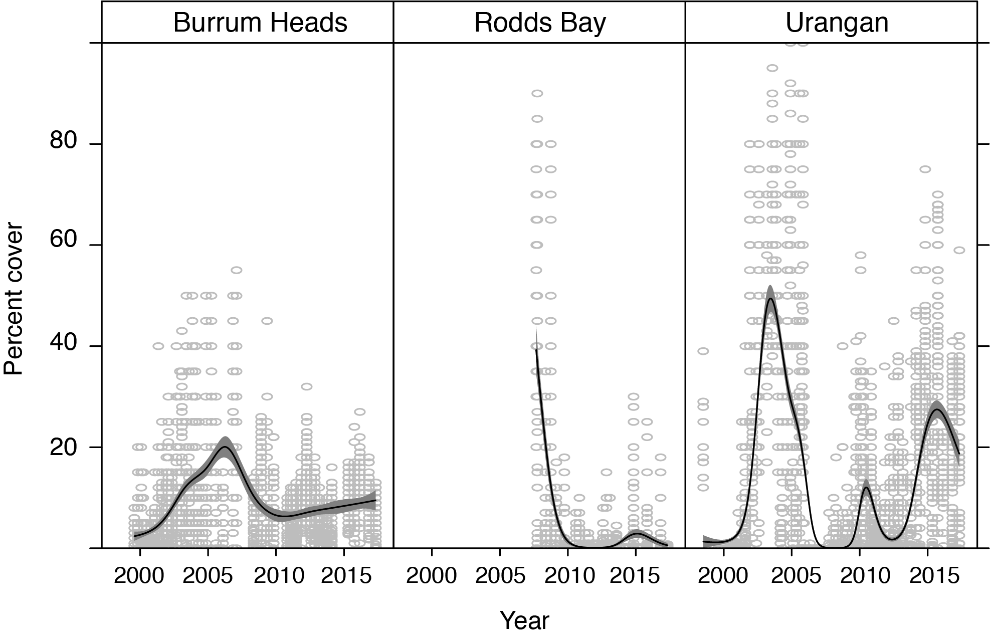
Figure 167. Temporal trends in seagrass abundance for each location in the Burnett Mary NRM region represented by a GAM plot.
Location trend (all sites pooled) represented by black line with grey shaded areas defining 95 per cent confidence intervals and quadrat data represented by grey circles.

Sediments composition

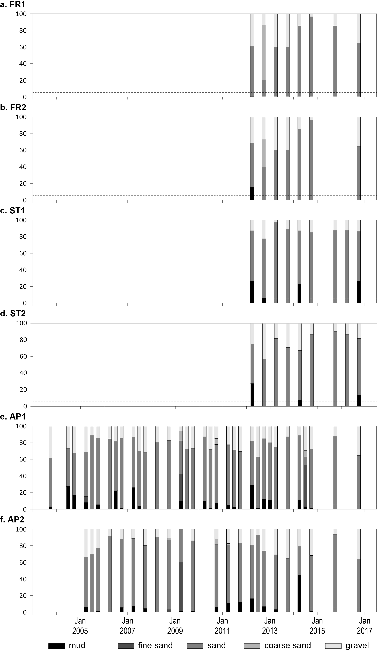
Figure 168. Sediment grain size composition at reef habitat monitoring sites in the Cape York region, 2003-2017.
Dashed line is the GBR long-term average proportion of mud.

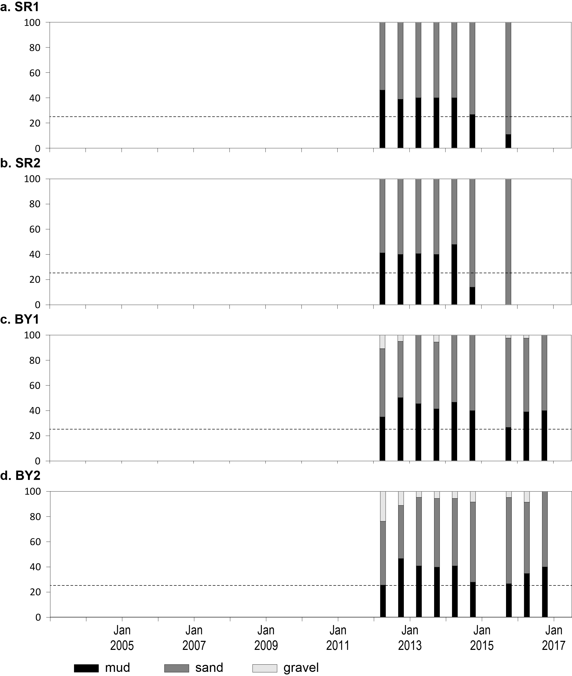
Figure 169. Sediment grain size composition at coastal habitat monitoring sites in the Cape York region, 2013-2017.
Dashed line is the GBR long-term average proportion of mud.

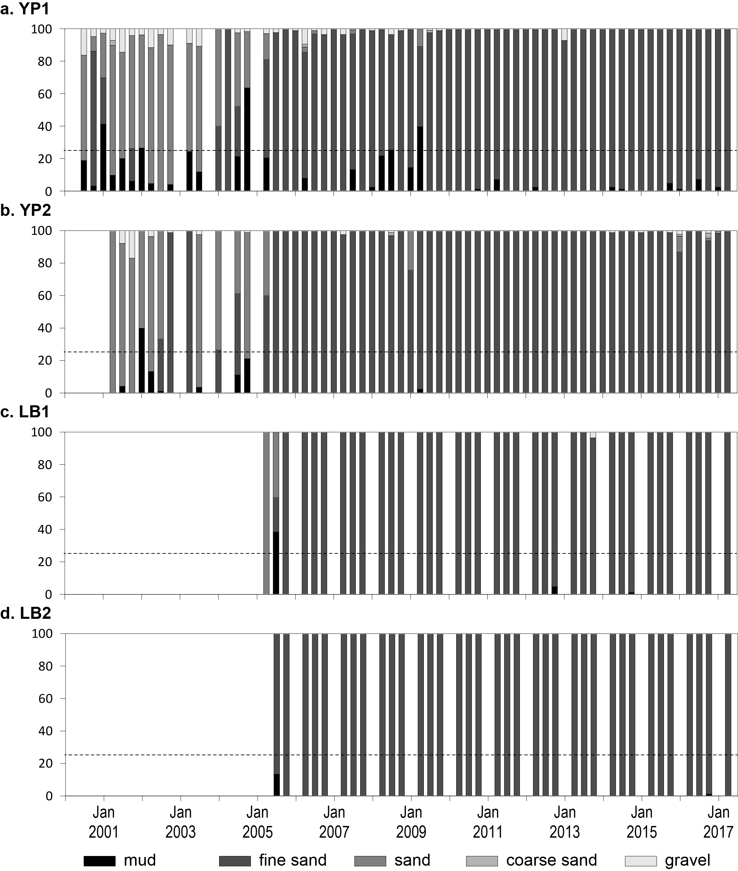
Figure 170. Sediment grain size composition at intertidal coastal habitat monitoring sites in the Wet Tropics region, 2001-2017.
Dashed line is the GBR long-term average proportion of mud.

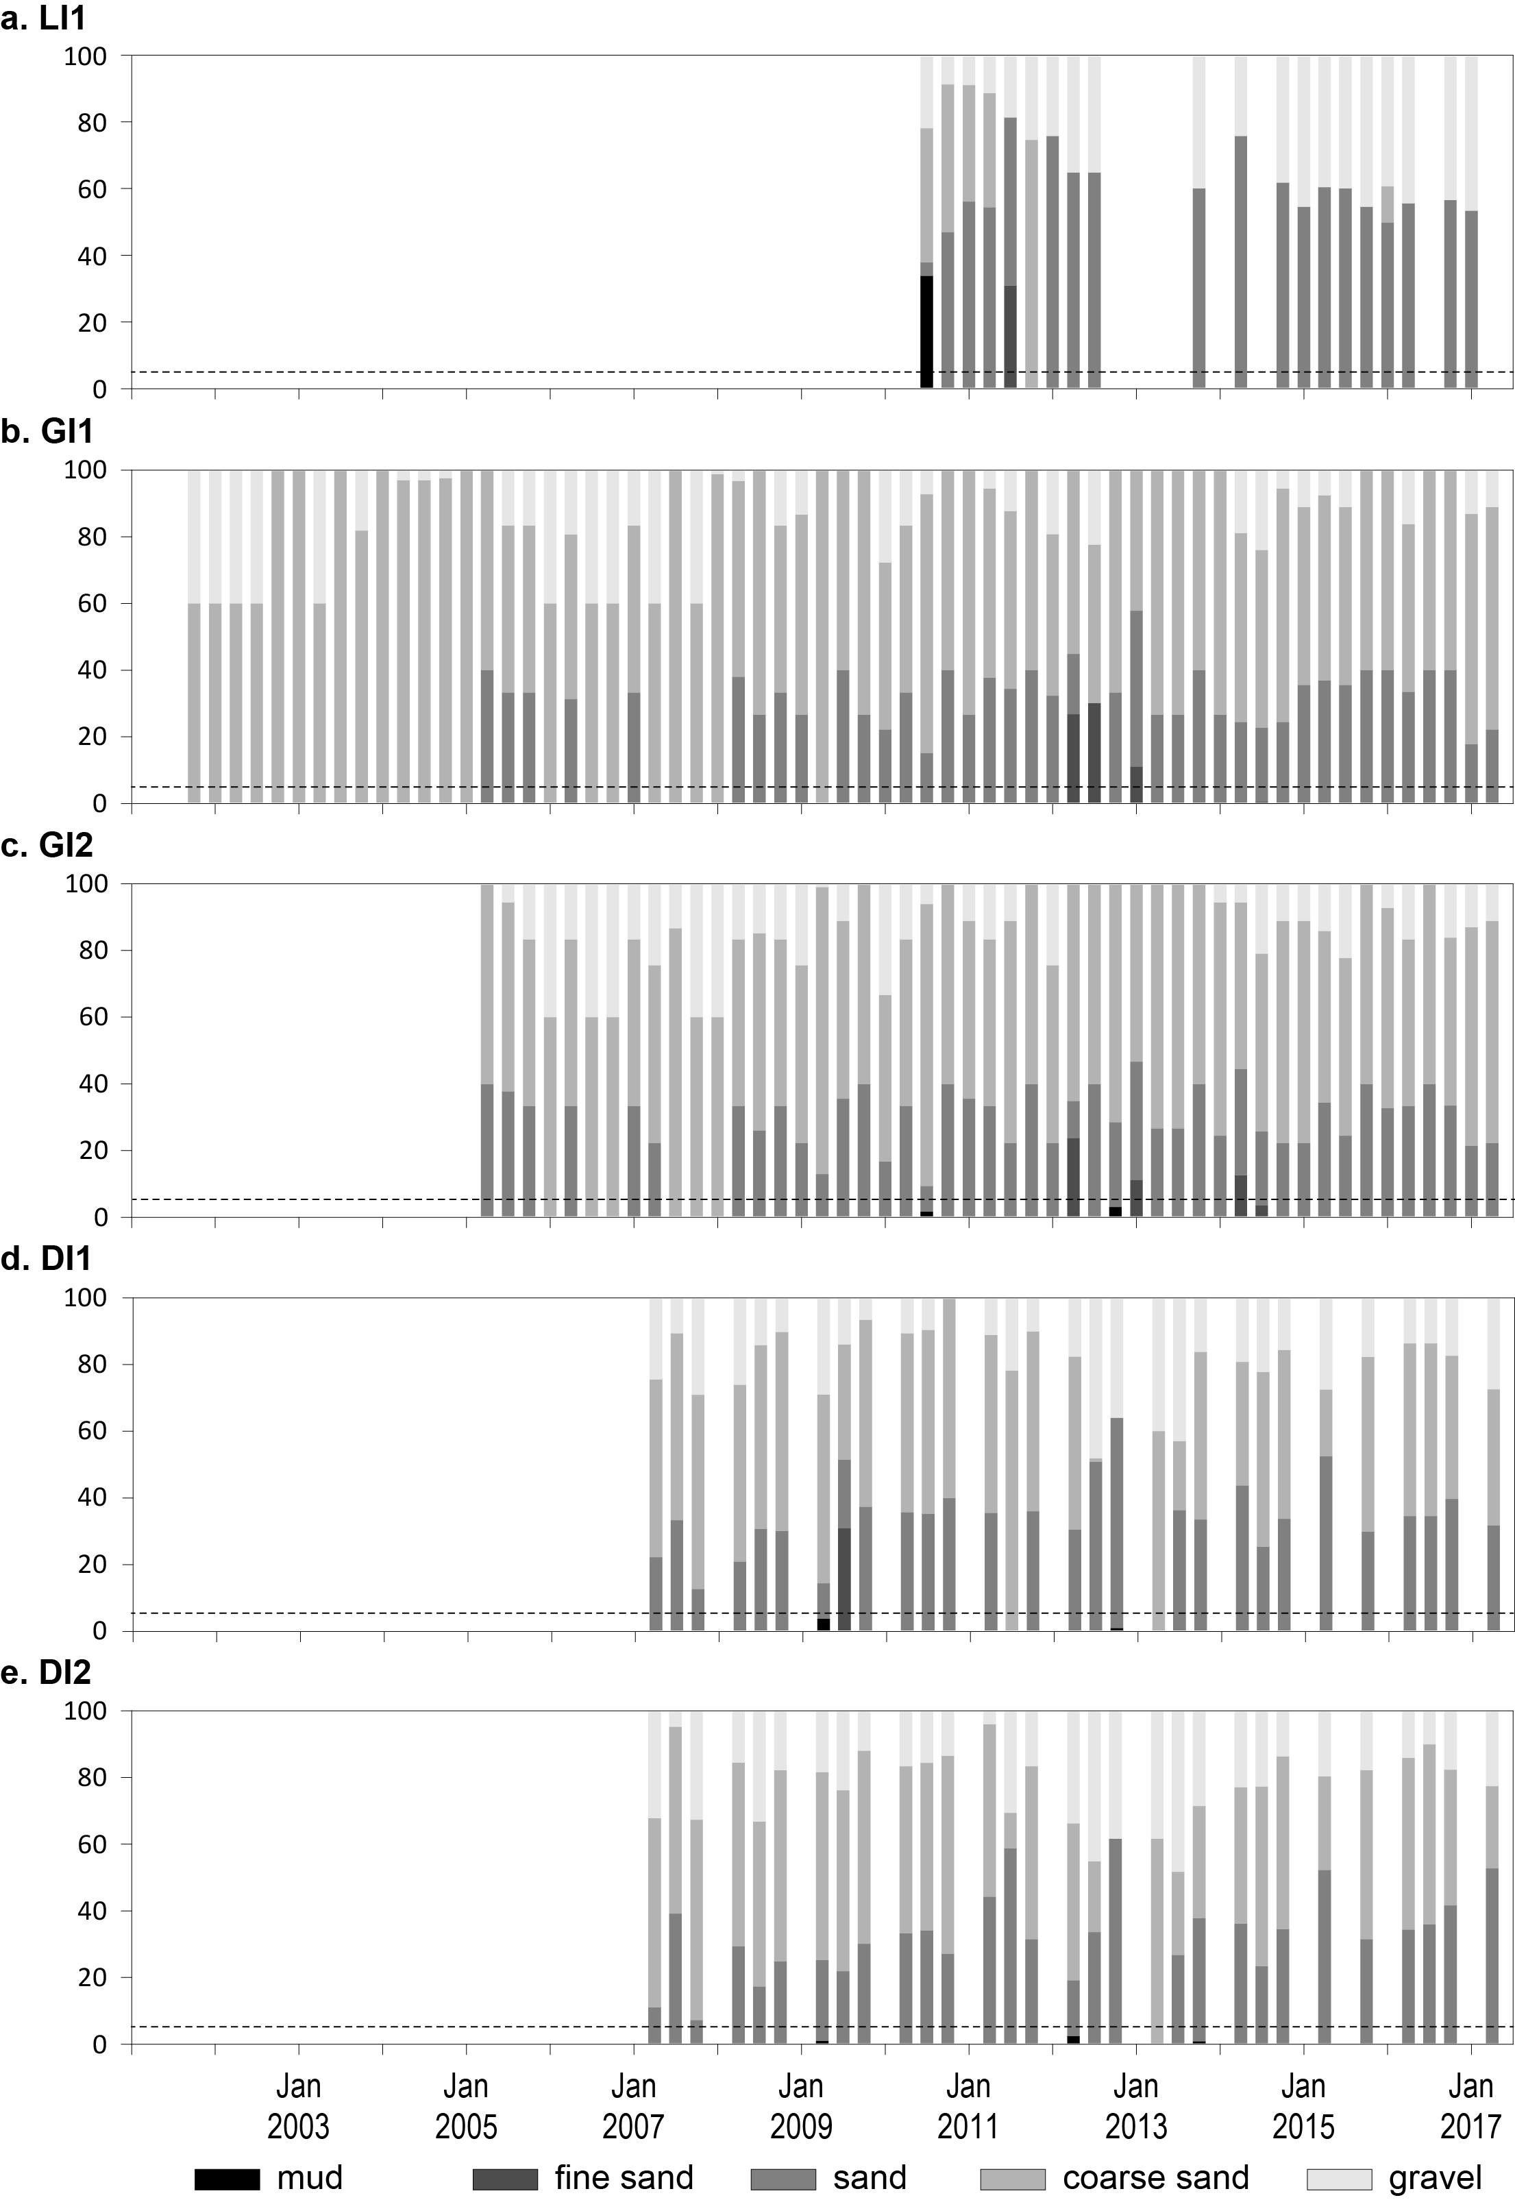
Figure 171. Sediment grain size composition at intertidal reef habitat monitoring sites in the Wet Tropics region, 2001-2017.
Dashed line is the GBR long-term average proportion of mud.

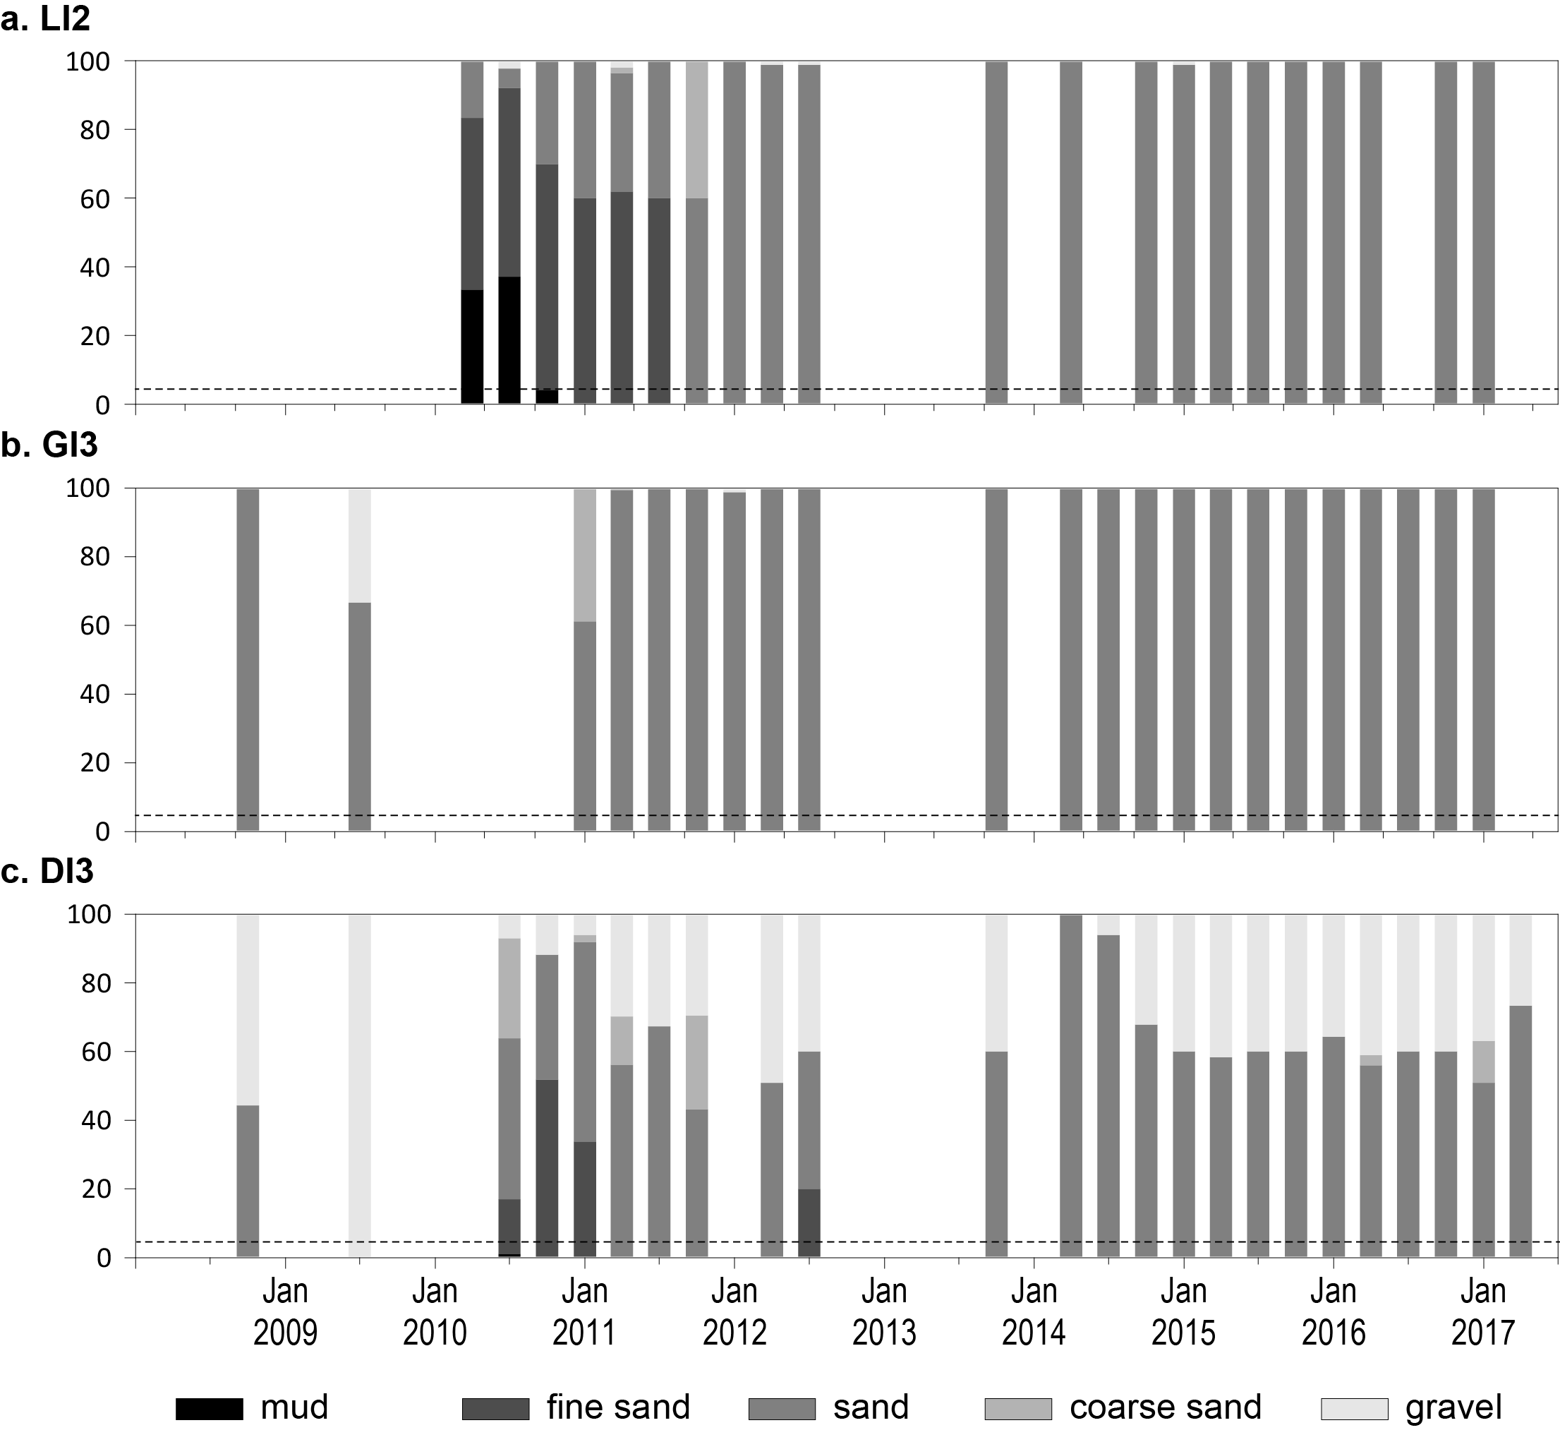
Figure 172. Sediment grain size composition at subtidal reef habitat monitoring sites in the Wet Tropics region, 2008-2017.
Dashed line is the GBR long-term average proportion of mud.

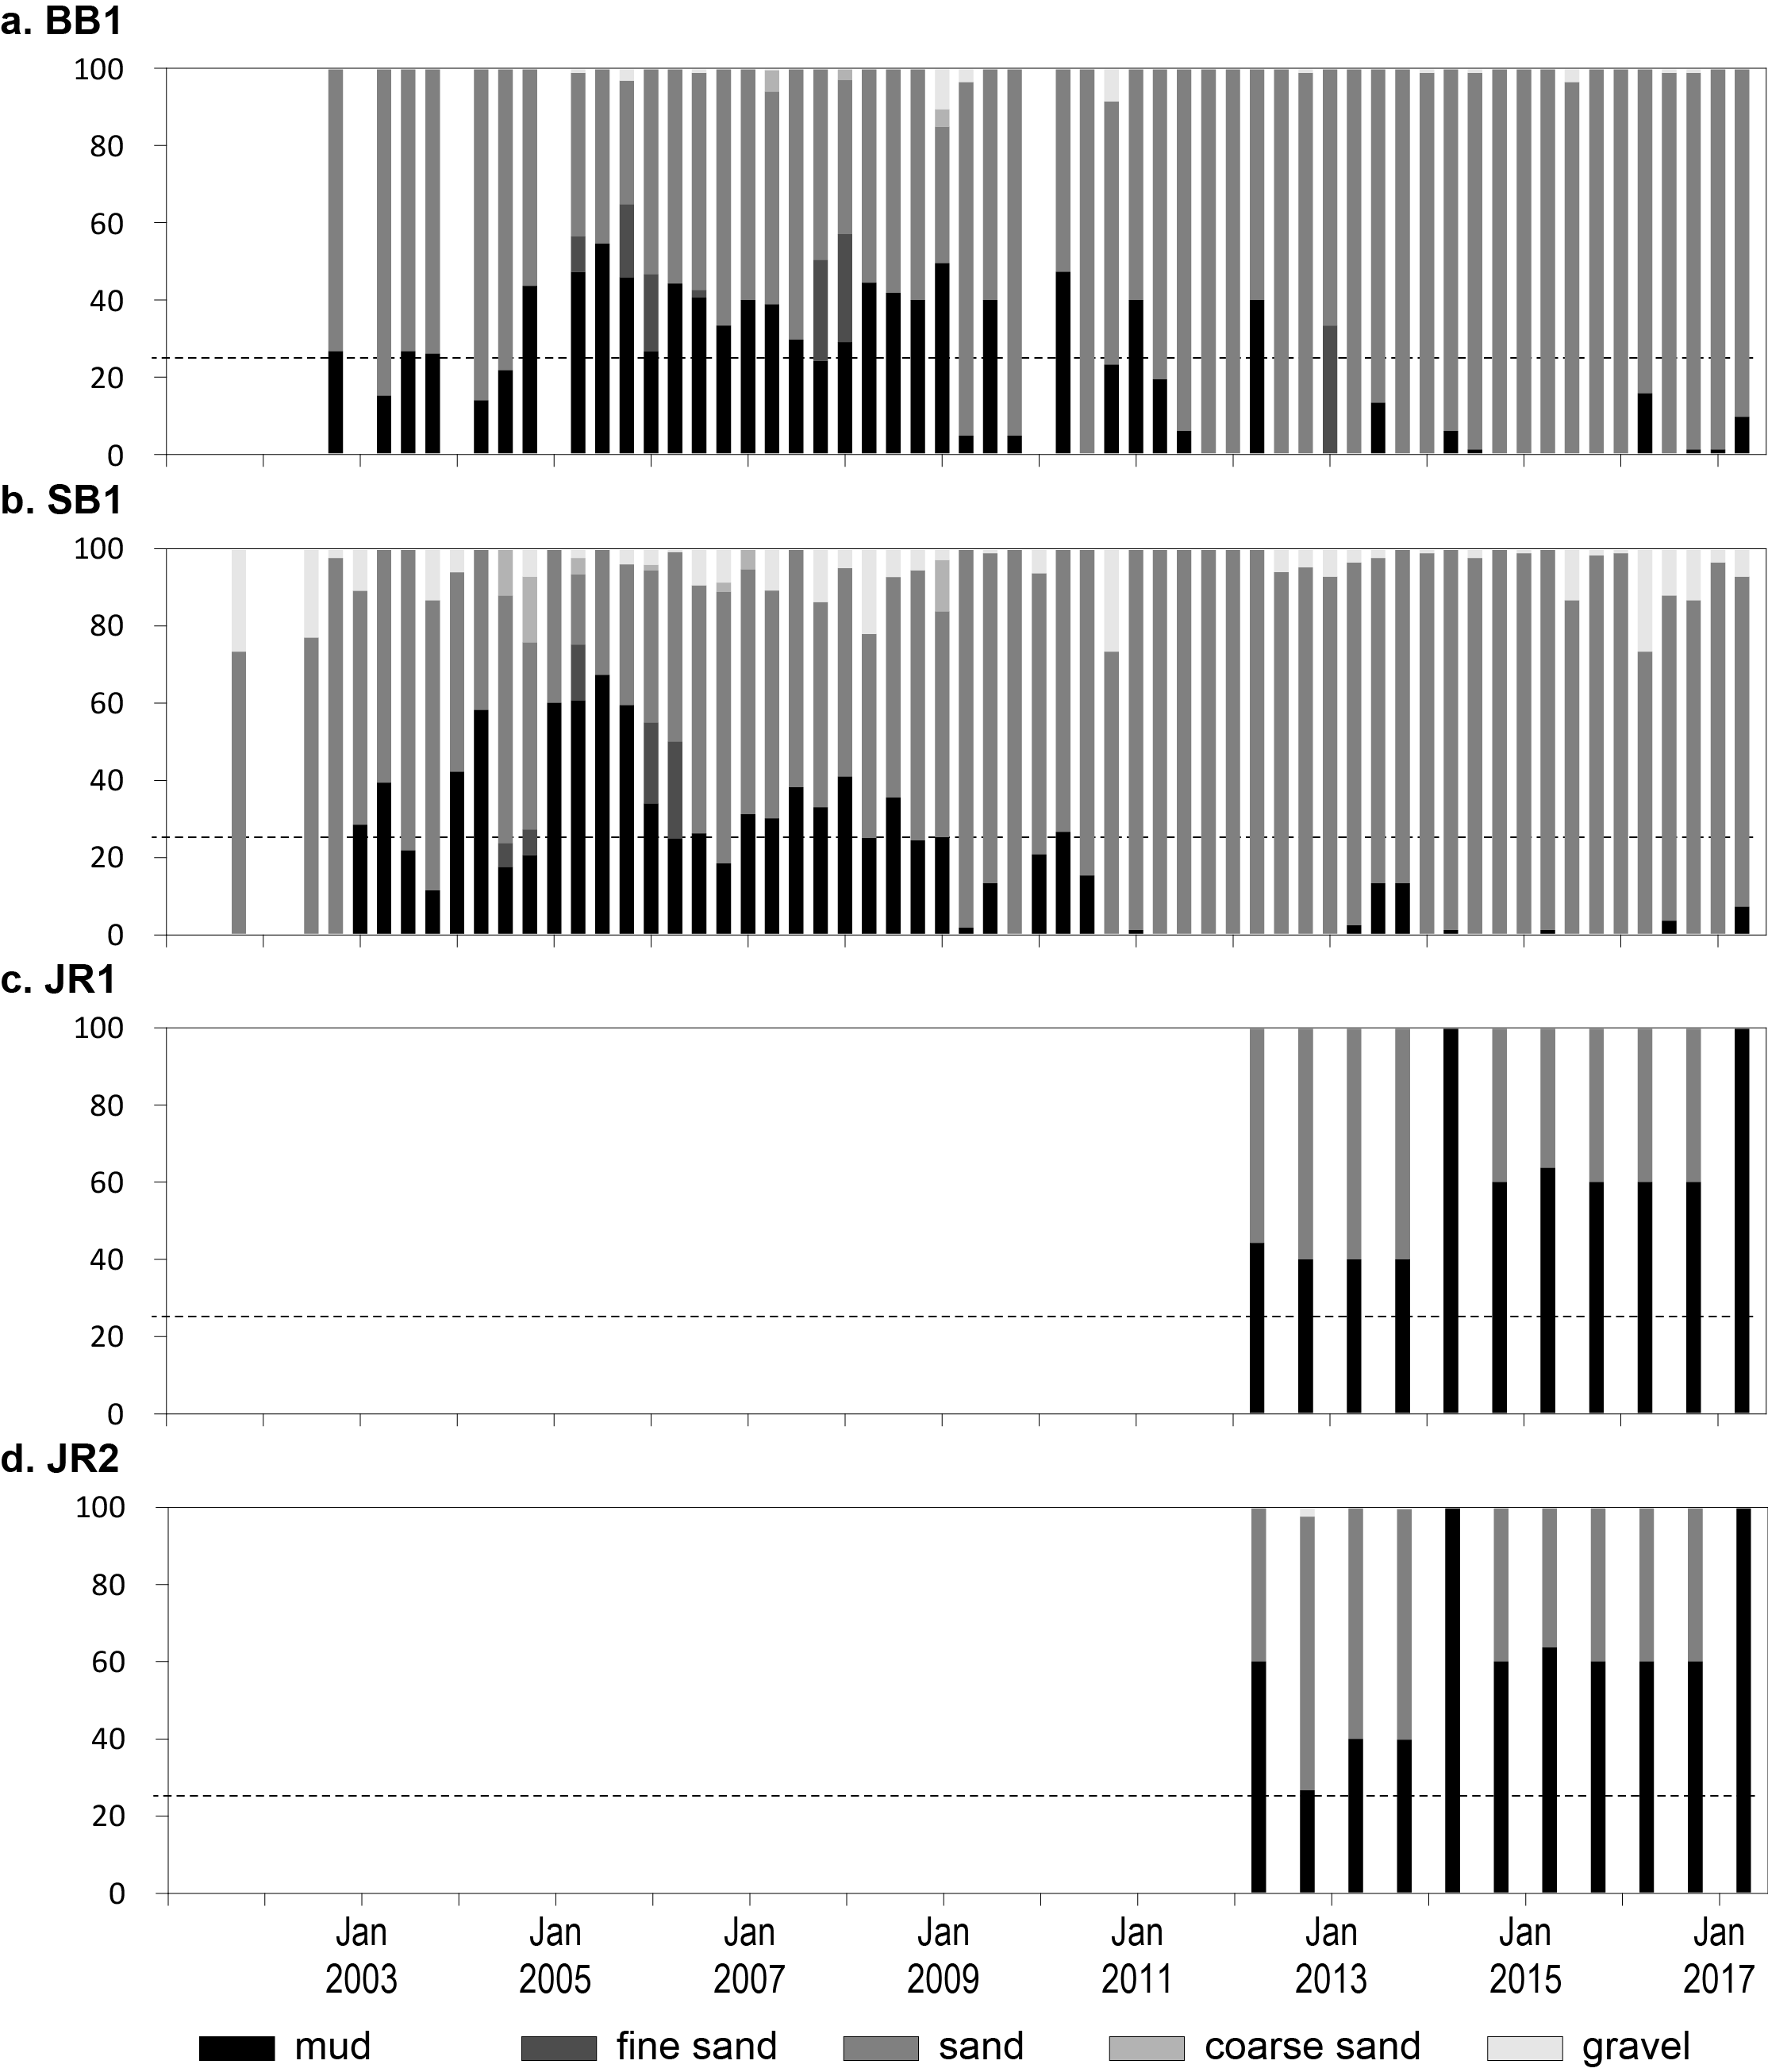
Figure 173. Sediment grain size composition at intertidal coastal habitat monitoring sites in the Burdekin region, 2001-2017.
Dashed line is the GBR long-term average proportion of mud.
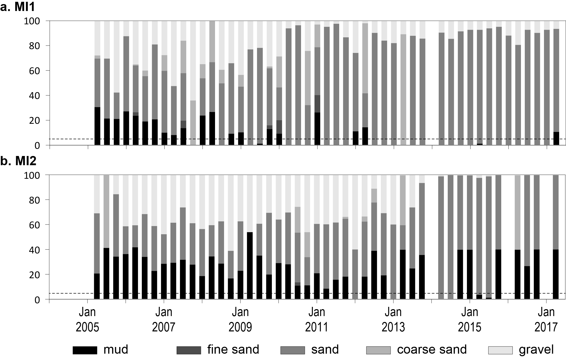
Figure 174. Sediment grain size composition at intertidal reef habitat monitoring sites in the Burdekin region, 2004-2017.
Dashed line is the GBR long-term average proportion of mud.

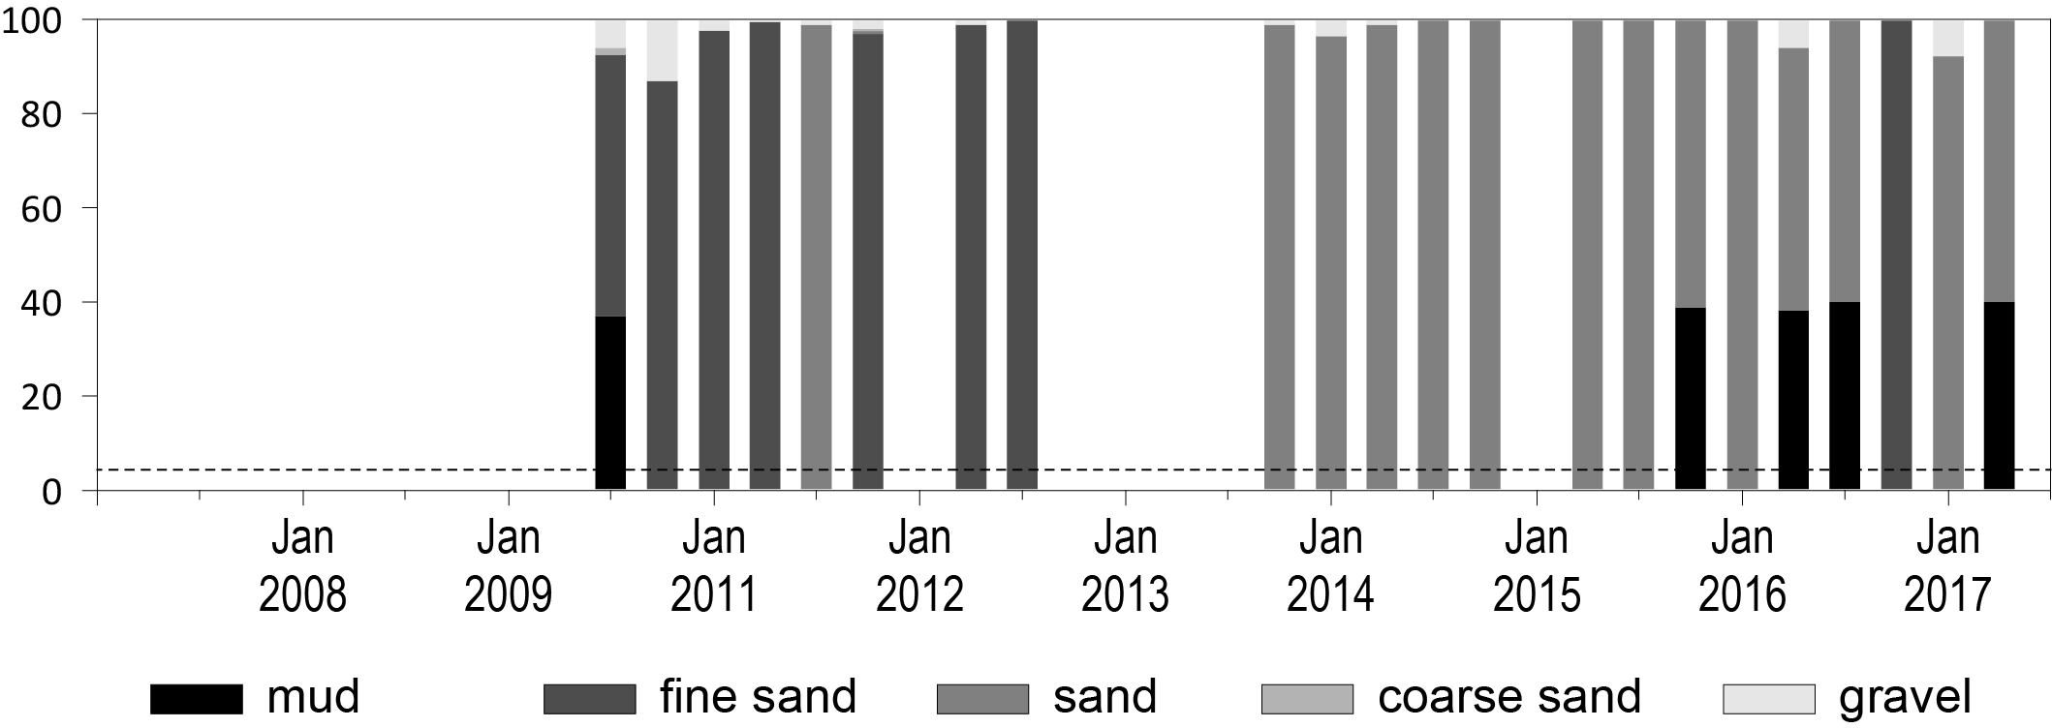
Figure 175. Sediment grain size composition at subtidal reef habitat monitoring sites in the Burdekin region, 2010-2017.
Dashed line is the GBR long-term average proportion of mud.

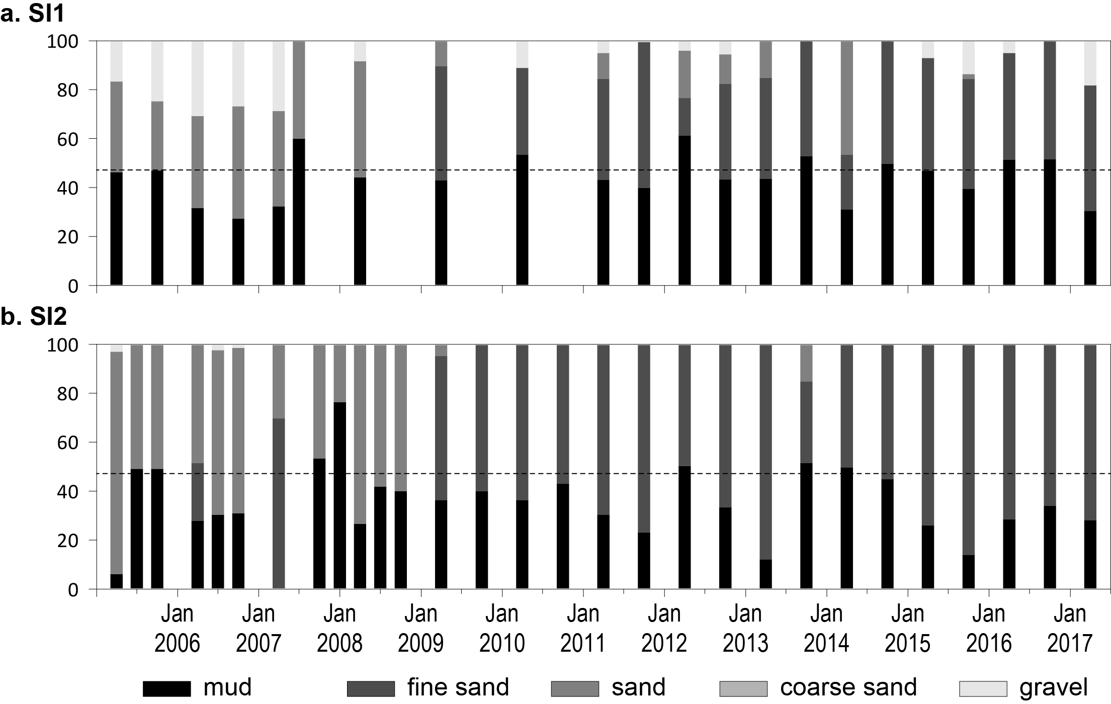
Figure 176. Sediment grain size composition at intertidal estuary habitat monitoring sites in the Mackay Whitsunday region, 2005-2017.
Dashed line is the GBR long-term average proportion of mud.

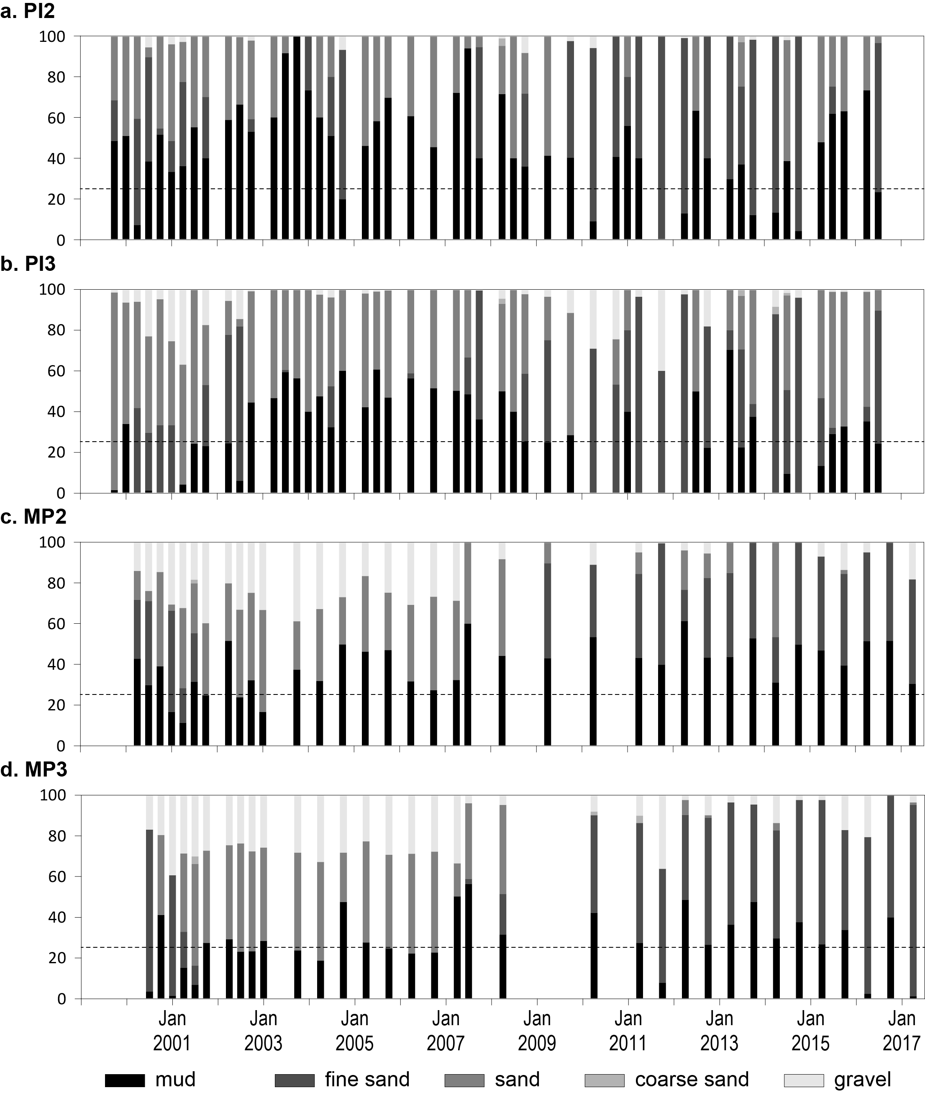
Figure 177. Sediment grain size composition at intertidal coastal habitat monitoring sites in the Mackay Whitsunday region, 1999-2017.
Dashed line is the GBR long-term average proportion of mud.
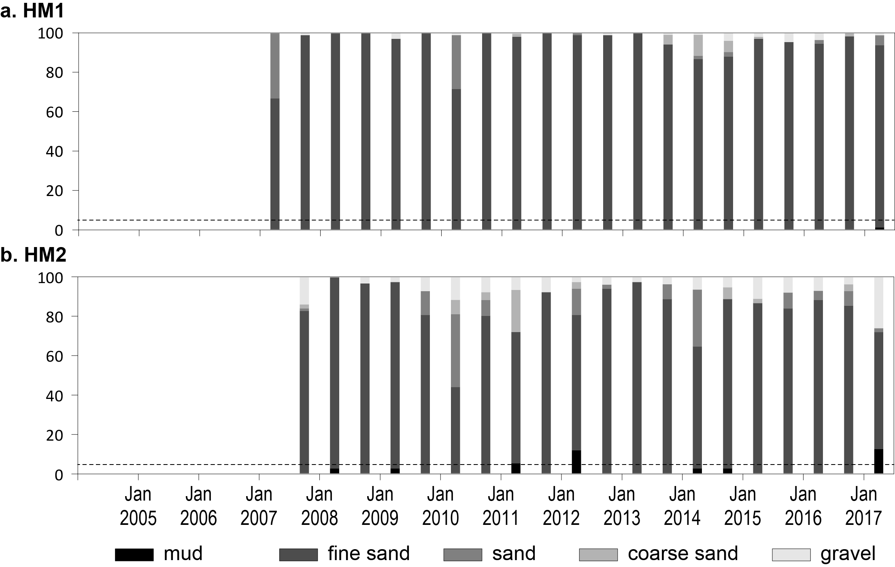
Figure 178. Sediment grain size composition at intertidal reef habitat monitoring sites in the Mackay Whitsunday region, 2007-2017.
Dashed line is the GBR long-term average proportion of mud.

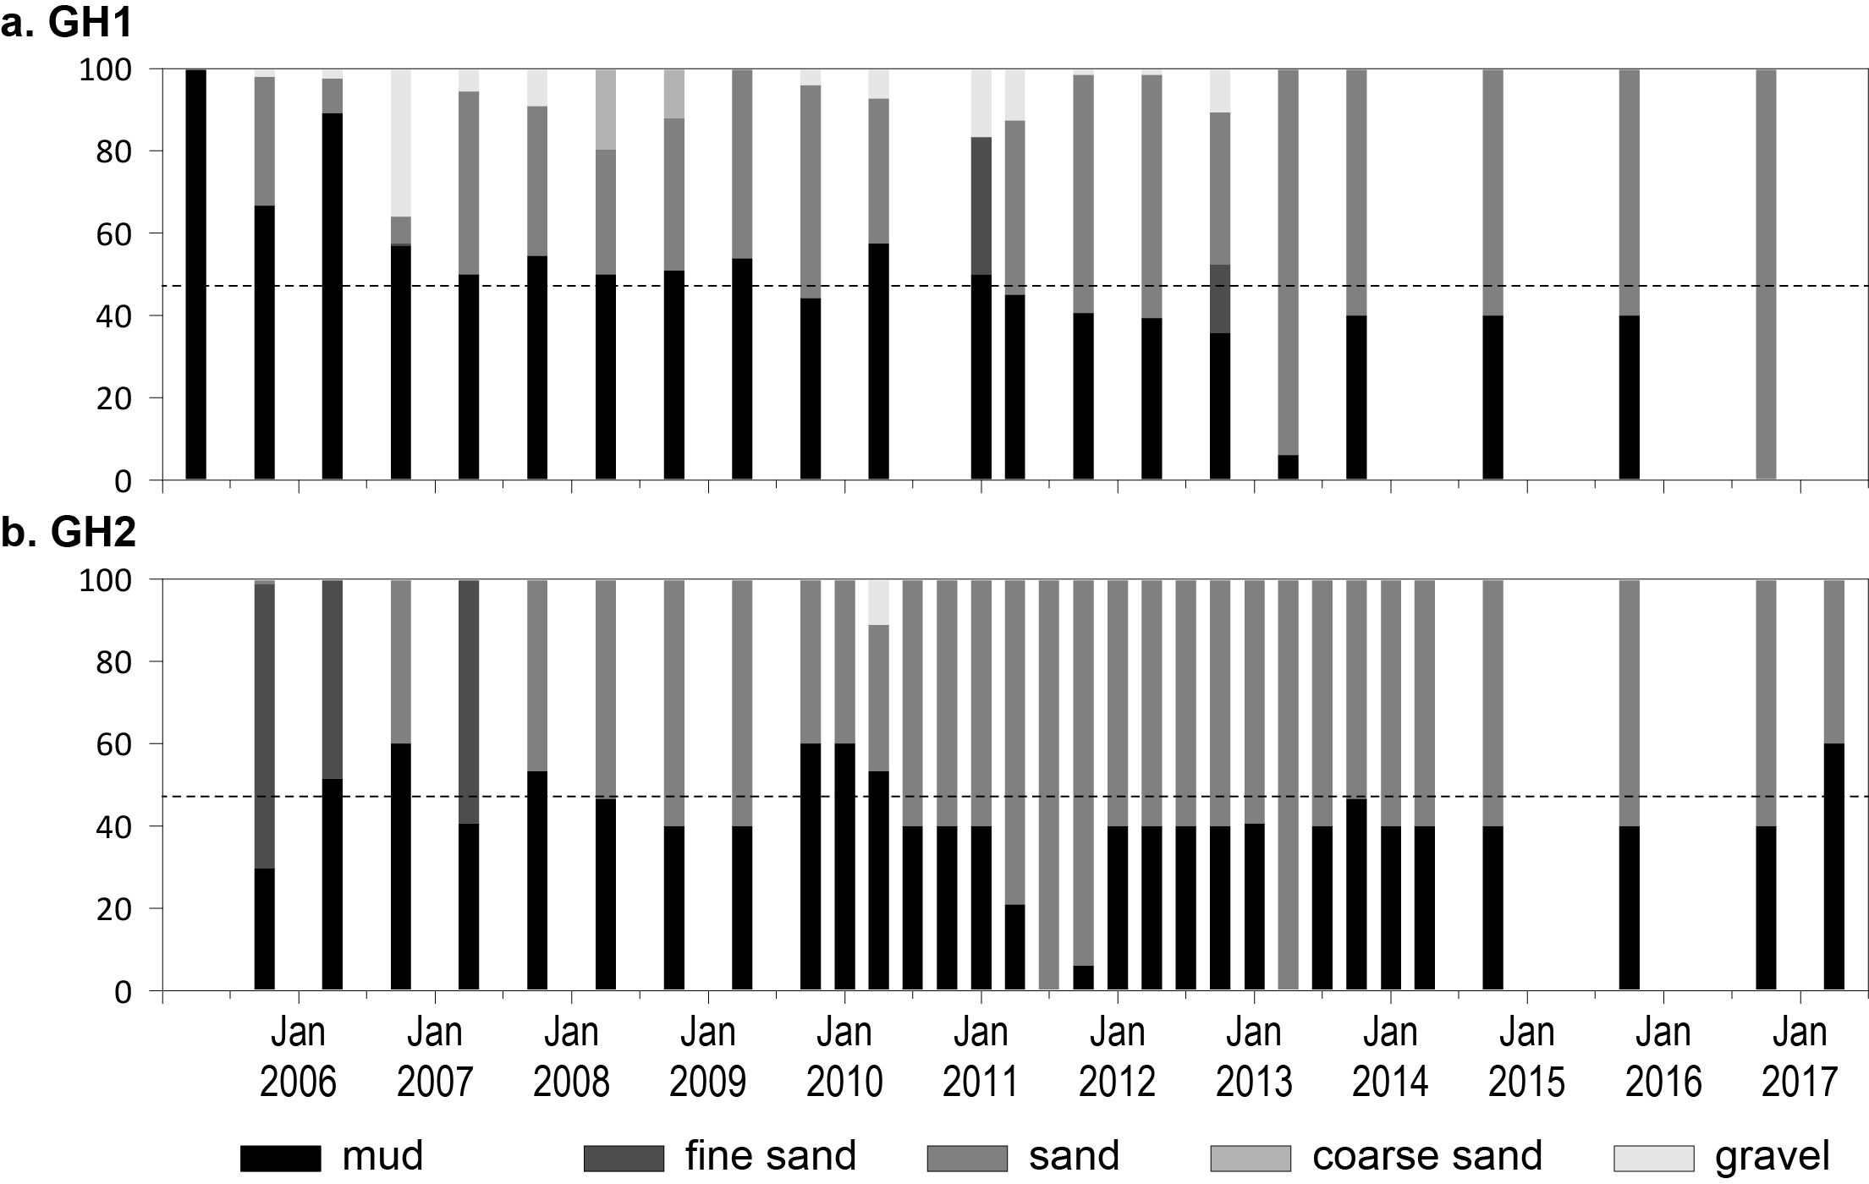
Figure 179. Sediment grain size composition at intertidal estuary habitat monitoring sites in the Fitzroy region, 2005-2017.
Dashed line is the GBR long-term average proportion of mud.

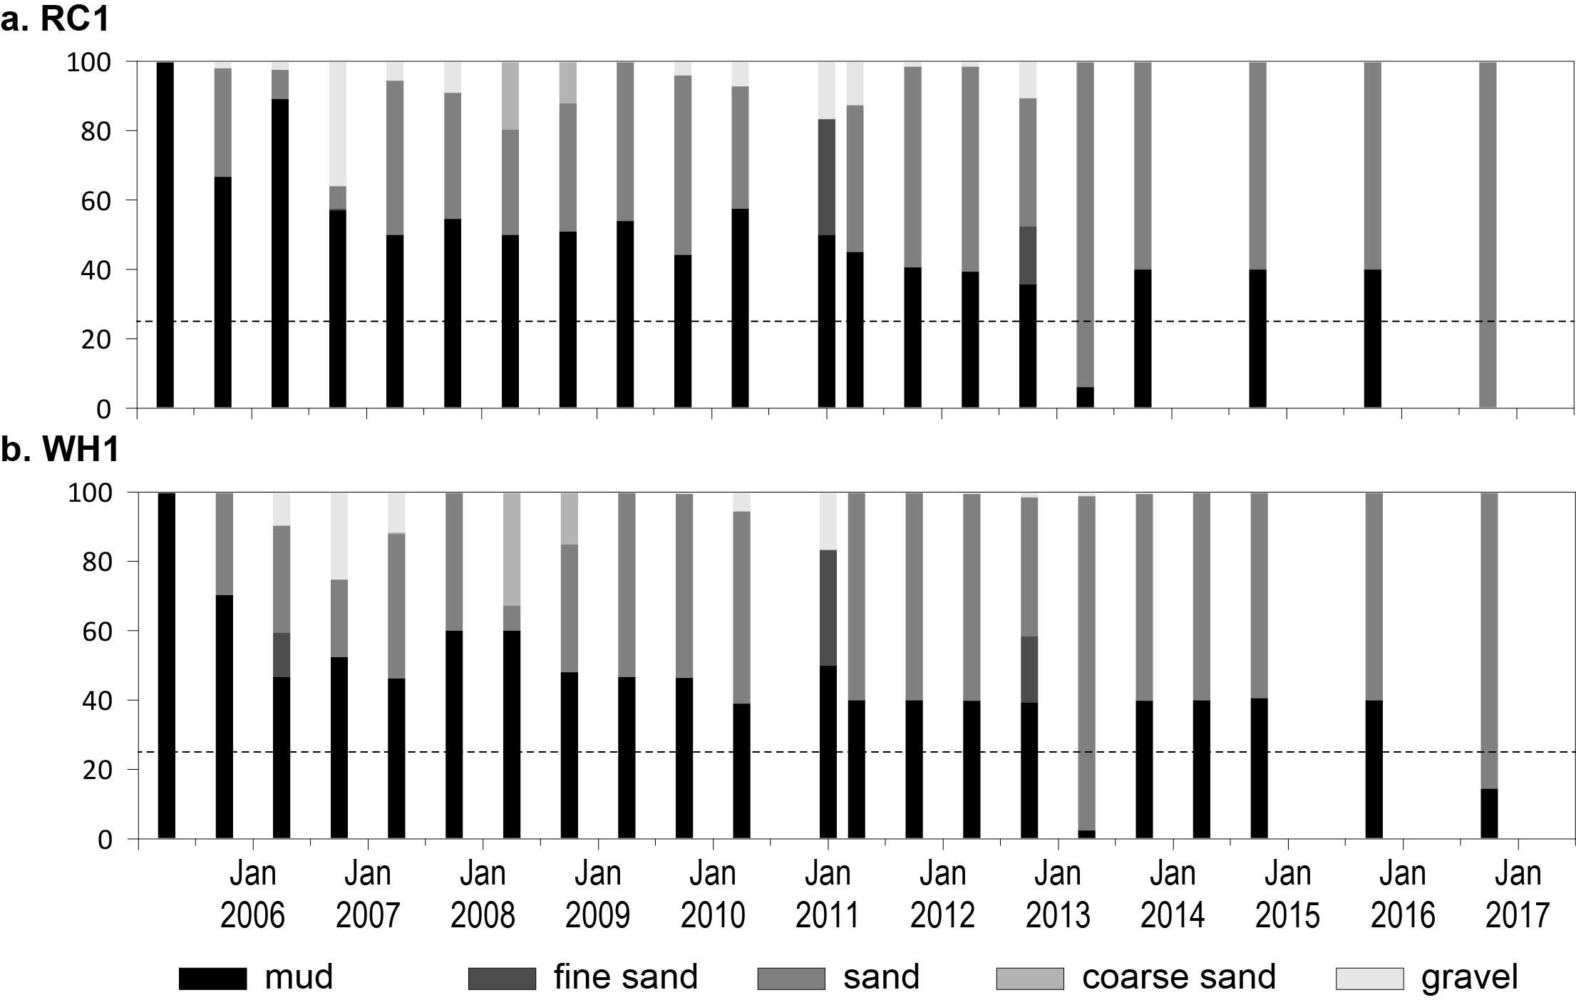
Figure 180. Sediment grain size composition at intertidal coastal habitat monitoring sites in the Fitzroy region, 2005-2017.
Dashed line is the GBR long-term average proportion of mud.

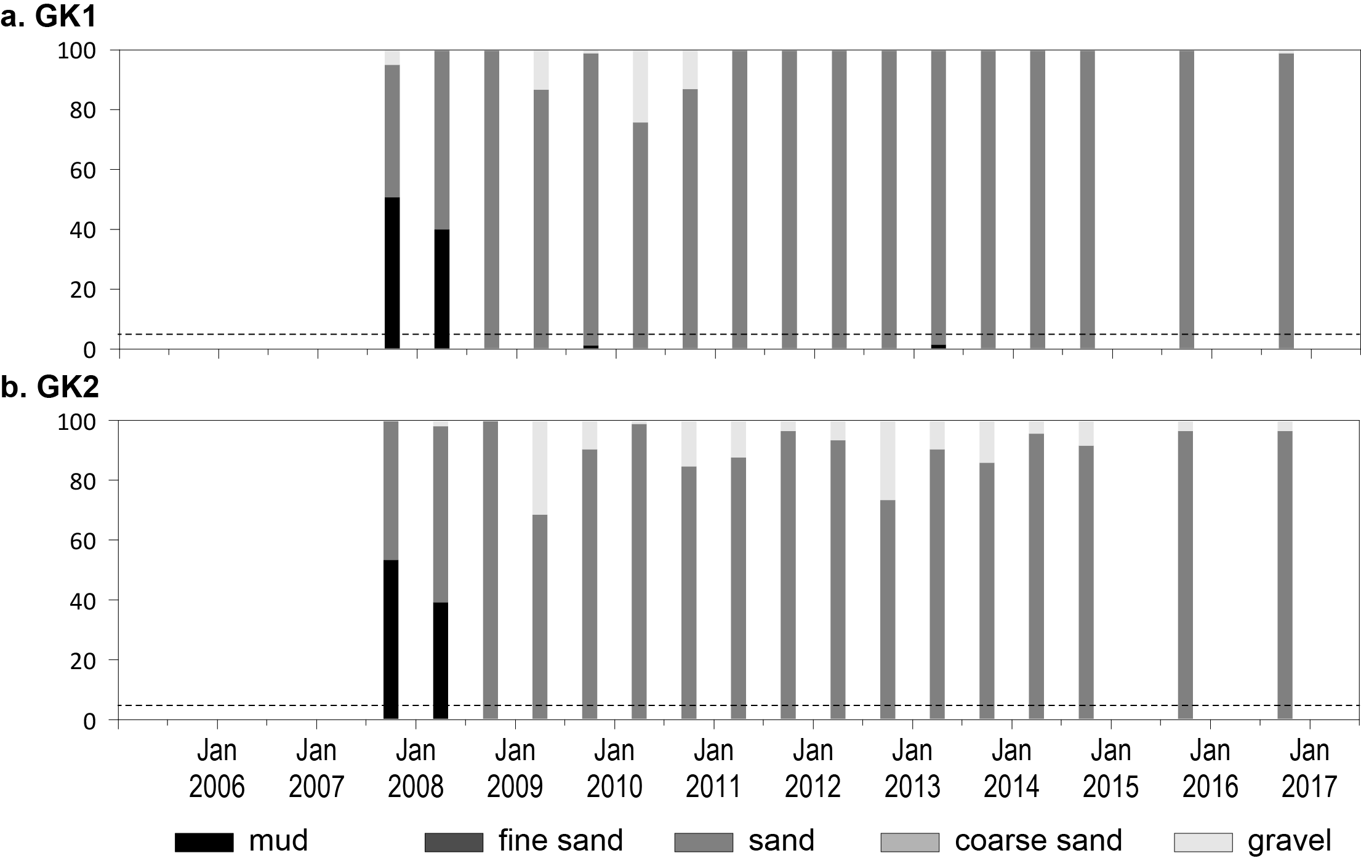
Figure 181. Sediment grain size composition at intertidal reef habitat monitoring sites in the Fitzroy region, 2007-2017.
Dashed line is the GBR long-term average proportion of mud.
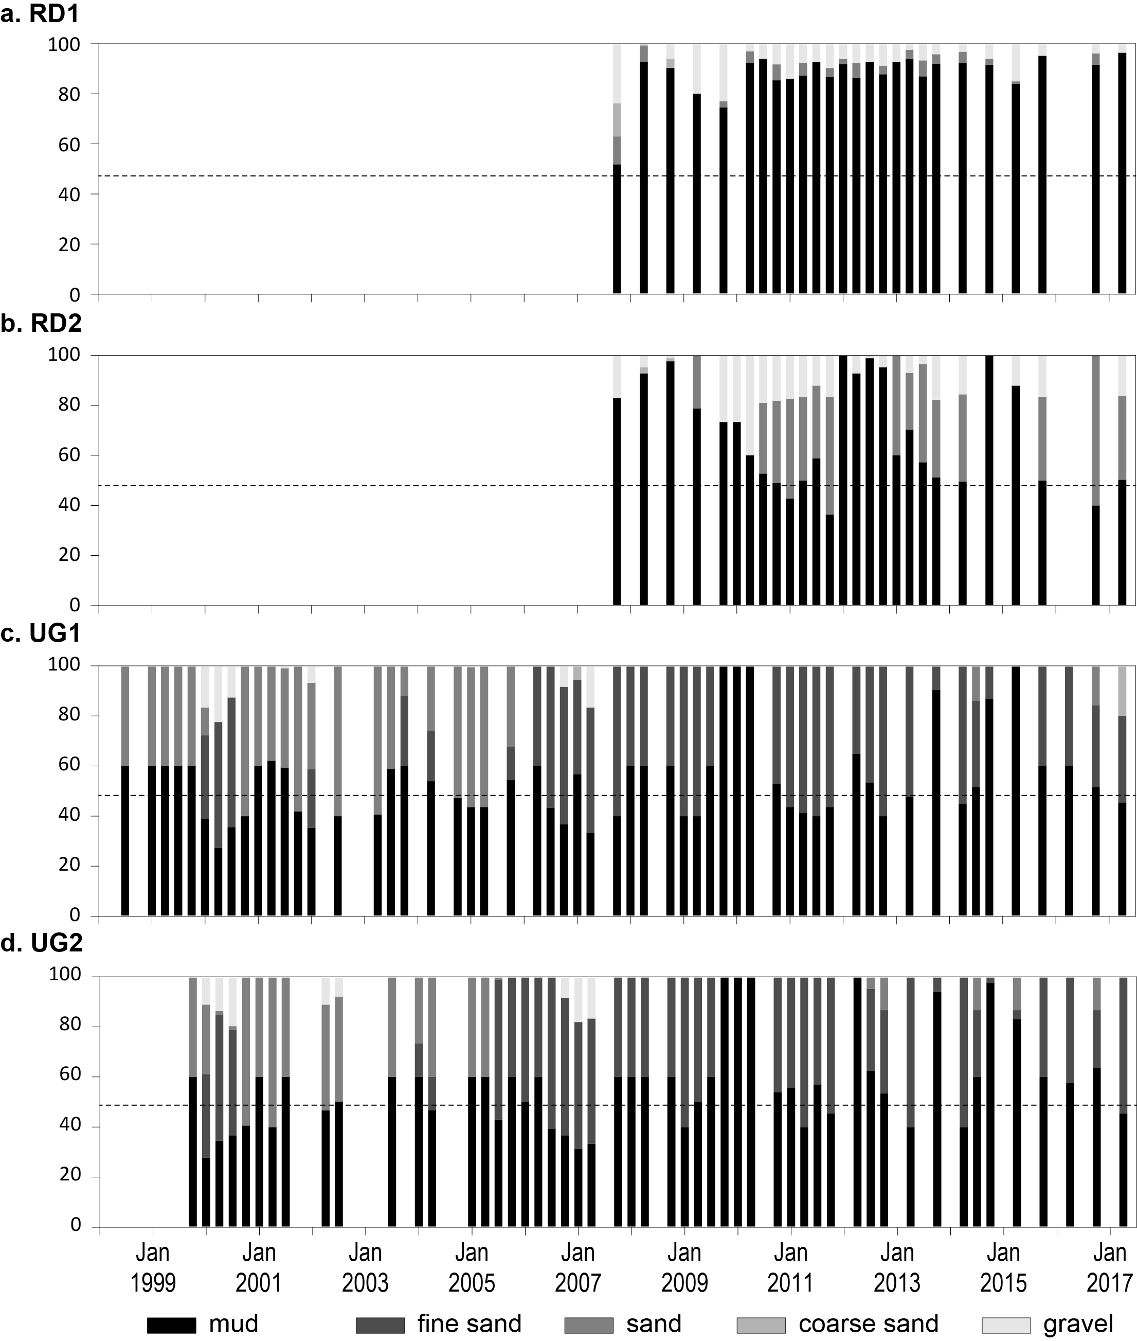
Figure 182. Sediment grain size composition at intertidal estuary habitat monitoring sites in the Burnett Mary region, 1999-2017.
Dashed line is the GBR long-term average proportion of mud.

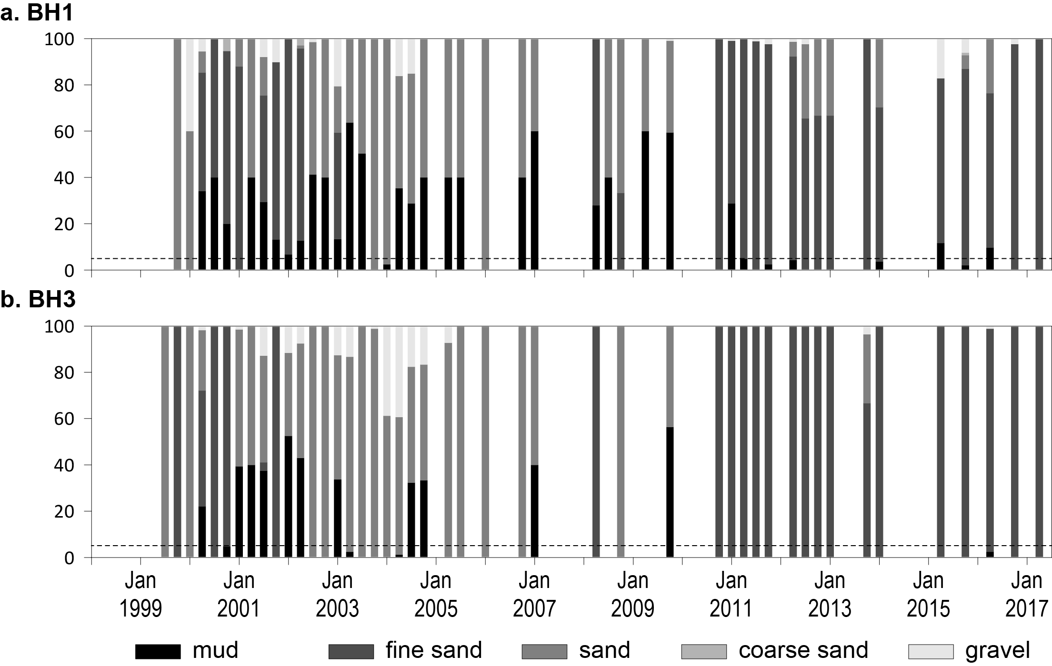
Figure 183. Sediment grain size composition at intertidal coastal habitat monitoring sites in the Burnett Mary region, 1999-2017.
Dashed line is the GBR long-term average proportion of mud.

Epiphytes and macroalgae

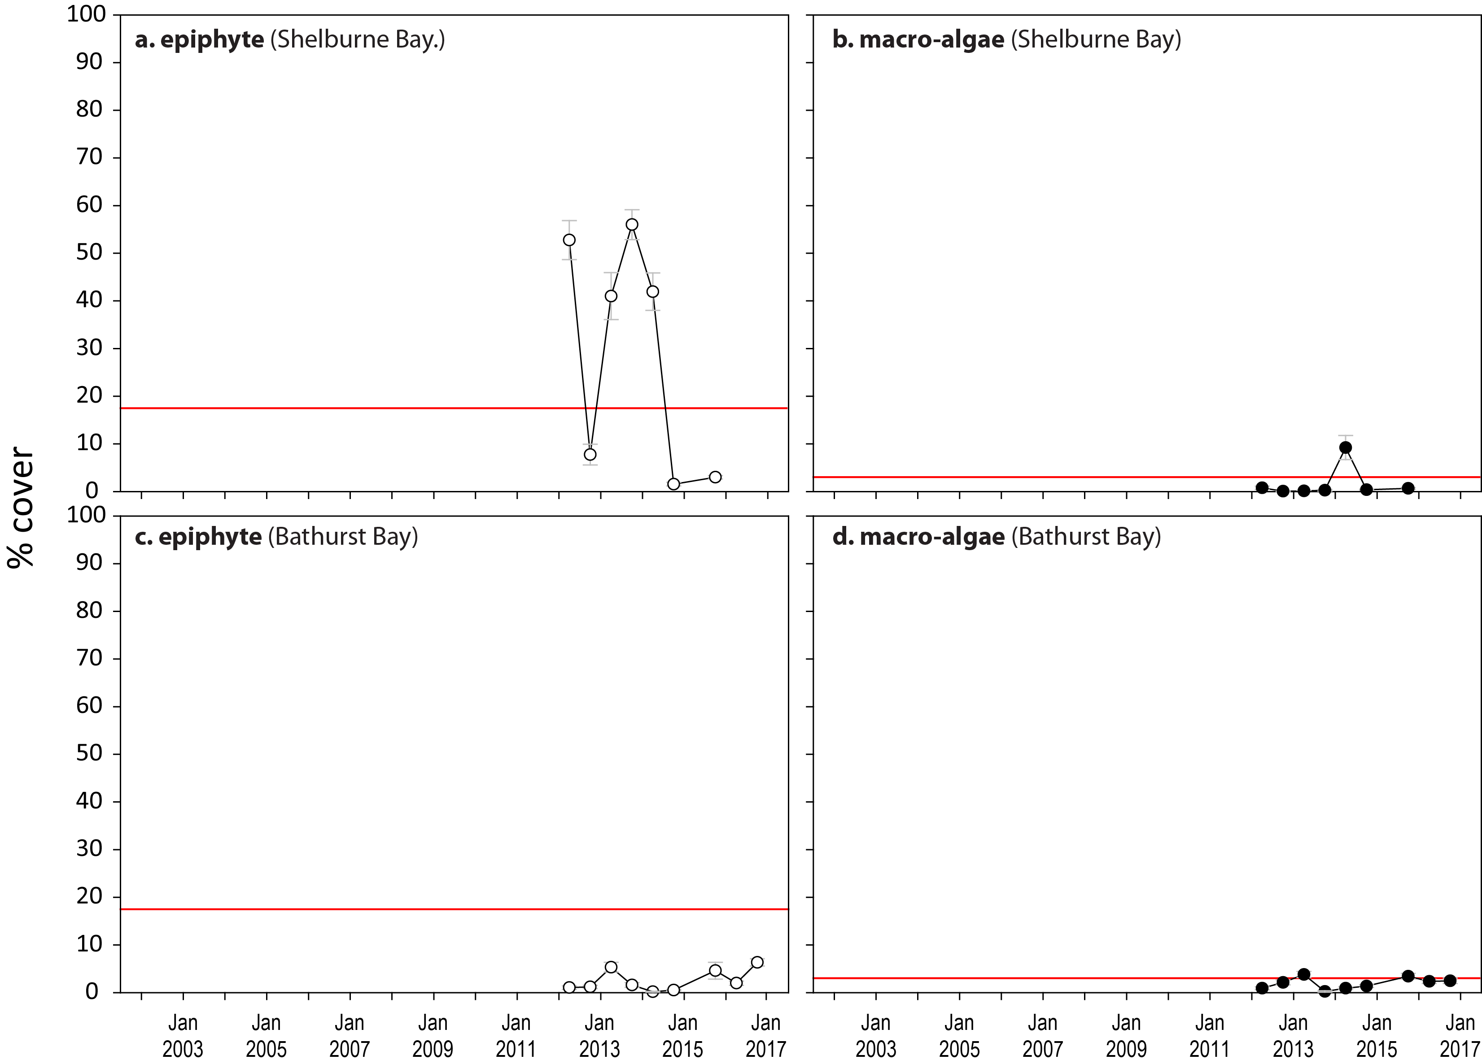
Figure 184. Long-term trend in mean abundance (per cent cover) (± SE) of epiphytes and macroalgae at intertidal coastal habitats (sites pooled), Cape York NRM region
. Red line = GBR long-term average; epiphytes=17.7 per cent, macroalgae=3.0 per cent.

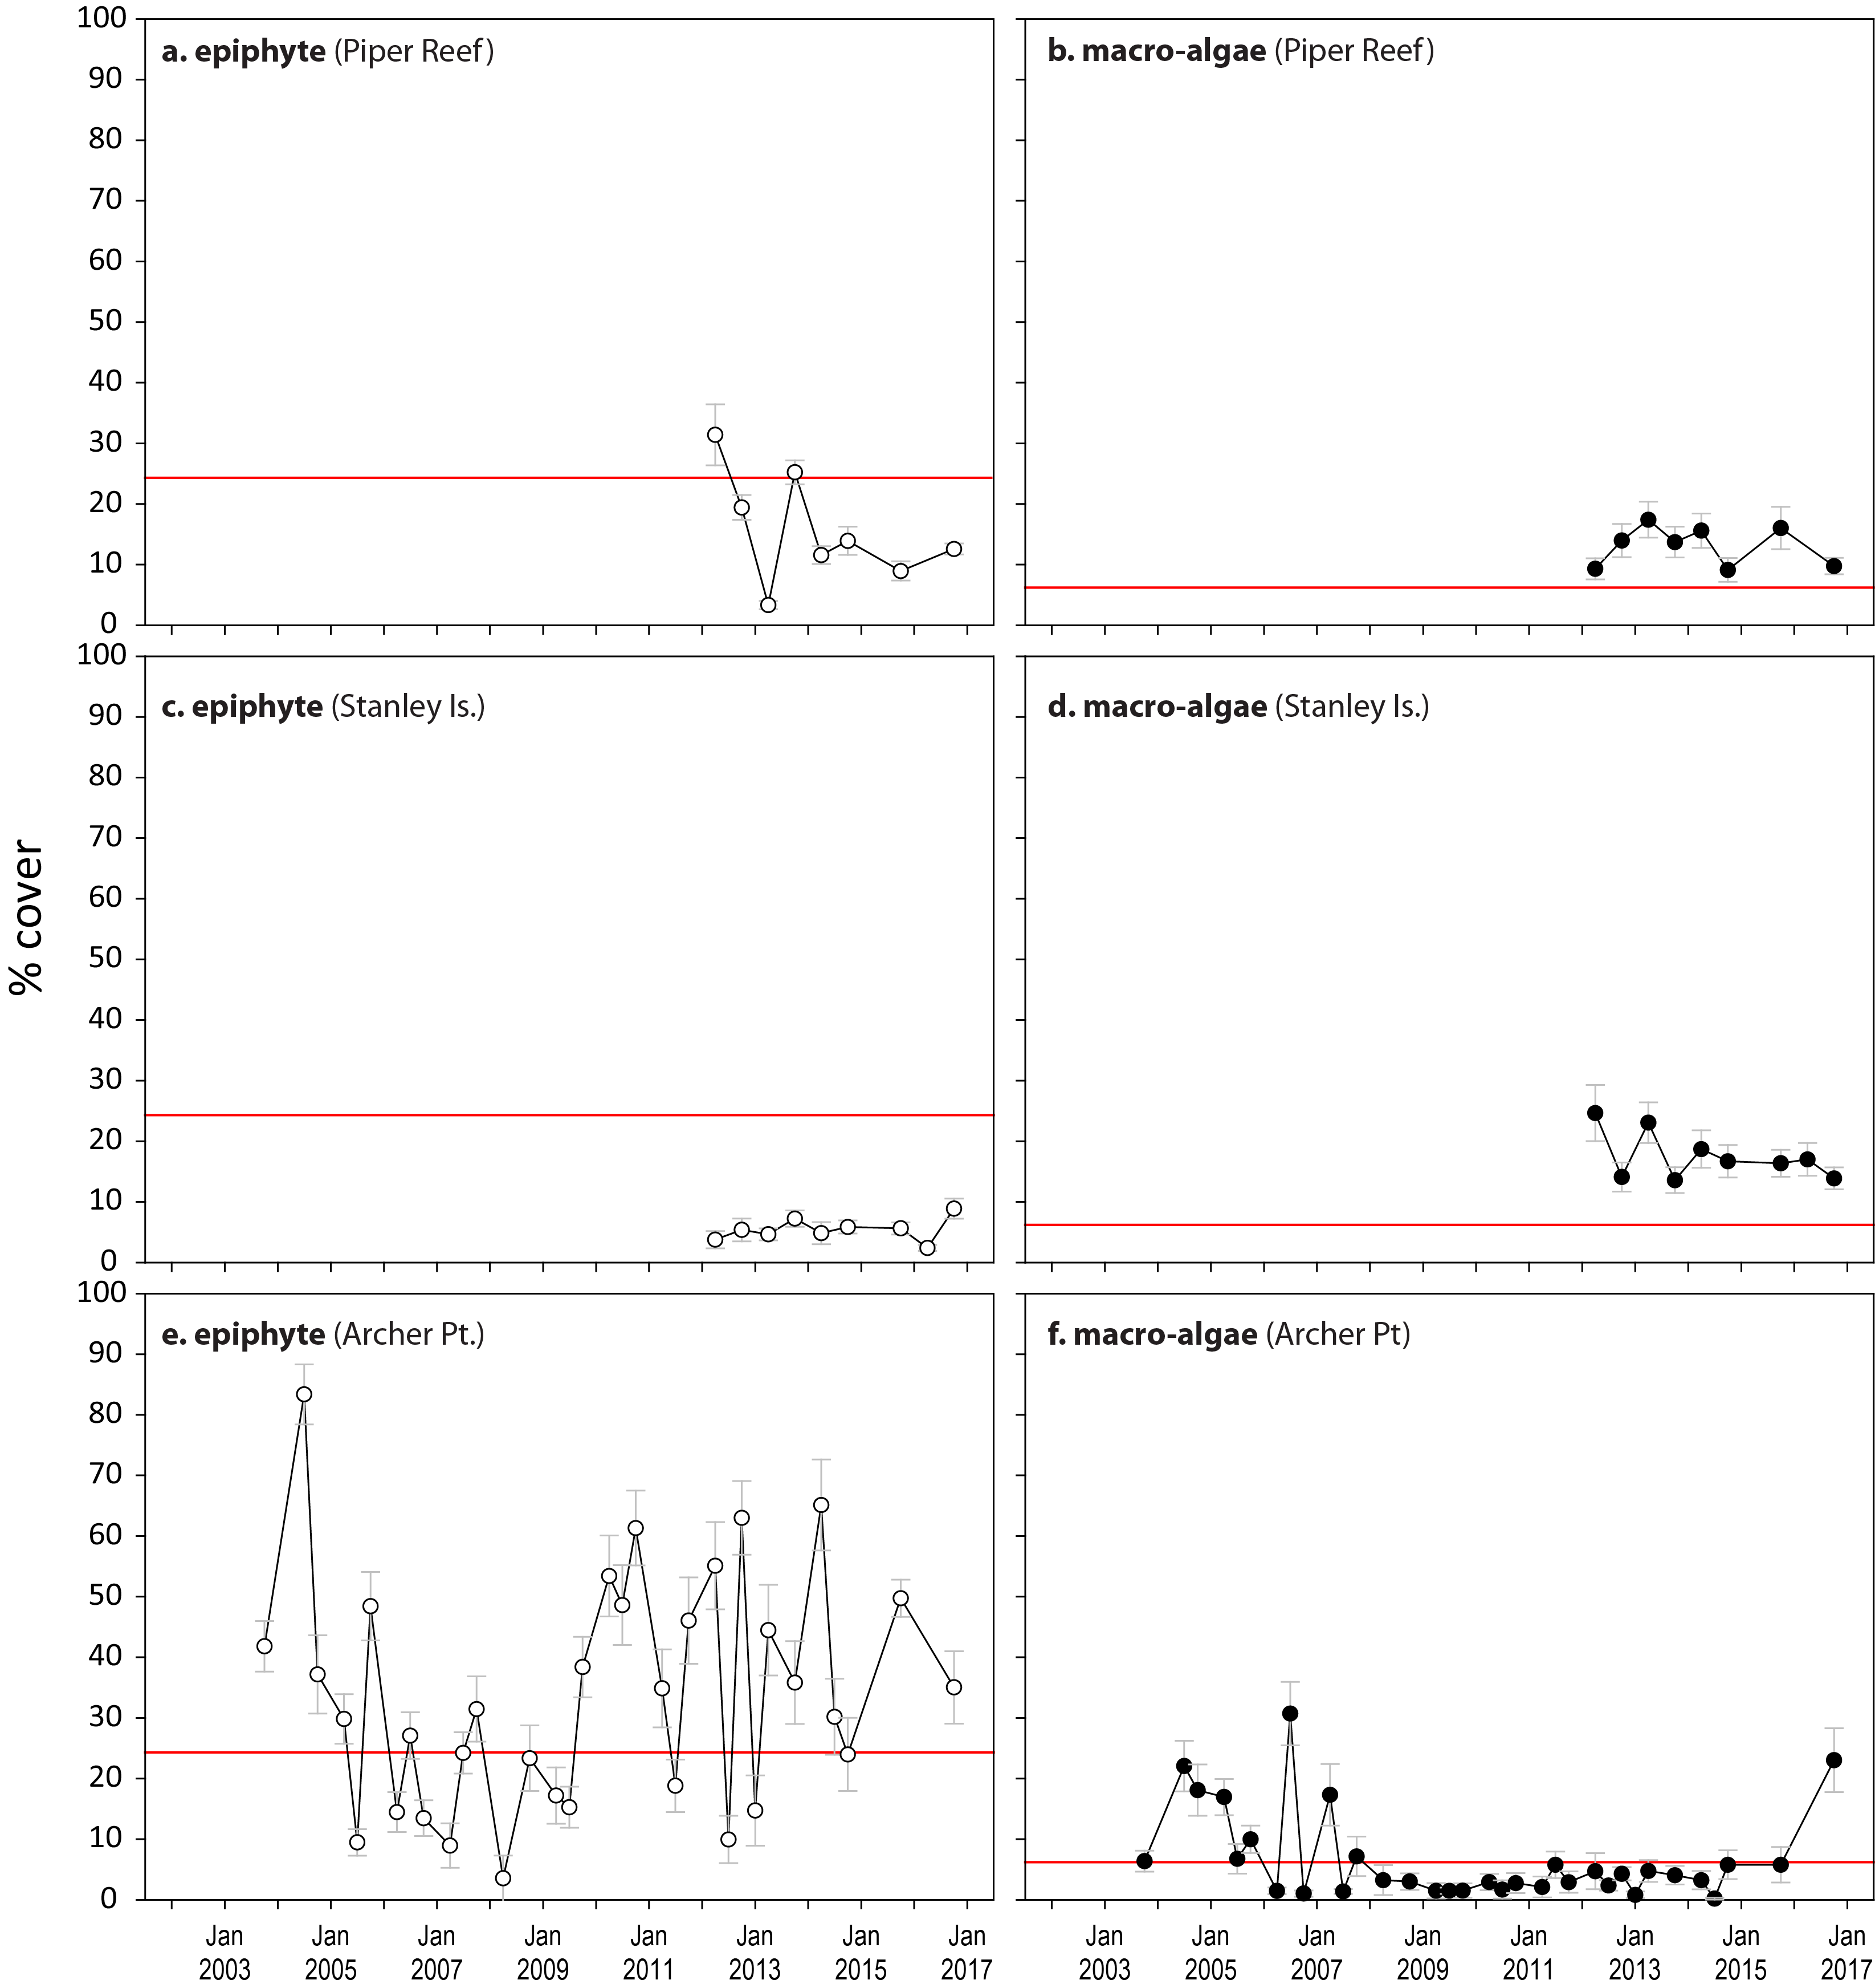
Figure 185. Long-term trend in mean abundance (per cent cover) (± SE) of epiphytes and macroalgae at intertidal reef habitats (sites pooled), Cape York NRM region
. Red line = GBR long-term average; epiphytes=24.3 per cent, macroalgae=6.2 per cent.

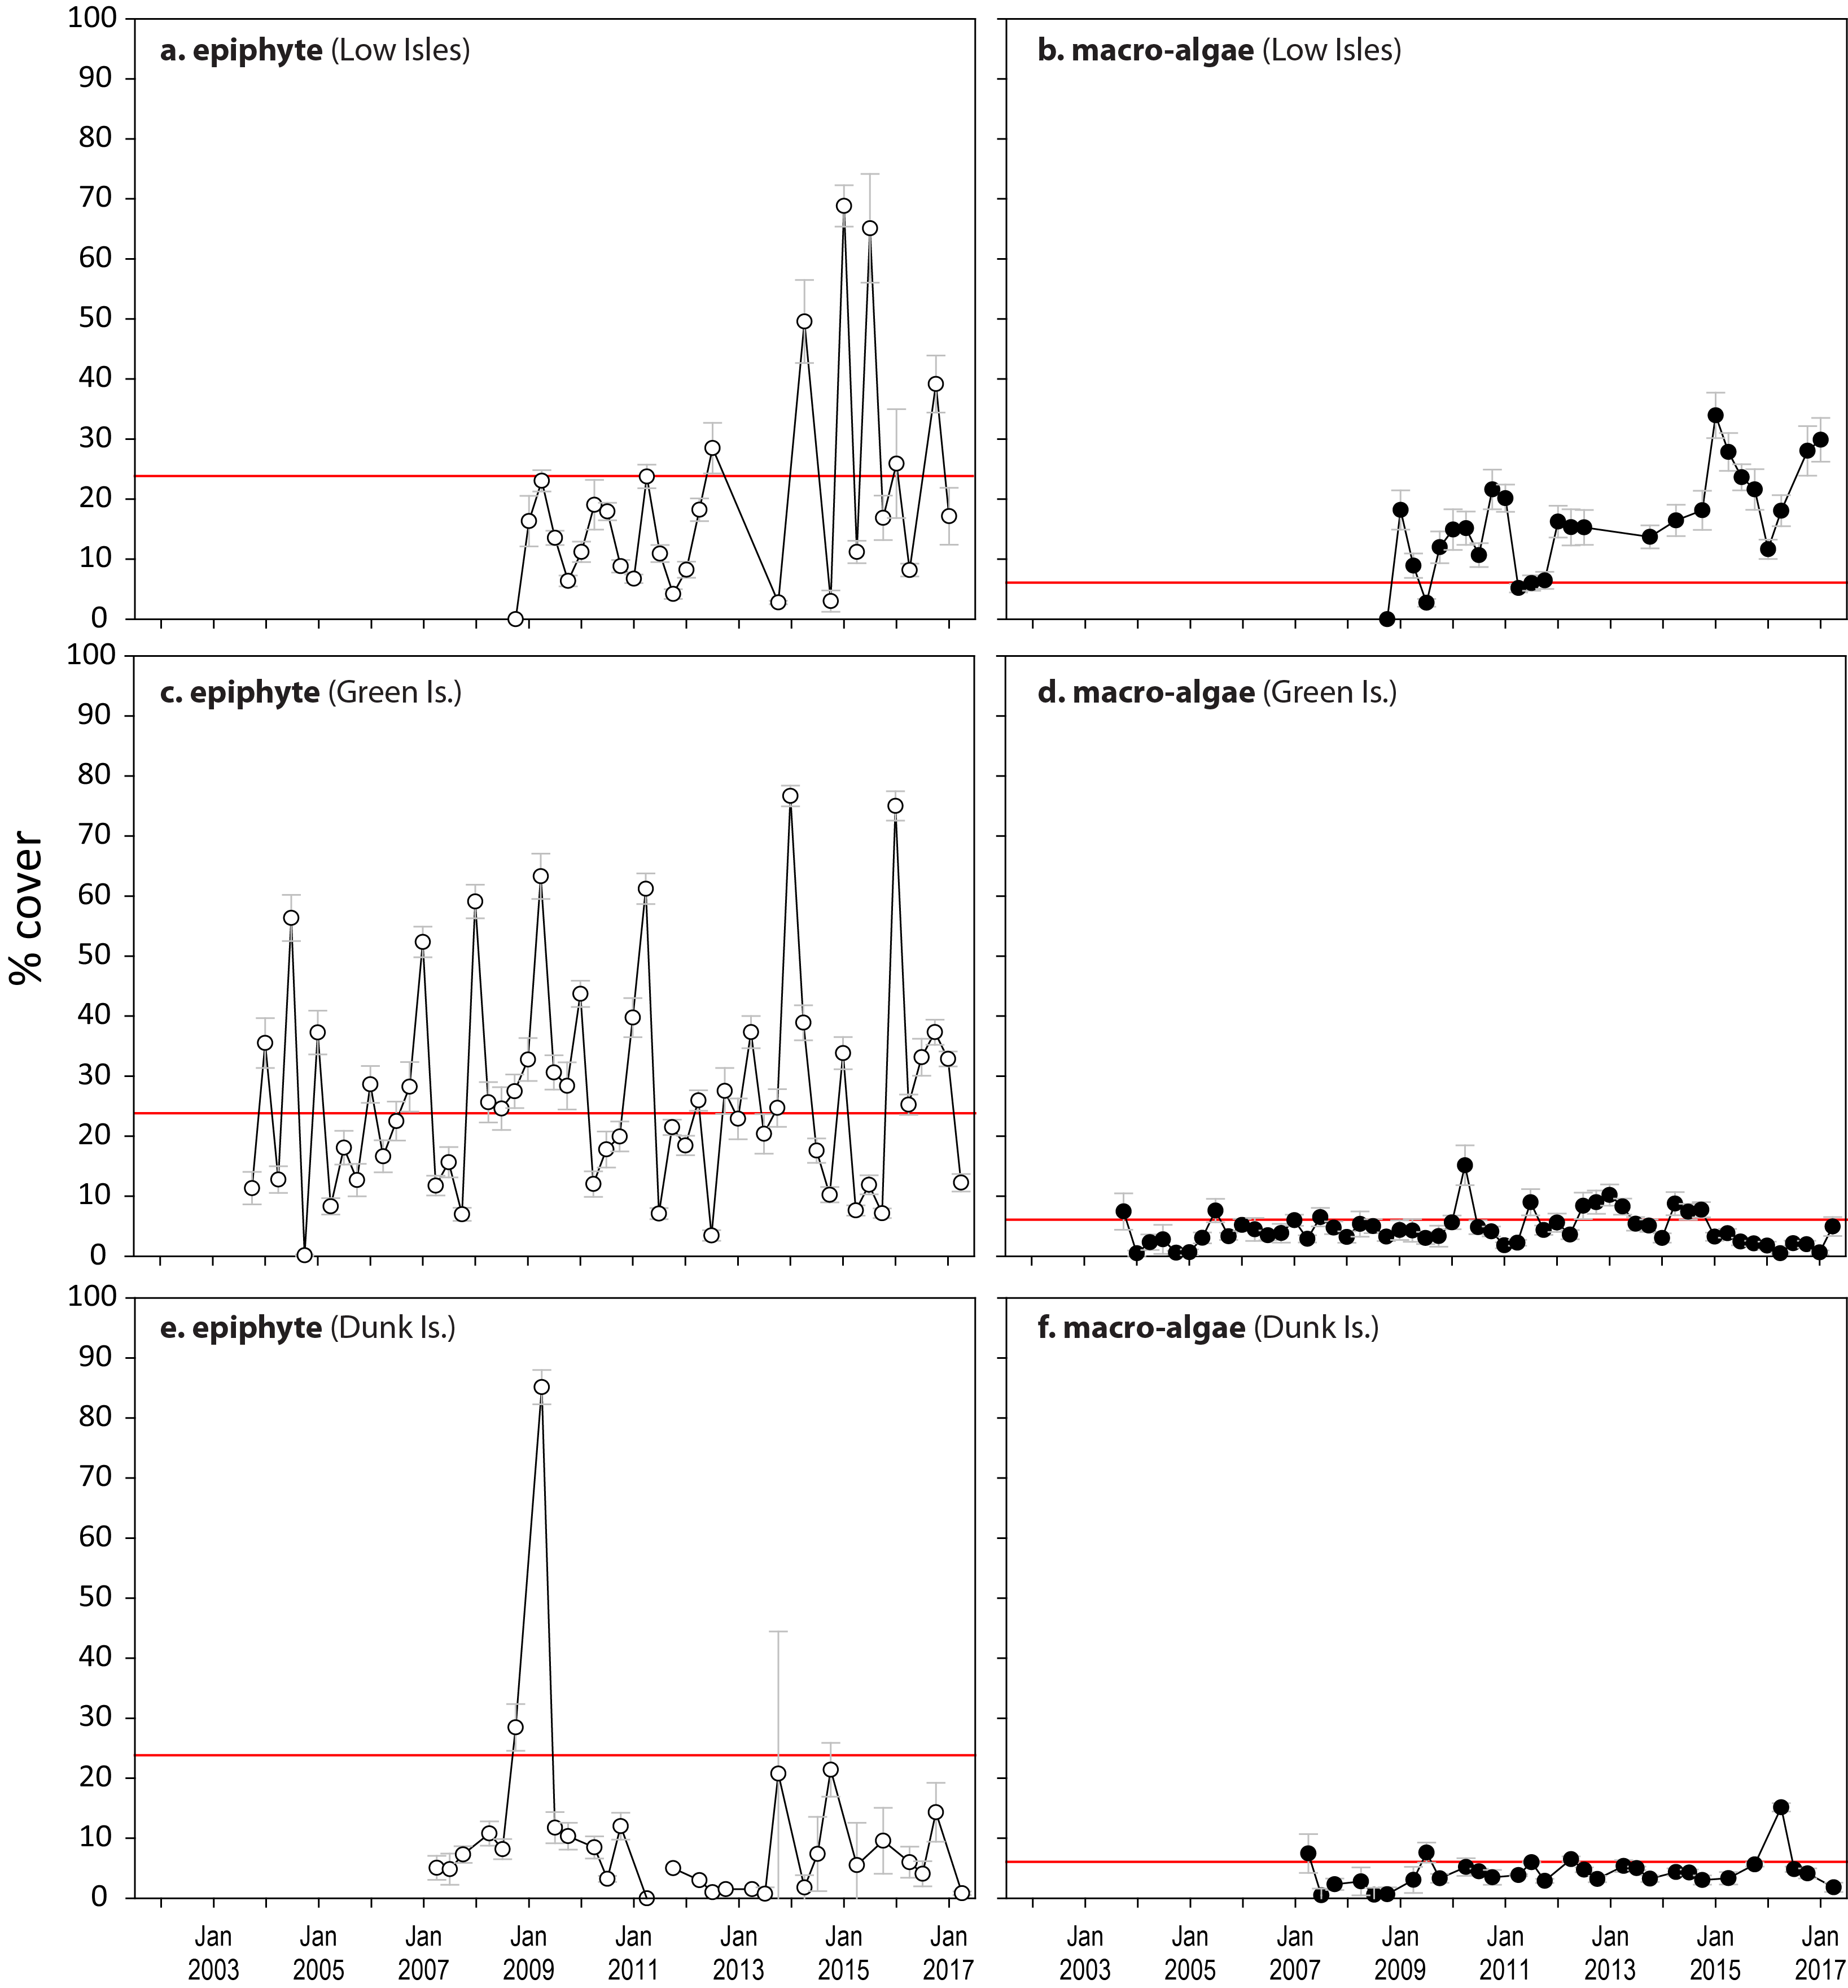
Figure 186. Mean abundance (per cent cover) (± SE) of epiphytes and macroalgae at intertidal reef seagrass monitoring locations (sites pooled) in the Wet Tropics NRM region
. Red line = GBR long-term average; epiphytes=24.3 per cent, macroalgae=6.2 per cent.

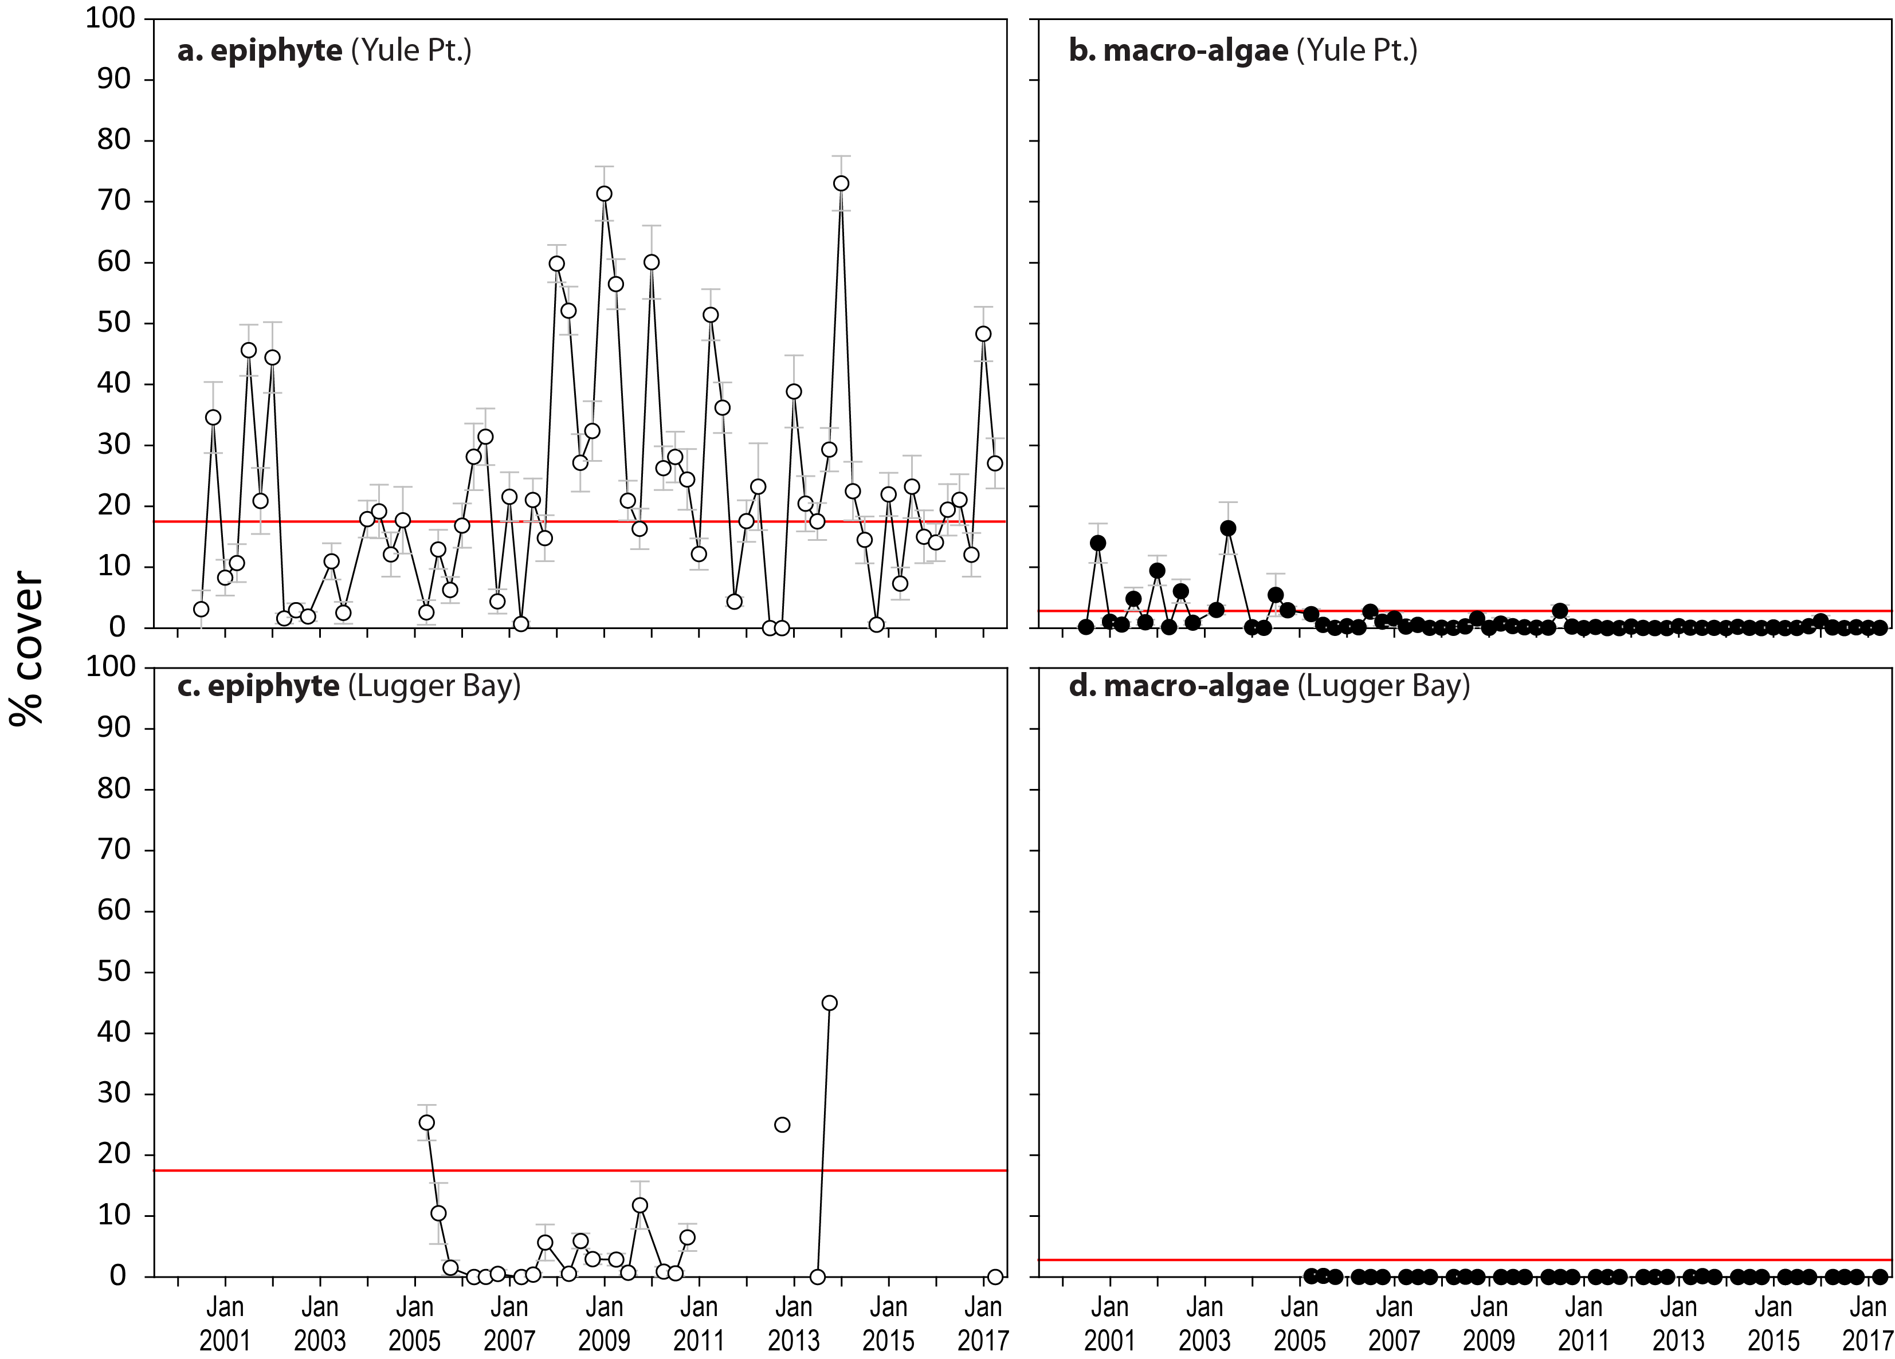
Figure 187. Mean abundance (per cent cover) (± SE) of epiphytes and macroalgae at coastal intertidal seagrass monitoring locations (sites pooled) in the Wet Tropics NRM region
. Red line = GBR long-term average; epiphytes=17.7 per cent, macroalgae=3.0 per cent.
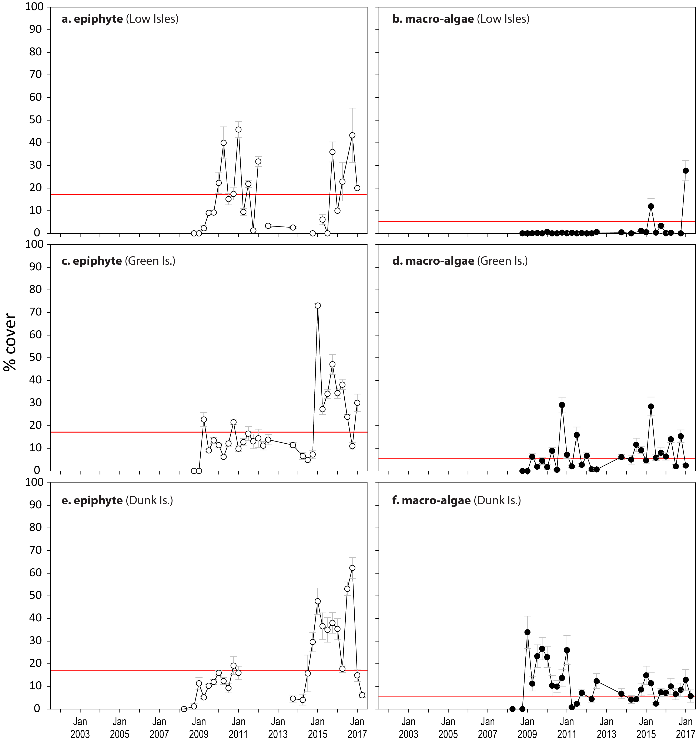
Figure 188. Mean abundance (per cent cover) (± SE) of epiphytes and macroalgae at subtidal reef seagrass monitoring sites in the Wet Tropics NRM region
. Red line = GBR long-term average for subtidal sites; epiphytes=17.1 per cent, macroalgae=5.5 per cent.

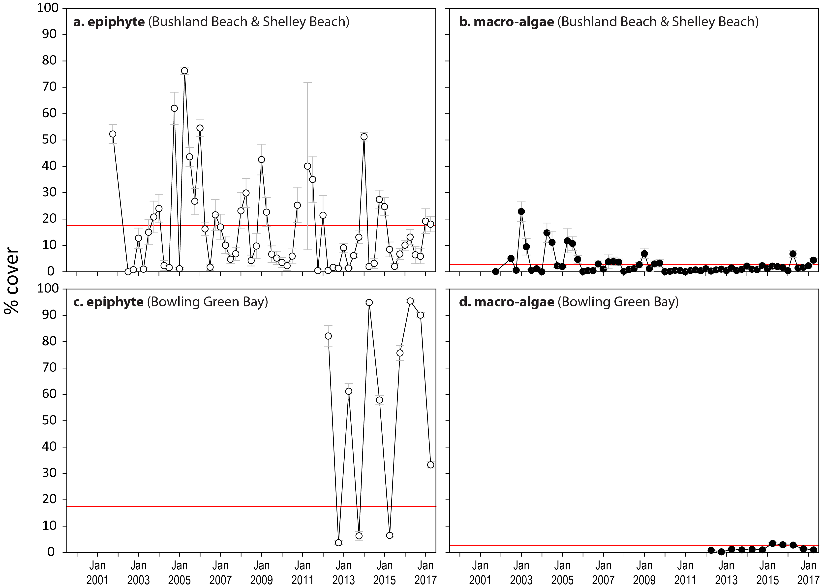
Figure 189. Mean abundance (per cent cover) (± SE) of epiphytes and macroalgae at coastal intertidal seagrass monitoring locations (sites pooled) in the Burdekin NRM region
. Red line = GBR long-term average; epiphytes=17.7 per cent, macroalgae=3.0 per cent.
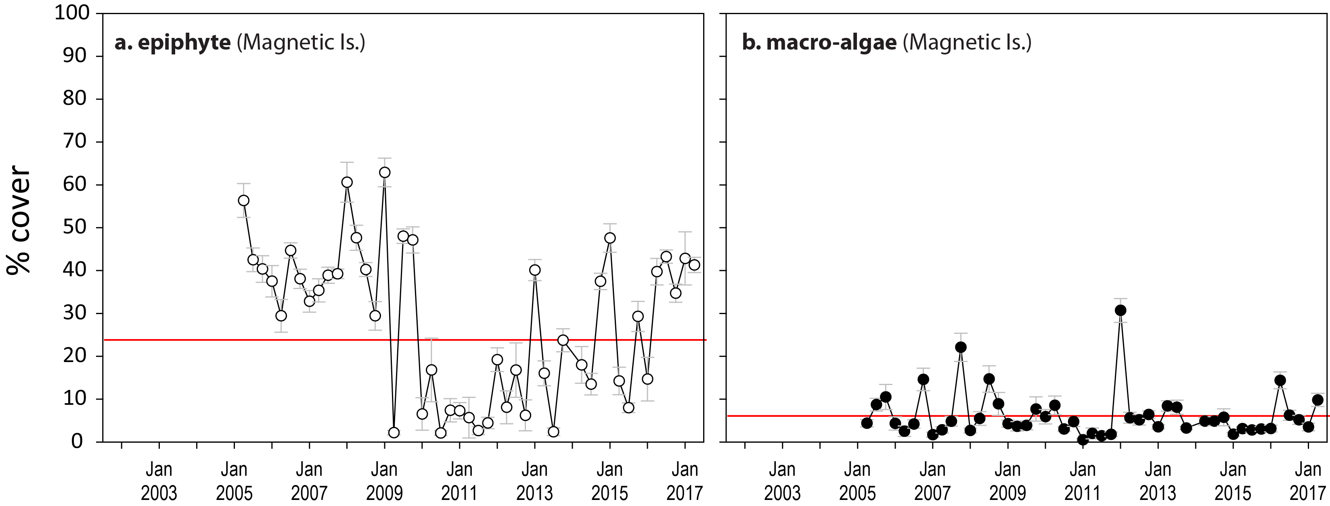
Figure 190. Mean abundance (per cent cover) (± SE) of epiphytes and macroalgae at intertidal reef seagrass monitoring locations (sites pooled) in the Burdekin NRM region
. Red line = GBR long-term average; epiphytes=24.3 per cent, macroalgae=6.2 per cent.

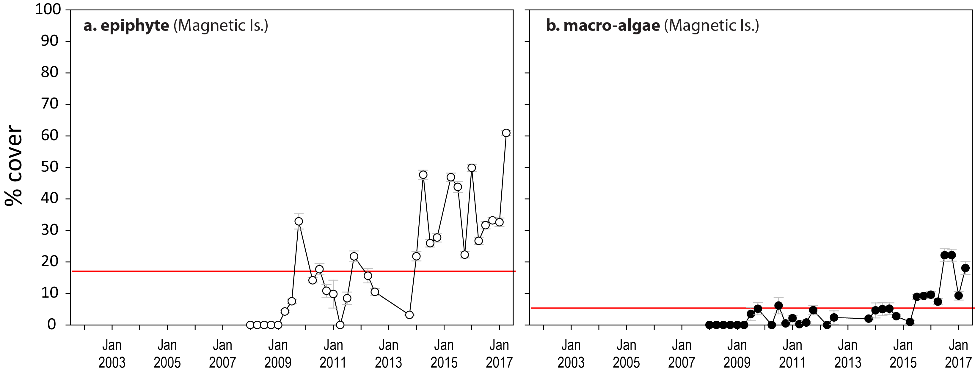
Figure 191. Mean abundance (per cent cover) (± SE) of epiphytes and macroalgae at subtidal reef monitoring sites in Picnic Bay, Burdekin NRM region
. Red line = GBR long-term average; epiphytes=17.1 per cent, macroalgae=5.5 per cent.

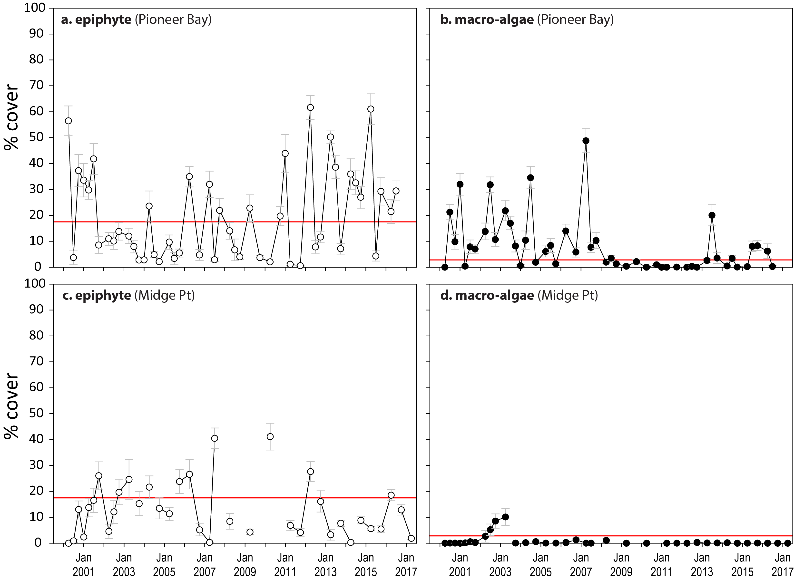
Figure 192. Mean abundance (per cent cover) (± SE) of epiphytes and macroalgae at coastal intertidal seagrass monitoring locations (sites pooled) in the Mackay Whitsunday NRM region
. Red line = GBR long-term average; epiphytes=17.7 per cent, macroalgae=3.0 per cent.

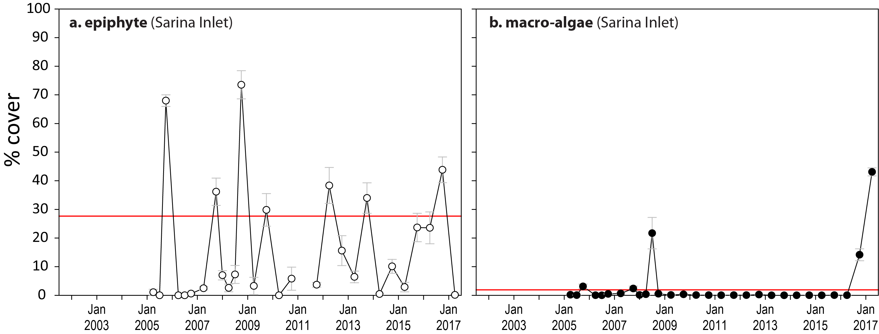
Figure 193. Mean abundance (per cent cover) (± SE) of epiphytes and macroalgae at estuarine seagrass monitoring locations (sites pooled) in the Mackay Whitsunday NRM region
. Red line = GBR long-term average; epiphytes=27.7 per cent, macroalgae=2.1 per cent.
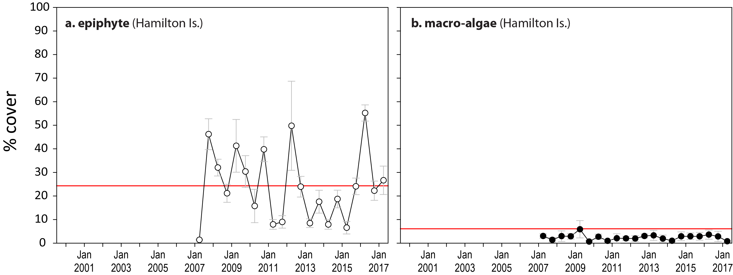
Figure 194. Mean abundance (per cent cover) (± SE) of epiphytes and macroalgae at reef seagrass monitoring locations (sites pooled) in the Mackay Whitsunday NRM region
. Red line = GBR long-term average; epiphytes=24.3 per cent, macroalgae=6.2 per cent.
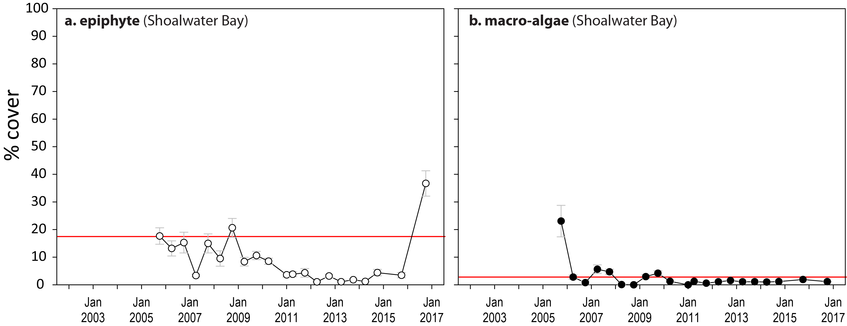
Figure 195. Mean abundance (per cent cover) (± SE) of epiphytes and macroalgae at coastal intertidal seagrass monitoring locations (sites pooled) in the Fitzroy NRM region
. Red line = GBR long-term average; epiphytes=17.7 per cent, macroalgae=3.0 per cent.
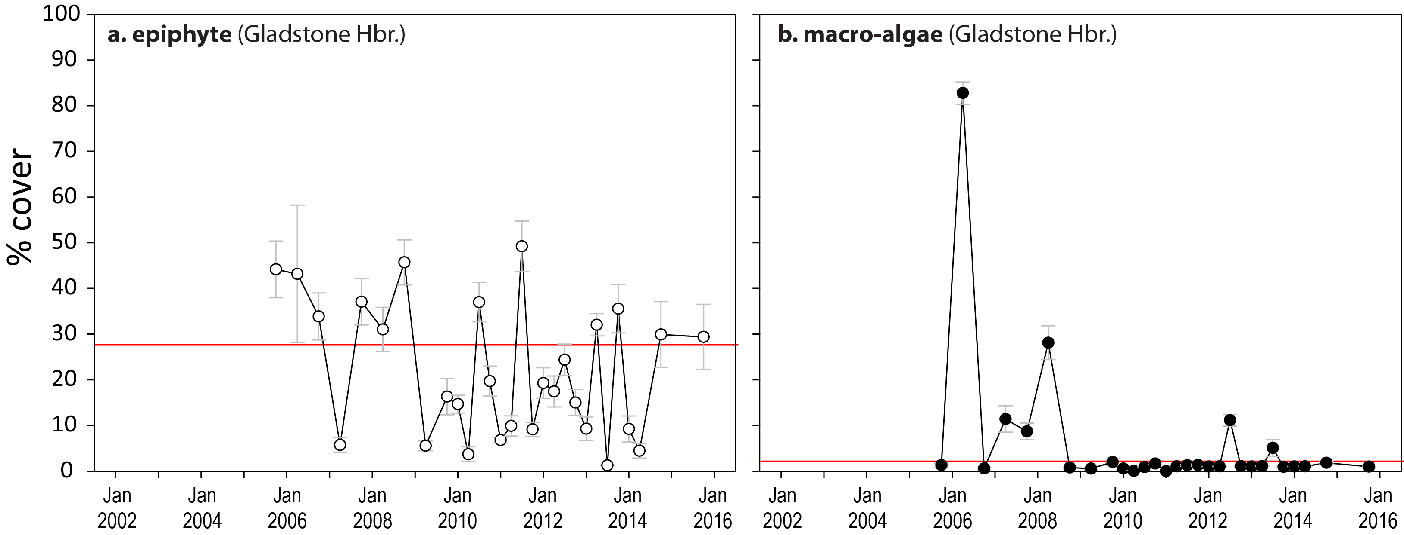
Figure 196. Mean abundance (per cent cover) (± SE) of epiphytes and macroalgae at estuarine seagrass monitoring locations (sites pooled) in the Fitzroy NRM region
. Red line = GBR long-term average; epiphytes=27.7 per cent, macroalgae=2.1 per cent.

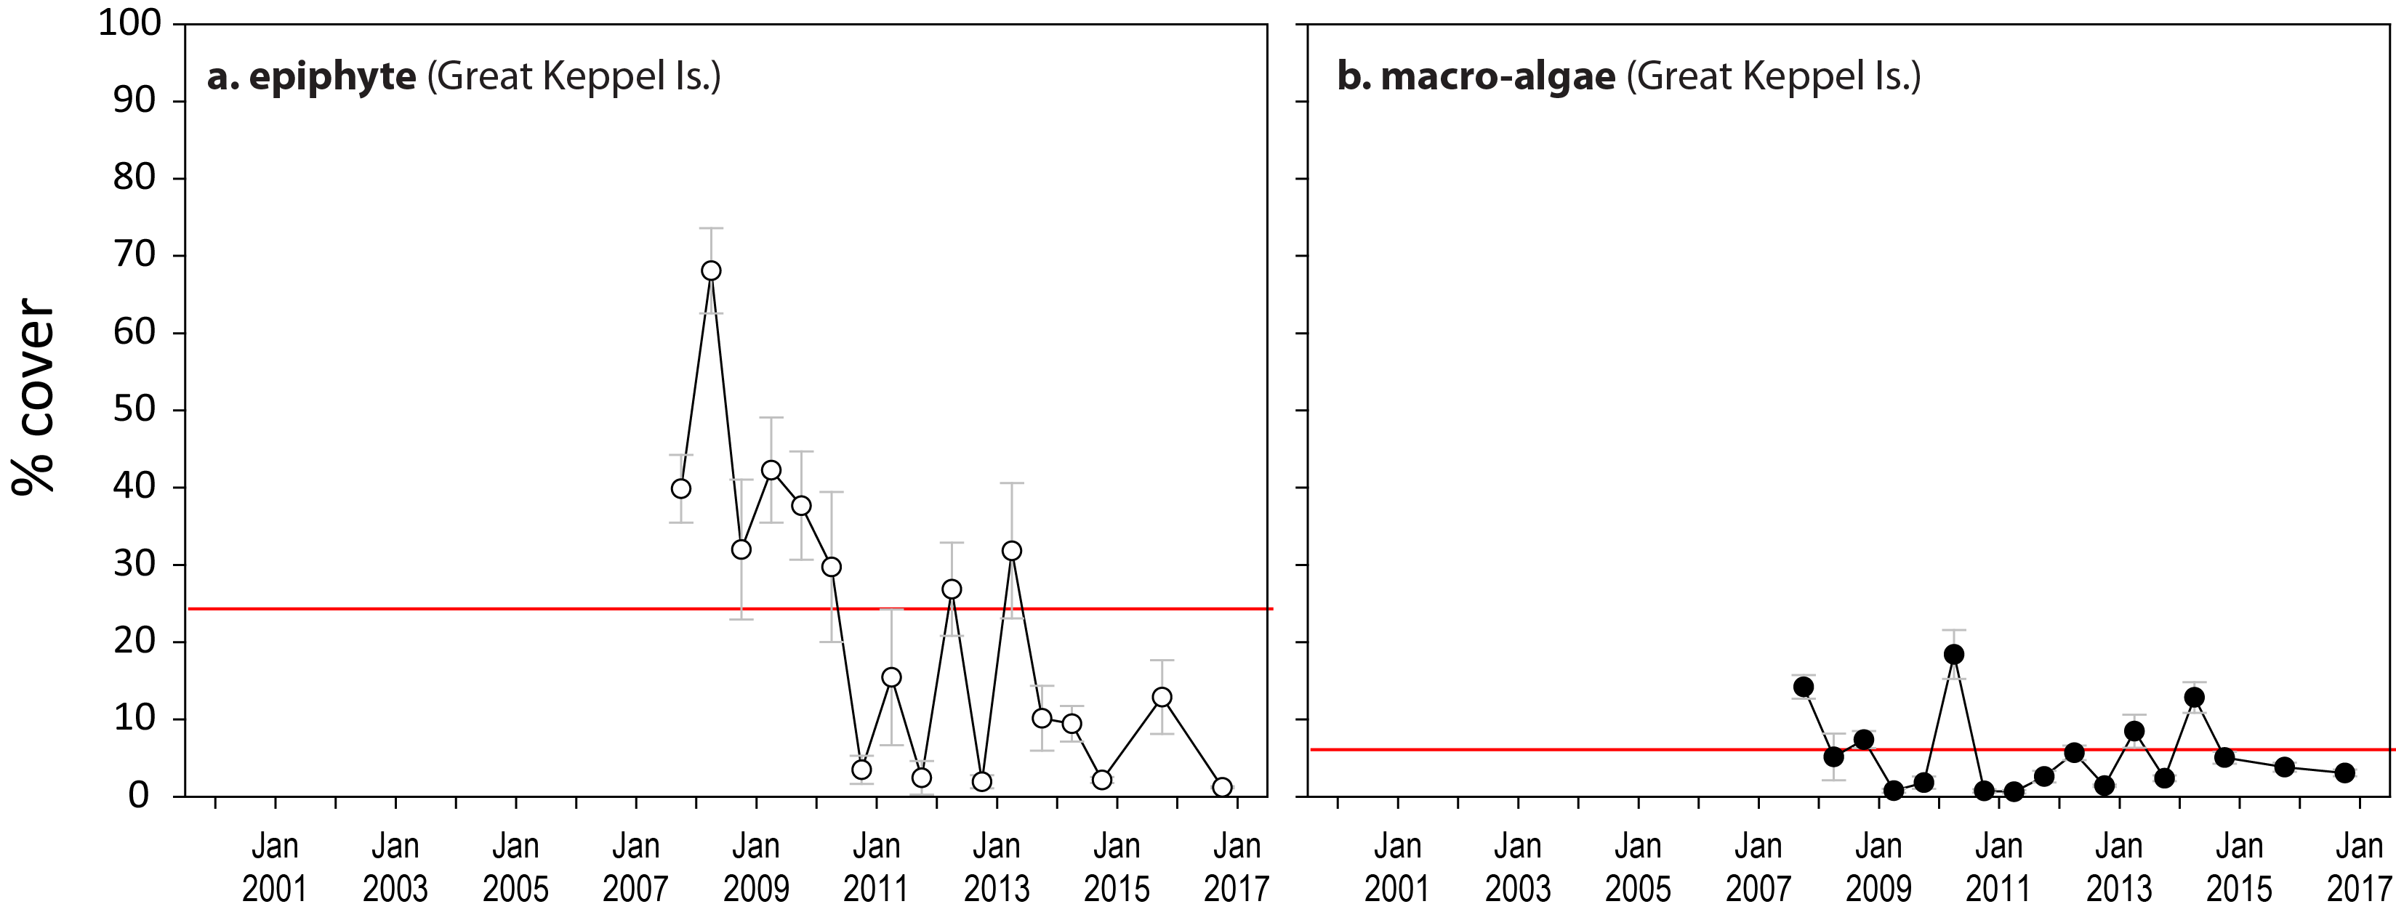
Figure 197. Mean abundance (per cent cover) (± SE) of epiphytes and macroalgae at reef seagrass monitoring locations (sites pooled) in the Fitzroy NRM region
. Red line = GBR long-term average; epiphytes=24.3 per cent, macroalgae=6.2 per cent.
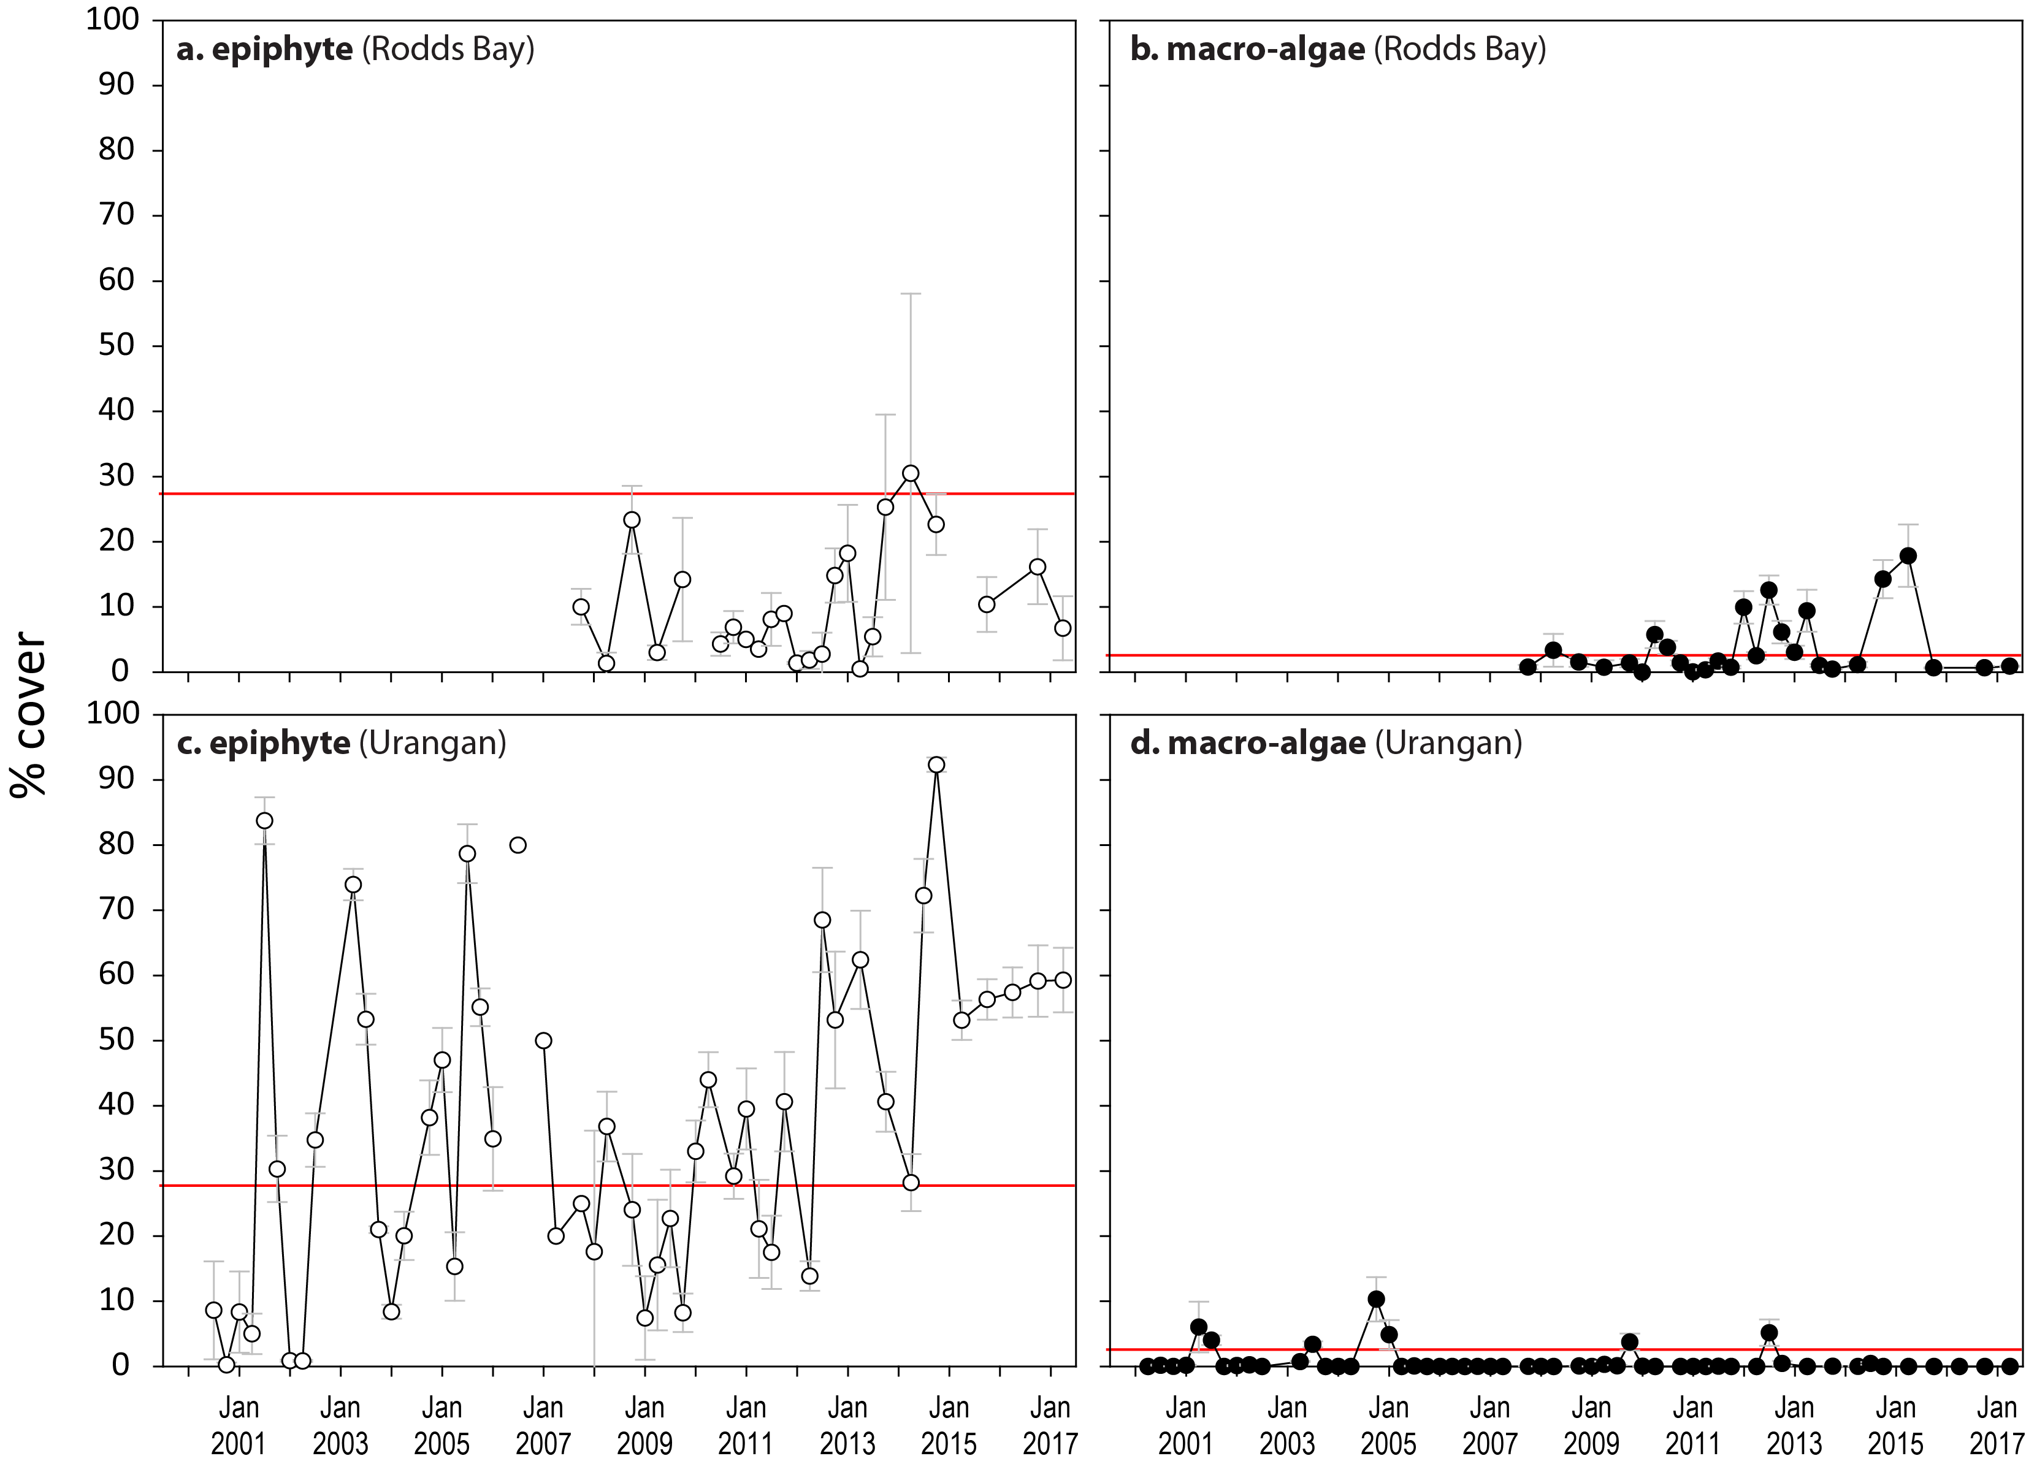
Figure 198. Mean abundance (per cent cover) (± SE) of epiphytes and macroalgae at estuarine seagrass monitoring locations (sites pooled) in the Burnett Mary NRM region.
Red line = GBR long-term average; epiphytes=27.7 per cent, macroalgae=2.1 per cent.
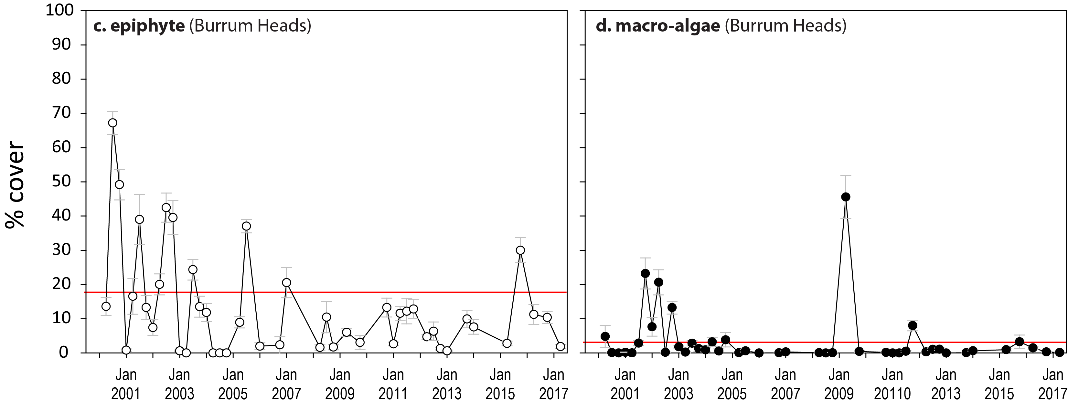
Figure 199. Mean abundance (per cent cover) (± SE) of epiphytes and macroalgae at coastal seagrass monitoring locations (sites pooled) in the Burnett Mary NRM region.
Red line = GBR long-term average; epiphytes=17.7 per cent, macroalgae=3.0 per cent.

Seagrass extent
Table 52. Proportion of area (within 100m radius of each monitoring site) which is covered by seagrass in the Cape York and Wet Tropics NRM regions.
For sites codes, see Table 5. Shading indicates area of seagrass declined >5 per cent (or absent) from previous assessment.
Date | SR1 | SR2 | FR1 | FR2 | ST1 | ST2 | BY1 | BY2 | AP1 | AP2 | LI1 | LI2 | YP1 | YP2 | GI1 | GI2 | GI3 | LB1 | LB2 | DI1 | DI2 | DI3
Oct-05 |  |  |  |  |  |  |  |  | 0.68 | 0.68 |  |  | 0.25 | 0.67 | 0.98 | 0.86 |  | 0.31 | 0.34
Apr-06 |  |  |  |  |  |  |  |  | 0.61 | 0.58 |  |  | 0.33 | 0.76 | 0.99 | 0.86 |  | 0.2 | 0.27
Oct-06 |  |  |  |  |  |  |  |  | 0.71 | 0.66 |  |  | 0.33 | 0.69 | 0.98 | 0.878 |  | 0.08 | 0.1
Apr-07 |  |  |  |  |  |  |  |  | 0.78 | 0.75 |  |  | 0.45 | 0.69 | 0.98 | 0.86 |  | 0.18 | 0.22 | 0.59 | 0.72
Oct-07 |  |  |  |  |  |  |  |  | 0.77 | 0.75 |  |  | 0.57 | 0.82 | 0.98 | 0.87 |  | 0.22 | 0.3 | 0.63 | 0.76
Apr-08 |  |  |  |  |  |  |  |  | 0.72 | 0.64 |  |  | 0.53 | 0.88 | 0.99 | 0.87 |  | 0.2 | 0.27 | 0.61 | 0.8
Oct-08 |  |  |  |  |  |  |  |  | 0.72 | 0.66 |  |  | 0.54 | 0.82 | 0.98 | 0.87 |  | 0.3 | 0.36 | 0.61 | 0.78
Apr-09 |  |  |  |  |  |  |  |  | 0.62 | 0.6 |  |  | 0.46 | 0.87 | 0.99 | 0.87 |  | 0.23 | 0.31 | 0.60 | 0.8
Oct-09 |  |  |  |  |  |  |  |  | 0.68 | 0.66 |  |  | 0.42 | 0.86 | 0.98 | 0.87 |  | 0.23 | 0.29 | 0.62 | 0.79
Apr-10 |  |  |  |  |  |  |  |  |  |  |  |  | 0.3 | 0.83 | 0.99 | 0.87 |  | 0.09 | 0.09 | 0.61 | 0.75
Oct-10 |  |  |  |  |  |  |  |  | 0.73 | 0.71 |  |  | 0.31 | 0.79 | 0.98 | 0.86 |  | 0.03 | 0.03 | 0.62 | 0.77
Apr-11 |  |  |  |  |  |  |  |  | 0.72 | 0.65 |  |  | 0.33 | 0.81 | 0.98 | 0.86 |  | 0 | 0 | 0 | 0.002
Oct-11 |  |  |  |  |  |  |  |  | 0.71 | 0.67 |  | 0.48 | 0.08 | 0.38 | 0.99 | 0.87 | 0.26 | 0 | 0 | 0.01 | 0.05 | 0
Apr-12 | 1 | 0.94 | 0.72 | 0.91 | 0.69 | 0.94 | 0.75 | 0.9 | 0.69 | 0.65 | 0.47 | 0 | 0.23 | 0.67 | 0.99 | 0.88 | 0.7 | 0 | 0 | 0.003 | 0.03 | 0
Oct-12 | 1 | 0.93 | 0.7 | 0.91 | 0.63 | 0.96 | 0.77 | 0.9 | 0.58 | 0.58 | 0.52 | 0.01 | 0.11 | 0.31 | 0.98 | 0.87 | 0.94 | 0 | 0.01 | 0.01 | 0.05 | 0
Apr-13 | 1 | 0.94 | 0.7 | 0.89 | 0.71 | 0.95 | 0.85 | 1 | 0.63 | 0.64 | 0.58 | 0.001 | 0.46 | 0.72 | 0.99 | 0.87 | 0.38 | 0 | 0.01 | 0.04 | 0.12 | 0
Oct-13 | 1 | 0.92 | 0.7 | 0.91 | 0.72 | 0.96 | 0.83 | 0.96 | 0.64 | 0.63 | 0.60 | 0.002 | 0.41 | 0.65 | 0.98 | 0.86 | 0.77 | 0.01 | 0.015 | 0.24 | 0.21 | 0
Apr-14 | 1 | 0.92 | 0.75 | 0.93 | 0.72 | 0.96 | 0.88 | 0.96 | 0.67 | 0.64 | 0.60 | 0.002 | 0.46 | 0.61 | 0.97 | 0.85 | 0 | 0 | 0.001 | 0.28 | 0.24 | 0
Oct-14 | 1 | 0.91 | 0.75 | 0.90 | 0.70 | 0.95 | 0.88 | 0.94 | 0.68 | 0.66 | 1.00 | 0.68 | 0.36 | 0.78 | 0.98 | 0.86 |  | 0.001 | 0.001 | 0.32 | 0.31 | 1
Apr-15 |  |  |  |  |  |  |  |  |  |  | 0.56 | 0.29 | 0.49 | 0.77 | 0.97 | 0.85 |  | 0.001 | 0.001 | 0.31 | 0.37
Oct-15 | 1 | 0.74 | 0.75 | 0.90 | 0.76 | 0.97 | 0.82 | 0.92 | 0.78 | 0.81 | 0.81 | 1 | 0.51 | 0.77 | 0.98 | 0.88 | 0.80 | 0 | 0 | 0.36 | 0.44 | 1
Apr-16 |  |  |  |  | 0.68 | 0.94 | 0.73 | 0.88 |  |  | 0.84 | 0 | 0.48 | 0.84 | 0.99 | 0.88 | 0.65 | 0 | 0 | 0.37 | 0.45 | 0.61
Oct-16 |  |  | 0.75 | 0.9 | 0.69 | 0.94 | 0.73 | 0.83 | 0.68 | 0.7 | 0.83 | 0.1 | 0.52 | 0.82 | 1 | 0.88 | 0.87 | 0 | 0 | 0.39 | 0.51 | 0.19
Apr-17 |  |  |  |  |  |  |  |  |  |  | 0.83 | 0.12 | 0.43 | 0.83 | 0.99 | 0.88 | 0.87 | 0.01 | 0.02 | 0.32 | 0.39 | 0.57

Table 53. Proportion of area (within 100m radius of each monitoring site) which is covered by seagrass in the Burdekin, Mackay Whitsunday, Fitzroy and Burnett Mary NRM regions.
For sites codes, see Table 5. Shading indicates area of seagrass declined >5 per cent (or absent) from previous assessment
Date | BB1 | SB1 | MI1 | MI2 | MI3 | JR1 | JR2 | PI2 | PI3 | HM1 | HM2 | MP2 | MP3 | SI1 | SI2 | RC1 | WH1 | GH1 | GH2 | GK1 | GK2 | RD1 | RD2 | UG1 | UG2
Oct-05 | 1 | 0.81 | 0.55 | 0.77 |  |  |  | 0.65 | 0.46 |  |  |  |  | 0.64 | 0.71 | 1 | 1 | 1 | 0.96 |  |  |  |  | 0.99 | 1
Apr-06 | 1 | 0.66 | 0.64 | 0.82 |  |  |  | 0.67 | 0.38 |  |  |  |  | 0.33 | 0.47 | 1 | 1 | 0 | 0 |  |  |  |  | 0 | 0
Oct-06 | 1 | 0.54 | 0.32 | 0.77 |  |  |  | 0.72 | 0.74 |  |  |  |  | 0.84 | 0.7 | 1 | 1 | 1 | 1 |  |  |  |  | 0 | 0
Apr-07 | 0.96 | 0.74 | 0.49 | 0.78 |  |  |  | 0.79 | 0.84 |  |  |  |  | 0.78 | 0.67 | 1 | 1 | 1 | 0.96 |  |  |  |  | 0 | 0
Oct-07 | 0.98 | 0.85 | 0.59 | 0.78 |  |  |  | 0.8 | 0.8 | 0.3 | 0.12 |  |  | 0.9 | 0.9 | 1 | 1 | 0.77 | 0.88 | 0.81 | 0.78 | 0.18 | 0.66 | 0.001 | 0
Apr-08 | 0.96 | 0.39 | 0.51 | 0.79 |  |  |  | 0.77 | 0.79 | 0.34 | 0.04 |  |  | 0.32 | 0.35 | 1 | 1 | 0.83 | 0.94 | 0.17 | 0.46 | 0.24 | 0.65 | 0.07 | 0.29
Oct-08 | 0.99 | 0.31 | 0.52 | 0.81 |  |  |  | 0.78 | 0.81 | 0.28 | 0.07 |  |  | 0.68 | 0.71 | 1 | 1 | 0.94 | 0.9 | 0.3 | 0.62 | 0.22 | 0.67 | 0.06 | 0.52
Apr-09 | 0.43 | 0.22 | 0.5 | 0.98 |  |  |  | 0.85 | 0.84 | 0.25 | 0.04 |  |  | 0.33 | 0.27 | 1 | 1 | 0.93 | 0.98 | 0.58 | 0.43 | 0 | 0.66 | 0.01 | 0.09
Oct-09 | 0.87 | 0.51 | 0.73 | 0.66 |  |  |  | 0.99 | 0.91 | 0.18 | 0.02 |  |  | 0.47 | 0.46 | 1 | 1 | 0.88 | 0.93 | 0.78 | 0.72 | 0.01 | 0.51 | 0.06 | 0.19
Apr-10 | 0.47 | 0.39 | 0.48 | 0.39 |  |  |  | 0.87 | 0.67 | 0.13 | 0.01 |  |  | 0.13 | 0.17 | 1 | 1 | 0.96 | 0.98 | 0.76 | 0.74 | 0 | 0 | 0.34 | 0.7
Oct-10 | 0.21 | 0.67 | 0.43 | 0.75 |  |  |  | 0.96 | 0.96 | 0.26 | 0.04 |  |  | 0.27 | 0.23 | 1 | 1 | 0.96 | 0.95 | 0.3 | 0.73 | 0.1 | 0 | 0.27 | 0.7
Apr-11 | 0.48 | 0.05 | 0.21 | 0.22 |  |  |  | 0.29 | 0.19 | 0.15 | 0.01 |  |  | 0.12 | 0.05 | 1 | 1 | 0.92 | 0.91 | 0.12 | 0.54 | 0.04 | 0.02 | 0.06 | 0.38
Oct-11 | 0.4 | 0.16 | 0.42 | 0.75 | 0.63 |  |  | 0.22 | 0.16 | 0.32 | 0.03 |  |  | 0.73 | 0.69 | 1 | 1 | 0.88 | 0.9 | 0.09 | 0.25 | 0.05 | 0.01 | 0.07 | 0.43
Apr-12 | 0.21 | 0.16 | 0.46 | 0.77 | 0.34 | 1 | 0.83 | 0.46 | 0.49 | 0.54 | 0.03 |  |  | 0.5 | 0.5 | 1 | 1 | 0.89 | 0.91 | 0.09 | 0.25 | 0 | 0 | 0.09 | 0.54
Oct-12 | 1 | 0.94 | 0.48 | 0.97 | 0.39 | 1 | 0.83 | 0.33 | 0.4 | 0.64 | 0.05 |  |  | 0.8 | 0.7 | 1 | 1 | 0.88 | 0.87 | 0.38 | 0.18 | 0.22 | 0.03 | 0.2 | 0.67
Apr-13 | 0.98 | 0.87 | 0.49 | 0.99 | 0.6 | 1 | 0.83 | 0.7 | 0.72 | 0.62 | 0.04 |  |  | 0.65 | 0.7 | 1 | 1 | 0.88 | 0.94 | 0.2 | 0.22 | 0.17 | 0 | 0.21 | 0.61
Oct-13 | 1 | 0.72 | 0.48 | 0.9 | 0.59 | 1 | 1 | 0.83 | 0.95 | 0.67 | 0.06 |  |  | 0.76 | 0.76 | 1 | 1 | 0.89 | 0.86 | 0.4 | 0.15 | 0 | 0 | 0.2 | 0.53
Apr-14 | 1 | 0.96 | 0.53 | 0.99 | 0.34 | 1 | 1 | 0.97 | 0.97 | 0.53 | 0.04 |  |  | 0.67 | 0.69 | 1 | 1 | 0.85 | 0.83 | 0.28 | 0.04 | 0.02 | 0.02 | 0.27 | 0.64
Oct-14 | 1 | 0.96 | 0.55 | 0.80 | 1 | 1 | 1 | 0.98 | 1 | 0.21 | 0.08 | 0.99 | 1 | 0.71 | 0.80 | 1 | 1 | 0.92 | 0.88 | 0.50 | 0.69 | 0.28 | 0.45 | 0.71 | 0.81
Apr-15 | 1 | 0.96 | 0.55 | 0.80 | 1 |  |  |  |  | 0.21 | 0.03 | 0.99 | 0.99 | 0.58 | 0.72 |  |  |  |  |  |  | 0 | 0 | 0.93 | 0.81
Oct-15 | 1 | 0.97 | 0.57 | 0.78 | 1 | 1 | 1 |  |  | 0.24 | 0.04 | 1 | 0.99 | 0.71 | 0.71 | 1 | 1 | 0.92 | 0.93 | 0.51 | 0.69 | 0.28 | 0.07 | 0.98 | 1
Apr-16 | 1 | 0.94 | 0.57 | 0.78 | 1 |  |  |  |  | 0.61 | 0.09 | 1 | 0.99 | 0.53 | 0.63 |  |  |  |  |  |  |  |  | 0.98 | 1
Oct-16 | 1 | 0.89 | 0.55 | 0.79 | 0.97 | 1 | 1 |  |  | 0.65 | 0.04 | 1 | 0.98 | 0.59 | 0.69 | 1 | 1 | 0.09 | 0.88 | 0.18 | 0.1 | 0.24 | 0 | 0.93 | 0.9
Apr-17 | 1 | 0.88 | 0.62 | 0.77 | 1 | 1 | 1 |  |  | 0.08 | 0 | 1 | 0.96 | 0.22 | 0.33 | 1 | 1 | 0.32 | 0.78 | 0.18 | 0.1 | 0.16 | 0 | 0.91 | 0.78

Species composition and distribution

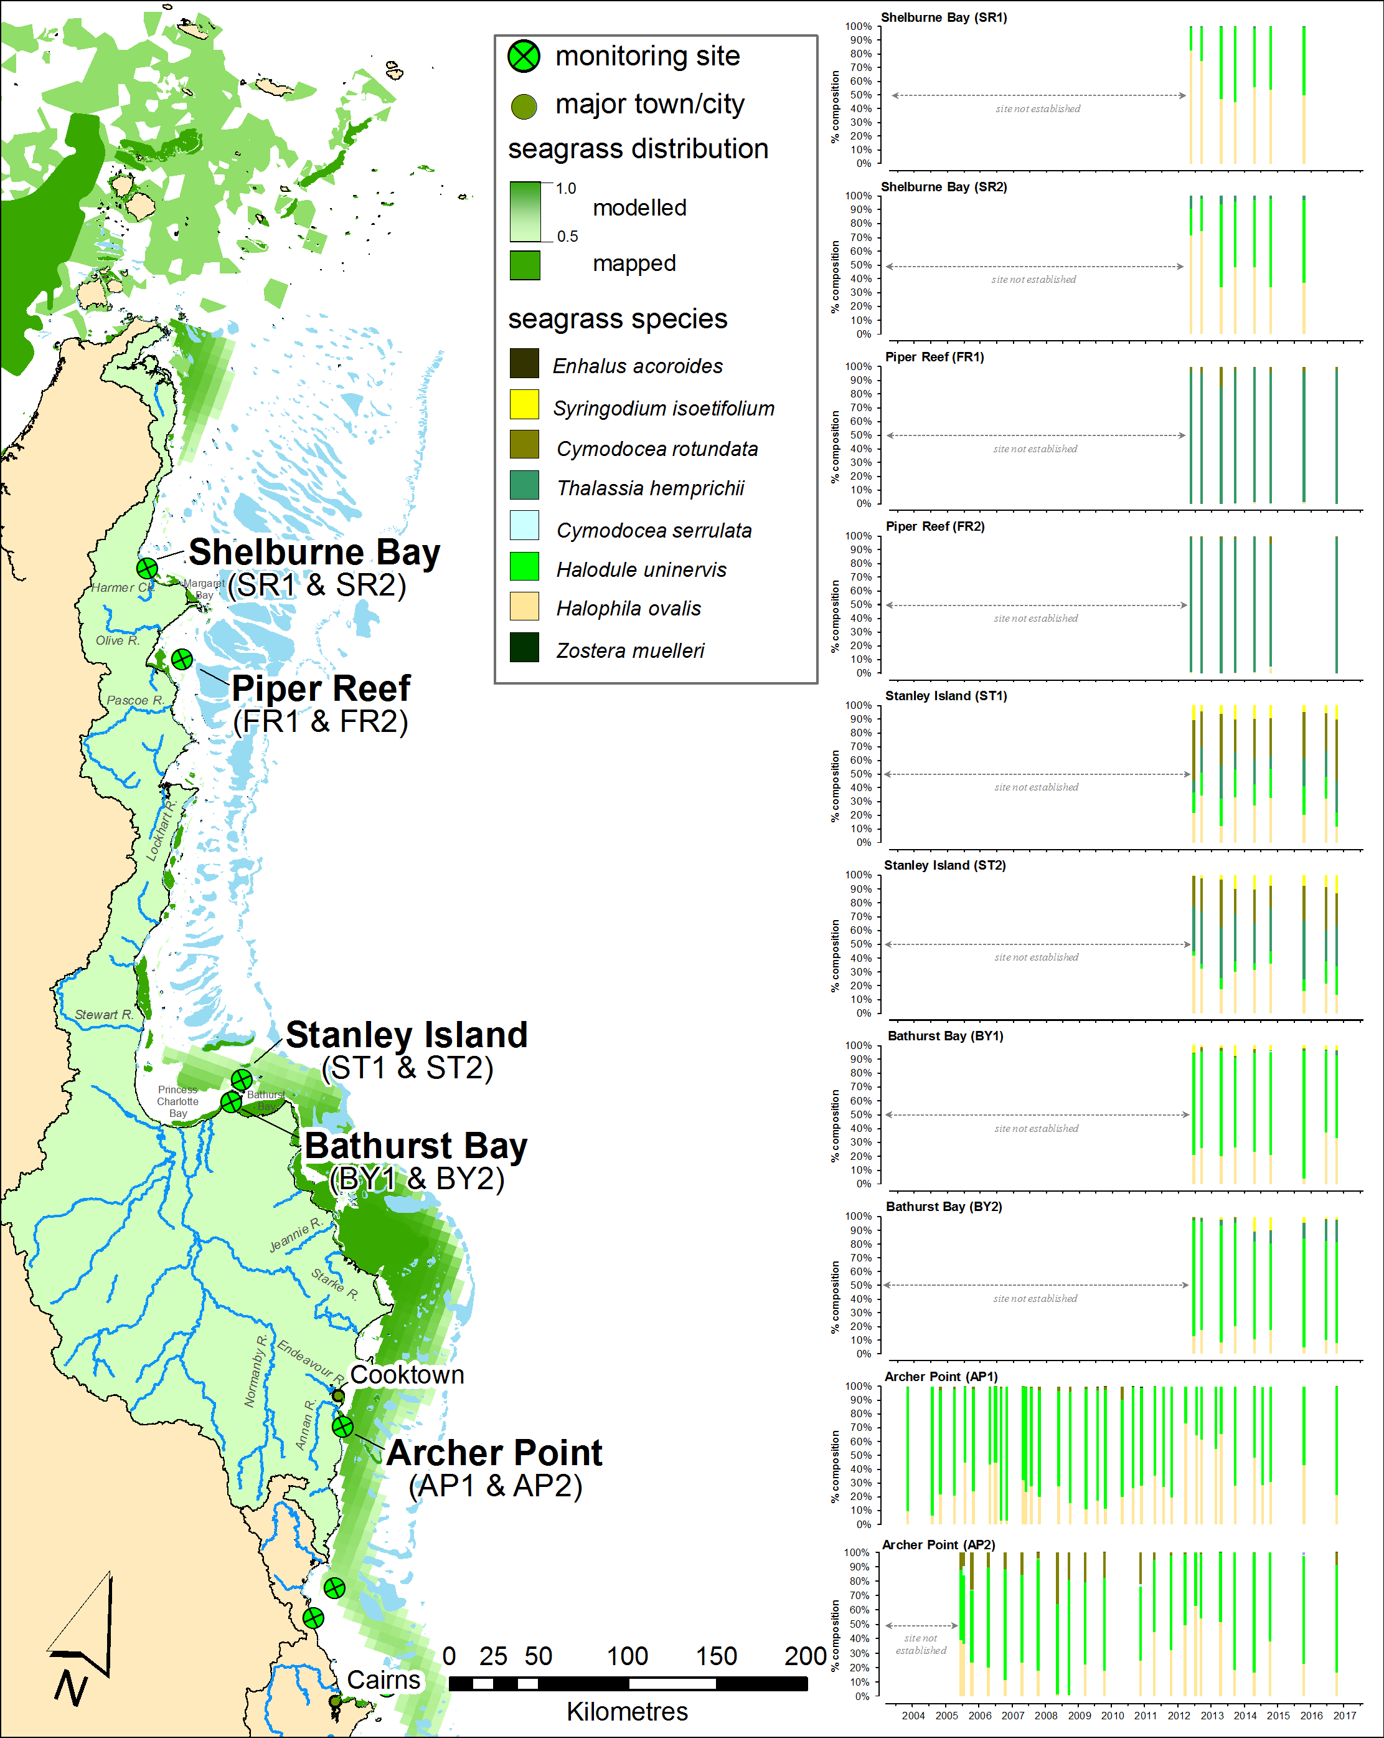
Figure 200. Location and species composition of each long-term seagrass monitoring site (MMP) in the Cape York region.
Please note: replicate sites within 500m of each other. See Figure 201 for unlabelled sites south of Archer Pt. Also shown is distribution of seagrass as the modelled distribution (including likelihood of presence from 0.5-1.0 McKenzie et al. 2010c) and composite of mapped distribution (McKenzie et al. 2014c).

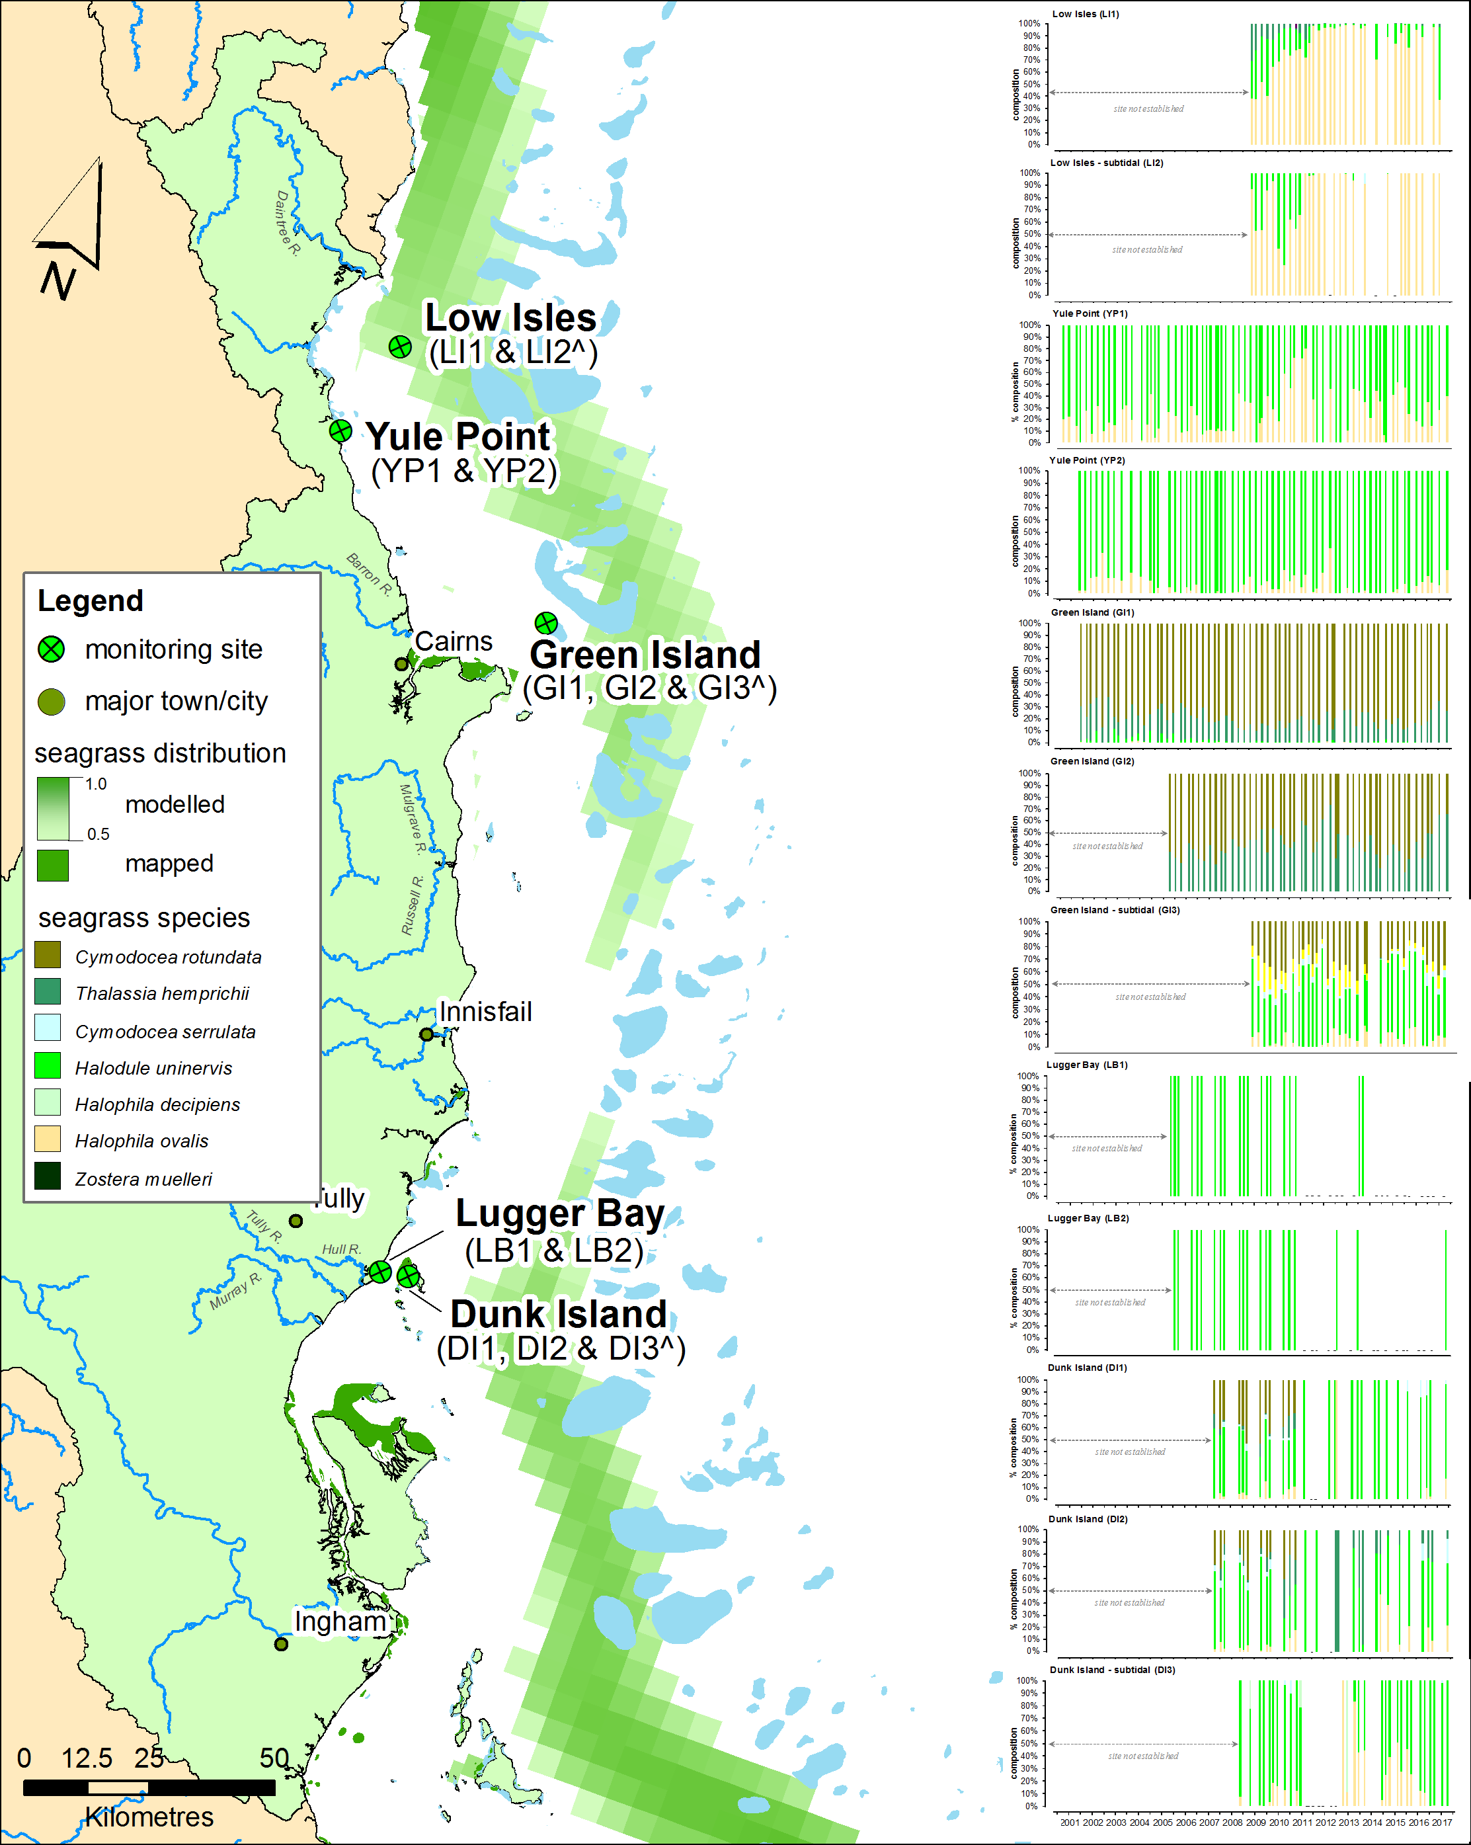
Figure 201. Location and species composition of each long-term seagrass monitoring site (MMP) in the Wet Tropics region.
Please note: replicate sites within 500m of each other. Also shown is distribution of seagrass as the modelled distribution (including likelihood of presence from 0.5-1.0 McKenzie et al. 2010c) and composite of mapped distribution (McKenzie et al. 2014c).

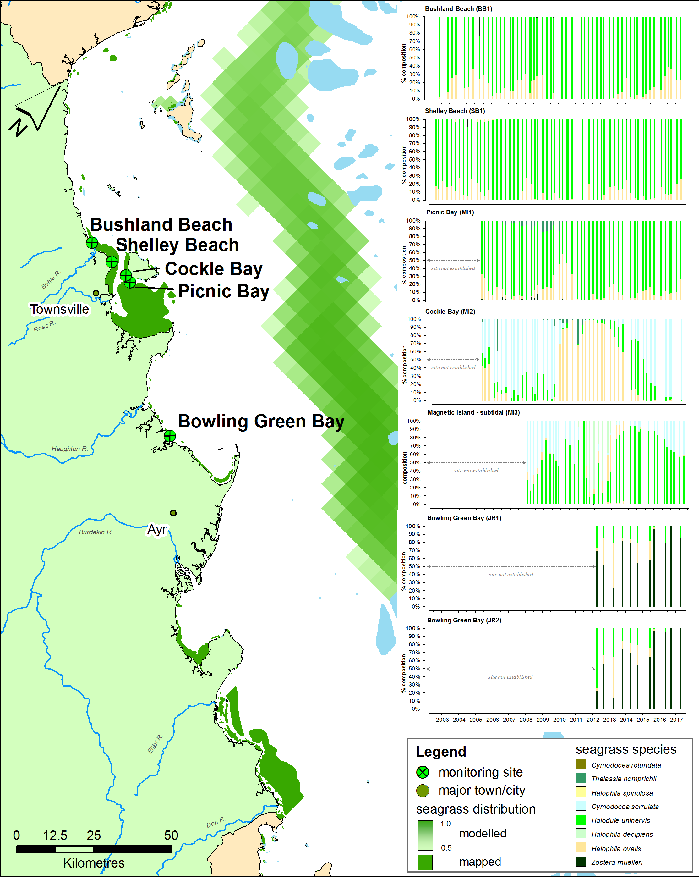
Figure 202. Location and species composition of each long-term seagrass monitoring site (MMP) in the Burdekin region.
Please note: replicate sites within 500m of each other. Also shown is distribution of seagrass as the modelled distribution (including likelihood of presence from 0.5-1.0 McKenzie et al. 2010c) and composite of mapped distribution (McKenzie et al. 2014c).

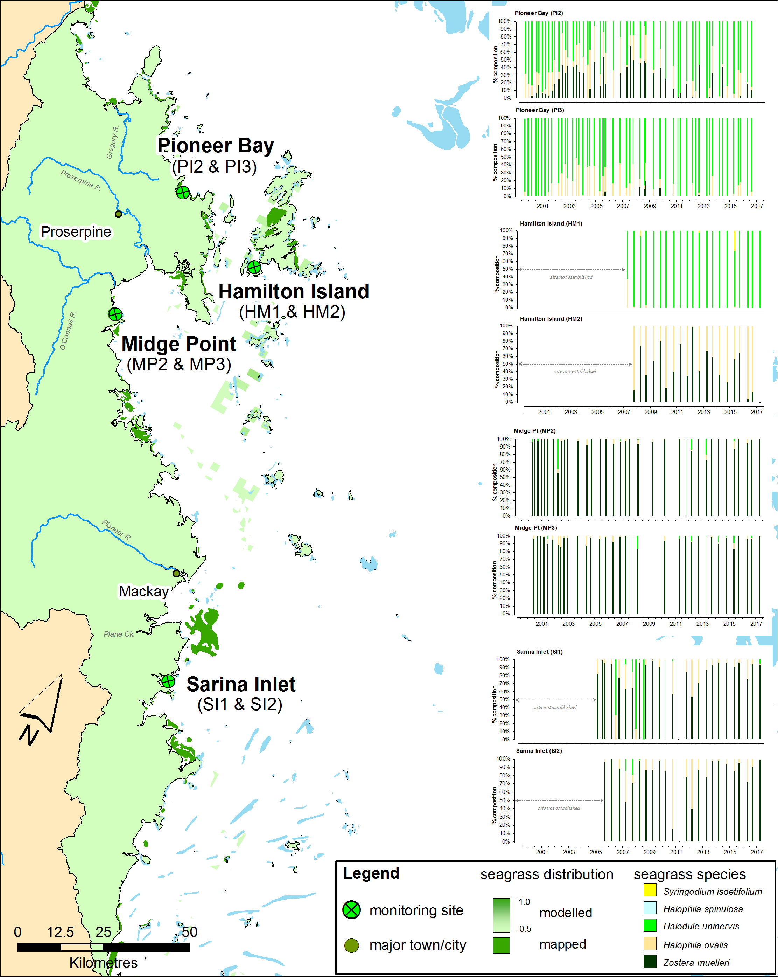
Figure 203. Location and species composition of each long-term seagrass monitoring site (MMP) in the Mackay Whitsunday region.
Please note: replicate sites within 500m of each other. Also shown is distribution of seagrass as the modelled distribution (including likelihood of presence from 0.5-1.0 McKenzie et al. 2010c) and composite of mapped distribution (McKenzie et al. 2014c).
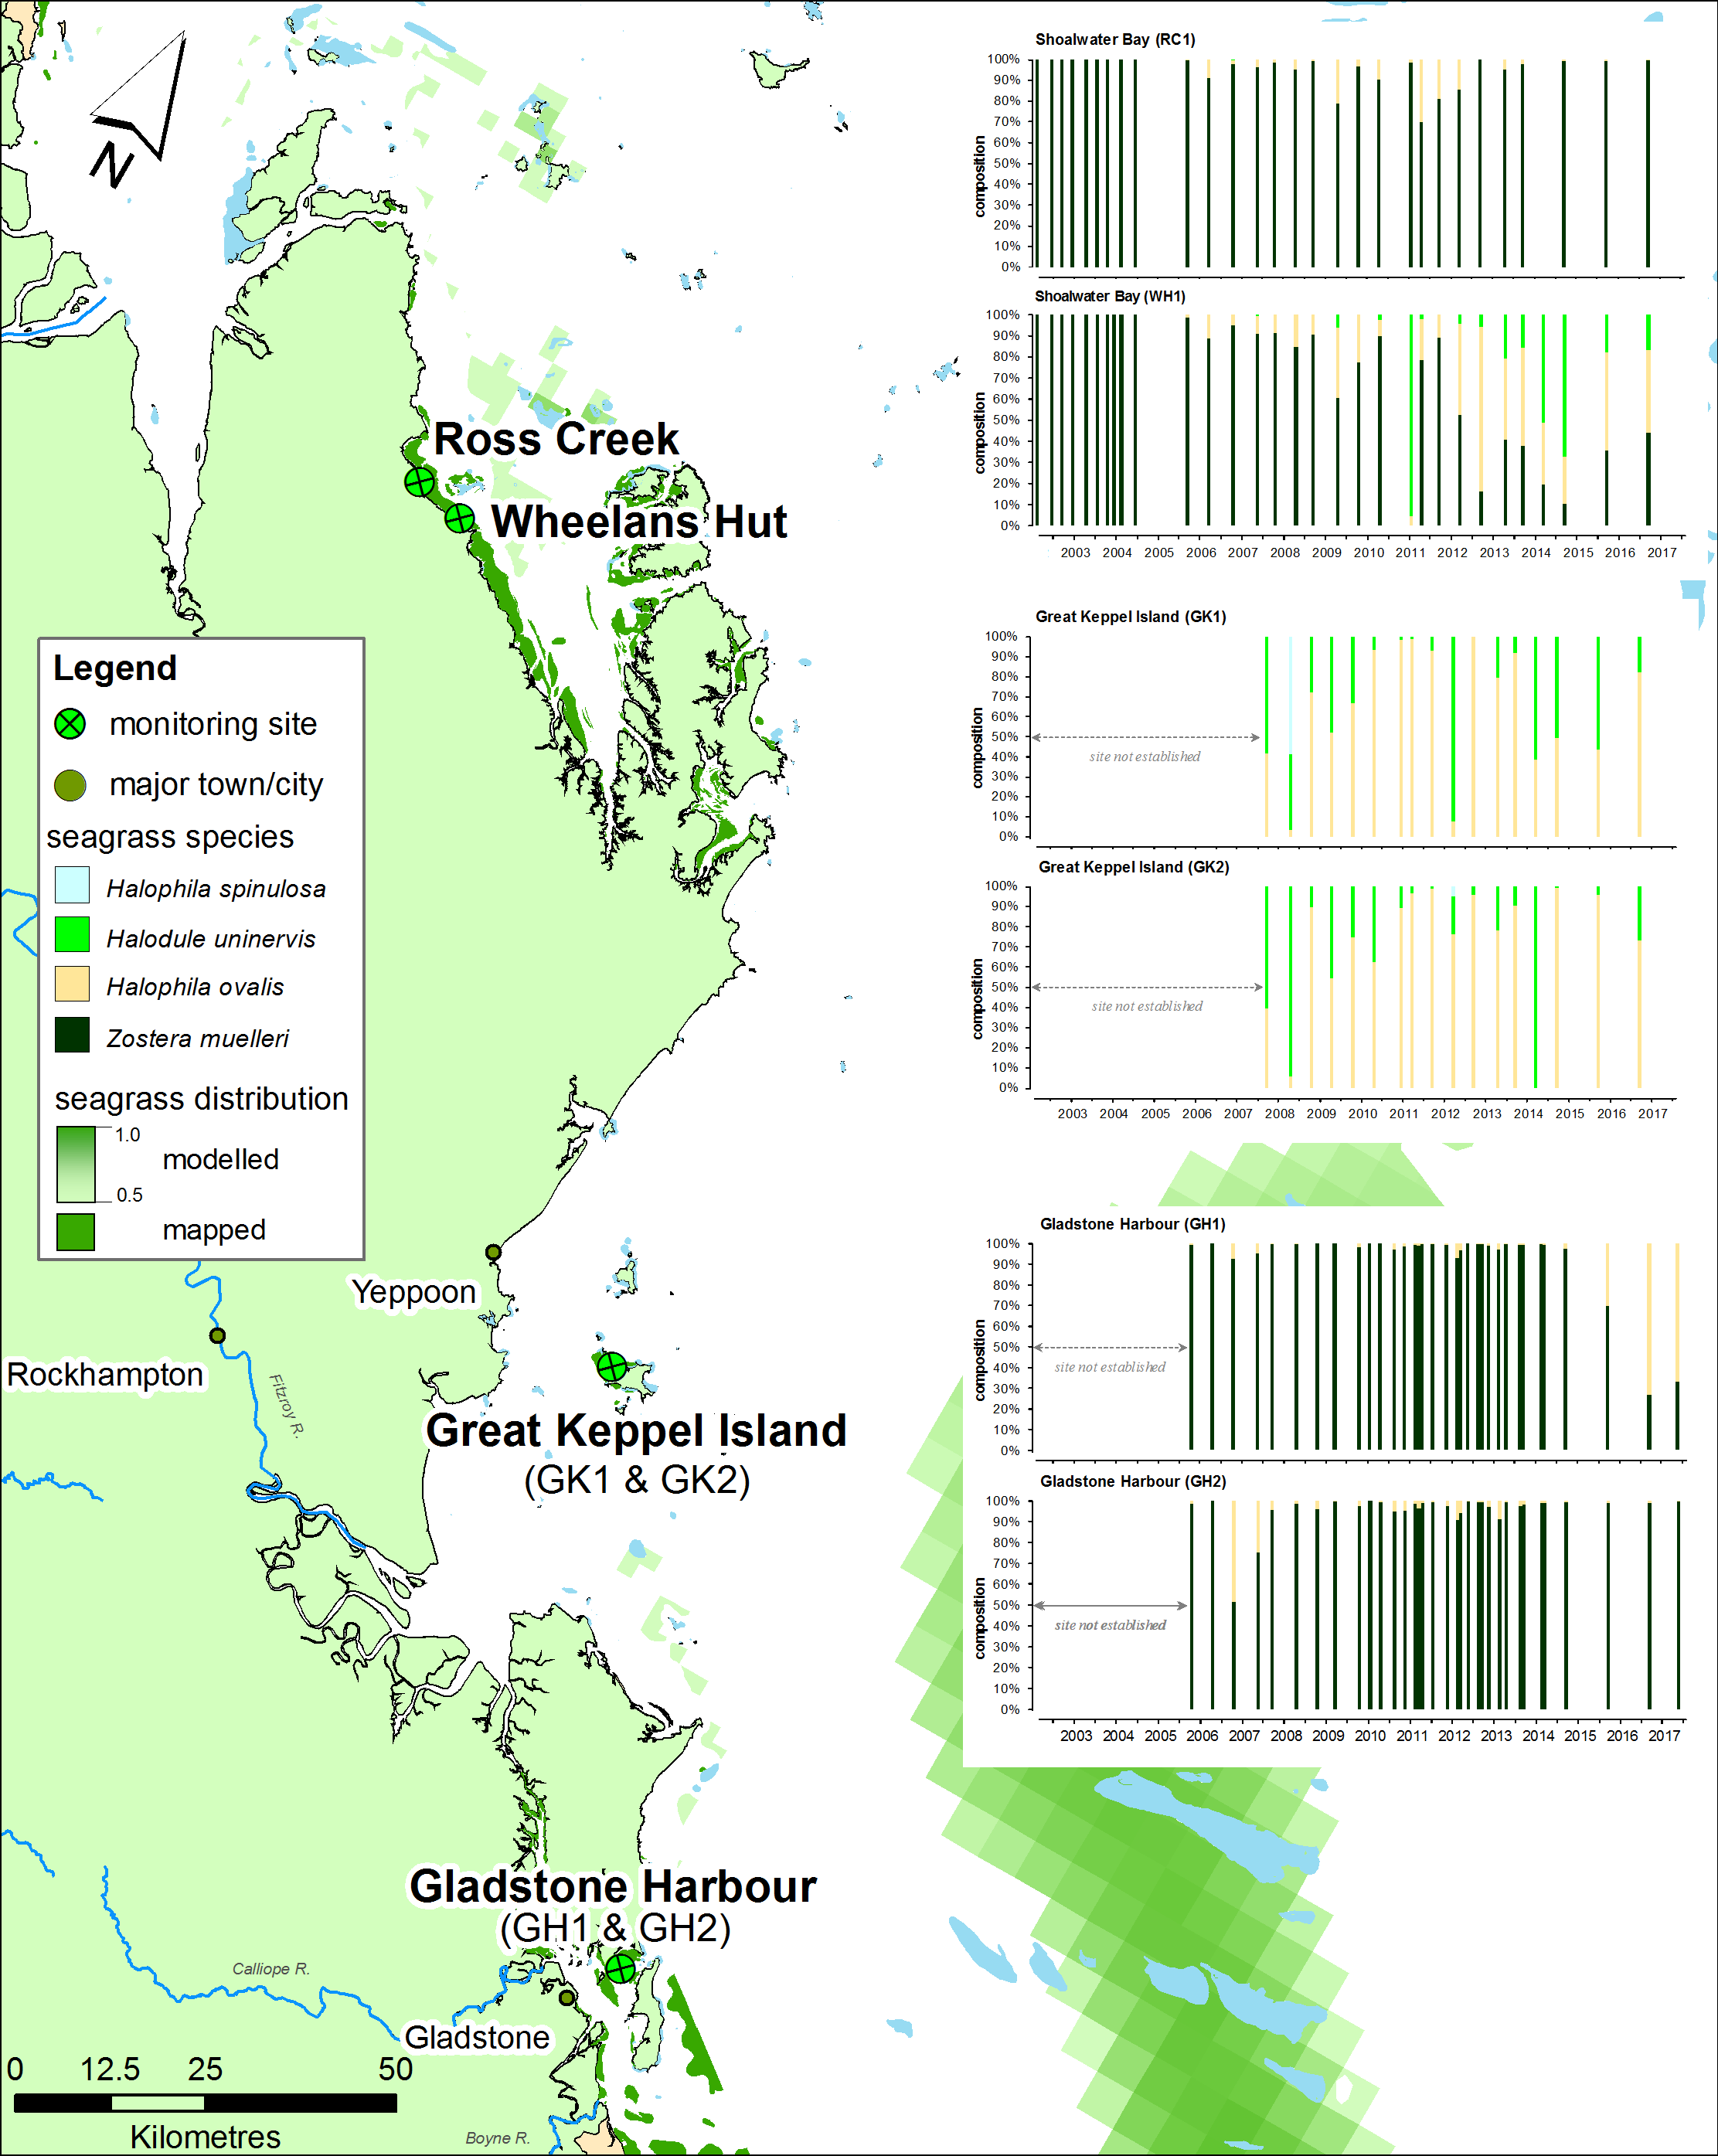
Figure 204. Location and species composition of each long-term seagrass monitoring site (MMP) in the Fitzroy region.
Please note: replicate sites within 500m of each other. Also shown is distribution of seagrass as the modelled distribution (including likelihood of presence from 0.5-1.0 McKenzie et al. 2010c) and composite of mapped distribution (McKenzie et al. 2014c).

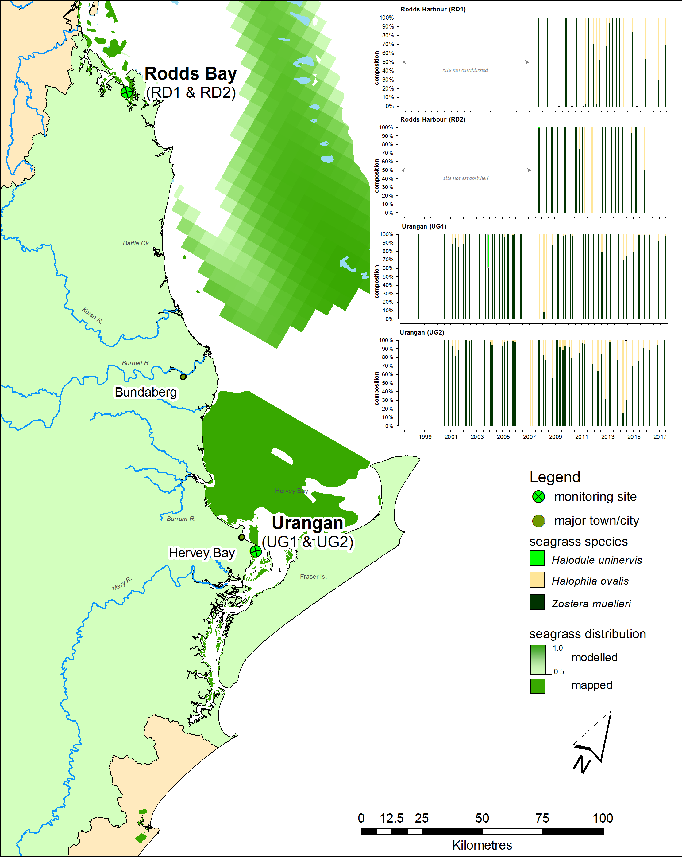
Figure 205. Location and species composition of each long-term seagrass monitoring site (MMP) in the Burnett Mary region.
Please note: replicate sites within 500m of each other. Also shown is distribution of seagrass as the modelled distribution (including likelihood of presence from 0.5-1.0 McKenzie et al. 2010c) and composite of mapped distribution (McKenzie et al. 2014c).

Seagrass leaf tissue
The following graphs display the elemental ratios (atomic) of seagrass leaf tissue C:N, N:P and C:P for the foundation seagrass species examined at each habitat or location in the NRM regions of the Great Barrier Reef. The horizontal shaded band on the C:N ratio panels represent the accepted seagrass “Redfield” ratio of 20:1 (Abal et al. 1994; Grice et al. 1996). C:N ratios below this line may indicate reduced light availability and/or N enrichment. The horizontal shaded band on the N:P panels represent the range of value associated with N:P balance ratio in the plant tissues, a seagrass “Redfield” ratio (Atkinson and Smith 1983; Duarte 1990; Fourqurean et al. 1992b; Fourqurean and Cai 2001). N:P ratio above this band indicates P limitation, below indicates N limitation and within indicates replete. Shaded portion on the C:P panel ≤500 represents the value associated with C:P balance ratio in the plant tissues, C:P values <500 may indicate nutrient rich habitats (large P pool).

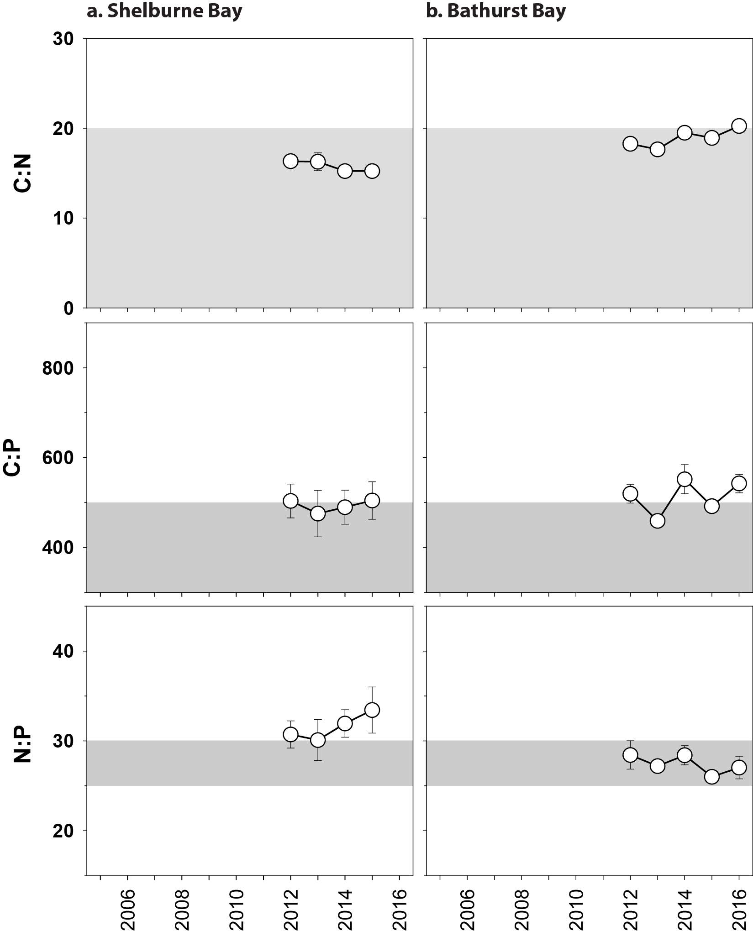
Figure 206. Elemental ratios (atomic) of seagrass leaf tissue C:N, N:P and C:P for the foundation seagrass species examined at each coastal location in the Cape York region each year
(species pooled) (mean ± SE).

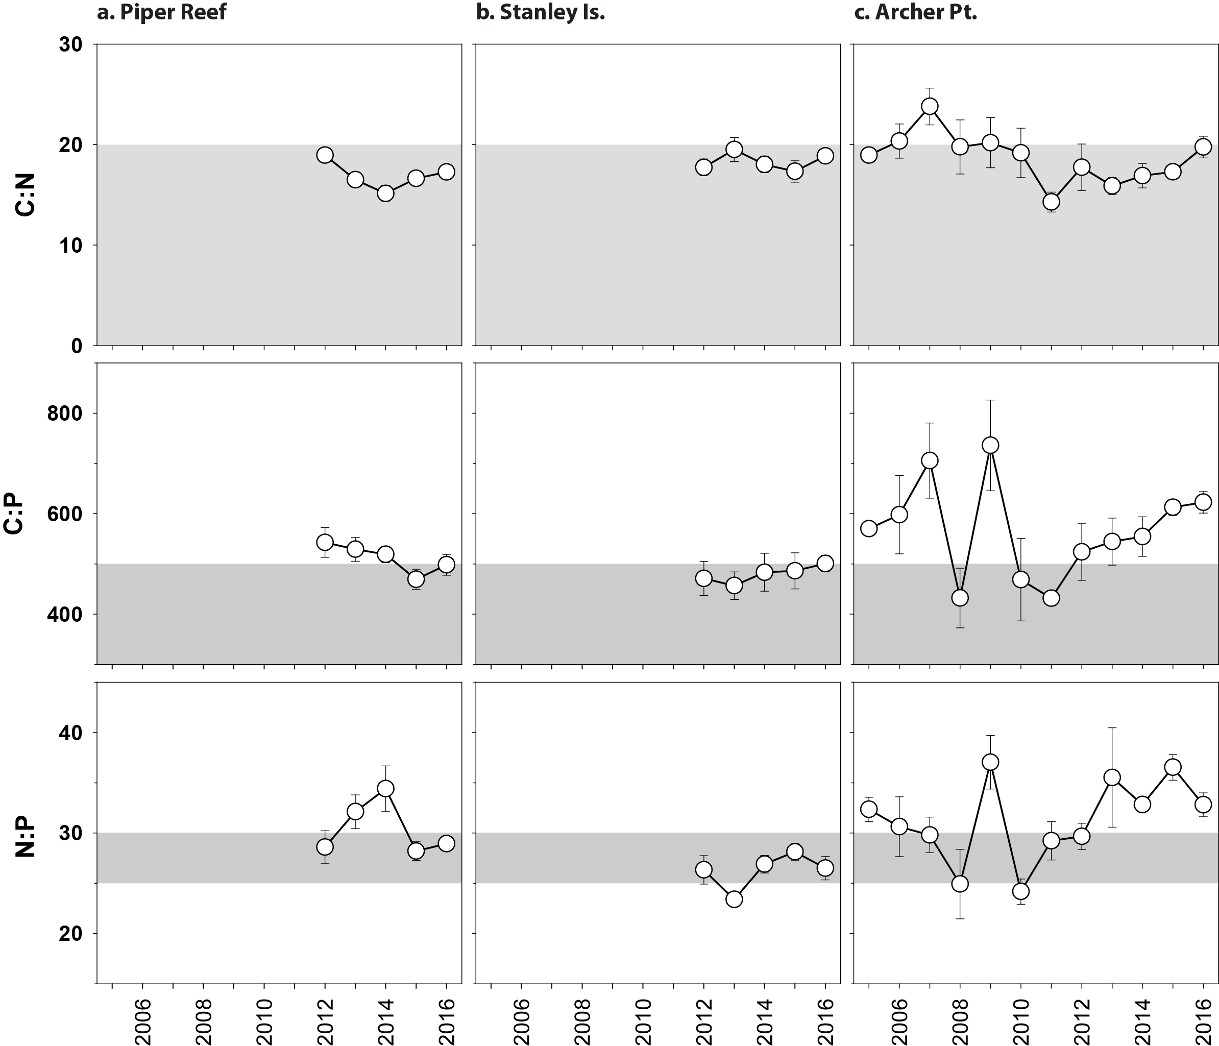
Figure 207. Elemental ratios (atomic) of seagrass leaf tissue C:N, N:P and C:P for the foundation seagrass species examined at each reef location in the Cape York region each year
(species pooled) (mean ± SE).

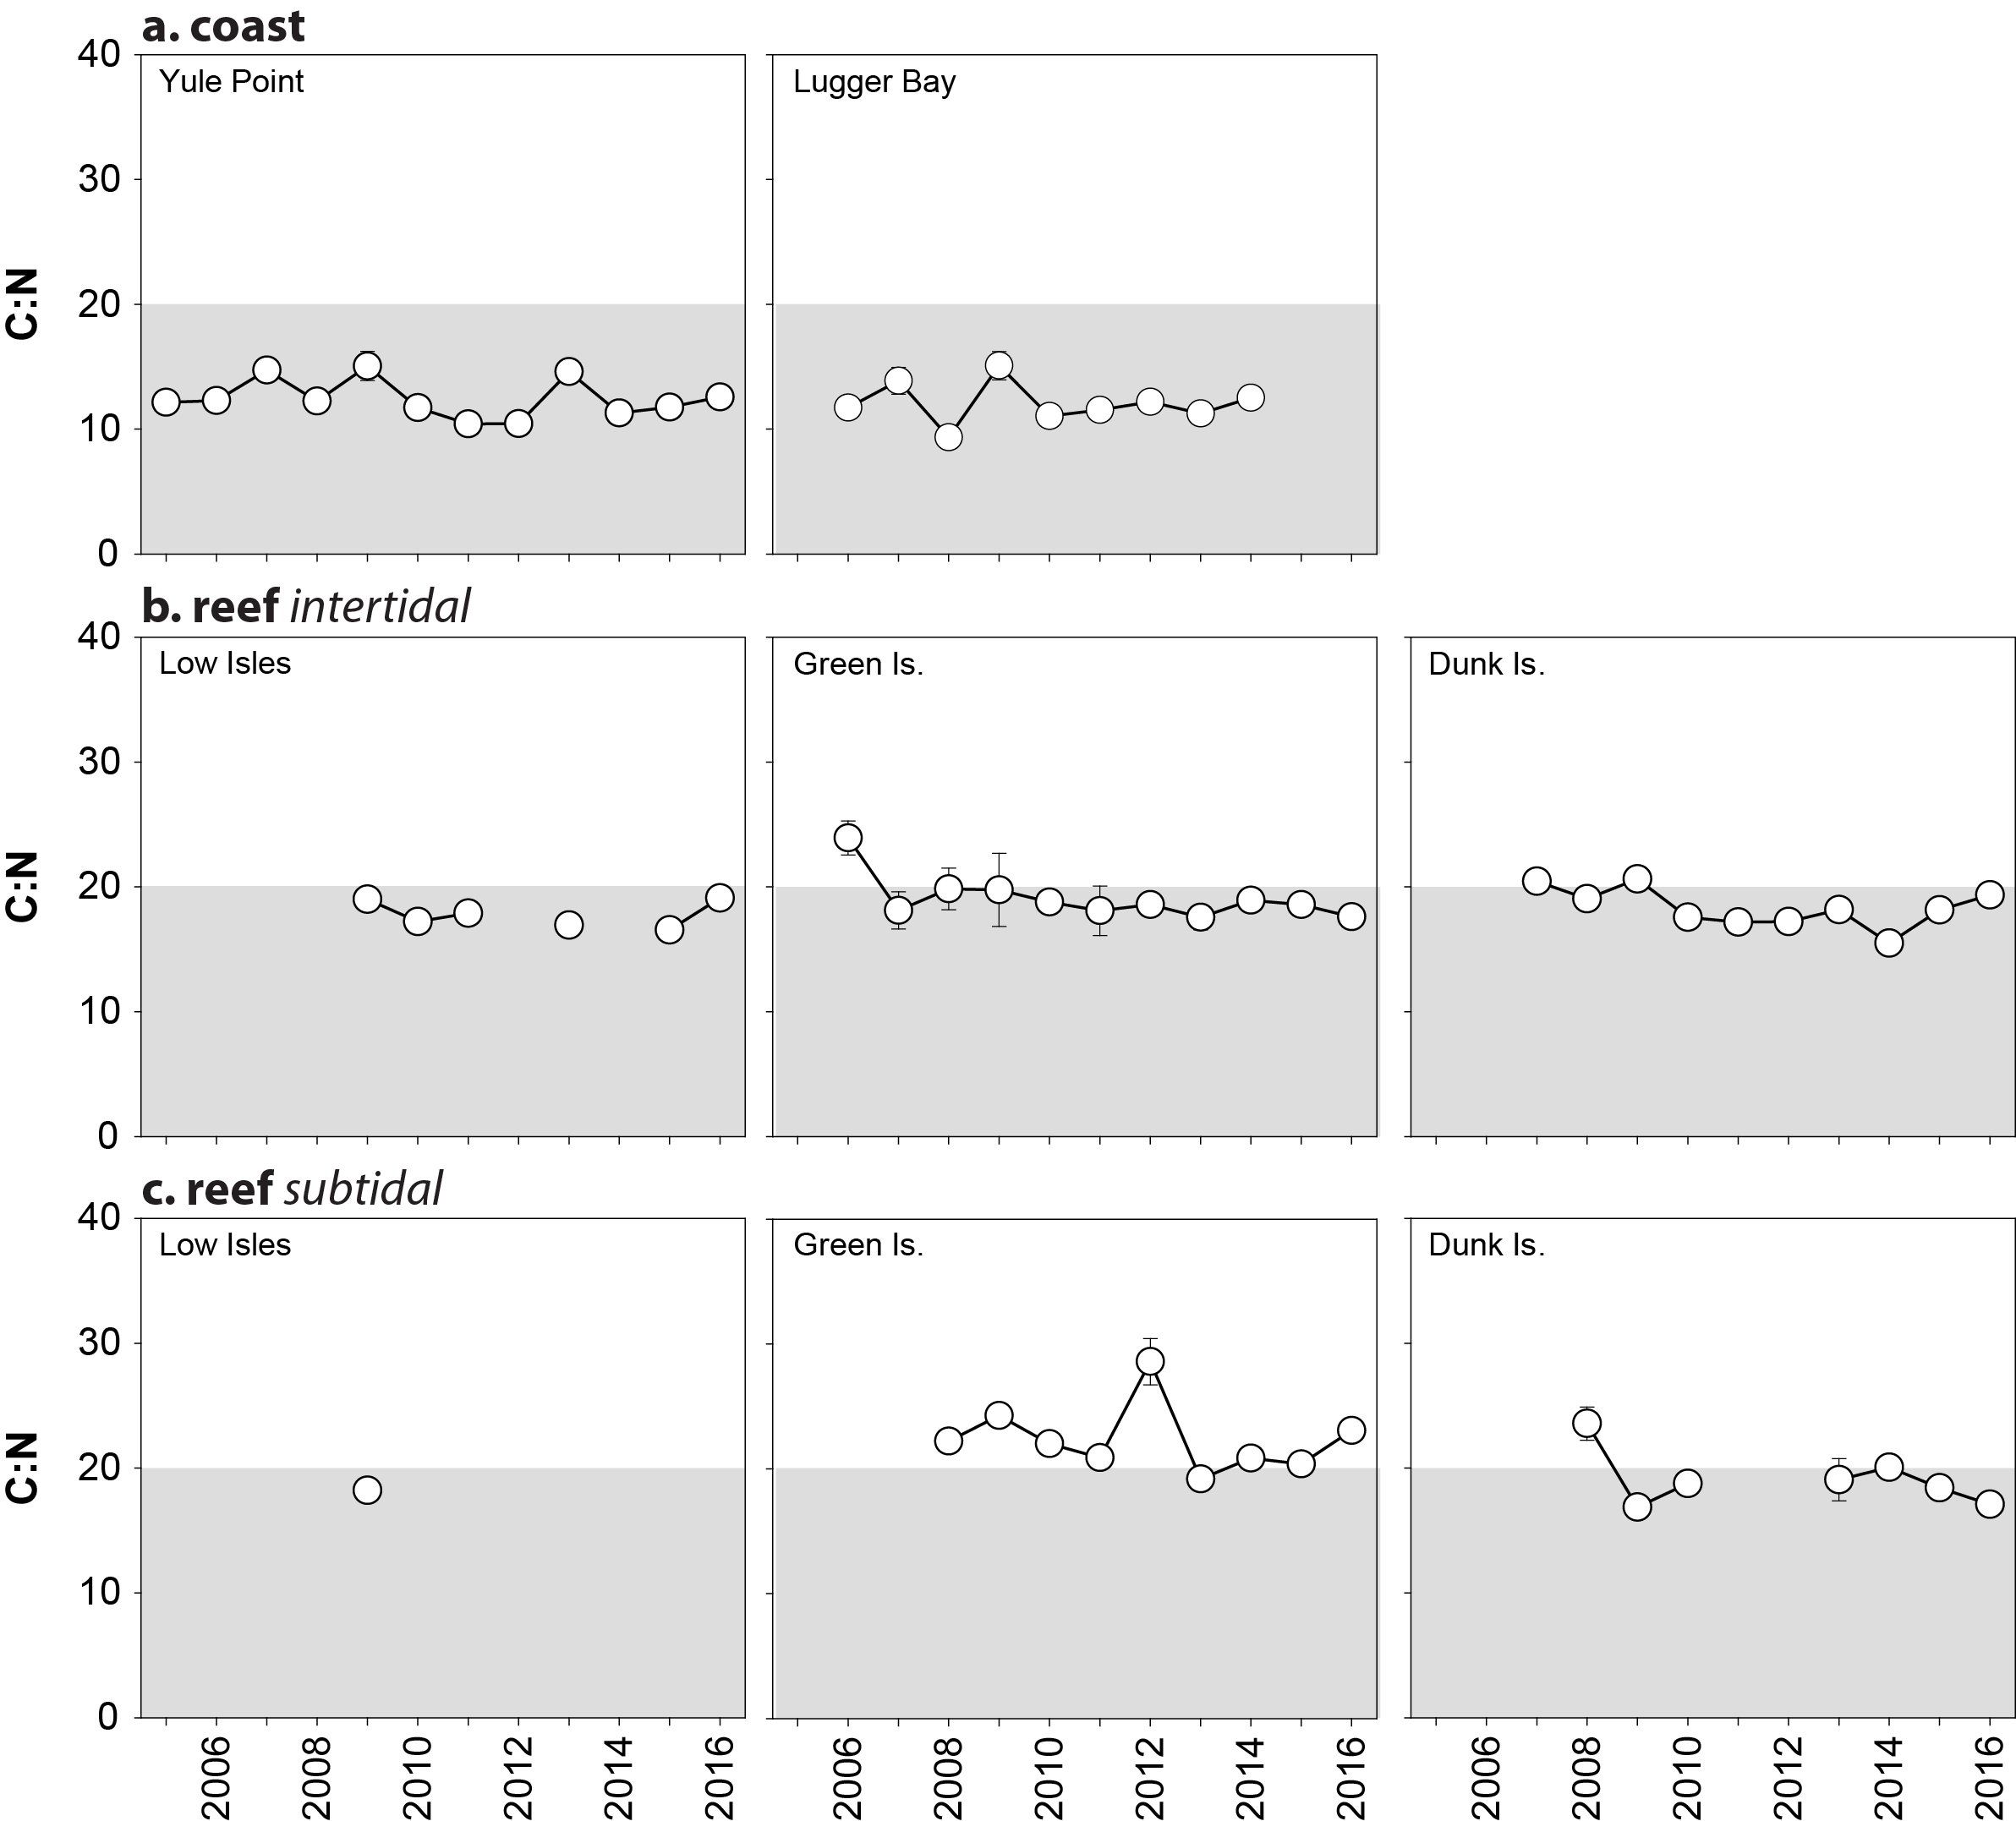
Figure 208. Elemental ratios (atomic) of seagrass leaf tissue C:N for the foundation seagrass species examined at each habitat and location in the Wet Tropics region each year
(species pooled) (mean ± SE).

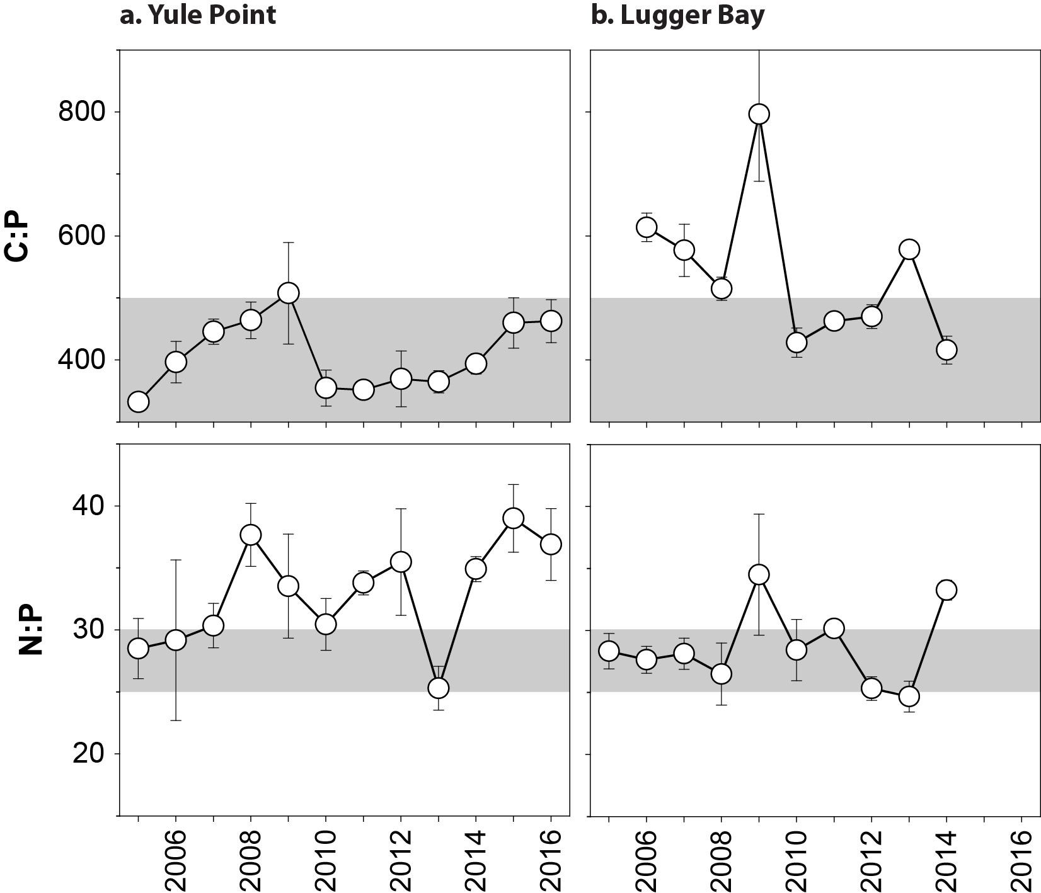
Figure 209. Elemental ratios (atomic) of seagrass leaf tissue C:P and N:P for the foundation seagrass species examined at intertidal coastal habitats in the Wet Tropics region each year
(species pooled) (mean ± SE).
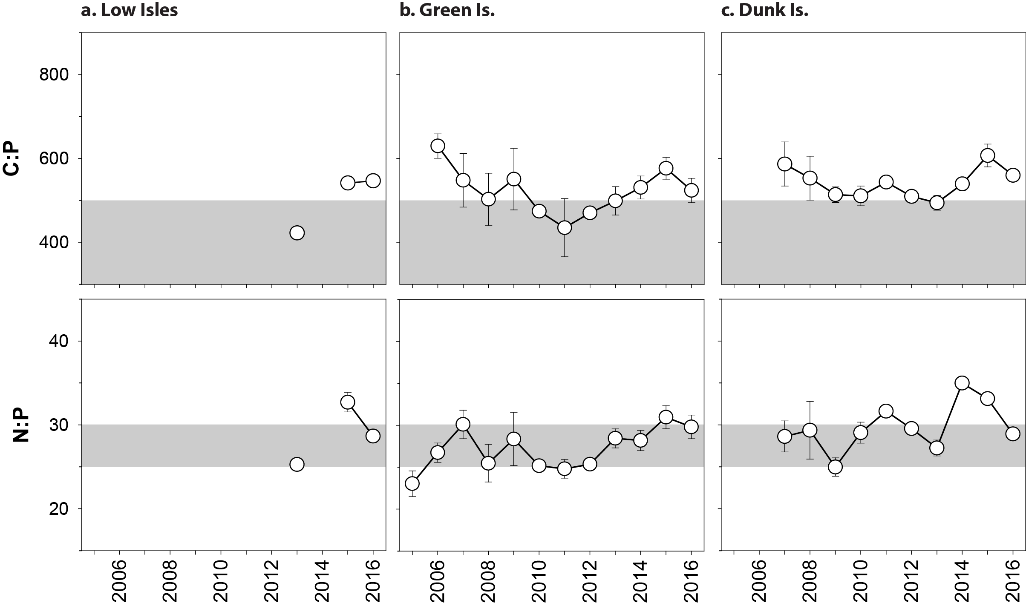
Figure 210. Elemental ratios (atomic) of seagrass leaf tissue C:P and N:P for the foundation seagrass species examined at intertidal reef habitats in the Wet Tropics region each year
(species pooled) (mean ± SE).

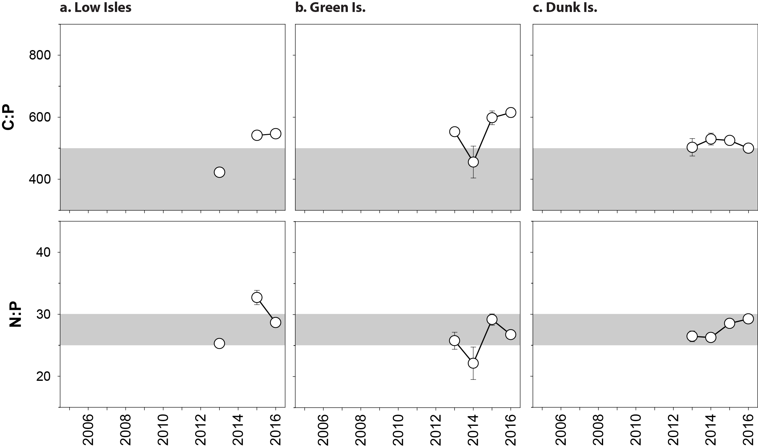
Figure 211. Elemental ratios (atomic) of seagrass leaf tissue C:P and N:P for the foundation seagrass species examined at subtidal reef habitats in the Wet Tropics region each year
(species pooled) (mean ± SE).

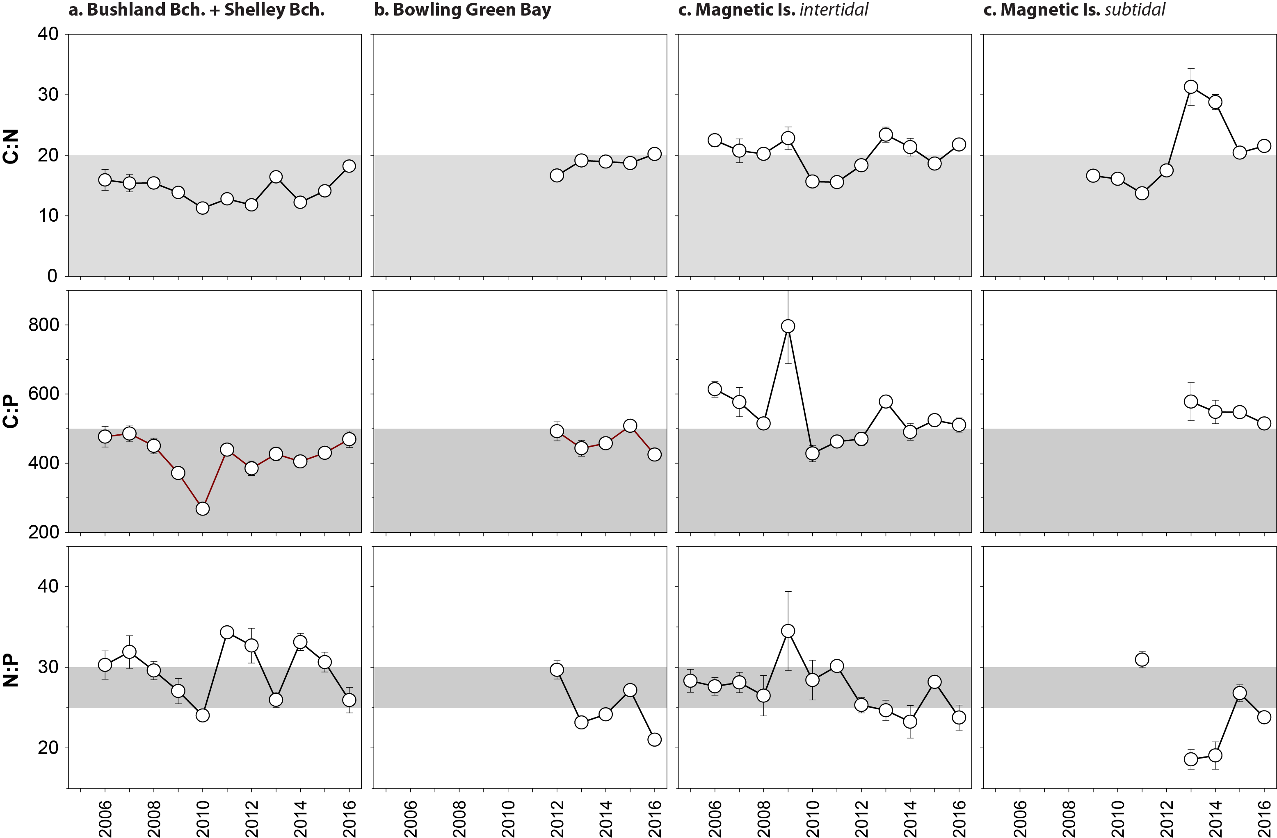
Figure 212. Elemental ratios (atomic) of seagrass leaf tissue C:N, N:P and C:P for the foundation seagrass species examined at each habitat and location in the Burdekin region each year
(species pooled) (mean ± SE).
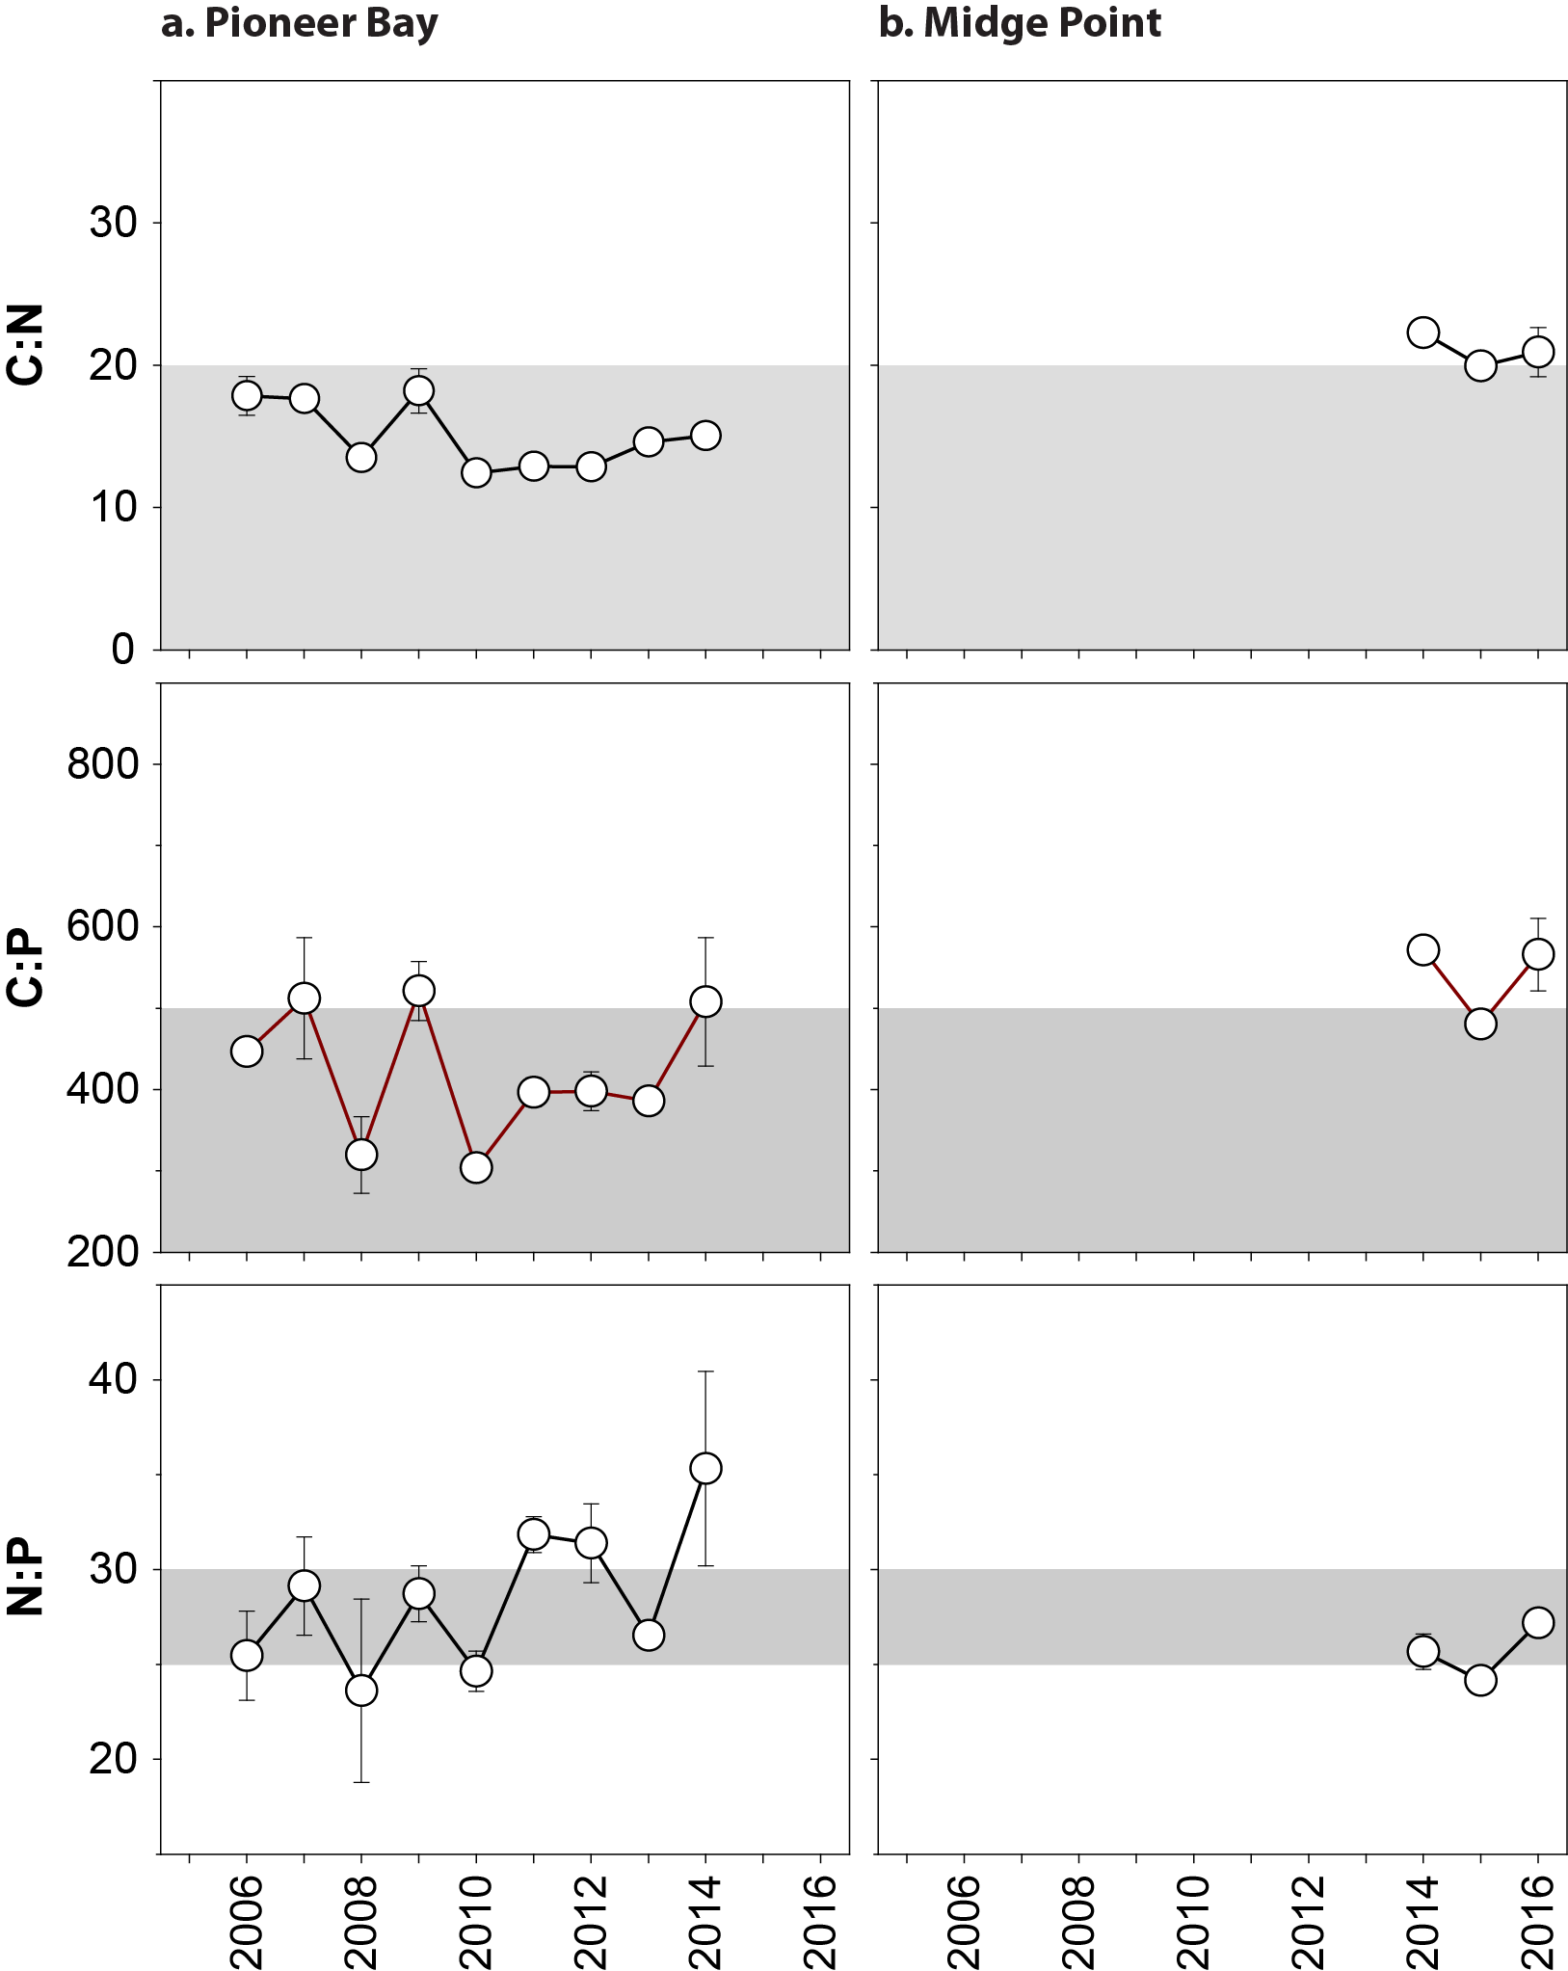
Figure 213. Elemental ratios (atomic) of seagrass leaf tissue C:N, N:P and C:P for the foundation seagrass species examined at coastal habitats in the Mackay Whitsunday region each year
(species pooled) (mean ± SE).
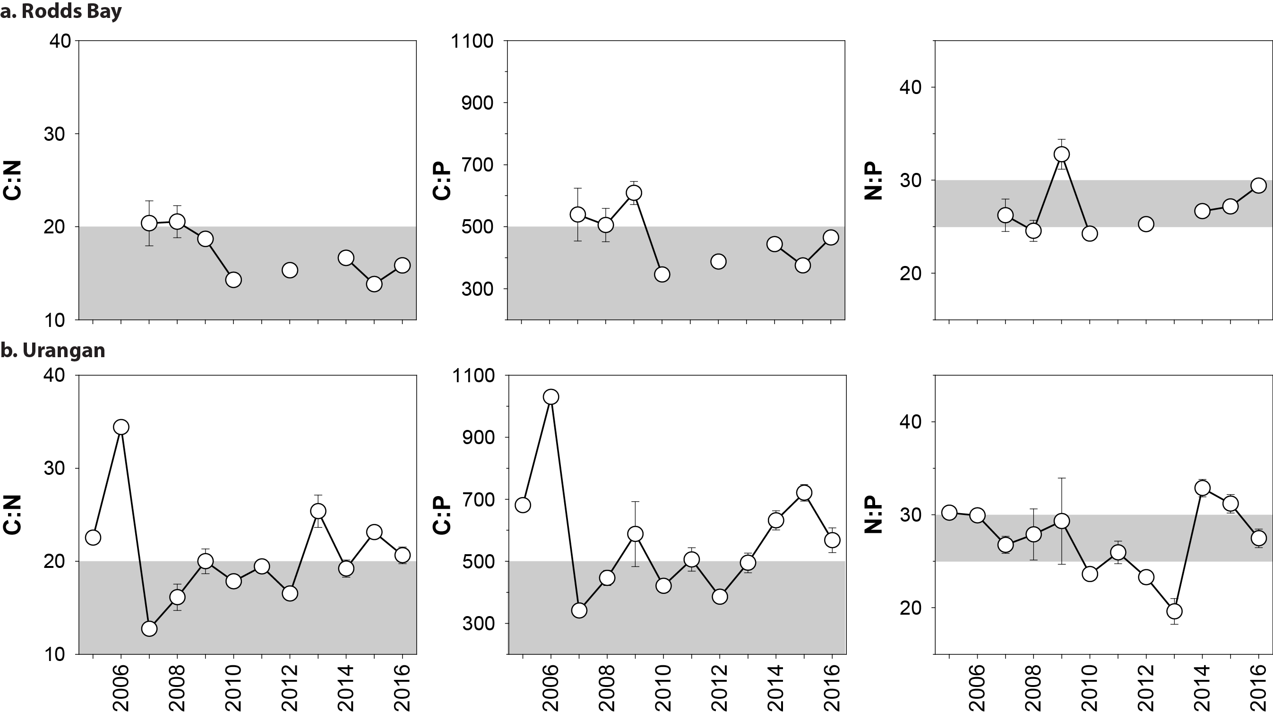
Figure 214. Elemental ratios (atomic) of seagrass leaf tissue C:N for the foundation seagrass species examined at each habitat in the Burnett Mary region each year
(species pooled) (mean ± SE).

Table 54. Seagrass leaf tissue nutrient and δ¹³C and δ¹⁵N concentrations measured in the late dry from 2011 to 2014 in each fo the NRMs.
Leaf tissues with low per centC (see Table 38), low C:N (<20:1), and isotopically depleted δ¹³C may indicate that growth is light limited (Grice et al. 1996; Fourqurean et al. 2005). Global δ¹³C averages from Hemminga and Mateo 1996). Shading indicates values lower than literature. CR=Cymodocea rotundata, EA=Enhalus acoroides, HO=Halophila ovalis, HS=Halophila spinulosa, HU=Halodule uninervis, TH=Thalassia hemprichii, ZM=Zostera muelleri.
NRM | Habitat | Species | Year | %C | C:N | δ¹³C ‰ | δ¹⁵N ‰ | % C lit  median | δ¹³C ‰  global average
Cape York | coastal | EA | 2012 | 36.68 | 14.72 | -13.07 | -9.41 | 38.3 | -5.8 (-6.7 to -4.9)
 | intertidal | HU | 2012 | 40.61 | 15.92 | -11.00 ±0.46 | 0.06 ±0.26 | 38.5 | -11.2 (-13.0 to -7.8)
 |  |  | 2013 | 39.86 | 15.74 | -11.71 ±0.25 | -1.77 ±0.93
 |  |  | 2014 | 40.62 | 19.15 | -11.22 ±0.12 | -0.08 ±0.51
 |  |  | 2015 | 38.98 | 16.34 | -9.57 ±0.99 | 0.89 ±0.78
 |  |  | 2016 | 42.19 | 19.61 | -10.68 ±0.18 | 0.58 ±0.21
 |  | SI | 2012 | 36.74 | 16.52 | -4.78 | 0.35 | 28 | -6.0 (-8.3 to -3.6)
 |  |  | 2013 | 36.34 | 18.07 | -6.10 ±0.09 | -0.58 ±0.34
 |  |  | 2014 | 36.69 | 24.00 | -4.28 ±0.25 | 0.20 ±0.1
 |  |  | 2015 | 33.00 | 22.65 | -8.48 ±1.65 | 0.55 ±0.45
 |  |  | 2016 | 38.57 | 19.28 | -4.75 ±0.00 | 0.42 ±0.00
 |  | TH | 2012 | 35.74 | 15.37 | -9.97 ±0.22 | -1.28 ±0.60 | 35.6 | -6.9 (-8.1 to -5.2)
 |  |  | 2013 | 36.15 | 17.97 | -10.50 ±0.15 | -1.33 ±0.47
 |  |  | 2014 | 37.68 | 16.78 | -10.21 ±0.18 | -0.37 ±0.18
 |  |  | 2015 | 36.95 | 16.09 | -10.53 ±1.08 | -0.86 ±0.83
 |  |  | 2016 | 41.07 | 16.19 | -8.88 ±0.10 | -0.10 ±0.04
 |  | ZM | 2012 | 38.94 | 17.28 | -10.23 | 1.84 | 32 | -10.8 (-12.4 to -9.2)
 |  |  | 2014 | 38.08 | 26.47 | -9.38 ±0.20 | 1.39 ±0.05
 |  |  | 2015 | 38.10 | 20.96 | -10.17 ±0.86 | 1.73 ±0.26
 |  |  | 2016 | 39.75 | 26.02 | -10.08 ±0.15 | 1.33 ±0.26
 | reef | CR | 2012 | 39.65 | 18.03 | -7.96 ±0.25 | -2.44 ±0.61 | 39 | -8.1 (-8.9 to -7.4)
 | intertidal |  | 2013 | 36.89 | 24.16 | -8.32 | -0.83
 |  |  | 2014 | 37.42 | 18.66 | -7.95 ±0.12 | -1.87 ±0.32
 |  |  | 2015 | 39.51 | 17.77 | -9.65 ±0.63 | 0.48 ±0.43
 |  |  | 2016 | 42.79 | 17.56 | -8.43 ±0.19 | -1.49 ±0.44
 |  | CS | 2012 | 40.34 | 19.12 | -8.57 | 0.37 | 40.4 | -10.7 (-12.4 to -8.0)
 |  |  | 2015 | 42.10 | 25.77 | -12.34 ±1.46 | -0.32 ±0.88
 |  |  | 2016 | 41.71 | 23.90 | -9.51 ±0.03 | 1.67 ±0.04
 |  | HU | 2011 | 42.48 | 15.50 | -8.78 ±0.30 | 0.72 ±0.44 | 38.5 | -11.2 (-13.0 to -7.8)
 |  |  | 2012 | 41.22 | 16.13 | -8.74 ±0.22 | 0.15 ±1.34
 |  |  | 2013 | 41.93 | 16.86 | -8.97 ±0.04 | -1.58 ±0.51
 |  |  | 2014 | 39.53 | 17.89 | -8.82 ±0.19 | -1.71 ±0.69
 |  |  | 2015 | 41.15 | 16.05 | -9.08 ±0.84 | 0.82 ±0.88
 |  |  | 2016 | 43.06 | 17.74 | -9.60 ±0.09 | -0.17 ±1.29
 |  | SI | 2012 | 22.27 | 19.83 | -4.01 ±0.24 | 1.11 ±0.94 | 28 | -6.0 (-8.3 to -3.6)
 |  |  | 2013 | 37.52 | 19.46 | -5.27 | 0.24
 |  |  | 2014 | 34.75 | 20.24 | -3.15 | 0.66
 |  |  | 2015 | 36.90 | 22.76 | -5.82 ±0.02 | 0.15 ±0.28
 |  |  | 2016 | 39.45 | 24.36 | -5.07 ±0.07 | 1.66 ±0.10
 |  | TH | 2012 | 37.42 | 15.91 | -6.26 ±0.27 | 0.65 ±0.84 | 35.6 | -6.9 (-8.1 to -5.2)
 |  |  | 2013 | 37.61 | 16.79 | -6.99 ±0.12 | 0.42 ±0.59
 |  |  | 2014 | 36.02 | 17.54 | -7.11 ±0.13 | -0.24 ±0.55
 |  |  | 2015 | 37.53 | 15.58 | -8.77 ±0.89 | -1.99 ±0.43
 |  |  | 2016 | 40.59 | 15.59 | -7.30 ±0.09 | 1.09 ±0.32
 |  | ZM | 2011 | 39.70 | 22.27 | -9.27 | 1.57 | 32 | -10.8 (-12.4 to -9.2)
 |  |  | 2013 | 36.86 | 20.08 | -9.03 ±0.08 | -0.66 ±0.38
Wet Tropics | coastal | HU | 2011 | 44.90 | 10.65 | -10.35 | 0.64 | 38.5 | -11.2 (-13.0 to -7.8)
 | intertidal |  | 2012 | 42.08 | 11.13 | -9.59 ±0.16 | 0.85 ±0.27
 |  |  | 2013 | 41.29 | 11.82 | -10.12 ±0.25 | 0.42 ±0.19
 |  |  | 2014 | 43.64 | 11.59 | -9.76 ±0.18 | 1.73 ±0.38
 |  |  | 2015 | 44.52 | 11.76 | -8.39 ±0.91 | 1.45 ±0.48
 |  |  | 2016 | 43.16 | 11.54 | -9.99 ±0.17 | 2.80 ±0.28
 | reef | CR | 2011 | 42.38 | 18.17 | -7.88 ±0.27 | -0.71 ±0.31 | 39 | -8.1 (-8.9 to -7.4)
 | intertidal |  | 2012 | 40.83 | 17.64 | -6.71 ±0.11 | -0.27 ±0.36
 |  |  | 2013 | 39.96 | 18.35 | -7.67 ±0.34 | 0.76 ±0.89
 |  |  | 2014 | 42.10 | 20.27 | -7.59 ±0.13 | 0.22 ±0.31
 |  |  | 2015 | 42.98 | 17.23 | -7.74 ±0.07 | 0.9 ±0.43
 |  |  | 2016 | 42.31 | 17.36 | -7.44 ±0.06 | 0.12 ±0.29
 |  | CS | 2013 | 41.81 | 22.61 | -10.63 ±0.07 | 3.64 ±0.22 | 40.4 | -10.7 (-12.4 to -8.0)
 |  |  | 2014 | 42.15 | 21.61 | -9.10 ±0.02 | 1.97 ±0.09
 |  |  | 2015 | 42.38 | 22.30 | -7.2 ±0.86 | 0.54 ±0.07
 |  | HU | 2009 | 34.29 | 19.45 | -11.05 ±0.14 | 0.23 ±1.08 | 38.5 | -11.2 (-13.0 to -7.8)
 |  |  | 2010 | 34.34 | 17.22 | -12.86 ±1.14 | 1.75 ±0.17
 |  |  | 2011 | 39.84 | 19.02 | -9.32 ±0.43 | 1.66 ±0.35
 |  |  | 2012 | 41.74 | 17.08 | -7.83 ±0.23 | 1.76 ±0.66
 |  |  | 2013 | 41.41 | 19.38 | -9.01 ±0.22 | 1.78 ±0.54
 |  |  | 2014 | 42.02 | 17.58 | -8.68 ±0.26 | 2.35 ±0.19
 |  |  | 2015 | 43.37 | 18.02 | -8.51 ±0.45 | 1.97 ±0.46
 |  |  | 2016 | 42.64 | 18.19 | -8.98 ±0.11 | -0.37 ±0.53
 |  | SI | 2015 | 39.50 | 22.84 | -7.31 ±0.28 | 1.59 ±0.85 | 28 | -6.0 (-8.3 to -3.6)
 |  | TH | 2009 | 30.41 | 18.55 | -8.66 ±0.24 | 1.22 ±0.17 | 35.6 | -6.9 (-8.1 to -5.2)
 |  |  | 2011 | 40.43 | 17.29 | -7.02 ±0.11 | 1.80 ±0.24
 |  |  | 2012 | 38.71 | 15.97 | -7.40 ±0.21 | 1.24 ±0.15
 |  |  | 2013 | 37.95 | 17.12 | -6.34 ±0.18 | 2.88 ±0.47
 |  |  | 2014 | 40.29 | 17.36 | -6.80 ±0.19 | 1.84 ±0.28
 |  |  | 2015 | 41.11 | 15.76 | -8.79 ±0.15 | 1.67 ±0.18
 |  |  | 2016 | 40.05 | 16.21 | -7.52 ±0.15 | 2.04 ±0.24
 | reef subtidal | CR | 2013 | 40.91 | 16.77 | -9.50 ±0.20 | -0.37 ±0.37 | 39 | -8.1 (-8.9 to -7.4)
 |  |  | 2014 | 41.73 | 17.00 | -9.85 ±0.16 | 1.09 ±0.23
 |  |  | 2015 | 41.43 | 17.59 | -7.65 ±1.35 | 1.87 ±0.89
 |  |  | 2016 | 42.21 | 20.10 | -9.71 ±0.23 | -1.11 ±0.99
 |  | CS | 2008 | 33.35 | 22.74 | -9.65 ±0.26 | 1.91 ±0.33 | 40.4 | -10.7 (-12.4 to -8.0)
 |  |  | 2009 | 33.69 | 24.27 | -9.87 ±0.03 | 2.19 ±0.15
 |  |  | 2010 | 32.70 | 22.87 | -9.78 ±0.24 | 1.34 ±0.36
 |  |  | 2011 | 37.88 | 22.89 | -9.91 ±0.13 | 2.79 ±0.29
 |  |  | 2012 | 40.60 | 28.58 | -9.73 ±0.13 | 2.11 ±0.35
 |  |  | 2013 | 38.59 | 22.56 | -10.11 ±0.43 | 3.04 ±0.44
 |  |  | 2014 | 39.65 | 21.72 | -9.46 ±0.22 | 3.47 ±0.13
 |  |  | 2015 | 41.23 | 22.84 | -9.44 ±0.09 | -1.96 ±0.31
 |  |  | 2016 | 42.49 | 22.53 | -9.87 ±0.17 | 1.20 ±0.28
 |  | HU | 2008 | 35.25 | 22.63 | -10.62 ±0.17 | 2.19 ±0.23 | 38.5 | -11.2 (-13.0 to -7.8)
 |  |  | 2009 | 34.46 | 17.24 | -11.25 ±0.36 | 0.95 ±0.15
 |  |  | 2010 | 33.50 | 19.96 | -11.69 ±1.11 | 2.23 ±0.48
 |  |  | 2011 | 38.94 | 18.88 | -9.64 ±0.04 | 1.82 ±0.23
 |  |  | 2013 | 39.19 | 19.58 | -9.85 ±0.17 | 2.71 ±0.29
 |  |  | 2014 | 41.26 | 18.96 | -10.10 ±0.15 | 2.82 ±0.19
 |  |  | 2015 | 43.03 | 19.09 | -8.83 ±1.19 | 1.88 ±0.27
 |  |  | 2016 | 43.25 | 17.83 | -10.06 ±0.09 | 1.51 ±0.30
 |  | SI | 2013 | 37.10 | 20.92 | -4.71 ±0.14 | 0.86 ±0.34 | 28 | -6.0 (-8.3 to -3.6)
 |  |  | 2014 | 35.53 | 22.30 | -5.03 ±0.20 | 1.47 ±0.19
 |  |  | 2015 | 37.63 | 21.35 | -9.57 ±0.07 | 1.58 ±0.44
 |  |  | 2016 | 37.53 | 24.12 | -5.47 ±0.13 | 0.08 ±0.26
Burdekin | coastal | HU | 2012 | 40.30 | 12.82 | -11.23 ±0.13 | 1.22v0.19 | 38.5 | -11.2 (-13.0 to -7.8)
 | intertidal |  | 2013 | 38.81 | 15.75 | -11.49 ±0.03 | 2.34 ±0.17
 |  |  | 2014 | 40.56 | 12.74 | -11.64 ±0.25 | 2.82 ±0.16
 |  |  | 2015 | 39.63 | 15.58 | -10.18 ±0.6 | 0.68 ±0.35 | 0 | 0
 |  |  | 2016 | 41.12 | 17.03 | -11.38 ±0.16 | 2.48 ±0.05
 |  | ZM | 2012 | 36.33 | 17.76 | -10.44 ±0.23 | 2.18 ±0.39 | 32 | -10.8 (-12.4 to -9.2)
 |  |  | 2013 | 35.75 | 18.56 | -10.75 ±0.06 | 2.59 ±0.15
 |  |  | 2014 | 34.85 | 20.12 | -11.71 ±0.17 | 2.80 ±0.06
 |  |  | 2015 | 37.60 | 18.89 | -10.43 ±0.78 | 1.18 ±1.39
 |  |  | 2016 | 38.19 | 18.55 | -10.00 ±0.18 | 2.48 ±0.11
 | reef | CS | 2012 | 40.47 | 21.91 | -9.07 ±0.02 | 1.54 ±0.60 | 40.4 | -10.7 (-12.4 to -8.0)
 | intertidal |  | 2013 | 40.71 | 19.46 | -10.00 ±0.09 | 2.06 ±0.04
 |  |  | 2015 | 40.17 | 20.11 | -8.99 ±0.09 | 1.59 ±0.4
 |  |  | 2016 | 41.44 | 22.27 | -10.06 ±0.08 | 2.00 ±0.10
 |  | HO | 2011 | 39.50 | 13.44 | -10.79 | 1.88 | 30.5 | -10 (-15.5 to -6.4)
 |  | HU | 2011 | 44.57 | 12.62 | -9.84 ±0.18 | 0.96 ±0.04 | 38.5 | -11.2 (-13.0 to -7.8)
 |  |  | 2012 | 41.63 | 16.53 | -9.11 ±0.07 | 1.32 ±0.50
 |  |  | 2013 | 39.50 | 20.04 | -10.03 ±0.17 | 2.23 ±0.13
 |  |  | 2014 | 38.02 | 22.11 | -9.40 ±0.30 | 2.32 ±0.20
 |  |  | 2015 | 40.40 | 18.49 | -9.87 ±0.44 | 1.37 ±0.26
 |  |  | 2016 | 41.43 | 19.88 | -9.40 ±0.37 | 1.83 ±0.11
 |  | TH | 2012 | 39.61 | 15.14 | -8.31 | 0.09 ±0.45 | 35.6 | -6.9 (-8.1 to -5.2)
 |  |  | 2013 | 36.48 | 15.65 | -8.85 ±0.05 | 1.58 ±0.09
 |  |  | 2016 | 38.91 | 17.46 | -8.71 ±0.00 | 1.16 ±0.00
 | reef | CS | 2009 | 35.10 | 18.83 | -10.96 ±0.18 | 1.03 ±0.38 | 40.4 | -10.7 (-12.4 to -8.0)
 | subtidal |  | 2013 | 40.28 | 24.21 | -11.59 ±0.24 | 3.39 ±0.22
 |  |  | 2014 | 41.99 | 28.24 | -10.38 ±0.46 | 3.08 ±0.22
 |  |  | 2015 | 40.63 | 21.24 | -10.52 ±0.25 | 1.05 ±1.11
 |  |  | 2016 | 41.19 | 22.19 | -11.36 ±0.08 | 3.19 ±0.08
 |  | HS | 2013 | 37.35 | 31.12 | -12.32 | 3.11
 |  | HU | 2009 | 38.29 | 16.60 | -10.69 ±1.00 | 1.05 ±0.48 | 38.5 | -11.2 (-13.0 to -7.8)
 |  |  | 2010 | 30.12 | 16.10 | -12.35 ±0.40 | -0.16 ±0.13
 |  |  | 2011 | 40.31 | 13.70 | -10.88 ±0.03 | 0.20 ±0.24
 |  |  | 2012 | 42.78 | 17.47 | -11.16 ±0.06 | 1.82 ±0.10
 |  |  | 2013 | 40.41 | 22.55 | -11.62 ±0.15 | 3.02 ±0.04
 |  |  | 2014 | 41.01 | 23.26 | -9.47 ±0.14 | 3.17 ±0.07
 |  |  | 2015 | 41.47 | 19.62 | -9.93 ±0.19 | 3.61 ±0.06
 |  |  | 2016 | 42.24 | 18.74 | -10.00 ±0.22 | 3.20 ±0.04
Mackay | estuarine | HU | 2016 | 42.93 | 12.16 | -12.26 ±0.00 | 1.86 ±0.00 | 38.5 | -11.2 (-13.0 to -7.8)
Whitsunday | intertidal | ZM | 2011 | 43.22 | 12.13 | -10.02 ±0.12 | 0.53 ±0.47 | 32 | -10.8 (-12.4 to -9.2)
 |  |  | 2012 | 40.47 | 12.92 | -10.45 ±0.19 | 2.08 ±0.22
 |  |  | 2015 | 37.60 | 17.39 | -10.57 ±0.2 | 1.29 ±0.54
 |  |  | 2016 | 40.39 | 17.07 | -11.25 ±0.42 | 1.98 ±0.19
 | coastal | HU | 2012 | 43.02 | 10.84 | -11.42 ±0.06 | -0.98 ±0.15 | 38.5 | -11.2 (-13.0 to -7.8)
 | intertidal |  | 2013 | 42.31 | 12.84 | -10.93 ±0.19 | 3.25 ±0.10
 |  |  | 2014 | 40.88 | 13.86 | -11.56 ±0.15 | 2.20 ±0.24
 |  |  | 2016 | 40.82 | 18.92 | -10.75 ±0.12 | 1.71 ±0.08
 |  | ZM | 2012 | 40.00 | 12.85 | -11.10 ±0.13 | 4.13 ±0.33 | 32 | -10.8 (-12.4 to -9.2)
 |  |  | 2013 | 41.05 | 13.56 | -11.47 ±0.14 | 4.15 ±0.55
 |  |  | 2014 | 39.53 | 19.60 | -10.16 ±0.22 | 2.97 ±0.13
 |  |  | 2015 | 36.48 | 19.93 | -9.43 ±0.76 | 1.6 ±0.26
 |  |  | 2016 | 39.48 | 20.28 | -11.03 ±0.45 | 1.99 ±0.18
 | reef | HU | 2011 | 45.40 | 9.81 | -10.23 | 1.44 | 38.5 | -11.2 (-13.0 to -7.8)
 | intertidal |  | 2012 | 42.80 | 10.04 | -9.22 ±0.03 | -0.20 ±0.19
 |  |  | 2013 | 42.19 | 10.67 | -8.91 ±0.08 | 0.80 ±0.72
 |  |  | 2014 | 43.89 | 11.24 | -8.79 ±0.09 | 0.89 ±0.25
 |  |  | 2015 | 44.55 | 10.57 | -9.66 ±0.17 | 1.91 ±0.16
 |  |  | 2016 | 45.82 | 9.17 | -10.24 ±0.04 | -2.69 ±0.87
 |  | ZM | 2011 | 42.50 | 13.77 | -9.3 | 0.74 | 32 | -10.8 (-12.4 to -9.2)
 |  |  | 2012 | 39.80 | 14.35 | -9.15 ±0.05 | 2.47 ±0.34
 |  |  | 2013 | 36.06 | 19.49 | -9.94 ±0.08 | 2.34 ±0.19
 |  |  | 2014 | 38.90 | 20.28 | -9.30 ±0.22 | 2.87 ±0.11
 |  |  | 2015 | 42.63 | 12.74 | -7.93 ±0.58 | 0.9 ±1.41
 |  |  | 2016 | 43.11 | 12.56 | -9.33 ±0.14 | 0.25 ±1.28
Fitzroy | estuarine | ZM | 2012 | 39.56 | 22.70 | -9.51 ±0.23 | 2.27 ±0.13 | 32 | -10.8 (-12.4 to -9.2)
 | intertidal |  | 2013 | 36.53 | 18.45 | -9.19 ±0.25 | 2.27 ±0.28
 |  |  | 2014 | 35.59 | 20.27 | -9.27 ±0.17 | 1.84 ±0.13
 |  |  | 2015 | 35.02 | 19.46 | -10.53 ±0.4 | 0.39 ±1.17
 |  |  | 2016 | 38.95 | 17.58 | -9.52 ±0.18 | 2.32 ±0.24
 | coastal | HU | 2013 | 40.34 | 20.40 | -11.17 | 1.07 | 38.5 | -11.2 (-13.0 to -7.8)
 | intertidal |  | 2015 | 36.55 | 14.49 | -8.82 ±0.15 | 0.73 ±0.27
 |  |  | 2016 | 41.79 | 13.72 | -8.45 ±0.08 | -0.83 ±0.63
 |  | ZM | 2011 | 40.08 | 18.36 | -9.28 ±0.07 | 0.72 ±0.10 | 32 | -10.8 (-12.4 to -9.2)
 |  |  | 2012 | 37.64 | 16.57 | -8.24 ±0.17 | 0.94 ±0.35
 |  |  | 2013 | 36.59 | 18.26 | -9.58 ±0.16 | 0.90 ±0.12
 |  |  | 2014 | 33.38 | 17.31 | -8.49 ±0.15 | 1.03 ±0.17
 |  |  | 2015 | 37.73 | 16.83 | -8.62 ±0.59 | 0.48 ±0.51
 |  |  | 2016 | 38.59 | 17.93 | -9.42 ±0.09 | 1.53 ±0.08
 | reef | HU | 2013 | 41.22 | 17.15 | -9.40 | -0.72 | 38.5 | -11.2 (-13.0 to -7.8)
 | intertidal |  | 2014 | 40.66 | 16.07 | -7.14 ±0.10 | 0.56 ±0.12
 |  |  | 2015 | 40.80 | 16.47 | -10.1 ±0.56 | -0.95 ±1.03
 |  |  | 2016 | 42.37 | 14.48 | -8.15 ±0.14 | -1.76 ±0.16
 |  | ZM | 2012 | 39.88 | 13.38 | -6.39 ±0.19 | -0.47 ±0.29 | 32 | -10.8 (-12.4 to -9.2)
 |  |  | 2013 | 39.79 | 16.05 | -7.36 ±0.15 | 0.92 ±0.37
 |  |  | 2014 | 36.19 | 21.48 | -7.43 ±0.00 | -0.08 ±0.00
 |  |  | 2015 | 37.70 | 16.41 | -8.68 ±0.89 | -0.45 ±0.78
 |  |  | 2016 | 39.72 | 16.58 | -7.58 ±0.24 | -0.15 ±0.76
Burnett | estuarine | HO | 2011 | 36.90 | 15.89 | -10.46 ± | 4.55 | 30.5 | -10 (-15.5 to -6.4)
Mary | intertidal | ZM | 2011 | 41.03 | 17.80 | -8.94 ±0.21 | 3.11 ±0.42 | 32 | -10.8 (-12.4 to -9.2)
 |  |  | 2012 | 39.48 | 15.75 | -10.78 ±0.05 | 1.72 ±0.33
 |  |  | 2013 | 35.02 | 18.92 | -10.540.08 | 3.79 ±0.30
 |  |  | 2014 | 37.86 | 18.67 | -10.75 ±0.24 | 2.26 ±0.10
 |  |  | 2015 | 39.19 | 20.02 | -9.81 ±0.89 | 1.75 ±0.7
 |  |  | 2016 | 40.78 | 17.24 | -10.82 ±0.18 | 1.70 ±0.40
 | coastal | HU | 2016 | 43.51 | 13.57 | -9.44 ±0.16 | -2.00 ±0.46 | 38.5 | -11.2 (-13.0 to -7.8)
 | intertidal | ZM | 2016 | 43.01 | 16.28 | -11.10 ±0.00 | -0.78 ±0.00 | 32 | -10.8 (-12.4 to -9.2)

Table 55. Percent carbon (± SE) in seagrass leaf tissue from published literature.
Species | per centC | Citation | Location
Cymodocea rotundata | 38.9 | Yamamuro & Chirapart 2005 | Trang, Thailand
Cymodocea serrulata | 42.7 | Grice et al. (1996) | Green Island
 | 38 | Atkinson & Smith (1984) | Cockle Bay
 | 40.4 | median
Enhalus acoroides | 38.3 | Duarte (1990) | Palau
Halophila ovalis | 32 ± 0.5 | McMahon (2005) | Moreton Bay - Aug
 | 29 ± 0.4 | McMahon (2005) | Moreton Bay - Jan
 | 30.5 | median
Halophila spinulosa
Halodule uninervis | 40.9 | Grice et al. 1996 | Green Island
 | 36 | Atkinson & Smith (1984) | N Queensland
 | 38.5 | median
Syringodium isoetifolium | 28 | Grice et al. 1996 | Green Island
Thalassia hemprichii | 32..61 | Erftemeijer and Herman 1994 | Kudingareng, Indonesia
 | 35.58 | Erftemeijer and Herman 1994 | Barang Lompo, South Sulawesi, Indonesia
 | 37.4 | Koike et al (1987) | Port Moresby, PNG
 | 40.4 | Koike et al (1987) | Port Moresby, PNG
 | 33 | Atkinson & Smith (1984) | Cockle Bay
 | 33.5 | Yamamuro & Chirapart 2005
 | 35.6 | median
Zostera muelleri (capricorni) | 32 | Atkinson & Smith (1984) | Pallerenda
 | 32 ±04 | McMahon (2005) | Urangan - April
 | 25 ±1.8 | McMahon (2005) | Urangan -Dec
 | 32 | median
Global | 33.6 ±0.31 | Duarte 1990

Results of statistical analysis

Table 56. Summary of GAMM for average cover vs time analysis for 2016–17.
For site/location details, see Tables 3 & 4. n = number of data points analysed, EDF = array of estimated degrees of freedom for the model terms.
Models | n | Edf | F | p-value | R-sq (adj)
GBR-wide
per cent cover = s(date) + random(site) | 55851 | 8.953 | 602.1 | <2e-16 | 0.0695
per cent cover = s(date) + habitat + random(site) | 55851 |  |  |  | 0.0758
Coastal intertidal |  | 8.886 | 284.8 | <2e-16
Estuarine intertidal |  | 8.916 | 357.6 | <2e-16
Reef intertidal |  | 8.649 | 193.3 | <2e-16
Reef subtidal |  | 4.837 | 110.4 | <2e-16
per cent cover = s(date) + NRM region + random(site) | 55851 |  |  |  | 0.107
Cape York |  | 5.903 | 46.97 | <2e-16
Wet Tropics |  | 8.485 | 180.09 | <2e-16
Burdekin |  | 8.926 | 453.15 | <2e-16
Mackay Whitsunday |  | 8.831 | 119.21 | <2e-16
Fitzroy |  | 7.469 | 34.37 | <2e-16
Burnett Mary |  | 8.782 | 337.42 | <2e-16
Cape York
per cent cover = s(date) + random(site) | 3911 | 6.812 | 55.88 | <2e-16 | 0.034
per cent cover = s(date) + habitat + random(site) | 3911 |  |  |  | 0.092
Coastal intertidal |  | 1.000 | 8.066 | 0.0045
Reef intertidal |  | 6.688 | 58.807 | <2e-16
per cent cover = s(date) + Location + random(site) | 3911 |  |  |  | 0.177
Coastal intertidal [SR] |  | 1.000 | 4.621 | 0.032
Reef intertidal [FR] |  | 1.000 | 11.072 | <0.001
Reef intertidal [ST] |  | 1.000 | 30.292 | <0.001
Coastal intertidal [BY] |  | 2.021 | 6.748 | <0.001
Reef intertidal [AP] |  | 7.764 | 53.53 | <2e-16
Northern Wet Tropics
per cent cover = s(date) + random(site) | 14023 | 8.733 | 188.8 | <2e-16 | 0.0467
per cent cover = s(date) + habitat + random(site) | 14023 |  |  |  | 0.138
Coastal intertidal |  | 8.557 | 158.40 | <2e-16
Reef intertidal |  | 7.786 | 79.88 | <2e-16
Reef subtidal |  | 6.173 | 33.37 | <2e-16
per cent cover = s(date) + Location + random(site) | 14023 |  |  |  | 0.608
Reef intertidal [LI1] |  | 5.484 | 31.34 | <2e-16
Reef subtidal [LI2] |  | 5.536 | 30.07 | <2e-16
Coastal intertidal [YP] |  | 8.605 | 134.90 | <2e-16
Reef intertidal [GI] |  | 6.924 | 37.14 | <2e-16
Reef subtidal [GI3] |  | 5.917 | 25.27 | <2e-16
Southern Wet Tropics
per cent cover = s(date) + random(site) | 5187 | 8.349 | 188.8 | <2e-16 | 0.279
per cent cover = s(date) + habitat + random(site) | 5187 |  |  |  | 0.368
Coastal intertidal |  | 4.933 | 66.08 | <2e-16
Reef intertidal |  | 7.435 | 244.37 | <2e-16
Reef subtidal |  | 7.238 | 29.88 | <2e-16
per cent cover = s(date) + Location + random(site) | 5187 |  |  |  | 0.449
Coastal intertidal [LB] |  | 5.084 | 57.56 | <2e-16
Reef intertidal [DI] |  | 7.511 | 122.61 | <2e-16
Reef subtidal [DI3] |  | 7.468 | 21.89 | <2e-16
Reef intertidal [GO] |  | 5.084 | 57.56 | <2e-16
Burdekin
per cent cover = s(date) + random(site) | 9987 | 8.952 | 363.9 | <2e-16 | 0.204
per cent cover = s(date) + habitat + random(site) | 9987 |  |  |  | 0.361
Coastal intertidal |  | 8.97 | 164.5 | <2e-16
Reef intertidal |  | 7.691 | 161.7 | <2e-16
Reef subtidal |  | 5.869 | 189.8 | <2e-16
per cent cover = s(date) + Location + random(site) | 9987 |  |  |  | 0.366
Coastal intertidal [JR] |  | 2.667 | 22.6 | <6e-13
Coastal intertidal [TSV] |  | 8.971 | 151.5 | <2e-16
Reef intertidal [MI1] |  | 7.691 | 161.9 | <2e-16
Reef intertidal [MI2] |  | 5.869 | 191.1 | <2e-16
reef subtidal [MI3] | 9987 | 8.952 | 363.9 | <2e-16 | 0.204
Mackay Whitsunday
per cent cover = s(date) + random(site) | 10727 | 8.805 | 120.5 | <2e-16 | 0.0831
per cent cover = s(date) + habitat + random(site) | 10727 |  |  |  | 0.263
Coastal intertidal |  | 8.835 | 81.45 | <2e-16
Estuarine intertidal |  | 6.979 | 100.73 | <2e-16
Reef intertidal |  | 6.913 | 48.33 | 1.3e-12
per cent cover = s(date) + Location + random(site) | 10727 |  |  |  | 0.352
Coastal intertidal [MP] |  | 7.766 | 14.15 | < 2e-16
Coastal intertidal [PI] |  | 8.929 | 108.67 | < 2e-16
Reef intertidal [HM] |  | 4.081 | 25.66 | < 2e-16
Estuarine intertidal [SI] |  | 6.980 | 109.12 | < 2e-16
Reef intertidal [HB] |  | 7.985 | 41.21 | < 2e-16
Fitzroy
per cent cover = s(date) | 7390 | 8.824 | 43.54 | <2e-16 | 0.0223
per cent cover = s(date) + Location | 7390 |  |  |  | 0.321
Coastal intertidal [SWB] |  | 8.003 | 90.543 | < 2e-16
Reef intertidal [GK] |  | 4.449 | 9.606 | <0.001
Estuarine intertidal [GH] |  | 7.956 | 90.543 | < 2e-16
Burnett Mary
per cent cover = s(date) | 8262 | 8.603 | 203.2 | <2e-16 | 0.199
per cent cover = s(date) + Location | 8262 |  |  |  | 0.307
Estuarine intertidal [RD] |  | 7.605 | 45.12 | <2e-16
Estuarine intertidal [UG] |  | 8.831 | 228.83 | <2e-16
per cent cover = s(date) + Loctn (no rand – convrg pb) | 8262 |  |  |  | 0.447
Estuarine intertidal [RD] |  | 4.721 | 173.82 | <2e-16
Estuarine intertidal [UG] |  | 8.917 | 12.04 | < 2e-16
Coastal intertidal [BH] |  | 8.258 | 64.74 | <2e-16

Table 57. Summary of GAMM statistical output for light vs time analysis for 2016–17.
For site/location details, see Tables 3 & 4. n = number of data points analysed, EDF = array of estimated degrees of freedom for the model terms.
models | n | Edf | F | p-value | R-sq (adj)
GBR-wide
Light = s(date) | 41130 | 15.96 | 194.9 | <2e-16 | 0.0728
Light = s(date) + habitat | 41130 |  |  |  | 0.268
Coastal intertidal |  | 14.04 | 64.46 | <2e-16
Estuarine intertidal |  | 12.97 | 50.03 | <2e-16
Reef intertidal |  | 15.91 | 93.08 | <2e-16
Reef subtidal |  | 15.91 | 103.61 | <2e-16
Light = s(date) + NRM region | 41130 |  |  |  | 0.183
Cape York |  | 7.41 | 44.28 | <2e-16
Wet Tropics |  | 15.91 | 111.86 | <2e-16
Burdekin |  | 15.82 | 85.03 | <2e-16
Mackay Whitsunday |  | 13.37 | 92.83 | <2e-16
Fitzroy |  | 13.28 | 31.05 | <2e-16
Burnett Mary |  | 11.72 | 29.38 | <2e-16
Cape York
Light = s(date) | 3380 | 5.948 | 87.31 | <2e-16 | 0.113
Light = s(date) + habitat | 3380 |  |  |  | 0.403
Coastal intertidal |  | 5.912 | 257.48 | <2e-16
Reef intertidal |  | 5.912 | 45.17 | <2e-16
Light = s(date) + Location | 3380 |  |  |  | 0.5
Coastal intertidal [SR] |  | 4.126 | 275.35 | <2e-16
Reef intertidal [FR] |  | 4.527 | 66.04 | <2e-16
Reef intertidal [ST] |  | 4.384 | 25.85 | <2e-16
Coastal intertidal [BY] |  | 5.813 | 54.46 | <2e-16
Reef intertidal [AP] |  | 2.680 | 21.58 | 5.43e-14
Wet Tropics
Light = s(date) | 14869 | 14.91 | 93.76 | <2e-16 | 0.0712
Light = s(date) + habitat | 14869 |  |  |  | 0.41
Coastal intertidal |  | 12.45 | 44.06 | <2e-16
Reef intertidal |  | 14.85 | 56.96 | <2e-16
Reef subtidal |  | 14.90 | 124.68 | <2e-16
Light = s(date) + Location | 14869 |  |  |  | 0.479
Reef intertidal [LI1] |  | 14.76 | 73.90 | <2e-16
Reef subtidal [LI2] |  | 14.72 | 40.75 | <2e-16
Coastal intertidal [YP] |  | 12.51 | 50.47 | <2e-16
Reef intertidal [GI] |  | 14.40 | 26.22 | <2e-16
Reef subtidal [GI3] |  | 14.10 | 30.71 | <2e-16
Reef intertidal [DI] |  | 14.41 | 24.03 | <2e-16
Reef subtidal [DI3] |  | 14.83 | 81.94 | <2e-16
Burdekin
Light = s(date) | 10446 | 15.74 | 62.84 | <2e-16 | 0.0946
Light = s(date) + habitat | 10446 |  |  |  | 0.435
Coastal intertidal |  | 13.13 | 55.04 | <2e-16
Reef intertidal |  | 15.29 | 26.99 | <2e-16
Reef subtidal |  | 15.66 | 28.17 | <2e-16
Light = s(date) + Location | 10446 |  |  |  | 0.448
Coastal intertidal [TSV] |  | 13.18 | 42.46 | <2e-16
Reef intertidal [MI1] |  | 15.18 | 15.58 | <2e-16
Reef intertidal [MI2] |  | 11.51 | 21.76 | <2e-16
reef subtidal [MI3] |  | 15.66 | 28.57 | <2e-16
Mackay Whitsunday
Light = s(date) | 4829 | 11.9 | 102.4 | <2e-16 | 0.195
Light = s(date) + habitat | 4829 |  |  |  | 0.313
Coastal intertidal |  | 10.75 | 102.11 | <2e-16
Estuarine intertidal |  | 9.496 | 28.14 | <2e-16
Reef intertidal |  | 10.70 | 17.93 | <2e-16
Light = s(date) + Location | 4829 |  |  |  | 0.342
Coastal intertidal [MP] |  | 4.771 | 36.57 | <2e-16
Coastal intertidal [PI] |  | 9.539 | 58.89 | <2e-16
Reef intertidal [HM] |  | 10.71 | 18.42 | <2e-16
Estuarine intertidal [SI] |  | 9.507 | 28.68 | <2e-16
Fitzroy
Light = s(date) | 4982 | 8.353 | 14.15 | <2e-16 | 0.035
Light = s(date) + Location | 4982 |  |  |  | 0.284
Coastal intertidal [SWB] |  | 9.28 | 18.15 | <2e-16
Reef intertidal [GK] |  | 10.81 | 110.58 | <2e-16
Estuarine intertidal [GH] |  | 9.68 | 26.06 | <2e-16
Burnett Mary
Light = s(date) | 2624 | 10.83 | 41.7 | <2e-16 | 0.179
Light = s(date) + Location | 2624 |  |  |  | 0.331
Estuarine intertidal [RD] |  | 10.7 | 35.95 | <2e-16
Estuarine intertidal [UG] |  | 11.2 | 19.94 | <2e-16

Table 58. Results of Mann­Kendall analysis to assess if there was a significant trend (decline or increase) over time in seagrass abundance (per cent cover).
The reported output of the tests performed are Kendall’s tau coefficient (Kendall-τ), the two-sided p-value (significant at α = 0.05 in bold), the Sen’s slope (showing the sign and strength of the trend) and the long-term trend.
NRM region | Habitat | Site | First Year | Last Year | n | Kendall-τ | p  (2-sided) | Sen’s slope  (confidence interval) | trend
Cape York | coastal intertidal | BY1 | 2012 | 2016 | 9 | 0.333 | 0.2515 | 0.0127 | no trend
Cape York | coastal intertidal | BY2 | 2012 | 2016 | 9 | 0.5 | 0.0763 | 0.0119 | no trend
Cape York | coastal intertidal | SR1 | 2012 | 2015 | 7 | -0.524 | 0.1331 | -0.0129 | no trend
Cape York | coastal intertidal | SR2 | 2012 | 2015 | 7 | 0.0476 | 1 | 0.0001 | no trend
Cape York | reef intertidal | AP1 | 2003 | 2016 | 36 | -0.473 | <0.0001 | -0.0050 (-0.0073 to -0.0027) | decrease
Cape York | reef intertidal | AP2 | 2005 | 2016 | 23 | -0.0435 | 0.7917 | -0.0010 | no trend
Cape York | reef intertidal | FR1 | 2012 | 2016 | 8 | -0.357 | 0.2655 | -0.0049 | no trend
Cape York | reef intertidal | FR2 | 2012 | 2016 | 7 | -0.0476 | 1 | -0.0103 | no trend
Cape York | reef intertidal | ST1 | 2012 | 2016 | 9 | 0.389 | 0.1753 | 0.0051 | no trend
Cape York | reef intertidal | ST2 | 2012 | 2016 | 9 | 0.704 | 0.0119 | 0.0070 (0.0041 to 0.0136) | increase
Cape York | reef intertidal | YY1 | 2012 | 2014 | 3 | 0.333 | 1 | 0.0105 | no trend
 | pooled |  | 2003 | 2016 | 36 | -0.382 | 0.0005 | -0.0028 (-0.0043 to -0.0014) | decrease
Wet Tropics | coastal intertidal | LB1 | 2005 | 2017 | 37 | -0.592 | <0.0001 | -0.0007 (-0.0017 to -0.0002) | decrease
Wet Tropics | coastal intertidal | LB2 | 2005 | 2017 | 36 | -0.522 | <0.0001 | -0.0006 (-0.0014 to -0.0001) | decrease
Wet Tropics | coastal intertidal | YP1 | 2000 | 2017 | 71 | -0.00362 | 0.9683 | -0.00001 | no trend
Wet Tropics | coastal intertidal | YP2 | 2001 | 2017 | 64 | 0.0327 | 0.7065 | 0.0002 | no trend
Wet Tropics | reef intertidal | DI1 | 2007 | 2017 | 30 | -0.311 | 0.0168 | -0.00223 | no trend
Wet Tropics | reef intertidal | DI2 | 2007 | 2017 | 30 | -0.268 | 0.0401 | -0.00227 | no trend
Wet Tropics | reef intertidal | GI1 | 2001 | 2017 | 63 | -0.188 | 0.0230 | -0.0012 (-0.0024 to -0.0002) | decrease
Wet Tropics | reef intertidal | GI2 | 2005 | 2017 | 49 | -0.159 | 0.1089 | -0.00156 | no trend
Wet Tropics | reef intertidal | GO1 | 2008 | 2016 | 7 | -0.429 | 0.2296 | -0.0168 | no trend
Wet Tropics | reef intertidal | LI1 | 2008 | 2017 | 32 | -0.519 | <0.0001 | -0.0023 (-0.0042 to -0.0013) | decrease
Wet Tropics | reef subtidal | DI3 | 2008 | 2017 | 36 | -0.00484 | 0.9782 | 0.0000 | no trend
Wet Tropics | reef subtidal | GI3 | 2008 | 2017 | 34 | -0.472 | 0.0001 | -0.00830 | no trend
Wet Tropics | reef subtidal | LI2 | 2008 | 2017 | 31 | -0.255 | 0.0466 | -0.0008 (-0.0018 to 0.0000) | decrease
 | pooled |  | 2000 | 2017 | 71 | -0.237 | 0.0001 | -0.0011 (-0.0018 to -0.0006) | decrease
Burdekin | coastal intertidal | BB1 | 2002 | 2017 | 56 | -0.087 | 0.3472 | -0.0007 | no trend
Burdekin | coastal intertidal | SB1 | 2001 | 2017 | 62 | -0.101 | 0.2510 | -0.0007 | no trend
Burdekin | coastal intertidal | SB2 | 2001 | 2017 | 62 | -0.268 | 0.0022 | -0.0029 (-0.0046 to -0.0011) | decrease
Burdekin | coastal intertidal | JR1 | 2012 | 2017 | 11 | 0.527 | 0.0293 | 0.0292 (0.0144 to 0.0677) | increase
Burdekin | coastal intertidal | JR2 | 2012 | 2017 | 11 | 0.709 | 0.0031 | 0.0327 (0.0200 to 0.0585) | increase
Burdekin | reef intertidal | MI1 | 2005 | 2017 | 48 | -0.239 | 0.0168 | -0.0034 (-0.0061 to -0.0007) | decrease
Burdekin | reef intertidal | MI2 | 2005 | 2017 | 46 | 0.0164 | 0.8796 | 0.0003 | no trend
Burdekin | reef subtidal | MI3 | 2008 | 2017 | 39 | 0.252 | 0.0245 | 0.0075 (0.0010 to 0.0135) | increase
 | pooled |  | 2001 | 2017 | 62 | 0.022 | 0.74687 | 0.0002 | no trend
Mackay Whitsunday | estuarine intertidal | SI1 | 2005 | 2017 | 30 | -0.0837 | 0.5359 | 0.0119 | no trend
Mackay Whitsunday |  | SI2 | 2005 | 2017 | 24 | 0.0652 | 0.6733 | -0.0050 | no trend
Mackay Whitsunday | coastal intertidal | MP2 | 2000 | 2017 | 36 | 0.218 | 0.0639 | 0.0070 | no trend
Mackay Whitsunday |  | MP3 | 2000 | 2017 | 34 | 0.098 | 0.4234 | 0.0127 | no trend
Mackay Whitsunday |  | PI2 | 1999 | 2016 | 53 | -0.315 | 0.0009 | -0.0049 (-0.0130 to 0.0034) | decrease
Mackay Whitsunday |  | PI3 | 1999 | 2016 | 52 | -0.0596 | 0.5382 | -0.0103 | no trend
Mackay Whitsunday | reef intertidal | HB1 | 2000 | 2016 | 39 | -0.301 | 0.0072 | -0.0129 (-0.0282 to 0.0096) | decrease
Mackay Whitsunday |  | HB2 | 2000 | 2016 | 38 | -0.105 | 0.3587 | 0.0010 | no trend
Mackay Whitsunday |  | HM1 | 2007 | 2017 | 21 | -0.476 | 0.0023 | 0.0105 (-0.0054 to -0.0016) | decrease
Mackay Whitsunday |  | HM2 | 2007 | 2017 | 20 | -0.168 | 0.3145 | 0.0051 | no trend
Mackay Whitsunday | pooled |  | 1999 | 2017 | 53 | -0.298 | <0.0001 | -0.0012 (-0.0018 to -0.0006) | decrease
Fitzroy | estuarine intertidal | GH1 | 2005 | 2017 | 34 | -0.23 | 0.0578 | 0.0002 | no trend
Fitzroy |  | GH2 | 2005 | 2017 | 34 | 0.105 | 0.3899 | -0.0012 | no trend
Fitzroy | coastal intertidal | RC1 | 2002 | 2016 | 29 | -0.182 | 0.1709 | -0.0010 | no trend
Fitzroy |  | WH1 | 2002 | 2016 | 31 | -0.191 | 0.1347 | -0.0023 | no trend
Fitzroy | reef intertidal | GK1 | 2007 | 2016 | 17 | -0.332 | 0.0697 | -0.0008 | no trend
Fitzroy |  | GK2 | 2007 | 2016 | 17 | -0.0147 | 0.9671 | -0.00001 | no trend
Fitzroy | pooled |  | 2002 | 2017 | 44 | -0.205 | 0.0325 | -0.0015 ( -0.0028 to -0.0002) | decrease
Burnett Mary | estuarine intertidal | RD1 | 2007 | 2017 | 26 | -0.0404 | 0.7910 | -0.0016 | no trend
Burnett Mary |  | RD2 | 2007 | 2017 | 27 | -0.375 | 0.0080 | -0.0083 (-0.0126 to -0.0049) | decrease
Burnett Mary |  | UG1 | 1998 | 2017 | 62 | 0.157 | 0.0770 | 0.0000 | no trend
Burnett Mary |  | UG2 | 1999 | 2017 | 57 | 0.307 | 0.0008 | -0.0007 (-0.0017 to -0.0002) | increase
Burnett Mary | coastal intertidal | BH1 | 1999 | 2017 | 47 | 0.0157 | 0.8834 | -0.00223 | no trend
Burnett Mary |  | BH3 | 1999 | 2017 | 47 | 0.408 | <0.0001 | -0.0023 (-0.0049 to -0.0001) | increase
Burnett Mary | pooled |  | 1998 | 2017 | 62 | -0.0816 | 0.24617 | -0.00022 | no trend

