


Reef Rescue Marine Monitoring Program: Final report of JCU Activities 2011/12 - Flood Plumes and Extreme weather monitoring for the Great Barrier Reef Marine Park Authority.
Prepared by Michelle Devlin¹, Amelia Wenger^{1, 2, 3}, Caroline Petus¹, Eduardo Teixeira da Silva¹, Jen Debose¹, and Jorge Álvarez-Romero¹

Centre for Tropical Water &
Aquatic Ecosystem Research
(TropWATER)

ATSIP Building
James Cook University
Townsville Qld 4811
Phone: 07 4781 4262
Fax: 07 4781 5589
Email: TropWATER@jcu.edu.au
Web: www.jcu.edu.au/tropwater

Reef Rescue Marine Monitoring Program: Final report of JCU Activities 2011/12 - Flood Plumes and Extreme weather monitoring for the Great Barrier Reef Marine Park Authority.

Final Report

TropWater REPORT NUMBER 12/01

Prepared by Michelle Devlin¹, Amelia Wenger^{1, 2, 3}, Caroline Petus¹, Eduardo Teixeira da Silva¹, Jennifer Debose¹, and Jorge Álvarez-Romero¹

¹ Catchment to Reef Research Group. Centre for Tropical Water and Aquatic Ecosystem Research
James Cook University, Townsville, Australia
² Landscape & Community Ecology. CSIRO Ecosystem Sciences. Townsville, Australia
³Australian Research Council Centre of Excellence for Coral Reef Studies, James Cook University, Townsville, QLD, Australia
⁴School of Marine and Tropical Biology, James Cook University, Townsville, QLD, Australia



Centre for Tropical Water & Aquatic Ecosystem Research (TropWATER)
James Cook University, Townsville Q 4811
Tel: 4781-5050 Fax: 4781-5589 Mobile: 0407-185-969
http://www.actfr.jcu.edu.au

This report should be cited as:

Devlin, M.J., Wenger, A., Petus, C., da Silva, E.T., DeBose, J., Álvarez-Romero, J (2012) Reef Rescue Marine Monitoring Program. Final Report of JCU Activities 2011/12– Flood Plumes and Extreme weather monitoring for the Great Barrier Reef Marine Park Authority. James Cook University. Townsville. (148 pp.)

For further information contact:

Michelle Devlin
Centre for Tropical Water & Aquatic Ecosystem Research (TropWATER)
James Cook University
Email: michelle.devlin@jcu.edu.au

Disclaimers
TropWATER advises that the information contained in this publication comprises general statements based on scientific research. The reader is advised and needs to be aware that such information may be incomplete or unable to be used in any specific situation. To the extent permitted by law, TropWATER (including its employees and consultants) excludes all liability to any person for any consequences, including but not limited to all losses, damages, costs, expenses and any other compensation, arising directly or indirectly from using this publication (in part or in whole) and any information or material contained in it.

Table of Contents
1
Table of Contents iv
Acknowledgements xiv
1 Executive summary 15
1.1 Measurements of water quality in the 2011-12 wet season 16
1.1.1 Flow characteristics of the 2011-12 wet season. 16
1.1.2 Cape York 16
1.1.3 Tully 17
1.1.4 Herbert 17
1.1.5 Fitzroy 20
1.2 Mapping the movement and extents of flood plume 20
1.2.1 Methods 20
1.2.2 Mapping outputs 20
1.2.3 Evaluation of the exposure of GBR ecosystems to plumes and anthropogenic water quality influences (nutrients, sediments) 22
1.3 Case studies for 2011-2012 wet season 23
2 Acronyms and Abbreviations 24
3 Introduction 25
3.1 Marine Monitoring Program 25
3.2 Sampling design 25
3.3 Outline of report 26
4 Characteristics of the 2011-2012 wet season sampling 28
4.1 Introduction 28
4.2 Sample collection 30
4.3 GBR catchment flow conditions 33
4.4 Regional flow characteristics 36
4.4.1 Normanby 36
4.4.2 Tully 37
4.4.3 Herbert 38
4.4.4 Fitzroy 39
4.5 Water Quality 40
4.5.1 Fitzroy 40
4.5.2 Tully 44
4.5.3 Tully - pesticide measurements 49
4.5.4 Cape York 49
4.6 Conclusions 51
5 Focus catchment – Herbert 52
5.1 Transect information 52
5.2 Spatial variability 53
5.3 Temporal variation in water quality data 54
5.4 Pesticide monitoring results 64
5.5 Conclusions 65
6 GBR flood plumes 66
6.1 Introduction 66
6.2 Remote sensing /GIS methodologies 66
6.3 Mapping outputs 69
6.4 Overview of methods 69
6.4.1 Full extent plume maps (qualitative and quantitative methods) 69
6.4.2 Plume water type maps (qualitative and quantitative methods) 70
6.4.3 Annual frequency of occurrence of plumes (qualitative and quantitative methods) 73
6.4.4 Annual frequency of occurrence of plume water types (qualitative method) 73
6.4.5 Annual exposure maps to pollutants (DIN and TSS) 73
6.4.6 Long-term exposure maps to pollutants (qualitative method) 77
6.4.7 Exposure of GBR and marine ecosystems to plumes and pollutants (TSS and DIN) (from the qualitative outputs). 77
6.5 Results 78
6.5.1 Movement and frequency of flood plume waters in GBR 78
6.5.2 Plume water type maps 81
6.5.3 Annual surface exposure to pollutants 82
83
6.5.4 Long-term surface exposure to pollutants 85
6.5.5 Exposure of GBR and marine ecosystems to plumes and pollutants (TSS and DIN) 85
6.6 Discussion and conclusions 90
6.6.1 Overview 90
6.6.2 Methods: 90
6.6.3 Mapping outputs: 91
6.6.4 Evaluation of the exposure of GBR ecosystems to plumes and anthropogenic water quality influences (nutrients, sediments) from the qualitative method outputs: 92
7 Initiation of phytoplankton sampling in flood plumes 94
7.1 Introduction 94
7.2 Initial results 96
7.3 Conclusion 100
8 Light measurements in the Herbert and Tully River plumes 102
8.1 Introduction 102
8.2 Methods 103
8.3 Results 105
8.4 Conclusion 111
9 References 112
10 Publications and supplementary material. 119
10.1 Journal papers - published 119
10.2 Journal papers - In press 120
10.3 Reports 120
10.4 Presentations 120
10.5 Chair sessions 121

List of Figures
Figure 1-1: significant mapping outputs: a) Extent and frequency of plume waters during the 2011-2012 wet season from the true colour classification (qualitative method). b) Frequency of occurrence of plume water types (primary, secondary and tertiary) measured over the 2011-12 wet season in the Burdekin (top) and Mackay-Whitsundays NRMs (bottom), c) 2010-11 exposure maps for TSS and DIN. 21
Figure 3-1: Location of the Marine Monitoring Sites sampled in the 2011-2012 wet season under the MMP terrestrial discharge program. Site locations for the four regions sampled (Fitzroy, Tully, Herbert and Normanby) are identified as blue circles. 27
Figure 4-1: Location and geographical information for the water quality sites sampled in the Wet Tropics (Tully and Herbert Rivers) (2011-12) 28
Figure 4-2: Location and geographical information for the water quality sites sampled in the Fitzroy (Rosslyn Bay to North Keppels) (2011-12). 29
Figure 4-3: Location and geographical information for the water quality sites sampled in the Cape York region (Normanby River) (2011-12). 29
Figure 4-4: Total annual discharge for all main NQ GBR rivers from 2000 to the current reporting year. 34
Figure 4-5: Daily discharge from the Normanby River at Kalpower Crossing for the 2011-12 wet season. 36
Figure 4-6: Long-term records of the total annual flow (2000 – 2012 water year, 1st October to 30th September) measured for the Normanby River at Kalpower Crossing. 36
Figure 4-7: Daily discharge from the Tully River at Euramo for the 2011-12 wet season. 37
Figure 4-8: Long-term records of the total annual flow (2000 – 2012 water year, 1st October to 30th September) measured for the Tully River at Euramo. 37
Figure 4-9: Daily discharge from the Herbert River at Ingham for the 2011-12 wet season. 38
Figure 4-10: Long-term records of the total annual flow (2000 – 2012 water year, 1st October to 30th September) measured for the Herbert River at Ingham. 38
Figure 4-11: Daily discharge from the Fitzroy River at the Gap for the 2011-12 wet season. 39
Figure 4-12: Long-term records of the total annual flow (2000 – 2012 water year, 1st October to 30th September) measured for the Fitzroy River at the Gap. 39
Figure 4-13: Sampling sites in the Fitzroy marine region. 40
Figure 4-14: Selected water quality parameters (TSS, DIN, DIP, PN, PP and Chl-a) presented for five salinity ranges for the data collected during the 2011-12 wet season in the Fitzroy region. Box plot presents the median (dark black line), the 25th and 75th percentiles (rectangle) and 3 standard deviations (vertical dashed lines), for the data sampled within the Fitzroy River plume. Numbers in brackets stand for the minimum (inclusive) and maximum (exclusive) salinity value for each class. 42
Figure 4-15: Comparison of five previous events (07/08, 08/09, 09/10, 10/11, 11/12) for key parameters (TSS (mg/L), Chl-a (µg/L)Comparison of five previous events for key pa⁻¹) for water quality data collected within the Fitzroy transects. Box plot presents the median (dark black line), the 25th and 75th percentiles (rectangle), 3 standard deviations (vertical dashed lines), and outlines (circles), for the data sampled within the Fitzroy River plume. 43
Figure 4-16: Location of the sampling sites within the Tully marine area. 44
Figure 4-17: Selected water quality parameters (TSS, DIN, DIP, PN, PP and Chl-a) presented for five salinity ranges for the data collected during the 2011-12 wet season in the Tully region. Box plot presents the median (dark black line), the 25th and 75th percentiles (rectangle), 3 standard deviations (vertical dashed lines), and outlines (circles), for the data sampled within the Fitzroy River plume. Numbers in brackets stand for the minimum (inclusive) and maximum (exclusive) salinity value for each class. 47
Figure 4-18: Salinity measured in the Tully region in the four the last wet season campaign plus the current one. Box plot presents the median (dark black line), the 25th and 75th percentiles (rectangle), 3 standard deviations (vertical dashed lines), and outlines (circles). 47
Figure 4-19: Water quality concentrations integrated over salinity ranges collected within the Tully River plume. Data is presented from sampling years 2010 – 2012. Water quality data presented for TSS, Chl-a, DIN, and DIP only. 48
Figure 4-20: Salinity measurements over four depths for the Tully river sites. 48
Figure 4-21: Location of (a) Kennedy River and (b) Normanby River for Cape York monitoring. 50
Figure 4-22: Selected water quality parameters (TSS, DIN, DIP, PN, PP and Chl-a) presented for five equidistant salinity ranges for the data collected during the 2011-12 wet season in the Cape York region. Box plot presents the median (dark black line), the 25th and 75th percentiles (rectangle), 3 standard deviations (vertical dashed lines), and outlines (circles), for the data sampled within the Fitzroy River plume. Numbers in brackets stand for the minimum (inclusive) and maximum (exclusive) salinity value for each equidistant class. 51
Figure 5-1: Location of (a) Northern Transect, (b) Southern Transect and (c) Palm Island Transect for Herbert River monitoring. 52
Figure 5-2: Water quality parameters (TSS, DIN, DIP, PN, PP and Chl-a) integrated over salinity classes. Box plot presents the median (dark black line), the 25th and 75th percentiles (rectangle), 3 standard deviations (vertical dashed lines), and outlines (circles), for the data sampled within the Herbert River plume. Numbers in brackets stand for the minimum (inclusive) and maximum (exclusive) salinity value for each class. 53
Figure 5-3: Changes in concentration over time for three key parameters (TSS, Chl-a and DIN) measured in the Herbert River flood plumes. Timing of sampling occurred November 2010 to late March 2011. 56
Figure 5-4: Predominantly wind direction for the two weather stations (Ingham, 18.6494˚S and 146.1769˚N and Cardwell, 18.2544˚S and 146.0192˚N). 57
Figure 5-5: The wind speed u-component for the weather stations located in (a) Cardwell, 18.2544˚S and 146.0192˚N and (b) Ingham, 18.6494˚S and 146.1769˚N. Red squares stand for the sampling dates, and red line shows the u-component temporal trend. 58
Figure 5-6: In-situ WQ parameters against distance from the Herbert River mouth for (a) salinity, (b) underwater light extinction (KdPAR, m⁻¹), (c) total suspended solids (TSS, mg/L), (d) chlorophyll-a (chl-a, µg/L), (e) dissolved inorganic nitrogen (DIN, µM), and (f) particulate nitrogen (PN, µM). See text and Table 5-4 for model explanation. 61
Figure 5-7: Salinity mixing profiles presented for each sampling date for five water quality measurements including DIN, DIP, TSS, Chl-a and Kd. 63
Figure 5-8: Depth-integrated exposure map for the Herbert marine region for salinity data. 64
Figure 5-9: Summary of grab and passive sampling data collected in the Herbert River region. Please refer to Bentley et al., 2012 for full details of the pesticide monitoring program. 65
Figure 6-1: River plumes along Queensland Coast, MODIS true colour image from Aqua satellite, (NASA/GSFC, Rapid Response). 67
Figure 6-2: Relations between the colour, the properties of absorption [Kd(PAR)] and the optical active constituents of plume waters. 68
Figure 6-3: Summary of the process followed to build plume water maps with examples of inputs and outputs: (a) Plume mapping process: different shadings represent steps (light gray), analyses within steps (white), intermediate outputs (dark gray), and final outputs (black); (b) A: MODIS-Aqua true colour image used to create the spectral signature defining 6 color classes for GBR plumes (25/01/2011), B and C: daily 6-color class map (25/01/2011) and weekly composite (19 to 25/01/2011) of 6-class map. D: reclassified map into weekly P, S, T composite (19 to 25/01/2011); E: Frequency of occurrence of the secondary water type in 2011; Figure C to E are zoomed in the Tully-Burdekin area (see red box on panel B). (Modified from Álvarez-Romero et al. 2013 and Devin et al., in press) 71
Figure 6-4: Process for the delineation of plume water types based on MODIS imagery through the application of spectral thresholds on Level-2 products (chl-a, adg_443_gsm used as proxy for CDOM+D concentrations and nLw_667 used as proxy for the TSS concentrations) using the SeaWiFS Data Analysis System. 72
Figure 6-5: improvement of the methods used to map the exposure of ecosystems to pollutants: (left) methods used in the previous MMP report assuming that loads are distributed homogeneously across all respective marine regions; (right) improved method integrating spatially distributed pollutants loads. P: primary, S: secondary and T: tertiary water types. 74
Figure 6-6: methods used for the production of the exposure maps. Steps include: (1) the production of annually averaged water type maps (through the qualitative or quantitative methods), (2) the production of maps of spatially distributed pollutants or scaled load maps and, (3) the multiplication of the annual frequency maps by the annual scaled load maps. 76
Figure 6-7: comparison of extents of Herbert and Burdekin riverine flood plumes as measured by MODIS true colour imagery during the main flood events of 2011 and 2012. Wind orientations measured at 9 am and 3pm in 2012 are indicated with white arrows and the locations of the Burdekin (B) and Herbert (H) rivers with red dots. 79
Figure 6-8: Extent and frequency of plume waters during the 2011-2012 wet season: a) true colour classification (qualitative method), b) L2 classification (quantitative method). Each mapped plume image is overlaid within GIS software to identify the areas of high frequency. Risk categories are defined by a “Natural Break (or Jenks)” classification: very Low: 1 to 3 weeks (1 to 21 days); Low: 4 to 7 weeks (22 to 49 days); moderate: 8 to 12 weeks (50 to 84 days); high: 13 to 17 weeks (85 to 119 days); very high: 18 to 22 weeks (120 to 154 days). 80
Figure 6-9: Comparison between 2012 weekly water type composites computed from a) the qualitative approach, and b) the quantitative approach. Weekly composites encompass data from the 29th of March to the 4th of April. 81
Figure 6-10: Weekly secondary plume maps for the Tully-Herbert marine region. 82
Figure 6-11: Frequency of occurrence of plume water types (primary, secondary and tertiary) measured over the 2011-12 wet season: a) whole GBR, b) Burdekin NRM and c) Mackay-Whitsundays NRM. 83
Figure 6-12: Surface exposure maps for TSS and DIN. 84
Figure 6-13: Long-term surface exposure map for (a) TSS and (b) DIN in the GBR, excluding Cape York. Long-term values are calculated from overlaying the annual exposure maps and combining the five category system into a three class system. Error! Bookmark not defined.
Figure 6-14: Inter-annual variation in total area under different DIN/TSS exposure categories. A) Variation in exposure to DIN. This graph shows the large area under high exposure categories during 2011 (greatly influenced by the Fitzroy River: B) Variation in exposure to TSS; in contrast to DIN, the largest area under high TSS exposure categories occurred during 2008 (in this case, largely driven by the Burdekin River). In both graphs the horizontal bars connected by short horizontal bars correspond to the estimated loads of DIN (A) and TSS (B) for each wet season. 88
Figure 6-15: Inter-annual variation in exposure of coral reefs and seagrass beds to DIN (A and C, respectively) and TSS (B and D, respectively). The exposed difference in exposure of habitats to TSS and DIN can be explained by their proximity to the coast, their location in relation to rivers contributing to the DIN load, and the estimated dispersal of both pollutants. In both graphs the horizontal bars connected by short horizontal bars correspond to the estimated loads of DIN (A and C) and TSS (B and D) for each wet season. 88
Figure 7-1: Step process through changing water quality conditions and the onset of COTS primary outbreak. 96
Figure 7-2: Range of chlorophyll values measured in wet season and flood conditions (1991 – 2012) 96
Figure 7-3: Change in abundance and diversity of flood plume phytoplankton data collected over the four NRM regions in the 2010- 12 sampling region. 97
Figure 7-4: Change in abundance and species of phytoplankton taxa within and between events. 98
Figure 7-5: Areas of high productivity (identified as secondary plume waters above 0.8µg/L). This is calculated for the 2009 period as an example only. Frequency of occurrence is calculated from the count of weekly aggregated maps against the number of times that chlorophyll exceeded 0.8µg/L. 99
Figure7-6: Plot of the relationship between number of species and the abundance of cells over each sample collected within the 2010-11 period. 100
Figure 8-1: Daily flow measurements for Tully and Herbert over the 2011-12 wet season. Sampling dates are identified by red asterisk. 104
Figure 8-2: Range of K_{d}(PAR) values over the three Wet Tropics transects, including Northern Herbert, Southern Herbert and Tully to Sisters. Mean K_{d}(PAR) is calculated from all sites measured over that sampling date within the transect. 106
Figure 8-3: Relationship between mean K_{d}(PAR) values and Mean TSS values for the three transects. 106
Figure 8-4: Spatial and temporal variations in Kd(PAR) and the three main OACs (TSS, CDOM, Chl-a). For each transect (i.e. day of data acquisition), samples are ordered according to their distance from the river mouth (from the closer to the furthest away). 107
Figure 8-5: Relationships between in-situ Kd(PAR) and in-situ OAC’s including TSS, Chl-a and CDOM. Axes are in logarithmic scale. 108
Figure 8-6: MODIS true colour composite (from NASA Ocean Colour online catalogue) illustrating river flood plumes along the Wet Tropics and Burdekin NMR on February 13th, 2012. The presence of high CDOM concentrated waters along the Tully and Herbert coast is illustrated by the dark colour (left). The corresponding MODIS L2 CDOM maps (aCDOM+D, m⁻¹) confirm the presence of CDOM rich waters (right). 109
Figure 8-7: Measures of Kd(PAR) in-situ compared with simulated (sim) K_{d} from two possible models including K_{d}=-0.18+0.71*cdom+0.04*tss+0.14*chl (Eq. 5) and K_{d}=-0.14+0.98*cdom+0.04*tss+0.08*chl (Eq. 6). 111

List of Tables
Table 1-1: Summary of transects that were completed during the 2011-2012 wet season only under the MMP and extreme weather programs. Minimum (min), maximum (max), mean and standard deviation (SD) are calculated over multiple sites and multiple dates within each river plume water surface and are provided as a guidance of the range of values within each sampling transect. Concentrations per site and date are shown in Appendix 1 and discussed in greater detail in the following sections. 19
Table 4-1: Summary of sites sampled per river/region that were completed during the 2011-2012 wet season under the MMP, including samples carried out on the 9th and 10th September, 2011 and on the 29th June, 2012 in the Tully region. 30
Table 4-2: Summary of chemical and biological parameters sampled for the MMP flood plume monitoring. 32
Table 4-3: Summary of Pesticide sampling design, including dates and locations of passive and grab sampling 32
Table 4-4: Annual freshwater discharge (ML) for the major GBR rivers (based on Water Year of October to September). 35
Table 4-5.The 75th and 95th percentile flow (ML/day) for the major GBR rivers (based on flow between 2000 to 2011) 34
Table 4-6: Summary of water quality data collected at the five Fitzroy transects sampled during the 2011-2012 wet season 40
Table 4-7: Summary of water quality data collected at the five Fitzroy transects sampled during the 2010- 2011 wet season 41
Table 4-8: Summary of water quality data collected at the Tully River plume transect sampled during the 2011-12 wet season. Data sampled over three transects during the dry season are also presented (i.e., 09/09/2011, 10/09/2011 and 29/06/2012). 46
Table 4-9: Summary of water quality data collected at the Normanby River plume transect sampled during the 2011-12 wet season. 50
Table 5-1: Statistical summary of the parametric (ANOVA) test and non-parametric (Kruskal-Wallis) test applied to selected environmental parameters against salinity. 53
Table 5-2: Spearman’s rank correlation coefficient. Value in bold indicates correlation >36%, and all correlations are significative at p < 0.05, except for those values in italic, light grey. 59
Table 5-3: Generalized additive mixed model (GAMM) – statistical summary and random effect selection. Four statistical tests (r-squared, p-value, AIC and BIC) were used on model evaluation as a function of four random effects and their permutation: transect (t), 5-day average river discharge (d), u-component of the wind (w) and/or none. Line in bold indicates the best result within each WQ parameter for the smaller AIC and BIC values (green), significative p-value (yellow). Negative r-squered means that the chosen model fits worse than a horizontal line. In this case no GAMM model is presented (e.g., for TSS). 60
Table 6-1: The median value of each exposure category against the reworked median value. 77
Table 6-2: Areas (km²) and percentage (%) of the GBR, seagrass beds, and coral reefs exposed to different categories of surface plume frequency. 86
Table 6-3: Areas (km²) and percentage (%) of the (a) GBR, (b) seagrass beds, and (c) coral reefs exposed to different categories of surface plume frequency within each regional area. 86
Table 6-4: Normalised surface flood exposure data for DIN and TSS and recalculated area of exposure for the three classes only. 89
Table 7-1: Number of samples where concentrations of chl-a have exceeded 0.8ug/L. Sampling period has been calculated from the long-term plume water quality data set (1991 – 2012) currently held within JCU ACRS database (https://eresearch.jcu.edu.au/tdh/data/f31cbf35-2c03-4c6f-a312-2f621b1fc5b5) 97
Table 8-1: Number of light attenuation profiles (with supporting environmental data) collected over two wet seasons. Number of samples is identified to date and transect. 103
Table 8-2: Regression statistics for equation 6 (all data with February 12th omitted 110

Acknowledgements
The Catchment to Reef Research Group within ACTFR (TropWater) would like to thank the Great Barrier Reef Marine Park Authority for their financial support for the ongoing work in the Reef Rescue Marine Monitoring Program and the Extreme Weather Response Program.
We would also like to acknowledge the contribution of valuable discussions and interactions with staff within the collaborating organisations in the MMP including Britta Schaffelke (AIMS), Angus Thompson (AIMS), Karen Kennedy (UQ), Michelle Waycott (JCU), Len McKenzie (DEEDI), Vittorio Brando (CSIRO) and Thomas Schroeder (CSIRO). In addition, the field assistance and coordination from Jason and Beck at Mission Beach Charters, Alison Jones at CQU and Peter at Keppel Dive are greatly appreciated.

Executive summary
The Reef Rescue Marine Monitoring Program (herein referred to as the MMP) undertaken in the Great Barrier Reef (GBR) lagoon assesses the long-term effectiveness of the Australian and Queensland Government’s Reef Water Quality Protection Plan and the Australian Government Reef Rescue initiative. The MMP was established in 2005 to help assess the long-term status and health of GBR ecosystems and is a critical component in the assessment of regional water quality as land management practices are improved across GBR catchments. The program forms an integral part of the Reef Plan Paddock to Reef Integrated Monitoring, Modelling and Reporting Program supported through Reef Plan and Reef Rescue initiatives. This report details the sampling that has taken place under the Reef Rescue Marine Monitoring Program: Terrestrial discharge into the Great Barrier Reef (project 3.7.2b) for the 2011/12 sampling year, led by James Cook University (JCU).
This report is been presented in three sections
- Characteristics of the 2011-12 wet season with focus on Herbert River.
- Measurements of annual and long-term flow
- Variation in water quality variables for the 2012 wet season sampling
- Comparison of mixing profiles
- Comparison of historical measurements
- Key findings
- Mapping of flood plumes
- Methodology: MODIS true colour and L2 products
- Mapping Outputs: MODIS true colour and L2 products
- Estimation of the exposure of GBR and marine ecosystems to plumes and pollutants (TSS and DIN)
- Key findings
- Case studies of 2011-12. Summary of new work, new direction, revised methodology and the main outputs of the sampling year. For 2011-12, four case studies will be presented including
- Initiation of phytoplankton sampling in Wet Tropic flood plumes
- Measurement of light conditions in the Herbert and Tully River flood plumes (2010 – 12)
There are also five appendices which report more detailed data or information including
- Appendix 1 – Publications and supplementary material.
- Appendix 2 – Detailed site data for all sites measured over the 2011/2012 reporting period.
- Appendix 3 - Detailed data for the light measurements summarised in Case Study
- Appendix 4 – Report on “Salinity Profiles in the Great Barrier Reef: a comparison between model outputs and in-situ data”
- Appendix 5 – Report on comparison on water quality concentrations collected in the Tully river and plume conditions. (Already submitted in late 2012).

Measurements of water quality in the 2011-12 wet season

Flow characteristics of the 2011-12 wet season.
Sampling of flood plumes in the GBR was successfully conducted during the 2011-12 wet season with river plumes associated with 13 sampling occasions in the Herbert River and 8 sampling occasions in the Tully Rivers with wet season sampling occurring betwen November and March. In addition, two sampling trips were carried out outside the wet season in September and June. Water sampling in flood plume periods also occurred once in both the Cape York region (3rd April, 2012) and the Fitzroy region (26th March, 2012).
The sampling in the Herbert region consisted of 3 fixed transects for repeated sampling during the wet season extending to (a) the Northern region of Hinchinbrook Island, (b) moving around the southern tip of Hinchinbrook Island, and (c) along the path taken by the Palm Island Barge from the Lucinda to Palm Island. Each of these transects were sampled a minimum time of 6 occasions over the course of the 2011-12 wet season. Sampling in the Tully took place along the fixed transect that had been previously established in the region (Devlin et al., 2011, 2012c), allowing for an assessment of the water quality at sites through time. Samples in the Fitzroy and Cape York were carried out over a transect in each region, visited once during the 2011-12 wet season.
Sampling within water associated with high flow and the onset and duration of flood plumes included the collection of water samples for the analysis of Total Suspended sediment (TSS), Chlorophyll-a (Chl-a), Coloured Dissolved Organic Matter (CDOM), dissolved and Particulate nutrients (nitrogen and phosphorus), salinity, temperature, photosystem II inhibiting herbicide (PSII herbicides), chlorophyll-a (chl-a) and phytoplankton counts. Depth profiling was undertaken (Seabird CTD) in the Fitzroy, Herbert and Tully river plumes. A PAR sensor was available for light attenuation measurements in the Herbert and Tully River plume sampling. Within each sampling region, grab samples have been taken for the measurement of pesticides. Additionally, pesticide sampling in the Herbert also incorporated passive samplers (Kennedy et al., 2012). This event sampling of pesticides was initiated last year and is run through the University of Queensland (UQ) and JCU to investigate the concentrations of pesticides measured with passive, grab and bioassay sampling.
Data collected from the Fitzroy, Herbert, Tully, and Cape York regions are summarised in Table 1-1, showing the number of field trips, total number of samples collected, the period of sampling within the wet season, and the water quality characteristics for each transect. Range of statistical measurements are shown for temperature, salinity, chlorophyll-a (chl-a), total suspended solids (TSS), dissolved inorganic nitrogen (DIN), dissolved inorganic phosphorus (DIP), particulate nitrogen (PN) and particulate phosphorus (PP) for each transect within regions. The mean values of chl-a (grouped across transects) range from 0.67µg/L (Fitzroy) to 3.74 µg/L (Tully to Sisters) compared against a wet season guideline of 0.63 µg/L. Mean TSS concentrations range from 6.89mg/L (Tully to Sisters) to 21.57 mg/L (Fitzroy) compared against a wet season guideline of 2.0mg/L. The maximum value of DIN (26.34 µM) for the sampling year over all transects is recorded at South Mission Beach on the 11th February, 2012.

Cape York
The sampling in Cape York underscored the importance of monitoring water quality over the whole GBR. There were particularly high values of DIN, ranging from 3.14 to 7.64 µM, and high values of PN, ranging from 0.3 to 19.2 µM, with an average of 5.3 µM. The high levels of PN and DIN suggest that PN may be an important source of DIN, potentially through the remineralisation of DIN from the high concentrations of PN. The maximum values of TSS are also high (95.0 mg/L) which is in a similar range to the maximum TSS value in the Southern Herbert. Large areas of Cape York are under grazing (Waterhouse et al., 2012) and may be the source of high sediment loads (see Brooks et al., 2013). In addition, Cape York is a very shallow area with fine sediment particles on the seabed, which is very susceptible to wind-driven resuspension. Note that this is very preliminary data and only reflects a single event over a single year. Further work in Cape York is planned for the 2012-2013 wet season and may provide more guidance to why these high levels of TSS and DIN are occurring.

Tully
A water quality gradient was evident from the Tully River mouth north to Sisters Island and a concentration gradient is measured from the river mouth across sites along the salinity mixing curve. Water quality gradients would are a natural phenomenon out of GBR rivers, however gradients are greatly skewed through onset of anthropogenic pollutant loads. Consistently high concentrations of DIN and chl-a have been recorded in the Tully region both through the 2010-2011 wet season (Devlin et al., 2012) and in the six sampling occasions in the 2011-12 wet season. TSS measurements ranged between 1.8 mg/L to 20.0 mg/L measured on the 11th February, 2012. The mean±1 SD of all chl-a and TSS measurements were 0.8±0.6 µg/L and 6.9±4.6 mg/L respectively. Sampling in wet season/high flow conditions are not directly comparable to the wet season water quality guidelines, however comparisons against these guidelines do provide a reference point as which to compare the wet season means, particularly over repeated sampling occasions and variable flow conditions.
Light attenuation was measured this year using a depth profiler, in order to increase our understanding of the role of light attenuation over the time scales at which we measure flood plumes.
Pesticides were detected in grab samples and were found to be persistent throughout the wet season sampling. Diuron was detected in all samples, though at low concentrations under water quality guidelines.

Herbert
In the 2011-12 wet season, the program maintained a strong link to a catchment monitoring program to better understand the relationship between catchment to reef and the influx of pesticides into the marine zone. Sampling in the flood plume was, where possible, concurrent with sampling occurring under the Hebert River monitoring program along the Herbert River and sub-catchment (Brodie pers. comm.). taken in the plume reflect concentrations that are influenced by both flow and wind regimes, with low flow conditions characterised by higher salinities but still recording high measurements of DIN and DIP, possible due to ressuspension. The Hebert region over the wet season showed high values of chl-a, TSS, and DIN. The chl-a concentrations ranged from 0.2 to 10.2 µg/L, TSS concentrations ranged from 2.0 up to maximum of 92 mg/L measured in the Hinchinbrook channel, and the DIN concentration ranged from 0.2 to 16.9 µM.
Data collected from the Herbert marine region shows a coupling between flow discharge and wind regime driving high WQ constituents concentration over the whole wet season, with the highest concentration peaks related to the highest flow measurements. The elevated concentrations of dissolved nutrients across all sampling occasions suggest that this small, but important coastal area of the GBR is nutrient enriched. These high nutrient values, coupled with the persistent high values of chl-a biomass mean that for several weeks to months of the year, the inshore coastal system adjacent to the Herbert is eutrophic. Further synthesis of other biological monitoring programs under the MMP is required to link these eutrophics symptoms to biological impact. However, in the absence of biological data for this report, we can conclude the water quality within the Herbert marine area, both north and south transects has reduced water quality over broad temporal (weeks) and spatial (> 50 km north and 30 km south) scales.

Table 1-1: Summary of transects that were completed during the 2011-2012 wet season only under the MMP and extreme weather programs. Minimum (min), maximum (max), mean and standard deviation (SD) are calculated over multiple sites and multiple dates within each river plume water surface and are provided as a guidance of the range of values within each sampling transect. Concentrations per site and date are shown in Appendix 2 and discussed in greater detail in the following sections.
NRM Region | Transect | No. of Field Trips | No. of Sample | Start Date | End Date |  | Temp (˚C) | Salinity | Chl-a (µg/L) | TSS (mg/L) | DIN (µM) | DIP (µM) | PN (µM) | PP (µM)
Cape York | Kennedy & Normanby | 1 | 17 | 26-03-12 | 26-03-12 | min | 31.30 | 0.09 | 0.20 | 2.80 | 3.141 | 0.097 | 0.286 | 0.065
 |  |  |  |  |  | max | 33.80 | 32.09 | 5.34 | 95.00 | 7.639 | 0.355 | 19.205 | 0.517
 |  |  |  |  |  | mean | 32.85 | 13.62 | 1.36 | 16.48 | 5.014 | 0.243 | 5.266 | 0.272
 |  |  |  |  |  | SD | 0.64 | 11.57 | 1.26 | 22.13 | 1.400 | 0.077 | 6.222 | 0.145
Wet Tropics | Tully to Sisters | 5 | 50 | 05-01-12 | 31-03-12 | min | 27.03 | 26.21 | 0.27 | 1.80 | 1.356 | 0.097 | 0.286 | 0.032
 |  |  |  |  |  | max | 31.79 | 35.05 | 3.74 | 20.00 | 26.344 | 0.678 | 7.639 | 0.452
 |  |  |  |  |  | mean | 29.54 | 30.57 | 0.76 | 6.89 | 4.357 | 0.396 | 2.598 | 0.215
 |  |  |  |  |  | SD | 1.19 | 2.43 | 0.63 | 4.79 | 4.724 | 0.131 | 1.844 | 0.121
Wet Tropics | Northern Herbert | 7 | 36 | 28-11-11 | 31-03-12 | min | 27.93 | 23.26 | 0.20 | 2.60 | 0.214 | 0.129 | 0.071 | 0.032
 |  |  |  |  |  | max | 32.07 | 35.01 | 10.15 | 34.00 | 5.711 | 0.581 | 4.641 | 0.646
 |  |  |  |  |  | mean | 29.33 | 31.56 | 1.36 | 9.66 | 2.269 | 0.386 | 2.210 | 0.230
 |  |  |  |  |  | SD | 0.86 | 2.98 | 1.82 | 7.87 | 1.409 | 0.115 | 1.359 | 0.199
Wet Tropics | Southern Herbert | 6 | 46 | 29-11-11 | 30-03-12 | min | 27.29 | 4.45 | 0.20 | 2.00 | 0.928 | 0.097 | 0.143 | 0.032
 |  |  |  |  |  | max | 30.66 | 35.07 | 7.48 | 92.00 | 16.920 | 0.646 | 19.633 | 1.679
 |  |  |  |  |  | mean | 28.94 | 27.90 | 1.78 | 14.07 | 5.295 | 0.363 | 5.140 | 0.279
 |  |  |  |  |  | SD | 0.95 | 7.18 | 1.71 | 15.80 | 4.649 | 0.164 | 5.658 | 0.304
Wet Tropics | Herbert to Palm Island | 6 | 20 | 29-11-11 | 30-03-12 | min | 27.33 | 24.74 | 0.20 | 2.50 | 0.857 | 0.194 | 0.357 | 0.032
 |  |  |  |  |  | max | 31.16 | 34.80 | 5.87 | 29.00 | 4.998 | 0.710 | 8.996 | 0.452
 |  |  |  |  |  | mean | 29.05 | 31.87 | 1.83 | 11.96 | 2.177 | 0.382 | 2.671 | 0.232
 |  |  |  |  |  | SD | 1.25 | 2.79 | 1.63 | 7.29 | 1.336 | 0.160 | 2.391 | 0.147
Fitzroy | Fitzroy to Keppels | 1 | 14 | 03-04-12 | 03-04-12 | min | 25.60 | 19.01 | 0.20 | 15.00 | 1.571 | 0.710 | 0.143 | 0.032
 |  |  |  |  |  | max | 27.33 | 33.28 | 2.14 | 31.00 | 3.284 | 2.583 | 3.427 | 0.291
 |  |  |  |  |  | mean | 26.30 | 26.91 | 0.67 | 21.57 | 2.162 | 1.446 | 1.637 | 0.137
 |  |  |  |  |  | SD | 0.52 | 4.63 | 0.80 | 5.64 | 0.511 | 0.606 | 1.045 | 0.088

Fitzroy
Intermediate to high values of the water quality parameters were measured in the Fitzroy River Plume one the 3rd April, 2012. The chl-a concentrations ranged from 0.2 to 2.1 µg/L, with concentrations much lower than had been measured in the previous year (Devlin et al., 2012). TSS concentrations were all high, ranging from 15 to 31 mg/L, with DIN concentration ranged from 1.6 to 3.3 µM and DIP ranging from 0.7 to 2.6 µM. Thus values of DIN and DIP were sufficient to initiate phytoplankton growth, but the high sediment conditions would likely be controlling growth through light limitation reflective in the low measurements of chl-a concentrations.

Mapping the movement and extents of flood plume
Important steps were undertaken to improve our capacity to identify and monitor the exposure of GBR ecosystems to plumes and anthropogenic water quality influences (nutrients and sediments). These steps include the development of new innovative methods based on MODIS satellite images, the production of synoptic maps describing the spatial and temporal movements of GBR river plumes and pollutants (TSS and DIN) discharged through plumes, and the evaluation of the exposure of GBR ecosystems to plumes waters, TSS and DIN.

Methods
Two families of supervised classification methods based on MODIS were developed: a true-color or qualitative method based on supervised classification of spectrally enhanced MODIS true colour images, and a L2 or quantitative method using threshold values on MODIS images calibrated into water quality proxies (TSS CHL, CDOM proxies). A method was also developed to map the exposure of GBR ecosystems to TSS and DIN (Alvarez-Romero et al., 2013). This method incorporates outputs from the qualitative method and spatially distributed load data to produce TSS and DIN exposure maps.

Mapping outputs
Mapping outputs that can be created from these two methods include (i) river plume maps (full extent) and composites at different temporal (daily, annual, multi-annual) and spatial (GBR, NRM, River) scales, (ii) plume water type maps (primary, secondary, tertiary) and composites at different temporal (daily, weekly, annual) and spatial (GBR, NRM, River) scales and (iii) maps of annual and multi-annual exposure maps (2007-2011) to TSS and DIN.
A selection of significant mapping outputs are presented in this report and Figure 1-1 and include river plume (full extent) and plume water type annual frequency maps as well as exposure (TSS and DIN, annual and multi-annual time scale) maps. The plume frequency maps (full extent) illustrate the movement of riverine waters (Figure 6-8), but do not provide information on the WQ composition of the water. Plume water types are associated with different levels and combination of pollutants and the plume water type maps help clustering WQ stressors into three broad categories of risk (Figure 6-9). Further information on the respective constituents of the plume waters, in particular the respective movement of sediment and dissolved inorganic nitrogen through the exposure mapping exercise (Figure 6-12), allows us to further understand the potential movements of pollutants which are carried within the plume water. Finally, integrating the annual exposure maps into a long-term exposure map based on three categories of exposure (high, medium, low) provides a simple overview of surface exposure over time for TSS and DIN (Figure 6-13).
Figure 1-1: significant mapping outputs: a) Extent and frequency of plume waters during the 2011-2012 wet season from the true colour classification (qualitative method). b) Frequency of occurrence of plume water types (primary, secondary and tertiary) measured over the 2011-12 wet season in the Burdekin (top) and Mackay-Whitsundays NRMs (bottom), c) 2010-11 exposure maps for TSS and DIN.

Extent and frequency of plume water types reflects the intensity, duration and constituent concentrations of the river discharge and are strongly linked to the catchment hydrology and land use practices. The Burdekin (Figure 6-11b) and Fitzroy catchments, which are under extensive agricultural development, are associated with a larger area of turbid primary waters. Inversely, the dominance of secondary water types (plume water with reduced TSS concentration) in the Mackay-Whitsunday (Figure 6-11c) or Northern Wet Tropics NRMs are linked to fertilised agriculture (predominantly sugarcane). Tertiary waters (CDOM dominated) are logically located offshore and constitute the transitional waters between plume-affected and ambient water. Spatial variability in pollutant exposure is further validated by the TSS and DIN exposure maps (annual or inter-annual scale; Figure 6-12 and Figure 6-13).

Evaluation of the exposure of GBR ecosystems to plumes and anthropogenic water quality influences (nutrients, sediments)
The map of the annual frequency of occurrence of plumes during the 2011-12 wet season build from the qualitative approach (Figure 6-8), was used to describe the spatial variability in the areal extend of plume waters in 2011-12 and described ecosystems affected by river plume waters. The total plume area over the 2011-12 wet season reached 218906 km², i.e., 63% of the GBR Marine Park (Table 6-2). However, the total area within the high to very high frequency category (i.e., affected by plumes 13 to 22 weeks per wet season) was a much lower total area (66870 km², i.e., 19% of the GBR Marine Park), ranging from 2672km² (i.e., 7%) in Burnett-Mary to 24,721km² (i.e., 24%) in Cape York (Table 6-3). The largest area of coral reefs that has experienced high to very high frequency of flood plumes was Cape York (2557 km² or 24% of the Cape York reefs) and Mackay-Whitsundays (266 km² or 8 % of the Mackay-Whitsundays reefs). The largest area of seagrass to experience these high to very high frequency of flood plumes was Cape York (2355.4 km² km² or 95.1 % of the Cape York reefs) and Burdekin (581.1km² or 99.9 % of the Burdekin reefs). While seagrass beds are less extended in Burnett-Mary, Fitzroy Mackay-Whitsunday and Wet Tropics (< 230 km²) more than 96 % of the seagrass meadows in these NRM have also experienced very high frequency of flood plume. Note that there are issues with plumes mapped in Cape York, potentially related to local processes (e.g., resuspension) that non plumes are being identified as plume water. Further work in the validation of algorithms in Cape York is underway so care needs to be taken with the analysis of plume maps in this region.
The spatial and temporal (2007-2011) variability in exposure of GBR and marine ecosystems to TSS and DIN was evaluated from the maps of annual and multi-annual exposure maps (2007-2011) to TSS and DIN (Figure 6-14 and Figure 6-15). TSS and DIN exposure of 2011, a wet season in which record discharges occurred, illustrated the degree of exposure that can be expected under extreme weather conditions (Devlin et al., 2012a). TSS and DIN exposure mapping for 2010-11 identifies up to 5,970 km² and 5,131 km² of the marine areas of the Wet Tropics and Burdekin regions, respectively, which are exposed to flood plumes carrying high DIN loads (i.e., areas classified as “high” or “very high” exposure to DIN). These areas represent 19% and 11% of the total marine portion of the Wet Tropics and Burdekin regions, respectively. Furthermore up to 5,131 km² (11%) of the Burdekin and 7,998 km² (9%) of the Fitzroy regions are classified as “high” to “very high” exposure for TSS. It is the intersection of the frequency of flood plumes, the proximity of the ecosystems and the load dispersal that allows us to estimate risk to the ecosystem. At this time, we have not integrated the 2012 load data required to calculate the surface exposure of the 2012 plume waters and cannot compare the long-term surface exposure mapping with the 2011 area.

Case studies for 2011-2012 wet season

Case study | Main outcomes
Initiation of phytoplankton sampling in Wet Tropic plumes | A targeted investigation of the response of plankton communities during flood plumes in nutrient enriched flood plumes will give insight into the processes potentially releasing the COTS larvae from food limitation in this region, which is a pre-requisite to develop future management strategies for a pre-emptive response to COTS outbreaks.
Measurement of light conditions in the Herbert and Tully River flood plumes (2010 – 12 | Light attenuation profiles plus supporting environmental data (CDOM, chl-a and TSS) was collected at two regions over the 2011-12 wet season from the Tully and Herbert marine region.  This initial report on the attenuation of light in wet season conditions show that it would be possible to model/simulate light attenuation data from TSS, CDOM and chl-a concentrations measured in-situ. Our first results show good correlations between the light attenuation coefficients and the optically active components of total suspended sediment, coloured dissolved organic matter and chlorophyll a. The data collected in the Herbert and Tully on the February 12th compared to all other sampling dates underline the necessity to do further research to study particular cases when the K_{d} coefficient is not linearly related to the 3 OACs.

Acronyms and Abbreviations
AIMS ................. Australian Institute of Marine Science
CDOM ............... Coloured Dissolved Organic Matter
Chl a .................. Chlorophyll a
CSIRO ............... Commonwealth Scientific and Industrial Research Organisation
DERM ................ Queensland Department of Environment and Resource Management
DIN .................... Dissolved inorganic nitrogen
DIP .................... Dissolved inorganic phosphorus
EnTox ............... National Research Centre for Environmental Toxicology,
University of Queensland
GBR .................. Great Barrier Reef
GBRMP ............. Great Barrier Reef Marine Park
GBRMPA .......... Great Barrier Reef Marine Park Authority
JCU ................... James Cook University
MA ..................... Macroalgae
ML ..................... Mega-litres
MTSRF .............. Marine and Tropical Sciences Research Facility
N ........................ Nitrogen
NASA ................ National Aeronautics and Space Administration
NRM .................. Natural Resource Management
NTU ................... Nephelometric Turbidity Units
PCA ................... Principal Component Analysis
PN ..................... Particulate Nitrogen
PP ...................... Particulate Phosphorous
PSII herbicide ... Photosystem II inhibiting herbicide
PSII-HEq ........... PSII – Herbicide Equivalent
QLD ................... Queensland
RRMMP ............. Reef Rescue Marine Monitoring Program
RRRC ................ Reef and Rainforest Research Centre Ltd
SE ...................... Standard Error
SPM ................... Suspended particulate matter
TSS ................... Total suspended solids
OAC’s………………Optically active components

Introduction

Marine Monitoring Program
The Reef Rescue Marine Monitoring Program (herein referred to as the MMP) undertaken in the Great Barrier Reef (GBR) lagoon assesses the long-term effectiveness of the Australian and Queensland Government’s Reef Water Quality Protection Plan (Reef Plan) and the Australian Government’s Reef Rescue initiative. The MMP was established in 2005 to help assess the long-term status and health of GBR ecosystems and is a critical component in the assessment of regional water quality as land management practices are improved across GBR catchments. The program forms an integral part of the Reef Plan Paddock to Reef Integrated Monitoring, Modelling and Reporting Program (P2R program) supported through Reef Plan and Reef Rescue initiatives.
Water quality in the GBR is influenced by an array of factors including land-based runoff and river flow, point source pollution, and extreme weather conditions. Monitoring the impacts of terrestrial discharge into the GBR is undertaken within the flood plume monitoring component of the MMP, which targets sampling of the high flow events which input large volumes of terrestrially sourced pollutants through river discharge to the GBR. Results presented in this report summarise the flood data collected over the 2011-2012 wet season.
Because of the large size of the GBR Marine Park (350,000 km²), the short-term nature and variability of runoff events (hours to weeks) and the often difficult weather conditions associated with floods, it is difficult and expensive to launch and coordinate comprehensive runoff plume water quality sampling campaigns across a large section of the GBR (Devlin et al., 2001; Furnas, 2003). To counter this variability this project, led by James Cook University (JCU), runs a multi-pronged assessment of the exposure of selected GBR inshore reefs to material transported into the lagoon from GBR Rivers. Plume water quality data is measured through a combination of in-situ water quality measurements taken at peak and post flow conditions in targeted catchments throughout the wet season. River plume extent, frequency and duration are measured through the use of remote sensing products.

Sampling design
The flood plume monitoring is part of a water quality assessment for the MMP which includes baseline and event sampling (Johnson et al., 2010, 2011). This monitoring is run in partnership with the other MMP sub-programs including water quality (Schaffelke et al., 2010, 2011, 2012, in press; Kennedy et al., 2011, 2012; Bentley et al., in press; Brando et al., 2011; in press), coral monitoring (Thompson et al., 2010, 2012) and seagrass monitoring (McKenzie et al., 2010, 2012; in press). These reports are available on GBRMPA webpage, http://www.gbrmpa.gov.au/resources-and-publications/publications/annual-reef-rescue-marine-monitoring-science-report. Synthesis of these outcomes is ongoing, however reporting of the outcomes are part of the Paddock to Reef Report Card and are presented as combined marine monitoring reported in the integrated report card.
The three main facets of the marine flood plume monitoring program are:
- Assessment of the transport and processing of nutrients, suspended sediment and pesticides. Delivered through water quality monitoring in flood plumes. Measurement of water quality parameters presented against salinity gradients for each catchment and each event to describe the movement and transport of water quality parameters.
- Estimation of the extent and exposure of flood plumes to reefs and seagrass beds related to prevailing weather and catchment conditions. Delivered through spatial mapping of plume extent and frequency. Information acquired from remote sensing products including true colour processing of plume waters and the application of water quality algorithms (Chlorophyll, Coloured Dissolved Organic Matter {CDOM} and Total Suspended Solids). Catchment runoff events involve space scales ranging from hundreds of metres to kilometres and time scales from hours to weeks, thus the use of remote sensing products at appropriate time and space scales is useful as a key indicators of cause and effect.
- Incorporation and synthesis of monitoring data into GBR wide understanding of anthropogenic water quality conditions, water models, the MMP and Paddock to Reef reporting. Synthesis and reporting of flood plume water quality data and exposure mapping into the MMP. Further work on the integration and reporting of water quality data collected under this sub-program and the long-term water quality sub-program is currently being investigated by JCU, CSIRO and AIMS researchers through Reef Rescue R&D funding (see http://www.rrrc.org.au/reefrescue/index.html).
Data from the flood monitoring feeds into the validation of existing models and the development of regionally based remote sensing algorithms (Brando et al., 2008; 2010). Water quality collected in flood plume waters is targeted at measuring the conditions during first flush and high flow event situations to identify the duration and extent of altered water quality conditions. Data collected under the MMP also feeds into the ongoing P2R program reporting.

Outline of report
The focus of the monitoring for the MMP is to better understand how extreme weather events affect water quality conditions in the GBR. The catchments targeted for intensive sampling were chosen in line with the overall aims of the MMP and with real time flooding information. The Tully River catchment is the wettest catchment in all of Australia and therefore floods every year. This catchment is the ideal location to assess the long-term effectiveness of the Reef Plan as data can be collected every year. Repeated sampling in the Tully adds value to the long-term data set we already have for this region (1994 – 2012). However, the main focus of sampling for 2011-12 took place in the Herbert River and represents the largest Wet Tropics catchment that flows into the GBR.The wet season in 2011-12, as with 2010-11, started with onset of early flows in the Wet Tropics during October and November, and extended into April 2012. It was characterised by many smaller episodic flows but no large cyclonic associated flow period. Heavy and consistent rain also continued in the Wet Tropics region later in the wet season, peaking in late March. Samples were taken from the Cape York region down to the Fitzroy River. All sites are identified on Figure 3-1.This report presents the results of the flood monitoring undertaken in the 2011-12 wet season as part of the requirements under MMP. The methods and results are presented in three sections: Part A reports all water quality measured over the four marine areas. Part B presents maps of flood plumes, a tool used to estimate surface exposure of ecosystems in the GBR to a range of water quality conditions. Part C presents a number of case studies as part of the larger water quality story, including: (i) Phytoplankton sampling in the Wet Tropics; (ii) Light measurements in the Tully and Herbert region; (iii) Use of a Water Quality metric, and (iv) Reporting on the focus catchment – Herbert. Appendix 3 summarises the details associated with the light measurements and Appendix 2 is the publication describing the surface exposure mapping process

Figure 3-1: Location of the Marine Monitoring Sites sampled in the 2011-2012 wet season under the MMP terrestrial discharge program. Site locations for the four regions sampled (Fitzroy, Tully, Herbert and Normanby) are identified as blue circles.
Part A: 2011-2012 wet season sampling

Characteristics of the 2011-2012 wet season sampling

Introduction
During the wet seasons, coastal and inshore areas adjacent to the catchments are regularly exposed to flood waters, carrying high concentrations of suspended solid and nutrients and pesticides into the marine environment. From November 2011 to April 2012, frequent sampling of the Herbert and Tully River flood plumes was conducted to collect water quality data during a number of significant flood events.. Sites within the Herbert region extended towards the north at the top of the Hinchinbrook channel and also from the Seymour and Herbert river mouths down to the southern end of Hinchinbrook Island. Sites within the Tully plume were located between the Triplet Islands in the south, to Sisters Island in the north and including sites at the Tully and Hull River mouths, additional coastal locations, Dunk Island and Bedarra Island (Figure 4-1). The sampling area includes areas within a high to moderate flood plume exposure area from the Tully-Murray River identified by water quality exceedances during previous wet seasons (Devlin et al., 2012c; Schaffelke et al., 2012) and an area of high frequency of plume coverage (Devlin and Schaffelke, 2009; Devlin et al., 2012). The aim of the pesticide monitoring for the Herbert River transect was to assess temporal and spatial variation in the concentrations of photosystem II herbicides during the wet season from 16th December 2010 to the 15th April 2011 using both passive (time integrated and event) and grab sampling (point in time) sampling techniques. Additional grab samples for pesticides were also collected in the Tully region.
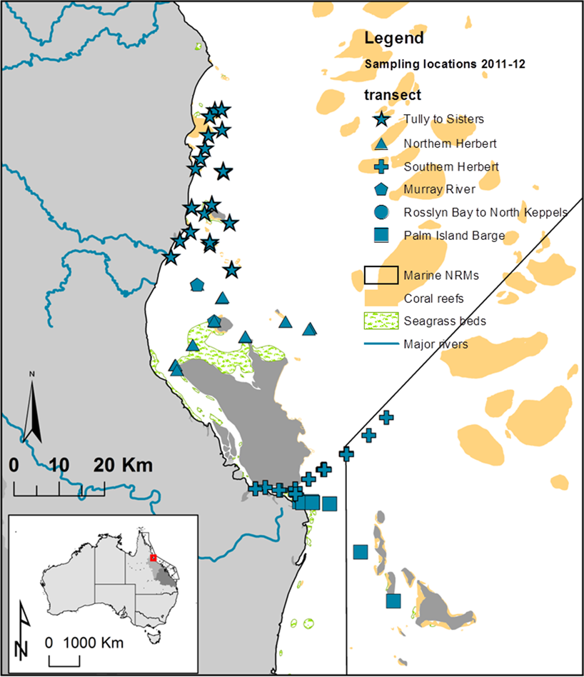

Figure 4-1: Location and geographical information for the water quality sites sampled in the Wet Tropics (Tully and Herbert Rivers) (2011-12)

.

The sampling in Fitzroy (Figure 4-2) and Cape York (Figure 4-3) occurred once only and were linked to substantive flooding events in response to a late season flow. The numbers of sites per region over sampling date are listed in Table 4-1. Samples carried out on the 9th and 10th September, 2011 and on the 29th June, 2012 in the Tully region were not included in the analysis and statistical summaries, but used in a comparison between wet and dry periods.
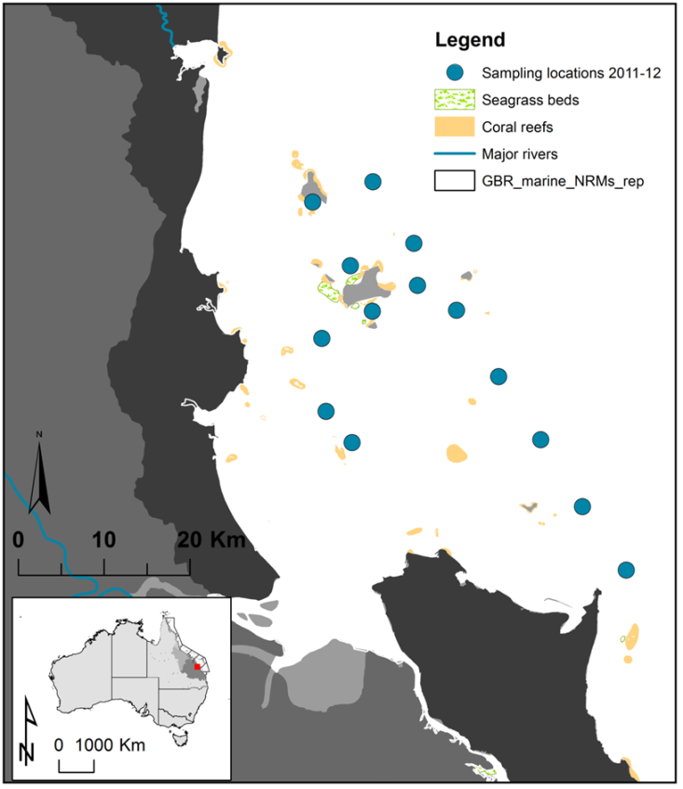

Figure 4-2: Location and geographical information for the water quality sites sampled in the Fitzroy (Rosslyn Bay to North Keppels) (2011-12).

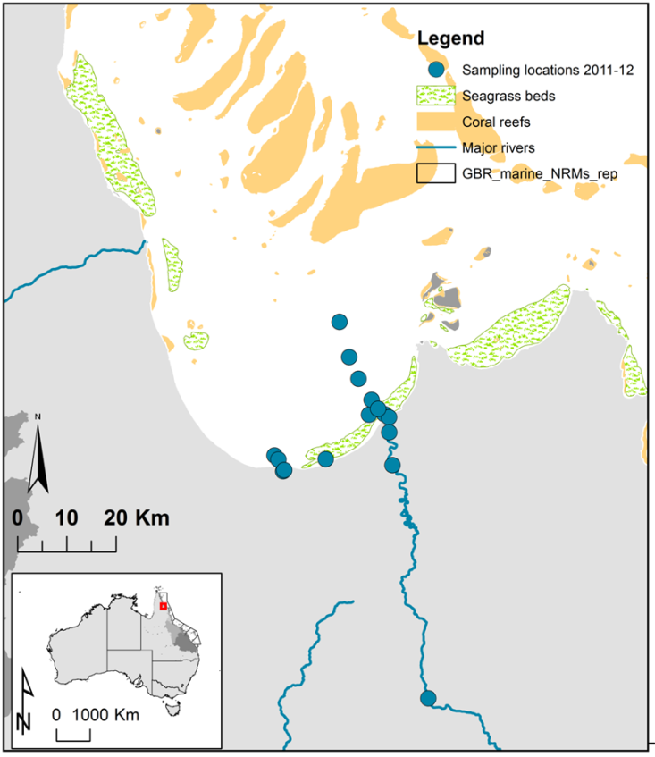

Figure 4-3: Location and geographical information for the water quality sites sampled in the Cape York region (Normanby River) (2011-12).

Table 4-1: Summary of sites sampled per river/region that were completed during the 2011-2012 wet season under the MMP, including samples carried out on the 9th and 10th September, 2011 and on the 29th June, 2012 in the Tully region.
Data count per NRM/Date |  | River |  |  | Region
YEAR | sample date | Herbert | Tully | Fitzroy | Cape York
2011 | 09/09/11 |  | 5
2011 | 10/09/11 |  | 3
2011 | 28/11/11 | 6
2011 | 29/11/11 | 10
2011 | 19/12/11 | 6
2011 | 20/12/11 | 10
2012 | 05/01/12 |  | 13
2012 | 20/01/12 | 6
2012 | 21/01/12 | 10
2012 | 11/02/12 |  | 14
2012 | 13/02/12 | 6
2012 | 14/02/12 | 11
2012 | 05/03/12 | 9 | 2
2012 | 06/03/12 | 15
2012 | 08/03/12 | 1 | 10
2012 | 30/03/12 | 10
2012 | 31/03/12 | 2 | 11
2012 | 26/03/12 |  |  |  | 17
2012 | 03/04/12 |  |  | 14
2012 | 29/06/12 |  | 11

Sample collection
Water sampling took place over three marine NRM regions, including Cape York (Normanby and Kennedy Rivers), the Wet Tropics (Herbert and Tully Rivers), and the Fitzroy (Fitzroy Rivers). Water sampling was carried out by TropWater staff from the Catchment to Reef research group, James Cook University. Further sampling was also undertaken by boat operators located in the Tully and Fitzroy areas and by co-researchers located in Cooktown. Appropriate training and discussion of logistics was carried out with these individuals prior to the water sampling.
This section outlines briefly the sampling and analysis methodology associated with the sampling and monitoring of flood plume water quality. Further detailed instructions and guidelines are provided in the annual QA/QC reports produced by the MMP program (GBRMPA, in press). Documents are available at http://www.gbrmpa.gov.au/resources-and-publications/publications/annual-reef-rescue-marine-monitoring-science-report
Plume (grab) sampling was carried out on small vessels, taking surface water samples from multiple sites for a suite of water quality measurements (Table 4-2) and measurement of depth profiles through the water column. The timing of the sampling depended on the type of event and the logistics of vessel deployment. Most samples were collected inside the visible area of the plume, although some samples were taken on and outside the edge of the plume for comparison.
Surface samples were collected using a clean, rinsed bucket in the top meter of water, taken at each site. From this sample, nutrient samples are taken using sterile 60 mL syringes and pre-rinsed three times with the seawater to be sampled. For dissolved nutrients, a 0.45 μm disposable membrane filter was then fitted to the syringe and a 10 mL samples were collected in polypropylene screw top sample tubes, pre-rinsed with filtered water. Particulate and total nutrient samples are not filtered but are otherwise collected in the same way. The tubes were then stored either on ice in an insulated container or in a freezer, depending on the sampling vessel. CDOM samples are collected using a 60 mL syringe fitted with a 0.2 μm disposable membrane filter into glass bottles and kept cool and dark until analysis by the TropWater laboratory, which should occur within 24 hours of collection generally (on occasion up to 72 hours). Individual 1-L samples were collected for suspended sediments and chlorophyll-a analysis. These are also placed on ice and filtered within 24 hours. At every third to fourth site (dependent on size of sampling area), samples were collected for phytoplankton enumeration and pesticides. Depth profiles were taken at each site in the Herbert, Tully and Fitzroy transects with a SeaBird profiler, collecting depth profiles of salinity, temperature, dissolved oxygen and light attenuation (see Table 7.2). Salinity profiles were taken at all sites.
Pesticide monitoring during flood plume events has focussed on three main activities. These include:
- Extended temporal monitoring at three sites from the mouth of the Herbert River using both grab and passive sampling (See Table 4-3)
- Additional grab sampling during flood plume events.
For the Herbert transect, SDB-RPS empore discs were deployed in either with a diffusion limiting membrane for periods of between 16 – 34 days to monitor time integrated concentrations. The discs were attached by cable tie to a surface marker buoy that was held in place by weights at the bottom. Grab samples were taken at the beginning and the end of each passive sampling period. This sampling will facilitate a comparison of time integrated and event passive sampler concentration estimates and point in time grab concentrations throughout the wet season. The pesticide sampling design in outlined in Table 4-3. Note that detailed outputs from the pesticide sampling will be presented in the companion MMP report (Bentey et al., in press).

Table 4-2: Summary of chemical and biological parameters sampled for the MMP flood plume monitoring.
Type of data | Parameter | Comments | Reported
Physico chemical | Depth (m) | Taken continuously through the water column at each site. Sampled with a SeaBird profiler | √
 | Salinity |  | √
 | Temperature (˚C) |  | √
 | Turbidity (ntu) |  | √
 | Light Attenuation (PAR) (Tully only) |  | √
Water quality | Dissolved nutrients (µM) | Surface sampling only | √
 | Particulate Nutrients (µM) | Surface sampling only | √
 | Chlorophyll-a (µg/L) | Surface sampling only | √
 | Phaeophytin (µg/L) | Surface sampling only | √
 | Total Suspended solids(mg/L) | Surface sampling only | √
 | Coloured Dissolved Organic Matter (443 m⁻¹) | Surface sampling only | √
 | Pesticides (PS-II herbicides) (ng/L) | Not at all sites | √
Biological | Phytoplankton counts | Not at all sites | No

Table 4-3: Summary of Pesticide sampling design, including dates and locations of passive and grab sampling

GBR catchment flow conditions
The wet season in 2011-12 started comparatively late with high flows in the Wet Tropics during the November and December, and extended into April 2011. It was characterised by the early onset of flow in the Wet Tropics, with high flow conditions in the Wet Tropics and Normanby Rivers in late October. Further high flow was experienced in the Tully and Herbert rivers in December. However, most rivers experienced the highest flow of the season in early to late March, with a long period of rain from March to April over the GBR catchments. High flow peaks were experienced in the Fitzroy on the 23rd and 30th March, respectively.
Total annual discharge of flow into the Great Barrier Reef from October 2011 to October 2012 was recorded as approximately 5.0×10⁷ megalitres, making it the 5th highest flow measurement out of the last 12 years (Figure 4-4). It was under 40% of the volume of freshwater that moved into the GBR over 2010-11 but still was a substantial year, bolstered by early and late flow conditions. The unusual characteristic from this year was that the high flow conditions were associated with low pressure systems and not driven by cyclonic conditions. Flow conditions in comparison to the long-term mean and median are presented in Table 4-4. It also shows the relative difference between the 2011-12 discharge and the long-term median flow. In the Wet Tropics region the Daintree, Russel, South Johnstone and Tully only exceeded the long-term median by over 1 to 1.9 times. The discharges from the southern rivers were much higher, with 2011-12 flow exceeding long-term median by 2.8 (Fitzroy), 2.9 (Burdekin) and up to 3.7 (Pioneer). The discharge from the Burdekin River was over 15 million megalitres, over 2.9 times the long-term median flow. The Mackay Whitsunday Rivers all exceeded the long-term median flow by >3.5 times, and in the case of the Pioneer River, over 3.7 times with 1.3 megalitres. Large differences were recorded in the southern dry tropics with the Fitzroy River flow 2.8 times the long-term median flow with a discharge of 8.0 million megalitres. The Burnett River flow was still above the long-term median (2.1) with 0.6 million megalitres, but this was substantively lower than the 2010-2011 flow of 8.4 million megalitres. Flow data (measured as total annual flow) shows that river discharge into the GBR has consistently increased for the past 6 years as compared to the first 6 years (2000-2005) (Fig. 4-4). This increase in flow has been a key driver in measurements of ecosystem decline, including seagrass metrics (see McKenzie et al., 2012) and coral health metrics (see Thompson et al., 2012). The large volume of flow is one of the main factors in the amount of plume area (see Álvarez-Romero et al, 2013) (Appendix 2). The summary of the plume events and the number of days in which flow exceeded a long-term 95th percentile is shown in Table 4-4.
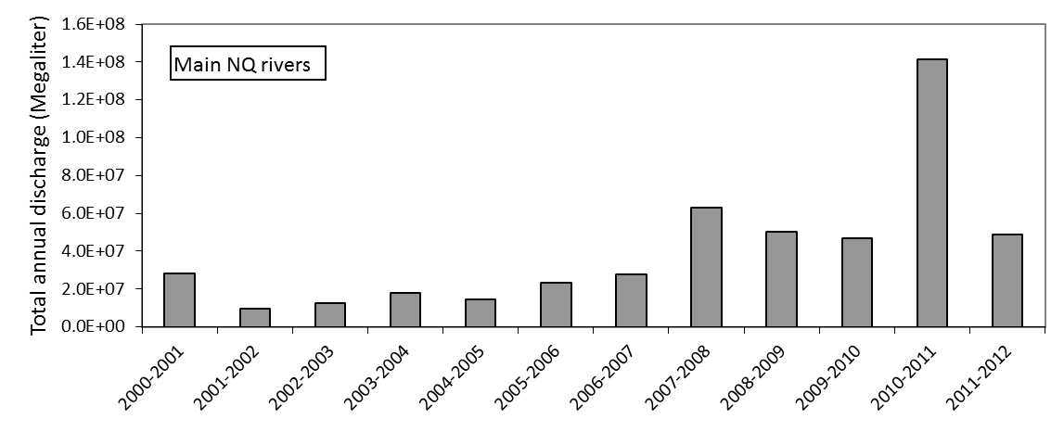
Figure 4-4: Total annual discharge for all main NQ GBR rivers from 2000 to the current reporting year.

Table 4-4.The 75th and 95th percentile flow (ML/day) for the major GBR rivers (based on flow between 2000 to 2011)
river | station | 75th %ile  (ML) | 95th %ile  (ML) | No days (2012) exceed 75th percentile | No days (2012) exceed 95th percentile
Daintree | 108002A | 1,921 | 8,958 | 24 | 8
Barron | 110001D | 1,034 | 6,150 | 18 | 6
Russell | 111101D | 3,230 | 12,306 | 16 | 5
N Johnstone | 112004A | 5,315 | 16,817 | 12 | 7
S Johnstone | 112101B | 2,368 | 7,084 | 14 | 5
Tully | 113006A | 9,401 | 29,045 | 20 | 7
Herbert | 116001F | 18,802 | 62,079 | 8 | 3
Burdekin | 120006B | 6,753 | 117,062 | 26 | 9
Proserpine | 122005A | 44 | 408 | 32 | 11
Fitzroy | 130005A | 3,642 | 65,655 | 35 | 12
Burnett | 136007A | 315 | 4,339 | 30 | 10

Table 4-5: Annual freshwater discharge (ML) for the major GBR rivers (based on Water Year of October to September).
Region | River | Annual long-term median river discharge | Annual long-term mean river discharge | Annual long-term standard deviation river discharge | Total year discharge 2011/2012 | Difference between 2011/2012 flow and long-term median | Ratio between 2011/2012 flow and long-term median
CapeYork | Normanby* | 2,645,979 | 2,883,826 | 1,518,587 | 1,148,732 | -1,497,247 | 0.4
Wet Tropics | Daintree | 704,855 | 820,423 | 478,554 | 1,355,022 | 650,167 | 1.9
Wet Tropics | Barron | 572,543 | 702,675 | 483,060 | 775,182 | 202,639 | 1.4
Wet Tropics | Russell | 993,921 | 981,019 | 348,547 | 1,291,799 | 297,878 | 1.3
Wet Tropics | Mulgrave | 728,135 | 795,461 | 380,793 | 1,057,191 | 329,056 | 1.5
Wet Tropics | North Johnstone | 1,758,010 | 1,821,213 | 670,616 | 3,033,579 | 1,275,569 | 1.7
Wet Tropics | South Johnstone | 849,969 | 824,351 | 320,106 | 979,588 | 129,619 | 1.2
Wet Tropics | Tully | 2,942,599 | 2,988,902 | 1,158,085 | 3,617,072 | 674,473 | 1.2
Wet Tropics | Herbert* | 5,017,480 | 6,040,528 | 4,069,852 | 6,876,065 | 1,858,585 | 1.4
Burdekin | Burdekin | 5,312,474 | 7,490,778 | 8,285,097 | 15,556,615 | 10,244,140 | 2.9
Mackay Whitsunday | O'Connell | 307,272 | 291,155 | 208,999 | 285,883 | -21,389 | 0.9
Mackay Whitsunday | Pioneer | 355,228 | 639,895 | 733,960 | 1,312,054 | 958,134 | 3.7
Mackay Whitsunday | Proserpine | 14,598 | 23,614 | 20,622 | 51,939 | 37,341 | 3.6
Mackay Whitsunday | Plane | 142,406 | 194,543 | 220,787 | 516,811 | 374,405 | 3.6
Fitzroy | Fitzroy | 2,899,774 | 4,690,607 | 5,564,235 | 8,005,893 | 5,106,119 | 2.8
Burnett | Burnett | 286,668 | 377,474 | 364,909 | 589,504 | 302,837 | 2.1
Total |  | 17,868,451 | 22,642,112 |  | 46,452,927 | 28,585,784 | 2.6

Note: Long-term (LT) median discharges were estimated from available long-term time series and included data up until wet season 1999 – 2000. Annual river discharge was calculated for the period between October 1st to September 30th of the following year. * For the Normanby and Herbert rivers suitable long-term time-series data are not available and the median of the available data has been used to allow for comparison of the river flow in 2011-12 relative to previous years. Colours highlight years where flow exceeded the median by >1.5 to 2 times (yellow), >2 to 3 times (orange), and >3 times (red). All data supplied by the Queensland Department of Environment and Resource Management.

Regional flow characteristics
Flow characteristics are presented below for the three rivers that were the focus of the flood plume water quality sampling, including Normanby Rivers (Figure 4.5), Tully River (Figure 4-8), Herbert River (Figure 4-10) and the Fitzroy River (Figure 4-12).

Normanby
Long-term flow data is not yet available for the Normanby River; however, the flow recorded in 2011-12 did reach a peak of 43,000 ML on March 12th, 2012. The total annual discharge from the Normanby River in 2011-12 reached 1,148,732 ML (Figure 4.6)
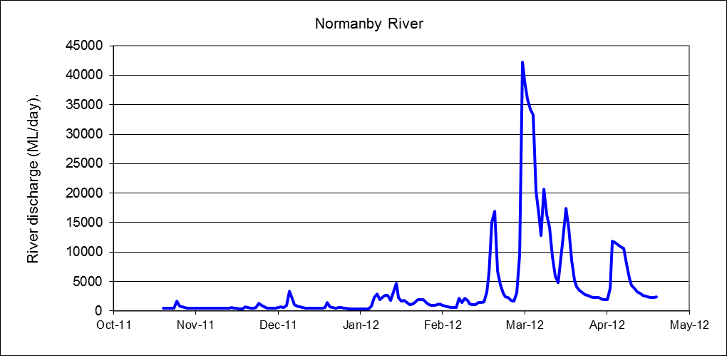
Figure 4-5: Daily discharge from the Normanby River at Kalpower Crossing for the 2011-12 wet season.
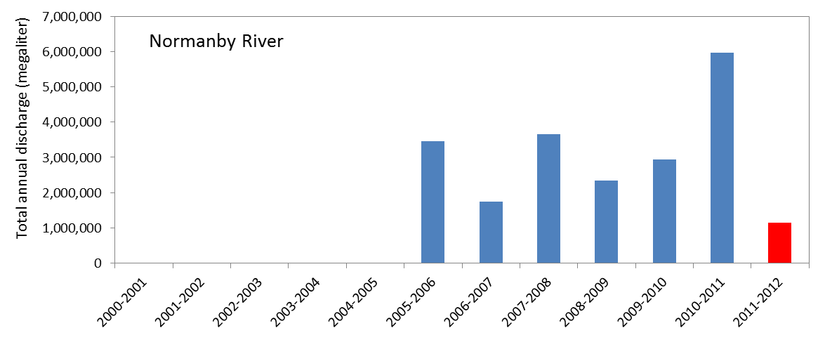
Figure 4-6: Long-term records of the total annual flow (2000 – 2012 water year, 1st October to 30th September) measured for the Normanby River at Kalpower Crossing.

Tully
The discharge from the Tully River was approximately 3.6 million ML in 2011-12, which is just above 1.2 times the long-term median flow. It follows six years of flow above the long-term median discharge (Table 4-5, Figure 4-8). The peak flows were sporadic throughout the wet season between late November 2011 and March 2012 (Figure 4-7) and were comparable to those recorded in previous years with a peak flow of 63,539 ML on 28th March, 2012.

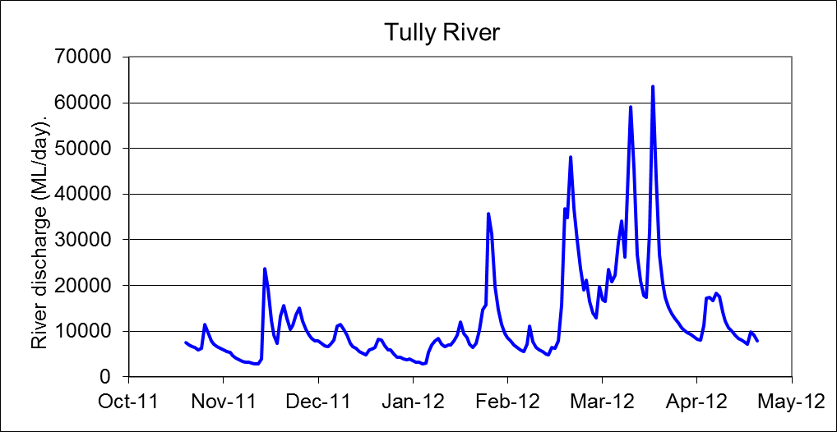

Figure 4-7: Daily discharge from the Tully River at Euramo for the 2011-12 wet season.

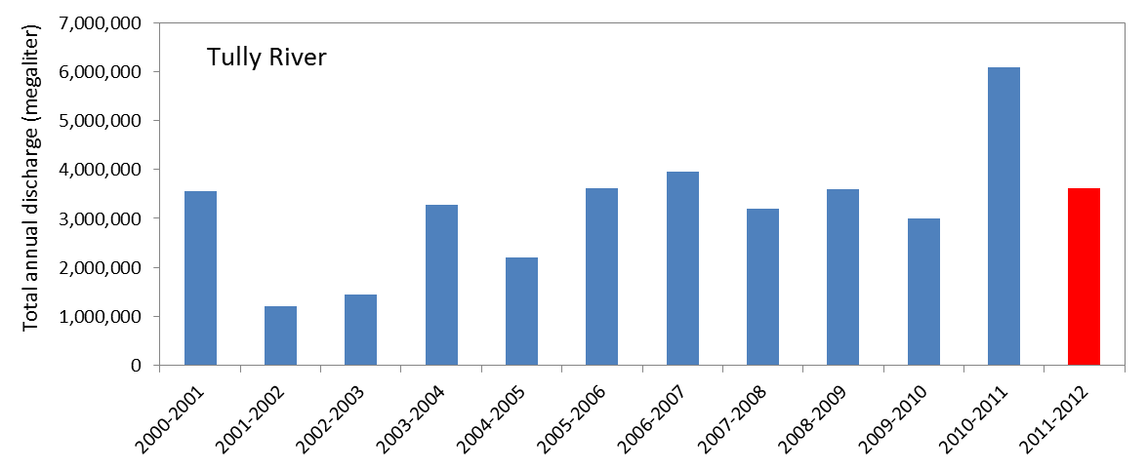
Figure 4-8: Long-term records of the total annual flow (2000 – 2012 water year, 1st October to 30th September) measured for the Tully River at Euramo.

Herbert
The discharge from the Hebert River was approximately 6.9 million ML over the 2011-12 water year (Figure 4-10). The flow data collected at the Ingham sites has only data recorded from 2009 and thus comparison with long-term median is not available. Total annual flow was recorded at 2.8 million ML with a peak flow measurement of 230,129 ML on the 21st March 2012 (Figure 4-9). Other significant peaks of flow occurred early as an early first flush on the 21st October with 10918 ML of flow and a further onset of flow on 26th November with 15,698 ML. A significant peak was also recorded on the 5th February with 230,129 ML. This wet season was characterised by early onset of flow (October - November) and continuing through to late June.
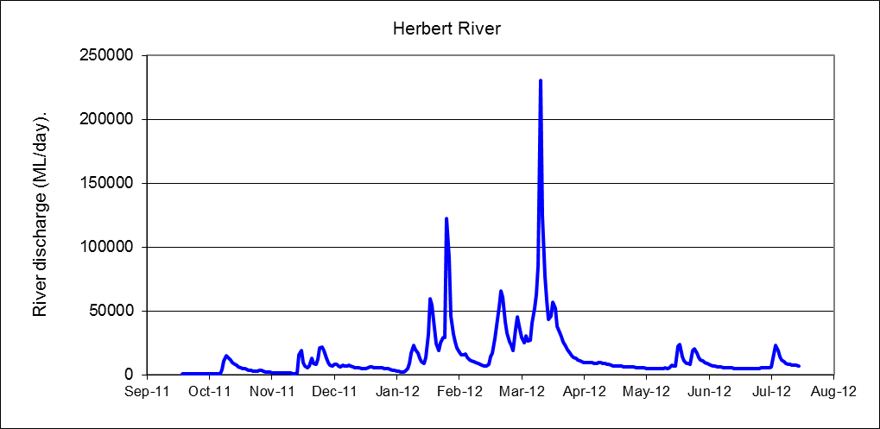
Figure 4-9: Daily discharge from the Herbert River at Ingham for the 2011-12 wet season.

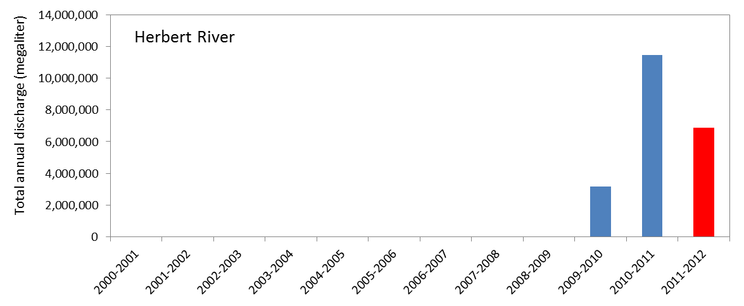
Figure 4-10: Long-term records of the total annual flow (2000 – 2012 water year, 1st October to 30th September) measured for the Herbert River at Ingham.

Fitzroy
The wet season was characterised by extended periods of flow above the 95th percentile between December 2011 and May 2012 (Table 4-4). The discharge from the Fitzroy River was approximately 8.0 million ML over the 2011-12 water year (Figure 4-12), which was the fourth highest volume of flow recorded in the last 10 years. Higher flow conditions were measured from February to April, with a peak flow of 240,886 ML on the 27th March, 2012 (Figure 4-11).
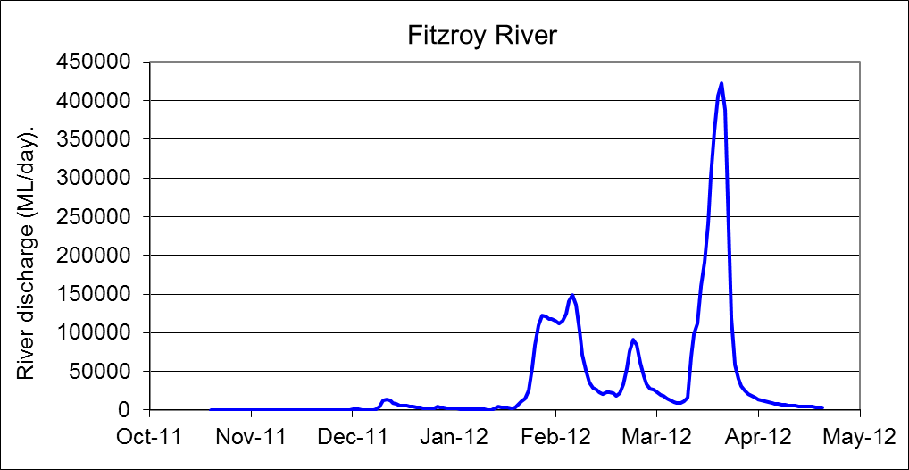

Figure 4-11: Daily discharge from the Fitzroy River at the Gap for the 2011-12 wet season.
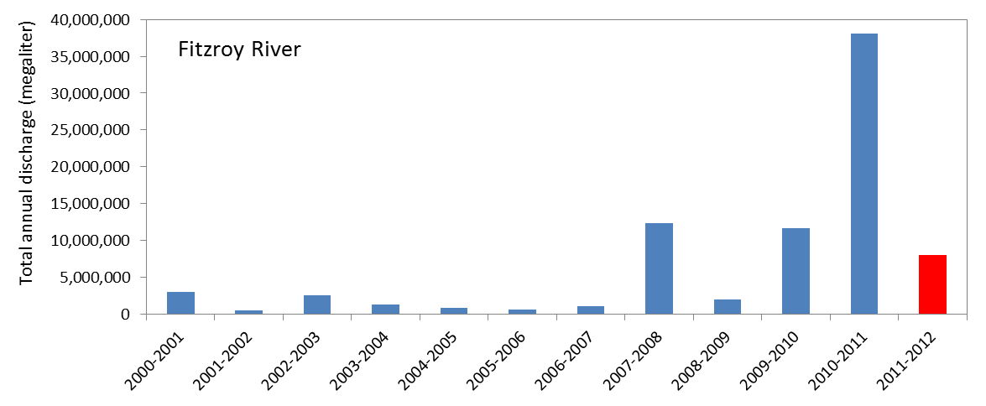
Figure 4-12: Long-term records of the total annual flow (2000 – 2012 water year, 1st October to 30th September) measured for the Fitzroy River at the Gap.

Water Quality

Fitzroy
Water sampling occurred during a flooding event in early April. The sampling followed two fixed transects that had been established in the previous year, one spanning from the Fitzroy River to Keppel Reef and the other extending from Rosslyn Bay to North Keppel (Figure 4-13). Data is presented for the 2011-2012 wet season (Table 4-6) with additional data presented from 2011 for comparison (Table 4-7).
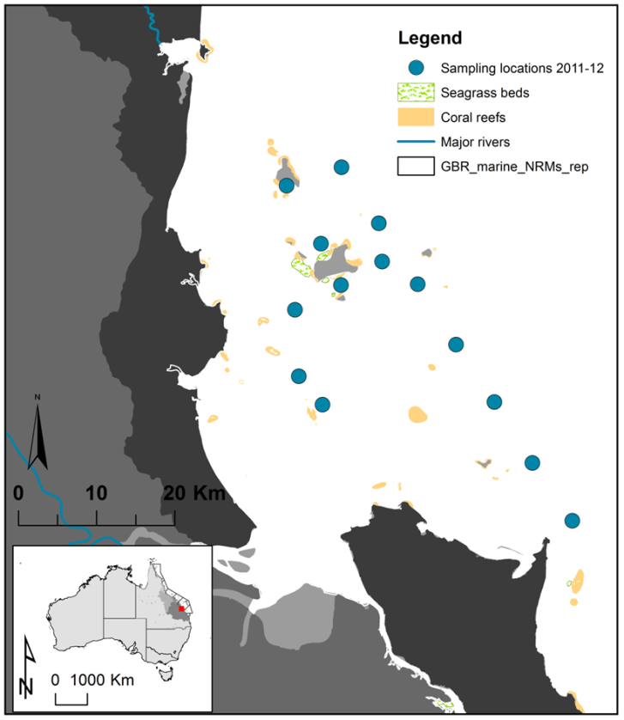

Figure 4-13: Sampling sites in the Fitzroy marine region.

Table 4-6: Summary of water quality data collected at the five Fitzroy transects sampled during the 2011-2012 wet season
Fitzroy transect* | No of samples | Statistical measurement | DIN (μM) | DIP (μM) | TSS (mg/L) | Chl-a (μg/L) | CDOM  (m⁻¹) | Salinity (0.5m)
Fitzroy mouth to Keppel Reef | 14 | Minimum | 1.57 | 0.71 | 15.00 | 0.20 | 0.20 | 19.01
Fitzroy mouth to Keppel Reef | 14 | Maximum | 3.28 | 2.58 | 31.00 | 2.14 | 2.14 | 33.28
Fitzroy mouth to Keppel Reef | 14 | Mean | 2.16 | 1.45 | 21.57 | 0.67 | 1.10 | 26.91
Fitzroy mouth to Keppel Reef | 14 | SD | 0.51 | 0.61 | 5.64 | 0.80 | 0.67 | 4.63

Table 4-7: Summary of water quality data collected at the five Fitzroy transects sampled during the 2010- 2011 wet season
Fitzroy transect* | No of samples | Statistical measurement | DIN (μM) | DIP (μM) | TSS (mg/L) | Chl-a (μg/L) | CDOM  (m⁻¹) | Salinity (0.5m)
Fitzroy mouth to Keppel Reef | 62 | Minimum | 1.5 | 0.14 | 9.6 | 0.2 | 0.14 | 3.1
Fitzroy mouth to Keppel Reef | 62 | Maximum | 13.9 | 1.34 | 38.0 | 22.4 | 3.2 | 34.6
Fitzroy mouth to Keppel Reef | 62 | Mean | 4.9 | 0.46 | 22.7 | 2.5 | 1.1 | 26.2
Fitzroy mouth to Keppel Reef | 62 | SD | 2.8 | 0.25 | 6.2 | 4.3 | 0.89 | 8.8
Rosslyn Bay to North Keppels | 22 | Minimum | 1.29 | 0.13 | 17.0 | 0.2 | 0 | 19.93
Rosslyn Bay to North Keppels | 22 | Maximum | 7.78 | 1.52 | 33.0 | 9.08 | 1.47 | 37.20
Rosslyn Bay to North Keppels | 22 | Mean | 2.81 | 0.56 | 21.3 | 1.92 | 0.41 | 32.69
Rosslyn Bay to North Keppels | 22 | SD | 1.60 | 0.33 | 4.0 | 2.54 | 0.44 | 5.23
Mackay (South) | 12 | Minimum | 1.6 | 0.39 | 1 | 0.27 | 0.02
Mackay (South) | 12 | Maximum | 2.8 | 0.68 | 3.2 | 4.81 | 0.46
Mackay (South) | 12 | Mean | 2.3 | 0.55 | 2.0 | 1.58 | 0.24
Mackay (South) | 12 | SD | 0.36 | 0.09 | 0.78 | 1.21 | 0.16
Shoalwater Bay | 12 | Minimum | 1.5 | 0.2 | 17 | 0.5 | 0.3 | 19.9
Shoalwater Bay | 12 | Maximum | 7.8 | 1.9 | 33 | 9.1 | 1.5 | 33.3
Shoalwater Bay | 12 | Mean | 3.7 | 0.65 | 21.3 | 3.2 | 0.7 | 4.8
Shoalwater Bay | 12 | SD | 1.9 | 0.4 | 4.0 | 3.0 | 0.4 | 28.8
Gladstone to Heron Island | 12 | Minimum | 1.8 | 0.3 | 3.4 | 0.2 | 0.02 | 28.4
Gladstone to Heron Island | 12 | Maximum | 2.8 | 0.47 | 13 | 2.7 | 0.28 | 34.8
Gladstone to Heron Island | 12 | Mean | 1.9 | 0.33 | 7.5 | 0.7 | 0.12 | 33.1
Gladstone to Heron Island | 12 | SD | 0.4 | 0.07 | 4.1 | 1.3 | 0.32 | 2.4

Comparisons with ambient and guideline values are offered to compare the average wet season concentrations with reported ambient and guideline values and are not for guideline reporting purposes. Statistical measurements for the main water quality components show that dissolved nutrients exceeded the long-term ambient concentrations (Schaffelke et al., 2012) with a minimum value for DIN and DIP of 1.6 µM and 0.7 µM, respectively. Maximum values for dissolved nutrients were 3.3 µM for DIN and 2.6 µM for DIP. The maximum value of DIN was much lower than what was recorded the previous year in the extreme flooding of the Fitzroy (13.9 µM) but the maximum DIP value recorded in 2012 exceeded that of the previous year (1.3 µM). Ambient values for DIN and DIP have been set at 0.2 and 0.05 µM respectively, showing that there was high nutrient enrichment during this time, particularly with the DIN concentrations. The TSS values were also elevated, with values ranging from 15 mg/L to 31 mg/L measured on the Fitzroy to Keppel transect. The persistence of high TSS values across both Fitzroy transects in the previous year potentially indicates that the smaller, mobile fraction of the TSS component does move offshore and over coral reef environments.
Measurements for key parameters are presented against five salinity groupings to demonstrate the change in the water quality parameters as they move away from the river mouth into the offshore coastal environment (Figure 4-14). There are high TSS values measured in the low salinity ranges but generally the mean TSS concentration is above 10 mg/L across the salinity gradient. It would be expected that the TSS values would fall as the water moves north and away from the river mouth, but these high values may be indicative of the TSS inorganic fraction dropping out and the onset of biological production with the high values of chl-a, CDOM and smaller mobile particles dominating the TSS component. DIN and DIP both show conservative mixing as they move through the salinity gradient, particularly DIP in the lower salinity ranges. Comparing Fitzroy data across the years (Figure 4-15) shows that the mean concentrations of some water quality variables is consistent over time, particularly for DIN, TSS and Chl-a. However the range and peak of the high concentrations can alter the structure of the boxplot, particularly in the repeated sampling associated with the large flow events in 2010-11. There are years which show significant difference in both mean and spread of data, notably for DIP, where the mean associated with data collected in this sampling year (11/12) is much higher than previous years.
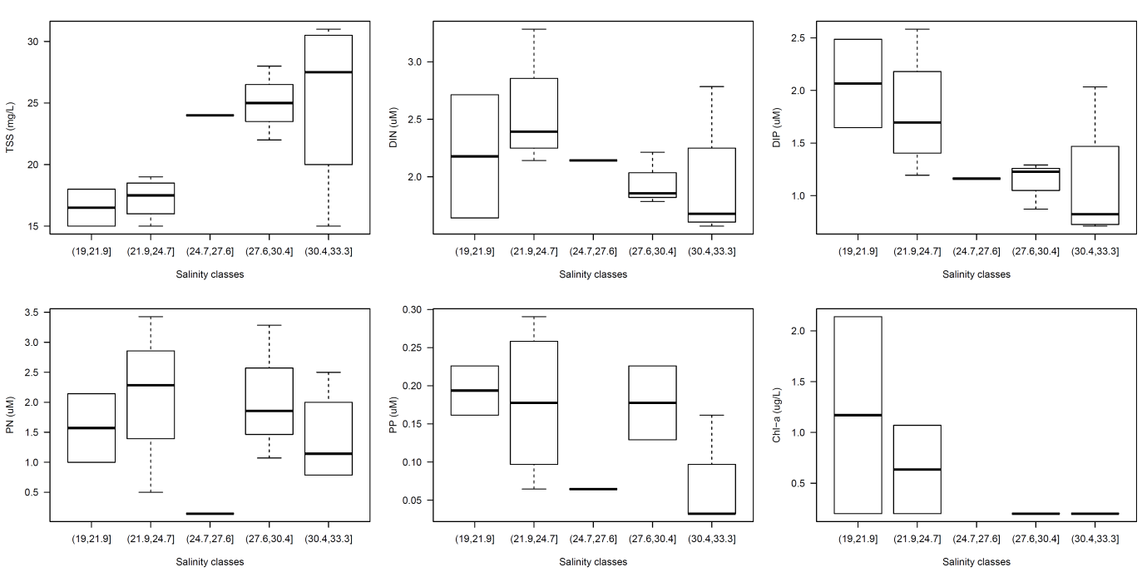
Figure 4-14: Selected water quality parameters (TSS, DIN, DIP, PN, PP and Chl-a) presented for five salinity ranges for the data collected during the 2011-12 wet season in the Fitzroy region. Box plot presents the median (dark black line), the 25th and 75th percentiles (rectangle) and 3 standard deviations (vertical dashed lines), for the data sampled within the Fitzroy River plume. Numbers in brackets stand for the minimum (inclusive) and maximum (exclusive) salinity value for each class.

Figure 4-15: Comparison of five previous events (07/08, 08/09, 09/10, 10/11, 11/12) for key parameters (TSS (mg/L), Chl-a (µg/L)Comparison of five previous events for key pa⁻¹) for water quality data collected within the Fitzroy transects. Box plot presents the median (dark black line), the 25th and 75th percentiles (rectangle), 3 standard deviations (vertical dashed lines), and outlines (circles), for the data sampled within the Fitzroy River plume.

Tully
Water sampling occurred over a number of dates (N = 5) to capture the temporal influence of the Tully River plume through repeated periods within the 2011-2012 wet season. The Tully transect is the longest time series of wet season data and forms a valuable contribution to our understanding of the variation in wet season concentrations. The Tully sampling occurred from the mouth of the Tully River north to the East of Sisters Island (N = 50) (Figure 4-16). During the dry season another 3 field trips were carried in the Tully region (9-10/Sep/2011 and 29/Jun/2012), sampling a total of 17 sites. Data from these extra field trips was not included in the statistics summaries presented for the Tully 2011-2012 wet season campaign, but used for comparison only.

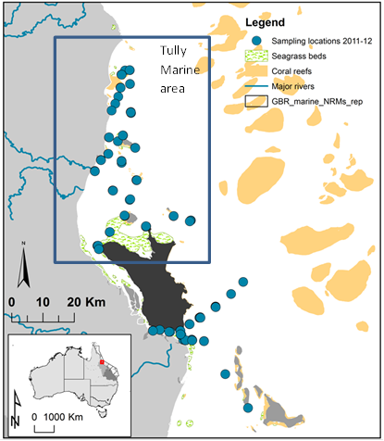

Figure 4-16: Location of the sampling sites within the Tully marine area.

Statistical measurements for the main water quality components (Table 4-8) show that dissolved nutrients were significantly higher than long-term ambient values as reported in Furnas, (2003) and Schaffelke et al., (2012) at all transects. The minimum values for DIN ranged from 1.3 − 3.0 μM and minimum DIP values ranged from 0.10 – 0.40 µM. The maximum values for DIN ranged from 1.9 − 26.3 μM and maximum DIP values ranged from 0.4 – 0.70 µM. The extremely high value of DIN (26.3 μM) was recorded at South Mission Beach on 11th February, 2012 at a salinity of 32.4. This high value may be influenced by resuspension through the plume conditions. In all sampling occasions, the maximum DIN exceeded 1.3 μM and this is reflective in the high mean value (4.4 μM) of DIN over all sampling occasions in the 2011-2012 wet season. Surprisingly DIN was still elevated in the last sampling period (2.6±1.1 µM, mean ± 1SD, in the 29th June, 2012) suggesting that nutrient enrichment in this area occurs over much longer time frames than previously reported (Devlin et al., 2011; 2012). Ambient values for DIN and DIP have been set at 0.2 μM and 0.05 μM respectively, indicating that there has been nutrient enrichment at all these transects over the entire sampling period, including the dry season campaigns (i.e., from September 2011 to June 2012). The TSS values were also elevated, with maximum values ranging from 4.5 – 20 mg/L for the wet season period. However the persistence of high TSS values through the Tully River plume (e.g., max. of 28 mg/L in the 29th June, 2012 under an estimated river discharge of 5450 ML/d) indicates that even under small river discharge (dry season period), high TSS values can be observed possible due to resuspension processes.
The range of chl-a values indicates high phytoplankton production in the plume waters, with Chl-a ranging from 0.3 − 3.7 μg/L. Mean values of Chl-a all exceed 0.5 µg/L, even in the earlier and later sampling occasions. These high values over a relatively large time period are indicative of persistent occurrences of high phytoplankton numbers in response to the large inorganic nutrient supply and non-light limiting conditions.
CDOM values represent the extent of the freshwater influence. Schroeder et al., (2012) suggests that 0.14 m⁻¹ CDOM represents a salinity of 30±4 (mean ± range). All values of CDOM in samples between early January and late March were higher than 0.14 m⁻¹ showing a clear freshwater signal. CDOM values in September 2011 and June 2012 are low and indicate that freshwater influence in these periods is minimal.
Water quality data was integrated over salinity ranges to demonstrate the mixing profiles through the salinity gradient (Figure 4-17). All the measurement WQ parameters were variable over the salinity gradient, without any significant trend (p > 0.06 in a Kruskal-Wallis test), except for DIP that exhibited an increasing values over the salinity gradient (p < 0.001 in a Kruskal-Wallis test). Note that in comparison with data from the previous year, salinity ranges are high (p < 0.001, Kruskal-Wallis test), all measuring salinity above 25 (Figure 4-18). This small salinity range is reflected in the Salinity × WQ boxplots, where the mean concentrations of most water quality variables do not reduce over salinity. This is particularly true for the variable measurements of PN, PP, TSS, DIN and chl-a. DIP measurements are shown to increase in these higher salinities, reflecting processes of desorption from PP.

Table 4-8: Summary of water quality data collected at the Tully River plume transect sampled during the 2011-12 wet season. Data sampled over three transects during the dry season are also presented (i.e., 09/09/2011, 10/09/2011 and 29/06/2012).
Sample date | No of samples | Stats | Temperature (˚C) | Salinity | CDOM (/m) | TSS (mg/L) | Chl-a (µg/L) | DIN (µM) | DIP (µM) | PN (µM) | PP (µM)
2011-09-09 | 5 | min | 23.17 | 16.28 | 0.05 | 4.20 | 0.27 | 1.214 | 0.323 | 0.571 | 0.065
2011-09-09 | 5 | max | 24.12 | 34.85 | 0.11 | 9.70 | 1.42 | 1.999 | 0.420 | 1.214 | 0.097
2011-09-09 | 5 | mean | 23.88 | 30.10 | 0.08 | 6.58 | 0.76 | 1.523 | 0.377 | 1.000 | 0.081
2011-09-09 | 5 | SD | 0.40 | 7.90 | 0.04 | 2.56 | 0.43 | 0.418 | 0.049 | 0.371 | 0.023
2011-09-10 | 3 | min | 22.07 | 23.87 |  | 3.80 | 0.30
2011-09-10 | 3 | max | 23.93 | 34.62 |  | 9.00 | 0.94
2011-09-10 | 3 | mean | 23.00 | 30.83 |  | 6.10 | 0.62
2011-09-10 | 3 | SD | 0.93 | 6.03 |  | 2.65 | 0.32
2012-01-05 | 13 | min | 28.46 | 31.98 | 0.10 | 1.80 | 0.30 | 1.571 | 0.420 | 0.286 | 0.032
2012-01-05 | 13 | max | 29.22 | 35.05 | 0.40 | 9.60 | 1.19 | 5.140 | 0.678 | 4.569 | 0.452
2012-01-05 | 13 | mean | 28.92 | 33.36 | 0.19 | 4.49 | 0.55 | 2.454 | 0.504 | 2.624 | 0.240
2012-01-05 | 13 | SD | 0.24 | 0.89 | 0.08 | 2.59 | 0.30 | 1.147 | 0.079 | 1.303 | 0.143
2012-02-11 | 14 | min | 30.38 | 28.44 | 0.10 | 7.80 | 0.53 | 2.999 | 0.291 | 0.714 | 0.032
2012-02-11 | 14 | max | 31.79 | 33.51 | 0.97 | 20.00 | 1.07 | 26.344 | 0.549 | 7.139 | 0.226
2012-02-11 | 14 | mean | 30.97 | 31.51 | 0.44 | 12.79 | 0.61 | 6.830 | 0.477 | 2.261 | 0.129
2012-02-11 | 14 | SD | 0.44 | 1.54 | 0.35 | 3.80 | 0.20 | 7.677 | 0.087 | 2.028 | 0.069
2012-03-05 | 2 | min | 29.28 | 29.56 | 0.18 | 3.30 | 0.27
2012-03-05 | 2 | max | 29.28 | 30.86 | 0.25 | 4.50 | 0.84
2012-03-05 | 2 | mean | 29.28 | 30.21 | 0.22 | 3.90 | 0.56
2012-03-05 | 2 | SD |  | 0.92 | 0.05 | 0.85 | 0.40
2012-03-08 | 10 | min | 29.71 | 26.21 | 0.15 | 2.10 | 0.27 | 1.356 | 0.097 | 0.357 | 0.032
2012-03-08 | 10 | max | 30.56 | 29.48 | 0.38 | 9.50 | 3.20 | 5.783 | 0.355 | 3.284 | 0.291
2012-03-08 | 10 | mean | 30.04 | 27.95 | 0.23 | 4.12 | 0.91 | 2.439 | 0.248 | 1.821 | 0.167
2012-03-08 | 10 | SD | 0.29 | 0.88 | 0.09 | 2.15 | 0.90 | 1.659 | 0.097 | 1.092 | 0.111
2012-03-31 | 11 | min | 27.03 | 26.75 | 0.24 | 2.90 | 0.53 | 2.856 | 0.226 | 0.500 | 0.194
2012-03-31 | 11 | max | 28.72 | 30.28 | 0.90 | 15.00 | 3.74 | 11.780 | 0.355 | 7.639 | 0.420
2012-03-31 | 11 | mean | 28.01 | 28.55 | 0.47 | 5.27 | 1.10 | 4.917 | 0.307 | 3.534 | 0.315
2012-03-31 | 11 | SD | 0.48 | 1.24 | 0.22 | 3.60 | 0.91 | 3.078 | 0.042 | 2.379 | 0.068
2012-06-29 | 11 | min | 22.07 | 23.87 | 0.10 | 3.00 | 0.20 | 1.142 | 0.097 | 0.286 | 0.032
2012-06-29 | 11 | max | 23.00 | 34.37 | 0.29 | 28.00 | 2.14 | 4.641 | 0.517 | 13.779 | 0.323
2012-06-29 | 11 | mean | 22.51 | 30.71 | 0.15 | 11.38 | 0.63 | 2.616 | 0.252 | 3.057 | 0.116
2012-06-29 | 11 | SD | 0.26 | 3.95 | 0.06 | 7.62 | 0.55 | 1.164 | 0.159 | 3.938 | 0.085
wet season only | 50 | min | 27.03 | 26.21 | 0.10 | 1.80 | 0.27 | 1.356 | 0.097 | 0.286 | 0.032
wet season only | 50 | max | 31.79 | 35.05 | 0.97 | 20.00 | 3.74 | 26.344 | 0.678 | 7.639 | 0.452
wet season only | 50 | mean | 29.54 | 30.57 | 0.32 | 6.89 | 0.76 | 4.357 | 0.396 | 2.598 | 0.215
wet season only | 50 | SD | 1.19 | 2.43 | 0.22 | 4.79 | 0.63 | 4.724 | 0.131 | 1.844 | 0.121

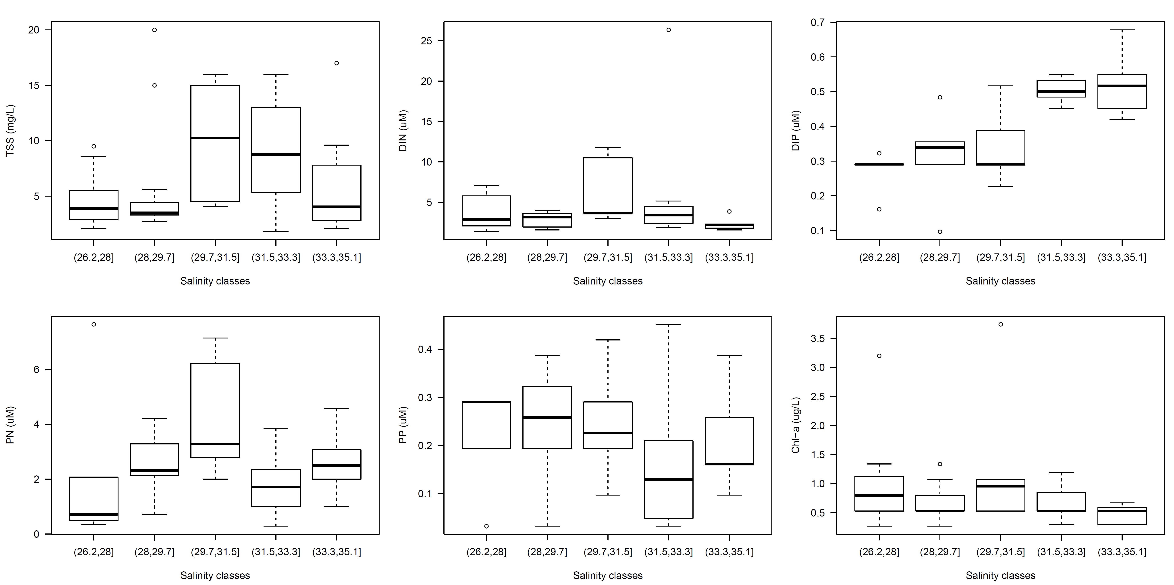
Figure 4-17: Selected water quality parameters (TSS, DIN, DIP, PN, PP and Chl-a) presented for five salinity ranges for the data collected during the 2011-12 wet season in the Tully region. Box plot presents the median (dark black line), the 25th and 75th percentiles (rectangle), 3 standard deviations (vertical dashed lines), and outlines (circles), for the data sampled within the Tully River plume. Numbers in brackets stand for the minimum and maximum salinity value for each class.

Combining the data over the past three years (2010-2012) and presenting the mean concentrations over equidistant salinity groupings allows a better representation of the mixing process over the full range of salinity concentrations (Figure 4-19). Reduction over salinity is variable depending on the parameter, but strong linear mixing curves are shown for both chl-a and TSS. Measurements of DIN and DIP stay high through the salinity ranges. Salinity over four depths (Figure 4-20) that salinity is only reduced in the top layer (0.5m) over most periods with the exception of the sampling occasion that follows the large flow event in March.
Figure 4-18: Salinity measured in the Tully region in the four the last wet season campaign plus the current one. Box plot presents the median (dark black line), the 25th and 75th percentiles (rectangle), 3 standard deviations (vertical dashed lines), and outlines (circles).
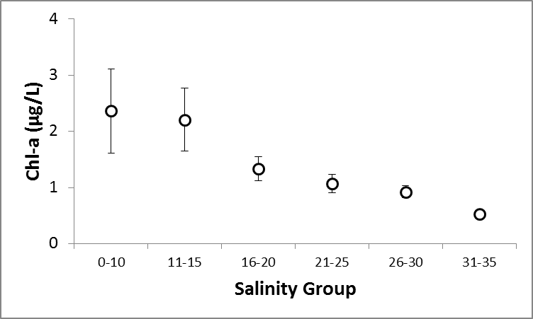
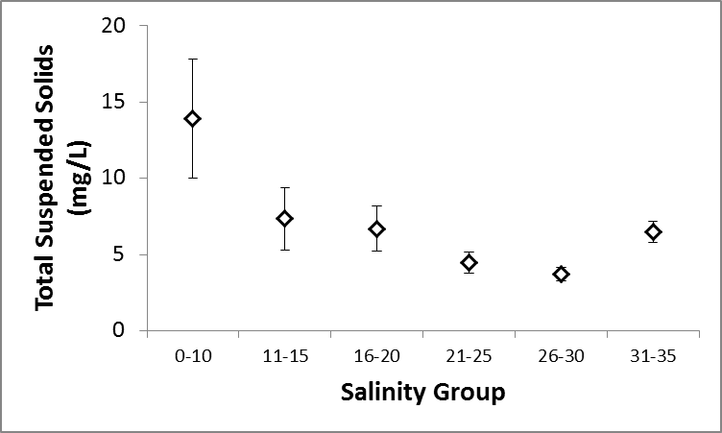
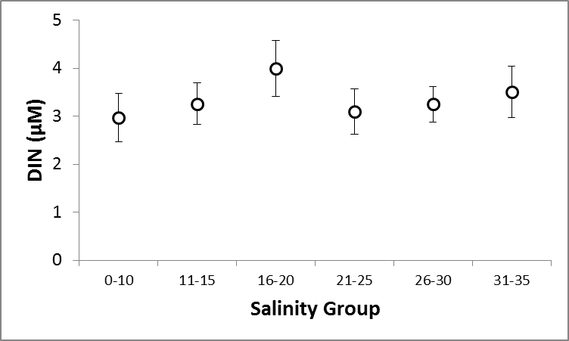
Figure 4-19: Water quality concentrations integrated over salinity ranges collected within the Tully River plume. Data is presented from sampling years 2010 – 2012. Water quality data presented for TSS, Chl-a, DIN, and DIP only.
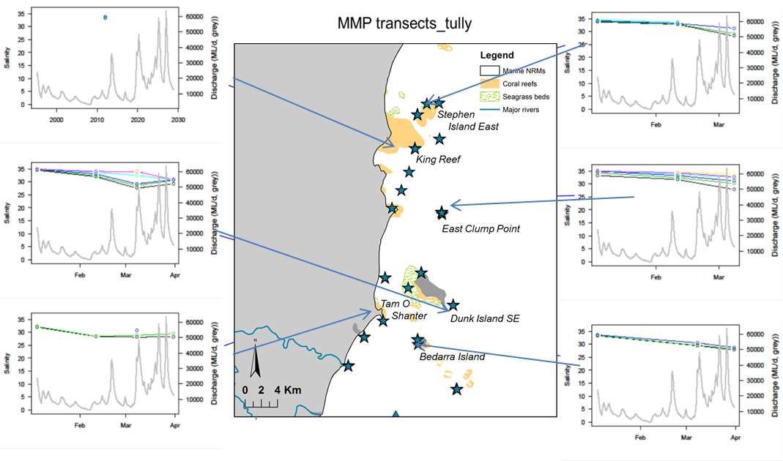
Figure 4-20: Salinity measurements over four depths for the Tully river sites.

Tully - pesticide measurements
Grab samples collected in a transect extending from the mouth of the Tully River, detected the presence of three herbicides (diuron, hexazinone and imidacloprid). Diuron was detected at all sites, however, hexazinone and imidacloprid were detected only at the Tully River mouth. For a full analysis of pesticides collected under this and other MMP programs, please refer to Bentley et al., (2012).

Cape York
The first set of data collected from the Far Northern GBR shows some surprising results with elevated DIN and high chlorophyll biomass values. However it is difficult to identify the coastal processes occurring in the Cape York region as we have no previous historical data and this set of data was taken over two days only. The data collected does identify that all water quality variable are high within the sampling period, indicating that there is some anthropogenic influence from the Cape York catchments which may be influenced by the area of catchment under grazing. Sites were sampled over two transects, one along and out of the Normanby River and one slightly north of the Normanby river (Figure 4-21).
Statistical measurements for the main water quality components (Table 4-9) show that dissolved nutrients is are higher than long-term ambient values as reported in Furnas, (2003) and Schaffelke et al., (2012). The values for DIN ranged from 3.1 − 7.6 μM and DIP values ranged from 0.10 – 0.36 μM. Ambient values for DIN and DIP have been set at 0.2 μM and 0.05 μM respectively, indicating that there has been nutrient enrichment at all these transects over the entire sampling period (September 2011 to June 2012). The TSS values were also elevated, with values ranging from 2.8 – 95 mg/L. However these are much lower TSS values than measured in other regions through wet season sampling and the only high value (95 mg/L) was measured at the Normanby river mouth. Chl-a ranges from 0.2ug/L to 2.oug0ug/L, and whilst at times some of these values exceed the (annual) water quality guideline (GBRMPA, 2009), they are lower than values measured in the Hebert, Tully and Fitzroy regions. Thus there are elevated concentrations, but associated with the dissolved nutrient fraction and not the TSS concentrations. The highest values of chl-a and DIN are recorded out upstream at sites which may represent freshwater/estuarine environments and thus the marine water quality guidelines do not apply. Freshwater and enclosed coastal guidelines for DIN are not available for Cape York (Moss et al., 2009) and thus difficult to draw conclusions from any existing guideline. At this point, with a small dataset and only two sampling occasions, the inference from the data collected would be the values for both nutrients and chl-a are higher than would have been expected, and further sampling is highly recommended.

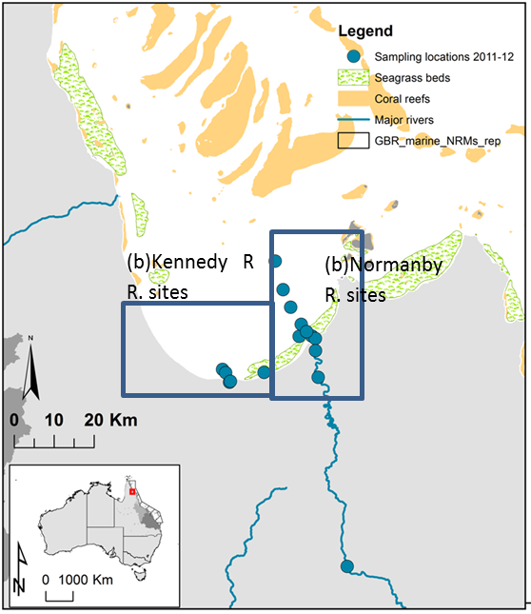

Figure 4-21: Location of (a) Kennedy River and (b) Normanby River for Cape York monitoring.

(a)Kennedy R. sites

Table 4-9: Summary of water quality data collected at the Normanby River plume transect sampled during the 2011-12 wet season.
Sample date | No of samples | Stats | Temperature (˚C) | Salinity | CDOM (/m) | TSS (mg/L) | Chl-a (µg/L) | DIN (µM) | DIP (µM) | PN (µM) | PP (µM)
Kennedy River 2012-03-26 | 5 | min |  | 21.40 | 1.08 | 2.80 | 0.89 | 3.498 | 0.129 | 0.714 | 0.194
Kennedy River 2012-03-26 | 5 | max |  | 32.09 | 3.68 | 7.40 | 1.91 | 5.497 | 0.323 | 2.927 | 0.387
Kennedy River 2012-03-26 | 5 | mean |  | 26.32 | 2.10 | 4.63 | 1.53 | 4.522 | 0.258 | 2.023 | 0.258
Kennedy River 2012-03-26 | 5 | SD |  | 5.40 | 1.39 | 2.44 | 0.56 | 1.000 | 0.112 | 1.161 | 0.112
Normanby River 2012-03-26 | 14 | min | 31.30 | 0.09 | 0.71 | 2.90 | 0.20 | 3.141 | 0.097 | 0.286 | 0.065
Normanby River 2012-03-26 | 14 | max | 33.80 | 26.70 | 5.37 | 95.00 | 5.34 | 7.639 | 0.355 | 19.205 | 0.517
Normanby River 2012-03-26 | 14 | mean | 32.85 | 11.59 | 2.83 | 18.24 | 1.36 | 5.012 | 0.245 | 5.726 | 0.269
Normanby River 2012-03-26 | 14 | SD | 0.64 | 10.69 | 1.60 | 23.05 | 1.34 | 1.487 | 0.073 | 6.493 | 0.150

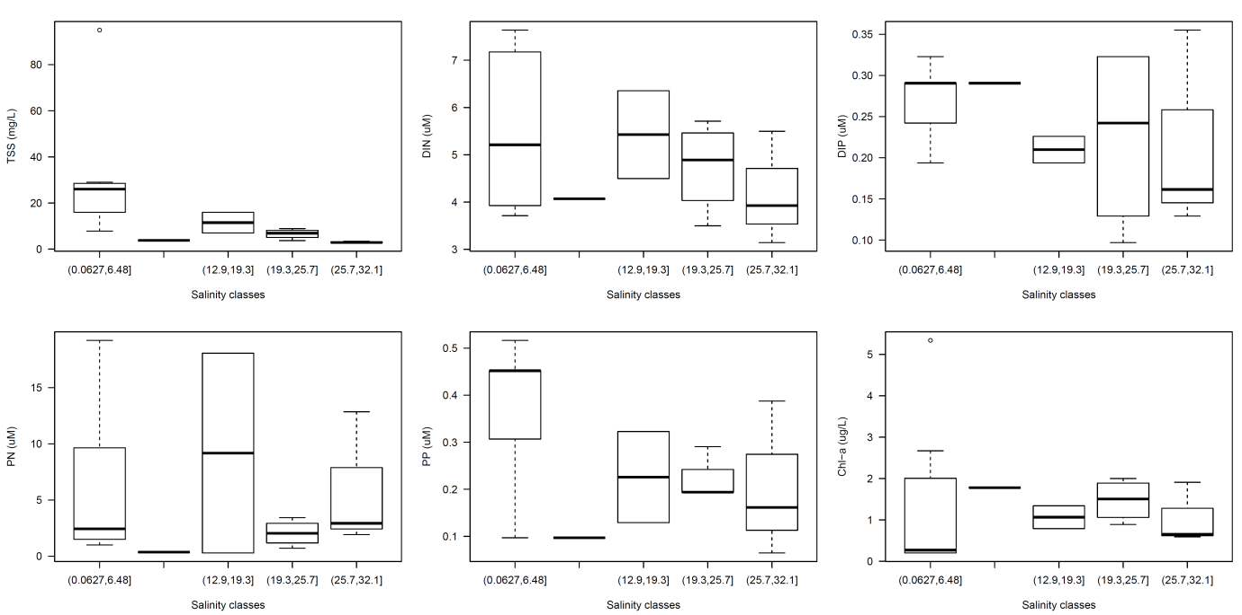
Figure 4-22: Selected water quality parameters (TSS, DIN, DIP, PN, PP and Chl-a) presented for five equidistant salinity ranges for the data collected during the 2011-12 wet season in the Cape York region. Box plot presents the median (dark black line), the 25th and 75th percentiles (rectangle), 3 standard deviations (vertical dashed lines), and outlines (circles), for the data sampled within the Normanby River plume. Numbers in brackets stand for the minimum and maximum salinity value for each equidistant class.
Mixing profiles for six water quality parameters show that TSS is only elevated in the lower salinity ranges and associated more with the river sites than the coastal areas (Figure 4-22). DIN concentrations are high at the lower salinity, reduce but increase again at higher salinities, remaining elevated at the high salinity end (max salinity = 26.7). DIP reduces conservatively through the salinity curve. PN and PP are high in lower salinities and then increase and decrease across the salinity gradient reflecting a mixture of uptake, desorption and adsorption processes. Chl-a is high in lower salinities, and stays elevated through the salinity gradient and the plume waters.

Conclusions
Whilst these initial results in Cape York are surprising and hint at processes that usually occur in a more anthropogenic influenced catchment, it is difficult at this time to make any broad conclusions based on the limited data set. Further work in Cape York and further north is essential in understanding flood plume processes in less impacted catchments and is needed for anchoring the deviation of other data away from these measurements. A large integrated sampling program with JCU and CSIRO is planned for 2012-13 and will target increased sampling of this area to provide more details on this initial work and further data for validation of water types around Cape York.

Focus catchment – Herbert

Transect information
Water sampling occurred over a number of dates (N = 12) to fully capture the spatial and temporal influence of the Herbert River plume through repeated periods within the Wet Season (N = 100). The Herbert sampling occurred over three separate transects. The northern transect was from Lucinda up to Gould Island. The southern transect was from the mouth of the Herbert River around the bottom of Hinchinbrook Island along a north-easterly direction. The third transect included five sites located from Lucinda jetty to Palm Island (Figure 5-1). Note that due to logistics, the last two barge sites (Barge 4 and Barge 5) were only sampled once.
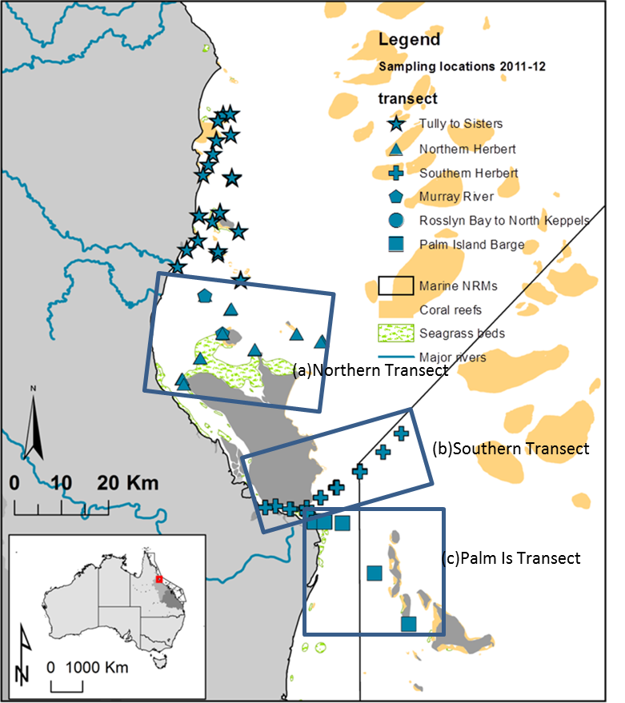

Figure 5-1: Location of (a) Northern Transect, (b) Southern Transect and (c) Palm Island Transect for Herbert River monitoring.

Spatial variability
The spatial variability of key water quality parameters, are shown in Figure 5-2 over equidistant salinity ranges. The minimum salinity collected with all transects is 4.5, which was sampled at the Herbert River mouth. However, the majority of the salinity data (97 data points out of a possible 100) had salinity > 17. An ANOVA test indicated that DIN, PN and chl-a present different concentrations over a salinity gradient, whereas TSS, DIP and PP exhibited no significant variation (Table 5-1). Some of the WQ parameters did not exhibit normal distribution, even after log transformation, for this cases a Kruskal-Wallis ANOVA was used instead of a parametric one.

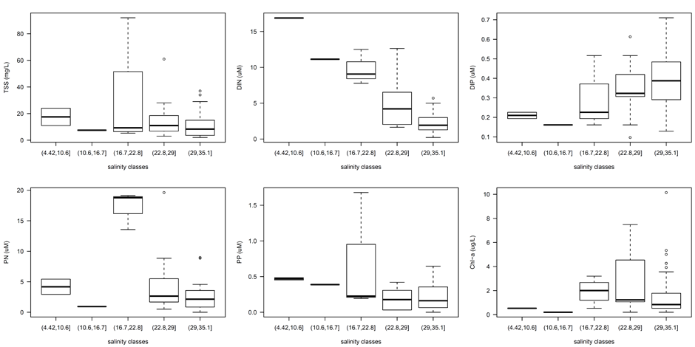
Figure 5-2: Water quality parameters (TSS, DIN, DIP, PN, PP and Chl-a) integrated over salinity classes. Box plot presents the median (dark black line), the 25th and 75th percentiles (rectangle), 3 standard deviations (vertical dashed lines), and outlines (circles), for the data sampled within the Herbert River plume. Numbers in brackets stand for the minimum and maximum) salinity value for each class.

Table 5-1: Statistical summary of the parametric (ANOVA) test and non-parametric (Kruskal-Wallis) test applied to selected environmental parameters against salinity.
parameter | test type | test value | df | p-value
log(TSS) | ANOVA | 1.479 | 4 | 0.214
log(DIN) | ANOVA | 19.081 | 4 | < 0.001
DIP | Kruskal-Wallis | 6.977 | 4 | 0.137
PN | Kruskal-Wallis | 12.508 | 4 | 0.014
PP | Kruskal-Wallis | 7.385 | 4 | 0.117
chl-a | Kruskal-Wallis | 11.569 | 4 | 0.021

Temporal variation in water quality data
The Herbert River transect was identified as the focus catchment for this sampling year, thus targeted for more frequent sampling over the wet season. The frequency of these measurements over a longer time period (28-Nov-2011 to 31-Mar-2012) allows a more robust analysis of temporal changes in the flood plume waters and a preliminary understanding of the longer term influence of the higher water quality concentrations associated with the Herbert River floods.

Table 5-2: Summary of water quality data collected at the Herbert River plume transect sampled during the 2011-12 wet season.
Transect | Sample Date |  | Temp (C) | Chl-a (µg/L) | TSS (mg/L) | CDOM 440 | DIN | DIP
North Herbert | 28/11/2011 | min | 28.8 | 0.20 | 3.40 | 0.05 | 1.29 | 0.13
North Herbert |  | max | 29.6 | 4.27 | 22.00 | 0.67 | 5.71 | 0.39
North Herbert |  | mean | 29.2 | 1.37 | 6.97 | 0.33 | 2.43 | 0.29
North Herbert | 19/12/2011 | min | 28.5 | 0.53 | 3.90 | 0.12 | 1.78 | 0.52
North Herbert |  | max | 28.9 | 1.87 | 6.60 | 0.46 | 2.36 | 0.55
North Herbert |  | mean | 28.7 | 1.11 | 5.58 | 0.26 | 2.18 | 0.53
North Herbert | 20/01/2012 | min | 28.9 | 0.20 | 10.00 | 0.09 | 0.21 | 0.19
North Herbert |  | max | 30.2 | 1.78 | 34.00 | 0.30 | 1.57 | 0.48
North Herbert |  | mean | 29.5 | 0.70 | 18.00 | 0.19 | 0.79 | 0.36
North Herbert | 13/02/2012 | min | 30.7 | 0.27 | 7.60 | 0.25 | 3.64 | 0.36
North Herbert |  | max | 32.5 | 1.87 | 20.00 | 0.60 | 4.57 | 0.58
North Herbert |  | mean | 31.6 | 0.77 | 13.92 | 0.44 | 4.12 | 0.46
North Herbert | 05/03/2012 | min | - | 0.27 | 2.60 | 0.07 | 1.14 | 0.39
North Herbert |  | max | - | 10.15 | 27.00 | 0.87 | 2.00 | 0.42
North Herbert |  | mean | - | 2.35 | 7.60 | 0.36 | 1.59 | 0.41
North Herbert | 31/03/2012 | min |  | 0.8 | 3.4 | 0.28 | 2.9 | 0.3
North Herbert | 31/03/2012 | max |  | 1.6 | 6.8 | 0.8 | 4.8 | 0.3
North Herbert | 31/03/2012 | mean |  | 1.17 | 4.6 | 0.51 | 3.8 | 0.3
Southern Herbert | 29/11/2011 | min | 28.8 | 0.2 | 2.1 | 0.1 | 0.9 | 0.3
Southern Herbert |  | max | 29.6 | 5.0 | 16.0 | 0.4 | 3.1 | 0.5
Southern Herbert |  | mean | 29.2 | 2.1 | 8.8 | 0.2 | 1.6 | 0.4
Southern Herbert | 20/12/2011 | min | 28.5 | 0.6 | 7.1 | 0.1 | 1.9 | 0.4
Southern Herbert |  | max | 28.9 | 3.6 | 20.0 | 0.6 | 4.5 | 0.6
Southern Herbert |  | mean | 28.7 | 1.9 | 11.7 | 0.3 | 3.2 | 0.6
Southern Herbert | 21/01/2012 | min | 28.9 | 0.2 | 15.0 | 0.0 | 1.1 | 0.1
Southern Herbert |  | max | 30.2 | 7.5 | 61.0 | 0.7 | 5.6 | 0.6
Southern Herbert |  | mean | 29.5 | 3.4 | 28.6 | 0.4 | 3.1 | 0.3
Southern Herbert | 14/02/2012 | min | 30.7 | 0.3 | 7.5 | 0.3 | 3.2 | 0.2
Southern Herbert |  | max | 32.5 | 5.3 | 16.0 | 1.6 | 12.5 | 0.5
Southern Herbert |  | mean | 31.6 | 1.6 | 11.9 | 0.8 | 6.6 | 0.4
Southern Herbert | 06/03/2012 | min | - | 0.5 | 2.0 | 0.2 | 1.1 | 0.2
Southern Herbert |  | max | - | 3.2 | 92.0 | 1.7 | 16.9 | 0.4
Southern Herbert |  | mean | - | 1.4 | 14.6 | 0.6 | 5.7 | 0.3
Southern Herbert | 30/03/2012 | min | 28.5 | 0.2 | 3.5 | 0.4 | 3.0 | 0.2
Southern Herbert | 30/03/2012 | max | 32.5 | 1.3 | 11.0 | 1.4 | 16.8 | 0.4
Southern Herbert | 30/03/2012 | mean | 29.7 | 0.8 | 7.4 | 0.8 | 10.4 | 0.3
48 sites visited from 02/1994 to 02/1999 |  | min |  | 0.25 | 1.36 |  | 0.24 | 0.01
 |  | max |  | 4.62 | 49.16 |  | 8.09 | 0.56
 |  | mean |  | 1.63 | 11.13 |  | 2.60 | 0.15

Statistical measurements for the main water quality components show that dissolved nutrients is significantly higher than long-term ambient values as reported in Furnas (2003) and Schaffelke et al. (2012) at all transects with the minimum value for DIN ranging from 0.1 – 3.6 μM and minimum DIP values ranging from 0.1 – 0.5 μM. The Herbert sites, as with the majority of sites collected in this program, are collected as rivers are flowing and are not directly comparable to any dry season values or an annual mean. However, sites in the Herbert marine zone have been sampled predominately in higher salinities, and thus would be comparable to the wet season values reported in Schaffelke et al., (2012) and Furnas (2003). In addition, repeated sampling during the wet season for both Tully and Herbert provide data across a range of flow conditions and represent an extended period of time during the wet season and reflect ongoing water quality conditions over a period of days to weeks to months. In all sampling occasions, the maximum DIN exceeded 2 μM and this is reflective in the high mean value (3.7 μM) of DIN over all sampling occasions. Surprisingly DIN was still elevated in the last sampling period (29th June, 2012) suggesting that nutrient enrichment occurs over much longer time frames than previously thought (Devlin et al., 2012A). Ambient values for DIN and DIP typically measure 0.2 μM and 0.05 μM respectively (Schaffelke et al., 2012), indicating that there has been nutrient enrichment at all these transects over the entire sampling period (September 2011 to June 2012). The TSS values were also elevated, with maximum values ranging from 6.6 – 92 mg/L. However the persistence of high TSS values through the Herbert River plume indicates that the smaller, mobile fraction of the TSS component is available for at least three months of the 2012 wet season, and also that resuspension may play an important role sustaining elevated TSS concentrations. These parameters compared to previous wet season sampled carried out from January, 1994 to January, 1999 (n = 48), did not show significant difference (p > 0.05, Wilcoxon Rank paired test), indicating that the coastal areas influenced by the Herbert River normally present high WQ parameters during the wet season. An exception occurred for DIN, which presented elevated values compared to previous sampling periods (W = 277, p < 0.001).

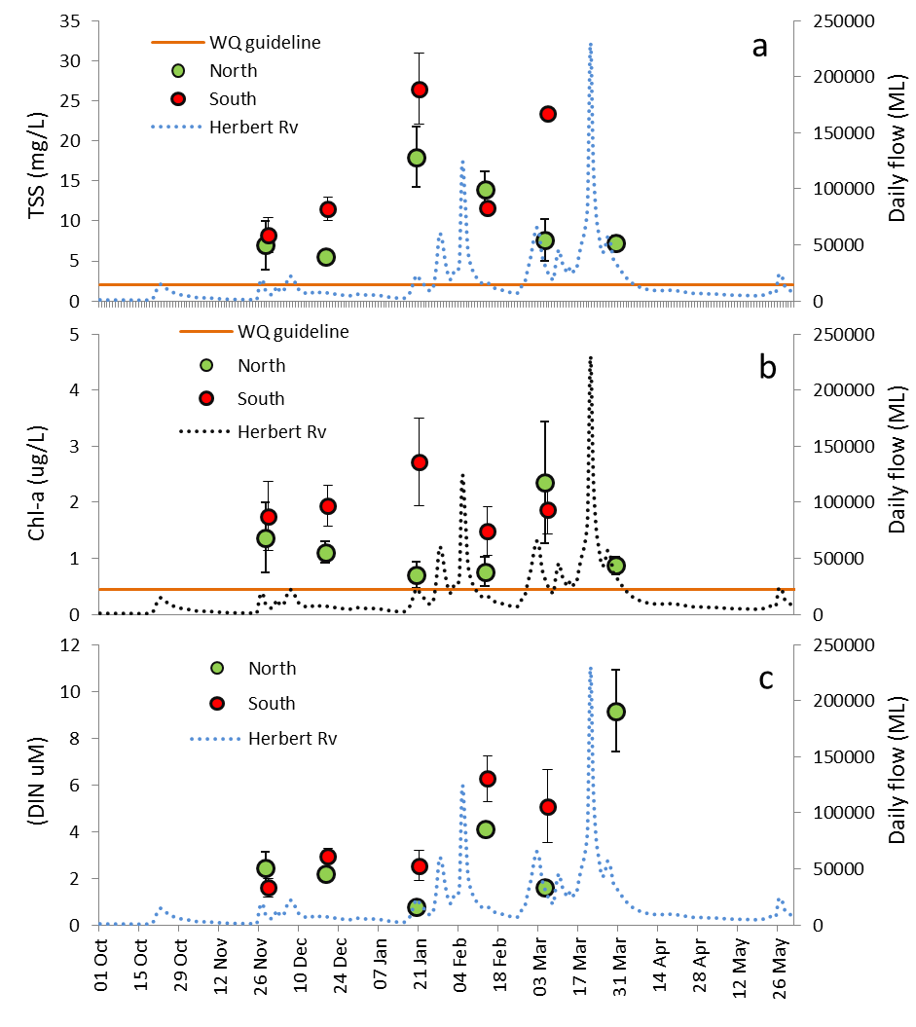
Figure 5-3: Changes in concentration over time for three key parameters (TSS, Chl-a and DIN) measured in the Herbert River flood plumes. Timing of sampling occurred November 2010 to late March 2011.

Figure 5-3 illustrates the changes in concentrations of three key water quality components in the flood plume over time, averaged over sites within the northern and southern transects. Concentrations of TSS increased over time at all sites, reaching a peak in mid-January (Fig. 5-1a). Chl-a concentrations are high over the wet season (Nov to April), particularly in sites within the southern transect (Fig. 5-1b). DIN concentrations showed a general trend of increasing with peak after the high flow (Fig. 5-1c). Similar temporal trend between river discharge and the other two WQ parameters (i.e., TSS and chl-a) were not observed, suggesting a no-clear timing between river discharge and the observed elevated WQ parameters concentrations.
The other notable output from this data shows that the measurements of many of the water quality variables where high through all the data points, particularly chl-a, which measured between 0.2 – 10.2 µg/L for all sites, with a mean of 1.76 µg/L for the whole wet season. The colour of the water was green in all sampling trips, and whilst colour assessment is not a reliable way of estimating production, it does indicate that the coastal waters out from the Herbert River mouth and around Hinchinbrook Island are extremely productive and may potentially be eutrophic with high DIN, and sufficient light to drive high phytoplankton biomass.

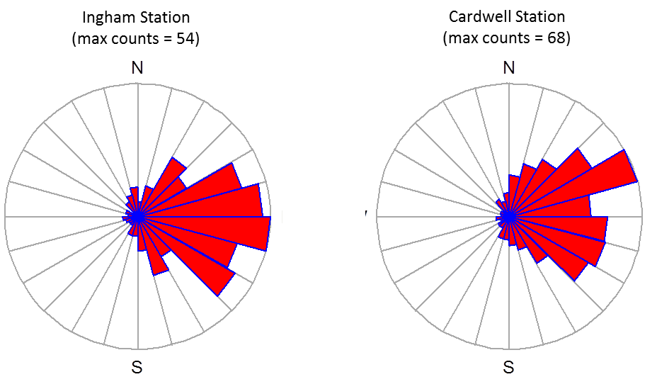

Figure 5-4: Predominantly wind direction for the two weather stations (Ingham, 18.6494˚S and 146.1769˚N and Cardwell, 18.2544˚S and 146.0192˚N).
Potential causes for the high WQ parameters concentration over the whole sampling period with apparently no correlation with river discharge were investigated by the calculation of the Spearman's rank correlation coefficient. A nonparametric correlation coefficient was computed because most of the variables did not present normal distribution. The Spearman's rank correlation coefficient was used to compare all the key WQ parameters presented in Figure 5-2 considering also salinity, the average of the Herbert River discharge calculated for the 5 previous days of each sampling date (Flow*, megalitres per day, hereafter ML/d), the underwater light extinction (KdPAR, m-1), and the u-component of the wind speed. 5-day average for the Herbert River discharge was arbitrarily selected as a way to represent a potential delay between the river gauge measurements (approx. distance 30 km from river mouth) until water reaches the sampling site (within 1 – 50 km from river mouth). Wind was considered in as a way to account for any potential resuspension that may affect the WQ constituent’s concentration. Wind data was obtained for two coastal stations (Cardwell, 18.2544˚S and 146.0192˚N, and Ingham, 18.6494˚S and 146.1769˚N) from the Australian Bureau of Meteorology (http://www.bom.gov.au/climate/data-services/), and it covers the whole sampling period. Ideally data form Lucinda station should be used instead, however no data for Lucinda was available for the period of interest due to the station breakdown caused by the TC Yasi passage. Because most of the wind was from the east during the sampling period (Figure 5-4), daily wind data measured at 06:00, 09:00 and 15:00 was decomposed into u-component (Figure 5-5). In addition, winds with negative u-component were assigned value zero, assuming that the larger fetch area at eastern of the sampling sites are much more efficient on wind and current generation than the wind blowing from land. The wind u-component was then paired against the WQ parameters considering the smallest time lag between wind measurements and the sampling time. Sites from the southern transect were assigned to the Ingham wind data, and northern sites to the Cardwell wind data. In this approach we assumed that wind would have similar effect on each sampling site, and the waves and currents would result in resuspension, which may not be true due to the local bathymetry and topography. Sites depth vary between 1 to 28 m with an average of 10.45±7.84 m (±1 SD), and some site are totally exposed to NW to SW winds whereas some are inside the channel between Hinchinbrook Is. and the continent. There are two main water movements that can cause sediment resuspension: waves wind-generated and currents (wind and tide generated). Waves are more efficient on sediment resuspension than currents, especially on shallow areas, because waves can impose to bottom sediment a regime of high and low pressures, promoting the sediment oscillation (Suhayda, 1986). This oscillation, which is caused by the orbital movement of the water particles under wave influence, weakens the mechanical and erosion strengths of the bed, leading to its fluidization and provoking thus a dramatic reduction on bed shear strength. Lou (1995) stated for Cleveland Bay that the swell waves are more efficient in reducing the bottom shear resistance than currents alone (more than 8 times), however currents play an important role in the transport of suspended sediment. In further approaches the orbital velocity of the particles next to the bottom and currents, wind and tide generated should be taken into account on the resuspension process quantification.
The Spearman's rank correlation coefficient indicated high correlations between salinity – flow*, salinity – KdPAR, salinity – DIN and KdPAR – chl-a (Table 5-2). These are negative correlations and indicate that a higher flow discharge as occurred in the previous 5 days of the sampling date reduces the sampled sites salinity and that lower salinities are associated with higher DIN concentrations and higher KdPAR values (i.e., reduced water transparency). KdPAR was also positively correlated with chl-a (the higher the light availability, the higher the primary production).
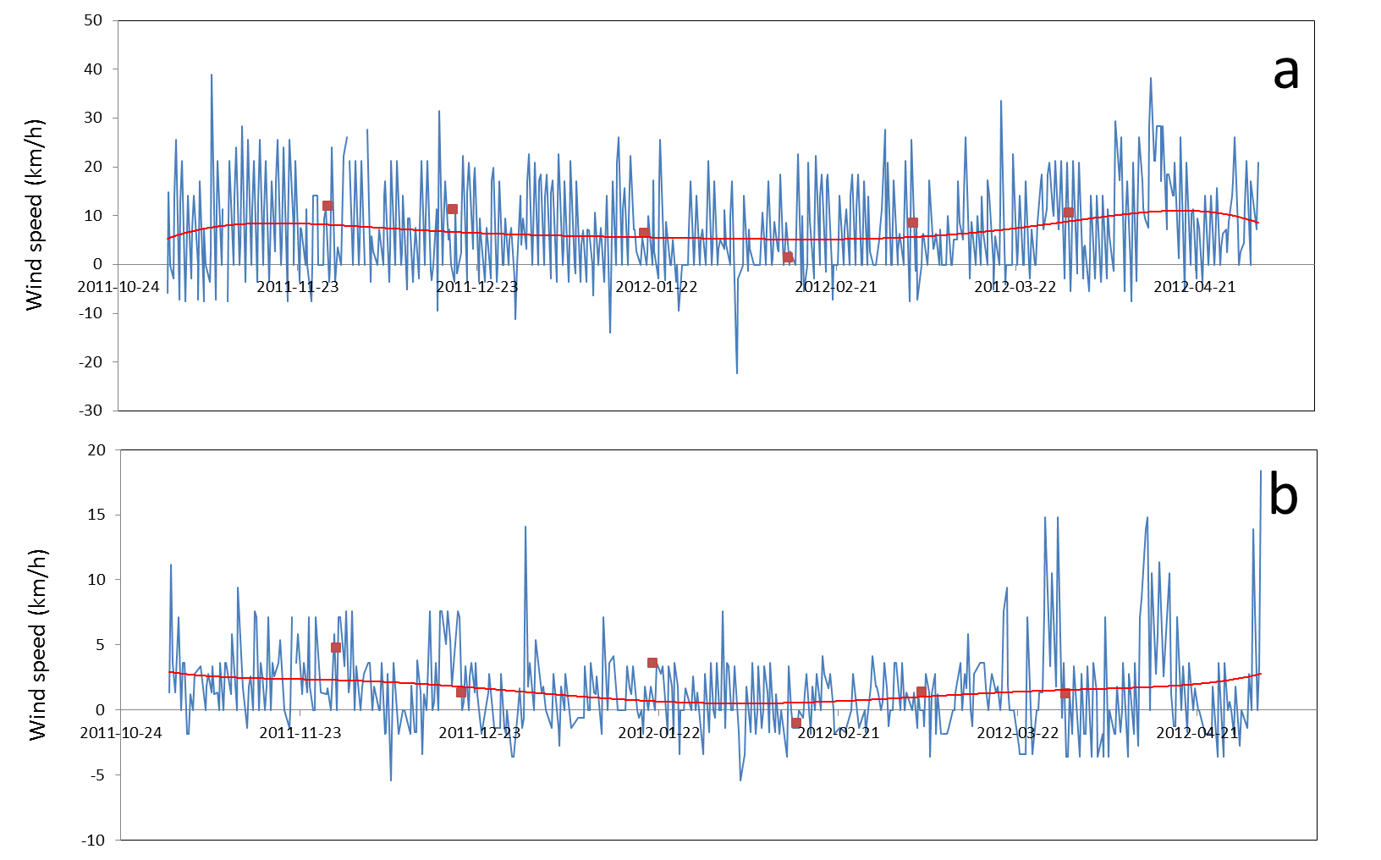
Figure 5-5: The wind speed u-component for the weather stations located in (a) Cardwell, 18.2544˚S and 146.0192˚N and (b) Ingham, 18.6494˚S and 146.1769˚N. Red squares stand for the sampling dates, and red line shows the u-component temporal trend.

Table 5-2: Spearman’s rank correlation coefficient. Value in bold indicates correlation >36%, and all correlations are significative at p < 0.05, except for those values in italic, light grey.
 | Flow* | Wind* | Salinity | KdPAR | TSS | chl-a | DIN | DIP | PN | PP
Flow* | 1 | 0.25 | -0.61 | 0.00 | -0.12 | 0.01 | 0.25 | -0.26 | 0.37 | 0.25
Wind* | 0.25 | 1 | 0.10 | -0.25 | -0.13 | -0.26 | -0.46 | 0.10 | 0.02 | -0.18
Salinity | -0.61 | 0.10 | 1 | -0.60 | -0.21 | -0.38 | -0.70 | 0.11 | -0.59 | -0.20
KdPAR | 0.00 | -0.25 | -0.60 | 1 | 0.48 | 0.61 | 0.51 | -0.11 | 0.39 | 0.16
TSS | -0.12 | -0.13 | -0.21 | 0.48 | 1 | 0.46 | 0.29 | -0.04 | 0.36 | 0.27
chl-a | 0.01 | -0.26 | -0.38 | 0.61 | 0.46 | 1 | 0.36 | 0.15 | 0.32 | 0.27
DIN | 0.25 | -0.46 | -0.70 | 0.51 | 0.29 | 0.36 | 1 | -0.05 | 0.51 | 0.08
DIP | -0.26 | 0.10 | 0.11 | -0.11 | -0.04 | 0.15 | -0.05 | 1 | -0.07 | -0.26
PN | 0.37 | 0.02 | -0.59 | 0.39 | 0.36 | 0.32 | 0.51 | -0.07 | 1 | 0.13
PP | 0.25 | -0.18 | -0.20 | 0.16 | 0.27 | 0.27 | 0.08 | -0.26 | 0.13 | 1
Flow* stands for the average flow calculated for the previous 5 days of the sampling date, and Wind* stands for the u-component of the wind speed (see text for explanation).
In a second approach, the relationship between WQ parameters and the site distance from the Herbert River mouth was investigated by using generalized additive mixed model (GAMM) (Table 5-3). A GAMM analysis was applied because it can account for the multitudinous variability intrinsic to a dataset resulted from samples being taken at varying runoff, salinity and wind regimes. GAMM was performed in R scripting language (R Development Core Team, 2009), with the package ‘mgcv’. The distance between each site and the Herbert River mouth was calculated taking into account the coastal line by using the cost distance tool in ArcGIS. Generalized Additive Mixed Model (GAMM) was used then to model WQ parameters (WQ_{i} in Eq. 1) as a function of distance from the Herbert River mouth.

WQi<-gamm(WQi~s(distance),random=list(effect=~1),data=data1). (Eq. 1)

In an exploratory analysis, four effects were tested as random effects: none effect at all, transect, 5-day average river discharge, u-component of the wind, and their permutation. As a result, specific random effects were selected to be applied in GAMM analysis for each WQ parameter. These selections, as indicated on Table 5-3, were made based on the best performance measured by r-squared, p-value and Akaike Information Criterion value (AIC, Sakamoto et al., 1986). Negative r-squared (i.e., the chosen model fits worse than a horizontal line) and no-significant p-value were used as a model exclusion criteria within each WQ parameter. For the no-excluded models, the lowest AIC value was used to select the best one. If more the one model exhibited the lowest AIC value, the simplest model, with less random effects, was selected. Only DIP and PP presented suitable GAMM models based on the selection criteria chosen. Results of GAMM analysis are presented on Table 5.3.

Table 5-3: Generalized additive mixed model (GAMM) – statistical summary and random effect selection. Four statistical tests (r-squared, p-value, AIC and BIC) were used on model evaluation as a function of four random effects and their permutation: transect (t), 5-day average river discharge (d), u-component of the wind (w) and/or none. Line in bold indicates the best result within each WQ parameter for the smaller AIC and BIC values (green), significative p-value (yellow). Negative r-squered means that the chosen model fits worse than a horizontal line. In this case no GAMM model is presented (e.g., for TSS).
 | r-squared | p-value | AIC | factor |  |  | r-squared | p-value | AIC | factor
Salinity | 0.069 | 0.053 | 626.943 | t |  | DIN | 0.101 | 0.046 | 342.759 | t
Salinity | 0.069 | 0.031 | 615.873 | f* |  | DIN | 0.099 | 0.015 | 336.149 | f*
Salinity | -0.054 | 0 | 339.453 | w* |  | DIN | -0.029 | 0 | 196.072 | w*
Salinity | 0.106 | 0.083 | 338.298 | w*_t |  | DIN | 0.085 | 0.002 | 195.836 | w*_t
Salinity | 0.1 | 0.138 | 335.1 | w*_t_f* |  | DIN | 0.085 | 0.002 | 197.836 | w*_t_f*
Salinity | 0.106 | 0.075 | 327.644 | w*_f* |  | DIN | 0.116 | 0.008 | 193.278 | w*_f*
Salinity | 0.077 | 0.14 | 617.806 | f*_t |  | DIN | 0.101 | 0.034 | 337.807 | f*_t
Salinity | 0.069 | 0.004 | 626.691 | none |  | DIN | 0.101 | 0.006 | 341.851 | none
KdPAR | 0.206 | 0 | 227.748 | t |  | PN | 0.066 | 0.024 | 360.039 | t
KdPAR | 0.207 | 0 | 227.078 | f* |  | PN | 0.066 | 0.065 | 355.858 | f*
KdPAR | 0.306 | 0 | 109.543 | w* |  | PN | -0.011 | 0.105 | 206.942 | w*
KdPAR | 0.305 | 0 | 111.25 | w*_t |  | PN | -0.011 | 0.105 | 208.942 | w*_t
KdPAR | 0.305 | 0 | 113.338 | w*_t_f* |  | PN | -0.011 | 0.105 | 210.942 | w*_t_f*
KdPAR | 0.302 | 0 | 110.969 | w*_f* |  | PN | -0.002 | 0.192 | 207.507 | w*_f*
KdPAR | 0.21 | 0.001 | 227.687 | f*_t |  | PN | 0.064 | 0.094 | 356.618 | f*_t
KdPAR | 0.206 | 0 | 225.748 | none |  | PN | 0.066 | 0.024 | 358.039 | none
TSS | 0.03 | 0.048 | 779.948 | t |  | DIP | -0.009 | 0.495 | -53.746 | t
TSS | 0.027 | 0.057 | 775.694 | f* |  | DIP | -0.012 | 0.411 | -65.629 | f*
TSS | -0.036 | 0.021 | 435.87 | w* |  | DIP | -0.108 | 0.127 | -37.736 | w*
TSS | -0.036 | 0.021 | 435.87 | w*_t |  | DIP | -0.109 | 0.143 | -36.71 | w*_t
TSS | 0.01 | 0.136 | 441.362 | w*_t_f* |  | DIP | -0.105 | 0.152 | -37.022 | w*_t_f*
TSS | -0.004 | 0.096 | 437.831 | w*_f* |  | DIP | -0.045 | 0.447 | -38.86 | w*_f*
TSS | 0.029 | 0.058 | 780.519 | f*_t |  | DIP | -0.01 | 0.441 | -61.333 | f*_t
TSS | 0.03 | 0.048 | 777.948 | none |  | DIP | -0.009 | 0.495 | -55.746 | none
Chl-a | 0.03 | 0.054 | 365.926 | t |  | PP | -0.017 | 0.89 | 11.513 | t
Chl-a | 0.08 | 0.105 | 366.517 | f* |  | PP | -0.017 | 0.879 | 10.721 | f*
Chl-a | 0.173 | 0 | 172.879 | w* |  | PP | -0.058 | 0.313 | 24.386 | w*
Chl-a | 0.276 | 0 | 177.92 | w*_t |  | PP | -0.038 | 0.569 | 22.892 | w*_t
Chl-a | 0.288 | 0 | 180.669 | w*_t_f* |  | PP | -0.038 | 0.569 | 24.892 | w*_t_f*
Chl-a | 0.257 | 0 | 176.149 | w*_f* |  | PP | -0.052 | 0.415 | 22.654 | w*_f*
Chl-a | 0.082 | 0.109 | 367.817 | f*_t |  | PP | -0.017 | 0.935 | 12.139 | f*_t
Chl-a | 0.074 | 0.084 | 364.731 | none |  | PP | -0.017 | 0.89 | 9.513 | none

Salinity exhibited increasing values as the distance between the Herbert River mouth and sites increased, and in 50 km away from the river mouth salinity approaches the marine salinity (Figure 5.6a). It is worthwhile to mention that the salinity model was dependent on the amount of river discharge computed as an average of the previous 5-day of the sampling date (Table 5-3). The underwater light attenuation (KdPAR, Figure 5.6b) was dependent on wind, and the longer the distance between river mouth and sampling site, the higher the water transparency, with values of equivalent secchi disc varying from 0.14 – 1 m (KdPAR = 1.44 secchi disk, Holmes 1970). Total suspended solids (TSS, Figure 5.6c) had no random factor, been dependent only on distance between sites and the Herbert River mouth (Table 5-3).
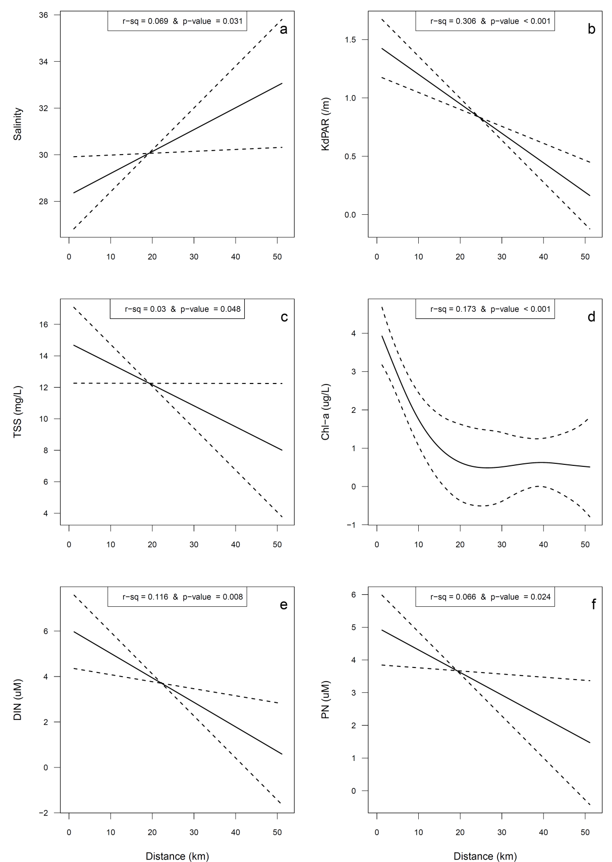

Figure 5-6: In-situ WQ parameters against distance from the Herbert River mouth for (a) salinity, (b) underwater light extinction (KdPAR, m⁻¹), (c) total suspended solids (TSS, mg/L), (d) chlorophyll-a (chl-a, µg/L), (e) dissolved inorganic nitrogen (DIN, µM), and (f) particulate nitrogen (PN, µM). See text and Table 5-4 for model explanation.

The lowest TSS concentrations were observed at sites within 40-50 km away from the river mouth. Interesting to note that wind (as u-component) and flow did not explain the TSS pattern observed in the field, indicating that other processes were influencing the movement of TSS. Chlorophyll-a (chl-a, Fig. 5-6d) was high close to the river mouth and reduced asymptotically up to 20 km away from it, getting stable after that. Chlorophyll-a model had wind as random effect suggestion that resuspension can affect primary production by injecting benthic diatoms into the water column, and/or by realising nutrients from the bottom sediment. Phytoplankton samples indicated that a higher number of benthic diatoms were associated with high chl-a concentrations (Devlin et al., 2013). Dissolved inorganic nitrogen concentrations were dependent on river discharge and wind (Table 5-3), and higher values were close to the river mouth (Fig. 5-6e). This pattern supports the behaviour exhibited by chlorophyll-a, suggesting that river discharge and also bottom sediment resuspension can drive chl-a biomass. Particulate nitrogen follow the spatial DIN behaviour, but it was depend only on the distance between sites and the Herbert River mouth, suggesting that the land-based nitrogen input is the main driver of PN in the flood plume waters.
Mixing profiles, with concentrations identified by date, show that the timing of the sampling and the intensity of flow are key drivers in driving the reduction of water quality concentrations through the salinity gradient (Figure 5.7). Concentrations of DIN are highest at the lowest salinities, and over the last sampling date reflecting continual flow and the high peak (220,000 ML) measured on the 18th March in the Herbert River.
Mixing curve relationships are difficult to ascertain due to the low number of points at the lower salinity end. The higher salinity measurements reflects the low to medium flow conditions that were measured during the 2011-12 wet season and can be contrasted with the low salinity measurements from the 2010-11 year (Devlin et al., 2012C). Mixing curves are generally conservative for DIN, though there is high scatter at the higher end of the salinity potentially reflecting the uptake processes. DIP starts at low concentrations and increases through the higher salinities, suggesting desorption of DIP from the particulate fraction. The highest K_{d} value, as would be expected is associated with the two highest TSS values, thought the higher chlorophyll values between 25 – 35 µg/L look to also influence the light attenuation (Figure 5-8).
Salinity data is presented at surface (0.5m) and variable depth (1, 5 and 10 m) as mean values for October to March 2012 (Figure 5-8). The average surface salinity for January to March was 32. Mean salinity at 5 m was reduced slightly but large differences in depth are not evident, indicating the well mixed condition of the water in the region affected by the Herbert River discharge.

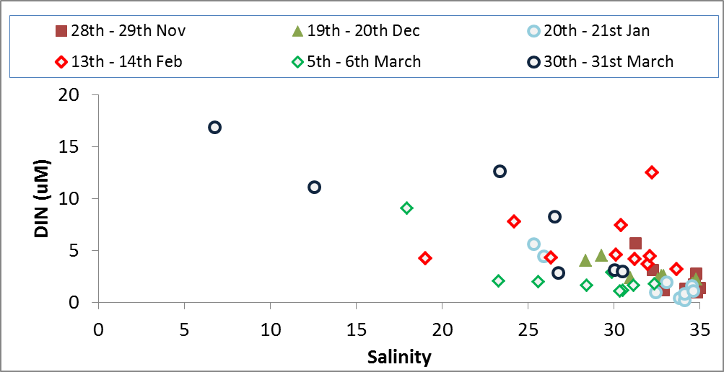
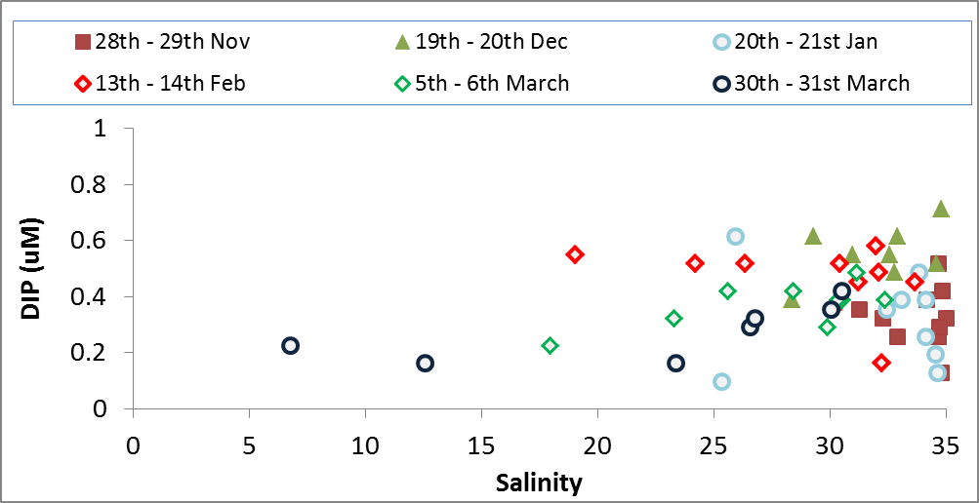
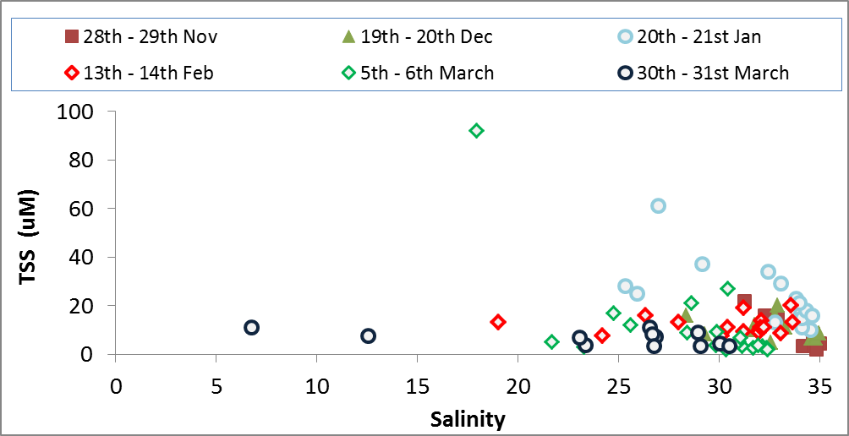
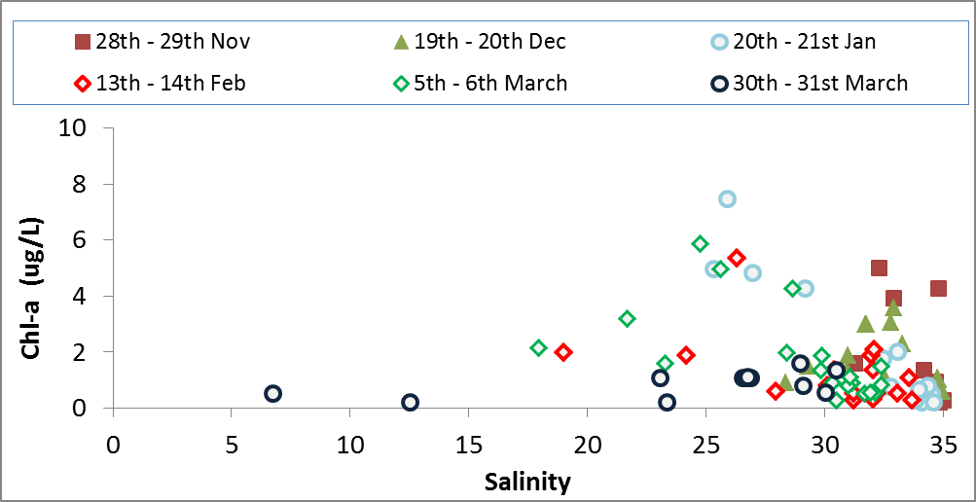
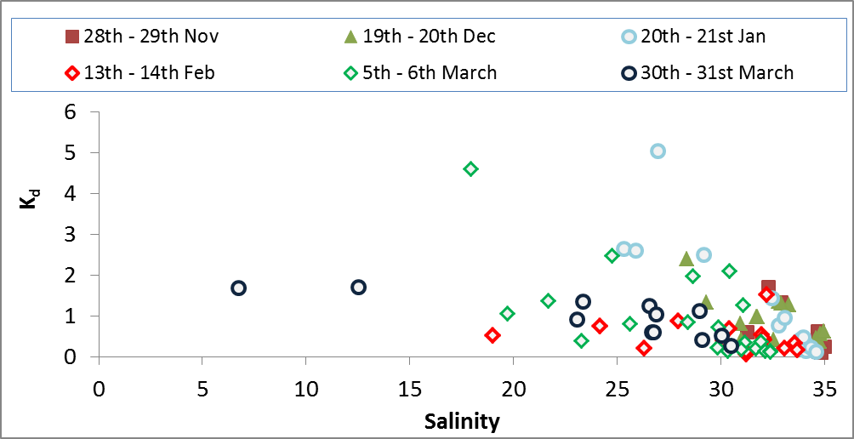
Figure 5-7: Salinity mixing profiles presented for each sampling date for five water quality measurements including DIN, DIP, TSS, Chl-a and Kd.

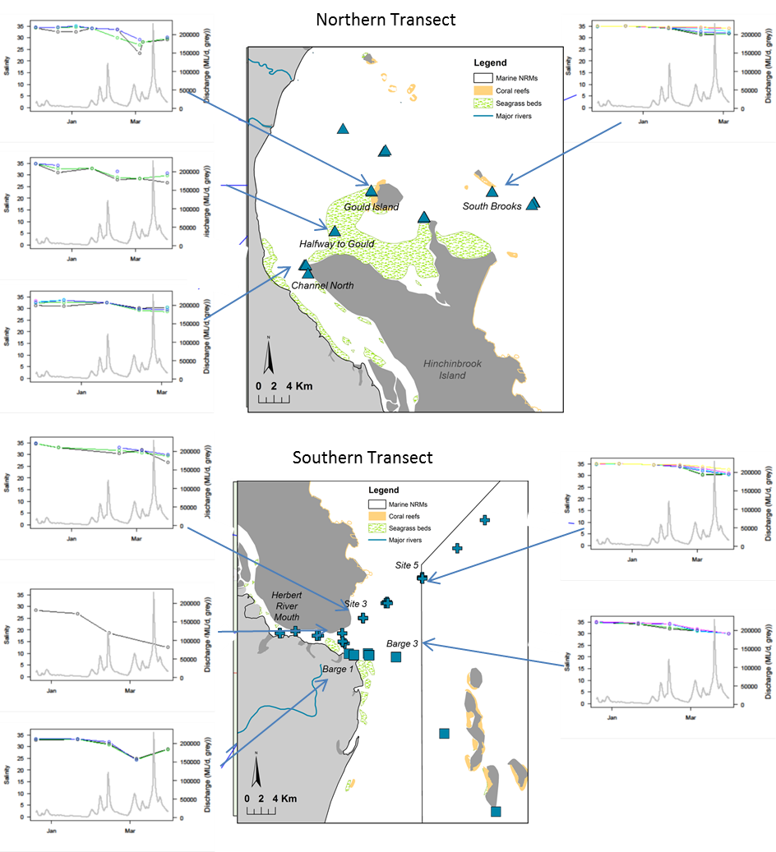
Figure 5-8: Depth-integrated exposure map for the Herbert marine region for salinity data.

Pesticide monitoring results
An intensive sampling campaign was undertaken in the Herbert catchment using a combination of grab and passive sampling techniques. Diuron, atrazine and simazine were the only herbicides detected in the grab samples, with diuron the most frequently detected and abundant. A greater number of herbicides were detected in the passive samplers including ametryn, hexazinone, tebuthiuron, metolachlor and imadicloprid (Figure 5-9). For a full analysis of pesticides collected under this and other MMP programs, please refer to Bentley et al., (2012).

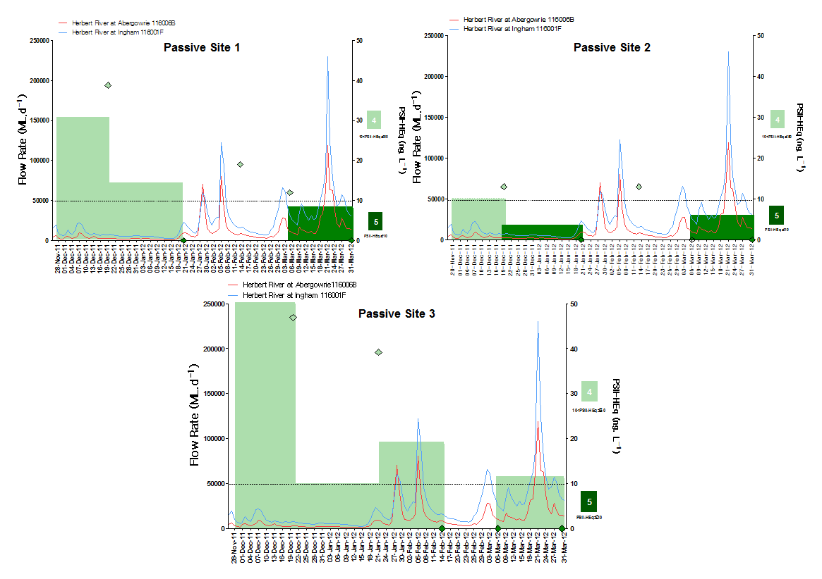
Figure 5-9: Summary of grab and passive sampling data collected in the Herbert River region. Please refer to Bentley et al., 2012 for full details of the pesticide monitoring program.

Conclusions
Data collected from the Herbert marine region shows conclusively that high nutrient enrichment is occurring over the wet season with the highest concentration peaks related to the highest flow measurements. However, concentrations of dissolved nutrients are high across all sampling occasion suggesting that this small, but important coastal area of the GBR is nutrient enriched. These high nutrient values, coupled with the persistent high values of Chl-a biomass mean that for several weeks to months of the year, the inshore coastal system adjacent to the Herbert is eutrophic. Further synthesis of other biological monitoring programs under the MMP is required to link these eutrophics symptoms to biological impact. However, in the absence of biological data for this report, we can conclude the water quality within the Herbert marine area, both north and south transects has reduced water quality over broad temporal (weeks) and spatial (> 50km north and 30km south) scales. The MMP program was run concurrently with the Herbert River catchment monitoring program and combining the catchment, river and plume data will be essential in identifying the source of pollutants and tracing source back to catchment activities. This work will be presented at a later date once catchment data has been reported.

PART B: FLOOD PLUME MAPPING

GBR flood plumes

Introduction
In 2010 the ACTFR (now TropWATER) was engaged by the GBRMPA to identify and map the risk and exposure of GBR ecosystems to anthropogenic water quality influences (nutrients, sediments and pesticides) to facilitate resilience mapping of the GBR for adaptive management purpose under a changing climate. River flood plumes are important pathway for terrestrial materials entering the sea, and a dominant source of coastal pollutants. Mapping the river plume extent, spatio-temporal variability, frequency, and duration help to develop risk models by mapping plume-affected areas which may experience acute or chronic high exposure to contaminants through river discharges. Knowledge of the areas and the type of ecosystem that is the most likely to be impacted by changing water quality help focus our understanding on what type of ecological impacts are occurring to those systems and better inform marine, coastal and catchment management.
Remote sensed imagery has become a useful and operational assessment tool in the monitoring of flood plumes in the GBR. Combined with in-situ water quality sampling the use of remote sensing is a valid and practical way to estimate both the extent and frequency of plume (surface) exposure on GBR ecosystems. Ocean colour imagery provides synoptic-scale information regarding the movement and composition of flood plumes. Thus, in the past four years, remotely sensed data combined with in-situ sampling of flood plumes has provided an essential source of data related to the movement and composition of flood plumes in GBR waters (Bainbridge et al., 2012; Brodie et al.; 2010; Devlin et al.; 2012a, b; Schroeder et al., 2012). Flood plumes have been mapped and the coverage of GBR ecosystems visually assessed using satellite imagery (Devlin and Schaffelke, 2009). A combination of aerial surveys and satellite imagery has also been employed in the GBR to determine areas of marine coastal ecosystems exposed to flood plumes (Brodie et al., 2010; Devlin et al., 2001; Devlin and Brodie, 2005; Schroeder et al., 2012). In combination with pollutant load, RS data have been further used to model the exposure of GBR marine ecosystems to land-based contaminants (Maughan and Brodie, 2009; Devlin et al., 2012a, b). The key findings, and detailed approaches undertaken to complete these assessments are summarised in Devlin et al. (2012b).

Remote sensing /GIS methodologies
Our efforts to improve methods of mapping and characterising GBR flood waters are continuing. For this reporting period we have used a combination of true colour and satellite imagery processed with bio-optical algorithms (Level 2 (L2) products)) to delineate the edge of the GBR plume and the dispersal of land-based pollutants with an increasing degree of confidence. The main catalogue of ocean colour satellite imagery used was that of the Moderate Resolution Imaging Spectroradiometer (MODIS) on-board the NASA Earth Observation System Terra and Aqua spacecrafts. In the GBR, Plume waters are driven by high river flow conditions, which are the periods in the monsoonal season that are typically associated with the passage of cyclones or low pressure systems (Devlin and Brodie, 2005).
Level-0 (L0) data corresponding to images during the summer/wet season (December to April inclusive) recorded between 2007 and 2012 were acquired from NASA’s Ocean Colour website (http://oceancolour.gsfc.nasa.gov). MODIS quasi-true colour (hereafter true colour) images and L2 products (Chl-a, Coloured Dissolve Organic Matters and Detrital matter absorption coefficient (aCDOM-D) and TSS proxies) were derived from L0 data using the processing scheme and bio-optical algorithms available in SeaWiFS Data Analysis System - SeaDAS (Baith et al., 2001). A combined near infrared to short wave infrared (NIR-SWIR) correction scheme (Wang and Shi, 2007) was applied to level-1 products to overcome the atmospheric correction issues above turbid waters, commonly found in the nearshore regions of the GBR.
The complex behaviour of coastal plumes is determined by various factors, including the Earth rotation effect (Coriolis effect), the catchment size, river discharge characteristics and the frequency and intensity of the high flow event, prevailing wind and current conditions, wind wave and tidal effects as well as topography/bathymetry and exit angle (e.g. Wolanksi et al., 2008; Devlin and Brodie, 2005; Devlin and Schaffelke, 2009). Coastal plumes are perfect examples of highly dynamic oceanographic structures, with spatial and temporal dynamical scales ranging from meters to hundreds of kilometres and from diurnal to weekly ranges, respectively, and for which remote sensing technologies are perfectly adapted tools.

Figure 6-1: River plumes along Queensland Coast, MODIS true colour image from Aqua satellite, (NASA/GSFC, Rapid Response).

To detect and map plumes remote sensors exploit their differences in colour from ambient marine waters (Figure 6-1). Water is transparent at blue and green wavelengths, but is strongly absorbing at longer wavelengths. Chlorophyll a, the primary photosynthetic pigment found in phytoplankton, has a primary absorption peak near 440 nm. CDOM absorption monotonically increases as wavelength decreases into the ultraviolet. Also, particulate scattering enhances reflectance (ratio of incoming to outgoing light) at longer wavelengths (Clarke et al., 1970, Morel and Prieur, 1977, McClain, 2009). The optical signature of a plume, its properties of absorption (measured by the attenuation coefficient of Photosynthetically Active Radiation – Kd(PAR)) and its colour are thus related to the presence and combination of these parameters called the optical active constituents (OACs) of the water (Figure 6-2).
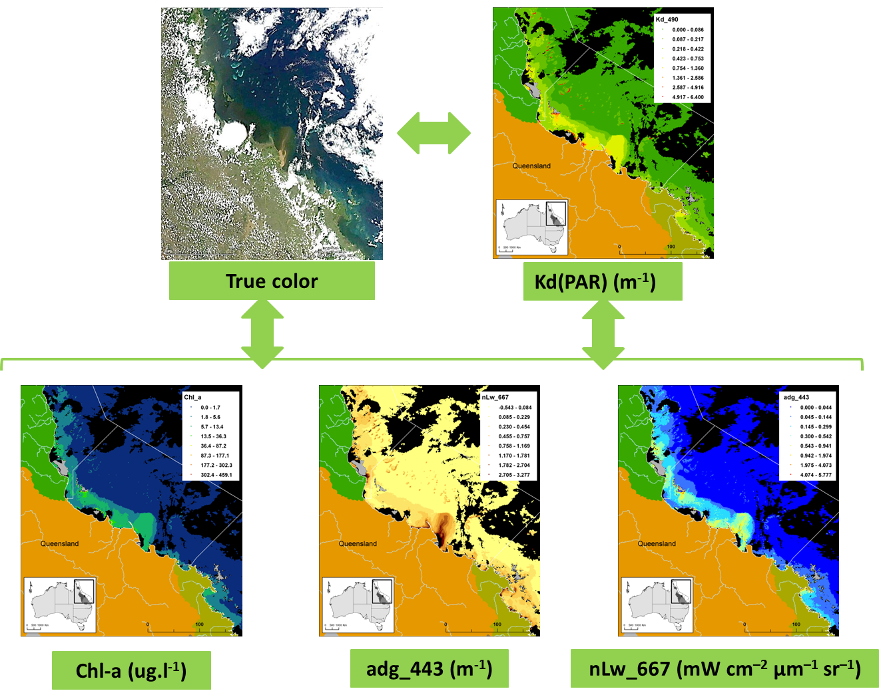

Figure 6-2: Relations between the colour, the properties of absorption [Kd(PAR)] and the optical active constituents of plume waters.

Mapping was based on two innovative plume mapping techniques that combine MODIS true colour and L2 imagery. We mapped the full extent of the plume, the plume water types (primary, secondary, tertiary; e.g. Devlin and Schaffelke, 2009 and Devlin et al., 2012a), and surface exposure to pollutants by applying a combination of true colour images classification (defined later as “qualitative” method), as well as supervised classification of MODIS Level 2 satellite products using thresholds which link to the gradients of CDOM, chlorophyll, TSS in plume waters (referred as quantitative method). At the time of completing this report, this method was still in development.
Simply put, we developed a set of mapping techniques which allow us to map GBR plume movements and influence on coastal ecosystems despite complexity in the application of satellite remote sensing technics in optically coastal complex waters (Qin et al., 2007).

Mapping outputs

The main products which are being developed under the MMP program include:
- Daily maps and weekly composites of the full extent of plumes and plume water types;
- Annual maps of the frequency of occurrence of river plume and of plume water types;
- Annual and multi-annual maps of surface exposure to pollutants (TSS and DIN), linking pollutant load to the water type classifications;

Overview of methods

Full extent plume maps (qualitative and quantitative methods)
Historically, visual interpretation of digitised true colour satellite images were performed to identify and delineate the full areal extent of the surface GBR flood plumes (Devlin and Schaffelke, 2009; Devlin et al., 2012a). In order to reduce human error originated from visual mapping, to allow the processing of a greater number of satellite images, and to provide greater detail on the composition of the plume, further automated (or quasi-automated) methods have been developed:
- A “qualitative” method (Álvarez-Romero et al., 2013) based on classification of spectrally enhanced true colour images. This method involve converting true colour images from Red-Green-Blue (RGB) to Intensity-Hue-Saturation (HIS) colour schemes, the definition of 6 colour classes corresponding to plume areas and that describe a gradient in the river borne pollutants as well as 2 classes corresponding to non-plume areas (cloud and sun glint signatures), the creation of spectral signatures for these respective areas, and the utilization of the created spectral signature to map the full extent of the plume. Weekly plume composite were created to minimize the amount of area without data per image due to masking of dense cloud cover, common during the wet season (Brodie et al., 2010), and intense sun glint. We used the combined 6 colour classes to define the full extent of the plume.
Analyses are realized in ArcGIS and a full description of the method is presented in Álvarez-Romero et al., 2013 and summarized in Figure 6.3a1.

- A “quantitative” method using the application of threshold values for delineating surface plume boundaries. This supervised method is based on MODIS L2 data calibrated into water quality (WQ)/OACs metrics. WQ metrics/ OACs chosen to delineate the full areal extend of the plume and plume water types are:
- The water-leaving radiance measured at 667 nm (nLw(667)) and after atmospheric corrections. This parameter is sensitive to the suspended solids in the water column and has been shown correlated with plume location (Salisbury et al., 2004; Thomas and Weatherbee, 2006). It is used as proxy for TSS and to approximate the dispersal of sediments within plumes.
- The Chl-a concentration, calculated by applying the GSM01 algorithm implemented in SeaDAS (Garver and Siegel, 1997; Maritorena et al., 2002). The GSM01 algorithm has been shown with the best performance of the seaDAS algorithm for retrieving of chlorophyll-a concentration in GBR waters over a wide range of conditions (Qin et al., 2007).
- The absorption of CDOM+D at a wavelength of 443 nm, calculated based on the quasi-analytical algorithm (QAA) (Lee et al., 2002). This QAA derives inherent optical properties (IOPs) of absorption and backscattering coefficients and has been shown to be appropriated for use within the GBR (Qin et al., 2002). The QAA derives the total spectral absorption and backscattering coefficients, which are decomposed into the spectral absorption coefficients associated with phytoplankton pigments and absorption of CDOM+D.
These processes are summarised in Figure 6-4Error! Reference source not found.. Analyses are realized using a combination of software: SeaDAS, Matlab and ArcGIS.

As with the qualitative approach, the purpose of this method is to integrate the dispersal patterns of pollutants from the coast to offshore. The distribution of satellite-retrieved [nLw, chl-a, CDOM+D] gradients along different river mouth-offshore sections is used to identify and validate water quality GBR thresholds above/under which OACs values are considered to be indicative of the full extent of the plume or respective plume water types presence (Figure 6-4). We used tertiary plume; identified by CDOM+D absorption value higher than 0.05 m⁻¹ and proportional to marine salinity value (e.g., Schroeder et al., 2012); to define the external boundary or full extent of the plume.

Plume water type maps (qualitative and quantitative methods)
Working with calibrated L2 MODIS images, Devlin et al. (2012b), have given significant insight into the characterization of the gradient of water types commonly found into the GBR river plumes. Each water type is associated with different levels and combination of pollutants and hence will impact on different components of the GBR ecosystems (Devlin et al., 2012b). Classification of surface waters into Primary, Secondary, and Tertiary water types can thus provide a mechanism to cluster cumulative WQ stressors into three (ecologically relevant) broad categories of risk magnitude (Petus et al., in review).
These water types were defined as:
- Primary waters, located in the immediate plume zone and characterised by high suspended sediment, light limitation and low salinity typically associated with the very near-shore areas and the initial stages of plume formation;
- Secondary waters characterised by moderately elevated sediment however, with sufficient light and excess nutrients to support elevated phytoplankton growth, and;
- Tertiary waters characterised by lower values of CDOM+D and Chl-a in comparison of the primary and secondary waters but still above ambient marine values. Tertiary water plumes constitute the transitional waters between plume-affected and ambient water.

Figure 6-3: Summary of the process followed to build plume water maps with examples of inputs and outputs: (a) Plume mapping process: different shadings represent steps (light gray), analyses within steps (white), intermediate outputs (dark gray), and final outputs (black); (b) A: MODIS-Aqua true colour image used to create the spectral signature defining 6 color classes for GBR plumes (25/01/2011), B and C: daily 6-color class map (25/01/2011) and weekly composite (19 to 25/01/2011) of 6-class map. D: reclassified map into weekly P, S, T composite (19 to 25/01/2011); E: Frequency of occurrence of the secondary water type in 2011; Figure C to E are zoomed in the Tully-Burdekin area (see red box on panel B). (Modified from Álvarez-Romero et al. 2013 and Devin et al., 2013)
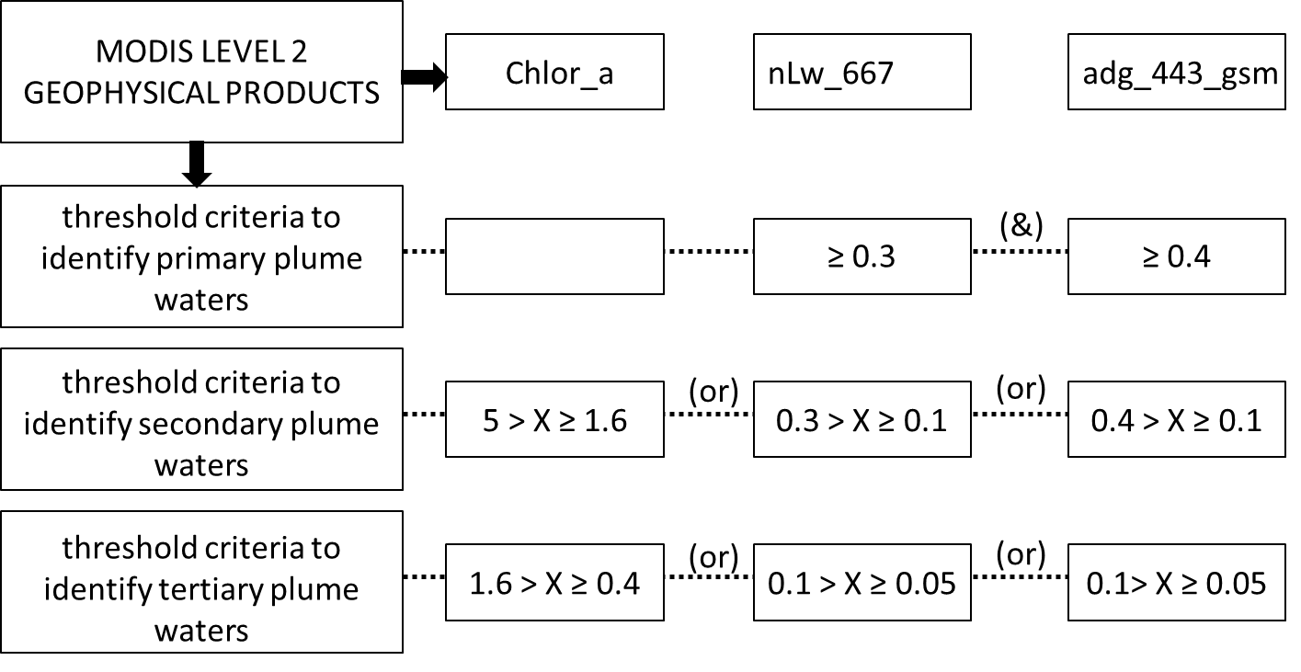

Figure 6-4: Process for the delineation of plume water types based on MODIS imagery through the application of spectral thresholds on Level-2 products (chl-a, adg_443_gsm used as proxy for CDOM+D concentrations and nLw_667 used as proxy for the TSS concentrations) using the SeaWiFS Data Analysis System.

Plume water types were mapped through the 2 methods:
- Qualitative method: the six colour classes weekly composites defined through the qualitative method of Álvarez-Romero et al. (2013) were further reclassified into 3 plume water types (primary, secondary, tertiary) roughly corresponding to the three water types defined by Devlin and Schaffelke (2009) and Devlin et al. (2012b) (Figure6-3a2) The sediment-dominated waters or primary water type was defined as corresponding to colour classes 1 to 4 of Álvarez-Romero et al. (2013). The chl-a dominated waters or secondary water type was defined as corresponding to the bluish-green waters (i.e., colour class 5 from Álvarez-Romero et al., 2013) and the tertiary water type was defined as corresponding to the colour class 6 of Álvarez-Romero et al. (2013).
- Qualitative method: the distribution of satellite-retrieved [nLw, chl-a, CDOM+D] gradients along different river mouth-offshore sections was used to identify and validate water quality GBR thresholds above/under which OACs values are considered to be indicative of the respective water types presence (Figure 6-4). The tertiary plume water type is identified by CDOM+D absorption value higher than 0.05 m⁻¹. The secondary plume water type, identified within MODIS imagery as having high concentrations of Chl-a and elevated CDOM+D, and the primary water type, identified within MODIS imagery as having high values of nLw(667) and elevated CDOM+D, were defined by a combination of chl-a, CDOM+D and TSS proxies (Figure 6-4).

Annual frequency of occurrence of plumes (qualitative and quantitative methods)
Both qualitative and quantitative methods aimed to assess the pixels/areas regularly covered by flood plume.
- Qualitative method: Weekly plume composites (i.e., presence/absence of plume) were overlaid to calculate the annual frequency of occurrence of plumes, representing the number of weeks plumes were present in each pixel during the wet season. The frequency of occurrence of flood plume was finally aggregated into frequency classes (low risk to high risk) based on a “Natural Break (or Jenks)” classification. Jenks is a statistical procedure (embedded in ArcGIS as one of the basic classification schemes) that basically analyses the distribution of values in the data and find the most evident breaks in it; i.e., the steep or marked breaks (Cromley and Mrozinski, 1997).
- Quantitative method: the same methodology was applied but without creation of the weekly composites. Daily data (i.e., presence/absence of plume) were overlaid to calculate the annual frequency of occurrence of plumes, representing the number of days plumes were present in each pixel during the wet season.
The qualitative approach (finalised) was applied on all images available during wet seasons of 2007 to 2012, while the quantitative one (still in development) was applied to the images of 2012 for comparison.

Annual frequency of occurrence of plume water types (qualitative method)
Weekly plume water type composites were assigned values of presence/absence of primary, secondary, or tertiary water type; and overlaid into an annual frequency map (Figure6-3a3). The annual frequency of occurrence for each water type was calculated as the number of weeks that a pixel value was retrieved as primary, secondary or tertiary water type, divided by the maximum number of weeks in a wet season (i.e., 22 weeks taken from the 1st of December to the 30th of April). This overlay of water type imagery created annual (wet season) frequency maps of occurrence to primary, secondary and tertiary water types for the whole GBR.

Annual exposure maps to pollutants (DIN and TSS)
Previously, integration of surface plume mapping with measures of annual river pollutant loads have provided both spatial and temporal information on the scale and content of GBR river plumes and their potential impact on the short and long-term water quality status of GBR waters (Devlin et al., 2012a, b). This approach has been useful to distinguish differences in exposure to different pollutants at the NRM scale and for reporting seasonal and/or annual differences for each region. However, a known limitation to this original approach (Devlin et al., 2012b) is that loads have been distributed homogeneously across all respective marine regions. Differential patterns of diffusion and deposition of pollutants in the coastal waters (or dispersal patterns) were not taken into account. As a consequence, artificial “boundaries” or “acute” changes in exposure levels were created along the boundaries of marine NRM regions, resulting in some areas being associated (assigned) with higher or lower exposure levels that those expected or reported.
Improvements of the methods comprise now the inclusion of spatially distributed pollutant loads, i.e: the catchment load information for NRM and the integration of the differential patterns of diffusion and deposition of pollutants in the coastal waters. The methods of this approach are outlined briefly in the following three steps and Figure 6.5. Further details of each step are outlined in Álvarez-Romero et al., 2013.

Step 1 - Scaling pollutant load information from GBR catchments
Estimated TSS and DIN loads (calculated from measurements close to river mouths) were used to calculate the percentage of TSS and DIN delivered by each river in relation to the total TSS/DIN load from the catchments in all four selected NRMs (Wet Tropics, Burdekin, Mackay-Whitsundays, and Fitzroy). Annual loads from seven major rivers draining into the four selected NRMs were used to calculate their proportional contribution to the total pollutant load. End-of-system loads were estimated based on flow and water quality sampling in selected gauging stations (Joo et al., 2012) for five monitoring periods (2007-2011) for TSS and DIN. The proportional contributions were calculated by dividing the TSS and DIN annual loads of each river by the summed load for all rivers.

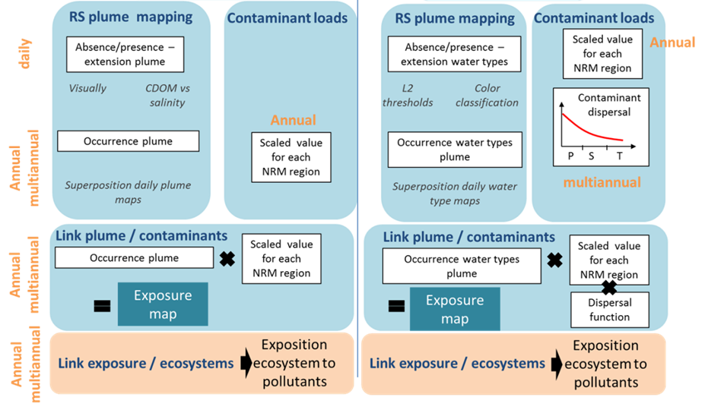
Figure 6-5: improvement of the methods used to map the exposure of ecosystems to pollutants: (left) methods used in the previous MMP report assuming that loads are distributed homogeneously across all respective marine regions; (right) improved method integrating spatially distributed pollutants loads. P: primary, S: secondary and T: tertiary water types.

Step 2 - Calculate the spatially distributed DIN and TSS maps
Grids representing the annual average distribution of TSS and DIN delivered by the seven major rivers in the study region were created for each river by multiplying their proportional contribution to the region-wide TSS and DIN loads with a cost-distance grid defining the maximum area of influence and the dispersal of pollutants in the sea (described below). The individual spatially distributed grids (one per river) were then summed to represent the full TSS and DIN load per cell; the overlap of two or more grids defined cells influenced by multiple rivers.
ArcMap Spatial Analyst (ESRI, 2010) was used to create the annual cost-distance grids for each river based on three inputs: source locations (points representing river mouths), a maximum distance (measured from river mouths), and a “cost” grid (representing how easily the pollutants spread in the ocean):
- The maximum distance for each river was calculated based on the volume of the largest flood event of the year (which was assumed to produce the largest plume) and the estimated extents of studied river plumes.
- The cost surface (a grid defining the “cost” per unit distance or impedance to move planimetrically through each cell) was calculated independently for TSS and for DIN. This was done using the maps representing the annual average water-type value for each pixel and functions estimating the relationships between the water types and the TSS and DIN contaminants.

Step 3: Calculate exposure by combining the frequency and the spatially distributed DIN and TSS maps
Finally, to create the final maps of exposure, the annual frequency of plume occurrence grid and the grid representing the sum of spatially distributed TSS and DIN loads for all rivers were multiplied. We grouped exposure values in five categories of exposure (from very low to very high) to investigate spatial variation in exposure.

Methods used are explained in details in Álvarez-Romero et al., 2013. The exposure maps were calculated using the frequency and average water-type maps computed from the true colour images (qualitative approach). Note that we aim to produce exposure maps from the quantitative supervised methodology as soon as the level 2 thresholds will be validated (Figure 6-6). We will then be able to compare and assess the best methodology to improve the mapping of exposure of GBR ecosystems to anthropogenic water quality influences.

Figure 6-6: methods used for the production of the exposure maps. Steps include: (1) the production of annually averaged water type maps (through the qualitative or quantitative methods), (2) the production of maps of spatially distributed pollutants or scaled load maps and, (3) the multiplication of the annual frequency maps by the annual scaled load maps.

Long-term exposure maps to pollutants (qualitative method)
Annual exposure maps are useful to identify the year to year variation of the surface exposure categories but it can also be useful to develop a long-term surface exposure map that can identify the areas that are influenced strongly by the movement of surface pollutants calculated over a longer term basis. Annual exposure maps were overlaid and the pixel for each category was reclassified using the median pixel of the overlaid imagery. The median value of each pixel is identified as the “recalculated” exposure value for the long-term exposure map (Table 6.1).

Table 6-1: The median value of each exposure category against the reworked median value.
Annual Exposure - 5 categories
 | Median (Value) | Equ-distant score
Very Low | 0 | 0.2
Low | 0.201 | 0.4
Moderate | 0.401 | 0.6
High | 0.601 | 0.8
Very High | 0.801 | 1

The median data was then classified (to represent the colour/exposure classes over three categories) using Jenks' Natural Breaks.

Exposure of GBR and marine ecosystems to plumes and pollutants (TSS and DIN) (from the qualitative outputs).
The exposure of GBR and marine ecosystems GBR is expressed simply as the area (km²) and/or percentage (%) of GBR marine park, coral reefs and seagrass meadows exposed to different categories of plume frequency or exposure categories for TSS and DIN. The marine boundaries used for the GBR Marine Park and each NRM region are those accepted officially by the Great Barrier Reef Marine Park Authority.

Using the 2011-12 map of frequency of occurrence of plumes created from the qualitative method the areas and percentage of the GBR Marine Park, seagrass beds, and coral reefs exposed to different categories of plume frequency were calculated for the whole GBR and within each regional area.

Using the annual exposure maps, the spatial and temporal (2007-2011) variability in exposure of marine ecosystems to pollutants was quantified in two ways (Álvarez Romero et al., 2013). First, the total GBR area in each exposure class for TSS and DIN was calculated. Second, the area of coral reefs and seagrass beds affected by different exposure categories were calculated. This analysis was undertaken for each year and the variation in total area and affected areas of these ecosystems was plotted to analyse variation through time. The total area and the affected area of the selected ecosystems under different exposure categories to TSS and DIN were compared between years to understand inter-annual variability in exposure in relation to estimated loads.
Finally, using the multi-annual exposure maps the areas (km²) of the GBR Marine Park, exposed to 3 reclassified categories of TSS and DIN exposure were calculated.

Results
Our team has been developing methods and maps to identify and map the exposure of GBR ecosystems to plumes and anthropogenic water quality influences (nutrients, sediments). Results will be presented as a series of maps and tables.

Movement and frequency of flood plume waters in GBR
Using remote sensing tools and GIS processing, we can track the movement of GBR river plumes over the wet season (December to April, inclusive), where the areal extent of surface plume waters moved from zero to along the whole length of the GBR at different periods of the wet season.
The movement of the Herbert River and Burdekin plume, as identified by true colour images, is depicted in Figure 6-7. The six images represent the movement of visible plume water through the months of January 2011 to April 2012. These series of true colour images illustrate the highly dynamic affecting the Herbert and Tully river plumes. Both are highly reactive system mainly controlled by the modulation of river discharge rates. Wind conditions primarily modulate the shape and orientation of plumes. We observe that western winds promote plumes advection on the continental shelf. When the river discharges are high and the plume well developed, this wind orientation increase the size of the plume and plumes can reach the coral reef.

6.4.3 Annual frequency of occurrence of plumes
The frequency of river plume computed from the qualitative and quantitative methods provides clear, visual information on the plume extent (Figure 6-8a, b). Note that this mapping exercise only identifies the surface plume waters and is not identifying scale or extent of impact.
Applying the two different methods gives similar outcomes in the lower part of the map, but different in the upper areas of the GBR (Figure 6-8). In general, tendencies are similar with the two methods even if exposure levels are lower when using the L2 thresholds. This is particularly true in the Northern half of the GBR (Tully to Cape York) where we have: (i) high to very high exposure levels with the true colour classification (a) and, low to moderate exposure levels with the L2 thresholds (b). These differences may result from differences in plume composition between the Wet and Dry tropics region or indicate that the L2 algorithms do not work well in Cape York. This is a shallow area with coral reefs and seagrass beds close to the coast and current algorithms seem to be failing in these waters. Further work is currently planned to increase sampling within Cape York marine waters to test and update the available algorithms. We are further investigating the thresholds and L2 products of the quantitative method through in-situ and satellite match-up and validation over different average-to-extreme climatic conditions (Petus et al., in review).

Figure 6-7: comparison of extents of Herbert and Burdekin riverine flood plumes as measured by MODIS true colour imagery during the main flood events of 2011 and 2012. Wind orientations measured at 9 am and 3pm in 2012 are indicated with white arrows and the locations of the Burdekin (B) and Herbert (H) rivers with red dots.
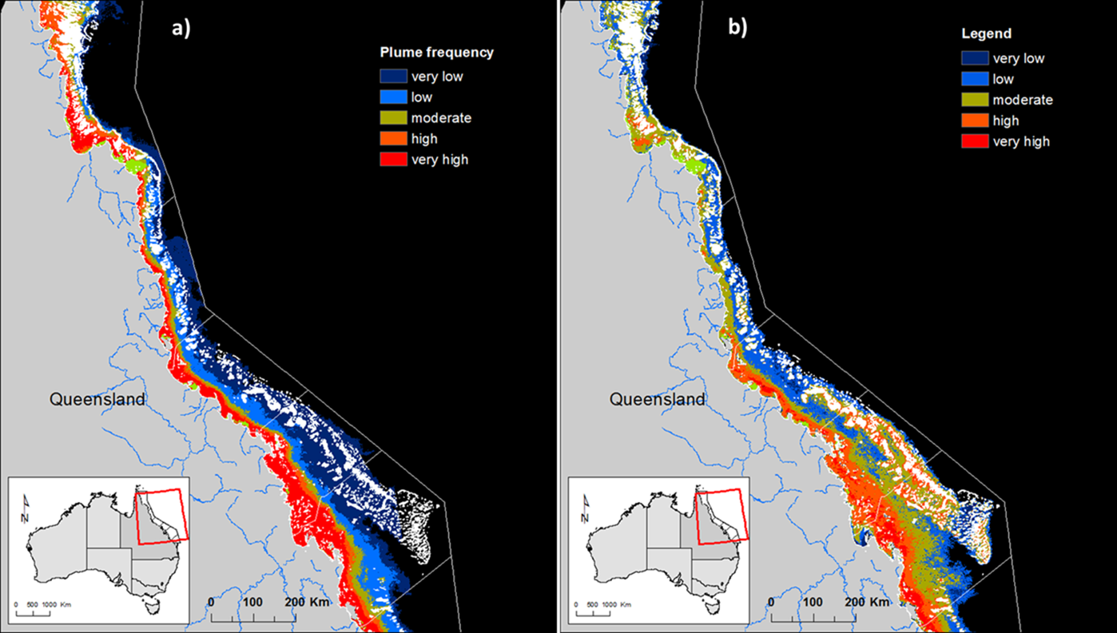
Figure 6-8: Extent and frequency of plume waters during the 2011-2012 wet season: a) true colour classification (qualitative method), b) L2 classification (quantitative method). Each mapped plume image is overlaid within GIS software to identify the areas of high frequency. Risk categories are defined by a “Natural Break (or Jenks)” classification: very Low: 1 to 3 weeks (1 to 21 days); Low: 4 to 7 weeks (22 to 49 days); moderate: 8 to 12 weeks (50 to 84 days); high: 13 to 17 weeks (85 to 119 days); very high: 18 to 22 weeks (120 to 154 days)

Plume water type maps
Examples of plume waters types (primary, secondary, tertiary) composites computed from the qualitative and quantitative methods are presented in Figure 6-9, Figure 6-10 and Figure 6-11. Applying the two different methods gives similar outcomes as illustrated by the weekly water type composite grouping daily data from the 29th of March to 4th of April (Figure 6-9a, b).

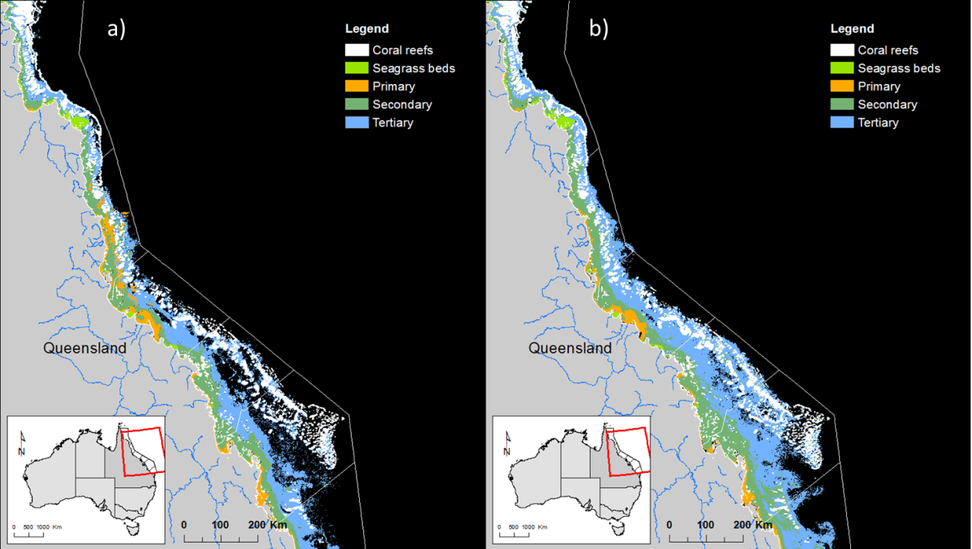

Figure 6-9: Comparison between 2012 weekly water type composites computed from a) the qualitative approach, and b) the quantitative approach. Weekly composites encompass data from the 29th of March to the 4th of April.

Flood plume water types over weekly (Figure 6-10) and annual (Figure 6-11) time scales provides synoptic information in monitoring the water quality conditions of GBR coastal waters. Figure 6-10 presents the weekly secondary plume surfaces mapped for the Tully-Herbert marine region over the 2011-12 wet season. Identifying the full extent of these secondary waters on weekly basis provides recurrent production maps (i.e., areas with mean chl-a = 1.3±0.6 μg L⁻¹; Devlin et al., in press), and identifies the area in which high phytoplankton biomass production are likely to occur during the variable wet season conditions. Figure 6-11a indicates the type/composition and frequency of plume waters types (primary, secondary, Tertiary) affecting the different NRMs (from the coast to offshore). Note that this mapping exercise only identifies the surface water types and is not identifying scale or extent of impact. Coastal waters of the Burdekin NRM are frequently affected by primary water type (i.e. sediment dominated waters, Figure 6-11b), while the Mackay-Whitsunday Figure 6-11c or Northern Wet Tropics NRMs are dominated by the secondary water types. Tertiary waters (CDOM dominated) are logically located offshore and constitute the transitional waters between plume-affected and ambient water.

Figure 6-10: Weekly secondary plume maps for the Tully-Herbert marine region.

Annual surface exposure to pollutants
Exposure maps have been produced over the 2007 to 2011 wet seasons (Álvarez-Romero et al., 2013 and Figure 6-12). The final surface exposure map presents the full extent of the plume but with the dispersal patterns of the surface pollutants identified to five main classes of surface exposure (very high, high, moderate, low and very low). Note that Cape York is not included as the exposure maps prior to 2011 do not have validated imagery from north of Cooktown. Further sampling in the Far North is a priority of both marine monitoring and remote sensing validation.
Overall, we observed that the area estimated to be under major influence of DIN is larger than that under major influence of TSS (see for example the Fitzroy NRM in 2010-11; Álvarez-Romero et al., 2013), which reflects the expected rapid deposition of sediment in areas near river mouths (Bainbridge et al., 2012).

Figure 6-11: Frequency of occurrence of plume water types (primary, secondary and tertiary) measured over the 2011-12 wet season: a) whole GBR, b) Burdekin NRM and c) Mackay-Whitsundays NRM.

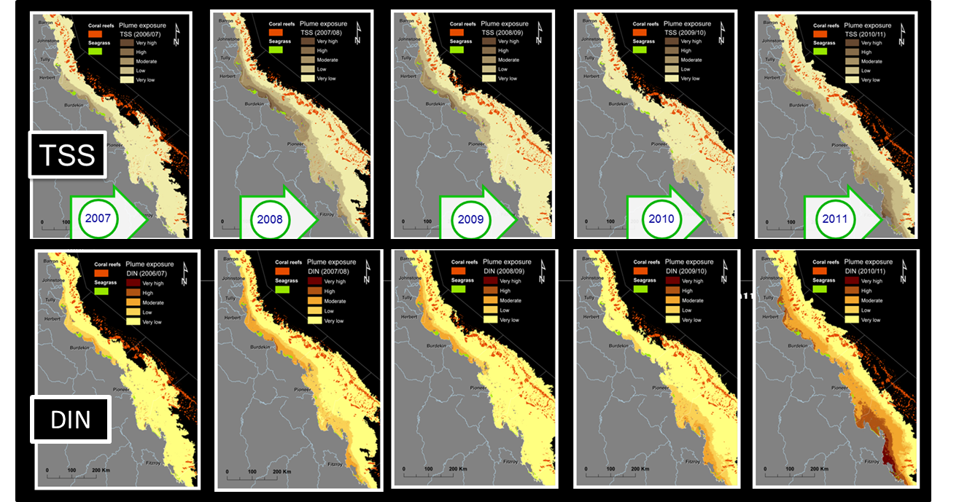
Figure 6-12: Surface exposure maps for TSS and DIN.

Long-term surface exposure to pollutants
Recalculating the annual exposure maps to a long-term exposure map is useful to show all areas which have been exposed to surface plumes. Generally, an inshore to offshore spatial pattern is present for exposure to both DIN and TSS, with inshore areas within 20 km of the coast most likely to experience frequent flood plume water inundation as well as DIN and TSS exposure, and offshore areas rarely experiencing flood plume waters (Figure 6-13).
Figure 6-13: Long-term surface exposure map for (a) TSS and (b) DIN in the GBR, excluding Cape York. Long-term values are calculated from overlaying the annual exposure maps and combining the five category system into a three class system

Exposure of GBR and marine ecosystems to plumes and pollutants (TSS and DIN)

Exposure of GBR and marine ecosystems to plumes during the 2011-12 wet season
The frequency map obtained from the true colour classification (Figure 6-8a) was used to described GBR plume extent and frequency over the surface of coastal ecosystems. The cumulative area for plume waters discharging from the Burdekin, Fitzroy and all the Wet Tropics Rivers is shown in Figure 6-8a with a maximum area of greater than 218,000 km² i.e., 63% of the GBR (Error! Reference source not found.) However, the actual area within the high to very high frequency category (13 to 22 plume extents, aggregated weekly, for the period from December to April) is a much lower total area (66,870 km²), ranging from 2,672 km² in Burnett-Mary to 24,721 km² in Cape York (Table 6-3). The largest area of coral reefs that has experienced high to very high frequency of flood plumes is Cape York (2,557 km² or 24% of the Cape York reefs) and Mackay-Whitsundays (266 km² or 8% of the Mackay-Whitsundays reefs). The largest area of seagrass to experience these high – very high frequency of flood plumes is Cape York (2,355 km² or 95.1 % of the Cape York reefs) and Burdekin (581. km² or 99.9% of the Burdekin reefs). While seagrass beds are less extended in Burnett-Mary, Fitzroy Mackay-Whitsunday and Wet Tropics (< 230 km²) more than 96% of the seagrass meadows in these NRM have experienced very high frequency of flood plume. It is the intersection of the frequency and movements of flood plumes, the proximity of the ecosystems and the load dispersal that control the exposure and risk of ecosystem to river plumes.

Table 6-2: Areas (km²) and percentage (%) of the GBR, seagrass beds, and coral reefs exposed to different categories of surface plume frequency.
 | Area (km²) |  | Plume frequency Category |  |  |  |  | Tot reached | Tot not reached
 | Area (km²) |  | Very low | Low | Medium | High | Very high | Tot reached | Tot not reached
GBR | 349330 | area | 83684 | 43820 | 24532 | 21696 | 45174 | 218906 | 130424
GBR | 349330 | % | 24% | 13% | 7% | 6% | 13% | 63% | 37%
Coral reef | 24377 | area | 11319 | 5229 | 2877 | 1965 | 1185 | 22575 | 1802
Coral reef | 24377 | % | 46% | 21% | 12% | 8% | 5% | 93% | 7%
seagrass | 3758 | area | 4 | 2 | 118 | 507 | 3121 | 3751 | 7
seagrass | 3758 | % | 0% | 0% | 3% | 13% | 83% | 100% | 0%

Table 6-3: Areas (km²) and percentage (%) of the (a) GBR, (b) seagrass beds, and (c) coral reefs exposed to different categories of surface plume frequency within each regional area.
a) Plume
Region | Area (km²) |  | Plume frequency  Category |  |  |  |  | Tot reached | Tot not reached
Region | Area (km²) |  | Very low | Low | Medium | High | Very high | Tot reached | Tot not reached
Burdekin | 46785 | area | 14231 | 7885 | 1873 | 1448 | 5961 | 31397 | 15387
Burdekin | 46785 | % | 30% | 17% | 4% | 3% | 13% | 67% | 33%
Burnett-Mary | 36633 | area | 3469 | 4169 | 1370 | 1058 | 1614 | 11680 | 24953
Burnett-Mary | 36633 | % | 9% | 11% | 4% | 3% | 4% | 32% | 68%
Cape York | 99772 | area | 11590 | 9661 | 11632 | 14412 | 10309 | 57603 | 42169
Cape York | 99772 | % | 12% | 10% | 12% | 14% | 10% | 58% | 42%
Fitzroy | 85032 | area | 21326 | 10890 | 5086 | 2742 | 11735 | 51780 | 33252
Fitzroy | 85032 | % | 25% | 13% | 6% | 3% | 14% | 61% | 39%
Mackay-Whitsunday | 48329 | area | 22519 | 4061 | 1774 | 2037 | 11834 | 42225 | 6104
Mackay-Whitsunday | 48329 | % | 47% | 8% | 4% | 4% | 24% | 87% | 13%
Wet Tropics | 32170 | area | 10549 | 7154 | 2798 | 2069 | 3721 | 26291 | 5879
Wet Tropics | 32170 | % | 33% | 22% | 9% | 6% | 12% | 82% | 18%
b) Coral Reef
Region | Area of coral reef (km²) |  | Plume frequency  Category |  |  |  |  | Tot reached | Tot not reached
Region | Area of coral reef (km²) |  | Very low | Low | Medium | High | Very high | Tot reached | Tot not reached
Burdekin | 2951 | area | 2397 | 390 | 0 | 22 | 38 | 2847 | 104
Burdekin | 2951 | % | 81% | 13% | 0% | 1% | 1% | 96% | 4%
Burnett-Mary | 276 | area | 44 | 224 | 3 | 1 | 4 | 276 | 0
Burnett-Mary | 276 | % | 16% | 81% | 1% | 0% | 1% | 100% | 0%
Cape York | 10747 | area | 2602 | 3034 | 2545 | 1882 | 675 | 10738 | 9
Cape York | 10747 | % | 24% | 28% | 24% | 18% | 6% | 100% | 0%
`Fitzroy | 4784 | area | 2566 | 231 | 128 | 29 | 168 | 3122 | 1662
`Fitzroy | 4784 | % | 54% | 5% | 3% | 1% | 4% | 65% | 35%
Mackay-Whitsunday | 3178 | area | 2868 | 25 | 8 | 31 | 235 | 3167 | 11
Mackay-Whitsunday | 3178 | % | 90% | 1% | 0% | 1% | 7% | 100% | 0%
Wet Tropics | 2441 | area | 842 | 1325 | 193 | 15 | 65 | 2440 | 1
Wet Tropics | 2441 | % | 34% | 54% | 8% | 1% | 3% | 100% | 0%
c) Seagrass
Region | Area of seagrass (km²) |  | Plume frequency  Category |  |  |  |  | Tot reached | Tot not reached
Region | Area of seagrass (km²) |  | Very low | Low | Medium | High | Very high | Tot reached | Tot not reached
Burdekin | 582 | area | 0.2 | 0.3 | 0.2 | 2.1 | 579.0 | 582 | 0
Burdekin | 582 | % | 0.0% | 0.0% | 0.0% | 0.4% | 99.5% | 99.9% | 0.1%
Burnett-Mary | 64 | area |  | <0.01 |  |  | 63.7 | 64 | 0
Burnett-Mary | 64 | % | 0.0% | 0.0% | 0.0% | 0.0% | 100.0% | 100.0% | 0.0%
Cape York | 2475 | area | 3.0 | 1.6 | 115.2 | 500.8 | 1854.6 | 2475 | 0
Cape York | 2475 | % | 0.1% | 0.1% | 4.7% | 20.2% | 74.9% | 100.0% | 0.0%
Fitzroy | 221 | area | 0.2 | 0.0 |  | 1.1 | 220.1 | 221 | 0
Fitzroy | 221 | % | 0.1% | 0.0% | 0.0% | 0.5% | 99.4% | 100.0% | 0.0%
Mackay-Whitsunday | 229 | area | 0.5 | 0.1 | 1.3 | 2.7 | 223.8 | 228 | 1
Mackay-Whitsunday | 229 | % | 0.2% | 0.0% | 0.6% | 1.2% | 97.7% | 99.7% | 0.3%
Wet Tropics | 187 | area | 0.0 |  | 1.4 | 5.7 | 179.8 | 187 | 0
Wet Tropics | 187 | % | 0.0% | 0.0% | 0.7% | 3.0% | 96.1% | 100.0% | 0.0%

Spatial and temporal variation in the exposure of GBR and marine ecosystems to pollutants (TSS and DIN) over the 2007 to 2011 wet seasons (Álvarez-Romero et al., 2013).
Coastal-marine habitats (coral reefs and seagrass beds) exhibited a range of exposures to DIN and TSS (Figure 6-14), reflecting the differences in the dispersal of pollutants and the locations of the habitats. The area under moderate to high exposure to DIN was larger than that for TSS across all studied wet seasons. Data for 2011, a wet season in which record discharges occurred, illustrated the degree of exposure that can be expected under extreme weather conditions (Devlin et al., 2012a), also manifested in the very extensive plumes within GBR coastal and offshore waters during this wet season (Figure 6-14).

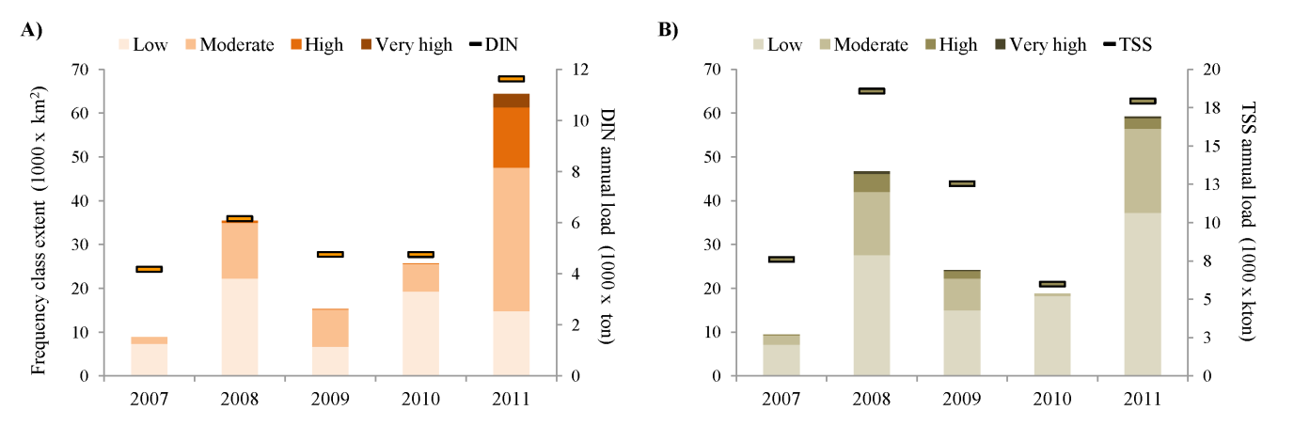
Figure 6-14: Inter-annual variation in total area under different DIN/TSS exposure categories. A) Variation in exposure to DIN. This graph shows the large area under high exposure categories during 2011 (greatly influenced by the Fitzroy River: B) Variation in exposure to TSS; in contrast to DIN, the largest area under high TSS exposure categories occurred during 2008 (in this case, largely driven by the Burdekin River). In both graphs the horizontal bars connected by short horizontal bars correspond to the estimated loads of DIN (A) and TSS (B) for each wet season.
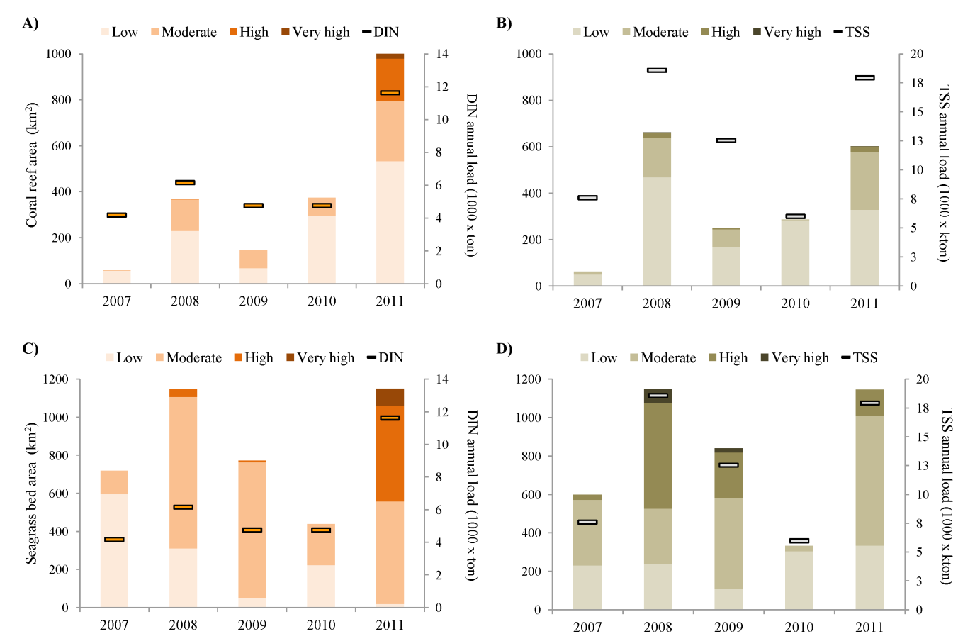

Figure 6-15: Inter-annual variation in exposure of coral reefs and seagrass beds to DIN (A and C, respectively) and TSS (B and D, respectively). The exposed difference in exposure of habitats to TSS and DIN can be explained by their proximity to the coast, their location in relation to rivers contributing to the DIN load, and the estimated dispersal of both pollutants. In both graphs the horizontal bars connected by short horizontal bars correspond to the estimated loads of DIN (A and C) and TSS (B and D) for each wet season.

Also worth noting are the differences in exposure of different habitats to DIN and TSS in response to the natural distribution of these habitats, as well as to the differences in the movement of pollutants. Overall, seagrass beds were commonly under higher exposure categories for both TSS and DIN, and most coral reefs were under low exposure categories, particularly for TSS. An assessment of the variation in area covered by plumes (Figure 6-14) and the number of mapped coral reefs and seagrass beds in each marine region (Figure 6-15). We found strong inter-annual variation in the area under exposure of the two modelled pollutants (Figure 6-14). Differences in exposure were related to the sources of pollutants, and thus were strongly influenced by the proportional contributions of the different rivers to annual region-wide loads. The area of coral reefs and seagrass beds potentially affected by TSS and DIN exposure also varied considerably, with maximum numbers of coral reefs affected in 2011. TSS exposure was high in both 2008/9 and 2010/11. While the exposed area can be large, the area influenced by high to very high exposure categories was a small component for both DIN and TSS, with the exception of DIN in 2011. As previously stated, the load data for 2012 are not yet available. Revised surface exposure of pollutants for this 2012 wet season will be presented once the annual load data for TSS, DIN has been finalised.

Long-term exposure of GBR to pollutants (TSS and DIN)
Surface exposure mapping identifies 22,149 km² of the GBR Marine Park that is exposed to flood plumes carrying high DIN loads (i.e., areas classified as ‘‘high’’ exposure to DIN) since 2006 (Error! Reference source not found.). Surface exposure mapping identifies 5,860 km² of the GBR Marine Park that is exposed to flood plumes carrying high TSS loads (i.e., areas classified as ‘high’ exposure to TSS) since 2006 (Table 6-4).

Table 6-4: Normalised surface flood exposure data for DIN and TSS and recalculated area of exposure for the three classes only.
Median value | Exposure | Area exposed
DIN (µM)
0 – 0.05 | low | 113,692 km²
0.05 – 0.15 | medium | 41,510 km²
0.15 – 0.6 | high | 22,149 km²
TSS(mg/L)
0 – 0.5 | low | 134,750 km²
0.05 – 0.15 | medium | 36,743 km²
0.15 – 0.7 | high | 5,860 km²

It should nevertheless be emphasized that the 5-year period covered by the long-term exposure maps has been characterized by extreme weather events, with above median flows in many Great Barrier Reef Rivers. Record flow conditions were particularly measured for 2010-11 where a combination of three cyclones produced record flows in nearly all GBR rivers, particularly in the southern half of the GBR. The areas exposed to DIN and TSS in Figure 6-13 are thus representative of extreme weather conditions.

Discussion and conclusions

Overview
River plume models underlie areas which may experience acute or chronic high exposure to river plume and pollutants. Knowledge of the areas and the type of ecosystem that is the most likely to be impacted by changing water quality help focusing our understanding on what type of ecological impacts are occurring to those systems and help marine, coastal and catchment management. As part of our efforts for the MMP in 2011-12, we have undertaken a number of important steps to improve our capacity to identify and monitor the exposure of GBR ecosystems to plumes and anthropogenic water quality influences (nutrients and sediments). These steps include the development of new innovative RS methods, the production of synoptic maps describing the spatial and temporal movements of GBR river plumes and pollutants (TSS and DIN) discharged through plumes, and the evaluation of the exposure of GBR ecosystems to plumes waters, TSS and DIN.

Methods:
We have achieved:
- The development of a semi-automated qualitative method to delineate plumes (full extent) and plume water types (primary, secondary, tertiary) using MODIS true color images (qualitative method);
- The exploration of an automated supervised quantitative method to delineate plumes and plume water types using MODIS L2 data and water quality thresholds (quantitative method). Our efforts to improve this quantitative method are continuing (Petus et al., in review);
- The development of an innovative satellite method to map the exposure of GBR ecosystems to TSS and DIN (Álvarez-Romero et al., 2013). This method incorporates outputs from the qualitative method and spatially distributed load data to produce TSS and DIN exposure maps (Álvarez-Romero, 2013) from 2007 to 2011 (2012 load data are not yet available at the time of this report).
MODIS images, offer frequent (daily) and synoptic (whole GBR scale) pictures of GBR coastal environments and thus can help with identification and mapping of GBR river plumes. Two families of supervised classification methods based on MODIS data have been investigated to map marine areas exposed to freshwater and the different plume water types: a true-color or qualitative method based on supervised classification of spectrally enhanced MODIS true colour images, and a L2 or quantitative method using threshold values on MODIS images calibrated into water quality proxies (TSS CHL, CDOM proxies) for delineating surface plume boundaries. Both methods present advantages and disadvantages: the true colour method offers a simple and objective method by clustering the information contained in MODIS true-colour composites (Red–Green–Blue bands), but relies on non-atmospherically corrected data, and usually the spectral signature used to classify images does not incorporate potential temporal and spatial variability. The L2 threshold method assume fixed WQ value/level/concentration thresholds and thus also ignores potential temporal and spatial variability, but does account for atmospheric correction. In addition, this method offers valuable quantitative information, such as the concentration of CDOM, TSS, or chl-a that are not directly available through the clustering of the true-colour composites (Petus et al. in review). Outputs from the qualitative method were further used in combination with pollutant load data and dispersal functions for pollutants from the coast to offshore to model the exposure of GBR marine ecosystems to land-based contaminants. Automated (or semi-automated) methods developed in this MMP project reduce human error originated from visual mapping (previous reports) and limit the time of processing.
Further development of the true color (quantitative) method include: (i) validate the method. This will be done through comparison between remote sensing derived products and in-situ water quality data. For example, comparison between the TSS and DIN annual exposure maps and in-situ TSS and DIN data is currently undertaken. First results are encouraging as they show a good agreement between exposure levels and pollutant concentrations measured in-situ over multi-annual time period. (ii) Produce annual exposure maps of Photosystem II inhibiting herbicides (PSII herbicides). The approach for modelling exposure to DIN (i.e., assuming conservative mixing) will be used for PSII. However, further investigation will be necessary to adjust the dispersal relationships i.e., relationship between PSII concentrations and color classes (see Figure 3 of Álvarez-Romero et al., 2013) to calculate the annual cost surface for PSII. (iii) Increase the spatial resolution of water quality data used to calculate the spatially distributed DIN and TSS maps. In his present form, the true color method use annual loads of TSS and DIN from seven major rivers draining into four selected NRMs to calculate their proportional contribution to the total pollutant load. Increase the spatial resolution of these data would increase the precision of the mapping. One solution would be to re-run the model with the annual loads from the Source Catchments modelling for all of the 35 GBR catchments. This would nevertheless require establishment of dispersal relationships for the additional rivers and might require non-negligible processing time and effort to automate processing steps as much as possible. Work is also currently undertaken to refine the thresholds and L2 parameters used in the quantitative method through in-situ and satellite match-up (Petus et al., in review). Validation of this method over different average-to-extreme climatic conditions will be undertaken as described above.

Mapping outputs:
Mapping outputs that can be produced from the RS method developed include:
- River plume maps (full extent) and composites at different temporal (daily, annual, multi-annual) and spatial (GBR, NRM, River) scales. These maps are created from both true colour images (qualitative method) and through Level 2 products (qualitative method);
- Plume water type maps (primary, secondary, tertiary) and composites at different temporal (daily, weekly, annual) and spatial (GBR, NRM, River) scales. Maps are created from both qualitative and quantitative methods;
- The development of annual and multi-annual exposure maps (2007-2011) to TSS and DIN. Maps are created from the qualitative method.
A selection of significant mapping outputs are presented in this report and include river plume (full extent) and plume water type annual frequency maps as well as exposure (TSS and DIN, annual and multi-annual time scale) maps. The plume frequency maps illustrate the movement of riverine waters (Figure 6-8), but do not provide information on the composition of the water and water quality constituents. Plume water types are associated with different levels and combination of pollutants and the plume water type maps help clustering WQ stressors into three broad categories of risk (Figure 6-9). Further information on the respective constituents of the plume waters, in particular the respective movement of sediment and dissolved inorganic nitrogen through the exposure mapping exercise (Figure 6-12), allows us to further understand the potential movements of pollutants which are carried within the plume water. Finally, integrating the annual exposure maps into a long-term exposure map based on three categories of exposure (high, medium, low) provides a simple overview of surface exposure over time for TSS and DIN (Figure 6-13).
Extent and frequency of plume water types reflects the intensity, duration and constituent concentrations of the river discharge and are strongly linked to the catchment hydrology and land use practices. For example, the two larger catchments over the GBR, that are under extensive agricultural development (i.e. Burdekin [Figure 6-11b] and Fitzroy which have greater than 80% of area utilised for agriculture), are associated with a larger area of turbid primary waters (e.g. Devlin et al., 2003; Maughan and Brodie, 2009; Brodie and Waterhouse, 2009; Devlin and Brodie, 2005; Devlin et al., 2011). Inversely, the dominance of secondary water types (plume water with reduced TSS concentration) in the Mackay-Whitsunday (Figure 6-11c) or Northern Wet Tropics NRMs is in agreement with previous studies describing elevated concentrations of DIN to fertilised agriculture (predominantly sugarcane) in the Wet Tropics and Mackay Whitsunday regions. Tertiary waters (CDOM dominated) are logically located offshore and constitute the transitional waters between plume-affected and ambient water.
Spatial variability in pollutant exposure is further validated by the TSS and DIN exposure maps (annual or inter-annual scale; Figure 6-12 and Figure 6-13). Results from the surface exposure confirm that the area between Townsville and Port Douglas experiences high exposure to surface DIN. Areas adjacent to the dry tropical rivers that is, the Burdekin and Fitzroy Rivers are exposed to high TSS values, most likely associated with grazing activities in adjacent catchments.
At a smaller time scale (weekly time scale; Figure 6-10), the area of secondary flood plume types (i.e., areas with mean chl-a = 1.3±0.6 μg L-1; Devlin et al., in press) identifies the area in which high phytoplankton biomass production are likely to occur. The location and extent of the secondary plume waters are influenced by the onset of the primary plume through the river discharge and the local climatic and hydrodynamic conditions, mainly controlled by the magnitude and direction of wind stress (Dzwonkowski and Yan, 2005; Petus et al., in review b), tides (e.g. Valente and da Silva, 2006), bathymetry (e.g. Lee and Valle-Levinson, 2012) and Coriolis force (Geyer et al. 2004). Mapping the annual frequency of the secondary water type (Figure 6-11, centre panel) gave a qualitative estimate of the area where high concentrations of chl-a have occurred during the 2011-12 wet season. This data can be used as a baseline for ongoing investigation of impacts of increased nutrient discharges into Great Barrier Reef waters. These include the role of altered water column nutrient status on COTS outbreaks and the influence of agriculture and urban coastal settlement on regional water quality (Devlin et al., in press).

Evaluation of the exposure of GBR ecosystems to plumes and anthropogenic water quality influences (nutrients, sediments) from the qualitative method outputs:
We have achieved:

- The evaluation of the exposure of GBR marine protected areas and marine ecosystems (in km2 and %) to plumes during the wet season 2011-2012 using the annual plume frequency map created from the qualitative method;
- The evaluation of the spatial and temporal (2007-2011) variability in exposure of marine ecosystems to TSS and DIN.
- The evaluation of the long-term exposure of GBR marine protected areas to pollutants (TSS and DIN).
A major factor which affects the level of exposure of ecosystems to flood plumes is the distance and direction from the pollutant source. It is the intersection of the frequency and movements of flood plumes, the proximity of the ecosystems and the load dispersal that control the exposure and risk of ecosystem to river plumes and land-based pollutants. Therefore, inshore regions with coral reefs and seagrasses in close proximity to the coast, and particularly river mouths, will experience frequent exposure to flood plumes, e.g. coral reefs offshore of Cairns and Port Douglas. The areas or ecosystems identified as having ‘high’ exposure to plume, TSS and DIN will experience surface plume waters that contain elevated concentrations of pollutants, which may potentially affect ecological processes. Despite elevated concentrations being measured across these exposure areas in periods of high flow, it is not possible to ascribe certainty that be linked to a measurable ecological impact. Exposure, as defined for this project, does not indicate certainty of an ecological impact on the plants and animals present within the plume.
The map of the annual frequency of occurrence of plumes during the 2011-12 wet season build from the qualitative approach (Figure 6-8), was used to describe the spatial variability in the areal extend of plume waters in 2011-12 and described ecosystems affected by river plume waters. The total plume area over the 2011-12 wet season reached 218906 km², i.e., 63% of the GBR Marine Park (Table 6-2). However, the total area within the high to very high frequency category (i.e., affected by plumes 13 to 22 weeks per wet season) was a much lower total area (66870 km², i.e., 19% of the GBR Marine Park), ranging from 2672km² (i.e., 7%) in Burnett-Mary to 24,721km² (i.e., 24%) in Cape York (Table 6-3). The largest area of coral reefs that has experienced high to very high frequency of flood plumes was Cape York (2557 km² or 24% of the Cape York reefs) and Mackay-Whitsundays (266 km² or 8 % of the Mackay-Whitsundays reefs). The largest area of seagrass to experience these high to very high frequency of flood plumes was Cape York (2355.4 km² km² or 95.1 % of the Cape York reefs) and Burdekin (581.1km² or 99.9 % of the Burdekin reefs). While seagrass beds are less extended in Burnett-Mary, Fitzroy Mackay-Whitsunday and Wet Tropics (< 230 km²) more than 96 % of the seagrass meadows in these NRM have also experienced very high frequency of flood plume.
TSS and DIN exposure of 2011, a wet season in which record discharges occurred, illustrated the degree of exposure that can be expected under extreme weather conditions (Devlin et al., 2012a). TSS and DIN exposure mapping for 2010-11 identifies up to 5,970 km² and 5,131 km² of the marine areas of the Wet Tropics and Burdekin regions, respectively, which are exposed to flood plumes carrying high DIN loads (i.e., areas classified as “high” or “very high” exposure to DIN). These areas represent 19% and 11% of the total marine portion of the Wet Tropics and Burdekin regions, respectively. Furthermore up to 5,131 km² (11%) of the Burdekin and 7,998 km² (9%) of the Fitzroy regions are classified as “high” to “very high” exposure for TSS. At the time of completion of this report, we have not integrated the 2012 load data required to calculate the surface exposure of the 2012 plume waters and cannot compare the long-term surface exposure mapping with the 2011 area.

Part C: CASE STUDIES

Initiation of phytoplankton sampling in flood plumes

Introduction
Our current state of knowledge reveals key gaps in our understanding of the role of phytoplankton communities in Great Barrier Reef waters, and the potential links to the crown of thorns (COTS) status. What is unknown in this link is if a change in phytoplankton community and/or size structure may play a role in the larval enhancement stage of the COTS life cycle, and if that change has been driven by changing water quality conditions in the Great Barrier Reef. International literature describes the role of phytoplankton size and community composition on the food web structure of all ecosystems (see references in Devlin et al., 2013). Alterations in nutrient stoichiometry, through increased N and P loads can have profound consequences on algal assemblages; nutrients introduced or released during the high flow events are rapidly taken up by pelagic and benthic algae and microbial communities, sometimes fuelling short-lived phytoplankton blooms and high levels of organic production. Increased contemporary concentrations of DIN and sometimes dissolved inorganic phosphorus (DIP) in flood plumes tend to promote phytoplankton species shifts to larger species of diatoms and dinoflagellates within the microphytoplankton community. A major long-term downstream indirect effect of flood plumes is postulated to be the triggering of outbreaks of the coral-eating COTS, which continue to kill more coral on the GBR than any other process. The last three outbreaks of COTS originated north of Cairns, the only part of the main reef track regularly intercepted by flood waters. Each outbreak was first observed 3-5 years after the largest 3 flood events on record. It is now thought that the survival and growth of the larvae of COTS increases with increasing concentrations of large phytoplankton, e.g. after large flood events.
A number of eutrophication indicators have been discussed that relate specifically to potential changes in the Great Barrier Reef (Fabricius et al. 2012; Cooper et al. 2007). These include:
- Presence of green water for days to weeks after peak flow events (Devlin and Brodie 2005).
- Changes in phytoplankton biomass as measured by increased chlorophyll a (Brodie et al. 2007).
- Increase in filter feeding organisms, particularly bio-eroding sponges and tubeworms (Fabricius 2005; Hutchings et al. 2005; Fabricius et al. 2012).
- Change in foram communities (Uthicke et al. 2012).
- Change in coral colour (e.g., Porites sp.; Cooper et al. 2012).
The nutrients introduced or released during flood events are rapidly taken up by pelagic and benthic algae and microbial communities (Alongi and McKinnon 2005), sometimes fuelling short-lived phytoplankton blooms and high levels of organic production (Furnas 1989; Furnas et al. 2005, 2011). This organic matter is cycled through the marine food web and transformed, e.g. into marine snow particles that may be deposited on to benthic communities, such as coral reefs, and can influence their structure, productivity, and health for long periods. Such cycling of organic matter ultimately uncouples event-driven inputs of nutrients from their long-term ecosystem effects (see for example, Anthony and Fabricius 2000; Fabricius and Wolanski 2000; Fabricius et al. 2003). Further, Brodie et al. (2005) and Fabricius et al. (2010) both identify enhanced nutrient supply in river run-off as critical for enhanced A. planci larval survival, a scenario linked to Lucas (1982), who hypothesized that A. planci suffer high levels of larval starvation in the absence of phytoplankton blooms.
Thus for the GBR it was suggested that only in periods of nutrient enrichment was phytoplankton likely to have sufficient biomass and be of the correct cell type and size to support COTS larvae to a successful settlement status (Brodie 1992). Agricultural and urban development of the GBR catchment has increased delivery of nutrients (N and P) to the GBR by several times and this delivery has occurred in pulses during wet season runoff events (e.g. Furnas 2003), resulting in large phytoplankton blooms (Devlin and Brodie 2005). Brodie et al. (2005) suggested that this increase in frequency and concentration of nutrient pulses, and hence, increased occurrence of large phytoplankton blooms, are the factors which allowed COTS outbreaks to occur. The area offshore from Cairns, where each of the three waves of COTS outbreaks began, is also known to be the area where nutrient rich river water enters the mid-shelf waters of the GBR on a regular basis (Brodie et al. 2005). The bioavailable nutrients (particularly DIN) causing the phytoplankton blooms in this area are known to be sourced from fertiliser runoff from primarily sugarcane cultivation, in the area between the Burdekin and Barron rivers (Waterhouse et al. 2012). COTS outbreaks seemed to be correlated in time with large discharge events from the Burdekin River and a recent model shows good correlation between the initiation of the waves of COTS outbreaks and high river discharge events in the Burdekin and Wet Tropics region (Fabricius et al. 2010). Further, with increases in river nutrient loads over the last 200 years, Fabricius et al.’s (2010) model shows that COTS outbreaks have likely increased in frequency, from one in 50-80 years to one every 15 years, which may be due to their finding that with every doubling of chlorophyll concentration (up to 3 µg l⁻¹), the odds that A. planci larvae will complete development, from bipinnaria to settlement, increases by a factor of 8.3 (Fabricius et al. 2010). These linkages are set out in Figure 3.2.
Our recent and ongoing work looks at identifying phytoplankton community characteristics through sampling for phytoplankton in flood plume and wet season conditions. At this stage, all analyses are through microscopy and focusing on identification of the larger taxa size. Over the next year, we will work with CSIRO to sample the phytoplankton community through the wet season through both microscopy enumeration, phytoplankton pigments (HPLC) and associated light and environmental conditions
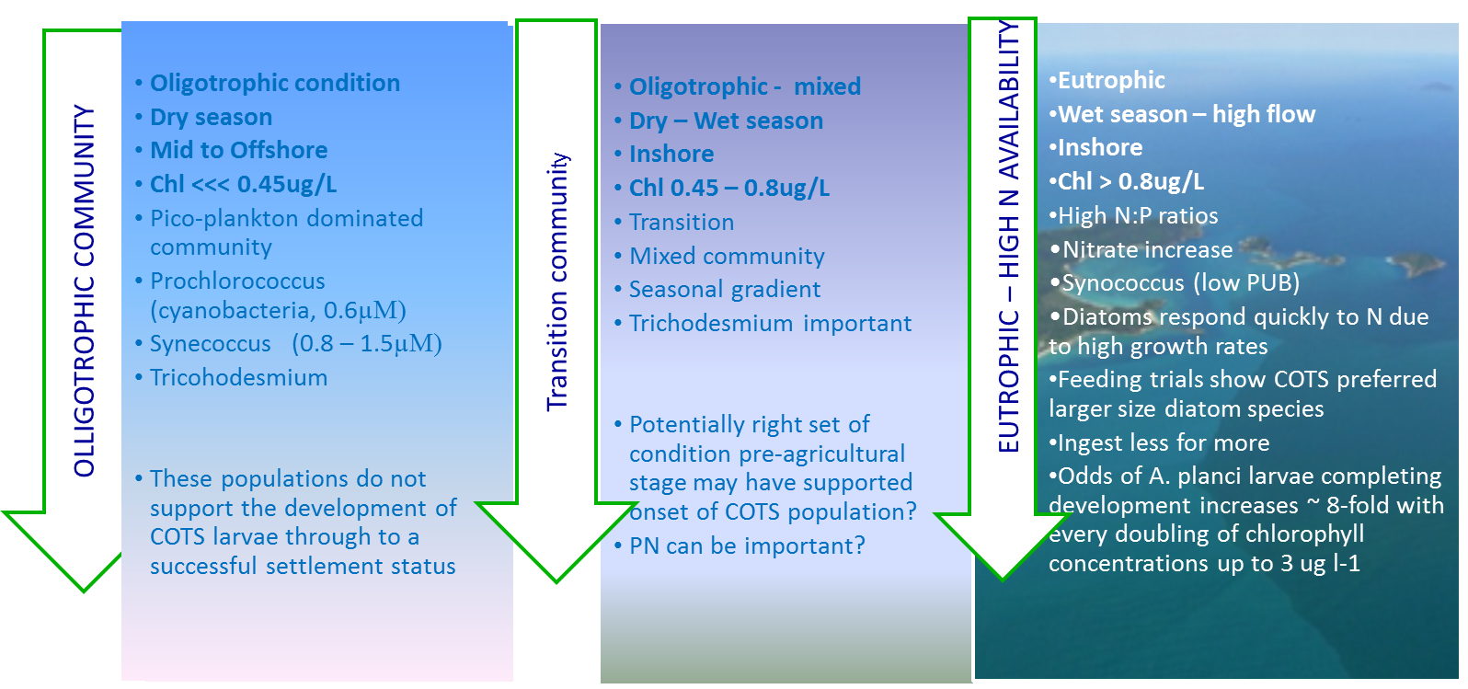
Figure 7-1: Step process through changing water quality conditions and the onset of COTS primary outbreak.

Initial results
Chlorophyll biomass is highly variable in the wet season, particularly after high flow events (Devlin and Schaffelke, 2009). Chlorophyll measurements are highest in the wet season, with over 90% of values exceeding the wet season water quality guideline (GBRMPA, 2009). Mean values calculated over regional areas range from 0.9 to 1.1 ug/L, with high values measured frequently over the Wet and Dry tropics with a high value of 25ug/L recorded in the Fitzroy flood plume in 1991 (Figure 7-2). These high values of chlorophyll biomass potentially represent a shift in the phytoplankton community for days and perhaps weeks after high flow period. This is more clearly seen in the percentage of times that Chl-a biomass has exceeded 0.8ug/L measured against the total number of samples measured within the long-term flood plume program (Table 3.1).
Figure 7-2: Range of chlorophyll values measured in wet season and flood conditions (1991 – 2012)

Table 7-1: Number of samples where concentrations of chl-a have exceeded 0.8ug/L. Sampling period has been calculated from the long-term plume water quality data set (1991 – 2012) currently held within JCU ACRS database (https://eresearch.jcu.edu.au/tdh/data/f31cbf35-2c03-4c6f-a312-2f621b1fc5b5)
River | Sampling No | No times Chl> 0.8ug/L | % exceedance
Barron | 77 | 57 | 74.03
Burdekin | 203 | 107 | 52.71
Burnett | 11 | 5 | 45.45
Daintree | 8 | 4 | 50.00
Fitzroy | 168 | 90 | 53.57
Herbert | 185 | 129 | 69.73
Johnstone | 57 | 30 | 52.63
Kennedy River | 3 | 3 | 100.00
Mossman | 9 | 5 | 55.56
Normanby River | 14 | 7 | 50.00
Pioneer River | 15 | 10 | 66.67
Proserpine River | 79 | 33 | 41.77
Russell-Mulgrave | 168 | 110 | 65.48
Tully | 453 | 236 | 52.10

Between 2010 and 2012, sampling was uneven through the four NRM regions, with the majority of the phytoplankton data collected in the Herbert and Tully regions. However, differences in the regions are most evident between the data collected in Cape York against the abundance and diversity of the phytoplankton data collected in the other three regions (Figure 7-3). These preliminary results suggest that the populations of phytoplankton are different between the far Northern and all other NRM regions; however more data is required before we can fully identify the variation in phytoplankton. There were high concentrations of chlorophyll measured in the Cape York samples so taxa may be dominated by the larger taxa measuring high biomass for small measures of abundance and diversity.
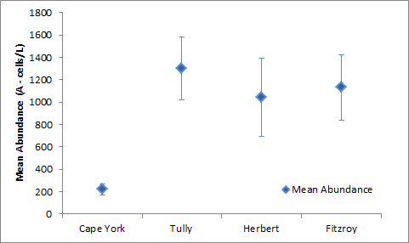
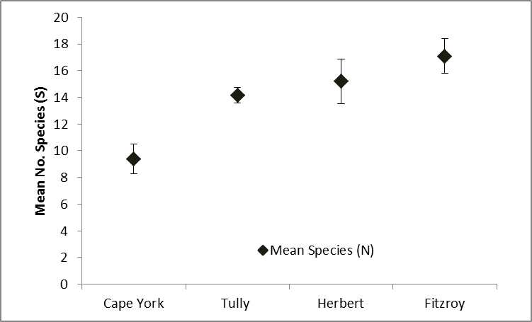

Figure 7-3: Change in abundance and diversity of flood plume phytoplankton data collected over the four NRM regions in the 2010- 12 sampling region.
Initial data suggests abundance (N) and species (S) are highest in the days following a large flood event, and that numbers of taxa can differ significantly between events, due to timing of flow and between catchments (Figure 7-4). Note again, these are very preliminary findings and further data needs to be analysed before a full analysis can be made.
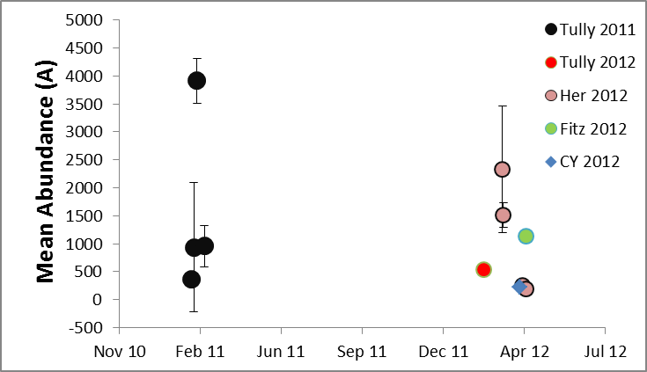
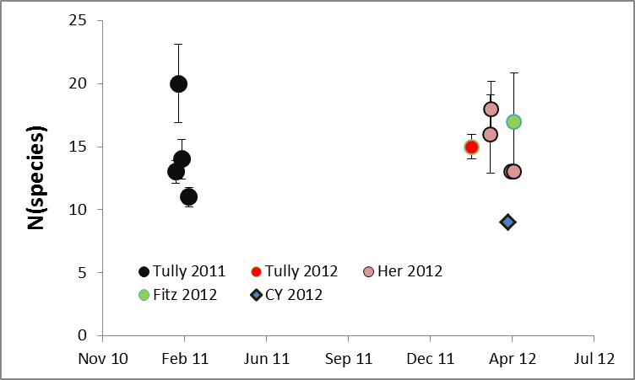

Figure 7-4: Change in abundance and species of phytoplankton taxa within and between events.
Mapping can also be used to define areas of high productivity (Figure 7-5) and allow us to estimate the probability of where high chlorophyll biomass values will occur. This spatial representation of the conditions and understanding how the phytoplankton community can be predicted by the range of chlorophyll biomass can allow a better understanding of the high risk areas for COTS larval enhancement. Mapping of water types (Álvarez-Romero et al., 2013) show a significant correlation between the secondary water type and high values of chlorophyll biomass (> 0.5ug/L). The production maps (Figure 7-5) identify areas which have been exposed to a high frequency of secondary plume water type, and thus to surface waters with high concentrations of Chl-a. The area of high production offshore around Cape Grafton and pushing towards Green Island is also the area identified in the COTS outbreak initiation stage (Brodie et al., 2005 and Fabricius et al., 2010).

Figure 7-5: Areas of high productivity (identified as secondary plume waters above 0.8µg/L). This is calculated for the 2009 period as an example only. Frequency of occurrence is calculated from the count of weekly aggregated maps against the number of times that chlorophyll exceeded 0.8µg/L.
Frequency is calculated from the number of images mapped over each sampling year. Daily images are aggregated into weekly composites to reduce error on a single pixel. The total number of composite images for each year = 22 (weekly from Nov to April inclusive).

The relationship between phytoplankton abundance and diversity is weak (Figure7-6) with no clear link between increasing abundance and increasing diversity. This indicates that the onset of high productivity may be more related to a rapid proliferation of species already within the water column. Thus diversity may be quite stable and it is the increasing proportion of the “right” taxa that drive food web shifts.
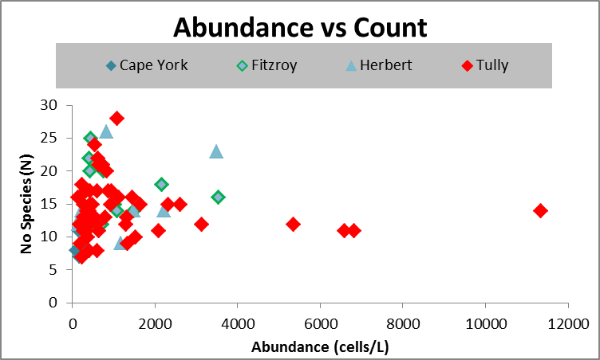

Figure7-6: Plot of the relationship between number of species and the abundance of cells over each sample collected within the 2010-11 period.

Conclusion
Analysing the species composition and size class of phytoplankton associated with various stages of plume development may help provide the missing link between increased nutrient loads, higher nutrient concentrations, changed water quality conditions and possible changes to food web/primary production in GBR waters including COTS outbreaks. Thus it is essential that we have a more enhanced knowledge on the drivers and consequences of changes in water quality and the associated phytoplankton response. A major long-term downstream indirect effect of flood plumes is postulated to be the triggering of outbreaks of the coral-eating COTS, which continue to kill more coral on the GBR than any other process. The last three outbreaks of COTS originated north of Cairns, the only part of the main reef track regularly intercepted by flood waters, each was first observed 3-5 years after the largest 3 flood events on record (Fabricius et al. 2010). It is now thought that the survival and growth of the larvae of COTS increases with increasing concentrations of large phytoplankton, e.g. after large flood events (Fabricius et al. 2010). A targeted investigation of the response of plankton communities in nutrient enriched flood plumes will give insight into the processes potentially releasing the COTS larvae from food limitation in this region, which is essential to develop future management strategies for a pre-emptive response to COTS outbreaks. Future work may also include evaluating phytoplankton communities as a routine monitoring tool, in the context of water quality and eutrophication assessment frameworks established under the current MMP and the on-going Paddock to Reef reporting of the GBR marine regions.
New monitoring work will focus on the linkages between these high production areas and the spatial and temporal variation within the phytoplankton community. Linkages and/or correlations between nutrient speciation and the movement of the flood waters also needs to be investigated to identify the drivers behind shifts in phytoplankton community and how long these shifts need to last to feed or drive the larval enhancement stage of COTS.
Further areas under investigation include:
- How important is the biomass increase in comparison with the change in phytoplankton community?
- What is the role of the phytoplankton community and associated chemical cues in promoting outbreaks?
- What is the role of nutrient supply in promoting the secondary outbreak?
- What is the role of nutrient speciation in supporting phytoplankton growth? Is particulate nitrogen an important component of the available nitrogen?
- How important is the N:P ratios in driving community change?
- How important is the N:Si ratio in driving community change and providing an indicator to assess the proportion of diatoms to dinoflagellates

Light measurements in the Herbert and Tully River plumes

Introduction
Effective strategies for managing nutrient enrichment in marine waters require an understanding of how different types of waters respond to nutrient inputs. Susceptibility to nutrient enrichment is controlled by a seemingly wide variety of processes (Painting et al, 2005). A review (Cloern, 2001) of the developing conceptual scientific model of marine eutrophication has shown a clear progression from simple dose – response models, typically used in freshwater science, to the more realistic model that identifies that the response can be direct and indirect and governed by ‘filters’. The main attributes that form the filter are the underwater light climate, the degree of horizontal exchange, the tidal mixing regime, the extent of pelagic and benthic grazing, and biogeochemical processes such as denitrification. Light limits growth of phytoplankton and is a first order determinant of the response of phytoplankton to nutrient input in the sea. The supply of light for phytoplankton growth in the sea is a product of the input of solar radiation at the surface and its reduction by optically active compounds (OACs) through absorption and scattering (Kirk, 1994). The rate at which light diminishes with depth is generally measured as the diffuse vertical light attenuation coefficient (Kd) in the Photosynthetically Active Radiation (PAR, 400 – 700 nm).
Phytoplankton, as all plants, requires an adequate supply of light and inorganic plant nutrients to grow. Light is an important limiting factor for primary production and plant growth, and plays a critical role in determining the biological response to nutrient enrichment. High turbidity due to the load of suspended particulate materials may reduce light levels to such an extent that estuaries may maintain low phytoplankton biomass and low primary production even under nutrient-rich conditions. Light is one of the key variables incorporated into any prediction of production or growth of phytoplankton. The growth rate of phytoplankton can be regarded as limited by the rate of supply of light or nutrients.
Knowledge of the underwater light climate can help predict the specific susceptibility of different environments to the adverse effects of nutrient enrichment, particularly during high flow events where the input of dissolved nutrients is highest and conditions approach eutrophic levels. Underwater light is attenuated by water itself and by certain dissolved and particulate substances, with the amount of light penetrating through the water column limited by the concentrations of dissolved and suspended materials in the water.
The optically important water quality parameters which influence light attenuation are coloured dissolved organic matter (CDOM) or yellow substance (Kirk, 1994), total suspended solids (TSS) and phytoplankton, known as optical active components (OACs). Suspended particulate matter can be further characterized by its contributions from fixed (non-combustible) suspended solids composed of clay, silt and sand mineral particles, and volatile (i.e., combustible) suspended solids composed of phytoplankton chlorophyll a (CHL) and non-pigmented organic detritus. Each of the materials has characteristically shaped light absorption spectra. Because light or PAR is measured over wide range of wavelengths, spectral dependence of adsorption means that effect of one material, such as phytoplankton, on light attenuation will depend on the concentrations of other materials present at same time. The total amount of light available to a body of water will be dependent on the partitioning of these optical components, and knowledge of how they interact can help in prediction of light attenuation for different plume water types, and provide better estimates of risk during the wet season and high flow conditions.

Methods
Light attenuation profiles plus supporting environmental (CDOM, CHL, TSS) data was collected at two regions over the 2011-12 wet season. Site data was collected from the Tully and Herbert marine region.
A total of 16 sampling occasions are available for this study, taken over three transects, two within the Herbert marine area and one within the Tully marine area (Table 8-1). Corresponding flow measurements for both the Tully and Herbert River are presented in Figure 8-1, with the sampling occasions highlighted on the flow graph.

Table 8-1: Number of light attenuation profiles (with supporting environmental data) collected over two wet seasons. Number of samples is identified to date and transect.

 | Number of samples
 | Northern Herbert | Southern Herbert | Tully to Sisters
09/09/2011 |  |  | 3
28/11/2011 | 6
29/11/2011 |  | 5
19/12/2011 | 6
20/12/2011 |  | 7
05/01/2012 | 1 |  | 12
20/01/2012 | 6
21/01/2012 |  | 6
11/02/2012 |  |  | 10
13/02/2012 | 6
14/02/2012 |  | 8
05/03/2012 | 7 |  | 1
06/03/2012 |  | 7
08/03/2012 | 1 |  | 11
30/03/2012 |  | 7
31/03/2012 | 2 |  | 7
Total = 119 | 35 | 40 | 44

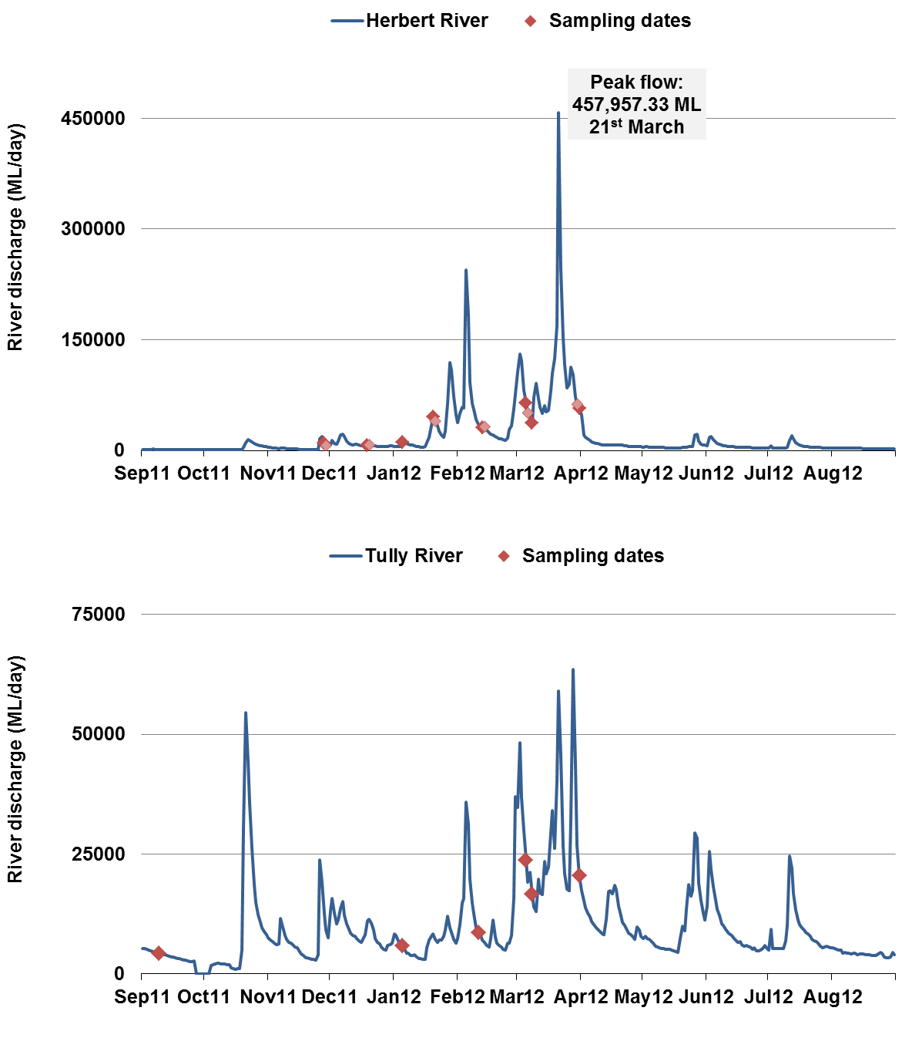

Figure 8-1: Daily flow measurements for Tully and Herbert over the 2011-12 wet season. Sampling dates are identified by red asterisk.

Phytoplankton (measured as chl-a), TSS and CDOM contribute to light attenuation (Kirk, 1994). It is commonly assumed that the average Kd(PAR) can be decomposed as a set of partial attenuation coefficients following Equation 1:
Kd(PAR) = Kd(W) + Kd(CDOM) + Kd(CHL) + Kd(TSS)………………….Equation 1
where K(w) is the attenuation due to pure water, and K(CDOM), Kd(CHL) + Kd(TSS) are the specific attenuation coefficients of CDOM, CHL and TSS, respectively.

Further assumptions are that contributions to light attenuation due to chlorophyll and total suspended sediment are proportional to their concentrations, and Kd(PAR) is often modelled as a linear function of water quality concentrations (e.g. Jiangtao et al., 2005; Devlin et al., 2009b):

K_{d}(PAR)=a+b*[CDOM]+c*[TSS]+d*[CHL])……………...Equation 2
Where [CDOM], [TSS], [CHL] are the respective concentrations of CDOM, TSS and CHL and the coefficient “a” encompasses the attenuation effect due to pure water.

The aim of this work is to develop a mechanistic model predicting light attenuation from the partitioning of OAC’s within the water column within flood plume water types. The use of a linear model of light attenuation to plot a range of water quality conditions that will result in depth specific attainment of minimum light requirements is then demonstrated.

Calculation of K_{d}(PAR)
The downwelling light attenuation coefficient, K_{d}(PAR) in meters⁻¹, was calculated using the Lambert-Beer Equation (Dennison et al., 1993):

I_{z} = I_{o} exp[-K_{d}(PAR)Ź]…………………….Equation 3

Where Io (iEm⁻²s⁻¹) is the PAR measured by the upper sensor, Iz (iEm⁻²s⁻¹) is the PAR at depth, z and z is the depth of interest in metres. Eq. (1) can be rearranged to calculate K_{d}(PAR):

K_{d}(PAR) = -1/ Ź ln(I _{Ź} / I_{o})……………...Equation 4

From our calculations, Ź is the distance between the upper and lower measurements of PAR measurement, I_{Ź} is the lowest PAR measurement and I_{o} is the upper PAR measurement.
Attenuation coefficients were calculated for each profile at each site during one wet season.

Results
The downwelling light attenuation coefficient, K_{d}(PAR) in meters⁻¹ was measured through water profile measurements of PAR in 119 samples. Samples were collected from Tully and Herbert marine regions, and over one sampling year (2011-12). Mean K_{d}(PAR) values range from 0.24m⁻¹ to 2.2m⁻¹ across the three transects and across the 6 month sampling period including September 2011 to 31st March 2012 (Figure 8-2)
In first approximation, there is a correlation between the mean value of OAC, particularly TSS and mean value of K_{d}(PAR) (Figure 8-3).

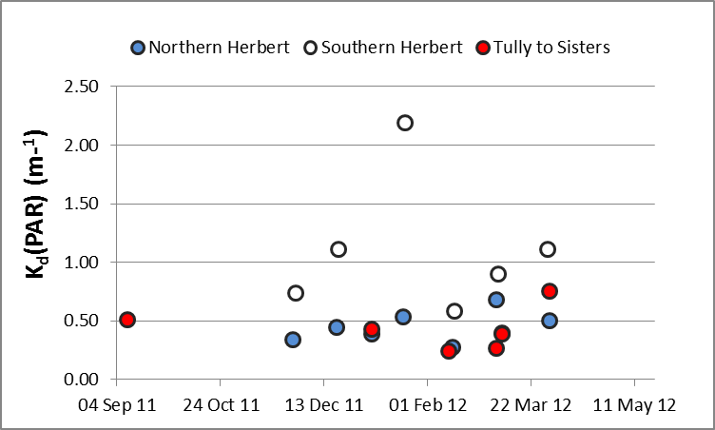

Figure 8-2: Range of K_{d}(PAR) values over the three Wet Tropics transects, including Northern Herbert, Southern Herbert and Tully to Sisters. Mean K_{d}(PAR) is calculated from all sites measured over that sampling date within the transect.

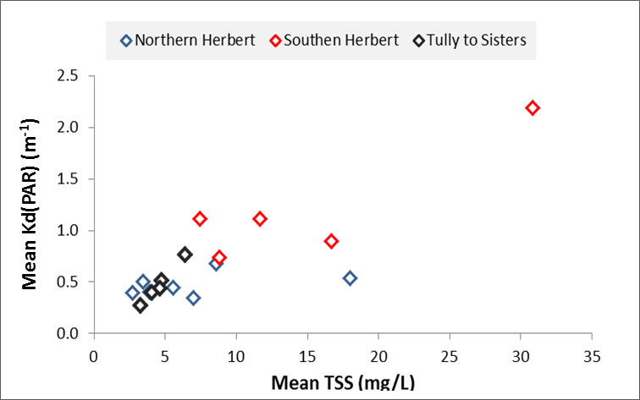
Figure 8-3: Relationship between mean K_{d}(PAR) values and Mean TSS values for the three transects.

The individual values for all sites are required to further analyse how well the respective OAC predict the K_{d}(PAR) variance. Measurements of K_{d}(PAR) vary over the sampling period (2011-2012) and relate strongly to variations in TSS, CDOM and Chl-a (Figure 8-4). The x axis refers to sample day (colored markers) and for each transect (i.e. day of data acquisition), samples are ordered according to their distance from the river mouth (from the closer to the furthest away). Full data (sample id, date, catchment and year) are presented in Appendix 2. The highest peaks of K_{d}(PAR) relate to high concentrations of TSS, though it does not explain all the K_{d}(PAR) variance. There are some occasions where the high peak of K_{d}(PAR) seem to relates more to the CDOM and Chl-a and most likely reflect the changing concentrations of the OAC’s across the different plume water types.

Figure 8-4: Spatial and temporal variations in Kd(PAR) and the three main OACs (TSS, CDOM, Chl-a). For each transect (i.e. day of data acquisition), samples are ordered according to their distance from the river mouth (from the closer to the furthest away).

Figure 8-5: Relationships between in-situ Kd(PAR) and in-situ OAC’s including TSS, Chl-a and CDOM. Axes are in logarithmic scale.
Individual OAC’s were measured against the in-situ K_{d}(PAR) (Figure 8-5) to investigate the correlation of the K_{d}(PAR) values (measured in-situ) to the concentrations of TSS, CDOM, and CHL (measured in-situ). These relationships were then used to investigate the predictive relationship between K_{d}(PAR) and the optical attenuation components (Equation 2) for all samples over both years and all regions.
Correlations exist between the K_{d}(PAR) values and the respective OACs (Figure 8-5), while the strongest predictive power against K_{d}(PAR) is observed for TSS over most dates and all three regions. However, in February 12 the relationship between parameters is significantly different and the K_{d}(PAR) values seem to be only correlated to the CDOM values (Figure 8-5, yellow crosses). The period at which the correlation is different is over 3 sampling dates (February 11, 13 and 14th, 2012), and If we look at other factors around February 12th, we can see that temperatures are high and salinity is low, and that this period is 5 days post peak flow in the Herbert. The different relationship observed in February may be due to the presence of a highly concentrated CDOM plume. This hypothesis is confirmed by the high CDOM values measured in all river transects between the 11 and the 14th of February (Figure 8-4). Furthermore, MODIS true colour image and the corresponding CDOM L2 maps measured the 13th of February 2012 both underlines presence of CDOM-concentrated water close to the Herbert and Tully shore on this date (Figure 8-6). However, these are just preliminary results and further analysis is required to fully understand the complexities between the OACs.
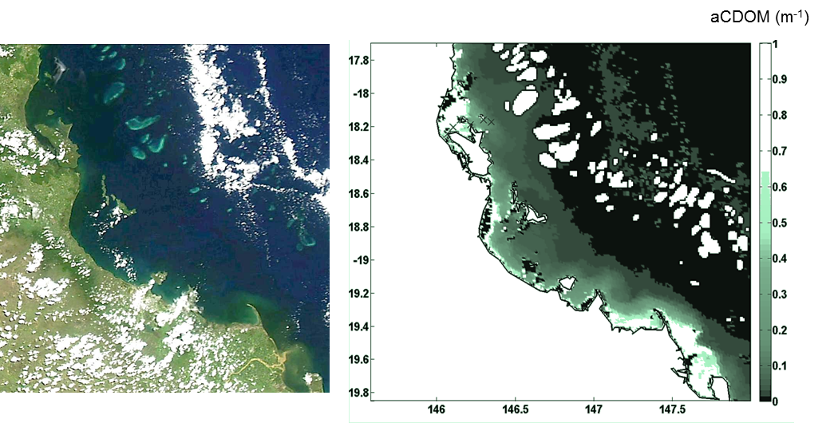
Figure 8-6: MODIS true colour composite (from NASA Ocean Colour online catalogue) illustrating river flood plumes along the Wet Tropics and Burdekin NMR on February 13th, 2012. The presence of high CDOM concentrated waters along the Tully and Herbert coast is illustrated by the dark colour (left). The corresponding MODIS L2 CDOM maps (aCDOM+D, m⁻¹) confirm the presence of CDOM rich waters (right).
Using the whole of Tully and Herbert data (i.e. including the data collected in February 2012), we obtain this multiple linear regression:
K_{d}(PAR)=-0.18+0.71*cdom+0.04*tss+0.14*chl…. Equation 5); (r² = 0.71, and every coefficient with significant p-values).

Using the whole of Tully and Herbert data (without February 2012) we obtain this multiple regression:
K_{d}(PAR)=-0.14+0.98*cdom+0.04*tss+0.08*chl…...Equation 6); (r² = 0.82 and every coefficient with significant p-values (Table 8-2).

Table 8-2: Regression statistics for equation 6 (all data with February 12th omitted
K_{d}=-0.14+0.98*cdom+0.04*tss+0.08*chl (equation 6

Regression Statistics
Multiple R | 0.91
R Square | 0.82
Adjusted R Square | 0.81
Standard Error | 0.37
Observations | 95.00

 | df | SS | MS | F | Significance F
Regression | 3.00 | 55.52 | 18.51 | 138.09 | 0.00
Residual | 91.00 | 12.20 | 0.13
Total | 94.00 | 67.72

 | Coefficients | Standard Error | t Stat | P-value | Lower 95% | Upper 95% | Lower 95.0% | Upper 95.0%
Intercept | -0.14 | 0.07 | -2.15 | 0.03 | -0.27 | -0.01 | -0.27 | -0.01
cdom_440 | 0.98 | 0.16 | 5.98 | 0.000 | 0.66 | 1.31 | 0.66 | 1.31
TSS_mg_l | 0.04 | 0.00 | 12.57 | 0.000 | 0.04 | 0.05 | 0.04 | 0.05
chl_ug_l | 0.08 | 0.03 | 3.17 | 0.002 | 0.03 | 0.14 | 0.03 | 0.14

Figure 8-7 shows the K_{d}(PAR) values measured in-situ and the Kd(PAR) values simulated from equation 5 or 6 (using the [TSS,CDOM, CHL] measured in-situ). In both cases, the data from February 2012 is not well simulated whereas K_{d}(PAR) values from September 11 to January 12 and March 2012 were well simulated.

We also tested a multiple correlation using only the data of Feb 2012 but coefficients a, c and d are not significant. This confirms that the K_{d}(PAR) data are only correlated significantly to the CDOM data on February 2012. Thus light attenuation in extreme conditions may be driven by low salinity and higher CDOM conditions and this observation illustrate the complexity of water types encountered in the GBR plume waters.

Figure 8-7: Measures of Kd(PAR) in-situ compared with simulated (sim) K_{d} from two possible models including K_{d}=-0.18+0.71*cdom+0.04*tss+0.14*chl (Eq. 5) and K_{d}=-0.14+0.98*cdom+0.04*tss+0.08*chl (Eq. 6).

Conclusion
This initial report on the attenuation of light in wet season conditions show that it would be possible to model/simulate light attenuation data from [TSS,CDOM, Chl-a] measured in-situ. Our first results show good correlations between the attenuation coefficients and the combined OACs. But the data collected in the Herbert and Tully on the February 12th underline the necessity to do further research to study particular cases when the K_{d} coefficient is not linearly related to the 3 OACs. Further investigations on different periods during wet season will provide more information on the predictive capabilities of those OAC’s and provide more understanding of light. Particularly, increase the number of data (spatially and temporally) will help investigate if preliminary models developed are catchment/NRM independent and consistent over multi-annual wet seasons. Testing of the in-situ data against remote sensing light measurements are also being investigated under this project.
The drivers of variability in the optically active compounds in coastal waters of the GBR are varied and complex and the mechanisms that control variability are, in many cases, not well described or understood. This work describes an initial approach to the understanding of these mechanisms for flood plumes and wet season conditions in the GBR. This will eventually lead to improved risk assessments being applied to the appropriate conceptual frameworks.

References
Alongi, D.M., McKinnon, A.D., 2005. The cycling and fate of terrestrially-derived sediments and nutrients in the coastal zone of the Great Barrier Reef shelf. Mar.Pollut. Bull. 51, 239–252
Álvarez-Romero, J. G., Devlin, M., Teixeira da Silva, E., Petus, C., Ban, N. C., Pressey, R. L., Kool, J., Roberts, J., Cerdeira, S., Wenger, A., and Brodie, J. (2013). A novel approach to model exposure of coastal-marine ecosystems to riverine flood plumes based on remote sensing techniques. Journal of Environmental Management 119, 194-207.
Anthony, K., Fabricius, K.E., 2000. Shifting roles of heterotrophy and autotrophy in coral energetics under varying turbidity. J. Exp. Mar. Biol. Ecol. 252, 221–253.
Bainbridge, Z., Wolanski, E., Álvarez-Romero, J., Lewis, S., Brodie, J., (2012). Fine sediment and nutrient dynamics related to particle size and floc formation in a Burdekin River flood plume, Australia. Mar. Pollut. Bull. 65, 236–248. Baith, K., Lindsay, R., Fu, G., McClain, C.R. (2001). SeaDAS: Data analysis system developed for ocean color satellite sensors, EOS, Transactions, American Geophysical Union, 82, p. 82.
Baith, K., Lindsay, R., Fu, G., McClain, C.R., 2001. SeaDAS, a data analysis system for ocean color satellite sensors. Eos Trans. Am. Geophys. Union. 82, 202.
Bentley, C., Paxman, C., Chue, K.L., Mueller, J. (in press) Pesticide monitoring in inshore waters of the Great Barrier Reef using both time integrated and event monitoring techniques (2011 - 2012). The University of Queensland, The National Research Centre for Environmental Toxicology (Entox).
Berkelmans, R. (2002). Time-integrated thermal bleaching thresholds of reefs and their variation on the Great Barrier Reef. Marine Ecology Progress Series 229: 73-82.
Berkelmans, R, Jones, A & Schaffelke, B. 2012, 'Salinity thresholds of Acropora spp. on the Great Barrier Reef', Coral Reefs, http://dx.doi.org/10.1007/s00338-012-0930-z
Brando, V.E., Schroeder, T., Dekker, A.G. and Park, Y.J.P. (2010). Reef Rescue Marine Monitoring Program: Using Remote Sensing for GBR wide water quality. Annual Report for 2009/10 Activities, CSIRO Land and Water, Canberra.
Brando, V.E., Blondeau-Patissier, D., Schroeder, T,.Dekker, A.G. and Clementson, L.A. (2011). Reef Rescue Marine Monitoring Program: Assessment of Terrestrial Run-off Entering the Reef and Inshore Marine Water Quality Monitoring using Earth Observation data. Final Report for 2010/11 Activities. CSIRO, Canberra.
Brando, V.E., Blondeau-Patissier, D., Schroeder, T,.Dekker, A.G. and Clementson, L.A. (in press). Reef Rescue Marine Monitoring Program: Assessment of Terrestrial Run-off Entering the Reef and Inshore Marine Water Quality Monitoring using Earth Observation data. Final Report for 2011/12 Activities. CSIRO, Canberra.
Brando, V.E., Dekker, A.G., Schroeder, T., Park, Y.J., Clementson, L.A., Steven, A. and Blondeau-Patissier, D. (2008). Satellite retrieval of chlorophyll CDOM and NAP in optically complex waters using a semi-analytical inversion based on specific inherent optical properties. A case study for Great Barrier Reef coastal waters.Ocean Optics XIX, Italy.
Brodie J (1992) Enhancement of larval and juvenile survival and recruitment in Acanthaster planci from the effects of terrestrial runoff: a review. Mar Freshw Res 43: 539–554
Brodie J, Fabricius K, De'ath G, Okaji K (2005) Are increased nutrient inputs responsible for more outbreaks of crown of thorns starfish? an appraisal of the evidence. Mar Pollut Bull 51: 266-278
Brodie J, De’ath G, Devlin M, Furnas M, Wright M (2007) Spatial and temporal patterns of near-surface chlorophyll a in the Great Barrier Reef lagoon. Mar Freshw Res 58: 342-353
Brodie, J., Binney, J., Fabricius, K., Gordon, I., Hoegh – Guldberg, O., Hunter, H., O’Reagain, P., Pearson, R., Quirk, M., Thorburn, P., Waterhouse, J., Webster, I. and Wilkinson, S. (2008). Scientific Consensus Statement on Water Quality in the Great Barrier Reef. The State of Queensland (Department of the Premier and Cabinet) Brisbane.
Brodie, J.E. and Waterhouse, J. (2009). Assessment of the relative risk of impacts of broad-scale agriculture on the Great Barrier Reef and priorities for investment under the Reef Protection Package. Stage 1 Report: April 2009. ACTFR Technical Report 09/17, Australian Centre for Tropical Freshwater Research, Townsville.
Brodie, J., Schroeder, Th., Rohde, K., Faithful, J., Masters, B., Dekker, A., Brando, V., and Maughan, M. (2010). Dispersal of suspended sediments and nutrients in the Great Barrier Reef lagoon during river discharge events: Conclusions from satellite remote sensing and concurrent flood plume sampling. Mar. Freshwater Res. 61(6), 651-664.
Brodie JE, Devlin MJ, Haynes D, Waterhouse J (2011) Assessment of the eutrophication status of the Great Barrier Reef lagoon (Australia). Biogeochemistry 106: 281-302 DOI 10.1007/s10533-010-9542-
Brodie, J., Schroeder, T., Rohde, K., Faithful, J., Masters, B., Dekker, A., Brando, V.,Maughan, M., 2010. Dispersal of suspended sediments and nutrients in the Great Barrier Reef lagoon during river-discharge events: conclusions from satellite remote sensing and concurrent flood-plume sampling. Mar. Freshwat. Res. 61, 651–664
Brodie JE, Waterhouse J (2012a) A critical assessment of environmental management of the 'not so great' Barrier Reef. Estuar Coast Shelf Sci. 104–105: 1–22
Brodie JE, Kroon FJ, Schaffelke B, Wolanski EC, Lewis SE, Devlin MJ, Bohnet IC, Bainbridge ZT, Waterhouse J, Davis AM (2012b) Terrestrial pollutant runoff to the Great Barrier Reef: An update of issues, priorities and management responses. Mar Poll Bull 65: 81-100
Clarke G.L., Ewing G.C., Lorenzen C.J., 1970. Spectra of backscattered light from sea obtained from aircraft as a measure of chlorophyll concentration. Science 16:1119–21.
Cromley, R.G., Mrozinski, R., D., 1997. An evaluation of classification schemes based on the statistical versus the spatial structure properties of geographic distribution in chloropleth mapping. Proceedings of the Annual Convention and Exposition Technical Papers, Auto-Carto XIII, April 7 - 10, 1997, Seattle, Washington.
Cooper, T.F., Uthicke, S. Humphrey, C., and Fabricius, K.E. (2007). Gradients in water column nutrients, sediment parameters, irradiance and coral reef development in the Whitsunday Region, central Great Barrier Reef. Estuarine, Coastal and Shelf Science 74: 458-470.
Cooper, T.F., Ridd, P.V., Ulstrup, K.E., Humphrey, C., Slivkoff, M. and Fabricius, K. (2008).Temporal dynamics in coral bioindicators for water quality on coastal coral reefs of the Great Barrier Reef. Marine and Freshwater Research 59 (8): 703-716.
Cooper, T.F., Fabricius, K.E., 2012. Pigmentation of massive corals as a simple bioindicator for marine water quality, Mar. Pollut. Bull. 65, 333–341.
De'ath, G. and Fabricius, K.E. (2008). Water Quality of the Great Barrier Reef: Distributions, Effects on Reef biota and Trigger Values for the Conservation of Ecosystem Health.' Research Publication No. 89. Great Barrier Marine Park Authority, Report to the Great Barrier Reef Marine Park Authority and published by the Great Barrier Reef Marine Park Authority, Townsville. 104 p.
De'ath, G. and Fabricius, K.E. (2010).Water quality as regional driver of coral biodiversity and macroalgal cover on the Great Barrier Reef. Ecological Applications 20: 840-850.
Devlin, M., Waterhouse, J., Taylor, J. and Brodie, J. (2001). Flood plumes in the Great Barrier Reef: spatial and temporal patterns in composition and distribution. GBRMPA Research Publication No. 68.Great Barrier Reef Marine Park Authority, Townsville, Australia.
Devlin, M., Brodie, J., Waterhouse, J., Mitchell, A., Audas, D., Haynes, D., 2003. Exposure of Great Barrier Reef inner-shelf reefs to river-borne contaminants. In: Proceedings of the 2nd National Conference on Aquatic Environments: Sustaining Our Aquatic Environments – Implementing Solutions. 20–23 November 2001, Townsville. CD-ROM, Queensland Department of Natural Resources and Mines, Brisbane.
Devlin, M., Brodie, J., 2005. Terrestrial discharge into the Great Barrier Reef Lagoon: nutrient behaviour in coastal waters. Mar. Pollut. Bull. 51, 9–22.
Devlin, M., and Schaffelke, B., 2009. Extent and exposure of riverine flood plumes in the Tully coastal region. Marine and Freshwater Research 60: 1109-1122.
Devlin, M.J., Barry , J., Mills, D.K., Gowen, R.J., Foden, J., Sivyer, D., Greenwood, N., Pearce, D., Tett, P. 2009b. Estimating the diffuse attenuation coefficient from ptically active constituents in UK marine waters. Estuarine, Coastal and Shelf Science 82:73–83.
Devlin, M., Harkness, P., McKinna, L. and Waterhouse, J., 2011. Mapping the surface exposure of terrestrial pollutants in the Great Barrier Reef. Report to the Great Barrier Reef Marine Park Authority, August 2010. Australian Centre for Tropical Freshwater Research. Report Number 10/12. http://www.gbrmpa.gov.au/resources-and-publications/publications/annual-reef-rescue-marine-monitoring-science-report.
Devlin, M., Schroeder, T., McKinna, L., Brodie, J., Brando, V., Dekker, A., 2012a, Monitoring and mapping of flood plumes in the Great Barrier Reef based on in-situ and remote sensing observations, in: Advances in Environmental Remote Sensing to Monitor Global Changes, CRC Press, Boca Raton.
Devlin, M.J., McKinna, L. I. W., Álvarez-Romero, J. G., Abott, B., Harkness, P., Brodie, J.,2012b. Mapping the pollutants in surface river plume waters in the Great Barrier Reef, Australia. Mar. Pollut. Bull. 65, 224–235.
Devlin, M., Álvarez-Romero, J., Wenger, A., da-Silva, E., Abbot, B. and Waterhouse, J., 2012c. Mapping the surface exposure of terrestrial pollutants and extreme weather reporting in the Great Barrier Reef. Report to the Great Barrier Reef Marine Park Authority, September, 2011. Australian Centre for Tropical Freshwater Research. Report Number 02/12
Devlin, M., Teixera, E., Petus, C., Wenger, A., Zeh, D., Álvarez-Romero, J., Brodie, J., in press. Combining in-situ water quality and remotely sensed data across spatial and temporal scales to measure wet season chlorophyll-a variability: Great Barrier Reef lagoon (Queensland, Australia)
Dight, I., 2009. Burdekin Water Quality Improvement Plan. NQ Dry Tropics,Townsville.
Dzwonkowski, B., & Yan, X.-H. (2005). Tracking of a Chesapeake Bay estuarine outflow plume with satellite-based ocean color data. Continental Shelf Research, 25, 1942-1958.
ESRI, 2010. ArcGIS 10.0. Environmental Systems Research Institute (ESRI), Redlands, CA. Evans, R.D., Murray, K.L., Field, S.N., Moore, J.A.Y., Shedrawi, G., Huntley, B.G., Fearns, P., Broomhall, M., McKinna, L.I.W., Marrable, D., 2012. Digitise this! A quick and easy remote sensing method to monitor the daily extent of dredge plumes. PLoS ONE 7, e51668.
Fabricius, K., De'ath, G., McCook, L., Turak, E., Williams, D. (2005). Changes in algal, coral and fish assemblages along water quality gradients on the inshore Great Barrier Reef. Marine Pollution Bulletin 51: 384-398.
Fabricius, K.E. (2005). Effects of terrestrial runoff on the ecology of corals and coral reefs: Review and synthesis. Marine Pollution Bulletin 50: 125–146.
Fabricius, K.E. (2011). Nutrient pollution. In: Hopley D (ed.) Encyclopedia of modern coral reefs. p. 722-731, Springer.
Fabricius, K., Wolanski, E., 2000. Rapid smothering of coral reef organisms by muddy marine snow. Estuar. Coast. Shelf Sci. 50, 115–120.
Fabricius, K.E., Wild, C., Wolanski, E., Abele, D., 2003. Effects of transparent exopolymer particles and muddy terrigenous sediments on the survival of hard coral recruits. Estuar. Coast. Shelf Sci. 57, 613–621.
Fabricius, K.E., Cooper, T.F., Humphrey, C., Uthicke, S., De’ath, G., Davidson, J., LeGrand, H., Thompson, A., Schaffelke, B., 2012. A bioindicator system for water quality on inshore coral reefs of the Great Barrier Reef. Mar. Pollut. Bull. 65, 320–332.
Furnas, M.J., 1989. Cyclonic disturbance and a phytoplankton bloom in a tropical shelf ecosystem. In: Okaichi, T., Anderson, D.M., Nemoto, T. (Eds.), Red Tides: Biology, Environmental Science and Toxicology. Proceedings of the First International Symposium on Red Tides held November 10-14, 1987, in Takamatsu, Kagawa Prefecture, Japan. Elsevier Science Publishing Co. Inc., pp. 273–276.
Furnas, M., 2003. Catchments and Corals: Terrestrial Runoff to the Great Barrier Reef. Australian Institute of Marine Science, Townsville.334 pp.
Furnas, M., Mitchell, A., Skuza, M., Brodie, J.E., 2005. In the other 90%: phytoplankton responses to enhanced nutrient availability in the GBR lagoon. Mar. Pollut. Bull. 51, 253–265.
Furnas, M., Alongi, D., McKinnon, A.D., Trott, L., Skuza, M., 2011. Regional-scale nitrogen and phosphorus budgets for the northern (14_S) and central (17_S) Great Barrier Reef shelf ecosystem. Cont. Shelf Res. 31, 1967–1990.
Garver, S.A. and Siegel, D.A. 1997. Inherent optical property inversion of ocean colour spectra and its biogeochemical interpretation 1. Time Series from the Sargasso Sea, J. of Geophys. Res., 102, 18,607-18, 625.
Geyer, W.R., Hill, P.S., & Kineke, G.C. (2004). The transport, transformation and dispersal of sediment by buoyant coastal flows. Continental Shelf Research, 24, 927-949.
Great Barrier Reef Marine Park Authority, (2009).Water Quality Guidelines for the Great Barrier Reef Marine Park. Great Barrier Reef Marine Park Authority, Townsville, 99p.
Great Barrier Reef Marine Park Authority, (2011). Extreme Weather and the Great Barrier Reef. Great Barrier Reef Marine Park Authority, ISBN 978 1 921682 74 2 (pdf).
Great Barrier Reef Marine Park Authority (in press) Reef Rescue Marine Monitoring Program: Quality Assurance/Quality Control Methods and Procedures. Great Barrier Reef Marine Park Authority, Townsville. http://www.gbrmpa.gov.au/resources-and-publications/publications/annual-reef-rescue-marine-monitoring-science-report
Holmes, R. W. (1970). The Secchi disk in turbid coastal zones. Limnology and Oceanography, 15, 688−694.
Humphrey, C.A., Codi King, S. and Klumpp, D.W. (2007) A multibiomarker approach in barramundi (Latescalcarifer) to measure exposure to contaminants in estuaries of tropical North Queensland. Marine Pollution Bulletin 54: 1569-1581.
Humphrey, C.A., Weber, M., Lott, C. Cooper, T., Fabricius.K. (2008). Effects of suspended sediments, dissolved inorganic nutrients and salinity on fertilisation and embryo development in the coral Acroporamillepora (Ehrenberg, 1834). Coral Reefs. 27:837–850
Jiangtao, X., Raleigh RH, and Shenn-Yu C (2005). A Simple Empirical Optical Model for Simulating Light Attenuation Variability in a Partially Mixed Estuary. Estuaries. 28(4): 572–580
Johnson, J., Waterhouse, J., Maynard, J. and Morris, S. (Writing Team) (2010) Reef Rescue Marine Monitoring Program: 2008/2009 Synthesis Report. Report prepared by the Reef and Rainforest Research Centre Consortium of Monitoring Providers for the Great Barrier Reef Marine Park Authority. Reef and Rainforest Research Centre Limited, Cairns (158pp.) (http://www.rrrc.org.au/mmp/mmp_pubs.html)
Joo, M., Raymond, M., McNeil, V., Huggins, R., Turner, R., Choy, S., 2012. Estimates ofsediment and nutrient loads in ten major catchments draining to the Great Barrier Reef during 2006-2009. Mar. Pollut. Bull. 65, 150–166.
Kennedy, K., Devlin, M., Bentley, C., Paxman, C., Chue, K.L., Mueller, J. (2011) Pesticide monitoring in inshore waters of the Great Barrier Reef using both time integrated and event monitoring techniques (2010 - 2011). The University of Queensland, The National Research Centre for Environmental Toxicology (Entox).
Kennedy, K., Schroeder, T., Shaw, M., Haynes, D., Lewis, S., Bentley, C., Paxman, C., Carter., Brando, V., Bartkow., Hearn, L., Mueller, J. (2012) Long-term monitoring of photosystem-II herbicides on the Great Barrier Reef – trends and correlation to remotely sensed water quality. Marine Pollution Bulletin. 65: 292-305
Kersell, A.P., and Jones, R. Effects of hypo-osmosis on the coral Stylophorapistillata: nature and cause of ‘low-salinity bleaching’. Marine Ecology Progress Series. 253: 145–154, 2003.
Kirk, J. T. O. 1994. Light and Photosynthesis in Aquatic Ecosystems, 2nd edition. Cambridge University Press, Cambridge, Maryland.
Larcombe, P., Ridd, P.V., Prytz, A., Wilson, B., 1995. Factors controlling suspendedsediment on inner-shelf coral reefs, Townsville, Australia. Coral Reefs 14, 163–171.
Lee Z.P., Carder K.L., and Arnone R. (2002). Deriving inherent optical properties from ocean color: A multi-band quasi-analytical algorithm for optically deep waters, Applied Optics. 41, 5755-5772.
Lee, J., Valle-Levinson, A. (2013). Bathymetric effects on estuarine plume dynamics. Journal of Geophysical Research C: Oceans, 118(4), 1969-1981
Maughan, M., Brodie, J.E., (2009). Reef exposure to river-borne contaminants: a spatial model. Mar. Freshwat. Res. 60, 1132–1140.
Maritorena, S., D. A. Siegel, and A. R. Peterson (2002), Optimal tuning of a semi-analytical model for global applications, Applied Optics, 41, 2705 – 2714.
McKenzie L, Unsworth R and Waycott M (2010) Reef Rescue Marine Monitoring Program: Intertidal Seagrass, Annual Report for the Sampling Period 1 September 2009 to 31 May 2010. Fisheries Queensland, Cairns.
McKenzie LJ, Collier C, Waycott M (2012) Reef Rescue Marine Monitoring Program: Nearshore Seagrass, Annual Report for the sampling period 1st July 2010–31st May 2011 Fisheries Queensland, Cairns 177pp
McKenzie LJ, Collier C, Waycott M (in press) Reef Rescue Marine Monitoring Program: Nearshore Seagrass, Annual Report for the sampling period 1st July 2011–31st May 2012 Fisheries Queensland, Cairns 177pp
McClain, C.R. 2009. A Decade of Satellite Ocean Color Observations. Annual Review Marine Sciences 1: 19–42
Morel, A. and Prieur, L., 1977. Analysis of variations in ocean color. Limnology and Oceanography 22:709–722.
Moss, A., Brodie, J., Furnas, M. (2005). Water quality guidelines for the Great Barrier Reef World Heritage Area: a basis for development and preliminary values. Marine Pollution Bulletin. 51:76-88.
Orpin, A.R., Brunskill, G.J., Zagorskis, I.,Woolfe, K.J. (2004). Patterns of mixed siliciclastic–carbonate sedimentation adjacent to a large dry-tropics river on the central Great Barrier Reef shelf, Australia. Aust. J. Earth Sci. 51: 665–683.
Petus, C., Da Silva, E., Devlin, M., Wenger, A., Alvarz-Romero, J., (in review). Using MODIS data for mapping of water types within flood plumes in the Great Barrier Reef, Australia: towards the production of river plume risk maps for reef and seagrass ecosystems. Submitted to the Journal of Environmental Management.
Petus, C., Marieu, V., Novoa, S., Chust, G., Bruneau, N., Froidefond, J.M. (in review b). Monitoring spatio-temporal variability of the Adour River turbid plume (Bay of Biscay, France) with MODIS 250-m imagery. Submitted to Continental Shelf Research
Parsons, T.R., Maita, Y. &Lalli, C. 1984, A Manual of Chemical and Biological Methods for Seawater Analysis, Pergamon, London.
Qin, Y., Brando, V., Dekker, A., and Blondeau-Patissier D., 2007. Validity of SeaDAS water constituents retrieval algorithms in Australian tropical coastal waters, Geophysical Research Letters, 34, L21603, doi:10.1029/2007GL030599.
Ryle, V.D., Mueller, H.R. &Gentien, P. 1981, Automated Analysis of Nutrients in Tropical Seawaters, Science Data Report No. 3, Australian Institute of Marine Science, Townsville.
Salisbury, J.E., Campbell, J.W., Linder, E., David Meeker, L., Müller-Karger, F.E., Vörösmarty, C.J., (2004). On the seasonal correlation of surface particle fields with wind stress and Mississippi discharge in the northern Gulf of Mexico. Deep Sea Research Part II: Topical Studies in Oceanography 51, 1187-1203.
Schaffelke B, Carleton J, Costello P, Davidson J, Doyle J, Furnas M, Gunn K, Skuza M, Wright M, Zagorskis I (2012a) Reef Rescue Marine Monitoring Program. Final Report of AIMS Activities 2010/11– Inshore Water Quality Monitoring. Report for the Great Barrier Reef Marine Park Authority. Australian Institute of Marine Science, Townsville. (94 p.)
Schaffelke B, Carleton J, Doyle J, Furnas M, Gunn K, Skuza M, Wright M, Zagorskis I (2011) Reef Rescue Marine Monitoring Program. Final Report of AIMS Activities – Inshore water quality monitoring 2009/10. Report for the Great Barrier Reef Marine Park Authority. Australian Institute of Marine Science, Townsville.
Schaffelke B, Carleton J, Doyle J, Furnas M, Gunn K, Skuza M, Wright M and Zagorskis I (2010) Reef Rescue Marine Monitoring Program. Final Report of AIMS Activities – Inshore water quality monitoring 2009/10.Australian Institute of Marine Science, Townsville.
Schaffelke, B., Carleton, J., Skuza, M., Zagorskis, I., Furnas, M.J., 2012b. Water quality in the inshore Great Barrier Reef lagoon: implications for long-term monitoring and management. Mar. Pollut. Bull. 65, 249–260.
Schroeder, T., Devlin, M.J., Brando, V.E., Dekker, A.G., Brodie, J.E., Clementson, L.A., McKinna,L., (2012). Inter-annual variability of wet season freshwater plume extent into the Great Barrier Reef lagoon based on satellite coastal ocean colour observations, Marine Pollution Bulletin, 65(4-9): 210-23
Thomas, A.C. and R. Weatherbee. 2006. Satellite-measured temporal variability of the Columbia River plume. Rem. Sensing. Env. 100: 167-178.
Thompson A, Davidson J, Schaffelke B and Sweatman H (2010) Reef Rescue Marine Monitoring Program. Final Report of AIMS Activities – Inshore coral reef monitoring 2009/10. Report for Reef and Rainforest Research Centre. Australian Institute of Marine Science, Townsville.
Thompson A, Costello P, Davidson J, Logan M, Schaffelke B, Uthicke S and Takahashi M (2012) Reef Rescue Marine Monitoring Program Report of AIMS Activities – Inshore coral reef monitoring 2011 Report for Great Barrier Reef Marine Park Authority Australian Institute of Marine Science Townsville 127 pp
Valente, A.S., da Silva J.C.B. (2009). On the observability of the fortnightly cycle of the Tagus estuary turbid plume using MODIS ocean colour images. Journal of Marine Systems, 75, 131-137.
Wang, M., Shi, W., 2007, The NIR-SWIR combined atmospheric correction approach for MODIS ocean colour data processing, Optics Express, Vol. 15, No. 24, 15722-15733.
Wolanski, E., Fabricius, K., Cooper, T. and Humphrey, C. (2008). Wet season fine sediment dynamics on the inner shelf of the Great Barrier Reef.Estuarine, Coastal and Shelf Science.77: 755-762.
Waterhouse, J., Brodie, J., Lewis, S., Mitchell., A., 2012. Quantifying the sources of pollutants to the Great Barrier Reef. Mar. Pollut. Bull. 65, 394–406.

Appendix 1
Publications and supplementary material.
Journal papers - published
Devlin, M.J., da Silva, E.T., Petus, C., Wenger, A., Alvarez-Romero, J.G., Zeh, D., Brodi, J. (2013). Combining in-situ water quality and remotely sensed data across spatial and temporal scales to measure variability in wet season chlorophyll-a: Great Barrier Reef lagoon (Queensland, Australia). Ecological Applications.
J. G. Álvarez-Romero, J. G., M. Devlin, E. Teixeira da Silva, C. Petus, N. C. Ban, R. L. Pressey, J. Kool, J. Roberts, S. Cerdeira, A. Wenger, and J. Brodie, J.(2013) Following the flow: a combined remote sensing-GIS approach to model exposure of marine ecosystems to riverine flood plumes. J Environ Manage 119:194–207
Devlin, M.J., Brodie, J., Wenger, A., da Silva, E., Álvarez-Romero, J.G., Waterhouse, J., McKenzie, L. (2012) Extreme weather conditions in the Great Barrier Reef: Drivers of change? Proceedings of the 12th International Coral Reef Symposium, Cairns, Australia, 9-13 July 2012 21A Watershed management and reef pollution
Devlin, M.J. and Schaffelke, B (editors). (2012). Catchment-to-Reef continuum: Case studies from the Great Barrier Reef. A special issue – Marine Pollution Bulletin 2012. 65:77-80
Bricker, S. & Devlin, M.J (Editors). (2011). Eutrophication: international comparisons of causes, consequences and management. Biogeochemistry.106: 135-136
Devlin, M.J. (2011). Flooding in NE Australia: how ongoing monitoring of flood plumes helps in managing the Great Barrier Reef. Marine Ecosystems and Management. Vol 4, No. 4.
Devlin, M., Schroeder, T., McKinna, L., Brodie, J., Brando, V., Dekker, A. (2012), Monitoring and mapping of flood plumes in the Great Barrier Reef based on in-situ and remote sensing observations, in: Advances in Environmental Remote Sensing to Monitor Global Changes, CRC Press, Boca Raton
Brodie, J.E., Kroon, F.J., Schaffelke, B., Wolanski, E., Lewis, S.E., Devlin, M.J., 788 Bainbridge, Z.T., Waterhouse, J., Davis, A.M., (2012). Terrestrial pollutant runoff to the Great Barrier Reef: an update of issues, priorities and management responses. Mar. Pollut. Bull. <http://dx.doi.org/10.1016/ 791 j.marpolbul.2011.12.012>.
Devlin M, McKinna LW, Álvarez-Romero JG, Petus C, Abott B, Harkness P and Brodie J (2012) Mapping the pollutants in surface riverine flood plume waters in the Great Barrier Reef, Australia. Mar Pollut Bull.65:224-235
Brodie, J.E., Devlin, M.J., Haynes, D. & Waterhouse, J. (2011). Assessment of the eutrophication status of the Great Barrier Reef lagoon (Australia). Biogeochemistry. DOI 10.1007/s10533-010-9542-2.
Devlin, M.J., Bricker, S. & Painting, S. (2011). Comparison of five methods for assessing impacts of nutrient enrichment using estuarine case studies. Biogeochemistry. 106:177-205
Kennedy, K., Schroeder, T., Shaw, M., Haynes, D., Lewis, S., Bentley, C., Paxman, C., Carter., Brando, V., Bartkow., Hearn, L., Mueller, J. (2012) Long-term monitoring of photosystem-II herbicides on the Great Barrier Reef – trends and correlation to remotely sensed water quality. Marine Pollution Bulletin. 65: 292-305
Schroeder, T., Devlin, M.J., Brando, V.E., Dekker, A.G., Brodie, J.E., Clementson, L.A., McKinna,L., 2012. Inter-annual variability of wet season freshwater plume extent into the Great Barrier Reef lagoon based on satellite coastal ocean colour observations, Marine Pollution Bulletin, 65(4-9): 210-23

Journal papers - In press
Petus, C., Eduardo Teixeira da Silva, , Michelle Devlin, Jorge Álvarez Romero, Amelia Wenger and Lachlan McKinna. Validated MODIS thresholds for mapping of water types within flood plumes in the Great Barrier Reef, Australia.
Devlin, M., Debose, J., Ajani, P. Variability in phytoplankton biomass and community over wet season conditions in the Great Barrier Reef. Making the linkages to COTS. Estuarine Coast and Shelf Science (in press).
Wenger, A., Devlin, M., Petus, C., da Silva, E., Extreme weather monitoring in the Great Barrier Reef. The wet season of 2010-11. Estuarine Coast and Shelf Science (in press).
Reports
Devlin, M., Álvarez-Romero, J., Wenger, A., da-Silva, E., Abbot, B. and Waterhouse, J., 2012. Mapping the surface exposure of terrestrial pollutants and extreme weather reporting in the Great Barrier Reef. Report to the Great Barrier Reef Marine Park Authority, September, 2011. Australian Centre for Tropical Freshwater Research. Report Number 02/12
Devlin, M, Debose, J. and Brodie, J.(2012). Review of phytoplankton in the Great Barrier Reef and potential links to Crown of Thorns. Report to the National Environmental Research Program. Reef and Rainforest Research Centre Limited, Cairns (39pp.).
Presentations
Devlin, M.J., Brodie, J., Wenger, A., da Silva, E., Álvarez-Romero, J.G., Waterhouse, J., McKenzie, L. (2012) Extreme weather conditions in the Great Barrier Reef: Drivers of change? Oral presentation at the 12th International Coral Reef Symposium, Cairns, Australia, 9-13 July 2012, Watershed management and reef pollution
Devlin, M and Schaffelke, B. (2012) Extreme weather in the GBR – Monitoring the WQ influence of the 2010- 2011 wet season. Oral presentation at the Healthy Waterways conference. Mackay. 2012.
Devlin, M.J., Brodie, J., Wenger, A., Petus, C., da Silva, E., Álvarez-Romero, J.G., Zeh, D., Waterhouse, J. and Brodie, J. (2012) Measuring extremes – monitoring the impacts of the 2010- 2011 major weather events. Oral presentation at the Coast to Coast conference, Brisbane Australia. 17 – 21 September 2012
Devlin, M.J., Brodie, J., Wenger, A., Petus, C., da Silva, E., Álvarez-Romero, J.G., Zeh, D., Waterhouse, J. and Brodie, J. (2012) Monitoring the Influence of WQ in the Great Barrier reef – use of innovative remote sensing techniques. Oral presentation to Chinese-Australian Symposium. ACOST3. James Cook University, Townsville, Australia. 25th June, 2012.
Devlin, M., Brando, V., Dobbie, M., Schaffelke, B., Schroeder, T., Best, M., Brodie, J., Comparison of water quality and eutrophication assessments in tropical (GBR) and temperate systems. Oral presentation to 50th ECSA Conference. Today's science for tomorrow's Management. 3-7 June 2012, NH Laguna Palace, Venice, Italy
Devlin, M.J., Brodie, J., Wenger, A., da Silva, E., Álvarez-Romero, J.G., Waterhouse, J. and Brodie, J. Marine Monitoring Program – initial outputs from the Herbert plume sampling 2012. Oral presentation to the Herbert River group. Wetlands Centre, Ingham. 11th April, 2012
Álvarez-Romero, J.G., M. Devlin, E. Teixeira da Silva, C. Petus, N. Ban, R. Pressey, J. Kool, J. Roberts, S. Cerdeira, A. Wenger, and J. Brodie. Spatial-temporal variation in exposure of marine ecosystems to land-based threats. Oral presentation at the 12th International Coral Reef Symposium, Cairns, Australia, 9-13 July 2012, Watershed management and reef pollution
Álvarez-Romero, J.G., Devlin, M., E. Teixeira da Silva, C. Petus. New methods for modelling river plumes and assessing exposure of marine habitats to pollutants. Oral presentation at the Coast to Coast conference, Brisbane Australia. 17 – 21 September 2012,
Eduardo Teixeira da Silva, Caroline Petus, Michelle Devlin, Jorge Álvarez Romero, Amelia Wenger and Lachlan McKinna. Identification of plume water types in the Great Barrier Reef. Poster presented on the 12th International Coral Reef Symposium, Cairns, Australia, 9-13 July 2012, Watershed management and reef pollution.
Devlin, M and Brodie, J. (2012). COTS, Water Quality and Phytoplankton. Size does matter. Oral presentation to Workshop on defending GBR coral against COTS predation. Fitzroy Island, 5th – 9th July 2012.
Devlin, M.J., Wenger, A., Petus, C., da Silva, E., Álvarez-Romero, J.G., Zeh, D., Waterhouse, J. and Brodie, J. (2012) Marine Monitoring Flood Plume Program – understanding WQ variability in the wet season and the influence of extreme events. Oral presentation to Marine Monitoring Program Annual Integration Workshop. 20-22 August, 2012.
Devlin, M.J., Wenger, A., Petus, C., da Silva, E., Álvarez-Romero, J.G., Zeh, D., Waterhouse, J. and Brodie, J. (2012) Marine Monitoring Flood Plume Program – outcomes from the 2011-12 wet season. Oral presentation to Marine Monitoring Program Annual Integration Workshop. 20-22 August, 2012.

Chair sessions
Session co-chair. Water quality: impacts and management. Oral presentation at the 12th International Coral Reef Symposium, Cairns, Australia, 9-13 July 2012, Watershed management and reef pollution
Session chair: Comparison of eutrophication monitoring techniques. 50th ECSA Conference. Today's science for tomorrow's Management. 3-7 June 2012, NH Laguna Palace, Venice, Italy

Appendix 2 – Site data associated with each sampling date
sample_id | site_grouping | NRM | transect | Lat_DD | Long_DD | sample_date
FPBK339 | Bedarra Island | Wet Tropics | Tully to Sisters | -18.00 | 146.14 | 9/09/2011
FPBK343 | Dunk Island North | Wet Tropics | Tully to Sisters | -17.93 | 146.15 | 9/09/2011
FPMW408 | East Clump Point | Wet Tropics | Tully to Sisters | -17.86 | 146.17 | 9/09/2011
FP736 | Channel North | Wet Tropics | Northern Herbert | -18.25 | 146.07 | 28/11/2011
FP737 | Halfway to Goold | Wet Tropics | Northern Herbert | -18.21 | 146.10 | 28/11/2011
FP738 | Goold Island | Wet Tropics | Northern Herbert | -18.16 | 146.15 | 28/11/2011
FP739 | Cape Richards | Wet Tropics | Northern Herbert | -18.19 | 146.21 | 28/11/2011
FP740 | South Brooks | Wet Tropics | Northern Herbert | -18.16 | 146.30 | 28/11/2011
FP741 | Offshore North Hinchinbrook | Wet Tropics | Northern Herbert | -18.17 | 146.35 | 28/11/2011
FP748 | Site 1 | Wet Tropics | Southern Herbert | -18.50 | 146.32 | 29/11/2011
FP749 | Site 2 | Wet Tropics | Southern Herbert | -18.49 | 146.32 | 29/11/2011
FP750 | Site 3 | Wet Tropics | Southern Herbert | -18.47 | 146.35 | 29/11/2011
FP751 | Site 4 | Wet Tropics | Southern Herbert | -18.45 | 146.38 | 29/11/2011
FP752 | Site 5 | Wet Tropics | Southern Herbert | -18.42 | 146.43 | 29/11/2011
FP771 | Channel North | Wet Tropics | Northern Herbert | -18.25 | 146.07 | 19/12/2011
FP772 | Halfway to Goold | Wet Tropics | Northern Herbert | -18.21 | 146.10 | 19/12/2011
FP776 | Goold Island | Wet Tropics | Northern Herbert | -18.16 | 146.15 | 19/12/2011
FP773 | Cape Richards | Wet Tropics | Northern Herbert | -18.19 | 146.21 | 19/12/2011
FP774 | South Brooks | Wet Tropics | Northern Herbert | -18.17 | 146.35 | 19/12/2011
FP775 | Offshore North Hinchinbrook | Wet Tropics | Northern Herbert | -18.16 | 146.30 | 19/12/2011
FP786 | Seymour River mouth | Wet Tropics | Southern Herbert | -18.49 | 146.23 | 20/12/2011
FP785 | Herbert River mouth | Wet Tropics | Southern Herbert | -18.50 | 146.32 | 20/12/2011
FP784 | Site 1 | Wet Tropics | Southern Herbert | -18.50 | 146.32 | 20/12/2011
FP783 | Site 2 | Wet Tropics | Southern Herbert | -18.49 | 146.32 | 20/12/2011
FP782 | Site 3 | Wet Tropics | Southern Herbert | -18.47 | 146.35 | 20/12/2011
FP781 | Site 4 | Wet Tropics | Southern Herbert | -18.45 | 146.38 | 20/12/2011
FP780 | Site 5 | Wet Tropics | Southern Herbert | -18.42 | 146.43 | 20/12/2011
FP719 | Tully River Mouth | Wet Tropics | Tully to Sisters | -18.03 | 146.06 | 5/01/2012
FP718 | Hull River Mouth | Wet Tropics | Tully to Sisters | -18.00 | 146.08 | 5/01/2012
FP717 | Tam O Shanter | Wet Tropics | Tully to Sisters | -17.98 | 146.10 | 5/01/2012
FP717 | Tam O Shanter | Wet Tropics | Tully to Sisters | -17.98 | 146.10 | 5/01/2012
FP722 | Bedarra Island | Wet Tropics | Tully to Sisters | -18.00 | 146.14 | 5/01/2012
FP721 | Triplets | Wet Tropics | Tully to Sisters | -18.06 | 146.19 | 5/01/2012
FP716 | South Mission Beach | Wet Tropics | Tully to Sisters | -17.93 | 146.10 | 5/01/2012
FP720 | Goold Island | Wet Tropics | Northern Herbert | -18.09 | 146.11 | 5/01/2012
FP723 | Dunk Island South | Wet Tropics | Tully to Sisters | -17.96 | 146.18 | 5/01/2012
FP724 | East Clump Point | Wet Tropics | Tully to Sisters | -17.86 | 146.17 | 5/01/2012
FP728 | King Reef | Wet Tropics | Tully to Sisters | -17.79 | 146.14 | 5/01/2012
FP725 | King Reef East | Wet Tropics | Tully to Sisters | -17.78 | 146.17 | 5/01/2012
FP727 | Sisters Island | Wet Tropics | Tully to Sisters | -17.75 | 146.14 | 5/01/2012
FP726 | Stephens Island | Wet Tropics | Tully to Sisters | -17.74 | 146.17 | 5/01/2012
FP819 | Channel North | Wet Tropics | Northern Herbert | -18.25 | 146.07 | 20/01/2012
FP818 | Halfway to Goold | Wet Tropics | Northern Herbert | -18.21 | 146.10 | 20/01/2012
FP817 | Goold Island | Wet Tropics | Northern Herbert | -18.16 | 146.15 | 20/01/2012
FP816 | Cape Richards | Wet Tropics | Northern Herbert | -18.19 | 146.22 | 20/01/2012
FP790 | South Brooks | Wet Tropics | Northern Herbert | -18.16 | 146.30 | 20/01/2012
FP789 | Offshore North Hinchinbrook | Wet Tropics | Northern Herbert | -18.17 | 146.35 | 20/01/2012
FP824 | Seymour River Mouth | Wet Tropics | Southern Herbert | -18.49 | 146.23 | 21/01/2012
FP828 | Herbert River mouth | Wet Tropics | Southern Herbert | -18.50 | 146.28 | 21/01/2012
FP826 | Site 1 | Wet Tropics | Southern Herbert | -18.50 | 146.32 | 21/01/2012
FP830 | Site 2 | Wet Tropics | Southern Herbert | -18.49 | 146.32 | 21/01/2012
FP822 | Site 4 | Wet Tropics | Southern Herbert | -18.46 | 146.38 | 21/01/2012
FP829 | Site 5 | Wet Tropics | Southern Herbert | -18.42 | 146.42 | 21/01/2012
FP857 | Tully River Mouth | Wet Tropics | Tully to Sisters | -18.03 | 146.06 | 11/02/2012
FP851 | South Mission Beach | Wet Tropics | Tully to Sisters | -17.93 | 146.10 | 11/02/2012
FP859 | Bedarra Island | Wet Tropics | Tully to Sisters | -18.01 | 146.14 | 11/02/2012
FP861 | Bedarra Island | Wet Tropics | Tully to Sisters | -18.00 | 146.14 | 11/02/2012
FP862 | Dunk Island South | Wet Tropics | Tully to Sisters | -17.96 | 146.18 | 11/02/2012
FP853 | Dunk Island West | Wet Tropics | Tully to Sisters | -17.94 | 146.13 | 11/02/2012
FP863 | Dunk Island North | Wet Tropics | Tully to Sisters | -17.93 | 146.15 | 11/02/2012
FP865 | East Clump Point | Wet Tropics | Tully to Sisters | -17.86 | 146.17 | 11/02/2012
FP881 | Stephens Island | Wet Tropics | Tully to Sisters | -17.74 | 146.17 | 11/02/2012
FP883 | Sisters Island | Wet Tropics | Tully to Sisters | -17.75 | 146.14 | 11/02/2012
FP838 | Channel North | Wet Tropics | Northern Herbert | -18.25 | 146.07 | 13/02/2012
FP842 | Halfway to Goold | Wet Tropics | Northern Herbert | -18.21 | 146.11 | 13/02/2012
FP839 | Goold Island | Wet Tropics | Northern Herbert | -18.16 | 146.15 | 13/02/2012
FP837 | Cape Richards | Wet Tropics | Northern Herbert | -18.19 | 146.21 | 13/02/2012
FP834 | South Brooks | Wet Tropics | Northern Herbert | -18.16 | 146.30 | 13/02/2012
FP835 | Offshore North Hinchinbrook | Wet Tropics | Northern Herbert | -18.17 | 146.35 | 13/02/2012
FP844 | Seymour River mouth | Wet Tropics | Southern Herbert | -18.49 | 146.23 | 14/02/2012
FP850 | Herbert River mouth | Wet Tropics | Southern Herbert | -18.50 | 146.28 | 14/02/2012
FP840 | Inside edge plume | Wet Tropics | Southern Herbert | -18.46 | 146.38 | 14/02/2012
FP843 | Site 1 | Wet Tropics | Southern Herbert | -18.50 | 146.32 | 14/02/2012
FP836 | Site 2 | Wet Tropics | Southern Herbert | -18.49 | 146.32 | 14/02/2012
FP841 | Site 3 | Wet Tropics | Southern Herbert | -18.47 | 146.35 | 14/02/2012
FP847 | Site 4 | Wet Tropics | Southern Herbert | -18.45 | 146.38 | 14/02/2012
FP846 | Site 5 | Wet Tropics | Southern Herbert | -18.42 | 146.42 | 14/02/2012
FP877 | Channel North | Wet Tropics | Northern Herbert | -18.25 | 146.07 | 5/03/2012
FP869 | Channel North | Wet Tropics | Northern Herbert | -18.26 | 146.07 | 5/03/2012
FP873 | Halfway to Goold | Wet Tropics | Northern Herbert | -18.21 | 146.11 | 5/03/2012
FP876 | Goold Island | Wet Tropics | Northern Herbert | -18.09 | 146.12 | 5/03/2012
FP878 | Cape Richards | Wet Tropics | Northern Herbert | -18.19 | 146.22 | 5/03/2012
FP879 | South Brooks | Wet Tropics | Northern Herbert | -18.16 | 146.30 | 5/03/2012
FP880 | Offshore North Hinchinbrook | Wet Tropics | Northern Herbert | -18.18 | 146.35 | 5/03/2012
FP874 | Triplets | Wet Tropics | Tully to Sisters | -18.06 | 146.19 | 5/03/2012
FP892 | Seymour River mouth | Wet Tropics | Southern Herbert | -18.49 | 146.23 | 6/03/2012
FP905 | Site 2 | Wet Tropics | Southern Herbert | -18.49 | 146.32 | 6/03/2012
FP902 | Site 3 | Wet Tropics | Southern Herbert | -18.47 | 146.35 | 6/03/2012
FP901 | Site 4 | Wet Tropics | Southern Herbert | -18.46 | 146.38 | 6/03/2012
FP898 | Site 5 | Wet Tropics | Southern Herbert | -18.43 | 146.42 | 6/03/2012
FP897 | Offshore southern 1 | Wet Tropics | Southern Herbert | -18.39 | 146.47 | 6/03/2012
FP900 | Offshore southern 2 | Wet Tropics | Southern Herbert | -18.35 | 146.51 | 6/03/2012
FP732 | Tully River mouth | Wet Tropics | Tully to Sisters | -17.03 | 146.06 | 8/03/2012
FP731 | Hull River Mouth | Wet Tropics | Tully to Sisters | -18.00 | 146.08 | 8/03/2012
FP730 | Tam O Shanter | Wet Tropics | Tully to Sisters | -17.98 | 146.10 | 8/03/2012
FP735 | Bedarra Island | Wet Tropics | Tully to Sisters | -17.93 | 146.15 | 8/03/2012
FP734 | Triplets | Wet Tropics | Tully to Sisters | -17.96 | 146.18 | 8/03/2012
FP729 | South Mission Beach | Wet Tropics | Tully to Sisters | -17.93 | 146.10 | 8/03/2012
FP733 | Goold Island | Wet Tropics | Northern Herbert | -17.00 | 146.14 | 8/03/2012
FP893 | Dunk Island South | Wet Tropics | Tully to Sisters | -17.86 | 146.17 | 8/03/2012
FP866 | East Clump Point | Wet Tropics | Tully to Sisters | -17.78 | 146.17 | 8/03/2012
FP867 | King Reef East | Wet Tropics | Tully to Sisters | -17.74 | 146.17 | 8/03/2012
FP868 | Stephens Island | Wet Tropics | Tully to Sisters | -17.75 | 146.14 | 8/03/2012
FP870 | Sisters Island | Wet Tropics | Tully to Sisters | -17.79 | 146.14 | 8/03/2012
FP928 | Seymour River mouth | Wet Tropics | Southern Herbert | -18.49 | 146.23 | 30/03/2012
FP927 | Herbert River mouth | Wet Tropics | Southern Herbert | -18.50 | 146.28 | 30/03/2012
FP939 | Site 1 | Wet Tropics | Southern Herbert | -18.50 | 146.32 | 30/03/2012
FP930 | Site 2 | Wet Tropics | Southern Herbert | -18.49 | 146.32 | 30/03/2012
FP932 | Site 3 | Wet Tropics | Southern Herbert | -18.47 | 146.35 | 30/03/2012
FP941 | Site 4 | Wet Tropics | Southern Herbert | -18.46 | 146.38 | 30/03/2012
FP933 | Site 5 | Wet Tropics | Southern Herbert | -18.43 | 146.43 | 30/03/2012
FP923 | Tully River Mouth | Wet Tropics | Tully to Sisters | -18.03 | 146.06 | 31/03/2012
FP753 | Hull River Mouth | Wet Tropics | Tully to Sisters | -18.00 | 146.08 | 31/03/2012
FP929 | South Mission Beach | Wet Tropics | Tully to Sisters | -17.93 | 146.10 | 31/03/2012
FP831 | Halfway to Goold | Wet Tropics | Northern Herbert | -18.09 | 146.12 | 31/03/2012
FP832 | Goold Island | Wet Tropics | Northern Herbert | -18.16 | 146.15 | 31/03/2012
FP921 | Tam O Shanter | Wet Tropics | Tully to Sisters | -17.98 | 146.10 | 31/03/2012
FP931 | Triplets | Wet Tropics | Tully to Sisters | -18.06 | 146.19 | 31/03/2012
FP925 | Dunk Island South | Wet Tropics | Tully to Sisters | -17.96 | 146.18 | 31/03/2012
FP924 | Dunk Island North | Wet Tropics | Tully to Sisters | -17.93 | 146.15 | 31/03/2012

Appendix 3 – Water quality data associated with each light analysis
date | site_grouping | transect | River | salinity | Kd |  | CDOM |  | TSS |  | chl
18-Jan-11 | Outer Rock | Offshore | Fitzroy | 31.50 | 0.53 |  | 0.92 |  | 22 |  | 4.81
18-Jan-11 | West Egg Rock | Rosslyn Bay to North Keppels | Fitzroy | 27.27 | 0.33 |  | 1.31 |  | 22 |  | 9.08
18-Jan-11 | East Ship Rock | Rosslyn Bay to North Keppels | Fitzroy | 24.95 | 0.27 |  | 0.71 |  | 23 |  | 1.6
22-Feb-11 | Murray Site 5 | Tully to Sisters | Tully | 24.40 | 0.52 |  | 0.46 |  | 3.1 |  | 0.53
22-Feb-11 | East Clump Point | Tully to Sisters | Tully | 28.99 | 0.18 |  | 0.22 |  | 1.9 |  | 1.87
22-Feb-11 | King Reef | Tully to Sisters | Tully | 27.24 | 0.29 |  | 0.29 |  | 1.6 |  | 2.4
15-Jan-13 | Dunk Island South | Tully to Sisters | Tully | 35.37 |  | 0.24 |  | 0.00 |  | 3.9 |  | 0.42
16-Jan-13 | Halfway to Goold | Northern Herbert | Herbert | 35.64 | 0.52 |  | 0.00 |  | 11 |  | 1.08
16-Jan-13 | Cape Richards | Northern Herbert | Herbert | 35.32 | 0.30 |  | 0.03 |  | 5.1 |  | 0.49
16-Jan-13 | Offshore North Hinchinbrook | Northern Herbert | Herbert | 35.13 | 0.12 |  | 0.03 |  | 4.4 |  | 0.29
16-Jan-13 | South Brooks | Northern Herbert | Herbert | 35.28 | 0.17 |  | 0.03 |  | 5.9 |  | 0.42
16-Jan-13 | Goold Island | Northern Herbert | Herbert | 35.02 | 0.45 |  | 0.00 |  | 5 |  | 0.39
16-Jan-13 | Channel North | Northern Herbert | Herbert | 35.07 | 0.90 |  | 0.14 |  | 10 |  | 2.9
17-Jan-13 | Site 1 | Southern Herbert | Herbert | 34.04 | 0.92 |  | 0.37 |  | 10 |  | 2.54
17-Jan-13 | Site 2 | Southern Herbert | Herbert | 34.56 | 0.81 |  | 0.26 |  | 8.6 |  | 1.83
17-Jan-13 | Site 3 | Southern Herbert | Herbert | 35.73 | 0.24 |  | 0.26 |  | 7.9 |  | 0.55
17-Jan-13 | Site 5 | Southern Herbert | Herbert | 35.39 | 0.18 |  | 0.26 |  | 3.9 |  | 0.49
17-Jan-13 | Site 4 | Southern Herbert | Herbert | 35.55 | 0.24 |  | 0.26 |  | 3.5 |  | 0.59
17-Jan-13 | Herbert River Mouth | Southern Herbert | Herbert | 33.98 | 0.92 |  | 0.33 |  | 11 |  | 2.64
17-Jan-13 | Seymour River Mouth | Southern Herbert | Herbert | 33.13 | 0.70 |  | 0.37 |  | 6 |  | 1.73
26-Jan-13 | Barge 5 | Palm Island Barge | Herbert | 27.87 | 0.22 |  |  |  |  |  | 2.2
26-Jan-13 | Barge 4 | Palm Island Barge | Herbert | 27.65 | 0.26 |  |  |  |  |  | 1.61
26-Jan-13 | Pier (Lucinda) | Burdekin to Palm Island | Burdekin | 33.99 | 0.60 |  |  |  |  |  | 0.75
26-Jan-13 | Site 4 | Southern Herbert | Herbert | 34.56 | 0.46 |  |  |  |  |  | 2.34
27-Jan-13 | Site 5 | Southern Herbert | Herbert | 34.90 | 0.25 |  |  |  |  |  | 0.78
27-Jan-13 | Murray Site 5 | Tully to Sisters | Tully | 31.74 | 0.42 |  | 2.42 |  |  |  | 1.17
27-Jan-13 | East Clump Point | Tully to Sisters | Tully | 34.20 | 0.28 |  |  |  |  |  | 0.84
27-Jan-13 | Offshore site | Tully to Sisters | Tully | 34.10 | 0.13 |  |  |  |  |  | 0.32
27-Jan-13 | King Reef East | Tully to Sisters | Tully | 34.20 | 0.35 |  |  |  |  |  | 0.93
28-Jan-13 | Barron site 2 | Barron | Barron | 34.62 | 0.11 |  |  |  |  |  | 0.2
28-Jan-13 | Low Islands | Mossman | Mossman | 33.75 | 0.20 |  |  |  |  |  | 0.21
28-Jan-13 | Snapper Island |  | Daintree-Kennedy | 34.56 | 0.17 |  |  |  |  |  | 0.3
29-Jan-13 | CTI-2/Bloomfield R | Daintree | Daintree-Kennedy | 34.68 | 0.12 |  |  |  |  |  | 0.26
29-Jan-13 | CTI-3/Annan R | Daintree | Daintree-Kennedy | 34.62 | 0.11 |  |  |  |  |  | 0.28
29-Jan-13 | CTI-4/Lookout Pt | Far North | no river | 34.38 | 0.23 |  |  |  |  |  | 0.66
30-Jan-13 | Offshore PCB | Offshore PCB + Normanby river | Normanby | 35.16 | 0.02 |  |  |  |  |  | 1.47
30-Jan-13 | Wilson Reef PCB | Offshore PCB + Normanby river | Normanby | 35.17 | 0.17 |  |  |  |  |  | 2.36
30-Jan-13 | Site 8 | Offshore PCB + Normanby river | Normanby | 32.06 | 0.25 |  | 3.25 |  |  |  | 1.78
30-Jan-13 | Site 9 | Offshore PCB + Normanby river | Normanby | 26.38 | 0.34 |  | 3.71 |  |  |  | 3.32
30-Jan-13 | Site 10 | Offshore PCB + Normanby river | Normanby | 32.21 | 0.58 |  | 3.71 |  |  |  | 5.18
30-Jan-13 | Site …. | Offshore PCB + Normanby river | Normanby | 28.67 | 1.22 |  | 4.19 |  |  |  | 8.82
31-Jan-13 | SITE 11 - PCB | PCB/Normanby -Kennedy Rivers | Normanby | 27.30 | 0.95 |  | 2.99 |  |  |  | 2.45
31-Jan-13 | SITE 12 - PCB | PCB/Normanby -Kennedy Rivers | Normanby | 26.03 | 1.69 |  | 3.85 |  |  |  | 2.5
31-Jan-13 | SITE 15 - PCB | PCB/Normanby -Kennedy Rivers | Normanby | 19.71 | 1.92 |  | 4.15 |  |  |  | 2.64
31-Jan-13 | SATELLITE PCB ('A') | PCB/Normanby -Kennedy Rivers | Normanby | 27.83 | 0.65 |  | 5.14 |  |  |  | 1.31
31-Jan-13 | SITE 16 - PCB | PCB/Normanby -Kennedy Rivers | Normanby | 24.14 | 1.02 |  | 4.77 |  |  |  | 3.37
31-Jan-13 | SITE 'B' (KENNEDY R) | PCB/Normanby -Kennedy Rivers | Normanby | 30.03 | 0.45 |  | 5.57 |  |  |  | 0.28
31-Jan-13 | SITE 2 - PCB | PCB/Normanby -Kennedy Rivers | Normanby | 31.93 | 1.26 |  | 6.03 |  |  |  | 0.82
31-Jan-13 | SITE 'C' (GREEN WATER OFF KENNEDY) | PCB/Normanby -Kennedy Rivers | Normanby | 32.62 | 0.29 |  |  |  |  |  | 0.87
31-Jan-13 | SITE 'D' - BLUEWATER OFF KENNEDY | PCB/Normanby -Kennedy Rivers | Normanby | 34.98 | 0.11 |  |  |  |  |  | 0.22
01-Feb-13 | Site 9 | Normamby river + channel + offshore | Normanby | 33.74 | 0.13 |  |  |  |  |  | 0.25
01-Feb-13 | Channel PCB | Normamby river + channel + offshore | Normanby | 30.81 | 0.40 |  |  |  |  |  | 0.57
01-Feb-13 | Southern Warden Reef | Normamby river + channel + offshore | Normanby | 34.08 | 0.16 |  |  |  |  |  | 0.39
01-Feb-13 | Howick group | Far North | no river | 35.01 | 0.15 |  |  |  |  |  | 0.85
02-Feb-13 | Turtle group/reef | Far North | no river | 35.10 | 0.23 |  |  |  |  |  | 0.43
02-Feb-13 | Boulder reef | Daintree | Daintree-Kennedy | 34.89 | 0.12 |  |  |  |  |  | 0.32
03-Feb-13 | Barron River (site 5) | Barron | Barron | 33.61 | 0.49 |  |  |  |  |  | 1.21
03-Feb-13 | Russell-Mulgrave (site 3) | Franklins | Russell-Mulgrave | 33.68 | 0.51 |  |  |  |  |  | 0.28
16-Dec-10 | Stephens Island | Tully to Sisters | Tully | 31.04 | 0.16 |  |  |  | 0.9 |  | 0.53
16-Dec-10 | Dunk Island North | Tully to Sisters | Tully | 30.94 | 0.19 |  | 0.02 |  | 6.1 |  | 0.27
16-Apr-13 | South Mission Beach | Tully to Sisters | Tully | 27.03 | 0.35 |  | 0.44 |  | 6.8 |  | 1.01
16-Apr-13 | TamO'Shanter | Tully to Sisters | Tully | 22.52 | 1.12 |  | 0.54 |  | 7.4 |  | 1.17
16-Apr-13 | Tully River Mouth | Tully to Sisters | Tully | 27.00 | 0.32 |  | 0.55 |  | 7.5 |  | 0.39
16-Apr-13 | Murray Site 5 | Tully to Sisters | Tully | 29.99 | 0.35 |  | 0.55 |  | 7.6 |  | 0.62
16-Apr-13 | Triplets | Tully to Sisters | Tully | 29.77 | 0.23 |  | 0.37 |  | 5.9 |  | 0.72
16-Apr-13 | Bedarra Island | Tully to Sisters | Tully | 28.51 | 0.41 |  | 0.47 |  | 7.3 |  | 1.04
16-Apr-13 | Dunk Island South | Tully to Sisters | Tully | 28.37 | 0.33 |  | 0.42 |  | 7.4 |  | 0.82
16-Apr-13 | Dunk Island South East | Tully to Sisters | Tully | 32.02 | 0.40 |  | 0.28 |  | 10 |  | 0.69
16-Apr-13 | Dunk Island North | Tully to Sisters | Tully | 32.05 | 0.30 |  | 0.35 |  | 7.6 |  | 0.78
16-Apr-13 | East Clump Point | Tully to Sisters | Tully | 30.09 | 0.26 |  | 0.25 |  | 4.2 |  | 1.24
16-Dec-10 | East Clump Point | Tully to Sisters | Tully | 30.20 | 0.08 |  | 0.01 |  | 1.2 |  | 0.27
08-Feb-13 | FR6 | Fraser Is | Mary | 34.50 | 0.16 |  | 0.01 |  | 9.3 |  | 0.41
08-Feb-13 | FR5 | Fraser Is | Mary | 34.34 | 0.18 |  | 0.04 |  | 8.5 |  | 0.78
08-Feb-13 | FR4 | Fraser Is | Mary | 34.43 | 0.22 |  | 0.05 |  | 7.2 |  | 0.52
08-Feb-13 | FR3 | Fraser Is | Mary | 32.62 | 0.45 |  | 0.23 |  | 11 |  | 1.76
16-Dec-10 | Dunk Island South East | Tully to Sisters | Tully | 30.94 | 0.16 |  | 0.07 |  | 1.3 |  | 0.27
08-Feb-13 | FR2 | Fraser Is | Mary | 28.00 | 1.50 |  | 0.81 |  | 61 |  | 14.99
08-Feb-13 | FR1 | Fraser Is | Mary | 25.12 | 3.28 |  | 1.22 |  | 105 |  | 17.93
09-Feb-13 | MB1 | Mary to Burnett River | Mary | 33.23 | 0.46 |  | 0.18 |  | 11 |  | 1.47
09-Feb-13 | MB3 | Mary to Burnett River | Mary | 30.98 | 0.32 |  | 0.45 |  | 9 |  | 2.41
09-Feb-13 | MB2 | Mary to Burnett River | Mary | 32.65 | 0.41 |  | 0.49 |  | 8.8 |  | 1.6
09-Feb-13 | MB4 | Mary to Burnett River | Mary | 33.82 | 0.27 |  | 0.17 |  | 4.5 |  | 1.5
09-Feb-13 | MB5 | Mary to Burnett River | Mary | 34.58 | 0.23 |  | 0.09 |  | 9.7 |  | 1.11
09-Feb-13 | Extra 1 | Mary to Burnett River | Mary | 31.43 | 0.64 |  | 0.40 |  | 8.8 |  | 1.95
13-Mar-13 | overpass stop on way to transect start | Burdekin to Palm Island | Burdekin | 33.84 | 0.22 |  | 0.22 |  | 8.3 |  | 0.49
13-Mar-13 | top of transect | Burdekin to Palm Island | Burdekin | 34.04 | 0.13 |  | 0.11 |  | 7.9 |  | 0.56
13-Mar-13 | Palm + Maggie | Burdekin to Palm Island | Burdekin | 33.92 | 0.11 |  | 0.07 |  | 7.7 |  | 0.94
13-Mar-13 | Blw Maggie + Palm back of | Burdekin to Palm Island | Burdekin | 33.89 | 0.17 |  | 0.07 |  | 9.2 |  | 0.95
13-Mar-13 | Blw Maggie + Palm back of | Burdekin to Palm Island | Burdekin | 33.76 | 0.30 |  | 0.07 |  | 8.7 |  | 0.81
13-Mar-13 | Blw Maggie + Palm back of | Burdekin to Palm Island | Burdekin | 33.55 | 0.48 |  | 0.09 |  | 8.9 |  | 1.01
14-Mar-13 | corner of Maggie | Burdekin to Palm Island | Burdekin | 33.41 | 0.45 |  | 0.08 |  | 8 |  | 0.65
14-Mar-13 | Blw Maggie + clearland Pt | Burdekin to Palm Island | Burdekin | 33.46 | 0.53 |  | 0.08 |  | 9.7 |  | 0.88
14-Mar-13 | Cape Cleveland | Burdekin to Palm Island | Burdekin | 22.83 | 0.48 |  | 0.09 |  | 7.8 |  | 0.81
14-Mar-13 | Lynches Beach | Burdekin to Palm Island | Burdekin | 33.81 | 0.22 |  | 0.14 |  | 6.7 |  | 0.42
15-Mar-13 | Uri Creek River | Burdekin to Palm Island | Burdekin | 33.38 | 0.44 |  | 0.07 |  | 8.2 |  | 1.04
15-Mar-13 | Don River Mouth | Burdekin to Palm Island | Burdekin | 33.30 | 0.33 |  | 0.07 |  | 8 |  | 0.2
15-Mar-13 | East Side Edgecumbe Bay | Burdekin to Palm Island | Burdekin | 33.45 | 0.51 |  | 0.06 |  | 6.4 |  | 0.36
15-Mar-13 | near Sinclairs Bay | Burdekin to Palm Island | Burdekin | 32.91 | 0.73 |  |  |  | 10 |  | 1.43
15-Mar-13 | Edgecumbe read Chyebarrsa Shoal | Burdekin to Palm Island | Burdekin | 33.54 | 0.24 |  |  |  | 4.7 |  | 0.2
16-Mar-13 | Edgecumbe Harbour | Burdekin to Palm Island | Burdekin | 32.80 | 0.43 |  |  |  | 5.1 |  | 0.42
16-Mar-13 | 10 Km ESE of Cape Upstar | Burdekin to Palm Island | Burdekin | 33.67 | 0.19 |  |  |  | 8.2 |  | 0.39
16-Mar-13 | Nobbies Inlet | Burdekin to Palm Island | Burdekin | 33.84 | 0.59 |  |  |  | 9.3 |  | 0.2
17-Mar-13 | Upstart Bay East off Burdekin River | Burdekin to Palm Island | Burdekin | 33.29 | 0.78 |  |  |  | 11 |  | 0.72
17-Mar-13 | NE of Burdekin Mouth | Burdekin to Palm Island | Burdekin | 33.66 | 0.29 |  |  |  | 5.5 |  | 0.39
17-Mar-13 | Burdekin River Plume | Burdekin to Palm Island | Burdekin | 33.67 | 0.29 |  |  |  | 10 |  | 0.95
17-Mar-13 | Burdekin River Plume north Station | Burdekin to Palm Island | Burdekin | 33.33 | 0.56 |  |  |  | 12 |  | 0.72
16-Dec-10 | Bedarra Island | Tully to Sisters | Tully | 27.09 | 0.43 |  | 0.09 |  | 4.5 |  | 0.53
17-Mar-13 | well NE of JCU site of Burdeking River mouth | Burdekin to Palm Island | Burdekin | 33.58 | 0.28 |  |  |  | 8.2 |  | 1.08
17-Mar-13 | East of tip Cape Bowling Green | Burdekin to Palm Island | Burdekin | 33.26 | 0.43 |  |  |  | 6.2 |  | 0.95
18-Mar-13 | Off North tip of Cape Bowling Green | Burdekin to Palm Island | Burdekin | 21.55 | 0.40 |  |  |  | 4 |  | 0.33
18-Mar-13 | ~5 km NNW of Cape Bowling Green | Burdekin to Palm Island | Burdekin | 33.25 | 0.31 |  |  |  | 10 |  | 0.2
18-Mar-13 | midway between Cape Bowling Green and Cape Cleveland | Burdekin to Palm Island | Burdekin | 33.71 | 0.23 |  |  |  | 5.4 |  | 0.49
18-Mar-13 | ~5 km east of Cape Cleveland | Burdekin to Palm Island | Burdekin | 33.51 | 0.03 |  |  |  | 3.1 |  | 0.2
16-Dec-10 | Triplets | Tully to Sisters | Tully | 29.98 | 0.09 |  | 0.04 |  | 2 |  | 0.2
16-Dec-10 | Murray Site 5 | Tully to Sisters | Tully | 28.76 | 0.21 |  | 0.11 |  | 4.3 |  | 0.2
16-Dec-10 | Murray Site 5 | Tully to Sisters | Tully |  | 0.21
16-Dec-10 | Hull River Mouth | Tully to Sisters | Tully | 29.93 | 0.46 |  | 0.07 |  | 1.9 |  | 0.27
16-Dec-10 | Tully River Mouth | Tully to Sisters | Tully | 30.97 | 0.52 |  | 0.36 |  | 3.1 |  | 0.8
16-Dec-10 | Tam O Shanter | Tully to Sisters | Tully | 29.80 | 0.26 |  | 0.09 |  | 2.8 |  | 0.27
16-Dec-10 | South Mission Beach | Tully to Sisters | Tully | 30.56 | 0.24 |  | 0.03 |  | 1.6 |  | 0.53
16-Dec-10 | Sisters Island | Tully to Sisters | Tully | 31.43 | 0.33 |  |  |  | 1.4 |  | 0.27
16-Dec-10 | King Reef | Tully to Sisters | Tully | 31.54 | 0.35 |  |  |  | 0.4 |  | 0.27
16-Dec-10 | Stephens Island | Tully to Sisters | Tully | 31.97 | 0.40 |  | 0.03 |  | 0.5 |  | 0.53
16-Dec-10 | King Reef East | Tully to Sisters | Tully | 31.22 | 0.13 |  | 0.02 |  | 1.1 |  | 0.27
12-Feb-11 | Dunk Island South East | Tully to Sisters | Tully | 26.82 | 0.39 |  | 0.45 |  | 1.4 |  | 1.07
18-Jan-11 | Burdekin Site 1 | Burdekin to Palm Island | Burdekin | 19.56 | 0.58 |  | 2.51 |  |  |  | 1.34
18-Jan-11 | Burdekin RM SE10 Site 3 | Burdekin to Palm Island | Burdekin | 31.24 | 1.47 |  | 0.78 |  |  |  | 1.41
18-Jan-11 | Burdekin Site 5 | Burdekin to Palm Island | Burdekin | 26.84 | 0.21 |  | 0.76 |  |  |  | 1.34
22-Feb-11 | Dunk Island North East | Tully to Sisters | Tully | 27.75 | 0.19 |  | 0.27 |  | 1.3 |  | 0.53
22-Feb-11 | King Reef East | Tully to Sisters | Tully | 28.44 | 0.23 |  | 0.23 |  | 1.3 |  | 0.53
22-Feb-11 | Stephens Island | Tully to Sisters | Tully | 28.80 | 0.22 |  | 0.24 |  | 1.6 |  | 1.34
22-Feb-11 | Bedarra Island | Tully to Sisters | Tully | 27.56 | 0.39 |  | 0.26 |  | 3.9 |  | 0.53
22-Feb-11 | Sisters Island | Tully to Sisters | Tully | 28.47 | 0.23 |  | 0.24 |  | 1.1 |  | 0.53
22-Feb-11 | Triplets | Tully to Sisters | Tully | 25.67 | 0.25 |  | 0.40 |  | 2.8 |  | 0.53
22-Feb-11 | Stephens Island | Tully to Sisters | Tully | 29.46 | 0.27 |  | 0.24 |  | 2.7 |  | 0.53
22-Feb-11 | Bedarra Island | Tully to Sisters | Tully | 27.93 | 0.37 |  | 0.27 |  | 1.9 |  | 0.53
22-Feb-11 | Dunk Island South | Tully to Sisters | Tully | 28.34 | 0.26 |  | 0.22 |  | 1.3 |  | 0.53
22-Feb-11 | South Mission Beach | Tully to Sisters | Tully | 27.38 | 0.34 |  | 0.25 |  | 1.7 |  | 0.27
22-Feb-11 | Tully River Mouth | Tully to Sisters | Tully | 27.06 | 0.61 |  | 0.44 |  | 4.2 |  | 0.27
22-Feb-11 | Tam O Shanter | Tully to Sisters | Tully | 26.92 | 0.58 |  | 0.36 |  | 2.1 |  | 0.53
22-Feb-11 | Hull River Mouth | Tully to Sisters | Tully | 26.80 | 0.48 |  | 0.35 |  | 1.8 |  | 0.53
18-Feb-11 | South Mission Beach | Tully to Sisters | Tully | 23.95 | 0.65 |  | 0.44 |  | 1.9 |  | 0.53
18-Feb-11 | Bedarra Island | Tully to Sisters | Tully | 24.41 | 0.50 |  | 0.41 |  | 1.7 |  | 1.6
18-Feb-11 | Tully River Mouth | Tully to Sisters | Tully | 16.89 | 1.72 |  | 0.51 |  | 12 |  | 0.53
18-Feb-11 | Dunk Island North | Tully to Sisters | Tully | 27.00 | 0.33 |  | 0.32 |  | 1.6 |  | 0.53
18-Feb-11 | Stephens Island | Tully to Sisters | Tully | 25.37 | 0.33 |  | 0.37 |  | 1.9 |  | 0.53
18-Feb-11 | King Reef East | Tully to Sisters | Tully | 25.44 | 0.24 |  | 0.35 |  | 0.9 |  | 0.53
18-Feb-11 | Dunk Island South East | Tully to Sisters | Tully | 27.26 | 0.87 |  | 0.35 |  | 2.6 |  | 1.07
18-Feb-11 | Stephens Island | Tully to Sisters | Tully | 25.92 | 0.21 |  | 0.32 |  | 2.8 |  | 1.07
18-Feb-11 | East Clump Point | Tully to Sisters | Tully | 25.38 | 0.22 |  | 0.37 |  | 2.5 |  | 1.07
18-Feb-11 | Sisters Island | Tully to Sisters | Tully | 25.95 | 0.33 |  | 0.32 |  | 1.8 |  | 1.07
18-Feb-11 | King Reef | Tully to Sisters | Tully | 24.78 | 0.33 |  | 0.39 |  | 2.4 |  | 1.07
18-Feb-11 | Triplets | Tully to Sisters | Tully | 23.62 | 0.40 |  | 0.55 |  | 3.1 |  | 0.53
18-Feb-11 | Tam O Shanter | Tully to Sisters | Tully | 22.89 | 1.36 |  | 0.48 |  | 2.8 |  | 2.14
18-Feb-11 | Hull River Mouth | Tully to Sisters | Tully | 22.25 | 2.89 |  | 0.83 |  | 32 |  | 2.67
18-Feb-11 | Murray Site 5 | Tully to Sisters | Tully | 25.99 | 0.50 |  | 0.37 |  | 4.3 |  | 1.6
05-Jan-12 | South Mission Beach | Tully to Sisters | Tully | 33.58 | 0.58 |  | 0.40 |  | 9.6 |  | 0.59
05-Jan-12 | Tam O Shanter | Tully to Sisters | Tully | 33.30 | 0.54 |  | 0.24 |  | 5.3 |  | 0.67
05-Jan-12 | Hull River Mouth | Tully to Sisters | Tully | 31.98 | 0.07 |  | 0.23 |  | 6.1 |  | 1.19
05-Jan-12 | Tully River Mouth | Tully to Sisters | Tully | 32.92 | 1.47 |  | 0.24 |  | 9.6 |  | 1.07
05-Jan-12 | Murray Site 5 | Tully to Sisters | Tully | 32.48 | 0.39 |  | 0.24 |  | 2.7 |  | 0.63
05-Jan-12 | Triplets | Tully to Sisters | Tully | 35.05 | 0.25 |  | 0.12 |  | 2.7 |  | 0.59
05-Jan-12 | Bedarra Island | Tully to Sisters | Tully | 32.00 | 0.43 |  | 0.19 |  | 1.8 |  | 0.3
05-Jan-12 | Dunk Island South East | Tully to Sisters | Tully | 34.54 | 0.44 |  | 0.16 |  | 2.8 |  | 0.59
05-Jan-12 | East Clump Point | Tully to Sisters | Tully | 33.24 | 0.18 |  | 0.14 |  | 4.6 |  | 0.3
05-Jan-12 | King Reef East | Tully to Sisters | Tully | 33.71 | 0.22 |  | 0.14 |  | 2.1 |  | 0.3
05-Jan-12 | Stephens Island | Tully to Sisters | Tully | 33.73 | 0.41 |  | 0.10 |  | 4.3 |  | 0.3
05-Jan-12 | Sisters Island | Tully to Sisters | Tully | 33.72 | 0.29 |  | 0.12 |  | 3 |  | 0.3
05-Jan-12 | King Reef | Tully to Sisters | Tully | 33.38 | 0.34 |  | 0.13 |  | 3.8 |  | 0.3
08-Mar-12 | South Mission Beach | Tully to Sisters | Tully | 27.28 | 0.30 |  | 0.38 |  | 2.1 |  | 0.53
08-Mar-12 | Tam O Shanter | Tully to Sisters | Tully | 29.48 | 0.60 |  | 0.29 |  | 4.4 |  | 1.34
08-Mar-12 | Hull River Mouth | Tully to Sisters | Tully | 27.63 | 0.66 |  | 0.27 |  | 2.9 |  | 1.34
08-Mar-12 | Tully River mouth | Tully to Sisters | Tully | 26.21 | 0.98 |  | 0.38 |  | 9.5 |  | 3.2
08-Mar-12 | Goold Island | Northern Herbert | Herbert | 28.05 | 0.40 |  | 0.30 |  | 3.9 |  | 1.07
08-Mar-12 | Bedarra Island | Tully to Sisters | Tully | 28.11 | 0.23 |  | 0.16 |  | 3.4 |  | 0.53
28-Nov-11 | Channel North | Northern Herbert | Herbert | 31.27 | 0.60 |  |  |  | 22 |  | 1.6
28-Nov-11 | Halfway to Goold | Northern Herbert | Herbert | 34.67 | 0.62 |  | 0.38 |  | 5 |  | 0.53
28-Nov-11 | Goold Island | Northern Herbert | Herbert | 34.17 | 0.33 |  | 0.38 |  | 3.4 |  | 1.34
28-Nov-11 | Cape Richards | Northern Herbert | Herbert | 34.99 | 0.25 |  |  |  | 4.5 |  | 0.27
28-Nov-11 | South Brooks | Northern Herbert | Herbert | 34.80 | 0.13 |  |  |  | 3.4 |  | 4.27
28-Nov-11 | Offshore North Hinchinbrook | Northern Herbert | Herbert | 34.71 | 0.13 |  |  |  | 3.5 |  | 0.2
29-Nov-11 | Site 1 | Southern Herbert | Herbert | 32.92 | 1.34 |  | 0.42 |  | 15 |  | 3.92
29-Nov-11 | Site 2 | Southern Herbert | Herbert | 32.28 | 1.70 |  | 0.39 |  | 16 |  | 5.01
29-Nov-11 | Site 3 | Southern Herbert | Herbert | 34.66 | 0.43 |  | 0.23 |  | 8.3 |  | 0.94
29-Nov-11 | Site 4 | Southern Herbert | Herbert | 35.01 | 0.13 |  | 0.09 |  | 2.5 |  | 0.2
29-Nov-11 | Site 5 | Southern Herbert | Herbert | 34.84 | 0.10 |  | 0.07 |  | 2.1 |  | 0.2
31-Mar-12 | Hull River Mouth | Tully to Sisters | Tully | 27.23 | 1.51 |  | 0.90 |  | 8.6 |  | 0.53
19-Dec-11 | Channel North | Northern Herbert | Herbert | 30.95 | 0.81 |  | 0.44 |  | 6.6 |  | 1.34
19-Dec-11 | Halfway to Goold | Northern Herbert | Herbert | 30.98 | 0.42 |  | 0.42 |  | 5.1 |  | 1.87
19-Dec-11 | Cape Richards | Northern Herbert | Herbert | 34.59 | 0.46 |  | 0.21 |  | 6.6 |  | 0.8
19-Dec-11 | South Brooks | Northern Herbert | Herbert | 35.01 | 0.20 |  | 0.10 |  | 3.9 |  | 0.53
19-Dec-11 | Offshore North Hinchinbrook | Northern Herbert | Herbert | 34.76 | 0.37 |  | 0.13 |  | 6.4 |  | 1.07
19-Dec-11 | Goold Island | Northern Herbert | Herbert | 32.56 | 0.41 |  | 0.24 |  | 4.9 |  | 1.07
20-Dec-11 | Barge 1 | Palm Island Barge | Herbert | 32.79 | 1.35 |  | 0.30 |  | 16 |  | 3.05
20-Dec-11 | Barge 2 | Palm Island Barge | Herbert | 33.29 | 1.27 |  | 0.25 |  | 11 |  | 2.29
20-Dec-11 | Barge 3 | Palm Island Barge | Herbert | 34.80 | 0.55 |  | 0.19 |  | 6.4 |  | 1
20-Dec-11 | Site 5 | Southern Herbert | Herbert | 35.07 | 0.16 |  | 0.10 |  | 7.1 |  | 0.59
20-Dec-11 | Site 4 | Southern Herbert | Herbert | 34.95 | 0.61 |  | 0.12 |  | 8.5 |  | 0.59
20-Dec-11 | Site 3 | Southern Herbert | Herbert | 32.91 | 1.31 |  | 0.29 |  | 20 |  | 3.56
20-Dec-11 | Site 2 | Southern Herbert | Herbert | 31.73 | 0.99 |  | 0.34 |  | 10 |  | 2.97
20-Dec-11 | Site 1 | Southern Herbert | Herbert | 31.78 | 0.98 |  | 0.36 |  | 12 |  | 2.97
20-Dec-11 | Herbert River mouth | Southern Herbert | Herbert | 28.36 | 2.40 |  | 0.46 |  | 16 |  | 0.89
20-Dec-11 | Seymour River Mouth | Southern Herbert | Herbert | 29.31 | 1.33 |  | 0.55 |  | 8.2 |  | 1.48
21-Jan-12 | Barge 1 | Palm Island Barge | Herbert | 33.09 | 0.96 |  | 0.18 |  | 29 |  | 2
20-Jan-12 | Offshore North Hinchinbrook | Northern Herbert | Herbert | 34.53 | 0.15 |  |  |  | 10 |  | 0.53
20-Jan-12 | South Brooks | Northern Herbert | Herbert | 34.09 | 0.14 |  | 0.17 |  | 17 |  | 0.2
10-Nov-12 | East Clump Point | Tully to Sisters | Tully | 35.30 | 0.11 |  | 0.28 |  | 5.8 |  | 1.56
10-Nov-12 | Tricodesmium sample | Tully to Sisters | Tully | 35.29 | 0.16 |  | 0.61 |  | 17
10-Nov-12 | Dunk Island North | Tully to Sisters | Tully | 35.34 | 0.21 |  | 0.27 |  | 7.8 |  | 1.06
10-Nov-12 | Tam O Shanter | Tully to Sisters | Tully | 28.66 | 0.46 |  | 0.33 |  | 12
10-Nov-12 | Hull River Mouth | Tully to Sisters | Tully | 35.36 | 0.79 |  | 0.33 |  | 11 |  | 1.03
10-Nov-12 | Tully River Mouth | Tully to Sisters | Tully | 35.23 | 1.26 |  | 0.69 |  | 21 |  | 1.78
11-Nov-12 | South Mission Beach | Tully to Sisters | Tully | 35.34 | 0.35 |  | 0.32 |  | 5.4 |  | 1.93
11-Nov-12 | Bedarra Island | Tully to Sisters | Tully | 35.34 | 0.29 |  | 0.26 |  | 4.7 |  | 0.82
11-Nov-12 | Dunk Island South | Tully to Sisters | Tully | 35.33 | 0.24 |  | 0.26 |  | 6 |  | 4.14
11-Nov-12 | King Reef East | Tully to Sisters | Tully | 35.24 | 0.18 |  | 0.25 |  | 5.1 |  | 2.33
20-Jan-12 | Cape Richards | Northern Herbert | Herbert | 33.83 | 0.41 |  | 0.08 |  | 23 |  | 0.27
20-Jan-12 | Goold Island | Northern Herbert | Herbert | 34.11 | 0.31 |  | 0.09 |  | 11 |  | 0.67
20-Jan-12 | Halfway to Goold | Northern Herbert | Herbert | 32.80 | 0.76 |  | 0.19 |  | 13 |  | 0.76
20-Jan-12 | Channel North | Northern Herbert | Herbert | 32.44 | 1.44 |  | 0.26 |  | 34 |  | 1.78
21-Jan-12 | Barge 3 | Palm Island Barge | Herbert | 34.11 | 0.29 |  | 0.08 |  | 15 |  | 0.67
21-Jan-12 | Site 4 | Southern Herbert | Herbert | 34.33 | 0.23 |  | 0.04 |  | 18 |  | 0.8
21-Jan-12 | Seymour River Mouth | Southern Herbert | Herbert | 25.32 | 2.65 |  | 0.67 |  | 28 |  | 4.96
21-Jan-12 | Barge 2 | Palm Island Barge | Herbert | 33.98 | 0.47 |  | 0.12 |  | 21 |  | 0.67
21-Jan-12 | Site 1 | Southern Herbert | Herbert | 25.91 | 2.61 |  | 0.67 |  | 25 |  | 7.48
21-Jan-12 | Herbert River mouth | Southern Herbert | Herbert | 26.96 | 5.05 |  | 0.58 |  | 61 |  | 4.81
21-Jan-12 | Site 5 | Southern Herbert | Herbert | 34.61 | 0.11 |  | 0.03 |  | 16 |  | 0.2
21-Jan-12 | Site 2 | Southern Herbert | Herbert | 29.16 | 2.50 |  | 0.40 |  | 37 |  | 4.27
31-Mar-12 | Murray Site 5 | Tully to Sisters | Tully | 26.75 | 0.60 |  | 0.46 |  | 3.4 |  | 1.12
31-Mar-12 | Goold Island | Northern Herbert | Herbert | 29.09 | 0.41 |  | 0.29 |  | 3.5 |  | 0.8
13-Feb-12 | South Brooks | Northern Herbert | Herbert | 31.23 | 0.16 |  | 0.41 |  | 18 |  | 0.27
13-Feb-12 | Offshore North Hinchinbrook | Northern Herbert | Herbert | 32.04 | 0.07 |  | 0.27 |  | 19 |  | 0.28
14-Feb-12 | Site 2 | Southern Herbert | Herbert | 26.33 | 0.87 |  | 0.83 |  | 13 |  | 0.59
13-Feb-12 | Cape Richards | Northern Herbert | Herbert | 31.98 | 0.20 |  | 0.44 |  | 9.9 |  | 0.3
13-Feb-12 | Channel North | Northern Herbert | Herbert | 30.11 | 0.54 |  | 0.55 |  | 9 |  | 1.87
13-Feb-12 | Goold Island | Northern Herbert | Herbert | 33.58 | 0.39 |  | 0.48 |  | 7.6 |  | 0.8
14-Feb-12 | Site 4 | Southern Herbert | Herbert | 32.10 | 0.20 |  | 0.32 |  | 16 |  | 5.34
14-Feb-12 | Site 3 | Southern Herbert | Herbert | 30.42 | 0.41 |  | 0.30 |  | 14 |  | 2.08
13-Feb-12 | Halfway to Goold | Northern Herbert | Herbert | 27.97 | 0.33 |  | 0.46 |  | 20 |  | 1.07
14-Feb-12 | Site 1 | Southern Herbert | Herbert | 24.20 | 0.68 |  | 0.58 |  | 11 |  | 1.34
14-Feb-12 | Seymour River Mouth | Southern Herbert | Herbert | 19.03 | 0.74 |  | 0.74 |  | 7.5 |  | 1.87
14-Feb-12 | Barge 1 | Palm Island Barge | Herbert | 31.22 | 0.51 |  | 0.74 |  | 13 |  | 1.97
14-Feb-12 | Site 5 | Southern Herbert | Herbert | 33.68 | 0.11 |  | 0.33 |  | 9.5 |  | 0.53
14-Feb-12 | Site 4 | Southern Herbert | Herbert | 33.06 | 0.17 |  | 1.38 |  | 13 |  | 0.27
14-Feb-12 | Barge 3 | Palm Island Barge | Herbert | 32.04 | 0.19 |  | 0.43 |  | 8.7 |  | 0.53
14-Feb-12 | Barge 2 | Palm Island Barge | Herbert | 32.23 | 0.46 |  | 0.39 |  | 11 |  | 1.34
14-Feb-12 | Herbert River mouth | Southern Herbert | Herbert | 18.67 | 1.53 |  | 1.50 |  | 11 |  | 0.53
11-Feb-12 | South Mission Beach | Tully to Sisters | Tully | 32.46 | 0.29 |  | 0.48 |  | 7.8 |  | 0.53
11-Feb-12 | Dunk Island West | Tully to Sisters | Tully | 30.88 | 0.29 |  | 0.15 |  | 16 |  | 0.53
11-Feb-12 | Tully River Mouth | Tully to Sisters | Tully | 30.71 | 0.56 |  | 0.97 |  | 9.5 |  | 0.53
11-Feb-12 | Bedarra Island | Tully to Sisters | Tully | 28.44 | 0.29 |  | 0.58 |  | 15 |  | 0.53
11-Feb-12 | Bedarra Island | Tully to Sisters | Tully | 30.20 | 0.33 |  | 0.21 |  | 11 |  | 1.07
11-Feb-12 | Dunk Island South East | Tully to Sisters | Tully | 31.99 | 0.10 |  | 0.16 |  | 7.9 |  | 0.53
11-Feb-12 | Dunk Island North | Tully to Sisters | Tully | 33.36 | 0.16 |  | 0.10 |  | 17 |  | 0.53
11-Feb-12 | East Clump Point | Tully to Sisters | Tully | 31.72 | 0.08 |  |  |  | 13 |  | 0.53
08-Mar-12 | East Clump Point | Tully to Sisters | Tully | 27.86 | 0.18 |  | 0.20 |  | 2.7 |  | 0.27
08-Mar-12 | King Reef East | Tully to Sisters | Tully | 28.76 | 0.23 |  | 0.16 |  | 3.5 |  | 0.8
08-Mar-12 | Stephens Island | Tully to Sisters | Tully | 28.30 | 0.20 |  | 0.18 |  | 5.6 |  | 0.27
05-Mar-12 | Channel North | Northern Herbert | Herbert | 25.60 | 0.81 |  | 0.67 |  | 12 |  | 4.96
08-Mar-12 | Sisters Island | Tully to Sisters | Tully | 28.29 | 0.20 |  | 0.15 |  | 2.7 |  | 0.53
05-Mar-12 | Goold Island | Northern Herbert | Herbert | 29.84 | 0.23 |  |  |  | 3.6 |  | 1.34
05-Mar-12 | Halfway to Goold | Northern Herbert | Herbert | 28.41 | 0.86 |  | 0.29 |  | 9 |  | 1.97
05-Mar-12 | Triplets | Tully to Sisters | Tully | 29.56 | 0.27 |  | 0.18 |  | 3.3 |  | 0.27
05-Mar-12 | Goold Island | Northern Herbert | Herbert | 23.26 | 0.39 |  | 0.55 |  | 3 |  | 1.6
05-Mar-12 | Channel North | Northern Herbert | Herbert | 30.42 | 2.09 |  | 0.83 |  | 27 |  | 10.15
05-Mar-12 | Cape Richards | Northern Herbert | Herbert | 30.51 | 0.27 |  |  |  | 3.1 |  | 0.27
05-Mar-12 | South Brooks | Northern Herbert | Herbert | 31.67 | 0.20 |  | 0.07 |  | 2.6 |  | 0.53
05-Mar-12 | Offshore North Hinchinbrook | Northern Herbert | Herbert | 32.15 | 0.15 |  | 0.06 |  | 3.3 |  | 0.56
11-Feb-12 | Stephens Island | Tully to Sisters | Tully | 32.83 | 0.16 |  |  |  | 14 |  | 0.53
11-Feb-12 | Sisters Island | Tully to Sisters | Tully | 32.45 | 0.20 |  |  |  | 13 |  | 1.07
11-Feb-12 | Sisters Island | Tully to Sisters | Tully |  | 0.20 |  | 0.07 |  | 14 |  | 0.53
06-Mar-12 | Seymour River Mouth | Southern Herbert | Herbert | 17.93 | 4.60 |  | 0.94 |  | 92 |  | 2.14
08-Mar-12 | Dunk Island South | Tully to Sisters | Tully | 27.57 | 0.17 |  | 0.17 |  | 4.4 |  | 0.27
06-Mar-12 | Channel water - outside plume | Southern Herbert | Herbert | 21.68 | 1.37 |  |  |  | 5.3 |  | 3.2
06-Mar-12 | Channel water - inside plume | Southern Herbert | Herbert | 19.71 | 1.05
06-Mar-12 | Barge 2 | Palm Island Barge | Herbert | 28.63 | 1.97 |  | 0.53 |  | 21 |  | 4.27
06-Mar-12 | Barge 3 | Palm Island Barge | Herbert | 31.14 | 0.36 |  | 0.22 |  | 3.3 |  | 0.89
06-Mar-12 | Offshore southern 1 | Southern Herbert | Herbert | 32.37 | 0.14 |  | 0.16 |  | 2.7 |  | 1.48
06-Mar-12 | Site 5 | Southern Herbert | Herbert | 30.32 | 0.15 |  | 0.22 |  | 2 |  | 0.89
06-Mar-12 | Barge 1 | Palm Island Barge | Herbert | 24.74 | 2.49 |  | 0.51 |  | 17 |  | 5.87
06-Mar-12 | Offshore southern 2 | Southern Herbert | Herbert | 32.40 | 0.12 |  | 0.25 |  | 2.1 |  | 0.84
06-Mar-12 | Site 4 | Southern Herbert | Herbert | 30.98 | 0.19 |  | 0.48 |  | 5 |  | 0.8
06-Mar-12 | Site 3 | Southern Herbert | Herbert | 31.93 | 0.38 |  | 0.50 |  | 3.6 |  | 0.56
06-Mar-12 | Extra - Outside inner plume | Southern Herbert | Herbert | 31.07 | 1.27 |  |  |  | 6.8 |  | 1.12
06-Mar-12 | Site 2 | Southern Herbert | Herbert | 29.89 | 0.72 |  | 0.53 |  | 9.4 |  | 1.87
31-Mar-12 | Tam O Shanter | Tully to Sisters | Tully | 27.83 | 0.68 |  | 0.34 |  | 5.5 |  | 1.07
30-Mar-12 | Barge 3 | Palm Island Barge | Herbert | 30.04 | 0.52 |  | 0.45 |  | 4.3 |  | 0.56
31-Mar-12 | Tully River Mouth | Tully to Sisters | Tully | 30.10 | 1.28 |  | 0.36 |  | 15 |  | 3.74
31-Mar-12 | Dunk Island North | Tully to Sisters | Tully | 30.28 | 0.68 |  | 0.32 |  | 4.1 |  | 1.07
31-Mar-12 | Dunk Island South | Tully to Sisters | Tully | 29.20 | 0.27 |  | 0.24 |  | 3.5 |  | 0.53
30-Mar-12 | Herbert River mouth | Southern Herbert | Herbert | 12.55 | 1.70 |  | 1.31 |  | 7.5 |  | 0.2
30-Mar-12 | Seymour River Mouth | Southern Herbert | Herbert | 6.74 | 1.69 |  | 0.90 |  | 11 |  | 0.53
31-Mar-12 | South Mission Beach | Tully to Sisters | Tully | 29.37 | 0.52 |  | 0.63 |  | 4.3 |  | 0.8
30-Mar-12 | Site 2 | Southern Herbert | Herbert | 23.37 | 1.35 |  | 0.81 |  | 3.9 |  | 0.2
31-Mar-12 | Triplets | Tully to Sisters | Tully | 27.14 | 0.37 |  | 0.71 |  | 3.9 |  | 0.8
30-Mar-12 | Site 3 | Southern Herbert | Herbert | 26.57 | 1.24 |  | 0.71 |  | 11 |  | 1.07
30-Mar-12 | Site 5 | Southern Herbert | Herbert | 30.49 | 0.27 |  | 0.46 |  | 3.5 |  | 1.34
30-Mar-12 | Barge 1 | Palm Island Barge | Herbert | 28.97 | 1.11 |  | 0.55 |  | 9.1 |  | 1.6
30-Mar-12 | Barge 2 | Palm Island Barge | Herbert | 26.87 | 1.04 |  | 0.53 |  | 7.2 |  | 1.07
30-Mar-12 | Site 1 | Southern Herbert | Herbert | 23.08 | 0.92 |  | 0.64 |  | 6.8 |  | 1.07
30-Mar-12 | Site 4 | Southern Herbert | Herbert | 26.68 | 0.60 |  | 0.58 |  | 8.4 |  | 1.07
11-Nov-12 | Stephens Island | Tully to Sisters | Tully | 33.13 | 0.12 |  | 0.28 |  | 9 |  | 1.71
11-Nov-12 | Sisters Island | Tully to Sisters | Tully | 35.30 | 0.05 |  | 0.27 |  | 4.7 |  | 1.43
11-Nov-12 | King Reef | Tully to Sisters | Tully | 35.28 | 0.04 |  | 0.18 |  | 5.4 |  | 9.74
10-Dec-12 | Russell mouth | Franklins | Russell-Mulgrave | 34.49 | 0.74 |  | 0.19 |  | 9.9 |  | 0.93
10-Dec-12 | Station 2 | Franklins | Russell-Mulgrave | 35.19 | 1.12 |  | 0.09 |  | 15 |  | 1.06
10-Dec-12 | Station 3 | Franklins | Russell-Mulgrave | 35.26 | 0.20 |  | 0.03 |  | 4.1 |  | 0.21
10-Dec-12 | Midway to Fitzroy | Franklins | Russell-Mulgrave | 35.24 | 0.20 |  | 0.03 |  | 3.9 |  | 0.34
10-Dec-12 | Station 5 | Franklins | Russell-Mulgrave | 35.27 | 0.26 |  | 0.04 |  | 6.4 |  | 0.31
15-Jan-13 | King Reef | Tully to Sisters | Tully | 35.09 | 0.28 |  | 0.08 |  | 3.5 |  | 0.23
15-Jan-13 | East Clump Point | Tully to Sisters | Tully | 33.04 | 0.22 |  | 0.03 |  | 4.1 |  | 0.36
15-Jan-13 | Dunk Island North | Tully to Sisters | Tully | 35.26 | 0.24 |  | 0.03 |  | 11 |  | 0.39
15-Jan-13 | Hull River Mouth | Tully to Sisters | Tully | 35.36 | 0.51 |  | 0.06 |  | 6 |  | 0.72
15-Jan-13 | Tully River Mouth | Tully to Sisters | Tully | 34.71 | 0.80 |  | 0.15 |  | 9.2 |  | 1.66
15-Jan-13 | Bedarra Island | Tully to Sisters | Tully | 35.30 | 0.40 |  | 0.00 |  | 7.6 |  | 0.68
09-Sep-11 | Hull River Mouth | Tully to Sisters | Tully | 34.41 | 0.67 |  |  |  | 9.7 |  | 0.8
09-Sep-11 | Bedarra Island | Tully to Sisters | Tully | 30.70 | 0.91 |  | 0.11 |  | 4.2 |  | 0.8
09-Sep-11 | Dunk Island North | Tully to Sisters | Tully | 34.26 | 0.40 |  |  |  | 4.9 |  | 0.27
10-Sep-11 | Inner Bay 2 | Tully to Sisters | Tully | 33.99 | 0.43 |  |  |  | 5.5 |  | 0.3
10-Sep-11 | Inner Bay 1 | Tully to Sisters | Tully | 34.62 | 0.23 |  |  |  | 3.8 |  | 0.63
10-Sep-11 | East Clump Point | Tully to Sisters | Tully | 23.87 | 0.31 |  |  |  | 9 |  | 0.94
15-Feb-11 | Tully River Mouth | Tully to Sisters | Tully | 22.19 | 1.20 |  | 0.60 |  | 6.5 |  | 0.53
15-Feb-11 | South Mission Beach | Tully to Sisters | Tully | 24.23 | 0.33 |  | 0.48 |  | 4.1 |  | 1.6
12-Feb-11 | King Reef | Tully to Sisters | Tully | 27.54 | 0.82 |  | 0.39 |  | 3.3 |  | 0.8
12-Feb-11 | King Reef | Tully to Sisters | Tully | 26.22 | 0.50 |  | 0.44 |  | 2.4 |  | 0.8
15-Feb-11 | Hull River Mouth | Tully to Sisters | Tully | 22.62 | 0.65 |  | 0.78 |  | 2.1 |  | 0.8
15-Feb-11 | Tam O Shanter | Tully to Sisters | Tully | 18.64 | 0.85 |  | 0.78 |  | 2.9 |  | 1.07
12-Feb-11 | King Reef East | Tully to Sisters | Tully | 25.73 | 0.35 |  | 0.44 |  | 2.3 |  | 1.34
15-Feb-11 | Bedarra Island | Tully to Sisters | Tully | 20.40 | 0.58 |  | 0.81 |  | 2.3 |  | 1.07
12-Feb-11 | Stephens Island | Tully to Sisters | Tully | 27.51 | 0.65 |  | 0.40 |  | 1.9 |  | 1.34
30-Dec-10 | Burdekin Site 3 (mid-plume boundary) | Burdekin to Palm Island | Burdekin | 3.58 | 0.73 |  | 2.72 |  |  |  | 0.53
30-Dec-10 | Burdekin Site 4 (northern) | Burdekin to Palm Island | Burdekin | 7.58 | 0.58 |  | 2.49 |  |  |  | 0.27
30-Dec-10 | Burdekin Site 1 (inner plume) | Burdekin to Palm Island | Burdekin | 0.11 | 0.40 |  | 3.48 |  |  |  | 0.94
06-Jan-11 | Iris Point | Burdekin to Palm Island | Burdekin | 31.97 | 0.11 |  | 0.20 |  | 0.6 |  | 0.53
30-Dec-10 | Burdekin Site 2 (inner plume 2) | Burdekin to Palm Island | Burdekin | 2.04 | 0.74 |  | 2.97 |  | 63 |  | 0.2
06-Jan-11 | Acheron Island | Burdekin to Palm Island | Burdekin | 26.00 | 0.25 |  | 0.51 |  | 3.5 |  | 0.27
06-Jan-11 | Orchard Rocks | Burdekin to Palm Island | Burdekin | 25.73 | 0.29 |  | 0.48 |  | 1.1 |  | 0.27
30-Dec-10 | Burdekin Site 5 (N end - Plantation Ck Mouth) | Burdekin to Palm Island | Burdekin | 10.71 | 0.29 |  | 2.21 |  |  |  | 0.53
06-Jan-11 | Pandora Reef | Burdekin to Palm Island | Burdekin | 27.93 | 0.23 |  | 0.41 |  | 2.1 |  | 0.53
06-Jan-11 | Havannah Island | Burdekin to Palm Island | Burdekin | 26.65 | 0.22 |  | 0.44 |  | 2.4 |  | 0.53
11-Jan-11 | GL_HI_Site 1 | Gladstone to Heron | Burnett | 28.38 | 0.46 |  | 0.83 |  | 4 |  | 2.67
09-Sep-11 | East Clump Point | Tully to Sisters | Tully | 34.85 | 0.24 |  | 0.05 |  | 5.1 |  | 0.53
11-Jan-11 | GL_HI_Site 5 | Gladstone to Heron | Burnett | 35.79 | 0.02 |  |  |  | 8.2 |  | 0.2
11-Jan-11 | GL_HI_Site 2 | Gladstone to Heron | Burnett | 32.67 | 0.22 |  | 0.27 |  | 5.6 |  | 0.2
11-Jan-11 | GL_HI_Site 3 | Gladstone to Heron | Burnett | 33.37 | 0.10 |  | 0.24 |  | 12 |  | 2.67
11-Jan-11 | GL_HI_Site 6 | Gladstone to Heron | Burnett | 34.86 | 0.01 |  |  |  | 13 |  | 0.2
11-Jan-11 | GL_HI_Site 4 | Gladstone to Heron | Burnett | 34.84 | 0.13 |  |  |  | 3.4 |  | 0.2
15-Feb-11 | King Reef | Tully to Sisters | Tully | 25.16 | 0.35 |  | 0.37 |  | 2.3 |  | 0.53
02-Jan-11 | Tam O Shanter | Tully to Sisters | Tully | 15.05 | 0.30 |  | 0.74 |  | 6.2 |  | 2.14
02-Jan-11 | South Mission Beach | Tully to Sisters | Tully | 18.08 | 0.14 |  | 0.67 |  | 3.4 |  | 1.6
15-Feb-11 | Stephens Island | Tully to Sisters | Tully | 24.62 | 0.31 |  | 0.41 |  | 1.6 |  | 0.8
15-Feb-11 | East Clump Point | Tully to Sisters | Tully | 22.99 | 0.32 |  | 0.60 |  | 4.8 |  | 0.8
15-Feb-11 | Murray Site 5 | Tully to Sisters | Tully | 18.11 | 0.57 |  | 1.34 |  | 3.4 |  | 0.8
15-Feb-11 | Stephens Island | Tully to Sisters | Tully | 24.56 | 0.40 |  | 0.44 |  | 3.4 |  | 1.07
15-Feb-11 | Triplets | Tully to Sisters | Tully | 18.30 | 0.44 |  | 1.13 |  | 4.1 |  | 0.8
15-Feb-11 | Sisters Island | Tully to Sisters | Tully | 25.33 | 0.42 |  | 0.39 |  | 2.3 |  | 1.07
15-Feb-11 | Dunk Island North | Tully to Sisters | Tully | 25.26 | 0.30 |  | 0.67 |  | 2.5 |  | 1.07
15-Feb-11 | King Reef East | Tully to Sisters | Tully | 24.48 | 0.31 |  | 0.41 |  | 2.3 |  | 0.8
15-Feb-11 | Dunk Island South East | Tully to Sisters | Tully | 24.76 | 0.61 |  | 0.53 |  | 3.2 |  | 0.8
19-Jan-11 | King Reef East | Tully to Sisters | Tully | 29.05 | 0.20 |  | 0.26 |  | 1.3 |  | 0.84
19-Jan-11 | East Clump Point | Tully to Sisters | Tully | 31.34 | 0.21 |  | 0.22 |  | 1.4 |  | 0.59
19-Jan-11 | Murray Site 5 | Tully to Sisters | Tully | 22.21 | 0.37 |  | 0.27 |  | 2.2 |  | 0.89
19-Jan-11 | Dunk Island South East | Tully to Sisters | Tully | 32.38 | 0.19 |  | 0.20 |  | 2.6 |  | 0.3
19-Jan-11 | Bedarra Island | Tully to Sisters | Tully | 21.80 | 0.40 |  | 0.20 |  | 2.1 |  | 0.59
19-Jan-11 | South Mission Beach | Tully to Sisters | Tully | 29.22 | 0.20 |  | 0.24 |  | 1.2 |  | 0.3
19-Jan-11 | Sisters Island | Tully to Sisters | Tully | 23.17 | 0.22 |  | 0.27 |  | 3.4 |  | 1.19
19-Jan-11 | Triplets | Tully to Sisters | Tully | 23.89 | 0.30 |  | 0.26 |  | 2.3 |  | 0.59
12-Feb-11 | Tully River Mouth | Tully to Sisters | Tully | 0.23 | 4.28 |  | 1.73 |  | 38 |  | 0.2
12-Feb-11 | Triplets | Tully to Sisters | Tully | 27.39 | 0.45 |  | 0.32 |  | 2.4 |  | 1.07
19-Jan-11 | Tully River Mouth | Tully to Sisters | Tully | 22.91 | 0.90 |  | 0.44 |  | 8.1 |  | 0.71
19-Jan-11 | Hull River Mouth | Tully to Sisters | Tully | 25.45 | 2.02 |  | 0.60 |  | 20 |  | 1.78
19-Jan-11 | Stephens Island | Tully to Sisters | Tully | 27.83 | 0.17 |  | 0.24 |  | 3 |  | 0.59
19-Jan-11 | King Reef | Tully to Sisters | Tully | 26.57 | 0.20 |  | 0.29 |  | 2.8 |  | 1.19
19-Jan-11 | Dunk Island North | Tully to Sisters | Tully | 31.53 | 0.26 |  | 0.19 |  | 2.4 |  | 0.3
12-Feb-11 | Bedarra Island | Tully to Sisters | Tully | 20.32 | 0.49 |  | 0.69 |  | 13 |  | 2.14
12-Feb-11 | Stephens Island | Tully to Sisters | Tully | 25.34 | 0.72 |  | 0.41 |  | 3.4 |  | 0.8
12-Feb-11 | Dunk Island North | Tully to Sisters | Tully | 26.32 | 0.42 |  | 0.37 |  | 2.5 |  | 1.34
12-Feb-11 | Tam O Shanter | Tully to Sisters | Tully | 8.95 | 1.17 |  | 1.43 |  | 6.9 |  | 4.01
12-Feb-11 | Hull River Mouth | Tully to Sisters | Tully | 7.97 | 2.06 |  | 1.43 |  | 8 |  | 6.14
12-Feb-11 | South Mission Beach | Tully to Sisters | Tully | 11.83 | 1.05 |  | 1.20 |  | 5.9 |  | 5.34
19-Jan-11 | Stephens Island | Tully to Sisters | Tully | 29.54 | 0.24 |  | 0.21 |  | 3.6 |  | 1.07
12-Feb-11 | East Clump Point | Tully to Sisters | Tully | 25.36 | 0.37 |  | 0.41 |  | 2.1 |  | 1.34
12-Feb-11 | Murray Site 5 | Tully to Sisters | Tully | 25.80 | 0.45 |  | 0.44 |  | 2.9 |  | 0.53

Due to the absence of data for the Euramo station at the Tully River, data from the Gorge station was used instead. A multiplicative correction factor of 3.594, determined from a temporal comparison between these two stations, was applied to extrapolate the Euramo discharge based on the Gorge discharge.

