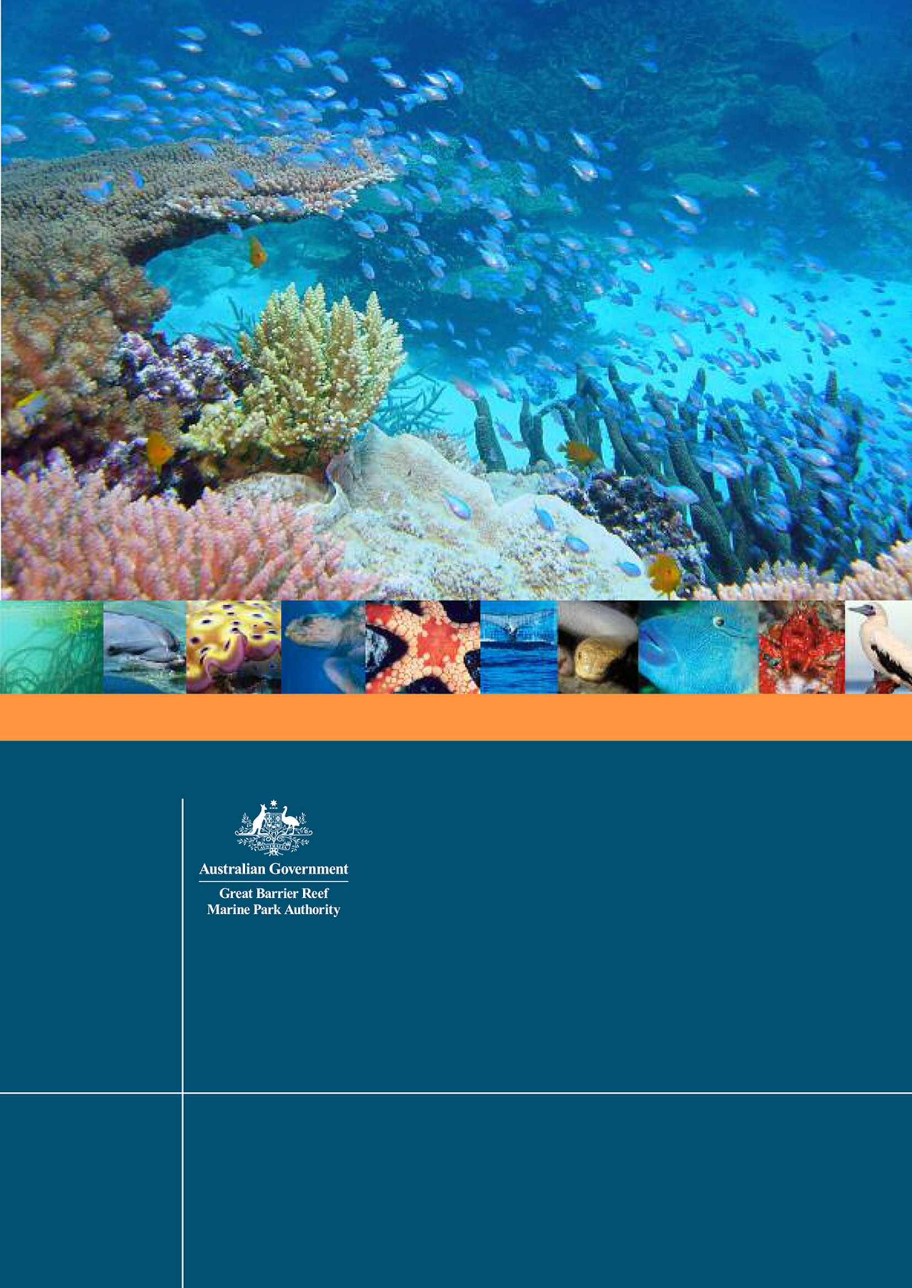
GREAT BARRIER REEF
BIODIVERSITY CONSERVATION
STRATEGY 2013

© Commonwealth of Australia 2013

Published by the Great Barrier Reef Marine Park Authority

ISBN 978 1 921682 72 8

This work is copyright. Apart from any use as permitted under the Copyright Act 1968,
no part may be reproduced by any process without the prior written permission of the
Great Barrier Reef Marine Park Authority.

The National Library of Australia Cataloguing-in-Publication entry :
Great Barrier Reef Biodiversity Conservation Strategy 2013 [electronic resource] / Great Barrier Reef
Marine Park Authority.
ISBN 9781921682728 (eBook; pdf)
Includes bibliographical references.
Biodiversity conservation--Queensland--Great Barrier Reef.
Ecosystem management--Queensland--Great Barrier Reef.
Great Barrier Reef Marine Park (Qld.)
Great Barrier Reef Marine Park Authority.
333.951609943

This publication should be cited as:
Great Barrier Reef Marine Park Authority 2013, Great Barrier Reef Biodiversity Conservation Strategy 2013,
GBRMPA, Townsville.

DISCLAIMER
The views and opinions expressed in this publication do not necessarily reflect those of the Australian
Government. While reasonable effort has been made to ensure that the contents of this publication are
factually correct, the Commonwealth does not accept responsibility for the accuracy or completeness of
the contents, and shall not be liable for any loss or damage that may be occasioned directly or indirectly
through the use of, or reliance on, the contents of this publication.

Requests and inquiries concerning reproduction and rights should be addressed to:
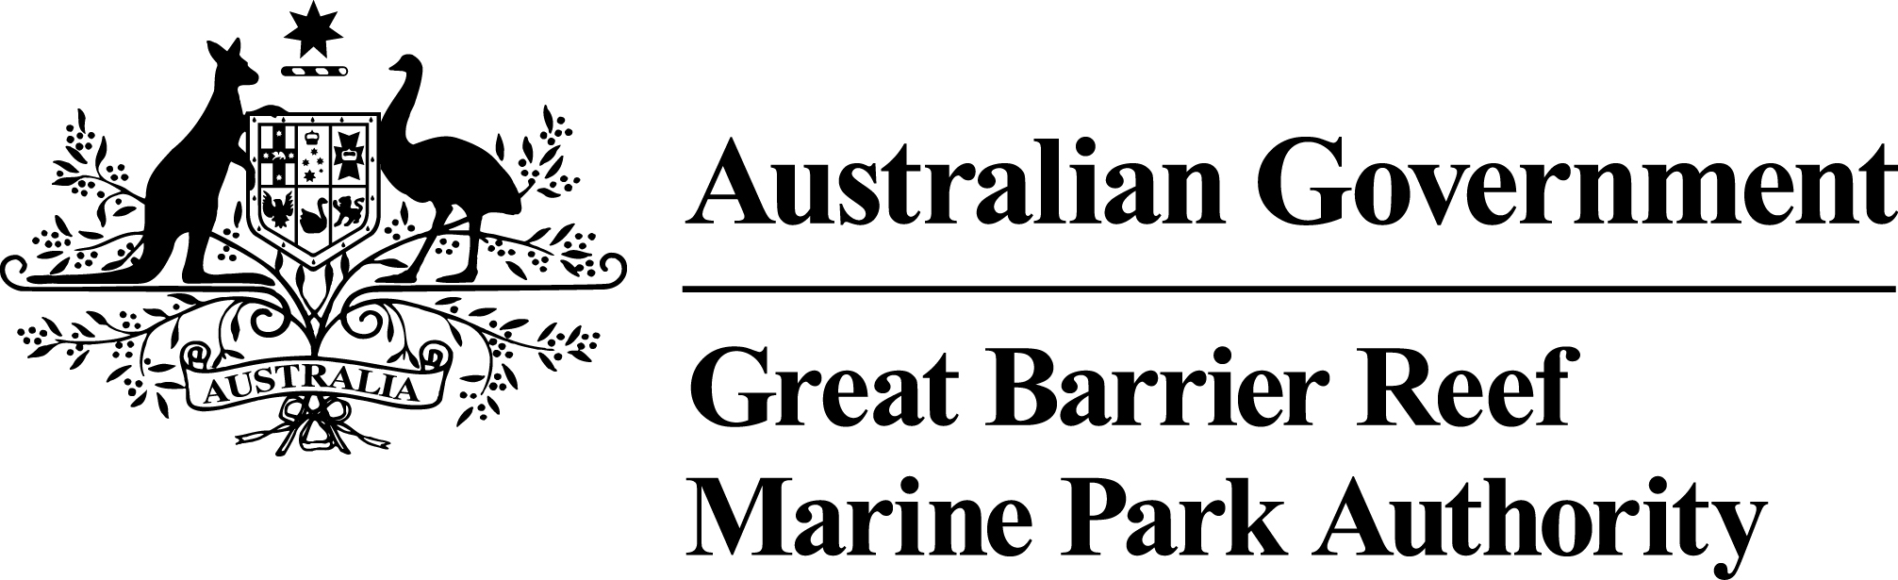
Director, Communications
2-68 Flinders Street
PO Box 1379
TOWNSVILLE QLD 4810
Australia

Phone: (07) 4750 0700
Fax: (07) 4772 6093
info@gbrmpa.gov.au

Comments and inquiries on this document are welcome and should be addressed to:
Director Ecosystem Conservation and Sustainable Use
info@gbrmpa.gov.au
www.gbrmpa.gov.au

summary
Biodiversity is the variability among living organisms from all sources including terrestrial, marine and other aquatic ecosystems, and the ecological complexes of which they are part; this includes diversity within species, between species, and of ecosystems. Conserving biodiversity is an essential part of safeguarding the Earth’s biological resources. The Great Barrier Reef World Heritage Area is an outstanding natural icon and internationally recognised for its biodiversity. Virtually all groups of marine plants and animals are abundantly represented, with thousands of different species recorded.
The Great Barrier Reef Outlook Report 2009 showed the Reef is one of the most diverse and remarkable ecosystems in the world — it also remains one of the most healthy coral reef ecosystems on Earth. The report also highlighted that climate change, continued declining water quality from catchment run-off, loss of coastal habitats from coastal development, illegal fishing and poaching and some remaining impacts from lawful fishing are the key ecosystem-level pressures reducing the resilience of the Reef. Importantly, it identified that while many biodiversity protection measures are making a difference, there is no overarching framework to guide and coordinate management actions.
Many of the pressures on the Great Barrier Reef date back over 150 years, including early catchment clearing and unsustainable levels of fishing and commercial hunting of vulnerable species such as humpback whales, sea cucumbers (for example, black teatfish), dugong and green turtles. While the challenge for management is to ensure any new activity in and adjacent to the World Heritage Area is ecologically sustainable, perhaps an even greater challenge is to address the legacy of past decisions and reverse the long-term declines in biodiversity.
Considerable effort has gone into protecting the Great Barrier Reef’s biodiversity. Over the past three decades or so, substantial progress has been made to address the impacts of fishing, threats to vulnerable species and declines in water quality. For example, significant improvements have been made in reducing fishing impacts such as the use of by-catch reduction devices in trawl nets, effort controls, revised possession and size limits, and the introduction of total allowable catches for some species or species groups. We have also made considerable progress in protecting and managing sustainable use of dugong through the implementation of Dugong Protection Areas and the development of Traditional Use of Marine Resource Agreements with Traditional Owners. The Great Barrier Reef Marine Park Zoning Plan 2003 has become one of the primary management tools for biodiversity protection by regulating activities within the Marine Park and providing a network of no-take zones which protect a minimum of 20 per cent of all 70 bioregions.
The outcome of these efforts is that population recovery is occurring for some species that were previously of concern. For example, international and national actions taken to address the decline in humpback whale populations have been a clear success, with the population that over-winters in the Great Barrier Reef increasing at approximately 10 per cent per year. The previously declining population of loggerhead turtles has also shown signs of recovery. The dugong population in the northern part of the Marine Park remains healthy, but the impact of recent extreme weather means there are ongoing concerns for dugongs in waters south of Cooktown.
The Great Barrier Reef Water Quality Protection Plan (Reef Plan) has been a significant initiative, and is making progress towards the goal of halting and reversing the decline in water quality entering the Reef. The progress towards this goal reflects the level of commitment by both the Australian and Queensland governments, which are investing in excess of $375 million over five years on Reef Plan activities. This includes $200 million for the Australian Government’s Caring for our Country Reef Rescue initiative and $175 million for Reef Plan activities through the Queensland Government.
Importantly, the progress to date reflects the very strong commitment and collaboration by key stakeholders, including the Australian Government, Queensland agencies, the Great Barrier Reef Marine Park Authority (GBRMPA), natural resource management groups, and farmers and graziers. It is important this work continues in order to achieve the goal of ensuring that by 2020 the quality of water entering the reef from adjacent catchments has no detrimental impact on the health and resilience of the Great Barrier Reef. Both the Australian and Queensland governments have committed their support to continue Reef Plan into the future.
Despite considerable management effort, some elements of biodiversity continue to decline. Within the Great Barrier Reef, coral cover has declined by approximately 50 per cent over the past 30 years, mainly affecting central and southern parts of the Reef; the abundance of seagrass meadows along most of the developed coast has declined primarily because of poor water quality; and significant range contractions and population declines have occurred for largetooth (previously known as the freshwater sawfish) and green sawfish due to fishing, coastal clearing and loss of wetlands. It is also possible the speartooth shark has become extinct from waterways on the east coast of Australia, as the last verified specimen was recorded in Princess Charlotte Bay in 1983. These declines clearly identify the need for all levels of government and the community to take a coordinated and focused approach to conserve biodiversity.
Climate change adds another pressure on biodiversity; as a result, we need to reorientate management objectives from preserving all species in their natural habitat and current locations to ensuring space and opportunities are available for ecosystems to adapt and reorganise. This will increase the chances that they can maintain the provision of ecosystem services through a diversity of well-functioning ecosystems.
The Great Barrier Reef Biodiversity Conservation Strategy 2013 has been developed to respond to the pressures identified in the Outlook Report and biodiversity declines. This strategy provides a context on the Reef, its biodiversity and the threats acting upon it. Most importantly, it provides a framework for biodiversity protection, conservation and management within the Reef.
This strategy establishes a process for determining and documenting the habitats, species and groups of species that are potentially at risk. Vulnerability assessments are being completed to identify actions to reduce the impacts on biodiversity. The habitats considered potentially at risk are coral reefs, islands, the lagoon floor, mangroves, open waters and seagrass meadows. The species or species groups considered to be potentially at risk and for which we are completing vulnerability assessments are dugongs, dwarf minke whales, grey mackerel, humpback whales, inshore dolphins, king and blue threadfin salmon, marine turtles, sea snakes, seabirds and shorebirds, pink snapper, and sharks and rays (including sawfish).
The process has also identified overwhelming evidence that inshore habitats along the developed coast south of Cooktown and the species that use these habitats are continuing to be affected by a range of threats. From an ecological and jurisdictional perspective the inshore areas of the Great Barrier Reef are complex; the integration of management and scientific activities could be improved. We propose that a key outcome of this strategy will be an inshore biodiversity program that draws together all relevant partners and activities to improve integration and seek synergies.
In seeking to address these ecosystem-level threats to the World Heritage Area, the Biodiversity Conservation Strategy 2013 is building on a solid foundation of 35 years of management by the Australian and Queensland governments. By balancing ecologically sustainable use, commercial realities and an overarching objective to protect and conserve biodiversity, GBRMPA will continue to work with other Australian Government agencies and the Queensland Government to ensure the long-term sustainability of this multiple-use marine park. A range of management tools is employed both inside the World Heritage Area and beyond its boundaries to address issues and manage activities impacting on the Great Barrier Reef. Many of the management measures employed in the Reef and beyond are improving its resilience.
A number of other programs that focus on reducing the risks from ecosystem-level threats and pressures are implemented by multiple government agencies, Traditional Owners, natural resource management groups, marine and land-based industries, and the community. Through a mixture of legislative and policy reforms, management arrangements and on-ground actions, these programs take a multi-disciplinary approach to addressing priority issues and reducing ecosystem-level pressures that impact on biodiversity.
This strategy seeks to recognise and build on these existing programs. This is addressed through a framework for action based on three strategic objectives aimed at restoring or maintaining ecosystem resilience and protecting biodiversity. These objectives are:
- engaging communities and fostering stewardship
- building ecosystem resilience in a changing climate
- improving knowledge.
Each of the strategic objectives is supported by long-term objectives, outcomes and key actions. The success of this strategy will be tracked through specific targets representing key areas of focus for biodiversity conservation. To ensure a complementary approach to biodiversity conservation and management, this strategy has been developed within the context of the Federal Government’s Australia’s Biodiversity Conservation Strategy 2010–2030, the Queensland Government’s Building nature’s resilience: a biodiversity strategy for Queensland and the Australian Government’s draft biodiversity policy. By ‘nesting’ the Great Barrier Reef Biodiversity Conservation Strategy 2013 within these national and state policies, a more coordinated approach will be taken to minimise threats to the biodiversity of the Reef.
GBRMPA will work in partnership with the Australian and Queensland governments to implement many of the strategy’s actions — these will address threats from within the Marine Park as well as those that originate from catchments adjacent to the Reef. Local government, Traditional Owners, community groups and marine industries will play an important role in implementing on-ground conservation activities to reduce threats and enhance the resilience of the Great Barrier Reef.

CONTENTS
SUMMARY i
1. ABOUT THIS STRATEGY 1
1.1 Scope 1
1.2 Development 3
2. BIODIVERSITY OF THE GREAT BARRIER REEF 4
2.1 Ecosystem services 7
3. APPROACH TO MANAGEMENT — BUILDING ON A SOLID FOUNDATION 8
3.1 Existing ecosystem-level programs 10
3.2 Stewardship 11
Traditional Owner partnerships in sea country management 11
The commercial fishing industry 11
High standard tourism operators 12
Reef Guardians 13
The ports, shipping and resource sectors 13
4. WHAT IS AT RISK AND WHY? 14
4.1 Vulnerability assessments 15
4.2 Risks to Great Barrier Reef biodiversity 17
4.3 Cumulative impacts and threats from extreme weather 19
5. THE WAY FORWARD — A FRAMEWORK FOR ACTION 21
5.1 Guiding principles 21
5.2 A framework for action 22
5.3 An inshore biodiversity program 26
6. IMPLEMENTATION 28
6.1 Review 31
7. REFERENCES 32

ABOUT THIS STRATEGY
The Great Barrier Reef Marine Park Act 1975 requires the Great Barrier Reef Marine Park Authority (GBRMPA) to prepare an Outlook Report for the Great Barrier Reef Region (the Region) every five years. In addition, the objects of the Act were amended in 2007 to read: “The main object of this Act is to provide for the long-term protection and conservation of the environment, biodiversity and heritage values of the Great Barrier Reef Region.” This amendment clearly emphasises the importance that GBRMPA places on the protection and conservation of biodiversity.
The Great Barrier Reef, one of Australia’s first World Heritage properties, was inscribed on the World Heritage List in 1981 in recognition of its outstanding universal value¹. The Reef’s diversity reflects the maturity of an ecosystem which has evolved over many thousands of years. It is the world’s most extensive coral reef system and has some of the richest biological diversity found anywhere on Earth². As a signatory to the World Heritage Convention, Australia has an obligation to protect, conserve, present and hand to future generations the natural heritage and outstanding universal value of the Great Barrier Reef World Heritage Area.
The Great Barrier Reef Outlook Report 2009³ identified the need for a framework for biodiversity conservation and management within the Great Barrier Reef Region to more effectively harness the resources available for management and the support of Reef industries and communities. The purpose of this strategy is to provide that overarching framework to guide and coordinate actions for the protection and conservation of biodiversity in the Region. It seeks to recognise and build on a solid foundation of existing programs and work already underway, while engaging communities, fostering stewardship, and increasing opportunities for all Reef-users to make a positive difference through improved knowledge and understanding.

Scope
The area examined in this strategy is the Great Barrier Reef Region as defined in the Great Barrier Reef Marine Park Act. The Region covers the area of ocean from the tip of Cape York in the north to just past Lady Elliot Island in the south. Its western boundary is mean low water, with the Region extending eastwards a distance of between 70 and 250 kilometres (Figure 1). It includes about 70 Commonwealth islands; however, the majority of islands in the Great Barrier Reef are owned by the Queensland Government or privately and are not included in the Region.
The Region’s boundaries match those of the Great Barrier Reef Marine Park, except the Region also includes the areas around major ports.
Where relevant to the Great Barrier Reef ecosystem, the strategy also looks beyond the boundaries of the Region and includes information about adjacent islands, neighbouring marine areas and the Great Barrier Reef catchment.

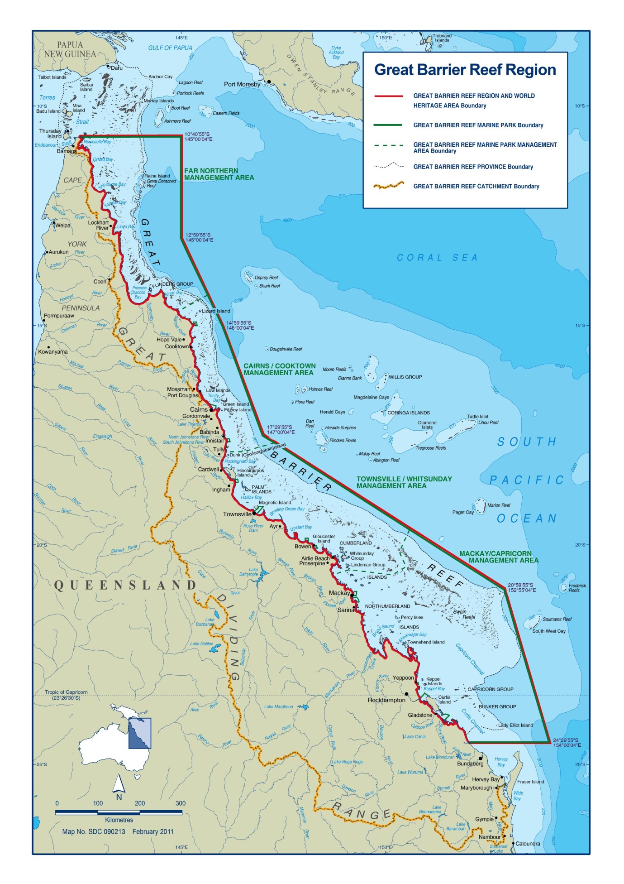Figure 1 The Great Barrier Reef Region

Development
This strategy was developed within the context of the Australian Government’s Australia’s Biodiversity Conservation Strategy 2010–2030⁴, the Queensland Government’s Building nature’s resilience: a biodiversity strategy for Queensland⁵ and the Australian Government’s draft biodiversity policy⁶. Through this complementary, or ‘nested’, approach, it is intended the strategy will provide a coordinated framework for biodiversity conservation and protection within the Great Barrier Reef Region. It will form the basis for all stakeholders to respond to regional scale and local issues and implement actions to reduce the impact of identified pressures within their sphere of influence.
A number of Australian and Queensland government agencies, researchers, industry groups (including representatives from the fishing, tourism, agricultural, grazing, ports, shipping and resources sectors) and members of the public contributed to the strategy’s development. GBRMPA’s Ecosystem Reef Advisory Committee also provided guidance throughout the development of this document, while advice was also received from the agency’s Indigenous Reef Advisory Committee, Tourism and Recreation Reef Advisory Committee, and the Catchment and Coastal Reef Advisory Committee.
A draft strategy was released for public consultation in August 2012 to give the community the opportunity to review the strategy and assist GBRMPA to finalise this important document. The community was asked to comment on whether the strategy focused on the right habitats and species and mix of actions and targets. Twenty five submissions were received and the draft strategy was amended to address comments received during that process.
No new research was undertaken as part of developing this strategy; rather, the evidence used is derived from existing research and information sources. Figure 2 provides an overview of the key considerations in preparing this strategy.

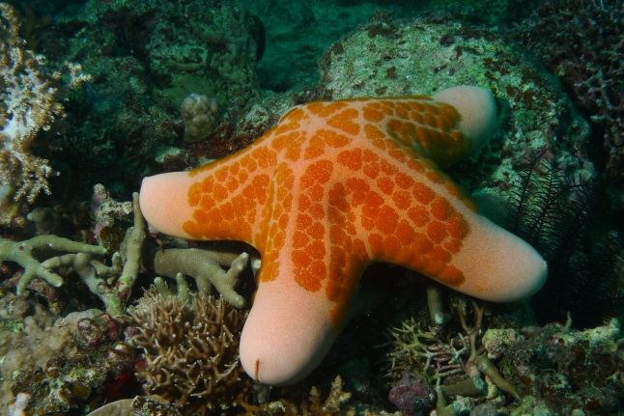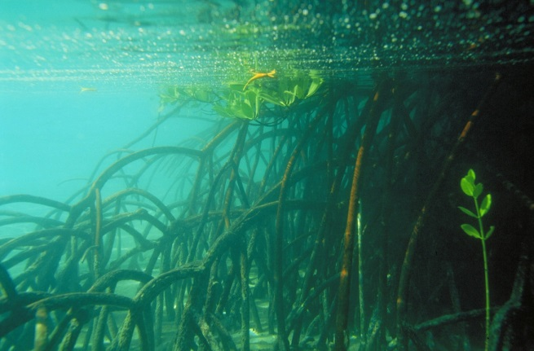
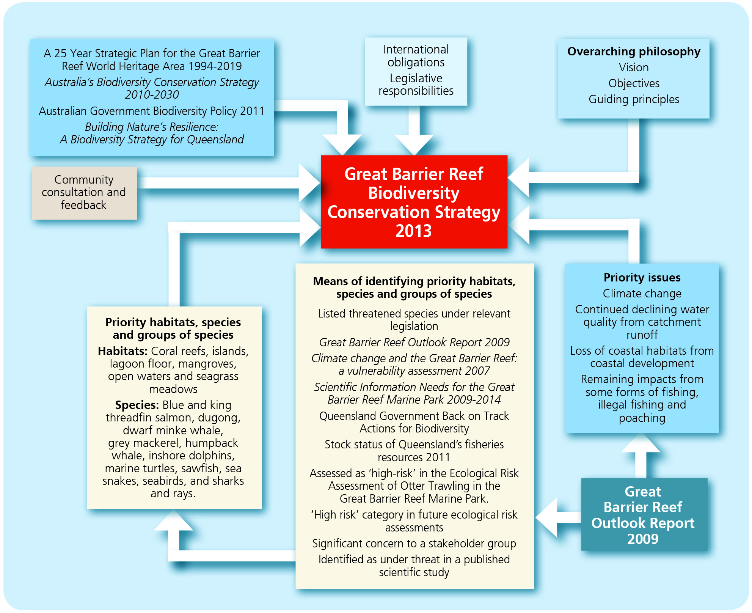

Figure 2 Key considerations in preparing the Great Barrier Reef Biodiversity Conservation Strategy 2013

BIODIVERSITY OF THE GREAT BARRIER REEF
Biodiversity is the variability among living organisms from all sources including terrestrial, marine and other aquatic ecosystems, and the ecological complexes of which they are part; this includes diversity within species, between species, and of ecosystems⁷. Conserving biodiversity is an essential part of safeguarding the Earth’s biological resources⁸. Three levels of biodiversity are usually recognised:
- genetic diversity — the variety of genetic information contained in individual microorganisms, plants and animals
- species diversity — the variety, size and age classes of species present in an area
- ecosystem diversity — the variety of habitats, ecological communities and ecological processes.
Around the world, biodiversity is under threat mainly from human-related pressures such as deforestation, coastal development, direct and indirect use of natural resources, population growth and an increasing reliance on fossil fuels⁹. A further stress on ecosystems is a rapidly changing climate^{10,11,12}, which can act to exacerbate the effects of the other threats^{3,11}. In aquatic and marine ecosystems, the impacts from these pressures has led to declines in species’ populations (especially corals, fish, marine mammals and seabirds⁹), declines in water quality¹³, increasing amounts of marine debris in the ocean and degradation of key marine habitats such as coral reefs¹⁴.
The Great Barrier Reef, one of Australia’s first World Heritage properties, was inscribed on the World Heritage List in 1981 in recognition of its outstanding universal value. Specifically, it was recognised as having outstanding examples of the following four natural criteria for World Heritage listing:
- To contain superlative natural phenomena or areas of exceptional natural beauty and aesthetic importance
- To be an outstanding example representing major stages of Earth's history, including the record of life, significant ongoing geological processes in the development of landforms, or significant geomorphic or physiographic features
- To be an outstanding example representing significant ongoing ecological and biological processes in the evolution and development of terrestrial, freshwater, coastal and marine ecosystems and communities of plants and animals
- To contain the most important and significant natural habitats for in situ conservation of biological diversity, including those containing threatened species of outstanding universal value from the point of view of science or conservation.
It is one of the world’s largest World Heritage properties, extending more than 2300 kilometres and covering 348,000 square kilometres on and adjacent to the north-east continental shelf of Australia. Larger than Italy, it is one of the world’s best known marine protected areas. The Great Barrier Reef’s diversity reflects the maturity of an ecosystem which has evolved over many thousands of years. It is the world’s most extensive coral reef system and has some of the richest biological diversity found anywhere on the planet^{1,2}.
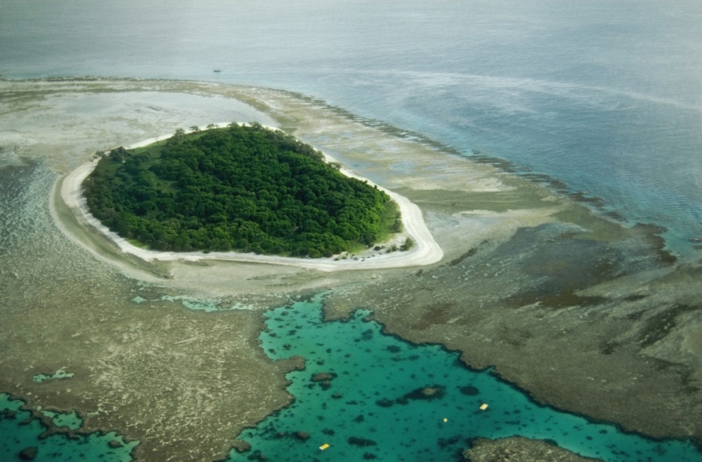
Vegetated coral cays are one example of the outstanding natural values of the Great Barrier Reef

Compared to many other ecosystems throughout the world, the biodiversity of the Great Barrier Reef World Heritage Area is well documented ^{2,3,15,16}. Nearly all groups of marine plants and animals are abundantly represented, with thousands of different species recorded (Table 1). It is also recognised there are many new species yet to be discovered and named². This extraordinary biodiversity and the interconnectedness of species and habitats make the Great Barrier Reef and the surrounding areas one of the most complex natural systems on Earth^{1,3}.

Table 1 Overview of the biodiversity of the Great Barrier Reef
Habitats/communities | Percentage of Great Barrier Reef Marine Park
Seagrass, shoals and sandy or muddy seabed (up to 200m deep) | ~61%
Mangroves | ~0.6%
Fringing reefs, mid-shelf reefs and outer reefs | 7%
Continental shelf/slope | ~15%
Deep water habitats | 16%
Islands | ~1%
Taxonomic group | Species diversity and level of knowledge in Great Barrier Reef
Macroalgae | At least 630 species; level of knowledge for a limited number of species good; overall level of knowledge poor
Seagrasses | 15 species; level of knowledge fairly good
Mangroves | 39 species; level of knowledge fairly good
Sponges | At least 2500 species for all Queensland waters; overall level of knowledge poor
Jellyfish | >100 species; overall level of knowledge poor
Bryozoans | ~950 species; overall level of knowledge poor
Soft corals and sea pens | At least 150 species; overall level of knowledge poor
Sea anemones | ~40 species; overall level of knowledge poor
Hard corals | >450 species; knowledge for many reef-building species good; level of knowledge for remainder poor
Molluscs | >3000 species; overall level of knowledge medium; good for commercially important species
Worms | At least 500 species; level of knowledge poor but better for polychaetes than other groups
Crustaceans | ~1300 species; overall level of knowledge poor; good for some commercially important species
Marine insects | Number of species unknown, probably >20, level of knowledge very poor
Marine arachnids | Number of species unknown, probably >5, level of knowledge very poor
Plankton | Species diversity very high; overall level of knowledge poor
Echinoderms | ~630 species; some species well studied, i.e. crown-of-thorns starfish, but majority poorly known
Ascidians/Tunicates | ~720 species for all Australian waters; overall level of knowledge poor
Bony fishes | ~1625 species.; level of knowledge good for some coral reef and commercially important species; poor for remainder
Sharks and rays | ~133 species; level of knowledge generally poor but improving
Crocodiles | 1 species estuarine crocodile; level of knowledge good
Marine turtles | 6 species; level of knowledge generally good
Sea snakes | 14 breeding species; level of knowledge good for several species; but remainder poor
Seabirds | 22 nesting species; level of knowledge good for some species; poor for remainder
Marine mammals | >30 species of whales and dolphins and 1 species of dugong; overall knowledge for dugong and humpback whales good; for remainder poor to very poor
Globally significant marine animal groups include more than 3000 species of molluscs and more than 1500 species of fish, plus a great diversity of sponges, anemones, marine worms, crustaceans, and many others². The establishment of cay and island vegetation shows the important role of birds, such as the pied imperial pigeon, in processes such as dispersal and colonisation. Similarly, island biogeography is demonstrated by remnant vegetation such as hoop pines.
Today, the coral reef ecosystem ranges from inshore fringing reefs to mid-shelf reefs and exposed outer reefs; these include examples of all stages of reef development^{3,17}. The processes of geological and geomorphological evolution are well represented, linking islands, coral cays, reefs and sand barriers. The varied seascapes and landscapes have been moulded by changing climates and sea levels, along with the erosive power of water, over long time periods¹⁸.
Many of the intertidal areas and wetlands adjacent to the Great Barrier Reef are also critical habitats for migratory birds. Australia is a signatory to the Convention on Wetlands of International Importance (Ramsar Convention) — as such it is obliged to promote the conservation of Ramsar wetlands and the wise use of all wetlands, while working to ensure Ramsar sites are managed to protect their ecological character.
The Great Barrier Reef Region contains two internationally important wetlands: Bowling Green Bay and Shoalwater and Corio Bays. Combined, these two sites cover more than 286,000 hectares. The sites provide important habitats for resident and migratory birds; in Bowling Green Bay, more than 220 species of birds have been sighted¹⁹ with up to 50 per cent of the migratory species of the East Asian Australasian Flyway using the site²⁰. Furthermore, Shoalwater and Corio Bays provide important ‘wintering’ habitat for at least 26 migratory species and critical habitat for many species, including the green turtle and the dugong.

Ecosystem services
All living creatures depend on biodiversity and natural ecosystems to provide the goods and services that sustain our wellbeing and our economy — usually referred to as 'ecosystem services' ^{9,21}. Interactions exist between people, biodiversity and ecosystems in that changing human conditions drive, both directly and indirectly, changes in biodiversity and ecosystems and, ultimately, changes in the services that ecosystems provide. As a result, the well-being of humans and biodiversity is inextricably linked.
Maintenance of biodiversity is critical for the provision of ecosystem services. When biodiversity is impacted by threats, whether environmental or man-made, ecosystems can become unstable, affecting all things that rely on those ecosystems²². This has the potential to impact on the industries that rely on a healthy ecosystem for their livelihoods and on the social values of that ecosystem^{8,23}.
Historically, the value of ecosystem services has rarely been fully considered in decision making. Healthy wetlands, for example, provide a natural water purification service, as well as flood protection, carbon sequestration, food products and much more. The disappearance of a wetland means these services would need to be replaced by man-made capital, like a water treatment plant or a flood levee bank. The value of the ecosystem service provided, and the cost of replacing this service through infrastructure, provides an indication of the true value of such ecosystem goods or services (otherwise known as natural capital) in the environment. The types of ecosystem services usually recognised⁹ are shown in Table 2.
Table 2 Types of ecosystem services usually recognised (Source: Millennium Ecosystem Assessment 2005⁹)
Type | Example of service provided
Provisioning | Food, water, fibre and fuel
Regulating | Climate regulation, water and disease
Cultural | Spiritual, aesthetic, recreation and education
Supporting | Primary production and soil formation

Today, much of the economy derived from the Great Barrier Reef is based upon the use of the ecosystem services it provides³. For example, the commercial fishing industry which operates within the Great Barrier Reef Marine Park is almost totally dependent on natural ecological systems for productivity and sustainable profit. Almost all marine-based tourism and recreation in the Great Barrier Reef is nature-based and reliant on a healthy and diverse ecosystem to provide a lasting impression for visitors to the Reef ³.
The interconnected nature of ecosystems within an area as diverse as the Great Barrier Reef means management actions simultaneously affect a range of ecosystem services, while ultimately affecting multiple-user groups who rely on the natural resources of the area²¹.
Protecting biodiversity is critical to maintaining functioning ecosystems that form a critical component of ecological resilience^{11,24}. Maintaining and re-establishing ecosystem functions must be part of a whole of ecosystem approach to biodiversity conservation. A whole of ecosystem approach expands on and complements management actions that are specific to certain species — these actions remain fundamental for biodiversity conservation¹¹.

approach to management — building on a solid
foundation
The Great Barrier Reef Region is managed under a comprehensive statutory framework (legislation, policies and management arrangements) administered by the Australian and Queensland governments. A range of management tools (Table 3) is employed inside the Region and beyond its boundaries to address issues and manage activities that have an impact on the Region. The management of some of the main activities is principally confined to actions within the Region (such as commercial fishing and marine tourism, defence and scientific research), while some of the major pressures require actions outside and sometimes well beyond the Great Barrier Reef (such as climate change, coastal development and water quality). This extends to meeting obligations under various international agreements and conventions.
For more than 35 years, the Commonwealth and Queensland governments have managed the Great Barrier Reef as a multiple-use marine park to ensure its long-term sustainability. This is done by balancing ecologically sustainable use, commercial realities and an overarching conservation objective. The Marine Park is considered by many to be a leading example of world’s best practice management. GBRMPA works in partnership with stakeholders, Traditional Owners, marine and catchment-based industries and interest groups, scientists, conservation groups, communities and all levels of government to achieve its goal of the long-term protection, ecologically sustainable use, understanding and enjoyment of the Great Barrier Reef for all Australians and the international community, through the care and development of the Marine Park.
The Great Barrier Reef Marine Park Zoning Plan 2003 is one of the primary management tools for the protection of the Reef ecosystem. It provides the underlying basis for these other programs and protects biodiversity by regulating activities within the Marine Park. It also provides for a network of no-take zones which protect at least 20 per cent (and often more) of all the 70 bioregions that extend along and across the Region. In combination, this network of no-take zones, other zone types and associated Regulations provide protection for habitats and species while offering opportunities for sustainable use of the Marine Park and its resources²⁵. The zoning of the Marine Park is complemented by similar zoning by the Queensland Government over adjacent state waters.

Table 3 Summary of the management tools used in addressing the broad management topics of the Great Barrier Reef (Source: Great Barrier Reef Outlook Report 2009³)
Management  tools | Management topics
Management  tools | Biodiversity protection | Climate change | Coastal development | Commercial marine tourism | Defence | Fishing | Heritage | Ports and shipping | Recreation (not including fishing) | Scientific research | Traditional use of marine resources | Water quality
Legislation | • |  | • | • | • | • | • | • | • | • | • | •
Zoning plans | • |  |  | • | • | • | • | • | • | • | •
Permits and licences | • |  | • | • |  | • | • | • |  | • | • | •
Management plans — legally binding | • |  | • | • |  | • | • |  | • | • | •
Management plans — policy | • | • | • | • | • | • | • | • | • | • | • | •
Site management | • |  | • | • | • | • | • | • | • | • |  | •
Policy | • | • | • | • | • | • | • | • | • | • | • | •
Research | • | • | • | • |  | • | • | • | • | • | • | •
Partnerships and best practices | • | • | • | • | • | • | • | • | • | • | • | •
Education and community awareness | • | • | • | • | • | • | • | • | • | • | • | •
Compliance | • |  | • | • |  | • | • | • | • | • | • | •

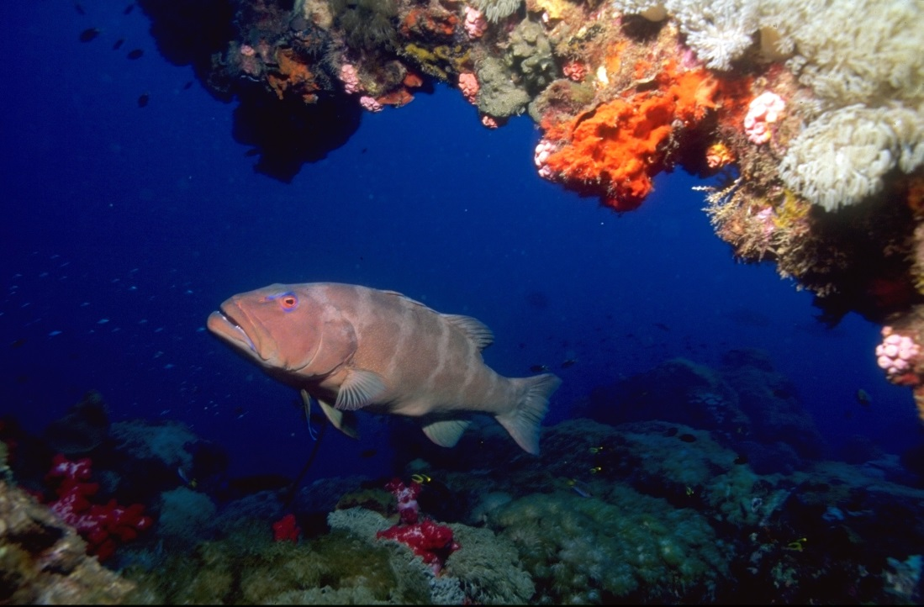
Coral trout are one species that has shown a dramatic increase in numbers in no-take areas since the Marine Park was rezoned in 2003

Existing ecosystem-level programs
There are a number of existing programs focused on reducing the risks from ecosystem-level impacts and pressures. These programs are implemented by multiple government agencies, Traditional Owners, natural resource management groups, industries and the community. These programs take a multi-disciplinary approach to address priority issues and reduce ecosystem-level pressures that impact biodiversity. A mixture of legislative and policy reforms, management arrangements and on-ground actions such as stewardship are used.
Pressure acting on ecosystem | Reef-related programs to address the ecosystem-level risk posed by these pressures
Climate change | Great Barrier Reef Climate Change Action Plan 2007–2012  The Climate Change Action Plan outlines a five year program of actions which Great Barrier Reef managers can take, in collaboration with stakeholders and other partners, to minimise the damage caused by climate change. The action plan is based on four objectives:  - targeted science  - a resilient Great Barrier Reef ecosystem  - adaptation of industries and regional communities  - reduced climate footprints.
Continued declining water quality from catchment run-off | Reef Water Quality Protection Plan 2009 (Reef Plan)  The Reef Water Quality Protection Plan 2009 is a joint Australian and Queensland government commitment to minimise the risk to the Great Barrier Reef ecosystem from a decline in the quality of water entering the Reef from adjacent catchments. Addressing declining water quality enhances the resilience of the Reef to better cope with the stresses of a changing climate and other pressures. Reef Plan has a monitoring and evaluation strategy, the Paddock to Reef program, to integrate information on management practices, catchment indicators, catchment loads and the health of the Great Barrier Reef.
Loss of coastal habitats from coastal development | Queensland Wetlands Program  The Australian and Queensland governments established the Queensland Wetlands Program in 2003, to protect wetlands in the Great Barrier Reef catchment and throughout the state, including those designated under the Convention on Wetlands of International Importance (Ramsar Convention). The program delivers projects that include a range of new mapping, information and decision-making tools. These enable government agencies, landowners, conservationists and regional Landcare groups to protect and manage wetlands for future generations.
Loss of coastal habitats from coastal development | The comprehensive strategic assessment of the Great Barrier Reef World Heritage Area  The Australian and Queensland governments are collaborating on a strategic assessment to improve the management of coastal development along the Great Barrier Reef coast. This will enhance the ecosystem programs detailed here and complement the actions and targets in this strategy; combined, they will make a substantial contribution to addressing the remaining impacts of coastal development.
Remaining impacts of fishing and hunting | Various Queensland Government fisheries management plans and management arrangements  Recreational and commercial fishing in the Marine Park is regulated by the Queensland Government's Fisheries Act 1994 and Fisheries Regulation 2008. Management of recreational fishing includes seasonal closures, restrictions on the size and number of fish taken, limits on the number of lines and hooks used and restrictions on the types of gear allowed. Commercial fishing is managed through a variety of means including limits on the amount of fish taken; limits on the number of fishing licences; spatial and seasonal closures; restrictions on fishing vessel size and on the length, mesh size and number of nets and hooks used; restrictions on the take of some fish species; and on the minimum and maximum size of fish retained.
Remaining impacts of fishing and hunting | Zoning and ecologically sustainable fishing in the Great Barrier Reef Marine Park  The Great Barrier Reef Marine Park Authority recognises fishing on the Reef is an important pastime and a source of income for Queensland coastal communities and the state’s seafood industry. The Great Barrier Reef Marine Park Zoning Plan 2003 ensured that at least 20 per cent of each bioregion was placed in highly protected, no-take zones in order to better protect the range of biodiversity in the Reef. The agency also works collaboratively with others including the Commonwealth Department of Sustainability, Environment, Water, Population and Communities, the Queensland Government, and commercial and recreational fishers to continuously improve fishing gear, methods and compliance. While fisheries management and fishing practices continue to improve, some risks remain, particularly illegal fishing — these are being progressively addressed.
Remaining impacts of fishing and hunting | Reef Rescue’s Indigenous Land and Sea Country Partnerships Program  In December 2008, the Australian Government committed $10 million over five years towards the Reef Rescue Indigenous Land and Sea Country Partnerships Program. The program is engaging Indigenous communities in collaborative sea country management that conserves biodiversity and protects cultural and heritage values of the Great Barrier Reef. The program is designed to:  - expand the Traditional Use of Marine Resources Agreement program across the Reef catchment  - develop sea country plans  - strengthen communication between local communities, managers and Reef stakeholders and build better understanding of Traditional Owner issues about the management of the Marine Park.

Stewardship
A range of stewardship-based programs within the Great Barrier Reef World Heritage Area and catchment are proving that a hands-on, community-based approach to caring for the Reef is essential in preserving its immense social, economic and environmental value.

Traditional Owner partnerships in sea country management
Aboriginal and Torres Strait Islander people are the Traditional Owners of the Great Barrier Reef Region. Today, there are approximately 70 Traditional Owner groups whose sea country includes the World Heritage Area.
A number of Great Barrier Reef Traditional Owner groups have developed a suite of sea country management arrangements including Traditional Use of Marine Resources Agreements. Partnerships are also fostered through Traditional Owner representation on GBRMPA’s Board and through the Indigenous Reef Advisory Committee which provides advice. The Reef Rescue Land and Sea Country Indigenous Partnerships Program provides an opportunity to enhance existing arrangements for sustainable traditional use of marine resources, sea country research and education, cultural heritage initiatives, sea country planning and support for Marine Park compliance matters.

Human use and occupation of the coastal zone of the Great Barrier Reef
"Aboriginal occupation of northern Australia predates the last substantial rise in sea level that ended approximately 6000 years ago. The Torres Strait islands have been occupied for at least the last 1000 years, although the land bridge between Australia and Papua New Guinea would have been occupied before incursion of the sea. At the time, the inshore seabed between the present mainland and the barrier reef would have been coastal plains, containing numerous swamps and rivers. Aboriginal people lived and hunted and used the resources of the plains before the sea level rose. Currently, about half the Aboriginal and Torres Strait Islander population of the tropical north of Australia live within 20 kilometres of the coast. Aboriginal and Torres Strait Islander people have used the resources of the coastal environment, reefs and islands of the Great Barrier Reef extensively for many generations. Archaeological research has dated substantial middens at Princess Charlotte Bay, containing the remains of extensive use of shellfish and dugong bones, up to 5000 years old.
The relationship between Aboriginal and Islander people and their maritime estates is a strong and continuing one. Fundamental to that relationship is the general principle that particular areas of coastline, and the adjacent sea, reefs, islands and cays are held under customary ownership — or more accurately stewardship —by identifiable local descent groups. The traditional estates of Aboriginal and Islander people do not finish at the shoreline."
Source: Lawrence, Kenchington and Woodley 2002²⁶.

The commercial fishing industry
Commercial fishing is a key activity conducted within the World Heritage Area. Commercial fishers and the Queensland Seafood Industry Association (the peak body representing the state’s seafood industry) play a crucial role in ensuring their industry is ecologically sustainable by promoting stewardship and continuous improvement. These approaches aim to maximise economic returns while minimising the impacts of commercial fishing on the environment. They are also developing new strategies to help the fishing industry adapt to climate change pressures.
For example, after elevated sea temperatures caused mass bleaching of coral reefs in the Great Barrier Reef in 1998 and 2002, Pro-vision Reef (a group representing the aquarium supply fisheries) developed an action plan²⁷ in collaboration with GBRMPA and the Queensland Government. Released in 2009, the Stewardship Action Plan was developed to ensure licensed participants in Queensland-based fisheries that supply the marine aquarium industry adhere to a uniform operational standard. It gave operators clear contingency plans to respond to major environmental disturbances linked to global climate change. The action plan has been complemented by the Coral Stress Response Plan²⁸ developed by the Queensland Department of Employment, Economic Development and Innovation (now Department of Agriculture, Fisheries and Forestry), commercial fishers and GBRMPA. The response plan outlines how fishers operating in the aquarium supply fishery can help improve the resilience of reef ecosystems, enabling them to recover from stress events, while allowing collecting to operate in some capacity where possible.
In early 2011, after extensive flooding from the Fitzroy River, there were concerns corals in the Keppel Island group (off Rockhampton) would be adversely affected by freshwater bleaching and increased turbidity and that coral collecting may not be sustainable in some areas for a period of time. Based on these concerns, the Coral Stress Response Plan was initiated and commercial aquarium supply collectors in the Keppel Island region agreed to impose a voluntary moratorium on coral collection in areas considered to be at risk. This moratorium will be lifted when environmental conditions and underwater surveys indicate coral reef habitats are recovering and could support limited collecting.

High standard tourism operators
The marine tourism industry is also a key partner in the protection and management of the Great Barrier Reef. Tourism operators help enhance visitor experiences of the Reef and play an important role in protecting the amazing biodiversity that supports their industry. Many tourism operators ensure their activities are best practice by following the Responsible Reef Practices for their sector²⁹. Their industry has also developed and implemented its own strategy to allow it to respond to and adapt to climate change³⁰. High Standard Tourism Operators have higher standards than required by legislation as part of their commitment to ecologically sustainable use. These operators are independently eco-certified as meeting best practice standards on the key areas of protection, presentation and partnership.
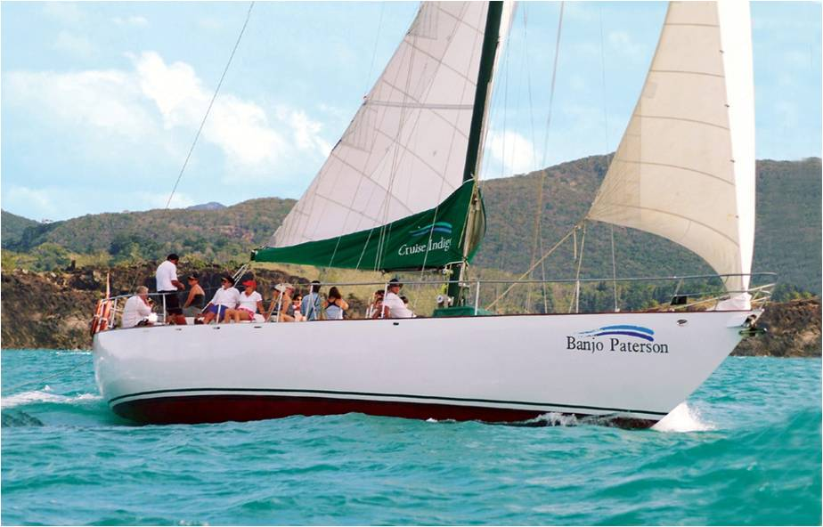
High standard tourism operators are key partners in improving the resilience of the Great Barrier Reef

Reef Guardians
The Reef Guardian stewardship program plays a critical role in ensuring the Great Barrier Reef’s values are appreciated and that community actions support management of the Marine Park so it is well placed to meet the challenges ahead. The program is empowering communities to help build the Reef’s resilience to withstand the impacts of a changing climate. The community-based initiative showcases environmental actions being taken within coastal communities and industries in the Great Barrier Reef catchment and Marine Park.
GBRMPA launched the Reef Guardian program in 2003 to encourage community action at a local level to achieve a healthier Reef. Today, there are more than 290 schools and more than 110,000 students in the Great Barrier Reef catchment involved in the Reef Guardian Schools initiative. Due to the success and uptake of the Reef Guardian Schools program, the initiative was expanded in 2007 to involve local councils. Thirteen councils from Bundaberg to Cooktown have signed up to the program, representing more than 890,000 residents over 317,000 square kilometres.
In 2010, the Australian Government announced funding for GBRMPA to improve the outlook of the Reef. This funding has enabled GBRMPA to expand the Reef Guardian initiative to other sectors. The Reef Guardian Farmers and Fishers pilot programs were launched in 2011 to recognise primary producers and fishers who use voluntary environmental practices that go well beyond mandatory standards, producing significant benefits for the Reef. The Reef Guardian program is playing an important role in encouraging communities, individuals and businesses to help build a healthy and resilient Marine Park.

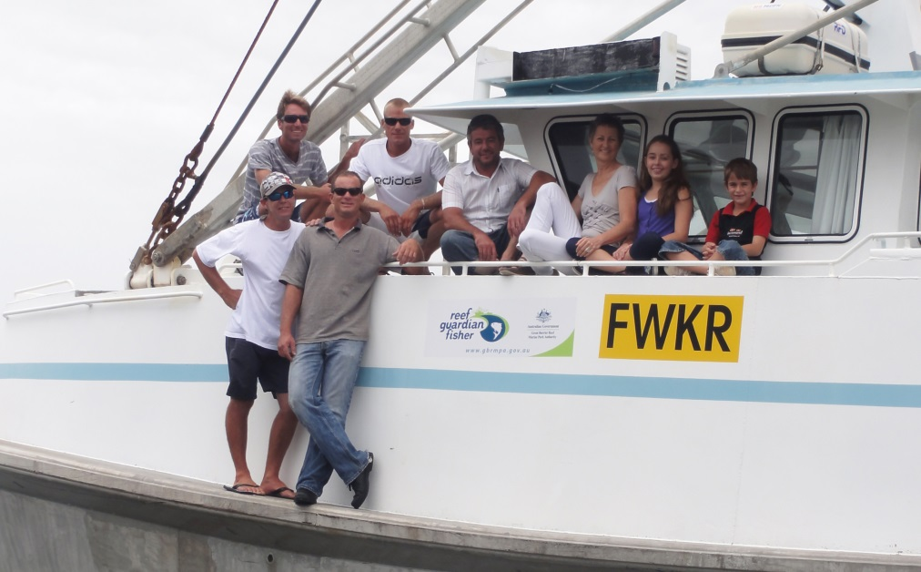
By adopting voluntary best environmental practices, Reef Guardian fishers are reducing their carbon footprint and improving the economic and ecological sustainability of their fisheries

The ports, shipping and resource sectors
A key principle underpinning stewardship is recognising that not all aspects of the management of the Great Barrier Reef are regulatory. The ports, shipping and resource sectors have been involved in a number of voluntary partnerships and programs over and above legislative requirements which play an important ongoing role in the conservation of the Reef’s biodiversity. These industries have a strong interest in preserving this biodiversity; the health of the Reef and the resources industry are intertwined.
An example of this voluntary approach is the Port Curtis Integrated Monitoring Program³¹. This program was the first collaborative broadly-focused monitoring program to be undertaken for the whole of Port Curtis. The program was established in 2001 as a consortium of members from 16 bodies representing industry, government (local and state), research institutions and other stakeholders. The aim was to develop a cooperative monitoring program for assessing the ecosystem health of Port Curtis and to ensure the environmental sustainability of the Port of Gladstone.
Researchers from across the country are involved in the program (including from Central Queensland University, Griffith University, Queensland Department of Agriculture, Fisheries and Forestry and CSIRO). This has enabled the program to use the latest techniques and emerging technologies to assess the health of the harbour within several main research themes: water quality (which includes bio-monitoring and ecological indicators), intertidal health (which includes an oil spill assessment) and seagrass health. The data from each research theme is analysed, collated, interpreted and presented in the form of a Port Curtis Ecosystem Health Report Card.
The Gladstone Healthy Harbour Partnership has been established to ensure the ongoing monitoring and improvement of Gladstone Harbour and surrounding catchments. The partnership will include representatives from government, industry, research, community and other interests. The purpose of the partnership is to align activities, harness the co-investment potential, implement an adaptive management framework and deliver a shared vision for a healthy Gladstone Harbour.

what is at risk and why?
Despite the considerable management effort expended in the Great Barrier Reef Region over many decades, research and monitoring have identified that some habitats and populations of some species have undergone steep declines in the past century. There is a clear need to implement measures to better understand and address these declines. Relevant examples include a significant reduction in the dugong population along the urban coast of Queensland³², as well as large declines in largetooth and green sawfish^{33,34} and in some species of seabird that nest on islands and cays within the Great Barrier Reef ^{35,36,37}.
To identify the elements of biodiversity considered to be potentially at risk and to determine which ones would be assessed as part of this strategy, a hierarchical approach was applied based on existing information. Elements of biodiversity were assessed in this strategy if they are:
- a listed species under the Environment Protection and Biodiversity Conservation Act 1999, the Nature Conservation Act 1992 or a protected species under the Great Barrier Reef Marine Park Regulations 1983
- assigned an assessment grade of poor or very poor in the Outlook Report 2009³
- assessed as vulnerable to climate change impacts in the Climate Change and the Great Barrier Reef: a vulnerability assessment¹⁶
- identified as having a high/moderate degree of concern to management and low/moderate adequacy of information in the Scientific information needs for the management of the Great Barrier Reef Marine Park 2009–2014¹⁵
- identified as a priority species in the Queensland Government’s Back on Track Actions for Biodiversity for the natural resource management regions adjacent to the Great Barrier Reef Region^{38,39,40,41,42,43}
- identified as having an exploitation status of overfished, uncertain or undefined in the Queensland Government's Stock status of Queensland's fisheries resources 2011⁴⁴
- assessed as having a high risk rating in the draft ecological risk assessment of otter trawling in the Great Barrier Reef Marine Park⁴⁵
- in a high risk category in any future ecological risk assessments
- of significant concern to a Great Barrier Reef Marine Park stakeholder group
- identified as under threat in a published scientific study
- identified as a keystone cultural species by a Traditional Owner group.
Table 4 summarises the elements of biodiversity identified as potentially at risk following the application of this hierarchical assessment. The individual habitats and species shown comprise the biodiversity elements identified as the focus for this strategy. The current list is not definitive and it is anticipated additional habitats and species will be added should information and vulnerability assessments indicate they are a management priority. Habitats and species will also be removed from the list if a vulnerability assessment indicates they are not a priority.
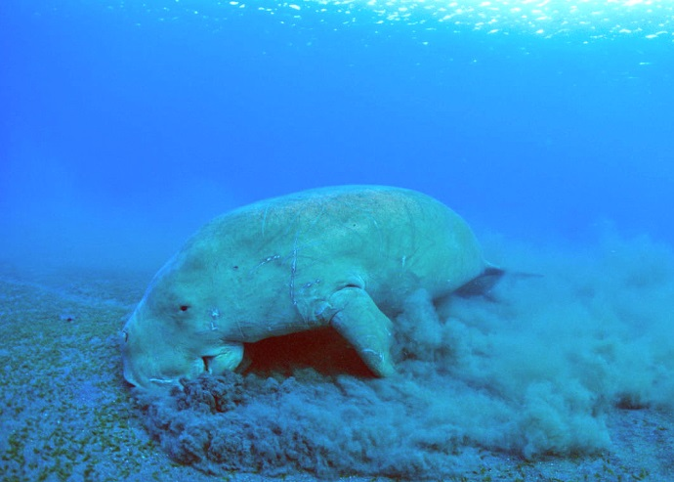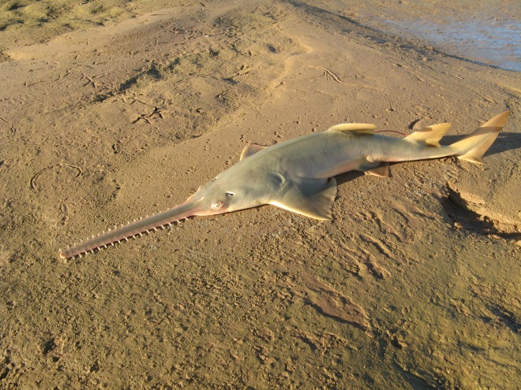
Largetooth (Freshwater) sawfish Photo: Stirling Peverell

Dugong foraging on seagrass

Vulnerability assessments
Once an element of biodiversity was identified as being potentially at risk, vulnerability assessments were conducted to:
- identify key sources of vulnerability
- identify appropriate and practical management actions that could be taken to mitigate risks and enhance ecosystem resilience
- identify gaps in management effectiveness, including deficiencies in legislation and policy, and those areas where additional research is required for making informed decisions.
The purpose of this process is to provide a mechanism to highlight concerns and to use a standard and transparent process to assess vulnerabilities of identified elements of biodiversity to known sources of pressure.

Table 4 Potentially at-risk elements of biodiversity
Elements of biodiversity identified as potentially at risk | Criteria
Elements of biodiversity identified as potentially at risk | Assessment grade from the Great Barrier Reef Outlook Report 2009 —poor or very poor | Assessed as vulnerable to the impacts of climate change | Identified as having a high/moderate degree of concern to management and low/moderate adequacy of information | Identified as a priority species in the Queensland Government's Back on Track Actions for Biodiversity | A listed species under the EPBC Act, the Nature Conservation Act 1992 or a protected species under the Great Barrier Reef Marine Park Regulations 1983 | Identified as having an exploitation status of overfished, uncertain or undefined in the Queensland Government's Stock status of Queensland's fisheries resources 2011 | Assessed as having a high risk rating in the draft ecological risk assessment of otter trawling in the Great Barrier Reef Marine Park
Habitats
Coral reefs |  | √
Islands |  | √ | √
Lagoon floor |  | √ | √
Mangroves |  | √ | √
Open water |  | √ | √
Seagrass meadows |  | √
Species or groups of species
Bony fish — threadfin salmon |  | √ | √ |  |  | √
Bony fish — grey mackerel |  | √ | √ |  |  | √
Bony fish — snapper |  | √ | √ |  |  | √
Dugong |  | √ |  | √ | √
Dwarf minke whale |  |  |  |  | √
Humpback whale |  |  |  |  | √
Inshore dolphins — Australian snubfin and Indo-Pacific humpback |  | √ | √ | √ | √
Inshore dolphins — inshore bottlenose |  | √ |  |  | √
Marine turtles | √ | √ |  | √ | √
Sawfish |  | √ |  | √ | √
Sea snakes |  |  | √ |  | √ |  | √
Seabirds — inshore and coastal foraging | √ | √ | √ | √# | √#
Seabirds — offshore and pelagic foraging | √ | √ | √ | √# | √#
Shorebirds |  | √ |  | √# | √#
Sharks and rays | √ | √ | √ | √# | √# |  | √
The vulnerability assessments guide the implementation of priorities for action in this strategy. The assessments use a standard approach to assess exposure, sensitivity and adaptive capacity to potential impacts⁴⁶ (Figure 3) based on the best available information on that particular habitat, species or group of species. Once developed, these assessments are peer-reviewed by natural resource managers and researchers considered to be authorities on that particular element of biodiversity.
The vulnerability assessments are also a key resource for consulting and engaging other groups and agencies that have a management responsibility for the biodiversity elements or have influence over the pressures affecting the habitat or species. The development of the vulnerability assessments provides an opportunity to gain a shared understanding of their concerns and resource limitations, before deciding on complementary actions to maximise outcomes. Measures to reduce the pressures acting on biodiversity must be practical, pragmatic and included within relevant work programs — or the effectiveness of such measures will be compromised. The information from the vulnerability assessments will be used to inform the development and implementation of an inshore biodiversity program outlined in Section 5.3. Vulnerability assessments available for each of the elements of biodiversity listed in the previous section will be published at www.gbrmpa.gov.au as they are completed.

Figure 3 Key components of vulnerability assessments (adapted from Wachenfeld et al., 2007⁴⁶)

Risks to Great Barrier Reef biodiversity
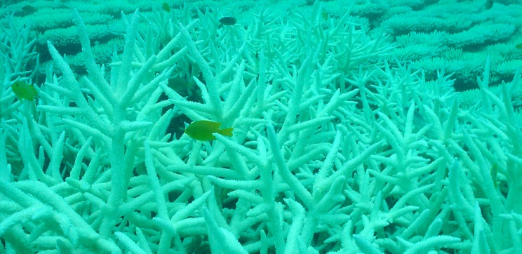
Many of the pressures on the Reef date back to early catchment clearing, and unsustainable levels of fishing and commercial hunting of species that occurred over the past 150 years inside and outside the Great Barrier Reef Region. This includes humpback whales⁴⁷, sea cucumbers (for example, black teatfish⁴⁸), as well as dugong and green turtles⁴⁹. While the challenge for management is to ensure any new activity in and adjacent to the World Heritage Area is ecologically sustainable, perhaps an even greater challenge is to address the legacy of past decisions and reverse the long term declines in biodiversity. The Outlook Report 2009³ identified that the Great Barrier Reef ecosystem is at a crossroad, and that decisions made now are likely to determine its long-term future. The report showed the Great Barrier Reef Region is threatened by a suite of pressures including climate change, declining water quality from catchment run-off, habitat loss from coastal development, illegal fishing and poaching, and some remaining impacts of legal fishing. Ocean acidification also has the potential to affect marine biodiversity worldwide, with reef-building corals identified as being particularly vulnerable^{10,50,51}.
Bleached branching corals as a result of high water temperatures

The Outlook Report assessed habitats that support species, populations of species and groups of species and the ecological processes that contribute to ecosystem health, as well as providing a high-level assessment of the effectiveness of biodiversity protection. These assessments indicated the majority of habitats and populations of species and groups of species are intact, but that some inshore habitats and some populations such as dugongs, as well as some species of sharks, seabirds and marine turtles, are known to have seriously declined, largely due to human activities and the resultant decline in environmental conditions³. There were also concerns that populations of some other species may have declined but there was insufficient data to confirm this. The ecosystem health summary indicated many of the key processes (such as nutrient cycling, pesticide accumulation and predation) of the Great Barrier Reef ecosystem are changing and negatively affecting the health of the ecosystem³.
The majority of the identified potentially at-risk elements of biodiversity in this strategy either occur in or spend all or part of their life in inshore areas. While inshore areas only make up about eight per cent of the Marine Park⁵², they support a range of significant ecosystems as well as recreation, fisheries and tourism. The vulnerability assessments (or where these have yet to be completed, the best available information for that habitat or species) have identified evidence showing inshore habitats and species continue to be impacted by a range of pressures including: declining water quality due to catchment run-off; loss of habitat because of coastal and port development; some remaining impacts of fishing; and climate change.
"Climate change poses an enormous danger and a new challenge for the protection of our natural heritage. What can marine managers do about changes that are worldwide in scope? We must start with understanding what the impacts on tropical marine ecosystems could be. Identifying the most sensitive species and habitats is an important outcome of this book. Identifying impacts that the ecosystem cannot tolerate is another. Efforts can then be targeted towards protecting these areas.
As we experience climate change, we are starting to see real action to reduce greenhouse gas emissions. Governments and industries from around the world are accepting the reality of climate change and are building strategies to reduce their carbon footprint. These efforts must continue. We are committed to some change and we must prepare for it. But efforts to reduce greenhouse gas emissions and the extent of climate change are in our hands.
Based on solid facts, we must work together to find solutions. For without solutions, the Great Barrier Reef and all life is in peril."
Jean-Michel Cousteau,
Founder and President, Ocean Futures Society

Foreword: Climate Change and the Great Barrier Reef: A Vulnerability Assessment¹⁶

While there have been large-scale projects to better understand biodiversity of the Great Barrier Reef (for example, coral reefs and coral cover^{53,54}; seabed biodiversity^{55, 56}) and significant programs addressing aspects of water quality⁵² and some inshore species (such as dugongs^{32,57,58} and marine turtles^{59,60}), there is an urgent need for a systematic approach to addressing the cumulative impacts on inshore biodiversity. Table 5 demonstrates the range of pressures the potentially at-risk elements of biodiversity are exposed to — all of which can act on habitats and species in inshore areas. Management of inshore areas is complex; current research and monitoring that focuses on inshore biodiversity and the impact of pressures acting on these biodiversity elements is also limited spatially and temporally and lacks integration. The development and implementation of an inshore biodiversity program will be a key outcome of this strategy.

Table 5 Pressures acting on the potentially at-risk elements of biodiversity
Elements of biodiversity identified as potentially at risk | Pressures
Elements of biodiversity identified as potentially at risk | Commercial tourism | Defence activities | Commercial fishing | Recreational fishing | Ports and shipping | Recreational (not fishing) | Traditional use | Climate change | Coastal development | Catchment run-off
Habitats
Coral reefs | √ |  |  | √ | √ | √ |  | √ | √ | √
Islands | √ |  |  |  | √ | √ |  | √ | √
Lagoon floor |  |  | √ |  |  |  |  | √ | √ | √
Mangroves |  |  |  |  | √ |  |  | √ | √ | √
Open water |  |  |  |  |  |  |  | √ |  | √
Seagrass meadows |  |  |  |  | √ |  |  | √ | √ | √
Species or groups of species
Bony fish — threadfin salmon |  |  | √ | √ | √ |  |  | √ | √ | √
Bony fish — grey mackerel |  |  | √ | √ | √ |  |  | √ | √ | √
Bony fish — snapper |  |  | √ | √ |  |  |  | √ | √ | √
Dugong |  |  | √ | √ | √ |  | √ | √ | √ | √
Dwarf minke whale |  |  |  |  |  |  |  | √
Humpback whale |  |  |  |  | √ |  |  |  | √
Inshore dolphins — Australian snubfin and Indo-Pacific humpback |  |  | √ | √ | √ | √ |  | √ | √ | √
Inshore dolphins — inshore bottlenose |  |  | √ | √ | √ | √ |  | √ | √ | √
Marine turtles |  |  | √ | √ | √ | √ | √ | √ | √ | √
Sawfish |  |  | √ | √ | √ |  |  | √ | √ | √
Sea snakes |  |  | √ |  | √ |  |  | √ | √ | √
Seabirds — inshore and coastal foraging | √ |  | √ | √ | √ | √ |  | √ | √ | √
Seabirds — offshore and pelagic foraging | √ |  | √ | √ |  | √ |  | √ | √ | √
Shorebirds | √ |  |  |  | √ | √ |  | √ | √ | √
Sharks and rays |  |  | √ | √ | √ |  |  | √ | √ | √

Cumulative impacts and threats from extreme weather
There have been large-scale cumulative impacts on coral reefs in the Great Barrier Reef from crown-of-thorns starfish outbreaks in the mid to late 1900s⁶¹, combined with mass coral bleaching events in 1998 and 2002 and physical damage caused by extreme weather in the past seven years (category four tropical cyclones Ingrid [2005] and Ului [2010]; category five tropical cyclones Larry [2006], Hamish [2009] and Yasi [2011])(Figure 4). This means coral reef habitats between Cooktown and Rockhampton have not had an opportunity to recover from these major disturbances. The regional scale of these cumulative impacts is unprecedented in the history of scientific monitoring of the Great Barrier Reef; together these events have caused damage to reefs spanning a distance of more than 1000 kilometres.
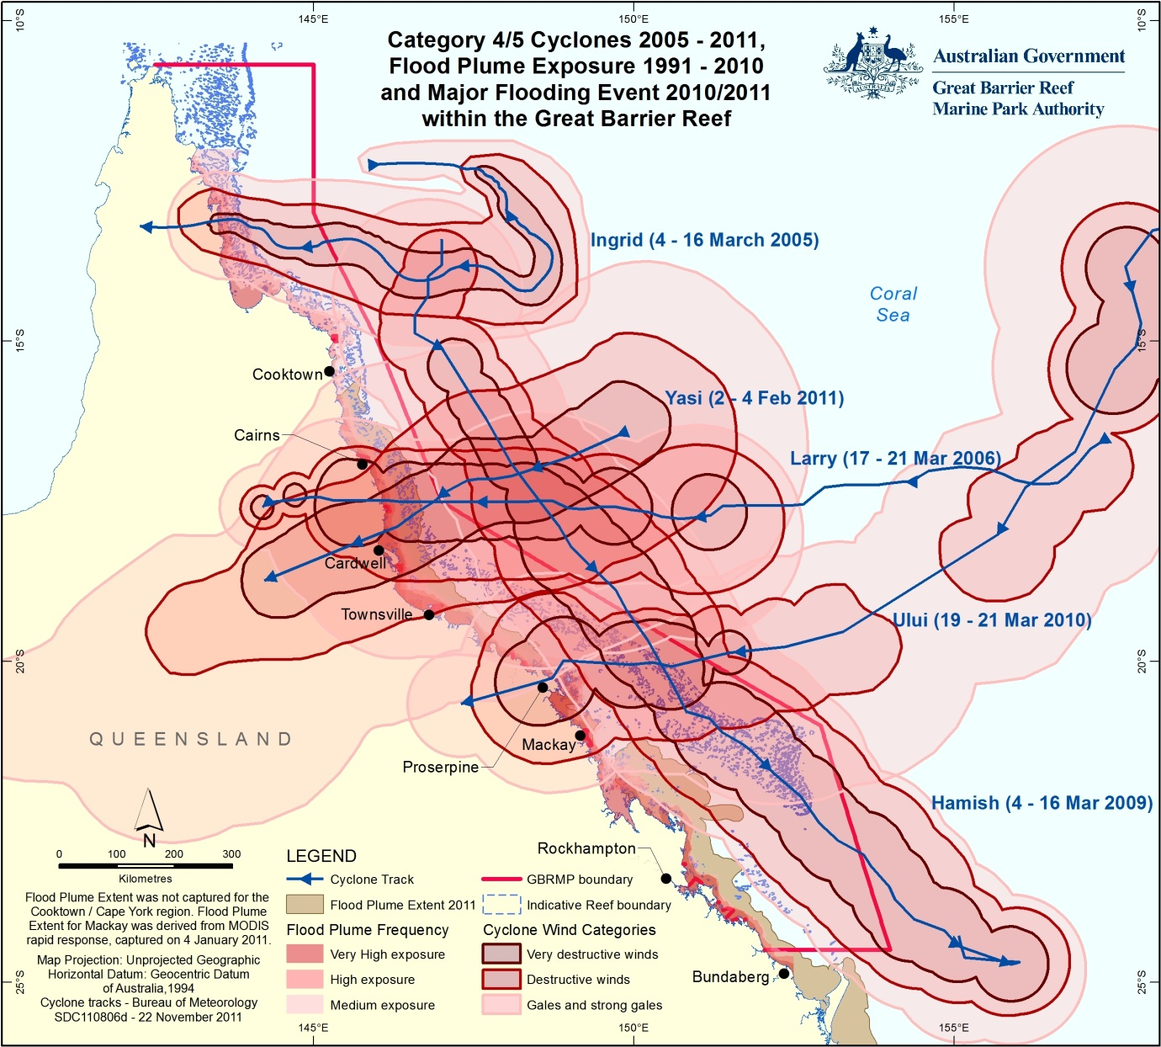

Figure 4 The dates and extent of the category four and five cyclones that have crossed the Great Barrier Reef since 2005
Severe tropical cyclones Hamish and Yasi — both category five storms — have had a significant impact on habitats and species in the Great Barrier Reef⁶² and on industries that rely on the Reef. As an example, the Coral Reef Fin Fish Fishery relies primarily on catches of live coral trout (Plectropomus species) to supply the overseas market. After cyclone Hamish, commercial fishers observed significant physical damage to many reefs and experienced a serious reduction in catch rates of coral trout and other species⁶³. This led to some fishers shifting their fishing effort from the southern Great Barrier Reef to reefs offshore of Bowen and further north⁶³. In February 2011, tropical cyclone Yasi damaged reefs in the central Great Barrier Reef, meaning the reduced commercial catch rates of coral trout continued in some areas⁶².
Major flooding in the 2009–2010 and 2010–2011 wet seasons meant inshore areas received significant amounts of sediments, nutrients and pollutants. This led to coral mortality at some nearshore coral reefs and a significant decline in seagrasses between Cairns and the southern limits of the Marine Park and into Hervey Bay⁶⁴. There was also significant physical damage to seagrass meadows from cyclone Larry and cyclone Yasi.
Taken together, these examples demonstrate the ecosystem-level impacts from extreme weather. Under these circumstances, management agencies may need to switch their emphasis to slowing the rate of decline of habitats and species and more actively implementing adaptation strategies to achieve net environmental benefits.

The way forward — a framework for action
Unavoidably, predictions of climate change dominate most aspects of the Great Barrier Reef's outlook over the next few decades. The extent and persistence of the damage to the ecosystem will depend to a large degree on the amount of change in the world’s climate^{3,11,65} and on the resilience of the Reef ecosystem in the immediate future³. Climate change impacts have already been witnessed¹⁶ and many parts of the ecosystem are vulnerable to its increasing effects¹⁶, with coral reefs particularly vulnerable⁶⁶. Changes to the ecosystem because of climate change are likely to have serious implications for industries and communities that rely on healthy and resilient biodiversity.
The conservation and management of biodiversity in a changing climate requires a re-evaluation of what outcomes we are trying to achieve. Future management objectives aimed at maintaining all species in their present locations and ecosystems in their present condition will be difficult to implement under a changing climate. Management objectives will need to be reorientated to maintaining the provision of ecosystem services through a diversity of well-functioning ecosystems¹¹. Furthermore, the uncertainty that characterises our knowledge and understanding of marine ecosystems and their components, as well as the difficulties in predicting how human interactions will affect marine ecosystems, all need to be considered in decision making that guides the management of biodiversity in the Great Barrier Reef Region in the face of climate change.

Guiding principles
The actions in this strategy are guided by five well-regarded principles to ensure a proactive approach is taken to reduce threats to biodiversity. The precautionary principle underpins all of these guiding principles. If there are threats of serious or irreversible risks to biodiversity, a lack of scientific certainty will not be used as a reason for postponing the implementation of measures to prevent environmental degradation. The five guiding principles relevant to all the potentially at-risk elements of biodiversity are:
- Take practical action now.
- Where possible reduce or eliminate threats to the resilience of the Great Barrier Reef ecosystem.
- Facilitate adaptation through flexible policy and management approaches.
- Integrate actions across partners and sectors.
- Build knowledge and plan strategically.

A framework for action
The purpose of this strategy is to provide a framework for biodiversity conservation and management within the Great Barrier Reef Region. It seeks to recognise and build on a solid foundation of existing programs and work already underway, engage communities and foster stewardship, and promote and maximise adaptation opportunities through improved knowledge and understanding.
Three objectives form the basis of this strategy:
- Engaging communities and fostering stewardship
- Building ecosystem resilience in a changing climate
- Improving knowledge.
These objectives drive key actions that will be taken to achieve the high-level and program-level outcomes required. Targets for measuring success have been applied and will determine modifications to the strategy as required (see Section 6).
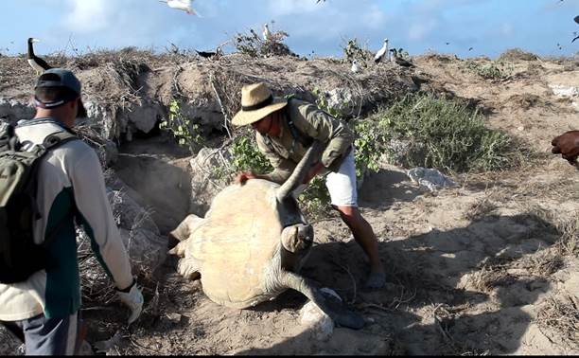
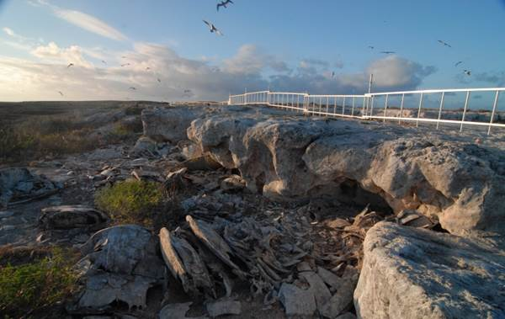
Actions to mitigate risk for at-risk species can take many forms. At Raine Island in the Far Northern Great Barrier Reef, which supports the world’s largest aggregation of nesting green turtles, Rangers from the Field Management Program, working with Traditional Owners flip overturned turtles so they can make it back to the water. They have also erected a barrier fence to stop green turtles falling over the cliffs and perishing in the sun. Both these actions contribute to reducing mortality of the turtles, thus improving the resilience of this species.

Objective 1: Engaging communities and fostering stewardship
Engaging communities and fostering stewardship are essential to increase effective engagement in biodiversity conservation and to achieve successful outcomes, especially in an environment where there are competing priorities for resources. This is especially relevant to an area as large and complex as the Great Barrier Reef Region. GBRMPA increasingly recognises the benefits of stewardship programs to achieve outcomes for biodiversity conservation. Engaging communities and fostering stewardship also provide ideal mechanisms for sharing and integrating information from different sources.
Objective | Engage the community and foster stewardship to facilitate and support best practice approaches to ensure the long-term protection and management of the Great Barrier Reef Region.
High-level outcome | Activities conducted in and adjacent to the Great Barrier Reef Region are ecologically sustainable and Traditional Owners, reef-based and adjacent land-based industries and the community have the knowledge, capacity and support tools to adapt to a changing climate.
Program-level outcomes | Key actions
A high level of awareness among the Australian public and tourists of the values of the Great Barrier Reef, the pressures facing it and the actions needed to address those pressures | Develop and implement an overarching communications strategy that includes use of website, media and social media.
 | Maintain the national education centre for the Great Barrier Reef (Reef HQ).
An expanded Sea Country Indigenous Partnerships Program with Traditional Owners to protect their cultural and heritage values and ensure sustainable traditional use of marine resources | Develop Traditional Use of Marine Resources Agreements in the Great Barrier Reef Region.
 | Develop partnerships for sea country management with Traditional Owner groups of the Great Barrier Reef Marine Park.
Communities, individuals and businesses work together to build a healthier and more resilient Great Barrier Reef | Maintain regional and sectoral consultation mechanisms such as the regional engagement program, Local Marine Advisory Committees and Reef Advisory Committees.
 | Embed biodiversity linkages into Reef Guardian and stewardship programs in schools, local government, farmers, graziers, fishers and tourism operators.
 | Maintain and expand the adoption of high standard practices by the Great Barrier Reef tourism industry for protection, presentation and partnership for biodiversity conservation.
 | Enhance cooperation and build stewardship with the coastal development, ports and shipping sectors.
 | Develop and implement a recreation management strategy and tourism management strategy to provide a framework for developing stewardship approaches to minimise the impacts to biodiversity from recreational and tourism activities occurring within the Great Barrier Reef Marine Park.
 | Develop and distribute education materials that raise awareness of inshore biodiversity including migratory species.
 | Pilot a regional management program in the Burdekin and expand it to four other 'hotspots' in the Great Barrier Reef.
A high level of awareness among the Australian public and tourists of the vulnerability of Great Barrier Reef biodiversity to climate change:  - Climate change adaptation strategies supported and adopted by Reef industries and users  - Enhanced adaptability of Reef-based industries to a changing climate. | Undertake education and extension activities to raise public awareness of the continuing impacts of climate change on the Great Barrier Reef ecosystem.
 | Document the lessons learned from the implementation of the Climate Change Action Plan 2007–2012 as a means of informing future adaptive management approaches.
 | Develop the second Climate Change Action Plan for the Great Barrier Reef.
 | Complete a review of the impacts of extreme weather in the Great Barrier Reef which appropriately considers the impacts on biodiversity.
 | Develop stewardship and certification plans which include climate change adaptation strategies with Reef-based industries, Reef users, other government agencies and the community.

Objective 2: Building ecosystem resilience in a changing climate
Building ecosystem resilience means enhancing the ecosystem’s capacity to adapt to, survive and recover from changes and disturbances⁶⁷. As highlighted in the Outlook Report, biodiversity of the Great Barrier Reef is under threat from a number of pressures — building ecosystem resilience will provide the best opportunity for the Reef to persist under existing threats and as our climate changes.
Objective | Build ecosystem resilience in a changing climate by reducing the threats to potentially at-risk elements of biodiversity, especially those found in inshore areas
High-level outcome | Demonstrable reduction in the threats to potentially at-risk elements of biodiversity through the development and implementation of targeted, specific management actions
Program-level outcome | Key actions
The decline in water quality entering the Reef from nutrients, pesticides, herbicides and sediment is reversed. | The Reef Water Quality Protection Plan 2009 is on target to ensure that by 2020 the quality of water entering the Reef from adjacent catchments has no detrimental impact on the health and resilience of the Great Barrier Reef.
 | Great Barrier Reef Water Quality Guidelines reviewed as necessary to incorporate the most up-to-date information.
 | GBRMPA to contribute to the Paddock to Reef monitoring and reporting program through the delivery of the Australian Government Reef Rescue marine monitoring program.
The threats to inshore biodiversity in the Great Barrier Reef Region are systematically addressed. | Develop and implement an integrated inshore biodiversity program with key collaborators, complete with targets, to better understand the impacts of cumulative pressures, including climate change, and to ensure long-term outcomes for inshore biodiversity in the Great Barrier Reef World Heritage Area.
Great Barrier Reef coastal ecosystems, wetland and riparian zones are managed for biodiversity values. | Undertake and publish an assessment identifying the coastal ecosystems most critical to the Great Barrier Reef ecosystem to provide a basis on which to focus future coastal management actions.
Contribute to a comprehensive strategic assessment of the Great Barrier Reef World Heritage Area that:
- plans for and systematically addresses the impacts of coastal development
- appropriately considers cumulative impacts
- effectively provides for the conservation of inshore biodiversity, including migratory species.
 | Comprehensively assess development approvals in the Great Barrier Reef World Heritage Area to avoid, mitigate and where necessary offset environmental impacts.
Remaining threats to habitats, species and groups of species are being addressed. | Prioritise key actions from vulnerability assessments and implement those of highest priority. Review programs by the publication of the next Outlook Report in 2014.
The biodiversity of the Great Barrier Reef Marine Park is well protected through an effective system of zoning and permitting. | Apply risk assessment methodology to ensure compliance patrol programs target activities posing the highest risks to biodiversity.
 | Continue to explore the application of technology for more effective surveillance including position-fixing methods for tracking vessels.
 | Ensure education and awareness programs target activities posing the highest risks to biodiversity.
 | Increase the number of Indigenous rangers that have completed 'Eyes and Ears' training.
 | Comprehensively assess permit applications to avoid, mitigate and where necessary offset impacts on biodiversity.

Objective 3: Improving knowledge
Despite the conservation and research efforts expended to understand biodiversity in the Great Barrier Reef Region, there are still significant gaps in our knowledge and limited data on long-term trends for the overwhelming majority of habitats and species⁶⁸. There is also a need to ensure better information is used by management to make evidence-based and transparent decisions that are communicated to and understood by the community.
Objective | Maximise the opportunities for habitats and species to adapt by improving our knowledge about habitats, species, groups of species, ecological processes and cumulative impacts and then using this information to improve management outcomes.
High-level outcome | Improved knowledge about potentially at-risk habitats, species and groups of species used to make better informed decisions and to ensure best outcomes for biodiversity.
Program-level outcome | Key actions
Increased science focus on:  - at-risk habitats, species and groups of species  - ecological processes  - conservation of inshore biodiversity. | Update the Great Barrier Reef scientific information needs document, based on priorities identified through vulnerability assessments for each potentially at-risk element of biodiversity.
 | Undertake targeted research that improves our knowledge and informs the management of potentially at-risk elements of biodiversity identified in this strategy.
 | Undertake targeted research that improves our knowledge of ecological processes and cumulative impacts.
 | Establish collaborations with scientific institutions for an integrated inshore biodiversity program to better understand the impacts of cumulative pressures including climate change and to ensure long-term outcomes for inshore biodiversity.
 | Ensure targeted research and monitoring programs are undertaken that improve our understanding of the relationship between declining water quality and health status and diseases in inshore species, including migratory species.
 | Maintain and improve monitoring programs to understand long-term trends in habitats, populations of species and ecosystem pressures.
Knowledge of Great Barrier Reef biodiversity enhanced through engagement with Traditional Owners, industry and the community | Continue to develop and expand the ‘Eye on the Reef' community-based monitoring program.
 | Expand partnership programs with Traditional Owners, industry and the community to build knowledge that supports biodiversity conservation at local and regional scales.
 | Continue to implement a range of approaches for disseminating contemporary information to Traditional Owners on biodiversity and threats to the Reef to assist them during the development and implementation process of Traditional Use of Marine Resources Agreements.
 | Ensure targeted research projects are in place to inform regional management in the Burdekin and other ‘hotspots’ as they are identified.
 | Disseminate contemporary information to Reef-based industries on ways to assist with managing and conserving biodiversity and reducing the threats to the Great Barrier Reef.
 | Develop and implement processes for better integrating traditional ecological knowledge into management and conservation of biodiversity.
 | Develop and implement processes for better integrating stakeholder knowledge into management and conservation of biodiversity.

An inshore biodiversity program
There is compelling evidence that inshore habitats along the developed coast south of Cooktown —and the species that use these habitats — continue to be affected by a range of pressures. Management of inshore areas is inherently complex. Current research and monitoring that focuses on inshore biodiversity and the impact of pressures acting on these biodiversity elements is limited spatially, temporally and lacks integration.
The aim of the inshore biodiversity program proposed by GBRMPA is to reduce the threats to inshore biodiversity so as to build the resilience of the species and ecosystem processes that sustain the Region’s biodiversity. Along with actions taken within the Marine Park, this goal may be achieved by linking GBRMPA’s Biodiversity Conservation Strategy with land-based and wetland conservation, habitat restoration and rehabilitation initiatives supported through Reef Plan⁶⁹ and other programs that provide conservation and management benefits for inshore biodiversity.
Management of the inshore area is complex for three reasons:
- The biodiversity itself is complex, with a wide variety of species and habitats interacting in complex ways.
- There are many different human activities impacting upon biodiversity — the cumulative impact of which is difficult to determine.
- There are many different legislative arrangements, across all three levels of government, overlapping in the coastal and inshore area.
Nevertheless, the inshore area offers a great opportunity because it contains the greatest concentration of threats to biodiversity that could be addressed by local and regional management intervention. Consequently, this is the area where GBRMPA has the greatest potential to improve the ecosystem’s outlook and its biodiversity. Although the inshore biodiversity program is still being developed, it is proposed that the key outcomes would be to:
- support major strategic activities, such as the comprehensive strategic assessment for the Great Barrier Reef Region, and to identify and define some of the requirements for a whole of government focus on this issue, including what tools are available to address the decline in inshore biodiversity in the World Heritage Area
- provide a process for prioritising potentially at-risk elements of biodiversity to target actions including the allocation of biodiversity offsets from major developments
- better coordinate and integrate relevant work, as well as information dissemination and exchange within GBRMPA and the broader community on matters relating to inshore biodiversity
- identify key knowledge gaps
- improve the coordination and integration for relevant research projects.
The publication of the GBRMPA report Informing the outlook for Great Barrier Reef coastal ecosystems ¹³ was an important precursor for the inshore biodiversity program. This report was the first step towards assessing coastal ecosystems at various geographic scales and understanding their importance for maintaining the health and resilience of the World Heritage Area. It identified that in order to restore and protect coastal ecosystems and manage for future coastal development, there is a need to understand coastal processes and aquatic connectivity at regional and local scales.
The inshore biodiversity program will be guided by the Informing the outlook for Great Barrier Reef coastal ecosystems ¹³ report and the regional sustainability planning projects for coastal ecosystems and inshore resilience under the umbrella of the strategic assessment for the World Heritage Area. A key outcome will be to identify actions to restore the lost connectivity and functioning of these vital coastal ecosystems to ensure the best outcomes for inshore biodiversity.

The time to focus on inshore biodiversity is now.
Unprecedented losses of dugong and green turtles in 2011 have highlighted the fragility of inshore ecosystems along the developed parts of the Great Barrier Reef coast. Signs that inshore ecosystems are under stress have been apparent for many decades, and while the rate of loss of dugong in 2011 was unprecedented in recent times, historically the dugong population along this coast had fallen by more than 90 per cent, with signs of the decline occurring as early as the 1960s³². Recent dugong and turtle deaths have been caused predominantly by the loss of seagrass meadows, the primary food for these species, following floods and cyclones in late 2010 and early 2011. However, a steady decline in the abundance of seagrass meadows along parts of the coast of Queensland has become evident, at least since regular monitoring began in the last three to four years⁷⁰. Recently scientists have also used cores taken from inshore reef flats to assess changes in coral communities over more than 800 years. This research found the Acropora assemblages, which were the predominant coral species at Pelorus Island (in the Palm Island group just north of Townsville), had remained stable for more than 800 years, until between the 1920s and 1950s when substantial changes in the inshore coral reef communities occurred⁷¹. These changes have been attributed to chronic increases in sediment flux and nutrient loading following land clearing in adjacent catchments ⁷¹.
Significant range contractions and population declines have occurred for the largetooth and green sawfish³³, listed as vulnerable under the Environment Protection and Biodiversity Conservation Act 1999 (EPBC Act). Most concerning of all is the possibility that the speartooth shark, listed as critically endangered under the EPBC Act, has now become extinct on the east coast of Australia³³. Not a single specimen was found when recent surveys were carried out to search for the speartooth shark along the east coast — this means the last verified specimen was recorded in 1983 at the Bizant River, which flows into Princess Charlotte Bay³³.
One of the main reasons inshore species are particularly vulnerable is that they often have life history traits and behaviours that predispose them to exposure to human-related threats. Many are relatively long-lived and maintain small home ranges (the areas where they spend most of their time). This reliance on a small home range is exhibited by the Australian snubfin dolphin⁷², arguably the Reef’s most threatened marine mammal. Recent evidence also suggests that commonly fished species such as king threadfin salmon⁷³ and grey mackerel⁷⁴ maintain discrete local populations at spatial scales of less than 100 kilometres. These localised populations are particularly susceptible to cumulative impacts associated with declining water quality, coastal development and intensive localised fishing pressure.
Despite being right on our doorstep, little is known about many inshore species. Compared with the relatively clear waters associated with the mid-shelf and outer coral reefs, inshore waters are often turbid, which makes scientific surveys very challenging. These waters also support potentially dangerous predators like estuarine crocodiles that may restrict in-water research opportunities. In this day and age, it seems inconceivable that a large marine mammal like the Australian snubfin dolphin is so poorly known that its conservation status cannot even be assessed under the EPBC Act, but this is the case for this species. What is known is that this inshore specialist feeds on fish and squid in shallow waters (of less than five metres deep)⁷⁵, and is typically found in bays with large river systems draining into them^{76,77}. Research has shown these dolphins live in small groups (of less than 100 animals per embayment)⁷⁸, and like the king threadfin salmon⁷³ maintain very small home ranges (of less than 200 square kilometres) with no interchange of animals from nearby bays⁷⁸. This maintenance of small home ranges with no intermixing means this species is particularly susceptible to localised extinction, especially from human-related threats. This situation is even more concerning because within the Great Barrier Reef World Heritage Area, current information indicates large groups of Australian snubfin dolphin have only been recorded in three areas: Princess Charlotte Bay and Bathurst Bay on Cape York Peninsula⁷², Cleveland Bay near Townsville⁷² and Keppel Bay at the mouth of the Fitzroy River⁷⁹. Of these three sites, one is a major port with an extensive expansion program (Townsville), while the other two sites are currently being assessed for new port developments.
Queensland’s resources boom has outstripped the capacity of current port facilities to handle the export of coal and other commodities. The scale and scope of the expansion of existing ports, along with proposals for new ports to meet export demands, requires careful consideration of the development of large-scale coastal infrastructure and subsequent increases in dredging activities, shipping movements and the number of ships moored in the Marine Park awaiting loading and offloading. Many of the potentially at-risk elements of biodiversity identified in this strategy can be found in these areas.
The rapid urban expansion, mining and development or expansion of ports and related infrastructure occurring along the Great Barrier Reef is adding further pressure to inshore biodiversity and must be considered in the context of the decline of water quality from catchment run-off, habitat loss from other coastal development, some remaining impacts of legal fishing, illegal fishing and poaching, climate change, recent cyclones and the extreme weather of 2010–2011.
Reef Plan⁶⁹ has been a significant initiative and is making progress towards the goal of halting and reversing the decline in water quality entering the Great Barrier Reef. It is important this work continues in order to achieve the goal of ensuring that by 2020 the quality of water entering the reef from adjacent catchments has no detrimental impact on the health and resilience of the Great Barrier Reef. Both the Australian and Queensland governments have committed their support to continue Reef Plan into the future.
While developing this strategy, there have been some significant changes in the way a number of proactive major resource sector companies are planning and evaluating their proposed port developments — particularly with regard to the understanding, minimisation and management of potential impacts on biodiversity and heritage values of the Great Barrier Reef. For example, in an industry-led voluntary approach, BHP Billiton, GVK Hancock Coal and Adani, along with the port authority North Queensland Bulk Ports, have published a cumulative environmental impact assessment for their proposed projects at the Port of Abbot Point (located to the north of Bowen). This initiative is over and above what is required under relevant Commonwealth legislation and policy and demonstrates a commitment to understand the cumulative nature of their separate projects.
This voluntary assessment⁸⁰ — involving leading scientific research organisations such as James Cook, Southern Cross and Curtin universities and the Defence Science and Technology Organisation — is scientifically based. It comprises more than 15 individual technical studies, culminating in an overarching report. In addition, eminent waterbird, marine and heritage experts were engaged in a peer-review process. This comprehensive cumulative impact assessment will be used to inform individual approval decisions at the port, while also providing a framework to better locate and design resource and port-related infrastructure to avoid and minimise potential impacts on the Reef and adjacent coastal habitats.
Strategic and effective management of development, along with targeted research and on-ground actions are essential if we are going to address the habitat and species declines in the inshore areas of the World Heritage Area. The success of Reef Plan⁶⁹ and the coordinated development assessment for the Port of Abbot Point ⁸⁰ provide solid models for effective and integrated management of our coastal resources. Together, they demonstrate that through strategic approaches to development planning and regional coordinated natural resource management programs, we can more effectively manage for sustainable development and take actions that will halt and reverse the decline of our coastal ecosystems.

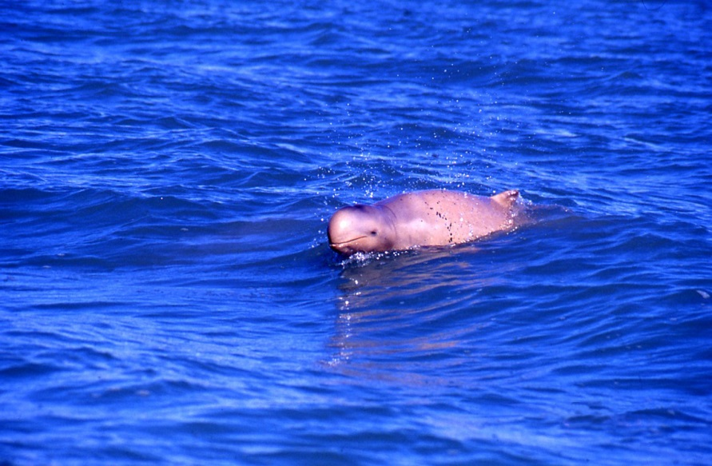
Australian snubfin dolphin Photo: Guido Parra

IMPLEMENTATION
The Great Barrier Reef Biodiversity Conservation Strategy 2013 will be implemented as a key response to the Outlook Report 2009³, while outcomes from the strategy will inform the development of the next Outlook Report in 2014. In accordance with the requirements of Section 54 of the Great Barrier Reef Marine Park Act, the effectiveness of management measures to protect and manage the Reef ecosystem (including those to conserve and manage biodiversity) will be assessed in a five-yearly cycle as part of the development of the next Outlook Report. Among other matters, that assessment will examine the extent to which the strategy’s objectives have been achieved. Scientific information needs for the management of the Great Barrier Reef Marine Park 2009–2014¹⁵ has been developed to identify the most urgent research questions and to guide investment in research and long-term monitoring programs. The priority research needs will be reviewed and updated every five years after each successive Outlook Report is completed.
Vulnerability assessments provide the roadmap for action in addressing priority biodiversity concerns for each potentially at-risk element of biodiversity. These assessments will continue to be developed and updated to address conservation strategies for each of the potentially at-risk biodiversity elements identified in this strategy. They will describe actions needed to address the pressures acting on each of these elements of biodiversity and report on how those actions are being addressed. These assessments will be updated as required as new information becomes available. They will also be reviewed and updated to inform each five-yearly Outlook Report. An implementation plan showing the strategy’s targets is shown in Table 6.
GBRMPA will work in partnership with the Australian and Queensland governments to implement many of the Biodiversity Conservation Strategy’s actions, particularly those that address threats originating from catchments adjacent to the Great Barrier Reef. Local government, Traditional Owners and community groups, as well as land-based and marine industries, will play an important role in implementing on-ground conservation activities to reduce threats and enhance the resilience of the Reef.

Table 6 Implementation plan for the Great Barrier Reef Biodiversity Conservation Strategy 2013
Targets | FY12/13 | FY 13/14 | FY 14/15 | FY 15/16 | FY 16/17
Objective 1 — Engaging communities and fostering stewardship
Implement an overarching communications strategy that includes use of website, media and social media. | • | • | • | • | •
Continue to maintain Reef HQ as the national education centre for the Great Barrier Reef. | • | • | • | • | •
Document the outcomes from the implementation of the Climate Change Action Plan 2007–2012 as a means of informing future adaptive management approaches. | •
Implement the Recreation Management Strategy for the Great Barrier Reef Marine Park. | • | • | • | • | •
Develop and implement the Tourism Management Strategy for the Great Barrier Reef Marine Park. | • | • | • | • | •
Develop and implement the second Climate Change Action Plan for the Great Barrier Reef. | • | • | • | • | •
Complete a review of the impacts of extreme weather that appropriately considers the impacts on biodiversity. | •
Embed biodiversity linkages into Reef Guardian and stewardship programs for schools, local government, farmers, fishers and tourism operators. | •
Raise public awareness of the continuing impacts of climate change on the Great Barrier Reef ecosystem. |  |  | • | • | •
Work on sea country management initiatives with at least 50 per cent of the Traditional Owner groups of the Great Barrier Reef Marine Park. |  | •
Develop and disseminate education materials that raise awareness of inshore biodiversity with Reef-based industries, Marine Park users, other government agencies and the community. |  | • | • | • | •
Implement a pilot regional management program in the Burdekin. |  | •
Integrate the economic value of biodiversity and ecosystem services into industry and stakeholder-based decision making within the Reef Guardian network. |  | •
Have 10 Traditional Use of Marine Resource Agreements accredited for the Great Barrier Reef Region. |  | •
Extend regional management programs to an additional four ‘hotspots’ within the Great Barrier Reef Marine Park. |  |  |  | •
Develop and implement stewardship and certification plans which include climate change adaptation strategies with Reef-based industries, Reef users, other government agencies and the community. |  |  |  | •
Objective 2 Building ecosystem resilience in a changing climate
Establish a multi-agency group to identify best practice fishing techniques to minimise risks to high-risk species targeted or captured incidentally in commercial fisheries. | •
Publish an assessment that identifies the coastal ecosystems most critical to the Great Barrier Reef ecosystem to assist with future coastal management. | •
Complete all vulnerability assessments on identified potentially at-risk elements of biodiversity. |  | •
Review and update as needed all vulnerability assessments on identified potentially at-risk elements of biodiversity. | • | • | • | • | •
Develop and implement an inshore biodiversity program for the Great Barrier Reef World Heritage Area with key collaborators. |  | • | • | • | •
Contribute to the development of the Reef Plan Paddock to Reef report by providing results from the Australian Government Reef Rescue marine monitoring program. |  | •
Complete a strategic assessment for the Great Barrier Reef Region. |  | •
Implement and review priority key actions to reduce threats to identified potentially at-risk elements of biodiversity. |  |  | • | • | •
Increase by 100 per cent the number of Indigenous rangers who have completed ‘Eyes and Ears’ training. |  |  | •
Objective 3 Improving knowledge
Build partnerships with researchers and other groups to support projects that improve our knowledge and understanding of the relationship between declining water quality and health status and diseases in inshore species. |  | •
Engage and form collaborations with scientific institutions to assist with the development and implementation of an integrated inshore biodiversity program in the Great Barrier Reef World Heritage Area. | • | • | • | • | •
Implement the Eye on the Reef community-based monitoring program for Reef-based industries, Traditional Owners and the community. | • | • | • | • | •
Put in place targeted research projects to inform the Burdekin regional management program. |  | •
Identify and implement processes for better integrating traditional ecological knowledge into management and conservation of biodiversity. |  | •
Develop and implement processes for better integrating stakeholder knowledge into management and conservation of biodiversity. |  | •
Ensure targeted research is underway to improve our knowledge and inform the management of potentially at-risk elements of biodiversity identified in this strategy. |  |  | •
Update the Scientific information needs for the Great Barrier Reef document, based on priorities identified through completion of vulnerability assessments for each identified potentially at-risk element of biodiversity. |  |  | •

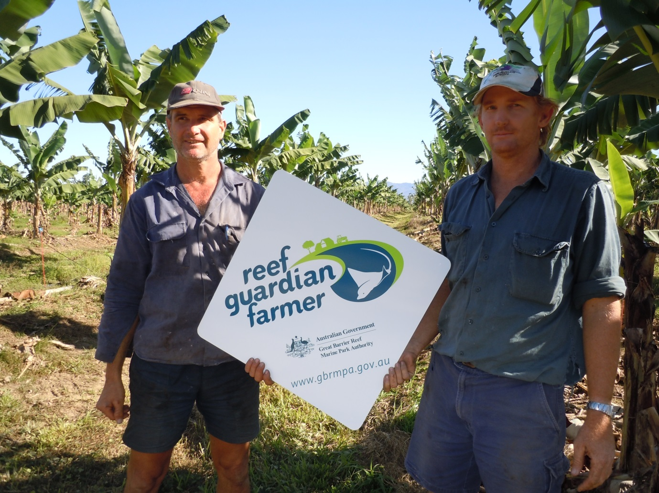
Reef Guardian farmers play a critical role in improving the quality of water entering the Great Barrier Reef

Review
This strategy will be reviewed every five years after each successive Outlook Report has been published. While further actions will be developed during the life of this strategy, the regular review will play a key role in determining future priorities, particularly in light of emerging pressures on the Great Barrier Reef and changing social and policy priorities.

REFERENCES
1. Lucas, P.H.C., Webb, T., Valentine, P.S. and Marsh, H. 1997, The outstanding universal value of the Great Barrier Reef World Heritage Area, Great Barrier Reef Marine Park Authority, Townsville.
2. Hutchings, P.A. and Kingsford, M.J. 2008, Biodiversity, in The Great Barrier Reef: biology, environment and management, eds P.A. Hutchings, M.J. Kingsford and O. Hoegh-Guldberg, CSIRO Publishing, Collingwood, pp. 122.
3. Great Barrier Reef Marine Park Authority 2009, Great Barrier Reef Outlook Report 2009, Great Barrier Reef Marine Park Authority, Townsville.
4. Department of Sustainability, Environment, Water, Population and Communities 2010, Australia's Biodiversity Conservation Strategy 2010-2030, SEWPaC, Canberra.
5. Department of Environment and Resource Management 2011, Building Nature's Resilience: A Biodiversity Strategy for Queensland, State of Queensland (Department of Environment and Resource Management), Brisbane, Australia.
6. Department of Sustainability, Environment, Water, Population and Communities 2011, Australian Government biodiversity policy: consultation draft, SEWPaC, Canberra.
7. IUCN, the International Union for Conservation of Nature 2012, About biodiversity, IUCN, viewed 22/11/2012, <http://www.iucn.org/what/tpas/biodiversity/about/?gclid=CJy_94HYp7MCFQZcpQoduAMA3g>.
8. Duffy, J.E. 2009, Why biodiversity is important to the functioning of real-world ecosystems, Frontiers in Ecology and the Environment 7(8): 437-444.
9. Millennium Ecosystem Assessment 2005, Ecosystems and human well-being: biodiversity synthesis, World Resources Institute, Washington DC.
10. Hoegh-Guldberg, O. and Bruno, J.F. 2010, The impact of climate change on the world's marine ecosystems, Science 328: 1523-1528.
11. Steffen, W., Burbidge, A., Hughes, L., Kitching, R., Lindenmayer, D., Musgrave, W., Stafford Smith, M. and Werner, P. 2009, Australia's biodiversity and climate change. Summary for policy makers, Department of Climate Change, Canberra.
12. Secretariat of the Convention on Biological Diversity 2009, Connecting biodiversity and climate change mitigation and adaptation: report of the Second Ad Hoc Technical Expert Group on Biodiversity and Climate Change, Convention on Biological Diversity, Montreal.
13. Great Barrier Reef Marine Park Authority 2012, Informing the outlook for Great Barrier Reef coastal ecosystems, Great Barrier Reef Marine Park Authority, Townsville.
14. Wilkinson, C. (ed) 2008, Status of coral reefs of the world: 2008, Global Coral Reef Monitoring Network and Reef and Rainforest Research Centre, Townsville.
15. Great Barrier Reef Marine Park Authority 2009, Scientific information needs for the management of the Great Barrier Reef Marine Park 2009-2014, Great Barrier Reef Marine Park Authority, Townsville.
16. Johnson, J.E. and Marshall, P.A. (eds) 2007, Climate change and the Great Barrier Reef: a vulnerability assessment, Great Barrier Reef Marine Park Authority and the Australian Greenhouse Office, Townsville.
17. Hutchings, P.A., Kingsford, M.J. and Hoegh-Guldberg, O. (eds) 2008, The Great Barrier Reef: biology, environment and management, CSIRO Publishing, Collingwood.
18. Daley, B., Griggs, P. and Marsh, H. 2008, Reconstructing reefs: qualitative research and the environmental history of the Great Barrier Reef, Australia, Qualitative Research 8(5): 584-615.
19. Department of Environment and Heritage Protection 2012, Bowling Green Bay Ramsar Site, The State of Queensland, viewed 22/11/2012, <http://wetlandinfo.derm.qld.gov.au/wetlands/PPL/DOIWandRAMSAR/RamsarWetland-5AU042.html>.
20. Department of Sustainability, Environment, Water, Population and Communities 2009, Migratory waterbirds, The Australian Government, viewed 22/11/2012, <http://www.environment.gov.au/biodiversity/migratory/waterbirds/index.html>.
21. Granek, E.F., Polasky, S., Kappel, C.V., Reed, D.J., Stoms, D.M., Koch, E.W., Kennedy, C.J., Cramer, L.A., Hacker, S.D., Barbier, E.B., Aswani, S., Ruckelhaus, M., Perillo, G.M.E., Silliman, B.R., Muthiga, N., Bael, D. and Wolanksi, E. 2009, Ecosystems services as a common language for coastal ecosystem-based management, Conservation Biology 24(1): 207-216.
22. Lindenmayer, D. 2007, On borrowed time: Australia's environmental crisis and what we must do about it, Penguin Books in association with CSIRO Publishing, Camberwell.
23. Steffen, W., Burbidge, A.A., Hughes, L., Kitching, R., Lindenmayer, D., Musgrave, W., Stafford Smith, M. and Werner, P.A. 2009, Australia's biodiversity and climate change, CSIRO Publishing, Collingwood.
24. Smithers, R.J., Cowan, C., Harley, M., Hopkins, J.J., Pontier, H. and Watts, O. 2008, England Biodiversity Strategy climate change adaptation principles, Department for Environment, Food and Rural Affairs, London.
25. McCook, L., Ayling, A., Cappo, M., Choat, J.H., Evans, R.D., De Freitas, D.M., Heupel, M.R., Hughes, T.P., Jones, G.P., Mapstone, B.D., Marsh, H., Mills, M., Molloy, F.J., Pitcher, C.R., Pressey, R.L., Russ, G.R., Sutton, S.G., Sweatman, H., Tobin, R., Wachenfeld, D. and Williamson, D.H. 2010, Adaptive management of the Great Barrier Reef: A globally significant demonstration of the benefits of networks of marine reserves, Proceedings of the National Academy of Science.
26. Lawrence, D., Kenchington, R. and Woodley, S. 2002, The Great Barrier Reef: Finding the Right Balance, Melbourne University Press, Melbourne, Victoria, Australia.
27. Donnelly, R. 2009, Pro-vision reef: Stewardship action plan. A statement of operational standards and climate change contingency planning, Pro-vision Reef Inc., Cairns, Queensland.
28. Department of Employment, Economic Development and Innovation 2009, Coral stress response plan for the coral and marine aquarium fish fisheries, The State of Queensland, Brisbane.
29. Great Barrier Reef Marine Park Authority 2010, Responsible reef practices for tourism operators in the Great Barrier Reef Marine Park, Great Barrier Reef Marine Park Authority, Townsville.
30. Great Barrier Reef Marine Park Authority 2009, Great Barrier Reef Tourism Climate Change Action Strategy 2009-2012, Great Barrier Reef Marine Park Authority, Townsville.
31. Port Curtis Integrated Monitoring Program Inc. 2012, About PCIMP, PCIMP Inc., viewed 22/11/2012, <http://www.pcimp.com.au/index.html>.
32. Marsh, H., De'ath, G., Gribble, N.A. and Lane, B. 2005, Historical marine population estimates: triggers or targets for conservation? The dugong case study, Ecological Applications 15(2): 481-492.
33. Stevens, J.D., Pillans, R.D. and Salini, J.P. 2005, Conservation assessment of Glyphis sp. A (speartooth shark), Glyphis sp. C (Northern Rivers shark), Pristis microdon (freshwater sawfish) and Pristis zijsron (green sawfish), CSIRO Marine Research, Hobart.
34. Compagno, L.J.V., Cook, S.F. & Fowler, S.L. 2010, Pristis microdon: IUCN red list of threatened species, IUCN, the International Union for Conservation of Nature, viewed 21/11/2012, <http://www.iucnredlist.org/apps/redlist/details/18174/0>.
35. Congdon, B.C. 2008, Seabirds, in The Great Barrier Reef: biology, environment and management, eds P.A. Hutchings, M.J. Kingsford and O. Hoegh-Guldberg, CSIRO Publishing, Collingwood, pp. 359-368.
36. Great Barrier Reef Marine Park Authority 2008, Seabirds and shorebirds in the Great Barrier Reef World Heritage Area in a changing climate, Great Barrier Reef Marine Park Authority, Townsville.
37. Batianoff, G.N. and Cornelius, N.J. 2005, Birds of Raine Island: population trends, breeding behaviour and nesting habitats, Proceedings of the Royal Society of Queensland 112: 1-29.
38. Department of Environment and Resource Management 2010, Mackay Whitsunday Natural Resource Management Region back on track actions for biodiversity, DERM, Brisbane.
39. Department of Environment and Resource Management 2010, Cape York Peninsula Natural Resource Management Region back on track actions for biodiversity, DERM, Brisbane.
40. Department of Environment and Resource Management 2010, Wet Tropics Natural Resource Management Region back on track actions for biodiversity, DERM, Brisbane.
41. Department of Environment and Resource Management 2010, Fitzroy Natural Resource Management Region back on track actions for biodiversity, DERM, Brisbane.
42. Department of Environment and Resource Management 2010, Burnett Mary Natural Resource Management Region back on track actions for biodiversity, DERM, Brisbane.
43. Department of Environment and Resource Management 2010, Burdekin Natural Resource Management Region back on track actions for biodiversity, DERM, Brisbane.
44. Department of Employment, Economic Development and Innovation 2011, Stock status of Queensland's fisheries resources 2011, The State of Queensland, Brisbane.
45. Pears, R.J., Morison, A.K., Jebreen, E.J., Dunning, M.C., Pitcher, C.R., Courtney, A.J., Houlden, B. and Jacobsen, I.P. 2013, Ecological risk assessment of the East Coast Otter Trawl Fishery in the Great Barrier Reef Marine Park: Technical Report, Great Barrier Reef Marine Park Authority, Townsville.
46. Wachenfeld, D., Johnson, J.E., Skeat, A., Kenchington, R., Marshall, P.A. and Innes, J. 2007, Introduction to the Great Barrier Reef and climate change, in Climate change and the Great Barrier Reef: a vulnerability assessment, ed. J.E. Johnson and P.A. Marshall, Great Barrier Reef Marine Park Authority and the Australian Greenhouse Office, Townsville, pp. 1-13.
47. Department of Environment and Heritage 2005, Humpback whale recovery plan 2005-2010, Australian Government, Canberra.
48. Uthicke, S. 2004, Overfishing of holothurians: lessons from the Great Barrier Reef, in Advances in sea cucumber aquaculture and management, eds A. Lovatelli, C. Conand, S. Purcell, S. Uthicke, J.-. Hamel and A. Mercier, FAO, Rome, Italy, pp. 163-171.
49. Daley, B., Griggs, P. and Marsh, H. 2008, Exploiting marine wildlife in Queensland: the commercial dugong and marine turtle fisheries, 1847-1969, Australian Economic History Review 48(3): 227-265.
50. Hoegh-Guldberg, O., Mumby, P.J., Hooten, A.J., Steneck, R.S., Greenfield, P., Gomez, E., Harvell, C.D., Sale, P.F., Edwards, A.J., Caldeira, K., Knowlton, N., Eakin, C.M., Iglesias-Prieto, R., Muthiga, N., Bradbury, R.H., Dubi, A. and Hatziolos, M.E. 2007, Coral reefs under rapid climate change and ocean acidification, Science 318(5857): 1737-1742.
51. Hendriks, I.E., Duarte, C.M. and Alvarez, M. 2010, Vulnerability of marine biodiversity to ocean acidification: A meta analysis, Estuarine, Coastal and Shelf Science 86: 157-164.
52. Reef Water Quality Protection Plan Secretariat 2011, Great Barrier Reef: First report card 2009 baseline, Reef Water Quality Protection Plan, The State of Queensland, Brisbane, Queensland.
53. De'ath, G., Fabricius, K., Sweatman, H. and Puotinen, M. 2012, Twenty-seven-year decline of coral cover on the Great Barrier Reef and its causes, www.pnas.org/cgi/doi/10.1073/pnas.1208909109 .
54. Sweatman, H., Cheal, A.J., Coleman, G.J., Emslie, M.J., Johns, K., Jonker, M., Miller, I.R. and Osborne, K. 2008, Long-term monitoring of the Great Barrier Reef: status report 8, Australian Institute of Marine Science, Townsville.
55. Pitcher, C.R., Austin, M., Burridge, C.Y., Bustamante, R.H., Cheers, S.J., Ellis, N., Jones, P.N., Koutsoukos, A.G., Moeseneder, C.H., Smith, G.P., Venables, W. and Wassenberg, T.J. 2008, Recovery of seabed habitat from the impact of prawn trawling in the far northern section of the Great Barrier Reef Marine Park. CSIRO Marine Research.
56. Pitcher, C.R., Doherty, P., Arnold, P.W., Hooper, J., Gribble, N.A., Bartlett, C., Browne, M., Campbell, N., Cannard, T., Cappo, M., Carini, G., Chalmeres, S., Cheers, S., Chetwynd, D., Colegax, A., Coles, R., Cook, S., Davie, P., De'ath, G., Devereux, D., Done, B., Donovan, T., Ehrke, B., Ellis, N., Ericson, G., Fellegara, I., Forcey, K., Furey, M., Gledhill, D., Good, N., Gordon, S., Haywood, M., Hendricks, M., Jacobsen, I., Johnson, J., Jones, M., Kininmonth, S., Kistle, S., Last, P., Leite, A., Amrks, S., McLeod, I., Oczkowicz, S., Robinson, M., Rose, C., Seabright, D., Sheils, J., Sherlock, M., Skelton, P., Smith, D., Smith, G., Speare, P., Stowar, M., Strickland, C., Van der Geest, C., Venables, W., Walsh, C., Wassenberg, T.J., Welna, A. and Yearsley, G. 2007, Seabed biodiversity on the continental shelf of the Great Barrier Reef World Heritage Area, CSIRO, Cleveland.
57. Marsh, H., Hodgson, A., Lawler, I., Grech, A. and Delean, S. 2007, Condition, status and trends and projected futures of the dugong in the northern Great Barrier Reef and Torres Strait, including identification and evaluation of the key threats and evaluation of available management options to improve its status. Marine and Tropical Sciences Research Facility report, Reef and Rainforest Research Centre Limited, Cairns, 77pp.
58. Marsh, H. and Lawler, I.R. 2006, Dugong distribution and abundance on the urban coast a Queensland: a basis for management: final report, Unpublished report to the Marine and Tropical Science Research Facility, Cairns.
59. Limpus, C.J. 2008, A biological review of Australian marine turtle species. 1. Loggerhead turtle, Caretta caretta (Linnaeus), Environmental Protection Agency, Brisbane.
60. Limpus, C.J. 2008, A biological review of Australian marine turtle species. 2. Green turtle, Chelonia mydas (Linnaeus), Environmental Protection Agency, Brisbane.
61. Brodie, J., Fabricius, K.E., De’ath, G. and Okaji, K. 2005, Are increased nutrient inputs responsible for more outbreaks of crown-of-thorns starfish? An appraisal of the evidence, Marine Pollution Bulletin 51(1-4): 266-278.
62. Great Barrier Reef Marine Park Authority 2011, Impacts of tropical cyclone Yasi on the Great Barrier Reef: A report on the findings of a rapid ecological impact assessment, July 2011, Great Barrier Reef Marine Park Authority, Townsville.
63. Tobin, A., Schlaff, A., Tobin, R., Penny, A., Ayling, T., Ayling, A., Krause, B., Welch, D.J., Sutton, S.G., Sawynok, B., Marshall, N., Marshall, P. and Maynard, J. 2010, Adapting to change: minimising uncertainty about the effects of rapidly-changing environmental conditions on the Queensland Coral Reef Fin Fish Fishery. Final report to the Fisheries Research and Development Corporation, project 2008/103, Fishing and Fisheries Research Centre technical report no. 11, James Cook University, Townsville.
64. McKenzie, L.J., Collier, C. and Waycott, M. 2012, Reef Rescue Marine Monitoring Program - Inshore Seagrass, Annual Report for the sampling period 1st July - 31st May 2011, Fisheries Queensland, Cairns.
65. Great Barrier Reef Marine Park Authority 2007, Climate Change Action Plan 2007-2012, Great Barrier Reef Marine Park Authority, Townsville.
66. Fabricius, K.E., Hoegh-Guldberg, O., Johnson, J., McCook, L. and Lough, J.M. 2007, Vulnerability of coral reefs of the Great Barrier Reef to climate change, in Climate Change and the Great Barrier Reef: A vulnerability assessment, eds J.E. Johnson and P.A. Marshall, Great Barrier Reef Marine Park Authority and the Australian Greenhouse Office, Townsville, pp. 515-554.
67. McCook, L.J., Folke, C., Hughes, T.P., Nyström, M., Obura, D. and Salm, R. 2007, Ecological resilience, climate change and the Great Barrier Reef, in Climate change and the Great Barrier Reef: a vulnerability assessment, eds J. Johnson and P. Marshall, Great Barrier Reef Marine Park Authority and Australian Greenhouse Office, Townsville, pp. 75-96.
68. Hockings, M. and Gilligan, B. 2009, Assessment of management effectiveness for the 2009 Great Barrier Reef outlook report, Great Barrier Reef Marine Park Authority, Townsville.
69. Department of Premier and Cabinet 2009, Reef Water Quality Protection Plan 2009, Reef Water Quality Protection Plan Secretariat, Brisbane.
70. McKenzie, L., Yoshida, R., Grech, A. and Coles, R. 2011, Queensland seagrasses: status 2010 - Torres Strait and East Coast, Department of Employment, Economic Development and Innovation, Fisheries Queensland, Brisbane.
71. Roff, G., Clark, T.R., Reymond, C.E., Zhao, J., Feng, Y., McCook, L.J., Done, T.J. and Pandolfi, J.M. 2012, Palaeoecological evidence of a historical collapse of corals at Pelorus Island, inshore Great Barrier Reef, following European settlement, Proceedings of the Royal Society B http://dx.doi.org/10.1098/rspb.2012.2100.
72. Parra, G.J. 2005, Behavioural ecology of Irrawaddy, Orcaella brevirostris (Owen in Gray, 1866), and Indo-Pacific humpback dolphins, Sousa chinensis (Osbeck, 1765), in northeast Queensland, Australia: a comparative study., James Cook University.
73. Welch, D.J., Ballagh, A., Newman, S.J., Lester, R.J.G., Moore, B.R., van Herwerden, L., Horne, J.B., Allsop, Q., Saunders, T., Stapley, J. and Gribble, N.A. 2010, Defining the stock structure of northern Australia's threadfin salmon species, Fisheries Research Development Corporation, Canberra.
74. Charters, R.A., Lester, R.J.G., Buckworth, R.C., Newman, S.J., Ovenden, J., Broderick, D., Kravchuk, O., Ballagh, A. and Welch, D.J. 2010, The stock structure of grey mackerel Scomberomorus semifasciatus in Australia as inferred from its parasite fauna, Fisheries Research 101: 94-99.
75. Parra, G.J. and Jedensjö, M. 2009, Feeding habits of Australian snubfin (Orcaella heinsohni) and Indo-Pacific humpback dolphins (Sousa chinensis), Project report to the Great Barrier Reef Marine Park Authority and the Reef and Rainforest Research Centre Limited, Cairns, University of Queensland, Brisbane.
76. Parra, G.J. 2006, Resource partitioning in sympatric delphinids: space use and habitat preferences snubfin and Indo-Pacific humpback dolphins, Journal of Animal Ecology 75: 862-874.
77. Parra, G.J., Schick, R. and Corkeron, P.J. 2006, Spatial distribution and environmental correlates of Australian snubfin and Indo-Pacific humpback dolphins, Ecography 29(3): 396-406.
78. Parra, G.J., Corkeron, P.J. and Marsh, H. 2006, Population sizes, site fidelity and residence patterns of Australian snubfin and Indo-Pacific humpback dolphins: implications for conservation, Biological Conservation 129: 167-180.
79. World Wildlife Fund 2009, Conserving Australia's unique coastal dolphins, World Wildlife Fund, Australia.
80. North Queensland Bulk Ports October 2012, Abbot Point Voluntary Cumulative Impact Assessment, North Queensland Bulk Ports, viewed 22/11/2012, <http://www.abbotpointworkinggroup.com.au/download.html>.
81. Great Barrier Reef Marine Park Authority 2010, Water quality guidelines for the Great Barrier Reef Marine Park, Great Barrier Reef Marine Park Authority, Townsville.

For some migratory species, like humpback whales, hunting pressure originated outside the boundaries of the Great Barrier Reef Region.
For green, flatback, hawksbill and loggerhead turtles
For green and largetooth sawfish only
For Hydrophis elegans and H. ornatus only⁴⁵
For 11 species of ray and skate only ⁴⁵ # - for some species only
For the purposes of this strategy, inshore areas include (but are not limited to) those areas extending up to 20km offshore from the coast and which correspond to enclosed coastal and open coastal water bodies as described in the Water Quality Guidelines for the Great Barrier Reef Marine Park (2010)⁸¹.
Adapted from Smithers et al., 2008²⁴

