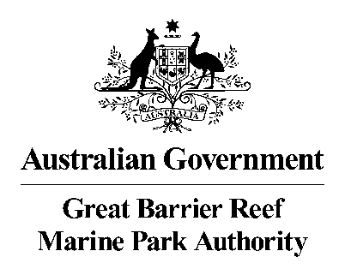

Priority Monitoring Gaps Prospectus
Reef 2050 Integrated Monitoring and Reporting Program

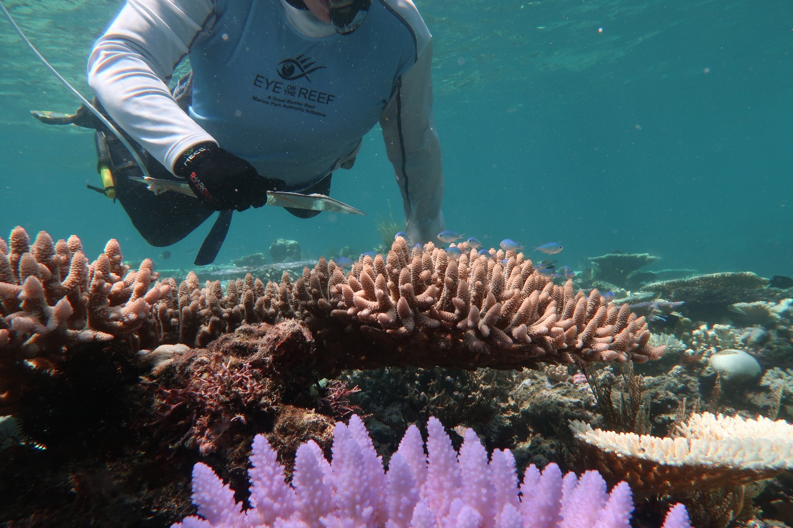
© Commonwealth of Australia 2021
Published by the Great Barrier Reef Marine Park Authority
ISBN 9780645043723
This document is licenced by the Commonwealth of Australia for use under a Creative Commons By Attribution 4.0 International licence with the exception of the Coat of Arms of the Commonwealth of Australia, the logo of the Great Barrier Reef Marine Park Authority, any other material protected by a trademark, content supplied by third parties and any photographs. For licence conditions see: http://creativecommons.org/licences/by/4.0


A cataloguing record for this publication is available from the National Library of Australia

This publication should be cited as:
Great Barrier Reef Marine Park Authority 2021, Priority Monitoring Gaps Prospectus: Reef 2050 Integrated Monitoring and Reporting Program, GBRMPA, Townsville.

Cover photo: Great Barrier Reef Marine Park Authority

Comments and questions regarding this document are welcome and should be addressed to:
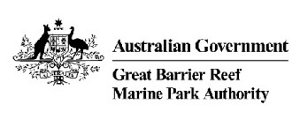
Great Barrier Reef Marine Park Authority
280 Flinders Street
(PO Box 1379)
Townsville QLD 4810, Australia

Phone: (07) 4750 0700
Fax: (07) 4772 6093
Email: info@gbrmpa.gov.au
www.gbrmpa.gov.au

The Reef 2050 Integrated Monitoring and Reporting Program partners acknowledge the continuing sea country management and custodianship of the Great Barrier Reef by Aboriginal and Torres Strait Islander Traditional Owners whose rich cultures, heritage values, enduring connections and shared efforts protect the Reef for future generations.

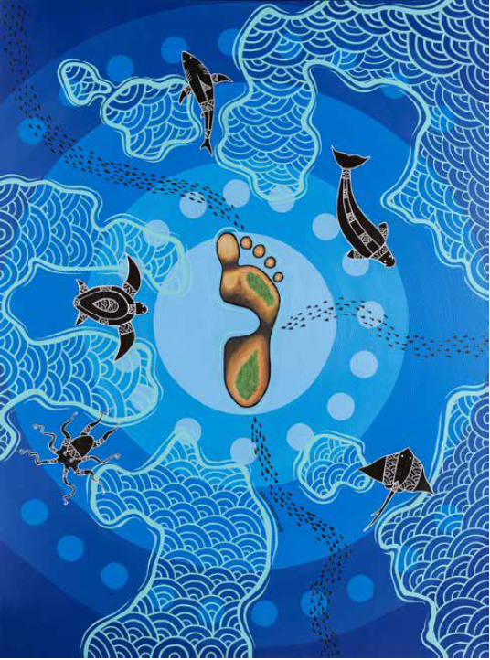
Step of Change by Nicky Bidju Pryor – Bidju Designs
Commissioned for the Great Barrier Reef Marine Park Authority’s Reflect Reconciliation Action Plan 2018.

Foreword

The Great Barrier Reef (the Reef) is world-renowned for its natural phenomena and beauty. While enduring, the Reef is showing signs of deterioration from increasing pressures of cumulative impacts both above and below the water. We aim to ensure that the Reef remains one of the best managed marine ecosystems in the world by making informed and proactive decisions to support its resilience, that are based on access to the best available science and knowledge.
The cutting edge Reef 2050 Integrated Monitoring and Reporting Program (the Program) is designed to enable resilience-based, future focused management of the Reef, and support innovation in Reef management as the climate changes. It will provide the Authority, as the Reef’s managers, with a comprehensive and up-to-date understanding of the Reef, its values, the processes that support it and the pressures that affect it. This knowledge drives effective management decisions and shapes strategic policy to address current and future challenges. Critically, the Program will inform future Great Barrier Reef Outlook reports and enable managers to assess the effectiveness of actions taken under the Reef 2050 Long-Term Sustainability Plan (Reef 2050 Plan).
The Program is and will continue to be effective, efficient and evolving, thanks to the input from a range of experts who collated existing monitoring programs, identified indicators to describe Reef health, and made recommendations to address any monitoring gaps.
As the chair of the Program’s Executive Group, I have the pleasure of presenting this Great Barrier Reef Monitoring Priorities for Future Investment prospectus on behalf of the Program partners. This prospectus provides an overview of the priority monitoring gaps that have been identified for investment over the next three years. The gaps have been prioritised based on their utility to assess progress against the Reef 2050 Plan and to inform management of the Reef. Many of the identified gaps present opportunities for co-investment from governments, industry and philanthropic organisations.
Finally we acknowledge that the content included in this prospectus does not negate the discretion of decision makers with regards to funding and approvals. It is expected that improvements in technology and understanding of the Reef will also present other opportunities for investment over time.

Josh Thomas
Chair
Executive Group
Reef 2050 Integrated Monitoring and Reporting Program

Contents

Foreword i
1. Overview 1
Knowledge to inform management 1
Aboriginal and Torres Strait Islander peoples and their knowledge 2
Reef Trust Partnership 3
2. Reef 2050 Integrated Monitoring and Reporting Program 5
Program governance 6
3. Prioritisation methodology 7
4. Monitoring Priorities 10
5. Integration 17
Appendix 1: Identified monitoring gaps considered 18
Appendix 3: Reef 2050 Plan Objectives and Management Goals 23

List of Tables
Table 1: Monitoring gaps from the ecological, social and Indigenous heritage components of the Reef system that are recommended for further investment over the next three years. 12

List of Figures
Figure 1: The Great Barrier Reef is one of the world’s most diverse marine ecosystems 2
Figure 2: Resilience-based management refers to using knowledge of current and future drivers that influence ecosystem function to prioritise, implement, and adapt management actions to enhance ecosystems health and human well-being 5
Figure 3: The Program design, illustrating the six Program priorities used throughout this plan. The Program is informed by the Reef 2050 Plan, and will result in better-informed management. 6
Figure 4: Previous work undertaken under the Reef 2050 Plan and Program that was accessed to inform the prioritisation of monitoring investment priorities 8
Figure 5: A high-level summary of the methodology which involved upfront framing and alignment, stakeholder consultation and gaps identification, work pack development and workshops, with development of the prospectus and design report to complete the project 9
Figure 6: The Driver, Pressure, State, Impact and Response (DPSIR) framework is a causal framework for describing the interactions between the interdependent components of society and the environment. 10
Figure 7: A total of 11 monitoring gaps have been prioritised for further investment 11
Figure 8: Strong People, Strong Country framework for monitoring Indigenous heritage consists of six key hubs 16

Overview
The Great Barrier Reef is beautiful, vast and diverse, an important part of Australia’s national identity, a global environmental icon, economic powerhouse and a key part of the spiritual and cultural identity of its First Nations People.
Despite being one of the best managed coral reef ecosystems in the world, the Great Barrier Reef Outlook Report 2019 highlights the urgent need for continued and accelerated action to improve the long-term outlook for the Reef. Timely global action to mitigate climate change is required in tandem with effective implementation of the Reef 2050 Long-Term Sustainability Plan (Reef 2050 Plan).

Knowledge to inform management
The Reef is an inherently complex social-ecological system. Biological, physical and social aspects are intertwined across spatial and temporal scales. A comprehensive and up-to-date understanding of the Reef, its values and the processes that support it, along with the pressures that are affecting it, is fundamental to knowing how to support its resilience.
Scientific research and knowledge make critical contributions to the way the Reef is understood, managed and used. Both the natural and human dimensions of the Reef, including how it is governed through such instruments as the Reef 2050 Plan, are part of the complexity that needs to be understood to achieve our vision of continued Reef health (refer to Figure 1).
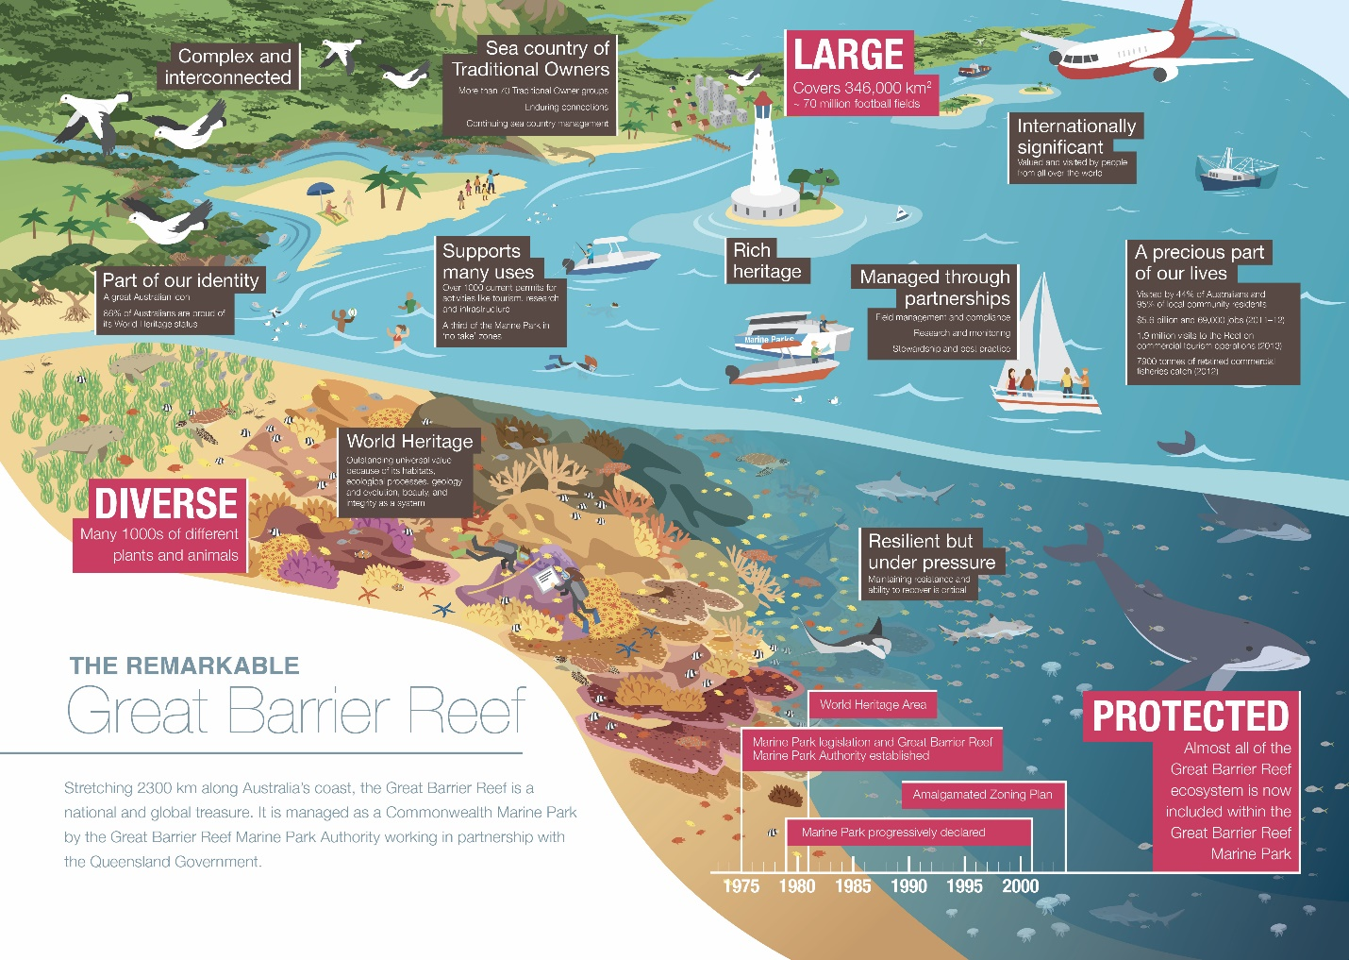
Figure 1: The Great Barrier Reef is one of the world’s most diverse marine ecosystems
. The Reef is a world heritage area and a multiple use Marine Park that is vitally important to communities and industries that depend on a healthy reef for recreation and their livelihoods.

Aboriginal and Torres Strait Islander peoples and their knowledge
Aboriginal and Torres Strait Islander peoples have been linked with the Reef since time immemorial and hold a wealth of information that could be used to understand the ecosystem, its values and processes. This knowledge is collectively termed Indigenous heritage and encapsulates natural values, cultural values and historic values that are significant to the Aboriginal and Torres Strait Islander peoples. It comprises tangible and intangible expressions of their relationships with country, people, beliefs, knowledge, law, language, symbols, ways of living, sea, land and objects, all arising from Indigenous spirituality. Importantly Traditional knowledge isn’t static, it is living and constantly evolves with the state of the Reef.
There are over 70 Aboriginal and Torres Strait Islander groups (also referred to as Traditional Owner groups or communities) with inherent rights, responsibilities, interests and aspirations for the Reef. Over half the Reef catchment, one quarter of the Reef’s coastline and just over 15 per cent of the Great Barrier Reef World Heritage area is subject to formal Indigenous ownership, interests or co-management arrangements, including native title claims, Traditional Use of Marine Resources Agreements and Indigenous Land Use Agreements. To continue to deliver cultural responsibilities for sea country and lore, Aboriginal and Torres Strait Islander peoples have formed organisations to manage land and sea programs. Many are Traditional Owner organisations, following cultural protocols and exercising cultural authority on behalf of specific Traditional Owner groups. These organisations can have partnerships with other organisations that also contribute to heritage management and some have on-ground management capacity through ranger programs. There is also growing involvement of Aboriginal and Torres Strait Islander peoples in the economic opportunities associated with the Reef, including cultural tourism, fishing and delivery of on-ground services.
For over 25 years these groups have been coming together to explore and call for a collective approach to achieving their rights and aspirations for ownership, access to, and involvement in the governance and management of sea country. They seek genuine partnership in the overarching governance of the Reef and far deeper ownership of, and participation in, its active day to day management.

Reef Trust Partnership
The Reef Trust – Great Barrier Reef Foundation Partnership is a $443.3 million six year grant between the Department of Agriculture, Water and the Environment, which manages the Reef Trust, and the Great Barrier Reef Foundation. It was been established to build on and support delivery of the joint Australian and Queensland Government Reef 2050 Long-Term Sustainability Plan. The grant is spread across six key investment areas, one of which is the Integrated Monitoring and Reporting component. The purpose of this allocation is to support the implementation of the Reef 2050 Integrated Monitoring and Reporting Program, improve health monitoring and reporting of the Great Barrier Reef World Heritage Area to ensure that monitoring and reporting to UNESCO is scientifically robust and investment outcomes are measurable. Investments from this allocation will be based on the following themes:
- Supporting critical monitoring activities identified via the Program;
- Catalysing technological innovation;
- A Reef-wide decision-making and forecasting platform;
- Understanding the value of community stewardship and disclosure of high-value information; and
- Supporting partnerships and building a community of practice.
The monitoring gaps outlined in this prospectus align to the above themes identified for investment under the Integrated Monitoring and Reporting component of the Reef Trust Partnership.

Reef 2050 Integrated Monitoring and Reporting Program
The Program has evolved and matured since it was first conceptualised as part of the Great Barrier Reef Strategic Assessment process and established under the Reef 2050 Plan in 2015. However it’s primary purpose remains to coordinate and integrate relevant Reef-based monitoring and modelling programs, so that managers can easily access the most up-to-date information needed to inform resilience-based management and reporting (refer to Figure 2).
Figure 2: Resilience-based management refers to using knowledge of current and future drivers that influence ecosystem function to prioritise, implement, and adapt management actions to enhance ecosystems health and human well-being
.

The Program has six overarching priorities (Figure 3):
Foundational priorities
  - Governance and program management
  - Science for management
Operational priorities
  - Collecting information
  - Accessing information
  - Guiding management actions
  - Informing Reef 2050 and Outlook reporting.

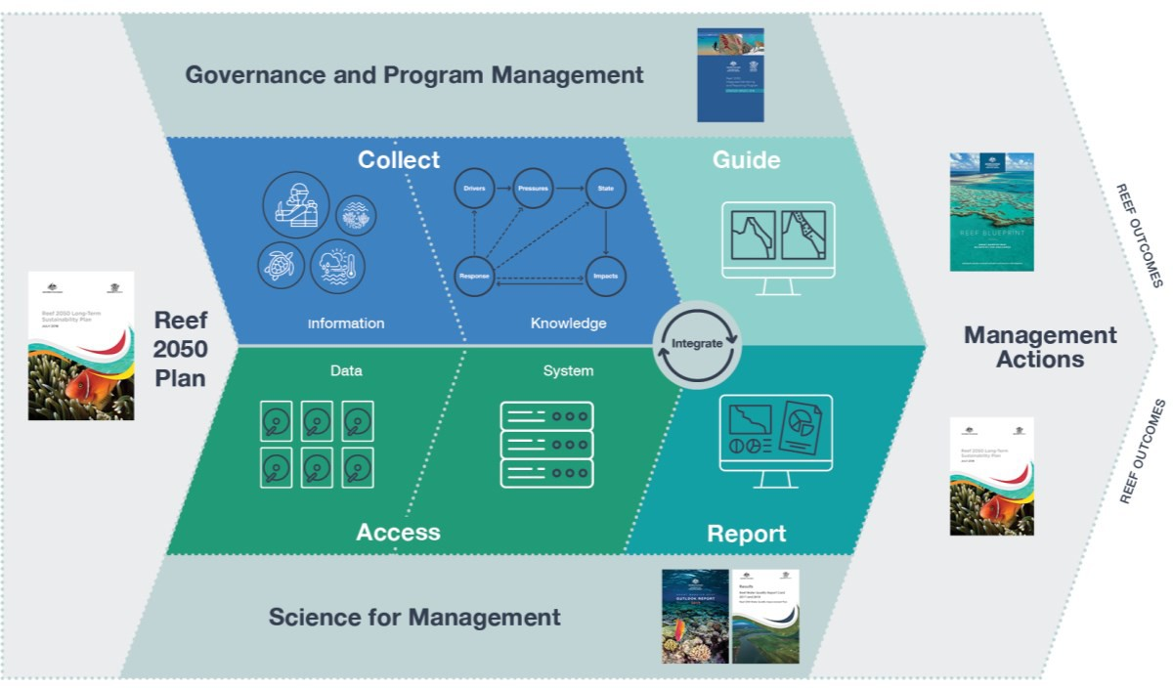
Figure 3: The Program design, illustrating the six Program priorities used throughout this plan. The Program is informed by the Reef 2050 Plan, and will result in better-informed management.

This prospectus relates to the core activity of ‘collecting information’, which aims to work with Reef managers, other stakeholders and end users to comprehensively understand what information is needed to inform decisions, compare that to the information that is already collected, and work to fill critical gaps. The prospectus is the culmination of a work led by the Authority and undertaken over two year (2019/20 – 2020/21) on ‘gap analysis to produce a prioritised list of information, monitoring and modelling needs for consideration in investment decisions’ fulfilling action 3B of the Annual Business Plan for 2020-21.

Program governance
The Program’s success is dependent on a collaborative approach between organisations that use or generate Reef-related monitoring data, science outcomes or reporting products. By working in partnership, there are opportunities to leverage both knowledge and funding to deliver increased efficiencies, cost effectiveness and improved alignment and coverage of monitoring programs. The executive group facilitates this outcome and is coordinated by the Great Barrier Reef Marine Park Authority and includes:
- Australian Government Department of Agriculture, Water and the Environment
- Australian Institute of Marine Science
- Commonwealth Scientific and Industrial Research Organisation
- Integrated Marine Observing System
- Queensland Government Department of Environment and Science
- Traditional Owner representatives
The Executive Group is supported by an Operations Group made up from individuals from the same organisations.

Prioritisation methodology
A working group was established with representatives from the Program’s governance bodies and key stakeholders to prioritise monitoring gaps identified by the thematic expert groups. The thematic expert groups were created to inform the Program’s design and develop objectives and key indicators as part of the 2020 review of the Reef 2050 Plan. The working group undertook a structured decision-making process to ensure adequate consideration was given to the complexity of the decision problem, the uncertainty involved, and the diversity of decision-makers involved. This ensured alignment between the Reef 2050 Plan, priority indicators, the Program’s objectives, as well as Program partners and stakeholders.
The working group set out to identify a prioritised list of monitoring needs that would effectively fill the gaps in monitoring and modelling activities, and their integrated application to decision making would support delivery of the Reef 2050 outcomes, over time in most efficient way. A decision tree based on the components of the Integrated Monitoring Framework and a set of assessment criteria generated from the results of the Trade-Off Assessment and the Program’s final purpose focused design (refer to Figure 4) were used to ensure transparency and alignment to working group’s mission.
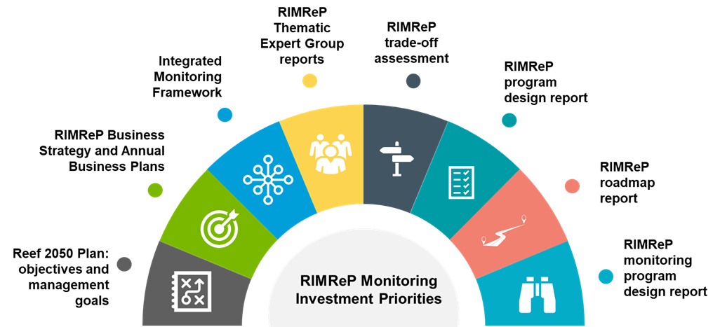
Figure 4: Previous work undertaken under the Reef 2050 Plan and Program that was accessed to inform the prioritisation of monitoring investment priorities
(reproduced from Bowen et al. 2020).
The assessment criteria that the working group looked at (in order of priority) was:
- How important the gap was to achieving the overall Programs vision?
  - Could a monitoring program fill a critical knowledge gap that will be useful for making management decisions or assessing the effectiveness of management decisions?
  - Could a monitoring program fill a critical knowledge gap that will be useful for assessing performance against the Reef 2050 Plan?
  - Would the monitoring program provide opportunities for integration of data information into future decision support processes through the Program?
- What type of gap the monitoring activity would address?
  - Would the monitoring program deliver innovative solutions relating to generating knowledge of the socio-ecological system?
  - Would the monitoring program fill a critical gap relating to predictive knowledge (i.e. strong causal inference for diagnosis and prognosis, early warning of change, supports predictive modelling frameworks)?
  - Would the monitoring program fill a knowledge gap with data, metrics and indicators that were sensitive to pressures on the Reef, spatial gradients and change?
- How well the monitoring gap could be filled within the three years?
  - Is the monitoring program feasible to implement within the three year funding cycle?
  - Can the monitoring program be scaled up or down depending on the availability of funding?
  - Degree of certainty that the monitoring program would successfully resolve the identified gap within the funding cycle.
Using the above criteria, the working group considered and rationalised the identified gaps to generate a final prioritised ‘prospectus’ list of 11 priorities for investment which is outlined in section 4 (refer to Figure 5 and Appendix 1). Further detail on the process is available in the design report (in prep GBRMPA)⁴, further detail on each monitoring gap is available from the Great Barrier Reef Marine Park Authority.
Figure 5: A high-level summary of the methodology which involved upfront framing and alignment, stakeholder consultation and gaps identification, work pack development and workshops, with development of the prospectus and design report to complete the project
reproduced from Bowen et al. 2020. The process was built as a structured decision-making process due to the complexity of the decision problem, the uncertainty involved, and the diversity of decision-makers involved with the process.

Monitoring Priorities
Development of the Program (refer to Figure 6) has been guided by the Integrated Monitoring Framework for the Great Barrier Reef World Heritage Area. The framework articulates a set of overarching principles and processes that provides the foundation for a standardised and integrated ecological, social and economic monitoring program that supports adaptive management. The intent of the Program is not to duplicate existing arrangements, but to coordinate and integrate existing monitoring, modelling and reporting programs across disciplines.
To capitalise on existing program investment, a total of 11 monitoring gaps from the ecological, social and Indigenous heritage components of the Reef system have been prioritised for further investment (refer to Table 1 and Appendix 1). The identified gaps are interrelated and together with existing monitoring programs will provide the backbone of an operational Program (refer to Figure 7). Funding of each prioritised monitoring gap will deliver improved guidance to Reef managers, enabling them to target management actions to maximise the Reef’s resilience and to measure progress against the Reef 2050 Plan.

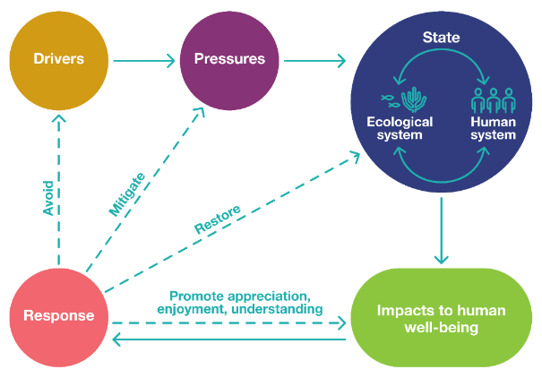
Figure 6: The Driver, Pressure, State, Impact and Response (DPSIR) framework is a causal framework for describing the interactions between the interdependent components of society and the environment.

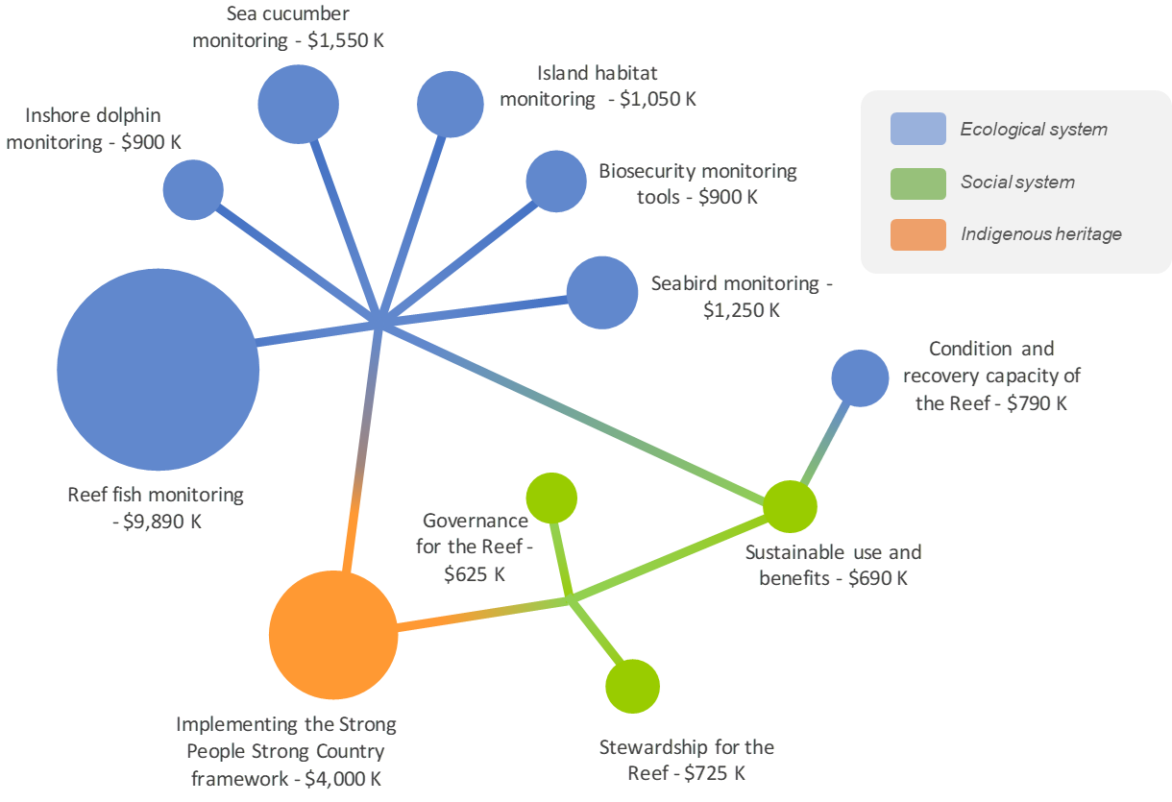
Figure 7: A total of 11 monitoring gaps have been prioritised for further investment
. The size of the circles in this figure are proportionate to the size of financial investment necessary to fill the prioritised monitoring gap. The 11 monitoring gaps from the ecological system, social system and Indigenous heritage are inter-related and contribute to the overall delivery of the Program’s purpose focused design.

Table 1: Monitoring gaps from the ecological, social and Indigenous heritage components of the Reef system that are recommended for further investment over the next three years.
Monitoring Gap | Associated Existing Monitoring Programs | Associated Institutions and End Users | Reef 2050 Plan* | Estimated Cost | Duration
Condition and recovery capacity of the Reef  Establish indicators and an analysis framework that allows Reef managers to consistently measure and assess the condition and recovery capacity of coral reef habitat. | IMOS  LTMP  MMP  RRAP | AIMS  CSIRO  GBRMPA  IMOS | OH1, M11, M12,  E2, E5 | $790,000 | 2
Inshore dolphin monitoring  To provide critical baseline information on distribution, threats, population demography and dynamics of inshore dolphin species, particularly the vulnerable listed Australian snubfin and Australian humpback dolphins. | EotR  QLD Marine Mammal Database  RJFMP  StrandNet | DAF  DES  GBRMPA  Traditional Owners | OS2, OS3, M6, M8, M10, M11, E2, E4, E5 | $900,000 | 3
Sea cucumber monitoring  To provide critical baseline information on distribution, population demography and dynamics of sea cucumber species, including the CITES listed black teatfish and white teatfish, to inform stock assessments and sustainable use. | Commercial catch and effort | AFMA  DAF  DAWE  GBRMPA  Traditional Owners | OS2, OS5, M6, E1, E2, E4, E5 | $1,550,000 | 3
Reef fish monitoring  Establish an integrated Reef fish monitoring program for species of recreational, commercial, biocultural and ecological significance (includes sharks and rays). This project breaks down into four sequential activities:  - Development of indicators  - Sampling design for integrated fish monitoring  - Underwater visual census of inshore and reef associated fishes  - Baited Remote Underwater Video Stations (BRUVS) monitoring in offshore areas | Boat ramp surveys, Commercial catch and effort  EotR  IMOS  LTMP  RJFMP | AIMS  CSIRO  DAF  DES  GBRMPA  NRM Groups  Regional report cards  Traditional Owners | OS4, OS5, M10, M11, E1, E2, E4, E5 | $9,890,000 | 3
Biosecurity monitoring tools  Development of monitoring tools to enable early detection of pest flora and fauna incursions on islands, and pest presence on vessels. | RJFMP | CSIRO  DES  GBRMPA | OH5, OS1, OS2, OIH1, OHD2, OHD3,  OHD4, M7, M11, E2, E4, E5 | $900,000 | 3
Island habitat monitoring  To provide critical baseline information on the condition and trend of key values associated with island habitats throughout the Great Barrier Reef World Heritage Area. | RJFMP | DES  GBRMPA  Traditional Owners | OH5, OS1, OS2, OS3, OIH1, OIH2, OIH4, OHD2, OHD3, OHD4, M9, M10, M11,  M12, E2, E5 | $1,050,000 | 3
Seabird monitoring  To provide critical baseline information on distribution, threats, population demography and dynamics of seabirds. | RJFMP | DES  GBRMPA  Traditional Owners | S1, M6, M7, M8  M9, M10, M11, M12 | $1,250,000 | 3
Sustainable use and benefits  To provide critical baseline information to monitor:  - impacts of human use on social and ecological Reef values;  - vulnerability of Reef dependent and associated industries and users to changes in Reef health;  - social and economic benefits reef users derive from the Reef; and  - environmental and cultural benefits with contributions from the Traditional Owners. | Boat ramp surveys, Commercial catch and effort  EotR  P2R  RJFMP  SELTMP  Vessel registrations | ABS  CSIRO  DAF  DES  GBRMPA  NRM Groups  Regional report cards  TMR  Traditional Owners | OHD1, OHD3, OHD5, Management Goals | $725,000 | 3
Monitoring collective capacity and effectiveness of implementation  To provide critical monitoring for:  - policy and program coherence;  - policy and program impact and outcomes;  - community involvement and satisfaction in Reef management; and  - availability and use of integrated knowledge sets  Monitoring will include Traditional Owner and non-Traditional Owner components to be co-developed with Indigenous Heritage monitoring work packs. | Developing DSS work  P2R  RJFMP  SELTMP  Strong people-Strong Country | AIMS  CSIRO  DAF  DAWE  DES  GBRMPA  IMOS  Traditional Owners | OHD5, E2, E3, E5, M2 | $625,000 | 3
Stewardship for the Reef  To provide critical baseline information to monitor:  - actions (direct and indirect) reef users are taking to reduce negative impacts on Reef values;  - stewardship activity outcomes for Reef health; and  - community engagement in Reef health initiatives. | CAP leaders  SELTMP  RJFMP  RRAP | AIMS  AMPTO  CSIRO  DAWE  DES  GBRF  GBRMPA  Traditional Owners | OHD1, OHD2,  OHD3, OHD5 | $690,000 | 3
Implementing the Strong People Strong Country framework  Piloting of the Strong People Strong Country framework in all aspects of monitoring, including indicator selection, data capture, data sharing protocols and co-interpretation of data. | TUMRAs  ILUAs  Sea Country Plans  Indigenous Ranger programs | Traditional Owners  CSIRO (existing involvement) | OIH1, OIH2, OIH3, OIH4, OIH5, M3 (and Box 3 of Reef 2050 Plan) | $4,000,000 | 3

Text Box:
The Strong-People – Strong Country Framework (SP-SC Framework) was developed in 2017-2018 in a related project led by the Indigenous Heritage Expert Group (IHEG) with support from CSIRO and James Cook University (JCU) staff, as part of the Program. The IHEG worked with CSIRO and was formed to advise on the co-design of the Indigenous heritage theme of the Program and comprised six GBR Traditional Owners with support from two JCU staff. The SP-SC Framework was designed to be fully completed over two stages, and in the first stage of the project the IHEG successfully progressed three key areas. Firstly, the preliminary design of the SP-SC Framework as a biocultural model to monitor the wellbeing of people and Country throughout the GBR using subjective and objective indicators and based on stories and statistics. Secondly, the identification by Traditional Owners of 6 Hubs: Country Health; People’s Health; Heritage and Knowledge; Culture and Community; Education; Empowerment and Economics (refer to Figure 8), and the recognition of forty-five factors that influence each of these six hubs, and uniquely describe the worldviews of the Traditional Owners of the GBR. Thirdly, the development of a subjective survey designed to capture data relating to Traditional Owners feelings about the Hubs and about the health of the GBR. This stage of the project identified that future work is needed to provide Traditional Owners-driven objective indicator and to support the potential contributions of Traditional Owners to monitoring other aspects including biophysical aspects of the health of the Reef. The next stage of this framework is now ready to further test the model and for Traditional Owners to identify the objective indicators to support the Hubs and the Framework.
In this current phase of the SP-SC Framework, the project team, consisting now of the Traditional Owner-led Integrated Monitoring and Reporting (IMR) Technical Working Group (TWG) and the Great Barrier Reef Foundation (GBRF) Traditional Owner Partnerships team, supported by CSIRO and other service providers (yet to be appointed) will test and further develop monitoring and reporting using the SP-SC Framework in selected pilot communities. What will emerge from this work is being built on the work of stage one that the IHEG developed and now the TOIMR TWG will further develop, some of which will be developed directly with the pilot communities. Testing the Framework will involve testing the Hubs through identifying objective indicators to reveal sub-sets to some, one or all the Hubs. Testing and developing this work further will be place-based and active-based within the pilot communities. The co-design approach is continuing to evolve and develop as a hands-on, participatory approach.
The budget in Appendix 1 is indicative of the work and forward thinking that the IHEG completed. The overall amount of $40 million reflected all the elements of work required and was based on a reef wide delivery of the SPSC Framework. The current stage is costed to $4 million which really reflects the work of piloting the SP-SC Framework, the other line-item areas could more be seen as ‘extension of’, or ‘future staged work’ of the SP-SC Framework.
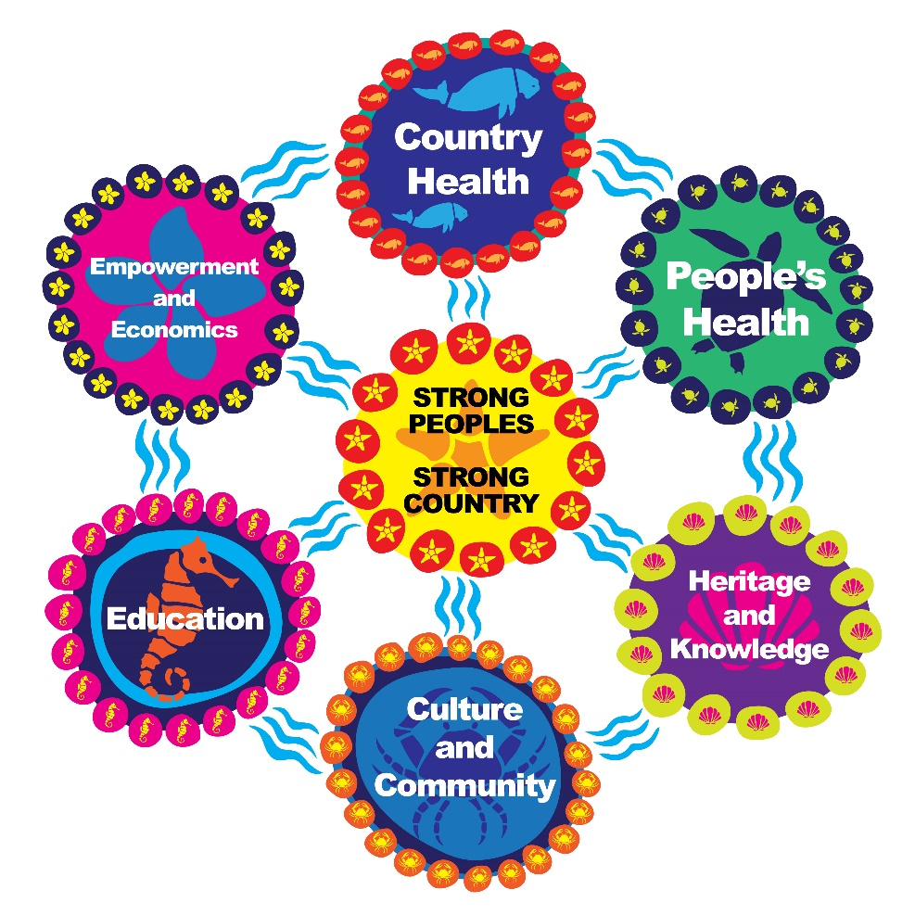
Figure 8: Strong People, Strong Country framework for monitoring Indigenous heritage consists of six key hubs
. © Mallie Designs.

Integration
The foundational integration funding need of the Program has not been identified or prioritised in this prospectus. However, the ability to integrate with other data sets and systems was a factor in the prioritisation of monitoring gaps listed in Table 1. Integration opportunities were also identified for each of the prioritised monitoring gaps (Figure 6 highlights some of these) and will be factored into implementation.
Key integration needs of the Program include:
- integration within monitoring/research areas, for example the integration of data from existing programs with any new monitoring programs established;
- integration across social and ecological system components to deliver overall assessments of Reef condition to inform reporting;
- operational integration to ensure the Program is delivered efficiently and effectively;
- integrated reporting; and
- integrated data management, for example optimal architecture for data discovery, storage, inter-operability and analysis systems.
A fully integrated Program is ambitious and has two aspects. Firstly, it requires innovation and collaboration across Reef managers, research partners, Traditional Owners and stakeholders. Secondly, integration refers to knowledge integration, needed at multiple levels through connections and causal links within and between environmental systems and processes, and the socio-economic and cultural systems and processes. This is a social-ecological view that encompasses the Reef’s values and attributes.
Integrating the perspectives of Traditional Owners and western science will provide a much better understanding of the Reef and how it has changed over time. Initiatives are already underway that recognise how the quality, value and impact of marine research outputs and management outcomes can be vastly improved when co-designed and delivered in partnership with Traditional Owners. It is crucial that any future funding of research on the Great Barrier Reef create mutually beneficial and collaborative relationships with Traditional Owners, based on the below principles from the Great Barrier Reef Marine Park Authority’s Aboriginal and Torres Strait Islander Heritage Strategy and to support delivery of the Great Barrier Reef Traditional Owners’ Theory of Change (refer to Appendix 2).
- Recognise a broad definition of Indigenous heritage.
- Engage respectfully with Traditional Owners on Indigenous heritage matters.
- Recognises that all sea country activities contribute to Indigenous heritage management.
- Respects that Traditional Owners own and control Indigenous heritage information.
- Support increasing co-management with Traditional Owners.
Each of the 11 prioritised monitoring gaps identified in this prospectus provide co-design and co-implementation opportunities to engage Traditional Owners.

Appendix 1: Identified monitoring gaps considered
Below is a list of all the identified monitoring gaps considered by the working group through the structured decision making process outlined in section 3 of this prospectus and detailed in the design report (in prep GBRMPA). The list was generated using information collated from the thematic expert working groups established to inform the design of the Program. The gaps that were prioritised have been highlighted.
Monitoring Gap | Reef 2050 Plan | Estimated Cost | Duration
Ecological Systems
Condition and recovery capacity of the Reef  Establish indicators and an analysis framework that allows Reef managers to measure and assess the condition and recovery capacity of coral reef habitat. | OH1, M11, M12, E2  E5 | $790,000 | 2
Inshore dolphin monitoring  To provide critical baseline information on distribution, threats, population demography and dynamics of inshore dolphin species, particularly the vulnerable listed Australian snubfin and Australian humpback dolphins. | OS2, OS3, M6, M8,  M10, M11, E2, E4, E5 | $900,000 | 3
Sea cucumber monitoring  To provide critical baseline information on distribution, population demography and dynamics of sea cucumber species, including the CITES listed black teatfish and white teatfish, to inform stock assessments and sustainable use. | OS2, OS5, M6, E1, E2, E4, E5 | $1,550,000 | 3
Reef fish monitoring  Establish an integrated Reef fish monitoring program for species of recreational, commercial, biocultural and ecological significance (includes sharks and rays). This project breaks down into four sequential activities:  - Development of indicators  - Sampling design for integrated fish monitoring  - Underwater visual census of inshore and reef associated fishes  - Baited Remote Underwater Video Stations (BRUVS) monitoring in offshore areas | OS4, OS5, M10, M11, E1, E2, E4,  E5 | $9,890,000 | 3
Biosecurity monitoring tools  Development of monitoring tools to enable early detection of pest flora and fauna incursions on islands, and pest presence on vessels. | OH5, OS1, OS2, OIH1, OHD2, OHD3  OHD4, M7, M11, E2, E4, E5 | $900,000 | 3
Island habitat monitoring  To provide critical baseline information on the condition and trend of key values associated with island habitats throughout the Great Barrier Reef World Heritage Area. | OH5, OS1, OS2, OS3, OIH1, OIH2, OIH4, OHD2, OHD3, OHD4, M9, M10, M11, M12, E2, E5 | $1,050,000 | 3
Seabird monitoring  To provide critical baseline information on distribution, threats, population demography and dynamics of seabirds. | S1, M6, M7, M8, M9, M10, M11, M12 | $1,250,000 | 3
Develop the Impact from Acute Disturbance indicator  Develop an analysis framework to assess the impact of acute disturbance on reef ecosystems through the integration of multiple monitoring activities. | OH1, M11, M12, E2, E5 | $1,000,000 | 2
Developing the Reef Functioning Capacity indicator  Develop an integrative analysis framework to assess the functional capacity of reef systems as an indicator informing the Reef 2050 Objectives and to inform adaptive management. | OH1, M11, M12, E2, E5 | $1,000,000 | 2
Develop the Mitigated COTS Damage metric  Develop the metric "mitigated COTS damage", including the development of an integrative analysis framework to combine data from existing and future COTS monitoring activities as part of an appropriately designed and coordinated COTS monitoring program. | OH1, M11, M12, E2, E5 | $1,000,000 | 3
Dugong population dynamics and distribution  To provide baseline information on distribution, threats, population demography and dynamics of dugongs. | OS2, OS3, M6, M8, M10, M11, E2, E4, E5 | $900,000 | 2
Integration of Indicators towards 2050 Objectives and Reporting  To enable, foster and integrate the data, metrics and indicators collected under the Program. Proposed initial key focus areas for integration are the links between ecological, societal and cultural values. This will ultimately lead to operational integrative workflows and analyses pipelines. | E2, E5 | $2,000,000 | 3
Monitoring to support delivery of the Queensland Marine Turtle Conservation Strategy  To provide ongoing monitoring of nesting and foraging populations of loggerheads, hawksbills and the northern GBR green turtle stock. | OS2, OS3, M6, M8, M10, M11, E2, E4, E5 | $440,000 | 2
Operational expansion of marine phys-chem reference station style monitoring sites  Comprehensive sampling of priority phys-chem parameters at geographically expanded observational sites. | Factors that influence the state of all objectives. | $7,780,000 | 3
Remote sensing algorithm refinement  Refine algorithms for nutrients, suspended sediment concentration (SSC), plankton characterisation, primary productivity from ocean colour remote sensing of ocean colour. | Factors that influence the state of all objectives. | $483,000 | 1
Seagrass meadow extent mapping  To improve the collection of meadow boundary information and patchiness for health assessments at sites currently monitored under the Marine Monitoring Program. | OH2, M11, M12, E2, E5 | $900,000 | 2
Sentinel Sites Monitoring scope  Scoping a Sentinel site-scale monitoring of key parameters to measure and model processes and mechanisms that drive change in coral reef ecosystems, centred around improving understanding of reef recovery capacity and reef ecosystem functionality. | OH1, M11, M12, E2, E5 | $79,000 | 1
Sentinel Site-scale Monitoring  Operationalisation of detailed monitoring activities around the Sentinel sites concept for in-depth monitoring of key physico-chemical parameters to help understanding physical and chemical drivers of processes and mechanisms that cause change in key GBR habitats (coral reefs and seagrass beds | OH1, M11, M12, E2, E5 | $7,170,000 | 3
Spatial Mapping of Qld Wetlands within the Great Barrier Reef World Heritage Area  To progress the intertidal and subtidal habitat mapping for some of the most important wetland areas within the Great Barrier Reef World Heritage Area. | OH3, OH4 | $13,300,000 | 2
Whale population dynamics and distribution  To provide baseline information on distribution, threats, population demography and dynamics of great whales (including humpback and dwarf minke whale species). | OS2, OS3, M6, M8, M10, M11, E2, E4, E5 | $900,000 | 3
Social System
Sustainable use and benefits  To provide critical baseline information to monitor:  - impacts of human use on social and ecological Reef values;  - vulnerability of Reef dependent and associated industries and users to changes in Reef health;  - social and economic benefits reef users derive from the Reef; and  - environmental and cultural benefits with contributions from the Traditional Owners. | OHD1, OHD3, OHD5, and Management Goals | $725,000 | 3
Monitoring collective capacity and effectiveness of implementation  To provide critical monitoring for:  - policy and program coherence;  - policy and program impact and outcomes;  - community involvement and satisfaction in Reef management; and  - availability and use of integrated knowledge sets  Monitoring will include Traditional Owner and non-Traditional Owner components to be co-developed with Indigenous Heritage monitoring work packs. | OHD5, E2, E3, E5, M2 | $625,000 | 3
Stewardship for the Reef  To provide critical baseline information to monitor:  - actions (direct and indirect) reef users are taking to reduce negative impacts on Reef values;  - stewardship activity outcomes for Reef health; and  - community engagement in Reef health initiatives. | OHD1, OHD2, OHD3, OHD5 | $690,000 | 3
Indigenous Heritage
Implementing the Strong People Strong Country framework  Piloting of the Strong People Strong Country framework in all aspects of monitoring, including indicator selection, data capture, data sharing protocols and co-interpretation of data. | OIH1, OIH2, OIH3,  OIH4, OIH5, M3 (and Box 3 of Reef 2050 Plan) | $4,000,000 | 3
Country or other plans and data storage systems  Develop or update Sea Country plans and establish suitable data storage systems. | OIH1, OIH2, OIH3, | $4,253,000 | 3
Developing Traditional Owner capacity  To support the delivery of monitoring services by Traditional Owners across all areas of the Program and Sea Country. | OIH4, OIH5, M3 (and Box 3 of Reef 2050 Plan) | $1,063,000 | 3
Strong Peoples-Strong Country framework  Develop and apply objective indicators at a Reef-wide scale with all Traditional Owner groups. | OIH1, OIH2, OIH3,  OIH4, OIH5, M3 (and Box 3 of Reef 2050 Plan) | $4,441,000 | 3
Strong Peoples – Strong Country framework  Apply subjective indicators at a Reef-wide scale with all Traditional Owner groups. | OIH1, OIH2, OIH3, | $8,779,000 | 3
Appendix 2: Great Barrier Reef Traditional Owners Theory of Change
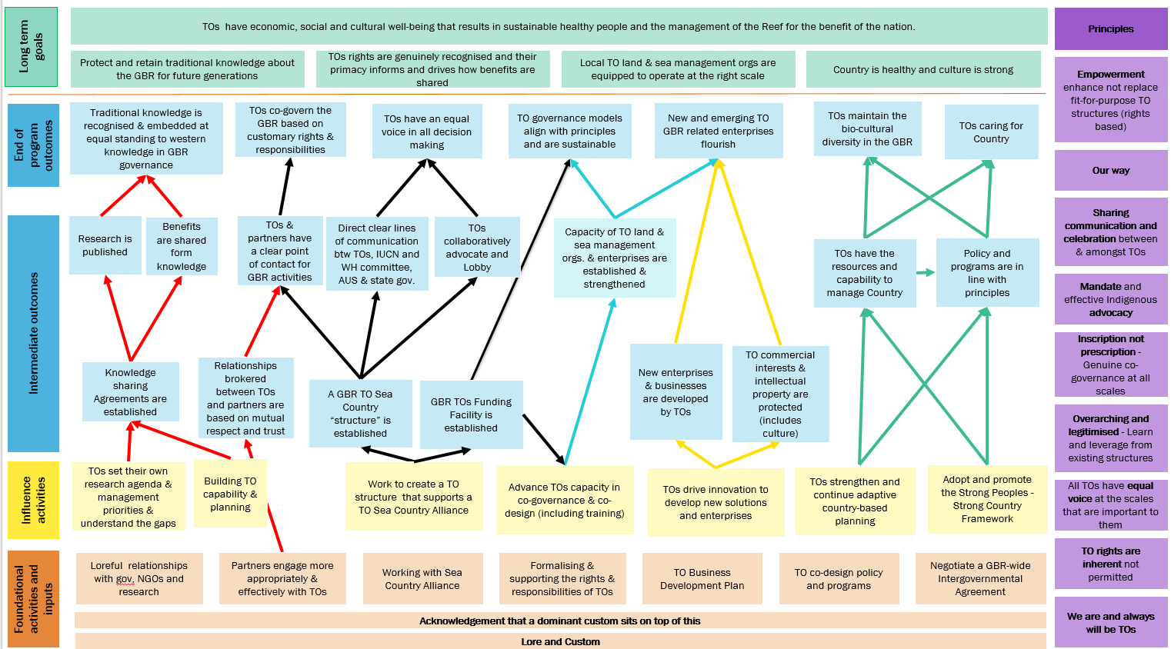

Appendix 3: Reef 2050 Plan Objectives and Management Goals
Reef 2050 Objectives
Habitat
OH1: Coral reef habitats maintain good condition and resilience.
OH2: Resilient seagrass meadows that maintain condition.
OH3: No loss of the extent of natural wetlands.
OH4: Wetland condition is improved.
OH5: Key values associated with islands are in a desired condition.
Species
OS1: Populations of seabirds and shorebirds are healthy.
OS2: Populations of protected species are healthy.
OS3: Populations of species of cultural significance to Traditional Owners are healthy.
OS4: Populations of bioculturally important fish and invertebrate species are healthy.
OS5: Populations of fish and invertebrate species that are important for recreational, commercial and culturally-based fisheries are healthy.
Indigenous heritage
OIH1: Traditional Owners caring for country.
OIH2: Traditional knowledge about the Great Barrier Reef is protected and retained for future generations.
OIH3: Traditional Owners’ rights are genuinely recognised and prioritised and inform and drive how benefits are shared.
OIH4: Local Traditional Owner land and sea management organisations are equipped to operate at the right scale.
OIH5: Country is healthy and culture is strong.
Human dimensions
OHD1: Uses of the Reef are ecologically sustainable as the system changes, in turn sustaining economic benefits to people.
OHD2: People maintain or grow their attachment to the Great Barrier Reef.
OHD3: People and communities take individual and collective action to maintain its resilience.
OHD4: Intangible and tangible historic heritage and contemporary cultural values remain intact.
OHD5: Governance systems to prioritise, adapt and engage communities in systems for Reef management are effective.

Management goals
Goals to reduce cumulative impacts and protect and conserve the Reef
M1: Australia contributes to global emissions reduction, through the Paris Agreement, to limit warming to well below 2°C and as close to 1.5°C as possible.
M2: Integrated planning across catchment and Reef reduces cumulative impacts.
M3: Indigenous heritage goals are considered, integrated and progressed in partnership.
M4: The flow of water to the Reef is further managed through targeted catchment restoration to mitigate water quality impacts.
M5: Reef 2050 Water Quality Improvement Plan targets and ambient water quality guidelines are met.
M6: The threats associated with fishing are reduced.
M7: Outbreaks of disease, introduced species and pests are reduced.
M8: Anthropogenic noise impacts are reduced.
M9: Artificial light impacts are reduced.
M10: Marine debris and rubbish pollution is reduced.
M11: Targeted Marine Park management reduces local and regional risks and supports ecosystem resilience.
M12: Potential Reef restoration and adaptation interventions are developed and deployed on a risk-basis.
Goals to enable delivery
E1: The vulnerability of sectors and economies dependent on Reef health is reduced, and users of the Reef are preparing for changes to the Reef.
E2: Science and knowledge are advanced and decisions are informed by the best available evidence-base.
E3: Governance systems are effective and coherent.
E4: Communities, industries and governments adopt stewardship behaviours.
E5: Comprehensive monitoring, evaluation

Great Barrier Reef Marine Park Authority, 2019. Aboriginal and Torres Strait Islander Heritage Strategy, Commonwealth of Australia.
Traditional Owners of the Great Barrier Reef: The Next Generation of Reef 2050 Actions, Commonwealth of Australia 2018.
Great Barrier Reef Foundation, 2018. Reef Trust Investment Strategy. Great Barrier Reef Foundation, Brisbane.
Mcleod et. al., 2019. The future of resilience-based management in coral reef ecosystems, Journal of Environmental Management, 233, pg. 291-301.
Australian Government and Queensland Government 2020, Reef 2050 Integrated Monitoring and Reporting Program Annual Business Plan 2020-21, Great Barrier Reef Marine Park Authority, Townsville.
An indicator is a simplified parameter that provides an indication of the condition of a more complex system and can be used to inform or evaluate management actions, or for reporting purposes. It is a high-level measure for assessment and can, in some cases, be characterised by multiple metrics and data sets.
Bowen J, et. al. (2020) draft RIMReP Monitoring Investment Priorities Project Design Report, prepared for the GBRMPA, Aurecon, Brisbane.
Hedge et. al., 2013, An integrated monitoring framework for the Great Barrier Reef World Heritage Area. Commonwealth of Australia.
Great Barrier Reef Marine Park Authority, 2019. Aboriginal and Torres Strait Islander Heritage Strategy, Commonwealth of Australia.

