Prepared on 14 June 2013 for the Great Barrier Reef Marine Park Authority by:
Glen Holmes, Chris McGrath, Josh Larsen, Marc Hockings and Patrick Moss
School of Geography, Planning and Environmental Management
The University of Queensland

Fish habitat connectivity case study
Lower Fitzroy River basin
Review of coastal ecosystem management to improve the health and resilience of the Great Barrier Reef World Heritage Area

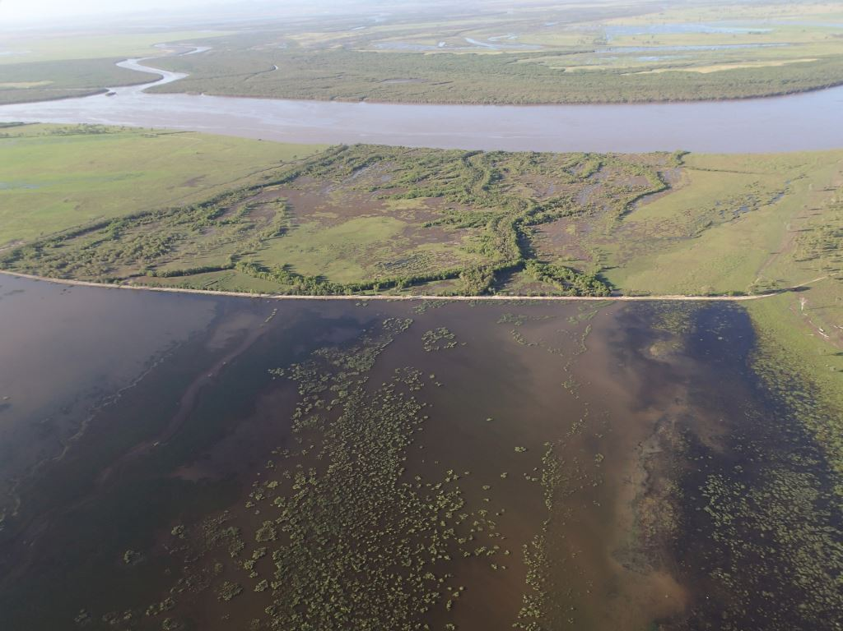

Page intentionally left blank for printing double-sided.

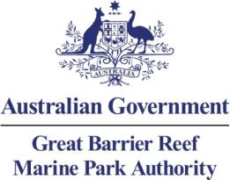

Fish habitat connectivity case study – Lower Fitzroy River basin
Review of coastal ecosystem management to improve the health and resilience of the Great Barrier Reef World Heritage Area
Prepared on 14 June 2013 for the Great Barrier Reef Marine Park Authority by:
Glen Holmes, Chris McGrath, Josh Larsen, Marc Hockings and Patrick Moss
School of Geography, Planning and Environmental Management
The University of Queensland

© Commonwealth of Australia 2013

Published by the Great Barrier Reef Marine Park Authority 2013

This work is copyright. You may download, display, print and reproduce this material in unaltered form only (appropriately acknowledging this source) for your personal, non-commercial use or use within your organisation. Apart from any use as permitted under the Copyright Act 1968, all other rights are reserved.

Disclaimer
The views and opinions expressed in this publication are those of the authors and do not necessarily reflect those of the contributors, the Australian Government or the Minister for Sustainability, Environment, Water, Population and Communities.

While reasonable efforts have been made to ensure that the contents of this publication are factually correct, the Australian Government does not accept responsibility for the accuracy or completeness of the contents, and shall not be liable for any loss or damage that may be occasioned directly or indirectly through the use of, or reliance on, the contents of this publication.
National Library of Australia Cataloguing-in-Publication entry
Holmes, G.
Coastal ecosystems management – case study: fish connectivity Glen Holmes, Chris McGrath, Josh Larsen, Marc Hockings and Patrick Moss.
ISBN 978 1 922126 19 1 (ebook)
Ecosystem management--Queensland--Great Barrier Reef.
Ecosystem health--Queensland--Great Barrier Reef.
Fishes--Habitat--Queensland--Great Barrier Reef.
Natural resources management areas--Queensland--Great Barrier Reef.
Great Barrier Reef (Qld.)--Management.
Great Barrier Reef Marine Park Authority.
577.5109943
This publication should be cited as:
Holmes, G., McGrath, C., Larsen, J., Hockings, M. and Moss, P.T. 2013, Coastal ecosystems management – case study: fish connectivity, GBRMPA, Townsville.
Acknowledgements
This report was supported through funding from the Australian Government Department of Sustainability, Environment, Water, Population and Communities.
This report is based on a report commissioned by the Great Barrier Reef Marine Park Authority, prepared on 14 June 2013 by Glen Holms, Chris McGrath, Josh Larsen, Marc Hockings and Patrick Moss, School of Geography, Planning and Environmental Management, The University of Queensland. The Great Barrier Reef Marine Park Authority also acknowledges the contributions of Hugh Yorkston, Donna-marie Audas, Jason Vains, Paul Groves, Carol Marshall, Melissa Evans, Ben Palmer, Emily Smart, Rose Dunstan and Sara Dunstan.

Requests and enquiries concerning reproduction and rights should be addressed to:
Great Barrier Reef Marine Park Authority
2-68 Flinders Street (PO Box 1379)
Townsville QLD 4810, Australia

Phone: (07) 4750 0700
Fax: (07) 4772 6093
Email: info@gbrmpa.gov.au

www.gbrmpa.gov.au

TABLE OF CONTENTS
TABLE OF CONTENTS i
Acknowledgements ii
EXECUTIVE SUMMARY 1
Context 1
Key issues 1
Current management 1
Potential management actions 2
INTRODUCTION 4
Background 4
Objectives and purpose of case study 4
METHODOLOGY 4
Coastal ecosystems of the region 6
Background 6
Overview of the basins within the study area 8
History of land use change 8
Impact on coastal ecosystems 13
Impacts on ecological function 14
Current condition and trend 14
Forecast of likely future activities and impacts on coastal ecosystems 17
Ponded Pastures 17
Case study of ponded pasture 20
Dams, weirs, barrages and other barriers to connectivity 23
Fishways 24
Land-use management and coastal ecosystems 27
Background 27
Overlapping roles of government 27
General laws, policies and programs relevant to fish passage in the lower Fitzroy River basins 28
Changes to coastal and regional planning 31
Changes to vegetation laws 31
Ponded Pastures 32
Marine plants and fish habitat areas 33
Fitzroy Basin Fish Passage Prioritisation Project 33
Protecting existing undisturbed coastal ecosystems 35
Reconnection and rehabilitation of disturbed coastal ecosystems 35
Return of coastal ecosystem function modified landscapes 36
Uncertainty in assessment and managing risk 37
Adaptive management 37
Discussion 39
Opportunities for improved management 40
Mapping priority areas for protection, rehabilitation and restoration for guidance under the EPBC Act 44
Potential management actions 46
REFERENCES 48
APPENDIX A – Lead researchers 50
APPENDIX B: Ecological function of natural coastal ecosystems linked to the health and resilience of the World Heritage Area 51
APPENDIX C: Ecological processes of modified systems linked to the health and resilience of the World Heritage Area. 53
APPENDIX D - DRAFT GBRMPA Assessment criteria for establishing management actions within the Great Barrier Reef catchment that help maintain health and resilience of ecosystems in the World Heritage Area 55
APPENDIX E – Selected ponded pastures in the lower Fitzroy region identified by Hyland (2002) 59

Acknowledgements
The Great Barrier Reef Marine Park Authority also thanks the following people and organisations for their assistance in preparing this report:
- Fitzroy Basin Association.
- Fitzroy River and Coastal Catchments (FRCC).
- Jim Tait from Econcern Environmental Consulting.
- stakeholders as per field assessments and review (Chris Small, Julie Cook, Jeff Mills, John Rodgers, Bill Sawynok, Shannon van Nunen and John McCabe).
- Stuart Hyland discussed his earlier work on ponded pastures (Hyland 2002).
- Tim Marsden from Reef Catchments, Mackay, discussed his work on fish barriers in the Fitzroy.¹

Cover photo: Ponded pasture at mouth of Fitzroy River by Jim Tait (2013).

EXECUTIVE SUMMARY

Context
The Fitzroy River basin is the largest catchment of the Great Barrier Reef, and the ecosystem functions it provides are vital for maintaining the health of the Great Barrier Reef. The coastal ecosystems of the lower Fitzroy River region, incorporating the lower Fitzroy, Styx, Shoalwater and Waterpark basins, encompass an area of approximately 20,000 km² and include varying levels of development. Much of the lower Fitzroy and Styx basins have been heavily modified for development (primarily for agriculture, dominated by grazing) while the Shoalwater and Waterpark basins remain relatively development free. In the case of the Shoalwater basin, this is predominantly due to the presence of the military training area which constrains development.
Development within the Fitzroy region has led to extensive changes in water flow regimes resulting from the harvesting of water resources for industry, agriculture and domestic use. The associated infrastructure, including dams, weirs, tidal barrages and ponded pasture systems, as well as other infrastructure connected with development such as road and rail connections, have resulted in many obstructions in water courses that act as barriers to fish movement and connectivity between ecosystems. These impacts are representative of many other Great Barrier Reef catchments and the management of them provides lessons for management of the Great Barrier Reef catchment generally.

Key issues
Improving the connectivity between ecosystems will benefit both fish populations and the health of the Great Barrier Reef World Heritage Area (World Heritage Area). More than 95 per cent of freshwater fish species in the region, including barramundi and mangrove jack, require the ability to move either between freshwater and marine ecosystems or wholly within freshwater systems. Restricting this movement reduces fisheries resources and associated ecological function. Gaps in knowledge pose a considerable obstacle to improving fish passage. There also remains only limited understanding of the ecosystem functions provided to the World Heritage Area by coastal ecosystems and how even modified systems such as ponded pastures still provide some level of ecological function. While some valuable surveys of ponded pastures have been done in the past, their management is considerably hampered by a lack of detailed information on the location, height and nature of the barriers that create the ponded pastures. While general propositions about good management of fish barriers can be made (for example the need for fishways), the installation and maintenance of management devices and practices invariably needs to be determined on a case-by-case basis. This complicates the management situation.

Current management
There are a number of state and Commonwealth laws that may regulate barriers to fish passage in the Fitzroy region. The main laws influencing the regulation of water infrastructure and ponded pastures are the Sustainable Planning Act 2009 (Qld) (SPA), Water Act 2000 (Qld), Fisheries Act 1994 (Qld), and the Environment Protection and Biodiversity Conservation Act 1999 (Cth) (EPBC Act).
It is important to realise that the planning and management frameworks created by these state and Commonwealth laws for activities impacting on fish passage in the lower Fitzroy River basins principally regulate new activities and development. The legacy of past development tends to become a fixed part of the “status quo” forming a background of impacts or condition of the environment. This is particularly significant to consider in the context of an area such as the lower Fitzroy River where most suitable sites for water infrastructure and most land suitable for ponded pastures has either already been developed or is unavailable for development (for example the military training area in Shoalwater). New development is, therefore, only a small part of the picture.
Ponded pastures have been developed in the area since the 1930s, and particularly during the 1970s to increase cattle production with the impacts on fisheries resources generally unrecognised. A moratorium on new ponded pastures has been in place since the 1990s, but this does not address the legacy of past unconstrained development in the region which has an ongoing impact through loss of habitat and connectivity, especially for fish breeding and feeding. These existing, lawfully constructed ponded pastures are generally located on freehold land and any government intervention in their management will need to engage positively with the landholders concerned, particularly for the provision of ecosystem functions that require adopting practices that may reduce cattle production while increasing fisheries (an outcome that the landholder does not directly benefit from).
Similarly, the construction of most dams, weirs and the barrage on the Fitzroy River, as well as many road crossings on watercourses that are barriers to fish passage occurred many decades ago and the current regulatory frameworks largely do not address the legacy impacts of this development. There has been a considerable effort in the past decade by the Queensland Government and Fitzroy Basin Association to identify and reduce fish barriers in the Fitzroy basin. The most significant fish barrier in the basin, the Fitzroy River Barrage at Rockhampton, includes a retrofitted fish passage, as do many other barriers installed under previous programs to improve fish passage. Evaluation of the Fitzroy River Barrage indicates that its effectiveness could be improved considerably if funding were available to implement alternatives for improved fish passage.

Potential management actions
Actions that could be taken include:
- The restoration of fish passage in the Great Barrier Reef catchment could be managed in a similar manner to poor water quality from coastal development and farming, another legacy issue identified as a key pressure on the World Heritage Area in the late 1990s. A long-term, collaborative approach is required to restore ecosystem function in the Great Barrier Reef catchment, with initial priority to include monitoring and improving the information available on fish barriers, then prioritising actions to restore fish passage and monitoring their implementation.
- Development of a guideline on actions likely to have a significant impact on the World Heritage Area to better inform landholders of what actions require approval under the EPBC Act. The guideline could supplement existing guidelines on significance under the EPBC Act and be linked to the “Framework to identify priority hydrological connections to the Great Barrier Reef World Heritage Area” mapping developed by the Great Barrier Reef Marine Park Authority (GBRMPA) which identifies wetlands, watercourses and other areas important for maintaining ecological function to the World Heritage Area. Actions in or affecting priority areas for protection, rehabilitation and restoration should be identified as likely to cause a significant impact on the World Heritage Area. The guideline might also identify particular actions within or affecting priority areas for protection, rehabilitation and restoration, such as dams, weirs, barrages, and ponded pastures, which are likely to cause a significant impact on the values of the Great Barrier Reef.
- A detailed survey of the location, height and nature of ponded pastures in the Fitzroy region that influence connectivity between marine and terrestrial ecosystems (or at least a smaller area in a pilot study such as Corio Bay) would improve understanding and facilitate prioritisation of options for improved management on a case-by-case (i.e. property level) basis. The survey would establish an agreed baseline and be linked to a plan to monitor change over time.
- Consider a program supporting transitional (one-off) payments or ongoing payments for ecosystem functions to landholders in exchange for changed management practices for ponded pastures to improve ecological function for the World Heritage Area. The ponded pastures around Corio Bay (which is part of the Shoalwater and Corio Bay Ramsar Wetland) would provide a good site for trialling such payments for ecosystem functions. If implemented, the program should be reviewed after 2-5 years and, if successful, consideration could be given to expanding it throughout the Great Barrier Reef catchment.
- In collaboration with the Queensland Government, review the implementation of the recommendations of the Fitzroy Basin Fish Barrier Prioritisation Project¹ with a view to prioritizing measures to reduce fish barriers in the Fitzroy catchment to improve ecological connection to the World Heritage Area.
- On the basis of the review of the Fitzroy Basin Fish Barrier Prioritisation Project, consider mechanisms that could assist directing funds to identified priorities to reduce fish barriers in the Fitzroy catchment to improve ecological function for the World Heritage Area.
- Develop mechanisms to work with Australian, state and local governments to ensure water and road infrastructure does not impact on the connectivity of natural systems. This engagement should seek to support and build upon the significant efforts of the Queensland Government to address these matters over the past decade. While major infrastructure is of obvious concern, poor design of even relatively small road crossings can stop fish passage upstream.

INTRODUCTION

Background
This case study is part of a series of case studies developed in association with the Great Barrier Reef Coastal Ecosystem Assessment Framework (CEAF) basin assessments.² The CEAF delivers an assessment of the cumulative impacts of development in highly developed and less developed areas of the Great Barrier Reef coastal zone to inform assessment of both present and future development pressures and potential net conservation gain opportunities for the World Heritage Area.

Objectives and purpose of case study
The objective of this report is to provide a case study of fish habitat connectivity in the lower Fitzroy River basin region of the Great Barrier Reef. It is one of a series of case studies supporting the CEAF basin assessments which are intended to inform the strategic assessment of the World Heritage Area and adjacent coastal zone by exploring the current extent and connections of coastal ecosystems, land use of the basins and identify blockages and obstructions in the environment that have the potential to affect the ecological function of the Great Barrier Reef. The series of case studies (of which this report forms one) examines how present coastal land-use activities and practices affect protection of Great Barrier Reef coastal ecosystems
This case study has reviewed the current state of knowledge regarding ponded pastures and barriers to fish migration within the study area. Through input from local stakeholders as well reviewing available literature, this case study has sought to identify what information regarding ponded pastures and fish barriers exists together with its accuracy and detail. It has also sought to identify the various management programs that are currently in place that cover ponded pastures and fish barriers with respect to coastal ecosystems and how those programs will influence the ecosystem function that are or could potentially be provided to the World Heritage Area.

METHODOLOGY
This case study was conducted in a short timeframe and with limited field work or attempts to gather primary data on the extent or nature of the impacts of barriers to fish passage in the Fitzroy region on World Heritage Area values due to ponded pastures or water infrastructure.
A literature review and use of mapping provided by GBRMPA from the CEAF basin assessments were the main methods used to gather information on the extent and nature of the barriers (pressures) to fish passage and the condition (including trends) of ecosystem function in the Fitzroy region. The report benefited from input from regional experts and interested stakeholders through the GBRMPA’s field assessment and workshop in the study area.
To better understand the nature of ponded pastures, a case study assessed information on a ponded pasture located on the northern banks of the mouth of the Fitzroy River. The site was chosen because of its location in a highly sensitive and important area for fisheries and because of the large ponded pasture located on the property identified by satellite imagery.
In considering possible policy improvements, the environmental regulatory design principles recommended by Gunningham and Grabosky³ were adopted, namely:
- Prefer policy mixes incorporating a broader range of instruments and institutions
- Prefer less interventionist measures (for example voluntary measures rather than legislation if practicable)
- Ascend a dynamic instrument pyramid to the extent necessary to achieve policy goals building in regulatory responsiveness
- Empower participants which are in the best position to act as surrogate regulators
- Maximise the opportunities for win-win outcomes.

In doing so, where possible this case study presents potential management actions that would not involve legislative change and could be done using existing frameworks.
The methodology adopted in this case study is also based on the terminology and framework for assessing the importance of coastal ecosystems for the World Heritage Area set out in the report, Informing the Outlook for Great Barrier Reef Coastal Ecosystems.⁴ That report identifies the coastal ecosystems that have been modified and natural corridors and essential connections to the Great Barrier Reef for flora and fauna that have been lost or compromised as a result of over more than one hundred and fifty years of catchment clearing and coastal development.

Coastal ecosystems of the region

Background
Coastal ecosystems represent the bridging ecosystems between the marine and terrestrial environments. As such, they play a vital role in maintaining the connectivity between these two environments through the provision of a range of ecosystem functions. Ecosystem functions are often considered within the context of the provision of functions to human society. The Millennium Ecosystem Assessment grouped these functions into four categories⁵:
- Provisioning functions such as food, water, timber, and fibre
- Regulating functions such as the regulation of climate, floods, disease, wastes, and water quality
- Cultural functions such as recreational, aesthetic, and spiritual benefits
- Supporting functions such as soil formation, photosynthesis, and nutrient cycling.
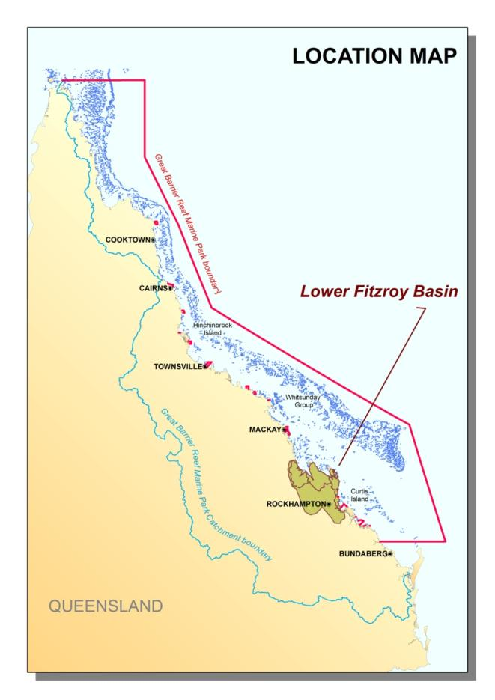
Figure 1: Lower Fitzroy basin study area
Supporting functions are those that maintain other ecosystem functions such as the provision of habitat to support commercial fisheries. Regulating functions not only provide functions to human wellbeing but also to other ecosystems. For example, the regulation of floods not only protects human assets from the damaging effects of floods but also similarly protects downstream ecosystems. Coastal and marine ecosystems are closely interlinked and rely on each other for the provision of many ecosystem functions to maintain ecosystem health.
The CEAF identifies 13 natural ecosystems within the coastal zone of the Great Barrier Reef and a range of physical, biogeochemical and biological functions that are provided to the Great Barrier Reef (Appendix B). Post-European settlement, coastal regions have undergone significant change, and the naturally occurring ecosystems are no longer the only ones to influence the number and extent of ecosystem functions provided. To account for these, the CEAF also identifies a further eight "modified" ecosystems (Appendix C).
The focus of this case study is on four of the basins within the Fitzroy Natural Resource Management (NRM) region: the lower Fitzroy, the Styx; Shoalwater; and Waterpark basins. The Queensland Government regional ecosystem mapping identifies that each of these basins has representations of eight coastal ecosystems identified in the CEAF (Table 1). It should be noted that the high values of grass and sedgelands, heath and shrublands and freshwater wetlands are not due to the maintenance or increase in natural versions of these ecosystems, but due primarily to the use of ponded pastures in agriculture in this region.
Table 1: Areas of concern – percentage of remaining coastal ecosystems within the study area. Note the increase in freshwater wetlands, together with the 100 per cent values in grass and sedgelands and heath and shrublands is associated with the development of ponded pastures in the region. Red cells indicate areas with less than 10 per cent remaining; orange 10–30 per cent, yellow 31–50 per cent and green greater than 50 per cent. Note these figures provide no information about ecosystem condition or functionality. White cells denote an absence of this coastal ecosystem from the basin and pink cells denote an increase in area.
Basin | Rainforests (%) | Forests (%) | Woodlands (%) | Forested floodplain (%) | Grass and sedgelands (%) | Heath and shrublands (%) | Freshwater wetlands (%) | Estuaries (%)
Styx | 67 | 57 | 31 | 34 | 176 | 100 | 209 | 97
Shoalwater | 87 | 86 | 67 | 38 | 63 | 102 | 1641 | 65
Waterpark | 88 | 79 | 84 | 50 | 99 | 74 | 126 | 94
Fitzroy | 33 | 50 | 18 | 20 | NA | 100 | 96 | 86

Altering coastal ecosystems through development for agriculture, or urbanisation or industry, can alter or even remove the ecosystem function provided by the original ecosystem, which can be detrimental to adjacent Great Barrier Reef ecosystems. One of the dominant issues associated with the development of land is the modification of waterways, from draining wetlands to provide for agriculture, to building roads to allow access to new areas. These modifications can often result in a barrier in the natural watercourse that can impede fish migration as well as reduce the capacity for other ecological functions, such as nutrient regulation and habitat provision (Appendix B and C).

Overview of the basins within the study area
The study area encompasses 19,897 km² and includes the lower reaches of the Fitzroy basin together with the whole of the Styx, Shoalwater and Waterpark basins (Figure 4). These basins represent the northern and eastern sections of the Fitzroy NRM region. The region contains many natural assets, including pristine estuarine systems, and represents the largest coastal wilderness area between southern New South Wales and Cape Melville on Cape York Peninsula.¹ The Fitzroy basin as a whole represents the largest basin that drains into the Great Barrier Reef and extensive areas of floodplain exist throughout the study area. These floodplains provide high levels of aquatic connectivity between ecosystems in time of flooding rains, and watercourses and wetlands on the floodplains provide refuge for some aquatic species in drier periods.
Of the five most extensive mangrove and saltmarsh areas within the Great Barrier Reef, two are found within the study area: Broad Sound-Shoalwater Bays and the Fitzroy estuary.⁶ These estuarine systems provide ecosystem functions vital to both the health of the World Heritage Area and to commercial fisheries as habitat and nursery grounds.
The basins of the study area contain a number of internationally important ecosystems. Besides the World Heritage Area, Ramsar listed wetlands are found in Shoalwater and Corio Bay areas. These areas also contain examples of half the wetland types found in Queensland. In addition to the Ramsar listed wetlands a number of nationally important wetlands are also found in this region. The estuarine and nearshore waters also provide habitat and nursery grounds for a number of important fisheries species as well as the iconic dugong with dugong protection areas located adjacent to the Shoalwater and Styx basins.
More detailed information on each of the basins within the study area can found in the respective Styx, and lower Fitzroy floodplain CEAF Basin Assessment Reports.

History of land use change
The Fitzroy basin assessment⁷ identified that there has been a significant reduction in species and ecosystem diversity as a result of changes in land use. This statement is equally true for the lower Fitzroy basin region within this study area, and to a lesser extent for the other basins as well. Since European settlement (identified as post-clear in this report) the floodplain areas in particular have undergone extensive modification, more so in the Fitzroy and Styx basins than in the Shoalwater or Waterpark basins (Figure 4). As part of this land use change, many of the waterways have been modified to allow for agricultural development resulting in broadscale changes to overland and underground hydrology as well as the introduction of barriers impacting on fish species’ ability to migrate either between differing freshwater habitats or between the freshwater and marine ecosystems.
Pre-clear, the study area was dominated by forests (52 per cent), woodlands (18 per cent) and forested floodplain (15 per cent) (Figure 4 top). By 2009, this landscape had changed significantly (Figure 4 bottom, Table 2) with much of the forested floodplain cleared for grazing. As illustrated in Table 2, some of the original coastal ecosystems have been significantly reduced. Others however, such as freshwater wetlands have been increased due to the practice of ponded pastures (discussed below). While this may appear to be beneficial in terms of continued delivery of ecosystem function, it is important to remember that these systems may not mirror the original ecosystems functions (refer to Appendix B and C).
Table 2: Area (km2) of pre-clear and 2009 coastal ecosystems within the study area based upon Queensland Government Regional Ecosystem mapping. Note the increase in Freshwater wetlands due to ponded pastures.
Coastal Ecosystem | Pre clear extent (ha) | 2009 extent (ha) | % remaining
Rainforests | 105,410 | 42,972 | 41
Forests | 1,030,697 | 616,497 | 60
Woodlands | 362,049 | 136,580 | 38
Forested floodplain | 294,681 | 68,324 | 23
Grass and sedgelands | 854 | 839 | 98
Heath and shrublands | 26,105 | 22,070 | 85
Freshwater wetlands | 7188 | 21,229 | 295
Estuaries | 148,797 | 122,869 | 83
Non Remnant | 0 | 941,580 | NA
Not Mapped | 13,887 | 16,707 | NA

Development within the Fitzroy region has been occurring for over 150 years. The construction of coastal barrages to prevent the ingress of tidal waters to allow an expansion of cropping and grazing land, or construction of roads accessing the coast (Figure 2), was an activity mainly undertaken 40 to 50 years ago when there were little or no legislative or industry management arrangements controlling these activities.⁴ The rate of change within the region has slowed as less land remained available for development. This is reflected in an assessment of recent land use change between 1999 and 2009 within the Fitzroy NRM region undertaken by the Queensland Government.⁸ It showed that over the entire NRM region only 2.36 per cent of the area (371,595 hectares) was identified as having a change in land use intensity. Of this, 55 per cent was identified as a decrease in the intensity of the land use. Only a minor fraction of this change was observed to have occurred within the study area (Figure 3).
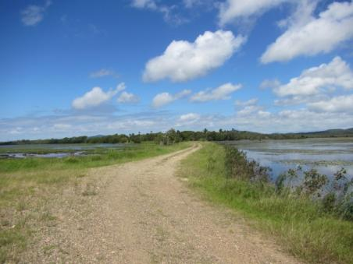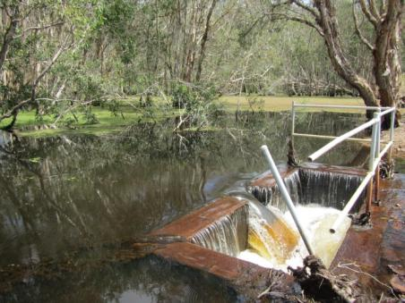
Figure 2: Bund wall (left) and fish barrier (right) in the upper catchment area adjacent to the Corio Bay Ramsar Wetland (photos courtesy of the Great Barrier Reef Marine Park Authority)
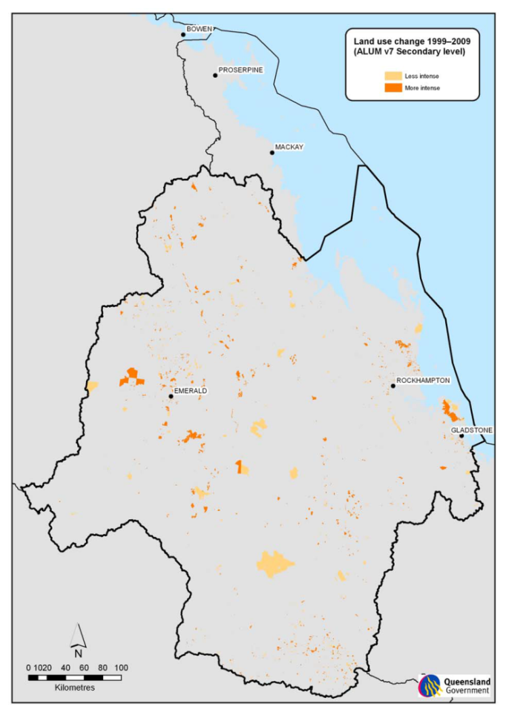
Current Study Area

Figure 3: 1999 - 2009 land use change within the Fitzroy NRM region⁸

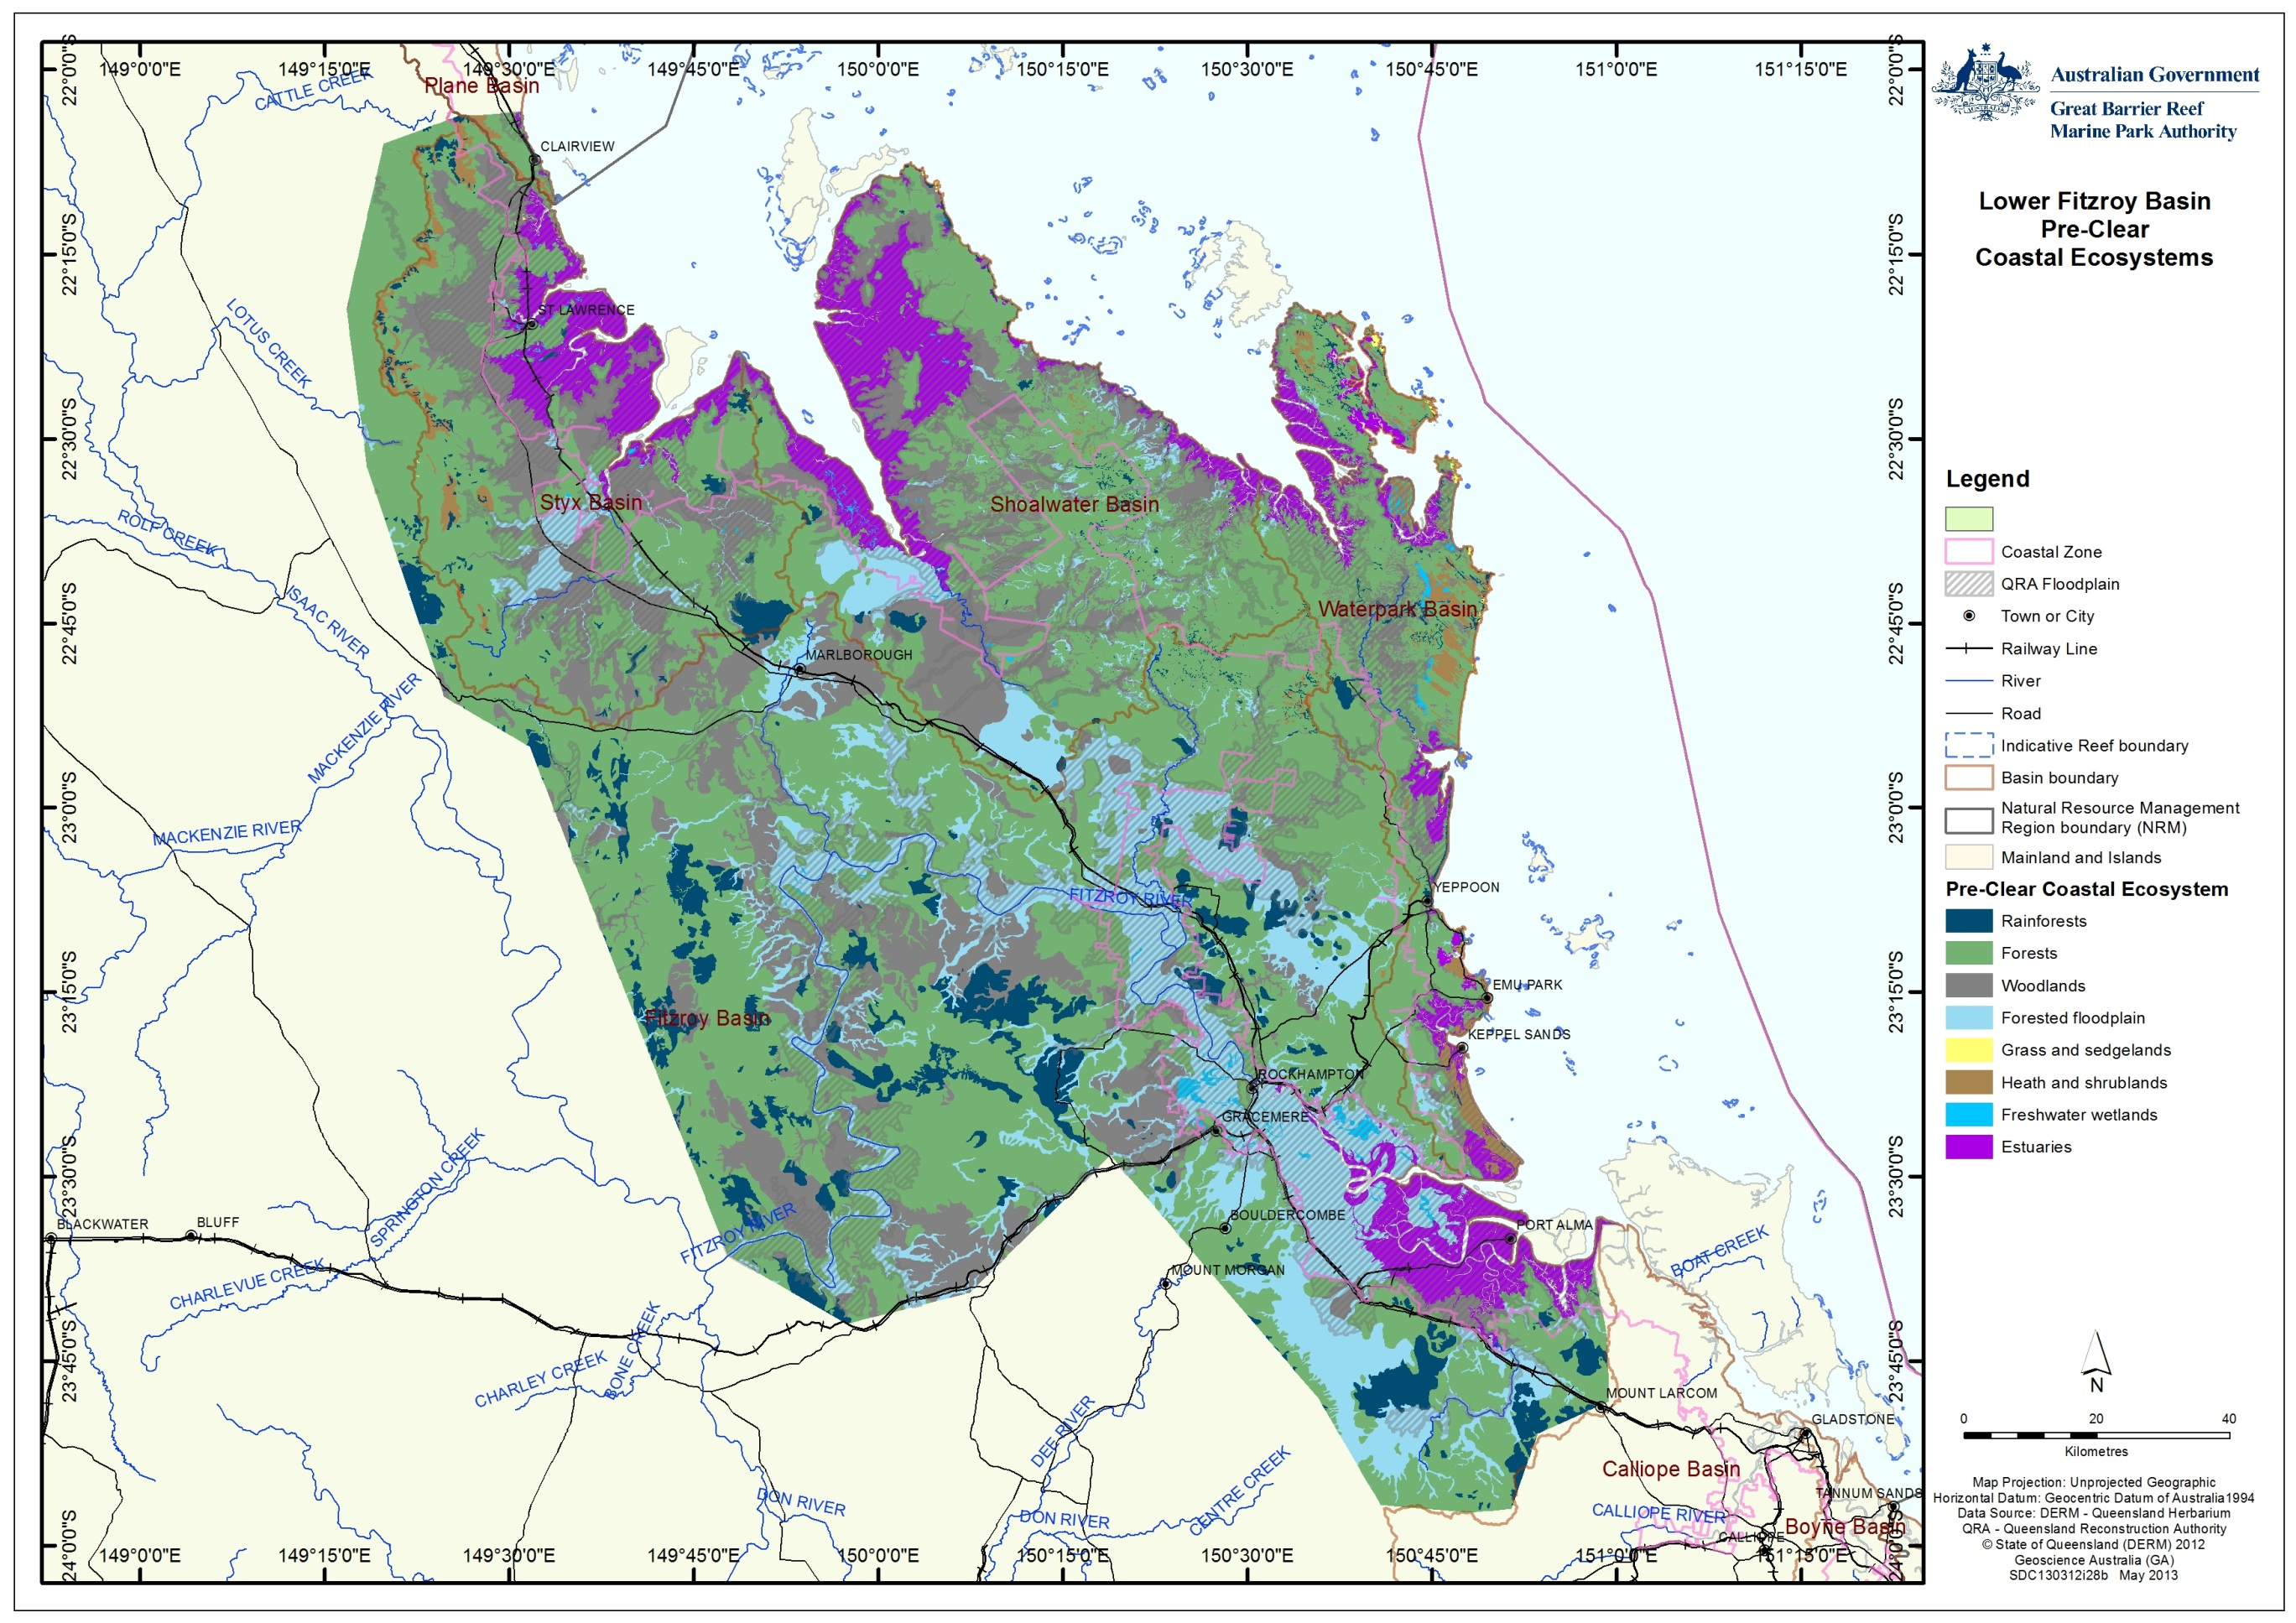

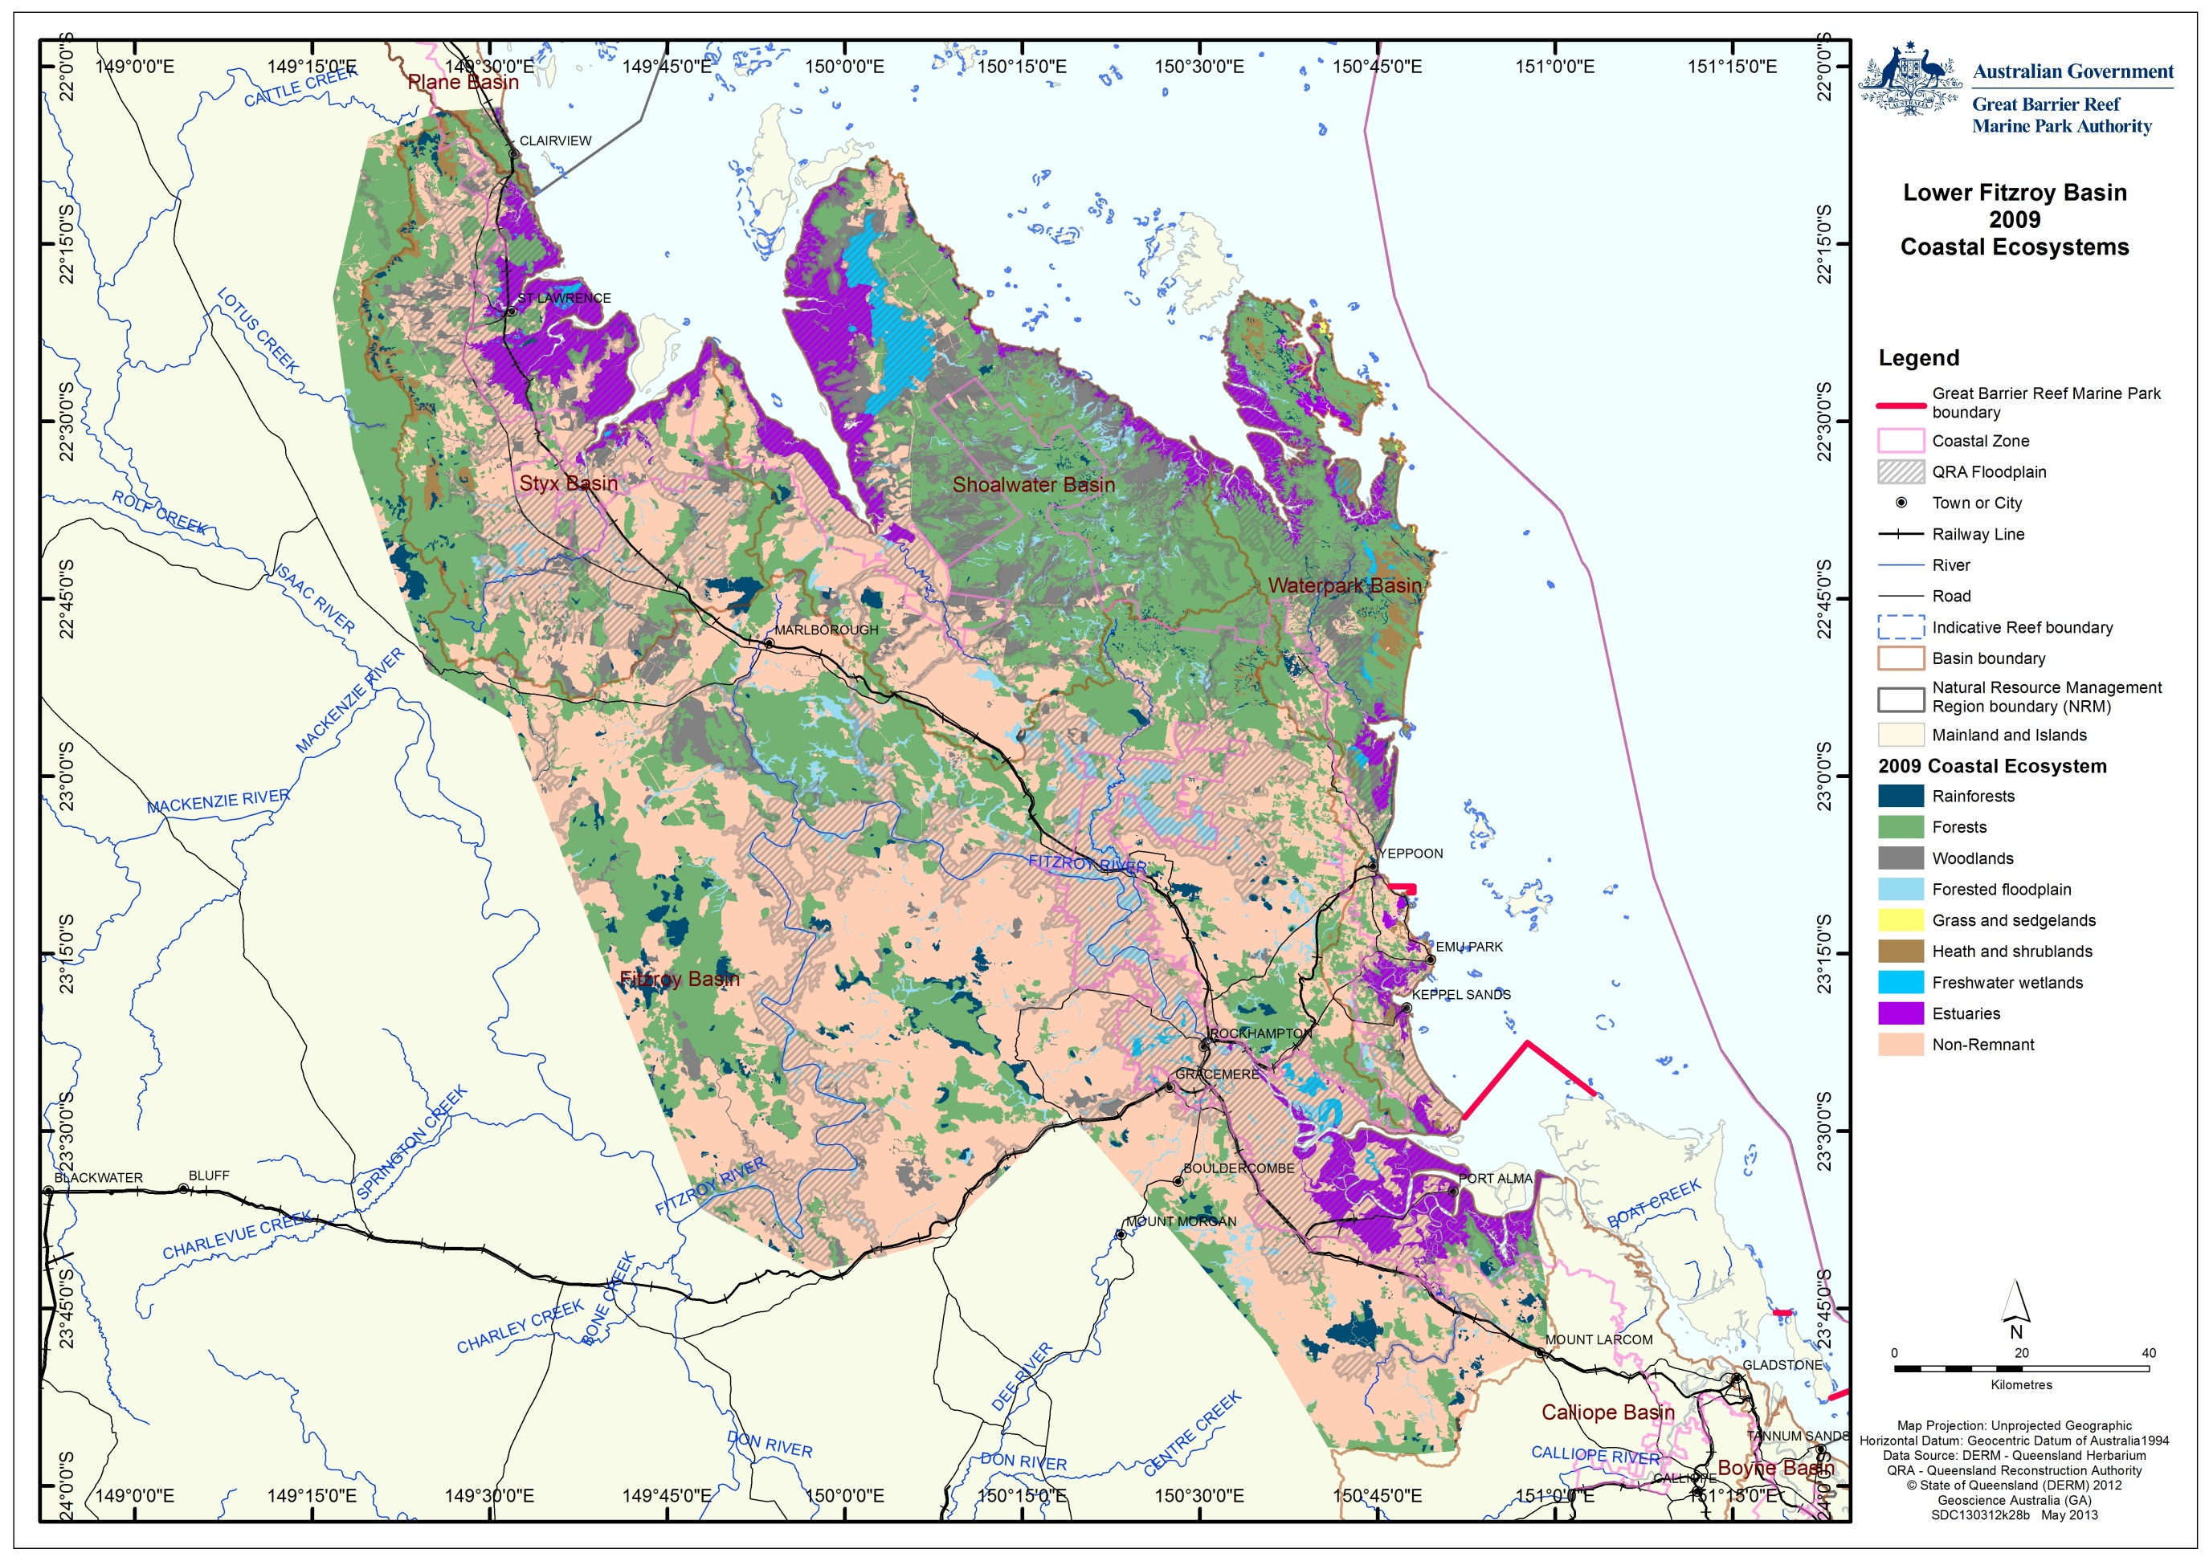
Figure 4: Study area coastal ecosystems pre-European settlement (above) and in 2009 (below)

Impact on coastal ecosystems
Impacts to ecosystems within the study area are a reflection of the conditions throughout the Fitzroy region. The extensive modification of the floodplain regions for agriculture and residential development have resulted in a reduction in ecosystem diversity. The Fitzroy basin assessment identifies the changes as:⁷
- Broadscale clearing of forests, woodlands, and modification of grass and sedgelands
- Modifications to river bank from straightening, channelization and removal of riparian vegetation, these have impacted upon terrestrial and in-water biodiversity
- Broadscale changes to overland and underground hydrology through overland flow, river straightening and groundwater management for irrigation. These have impacted upon terrestrial and in-water biodiversity. Changes to the seasonality of water flows is further impacting on both aquatic and terrestrial biodiversity
- Barriers impacting on fish migration between marine and freshwater habitats. These barriers can contribute to the loss of species diversity within fish communities and severely impacts the health of the regions aquatic ecosystems
- Introduction of pasture grasses that have changed the flora biodiversity and the fire regime. These African and South American grasses burn hotter causing significant changes to biodiversity (including species loss). The risk to biodiversity can be reduced through sustainable grazing management
- Aquatic biodiversity has declined in some parts of the basin as a result of landscape changes and land use practices. The coastal region of the Fitzroy basin is dominated by grazing.

Changes in land use (such as grazing and extensive cropping) have also left ongoing legacy issues which continue to impact on the life history of local aquatic and terrestrial species with connections to the Reef (such as migratory fish, migratory birds), leading to an ongoing decline in species diversity.
Ponded pastures interfere with the natural connectivity between ecosystems within the coastal zone both directly and indirectly. They directly interfere through the construction of barriers to prevent or restrict water movement, thereby also preventing fish migration and the connectivity of other ecological functions between, for example, upstream forests and woodlands and downstream estuarine systems. Indirectly, introduced pasture species may escape from ponded pastures, and outcompeting the native species in aquatic systems and choking receiving the waterways. Three ponded pasture grasses introduced to Queensland are now regarded as invasive weeds.⁹ If not carefully managed, ponded pasture systems also have the potential to become anoxic (oxygen depleted), such that fauna trapped within the pastures can no longer survive. Pulses of anoxic water released from ponded pastures can also have detrimental impacts to downstream aquatic fauna.
The weirs and levies constructed to maintain ponded pastures are not the only barrier to fish migration and connectivity within the study area. The redirecting of water resources for agriculture and domestic use as well as flood mitigation works have also resulted in a number of barriers to fish movement within the study area. These barriers may take the form of a physical obstruction or result from the redirecting of water flow away from, for example, nursery habitats.
The most significant barrier to fish migration within the Fitzroy region is the Fitzroy barrage. Its construction in 1970 effectively reduced the length of the Fitzroy estuary by 50 km, significantly reducing the available habitat for estuarine species as well as creating a significant barrier to migration. Despite multiple modifications to the original fish ladder installed on the barrage during construction, it remains an effective barrier to some fish sizes.¹⁰ The barrage and other human impacts including dredging, land use, and increased sediment load have changed the hydrodynamics of the system with a poor flushing zone downstream of the barrage resulting in changes in mangrove areas around the mouth of the lower estuary.
Within the Fitzroy basin region there are 49 known species of freshwater fish¹. More than 95 per cent of these require the ability to migrate. 23 species are known to be diadromous, requiring free access between freshwater and marine systems. Another 23 species are potamodromous, undertaking significant migrations wholly within freshwater systems. Infrastructure that has been constructed to redirect water resources often inadvertently acts as a barrier to fish passage, thereby contributing to the potential loss of species diversity and severely impacting aquatic ecosystem health.¹
The clearing of land for agriculture adjacent to waterways, both within and outside ponded pasture systems also impacts on fish habitat through the removal of riparian vegetation as well as decreasing water quality via increased levels of nutrients, sediment and pesticides in run-off water.

Impacts on ecological function
Within the study area, the coastal ecosystems that have been most impacted by development are forests, woodlands and forested floodplain (Table 1). Appendix B and C list the range of known ecological functions that these systems provided to the Great Barrier Reef. In many cases, these functions have either been reduced or removed through changes to a modified system (compare Appendix B and C). It is important to note that there remain many knowledge gaps in our understanding of the nature and scope of the ecological functions provided by both natural and modified ecosystems, as identified by the blank cells within Appendix B and C.
The ecosystem that has undergone the largest degree of change within the study area is the forested floodplain, where less than a quarter remains. One of the most important functions provided by this ecosystem is that of connectivity. Only freshwater wetlands and groundwater systems provide this service to a similar degree. The modification of upstream hydrology and the changing of these ecosystems for (predominantly) agriculture has resulted in a reduction in the frequency of connectivity across the landscape from perhaps annual events to decadal events. This reduction in connectivity has in turn reduced the frequency of delivery of other functions to the World Heritage Area.

Current condition and trend
As with the Fitzroy basin as a whole, the current study area has undergone significant modification since European settlement with, for example, 77 per cent of the forested floodplain modified for agriculture and other developments (Table 2). These changes in land use have resulted in impacts to the natural ecosystems including changes in hydrology, landscape water balance, declining water quality, removal of riparian vegetation and the installation of infrastructure that has resulted in barriers to fish passage.
Within the study region, 47 per cent of the land has been modified in some manner. Of the remaining remnant vegetation, less than 10 per cent has its conservation status classified as the biodiversity being either partially or wholly endangered while 59 per cent is classified as not being of concern (Figure 5). This is primarily due to the military training area at Shoalwater restricting development over a large area.
While the general ecosystem health of the lower Fitzroy has been considerably compromised since European settlement, there has been little change in the last decade (Figure 3) and the system may be considered to have stabilised, albeit in a degraded state. There remain however, ongoing impacts resulting from land use change, such as degraded water quality, and these are continuing to put pressure on the World Heritage Area. The report cards released under the Paddock to Reef Program show that from 2009-2010 and 2010-2011 there has been some progress made in lessening water quality impacts on the World Heritage Area. There was a good uptake of improved land management practices across the Fitzroy NRM region, although there were only minor reductions in pollutant loads and significant reductions in riparian vegetation in the Styx and Waterpark basins.^{11,12}
A more detailed assessment of the ecological status and trends within the study area can be found in the various CEAF basin assessments.

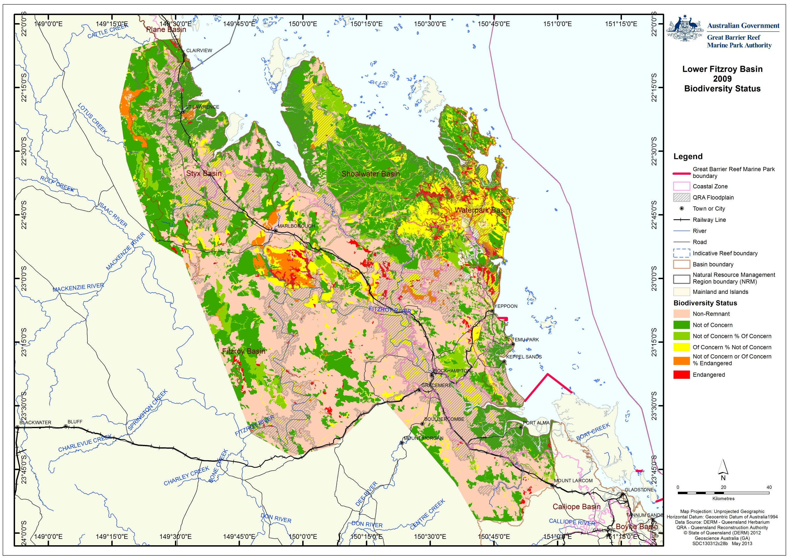
Figure 5: Ecosystem biodiversity status within the study area

Forecast of likely future activities and impacts on coastal ecosystems
A large proportion of the developed region of the study area is within the floodplain. As the region continues to grow and develop, there will be increased pressure on local and state governments to improve flood mitigation strategies and infrastructure as well as providing water resources throughout the region. Such programs are currently underway with a multi-million dollar upgrade to road infrastructure on the Yeppen floodplain outside Rockhampton. These have the potential to further restrict connectivity between ecosystems.
The allocation of water resources has already been identified as vital for growth in the region with the Lower Fitzroy River Infrastructure Project aiming to secure water resources for future growth. Options being investigated include the raising of the Eden Bann Weir and the construction of an additional weir at Rookwood Crossing. The final business case for these projects is due for release later this year. Should these two infrastructure projects go ahead they will potentially further decrease connectivity in the region if not well managed/designed, although the upgrade also provides opportunity for improvement to the design of the fish lock at Eden Bann weir.

Ponded Pastures
Ponded pastures are defined as “the practice developed by pastoralists to create an environment by either the construction of banks or the modification of naturally wet areas, in which fresh water is impounded or used primarily to grow suitably adapted plant species and produce fodder for grazing”.¹³ Their impact varies depending on their location, height and management. Ponded pastures formed by blocking watercourses effectively act as a barrage or weir and can significantly restrict fish passage (Figure 6).
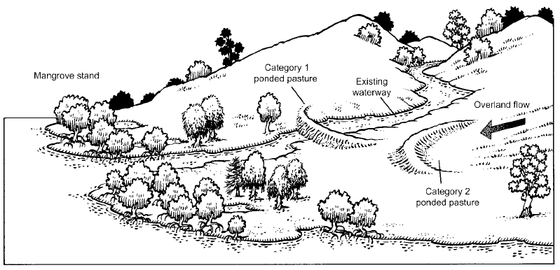
Figure 6: Ponded pastures in a waterway (category 1) have considerable impacts on marine or estuarine ecosystems. Ponded pastures capturing overland flow (category 2) have far lower interference with natural downstream processes in marine or estuarine ecosystems.⁹
Ponded pasture practices have been occurring in Australia since the 19th Century when banks were constructed to prevent salt water incursion in inter-tidal areas to allow for additional grazing areas. As earth moving equipment developed, larger and larger banks were able to be constructed parallel to the coast. The banks not only prevented salt water incursion but also captured and held freshwater, increasing the opportunity for more intensive cattle grazing.¹³
During the 1930s, ponded pasture development began in dryland areas and the introduction of new (exotic) pasture species together with the promotion of the practice by the Department of Primary Industries saw a rapid expansion in the 1970s.¹³
While many ponded pastures have allowed for increased economic production, some types have also resulted in detrimental effects to tidal areas and natural wetlands by interfering with the natural flow of water, as well as facilitated the spread of exotic pasture species introduced to boost grazing productivity. In Queensland, three specific introduced species have been used in ponded pastures, Para grass (Brachiaria mutica), Aleman grass (Echinochloa polystachya cv. Amity) and Hymenachne (Hymenachne amplexicaulis cv. Olive). All three of these species are now considered invasive weeds in natural freshwater systems.^{13,14}
To date there is no known detailed inventory of ponded pastures within the whole study area. Hyland¹⁵ identified and mapped ponded pastures in three locations within the study area (Fitzroy Estuary, Corio Bay and the Broad Sound) in an investigation into the impacts of ponded pastures on barramundi and other finfish. The mapping of the extent of ponded pastures in Corio Bay and the case study area of the Fitzroy estuary (see below) from that report is attached as Appendix E. The study identified 75 pondage systems in the Fitzroy estuary and Corio Bay areas and another 80 in Broad Sound with pondage banks ranging from 10 metres to about 18 kilometres in length.
The Queensland Government’s land use mapping project (QLUMP) using the Australian Land Use and Management classification (ALUM) also identifies areas of potential ponded pastures through the three tiered classification of water (primary class) marsh/wetland or estuary/coastal waters (secondary class) and production (tertiary class). Many of the areas identified in this manner however, require validating (compare Figure 7 with Appendix E).
Challen and Long emphasized how management practices such as deep water reservoirs within ponded pastures (Figure 8) “play an important role in supporting fish that are trapped behind banks, by providing a fish refuge that has adequate water depth and water volume of high quality”.⁹ Challen and Long also recommended that the minimum depth of such reservoirs be 3.0 to 3.5 metres and that they be at least 20 metres long to prevent exotic pasture grasses from smothering them. ⁹

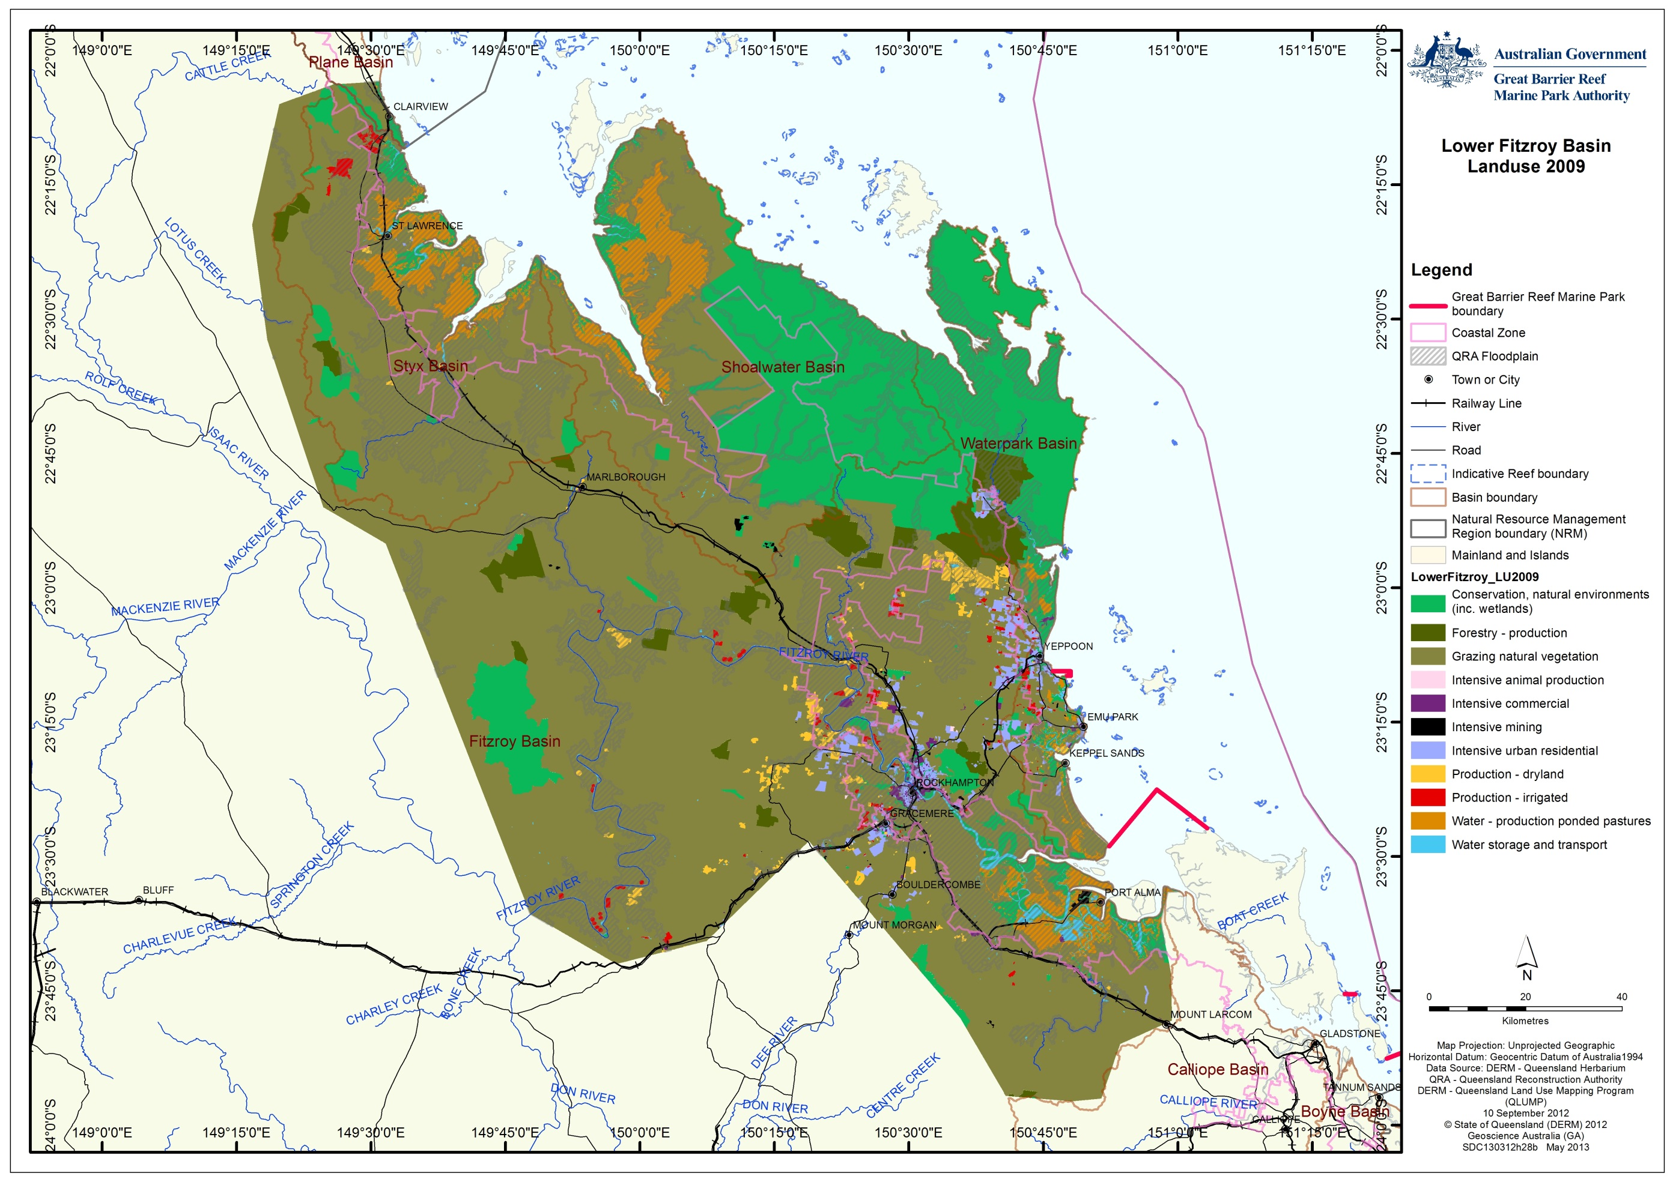
Figure 7: 2009 Land use identified by the QLUMP

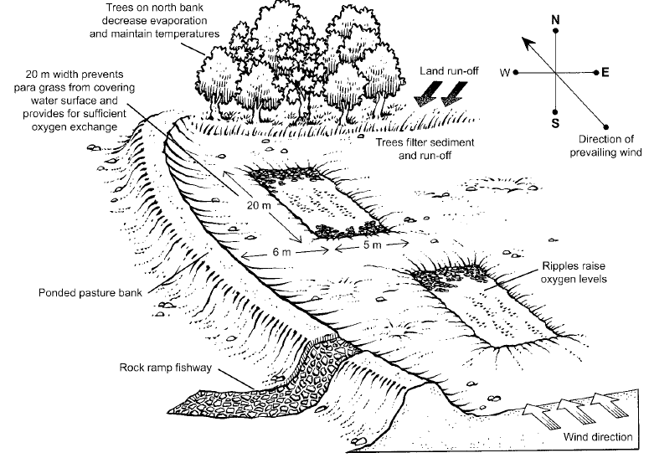
Figure 8: DPI&F recommendations for optimal ponded pasture layout for maximum fisheries benefits.⁹

Case study of ponded pasture
A case study was used of a ponded pasture at the mouth of the Fitzroy River (Figure 9, Figure 10 and Figure 11) to better understand the nature of their impacts and to test the information available regarding ponded pastures more generally. The case study site was selected for its location in the core fish habitat area of the lower Fitzroy River delta and its significant size. The site was identified as a ponded pasture in Hyland¹⁵ using Landsat imagery from July 1991 and it was reported that the main ponded pasture system was constructed in the 1960's. A check of historical GoogleEarth images from 2003-2013 indicates that the site has continued to be maintained as a ponded pasture. Note that this ponded pasture system does not appear in the QLUMP (Figure 7) but was identified in Hyland.¹⁵
Prior to conversion to a ponded pasture, this system was an estuary (Figure 4). Based on the information available, it is assessed that this ponded pasture is a significant barrier to fish passage, effectively acting as a barrage on tributaries at the mouth of the Fitzroy River, one of the most important areas for fisheries and providing significant ecological functions to the World Heritage Area.
It is difficult to make any further assessment of the site as the following information is unavailable:
- Detailed information on the ponded pasture itself
- The height of the bund wall, other than the observation from the photograph in Figure 11 that it must be above highest astronomical tide (HAT), thereby preventing fish access except in large flood events
- Management practices at the ponded pasture and whether or not any of the recommendations in Challen and Long⁹ were being actively implemented. However, in terms of their recommendation for deep pools to be constructed as fish refuges as water recedes, it is apparent from the satellite images and photograph that there are areas of deep water where the watercourse and estuary channels used to be located within the ponded pasture.

The lack of accessible documentary records of ponded pasture extent, height and management hampers management of fish passage. Without such information, any management measures will be ad hoc. One lesson from this case study and the survey of other ponded pastures done by Hyland¹⁵ is that ponded pastures vary greatly in attributes and likely impacts on fisheries resources. Any program to improve their management will need ultimately to be implemented on a case-by-case basis.

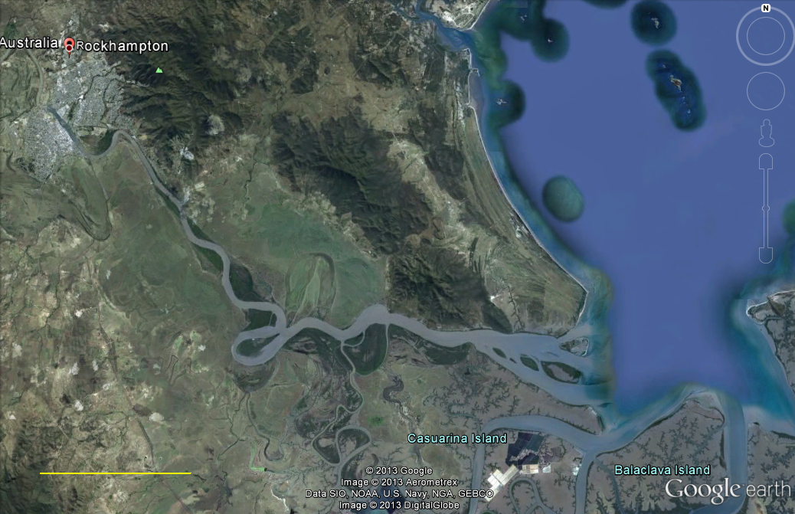
10 kilometres

Figure 9: Location of ponded pasture case study at mouth of Fitzroy River. Red box delineates area shown in Figure 10.
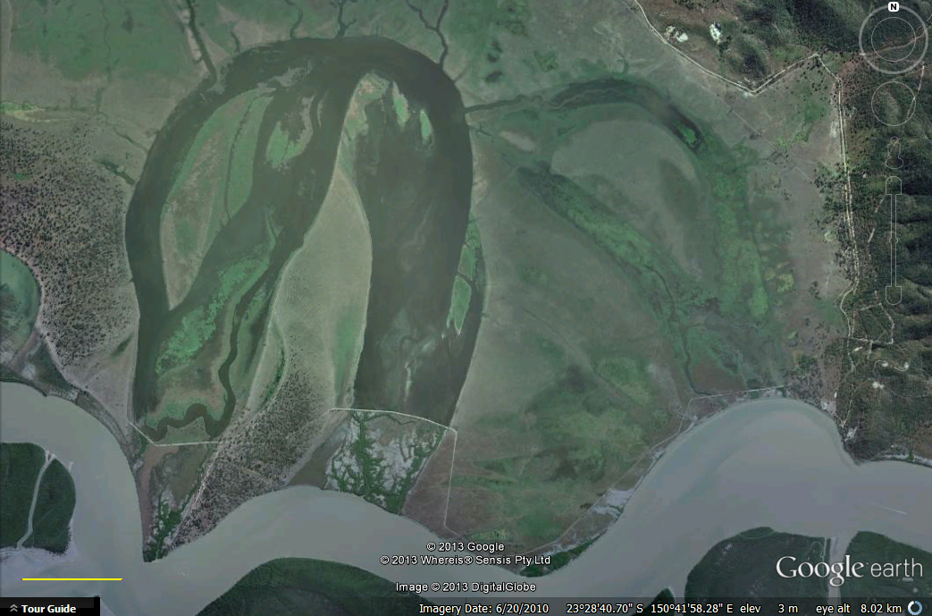
1 kilometre
Figure 10: Ponded pasture case study site at mouth of Fitzroy River. Arrow indicates direction of view shown in Figure 11.
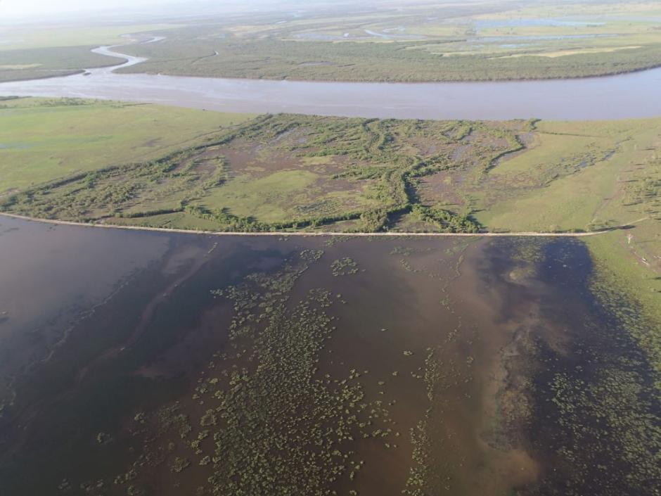
Figure 11: Ponded pasture on northern bank at mouth of Fitzroy River effectively acting as a barrage on tributaries of the river. Location shown in Figure 9 and Figure 10. Photograph by Jim Tait (2013)

Dams, weirs, barrages and other barriers to connectivity
While they are not normally included in a review of water infrastructure, it should be noted that many ponded pastures effectively form weirs and barrages in many smaller watercourses (category 1 ponded pastures, Figure 6). Development within the study area has resulted in a range of infrastructure that interferes with the natural flow of water. These include, tidal barrages, road and rail crossings, dams and weirs. As with ponded pastures, there remains no detailed inventory of the barriers to fish migrations within the study area. However, in contrast to ponded pastures there has been much progress towards the development of an inventory of other barriers through the Fitzroy Basin Fish Barrier Prioritisation Project (discussed later in the document).¹ This project aimed to identify and prioritise the barriers to fish movement within the Fitzroy NRM region. However, after prioritising the top 500 potential barriers (of >10,600), only 136 were actually assessed (Figure 13). The Queensland Government does maintain a spatial dataset of dams and weirs but it only includes those that are owned and controlled by the state. Dams, weirs or barrages owned by local governments, mining companies or the general public are not necessarily included.¹⁶
Physical obstructions are not the only form of barrier to fish migration. Many infrastructure installations such as road crossings, while not directly obstructing the flow of water, do change the dynamics of water flow through, for example, the installation of smooth concrete box culverts or narrowing of channel flows (Figure 12). This change of hydrodynamics (for example concentration of stream flow resulting in increased velocity, or the creation of dark tunnels) can be an effective barrier to fish movement.
Figure 12: Road crossings that change flow dynamics and act as barriers to fish movement¹
Barriers to fish migration, other than man-made constructions, can also arise from land development practices. Decreases to water quality through poor agricultural practices or through periodic industrial water releases (for example from mines) can reduce the health of aquatic species or form a biochemical barrier to aquatic species moving through river and stream systems. Elevated pollutants such as heavy metals or salts, or decreased oxygen levels generated by excess aquatic weed growth are often just as effective as barriers to fish movement as physical structures.
Riparian vegetation also plays an important role in fish habitat provision, affecting mortality rates, body morphology, disease resistance, water temperature and metabolic rates.¹⁷ Loss of the natural riparian vegetation can lead to changes in habitat and food-web structure as well as facilitating the invasion of exotic species.

Fishways
Many infrastructure barriers to fish passage can be modified through an engineering solution to allow at least some fish to be able to swim past the barrier. These solutions can be as simple as the installation of baffles in a box culvert to break-up the flow of water. Larger infrastructure, such as the Eden Bann weir or the Fitzroy River Barrage (Figure 14), requires more complex (and costly) engineering solutions.
The installation of the Fitzroy River Barrage to supply water to Rockhampton in 1970 had a significant effect on catadromous and diadromous fish populations¹⁸ even though a fish ladder was incorporated into the construction. The ineffectiveness of the initial ladder¹⁹ led to its modification in 1987 and then again in 1994¹⁰. However, despite the multiple modifications and improvement in efficiency of the fish ladder, it remains a barrier to the passage of smaller and larger size classes of fish, thereby threatening the sustainability of these fish populations.¹⁰ A $95,000 upgrade to the fish ladder at the end of 2012 has aimed to prevent further damage to the ladder in flood events and has not improved the efficiency of the ladder. Moore and Marsden¹ recommended that due to the number of fish needing to pass by this infrastructure, an additional vertical slot fishway was needed on the opposite bank to the existing fishway. They estimated the cost at $2 million but the work has not been completed.

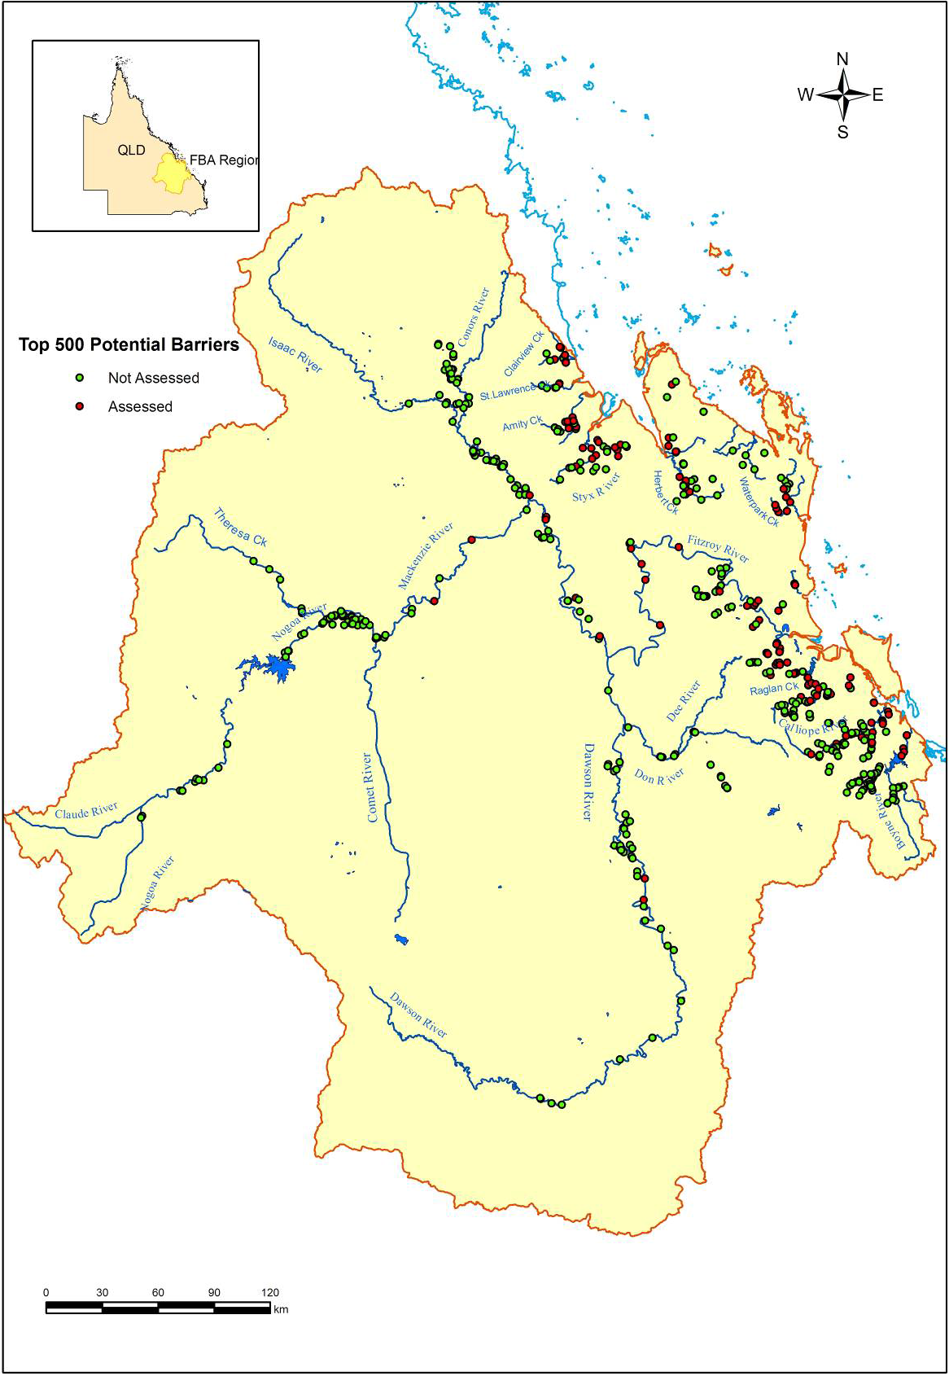
Figure 13: Fitzroy Basin Fish Barrier Prioritisation Project top 500 potential barriers. Red dots indicating barrier has been assessed (136), green dots indicating no assessment¹
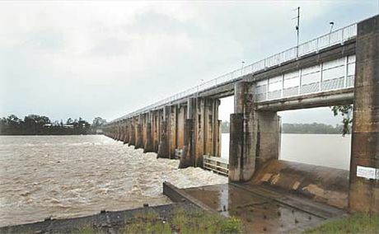
Figure 14: Fitzroy River Barrage. Source: Rockhampton Morning Bulletin
An assessment of the fish lock used to transport fish over the 7.6 metre Eden Bann weir 81 kilometres upstream of the Fitzroy River Barrage found that, although the fish lock was able to transport a range of fish sizes over the weir, the total amount of fish using the device remained small even after modification of the initial design.²⁰ It was also reported that in the three years of the study the fish lock was inoperable for 48 per cent of the time due to mechanical or software failure²⁰ highlighting the risks associated with more complex engineering solutions. The proposed raising of the Eden Bann weir by another 5.7 metres²¹ will add to the difficulty of providing effective fish passage.

Land-use management and coastal ecosystems

Background
Waterways of the Fitzroy basin, together with the neighbouring Styx, Shoalwater and Waterpark basins, have undergone significant modification to allow for the development of agriculture, distribution of water resources, roads, flood mitigation, etc, in the past 150 years. Many of these modifications have resulted in barriers to fish migration both between freshwater and estuarine / marine waters and between differing freshwater ecosystems. As more than 95 per cent of the known fish species in the Fitzroy NRM region require the ability to migrate, barriers to migration are likely to result in not only a decrease in species diversity but also a decrease in the health of aquatic ecosystems generally.¹
The practice of ponded pastures has also had significant impacts on both fish migration and habitat. Ponded pasture systems constructed to convert intertidal areas to grazing lands have effectively removed those areas as providers of habitat and other ecosystem functions while at the same time, together with other more terrestrial ponded pasture systems, have expanded the amount of freshwater wetlands (by more than an order of magnitude in some areas). These changes have resulted in both a reduction of ecological function in some areas as well as the introduction of pest weed species.
To be able to effectively manage the World Heritage Area, the consequences of various changes to ecological functions that have been made within the coastal catchments of the Great Barrier Reef need to be understood as well as how these various systems are currently managed.

Overlapping roles of government
The complex jurisdictional environment and the arrangements applying to the coastal zone around Australia are well recognised.⁴
There are four tiers of governance with overlapping roles in the planning and management frameworks that regulate activities impacting on fish passage in the lower Fitzroy River region.
The World Heritage Committee plays an international oversight and assistance role under the World Heritage Convention. While the Committee cannot make decisions implementable under Australian law, its decisions and recommendations affect the governance of the World Heritage Area. At its 2012 meeting the Committee expressed its concern at the unprecedented scale of coastal development currently being proposed within and affecting the World Heritage Area. It will review the status of the property at its 2015 meetings with a view to possibly entering the World Heritage Area on the List of World Heritage in Danger. The Australian and Queensland governments have undertaken a strategic assessment of development adjacent to the World Heritage Area and adjacent coastal zone in response. While it has an important international role, the World Heritage Committee is not directly involved in the day-to-day planning and management of activities within or affecting the World Heritage Area.
The Commonwealth or Australian Government is ultimately responsible for fulfilling Australia’s obligations under the World Heritage Convention to protect, conserve, and restore the World Heritage Area. The GBRMPA is an independent statutory authority of the Australian Government responsible for the protection and management of the Marine Park and World Heritage Area. It shares the responsibility for day-to-day planning and management of activities within the Marine Park with relevant Queensland Government departments, such as the Queensland Boating and Fisheries Patrol. GBRMPA currently has a limited and largely advisory role in relation to coastal development adjacent to the World Heritage Area. The Australian Government Department of the Environment administers the EPBC Act, which regulates new development both within and outside the World Heritage Area likely to significantly impact on the World Heritage Area, but which has little control over the legacy effect of development prior to commencement of the EPBC Act in 2000.
The Queensland Government has primary responsibility for the planning and management of activities in the State of Queensland. It has many departments with roles in coastal planning, fisheries management, ports, agriculture and mining. Land-use and development (other than mining and petroleum extraction) are primarily regulated under the Sustainable Planning Act 2009 (SPA) (Qld). Many other pieces of legislation are integrated under SPA, including laws that influence the connectivity of coastal ecosystems, such as dams and weirs, and laws to manage damage to marine plants such as mangroves. Mining and petroleum extraction is regulated under separate legislation.
Local governments are statutory authorities created by the Queensland Government to govern within the local government areas. Local governments play a central role in most land-use planning in the Great Barrier Reef catchment through the creation of planning schemes that create land use zones to guide new development.

General laws, policies and programs relevant to fish passage in the lower Fitzroy River basins
The various Commonwealth and Queensland planning and management frameworks for activities impacting on fish passage in the lower Fitzroy River basins principally regulate new activities and development. The legacy of past development tends to become a fixed part of the “status quo” forming a background of impacts or condition of the environment. This is particularly significant to consider in the context of an area such as the lower Fitzroy River where most suitable sites for water infrastructure and most land suitable for ponded pastures has either already been developed or is unavailable for development (for example the military training area in Shoalwater). As GBRMPA noted in Informing the outlook for Great Barrier Reef coastal ecosystems ⁴:
The construction of coastal barrages to prevent the ingress of tidal waters to allow an expansion of cropping and grazing land, or through construction of roads accessing the coast, was an activity mainly undertaken 40 to 50 years ago when there were little or no legislative or industry management arrangements controlling these activities. While many of these impediments remain and continue to affect functions of these coastal ecosystems, the current legislative arrangements in place prevent any significant increase in these structures. Industries are working towards much better practices, so the risk to coastal ecosystems from the construction of new coastal barrages, for example, is now significantly reduced.
The main legislation regulating water infrastructure and ponded pastures are the:
- Sustainable Planning Act 2009 (Qld) (previously the Integrated Planning Act 1997 (IPA))
- Water Act 2000 (Qld)
- Fisheries Act 1994 (Qld)
- Environment Protection Act 1995 (Qld)
- Coastal Protection and Management Act 1997 (Qld)
- Environment Protection and Biodiversity Conservation Act 1999 (C'wth)

The SPA creates a development assessment system linked to the Coastal Protection and Management Act, Water Act, Fisheries Act and other Acts for, amongst other things, operational works:
- Interfering with a watercourse, lake or spring or overland flow (including by constructing a ponded pasture)
- Damaging, removing or destroying marine plants (i.e. plants normally subject to tidal inundation including mangroves and marine couch) and declared fish habitat areas

As GBRMPA noted in the Great Barrier Reef Outlook Report 2009²²:
The planning system, particularly the Integrated Planning Act 1997, theoretically provides a framework within which the major threats and risks to Great Barrier Reef values can be addressed, but without the relevant regional plans, there is little guidance for local planning decisions. There is also limited capacity in some local government authorities to deal with the complex issues involved in coastal development. Pressure from stakeholders and high levels of staff turnover are significant issues in some areas. In addition, engagement of stakeholders through planning processes is generally not comprehensive and balancing government priorities, community concerns and technical input is a significant challenge at the local level.
These points remain valid since the replacement of the Integrated Planning Act 1997 (Qld) by the SPA. We consider that the conclusions in the Outlook Report 2009²² remain valid concerning the existing protection and management tools relevant to the Great Barrier Reef Marine Park. Overall, the Outlook Report 2009 found a lack of integrated planning, resources and enforcement in managing coastal development is compromising the protection of the World Heritage Area.
In addition to linking to the SPA, the Water Act 2000 (Qld) creates a hierarchy of plans and licences for managing the extraction and use of water in each major catchment. The two major levels of planning are the water resource plan and the resource operations plan. In the Fitzroy Basin, the relevant plans are the Water Resource (Fitzroy Basin) Plan 2011 and the Fitzroy Basin Resource Operations Plan 2004. A resource operations licence, which may impose conditions regarding the operation of fishways, is also required under the Water Act 2000 to operate water infrastructure such as the Fitzroy River Barrage.
The EPBC Act protects matters of national environmental significance, which include the world heritage values and the environment of the World Heritage Area. However, as for state laws, the EPBC Act has little influence or control over the legacy impacts of things such as ponded pastures that were constructed 40 or 50 years ago. Sections 43A and 43B of the EPBC Act exempt from requiring approval under the Act, development and activities that were fully approved or an existing lawful use at the commencement of the Act on 16 July 2000.
The EPBC Act also deals with cumulative and indirect impacts to an extent in the assessment of actions impacting on matters of national environmental significance. The cumulative impacts of other development on a matter protected under the EPBC Act are part of the context of the impacts of an action that must be considered in assessing whether the action will have a “significant impact”.²³ For example, when assessing a proposed dam to supply water for irrigated agriculture to downstream farmers under the EPBC Act, the cumulative and indirect impacts of the use of the water by the farmers and the water pollution that they might generate must be considered²³.
The EPBC Act has been important in stopping two major projects that would have had considerable impacts on the habitat values of the study area. In 2006 a Federal Court decision stopped the original proposal for a major dam on the Fitzroy River, the Nathan Dam, which was linked to a proposed major expansion of irrigated cotton in the lower Dawson River (a tributary of the Fitzroy River). In 2008 the Minister rejected as clearly unacceptable a proposed new coal-loading terminal between Shoalwater Bay and Corio Bay. While these are significant outcomes, the EPBC Act’s application has been largely limited to major new projects.
A final component of the general legal framework potentially relevant to connectivity in the lower Fitzroy catchment is section 66(2)(e) of the Great Barrier Reef Marine Park Act 1975 (Cwlth), which provides a power to regulate or prohibit “acts (whether in the Marine Park or elsewhere) that may pollute water in a manner harmful to animals and plants in the Marine Park.” This power was used to regulate aquaculture development in the Great Barrier Reef catchment under the Great Barrier Reef Marine Park (Aquaculture) Regulations 2000 (Cwlth). As the power is limited to acts “that may pollute water”, it is unlikely to allow general regulation of ponded pastures and fish barriers.

Changes to coastal and regional planning
Since the summaries of management arrangements were prepared for the Outlook Report 2009²² and Informing the Outlook for Great Barrier Reef coastal ecosystems 2012⁴, state planning and environmental laws have undergone significant change.
The Coastal Protection and Management Act 1995 (Qld) (CPMA) provided for the development of a State Coastal Management Plan (SCMP 2002) and regional coastal management plans (RCMPs) to be developed however only three RCMPs were completed and those that were developed were repealed in 2012.
The Queensland Government created a new Queensland Coastal Plan in 2012 under the CPMA to replace the State Coastal Management Plan 2001 and associated regional coastal management plans. The plan had two parts: State Policy for Coastal Management and the State Planning Policy 3/11: Coastal Protection (SPP 3/11). SPP 3/11 provided policy direction for natural resource management decision-makers about land on the coast, such as coastal reserves, beaches, esplanades and tidal areas.
The Queensland Government suspended the operation of the SPP 3/11 and created the Coastal Protection State Planning Regulatory Provision (SPRP) in October 2012. The Queensland Coastal Plan – State Policy for Coastal Management and the SPRP remain in operation.
The Queensland Government is intending to replace the SPRP through the creation of a single state planning policy (single SPP) during 2013 / 2014. A draft single SPP has been released which includes sections on biodiversity, coastal management and healthy waterways and makes several references to the Great Barrier Reef including referring readers to “Guideline: Protecting wetlands of high ecological significance in Great Barrier Reef catchments (currently under review)” in relation to coastal management.
The Queensland Government released a new regional plan for Central Queensland, which includes the Fitzroy region, on the 14 October 2013. It recognises the importance of maintain biodiversity, coastal environments and healthy waterways, including stating that “the health of waterways is pivotal to the prosperity of the region.”

Changes to vegetation laws
There are also significant amendments to the vegetation management laws underway. The Vegetation Management Framework Amendment Act 2013 (Qld), assented to on 23 May 2013, amends the vegetation clearing controls created under the Vegetation Management Act 1999 (Qld) (VMA) and SPA. The changes remove the previous ban on broadscale clearing remnant vegetation for agriculture if the proposed clearing is for cropping or irrigated pastures. The ban on clearing for non-irrigated pastures remains at this stage.
In addition, the amendments remove the controls on clearing of high value regrowth on freehold land other than in the “regrowth watercourse area” which is defined as “an area located within 50 metres of a watercourse located in the Burdekin, Mackay Whitsunday or Wet Tropics catchments identified on the vegetation management watercourse map.” The Fitzroy region is not included in the definition of “regrowth watercourse area” and, consequently, the previous controls on clearing of high value regrowth vegetation will be largely unrestricted.
A related change is that the recently enacted Land, Water and Other Legislation Act 2013 (Qld) removed the protection of riparian (in-stream) vegetation from s814 of the Water Act 2000 (Qld). This change removes restrictions on clearing that are otherwise allowed under the VMA/SPA regime, including high value regrowth vegetation.
Taylor²⁴ suggests that in the Rockhampton Regional Council local government area the amendments to the VMA/SPA framework allow clearing of up to 39,509 hectares of remnant vegetation and high value regrowth vegetation.
In the Fitzroy region the practical significance of the amendments, however, is limited by the fact that most of the areas that can support irrigated pastures and high value agriculture have already been cleared so new clearing will generally be at the margins.

Ponded Pastures
The control on new ponded pastures under SPA is linked to policies restricting their approval. The Queensland Government regulated ponded pasture practices in recognition of the detrimental ecological impact they facilitated. In 1991 a moratorium was announced to prevent new ponded pastures being constructed below the highest astronomical tide (HAT), although repair and maintenance was allowed on existing systems. In 2001 the Ponded Pastures Policy¹³ was adopted, replacing the 1991 moratorium. This policy states that ponded pastures should only be located in areas that are not:
- Tidal areas below Highest Astronomical Tide (HAT)
- In or adjacent to natural wetlands
- Of high conservation or fish habitat values.

The policy also states that ponded pastures proposed to be developed in other areas must meet ecologically sustainable development principles.
The Queensland Department of Primary Industries and Fisheries (DPI&F) have also produced a fisheries guideline for managing ponded pastures.⁹ This guideline provides information on the potential problems of ponded pastures to fish and makes recommendations to minimise those impacts.
While these policies and guidelines remain in place, our literature review indicates that there is no published evaluation of the adoption or effectiveness of these measures beyond the work of Hyland¹⁵.

Marine plants and fish habitat areas
Marine plants and declared fish habitat areas (FHA) are protected under the Fisheries Act 1994 (Qld) against physical disturbance associated with coastal development. Again, this system is now linked to SPA.
There are four declared fish habitat areas within the study area:
- Lower Fitzroy River
- Corio Bay
- Cawarral Creek
- Broad Sound

These areas have been declared on a range of habitat values, fisheries values as well as unique features (for example Broad Sound FHA has the largest tidal range in Queensland and is the state's largest FHA, while the Fitzroy FHA is the end point of the largest river system in Queensland).
While FHA's are currently limited to the marine and estuarine environment, the Queensland Government recognises that there is a need to expand the declared FHA network into freshwater areas and policies have been under consideration for freshwater declared FHA assessment and management.²⁵
There are several guidelines produced by the Queensland Government under the FHA program relevant to potential fish barriers and ponded pastures. These include:
- Managing Ponded Pastures
- Design of Stream Crossings - currently under review
- Fish-friendly structures

Fitzroy Basin Fish Passage Prioritisation Project
Completed in 2008, the Fitzroy Basin Fish Barrier Prioritisation Project was a joint project between the Fitzroy Basin Association and the DPI&F. It was the first comprehensive fish barrier prioritisation project undertaken in the Fitzroy region with the objective to identify all potential barriers to fish passage in the region and prioritise them for remediation. This project defined barriers as any structure that impeded the movement of fish, and identified a total of 10,632 potential system barriers. While this project included the entire Fitzroy NRM region, a significant number of these potential barriers were within the bounds of this current study. The project refined the number of barriers through a three stage prioritisation process to identify the 30 top barriers requiring remediation.¹ Barriers on wetlands were identified in the project but not included in the prioritisation, as it included only barriers on recognised watercourses. The prioritising process consisted of:
- An automated GIS prioritisation process of five biological criteria
- A manual prioritisation of 10 biological criteria of the refined GIS list
- A manual prioritisation of refined biological list for six social, economic and technical criteria.

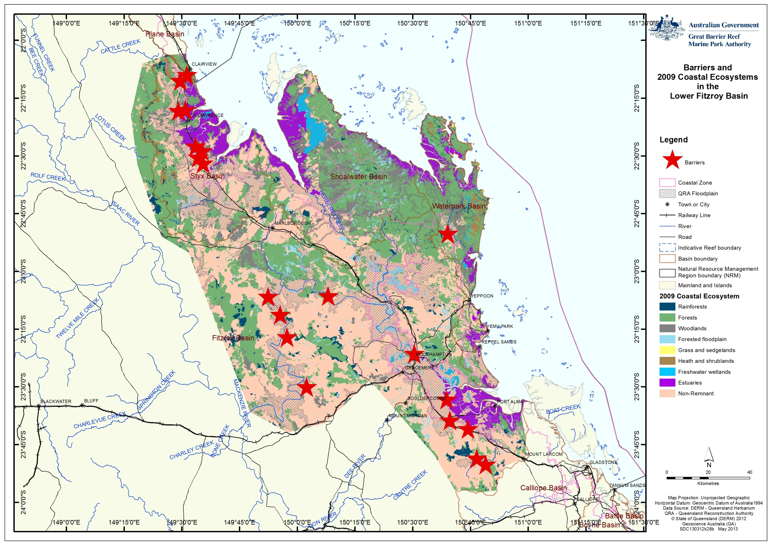
Figure 15: Location of barriers () identified by the Fitzroy Basin Fish Barrier Prioritisation Project within the current study area

Of the 30 top barriers identified in the Fitzroy Basin Fish Barrier Prioritisation Project, 20 are located within the bounds of the current study (Figure 15), including 8 of the top 10. It should be noted that the third prioritisation level considered social, economic and technical criteria. These criteria are related more to the practicalities of addressing fish barriers rather than the effect that any given barrier may be having in terms of reducing the connectivity between ecosystems. As such, the final 30 may not have the same priority level when considered with respect to the impacts on the World Heritage Area.
It is also important to note that while the Fitzroy Basin Fish Barrier Prioritisation Project identified many thousands of "potential" fish barriers within the bounds of the current study using an automated process, when on-ground investigations were made of the prioritised barriers, a significant number were found not to be barriers (i.e. the initial automated process returned many false positives in identifying barriers).
Since the completion of the Fitzroy Basin Fish Barrier Prioritisation Project there has been some progress to addressing fish barriers in the Fitzroy region. For example, a fishway has now been constructed at the Waterpark Creek weir (ranked 16 in the Fitzroy Basin Fish Barrier Prioritisation Project).

Protecting existing undisturbed coastal ecosystems
The general laws described above, such as the SPA and EPBC Act, provide reasonably comprehensive frameworks to regulate new development. This means that there are typically regulatory controls protecting existing, undisturbed coastal ecosystems.

There are far fewer controls on existing (or legacy) development, or legal obligations to restore areas degraded by otherwise lawful activities.

Reconnection and rehabilitation of disturbed coastal ecosystems
While existing laws principally regulate new development, there have been many state and Commonwealth programs to reconnect and rehabilitate disturbed ecosystems in the Great Barrier Reef catchment, particularly linked to improving water quality under the Reef Water Quality Protection Plan (Reef Plan).
The Great Barrier Reef Coastal Wetlands Protection Programme (GBRCWPP) was a multi-million dollar program that ran from 2003 to the present with the aim to develop and implement measures for the long term conservation and management of priority wetlands in the Great Barrier Reef catchment to assist in achieving the goal of Reef Plan. A $2 million Pilot Programme ran from 2004-2007 to fast track the delivery of tangible outcomes that protect priority wetlands in the Reef catchment area. The GBRCWPP was part of the Queensland Wetlands Programme (QWP), which was jointly funded until 2013 by both Australian and Queensland Governments. Information on the QWP can be found on the Queensland Department of Environment and Heritage Protection website.
Water Quality Improvement Plans (WQIP) and Healthy Waters Management Plans (HWMP), together with the Water Resource Plans (WRP) all have a role in identifying where ecosystem function has been lost or modified, and have the ability to put in place management actions to reconnect and rehabilitate them.
Although a WQIP was not developed for the Fitzroy prior to the finalisation of the Commonwealth funded WQIP program, environmental values and water quality objectives for the Fitzroy River Sub-basin were developed as part of the WQIP program. A HWMP has not yet been developed for the Fitzroy, Styx, Shoalwater or Waterpark basins but the new Reef Rescue initiative 2013-2018 has identified the updating of those plans as a priority action in 2013-14.

Return of coastal ecosystem function modified landscapes
Of the four basins within the study area, the Fitzroy and Styx have undergone the greatest level of change from the pre-European state with 45 per cent and 60 per cent of the basins’ vegetation modified respectively (Table 3). Returning the ecological functions to the World Heritage Area of these systems will increase the overall health of the World Heritage Area in the vicinity of the study area. This will also likely increase the resilience of the system to other stressors such as those posed by climate change. However, deciding the best approach of how to return these functions will not be straightforward. It is unlikely that it will be feasible to return many (if any) of the modified ecosystems to their pre-clear state. This is in part due to the financial difficulties of such a task but also due to the high degree of interconnectedness between ecosystems and the reliance on many of the functions provided by other ecosystems. It is likely to be near impossible to totally rehabilitate an area so that its ecological function provision level is equivalent to its pre-clear state without also rehabilitating all the ecosystems that it relies on.
Table 3: Modification in coastal ecosystems within basins of the study area

Basin | Total Area (ha) | % Modified
Styx | 301363 | 45
Shoalwater | 361192 | 23
Waterpark | 184094 | 18
Fitzroy | 1143018 | 60

Another factor that must be considered is that many of the modified systems provide a range of ecological function of their own (refer to Appendix B and C). Ecological functions are provided not only to the World Heritage Area but also to other ecosystems. These become an element of the ecological functions that these systems provide to society. Many modified systems have become important ecosystems in their own right. For example, there are anecdotal reports that some ponded pasture areas in the Styx basin have become a habitat to rare bird life such as the critically endangered Capricorn Yellow Chat, and returning these areas to their original intertidal mudflat ecosystems will likely be detrimental unless other habitat is available. Any planned rehabilitation of a modified ecosystem must be considered in the context of the ecosystem functions currently supplied both to the World Heritage Area and to others.
Restoring the connectivity between ecosystems by appropriately modifying (where necessary) existing barriers to the fish movement will have a significant positive effect on the overall ecological function provision to the World Heritage Area. With >95 per cent of known fish species in the Fitzroy NRM area requiring the ability to migrate, both between freshwater and marine habitats as well as wholly within freshwater environments, the effective removal of barriers to migration via installation of appropriate fishways, fish ladders or modification of banks and levies will boost fish populations that are currently reduced by the presence of barriers. This will also have beneficial consequences for the aquatic ecosystems as the fish themselves are service providers, for example providing food, controlling pests, etc.
Managing water quality and habitat is a major issue as the physical objects are not the only barriers to fish movement, as has been previously discussed. The water quality within the system must be maintained at a level that supports ecological and biological processes that promote natural aquatic biodiversity. Progress is being made towards improving water quality through the development of appropriate Water Quality Objectives and HWMPs. Similarly there must be suitable habitat available through, for example, the maintenance of riparian vegetation. In short, a whole of system approach is needed when considering the most cost effective approach to the return of ecosystem function to modified landscapes.

Uncertainty in assessment and managing risk
Ecosystem functions and the role that they play is a very complex issue. While it is well accepted that functional ecosystems are vitally important to the heath of ecosystems, and subsequently to human society, the importance of one ecosystem function over another is less understood. This is particularly important where it may be required to compare the value of one service to another when considering whether or not to undertake a management action. There also remain many unknowns with respect to the level of ecological functions that one ecosystem provides for others as highlighted by both the blank cells within Appendix B and C and those labelled with a tick where the function is known but the capacity is unknown.

Adaptive management
Although there remain many knowledge gaps regarding the provision of ecological functions, there is sufficient understanding of the importance of ecosystem function provision to undertake management action. This action should however be designed with the principals of adaptive management incorporated. This is particularly important due to the number of unknowns associated with the various ecosystems and the function that they may potentially provide. As a greater understanding of this area is developed the management actions should be reviewed and revised accordingly. Similarly, any management strategy aimed at a regional scale must be able to adjust to local/fine scale conditions. The adaptive management process - plan, implement, monitor, review, adapt - is fundamental to effective environmental management.

Discussion
To maintain and restore the ecological function in light of the ecosystem functions they provide to the Great Barrier Reef catchment and the World Heritage Area, there is a continual need to seek integrated planning outcomes that recognize the continuity of biophysical and ecological linkages across the entire coastal zone from the top of the Great Barrier Reef catchment through to the adjacent inshore marine areas. Zoning with the Great Barrier Reef Marine Park such as green (no-take) zones should be supported by appropriate and complementary management within the Great Barrier Reef catchment.
While ponded pastures, dams, weirs and barrages have contributed social and economic benefits, they have also contributed to the degradation of the coastal regions of the largest river basin within the Great Barrier Reef and its smaller neighbouring basins. The redistribution of water resources and infrastructure put in place to mitigate the effects of floods have both reduced the available habitat and migration ability for >95 per cent of freshwater fish species in the region, including recreationally and commercially import species such as barramundi and mangrove jack. The Fitzroy estuary alone has been reduced by almost half (50 kilometres) of its original range with the construction of a single piece of infrastructure - the Fitzroy Barrage. This and other dams and weirs throughout the Fitzroy NRM region have had a major impact on fish communities.¹⁸
The ecological impacts of ponded pastures have long been understood, with a moratorium on the development of ponded pastures below highest astronomical tide put in place over two decades ago. However, the legacy issue of these older ponded pasture systems, especially Category 1 types, together with the problems associated with escaped exotic grass species is that they have the capacity to block waterways and decrease dissolved oxygen levels, effectively removing these areas as viable fish habitat. As such, ponded pastures remain an important management issue for rejuvenating connectivity and improving ecological functions to the World Heritage Area.
The return of some degree of ecological function to any area currently isolated by ponded pastures, dams or weirs may not require the removal of these barriers. Many ecosystems do not require the continuous connectivity with the marine environment to be able to supply their ecological functions. Many (pre-clear) ecosystems would have only been connected to the marine environment during the wet season, following heavy rains. Upstream dams and weirs have resulted in many of these ecosystems now only being connected in times of significant flooding events, and areas that previously would have been connected on an annual basis may now only be connected on a decadal basis. Reconnecting these systems may be achieved through simple modifications to allow periodic connectivity. For example, ponded pasture bund walls that are slightly reduced in size to allow only the highest spring tides access may be sufficient to re-establish them as a fish habitat area. The management guidelines developed by Challen and Long⁹ for example aim to maintain the viability of ponded pastures as fish habitat areas.
The importance of sustained connectivity of the study area is demonstrated through the recent reports of significant numbers of large barramundi being caught inland of the Eden Bann Weir. This has been attributed to the major flooding in recent years in combination with strong recruitment in earlier years (pers comm Bill Sawynok - InfoFish). In terms of fisheries, this example also illustrates that it is not simply the presence or absence of barriers within the system that influence fish numbers but also other factors such as the timing and magnitude of river flows which act as brooding triggers for many fish species.
Many ponded pasture systems in the lower Fitzroy region have been in place for decades. This has resulted in the modified ecosystems being well established and consideration must be given to this when deciding what (if any) adjustments to make to ponded pastures systems. The ecosystem functions provided by these modified systems must also be weighed against any potential benefits of attempting to return previously lost ecological functions.

Opportunities for improved management
Site specific knowledge of ponded pastures and other barriers would significantly enhance management of the coastal ecosystems that provide support functions to the World Heritage Area. As previously noted data on both ponded pasture systems and fish barriers within the lower Fitzroy region is poor and, as such, may be inadequate for effective management decisions. The opportunity therefore exists to further improve and more comprehensively assess ponded pastures systems and fish barriers.
The Queensland Government has developed a protocol for identifying and inventorying structures that may impact fish habitats and movement.²⁶ One issue with this inventory system is that it does not rate the effectiveness of any fishway type, which could be included as part of any collation of data on fish barriers (i.e. are all fish sizes able to pass freely). It may also be feasible to build on the Lawrence et al²⁶ inventory system to include data on ponded pastures as well as the upstream and downstream ecosystem significance.
Some of this information has already been collected as part of the Fitzroy Basin Fish Barrier Prioritisation Project, although there remain many data gaps. The logistics of collecting this data is also a limiting factor since, as noted in the Fitzroy Basin Fish Barrier Prioritisation Project, there are large numbers of potential barriers to fish passage in the region (>10,600 in the Fitzroy NRM region). Many of these barriers when investigated "on the ground" were found not to be barriers or were natural obstructions. Therefore as on-ground validation is required, to realistically be able to manage such a task, prioritisation is needed to direct resources for on-ground investigations.
On ground validation would be facilitated by identifying ecosystems that have a high priority as ecological function providers to the World Heritage Area. One approach to effect this would be to map ecosystems that provide high ecological function to the World Heritage Area, in a similar manner to the High Ecological Value (HEV) areas identified in the Water Quality Improvement Plans developed under the National Water Quality Management Strategy (NWQMS) / Healthy Waters Management Plans under the Environment Protection (Water) Policy 2009 (EPP (Water)). Such mapping could then be used to trigger when closer scrutiny is required to assess the potential impacts to the World Heritage Area. To be effective, such mapping would need to identify and prioritise the ecological functions provided by each ecosystem, including modified ecosystems. Appendix B and C list known ecological functions and the level of provision from each ecosystem type. There are however, many knowledge gaps in the list - as highlighted by the blank cells in Appendix B and C. It is important to note that while the data currently contained in Appendix B and C is sufficient to develop a priority ecosystems map, the filling of the knowledge gaps would enhance its robustness.
In identifying the priority ecological function providers, it should be acknowledged that differing functions may be of higher importance to the World Heritage Area than others. Similarly, the proximity of other providers of any given function should also be considered. By incorporating a proximity weighting measure, the potential for development/modification "creep" to go undetected would be minimised. As an ecosystem is modified through change and a function is removed or reduced, the remaining providers of that function will become more important and therefore trigger more careful management to ensure the continued supply of the function.
Areas of high risk could also be combined with maps of priority ecological function providers. By including areas where there is a high level of risk for a negative impact on the World Heritage Area, a spatially explicit tool could be developed to identify areas that should be carefully managed to ensure the minimum negative impact on the World Heritage Area.
The GBRMPA have developed a preliminary version of such a management layer (Figure 17 and Appendix D) in their cumulative area analysis for areas of high functional connection for the World Heritage Area. This work is currently in a preliminary stage.
Although there has already been an undertaking to identify areas with environmental values and areas of high ecological value under the EPP (Water), these values may not always correspond to those for the World Heritage Area. Similarly, although there are many areas that are being maintained for conservation (Figure 16), these areas may not necessarily correspond to areas of coastal ecosystem function that are of high importance for the World Heritage Area (compare to preliminary map in Figure 17).

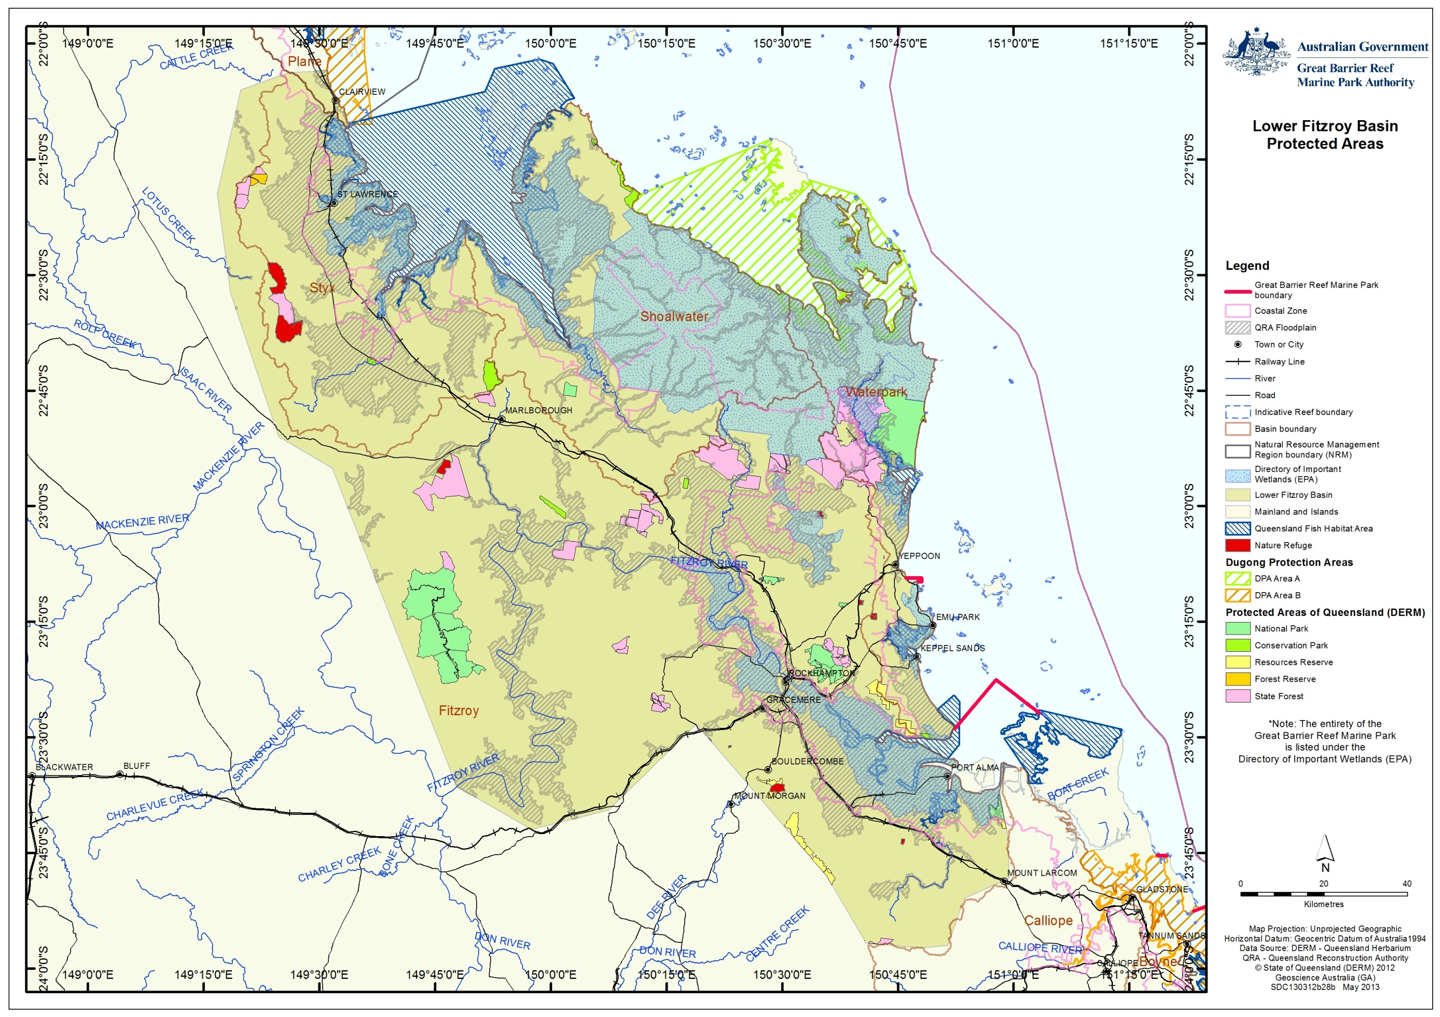
Figure 16: Conservation areas within in the Lower Fitzroy study area

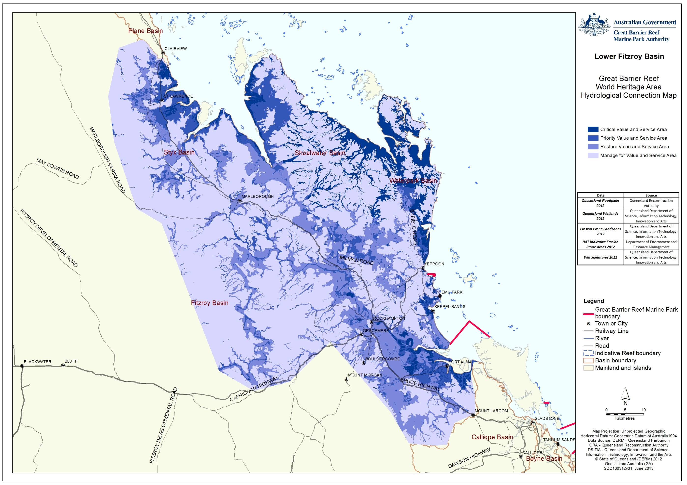
Figure 17: Draft accumulative analysis of areas that have high functional connection to the World Heritage Area in the lower Fitzroy River region. Source: GBRMPA

Once priority management areas have been identified, implementing management actions could be based on an approach similar to the Reef Plan program, involving state and commonwealth governments working in partnership with industry and include site specific actions and pilot programs in high priority areas (such as ponded pastures in the Corio Bay region) before implementing wider scale actions.
One approach to funding management actions that may be feasible is a "payments for ecosystem functions" program, whereby land holders may be supported for altering current land management to allow for the restoration of ecological function such as fish habitat. A similar program was successfully implemented in northern NSW funded under the Federal Government Sustainable Regions Program.

Mapping priority areas for protection, rehabilitation and restoration for guidance under the EPBC Act
Clearer guidance could also be provided under the EPBC Act to ensure future development takes into account areas of high ecological function for the World Heritage Area. The threshold for liability under the EPBC Act is that an action is likely to have a “significant impact” on a matter of national environmental significance. This term is not defined in the EPBC Act but the Federal Court has held it to mean an impact that is important, notable or of consequence having regard to its context and intensity.²³ To assist members of the public to understand the test better, the Department of the Environment has published administrative guidelines on what constitutes a significant impact on a matter protected under the EPBC Act.²⁷
While the World Heritage Area is recognised with its own matter of national environmental significance trigger (in addition to the World Heritage trigger) under the EPBC Act, there is no specific guideline for actions having a significant impact on the Marine Park or the World Heritage Area. The general guidelines on significance provide the following criteria for the Great Barrier Reef²⁷:
“An action is likely to have a significant impact on the environment of the Great Barrier Reef Marine Park if there is a real chance or possibility that the action will:
  - modify, destroy, fragment, isolate or disturb an important, substantial, sensitive or vulnerable area of habitat or ecosystem component such that an adverse impact on marine ecosystem health, functioning or integrity in the Great Barrier Reef Marine Park results
- have a substantial adverse effect on a population of a species or cetacean including its life cycle (for example, breeding, feeding, migration behaviour, life expectancy) and spatial distribution
- result in a substantial change in air quality or water quality (including temperature) which may adversely impact on biodiversity, ecological health or integrity or social amenity or human health
- result in a known or potential pest species being introduced or becoming established in the Great Barrier Reef Marine Park
  - result in persistent organic chemicals, heavy metals, or other potentially harmful chemicals accumulating in the marine environment such that biodiversity, ecological integrity, or social amenity or human health may be adversely affected, or
  - have a substantial adverse impact on heritage values of the Great Barrier Reef Marine Park, including damage or destruction of an historic shipwreck.”

These guidelines give a good foundation to work from but it would be useful if mapping of areas of particular concern to the protection of the World Heritage Area was undertaken to inform EPBC Act decisions. Clear mapping of protected matters where possible greatly improves the ability to implement regulation of impacts on them. The regional ecosystem maps for vegetation management under State laws is an example of this. The ability to quickly obtain a property-level map of regional ecosystems for free from an online search tool has been one of the greatest strengths of the State vegetation management system over the past decade.
Application of the significance guidelines supporting the EPBC Act would be improved if GBRMPA developed maps for the “Framework to identify priority hydrological connections to the Great Barrier Reef World Heritage Area” that identify the areas that are most sensitive for impacts on the Great Barrier Reef like “important, substantial, sensitive or vulnerable areas” referred to in the first criterion in the general guidelines.
The areas identified in the “Framework to identify priority hydrological connections to the Great Barrier Reef World Heritage Area” developed by the GBRMPA (Figure 17) would be a suitable starting point for such mapping, assuming the guidelines referred to development “in or affecting” the areas identified in the maps. The boundaries of the areas are not critical, as the purpose of the maps would be to focus attention on the connection of the catchment to the World Heritage Area. That mapping could be linked to a free online search tool similar to State regional ecosystem maps that can generate property-level maps based on entering either the lot and plan of a property or its latitude and longitude coordinates.

Potential management actions
Actions that could be taken include:
- The restoration of fish passage in the Great Barrier Reef catchment could be managed in a similar manner to poor water quality from coastal development and farming, another legacy issue identified as a key pressure on the World Heritage Area in the late 1990s. A long-term, collaborative approach is required to restore ecosystem function in the Great Barrier Reef catchment, with initial priority to include monitoring and improving the information available on fish barriers, then prioritising actions to restore fish passage and monitoring their implementation.
- Development a guideline on actions likely to have a significant impact on the World Heritage Area to better inform landholders of what actions require approval under the EPBC Act. The guideline could supplement existing guidelines on significance under the EPBC Act and be linked to the “Framework to identify priority hydrological connections to the Great Barrier Reef World Heritage Area” mapping developed by the Great Barrier Reef Marine Park Authority (GBRMPA) which identifies wetlands, watercourses and other areas important for maintaining ecological function to the World Heritage Area. Actions in or affecting priority areas for protection, rehabilitation and restoration should be identified as likely to cause a significant impact on the World Heritage Area. The guideline might also identify particular actions within or affecting priority areas for protection, rehabilitation and restoration, such as dams, weirs, barrages, and ponded pastures, which are likely to cause a significant impact on the values of the Great Barrier Reef.
- A detailed survey of the location, height and nature of ponded pastures in the Fitzroy region that influence connectivity between marine and terrestrial ecosystems (or at least a smaller area in a pilot study such as Corio Bay) would improve understanding and facilitate prioritisation of the options for improved management on a case-by-case (i.e. property level) basis. The survey would establish an agreed baseline and be linked to a plan to monitor change over time.
- Consider a program supporting transitional (one-off) payments or ongoing payments for ecosystem functions to landholders in exchange for changed management practices for ponded pastures to improve ecological function for the World Heritage Area. The ponded pastures around Corio Bay (which is part of the Shoalwater and Corio Bay Ramsar Wetland) would provide a good site for trialling such payments for ecosystem functions. If implemented, the program should be reviewed after 2-5 years and, if successful, consideration could be given to expanding it throughout the Great Barrier Reef catchment.
- In collaboration with the Queensland Government, review the implementation of the recommendations of the Fitzroy Basin Fish Barrier Prioritisation Project¹ with a view to prioritizing measures to reduce fish barriers in the Fitzroy catchment to improve ecosystem connection to the World Heritage Area.
- On the basis of the review of the Fitzroy Basin Fish Barrier Prioritisation Project, consider mechanisms that could assist directing funds to identified priorities to reduce fish barriers in the Fitzroy catchment to improve ecological function for the World Heritage Area.
- Develop mechanisms to work with Australian, state and local governments to ensure water and road infrastructure does not impact on the connectivity of natural systems. This engagement should seek to support and build upon the significant efforts of the Queensland Government to address these matters over the past decade. While major infrastructure is of obvious concern, poor design of even relatively small road crossings can stop fish passage upstream.

REFERENCES
1. Moore, M. and Marsden, T. 2008, Fitzroy Basin Fish Barrier Prioritisation Project, Queensland Department of Primary Industries and Fisheries, Brisbane, Queensland.
2. Great Barrier Reef Marine Park Authority 2012a, Great Barrier Reef Coastal Ecosystems Assessment Framework, GBRMPA, Townsville.
3. Gunningham, N., Grabosky, P.andSinclair, D. 1998, Smart regulation: Designing environmental policy, Oxford University Press, Oxford.
4. Great Barrier Reef Marine Park Authority 2012b, Informing the outlook for Great Barrier Reef coastal ecosystems, GBRMPA, Townsville.
5. United Nations Environment Programme (UNEP) 2006, Marine and coastal ecosystems and human well-being: A synthesis report based on the findings of the Millennium Ecosystem Assessment. United Nations Environment Programme, Nairobi, Kenya.
6. Goudkamp, K. and Chin, A. 2006, Mangroves and saltmarshes, in The state of the Great Barrier Reef online, ed. A. Chin, Great Barrier Reef Marine Park Authority, Townsville.
7. Great Barrier Reef Marine Park Authority 2013, Fitzroy Basin Assessment, Fitzroy Basin Association Natural Resource Management region: Assessment of ecosystem services within the Fitzroy Basin focusing on understanding and improving the health and resilience of the Great Barrier Reef, GBRMPA, Townsville.
8. Queensland Department of Science, Information Technology, Innovation and the Arts 2012, Land use summary 1999-2009: Fitzroy NRM Region, Queensland Department of Science, Information Technology, Innovation and the Arts, Brisbane.
9. Challen, S. and Johns, L. 2004, Fisheries guidelines for managing ponded pastures: Fish Habitat Guideline FHG 005, Department of Primary Industries, Queensland.
10. Stuart, I.G. and Mallen-Cooper, M. 1999, An assessment of the effectiveness of a vertical-slot fishway for non-salmonid fish at a tidal barrier on a large tropical/subtropical river, Regulated Rivers: Research & Management 15(6): 575-590.
11. Department of the Premier and Cabinet 2013a, Great Barrier Reef Third Report Card 2011, Reef Water Quality Protection Plan, Reef Water Quality Protection Plan Secretariat, Brisbane.
12. Department of the Premier and Cabinet 2013b, Great Barrier Reef Second Report Card 2010, Reef Water Quality Protection Plan, Reef Water Quality Protection Plan Secretariat, DPC, Brisbane.
13. Department of Natural Resources and Mines 2001, Policy for development and use of ponded pastures, Queensland Government Department of Natural Resources and Mines, Brisbane.
14. Houston, W.A. and Duivenvoorden, L.J. 2003, Replacement of littoral native vegetation with the ponded pasture grass Hymenachne amplexicaulis: effects on plant, macroinvertebrate and fish biodiversity of backwaters in the Fitzroy River, Central Queensland, Australia, Marine and freshwater research 53(8): 1235-1244.
15. Hyland, S. 2002, An investigation of the impacts of ponded pastures on barramundi and other finfish populations in tropical coastal wetlands, Department of Primary Industries, Queensland.
16. Dams and weirs location - Queensland - digital data for download (Department of Environment and Resource Management), viewed 30/06/2013, <http://www.nrm.qld.gov.au/services_resources/item_details.php?item_id=34514> .
17. Pusey, B.J. and Arthington, A.H. 2003, Importance of the riparian zone to the conservation and management of freshwater fish: a review, Marine and Freshwater Research 54(1): 1-16.
18. Berghuis, A. and Long, P. 1999, Freshwater fishes of the Fitzroy Catchment, central Queensland, Proceedings of the Royal Society of Queensland, The 108: 13.
19. Kowarsky, J. and Ross, A.H. 1981, Fish movement upstream through a central Queensland (Fitzroy River) coastal fishway, Marine and Freshwater Research 32(1): 93-109.
20. Stuart, I.G., Berghuis, A.P., Long, P.E. and Mallen‐Cooper, M. 2007, Do fish locks have potential in tropical rivers? River Research and Applications 23(3): 269 - 286.
21. GHD Pty Ltd 2010, Lower Fitzroy River infrastructure project: initial advice statement, Gladstone Area Water Board and SunWater Limited, Queensland.
22. Great Barrier Reef Marine Park Authority 2009, Great Barrier Reef Outlook Report 2009, GBRMPA, Townsville.
23. McGrath, C. 2004, Key Concepts of the Environment Protection and Biodiversity Conservation Act 1999 (Cth), Environmental and Planning Law Journal 22: 20 - 39.
24. Taylor, M.F.J. 2013, Bushland at risk of renewed clearing in Queensland. WWF-Australia, Sydney.
25. Fisheries Queensland and Department of Employment, Economic Development and Innovation 2010, Declared Fish Habitat Area network strategy 2009-2014, The State of Queensland, Queensland.
26. Lawrence, M., Sully, D., Beumer, J.andCouchman, D. 2010, Fisheries guidelines for conducting an inventory of instream structures in coastal queensland (revised version), Fish habitat guideline FHG 007 update edn, The State of Queensland, Queensland.
27. Department of the Environment, Water, Heritage and the Arts 2009, Matters of national environmental significance: Significant impact guidelines 1.1. Environment Protection and Biodiversity Conservation Act 1999, Australian Government, Canberra.
28. Great Barrier Reef Marine Park Authority 2011, Catchment to Reef Ecological Expert Advisory Workshop, Great Barrier Reef Marine Park Authority, Townsville.

APPENDIX A – Lead researchers
Dr Glen Holmes is a part-time lecturer at the School of Geography, Planning and Environmental Management at the University of Queensland (GPEM). He holds a BEng, Master of Marine Studies, and PhD. His PhD research developed a scenario-based coral reef ecosystem model to assist management following mass coral mortality events; including research into the nutrient dynamics following coral mortality; coral settlement and recruitment; reef structure; and coral reef ecosystem modelling. His publications include: Holmes G, Johnstone R (2010). Modelling coral reef ecosystems with limited observational data, Ecological Modelling, 221: 1173-1183.
Dr Chris McGrath is a senior lecturer (environmental regulation) at GPEM. He holds a BSc, LLB, LLM and PhD. From 2000-2010 he practiced in Brisbane as a barrister specialising in environmental regulation. He has published extensively on environmental law and policy in Queensland. His publications include: McGrath C (2010), Does Environmental Law Work? How to Evaluate the Effectiveness of an Environmental Legal System (Lambert Academic Publishing, Saarbrücken); and McGrath C (2011), Synopsis of the Queensland Environmental Legal System (5th ed, Environmental Law Publishing, Brisbane).
Dr Josh Larsen is a lecturer in hydrology at GPEM. He holds a BSc (Hons) and PhD. He has broad research interests across hydrology, biogeochemistry, climate, and landscapes, both present and past. His publications include: Larsen, J.R. 2011. Was evaporation lower during the Last Glacial Maximum? Quaternary Australasia. 28(1), 11-13; and Larsen, A., Bork, H.-R., Fuchs, M., Fuelling, A., Larsen, J.R. (accepted). The processes and timing of sediment delivery from headwaters to the trunk stream of a central European mountain gully catchment. Geomorphology.
Professor Marc Hockings is the director of the environmental management program at GPEM. He holds a BSc, MSc (Zoology) and PhD. As Vice Chair of the IUCN World Commission on Protected Areas he leads the global program on Science and Management. He was the principal author of the IUCN’s best practice guidelines on evaluation of management effectiveness in protected areas. His research interests centre around the monitoring and evaluation of conservation management with a particular focus on protected areas. In 2008 he received the Kenton R. Miller Award for Innovation in Protected Area Sustainability for his work on management effectiveness. His publications include: Hockings, M. et al (2008) Enhancing our Heritage Toolkit: Assessing management effectiveness of natural World Heritage sites. UNESCO World Heritage Papers No. 23. UNESCO, Paris. 104pp; and Hockings, M. and Gilligan, B (2009) Assessment of management effectiveness for the 2009 Great Barrier Reef Outlook Report, Great Barrier Reef Marine Park Authority, Townsville.
Dr Patrick Moss is a senior lecturer at GPEM. He holds a BA(Hons), BSc and PhD. His research interests are in the areas of Biogeography, Landscape Ecology and Palaeoecology. He is currently working on reconstructing Quaternary environments in North and South Eastern Queensland, as well as examining the Eocene environments of the Okanagan highlands in British Columbia, Canada. His publications include: Moss, P.T., ‘An island of green in the sunburnt country: The rainforests of the Humid Tropics of northeastern Australia and their response to Quaternary environmental change’. Geography Compass 2 (6):1777-1797, 2008.
For further information and lists of publications, see the GPEM website at http://www.gpem.uq.edu.au/our-people#academic

APPENDIX B: Ecological function of natural coastal ecosystems linked to the health and resilience of the World Heritage Area
Note: Islands have been excluded as they vary considerably between island types.
Process | Ecological Function | Coral Reefs | Lagoon floor | Open water | Seagrass | Coastline | Estuaries | Freshwater wetlands | Forest floodplain | Heath and shrublands | Grass and sedgelands | Woodlands | Forests | Rainforests
 | Physical processes- transport and mobilisation
Recharge/discharge | Detains water |  |  |  |  |  | MH | H
Recharge/discharge | Flood mitigation |  |  |  |  |  | M |  | H |  | L
Recharge/discharge | Connects ecosystems |  |  |  |  |  |  | H | H
Recharge/discharge | Regulates water flow (groundwater, overland flows) | H | L |  |  |  | MH | H |  |  | L | MH | MH | H
Sedimentation/ erosion | Traps sediment | M | MH | ML | M |  | H | H |  |  | L | MH | MH | MH
Sedimentation/ erosion | Stabilises sediment from erosion |  |  |  | M | H |  |  |  |  | L | MH | MH | M
Sedimentation/ erosion | Assimilates sediment |  |  |  |  |  |  | H |  |  |  | MH | MH | H
Sedimentation/ erosion | Is a source of sediment |  |  |  |  |  |  | M |  |  |  | MH | MH
Deposition and mobilisation processes | Particulate deposition & transport (sed/nutr/chem. etc) |  |  |  |  |  |  | H
Deposition and mobilisation processes | Material deposition & transport (debris, DOM, rock etc) |  |  |  |  |  |  | H
Deposition and mobilisation processes | Transports material for coastal processes |  |  |  |  |  |  | H
 | Biogeochemical Processes – energy and nutrient dynamics
Production | Primary production |  |  | H | H |  | H | H |  |  |  | M | M | H
Production | Secondary production |  |  |  | H |  | H
Nutrient cycling (N, P) | Detains water, regulates flow of nutrients |  |  |  |  |  |  | H
Nutrient cycling (N, P) | Source of (N,P) |  |  |  | M | L | H |  |  |  |  | M | M | H
Nutrient cycling (N, P) | Cycles and uptakes nutrients | L | H | H | M | L | H | MH
Nutrient cycling (N, P) | Regulates nutrient supply to the reef |  |  |  | M | L | H | M | H |  |  | M | M | H
Carbon cycling | Carbon source |  |  |  | M | L | H | H |  |  |  |  |  | H
Carbon cycling | Sequesters carbon |  | H | L | M | L | H | H
Carbon cycling | Cycles carbon | L | H | H | M | L | H |  |  |  |  | H | H | H
Decomposition | Source of Dissolved Organic Matter |  |  |  |  |  | H | H |  |  |  |  |  | H
Oxidation-reduction | Biochar source |  |  |  |  |  |  |  |  |  |  | H | H
Oxidation-reduction | Oxygenates water |  | H | H |  | L
Oxidation-reduction | Oxygenates sediments |  |  |  | M | L
Regulation processes | pH regulation |  |  |  | M |  |  | H
Regulation processes | PASS management |  |  |  |  |  | H | H
Regulation processes | Salinity regulation
Regulation processes | Hardness regulation |  |  |  |  |  |  | H
Regulation processes | Regulates temperature |  |  |  |  |  |  |  |  |  |  |  |  | ML
Chemicals/heavy metal modification | Biogeochemically modifies chemicals/heavy metals | L |  |  | M |  |  | H
Chemicals/heavy metal modification | Flocculates heavy metals |  |  |  |  |  |  | H
 | Biological processes (processes that maintain animal/plant populations)
Survival/reproduction | Habitat/refugia for aquatic species with reef connections | H | M | L |  | H | H | H
Survival/reproduction | Habitat for terrestrial spp with connections to the reef | H |  |  |  |  |  | H
Survival/reproduction | Food source |  |  |  | H |  |  |  |  | H
Survival/reproduction | Habitat for ecologically important animals | H |  |  | H | L | H
Dispersal/ migration/ regeneration | Replenishment of ecosystems – colonisation (source/sink) | H |  |  | H | M | H | H
Dispersal/ migration/ regeneration | Pathway for migratory fish |  |  |  |  |  |  | H
Pollination
Recruitment | Habitat contributes significantly to recruitment | H |  |  | H | H | H | H |  | H
Capacity of natural coastal ecosystems to provide ecological functions for the Great Barrier Reef²⁸
H – High capacity for this system to provide this function, M – medium capacity for this system to provide this function, L- low capacity for this system to provide this function, N – No capacity for this system to provide this function, X- Not applicable, – function is provided but capacity unknown. Boxes with no data indicate a lack of information available.

APPENDIX C: Ecological processes of modified systems linked to the health and resilience of the World Heritage Area.
Note: Islands have been excluded as they vary considerably between island types.
Process | Ecological Function | Groundwater Ecosystems | Irrigated agriculture | Non-irrigated agriculture | Dams & Weirs | Urban | Mining – operational o/cut | Forestry Plantation | Extensive agriculture | Ponded pastures
Physical processes- transport & mobilisation
Recharge/Discharge | Detains water | ₁ | M |  |  | L | M |  | H
Recharge/Discharge | Flood mitigation |  | N |  |  | L | X |  | X
Recharge/Discharge | Connects ecosystems | H | L |  |  | L | N |  | L
Recharge/Discharge | Regulates water flow (groundwater, overland flows) | H | M |  |  | L | L |  | M
Sedimentation/ erosion | Traps sediment | N | M₄ |  |  | L | M |  | H
Sedimentation/ erosion | Stabilises sediment from erosion |  | M₄ |  |  | H | N |  | H
Sedimentation/ erosion | Assimilates sediment |  | M |  |  | L | N |  | H
Sedimentation/ erosion | Is a source of sediment |  | L |  |  | L₁₁ | M |  | L
Deposition & mobilisation processes | Particulate deposition & transport (sed/nutr/chem. etc) | ₂ | L |  |  | L | L |  | H
Deposition & mobilisation processes | Material deposition & transport (debris, DOM, rock etc) |  | L |  |  | L | L |  | L
Deposition & mobilisation processes | Transports material for coastal processes |  | N |  |  | M | L
Biogeochemical Processes – energy & nutrient dynamics
Production | Primary production | N |  |  |  |  |  |  | M
Production | Secondary production | ₃ |  |  |  |  |  |  | H
Nutrient cycling (N, P) | Detains water, regulates flow of nutrients |  |  |  |  |  |  |  | M₁₃
Nutrient cycling (N, P) | Source of (N,P) |  |  |  |  |  |  |  | M
Nutrient cycling (N, P) | Cycles and uptakes nutrients |  |  |  |  |  |  |  | H
Nutrient cycling (N, P) | Regulates nutrient supply to the reef |  |  |  |  |  |  |  | H
Carbon cycling | Carbon source |  |  |  |  |  |  |  | M
Carbon cycling | Sequesters carbon |  |  |  |  |  |  |  | MH
Carbon cycling | Cycles carbon |  |  |  |  |  |  |  | H
Decomposition | Source of Dissolved Organic Matter |  |  |  |  |  |  |  | L₁₄
Oxidation-reduction | Biochar source |  |  |  |  |  |  |  | X
Oxidation-reduction | Oxygenates water | N |  |  |  |  |  |  | L
Oxidation-reduction | Oxygenates sediments | N |  |  |  |  |  |  | ₁₅
Regulation processes | pH regulation |  |  |  |  |  |  |  | ₁₅
Regulation processes | PASS management |  |  |  |  |  |  |  | L
Regulation processes | Salinity regulation |  |  |  |  |  |  |  | ₁₅
Regulation processes | Hardness regulation |  |  |  |  |  |  |  | ₁₅
Regulation processes | Regulates temperature |  |  |  |  |  |  |  | L₁₆
Chemicals/heavy metal modification | Biogeochemically modifies chemicals/heavy metals |  |  |  |  |  |  |  | X₁₇
Chemicals/heavy metal modification | Flocculates heavy metals |  |  |  |  |  |  |  | L
Biological processes (processes that maintain animal/plant populations)
Survival/reproduction | Habitat/refugia for aquatic species with reef connections | N | L₅ | L₅ | L₈ | L₁₂ | N | N | L | M₁₈
Survival/reproduction | Habitat for terrestrial spp with connections to the reef | N | L | L | H₉ | L | N | N | L | L₁₉
Survival/reproduction | Food source | N | N | N | M | L | N | L | M | L
Survival/reproduction | Habitat for ecologically important animals |  | N | N | L₁₀ | N | N | N | M | L₁₉
Dispersal/ migration/ regeneration | Replenishment of ecosystems – colonisation (source/sink) | N | N | N | L | N | N | N | M | L₂₀
Dispersal/ migration/ regeneration | Pathway for migratory fish | - | N₆ | N₆ | L₈ | N | N | N | ₁₅ | L₂₁
Pollination |  | - | L₇ | L₇ | N |  | N
Recruitment | Habitat contributes significantly to recruitment |  | N | N | L | N | N | N | M | N
Capacity of natural and modified coastal ecosystems to provide ecological functions for the Great Barrier Reef. H – High capacity for this system to provide this function, M – medium capacity for this system to provide this function, L- low capacity for this system to provide this function, N – No capacity for this system to provide this function, X- Not applicable, – function is provided but capacity unknown. Boxes with no data indicate a lack of information available. Note that the capacity shown for modified systems assumes periods of low hydrological flow. End-notes 1 – Capacity depends on hydraulic characteristics of the aquifer (porosity, permeability, storativity); 2- particulate transport occurs sometimes in subterranean systems; 3- secondary production is variable; 4- dependent upon crop cycle; 5- Habitat for crocodiles and turtles; 6- especially in channels, but is dependent on water quality; 7- depends upon crop; 8- only where fish passage mechanisms exist; 9- especially water & shorebirds; 10- particularly aquatic species (though may lack connectivity); 11- refers to new developments; 12- impoundments, ornamental lakes and stormwater channels; 13- hoof compaction of soil increases run-off; 14- particulate Organic Carbon is high, Dissolved is Low; 15- unchanged from natural ecosystem capacity; 16- relates more to extent of vegetation clearance of riparian zone; 17- contaminant; 18 – in the dry season amongst Hymenachne; 19- particularly for birds; 20- sink biologically as species move into areas but reduced water quality can affect badly; 21- subject to water quality and grazing regime.

APPENDIX D - DRAFT GBRMPA Assessment criteria for establishing management actions within the Great Barrier Reef catchment that help maintain health and resilience of ecosystems in the World Heritage Area

Criteria for management and investment in the Great Barrier Reef Catchment
Criteria include data layers from QRA Floodplain, Queensland wetlands (wetclass), Wet ecosystem signatures, Erosion prone landzones and highest astronomical tide attributes. These layers were overlayed to quantitatively record the number of incidences over the Great Barrier Reef catchment. A blue value was applied to this overlay information ranging from 1 to 5 (for example, a score of 3 indicates that there are three related data layers overlapping at a particular location). This information was used to identify areas having a graduated blue score – with the higher the score indicating a greater hydrological connection to the World Heritage Area.
Additionally, existing GBRMPA coastal ecosystem groupings for the pre clear and 2009 layers were incorporated to identify coastal ecosystems areas that have remained intact and those that are modified. A map identifying the intact, modified (not classified as a remnant ecosystem) and changed (changed to a different coastal ecosystem classification) was then created and this was incorporated with the blue values.
A value analysis was then performed on the Coastal Ecosystem groupings and Queensland Land Use data, this involved identifying areas where the pre clear value of the Coastal Ecosystems = the value of the current land use (2009 QLUMP data). The analysis identified those areas we assume continue to provide the same ecological function (2009) as they did pre-European development.

Data layers
Below is a list of the data layers used and the purpose for including them in the analysis.

QRA Floodplain
The data has been developed through a process of drainage sub-basin analysis utilising data sources including 10 metre contours, historical flood records, vegetation, soils mapping and satellite imagery. These are areas most connected to the marine environments during flooding events.
QRA Floodplain data correlation to coastal ecosystem ecological function: forested floodplains and wetlands support physical, biogeochemical and biological processes for the Great Barrier Reef and World Heritage Area, and in most catchments represent the ecosystem that most closely connects the catchment to the World Heritage Area.

Highest Astronomical Tide (highest astronomical tide, storm surge areas and QRA floodplain)
The data layer provides information on areas potentially at risk of adverse coastal hazard impacts such as temporary and permanent sea inundation, and areas subject to coastal erosion. These area areas connected to marine environments by marine water movements.

Highest Astronomical Tide (H.A.T.) and Storm surge data correlation to coastal ecosystem ecological function: forested floodplains, freshwater wetlands, beaches and estuarine (mangroves and saltmarsh area) areas that are affected by H.A.T provide significant physical, biogeochemical and biological processes for the Great Barrier Reef and in most catchments represent the ecosystem that connects most regularly the landscape to the World Heritage Area.
Implications for the Great Barrier Reef World Heritage Area: Pollution of surface and groundwater resources can have downstream impacts on the World Heritage Area. Altered natural water movement pathways (landscape hydrological regimes) across the site may result in increased turbidity and sedimentation of nearby waterways and eventually the World Heritage Area. Desired outcomes for the World Heritage Area:
- Hydrological regimes must be maintained or managed to achieve improved water quality outcomes.
- Surface and groundwater resources are protected from pollution by contaminants.
- Little or no change in hydrological flow within and across the catchment and or development site.

Stormwater run-off from hard-surfaces can have significant impacts on downstream biodiversity and sensitive ecosystems, including those in the World Heritage Area. The quality and quantity of stormwater should be managed to minimiser achieve no net increase in the discharge of pollutants or contaminants. Desired outcomes for the World Heritage Area:
- Development within the coastal zone must minimise change in the quality and quantity of peak and concentrated flow leaving a development site.
- Stormwater should be contained within a development site inside a 1:100 ARI.
- Water run-off should be treated on-site to prevent discharge of contaminants or sediment.
- Concentrated flows and changes in peak flow should be prevented, and on-site reuse and infiltration should be maximised.

Queensland wetlands
Queensland’s wetlands Program provides mapping of extent and type of wetlands across Queensland. The mapping identifies wetland types and applies buffer areas. Wetland mapping provides specific recognition of this ecosystems functional role for the Great Barrier Reef World Heritage Area.
Wetlands correlation to coastal ecosystem ecological function: wetlands represent identified areas in the landscape that have a specific ecological function for supporting aquatic habitat and ecosystem function for the Great Barrier Reef.
Wetland areas play an important role as productivity hot spots in the landscape, as refuges in dry times, in capturing and filtering nutrients and sediments and protecting nearby waterways and sensitive ecosystems by slowing and dispersing water flows. This includes downstream ecosystems in the Marine Park.
Freshwater inflow is one of the most influential coastal processes affecting biological community structure and function in coastal lagoons, estuaries and deltas of the world. As this sediment load has increased since European settlement of the catchment, it has significantly modified most wetland systems and their ecological functions.²²
Riparian zones are the transitional areas between terrestrial and aquatic ecosystems. Riparian ecosystems —vegetation growing on the banks of streams or rivers — are important energy and nutrient sources for stream ecosystems. They provide food, habitat and shade for both terrestrial and aquatic organisms. They are important for stream bank stability, guarding against excessive erosion and protecting water bodies from pollutants travelling overland in run-off. They are also very effective in removing nutrients for groundwater before it enters rivers and streams. Riparian ecosystems provide refuge for plants and animals in times of environmental stress. They serve as important wildlife corridors for terrestrial species. Desired outcomes for the World Heritage Area:
- Wetland and their riparian areas are protected.
- Wetlands, especially wetland aggregations remain appropriately connected.
- Groundwater dependant ecosystems are considered and maintained.
- The functions of wetlands and their associated aggregations as habitat, for filtering nutrients and sediments, supporting biodiversity and providing nursery areas for fish are maintained.

Erosion prone landzones
Erosion prone landzone mapping is based on mapping derived from Landsat imagery, comparing Regional Ecosystems with landform and topology. Highlights the erosive nature of coastal dunes, alluvium (river creek flats), old loamy and sandy plains and hills and lowlands on granitic rocks and areas of non-remnant vegetation.
Erosion prone landzones correlation to coastal ecosystem ecological function: sediments, and nutrients bound to sediments represent a significant threat to water quality in inshore waters of the World Heritage Area. The reason for including this in the analysis is that its role in maintaining and protecting coastal ecosystems on the soils that are highly erodible will assist in managing and minimising sediment erosion.
Erosion and land disturbance can increase loss of sediment and contaminant loads from the catchment or development site with significant impacts on downstream biodiversity and sensitive ecosystems. Erosion should be minimised to prevent land form instability and the movement of sediments and other pollutants into waterways. Desired outcomes for the World Heritage Area:
- Layout and design of developments aims to reduce disturbance to landscapes prone to erosion, waterlogging, instability or landforms that carry stormwater naturally.
- No increase in discharge of sediment or contaminants from the development sites.

Wet signatures
The information was derived from the preclear Regional Ecosystem that have adapted to wet or inundated areas.
Wet signatures correlation to coastal ecosystem ecological function: similarly to wetlands and the floodplain, wet signature regional ecosystems represent those areas that have a specific ecological role for supporting aquatic habitat and ecosystem functions for inshore waters of the World Heritage Area that may not be identified in floodplain and wetland mapping areas.
Potential acid sulphate soils are often closely associated with low lying wet soil signature. These soils can be exposed by changes to hydrological processes. Acidic run-off and associated metal leachate can degrade water quality and impact ecosystems in the Marine Park. Disturbance of acid sulphate soils should be minimised, or managed to prevent acidic run-off or leaching of heavy metal contaminants. Desired outcomes for the World Heritage Area:
- Developments involving acid sulphate soils in low-lying coastal areas are planned and managed to avoid potential adverse impacts, including effects on the ecology of wetlands, aquatic systems and the World Heritage Area.
- No acidic run-off or release of metal contaminants should originate from development sites

Regional ecosystems (assessed for ecosystem function to the Great Barrier Reef and grouped into Coastal Ecosystems)
Pre-clear and post-clear extent and intactness of coastal ecosystems was analysed to identify intact and modified coastal ecosystems in the landscape. The resulting analysis shows areas in the landscape that are a priority for maintaining their connections and ecological functions.
Vegetation plays an important role in stabilising soil, reducing erosive forces, capturing water, filtering nutrients, and providing habitat for significant species. Critical habitats such as riparian areas, remnant vegetation and wetlands need to be recognised for the ecosystem functions they provide, and protected in a way that maintains these functions. Desired outcomes for the World Heritage Area:
- Retention of stabilising vegetation along waterways, discharge and recharge areas, gullys and first order streams ridgelines, lands subject to salinity and steep slopes.
- Vegetated set-backs from sensitive areas and the coast should be established and maintained.

Queensland Land Use Management Program data
Queensland Land Use Mapping Program (QLUMP) data maps assess and maps patterns of land use and land use change across Queensland in accordance with the Australian Land Use and Management (ALUM) classification (PDF)*. The datasets are used by government, the private sector, research agencies and community groups for natural resource assessment, monitoring and planning.

APPENDIX E – Selected ponded pastures in the lower Fitzroy region identified by Hyland (2002)
The investigation into the effects of ponded pastures on barramundi identified 175 ponded pasture systems in the Fitzroy Estuary, Corio Bay and Broad Sound regions. Only the identified ponded pastures corresponding to the case the study and Corio Bay areas are included here. For the complete list of maps identifying ponded pasture systems refer to the full report available at http://frdc.com.au/research/Documents/Final_reports/1997-201-DLD.pdf
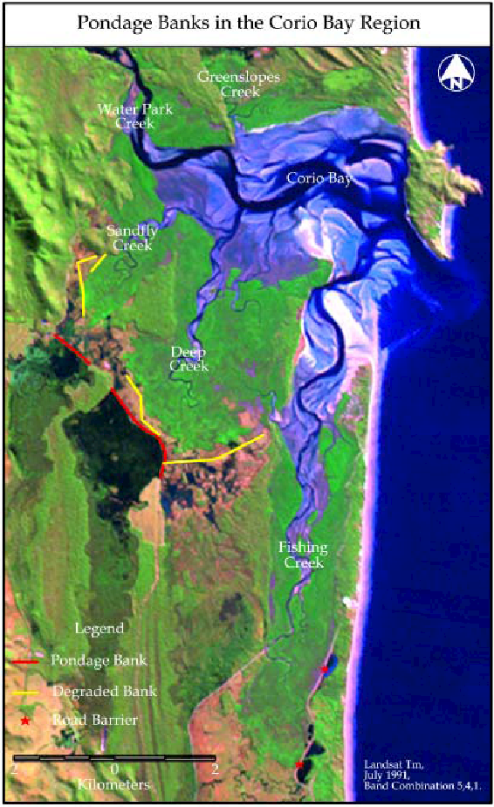
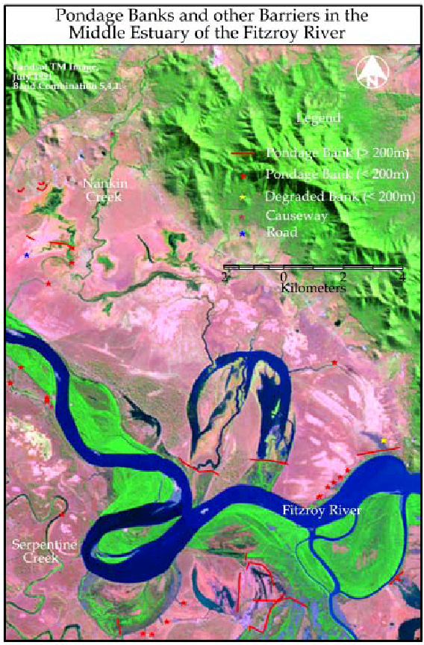

Building on the Hyland (2002) report and including an assessment of the adoption, or lack of adoption, of the management practices to minimize impacts on fisheries recommended by Challen and Long (2004).
Note that the Fitzroy Basin Fish Barrier Prioritisation Project did not prioritise wetland barriers, which are important to World Heritage Area. Its priority projects may also not represent the priority projects from the GBRMPA perspective. Some of the barriers identified in the FBFBPP have already been addressed (for example there is now a fishway at Waterpark Weir, ranked #16 in the FBFBPP).
See Rockhampton Regional Council: http://www.rockhamptonregion.qld.gov.au/About_Council/News_and_Announcements/Latest_News/Redesignupgrade_to_Fitzroy_River_Barrage_fish_ladder_complete
These focus on water quantity only. Water quality is protected principally under the Environmental Protection Act 1994 (Qld).
Based on the decision in Minister for the Environment and Heritage v QCC (2004) 139 FCR 24 (the Nathan Dam Case).
See http://www.envlaw.com.au/nathan.html
See http://www.envlaw.com.au/waratah.html
See http://www.ehp.qld.gov.au/coastalplan/
See pp 27-28 at http://www.dsdip.qld.gov.au/resources/policy/state-planning/draft-spp.pdf
See http://www.dsdip.qld.gov.au/regional-planning/the-central-queensland-regional-plan.html
In theory, all people have to take reasonable and practicable measures to avoid environmental harm under the Environmental Protection Act 1994 (Qld).
See http://www.environment.gov.au/water/policy-programs/wetlands/gbrwetlands.html
See http://www.environment.gov.au/water/publications/environmental/wetlands/wetlands-final-report.html
See http://wetlandinfo.ehp.qld.gov.au/wetlands/index.html
Fish Unlimited: www.wetlandcare.com.au/index.php/our-work/successful-projects/wetland-restoration-and-rehabilitation/fish-unlimited1/
See the search tool on the EHP website at http://www.ehp.qld.gov.au/ecosystems/biodiversity/regional-ecosystems/maps/index.php#lot.
Including the adoption, or lack of adoption, of the management practices to minimize impacts on fisheries recommended by Challen and Long (2004).
Note that the FBFBPP did not look at wetland barriers, which are important to World Heritage Area, and its priority projects may not represent the priority projects from the Great Barrier Reef perspective. Some of the barriers identified in the FBFBPP have already been addressed (for example there is now a fishway at Waterpark Weir, ranked #16 in the FBFBPP). The FBFBPP is a good starting point, but that is all.

