Coral bleaching
Year 8
Learning area: Science
Science Understanding (sub-strand):
Biological sciences

© Commonwealth of Australia 2016
Published by the Great Barrier Reef Marine Park Authority
With the exception of the Commonwealth Coat of Arms, content supplied by third parties, logos and other material protected by a trademark, the content of this publication is licensed under the Creative Commons Attribution-Non Commercial-Share Alike 3.0 Licence.
A summary of license terms is available from
http://www.creativecommons.org/licenses/by-nc-sa/3.0/
The full license terms are available from
http://www.creativecommons.org/licenses/by-nc-sa/3.0/legalcode
This publication should be cited as:
Great Barrier Reef Marine Park Authority 2015, Coral bleaching: Year 8 Australian science curriculum focus, GBRMPA, Townsville.
National Library of Australia Cataloguing-in-Publication entry
Coral bleaching: year 8 Australian science curriculum focus / Great Barrier Reef Marine Park Authority.
ISBN 9781922126696
Coral bleaching--Queensland--Great Barrier Reef--Study and teaching (Secondary).
Coral reef ecology--Queensland--Great Barrier Reef--Study and teaching (Secondary).
Great Barrier Reef (Qld.)--Study and teaching (Secondary).
Great Barrier Reef Marine Park Authority.
578.778909943

In this unit, the sections ‘Curriculum intent’, ‘Assessment – Assessing student learning’ and ‘Making judgements – achievement standard’ include content that is © Australian Curriculum, Assessment and Reporting Authority (ACARA) 2010 to present, unless otherwise indicated. This material was downloaded from the Australian Curriculum website (accessed March 2015) and was modified. The material is licensed under CC BY 4.0. Version updates are tracked on the Curriculum version history page of the Australian Curriculum website.
ACARA does not endorse any product that uses the Australian Curriculum or make any representations as to the quality of such products. Any product that uses material published on this website should not be taken to be affiliated with ACARA or have the sponsorship or approval of ACARA. It is up to each person to make their own assessment of the product, taking into account matters including, but not limited to, the version number and the degree to which the materials align with the content descriptions (where relevant). Where there is a claim of alignment, it is important to check that the materials align with the content descriptions (endorsed by all education Ministers), not the elaborations (examples provided by ACARA).
Comments and inquiries on this document should be addressed to:
Great Barrier Reef Marine Park Authority
2-68 Flinders Street
PO Box 1379
TOWNSVILLE QLD 4810
Australia
Phone: (07) 4750 0700
Fax: (07) 4772 6093
info@gbrmpa.gov.au
http://www.gbrmpa.gov.au
Coral bleaching — Year 8
Contents
Unit overview 5
Teacher information 6
Curriculum intent 11
Feedback 17
Assessment 18
Sequencing teaching and learning 19
Making judgements 20
Teaching sequence 21
Resources 43
Resource 1 – TWLH chart 44
Resource 2 – Word bank 45
Resource 3 – Student reflections 46
Resource 4 – Procedural text – Cell observations 47
Resource 5 – Procedural text – Chloroplast search 48
Resource 6 – Observing animal cells 49
Resource 7 – Coral information 52
Resource 8 – Future circles 56
Resource 7 – Student task sheet and Guide for making judgements 57

Unit overview

Unit title | Coral bleaching
Learning Area | Science
Science Understanding  (sub-strand) | Biological sciences
Year level | 8
Duration | Approximately 6 weeks*  *based on 2 lessons of science per week for Year 8 (50 minutes per lesson).  This mini unit provides a Great Barrier Reef perspective to the understanding of cells and aspects of science as a human endeavour. An alternative to teaching this unit is to incorporate lessons into pre-existing Year 8 units.
Unit description | In this mini unit, students will observe different animal and plant cells under the microscope. They will investigate the structure and function of different animal cells and observe and describe the function of chloroplast in plant cells. Students will investigate zooxanthellae and their symbiotic relationship with coral and use this understanding to explain coral bleaching. Students will recognise the link between carbon footprint and coral bleaching and identify ways to manage carbon footprints from the individual to community level.

Teacher information

Safety and risk management
You will need to identify safety issues and conduct your own curriculum activity risk assessments for all activities and excursions in this mini unit.
For advice and documents, please refer to the Department of Education and Training Curriculum Activity Risk Assessment Guidelines: http://education.qld.gov.au/health/safety/hazards/curriculum-activities.html
The actual risk level for activities in this mini unit will vary according to the specific circumstances of the activity and your school and classroom context. You must consider all circumstances when you complete a risk assessment. Examples of considerations include, but are not limited to:
- Is the activity occurring within, or outside school grounds e.g. an excursion?
- How will students be supervised during the activity?
- What will students do during the activity?
- Are there any special student considerations e.g. medical, behavioural or special needs?
- What hazards do you need to take into account e.g. hazardous substances, tools or equipment?

Unit details
The Great Barrier Reef Marine Park Authority (GBRMPA) Coral bleaching mini unit is a Year 8 Science unit of work. The content descriptions for this mini unit are from the Australian Curriculum: Science (Version 7.4 dated 30th March 2015 http://www.australiancurriculum.edu.au).
The mini unit follows the inquiry-based 5Es approach to teaching science. The inquiry questions that underpin the mini unit are:
- What are the structures of plant and animal cells?
- How is coral formed and what does it need to survive?
- What is coral bleaching and why does it occur?
- When coral bleaching occurs, how does this affect the Great Barrier Reef and industries reliant on the Great Barrier Reef?
- What behaviours can we change to help prevent coral bleaching?

Time allocation
The mini unit is based on two lessons of science per week for Year 8 students. Each lesson is approximately 50 minutes long, with some lessons requiring more time to allow further depth of study e.g. Internet research, or time for excursions.
The overall mini unit, or the individual lessons, can be extended or shortened to cater for individual classes as deemed necessary by the class teacher.

Unit aims
The lessons are structured to build students’ knowledge of animal and plant cells, to gain an in-depth understanding of how and why coral bleaching occurs and what can be done locally and globally to help reduce such events. Corals are the building blocks of the Great Barrier Reef. Their health is vital to all life on the Great Barrier Reef. (For more information on coral see the section ‘Background information – coral and also http://www.gbrmpa.gov.au.)
Teaching students about coral reefs and their structure, life cycle, and survival needs will build their environmental knowledge and encourage their understanding of sustainability and stewardship.

Key threats to the Reef
GBRMPA encourages teachers, students and communities to follow the main aim of Reef Guardians – to be custodians of their local ecosystems and stewards of the Reef. In the Great Barrier Reef Outlook Report 2014, the key threats to the reef are climate change, land-based run-off, coastal development, and other direct impacts such as unsustainable fishing activities and marine debris. (See http://www.gbrmpa.gov.au for more information on the Outlook Report 2014).
In this mini unit, students will explore the threat of coral bleaching on the Great Barrier Reef.

Stewardship
The Reef Guardian Schools Program encourages responsible use and protection of the Great Barrier Reef ecosystems. Schools are encouraged to take ownership of conservation activities and on-ground projects that involve students, teachers and their local communities. These environmental actions foster a greater appreciation and understanding of the Great Barrier Reef and empower students to become lifelong stewards.
The following are examples of stewardship activities that relate to the learning experiences of this mini unit:
- Develop a home, school or community awareness raising campaign/poster linking carbon footprints to the health of the Great Barrier Reef. Provide ideas and practical strategies of what can be done to protect the Reef. (See lesson 10 and the assessment task in lesson 11-13. Consider this becoming an adjustment to the assessment task).

Citizen science participation
Citizen science is scientific research conducted by non-professionals – in this case by students, teachers and communities. Schools can participate in the collection and submission of scientific data to local management authorities including GBRMPA, local councils and local Natural Resource Management agencies where the data can be used to inform sustainable ecosystem management decisions.
Specific examples of citizen science participation are provided in the lesson plans of this mini unit which are found in the section ‘Teaching sequence’.

Building partnerships
Delivery of this unit can be enhanced by building partnerships within the school and wider community.
Partner organisations could include the following:
- local council
- Local Marine Advisory Committees (LMAC)
- your nearest natural resource management organisation (NRM): http://www.nrm.gov.au/regional/regional-nrm-organisations
- other schools
- connecting with marine research scientists or dive groups
- museums, like the Museum of Tropical Queensland
- universities (James Cook University or University of Queensland)
- Australian Institute of Marine Science
- Tangaroa Blue: http://www.tangaroablue.org/
- Reef HQ, Townsville
- Underwater World, Mooloolaba

Background information – coral

What is coral?
Corals are magnificent creatures and they are responsible for the formation and beauty of the Great Barrier Reef. About 600 different kinds of corals are found in the Great Barrier Reef Marine Park and they come in many different shapes, sizes and colours.
Corals are animals closely related to jellyfish, but do not move through the water. Instead, most corals remain in one place throughout their lifetime.
Like most creatures, corals require food, water, shelter and sunlight to survive. The exact rate at which coral colonies grow varies amongst species. Massive Porites corals are the slowest growing species growing at an average of one to three millimetres per year, while staghorn corals can grow up to 30 centimetres each year.

Types of coral
Generally there are two main types of corals — hard and soft.
Hard or stony corals have six (or multiples of six) smooth tentacles, while soft corals have eight feathery tentacles around their mouth.
Hard corals have a hard skeleton made of calcium carbonate, which is the part you see when a coral dies. These parts when broken up, form coral rubble and eventually become the sand on the floor of the reef. Soft corals do not have a hard skeleton.

Importance of coral
Corals are responsible for the formation of the Great Barrier Reef. They are the building blocks of the Reef and form a major part of the Reef ecosystem, providing food and shelter for hundreds of species of animals. When mass bleaching occurs and coral does not recover, the biodiversity in that area of reef is severely impacted.

Some unique facts about corals

Colouring
Some corals have pigments in their tissue that create their orange, yellow, green, blue, red and purple colours. Others get their golden-brown colour from algae (zooxanthellae) that live inside the tissue of coral polyps.

Feeding
Corals eat tiny animals which drift around in the water (called zooplankton) and very small fish. These animals are caught by the coral’s tentacles that are loaded with specialised stinging cells called nematocysts.
Corals can also feed from the tiny plants or algae called zooxanthellae that live within their cells in a symbiotic (mutually beneficial) relationship.
Like plants, zooxanthellae use the sun to make food for themselves and the coral. This is why it is important for corals to live in clear, shallow waters where they can get lots of sunlight.

Useful websites
- Reef vid – a resource of free coral reef video clips:
http://www.reefvid.org/
- EcoKids:
http://www.ecokids.ca
- Great Barrier Reef Marine Park Authority:
http://www.gbrmpa.gov.au
- Middle School Science Resources:
http://www.middleschoolscience.com
- The Biology Corner:
http://www.biologycorner.com
- Be part of the Eye on the Reef:
http://www.gbrmpa.gov.au/visit-the-reef/eye-on-the-reef/get-involved-with-eye-on-the-reef
- CoralWatch:
http://www.coralwatch.org/

Curriculum intent

Australian Curriculum: Science

Year 8 Level Description
The Science Inquiry Skills and Science as a Human Endeavour strands are described across a two-year band. In their planning, schools and teachers refer to the expectations outlined in the achievement standard and also to the content of the Science Understanding strand for the relevant year level to ensure that these two strands are addressed over the two-year period. The three strands of the curriculum are interrelated and their content is taught in an integrated way. The Science as a Human Endeavour strand can provide relevant contexts in which science can be taught. The order and detail in which the content descriptions are organised into teaching/learning programs are decisions to be made by the teacher.
Over Years 7 to 10, students develop their understanding of microscopic and atomic structures; how systems at a range of scales are shaped by flows of energy and matter and interactions due to forces, and develop the ability to quantify changes and relative amounts. In Year 8, students are introduced to cells as microscopic structures that explain macroscopic properties of living systems. They link form and function at a cellular level and explore the organisation of body systems in terms of flows of matter between interdependent organs. Similarly, they explore changes in matter at a particle level, and distinguish between chemical and physical change. They begin to classify different forms of energy, and describe the role of energy in causing change in systems, including the role of heat and kinetic energy in the rock cycle. Students use experimentation to isolate relationships between components in systems and explain these relationships through increasingly complex representations. They make predictions and propose explanations, drawing on evidence to support their views.

Content descriptions
This mini unit provides opportunities for students to engage in the following Australian Curriculum Content descriptions:
Science Understanding (SU) | Science as a Human Endeavour (SHE) | Science Inquiry Skills (SIS)
Biological sciences  - Cells are the basic units of living things and have specialised structures and functions (ACSSU149) | Use and influence of science  - Science and technology contribute to finding solutions to a range of contemporary issues; these solutions may impact on other areas of society and involve ethical considerations (ACSHE135) | Planning and conducting  - Collaboratively and individually plan and conduct a range of investigation types, including fieldwork and experiments, ensuring safety and ethical guidelines are followed (ACSIS140)  Processing and analysing data and information  - Summarise data, from students’ own investigations and secondary sources, and use scientific understanding to identify relationships and draw conclusions (ACSIS145)  Communicating  - Communicate ideas, findings and solutions to problems using scientific language and representations using digital technologies as appropriate (ACSIS148)

Year 8 achievement standard
By the end of Year 8, students compare physical and chemical changes and use the particle model to explain and predict the properties and behaviours of substances. They identify different forms of energy and describe how energy transfers and transformations cause change in simple systems. They compare processes of rock formation, including the time scales involved. They analyse the relationship between structure and function at cell, organ and body system levels. Students examine the different science knowledge used in occupations. They explain how evidence has led to an improved understanding of a scientific idea and describe situations in which scientists collaborated to generate solutions to contemporary problems.
Students identify and construct questions and problems that they can investigate scientifically. They consider safety and ethics when planning investigations, including designing field or experimental methods. They identify variables to be changed, measured and controlled. Students construct representations of their data to reveal and analyse patterns and trends, and use these when justifying their conclusions. They explain how modifications to methods could improve the quality of their data and apply their own scientific knowledge and investigation findings to evaluate claims made by others. They use appropriate language and representations to communicate science ideas, methods and findings in a range of text types.

General capabilities
This mini unit provides opportunities to address the following organising elements of the general capabilities:
Literacy  - Comprehending texts through listening, reading and viewing  - Composing texts through speaking, writing and creating  - Text knowledge  - Grammar knowledge  - Word knowledge  - Visual knowledge | ICT capability  - Applying social and ethical protocols and practices when using ICT  - Investigating with ICT  - Managing and operating ICT
Numeracy  - Recognising and using patterns and relationships  - Using measurement | Critical and creative thinking  - Inquiring – identifying, exploring and organising information and ideas  - Generating ideas, possibilities and actions  - Reflecting on thinking and processes
Personal and social competence  - Self-awareness  - Self-management  - Social awareness  - Social management | Ethical understanding  - Reasoning in decision making and actions
Intercultural understanding
- Recognising culture and developing respect

Cross-curriculum priorities
This mini unit provides opportunities for students to address aspects of the following cross-curriculum priorities:
Sustainability
Students will:
- focus on protecting environments through informed individual and community action that recognises the interdependence of healthy social, economic and ecological systems
- understand that actions for a sustainable future require us to explore and understand environments and results from actions to preserve and restore the quality and uniqueness of environments

Relevant prior curriculum
Students require prior experience from Year 7 with:

Science Understanding

Biological sciences
- There are differences within and between groups of organisms; classification helps organise this diversity (ACSSU111)

Science as a Human Endeavour

Use and influence of science
- Science and technology contribute to finding solutions to a range of contemporary issues; these solutions may impact on other areas of society and involve ethical considerations (ACSHE120)

Curriculum working towards
The teaching and learning in this mini unit works towards the following in Year 9:

Science Understanding

Biological sciences
- Multi-cellular organisms rely on coordinated and interdependent internal systems to respond to changes to their environment (ACSSU175)

Science as a Human Endeavour

Use and influence of science
- People can use scientific knowledge to evaluate whether they should accept claims, explanations or predictions (ACSHE160)

Feedback

Supportive learning environment
Differentiation  Consider the individual needs of your students – including gifted and talented, ESL and students requiring additional support.  For information refer to the Australian Curriculum, Assessment and Reporting Authority (ACARA) web pages on student diversity:  http://www.australiancurriculum.edu.au/studentdiversity/student-diversity-advice  Further information for Queensland state schools can be found as part of the P-12 curriculum, assessment and reporting framework and associated resources:  http://education.qld.gov.au/curriculum/framework/p-12/ | Feedback to students  Teachers:  - plan opportunities for conversations to provide ongoing feedback (spoken and written) and encouragement to students on their strengths and areas for improvement  - reflect on and review learning opportunities to individualise learning experiences required  - provide multiple opportunities for students to experience, practise and improve knowledge, processes and skills.  Students:  - identify what they can do well and what they need to improve.  - provide feedback to a peer on interaction skills and suggest some strategies for improvement (written and spoken feedback).
Reflection on the unit plan
At the conclusion of the mini unit, teachers can reflect on it for future planning by answering the following questions:
- What worked well in this mini unit?
- What was a stumbling block?
- How would you refine it?
- What trends and gaps in learning have you identified?
- How will you build on these learning experiences next term and beyond?

Assessment
Assessment is the purposeful, systematic and ongoing collection of information as evidence for use in making judgements about student learning and to support improving student learning.

Monitoring student learning
Student learning should be monitored throughout the mini unit. Each lesson in this mini unit provides opportunities for monitoring learning and for gathering evidence of student progress. For examples of ways to monitor learning refer to each of the lesson plans under the section ‘Teaching sequence’.

Assessing student learning
Summative assessment task: | Coral bleaching – information poster (Lesson 11-13)
Description: | Students will create an information poster aimed to educate the local community about coral bleaching. In the poster, students will explain how coral is formed and the role it plays in the ecosystems of the Great Barrier Reef. They will use their understanding of cell structure and function to explain the process of coral bleaching and its causes. They will identify the short and long term effects of coral bleaching for reef health and give examples of what individual people can do to prevent the causes of coral bleaching.
This assessment task provides opportunities to gather evidence of student learning in: | Science Understanding  Biological sciences  - Cells are the basic units of living things and have specialised structures and functions (ACSSU149)  Use and influence of science  - Science and technology contribute to finding solutions to a range of contemporary issues; these solutions may impact on other areas of society and involve ethical considerations (ACSHE135)  Communicating  - Communicate ideas, findings and solutions to problems using scientific language and representations using digital technologies as appropriate(ACSIS148)
See Resource section: Resource 9 for the Student task sheet and the Guide for making judgements for the assessment task: Coral bleaching – information poster.

Sequencing teaching and learning
A suggested learning sequence for this mini unit is summarised below. For detailed information for each lesson in this sequence go to the section ‘Teaching Sequence’.
Inquiry phase | Lesson | Purpose
Engage | Lesson 1: What do we know about the reef, coral and coral bleaching? | To capture interest and discover what students think they know and want to know about coral and coral bleaching.
Explore | Lesson 2: What are cells? | To observe onion skin cells and banana cells under the microscope and complete labelled diagrams of the cells. To identify similarities and differences between the cells and their structures.
Explore | Lesson 3: What is the structure and function of chloroplasts? | To observe chloroplasts under the microscope and to draw and describe their structure. To describe the function of chloroplasts in plant cells.
Explore | Lesson 4 - 5: What are the structures and functions of animal cells? | To observe different animal cells under the microscope and draw and describe their structure. To relate the structure of different animal cells to their function. To compare and contrast animal and plant cells.
Explain | Lesson 6: What are zooxanthellae? | To investigate single-celled zooxanthellae and describe their function and symbiotic relationship with coral.
Explain | Lesson 7 - 8: What is coral? | To investigate coral structure, life cycle and needs for survival.
Elaborate | Lesson 9: What is coral bleaching? | Define coral bleaching and describe what causes it and its impacts on the Great Barrier Reef. To identify the relationship between sea temperature and coral bleaching.
Elaborate | Lesson 10: What can we do to about coral bleaching? | To understand how carbon footprint relates to coral bleaching. To describe what can be done to reduce carbon footprint.
Evaluate | Lesson 11 - 13: Reflections and assessment task | To review and reflect on learning and introduce and complete the assessment task.
TOTAL: 13 Lessons (50 minutes per lesson)

Making judgements

Achievement standard
In this mini unit, assessment of student learning aligns to the following components of the Year 8 achievement standard.
By the end of Year 8, students compare physical and chemical changes and use the particle model to explain and predict the properties and behaviours of substances. They identify different forms of energy and describe how energy transfers and transformations cause change in simple systems. They compare processes of rock formation, including the time scales involved. They analyse the relationship between structure and function at cell, organ and body system levels. Students examine the different science knowledge used in occupations. They explain how evidence has led to an improved understanding of a scientific idea and describe situations in which scientists collaborated to generate solutions to contemporary problems.
Students identify and construct questions and problems that they can investigate scientifically. They consider safety and ethics when planning investigations, including designing field or experimental methods. They identify variables to be changed, measured and controlled. Students construct representations of their data to reveal and analyse patterns and trends, and use these when justifying their conclusions. They explain how modifications to methods could improve the quality of their data and apply their own scientific knowledge and investigation findings to evaluate claims made by others. They use appropriate language and representations to communicate science ideas, methods and findings in a range of text types.

Guide for making judgements
See Resource section: Resource 9 for the Student task sheet and the Guide for making judgements for the assessment task: Coral bleaching – information poster.

Teaching sequence
Engage
Explore
Explain
Elaborate
Evaluate

Lesson 1: What do we know about the reef, coral and coral bleaching?
Duration: 50 minutes

Lesson objectives
Students will:
identify and communicate what they already know about coral and coral bleaching.

Suggested learning sequence

Introduction – GBRMPA reef clips
- Watch the GBRMPA clips as well as other clips of the Reef showing general reef life and different types of coral (See ‘Useful web links’ for links).
- Ask students to share any experiences they have had visiting the Great Barrier Reef, Reef HQ in Townsville or other reefs around Australia or the world.
Activity – TWLH chart
- Discuss with students what they think they already know about the reef, coral and coral bleaching. You could do this as a whole class, or ask students to form pairs and write down what they know about each topic and then share their answers with the class.
- Ask students if there is anything they would like to know about these topic areas. Record students’ responses in a class and/or an individual TWLH chart. (See Resource 1 – TWLH chart for individual charts).
T  What we think we know | W  What we want to learn | L  What we learned | H  How we know (scientific understanding)

- Break students up into pairs or small groups to research the Reef. Have a list of questions written on the board for students to find answers to. Each group could answer two or three questions and then report back to the class. Some suggestions of questions are:
- Where is the Great Barrier Reef?
- How big is it?
- What biodiversity does it support?
- What environmental value does it have?
- What economic value does it have?
- What social value does it have?
- Why look after it?
- What if it is not looked after?
- What is threatening it?
- Provide students with books, Reef Fact Sheets, maps from GBRMPA and Internet access for them to do their research.
- Students share their answers with the class.
- Review with students the scientific vocabulary pertinent to this lesson (See Resource 2– Word bank for suggested terms).
- Start a science journal with students to record their learning and reflections after each science lesson. (See Resource 3 – student reflections for examples of sentence starters you can use to guide student reflections.)

 Science journal
A science journal is a record of observations, experiences and reflections. It contains a series of dated, chronological entries. It may include written text, drawings, labelled diagrams, photographs, tables and graphs. The science journal can be used as a part of student assessment.

Opportunities to monitor student learning
Diagnostic assessment opportunities:
Use individual TWLH charts and discussions to determine students' current knowledge of the reef, coral and coral bleaching. Use this when planning future lessons.

Resources

Useful web links
Reef vid – a resource of free coral reef video clips:
http://www.reefvid.org/
Other YouTube clips or videos that show coral bleaching and general life on the reef e.g.
- National Geographic – Exploring Oceans: Great Barrier Reef:
https://www.youtube.com/watch?v=wbNeIn3vVKM
- Stunning time-lapse shows coral reef’s secret life on the Great Barrier Reef – B BC News:
https://www.youtube.com/watch?v=_mijYXcSCS4
Hint: Access and pre-load YouTube clips before the lesson so that you can play them immediately for students when required.
Books, Reef Fact Sheets and Maps from Resources and publications, GBRMPA website:
http://www.gbrmpa.gov.au/

Printable resources
Resource 1 – TWLH chart
Resource 2 – Word bank
Resource 3 – Student reflections
Engage
Explore
Explain
Elaborate
Evaluate

Lesson 2: What are cells?
Duration: 50 minutes

Lesson objectives
Students will:
observe onion skin cells and banana cells under a microscope and complete labelled diagrams of the cells
identify similarities and differences between the cells and their structures.

Suggested learning sequence
Introduction – setting up
- Discuss with students what they know about cells.
- As a class, read Resource 4 – Procedural text - Cell observations.
Note: This activity will provide students with the opportunity to develop skills in preparing slides, using a microscope, identifying differences and similarities and practising drawing what they see.
If this is the first time students have used a microscope, take time to introduce the microscope, its parts, how to safely move it around the classroom, and how it works.
See ‘useful web links’ for examples of slide preparation and using a microscope.
Activity – Cell observations
- Complete the steps in the Resource 4 – Procedural text - cell observations to examine onion skin cells and banana cells under a microscope and complete labelled diagrams of the cells.
- As a class, discuss the similarities and differences between the banana and the onion skin cells, and have students note these in their science journal.
- Create a class chart with the headings ‘cell structure’ and ‘function’. List some of the basic structures of the cells observed e.g. nucleus, cytoplasm, cell wall and the function of each one.
- Review with students the scientific vocabulary pertinent to this lesson (See Resource 2 – Word bank for suggested terms).
- Students add their learning and reflections to their science journal. (See Resource 3 – Student reflections for examples of sentence starters you can use to guide student reflections).

Opportunities to monitor student learning
Formative assessment opportunities:
Use students' drawings and journal entries to assess their developing science inquiry skills and knowledge of cells.

Resources

Useful web links
Understand your microscope activity at Color the Microscope Parts:
http://www.biologycorner.com/worksheets/microscope_coloring.html
Onion slide preparation (using iodine) and viewing the cells using a compound light microscope at Onion Skin Epidermal Cells: How to Prepare a Wet Mount Microscope Slide:
https://www.youtube.com/watch?v=PrX3h-AflZI
Methylene blue stain demonstration at How to Stain a Slide:
https://www.youtube.com/watch?v=vGjvSeJfhDs
Hint: Access and pre-load your YouTube clips before the lesson so that you can play them immediately for students when required.

Printable resources
Resource 2 – Word bank
Resource 3 – Student reflections
Resource 4 – Procedural text -cell observations

Other resources
Equipment listed in Resource 4 – Procedural text – cell observations
White paper and pencils (if needed) for diagrams
Engage
Explore
Explain
Elaborate
Evaluate

Lesson 3: What is the structure and function of chloroplasts?
Duration: 50 minutes

Lesson objectives
Students will:
observe chloroplasts under the microscope and draw and describe their structure
describe the function of chloroplasts in plant cells.

Suggested learning sequence
Introduction – setting up
- As a class, read Resource 5 – Procedural text – chloroplast search. Note the steps where students will answer questions in their science journal.
- Discuss with students what chloroplasts do and what they should be looking for when they examine the plant cells under the microscope.
Note: In this lesson, students will need to gain an understanding of how plants create energy using sunlight. This is important for when they learn about zooxanthellae in Lesson 6.
Activity – Cell observations
- Complete the steps in the Resource 5 – Procedural text – chloroplast search to observe chloroplasts and draw and describe their structure.
- As a class, discuss what students observe under the microscope and how the chloroplasts use the sunlight to make energy for the plants.
- Review with students the scientific vocabulary pertinent to this lesson (See Resource 2– Word bank for suggested terms).
- Students add their learning and reflections to their science journal. (See Resource 3 – Student reflections for examples of sentence starters you can use to guide student reflections).

Opportunities to monitor student learning
Formative assessment opportunities:
Use students' drawings and journal entries to assess their developing science inquiry skills and knowledge of cell structures.

Resources

Printable resources
Resource 2 – Word bank
Resource 3 – Student reflections
Resource 5 – Procedural text – chloroplast search

Other resources
Equipment listed in Resource 5 – procedural text – chloroplast search
White paper and pencils (if needed) for diagrams
Engage
Explore
Explain
Elaborate
Evaluate

Lesson 4 and 5: What are the structures and functions of different animal cells?
Duration: 1 hour 20 minutes

Lesson objectives
Students will:
observe different animal cells under the microscope and draw and describe their structure
relate the structure of different animal cells to their function
compare and contrast animal and plant cells

Suggested learning sequence
Introduction – setting up
- As a class, read Resource 6 – Observing animal cells.
Note: To save paper instead of giving Resource 6 to everyone, have students draw their own table for cell diagrams and descriptions and answer questions directly into their science journal.
- Discuss with students what different kinds of animal cells they can think of e.g. skin, blood, hair, nerve cells.
- Ask students if they think that all animal cells will look the same under the microscope or if they will look different? Why?
- Set up for the Resource 6 – Observing animal cells activity. If need be, have students draw the table in their science journal for cell diagrams and descriptions.
Note: If coral cells are not available, teachers could provide students with pictures of coral cells from books or the Internet. See ‘useful web links’ for examples.

Activity – Cell observations
- Have students observe the microscopic slides of different animal cells and draw and describe them.
- Discuss with students what they observed. The questions in Resource 6 – Observing animal cells could be done as a class or used as discussion points once the activity has finished.
- As a class, relate the structure of the different animal cells to their function.
- Compare and contrast the basic structures of the animal cells observed to the plant cells from the previous lessons. Have students summarise these similarities and differences in a chart in their journal.
- Review with students the scientific vocabulary pertinent to this lesson (See Resource 2 – Word bank for suggested terms).
- Students add their learning and reflections to their science journal. (See Resource 3 – Student reflections for examples of sentence starters you can use to guide student reflections).

Opportunities to monitor student learning
Formative assessment opportunities:
Use students' drawings and journal entries to assess their developing science inquiry skills and knowledge of cell structures.

Resources

Useful web links
Microscopic slides of Stylophora pistillata (hood or smooth cauliflower coral). Select the image to enlarge it. Zooxanthellae are labelled Z:
http://www.pnas.org/content/111/35/12728/F1.expansion.html
Low and high magnification images of polyp tissue (Scroll down to Figure 2 and 3 and select the images to enlarge):
http://www.hoajonline.com/histology/2055-091X/1/7

Printable resources
Resource 2 – Word bank
Resource 3 – Student reflections
Resource 6 – Observing animal cells

Other resources
Equipment listed in Resource 6 – Observing animal cells
White paper and pencils (if needed) for diagrams
Engage
Explore
Explain
Elaborate
Evaluate

Lesson 6: What are Zooxanthellae?
Duration: 1 hour 40 minutes
Lesson objectives
Students will:
investigate single-celled zooxanthellae and describe their function and symbiotic relationship with coral.

Suggested learning sequence

Introduction – Class discussion
- Ask students if they have heard of zooxanthellae, or if anyone has any ideas about what they are and what role they play on the Great Barrier Reef.
- Provide images of zooxanthellae, or look at zooxanthellae under a light microscope if available (see ‘useful web links’ for links to images).
- As a class, define what zooxanthellae are and what they do. Students may need help with this if they have not heard of zooxanthellae before.
- Discuss zooxanthellae with students using the following questions as a guide:
- If zooxanthellae are plants and need sunlight to make energy as all plants do, how do they get that sunlight underwater?
- Would they prefer to live in shallow water or deep water? Why?
- What do you think happens when they do not receive enough sunlight or too much sunlight?
Activity – Zooxanthellae research
- View GBRMPA clips about zooxanthellae (see ‘useful web links’ for video and animation links).
- Watch the clips a couple of times and ask students to take notes about:
- what zooxanthellae do
- why they are important
- their relationship with coral
- how humans impact them
- Discuss the clips and ask students to share something from the notes they took.
- Group students into pairs and ask students to write a small report about zooxanthellae explaining the main points about them. Areas to research might include:
- their needs
- how they react to sunlight
- what the symbiotic relationship is between coral and zooxanthellae
- what their importance is to the Great Barrier Reef
- how they are affected by changes in temperature
- Students may want to watch the video clips again to research, or you may have books or fact sheets from GBRMPA for students to use.
- Ask students to share their small reports.
- Review with students the scientific vocabulary pertinent to this lesson (See Resource 2 – Word bank for suggested terms).
- Students add their learning and reflection to their science journal. (See Resource 3 – Student reflections for examples of sentence starters you can use to guide student reflections).

Opportunities to monitor student learning
Formative assessment opportunities:
Use students' notes and small reports to assess their developing knowledge of science understandings and science as a human endeavour.

Resources

Useful web links
Slideshow and information on Zooxanthellae and Coral bleaching:
http://ocean.si.edu/slideshow/zooxanthellae-and-coral-bleaching
Stained microscope slide image of zooxanthellae within cells of coral polyp tissue: Living in harmony, but stress can kill by João Monteiro:
http://www.livingoceansfoundation.org/living-in-harmony-but-stress-can-kill/
Microscopic slides of Stylophora pistillata (Hood or smooth cauliflower coral). Select to enlarge image. Zooxanthellae are labelled Z:
http://www.pnas.org/content/111/35/12728/F1.expansion.html
Video - zooxanthellae symbiotic relationship with coral: Coral Bleaching https://www.youtube.com/user/TheGBRMPA
Animation - Coral, zooxanthellae and coral bleaching
https://www.youtube.com/user/TheGBRMPA/videos
Information on zooxanthellae and coral with photos: NOAA Coral Reef Conservation Program: Symbiotic Algae:
http://coralreef.noaa.gov/aboutcorals/coral101/symbioticalgae/
Reef Beat posters 2008 – Poster 3 on Corals found at:
http://elibrary.gbrmpa.gov.au/jspui/handle/11017/2781

Great Barrier Reef Outlook Report 2014
Access the report at: http://elibrary.gbrmpa.gov.au/jspui/handle/11017/2855
Useful information for this lesson can be found on:
Page 56: zooxanthellae symbiosis

Printable resources
Resource 2 – Word bank
Resource 3 – Student reflections

Other resources
Books, fact sheets, posters, Internet access for research.
Engage
Explore
Explain
Elaborate
Evaluate

Lesson 7 and 8: What is coral?
Duration: 50 minutes

Lesson objectives
Students will:
investigate and understand coral structure, life cycle and needs for survival.

Suggested learning sequence

Introduction – coral video
- View the GBRMPA Coral Bleaching and the Great Barrier Reef animation that shows the life cycle of coral, the role zooxanthellae play in the life cycle, and how climate change and associated rising sea temperatures can cause coral bleaching (see ‘useful web links’ for video link).
- Discuss the clip with students. Ask questions such as:
- What happened in the clip when the coral started to die?
- Why did the coral start dying?
- What happened to the ecosystem when the coral started to grow again?
- What is the importance of coral on the Great Barrier Reef?
Activity – Investigating coral
- Use Resource 7 – Coral information for students to take notes on the two main types of coral – soft coral and hard coral.
- Ask students to form pairs or small groups. Each pair or group chooses either soft or hard coral to research.
- You could also have other books, fact sheets and images of coral available for students to use.
- Ask students to research a number of topics. Some suggestions are:
- explain the life cycle of coral
- explain the survival needs of coral
- draw and label a diagram of the structure of coral
- explain how corals get their food
- explain where coral get its colour
- explain the role of zooxanthellae in relation to coral
- explain why coral is such an important part of the Great Barrier Reef
- describe an ecosystem
- explain the different threats corals face
- explain how corals repair themselves
- Students could choose two or three different topics and share their findings with the rest of the class.
- You could also ask students to each write one paragraph about a different topic to generate a class constructed report about coral for display.
- OPTIONAL EXTRA ACTIVITY – To build knowledge about coral, investigate coral via local resources such as Reef HQ, Underwater World, museums, scientists, information centres, libraries, or other resources available in your local area.
- Review with students the scientific vocabulary pertinent to this lesson (See Resource 2 – Word bank for suggested terms).
- Students add their learning and reflection to their science journal. (See Resource 3 – Student reflections for examples of sentence starters you can use to guide student reflections).

Opportunities to monitor student learning
Formative assessment opportunities:
Use students’ research to assess their developing knowledge of science understandings and human endeavours.

Resources

Useful web links
GBRMPA Coral bleaching and life cycle video at: Coral bleaching on the Great Barrier Reef
https://www.youtube.com/user/TheGBRMPA
Hint: Access and pre-load YouTube and other video clips before the lesson so that you can play them immediately for students when required.
Reef beat posters 2008 – Poster 3 on Corals found at:
http://elibrary.gbrmpa.gov.au/jspui/handle/11017/2781

Printable resources
Resource 2 – Word bank
Resource 3 – Student reflections
Resource 7 – Coral information
Engage
Explore
Explain
Elaborate
Evaluate

Lesson 9: What is coral bleaching?
Duration: 50 minutes

Lesson objectives
Students will:
define coral bleaching and describe what causes it and its impacts on the Great Barrier Reef
identify the relationship between sea temperature and coral bleaching.

Suggested learning sequence

Introduction – review
- Watch the GBRMPA Coral Bleaching clips again (see ‘useful web links’ for links).
- Ask students to apply their knowledge and understanding of how coral forms, what it needs to survive, and the behaviour of zooxanthellae to create a definition of what coral bleaching is and what causes it.
- Pose the question – what does coral bleaching mean for the Great Barrier Reef? Write down some of the students’ responses for students to reflect on later in the lesson.
Activity – Data
- As a class, read Reef Beat Poster 2 - Coral Bleaching from the 2009 Great Barrier Reef poster series.
- Clarify unknown words and ask students if they have any comments about the information.
- Discuss the graph on the poster and ask students to predict what will happen if the sea temperatures continue to rise – short term and long term.
- Ask students to use the information in the poster to write their own paragraph about what coral bleaching is, what causes it and what its impacts on the Reef might be. Students could reflect back on information from the beginning of the lesson to help them think about what to write.
- Ask students to share their paragraphs.
- OPTIONAL EXTRA ACTIVITY
If time allows, students could complete a futures circle to look at the long term and short term impacts of coral bleaching in more depth. See Resource 8 – Futures circle.
The futures circle is a circular form of a cause-and-effect chart that asks students to look at the environmental, economic and social impacts of coral bleaching, while also looking at what could be done to help stop coral bleaching from occurring.
- Review with students the scientific vocabulary pertinent to this lesson (See Resource 2 – Word bank for suggested terms).
- Students add their learning and reflections to their science journal. (See Resource 3 – Student reflections for examples of sentence starters you can use to guide student reflections).

Citizen science
Engage in monitoring programs of coral and the reef such as ‘Eye on the reef’ and ‘Coral Watch’:
Eye on the reef: http://www.gbrmpa.gov.au/visit-the-reef/eye-on-the-reef/get-involved-with-eye-on-the-reef
CoralWatch: http://www.coralwatch.org/

Opportunities to monitor student learning
Formative assessment opportunities:
Use students’ written work and discussions to assess their developing knowledge of science understandings and human endeavours.
Use futures circle (if done) to assess students’ knowledge of science as a human endeavour.

Resources

Useful web links
Animation - Coral and zooxanthellae and coral bleaching
https://www.youtube.com/user/TheGBRMPA
GBRMPA Coral bleaching and life cycle video at: Coral bleaching on the Great Barrier Reef
https://www.youtube.com/user/TheGBRMPA
Hint: Access and pre-load YouTube clips before the lesson so that you can play them immediately for students when required.
Reef Beat posters 2009 – Poster 2 on coral bleaching found at:
http://elibrary.gbrmpa.gov.au/jspui/handle/11017/2780

Great Barrier Reef Outlook Report 2014
Access the report at: http://elibrary.gbrmpa.gov.au/jspui/handle/11017/2855
Useful information for this lesson can be found on:
page 20: reduction in hard coral cover
page 51: sea surface temperature
page 158-159: modelling and vulnerability

Printable resources
Resource 2 – Word bank
Resource 3 – Student reflections
Resource 8 – Futures circle
Engage
Explore
Explain
Elaborate
Evaluate

Lesson 10: What can we do about coral bleaching?
Duration: 50 minutes

Lesson objectives
Students will:
understand how a carbon footprint relates to coral bleaching
describe what can be done to reduce their carbon footprint.

Suggested learning sequence

Before this lesson:
Before this lesson, have students calculate their carbon footprint as homework so they can check usage patterns of their own households. Students can use the calculator at the following website (use the quick version):
http://www.epa.vic.gov.au/agc/calculator/index.html
Introduction – review
- As a class, read Reef Beat Poster 10 - What you can do? from the 2009 poster series. Clarify unknown words and ask students if they have any comments about the information.
- Ask students to comment on how the information in the poster relates to coral bleaching. How will making the changes suggested help stop coral bleaching?
- Discuss with students things they already do as suggested in the poster or other ideas they may have.
Activity – Carbon footprints
- If students have not already done so, use the following website to calculate individual carbon footprints. (Explain what the unit Tonnes ghg stands for).
http://www.epa.vic.gov.au/agc/calculator/index.html
- Analyse the footprints of individuals and discuss how the class as a whole uses energy. Ask questions such as:
- Do they have sustainable carbon footprints? Why do you say that?
- Are they too high?
- What were the main reasons for the high value?
- How does their energy use impact living organisms such as coral?
- Discuss how the carbon footprint is related to coral bleaching and together, develop an explanation or create a visual e.g. flow chart in their science journals to demonstrate the link between their carbon footprint and coral bleaching. Ask guiding questions such as:
- How can you link your carbon footprint to coral bleaching?
- Why is it important to learn about carbon footprints?
- Are carbon footprints related to other environmental issues?
- What are some examples of these issues?
- Ask students to form pairs and in five minutes, write down a number of ways they can reduce their carbon footprint and therefore help stop coral bleaching.
- Ask the students to share their responses and create a class list of what they can do as individuals, as a class, as a school, as a family, as a community.
- Review with students the scientific vocabulary pertinent to this lesson (See Resource 2 – Word bank for suggested terms).
- Students add their learning and reflection to their science journal. (See Resource 3 – Student reflections for examples of sentence starters you can use to guide student reflections).

Opportunities to monitor student learning
Formative assessment opportunities:
Use students’ comments, ideas, and analysis to assess how they have applied their science knowledge to their daily lives in caring for the environment.

Resources

Useful web links
Carbon footprint calculator (use the quick version) at: Australian Greenhouse Calculator:
http://www.epa.vic.gov.au/agc/calculator/index.html
Reef Beat posters 2009 – Poster 10 found at:
http://elibrary.gbrmpa.gov.au/jspui/handle/11017/2780

Great Barrier Reef Outlook Report 2014
Access the report at: http://elibrary.gbrmpa.gov.au/jspui/handle/11017/2855
Useful information for this lesson can be found on:
page 227 and 229: Management of reef threats

Printable resources
Resource 2 – Word bank
Resource 3 – Student reflections
Engage
Explore
Explain
Elaborate
Evaluate

Lesson 11 - 13: Reflections and assessment task
Duration: 2 hours 30 minutes

Suggested learning sequence

Introduction – reflections and task introduction
- As a class, reflect and record what has been learned in the original TWLH chart.
- Explain to students that they are going to begin their final assessment project. Present them with the task sheet and the Guide for making judgements (Resource 9 – Student task sheet and Guide for making judgements).
- Read through the Task sheet and Guide for making judgements together and identify all the requirements of the task.
- Discuss available resources (identify all the work done throughout the unit that will help the students complete the task).
- Set out a plan for time management and resource management.
Activity – Prepare posters
- Allow students time to research and prepare their posters.
- Students may need scaffolding for different parts of the poster and this will depend on the needs of the class.
- How much time students are able to spend preparing their posters will depend on the needs of the class and the length of time available in the school term.

Opportunities to monitor student learning
Summative assessment opportunities:
Student posters can be used to assess students’ knowledge and understanding of science understandings, science as a human endeavour and science inquiry skills.

Resources

Printable resources
Resource 9 – Student task sheet and Guide for making judgements

Other resources
Class displays
Fact sheets, posters
Science journal entries
Access to the Internet

Resources

Resource 1 – TWLH chart
Name: __________________________
T  What we  THINK  we know about | W  What we  WANT  to learn about | L  What we  LEARNED  about | H  HOW  we know  (scientific understandings)
The Great Barrier Reef | The Great Barrier Reef | The Great Barrier Reef | The Great Barrier Reef
Coral | Coral | Coral | Coral
Coral bleaching | Coral bleaching | Coral bleaching | Coral bleaching

Resource 2 – Word bank

Cell | Cell wall | Cell membrane | Cytoplasm
Nucleus | Chloroplast | Coral | Coral bleaching
Zooxanthellae | Polyp | Tissue | Single-celled organism
Symbiotic relationship | Climate change | Soft coral | Hard coral
Tonnes ghg | Carbon footprint | Sustainable

Resource 3 – Student reflections
Consider displaying sentence starters, or questions like those below in the classroom. Alternatively, these phrases could be turned into laminated thought bubbles that are passed to students directly. Students could choose two or three thoughts to complete in their journal then share their responses with the class.
End of lesson reflections |  |  | Guiding students to reflect on their own thinking
Today I discovered …  I want to know more about …  Something new I found out was …  I am excited about …  Something I am finding interesting is …  The most challenging thing was … |  | I am most proud of …  I feel confident about …  I am enjoying … because …  I am confused by …  Today I asked …  A question I have is … | I am starting to think differently about …  I got stuck when … and I got back on track by …  I figured out that …  I solved a problem by …  I first thought … but then I realised that … | This idea is useful for …  Some things I didn’t understand are …  To help me understand better I will …  Before I didn’t know …  Now I realise/know …
Reflecting on stewardship and taking action |  |  | End of unit reflections – where I was and where I am now
This information can make a difference by …  It is important to know about this because …  Something I will now do as a result of my learning is …  Something I want to do next is … | Something I will now help others understand is …  I can make a difference by …  An action I/we can take is …  If we don’t … the consequences could be …  It is important to … because … |  | - I used to think …  - Now I know …  - This causes me to (re)think/ wonder … |  | - Revisit your first journal entry. What do you understand now that you didn’t back then?  - Review your work so far. What has been the biggest discovery/learning/challenge?  - Reconsider your initial ideas. Have your ideas changed? If so how?
- I didn’t know how to …
- Now I can …
- In the future I will …

Resource 4 – Procedural text – Cell observations
Adapted from Ash, M, Buchanen, J, Haire, M & Kennedy, E, 1999, Jacaranda Science 1, John Wiley, Brisbane.
Aim
To compare and contrast onion skin cells and banana cells
Equipment per group
- Microscope (and light if not installed)  - Cover slips  - Microscope slides  - Pipette  - Onion (pre-cut pieces) | - Banana (pre-cut pieces)  - Methylene blue (be careful as these dyes can stain your clothes and skin)  - Iodine  - Tweezers  - Gloves
Procedure
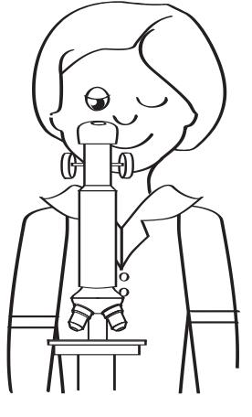
- Put gloves on.
- Carefully peel a very thin layer of onion skin (membrane) from the onion using tweezers.
- Place a flat piece of onion skin onto a slide.
- Use a pipette to put a drop of methylene blue onto the onion skin.
- Cover with a cover slip (make sure there are no air bubbles).
- Observe the onion skin under the microscope.
- Draw an annotated drawing in your science journal of what you see under the microscope.
- Squash a very small amount of banana onto a slide.
- Put a drop of iodine onto the banana.
- Cover with a cover slip.
- View the banana under the microscope.
- Complete an annotated drawing in your science journal of what you see under the microscope.
- Wash and pack up your equipment.

Resource 5 – Procedural text – Chloroplast search
Adapted from Ash, M, 1999 Jacaranda Science 2, John Wiley, Brisbane.
Aim
To find and observe chloroplasts
Equipment per group
- Gloves  - Tweezers  - Pipette  - Moss or Spirogyra  - Water | - Microscope (and light if not installed)  - Slides  - Cover slips  - Diluted iodine solution
Procedure
- Put on gloves.
- Put a drop of water on a microscope slide using a pipette.
- Use the tweezers to take a leaf from the moss plant or a small piece of Spirogyra and place it into the drop of water.
- Cover the leaf with a cover slip.
- Use the light microscope to observe the leaf.
- Complete a scientific drawing in your science journal of what you see.
- Label any chloroplasts that are present on your drawing.
- Write down a description of the chloroplasts with your drawing.
- What do you think gives the chloroplasts their colour? Write down your answer in your science journal.
- Put a drop of diluted iodine solution under the cover slip. (Iodine stains starch a blue-black colour.)
- Did the iodine stain any part of the leaf a dark colour? Write down your answer in your science journal.
- If so, what does this suggest about chloroplasts? Write down your answer in your science journal.

Resource 6 – Observing animal cells
Adapted from Ash, M, Buchanen, J, Haire, M & Kennedy, E, 1999, Jacaranda Science 1, John Wiley, Brisbane.
Aim
To observe and compare animal cells
Equipment per group
- Microscope (and light if not installed)
- Prepared animal slides e.g.
- blood cells
- cheek cells
- muscle cells
- nerve cells
- coral cells (if available)
Observations of animal cells
Cell type | Sketch  Allow plenty of space to draw your specimen. Draw and label two to three cells in pencil and include the magnification and estimated size. | Description  Describe in words what the specimen looks like.

Cell type | Sketch  Allow plenty of space to draw your specimen. Draw and label two to three cells in pencil and include the magnification and estimated size. | Description  Describe in words what the specimen looks like.

Questions
Which features did the animal cells have in common?
How did the animal cells differ from each other?
Why are there some features that all cells possess?
Suggest how the shape or size of the cells may assist the cell in doing its job.
Suggest reasons for some of the differences observed between the cells.

Resource 7 – Coral information

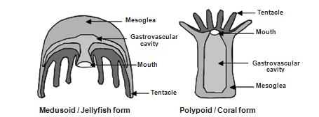
About coral
Corals are responsible for the formation of the Great Barrier Reef and are extremely beautiful. Although corals show a wide range of shapes and sizes, they share the same basic body plan – a simple sack-like stomach with a single mouth, surrounded by a ring of tentacles. However, corals come in a wide range of shapes and sizes. This depends on factors such as genetics, water depth, current strength and its location on a reef.
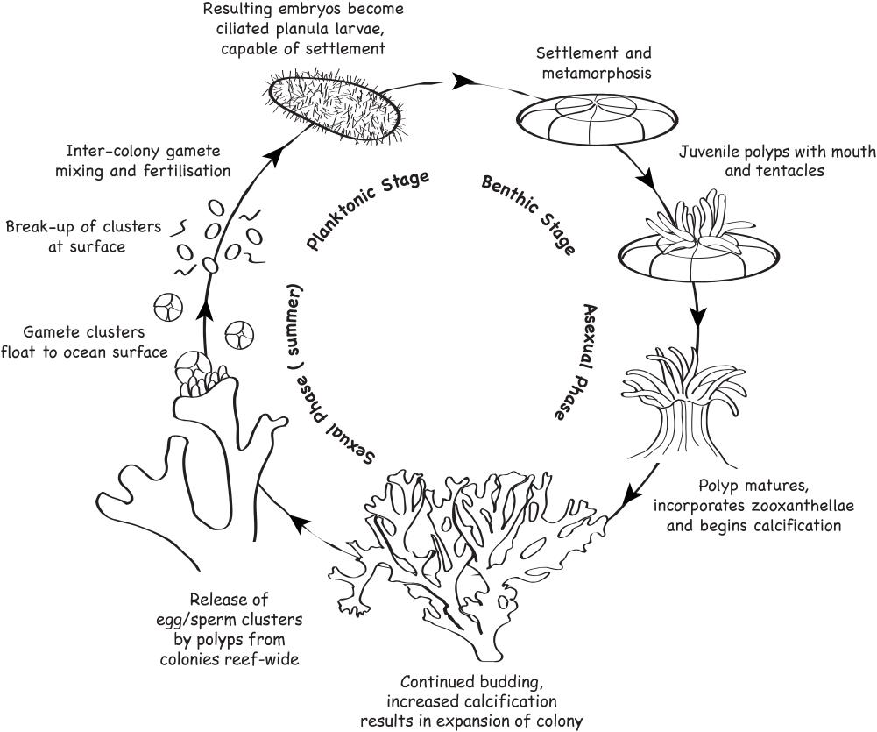
Corals are closely related to jellyfish and are very simple animals. However, the majority of corals are colonial with many single polyps making up one colony. A coral colony can be thought of as being similar to an apartment building made up of several units, with each tenant holding their head out the window to catch passing food. Each polyp has its own mouth, stomach and tentacles and reproductive organs. All feed and breed individually. Some corals are composed of only one polyp and are called solitary corals.

Different corals
Generally there are two main types of corals – hard and soft. Hard or stony corals have six (or multiples of six) smooth tentacles, while soft corals have eight feathery tentacles around their mouth. Hard corals have a hard skeleton, which is the part you see when a coral dies and is the part that is artificially coloured and sold in shops. Soft corals do not have hard skeletons but instead grow wood-like cores for support and have fleshy rinds for protection.

Growth
The framework of a coral reef is composed of the calcareous skeletons of many corals. As a coral grows, new polyps replace old polyps which become the calcareous skeleton.

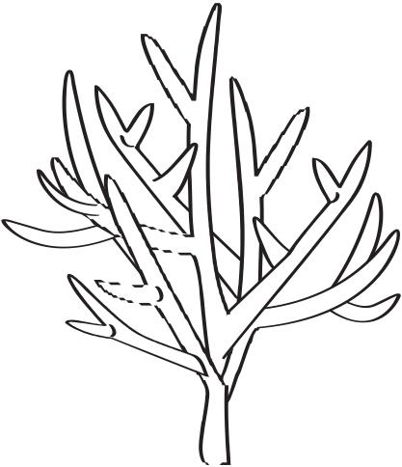
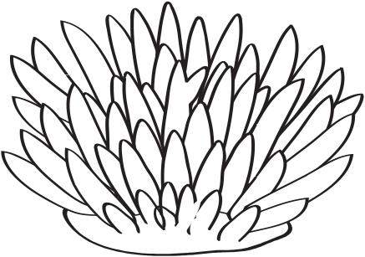
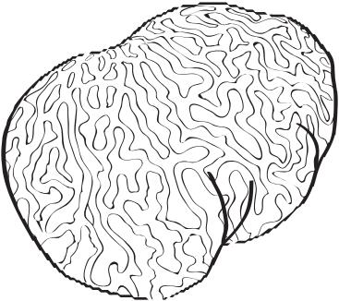
Feeding
Corals employ a variety of methods to obtain their food. Corals use their tentacles to filter and capture plankton and small fish from the water column. Nematocysts (stinging cells) lining the tentacle skin help to paralyse the food so that the tentacles can deliver it to the mouth.
Hard corals, however, gain most of their energy from the tiny algae called zooxanthellae which live inside their skin. The zooxanthellae use the coral as a safe place to live, and in return, can provide the coral with up to 80 per cent of its energy. This is called a symbiotic relationship. This is why it is important for corals to live in shallow waters where they can get lots of sunlight.
Soft corals are much more likely to feed with their tentacles extended during the day than hard corals. Some contain zooxanthellae and appear brown in colour while the bright colours of the spicules are revealed in those without zooxanthellae. Only some species are able to retract their polyps. Some of these can also contract their entire structure when under stress, such as in low tides.

Coral colour
Some corals have pigments in their tissues that give them their orange, yellow, green, blue, red and purple colours. Others get their golden brown colour from the algae (zooxanthellae) that live within their tissues. As light passes through water it is refracted, or bent.
Some colours, such as reds and yellows are lost, i.e., you can no longer see them. The colours left are the blues and greens and this is why the ocean appears a blue colour. The corals you see in many pictures only appear so colourful because the photographer has used artificial lights to capture all the colours of the spectrum.

Coral health
When corals are in suboptimal conditions (water too warm, too fresh or too salty or too much or too little light) they become stressed and can lose their zooxanthellae and end up a white colour. This is known as coral bleaching. The coral actually looks dead but often it is not. High or low temperatures and lack of sunlight can cause a coral to bleach but they can regain the algae into their tissues and their colours can return if stressors are reduced or cease.

Soft coral and hard coral
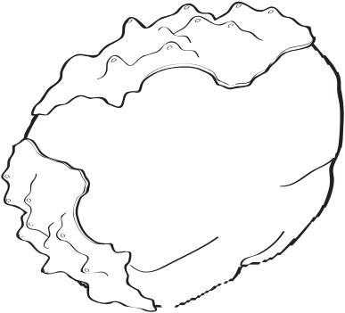
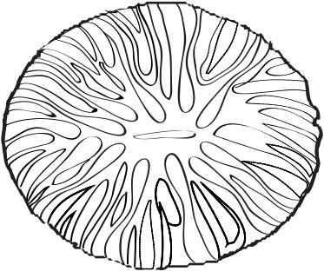
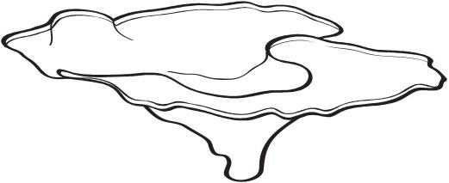
Soft corals have soft bodies made up of a large number of polyps connected by fleshy tissue. They lack the limestone skeleton found on their relatives, the hard coral. The term ‘soft’ is a bit misleading because these corals have numerous tiny, needle-like spicules in their tissues. Apart from their swaying bodies and jelly-like feel, soft corals are distinguished by the eight tentacles on each polyp and have a feathery appearance, whereas hard corals have smooth tentacles.
Soft corals may seem potentially more vulnerable to predators than those hard corals which have a stony skeleton but, in reality, they are not. This is partly because of the presence of the spiky spicules which function like thorns on a rose bush and partly because soft corals contain powerful toxins (terpenes). Underwater, these toxins make the tissues of soft corals either distasteful or toxic to fish. They are also put to use in the constant battle for space. Soft corals introduce them into the water around them where they can kill neighbouring hard corals and repel other soft corals. Soft corals are able to move, very slowly, by extending the tissues at their base. When their route crosses hard coral colonies, they kill the polyps, leaving a white, dead path behind them.

Coral needs
Humans need food, water and shelter to survive. These things are also important to corals but they have other specific needs including:
- preferably clear water, although some corals are able to survive in inshore muddy waters
- shallow water (approximately 0-30m) where they receive adequate sunlight, although they are found deeper than this, as well as in caves
- low nutrient levels
- water temperature ranging 16-35 °C.

Threat
Humans can damage corals by hitting them with anchors, walking on them, accidentally kicking them and polluting sea water. Storms and cyclones can injure, or even kill many corals. Diseases can also kill them and climate change can impact upon them.

Coral predators
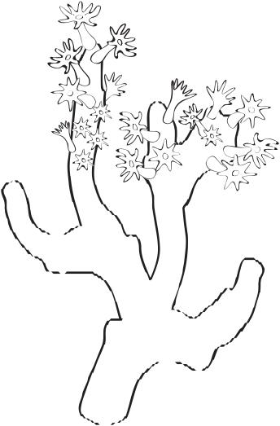
Parrotfish, butterfly fish, angelfish, sea slugs, snails, worms and the crown-of-thorns starfish all eat
corals.

Coral relationships
Crabs, shrimps, fish, eels and worms all live under, or within, a coral colony for protection.

Recognising coral
The easiest way to identify hard corals is by their appearance e.g. boulder, branching, plate, table, vase, bushy, solitary. They can also be described as rock-like, heavy and solid feeling. Hard corals can also be sharp and dangerous.

Protecting coral
It is important to treat corals well so they will be around for a very long time. Never remove or break off a piece of coral. Don’t walk on coral - stick to the sandy areas. When you are in a boat, never anchor on or near a coral reef because the anchor could break the coral.

Resource 8 – Future circles
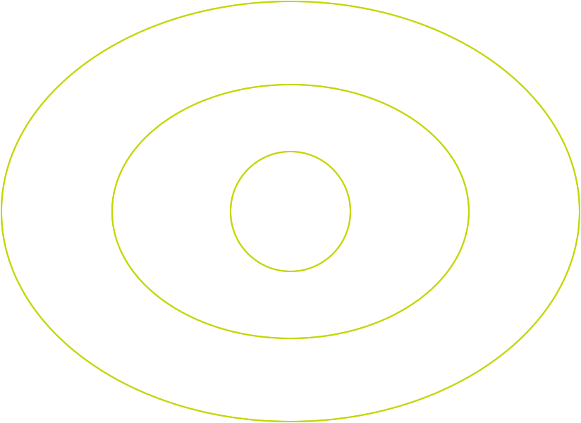
Students identify a certain event. As they move out of the circle, they define what gradually happens due to the event. For more advanced analysis of an event, students look at the N, S, E and W of an event - Natural, Social, Economic and who did it? And/or who will fix it? Students could then go on to investigate how it could be fixed.
Natural impacts
Social impacts
Economic impacts
Who did it?
Who will fix it?
EVENT
IMMEDIATE EFFECT
An immediate result of the event
SHORT AND LONG TERM EFFECTS
Things that happen more slowly over time due to the immediate impacts

Resource 7 – Student task sheet and Guide for making judgements

Coral bleaching – Year 8 information poster

Your task:
You will create an information poster aimed at educating the local community about coral bleaching. On the information poster, you will need to include the following information:
- explain how coral is formed and how it survives on the Great Barrier Reef
- explain the role coral plays in the ecosystem of the Great Barrier Reef
- use your understanding of cell structure and function to explain the process of coral bleaching and what causes it to happen
- provide examples of the short and long terms effects of coral bleaching
- explain which scientific evidence has improved our understanding of coral bleaching and describe what can be done by individuals to help solve the problem.
You will also need to consider design aspects and include pictures or diagrams on your poster to enhance your explanations of coral bleaching on your educational poster.

Year 8 Science: Coral bleaching — information poster | Name:
Purpose: To explain how coral forms and survives and its role in the Great Barrier Reef. Use knowledge of cell structure and function to explain the process of coral bleaching and what causes it to happen. To give examples of long and short term effects of coral bleaching. To explain which scientific evidence has improved your understanding of coral bleaching and describe what can be done by individuals to help solve the problem.
Explains how relationships with other living things and the environment assist or hinder its survival
Science Understanding |  | Science as a Human Endeavour |  | Science Inquiry Skills
Biological sciences |  | Use and influence of science |  | Communicating
Explains how coral forms and survives and its role in the Great Barrier Reef. Uses knowledge of cell structure and function to explain the process of coral bleaching and what causes it to happen. Gives examples of long and short term effects of coral bleaching |  | Explain how science evidence has improved our knowledge of coral bleaching and describe what can be done by individuals to help solve the problem |  | Completes an information poster that uses appropriate language and representations to communicate science ideas
 | - Integrates all explanations with science knowledge |  | - Thorough explanation of how scientific evidence which has improved our knowledge of coral bleaching, has also informed solutions to the problem |  | - Coherently and concisely uses relevant scientific language and representations throughout | A
 | - Links all explanations with science knowledge |  | - Explains how scientific evidence which has improved our knowledge of coral bleaching, has also informed solutions to the problem |  | - Coherently uses relevant scientific language and representations throughout | B
 | - Explains how coral forms and survives and its role in the Great Barrier Reef. Uses knowledge of cell structure and function to explain the process of coral bleaching and what causes it to happen. Gives examples of long and short term effects of coral bleaching |  | - Explains how scientific evidence has improved our knowledge of coral bleaching and describes what can be done by individuals to help solve the problem |  | - Completes an information poster that uses appropriate language and representations to communicate science ideas | C
 | - Partially explains how coral forms and survives. Recalls some knowledge of cell structure and function to partially explain coral bleaching and what causes it to happen. Gives a partial examples of effects of coral bleaching |  | - Statements about what can be done by individuals to help solve the problem of coral bleaching |  | - Completes an information poster that uses everyday language and representations to communicate science ideas | D
 | - Recalls some information about coral, cells, coral bleaching and its effects |  | - Statements about the problem of coral bleaching |  | - Information poster with fragmented use of language and representations | E
Teacher feedback:

