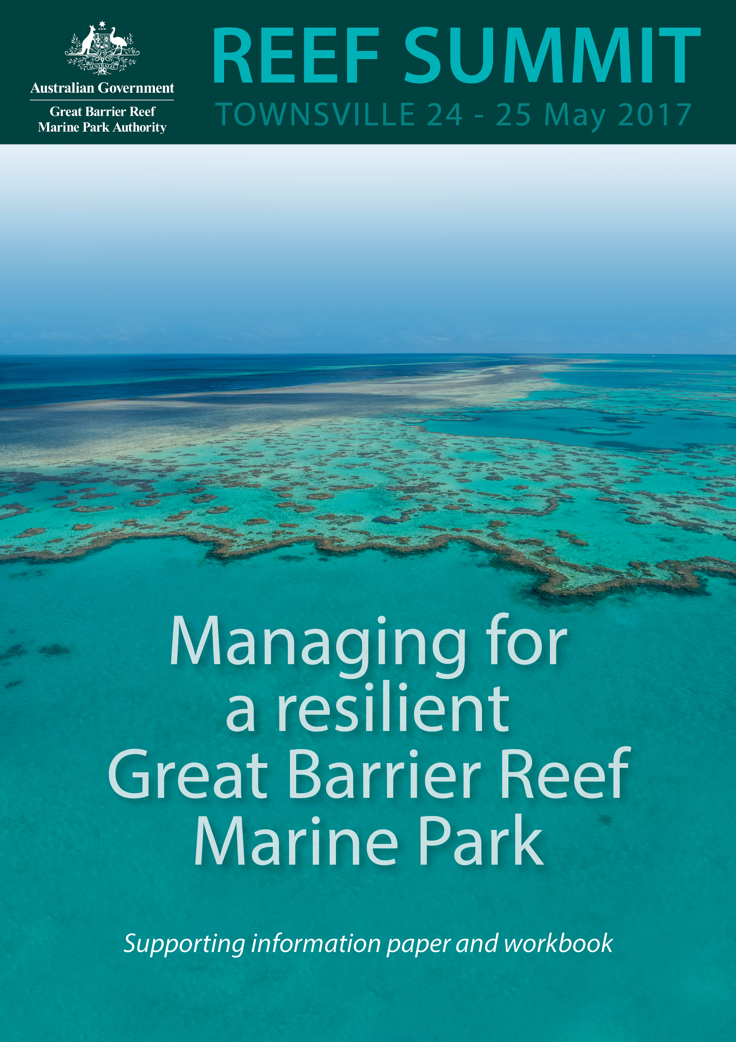

© Commonwealth of Australia 2017
Published by the Great Barrier Reef Marine Park Authority
This publication is licensed by the Commonwealth of Australia for use under a Creative Commons By Attribution 4.0 International licence with the exception of the Coat of Arms of the Commonwealth of Australia, the logo of the Great Barrier Reef Marine Park Authority, any other material protected by a trademark, content supplied by third parties and any photographs. For licence conditions see: http://creativecommons.org/licences/by/4.0


This publication should be cited as:
Great Barrier Reef Marine Park Authority 2017, Managing for a resilient Great Barrier Reef Marine Park supporting information paper and workbook, GBRMPA, Townsville.
Acknowledgements
This discussion paper is based on a collation of information prepared by Reef Ecologic commissioned by the Great Barrier Reef Marine Park Authority.

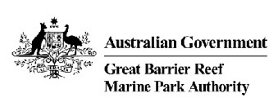
Great Barrier Reef Marine Park Authority
2–68 Flinders Street
(PO Box 1379)
Townsville QLD 4810, Australia

Phone: (07) 4750 0700
Fax: (07) 4772 6093
Email: info@gbrmpa.gov.au
www.gbrmpa.gov.au

The Great Barrier Reef Marine Park Authority acknowledges the continuing sea country management and custodianship of the Great Barrier Reef by Aboriginal and Torres Strait Islander Traditional Owners whose rich cultures, heritage values, enduring connections and shared efforts protect the Reef for future generations.

Contents
1 Introduction: A critical turning point and a blueprint for action 4
1.1 Independent experts and Traditional Owners call for action 7
1.2 Toward a blueprint for the future 8
2 Context: Beyond the crossroad 10
2.1 Building on a legacy of leadership in management 14
2.2 Climate change and marine park management 15
2.3 What’s new? 16
2.4 Why the urgency? 20
2.5 Scale – a critical consideration 22
2.6 What’s needed? 23
3 Coping with change: resilience-based management 24
3.1 What is resilience? 24
3.2 What is resilience-based management? 25
3.3 Why do we need resilience-based management? 27
3.4 Principles for integrating and driving resilience-based management 27
3.5 Tools and approaches for building resilience in the Great Barrier Reef context 30
3.6 Improving current tools 30
3.7 Resilience-based management: across sectors and coral reefs 32
3.8 Making the investment case for interventions: the “resilience dividend” 36
4 The response: ingredients of success 37
4.1 Innovation 37
4.2 Optimise existing tools and approaches 40
4.3 Enablers 42
5 Toward a blueprint for a resilient Great Barrier Reef 57
References 59
Further reading 60
Appendix A: Management tools employed by the Great Barrier Reef Marine Park Authority 62
Appendix B. Drivers, pressures and impacts 66
Appendix C. Approaches that can be used to assist understanding barriers 69
Notes and end-of-day reflections 70

Introduction: A critical turning point and a blueprint for action

The Great Barrier Reef Marine Park Authority (the Authority) looks after one of the world’s most spectacular natural treasures — a World Heritage Area renowned for its stunning beauty and diversity of marine life and habitats.

For more than 40 years it has been our great privilege to manage the Great Barrier Reef for its long-term protection and conservation on behalf of all Australians and the world. The Authority provides independent technical and policy expertise to advise the Minister and Australian Government on the long-term and day-to-day management of the Great Barrier Reef Marine Park and World Heritage Area. We have a proud tradition of adapting our management arrangements to address the highest risks (Table 1).

Our work is informed by the best available science, ecological knowledge shared by Traditional Owners whose connections with the Reef go back more than 60,000 years, and insights from the communities and industries that live and work in the Great Barrier Reef Region.

However, over the last few decades the Authority, together with partners from government, community, Traditional Owners, industry and science sectors, has witnessed a rapidly changing landscape of pressures, system-shocks and management expectations. Like all coral reefs around the world, the Great Barrier Reef is under increasing pressure from a range of sources, particularly climate change, a symptom of which is the 2016–2017 mass coral bleaching event, the worst the Reef has experienced.

The cumulative effects of these changes are impacting the resilience of the coral reef system and we are witnessing a large-scale shift in the ecosystem and decline in its condition. There is now an urgent need to review, rethink and substantively escalate our collective management approach.

As Marine Park managers our top priority is building the Reef’s resilience so it can tolerate and recover from serious disturbances such as mass coral bleaching and cyclones.

The crisis is on a global scale: all around the world coral reefs are declining, many precipitously, as accelerating changes in climate bring shocks to systems already under pressure.

Pressures originate at local, regional, Marine Park, catchment and global scales. These pressures and impacts do not operate in isolation — they overlap and interact with each other – and their accumulation over time and space diminishes the resilience of the Reef’s ecosystem and its ability to recover from disturbance. While some habitats are less affected, corals — the engine room of the Reef ecosystem — are already experiencing the effects of climate change.
A crisis
Crisis means different things to different people. When written in Chinese, the word 'crisis' is composed of two characters: one represents danger and the other represents opportunity.

Let’s acknowledge the threats and grasp the opportunity for increasing the resilience of the Great Barrier Reef and our communities.


The impact is not just on the Great Barrier Reef ecosystem, but also on the cultural values of Traditional Owners; economic values to the tourism and fishing industries which rely on a healthy Reef; social values for communities along the coast for whom the Reef is part of their daily life; and the broader Australian and international community who consider it to be an irreplaceable icon — belonging to the global community.

It is critical for reefs worldwide, including the Great Barrier Reef, that local, regional and global efforts to reduce greenhouse gas emissions are effective. While Australia is a partner in international action to reduce greenhouse gas emissions through the Paris Climate Agreement, this needs to be supported by improving the Reef’s resilience to climate change through reducing local pressures.

This underscores the need for integrated actions at different spatial and time scales to mitigate and manage their impacts on the Great Barrier Reef.

Improving management of cumulative impacts to reduce pressures, together with actions which improve the resilience, is critical to the future health of the Great Barrier Reef.

While we are not alone in facing this challenge, Australia is well-placed to tackle it. The importance we place on the Reef — to our identity, heritage, culture, reputation and economy — brings unparalleled, social, technological and economic capacity, which provides both incentive and ability to catalyse the necessary management transformation.

This document summarises recent events that have led to the current situation, which create a compelling case for urgent, decisive action. It acknowledges the strong legacy of management and leadership that lay the foundations for an effective response, setting the stage for insightful analysis, interactive discussions and innovative thinking that we hope will characterise deliberations during the Reef Summit: Managing for Resilience.

Table 1: Chronology of key management responses to emerging issues from the 1970s to the present. Since 1975, the Authority and its partners have continually adapted its management arrangements to address the highest risks. (Adapted from Table 1.1, p 1-8 of the Great Barrier Reef Region Strategic Assessment Report)
1970s | 1980s | 1990s | 2000s | 2010s
- Great Barrier Reef Marine Park Act 1975  - Great Barrier Reef Marine Park Authority established  - Intergovernmental Agreement — Emerald Agreement | - Inscribed on World Heritage List  - Marine Park sections proclaimed and zoning plans developed  - Joint field management arrangements with Queensland established  - Research and monitoring programs initiated | - 25 Year Strategic Plan  - Plans of management for Cairns Area and Whitsundays  - Compulsory pilotage  - Dugong Protection Areas  - Environmental management charge  - Cooperative Research Centre  - Eye on the Reef monitoring and stewardship program | - Great Barrier Reef Marine Park Zoning Plan (representative areas program)  - Plans of management for Hinchinbrook and Shoalwater Bay  - Reef Water Quality Protection Plan  - Aquaculture Regulations  - Traditional Use of Marine Resources Agreements and sea country partnerships  - Site Management Arrangements  - Best practices and stewardship  - Reef Guardian program  - Great Barrier Reef Climate Change Vulnerability Assessment and Action Plan  - Outlook Report 2009  - Great Barrier Reef Inter-governmental Agreement  - Research partnerships | - Reef 2050 Plan  - Climate Change Adaptation Strategy  - Informing the outlook for Great Barrier Reef coastal ecosystems  - Biodiversity Conservation Strategy and vulnerability assessments  - Great Barrier Reef Region Strategic Assessment  - Cumulative impact management policy – (in prep)  - Net benefit policy – (in prep)  - Resilience-based management  - Intervention policy – (in prep)  - Reef Health Incident Response System  - Reef Integrated Monitoring and Reporting Program  - Crown-of-thorns-starfish control

Independent experts and Traditional Owners call for action
The seventh meeting of the Reef 2050 Plan Independent Expert Panel was held on 5 May 2017 to develop advice on protection of the Great Barrier Reef in light of widespread coral bleaching in both 2016 and 2017. The communiqué from the meeting presents a succinct summary of the current situation and the imperative for action:
…coral bleaching since early 2016 has changed the Reef fundamentally. There is great concern about the future of the Reef, and the communities and businesses that depend on it, but hope still remains for maintaining ecological function over the coming decades.
…in our lifetime and on our watch, substantial areas of the Great Barrier Reef and the surrounding ecosystems are experiencing major long-term damage which may be irreversible unless action is taken now. The planet has changed in a way that science informs us is unprecedented in human history. While that in itself may be cause for action, the extraordinary rapidity of the change we now observe makes action even more urgent.
…action to reduce emissions of greenhouse gases must be central to the response. This needs to be coupled with increased efforts to improve the resilience of the coral and other ecosystems that form the Great Barrier Reef. The focus of efforts should be on managing the Reef to maintain the benefits that the Reef provides.
The Indigenous Reef Advisory Committee met on the 16–17 May 2017 and voiced concerns about the state of the Reef and encouraged international experts to share their knowledge and best practice. The committee prepared a statement which will be read at the Summit.
The Reef 2050 Advisory Committee is meeting on 19 May 2017 to consider advice from the Independent Expert Panel and provide stakeholder guidance on actions in response to the coral bleaching and other cumulative pressures on the Reef.
Reef 2050 Plan  A shared pathway for the future management of the Reef  The Authority has a lead role in delivering foundational Reef management programs, as well as over half of the actions identified in the Reef 2050 Plan. We deliver most of these actions in partnership with others including Traditional Owners, other government agencies, industry, researchers and community groups. Advice from the Reef 2050 Independent Expert Panel and Advisory Committee, together with outcomes from the Summit, will inform future actions under the Plan.  The Plan provides an overarching strategy for management for the Reef and a framework for partners to work together to stengthen and develop initiatives for the Reef. | 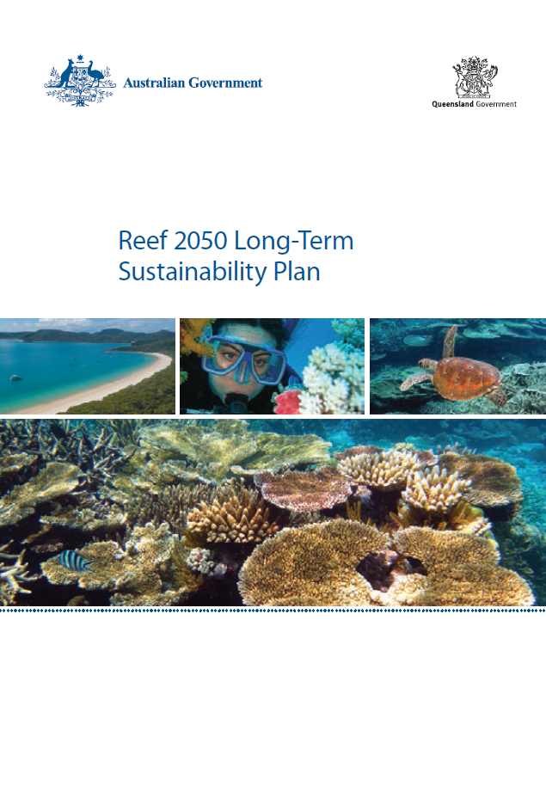

Toward a blueprint for the future

  - The diversity, frequency, and scale of human impacts on coral reefs are increasing to the extent that reefs are threatened globally. Projected increases in carbon dioxide and temperature over the next 50 years exceed the conditions under which coral reefs have flourished over the past half-million years. However, reefs will change rather than disappear entirely, with some species already showing far greater tolerance to climate change and coral bleaching than others. International integration of management strategies that support reef resilience need to be vigorously implemented, and complemented by strong policy decisions to reduce the rate of global warming.
  - Hughes et al., Science 2003

The need for further action is clear. We must do things differently, smarter, with more commitment, more resources, and more of us involved. The Reef Summit: Managing for resilience is the launch pad for new ideas and a reinvigorated approach to managing the Great Barrier Reef Marine Park.

This document provides background information, introduces concepts and ideas, and provides spaces to capture your thoughts, all with the goal of helping participants maximise their contribution to the important discussions ahead.

We welcome your input and feedback on its content which, together with the outcomes from the summit, will inform the production of a Great Barrier Reef: managing for resilience report.

The Summit will not solve all of the problems facing the Reef in two days, but we hope that it draws on the strong legacy of leadership and innovation to establish a blueprint to refine and enhance our Reef management.

We all need to work together to ensure the resilience and functionality of this natural wonder is sustained for generations to come.

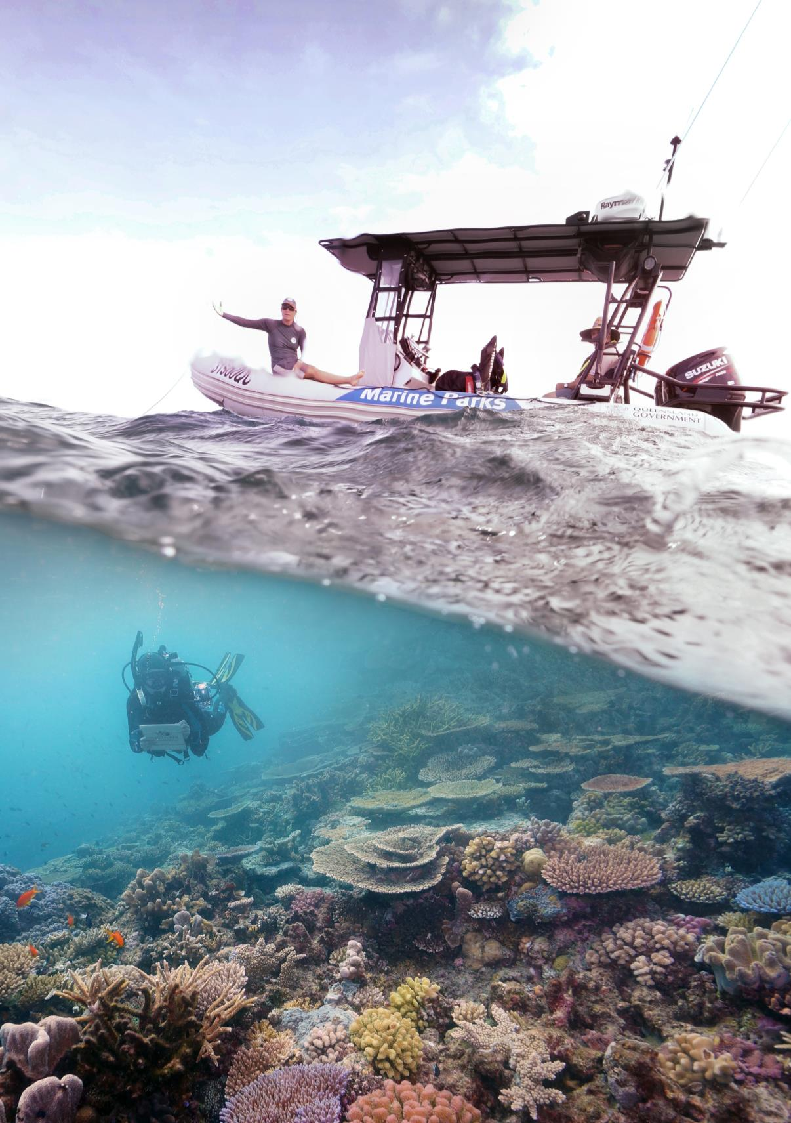

Context: Beyond the crossroad

The 2009 Great Barrier Reef Outlook Report stated the Reef was at a crossroad. Severe bleaching events, accumulating local pressures from human activities on land and sea, and projected trends in climate and patterns of use, highlighted the importance of decisions made in subsequent years to the Reef’s long-term future.

The 2014 Great Barrier Reef Outlook Report presented evidence that continuing investment in management of the Reef was producing positive results. For example, the zoning plan was delivering a range of benefits, pollutant loads entering the Reef had measurably reduced, and Traditional Use of Marine Resource Agreements had recognised contemporary management practices which incorporated traditional knowledge with the latest science. However, it was clear that the outlook for the Great Barrier Reef had declined, and was even then assessed as poor.

Climate change, declining water quality from land-based run-off, impacts from coastal development, and some fishing impacts remained major threats to the future vitality of the Great Barrier Reef. A series of major storms and floods leading up to the publication of the 2014 Outlook Report established a trend of increasingly frequent shocks to an ecosystem already under pressure. Predictions that the accumulation of all impacts on the Reef would further weaken its resilience prompted warnings that urgent action was needed to restore the Reef’s ability to cope with serious disturbances, such as major coral bleaching events, in the future.

In the past two years, the resilience of the Great Barrier Reef has faced the greatest test yet in the form of an unprecedented combination of system impacts: two consecutive years of mass coral bleaching, coral disease outbreaks and a category 4 tropical cyclone which crossed reefs in the Whitsundays. Last year, after the peak temperatures in March, 67 per cent of the corals died along a 700 kilometre northern section of the Reef — potentially the single greatest loss of corals ever recorded on the Reef. Adding to these climate-related impacts is the major crown-of-thorns starfish outbreak, which has been ongoing since 2012.

The amount of coral mortality resulting from the most recent bleaching event is still being determined, but the combined footprint of reefs affected by the back-to-back bleaching events covers two-thirds of the length of the Great Barrier Reef. The impacts of cyclone Debbie are also still being assessed, but early reports indicate that the slow-moving and powerful cyclone caused extensive damage to many reefs in its track. A key focus of the damage assessments for these events is to identify less impacted areas of reef, as these are especially important to the ability of the ecosystem to recover (ecological resilience), as well as supporting the capacity of Reef-dependent industries (especially tourism) to adapt (social resilience).

The rapid succession of severe impacts sharpens our concern about the future of the Great Barrier Reef and the need to reshape our approach to marine park management. Badly damaged reefs need 10 to15 years — or longer — for substantial recovery, so projections for increasingly frequent coral bleaching events and greater probability of severe cyclones each summer point to a dynamic future where many coral reef areas will be almost constantly in a state of recovery. Recent events and future projections emphasise the need for a new approach.

These events also have a human dimension. The Great Barrier Reef is a vital source of ecosystem services that underpin billions of dollars of economic activity each year and incalculable non-economic benefits such as recreational opportunities, shoreline protection, deep-rooted cultural heritage and community wellbeing. While humans are profoundly adaptable, and key industries such as tourism remain vibrant, recent declines signal tough times ahead as Reef-dependent businesses and individual users are forced to adapt to changing conditions. Building social resilience is going to be as important as our efforts to support ecosystem resilience if we are to successfully navigate the current situation.
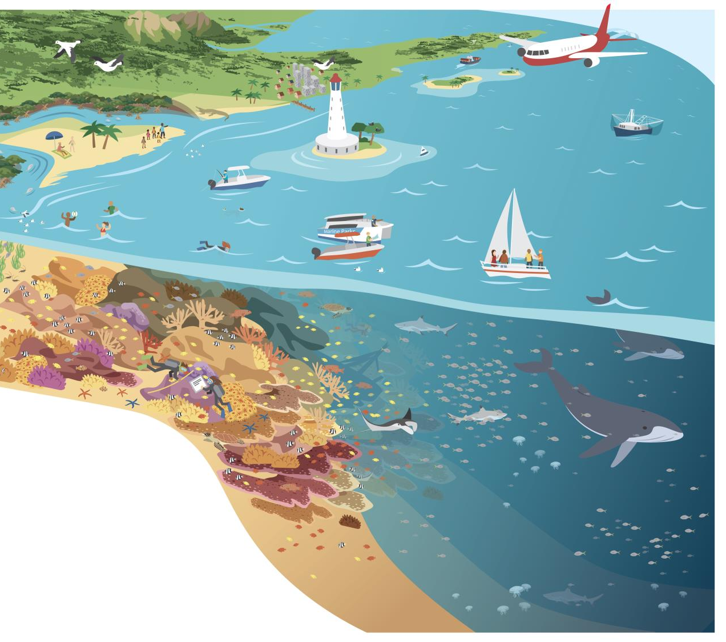

Figure 1:
The Great Barrier Reef is a large, diverse, biocultural, multiple use marine protected area.

A summer of severe impacts – an update on current conditions

This year’s bleaching event is a continuation of the 2016 event, the worst on record for the Great Barrier Reef. Triggered by a strong El Niño and high ocean temperatures associated with climate change, the mass bleaching is part of the ongoing global event affecting the world’s coral reefs since 2014.

During 2016, the extent and severity of bleaching varied greatly across the Marine Park with the most severe bleaching occurring in the far north above Port Douglas, the area experiencing the most coral mortality. Only minor bleaching was detected in the southern part of the Marine Park.

Reports to-date indicate bleaching during 2017 is widespread but variable, with the most severe bleaching in the central region of the Marine Park between Townsville and Cairns. Surveys and data analysis are still underway.

During March 2017, severe tropical cyclone Debbie crossed the Great Barrier Reef making landfall in the Whitsunday Islands. While it is too early to assess the environmental impact of the cyclone, its key attributes — large, intense and slow moving — indicate it is likely to have caused considerable damage to many reefs and other marine environments in the central region of the Great Barrier Reef. Nonetheless, even in the impact zone, there are likely to be patches of undamaged reef. These will be critical to the recovery process.

On top of these system shocks, coral disease and crown-of-thorns starfish outbreaks are also causing coral losses primarily in the northern and central regions of the Marine Park. These cumulative impacts make the protection of the remaining coral in these areas a top priority.

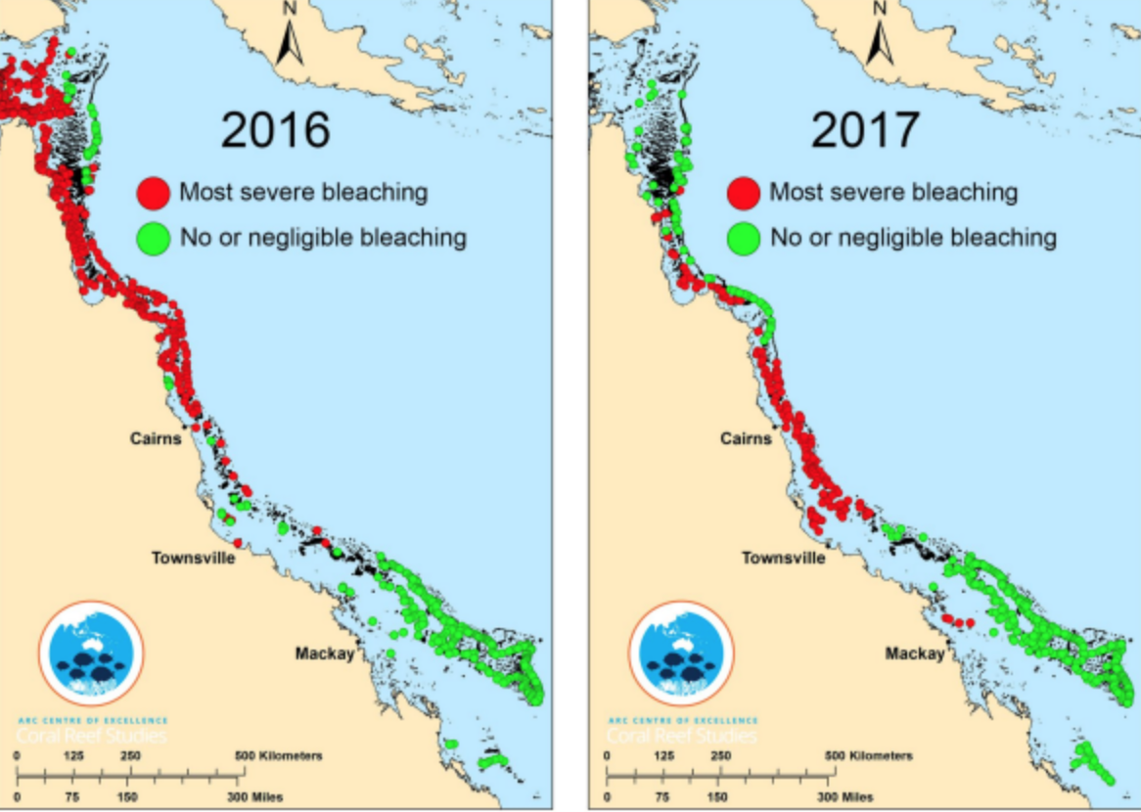
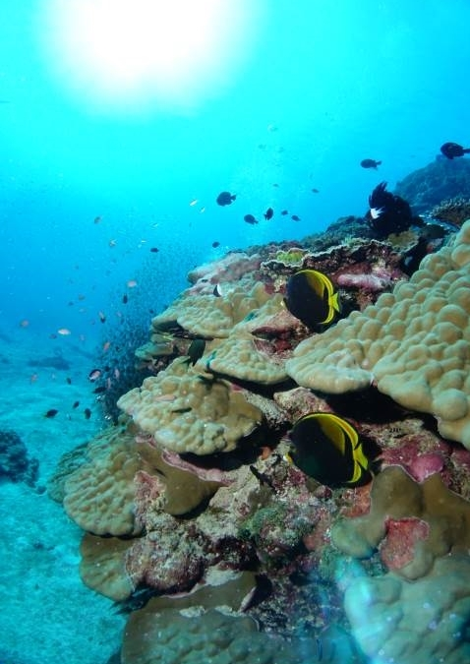

Building on a legacy of leadership in management
Recent events have not come as a surprise.

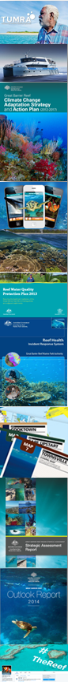
For over a decade the Authority, together with its partners, has been evolving and adapting management of the Reef in the face of growing evidence of accelerating climate change, and the escalating vulnerability of the ecosystem and the people who depend upon it. This work builds on our foundational management programs.

The Authority assesses risks to the Reef, works with partners and research providers, and educates the community about the Reef’s natural beauty and actions needed to improve its resilience.

The Great Barrier Reef Marine Park Zoning Plan and associated legislation is the foundation of our management which underpins the Reef’s resilience. The zones, designed to protect the Marine Park’s range of biodiversity, operate as a connected network and are delivering a range of benefits for coral reef resilience.

Field management actions, which the Authority implements in partnership with the Queensland Parks and Wildlife Service, covers upholding compliance with the Zoning Plan, responding to incidents, welcoming people to the Marine Park, engaging with Aboriginal and Torres Strait Islander people and delivering direct conservation actions to protect and recover important natural and cultural values. In-park activities also include installing Reef protection markers and moorings.

We work closely with the traditional custodians of the Great Barrier Reef, Traditional Owner groups, particularly through Traditional Use of Marine Resources Agreements that cover about one-quarter of the coast of the Marine Park.

The Marine Park Authority’s stewardship and partnership approaches create awareness and support people to take action to protect the Reef’s values. This provides a strong foundation for maintaining a balance between protecting the Reef, managing competing demands and supporting sustainable use.

The Authority’s comprehensive management is underpinned by a knowledge base that drives our adaptive approach, focusing on managing cumulative impacts in the face of climate change. We use the best available information to inform our management approaches and report on its effectiveness, including scientific, monitoring and modelling data, together with Traditional Owner and stakeholder knowledge.

Climate change and marine park management
In 2007, the Authority coordinated production of the Great Barrier Reef Vulnerability Assessment, which highlighted that climate change would have far-reaching consequences for the Reef. This provided the impetus and knowledge base for the Great Barrier Reef Climate Change Action Plan 2007-2012, which guided five years of innovative actions and partnerships to build resilience in the ecosystem, and the communities and industries that depend upon it.

The first Outlook Report, released in 2009, conveyed the clear message that climate change is the dominant driver of the long-term future of the Reef, and that its outlook depended strongly on global efforts to mitigate climate change and local efforts to build resilience.

A report on the Outcomes from the Climate Change Action Plan summarised successes and lessons from over 250 projects, positioning the Authority at the leading edge of efforts to understand, test and implement adaptation options to help the Great Barrier Reef cope with climate change.

Among these was the development of the Authority’s Reef Health Incident Response Systems that enables the agency to detect, assess and respond to climate change driven disturbances including coral bleaching, coral disease and cyclone impacts together with crown-of-thorns starfish.

The Biodiversity Conservation Strategy released in 2013 highlighted that inshore habitats were among the most at risk from the cumulative pressures of local stressors and climate change, and signaled an urgent need to focus resilience-building efforts on these highly vulnerable areas.

The Great Barrier Reef Outlook Report 2014 and the Great Barrier Reef Region Strategic Assessment 2014 drew upon the most up-to-date information and research to systematically assess the key threats to the Reef, and the effectiveness of management to address those threats. Climate change remained the greatest threat to the long-term health of the Reef.

The Strategic Assessment also made recommendations on how management could be improved to address those threats.

These reports and recommendations have been key inputs to the Australian and Queensland governments’ Reef 2050 Plan which builds on existing management to provide a national approach for protecting and managing the Reef.

While recent events highlight the need to revisit and adjust our strategic plans for managing the Great Barrier Reef, the legacy of previous planning and management programs provide a strong foundation for an effective response to the deteriorating condition of the Reef.

What’s new?
Never in the 40-year history of the Reef’s management have we seen the Reef exposed to so many severe and extensive impacts. Particularly alarming is the loss of so much coral in the Far Northern region during the 2016 coral bleaching event. Up until that point, the Far North was a ‘bright spot’ for the Reef. While key habitats, species and ecosystem processes in central and southern inshore areas had deteriorated from the cumulative effects of impacts, the northern third of the Great Barrier Reef Region shone out as a refuge with good water quality and an ecosystem in good condition. These recent events drive a step-change in our level of concern about the future of the Great Barrier Reef, and in our imperative to act.

The imperative to address climate change

Greenhouse gas emissions are already causing air and ocean warming that, in the past two years, has caused the onset of oceanic heat-waves leading to the largest scale loss of corals recorded in the management of the Great Barrier Reef.

Without the strongest possible climate change mitigation, climate change impacts on coral reefs are predicted to worsen and affect the survival of coral reefs globally.

Minimising climate change-related threats to coral reef habitats necessitates immediate and substantial reduction of greenhouse gas emissions.

Keeping within the 1.5 degrees Celsius goal of the Paris Agreement will help maximise future environmental, economic, social and cultural values of coral reefs.

The Reef has shown it has an ability to repair itself and has done so previously. The 2004 enhancement of the protected area network, improving the Reef’s water quality, culling crown-of-thorns starfish and increasing compliance are critical to boosting the Reef’s resilience and its ability to repair and regrow. However, we are moving into uncharted territory.

Fortunately, as the impacts have been escalating, our knowledge and capacity has also been expanding. Coral reef scientists and managers around the world have been testing, refining and deploying strategies aimed at building the resilience of reefs to climate change impacts and other future disturbances.

In the Great Barrier Reef many conventional management tools have been adapted and improved to increase their effectiveness in dealing with compounding challenges. Examples include: application of special management areas for targeted protection of threatened species such as dugong; and improved uses of infrastructure, such as moorings, marker buoys and fences to deliver important gains in resilience for local coral reefs and nesting turtles on islands.

Novel tools are also being developed that have the potential to underpin a new wave of resilience-based management. Dynamic exposure maps have been compiled that demonstrate our ability to spatially analyse cumulative threats. Combined with sophisticated new models of oceanography and biological connectivity, this for the first time, provides managers with the ability to operationalise a broad range of resilience-building ideas. Although still only developmental, these products are enabling sophisticated targeting of crown-of-thorns starfish control to deliver one of the most promising Reef-wide resilience-building measures yet attempted.

Care of the Reef is a shared responsibility. People from all walks of life are taking a greater interest and active role in management, stewardship, citizen science and advocacy for the Reef. The call for action has been heard and we need to translate this call into programs that can grow awareness, enhance partnerships and harness the knowledge, skills and resources of all those willing to act.

Exposure and connectivity mapping for resilience-based management
Management that incorporates knowledge of spatial patterns in disturbance exposure has the best chance of delivering resilience benefits (Game et al. 2014, Mcleod et al. 2008). Maps can represent cumulative pressures, reveal underlying spatial patterns of impact, identify locations of potential refugia and evaluate the effectiveness of spatial management (Maynard et al. 2015). Annual (dynamic) exposure maps can guide impact assessments and direct management actions in response to incidents.  The benefits of exposure mapping can be further enhanced if they are combined with connectivity maps based on hydrodynamic modelling. Connectivity is a core component of Reef resilience as it underpins coral recruitment.  Recent advances in computing, modelling and remote sensing technologies have enabled connectivity maps of the Great Barrier Reef. Network theory (an approach that is commonly used to map the spread of human disease epidemics) combined with hydrodynamic data can help identify reef locations that have extensive connections (Hock et al. 2014).  Dynamic mapping of exposure and connectivity enables managers to move beyond risk management in protected area design, toward identifying probable refugia that are most likely to benefit from enhanced strategic and tactical management. | 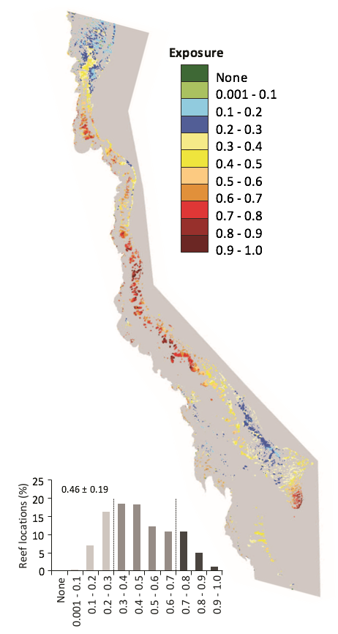  Relative frequency of disturbances is based on averaging the frequency values for the four disturbances using available data: coral bleaching, cyclones, and freshwater inundation. The histogram represents the proportion of reef locations with low (<0.3), medium (≥0.3 ≤ 0.7) and high (>0.7) relative exposure (Maynard et al. 2015)

Resilience-based management of the Great Barrier Reef Marine Park:
crown-of-thorns starfish control

The use of new technologies to target crown-of-thorns starfish (COTS) control activities represents the first large-scale resilience-based management action in the Great Barrier Reef Marine Park that can be scaled and adapted to support coral reef ecosystem resilience as the situation changes. COTS are a native coral predator found throughout the Great Barrier Reef and on reefs around the world. In the Marine Park major outbreaks have been recorded around every 17 years and the impact of COTS predation is recognised as one of the primary drivers of coral mortality (Osborne et al 2011, De’ath et al. 2012). Emerging technologies such as hydrodynamic modelling and network analysis have been deployed to identify reefs that are more likely to contribute to an outbreak once it is initiated (Hock et al. 2014). This new approach (Hock et al. 2016) is being used in concert with enhanced culling techniques (Bostrom-Einarsson and Rivera-Posada 2016) and field assessments to target control program activities to meet management objectives.

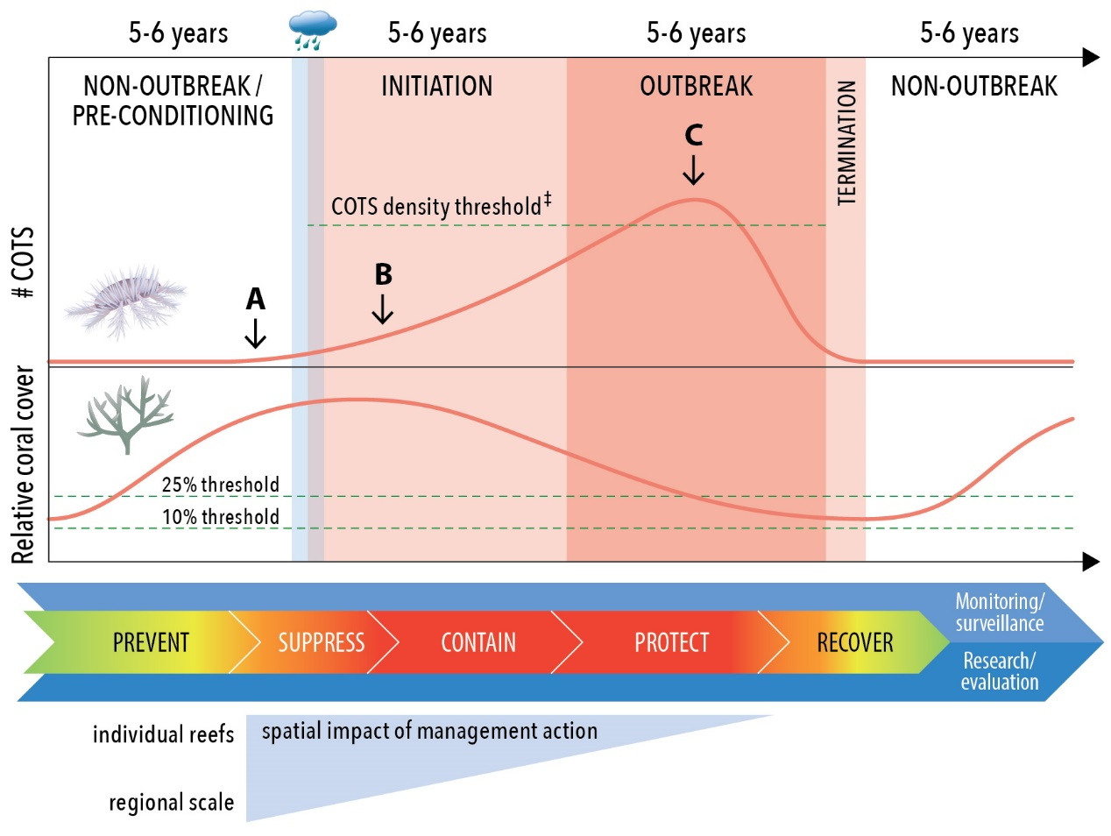

Outbreak management objectives are adapted based upon the COTS outbreak stage and the degree to which early stages have been addressed. Similar to bushfire management principles, once an outbreak is initiated, early intervention (A) is targeted to suppress the spread of the outbreak; if that is unsuccessful (B) containment becomes the objective, followed by asset protection (C) if a large-scale outbreak occurs. Source: Great Barrier Reef Marine Park Authority Crown-of-Thorns Starfish Management Strategy (in review)

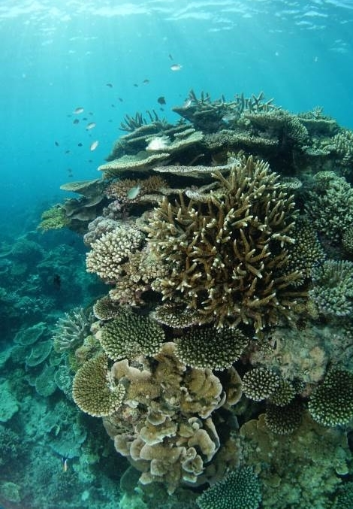

Why the urgency?
The 2016 and 2017 mass coral bleaching events and the damaging passage of cyclone Debbie have compounded the cumulative impacts of the past decade, which include a series of severe tropical cyclones, an ongoing crown-of-thorns starfish outbreak and an increasing prevalence of coral disease. Given that a healthy coral reef can take 10 to 15 years or longer for substantive ecological recovery after a major impact, the unprecedented frequency of these impacts portrays clearly the importance of urgent action to build the Reef’s resilience and maintain its functionality.

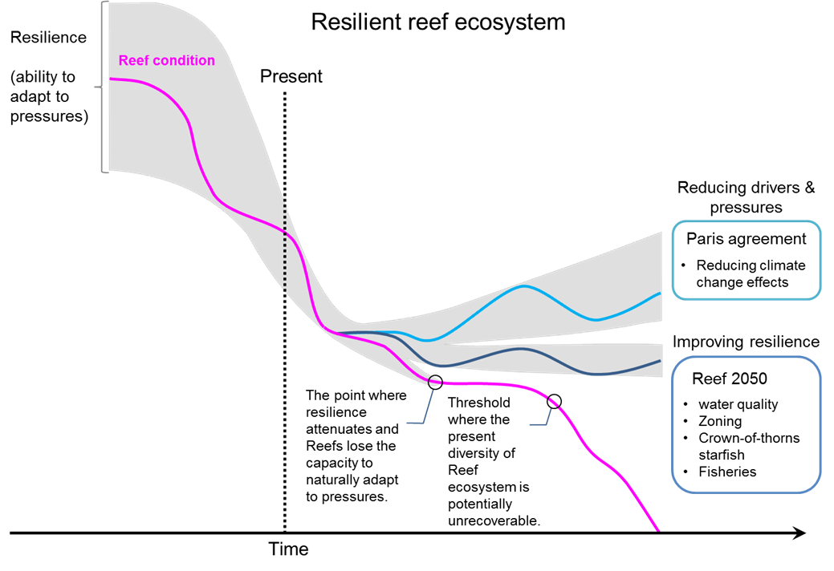
Figure 2: Identifying scenarios in managing for Reef resilience

Importantly, the consequences of the ecological decline extend beyond impacts to intrinsic biodiversity and ecosystem health values. Impacts to the Reef’s health translate to socioeconomic risks, particularly for the tourism industry. The Great Barrier Reef is also central to the identity and wellbeing of many Australians, and is widely regarded internationally as a natural asset of global significance. Allowing it to decline further without committing every effort to help it cope with the challenges ahead is not an option.

While global trends in key drivers such as climate require us to take a long-term view of the rate at which we will realise benefits from our investments in building resilience, any further delays in action will only compound the damage. Worse, delays in action could allow the Great Barrier Reef to decline to such a point that it loses its ability to recover (as it crosses a resilience threshold; Figure 2). Urgent action is required if we are to minimise further losses and give the Reef the best chance of survival. We need to take action now to reduce the highest risks and major drivers of decline (see Figure 3). Even with direct action there will be a time lag (of up to 20 years) before some benefits are realised (Figure 4). This requires us to invest in a suite of actions such as crown-of-thorns starfish control and restoration activities to maintain system functionality in the short to medium term.
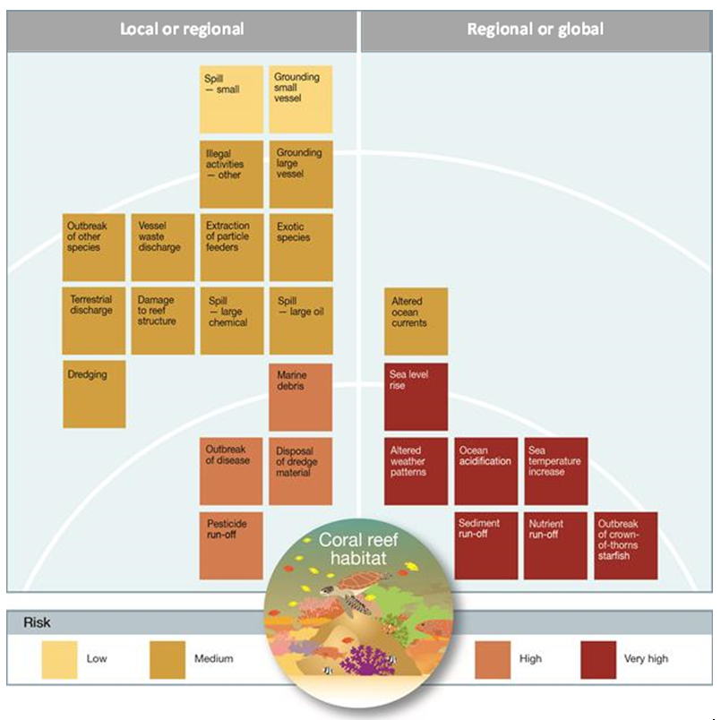
Figure 3 – Cumulative effects of drivers and impacts on coral reef habitats (adapted from p.261 of the Great Barrier Reef Outlook Report).

Scale – a critical consideration
The drivers and impacts affecting coral reefs occur at a range of temporal and spatial scales and their recovery periods vary based on the type of impact. This is a key consideration in formulating a response to build resilience.
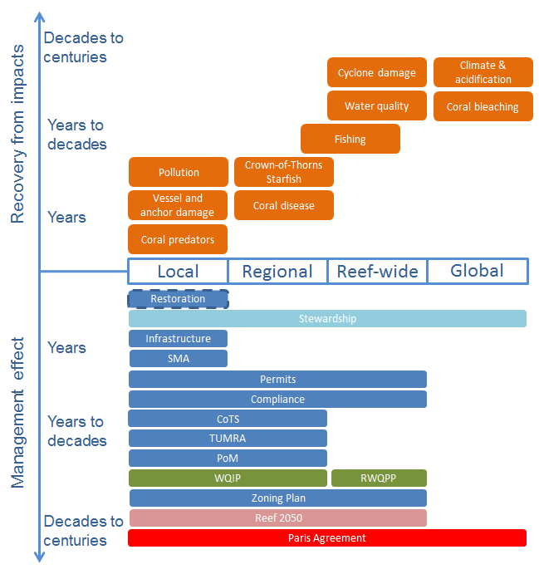

Figure 4: Conceptual timescales for recovery from impacts and management interventions across a range of spatial scales.

SMA—special management areas; COTS—crown-of-thorns starfish; TUMRA—Traditional Use of Marine Resource Agreements; POM— Plan of Management; WQIP—Water Quality Improvement Plan; RWQPP—Reef Water Quality Protection Plan.
When prioritising and implementing management responses, it is critical to be realistic about the spatial and temporal scale (including any time lags) at which the management action will take affect and produce outcomes (Figure 4).

Ideally, a package of response actions should consider the cumulative effect of multiple drivers and impacts and system responses, and actions should be nested across scales. For example: reducing greenhouse gas emissions, crown-of-thorns starfish control and best practice anchoring represent a suite of nested actions designed to tackle impacts on coral reef habitats, together with the social and economic benefits they provide, at global, regional and local levels.

What’s needed?
While the Reef has changed over decades, the accelerating change over the last two years raises particularly important questions about our current approach to management. We are entering a new paradigm of marine park management that will require greater innovation to support resilience of the Reef.

Responding to new challenges requires new thinking. There has been a growing recognition by coral reef managers globally that business-as-usual approaches are not adequate to address the rapidly changing landscape of risk. Innovation needs to become a central and ongoing element of our approach to managing coral reefs. Management and decision-making needs to be forward-looking, responsive, flexible and adaptive to deal with change and uncertainty. Importantly, innovation, adaptability and resilience need to be institutionalised through adoption of a resilience-based management approach.

The response to the Great Barrier Reef crisis must build on the strong foundation of past and current programs of action, but bring new tools and innovative approaches that can transform the outlook for the Reef. A blueprint for transforming marine park management of the Reef must therefore include innovative approaches to the use of existing tools, as well as truly novel ideas and new tools.

The following sections provide an overview of resilience and the concept of resilience-based management (Section 3), and introduces a range of ideas and frameworks that are likely to be important ingredients (Section 4) in developing a successful response to the current events.

This document concludes with an introduction to the idea of a ‘blueprint’ (Section 5) as an output from the Summit that can capture ideas and recommendations for improving resilience of the Great Barrier Reef.

Coping with change: resilience-based management
Resilience-based management
– a working definition

Using resilience principles and knowledge of current and future human and ecosystem drivers to identify, prioritise, implement and adapt management actions to sustain ecosystem resilience and human wellbeing.
The increasing rate of change, and future uncertainty, create pervasive new challenges for the management of coral reefs. Resilience has emerged as a central concept for framing and designing coral reef management in the face of change and forms part of the Authority’s adaptive management approach.

This section provides an overview of the concepts of resilience and resilience-based management, and reviews current and potential benefits of using resilience as an organising principle for a sustained response to current events.

What is resilience?
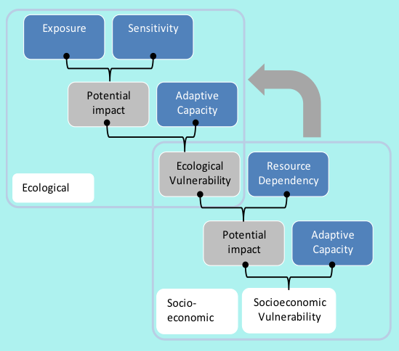
Resilience refers to the capacity of a system to resist and recover from disturbance, and undergo change while still retaining essentially the same function, structure and integrity. It is not about a single, static state, but rather the capacity of an ever-changing, dynamic system to return to a healthy state after a disturbance or impact. It is a concept that is applied to both natural and social systems — from habitats and species, to communities, businesses and social assets.
Figure 5 Illustrating vulnerability, and the links between socio-economic and ecological vulnerability. Resilience is the combination of sensitivity and adaptive capacity (ecological) or resource dependency and adaptive capacity (socio-economic). From Marshall et al. 2013.

Resilience (sensitivity and adaptive capacity) is a way of describing the properties of a system and how it responds to exposure to disturbance.

Together with exposure, resilience helps determine a system’s overall vulnerability. Resilience and vulnerability are related concepts which are key to understanding and assessing linkages between the Reef ecosystem and the social system (individuals, communities and industries) (Figure 5).

Understanding and measuring resilience has been an increasingly important focus for research. These advances have enabled important progress in our efforts to operationalise resilience, leading to a rapidly accelerating community of practice among coral reef managers who are using resilience to inform and shape efforts to protect biodiversity and sustain delivery of ecosystem services. While still developmental in most places, resilience-based management is increasingly being utilised as an approach for managing coral reefs in times of change and uncertainty.

What is resilience-based management?
Resilience-based management uses principles and knowledge of current and future drivers of human and ecological systems to identify, prioritise and implement actions to sustain ecosystem resilience and human wellbeing. Due to the inescapable uncertainty and changing conditions facing coral reefs, resilience-based management also must be adaptive (Anthony et al. 2015).

Resilience-based management will not future proof coral reefs against the impacts of climate change. However, decision makers and stakeholders across a vast diversity of endeavours are turning to resilience as a way of planning and managing in a time of great uncertainty and change.

The idea of resilience-based management is founded on well-established scientific principles, and the use of resilience in strategic management of coral reefs offers insights and approaches that are becoming critical to the long-term protection of these complex ecosystems. Resilience thinking is being used to understand the long-term and cumulative implications of key stressors on reefs, and to guide the identification and prioritisation of management responses (Table 2).

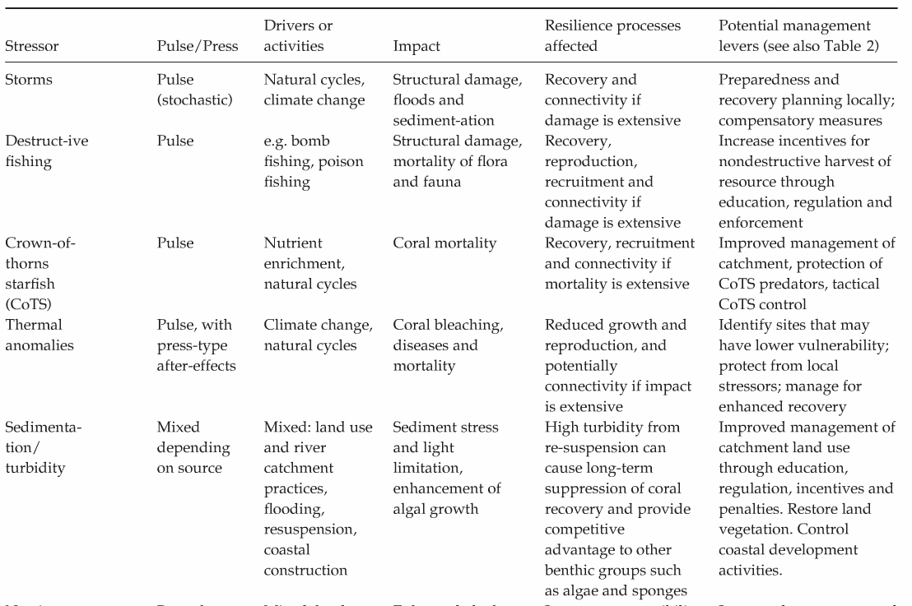
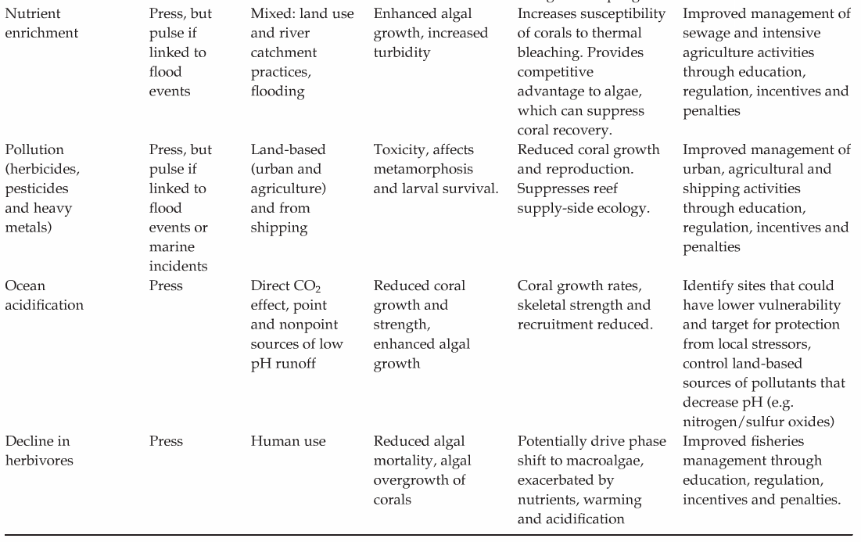
Table2: Key stressors on coral reefs, their implications for resilience, and potential management responses for building resilience (Source: Anthony et al 2014).

Why do we need resilience-based management?
Resilience is a particularly important concept for systems affected by increasingly frequent shocks, unprecedented levels of pressure and / or an uncertain future regime of exposure. Systems facing increasingly frequent and severe stress, like the Great Barrier Reef, can enter a state of almost constant recovery. Managing reef systems for recovery, and for their ability to cope with future impacts, requires a shift in focus to understanding and supporting resilience, instead of the more conventional approaches that focus on sustaining multiple uses and reducing human pressures while relying on natural recovery to maintain condition.

Approaches to managing natural systems have evolved over recent decades, tracing a trajectory from single-species management, through steady-state ecosystem management, and on to ecosystem-based management (Chapin et al. 2010; Maynard et al. 2015). More recently, scientists and conservation practitioners have recognised that the complexity and dynamic nature of many natural systems demands a more nuanced and sophisticated approach that is also more flexible and forward-looking. This has given rise to the movement toward resilience-based management (Anthony et al. 2015), which takes a systems approach that acknowledges complexity and embraces uncertainty.

Principles for integrating and driving resilience-based management
A defining feature of resilience-based management is the integration of resilience into decision-making at all levels.

Developing management principles for resilience and integrating these within broader management approaches at organisational, program and project levels can assist in driving resilience outcomes.

The application of resilience principles should be context-specific: for example, building resilience will require a different focus and approach across different landscapes and systems. Similarly, policy organisations will build resilience thinking into their business differently to implementation organisations.

A succinct set of management principles or considerations based on resilience-building concepts is also central to communicating, motivating and sustaining resilience-based management.

The table 3 summarises management principles for a range of organisations and programs, which may be helpful in developing resilience-based management principles for the Great Barrier Reef.

Table 3: A comparison of core principles from the Australian Government and other organisations, including the Great Barrier Reef Marine Park Authority’s Climate Change Adaptation Strategy and Action Plan (2012-2017), Resilience Alliance and 100 Resilient Cities.
Australian Government | GBRMPA climate change adaptation strategy (2011)¹ | Resilience Alliance | 100 Resilient Cities
Accountability | Focus on reducing non-climate stresses | Maintain diversity and redundancy | Reflective
Transparency/  openness | Involving local communities | Manage connectivity | Resourceful
Integrity | Multi-partner strategy development | Manage slow variables & feedbacks | Inclusive
Stewardship | Building on existing good practices | Foster complex adaptive systems thinking | Integrated
Efficiency | Adaptive management approaches | Encourage learning | Robust
Leadership | Integrating ecosystem-based adaptation with wider adaptation strategies | Broaden participation | Redundant
Accountability | Communicating and educating | Promote polycentric governance | Flexible

Other considerations in developing and integrating resilience-based actions include:
- Outcome focus – clearly defined objectives and outcomes
- Systems perspective – adopting an approach which recognises the cause-and-effect relationships between drivers and pressures on the state of the system and impacts on the benefits it provides
- Scale - including the spatial scale of the impact being addressed and the scale of management action/intervention required to deliver the specific objective or desired outcome
- Strategic approaches – including a variety of options to manage uncertainty, address risk, and facilitate learning, adaptive management, coordination, collaboration and trial of new and novel approaches
- Collaboration potential – opportunities to align effort, share information, and integrate and facilitate efficient and effective delivery at the most relevant scale across multiple actions
- Cost – over the full life cycle of the management action/intervention
- Effectiveness - including proof of concept, field trials for novel actions
- Risk – understanding and managing risk, including uncertainties and the risk of not acting
- Feasibility – of actions achieving objectives and outcomes within agreed timeframes, and ensuring risk is appropriately considered and managed
- Evaluation and adaptive management – to monitor performance and drive continuous improvement.
These considerations have been based on the Authority’s ‘Beyond impact assessment and communication: management action options in response to reef health incidents’ and development of Reef 2050 policies on cumulative impact management and net benefits.

PRINCIPLES AND CRITERIA

Use this box to capture your ideas on principles and criteria for resilience-based management?

HINT- Are your ideas SMART (Specific, Measurable, Achievable, Realistic, Timely)?

Principles and criteria

Tools and approaches for building resilience in the Great Barrier Reef context
In the Great Barrier Reef, the concept of building resilience is already informing strategic planning and actions. Many of the management interventions applied to the Great Barrier Reef, from the Reef-wide rezoning in 2004 to the use of special management areas and Reef protection markers, to water quality improvements and crown-of-thorns starfish control, all contribute to the resilience of the Reef. But these existing tools are not always designed or applied with a specific resilience focus, creating opportunities for improvements in management through the adaptation of existing tools. A more comprehensive and innovative approach to resilience-based management will help propel an effective response to current events.

Improving current tools
Management of the Great Barrier Reef involves an extensive box of management tools and approaches, many with a long history of implementation, which might be further tuned or adapted to accelerate improvements in resilience. Table 4 and Appendix A provides a summary of the tools used currently in the Great Barrier Reef, with brief descriptions of their purposes and illustrative examples of their components and application.

On a whole-system scale, the resilience of the Great Barrier Reef has benefited from proactive management in the form of the rezoning program that was implemented in 2004. Increasing the coverage of no take areas from five to 33 per cent of the Marine Park has delivered measurable improvements in the resilience of coral and fish communities (Mellin et al. 2016). Recent work in Western Australia indicates that further resilience benefits could be achieved by incrementally refining existing spatial management arrangements (Davies et al. 2016).

Resilience has also been a key concept behind water quality improvement plans, which is driving measurable improvements in catchment use and inputs to the Great Barrier Reef. Resilience thinking has informed other improvements in management, too, including better targeting of efforts to address illegal fishing and coastal development, and innovative responses to risks from crown-of-thorns starfish and the decline in sea turtle nesting success on Raine Island.

There is abundant scope for stewardship and other community activities to contribute to building the resilience of the Reef. Voluntary measures, whether individual actions driven by personal values, community initiatives (such as projects by Local Marine Advisory Committees or citizen science) or more formal commitments such as memorandums of understanding or stewardship programs, can all be powerful ways to increase the effort directed toward building resilience.

The Reef Guardian program has proven to be highly effective approach to engaging local communities and inspiring local actions that can support resilience. This model is now being replicated internationally as a way of encouraging and formalising voluntary measures to support resilience-based management.

Table 4: Authority’s management tools and their use in managing direct use, addressing external drivers and protecting values (Great Barrier Reef Outlook Report 2014)
Management tools | Direct uses |  |  |  |  |  |  |  |  | External factors |  |  |  | Values
Management tools | Commercial marine tourism | Defence activities | Fishing | Ports | Recreation (other than fishing) | Research and educational activities | Shipping | Traditional use of marine resources | Climate change |  | Coastal development | Land-based run-off | Biodiversity values |  | Heritage values | Community benefits of the environment
Acts and Regulations
Zoning plans
Management plans
Permits and licences
Traditional Owner agreements
Compliance
Site infrastructure
Fees and charges
Policy
Partnerships
Stewardship and best practice
Education and community awareness
Research and monitoring
Reporting

Resilience-based management: across sectors and coral reefs
Resilience thinking has become an increasingly prominent feature of planning and management across a diversity of sectors and geographies. In the environmental fields alone, the prominence of resilience in the scientific literature has increased by orders of magnitude over the last couple of decades (publications 250 to >6000; citations 100 to >20,000). While many people involved in coral reef research and management will be familiar with resilience in these disciplinary contexts, there is also much insight to be gained from efforts to apply resilience in other disciplines and areas of human endeavour.

Resilience in other sectors
In human development, for example, resilience thinking is being used to change the way humanitarian assistance is delivered. This includes ensuring response programs actively build resilience to future shocks. Aid programs have identified characteristics of communities that need to be in place for resilience, including overarching issues such as good governance and women’s empowerment. These are now focal areas for strategic efforts in disaster risk reduction.

Resilience is also transforming the way infrastructure is designed and built. Planners and designers realise they can’t always prevent an infrastructure failure when a major disruption hits. But they are increasingly recognising that building in resilience measures can help infrastructure withstand shocks or fail safely.

The importance of resilience has led to it being the centrepiece of a global program to help cities cope with the physical, social and economic challenges of the 21st Century. The 100 Resilient Cities Program supports the adoption and incorporation of a view of resilience that includes not just the shocks — earthquakes, fires, floods, etc.—but also the stressors that weaken the fabric of a city on a day-to-day or cyclical basis, such as energy costs, water shortages, unemployment and housing affordability. By addressing both the shocks and the stressors, a city becomes more able to respond to adverse events, and is overall better able to deliver basic functions in both good times and bad.

Recently, the Torres Strait Regional Authority released its Regional Adaptation and Resilience Plan 2016-2021 detailing how climate change will impact the region’s communities, land and sea country, and what steps can be taken to reduce the likely impacts to ensure the region’s future viability. Inherent within this Plan, and resilience based approaches in other sectors, are the deep connections and inseparable linkages between ecological and human dimensions of our environment.

Coral reef resilience initiatives
Many coral reef management programs now feature resilience as a lens through which the system is viewed for strategic planning, or as a concept for defining and targeting management actions.

In Western Australia, recent research has considered how resilience features understanding could be incorporated into the existing Ningaloo Reef protected area network at (Figure 6). These findings highlight the significant resilience dividend (see section 3.8) that could be achieved by adapting existing management arrangements to maximise resilience (Davies et al. 2016).

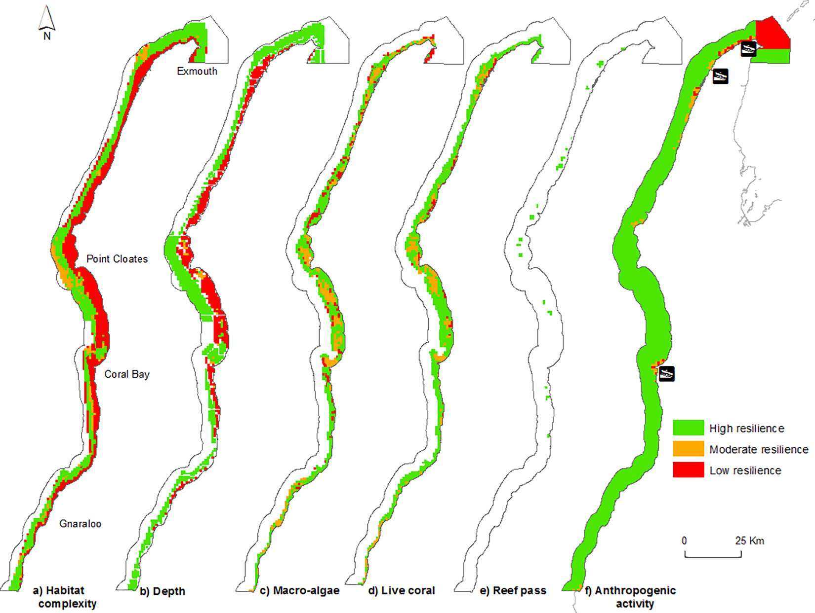

Figure 6: Spatial distribution of resilience features at Ningaloo Marine Park; a) Structural complexity, b) Depth, c) Live coral cover, d) Macro-algal cover, e) Reef passes (water mixing), f) Proximity to anthropogenic activity. (Davies et al. 2016)

The Reef Resilience Network, a collaborative effort led by The Nature Conservancy and the US National Oceanic and Atmospheric Administration (NOAA) with support from the Great Barrier Reef Marine Park Authority, among others, has for over 10 years provided capacity building, networking facilities and an information portal to support the integration of resilience into day-to-day management of coral reefs all around the world.

The Florida Reef Resilience Program is a collaborative effort among managers, scientists, conservation organizations and reef users to develop resilience–based management strategies for coping with ocean warming and other stresses on Florida's coral reefs. The Program worked with diverse stakeholders over five years to produce the Climate Change Action Plan for the Florida Reef System, with a key goal of increasing resilience through active management.
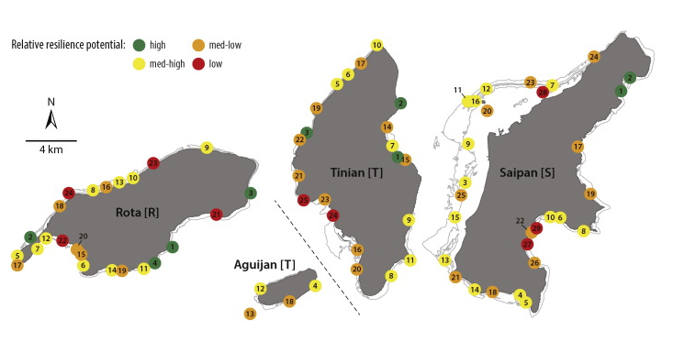
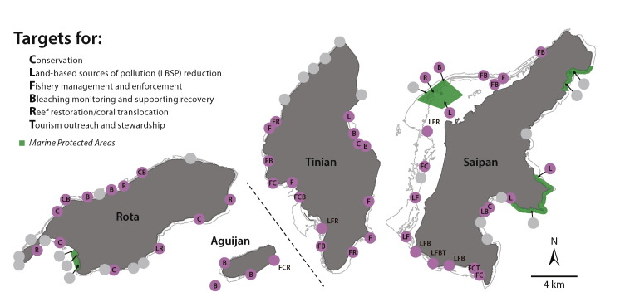
Figure 7: An example of the use of resilience mapping to inform targets for management action used in the Commonwealth of the Northern Marianas Islands (Maynard et al. 2015)
Work in the Commonwealth of the Northern Marianas Islands has demonstrated important advances in operationalising resilience concepts for coral reef management. By mapping characteristics of reef resilience across 76 sites, the researchers produced maps of the spatial variation in resilience, enabling managers to identify priority areas for actions aimed at building resilience (Figure 7).

Recent work in French Polynesia has taken this further, showing that social-ecological resilience can be mapped, and tracked through time, as a basis for an adaptive resilience-based management program.

The Coral Bleaching Recovery Plan, recently prepared for the Hawai’i Department of Aquatic Resources, is a particularly pertinent initiative from the international coral reef management community. Following a bleaching event that was unprecedented for Hawai’i, the Department initiated a comprehensive coral reef management planning process, with the goal of identifying management interventions that could promote coral recovery. This process drew on expert consultations and a review of the scientific literature to identify and prioritise management actions, which will form the basis of efforts to accelerate recovery of reefs damaged by the recent bleaching event.
Priority actions for promoting coral recovery in Hawai’i

The Division of Aquatic Resources in Hawai’i recently completed a comprehensive expert elicitation and literature review process to identify and prioritise management actions that could promote recovery of coral reefs damaged by the severe coral bleaching events of 2014–15 (Rosinski and Walsh, 2016). The table below presents the results of their analysis, showing differences between the different sources of information, and their overall assessment of effectiveness.

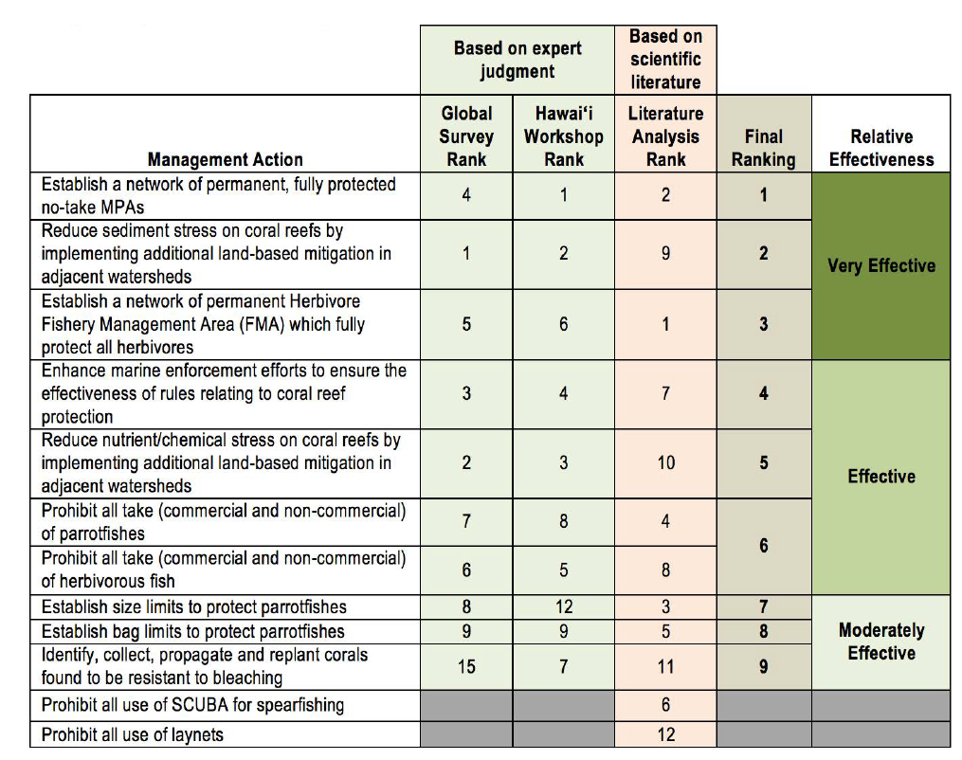

Making the investment case for interventions: the “resilience dividend”
Building resilience requires investments of time, knowledge, money and opportunity.

The Reef 2050 Plan and its supporting investment framework outlines the collective responses of government, Traditional Owners, science, industry and community sectors, together with current and future investment priorities, for the long-term management of the Reef.

The investment framework identified the following six priorities:

- Reef water quality protection plan actions
- Field management program actions
- Crown-of-thorns starfish actions
- Traditional Owner actions
- Fisheries actions
- Integrated monitoring and reporting

Moving forward, a key consideration in adopting a more explicit resilience-based management approach, is that of evaluating the costs of implementing resilience-building against the costs of inaction. These costs can be difficult to evaluate, but weighing the consequences and probability of undesirable outcomes under a business-as-usual scenario is essential for evaluating the costs and benefits of investing in resilience.

The case for investing in resilience is also strengthened by considering the full “resilience dividend” which has two parts.

- First, resilience minimises the amount by which the system or system component suffers an impact as the result of a shock (for example, reduced coral cover, losses of biodiversity, decrease in ecosystem services, decrease in community wellbeing). It maximises the speed at which a sustained recovery can begin.

- The second part of the resilience dividend can be broadly defined as the co-benefits of investing in resilience—that is, more resilient industries, more diversified economic opportunities, more tourism or new (and more) jobs.

The response: ingredients of success

The Authority and many of our partners, recognise the need to drive opportunities for innovation while optimising existing management tools and approaches.

Australia has a proud history of leadership and innovation in its management of the Reef, but we must continue to adapt and act decisively if we are to launch an appropriate response to the current conditions. To do this we must define and sustain a new approach to management.

This section presents ideas and issues that might assist your thinking about the ingredients necessary for an effective response to events facing the Reef. These are concepts and frameworks that might help conceptualise the challenge that confronts us, understand the requirements necessary for an effective response, inspire a fresh way of looking at the problem, or guide thinking toward new tools and approaches for management.

Innovation
At the heart of an effective response to a new problem lies innovation. Innovation creates new ideas, defines new paths and discovers novel applications for existing tools to navigate uncharted territory and address emerging challenges. Innovation is about experimentation. It involves the acceptance, or at least tolerance, of uncertainty and the risk of failure, on the basis that valuable learning will also come from failure. All risks have potential benefits and innovation can create long-lasting advantages and produce dramatic shifts in outcomes.

Processes and environments that encourage innovation are central to the success of organisations and endeavours in a rapidly changing and uncertain world. Effective and sustainable innovation requires both imaginative and analytical input (Figure 8). Imagination and creativity are essential to recognising and characterising the problem (problem finding) and to identifying and testing possible solutions (solution finding). Selecting the solutions most likely to work within the real-world constraints in which we operate, and developing feasible and acceptable plans (solution selection) requires structured, analytical thinking, as does implementation and evaluation (solution implementation).
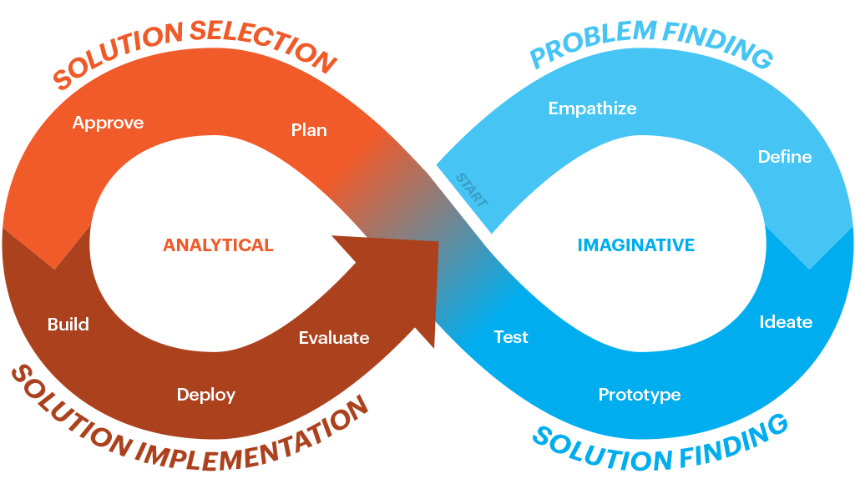
Figure 8: Steps in the process, and the types of thinking required, for successful innovation
Innovation has been a component of managing the Great Barrier Reef over the last 40 years. Examples include: establishing an Act of Parliament to create a multiple use marine protected areas Great Barrier Reef Marine Park Act; enforcing multiple-use zoning plans over a large scale; introducing vessel monitoring systems, developing the citizen science app “Eye on the Reef”; and implementing a single-shot injection approach to cull crown-of-thorns starfish.

Innovation was also the focus of recent internal strategy sessions held by the Authority. A range of “big ideas” and insights for improving management effectiveness were proposed, including: the need to lead with bold and ingenious ideas to guarantee the beauty and resilience of the Great Barrier Reef and the world’s reefs; ‘engaging global thinkers, tinkerers, engineers, businesses and scientists to drive and inspire new ideas’ and a greater focus on Reef restoration and rehabilitation.

INNOVATIVE IDEA CAPTURE

Use this page to capture some of your innovative ideas and reforms for marine park management to help create a resilient Great Barrier Reef. Consider the timescale required for implementation (see Figure 4). What marine park management actions could help the immediate response to recent events (implemented over the next 100 days or so)? Over the medium term (1-3 years)? And what might be helpful, but would require longer timeframes to implement (10 years or more)?

HINT- Are your ideas SMART (Specific, Measurable, Achievable, Realistic, Timely)

Short (100 days) | Medium (1-3 years) | Long (10 years)

Optimise existing tools and approaches
Impacts on the Great Barrier Reef (refer to Appendix B) rarely occur in isolation but often overlap and may interact with each other. Where impacts accumulate over time and space, they can lower the resilience of the ecosystem and its ability to recover from disturbance. Understanding the cumulative nature of impacts, and ensuring that this is considered in management decisions, is essential to effectively building the resilience of the Reef.

Tools and decision-support systems that help managers understand and consider cumulative pressures when making decisions will be crucial to resilience-based management of the Great Barrier Reef.

The cumulative impacts of local pressures and threats associated with climate events mean existing management measures have not been sufficient to reverse the decline in the health of the Great Barrier Reef. Responding to these events will require that management approaches undergo a strategic shift from primarily focusing on avoiding and mitigating impacts to a focus on achieving a net benefit environmental outcome for the Reef. This includes a shift in policy and including guidance on Reef interventions and restoration activities.

EXISTING TOOLS AND APPROACHES

Use this page to capture thoughts on how we can optimise and improve on our existing tools or approaches to better address threats and pressures from cumulative impacts, and guide opportunities to restore and enhance coral reef ecosystems.

HINT- Are your ideas SMART (Specific, Measurable, Achievable, Realistic, Timely)?

Tool or approach | How to improve management of threats and cumulative pressures? | How to improve opportunities enhance and restore coral reef habitats

Enablers
To achieve innovation and optimisation of Reef management, a range of enabling tools and approaches are required.

Behavioural change
Change is necessary in responding to a crisis, yet changing behaviours and attitudes can often be difficult. A theory-of-change approach can identify important barriers to change, and help design and prioritise strategies for overcoming these barriers. The conservation organisation ‘Rare’ specialises in driving behavioural change to convert resource users into environmental stewards. Their approach takes powerful ideas from marketing and applies them to inspire and facilitate change (Figure 9).
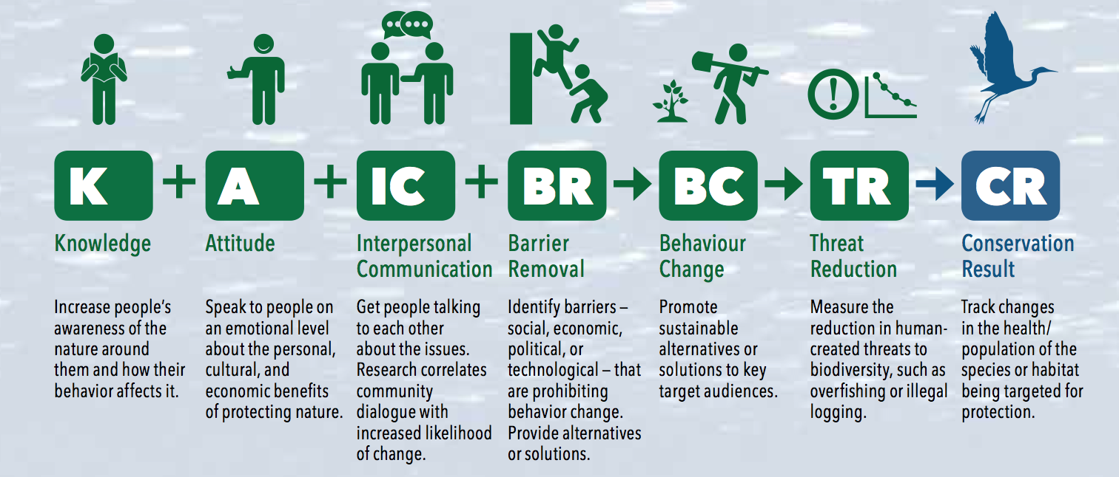
Figure 9: Rare's theory of change
The Authority already uses social-based marketing and theory-of-change approaches in key areas of its business, including designing communications strategies and the Reef Guardians program. Extending this approach to drive change across the entire spectrum of stakeholders and organisations that can influence the future of the Reef through actions to build resilience, has the potential to accelerate or improve the effectiveness of our response.

Other approaches that can be used to assist understanding barriers and opportunities to behavioural change include PESTEL (Political, Economic, Social, Technological, Environmental, Legal), SWOT (Strengths, Weaknesses, Opportunities and Threats) and SOAR (Strengths, Opportunities, Aspirations and Results) (see Appendix C).

A combination of these approaches is likely to be useful in designing strategies, programs and activities as part of a resilience-based management response in the Great Barrier Reef.

BEHAVIOURAL CHANGE

Use this page to capture your thoughts on the enabling tools that can help inspire and facilitate change, and how these tools can build on existing management tools and approaches to influence the broader Reef community.

HINT- Are your ideas SMART (Specific, Measurable, Achievable, Realistic, Timely)?

Enabling tool or approach | How can it be integrated with existing management tools and approaches to inspire and facilitate change more broadly?

Adopting a systems approach
Coral reefs are social-ecological systems possessing all the characteristics of “complex systems”. The challenges faced by reef managers, and the recent events on the Great Barrier Reef, highlight some of these features, including: numerous interacting elements, nonlinear interactions between elements and constant change. Yet, for the most part, management of coral reefs systems has tended to rely on tools and approaches that are generally suited to simpler, tractable systems (Game et al. 2013).

Current events facing the Great Barrier Reef provides an opportunity to evolve an approach to its management that is more cognisant and appropriate to the complexity of the system. Adaptive management is a core element in dealing with complexity, but additional measures are required for adaptive management to adequately deal with the nature of complexity. Key challenges for effective use of adaptive management in complex systems include scenario forecasting (e.g. modelling), measuring performance (monitoring, evaluating, reporting and improvement) and the fact that many management interventions change the nature of the problem in complex systems. None of these problems are insurmountable, but an approach that recognises and embraces the complexity of coral reef systems is more likely to provide the foundation for an effective response to the current challenge than an overly simplistic one (Table 5).

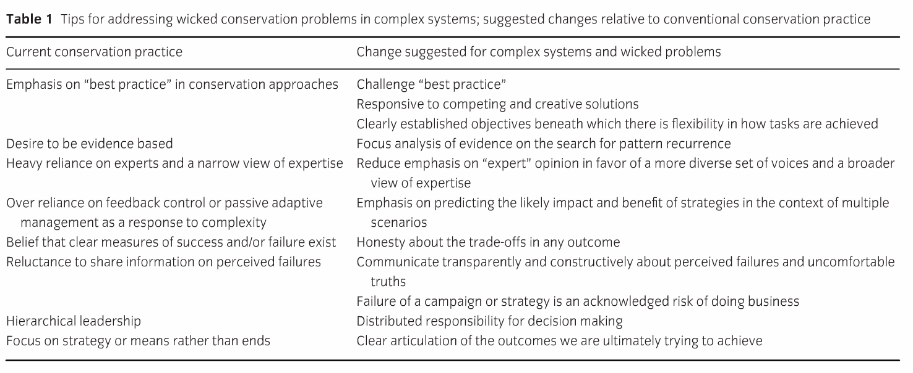
Table 5: Tips for addressing wicked conservation problems in complex systems, suggested changes relative to conventional conservation practice. Source: Game et al 2014.

SYSTEMS APPROACH

Use this page to capture thoughts on how we can adapt our management approaches to better recognise complex human and reef system responses to pressures and threats.

HINT- Are your ideas SMART (Specific, Measurable, Achievable, Realistic, Timely)?

Tool or approach | How can existing management tools and approaches be adapted to recognise and manage a complex and rapidly changing human and reef systems?

Partnerships

The Great Barrier Reef plays an important role in the health and wellbeing of people living along its entire coast, as well as a wide range of visitors from interstate, and internationally. Engaging Traditional Owners, stakeholders and local communities through positive and constructive relationships has been a key strategy in the Authority’s management of the Reef.

This strong track record lays the foundation for further strengthening existing partnerships and empowering a new wave of stewardship activities within the broader community. Traditional Owners have rights and responsibilities beyond stakeholders’ interests in the Reef. Acknowledgement of these inherent rights forms the basis for our partnership approach with Traditional Owners through our governance arrangements, together with joint agreements and ranger and other programs for on-ground delivery for Reef management.

Increasingly, commercial users of the Reef, community groups and individuals are looking for opportunities, and acquiring the capacity, to contribute directly to the rebuilding of the Reef’s resilience. Examples include community-run turtle hospitals, and a range of organisations and businesses seeking to test and deploy coral restoration methods. Building on the stewardship framework (Figure 9), the current situation opens the opportunity to explore new and valuable partnerships that broaden the base of resilience-building activities occurring in the Great Barrier Reef.

The rise of public-private partnerships for conservation presents additional opportunities for innovative approaches to management in the Great Barrier Reef. Conservation agreements are a form of these partnerships that are already used by the Australian Government. They formalise arrangements between the government and a private entity to co-contribute to the protection and conservation of biodiversity.

Businesses such as commercial tourism operations also have strong vested interests in protection and improved resilience of coral reefs.

Examples of partnerships between tourism operators such as private resorts and government agencies to co-manage coral reefs are beginning to emerge internationally. These innovative approaches to management of local reefs may prove to be interesting models to consider for the Great Barrier Reef.

PARTNERSHIPS

Use this page to capture thoughts on how to better partner for opportunities to contribute directly to the rebuilding of the Reef’s resilience.

HINT- Are your ideas SMART (Specific, Measurable, Achievable, Realistic, Timely)?

Tool or approach | Partnership approach that can contribute directly to building Reef resilience?

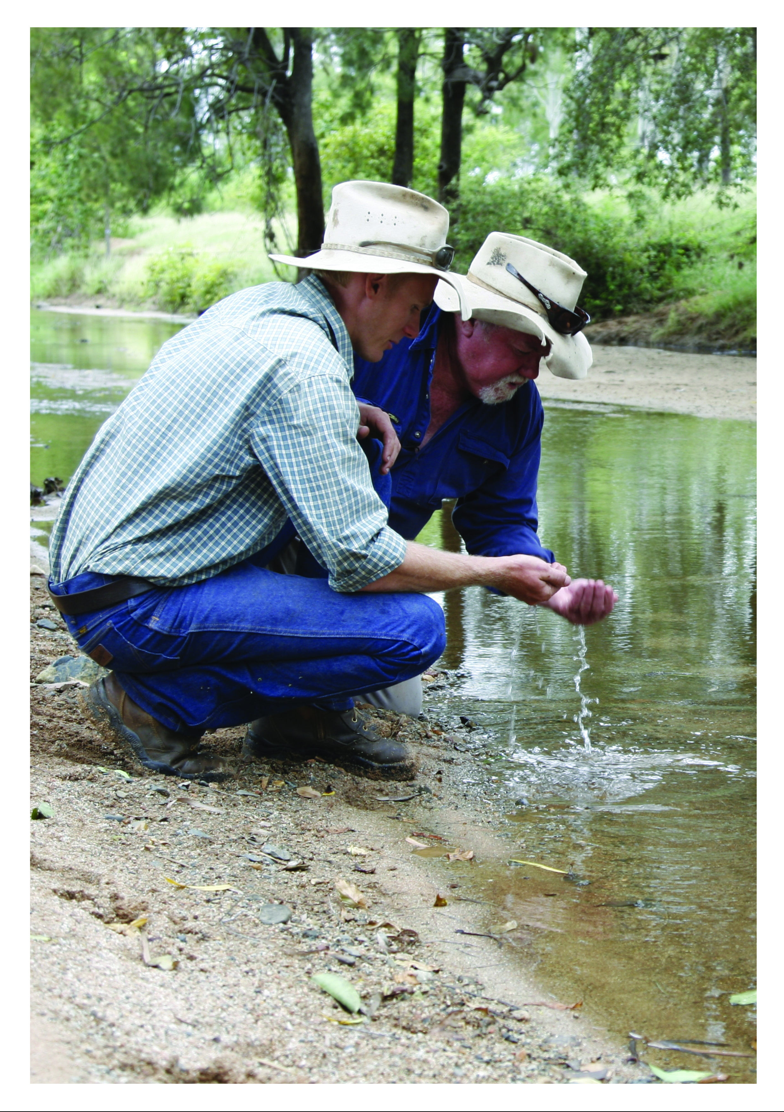

Effective communication
Effective communication is central to sharing knowledge, improving awareness and understanding, and motivating and creating behavior change consistent with conservation goals. It is about engaging hearts, minds and hands with hope, plans and actions for a resilient Reef future.
The Authority has long recognised it cannot achieve its vision — a healthy Great Barrier Reef for future generations — on its own; we must work with government, Traditional Owners, industry and community partners. Trust is critical to enabling these partnerships. Developing and maintaining trust can be facilitated through targeted and consistent communication, which meets public and stakeholder expectations. Matching people’s expectations with the realities of managing such a vast diverse ecosystem is vital to ensure enduring support and trust from the Reef’s stakeholders locally, throughout Australia and the world.
As an example of an engagement tool, independent market research commissioned by the Authority in 2016 segmented stakeholders based on their proximity to the Reef, noting that proximity need not be purely geographical; it can also be experiential. This segmentation was used to recommend an ‘engagement’ model (Table 6) with stakeholders, with the aim of migrating people towards increasingly positive associations with the Reef — encouraging people to adopt Reef-friendly behaviours and become advocates for the Reef (B).
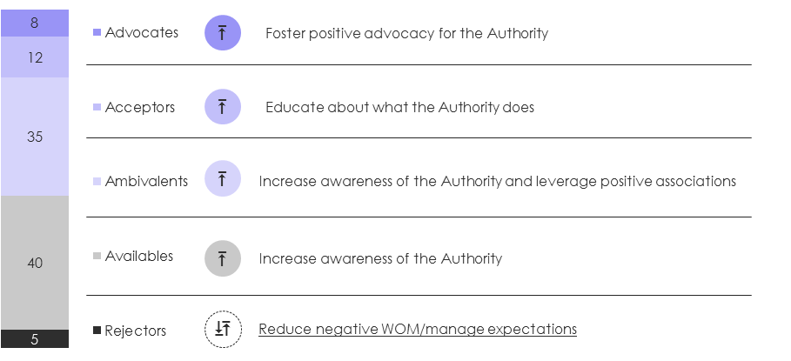
Figure 10: An engagement model aimed at moving people towards more positive associations with the Reef.

Table 6: Actioning the engagement model – a planned approach to communication

What | Description
Frame of reference | Beliefs, attitudes, cultural practices operate in this space? (what motivates them?)
Defining attitude to the Authority | Defining attitude/ action to the Authority and what drives this? (what do they think of the Authority?)
Obstacles/issues | What beliefs, cultural practices, peer pressure, misinformation, stand in the way? (Are there any specific issues with the Authority that need to be addressed?)
Desired change | What do we want them to think, feel, and say do about the Authority? (Desired change in attitude/behavior, role in the Authority’s communications plan)
Brand messaging | What are the specific brand messages that will deliver to the desired changes?
Channels | What opportunities (times and places) exist for influencing/communication? (What are the best media channels for ‘right time/right place communications?)
Communications goal | What is the overarching communication goal for this target group?

COMMUNICATION

Use this page to capture thoughts on how we can better communicate, to motivate and create behaviour change. Please include examples of what has worked and what hasn’t and what you would do differently based on lessons learned.

HINT- Are your ideas SMART (Specific, Measurable, Achievable, Realistic, Timely)?

Tool or approach | How can we improve knowledge sharing and motivate people through the tool or approach to result in changed behaviour and achieve conservation action?

Adaption pathways
Responding to an unfolding crisis — a form of urgent and dynamic adaptation — requires decisive action that allows flexibility and foresight.

Adaptation pathways may be helpful in providing structure and guidance in designing a sustained response to enhancing Reef resilience. The adaptation pathways approach provides a decision-making strategy made of up a sequence of manageable steps or decision-points over time, where each decision-point is triggered by some change (social or ecological).

Each decision-point has a series of identified choices or options. Once triggered, the options for that step are ‘tested’ against plausible futures and the acceptable risk to the organisation or community. The wide range of options considered, evaluated and left on the table for the future gives decision makers flexibility and allows decisions to be responsive and iterative.

Importantly, each trigger — or threshold — may have a lead time associated with it. This can represent the lag-time expected in a response to a decision (for example, the time taken to confirm that a coral restoration activity has delivered the expected ecological benefit), or it can signal that a lead time is required before an option can be implemented (such as the time needed to bring a new technology to an operational scale).

Adaptation pathways can be illustrated in the form of a “route map” or similar diagram, helping capture and communicate the process of adaptive decision making, and the importance of time lags, future decision points and changing uncertainties. While still developmental, these approaches have been used in major planning exercises (Figure 11) and could assist in shaping a blueprint for coral reef resilience.

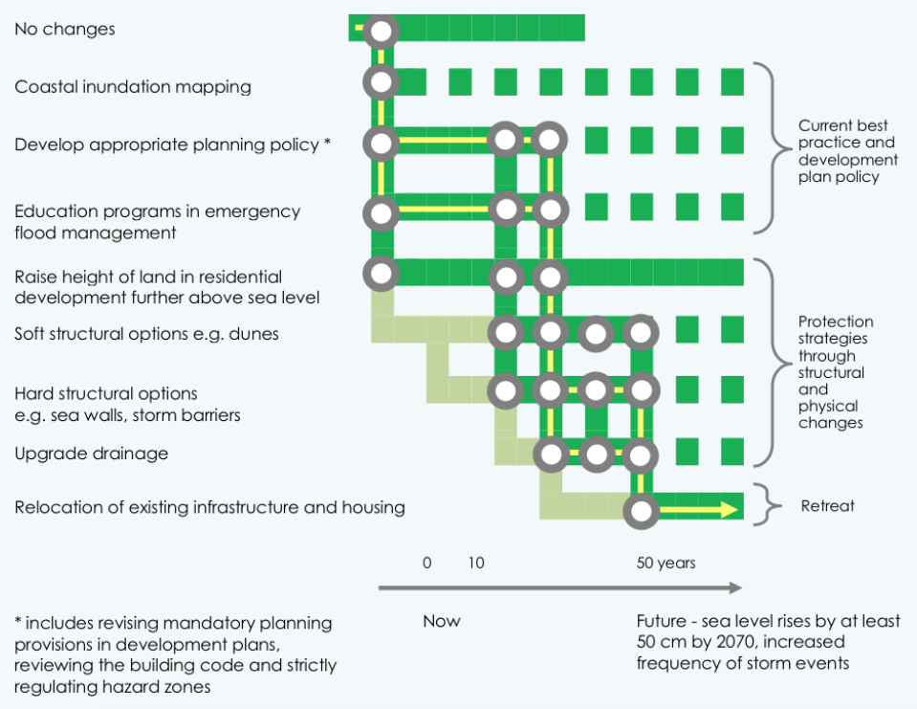
Figure 11: An example decision pathway from an adaptation planning exercise in the Eyre Peninsula, for agriculture. Source: Siebentritt et al. 2014.

ADAPTIVE MANAGEMENT

Use this page to capture your thoughts on what a ‘route map’ for actions to support coral reef resilience might look like. Consider the key management options you would consider for reef management (see section five) and time for implementation. Note some of the decisions you would make in determining whether or not to implement a key management option.

HINT- Are your ideas SMART (Specific, Measurable, Achievable, Realistic, Timely)?

Management option | Now | 5 yrs | 10 yr | 20 yr | 50 yr | 100 yr

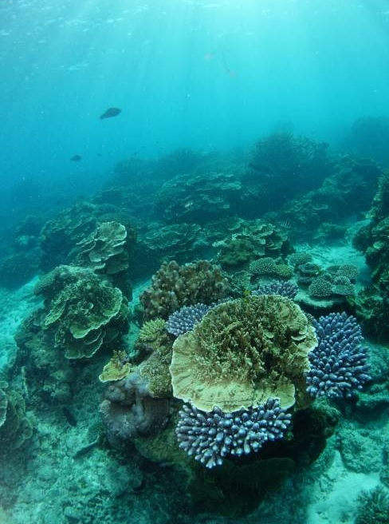

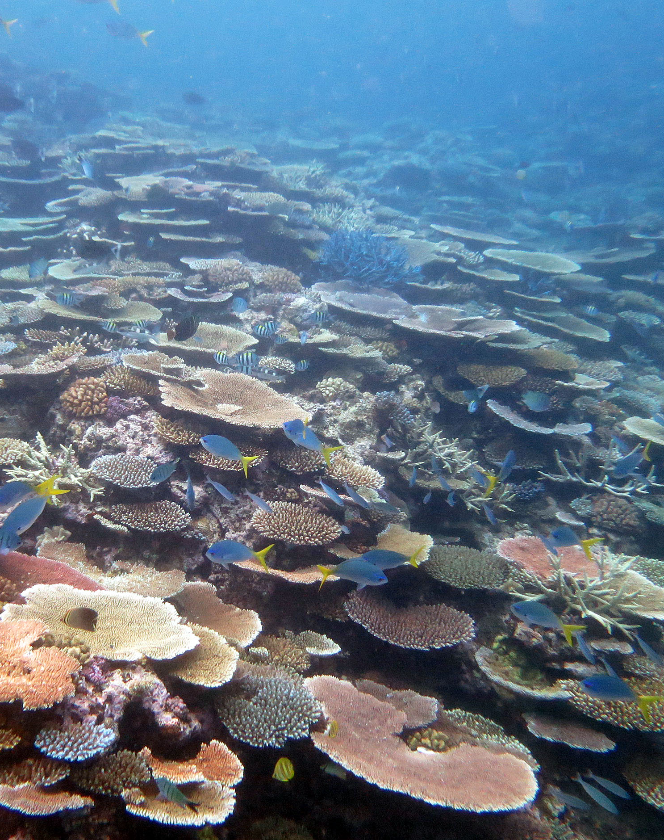

Taylor Reef – damaged by cyclone Yasi, showing strong recovery after 5 years

Photo taken in 2015, courtesy of AIMS

Toward a blueprint for a resilient Great Barrier Reef

Like all coral reefs around the world, the Great Barrier Reef is under increasing pressure from a range of sources, particularly climate change. The back-to-back bleaching events, the recent cyclone and the signs of accelerating change are a clear sign that our coral reef system is facing an unprecedented turning point, and that we must respond decisively and effectively.

The Authority has a long and proud history of working with partners and stakeholders to manage and protect the Great Barrier Reef in the face of a range of threats and challenges. As we confront our greatest challenge yet, we must draw on this strong legacy of leadership and innovation to define a bold new vision and shape a powerful and coherent approach to managing the Reef over coming decades.

We have already undertaken an analysis of response options to address the consecutive bleaching events and cumulative pressures impacting the Reef. We want to build on these actions and develop innovative new approaches to our management by harnessing the expertise of those attending the Summit.

Coral reefs are facing unprecedented impacts, but we must turn this into unprecedented opportunity. Coral reefs all around the world are in decline, and coral reef managers everywhere are struggling to adapt and remain effective. The global coral reef community will once more be looking to the managers of the Great Barrier Reef for inspiration and leadership; it is crucial we step up.

Foremost among our efforts must be renewed calls, and stronger actions, to reduce the rate and extent of climate change. It is also essential that we acknowledge that we cannot hope to fully “climate-proof” our Reef. But, there is also a clear and important difference between doing nothing, and doing everything we can to build its resilience. Our efforts must be directed toward doing everything we can to give it a fighting chance. Defining how we do that is now our most important responsibility.

The Great Barrier Reef Summit: Managing for resilience recognises the “new normal” and is our opportunity to articulate the vision and direction that will enable us to give our Reef its best chance of coping with the decades ahead.

The deliberations, innovation and inspiration from the Summit will be synthesised into a “blueprint” for resilience for the world’s Great Barrier Reef. We also hope that it will guide and inspire coral reef managers around the world so that together we can help coral reefs survive the global crisis.

TOWARDS A BLUEPRINT
Use this page to capture your ideas on design elements for a resilience blue print for Great Barrier Reef Marine Park management. Think about alignment or ‘nesting’ of actions across spatial scales and time.

HINT- Are your ideas SMART (Specific, Measurable, Achievable, Realistic, Timely)?

SCALE | DESIGN ELEMENTS FOR RESILIENCE






References
Australian Government (2008). Economic contribution of the GBRMP, 2006-2007. Access Economics Pty Ltd. Research Publication No. 98.
Advance Queensland (2017). Small business Innovation research. Reef Water Quality Monitoring. http://advance.qld.gov.au/small-business/sbir/sbir-reef-challenge.aspx
Anthony K.R.N., Marshall P.M., Abdullah A., Beeden R. (2015) Operationalizing resilience for the adaptive management of coral reefs. Global Change Biology 21:48-61
Boström-Einarsson, L., Rivera-Posada, J. (2016). Controlling outbreaks of the coral-eating crown-of-thorns starfish using a single injection of common household vinegar. Coral Reefs 35: 223
Chapin, F. S., Stephen R. Carpenter, Gary P. Kofinas, et al. 2010. Ecosystem Stewardship: Sustainability Strategies for a Rapidly Changing Planet." Trends in Ecology & Evolution. 25 (4):241-249.
Davies HN, Beckley LE, Kobryn HT, Lombard AT, Radford B, Heyward A (2016) Integrating Climate Change Resilience Features into the Incremental Refinement of an Existing Marine Park. PLoS ONE 11(8): e0161094. doi:10.1371/journal.pone.0161094
Edwards, A.J., Gomez, E.D. (2007). Reef Restoration Concepts and Guidelines: making sensible management choices in the face of uncertainty. Coral Reef Targeted Research & Capacity Building for Management Programme: St Lucia, Australia. 38 pp.
De’ath G, Fabricius K.E., Sweatman H, Puotinen M. 2012, The 27-year decline of coral cover on the Great Barrier Reef and its causes. Proceedings of the National Academy of Sciences 109(44).
Game, E.T., Meijaard, E., Sheil, D., McDonald-Madden, E. (2014). Conservation in a wicked complex world; challenges and solutions. Conservation Letters, May/June 2014, 7(3), 271–277
Hock, K., Wolff, N.H., Condie, S.A., Kenneth R. N. Anthony, K.R.N., Mumby, P.J., Marshall, N.A., Tobin, R.C., Marshall, P.A., Gooch, M, and Hobday, A. J. (2013) Connectivity networks reveal the risks of crown-of-thorns starfish outbreaks on the Great Barrier Reef. Journal of Applied Ecology 2014, 51, 1188–1196 doi: 10.1111/1365-2664.12320
Marshall, P.A., Dowd, A.M., Luder, C., Maynard, J.A., Beeden, R. (2015). A Reef Managers Guide to Fostering Community Stewardship, Gland, Switzerland, IUCN.
Maynard, J., Parker, B., Beeden, R., Tamelander, J., McGowan, P., Gramer, L., Heron, S., Kendall, M, S. McKagan, S., McLeod, E., Oleson, K., Pittman, S. (2015). Coral Reef Resilience Research and Management – Past, Present and Future: Workshop Report. Silver Spring, MD: NOAA Coral Reef Conservation Program. NOAA Technical Memorandum CRCP 20. 47pp.
Mellin, C., Mouillot, D., Kulbicki, M., McClanahan, T.R et al. (2016). Humans and seasonal climate variability threaten large-bodied coral reef fish with small ranges. Nature Communications 7, Article number: 10491 (2016):10.1038/ncomms10491
Osborne K, Dolman AM, Burgess SC, Johns KA (2011) Disturbance and the Dynamics of Coral Cover on the Great Barrier Reef (1995–2009). PLoS ONE6(3):e17516. doi:10.1371/journal.pone.0017516
Rosinski, A., Walsh, W. (2016). Prioritized management strategies for promoting post-bleaching coral recovery in Hawai’I : survey results.
Siebentritt, M. A., N. Halsey and M. Stafford Smith, 2014: Regional Climate Change Adaptation Plan for the Eyre Peninsula. Prepared for the Eyre Peninsula Integrated Climate Change Agreement Committee. Accessed 15 May 2017.
Wentworth Group of Concerned Scientists (2014). Blueprint for a healthy environment and a productive economy.

Further reading
Brodie, J., Waterhouse, J (2012). A critical review of environmental management of the ‘not so’ Great Barrier Reef. Estuarine, Coastal and Shelf Science 104-105 (2012) 1e22
Commonwealth of Australia (2015). Reef Trust. Partnerships for the reef. http://www.environment.gov.au/system/files/resources/b4374655-380a-4072-998b-040009c5b085/files/partnerships-reef.pdf
CSIRO (2008). Future Scenarios for the Great Barrier Reef Catchment. http://www.clw.csiro.au/publications/waterforahealthycountry/2009/wfhc-future-scenarios-GBR-catchment.pdf
Davey, G. (2014). The Great Barrier Reef World Heritage Marine Protected Area: valuing local perspectives in environmental protection. Australian Geographer 01/2014; 45(2).
DEHP (2017). Queensland Reef Water Quality program. Great Barrier reef Innovation Fund. https://www.qld.gov.au/environment/assets/.../reef/gbr-innovationfund-factsheet.pdf
Edgar, G.J, Stuart-Smith, R.D., Willis, T.J., Kininmonth, S., Baker, S.C., Banks, S. et al (2014)
Global conservation outcomes depend on marine protected areas with five key features. Nature 506 (7487), 216-220.
Fitzsimmons, J., Wescott, G. (2016). Big, bold and blue: lessons from Australia’s marine protected areas. CSIRO Publishing.

Fox, H.E., Holtzman, J.L., Haisfield, K.M., McNally, C.G., Cid, G.A., Mascia, M.B., Parks, J.E., Pomeroy, R.S (2014). How Are Our MPAs Doing? Challenges in Assessing Global Patterns in Marine Protected Area Performance. Coastal Management 24(3): 207-222.

GBRMPA (2014). Great Barrier Reef region strategic assessment: strategic assessment report / Great Barrier Reef Marine Park Authority.
GBRMPA (2014b). Great Barrier Reef Outlook Report 2014, GBRMPA, Townsville.
Grech, A, Bos, M., Brodie, J., Coles, R., Dale, A, Gilbert, R, Hamann, M., Marsh, H., Neil, K, Pressey, R, Rasheed, M, Sheaves, M, Smith, A (2013). Guiding principles for the improved governance of port and shipping impacts in the Great Barrier Reef
Gregory, K (2017). Experts call for Australia to take lead on saving Great Barrier Reef. ABC News. 16 March. http://www.abc.net.au/news/2017-03-16/reef-experts-call-for-australia-to-save-great-barrier-reef/8361422
Hamel, G (2006). The what, why and how of business innovation. https://hbr.org/2006/02/the-why-what-and-how-of-management-innovation
Llley, D., Morris, R.K.A., Cruickshanks, K., Macleod, C., Underhill-Day, J., Brereton, T. & Mitchell, J. 2012. Identifying best practice in management of activities on Marine Protected Areas. Natural England Commissioned Reports, Number 108.
Miloševic, D. & Iewwongcharoen, B. (2004). Project management tools and techniques: the contingency use and their impacts on project success. Paper presented at PMI® Research Conference: Innovations, London, England. Newtown Square, PA: Project Management Institute.
Palmer, C., Shilton, D., Jeyaratnam, E., Mountain, W. (2015). Australia’s innovation problem explained in 10 charts. The Conversation. https://theconversation.com/australias-innovation-problem-explained-in-10-charts-51898
Pinkerton, E. 1999. Factors in overcoming barriers to implementing co-management in British Columbia salmon fisheries. Conservation Ecology 3(2): 2. [online] URL: http://www.consecol.org/vol3/iss2/art2/
Queensland Government (2017). Palaszczuk Government calls for innovators to help the Great Barrier Reef. http://statements.qld.gov.au/Statement/2017/2/26/palaszczuk-government-calls-for-innovators-to-help-the-great-barrier-reef
Read, A. D. (2014). Effectiveness of marine park management: a case study from New South Wales, Australia. PhD. University of Wollongong.
Sawyer, S. (2017). Opinion. Will innovation ever help the Great barrier Reef. https://www.sunshinecoastdaily.com.au/news/opinion-will-innovation-even-help-great-barrier-re/3149664/
Tart, D., Hart, B., Hughes, T., Hussey, K. (2017). Reef 2050 Long Term Sustainability Plan. Progress on Implementation. Review by Great Barrier Reef Independent Review Group. http://www.wwf.org.au/ArticleDocuments/353/pub-reef-2050-long-term-sustainability-plan-21feb17.pdf.aspx?Embed=Y
Torres Strait Regional Authority (2016). Torres Strait Adaptation and Resilience Plan 2016-2021. Report prepared by the Environmental Management Program, Torres Strait Regional Authority, June 2016, 108pp.
University of Hawaii (2017). Coral Bleaching Recovery Plan. Identifying Management Responses to promote Coral Recovery in Hawaii. Prepared for Department of Natural Resources, Division of Aquatic Resources.
University of Queensland (2017). Designing the world’s marine parks. http://www.uq.edu.au/research/research-at-uq/designing-the-worlds-marine-parks
WWF (2007). Management Effectiveness Tracking Tool. Reporting Progress at Protected Area Sites: Second Edition. World Wildlife Fund International.

Appendix A: Management tools employed by the Great Barrier Reef Marine Park Authority
(Chapter 3, Strategic Assessment Report)
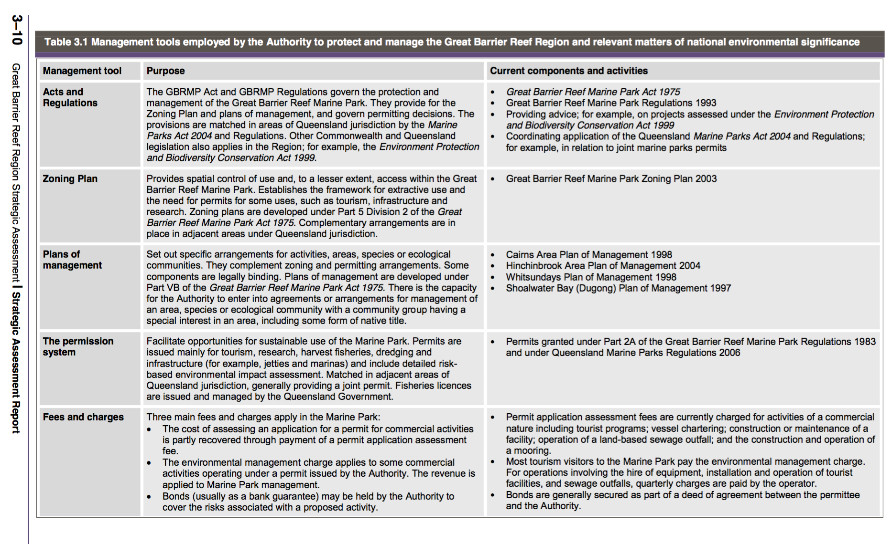
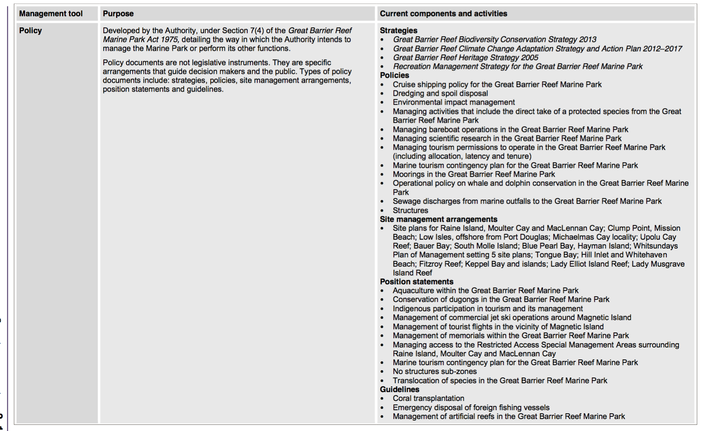
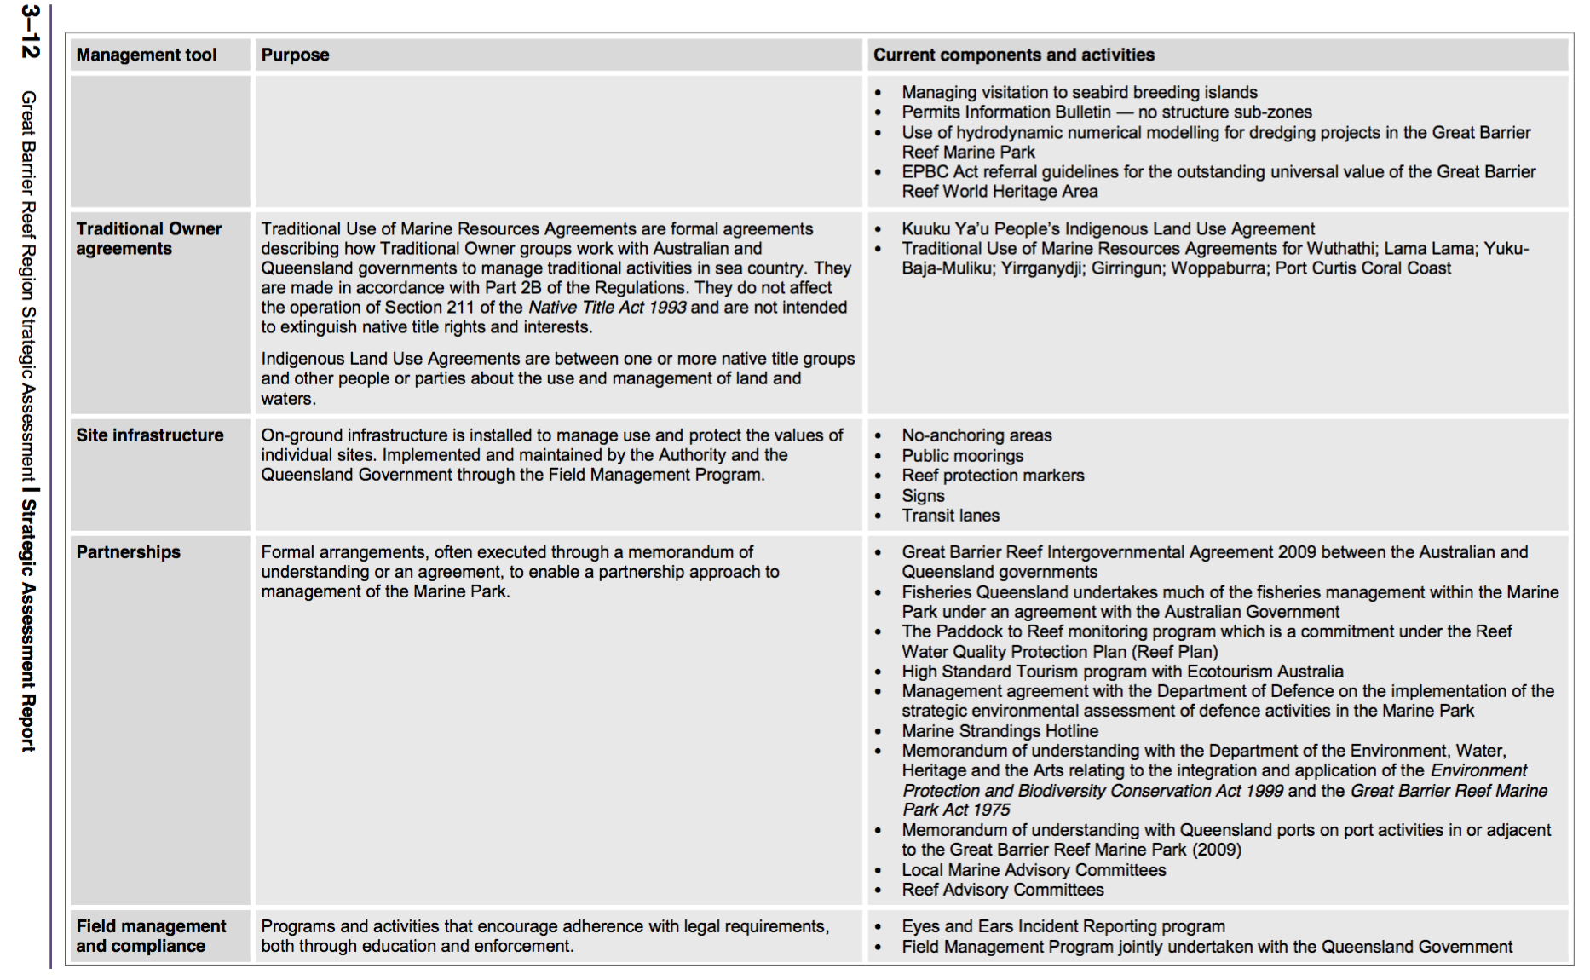
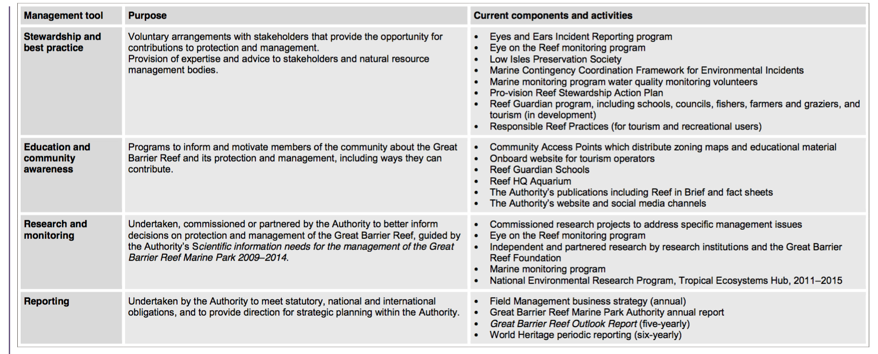

Appendix B. Drivers, pressures and impacts
Drivers are overarching causes that can drive change in the environment (State of the Environment, 2011; Strategic Assessment Report, 2014) and have also been referred to as underlying causes of change in the environment (Outlook Report, 2014). The Reef 2050 Integrated Monitoring and Reporting Program, proposes to adopt six drivers of change for the Great Barrier Reef system:
- Climate change
- Population growth
- Economic growth
- Technological developments
- Societal attitudes
- Governance systems
Pressures and impacts are mechanisms that exert a change force (either positive or negative) on a value. Put another way, pressures and impacts are the change mechanisms (e.g. processes or activities) that result from drivers. Pressures defined in the table below are consistent with the Outlook Report ‘threats’ (2014) and the Strategic Assessment Report ‘impacts’ (2014).
Pressures and impacts | Definitions
Acid sulphate soils | Exposure and subsequent oxidation of potential acid sulphate soils.
Altered ocean currents | Altered ocean currents due to climate change or anomalies related to the El Niño-Southern Oscillation, and altered coastal water movement at a local scale.
Artificial light | Artificial lighting including from resorts, industrial infrastructure, mainland beaches and coastlines, vessels and ships.
Atmospheric pollution | Pollution of the atmosphere related to domestic, industrial and business activities in both the Region and adjacent areas. The contribution of gases such as carbon dioxide to climate change is not included as this is encompassed under threats such as sea temperature increase and ocean acidification.
Artificial barriers to flow | Artificial barriers to riverine and estuarine flow including breakwalls, weirs, dams, gates, ponded pastures, and weeds causing changes to hydrology, groundwater and ecological connectivity.
Coastal reclamation | Coastal land reclamation, including for ports and groynes.
Cyclone activity | Cyclone activity.
Damage to reef structure | Physical damage to reef benthos (reef structure) through actions such as snorkelling, diving, anchoring and fishing, but not vessel grounding.
Damage to seafloor | Physical damage to non-reef benthos (seafloor) through actions such as trawling and anchoring, but not vessel grounding.
Disposal and resuspension of dredge material | Sea dumping of dredge material including smothering, loss and modification of seabed habitats and resuspension.
Dredging | Dredging of the seafloor.
Exotic species and diseases | Introduction of exotic species and diseases from aquaculture operations, hull fouling, ballast release, imported bait and release of aquarium specimens to the Region, plus the introduction of weeds and feral animals to islands.
Extraction – discarded catch | Immediate or post-release effects (such as death, injury, reduced reproductive success) on discarded species as a result of interactions with fishing gear. Does not include species of conservation concern.
Extraction — fishing in spawning aggregations | Retained take (extraction) of fish from unidentified or unprotected spawning aggregations.
Extraction – herbivores | Retained take (extraction) of herbivores (e.g. some fish, molluscs, dugongs, green turtles) through commercial and non-commercial uses.
Extraction – incidental catch of species of conservation concern | Immediate or post-release effects (such as death, injury, reduced reproductive success) of interactions of species of conservation concern with fishing gear.
Extraction — lower order predators | Retained take (extraction) of lower order predators (e.g. coral trout and snapper) through commercial, recreational and traditional fishing.
Extraction — lower trophic orders | Retained take (extraction) of lower trophic orders (e.g. scallops, sea cucumbers and prawns) through commercial, recreational and traditional fishing.
Extraction — top order predators | Retained take (extraction) of top order predators (e.g. sharks) through commercial, recreational and traditional fishing and the Queensland Shark Control Program.
Grounding large vessel | Grounding of large vessels (>50m) including physical damage and the dislodging of antifoulants.
Grounding small vessel | Grounding of small vessels (<50m) including physical damage and the dislodging of antifoulants.
Illegal activities — other | Illegal activities such as entering a protected or restricted area, illegal release of industrial discharge, shipping outside of designated shipping areas.
Illegal fishing and poaching | Illegal fishing, collecting and poaching (foreign or domestic) including of species of conservation concern.
Incompatible uses | Activities undertaken within the Region that disturb or exclude other users, such as recreational use in areas important for cultural activities.
Increased freshwater inflow | Increased freshwater inflow from prolonged or heavy rainfall including flood events, and from changes to catchment ecosystems; resulting in reduced salinity.
Marine debris | Manufactured material discarded, disposed of or abandoned in the marine and coastal environment (including discarded fishing gear and plastics).
Modifying supporting terrestrial habitats | Clearing or modifying supporting terrestrial habitats such as wetlands, saltmarshes, mangroves and sand dunes — this also includes trampling and damage from recreational vehicle use.
Noise pollution | Noise from human activities, both below and above water.
Nutrients from catchment run-off | Nutrients entering the Region in run-off from the catchment.
Ocean acidification | Increasing acidity of the Region’s waters.
Outbreak or bloom of other species | Outbreak of naturally occurring or native species, excluding crown-of-thorns starfish.
Outbreak of crown-of-thorns starfish | Outbreak of crown-of-thorns starfish (i.e. when the density exceeds about 30 starfish per hectare).
Outbreak of disease | Outbreak of disease, both naturally occurring and introduced.
Pesticides from catchment run-off | Pesticides (including herbicides, insecticides, fungicides) entering the Region in run-off from the catchment.
Rising sea level | Rising sea level.
Sea temperature increase | Increasing sea temperature.
Sediments from catchment run-off | Sediments entering the Region in run-off from the catchment.
Spill — large chemical | Chemical spill that triggers a national or regional response or is more than 10 tonnes.
Spill — large oil | Oil spill that triggers a national or regional response or is more than 10 tonnes.
Spill — small chemical and oil | Chemical or oil spill that does not trigger a national or regional response and is less than 10 tonnes
Urban and industrial discharge | Point and diffuse-source land-based discharge of pollutants from urban and industrial land use and mining, including polluted water, sewage, wastewater and stormwater.
Vessel strike on wildlife | Death or injury to wildlife as a result of being struck by a vessel of any type or size.
Waste discharge from a vessel | Waste discharged from a vessel into the marine environment.
Wildlife disturbance | Disturbance to wildlife including from snorkelling, diving, fish feeding, walking on islands and beaches, and the presence of boats; not including noise pollution.

Appendix C. Approaches that can be used to assist understanding barriers
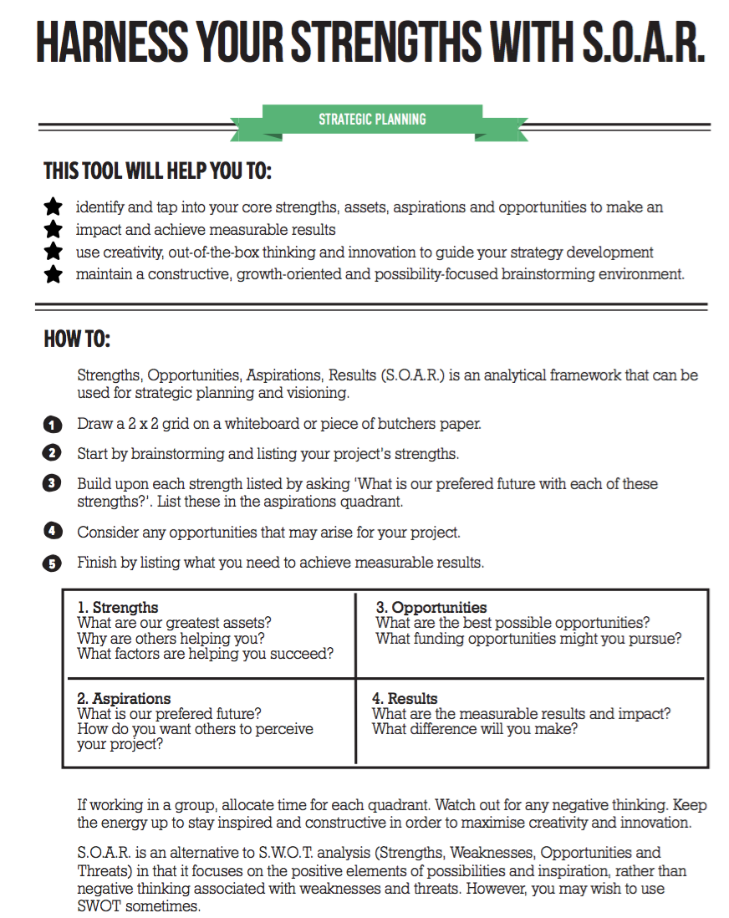

Notes and end-of-day reflections

End of Day Reflection (Day 1)

What was the most interesting thing you learnt today that will tell your work friends about when you return to your workplace?

End of Day Reflection (Day 2)

What was the most interesting thing you learnt today that will tell your work friends about when you return to your workplace?

This page has been left intentionally blank


