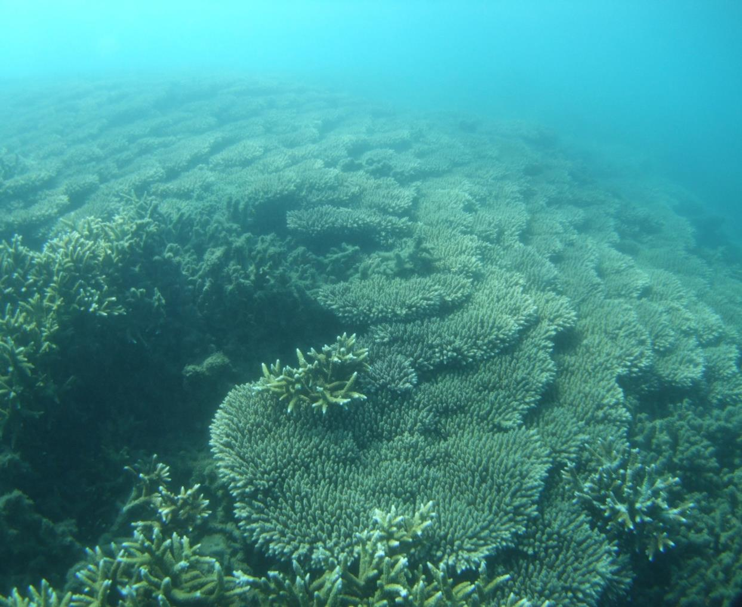
m
Baffle Basin Assessment
Burnett-Mary Regional Management Group NRM Region

Assessment of ecological functions within the Baffle basin focusing on understanding and improving the health and resilience of the Great Barrier Reef

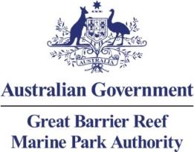

Baffle Basin Assessment – Burnett-Mary Regional Management Group Natural Resource Management Region
Assessment of ecological functions within the Baffle basin focusing on understanding and improving the health and resilience of the Great Barrier Reef

© Commonwealth of Australia 2013

Published by the Great Barrier Reef Marine Park Authority 2013

This work is copyright. You may download, display, print and reproduce this material in unaltered form only (appropriately acknowledging this source) for your personal, non-commercial use or use within your organisation. Apart from any use as permitted under the Copyright Act 1968, all other rights are reserved.

Disclaimer
The views and opinions expressed in this publication are those of the authors and do not necessarily reflect those of the Australian Government or the Minister for Sustainability, Environment, Water, Population and Communities.

While reasonable efforts have been made to ensure that the contents of this publication are factually correct, the Australian Government does not accept responsibility for the accuracy or completeness of the contents, and shall not be liable for any loss or damage that may be occasioned directly or indirectly through the use of, or reliance on, the contents of this publication.

National Library of Australia Cataloguing-in-Publication entry
Baffle basin assessment : Burnett-Mary Regional Management Group Natural Resource
Management region / Great Barrier Reef Marine Park Authority.
ISBN 978 1 922126 12 2 (ebook)
Ecosystem management--Queensland--Great Barrier Reef.
Ecosystem health--Queensland--Great Barrier Reef.
Natural resources management areas--Queensland--Great Barrier Reef.
Great Barrier Reef (Qld.)--Environmental conditions.
Great Barrier Reef Marine Park Authority.
577.09943

This publication should be cited as:
Great Barrier Reef Marine Park Authority 2013, Baffle basin assessment: Burnett-Mary
Regional Management Group Natural Resource Management region, GBRMPA, Townsville.

The Great Barrier Reef Marine Park Authority (GBRMPA) would like to thank the Burnett-Mary Regional Natural Resource Management Group NRM for their invaluable assistance with knowledge of the Baffle Creek basin (Baffle basin), the Queensland Wetlands Program and Hooked on 1770 charters. Water quality information was provided by TropWATER Townsville. The GBRMPA also acknowledges the contributions of Hugh Yorkston, Donna-marie Audas, Jason Vains, Paul Groves, Carol Marshall, Melissa Evans, Ben Palmer, Rose Dunstan, Emily Smart and Sara Dunstan.

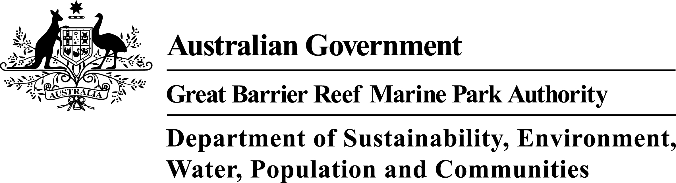

Requests and enquiries concerning reproduction and rights should be addressed to:

Great Barrier Reef Marine Park Authority
2-68 Flinders Street (PO Box 1379)
Townsville QLD 4810, Australia

Phone: (07) 4750 0700
Fax: (07) 4772 6093
Email: info@gbrmpa.gov.au

www.gbrmpa.gov.au

Contents
EXECUTIVE SUMMARY 1
Context 1
The Baffle basin 1
Key issues 2
Potential management actions 3
INTRODUCTION 4
Background 4
Purpose 4
Methodology 6
PART A: VALUES OF THE GREAT BARRIER REEF REGION – BAFFLE BASIN 9
Chapter 1: Baffle basin – background to changes affecting matters of national environmental significance 9
1.1 Background and history of the Baffle basin 9
Chapter 2: Values and their current condition 12
2.1 Matters of National Environmental Significance in the basin 14
2.2 Other protected areas and values in the basin 15
2.3 Coastal ecosystems 19
2.4 Ecosystem processes 42
2.5 Connectivity 44
Chapter 3: Impacts on the values 51
3.1 Drivers of change 51
3.2 Activities and impacts 53
3.3 Land use within the coastal zone 56
3.4 Actual and potential impacts 57
PART B: OUTCOMES OF BASIN ASSESSMENT 63
Chapter 4: Projected condition of Great Barrier Reef catchment values 63
4.1 Summary of current state of coastal ecosystems 63
4.2 Outline of key current and likely future pressures and impacts on coastal ecosystems in the Baffle basin 64
4.3 Current and likely future impacts on coastal ecosystems and likely resultant impacts on the World Heritage Area 68
4.4 Priorities for conservation and restoration 77
4.5 Potential management actions 79
4.6 Knowledge gaps 80
REFERENCES 81
Appendix A – Field Assessment Template 84
Appendix B – Key Terminology used in this report 85
Appendix C – Values and their elements that underpin matters of national environmental significance 86
Appendix D – Threatened species of the Baffle basin 90
Appendix E – Migratory species of the Baffle basin 91
Appendix F – Ecological processes 92
Appendix G – Water quality report for the Baffle basin 96

EXECUTIVE SUMMARY

Context
A healthy and resilient Great Barrier Reef World Heritage Area (the World Heritage Area) is reliant upon the ecological integrity of the adjacent Great Barrier Reef catchment (catchment) and its’ ecosystems (coastal ecosystems).

The Baffle basin provides habitat for many important marine, estuarine, freshwater and terrestrial species with lifecycles that have connections to the World Heritage Area. The coastal ecosystems in the basin also provide a range of ecosystem functions that support the health and resilience of the marine environment.

Within the marine environment, coastal waters provide high value marine areas including around islands and inshore coral reefs. To protect representations of these areas, there are many coastal and inshore Marine National Park Zones adjacent to this basin.

This Report is part of a series of similar reports investigating the nature, condition, connectivity and management of coastal ecosystems within basins that form the catchment of the World Heritage Area. The purpose of this Report on the Baffle basin is to:

- Review coastal ecosystems in the basin, assess their state and consider the pressures that they are facing now, and into the future.
- Understand the connections between coastal ecosystems and the World Heritage Area, and how changes to these connections are impacting on the ecological functions they provide to the Great Barrier Reef.
- Provide information to support future planning and management decisions, including identifying areas important for protection or potential offsets.
- Empower communities and stakeholders by providing information that can support on-ground actions.

Maps shown in this basin assessment were derived from a range of data sources, and should only be used as a guide.

The Baffle basin
The Baffle basin is located north of Bundaberg and south of Gladstone. It covers some 410,471 hectares. Compared with other basins in the Great Barrier Reef catchment, the Baffle basin is a relatively undisturbed basin with only a few smaller coastal communities within an otherwise undisturbed coastal zone. Approximately 22 per cent of the Baffle basin is afforded protection through National Parks, Conservation Parks and Protected Areas with around 34 per cent of the coastal zone protected. As a result, estuaries within the Baffle basin remain in near pristine condition. Pancake Creek estuary for example contains healthy coral reef and seagrass ecosystems.

Key issues
The Baffle basin has significant natural assets and is home to (and used by) many important marine, estuarine, freshwater and terrestrial species with connections to the World Heritage Area. It is one of the lesser impacted of the basins assessed under the Coastal Ecosystems Assessment Framework.

Forests are the dominant coastal ecosystem and these have experienced the greatest area of loss, with around 117,937 hectares cleared. Forested floodplain ecosystems have had the greatest proportional loss, with only 38 per cent remaining. Approximately 15 per cent of the basin is contained within National Parks or State Forests.¹ Overall, around 63 per cent of coastal ecosystems in the Baffle basin have been retained.

The Baffle Creek catchment and estuary are the least impacted in the Central Queensland region and are used as a general yardstick of what is ‘normal’ for undisturbed systems.² The freshwater waterways of the Baffle basin are generally in good to very good condition. Stream banks appear mostly stable, with bank susceptibility to erosion considered to be low to minimal. Riparian vegetation condition ranges from very poor to very good. Most streams provide good aquatic habitat.¹

The estuaries in the Baffle basin are largely unmodified or in near pristine condition. Of these, the Pancake Creek estuary may be the last remaining mainland estuary containing an intact and healthy coral reef system. Although it occurs outside the Marine Park, it falls within the boundary of the World Heritage Area. Other values of Pancake Creek include reports of Australian snubfin dolphins and dugong feeding trails.

Ground and river water extraction in the Baffle basin is currently limited.³ Increased human induced drivers will likely change the coastal aquifers, floodplain and wetlands in the future. Climate change will exacerbate future problems unless managed for into the future.

The greatest threat to the World Heritage Area from the Baffle basin comes from degradation of the riparian zone and the subsequent loss of soil through erosion. These changes are reflected in the elevated levels of suspended sediments in receiving waters. Progress has been made to improve this situation through Reef Plan and by on-ground programs initiated by the Burnett-Mary Regional Group. The expansion of urban development driven by the resources boom in nearby Gladstone may also lead to problems (such as increased demand for water and waste disposal) in the future.

The waters of the World Heritage Area adjacent to the Baffle basin are in relatively good condition. The impacts from recent flood events have not been assessed, however given the relatively good health of the inshore marine ecosystems prior to the flooding there is a good prospect for recovery from these impacts. Remaining coastal ecosystems, especially those situated in the coastal zone and floodplain should be conserved to maintain the current level of ecological processes. Riparian areas impacted from grazing are the priorities for restoration in this basin. Future urban development also needs to utilise water sensitive urban design to ensure water quality and environmental values are maintained.

Potential management actions
This report has been developed as a baseline for the Baffle basin. In order to ensure that the basin is best represented, consideration of additional finer scale data, local knowledge and information will further enhance this assessment.

Coastal ecosystems located in the floodplain and coastal zone are those that are at most at risk in the future from development pressures such as increasing urbanisation and aquaculture. Future conservation and restoration measures need to focus on these ecosystems to prevent further loss and impacts. These areas are also at greatest risk from flooding, storm and climate change impacts so high value infrastructure, such as residential and industrial development should be avoided in these areas or managed in such a way that manages the risk from natural events while maintaining ecosystem functions for the World Heritage Area. Current infrastructure in these areas needs to be managed to current best practice.

Ensuring the long-term health of the Reef requires greater protection of, and restoration of important ecological processes and functions provided by Fitzroy basin coastal ecosystems. Actions that would increase protection and restore processes and function include:
- Restoration of riparian corridors to a standard that provides effective ecological functions with vegetation adapted to the future climate scenarios.
- Improvement in agricultural practices where riparian buffers are minimal or non-existent.
- Inclusion of undeveloped freehold and leasehold allotments adjacent to significant natural sites (such as Pancake Creek and Eurimbula Creek estuary) into the protected area estate.
- Establishment of no anchor zones in areas of seagrass and coral in Pancake Creek.
- Mapping of regional ecosystems at a local scale supported by ground-truthing.
- Limit the development of irrigated cropping in the basin to prevent the problems that are occurring in other basins (refer to the Haughton basin assessment) from impacting this area.

INTRODUCTION

Background
The Great Barrier Reef Marine Park (Marine Park) covers an area of approximately 348,000 km² and extends from Cape York in the north to Bundaberg in the south. The Great Barrier Reef World Heritage Area was accepted in 1981 for inclusion in the World Heritage List, meeting all four of the natural heritage criteria (aesthetics and natural phenomena; geological processes and significant geomorphic features representing major stages of earth’s history; ecological and biological processes; and habitats for the conservation of biological diversity, including threatened species). The World Heritage Area includes additional areas outside of the Marine Park. The World Heritage Area extends from the low water mark on the Queensland coast to up to 250 km offshore past the edge of the continental shelf and includes coastal and island ecosystems, as well as some port and tidal areas, outside of the Marine Park.

The adjacent Great Barrier Reef catchment encompasses an area of 424,000 km² with all water flowing from the catchment into the World Heritage Area. The catchment contains a diverse range of terrestrial, freshwater and estuarine ecosystems. These coastal ecosystems include rainforests, forests, woodlands, forested floodplains, freshwater wetlands, heath and shrublands, grass and sedgelands, and estuaries.

Coastal ecosystems support the health and resilience of the World Heritage Area. The ecological functions provided by coastal ecosystems include physical processes (such as sediment and water distribution and cycling), biogeochemical processes (such as nutrient and chemical cycling) and biological processes (such as habitat and food provisioning).

This Report assesses the Baffle basin’s current land use, remaining extent and pressures on coastal ecosystems, and how this basin supports and maintains the health and resilience of the World Heritage Area.

Purpose
The purpose of a basin assessment is to assess at the landscape scale ecological functions, the risks to these functions and the cumulative impacts that are affecting the long-term health of the World Heritage Area. The focus area for this Report is the Baffle basin, which includes ecosystems extending from the inshore areas of the Marine Park to the upper extent of the Baffle basin. The information collected, collated and analysed provides a rapid summary of the state of the basin’s ecological assets and highlights pressures and threats, ecological condition and the social response to threats and pressures that are influencing the health of the World Heritage Area. More influencing factors – and consequently more pressures – are at work at finer scales of analysis and should be considered when planning or managing these areas.

The Great Barrier Reef catchment is made up of thirty-five basins draining directly into the World Heritage Area, as shown in Table 1.
Table 1: Basins in the Great Barrier Reef catchment
Great Barrier Reef catchment | NRM regions | Basins | Coastal zone as defined by Queensland State Coastal Management Plan 2011
Great Barrier Reef catchment | Cape York NRM region  (managed by Cape York NRM) | Jacky Jacky
Great Barrier Reef catchment | Cape York NRM region  (managed by Cape York NRM) | Olive-Pascoe
Great Barrier Reef catchment | Cape York NRM region  (managed by Cape York NRM) | Lockhart
Great Barrier Reef catchment | Cape York NRM region  (managed by Cape York NRM) | Stewart
Great Barrier Reef catchment | Cape York NRM region  (managed by Cape York NRM) | Normanby
Great Barrier Reef catchment | Cape York NRM region  (managed by Cape York NRM) | Jeanie
Great Barrier Reef catchment | Cape York NRM region  (managed by Cape York NRM) | Endeavour
Great Barrier Reef catchment | Wet Tropics NRM region (managed by Terrain) | Daintree
Great Barrier Reef catchment | Wet Tropics NRM region (managed by Terrain) | Mossman
Great Barrier Reef catchment | Wet Tropics NRM region (managed by Terrain) | Barron
Great Barrier Reef catchment | Wet Tropics NRM region (managed by Terrain) | Mulgrave-Russell
Great Barrier Reef catchment | Wet Tropics NRM region (managed by Terrain) | Johnstone
Great Barrier Reef catchment | Wet Tropics NRM region (managed by Terrain) | Tully
Great Barrier Reef catchment | Wet Tropics NRM region (managed by Terrain) | Murray
Great Barrier Reef catchment | Wet Tropics NRM region (managed by Terrain) | Herbert
Great Barrier Reef catchment | Burdekin Dry Tropics NRM region  (managed by NQ Dry Tropics) | Black
Great Barrier Reef catchment | Burdekin Dry Tropics NRM region  (managed by NQ Dry Tropics) | Ross
Great Barrier Reef catchment | Burdekin Dry Tropics NRM region  (managed by NQ Dry Tropics) | Haughton
Great Barrier Reef catchment | Burdekin Dry Tropics NRM region  (managed by NQ Dry Tropics) | Burdekin
Great Barrier Reef catchment | Burdekin Dry Tropics NRM region  (managed by NQ Dry Tropics) | Don
Great Barrier Reef catchment | Mackay Whitsunday NRM region  (managed by Reef Catchments) | Proserpine
Great Barrier Reef catchment | Mackay Whitsunday NRM region  (managed by Reef Catchments) | O'Connell
Great Barrier Reef catchment | Mackay Whitsunday NRM region  (managed by Reef Catchments) | Pioneer
Great Barrier Reef catchment | Mackay Whitsunday NRM region  (managed by Reef Catchments) | Plane
Great Barrier Reef catchment | Fitzroy NRM region  (managed by Fitzroy Basin Association) | Styx
Great Barrier Reef catchment | Fitzroy NRM region  (managed by Fitzroy Basin Association) | Shoalwater
Great Barrier Reef catchment | Fitzroy NRM region  (managed by Fitzroy Basin Association) | Waterpark
Great Barrier Reef catchment | Fitzroy NRM region  (managed by Fitzroy Basin Association) | Fitzroy
Great Barrier Reef catchment | Fitzroy NRM region  (managed by Fitzroy Basin Association) | Calliope
Great Barrier Reef catchment | Fitzroy NRM region  (managed by Fitzroy Basin Association) | Boyne
Great Barrier Reef catchment | Burnett-Mary NRM region  (managed by Burnett Mary Regional Group) | Baffle
Great Barrier Reef catchment |  | Kolan
Great Barrier Reef catchment |  | Burnett
Great Barrier Reef catchment |  | Burrum
Great Barrier Reef catchment |  | Mary

Methodology
The methods underpinning this basin assessment are detailed in the Coastal Ecosystems Assessment Framework⁴, a tool developed in partnership with the Queensland Government (available at www.gbrmpa.gov.au). The Coastal Ecosystems Assessment Framework was developed and used as the basis of the Informing the Outlook for Great Barrier Reef coastal ecosystems⁵ report and provides a holistic approach to assessing and understanding ecological functions provided by coastal ecosystems and the pressures affecting them.

The catchment in its current state is a mosaic of natural and modified ecosystems with a suite of values and functions of importance to the World Heritage Area. The methodology used to understand the values and functions provided by natural and modified coastal ecosystems are outlined in the Coastal Ecosystem Assessment Framework⁴ and have been used as a basis to assess the Baffle basin assessment. Figure 1 below describes the methodology used to rapidly assess the ecological functions and values to conduct the Baffle basin assessment.
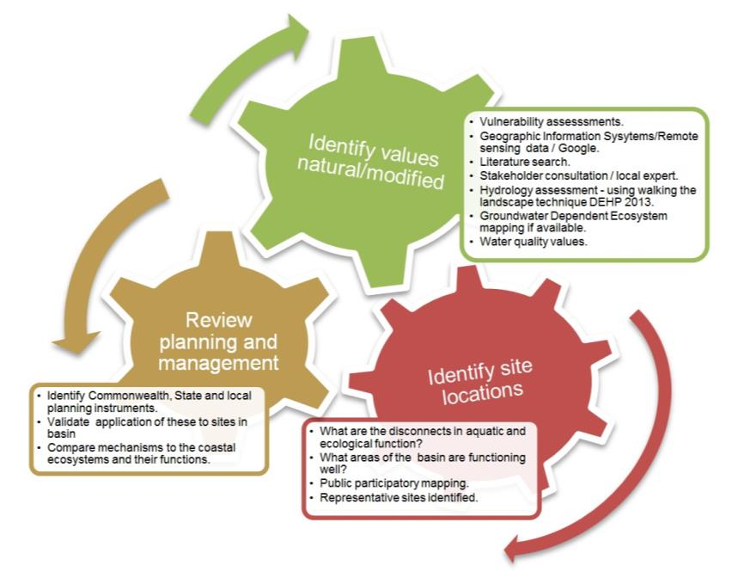
Figure 1: Summary of the methodology for conducting a rapid basin scale assessment

Stakeholder engagement and verification of assessment information has been crucial to the development of this basin assessment. Building on the information collected and collated for the Informing the Outlook for coastal ecosystems⁵ report, the methodology for preparing this Report incorporated the following steps:

- Local experts were consulted to identify areas of interest to visit in the field as part of a ‘rapid assessment’.
- Research was conducted on the basin using available information.
- Sites of interest were identified using coastal ecosystem maps and Google earth (GPS identification for sites to be visited for field work).
- Collaboration with local stakeholders (i.e. consultants, natural resource management bodies, local land owners) helped to verify the issues affecting the basin, as well as additional field sites.
- Field investigations were conducted using the field site assessment template forms (Appendix A) to capture site locations and reference photos at basin sites (Figure 2).
- GPS coordinates from field assessments were imported into Google earth to assist with report preparation.
- Preliminary basin assessments were compiled to facilitate stakeholder input.
- Workshops were conducted to bring stakeholders together to present information and incorporate feedback into the basin assessment.
- Draft basin assessments were prepared as a basis to further stakeholder input.
- Basin assessments finalised and published.

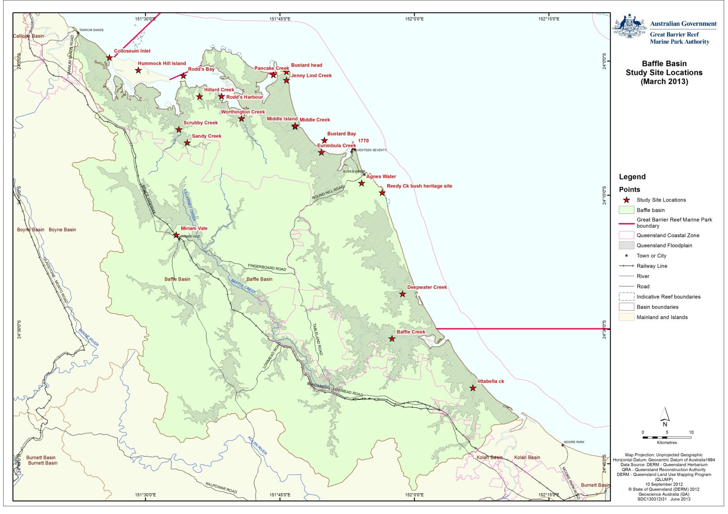
Figure 2: Study sites for the Baffle basin assessment

PART A: VALUES OF THE GREAT BARRIER REEF REGION – BAFFLE BASIN
- Baffle basin – background to changes affecting matters of national environmental significance

Background and history of the Baffle basin
The Baffle basin is located south of Gladstone (Figure 1.1.1) and waterways in the basin flow from near Turkey Beach in the north and enter the World Heritage Area south of the town of Agnes Water. The major tributaries of the Baffle Creek are Eurimbula and Eulelia creeks, both of which drain water from the hill slopes located in the central Baffle basin and merge with Baffle Creek on the floodplain.
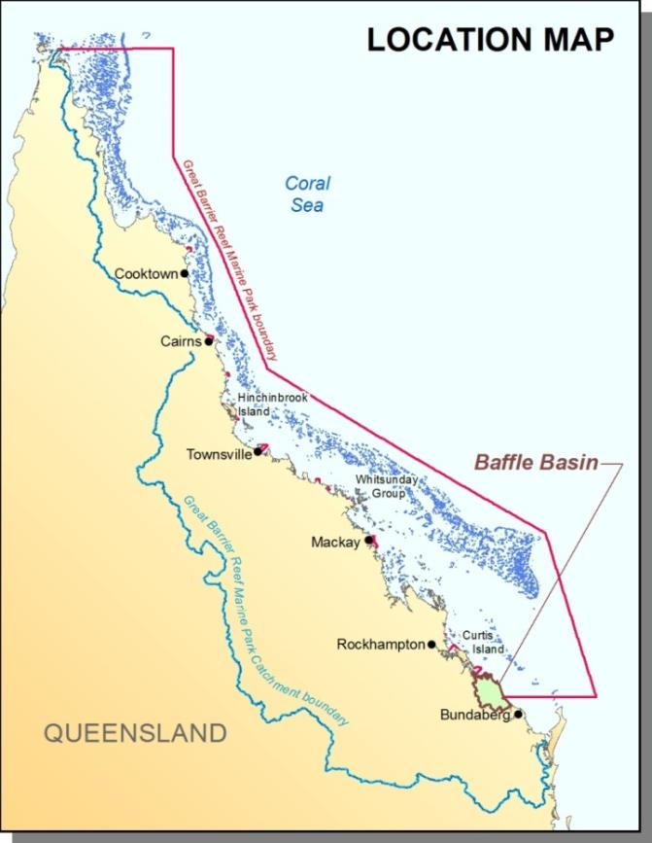
Figure 1.1.1: Map of the Baffle basin and its proximity to the Great Barrier Reef catchment and the Great Barrier Reef Marine Park
There are many smaller waterways flowing into the near pristine estuaries of the Baffle basin including Bustard Bay, Pancake Creek, Rodds Harbour, Colosseum Inlet and Seven Mile Creek. Close to the coastline the islands of Hummock Hill and Wild Cattle offer scenic amenity, whilst further offshore the islands of the Capricorn Bunker Group are of high value to the World Heritage Area as bird and turtle rookeries (and for tourism). The coastline on the eastern side of the Baffle basin is exposed to wave action and these waves have generated coastal dune systems that provide nesting habitat for marine turtles and feeding habitat for migratory birds.
The tidal wetlands of the Baffle basin are near pristine and, in addition to the significant values they provide to the World Heritage Area, they are also important areas for the traditional owners of these coastal lands, with the estuaries providing focal places for gatherings as evident by the presence of middens in the area.
Overall water quality within the Great Barrier Reef Marine Park portion of the Burnett-Mary region is considered in good condition⁶ (refer Appendix E), however there is a lack of historical and current water quality data for comparisons. There have been substantial losses to riparian vegetation and wetland areas since pre-European times and seagrass coverage is severely impacted by flood events. Many sugar cane growers have implemented cutting-edge or best management practices for the use of herbicides.
Historically, land clearing was promoted by the Commonwealth and state governments as part of promoting productivity and national economic prosperity. Incentives for agriculture development (such as post war settlement schemes) increased the rate of land clearing, with offerings of cheap land, loans or tax concessions. This forms part of the history (Table 1.1.1) which has led to the current land condition of the Baffle basin.⁷
Table 1.1.1: Historical timeline for the Baffle basin
Year | Event
1770 | Captain Cook first lands in Queensland.
1860s | Pastoral leaseholders run sheep then switch to cattle due to harm caused by speargrass to the sheep.
1870s | Harvesting of hoop pine in the Eurimbula scrub near Bustard Bay.
1878 | Agnes Water under a pastoral lease.
1890 | Sawmilling occurs in the area and the area becomes a holiday destination.
1890s | Several pastoral leaseholds resumed for farm selections including bananas, tobacco and dairy.
1936 | Town of 1770 officially named.
1970s | Agnes and 1770 grow with many holiday homes constructed in the area.
2001 | Agnes Water population is three times that of Miriam Vale, the shire’s administrative centre. Agnes Water became the principal commercial and industrial centre.

Baffle Creek and the other waterways in the basin are used for irrigation, industry, stock watering and drinking. The adjoining coastal waters are used for recreation (swimming, boating, fishing, diving and tourism) and seafood harvest. Both hold significant cultural and spiritual values for the local Traditional Owners. Off shore are the islands of the Capricorn-Bunker group – islands with fringing coral reefs - that are significant nesting sites for marine turtles and seabirds.
Over 120,000 people visit the Great Barrier Reef in the Mackay/Capricorn region annually. These visitors contribute financially to the local communities and the tourism industry. There were 7480 recreational vessels (motorboats, speedboat, personal watercraft and sailboats) registered in the Gladstone Regional Council as of December 2012.
Heritage values include the lighthouse at Bustard Head. The Queensland Government built its first lighthouse here in 1868 made of cast iron.⁷ Infrastructure used during the construction and maintenance of the lighthouse still remains in the waters of the adjacent Pancake Creek and may be of heritage value.

- Values and their current condition
The values that are considered in this report include:

- Inshore marine ecosystems that underpin the outstanding universal value of the World Heritage Area (such as coral reefs, seagrasses and associated species).
- Terrestrial coastal ecosystems that provide ecosystem functions to the Great Barrier Reef World Heritage Area and other matters of national environmental significance (MNES).

A conceptual model of these ecosystems and the functions they provide is shown in Figure 2.1. The ecosystems examined in this report also provide habitat for a range of other MNES. The MNES in the Baffle Basin are outlined in Section 2.1 below and the values and their elements that underpin matters of national environmental significance for the Baffle basin and adjacent waters are shown in Appendix C.

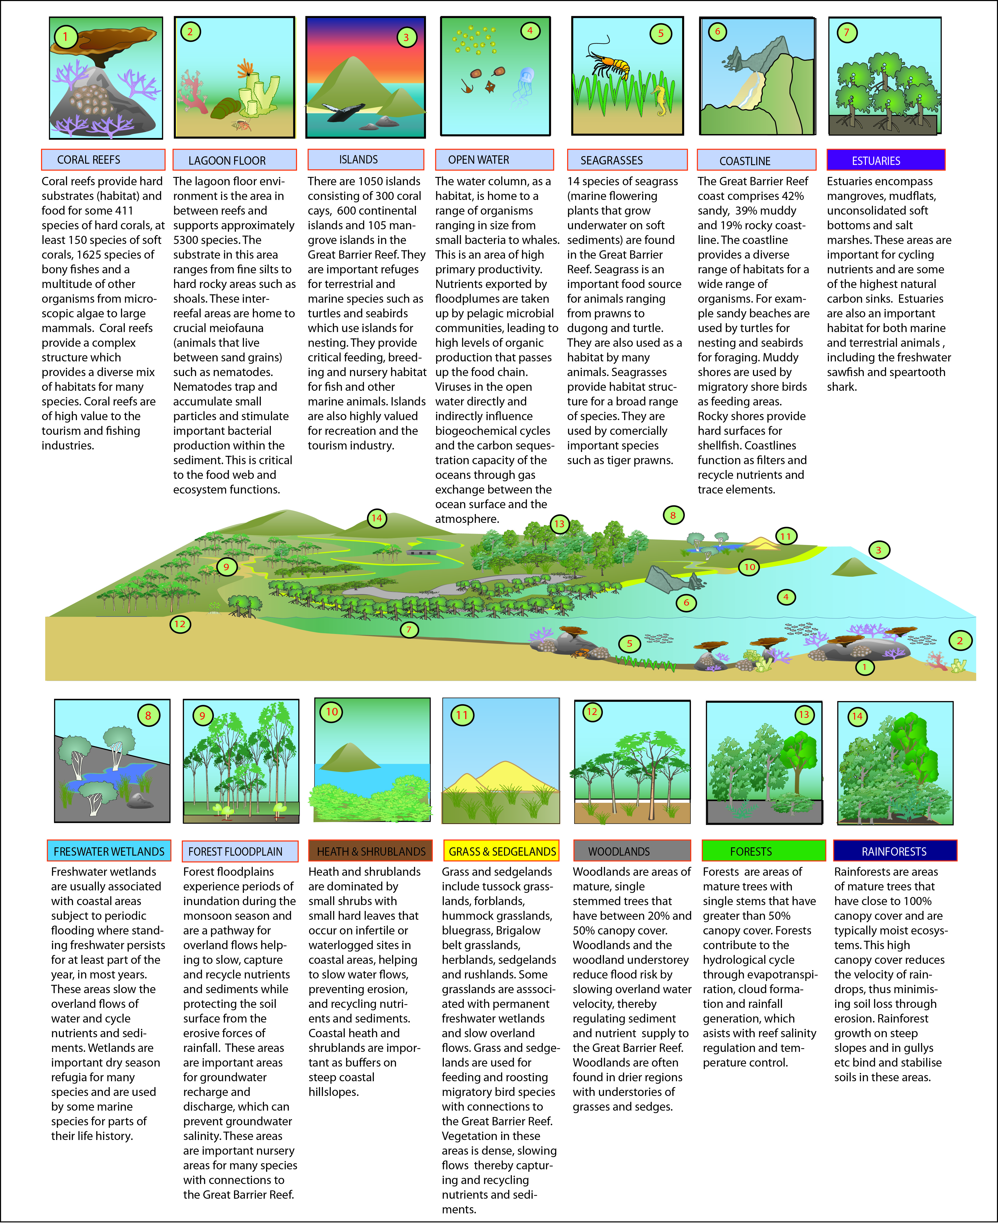
Figure 2.1: Conceptual model for categorizing the Great Barrier Reef coastal, catchment and inshore ecosystems and assessing the ecological functions and services of those ecosystems to the cumulative impacts of development

Matters of National Environmental Significance in the basin
Under the Environment Protection and Biodiversity Conservation Act 1999 (EPBC Act), actions that have, or are likely to have, a significant impact on a matter of national environmental significance require referral to the Australian Government Environment Minister. The Minister will decide whether assessment and approval may be required under the EPBC Act. There are eight matters of national environmental significance protected under the EPBC Act. These are:
- World heritage properties
- National heritage places
- Wetlands of international importance (listed under the Ramsar Convention)
- Listed threatened species and ecological communities
- Migratory species protected under international agreements
- Commonwealth marine areas
- The Great Barrier Reef Marine Park
- Nuclear actions (including uranium mines).

World heritage properties
The Great Barrier Reef was inscribed in the World Heritage List in 1981 and meets all four natural criteria. Parts of the Baffle basin and all of the adjacent marine areas fall within the World Heritage Area.

National heritage properties
The EPBC Act provides for the listing of natural, historic or Indigenous places that are of outstanding national heritage value. Within the Baffle basin only the Great Barrier Reef is listed as a National Heritage Property (for its natural values).

Wetlands of international importance (declared Ramsar wetlands)
There are no wetlands of International significance in the Baffle basin.

Listed threatened species
Six species of bird, one species of fish, five species of mammal, three species of cycad, fourteen species of plant and nine species of reptile have been identified as listed threatened species within the Baffle basin and adjacent waters. A list of these can be found in Appendix D.

Ecological communities
There are two critically endangered ecological communities that occur within the Baffle basin. These are the Littoral Rainforest and Coastal Vine Thickets of Eastern Australia and Lowland Subtropical Rainforest on Basalt Alluvium.

Listed migratory species
The EPBC Act lists migratory species which includes those species listed in the:

- Convention on the Conservation of Migratory Species of Wild Animals (Bonn Convention)
- China-Australia Migratory Bird Agreement (CAMBA)
- Japan-Australia Migratory Bird Agreement (JAMBA)
- Listed international agreement for this purpose if satisfied that it is an agreement relevant to the conservation of migratory species.

There are 27 species of migratory birds, three species of migratory mammal, seven species of migratory reptiles that occur within the Baffle basin and adjacent waters. A list of these can be found in Appendix E.

The Great Barrier Reef Marine Park
The Marine Park is recognised as a matter of national environmental significance under the EPBC Act to enhance the management and protection of the ecosystems in the Great Barrier Reef Region. The Great Barrier Reef Marine Park Zoning Plan 2003 (the Zoning Plan) is the overarching plan that provides for a range of ecologically sustainable recreational, commercial, and research opportunities and for the continuation of traditional activities. Each zone has different rules for the activities that are allowed (as of right), prohibited, and those that require permission. Zones may also place restrictions on how some activities are conducted.

Other protected areas and values in the basin
Although not matters of national environmental significance, there are other areas within the Baffle basin that have intrinsic values and may also have significance for the long-term health and resilience of the World Heritage Area as detailed below.

Dugong Protection Areas
A Dugong Protection Area B occurs in the coastal waters of the Baffle basin (Figure 2.2.1).
In Zone ‘B' Dugong Protection Areas mesh netting practices are allowed to continue, but with more rigorous safeguards and restrictions than in Dugong Protection Area A. Zone ‘B’ Dugong Protection Areas have been shown to contain about 22 per cent of dugongs in the southern Great Barrier Reef. These measures are being kept under review to ensure protection of dugongs in these areas.

These are mapped, along with Nationally Important Wetlands, Conservation Parks, National Parks, Forest Reserves, Nature Reserves and Fish Habitat Protection areas in Figure 2.2.1.

Nationally important wetlands (Directory of Important Wetlands in Australia)
The Directory of Important Wetlands in Australia identifies nationally important wetlands and provides information on their values providing a valuable tool for management and conservation. Nationally important wetlands in the Baffle basin⁸ include:
- Bustard Bay Wetlands
- Colosseum Inlet – Rodds Bay
- Deepwater Creek
- Granite Creek
- Great Barrier Reef Marine Park.

These are mapped, along with Conservation Parks, National Parks, Forest Reserves, Nature Reserves and Fish Habitat Protection areas in Figure 2.2.1.

Conservation parks, national parks and forest reserves
There are 26 protected areas within the Baffle basin:⁸
- Arthurs Seat State Forest
- Baffle Creek Conservation Park
- Bottle Creek Conservation Park
- Broadwater Conservation Park
- Bulburin East Forest Reserve
- Bulburin National Park
- Bulburin State Forest
- Bustard Head Conservation Park
- Castle Tower National Park
- Deepwater National Park
- Eurimbula National Park
- Eurimbula Resources Reserve
- Joseph Banks (Round Hill Head) Conservation Park
- Littabella Conservation Park
- Littabella Forest Reserve
- Littabella National Park
- Monduran State Forest 1
- Mount Colosseum National Park
- Mount Coulston State Forest
- Mount Stanley Forest Reserve 2
- Mouth of Baffle Creek Conservation Park 1
- Mouth of Baffle Creek Conservation Park 2
- Warro National Park
- Watalgan State Forest
- Wild Cattle Island National Park
- Yandaran State Forest.
These are shown in Figure 2.2.1.

Fish Habitat Areas
Declared fish habitat areas (FHA) are areas protected under the Fisheries Act 1994 (Qld) against physical disturbance associated with coastal development and are selected on the basis of their respective values. There are six⁸ fish habitat areas in this area. These are:
- Baffle Creek
- Colosseum Inlet
- Eurimbula
- Kolan River
- Rodds Harbour
- Seventeen Seventy-Round Hill.

These are shown in Figure 2.2.1.

Nature refuges
A nature refuge is a class of protected area under the Nature Conservation Act 1992 that acknowledges a commitment to manage and preserve land with significant conservation values while allowing compatible and sustainable land uses to continue. Although a nature refuge agreement may be entered into voluntarily, a nature refuge agreement is legally binding. There are five nature refuges in the Baffle basin (Figure 2.2.1). These are:
- Geoglen Nature Refuge
- Glider Gully Nature Refuge
- Koolkuna Nature Refuge
- Reedy Creek Nature Refuge
- Woodside Nature Refuge.

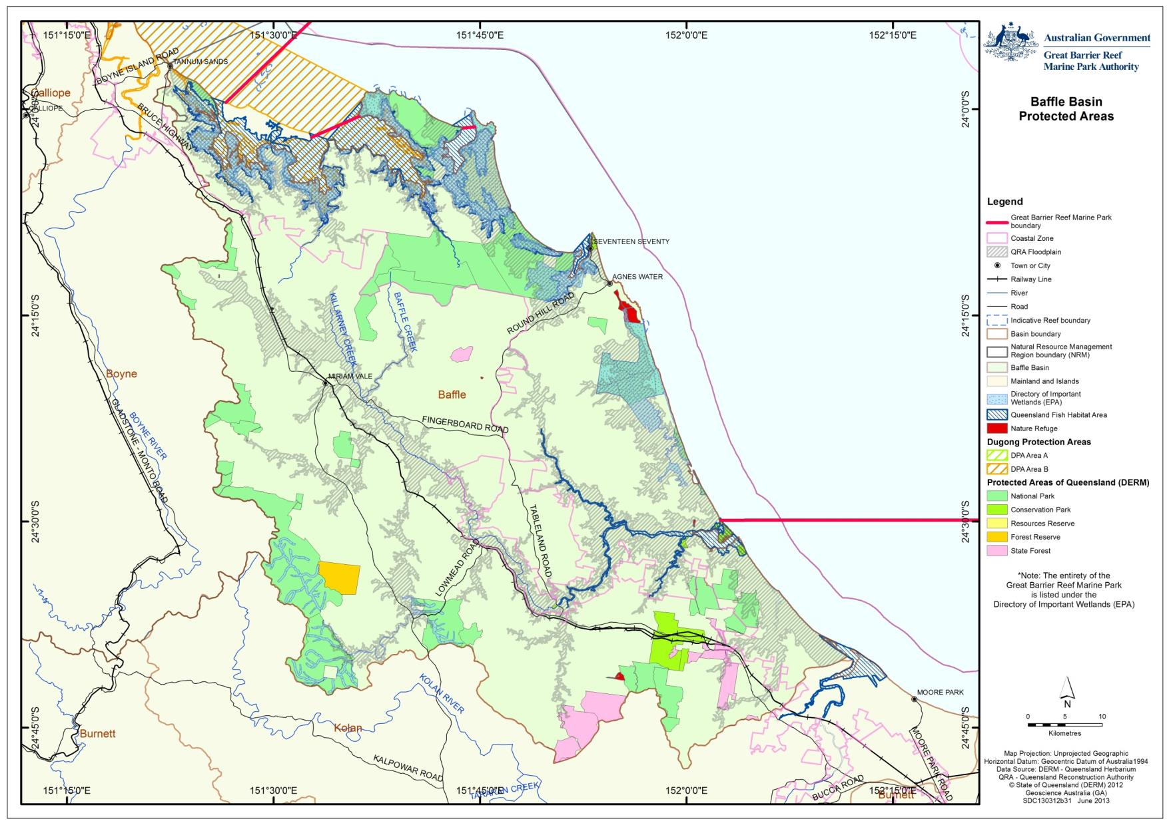
Figure 2.2.1: This map shows the spatial extent of some values in the Baffle basin that may underpin matters of national environmental significance, including World Heritage Properties, National Heritage Properties, Ramsar wetlands, Nationally Important wetlands, National Parks, Conservation Parks, forest reserves, Fish Habitat Areas, and Nature Refuges

Coastal ecosystems
The Great Barrier Reef inshore ecosystems are made up of many complex components, including estuarine and marine ecosystems such as mangroves, seagrasses and inshore coral reefs, which are closely linked to adjacent coastal ecosystems. These include coastal freshwater wetlands, coastlines and forested floodplains (Figure 2.3.1). These coastal ecosystems are interconnected and reliant on one another for their ongoing health and resilience. Species that form part of the amazing biodiversity of the Marine Park live in and move between these ecosystems throughout their life cycles.

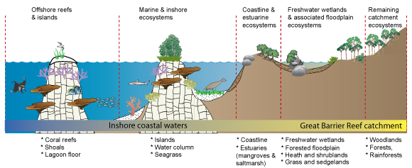
Figure 2.3.1: Broad groupings of coastal ecosystems illustrating the general level of importance for the ongoing health and resilience of the Great Barrier Reef

Coastal ecosystems are not easily separated and defined, as functionally they are all connected one way or another. Each component provides specific ecological functions that together make up and support the health and resilience of the ecosystem as a whole.

Inshore marine coastal ecosystems
The inshore coastal waters adjacent to the Baffle basin are home to a range of marine flora and fauna, many of which are of conservation concern. These include animals such as marine turtles, dugong, inshore coral reefs and seagrass meadows. Figure 2.3.2 shows the reefal and non-reefal bioregions (regions of similar biological or biophysical diversity) that occur within the Great Barrier Reef adjacent to the Baffle basin. Figure 2.3.3 shows the Marine Park Zoning Plan, used to conserve many marine values.

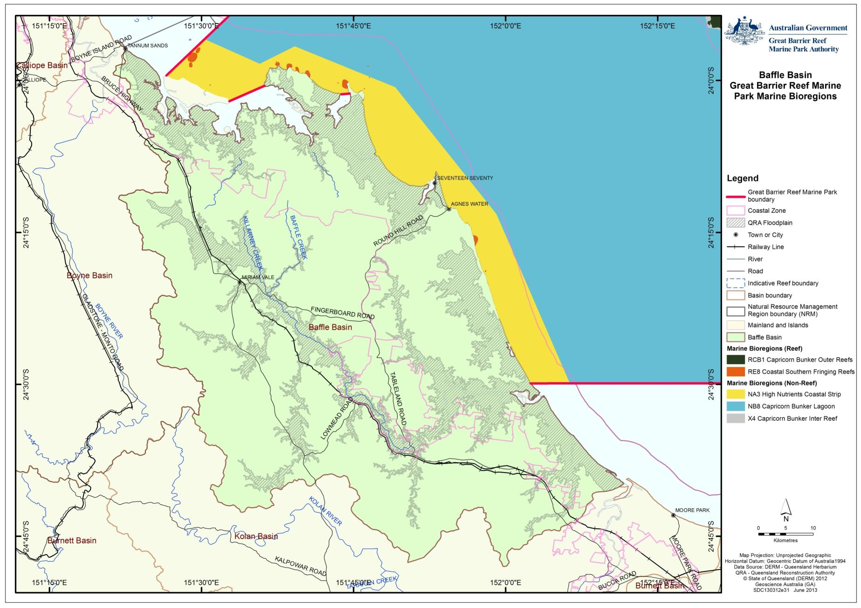
Figure 2.3.2: Marine bioregions adjacent to the Baffle basin

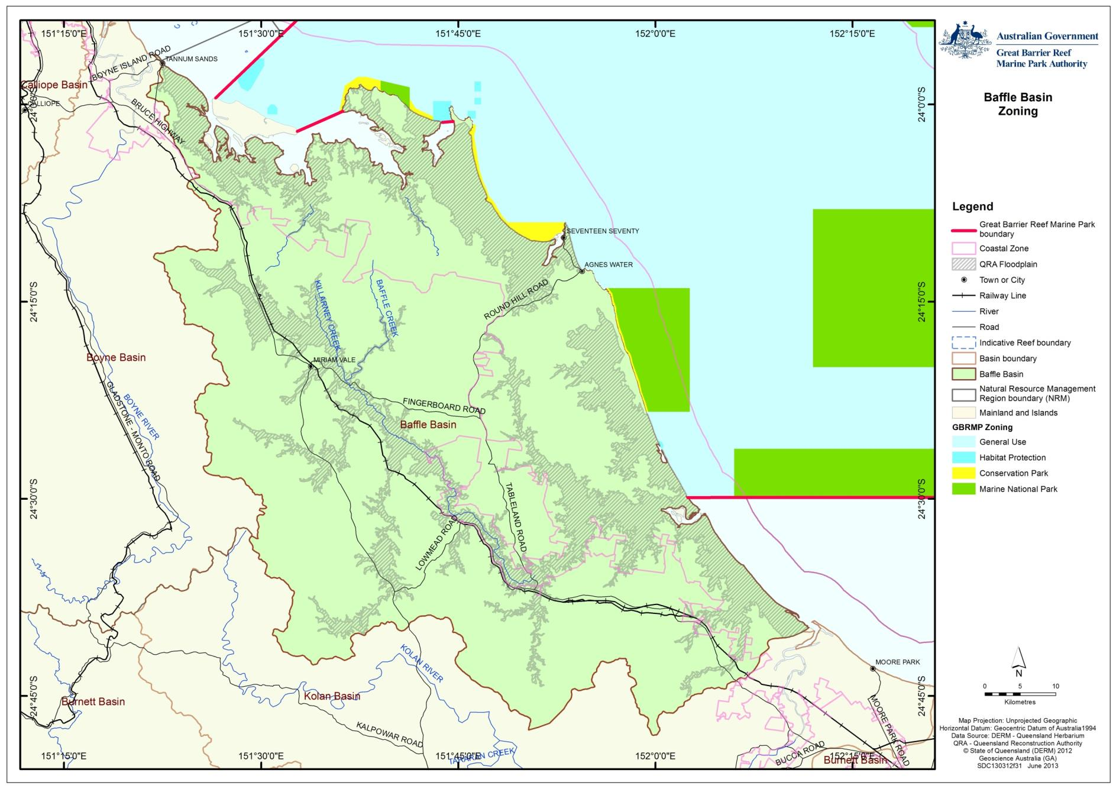
Figure 2.3.3: Zoning within the Great Barrier Reef Marine Park adjacent to the Baffle basin

The Burnett-Mary region contains one of the largest areas of seagrass meadows in Eastern Australia.⁹ Based on the Reef Water Quality Protection Plan Report Card (2011), seagrass meadows within the Burnett-Mary region are considered in good condition overall, however, meadows are either in decline or have failed to recover after the effects of flooding in 2006¹⁰. This decline is likely to continue as a result of the large flooding events that recently took place in 2013. Corals were not evaluated in this region as part of the 2009 baseline for the First Report Card.
Flood plumes from the Baffle Creek basin mix with the plumes from larger basins (such as the Burnett) and these combined plumes can reach as far as the Capricorn-Bunker Group.

Seagrass mapping was undertaken by the Queensland Government in 1988 (Figure 2.3.4). A further survey in 2002 showed a greater extent of seagrass, with 8.4 km² of seagrass habitat mapped with meadows occurring in Pancake, Jenny Lind, Middle, Eurimbula and Round Hill creeks. Pancake Creek was found to have the most extensive meadows. Species identified were Zostera capricorni, Halodule univervis and Halophila ovalis. Dugong feeding trails were observed in Pancake Creek.¹¹

Seagrass meadows in the Burnett-Mary region, although in good condition overall, are in decline or have failed to recover from the effects of flooding in 2006. The presence of many reproductive structures (for example, flowers on seagrasses) suggests recovery may be possible.¹²

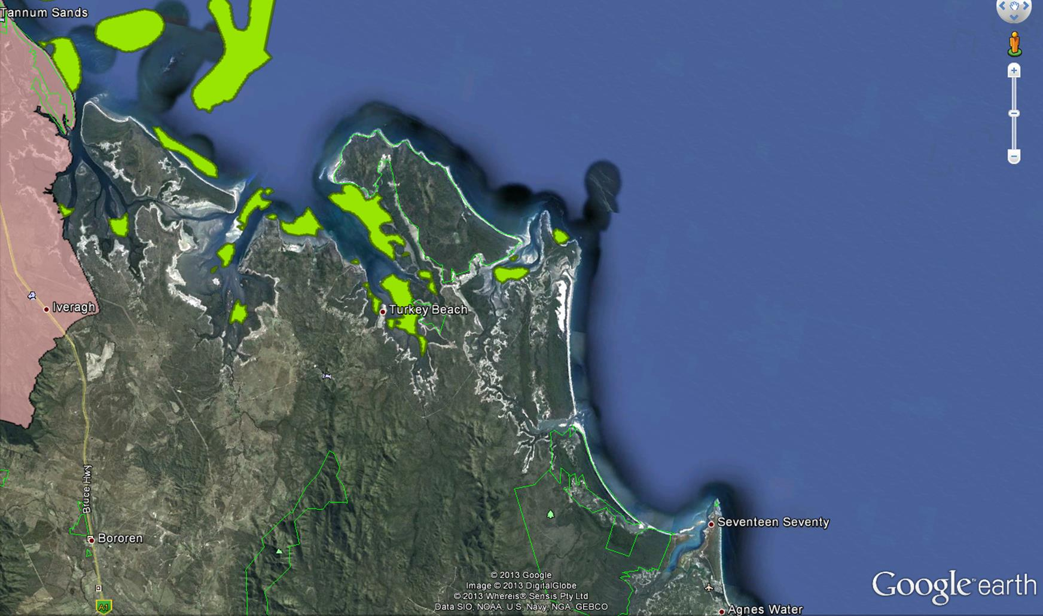
Figure 2.3.4: Map showing the extent of mapped seagrass (shallow and deep-water) (shown in green) for the Baffle basin

Extensive fringing reefs are present in the Baffle basin coastal waters including between Clews Point and Rodd’s Peninsula and around Hummock Hill Island.¹

Hummock Hill Island includes waters within the Dugong Protection Area and estuarine wetlands identified in the Queensland Government wetlands mapping. The island itself has little development and many intrinsic values. Foreshores are feeding habitat for migratory shorebirds and a site of nesting for resident shorebirds. Beneath the water deepwater seagrass meadows provide food and habitat for many Great Barrier Reef species and hard and soft coral colonies exist along the entire seaward side of the island.¹

The inshore marine ecosystems to the east of the Baffle basin provide inter-nesting habitat for marine turtles for up to two weeks before they nest. Turtles nest on the mainland and islands annually.

Changes to coastal ecosystems
Despite widespread clearing in some parts of the Baffle basin, much of the species and ecosystems remain. This is more so in the coastal areas where many of the estuaries are in near pristine condition and around 75 per cent of the other coastal ecosystems remain unmodified. These estuaries often have seagrass meadows and one estuary, Pancake Creek estuary, houses possibly the last remaining estuarine coral reef along the Great Barrier Reef coastline.
In pre-European times, the 410,471 hectare Baffle basin was dominated by forests, woodlands and forested floodplain (Figure 2.3.5). Since European settlement, these forested areas were thinned for grazing and later cleared for irrigated intensive agriculture (in some areas) (Figure 2.3.6).

Although these changes can potentially have negative consequences for coastal ecosystems, the condition of aquatic coastal ecosystems was generally in good condition at the time of this assessment.

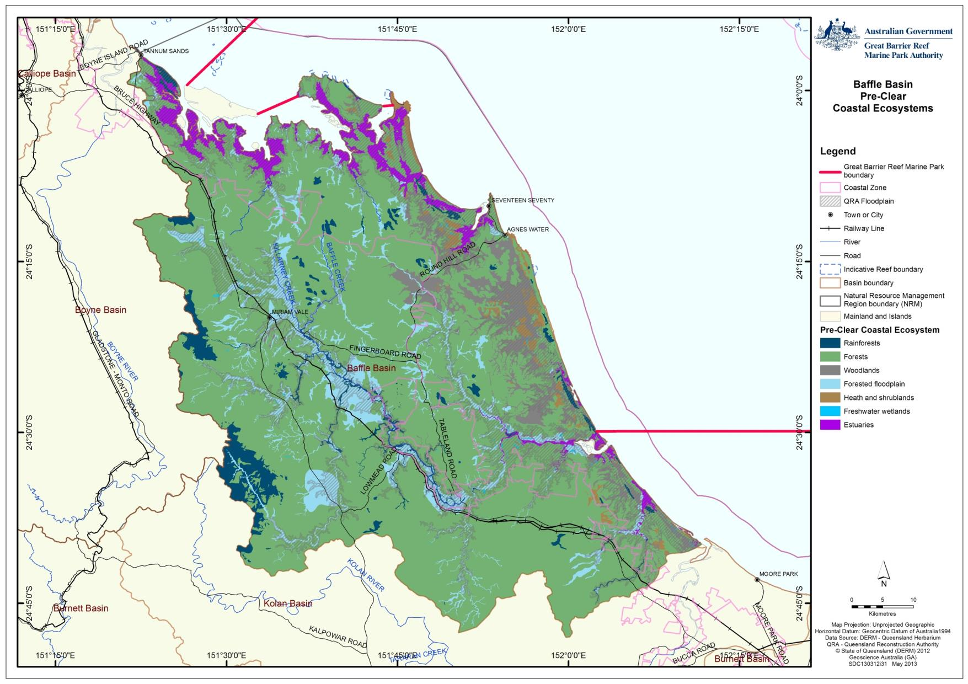
Figure 2.3.5: This map shows the pre-clear coastal ecosystems in the Baffle basin

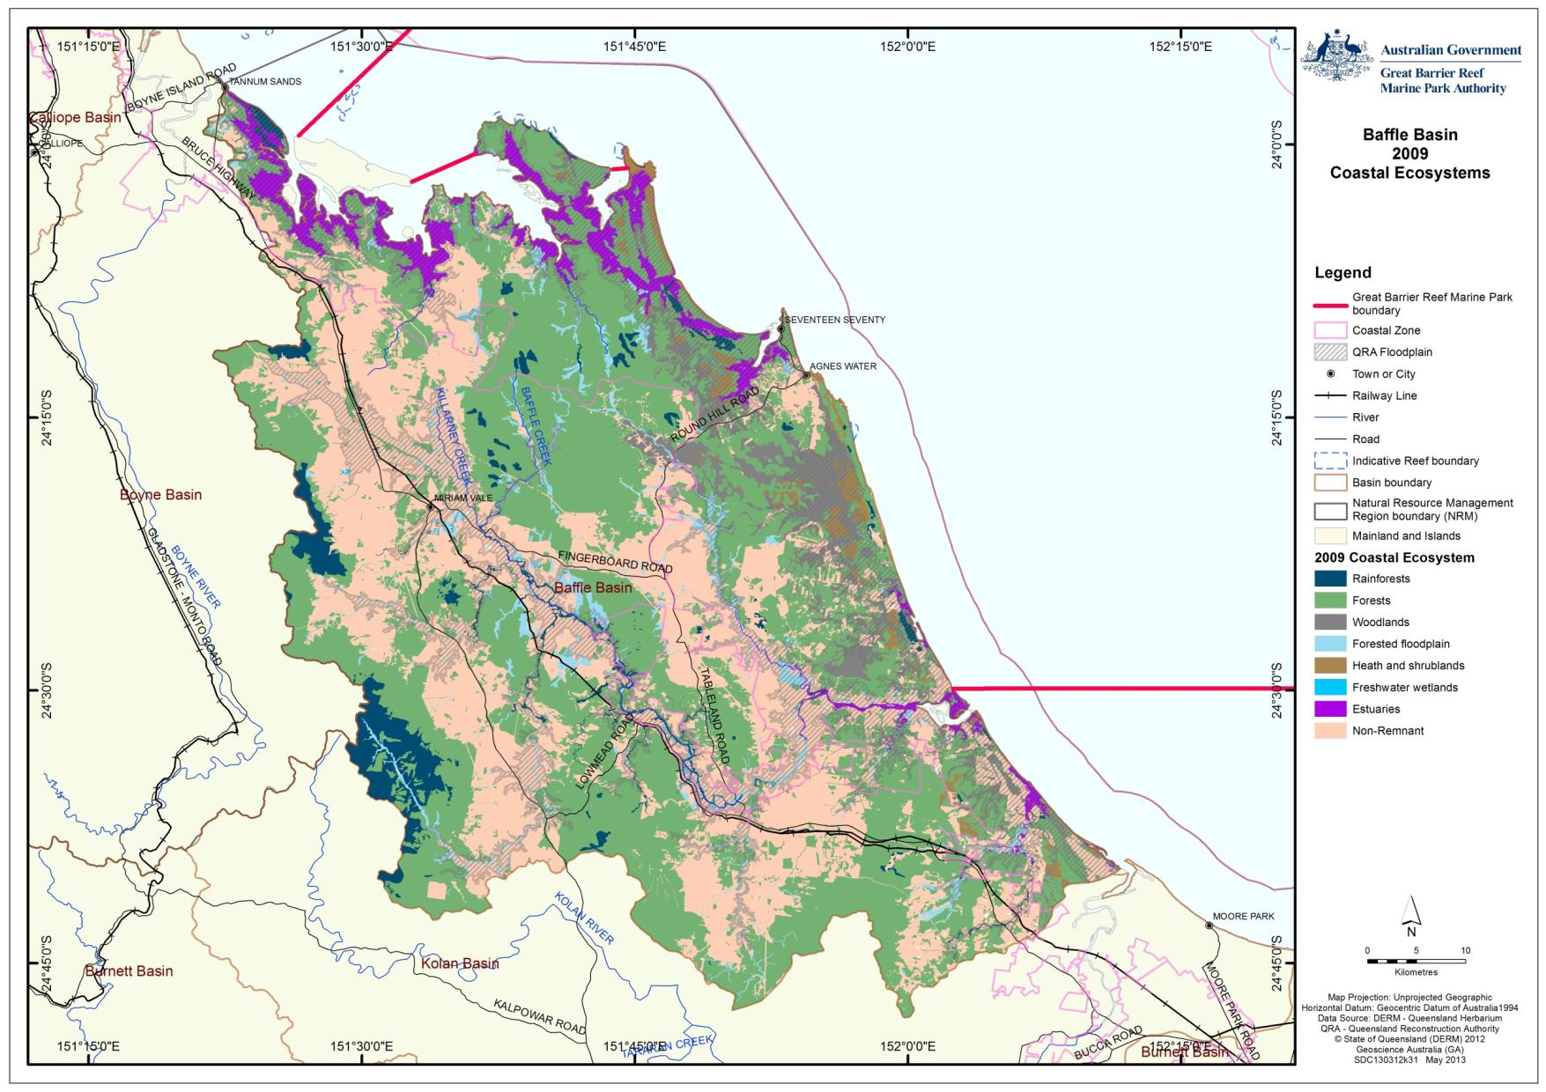
Figure 2.3.6: This map shows the post-clear coastal ecosystem assemblages in the Baffle basin (derived from 2006 Queensland Government Regional Ecosystem data)

The changes to coastal ecosystems (Table 2.3.1) show that the greatest proportion of modification to terrestrial coastal ecosystems has occurred to forested floodplains (loss of 62 per cent), freshwater wetlands (loss of 40 per cent) and forests (loss of 38 per cent). The greatest extent of loss has occurred within the forested coastal ecosystem (loss of 117,937 hectares).

Table 2.3.1: Area (ha) of pre-clear and post-clear coastal ecosystems based upon Queensland Government Regional Ecosystem mapping
 | Ecosystem | Pre-clear | 2006 | 2009 | % remaining
 | Rainforests | 16,554 | 14,952 | 14,946 | 90
 | Forests | 307,791 | 191,268 | 189,854 | 62
 | Woodlands | 24,549 | 19,203 | 19,088 | 78
 | Forested floodplain | 38,420 | 14,668 | 14,547 | 38
 | Grass and sedgelands | 0 | 0 | 0 | na
 | Heath and shrublands | 6,496 | 6,399 | 6,390 | 98
 | Freshwater wetlands | 484 | 290 | 289 | 60
 | Estuaries | 15,924 | 15,901 | 15,901 | 100
 | Non Remnant | 0 | 147,172 | 148,841 | N/A
 | Not Mapped | 253 | 617 | 616 | N/A

The impacts these changes to the coastal ecosystems will have on the World Heritage Area will be dependent on the modified ecosystems that have replaced them. The impacts from grazing for example will impact differently to those of intensive urban developments. To understand the impacts on the World Heritage Area, refer to Chapter 3 – Impacts on the values.

Coastline and estuarine coastal ecosystems
The extent of estuaries in the Baffle basin has remained relatively unchanged according to Queensland Government Regional Ecosystem mapping (Table 2.3.1). There are seven estuarine ecosystems in the Baffle basin that experience a tidal range of around four metres. The condition of the seven estuaries in the Baffle basin have been assessed as near pristine or largely unmodified (Table 2.3.2 and Table 2.3.5).^{13,14}
Table 2.3.2: Australian Natural Resource Atlas (ANRA) classification of estuaries for the Baffle basin
Name of estuary | Class | Sub-class | Condition
Pancake Creek/Jenny Lind Creek | Tide Dominated | Tide-Dominated Estuary | Near Pristine
Rodd’s Harbour | Tide Dominated | Tide-Dominated Estuary | Near Pristine
Round Hill Creek | Tide Dominated | Tidal Flat/Creek | Near Pristine
Eurimbula Creek | Tide Dominated | Tidal Flat/Creek | Near Pristine
Blackwater/Mitchell Creek | River Dominated | Wave Dominated Delta | Near Pristine
Baffle Creek | River Dominated | Tide Dominated Delta | Near Pristine
Littabella Creek | River Dominated | Wave-Dominated Delta | Largely Unmodified
Table 2.3.3: Values of the estuarine environment identified in the Burnett-Baffle Water Quality Improvement Plan 2009
Estuarine waters | Dugong Protection Area | Marine Park zoning | Water Quality | Land use change | Other values
Hummock Hill Island | Yes | General Use Zone. | High value | Minimal change | Seagrass  Fringing coral reefs
Colosseum Inlet | Yes | General Use Zone. | High value | Minimal change | Fish Habitat Area.  Reef in estuary.  Resident nesting shorebirds.  Some migratory shorebird roosts.  Notable mangrove species record.  Seagrass.
7 Mile Creek | Yes | General Use Zone. | High value | Minimal change | Fish Habitat Area.  Resident nesting shorebirds.  Seagrass.
Turkey Beach, Rodds Bay | Yes | General Use Zone; Habitat Protection Zone. | High value | Minimal change | Fish Habitat Area.  Seagrass.  Migratory shorebird roosts.  Fish and prawn nursery.  Notable mangrove species record (Ceriops tagal var tagal).
Rodds Peninsula, Rodds harbour | Yes | General Use Zone; Habitat Protection Zone. | High value | Minimal change | Fish Habitat Area.  Seagrass.  Migratory shorebird roosts.  Fish and prawn nursery.  Resident shorebird nesting.  False water rat habitat.
Pancake/ Middle/Jenny Lind creeks | No | General Use Zone; Habitat Protection Zone. | High value | Minimal change | Fish Habitat Area.  Unique coral reef.  Seagrass.  Internationally significant migratory shorebird roosts.  Resident shorebird nesting.  False water rat habitat.
Deepwater Creek | No | Marine National Park Zone. | No data | 2 small barrages
Baffle Creek | No | South of Marine Park. Close to Marine National Park and General Use Zones. | High value | Minimal change | Fish Habitat Area.  Seagrass.  Dugong and turtle foraging.  High fish species diversity.
Litabella Creek | No | South of Marine Park boundary. | No data | No data | Dugong foraging.

The sandy beach dominated coastline in the Baffle basin is widely used by migratory and resident shorebirds for roosting and nesting. Marine turtles, including loggerhead, flatback and green turtles are known to nest on the mainland and islands of this area. Much of the coastline around the Baffle basin is largely unmodified. Most modifications that have occurred are adjacent to the coastal settlements of Turkey Beach and 1770. These modifications are unlikely to have any significant impact on the World Heritage Area.

Rodds Harbour (Figure 2.3.7) in the northern part of the Baffle basin remains in good condition¹ and provides good fish and bird habitats. Its values include seagrass, fish and prawn nursery areas, migratory shorebird roosts and notable mangrove species.¹ Rodds Harbour is also a Fish Habitat Area.

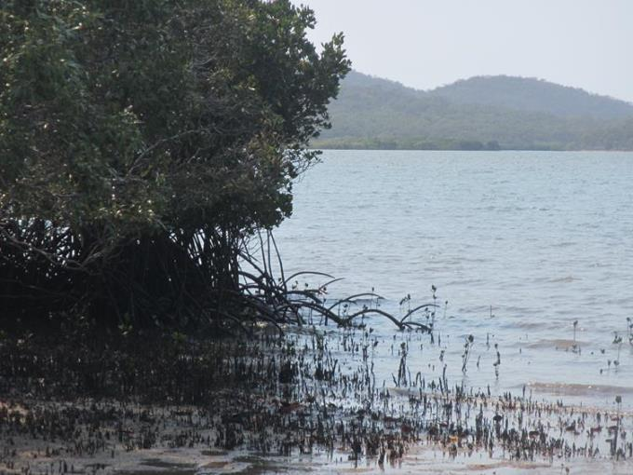
Figure 2.3.7: Rodds Harbour provides good habitat for birds and fish

Pancake Creek estuary provides a unique example (and possibly the last remaining example) of an estuarine coral reef in the World Heritage Area. Coral cover in Pancake Creek was assessed by GBRMPA staff in December 2012 (Figure 2.3.8). Coral cover showed evidence of a recent decline (most likely associated with recent flood events) when compared with earlier assessments made by the Burnett Mary Regional NRM Group. Despite this impact macroalgae cover was minimal and the remaining coral cover (approximately 50 per cent cover) was healthy. The estuary also contains seagrass meadows. The estuary is in near pristine condition,¹⁴ is a Fish Habitat Area and an internationally significant migratory shorebird roost.¹

Settlement and juvenile coral numbers were not assessed. This area is presently used as a safe anchorage by boat owners with anchor damage posing a risk to the unique coral reef at this site. A no anchor zone has been proposed for this site by the Burnett-Mary Regional Group. Most of Pancake Creek estuary coastal ecosystems are protected in National Parks however there is one freehold and one leasehold property that currently remain in undeveloped condition. Pancake Creek estuary as a whole is in near pristine condition (Figure 2.3.9).

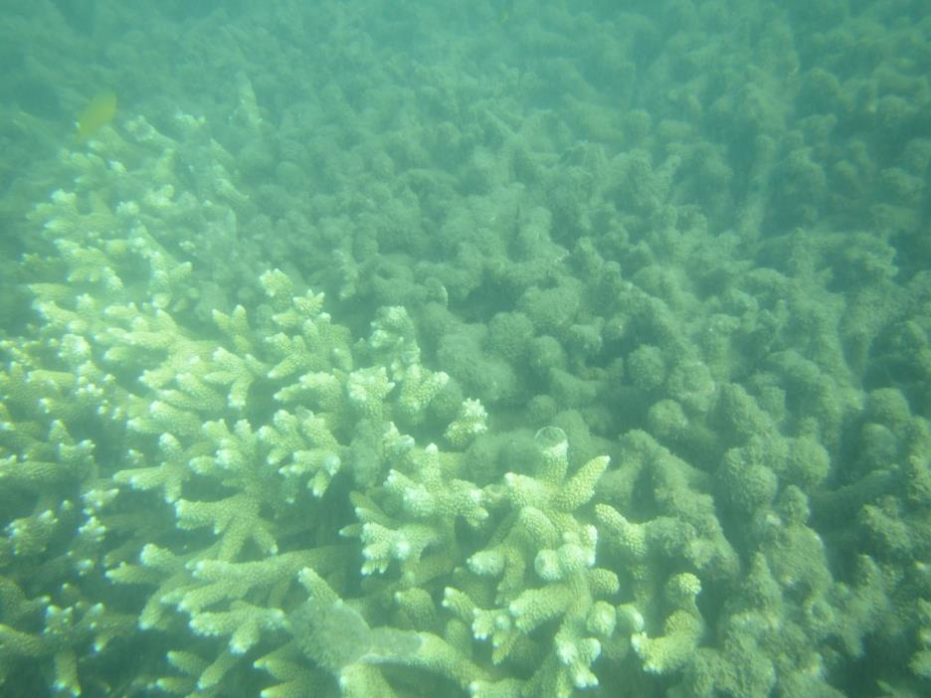
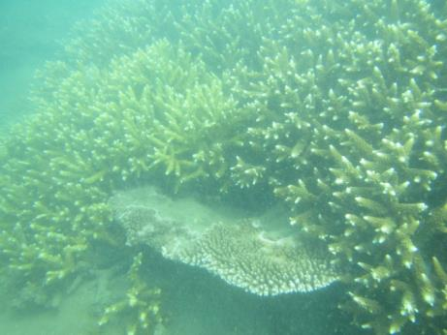
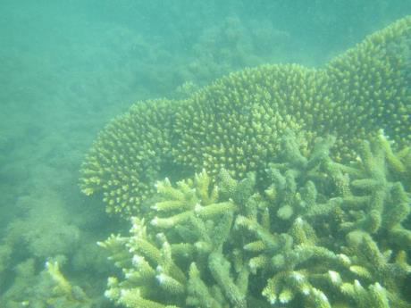
Figure 2.3.8: Acropora corals growing in Pancake Creek estuary (photos taken in December 2012)
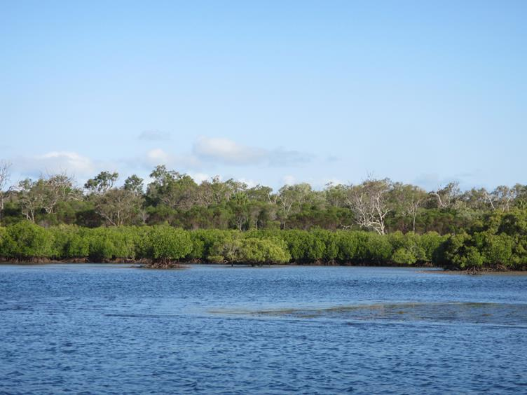
Figure 2.3.9: Upstream tidal waters of Pancake Creek showing forest ecosystems behind fringing mangroves

At the mouth of Baffle Creek, the estuary remains in near pristine condition with healthy mangroves, relatively good water quality and abundant wildlife (Figure 2.3.10). This values of this estuary include seagrass (used by dugong and turtles for foraging), high fish species diversity and contains a Fish Habitat Area.¹

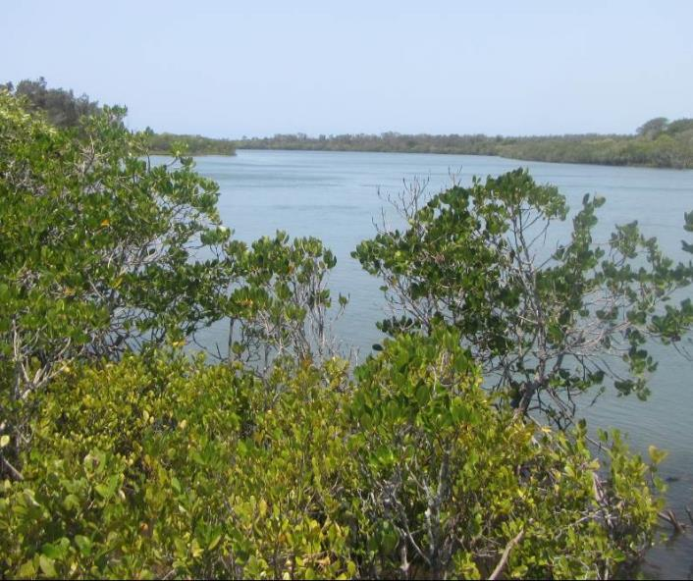
Figure 2.3.10: Baffle Creek estuary is in near pristine condition
Rules Beach is to the north of the Baffle Creek estuary. It is situated between two national parks, both of which have camping areas that are only accessible through beach access. Rules Beach is used by turtles for nesting and was heavily eroded during site visits in December 2012 (Figures 2.3.11 and 2.3.12). Erosion has been ongoing in this area and the erosion prone area was purportedly mapped incorrectly and this has allowed urban residential development to occur on the second dune system.

Beach erosion is also occurring at Deepwater.

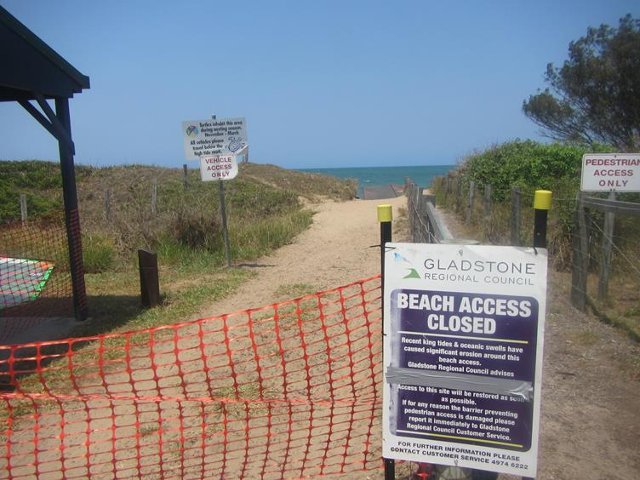
Figure 2.3.11: Rules Beach is used by turtles for nesting. Off road vehicles are permitted to allow access to nearby camp grounds

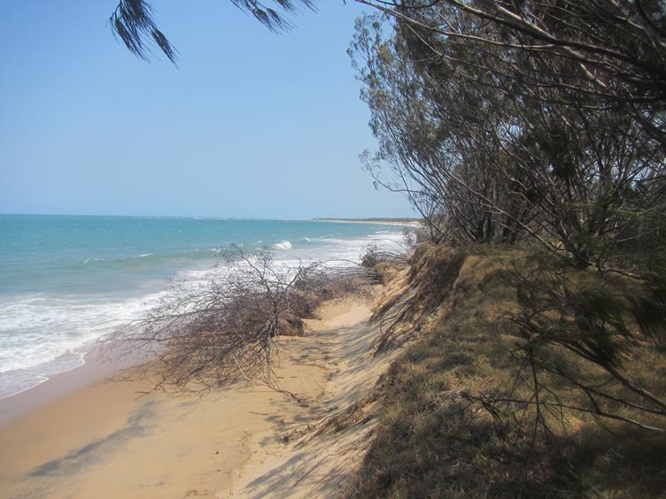
Figure 2.3.12: Beach erosion at Rules Beach, December 2012

The beach at 1770 is in near pristine condition and provides a range of rocky and sandy beach habitats (Figure 2.3.13).

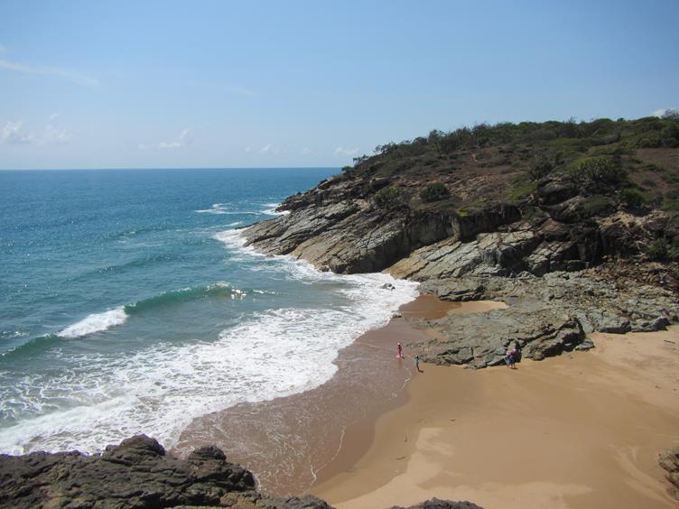
Figure 2.3.13: The beach at 1770

Freshwater wetlands and associated floodplain coastal ecosystems
Freshwater wetlands and associated floodplain ecosystems provide physical, biogeochemical and biological processes, including the provision of major food and habitat resources for fish, birds and invertebrates as well as being a nursery ground for marine fish such as barramundi and invertebrates such as prawns.¹⁵ They function as links between the terrestrial and marine ecosystems and provide pathways for the movement of nutrients as well as pollutants from the terrestrial environment to the World Heritage Area.¹⁵

Within the Baffle basin, forested floodplains and freshwater wetlands have experienced a reduction in extent. The greatest reduction has been to forested floodplain ecosystems, with a decline of 62 per cent.

The Queensland and Australian governments, through the Queensland Wetlands Program have mapped wetlands within the Baffle basin at a finer scale than the current regional ecosystem mapping. The extent and classification types of wetlands within the Baffle basin are shown in Table 2.3.4.⁸

Table 2.3.4: Queensland Wetlands Program data for the freshwater and estuarine wetlands of the Baffle basin
System, as defined by Queensland Wetlands Program | Area (km²) | Wetlands area (%) | Total area of basin (%)
Artificial and highly modified | 7.74 | 2.4 | 0.2
Estuarine | 134.46 | 42 | 3.3
Lacustrine | 1.82 | 0.6 | 0
Palustrine | 106.79 | 33.4 | 2.6
Riverine | 69.23 | 21.6 | 1.7
Total | 320.05 | 100 | 7.8

The 2003 State of the Rivers Report noted that overall, the condition of the remaining freshwater wetland coastal ecosystems was good. Greater than 56 per cent of all freshwater wetlands were either in a moderate, good or very good condition.¹⁶ Table 2.3.5 shows the values from each freshwater system as assed by the Water Quality Improvement Plan (2009) for this basin.¹
Table 2.3.5: Values and condition of freshwater wetland ecosystems in the Baffle basin
System | Water quality | Degree of land use change | Riparian habitat | Other comments
Northern freshwater tributaries of Rodd’s Bay | Good | Minimal | Good | Area contains high richness and special values.  Large proportion falls within protected areas.
Eurimbula Creek | Good | Minimal | Good | Area contains high richness and special values.  Large proportion falls within protected areas.
Round Hill Creek | No data | No data | No data | Falls within protected areas.
Deepwater/Blackwater Creeks | Good | Some urban development | Good | Area contains high richness and special values.  Proportion falls within protected areas.
Baffle Creek – upper reaches | No data | Minimal | Good | Proportion falls within protected areas.
Baffle Creek – lower reaches | No data | Moderate development | Variable
Littabella Creek | No data | Minimal | Good | Proportion falls within protected areas.

The wetland shown at Figure 2.3.14 and adjacent forested floodplain near Baffle Creek was viewed during the field assessment. Despite evidence of grazing, the wetland appeared in good condition and the surrounding forested floodplain vegetation was in relatively good condition.

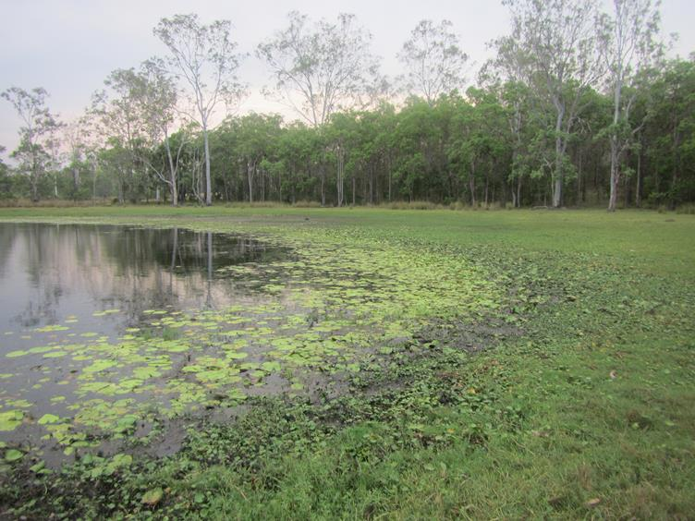
Figure 2.3.14: This photo shows an example of a healthy wetland amongst forested floodplain near Baffle Creek. The property showed signs of low level well managed grazing practices

During the field assessment, riparian vegetation was much better in most places than in many of the other basins assessed during this project. Places like Scrubby Creek (Figure 2.3.15) had good water clarity, fish present and few weeds.

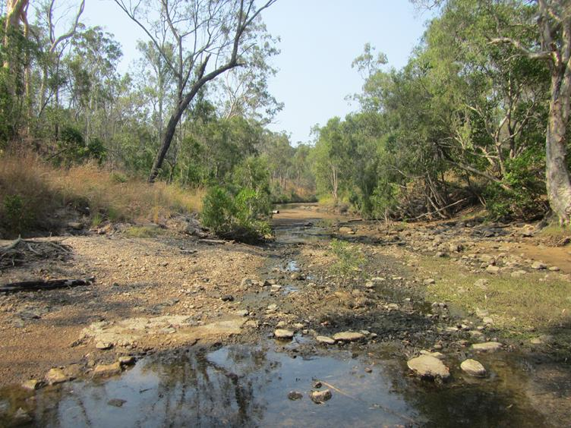
Figure 2.3.15: This photo shows a good riparian zone at Scrubby Creek

Baffle Creek

Euleilah Creek (Figure 2.3.16) is a tributary of Baffle Creek that is in near pristine condition.¹ Despite clearing in some areas, good riparian cover remains along much of the bank.
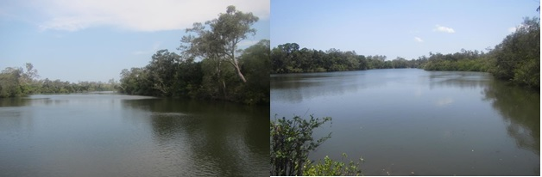
Figure 2.3.16: Euleilah Creek (a tributary of Baffle Creek) has a good riparian buffer along much of the waterway and is in near pristine condition

Further upstream in Baffle Creek (Essendean Bridge) (Figure 2.3.17), the creek showed good riparian vegetation, abundant in-stream habitat, diverse fish assemblage and good deepwater pools.
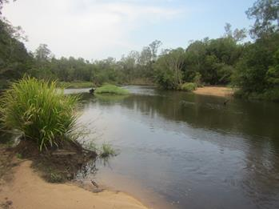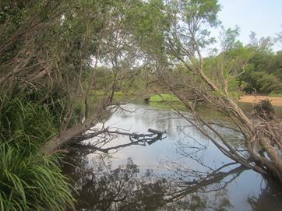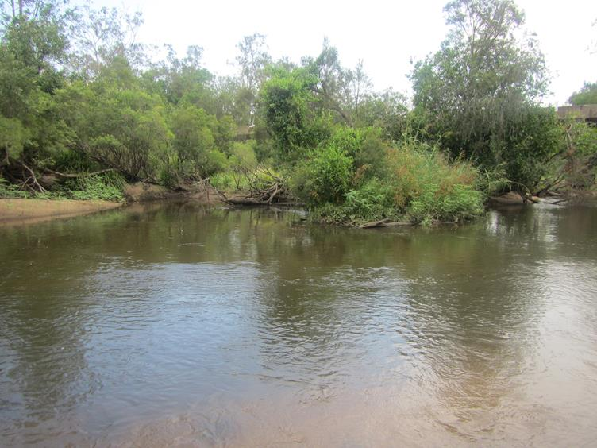
Figure 2.3.17: Baffle Creek at Essendean Bridge is a good example of a healthy waterway

Away from the immediate beach front, Rules beach has a unique mix of coastal vegetation including critically endangered littoral rainforest, coastal heath (Figure 2.3.18) and forested floodplain (Figure 2.3.19). With the exception of coastal National Parks at Mitchell Creek and the Mouth of Baffle Creek Conservation Park, much of this relatively natural area is freehold rural residential allotments.

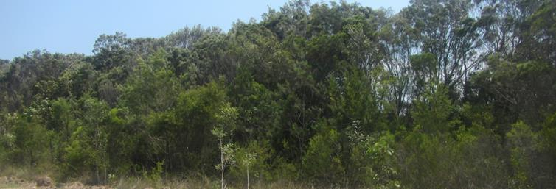
Figure 2.3.18: Coastal heath and shrublands north of Rules Beach

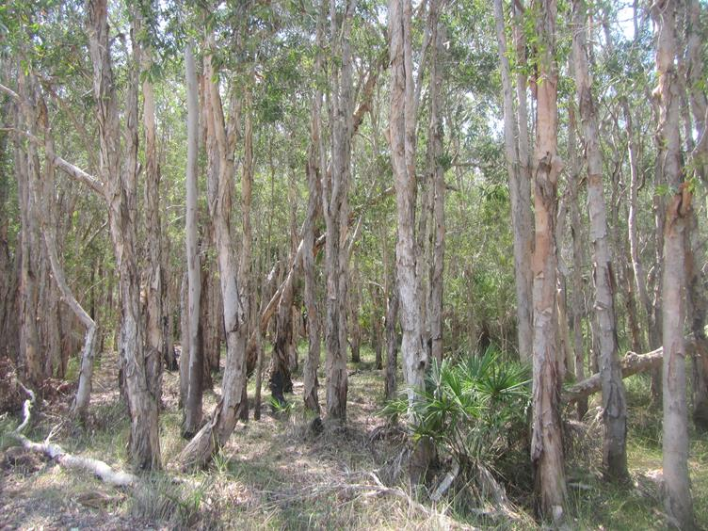
Figure 2.3.19: Melaleuca floodplain forest between Rules Beach and Deepwater

Blackwater Creek (Figure 2.3.20) is a small sub-basin flowing into Mitchell Creek National Park estuary. This near pristine system is bounded by rural residential allotments that retain the majority of vegetation.
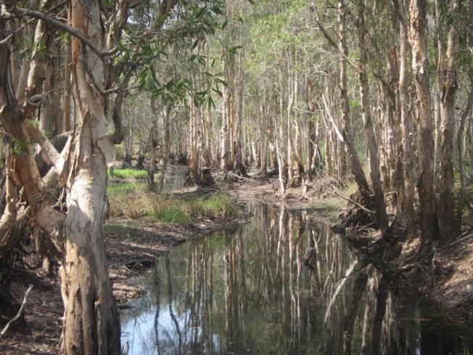
Figure 2.3.20: Blackwater Creek is in near pristine condition

Terrestrial catchment ecosystems
Forests have been subjected to the greatest proportional losses within the Baffle basin (38 per cent). Losses to rainforests (11 per cent) and woodlands (22 per cent) have been much less. The impacts from the loss of these forested ecosystems on the World Heritage Area are considered in Section 2.4 – Processes.

According to the Burnett-Baffle Water Quality Improvement Plan (WQIP)¹, approximately 27 per cent of riparian vegetation within the Baffle basin is in very good condition. Nine per cent is in good condition, 11 per cent in moderate condition, 27 per cent in poor condition and 26 per cent in very poor condition. This assessment was based on the width of remnant vegetation, structural diversity and abundance of native plant species. The greatest loss of riparian vegetation has occurred in the western and southern tributaries of the Baffle basin.¹

The Queensland Government has assigned regional ecosystems a conservation status which is based on its current remnant extent (how much of it remains) in a bioregion. Regional ecosystems were originally defined by Sattler and Williams (1999)²⁷ as vegetation communities in a bioregion that are consistently associated with a particular combination of geology, landform and soil. Vegetation that is classified as endangered is afforded most protection in Queensland; however some industries such as mining, transport, electricity and community infrastructure may be exempt. Lesser protection is afforded by the other categories. These have been mapped for the Baffle basin (Figure 2.3.21). Information on regional ecosystem information provides the basis for the development of coastal ecosystem functional groups identified in the Coastal Ecosystem Assessment Framework.⁴ However regional ecosystem conservation classification is based on terrestrial distribution, and do not assess their functional linkage to the World Heritage Area. Regional ecosystem conservation classifications most likely do not protect coastal ecosystems most important to the maintaining the health and resilience of the World Heritage Area.

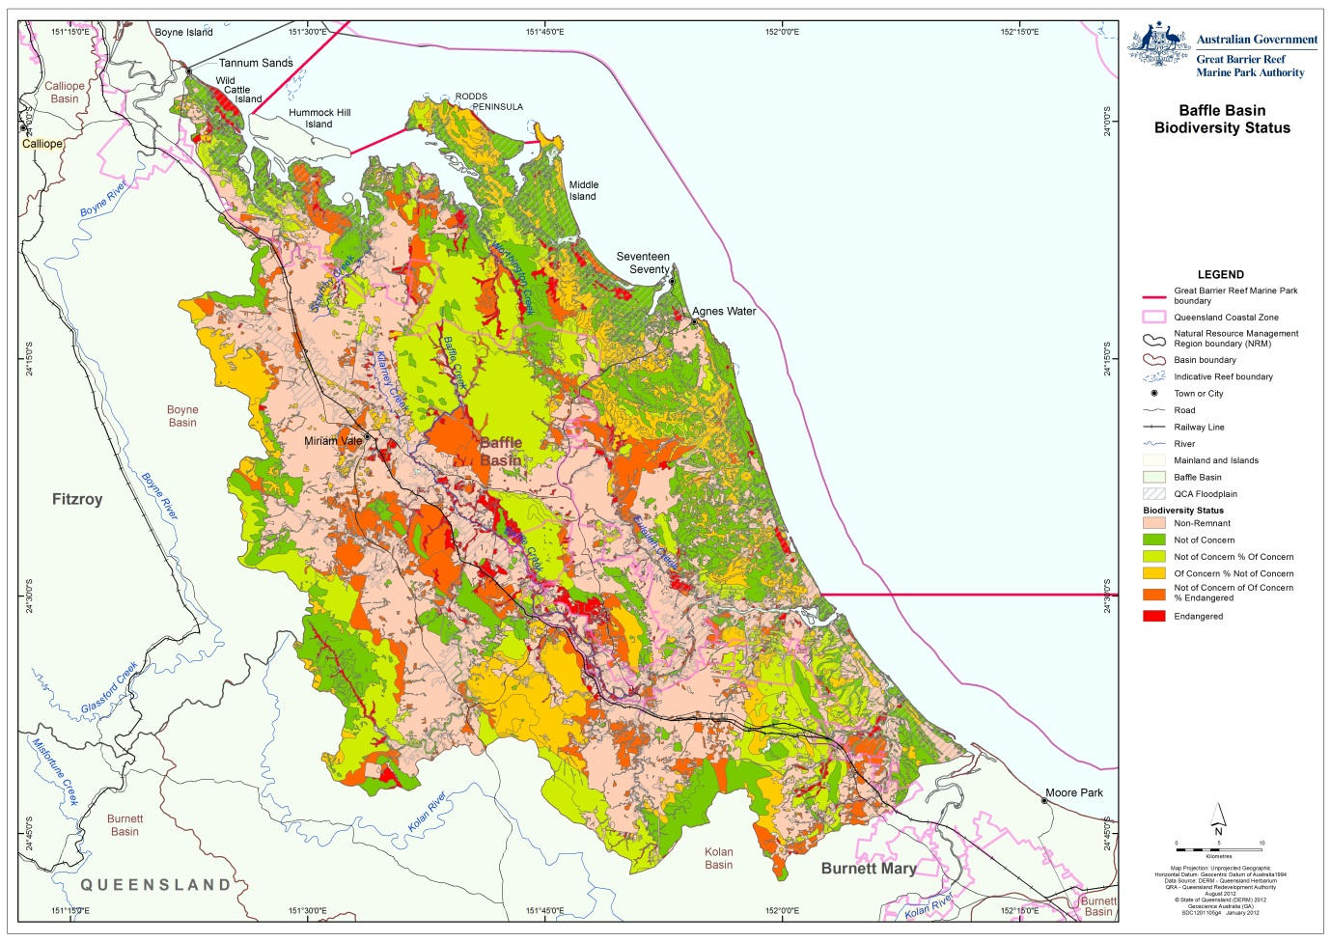
Figure 2.3.21: Regional ecosystem conservation status map for the Baffle basin

During the field assessment, areas of critically endangered coastal littoral rainforest were observed on freehold land at Rules Beach (Figure 2.3.22). This littoral rainforest is not shown in Figure 2.3.23. The rainforest is situated between the coast and macadamia plantations/dairy farms and are owned by developers or family trusts, making engagement with the landholders difficult.¹⁷

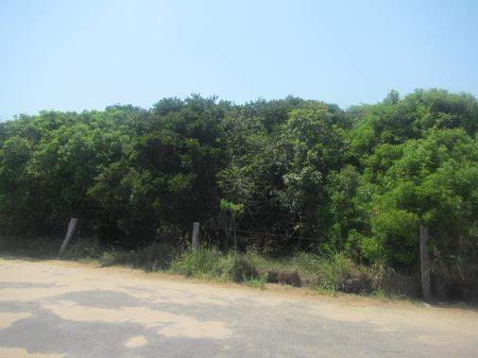
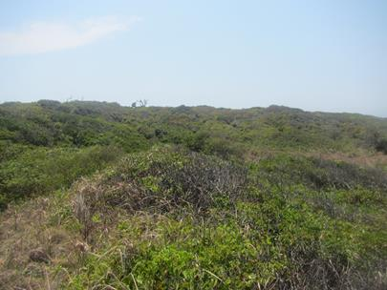
Figure 2.3.22: Critically endangered littoral rainforest along the coast at Rules Beach

Another parcel of freehold land bordered completely by National Park adjoins the near pristine Eurimbula Creek estuary. This property only has a small area for a home site cleared with the rest of the property intact. This site was inaccessible at the time of the assessment but contains a critically endangered regional ecosystem. The adjacent Eurimbula National Park (Figure 2.3.23) presented a good example of a healthy coastal ecosystem and potential offset site. The nearby grazing property was also in relatively good condition.

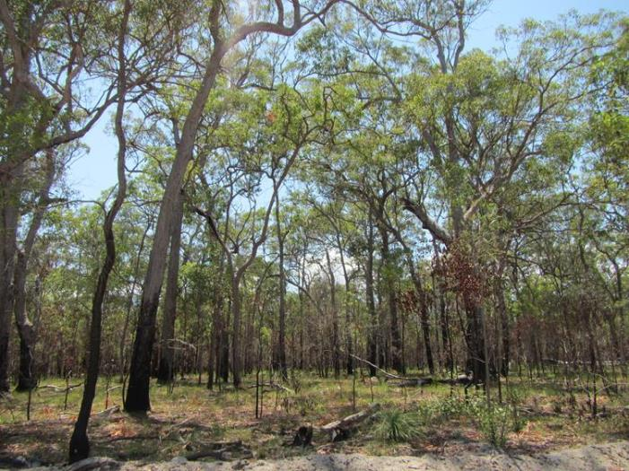
Figure 2.3.23: Healthy woodland community in Eurimbula National Park

Ecosystem processes
The condition of ecosystem processes in the Baffle basin varies both spatially and temporally. Areas that have been highly modified from the natural coastal ecosystems that were once there, show the greatest degree of change in processes. These are areas, for example, where riparian vegetation has been removed for the purposes of grazing, altering the sediment trapping and nutrient cycling that would otherwise occur in these areas.

Appendix E contains a list of coastal ecosystems and some of the ecological processes they deliver for the health and resilience of the World Heritage Area.

The Baffle basin was observed to have some of the healthiest freshwater and estuarine wetlands of all the basins reviewed in this process. These provide for important biological processes such as the recruitment of animals like prawns, barramundi, mangrove jack, mullet and crabs. The health and resilience of these wetlands are important to the health and resilience of the animals that use them.

The freshwater systems in this basin are free of dams or weirs and water extraction is limited. This is allowing physical, biogeochemical and biological processes to occur relatively naturally.

The estuaries within this basin continue to provide ecosystem processes relatively unimpeded. Some impacts, such as net fishing in Pancake Creek, will likely impact on the populations of some species of conservation concern (such as sawfish).

Physical processes
Physical processes are those that transport and mobilise elements such as water, sediments and minerals. They include groundwater recharge/discharge, sedimentation/erosion of soils and deposition and mobilisation processes.⁵ All coastal ecosystems provide these functions, some more than others.

Within the Baffle basin there are no significant dams or other barriers that impact on physical processes (such as sand extraction, overuse of groundwater resources). Extensive retention of riparian vegetation and natural deep water holes in areas such as Island Creek, a tributary of Baffle Creek (Figure 2.4.1), provides for good physical processes.
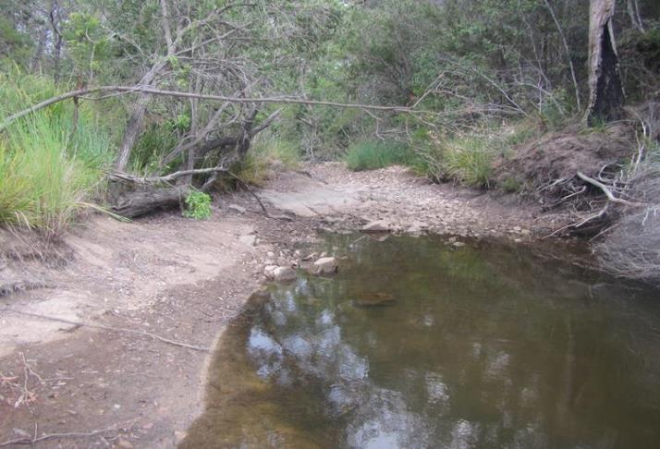
Figure 2.4.1: Deep waterhole and good riparian vegetation cover allows for physical processes to occur in near natural conditions

Biogeochemical processes
Biogeochemical processes revolve around energy and nutrient dynamics. Biogeochemical processes include production, nutrient cycling, carbon cycling, decomposition, oxidation-reduction, regulation processes and chemical/heavy metal modification. Wetland and associated floodplain ecosystems offer the greatest capacity for maintaining biogeochemical processes as these ecosystems slow the flow of water and allow the processes to occur. During large flood events biogeochemical processes in coastal ecosystems often do not occur as water flows at high speed directly into inshore coastal waters. In more developed basins, the volume of nutrients is often higher as a result of fertiliser use and point source discharges. These processes are then transferred to the inshore coastal waters. Table 2.4.1 outlines the nutrient forms and their availability for biogeochemical processes.

Table 2.4.1: Forms of nutrients and their impact on the aquatic environment
Term | Description/source | Impact on aquatic environment
Particulate organic matter | Large particles of organic matter (e.g. dead plants and animals) that get broken down by decomposers into smaller dissolved organic matter. | Not available for uptake by plants and animals.
Dissolved organic matter (DOM) | Large molecules of organic matter (nitrogen, carbon, phosphorus etc.) produced as a result of decomposition. | Not biologically available until broken down by bacteria.
Dissolved inorganic matter | By-product of bacterial decomposition of DOM or applied in this form as fertilisers. | Nutrients such as nitrogen and phosphorus are freely available in this form for uptake by cyanobacteria, plants and animals.

Coastal waters adjacent to the Baffle basin have elevated levels of nutrients. These however may be attributed to discharge from river systems to the south of the basin which are carried northwards by the prevailing trade winds. Biogeochemical processes within the basin appear to occurring in a relatively natural state.

Biological processes
Biological processes are the processes that maintain animal and plant populations. These include survival/reproduction mechanisms, dispersal/migration/regeneration, pollination and recruitment. Wetland and associated floodplain ecosystems offer the greatest capacity for maintaining biological processes.

Biological processes such as fish migrations and reproduction can be hampered by in-stream structures that prevent fish passage. Based on our field assessments, these biological processes are occurring throughout much of the basin although a number of areas could be improved (see Section 2.5). Good base flows, in-stream habitat, deep pools and riparian cover are facilitating fish migrations, with fish such as mullet observed as far upstream as Lowmead (Figure 2.4.2).

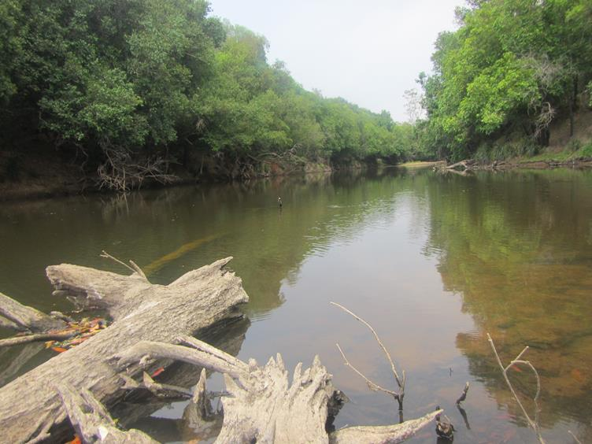
Figure 2.4.2: Good riparian cover and in-stream habitat in Baffle Creek facilitates fish passage from the coast into the upper Baffle basin

Connectivity
Connectivity is a mechanism that supports ecological processes.¹⁸ Disruptions to connectivity between different areas where fish breed and grow can lead to degraded populations, reduced resilience to change, or even localised extinctions. Figure 2.5.1 shows the sub-basin waterways that were considered by this assessment. The map in Figure 2.5.2 shows the stream orders (classification system where waterways are given an ‘order’ according to the number of additional tributaries associated with each waterway) combined with land zones and elevation. These tools were used to assess the connectivity of waterways between the World Heritage Area and the Baffle basin.

Overall connectivity within the Baffle basin is unimpeded with no major dams or weirs present. Water quality and ecosystem health is generally good with good riparian cover in many areas (refer Appendix F).¹ In-stream structures and deep-water pools were present in most sites visited.
Connectivity can be overland (via air, waterways or overland) or underground (through sub-terrain water movement). Connectivity across these forms of hydrology can be influenced through water extraction, irrigation and modifications of the flow regimes (such as dams, obstructions to groundwater recharge/discharge).

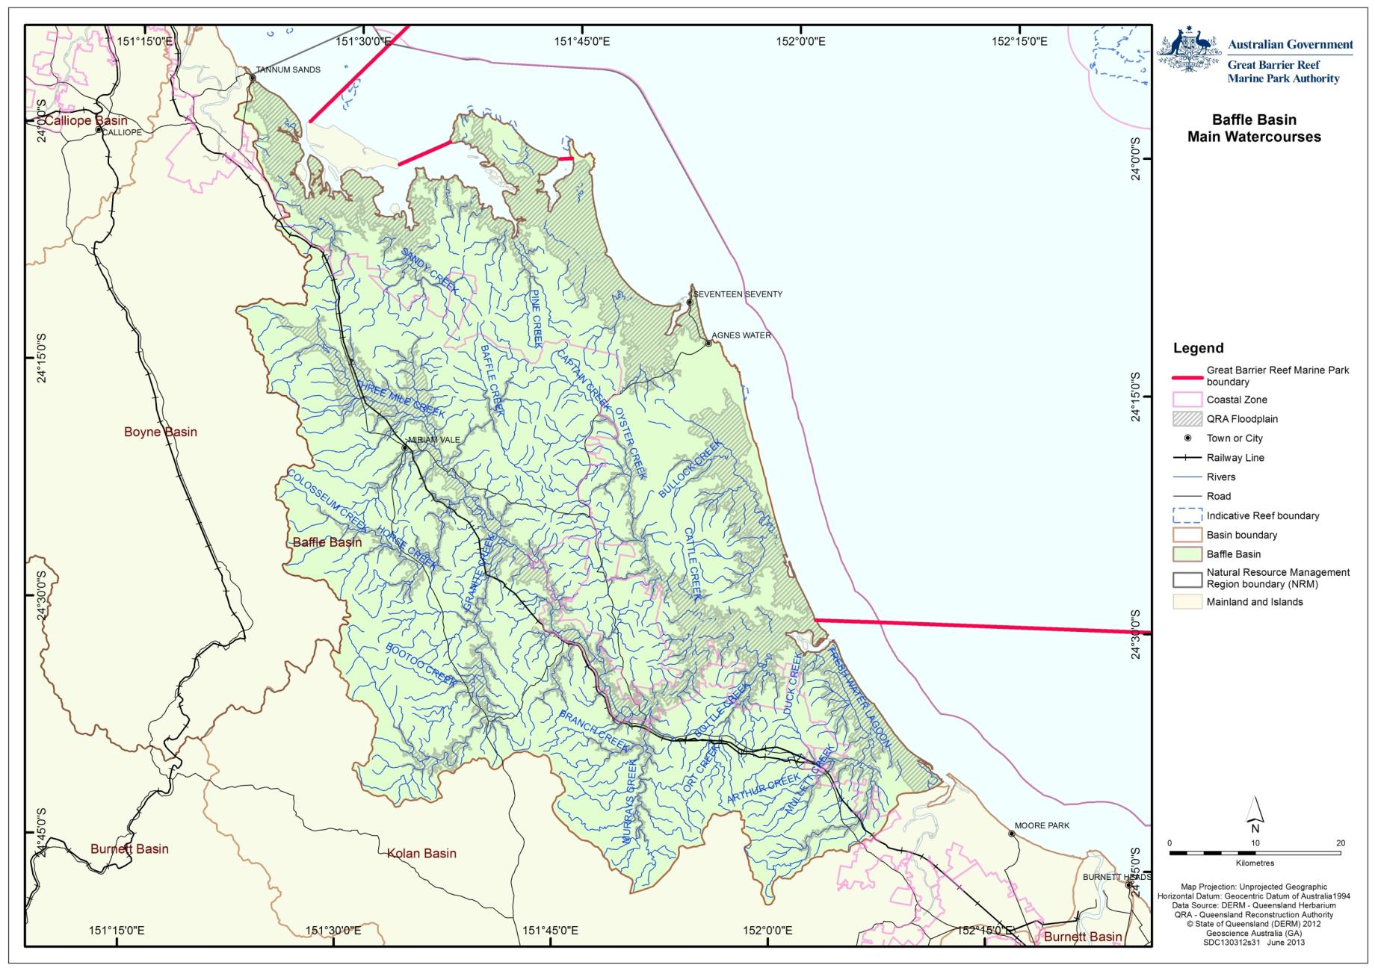
Figure 2.5.1: Major streams in the Baffle basin considered in this assessment

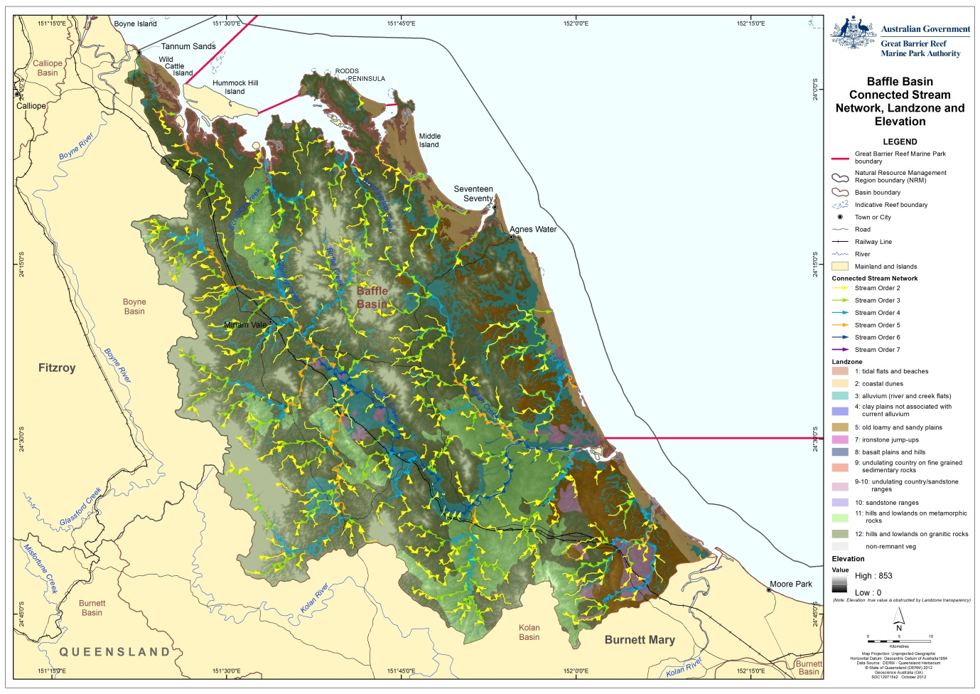
Figure 2.5.2: Stream order and elevation map showing the floodplain in the Baffle basin

Surface hydrology
Overland hydrology in the Baffle basin at the sites assessed showed only a few minor impediments to connectivity, mostly in some of the smaller creek systems (Figure 2.5.3). Table 2.5.1 considers impediments to overland connectivity.¹

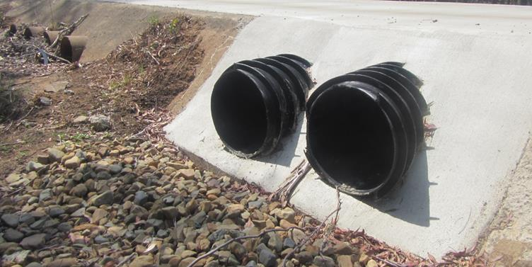
Figure 2.5.3: Culverts that are not best practice for fish passage located on Blackwater Creek. Note the ones in the foreground are however an improvement on the previous culverts in the background

Table 2.5.1: Impediments to overland connectivity for freshwater wetland ecosystems in the Baffle basin
System | Impediments to connectivity
Northern freshwater tributaries of Rodd’s Bay | None
Eurimbula Creek | One (estuary)¹³
Round Hill Creek | None
Deepwater/Blackwater creeks | Minor impoundments (two)
Baffle Creek – upper reaches | None
Baffle Creek – lower reaches | None
Littabella Creek | One (estuary)¹³

In general, road culverts that were reviewed in this assessment were of designs that allowed for flow connectivity and good fish passage. The Scrubby Creek crossing (Figure 2.5.4) provides good linear flow that can assist in fish passage in all but peak flows. The culvert under Island Creek (Figure 2.5.5) allows for hydrological flow but the round design and lack of structure prevents fish passage in most flow situations. The well-established riparian zones in much of the Baffle basin are likely to provide for good connectivity (Figure 2.5.6).

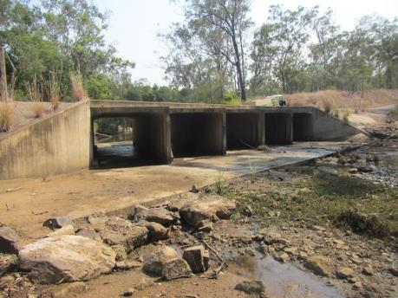
Figure 2.5.4: A well-designed road culvert at the Scrubby Creek road crossing

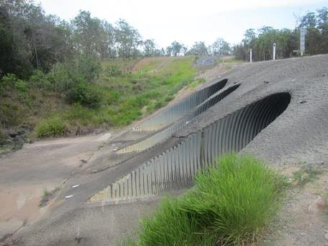
Figure 2.5.5: This road culvert over Island Creek is designed to handle large flows however is lacking ‘structure’ to facilitate fish passage during high flow events. Structures, such as embedded rocks, provide shelter for fish from the water velocity and also from predation

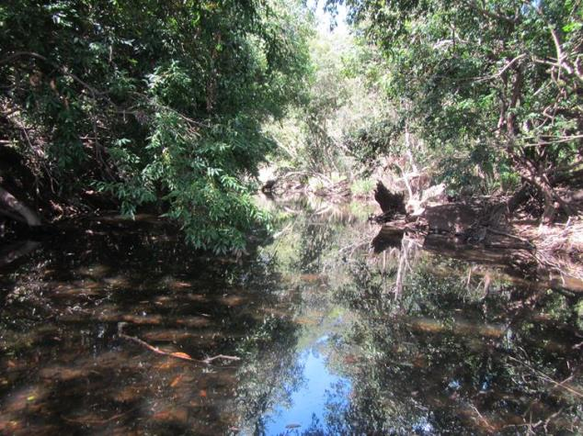
Figure 2.5.6: Good natural connectivity is provided by in-stream habitat and shading by riparian vegetation in Baffle Creek

Groundwater hydrology
Extraction of water from the Baffle Creek basin is regulated under the Water Act 2000 and managed specifically for this basin under the Water Resource (Baffle Creek basin) plan 2010¹⁹. Under this plan, environmental flows are managed for. The specific environmental outcomes include:
- To minimise changes to the natural variability of flows that support aquatic ecosystems.
- To provide for the continued capability of one part of an aquatic system to be connected to another.
- To minimise changes to natural variability in water levels to support natural ecological processes, including maintaining refugia associated with waterholes and lakes.
- To minimise adverse impacts on aquatic ecosystems immediately downstream of new water resource development.
- To improve understanding of the matters affecting flow ecology responses of ecosystems within the plan area.

Further specific environmental outcomes are stated, including:
- To maintain the near-natural flow regime that supports waterholes and estuarine ecosystems in the Eurimbula Creek catchment area and Worthington Creek catchment area.
- To minimise changes to flows that maintain existing brackish habitat downstream of barrages in the Broadwater Creek catchment area.
- In the Baffle Creek catchment area –
- To maintain connectivity between Baffle Creek and its adjacent floodplain system including lakes.
- To maintain the near-natural flow regime that provides for intermittent brackish habitat through the entire length of the Baffle Creek estuary.
- To minimise changes to the low flow regime that provides for riffle habitat and maintains waterholes.
- To minimise changes to the persistence of waterholes.
- To minimise changes to the flow regime that maintains brackish habitat in the upper reaches of Littabella Creek estuary.

Excessive groundwater extraction for the supply of water for consumption and irrigation can lead to problems of seawater intrusion in coastal areas. For example coastal aquifers in the Haughton basin have experienced increased levels of salinity largely due to excessive water extraction for irrigation and loss of wetland groundwater recharge sites and are now controlled through artificial means. Over-extraction of groundwater can also affect ecosystem processes through changes in residence time and reduce the number and quality of deep water pools that provide dry-season refugia for aquatic species such as mangrove jack.

- Impacts on the values

Drivers of change
The primary drivers of change for the Baffle basin are climate change, economic growth population growth and technical development.

Climate change
The Queensland Government has carried out extensive mapping of coastal areas projected to be at risk based on climate change predictions up until the year 2070. The maps they produced factor in climate change impacts including sea-level rise of 30 centimetres and a 10 per cent increase in the maximum potential intensity of cyclones and associated storm surge at-risk areas and erosion prone areas.²⁰

Information on climate change impacts is based on the most recent report from the Intergovernmental Panel on Climate Change (IPCC) – the international scientific authority on climate change. Property scale and area-based coastal hazard maps are available at http://www.ehp.gov.au/coastal/management/maps/index.html.

The impacts of climate change on the Baffle basin will vary strongly across the basin. The low lying estuaries of the Baffle basin are most likely to be affected under future climate change scenarios, especially the influence of sea-level rise, storm surge and altered rainfall patterns. An assessment of climate change impacts on the Baffle basin is beyond the scope of this report. Table 3.1.1 shows the regional climate change predictions that will apply to temperature, rainfall, evaporation and extreme events.²¹

Table 3.1.1: Regional climate change predictions for the Burnett-Mary region for temperature, rainfall, evaporation and extreme events
Element | Prediction
Temperature | Average annual temperature in the region has increased by 0.4ºC over the last decade (from 20.5ºC to 20.9ºC).  Projections indicate an increase of up to 4.1ºC by 2070, leading to annual temperatures well beyond those experienced over the last 50 years.  By 2070, Bundaberg may have twelve times the number of hot days over 35ºC (increasing from an average of one per year to an average of 12 per year by 2070) while Gayndah may have more than triple (increasing from an average of 23 per year to an average of 81 per year by 2070).
Rainfall | Average annual rainfall in the last decade fell nearly 12 per cent compared with the previous 30 years. This is generally consistent with natural variability experienced over the last 110 years, which makes it difficult to detect any influence of climate change at this stage.  Models have projected a range of rainfall impacts from an annual increase of 16 per cent to a decrease of 33 per cent by 2070. The best estimate of projected rainfall change shows a decrease under all emission scenarios.
Evaporation | Projections indicate annual potential evaporation could increase 7-16 per cent by 2070.
Extreme events | The 1-in-100-year storm tide event is projected to increase by 50 cm in Hervey Bay if certain conditions eventuate. These conditions are a  30 cm sea-level rise, a 10 per cent increase in cyclone intensity and frequency, as well as a 130 km shift southwards in cyclone tracks.

Economic growth
Economic growth has been a driver of land use change in the Baffle basin, with agricultural products the primary industry. Tourism/seachange is a growing industry, with developers encouraged to develop the coastal areas. Recent growth in the Gladstone region as a result of the resources boom is expected to see a flow-on effect in the Baffle basin. Until now, the lack of infrastructure to support families has limited development in the basin. The construction of a new school in Agnes Water is expected to generate a demand for housing in the Baffle basin for families of workers from Gladstone.

Population growth
The Burnett-Mary catchment is expected to grow by 40 per cent over the next 40 years, with the population reaching approximately 300,000 by 2016.¹ The population and assets exposed to coastal risks will increase significantly over the coming decades as the population grows and people continue to pursue coastal sea change lifestyle.

Technological development
Development in the Baffle basin is currently water limited.¹⁹ Construction of desalination and wastewater treatment plants is underway in the area. This will facilitate ongoing expansion of urban development in Agnes Water/1770.

Activities and impacts
Grazing is the dominant land use in the Baffle basin. Approximately 22 per cent of the Baffle basin is protected estate. Land use for 1999 and 2009 is shown in Table 3.2.1 and Figures 3.2.1 and 3.2.2.
Table 3.2.1: Major land use categories (hectares) for the Baffle basin in 1999 and 2009 based on Queensland Land Use Mapping Program data
 | Land use area (ha) - Baffle | 1999 | 2009
 | Conservation, natural environments (inc. wetlands) | 89,597 | 91,826
 | Forestry - production | 8,345 | 27,112
 | Grazing natural vegetation | 273,399 | 273,636
 | Intensive animal production | 3,353 | 156
 | Intensive commercial | 545 | 476
 | Intensive mining | 172 | 144
 | Intensive urban residential | 23,242 | 7,273
 | Production - dryland | 4,571 | 1,854
 | Production - irrigated | 2,124 | 3,108
 | Water - production ponded pastures | 0 | 45
 | Water storage and transport | 4,573 | 4,425
 | Not Mapped | 550 | 416
 | Total Area (ha) | 410,471 | 410,471

It should be noted that the decrease in intensive urban residential shown in Table 3.2.1 is due to a change in mapping. Previously peri-urban properties were mapped as the whole allotment. The 2009 mapping now recognises only the extent of the building footprint as intensive urban residential, with the remainder of the land re-appropriated into grazing natural vegetation.

From Figures 3.2.1 and 3.2.2 the extent of protection of the coastal zone is apparent. The majority of remaining coastal land is used for grazing natural vegetation.

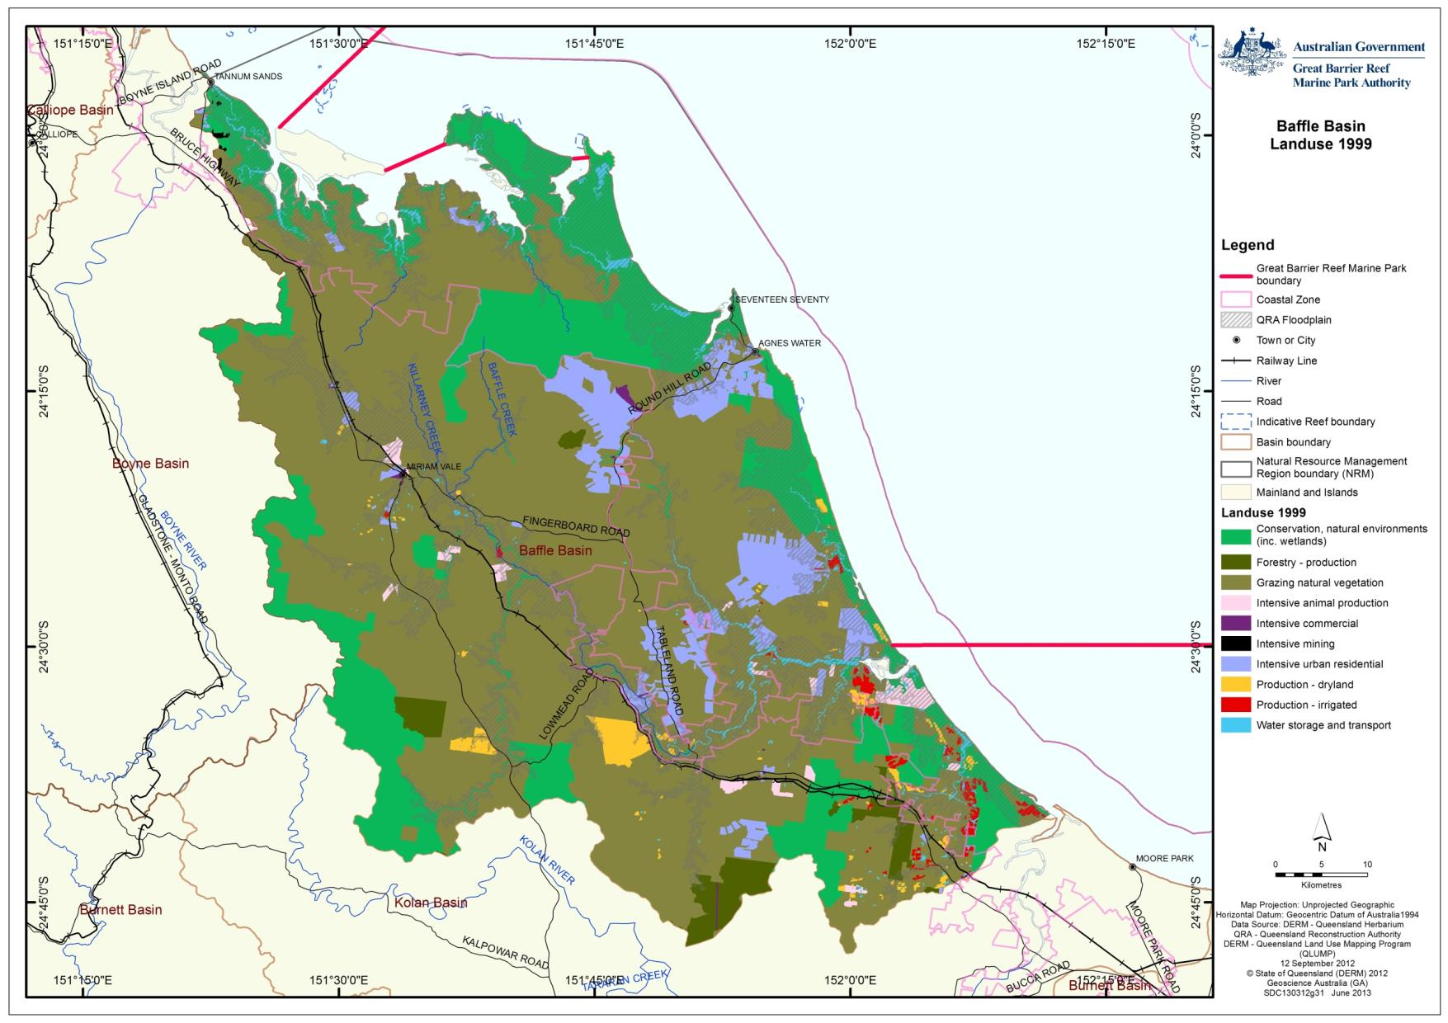
Figure 3.2.1: Map of land use for the Baffle basin based on 1999 QLUMP data

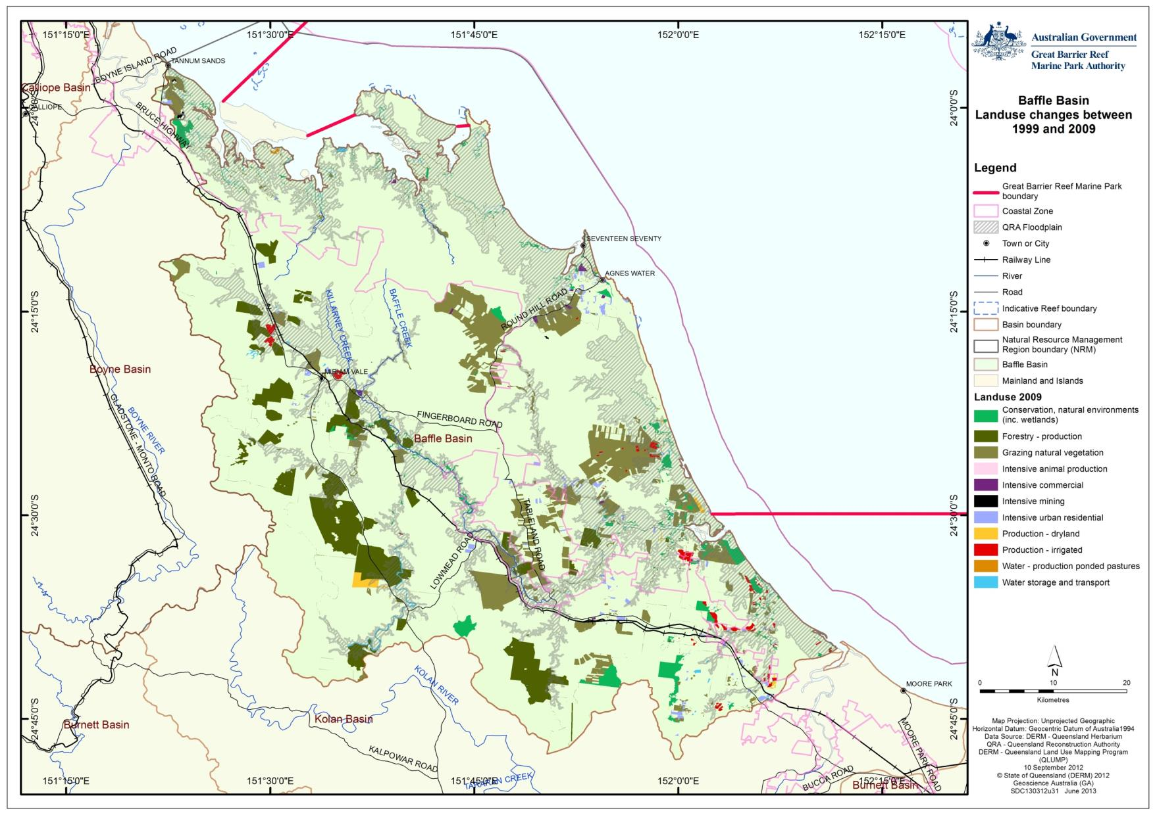
Figure 3.2.2: Map of land use change for the Baffle basin between 1999 and 2009

Land use within the coastal zone
The coastal zone includes Queensland’s coastal waters (which extend three nautical miles out to sea), coastal islands and land below 10 metres Australian Height Datum or within five kilometres of the coastline, whichever is greater. The land use occurring within the coastal zone for 1999 and 2009 is shown in Table 3.3.1. Approximately 34 per cent of the coastal zone is within protected areas and another 58 per cent is grazed natural areas. Only three per cent of the coastal zone is used intensively for mining, commercial uses, intensive animal production or urban residential.

Table 3.3.1: Major land use categories (hectares) for the Baffle basin coastal zone in 1999 and 2009 based on Queensland Land Use Mapping Program data. Note that the decrease in intensive urban residential is due to a change in mapping. Previously peri-urban properties were mapped as the whole allotment. The 2009 mapping now recognises only the extent of the building footprint as intensive urban residential, with the remainder of the land reapproriated into grazing natural vegetation
 | Land use area (ha) - Baffle Coastal Zone | 1999 | 2009
 | Conservation, natural environments (inc. wetlands) | 55,875 | 56,537
 | Forestry - production | 231 | 1,298
 | Grazing natural vegetation | 86,718 | 95,442
 | Intensive animal production | 1,532 | 136
 | Intensive commercial | 68 | 294
 | Intensive mining | 166 | 138
 | Intensive urban residential | 12,926 | 4,413
 | Production - dryland | 942 | 510
 | Production - irrigated | 1,420 | 1,879
 | Water - production ponded pastures | 0 | 45
 | Water storage and transport | 4,165 | 3,485
 | Not Mapped | 550 | 416

Actual and potential impacts
The main impacts to the World Heritage Area from land use in the Baffle basin is primarily associated with declining water quality from land used for grazing and agricultural use (Appendix F). In many places those impacts are mitigated through the retention of appropriate riparian buffers coupled with uptake of best management practices. The first report card of the Reef Water Quality Protection Plan (2011)¹⁰ identified that 70 per cent of horticultural producers, and eight per cent of sugar cane growers are currently using cutting-edge or best management practices for herbicides in the Burnett-Mary region. Additionally, cutting-edge or best management practices are being used by 42 per cent of horticulture producers for nutrients and by 65 per cent for soil. Data regarding management adoption for the grazing and grain industries are not yet available.

Forestry
There is 27,112 hectares of forestry in the Baffle basin. Of this, 27,000 hectares is production forestry from forest areas (allocated as non-remnant coastal ecosystems). This has increased from 8345 hectares in 1999 as a result of a shift in land use from grazing natural areas to forestry. The impacts to the World Heritage Area from the forestry in this basin are not known.

Grazing natural vegetation
Dryland grazing of natural areas occurs throughout much of the upper basin. Impacts vary according to the level of uptake of best management practice. The main impact is loss of topsoil and compaction of soil as a result of over stocking of cattle. Much of the grazing land observed during GBRMPA field assessments appeared to have retained some tree cover. (Figure 3.4.1). Between 1999 and 2009 around 16,000 hectares of grazing natural areas was reallocated as forestry land and an equivalent amount of land assigned as intensive urban (rural residential) has been assigned as grazing natural areas.

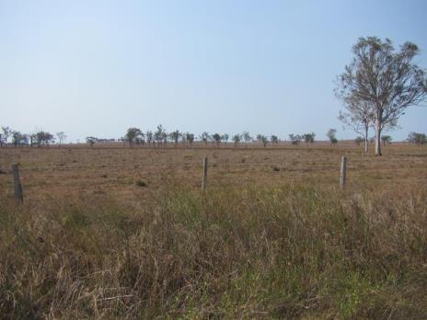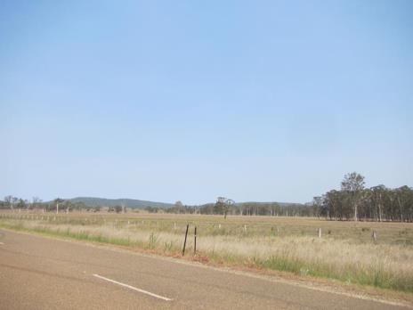
Figure 3.4.1: Significantly modified grazing lands with few remaining trees and good ground cover (left). Grazing lands with good stands of remnant trees (right)

Giant rats’ tail grass is a problem species for the Baffle basin. Because this accidentally introduced grass is not consumed by cattle and graziers use herbicides to eradicate it from grazing lands, this may have implications for water quality and coastal ecosystem health.¹⁷
The lack of water infrastructure in some parts of the basin means that creek access by cattle is required. Figure 3.4.2 shows a well-designed cattle access point that minimises impact on riparian vegetation. Most of the riparian zone was fenced to exclude cattle on this property.

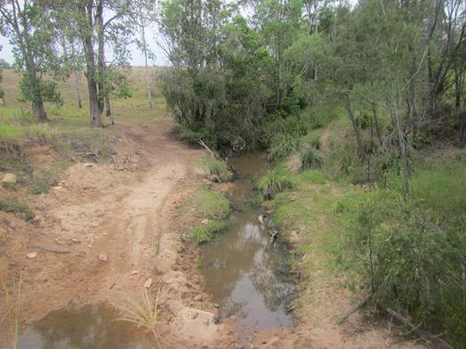
Figure 3.4.2: Although allowing cattle access to drink from creeks is generally not considered to be best practice, where necessary this can be done in a way that minimises impacts to waterways. Gently sloping access paths such as this allow cattle to drink from a designated point thereby reducing impacts on riparian vegetation
On other properties however, lack of fencing allowed cattle access to waterways and this was causing bank erosion on steeper banks (Figure 3.4.3).

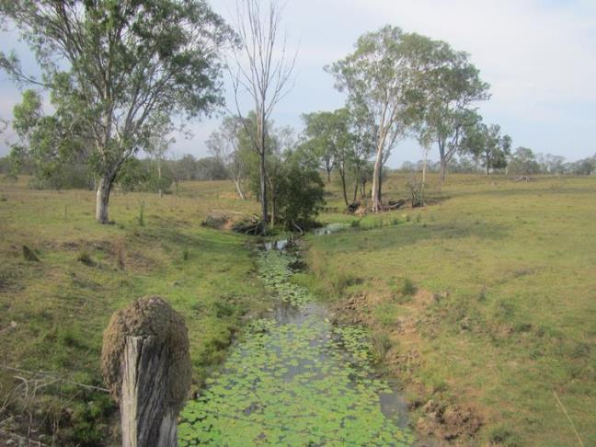
Figure 3.4.3: Example of grazing property with an unfenced waterway

Intensive animal production
A 25 hectare area adjacent to Littabella Creek is used for the grow-out of soft shell crab. Another aquaculture facility lies on the bank of the lower Baffle Creek.

Intensive commercial
Commercial areas in the Baffle basin are limited to 500 hectares of small scale local industries. There are no ports, marinas or port infrastructure in this basin.

Intensive mining
Mining is limited in the Baffle to a 100 hectare stone quarry (Koorrooeenah Quarry), which is unlikely to have any significant impact on the World Heritage Area, and sand mining to the West of Hummock Hill Island in the north of the basin.

Intensive urban residential
The only substantial coastal developments (within the coastal zone) are the urban settlements of Turkey Beach and Agnes Water/1770 with the greatest population located primarily within the town centre of Agnes Water/1770. The coastal settlements of Agnes Water and 1770 are a mix of residential and holiday accommodation.⁸

With the recent resources boom in nearby Gladstone, the area is experiencing an increase in fly-in-fly-out (FIFO) workers. A new high school is expected to increase demand for more housing for families of FIFO workers that currently reside in Gladstone. Currently, development in this area is restricted by a lack of wastewater treatment and water availability. Much of the remaining undeveloped oceanfront land is contained within National Parks however there is available freehold land south and southwest of the current development. A desalination plant and a wastewater treatment plant are currently under construction to service this existing and expanding urban development.

Turkey Beach (Figure 3.4.4) is a small north facing coastal settlement situated on the Rodd’s Harbour. A development proposal for another 200 urban lots at Turkey Beach was rejected due to insufficient wastewater treatment facilities at the site. The landfill for this community is located in the coastal zone and the impacts on the marine environment from this facility are not known.

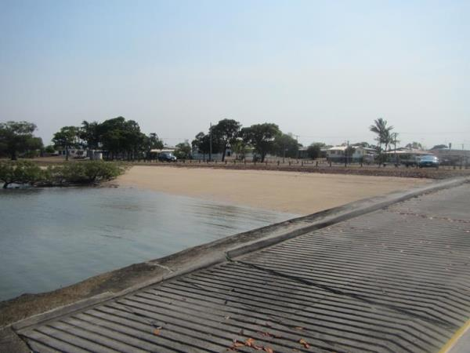
Figure 3.4.4: Boat ramp and residential development at Turkey Beach

Recreational vehicle use on beaches occurs in many parts of this basin and this poses a direct threat to sea turtle nests on beaches.²²

The town of 1770 (near Agnes Water) is a small coastal settlement with small maritime facilities (jetties and boat ramp) (Figure 3.4.5). Much of the town is located on hills adjacent to rocky shores or mangroves and is away from turtle nesting beaches.

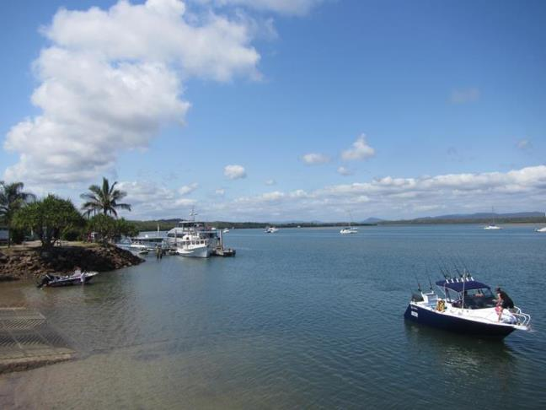
Figure 3.4.5: Boat ramp and boating facilities at 1770 are limited to a sole boat ramp, pontoon and a small area of rock wall

There are many rural residential allotments throughout the Baffle basin. Many of these properties have a high level of clearing and carry different forms of agriculture including sheep, goats, cows, macadamias, mangoes and avocados.

Peri-urban developments (rural residential allotments) are common throughout the Baffle basin. Impacts from peri-urban developments can include loss or fragmentation of coastal ecosystems, introduction of noxious species, unregulated over-extraction of groundwater and contribution to declining water quality. These developments are generally lacking in infrastructure (such as sewage and water) and landholders are generally not supported by Natural Resource Management groups as are other rural land owners.

Production – dryland
A few small properties of dryland production (mangoes, macadamias) occur throughout the Baffle Creek basin (Figure 3.4.6).
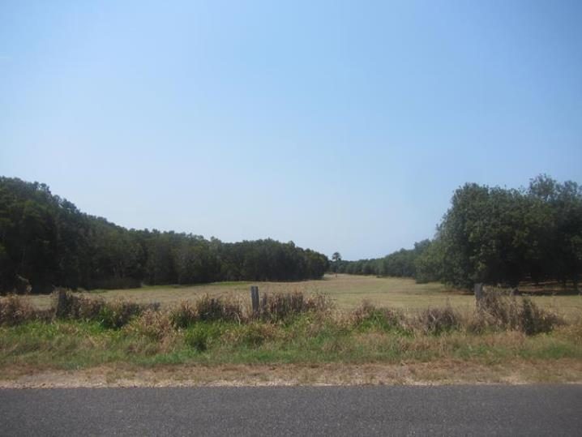
Figure 3.4.6: Macadamia plantation (right) grown in close proximity to remnant littoral rainforest

Production – irrigated
Irrigated cropping makes up one per cent of the land use in this basin. The extent of impacts is limited however there is evidence of expanding irrigated cropping adjacent to Litabella Creek. Water extraction and retention (in dams) is common along Littabella Creek.¹³

Best management practice is being employed in the sugar cane and cotton growing industries in this region. Such practices include the maintenance of riparian areas, reduction of fertiliser and pesticide use and the recycling of water. For information on the water quality impacts from irrigated production in the Burnett-Mary region refer to Appendix F.

Water – marsh/wetland production
Marsh wetland production occurs in wetland areas that have been modified with bund walls for the purpose of growing pasture grasses used for grazing (ponded pastures). There is no marsh/wetland production in this basin.

Water – intensive use and water-storage and treatment
Sewage dishcharge is limited to Agnes Water lagoon Sewage Treatment Plant. This watstewater is treated in lagoon ponds and used for irrigation.The other smaller settlements are currently unsewered and impact are not known. Table 3.4.1 outlines the status of wastewater treatment in the main urban centres in the Baffle basin.

Table 3.4.1: Status of wastewater treatment in the Baffle basin
Urban centre | Wastewater treatment
Turkey Beach | Unsewered.
Agnes Water | Sewered. Lagoon treatment with wastewater used for irrigation. New plant under construction. Desalination plant pending operation.
1770 | Unsewered.
Miriam Vale | Sewered. No stormwater management.
Deepwater | Unsewered, no water.

Within the Baffle basin, future water demands are likely to be needed to support aquaculture and agriculture in addition to town water supplies and potential projects of state and regional significance.³ Unallocated water and potential uses identified included Baffle Creek (increased demand for town water supplies over the next 10 years and potential demand for mining in the longer term), Eurimbula Creek (potential small expansion of aquaculture), Broadwater Creek (irrigation expansion for horticulture) and Littabella Creek (horticulture and aquaculture expansion).³

PART B: OUTCOMES OF BASIN ASSESSMENT
- Projected condition of Great Barrier Reef catchment values

Summary of current state of coastal ecosystems
Coastal ecosystems in the Baffle basin have been modified. During the 1960s to 1980s, the Brigalow Scheme promoted widespread clearing of woody vegetation and encouraged agricultural development. Compared with the other basins studied in this process, the current state of the Baffle basin however is relatively good. Coastal ecosystems that have been most affected are forests, woodlands, forested floodplains and freshwater wetlands (Table 4.1.1).
Table 4.1.1: Percentage of remaining coastal ecosystems in the Baffle basin, Baffle basin coastal zone and the Baffle basin floodplain. Yellow cells indicate areas with 31-50 per cent remaining and green greater than 50 per cent. Note these figures provide no information about ecosystem condition or functionality
Baffle basin % coastal ecosystem remaining | Rainforests | Forests | Woodlands | Forested floodplain | Grass and sedgelands | Heath and shrublands | Freshwater wetlands | Estuaries
Basin wide | 90 | 62 | 78 | 38 | N/A | 98 | 60 | 100
Floodplain | 78 | 58 | 79 | 33 | N/A | 98 | 60 | 100
Coastal zone | 80 | 71 | 80 | 56 | N/A | 98 | 65 | 100

Overall, the remaining coastal ecosystems within the Baffle basin are in relatively good condition. This assessment is based upon the following:

- Much of the basin is under grazing regimes which, if managed to best practice, will minimise any impacts on the World Heritage Area.
- There are no major dams or weirs on any of the waterways within the Baffle basin to impede connectivity.
- The condition of wetlands visited in this basin assessment showed that the wetlands in this basin were in good overall condition. This is likely influenced by the limited availability of water for irrigation which promotes sustainable use and recycling, and limits the extent of agriculture.
- Urban settlements are small, limited mostly by water availability and the lack of supporting infrastructure.
Between 2006 and 2009, 1669 hectares of coastal ecosystems were modified, including 1414 hectares of forest, 116 hectares of woodlands, 122 hectares of forested floodplain, six hectares of rainforest, nine hectares of heath and shrublands, and one hectare of freshwater wetlands. The current state of coastal ecosystems in the Baffle basin is summarised in Table 4.1.2
Table 4.1.2: Summary of the current state of coastal ecosystems in the Baffle basin
 | Coastal ecosystem | Current condition
 | Rainforests | Status is good although 6 hectares was lost between 2006 and 2009.
 | Forests | Heavily impacted with 38 per cent modified and much of the remaining forests heavily grazed. Only 58 per cent of forests on the floodplain and 71 per cent of forests in the coastal zone remain.
 | Woodlands | Reduced in extent by 22 per cent with much of the remainder under grazing regimes.
 | Forested floodplain | Proportionally the greatest impacted coastal ecosystem with only 33 per cent remaining on the floodplain.
 | Grass and sedgelands | Never present in this basin.
 | Heath and shrublands | Mostly intact.
 | Freshwater wetlands | Around 40 per cent of the Baffle basin wetlands have been modified. Remaining wetlands assessed appear to be in a reasonable condition.
 | Estuaries | Mostly intact.

Outline of key current and likely future pressures and impacts on coastal ecosystems in the Baffle basin
Table 4.2.1 provides a brief summary of the current pressures and future outlook for coastal ecosystems in the Baffle basin. The biodiversity of the Baffle basin has not changed significantly from its former state and represents a good example of a basin with a good balance of development coupled with healthy, near pristine coastal ecosystems. The Queensland Government recognises this and uses the Baffle basin as a reference site for South-East Queensland inshore and estuarine water quality monitoring.² The coastal zone and coastal waters remain free from large industry and are unique compared to the heavily modified nearby locations of Gladstone and Hervey Bay.
Likely future impacts will arise from the economic growth experienced in Gladstone. Urban expansion, and with it increased recreational fishing/boating, will likely impact upon the coastal waters of the World Heritage Area. The lack of water infrastructure may limit this growth. Further demand for water for horticulture, industry, mining, drinking water and aquaculture may all impact on ecological processes if not well managed.

Many projects have been undertaken in the Baffle basin with the goal of improving ecosystem health. These include the removal of fish barriers, riparian revegetation projects, coastal foreshore protection projects by the Burnett-Mary Regional Group and promotion of improved land management practices through Reef Plan.^{23,24}

The Burnett-Baffle Water Quality Improvement Plan was developed to manage the reduction of pollutant loads entering waterways within the area and to achieve the water quality objectives required to protect the environmental values for the areas resources¹. The plan made a priority of addressing high impacts from priority pollutants outlined in Reef Plan such as sediments, nutrients and pesticides.

Vegetation in the Baffle basin that is classified as Not Of Concern could potentially be cleared under the current Vegetation Management Act 1999 if not provided protection through other mechanisms.

In the absence of adaptation, beach erosion in the Baffle basin will continue under the influence of climate change, and coastal developments, such as those at Agnes Water and 1770 are likely to continue to be under threat from erosion into the future.

Economic growth and climate change drivers (for example, changed rainfall patterns and sea-level rise) will be the primary drivers of change to coastal aquifers, groundwater dependant ecosystems, estuaries and wetlands in the Baffle basin into the future. This growth will also exacerbate existing anthropogenic pressures on coastal ecosystems and the World Heritage Area through an increase in nutrient, sediment and toxicant input.

Table 4.2.1: Summary of the current pressures and future outlook for coastal ecosystems in the Baffle basin
Pressure | Current status (1999-2009) | Description | Future outlook | Description
Urban development | Uncertain | Unable to quantify due to changes in the methods of land use mapping between 1999 and 2009 for this basin. | Increase | Urban centres are expected to increase further with the growth experienced in Gladstone. Expect further growth in peri-urban developments.
Agriculture (production) | Decrease | Agriculture production (dryland) has decreased and irrigated production has increased between 1999 and 2009. | No significant change expected | Agricultural production is currently restricted by the availability of water. Unlikely to expand significantly unless water infrastructure is improved.
Irrigation infrastructure | No change | No additional water infrastructure. | Uncertain | Potential for new water infrastructure if irrigated production continues to expand.
Grazing | No change | There has been no substantial change in extent of grazing in the Baffle basin. | Uncertain | Subject to market demands.
Introduced species | Uncertain | Weeds are established throughout the basin. | Uncertain | Ongoing control programs for weed management in place however climate change impacts are uncertain and may encourage proliferation of some weed species. Expansion of irrigation infrastructure may increase extent of aquatic and terrestrial weeds.
Climate Change | Uncertain | Not assessed. | Increase | Increasing intensity of episodic events, droughts and changes in rainfall patterns all likely to impact on coastal ecosystems.
Vegetation removal | Minimal change | The introduction of the Vegetation Management Act 1999 provided a regulatory framework for broad-scale land clearing across Queensland. Since its introduction, the rate of vegetation clearance in the basin has significantly declined. | Uncertain | Amendments proposed for the Vegetation Management Act 1999.

Vegetation removal
The introduction of the Vegetation Management Act 1999 and the Sustainable Planning Act 2009 now regulates vegetation clearing on approximately 95 per cent of Queensland by triggering assessment and applying penalties for non-approved clearing. The Vegetation Management Act 1999 also provides mapping of areas of conservation significance through Regional Ecosystems. Regrowth vegetation (especially riparian) provides some protection. However, this legislation does not provide protection to mangroves, grasses, non-woody vegetation or plants within some grassland ecosystems. Marine plants such as mangroves, saltmarsh and saltcouch are provided protection under the Queensland Fisheries Act 1994. Other legislation also applies depending on the location of the vegetation and the tenure of the land.

Agriculture/grazing
The Reef Water Quality Protection Plan (Reef Plan) is a collaborative program of coordinated projects and partnerships designed to improve the quality of water in the Great Barrier Reef though improved land management in the Great Barrier Reef catchment. The plan is a joint Australian and Queensland Government initiative that specifically focuses on non-point-source pollution. This is where irrigation or rainfall carries pollutants such as sediments, nutrients and pesticides into waterways and the Reef lagoon. Reef Plan sets targets for water quality and land management improvement, and identifies actions to improve the quality of water entering the Reef. Initially established in 2003, the plan was updated in 2009.

Reef Rescue initiatives that have been implemented in the Baffle basin include grazing grants to promote better soil health, controls for gully and stream bank erosion, improved water quality through riparian fencing and spreading of waters to exclude stock from creeks and rivers. Water quality improvement grants are also available for growers that use effective chemical application rates, reduce off-farm run-off and apply fertiliser in a precise manner to promote better soil health.

Current and likely future impacts on coastal ecosystems and likely resultant impacts on the World Heritage Area
The key current and likely future impacts on coastal ecosystems and likely resultant impacts on the World Heritage Area are summarised in Table 4.3.1. The biggest threat to inshore and mid-shelf coastal ecosystems adjacent to the Baffle basin is not from run-off from Baffle Creek, but rather the influence of the Fitzroy River to the north and the Burnett and Mary rivers to the south. These larger, more modified systems discharge a greater volume with higher loads of pollutants than any of the Baffle basin waterways.

Table 4.3.1: Key current impacts and likely future impacts in the Baffle basin and the likely consequences for the World Heritage Area
Current impacts on Coastal Ecosystems | Trend 1999-2009 | Current likely impacts as a result on the World Heritage Area | Future likely impacts on Coastal Ecosystems | Future likely impacts on the World Heritage Area
Broadscale clearing of coastal ecosystems for agriculture, urban or industry | Rates of clearing have declined as a result of the Vegetation Management Act 1999. | Loss of ecological process and connectivity, replacement of some ecological processes depending on the nature of the modified system. | Coastal ecosystems unlikely to be returned to their former state, further losses expected under forestry agreements. | Potential further decline in water quality.
Farm run-off | Improvements as a result of increasing rates of best management practice (BMP) uptake. | Improvements to water quality expected, although delayed due to lag effects. Changes in land use will not be obvious for a few years. | Dependant on extent of new horticulture and uptake of best management practice. | Water quality expected to improve over time.
Groundwater changes | Construction of desalination plant at Agnes Water to provide water for urban areas. Groundwater and river extraction used throughout the basin. | Potential decline in biological and biogeochemical processes, changes to connectivity from over-extraction of groundwater. | Over extraction may lead to increases in salinity and loss of dry season refugia in waterways. | As for current impacts.
Stream/river bank erosion | Increasing as a result of extreme weather events. Legacy issues from historical clearing. | Increase in suspended sediments and turbidity in coastal waters; potential increase in sediment (sand) build up in waterways. | Management actions (e.g. Reef Plan) underway to restore riparian areas. | Likely to improve under uptake of best management practices and restoration projects.
Declining water quality | Improvements in recent years. | Decline in inshore ecosystem health and resilience. | Likely to improve as a result of management actions targeted at improving water quality. | Improvements expected but will take time to take effect.
Impacts from introduced terrestrial weeds | Established throughout the basin (mostly in modified landscapes). | Introduced grasses generate hotter fires that can destroy forest canopies and expose soil which can be eroded, especially when fires occur late in the dry season. | Eradication to date has been ineffective and many grasses are still used as pasture grass. Strategic basin scale management actions are needed to manage and control. | Likely to lead to increases in erosion and therefore more suspended sediments in the GBRWHA unless management actions implemented.
Impacts from peri-urban developments | Increasing. | Introduction of weeds, feral animals, wastewater (most peri-urban areas are unsewered), vegetation removal, litter, erosion. | Declines in water quality. | Likely further decline in water quality. Current impacts expected to continue.
Direct impacts | There has been problems associated with vehicle use on beaches. | Destruction of turtle nests and disturbance of seabird nesting and foraging. | Sand compaction, beach erosion. | Potential decline of turtles and birds that are MNES.

Water quality
Water quality discharged from the Baffle basin into inshore waters of the World Heritage Area changes seasonally. Higher concentrations of nutrients, sediments and toxicants are generally detected in the wet season, compared to the dry season when flood plumes transport these elements from the sub-basins into the marine environment. Herbicides that inhibit photosynthesis, and in particular diuron, are occasionally detected in inshore waters of the Great Barrier Reef in this area. At times these herbicides are detected at concentrations that, when considered together, have the potential to affect marine organisms, such as seagrass and corals. However, these may originate from other waterways, and there is limited water quality monitoring of plumes from the Baffle basin.

Figure 4.3.1 provides an example of the relationships between pressures, state and impact from increased pollutants being delivered to the Great Barrier Reef.²⁵ Note that these sequential impacts are linked primarily to nutrient loading scenarios, and do not define the cumulative impacts from increasing temperature and nutrients, or from other pollutants such as suspended sediment and pesticides. Recent work^{26,27,28} indicates that the combined impacts of rising temperatures and increasing nutrients, particularly dissolved inorganic nitrogen (DIN), will result in reduced resilience of coral reefs to recover from more frequent bleaching events.²⁵

Figure 4.3.1: Pathway from nutrient enrichment to biological impact from total suspended solids (TSS); dissolved inorganic nitrogen (DIN); photosynthesis inhibiting herbicides (PSII); and crown-of-thorns starfish (COTS)

The impacts of increasing sediments and nutrients on coral reefs (Figure 4.3.2) and seagrass (Figure 4.3.3) include shading, reduced resilience and reduced recruitment.²⁵ Abundances of a range of other reef associated organisms have also been shown to change along the water quality gradient.²⁵
Reduced coral settlement
SEDIMENTS
Juvenile mortality
Physiological impacts
Reduced abundance
NUTRIENTS
Increased filter feeders
Physiological impacts
Increased organic matter
COTS
Increased competition

Figure 4.3.2: Potential and known impacts of increasing nutrients and sediments on coral reefs²⁵
Increase in sediment loads
SEDIMENTS
Increased shading
Physiological impacts
Reduced biomass
Habitat loss
NUTRIENTS
Increased shading
Increase in nutrient loads
Physiological impacts
Reduced biomass
Habitat loss
Figure 4.3.3: Potential and known impacts of increasing nutrients and sediments on seagrass beds²⁵

Baffle Creek experienced devastating floods in February 2013. The Baffle Creek rose to 22 metres, twice the level to be called flooding.²⁹ Overnight, the water levels went from minor to major, to exceed record levels. Despite this being considered a one in 100 year event, a similar flood event occurred two years prior. These events resulted in high velocity flows carrying freshwater, sediments, nutrients and toxicants into the World Heritage Area. These event flows can have detrimental effects on inshore coastal ecosystems such as coral reefs and seagrass.

Figure 4.3.4 shows the extent of the flood plume in February 2013. The mid shelf (including the Carpicorn-Bunker groups of islands), outer shelf and deep reefs are unlikely to be exposed to primary flood plumes generated in this region. Secondary plumes (phytoplankton) may reach the mid shelf reefs. Flood plumes from the Baffle Creek basin are unlikely to directly reach these reefs however may amalgamate with the larger plumes of the Burnett and Mary rivers, thereby reaching inshore reefs.

Figure 4.3.4: Flood plumes from Baffle Creek, the Burnett River and Mary River during the February 2013 floods

Water quality and changes to hydrological flows are the greatest current and future risks to the World Heritage Area for much of the Great Barrier Reef catchment. Whilst not currently a threat in the Baffle basin (due to good practices and limited ecosystem modification), continued loss of coastal ecosystems and changes to hydrological regimes in the future will likely reduce the capacity to provide ecological functions for the Reef.

The spatial distribution of various water quality variables were predicted and mapped across six regions and three cross-shelf (coastal, inner shelf and outer shelf) positions in the Great Barrier Reef using measurements from 1985-2006.³⁰ From this work, values for the Burnett-Mary region have been derived (Table 4.3.2).

Table 4.3.2: Mean annual values of water quality variables predicted in 3 cross-shelf regions of the Burnett-Mary region. Secchi depth = depth of water clarity, Chl a = chlorophyll a is a proxy for nutrients, SS = suspended sediments, PN = particulate nitrogen, PP = particulate phosphorus, TDN = total dissolved nitrogen, TDP = total dissolved phosphorus; TN = total nitrogen, TP = total phosphorus
Variable | Coastal | Inner Shelf | Outer Shelf | Across all zones
Secchi depth (m) | 6.4 ± 1.3 | 11.4 ± 1.1 | 17.4 ± 1.5 | 15.8 ± 1.5
Chl a (µg L⁻¹) | 1.2 ± 0.10 | 0.8 ± 0.06 | 0.5 ± 0.03 | 0.5 ± 0.04
SS (mg L⁻¹) | 2.4 ± 0.6 | 1.5 ± 0.4 | 0.6 ± 0.2 | 0.8 ± 0.2
PN (µmol L⁻¹) | 2.0 ± 0.3 | 1.6 ± 0.3 | 0.8 ± 0.2 | 1.0 ± 0.2
PP (µmol L⁻¹) | 0.12 ± 0.02 | 0.10 ± 0.02 | 0.06 ± 0.01 | 0.06 ± 0.02
TDN (µmol L⁻¹) | 5.0 ± 0.6 | 4.8 ± 0.5 | 4.7 ± 0.4 | 4.8 ± 0.4
TDP (µmol L⁻¹) | 0.28 ± 0.06 | 0.25 ± 0.05 | 0.25 ± 0.04 | 0.25 ± 0.05
TN (µmol L⁻¹) | 6.0 ± 0.8 | 5.9 ± 0.8 | 5.6 ± 0.9 | 5.6 ± 0.9
TP (µmol L⁻¹) | 0.47 ± 0.11 | 0.42 ± 0.11 | 0.27 ± 0.09 | 0.30 ± 0.09

The current best estimates of modelled loads leaving the Baffle Creek basin are provided in Table 4.3.3. Pre-development loads were substantially lower than current values for all parameters measured. After the implementation of the Reef Rescue program in 2008, an improvement in load values was observed for TSS, DIN, PN, TN, PSII herbicides, PP and TP. Improvements for DON, DIP and DOP loads have not yet been measured. It has been suggested that a 38 per cent reduction in sediment loads is necessary to meet the sustainable loads targets set by the Water Quality Improvement Plan.¹ Further information on water quality can be found in Appendix F.

Table 4.3.3: Best estimates of modelled total pre-development values, current values and anthropogenic changes in water quality parameters. Reef Rescue values represent the values after the commencement of the Reef Rescue Program and Reef Rescue change represents the improvement (%) after implementation³¹
 | Pre-development | Current (2008/2009) | Current (2009/2010) | Anthropogenic  Increase | Reef Rescue change (%) | Total change (%)
TSS  (kt/yr) | 20 | 56 | 56 | 36 | 0.4 | 0.4
DIN  (t/yr) | 12 | 31 | 27 | 19 | 20.4 | 20.4
DON  (kt/yr) | 52 | 100 | 100 | 48 | 0 | 0
PN  (t/yr) | 63 | 95 | 95 | 32 | 0.6 | 0.6
TN  (t/yr) | 127 | 227 | 223 | 100 | 4.2 | 4.2
PSII  (kg/yr) | 0 | 24 | 19 | 24 | 21.0 | 21.0
DIP  (t/yr) | 3 | 7 | 7 | 4 | 0 | 0
DOP  (t/yr) | 2 | 4 | 4 | 2 | 0 | 0
PP  (t/yr) | 25 | 39 | 39 | 14 | 0.8 | 0.8
TP  (t/yr) | 30 | 51 | 51 | 20 | 0.5 | 0.5

The World Heritage Area is experiencing impacts from both land and sea. Climate change drivers – ocean acidification, sea-level rise and rising sea temperatures are leading to declines in coral and seagrass. On the land, changes to coastal ecosystems are impacting on their ability to maintain physical, biogeochemical and biological processes for the long-term health and resilience of the World Heritage Area.

Changes in rainfall patterns coupled with more intense climatic changes (such as increased intensity of episodic events or drought) are likely to see multiple effects on coastal ecosystems. These may include larger pulsed flows of freshwater containing sediments, nutrients and toxicants entering the World Heritage Area. Coastal ecosystems may not be able to retain and filter material as it moves across the floodplain. Land clearing and modification of coastal ecosystems will likely amplify run-off. This will result in the delivery of additional materials that would otherwise have been assimilated in transit.
The increased frequency of extreme storm events (five category five cyclones in the last ten years for example) are impacting on the coastal zone and floodplain. Beaches are showing net erosion (for example Agnes Water Beach) and this erosion is expected to continue under the influence of climate change. This may result in the loss of suitable habitat for listed threatened and migratory species (such as turtle nesting).

Loss and modification of coastal ecosystems in other areas have impacted the World Heritage Area by changing sediment delivery to inshore waters. The construction of dams, water extraction and sand mining all result in reductions in coarse sediment delivery to the World Heritage Area. Land use changes (such as new urban areas, agriculture) can however result in an increase of sediment delivery to the World Heritage Area. Currently, the Baffle basin sediment loads are amongst the lowest in the World Heritage Area. Ongoing improvements to land management have the potential to maintain and improve the sediment budget in this basin.

Actions are being taken to improve the condition of the Baffle basin. The Reef Water Quality Protection Plan (Reef Plan) is a collaborative program of coordinated projects and partnerships designed to improve the quality of water in the Great Barrier Reef though improved land management in reef catchments. The plan is a joint Australian and Queensland Government initiative that specifically focuses on non-point-source pollution. This is where irrigation or rainfall carries pollutants such as sediments, nutrients and pesticides into waterways and the reef lagoon. Reef Plan sets targets for water quality and land management improvement, and identifies actions to improve the quality of water entering the reef. Initially established in 2003, the plan was updated in 2009.

The Natural Resource Management group Burnett-Mary Regional Group (BMRG) have been working closely with local government and landholders to make improvements in such things as land management and conservation.

Priorities for conservation and restoration
Coastal ecosystems located in the floodplain and coastal zone are those that have experienced the greatest losses and those most at risk in the future from development pressures such as increasing urbanisation and aquaculture. Future conservation measures should include protection of these ecosystems from further decline and impacts and restoration efforts should focus on these areas. These areas are also at greatest risk from flooding, storm and climate change impacts. High value infrastructure, such as residential and industrial development should be avoided in these areas or managed in such a way that manages the risk from natural events while maintaining ecosystem functions for the World Heritage Area. Current infrastructure in these areas needs to be constructed and managed to current best practice. Coastal ecosystems outside of these zones should be retained where possible.

Coastal zone
Coastal ecosystems in the coastal zone generally have the closest connections to the World Heritage Area and generally have a higher capacity to provide physical, biological and biogeochemical processes for the World Heritage Area. Some coastal ecosystems in the coastal zone also fall within the World Heritage Area. The coastal zone is also the area at greatest risk from the impacts of climate change. Actions that could be taken to reduce pressure on the coastal zone in the Baffle basin include:
- Limit further loss of remaining coastal ecosystems.
- Increased protection provided to remaining coastal ecosystems (especially land adjacent to significant natural sites such as Pancake Creek and Eurimbula Creek estuary).
- Appropriately restore riparian corridors in this area to a standard that provides effective ecological functions. Any re-vegetation should consider the appropriateness of including species adapted for future climate scenarios.
- Improve agricultural practices to current best practice standards.
- Limit further intensive development in the coastal zone. This will not only reduce environmental impacts, but may also reduce the risk of economic impacts resulting from future climate change, as scenarios predict that the coastal zone will be at greatest risk from sea-level rise and storm surge.
- Consistent with Queensland planning provisions, future urban developments that cannot be sited outside of the coastal zone be constructed to current best practice, employing principles such as water sensitive urban design, gross pollutant traps and tertiary sewage treatment.
- Implement measures (including compliance) to restrict vehicle and pet access to sensitive areas (such as turtle nesting beaches and important migratory bird sites) as identified by the Burnett Mary Regional Group.
- Establish no anchor zones in Pancake Creek to protect the seagrass and coral reefs.

Floodplain
Floodplains support particularly rich coastal ecosystems, especially in terms of diversity and abundance. These areas are important for the physical, biological and biogeochemical processes they provide for the long-term health and resilience of the World Heritage Area. Action that could be taken to reduce pressure on the floodplain in the Baffle basin includes:
- Limit further loss of remaining coastal ecosystems.
- Increased protection of remaining coastal ecosystems.
- Restore riparian corridors in this area to a standard that provides effective ecological functions. Any re-vegetation should consider the include species adapted for future climate scenarios.
- Improve connectivity between remnant coastal ecosystems within the floodplain.
- Improve agricultural practices to current best practice standards.
- Limit further intensive development in the floodplain. This will not only reduce environmental impacts, but may also reduce the risk of economic impacts resulting from future climate change, as scenarios predict that the floodplain will be at increased risk from flooding.
- Future urban developments that cannot be sited outside of the floodplain be constructed to current best practice, employing principles such as water sensitive urban design, gross pollutant traps and tertiary sewage treatment.

Riparian zones and waterways
Riparian vegetation provides important physical, biological and biogeochemical processes essential for the long-term health and resilience of the World Heritage Area. Riparian vegetation slows water velocity and provides areas of nutrient cycling, fish habitat and pathways for fish passage and connectivity across the basin. Action that could be taken to reduce pressure on the riparian zones includes:
- Restore riparian corridors to a standard that provides effective ecological functions. Any re-vegetation should consider the appropriateness of using species adapted for future climate scenarios and should consider adjacent land use.
- Seek to protect or reinstate in-stream habitats to provide improved flow regulation and fish habitat structure.
- Control introduced grass species that are compromising the health and resilience of the waterways through appropriate means, including innovative alternatives such as controlled grazing regimes.
- Limit further construction of dams and weirs in this basin where they might impact on coastal ecosystems or the Marine Park.
- Further development adjacent to waterways should not increase point and non-point source pollutants entering waterways.

Wetlands
Wetlands provide habitat for many species with connections to the World Heritage Area and are often referred to as the ‘kidneys of the Reef’. Wetlands provide important physical, biological and biogeochemical processes that support the long-term health and resilience of the World Heritage Area. Action that could be taken to reduce pressure on wetlands includes:
- Limit further loss of wetlands.
- Improve connectivity between wetlands to allow greater connections between the wetlands and the World Heritage Area.
- Increase protection of remaining wetlands.
- Restore and manage wetlands to maximise nutrient recycling, sediment deposition and nursery areas for fish species.
- Control and manage introduced species that compromise wetland health.

Other areas
Areas outside of the coastal zone and floodplain still provide some physical, biological and biogeochemical processes to the World Heritage Area. Action that could be taken to reduce pressure on these areas includes:
- Appropriate restoration of riparian corridors to a standard that provides effective ecological functions.
- Encourage best practice management of agricultural activities, particularly in areas where riparian buffers are minimal or non-existent.

Potential management actions
This report has been developed as a baseline for the Baffle basin. In order to ensure that the basin is best represented, consideration of additional finer scale data, local knowledge and information will further enhance this assessment.

Coastal ecosystems located in the floodplain and coastal zone are those that are at most at risk in the future from development pressures such as increasing urbanisation and aquaculture. Future conservation and restoration measures need to focus on these ecosystems to prevent further loss and impacts. These areas are also at greatest risk from flooding, storm and climate change impacts so high value infrastructure, such as residential and industrial development should be avoided in these areas or managed in such a way that manages the risk from natural events while maintaining ecosystem functions for the World Heritage Area. Current infrastructure in these areas needs to be managed to current best practice.

Coastal ecosystems outside of these zones should be retained where possible. Priorities for conservation and restoration include:
- Restoration of riparian corridors to a standard that provides effective ecological functions with vegetation adapted to the future climate scenarios.
- Improvement in agricultural practices where riparian buffers are minimal or non-existent.
- Inclusion of undeveloped freehold and leasehold allotments adjacent to significant natural sites (such as Pancake Creek and Eurimbula Creek estuary) into the protected area estate.
- Establishment of no anchor zones in areas of seagrass and coral in Pancake Creek.
- Mapping of regional ecosystems at a local scale supported by ground-truthing.
- Limit the development of irrigated cropping in the basin to prevent the problems that are occurring in other basins (refer to the Haughton basin assessment) from impacting this area.

Knowledge gaps
In assessing this basin, a number of knowledge gaps were identified. These included:
- Reef Plan focuses on sediments, nutrients and pesticides, but further water quality research is required that relates to pollutants that are not covered by Reef Plan, such as microplastics, pharmaceuticals etc., and their effects on the World Heritage Area.
- Implications of agricultural chemicals on the marine environment.
- Effectiveness of current marine monitoring sites. Current sites in this basin are limited to locations that provide ease of access and do not necessarily reflect monitoring at specific river mouths. Integrated monitoring of in-stream and river mouth water quality and ecosystem health would provide more pertinent information on the ability of remaining coastal ecosystems to provide functions to maintain the health and resilience of the Great Barrier Reef.
- Lack of ongoing freshwater water quality monitoring.
- The unique values of Pancake Creek estuary need to be preserved. Monitoring of this site needs to be done to guarantee ongoing health and resilience.
- The impacts of sediment compaction and surface water extraction on surface and groundwater now and under future climate change scenarios.
- During this assessment it was noted that regional ecosystem mapping may not have identified regional ecosystems correctly. Further ground-truthing at a basin scale is recommended.
- Studies of environmental water flows in the basin so that over extraction does not occur.

REFERENCES
1. Burnett-Mary Regional Group 2011, Burnett-Baffle Water Quality Improvement Plan (2011). Research and Development Prospectus, pp. 40, Burnett-Mary Regional Group.
2. Aquatic Ecosystem Health, Department of Environment & Resource Management 2012, Long-term Water Quality Monitoring of Estuaries and Inshore Coastal Waters in Central Queensland 1993 to 2006, The State of Queensland, Department of Environment & Resource Management, Brisbane.
3. Department of Natural Resources and Mines 2010, Water Resource (Baffle Creek Basin) Plan 2010, The State of Queensland, Brisbane.
4. Great Barrier Reef Marine Park Authority 2012a, Great Barrier Reef Coastal Ecosystems Assessment Framework, GBRMPA, Townsville.
5. Great Barrier Reef Marine Park Authority 2012b, Informing the outlook for Great Barrier Reef coastal ecosystems, GBRMPA, Townsville.
6. Department of the Premier and Cabinet 2011a, Reef Water Quality Protection Plan technical report baseline 2009, Reef Water Quality Protection Plan Secretariat DPC, Brisbane.
7. Centre for the Government of Queensland 2011, Queensland Places, viewed 30/06/2013, <http://queenslandplaces.com.au/home>.
8. Department of Environment and Resource Management Queensland Wetlands Program (Department of Environment and Resource Management), Department of Environment and Resource Management, viewed 30/06/2013, <http://wetlandinfo.derm.qld.gov.au/wetlands/PPL/QldWetlandProgramme.html>.
9. McKenzie, L.J., Lee Long, W.J., Coles, R.G. and Roder, C.A. 2000, Seagrass-watch: community based monitoring of seagrass resources, Biologia Marina Mediterranea 7(2): 393-396.
10. Department of the Premier and Cabinet 2011b, Great Barrier Reef First Report Card (2009 Baseline), Reef Water Quality Protection Plan, Reef Water Quality Protection Plan Secretariat, Brisbane.
11. Taylor, H.A., McKenna, S.A. and Rasheed, M.A. 2010, Bustard Bay Seagrass Baseline Assessment November 2009, Fisheries Queensland, Department of Employment, Economic Development and Innovation, Cairns.
12. Department of the Premier and Cabinet 2013, Great Barrier Reef Second Report Card 2010, Reef Water Quality Protection Plan, Reef Water Quality Protection Plan Secretariat, DPC, Brisbane.
13. McKenzie, J. and Duke, N.C. 2008, State of the Mangroves. A condition assessment of the tidal wetlands of the Burnett Mary Region, School of Biological Science, University of Queensland, Brisbane.
14. Australian Natural Resources Atlas 2000, Coasts: Understanding Condition. Estuary Assessment 2000, viewed 30/06/2013, <http://www.anra.gov.au/topics/coasts/condition/index.html>.
15. Queensland Department of Environment and Resource Management 2010, Fitzroy coastal floodplain wetlands: Conceptual model case study series, The Queensland Wetlands Program, Brisbane.
16. Department of Natural Resources & Mines 2003, State of the Rivers, The State of Queensland, Brisbane.
17. O'Brien, B. 2013, Burnett-Mary regional group. Personal communications.
18. Queensland Wetlands Program 2013, Connectivity and the landscape, Queensland Government, viewed 30/06/2013, <http://wetlandinfo.ehp.qld.gov.au/wetlands/ecology/landscape/>.
19. Queensland Government 2010, Water resource (Baffle Creek basin) plan 2010, Queensland Government, Brisbane.
20. State of Queensland 2013, Queensland Coastal Plan: Coastal hazard maps, Department of Environment and Heritage Protection, viewed 30/06/2013, <http://www.ehp.qld.gov.au/coastal/management/maps/index.html>.
21. The State of Queensland, (Department of Environment and Heritage Protection) 2012, Climate change impacts in Queensland's regions, The State of Queensland (Department of Environment and Heritage Protection), viewed 30/06/2013, <http://www.ehp.qld.gov.au/climatechange/regional-summaries.html>.
22. Sargent, S. 2013, Burnett-Mary regional group. Personal communications.
23. Department of the Premier and Cabinet 2009, Reef Water Quality Protection Plan 2009 for the Great Barrier Reef World Heritage Area and Adjacent Catchments, Reef Water Quality Protection Plan Secretariat, DPC, Brisbane.
24. Department of Environment and Resource Management 2010, Burnett Mary Natural Resource Management Region back on track actions for biodiversity, Department of Environment and Resource Management, Brisbane.
25. Devlin, M., Harkness, P., McKinna, L. and Waterhouse, J. 2010, Mapping the surface exposure of terrestrial pollutants in the Great Barrier Reef. Report to the Great Barrier Reef Marine Park Authority, Australian Centre for Tropical Freshwater Research, James Cook University, Townsville.
26. Wooldridge, S.A. and Done, T.J. 2009, Improved water quality can ameliorate effects of climate change on corals, Ecological Applications 19: 1492-1499.
27. Negri, A.P., Flores, F., Rothig, T. and Uthicke, S. 2011, Herbicides increase the vulnerability of corals to rising sea surface temperature, Limnology and Oceanography 56(2): 471-485.
28. Shaw, M., Negri, A.P., Fabricius, K. and Mueller, J.F. 2009, Predicting water toxicity: Pairing passive sampling with bioassays on the Great Barrier Reef, Aquatic Toxicology 95(2): 108-116.
29. The Observer 2013, Baffle Creek community recovering after devastating floods. The Observer, viewed 30/06/2013, <www.gladstoneobserver.com.au/news/community-is-swamped-as-records-crash/1740160/>.
30. De'ath, G., Coles, R., McKenzie, L. and Pitcher, R. 2008, Spatial distributions and temporal change in distributions of deep water seagrasses in the Great Barrier Reef region, Reef and Rainforest Research Centre, Cairns.
31. Martin, K., Schaffelke, B., Thompson, A., McKenzie, L., Muller, J., Bentley, C., Paxman, C., Collier, C., Waycott, M. and Brando, V. 2013, Reef Rescue Marine Monitoring Program Synthesis Report 2010/11, Great Barrier Reef Marine Park Authority, Townsville.
32. Millennium Ecosystem Assessment 2005, Ecosystems and human well-being: wetlands and water synthesis, World Resources Institute, Washington DC.
33. Great Barrier Reef Marine Park Authority 2010, Water quality guidelines for the Great Barrier Reef Marine Park, GBRMPA, Townsville.
34. Great Barrier Reef Marine Park Authority 2011, Catchment to Reef Ecological Expert Advisory Workshop, Great Barrier Reef Marine Park Authority, Townsville.

Appendix A – Field Assessment Template
Date | Basin Name | Latitude (-18.861499) | Camera No | Photo No
Time | Way Point | Longitude (145.865234) | Photo no.
Team Members

Experts

Site Name

Site Description

Site Condition (circle): Excellent Good Average Poor Very poor Unknown
Coastal Ecosystems: Coral Reef Open Water Lagoon Floor Seagrass Coastline Estuaries
Freshwater Wetlands Mangroves Saltmarshes Heath and Shrublands
Grass and sedgelands Forested Floodplain Woodlands Forests Rainforests
Condition: intact fragmented cleared other
Landuse: Conservation and natural environments (inc wetlands), Forestry: dryland or irrigated plantation, Grazing: dryland, irrigates or natural vegetation Intensive: commercial, mining, animal production, urban residential Production: dryland or dryland sugar, Production forestry, Water: marsh wetland production or intensive use, water storage and treatment, uncertain
Direct Impacts (threats):

Direct Impacts (threats):

Indirect Impacts / Threats:

MNES or threatened species

Other Information

Appendix B – Key Terminology used in this report
Basins: | An extent or an area of land where surface water channels to a hydrological network and discharges at a single point i.e. river, stream, creek. Defined by Queensland Government and may include many sub-basins.
Coastal zone: | Area of coast as defined by the Coastal Protection and Management Act 1995 (Queensland)
Coastal Ecosystem: | Marine, estuarine, freshwater and terrestrial ecosystems that connect the land and sea and have the potential to influence the health and resilience of the Great Barrier Reef. For this study, this includes the Great Barrier Reef catchment and 10% of the Reef waters seawards of the coastline.
Ecosystem: | A dynamic complex of plant, animal and micro-organism communities and the non-living environment interacting as a functional unit. Source: Millenium Ecosystem Assessment 2005.³²
Ecosystem function: | The interactions between organisms and the physical environment, such as nutrient cycling, soil development and water budgeting.
Inshore marine areas: | Include (but not limited to) those areas extending up to 20 km offshore from the coast and which correspond to enclosed coastal and open coastal water bodies as described in the Water Quality Guidelines for the Great Barrier Reef Marine Park (2010).³³
Great Barrier Reef catchment (catchment): | The 35 river basins in Queensland which drain into the Great Barrier Reef (Table 1).
Natural Resource Management (NRM) regions: | A group of basins managed by non-government organisations (NRM bodies) within Queensland (Table 1).
Natural Resource Management (NRM) bodies: | Non-government organisations focused on environmental and sustainable agriculture programs and activities.
Non Remnant: | Vegetation that does not meet the criteria of remnant vegetation as defined under the Vegetation Management Act 1999.
Pre-clear: | Queensland Government reconstruction of regional ecosystems to represent vegetation pre-European settlement.
Post-clear: | Queensland Government mapping of the state of regional ecosystems that occurred in 1999 and 2009.
Remnant vegetation: | Vegetation that meets all of following criteria:  - 50 per cent of the predominant canopy cover that would exist if the vegetation community were undisturbed.  - 70 per cent of the height of the predominant canopy that would exist if the vegetation community were undisturbed.  - Composed of the same floristic species that would exist if the vegetation community were undisturbed.
Regional ecosystem: | Regional ecosystems (REs) are vegetation communities that are consistently associated with a particular combination of geology, land form and soil in a bioregion. The Queensland Herbarium has mapped the remnant extent of regional ecosystems for much of the State using a combination of satellite imagery, aerial photography and on-ground studies. Each regional ecosystem has been assigned a conservation status which is based on its current remnant extent (how much of it remains) in a bioregion. Some areas of Cape York have not been mapped.
Sub-basin | Smaller catchment area situated within a basin.
Vulnerability: | The degree to which a system or species is susceptible to, or unable to cope with, adverse effects of pressures. Vulnerability is a function of the character, magnitude, and rate of variation or change to which a system or species is exposed, its sensitivity, and its adaptive capacity.

Appendix C – Values and their elements that underpin matters of national environmental significance
Values and their elements that underpin matters of environmental significance | Matters of national environmental significance (MNES)
 | World Heritage Properties | National heritage places | Wetlands of international importance | Listed threatened species and ecological communities | Listed migratory species | Commonwealth marine areas | Great Barrier Reef Marine Park
Biodiversity - Habitats
Islands
Beaches and coastlines
Mangroves
Seagrass meadows
Coral reefs (<30m)
Mesophotic (deep water) corals
Lagoon floor
Shoals
Halimeda banks
Continental slope
Open waters
Saltmarshes
Freshwater wetlands
Forest floodplain
Heath and shrublands
Grass and sedgelands
Woodlands
Forests
Rainforests
Biodiversity - Species
Dune & saltmarsh plants
Mangroves
Seagrasses
Macroalgae
Benthic microalgae
Corals
Seahorses and allies
Other invertebrates
Plankton and microbes
Bony fish
Sharks and rays
Sea snakes
Marine turtles
Estuarine crocodile
Seabirds
Shorebirds
Whales
Dolphins
Dugongs
Ecosystem Processes – Physical processes
Ocean currents
Cyclones & wind
Freshwater inflow
Sedimentation
Sediment re-suspension
Sea level
Sea temperature
Light
Aquatic connectivity
Ecosystem Processes – Geomorphological processes
To be determined (SEWPaC advice)
Ecosystem Processes – Chemical processes
Nutrient cycling
Pesticide accumulation
Ocean acidity
Ocean salinity
Ecosystem Processes – Ecological processes
Microbial processes
Particle feeding
Primary production
Herbivory
Predation
Symbiosis
Bioturbation
Reef building
Competition
Ecological connectivity
Recruitment
Heritage – Outstanding Universal Value
Superlative natural phenomena, exceptional natural beauty and aesthetic importance (Criterion VII)
Geological processes and geomorphic features (Criterion VII)
Ecological and biological processes (Criterion IX)
See Ecosystem Processes
Natural habitats for conservation of biodiversity (Criterion X)
See Biodiversity - Habitats
Integrity
Heritage – Natural
See Biodiversity and Ecosystem Processes above
Heritage – Indigenous
Cultural practices, observances and customs
Sacred sites, sites of significance, places for cultural tradition
Stories, song lines and marine totems
Indigenous structures, tools and archaeology
Places of historic significance - Indigenous
Places of aesthetic value - Indigenous
Heritage – Non-Indigenous
Places of historic significance – historic shipwrecks
Places of historic significance - World War II features and sites
Places of historic significance - lighthouses
Places of historic significance – other
Places of scientific significance (research stations, expedition sites)
Places of aesthetic value
See OUV - criterion vii
Places of social significance – iconic sites
Community benefits derived from the Great Barrier Reef Region
Income
Employment
Understanding and appreciation
Enjoyment
Access to Reef resources
Personal attachment
Social relationships
Health benefits

Appendix D – Threatened species of the Baffle basin
Birds
Botaurus poiciloptilus
Erythrotriorchis radiatus
Fregetta grallaria grallaria
Geophaps scripta scripta
Poephila cincta cincta
Turnix melanogaster
Fish
Thunnus maccoyii
Mammals
Dasyurus hallucatus
Eubalaena australis
Megaptera novaeangliae
Phascolarctos cinereus (combined populations of QLD, NSW and the ACT)
Xeromys myoides
Other
Cycas megacarpa
Cycas ophiolitica
Macrozamia pauli-guilielmi
Plants
Acacia attenuata
Apatophyllum olsenii
Bosistoa selwynii
Bulbophyllum globuliforme
Cupaniopsis shirleyana
Germainia capitata
Grevillea venusta
Macadamia jansenii
Medicosma elliptica
Phaius australis
Samadera bidwillii
Sophora fraseri
Streblus pendulinus
Taeniophyllum muelleri
Reptiles
Caretta caretta
Chelonia mydas
Dermochelys coriacea
Egernia rugosa
Eretmochelys imbricata
Furina dunmalli
Lepidochelys olivacea
Natator depressus
Paradelma orientalis

Appendix E – Migratory species of the Baffle basin

Aves (Birds)
Bar-tailed Godwit
Black-faced Monarch
Cattle Egret
Common Sandpiper
Curlew Sandpiper
Eastern Curlew
Fork-tailed Swift
Great Egret, White Egret
Great Knot
Greater Sand Plover, Large Sand Plover
Grey Plover
Grey-tailed Tattler
Lesser Sand Plover, Mongolian Plover
Little Curlew, Little Whimbrel
Marsh Sandpiper, Little Greenshank
Pacific Golden Plover
Red Knot, Knot
Red-necked Stint
Ruddy Turnstone
Rufous Fantail
Satin Flycatcher
Sharp-tailed Sandpiper
Spectacled Monarch
Terek Sandpiper
Whimbrel
White-bellied Sea-Eagle
White-throated Needletail
Mammalia (Mammals)
Dugong
Humpback Whale
Southern Right Whale
Reptilia (Reptiles)
Flatback Turtle
Green Turtle
Hawksbill Turtle
Leatherback Turtle, Leathery Turtle, Lute Turtle
Loggerhead Turtle
Olive Ridley Turtle, Pacific Ridley Turtle
Salt-water Crocodile, Estuarine Crocodile

Appendix F – Ecological processes
Ecological processes of natural coastal ecosystems linked to the health and resilience of the Great Barrier Reef. Islands have been excluded as they vary considerably between island types.

Process | Ecological Service | Coral Reefs | Lagoon floor | Open water | Seagrass | Coastline | Estuaries | Freshwater wetlands | Forest floodplain | Heath and shrublands | Grass and sedgelands | Woodlands | Forests | Rainforests
 | Physical processes- transport and mobilisation
Recharge/discharge | Detains water |  |  |  |  |  | MH | H
Recharge/discharge | Flood mitigation |  |  |  |  |  | M |  | H |  | L
Recharge/discharge | Connects ecosystems |  |  |  |  |  |  | H | H
Recharge/discharge | Regulates water flow (groundwater, overland flows) | H | L |  |  |  | MH | H |  |  | L | MH | MH | H
Sedimentation/ erosion | Traps sediment | M | MH | ML | M |  | H | H |  |  | L | MH | MH | MH
Sedimentation/ erosion | Stabilises sediment from erosion |  |  |  | M | H |  |  |  |  | L | MH | MH | M
Sedimentation/ erosion | Assimilates sediment |  |  |  |  |  |  | H |  |  |  | MH | MH | H
Sedimentation/ erosion | Is a source of sediment |  |  |  |  |  |  | M |  |  |  | MH | MH
Deposition and mobilisation processes | Particulate deposition & transport (sed/nutr/chem. etc.) |  |  |  |  |  |  | H
Deposition and mobilisation processes | Material deposition & transport (debris, DOM, rock etc.) |  |  |  |  |  |  | H
Deposition and mobilisation processes | Transports material for coastal processes |  |  |  |  |  |  | H
 | Biogeochemical Processes – energy and nutrient dynamics
Production | Primary production |  |  | H | H |  | H | H |  |  |  | M | M | H
Production | Secondary production |  |  |  | H |  | H
Nutrient cycling (N, P) | Detains water, regulates flow of nutrients |  |  |  |  |  |  | H
Nutrient cycling (N, P) | Source of (N,P) |  |  |  | M | L | H |  |  |  |  | M | M | H
Nutrient cycling (N, P) | Cycles and uptakes nutrients | L | H | H | M | L | H | MH
Nutrient cycling (N, P) | Regulates nutrient supply to the reef |  |  |  | M | L | H | M | H |  |  | M | M | H
Carbon cycling | Carbon source |  |  |  | M | L | H | H |  |  |  |  |  | H
Carbon cycling | Sequesters carbon |  | H | L | M | L | H | H
Carbon cycling | Cycles carbon | L | H | H | M | L | H |  |  |  |  | H | H | H
Decomposition | Source of Dissolved Organic Matter |  |  |  |  |  | H | H |  |  |  |  |  | H
Oxidation-reduction | Biochar source |  |  |  |  |  |  |  |  |  |  | H | H
Oxidation-reduction | Oxygenates water |  | H | H |  | L
Oxidation-reduction | Oxygenates sediments |  |  |  | M | L
Regulation processes | pH regulation |  |  |  | M |  |  | H
Regulation processes | PASS management |  |  |  |  |  | H | H
Regulation processes | Salinity regulation
Regulation processes | Hardness regulation |  |  |  |  |  |  | H
Regulation processes | Regulates temperature |  |  |  |  |  |  |  |  |  |  |  |  | ML
Chemicals/heavy metal modification | Biogeochemically modifies chemicals/heavy metals | L |  |  | M |  |  | H
Chemicals/heavy metal modification | Flocculates heavy metals |  |  |  |  |  |  | H
 | Biological processes (processes that maintain animal/plant populations)
Survival/reproduction | Habitat/refugia for aquatic species with reef connections | H | M | L |  | H | H | H
Survival/reproduction | Habitat for terrestrial species with connections to the reef | H |  |  |  |  |  | H
Survival/reproduction | Food source |  |  |  | H |  |  |  |  | H
Survival/reproduction | Habitat for ecologically important animals | H |  |  | H | L | H
Dispersal/ migration/ regeneration | Replenishment of ecosystems – colonisation (source/sink) | H |  |  | H | M | H | H
Dispersal/ migration/ regeneration | Pathway for migratory fish |  |  |  |  |  |  | H
Pollination
Recruitment | Habitat contributes significantly to recruitment | H |  |  | H | H | H | H |  | H

Capacity of natural coastal ecosystems to provide ecological functions for the Great Barrier Reef³⁴
H – high capacity for this system to provide this service, M – medium capacity for this system to provide this service, L – low capacity for this system to provide this service, N – no capacity for this system to provide this service, X – not applicable, – service is provided but capacity unknown. Boxes with no data indicate a lack of information available. Note that the capacity shown for modified systems assumes periods of low hydrological flow.

Ecological processes of modified systems linked to the health and resilience of the Great Barrier Reef. Islands have been excluded as they vary considerably between island types.

Process | Ecological Service | Groundwater Ecosystems | Irrigated agriculture | Non-irrigated agriculture | Dams & Weirs | Urban | Mining – operational o/cut | Forestry Plantation | Extensive agriculture | Ponded pastures
 | Physical processes- transport & mobilisation
Recharge/Discharge | Detains water | ₁ | M |  |  | L | M |  | H
Recharge/Discharge | Flood mitigation |  | N |  |  | L | X |  | X
Recharge/Discharge | Connects ecosystems | H | L |  |  | L | N |  | L
Recharge/Discharge | Regulates water flow (groundwater, overland flows) | H | M |  |  | L | L |  | M
Sedimentation/ erosion | Traps sediment | N | M₄ |  |  | L | M |  | H
Sedimentation/ erosion | Stabilises sediment from erosion |  | M₄ |  |  | H | N |  | H
Sedimentation/ erosion | Assimilates sediment |  | M |  |  | L | N |  | H
Sedimentation/ erosion | Is a source of sediment |  | L |  |  | L₁₁ | M |  | L
Deposition & mobilisation processes | Particulate deposition & transport (sed/nutr/chem. etc.) | ₂ | L |  |  | L | L |  | H
Deposition & mobilisation processes | Material deposition & transport (debris, DOM, rock etc.) |  | L |  |  | L | L |  | L
Deposition & mobilisation processes | Transports material for coastal processes |  | N |  |  | M | L
 | Biogeochemical Processes – energy & nutrient dynamics
Production | Primary production | N |  |  |  |  |  |  | M
Production | Secondary production | ₃ |  |  |  |  |  |  | H
Nutrient cycling (N, P) | Detains water, regulates flow of nutrients |  |  |  |  |  |  |  | M₁₃
Nutrient cycling (N, P) | Source of (N,P) |  |  |  |  |  |  |  | M
Nutrient cycling (N, P) | Cycles and uptakes nutrients |  |  |  |  |  |  |  | H
Nutrient cycling (N, P) | Regulates nutrient supply to the reef |  |  |  |  |  |  |  | H
Carbon cycling | Carbon source |  |  |  |  |  |  |  | M
Carbon cycling | Sequesters carbon |  |  |  |  |  |  |  | MH
Carbon cycling | Cycles carbon |  |  |  |  |  |  |  | H
Decomposition | Source of Dissolved Organic Matter |  |  |  |  |  |  |  | L₁₄
Oxidation-reduction | Biochar source |  |  |  |  |  |  |  | X
Oxidation-reduction | Oxygenates water | N |  |  |  |  |  |  | L
Oxidation-reduction | Oxygenates sediments | N |  |  |  |  |  |  | ₁₅
Regulation processes | pH regulation |  |  |  |  |  |  |  | ₁₅
Regulation processes | PASS management |  |  |  |  |  |  |  | L
Regulation processes | Salinity regulation |  |  |  |  |  |  |  | ₁₅
Regulation processes | Hardness regulation |  |  |  |  |  |  |  | ₁₅
Regulation processes | Regulates temperature |  |  |  |  |  |  |  | L₁₆
Chemicals/heavy metal modification | Biogeochemically modifies chemicals/heavy metals |  |  |  |  |  |  |  | X₁₇
Chemicals/heavy metal modification | Flocculates heavy metals |  |  |  |  |  |  |  | L
 | Biological processes (processes that maintain animal/plant populations)
Survival/reproduction | Habitat/refugia for aquatic species with reef connections | N | L₅ | L₅ | L₈ | L₁₂ | N | N | L | M₁₈
Survival/reproduction | Habitat for terrestrial species with connections to the reef | N | L | L | H₉ | L | N | N | L | L₁₉
Survival/reproduction | Food source | N | N | N | M | L | N | L | M | L
Survival/reproduction | Habitat for ecologically important animals |  | N | N | L₁₀ | N | N | N | M | L₁₉
Dispersal/ migration/ regeneration | Replenishment of ecosystems – colonisation (source/sink) | N | N | N | L | N | N | N | M | L₂₀
Dispersal/ migration/ regeneration | Pathway for migratory fish | - | N₆ | N₆ | L₈ | N | N | N | ₁₅ | L₂₁
Pollination |  | - | L₇ | L₇ | N |  | N
Recruitment | Habitat contributes significantly to recruitment |  | N | N | L | N | N | N | M | N

Capacity of natural coastal ecosystems to provide ecological functions for the Great Barrier Reef³⁴
H – high capacity for this system to provide this service, M – medium capacity for this system to provide this service, L – low capacity for this system to provide this service, N – no capacity for this system to provide this service, X – not applicable, – service is provided but capacity unknown. Boxes with no data indicate a lack of information available. Note that the capacity shown for modified systems assumes periods of low hydrological flow. End-notes 1 – capacity depends on hydraulic characteristics of the aquifer (porosity, permeability); 2 - particulate transport occurs sometimes in subterranean systems; 3 - secondary production is variable; 4 - dependent upon crop cycle; 5 - habitat for crocodiles and turtles; 6 - especially in channels, but is dependent on water quality; 7 - depends upon crop; 8 - only where fish passage mechanisms exist; 9 - especially water & shorebirds; 10 - particularly aquatic species (though may lack connectivity); 11 - refers to new developments; 12 - impoundments, ornamental lakes and stormwater channels; 13 - hoof compaction of soil increases run-off; 14 - particulate organic carbon is high, dissolved is low; 15 - unchanged from natural ecosystem capacity; 16 - relates more to extent of vegetation clearance of riparian zone; 17 - contaminant; 18 – in the dry season amongst Hymenachne; 19 - particularly for birds; 20 - sink biologically as species move into areas but reduced water quality can affect badly; 21 - subject to water quality and grazing regime.

Appendix G – Water quality report for the Baffle basin

Baffle Creek basin (provided by TropWATER)

1. Summary
The Baffle Creek basin is situated within the Burnett-Mary region. Overall water quality within the Great Barrier Reef Marine Park portion of the Burnett-Mary region is considered in good condition¹, however there is a lack in historical and current water quality data for comparisons. There have been substantial losses to riparian vegetation and wetland areas since pre-European times and seagrass coverage is severely impacted by flood events. Many sugarcane growers have implemented cutting-edge or best management practices of herbicides, however long-term monitoring of water quality in-stream and coastal environments are needed for this region.

2. Hydrology and drainage
There have been no extensive hydrological modifications in the Baffle Creek basin. No major dams or weirs are located in the Baffle catchment and the stream length is 2902 km.²

3. Basin water quality

a) Water quality
1) Status of monitoring in basin and rivers
The Queensland Environmental Protection Agency (QEPA) established and conducted long-term monitoring sites at Baffle Creek from 1982-2004. Although extensive data was collected, few attempts have been made to assess and analyse these long term data sets.³

2) Water quality data
Estimates of exports from the Baffle catchment showed 290,000 tonnes/year of sediment, 654 tonnes/year of nitrogen and 128 tonnes/year of phosphorus are exported into the Great Barrier Reef.⁴ Historical event data is limited to one site on Baffle Creek.²

b) Ecological effects of water quality and hydrological changes in basin
Indicators of catchment health used to create the baseline for the First Report Card established by the Reef Water Quality Protection Plan (2009) included wetland and riparian loss, groundcover and catchment loads. From 2004-2008 the loss of riparian vegetation in the Burnett-Mary region was higher than all other Great Barrier Reef regions (1.04%). Loss of riparian vegetation leads to greater soil erosion and increased in-stream turbidity, which can result in reduced light levels reaching aquatic plants, smothering of benthic organisms and fish gill blockage.

4. Coastal water quality

a) Water quality
1) Status of monitoring in coastal areas
Few studies have collected data on the water quality status from the Baffle Creek basin itself and in most reports the Baffle Creek is combined with the Burnett River. There is little information on the use of pesticides in the Burnett-Mary region, with many of the only documented estimates available for the sugar industry.⁵

2) Water quality data
Since sugarcane cultivation is the predominant cropping activity in coastal areas of this region, priority water quality contaminants are dissolved inorganic nutrients, and herbicide residues.⁶ Pesticides with the highest application in the Burnett-Mary region are diuron, chlorpyrifos, atrazine, asulam, and paraquat.⁵ Compared to the Barrum and Burnett catchments, the Baffle catchment contained the lowest application rates of pesticides (Table 1) in 1996; however it also had the lowest area of sugarcane farming.

It has been estimated that there is a high degree of sediment input and a moderate level of nitrogen and phosphorus exported into the coastal marine environment.⁴ Secchi depths in the Baffle Estuary were measured by the Department of Primary Industries. They found that the upper and lower Baffle estuaries had the second and third highest Secchi depths (approx. 1.7m and 1.5m, respectively) compared to the Elliot and Burnett estuaries.³ In general, the study found that the upper reaches of estuaries had lower Secchi depths than the lower regions of the estuaries.

Modelled pollutant loads associated with current land uses were described in detail in the water quality targets section of the Burnett-Baffle Water Quality Improvement Plan. Model estimates showed that 89% of sediments derived from land originated from grazing land use and entered waterways as a result of hillslope erosion rather than gully erosion.⁷ The ChloroSim model was used to correlate chlorophyll a concentrations with dissolved inorganic nitrogen levels in the rivers. Calculations conducted by Brodie and Grinter (2009) showed that an 80% reduction in DIN from rivers was necessary to achieve the water quality target of 0.45 µg/L of chlorophyll a. ⁸

Table 1: Estimated pesticide usage (kg/active ingredient/year) in Baffle Creek sugarcane areas. Adapted from Hamilton and Haydon (1996)⁵
Pesticide | Atrazine | Diuron | 2,4-D | Glyphosat | Paraquat | Trifluralin | Asulam | Chlorpyrifos | Ethoprophos | Aldicarb
Application Rate | 523 | 234 | 66 | 121 | 108 | 72 | 306 | 356 | 97 | 47

Baffle Creek experienced 800mm of rain in February 2013, which led to devastating floods after the Baffle Creek rose to 22m (twice the required level to be called flooding).⁹ Overnight, the water levels went from minor to major, to above record levels. Despite this being considered a one in 100 year or one in 20 year event, a similar flood event occurred two years prior. Figure 1 shows the extent of the flood plume in February 2013.

Figure 1: Flood plume from Baffle Creek, the Burnett River and Mary River, February 2013

The spatial distribution of various water quality variables were predicted and mapped across 6 regions and 3 cross-shelf (coastal, inner shelf and outer shelf) positions in the Great Barrier Reef using measurements from 1985-2006).¹⁰ The values predicted for the Burnett-Mary are provided in Table 2. All variables generally decreased with increased distance from the coast with the exception of Secchi depth, which increased at more offshore sites. Compared to the other 5 analysed regions (Cape York, Mackay Whitsunday, Fitzroy, Burdekin and Wet Tropics), the coastal area of the Burnett-Mary contained: the highest chlorophyll a values, and the lowest offshore particulate nitrogen values.

Table 2: Mean annual values of water quality variables predicted in 3 cross-shelf regions of the Burnett-Mary region
Variable | Coastal | Inner Shelf | Outer Shelf | Across all zones
Secchi depth (m) | 6.4 ± 1.3 | 11.4 ± 1.1 | 17.4 ± 1.5 | 15.8 ± 1.5
Chl a (µg L⁻¹) | 1.2 ± 0.10 | 0.8 ± 0.06 | 0.5 ± 0.03 | 0.5 ± 0.04
SS (mg L⁻¹) | 2.4 ± 0.6 | 1.5 ± 0.4 | 0.6 ± 0.2 | 0.8 ± 0.2
PN (µmol L⁻¹) | 2.0 ± 0.3 | 1.6 ± 0.3 | 0.8 ± 0.2 | 1.0 ± 0.2
PP (µmol L⁻¹) | 0.12 ± 0.02 | 0.10 ± 0.02 | 0.06 ± 0.01 | 0.06 ± 0.02
TDN (µmol L⁻¹) | 5.0 ± 0.6 | 4.8 ± 0.5 | 4.7 ± 0.4 | 4.8 ± 0.4
TDP (µmol L⁻¹) | 0.28 ± 0.06 | 0.25 ± 0.05 | 0.25 ± 0.04 | 0.25 ± 0.05
TN (µmol L⁻¹) | 6.0 ± 0.8 | 5.9 ± 0.8 | 5.6 ± 0.9 | 5.6 ± 0.9
TP (µmol L⁻¹) | 0.47 ± 0.11 | 0.42 ± 0.11 | 0.27 ± 0.09 | 0.30 ± 0.09

The current best estimates of modelled loads leaving the Baffle Creek basin are provided in Table 3. Pre-development loads were substantially lower than current values for all parameters measured. For example, TN levels have increased by approximately 100 t/yr. After the implementation of the Reef Rescue program in 2008, an improvement in load values was observed for TSS, DIN, PN, TN, PSII herbicides, PP and TP. For example, modelled PSII herbicide export values from the Baffle Creek basin showed that the total export in 2008/2009 (24 kg/yr) had increased compared to pre-development loads (0 t/yr). However, after the implementation of the Reef Rescue program (2009/2010) values decreased to 19 kg/yr, which is a 21% improvement. Improvements for DON, DIP and DOP loads have not yet been measured. It has been suggested that a 38% reduction in sediment loads is necessary to meet the sustainable loads targets set by the Water Quality Improvement Plan.^{2,8}

Table 3: Best estimates of modelled total pre-development values, current values, and anthropogenic changes in water quality parameters. Reef Rescue values represent the values after the commencement of the Reef Rescue Program and Reef Rescue change represents the improvement (%) after implementation
 | Pre-development | Current (2008/2009) | Current (2009/2010) | Anthropogenic  Increase | Reef Rescue (2009/2010) | Reef Rescue change (%) | Total change (%)
TSS  (kt/yr) | 20 | 56 | 56 | 36 | 56 | 0.4 | 0.4
DIN  (t/yr) | 12 | 31 | 27 | 19 | 27 | 20.4 | 20.4
DON  (kt/yr) | 52 | 100 | 100 | 48 | 100 | 0 | 0
PN  (t/yr) | 63 | 95 | 95 | 32 | 95 | 0.6 | 0.6
TN  (t/yr) | 127 | 227 | 223 | 100 | 223 | 4.2 | 4.2
PSII  (kg/yr) | 0 | 24 | 19 | 24 | 19 | 21.0 | 21.0
DIP  (t/yr) | 3 | 7 | 7 | 4 | 7 | 0 | 0
DOP  (t/yr) | 2 | 4 | 4 | 2 | 4 | 0 | 0
PP  (t/yr) | 25 | 39 | 39 | 14 | 39 | 0.8 | 0.8
TP  (t/yr) | 30 | 51 | 51 | 20 | 51 | 0.5 | 0.5
Source: Report Card 2 (in press)¹¹

b) Ecological effects of water quality and hydrological changes in coastal areas
The Burnett-Mary region contains one of the largest areas of seagrass meadows in Eastern Australia.¹² Based on the Reef Water Quality Protection Plan Report Card (2011), seagrass meadows within the Burnett-Mary region are considered in good condition overall, however, meadows are either in decline or have failed to recover after the effects of flooding in 2006. This decline is likely to continue as a result of the large flooding events that recently took place in 2013. Corals were not evaluated in this region as part of the 2009 baseline for the First Report Card.

Between 2001 and 2005, the loss of wetlands was 180 hectares (0.36%).¹ Overall, there has been a 30% decline since pre-European times¹, however the condition of estuaries within Colosseum Inlet, Rodds Bay, Baffle River, Pancake Creek, Eurimbula and Round Hill are all considered as near pristine.¹³

Table 4: Baffle Creek basin estuary classification according to Ozestuaries¹³
River/ Creek | Estuary | Delta | Catchment Area (km²) | Tidal range (semi-diurnal) | Estuary length (km) | Condition | Mangrove Area (km²) | Salt Marsh area (km²) | Seagrass area (km²)
Colosseum Inlet | Tide | Tide | 475 | 2.8 | 13.75 | Near pristine | (44.1) | (20.7) | 0.001
Rodds Bay | Tide | Tide | 231 | 2.6 | 16.1 | Near pristine | (17.3) | (6.3) | 0.001
Baffle | River | Tide | 2652 | 2.3 | 19.81 | Near pristine | 2.5 | 3.38 | 0
Pancake (Jennylin) | Tide | Tide | 115 | 2.5 | 10.25 | Near Pristine | (16.4) | (10.9) | 0
Eurimbula | Tide | Tide | 83 | 2.5 | 4.34 | Near Pristine | (3.0) | (1.1) | 0
Round Hill | Tide | Tide | 99 | 2.5 | 7.54 | Near Pristine | (4.8) | (3.2) | 0.001

5. Additional pollutants
There are no studies to date examining the occurrence or impacts of micropollutants such as microplastics, heavy metals and pharmaceutical wastes in the Baffle Creek basin.

6. Management

- In basin for basin
Key water quality issues that have been identified for this area are: loss of riparian zones, sediment, nutrient and pollutant run-off from agricultural and grazing lands and urban regions as well as tourism, industrial and mining activities.³

The sugarcane and cotton growing industries have developed best management practices that include the maintenance of riparian areas, reduction of fertiliser and pesticide use and the recycling of water. A main management objective of the Burnett-Mary region is to reduce the extra nutrients and sediments from entering the waterways. As urban population expands it will be necessary that sewage treatment plants are assessed and upgraded accordingly.

The Burnett-Baffle Water Quality Improvement plan (WQIP) was designed to manage the reduction of pollutant loads entering waterways within the area and to achieve the water quality objectives required to protect the environmental values for the areas resources.² The plan made a priority of addressing high impacts from priority pollutants outlined in Reef Plan such as sediments, nutrients and pesticides.

b) In basin for Great Barrier Reef
The first report card of the Reef Water Quality Protection Plan (2011) identified that 70% of horticultural producers, and 8% of sugarcane growers are currently using cutting-edge or best management practices for herbicides. Additionally, cutting-edge or best management practices are being used by 42% of horticulture producers for nutrients and by 65% for soil. Data regarding management adoption for the grazing and grain industries are not yet available.

Management objectives should include more baseline studies that will enable the current status of the Baffle Creek basin to be either maintained or improved upon in the future.³

7. Future land use changes
According to the Reef Water Quality Protection Plan (RWQPP), there is a moderate biophysical and development risk and a high capacity for communities to change practices that cause land based pollution.³ The Burnett-Mary catchment is expected to grow by 40% over the next 40 years, with the population reaching approximately 300,000 by 2016.²

8. Knowledge gaps
There are major knowledge gaps regarding many environmental aspects of the Baffle Creek basin. Although QEPA has been monitoring water quality within the Burnett-Mary region since the early 1980s, very few reports on long term trends and changes in the state of the environment have been written, with the exception of the Burnett and Mary River and the Great Sandy Strait region.¹⁴ There is a therefore an extensive knowledge gap on ecosystem health and historic rates of changes within key habitats of the Baffle Creek basin.³ There is a need for full monitoring of in-stream, estuarine and coastal water quality.

REFERENCES:

1. Department of the Premier and Cabinet 2011, Reef Water Quality Protection Plan technical report baseline 2009, Reef Water Quality Protection Plan Secretariat, Department of the Premier and Cabinet, Brisbane, viewed 30/06/2013, <http://www.reefplan.qld.gov.au/measuring-success/report-cards/assets/technical-report.pdf>.
2. Burnett-Mary Regional Group 2011, Burnett-Baffle Water Quality Improvement Plan (2011). Research and Development Prospectus, pp. 40.
3. Prange, J.A. and Duke, N.C. 2004, Technical paper Burnett-Mary Regional Assessment. Marine and Estuarine Water Quality and Wetland Habitats of the Burnett-Mary Region. Draft final report.
4. Furnas, M. 2003, Catchments and corals: terrestrial run-off to the Great Barrier Reef, Australian Institute of Marine Science, Townsville.
5. Hamilton, D. and Haydon, G. 1996, Pesticides and fertilisers in the Queensland sugar industry - estimates of usage and likely environmental fate, Queensland Department of Primary Industries, Brisbane, viewed 30/06/2013, <Atrazine - Soil Water>.
6. Stork, P.R., Bennett, F.R. and Bell, M.J. 2008, The environmental fate of diuron under a conventional production regime in a sugarcane farm during the plant cane phase. Pest Management Science 64: 954-963.
7. Fentie, B., Esslemont, G., Searle, R., Sherman, B.S., Read, A., Chen, Y., Brodie, J., Wilson, P. and Sallaway, M. 2006, Sediment and nutrient modelling in the Burnet Mary NRM region, in The use of Sednet and Annex models to guide GBR catchment sediment and nutrient target setting, eds A.L., Cogle, C. Carroll and B.S. Sherman, Queensland Department of Primary Industries, Brisbane, pp. 1-27.
8. Brodie, J. and Grinter. 2009, Water Quality Targets for the Burnett/Baffle WQIP. Burnett-Baffle Water Quality Improvement Plan.
9. The Observer 2013, Baffle Creek community recovering after devastating floods. The Observer, viewed 30/06/2013, <www.gladstoneobserver.com.au/news/community-is-swamped-as-records-crash/1740160/>.
10. De'ath, G. and Fabricius, K.E. 2008, Water quality of the Great Barrier Reef: distributions, effects on reef biota and trigger values for the protection of ecosystem health, Great Barrier Reef Marine Park Authority, Townsville.
11. Department of Premier and Cabinet, State of Queensland 2013, Great Barrier Reef Second Report Card 2010, Reef Water Quality Protection Plan, Reef Water Quality Protection Plan Secretariat, Brisbane, Australia.
12. McKenzie, L., Roder, C., Roelofs, A.J. and LeeLong, W. 2000, Post-flood monitoring of seagrasses in Hervey Bay and the Great Sandy Strait, 1999: implications for dugong, turtle and fisheries management, DPI, Cairns.
13. Geoscience Australia 2004, OzEstuaries database. Geoscience Australia, viewed 30/06/2013, <http://www.ozestuaries.org/>.
14. QEPA Mary River 2001, Water quality condition and trends. Queensland Environmental Protection Agency, Brisbane.

