Reef Guardian Councils
Highlight Report
Summaries
2015–16
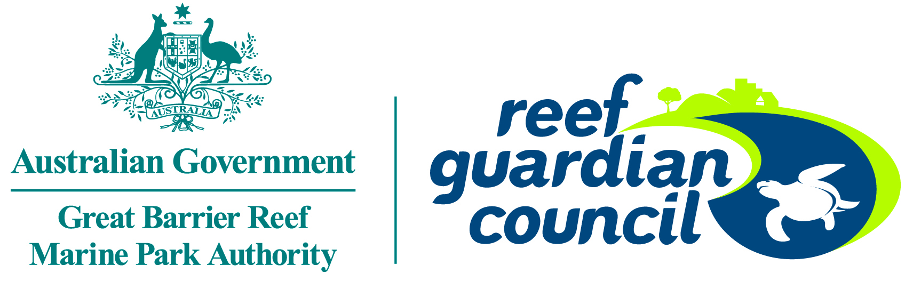

© Commonwealth of Australia 2017
Published by the Great Barrier Reef Marine Park Authority
ISBN 978-0-9953731-1-2
The Reef Guardian Councils: Highlight reports 2015-2016 is licensed by the Commonwealth of Australia for use under a Creative Commons By Attribution 4.0 International licence with the exception of the Coat of Arms of the Commonwealth of Australia, the logo of the Great Barrier Reef Marine Park Authority, any other material protected by a trademark, content supplied by third parties and any photographs. For licence conditions see: http://creativecommons.org/licences/by/4.0


This publication should be cited as:
Great Barrier Reef Marine Park Authority and Reef Guardian Councils 2017, Reef Guardian Councils: Highlight reports 2015-2016, GBRMPA, Townsville.

A cataloguing record is available for this publication from the National Library of Australia
While all efforts have been made to verify facts, the Great Barrier Reef Marine Park Authority takes no responsibility for the accuracy of information supplied in this publication.
Aboriginal and Torres Strait Islander readers are advised this publication may contain names and images of deceased persons.

Comments and questions regarding this document are welcome and should be addressed to:
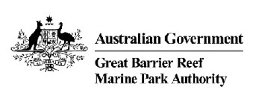
Great Barrier Reef Marine Park Authority
2–68 Flinders Street
(PO Box 1379)
Townsville QLD 4810, Australia

Phone: (07) 4750 0700
Fax: (07) 4772 6093
Email: info@gbrmpa.gov.au
www.gbrmpa.gov.au

Introduction
The Reef Guardian Council stewardship program unites 17 councils working together to preserve the health and resilience of the Great Barrier Reef — for today and tomorrow.
The councils and their communities are taking positive environmental action to safeguard the Reef.
Each year, the Great Barrier Reef Marine Park Authority reviews each council’s activities and produces this report to celebrate their achievements.

Local Government Areas in the Great Barrier Reef Catchment
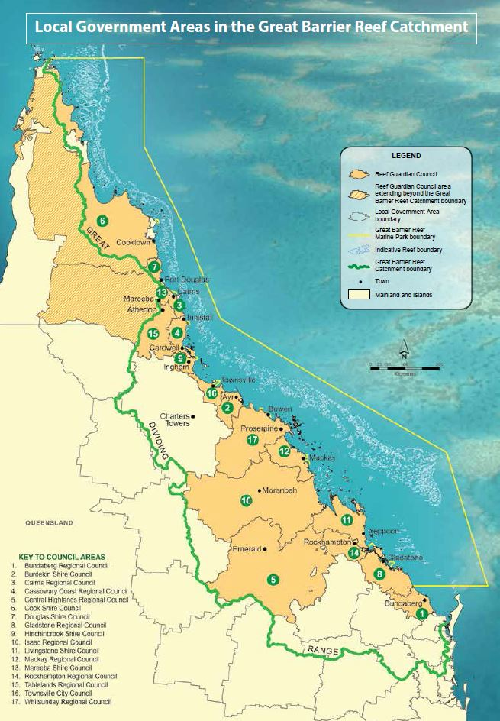

Table of contents
Introduction 3
Local Government Areas in the Great Barrier Reef Catchment 4
About Reef Guardian Councils 6
Bundaberg Shire Council 8
Burdekin Shire Council 10
Cairns Regional Council 12
Cassowary Coast Regional Council 14
Central Highlands Regional Council 16
Cook Shire Council 18
Douglas Shire Council 20
Gladstone Regional Council 22
Hinchinbrook Shire Council 24
Isaac Regional Council 26
Livingstone Shire Council 29
Mackay Regional Council 31
Mareeba Shire Council 33
Rockhampton Regional Council 36
Tablelands Regional Council 39
Townsville City Council 41
Whitsunday Regional Council 43

About Reef Guardian Councils
The Great Barrier Reef Marine Park Authority’s Reef Guardian program began in 2003, working with schools to encourage the community to take action for a healthier Reef. Over the past 15 years it has expanded to include farmers, fishers and councils.
There are 17 participating councils located within the Great Barrier Reef catchment. They cover a 300,000 square kilometre area with a population of more than one million people stretching from Cape York in the north to Bundaberg in the south.
Each council undertakes a range of environmental initiatives to improve the health of the Reef. They also play an important role in planning for sustainable population growth, approving environmentally sound developments, and preparing the community for climate change impacts.
Through the Reef Guardian program councils are committed to continuous environmental improvement and a better future for the Great Barrier Reef.

Councils are partners
The Reef Guardian Council program has evolved as a collaborative partnership between mayors, council officers and the Great Barrier Reef Marine Park Authority. Steering committee and working group meetings are convened several times a year for mayors and council officers to share ideas and foster continuous environmental improvement. The councils have a strong sense of ownership and actively drive the program’s direction.

Annual action plans
Each Reef Guardian Council prepares an annual action plan to identify activities that will be undertaken to promote and protect the health of the Reef. With assistance from agency staff, councils list a range of activities that will benefit the Reef under the general headings of land, water and waste management, community education and climate change. Actions vary depending on the capacity and context of each council, but generally cover everything from the big picture of new planning schemes, to the detail of installing new pipes in causeways to improve waterway connectivity.

Highlight reports
The action plan is reviewed at the end of each year and each council produces a report outlining their key achievements. This document is a compilation of the 2015–16 highlight reports provided by the councils. It demonstrates how the hands-on, community-based approach of Reef Guardians can make a real difference to the health and resilience of the Great Barrier Reef.

Reef Guardian projects
Healthy waterways and coastlines are vital for the Reef’s survival. Councils are helping to secure the Reef’s future by restoring and reconnecting coastal ecosystems and considering the impact of future council planning scheme developments.
Councils are also improving water quality by upgrading wastewater treatment plants, improving stormwater management and reducing threats of chemicals and other pollutants. Many of these projects are highlighted in this report.

Reef 2050 Plan
The Australian and Queensland governments released the Reef 2050 Long Term Sustainability Plan in 2015. The plan provides a blueprint for governments, industry and communities to work in partnership to ensure the Great Barrier Reef remains a global icon into the future.

Local government is listed as a partner against 35 priority actions to be undertaken by 2020 to continue progress towards 2050 targets. The Reef Guardian partnership is more important than ever as the participating councils align their activities with the Reef 2050 Plan.

Bundaberg Shire Council

Pipeline to the future
The council’s largest infrastructure project, the state-of-the-art Rubyanna Wastewater Treatment Plant, is underway, with preliminary earthworks and foundations already completed. The new plant will replace aged infrastructure and enable the council to cater for future population growth. Smart environmental features include a solar farm to offset electricity costs. Later stages of the project will connect the plant to coastal communities.
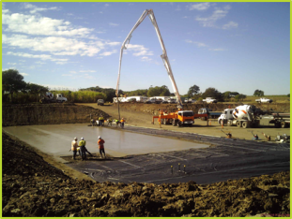
Construction underway: installation of the digester blinder slab at the Rubyanna Wastewater Plant.

Detecting dirty secrets
The council stepped up its surveillance activities in a bid to reduce illegal dumping in 2015–16. Extra security cameras were installed in dumping hotspots, and additional surveillance was carried out by the council’s compliance staff. The expanded anti-dumping program included an educational campaign, complete with mobile billboard: a council vehicle emblazoned with the message, “Don’t let your litter bug our Reef”. The program has reduced the incidence of illegal dumping.
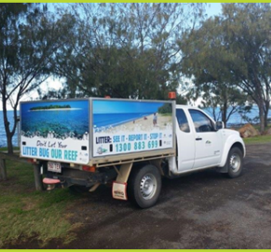
Taking the message to the streets: council’s vehicle with illegal dumping educational messages.

Trappings of success
Several gross pollutant traps, which collect floating rubbish before it enters the sea, have been installed at Baldwin Swamp. One of Bundaberg’s high-profile environmental parks, Baldwin Swamp is located in an urban catchment area which includes a wetland that empties into the Burnett River. The pollutant traps are designed to collect floating rubbish, such as bottles and cans, in low-flow situations. The rubbish is then easy for council staff and community volunteers to retrieve and remove.
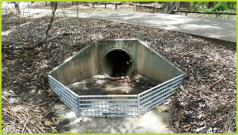
Trapping trash: a pollutant trap installed at Baldwin Swamp Environmental Park.

Water-sensitive urban male
Council design team leader, Jason Reepsdorff, is a big fan of water-sensitive urban design, which integrates storm water, ground water, waste water management and water supply into urban design to minimise environmental impacts, including erosion and reduced water quality. Jason is the key contact for implementation of policy, principles and technical training arrangements. Water-sensitive urban design is being trialled throughout Queensland.
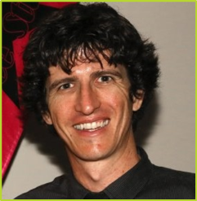
Jason Reepsdorff: a council champion for Water Sensitive Urban Design.

Methane under fire
Methane gas generated by landfill is no match for the council’s new gas flaring system, installed at the University Drive waste facility. The cutting-edge methane gas disposal technology converts the harmful gas into carbon dioxide, which is around 23 times less hazardous to the environment than methane. The gas flare unit features 24 gas wells and is accruing carbon credits under the Emissions Reduction Fund.
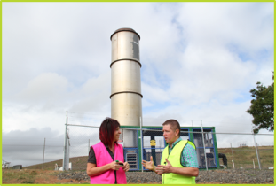
Cutting edge: waste and recycling co-ordinator Kerry Dalton and Councillor Scott Rowleson unveil the new gas flaring system.

Burdekin Shire Council

Weed science
The Council unleashed a battery of methods to clear weeds from local waterways, joining forces with landholders, the water board and government agencies to combat the plant pests. A floating harvester was used to remove about 1000 tonnes of floating weed from Lilliesmere Lagoon, in collaboration with Lower Burdekin Water. Elsewhere, weevils were deployed to control Salvinia molesta (native to Brazil) and aerial spraying was utilised in areas inaccessible to boats.
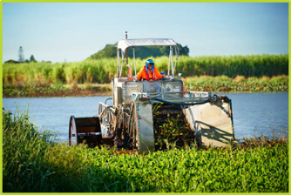
Taking action: water weeds officer using a weed harvester to remove aquatic weed in Lilliesmere Lagoon.

The fifth “R” – recycling
Council officers, keen to educate the community in ways to manage waste and reduce landfill by recycling, have found young ears particularly receptive. Six kindergartens and five schools put their hands up to attend recycling and composting awareness sessions and also utilised the Council’s “Reduce, Re-use and Recycle” presentations. Media promotion and organised clean-up days have also raised community awareness of responsible waste management.
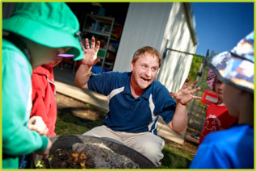
Inspiring action: an environment and health project officer interacts with children during a composting session.

A clean sweep
Following the Great Barrier Reef Clean-up, the council hosted a workshop to develop short and long-term plans to reduce marine debris and litter. Funded by the Australian Government’s Reef Trust, the marine debris reduction workshop was delivered by Tangaroa Blue, in partnership with the Great Barrier Reef Marine Park Authority. Council staff, industry stakeholders and local environment groups used data collected from the area to create the debris reduction plans. A clean-up at Alva Beach, hosted by the council, Tangaroa Blue and NQ Dry Tropics, collected 444 kilograms of rubbish, including 1080 litres of recyclable items.
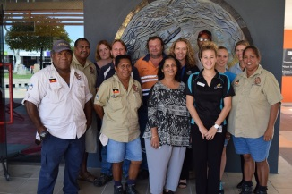
Collective ideas: participants in the marine debris source reduction workshop.

United attack on pests
The council launched a new Pest Management Plan in 2016. Developed with assistance from local industry, environmental groups and non-government organisations, the plan aims to protect the Burdekin region from plant and animal pests. The council has developed a coordinated approach to feral pig control, aligning its activities with neighbouring councils. Thanks to external funding, additional trapping, baiting and shooting programs have been undertaken throughout the shire, with positive outcomes for landholders.
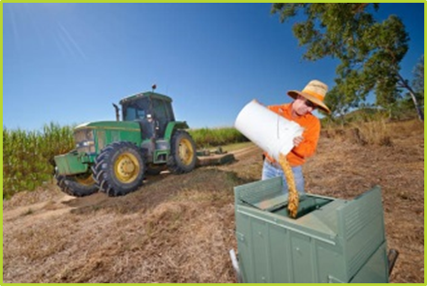
Keeping pests under control: a council pest management officer prepares a hog hopper feeding station.

Fostering green work habits
Council staff working in a range of areas, including road construction and maintenance, parks and gardens, and water and wastewater, have received training in environmentally responsible work practices. The training focused on activities that could affect water quality, flora or fauna. Topics included weed management, storage and spill control of fuels and hazardous substances, waste management, erosion and sediment control, as well as efficient resource and energy use.
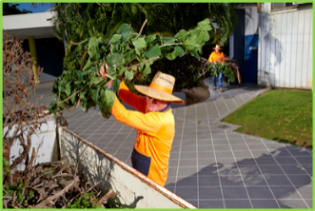
Knowledge is key: Parks and Gardens staff remove green waste for mulching at the transfer station.

Cairns Regional Council

Wave of volunteers bag debris
The Great Northern Clean Up saw communities across Northern Australia participating in activities to clean up beaches, bushland and waterways, in preparation for the wet season. The Cairns region Great Northern Clean Up was delivered in partnership with council, Clean Up Australia, neighbouring councils and active community groups. More than 200 volunteers scoured 16 sites in 2015, compared to just nine the previous year. With a focus on preventing single-use plastics, like drinking straws and plastic bags, from becoming marine debris, the council measured event success on participation rates, rather than volume or weight of litter collected.
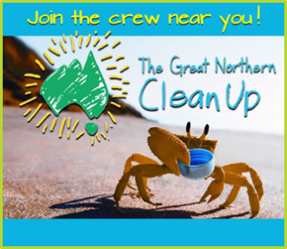
Cleaning up with community: if you don’t clean up for the reef, who will?

Green speak
The council adopted a colourful technique known as reverse graffiti to deliver an important message about the connection between land and sea. Using stencils and high-pressure cleaners, the council created public art with the key message: “the Reef starts here”. The initiative has added another tool to council’s community engagement in the control of urban stormwater pollution and responsible disposal of litter.
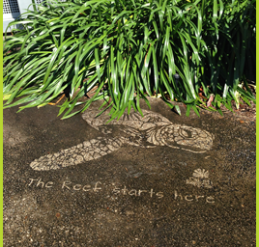
Communicating on point: reverse graffiti at the entrance to Cairns Regional Council head office.

No-fly zone
Helium balloons are highly mobile, single-use items that can have a devastating effect on wildlife, when deflated or torn remnants descend back to land or sea. The Cairns Regional Council has banned balloon releases at all events held on council-managed land, including parks and foreshores. The ban aims to help reduce marine debris, raise awareness of the issue and promote responsible waste management by event organisers. The initiative is enforced through the park and foreshore event booking process.

Bust up: balloon releases are a thing of the past in Cairns.

Painting the town green
The Cairns ECOfiesta, which celebrates sustainable living and the natural environment, attracted more than 10,000 people in 2016. With live music, performance, activities, local food and a huge sustainability trade show, the ECOfiesta appeals to locals and visitors alike. Widespread availability of organic products in supermarkets indicates the eco-conscious consumer is the new growth market. Combine this with a region renowned for its World Heritage-listed rainforest and Reef and you have the perfect ingredients for a premier sustainability festival. ECOfiesta has quickly become a standout on far north Queensland’s event calendar.
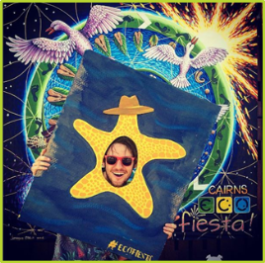
Standing out: Cairns ECOfiesta celebrates sustainable living and the Great Barrier Reef.

Workplace funding a turtle success!
The council raises more than $10,000 a year, through workplace giving, to rehabilitate sick and injured turtles at the Cairns Turtle Rehabilitation Centre. The initiative sees council staff make small, regular donations through their pay that is matched dollar-for-dollar by council. An Australian Charities Foundation study has found that workplace giving is a highly valuable program, as it builds employer and employee engagement by focusing on a shared goal. For the council and its staff, this shared goal is the conservation of an iconic reef species — the sea turtle.
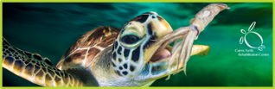
Saving an icon: adult green sea turtles can easily eat 60 squid a day when in care.

Cassowary Coast Regional Council

Putting conservation in the picture
Mourilyan State School, Cassowary Coast Regional Council, and regional artist Daniel ‘Wally’ Wallwork joined forces to create a colourful, engaging mural as part of the Great Barrier Reef Clean-up. The mural aims to raise community awareness of the dangers of marine debris to our local sea life. Both the artist and students worked together to design and create the vibrant piece, installed at an amenities block beside the Innisfail skate park, where it attracts a youthful audience. The project was made possible by substantial in-kind contributions from council staff and Mourilyan State School students and teachers.
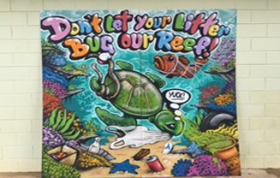
Communicating in colour: part of the mural in place at the amenities block near the Innisfail Skate Park.

Bin-eficial initiative
In September 2016, the council launched a community composting and subsidy program. Open to all residents, the program provides a $20 subsidy for any worm farm or compost bin purchased. With the cost of compost bins decreasing markedly in recent years, the subsidy offers a significant incentive. Along with the subsidy, residents receive an information package, providing facts and tips on effective composting methods. The program will also reduce the volume of wet waste transported from the region, and contribute to savings for ratepayers.
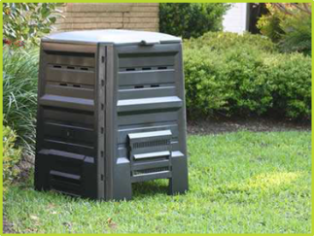
Cost-effective composting: compost bin available from most hardware stores for as little as $40.

Stopping the slide
Being situated in the World Heritage-listed Wet Tropics area, which receives high-volume, high-intensity rainfall, poses particular challenges for council works. Sediment control methods are vital for protecting the Great Barrier Reef from damaging run-off. Supervisory staff receive formal training in sediment and erosion control techniques and practices relevant to this environment. All works are planned in advance to either avoid times of the year when rain is most likely, or ensure erosion and sediment controls are identified and installed, and a maintenance program devised for when heavy rain occurs.
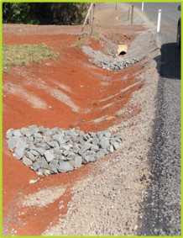
Combatting sediment run-off: sediment control devices installed in a steep roadside drain by council staff.

Shutter bugs nab litter bugs
The council deploys a number of officers trained to investigate illegal dumping and littering, and also utilises five portable surveillance cameras, funded by the Department of Environment and Heritage Protection, to monitor illegal dumping hotspots. The officers liaise with other council sections to identify appropriate sites for the cameras and facilitate a prompt response to reports of rubbish dumping. In most cases, offenders are identified and either fined or directed to remove the rubbish and supply council with records of disposal at a transfer station or other waste facility.
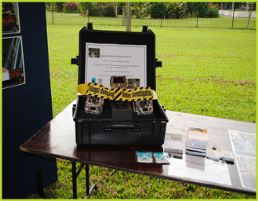
Caught on camera: portable surveillance cameras are used to monitor illegal dumping hotspots.

Coastal care harnesses community will
The council's Coastal Engagement Program works with a range of community groups, Traditional Owners, schools and government departments to identify priorities in the care of fragile coastal areas. An incorporated education program informs the community on the importance of coastal ecosystems and ways to help protect and rehabilitate damaged areas. Regular tree plantings and targeted projects such as wetland rehabilitation are developed under the Reef Guardian program and in partnership with Conservation Volunteers Australia’s Green Army.
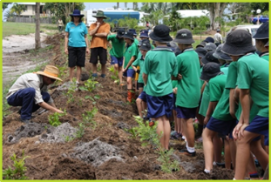
Getting involved: teachers and students from Wongaling State School take part in a wetland rehabilitation project.

Central Highlands Regional Council

Reining in stormwater damage
The council has continued to expand its stormwater system, in response to increasingly frequent intense storm activity due to climate change. The systems have been re-engineered, significantly increasing their capacity to reduce the risk of potential stormwater discharge from the Lochlees and Blackwater landfills during high rainfall periods. In preparation for its first wet season, the system was hydro-mulched — a process where seed, fertiliser, mulch and a binder are combined in water and sprayed onto the soil to reduce erosion.
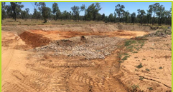
Work in progress: Detention Basin 5 completed and waiting to be hydro-mulched.

Landfills dumped
The council has replaced landfills – which served the communities of Springsure, Willows and Boguntungan for over 80 years – with waste transfer and bin stations. The new facilities will reduce the risk of windblown litter and increase recycling opportunities available to these communities. Another three stations are planned for construction in the next 18 months to consolidate the Central Highlands landfilling operations.
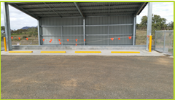
New approach: Springsure transfer station getting ready for action.

Tackling a thorny issue
The council, in collaboration with Biosecurity Queensland and Central Highlands Regional Resources Use Planning Cooperative Limited (CHRRUP), hosted a field day to raise community awareness of the need to control the locally declared plant pest, willows cactus. The cactus infests reserves and is reducing biodiversity in the area. A Green Army project to remove the cactus has been running in conjunction with Biosecurity Queensland herbicide trials. Trial results are expected to be released in April 2017.
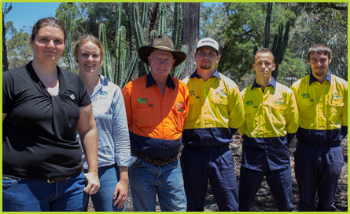
Collaborative effort: project staff from council, CHRRUP and the Green Army.

Water samples on tap
In the Central Highlands, intense storms can reduce access to water sampling sites, by flooding roads and turning access tracks into swamps. To address this issue council has installed multiple rising stage samplers to collect water samples for later analysis – and maintain the council’s ability to monitoring water quality.
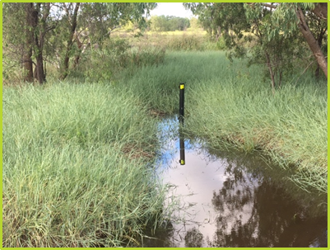
Accessibility solution: rising stage sampling at Capella in action.

Cook Shire Council

Stopping the flow of marine debris
Following the Great Barrier Reef Clean-up, the council hosted a workshop designed to kick-start community projects designed to reduce marine debris at the source. Workshop participants included Traditional Owners, teachers, environmental groups, community groups, council workers and concerned residents. The marine debris source reduction workshop was funded by the Australian Government’s Reef Trust, and delivered by Tangaroa Blue, in partnership with the Great Barrier Reef Marine Park Authority.
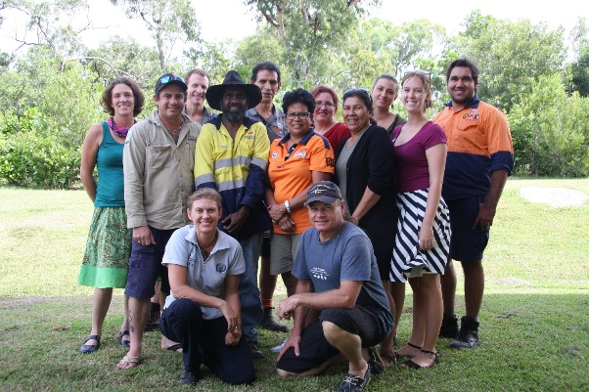
Ready to tackle Reef pollutants: participants in the marine debris source reduction workshop

Drawing on children’s support
The council works with a range of community members and groups engaged in activities designed to protect the Reef. In May, the council supported a Beach clean-up, donating resources such as bins and other equipment, and encouraging all staff to participate. The council also assisted an anti-littering sign campaign launched by a resident. The campaign recruited children to design signs, which were then printed and displayed in various locations. Council donated staff time to talk to children and erect the signs.

Getting the message out there: one of the children’s signs.

No butts about it
The council attached cigarette butt containers to street bins, in an effort to encourage people to “bin their butts” and stop them entering drains which flow into the Reef. A reduction in cigarette butt litter has already been noted. Dog waste bags, which have been fitted at access points to beaches and public walking tracks, have also been well received and utilised.
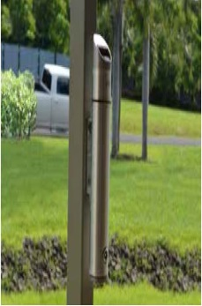
New Butt Bins are having a positive impact on litter.

Waste oil no longer the pits
The council has stopped using waste oil pits, after the location was identified as a possible future risk to a nearby waterway. Monitoring bores have been installed so that possible problems can be identified and rectified. The site will be extensively rehabilitated and revegetated with native plants.
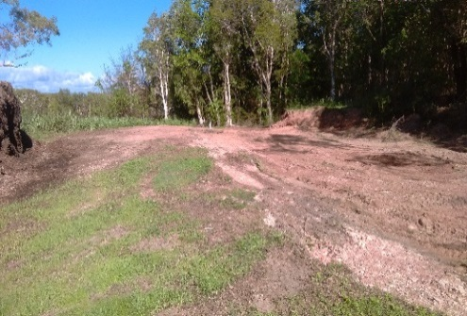
On the road to recovery: a rehabilitated site.

Douglas Shire Council

Scrap Shack cleans up!
In June 2016, the council officially opened The Scrap Shack, a ‘give-back’ recycling shop. The moniker was chosen through a community naming competition and the shack sign made from items recovered from the waste stream. In its first month of operation at the Killaloe landfill and transfer station, 3.56 tonnes of items were directed from landfill to the shop – and the public took home 4.20 tonnes of items. The Scrap Shack aligns with council’s Waste Reduction and Recycling Plan, which includes a 15 per cent landfill diversion target by 2024 (based on 2012–13 figures).
Reducing, reusing, recycling: Mayor Julia Leu (right) and Brydie Maro (left) open The Scrap Shack.

Flushed with success
In partnership with Queensland Parks and Wildlife Service, the council commissioned a new eco-friendly public toilet at Cow Bay. The toilet includes an advanced secondary treatment, which removes 99 per cent of wastewater contaminators – achieved without the use of any power or chemicals. The toilet’s water supply comes from rainfall run-off, collected during the monsoon and stored in a 700-litre tank, or a bore. Solar panels on the roof and a small back-up generator pump the water from the bore into the water tank. The toilet has been welcomed by the Daintree community; it benefits both locals and tourists.
No power or chemicals required: the new Cow Bay public toilet.

All clean ahead
The council has released its proposal for a new planning scheme, which promotes environmental responsibility as fundamental to the community’s future prosperity. Douglas Shire is internationally recognised as a biodiversity treasure house, with its rainforests home to plant and animal species found only in this region. The proposed planning scheme addresses the need to conserve the natural environment, outstanding biodiversity and natural resources of the region, ensuring it remains clean and pollution-free.
Environmental responsibility: aerial view of Port Douglas.

Shopping for alternatives
Australians dispose of four billion plastic bags each year, with the average bag used for just 12 minutes, but taking 1000 years to break down. Plastic bags in the environment are detrimental to birds, marine animals and ecosystems, as well as human health and the economy. Plastic Free Douglas focuses on reducing the number of disposable plastic bags ending up as litter and landfill. The group includes various business and community stakeholders, as well as the council. Plastic Free Douglas encourages the community to utilise reusable bags, old boxes or baskets for shopping, and inspires businesses to register as ambassadors and offer alternatives to the single-use plastic bag.
Reducing reliance on plastic: Plastic Free Douglas promotes plastic bag alternatives.

SES saves power
The council has installed a solar power system on the State Emergency Services (SES) building in Diwan, making it the main power supply for the facility. The new 1.56 kilowatt system replaced an old and inefficient generator. The installation incorporates a 12 volt gel battery bank, which stores energy during daylight hours, ensuring power is available 24 hours a day. The system has the capacity to be supplemented by a generator, if required during bad weather or in the event of an emergency. The building’s primary power requirements are lighting, two-way radio charging and powering emergency equipment.
Storing power: rooftop solar panels at the SES building in Diwan.

Gladstone Regional Council

Plan spans diverse habitats
The council’s landmark Biodiversity Conservation Strategic Plan is designed to preserve and conserve regional biodiversity values on behalf of the community. Biodiversity across the region includes grazing land, woodlands and forests extending west to the Great Dividing Range, and seawards to include the Great Barrier Reef. The plan prioritises the main threats to the region’s biodiversity and outlines what can be done to achieve environmental outcomes.
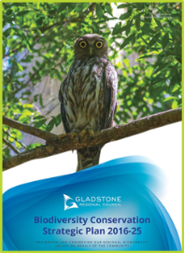
Planning in place: Biodiversity Conservation Strategic Plan 2016–25.

Drawing the line against pests
The council’s Biosecurity Plan 2016–19 provides strategic direction for government, industry, community groups and landholders to manage invasive species within council boundaries. The plan ensures resources are invested to achieve effective outcomes for invasive species management and incorporates mechanisms for monitoring, evaluating and reporting on the effectiveness of actions implemented.
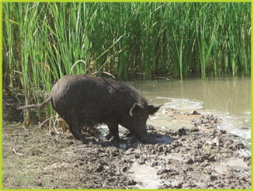
Combatting known threats: feral pigs cause damage to waterways.

Turning the hose on weeds
Opened in 2016, the Aldoga wash-down facility is an essential tool in managing weeds spread via seeds lodged on vehicles and transported across the Gladstone region and beyond. The facility, which uses an on-site water recycling system, is available 24/7. Pest management staff also conduct free weed hygiene inspections on vehicles at the facility (bookings are mandatory). The facility was funded by Gladstone Liquefied Natural Gas and Australia Pacific Liquefied Natural Gas.
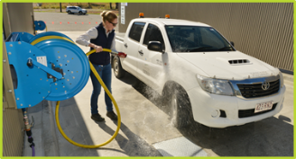
Stopping weeds: weed management liaison officer Emily Weatherall at the wash-down facility.

On track to protect beaches
The council has installed flexible dune fencing and improved beach access tracks to safeguard beaches between Agnes Water and Seventeen Seventy. Trampling and uncontrolled access at many beach entry points had caused significant damage to dune vegetation, making dunes vulnerable to wind erosion. The new measures provide a clear route for pedestrians and are allowing dune vegetation to recover.
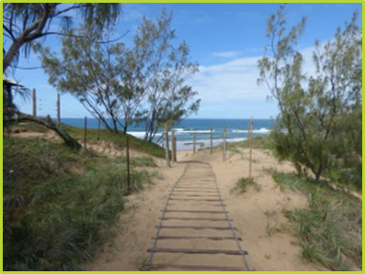
Clear direction: beach access fencing and tracks at Agnes Water direct pedestrians away from dune vegetation.

Rocky path to breeding success
The council partnered with the Fitzroy Basin Association to install a fishway that enables fish to migrate safely, and also improves waterway health. The federally-funded, rock-work design fishway passage at Lake Callemondah connects the estuarine creek and the freshwater lake. A series of low-flow, rocky pools on the tidal side allow fish to pass through the culvert under the causeway. Fish such as barramundi, sea mullet and mangrove jack need both fresh and saltwater migration passages to complete their breeding cycles.
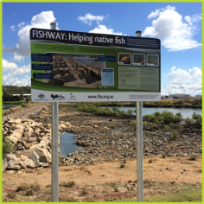
Creating connections: the new fishway passage is located at Lake Callemondah, Gladstone.

Hinchinbrook Shire Council

Pest project has teeth
The Pelorus Island goat control project has been designed to eradicate the feral goat population from the island through the introduction of healthy, neutered male dingoes. The project follows a similar successful project on Townshend Island in 1993. Pelorus Island, with its pristine fragile environment of rainforest and open woodland, is located about 16 kilometres from the mainland, in the Great Barrier Reef. Over-grazing by feral goats has caused devastating erosion on the eastern side of the island, as well as vegetation changes leading to establishment of woody weeds.
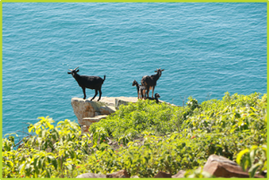
Goats gone wild: over-grazing feral goats on Pelorus Island.

Trunk call foils erosion
The council has employed a natural restoration technique to combat erosion at Insulator Creek, which was gradually encroaching into the road corridor and threatening the integrity of the Bruce Highway. In partnership with the Herbert River Landcare Group, council sought advice from an American environmental consultant, which proposed re-profiling the creek, using logs and stumps from locally-sourced fallen trees. These were embedded into the creek bank and interlaced for strength, supported by rock and revegetated. This approach promotes natural healing and long-term dynamic stability.
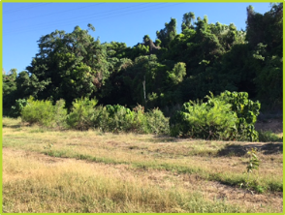
Natural restoration in action: locally sourced logs and stumps used to re-profile Insulator Creek.

Hello sunshine!
The council has implemented a pilot solar project, with the installation of a photovoltaic (PV) solar system at the Hinchinbrook Aquatic Centre. All of the power generated by the PV solar system will be used on site, significantly reducing the amount of grid power used for operating the pool heater, filter and pumps. The project underlines the council’s commitment to investigating alternative and sustainable power sources that offer environmental and economic benefits to the community.
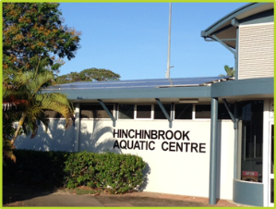
Sustainable power: council’s pilot solar project takes off at the Hinchinbrook Aquatic Centre.

Shire puts lid on oil spill
In July 2015, a multi-agency response involving hundreds of people was mobilised to combat an oil spill which affected beaches and islands in the shire. Between 10 –15 tonnes of oil was released by an unidentified ship off Cape Upstart, north of the Whitsundays. Workers collected 120 cubic metres of contaminated sand from 128 kilometres of beach. The contaminated sand was stored at one of council’s waste facilities, then transported to Townsville for disposal. Council officers worked tirelessly until the clean-up was complete. In August 2015, an inspection of several beaches by council, Maritime Safety Queensland and the Department of Environment and Heritage Protection, confirmed the clean-up was successful.
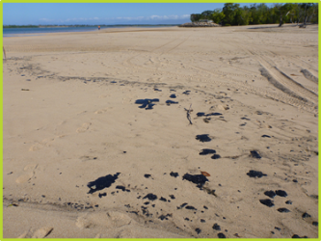
Coastal clean-up: 128 kilometres of beach was cleaned of contaminated sand after the oil spill off Cape Upstart.

Council raises bar in pest control
The council has modified traps used in its successful feral pig management program to reduce the number of off-target species occasionally found in traps. The placement of a bar across the entry to traps used by the council’s pig management officer has led to a significant reduction in the number of other species caught. The traps have successfully reduced sugarcane losses, saving farmers approximately $1 million a year, and have also significantly minimised physical and environmental damage to cane properties and coastal wetlands.
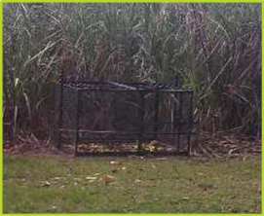
Trap attack: the modified pig traps significantly reduce capture of off-target species.

Isaac Regional Council

Reclaiming the foreshore
The Clairview Coastal Connectivity Restoration Project is strengthening important ecosystem areas within the foreshore reserve through the removal of exotic weed pests. Exotic weed species such as guinea grass (Megathyrsus maximus) and mother-of-millions (Bryophyllum spp.) have been treated, and a large amount of rubbish has been removed from the area. Community members have helped to plant some of the 1500 native species that will improve coastal vine thicket, develop habitat, and mitigate sediment run-off and dune erosion.
Cleaned up and cared for: the Clairview coastal connectivity restoration site.

Water recycling – a turf call!
The council recently upgraded its water recycling and irrigation systems and infrastructure. Recycled water is now used to irrigate turf in Moranbah and a new master control system and solar-powered sub-controllers have been installed to more effectively control effluent. These technical upgrades combined with operational reporting have resulted in greener open spaces.
Conserving water: recycled water is used to irrigate grass for a green result.

Reef out the Rubbish
“Reef out the Rubbish” — part of the education and engagement strategy for the council’s Littering and Illegal Dumping Management Plan — is in its second year. The plan sees council and natural resource management groups partnering to target waterways health and raise awareness of marine debris. Community members, including school students, have participated in clean-up days to tackle large amounts of rubbish in public areas, as well as learn about local wildlife, vegetation and marine debris issues.
All hands on deck: clean-up teams Reef out the Rubbish.

Wetlands weekend a hot event
The St Lawrence Wetlands Weekend celebrated all things to do with wetlands. The council’s environment team led eco-talks, followed by presentations from the Great Barrier Reef Marine Park Authority, Birdlife Capricornia, Mackay and District Turtle Watch Association and Capricornia Catchments. Participants exchanged views on the relationship between land management and ecosystem functions, including observations on weeds, sediment transport, nutrient cycles, water quality and local wildlife. A bushman’s dinner with live music and market stalls provided the perfect finishing touch.
Managing wetlands: St Lawrence Wetlands Weekend included eco-talks and idea sharing.

Baiting – a recipe for success
Coordinated pest management continues to benefit the region, minimising the impact of feral animals on native fauna and commercial agriculture. In 2015–16, the 1080 sodium fluoroacetate baiting program again provided support to landholders seeking to control wild dog and pig populations on their properties. With the assistance of an educational display, the public has also been able to learn about pest animals and management strategies at community events.
Up close: feral animal features in education display.

Livingstone Shire Council

Nurturing Kinka Wetlands
The Kinka Wetlands Protection and Enhancement Project continued to build upon previous planning and works designed to protect and enhance this significant environmental asset. Specific activities carried out in 2015–16 included maintenance of previous on-ground works to reduce sediment run-off, pest plant and animal eradication (lantana and pigs), community engagement and inclusion of sites under environmental management and conservation zoning as part of the new Livingstone Planning Scheme. A project is currently being developed to erect bird hides, platforms and associated signage at the wetland site.
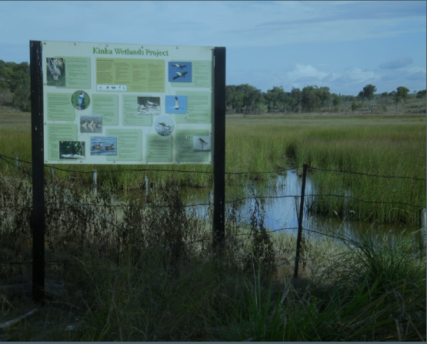
In focus: Kinka Wetlands is a significant environmental asset.

Putting sustainability on the map
The new Livingstone Planning Scheme incorporates a range of actions designed to ensure positive environmental outcomes for the Great Barrier Reef. The plan is expected to complete its final state interest check by the Queensland Government by mid-2017, following the conclusion of the community consultation period in January. The new scheme features biodiversity corridors and mapped locally-significant vegetation, identification and protection of waterways, wetlands and riparian vegetation, protection of significant terrestrial areas including habitat connectivity, and consideration of hazards such as bushfire, flood and climate change.
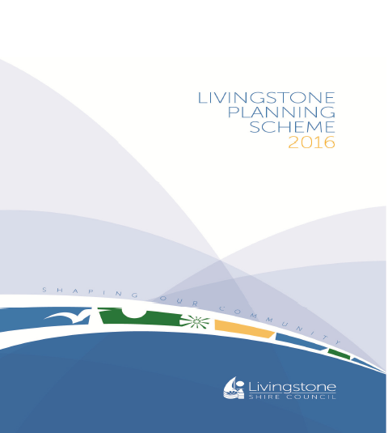
Soon to launch: Livingstone Planning Scheme 2016.

Piecing together the bigger picture
As part of the Great Barrier Reef Clean-up, the council engaged local central Queensland artist, Amber Countryman, to create a beachside mosaic mural featuring the snubfin dolphin. The mural aims to raise awareness and educate the community about marine debris and its effect on Keppel Bay and this threatened dolphin species. The artwork utilised around 3200 pieces of tile sourced from clearance stock, cut-offs, leftovers, used samples, recycled crockery and beach glass. It adorns a wall within a high profile area of the Yeppoon foreshore. The project was delivered through the Great Barrier Reef Marine Park Authority and funded by the Australian Government’s Reef Trust.
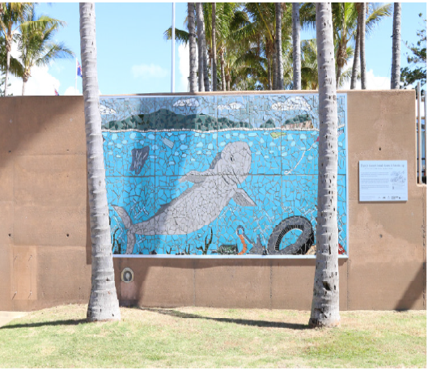
Piecing together the future: this marine debris mural features the threatened snubfin dolphin.

Push to ban bags
The council continues to support the Livingstone Plastic Bag Free group in their bid to ban single-use plastic bags throughout the shire. The group’s activities during 2015–16 included ongoing lobbying of the State Government to consider legislation banning plastic bags, as well as representation at community events to raise awareness of the threat imposed by plastic on the environment.
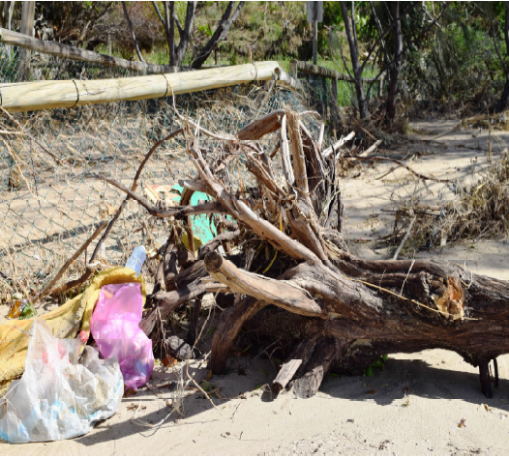
The plastic bag problem: many single-use plastic bags become beach debris.

Pooling resources to tackle waterway health
The council has formed key stakeholders partnerships designed to better manage the health Fig Tree Creek — a crucial urban waterway in the shire. The stakeholders include Capricornia Catchments, Capricorn Coast Landcare, the Great Barrier Reef Marine Park Authority and Livingstone Remnant Vegetation Group. The health of the waterway is under increasing pressure and its protection is paramount to reducing potential impacts on the Great Barrier Reef. A number of further on-ground and planning activities are proposed, culminating in a master plan.
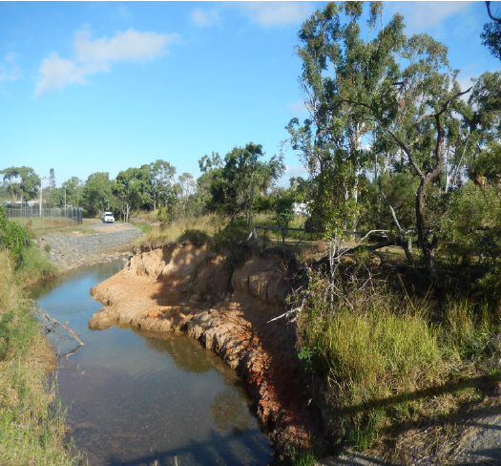
Protection plan underway: Fig Tree Creek is a key waterway in Livingstone shire.

Mackay Regional Council

Artful digest of marine debris
As part of the Great Barrier Reef Clean-up, the council engaged local artist David Day to create several original art pieces using marine debris collected from the area. The feature piece is a marine turtle made from thongs and other materials found on local beaches. The underside of the turtle is made from a plastic crate, through which you can view marine debris such as plastic and rope. This illustrates the problems marine turtles can have when they ingest plastic and other materials. The art pieces, which stimulate discussion on marine debris and how it can affect the Great Barrier Reef, are being used in displays and at Coastcare events.
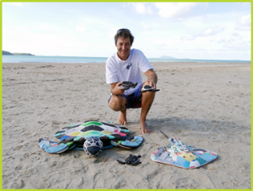
Re-imagining debris: local artist David Day with his artwork made from marine debris.

Project highlights flow-on effects
A $379,000 rejuvenation project, co-funded by the council, Reef Catchments Limited and the Department of Transport and Main Roads, focused on re-establishing aquatic and terrestrial connectivity between the Pioneer River and the Lagoons Creek wetland system. The result is improved water quality, increased biodiversity and aesthetic enhancements. The project has turned a heavily modified and degraded stretch of Lagoons Creek into a large wetland area with numerous rock ramp fishways and extensive vegetation.
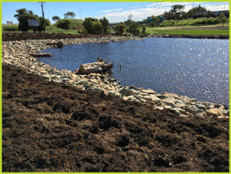
Newly completed: the Lagoons Creek wetland system will provide habitat for wildlife and improve amenity value.

From little creeks big things grow
The council partnered with Reef Catchments Limited to improve the quality of water entering the Great Barrier Reef lagoon from coastal urban development centres. The Little McCreadys Creek rehabilitation project occupies about 4.5 hectares of council land on a tributary to the main McCreadys Creek system. The Little McCreadys Creek project is one of council’s five priority implementation projects for stormwater quality management. Future benefits include improvements to fish passage, biodiversity, water quality, amenity, aesthetics, cooling and reinstating natural systems.
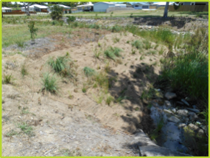
Big improvement: water quality and habitat improvements have been made at Little McCreadys Creek.

New facility on a wave
The Sarina water recycling facility is a multi-million dollar state-of-the-art facility constructed to meet stringent conditions, given the proximity of the plant to the Great Barrier Reef. The new facility replaces a 40-year-old sewage treatment plant, which used out-dated technology and lacked capacity to meet future demand. The new, sophisticated system has reduced effluent disposal — enhancing the health and resilience of the Great Barrier Reef — and contributes recycled water to irrigate the local golf course.
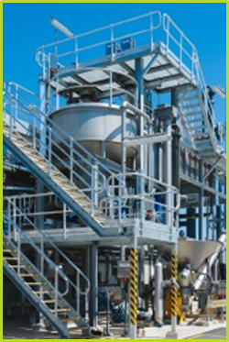
In with the new: Sarina now has a state-of-the-art water recycling facility.

Optical sorting optimises recycling
The council’s newly upgraded materials recovery facility features innovative ways to achieve greater recycling efficiencies. Through a design-build-operate contract with Recycling Design & Technologies, council achieved a modern, highly efficient plant upgrade, including an Australian-first optical sorting system. This has increased the region’s overall recycling rate by 38 per cent. Council also introduced a glass crushing plant, which diverted 2744 tonnes of glass product from landfill in 2015–16. The recycled crushed glass is being used for bedding material under concrete, backfilling and subsoil drainage – providing a significant cost saving to ratepayers.
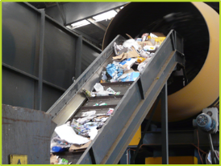
Efficent: recycling rates have increased by 38 per cent following the material recovery facility upgrades.

Mareeba Shire Council

Planning for responsible growth
On 1 July 2016, the new Mareeba Shire Council Planning Scheme and associated planning scheme policies under the Sustainable Planning Act 2009 came into effect. The planning scheme and policies serve to protect the natural environment through contemporary development control measures. The council is now well placed to responsibly encourage agricultural, resource extraction and population development, while conserving areas of natural resource, cultural heritage and in particular, areas of environmental significance such as waterways that flow to the Great Barrier Reef lagoon.
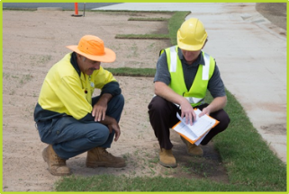
Prepared: Mareeba is well placed to benefit from spill-over population and development from Cairns.

Slick sludge management
The council has successfully upgraded the Kuranda Sewage Treatment Plant. Upgrades have enabled the removal of nutrients that were previously overloading the treatment process and have eliminated the risk of a sludge overflow event impacting the Great Barrier Reef lagoon. The upgrade has also reduced phosphorus carryover in effluent waters released to the Barron River, which flows to the Great Barrier Reef lagoon.
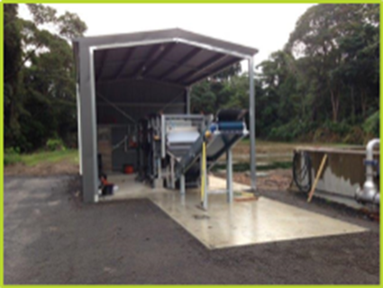
Upgraded: Kuranda Sewage Treatment Plant's new sludge belt press plant.

Meters dial up water conservation
The council has installed approximately 5000 water smart meters throughout the region to monitor water consumption rates and identify excess water use and water leaks. This has greatly increased water conservation through reduced raw water consumption and water treatment requirements, and supports improved environmental flow in the Barron River.
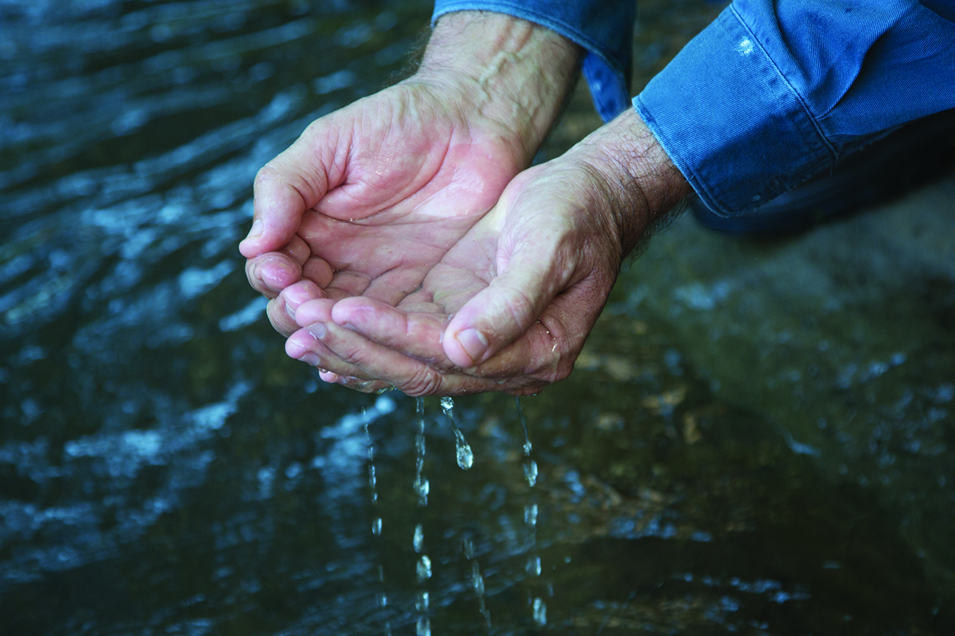
Smart move: water conservation is critical to improving water quality entering the Great Barrier Reef lagoon.

Cane industry recycling – in the bag
The council has participated in a successful trial to recover and recycle sugar cane fertiliser bags. The trial, which aimed to prevent incorrect disposal of the bags (such as burning), attracted support from key manufacturers, federal and local governments, and local plastic processors. In total, around 217 tonnes, representing 72,382 bags, were processed into re-useable plastic. The northern catchment, including Mareeba, was responsible for 68 per cent of this total. The trial’s success has now led to collections including other agricultural plastics.
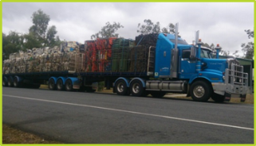
Plastics re-purposed: transport of baled agricultural and other hard plastics to secondary markets.

Monitored fleet speeds fuel efficiency
The council has implemented a management system for its fleet of trucks, plant and vehicles. The system uses GPS tracking and monitoring technology to increase asset productivity and efficiency. Council has been able to monitor fuel usage, kilometres travelled and engine hours for individual fleet vehicles. Since installation, a ten per cent increase in kilometres travelled per litre of fuel used for light and heavy trucks has been measured, resulting in fuel cost savings of approximately $4000.
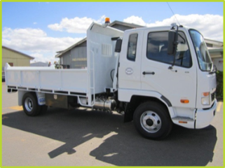
Managing efficiencies: a council vehicle fitted with the new fleet management system.

Rockhampton Regional Council

Ladder of success – for fish
A new fish ladder at the Fitzroy River Barrage was officially launched in time for World Fish Migration Day, in May 2016. The $500,000 project, completed under the Federal Government’s Reef Programme, has significantly increased fish passage upstream — up to 400 fish per minute. Built alongside the existing fishway, it features innovative design techniques which reduce the velocity of water flowing from the upper level of the river to the below barrage level. This allows juveniles as small as nine millimetres to navigate their way safely upstream, improving habitat connectivity.
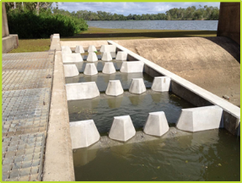
Fast flow: the new fish ladder at the Fitzroy River Barrage has increased passage to 400 fish per minute.

Nipping weeds in the bud
Busting weeds and revegetating council land with native plants is a daily activity for the council’s vegetation management team. During Weedbusters Week, the team encouraged community involvement in helping to stop the spread of weeds. A range of information stalls, awareness activities and a children’s colouring competition educated the community about the devastating impact weeds can have on our natural environment. Council’s message is simple: “a year of weeds, a decade of seeds” and “if in doubt take it out”!
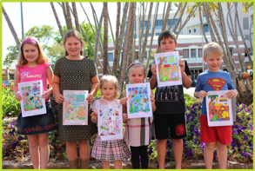
Winners: the Weedbusters Week colouring competition winners holding their wonderful artworks.

Waste management – not a waste of time
Our waste – it’s not just a load of old rubbish! Council adopted a Waste Reduction and Recycling Plan (2016–2024), which challenges the region’s current waste management performance and strives to achieve clear, set targets for waste reduction and diversion. The plan’s vision is to manage waste production in a manner sustainable for the environment and community through innovative developments, driving community values and shifts in culture. Over the lifetime of this plan, council will achieve an overall reduction in waste to landfill of 15 per cent.
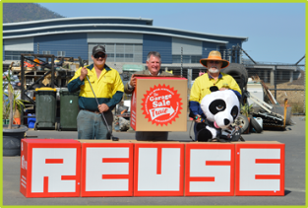
Diverting waste to landfill: the 2015 Garage Sale Trail encouraged community to reuse items.

Overlays underpin sustainable development
The Rockhampton Region Planning Scheme, adopted in 2015, includes a range of extra or enhanced environmental overlays to manage development through planning provisions. Overlays indicate areas of value as identified through detailed background studies. For example, biodiversity overlays protect, rehabilitate and manage areas of environmental significance. The water resource catchments overlay ensures that development of land within catchments is managed to protect water quality.
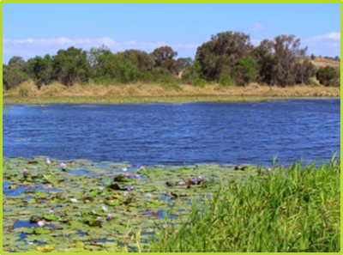
Picturesque: Rockhampton Regional Council features water catchments such as this lagoon in Pink Lily.

Fleet puts brake on gas emissions
Council is committed to the reduction of greenhouse gas emissions from its vehicle fleet. The Fleet Vehicle Greenhouse Gas Emissions Reduction Policy introduced environmental standards to ensure the key component of vehicle procurement decisions are based on reducing emissions. The implementation of this policy means that council fleet vehicles will meet a minimum Greenhouse Rating of 6.0 for passenger vehicles and 5.0 for light commercial vehicles. Fleet vehicles not meeting this standard will be phased out at asset renewal.

Electric: council and Ergon Energy are working together to trial the use of an electric car in the council fleet.

Tablelands Regional Council

Environmental education – home delivered
Council garbage trucks now have a dual role. Not only does the fleet collect household rubbish but it also functions as a mobile educational device. Signage on trucks reinforce messaging about water saving, recycling, littering, responsible pet ownership, disaster management and pest weeds.
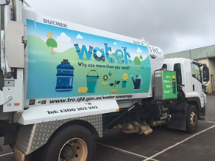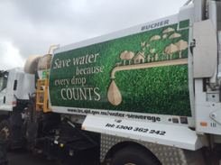
Taking the messages to the streets: garbage trucks sport engaging artwork to deliver key messages.

Run-off project a runaway success
Slowing stormwater run-off from catchments in the Atherton region has been a major joint project between the council and Barron Catchment Care. The five-year project commenced in 2013 and is funded by the Federal Government. The project continues to achieve impressive results, improving the management of stormwater run-off in the Rangeview area. Completion of stormwater infrastructure at the end of Hutton Drive has greatly eased local residents’ concerns about the possibility of flooding in this area.
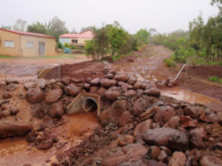
Stormwater slowdown: drain constructed at Hutton Drive, Rangeview, using watershed restoration techniques.

Waste results carry weight
During 2015–16, 1100 tonnes of steel, 600 tonnes of cardboard, 22 tonnes of tin, 15 tonnes of aluminium and 75 tonnes of plastics were redirected from council landfill. Council also took part in a fertiliser bag recycling trial which kept a further 30 tonnes of waste from landfill. Recycling was introduced at the Herberton waste transfer station, triggering the need to replace yellow kerbside bins with a skip to meet demand. Council continued to work with junior schools, kindergartens and adult education centres to spread the recycling message, and hosted a recycling activities day at Malanda Library.
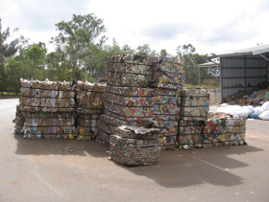
New life: material at Atherton’s recycling facility ready to go to market

Grass-roots support for nature refuge
The council’s Community Revegetation Nursery has been supporting a crucial nature refuge by supplying native plants for community tree planting. Cloudland Nature Refuge is a large rainforest situated on freehold land in the Atherton Tablelands. It represents the biggest rainforest remnant on basalt outside the Wet Tropics World Heritage Area. Cloudland has very high biodiversity values as habitat for a range of threatened plants and animals. These include the nationally endangered southern cassowary and a number of endemic possums. To date, 370 plant species have been recorded on the Cloudland Nature Refuge, including at least five rare species.
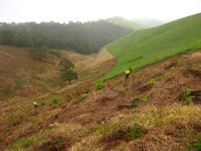
Revegetation in action: council’s nursery supplied native plants to the Cloudland Nature Refuge.

A shining light in energy efficiency
The council has developed a Council Building Energy Efficiency Program, outlining actions required to reduce the energy consumption at council’s administration offices, depots and public spaces. In May and June, the external bollard lights at council’s Cook Street aged housing units were replaced with LED lights. Other lighting throughout council offices has also been changed to LED, and council commenced switching off fridges in public halls, which have previously been left running between bookings. Settings and timers have been changed throughout the region to ensure more efficient operation of council facilities.
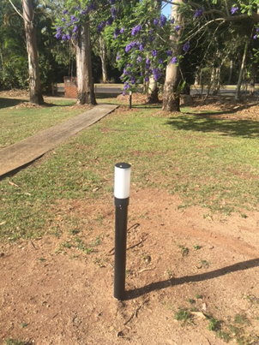
Efficiencies: energy efficient LED bollards placed in public areas.

Townsville City Council

Game of thorns battle
Townsville City Council has been engaged in a perpetual game of thorns with some of the country’s most invasive weed families. The specialised landscape ecology team is committed to an ongoing weed control program that sees highly skilled crews tackling weeds across all terrain to improve biodiversity and restore natural habitat along local waterways. Specialist crews also support local fire brigades to conduct controlled burns and facilitate strategic burning of council-controlled land. This ancient land management practice is an effective tool in protecting values within the Reef catchment.
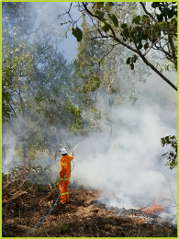
Strategic management: specialists undertake controlled burn at Cungulla.

Free tip for tidy residents
Every year, council encourages residents to clean up around their homes and gardens in preparation for the cyclone season. A free dumping weekend is declared for residents to drop off green waste and domestic rubbish. These activities reduce the amount of rubbish and green waste that would otherwise enter waterways within the Reef catchment during storms and cyclones.
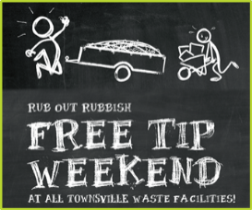
Encouraging responsible rubbish disposal: free dumping weekend promotion.

Making sense of environmental sensors
The council’s sustainability department has entered into a partnership with Origin Energy to craft a one-of-a-kind sensor project. The five-year Rowes Bay Sensory Project will encourage the community to explore the emerging field of low-cost sensing. Together with James Cook University, council is engaging students, residents and citizen scientists to learn how to invent and maintain environmental sensors that can help us understand the local environment and better inform management practices.
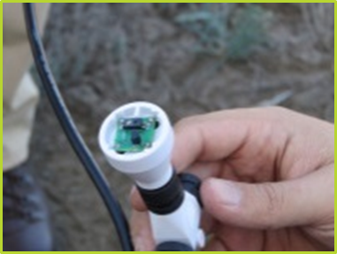
Invent, create and maintain: environmental sensor at Rowes Bay.

Rehab for lawns with a drinking problem
In the dry tropics environment of Townsville, lawns can require large amounts of water to stay green and healthy. Based on the work of local experts, The Lawn Tamer Program aims to provide residents with engaging information and best practice advice on how to train a stronger lawn with less water. Lawn Tamer has the potential to reduce fertiliser run-off, decrease the amount of green waste generated by lawns, improve the soils and optimise water use across the city.

Everyday man: the Lawn Tamer.

Tailoring stormwater solutions
Urban stormwater quality management is a critical focus for local governments, particularly in Townsville, with its highly erosive rainfall, dispersive soils and rapid growth rates. The Townsville Regional Stormwater Quality Treatment Strategy proposes a variety of locally calibrated and effective stormwater treatment options that are prioritised and applied regionally. Considerable focus will be on construction phase soil loss and biological assets that are maintainable and functional in Townsville.
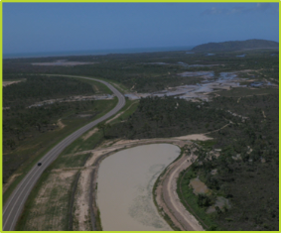
Key element: urban stormwater quality management is a critical focus for local governments.

Whitsunday Regional Council

Weather-proofing water quality
A working group of developers, regional consultants and technical experts in stormwater management have developed a guideline on stormwater management specific to the Whitsunday Regional Council. The guideline provides clear direction to developers and council staff on stormwater improvement devices to ensure water flowing to the Great Barrier Reef meets nutrient load reduction targets and reduced nutrient loading on the Reef.
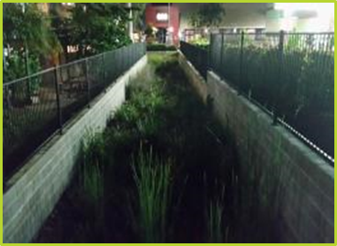
Top quality: bio-retention system located in Airlie Beach.

Trap closes on Reef pollutants
The council has installed three gross pollutant traps within the Cannonvale Botanic Gardens precinct to minimise run-off pollutants entering the Great Barrier Reef. The traps are designed to reduce gross pollutants by 93 per cent, sediment by 40 per cent and nutrients by up to 30 per cent. The new traps, which have been specifically located in catchments with urban and commercial uses, were installed through the Federal Government’s Reef Program, in partnership with Reef Catchments Limited.
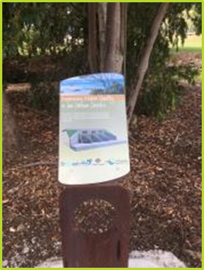
Reducing pollutants piece by piece: information signage located at gross pollutant trap.

Stepping stones to avoid sediment loss
Developers in the Whitsunday region received the latest information on erosion and sediment control at a workshop run by the council and Reef Catchments. The Water by Design workshop is a nationally recognised urban water capacity building program. It enables better design and assessment of erosion and sediment control strategies and outlines how to effectively incorporate water-sensitive urban design approaches into developments to meet state planning requirements. Best practice urban stormwater management will help preserve the condition of Whitsunday waterways and reduce the impact of development on the Great Barrier Reef.
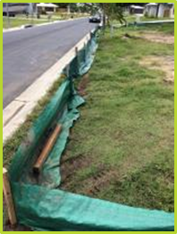
Strategic controls: a sediment fence erected at a development site.

Feral pig offensive
The council’s feral pig program is continuing to significantly reduce the widespread damage caused by feral pigs in the council area. The large-scale program utilises a range of control options, including ground and aerial baiting, trapping and aerial shooting. With the help of partners, the council has grown the program to cover more than two million hectares. The control program is successfully reducing the impact of feral pigs on the natural environment, including turtle nesting areas and wetlands, as well as agriculture.
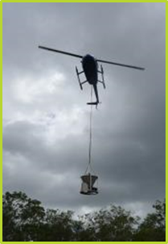
Aerial baiting: one control option includes using a helicopter with a 1080 bait disperser.

High water mark
The new Cannonvale wastewater treatment facility exceeds the most stringent effluent discharge requirements to help protect the Great Barrier Reef. The council opened the $32 million plant, in partnership with Tenix. The facility offers significant environmental benefits to the local community by reducing wastewater overflows, noise and odour, as well as the nutrient load discharged into the environment.
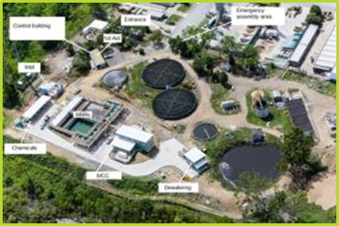
Upgraded: aerial layout of the Cannonvale Sewage Treatment Plant.

