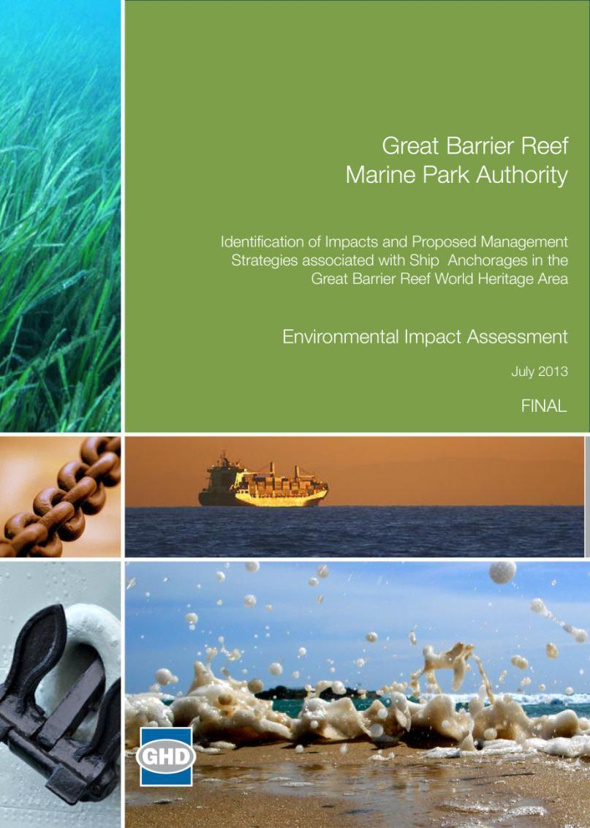
Great Barrier Reef Marine Park Authority
Contents
EXECUTIVE SUMMARY v
ACRONYMS/GLOSSARY xii
1. Introduction 1
1.1 Relationship of this project to the comprehensive strategic assessment 1
1.2 Background to this project 1
1.3 This project 2
1.4 Study area 3
1.5 The structure of this report 6
2. Values of the great barrier reef 9
2.1 The recognised value of the World Heritage Area 9
2.2 Legislative tools for value management 9
2.3 Management of the Reef 10
3. Existing Environment 12
3.1 Approach 12
3.2 General environmental conditions 17
3.3 Anchorage area of the Port of Cairns 18
3.4 Anchorage area of the Port of Townsville 27
3.5 Anchorage area of the Port of Abbot Point 36
3.6 Anchorage area of the Port of Hay Point 45
3.7 Anchorage area of the Port of Gladstone 54
3.8 Summary of existing environment across all port anchorages 63
4. Consultation in support of impact assessment 65
4.1 Consultation in support of the Strategic Assessment 65
4.2 Consultation in support of this project 65
5. Impact Assessment 68
5.1 Assessment methodology 68
5.2 Actual and potential impacts 73
5.2.1 Disturbance to seabed and supported biodiversity 80
5.2.2 Release of emissions or pollutants/wastes 81
5.2.3 Altered aesthetic value 84
5.2.4 Interference with access to resources 84
5.2.5 Marine pest introduction 86
5.2.6 Interference with species behaviour 87
5.3 Summary of potential impacts and further management options 88
6. CONCLUSIONS 93
6.1 Introduction 93
6.2 Port of Cairns anchorage area 93
6.3 Port of Townsville anchorage area 95
6.4 Port of Abbot Point anchorage area 96
6.5 Port of Hay Point anchorage area 98
6.6 Port of Gladstone anchorage areas 99
6.7 Summary 101
7. REFERENCES 103

APPENDIX
Appendix A 111
Appendix B 117
Table Index
Table E-1: Values of each of the ports ix
Table 1-1: The Region vs Marine Park vs World Heritage Area 4
Table 1-2: Bounds (latitude and longitude) and area (in ha) of the anchorage areas at each of the five major ports (Latitudes and longitudes are provided by point number. Point 1 is top left corner, Point 2 is top right corner, Point 3 is bottom left corner and Point 4 is bottom right corner of a bounded area) 8
Table 3-1: Summary of desktop sources that informed the likelihood of occurrence assessment of the anchorage areas at each of the five major ports 14
Table 3-2: World Heritage Area values associated with the Port of Cairns anchorage area 23
Table 3-3: World Heritage Area values associated with the Port of Townsville anchorage area 32
Table 3-4: World Heritage Area values associated with the Port of Abbot Point anchorage area 41
Table 3-5: World Heritage Area values associated with the Port of Hay Point anchorage area 50
Table 3-6: World Heritage Area values associated with the Port of Gladstone anchorage area 59
Table 5-1: Scale of consequences of impact (GBRMPA 2009b) 70
Table 5-2: Likelihood of impact (GBRMPA 2009b) 71
Table 5-3: Hazard risk grade matrix (GBRMPA 2009b) 71
Table 5-4: Acceptability of risk (GBRMPA 2009b) 72
Table 5-5: Potential impacts and OUV that may have an impact on the value of the environment at each of the five port anchorage areas 77
Table 5-6: Hazard risk assessment summary (OUV categories are provided in section 5.2) 90
Table A1: Presence of Commonwealth listed threatened species across the five port ship anchorages (legend at base of table) 112
Table A2: Presence of Commonwealth listed migratory species across the five port anchorage areas (legend at base of table) 114

Figure Index
Figure 1-1: Overview of ports in the Great Barrier Reef Marine Park and World Heritage Area 5
Figure 3-1: Average monthly rainfall across sites of relevance to the anchorage areas (Bureau of Meteorology (BoM) 2012) 17
Figure 3-2: Example of bioturbated silty inner shelf seabed similar to that found in the Cairns anchorage area (Pitcher et al. 2007) and a wetland migratory species, the red-necked stint, photographed in Cairns (Cook 2012) 20
Figure 3-3: Anchorage area of the Port of Cairns 21
Figure 3-4: Conceptual visualisation of values of the Port of Cairns anchorage area 22
Figure 3-5: Juvenile green turtle and dugong observed in Cleveland Bay during surveys of marine megafauna (GHD 2011b) 29
Figure 3-6: Anchorage area of the Port of Townsville 30
Figure 3-7: Conceptual visualisation of values of the Port of Townsville anchorage area 31
Figure 3-8: Patchy seagrass identified in benthic assessments and Australian snubfin dolphins observed within the Abbot Point port (GHD 2010) 38
Figure 3-9: Anchorage area of the Port of Abbot Point 39
Figure 3-10: Conceptual visualisation of values of the Port of Abbot Point anchorage area 40
Figure 3-11: Hard and soft corals from Victor Islet (roughly 2 km south of the anchorage), and coral trout, a commonly targeted commercial fisheries species, found near Round Top Island (11 km northwest of the anchorage), within the vicinity of Hay Point port (GHD 2005) 46
Figure 3-12: Anchorage area of the Port of Hay Point 48
Figure 3-13: Conceptual visualisation of values of the Port of Hay Point anchorage area 49
Figure 3-14: Indo-Pacific humpback dolphins observed in Port Curtis (GHD 2009d) and benthic sampling of epifauna in Gladstone (GHD 2009c) 56
Figure 3-15: Anchorage areas of the Port of Gladstone 57
Figure 3-16: Conceptual visualisation of values of the Port of Gladstone anchorage area 58
Figure 4-1: Distribution of responses regarding potential impacts across social, economic and environmental criteria 66
Figure 5-1: Anchorage activity by port from 2009 to September 2012. Data provided by MSQ for vessels greater than 50 m in length. 73
Figure 5-2: Conceptual visualisation of potential impacts from anchorage use 76

EXECUTIVE SUMMARY
Introduction to the project
The Great Barrier Reef (the Reef) is the world’s largest coral reef ecosystem, spanning more than 348,000 km² of the continental shelf of Queensland. The Reef has significant value which is recognised by its inclusion as a Marine Park, a World Heritage Area, a National Heritage Place and a Commonwealth Marine Area. The recognition of these significant values carries an obligation and responsibility to protect and conserve the values for the future.
The Australian and Queensland Governments are working together on a comprehensive strategic assessment (the Strategic Assessment) of the Great Barrier Reef World Heritage Area (World Heritage Area) and adjacent coastal zone. The Strategic Assessment will include an overall assessment of the effectiveness of management arrangements to protect the environmental, social, cultural and heritage values of the World Heritage Area and other matters of national environmental significance (MNES) protected under the Environmental protection and Biodiversity Conservation Act 1999 (EPBC Act). The goal is to ensure these matters, including the World Heritage values of the Reef, are protected while creating a long-term plan for sustainable development in the region.
The Strategic Assessment comprises two elements: The Great Barrier Reef Coastal Zone Strategic Assessment to be undertaken by the Queensland Government; and The Great Barrier Reef Region Strategic Assessment of the marine component to be undertaken by the Great Barrier Reef Marine Park Authority (GBRMPA). The marine component will examine the values, the condition and trend of those values, impacts on those values, what is being done to protect those values (i.e. current management arrangements) and the effectiveness of the management arrangements. Once this is established the likely condition and trend of values will be estimated and future management arrangements will be identified. Ports and shipping are two such activities where concern about impacts on the values has been expressed.
This project supports the marine component by completing works to achieve the “identification of impacts and proposed management strategies associated with ship anchorages in the Great Barrier Reef World Heritage Area”. Three phases of work facilitate the project:
- Identification of the environmental, social, cultural and heritage impacts of anchoring associated with the five major ports in the World Heritage Area: Cairns, Townsville, Abbot Point, Hay Point, and Gladstone.
- Socio-economic costs and benefits associated with different anchorage strategies.
- Anchorage management strategies that could be used to avoid, mitigate, offset or adaptively manage identified impacts.
The project, in its entirety, will complement other projects being delivered in support of the Strategic Assessment, including development of improved information upon which to base decisions in relation to dredge spoil management. This report focusses on the Environmental Impact Assessment (EIA) phase of the project. Additional reports relating to the remainder of the project will be developed over the course of the project and provided at a later date.
Project study area
Under predicted population growth and industrial expansion in coming years and considering Queensland port industry vessel forecasts, vessel visitation across all ports within or adjacent to the Great Barrier Reef Marine Park or World Heritage Area is predicted to increase from around 4000 per annum currently to over 10,000 per annum by 2032 (PMG 2012). The cost benefit phase of this project will consider the effectiveness or relevance of different management scenarios at ameliorating identified impacts of ship anchorage under predicted increases in shipping activity.
These predicted shipping increases are driven primarily by bulk commodity exports from ports located between Cairns and Gladstone. Accordingly, to inform the Strategic Assessment, this project is considering the risks from trading vessel anchorages associated with the five major ports namely:
- Port of Cairns
- Port of Townsville
- Port of Abbot Point
- Port of Hay Point
- Port of Gladstone.
As the project requires investigation of impacts associated with anchorages of the five major ports, a key step, therefore, has been to define the existing areas being used for anchorage by trading vessels working to each of the nominated ports. This was achieved through consultation with each port’s Regional Harbour Master to confirm designated anchorages defined by navigational charts and, for locations without charted anchorages, to define an area within which vessels are known or directed to anchor. Where specific anchor drop points are mapped a conservative approach of considering the entire area across which anchor drop may occur has been used to define the anchorage area of a port. This has provided an envelope of seabed adjacent each of the five ports within which anchorage currently occurs. These spatial areas provide the footprint of investigation adjacent to each port addressed by this study.
Approach
To identify the potential impacts which may be realised from use of anchorages associated with each of the five major Queensland ports information has been collated regarding the environmental, social, cultural and heritage values of the World Heritage Area at each of the anchorage areas. Consultation has occurred with stakeholder groups regarding what potential impacts may occur from use of these anchorage areas by vessels anchoring and a structured impact assessment has been undertaken. This information is reported with regard to the different geographies of interest and matters at each site that support designation of the World Heritage Area and the Outstanding Universal Value (OUV) of the Reef.

Environmental, social, cultural and heritage conditions at all five port anchorages
There is a range of sensitive environmental, social, cultural and heritage values of relevance to the Reef’s listing as a World Heritage Area that are consistent to all five geographies and which could be affected by area use.
Four of the five anchorage areas being assessed, Abbot Point being the exception, are within close proximity to populated areas and are thus jointly utilised by various commercial fishery and tourism operators.
Although seagrasses have only been recorded to characterise two of the locations, all of the anchorage areas are known to provide some habitat value to marine megafauna and species (including fish) dependent on seagrasses. Accordingly use of the anchorages has the potential to both directly and indirectly affect megafauna, fisheries assemblages and those accessing these resources.
Coral reefs are not located within the anchorage areas but are environmental features of adjacent habitats at varying distances from the anchorage areas and thus have the potential to be indirectly affected from use of the anchorage areas. The inner anchorage area at Port of Gladstone supports rocky reef habitat with all other anchorage areas located in open soft sediment habitats. Direct impacts to soft sediment habitats will occur from anchorage activities.
None of the anchorage areas are known to support non-indigenous cultural values of a historic nature, such as ship wrecks of heritage importance. All of the anchorage areas do, however, support values of relevance to Indigenous cultural heritage, including totem species (primarily dugong and marine turtles), and non-indigenous cultural heritage such as places of social significance and aesthetic value.
None of the anchorage areas are known to support threatened ecological communities. All of the anchorage areas support a diversity of protected fauna including marine megafauna, sharks and avifauna. The anchorages also support features that underpin the OUV of the World Heritage Area. The anchorage areas also occur in areas that are considered to provide aesthetic value. A summary of the relevance of these values to each of the ports is provided in table E-1.
Summary of potential impacts across all five port anchorages of interest
The primary impacts to the OUV of the World Heritage Area that may be realised on a frequent basis from ship anchorage are:
- a reduction in the aesthetic value of the coastal vista
- preclusion of other users of the World Heritage Area
- minor releases of pollutants/wastes from ships
- generation of small turbidity plumes from anchor drop and chain drag
- disturbance to seabed biodiversity from anchor drop and chain drag
- disturbance to fauna from persistent noise and light impacts while at anchor (e.g. from generators, engines).
Of these chronic impacts, a reduction in the aesthetic values has a high risk rating. Of all other potential impacts, release of marine pest species is the only activity considered to be of high risk to the values of the World Heritage Area, although the chance of this occurring is considered unlikely to rare.
The current anchorages are generally located in areas that have little effect on the majority of the biodiversity values for which the reef is recognised. They are located in open seabed systems and do not have long-term impacts from anchor drop or chain drag on sensitive habitats such as coral reef systems. With regard to biodiversity values, the anchorage areas are, therefore, well positioned. It is unclear whether there have been guiding principles applied to area selection with respect to protection of biodiversity values. If these are currently used by relevant agencies in selecting anchorages, then they should continue to apply to future anchorage management.
It is recognised that anchorage areas are defined with regard to the port access requirements, vessel navigational safety and port throughput demands. A number of strategies could apply to anchorage area management which would minimise risk of potential impacts occurring. These include selecting anchorage sites with consideration for:
- reducing the spatial footprint required for anchorage
- needs of all users access to marine resources
- the cultural values of users
- seabed biodiversity and sediment conditions
- the aesthetic vista of coastal communities.
Ongoing communication and education regarding potential environmental impacts from anchorage use, how these influence the values of the Reef and opportunities to ameliorate or minimise impacts will support sustainable use of the World Heritage Area.

Table E-1: Values of each of the ports
World Heritage Area values with the potential to be impacted | Cairns | Townsville | Abbot Point | Hay Point | Gladstone Inner | Gladstone Outer
Seabed habitat and benthic diversity | Open soft sediment habitat, low diversity benthos, adjacent seagrass  Low potential for impact | Open soft sediment habitat, low diversity benthos, adjacent/overlapping with seagrass  Low potential for impact | Open soft sediment habitat, low diversity benthos, adjacent seagrass  Low potential for impact | Open soft sediment habitat, low diversity benthos, adjacent/overlapping seagrass  Low potential for impact | Rocky reefal habitat, moderate diversity benthos, adjacent seagrass  Moderate potential for impact | Open soft sediment habitat, low diversity benthos, near seagrass  Low potential for impact
Coral reefs | Adjacent anchorage  Moderate potential for impact | Adjacent anchorage  High potential for impact | At distance from anchorage  Low potential for impact | Adjacent anchorage  High potential for impact | Adjacent anchorage  Moderate potential for impact | At distance from anchorage  Low potential for impact
Wetlands and mangroves | Adjacent key habitats  Moderate potential for impact | At distance from key habitats  Low potential for impact | Adjacent key habitats  Moderate potential for impact | Adjacent key habitats  High potential for impact | Adjacent key habitats  Moderate potential for impact | Adjacent key habitats  Moderate potential for impact
Megafauna | Anchorage adjacent to species habitat  Low potential for impact | Anchorage overlaps with species habitat  Moderate potential for impact | Anchorage overlaps with species habitat  Moderate potential for impact | Anchorage overlaps with species habitat  High potential for impact | Anchorage adjacent species habitat  Moderate potential for impact | Anchorage adjacent species habitat  Moderate potential for impact
Avifauna transiting the area – migratory and wetland species | Anchorage adjacent key habitat  Moderate potential for impact | Anchorage at distance from key habitat  Low potential for impact | Anchorage adjacent key habitat  Moderate potential for impact | Anchorage adjacent key habitat  Moderate potential for impact | Anchorage adjacent key habitat  Moderate potential for impact | Anchorage at distance from key habitat  Low potential for impact
Aesthetic value and human uses of the area | Anchorage within 2 km of Yarrabah Aboriginal community  High potential for impact | Anchorage within 2 km of Magnetic Island  High potential for impact | Anchorage approximately 30 km from Bowen  Low potential for impact | Anchorage <10 km from Sarina  Moderate potential for impact | Anchorage within 2 km of Gladstone  High potential for impact | Anchorage approximately 20 km from Gladstone  Low potential for impact

Balance is needed to achieve location and management of anchorage areas such that potential impacts to the OUV of the World Heritage Area are avoided while maintaining appropriate port access and vessel safety. The potential opportunities for management of impacts associated with the use of anchorage areas in the World Heritage Area are considered in the next phase of work for this project. The findings from this report will inform that. Under the next phase of work an analysis of the socio-economic costs and benefits of existing anchorage operation and different management scenarios, out to a 25 year planning horizon, will be completed. Management options analysed in that phase of work will consider the impacts identified by this assessment to ascertain applicability of different management strategies at ameliorating identified impacts for each of the different port geographies under predicted future trade volumes.
Information from both this report and the yet to be completed Cost Benefit Analysis (CBA) will inform development of potential management strategies for the anchorages under consideration. Identified management strategies will need to be applicable to all of the port anchorages and will underpin ongoing sustainable use of anchorages in the World Heritage Area without putting at risk the values for which that area is recognised.

ACRONYMS/GLOSSARY
Acronym/Term | Meaning
ALARP | As Low As Reasonably Practicable
ANZECC | Australian and New Zealand Environment and Conservation Council
BoM | Bureau of Meteorology
Bunkering | the act or process of supplying a ship with fuel/oil. Bunkering is not currently available at the Port of Abbot Point or the Port of Hay Point.
CBA | Cost Benefit Analysis
CHRIS | Coastal Habitat Resources Information System
the Strategic Assessment | Comprehensive Strategic Assessment
DAFF | Department of Agriculture, Fisheries and Forestry
DEHP | Department of Environment and Heritage Protection
DIWA | Directory of Important Wetlands in Australia
DSDIP | Department of State Development, Infrastructure and Planning
DSEWPaC | Department of Sustainability, Environment, Water, Population and Communities
DSA | Designated Shipping Area
DPA | Dugong Protection Area
environmental | the ecosystems and their constituent parts, natural and physical resources; and the qualities and characteristics of locations, places and areas, that contribute to their biodiversity and ecological integrity.
EAM | Environmental Assessment and Management
EIA | Environmental Impact Assessment
EPBC Act | Environment Protection and Biodiversity Conservation Act 1999
the Reef | Great Barrier Reef
the Marine Park | Great Barrier Reef Marine Park
GBRMP Act | Great Barrier Reef Marine Park Act 1975
GBRMPA | Great Barrier Reef Marine Park Authority
the Region | Great Barrier Reef Region
World Heritage Area | Great Barrier Reef World Heritage Area
HRG | Hazard Risk Grade
ha | Hectares
IMO | International Maritime Organisation
km | Kilometres
km² | Kilometres squared
LAT | Lowest Astronomical Tide
LWM | Low Water Mark
MNES | Matters of National Environmental Significance
m | Metres
mm | Millimetres
MSQ | Maritime Safety Queensland
NQBP | North Queensland Bulk Ports Corporation
OUV | Outstanding Universal Value
PMST | Protected Matters Search Tool
PSSA | Particularly Sensitive Sea Area
RHM | Regional Harbour Master
SPRAT | Species Profile and Threats
ToR | Terms of Reference

Introduction

Relationship of this project to the comprehensive strategic assessment
The Great Barrier Reef Marine Park Authority (GBRMPA) is the principal advisor to the Commonwealth Government on the conservation, care and utilisation of the Great Barrier Reef Marine Park (the Marine Park). The Marine Park is a multiple-use marine park that supports a range of activities, industries, communities and businesses. The main object of the Great Barrier Reef Marine Park Act 1975 (GBRMPA Act) is to provide for the long term protection and conservation of the environment, biodiversity and heritage values of the Great Barrier Reef Region (the Region) for all Australians and the international community through the care and development of the Marine Park.
The Australian and Queensland Governments are working together on a comprehensive strategic assessment (the Strategic Assessment) of the Great Barrier Reef World Heritage Area (World Heritage Area) and adjacent coastal zone. The Strategic Assessment will include an overall assessment of the effectiveness of management arrangements to protect the environmental, social, cultural and heritage values of the World Heritage Area and other matters of national environmental significance (MNES) protected under the Environmental Protection and Biodiversity Conservation Act 1999 (EPBC Act). The goal is to ensure these matters, including the World Heritage values of the Reef, are protected while creating a long-term plan for sustainable development in the region.
The Strategic Assessment comprises two components: The Great Barrier Reef Coastal Zone Strategic Assessment to be undertaken by the Queensland Government; and The Great Barrier Reef Region Strategic Assessment of the marine component to be undertaken by the Great Barrier Reef Marine Park Authority (GBRMPA) (for further information on the full Strategic Assessment Terms of Reference see GBRMPA 2012).
The marine component will examine the values, the condition and trend of those values, impacts on those values, what is being done to protect those values (i.e. current management arrangements) and the effectiveness of the management arrangements. Once this is established the likely condition and trend of values will be estimated and future management arrangements will be identified. Ports and shipping are two such activities where concern about impacts on the values has been expressed. This project supports the marine component by completing works to achieve the “identification of impacts and proposed management strategies associated with ship anchorages in the Great Barrier Reef World Heritage Area”. Findings from the project will inform the marine component of the Strategic Assessment of the Reef and associated regional sustainability planning.

Background to this project
There is a predicted increase in shipping traffic within the Marine Park and World Heritage Area over the next 10 years, primarily driven by bulk commodity exports. This increase is focused around existing and future port expansions at Queensland ports between Cairns and Gladstone. The proposed port expansions may have far reaching and long-lasting implications for the health of the Marine Park and in particular the in-shore biodiversity of the Region.
The International Maritime Organisation (IMO) designated the Reef as a Particularly Sensitive Sea Area (PSSA) in 1990. This confirms that the Reef was considered particularly vulnerable to the impacts of international shipping. With this declaration, the Australian Government was able to implement a number of measures to protect the Reef, including ship routing, traffic management, shore based monitoring, emergency response arrangements and pilotage.
The Great Barrier Reef Marine Park Zoning Plan 2003 designates where ships may navigate; which is only within the Designated Shipping Areas (DSA) and the General Use Zone. The definition of navigate includes moor, or anchor, in the course of navigation. This indicates that ships are allowed to navigate (including anchor) in the DSA and the General Use Zone in the Marine Park.
The projected increase in shipping has the potential to increase both the number and size of anchorage areas adjacent to ports. Existing arrangements for anchorage placement in the Region are relatively informal. The Queensland Department of Transport and Main Roads, through Maritime Safety Queensland (MSQ), provide guidance to mariners to ensure orderly management of shipping in areas adjacent to ports, with the focus on safety and navigation.

This project
The current project will develop an understanding of the environmental, social, cultural and heritage impacts, risks, costs and benefits of ship anchorage adjacent major ports operating in the Reef and synthesise relevant strategies for managing anchorage to reduce potential impacts. Through this the project will provide information to support best practice environmental management of ship anchoring in the Reef and inform future policy and planning outcomes, including the Strategic Assessment, Regional Sustainability Planning and the North East Shipping Management Plan.
This project is being delivered across three phases of work:
- Identification of the environmental, social, cultural and heritage impacts of anchoring associated with the five major ports in the World Heritage Area: Cairns, Townsville, Abbot Point, Hay Point, and Gladstone.
- Socio-economic costs and benefits associated with different anchorage strategies.
- Anchorage management strategies that could be used to avoid, mitigate, offset or adaptively manage identified impacts.
This project will directly inform the following Strategic Assessment deliverables, as set out under the Terms of Reference (ToR) (GBRMPA 2012) for the Great Barrier Reef Region Strategic Assessment:
- Item 3.1 Assessment of actual and potential impacts including direct, indirect, consequential and cumulative impacts
- Item 4.1.1 (c) Consider environmental, social, cultural and economic issues
- Item 4.1.1 (d) Avoid, mitigate, offset and adaptively manage impacts
- Item 4.1.1 (e) Address uncertainty and risk
- Item 4.1.1 (f) Provide certainty regarding where uses may occur etc.
- Item 4.2 relevant Demonstration Cases
- Item 5 Describe projected condition of relevant matters of national environmental significance
- Item 6 Recommendations for changes to the Program
Key benefits of the project are identified to be:
- Assist the GBRMPA and the Department of Sustainability, Environment, Water, Population and Communities (DSEWPaC) in providing high level scientific and environmental advice and strategies for improved ship anchorage management for the Region.
- Assist with addressing potential environmental, social, cultural and heritage issues related to anchoring, including cumulative impacts, due to increases in ports and shipping activities in the Region (i.e. port expansions and associated increases in shipping volumes).
- Assist in the identification of improved management and protective measures to protect values that underpin MNES (such as the Marine Park) and those values identified in the GBRMPA Outlook Report 2009 (GBRMPA 2009a), which include biodiversity, ecosystem health, heritage values, human use and aesthetics.
- Improved guidance for ports and mariners concerning anchoring arrangements and selection of future anchoring areas that support the orderly management of shipping through safety, navigation, environmental, cultural and multiple-use considerations.
- Likely administrative reductions for the GBRMPA, other regulatory agencies and ports due to improved guidance and through the development of policies that streamline environmental assessment processes.
- The project's expected outputs have potential to support the interests of other commercial and non-commercial users of the Marine Park by reducing the risk of user conflict.
The project, in its entirety, will complement other projects being delivered in support of the Strategic Assessment, including development of improved information upon which to base decisions in relation to dredge spoil management. This report prescriptively pertains to the Environmental Impact Assessment (EIA) phase of the project. Additional reports relating to the remainder of the project will be developed over the course of the project and provided at a later date.

Study area
In 1975 the Region was established and today provides for the long-term protection and conservation of the environment, biodiversity and heritage values of the Region. Australia's Reef is the largest coral reef ecosystem on earth, with the Region extending more than 2300 kilometres (km) along the Queensland coastline and covering 346,000 square kilometres (km²).
In 1981 the area was listed as a World Heritage property for its OUV and in 2007 it was listed as a National Heritage property. The property was the first coral reef ecosystem in the world to be nominated on the basis of all four natural criteria. The Region and World Heritage Area have the same outer boundary. However, the Region does not include internal waters of Queensland or Queensland islands, which are included in the World Heritage Area.
The Marine Park was declared in sections (between 1979 and 2001) and today covers the majority (99.5 per cent) of the Region (or just under 99 per cent of the World Heritage Area). As sections of the Marine Park were declared, various ports and harbours were not included; today 13 ports are not part of the Marine Park but are within the World Heritage Area (figure 1-1, table 1-1).
Table 1-1: The Region vs Marine Park vs World Heritage Area
The Region | Marine Park | World Heritage Area
Proclaimed 1975 | Declared in sections between 1979 and 2001; made into one amalgamated section in 2004 | Inscribed 1981
346,000 km² | 344,400 km² | 348,000 km²
The Region does not include:  - Internal waters of Queensland  - 980 Queensland islands | Marine Park does include 70 Commonwealth owned islands  Marine Park does NOT include:  - Internal waters of Queensland  - 980 Queensland islands  - 13 ports in 12 exclusion areas | Does include:  - All islands within outer boundary (1050)  - All waters seaward of low water mark (LWM) of coast (including internal waters of Queensland and port waters)

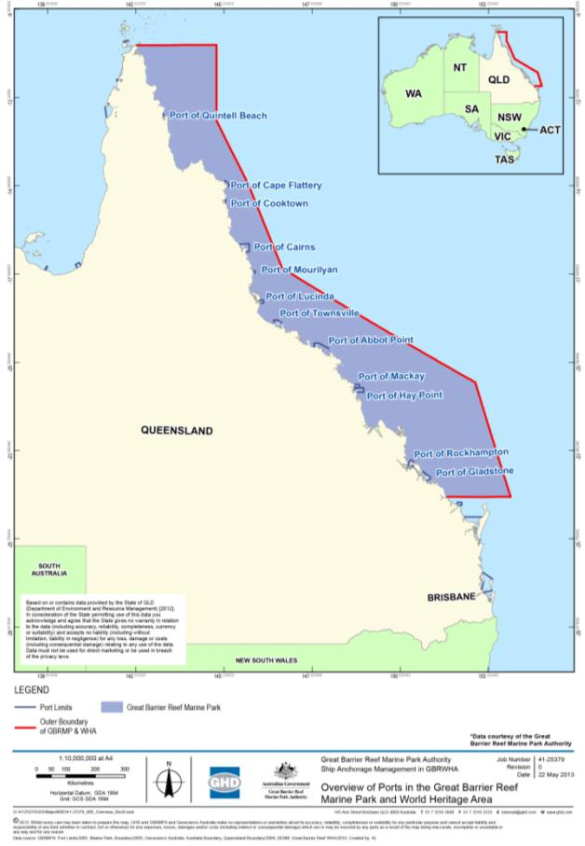
Figure 1-1: Overview of ports in the Great Barrier Reef Marine Park and World Heritage Area

As noted under section 1.2, the predicted increase in shipping traffic within the Marine Park and World Heritage Area in coming years is driven primarily by bulk commodity exports from ports located between Cairns and Gladstone. Accordingly, to inform the Strategic Assessment, this project is considering the risks from trading vessel anchorage associated with the five major Queensland ports of:
- Port of Cairns
- Port of Townsville
- Port of Abbot Point
- Port of Hay Point
- Port of Gladstone.
Anchorage areas are designated on navigational charts for only three of these locations; Cairns, Hay Point and Gladstone. Vessels may also anchor outside of designated areas at the discretion of the ship’s Master as long as they are compliant with relevant zoning and legislative protection measures for the World Heritage Area. Management and direction for anchorage in each of the geographies is provided to bulk cargo and other trading vessels by the Regional Harbour Master (RHM).
This project involves investigation of impacts associated with anchorages of the five major ports. A key step, therefore, has been to define the existing areas being used for anchorage by trading vessels working to each of the nominated ports. This was achieved through consultation with each port’s RHM to confirm designated areas and, for locations without charted anchorages, to define an area within which vessels are known or directed to anchor. Where specific anchor drop points are mapped a conservative approach of considering the entire area across which anchor drop may occur has been used to define the anchorage area of a port. This has provided an envelope of seabed adjacent each of the five ports within which anchorage currently occurs (refer section 3). The bounds of the ship anchorage areas (GPS coordinates) at each of the ports and the total area (in hectares (ha)) of each ship anchorage are provided in table 1-2 and the anchorage areas are presented in figure 3-3, figure 3-6, figure 3-9, figure 3-12 and figure 3-15.
These spatial areas provide the footprint of investigation adjacent each port addressed by this study. This study area is larger than the actual footprint of the anchorages and provides a conservative approach of considering the entire area across which anchor drop may occur. This approach takes into account direct impacts from anchor drop in addition to indirect impacts that can be experienced by designating a network of spatially disparate drop points, such as habitat fragmentation or impact to habitat continuity/integrity.

The structure of this report
To identify the potential impacts which may be realised from use of anchorages associated with each of the five major Queensland ports information has been collated regarding the environmental, social, cultural and heritage values of the World Heritage Area which have been related to the existing environment at each of the anchorage areas. Consultation has occurred with stakeholder groups regarding what potential impacts may occur from use of these anchorage areas by vessels anchoring and a structured impact assessment has been completed to identify what the consequence of any potential impact occurring is in relation to the environmental, social, cultural and heritage values of the anchorage areas. This information is reported in the following sections with regard to the different geographies of interest and matters at each site that support designation of the World Heritage Area and the OUV of the Reef. Subsequent sections of this report are, therefore, reported as follows:
Section 2 – Values of the Great Barrier Reef
Section 3 – Existing environment
Section 4 – Consultation in support of the impact assessment
Section 5 – Impact assessment
Section 6 – Conclusions
Section 7 – References

Table 1-2: Bounds (latitude and longitude) and area (in ha) of the anchorage areas at each of the five major ports (Latitudes and longitudes are provided by point number. Point 1 is top left corner, Point 2 is top right corner, Point 3 is bottom left corner and Point 4 is bottom right corner of a bounded area)
Port | Point 1 | Point 2 | Point 3 | Point 4 | Area (ha)
Cairns | -16.809302  145.77560 | -16.75466  145.86635 | -16.97995  145.96195 | -16.95247  146.01798 | 24,118
Townsville | -19.01963  146.80780 | -19.02737  147.03623 | -19.13087  146.90595 | -19.13266  147.06002 | 23,762
Abbot Point | -19.65923  147.98337 | -19.67425  148.28264 | -19.81606  147.98092 | -19.87983  148.22934 | 58,818
Hay Point | -21.17225  149.31492 | -20.97303  149.81436 | -21.29850  149.31236 | -21.29862  149.95951 | 157,284
Gladstone inner anchorage | -23.83373  151.29568 | -23.82218  151.31167 | -23.87902  151.35518 | -23.86798  151.36551 | 1403
Gladstone outer anchorage | -23.83195  151.42357 | -23.76377  151.49485 | -23.94741  151.59231 | -23.87346  151.66395 | 22,722

Values of the great barrier reef

The recognised value of the World Heritage Area
World Heritage Areas are considered to have attributes that are recognised globally for their outstanding natural and/or cultural value. The Reef is the world’s largest World Heritage property, extending over 2000 km in length (DSEWPaC 2011). The anchorage areas of the five major ports being assessed in this report are located within the coastal boundaries of the World Heritage Area (figure 1-1).
At the time of inscription of a World Heritage property, the World Heritage committee adopts a statement of OUV for the inscribed property. This statement provides a reference for future monitoring and protection (Lucas et al. 1997). The Reef was inscribed on the World Heritage List in 1981 and was recognised for the following values (Lucas et al. 1997):
- Outstanding example representing a major stage of the earth’s evolutionary history given the Reef is the largest single collection of coral reefs in the world.
- Outstanding example representing significant ongoing geological processes, biological evolution and man’s interaction with his natural environment given the Reef represents a mature system which has been in existence for millions of years.
- Containing unique, rare and superlative natural phenomena, formations and features and areas of exceptional natural beauty.
- Providing habitats where populations of rare and endangered species of plants and animals survive.
Examples of these values or attributes identified by the World Heritage Committee include the biodiversity and interconnectedness of species and habitats along the Reef, and ecosystem processes such as physical, geomorphological, chemical and ecological processes. The Reef’s biodiversity includes over 2900 separate coral reefs, deep oceanic waters, 70 bioregions, beaches and coastlines, over 2000 km² of mangroves, 6000 km² of seagrass beds and 900 islands, as well as a number of important faunal and floral groups and conservation significant species (see GBRMPA In prep). The immensity of this biodiversity makes the Reef one of the most complex natural systems in the world.
The Reef also has significant heritage and cultural value, including indigenous cultural importance for Aboriginal and Torres Strait Islanders. In addition, non-indigenous heritage values are represented and include mapped historic shipwrecks and lighthouses which occur throughout the Reef. These heritage and cultural values of the Reef, along with its biological diversity, represent features that are of outstanding national heritage value to Australia which led to the Reef being registered as a place of National Heritage in May 2007.

Legislative tools for value management
The Reef is the world’s largest coral reef ecosystem, spanning more than 348,000 km² of the continental shelf of Queensland. The Reef has significant value which is recognised by its inclusion as a Marine Park, a World Heritage Area, a National Heritage Place and a Commonwealth Marine Area. The recognition of these significant values carries an obligation and responsibility to protect and conserve the values for the future.
The Commonwealth government’s main environmental legislation that affords protection to the Reef includes the GBRMP Act and the EPBC Act. The GBRMP Act designates the Reef as a Marine Park and establishes the GBRMPA as a management agency that has the chartered responsibility “to provide for the protection, wise use, understanding and enjoyment of the Great Barrier Reef in perpetuity through the care and development of the Great Barrier Reef Marine Park”.
The EPBC Act seeks “to provide for the protection of the environment, especially those aspects of the environment that are matters of national environmental significance” (MNES). There are several MNES for which the Reef is recognised and against which any actions that may harm these values must be assessed. Those MNES protected by the EPBC Act that are of relevance to this assessment are defined by the ToR for the Strategic Assessment (refer Department of State Development, Infrastructure and Planning (DSDIP) 2012) to be:
        - World Heritage properties (sections 12 and 15A of the EPBC Act)
        - National Heritage places (sections 15B and 15C of the EPBC Act)
        - Wetlands of international importance (sections 16 and 17B of the EPBC Act)
        - Listed threatened species and ecological communities (sections 18 and 18A of the EPBC Act)
        - Listed migratory species (sections 20 and 20A of the EPBC Act)
        - Commonwealth marine areas (sections 23 and 24A of the EPBC Act)
        - The Great Barrier Reef Marine Park (sections 24B and 24C of the EPBC Act).

Management of the Reef
Prior to inscription upon the World Heritage or National Heritage registers the Reef was recognised as an environment requiring special management to provide sustainable use with appropriate protection. In 1975 the Marine Park was designated and the GBRMPA established with the responsibility of management of activities within the Marine Park. The Marine Park covers more than 344,400 km² of the World Heritage Area and extends 2300 km along the Queensland coast, encompassing most of the waters from low water mark on the mainland coast (Hutchings et al. 2008). The Marine Park is a multiple use area, supporting a wide range of social and economic uses that are considered as values of the Reef. The Reef supports significant commercial industries such as marine tourism, fishing, ports and shipping. The Reef is also a major recreational area for locals and tourists alike, an internationally recognised scientific resource and an important area for defence activities. A number of coastal areas, such as the operational port environments, are excluded from the Marine Park. This provides opportunity for targeted, intensive management of those environments against the activities which are conducted within those areas (responsibility for which rests with the various port management agencies operating in Queensland).
The main aim of the GBRMPA is to protect all values of the Marine Park; some of these values include the biodiversity of the Reef, as well as its ecosystem processes noted under section 2.1. This is a critical role for maintenance of a healthy Reef which is better able to resist, recover and adapt to impacts and stressors, as well as providing essential resources for numerous species and human use.
Since its inscription the pressures on the Reef have been increasing, including in response to climate change and as a result of population growth placing a greater demand on the resources of the Reef. The GBRMPA has a pivotal role to balance management objectives with sustainable use of this environmental asset. Measuring the potential impacts of different activities against the values for which the Reef is protected facilitates that role. This report, therefore, considers how ship anchorages associated with each of the five major ports may affect the MNES for which the Reef is recognised. This is achieved by considering whether any of the OUV components of the Reef occur within the anchorage area, whether they are affected by the activity of anchoring and what that effect may be.

Existing Environment

Approach
Research and monitoring of the marine environment of Queensland, including throughout the World Heritage Area, has occurred since the discovery of Australia. This is evidenced by numerous references to the coral reef systems of the Reef, and the fauna they support, scattered throughout the diary of Captain James Cook during the voyage of the Endeavour in 1770 (refer Thomas 2012). Since the first discoveries of the Reef significant research and monitoring has been reported in scientific and other literature. All of this information is openly accessible through library and web based searches and has been used to inform this project. Information has also been used, where available, from studies that underpin the management of natural resources (such as fisheries), coastal developments or tourism infrastructure. A summary of online databases that have been accessed in describing the existing anchorage areas is provided in table 3-1. As such, information that supports understanding of potential impacts from anchoring in the World Heritage Area is drawn from numerous reports on current and historic environmental studies undertaken within or nearby these anchorage areas.
Few studies have prescriptively looked at the anchorage areas of the five major ports; exceptions include two studies recently completed at Abbot Point and Hay Point (GHD 2012a, WorleyParsons 2012). Extensive surveys of habitats similar to those known to occur at anchorage areas have, however, been completed. The findings from these surveys show a high level of congruency. As such, it is considered valid to use information from surveys of relevant environs adjacent to the anchorage areas to inform the description of environmental, social, cultural and heritage values specific to the five ship anchorage areas. As surveys are of varying temporal and spatial scale, a review of online databases has also provided an indication of whether protected species and ecological communities have potential to occur within the anchorage areas. Databases such as the Protected Matters Search Tool (PMST) do not necessarily provide an explicit record of a species presence in an area but predicts potential presence of a species or ecological community based on a combination of bioclimatic modelling, known distribution and habitat preferences. In summarising that content here consideration has been given to the habitat requirements of reported species in conjunction with known records from surveys. A likelihood of occurrence assessment was undertaken to filter listed threatened or migratory species that could potentially occur within anchorage areas to focus assessment on those taxa that are known or that may occur.
Determination of likelihood of occurrence considered information relating to:
- habitat preferences
- distribution
- relative abundance
- previous records from the region
- database records, including those registered by the Species Profile and Threats (SPRAT) database (DSEWPaC 2012a).
A likelihood of occurrence ranking was attributed to conservation significant species predicted to occur across the anchorage areas, based on the following framework:
- Unlikely to occur: species has not been recorded in the anchorage areas (no records from desktop searches) AND/OR current known distribution does not encompass anchorage areas AND/OR suitable habitat is generally lacking from anchorage areas.
- May occur: species has not been recorded in anchorage areas (desktop searches) although species’ distribution incorporates anchorage areas AND potentially suitable habitat occurs at anchorage areas.
- Known to occur: species has been recorded in anchorage areas (desktop searches) AND suitable habitat is present at anchorage areas.
A precautionary approach has been applied to attribute likelihood of occurrence. Information from desktop research and database searches informed the outcomes. For Gladstone, the likelihood of occurrence assessment and discussion of potential impacts for anchorage areas were combined for Gladstone inner and outer anchorage areas. Where a difference in likelihood of occurrence outcome exists between the Gladstone inner anchorage and outer anchorage areas, the higher likelihood outcome has been assumed across the anchorage areas to provide a conservative understanding of the potential to impact on a species as a result of ship anchorages. For instance, where a species is considered unlikely to occur within the inner anchorage area but likely to occur within the outer anchorage area, an overall ranking of likely to occur has been applied to the species for assessment.
The existing environmental, social, cultural and heritage conditions of each anchorage area described in this section of the report provide context to the subsequent EIA. General environmental conditions that are applicable to all of the five port anchorage areas are described first and followed by descriptions of values which are relevant only to the specific geography of each port.

Table 3-1: Summary of desktop sources that informed the likelihood of occurrence assessment of the anchorage areas at each of the five major ports
Source and name | Description of information source | Desktop search extent | Limitation of use
DSEWPaC  Protected Matters Search Tool  (DSEWPaC 2012b) | The PMST identifies MNES and other matters protected by the EPBC Act that may occur within or relate to anchorage areas. The tool predicts the potential presence of a species/ecological community in an area based on bioclimatic modelling, known distribution and habitat preferences (the species that are listed as either threatened or migratory under the EPBC Act are provided in Appendix A). | The latitude and longitude coordinates of the top right and bottom left corners of a bordered area were used to designate the anchorage areas to be searched. The area was based on GPS coordinates identified in (table 1-2). As the search area is considered to be conservative (refer section 1.4) no buffer zone was added. | This is a predictive tool only – it does not necessarily indicate that a species or ecological community occurs in a defined area. Presence of a species or ecological community is predicted based on a combination of bioclimatic modelling, known distribution and habitat preferences. In predicting species or community presence, it allows for desktop research efforts to be targeted.
Department of Environment and Heritage Protection (DEHP)  Wildlife Online database  (DEHP 2012) | The DEHP Wildlife Online database maintains a catalogue of animal and plant species records from specific localities across Queensland. As well as common species, records of animals and plants listed as threatened under the EPBC Act are contained within the database. | The latitude and longitude coordinates of the top right and bottom left corners of a bordered area were used to designate the anchorage areas to be searched. The area was based on GPS coordinates identified in (table 1-2). As the search area is considered to be conservative (refer section 1.4) no buffer zone was added. | This database catalogues known records of species in a defined area. DEHP recommend that independent verification of records should be undertaken to inform the accuracy and completeness of information catalogued within this database (i.e. PMST and desktop research).
Queensland Museum  Queensland Museum Zoology Data Search  (Queensland Museum 2012) | The Queensland Museum catalogues fish and crustacean specimen records obtained throughout Queensland. | The latitude and longitude coordinates of the top right and bottom left corners of a bordered area were used to designate anchorage areas to be searched. The area was based on GPS coordinates identified in (table 1-2). As the search area is considered to be conservative (refer section 1.4) no buffer zone was added. | This database catalogues known records of species in a defined area. The age and lack of spatial precision of species records may limit their value for inclusion in current studies in some instances.
Ramsar  Ramsar List of Wetlands  (Ramsar 2012) | The Ramsar List of Wetlands identifies wetlands of international importance. | A search for wetlands within the vicinity of anchorage areas was conducted. | NA - this mapping identifies the location of wetlands that satisfy at least one criterion agreed upon by the Ramsar Convention.
DSEWPaC  Directory of Important Wetlands (DIWA)  (Environment Australia 2001) | The DIWA identifies nationally important wetlands. The DSEWPaC PMST (see above) lists nationally important wetlands occurring within or related to prescribed search extents. | A search for wetlands within the vicinity of the anchorage areas was conducted. | NA - this mapping identifies the location of wetlands that satisfy at least one criterion agreed upon by the Australian and New Zealand Environment and Conservation Council (ANZECC) Wetlands Network in 1994.
Department of Agriculture, Fisheries and Forestry (DAFF)  Coastal Habitat Resources Information System (CHRIS)  (DAFF 2012) | CHRIS is a resource centre for Queensland coastal fish habitat, fisheries resources and environmental datasets (layers) which facilitates monitoring of the condition and trend of coastal fisheries habitats. | Grid numbers from the interactive map of the CHRIS website were used to guide searches of commercial fishery types at the assessed anchorages areas. | Fisheries data is not available for recent years, only prior to 2005. However, fishery type is not considered to have changed dramatically within the regions assessed.
CSIRO  Seabed Biodiversity data  (Pitcher et al. 2007) | From 2003 to 2006, the Great Barrier Reef Seabed Biodiversity Project mapped habitats and their associated biodiversity across the length and breadth of the 210,000 km² shelf in the Marine Park. | Information reported by the project was reviewed to provide content of relevance to each anchorage area’s geography. | This database catalogues known records of species from the seabed in a defined area.

General environmental conditions
Located offshore of the Queensland coast adjacent major cities, anchorage areas are often visible from land. Vessels at anchor within these areas may be observed by local residents, visitors to each of the major cities or by tourists visiting the reef. All anchorage areas are located within the multiple use zones of the Marine Park. These areas may be accessed by other users of the Marine Park including, but not limited to, commercial and recreational fishers and sailors.
Sites having significant cultural value to either Indigenous or non-indigenous heritage are not known to exist within anchorage areas. There are, however, a number of sites of cultural value along the Queensland coast in areas adjacent to the anchorages (DSEWPaC 2012c, d).
The anchorages of the five major Queensland ports are subjected to climatic conditions typical of tropical monsoon areas, experiencing high temperatures and heavy rainfall during summer months (greater than 250 millimetres (mm)) and dry, mild winter months with rainfall less than 50 mm (figure 3-1).

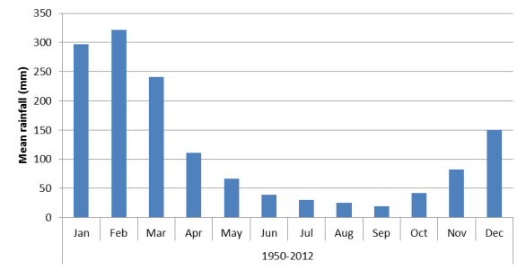
Figure 3-1: Average monthly rainfall across sites of relevance to the anchorage areas (Bureau of Meteorology (BoM) 2012)
The relatively close coastal location of each of the anchorage areas exposes these environments to seasonal inputs of freshwater, sediment, nutrients and pollutants during the summer months or ‘wet season’. This is particularly true for the anchorage areas of Cairns, Townsville and Gladstone, given that the ports associated with each of these anchorage areas are located within estuary or river mouths with significant catchment areas.
Prevailing wind conditions that influence the anchorage areas are from the south-south-east, for the majority of the year. During spring and summer winds can, however, swing to the east and north-east. These conditions may only occur for a matter of weeks during these seasonal periods.
The east coast of Queensland is subjected to extreme weather events in the form of tropical cyclones. The associated storm surges and high waves have the potential to impact coastal habitats, as well as impact shipping and anchorage activities. The location, depth, seabed and biodiversity of each of the anchorage areas, as they are currently known, is described in the following sections.

Anchorage area of the Port of Cairns
Anchorage drop points for ships servicing the Port of Cairns are principally located at the mouth of Trinity Inlet, to the north-north-east of the port and the city of Cairns. A single anchor drop point also occurs to the south of Cairns, to the west of Cape Grafton and approximately 3 km to the south-west of Fitzroy Island (figure 3-3). The southern anchor drop point has not been used in the last six years (Captain Michael Barnett (Cairns RHM), pers. comm., 27 September 2012), however is listed as a designated anchorage. To provide a conservative analysis of the environment of the anchorage area an investigation area that encapsulates all anchor drop points has been considered, as depicted in figure 3-3.
The anchorage area for the Port of Cairns is located within sight of the city of Cairns and as such anchored ships are highly visible to residents and visitors to the city and surrounding islands within the World Heritage Area. The Yarrabah Aboriginal community is located approximately 2 km to the south from the anchorages area.
Located within a Marine Park General Use Zone (figure 3-3), Cairns Port anchorage area is transited by commercial vessels accessing the port, but also by commercial and recreational fishing vessels accessing fishing areas and a high volume of tourism vessels accessing the Reef and islands within the Work Heritage Area. Adjacent to the anchorage area are a number of management zones offering habitat protection.
An Estuarine Conservation Zone is located immediately south of the main anchorage area, while a Conservation Park Zone is located approximately 5 km to the south-east. Scientific Research, Habitat Protection and further Conservation Park Zones are located 9 km to the east of the main anchorage area but are within 3 km of the southern anchorage.
There are no Ramsar wetlands of international importance in the vicinity of the Port of Cairns ship anchorages. In addition, desktop search of existing database and literature records did not identify any wetlands of national importance near the anchorage area.
The seabed within the anchorage area is approximately -7 to -16 metres (m) lowest astronomical tide (LAT) and is understood to be comprised of open, relatively bare, bioturbated habitat (based on descriptions provided in Neil et al. 2003a, Pitcher et al. 2007, WorleyParsons 2010) (figure 3-2). Sediments in the northern portion of the anchorage area are dominated by silts and clays (WorleyParsons 2010).
The seabed near the anchorage area is known to support macroalgae and invertebrate populations, typically in low abundance (Neil et al. 2003a, b, WorleyParsons 2010). Seagrasses (e.g. Halodule uninervis and Halophila decipiens) and algae (varying Families) have been recorded in low frequency and with a patchy distribution within the anchorage area (Neil et al. 2003a, Fairweather et al. 2011). Nearby, marine plants including mangroves and intertidal seagrass meadows are present in high density along the mouth of the Trinity Inlet and the Cairns foreshore (Fairweather et al. 2011).
Sea pens (Pennatulacea), anemones and solitary corals have previously been identified in sparse distribution from within the anchorage area (Neil et al. 2003a). Fringing coral reefs are not located within the anchorage area, but are located at Fitzroy and Green Islands approximately 3 km and 9 km away from the anchorage area respectively.
The anchorage area provides habitat for fish, including EPBC Act listed marine fish (DSEWPaC 2012a). The commercial fisheries that operate in areas associated with the Port of Cairns anchorage area (grid number H16) are line, net, pot and trawl (otter). Primary target species in the anchorage area for the trawl fisheries are prawns and bugs from the trawl fisheries. Line fishers operating in the anchorage area principally target Spanish mackerel (DAFF 2012).
Although records are not explicit, the anchorage area is also expected to be transited by marine megafauna. Megafauna that are known to occur within Trinity Bay and are likely to utilise the anchorage area include dugongs, turtles and estuarine crocodiles (Limpus 2008, WorleyParsons 2010). EPBC Act listed and migratory wetland and marine birds may also utilise the anchorage area (DSEWPaC 2012a) (figure 3-2). Review of online databases and assessment of likelihood of occurrence identifies the following EPBC Act protected species of relevance to the anchorage area:
- white-bellied storm petrel
- fork-tailed swift
- little tern
- fairy tern
- humpback whale
- whale shark
- dugong
- Australian snubfin dolphin
- Indo-Pacific humpback dolphin
- estuarine crocodile
- loggerhead turtle
- green turtle
- hawksbill turtle
- olive ridley turtle
- flatback turtle.
The wetland migratory species considered ‘known’ or that ‘may’ occur in the ship anchorage include:
- common sandpiper
- sharp-tailed sandpiper
- red-necked stint
- greater sand plover
- lesser sand plover
- grey-tailed tattler
- little curlew
- whimbrel
- grey plover
- terek sandpiper.

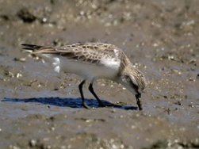
Figure 3-2: Example of bioturbated silty inner shelf seabed similar to that found in the Cairns anchorage area (Pitcher et al. 2007) and a wetland migratory species, the red-necked stint, photographed in Cairns (Cook 2012)
With regard to the MNES and OUV for which the Reef is protected (as described in section 2), table 3-2 describes the relatedness of World Heritage Area values considered to occur at the Port of Cairns anchorage area. The anchorage area is not considered to provide highly valued habitat or geomorphic features that are integral to the ongoing maintenance of ecosystem processes or core feeding or breeding habitat critical for the persistence of any protected species. Figure 3-4 presents a conceptual visualisation of the sensitive marine environments, as well as potential cultural, social or heritage values, for the Port of Cairns anchorage.

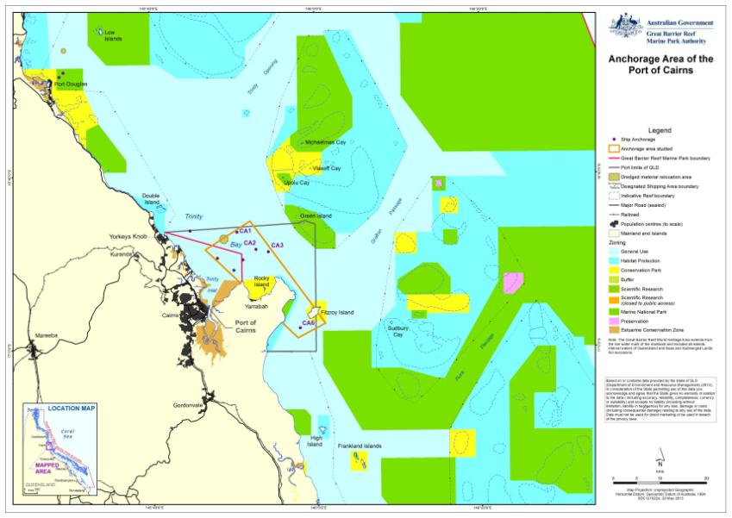
Figure 3-3: Anchorage area of the Port of Cairns

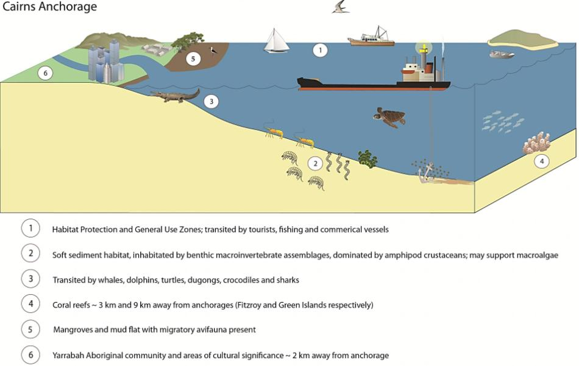
Figure 3-4: Conceptual visualisation of values of the Port of Cairns anchorage area

Table 3-2: World Heritage Area values associated with the Port of Cairns anchorage area
World Heritage Area values | OUV components of the Reef | Relevance to the Port of Cairns anchorage area
An outstanding example representing major stages of earth's history, including the record of life, significant on-going geological processes in the development of landforms, or significant geomorphic or physiographic features. | - Geomorphological evolution  - Reef building  - Sea level change  - Outer reef  - Beaches  - Continental slope | - The anchorage area does not contain any significant geomorphic or physiographic features which are integral to the ongoing ecological functioning of the Reef. The anchorage area supports open seabed habitat which provides for movement corridors and connectivity, however, these habitats are not unique within the anchorage area and are well represented elsewhere across the World Heritage Area.  - The anchorage area is coastally proximate and can be affected by sea level change.  - The anchorage area does not contain significant extant or extinct coral communities, including outer reefs.  - The anchorage area does not extend to beach areas and does not occur on the continental slope.
An outstanding example representing significant ongoing ecological and biological processes in the evolution and development of terrestrial, fresh water, coastal and marine ecosystems and communities of plants and animals. | - Physical process  - Connectivity  - Upwellings  - Continental Islands  - Halimeda banks  - Hard corals  - Island plants  - Aboriginal Sea Country | - Coastal (physical) processes associated with the formation of beaches are not affected by the use of the anchorage area.  - Upwellings are not known to occur within the anchorage area.  - Fitzroy Island occurs on the edge of the anchorage area (figure 3-3), however, the closest designated anchorage point is approximately 3 km away and has not been used in the last six years (Captain Michael Barnett (Cairns RHM), pers. comm., 27 September 2012).  - No significant Halimeda banks are known to occur within the anchorage area.  - The anchorage area is characterised by open seabed with patchily distributed benthic epifauna, macroalgae and in some locations low density seagrass. Species represented are not unique and are well represented locally in the geography outside of the anchorage area.  - Solitary hard corals are sparsely distributed within the anchorage area. Significant reef systems integral to the ecological functioning of the Reef are not a feature of the anchorage area.  - The anchorage area does not support unique features or habitats requiring a higher level of management protection, as reflected by the Marine Park General Use Zoning of the anchorage.  - Fitzroy Island occurs on the edge of the anchorage area, however the closest designated anchorage point is approximately 3 km away and has not been used in the last six years (as discussed above). Therefore, no island plants are considered associated with the anchorage area.  - Indigenous community links to the anchorage area has been recognised as being present. The anchorage area may support totem species (primarily dugong and marine turtles).
Contains superlative natural phenomena or areas of exceptional natural beauty and aesthetic importance. | - Water clarity  - Scenic vistas  - Visible from space  - Complex string of reef structures  - Unparalleled aerial panorama of seascapes  - Globally important breeding colonies of seabirds  - Raine Island (green turtle breeding)  - Over-wintering butterflies  - Cod Hole  - Coral diversity  - Reef fish  - Number of whales | - Marine waters within the anchorage area are subject to significant variation in clarity due to natural seasonal variability of conditions. The anchorage area is located coastally and subject to freshwater inundation, including from riverine outflows. This is reflected in the high prevalence of terrigenous and fine sediments (vs coralline sands).  - The anchorage area is located adjacent to residential centres, and in close proximity to land, providing opportunity for appreciation of the aesthetic beauty of the Reef. The scenic features surrounding the anchorage area could be considered remarkable, exceptional or unique in the context of the World Heritage Area listing, in terms of scenic vistas, when viewed from the air or sea.  - No natural features of the anchorage area are likely to be visible from space.  - Only solitary hard corals are known to occur sparsely within the anchorage area. No complex string of reef structures is present within the anchorage area although fringing reefs occur in close proximity (3 to 9 km away from the anchorage area).  - The anchorage area does not contain any unparalleled aerial panoramas of seascapes. These are all adjacent coastal environments that already support residential and/or industry development and have, therefore, been previously modified from natural state.  - The anchorage area does not affect any globally important breeding colonies of seabirds, over-wintering butterflies, Raine Island or the Cod Hole.  - Only sparsely distributed cnidarians occur within the anchorage area. No significant reef complexes are present. Reefs having higher coral diversity, including fringing reefs, do occur in close proximity (3 to 9 km away from the anchorage area).  - Whale migration is known to occur adjacent the anchorage area. Some coastal habitats inshore from the anchorage area are also used by whales resting on migration. It is therefore possible that whales may use habitats within the anchorage area.
Contains the most important and significant natural habitats for in-situ conservation of biological diversity, including those containing threatened species of OUV from the point of view of science or conservation. | - Mangroves  - Sea snakes  - Coral genera  - Lagoon floor  - Dugong  - Inshore dolphins  - Humpback whales  - Loggerhead turtles  - Green turtles  - Seabirds  - Island plant species | - The seabed within the anchorage and surrounding area is comprised of open, soft bottom habitat.  - Mangroves are not present within the anchorage area but do occur in adjacent coastal habitats.  - The anchorage area is known to be transited by whales, inshore dolphins, including the Australian snubfin and Indo-Pacific humpback dolphin, dugong, crocodiles, a variety of shark species and the six species of turtle known to occur in the Reef. No habitat critical to the survival of these species’ is present within the anchorage area although the seabed environ of the area is part of a matrix of important coastal habitats for these species and seagrass feeding habitat does occur in close proximity to the anchorage area. Indirect impacts to such species transiting the anchorage area may occur (e.g. noise impacts resulting in displacement or altered behaviour from light impacts).  - As noted above, the anchorage area supports a low prevalence of inshore cnidarians but does not support coral reefs. Inshore fringing reefs of higher diversity are adjacent the anchorage area.  - The anchorage area does not provide significant habitat value for seabird populations although they are likely accessed by seabirds for feeding or during transit.  - Fitzroy Island occurs on the edge of the anchorage area, however the closest designated anchorage point is approximately 3 km away and has not been used in the last six years (Captain Michael Barnett (Cairns RHM), pers. comm., 27 September 2012). Therefore, no island plants are considered associated with the anchorage area.

Anchorage area of the Port of Townsville
The anchorage area servicing the Port of Townsville is located approximately 17 km north-east of the port and the city of Townsville and to the east-south-east of Magnetic Island (figure 3-6). The seabed in this area is between -10 to -25 m LAT and the seabed habitat type is mainly bioturbated, comprising of soft sediments, mainly silts and soft mud with a coarser biogenic carbonate component (Cruz-Motta and Collins 2004, Pitcher et al. 2007).
The anchorage area is visible to residents and visitors to Magnetic Island, given that it is located approximately 2 km from Magnetic Island. Located in a General Use Zone of the Marine Park, the anchorage area is transited by large commercial vessels servicing the Port of Townsville, but also by commercial and recreational fishing vessels and tourism operators accessing the Reef. The anchorage area is immediately adjacent to a Marine Park Habitat Protection Zone and within approximately 2 km of Conservation Park and Marine National Park Zones that fringe Magnetic Island. A Marine National Park Zone, that includes Great Palm Island and potentially culturally significant sites, is more than 15 km to the north of the anchorage area.
Bowling Green Bay is situated approximately 10 km to the south of the ship anchorage and covers an area of approximately 35,500 ha. Bowling Green Bay is listed under Ramsar as a wetland of international importance, and it is one of Australia’s largest and most diverse tropical coastal wetlands (EPA 2000). This Ramsar site is a mosaic of coastal wetland systems, mountainous areas (Cape Cleveland and Feltham Cone), dune systems, coastal plains and the sand spit of Cape Bowling Green, with mangrove communities, salt pans, forest and woodland (DEH 1999). The site is contiguous with the Marine Park and the Bowling Green Bay Fish Habitat Reserve (DERM 2012).
Bowling Green Bay has a rich diversity of flora due to the extensive wetland communities of intertidal algae, seagrasses, mangroves, saline grasses and herbs, sedges and other aquatic species (DEH 1999). Over 200 birds are known to occur in the site, of these 103 are known to breed within its confines, and 13 species have a conservation status that is endangered, vulnerable or rare (DEH 1999). Rare and threatened animals which live in or visit the wetland include the endangered loggerhead turtle, vulnerable green turtle, dugong, saltwater crocodile and little tern, and the rare painted snipe and eastern curlew (EPA 2000) (figure 3-5).
The site has high aesthetic and cultural value due to its significant potential for environmental education and recreation (DEH 1999). The site is, however, located at distance from the anchorage area and is not likely to be directly affected by anchorage activities. No other wetlands of national importance were identified with any relevance to the anchorage area.
Information on the benthic flora and fauna from across the entire anchorage area is lacking, however, data exists from the western portion of the anchorage area. This data comes from a number of seabed biodiversity studies completed to inform the use of the Port of Townsville maintenance dredged material disposal site, which is located within the western part of the anchorage area. The seabed characteristics across this area are considered to be relatively uniform in nature and support low diversity macrobenthic invertebrate communities similar to those in surrounding deepwater, soft bottom areas, including gastropods, solitary corals, brittle stars, polychaetes, hydrozoans and bryozoans (Cruz-Motta and Collins 2004, GHD 2011a).
Deepwater seagrass meadows are known to have previously occurred within the anchorage area (Rasheed and Taylor 2008). Recent surveys have not been completed across the area to confirm species persistence at this site. Rasheed and Taylor (2008) describe deepwater seagrass meadows in Cleveland Bay, in the vicinity of the anchorage area, as being very patchy, low biomass, mixed species (Cymodocea serrulata, Halophila and Halodule spp.) meadows. Mangroves and intertidal mudflats are located within Cockle Bay on Magnetic Island, approximately 18 km south-west of the anchorage area.
In addition to the sensitive marine plants and mudflats of Magnetic Island, the island supports numerous fringing coral reefs, including those located approximately 3 km from the anchorage area. Further afield, fringing coral reefs and seagrasses also occur to the south of the anchorage area at Cape Cleveland. Mid-shelf reefs are located more than 25 km to the east of the anchorage area.
The anchorage area is known to be utilised by a large range of fishery species, avifauna and megafauna of conservation significance. Observations within the anchorage area of megafauna include the Australian snubfin dolphin, inshore bottle nosed dolphins, marine turtles, humpback whales, sharks and sea snakes (GHD 2012b). However, this area is also likely to be utilised by other marine megafauna, EPBC Act listed and migratory wetland and marine birds (DSEWPaC 2012a). Review of online databases and assessment of likelihood of occurrence identifies the following EPBC Act protected species of relevance to the anchorage area:
- white-bellied storm petrel
- humpback whale
- dugong
- Australian snubfin dolphin
- Indo-Pacific humpback dolphin
- estuarine crocodile
- loggerhead turtle
- green turtle
- hawksbill turtle
- olive ridley turtle
- flatback turtle.
Surveys near the Port of Townsville undertaken in 2008 confirmed the visitation of migratory shorebird species to the region (GHD 2009a).
The commercial fisheries that operate out of Townsville port and specifically report catch from the anchorage area (grid numbers J21 and K21) are line, net, pot and trawl (otter) fisheries. The primary target species across these are prawns (trawl), crabs (pot), and shark (all fishery types). The line fishers that operate in the anchorage area target grey and Spanish mackerel (DAFF 2012).
Figure 3-5: Juvenile green turtle and dugong observed in Cleveland Bay during surveys of marine megafauna (GHD 2011b)
The sensitive marine environments, as well as potential social, cultural and heritage values, present at the Port of Townsville anchorage are depicted conceptually in figure 3-7. The values considered to occur at the Port of Townsville anchorage area are described in table 3-3 with regard to the MNES for which the Reef is protected, including the OUV of the Reef (as described in section 2). The anchorage area is not considered to contain significant geomorphic features or important habitat core to feeding or breeding of any protected species. However, the anchorage area is a part of a matrix of habitat and environmental features which supports the diversity for which the Reef is recognised.

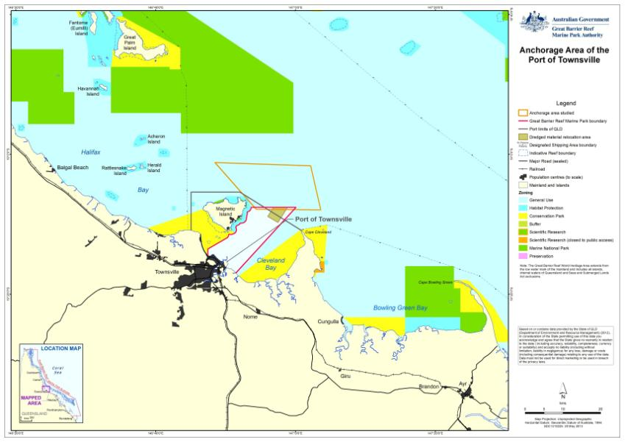
Figure 3-6: Anchorage area of the Port of Townsville

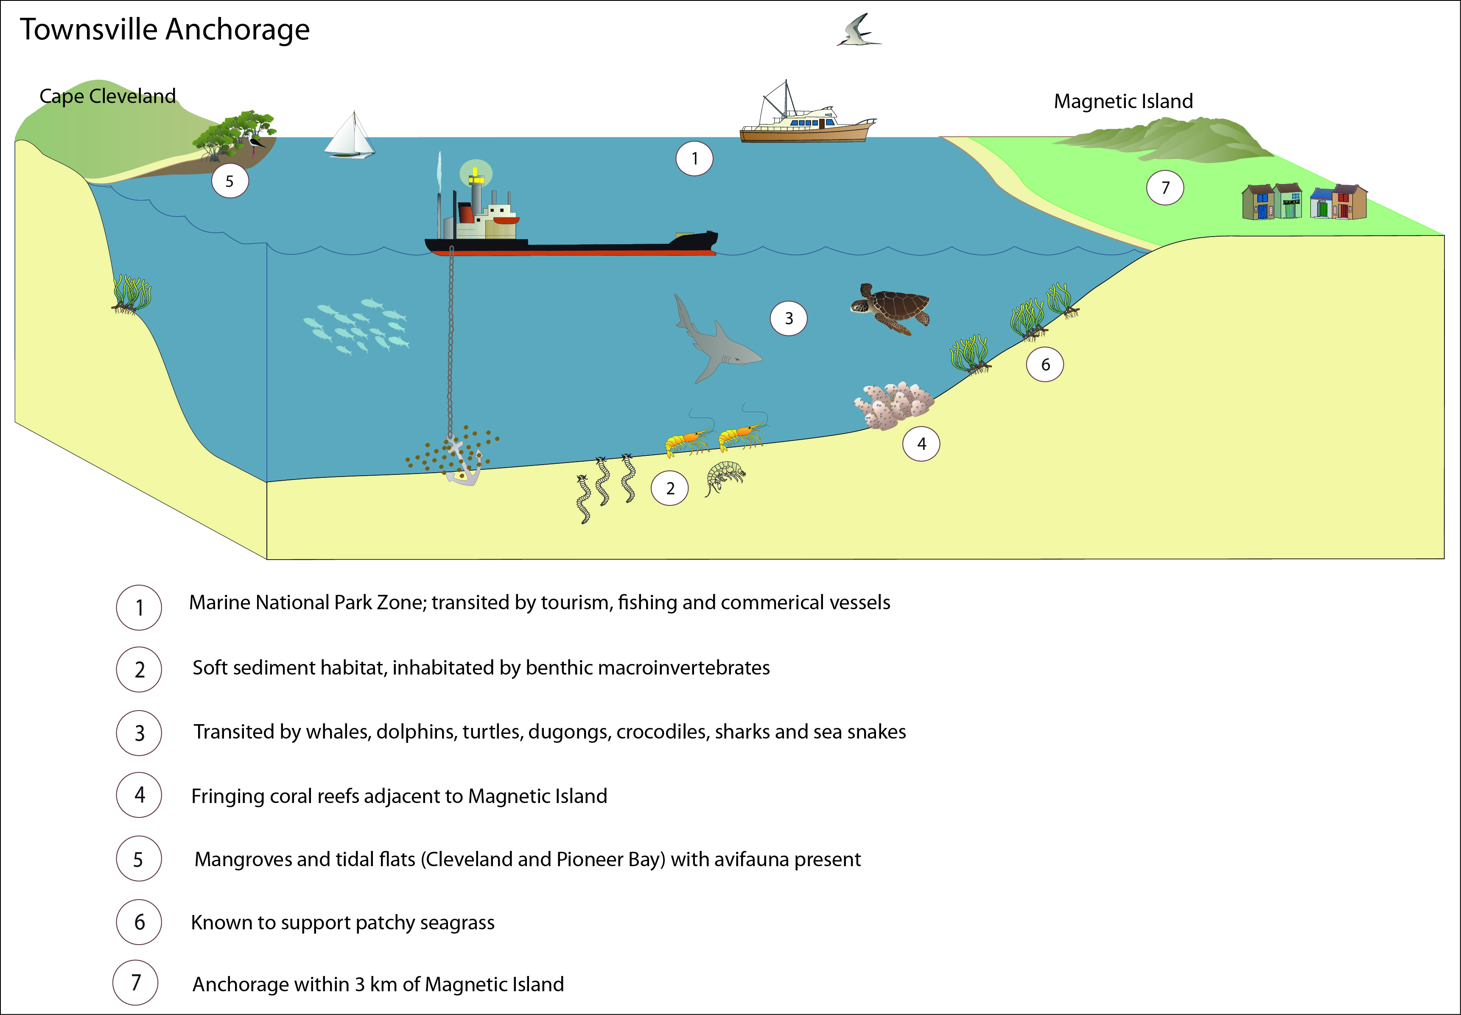
Figure 3-7: Conceptual visualisation of values of the Port of Townsville anchorage area

Table 3-3: World Heritage Area values associated with the Port of Townsville anchorage area
World Heritage Area values | OUV components of the Reef | Relevance to the Port of Townsville anchorage area
An outstanding example representing major stages of earth's history, including the record of life, significant on-going geological processes in the development of landforms, or significant geomorphic or physiographic features. | - Geomorphological evolution  - Reef building  - Sea level change  - Outer reef  - Beaches  - Continental slope | - The anchorage area does not contain any significant geomorphic or physiographic features which are integral to the ongoing ecological functioning of the Reef. The anchorage area supports open seabed habitat which provides for movement corridors and connectivity, however, these habitats are not unique within the anchorage area and are well represented elsewhere across the World Heritage Area.  - The anchorage area is coastally proximate and can be affected by sea level change.  - The anchorage area does not contain significant extant or extinct coral communities, including outer reefs.  - The anchorage area does not extend to beach areas and does not occur on the continental slope.
An outstanding example representing significant ongoing ecological and biological processes in the evolution and development of terrestrial, fresh water, coastal and marine ecosystems and communities of plants and animals. | - Physical process  - Connectivity  - Upwellings  - Continental Islands  - Halimeda banks  - Hard corals  - Island plants  - Aboriginal Sea Country | - Coastal (physical) processes associated with the formation of beaches are not affected by the use of the anchorage area.  - Upwellings are not known to occur within the anchorage area.  - No continental islands occur within the anchorage area.  - No significant Halimeda banks are known to occur within the anchorage area.  - The anchorage area is characterised by open seabed with patchily distributed macrobenthic fauna and in some locations low biomass deepwater seagrass meadows. Species represented are not unique and are well represented locally in the geography outside of the anchorage area.  - Solitary hard corals are present at very low densities within the anchorage area. Significant reef systems integral to the ecological functioning of the Reef are not a feature of the anchorage area.  - The anchorage area does not support unique features or habitats requiring a higher level of management protection, as reflected by the Marine Park General Use Zoning of the anchorage.  - No islands occur within the anchorage area and, therefore, no island plants are associated with the anchorage area. The anchorage area is, however, adjacent an inshore coastal island (Magnetic Island).  - Indigenous community links to the anchorage area has been recognised as being present. The anchorage area may support totem species (primarily dugong and marine turtles).
Contains superlative natural phenomena or areas of exceptional natural beauty and aesthetic importance. | - Water clarity  - Scenic vistas  - Visible from space  - Complex string of reef structures  - Unparalleled aerial panorama of seascapes  - Hinchinbrook Channel  - Globally important breeding colonies of seabirds  - Over-wintering butterflies  - Coral diversity  - Reef fish  - Number of whales | - Marine waters within the anchorage area are subject to significant variation in clarity due to natural seasonal variability of conditions. The anchorage area is located coastally and subject to freshwater inundation, including from riverine outflows. This is reflected in the high prevalence of terrigenous and fine sediments (vs coralline sands).  - The anchorage area is located adjacent to residential centres, and in close proximity to land, providing opportunity for appreciation of the aesthetic beauty of the Reef. The scenic features surrounding the anchorage area could be considered remarkable, exceptional or unique in the context of the World Heritage Area listing, in terms of scenic vistas, when viewed from the air or sea.  - No natural features of the anchorage area are likely to be visible from space.  - Only solitary hard corals are known to occur within the anchorage area. No complex string of reef structures is present within the anchorage area although fringing reefs occur in close proximity at Magnetic Island.  - The anchorage area does not contain any unparalleled aerial panoramas of seascapes. These are all adjacent coastal environments that already support residential and/or industry development and have, therefore, been previously modified from natural state.  - The anchorage area does not affect the Hinchinbrook Channel, any globally important breeding colonies of seabirds or over-wintering butterflies.  - Only sparsely distributed cnidarians occur within the anchorage area. No significant reef complexes are present. Reefs having higher coral diversity, including fringing reefs, do occur in close proximity (Magnetic Island).  - Whale migration is known to occur adjacent the anchorage area. Some coastal habitats inshore from the anchorage area are also used by whales resting on migration. It is therefore possible that whales may use habitats within the anchorage area.
Contains the most important and significant natural habitats for in-situ conservation of biological diversity, including those containing threatened species of OUV from the point of view of science or conservation. | - Mangroves  - Sea snakes  - Coral genera  - Lagoon floor  - Dugong  - Inshore dolphins  - Humpback whales  - Loggerhead turtles  - Green turtles  - Seabirds  - Island plant species | - The seabed within the anchorage and surrounding area is comprised of open, soft bottom habitat.  - Mangroves are not present within the anchorage area but do occur in adjacent coastal habitats (Magnetic Island).  - The anchorage area is known to be transited by whales, inshore dolphins, including the Australian snubfin and Indo-Pacific humpback dolphin, dugong, crocodiles, a variety of shark and sea snake species and the six species of turtle known to occur in the Reef. No habitat critical to the survival of these species’ is present within the anchorage area although the seabed environ of the area is part of a matrix of important coastal habitats for these species and seagrass feeding habitat does occur in close proximity to the anchorage area. Indirect impacts to such species transiting the anchorage area may occur (e.g. noise impacts resulting in displacement or altered behaviour from light impacts).  - As noted above, the anchorage area supports a low prevalence of inshore cnidarians but does not support coral reefs. Inshore fringing reefs of higher diversity are adjacent the anchorage area, at Magnetic Island.  - The anchorage area provides significant habitat value for seabird populations although they are likely accessed by seabirds for feeding or during transit.  - No islands occur within the anchorage area and, therefore, no island plants are associated with the anchorage area. The anchorage area is, however, adjacent an inshore coastal island (Magnetic Island).

Anchorage area of the Port of Abbot Point
The anchorage area servicing the Port of Abbot Point is located approximately 5 km north-north-west of the port (figure 3-9). The seabed in this area is relatively flat with a gentle slope shoaling away from the coastline such that depth ranges from approximately -15 m to -35 m LAT. Recent surveys indicate that sediments across the anchorage area are likely to be comprised of sands and silts, predominantly terrigenous in source.
Abbot Point is not a residential centre. The only facilities at Abbot Point are associated with the operation of the existing port. The nearest residential centre is at Bowen, located approximately 30 km south of Abbot Point (figure 3-9). The anchorage area at Abbot Point does not, therefore, have a high level of visibility to residents and visitors to Bowen. The anchorage area is located in a General Use Zone of the Marine Park and is transited principally by commercial vessels servicing the Port of Abbot Point but is also transited by fishing vessels travelling between southern centres and northern reefs.
The anchorage area is not typically transited by tourism operators accessing the Reef from southern or northern port centres. Habitat Protection, Marine National Park and Conservation Park Zones of the Marine Park are located at least 9 km west and inshore of the anchorage area. Sites of significant cultural value are located onshore of the anchorage area in the form of shell middens and rock fish traps.
There are no Ramsar wetlands of international importance in the vicinity of the Port of Abbot Point ship anchorage. The Caley Valley Wetland is, however, an expansive wetland located at Abbot Point which has connectivity to the marine environment on the western side through coastal mangrove habitat. The wetland covers an area of 5154 ha and is listed under the DIWA as a palustrine system (modified from an original brackish wetland). This system offers nursery habitat to a number of marine species and seasonally discharges into the Marine Park (DSEWPaC 2012e). The wetland area is approximately 10 km south from the anchorage area.
Pitcher et al. (2007) describe the broad biological seabed habitat type at Abbot Point being predominantly made up of seagrass and Halimeda (figure 3-8). Detailed seabed surveys across the port in support of proposed developments since 2007 have refined understanding at smaller spatial scales of resolution. Recent surveys also provide understanding of seabed conditions following large cyclone and flooding disturbances which occurred in 2011.
Long-term monitoring has identified that seagrasses at the port are highly dynamic (McKenna and Rasheed 2011). Detailed seagrass assessments have not extended across the port boundaries to the anchorage area; they have focussed on coastal meadows within the port limits (refer McKenna and Rasheed 2011). Baseline surveys (Rasheed et al. 2005) demonstrated that seagrasses within the port did not extend into depths associated with the anchorage area, they occurred closer to the coast in waters that were shallower. Recent studies have confirmed that seagrasses are not present in the anchorage area (McKenna et al. 2008) although based on previous surveys of similar habitats (e.g. Pitcher et al. 2007) algal taxa are likely to occur in patchy distribution.
Surveys indicate the anchorage area is likely to support sparsely distributed epibenthic macroinvertebrates (Pitcher et al. 2007, GHD 2012a). The assemblages are not considered unique to this area; they are similar to those found across the port environment which have shown little variability in composition through time (refer Ottaway et al. 1989, Hoedt et al. 1999, Rasheed et al. 2005, Pitcher et al. 2007).
Although not a characterising feature of the anchorage area, seagrass meadows have been recorded in sparse, though extensive, distribution in the coastal areas of the port. Mangroves and other sensitive ecosystem receptors are also known to occur along the coast of Abbot Point, particularly to the south-west of the anchorage area where mangrove wetlands provide connectivity to the inland Caley Valley Wetland.
Coral reefs do not occur within the anchorage area of Abbot Point, however, sparsely distributed cnidarians may be present in the form of solitary fungid and soft corals, sea pens and anemones. Coral reefs are located 8 km away to the east at Nares Rock and Holbourne Island and approximately 6 km to the west at Camp Island. Mid-shelf reefs are more than 15 km offshore from the anchorage area.
The anchorage area is known to provide habitat for fish, including EPBC Act listed marine fish and given the diversity of megafauna and avifauna observed coastally at Abbot Point (GHD 2009b, 2010) the anchorage area is also expected to be transited by the following species:
- marine reptiles (crocodiles, sea snakes and five species of turtles (green, flatback, loggerhead, hawksbill and olive ridley turtles))
- dugong
- cetaceans (humpback whales and four species of dolphins (Indo-Pacific humpback dolphin, Australian snubfin dolphin (figure 3-8), bottlenose dolphin and common dolphin))
- migratory marine elasmobranchs (e.g. bull sharks, leopard sharks and manta rays).
Beyond marine megafauna, other protected species likely to use the anchorage area include EPBC Act listed and migratory wetland and marine birds (DSEWPaC 2012a) that are accessing the Caley Valley wetland and offshore islands of the Marine Park. Migratory and marine bird species have been recorded at the Caley Valley Wetland during a number of baseline studies (GHD 2010, BMT WBM 2012a) The EPBC Act PMST search (DSEWPaC 2012b) and assessment of likelihood of occurrence did not identify any migratory birds of relevance to the anchorage area, however, it did identify two marine birds; the white-bellied storm petrel and herald petrel.
Line, net, pot and trawl (beam and otter) are the most predominant commercial fisheries that operate in the areas associated with the Port of Abbot Point anchorage area (grid numbers M22 and L22). The target species of these industries are prawns and scallops from the trawl fisheries, and shark from net fishery. Line fisheries operating across the anchorage area target transient Spanish mackerel (DAFF 2012).
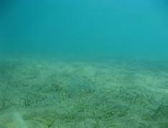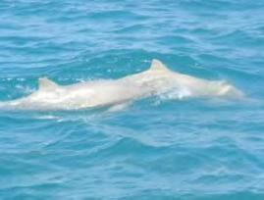
Figure 3-8: Patchy seagrass identified in benthic assessments and Australian snubfin dolphins observed within the Abbot Point port (GHD 2010)
The MNES and World Heritage Area values considered to occur at the Port of Abbot Point anchorage area are outlined in table 3-4. The anchorage area is characterised by open seabed with patchily distributed benthic fauna and flora. The anchorage area does not support unique features or habitats requiring a higher level of management protection, as reflected by the Marine Park General Use Zoning of the anchorage. Species represented are not unique and are well represented locally in the geography outside of the anchorage area. Figure 3-10 presents a conceptual visualisation of the sensitive marine environments, as well as potential cultural, social or heritage values, for the Port of Abbot Point anchorage.

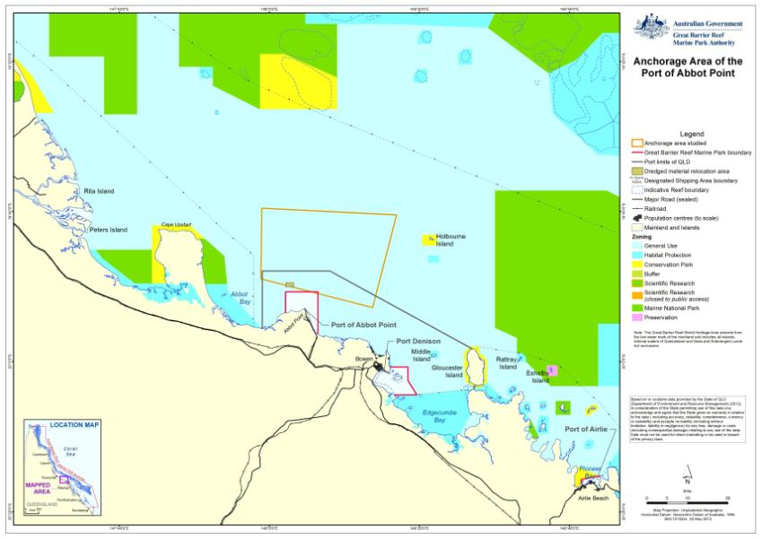
Figure 3-9: Anchorage area of the Port of Abbot Point

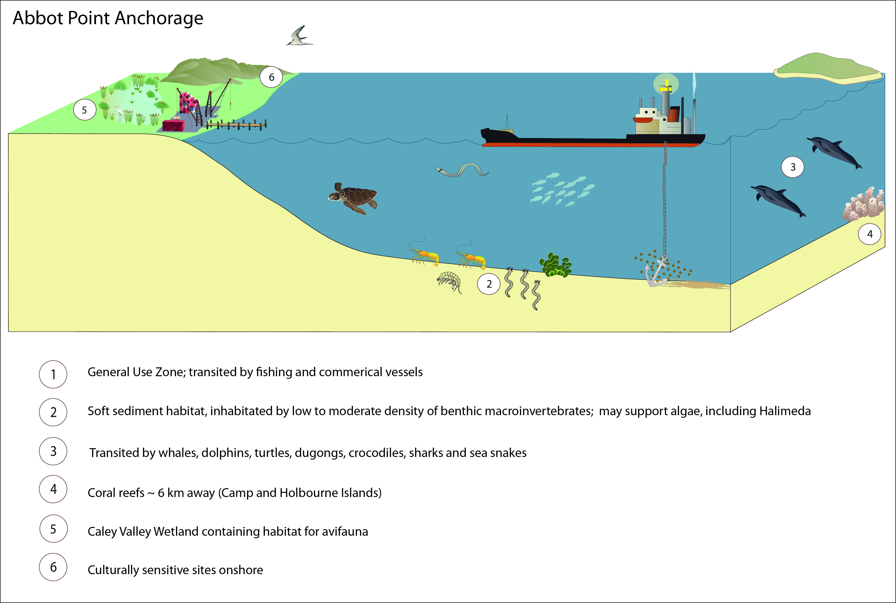
Figure 3-10: Conceptual visualisation of values of the Port of Abbot Point anchorage area

Table 3-4: World Heritage Area values associated with the Port of Abbot Point anchorage area
World Heritage Area values | OUV components of the Reef | Relevance to the Port of Abbot Point anchorage area
An outstanding example representing major stages of earth's history, including the record of life, significant on-going geological processes in the development of landforms, or significant geomorphic or physiographic features. | - Geomorphological evolution  - Reef building  - Sea level change  - Outer reef  - Beaches  - Continental slope | - The anchorage area does not contain any significant geomorphic or physiographic features which are integral to the ongoing ecological functioning of the Reef. The anchorage area supports open seabed habitat which provides for movement corridors and connectivity, however, these habitats are not unique within the anchorage area and are well represented elsewhere across the World Heritage Area.  - The anchorage area is coastally proximate and can be affected by sea level change.  - The anchorage area does not contain significant extant or extinct coral communities, including outer reefs.  - The anchorage area does not extend to beach areas and does not occur on the continental slope.
An outstanding example representing significant ongoing ecological and biological processes in the evolution and development of terrestrial, fresh water, coastal and marine ecosystems and communities of plants and animals. | - Physical process  - Connectivity  - Upwellings  - Continental Islands  - Halimeda banks  - Hard corals  - Island plants  - Aboriginal Sea Country | - Coastal (physical) processes associated with the formation of beaches are not affected by the use of the anchorage area.  - Upwellings are not known to occur within the anchorage area.  - No continental islands occur within the anchorage area.  - No significant Halimeda banks are known to occur within the anchorage area, however, Halimeda is present.  - The anchorage area is characterised by open seabed with patchily distributed epibenthic macroinvertebrates and algae. Species represented are not unique and are well represented locally in the geography outside of the anchorage area.  - Solitary hard corals are present at very low densities within the anchorage area. Significant reef systems integral to the ecological functioning of the Reef are not a feature of the anchorage area.  - The anchorage area does not support unique features or habitats requiring a higher level of management protection, as reflected by the Marine Park General Use Zoning of the anchorage.  - No islands occur within the anchorage area and, therefore, no island plants are associated with the anchorage area.  - Indigenous community links to the anchorage area has been recognised as being present. The anchorage area may support totem species (primarily dugong and marine turtles).
Contains superlative natural phenomena or areas of exceptional natural beauty and aesthetic importance. | - Water clarity  - Scenic vistas  - Visible from space  - Complex string of reef structures  - Unparalleled aerial panorama of seascapes  - Whitsunday Islands  - Globally important breeding colonies of seabirds  - Over-wintering butterflies  - Coral diversity  - Reef fish  - Number of whales | - Marine waters within the anchorage area are subject to significant variation in clarity due to natural seasonal variability of conditions. The anchorage area is located coastally and subject to freshwater inundation, including from riverine outflows. This is reflected in the high prevalence of terrigenous and fine sediments (vs coralline sands).  - The anchorage area is not located adjacent to residential centres, however, it is located in close proximity to land. Following, the scenic features surrounding the anchorage area could be considered remarkable, exceptional or unique in the context of the World Heritage Area listing, in terms of scenic vistas, when viewed from the air or sea.  - No natural features of the anchorage area are likely to be visible from space.  - Solitary hard and soft corals are known to occur sparsely within the anchorage area. No complex string of reef structures is present within the anchorage area, although fringing reefs occur in close proximity (6 to 8 km away) at Holbourne Island, Camp Island and Nares Rock.  - The anchorage area does not contain any unparalleled aerial panoramas of seascapes. These are all adjacent coastal environments that already support residential and/or industry development and have, therefore, been previously modified from natural state.  - The anchorage area does not affect the Whitsunday Islands, any globally important breeding colonies of seabirds or over-wintering butterflies.  - Only sparsely distributed cnidarians occur within the anchorage area. No significant reef complexes are present. Reefs having higher coral diversity, including fringing reefs, do occur in close proximity (Holbourne Island, Camp Island and Nares Rock).  - Whale migration is known to occur adjacent the anchorage area. Some coastal habitats inshore from the anchorage area are also used by whales resting on migration. It is therefore possible that whales may use habitats within the anchorage area.
Contains the most important and significant natural habitats for in-situ conservation of biological diversity, including those containing threatened species of OUV from the point of view of science or conservation. | - Mangroves  - Sea snakes  - Coral genera  - Lagoon floor  - Dugong  - Inshore dolphins  - Humpback whales  - Loggerhead turtles  - Green turtles  - Seabirds  - Island plant species | - The seabed within the anchorage and surrounding area is comprised of open, soft bottom habitat.  - Mangroves are not present within the anchorage area but do occur in adjacent coastal habitats (Caley Valley Wetland).  - The anchorage area is known to be transited by whales, inshore dolphins, including the Australian snubfin and Indo-Pacific humpback dolphin, dugong, crocodiles, a variety of shark and sea snake species and the six species of turtle known to occur in the Reef. No habitat critical to the survival of these species’ is present within the anchorage area although the seabed environ of the area is part of a matrix of important coastal habitats for these species and seagrass feeding habitat does occur in close proximity to the anchorage area. Indirect impacts to such species transiting the anchorage area may occur (e.g. noise impacts resulting in displacement or altered behaviour from light impacts).  - As noted above, the anchorage area supports a low prevalence of inshore cnidarians but does not support coral reefs. Inshore fringing reefs of higher diversity are adjacent the anchorage area (Holbourne Island, Camp Island and Nares Rock).  - The anchorage area does not provide significant habitat value for seabird populations although they are likely accessed by seabirds for feeding or during transit.  - No islands occur within the anchorage area and, therefore, no island plants are associated with the anchorage area.

Anchorage area of the Port of Hay Point
The anchorage area for ships servicing the Port of Hay Point are located immediately adjacent the port terminals in waters greater than -10 m LAT. The nearest residential centre is Sarina, approximately 10 km south of Hay Point. While the anchorage area does not have a high level of visibility from Sarina, the scenic vista surrounding the anchorage area may still be considered remarkable, exceptional or unique in the context of the World Heritage Area listing, particularly for visitors to Mackay and Sarina north and south of the Port of Hay Point respectively. The anchorage area of Hay Point port has 102 designated anchorages (figure 3-12).
Located in a General Use Zone of the Marine Park, the anchorage area at Hay Point is surrounded by protected habitat at varying distances. A Habitat Protection Zone is located immediately west of the anchorage area, while there are several small Habitat Protection Zones encompassing fringing coral reefs surrounding the anchorage area, of which the closest is located approximately 5 km to the south of a designated anchorage. Conservation Park Zones are located approximately 5 km west, as well as approximately 15 km north and north-east, of the anchorage area. Marine National Park Zones are located more than 5 km north and east of the anchorage area (figure 3-12).
There are no Ramsar wetlands of international importance or nationally important wetlands in the vicinity of the Port of Hay Point ship anchorage area.
Compared to locations such as Cairns, the anchorage area is likely to be transited by only a low volume of tourism operators accessing the Reef and islands within the World Heritage Area. The Hay Point anchorage area is, however, transited by large commercial ships servicing the Port of Hay Point, and also commercial and recreational fishing vessels operating out of centres north and south of the port. The commercial fisheries that operate in the vicinity of the Port of Hay Point anchorage area (grid number O25) are line, net, pot and trawl (beam and otter), targeting (primary product) prawns and scallops (trawl). The line fishery in this sector reported coral trout and shark as the primary target product (DAFF 2012) (figure 3-11).
Sediments within the anchorage area are comprised of soft sand and muddy silt substrata (Pitcher et al. 2007, BMA 2011) and are known to support benthic macroinvertebrate assemblages typical of those described from deepwater (>10 m) open seabed areas within the Reef (Thomas and Rasheed 2011). Low density seagrass meadows and algae are also known to occur within the anchorage area (Pitcher et al. 2007, Thomas and Rasheed 2011). Surveys of seagrass completed within port limits since 2004 have noted that coastal and deepwater meadows are transient at Hay Point (Thomas et al. 2012, Thomas et al. 2011).
Mangroves and intertidal mudflats provide coastal habitat adjacent to the anchorage area, however, these are interspersed with rocky reefs and intertidal rocky shoals (URS 2000). Further afield diverse hard and soft coral reefs are supported on Victor Islet (approximately 2 km south of the anchorage area) and surrounding Round Top and Flat Top Islands (approximately 11 km and 13 km north, north-west of the anchorage area respectively) (figure 3-11).
As for all anchorages to the north of Hay Point, a diversity of fish, birds and megafauna transit through the anchorage area (DSEWPaC 2012a). The presence of low density seagrasses within the anchorage area of Hay Point does, however, provide habitat which may be utilised by dugong and marine turtles (six species have been recorded at Hay Point) offering a feeding area rather than just a transitory habitat. Review of online databases indicates the EPBC Act protected species likely to occur in the Hay Point anchorage include:
- white-bellied storm petrel
- southern giant petrel
- Kermadec petrel (western)
- Caspian tern
- dugong
- humpback whale
- Australian snubfin dolphin
- Indo-Pacific humpback dolphin
- estuarine crocodile
- loggerhead turtle
- green turtle
- hawksbill turtle
- olive ridley turtle
- flatback turtle.
Figure 3-11: Hard and soft corals from Victor Islet (roughly 2 km south of the anchorage), and coral trout, a commonly targeted commercial fisheries species, found near Round Top Island (11 km northwest of the anchorage), within the vicinity of Hay Point port (GHD 2005)
A conceptual visualisation of the sensitive marine environments, as well as potential cultural, social or heritage values, present at the Hay Point anchorage area is provided in figure 3-13. The relatedness of the values considered to occur at the Port of Hay Point anchorage area is described in table 3-5 with regard to the MNES and the OUV for which the Reef is protected. The anchorage area supports open seabed habitat which provides for movement corridors and connectivity, however, these habitats are not unique within the anchorage area and are well represented elsewhere across the World Heritage Area. No core feeding or breeding habitat for any protected species is present at the anchorage area, however, it is a part of a matrix of habitat and environmental features which supports the diversity for which the Reef is recognised.

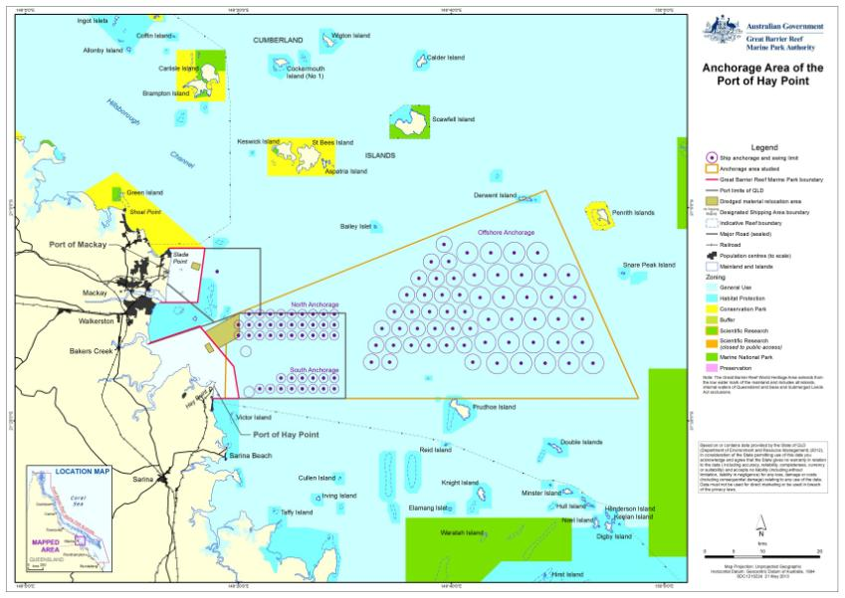
Figure 3-12: Anchorage area of the Port of Hay Point

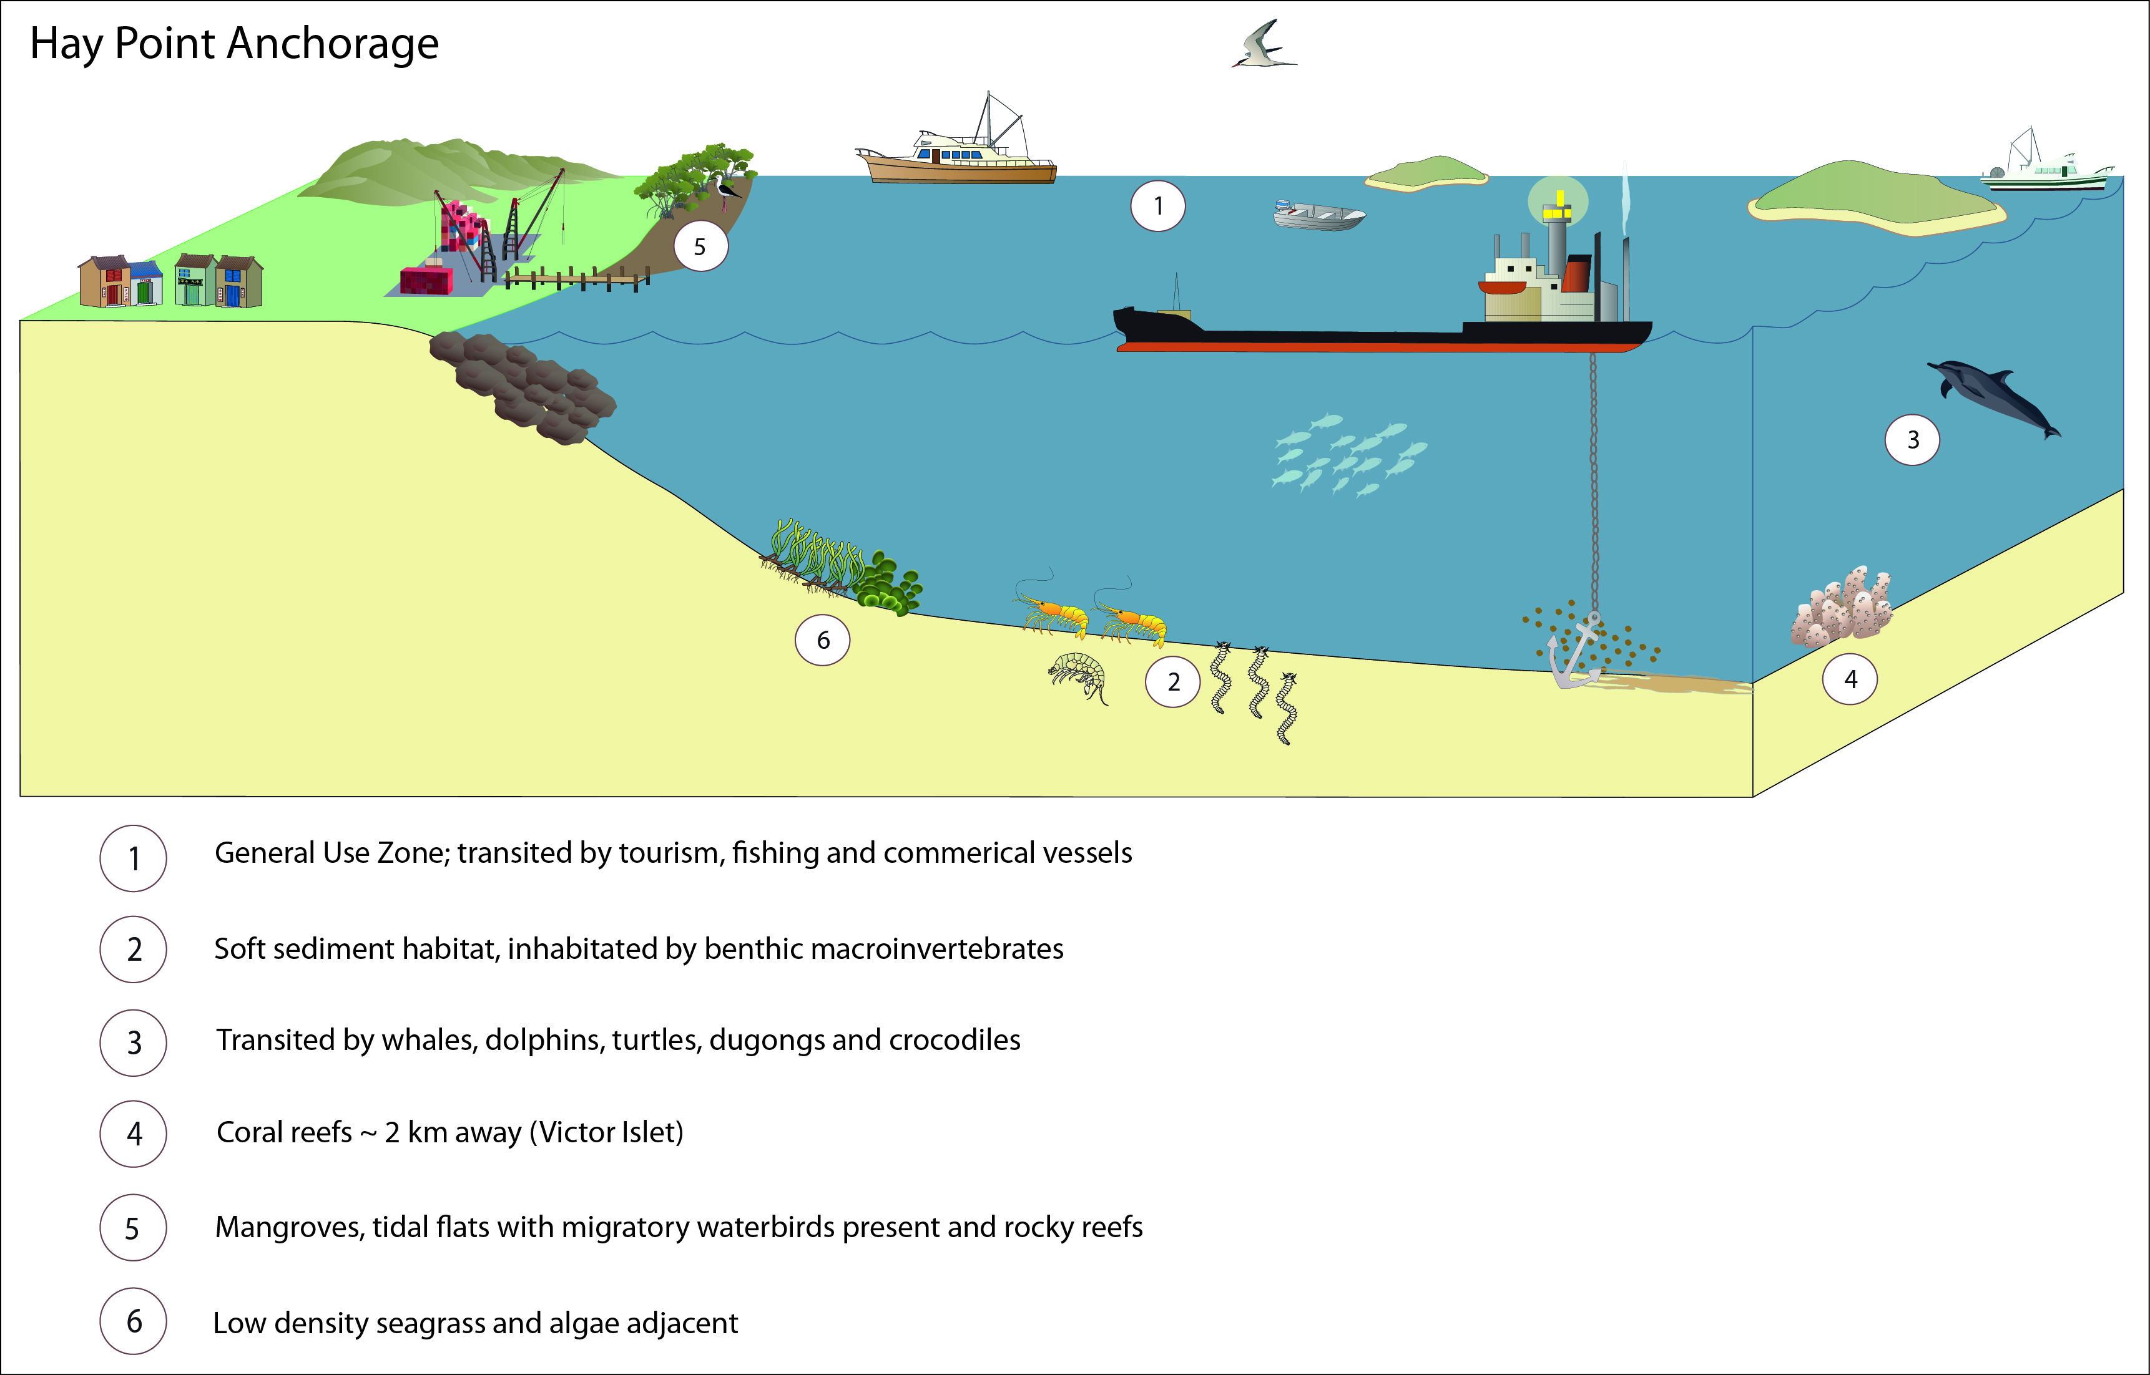
Figure 3-13: Conceptual visualisation of values of the Port of Hay Point anchorage area

Table 3-5: World Heritage Area values associated with the Port of Hay Point anchorage area
World Heritage Area values | OUV components of the Reef | Relevance to the Port of Hay Point anchorage area
An outstanding example representing major stages of earth's history, including the record of life, significant on-going geological processes in the development of landforms, or significant geomorphic or physiographic features. | - Geomorphological evolution  - Reef building  - Sea level change  - Outer reef  - Beaches  - Continental slope | - The anchorage area does not contain any significant geomorphic or physiographic features which are integral to the ongoing ecological functioning of the Reef. The anchorage area supports open seabed habitat which provides for movement corridors and connectivity, however, these habitats are not unique within the anchorage area and are well represented elsewhere across the World Heritage Area.  - The anchorage area is coastally proximate and can be affected by sea level change.  - The anchorage area does not contain significant extant or extinct coral communities, including outer reefs.  - The anchorage area does not extend to beach areas and does not occur on the continental slope.
An outstanding example representing significant ongoing ecological and biological processes in the evolution and development of terrestrial, fresh water, coastal and marine ecosystems and communities of plants and animals. | - Physical process  - Connectivity  - Upwellings  - Continental Islands  - Halimeda banks  - Hard corals  - Island plants  - Aboriginal Sea Country | - Coastal (physical) processes associated with the formation of beaches are not affected by the use of the anchorage area.  - Upwellings are not known to occur within the anchorage area.  - No continental islands occur within the anchorage area. The anchorage area is bordered by two islands, Prudhoe and Derwent Island, however, designated anchorage points are at least 5 km away.  - No significant Halimeda banks are known to occur within the anchorage area.  - The anchorage area is characterised by open seabed with patchily distributed benthic macroinvertebrates, algae and in some locations low density seagrass. Species represented are not unique and are well represented locally in the geography outside of the anchorage area.  - Solitary hard corals are present at low densities within the anchorage area. Significant reef systems integral to the ecological functioning of the Reef are not a feature of the anchorage area.  - The anchorage area does not support unique features or habitats requiring a higher level of management protection, as reflected by the Marine Park General Use Zoning of the anchorage.  - No islands occur within the anchorage area, however, the area is bordered by Prudhoe and Derwent Island. Since the closest designated anchorage point is approximately 5 km away from these islands, no island plants are considered associated with the anchorage area. There are also a number of other inshore coastal islands in the vicinity of the anchorage area.  - Indigenous community links to the anchorage area has been recognised as being present. The anchorage area may support totem species (primarily dugong and marine turtles).
Contains superlative natural phenomena or areas of exceptional natural beauty and aesthetic importance. | - Water clarity  - Scenic vistas  - Visible from space  - Complex string of reef structures  - Unparalleled aerial panorama of seascapes  - Globally important breeding colonies of seabirds  - Over-wintering butterflies  - Coral diversity  - Reef fish  - Number of whales | - Marine waters within the anchorage area are subject to significant variation in clarity due to natural seasonal variability of conditions. The anchorage area is located coastally and subject to freshwater inundation, including from riverine outflows. This is reflected in the high prevalence of terrigenous and fine sediments (vs coralline sands).  - The anchorage area is located near to residential centres, and in close proximity to land, providing opportunity for appreciation of the aesthetic beauty of the Reef. The scenic features surrounding the anchorage area could be considered remarkable, exceptional or unique in the context of the World Heritage Area listing, in terms of scenic vistas, when viewed from the air or sea.  - No natural features of the anchorage area are likely to be visible from space.  - Only solitary hard corals are known to occur within the anchorage area. No complex string of reef structures is present within the anchorage area although hard and soft coral reefs occur in close proximity (2 to 13 km away) at Victor Islet, and Round and Flat Top Islands, and fringing reefs occur nearby at some Islands.  - The anchorage area does not contain any unparalleled aerial panoramas of seascapes. These are all adjacent coastal environments that already support residential and/or industry development and have, therefore, been previously modified from natural state.  - The anchorage area does not affect any globally important breeding colonies of seabirds or over-wintering butterflies.  - Only sparsely distributed cnidarians occur within the anchorage area. No significant reef complexes are present. Reefs having higher coral diversity, including fringing reefs, do occur in close proximity (Victor Islet, and Round and Flat Top Islands).  - Whale migration is known to occur adjacent the anchorage area. Some coastal habitats adjacent from the anchorage area are also used by whales resting on migration. It is therefore possible that whales may use habitats within the anchorage area.
Contains the most important and significant natural habitats for in-situ conservation of biological diversity, including those containing threatened species of OUV from the point of view of science or conservation. | - Mangroves  - Sea snakes  - Coral genera  - Lagoon floor  - Dugong  - Inshore dolphins  - Humpback whales  - Loggerhead turtles  - Green turtles  - Seabirds  - Island plant species | - The seabed within the anchorage and surrounding area is comprised of open, soft bottom habitat.  - Mangroves are not present within the anchorage area but do occur in adjacent coastal habitats.  - The anchorage area is known to be transited by whales, inshore dolphins, including the Australian snubfin and Indo-Pacific humpback dolphin, dugong and crocodiles, and the six species of turtle known to occur in the Reef. No habitat critical to the survival of these species’ is present within the anchorage area although the seabed environ of the area is part of a matrix of important coastal habitats for these species and seagrass feeding habitat does occur at the anchorage area. Indirect impacts to such species transiting the anchorage area may occur (e.g. noise impacts resulting in displacement or altered behaviour from light impacts).  - As noted above, the anchorage area supports a low prevalence of inshore cnidarians but does not support coral reefs. Inshore fringing reefs of higher diversity are adjacent the anchorage area (Victor Islet, and Round and Flat Top Islands).  - The anchorage area does not provide significant habitat value for seabird populations although they are likely accessed by seabirds for feeding or during transit.  - No islands occur within the anchorage area (Prudhoe and Derwent Island border the area) and, therefore, no island plants are considered to be associated with the anchorage area. The anchorage area is, however, adjacent inshore coastal islands.

Anchorage area of the Port of Gladstone
The majority of anchorages servicing the Port of Gladstone are located in an area east-south-east of Facing Island, outside of Gladstone Harbour (referred herein to as the outer anchorage area) (figure 3-15). A smaller anchorage area, herein referred to as the inner anchorage area, is located to the west of Facing Island within Gladstone Harbour (figure 3-15). The outer anchorage area is located more than 20 km from the Port of Gladstone, outside of the port limits and in an area of open seabed approximately -15 m to -22 m LAT. The inner anchorage area is located within the port limits and approximately 5 km from the main Port of Gladstone in approximately -11 to -16 m LAT, situating it outside of the Marine Park.
The inner anchorage area is visible to residents and visitors to Gladstone and the nearby islands within the World Heritage Area. The outer anchorage is located in a General Use Zone of the Marine Park, while the inner anchorage area is outside of the Marine Park. Both anchorage areas are utilised by large commercial ships servicing the Port of Gladstone and are regularly transited by commercial and recreational fishing vessels and a low volume of tourism operators accessing the Reef and islands within the World Heritage Area.
The commercial fisheries that operate in areas associated with the anchorage areas of Gladstone port (grid number S30) are line, net, pot (crab) and trawl (otter and beam). The primary product targeted in this region has been previously reported to be crab (pot), prawns and scallops (trawl), as well as grey and Spanish mackerel (line) (DAFF 2012). Catches have, however, been reduced in recent times (Petus and Devlin 2012) and it is thought this has been in response to flooding and other water quality impacts.
Protected habitats occur approximately 5 km west and south of the outer anchorage (figure 3-15). Further afield, to the north-east, are numerous Marine National and Conservation Park zoned areas associated with the Capricorn Group of reefs located over 20 km north-west of the outer anchorage.
There are no Ramsar wetlands of international importance in the vicinity of either of the Gladstone anchorage areas. Port Curtis offers value of national importance as wetland habitat. The Port Curtis wetland includes all tidal areas in the vicinity of Gladstone, from the southern end of the Narrows, and between Gatcombe Head and Canoe Point, including the seaward side of Facing Island and Sable Chief Rocks, and to southern Curtis Island. It has a mosaic of rocky islands, intertidal flats and estuarine habitats with extensive mangroves, seagrass beds and salt flats. The seagrass beds provide important habitat for a number of migratory and marine birds, marine invertebrates and marine fauna including fish, dugong and turtles (DSEWPaC 2012e). Within the wetland there are a number of culturally significant sites on Facing Island and a number of shipwrecks along the coast (DSEWPaC 2012c, d, e). These values are also reflected and acknowledged by the Marine Park designation of the region.
Benthic assemblages within the inner anchorage area are characteristic of rocky reefs being dominated by sponges, hard and soft corals, bryozoans and gorgonians (Rasheed et al. 2003). In contrast, the outer anchorage area is comprised of more open soft sediment habitat with isolated or low densities of benthic macroinvertebrates (Rasheed et al. 2003) (figure 3-14). Isolated soft and hard corals, as well as gorgonians, are known to occur in the deeper water of the offshore anchorage area (Rasheed et al. 2003, Pitcher et al. 2007), however, these are sparsely distributed rather than reefal structures. More developed coral communities and reefs are located on the east of Facing Island, approximately 7 km from the outer anchorage area.
Previous mapping has not detected seagrass within the inner anchorage area (Rasheed et al. 2003, Pitcher et al. 2007). The area has not been revisited during recent seagrass surveys; the depth and habitat characteristics at the anchorage area are unlikely to support seagrasses which occur in more shallow water soft sediment habitats of Gladstone (McCormack et al. 2012, Chartrand et al. 2011, GHD 2009c, Thomas et al. 2010).
The soft sediments of the outer anchorage area have been previously shown to support deepwater seagrass (Pitcher et al. 2007, Thomas et al. 2010). Significant decline of seagrasses occurred in Gladstone following flooding in 2011 (Chartrand et al. 2011) and it is currently unknown whether extant seagrasses persist in deepwater sites. Previous surveys carried out by Pitcher et al. (2007) have documented a variety of algae within the region of the outer anchorage area. More current studies have found that macroalgae has been described as only a minor component of the benthic communities in the Port of Gladstone (QGC 2009). As such, if macroalgae is present, it is likely to be at very low densities within either of the anchorage areas.
Both the inner and outer anchorage areas are in close proximity to intertidal seagrasses, mudflats and mangrove assemblages (Rasheed et al. 2003; GHD 2009c). These coastal habitats support a diversity of fauna across Gladstone including providing inter-nesting feeding and resting habitat for turtles and feeding habitat for dugong (GHD 2009d). The anchorage areas themselves also provide habitat in support of fishery species, EPBC Act listed and migratory wetland and marine birds and marine megafauna (GHD 2009d, 2011c, DSEWPaC 2012a). Online review of PMST indicates the following EPBC Act protected species are likely to occur across the anchorages:
- white-bellied storm petrel
- southern giant petrel
- kermadec petrel (western)
- common sandpiper
- ruddy turnstone
- sharp-tailed sandpiper
- humpback whale
- dugong
- Australian snubfin dolphin
- Indo-Pacific humpback dolphin
- estuarine crocodile
- loggerhead turtle
- green turtle
- leatherback
- hawksbill turtle
- olive ridley turtle
- flatback turtle.
Surveys since 2008 show that inshore dolphins, marine turtles and other reptiles, a range of shark species and dugong regularly occur within Gladstone Harbour (GHD 2009d, QGC 2009) (figure 3-14) and a dedicated Dugong Protection Area (DPA) is established south of the anchorage areas at Rodds Bay. Habitats adjacent the inshore anchorage area and within 8 km of the offshore anchorage area were reported by GHD (2009d) to provide dugong conservation value given the observations of megafauna within the anchorage area. The anchorage areas are likely to provide transitory habitat and some feeding for different megafauna.
Avifauna surveys undertaken between Port Alma and Rodds Peninsula since January 2011 (GHD 2011c) report a number of migratory birds species including the common sandpiper, ruddy turnstone and sharp-tailed sandpiper listed above.
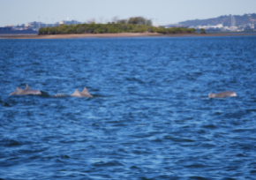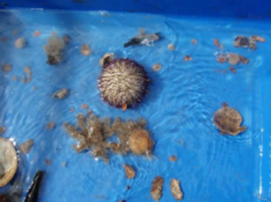
Figure 3-14: Indo-Pacific humpback dolphins observed in Port Curtis (GHD 2009d) and benthic sampling of epifauna in Gladstone (GHD 2009c)
The values considered to occur at the Port of Gladstone anchorage area is described in table 3-6 with regard to the MNES for which the Reef is protected, including the OUV of the Reef (as described in section 2). The anchorage area does not contain any significant geomorphic or physiographic features which are integral to the ongoing ecological functioning of the Reef. The anchorage area does not support unique features or habitats requiring a higher level of management protection, or important feeding or breeding habitat critical for the persistence of any protected species. The sensitive marine environments, as well as potential cultural, social or heritage values, for the Port of Gladstone anchorages (inner and outer) are conceptually depicted in figure 3-16.

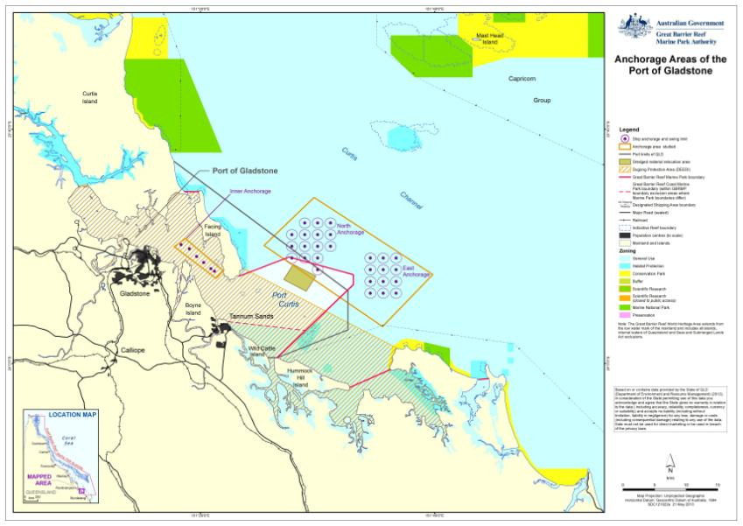
Figure 3-15: Anchorage areas of the Port of Gladstone

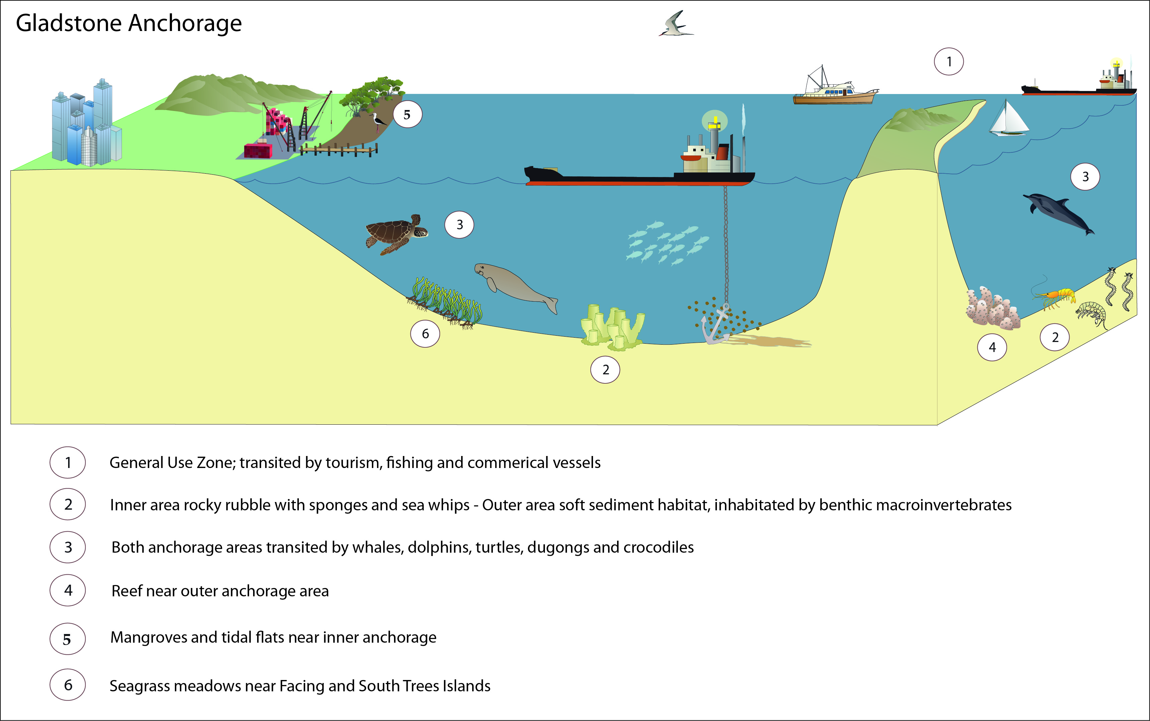
Figure 3-16: Conceptual visualisation of values of the Port of Gladstone anchorage area
Table 3-6: World Heritage Area values associated with the Port of Gladstone anchorage area
World Heritage Area values | OUV components of the Reef | Relevance to the Port of Gladstone anchorage area (inner and outer anchorage areas)
An outstanding example representing major stages of earth's history, including the record of life, significant on-going geological processes in the development of landforms, or significant geomorphic or physiographic features. | - Geomorphological evolution  - Reef building  - Sea level change  - Outer reef  - Beaches  - Continental slope | - The anchorage area does not contain any significant geomorphic or physiographic features which are integral to the ongoing ecological functioning of the Reef. The anchorage area supports open seabed habitat which provides for movement corridors and connectivity, however, these habitats are not unique within the anchorage areas and are well represented elsewhere across the World Heritage Area.  - The anchorage area is coastally proximate and can be affected by sea level change.  - The anchorage area does not contain significant extant or extinct coral communities, including outer reefs. The inner anchorage area of Gladstone does include rocky reef, however, this is not a significant feature of that region of the Reef and that habitat is well represented outside of the anchorage area elsewhere in the region.  - The anchorage area does not extend to beach areas and does not occur on the continental slope.
An outstanding example representing significant ongoing ecological and biological processes in the evolution and development of terrestrial, fresh water, coastal and marine ecosystems and communities of plants and animals. | - Physical process  - Connectivity  - Upwellings  - Continental Islands  - Halimeda banks  - Hard corals  - Island plants  - Aboriginal Sea Country | - Coastal (physical) processes associated with the formation of beaches are not affected by the use of the anchorage area.  - Upwellings are not known to occur within the anchorage area.  - No continental islands occur within the anchorage area.  - No significant Halimeda banks are known to occur within the anchorage area.  - The anchorage area is characterised by open seabed with patchily distributed benthic epifauna, macroalgae and in some locations seagrass meadows. The inner anchorage does include rocky reefs with sponges, and hard and soft corals. Species represented are not unique and are well represented locally in the geography outside of the anchorage area.  - Solitary hard corals are present within the anchorage area and the inner anchorage area supports some rocky reef habitat. Significant reef systems integral to the ecological functioning of the Reef are not a feature of the anchorage area.  - The anchorage area does not support unique features or habitats requiring a higher level of management protection, as reflected by the Marine Park General Use Zoning of the anchorage.  - No islands occur within the anchorage area and, therefore, no island plants are associated with the anchorage area. The anchorage area is, however, adjacent inshore coastal islands (Facing, Quoin and South Tree Island).  - Indigenous community links to the anchorage area has been recognised as being present. The anchorage area may support totem species (primarily dugong and marine turtles).
Contains superlative natural phenomena or areas of exceptional natural beauty and aesthetic importance. | - Water clarity  - Scenic vistas  - Visible from space  - Complex string of reef structures  - Unparalleled aerial panorama of seascapes  - Globally important breeding colonies of seabirds  - Over-wintering butterflies  - Coral diversity  - Reef fish  - Number of whales | - Marine waters within the anchorage area are subject to significant variation in clarity due to natural seasonal variability of conditions. The anchorage area is located coastally and subject to freshwater inundation, including from riverine outflows. This is reflected in the high prevalence of terrigenous and fine sediments (vs coralline sands).  - The anchorage area is located adjacent to residential centres, and in close proximity to land, providing opportunity for appreciation of the aesthetic beauty of the Reef. The scenic features surrounding the anchorage area could be considered remarkable, exceptional or unique in the context of the World Heritage Area listing, in terms of scenic vistas, when viewed from the air or sea.  - No natural features of the anchorage area are likely to be visible from space.  - Solitary hard corals are known to occur within the anchorage area and rocky reefs in the inner anchorage. No complex string of reef structures is present within the anchorage area although coral reefs occur in close proximity (Facing Island).  - The anchorage area does not contain any unparalleled aerial panoramas of seascapes. These are all adjacent coastal environments that already support residential and/or industry development and have, therefore, been previously modified from natural state.  - The anchorage area does not affect any globally important breeding colonies of seabirds or over-wintering butterflies.  - Sparsely distributed cnidarians occur within the anchorage area, and hard and soft corals in the inner anchorage. No significant reef complexes are present. The inner anchorage area of Gladstone does include rocky reef, however, this is not a significant feature of that region of the Reef and that habitat is well represented outside of the anchorage area elsewhere in the region. Reefs having higher coral diversity, including fringing reefs, do occur in close proximity (Facing Island).  - Whale migration is known to occur adjacent the anchorage area. Some coastal habitats adjacent from the anchorage area are also used by whales resting on migration. It is therefore possible that whales may use habitats within the anchorage area.
Contains the most important and significant natural habitats for in-situ conservation of biological diversity, including those containing threatened species of OUV from the point of view of science or conservation. | - Mangroves  - Sea snakes  - Coral genera  - Lagoon floor  - Dugong  - Inshore dolphins  - Humpback whales  - Loggerhead turtles  - Green turtles  - Seabirds  - Island plant species | - The seabed within the anchorage and surrounding area is comprised of open, soft bottom habitat with the exception of the inner anchorage, which supports rocky reef.  - Mangroves are not present within the anchorage area but do occur in adjacent coastal habitats.  - The anchorage area is known to be transited by whales, inshore dolphins, including the Australian snubfin and Indo-Pacific humpback dolphin, dugong and crocodiles, and the six species of turtle known to occur in the Reef. No habitat critical to the survival of these species’ is present within the anchorage area although the seabed environ of these areas is part of a matrix of important coastal habitats for these species and seagrass feeding habitat does occur at the anchorage area. Indirect impacts to such species transiting the anchorage area may occur (e.g. noise impacts resulting in displacement or altered behaviour from light impacts).  - As noted above, the anchorage area supports a low prevalence of inshore cnidarians and rocky reef, but not significant coral reefs. Coral reefs of higher diversity are adjacent the anchorage area (Facing Island).  - The anchorage area does not provide significant habitat value for seabird populations although they are likely accessed by seabirds for feeding or during transit.  - No islands occur within the anchorage area and, therefore, no island plants are associated with the anchorage area. The anchorage area is, however, adjacent inshore coastal islands.

Summary of existing environment across all port anchorages
All of the anchorage areas, with the exception of Abbot Point, are within close proximity to residential populations and are jointly utilised by various fishery sectors and tourism operators. Although seagrasses have only been recorded to characterise two of the locations, all of the anchorage areas are known to provide some habitat value to marine megafauna and fisheries species dependent on seagrasses. Accordingly use of the anchorages has the potential to both directly and indirectly affect megafauna, fisheries assemblages and those accessing these resources.
Coral reefs are not located within the anchorage areas but are environmental features of adjacent habitats at varying distances from the anchorage areas. Only the inner anchorage area at Port of Gladstone supports rocky reef habitat with all other anchorage areas located in open soft sediment habitats. Direct impacts to soft sediment habitats will occur from anchorage activities. Coral reefs have the potential to be indirectly affected from use of the anchorage areas.
None of the anchorage areas are known to support non-indigenous cultural values such as ship wrecks of heritage importance. All of the anchorage areas do, however, support values of relevance to Indigenous cultural heritage, including totem species (primarily dugong and marine turtles).
With regard to prescriptive values protected by the EPBC Act, none of the anchorage areas are known to support threatened ecological communities or listed plant species. All of the anchorage areas support a diversity of marine megafauna, shark and avifauna that are recognised to be either threatened or migratory species under the EPBC Act. A summary of those threatened and migratory species which are known, or may, occur at each of the anchorages is provided in Appendix A (DSEWPaC 2012b).
Studies to date, as summarised in sections 3.3 through 3.7 demonstrate there are a range of environmental, social, cultural and heritage values that are consistent to all five geographies which could be affected by anchorage area use. The relative effect of anchoring on each value differs between locations according to the prevalence of that value at that site, the frequency of anchoring behaviour (considered further in section 5) and the occurrence of any external influences on each value, such as seasonal inputs of freshwater or occurrence of cyclones.
None of the anchorage areas are considered to provide highly valued habitat or geomorphic features, habitat or features integral to the ongoing maintenance of ecosystem processes or core feeding or breeding habitat critical for the persistence of any protected species. Each of the anchorage areas are, however, part of a matrix of habitat and environmental features which supports the diversity for which the Reef is recognised.
Potential direct and indirect impacts that could occur from ship anchoring activities, and which can in turn affect the biodiversity of the anchorage area, are similar across the EPBC Act protected species discussed above, and may include:
- Temporary displacement from foraging habitat: damage or removal of seabed habitat, temporary shifts in baseline underwater noise levels and vibration
- Injury/mortality of fauna from ship strike
- Introduced marine pests and disease: internationally sourced vessels have the potential to introduce marine pest species through discharge of ballast water or biofouling of vessel hull surfaces.
How anchoring activities may impact upon these values has been considered in section 5.

Consultation in support of impact assessment

Consultation in support of the Strategic Assessment
As part of the Strategic Assessment the GBRMPA are undertaking consultation activities, in the form of stakeholder workshops. These events are providing opportunity for the views of stakeholders that use and have an interest in the Reef to inform the Strategic Assessment.
A series of workshops are being held across northern, central and southern districts of the World Heritage Area that will bring together information from stakeholders from a range of diverse backgrounds including:
- recreational users
- tour operators
- commercial fishers
- traditional owners
- researchers
- conservationists
- farmers
- councillors
- ports and shipping representatives.
The workshops have and will seek input from the stakeholders on what they value about the World Heritage Area, and their concerns regarding impacts on those values. The input obtained from the workshops will provide essential knowledge and information for the development of the Strategic Assessment.

Consultation in support of this project
This project is a targeted delivery being completed under the Strategic Assessment. It will leverage knowledge where feasible from the wider consultation being completed under the Strategic Assessment. However, there is also a need for this project to complete dedicated consultation in support of its objectives.
A large range of stakeholders hold valuable knowledge regarding the use, management and operation of anchorages associated with each of the five Queensland ports within the World Heritage Area. To provide opportunity to invest that knowledge to inform assessment of potential impacts associated with use of the anchorages, consultation will be completed during the delivery of this project. Stakeholders engaged in consultation prescriptively for this project include, but are not limited to:
- DSEWPaC
- GBRMPA
- port authorities
- the Association of Marine Park Tourism Operators
- Australian Maritime Safety Association
- Maritime Safety Queensland
- Transport and Main Roads.
To date, in support of this phase of work (refer section 1.3), a number of consultation activities have been completed. These include engagement with stakeholders during a number of industry meetings relating to the management of shipping within the World Heritage Area. To complement those events, a dedicated project specific workshop was also held in Townsville at the offices of the GBRMPA on 25 September 2012. The investment of all industry, government and public interest stakeholder groups into the project delivery is gratefully acknowledged.
That event enabled discussion with attendees on matters including key considerations and drivers for defining the location of anchorage areas associated with each major port. Discussion also considered the environmental, social and economic impacts participants considered were directly linked, or perceived to be linked, to anchorage area operation. Responses categorised as potential impacts to the environment outweighed those categorised as potential social or economic impacts associated with operation of the existing anchorage areas (figure 4-1).
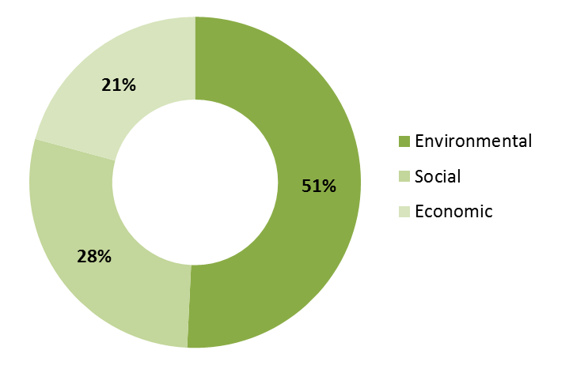
Figure 4-1: Distribution of responses regarding potential impacts across social, economic and environmental criteria
Across the criteria noted in figure 4-1 participants independently identified potential impacts that could result from anchorage area use. Participants were able to identify as many issues as they wished on the proviso each issue was linked to a potential. A total of 130 responses were received from participants in the workshop. As the task was completed by individuals independent of others a large number of responses were equivalent. Of the 130 responses, two identified impacts accounted for nearly 40 per cent of all impacts identified.
These two were:
- Impacts to the benthic environment from anchoring and associated ship behaviour such as chain drag or release of wastes and other pollutants while at anchor.
- Impacts on the aesthetic value of the World Heritage Area (as viewed from land) as a result of vessels sitting at anchor or undertaking other supply chain activities.
Across all other responses were described by the following issues:
- ship safety
- influence on other users of the marine park
- marine pests
- pollution other than that from wastes released at anchor
- efficient and effective management of anchorages, port operations and the Marine Park.
The latter point reflected discussion around the balance needed between all relevant sectors for sustainable use of the environmental, social, cultural and heritage assets of the World Heritage Area. It was noted during the workshop that anchorage areas are General Use Zones that are accessible by all users of the Marine Park but that some users may be displaced depending on the arrangement of the anchorage and utilisation by vessels at anchor.
Information discussed during the workshop has been used to inform potential impacts from anchorage operation, which is considered in section 5. It is acknowledged, however, that as consultation and further investigation occurs during the course of delivering the remaining scopes for this project, information provided herein may not reflect the final assessment.
As Traditional Owners were unable to be consulted during the this phase of work complete understanding of the cultural value of the sea country associated with the anchorage areas is acknowledged to be a knowledge gap of the project.
Content from this and remaining work phases will be synthesised into a complete summary of the project once all work phases are complete. Where relevant information presented here will be cross linked to that discovered at later phases in the project. Inclusion of all content as developed during the project in the synthesis report is relevant to demonstrate the development of information.

Impact Assessment

Assessment methodology
The risks and consequences of any impacts being realised on the values of the World Heritage Area from ship anchorage has been assessed using the GBRMPA Environmental Assessment and Management (EAM) Risk Management Framework (GBRMPA 2009b). This applies a risk-based assessment which considers the source of each environmental risk, the potential consequences of that risk occurring and the likelihood that identified consequences will be realised. This approach is consistent with the Australian and New Zealand Standard for Risk Management (AS/NZS ISO 31000:2009).
Risk analysis may be undertaken to various degrees of refinement depending upon the risk information and data available. Analysis techniques include:
- qualitative assessment
- semi-quantitative assessment
- quantitative assessment.
In practice, a qualitative analysis is often used to first obtain a general indication of the level of risk and then a more quantitative analysis is applied to refine the risk.
A quantitative risk assessment can be undertaken based on statistical analysis for various consequences and probabilities. In the absence of statistical data, an estimate may be made on the degree of the consequence and frequency.
Environmental risk essentially considers the risk of irreversible change to natural ecological processes and community interaction. The approach takes account of the:
- influence of direct and indirect actions on values
- spatial and temporal nature of any impacting action
- resilience of a system to any impacting action, including its ability to adapt, resist or recover from any impact.
The risk assessment methodology used here is a mixed model, applying a semi-quantitative process for determining risk. The process followed in completing this risk assessment is defined in the GBRMPA EAM Risk Management Framework (GBRMPA 2009b). The semi-quantitative process estimates the severity of the consequence and likelihood of impacts and assigns a score to each. The assigned scores for consequence and likelihood are not linearly related to each other, or to the level of environmental impact, but are weighted descriptors.
It is not possible to directly compare the impacts from a diverse range of project aspects (for example, comparing air quality impacts with water quality impacts). As such, relative consequences have been judged according to different criteria. The GBRMPA EAM Risk Management Framework (GBRMPA 2009b) provides a Hazard Risk Calculator which provides scales that are able to be used for assessing likelihood and consequence of any risk to the environment being realised. A full description of the Hazard Risk Calculator is provided by GBRMPA (2009b). The definitions used here to assess relative consequences are provided in table 5-1 through to table 5-4. An important feature of the GBRMPA EAM Risk Management Framework is that risks are analysed in the context of existing controls being in place.
In completing this risk assessment consideration has been given to whether any actions associated with use of the vessel anchorages result in significant impacts upon the values of the anchorage areas. This is achieved by giving consideration to relevant Significant Impact Guidelines criteria (DSEWPaC 2009). These criteria define the actions that lead to significant impact upon listed threatened or migratory species or communities. Those criteria are provided in detail in Appendix B. In summary, the Significant Impact Guidelines criteria provide guiding principles against which assessment can ascertain whether the values for which a protected matter was recognised are materially altered by any potentially impacting action.
A significant impact upon a protected matter would be considered to occur if:
- the value for which the protected matter was recognised was lost, degraded or damaged to be notably altered or diminished by an impact
- important populations of protected species were interfered with to the extent that the species distributional range was reduced or the species ability to persist as a recognised population with resilient genetic diversity was reduced
- habitat critical to the survival of a protected species for breeding, roosting, foraging or ecological functioning was interfered with such that the species was detrimentally affected.
Following identification of potential impacts and consequences, the probability of occurrence was estimated and an assessment of the likelihood of the consequences of an event occurring is undertaken. Table 5-2 indicates the likelihood ratings used.

Table 5-1: Scale of consequences of impact (GBRMPA 2009b)
 | Insignificant | Minor | Moderate | Major | Catastrophic
Environment – Ecosystem | No impact or, if impact is present, then not to an extent that would draw concern from a reasonable person.  No impact on the overall condition of the ecosystem. | Impact is present but not to the extent that it would impair the overall condition of the ecosystem, sensitive population or community in the long-term. | Impact is present at either a local or wider level.  Recovery periods of 5-10 years anticipated. | Impact is significant at either a local or wider level or to a sensitive population or community.  Recovery periods of 10-20 years are likely. | Impact is clearly affecting the nature of the ecosystem over a wide area  OR impact is catastrophic and possibly irreversible over a small area or to a sensitive population or community  Recovery periods of greater than 20 years likely  OR condition of an affected part of the ecosystem irretrievably compromised.
Environmental Perception | No media attention. | Individual complaints. | Negative regional media attention and regional group campaign. | Negative national media attention and national campaign. | Negative and extensive national media attention and national campaigns.

Table 5-2: Likelihood of impact (GBRMPA 2009b)
Description | Frequency | Probability
Almost certain | Expected to occur more or less continuously throughout a year (e.g. more than 250 days per year) | 95-100% chance of occurring
Likely | Expected to occur once or many times in a year (e.g. one to 250 days per year) | 71-95% chance of occurring
Possible | Expected to occur once or more in the period of one to 10 years | 31-70% chance of occurring
Unlikely | Expected to occur once or more in the period of 10 to 100 years | 5-30% chance of occurring
Rare | Expected to occur once or more over a timeframe greater than 100 years | 0-5% chance of occurring

A five-scale qualitative description of the likelihood and consequences for each risk enables a semi-quantitative method to be used to calculate a ‘grade’ for each risk.
The Hazard Risk Grade (HRG) is a uniform method used to grade hazards against one another and determine a priority order for dealing with the risks identified (table 5-3). HRG is calculated according to the equation:
HRG = Likelihood Rating X Consequence Rating
Table 5-3: Hazard risk grade matrix (GBRMPA 2009b)
Likelihood | Consequence Rating
Likelihood | Insignificant | Minor | Moderate | Major | Catastrophic
Almost certain | Medium | Medium | High | Extreme | Extreme
Likely | Medium | Medium | High | High | Extreme
Possible | Low | Medium | High | High | Extreme
Unlikely | Low | Low | Medium | Medium | High
Rare | Low | Low | Medium | Medium | Medium

Table 5-4: Acceptability of risk (GBRMPA 2009b)
Grade | Risk Mitigation Actions
L | LOW: These risks should be recorded, monitored and controlled by the responsible manager. Activities with unmitigated Environment, Health and Safety risks that are graded above this level should be avoided.
M | MEDIUM: Mitigation actions to reduce the likelihood and consequences to be identified and appropriate actions (if possible) to be identified endorsed by Director\Manager level.
H | HIGH: If uncontrolled, a risk event at this level may have a significant impact on the operation of a business unit or the GBRMPA as a whole. Mitigating actions need to be very reliable and should be approved and monitored in an ongoing manner by the General Manager.
E | EXTREME: Activities and projects with unmitigated risks at this level should be avoided or terminated. This is because risk events graded at this level have the potential to cause serious and ongoing damage to the organisation, the community or the environment. Reporting emerging or continuing risks exposures at this level to the General Manager. The Chairman should be advised of identified or emerging strategic risks which have been graded at this level.

Following the analysis of severity of a risk, it is necessary to determine the acceptability of the risk and then determine the option or options that provide the greatest cost benefit (table 5-4). Risks may be treated in one or a combination of ways:
- Avoiding a risk by preventing the activity that leads to the risk eventuating
- Reducing the likelihood of the risk eventuating
- Reducing the consequences if the risk does eventuate
- Transferring the risk
- Retaining the risk.
Those matters that are deemed to have all relevant controls or treatments applied are provided a risk ranking of ‘As Low As Reasonably Practicable’ (ALARP). Impacts resulting from risks may be managed to mitigate the environmental affect, or offset to realise no net loss of environmental values.
Review of recent anchoring activity (to September 2012) for vessels greater than 50 m in length identifies differences across the five ports (figure 5-1). Gladstone and Hay Point have a higher frequency of anchorage use than Abbot Point and Cairns, however, anchorages across all ports are used throughout the year. Locations such as Townsville may have one or two vessels anchored at any one time (Frank D’Souza (MSQ), pers. comm., 25 September 2012). This contrasts with Hay Point where as many as 60 vessels may be anchored at any one time (Graham Rawlings (North Queensland Bulk Ports Corporation (NQBP)), pers. comm., 16 October 2012). Gladstone has a high level of anchorage use but fewer anchorage sites than Hay Point.
Demand for anchorage use across each port changes during the year. This demand is influenced by many factors including market demand for the commodity being exported and is not able to be quantified at this time. Hence, for impact assessment a reasonable scenario that any of the port anchorages may be used at any time of the year has been applied. Any vessel at anchor across the five ports may give rise to any of the impacts identified and likelihood of an impact occurring is determined with consideration to the chance (or likelihood) that an impact may eventuate from a vessel at anchor.
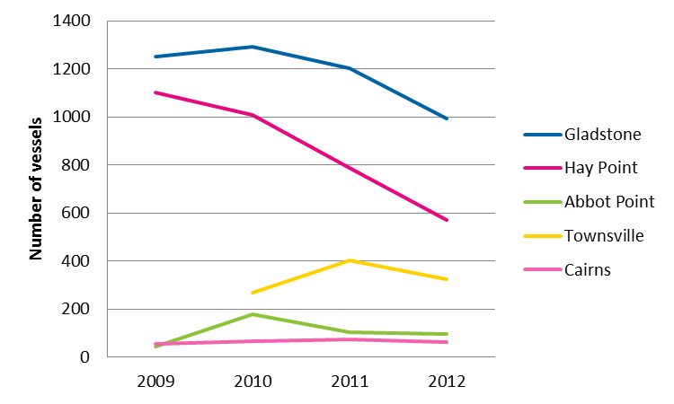
Figure 5-1: Anchorage activity by port from 2009 to September 2012. Data provided by MSQ for vessels greater than 50 m in length.
The five ports investigated in this report are considered mainly export ports, indicating that vessels arriving to service these ports are empty. Therefore, risks relating to potential impacts from grounding or collision do not take into account different cargo types that may be carried by vessels visiting different ports. These risks are considered equivalent across the ports.

Actual and potential impacts
Vessels arriving at any of the five major ports within the World Heritage Area may gain immediate access to the port upon arrival or they may be required to stay at anchor offshore of the port until berth access becomes available. The action of anchoring, and the presence of vessels at anchor within the World Heritage Area, has potential to realise a number of impacts on the values of the World Heritage Area.
Various studies from around the globe have considered how anchoring may influence seabed conditions. These have examined impacts on habitats including, but not limited to:
- seagrass meadows and algae (Walker et al. 1989, Francour et al. 1999, Ceccherelli et al. 2007, Ostendorp et al. 2009)
- rubble and coral reefs (Davis 1977, Glynn 1994, Rogers and Garrison 2001, Fava et al. 2009, Burgin and Hardimann 2011)
- soft sediment macro-invertebrate assemblages (Backhurst and Cole 2000, Ostendorp et al. 2009).
Research has, however, principally examined the role recreational and tourist vessels have on seabed biodiversity as a result of repeated anchoring. Studies have also examined the efficacy of different management strategies for anchor damage reduction, such as the application of recreational vessel moorings (e.g. refer Walker et al. 1989 and Ostendorp et al. 2009). These studies provide a foundation of knowledge of the potential impacts that can be realised from commercial vessel anchoring in the World Heritage Area.
Concerns were raised during the consultation period regarding the interaction between anchored vessels and commercial fishing activities, typically trawling because of the risk of collision and fishing gear becoming entangled with anchored vessels. Safety is also of concern in areas where vessels have previously anchored due to possible changes in bathymetry which compromise the safe and optimal operation of trawl equipment. There are also safety concerns for maritime users where the perceived safe operating distance around anchored ships is greater than the direct physical dimensions and the swing distance of an anchored ship. These and other social concern matters have also informed impact assessment.
Values that could be affected that are known to occur within the anchorage areas are described under section 2 and section 3 and include a range of seabed and pelagic biodiversity, aesthetic value of the World Heritage Area and ability of other users to access the resources and environment of the anchorage areas.
To achieve anchorage, vessels drop their anchor and chain onto the seabed at a location designated by the RHM. During stay at anchor, vessels will run navigational lights for safety and may undertake maintenance. Consultation (refer section 4) has confirmed that bunkering is an infrequent activity for vessels accessing the five major ports within the World Heritage Area, however, low levels of bunkering may occur in Cairns, Townsville or Gladstone. It is most likely to occur at berth rather than at anchor.
As such, all vessels using existing anchorage areas across all ports have potential to:
- Directly affect seabed topography and biodiversity from anchor drop and chain drag.
- Directly or indirectly affect water, air and sediment quality from release of emissions, pollution or wastes either from the vessel itself associated with running the vessel at anchor, as accidental release of contaminated bilge or ballast water, during bunkering if it were to occur or from anchor or chain disturbance of seabed sediments if contaminants were bound within them.
- Alter the vista of the Reef; during the day vessels are visible offshore at anchor and at night running lights maintain that visibility to coastal districts and other users of the Marine Park.
- Influence the use of the anchorage area by others. For instance, access to fisheries resources may be affected if fishers have to navigate around anchored vessels.
- Introduce marine pests if present on vessels at anchor as biofouling, within ballast water chambers, sea chests or internal seawater cooling systems.
- Alter the behaviour of animals using the area. For instance, different species may be attracted to anchored vessels at night due to light spill. Other species may be displaced from the area if affected by engine noise. Vessels arriving at anchor or departing may contact fauna (e.g. whales) if they are present in the area.
The above impacts are relevant to all five port anchorages areas and the matters (defined following) that support the OUV of the Reef (table 5-5). These potential impacts are conceptually presented in figure 5-2. All of these actions may have an impact on the value of the environment within the anchorage areas under current and future shipping activity within the World Heritage Area. The prescriptive environmental, socio-economic costs and benefits of ship anchoring under increased shipping movement scenarios is considered in phase 2 of this project (section 1.3). With regard to current use the potential risks to all five ports associated with each impact type are considered in more detail following.
They also have the potential to impact upon the following matters that support the OUV of the Reef:
- Outstanding example representing a major stage of the earth’s evolutionary history given the Reef is the largest single collection of coral reefs in the world.
- Outstanding example representing significant ongoing geological processes, biological evolution and man’s interaction with his natural environment given the Reef represents a mature system which has been in existence for millions of years.
- Containing unique, rare and superlative natural phenomena, formations and features and areas of exceptional natural beauty.
- Providing habitats where populations of rare and endangered species of plants and animals survive.
These numerated categories, and the values that support each category (defined in table 3-2 to table 3-6) have been referenced in following sections and in completing the HRG to consider how each of these values may be influenced by each of the impacts described following.

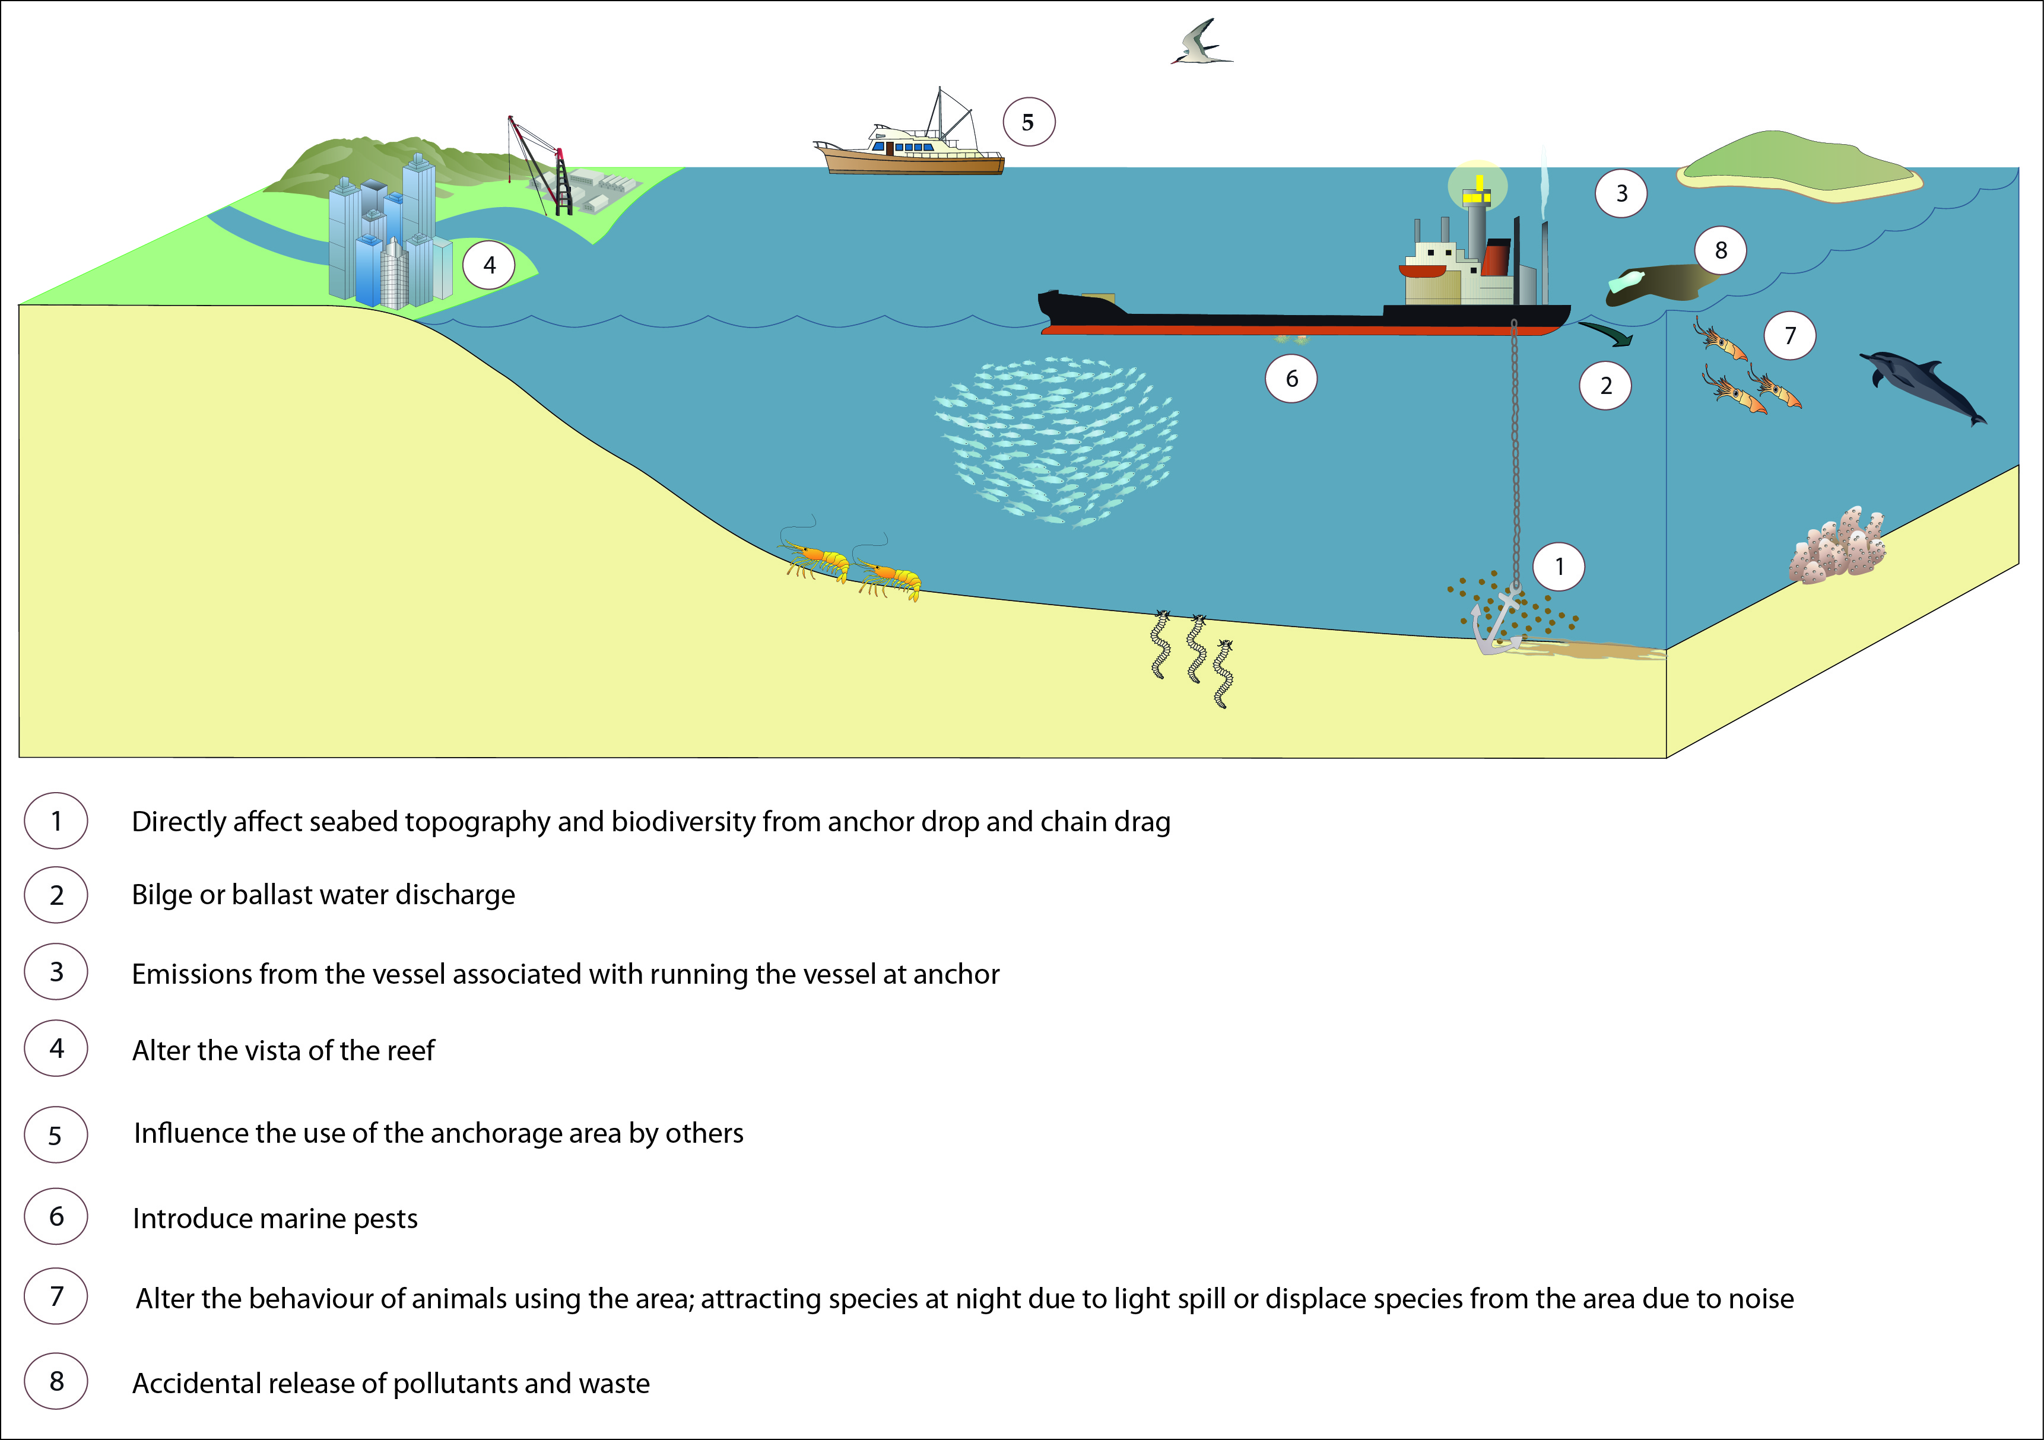
Figure 5-2: Conceptual visualisation of potential impacts from anchorage use

Table 5-5: Potential impacts and OUV that may have an impact on the value of the environment at each of the five port anchorage areas
Impact | OUV | Cairns | Townsville | Abbot Point | Hay Point | Gladstone  Inner | Gladstone  Outer
Disturbance to seabed and supported biodiversity:  Directly affect seabed topography and biodiversity from anchor drop and chain drag | 2, 3, 4 | Open soft sediment habitat, low diversity  Low potential for impact | Open soft sediment habitat, low diversity  Low potential for impact | Open soft sediment habitat, low diversity  Low potential for impact | Open soft sediment habitat, low diversity  Low potential for impact | Rocky reefal habitat, moderate diversity  Moderate potential for impact | Open soft sediment habitat, low diversity  Low potential for impact
Release of emissions or pollutants/wastes:  Directly or indirectly affect water, air and sediment quality from release of emissions, pollution or wastes either from the vessel itself associated with running the vessel at anchor | 2, 3 | Low frequency of anchorage use  Low potential for impact | Low frequency of anchorage use  Low potential for impact | Low frequency of anchorage use  Low potential for impact | High frequency of anchorage use  High potential for impact | Moderate frequency of anchorage use  Moderate potential for impact | Moderate frequency of anchorage use  Moderate potential for impact
Altered aesthetic value:  Alter the vista of the Reef; during the day vessels are visible offshore at anchor and at night running lights maintain that visibility to coastal districts and other users of the Marine Park | 3 | Anchorage within 2 km of Yarrabah Aboriginal community  High potential for impact | Anchorage within 2 km of Magnetic Island  High potential for impact | Anchorage approximately 30 km from Bowen  Low potential for impact | Anchorage <10 km from Sarina  Moderate potential for impact | Anchorage within 2 km of Gladstone  High potential for impact | Anchorage approximately 20 km from Gladstone  Low potential for impact
Interference with access to resources:  Access to fisheries resources may be affected if fishers have to navigate around anchored vessels | 2, 3 | Currently concern for impact is low | Currently concern for impact is low | Currently concern for impact is low | Potential navigational impacts currently exist | Potential navigational impacts of minor concern currently exist | Currently concern for impact is low
Marine pest introduction:  Introduce marine pests if present on vessels at anchor as biofouling, within ballast water chambers, sea chests or internal seawater cooling systems | 2, 4 | Low frequency of anchorage use  Low potential for introduction | Low frequency of anchorage use  Low potential for introduction | Low frequency of anchorage use  Low potential for introduction | High frequency of anchorage use  High potential for introduction | Moderate frequency of anchorage use  Moderate potential for introduction | Moderate frequency of anchorage use  Moderate potential for introduction
Interference with species behaviour:  Species may be attracted to anchored vessels at night due to light spill, other species may be displaced from the area if affected by engine noise, and vessels arriving at anchor or departing may contact fauna (e.g. whales) if they are present in the area | 2, 3, 4 | Anchorage adjacent to species habitat  Low potential for impact | Anchorage overlaps with species habitat  Moderate potential for impact | Anchorage overlaps with species habitat  Moderate potential for impact | Anchorage overlaps with species habitat  High potential for impact | Anchorage adjacent species habitat  Moderate potential for impact | Anchorage adjacent species habitat  Moderate potential for impact

Disturbance to seabed and supported biodiversity
Direct impacts from disturbance to the seabed and its supported biodiversity have the potential to occur at all five port anchorage areas (table 5-5). All anchorage areas, except the inner anchorage area of Gladstone, can be described as deepwater open soft seabed systems. These habitats are characterised by sparsely distributed patches of epibenthic fauna. The inner anchorage area of Gladstone supports some rocky reef habitat, but this is not unique to the anchorage area and is well represented in adjacent environs. None of the anchorage areas support reefal systems. Only the anchorage areas of Hay Point and offshore of Gladstone are recognised to support seagrasses, however, algal assemblages may occur in patchy distribution across all anchorage areas.
Anchor and chain damage may create furrows or divots across the seabed as a result of anchor and chain drag. This may remove any biota in the pathway of the chain and anchor, and the resultant altered topography has ability to influence further recruitment. Impacts could be realised as a vessel is dropping anchor, at anchor due to chain swing or if a ship dragged and eventually broke anchor. Severe impacts to seabed biodiversity would occur from ship grounding which could occur within or adjacent an anchorage if vessels within the anchorage area collided or if a vessel broke anchor. Such impacts would be considered to be rare with safe vessel navigational management actively controlling this risk. Impacts from anchor drop and chain drag are, however, chronic. Given the existing open seabed habitat and patchy distribution of the anchorage areas this influence on these systems is not predicted to fragment any biodiversity nor is it predicted to alter the value of these areas negatively. Small turbidity plumes created during anchor drop and from chain movements are unlikely to be detectably different from changes in water quality due to wave disturbance across these open seabed environs.
The types of assemblages known to occur within the anchorage areas (solitary cnidarians, burrowing anemones, occasional sponges) are sparsely distributed and typically transient in nature being affected periodically by natural disturbances (Dayton 1971, Sousa 1984, Connell and Keough 1985, McGuinness 1987a, b). Studies to date (e.g. Rasheed et al. 2003, GHD 2012a) and others noted in section 3) have demonstrated that the seabed biota associated with anchorage areas does not differ from that in adjacent habitats where anchoring does not occur. This finding is supported by a recent study, investigating potential impacts of ship anchoring on the seafloor biota in the existing Hay Point anchorage area (refer WorleyParsons 2012). Results to date indicate that none of the anchorage related impacts on the seabed or associated water column are of sufficient influence to alter the patterns of species composition or distribution such that they are detectably different between areas used for anchorage and those that are not. All anchorages except the inner Gladstone anchorage are located in open soft seabed conditions similar to that described for Hay Point. The effects of anchoring across all ports (except Gladstone inner area) are, therefore, predicted to be as described by findings from Hay Point, with effects on the seabed related to anchorage unable to be readily discerned and are considered to have a low potential of impacting the habitat.
As described in section 3.7 the inner anchorage of Gladstone is characterised as a rocky reef supporting sponges, bryozoans and gorgonians. This diversity has been recorded irrespective of anchoring activity occurring at the site, demonstrating persistence of these fauna under the disturbance that results from anchoring activity. It is, therefore, considered that diversity at this site is not currently being adversely affected by anchoring although there is a moderate potential to impact upon this diversity. With regard to identifying the potential HRG for this impact, current data suggest that while impacts from anchoring may occur these do not impair the overall condition of the ecosystem in the long term. This impacts is, therefore, categorised to be of minor consequence (refer table 5-1). However, disturbance to the seabed from anchoring activity is almost certainly occurring. The resultant risk to the biodiversity values of the seabed areas from anchoring activity are, therefore, considered to be of medium risk (refer table 5-6).
Any opportunity to expand areas used for anchoring or to relocate anchorage areas should, however, take into account the potential influences increased levels of disturbance may have and complete relevant assessments to select areas at low risk of being affected by anchoring activities. To avoid cumulative loss of seabed habitat consideration should be given to managing anchorages within as small an area as feasible for safe operation of the anchorage.

Release of emissions or pollutants/wastes
All five ports have the potential to be impacted by the release of emissions or pollutants/wastes either directly or indirectly (table 5-5), and these are presented following. The level of vessel visitation to each of the anchorages influences the impact potential across each of the ports.
As discussed in section 5.2, all five ports are predominately export ports, as such, the vessels servicing these ports and utilising the associated anchorage areas are generally without cargo. Different cargo types (e.g. coal versus produce) are therefore considered a non-differentiator in this analysis of potential impacts from pollutants and wastes, and all risks posed by vessels apply the same across the five ports.
Air emissions
Vessels at anchor will release emissions associated with the combustion of carbon-based liquid fuels including marine diesel oil and heavy fuel. Typically this is in relation to operation of auxiliary engines from which the vessel draws power (vs propulsion). Management of air emissions from ships continues to have a profile in the international shipping sector; the global nature of the shipping fleet maintains the global profile of this issue.
Emissions generated by vessels can impact the air quality of the local environment and may have flow on affects to wider geographies, including onshore communities. The IMO is the United Nations specialised agency with responsibility for the safety and security of shipping and the prevention of marine pollution by ships. The IMO continues to influence the shipping industry to evolve technological solutions towards the reduction of ship emissions. Consideration is being given to application of different fuels or renewable energy technologies to ameliorate emissions release. The global shipping fleet adoption of any emerging technologies indicated by the IMO as relevant for managing environmental impacts will occur as those technologies become available.
Goldsworthy and Galbally (2011) provide a review of relevant issues for Australian waters and note that there is limited knowledge about the influences of ship based emissions on both coastal and urban regions for Australian ports. The authors also note that there has been no attempt to control ship emissions in Australia beyond the global requirements identified under IMO regulations and that the necessity for such has not been examined.
With regard to potential impacts from ships at anchor off each of the five major ports within the World Heritage Area, all vessels using these areas would be required to adhere to IMO regulations governing emissions releases. As technological improvements achieve better controls over these emissions the likely risk to the environment from emissions will decrease.
The majority of anchorages are located at distance from residential populations and, given current management regimes, potential consequence for impacts is considered to be minor. Although, as releases occur year round, the resultant risk to the environment from pollution release under current controls is considered to be of medium risk (refer table 5-6). Consideration to proximity to sensitive receptors should, however, be given if expansion of relocation of anchorage areas is proposed.
Pollutants/wastes
Pollution releases can occur across minor (small, chronic releases on an ongoing basis) or as a result of a single large scale release, such as an oil spill or due to a ship grounding. Individual small scale releases may not be detectable but may accumulate over time to impact upon the environment. This can include if contaminants are bound within sediments and disturbed by anchoring activity. The types of pollutants or wastes that may be released from vessels on a small or large scale considered here include:
- fuels, oils, polycyclic aromatic hydrocarbons
- metals (such as tributyle tin, copper or other compounds associated with antifoulant)
- rubbish
- refuse
- sewage
- waste of any kind, including galley waste, waste water or liquid waste.
Single large scale releases may realise a significant impact both at a spatial and temporal scale, covering a broad area and taking years to clean up. Accidental release may occur while a ship is at anchor or if a ship were to break anchor. Pollution impacts can also be realised if a navigational accident, including collision, were to occur. Under a worst case scenario a major pollution spill could include widespread impact to the World Heritage Area.
A range of international legislation governs the release of all pollutants from ships across all scales. The conventions which Australia has adopted, formulated by the IMO, deal with ship related marine pollution include (but are not limited to):
- International Convention on the Control of Harmful Anti-Fouling Systems on Ships 2001
- International Convention on Civil Liability for Bunker Oil Pollution Damage 2001
- International Convention for the Prevention of Pollution from Ships (MARPOL)
- International Convention on Oil Pollution Preparedness, Response and Cooperation 1990.
These conventions provide measures that seek to control the risk of pollution being released from ship operation. In particular, MARPOL is recognised to be the most comprehensive initiative to regulate and minimise pollution from ships. By defining pollutants, MARPOL specifies prohibitions, restrictions and conditions for discharges at sea. MARPOL is given effect in Australia by the Commonwealth Protection of the Sea (Prevention of Pollution from Ships) Act 1983 and the Navigation Act 1912, and complementary State and Northern Territory legislation. MARPOL is continually being amended to provide the most current and relevant protection to environmental values.
The Reef is recognised to be a “PSSA” and protective measures in addition to MARPOL for pollution management apply within this area. Compulsory pilotage in certain sections of the World Heritage Area and a ship reporting system were protective measures introduced on sections of the Reef in October 1991. These controlling provisions reduce risk of grounding or collision and, therefore, provide improved opportunity to manage risk of pollution release.
All vessels using the anchorage areas in Queensland, including during navigation to and from these areas, are required to comply with Australian MARPOL legislation for the Reef. Regional Harbour Masters, in conjunction with MSQ, provide direction to ships within their region with regard to safe operation, including requirement to evacuate anchor if deemed necessary, such as in the event of a cyclone or severe storm threat.
Given current management regimes, potential consequence for impacts to be realised from minor releases is considered to be minor as individual releases may not have a detectable affect. It is almost certain, however, that undetected releases of small waste materials occur year round within the World Heritage Area. A recent report by Wilson (2011) identified that, in Gladstone, the commercial shipping and fishing/boating sectors accounted for more than double the land based sources of debris. This finding has informed the assessment completed herein and guided identification of relevant management options. Given the minor release of different types of minor pollutants/wastes is almost certainly occurring, this impact is considered to pose a medium risk to the environmental, social, cultural and heritage values of the anchorage areas (table 5-6).
Although controls are in place, the potential consequence of a large scale pollutant release would be considered to be catastrophic as the system may be irreversibly affected. These events are rare within the World Heritage Area (GBRMPA 2006) under current controls and this threat is considered to also pose a medium risk to the values of the anchorage areas (table 5-6).
Maintaining anchorage areas within the coastal district provides ability to respond rapidly if any pollutant releases occur. Moving anchorage areas away from the coast would increase the response time to any pollutant release and could, therefore, increase the relative impact from any such event. Concentrating anchorages within the smallest footprint safe for anchorage management restricts the expanse of the Reef exposed to pollutant risk and enables period audit that management measures are being effective.

Altered aesthetic value
As identified in table 5-5 all five port anchorage areas have the potential to alter the aesthetic value of the World Heritage Area and Reef. The distance of each anchorage from viewpoints on land and the level of vessel visitation influence the impact potential across each of the ports.
With the exception of Abbot Point, the anchorage areas are visible to residents and tourists both during the daytime and at night. A recent Cumulative Impact Assessment for Abbot Point noted that location does not encompass areas of exceptional natural beauty and is an existing industrial port (Eco logical Australia and Open Lines 2012). Similar detailed technical assessments have not been completed for the ports that have nearby residents. A review of environmental implications of shipping across the Great Barrier Reef was, however, developed in support of the Cumulative Impact Assessment. That study concluded that “current and forecast shipping activities (including anchorage) are not seen to pose an unmanageable or unacceptable risk to the Reef or its natural and World Heritage values” (PGM 2012). Whether the use of anchorages creates an impact to the vista of the reef is subjective. The presence of anchored vessels has potential to detract from the natural state of the vista. This is reflected by comments from the public to the GBRMPA (R. Gilbert (GBRMPA), pers. comm., 25 September 2012).
There is, however, a lack of knowledge regarding how the presence of ships at anchor affects the aesthetics of the World Heritage Area and whether or not impacts are consistent across all of the five port anchorage areas. Studies examining impacts from anchorages have typically focussed on biodiversity values (refer 5.2.1). Recent studies that have considered potential aesthetic impacts on the World Heritage Area have been completed as part of Environmental Impact Statements associated with coastal developments in Queensland. These have, however, principally focussed on the potential effect of proposed developments on the scenic vistas of coastal districts versus the panorama of the ocean and horizon.
The uncertainty regarding aesthetic impacts has been incorporated into the risk assessment and underpins the rating of this issue as a high risk. This matter is therefore considered to be of a moderate consequence and has a high risk of continuing to affect the values of the Reef across all of the anchorage areas.
Additional phases of work to be completed (as described under section 1.3) will include socio-economic Cost Benefit Analysis (CBA) of anchorage management. It is expected that consultation during those additional studies will provide additional information to inform this issue.

Interference with access to resources
A high density of vessels at anchor can interfere with another user’s ability to effectively use that area. Anchorages are naturally positioned offshore of operational port environments and adjacent shipping channels for ease of port access. These areas also support residential and tourist centres that also seek access the reef environment through use of the shipping channels and surrounding habitat. This offers potential opportunity for conflict of use of the marine environment, particularly with the marine tourism and fisheries sectors. Both marine tourism and the fishery sector may seek access to the same resources occupied by the ship anchorage areas. All of the anchorage areas have the potential to impact or interfere with access to resources (table 5-5), although the location and frequency of use of the anchorage area influence the impact potential across each of the ports.
Tourism provides a significant economic revenue base for Queensland’s economy. Reef based tourism provides opportunity for international and domestic visitation to the World Heritage Area and plays an important role in facilitating appreciation of the Reef’s values in support of their protection.
Consultation to date across management and operational sector representatives (refer section 4) indicates tourism vessels are not detrimentally affected in their passage to the Reef by vessels using the anchorages. These vessels navigate via the shipping channels past the anchorage areas to the offshore reef systems. Tourists onboard these vessels may, however, be influenced by the presence of vessels at anchor during their journey.
Fishing has previously been considered to be the fifth largest commercial industry by value in Queensland (CRC Reef 2001) and this industry continues to provide substantive inputs to our economy (OESR 2012). Recreational fishing and boating is also a popular pastime for residents of Cairns, Townsville, Mackay (near Hay Point) and Gladstone (Blackman 2010). All of the anchorage areas under assessment support some level of commercial and/or recreational fishery activity with targeted catch being species sourced principally through trawl and line activities.
It is more likely that conflict of use could exist between the fishing sector and the commercial shipping sector. Trawl or line fishers targeting prawns or mackerel schooling across anchorages could be required to navigate around vessels at anchor. If density of anchorage was high within a valued fishing ground this could restrict access to fisheries resources. Vessels at anchor may also affect the experience of fishers undertaking recreational activity. Although catch is reported from anchorage areas, the relative contribution of this catch to the overall fishery is unclear.
Both the tourism and fishery sectors are currently operating without identifiable conflict with the existing anchorage areas and, as such if any impacts are present they do not appear to be impairing these existing operations in the long-term. While it is almost certain that the presence of vessels at anchor alters the behaviour of other potential users of the Marine Park, the consequence of this is considered minor. The preclusion of other users is, therefore, considered to pose a medium risk to the values which the anchorage areas are recognised for (refer table 5-6).

Marine pest introduction
The introduction of marine pests is a potential impact that could occur at each of the five port anchorage areas (table 5-5). The frequency of vessel visitation influences the impact potential across each of the ports.
Introduced marine pests, if present, on vessels at anchor as biofouling, within ballast water, ballast chambers, sea chests or internal seawater cooling systems have the potential to be introduced to the anchorage areas. This may occur if a pest species is knocked from the hull or anchor/chain during deployment of the anchor and chain, or as a result of release while a vessel is at anchor. Introduced marine pest species can cause widespread harm to the environment and the industries dependent on the ecosystem services of a system.
A range of international and Commonwealth legislation provides management measures for the risk of translocating marine pest species in either ballast water or as biofouling. Key legislative instruments currently include the IMO 'International Convention for the Control and Management of Ships' Ballast Water and Sediments 2004' and the Australian Commonwealth Quarantine Act 1908. Australia is, however, in the process of revising current legislative controls in relation to biosecurity management. The IMO Convention is not yet in force, however, is predicted to be ratified in the near future.
A proposed new Commonwealth Biosecurity Act is to be supported by two new Bills; the Biosecurity Bill and the Inspector General of Biosecurity Bill. The provisions in the Biosecurity provide broadly the same control measures as those currently identified under the Quarantine Act 1908 with regard to marine pest biosecurity management. The legislative reforms are proposed to provide greater support to prevention and early intervention actions. They also identify the requirements Australia will apply to management of ballast water risks in accordance with the IMO Convention.
Currently all internationally plying vessels intending to discharge ballast water anywhere inside the Australian territorial sea are required to manage their ballast water in accordance with mandatory requirements. These requirements identify that internationally sourced ballast water at high-risk of introducing marine pests must be exchanged at sea by an approved method (e.g. tank flow through). Under new provisions this restriction will remain. An alternative management option will, however, be included which provides opportunity for vessels to apply ballast water treatment systems (instead of ballast exchange) to manage biosecurity risk.
The IMO Marine Environment Protection Committee recently released voluntary guidelines to minimise the transfer of invasive aquatic species by ships’ biofouling. Australia is considering application of a range of biofouling management options which are consistent with the IMO guidelines. None of these are as yet determined, however. As such, biofouling remains unregulated in Australia.
A few marine pest species have been detected in port environments in Queensland (e.g. Asian green mussel, refer Stafford et al. 2007) presumed introduced as biofouling. The five major ports within the World Heritage Area all had baseline surveys for marine pests completed between 1997 and 2002 (refer CSIRO 1998, Hoedt et al. 1999, Lewis et al. 2001, Neil et al. 2002, Neil et al. 2003b). Findings from those surveys indicated that no pest species had been translocated via ballast water to any of these port environments. Port environments offer more opportunities for successful introduction of pest species than anchorages do given the diversity of substrata available for invasion (Kinloch et al. 2003, Neil et al. 2005).
Although no dedicated surveys for marine pests at anchorage areas have been completed in recent history, the lack of successful introductions to port environments to date (note that all reported introductions have not persisted) provides evidence to suggest it is unlikely that pest species would be introduced to deepwater anchorages under the current or proposed future management regimes. The potentially catastrophic result if an introduction was successful, however, categorises this impact as potentially of high risk to the values of the Reef (table 5-6).

Interference with species behaviour
Marine megafauna are known to migrate through anchorage areas and to rest or feed in the habitats used for ship anchoring. Vessels at anchor have potential to affect these behaviours either by displacing species from habitat or by generating noise or light which influence species. The potential for interference with species behaviour may occur at all of the anchorage areas (table 5-5). The level of vessel visitation influences the impact potential across each of the ports.
A recent vulnerability assessment for the Indo-Pacific humpback and Australian snubfin dolphin identified that these species, in particular, are highly vulnerable to impacts related to commercial shipping operations (GBRMPA 2011). The vulnerability ranking reflected the use by cetaceans of sonar to assist with navigation and communication which could be affected by noise generated from vessels at anchor.
Light spill at night from vessels at anchor may adversely affect species like marine turtles and avifauna that use light cues for nocturnal navigation (Witherington and Martin 1996, Witherington 1997, Gauthreaux and Belser 2006, Limpus 2007). It may also affect prey species that megafauna target having flow on affects to the behaviours of the predators. A number of planktonic and pelagic species can be attracted to lights over water at night (Ben-Yami 1976). Squid in particular may school around lights and this can alter the behaviour of dolphins targeting this prey (Buscaino et al. 2011).
There is also a limited risk that vessels arriving at anchor or departing may contact fauna (e.g. whales) if they are present in the area. The chance of this occurring is rare given that vessels coming to anchor or departing are operating at slow speeds in deepwater giving species opportunity to move out of the way of vessels.
Migratory and threatened marine mammals, birds and reptiles are awarded protection within a variety of international agreements. These agreements are acknowledged within Australian legislation under the EPBC Act. Regulations under the EPBC Act regarding interactions with whales and dolphins, including by commercial vessel operators, have been defined within the Australian National Guidelines for Whale and Dolphin Watching (DEH 2006). These guidelines identify that vessels should not approach closer than 100 m to any whale or 50 m to any dolphin. Although similar provisions are not in place for marine reptiles, those species are also afforded protection from harm under the EPBC Act. There are no controls currently available to restrict potential impacts to species from light spill or noise.
Commercial vessels at anchor currently co-exist with marine megafauna and avifauna accessing these marine habitats. Negative interactions have not been noted to affect any species, as evidenced by incidental sightings from Townsville pilot vessels (reported in GHD 2012b). Surveys that support a number of environmental impact assessment studies for proposed port expansions at Abbot Point, Townsville and Gladstone have not identified ship anchorage as a high risk for these protected species. The recently released draft Cumulative Impact Assessment for Abbot Point, developed in consultation with an expert technical panel, confirmed this finding. A research project examining humpback whale breeding and calving habitat in the Great Barrier Reef (Smith et al. 2012), while not focussed on assessing interactions with anchorage use, did not detect any changes in humpback whale behaviours despite increases in shipping activity. As such, even though it is likely that interactions are occurring, these are not considered to be interfering with any populations to cause decline or displacement. As such, the consequence of any influence on megafauna or avifauna from anchorage use is considered to be minor and the risk to these species is considered to be medium (table 5-6).

Summary of potential impacts and further management options
The primary impacts to the OUV of the World Heritage Area that may be realised on a frequent basis from ship anchorage are:
- a reduction in the aesthetic value of the coastal vista
- preclusion of other users of the World Heritage Area
- minor releases of pollutants/wastes from ships
- generation of small turbidity plumes from anchor drop and chain drag
- disturbance to seabed biodiversity from anchor drop and chain drag
- introduction of marine pest species.
Of these chronic impacts, a reduction in the aesthetic values has the highest HRG rating. There is potential to apply additional management measures to those currently in existence to facilitate reducing this impact. This may be in the form of aggregating anchorage areas with due regard to aesthetic values of the World Heritage Area. Such an action would also seek to ameliorate some potential impacts associated with preclusion of other users of the area if selected with the objective of balancing the needs of all users of the Reef.
Of all other potential impacts, release of marine pest species is the only activity considered to be of high risk to the OUV of the World Heritage Area, although the chance of this occurring is considered unlikely to rare. This is the only impact identified that continues to be a high risk to the OUV of the World Heritage Area under all potential controlling measures. The act of concentrating vessels within anchorage areas could work to both increase and decrease the risk of any successful introductions. For instance, aggregations of vessels may offer increased chance of any propagule breeding success or increase the frequency any one site is inoculated with pest species. However, it would also provide improved opportunity to detect and manage any impacts.
The current anchorages are generally located in areas that have little effect on the majority of the biodiversity values for which the reef is recognised. They are located in open seabed systems and there is no evidence of long-term impacts from anchor drop or chain drag on sensitive habitats such as coral reef systems, sponge gardens or seagrass meadows. With regard to biodiversity values, the anchorage areas are, therefore, well positioned. It is unclear whether there have been guiding principles applied to area selection with respect to protection of biodiversity values. If biodiversity values are used by relevant agencies in selecting anchorages currently, they should continue to apply them to future anchorage management.
It is recognised that anchorage areas are defined with regard to the port access requirements, vessel navigational safety and port throughput demands. A number of strategies could apply to anchorage area management which would minimise risk of potential impacts occurring. These include selecting anchorage sites with consideration for:
- reducing the spatial footprint required for anchorage
- needs of all users to access marine resources
- seabed biodiversity and sediment conditions
- the aesthetic vista of coastal communities.
Balance is needed to achieve location and management of anchorage areas such that potential impacts to the OUV of the World Heritage Area are avoided while maintaining appropriate port access and vessel safety. Aggregating anchorages in proximity to emergency response centres provides sound ability to rapidly respond to any catastrophic impacts, such as major pollution spills or the introduction of a marine pest. It also provides opportunity to examine the efficacy of existing management controls to enable intervention if needed for improved value protection. Such intervention could include regular audits of the presence of minor wastes/pollutants or confirmation that seabed conditions are not heavily affected. Intervention measures to ameliorate such impacts, if detected, could include dedicated clean up response to any pollutant releases (provisions for cost recover exist under current legislation) or adapting the anchorage area use to rest affected areas and enable recovery. Ongoing communication and education regarding potential environmental impacts from anchorage use, how these influence the values of the Reef and opportunities to ameliorate or minimise impacts will support sustainable use of the World Heritage Area.
The potential opportunities for management of impacts associated with the use of anchorage areas in the World Heritage Area are considered in the next phase of work for this project. The findings from this report will inform an analysis of the socio-economic costs and benefits of existing anchorage operation and different management scenarios, out to a 25 year planning horizon, will be completed under the next phase of work. Management options analysed in that phase of work will consider the impacts identified by this assessment to ascertain applicability of different management strategies at ameliorating identified impacts for each of the different port geographies under predicted future trade volumes.
Table 5-6: Hazard risk assessment summary (OUV categories are provided in section 5.2)
No | Activity or Element | Impact | OUV | Consequence Category | Current Controls |  |  |  | Post Management Risk
 |  |  |  |  | Current Controls | Consequence | Likelihood | Risk Level | Proposed Treatment / Management | Consequence | Likelihood | Risk Level
1 | Anchoring | Disturbance to seabed – damaged or disturbance to benthos | 2 | Ecosystem | Partial controls applied through use of designated anchorages to minimise area and type of potential impact | Insignificant | Almost certain | Medium | Aggregate anchorages at each port, selection of suitable anchorage sites | Insignificant | Almost certain | Medium
2 | Ship breaking anchor | Disturbance to seabed – damage or disturbance to benthos from anchor/chain drag | 2 | Ecosystem | Partial controls applied through use of designated anchorages to minimise area and type of potential impact | Insignificant | Almost certain | Medium | Aggregate anchorages at each port, selection of suitable anchorage sites | Insignificant | Unlikely | Low
3 | Ship breaking anchor | Disturbance to seabed – damage or disturbance to benthos from grounding | 2 | Ecosystem | Partial controls applied through use of designated anchorages and harbour master direction to minimise area and type of potential impact | Major | Rare | Medium | Aggregate anchorages at each port, selection of suitable anchorage sites taking account of collision/grounding risk | Major | Rare | Medium
4 | Anchoring | Disturbance to seabed - generation of minor turbidity | 3 | Ecosystem | None | Insignificant | Almost certain | Medium | Aggregate anchorages at each port, selection of suitable anchorage sites | Insignificant | Almost certain | Medium
5 | Ship breaking anchor | Disturbance to seabed – generation of minor turbidity | 3 | Ecosystem | None, however habitat not predicted to be detrimentally affected | Insignificant | Possible | Low | Aggregate anchorages at each port, selection of suitable anchorage sites | Insignificant | Possible | Low
6 | Anchoring | Disturbance to seabed – change in seabed topography | 1 | Ecosystem | None | Insignificant | Rare | Low | Aggregate anchorages at each port, consider all users, selection of suitable anchorage sites | Insignificant | Rate | Low
7 | Ship breaking anchor | Disturbance to seabed – change in seabed topography | 1 | Ecosystem | None, however habitat no predicted to be detrimentally affected | Insignificant | Unlikely | Low | Aggregate anchorages at each port, consider all users, selection of suitable anchorage sites | Insignificant | Unlikely | Low
8 | Ship at anchor | Release of air emissions | 3,4 | Ecosystem | None | Minor | Almost certain | Medium | Aggregate anchorages at each port, consider location specific anchor waste management strategy | Minor | Likely | Medium
9 | Anchoring | Release of pollutants – sediment contaminants | 2,3,4 | Ecosystem | None | Insignificant | Unlikely | Low | Aggregate anchorages at each port, selection of suitable anchorage sites | Minor | Likely | Low
10 | Ship at anchor | Release of pollutants – minor release of pollution (wastes) | 3,5 | Ecosystem | IMO and Australian Legislation | Minor | Almost certain | Medium | Aggregate anchorages at each port, consider location specific anchor waste management strategy | Minor | Likely | Medium
11 | Ship breaking anchor | Release of pollutants from ship grounding | 3,4 | Ecosystem | Partial controls applied through use of designated anchorages and harbour master direction to minimise area and type of potential impact | Major | Unlikely | Medium | Aggregate anchorages at each port, consider location specific grounding risks and management measures | Major | Rare | Medium
12 | Ship breaking anchor | Release of pollutants – minor release of pollution (wastes) | 3,4 | Ecosystem | IMO and Australian Legislation | Minor | Almost certain | Medium | Aggregate anchorages at each port, consider location specific anchor waste management strategy | Minor | Almost certain | Medium
13 | Ship at anchor | Release of pollutants – major release of pollution | 3,4 | Ecosystem | IMO and Australian Legislation | Catastrophic | Rare | Medium | Aggregate anchorages at each port | Catastrophic | Rare | Medium
14 | Ship breaking anchor | Release of pollutants – major release of pollution | 3,4 | Ecosystem | IMO and Australian Legislation | Catastrophic | Rare | Medium | Aggregate anchorages at each port | Catastrophic | Rare | Medium
15 | Ship at anchor | Release of pollutants – shipping hazard/collision | 1,2,3,4 | Ecosystem | IMO and Australian Legislation | Catastrophic | Rare | Medium | Aggregate anchorages at each port, managed anchorage, dedicated GPS markers for anchor drop | Catastrophic | Rare | Medium
16 | Ship breaking anchor | Release of pollutants – shipping hazard/collision | 1,2,3,4 | Ecosystem | IMO and Australian Legislation | Catastrophic | Rare | Medium | Aggregate anchorages at each port, reduce time at anchor, align consider all users | Catastrophic | Rare | Medium
17 | Ship at anchor | Altered aesthetic value | 3 | Ecosystem | None | Moderate | Almost certain | High | Aggregate anchorages at each port, reduce time at anchor | Minor | Almost certain | Medium
18 | Ship at anchor | Interference with access to resources (preclusion of other users) | 3 | Ecosystem | None | Minor | Almost certain | Medium | Aggregate anchorages at each port, reduce time at anchor, align consider all users | Insignificant | Possible | Low
19 | Anchoring | Marine pest introduction | 2,4 | Ecosystem | IMO and Australian Legislation | Catastrophic | Unlikely | High | Aggregate anchorages at each port, all vessels to adhere to national biosecurity controls and decrease time at anchor | Catastrophic | Rare | Medium
20 | Ship at anchor | Marine pest introduction | 2,4 | Ecosystem | IMO and Australian Legislation | Catastrophic | Unlikely | High | Aggregate anchorages at each port, all vessels to adhere to national biosecurity controls and decrease time at anchor | Catastrophic | Unlikely | High
21 | Ship at anchor | Interference with species behaviour, in particular marine megafauna or fisheries assemblages | 3,4 | Ecosystem | Australian Legislation for direct interaction. No controls for light spill or noise impacts | Minor | Likely | Medium | Aggregate anchorages at each port, anchorage selection to take account of migratory species pathways | Minor | Likely | Medium

CONCLUSIONS

Introduction
Protecting and providing management for the persistence, or improvement, of the values of the Reef is a driving objective for the GBRMPA. As the Outlook Report identified, a range of potential threats exist to those values: climate change, catchment runoff, coastal development and fishing, among others (GBRMPA 2009a). Many of these threats can be linked to anthropogenic actions.
One such activity that has potential to denigrate the values for which the World Heritage Area is recognised is that of commercial shipping. This industry provides significant support to the economy of Queensland and Australia. There is, therefore, a need to ensure that the management of risks associated with shipping activities provides for an appropriate level of protection to the values of the World Heritage Area.
Currently, the designation of anchorage areas does not take into account potential impacts to the OUV of the World Heritage Area. In the following sections, port specific assessments and conclusions regarding the potential of ship anchorage to influence the values of the World Heritage Area are summarised. The existing environment and World Heritage Area values, and potential impacts to those values, as summarised in sections 3.8 and 5.3, are similar across ports, indicating that there is some overlap of content in the conclusions between ports. Although there are similarities in some findings, information provided here is structured to summarise findings against each of the five ports of interest in this study.

Port of Cairns anchorage area
The anchorage area at the Port of Cairns is located in deepwater habitat, characterised by soft terrigenous sediment. No hard coral reefs are supported in the anchorage area, however, some solitary corals are sparsely distributed throughout. Seagrasses are not present within the anchorage, but algae are predicted to occur in patchy distribution. Species present at the anchorage area, and of cultural and environmental value, include turtles, dugong, dolphins and whales. The anchorage provides habitat for these protected marine fauna in addition to a range of pelagic fish targeted by commercial, charter and recreational fishers.
The anchorage area for the Port of Cairns is located within sight of the city of Cairns and coastal communities. As such, anchored ships are highly visible to residents and visitors to the city and surrounding islands within the World Heritage Area.
The number of vessels that can use the anchorage is restricted in part by the size of the anchorage. At 24,118 ha the anchorage area of the Port of Cairns is relatively large, however, the designated southern anchorage point is rarely used (Captain Michael Barnett (Cairns RHM), pers. comm., 27 September 2012), which reduces the effective anchorage area to approximately half the size. This leaves only five designated anchorage points which are utilised by large vessels.
Values for which the World Heritage Area is designated that have potential to be impacted by use of the ship anchorage associated with the Port of Cairns include:
- a reduction in the aesthetic value of the coastal vista
- preclusion of other users of the World Heritage Area
- minor releases of pollutants/wastes from ships
- generation of small turbidity plumes from anchor drop and chain drag
- disturbance to seabed biodiversity from anchor drop and chain drag
- introduction of marine pest species.
These have potential to affect values for which the World Heritage Area is held iconic, including the physiographic features, ecological communities, natural beauty and species of conservation significance. Not all of these impacts occur on a regular basis; some only occur on an infrequent or accidental basis. Measures to manage the risk of occurrence of such potential impacts are already in place and ongoing work by the IMO and Australian shipping management bodies will continue to improve these management measures.
A number of other potential impacts are, however, occurring on a chronic basis with little current management in place. The most apparent of these is the reduction in aesthetic values, and also the preclusion of other users from the Marine Park. Scenic features surrounding the Port of Cairns anchorage area could be considered significant in the context of the World Heritage Area listing, in terms of scenic vistas. However, to date there have been no technical studies to validate this for the Port of Cairns anchorage area. Nonetheless, the presence of anchored vessels has potential to detract from the natural state of the vista. Recreational fishing and boating is a popular pastime for residents of Cairns, in addition tourism and commercial fishing are important industries for the area.
The majority of the biodiversity values for which the Reef is recognised are little affected by the anchorage area. It is located in an open seabed system and does not have long-term impacts from anchor drop or chain drag on sensitive habitats such as coral reef systems, sponge gardens or seagrasses. With regard to biodiversity values, the anchorage area is, therefore, well positioned.
Whether there have been guiding principles applied to area selection with respect to protection of biodiversity values is unclear. If these are used by relevant agencies in selecting anchorages currently, they should continue to apply to future anchorage management.
Potential to reduce impacts from anchorage area use could also be realised by selecting anchorage sites with consideration for:
- reducing the spatial footprint required for anchorage
- needs of all users to access marine resources
- seabed biodiversity and sediment conditions
- the aesthetic vista of coastal communities.
Impacts identified for the Port of Cairns anchorage will inform the next phase of work, the socio-economic CBA. A range of anchorage management strategies will be analysed in that phase of work to ascertain which strategies work to ameliorate identified impacts under predicted future trade volumes.

Port of Townsville anchorage area
The Port of Townsville anchorage area is located in deepwater and the seabed habitat type is mainly comprised of soft silt and mud sediments, supporting low diversity macrobenthic invertebrate communities. There are no hard coral reefs in the anchorage area, however, some solitary corals are sparsely distributed throughout and fringing coral reefs are nearby at Magnetic Island. Patchy, low biomass seagrass meadows are known to have previously occurred within the anchorage area, but recent studies have not been completed to confirm their ongoing persistence.
Bowling Green Bay, a Ramsar wetland, is situated approximately 10 km to the south of the ship anchorage and is not likely to be affected by anchorage activities. Iconic species of the Reef with high cultural value, including turtles, dolphins and whales, are known to transit the anchorage area.
The coastal proximity of the anchorage area means anchored ships are highly visible to residents and visitors alike to Townsville and Magnetic Island. Additionally, the anchorage area is transited by commercial and recreational fishing vessels and tourism operators accessing the Reef and World Heritage Area islands.
The Port of Townsville anchorage area is 23,762 ha and does not currently have any designated anchorage points. Therefore, the spatial footprint of the anchorage is not well defined. Designating specific anchorage sites would improve ability to manage potential risks including conflict with other users, seabed impacts and risk of vessel collision.
Anchorage use in Townsville can, therefore, potentially impact on a number of values for which the World Heritage Area is designated. These impacts include:
- a reduction in the aesthetic value of the coastal vista
- preclusion of other users of the World Heritage Area
- minor releases of pollutants/wastes from ships
- generation of small turbidity plumes from anchor drop and chain drag
- disturbance to seabed biodiversity from anchor drop and chain drag
- introduction of marine pest species.
These have potential to affect values for which the World Heritage Area is held iconic, including the physiographic features, ecological communities, natural beauty and species of conservation significance. Not all of these impacts occur on a regular basis; some only occur on an infrequent or accidental basis. Measures to manage the risk of occurrence of such potential impacts are already in place and ongoing work by the IMO and Australian shipping management bodies will continue to improve these management measures.
There are a number of other potential impacts occurring on a chronic basis with little current management in place, including the reduction in aesthetic values and secondarily the preclusion of other users of the Marine Park. While the Port of Townsville anchorage area is not considered to contain any unparalleled aerial panoramas of seascapes the surrounding area, it does present exceptional scenic features in the context of the World Heritage Area listing. The presence of anchored vessels, therefore, has the potential to diminish the aesthetic value of these scenic features. However, to date there have been no technical studies to validate this for the Port of Townsville anchorage area. Tourism, as well as commercial and recreational fishing and boating are popular pastimes for residents and visitors of Townsville. There is the opportunity to consider application of measures to ameliorate these chronic impacts.
The potential to indirectly impact megafauna and avifauna species transiting the anchorage area has also been identified (e.g. noise impacts, avoidance and light impacts). At present, commercial vessels at anchor are considered to co-exist with marine megafauna and avifauna accessing these marine habitats and, as such, these impacts are considered minor. Furthermore, no controls are currently available to restrict potential impacts to species from anchored ships due to light spill or noise. The existing impacts are a result of the anchored vessels maintaining safe operational lighting and these impacts are, therefore, unable to ameliorated.
The Port of Townsville anchorage is located in open seabed systems and does not have long-term impact on sensitive habitats such as coral reef systems, sponge gardens or seagrass. With regard to biodiversity values for which the Reef is recognised, the anchorage area is considered to have little effect and is therefore well positioned. Designated specific anchor drop points would improve opportunity for risk management. Potential to reduce impacts from anchorage area use could be realised by selecting dedicated anchorage sites with consideration for:
- reducing the spatial footprint required for anchorage
- needs of all users to access marine resources
- seabed biodiversity and sediment conditions
- the aesthetic vista of coastal communities.
Impacts identified for the Port of Townsville anchorage will inform the next phase of work, the socio-economic CBA. A range of anchorage management strategies will be analysed in that phase of work to ascertain which strategies work to ameliorate identified impacts under predicted future trade volumes.

Port of Abbot Point anchorage area
The anchorage area servicing the Port of Abbot Point is characterised by sand and silt seabed, and is located in deepwater, approximately 5 km from the port. Coral reefs and seagrass meadows do not occur within the anchorage area of Abbot Point but solitary corals are sparsely distributed. Given the diversity of megafauna and avifauna observed coastally at Abbot Point (GHD 2009b, 2010) the anchorage area is also expected to be transited by marine reptiles, dugong, cetaceans, elasmobranchs and migratory birds afforded protection under the World Heritage listing of the Reef.
The Caley Valley Wetland is located at Abbot Point, approximately 10 km south from the anchorage area and is listed under the DIWA. It is distally connected to the marine environment but is not predicted to be impacted by vessel anchorage.
The anchorage at Abbot Point is the second largest anchorage area of those assessed at 58,818 ha. Unlike others assessed here it is located away from a major population centre. Nonetheless, the scenic features surrounding the anchorage area could be considered remarkable, exceptional or unique in the context of the World Heritage Area listing, when viewed from the air or sea. The anchorage area is transited principally by commercial vessels servicing the Port of Abbot Point and fishing vessels returning to ports north or south of Abbot Point, but is not typically transited by tourism operators accessing the Reef.
Review completed by this project indicates that there are a number of values for which the World Heritage Area is designated that have potential to be impacted by the ship anchorage associated with the Port of Abbot Point anchorage. These impacts include:
- a reduction in the aesthetic value of the coastal vista
- preclusion of other users of the World Heritage Area
- minor releases of pollutants/wastes from ships
- generation of small turbidity plumes from anchor drop and chain drag
- disturbance to seabed biodiversity from anchor drop and chain drag
- introduction of marine pest species.
These have potential to affect values for which the World Heritage Area is held iconic, including the physiographic features, ecological communities, natural beauty and species of conservation significance. Not all of these impacts occur on a regular basis; some only occur on an infrequent or accidental basis. Measures to manage the risk of occurrence of such potential impacts are already in place and ongoing work by the IMO and Australian shipping management bodies will continue to improve these management measures.
Little current management is in place for potential chronic impacts, the most apparent being aesthetic values and the preclusion of other users of the Marine Park. Abbot Point is not located in close proximity to a residential area and is not typically transited by tourism vessels. The Abbot Point Cumulative Impact Assessment noted that geography does not encompass areas of exceptional natural beauty and that current or future shipping activities are not considered to pose an unacceptable risk to the Reef or its natural and World Heritage values (Eco logical Australia and Open Lines 2012; PMG 2012).
Commercial vessels at anchor are currently considered to co-exist with marine megafauna and avifauna accessing the marine habitats in the anchorage area. Potential indirect impacts to megafauna and avifauna species transiting the anchorage area still may occur, such as noise impacts, avoidance or light impacts. At present there are no controls available to restrict potential impacts to species from light spill or noise. Furthermore, no controls are currently available to restrict potential impacts to species from anchored ships due to light spill or noise. The existing impacts are a result of the anchored vessels maintaining safe operational lighting and these impacts are, therefore, unable to ameliorated.
The current anchorage is generally located in an area that has little effect on the majority of the biodiversity values for which the reef is recognised. With regard to biodiversity values, the anchorage area is considered well positioned, since it does not have long-term impacts from anchor drop or chain drag on sensitive habitats such as coral reef systems, sponge gardens or seagrasses. Designated specific anchor drop points would improve opportunity for risk management. Potential to reduce impacts from anchorage area use could be realised by selecting dedicated anchorage sites with consideration for:
- reducing the spatial footprint required for anchorage
- needs of all users to access marine resources
- seabed biodiversity and sediment conditions
- the aesthetic vista of coastal communities.
Impacts identified for the Port of Abbot Point anchorage will inform the next phase of work, the socio-economic CBA. A range of anchorage management strategies will be analysed in that phase of work to ascertain which strategies work to ameliorate identified impacts under predicted future trade volumes.

Port of Hay Point anchorage area
The Port of Hay Point anchorage area is located immediately adjacent the port terminals in deepwater. Sediments within the anchorage area are comprised of soft sand and muddy silt. The anchorage area is surrounded by a number of islands, some with fringing coral reefs, but no solitary corals occur within the anchorage area. Low density seagrass meadows and algae are known to occur within the anchorage area. Turtle, dugong, and cetaceans considered iconic for the Reef and having high cultural value are known to transit the anchorage area. Low density seagrasses within the anchorage area may be utilised by dugong and marine turtles as feeding habitat. The anchorage provides habitat for these protected marine fauna in addition to a range of fish, some of which are targeted by commercial and recreational fishers.
The close coastal proximity means that the anchorage area is highly visible to residents and visitors to Mackay and Sarina. The anchorage area is likely to be transited by only a low volume of tourism operators accessing the Reef and islands within the World Heritage Area. The Hay Point anchorage area is, however, transited by commercial and recreational fishing vessels.
At 157,285 ha Hay Point has the largest anchorage area and has numerous designated anchorage points. The spatial footprint of the anchorage makes allowance for vessel visitation drivers, such as product being traded by the port, in conjunction with navigational safety needs. Currently, anchorage area designation does not take into account potential impacts to the OUV of the World Heritage Area.
The review completed by this project indicates that there are a number of values for which the World Heritage Area is designated that have potential to be impacted by the Port of Hay Point ship anchorage. These impacts include:
- a reduction in the aesthetic value of the coastal vista
- preclusion of other users of the World Heritage Area
- minor releases of pollutants/wastes from ships
- generation of small turbidity plumes from anchor drop and chain drag
- disturbance to seabed biodiversity from anchor drop and chain drag
- introduction of marine pest species.
These have potential to affect values for which the World Heritage Area is held iconic, including the physiographic features, ecological communities, natural beauty and species of conservation significance. Not all of these impacts occur on a regular basis; some only occur on an infrequent or accidental basis. Measures to manage the risk of occurrence of such potential impacts are already in place and ongoing work by the IMO and Australian shipping management bodies will continue to improve these management measures.
A number of other potential impacts are, however, occurring on a chronic basis with little current management in place. The most apparent of these is the reduction in aesthetic values and secondarily the preclusion of other users of the Marine Park. The Port of Hay Point anchorage is in close proximity to the coast, therefore anchored ships can impact on the aesthetic beauty of the Reef and interfere with vessels transiting from port to nearby fishing grounds or coastal island. The opportunity exists to consider the application of management measures to ameliorate these chronic impacts.
The current anchorage is generally located in an area that has little effect on the majority of the biodiversity values for which the reef is recognised. It is located in open seabed systems and does not have long-term impacts from anchor drop or chain drag on sensitive habitats such as coral reef systems, sponge gardens or seagrasses. With regard to biodiversity values, the anchorage area is, therefore, well positioned. Potential to reduce impacts from anchorage area use could be realised by considering ongoing anchorage management with regard to:
- reducing the spatial footprint required for anchorage
- needs of all users to access marine resources
- seabed biodiversity and sediment conditions
- the aesthetic vista of coastal communities.
Impacts identified for the Port of Hay Point anchorage will inform the next phase of work, the socio-economic CBA. A range of anchorage management strategies will be analysed in that phase of work to ascertain which strategies work to ameliorate identified impacts under predicted future trade volumes.

Port of Gladstone anchorage areas
The Port of Gladstone has two anchorages, the outer and inner anchorage. The outer anchorage area is located outside of the port limits in an area of open seabed comprised of soft sediment habitat with sparsely distributed solitary corals. The inner anchorage area is located within the port limits, approximately 5 km from the main port. The inner anchorage is characterised by rocky, rubble habitat that supports some soft corals, sponges and live rock, however this habitat is considered to be well represented in adjacent areas and is not unique to the anchorage. Algae and deepwater seagrasses have been reported in the area of the outer anchorage, no seagrass are known to occur in the inner anchorage. Iconic species of the Reef, including inshore dolphins, marine turtles and other reptiles, a range of shark species and dugong, regularly occur within Gladstone Harbour (GHD 2009d, QGC 2009). Habitat providing dugong conservation value has been identified adjacent the inshore anchorage area. The anchorage areas are likely to provide transitory habitat and some feeding for different megafauna, as well as habitat in support of fishery species.
The inner anchorage area is visible to residents and visitors to Gladstone and adjacent islands, while the outer anchorage is further offshore. Both anchorage areas are regularly transited by commercial and recreational fishing vessels and a low volume of tourism operators accessing the Reef and islands within the World Heritage Area.
The smallest anchorage across those assessed is the Gladstone inner anchorage area at only 1403 ha, while the outer anchorage is 22,722 ha. Review completed by this project indicates that there are a number of values for which the World Heritage Area is designated that have potential to be impacted by ship anchorage associated with the Port of Gladstone. These impacts include:
- a reduction in the aesthetic value of the coastal vista
- preclusion of other users of the World Heritage Area
- minor releases of pollutants/wastes from ships
- generation of small turbidity plumes from anchor drop and chain drag
- disturbance to seabed biodiversity from anchor drop and chain drag
- introduction of marine pest species.
These have potential to affect values for which the World Heritage Area is held iconic, including the physiographic features, ecological communities, natural beauty and species of conservation significance. Not all of these impacts occur on a regular basis; some only occur on an infrequent or accidental basis. Measures to manage the risk of occurrence of such potential impacts are already in place and ongoing work by the IMO and Australian shipping management bodies will continue to improve these management measures.
A number of other chronic potential impacts are, however, occurring with little current management in place. Reduction in aesthetic values is the most apparent of these, followed by the preclusion of other users. Ships at anchor in anchorage areas situated close to coastal areas, such as the inner anchorage, impact on the scenic values of the World Heritage Area.
Potential indirect impacts to megafauna and avifauna species transiting the anchorage area have been identified (e.g. noise impacts, avoidance and light impacts). However, commercial vessels at anchor currently co-exist with marine megafauna and avifauna accessing these marine habitats and, as such, these impacts are considered minor. At present there are no controls currently available to restrict potential impacts to species from light spill or noise. Furthermore, no controls are currently available to restrict potential impacts to species from anchored ships due to light spill or noise. The existing impacts are a result of the anchored vessels maintaining safe operational lighting and these impacts are, therefore, unable to be ameliorated.
The current anchorages are located in areas that have little effect on the majority of the biodiversity values for which the reef is recognised. They are located, predominantly, in open seabed systems. Potential to reduce impacts from anchorage area use could be realised by considering ongoing anchorage management with regard to:
- reducing the spatial footprint required for anchorage
- needs of all users to access marine resources
- seabed biodiversity and sediment conditions
- the aesthetic vista of coastal communities.
Impacts identified for the Port of Gladstone anchorage will inform the next phase of work, the socio-economic CBA. A range of anchorage management strategies will be analysed in that phase of work to ascertain which strategies work to ameliorate identified impacts under predicted future trade volumes.

Summary
This project has considered those values that are currently being affected by ship anchorage adjacent the five major ports of Queensland that occur within the World Heritage Area. In doing so, consideration has been given to both the existing environment of the anchorage areas as well as any values which are not actually recorded at each site but which have potential to occur.
All of the anchorage areas, except that of the inner anchorage of Gladstone which is characterised by rocky habitat, are located in open soft sediment deepwater habitat. None of the anchorages support hard coral reefs although sparsely distributed solitary corals do occur. Seagrasses have been recorded at two of the anchorage areas and algae are predicted to occur in patchy distribution across all of the anchorages.
Species such as turtle, dugong, dolphins and whales, are considered iconic for the Reef and have high cultural value. All of the anchorages provide habitat for these protected marine fauna in addition to a range of pelagic fish targeted by commercial, charter and recreational fishers.
The coastal proximity of the anchorage areas means that they are typically visible by residents of the adjacent population centres. The anchorage at Abbot Point is unique being located away from a major population centre.
This project review indicates that there are a number of values for which the World Heritage Area is designated that have potential to be impacted by ship anchorage associated with each of the five major Queensland ports. These impacts are consistent across the five ports and discussed above.
In addition, the potential to reduce impacts from anchorage area use could be realised by applying dedicated activity towards selecting anchorage sites with consideration for:
- reducing the spatial footprint required for anchorage
- needs of all users to access marine resources
- seabed biodiversity and sediment conditions
- the aesthetic vista of coastal communities.
Balance is needed to achieve location and management of anchorage areas such that potential impacts to the OUV of the World Heritage Area are avoided while maintaining appropriate port access and vessel safety. The potential opportunities for management of impacts associated with the use of anchorage areas in the World Heritage Area are considered in the next phase of work for this project. The findings from this report will inform that phase in which a CBA will be completed. The CBA will comprise an analysis of the socio-economic costs and benefits of existing anchorage operation and different management scenarios, out to a 25 year planning horizon. Management options analysed in that phase of work will consider the impacts identified in this assessment to ascertain applicability of different management strategies at ameliorating identified impacts for each of the different port geographies under predicted future trade volumes.
Information from both this report and the yet to be completed CBA will inform development of potential management strategies for the anchorages under consideration. Identified management strategies will need to be applicable to all of the port anchorages and will underpin ongoing sustainable use of anchorages in the World Heritage Area without putting at risk the values for which that area is recognised.

REFERENCES
Backhurst, M.K. and Cole, R.G. 2000, Biological impacts of boating at Kawau Island, north-eastern New Zealand, Journal of Environmental Management 60: 239-251.
Ben-Yami, M. 1976, Fishing with light, Fishing News Books, London.
Blackman, A.J. 2010, Queensland’s Recreational Marine Industry, Marine Queensland in collaboration with the Centre for Independent Research.
BMA 2011, Dredging and Blasting Environmental Management Plan Hay Point Coal Terminal Expansion Phase 3, BM Alliance Coal Operations Proprietary Limited.
BMT WBM Proprietary Limited (BMT WBM) 2012a, Kaili (Caley) Valley Wetlands Environmental Management Plan – Baseline Report, Department of Employment, Economic Development and Innovation.
Bureau of Meteorology (BoM) 2012, Climate Data Online, viewed 05/10/2012, http://www.bom.gov.au/climate/data/.
Burgin, S. and Hardiman, N. 2011, The direct physical, chemical and biotic impacts on Australian coastal waters due to recreational boating, Biodiversity Conservation 20: 683-701.
Buscaino, G., Bellante, A., Buffa, G., Filiciotto, F., Maccarrone, B., Di Stefano, V., Tranchida, G. and Mazzola, S. 2011, Depredation of striped dolphin on squid fishery and behavioural responses to interactive pinger, Journal of Acoustical Society of America 129: 2399-2399.
Ceccherelli, G., Campo, D. and Milazzo, M. 2007, Short-term response of the slow growing seagrass Posidonia oceanica to simulated anchor impact, Marine Environmental Research 63: 341-349.
Chartrand, K.M., McCormack, C.V. and Rasheed, M.A. 2011, Port Curtis and Rodds Bay seagrass monitoring program, November 2010, Department of Employment, Economic Development and Innovation, Fisheries Queensland, Cairns.
Connell, J.H. and Keough, M.J. 1985, Disturbance and patch dynamics of subtidal marine animals on hard substrata dynamics, in The Ecology of Natural Disturbance and Patch Dynamics, ed. S.T.A. Pickett and P.S. White, Academic Press, Sydney, pp. 125-151.
Cook, D. 2012, Red-necked stint, viewed 11/10/2012, http://carolinabirds.org/HTML/AU_Shorebirds_Sandpiper.htm.
CRC Reef 2001, CRC Reef reports on social and financial profiles of Queensland fishers, viewed 10/10/2012, http://www.reef.crc.org.au/research/fishing_fisheries/socialass.html.
Cruz-Motta, J.J and Collins, J. 2004, Impacts of dredged material disposal on a tropical soft-bottom benthic assemblage, Marine Pollution Bulletin 48: 270-280.
CSIRO 1998, ‘Introduced species survey – Port of Hay Point’, Queensland, report to the Ports Corporation of Queensland by the Centre for Research on Introduced Marine Pests, CSIRO Marine Research, Unpublished report.
Davis, G.E. 1977, Anchor Damage to a Coral Reef on the Coast of Florida, Biological Conservation 11: 29-34.
Dayton, P.K. 1971, Competition, disturbance, and community organisation: the provision and subsequent utilisation of space in a rocky intertidal community, Ecological Monographs 41: 351-389.
Department of Agriculture, Fisheries and Forestry (DAFF) 2012, Coastal Habitat Resources Information System (CHRIS), viewed 08/10/2012, http://chrisweb.dpi.qld.gov.au/chris/.
Department of Environment and Heritage (DEH) 1999, Information Sheet on Ramsar Wetlands, Queensland National Parks and Wildlife Service, Townsville.
Department of Environment and Heritage (DEH) 2006, Australian National Guidelines for Whale and Dolphin Watching 2005, Department of Environment and Heritage.
Department of Environment and Heritage Protection (DEHP) 2012, Wildlife Online Database, viewed 19/9/2012, http://www.ehp.qld.gov.au/wildlife/wildlife-online/index.html.
Department of Environment and Resource Management (DERM) 2012, Bowling Green Bay National Park, viewed 25/9/2012, http://www.derm.qld.gov.au/parks/bowling-green-bay/index.html.
Department of State Development, Infrastructure and Planning (DSDIP) 2012, Great Barrier Reef Coastal Zone Strategic Assessment – Background and Final Terms of Reference, Queensland Government, Brisbane.
Department of Sustainability, Environment, Water, Population and Communities (DSEWPaC) 2009, Significant Impact Guidelines 1.1: Matters of National Environmental Significance, Australian Government, Canberra.
Department of Sustainability, Environment, Water, Population and Communities (DSEWPaC) 2011, The Great Barrier Reef, Queensland, World Heritage Places, viewed 20/9/2012, http://www.environment.gov.au/heritage/places/world/great-barrier-reef/information.html.
Department of Sustainability, Environment, Water, Population and Communities (DSEWPaC) 2012a, Species Profile and Threats Database, viewed 21/9/2012, http://www.environment.gov.au/cgi-bin/sprat/public/sprat.pl.
Department of Sustainability, Environment, Water, Population and Communities (DSEWPaC) 2012b, Protected Matters Search Tool, viewed 19/9/2012, http://www.environment.gov.au/epbc/pmst/index.html.
Department of Sustainability, Environment, Water, Population and Communities (DSEWPaC) 2012c, Australian Heritage Database, viewed 08/10/2012, http://www.environment.gov.au/cgi-bin/ahdb/search.pl.
Department of Sustainability, Environment, Water, Population and Communities (DSEWPaC) 2012d, Australian National Shipwreck Database, viewed 08/10/2012, https://apps5a.ris.environment.gov.au/shipwreck/public/wreck/search.do.
Department of Sustainability, Environment, Water, Population and Communities (DSEWPaC) 2012e, Directory of Important Wetlands in Australia – Information Sheet, viewed 26/9/2012, http://www.environment.gov.au/cgi-bin/wetlands/report.pl?smode=DOIW;doiw_refcodelist=QLD019.
Eco logical Australia and Open Lines 2012, Abbot Point Cumulative Impact Assessment: Part C – Impact Assessment, Chapter 11 – World and National Heritage, prepared for North Queensland Bulk Ports Corporation Limited.
Environmental Protection Agency (EPA) 2000, Wetlands – more than just wet land: Bowling Green Bay, Queensland Government, Townsville.
Environment Australia 2001, A Directory of Important Wetlands in Australia, Third Edition, Environment Australia, Canberra.
Fairweather, C.L., McKenna, S.A. and Rasheed, M.A. 2011, Long term seagrass monitoring in Cairns Harbour and Trinity Inlet – December 2009 and 2010, Department of Employment, Economic Development and Innovation, Fisheries Queensland, Cairns.
Fava, F., Ponti, M., Scinto, A., Calcinai, B. and Cerrano, C. 2000, Possible effects of human impacts on epibenthic communities and coral rubble features in the marine Park of Bunaken (Indonesia), Estuarine, Coastal and Shelf Science 85: 151-156.
Francour, P., Ganteaume, A. and Poulain, M. 1999, Effects of boat anchoring in Posidonia oceanica seagrass beds in the Port-Cros National Park (north-western Mediterranean Sea), Aquatic Conservation: Marine and Freshwater Ecosystems 9: 391-400.
Gauthreaux, S.A. and Belser, C.G. 2006, Effects of artificial night lighting on migrating birds. In: Ecological Consequences of Artificial Night Lighting, ed. C. Rich and T. Longcore, Island Press, Washington DC, pp. 67-93.
GHD 2005, Port of Hay Point Apron Areas and Departure Path Capital Dredging: Environmental Impact Statement, prepared for Ports Corporation of Queensland.
GHD 2009a, Townsville Marine Precinct Project Environmental Impact Statement: Avifauna Assessment, Report by Peter Driscoll for GHD, prepared for the Port of Townsville.
GHD 2009b, Megafauna Assessment Report: Proposed Abbot Point Multi Cargo Facility EIS, prepared for North Queensland Bulk Ports Corporation Limited.
GHD 2009c, Western Basin Dredging and Disposal Project: Marine Ecology Assessment, prepared for Gladstone Ports Corporation Limited.
GHD 2009d, Western Basin Dredging and Disposal Project: Marine Megafauna Baseline and Impact Assessment, prepared for Gladstone Ports Corporation Limited.
GHD 2010, Proposed Abbot Point Multi Cargo Facility Draft Environmental Impact Statement, prepared for North Queensland Bulk Ports Corporation Limited.
GHD 2011a, Port of Townsville Report for Port Expansion Project: Benthic Ecology and Fisheries Resources Report, prepared for Port of Townsville Limited.
GHD 2011b, Port of Townsville Report for Port Expansion: Marine Megafauna, prepared for Port of Townsville Limited.
GHD 2011c, Reports for Migratory Shorebird Monitoring Port Curtis to Port Alma Surveys 1 – 4, Sandpiper Ecological Surveys, prepared for Gladstone Ports Corporation Limited.
GHD 2012a, Abbot Point, Terminal 0, Terminal 2 and Terminal 3 Capital Dredging Public Environment Report, prepared for North Queensland Bulk Ports Corporation Limited.
GHD 2012b, Port Expansion Project: Marine Megafauna, prepared for Port of Townsville Limited.
Glynn, P.W. 1994, State of Coral Reefs in the Galapagos Islands: Natural vs Anthropogenic Impacts, Marine Pollution Bulletin 29: 131-140.
Goldsworthy, L. and Galbally, I.E. 2011, Ship engine exhaust emissions in waters around Australia – an overview, Air Quality and Climate Change 45: 24-32.
Great Barrier Reef Marine Park Authority (GBRMPA) 2006, Management Status: Shipping and oil spills, Commonwealth of Australia.
Great Barrier Reef Marine Park Authority (GBRMPA) 2009a, Great Barrier Reef Outlook Report 2009, Commonwealth of Australia.
Great Barrier Reef Marine Park Authority (GBRMPA) 2009b, Environmental Assessment and Management (EAM) Risk Management Framework, Commonwealth of Australia (available at http://www.gbrmpa.gov.au/__data/assets/pdf_file/0008/4949/gbrmpa_EAMRiskManagementFramework.pdf).
Great Barrier Reef Marine Park Authority (GBRMPA) 2011, A Vulnerability Assessment for the Great Barrier Reef: Indo-Pacific humpback and Australian snubfin dolphins, Commonwealth of Australia.
Great Barrier Reef Marine Park Authority (GBRMPA) 2012, Great Barrier Reef Region Strategic Assessment Terms of Reference, Commonwealth of Australia (available at http://www.gbrmpa.gov.au/__data/assets/pdf_file/0010/26866/Great-Barrier-Reef-Region-Strategic-Assessment-Terms-of-Reference.pdf).
Great Barrier Reef Marine Park Authority (GBRMPA) In prep, Chapter 4: Matters of National Environmental Significance in the Great Barrier Reef Region, in. The Great Barrier Reef Region Strategic Assessment [DRAFT], Great Barrier Reef Marine Park Authority, Townsville.
Hutchings, P., Kingsford, M. and Hoegh-Guldberg, O. 2008, The Great Barrier Reef: biology, environment and management, CSIRO Publishing, Melbourne.
Hoedt, F.E., Choat, J.H., Collins, J. and Cruz, J.J. 1999, ‘Mourilyan Harbour and Abbot Point surveys: Port marine baseline surveys and surveys for introduced marine pests, James Cook University School of Marine Biology and Aquaculture, prepared for Ports Corporation of Queensland’, Unpublished report.
Kinloch, M., Summerson, R. and Curran, L. 2003, Domestic vessel movements and the spread of marine pests, Bureau of Rural Sciences, Department of Agriculture, Fisheries and Forestry, viewed 10/10/2012, http://www.affa.gov.au/brs.
Lewis, S., Hewitt, C.L. and Melzer, A. 2001, Port Survey for Introduced Marine Species Port Curtis, Centre for Environmental Management, University of Central Queensland, Gladstone, prepared for Gladstone Ports Corporation Limited.
Limpus, C.J. 2007, A biological review of Australian marine turtle species. 5. flatback turtle, Natator depressus (Garman), Environmental Protection Agency, Queensland.
Limpus, C. 2008, A biological review of Australian marine turtle species. 2. Green turtle, Chelonia mydas (Linnaeus), Environmental Protection Agency, Queensland.
Lucas, P.H.C., Webb, T., Valentine, P.S. and Marsh, H. 1997, The outstanding universal value of the Great Barrier Reef World Heritage Area, Great Barrier Reef Marine Park Authority, Townsville.
McCormack, C.V., Sankey, T.L., Davies, J.N., Carter, A.B. and Rasheed, M.A. 2012, Gladstone Permanent Transect Seagrass Monitoring – August 2012 Update Report, Department of Agriculture, Fisheries and Forestry, Fisheries Queensland, Cairns.
McGuinness, K.A. 1987a, Disturbance and organisms on boulder. I. Patterns in the environment and the community, Oecologia 71: 409-419.
McGuinness, K.A. 1987b, Disturbance and organisms on boulder. II. Causes of patterns of diversity and abundance, Oecologia 71: 420-430.
McKenna, S.A. and Rasheed, M.A. 2011, Port of Abbot Point Long-Term Seagrass Monitoring: Interim Report 2008-2011, Department of Employment, Economic Development and Innovation, Fisheries Queensland, Cairns.
McKenna, S.A., Rasheed, M.A., Unsworth, R.K.F. and Chartrand, K.M. 2008, Port of Abbot Point seagrass baseline surveys – wet & dry season 2008., Department of Primary Industries and Fisheries, Cairns.
Neil, K.M., Sheaves, J., Cruz, J.J., Hoedt, F.E. and Choat, J.H. 2002, Port baseline surveys and surveys for introduced marine pests: the Port of Townsville, CRC Reef Research Centre and JCU Marine Biology and Aquaculture, prepared for Townsville Port Authority, In review.
Neil, K.M., Stafford, H., Rose, C. and Thomas, R. 2003a, Flora and Fauna Survey: Cairns Port Authority Ocean Disposal Site, CRC Reef Research Centre and Queensland Department of Primary Industries, prepared for Cairns Port Authority.
Neil, K.M., Stafford, H., Rasheed, M.A., Coles, R.C. and Weibkin, A. 2003b, Port Baseline Surveys for Introduced Marine Pests: the Port of Cairns, CRC Reef Research Centre, Queensland Department of Primary Industries and JCU Marine Biology and Aquaculture, prepared for Cairns Port Authority.
Neil, K.M., Hilliard, R., Clark, P. and Russell, B.C. 2005, A Situation and Gaps Analysis of IMS, Vectors, Nodes and Management Arrangements for the Northern Planning Area, CRC Reef Research Centre, URS Perth and the MAGNT for National Oceans Office Branch of the Department of Environment and Heritage.
OESR 2012, Office of Economic and Statistic research, viewed 09/11/2012, http://www.oesr.qld.gov.au.
Ostendorp, W., Gretler, T., Mainberger, M., Peintinger, M. and Schmieder, K. 2009, Effects of mooring management on submerged vegetation, sediments and macro-invertebrates in lake Constance, Germany, Wetlands Ecological Management 17: 525-541.
Ottaway, JR, Andrews, JS, Burdon-Jones, C, Hammond, LS, Roberts, CR and Saalfeld, WK 1989, Marine environmental impacts of construction of an off-shore coal-loading facility at Abbot Point, Queensland, Department of Marine Biology, School of Biological Sciences, James Cook University, Townsville.
Petus, C. and Devlin, M. 2012, Using satellite maps to document the extent of sediment plumes associated with dredging activity in Gladstone Port’s western basin, Queensland, Catchment to Reef Research Group, ACTFR Tropwater Research, James Cook University, Townsville.
PGM 2012, Great Barrier Reef Shipping: Review of Environmental Implications, prepared for Abbot Point Working Group.
Pitcher, C.R., Doherty, P., Arnold, P., Hooper, J., Gribble, N., Bartlett, C., Browne, M., Campbell, N., Cannard, T., Cappo, M., et al. 2007, Seabed Biodiversity on the Continental Shelf of the Great Barrier Reef World Heritage Area, Australian Institute of Marine Science, CSIRO, Queensland Museum and Queensland Department of Primary Industries, CRC Reef Research Centre, Queensland.
QGC 2009, Queensland Curtis LNG Environmental Impact Statement: Marine Ecology, prepared for QGC.
Queensland Museum 2012, Queensland Museum Zoology Data Search, viewed 20/9/2012, http://www.qm.qld.gov.au/Research/Biodiversity/Studying+biodiversity/Zoology+Data+Search.
Ramsar 2012, The Ramsar List of Wetlands of International Importance, viewed 19/9/2012, http://www.ramsar.org/cda/en/ramsar-documents-list/main/ramsar/1-31-218_4000_0__.
Rasheed, M.A. and Taylor, H.A. 2008, Port of Townsville seagrass baseline survey report, 2007– 2008, Department of Primary Industries and Fisheries, Cairns.
Rasheed, M.A., Thomas, R., Roelofs, A.J. Neil, K.M. and Kerville, S.P. 2003, Port Curtis and Rodds Bay seagrass and benthic macro-invertebrate community baseline survey, November-December 2002, Department of Primary Industries and Fisheries, Cairns.
Rasheed, M.A., Thomas, R. and McKenna, S.A. 2005, Port of Abbot Point seagrass, algae and benthic macro-invertebrate community survey March 2005, Department of Primary Industries and Fisheries, Cairns.
Rogers, C.S. and Garrison, V.H. 2001, Ten Years after the Crime: Lasting Effects of Damage from a Cruise Ship Anchor on a Coral Reef in St. John, U.S. Virgin Islands, Bulletin of Marine Science 69: 793-803.
Smith, J.N., Grantham, H.S., Gales, N., Double, M.C., Noad, M.J. and Paton, D. 2012, Identification of humpback whale breeding and calving habitat in the Great Barrier Reef, Marine Ecology Progress Series 447: 259-272.
Sousa, W.P. 1984, The role of disturbance in natural communities, Annual Review of Ecology and Systematics 15: 353-39.
Stafford, H., Willan, R.C. and Neil, K.M. 2007, The invasive Asian Green Mussel, Perna viridis (Linnaeus, 1758) (Bivalvia: Mytilidae), breeds in Trinity Inlet, tropical northern Australia, Molluscan Research 27: 105–109.
Thomas, S. 2012, Captain Cook’s Journal during his first voyage round the world made in H.M. Bark “Endeavour” 1768-71: A literal Transcription of the Original Mss. With Notes and Introduction edited by Captain W.J.L. Wharton, R.N., F.R.S. Hydrographer of the Admiralty, viewed 04/10/2012, http://ebooks.adelaide.edu.au/c/cook/james/c77j/index.html.
Thomas, R., Leith, M. and Rasheed, M.A. 2012, Port of Hay Point Seagrass – November 2011, Department of Agriculture, Fisheries and Forestry, Cairns.
Thomas, R. and Rasheed, M.A. 2011, Port of Hay Point Seagrass, Algae and Benthic Macro-invertebrate Survey October 2010, Department of Employment, Economic Development and Innovation, Brisbane.
Thomas, R., Unsworth, R.K.F. and Rasheed, M.A. 2010, Seagrasses of Port Curtis and Rodds Bay and long term seagrass monitoring, November 2009, Department of Employment, Economic Development and Innovation, Brisbane.
URS 2000, Dalrymple Bay Coal Terminal: Expansion Stages 6 and 7: Draft Environmental Impact Statement, prepared for Ports Corporation Queensland.
Walker, D.I., Lukatelick, R.J., Bastyan, G. and McComb, A.J. 1989, Effect of Boat Moorings on Seagrass Beds near Perth, Western Australia, Aquatic Botany 36: 69-77.
Wilson, S. 2011, Gladstone Healthy Harbour Marine Debris Study: Final Report for 2011, Central Queensland University, Gladstone.
Witherington, B.E. 1997, The Problem of photo pollution for sea turtles and other nocturnal animals, in Behavioural Approaches to Conservation in the Wild, ed. J.R. Clemmons and R. Buchholz, Cambridge University Press, Cambridge, pp. 303-328.
Witherington, B.E. and Martin, R.E. 1996, Understanding, assessing, and resolving light pollution problems on sea turtle nesting beaches, Florida Marine Research Institute, Department of Environmental Protection.
WorleyParsons 2010, Cairns Port Long Term Management Plan Dredging and Dredge Spoil Management, prepared for Far North Queensland Ports Corporation.
WorleyParsons 2012, Dudgeon Point Coal Terminals Project: Anchorage Benthic Habitat Study, draft report prepared for North Queensland Bulk Ports Corporation Limited.

EPBC Act Protected Matters Search Tool Listed Threatened and Migratory Species

Table A1: Presence of Commonwealth listed threatened species across the five port ship anchorages (legend at base of table)
Species | EPBC Act Status | Predicted to Occur |  |  |  |  | Previously Recorded |  |  |  |  | Likelihood of Occurrence
Species | EPBC Act Status | CNS | TSV | AP | HP | GLD | CNS | TSV | AP | HP | GLD | CNS | TSV | AP | HP | GLD
Birds
red goshawk  Erythrotriorchis radiatus | V |  |  |  |  |  |  |  | - | - | - | U | U | - | - | -
white-bellied storm-petrel  Fregetta grallaria grallaria | V |  |  |  |  |  |  |  |  |  |  | M | M | M | M | M
Australian painted snipe  Rostratula australis | V |  |  |  |  |  |  | - | - | - | - | U | - | - | - | -
fairy tern  Sternula nereis nereis | V |  |  |  |  |  |  | - | - | - | - | M | - | - | - | -
southern giant-petrel  Macronectes giganteus | E |  |  |  |  |  | - | - | - |  |  | - | - | - | M | M
kermadec petrel (western)  Pterodroma neglecta neglecta | V |  |  |  |  |  | - | - | - |  |  | - | - | - | M | M
herald petrel  Pterodroma heraldica | CE |  |  |  |  |  | - | - |  | - | - | - | - | M | - | -
Cetaceans
blue whale  Balaenoptera musculus | E |  |  |  |  |  |  |  |  |  |  | U | U | U | U | U
humpback whale  Megaptera novaeangliae | V |  |  |  |  |  |  |  |  |  |  | M | K | K | M | M
Reptiles
loggerhead turtle  Caretta caretta | E |  |  |  |  |  |  |  |  |  |  | M | M | M | M | M
green turtle  Chelonia mydas | V |  |  |  |  |  |  |  |  |  |  | M | K | M | M | M
leatherback turtle  Dermochelys coriacea | E |  |  |  |  |  |  |  |  |  |  | U | U | U | U | M
hawksbill turtle  Eretmochelys imbricata | V |  |  |  |  |  |  |  |  |  |  | M | M | M | M | M
olive ridley turtle  Lepidochelys olivacea | E |  |  |  |  |  |  |  |  |  |  | M | K | M | M | M
flatback turtle  Natator depressus | V |  |  |  |  |  |  |  |  |  |  | M | M | M | M | M
Fish
dwarf sawfish  Pristis clavata | V |  |  |  |  |  |  | - | - | - | - | U | - | - | - | -
green sawfish  Pristis zijsron | V |  |  |  |  |  |  |  |  |  |  | U | U | U | U | U
whale shark  Rhincodon typus | V |  |  |  |  |  |  |  |  |  |  | M | M | U | U | U
Note: CNS = Cairns, TSV = Townsville, AP = Abbot Point, HP = Hay Point, GLD = Gladstone; Predicted to occur: tick = known, may or likely to occur in ship anchorage from PMST, cross = not known to occur in ship anchorage from PMST; Previously recorded: tick = recorded in ship anchorage based on desktop research, cross = not recorded in ship anchorage based on desktop research, - = not predicted to occur based on PMST; Likelihood of occurrence: K = known to occur, M = may occur, U = unlikely to occur in ship anchorage, - = not predicted to occur based on PMST.
Source: PMST searches for all ports conducted via http://www.environment.gov.au/epbc/pmst/. Port searches were conducted on: Cairns 27/09/2012 10:55, Townsville 24/09/2012 13:33, Abbot Point 24/09/2012 13:38, Hay Point 20/09/2012 11:18, Gladstone inner 20/09/2012 11:21, Gladstone outer 20/09/2012 11:24. Bounds of the searches are provided in table 1-2).

Table A2: Presence of Commonwealth listed migratory species across the five port anchorage areas (legend at base of table)
Species | Predicted to Occur |  |  |  |  | Previously Recorded |  |  |  |  | Likelihood of Occurrence
Species | CNS | TSV | AP | HP | GLD | CNS | TSV | AP | HP | GLD | CNS | TSV | AP | HP | GLD
Migratory marine birds
fork-tailed swift  Apus pacificus |  |  |  |  |  |  | - | - | - | - | M | - | - | - | -
great egret  Ardea alba |  |  |  |  |  |  | - | - | - | - | U | - | - | - | -
cattle egret  Ardea ibis |  |  |  |  |  |  | - | - | - | - | U | - | - | - | -
little tern  Sterna albifrons |  |  |  |  |  |  | - | - | - | - | M | - | - | - | -
Caspian tern  Sterna caspia |  |  |  |  |  | - | - | - |  | - | - | - | - | M | -
Migratory marine mammals
bryde’s whale  Balaenoptera edeni |  |  |  |  |  |  |  | - |  |  | U | U | - | U | U
dugong  Dugong dugon |  |  |  |  |  |  |  |  |  |  | M | M | M | M | M
Australian snubfin dolphin  Orcaella heinsohni |  |  |  |  |  |  |  |  |  |  | M | K | M | M | M
killer whale  Orcinus orca |  |  |  |  |  |  |  |  |  |  | U | U | U | U | U
indo-pacific humpback dolphin  Sousa chinensis |  |  |  |  |  |  |  |  |  |  | M | M | M | M | M
Migratory marine reptiles
estuarine crocodile  Crocodylus porosus |  |  |  |  |  |  |  |  |  |  | M | M | M | M | M
Migratory marine sharks
shortfin mako  Isurus oxyrinchus |  |  |  |  |  | - | - |  | - | - | - | - | U | - | -
longfin mako  Isurus paucus |  |  |  |  |  | - | - |  | - | - | - | - | U | - | -
porbeagle shark  Lamna nasus |  |  |  |  |  |  |  |  |  |  | U | U | U | U | U
Wetland migratory species
common sandpiper  Actitis hypoleucos |  |  |  |  |  |  | - | - | - |  | M | - | - | - | M
ruddy turnstone  Arenaria interpres |  |  |  |  |  | - | - | - | - |  | - | - | - | - | M
sharp-tailed sandpiper  Calidris acuminata |  |  |  |  |  |  | - | - | - |  | M | - | - | - | M
red knot  Calidris canutus |  |  |  |  |  | - | - | - | - |  | - | - | - | - | M
curlew sandpiper  Calidris ferruginea |  |  |  |  |  | - | - | - | - |  | - | - | - | - | M
red-necked stint  Calidris ruficollis |  |  |  |  |  |  | - | - | - |  | M | - | - | - | M
great knot  Calidris tenuirostris |  |  |  |  |  | - | - | - | - |  | - | - | - | - | M
greater sand plover  Charadrius leschenaultii |  |  |  |  |  |  | - | - | - |  | M | - | - | - | M
lesser sand plover  Charadrius mongolus |  |  |  |  |  |  | - | - | - |  | M | - | - | - | M
latham’s snape  Gallinago hardwickii |  |  |  |  |  | - |  | - | - | - | - |  | - | - | -
grey-tailed tattler  Heteroscelus brevipes |  |  |  |  |  |  | - | - | - |  | M | - | - | - | M
bar-tailed godwit  Limosa lapponica |  |  |  |  |  | - | - | - | - |  | - | - | - | - | M
eastern curlew  Numenius madagascariensis |  |  |  |  |  | - | - | - | - |  | - | - | - | - | M
little curlew  Numenius minutus |  |  |  |  |  |  | - | - | - | - | M | - | - | - | -
whimbrel  Numenius phaeopus |  |  |  |  |  |  | - | - | - |  | M | - | - | - | M
pacific golden plover  Pluvialis fulva |  |  |  |  |  | - | - | - | - |  | - | - | - | - | M
grey plover  Pluvialis squatarola |  |  |  |  |  |  | - | - | - |  | M | - | - | - | M
marsh sandpiper  Tringa stagnatilis |  |  |  |  |  | - | - | - | - |  | - | - | - | - | M
terek sandpiper  Xenus cinereus |  |  |  |  |  |  | - | - | - |  | M | - | - | - | M
Note: CNS = Cairns, TSV = Townsville, AP = Abbot Point, HP = Hay Point, GLD = Gladstone; EPBC Act Status: CE = critically endangered, E = endangered, V = vulnerable ; Predicted to occur: tick = known, may or likely to occur in ship anchorage from PMST, cross = not known to occur in ship anchorage from PMST; Previously recorded: tick = recorded in ship anchorage based on desktop research, cross = not recorded in ship anchorage based on desktop research, - = not predicted to occur based on PMST; Likelihood of occurrence: K = known to occur, M = may occur, U = unlikely to occur in ship anchorage, - = not predicted to occur based on PMST.
Source: PMST searches for all ports conducted on http://www.environment.gov.au/epbc/pmst/. Port searches were conducted on: Cairns 27/09/2012 10:55, Townsville 24/09/2012 13:33, Abbot Point 24/09/2012 13:38, Hay Point 20/09/2012 11:18, Gladstone inner 20/09/2012 11:21, Gladstone outer 20/09/2012 11:24. Bounds of the searches are provided in table 1-2)

Significant Impact Guidelines criteria for the World Heritage Area, Listed Threatened and Migratory Species

World Heritage Area
The Significant Impact Guidelines (DSEWPaC 2009) identify that an action will have a significant impact on World Heritage values if the action results in:
- one or more of the World Heritage values to be lost
- one or more of the World Heritage values to be degraded or damaged
- one or more of the World Heritage values to be notably altered, modified, obscured or diminished.
Listed Threatened Species
The Significant Impact Guidelines (DSEWPaC 2009) indicate that an action will require approval if the action has, will have, or is likely to have a significant impact on a listed threatened species. An action is likely to have a significant impact on a threatened species if there is a real chance or possibility that it will:
- lead to a long-term decrease in the size of a population
- reduce the area of occupancy of the species
- fragment an existing population into two or more populations
- adversely affect habitat critical to the survival of the species
- disrupt the breeding cycle of a population
- modify, remove, destroy, isolate or decrease the availability or quality of habitat to the extent that the species is likely to decline
- result in invasive species that are harmful to an endangered or critically endangered species becoming established in the endangered or critically endangered species’ habitat
- introduce disease that may cause the species to decline
- interfere with the recovery of the species.
Listed Migratory Species
The Significant Impact Guidelines (DSEWPaC 2009) indicate that an action will require approval if the action has, will have, or is likely to have a significant impact on a listed migratory species. An action is likely to have a significant impact on a migratory species if there is a real chance or possibility that it will:
- substantially modify (including by fragmenting, altering fire regimes, altering nutrient cycles or altering hydrological cycles), destroy or isolate an area of important habitat for a migratory species
- result in an invasive species that is harmful to the migratory species becoming established in an area of important habitat for the migratory species
- seriously disrupt the lifecycle (breeding, feeding, migration or resting behaviour) of an ecologically significant proportion of the population of a migratory species.

GHD
145 Ann Street Brisbane QLD 4000
GPO Box 668 Brisbane QLD 4001
T: (07) 3316 3000 F: (07) 3316 3333 E: bnemail@ghd.com.au
© GHD 2012
This document is and shall remain the property of GHD. The document may only be used for the purpose for which it was commissioned and in accordance with the Terms of Engagement for the commission. Unauthorised use of this document in any form whatsoever is prohibited.
G:\41\25379\WP\441083.docx
Document Status
Rev No. | Author | Reviewer |  | Approved for Issue
Rev No. | Author | Name | Signature | Name | Signature | Date
Rev A | DRAFT |  |  |  |  | 12/10/12
Rev A1 | DRAFT |  |  |  |  | 18/10/12
Rev 0 | C Page  C Sims  K Neil  S Claus | K Neil  D Petch  J Keane | On File | D Petch  J Keane | On File | 9/11/12
1 | C Page  S Cross  K Neil | K Neil | On File | D Petch | On File | 15/11/12
2 | C. Sims | K. Neil | On File | K. Neil | On File | 18/06/2013
3 | C. Sims | K. Neil | On File | K. Neil | On File | 22/07/2013

