Reef Rescue Marine Monitoring Program: Flood Plume Monitoring Annual Report 2010-11
Incorporating results from the Extreme Weather Response Program flood plume monitoring

Final Report

ACTFR REPORT NUMBER 12/02


Prepared by Michelle Devlin¹, Amelia Wenger^{1,2,3} Jane Waterhouse¹, Jorge Alvarez- Romero^{1,3}, Brett Abbott², Eduardo Teixeira da Silva¹

¹ Catchment to Reef Research Group. Centre for Tropical Water and Aquatic Ecosystem Research
James Cook University, Townsville, Australia
² Landscape & Community Ecology. CSIRO Ecosystem Sciences. Townsville, Australia
³Australian Research Council Centre of Excellence for Coral Reef Studies, James Cook University, Townsville, QLD, Australia
⁴School of Marine and Tropical Biology, James Cook University, Townsville, QLD ,Australia

Table of Contents
Table of Contents ii
List of Figures v
List of Tables vii
Acknowledgements ix
1. Executive summary 1
1.1. 2010-11 flow conditions and sampling 1
1.2. Water quality characteristics 2
1.3. Site specific risk assessment 4
1.4. Mapping of surface exposure (long term exposure and 2011) 5
2. Introduction 6
3. Water Quality Methods 8
3.1. Sampling design 8
3.1. Sample collection 8
3.2. Research collaboration 11
3.3. Laboratory analysis 11
3.3.1. Dissolved and total nutrients 11
3.3.2. Phytoplankton pigments 12
3.3.3. Total suspended solids 12
3.3.4. Coloured dissolved organic matter (CDOM) 12
3.3.5. Pesticides 13
3.4. Regional sampling 13
3.4.1. Fitzroy region –WQ sites 13
3.4.2. Burdekin region – WQ and sediment sites 15
3.4.3. Wet Tropics region – WQ sites 16
3.5. Methods for Reporting 18
3.5.1. Developing a flood water quality metric 18
3.5.2. Mapping the extent of flood plumes 19
4. Water Quality Results 21
4.1. 2010-11Weather Events 21
4.2. Flow conditions 2010-11 24
4.2.1. GBR catchment flow conditions 24
4.2.2. Regional flow characteristics 28
4.3. Water quality characteristics 32
4.3.1. Fitzroy 33
4.3.2. Burdekin 40
4.3.3. Wet Tropics 43
4.4. Material Transport 54
4.4.1. Transport of nutrients 54
4.5. Water Quality Index 57
5. Mapping methods 60
5.1. Remote sensing methodology/GIS 60
5.2. Mapping the extent of surface plume waters 62
5.3. Mapping the transport of surface pollutants within plume waters 63
5.4. Mapping of plume characteristics through L2 products 65
5.5. Annual reporting of the surface exposure of river plumes. 66
6. Mapping results 67
6.1. Overview 67
6.2. Estimating surface exposure of flood plume waters 67
6.3. Mapping the transport of surface pollutants within plume waters 74
6.4. Mapping of water types for GBR plume waters 77
7. Discussion 81
7.1. 2010-11 water quality characteristics 81
7.2. Flood extent, water types and surface exposure 2010-11 82
7.3. Potential impacts associated with 2010-11 events 83
7.3.1. Inshore coral reef monitoring 2005-2011 83
7.3.1. MMP Seagrass Status 2005-2011 84
7.3.2. Water quality influences - Acute risk and chronic risk 85
7.3.3. Wet Tropics region 86
7.3.4. Fitzroy region 87
8. Conclusions 90
8.1. Future directions 91
9. References 92
Appendix 1: Publications and Communication 97
9.1. Communications, major activities or events 97
9.2. Radio interviews 97
9.3. Newspaper and magazine articles (some examples) 97
9.4. Documentary footage 97
Appendix 2: Additional Studies 100
9.5. Impacts of the 2011 Fitzroy floods on Keppel Islands fringing reefs 100
APPENDIX 3 - Case study – Mapping the surface exposure of plume waters for Paddock to Reef Program reporting. 104
9.6. Background 104
9.7. Methodology 104
APPENDIX 4 - Devlin M, McKinna LW, Alvarez-Romero JG, Petus C, Abott B, Harkness P and Brodie J (2012) Mapping the pollutants in surface riverine flood plume waters in the Great Barrier Reef, Australia. Mar Pollut Bull. 107
APPENDIX 5 - Devlin M, Brodie, J., Wegner, A., da-Silva, E., Alvarez-Romero JG, Waterhouse, J and McKenzie (2012) Chronic and acute influences on the Great Barrier Reef: Putting extreme weather conditions in context. Proceedings of the 12th international coral reef symposium, cairns. australia, 9 – 13 july. ,2012 107

List of Figures
Figure 3-1. Location of sites within the flood plume water quality monitoring for the 2010-11 wet season. 13
Figure 3-2: Plume sampling sites where passive samplers were deployed during a major flood event in the Fitzroy region. 14
Figure 3-3: MODIS satellite image (4 January 2011) of the Burdekin River flood plume, with the location of the three sampling transects overlain. The sampling site in the freshwater part of the Burdekin River at Inkerman is also shown. The white patches over water (adjacent to the coast) are clouds. Source: Bainbridge et al., (2012). 16
Figure 3-4.Location and geographical information for the water quality sites sampled in the Wet Tropics (Tully and Russell-Mulgrave Rivers) (2010-11). 17
Figure 3-5: Process of calculating the WQI for each site sampled in the 2011 season. WQI can also be scaled up to be at the transect and regional level. 19
Figure 4-1. Cyclone Yasi passage as it moved across the GBR and approached landfall on 2 February 2011. Source: Bureau of Meteorology (www.bom.gov.au). 22
Figure 4-2: Aerial imagery of the area affected by Cyclone Yasi,. (a) pre Cyclone yasi, (b) two days prior to Cyclone Yasi, (c) during Cyclone Yasi and (d) post Cyclone Yasi. Note the scouring and turbid conditions throughout the central GBR. 23
Figure 4-3: Annual freshwater input into the GBR (2000 – 2011). Data source: DERM. 24
Figure 4-4: Extended flow periods associated with the passage of three cyclones between December and February 2011 for (a) Fitzroy River, (b) Burdekin River, (c) Herbert River and (d) Tully River. 25
Figure 4-5. Illustration of high flow periods (greater than the 95th percentile) for the major GBR rivers in the 2010-2011 sampling year (based on flow between 2000 to 2011). 75th and 95th percentiles are calculated from the long term data. The number of years available for each calculation is noted. 26
Figure 4-6: Significant flood peaks (height) which have occurred at Rockhampton during the last 150 years. 28
Figure 4-7: Long term records of the total annual flow measured for the Fitzroy River (at The Gap). 29
Figure 4-8. Long term records of the total annual flow measured for the Burdekin River (at Clare). 30
Figure 4-9: Long term records of the total annual flow measured for the Tully River (at Euramo). 30
Figure 4-10: Location of all sampling sites within the 6 transects sampled for surface water quality concentrations. Note that additional depth profiling (salinity, temperature and light) were collected at sites within Tully to Sisters and Fitzroy to Keppels transects. 32
Figure 4-11: The change in mean concentrations for key parameters (TSS (mg/L), Chl-a (μg/L), DIN (μM), DIP (μM), PN (μM), and CDOM (m⁻¹) over the salinity gradient for the Fitzroy transects. 35
Figure 4-12: Changes in concentration over time for three key parameters (Chl-a, TSS and DIN) measured in the Fitzroy flood plume. Timing of sampling occurred between 4 January to April 2011. Note that TSS samples were not collected in the last two sampling dates for these sites. 37
Figure 4-13: The mean values of four water quality parameters measured over the entire sampling season at each site in the Fitzroy. Data is compared to the threshold values set for each parameter. 38
Figure 4-14: Depth-integrated exposure map for the Fitzroy marine region for salinity data, focussing on bleaching threshold for corals. 39
Figure 4-15: Herbicide concentrations at the Keppel Bay sites during the major January flood event in the Fitzroy River. 40
Figure 4-16: The change in mean concentrations for key parameters (TSS, Chl-a, DIN, PN, DIP and CDOM) over the salinity gradient from the Burdekin River mouth to the Palm Island Group. Samples were taken over different dates and the change in salinity is indicative of the plume moving both through time and space. 42
Figure 4-17. Water quality concentrations integrated over salinity ranges collected within the Tully River plume. Water quality data presented for TSS, Chl-a, DIN, PN, DIP, PP and CDOM. 46
Figure 4-18. The mean values of four water quality parameters measured over the entire sampling season at each site in the Tully. Data is compared to the threshold values set for each parameter. 47
Figure 4-19: Changes in concentration over time for three key parameters (Chl-a, TSS and DIN) measured in the Tully River flood plumes. Timing of sampling occurred November 2010 to late March 2011. 49
Figure 4-20: Spatial interpolation of salinity gradient (averaged over both January and February sampling dates) presented for at 0.5m and 5m depth for the Tully transect 50
Figure: 4-21. Spatial interpolation of DIN in the Tully River plumes during the 2011 wet season (November 2010 to March 2011). 51
Figure 4-22: Depth-integrated exposure map for the Tully marine region for salinity data, focussing on bleaching threshold for corals. 52
Figure 4-23. Frequency of detection (% of samples detected) for grab and passive samplers at the Tully transect sites. 53
Figure 4-24. Proportion of TN and TP through the salinity gradient for the three NRM regions (Tully, Burdekin and Fitzroy). 54
Figure 4-25: The proportion of TN over salinity gradient for the Tully, Burdekin and Fitzroy river plumes (2011). 55
Figure 4-26: The proportion of TP over salinity gradient for the Tully, Burdekin and Fitzroy river plumes (2011). 56
Figure 5-1. The extent of the riverine plume as measured by MODIS imagery (Level 1 processing) on the 11th January 2011. 61
Figure 5-2: River plumes along Queensland Coast, MODIS true colour image from Aqua satellite, February 10, 2007 (NASA/GSFC, Rapid Response 61
Figure 5-3: The three steps involved in the mapping the surface exposure of plume waters for the GBR. 65
Figure 6-1. The areal extent of the Fitzroy plume mapped over 2 weeks, with plume extents identified for the 31 December 2010, 4 January and 11 January 2011. 68
Figure 6-2. Movement of visible flood plume waters through the 2010-11 wet season (incorporating January to April 2011) from Wet Tropics River plumes. 69
Figure 6-3. Movement of visible flood plume waters through the 2011 wet season (January to April) from the Burdekin River plume. 70
Figure 6-4: Movement of visible flood plume waters through the 2011 wet season (January to April) from the Fitzroy River plume 71
Figure 6-5. Surface exposure of plume waters as measured by the frequency and extent of plume movement during the 2011 wet season. Each mapped plume image is overlaid within GIS software to identify the areas of high exposure. Surface exposure is presented for (a) Wet Tropics, (b) Burdekin and (c) Fitzroy. 72
Figure 6-6. Cumulative plume area over wet season for rivers discharging out of the Burdekin, Fitzroy and Wet Tropics Rivers. 73
Figure 6-7. Area of high exposure for (a) DIN, (b) TSS and (c) PSII herbicides identified for the Fitzroy, Tully and Burdekin plumes. Area shows the spatial extent and time-averaged frequency for the 2010-11 wet season. 76
Figure 6-8: Spatial classification of the three main water types to occur within the Wet Tropics NRM area, Great Barrier Reef. Extent and frequency of the primary water type (b) within a small but substantive inshore wedge out to a distance of 25 km offshore. Extent and frequency of the secondary water types as characterised by elevated chl-a concentrations occurs further offshore to a distance of 100 km. The full extent of all plumes, out to the edge of the tertiary plume, is shaded in yellow (a). 77
Figure 6-9: Mean values (+/- 2SE) of Chl-a and TSS and CDOM measured in the delineated primary, secondary and tertiary water types. 78
Figure 6-10: The long term plume distribution and frequency associated with the plume water types. Information is presented for the distribution of primary and secondary waters in the smaller boxes, with the overall surface plume extent, as measured by the combination of primary, secondary and tertiary waters, is shown in the larger map. Area covered by each plume type is shown in the figure. 80
Figure 7-1. Combined hard and soft coral cover (2009-2011) in the Wet Tropics, Burdekin, Mackay Whitsunday and Fitzroy regions. Negative (red) - <25%; Neutral (grey) – 25-50%; Positive (green) - >50%. Source: Thompson et al., (2012). 84
Figure 7-2: Water quality index score calculated for each site within the Tully River plume. 86
Figure 7-3: Drivers of water quality in wet season conditions in the Tully marine region. 87
Figure 7-4: Average water quality values for Chl-a, TSS and DIN for each of the Fitzroy River transects. Sites are colour coded to distance. 88
Figure 7-5. Drivers of water quality in wet season conditions in the marine region affected by the Fitzroy River flood plume. 88
Figure 7-6. Discharge, secchi depth and coral communities in the Fitzroy region. Source: Thompson et al., (2012). 89

List of Tables
Table 1-1. Summary of transects that were completed during the 2010-2011 wet season under the MMP and extreme weather programs. 3
Table 3-1. Summary of chemical and biological parameters sampled for the MMP flood plume monitoring. 9
Table 3-2. Summary of transects that were completed during the 2010-2011 wet season under the MMP and EWRP. 10
Table 3-3. Thresholds for a range of water quality parameters defined for the risk assessment. 18
Table 4-1.The 75th and 95th percentile flow for the major GBR rivers (based on flow between 2000 to 2011). 26
Table 4-2: Annual freshwater discharge (ML) for the major GBR rivers (based on Water Year of October to September). 27
Table 4-3: River flow condition for Burdekin, Fitzroy and Tully Rivers. Long term flow records (2000- 2011) and the 2010-2011 wet season flow conditions are reported. Horizontal grey lines identify the 95th percentile and the vertical lines denote the period of plume sampling associated with that river. 31
Table 4-4: Summary of water quality data collected at the five Fitzroy transects sampled during the 2011 wet season. 33
Table 4-5. Summary of water quality data collected at three Burdekin transects sampled during the 2011 wet season. 41
Table 4-6. Summary of water quality data collected over time at the Tully River plume transect sampled during the 2011 wet season. 44
Table 4-7: Range of WQI scores calculated for the 2011 data, with the largest positive scores (greater than 5) associated with the greatest deviation (highest concentrations) away from the mean. 57
Table 4-8: The water quality index of the sampling sites influenced by the Fitzroy River, scaled by the use of Z scores. The Water Quality Index (WQI) over sampling period is scaled from the mean of the site data against the mean and standard deviation from all Fitzroy data collected in 2011. The WQI for historical data is scaled from the mean of the 2011 site data against all water quality data collected within flood plumes (1991 – 2010). 58
Table 4-9: The water quality index of the sampling sites influenced by the Tully River, scaled by the use of Z scores. The Water Quality Index (WQI) over sampling period is scaled from the mean of the site data against the mean and standard deviation from all Tully data collected in 2011. The WQI for historical data is scaled from the mean of the 2011 site data against all water quality data collected within flood plumes (1991 – 2010). 58
Table 4-10: A comparison of the water quality indices from the Tully region over time. 59
Table 4-11: A comparison of the water quality indices from the Fitzroy region through time. 59
Table 4-12: Average (and SD) water quality values from the Tully River calculated from the long term plume water quality data set (1991 – 2011) currently held within JCU. 59
Table 4-13: The WQI of the different transects reported in this sampling year (2010-11), scaled by the use of Z scores. The WQI for each transect is scaled from the mean water quality data measured over each transect against the mean and standard deviation from all 2011 water quality data. The water quality parameter that most influences the WQI is highlighted in yellow. 59
Table 5-1: Number of images used for plume mapping in each sampling region for 2010-11. 62
Table 6-1. Number of coral reefs and seagrass beds located within the high to very high plume water exposure categories 73
Table 6-2: Number of reefs and seagrass beds exposed to different categories of surface pollutants. 75
Table 6-3: Areal extent (km2) associated with the three main water types identified for plume waters. 79

Acknowledgements
The Catchment to Reef Research Group within ACTFR (TropWater) would like to thank the Great Barrier Reef Marine Park Authority for their financial support for the ongoing work in the Reef Rescue Marine Monitoring Program and the Extreme Weather Response Program.
We would also like to acknowledge the contribution of valuable discussions and interactions with staff within the collaborating organisations in the MMP including Britta Schaffelke (AIMS), Angus Thompson (AIMS), Karen Kennedy (UQ), Michelle Waycott (JCU), Len McKenzie (DEEDI), Vittorio Brando (CSIRO) and Thomas Schroeder (CSIRO). In addition, the field assistance and coordination from Jason and Beck at Mission Beach Charters, Alison Jones at CQU and Peter at Keppel Dive are greatly appreciated.

Executive summary
The Reef Rescue Marine Monitoring Program (herein referred to as the MMP) undertaken in the Great Barrier Reef (GBR) lagoon assesses the long-term effectiveness of the Australian and Queensland Government’s Reef Water Quality Protection Plan (Reef Plan) and the Australian Government’s Reef Rescue initiative. The MMP was established in 2005 to help assess the long-term status and health of GBR ecosystems and is a critical component in the assessment of regional water quality as land management practices are improved across GBR catchments. The program forms an integral part of the Reef Plan Paddock to Reef Integrated Monitoring, Modelling and Reporting Program (P2R program) supported through Reef Plan and Reef Rescue. This report details the sampling that has taken place under the Reef Rescue Marine Monitoring Program: Terrestrial discharge into the Great Barrier Reef (project 3.7.2b) for the 2010-11 sampling year, led by James Cook University (JCU).

2010-11 flow conditions and sampling
In the period from September 2010 through to November 2011 a series of extreme events occurred on the GBR. With the very strong La Nina beginning in mid-2010, above average rainfall, both intense and prolonged occurred across eastern Queensland. Three cyclones crossed the North Queensland coast over a period of three months. The 2010-11 wet season started with high flows in the Wet Tropics during the November and December 2010, and extended into April 2011. It was characterised by a weather system (Cyclone Tasha crossed the coast near Innisfail in December and eventually went south) which caused large scale and in some cases severe flooding from Brisbane, Burnett and Fitzroy Rivers and started floods in the Burdekin River. This was followed by Cyclone Anthony, a category 2 cyclone which crossed the coast near Bowen. This travelled inland and went south where it created flooding conditions from NSW to Victoria. This was then followed by Cyclone Yasi (category 5 tropical cyclone, which crossed the Queensland coast near Cardwell in early February 2011).
Nearly all of the GBR Rivers experienced a degree of flooding over the 2010-11 wet season, and flow conditions were all above the long term mean and median flow, indicating that this was a very wet year for the entire GBR. Flood waters moved into the GBR from the Burdekin River in late December, from the Fitzroy River in the early weeks of January 2011, and indirectly from the southern rivers, particularly the Mary-Burnett catchments. Heavy and consistent rain also continued in the Wet Tropics region throughout the wet season, peaking in February in association with Cyclone Yasi. The total flow for all GBR rivers was 2.6 times the long term median flow, with all rivers reported under the Reef Plan exceeding the long term median flow by 2 or more times, except for the Tully River which exceeded 1.5 times.
In the Burdekin River the Burdekin Falls dam flowed over the spillway for more than 300 days and the discharge at the mouth was the third highest in the instrumental record (approximately 35 million ML). This followed greatly above average (mean approximately 8 million ML) flows in the Burdekin River in both 2008 (26 million ML) and 2009 (30 million ML). To the south, the Fitzroy River had its largest flow in the instrumental record (approximately 38 million ML) following large flows in 2008 and 2009, while the Burnett River had its first substantial flow (8 million ML) for 20 years and about eight times the mean. The Mary River had its largest flow for 10 years (Pickersgill et al., 2011). In most cases the instrumental record extends back about 80 years.

Sampling of flood plumes in the GBR was successfully conducted during the 2010-11 wet season within river plumes associated with the Fitzroy, Burdekin and Tully Rivers over several intervals. This was undertaken as part of the MMP with additional funding from the GBR Extreme Weather Response Program implemented by the Great Barrier Reef Marine Park Authority (http://www.gbrmpa.gov.au/outlook-for-the-reef/extreme-weather/response-program). Water sampling occurred in three marine regions - the Wet Tropics (November to April, 2011), Burdekin (January 2011) and the Fitzroy (extending into the Mackay Whitsunday region; January to March 2011). Higher frequency sampling was initiated for the plume waters associated with the 2011 wet season including the record floods in the Fitzroy and the aftermath of Cyclone Yasi. The highest frequency of sampling occurred in the Tully/Burdekin and the Fitzroy (Keppel Islands to Mackay).
Repeated sampling occurred at weekly or fortnightly periods during the high flow periods in the Fitzroy and Tully transects. Plume sampling in the Fitzroy River plume included 8 separate transects from the Fitzroy mouth to Keppel Island reefs, Shoalwater bay, Rosslyn Bay out past the Keppel Islands, Gladstone to Heron Island and north to Mackay. Sampling in the Tully focused on frequent sampling over the wet season, with onset of sampling occurring early in November and continuing until the final week of March. It involved 1 transect with repeated sampling at high frequency (days to weeks), and incorporated a new pesticide sampling program run through the University of Queensland (UQ) and JCU which investigated the concentrations of pesticides measured with passive, grab and bioassay sampling. High frequency sampling was also undertaken in high flow (~ every 3 days) during February and March 2011. An additional transect from the Russell-Mulgrave catchments was also undertaken in December 2010. The Burdekin was sampled in collaboration with research project (Bainbridge et al., 2012) mapping the sediment signature of plume waters. This increased spatial and temporal sampling of plume waters in several locations gives a greater understanding of the variability and influence of water quality parameters within the formation and evolution of flood plumes in the GBR.
Sampling within river plumes included the collection of water samples for the analysis of Total Suspended sediment (TSS), Chlorophyll-a (Chl-a), Coloured Dissolved Organic Matter (CDOM), dissolved and particulate nutrients (nitrogen and phosphorus), salinity, temperature and PSII herbicides. Further collection of sediment samples in the Fitzroy River plume was also undertaken for the analysis for dissolved and particulate organic matter and pesticides. Depth profiling was undertaken (Seabird CTD) in both Fitzroy and Tully river plumes. A PAR sensor was available for light attenuation measurements in the Tully River plume sampling.

Water quality characteristics
Data collected from the Fitzroy, Burdekin and Tully regions is summarised in Table 1.1, showing the number of field trips, total number of samples collected, the period of sampling within the wet season, and the water quality characteristics for each transect. Satellite images were also obtained for each region throughout the wet season, with variable results due to the quality of the images mostly associated with high cloud cover. These images were used to define plume extent on the particular date. Pesticide samples were also collected in the Fitzroy and Tully transects, as shown in Table 1.1.

Table 1-1: Summary of transects that were completed during the 2010-2011 wet season under the MMP and extreme weather programs.
NRM region | Transect | No. Field Trips | No. Samples | Start Date | End Date | Depth Profiles | TSS (mg/L) |  |  | Chl (μg/L) |  |  | DIN (µM)
 |  |  |  |  |  |  | min | max | mean | min | max | mean | min | max | mean
Burdekin | Inner (coastal) | 3 | 18 | 30-Dec-10 | 18-Jan-11 | yes | 1 | 11 | 3.7 | 0.2 | 2.7 | 1.1 | 1 | 23 | 4
Fitzroy | Gladstone | 2 | 6 | 11-Jan-11 | - | yes | 3 | 13 | 7.5 | 0.2 | 2.7 | 0.69 | 1.8 | 2.8 | 2
Fitzroy | Keppel Islands | 8 | 57 | 04-Jan-11 | 14-Apr-11 | yes | 10 | 38 | 22.7 | 0.2 | 22 | 2.2 | 1.5 | 14 | 4.8
Fitzroy | Mackay | 1 | 11 | 19-Jan-11 | - | no | 1 | 3.2 | 2 | 0.3 | 4.8 | 1.6 | 1.6 | 2.8 | 2.3
Fitzroy | Rosslyn Bay to North Keppels | 3 | 18 | 18-Jan-11 | 20-Feb-11 | no | 17 | 33 | 21.3 | 0.5 | 9.1 | 3.2 | 1.5 | 7.8 | 3.7
Fitzroy | Shoalwater Bay | 1 | 7 | 20-Jan-11 | - | no | 25 | 33 | 28 | 0.2 | 1.6 | 0.5 | 2.2 | 6.8 | 3.3
Fitzroy | Swains (offshore) | 1 | 12 | 19-Jan-11 | 26-Jan-11 | no
Fitzroy | Keppels -Salinity runs | 6 |  | 06-Jan-11 | 12-Apr-11 | yes
Russell Mulgrave | Frankland Islands | 1 | 113 | 28-Dec-10 | - | yes | - |  |  | - |  |  | -
Tully | Goold Island to Sisters Islands | 14 | 171 | 22-Nov-10 | 25-Mar-11 | yes | 0 | 38 | 4.6 | 0.2 | 6.1 | 1.1 | 0.9 | 11 | 3.1

Fitzroy
High values of for all water quality variables were measured over all of the transects with highest values associated with the Fitzroy River – the Keppel transect and the Shoalwater Bay transect. Water quality values were highest along a northern gradient from the Fitzroy mouth. Average Chl-a values averaged between 0.5 to 2.6μg/L, average TSS values ranged from 3 to 29mg/L and average DIN values ranged from 2 to 5μM over the 6 transects located from the Fitzroy River mouth to the southern end of the Whitsunday Reefs. These results are comparable to those seen in previous plume sampling in the region (2008 and 2010 ), with concentrations elevated for period of weeks (Johnson et al., 2011) However reporting of the 1991 event (Cyclone Joy) showed much higher concentrations of chlorophyll biomass which may be related to the prevailing offshore winds at the time. Further statistical work is required to develop robust relationships between intensity of discharge, wind direction and extended water quality concentrations.

Wet Tropics
The Wet Tropics results showed reduced salinity at all sampled sites, with surface salinity 15 – 25ppt and salinity at 5m ranging from 25 to 31ppt. Temperature was also measured at all sites with a mean temperature for the Tully sites over the sampling period of 29.1 degrees Celsius. The recorded temperature at Bedarra Island was greater than 29 degrees Celsius for over 60 days (January to April 2011.) Cumulative exposure (in days) is suggested to be no more than 40 days at at temperature of 29⁰C for inshore reefs (Berklemans, 2008).
A water quality gradient was evident from the Tully River mouth north to Sisters Island and is linked to distance from the river mouth across all sites. Consistently high concentrations of all pollutants were evident at the Bedarra Island and King Reef sites (see Fig. 3.4). High concentrations of all water quality measurements were measured for an extended period of almost 14 weeks.
Nutrient transport was dominated by DIN, DON and DOP/PP. DIN values ranged from 1 to 10.5µM (ambient concentrations typically ~ 0.5µM).
Light attenuation was measured this year for the first time using a depth profiler, to increase our understanding of the role of light attenuation over the time scales at which we measure flood plumes. Pesticides were detected in both grab samples and passive samplers and were found to be persistent throughout the wet season sampling. Diuron was detected in all samples, and there were repeated detections of atrazine, simazine and tebuthiuron.

Site specific risk assessment
A water quality index (WQI) was calculated for each site and for each transect within the Wet Tropics, Burdekin and Fitzroy NRM regions sampled in this wet season. The Burnett-Mary was not included in the water quality index as no previous plume water samples have been collected from that region. The water quality index is based on combining all the water quality data into a single score. This is achieved by the use of Z scores which normalise the variable water measurements by adjusting for the standard deviation of each parameter against a common mean. The Z scores associated with each water quality parameter combined to give an overall ranking (WQI) for each site within the Fitzroy and Tully River plume transects. WQI were also calculated for each transect, including the six Fitzroy transects, the Tully and the Burdekin transect. The data from this year from each region was then compared to data previously collected in the region to see how this year fared in relation to previous years. Finally, the data from this year was compared to all water quality data previously collected in the GBR (collected over a 20 year period) to assess if any regions had comparatively poor water quality. The highest WQI scores were calculated for the sites within the Fitzroy –Keppels transect due to the high concentrations of TSS and DIN. The influence from these acute concentrations would have been further exacerbated by the low salinity and higher temperatures which were also experienced at these sites. The calculation of a WQI index is a useful way to identify the sites which experience the most extreme water quality concentrations and the cumulative effect of high concentrations of water quality parameters. However, further work is required to understand the factors which drive the variability between water quality measurements and to identify the variation which is most likely due to anthropogenic influences.

Mapping of surface exposure (long term exposure and 2011)
Interpretation of quasi-true colour images through colour manipulation and the application of remote sensing algorithms was used to identify the full extent of the surface river plumes. Remote sensing imagery was extracted to coincide with the high flow events in the 2010-11 wet seasons. Imagery was selected based on a clear image being associated with the period of high flow. Information on the frequency and movement of regional river plumes was calculated from the overlay of plume imagery extracted between January and April 2011. Integration of both surface plume mapping, knowledge of both long term annual loads and reported measures of the annual river pollutant loads provides spatial and temporal information on the scale and content of GBR river plumes. An assessment of their potential impact on the short and long term water quality status of GBR waters can then be performed.
Long term measured and/or modelled pollutant loads for each catchment and region have been calculated (Brodie et al., 2009) for the three pollutants of concern (DIN, TSS and PSII herbicides). These load estimates identified the two large dry catchments (Burdekin and Fitzroy) as the primary source of TSS to the reef, with proportional contributions of 42% and 29%, respectively. DIN loading is elevated in catchments that are dominated by fertilised agriculture, particularly in the Wet Tropics and the lower Burdekin catchments. This is manifested in the high proportional contribution of both NRMs to DIN (i.e., 30% for the Wet Tropics and 39% for the Burdekin). PSII herbicides are exported from all agricultural catchments, with the pesticide load related to the agricultural activity (Lewis et al., 2009), indicating that the Mackay Whitsunday and Wet Tropics NRMs are the major contributors (~38% each), followed by the Burdekin (19%). These values are reflected in the calculated surface exposure to each pollutant within each marine NRM.
Surface exposure mapping identifies up to 5,970 km² and 5,131 km² of the marine areas of the Wet Tropics and Burdekin regions, respectively, which are exposed to flood plumes carrying high DIN loads (i.e., areas classified as “high” or “very high” exposure to DIN). These areas represent 19% and 11% of the total marine portion of the Wet Tropics and Burdekin regions, respectively. The surface mapping also indicated that up to 5,690 km² (12%) of the marine area of the Mackay Whitsunday region and up to 2,538 km² (8%) of the Wet Tropics are classified as “very high” exposure for PSII herbicides. Furthermore up to 5,131 km² (11%) of the Burdekin and 7,998 km² (9%) of the Fitzroy regions are classified as “high” to “very high” exposure for TSS. At this time, we have not integrated the 2011 load data required to calculate the surface exposure of the 2011 plume waters and cannot compare the long term surface exposure mapping with the 2011 area.

Introduction
The Reef Rescue Marine Monitoring Program (herein referred to as the MMP) undertaken in the Great Barrier Reef (GBR) lagoon assesses the long-term effectiveness of the Australian and Queensland Government’s Reef Water Quality Protection Plan (Reef Plan) and the Australian Government’s Reef Rescue initiative. The MMP was established in 2005 to help assess the long-term status and health of GBR ecosystems and is a critical component in the assessment of regional water quality as land management practices are improved across GBR catchments. The program forms an integral part of the Reef Plan Paddock to Reef Integrated Monitoring, Modelling and Reporting Program (P2R program) supported through Reef Plan and Reef Rescue initiatives.
Water quality in the GBR is influenced by an array of factors including land-based runoff and river flow, point source pollution, and extreme weather conditions. Monitoring the impacts of terrestrial discharge into the GBR is undertaken within the flood plume monitoring component of the MMP, which targets sampling of the high flow events which input large volumes of terrestrially sourced pollutants through river discharge to the GBR. Results presented in this report summarise the flood data collected over the 2010-11 wet season.
Because of the large size of the GBR Marine Park (350,000 km²), the short-term nature and variability of runoff events (hours to weeks) and the often difficult weather conditions associated with floods, it is difficult and expensive to launch and coordinate comprehensive runoff plume water quality sampling campaigns across a large section of the GBR (Devlin et al., 2001; Furnas, 2003). To counter this variability this project, led by James Cook University (JCU), runs a multi-pronged assessment of the exposure of selected GBR inshore reefs to material transported into the lagoon from GBR Rivers. Plume water quality data is measured through a combination of in situ water quality measurements taken at peak and post flow conditions in targeted catchments throughout the wet season. River plume extent, frequency and duration are measured through the use of remote sensing products.
The focus of the monitoring for 2010-11 was to better understand how extreme weather events affect water quality conditions in the GBR. The catchments targeted for intensive sampling were chosen in line with the overall aims of the MMP and with real time flooding information. The Tully River catchment is the wettest catchment in all of Australia and therefore floods every year. This catchment is the ideal location to assess the long-term effectiveness of the Reef Plan as data can be collected every year. The sampling that took place in the Tully River plume adds to a multi-year data set for the region. The repeated sampling in the Burdekin River and Fitzroy River catchments was based on the extreme flooding events that occurred within both catchments. The Burdekin River and Fitzroy River represent the two largest catchments that flow into the GBR. Since they are both located in the dry tropics, flooding does not occur on an annual basis. In order to understand the input of these sporadic but intense flooding events, sampling was focused in these regions to capture the 2011 flooding events.
The wet season in 2010-11 started with high flows in the Wet Tropics during the November and December, and extended into April 2011. It was characterised by a weather system which caused large scale and in some cases severe flooding from Rockhampton to Victoria, and the formation and passage of a Category 5 tropical cyclone, Cyclone Yasi, across the Queensland coast in early February 2011. Flood waters moved into the GBR from the Fitzroy River in the early weeks of January 2011, and indirectly from the southern rivers, particularly the Mary-Burnett catchments. Heavy and consistent rain also continued in the Wet Tropics region throughout the wet season, peaking in February in association with Cyclone Yasi.
In recognition of the scale of events in 2010-11, the Great Barrier Reef Marine Park Authority (GBRMPA) implemented an Extreme Weather Response Program (EWRP - http://www.gbrmpa.gov.au/outlook-for-the-reef/extreme-weather/response-program) to respond to the extraordinary flow and flood conditions experienced in South East Queensland, the Mary and Burnett catchments, and the GBR. This extended sampling involved collaboration between a number of agencies including JCU, the Department of Environment and Resource Management (DERM), the Burnett Mary Regional Group (BMRG), Reef Catchments (Mackay Whitsunday NRM region), and Central Queensland University (CQU). Additional funding from the EWP expanded the capacity of the MMP with additional sampling effort in both the Fitzroy and Tully regions.
This report presents the results of the flood monitoring undertaken in the 2010-11 wet season as part of the MMP and the EWP. The methods and results are presented in two sections: Part A Water Quality (Section 3 and 4), and Part B Mapping of flood plumes (Section 5 and 6). Water quality results are presented on a regional basis, and estimation of flood plume extent is provided for the GBR. Assessment of the estimated surface exposure of ecosystems in the GBR to a range of water quality conditions is also included in Section 6. A combined discussion of the results of the monitoring and mapping is provided in Section 7, with conclusions in Section 8. Appendix 1 summarises the publication and communication effort associated with this project.
Part A: Water Quality Monitoring

Water Quality Methods

Sampling design
The flood plume monitoring is part of a water quality assessment for the MMP which includes baseline and event sampling. This monitoring is run in partnership with the other MMP sub-programs including water quality (Schaffelke et al., in prep; Kennedy et al., in prep), coral monitoring (Thompson et al., in prep) and seagrass monitoring (McKenzie et al., 2012).
The three main facets of the marine flood plume monitoring program are:
- Assessment of the transport and processing of nutrients, suspended sediment and pesticides. Delivered through water quality monitoring in flood plumes. Measurement of water quality parameters presented against salinity gradients for each catchment and each event to describe the movement and transport of water quality parameters.
- Estimation of the extent and exposure of flood plumes to reefs and seagrass beds related to prevailing weather and catchment conditions. Delivered through spatial mapping of plume extent and frequency. Information acquired from remote sensing products including true colour processing of plume waters and the application of water quality algorithms (Chlorophyll, Coloured Dissolved Organic Matter {CDOM} and Total Suspended Solids). Catchment runoff events involve space scales ranging from hundreds of metres to kilometres and time scales from hours to weeks, thus the use of remote sensing products at appropriate time and space scales is useful as a key indicators of cause and effect.
- Incorporation and synthesis of monitoring data into GBR wide understanding of anthropogenic water quality conditions, water models, the MMP and Paddock to Reef reporting. Synthesis and reporting of flood plume water quality data and exposure mapping into the MMP. Further work on the integration and reporting of water quality data collected under this sub-program and the long-term water quality sub-program is currently being investigated by JCU, CSIRO and AIMS researchers through Reef Rescue R&D funding (see http://www.rrrc.org.au/reefrescue/index.html).
Data from the flood monitoring feeds into the validation of existing models and the development of regionally based remote sensing algorithms (Brando et al., 2008; 2010). Water quality collected in flood plume waters is targeted at measuring the conditions during first flush and high flow event situations to identify the duration and extent of altered water quality conditions. Data collected under the MMP also feeds into the ongoing P2R program reporting.

Sample collection
Water sampling occurred in four marine regions; the Wet Tropics, Mackay Whitsundays, Burdekin and Fitzroy. A high frequency of sampling was required for the plume waters associated with the wet weather, including the record floods in the Fitzroy and the aftermath of Cyclone Yasi. Water sampling was carried out by in the Catchment to Reef Research Group in the Centre for Tropical Water and Aquatic Ecosystem Research TropWater JCU. Further sampling was also undertaken by boat operators located in the Tully and Fitzroy regions. Appropriate training was carried out with these individuals prior to the plume sampling.
Plume (grab) sampling was carried out on small vessels, taking surface water samples from multiple sites for a suite of water quality measurements (Table 3.1). The sampling locations were dependent on which rivers were flooding and the areal extent of the plume, but generally samples were collected in a series of transects heading out from the mouth of the Tully, Burdekin and Fitzroy rivers. A summary of transects sampled in the 2011 wet season are provided in Table 3.2. The timing of the sampling also depended on the type of event and the logistics of vessel deployment. Most samples were collected inside the visible area of the plume, although some samples were taken outside the edge of the plume for comparison.
Table 3-1: Summary of chemical and biological parameters sampled for the MMP flood plume monitoring.
Type of data | Parameter | Unit measure | Comments | Reported
Physico chemical | Depth | m | Taken continuously through the water column at each site. Sampled with Sea Bird profiler | √
 | Salinity | psu |  | √
 | Temperature | Degrees celcius |  | √
 | Turbidity | ntu |  | √
 | Light Attenuation (Tully only) | PAR |  | √
Water quality | Dissolved nutrients | µM | Surface sampling only | √
 | Particulate Nutrients | µM | Surface sampling only | √
 | Chlorophyll (Chl-a)) | µg l⁻¹ | Surface sampling only | √
 | Phaeophytin | µg l⁻¹ | Surface sampling only | √
 | Total Suspended Solids (TSS) | mg l⁻¹ | Surface sampling only | √
 | Coloured Dissolved Organic Matter (CDOM) | 440m⁻¹ | Surface sampling only | √
 | Pesticides (PS-II herbicides) () | ng l⁻¹ | Not at all sites | √
Biological | Phytoplankton counts |  | Not at all sites | No

Table 3-2: Summary of transects that were completed during the 2010-2011 wet season under the MMP and EWRP.

NRM region | Transect | No. Field Trips | No. Samples | Start Date | End Date | Depth Profiles
Burdekin | Inner | 3 | 18 | 30-Dec-10 | 18-Jan-11 | yes
Fitzroy | Gladstone | 2 | 6 | 11-Jan-11 | - | yes
Fitzroy | Keppel Islands | 8 | 57 | 04-Jan-11 | 14-Apr-11 | yes
Fitzroy | Mackay | 1 | 11 | 19-Jan-11 | - | no
Fitzroy | Rosslyn Bay to North Keppels | 3 | 18 | 18-Jan-11 | 20-Feb-11 | no
Fitzroy | Shoalwater Bay | 1 | 7 | 20-Jan-11 | - | no
Fitzroy | Swains (offshore) | 1 | 12 | 19-Jan-11 | 26-Jan-11 | no
Fitzroy | Keppels -Salinity runs | 6 |  | 06-Jan-11 | 12-Apr-11 | yes
Russell-Mulgrave | Frankland islands | 1 | 113 | 28-Dec-10 | - | yes
Tully | Gould to Sisters | 14 | 171 | 22-Nov-10 | 25-Mar-11 | yes

Surface samples were collected at each site using a clean, rinsed bucket in the top 1 metre of water. From this sample nutrient samples were taken using sterile 50 mL syringes and pre-rinsed three times with the seawater to be sampled. For dissolved nutrients, a 0.45 μm disposable membrane filter was then fitted to the syringe and a 10 mL samples were collected in polypropylene screw top sample tubes. Particulate and total nutrient samples are not filtered but are otherwise collected in the same way. The tubes were then stored either on ice in an insulated container or in a freezer, depending on the sampling vessel. CDOM samples were collected using a 50mL syringe fitted with a 0.2 μm disposable membrane filter into glass bottles and kept cool and dark until analysis by the TropWater laboratory, which occurs within 24 hours of collection. Individual 1L samples were collected for TSS and Chl-a analysis. These were also placed on ice and filtered within 24 hours. At every third to fourth site (dependent on size of sampling area), samples were collected for phytoplankton enumeration and pesticides. Depth profiles were taken at each site in the Tully and Fitzroy transects with a SeaBird profiler, collecting depth profiles of salinity, temperature, dissolved oxygen and light attenuation (see Table 3.2). Salinity profiles were taken at all sites.
Pesticide monitoring during flood plume events focussed on three main activities:
- Extended temporal monitoring at three sites from the mouth of the Tully River using both grab and passive sampling.
- Spatial monitoring at five sites during the major flood event in the Fitzroy River using passive sampling over two deployment periods, with concomitant sediment trapping and analysis.
- Grab sampling during flood plume events (Fitzroy to Mackay Whitsunday and the Burdekin).
For the Tully transect, SDB-RPS empore discs were deployed with a diffusion limiting membrane for periods of between 16 – 34 days to monitor time integrated concentrations. The discs were attached by cable tie to a surface marker buoy that was held in place by weights at the bottom. It is recognised that there may be significant variation in concentration during flood plume events which may not be sufficiently “captured” using these extended sampling periods. To capture these differences a series of shorter “event” sampling periods were also undertaken with deployment periods of between 3 – 6 days where the empore discs were deployed without a diffusion limiting membrane to increase the sampling rate (see Kennedy et al., in prep). Grab samples were taken at the beginning and the end of each passive sampling period in the same location. This sampling allowed a comparison of time integrated and event passive sampler concentration estimates and point in time grab concentrations throughout the wet season. Further detail of study design and methods is incorporated below.

Research collaboration
Additional field work was carried out in collaborative projects assessing the short and long term impacts associated with the extreme weather events over this wet season as part of the EWRP. For the Fitzroy, impacts to the corals and seagrass beds were related to the long period of freshwater flow, exposing the inshore ecosystems to elevated nutrients, sediments and pesticides with cumulative impacts from low salinity waters. Work by Alison Jones (Central Queensland University {CQU}) and the ongoing MMP component for inshore corals (Thompson et al., 2012;) and seagrasses (McKenzie et al., 2010;2012) have reported on the ecosystem impacts of these floods in further detail. Inshore ecosystems located between the Burdekin and Barron Rivers were monitored under the MMP. In addition, the GBRMPA lead a rapid response monitoring survey to identify the severity of impact on 74 coral reefs located between Burdekin River and Barron River. The key findings of the EWRP are presented in a consolidated report (GBRMPA, 2011). ).

Laboratory analysis
Laboratory analysis techniques vary slightly between agencies. The methods described in this report are for the TropWater laboratories at JCU. Further detailed information on the scope of the field and laboratory analyses can be found in the MMP QA/QC Report
(http://www.rrrc.org.au/mmp/mmp_pubs.html).

Dissolved and total nutrients
Samples were analysed for concentrations of dissolved inorganic nutrients (NH₄, NO₂, NO₃, NO₂ + NO₃, PO₄ and Si) by standard procedures (Ryle et al., 1981) implemented on a Skalar 20/40 autoanalyser, with baselines run against artificial seawater. Analyses of total dissolved nutrients (Total Dissolved Nitrogen {TDN} and Total Dissolved Phosphorus{TDP}) were carried using persulphate digestion of water samples which are then analysed for inorganic nutrients, as above. Dissolved Organic Nitrogen (DON) and Dissolved Organic Phosphorus (DOP) were calculated by subtracting the separately measured inorganic nutrient concentrations (above) from the TDN and TDP values. Particulate nitrogen (PN) concentrations of the particulate matter collected on the GF/F filters were determined by high temperature combustion using an ANTEK Model 707 Nitrogen Analyser. The filters were freeze dried before analysis. Following primary (650 ºC) and secondary combustion (1050 ºC), the nitrogen oxides produced were quantified by chemiluminescence.
Particulate phosphorus (PP) was determined colorimetrically (Parsons et al., 1984) following acid-persulfate digestion of the organic matter retained on the glass fibre filters. Acid-wash glass mini-scintillation vials were used as reaction vessels. Filters were placed in the vials with 5 ml of 5% w/v potassium persulfate and refluxed to dryness on an aluminum block heater using acid-washed marbles as stoppers for the vials. Following digestion, 5 ml of deionized water was added to each vial and the filter and salt residue resuspended and pulverized to dissolve all soluble material. The residue in the vials was compressed by centrifugation and the inorganic P determined colorimetrically in aliquots of supernatant. Inorganic and organic P standards were run with the batch of samples.

Phytoplankton pigments
Phytoplankton pigments are analysed in the TropWater laboratories using the spectrophotometric method. Samples are processed promptly after filtration to prevent possible Chl-a degradation from residual acidic water on filter paper. Samples on filters taken from water having pH 7 or higher may be stored frozen for three weeks. The pigments are extracted from the plankton concentrate with aqueous acetone and the optical density (absorbance) of the extract is determined with a spectrophotometer. To achieve consistent complete extraction of the pigments, the cells are disrupted the cells mechanically with a tissue grinder. The absorbance of chlorophyll pigments within the centrifuged samples is read using a dual beam spectrophotometer.

Total suspended solids
Suspended solids refer to any matter suspended in the marine water. TSS concentrations are determined gravimetrically from the difference in weight between loaded and unloaded 0.4µm polycarbonate filters after the filters had been dried overnight at 60ºC. A well-mixed sample is filtered through a weighed standard glass fibre filter and the residue retained on the filter is dried to a constant weight at 103-105ºC. The increase in weight of the filter represents the TSS.

Coloured dissolved organic matter (CDOM)
CDOM is an important optical component of coastal waters defined as the fraction of light absorbing substances that pass through a filter of 0.2μm pore size. CDOM is typically comprised of humic and fulvic substances which are sourced from degradation of plant matter, phytoplankton cells and other organic matter. Waters dominated by CDOM often appear yellow/orange in color and often black. This is a consequence of strong absorption exhibited by CDOM in the blue and ultra-violet (UV) regions of the electromagnetic spectrum. CDOM has been known to contaminate chlorophyll satellite algorithms and also has been examined as a tracer estuarine/river transport into the marine environment. Thus, knowledge of CDOM variability within the GBR is extremely useful.
Water samples are collected in glass bottles and kept cool and dark until analysis by TropWater laboratory, which should occur within 24 hours of collection generally (on occasion up to 72 hours). Beyond this period, there might be a slight effect of biological activity on the CDOM concentrations, however provided that the material is cooled this effect will be minimal and compared to other measurement issues, negligible. Samples are allowed to come to room temperature before placement into a 10 cm path length quartz cell. The CDOM absorption coefficient (m⁻¹) of each filtrate is measured from 200-900nm using a GBC 916 UV/VIS spectrophotometer, and Milli-Q water (Millipore) used as a reference. CDOM absorption spectra are finally normalised to zero at 680 nm and an exponential function fitted over the range 350-680nm.

Pesticides
The water samples were analysed by liquid chromatography mass spectrometry (LCMS) and gas chromatography mass spectrometry (GCMS) at the National Association of Testing Authorities accredited QHFSS Laboratory. Organochlorine, organophosphorus and synthetic pyrethroid pesticides, urea and triazine herbicides and polychlorinated biphenyls were extracted from the sample with dichloromethane. The dichloromethane extract was concentrated prior to instrumentation quantification by GCMS and LCMS. The only variation to this technique for the seawater samples was that sodium chloride was not added for the extractions.

Regional sampling
There were three main regions sampled under the MMP/EWRP in 2010-11, including the Fitzroy (January to March 2011), Burdekin (January 2011) and Wet Tropics (Tully) (November to April, 2011). There were also a small number of samples taken around the Frankland Islands off the Russell-Mulgrave catchment (Figure 3.1). The highest frequency of sampling occurred in the Tully/Burdekin and the Fitzroy (Keppel Islands to Mackay).

Figure 3-1: Location of sites within the flood plume water quality monitoring for the 2010-11 wet season.

Fitzroy region –WQ sites
Table 3.1 identifies all the sampling transects in the southern GBR, which focus on the spatial and temporal sampling of the Fitzroy plumes through the months of January and February 2011. The location of the sites within each transect is shown in Figure 3.1.
Water samples were collected in the Fitzroy marine area in response to the flood conditions of the Fitzroy and other southern rivers. Samples were taken in a number of different transects, moving from the mouth of the Fitzroy along the Keppel Island reef system to the bottom end of the Whitsunday Islands reef system and south to Gladstone to Heron Island. There were also a number of other research and monitoring programs which carried out sampling in plume waters, particularly in the southern regions. These included State government (DERM) monitoring of sites south of Agnes Water (Figure 3.1) and CSIRO profiling the inner plume waters. Data from these programs are will be reported later this year (Robson, pers comm).
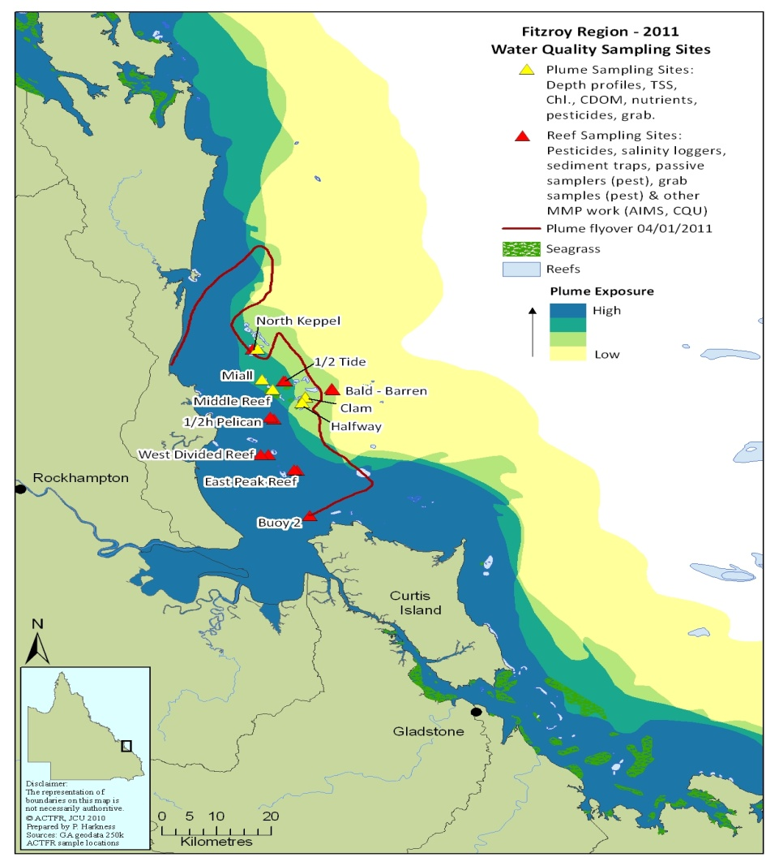
Passive samplers were deployed at several locations in the Fitzroy region. The aim of the pesticide monitoring was to monitor spatial variation in the concentrations of herbicides at sites impacted by an extreme flood event in the Fitzroy River. The sites included Middle Reef, Miall, North Keppel Island, Halfway and Clam (Figure 3.2).

Figure 3-2: Plume sampling sites where passive samplers were deployed during a major flood event in the Fitzroy region.
The samplers were deployed by Alison Jones (CQU) who also performed sediment trapping at different depths and heights within the water column. A proportion of these sediment samples were also submitted for pesticide analysis to assess the importance sediment facilitated transport of both herbicides and insecticides for these sites. Data from sediment analysis is not available at this time due to delays at QHSS laboratories.
SDB-RPS empore disc passive samplers were deployed from the 2nd January to 8th February 2011, and the Fitzroy River peak height occurred on the 5 January 2011. These passive samplers were analysed for herbicides using the more sensitive ABSciex 4000Q LCMSMS. The sediment samples were analysed for both herbicides (LCMS) and pesticides (GCMS). A second deployment of passive samplers at these sites included polydimethylsiloxane (PDMS) passive samplers along-side the empore discs. PDMS samplers are used to sample pesticides such as chlorpyrifos and dieldrin. These samplers were deployed either from the 8 February to 4 March 2011 or from 21 February to 4 March 2011 at these sites.
Grab sampling was also undertaken at 11 sites in the Fitzroy plume extending into the Mackay Whitsunday region on 19 January 2011.

Burdekin region – WQ and sediment sites
The Burdekin region was sampled in collaboration with a research project mapping the sediment signature of plume waters (Bainbridge et al., 2012). Sampling trips were completed three times in January 2011 extending from the Palm Island group north of the Burdekin, Magnetic Island and the Burdekin River mouth (Figure 3.3). This increased spatial and temporal sampling of plume waters in several locations gives a greater understanding of the variability and influence of water quality parameters within the formation and evolution of flood plumes in the GBR.
During December/January 2010-11 the sampling of the Burdekin River flood plumes was conducted to collect water quality data in two locations north of the Burdekin River during a significant flood event that occurred from the 24 December 2010 to 18 January 2011. The first area was focused around the Burdekin River mouth and the second area was north of the mouth from Magnetic Island to the Palm Islands. This work also examined the dispersal of suspended sediments and dissolved and particulate nutrients through the plume waters. An extreme peak n daily discharge (10,600 m³ s⁻¹) occurred on 28 December 2010 at the end-of-catchment river gauge (Clare GS120006B), exceeding the long term mean peak annual discharge of 9,115 m³ s⁻¹(data sourced from DERM).
Samples were collected in the flood plume at sites at 2, 9 and 21 days after the flood peak (Figure 3.3). The initial flood plume sampling sites on 30 December 2010 were located along the plume salinity gradient from the river mouth. This transect was repeated approximately three weeks later (18 January 2011) to capture changes in plume dynamics. A far-field sampling transect was also completed from Magnetic Island to the Palm Island Group (6 January 2011) to capture the visible extent of the northward plume boundary using MODIS Rapid Response near real-time (true colour satellite) imagery (see Figure 3.2; http://rapidfire.sci.gsfc.nasa.gov).
Pesticide grab samples were taken in plumes from the Burdekin River on 30 December 2010 (Site 4 Northern and Site 1 Inner Plume in Figure 3.3).

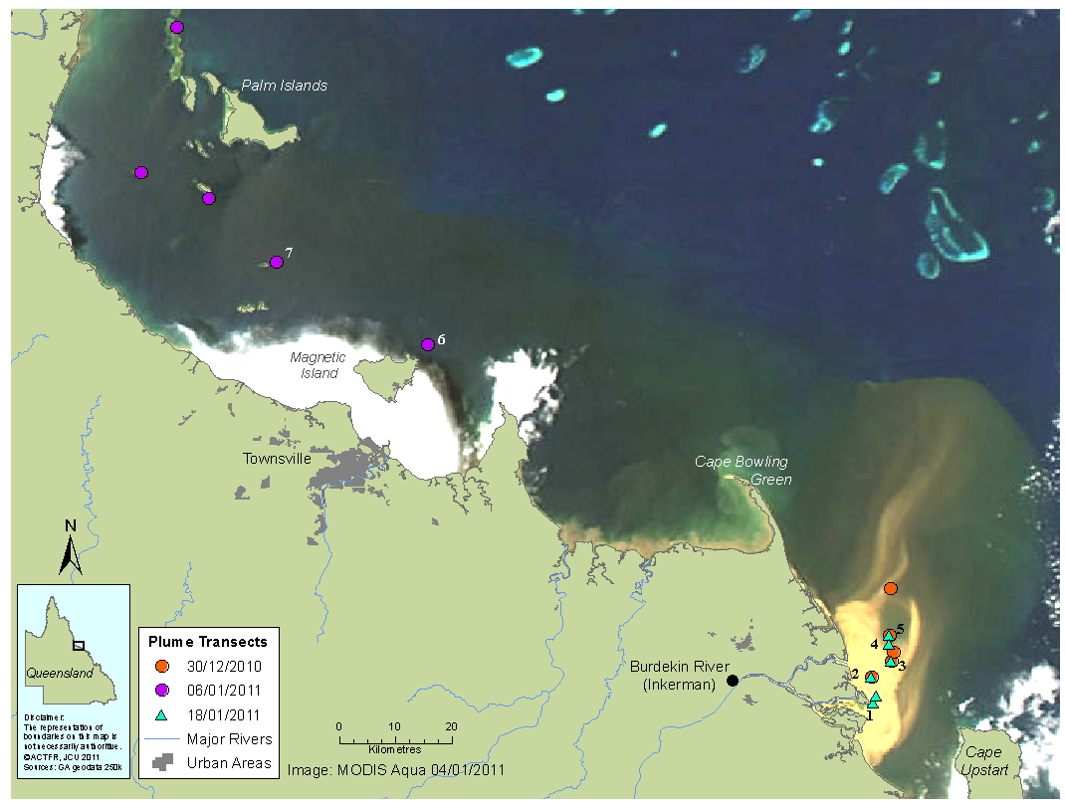
Figure 3-3: MODIS satellite image (4 January 2011) of the Burdekin River flood plume, with the location of the three sampling transects overlain. The sampling site in the freshwater part of the Burdekin River at Inkerman is also shown. The white patches over water (adjacent to the coast) are clouds. Source: Bainbridge et al., (2012).

Wet Tropics region – WQ sites
During the wet season the coastal and inshore areas adjacent to the Tully River catchment are regularly exposed to flood waters from the Tully River, and to a lesser extent from the Herbert River via the Hinchinbrook Channel, carrying high concentrations of TSS, nutrients and pesticides into the marine environment. From November 2010 to March 2011, frequent sampling of flood plumes in the Tully marine area was conducted at 17 sites in the Tully marine area during a number of significant flood events. Five of those sampling periods occurred just after the highest flow period in February 2011, at approximately 3 day intervals for a period of two weeks. This was designed to capture the short term variability associated with the onset of the high flow and assess the ongoing influence of the high river discharge in the marine area. Sites within the Tully marine area were located between Goold Island in the south, to Sisters Island in the north including sites at the Tully and Hull River mouths, additional coastal locations, Dunk Island and Bedarra Island (Figure 3.4). The sampling area includes areas within a high to moderate flood plume exposure area from the Tully-Murray River identified by water quality exceedances during previous wet seasons (Devlin et al., 2010a, 2010b; Schaffelke et al., 2010) and an area of high frequency of plume coverage (Devlin and Schaffelke, 2009; Devlin et al., 2010b). In addition, a small number of samples were collected around the Frankland Island reefs (adjacent to the Russell-Mulgrave catchment) in late December 2010 (Table 3.2; Figure 3.4).
The aim of the pesticide monitoring for the Tully River transect was to assess temporal and spatial variation in the concentrations of photosystem II herbicides during the wet season from 16 December 2010 to 15 April 2011 using both passive (time integrated and event) and grab sampling (point in time) techniques.

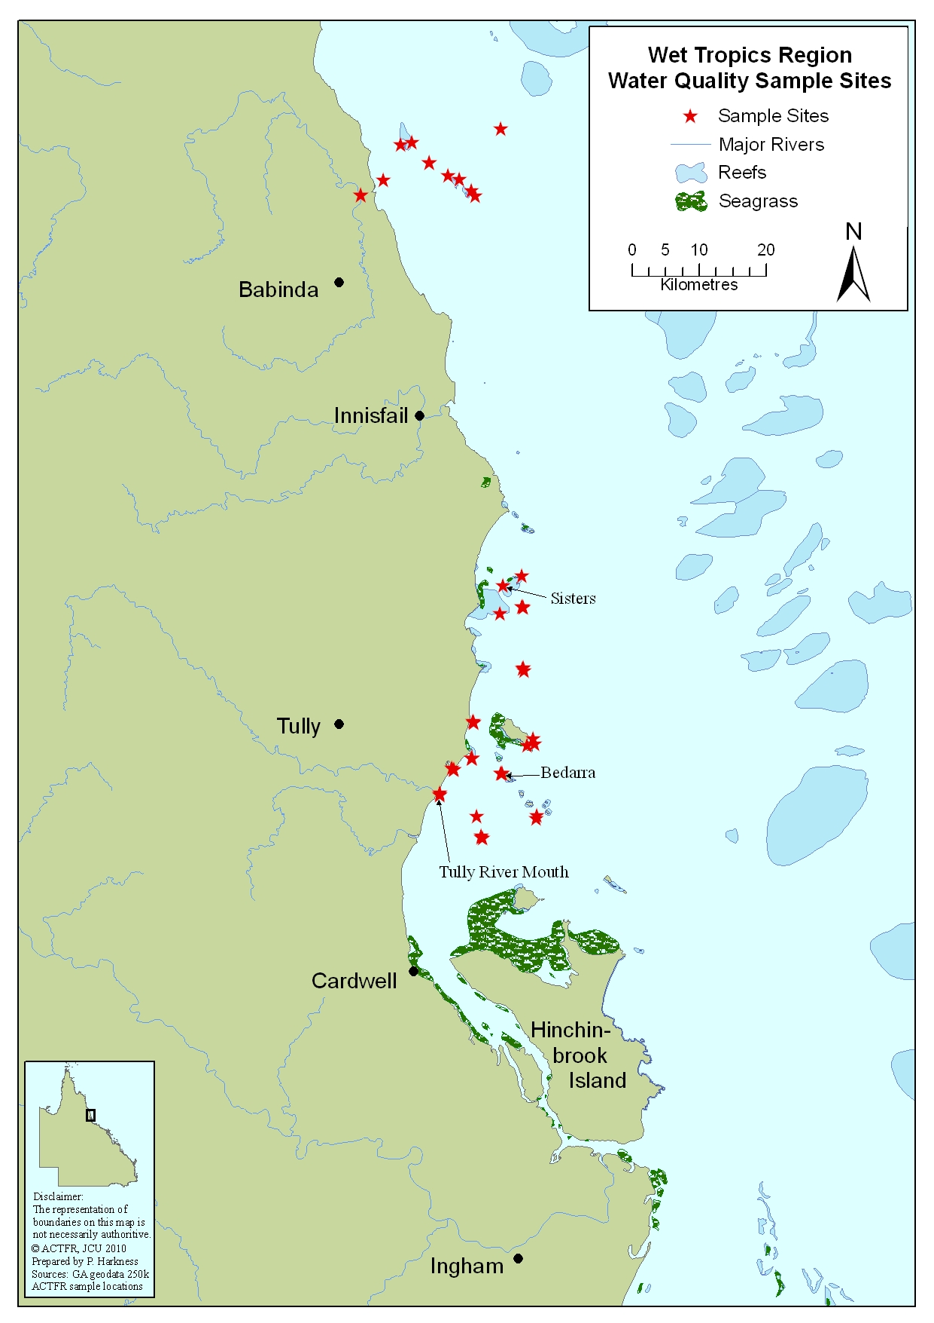
Figure 3-4:Location and geographical information for the water quality sites sampled in the Wet Tropics (Tully and Russell-Mulgrave Rivers) (2010-11).

Methods for Reporting

Developing a flood water quality metric
As part of the MMP, it is desirable to report the results against a set of thresholds so that measurable changes can be defined in a consistent and relevant manner. As shown in Table 3.3, a series of thresholds are suggested for each parameter in the flood monitoring component of the MMP. These thresholds are based on either the GBR Water Quality Guidelines (GBRMPA, 2009; De’ath and Fabricius, 2008, 2010), other published thresholds (Moss et al., 2005) or best available information on thresholds related to time (Berklemans 2002; Kerswell and Jones 2003; Humphrey et al. 2008).

Table 3-3. Thresholds for a range of water quality parameters defined for the risk assessment.
Parameter | Threshold | Description
DIN (μM) | 0.2 (Tully)-0.5 (Fitzroy) | Moss et al., 2005
TSS (mg/L) | 2.4 (summer mean) | De’ath and Fabricius, (2008, 2010); GBRMPA (2009)
Chl-a (μg/L) | 0.6 (summer mean) | De’ath and Fabricius, (2008, 2010); GBRMPA (2009)
Salinity (ppt) | 28 | Reduced fertilization success and increased developmental abnormalities in coral (Humphrey et al., 2008)
Temperature (degrees celcius) | 29 | Increased susceptibility to bleaching in corals (Berkelmans, 2002)

This year, considerable effort has been directed towards improving the mapping of flood plume extent and predicted concentrations of sediments and nutrients within mapped flood plume extents for Reef Plan reporting. In an attempt to convey the combined water quality conditions, we have developed a Water Quality metric for the flood plume monitoring data. It is difficult to assess water quality in variable conditions experienced during flood plume periods and to identify the cumulative impacts of all pollutants carried in flood plumes. We have used the Water Quality metric, as reported by Fabricius et al., (2005) and Cooper et al., (2008), that combines the water quality information at a site level and normalises this information to be able compare the water quality data across sites and time. This allows us to identify the sites which have experienced the most extreme water quality values over the plume sampling season.
The metric, referred to as the Water Quality Index or WQI is based on combining information of each water quality parameter measured within a site or a transect and comparing it against water quality data collected over the entire 2011 wet season or collected over the entire plume sampling program (see Devlin et al., 2001; Devlin and Schaffelke, 2009). Eight water quality variables were used to create the index: TSS, Chl-a, dissolved inorganic nitrogen (DIN) and phosphorus (DIN and DIP), PN and PP, and DON and DOP. Each water quality variable was standardised by subtracting the mean of all sites divided by the standard deviation. The standardised values were summed over the eight variables for each reef. A reef with a high WQI will typically have high concentrations of most of the variables that form the index, and a reef with low values has lower concentrations. A site with a high WQI value would have elevated levels of pollutants while one with a low WQI has a low level of pollutants. Figure 3.5 illustrates how this index is calculated.
Using the range of WQI scores measured across all sites and all years calculated from the long term data base, a qualitative assessment of the actual WQI value can be calculated for the 2011 data. A WQI score approaching zero means that the mean values of all water quality parameters (combined as Z scores) calculated for that site or transect was similar to the overall WQI calculated for all sites or for all transects. The higher the value away from zero, the greater the difference between the WQI for the site or transect and the overall WQI. Higher values of WQI indicate that one or many of the water quality parameters within the analysis have very high measurements away from the average value. For instance, high TSS measurements (e.g. > 20mg/L) will influence both the Z sore calculated for TSS and for the overall WQI.
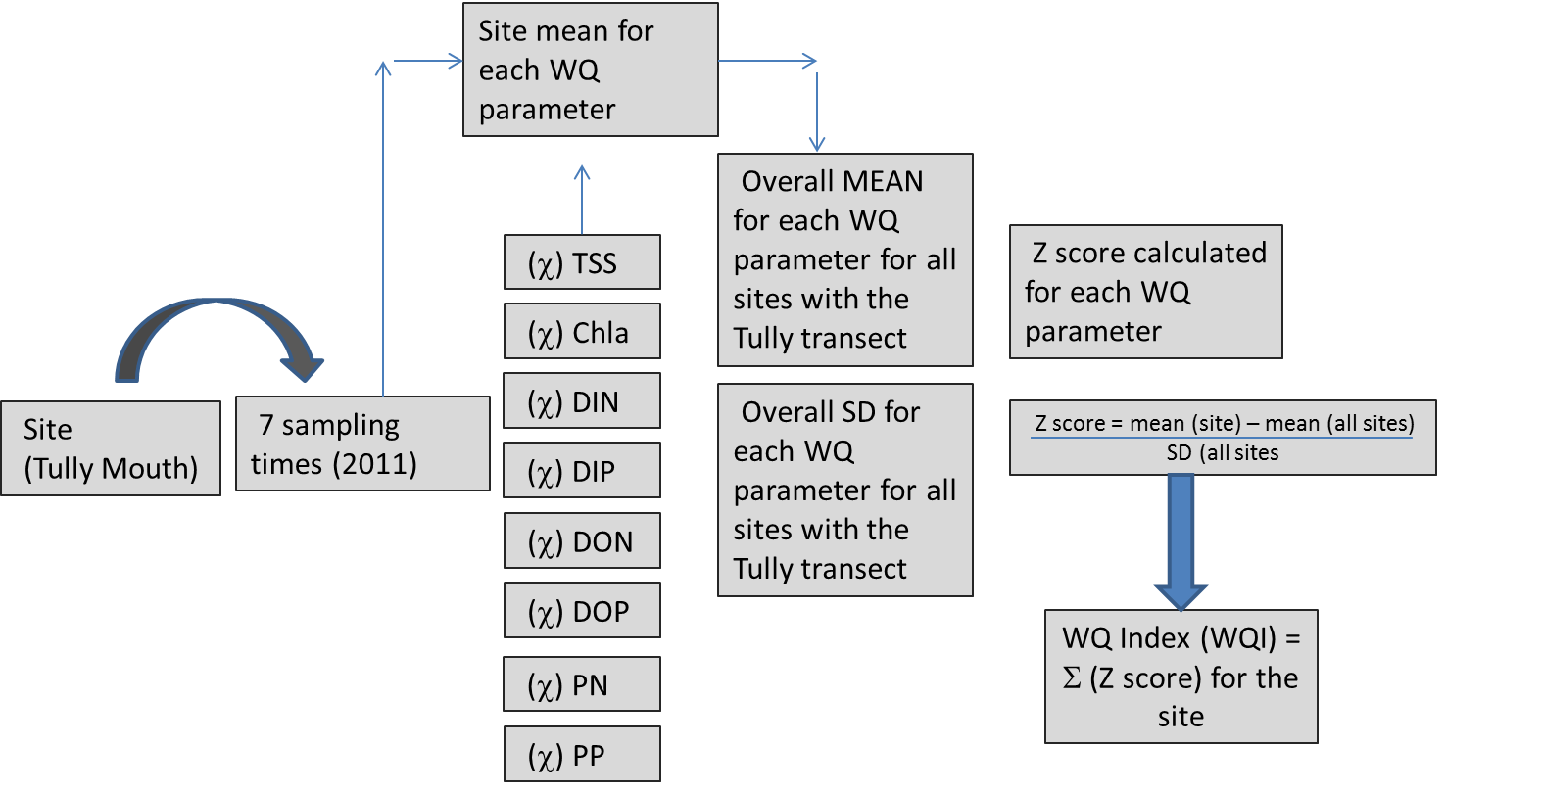
Three WQI were calculated for each site: 1) for the site based on 2011 data only; 2) for the site based on all the water quality data from that region through time; and 3) for the site based on all water quality data collected within the flood plume sampling program (1991 – 2011) (Devlin and Waterhouse, in press).

Figure 3-5: Process of calculating the WQI for each site sampled in the 2011 season. WQI was also be scaled up to the transect and regional level for comparison across catchment and year.

Mapping the extent of flood plumes
It is proposed that P2R program reporting will now present a measurement of the plume surface exposure as an indication of the scale of disturbance, influenced by high flows and pollutant loads. Surface plume exposure can be mapped each year through the cumulative mapping of the three main water types (primary, secondary and tertiary) identified by information available from remote sensing algorithms. The tertiary plume (identified by CDOM value higher than 0.14m²; CDOM is proportional to salinity value of 30+/- 4) was used to define the boundary or maximum extent of the plume. Algorithms associated with the mapping of secondary water types, characterised by elevated Chl-a and CDOM values, were also used to define the boundary edge in areas of the plume where tertiary water is absent or scattered/diffuse and difficult to define. Complementary to this automated mapping of water types, the true colour classification techniques offer a good alternative to delineate the extent (boundary) of the plume. Through the combination of spectral enhancement and unsupervised classification (ISO method) of images, we can identify classes that can potentially be related to variations in surface water parameters, such as TSS and Chl-a and therefore contribute to understanding the spatial variation and movement of plumes. The overall mapped image, through extent and composition, allows a better understanding of the spatial and temporal evolution of river plumes.
The frequency of the incidence of surface plume waters is assessed based on available and appropriate imagery and linked to high flow periods. A plume frequency map was constructed by counting the overlapping plumes (i.e., combined primary, secondary and tertiary plumes) for each pixel, which ranges from 1 to 10 plumes. The frequency was then normalised by calculating its logarithm, resulting in frequency values from 0 to 1. Normalised values were then grouped in 5 frequency classes based on the standard deviation.
The surface area of the plume waters are then scaled against the proportional contribution of each catchment in terms of pollutant loads. To complete this exercise annually, pollutant load data for each catchment is required as input data, to be supplied by DERM under the catchment load monitoring component of the P2R program. The final surface exposure map presents the full extent of the plume but with the spatial movement of the surface pollutants identified to four main classes of surface exposure (very high, high, moderate and low).
As this is the first time that this method is being reported, Section 5 includes further detail of this method and examples of the proposed reporting products.

Water Quality Results

2010-11Weather Events
The wet season 2010-11 was characterised by extreme events in the GBR region, starting with a very strong La Nina, and beginning in mid-2010, which brought extraordinary rainfall, both intense and prolonged, across eastern Queensland. Three cyclones crossed the North Queensland coast in this period, including Tropical Cyclone (TC) Tasha, which crossed the coast near Innisfail in December 2010 and eventually went south causing large scale and in some cases severe flooding from Brisbane, Burnett and Fitzroy Rivers and started floods in the Burdekin River. TC Tasha was followed by TC Anthony, a category 2 cyclone that crossed near Whitsundays. This travelled inland and went south where it created flooding conditions from NSW to Victoria. This was then followed by TC Yasi, a category 5 cyclone, which crossed the Queensland coast in early February 2011. The mechanical damage from this cyclone was immense and drove further continuing flooding conditions north of the Whitsundays.
The wet season in 2010-11 started comparatively early with high flows in the Wet Tropics during the November and December, and extended well into April 2011. Flood waters moved into the GBR from the Burdekin River at the end of 2010, and from the Fitzroy River in the early weeks of January 2011, and indirectly from the southern rivers, particularly the Mary-Burnett catchments. Heavy and consistent rain also continued in the Wet Tropics region throughout the wet season, peaking in February in association with Cyclone Yasi.
Severe TC Yasi made land fall in northern Queensland, in the early hours of 3 February 2011. Yasi originated from a tropical low near Fiji. The system intensified to a category 3 cyclone at about 5pm AEST (07:00 UTC) on 31 January 2011. Late on 1 February the cyclone strengthened to a category 4 system, and then intensified to a category 5 system early on 2 February.
The large destructive core crossed the coast between Innisfail and Cardwell with a central pressure of 930 hectopascals and maximum 10-minute sustained winds of 215 km/h (Figure 4.1). Maximum 3-second gusts were estimated at 285 km/h, with these likely to affect an area spanning from Ingham to Cairns according to the Threat Map for a period of 3-4 hours.
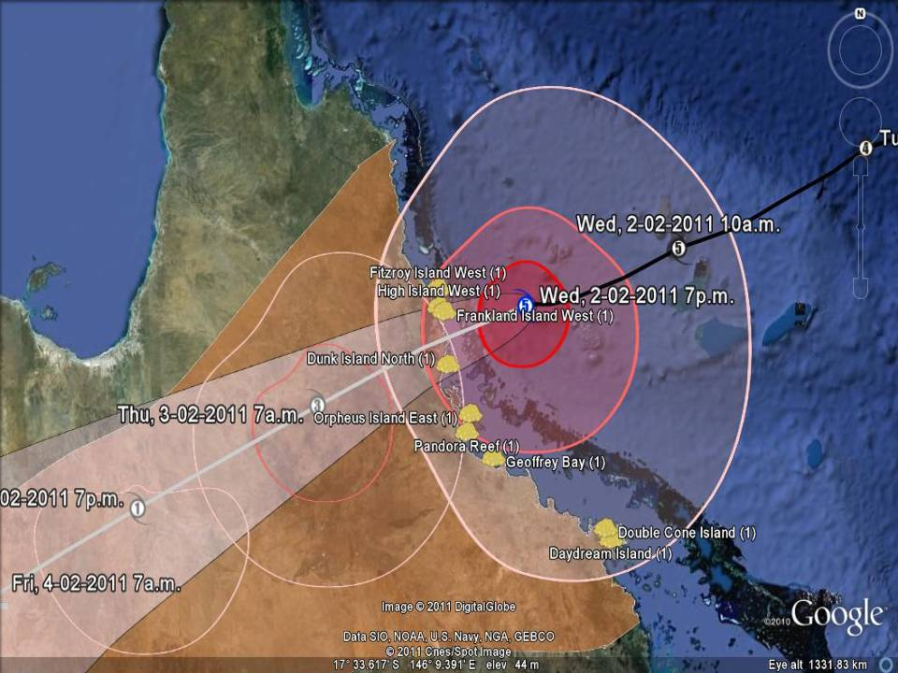
Figure 4-1. Cyclone Yasi passage as it moved across the GBR and approached landfall on 2 February 2011. Source: Bureau of Meteorology (www.bom.gov.au).
In Mission Beach near where TC Yasi made landfall, wind gusts were estimated to have reached 290 km/h, leaving behind significant damage. A storm surge estimated to have reached 7 metres) destroyed several structures along the coast and pushed up to 300 metres inland. The worst affected areas were around Tully, Silkwood, Mission Beach, Innisfail and Cardwell. Figure 4.2 shows the change in the inshore area before and after the passage of TC Yasi. In August 2010, the water is relatively clear with reef and bottom structure clearly seen. In January 2011, the water is more turbid due to the onset of the wet season; however, detail over reef and bottom is still visible. After the passage of TC Yasi (2 February 2011), the first visual image (5 February 2011) clearly shows a large area of scouring and sand visible out to the outer reefs. Mechanical damage, plus the cumulative impacts of water quality was most evident in reef systems north of Townsville and south of the Russell-Mulgrave (GBRMPA, 2011).

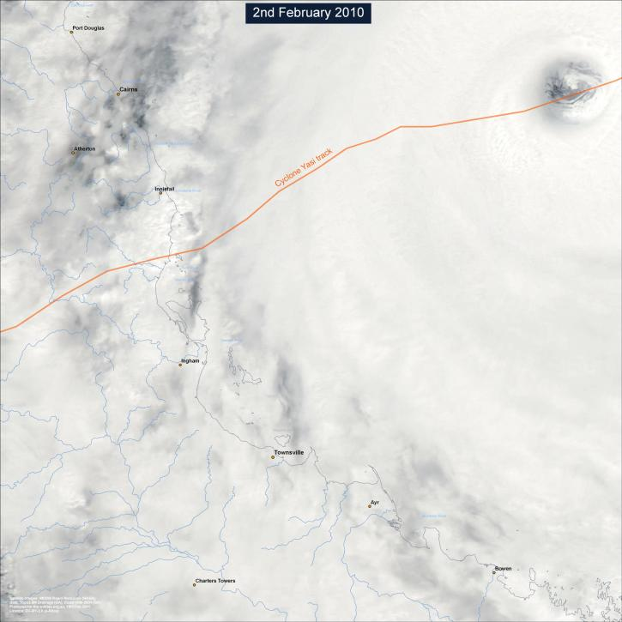
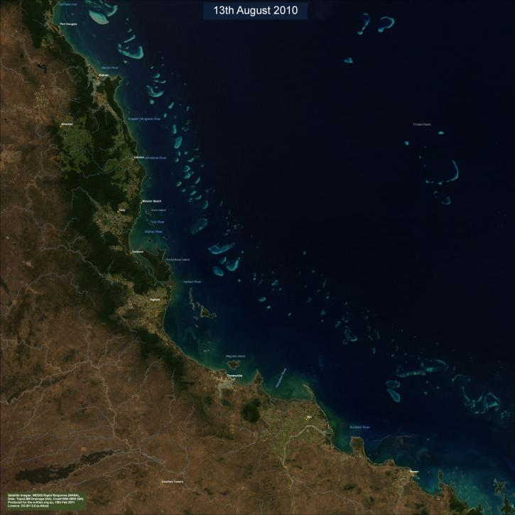
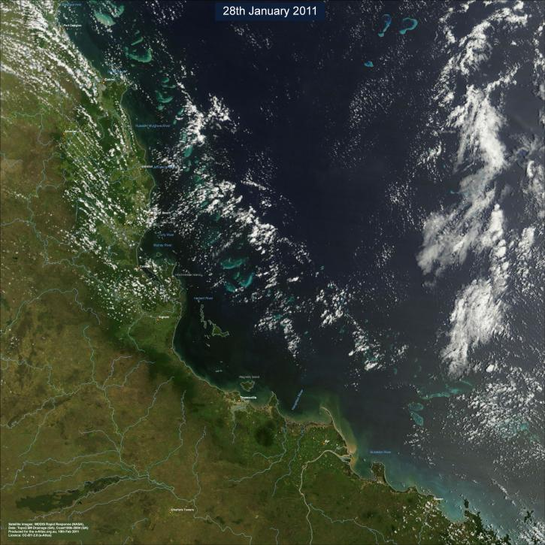
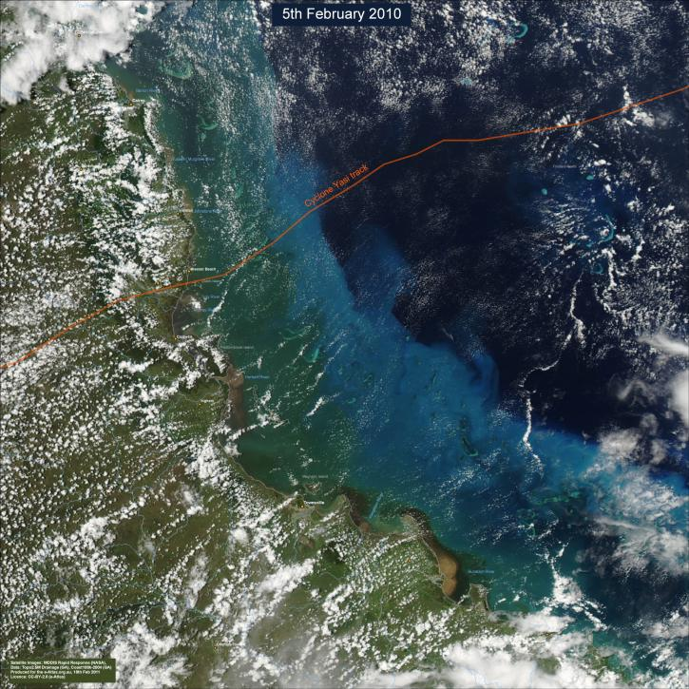

Figure 4-2: Aerial imagery of the area affected by Cyclone Yasi,. (a) pre Cyclone Yasi, (b) two days prior to Cyclone Yasi, (c) during Cyclone Yasi and (d) post Cyclone Yasi. Note the scouring and turbid conditions throughout the central GBR.
It is understood that the extreme weather events experienced in Australia in 2010-11 were associated with the ‘La Nina’ cycle. La Nina is the extreme phase of a naturally occurring climate cycle called the El Nino/Southern Oscillation, with El Nino periods themselves on the other end of that cycle. The cycle is governed, like so much else on the planet, by the sea—in this case, large-scale changes in the sea-surface temperature in the eastern tropical Pacific. Normally the sea-surface temperatures in that region fall between 16 to 22⁰C, with warm pools that can rise above 27⁰C in the central and western Pacific. In El Nino years, those warm pools expand across much of the tropics, but during La Nina years the opposite occurs, and an upwelling brings cold water to the surface that can lower temperatures by as much as 13⁰C . For both El Nino and La Nina, abnormal changes to sea-surface temperatures in turn alter global weather patterns, changing both air temperatures and precipitation. El Nino often leads to drought and unusually hot weather in parts of the world, but La Nina reverses that effect, leading to more clouds and wetter weather in places like Australia and Indonesia. The last time the Australian city of Brisbane flooded was in 1974—the same year as a particularly strong La Nina episode. La Nina events can usually last a year or longer, with the entire El Nino/Southern Oscillation cycle lasting three to four years.

Flow conditions 2010-11

GBR catchment flow conditions
The 2010-11 wet season was characterized by extreme events in the GBR region, driven by a very strong La Niña in mid-2010, which brought extraordinary rainfall, both intense and prolonged, across eastern Queensland. Three cyclones crossed the North Queensland coast in this period, including Tropical Cyclone (TC) Tasha, which crossed near Innisfail in December 2010 and eventually went south causing severe flooding from the Brisbane, Burnett, Fitzroy and Burdekin Rivers (Figure 4.4). TC Tasha was followed by TC Anthony, a category 2 cyclone that crossed near Whitsundays in February 2011. This travelled inland and traversed south creating flooding conditions in the southern states of Australia (Figure 4.4). The third one, TC Yasi (category 5), crossed the coast between Cairns and Townsville in early February 2011 causing immense physical damage (GBRMPA, 2011). The large size of TC Yasi drove further flooding conditions north of the Whitsundays.
The combination of extreme events produced record river flows in nearly all GBR rivers, especially in the southern half of the GBR. The total flow for all GBR rivers (Figure 4.3) was 2.6 times the long term median flow, with all rivers exceeding the long term median flow by 2 or more times, except for the Tully River (1.5 times).

Figure 4-3: Annual freshwater input into the GBR (2000 – 2011). Data source: DERM.
The 2010-11 wet season started comparatively early, with high flows in the Wet Tropics during November and December 2010, extending into April 2011. Extended flows were heavily influenced by formation and passage of the three tropical cyclones. Overall, flooding occurred in one or more GBR rivers for a period of 4 months.
In the Burdekin River (Figure 4.4b), the Burdekin Falls dam flowed over the spillway for more than 300 days and the discharge at the mouth was the third highest in the instrumental record (approximately 35 million ML). This followed above average flows (mean approximately 8 million ML) in the Burdekin River in both 2008 (26 million ML) and 2009 (30 million ML) (Figure 4.8). To the south, the Fitzroy River (Fig. 4.4a) had its largest flow in the instrumental record (approximately 38 million ML) following large flows in 2008 and 2009, while the Burnett River had its first substantial flow (8 million ML) for 20 years and about eight times the mean. The Mary River had its largest flow for 10 years (Pickersgill et al., 2011). In all cases, except for the Burnett River, the instrumental record extends back about 80 years. Rivers in the Wet Tropics had above average flows by factors of times 2-3 but not record flows (Figure 4.4c, 4.4d).
Figure 4-4: Extended flow periods associated with the passage of three cyclones between December and February 2011 for (a) Fitzroy River, (b) Burdekin River, (c) Herbert River and (d) Tully River.
Flow conditions in comparison to the long term mean and median are presented in Table 4.1. It also shows the relative difference between the 2010-11 discharge and the long term median flow. The discharge from the Normanby River in the Cape York region was just over 2 times the long term median flow. In the Wet Tropics region the Daintree, Mulgrave, North Johnstone and South Johnstone rivers exceeded the long term median by 3 to 4 times, while the Barron and Herbert discharges were 4 to 5 times the long term median flow. The discharges from the Russell and Tully Rivers still exceeded the long term median flow but to a lesser extent (approximately 2.5 and 1.5 times respectively), however, the actual volume from the Tully River was still over 4.6 million megalitres. The discharge from the Burdekin River was over 38 million megalitres, over 7 times the long term median flow. The Mackay Whitsunday Rivers all exceeded the long term median flow by more than 8 times, and in the case of the Proserpine River, over 22 times with 454,000 megalitres. Extreme differences were recorded in the southern rivers, with the Fitzroy River flow 15.8 times the long term median flow with a discharge of 40.5 million megalitres, and the Burnett River flow more than 60 times the long term median flow with a comparatively large flow of 8.2 million megalitres.
The summary of the plume events and the number of days in which flow exceeded a long term 95th percentile is shown in Table 4.2 and illustrated in Figure 4.5.
Table 4-1.The 75th and 95th percentile flow for the major GBR rivers (based on flow between 2000 to 2011).

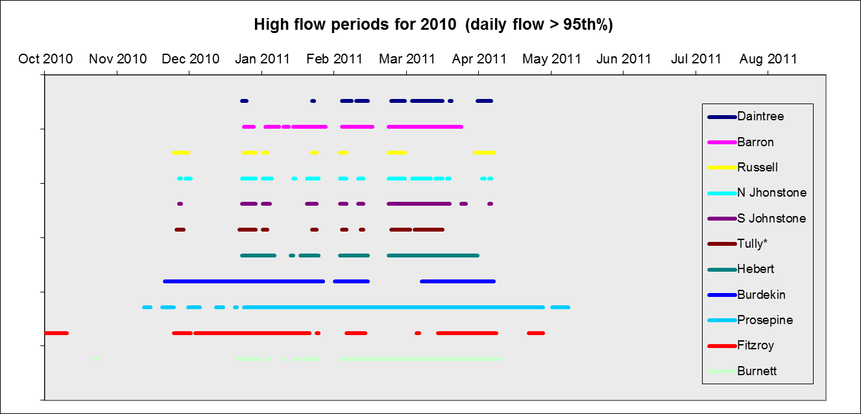
Figure 4-5. Illustration of high flow periods (greater than the 95th percentile) for the major GBR rivers in the 2010-2011 sampling year (based on flow between 2000 to 2011). 75th and 95th percentiles are calculated from the long term data. The number of years available for each calculation is noted.

Table 4-2: Annual freshwater discharge (ML) for the major GBR rivers (based on Water Year of October to September).
River | Long-term river discharge median | Long-term river discharge mean | Long-term river discharge (SD) | Total year discharge 2010/2011 | Difference between 2010/2011 flow and long-term median | Relative difference between 2010/2011 flow and long-term median
**Normanby River at Kalpower Crossing | 2,944,017 | 2,825,572 | 789,756 | 5,962,823 | 3,018,806 | 2.03
Daintree River at Bairds | 715,189 | 806,563 | 473,988 | 1,655,860 | 940,671 | 2.32
Barron River at Myola | 577,829 | 694,779 | 467,903 | 1,902,626 | 1,324,797 | 3.29
Russell River at Bucklands | 869,618 | 902,834 | 420,851 | 1,768,101 | 898,483 | 2.03
Mulgrave River at Peets Bridge | 728,916 | 756,590 | 361,107 | 1,397,886 | 668,970 | 1.92
North Johnstone River at Tung Oil | 1,746,100 | 1,741,505 | 589,926 | 3,535,495 | 1,789,395 | 2.02
South Johnstone River at Upstream | 795,465 | 739,035 | 301,818 | 1,689,576 | 894,111 | 2.12
Tully River at Euramo | 3,077,245 | 2,969,403 | 1,098,284 | 4,179,394 | 1,102,149 | 1.36
Herbert River At Ingham | 3,109,254 | 3,219,790 | 2,530,597 | 11,442,699 | 8,333,445 | 3.68
Burdekin River at Clare | 5,312,984 | 8,148,322 | 8,824,115 | 34,805,726 | 29,492,741 | 6.55
O'Connell | 150,210 | 188,815 | 139,809 | 584,343 | 434,133 | 3.89
Pioneer | 633,606 | 768,349 | 601,084 | 3,299,324 | 2,665,718 | 5.21
Proserpine River at Proserpine | 20,180 | 29,138 | 22,177 | 345,803 | 325,623 | 17.14
Plane | 58,096 | 76,270 | 74,128 | 259,929 | 201,834 | 4.47
Fitzroy River at The Gap | 2,560,304 | 4,453,919 | 5,318,403 | 38,180,078 | 35,619,774 | 14.91
**Burnett River at Figtree Creek | 121,922 | 276,598 | 325,232 | 7,120,008 | 6,998,086 | 58.40
 | 17,079,503 | 20,234,831 |  | 44,698,584 | 27,619,081 | 2.62
Note: Long-term (LT) median discharges were estimated from available long-term time series and included data up until 2010. Estimates for 2011 only include data up to 10 June 2011. ** For the Normanby and Burnett rivers suitable long-term time-series data are not available and the median of the available data has been used to allow for comparison of the river flow in 2010-11 relative to previous years. Colours highlight years where flow exceeded the median by 1.5 to 2 times (yellow), 2 to 3 times (orange), and more than 3 times (red). All data supplied by the Queensland Department of Environment and Resource Management.

Regional flow characteristics
Flow characteristics are presented below for the three rivers that were the focus of the flood plume water quality sampling – the Fitzroy, Burdekin and Tully.

Fitzroy
The Fitzroy floods were extremely large with a relative difference of 14.9 based on the 2010-11 flow compared to the long term median. The volume of discharge associated with the Fitzroy floods was the largest since 1918. The 2010-11 flow was greater than the large flow events experienced in 1991 and 1954 in volume though peak heights were greater in 1954 and 1991. The maximum height for 2011 was 9.1metres.
The Fitzroy River at Rockhampton has a long and well documented history of flooding with flood records dating back to 1859. The highest recorded flood occurred in January 1918 and reached 10.11 metres on the Rockhampton gauge. The most recent minor flood for the Fitzroy River was in 2008 and reached 7.50 metres on the Rockhampton gauge. This flood event also provided Emerald with its second largest flood on record registering 15.36 metres on the Emerald gauge. Figure 4.6 shows the significant flood peaks (height) which have occurred at Rockhampton during the last 150 years. Figure 4.5 illustrates the comparative volume of flow measured at Rockhampton in 2010-11.
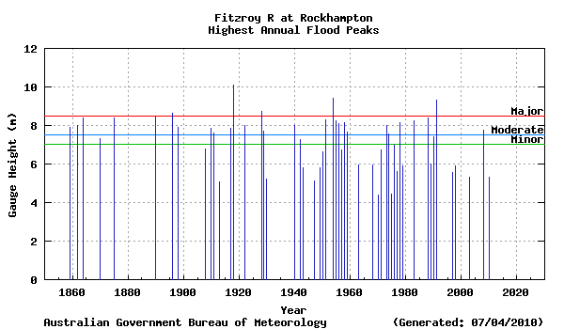
Figure 4-6: Significant flood peaks (height) which have occurred at Rockhampton during the last 150 years.
The wet season was characterised by extended periods of flow above the 95th percentile between December 2010 and May 2011 (Table 4.2 and Figure 4.7). The peak flows in December 2010 (at the commencement of plume sampling) were considerably larger than any daily discharges recorded in the last 10 years (Figure 4.7).

Burdekin
The discharge from the Burdekin River was over 34 million megalitres in 2010-11, which is approximately 6.5 times the long term median flow. The flow was comparable to the large event in 1990-91 of approximately 40 million megalitres. It follows large events in 2007-08 (27 million megalitres) and 2008-09 (30 million megalitres) (Figure 4.8).
The wet season was characterised by extended periods of flow above the 95th percentile between December 2010 and April 2011 (Table 4.2 and Figure 4.8). The peak flows were recorded in later December 2010 (at the time of plume sampling) and February 2011 (Figure 4.8). These peak flows were not as high as those recorded in the large event of 2008-09, but the overall wet season discharge was greater and extended over a period of 60 days.

Figure 4-7: Long term records of the total annual flow measured for the Fitzroy River (at The Gap).
Figure 4-8. Long term records of the total annual flow measured for the Burdekin River (at Clare).

Tully
The discharge from the Tully River was approximately 4.2 million megalitres in 2010-11, which is just over 1.3 times the long term median flow. The flow is close to record flows of 5.3 million megalitres in 1999-00. It follows five years of flow above the long term median discharge (Figure 4.9).
The wet season was characterised by several periods of 3-5 days flow above the 95th percentile between December 2010 and February 2011, with an extended period in late February to March 2011 (Table 4.2 and Figure 4.9). The peak flows were sporadic throughout the wet season between late November 2010 and March 2011 (Figure 4.9), and were comparable to those recorded in previous years.

Figure 4-9: Long term records of the total annual flow measured for the Tully River (at Euramo).
Table 4-3: River flow condition for Burdekin, Fitzroy and Tully Rivers. Long term flow records (2000- 2011) and the 2010-2011 wet season flow conditions are reported. Horizontal grey lines identify the 95th percentile and the vertical lines denote the period of plume sampling associated with that river.
Long term river flow conditions (2000 – 2011) | 2010-2011 river flow conditions
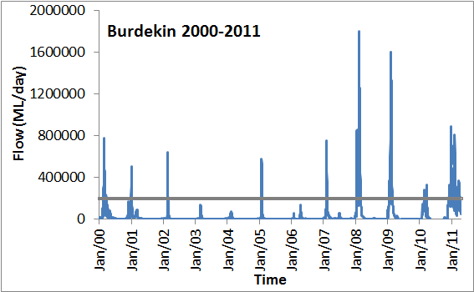 | 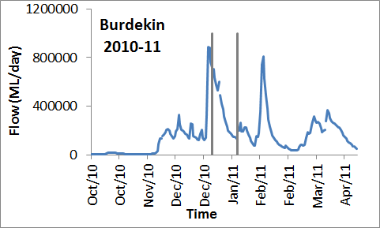
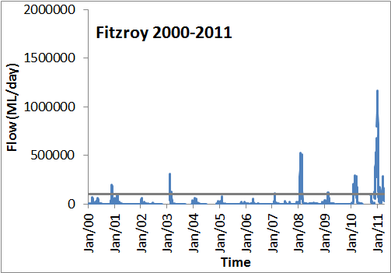 | 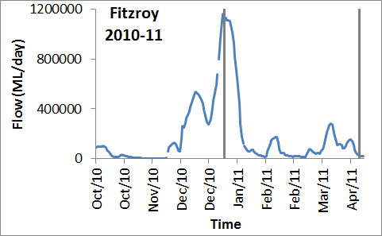
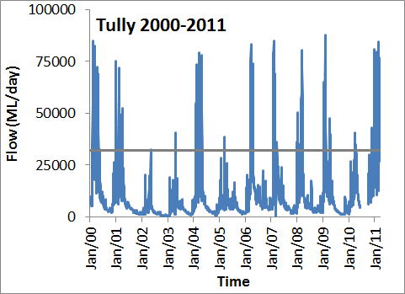 | 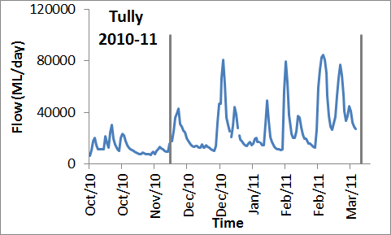

Water quality characteristics
Flood plume waters generally move into the GBR as buoyant freshwater masses and are usually constrained in the top surface layer until dissipated or eventually mixed into the water column (Devlin and Brodie 2005). For this reason, water sampling typically focuses on the top surface layer of the flood plumes in addition to the remotely sensed data. Sampling sites are indicated in Fig. 4-10, and all samples were analysed for salinity, TSS, Chl-a, nutrients, CDOM and water temperature.
Figure 4-10: Location of all sampling sites within the 6 transects sampled for surface water quality concentrations. Note that additional depth profiling (salinity, temperature and light) were collected at sites within Tully to Sisters and Fitzroy to Keppels transects.

Fitzroy
Water sampling occurred over a number of transects to capture the full extent of the Fitzroy plume, with additional sampling out of Gladstone to capture the plume water extending from the Mary-Burnett River systems. The majority of the sampling occurred in the Fitzroy River to Keppel Reef transect (N = 62), with repeated sampling at the Rosslyn Bay to North Keppel transect (N = 22). Additional sampling occurred at the end of the Fitzroy plume (Mackay transect, N=12) and off Shoalwater Bay (N = 12) and offshore from Gladstone to Heron Island (N = 12) (Table 4.4).
Table 4-4: Summary of water quality data collected at the five Fitzroy transects sampled during the 2011 wet season.
Fitzroy transect* | No of samples | Statistical measurement | DIN (μM) | DIP (μM) | TSS (mg/L) | Chl-a (μg/L) | CDOM | Salinity (0.5m)
Fitzroy mouth to Keppel Reef | 62 | Minimum | 1.5 | 0.14 | 9.6 | 0.2 | 0.14 | 3.1
Fitzroy mouth to Keppel Reef | 62 | Maximum | 13.9 | 1.34 | 38 | 22.4 | 3.2 | 34.6
Fitzroy mouth to Keppel Reef | 62 | Mean | 4.9 | 0.46 | 22.7 | 2.5 | 1.1 | 26.2
Fitzroy mouth to Keppel Reef | 62 | SD | 2.8 | 0.25 | 6.2 | 4.3 | 0.89 | 8.8
Rosslyn Bay to North Keppels | 22 | Minimum | 1.29 | 0.13 | 17.0 | 0.2 | 0 | 19.93
Rosslyn Bay to North Keppels | 22 | Maximum | 7.78 | 1.52 | 33.0 | 9.08 | 1.47 | 37.20
Rosslyn Bay to North Keppels | 22 | Mean | 2.81 | 0.56 | 21.3 | 1.92 | 0.41 | 32.69
Rosslyn Bay to North Keppels | 22 | SD | 1.60 | 0.33 | 4.0 | 2.54 | 0.44 | 5.23
Mackay (South) | 12 | Minimum | 1.6 | 0.39 | 1 | 0.27 | 0.02
Mackay (South) | 12 | Maximum | 2.8 | 0.68 | 3.2 | 4.81 | 0.46
Mackay (South) | 12 | Mean | 2.3 | 0.55 | 2.0 | 1.58 | 0.24
Mackay (South) | 12 | SD | 0.36 | 0.09 | 0.78 | 1.21 | 0.16
Shoalwater Bay | 12 | Minimum | 1.5 | 0.2 | 17 | 0.5 | 0.3 | 19.9
Shoalwater Bay | 12 | Maximum | 7.8 | 1.9 | 33 | 9.1 | 1.5 | 33.3
Shoalwater Bay | 12 | Mean | 3.7 | 0.65 | 21.3 | 3.2 | 0.7 | 4.8
Shoalwater Bay | 12 | SD | 1.9 | 0.4 | 4.0 | 3.0 | 0.4 | 28.8
Gladstone to Heron Island | 12 | Minimum | 1.8 | 0.3 | 3.4 | 0.2 | 0.02 | 28.4
Gladstone to Heron Island | 12 | Maximum | 2.8 | 0.47 | 13 | 2.7 | 0.28 | 34.8
Gladstone to Heron Island | 12 | Mean | 1.9 | 0.33 | 7.5 | 0.7 | 0.12 | 33.1
Gladstone to Heron Island | 12 | SD | 0.4 | 0.07 | 4.1 | 1.3 | 0.32 | 2.4
Offshore Swains transect | 8 | Minimum
Offshore Swains transect | 8 | Maximum
Offshore Swains transect | 8 | Mean
Offshore Swains transect | 8 | SD

Statistical measurements for the main water quality components show that dissolved nutrients exceeded the long term ambient concentrations (Furnas, 2003) and at all transects with a minimum value for DIN and DIP of 1.5μM and 0.14μM measured at the Fitzroy to Keppel transect. Maximum values for dissolved nutrients ranged from 2.8μM up to 13.9μM for DIN and 0.47μM up to 1.3μM for DIP. Ambient values for DIN have been set at 0.2 and 0.05μM for DIP, indicating that there has been nutrient enrichment at all these transects over the entire sampling period (January to March), but particularly in January. The particulate Nitrogen values exceeded the wet season adjusted guideline value (1.8 μΜ) at 70 out of 108 sampled sites. The PN values ranged from a minimum value of 0.07 μΜ to a maximum value of 48.3 μΜ, with a mean of 6.6 μΜ. The TSS values were also elevated, with maximum values ranging from 3.2mg/L (Mackay) to 38mg/L (Fitzroy to Keppel). These maximum values could potentially have been higher further inshore than East Peak Island (closest site to river mouth).The persistence of high TSS values through all the Fitzroy transects potentially indicates that the smaller, mobile fraction of the TSS component did move hundreds of kilometres to the north (Mackay). Winds experienced throughout January and February were predominately south easterly and forced the plume movement to the north and constrained inshore. Thus the higher fraction of TSS in the Gladstone to Heron Island transect would not have been sourced from the Fitzroy and suggests that this TSS originated from the Mary-Burnett River catchments.
The range of Chl-a indicates high phytoplankton production in the plume waters, with Chl-a values reaching a maximum of 22.4μg/L in the Fitzroy to Keppel transect (East Peak Island). This high value is similar to chlorophyll values collected in the offshore flood plume waters after Cyclone Joy in early 1991 (Brodie et al., 1992; Devlin et al., 2001). High values were also measured at the other transects with maximum values of 9.1μg/L (Rosslyn Bay), 4.8μg/L (Mackay) and 2.7μg/L. These high values over this spatial extent are indicative of persistent occurrences of high phytoplankton numbers in response to the large inorganic nutrient supply and non-light limiting conditions.
CDOM values represent the extent of the freshwater influence. Schroeder et al., (in review) suggests that 0.14m⁻¹ CDOM represents a salinity of 30 (+/- 4) ppt. All values of CDOM in all samples over all transects were higher than 0.14⁻¹, showing that the plume water from the Fitzroy did extend north to Mackay and persisted over the many weeks within the sampling program (January to March).

Spatial variability
Measurements for key parameters are presented against five salinity groups to demonstrate the change in the water quality parameters as they move away from the river mouth into the offshore coastal environment (Figure 4.11). DIN and DIP both show conservative mixing as they move through the salinity gradient, particularly DIP in the lower salinity ranges. There are high TSS values measured in the low salinity ranges but generally the TSS concentrations averages above 10mg/L through the salinity gradient. It would be expected that the TSS values would fall as the water moves further north, but these high values may be indicative of the TSS inorganic fraction dropping out and the onset of biological production with the high values of Chl-a, CDOM and smaller mobile particles dominating the TSS component. The influence of the Fitzroy River plumes GBR water quality was evident in sites around Mackay, which are 350km northwest from the Fitzroy River mouth and 150km offshore to the Swains

Figure 4-11: The change in mean concentrations for key parameters (TSS (mg/L), Chl-a (μg/L), DIN (μM), DIP (μM), PN (μM), and CDOM (m⁻¹) over the salinity gradient for the Fitzroy transects.

Temporal variability
The additional funding through the GBRMPA’s EWRP and support from the QPWS staff and vessels in the southern GBR allowed a more frequent sampling strategy than normally taken under the MMP. The frequency of these measurements over a longer time period (4 January 2011 to 18 March 2011) allows a more robust analysis of temporal changes in the flood plume waters and a preliminary understanding of the longer term influence of the higher water quality concentrations associated with the large Fitzroy river floods.
Figure 4.12 illustrates the changes in concentrations of three key water quality components in the flood plume over time for four sites. The sites are located close to the river mouth (East Peak Island, Pelican to Humpy Island, Half Tide rocks and Maizie Bay (North Keppel). Concentrations of TSS increased over time at all sites, reaching a peak in early February. Chl-a concentrations also increased at the Pelican to Humpy Island. DIN concentrations were variable in the early stages of the plume but concentrations did increase at all sites during the later stages of January into February. All measurements exceeded 2μg/L for the entire sampling period (Figure 4.12). One way in which we is to compare the values recorded during the flood plume to the target values proposed for different water quality parameters in the GBR. Figure 4.13 shows the mean value of different water quality parameters at each site over the sampling period. The recorded values of TSS, DIN, and DIP throughout the entire sampling period all exceed the annual summer thresholds for TSS(GBRMPA, 2009). The values for Chlorophyll-a also exceed the threshold level for annual summer chlorophyll biomass. .
Salinity was below the 28ppt threshold for the two sites closest to the river mouth (Figure 4.13) and were more varied with greater distance from the river mouth but still around the 28ppt threshold. Surface water temperature in the Fitzroy region was not elevated, suggesting that the ecosystems receiving the water from the Fitzroy did not have to cope with temperature stress. The combined data illustrates that for most of the sampling period all sites would have had cumulative impacts from water quality pollutants, such as TSS and DIN, as well as decreased salinities.

.
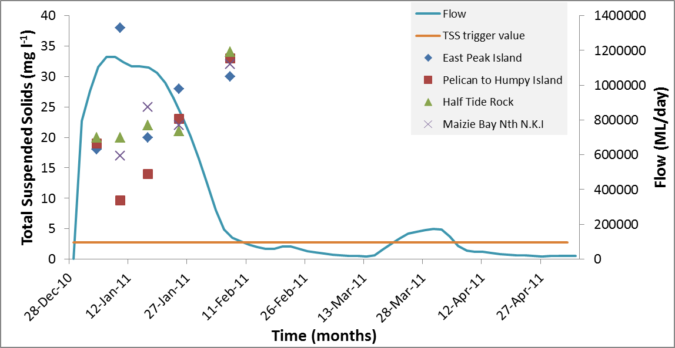
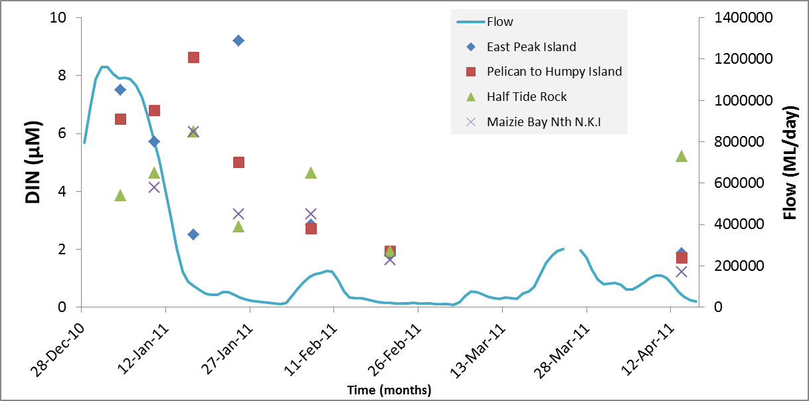

Figure 4-12: Changes in concentration over time for three key parameters (Chl-a, TSS and DIN) measured in the Fitzroy flood plume. Timing of sampling occurred between 4 January to April 2011. Note that TSS samples were not collected in the last two sampling dates for these sites.

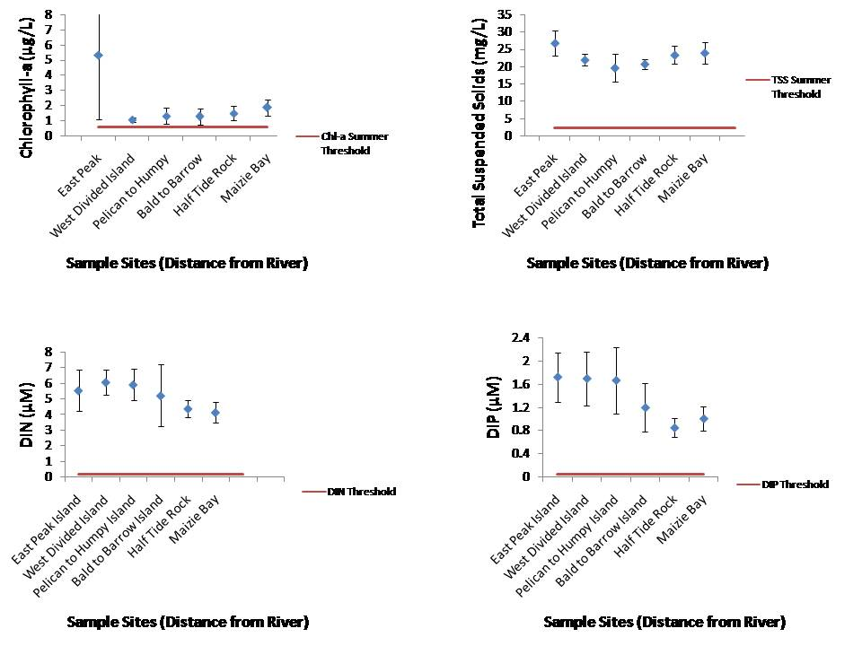
Figure 4-13: The mean values of four water quality parameters measured over the entire sampling season at each site in the Fitzroy. Data is compared to the threshold values set for each parameter.

Figure 4.14 presents a depth integrated map of salinity data for the Fitzroy region, focusing on the bleaching threshold for corals based on experimental data from the literature (e.g. Berkelmans 2002).

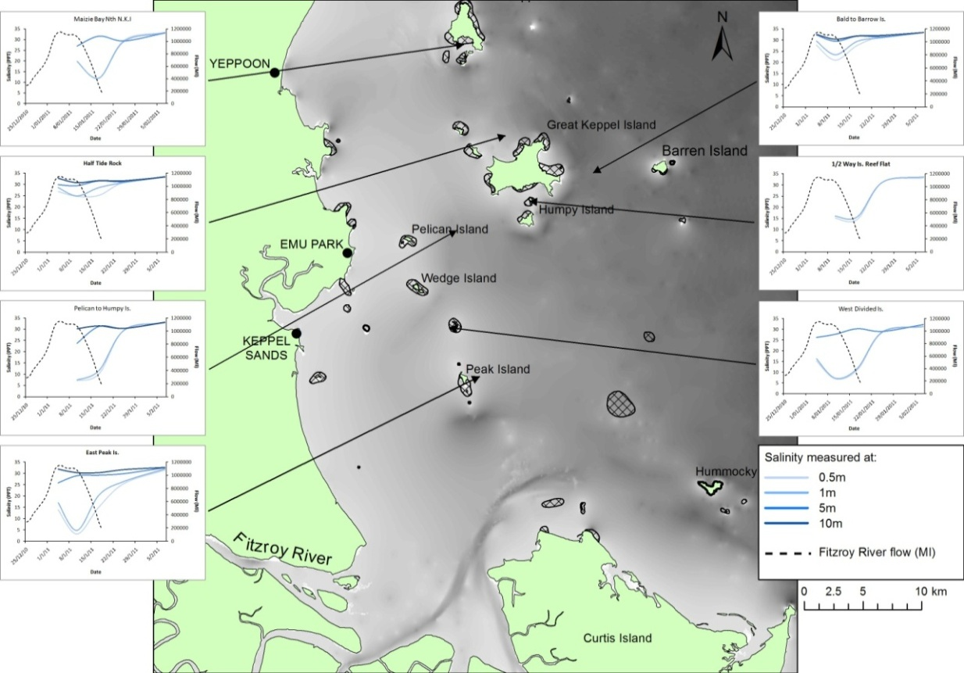

Figure 4-14: Depth-integrated exposure map for the Fitzroy marine region for salinity data, focussing on bleaching threshold for corals.

Pesticide monitoring
Concentrations of individual pesticides estimated using passive samplers at the four monitoring sites in the Fitzroy region are shown in Figure 4.15. The concentration profiles of the primary PSII herbicides are variable between sites and for this region, with tebuthiuron present at the highest concentrations at each site. The time-averaged concentrations of tebuthiuron exceed the GBRMPA guideline of 20 ng.L⁻¹ at both North Keppel Island and Halfway. Exceedances for all sites within this period are likely given the time averaged concentration range of between 13 and 23 ng.L⁻¹, but unconfirmed through grab sampling. Atrazine, diuron and metolachlor are also measured at high concentrations in the four sites, with concentrations measuring between 4.5 and 7.7ng.L⁻¹ for each site. Note that bromacil, haloxyfop and 3,4-dichloroaniline (diuron transformation product) were also detected at all of these sites in trace amounts (1 – 2 ng per sampler).
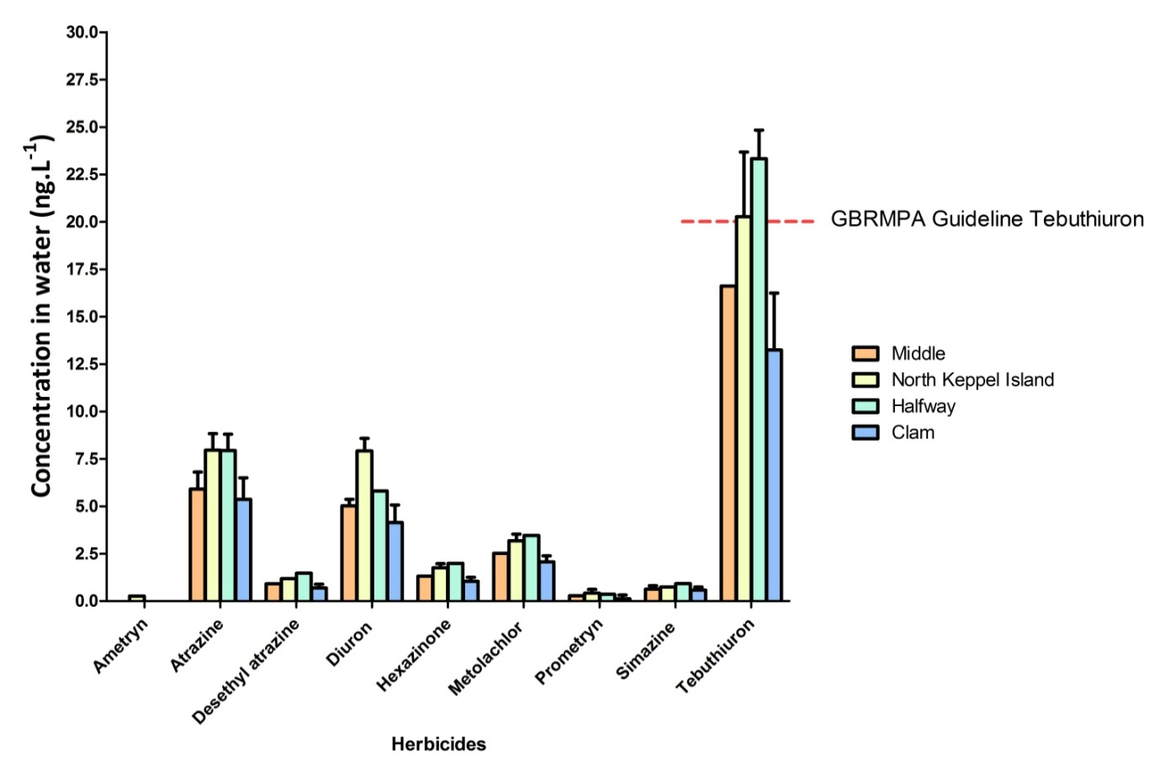
Figure 4-15: Herbicide concentrations at the Keppel Bay sites during the major January flood event in the Fitzroy River.
Results from pesticide grab sampling at 11 sites in the Fitzroy plume extending into the Mackay Whitsunday region on 19 January 2011 also detected several PSII herbicides. Atrazine (10 – 20 ng.L⁻¹) and diuron (10 ng.L⁻¹) were detected at two of these sites (FPMW422 & 425), while tebuthiuron (10 ng.L⁻¹) was detected at four of these sites (FPMW 429, 430, 432 & 433).

Burdekin
Water quality sampling in the Burdekin marine region was initiated in late December (30 December 2010) with additional sampling trips on 6 and 18 January 2011. Water sampling occurred over a two transects to capture the initial, low salinity primary plume (inner plume) and the ongoing plume influence around Magnetic Island to the Palm Island Group (refer to Figure 3.3). The sampling occurred in the inner plume (N = 5) in late December 2010 and further north (Magnetic Island to Palm Islands) at two follow up sampling occasions (6 January (N = 8) and 18 January, N = 14) (Table 4.5).
Statistical measurements for the main water quality components shown in Table 4.5 show that dissolved nutrients were high at all transects with a minimum value for DIN and DIP of 1.0μM and 0.03μM measured further north around Magnetic Island. Note that a very high minimum value of 5.7μM was measured at the Burdekin River primary plume transect. Maximum values for dissolved nutrients ranged from 2.6μM up to 23.2μM for DIN and 0.11μM up to 0.8μM for DIP. The TSS values were also elevated, with maximum values ranging from 3.5mg/L (Magnetic Island) to 50mg/L (Burdekin River).
Table 4-5. Summary of water quality data collected at three Burdekin transects sampled during the 2011 wet season.
Burdekin transect | No of samples | Statistical measurement | DIN (μM) | DIP (μM) | TSS (mg/L) | Chl-a (μg/L) | CDOM | Salinity (0.5m)
Burdekin mouth (30 Dec 10) | 6 | Minimum | 5.7 | 0.17 | 0.6 | 0.2 | 2.3 | 0
Burdekin mouth (30 Dec 10) | 6 | Maximum | 7.9 | 0.43 | 11 | 2.7 | 3.6
Burdekin mouth (30 Dec 10) | 6 | Mean | 6.9 | 0.25 | 3.7 | 1.2 | 2.9
Burdekin mouth (30 Dec 10) | 6 | SD | 0.9 | 0.10 | 3.3 | 0.8 | 0.5
Magnetic Is to Palm Is (6 Jan 11) | 8 | Minimum | 1.0 | 0.03 | 0.6 | 0.2 | 0.18 | 1
Magnetic Is to Palm Is (6 Jan 11) | 8 | Maximum | 2.6 | 0.11 | 3.5 | 1.3 | 0.6 | 8
Magnetic Is to Palm Is (6 Jan 11) | 8 | Mean | 1.8 | 0.08 | 1.8 | 0.5 | 0.4 | 4.5
Magnetic Is to Palm Is (6 Jan 11) | 8 | SD | 0.5 | 0.03 | 0.9 | 0.4 | 0.1 | 2.4
Magnetic Is to Palm Is (6 Jan 11) | 14 | Minimum | 1.1 | 0.25 | 1.4 | 0.3 | 0.1 | 18
Magnetic Is to Palm Is (6 Jan 11) | 14 | Maximum | 23.2 | 0.8 | 11 | 2.7 | 2.8 | 23
Magnetic Is to Palm Is (6 Jan 11) | 14 | Mean | 4.2 | 0.50 | 4.9 | 1.4 | 0.9 | 20.3
Magnetic Is to Palm Is (6 Jan 11) | 14 | SD | 6.0 | 0.14 | 3.8 | 0.8 | 1.0 | 1.9

The range of Chl-a indicates high phytoplankton production in the plume waters, with Chl-a values reaching a maximum of 2.7μg/L both at the inshore and offshore transect.These are lower than Chl-a values measured in the Fitzroy plume, however they do still indicate relatively high levels of phytoplankton numbers over time (weeks) and space (Burdekin River to Palm Island).

Spatial variability
Measurements for key parameters are presented against five salinity groups to demonstrate the change in the water quality parameters as they move away from the river mouth into the offshore coastal environment (Figure 4.16). DIN and DIP both showed conservative mixing as they moved through the salinity gradient, particularly DIP in the lower salinity ranges. There were high TSS values measured in the low salinity ranges but generally the TSS concentrations averaged above 10mg/L through the salinity gradient. It would be expected that the TSS values would fall as the water moves further north, but these high values may be indicative of the TSS inorganic fraction dropping out and the onset of biological production with the high values of Chl-a, CDOM and smaller mobile particles dominating the TSS component.
Collaborative work currently being undertaken within TropWater by Zoe Bainbridge (see Bainbridge et al., 2012) analysed the suspended sediment in all Burdekin samples to identify a catchment signature on Burdekin sediment. The results from this plume study show that the vast majority of Burdekin sediment is initially deposited (0 – 3 salinity zone) with a smaller fine fraction (<4 µm) transported considerable distances along the plume extent. In both cases the sediments are carried as organic-rich particulate matter. Marine snow was found to cause the rapid flocculation and deposition of riverine sediment within 10 km of the river mouth (0 – 3 salinity) during the peak of the 2010-11 Burdekin River flood event. The study highlighted the importance of particulate nitrogen in stimulating pelagic production (most likely heterotrophic bacteria) that formed marine snow within this initial, turbid zone. However, this process requires further investigation particularly in the GBR lagoon where particulate nitrogen can be the dominant form of nitrogen discharged from the large, dry tropical rivers which make up a considerable proportion of the total GBR catchment area. This is quite different to most international river plumes studied, where nitrogen loading is dominated by dissolved inorganic nitrogen.

Temporal variability
Due to the small number of sampling events and sites across salinity gradient for the Burdekin River plume, figures showing the changes in concentration over time for three key parameters (Chl-a, TSS and DIN) are not shown in this report.

Pesticide monitoring
In the two pesticide samples collected as part of the Burdekin sampling (Burdekin River mouth inner plume), tebuthiuron was the only herbicide detected in both of these samples at concentrations which are equivalent to the GBRMPA Guideline of 20 ng.L⁻¹.
Figure 4-16: The change in mean concentrations for key parameters (TSS, Chl-a, DIN, PN, DIP and CDOM) over the salinity gradient from the Burdekin River mouth to the Palm Island Group. Samples were taken over different dates and the change in salinity is indicative of the plume moving both through time and space.

Wet Tropics
Water sampling occurred over a number of dates (N = 14) to fully capture the temporal influence of the Tully River plume through repeated high flow periods. The Tully sampling occurred from the mouth of the Tully River north to the East of Sisters Island (N = 181) (refer to map of sample sites, Figure 3.4). Additional sampling occurred on one occurrence in the Russell-Mulgrave plume (N=6) around the Frankland and High Island reefs (Table 4.6).
Statistical measurements for the main water quality components (Table 4.6) show that dissolved nutrients were significantly higher than long term ambient values as reported in Furnas, (2003) and Schaffelke et al., (2012) at all transects with the minimum value for DIN ranging from 0.1μM to 2.7μM and minimum DIP values ranging from 0.03 to 0.36. Maximum values for DIN and DIP reached 11.1μM and 2.03μM respectively. In all sampling occasions, the maximum DIN exceeded 4μM other than the last sampling occasion (25 March 2011). The lowest DIN values were measured at the end of the sampling period (25 March 2011) indicating that the high nutrient concentrations had reduced by the third month. DIP. Ambient values for DIN have been set at 0.2 and 0.05 μM for DIP, indicating that there has been nutrient enrichment at all these transects over the entire sampling period (January to March). The TSS values were also elevated, with maximum values ranging from 4.2mg/L to 38mg/L. TSS values seem to persist above 5mg/L for most all sites for all transects. However the persistence of high TSS values through the Tully River plume indicates that the smaller, mobile fraction of the TSS component is available for three months of the 2011 wet season. Winds experienced throughout January and February were predominately south easterly and forced the plume movement to the north and constrained inshore (see Section 6).
The range of Chl-a values indicates high phytoplankton production in the plume waters, with Chl-a ranging from 1.1μg/L to 6.1μg/L. These high values over a relatively large area indicative of persistent occurrences of high phytoplankton numbers in response to the large inorganic nutrient supply and non-light limiting conditions.
CDOM values represent the extent of the freshwater influence. Schroeder et al., (in press) suggests that 0.14m⁻¹CDOM represents a salinity of 30 (+/- 4) ppt. All values of CDOM in all samples over all transects were higher than 0.14m⁻¹.
Table 4-6. Summary of water quality data collected over time at the Tully River plume transect sampled during the 2011 wet season.
Wet Tropics transect | No of samples | Statistical measurement | DIN (μM) | DIP (μM) | TSS (mg/L) | Chl-a (μg/L) | CDOM  (⁻¹) | Salinity (0.5m)
Tully River to Sister Is.  22/11/201 | 13 | Minimum | 0.9 | 0.03 | 3.2 | 0.3 | 0.00 | 15.1
Tully River to Sister Is.  22/11/201 | 13 | Maximum | 5.4 | 0.48 | 22.0 | 2.3 | 0.64 | 34.1
Tully River to Sister Is.  22/11/201 | 13 | Mean | 2.5 | 0.30 | 6.2 | 0.6 | 0.16 | 29.4
Tully River to Sister Is.  22/11/201 | 13 | SD | 1.6 | 0.11 | 4.9 | 0.6 | 0.26 | 7.0
Tully River to Sister Is  16/12/2010 | 17 | Minimum | 1.9 | 0.13 | 0.4 | 0.2 | 0.00 | 26.7
Tully River to Sister Is  16/12/2010 | 17 | Maximum | 4.4 | 0.58 | 6.1 | 0.8 | 0.37 | 31.7
Tully River to Sister Is  16/12/2010 | 17 | Mean | 2.7 | 0.38 | 2.2 | 0.4 | 0.05 | 30.2
Tully River to Sister Is  16/12/2010 | 17 | SD | 0.7 | 0.10 | 1.6 | 0.2 | 0.10 | 1.3
Tully River to Sister Is  2/01/2011 | 16 | Minimum | 2.7 | 0.36 | 2.1 | 0.5 | 0.25 | 7.2
Tully River to Sister Is  2/01/2011 | 16 | Maximum | 10.1 | 0.71 | 15.0 | 5.3 | 0.97 | 31.8
Tully River to Sister Is  2/01/2011 | 16 | Mean | 4.7 | 0.56 | 5.5 | 1.8 | 0.59 | 21.4
Tully River to Sister Is  2/01/2011 | 16 | SD | 2.4 | 0.10 | 3.8 | 1.2 | 0.24 | 7.7
Tully River to Sister Is  18/1/2011 | 4 | Minimum | 1.8 | 0.35 | 1.5 | 0.3 | 0.21
Tully River to Sister Is  18/1/2011 | 4 | Maximum | 4.9 | 0.95 | 19.0 | 1.1 | 0.41
Tully River to Sister Is  18/1/2011 | 4 | Mean | 2.7 | 0.53 | 7.7 | 0.6 | 0.28
Tully River to Sister Is  18/1/2011 | 4 | SD | 1.5 | 0.29 | 8.1 | 0.3 | 0.09
Tully River to Sister Is  19/1/2011 | 14 | Minimum | 1.7 | 0.33 | 1.2 | 0.3 | 0.18 | 25.1
Tully River to Sister Is  19/1/2011 | 14 | Maximum | 5.9 | 1.15 | 20.0 | 1.8 | 0.62 | 29.9
Tully River to Sister Is  19/1/2011 | 14 | Mean | 2.6 | 0.50 | 4.0 | 0.8 | 0.27 | 27.4
Tully River to Sister Is  19/1/2011 | 14 | SD | 1.1 | 0.22 | 4.9 | 0.4 | 0.12 | 1.7
Tully River to Sister Is.  12/2/2011 | 15 | Minimum | 1.3 | 0.30 | 1.4 | 0.2 | 0.32 | 1.2
Tully River to Sister Is.  12/2/2011 | 15 | Maximum | 7.1 | 1.67 | 38.0 | 6.1 | 1.79 | 27.5
Tully River to Sister Is.  12/2/2011 | 15 | Mean | 2.4 | 0.55 | 6.4 | 1.9 | 0.72 | 21.1
Tully River to Sister Is.  12/2/2011 | 15 | SD | 1.4 | 0.34 | 9.3 | 1.8 | 0.51 | 8.7
Tully River to Sister Is  13/2/2011 | 4 | Minimum |  |  | 2.1 | 0.3 | 0.44
Tully River to Sister Is  13/2/2011 | 4 | Maximum |  |  | 20.0 | 2.9 | 1.22
Tully River to Sister Is  13/2/2011 | 4 | Mean |  |  | 7.0 | 1.3 | 0.92
Tully River to Sister Is  13/2/2011 | 4 | SD |  |  | 8.7 | 1.2 | 0.42
Tully River to Sister Is  15/2/2011 | 16 | Minimum | 1.7 | 0.27 | 1.6 | 0.5 | 0.39 | 17.7
Tully River to Sister Is  15/2/2011 | 16 | Maximum | 10.0 | 1.60 | 6.5 | 1.6 | 1.40 | 26.1
Tully River to Sister Is  15/2/2011 | 16 | Mean | 2.8 | 0.45 | 3.3 | 0.9 | 0.69 | 22.4
Tully River to Sister Is  15/2/2011 | 16 | SD | 2.0 | 0.31 | 1.3 | 0.3 | 0.29 | 2.9
Tully River to Sister Is  17/2/2011 | 4 | Minimum |  |  | 1.5 | 0.5 | 0.09
Tully River to Sister Is  17/2/2011 | 4 | Maximum |  |  | 15.0 | 1.9 | 0.64
Tully River to Sister Is  17/2/2011 | 4 | Mean |  |  | 5.3 | 1.0 | 0.43
Tully River to Sister Is  17/2/2011 | 4 | SD |  |  | 6.5 | 0.6 | 0.24
Tully River to Sister Is  18/2/2011 | 16 | Minimum | 1.4 | 0.26 | 0.9 | 0.5 | 0.32 | 21.1
Tully River to Sister Is  18/2/2011 | 16 | Maximum | 11.1 | 2.03 | 32.0 | 2.7 | 0.87 | 26.9
Tully River to Sister Is  18/2/2011 | 16 | Mean | 2.9 | 0.53 | 4.8 | 1.1 | 0.45 | 24.6
Tully River to Sister Is  18/2/2011 | 16 | SD | 2.6 | 0.47 | 7.7 | 0.6 | 0.14 | 1.6
Tully River to Sister Is  21/2/2011 | 16 | Minimum |  |  | 1.1 | 0.5 | 0.18
Tully River to Sister Is  21/2/2011 | 16 | Maximum |  |  | 4.2 | 1.3 | 0.37
Tully River to Sister Is  21/2/2011 | 16 | Mean |  |  | 2.4 | 0.8 | 0.26
Tully River to Sister Is  21/2/2011 | 16 | SD |  |  | 1.3 | 0.4 | 0.09
Tully River to Sister Is  22/2/2011 | 15 | Minimum | 1.8 | 0.12 | 1.1 | 0.3 | 0.21 | 24.3
Tully River to Sister Is  22/2/2011 | 15 | Maximum | 6.9 | 0.46 | 4.2 | 2.4 | 0.48 | 29.5
Tully River to Sister Is  22/2/2011 | 15 | Mean | 3.4 | 0.23 | 2.1 | 0.7 | 0.29 | 27.5
Tully River to Sister Is  22/2/2011 | 15 | SD | 1.4 | 0.09 | 0.9 | 0.6 | 0.09 | 1.4
Tully River to Sister Is  3/3/2011 | 16 | Minimum | 1.7 | 0.04 | 2.0 | 0.8 | 0.62 | 7.1
Tully River to Sister Is  3/3/2011 | 16 | Maximum | 9.9 | 0.24 | 21.0 | 3.7 | 1.56 | 27.1
Tully River to Sister Is  3/3/2011 | 16 | Mean | 3.7 | 0.09 | 5.8 | 1.9 | 0.96 | 17.1
Tully River to Sister Is  3/3/2011 | 16 | SD | 2.4 | 0.06 | 5.8 | 1.1 | 0.29 | 5.6
Tully River to Sister Is  25/3/2011 | 15 | Minimum | 0.1 | 0.00 | 1.5 | 0.2 | 0.07 | 1.7
Tully River to Sister Is  25/3/2011 | 15 | Maximum | 1.1 | 0.03 | 21.0 | 1.1 | 1.06 | 34.7
Tully River to Sister Is  25/3/2011 | 15 | Mean | 0.3 | 0.01 | 5.2 | 0.6 | 0.29 | 26.9
Tully River to Sister Is  25/3/2011 | 15 | SD | 0.3 | 0.01 | 4.6 | 0.2 | 0.26 | 9.2

Spatial variability
Water quality data was integrated over salinity ranges to demonstrate the mixing profiles through the salinity gradient (Figure 4.17). Measurement of TSS, Chl-a, and DIN reduced over the salinity gradient, though the scale of reduction varied for each water quality constituent. The values of TSS reduced from a mean value of 12mg/L in the lower salinity ranges (0 -10) to a mean values between 5 to 6mg/L in the higher salinity ranges (26 – 36ppt). DIN concentration reduced over the salinity gradient, though nonlinear mixing is evident around the 11 to 15 ppt. Concentrations of DIN reduced overall from a mean value of 5.1μM to 2.2μM. The values measured in the higher salinities are still 10 fold higher than the ambient long term values (wet season – 0.2μM).
Figure 4.18 shows the mean value of different water quality parameters at each site over the sampling period. The recorded values of DIN and DIP throughout the entire sampling period all exceed the threshold values by quite a large margin. The values for Chl-a also exceed the threshold level, but there is more variation between sites. TSS values only exceed the threshold values at the sites closest to the river mouths. The figures highlight that even at sampling site the furthest from the river mouth, there are high levels of nutrients being recorded.
Salinity was below the 28ppt threshold for the two sites closest to the river mouth (Table 4.6). Salinity values in the sites at a greater distance from the Tully River mouth were also around the 28ppt threshold, with lower values following TC Yasi. Sites in the Tully transect exceeded the temperature threshold for most of the sampling period.

Figure 4-17. Water quality concentrations integrated over salinity ranges collected within the Tully River plume. Water quality data presented for TSS, Chl-a, DIN, PN, DIP, PP and CDOM.

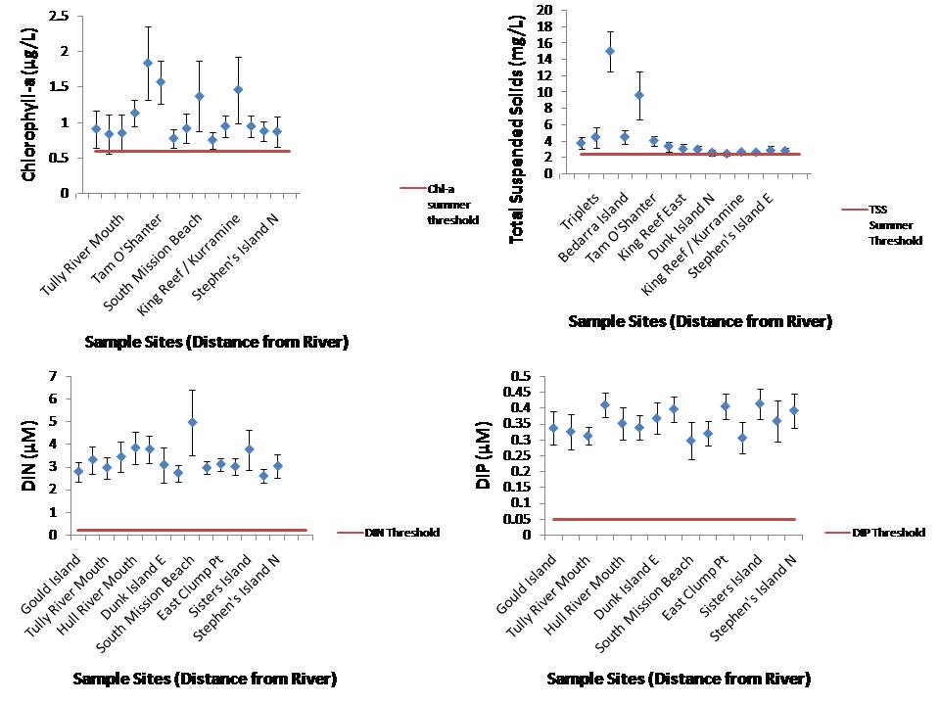
Figure 4-18. The mean values of four water quality parameters measured over the entire sampling season at each site in the Tully. Data is compared to the threshold values set for each parameter.

Temporal variability
The additional funding and support from the GBRMPA’s EWRP and the use of small local research boats allowed a more frequent sampling strategy than normally taken under the MMP. The frequency of these measurements over a longer time period (November 2010 to the end of March 2011) allows a more robust analysis of temporal changes in the flood plume waters and a preliminary understanding of the longer term influence of the higher water quality concentrations associated with the large Tully river floods.
Figure 4.19 illustrates the changes in concentrations of three key water quality components in the flood plume over time for four sites. The sites are located close to the river mouth (Tully River Mouth, Bedarra Reef and North Dunk. Concentrations of TSS increased over time at all sites, reaching a peak in early February. Chl-concentrations are high, particularly later in the wet season (March to April) around Tully River mouth and Bedarra Island. DIN concentrations were variable but peak after the high flow associated with TC Yasi (early February 2011). DIN concentrations reached up to 12μM, and ranged between 1 and 12μM for the whole sampling period (with the exception of one low value measured at Bedarra).
The spatial variability of two key water quality parameters, salinity and DIN, for the Tully marine region is shown in Figure 4.20 and 4.21 over a series of dates. Sampling points for salinity and DIN were imported into ArcGIS 9.3, and spatial locations checked. Any incorrectly located points were relocated to the correct position corresponding to sampling site. A surface was created for each set of points by date, or dates were aggregated into averages if average measures were required. Surfaces were created using the Ordinary Kriging method available within the Geostatistical analysis extension within ArcGIS 9.3. However due to the sparseness of sampling points available, some smoothing was performed on the datasets (smoothing level 0.1), to reduce edge noise.
Salinity data is presented at surface (0.5m) and 5m depth as mean values for January and February 2011 (Figure 4.20). The average surface salinity for January was 20ppt, increasing slightly to an average value of 23ppt for February. Mean salinity at 5m was still reduced with values of approximately 32 for January and 30 for February. Spatial interpolation of DIN concentrations mapped from November to February 2011 is presented in Figure 4.21. DIN concentrations are high (relative to the ambient values) from early January to late February, though the area of influence changes over that time, reflective of the movement of the plume waters.
Figure 4.22 presents a depth integrated map of salinity data for the Tully region, focusing on the bleaching threshold for corals. Corals at depth of 10m and above experienced reduced salinity conditions for most of January and February, with salinity ranging from 25 to 31ppt.

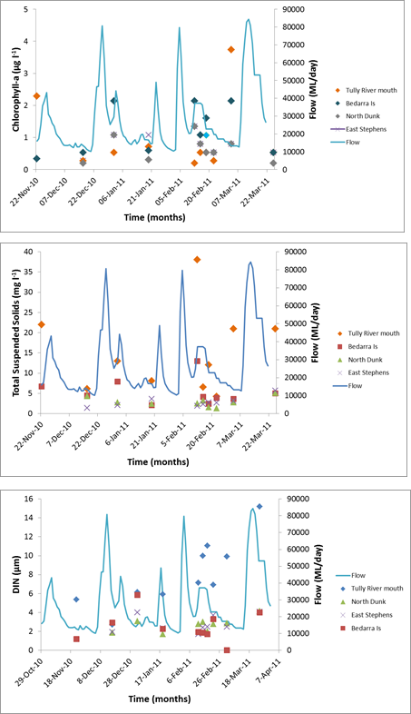

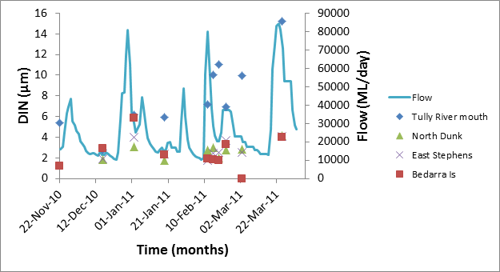

Figure 4-19: Changes in concentration over time for three key parameters (Chl-a, TSS and DIN) measured in the Tully River flood plumes. Timing of sampling occurred November 2010 to late March 2011.

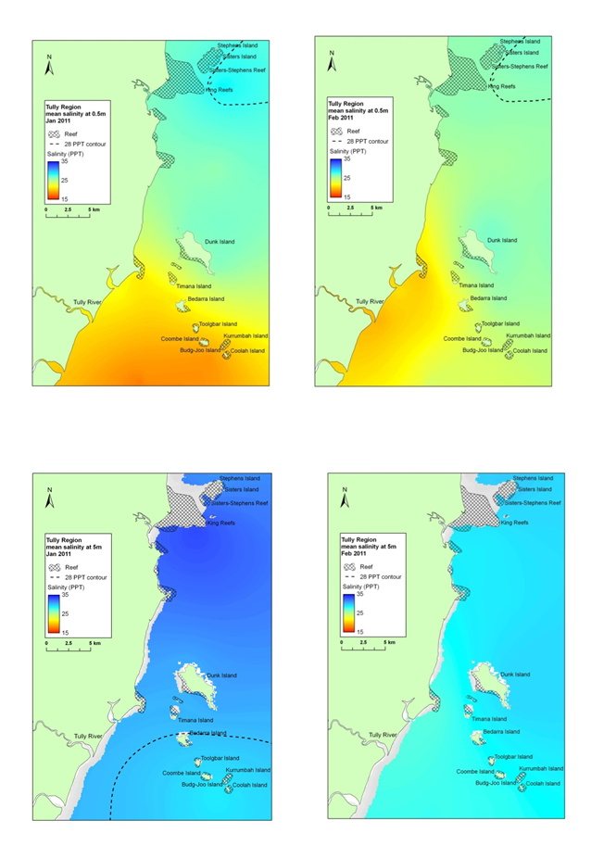
Figure 4-20: Spatial interpolation of salinity gradient (averaged over both January and February sampling dates) presented for at 0.5m and 5m depth for the Tully transect
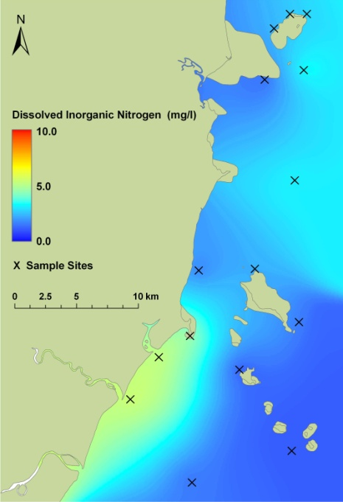
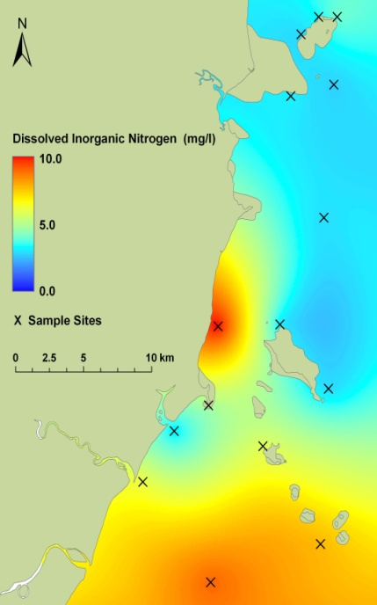
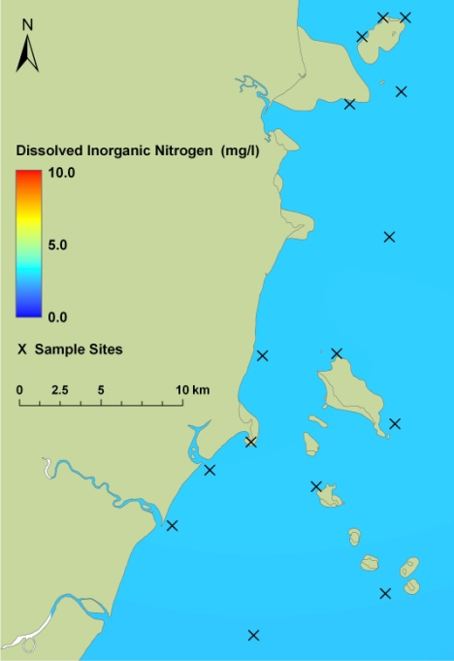
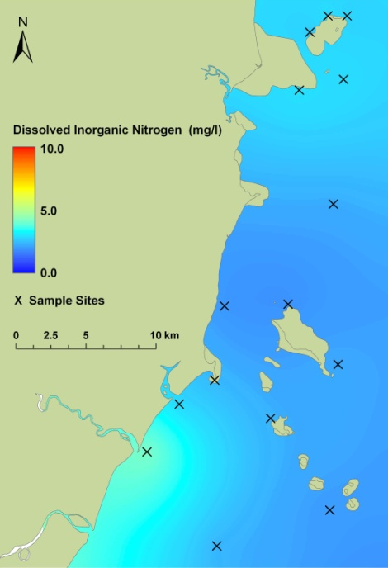
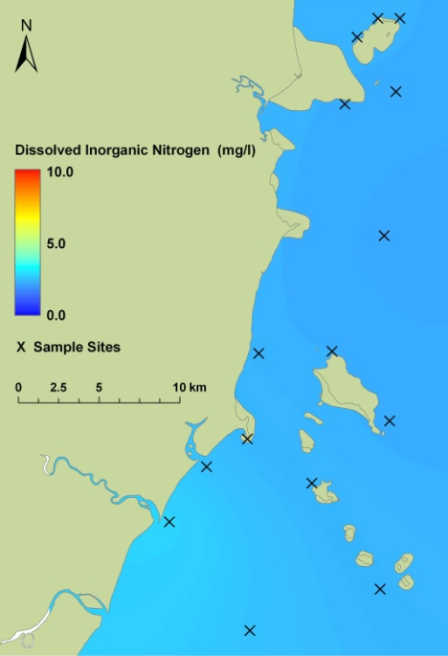
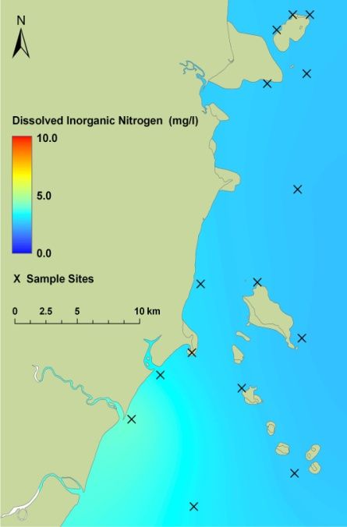
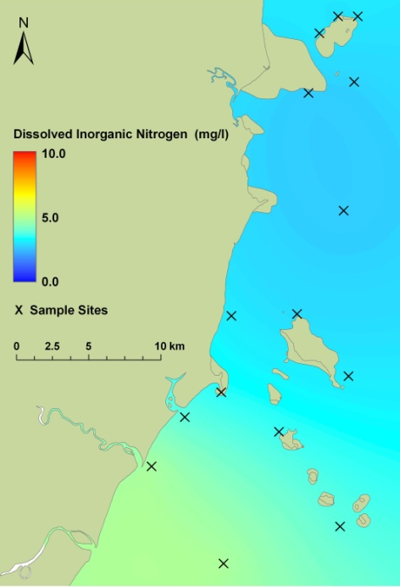
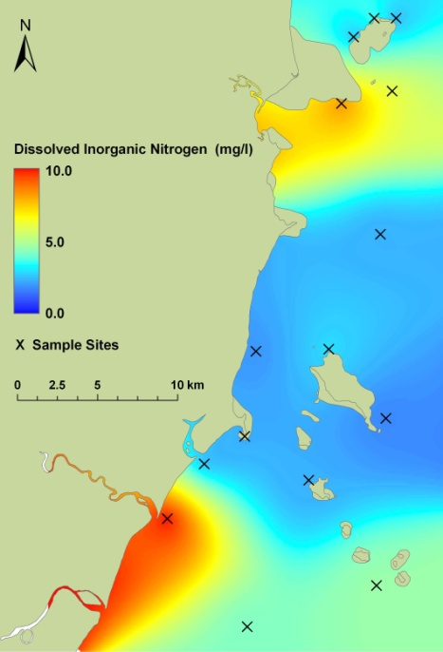
22nd Nov 2010
16th Dec 2010
2nd Jan 2011
19th Jan 2011
12th Feb 2011
15th Feb 2011
22nd Feb 2011
3rd March 2011

22nd Feb 2011

y
Figure: 4-21. Spatial interpolation of DIN in the Tully River plumes during the 2011 wet season (November 2010 to March 2011).

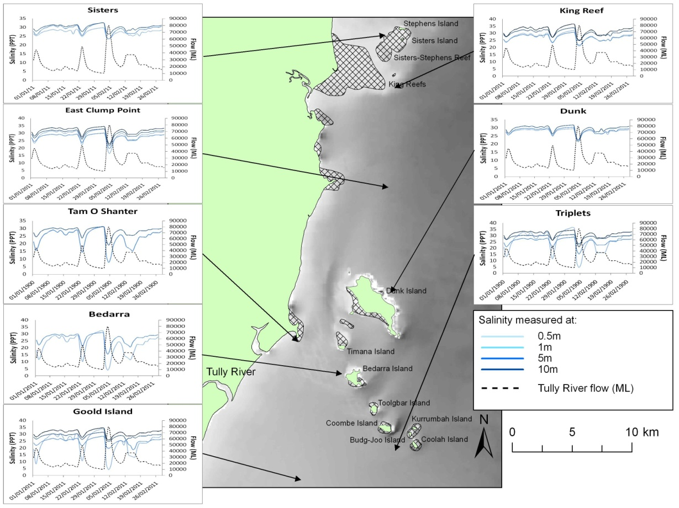
Figure 4-22: Depth-integrated exposure map for the Tully marine region for salinity data, focussing on bleaching threshold for corals.

Pesticide monitoring results
A greater number of pesticides were detected at the Tully River Mouth (atrazine, diuron, hexazinone and imidacloprid) than at Bedarra Island (diuron, hexazinone) and at Sisters Island (diuron) using grab sampling techniques. The differences in percentage detection of individual pesticides between passive and grab sampling are illustrated in Figure 4.23. In addition to atrazine, diuron and hexazinone, PSII herbicides such as ametryn, simazine and tebuthiuron were also detected at all sites using passive sampling techniques. However the imidacloprid detected in grab samples at the Tully River mouth was not detected in the passive samplers.
Both techniques illustrate a clear gradient in the diuron concentrations with Tully River mouth >Bedarra Island > Sisters Island.
For a full analysis of pesticides collected under this and other MMP components, please refer to Kennedy et al., (2012).

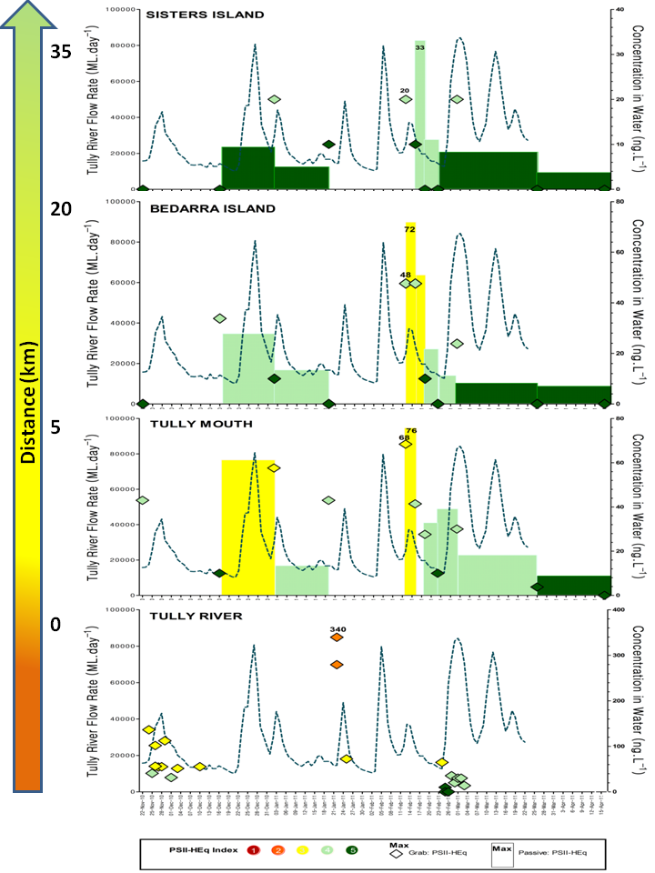
Figure 4-23. Frequency of detection (% of samples detected) for grab and passive samplers at the Tully transect sites.

Material Transport

Transport of nutrients
As part of the program’s objective to improve understanding of flood plume dynamics, further analysis of the nutrient results for this wet season was undertaken. The export of nitrogen and phosphorus, particularly the bioavailable fraction, is a main pollutant in the GBR and can potentially impact on corals and seagrass beds over acute and chronic stages (e.g. Brodie et al., 2011; Fabricius, 2011a; 2011b). We compared total nitrogen (TN) and total phosphorus (TP) across the three study areas (Figure 4.24). The Fitzroy River has the highest proportion of TN and TP, with maximum values of 50μM in the low salinity ranges for TN and 5μM for TP.
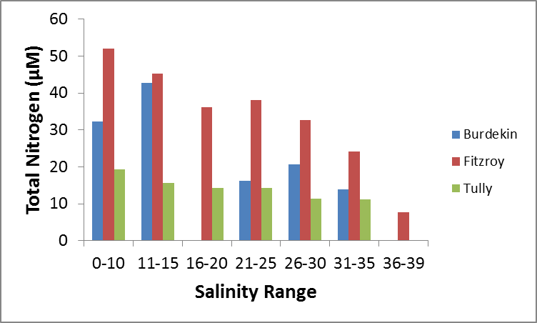
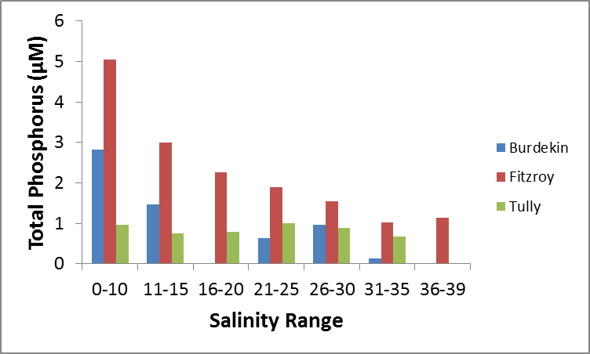
Figure 4-24. Proportion of TN and TP through the salinity gradient for the three NRM regions (Tully, Burdekin and Fitzroy).
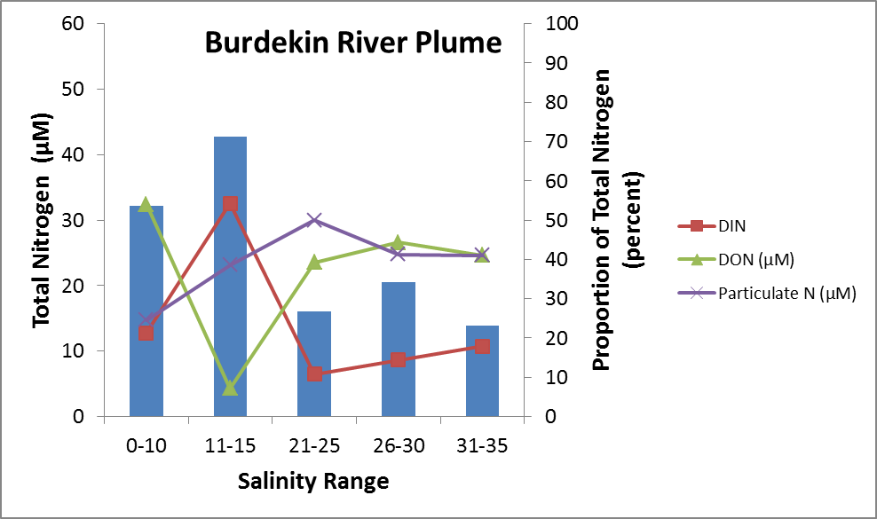
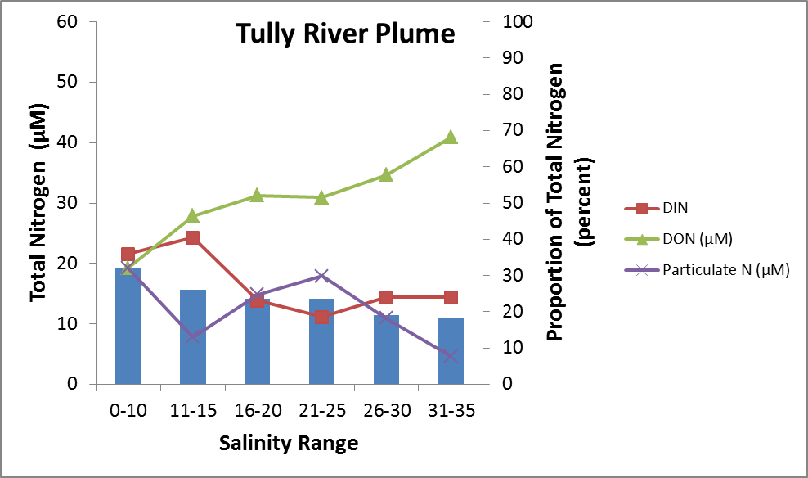
The portioning of nitrogen and phosphorus as river waters move into the GBR is an important process in the understanding of bioavailability required for primary and secondary biological responses. The proportion of the nitrogen and phosphorus varies between each catchment with the Tully having the dissolved organic component of nitrogen the dominant source, with the exception of the lower salinity ranges where DIN dominates the TN (Figure 4.25). In contrast, the Burdekin has a high DON at the lowest and highest salinities, however this trend is less clear as there were no salinity values recorded between 16-20 PSU in the Burdekin. Nitrogen in the Fitzroy river plume is dominated by DON through all the salinity ranges (Figure 4.25). TP is dominated by organic phosphate (DOP) and PP in the Tully river plume (Figure 4.26). In contrast the TP pool in Burdekin plume waters is dominated by DIP in the lower salinities, followed by an oscillation between PP and DIP (Figure 4.26). The Fitzroy river plume is dominated by PP through all salinity ranges.
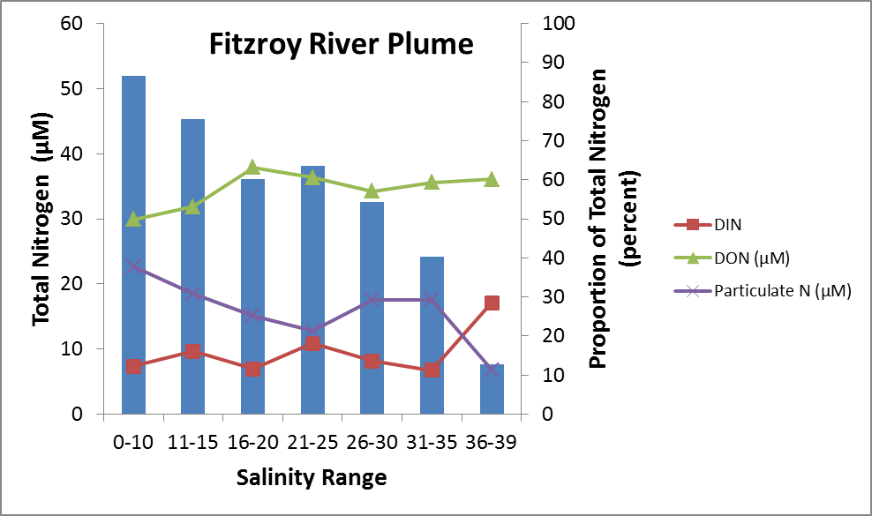
Figure 4-25: The proportion of TN over salinity gradient for the Tully, Burdekin and Fitzroy river plumes (2011).
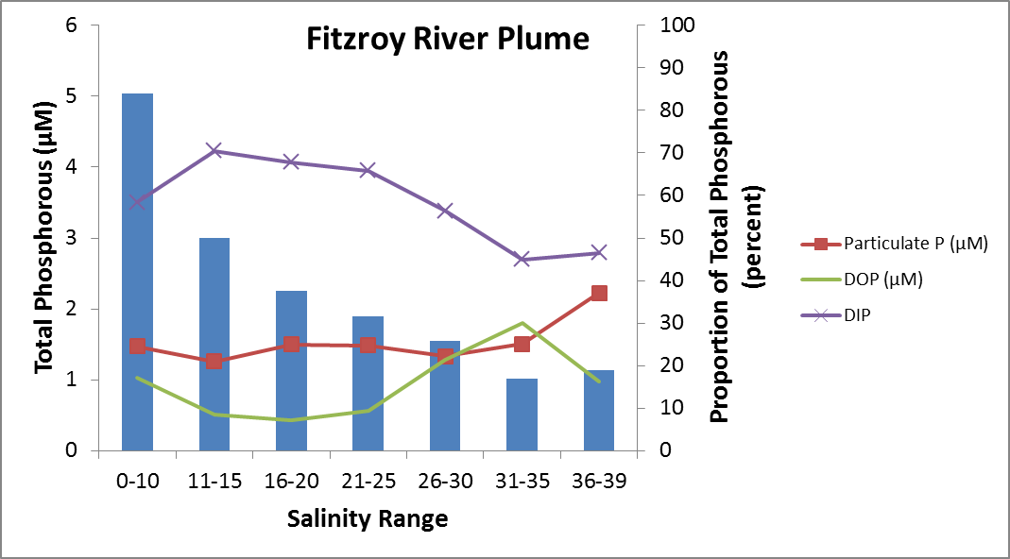
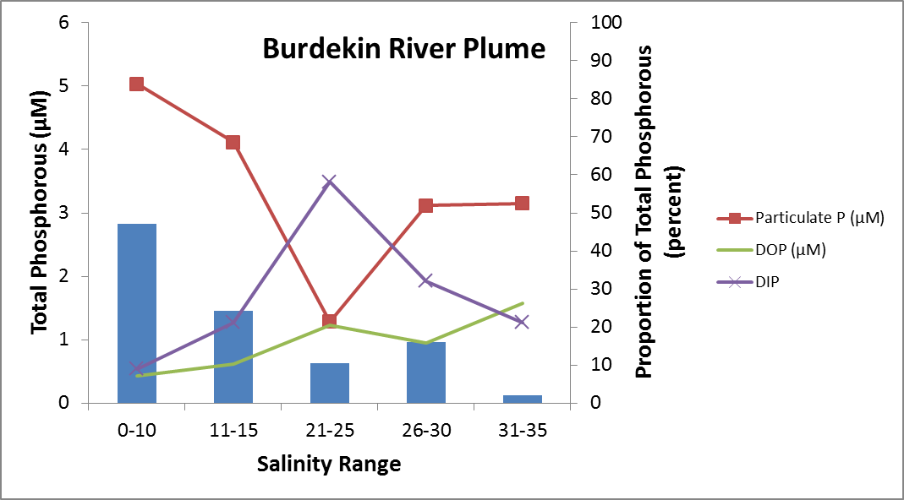
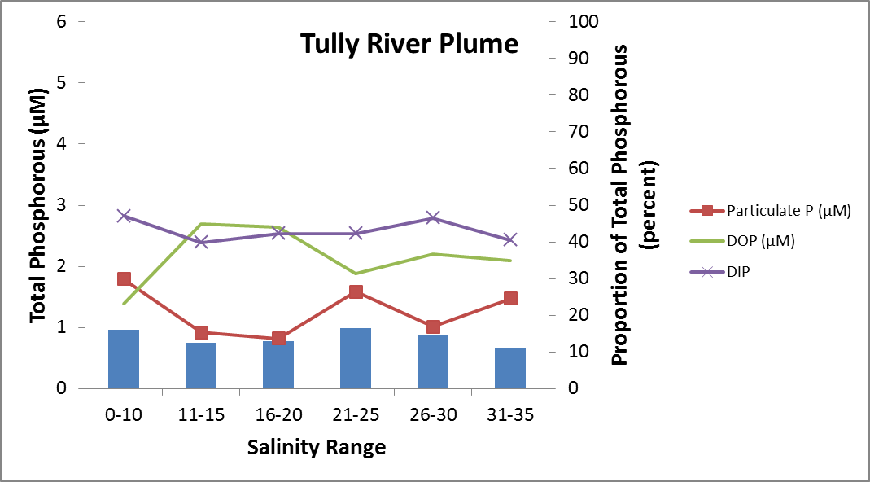
Figure 4-26: The proportion of TP over salinity gradient for the Tully, Burdekin and Fitzroy river plumes (2011).

Water Quality Index
As part of our ongoing effort to understand how water quality is affecting the GBR, we have incorporated a water quality metric to explore how sites fared within this sampling season, how the water quality from the sampling season compared to previous water quality collected from each region, and finally, how the water quality from each region in 2011 compared to the long term data set of all the water quality collected from flood plumes in the GBR. The method for calculating a preliminary Water Quality Index (WQI) was described in Section 3.5.1.
The range of WQI scores calculated for the 2011 data are shown in Table 4.8, with the largest positive scores (greater than 5) associated with the greatest deviation (highest concentrations) away from the mean. The WQI values for Fitzroy plume transect (Table 4.9) and for the Tully plume transect (Table 4.10) show that for the 2011 sampling period, the nearshore sites (East Peak Island to Pelican to Humpy) and the Tully River mouth have the highest WQI, which would be driven by the very high values of TSS and DIN measured at these sites. When the data collected this year from each region is compared to previously collected data from the same region, this year shows an elevated WQI in both the Fitzroy region and the Tully region (Tables 4.11 and 4.12). The WQI for the same sites over the whole period show that the WQI for those same Keppel sites increases to very high WQI values. In comparison, the Tully mouth and all other Tully sites have reduced WQI values when comparing to the long term flood plume data. This indicates that the WQ data measured in the Fitzroy transect was high, both in terms of the other plume data collected this year, and also when compared to all of the water quality data collected over 20 years of plume sampling. Long term values for the common water quality parameters are shown in Table 4.13. In contrast, the Tully transect has elevated concentrations, and as shown in the temporal graphs, are elevated over an extended period of time. However, the scale of difference between the mean values and the Tully transect water quality data is small. Impact monitoring needs consider the severity of impact from short, very high concentrations of water quality values, particularly TSS in the Fitzroy and Burdekin transects as compared to the more persistent, elevated, though less extreme concentrations associated with Wet Tropics Rivers such as the Tully transect sites.

Table 4-7: Range of WQI scores calculated for the 2011 data, with the largest positive scores (greater than 5) associated with the greatest deviation (highest concentrations) away from the mean.

Table 4-8: The water quality index of the sampling sites influenced by the Fitzroy River, scaled by the use of Z scores. The Water Quality Index (WQI) over sampling period is scaled from the mean of the site data against the mean and standard deviation from all Fitzroy data collected in 2011. The WQI for historical data is scaled from the mean of the 2011 site data against all water quality data collected within flood plumes (1991 – 2010).
Sites (distance from river mouth) | WQI over sampling period | WQI over sampling period compared to historic data
East Peak Island | 7.04 | 11.44
West Divided Island | 5.14 | 9.65
Pelican to Humpy Island | 5.25 | 9.46
Bald to Barrow Island | -0.37 | 4.08
Half Tide Rock | 0.16 | 4.33
Maizie Bay | 3.78 | 8.77
Halfway Is. Reef flat | 2.98 | 8.84

Table 4-9: The water quality index of the sampling sites influenced by the Tully River, scaled by the use of Z scores. The Water Quality Index (WQI) over sampling period is scaled from the mean of the site data against the mean and standard deviation from all Tully data collected in 2011. The WQI for historical data is scaled from the mean of the 2011 site data against all water quality data collected within flood plumes (1991 – 2010).

Sites (distance from river mouth) | WQI over sampling period | WQI over sampling period compared to historic data
Tully River Mouth | 2.48 | -1.31
Bedarra Island | 0.94 | -2.06
Hull River Mouth | 2.51 | -1.60
Tam O'Shanter Point | 0.04 | -2.82
Dunk Island E | -1.10 | -2.93
King Reef East | -0.49 | -2.90
South Mission Beach | 0.31 | -2.35
Dunk Island N | -1.86 | -3.66
East Clump Pt | -1.84 | -3.36
King Reef / Kurramine | -0.04 | -2.61
Sisters Island | -0.79 | -2.91
Stephen's Island | -0.97 | -3.02

Table 4-10: A comparison of the water quality indices from the Tully region over time.
Year | 1994 | 1995 | 1997 | 1998 | 2006 | 2007 | 2009 | 2010 | 2011
WQI | -2.74 | 1.76 | 2.90 | 1.97 | -0.47 | -3.61 | 0.95 | -3.68 | 0.12

Table 4-11: A comparison of the water quality indices from the Fitzroy region through time.
Year | 1991 | 2008 | 2011
WQI | -0.92 | -1.82 | 1.48

Table 4-12: Average (and SD) water quality values from the Tully River calculated from the long term plume water quality data set (1991 – 2011) currently held within JCU.
Parameter | TSS | Chl-a | DIN | DON | PN | PP | DOP | DIP
Mean | 10.89 | 1.77 | 3.69 | 9.25 | 3.94 | 0.28 | 0.27 | 0.41
SD | 11.59 | 2.57 | 4.18 | 7.85 | 5.14 | 0.42 | 0.26 | 0.41

The WQI value can be influenced by a single value, for example, in sites close to river mouth, it would be expected that a high (+) WQI value would be influenced by high TSS measurements. The WQI value for each transects ranges from 7.77 to -2.18 (Table 4.14). These high WQI values are very much driven by high values of suspended sediment, particularly PN in the Fitzroy-Keppels and TSS in the Burdekin and Shoalwater Bay. Rosslyn Bay WQI identifies very high values of DON in relation to all other DON values measured in the 2011 plume samples. The WQI does not preclude that values in the Tully transect were high, however in relation to the extreme variation of other parameters, water quality data within the Tully transect showed some of the lowest concentrations measured within the 2011 sampling year.
Table 4-13: The WQI of the different transects reported in this sampling year (2010-11), scaled by the use of Z scores. The WQI for each transect is scaled from the mean water quality data measured over each transect against the mean and standard deviation from all 2011 water quality data. The water quality parameter that most influences the WQI is highlighted in yellow.
Transect | Parameter
Transect | WQI | Chl-a | DIN | DON | PN | PP | DOP | DIP | TSS
Fitzroy-Keppels | 7.77 | 0.12 | 0.42 | 1.53 | 1.64 | 0.51 | 0.28 | 2.28 | 0.98
Rosslyn Bay-North Keppels | 5.96 | 0.57 | -0.01 | 2.64 | 0.57 | -0.24 | 0.91 | 0.61 | 0.9
Shoalwater Bay | 2.41 | -0.47 | 0.03 | 0.88 | 0.75 | -0.37 | 0.02 | 0.06 | 1.5
Swains | 1.44 | 0.12 | -0.07 | 1.76 | -0.14 | -0.48 | 0.79 | 0.23 | -0.75
Mackay | -1.92 | -0.19 | -0.36 | -0.57 | -0.56 | 0.48 | -0.29 | 0.33 | -0.76
Burdekin | 1.79 | -0.24 | 0.28 | 0.24 | 0.74 | 1.44 | -0.30 | 0.19 | -0.56
Tully | -2.18 | -0.28 | -0.16 | -0.49 | -0.32 | -0.25 | 0.05 | -0.19 | -0.55
Part B: Flood Plume Mapping

Mapping methods

Remote sensing methodology/GIS
Remote sensed imagery has become a useful and operational assessment tool in the monitoring of flood plumes in the GBR. Combined with in situ water quality sampling the use of remote sensing is a valid and practical way to estimate both the extent and frequency of plume (surface) exposure on GBR ecosystems. Plume waters are driven by high river flow conditions, which are the periods in the monsoonal season that are typically associated with the passage of cyclones or low pressure systems (Devlin and Brodie, 2005). The use of remote sensing algorithms is also improving in estimating water quality parameters such as TSS, Chl-a and absorption of CDOM. Ocean colour imagery provides synoptic-scale information regarding the movement and composition of flood plumes. Our efforts to improve methods of mapping and characterising GBR flood waters are continuing. For this reporting period we have used ocean colour satellite imagery to delineate the edge of the plume with an increasing degree of confidence.
The main catalogue of ocean colour satellite imagery used was that of the Moderate Resolution Imaging Spectroradiometer (MODIS) on-board the NASA Earth Observation System Terra and Aqua spacecrafts. Level-0 (L0) data corresponding to images during high-flow periods recorded between 2001 and 2010 were acquired from NASA’s Ocean Colour Browse website. The number of data available during high flood periods was also constrained to dates associated with low cloud cover over our study area with a maximum of 11 MODIS scenes were finally selected and processed as follows. True colour images and L2 products (Chl-a, CDOM and detrital matter absorption coefficient (aCDM-D) and two TSS proxies) were derived from L0 data using SeaWiFS Data Analysis System v5.4 – SeaDAS (Baith et al., 2001). A combined near infrared to short wave infrared (NIR-SWIR) correction scheme (Wang and Shi, 2007) was applied to level-1 products to overcome the atmospheric correction issues above turbid waters, commonly found in the nearshore regions of the GBR.
In combination with in situ sampling of flood plumes, remotely sensed data has provided an additional source of data related to the movement and composition of flood plumes in GBR waters (Bainbridge et al., 2012 Brodie et al., 2010; Devlin et al., 2012; Schroeder et al., 2012), particularly because spatial coverage from vessel sampling is usually limited due to cost and adverse weather conditions. Flood plumes have been mapped and the coverage of GBR ecosystems visually assessed using satellite imagery (Devlin and Schaffelke, 2009). A combination of aerial surveys and satellite imagery has also been employed in the GBR to determine areas of marine coastal ecosystems exposed to flood plumes (Brodie et al., 2010; Devlin et al., 2001; Devlin and Brodie, 2005; Schroeder et al., 2012).
Two images taken during the 2011 flood conditions are shown in Figure 5.1 and Figure 5.2. The estimated plume extent out of the Fitzroy River on the 11th January is mapped through the visual interpretation of the extent of both the brown (turbid) and green (chlorophyll biomass) plume water. The plume movement over a much greater spatial scale, though with some loss of true colour resolution is illustrated in Fig 5-2 and shows clearly how the distribution of single flood plumes are merging into one continuous GBR wide plume extent.
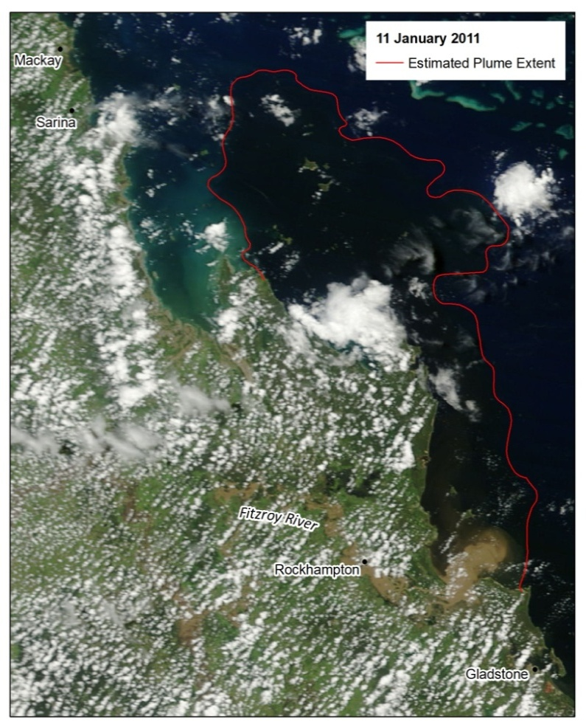
Figure 5-1. The extent of the riverine plume as measured by MODIS imagery (Level 1 processing) on the 11th January 2011.
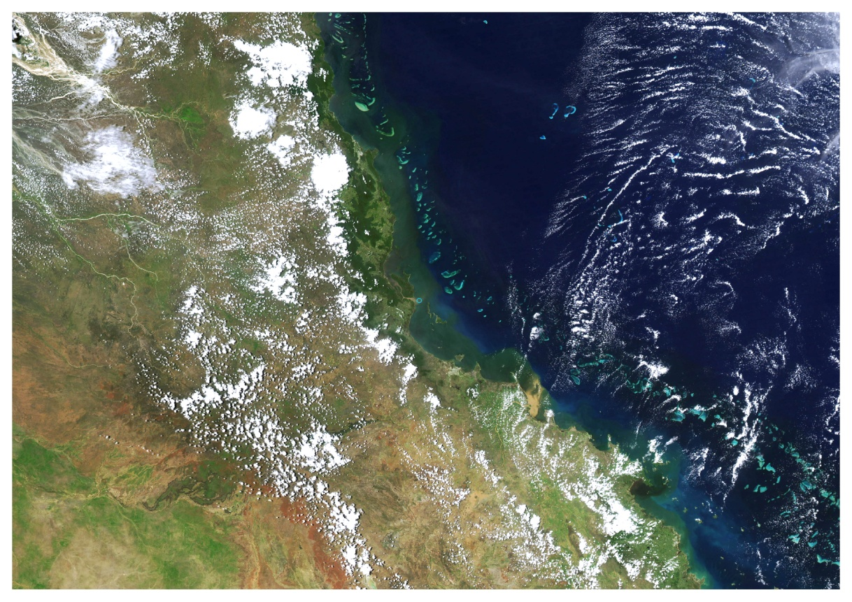

Figure 5-2: River plumes along Queensland Coast, MODIS true colour image from Aqua satellite, February 10, 2007 (NASA/GSFC, Rapid Response

The three main products which are generated through the use of remote sensing imagery for the flood plume monitoring component of the MMP are:
- Maps of flood plume frequency and movement;
- Surface exposure maps, linking pollutant load to the plume distribution; and
- Mapping plume water types.
The mapping of plume waters is dependent on the type of system, the frequency of high flow events and the number of available images that meet the mapping requirements. The number of mapped plumes for the 2010-11 wet season are shown in Table 5.1. Plume distribution mapping was constrained to the dates which are associated with onset and passage of the high flow conditions. For this study, the periods of high flow were taken on the dates where the daily flow (measured in ML) exceeded the 95th percentile value flow calculated from a flow data collected over a period of twenty years (1990 to 2010). Flow data was made available from DERM. High flow periods can last from days to weeks depending on the size of the event and the type of catchment (Devlin et al., 2011). The extent of the surface plume water is primarily dependent on the catchment size, the frequency and intensity of the high flow event and prevailing wind and current conditions (Wolanksi et al., 2008; Devlin and Brodie, 2005; Devlin and Schaffelke, 2009) and thus the duration of sampling is opportunistic and driven by both the formation and extent of the plume.
Table 5-1: Number of images used for plume mapping in each sampling region for 2010-11.
Month | Number of mapped plumes
Month | Wet Tropics | Burdekin | Fitzroy
January 2011 | 5 | 6 | 6
February 2011 | 5 | 6 | 6
March 2011 | 5 | 4 | 2
April 2011 | 5 | 5 | 4
Total | 20 | 21 | 18

Mapping the extent of surface plume waters
Interpretation of quasi-true colour images through colour manipulation and the application of remote sensing algorithms were used to identify the full extent of the surface river plumes. Remote sensing imagery was extracted to coincide with the high flow events in the 2010-11 wet seasons. Imagery was selected based on a clear image being associated with the period of high flow. Information on the frequency and movement of regional river plumes was calculated from the overlay of plume imagery extracted between January and April 2011.
Complementary to the automated mapping of water types, true colour classification techniques offer a good alternative to delineate the extent (boundary) of the plume, to better understand the spatial and temporal evolution of river plumes. Based on a combination of spectral enhancement and unsupervised classification (ISO method) of images, we can identify classes that, potentially, can be related to variations in surface water parameters, such as TSS and chlorophyll and therefore contribute to understand the spatial variation and movement of plumes. A combination of MODIS L2 products (e.g., CDOM, Chl-a) and the mapping of water characteristics through the use of Level-2 described before, along with data from water quality sampling data will be used to refine and interpret the classes. This technique offers a valuable alternative to plume mapping, particularly where visual interpretation or algorithms are not able to resolve differences in surface waters due to unsuitable atmospheric conditions (e.g., medium to high cloud cover, glint), and can reduce human error originated from visual mapping. Information on cloud cover and number of available images per pixel will be incorporated into this procedure to have an estimate on our confidence in the plume frequency used to calculate exposure. We are in the process of refining this method and automating it as much as possible to enable batch processing of multiple images as required to obtaining as much information as possible. The information from this technique will then be used to refine and complement the exposure and risk assessment described in this report.

Mapping the transport of surface pollutants within plume waters
In 2010 the TropWater was engaged by the GBRMPA to identify and map the risk and exposure of GBR ecosystems to anthropogenic water quality influences (nutrients, sediments and pesticides) to facilitate resilience mapping of the GBR for adaptive management purpose under a changing climate. The key findings, and detailed approaches undertaken to complete these assessments are summarised in Devlin et al., (2010b).
True colour mapping techniques and application of remote sensing algorithms, validated against the in situ water quality sampling have been used to estimate the surface exposure of flood plume waters, scaled against catchment loads for the Tully, Burdekin and Fitzroy over the 2010-11 wet season.
The movement of surface plume waters and the area most likely to be exposed to the surface pollutants was calculated through mapping of the plume water movement and catchment load information. Integration of both surface plume mapping and knowledge of both long term annual loads and reported measures of the annual river pollutant loads provides both spatial and temporal information on the scale and content of GBR river plumes and their potential impact on the short and long term water quality status of GBR waters.
The details of each step (as illustrated in Figure 5.3) include:
- The scaling of catchment loads to identify catchments which are transporting the highest pollutant loads;
- Mapping the spatial and temporal distribution of plume waters between the period 2001 – 2010; and
- Integration of the pollutant load information with the plume distribution into a surface exposure areal measurement.
The distribution of flood plume and areas most likely to be exposed to particular pollutants were calculated by the mapping of surface flood plume water based on true colour satellite images in combination with catchment pollutant load information. The process entails three steps (Figure 5.3).
Step 1 - Calculating the proportional contribution of pollutant loads from GBR catchments
Load data from five NRM regions discharging directly into the GBR (Burnett-Mary was not included in this analysis) was summarised for the three main pollutants (TSS, DIN and PSII herbicides) using modelled and monitored load data as reported in Brodie et al. (2009), Kroon et al. (2012), and Waterhouse et al. (in press). The annual means of the long-term load data for each pollutant was calculated for each NRM region. Following this, the proportional pollutant load (PL) contribution of each region, with respect to the overall GBR pollutant load, was estimated. For example, the Wet Tropics region contributes 0.16, 0.30 and 0.39 of the annual anthropogenic load of TSS, DIN and PSII herbicides respectively when scaled against the GBR-wide pollutant load (Figure 5.3, step 1).
Step 2 - Mapping the distribution and frequency of surface flood plume waters
Visual interpretation of true colour satellite images was performed to identify and delineate the full areal extent of the surface GBR flood plumes (Brando et al., 2010, Devlin and Schaffelke, 2009; Devlin et al., 2012a; 2012b). Mapped flood plumes (i.e., only those associated with high-flow events) were overlaid to calculate the long-term frequency of occurrence (P_{x}, corresponding to the number of times any given area/pixel of the GBR was covered by flood plumes) over a period of 10 years (2001 to 2010). The frequency of occurrence of flood plumes was aggregated into frequency classes (F_{n}), where the class value was calculated from number of plumes normalised to four equal-interval frequency classes (see Figure 5.3, step 2).
Step 3 - Estimating the surface exposure for each pollutant
Surface exposure for each pollutant was estimated by scaling the pollutant load (PL) contribution against the frequency class of the flood plume distribution (F_{n}) within each NRM region (Figure 5.3, step 3). A quantitative surface exposure (E) value for TSS, DIN and PSII herbicides was calculated for each pixel. Based upon these surface exposure values, each pixel was assigned one of four exposure types, “very high”, “high”, “moderate” and “low” for TSS, DIN and PSII herbicides respectively. Note that DIN surface exposure values are not presented for Cape York due to the high error associated with the modelled anthropogenic load from this region (Waterhouse et al., in press) and that the PSII herbicide load from Cape York was assumed to be zero and thus not assigned to any exposure category.
The surface distribution of the surface exposure (one for each pollutant: TSS, DIN, and PSII) were overlaid with maps of current distribution of coral reefs and seagrass beds to calculate the number and area of reefs and seagrass exposed to each surface exposure category (see Figure 5.3). Coral (sourced from GBRMPA, 2009) and seagrass (sourced from the Northern Fisheries Centre, 2009) distribution maps were provided as shapefiles by the GBRMPA. Coral reefs and seagrass beds located outside of any of the mapped flood plumes were deemed “un-exposed” and quantified accordingly.
Figure 5-3: The three steps involved in the mapping the surface exposure of plume waters for the GBR.

Mapping of plume characteristics through L2 products
Plume mapping can readily identify three water types in flood conditions, characterised by varying colour and spectral properties. The first water type is the immediate plume zone, or primary water, characterised by high suspended sediment, light limitation and low salinity typically associated with the very near-shore areas and the initial stages of plume formation. The second water type (hereafter known as secondary) is characterised by moderately elevated sediment however, with sufficient light and excess nutrients to support elevated phytoplankton growth. Such conditions were identified within MODIS imagery as having high concentrations of Chl-a and elevated CDOM
Semi-analytical algorithms to produce L2 products were applied to the 11 atmospherically corrected MODIS images (only those captured over the Wet Tropics marine areas during periods of high-flow and negligible cloud coverage) to map the inshore waters constituents and delineate the different GBR flood plume water types (i.e., primary, secondary and tertiary) as defined in Devlin and Schaffelke, (2009) and Devlin et al. (2012a).
Four L2 products were mapped to characterise the three GBR typical surface waters types using SEADAS. The normalized water-leaving radiance at 667 nm (nLw_667, μW.cm⁻² .nm⁻¹ .sr⁻¹) was first mapped. This parameter is assumed to be effective to trace suspended particulate matter (Li et al., 2003) and has been positively correlated with TSS values and used to characterise flood plume water types (Devlin et al., 2012b). The particulate backscattering coefficient at 555 nm (bbp_555, m⁻¹), less sensitive to dissolved material, was obtained using the GSM01 model (Maritorena et al., 2002) and used as a second proxy for particulate load (D’Sa et al., 2007; Shanmugam et al., 2011). Chlorophyll-a concentration (µg L⁻¹) was obtained using the GSM01 model (Maritorena et al., 2002) and used as a proxy of primary production. Finally, the absorption coefficient of coloured dissolved and detrital matter (aCDOM+D, m⁻¹) at a wavelength of 443 nm was calculated based on the quasi-analytical algorithm (QAA) described in Lee et al. (2002).This parameter, related to the concentration of coloured dissolved and detrital matter in water, has been shown to be a good proxy for salinity (Schroeder et al., 2012), and thus useful to delineate the maximum freshwater effected extent of flood plumes. Performance of algorithms selected to map the Chl-a concentrations and the CDOM+D absorption coefficient are limited due to the high complexity of the inshore waters but they are the best readily available algorithms which allow satellite analysis of the flood plume waters constituents in the GBR (Qin et al., 2007). Furthermore, precision of these algorithms are assumed to increase as the flood plume moved from turbid water (i.e., high TSS coastal waters) to offshore clearer waters.
Combination of the L2 products (Chl-a, CDOM+D, nLw_667, bbp_551) obtained during the 11 flood events were used to characterise the three GBR typical surface waters types (Devlin and Schaffelke, 2009; Devlin et al., 2012a). For each water type, thresholds values of nLw_667, bbp_551, CDOM+D and Chl-a that best discriminated the gradients of TSS, Chl-a, CDOM commonly found through flood plumes were determined empirically and adjusted until clear separation of the three water types was achieved. The extent and frequency of the different waters types in the GBR inshore waters were finally computed as described in Figure 5.3 (step 2) and maps depicting frequency of occurrence of primary and secondary water types were produced. Due to the relatively limited presence of the tertiary water type (i.e., occurring mostly in the edge or outer flood plume), the frequency map for tertiary water was not calculated. However, a map showing the frequency of the full flood plume (i.e., combined maps of the 3 water types) was produced.
Water quality data collected in situ over the 9-year period as part of the MMP within the Wet Tropics region and over the main flood events of the wet season were identified. Chl-a, TSS and CDOM field measurements available were assigned to a water type based on the location of the in situ site against the satellite water type map obtained. The mean in situ water quality values (+/- 2SE) within each water type were finally plotted to test if the delineation of water types from the satellite images could be relevant to the gradient of water quality data that is measured through GBR flood plumes.

Annual reporting of the surface exposure of river plumes.
As a requirement under P2R program reporting, we will report on the surface exposure of two pollutants (TSS and DIN) carried in plume waters. The annual exposure maps are created by the scaling of the annual regional pollutant loads against the long term frequency of plume waters with the maximum extent of the plume water for that wet season. Simply, we use a combination of the spatial information from true colour imagery and the automated water type mapping to create a year to year map in which the areal extent of exposure classes is presented. More details on the case study to go into the 2009-10 report card is presented in Appendix 3.

Mapping results

Overview
As indicated in Section 5, our team has been developing techniques to identify and map the risk and exposure of GBR ecosystems to anthropogenic water quality influences (nutrients, sediments and pesticides) (see Devlin et al., 2011b; 2012b). As part of our efforts for the MMP in 2010-11, we have undertaken a number of important steps to improve our technique including:
- Development of surface exposure maps (plume frequency and movement) for 2011 plumes in the Tully, Burdekin and Fitzroy regions.
- Incorporation of 2010 data (2011 load data is not yet available for all rivers from DERM) into the surface exposure maps.
- Improvement of the delineation of water types against water quality thresholds.
We present our results as a series of maps which identify the movement of flood plume waters, the frequency at which those plume waters occurred, the mapping of plume waters scaled against catchment loads of TSS, DIN and PSII herbicides and finally the areal extent of specific plume types which have been identified by water quality thresholds.

Estimating surface exposure of flood plume waters
Figure 6.1 shows the river plume extending from the Fitzroy River on 11 January 2011. Using remote sensing tools and GIS processing, we can track the movement of the plume over a period of days, where the areal extent moved from zero to 25,000km². Figures 6.2 to 6.4 show the movement and estimated areal coverage for the Wet Tropics, Burdekin and Fitzroy plume from late December 2010 to March 2011.
The movement of the Wet Tropics river plumes, as identified by true colour image analysis, is depicted in Figure 6.2. The four images represent the movement of visible plume water through the months of January to April 2011. The plume moved over time, but generally the area exposed to these plume waters was relatively constant. The movement of the plume was generally to the north and reasonably constrained to the coast. The persistence of the plume water over the same area may be due to the persistence of the green secondary water, indicating that elevated concentrations of Chl-a in the water column over a period of months. The Burdekin River plumes were constrained over the first two months (Figure 6.3) but moved offshore during March to April, most likely associated with changes in wind direction to prevailing offshore winds. Flow in the Burdekin continued to be high for all of the wet season, with discharge from the Burdekin River measuring over 38 million megalitres, over 7 times the long term median flow (Table 2.1). The Fitzroy River plumes generally moved north up to the Whitsunday Reefs (Figure 6.4) at distances greater than 400km. These individual plume maps illustrated the extent of the river plumes for these three NRM regions and show that potential exposure to surface river plumes was over weeks to months for the 2011 wet season.
The surface exposure of flood plume waters is presented in Figure 6.5. This simply is the movement and frequency of the 2011 flood plumes overlaid and presented in 5 frequency classes (very high, high, medium, low, very low) for the three NRM regions. This indicates the movement of the surface plume water and the area which is likely to be influenced by plume waters. Note that this mapping exercise only identifies the surface plume water and is not identifying scale or extent of impact. The surface exposure maps (Figure 6.5) show clearly that for a period of weeks, surface plume water were detectable north of the major Wet Tropic Rivers, Burdekin and Fitzroy Rivers for large distances (up to 480km) and also on a few occasions (<3) moved offshore past the central GBR. The number of coral reefs and seagrass beds within the “very high” (over 18 plume days) and high (15 – 18 plume days) varied for each NRM region, but varied between 75 (Burdekin) and 232 (Fitzroy) coral reefs and 66 (Wet Tropics) and 71 (Fitzroy) for seagrass beds (Table 6.1).
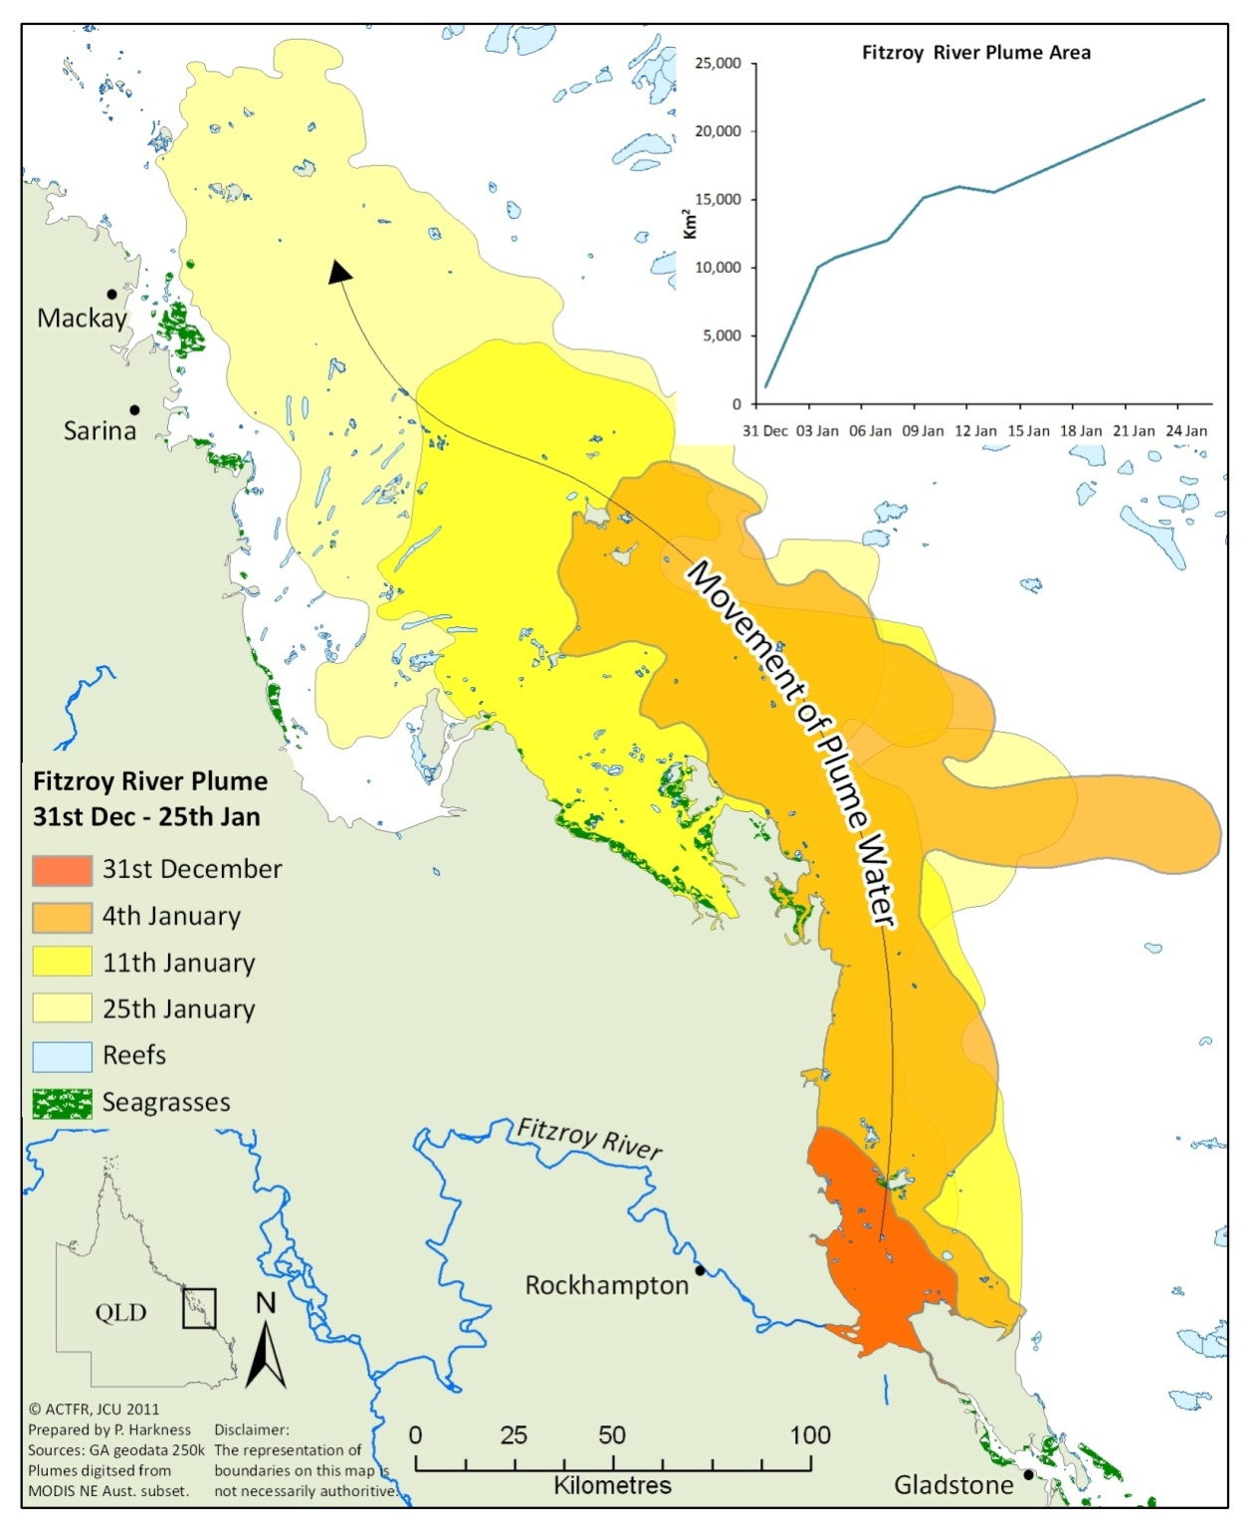
Figure 6-1. The areal extent of the Fitzroy plume mapped over 2 weeks, with plume extents identified for the 31 December 2010, 4 January and 11 January 2011.

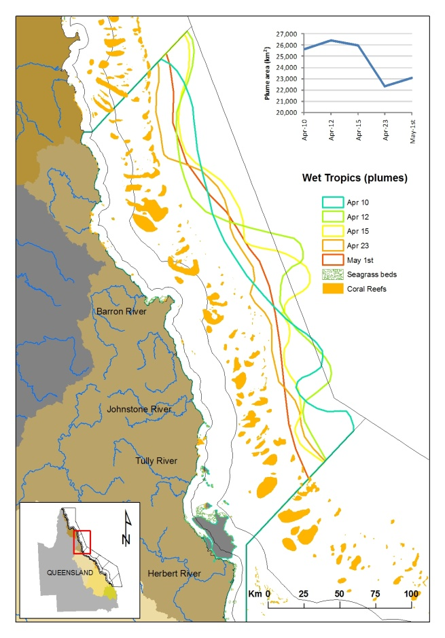
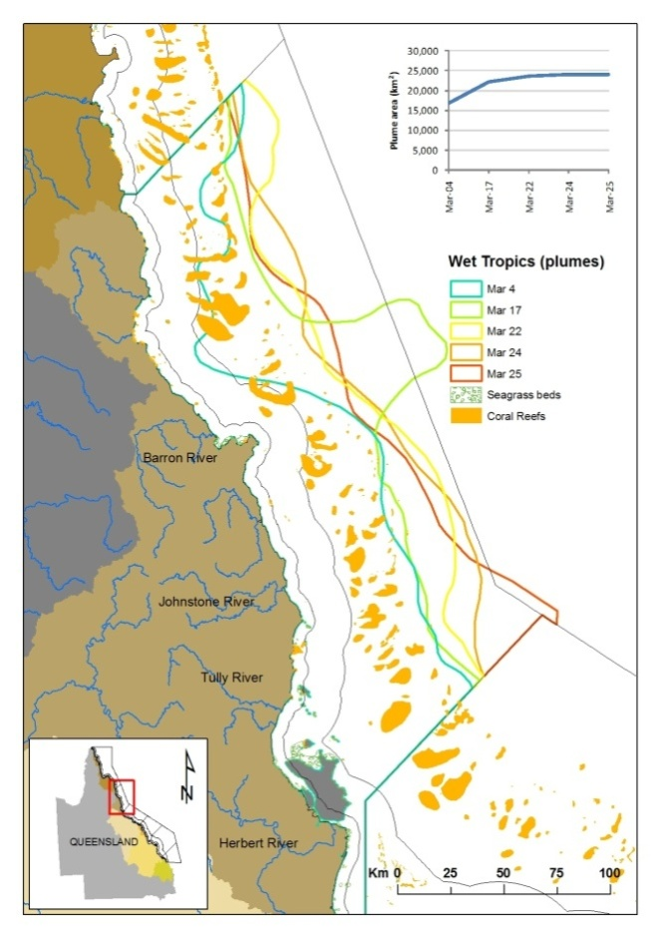
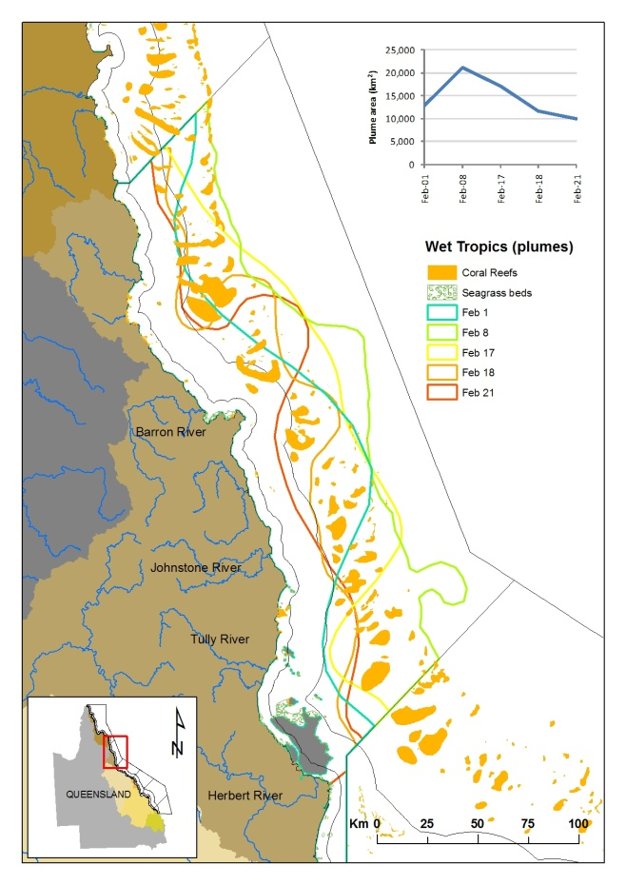
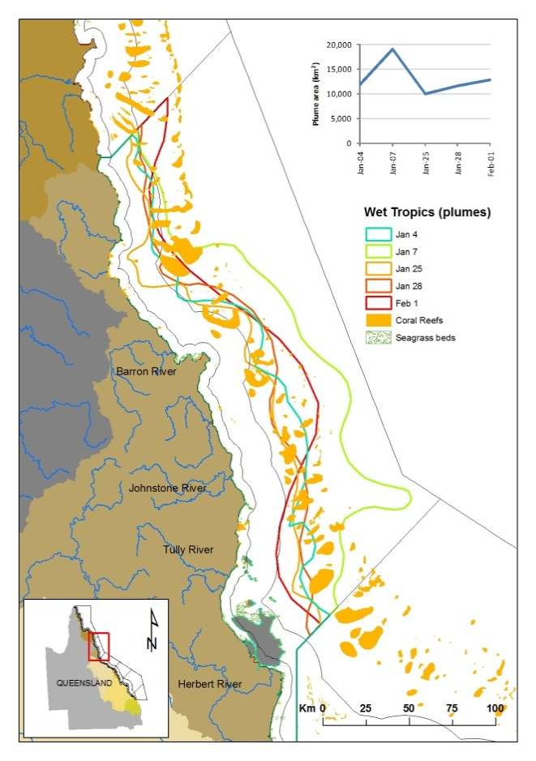
Figure 6-2. Movement of visible flood plume waters through the 2010-11 wet season (incorporating January to April 2011) from Wet Tropics River plumes.

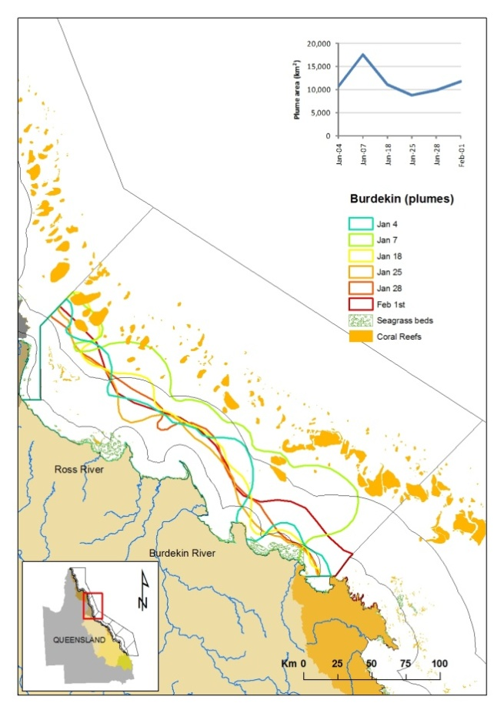
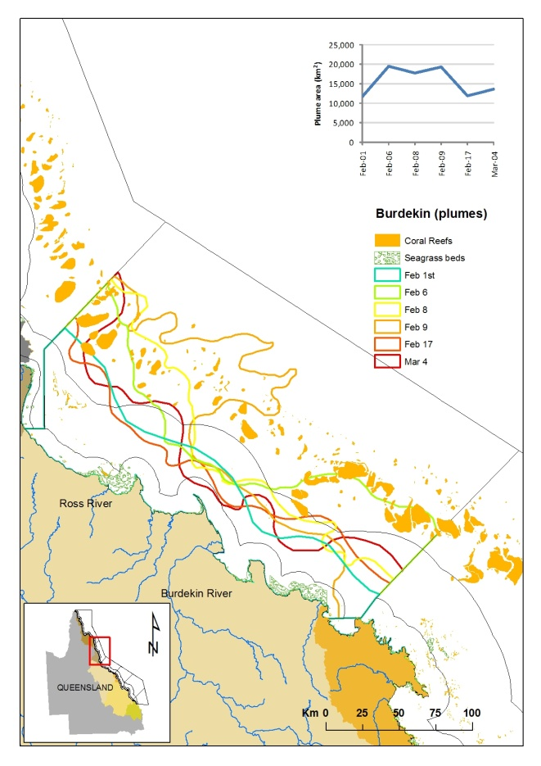
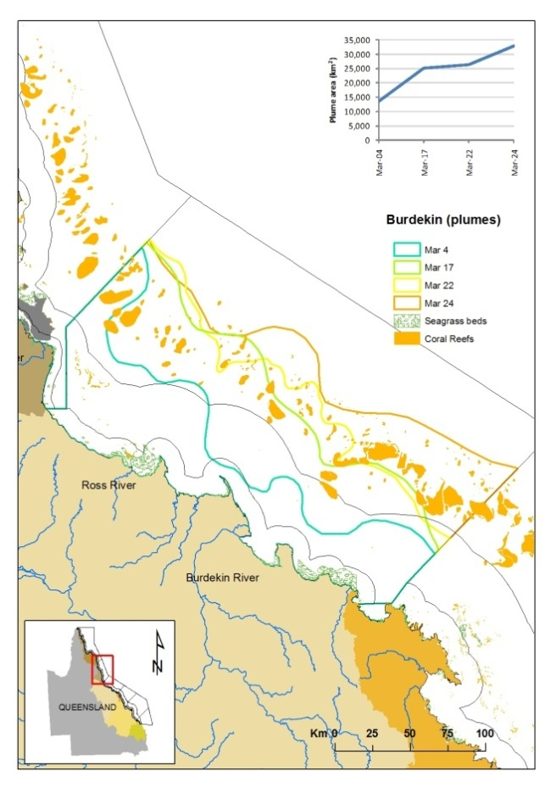
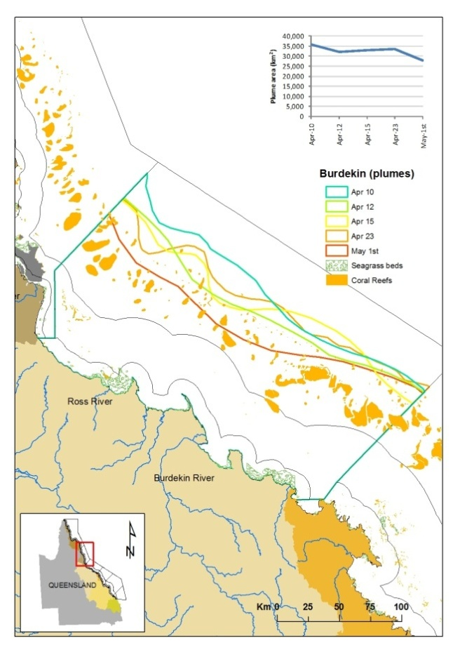
Figure 6-3. Movement of visible flood plume waters through the 2011 wet season (January to April) from the Burdekin River plume.
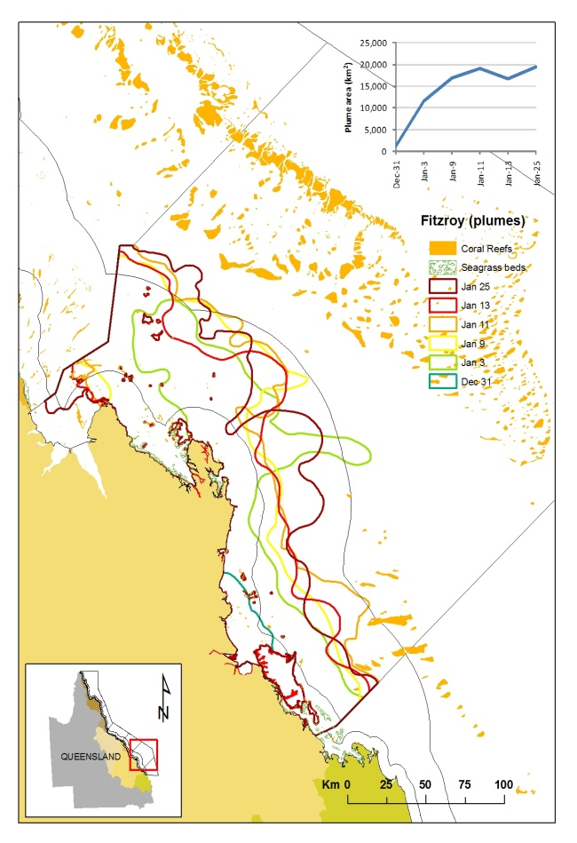
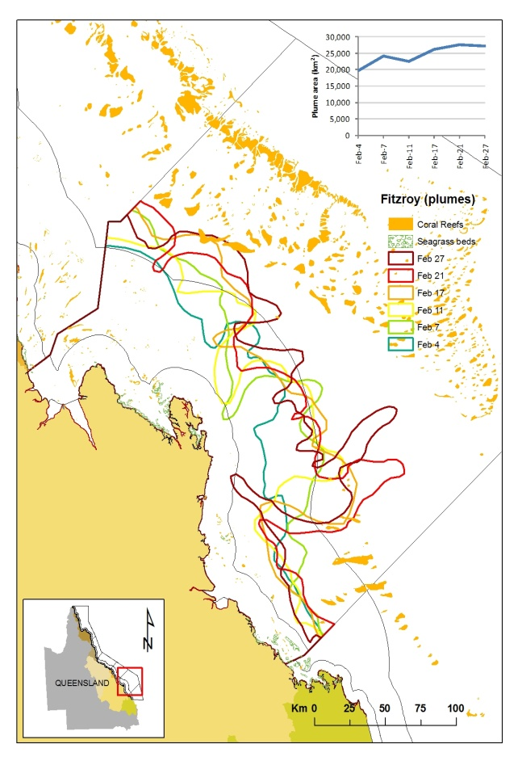
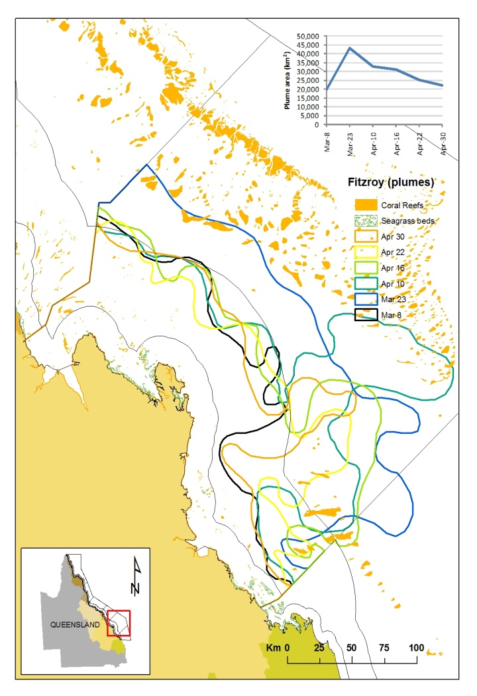
Figure 6-4: Movement of visible flood plume waters through the 2011 wet season (January to April) from the Fitzroy River plume

Figure 6-5. Surface exposure of plume waters as measured by the frequency and extent of plume movement during the 2011 wet season. Each mapped plume image is overlaid within GIS software to identify the areas of high exposure. Surface exposure is presented for (a) Wet Tropics, (b) Burdekin and (c) Fitzroy.
The combination of each plume image identifies the full extent and frequency at which we have measured surface plume waters through the 2010/2011 wet season. The cumulative area for plume waters discharging from the Burdekin, Fitzroy and all the Wet Tropics Rivers is shown in Figure 6.6, with a maximum area of greater than 90,000km². However, the actual area within the high to very high exposure category (greater than 10 to 18 plume extents for the period January to April) is a much lower total areas, ranging from 404km² in Fitzroy to 1,839km² in the Wet Tropics (Table 6.1).

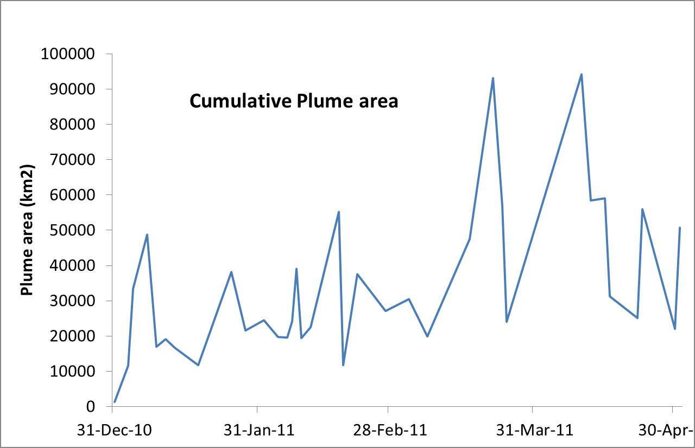
Figure 6-6. Cumulative plume area over wet season for rivers discharging out of the Burdekin, Fitzroy and Wet Tropics Rivers.

Table 6-1. Number of coral reefs and seagrass beds located within the high to very high plume water exposure categories
NRM Region | Coral Reefs | Seagrass Beds | Total area (km²)
Wet Tropics | 218 | 66 | 1839
Burdekin | 75 | 71 | 847.3
Fitzroy | 232 | 135 | 404

Mapping the transport of surface pollutants within plume waters
Using frequency maps, it is possible to map the surface exposure of flood plume waters (Figure 6.5). The plume frequency maps illustrate the movement of riverine waters but do not provide information on the composition of the water and water quality constituents. The presence or exposure to surface plume waters does not signify impact, or allow us to make decisions on the potential impact which may occur. Further information on the constituents of the plume waters, in particular the movement of both sediment and dissolved inorganic nitrogen, allows us to develop a better understanding of the potential impacts of pollutants which are carried within the plume water. An estimate of the areas of surface exposure to pollutants (TSS, DIN and PSII herbicides) in the 2010-11 wet season has been developed for the Tully, Burdekin and Fitzroy regions (Figure 6.7) respectively. An assessment of the number and area of mapped coral reefs and seagrass beds in each exposure category is also included in each map. This is a new approach developed for reporting this year. It builds on the techniques used in Devlin et al., (2010b) to estimate plume exposure over a longer period (2000 to 2010), but is specifically relevant to the current reporting period by the use of 2011 plume data.
Appropriate assessment of plume exposure must identify the pollutants within the plume that are most likely to cause impact, and include the potential impacts from elevated loads of TSS, DIN (Fabricius, 2011, Brodie et al.,2011; Brodie et al., 2012) and PSII herbicides (Lewis et al., 2009; Lewis et al., 2012). Building on the techniques established in Devlin et al., (2010b), the approach has been improved through the incorporation of load data from 2006 and up to and including 2010. However, load data for 2011 is not yet available and therefore the pollutant contributions are based on long term annual load data (Brodie et al., 2009). Revised surface exposure of pollutants for this 2011 wet season will be presented once the annual load data for TSS, DIN and PSII herbicides has been finalised.
Pollutant load information was coupled with the frequency and movement of flood plumes for the period between 2001 and 2011 to identify the areas of high exposure to water quality pollutants (DIN, TSS and PSII herbicides), and the numbers of specific ecosystems that are within these exposure areas (Figures 6.7). Five exposure classes are presented within each map and are based on the natural break system with Arcview Spatial analysis. The exposure number is based on the proportional pollutant load data scaled against the plume frequency and reported as the exposure classes within the maximum plume extent for the 2011 wet season. High proportional contributions of DIN are seen in the inshore regions of the Wet Tropics and the Fitzroy. Contributions of TSS loads are highest in the plume areas north of both the Burdekin and Fitzroy Rivers. Proportional loads of PSII herbicides are highest in the Wet Tropics, though this could be reduced once the imagery from the Mackay Whitsunday was incorporated into the analysis.
The number of coral reefs and seagrass beds which could be potentially affected by exposure to surface plume pollutants is presented in Table 6.2. The number of coral reefs exposed to surface plume waters carrying high load contributions of TSS (80 – Burdekin), DIN (Wet Tropics – 187) and PSII herbicides (Wet Tropics – 187) varies between regions. The number of seagrass beds exposed to exposed to surface plume waters carrying high load contributions of TSS (86 – Burdekin), DIN (90 - Wet Tropics) and PSII herbicides (90 - Wet Tropics) varies over regions and identifies the scale of exposure is related to the load contributions and the movement of frequency of plumes in any given year. The mapping of these high exposure areas allows us to identify the systems most likely to experience acute impact from flood plume waters. Ongoing validation with the MMP coral and seagrass programs is required to test the scale of impact on these affected reef and seagrass areas.
Table 6-2: Number of reefs and seagrass beds exposed to different categories of surface pollutants.
Exposure |  |  |  | Coral reefs |  | Seagrass beds
 | PSII | TSS | DIN | Num. | Km² | Num. | Km²
Burdekin | 0.00 | 0.00 | 0.00 | 0 | 0.00 | 0 | 0.00
Burdekin | 0.06 | 0.36 | 0.14 | 13 | 20.30 | 0 | 0.00
Burdekin | 0.13 | 0.72 | 0.28 | 126 | 1,266.17 | 0 | 0.00
Burdekin | 0.19 | 1.07 | 0.41 | 39 | 533.38 | 0 | 0.00
Burdekin | 0.25 | 1.43 | 0.55 | 13 | 205.96 | 3 | 0.29
Burdekin | 0.32 | 1.79 | 0.69 | 80 | 54.01 | 86 | 585.76
Burdekin |  |  |  |  | 2,079.82 |  | 586.05
Fitzroy | 0.00 | 0.00 | 0.00 | 559 | 2,607.36 | 0 | 0.00
Fitzroy | 0.15 | 0.25 | 0.14 | 66 | 627.85 | 0 | 0.00
Fitzroy | 0.30 | 0.49 | 0.28 | 10 | 41.68 | 0 | 0.00
Fitzroy | 0.45 | 0.74 | 0.42 | 2 | 3.72 | 0 | 0.00
Fitzroy | 0.59 | 0.98 | 0.56 | 28 | 39.13 | 3 | 0.76
Fitzroy | 0.74 | 1.23 | 0.70 | 221 | 139.49 | 117 | 225.50
Fitzroy |  |  |  |  | 3,459.23 |  | 226.27
Wet Tropics | 0.00 | 0.00 | 0.00 | 0 | 0.00 | 0 | 0.00
Wet Tropics | 0.23 | 0.10 | 0.24 | 0 | 0.00 | 0 | 0.00
Wet Tropics | 0.46 | 0.20 | 0.49 | 0 | 0.00 | 0 | 0.00
Wet Tropics | 0.68 | 0.30 | 0.73 | 42 | 272.95 | 0 | 0.00
Wet Tropics | 0.91 | 0.40 | 0.98 | 83 | 865.49 | 0 | 0.00
Wet Tropics | 1.14 | 0.50 | 1.22 | 187 | 787.35 | 90 | 186.85
Wet Tropics |  |  |  |  | 1,925.79 |  | 186.85
 |  |  | TOTAL |  | 7,464.84 |  | 999.17

Figure 6-7. Area of high exposure for (a) DIN, (b) TSS and (c) PSII herbicides identified for the Fitzroy, Tully and Burdekin plumes. Area shows the spatial extent and time-averaged frequency for the 2010-11 wet season.
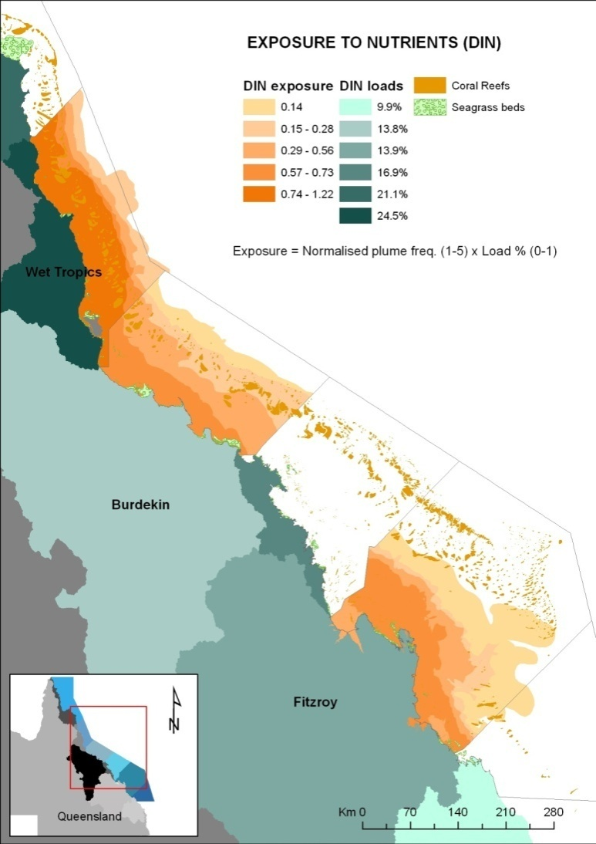
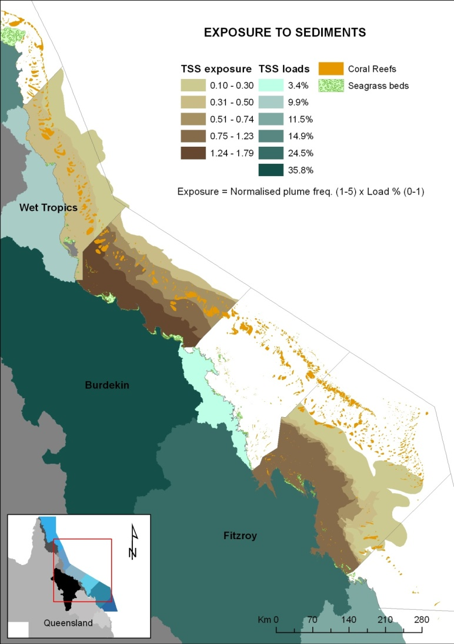
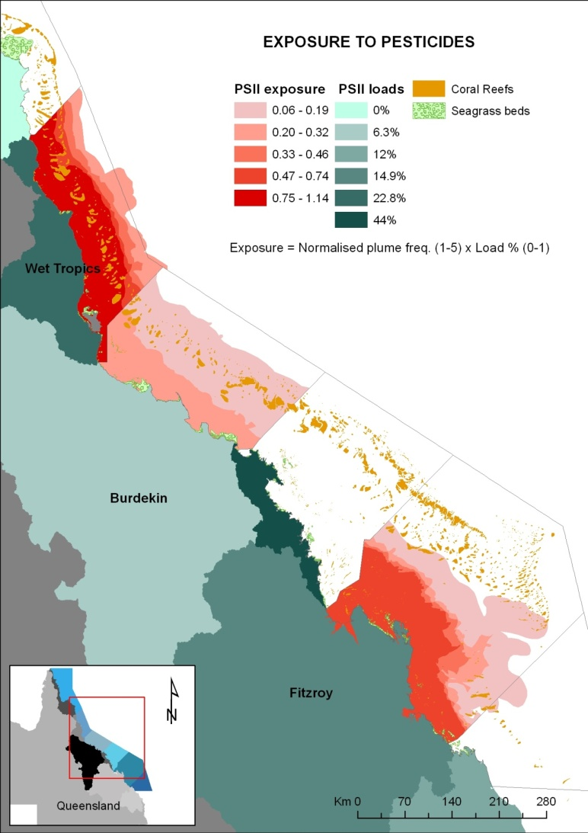

Mapping of water types for GBR plume waters
Within the Wet Tropics, the mapping of the extent and frequency of the different waters types into the GBR inshore waters revealed the primary water type occurs parallel to the coast predominately in a small band of no more than 25km (Figure 6.8). The secondary water type also occurs parallel to the coast however, reached a greater distance offshore of up to 100km (Figure 6.8). The greatest extent of secondary water was found to occur north of the Barron River and north of the Tully-Murray and Johnstone Rivers, and offshore of these rivers, reflecting that high value of primary production can occur at some distance and time away from the flood plume core. The full extent of the plume, as defined by the edge of the tertiary water extends out to ~150km at the furthest edge. Based on the combined maps of water types (i.e., full extent of flood plumes), we estimated that the area of the summed flood plumes covered ~160,000km² of the GBR during the 10-year study period (~45% of the GBR Marine Park area).
All in situ water quality measurements within the Wet Tropics Region were assigned to a water type based on the location of the site against the water type map (Figure 6.9). Mean TSS values drop from 23.3 +/- 8.4 in the primary water type to 8.3+/- 4.5 in the tertiary water. Mean chl-a values drop from 1.1 +/- 0.05 in primary water to 0.99 +/- 0.24 in the tertiary water, with a peak in the secondary type of 1.5+/-0.05. Mean CDOM values drop from 0.36+/-0.06 to 0.18 +/- 0.04 (Figure 6.9). Thus, despite the uncertainty associated with the semi-analytical algorithms employed (Qin et al., 2007), using a combination of L2 products is useful for delineating water type gradients typical observed in situ within the GBR flood plumes.

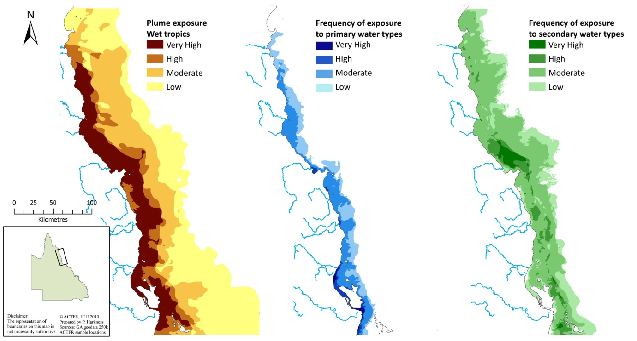
Figure 6-8: Spatial classification of the three main water types to occur within the Wet Tropics NRM area, Great Barrier Reef. Extent and frequency of the primary water type (b) within a small but substantive inshore wedge out to a distance of 25 km offshore. Extent and frequency of the secondary water types as characterised by elevated chl-a concentrations occurs further offshore to a distance of 100 km. The full extent of all plumes, out to the edge of the tertiary plume, is shaded in yellow (a).

Figure 6-9: Mean values (+/- 2SE) of Chl-a and TSS and CDOM measured in the delineated primary, secondary and tertiary water types.

The combined information from water type mapping can and does provide information on the full scale of the river plume and is useful for the reporting of plume properties and annual plume extent (Table 6.3 and Figure 6.10). Information on the distribution of primary and secondary waters in the and the overall surface plume extent (Figure 6.10), as measured by the combination of primary, secondary and tertiary waters provides information on both the scale of the plume movement but also the composition of that plume water and allows a more rigorous analysis of the potential impacts of altered water quality conditions associated with the river plume water. Area covered by each plume type is shown in the figure. This work is ongoing and we have concentrated on the methodology associated with these mapping processes. We expect to increase our capacity to report on all aspects of the plume mapping through quicker processing and better baseline data that is now available. Validation of the water types is ongoing and will provide a useful and vital link between the plume mapping information and the collection of in-situ measurements of plume water quality data.

Table 6-3: Areal extent (km2) associated with the three main water types identified for plume waters.
Year | Total | Primary | Secondary | tertiary
2000 | 17,900 | 3,206 | 12,841 | 1,853
2001 | 11,456 | 2,501 | 6,925 | 2,030
2002 | 14,295 | 1,501 | 10,137 | 2,657
2003 | 21,760 | 5,081 | 9,062 | 7,617
2004 | 17,560 | 1,300 | 15,246 | 1,014
2005 | 21,379 | 2,731 | 17,042 | 1,606
2006 | 17,378 | 2,175 | 9,408 | 5,796
2007 | 43,599 | 3,532 | 38,497 | 1,570
2008 | 27,337 | 3,747 | 18,476 | 5,115
2009 | 51,712 | 4,281 | 47,102 | 329

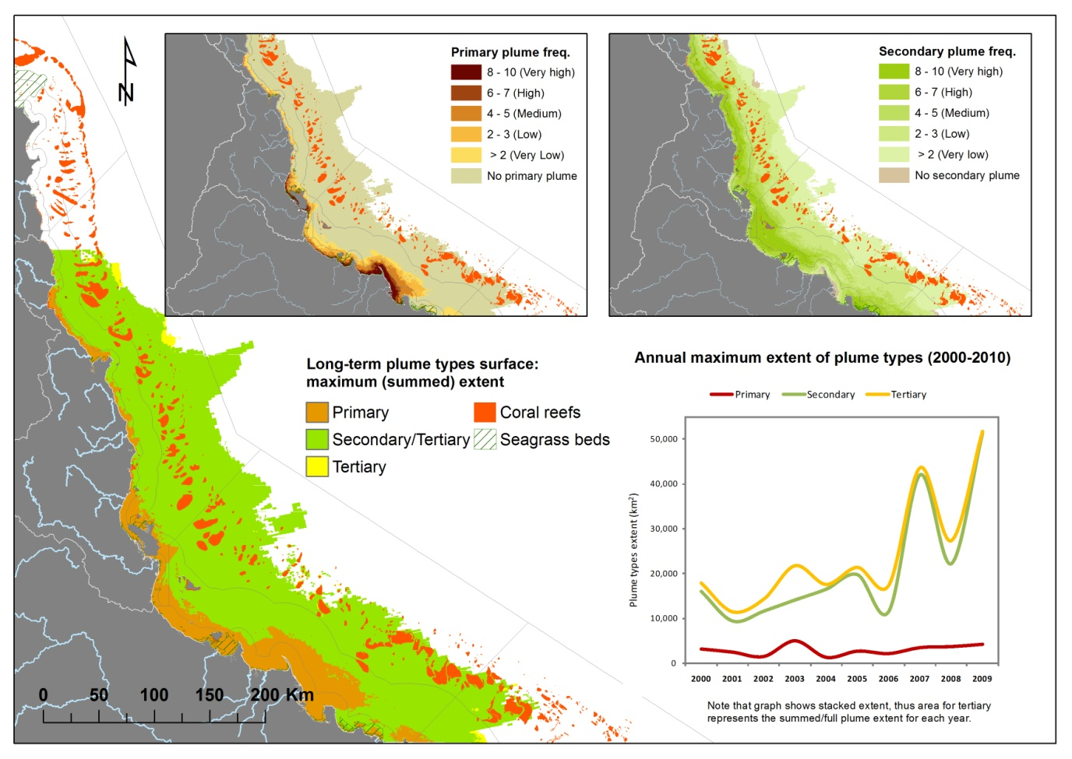
Figure 6-10: The long term plume distribution and frequency associated with the plume water types. Information is presented for the distribution of primary and secondary waters in the smaller boxes, with the overall surface plume extent, as measured by the combination of primary, secondary and tertiary waters, is shown in the larger map. Area covered by each plume type is shown in the figure.

The methodology and outputs from both the surface exposure mapping and the characterisation of water types is also described in Devlin et al., 2012b and has been attached as Appendix 4.

Discussion

2010-11 water quality characteristics
The different flooding regimes in combination with land-based activities drive both short and long-term water quality changes in the GBR. Effects of poor water quality can be both chronic and acute. The reefs next to the Tully are regularly inundated with flood plume waters. Although the flooding remains relatively consistent in the wet tropics, the chronic exposure to degraded water can lead to stressed ecosystems that cannot recover as quickly. On the other hand, in a system like the Fitzroy where flooding happens much more sporadically, coastal ecosystems and coral reefs experience acute, event driven impacts from large floods. These large flooding events can last for weeks during which water quality is degraded, leading to rapid stress and mortality.
Water quality conditions and the scale of impact can be determined by multiple parameters. In the GBR, the main drivers of water quality are suspended sediment, pesticides and nutrients, particularly dissolved inorganic nitrogen (Brodie et al., 2011). The land use patterns determine the prevalence of each pollutant and the rainfall patterns help to shape the concentrations of each pollutant that flow into the coastal zone.
As identified in Section 4.3.2, collaborative studies with Bainbridge and others show that the vast majority of Burdekin sediment is initially deposited (0 – 3 salinity zone) with a smaller fine fraction (<4 µm) transported considerable distances along the plume extent. In both cases the sediments are carried as organic-rich particulate matter. While earlier studies have shown the sediment that is initially deposited near the mouth of the river is eventually resuspended and largely incorporated within north-facing embayments (e.g. Orpin et al., 2004), no study has previously examined the dispersal of the finer fraction. The study showed that this fraction (<4 µm) is commonly transported as small, low density organic-rich flocs or as individual inorganic particles which have the ability to be carried at least 100 km within the buoyant plume waters. Research is needed to determine if plankton blooms known to occur where TSS concentrations fall below 10 mg L⁻¹ enhance the settling of these particles by binding them into larger aggregates.
Although the specific catchment (soil) source of this fine inorganic sediment is still being characterised these preliminary results suggests that, in this organic-rich form, these terrigeneous fine sediments have the potential to settle on sensitive marine ecosystems such as coral reefs and are more likely to be remobilised during subsequent wind-driven resuspension events (e.g. Wolanski et al., 2008). Moreover, organic-rich fine sediments present a much higher risk to corals via sedimentation than inorganic sediments due to the development of anoxia through bacterial growth on the surface of the coral (Weber et al., 2006). Future studies are needed to examine the behaviour of the Burdekin River plume during strong wind conditions when greater mixing between brackish and marine waters may change the biogeochemical processes that influence riverine sediment dispersal and nutrient uptake. This interpolation, as well as the measured salinity data at each site shows that a major pressure for coral reefs and seagrass beds within the Tully plume area would have been reduced salinity conditions.
The water quality impact can be investigated by examining the exceedances of single water quality parameter against a set of suggested thresholds. Mean water quality concentrations for the pollutants of concern are plotted against proposed thresholds or time dependent periods to identify the sites in which we are likely to see an ecological impact based on the severity and timing of the pollutant and/or temperature exposure. We acknowledge that values chosen will not be applicable to all species and certainly the effects seen beyond the thresholds chosen will depend on temporal variation. This method is still in a testing phase, and further details on thresholds are still required to improve the confidence in the risk assessment. However, we propose that by placing a concrete threshold value on these water quality parameters, we may begin to examine how more sensitive species will respond to changes in water quality. At this point, for TSS and Chl-a, the thresholds developed under the GBRMPA water quality guidelines(GBRMPA, 2009) are identified, and range of standard deviations away from these thresholds are used to guide the area proposed as risk categories. Further work on the integration of the temporal component of a risk assessment and the integration of a time dependent response curve, particularly for TSS, salinity and temperature is ongoing.
The pollutants feeding into the GBR do not work in isolation and the delivery of these pollutants can occur through additive or cumulative impacts. Thus it is important to measure overall water quality experienced by each site. One of the difficulties in determining how land use practices are affecting the GBR is that the pollutant loads are not comparable to each other or between each catchment. This means that it can be difficult to assess the extent to which a pollutant is elevated in relation to other pollutants. The water quality index enabled us to examine how sites differed along a water quality gradient moving away from a river source (Cooper et al., 2007; 2008). It was also allowed for a comparison between regions other in relation to all of water quality data collected over time and space in the GBR. This allowed for an assessment of which sites and regions had the lowest water quality. Specific sites in the Tully region experienced reduced water quality both when compared to other sites sampled this year and to previous data from the region. However, when compared to data that has been collected throughout the GBR, the Tully actually scores better for water quality than many other regions. The Fitzroy region, in contrast, had a very elevated WQI in every comparison that was made. This means that not only did the Fitzroy region fare badly in comparison to previous events in the region, it had some of the poorest water quality that has ever been collected in the GBR.
One of the limitations of the WQI is that it does not distinguish between chronic and acute effects. The Fitzroy region had incredibly poor water quality this year, but it also has only had three big flooding events in the past twenty years. Therefore, it may be that for the duration of the flood plume, the water quality was poor, but once the flood plume dissipated, the system would begin seeing improved water quality. In contrast, though the Tully region had relatively good water quality in relation to the other water quality in the GBR, the system floods every year. This means that sites in the Tully region are likely to experience chronic reduced water quality because the system experiences flood plumes so frequently.

Flood extent, water types and surface exposure 2010-11
The use of remote sensing, both through the mapping of the plume extent and content, and the application of remote sensing algorithms gives us valuable information on the potential impact and severity of water quality associated with flood plumes. Information from plume mapping is presented as three layers of information, including
- Development of surface exposure maps (plume frequency and movement) for 2011 plumes in the Tully, Burdekin and Fitzroy regions.
- Surface exposure maps identifying the movement and extent of pollutants carried in flood plume waters.
Surface exposure maps, which are a qualitative assessment of the areal extent of river plume waters, and through the overlay of daily images, also provides a measurement of the frequency of occurrence of plume waters for each NRM region. The surface exposure maps show a strong band of river plume influence for the three NRM regions (Wet Tropics, Burdekin and Fitzroy). The surface exposure of pollutants is also presented for each NRM region, and is a useful tool to visualise and report the distribution of the surface waters scaled to the pollutant load information. It allows an estimation of the extent of surface plume waters which carry increased concentrations of sediment, nutrients and PSII herbicides and could potentially affect the underlying ecosystems. The mapping of water types, applying water quality and spectral thresholds to define the water quality characteristics of the river plume, provides further information on the plume quality. The use of batch processing scripts against MODIS imagery provides a useful tool to map the spatial influence of the high TSS waters associated with primary waters, the higher nutrient, increased phytoplankton production associated with secondary waters, and the overall extent of the tertiary waters

Potential impacts associated with 2010-11 events
Coral damage was reported across an area of approximately 89,090 km2 of the GBR Marine Park (about 26% of the total). In total, approximately 15% of the total reef area in the Marine Park sustained some coral damage and 6% was severely damaged. It can be estimated that TC Yasi by itself accounted for a 2% loss in coral cover across the GBR (GBRMPA, 2011).
Extensive damage to coral and seagrass occurred in a 300 km wide band right across the continental shelf (GBRMPA, 2011) as a result of TC Yasi. Coral damage was reported across an area of approximately 89,090 km² of the Great Barrier Reef Marine Park (about 26% of the total). In total, approximately 15% of the total reef area in the Marine Park sustained some coral damage and 6% was severely damaged. It can be estimated that TC Yasi by itself accounted for a 2% loss in coral cover across the GBR (GBRMPA, 2011). It was also estimated that approximately 98% intertidal seagrass area was lost as a consequence of TC Yasi destructive winds, and only a few isolated shoots remained in coastal and reef habitats (McKenzie et al 2012).
In addition, the MMP surveys continued during the 2010-11 wet season. The results of these studies are summarised in McKenzie et al. (2012) and Thompson et al., (2012) and highlighted below. Additional studies of the impacts on coral reefs from the 2010-11 wet season were also undertaken in the Fitzroy Region: Keppel Islands (GBRMPA, in review).
Results from these studies show increased juvenile coral mortality and impacts on seagrass communities including increased mortality and decreased areal coverage prior to the 2011 events. However, these impacts were further exacerbated by the long periods of low salinity waters and higher turbidity conditions associated with the extreme weather (McKenzie et al., 2012).

Inshore coral reef monitoring 2005-2011
Thompson et al., (2012) presents the results of the MMP coral reef monitoring program to 2010-11. As an example of the status of coral cover in the GBR, Figure 7.2 shows a summary of the results of the combined hard and soft coral cover monitoring in the Wet Tropics, Burdekin, Mackay Whitsunday and Fitzroy regions for 2009, 2010 and 2011. The main issue of concern presented here is the continued low cover on all reefs in the Burdekin region, and the substantial loss of coral cover associated with Cyclone Yasi and extreme flooding in the Fitzroy region.

MMP Seagrass Status 2005-2011
McKenzie et al., (2012) presents the results of the MMP seagrass health monitoring program. Several conclusions have been drawn for the results since the commencement of the program. Seagrass meadows have declined in abundance over the last 3-4 years, however, the total area of seagrass has changed little over the long-term (5-10 years). It is concluded that seagrass declines are most likely the result of natural variations in climate, particularly tropical storms and flood run-off, against a background of reduced water quality.
In the late 2011 wet season, 83% of the MMP sites examined were classified as poor in abundance(against the guidelines defined the program report) south of Cairns. The overall trend in seagrass abundance of the same 30 sites since they were established in 2005 is decline.

Figure 7-1. Combined hard and soft coral cover (2009-2011) in the Wet Tropics, Burdekin, Mackay Whitsunday and Fitzroy regions. Negative (red) - <25%; Neutral (grey) – 25-50%; Positive (green) - >50%. Source: Thompson et al., (2012).
Significant losses of seagrass have been identified in the areas directly affected by the path of TC Yasi. In March 2011, monitoring and aerial reconnaissance of the affected area (Lucinda to Innisfail) indicate ~98% intertidal seagrass area has been lost. In addition, cumulative impacts of multiple, harsh, wet seasons (e.g. low light, higher temperatures, etc) appears to have degraded seagrass resilience and made it more susceptible to wet season conditions compared to previous years. The scales of losses are expected to have an impact on food resource availability for dugong and result in further losses of dugong. Dugongs died in record numbers in Queensland during 2011 (Department of Environment and Resource Management, 2011) with 168 deaths reported between January and October 2011, compared to 73 in 2010, 47 in 2009 and 35 in 2008. This is believed to be due mainly to starvation associated with the loss of seagrass (Bell and Ariel 2011). In the period from January to October 2011 approximately 1,100 turtles (mostly green turtles) have been reported as stranded on the Queensland coast, compared with 624 in the same period in 2010, 715 in 2009 and 645 in 2008 (Department of Environment and Resource Management, 2011). However, some limited signs of early recovery are evident in seagrass monitoring sites around Magnetic Island (intertidal and subtidal, July 11) although complete recovery is expected to take 2-5 years. Complete seagrass recovery (to >50th percentile abundance and >70% distribution foundation species) is expected to take several years, but will depends on habitat (estuary coast, deep-water or reefs) and the level of physical disturbance experienced. For example, estuary seagrass habitats have recovered, 2-3 years after 100% loss (Campbell and McKenzie 2004); coastal habitats have recovered, 2-3 years from remnant plants (McKenzie et al. 2010); deepwater habitats have taken 1-3 years to recover (McKenzie and Campbell 2003) and reef habitats have recovered 8-10 years after 100% loss (Birch and Birch 1984).

Water quality influences - Acute risk and chronic risk
As identified in section 7.1, water quality influences must be considered in terms of acute risk (terrestrial runoff) and ongoing chronic risk (long term water quality concentrations). Managers need to understand the link between acute and chronic risk from water quality on GBR ecosystems, and the subsequent impact on resilience. In this case, acute risks are characterised by reduced salinity waters coupled with inputs of high TSS/nutrients/pesticides during and after high flow events – resulting in potential additive or cumulative impacts. Chronic risks are associated with a long term supply of finer sediment – increasing annual turbidity, higher levels of production particularly in inshore areas, change to macroalgae dominance and the food web leading to secondary effects such as COTS outbreaks. The implications of frequent intense events for the management and future ecosystem health of the GBR are discussed below.
Acute stressors from flood plumes on marine ecosystems include prolonged freshwater exposure, decreased light availability and smothering by high sedimentation during flood events or due to resuspension of terrigeneous fine sediments by wind, waves and tides in the period after the flood (Fabricius 2005; Cooper et al. 2007, 2009). Large scale mortality events associated with low salinity and higher temperature waters through flood conditions have been documented for coral reefs (Byron and O'Neill 1992; van Woesik et al. 1995; Berklemans, 2009). Flood events with excess sediment and nutrient loads have also been known to cause local declines of GBR seagrasses (Schaffelke et al., 2005; Waycott et al., 2005; McKenzie et al., 2010) and recently linked with increased mortality of dugongs and sea turtles in the GBR (McKenzie et al., 2010, 2011).
Chronic exposure of corals to increased levels of nutrients, sedimentation and turbidity may affect certain species that are sensitive or vulnerable to changes in environmental conditions. This may lead to medium and long-term impacts such as reduced densities of juvenile corals, subsequent changes in community composition, decreased species richness and shifts to communities that are dominated by more resilient coral species and macroalgae (DeVantier et al. 2006; Fabricius et al. 2005; van Woesik et al. 1999). Recent work has linked an increase in long-term turbidity to the export and continual availability of finer sediment out of the large Dry Tropic regions (Lambrechts et al., 2010; Wolanski et al, 2008). Seagrasses can also be impacted over longer periods by continual exposure to higher loads of suspended particles through the enhanced terrestrial Total Suspended Sediments (TSS) fluxes in flood plumes (Bainbridge et al., 2012; Fabricius et al., in review, Lambrechts et al., 2010). Other long-term ecological impacts can be seen in the proliferation of Crown of Thorns Starfish (COTS) in areas which are regularly influenced by anthropogenic nutrient loads (Brodie et al., 2005; Fabricius, 2011a). Recent studies (Brodie et al., 2011; De’ath and Fabricius, 2010) have reviewed the impacts of COTS that are potentially linked to the increased nutrient conditions found along the central and southern GBR areas.

Wet Tropics region
In the 2010-11 wet season, sampling in the Wet Tropics region (Tully River focus) showed reduced salinity at all sites, with surface salinity 15 – 25ppt and salinity at 5m ranging from 25 to 31ppt. High temperatures were also measured at all sites with a mean temperature for Tully sites over sampling period of 29.1 degrees Celsius, with temperature results for Bedarra Island greater than 29 degrees Celsius for over 60 days (January to April 2011.)
A water quality gradient is evident from the Tully River mouth north to Sisters Island and a pollutant gradient is linked to distance from the river mouth across all sites. Consistently high concentrations of all pollutants were evident at the Bedarra Island and King Reef sites. High concentrations of all water quality measurements were measured for an extended period of almost 14 weeks. The scale of impact for each site (as measured by the Water Quality index) is influenced strongly by the distance away from the river mouth (Figure 7.3).
Nutrient transport was dominated by DIN, DON and DOP/PP. DIN values ranged from 1 to 10.5µM (ambient concentrations typically ~ 0.5µM).
Pesticides were detected in both grab and passive samplers and were found to be persistent through wet season. Diuron was detected in all samples, and there were repeated detects of atrazine, simazine and tebuthiuron.
These drivers of water quality in the Tully marine region during the wet season are depicted in Figure 7.4. It is evident that there are ongoing water quality issues associated with river plumes in the Wet Tropics region, with wet season rainfall events continuing to be the main mechanism for delivery of reduced water quality in the GBR, although a significant cyclonic event at the scale of cyclone Yasi can have catastrophic effects on local and regional ecosystems particularly with regard to recovery.
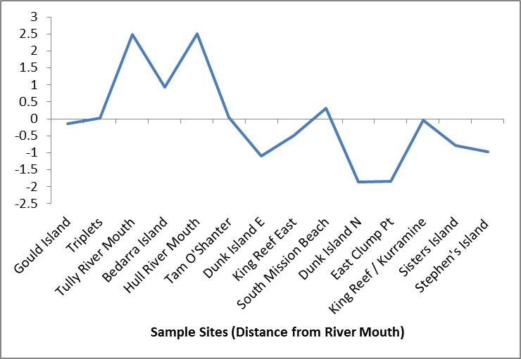
Figure 7-2: Water quality index score calculated for each site within the Tully River plume.
Figure 7-3: Drivers of water quality in wet season conditions in the Tully marine region.

Fitzroy region
The Fitzroy River plume and the potential impacts from the river waterisunique in the scale and extent, due to the extreme flow event and the distance associated with the 2011 river plume waters. The area of GBR exposed to Fitzroy flood plume waters exceeded 400km north of the Fitzroy River mouth, potentially affecting up to 45,000km² of the inshore to central GBR. However despite the large areal coverage of the Fitzroy River plume, the area of greatest impact would have been the Keppel Reefs, exposure to very high loads of TSS, DIN and PS-herbicides.
The movement of high water quality parameters is summarised in Figure 7.5, clearly showing high average values of TSS, Chl-a and DIN for a series of transects moving north from the Fitzroy. Chl-values averaged between 0.5 to 2.6μg/L. Average TSS values ranged from 3 to 29mg/L and average DIN values ranged from 2 to 5μM. All these values are high in both space and time and will have considerable impact on both acute processes with the affected GBR waters, but also will contribute to the ongoing chronic water quality issues within GBR (see Brodie et al., 2011).
As reported for the Tully, it is the combined impact, either through cumulative or additive processes of a number of water quality changes associated with the onset and movement of the Fitzroy River plume (Figure 7.5) which will affect the inshore ecosystems. Figure 7.7 shows discharge, secchi depth and the number of diseased coral communities in the Fitzroy region over the period 2000 to 2011. It shows a potential indication of the chronic effects of flood conditions in these regions and identifies that the occurrence of floods is a likely driver of increased diseases on corals in the Keppel regions

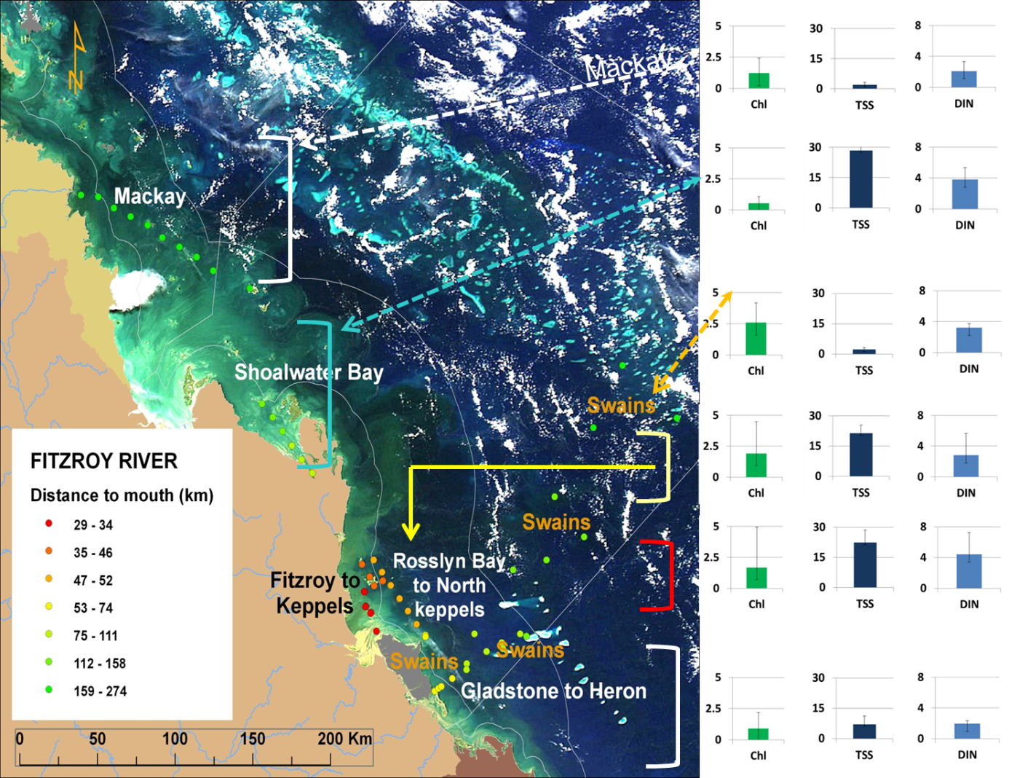
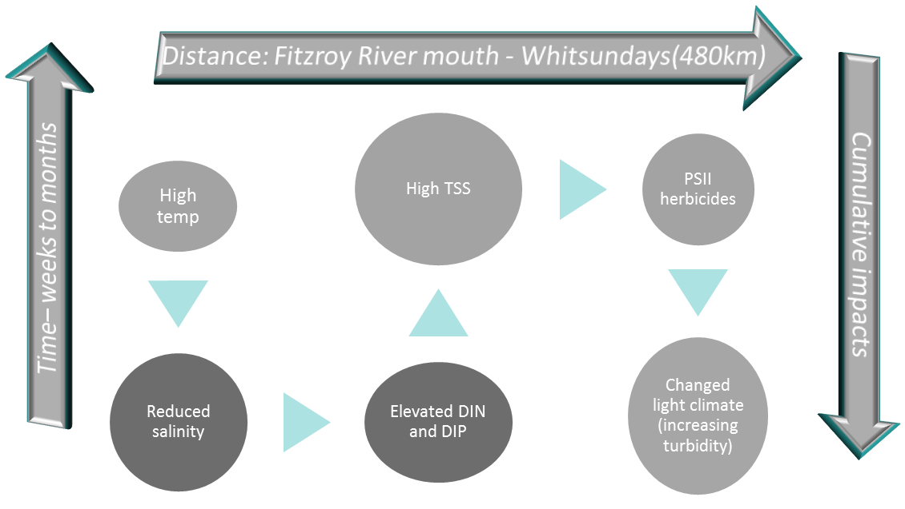
Figure 7-4: Average water quality values for Chl-a, TSS and DIN for each of the Fitzroy River transects. Sites are colour coded to distance.
Figure 7-5. Drivers of water quality in wet season conditions in the marine region affected by the Fitzroy River flood plume.
High flows in the Fitzroy River over the past three years has seen ongoing water quality issues within the Keppel Reef system. These water quality issues from the Fitzroy River plume have been exacerbated by the record floods and associated loads that were experienced in the 2011 wet season. Current MMP data, particularly with the inshore coral reefs, are showing signs of decline, both in terms of hard coral cover and increased disease (Thompson et al., in press). Rates of recovery will depend on the resilience of the system which may be helped by a period of time in which dry flow conditions dominate.
Figure 7-6. Discharge, secchi depth and coral communities in the Fitzroy region. Source: Thompson et al., (2012).

Conclusions
The flood monitoring component of the MMP was extended in the 2010-11 wet season with support from the EWRP, enabling comprehensive sampling to be undertaken in several locations in the GBR. Intensive sampling was undertaken in the Wet Tropics (Tully River focus) and Fitzroy region, with some sampling effort in the Burdekin and Burnett Mary regions. In addition, the capacity to map the extent and characteristics of flood plumes in wet season conditions has expanded considerably in the last 12 to 18 months, indicated by the comprehensive map products presented in this report.
The 2010-11 wet season could be characterised as an extreme water quality for the GBR. The influence of flood plumes extended over hundreds of kilometres over periods of weeks to months (January to April 2011). Elevated concentrations of TSS, nutrients and PSII herbicides were measured throughout the wet season.
Results from the seagrass health monitoring program indicate chronic decline of seagrass abundance in the Burdekin and Wet Tropics regions. Monitoring of inshore coral ecosystems show evidence of decline in hard and soft coral cove, particularly in the Burdekin region, and further evidence that increased incidence of disease may be associated with water quality issues. These results indicate that the impacts from TC Yasi and the extensive floods experienced in many GBR rivers are driving large scale change in an already perturbed environment.
Water quality data presented in this report shows clearly that the impacts of high flow periods in the inshore GBR will be related to both the short term (acute) changes associated with the onset of the river plumes, and the movement and extent of these low salinity, high nutrient and sediment carrying waters, potentially exacerbated by higher temperatures. However, the most significant impacts from water quality are most likely driven by the longer term (chronic) changes which are associated with weeks to months of altered water quality conditions, in particular nutrient enriched, turbid waters which can affect the key ecological functions of seagrass and coral communities of the GBR.
Coral reefs respond to stress in complex ways especially in the presence of both acute and chronic stresses (Kinsey, 1988). Kinsey (1988) describes in case studies from Green Island on the GBR and Kaneohe Bay in Hawaii how it was the combination of these two types of stress which led to the long term decline of the coral reefs. In the case of Green Island it was the acute stress of COTS (with high coral mortality) combined with long term chronic water quality stress that in combination led to a degraded coral reef which became dominated in large areas by seagrass and macroalgae. Similarly in Kaneohe Bay acute stress from large freshwater catchment discharge (with high coral mortality) combined with nutrient stress from sewage discharges killed the reef (need reference). Removal of the chronic stress in this case (sewage effluent discharge removal) led to reef recovery even in the continuing presence of the acute freshwater stress.
For the GBR the acute stresses causing coral mortality including large discharges of fresh, sediment and nutrient rich water as in 2010-11, cyclones, COTS and bleaching events (Osborne et al., 2011) combined with the chronic stresses of poor water quality associated with the long-term effects of sediment, nutrient and pesticide discharge and ocean acidification appear to be driving the GBR to degraded condition evidenced in low coral cover (Hughes et al., 2011) and poor condition of seagrass, dugongs and turtles (Brodie and Waterhouse, in press).
The extreme weather events of 2010-11 allowed us to see this combined stress response working in ‘real time’. The likelihood of increased frequency of extreme runoff events associated with climate change (Trenberth, 2011) combined with continued chronic stresses make the long-term outlook for the GBR to be bleak.

Future directions
An additional modification to exposure maps that we are working on refers to scaling of frequency maps based on pollutant loads (i.e., proportional contributions from each basin). Incorporating the contributions from individual rivers to marine NRM regions other than those to which they drain directly is therefore needed. For this reason, a practical approach to improve exposure surface is to create a “cost-distance” surface that can act as a proxy for pollutant diffusion potential across the GBR. This cost surface would be calculated for each major river and be used to scale their individual pollutant proportional contributions across the whole GBR (or areas likely to be affected by each river). Some of the elements considered include the maximum know extent of the high TSS plume (i.e., primary plume, as mapped with algorithms from MODIS L0 imagery), maximum known area of influence from major rivers (which then can be used along with discharge information to estimate the maximum area of influence of other rivers), and the known or inferred dominant direction of the plume movement, which is influenced by dominant winds and currents and therefore can be estimated based on identified/mapped patterns (again, colour classification techniques can be useful for this), wind information and/or available hydrodynamic models. We are beginning to explore this approach and we aim to produce a refined exposure map that will reflect more precisely the spatial variation and risk/exposure levels of different ecosystems to river plumes, and in particular to different pollutants. An additional advantage of this approach is that this information may provide more information that will allow us to consider the relation between particular marine areas and individual rivers, which then can better inform catchment management practices. Again, information from remote sensing and WQ sampling data will be very important to validate and adjust the results of this revised exposure model.
From the outputs of this report and ongoing discussions with other MMP providers, some suggested research areas for future directions are listed below:
- Resilience and recovery - what is it? How to we get it?
- What are the trigger points associated with resilience and recovery of our inshore coral reefs and seagrass beds?
- Need for further understanding of the additive and/or cumulative impacts of multiple stressors on key ecosystems.
- Lab based measurements need to represent the cumulative and ongoing influence of these multiple stressors with high temperatures.
- Are we at or past a tipping point?
- Extreme weather is part of a natural cycle and will shape and change reef ecosystems.
- If WQ is key driver of change, are we doing enough to modify or stop the impact?

References
Bainbridge, Z., Wolanski, E., Lewis, S. and Brodie, J. (2012). Biological uptake of particulate nitrogen enhances sediment flocculation in a Burdekin River flood plume. Marine Pollution Bulletin.
Baith, K., Lindsay, R., Fu, G., McClain, C.R. (2001). SeaDAS: Data analysis system developed for ocean color satellite sensors, EOS, Transactions, American Geophysical Union, 82, p. 82.
Bell I and Ariel E (2011). Dietary shift in green turtles. Seagrass-Watch News 44(November) 2-5
Berkelmans, R. (2002). Time-integrated thermal bleaching thresholds of reefs and their variation on the Great Barrier Reef. Marine Ecology Progress Series 229: 73-82.
Berkelmans R., 2009. Bleaching and mortality thresholds: How much is too much? In: Coral Bleaching: Patterns, Processes, Causes and Consequences (MJH van Oppen and JM Lough eds) Ecological Studies 205, Springer-Verlag, Berlin Heidelberg:103-119
Brando, V.E., Schroeder, T., Dekker, A.G. and Park, Y.J.P. (2010a). Reef Rescue Marine Monitoring Program: Using Remote Sensing for GBR wide water quality. Annual Report for 2009/10 Activities, CSIRO Land and Water, Canberra.
Brando, V.E., Dekker, A.G., Schroeder, T., Park, Y.J., Clementson, L.A., Steven, A. and Blondeau-Patissier, D. (2008). Satellite retrieval of chlorophyll CDOM and NAP in optically complex waters using a semi-analytical inversion based on specific inherent optical properties. A case study for Great Barrier Reef coastal waters.Ocean Optics XIX, Italy.
Brando, V.E., Blondeau-Patissier, D., Schroeder, T,.Dekker, A.G. and Clementson, L.A. (2011). Reef Rescue Marine Monitoring Program: Assessment of Terrestrial Run-off Entering the Reef and Inshore Marine Water Quality Monitoring using Earth Observation data. Final Report for 2010/11 Activities. CSIRO, Canberra.
Brodie, J.E., Kroon, F.J., Schaffelke, B., Wolanski, E., Lewis, S.E., Devlin, M.J., Bainbridge, Z.T., Waterhouse, J., Davis, A.M. (2012). Terrestrial pollutant runoff to the Great Barrier Reef: An update of issues, priorities and management responses. Mar. Pollut. Bull. doi:10.1016/j.marpolbul.2011.12.012.Brodie JE, Schroeder T, Rohde K, Faithful J, Masters B, Dekker A, Brando V and Maughan M (2010) Dispersal of suspended sediments and nutrients in the Great Barrier Reef lagoon during river-discharge events: conclusions from satellite remote sensing and concurrent flood-plume sampling. Mar Freshwat Res 61: 651-664
Brodie, J.E. Waterhouse, J . in press. A critical review of environmental management of the ‘not so Great’ Barrier Reef. Estuarine, and Coastal Shelf Science. Brodie, J., Devlin, M., Haynes, D. and Waterhouse, J. (2011) Assessment of the eutrophication status of the Great Barrier Reef lagoon (Australia).Biogeochemistry, DOI to be sup5plied.
Brodie, J.E., Mitchell, A., 1992. Nutrient composition of the January 1991 Fitzroy River plume. In: Workshop on the Impacts of Flooding, GBRMPA Workshop Series No. 17, GBRMPA, Townsville. pp 56-74
Brodie, J.E. Waterhouse, J., Lewis, S.E., Bainbridge, Z.T., Johnson, J., 2009. Current loads of priority pollutants discharged from Great Barrier Reef Catchments to the Great Barrier Reef. ACTFR Technical Report 09/02, Australian Centre for Tropical Freshwater Research, Townsville.104pp
Byron GT, O'Neill J.P., 1992. Flood induced coral mortality on fringing reefs in Keppel Bay. In : Workshop on the Impacts of Flooding Proceedings of a Workshop held in Rockhampton, Australia, 27 September 1991 (Byron G T ed),76-89
Coles, R., McKenzie, L., Grech, A. 2011. Can we learn from severe climate events? Seagrass Watch Magazine 43, 8-10.
Cooper, T.F., Uthicke, S. Humphrey, C., and Fabricius, K.E. (2007). Gradients in water column nutrients, sediment parameters, irradiance and coral reef development in the Whitsunday Region, central Great Barrier Reef. Estuarine, Coastal and Shelf Science 74: 458-470.
Cooper, T.F., Ridd, P.V., Ulstrup, K.E., Humphrey, C., Slivkoff, M. and Fabricius, K. (2008).Temporal dynamics in coral bioindicators for water quality on coastal coral reefs of the Great Barrier Reef. Marine and Freshwater Research 59 (8): 703-716.
D’Sa, E. J., R. L. Miller, and B. A. McKee. 2007. Suspended particulate matter dynamics in coastal waters from ocean color: Application to the northern Gulf of Mexico. Geophysical Research Letters 34:L23611.
De'ath, G. and Fabricius, K.E. (2008). Water Quality of the Great Barrier Reef: Distributions, Effects on Reef biota and Trigger Values for the Conservation of Ecosystem Health.' Research Publication No. 89. Great Barrier Marine Park Authority, Report to the Great Barrier Reef Marine Park Authority and published by the Great Barrier Reef Marine Park Authority, Townsville. 104 p.
De'ath, G. and Fabricius, K.E. (2010).Water quality as regional driver of coral biodiversity and macroalgal cover on the Great Barrier Reef. Ecological Applications 20: 840-850.
Department of Environment and Resource Management 2011. Marine stranding update, 1 January - 18 October 2011. http://www.derm.qld.gov.au/wildlife-ecosystems/wildlife/caring_for_wildlife/marine-strandings-data.html
DeVantier, L., De’ath, G., Turak, E., Done, T., Fabricius, K., 2006. Species richness and community structure of reef-building corals on the nearshore Great Barrier Reef. Coral Reefs, 25, 329–340.
Devlin, M., Brodie, J., 2005. Terrestrial discharge into the Great Barrier Reef Lagoon: nutrient behavior in coastal waters. Mar. Pollut. Bull. 51, 9-22.
Devlin and Waterhouse in press. Synthesis of Flood Plume Monitoring in the Great Barrier Reef 1991-2012. Reseach Publication. Australian Centre for Tropical Freshwater Research, James Cook University, Townsville.
Devlin, M., Waterhouse, J., Taylor, J. and Brodie, J. 2001. Flood plumes in the Great Barrier Reef: spatial and temporal patterns in composition and distribution. GBRMPA Research Publication No. 68.Great Barrier Reef Marine Park Authority, Townsville, Australia.
Devlin MJ, McKinna L and Harkness P (2010a) Reef Rescue Marine Monitoring Program: Terrestrial runoff in the Great Barrier Reef (3.7.2b). Flood Plume Monitoring for 2009/10 Annual Report. Australian Centre for Tropical Freshwater Research, James Cook University, Townsville.
Devlin, MJ, Harkness, P, McKinna, L and Waterhouse, J (2010b) Mapping of risk and exposure of Great Barrier Reef ecosystems to anthropogenic water quality. A report to the Great Barrier Reef Marine Park Authority, August 2010. ACTFR Report No. 10/12. Australian Centre for Tropical Freshwater Research (ACTFR), James Cook University, Townsville.
Devlin, M., and Schaffelke, B. (2009).Extent and exposure of riverine flood plumes in the Tully coastal region. Marine and Freshwater Research 60: 1109-1122.
Devlin, M., Schroeder, T., McKinna, L., Brodie, J., Brando, V., Dekker, A. (2012a), Monitoring and mapping of flood plumes in the Great Barrier Reef based on in-situ and remote sensing observations, in: Advances in Environmental Remote Sensing to Monitor Global Changes, CRC Press, Boca Raton.
Devlin, M., McKinna, L., Alvarez-Romero., J.G., Petus, C., Abott, B., Harkness, P., Brodie, J., (2012b). Mapping the pollutants in surface riverine flood plume waters in the Great Barrier Reef, Australia. Marine Pollution Bulletin. Doi.
Fabricius, K.E. (2005). Effects of terrestrial runoff on the ecology of corals and coral reefs: Review and synthesis. Marine Pollution Bulletin 50: 125–146.
Fabricius, K.E. (2011a). Nutrient pollution. In: Hopley D (ed.) Encyclopedia of modern coral reefs. p. 722-731, Springer.
Fabricius, K.E. 2011b. Factors determining the resilience of coral reefs to eutrophication: a review and conceptual model. in: Dubinsky, Z. Stambler, N. (Eds.), Coral Reefs: An Ecosystem in Transition, Springer Press, pp. 493-506.
Fabricius, K., De'ath, G., McCook, L., Turak, E., Williams, D. (2005). Changes in algal, coral and fish assemblages along water quality gradients on the inshore Great Barrier Reef. Marine Pollution Bulletin 51: 384-398.
Furnas, M., 2003. Catchments and Corals: Terrestrial Runoff to the Great Barrier Reef. Australian Institute of Marine Scoience, Townsville.334 pp.
Great Barrier Reef Marine Park Authority, (2009).Water Quality Guidelines for the Great Barrier Reef Marine Park. Great Barrier Reef Marine Park Authority, Townsville, 99p.
Great Barrier Reef Marine Park Authority, (2011). Extreme Weather and the Great Barrier Reef. Great Barrier Reef Marine Park Authority, ISBN 978 1 921682 74 2 (pdf).
Humphrey, C.A., Codi King, S. and Klumpp, D.W. (2007) A multibiomarker approach in barramundi (Latescalcarifer) to measure exposure to contaminants in estuaries of tropical North Queensland. Marine Pollution Bulletin 54: 1569-1581.
Humphrey, C.A., Weber, M., Lott, C. Cooper, T., Fabricius.K. (2008). Effects of suspended sediments, dissolved inorganic nutrients and salinity on fertilisation and embryo development in the coral Acroporamillepora (Ehrenberg, 1834). Coral Reefs. 27:837–850.
Hughes TP, Bellwood DR, Baird AH, Brodie JE, Bruno JF and Pandolfi JM (2011) Shifting base-lines, declining coral cover, and the erosion of reef resilience Comment on Sweatman et al (2011) Coral Reefs 30:653-660
Johnson, J., Waterhouse, J., Maynard, J. and Morris, S. (Writing Team) (2010) Reef Rescue Marine Monitoring Program: 2008/2009 Synthesis Report. Report prepared by the Reef and Rainforest Research Centre Consortium of Monitoring Providers for the Great Barrier Reef Marine Park Authority. Reef and Rainforest Research Centre Limited, Cairns (158pp.) (http://www.rrrc.org.au/mmp/mmp_pubs.html)
Kennedy, K., Devlin, M., Bentley, C., Paxman, C., Chue, K.L., Mueller, J. (2012) Pesticide monitoring in inshore waters of the Great Barrier Reef using both time integrated and event monitoring techniques (2010 - 2011). The University of Queensland, The National Research Centre for Environmental Toxicology (Entox).
Kennedy, K., Schroeder, T., Shaw, M., Haynes, D., Lewis, S., Bentley, C., Paxman, C., Carter., Brando, V., Bartkow., Hearn, L., Mueller, J. (2011) Long-term monitoring of photosystem-II herbicides on the Great Barrier Reef – trends and correlation to remotely sensed water quality. Marine Pollution Bulletin.
Kersell, A.P., and Jones, R. Effects of hypo-osmosis on the coral Stylophorapistillata: nature and cause of ‘low-salinity bleaching’. Marine Ecology Progress Series. 253: 145–154, 2003.
Kinsey, D.W. 1991. Can we resolve the nutrient issue for the Reef? Search 22, 119-121.
Kroon, F.J., Kuhnert, P., Henderson, B., Wilkinson, S., Henderson, A., Brodie, J., Turner, R., (2012). River loads of suspended solids, nitrogen, phosphorus and herbicides delivered to the Great Barrier Reef lagoon. Mar. Pollut. Bull. doi:10.1016/j.marpolbul.2011.10.018.
Lambrechts, J. Humphrey, C. McKinna, L. Gourge, O. Fabricius, K. Mehta, A. Lewis, S. Wolanski, E., 2010. The importance of wave-induced bed fluidisation in the fine sediment budget of Cleveland Bay, Great Barrier Reef. Estuar. Coast. Shelf. Sci. 89, 154-162.
Lewis, S.E., Brodie, J.E., Bainbridge, Z.T., Rohde, K.W., Davis, A.M., Masters, B.L., Maughan, M., Devlin, M.J., Mueller, J.F., Schaffelke, B., 2009. Herbicides: A new threat to the Great Barrier Reef. Environ. Pollut. 157, 2470–2484.
Lewis, S.E., Schaffelke, B., Shaw, M., Bainbridge, Z.T., Rohde, K.W., Kennedy, K.E., Davis, A.M., Masters, B.L., Devlin, M.J., Mueller, J.F., Brodie, J.E., 2012. Assessing the risks of PS-II herbicide exposure to the Great Barrier Reef. Mar. Pollut. Bull. doi:10.1016/j.marpolbul.2011.11.009.
Li, R.-R., Y. J. Kaufman, G. Bo-Cai, and C. O. Davis. 2003. Remote sensing of suspended sediments and shallow coastal waters. IEEE Transactions on Geoscience and Remote Sensing 41:559-566.
Maritorena, S., D. A. Siegel,. A. Peterson., 2002. Optimization of a semi-analytical ocean colour model for global scale applications, Appl. Optics., 41, 2705–2714.
McKenzie LJ, Yoshida RL, Unsworth R (2011) Seagrass-Watch News Issue 44 November 2011 Seagrass watch HQ 32pp
McKenzie L, Unsworth R and Waycott M (2010) Reef Rescue Marine Monitoring Program: Intertidal Seagrass, Annual Report for the Sampling Period 1 September 2009 to 31 May 2010. Fisheries Queensland, Cairns.
McKenzie LJ, Collier C, Waycott M (2012) Reef Rescue Marine Monitoring Program: Nearshore Seagrass, Annual Report for the sampling period 1st July 2010–31st May 2011 Fisheries Queensland, Cairns 177pp
Moss, A., Brodie, J., Furnas, M. (2005). Water quality guidelines for the Great Barrier Reef World Heritage Area: a basis for development and preliminary values. Marine Pollution Bulletin. 51:76-88.
Orpin, A.R., Brunskill, G.J., Zagorskis, I.,Woolfe, K.J. (2004). Patterns of mixed siliciclastic–carbonate sedimentation adjacent to a large dry-tropics river on the central Great Barrier Reef shelf, Australia. Aust. J. Earth Sci. 51: 665–683.
Osborne K, Dolman AM, Burgess SC and Kerryn JA (2011) Disturbance and dynamics of coral cover on the Great Barrier Reef (1995–2009) PLoS One 6:e17516
Parsons, T.R., Maita, Y. &Lalli, C. 1984, A Manual of Chemical and Biological Methods for Seawater Analysis, Pergamon, London.
Pickersgill G, Smith T, Wedlock B, Ford E, Watson D and Burgess S (2011) Flooding in the Mary River: experiences from the present, lessons for the future Proceedings of Riversymposium 2011
Qin, Y., Brando, V., Dekker, A., and Blondeau-Patissier D., (2007). Validity of SeaDAS water constituents retrieval algorithms in Australian tropical coastal waters, Geophysical Research Letters, 34, L21603, doi:10.1029/2007GL030599.
Ryle, V.D., Mueller, H.R. and Gentien, P. (1981). Automated Analysis of Nutrients in Tropical Seawaters, Science Data Report No. 3, Australian Institute of Marine Science, Townsville.
Schaffelke, B., Mellors, J., Duke, N.C., 2005. Water quality in the Great Barrier Reef region: responses of mangrove, seagrass and macroalgal communities. Mar. Pollut. Bull. 51, 279-296.
Schaffelke, B., Carleton, J., Doyle, J., Furnas, M., Gunn, K., Skuza, M. Wright, M. Zagorskis, I. (2011). Reef Rescue Marine Monitoring Program. Final Report of AIMS Activities – Inshore water quality monitoring 2009/10. Report for the Great Barrier Reef Marine Park Authority. Australian Institute of Marine Science, Townsville.
Schaffelke, B., Carleton, J., Doyle, J., Furnas, M., Gunn, K., Skuza, M. Wright, M. Zagorskis, I. (2012). Reef Rescue Marine Monitoring Program. Final Report of AIMS Activities – Inshore water quality monitoring 2010/11. Report for the Great Barrier Reef Marine Park Authority. Australian Institute of Marine Science, Townsville.
Thompson, A., Davidson, J., Schaffelke, B. and Sweatman, H. (2010). Reef Rescue Marine Monitoring Program. Final Report of AIMS Activities – Inshore coral reef monitoring 2009/10. Report for Reef and Rainforest Research Centre. Australian Institute of Marine Science, Townsville.
Thompson, A., Costello, P., Davidson, J., Logan, M., Schaffelke, B., Uthicke, S. and Takahashi, M. (2012). Reef Rescue Marine Monitoring Program Report of AIMS Activities – Inshore coral reef monitoring 2011 Report for Great Barrier Reef Marine Park Authority Australian Institute of Marine Science Townsville 127 pp
Schroeder, T., Devlin, M., Brando, V.E., Dekker, A.G., Brodie, J., Clementson, L., McKinna. L., 2012. Inter-annual variability of wet season freshwater plume extent into the Great Barrier Reef lagoon based on satellite coastal ocean colour observations. Mar. Pollut. Bull.
Trenberth KE (2011) Changes in precipitation with climate change. Clim. Res. 47:123–138
Van Woesik, R., Tomascik, T., Blake, S.,1999. Coral assemblages and physico-chemical characteristics of the Whitsunday Islands: evidence of recent community changes. Mar. Freshwat. Res. 50, 427-440.
van Woesik R, De Vantier LM, Glazebrook JS.,1995. Effects of Cyclone 'Joy' on nearshore coral communities of the Great Barrier Reef. Mar. Ecol. Prog. Ser. 128, 261-270
Wang, M., Shi, W., 2007, The NIR-SWIR combined atmospheric correction approach for MODIS ocean colour data processing, Optics Express, Vol. 15, No. 24, 15722-15733.
Waterhouse, J., Brodie, J.E., Lewis, S., Mitchell, A., 2012. Quantifying the sources of pollutants to the Great Barrier Reef. Marine Pollution Bulletin.
Waycott, M. Longstaff, B. Mellors, J., 2005. Seagrass population dynamics and water quality in the Great Barrier Reef region: A review and future research directions. Mar. Pollut. Bull. 51, 343-350
Weber, M., Lott, C., Fabricius, K.E. 2006. Sedimentation stress in a scleractinian coral exposed to terrestrial and marine sediments with contrasting physical, organic and geochemical properties. Journal of Experimental Marine Biology and Ecology. 336, 18-32.
Wolanski, E., Fabricius, K., Cooper, T. and Humphrey, C. (2008). Wet season fine sediment dynamics on the inner shelf of the Great Barrier Reef.Estuarine, Coastal and Shelf Science.77: 755-762.

Appendix 1: Publications and Communication

Communications, major activities or events
During the wet season, a very high incidence of media attention was given to the impacts of the Queensland floods and Cyclone Yasi.
A summary of the media events is given below.

Radio interviews
- Dr Michelle Devlin - Interview with BBB World Service
- Dr Michelle Devlin - Interview with BBB Radio Wales
- Dr Michelle Devlin - Interview with BBB Radio 1/Radio 2
- Dr Michelle Devlin - Interview with Radio France Internationale
- Dr Michelle Devlin - Interview with ABC Queensland.

Newspaper and magazine articles (some examples)
The Age
Sydney Morning Herald
The Wall Street Journal - Europe – Wed, 09 Mar 2011 18:48
Great Barrier Reef Faces Long Recovery
SYDNEY—The damage done by Cyclone Yasi to the Great Barrier Reef, Australia's top tourist attraction, will take decades to fully mend, which could prompt fewer visitors and smaller catches for the local fishing industry, according to a growing number of scientists.
Singapore News<http://ct.moreover.com/ct?haid=b1362743a612b4641299026590545f8cd22b6b1b04e20&co=f000000000664s-3413021309>
Discovery (JCU newsletter).
Nature (see article below)
New Scientist
Marine Ecosystems and management

Documentary footage
Ralf Blasius – The impacts of the extreme weather report. (German documentary)
https://files.me.com/blasius/0y1lnz.mov
Michelle Thomas – Reef Reuters Story
http://english.ntdtv.com/ntdtv_en/ns_life/2011-04-04/scientists-great-barrier-reef-threatened-by-toxic-flood-debris.html
Material supplied to The Great Barrier Reef Foundation.

Appendix 2: Additional Studies

Impacts of the 2011 Fitzroy floods on Keppel Islands fringing reefs
The 2011 Fitzroy flood has impacted an estimated 30% of the total 12 sq km of fringing reefs in the Keppel Islands region (Alison Jones, personal communication). Flood impacts were restricted to 100% on most of the major reef flats at ~2m below sea level but particularly on sites close to the flood plume (Halfway, Clam, Middle, Miall and Humpy) and extended to approximately 10-30% mortality down to ~6-8m on reef slopes. At Clam Bay for instance, Acroporaformosa beds at 8m showed few impacts of the flood.

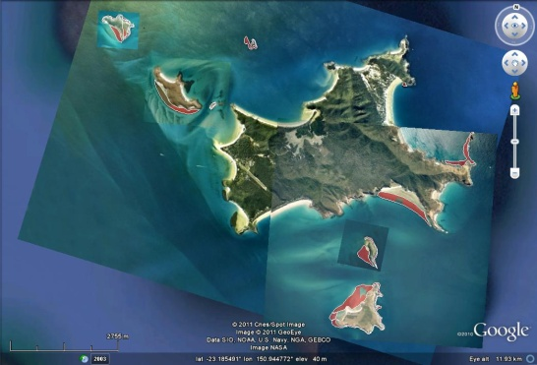

Figure A2.1. Google Earth images of the area where known coral reef impacts occurred from the 2011 Fitzroy flood, particularly surface bleaching. Sites include (a). Pelican reef and (b) Great Keppel Island and surrounds.
Flood impacts in the Fitzroy region were influenced by four main factors:
- Distance from the source of the flood plume – the closer to the Fitzroy River the worse the impacts e.g. Halfway reef flat mortality was worse than North Keppel mortality and Miall reef mortality was worse than Wreck Bay mortality.
- Aspect – at sites in the shadow of the plume (the eastern and northern sides of reefs north of Great Keppel Island and North Keppel Island e.g Little Peninsular, Big Peninsular, Parker’s bommies, Wreck) there was less mortality on the reef flats and slopes. Reefs south of Great Keppel Island had significant mortality (e.g. Clam, Halfway, Miall, Middle and Humpy)
- Depth – corals within the freshwater meniscus of ~2-4m were affected more than corals which were deeper than the meniscus at ~6-8m.
- Species composition – Acroporids and Pocilloporids were more likely to be affected by the plume but mainly because these are common on shallow reef flats at 0-2m. Cyphastrea, Fungia and Porites survived on reef flats impacted by the plume.

Specific site impacts
Pelican Island –Mortality reported to 2m then some species specific mortality 2-4m (perscomm AIMS, Long term monitoring)
HumpyIsland– not surveyed but reports from AIMS LTM team and Marine Parks (John Olds) suggest mortality to 2m all around the island and then little mortality below ~4m.
Halfway reef flat – 100% flood mortality on the reef flat to ~6m (Figure A2.2).
Clam Reef– 100% mortality to ~6m on the slope and no impacts at 8m (Figure A2.3, A2.4).

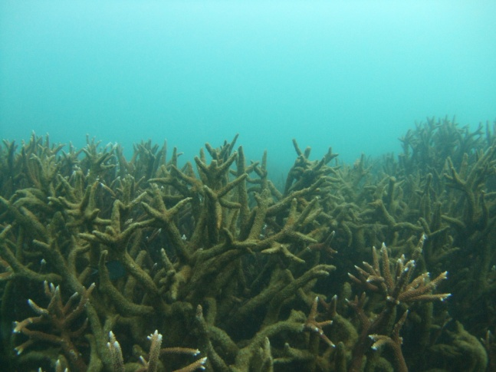
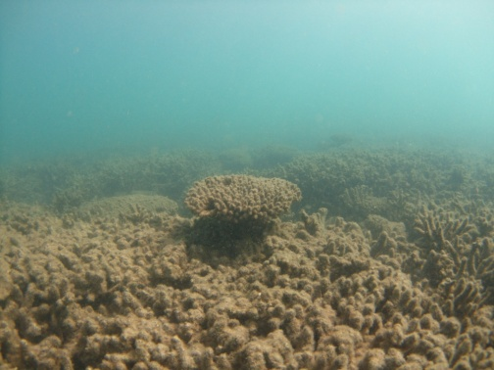
Halfway Reef – 6m
Halfway Reef – 2m

Figure A2.2.Coral mortality on Halfway Reef Flat at (a - left) 2m and (b - right) 6m.
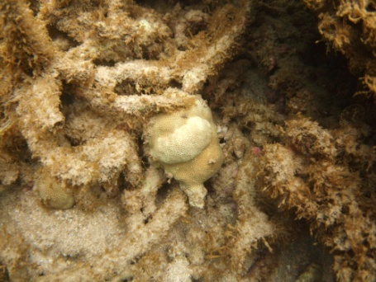
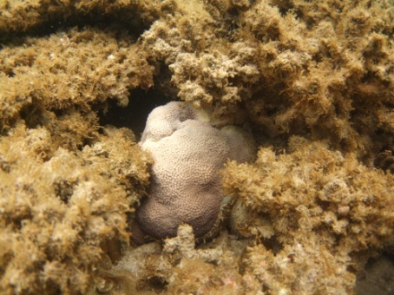
Clam Reef – Porites
Clam Reef – Cyphastrea

Figure A2.3. (a - left) Cyphastrea and (b - right) Porites at Clam slope May 2011.

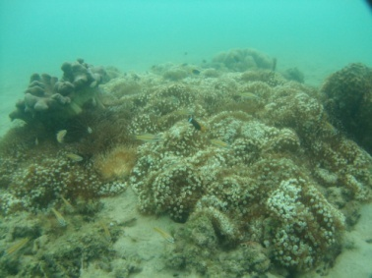
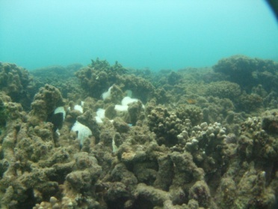

Figure A2.4. Coral mortality on Clam Reef Flat at (a - left) 6m;(b - right) no impact at 8m.

Miall: The northwestern bay of Miall has almost 100% mortality to up 2m then partial mortality between 2m and 6m, followed by no mortality at 6m. The southern bay of Miall is 100% dead to 4m depth. The occasional Porites juvenile, Cyphastrea (adult) and Fungia (adult and juveniles) are alive on the reef flat and slope (Figure A2.5).
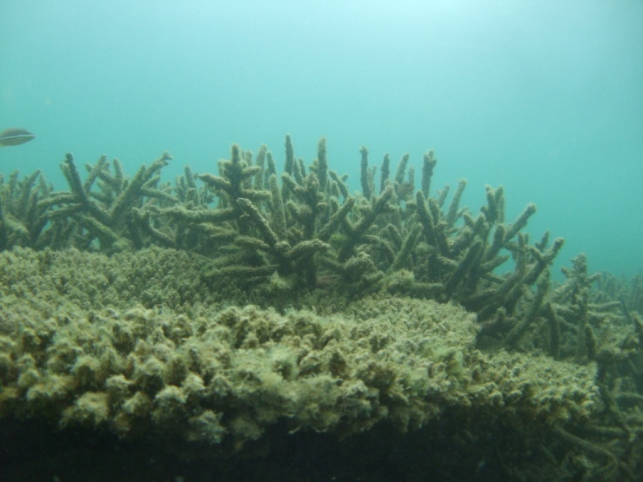
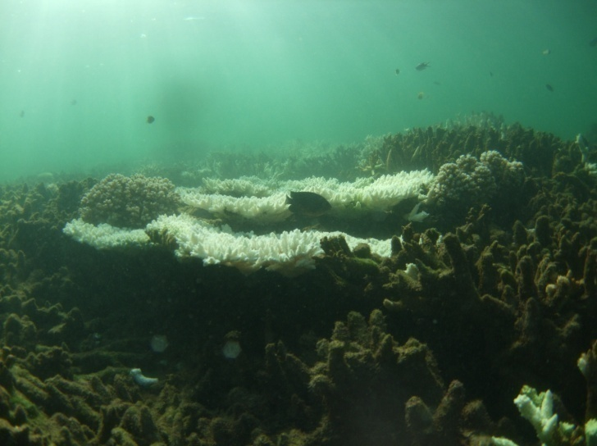
Miall Reef- 2m
Miall Reef- 2m

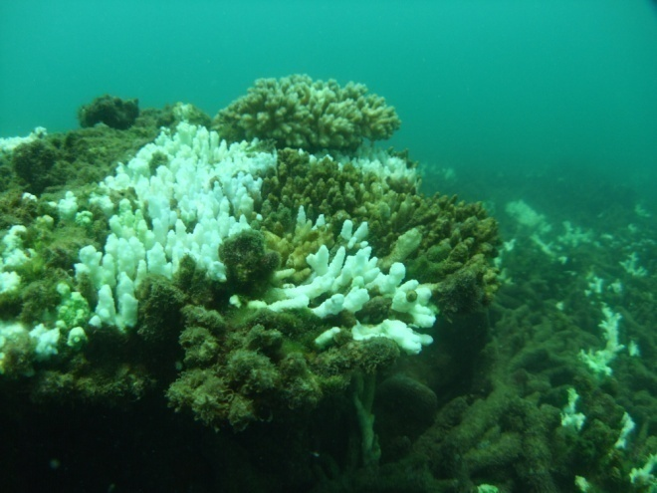
Miall Reef- 2m

Figure A2.5.Coral bleaching at Miall Reef at (a - left) 2m, (b - right) 2m. Coral mortality at (b- bottom) 2m

North Keppel : The North Keppel– Maizie Bay reef flat at 0-1m had 100% mortality between 0 to 1m, (Figure A2.6a) but below 1-2m there was <10% mortality with the occasional (<1%) white bleached colony (mainly Montipora, FigureA2.6b). Below the 2m depth mark there was no significant impact. All white bleached colonies have since returned to healthy colouration (Fig A2.6c).

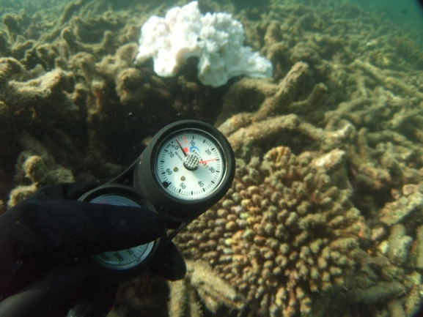
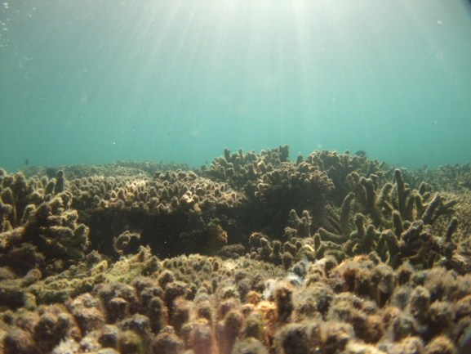
- North Keppel- 1m

B. North Keppel- 3m

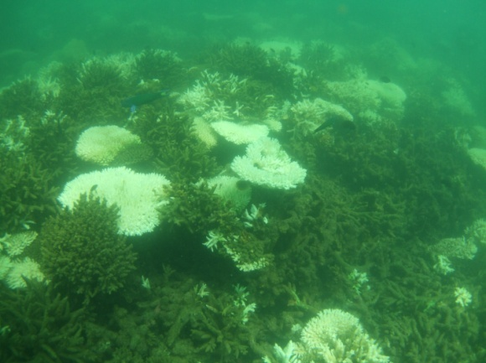

C. North Keppel- 2-3m

Figure A2.6. Coral mortality at North Keppel Reef at (a -left) 1m, (b – right) partial bleaching at 2m and signs of recovery at (b - bottom) 2m.

APPENDIX 3 - Case study – Mapping the surface exposure of plume waters for Paddock to Reef Program reporting.

Background

Methodology

Mapping of the full extent of plume water was based on composite maps of plume water types (i.e., full extent/area covered by the primary, secondary and tertiary water types combined). We used the tertiary plume (identified by CDOM value higher than 0.14ug/L; CDOM is proportional to salinity value of 30+/- 4) to define the boundary or maximum extent of the plume/ Algorithms associated with the mapping of secondary water types, characterised by elevated chlorophyll and CDOM values, was also used to define the boundary edge in areas of the plume where tertiary water is absent or scattered/diffuse and difficult to define. In short, we have mapped the full extent of the plume by applying a combination of algorithms and identifying thresholds which link to the gradients of CDOM, chlorophyll, TSS in plume waters when required (e.g., areas where algorithms could not be applied due to high cloud cover or glint). An innovative plume mapping technique that combines radiometric enhancement and unsupervised classification of true colour MODIS imagery was also employed to fill in blanks of areas with no information on water types.
Simply put, we develop a set of mapping techniques which allow us to map the full extent of the plume despite limitations in the application of the RS algorithms. The use of water types also allows us to eventually map the main water quality characteristics associated with the water types.
The third step was to take the annual loads of DIN and TSS made available through DERM and calculate the proportional contribution for each pollutant from each catchment. These proportional catchment loads were then scaled by multiplying them by the normalised frequency of surface plume waters (see above). The surface extent was normalised (0-1) to five categories for each pollutant, which can be visualised on a map and reported as an areal measurement for each category.
We calculated a frequency of surface plume waters based on available and appropriate imagery and linked to high flow periods. The plume frequency map was constructed by counting the overlapping plumes (i.e., combined primary, secondary and tertiary plumes) for each pixel, which ranges from 1 to 10 plumes. We then normalised the frequency by calculating its logarithm, resulting in frequency values from 0 to 1. Normalised values were then grouped in 5 frequency classes [JAR1] based on the standard deviation (Fig x.x)
- Note that we are not reporting PSII as we do not have annual load data for pesticides.
- We have focused the case study on Burdekin and Wet Tropics, but happy to extend to other regions.
- 2010 maps are coming and should be available this week.
- The overall map is the long term map, which is all the images plotted between 2000- 2009, normalised against the long term average load data (taken from Brodie et al., 2009).
- We can report the difference each year between the long term exposure and the year to year exposure, but for now we have just presented the surface area for year to year and the proportional contribution of each catchment to surface exposure (related back to loads).

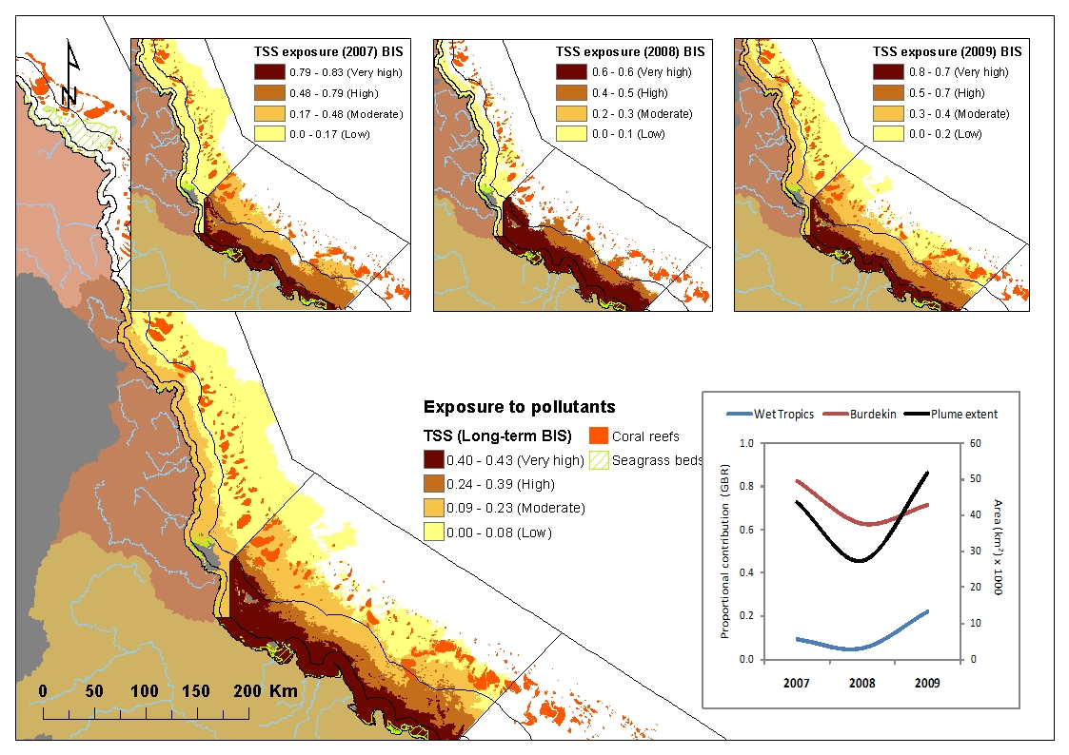
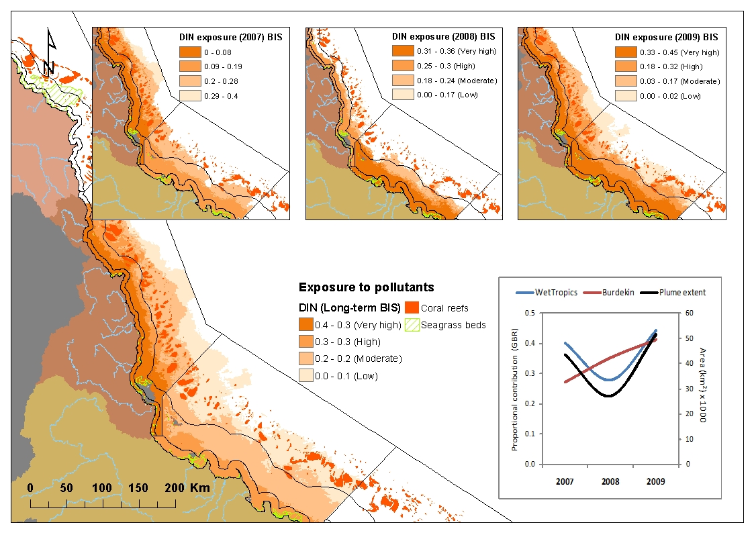

Figure A3-1: .Surface exposure maps as required for Paddock to Reef reporting.

APPENDIX 4 - Devlin M, McKinna LW, Alvarez-Romero JG, Petus C, Abott B, Harkness P and Brodie J (2012) Mapping the pollutants in surface riverine flood plume waters in the Great Barrier Reef, Australia. Mar Pollut Bull.

APPENDIX 5 - Devlin M, Brodie, J., Wegner, A., da-Silva, E., Alvarez-Romero JG, Waterhouse, J and McKenzie (2012) Chronic and acute influences on the Great Barrier Reef: Putting extreme weather conditions in context. Proceedings of the 12th international coral reef symposium, cairns. australia, 9 – 13 july. ,2012

