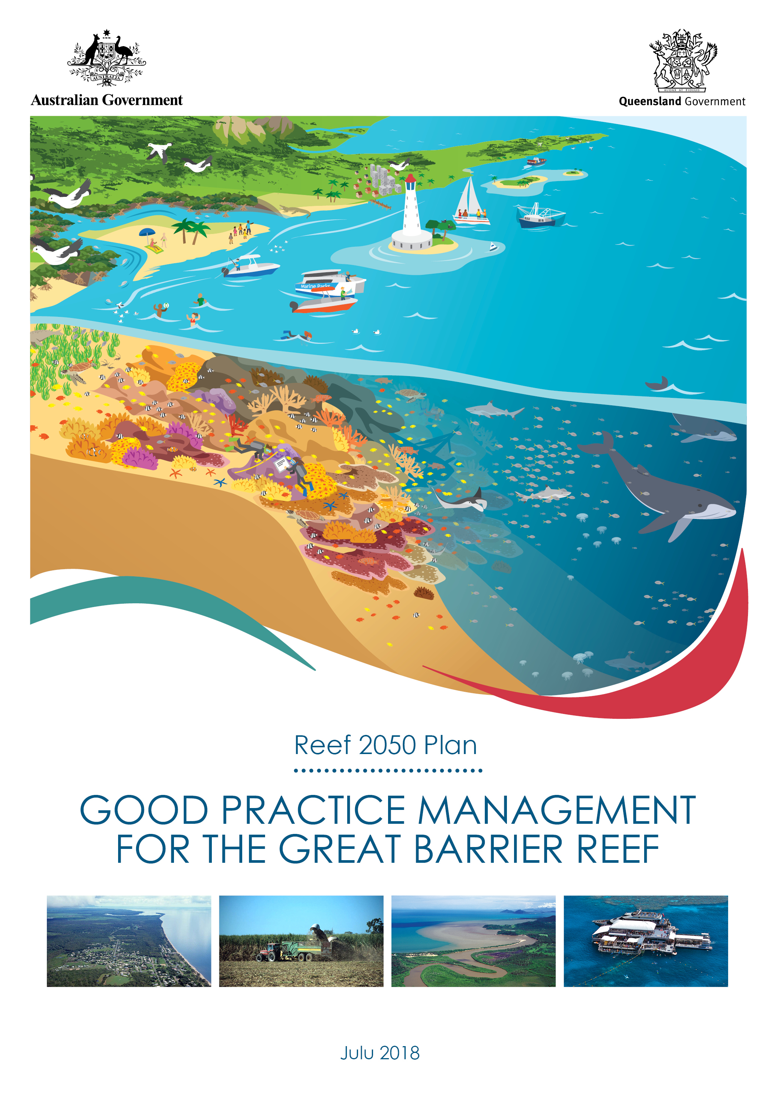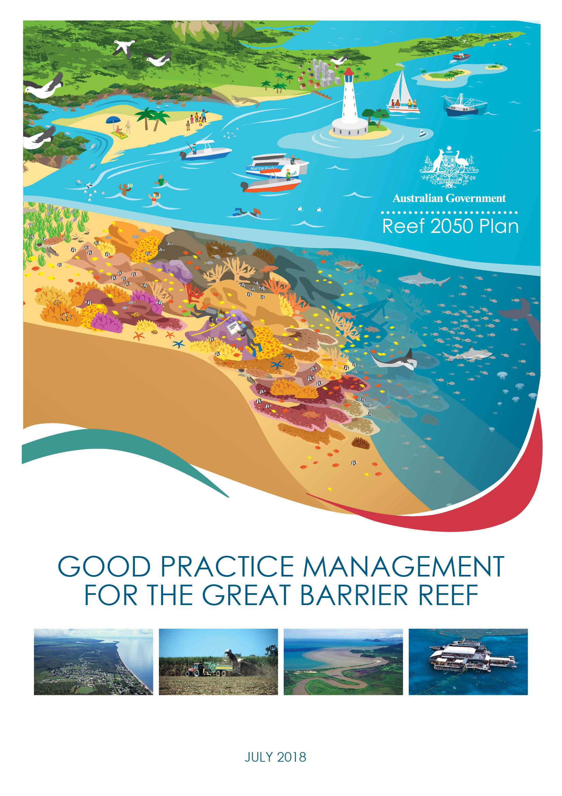
© Commonwealth of Australia 2018
Published by the Great Barrier Reef Marine Park Authority
ISBN 978-0-6480964-4-3

The Good Practice Management for the Great Barrier Reef is licensed by the Commonwealth of Australia for use under a Creative Commons By Attribution 4.0 International licence with the exception of the Coat of Arms of the Commonwealth of Australia, the logo of the Great Barrier Reef Marine Park Authority, any other material protected by a trademark, content supplied by third parties and any photographs. For licence conditions see: http://creativecommons.org/licences/by/4.0


A cataloguing record for this publication is available from the National Library of Australia

This publication should be cited as:
Great Barrier Reef Marine Park Authority 2018, Good Practice Management for the Great Barrier Reef, GBRMPA, Townsville.
Comments and questions regarding this document are welcome and should be addressed to:
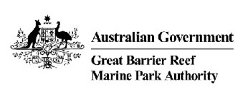
Great Barrier Reef Marine Park Authority
2–68 Flinders Street
(PO Box 1379)
Townsville QLD 4810, Australia

Phone: (07) 4750 0700
Fax: (07) 4772 6093
Email: info@gbrmpa.gov.au
www.gbrmpa.gov.au

Contents
Purpose 3
Target audience 3
Context 3
Good Practice Management considerations 5
Implementation 10
Review and evaluation 10
Definitions 11
Further information 15
Attachment 1: Drivers of change, pressures and impacts on the Great Barrier Reef 16
Attachment 2: Risks to Great Barrier Reef values as reported in the Great Barrier Reef Outlook Report 17
Attachment 3: Great Barrier Reef Outlook report condition and trend assessment approach (adapted from page 9 of the Great Barrier Reef Outlook Report 2014) 22
Attachment 4: Values, attributes and processes that underpin matters of national environmental significance relevant to the Great Barrier Reef 24

Purpose
Good Practice Management for the Great Barrier Reef sets out foundational considerations for making decisions or undertaking actions that may impact on the Great Barrier Reef.
It is part of a suite of policy documents under the Reef 2050 Plan (refer figure 1).

Target audience
The target audience to apply these considerations is all stakeholders - government, Traditional Owners, industry and the community - involved in delivering programs, plans, policies and on-ground actions that influence the condition of the Great Barrier Reef.
Government agencies and authorities should apply these considerations when revising or preparing relevant agreements, policies, plans, strategies and programs. Traditional Owners and stakeholders including, industry, businesses, conservationists, infrastructure providers and developers, are encouraged to incorporate these considerations when developing proposals, guidance material, programs or plans.
Researchers and the community can also apply these considerations to better understand priorities for the Great Barrier Reef, and focus areas for improvement and measurement.

Context
The Great Barrier Reef – like all reefs globally – is an icon under pressure. Cumulative impacts are compounding over space and time and are diminishing the Reef’s ability to recover from disturbances. This loss of resilience is especially concerning given the importance of protecting the Reef from climate change impacts.
The cumulative effects of these changes are impacting the resilience of the Reef and we are witnessing a large-scale shift in the ecosystem and deterioration in its condition.
It also impacts the cultural values of Traditional Owners; the tourism and fishing industries which rely on a healthy Reef; communities along the coast for whom the Reef is part of their life; and the broader Australian and international community who consider it to be ‘our Reef’.
There is an urgent need to review, rethink and substantively escalate our collective management approach in response. Actions must be timely, delivered at the appropriate scales and be implemented in the context of a changing climate.
The Reef 2050 Plan provides an overarching strategy for long-term management of the Great Barrier Reef. It brings together actions across government, Traditional Owners, industry, researchers and the community. The Plan provides an agreed outcomes-based, target-driven framework for protecting the Great Barrier Reef’s health and resilience while allowing for ecologically sustainable use.
The Plan details primary principles to consider in all decision-making that affects the Great Barrier Reef which are:
  - maintaining and enhancing outstanding universal value in every action
  - basing decisions on the best available science
  - delivering a net benefit to the ecosystem
  - adopting a partnership approach to management.
It is underpinned by the principles of ecologically sustainable development, including the precautionary principle.
Practical approaches for addressing these principles are contained in the Reef 2050 Policy Guideline for Decision Makers. This document, Good Practice Management for the Great Barrier Reef, provides additional guidance for decision-makers and the broader community (Figure 1).
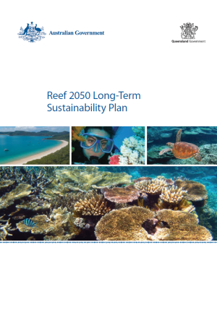
Figure 1 - Policy guidance supporting implementation of the Reef 2050 Plan
Net benefit policy
Cumulative impact management policy
Guidance for good management in the Great Barrier Reef
Reef 2050 Plan policy guideline for decision makers

Good Practice Management considerations
Focus on outcomes
Adopting an outcomes-based approach was a key recommendation of the Great Barrier Reef Region Strategic Assessment, and underpins the Reef 2050 Plan’s delivery.
The condition and trend of the Great Barrier Reef’s values (Tables A4.1 and A4.2) are reported every five years in the Great Barrier Reef Outlook Report and provide an assessment of ‘very good’, ‘good’, ‘poor’ or ‘very poor’ for each of the values (Attachment A3.1 – reference condition). Desired outcomes for the Great Barrier Reef seek to restore the condition of values assessed as ‘poor’ or ‘very poor’, and to maintain and enhance where condition is assessed as ‘good’ or ‘very good’. This is set out in Table 1.
Decisions should align with the desired outcomes for the condition and trend of Great Barrier Reef values, including its outstanding universal value. Decisions should be made in the context of a changing climate and accommodate possible global warming of at least 1.5ºC above pre-industrial levels, be focused on ecological functions and minimising the cumulative impacts of multiple stressors.
Management options should be compared with appropriate standards and guidelines, including desired outcomes for the state of the Great Barrier Reef’s values, to inform the acceptability of the proposed action. This includes considering the precautionary principle and principles of ecologically sustainable use. Management options should recognise and be aimed at identifying critical ecological functions and identifying the key species that support the Reef’s ecological processes, and target interventions to maintain or restore these ecological functions and to support those species.
Current condition | Desired outcome
Very good | The condition is maintained
Good | The condition is maintained and enhanced
Poor | The condition is restored to good
Very poor | The condition is restored to good
Trend in condition | Desired outcome
Improving | The trend is maintained
Stable | The trend is maintained and improved
Deteriorating | The decline is halted and reversed
Table 1: Desired outcomes for Great Barrier Reef values
Future-looking, dynamic and adaptive
Prognostic or forecasting tools and reference scenarios should be used to inform planning and actions, together with monitoring and diagnostic tools to adjust actions.
The results of targeted research, modelling and monitoring should be used to evaluate the performance of actions and drive continuous improvement.
Programs, plans and responses may need to be modified in response to advances in predictive modelling, new science, emerging issues or changing circumstances. Where a condition of an approval or permission provides for adapting management in response to impacts and condition of values, there is also scope to modify actions in line with new information.
The Reef 2050 Plan and the Reef 2050 Integrated Monitoring and Reporting Program provide an adaptive management framework (Figure 2) to assess progress towards outcomes and targets, and reduce impacts, using the Driver Pressure State Impact Response framework.

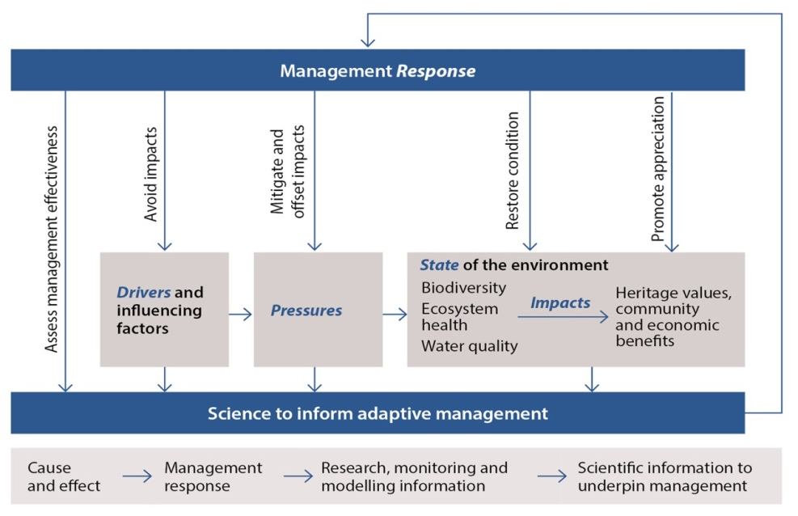
Figure 2: Reef 2050 Plan Adaptive Management Framework
Avoidance of impacts is the highest priority
Measures to avoid impacts should be documented and consider prudent and feasible alternatives, including the alternative of not carrying out the proposed action.
Measures to mitigate impacts to reduce the likely significance of any residual impacts should be clearly documented as part of the avoid–mitigate–offset hierarchy (Figure 3). Consider how the action could be redesigned, relocated or altered to avoid and or minimise any likely impacts.
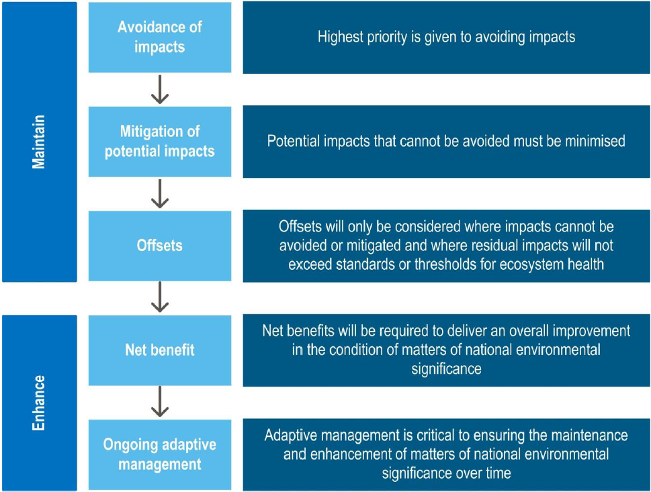
Figure 3 – Avoid, mitigate and offset hierarchy
Take a systems perspective
Healthy and resilient ecosystems are fundamental to protecting Great Barrier Reef values, and the community and economic benefits they support.
The Driver, Pressure, State, Impact, Response (DPSIR) framework (Figure 2) should be used to understand links between drivers of, activities in and pressures on the state of the environment, and the impacts on the benefits it provides (refer to Attachment 1 for the Drivers, impacts and pressures that apply to the Great Barrier Reef).
Adopting a systems perspective focused on affected Great Barrier Reef values provides a strong basis for achieving desired outcomes (Table 1). Decisions should clearly:
- specify the space and time scales in which the drivers, pressures and impacts affect Great Barrier Reef values, including the Reef’s outstanding universal value
- specify the space and time scales at which affected values occur including, for example, migratory pathways
- identify cause-and-effect relationships between drivers, pressures and impacts on Great Barrier Reef values
- identify and account for connections between land and sea, and within the marine environment.
Use the best available information
The best available information from the most appropriate sources should be used.
This includes historical information, monitoring data, Traditional Owner and stakeholder knowledge, observation, modelling, forecasts, expert judgement, citizen science, peer-reviewed literature and science.
Actively engage affected communities and stakeholders regarding ecological, cultural, social and economic values represented by the Great Barrier Reef in their area of interest.
Information should specify possible limitations of data and modelling; divergence in expert judgement, or uncertainty, availability, quality, quantity and ongoing relevance of information.
Understand and manage risk
Risk-management processes should be integrated into decision-making and demonstrate consistency with the Australian/New Zealand/International Standard, AS/NZS ISO 31000:2009 Risk management – Principles and guidelines. When identifying and analysing risks, the following factors should be considered:
- time lags which may exist between cause-and-effect relationships of impacts, both positive and negative, on values
- diversity, complexity and connectivity between environmental components and processes, including cumulative or synergistic effects
- effects that are prone to change if the context changes
- lack of reliable data
- possibility of human error
- natural variation, where the likelihood of an outcome may depend on a variety of factors and the vulnerability of components of a system
- uncertainties likely to have a significant impact on decision-making.
The Great Barrier Reef Outlook Report should be used as a guide to the types and level of risks to the Great Barrier Reef from drivers, pressures and activities (refer Attachments 1 and 2).
Specific guidance for undertaking risk assessment for Great Barrier Reef values has been developed (See Attachment 2 – example of a risk assessment procedure for the Marine Park permission system).
Assess vulnerability and resilience
The vulnerability and resilience of the overall ecosystem and its values (Figure 4) should be assessed. Consider whether exposure of a value to impacts – including the interaction of effects between impacts and past, present and reasonably foreseeable future pressures – is significant, by gauging:
- the sensitivity of the value(s) including:
  - current condition and trend
  - life histories/processes that are impacted
  - dependency on impacted resources
  - health thresholds
  - risk and uncertainty around assumptions
- the adaptive capacity of the value(s) including:
  - rate of recovery between disturbances, based on current condition
  - rate of change and reorganising of a system to a desirable functioning state
  - risk and uncertainty around assumptions.
Vulnerability and resilience should be considered when assessing the level of risk, identifying strategies for building resilience, assessing the urgency of action, evaluating the efficacy and cost-effectiveness of options, and for engaging and empowering stakeholders in adaptation processes.
Adopting a rigorous approach to risk assessment will highlight areas of vulnerability where further analysis to improve resilience may be required. Specific guidance for considering vulnerability in risk assessment for Great Barrier Reef values has been developed (See Attachment 2).
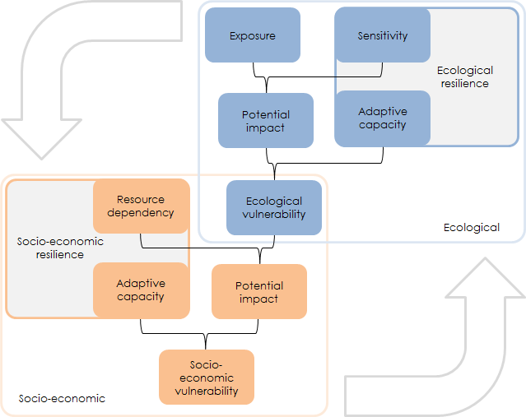
Figure 4 - Illustrating system vulnerability and resilience (Marshall, Tobin, Marshall, Gooch and Hobday, 2013).

Promote collaboration and innovation
Participatory approaches based on international best practice should be adopted to facilitate effective stakeholder engagement. This is particularly important where decisions affect community and economic benefits derived from the Reef, including social, cultural and economic values.
Innovative and collaborative approaches which create opportunities to leverage resources, align effort, share information, generate new ideas and achieve multiple outcomes should be promoted.
Ensure transparent governance
Implementation of decision or actions should be supported by effective and transparent governance measures.
Clear governance arrangements are required to promote alignment, maximise efficient use of resources and reduce duplication of effort. Methods of communicating information and engaging with relevant stakeholders should facilitate timely, accurate and understandable exchanges of information, while considering relevant information security requirements (such as privacy and confidentiality).
At a strategic level, accountability for delivery of actions and achieving outcomes will occur through the Reef 2050 Plan annual reporting, the Great Barrier Reef Outlook Report and review of the Reef 2050 Plan. The Reef 2050 Integrated Monitoring and Reporting Program will provide improved tracking of progress towards outcomes and targets.
Where relevant, regulatory compliance and enforcement programs may contribute to transparent and accountable governance by aligning with and supporting the Reef 2050 Integrated Monitoring and Reporting Program.
Traditional Owners and stakeholders including, industry, businesses, conservationists, infrastructure providers and developers, – are encouraged to similarly adopt clear governance arrangements and public reporting of outcomes.
Monitor, evaluate and report
The Reef 2050 Integrated Monitoring and Reporting Program is establishing standard protocols for collecting, storing, accessing and reporting information. Monitoring and reporting should be consistent with these protocols and appropriate to the nature and level of risk.
Accountability for achieving outcomes should occur through fit-for-purpose modelling, monitoring, evaluation and reporting programs that align and form part of the Reef 2050 Integrated Monitoring and Reporting Program. It will clearly link performance indicators to decision-makers that have the oversight for the relevant project, program or plan.
Reporting should not only focus on implementation of actions but achievements towards outcomes.
Modelling, monitoring and review should be systematically integrated into decisions and implementation of plans, programs and actions concerned with reducing impacts and delivering net benefits. It is then possible to detect change, maintain currency of information and standards for modelling and monitoring and evaluate the effectiveness of management interventions.

Implementation
This Good Practice Management for the Great Barrier Reef has been developed with advice from the Reef 2050 Advisory Committee and the Independent Expert Panel (Figure 5) and targeted and public engagement. In finalising this document, it is recognised that implementation of the foundational considerations in this document will be staged, recognising the need to develop specific guidance for relevant agencies and sectors.
Reef 2050 Plan, supported by Reef 2050 Plan policies, progress reports and investment strategies
Implemented by Australian and Queensland governments and Reef 2050 Plan partners.
Implementation advice from the Reef 2050 Independent Expert Panel and the Reef 2050 Advisory Committee.

Implemented through Inter-governmental Agreement on the Great Barrier Reef
  - Ministerial decision – making
  - Supported by Senior Officer Committee
Progress monitored through the Reef 2050 Annual Reports and Reef 2050 Integrated Monitoring and Reporting Program.
Effectiveness of management reported through the Great Barrier Reef Outlook Report and Reef 2050 Plan Annual Reports
Figure 2 - Framework supporting the implementation of the Reef 2050 Plan

Review and evaluation
The effectiveness of applying these considerations in decision–making and achieving desired outcomes will be reviewed and evaluated at the whole of Reef level in line with the five yearly Great Barrier Reef Outlook Report. Effective implementation should deliver decisions and actions that apply these good practice considerations. In the longer-term this should translate to an improvement in the condition or trend of the Reef’s values.
This document is to be read in conjunction with the Reef 2050 Policy Guideline for Decision Makers which illustrates a wide range of actions designed to manage drivers and pressures on the Reef.

Definitions
Action
Actions and activities are used to describe projects and project parts under the EPBC Act and GBRMP Act. For this document actions are used, assuming activities comprise action, or a subset of an action. Also includes development proposals and/or planning actions.
Adaptive capacity
The ability for a component of the environment to adapt to impacts to maintain or improve its condition. Includes the environmental component’s ability to recover, reorganise or build capacity to learn and adapt in between events.
Adaptive management
A systematic process for continually improving management practices through learning from the outcomes of previous management. It includes a monitoring, evaluation, reporting and improvement cycle.
Avoid-mitigate-offset hierarchy
Is used to guide assessment of actions and inform decision-making. The highest priority is given to avoiding impacts on the environment. Avoidance measures must consider prudent and feasible alternatives to a proposed action. Potential impacts that cannot be avoided must be minimised. Mitigation measures must consider direct, indirect and cumulative impacts, and account for the likely spatial and temporal scales of impacts across the duration of the proposed activity. Offsets compensate for the residual adverse impacts of an action on the environment.
Baseline condition
A description of existing conditions to provide a starting point (e.g. pre-project condition of biodiversity) against which comparisons can be made (e.g. post-impact condition of biodiversity), allowing the change to be quantified. Baseline conditions for the Marine Park are measured from its World Heritage Declaration in 1981.
Biodiversity elements
Biodiversity is the variety of life on Earth. It includes all living things and the way they interact with each other and their environment. The Region’s biodiversity values which underpin matters of national environmental significance include:
- Great Barrier Reef habitats
- terrestrial habitats that support the Great Barrier Reef
- species
Community benefit
The interconnectedness of people and their environment as reflected in the definition of ‘environment’ under the EPBC Act and GBRMP Act and as defined in this document.
Consequential impacts
Are a form of ‘indirect’ impact resulting from further actions (including actions by third parties) that are made possible or are facilitated by implementation of the activity. For example, a port expansion may result in an increase in shipping activity which may bring with it a suite of consequential impacts (e.g. anchoring impacts, displacement of uses).
Cumulative impacts
Cumulative impacts are defined as the interaction of effects between one or more impacts and past, present, and reasonably foreseeable future pressures.
Cumulative impact assessment
Takes into account direct, indirect and consequential impacts and the incremental and compounding effects of these impacts over time, including past, present and reasonably foreseeable future pressures.
Decision
Decisions are not limited to regulatory decision-making. Decisions include developing, revising or implementing relevant agreements, policies, plans, strategies and programs; implementing legislation as part of the Great Barrier Reef planning and assessment processes; prioritising and undertaking on-ground actions.
Drivers
An overarching cause that can drive change in the environment. It can affect the environment indirectly by changing the way people undertake activities that affect the environment (indirect drivers) or by directing changing conditions in the environment itself (direct drivers). Examples include climate change, economic growth and population growth.
Ecological processes and functions
Ecological processes comprise a number of functions including: microbial processes, particle feeding, primary production, herbivory, predation, symbiosis, recruitment, reef building, competition and connectivity. Key ecological processes of the Great Barrier Reef are listed in Table A4.2. Changes in these processes can have direct and indirect effects on other species such as depletion of prey or predators and the delivery of ecosystem services. Ecosystem services are the benefits provided to humans through the transformations of resources (or environmental assets, including land, water, vegetation and atmosphere) into a flow of essential goods and services e.g. clean air, water, and food 12 (Ecosystem services definition cited in Department of the Environment, Water, Heritage and the Arts (2009). Ecosystem Services: Key Concepts and Applications, Occasional Paper No 1, Department of the Environment, Water, Heritage and the Arts, Canberra).
Ecologically sustainable use
The principles of ecologically sustainable use are defined in section 3AA of the GBRMP Act as:
- decision-making processes should effectively integrate both long-term and short-term environmental, economic, social and equitable considerations
- the precautionary principle
- the principle of inter-generational equity—that the present generation should ensure that the health, diversity and productivity of the environment is maintained or enhanced for the benefit of future generations
- the conservation of biodiversity and ecological integrity should be a fundamental consideration in decision-making
- improved valuation, pricing and incentive mechanisms should be promoted
Effect
Is a deviation from the expected (positive or negative).
Environment
Includes ecosystems and their constituent parts, including people and communities; natural and physical resources; the qualities and characteristics of locations, places and areas; heritage values of places; and the social, economic and cultural aspects of the above. (EPBC Act and GBRMP Act).
Event
A change in situation; something happening or not happening (when it was expected); an incident or occurrence that exposes a value to a hazard.
Exposure
The magnitude, frequency and duration of an environmental component’s contact with a hazard.
Great Barrier Reef
Refers to the Great Barrier Reef World Heritage Area, Great Barrier Reef Marine Park and Great Barrier Reef Region areas relevant to the decision-making or action.
Hazard
A source of potential harm; a situation, action or behaviour that may negatively impact on an environmental component, whether intentionally or unintentionally.
Heritage values
The Region’s heritage values, which underpin matters of national environmental significance, are grouped into five broad categories:
- Indigenous heritage values: the heritage values of a place that are of significance to Aboriginal and Torres Strait Islander persons in accordance with their practices, observances, customs, traditions, beliefs or history
- other heritage values: a place’s natural and cultural environment having aesthetic, historic, scientific or social significance, or other significance, for current and future generations of Australians
- world heritage values: the natural heritage and cultural heritage of a property that is internationally recognised as being of outstanding universal value
- national heritage values: the values of a place that are of national significance as recognised through placement on the National Heritage List
- Commonwealth heritage values: the values of a place that are specified in its placement on the Commonwealth Heritage List.
Integrity
Relates to ‘wholeness and intactness’ of the World Heritage property and how it conveys the values it holds. Integrity can also relate to the size of the property (sufficient size to continue to represent the values) and to any threats affecting the property.
Impact
The result or effect that happens when an environmental component is exposed to a hazard; may be positive or negative.
Matters of national environmental significance
Those matters as defined in the Environment Protection and Biodiversity Conservation Act.
Net benefit
A decision or action which results in a net improvement to the condition and/or trend of a Great Barrier Reef environmental value or process as described in Attachment 4 – Tables A4.1 and A4.2.
Outstanding universal value
Cultural and/or natural significance which is so exceptional as to transcend national boundaries and to be of common importance for present and future generations of all humanity. Outstanding universal value is distributed throughout the entire Great Barrier Reef World Heritage Area. The relationship between outstanding universal value and Great Barrier Reef values is described in Attachment 4.
Pressure (Threats)
An activity or group of activities that cause an impact on a value.
Program
Includes programs, plans, decisions and on-ground actions.

Reference condition
Assessment of the reference condition and trend of Great Barrier Reef values (taking into account past and present effects) is described in Attachment 3 and values are benchmarked and graded every five years through the Great Barrier Reef Outlook Report.
Reference scenario
What is likely to have occurred in the absence of management response. The reference scenario is based on the current condition and trend, taking into account reasonably foreseeable future pressures. Grading statements for condition are described in Attachment 3 – Table A3.1.
Resilience
The ability of an environmental component to cope with change or exposure and remain in a desirable functioning state. It includes the ability to absorb impacts and continue functioning, and recover, reorganise or build capacity to learn and adapt in between events.
Risk
Defined by the Australia/New Zealand Standard for Risk Management (AS/NZS 31000:2009 ) as “effect of uncertainty on objectives.” For this policy/guideline, risk relates to uncertainty as to whether the objectives of the policy can be achieved i.e. achieving desired states for Great Barrier Reef values.
Sensitivity
The degree to which a component of the environment is responsive to a specific impact.
Severity
How serious a consequence would be if it occurred; the degree of degradation that would occur to the value if that consequence occurred.
Values
Refers to values and processes as described in Attachment 4. Foremost, healthy and resilient ecosystems are fundamental to the protection of biodiversity and heritage values and the community benefits they support.
Vulnerability
The susceptibility of environmental components to degradation from impacts. Vulnerability is a function of the environmental component’s exposure, sensitivity and adaptive capacity.
Zone of influence
The area or spatial extent in which an activity or pressure has the potential to impact a component of the environment. The ‘zone of influence’ or ‘zone of impact’ is used to describe the area and temporal scale of effect at which impacts (such as from an action, project, plan or program) are occurring and the scope of response available or required to manage impacts. The zone of influence includes the assessment of the boundaries to biological and life processes needed to encompass the spatial and temporal extent of impacts that influence the condition of environmental values, ecosystem processes and socio-ecological systems throughout the period during which impacts of the decision will occur. The zone of influence can be described in three parts:
- zone of ecological influence - the area or spatial extent in which an activity or pressure directly impacts a component of the environment
- zone of system influence - the area or spatial extent in which an activity or pressure has an indirect or consequential impact on a component of the environment, recognising the boundaries to biological and life processes extend beyond the direct impact of the activity
- zone of management influence – which includes the scope of response encompassing direct and indirect impacts and other past, present pressures and threats affecting values and processes.

Further information
Director- Policy and Planning
Great Barrier Reef Marine Park Authority
2 - 68 Flinders Street
PO Box 1379
Townsville Qld 4810
Australia

Phone + 61 7 4750 0700
Fax + 61 7 4772 6093
email reefcoords@gbrmpa.gov.au

www.gbrmpa.gov.au
Document control information
Approved by: | Great Barrier Reef Ministerial Forum | Approved date: | 19 June 2018
Last reviewed: | New
Next review:
Created: | July 2018
Document custodian: | Director- Policy and Planning, Great Barrier Reef Marine Park Authority
Replaces: | New

Attachment 1: Drivers of change, pressures and impacts on the Great Barrier Reef
Drivers are overarching causes that can drive change in the environment (State of the Environment, 2011; Strategic Assessment Report, 2014) and have also been referred to as underlying causes of change in the environment (Great Barrier Reef Outlook Report, 2014). For the purposes of this policy and the Reef Integrated Monitoring and Reporting Program, it is proposed to adopt six drivers of change for the Great Barrier Reef system:
- Climate change
- Population growth
- Economic growth
- Technological developments
- Societal attitudes
- Governance systems
Pressures and impacts are mechanisms that exert a change force (either positive or negative) on a value. Put another way, pressures and impacts are the change mechanisms (e.g. processes or activities) that result from drivers. For the purposes of this policy, pressures are defined consistent with the Great Barrier Reef Outlook Report ‘threats’ (2014) and the Strategic Assessment Report ‘impacts’ (2014). The green boxes in Table A1.1 are pressures and impacts of particular relevance in the Great Barrier Reef catchment. Refer to Attachment 2 for the process for assessment of risk to Great Barrier Reef values.

Table A1.1 – Pressures and impacts, their definitions and their risks to values
 | Pressures and impacts | Risk |  | Definitions
 | Pressures and impacts | Ecosystem | Heritage | Definitions
Region-wide | Cyclone activity |  |  | Cyclone activity.
Region-wide | Sea temperature increase |  |  | Increasing sea temperature.
Region-wide | Ocean acidification |  |  | Increasing acidity of the Region’s waters.
Region-wide | Rising sea level |  |  | Rising sea level.
Region-wide | Modifying supporting terrestrial habitats |  |  | Clearing or modifying supporting terrestrial habitats such as wetlands, saltmarshes, mangroves and sand dunes — this also includes trampling and damage from recreational vehicle use.
Region-wide | Nutrients from catchment run-off |  |  | Nutrients entering the Region in run-off from the catchment.
Region-wide | Sediments from catchment run-off |  |  | Sediments entering the Region in run-off from the catchment.
Region-wide | Outbreak of crown-of-thorns starfish |  |  | Outbreak of crown-of-thorns starfish (i.e. when the density exceeds about 30 starfish per hectare).
Region-wide | Illegal fishing and poaching |  |  | Illegal fishing, collecting and poaching (foreign or domestic) including of species of conservation concern.
Region-wide | Extraction – incidental catch of species of conservation concern |  |  | Immediate or post-release effects (such as death, injury, reduced reproductive success) of interactions of species of conservation concern with fishing gear.
Region-wide | Increased freshwater inflow |  |  | Increased freshwater inflow from prolonged or heavy rainfall including flood events, and from changes to catchment ecosystems; resulting in reduced salinity.
Region-wide | Artificial barriers to flow |  |  | Artificial barriers to riverine and estuarine flow including breakwalls, weirs, dams, gates, ponded pastures, and weeds causing changes to hydrology, groundwater and ecological connectivity.
Region-wide | Marine debris |  |  | Manufactured material discarded, disposed of or abandoned in the marine and coastal environment (including discarded fishing gear and plastics).
Region-wide | Incompatible uses |  |  | Activities undertaken within the Region that disturb or exclude other users, such as recreational use in areas important for cultural activities.
Region-wide | Extraction – discarded catch |  |  | Immediate or post-release effects (such as death, injury, reduced reproductive success) on discarded species as a result of interactions with fishing gear. Does not include species of conservation concern.
Region-wide | Extraction — top order predators |  |  | Retained take (extraction) of top order predators (e.g. sharks) through commercial, recreational and traditional fishing and the Queensland Shark Control Program.
Region-wide | Extraction — lower order predators |  |  | Retained take (extraction) of lower order predators (e.g. coral trout and snapper) through commercial, recreational and traditional fishing.
Region-wide | Extraction — lower trophic orders |  |  | Retained take (extraction) of lower trophic orders (e.g. scallops, sea cucumbers and prawns) through commercial, recreational and traditional fishing.
Region-wide | Altered ocean currents |  |  | Altered ocean currents due to climate change or anomalies related to the El Niño-Southern Oscillation, and altered coastal water movement at a local scale.
Local or regional | Pesticides from catchment run-off |  |  | Pesticides (including herbicides, insecticides, fungicides) entering the Region in run-off from the catchment.
Local or regional | Disposal and resuspension of dredge material |  |  | Sea dumping of dredge material including smothering, loss and modification of seabed habitats and resuspension.
Local or regional | Extraction — fishing in spawning aggregations |  |  | Retained take (extraction) of fish from unidentified or unprotected spawning aggregations.
Local or regional | Outbreak of disease |  |  | Outbreak of disease, both naturally occurring and introduced.
Local or regional | Outbreak or bloom of other species |  |  | Outbreak of naturally occurring or native species, excluding crown-of-thorns starfish.
Local or regional | Urban and industrial discharge |  |  | Point and diffuse-source land-based discharge of pollutants from urban and industrial land use and mining, including polluted water, sewage, wastewater and stormwater.
Local or regional | Acid sulphate soils |  |  | Exposure and subsequent oxidation of potential acid sulphate soils.
Local or regional | Artificial light |  |  | Artificial lighting including from resorts, industrial infrastructure, mainland beaches and coastlines, vessels and ships.
Local or regional | Damage to reef structure |  |  | Physical damage to reef benthos (reef structure) through actions such as snorkelling, diving, anchoring and fishing, but not vessel grounding.
Local or regional | Damage to seafloor |  |  | Physical damage to non-reef benthos (seafloor) through actions such as trawling and anchoring, but not vessel grounding.
Local or regional | Dredging |  |  | Dredging of the seafloor.
Local or regional | Coastal reclamation |  |  | Coastal land reclamation, including for ports and groynes.
Local or regional | Exotic species and diseases |  |  | Introduction of exotic species and diseases from aquaculture operations, hull fouling, ballast release, imported bait and release of aquarium specimens to the Region, plus the introduction of weeds and feral animals to islands.
Local or regional | Extraction – herbivores |  |  | Retained take (extraction) of herbivores (e.g. some fish, molluscs, dugongs, green turtles) through commercial and non-commercial uses.
Local or regional | Grounding large vessel |  |  | Grounding of large vessels (>50m) including physical damage and the dislodging of antifoulants.
Local or regional | Illegal activities — other |  |  | Illegal activities such as entering a protected or restricted area, illegal release of industrial discharge, shipping outside of designated shipping areas.
Local or regional | Noise pollution |  |  | Noise from human activities, both below and above water.
Local or regional | Spill — large chemical |  |  | Chemical spill that triggers a national or regional response or is more than 10 tonnes.
Local or regional | Spill — large oil |  |  | Oil spill that triggers a national or regional response or is more than 10 tonnes.
Local or regional | Vessel strike on wildlife |  |  | Death or injury to wildlife as a result of being struck by a vessel of any type or size.
Local or regional | Waste discharge from a vessel |  |  | Waste discharged from a vessel into the marine environment.
Local or regional | Wildlife disturbance |  |  | Disturbance to wildlife including from snorkelling, diving, fish feeding, walking on islands and beaches, and the presence of boats; not including noise pollution.
Local or regional | Grounding small vessel |  |  | Grounding of small vessels (<50m) including physical damage and the dislodging of antifoulants.
Local or regional | Spill — small chemical and oil |  |  | Chemical or oil spill that does not trigger a national or regional response and is less than 10 tonnes
Local or regional | Atmospheric pollution |  |  | Pollution of the atmosphere related to domestic, industrial and business activities in both the Region and adjacent areas. The contribution of gases such as carbon dioxide to climate change is not included as this is encompassed under threats such as sea temperature increase and ocean acidification.

Attachment 2: Risks to Great Barrier Reef values as reported in the Great Barrier Reef Outlook Report
The Great Barrier Reef Outlook Report provides a full description of threats and risks. The Great Barrier Reef Outlook Report has a standard set of criteria to allow the comparison of different types of threats within the one risk assessment, based on the likelihood and consequence of each threat. The likelihood and consequence of each predicted threat are ranked on five-point scales, as described below.

Figure A2.1 - Likelihood scale
Likelihood | Expected frequency of a given threat
Almost certain | Expected to occur more or less continuously throughout a year
Likely | Not expected to be continuous but expected to occur one or more times a year
Possible | Not expected to occur annually but expected to occur within a 10-year period
Unlikely | Not expected to occur in a 10-year period but expected to occur in a 100-year period
Rare | Not expected to occur within the next 100 years
Figure A2.2 - Consequence scale
Based on current management
Consequence | Ecosystem |  | Heritage
Consequence | Broad scale | Local scale | Heritage
Catastrophic | Impact is clearly affecting, or would clearly affect, the nature of the ecosystem over a wide area. Recovery periods greater than 20 years likely |  | Impact is or has the potential to destroy a class or collection of heritage places on a large scale; or is clearly affecting, or would clearly affect, a range of heritage values over a wide area.
Major | Impact is, or would be, significant as a wider scale. Recovery periods of 10 to 20 years likely. | Impact is, or would be, extremely serious and possibly irreversible to a sensitive population or community.  Condition of an affected part of the ecosystem possibly irretrievably compromised. | Impact is, or would be, adversely affect the heritage values of a number of places; destroy individual heritage places of great significance; or significantly affect the heritage values over a wide area.
Moderate | Impact is, or would be, present at a wider scale, affecting some components of the ecosystem. Recovery periods of five to 10 years likely. | Impact is, or would be, serious and possibly irreversible over a small area. Recovery periods of 10 to 20 years likely. | Impact is, or would, affect individual heritage places or values of significance; or affect to some extent the heritage values at a wider scale.
Minor | Impact is, or would be, not discernible at a wider scale.  Impact would not impair the overall condition of the ecosystem, or a sensitive population or community, over a wider level. | Impact is, or would be, significant to a sensitive population or community at a local level. Recovery periods of five to 10 years likely. | Impact is, or would, affect heritage places or values of local significance, but not at a wider scale. Impact would not impair the overall condition of the heritage values.
Insignificant | No impact; or if impact is, or would be, present then only to the extent that it has no discernible effect on the overall condition of the ecosystem. | No impact; or if impact is, or would be, present then only to the extent that it has no discernible effect on the overall condition of the ecosystem. | No impact; or if impact is, or would be, present then only to the extent that it has no discernible effect on the heritage values; or positive impacts.

Figure A2.3 - Risk matrix legend
Likelihood and consequence are combined to determine risk level, in accordance with the Australian Standard for Risk Assessment (AS/NZS ISO 31000:2009).

 |  | LIKELIHOOD
 |  | Rare | Unlikely | Possible | Likely | Almost certain
CONSEQUENCE | Catastrophic
CONSEQUENCE | Major
CONSEQUENCE | Moderate
CONSEQUENCE | Minor
CONSEQUENCE | Insignificant

Risk
 | Low |  | Medium |  | High |  | Very high

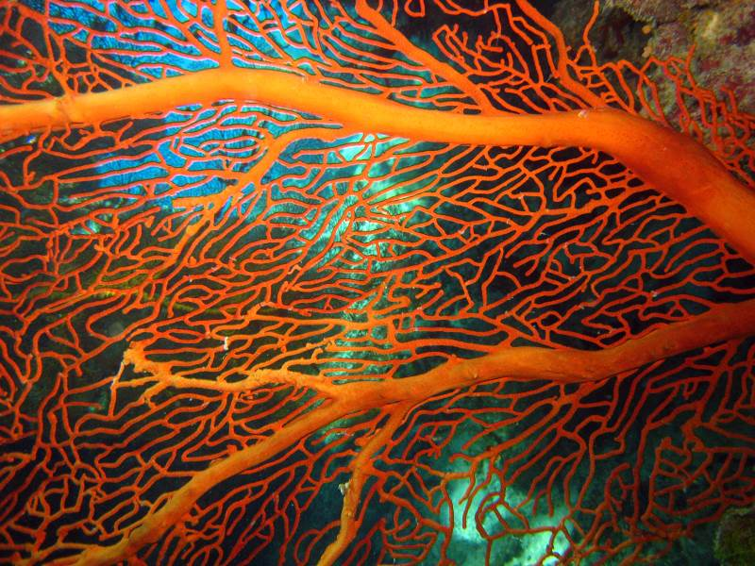
Photograph: Chris Jones
Example: Risk assessment procedure for the Marine Park permission system:
Determine sensitivity and exposure
Determine whether a risk event may occur. A risk event is when an activity exposes a value to hazard to which that value is sensitive. An event only occurs if two things are true:
  - The value is sensitive to that hazard; and
  - The value may be exposed to that hazard.
Consider sensitivity – is the value sensitive to the hazard, that is, likely to change in response to the hazard, creating an impact?
  - Low sensitivity – Value is not known to be affected by the hazard
  - Medium sensitivity – Value is known to be slightly affected by the hazard (sub-lethal effects)
  - High sensitivity – Hazard has well-documented negative impacts on the value (lethal effects are possible)
  - Uncertain – There is a high degree of scientific uncertainty, or no knowledge about the value’s sensitivity.
Consider exposure – is the value likely to be exposed to the hazard?
  - Low exposure – The value is not known to occur in the zone of impact, or has been reported as a rare, aberrant visitor. There are no reasons to believe that the value occurs in the zone of impact.
  - Medium exposure – The value has occasionally been reported in the zone of impact, or there is reason to believe that the value occurs in the zone of impact.
  - High exposure – The value is commonly reported or known to occur in the zone of impact.
  - Uncertain - There is a high degree of scientific uncertainty, or no knowledge about the value’s occurrence or range.
Use figure A2.4 to determine whether a risk event needs to be considered in the assessment.
Figure A2.4 – Does a risk event need to be considered in the assessment?
SENSITIVITY | Uncertain | Low | Medium | High
EXPOSURE
Low | Case by case decision | No | No | Yes
Medium | Case by case decision | No | Yes | Yes
High | Case by case decision | Yes | Yes | Yes
Uncertain | Case by case decision | Case by case decision

Analyse the risks
Analyse the likelihood and consequence of how a risk may affect a value. These effects are called “impacts.”
A “risk rating” is calculated based on:
  - the consequence of the impacts to a value (expressed in terms of severity) if a risk event occurs and
  - the likelihood of that risk event occurring (expressed in terms of probability or frequency).
The risk rating provides a measure of the level of risk, which is then used to decide the acceptability of that risk and to establish management priorities for treating the risk.
Standard descriptions for consequence and likelihood, based on a five-point scale, allow the comparison of different types of hazards within a single risk assessment.

Determine the possible impacts
For each event and hazard, list the potential impacts to relevant values that might reasonably be expected to occur.
Impacts are distinct effects on some aspect of a value. They are different from consequences (which are considered in the next step); a consequence is the overall outcome on the condition or trend of the value.
Consider the full range of values that might be impacted. For example, death of a dolphin may impact not only on the biophysical value of dolphins, but also on social or Indigenous heritage values associated with dolphins.
Where quantitative information is available, this should be used to more accurately identify the potential impacts.
Determine the severity of consequences
This step moves from impacts on an aspect of a value to considering the consequence – that is, the overall outcome on the condition or trend of the value.
Table A2.3 provides a standardised description of consequences for different general categories of values. These generic descriptions may be supplemented with:
  - The individual Value assessment guidelines provide consequence tables unique to specific values.
  - Expert advice may be used to develop a consequence table for a specific value, where Value Assessment Guidelines are not yet available.
Consider each value that may experience consequences, and how the severity of these consequences differ depending on the value.
Consider at what scale the consequence may occur:
  - Local scale – A single bay, reef or island; generally an area less than 100 square kilometres
  - Regional scale – A Natural Resource Management region
  - Widespread scale – Overall condition of the value across multiple regions or across the entire Marine Park; generally, affecting 50 per cent or more of the value’s extent.
Consider the vulnerability of the value, or of sub-groups within that value. If there are populations, groups or individuals that are particularly vulnerable to a certain impact, the consequence level will typically be higher. In particular:
  - impact to different life histories/processes
  - the dependency of values on impacted resources
  - the current condition and trend in condition of values
  - relevant health thresholds
  - the ability of the value to adapt to the new impact to maintain or improve its condition, such as the rate of recovery between disturbances, based on current condition or rate of change and reorganising of a system to a desirable functioning state.

Attachment 3: Great Barrier Reef Outlook report condition and trend assessment approach (adapted from page 9 of the Great Barrier Reef Outlook Report 2014)

A set of assessment criteria is used to analyse available evidence. For example, the assessment of biodiversity uses two assessment criteria — habitats to support species and populations of species or groups of species. Within each assessment criterion there are multiple assessment components. A series of statements is then used to standardise the allocation of grades for all components examined in an assessment, as well as the overall grade for the criterion.

Grading statements (refer to Table A3.1)
The grade allocated is a ‘grade of best fit’, based on a qualitative assessment of the available evidence for the Region. It is not a comparison of the Region in relation to other tropical ecosystems around the world. The statements developed for assessing most heritage values are based on those used in the Australian State of the Environment Report and Strategic Assessment draft report. Those for the assessment of world and national heritage values are adapted from a grading system developed by the International Union for Conservation of Nature to assess the outstanding universal value of natural world heritage sites. One aspect considered in grading the condition of heritage values is the degree to which those values have been recorded and identified. This recognises the important role an understanding of heritage plays in its protection.

Trend and confidence
The approach to grading is refined by including an indication of trend and confidence, similar to the Australian State of the Environment Report and the Strategic Assessment report. There are four categories for trend: improved, stable, deteriorated and no consistent trend. The category of ‘no consistent trend’ is applied to a component when the available information is too variable to establish a trend, for example where there is strong variation across broad areas or across species within a group. The terms ‘improved’ and ‘deteriorated’ are replaced with ‘increased’ and ‘decreased’ in assessments of benefits, impacts, threats and risks. Similar to the Australian State of the Environment Report and the Strategic Assessment report, the level of confidence in each assessment of grade and trend is rated. The categories used are:
  - adequate high quality evidence and high level of consensus
  - limited evidence or limited consensus
  - inferred, very limited evidence.
For components where the confidence level is ‘inferred, very limited evidence’, the assessment is based on knowledge from managing agencies, Traditional Owners, topic experts and informed stakeholders (expert elicitation).

Evidence used
The evidence used in the Great Barrier Reef Outlook Report is derived from existing research and information sources. It is drawn from the best available published science based on:
  - relevance to the required assessments
  - duration of study
  - extent of area studied
  - reliability (such as consistency of results across different sources, peer review and rigour of study).

Table A3.1 - Condition of values grading statements
Functional group of values | Condition grading statement
Functional group of values | Very good | Good | Poor | Very poor
Habitat to support species | All major habitats are essentially structurally and functionally intact and able to support all dependent species. | There is some habitat loss, degradation or alteration in some small areas, leading to minimal degradation but no persistent, substantial effects on populations of dependant species. | Habitat loss, degradation or alteration has occurred in a number of areas leading to persistent substantial effects on populations of dependent species. | There is widespread habitat loss, degradation or alteration leading to persistent, substantial effects on many populations of dependent species.
Populations of species and groups of species | Only a few, if any, species populations have deteriorated as a result of human activities or declining environmental conditions. | Populations of some species (but no species groups) have deteriorated significantly as a result of human activities or declining environmental conditions. | Populations of many species or some species groups have deteriorated significantly as a result of human activities or declining environmental conditions. | Populations of a large number of species have deteriorated significantly.
Physical, chemical and ecological processes | There are no significant changes in processes as a result of human activities. | There are some significant changes in processes as a result of human activities in some areas, but these are not to the extent that they are significantly affecting ecosystem function. | There are substantial changes in processes as a result of human activities, and these are significantly affecting ecosystem functions in some areas. | There are substantial changes in processes across a wide area as a result of human activities, and ecosystem functions are seriously affected in much of the area.
Outbreak of disease, introduced species and pest species | No records of diseases above expected natural levels; no introduced species recorded; pests populations within naturally expected levels. | Diseases occasionally above expected natural levels but recovery prompt; any occurrences or introduced species successfully addressed; pests sometimes present above natural levels with limited effects on ecosystem function. | Unnaturally high levels of disease regularly recorded in some areas; occurrences of introduced species require significant intervention; pests outbreaks in some areas affecting ecosystem function more than expected under natural conditions. | Unnaturally high levels of disease often recorded in many areas; uncontrollable outbreaks of introduced pests; opportunistic pests seriously affecting ecosystem function in many areas.
Indigenous, historic, social, aesthetic, scientific, Commonwealth and Natural heritage values | Heritage values have been systematically and comprehensively identified and included in relevant inventories or reserves. Known heritage values are well maintained and retain a high degree of integrity. | Heritage values have been mostly identified and included in relevant inventories or reserves. Known heritage values are generally maintained and retain much of their integrity. | Heritage values have not been systematically identified. Known heritage values are degrading and generally lack integrity. | Heritage values have not been identified. Known heritage values are degraded and lack integrity.
World and national heritage values | All elements necessary to maintain the outstanding universal value are essentially intact, and their overall condition is stable or improving. Available evidence indicates only minor, if any, disturbance to this element of outstanding universal value. | Some loss or alteration of the elements necessary to maintain the outstanding universal value has occurred, but their overall condition is not causing persistent or substantial effects on this element of outstanding universal value. | Loss or alteration of the elements necessary to maintain outstanding universal value has occurred, which is leading to a significant reduction in this element of the outstanding universal value. | Loss or alteration of most elements necessary to maintain the outstanding universal value has occurred, causing a major loss of the outstanding universal value.
Economic and social benefits of use | Use of the Region provides significant economic and social benefit, in ways that sustain the fundamental value of the natural resource. The Region is strongly recognised, valued and enjoyed by catchment residents, the nation and the world community. | Use of the Region provides valuable economic and social benefit. The Region is valued by catchment residents, the nation and the world community. | There are few and declining economic and social benefits derived from the use of the Region. Many do not recognise the value of the Region and do not enjoy their visit to the Region. | Use of the Region contributes little or no economic and social benefit. The Region holds little value for catchment residents, the nation or the world community.

Attachment 4: Values, attributes and processes that underpin matters of national environmental significance relevant to the Great Barrier Reef

Relationship between values and processes and ‘outstanding universal value’
A property is considered to be of ‘outstanding universal value’ if it meets one or more of 10 world heritage criteria and is inscribed on the World Heritage List. To be deemed to be of outstanding universal value ‘a property must also meet the conditions of integrity and/or authenticity and must have an adequate protection and management system to ensure its safeguarding’. Effective future protection of the Great Barrier Reef’s outstanding universal value, together with the seven matters of national environmental significance, relies on the integration of management measures and a systems approach to the protection of values and processes.

Table A4.1 - Key values and attributes of matters of national environmental significance

The following table outlines key values and attributes for the Great Barrier Reef. These values and attributes underpin Reef-related Matters of National Environmental Significance. For the World Heritage Area, values are based the Statement of Outstanding Universal Value.
Given the scale and complexity of the Great Barrier Reef and its diversity and interconnectedness, key values and processes are combined into one comprehensive set as a basis for assessment of outstanding universal value and the seven matters of national environmental significance. The key values and processes presented in the following tables are based on those identified in the description of each matter in Sections 4.2 to 4.9 of the Great Barrier Reef Region Strategic Assessment Report.

 | World heritage properties |  |  |  |  |  |  |  | Listed migratory and  threatened species
Key values and attributes | Criterion i (now viii) | Criterion ii (now ix) | Criterion iii (now vii) | Criterion iv (now x) | Integrity | Great Barrier Reef Marine Park | National heritage places | Commonwealth marine areas | Marine turtles | Estuarine crocodiles | Whales | Dolphins | Dugongs | Sharks and rays | Seabirds | Shorebirds | Wetlands of international importance
Biodiversity — Great Barrier Reef habitats
Islands
Beaches and coastlines
Mangrove forests
Seagrass meadows
Coral reefs (<30 m)
Deeper reefs (>30 m)
Lagoon floor
Shoals
Halimeda banks
Continental slope
Open waters
Biodiversity — terrestrial habitats that support the Great Barrier Reef
Saltmarshes
Freshwater wetlands
Forested floodplain
Heath and shrublands
Grass and sedgelands
Woodlands
Forests
Rainforests
Connecting water bodies
Biodiversity — species
Mangroves
Seagrasses
Macroalgae
Benthic microalgae
Corals
Other invertebrates
Plankton and microbes
Bony fish
Sharks and rays
Sea snakes
Marine turtles
Estuarine crocodiles
Seabirds
Shorebirds
Whales
Dolphins
Dugongs
Geomorphological features
Coral reefs
Islands and shorelines
Channels and canyons
River deltas
Halimeda banks
Seagrass meadows
Aboriginal and Torres Strait Islander heritage
Cultural practices, observances, customs and lore
Sacred sites, sites of particular significance, places important for cultural tradition
Stories, songlines, totems and languages
Indigenous structures, technology, tools and archaeology
Historic heritage
Places of historic significance — historic shipwrecks
Places of historic significance — World War II features and sites
Places of historic significance — lightstations
Places of historic significance — other
Places of scientific significance (research stations, expedition sites)
Places of social significance — iconic sites
Community benefits of the environment
Income
Employment
Understanding
Appreciation
Enjoyment
Access to Reef resources
Personal connection
Health benefits
Aesthetics

Table A4.2 Key environmental processes relevant to matters of national environmental significance
For the World Heritage Area, connections are based on the Statement of Outstanding Universal Value. For listed species, processes that have a major supporting role in maintaining the species are shown (for example, the role that beaches play in the nesting of listed marine turtles). For wetlands of international importance, the connections shown are those discussed in the Ramsar Convention information sheet.

 | World heritage properties |  |  |  |  |  |  |  | Listed migratory and  threatened species
Key environmental processes | Criterion i (now viii) | Criterion ii (now ix) | Criterion iii (now vii) | Criterion iv (now x) | Integrity | Great Barrier Reef Marine Park | National heritage places | Commonwealth marine areas | Marine turtles | Estuarine crocodiles | Whales | Dolphins | Dugongs | Sharks and rays | Seabirds | Shorebirds | Wetlands of international importance
Waves, currents and tides
Cyclones
Wind
Sedimentation
Sea level
Sea temperature
Light
Nutrient cycling
Ocean acidity
Freshwater inflow and salinity
Microbial processes
Particle feeding
Primary production
Herbivory
Predation
Symbiosis
Competition
Connectivity
Recruitment
Reef building



