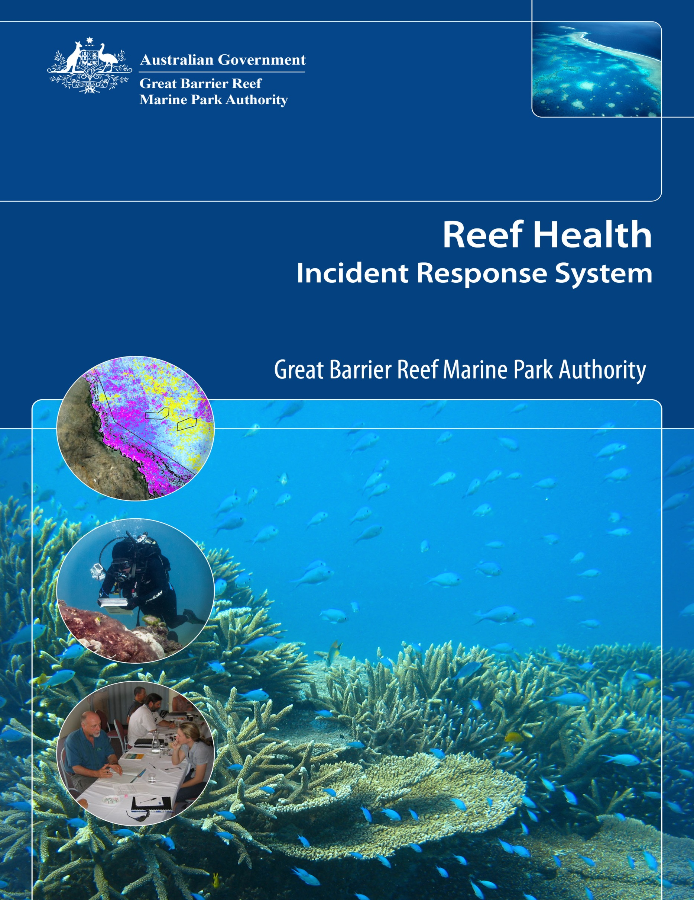

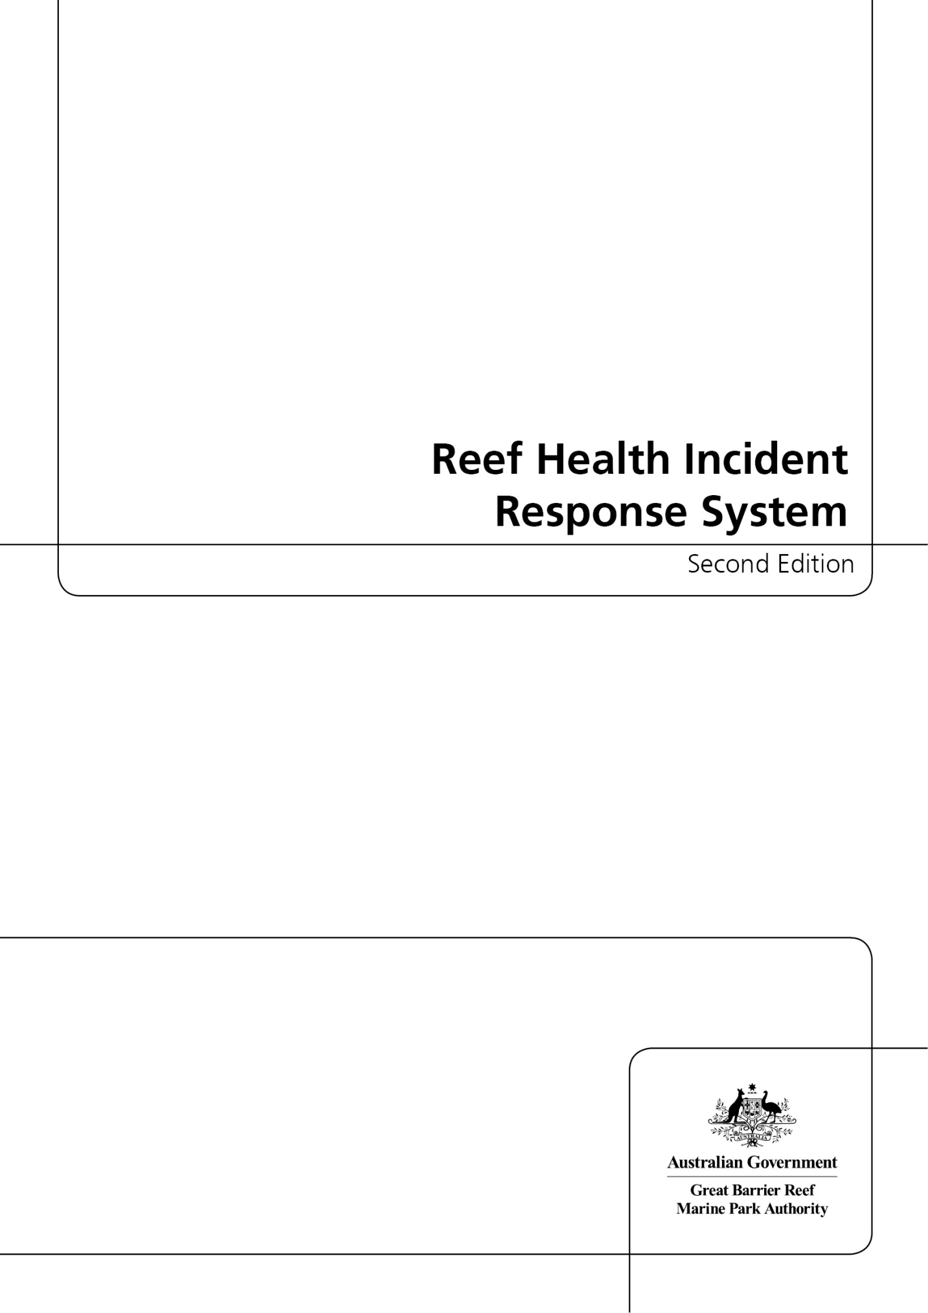

© Commonwealth of Australia 2013

Published by the Great Barrier Reef Marine Park Authority

Reef Health Incident Response System Second Edition

ISSN 2200-2057

ISBN 978-1-922126-32-0 Second Edition (pdf)

This work is copyright. Apart from any use as permitted under the Copyright Act 1968,
no part may be reproduced by any process without the prior written permission of the
Great Barrier Reef Marine Park Authority.

Requests and enquiries concerning reproduction and rights should be addressed to:

Director, Communications and Parliamentary
2-68 Flinders Street
PO Box 1379
TOWNSVILLE QLD 4810
Australia

Phone: (07) 4750 0700
Fax: (07) 4772 6093
info@gbrmpa.gov.au

Comments and enquiries on this document are welcome and should be addressed to:
Director, Ecosystem Conservation and Resilience
info@gbrmpa.gov.au

www.gbrmpa.gov.au

Contents

Introduction 3

Early warning system 3

Predictive tools and near real-time monitoring of environmental conditions 3

Monitoring network 3

Incident response 4

Management actions 10

Communications 10

Conclusions 11

Appendix A – Reef Health and Impact Point Survey reporting form 13

Appendix B – Survey protocol used in monitoring network 14

Feedback:

The Great Barrier Reef Marine Park Authority reviews and updates the risk and impact assessment plans each year prior to the start of the Australian summer season. We actively seek feedback on the plans throughout the year in order to inform these reviews. Please provide any feedback to eyeonthereef@gbrmpa.gov.au.

Introduction

The Great Barrier Reef is one of the world’s most resilient and best managed tropical ecosystems. However, the long-term resilience of the Reef is vulnerable to the increasing simultaneous and cumulative impacts of reef health incidents such as coral bleaching and disease, crown-of-thorns starfish outbreaks, flood plumes and tropical cyclones. Climate change greatly increases the risk that reef health incidents such as bleaching, and disease outbreaks will become more frequent and more severe in the future. While the immediate effects of these incidents may be modest, their cumulative impact over time will have significant long-term consequences on the ecology and resilience of the Reef. This includes the resilience of the linked social and ecological communities on the Great Barrier Reef. Because the likelihood of incidents occurring is increasing, along with the consequences of these incidents, the Great Barrier Reef is at increasing risk. This is especially significant given the uniqueness of the resources in the Great Barrier Reef Marine Park (the Marine Park) on a global scale and the importance of the Reef to Queensland’s economy. Indeed, the Great Barrier Reef was recently valued by Oxford Economics at $54.1 billion with as much as 73 per cent of that value at risk during a severe, spatially extensive coral bleaching event.

The purpose of the Reef Health Incident Response System is two-fold:

- to summarise the implementation process used to respond to reef health incidents at variable scales and locations
- to clarify how incident response resources and capacity are prioritised and allocated during individual and simultaneously occurring reef health incidents.

This document outlines the Great Barrier Reef Marine Park Authority's (GBRMPA’s) strategic framework for responses to reef health incidents. It describes how we combine broad-scale, longer-term strategic management initiatives with timely and targeted responses to incidents. Both are essential components for managing the long-term resilience of the Great Barrier Reef and the industries and communities that rely upon it. The Reef Health Incident Response System provides a common framework that is used to
respond to any reef health incident and enables us to work with partners, such as the Queensland Parks and Wildlife Service, to implement effective, collaborative response actions.

The Reef Health Incident Response System framework includes four core components, each of which is described within this document:

- Early warning system — tools to understand the risk of reef health incidents occurring

- Incident response — evaluate the nature and severity of incidents and coordinate an appropriate response

- Management actions — target the implementation of management strategies that minimise impacts and promote recovery

- Communications — communicate to partner agencies, senior decision-makers, stakeholders and the public about reef condition and pending management actions; communication is a central theme which unifies the other three Reef Health Incident Response System components (Figure 1)

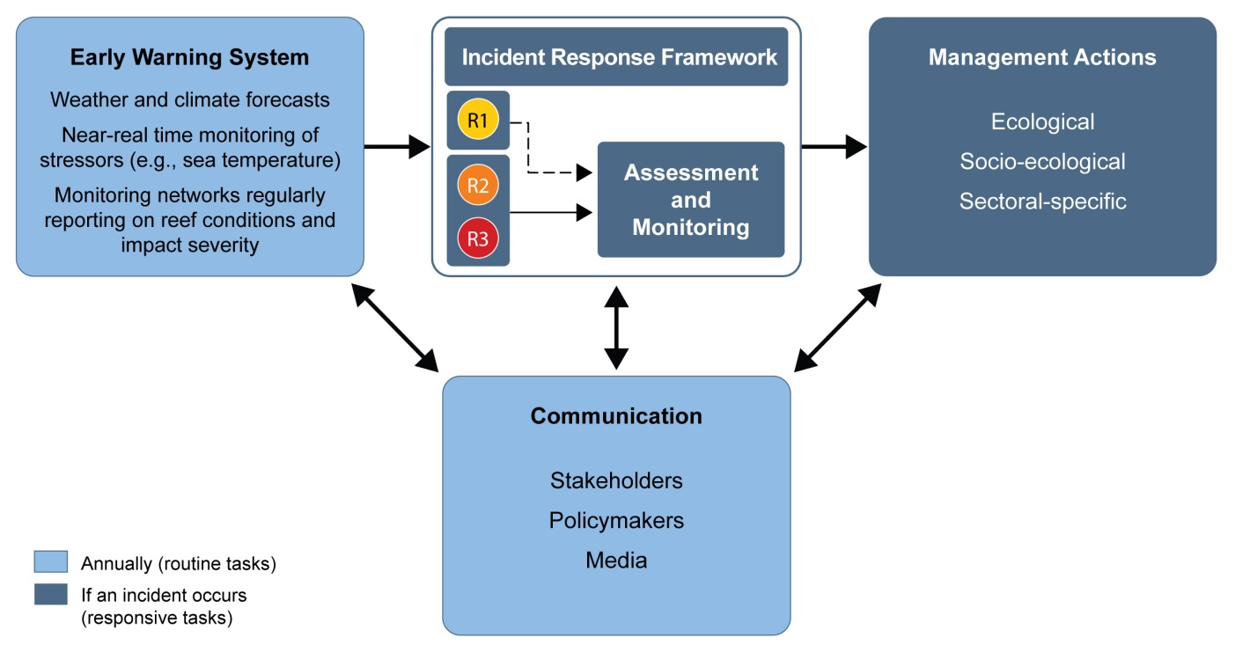

Figure 1: The Reef Health Incident Response system components for responding to reef health incidents. Effective incident response requires both routine and responsive tasks as well as effective communication with stakeholders, policymakers and the media regarding reef condition and management actions. Management response is triggered following an incident response framework and is based upon information collected on the severity and spatial extent of impacts (see Figure 2) and a subsequent situation analysis (Figure 3).

Early warning system

There are three parts to the early warning system:

- Predictive tools and other tools that enable near real-time monitoring of conditions conducive to an incident
- A monitoring network provides reports to GBRMPA on reef condition and impacts observed
- Site inspections allow GBRMPA and the Queensland Parks and Wildlife Service to quantify impacts or to ground-truth predictions

Predictive tools and near real-time monitoring of environmental conditions

Some reef health incidents are preceded by a series of conditions that can be used to assess the probability of an event occurring. For these incidents (bleaching, disease outbreaks, flood plumes and cyclones), predictive tools have been developed that provide a seasonal outlook in the months that precede high risk seasons. For these four types of incidents, tools have also been developed that enable near real-time monitoring of conditions conducive to the event occurring (e.g. sea surface temperature anomalies). In effect, for these four types of incidents, we have some form of warning at least a week (in the case of cyclones) or more (several months for coral bleaching, outbreaks of temperature-dependent coral diseases, and flood plumes) in advance of a major reef health incident. We monitor the predictive tools regularly during the summer months and report to senior decision-makers and stakeholders regarding incident likelihood (see links between the early warning system and communication, Figure 1).

Monitoring network

For the four incidents types mentioned above (as well as invasive species and crown-of-thorns starfish (Acanthaster planci)) GBRMPA relies on field reports provided by a monitoring network that includes Queensland Parks and Wildlife Service rangers, as well as trained volunteers. The network covers the entire Great Barrier Reef and includes regular reef users, such as dive professionals, tourism operators, fishers, researchers, community groups and other recreational users who voluntarily monitor and report (Appendix A) on conditions at reefs they visit. Monitoring network reports are reviewed weekly to identify where impacts have been sighted. Information is collated in the Eye on the Reef database and displayed as report files which can be viewed through Google EarthTM. This system displays information and visual representations for all the data collected at each reef in the Marine Park. Eye on the Reef reports are used to target site inspections in order to determine the severity and spatial extent of impacts.

Site inspections

Site inspections in the Marine Park involve a series of surveys at two depths using the method described in Appendix B. Inspections are conducted on an as-needed basis at sites where:

- monitoring network participants have reported widespread minor impacts, or moderate or severe impacts over any scale
- tools enabling near real-time monitoring of conditions indicate the risk of a reef health incident occurring is high (e.g. systems indicate that temperature stress is severe enough to cause coral bleaching)
- a ship grounding or oil spill has occurred.

If site inspections confirm moderate to severe localised impacts (relating to any incident) or widespread minor impacts (relating to bleaching, disease outbreaks, flood plumes and/or cyclones), the incident response component of the Reef Health Incident Response System is activated.

Incident response

GBRMPA uses the Australasian Inter-service Incident Management System framework to coordinate the governance, planning, operations, logistics, financial and inter-agency liaison arrangements required to adequately respond to a reef health incident. The timeline below describes the process and procedures whereby the incident response component of the system is activated and deactivated.

Information gathered from the early warning system and site inspections helps us to understand the severity and spatial extent of impacts. Once the spatial extent and severity of the impact have been classified based on the standardised criteria for each incident, we use the matrix in Figure 2 to inform a detailed situation analysis.

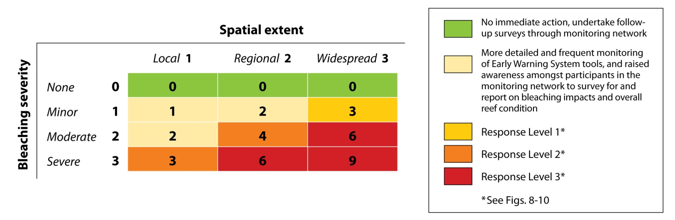

Figure 2: Example of a matrix combining measures of impact severity and spatial extent to inform the situation analysis (Figure 3). The situation analysis determines the final decision regarding which response level is triggered. Specific criteria for the levels of impact severity and the spatial extent or scale of threat can be found in the individual risk and impact assessment plans.

The situation analysis is assessed by GBRMPA’s governance group (the executive management group, the incident coordinator and the scientific, communication and liaison, and stakeholder advisory groups), which makes a final decision on the required level of response (Figure 3). There are three potential response levels — 1, 2 and 3. Each increase in response level (from 1 to 3) correlates to a corresponding increase in the severity and spatial extent of the impacts as well as an increase in the management investment and resources required to effectively respond. The activation and conditional activation of the incident response framework varies according to each response level (Figures 4, 5 and 6), but the framework used for each of the three response levels is standardised for all reef health incidents.

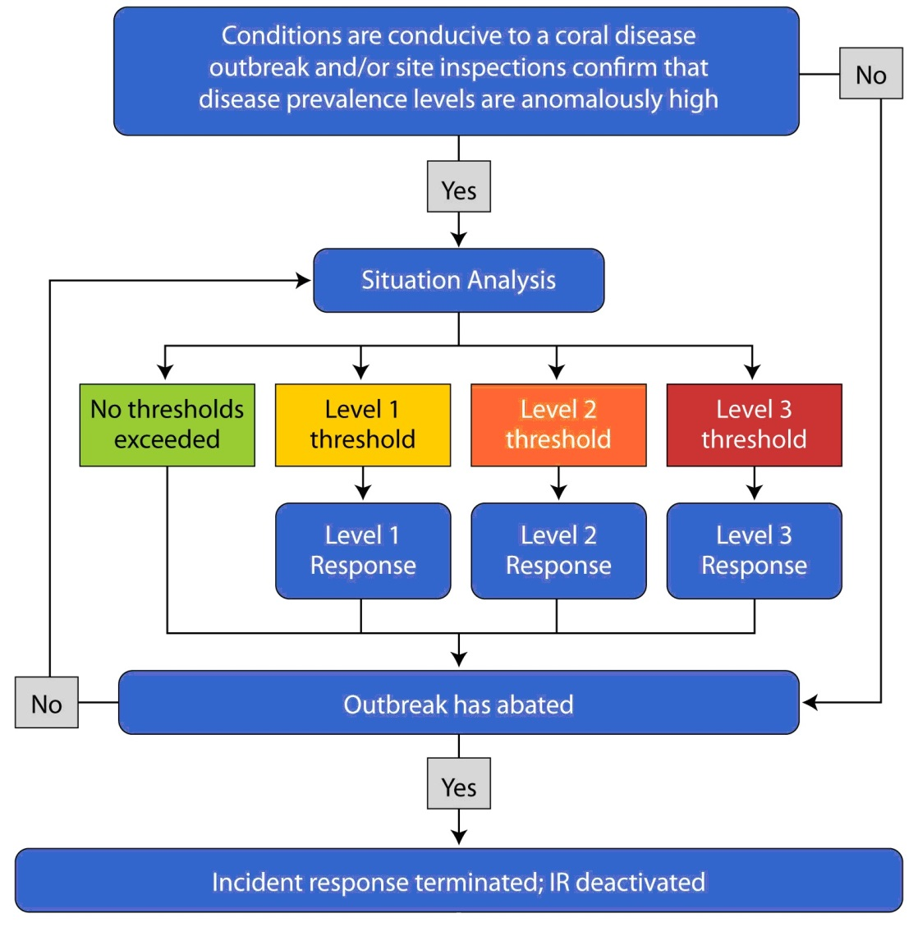

Figure 3: Example of an incident response chain of events during a reef health incident. The situation analysis is informed by the matrix seen in Figure 2 and is re-visited following the incident response if the high risk season has not passed or the threat has not been removed. If the high risk season has passed or the threat has been removed, incident response is terminated, the incident response is deactivated, and impact management and recovery monitoring are undertaken.

Once the appropriate response level has been determined, the corresponding planning and resource provisions of the incident response are activated. Communications, liaison, and reporting tasks are activated for all response levels. For response level 1, which may lead to response levels 2 or 3 if impacts become more severe or extensive through time, the logistics for extensive underwater surveys are only conditionally activated, and budgeting, contracting, staff procurement, and impact mitigation/recovery surveys are not activated (Figure 4). Conditional activation is based upon the type of incident and the outcome of the situation analysis. For response level 2, vessel support and underwater surveys are activated, as are budgeting and administration. Contracting, staff procurement, and impact mitigation/recovery surveys are all conditionally activated (Figure 5). For response level 3, the entire incident response framework is activated (Figure 6).
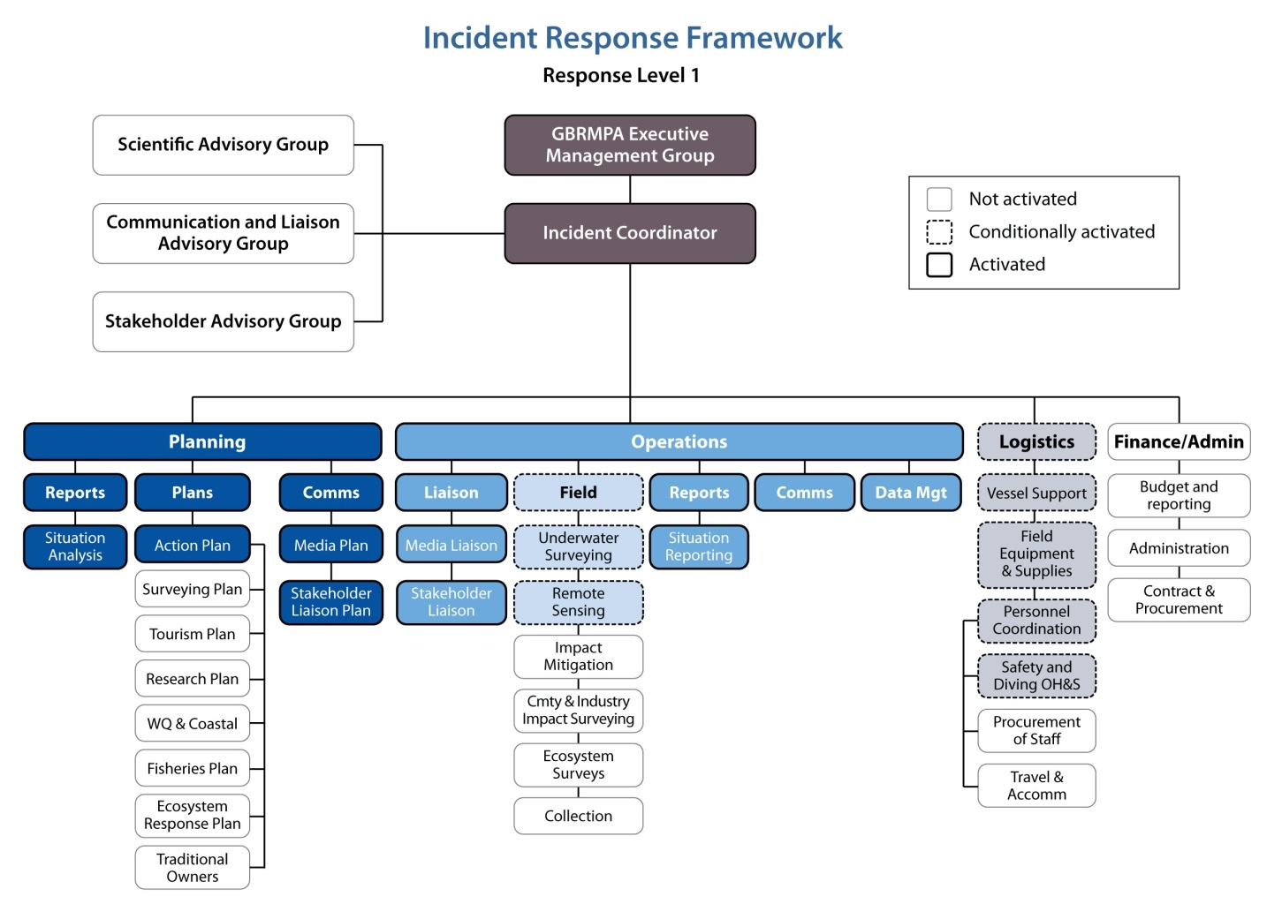

Figure 4: Response level 1 within the incident response framework. Activation and conditional activation of incident response components are illustrated by the intensity of colour and border for each box. For most incidents, response level 1 may lead to response levels 2 or 3, so the focus is on reporting and situation analysis. At this response level, liaison, communications, reporting and situation analysis are activated but most of the incident response is either not activated or conditionally activated.
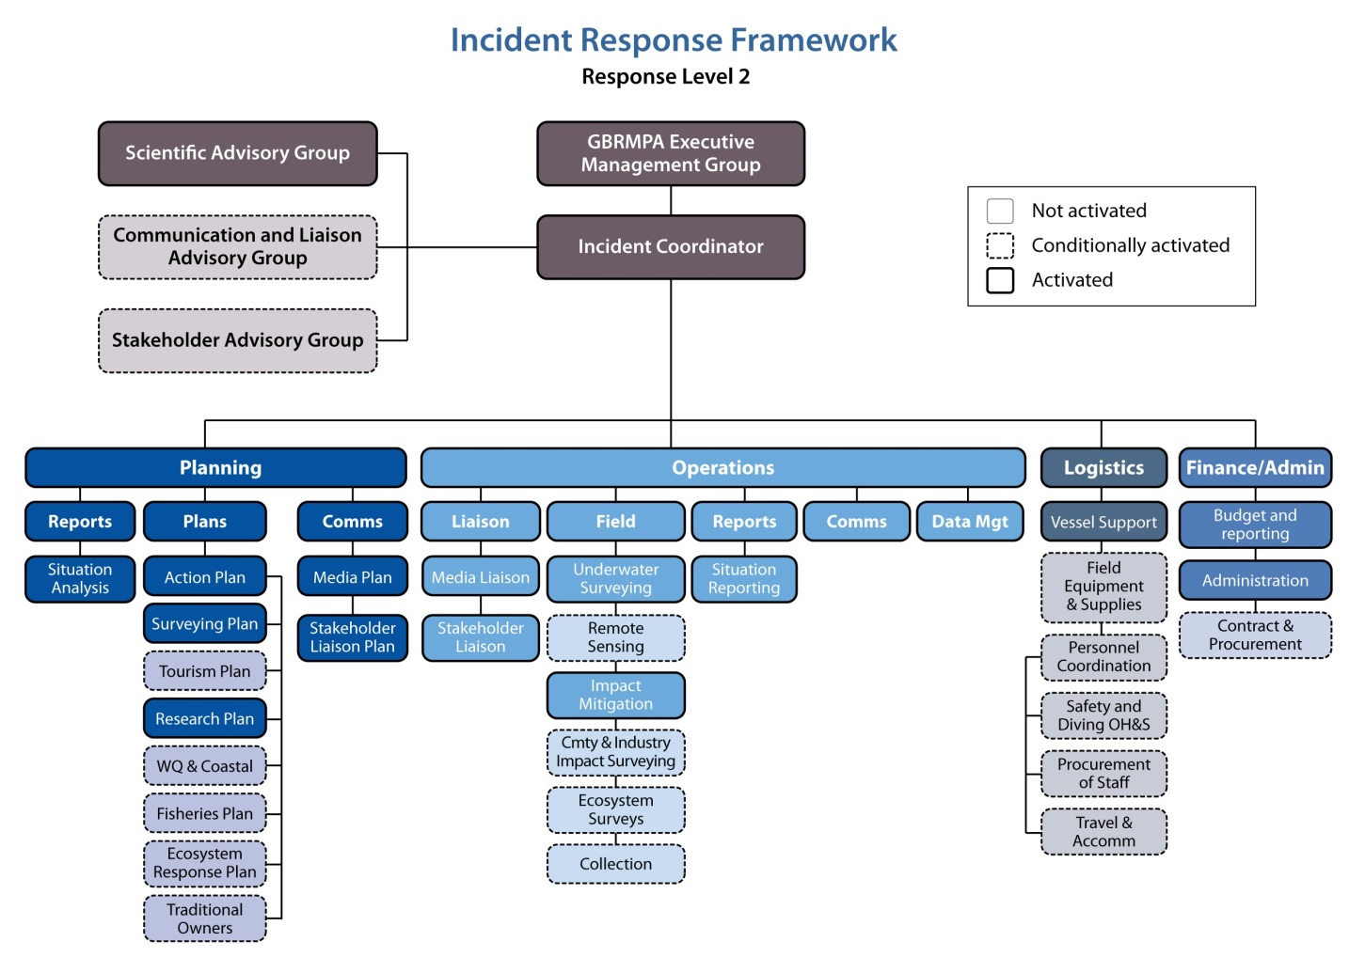
Figure 5: Response level 2 within the incident response framework. Activation and conditional activation of incident response components are illustrated by the intensity of colour and border for each box. At this response level, much of the incident response is activated but aspects of finance/administration, logistics and field-based operations are conditionally activated, highlighting that these represent management resources invested on a case-by-case basis.

If response levels 2 and 3 are activated, ecosystem surveys are initiated to characterise the extent and severity of impacts as well as the associated longer-term ecological implications of impacts. The monitoring network described in the early warning system section is rapidly increasing the number of reefs for which information is available on baseline condition, while the Australian Institute of Marine Science (AIMS) Long-term Monitoring Program has baseline information on sites throughout the management regions of the Marine Park. Therefore, efforts to assess impacts from reef health incidents focus on characterising impacts during and in the weeks that follow the incident, and quantifying mortality and rates of recovery six months after an incident and in the years that follow.
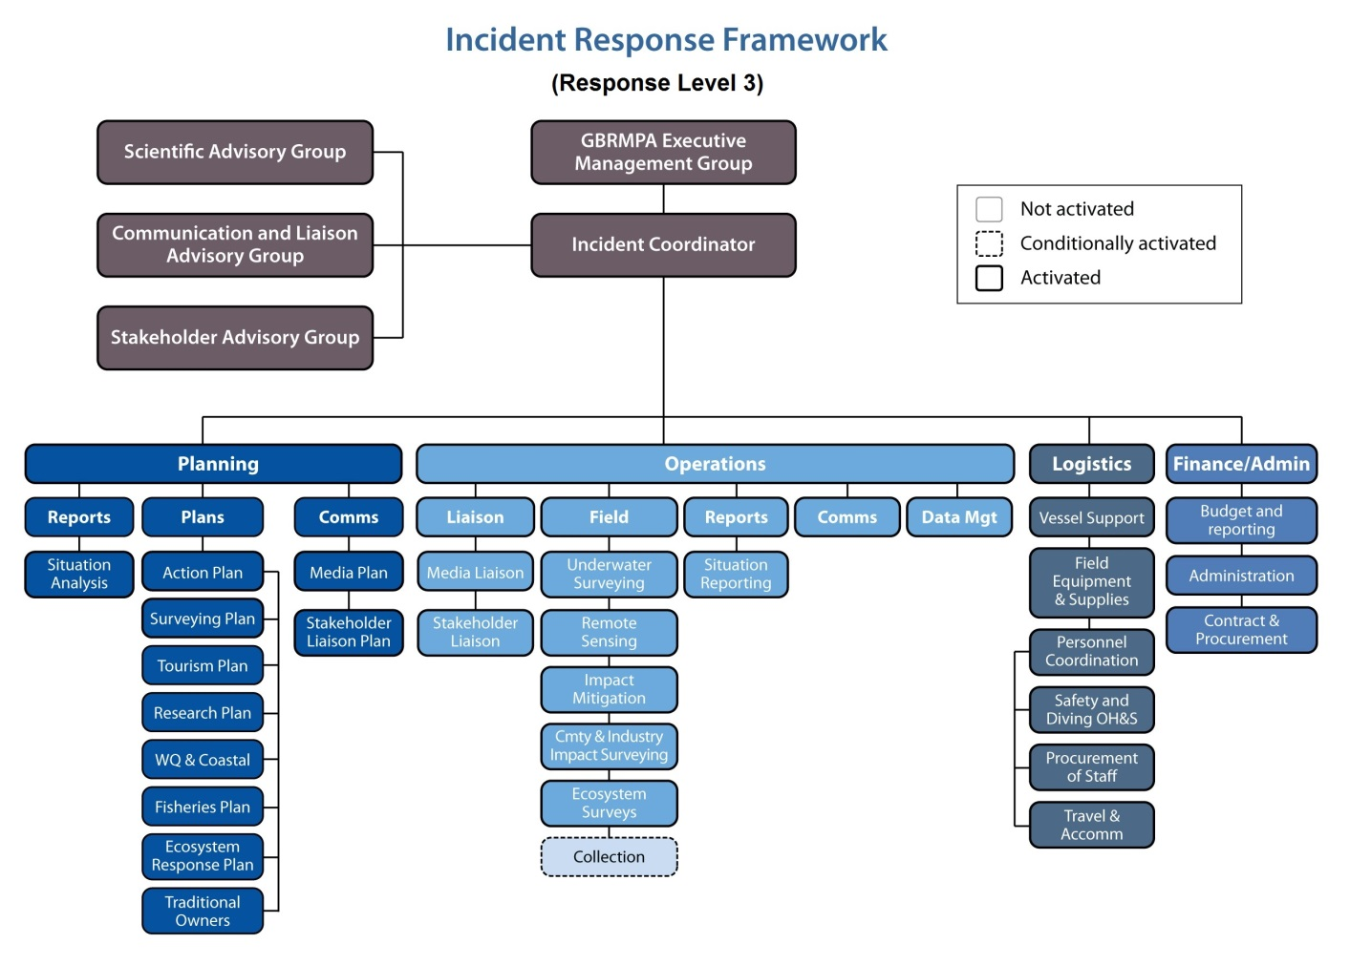
Figure 6: Response level 3 within the incident response framework. Framework components are activated or conditionally activated depending upon the nature, extent and severity of the incident. When the outcome of the situation analysis (Figure 3) is that response level 3 has been triggered, the entire incident response is activated, except collection during field-based operations, which is conditionally activated.

For the four incidents with the greatest potential to cause spatially extensive impacts to reef health (bleaching, disease outbreaks, crown-of-thorns starfish and cyclones), impact and recovery assessment surveys are focused at the 47 AIMS Long-term Monitoring Program sites and similar survey protocols are used for all incidents (refer to individual risk and impact assessment plans for details). For all other incidents, the location of surveys depends both on where the incident has occurred and where impacts are most severe. The protocols will vary for each incident type and potentially for each incident (i.e., survey locations and protocol will be determined during the situation analysis).

Communications

All incident responses require effective communication with the media, stakeholders and community members to increase support and compliance with response actions. All routine and responsive tasks undertaken to respond to any reef health incident rely heavily on communications products, particularly since incidents usually attract significant interest from the public, media, managers and parliament. The individual risk and impact assessment plans ensure timely and credible information on reef health is available throughout and following incidents. Templates within the communication sections of each risk and impact assessment plan provide a targeted briefing schedule to communicate the onset of an incident and to describe the frequency and timing of various tasks associated with collating information when incidents occur. In addition, GBRMPA aids the efforts of other agencies and conservation-based non-government organisations in the region to use community-based social marketing to promote environmentally conscientious behaviour. Effective communication and messaging enhances community support for ongoing and new conservation initiatives and policies and, when used effectively, is a management action in itself.

Importance of management actions

Timely and targeted implementation of effective management actions is fundamental to fulfilling GBRMPA's mandate to protect the Reef from threats. Numerous existing management arrangements support and build resilience across the entire Great Barrier Reef Region. We have invested heavily in a number of management strategies to protect the Marine Park and to support the natural resilience of its diverse habitats. Examples of resilience building management actions include the Reef Water Quality Protection Plan of 2003 and the Representative Areas Program, which increased the percentage of the Marine Park contained within ‘green’ no take zones.

In dealing with reef health incidents, broad-scale, strategic management initiatives are complemented with timely and targeted responses to incidents, as well as with a strategic enhancement or alteration of existing management arrangements. For all reef health incidents, there are three categories of opportunities available to us for management intervention:

- implement strategies to prevent impacts, such as ship groundings, oil spills or invasive species outbreaks, from occurring

- implement strategies during and following incidents to a) mitigate impacts and b) promote recovery at severely affected sites

- support and enhance resilience of the linked social-ecological systems of the Reef and promote its ability to resist damage and recover quickly following disturbance.

These opportunities are not mutually exclusive as many actions contribute to more than one intervention type (Figure 7). However, for each management opportunity, actions can be classified as ecological, socio-ecological, or sectoral-specific in nature. Within the categories listed above, we can implement actions at the local, regional, and whole-of-Reef scale (Figure 7). The priorities for management are actions that support or enhance the resilience of the linked social and ecological systems of the Reef, since most of these actions work to prevent impacts and/or promote recovery from more than one type of reef health incident.

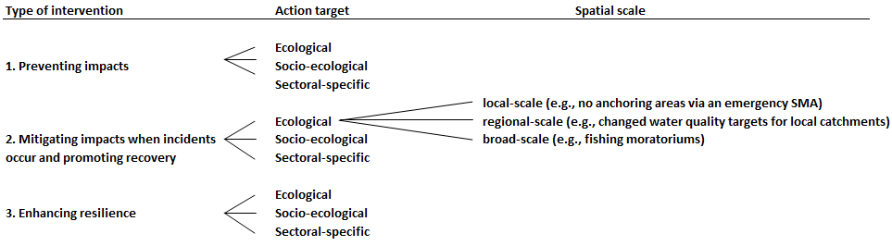

Figure 7: Classification of management interventions, action targets and spatial scales over which management actions are meant to have an effect. The example actions work to mitigate ecological impacts and promote recovery following bleaching events and coral disease outbreaks. Many management actions can be classified under more than one of the management intervention types.

Conclusions

As reef health incidents become more frequent and severe, impacts on the Great Barrier Reef ecosystem, industries and reef users will become increasingly acute and apparent. We have responded to this increased risk with a corresponding increase in management capacity to deal with reef health incidents, including this Reef Health Incident Response System document, the complementary resource kit and the risk and impact assessment plans for key threats to the Reef. This new suite of management tools provides the foundation for effective management actions in response to reef health incidents.

This document details the overarching structure of the incident response capacity and demonstrates the standardised approach to respond to reef health incidents. Timely and targeted actions following an incident supplement the existing broad-scale initiatives that have already been implemented (e.g. the Reef Water Quality Protection Plan of 2003, Representative Areas Program zoning scheme 2003, and the ongoing Reef Guardians program). These actions continually evolve, as previous and ongoing efforts are evaluated and improved upon here in Queensland and in other areas around the world. Our incident response program guides actions and will render a heightened transparency and consistency in the future to management decision-making during and following reef health incidents.

Appendix A — Reef Health and Impact Survey form

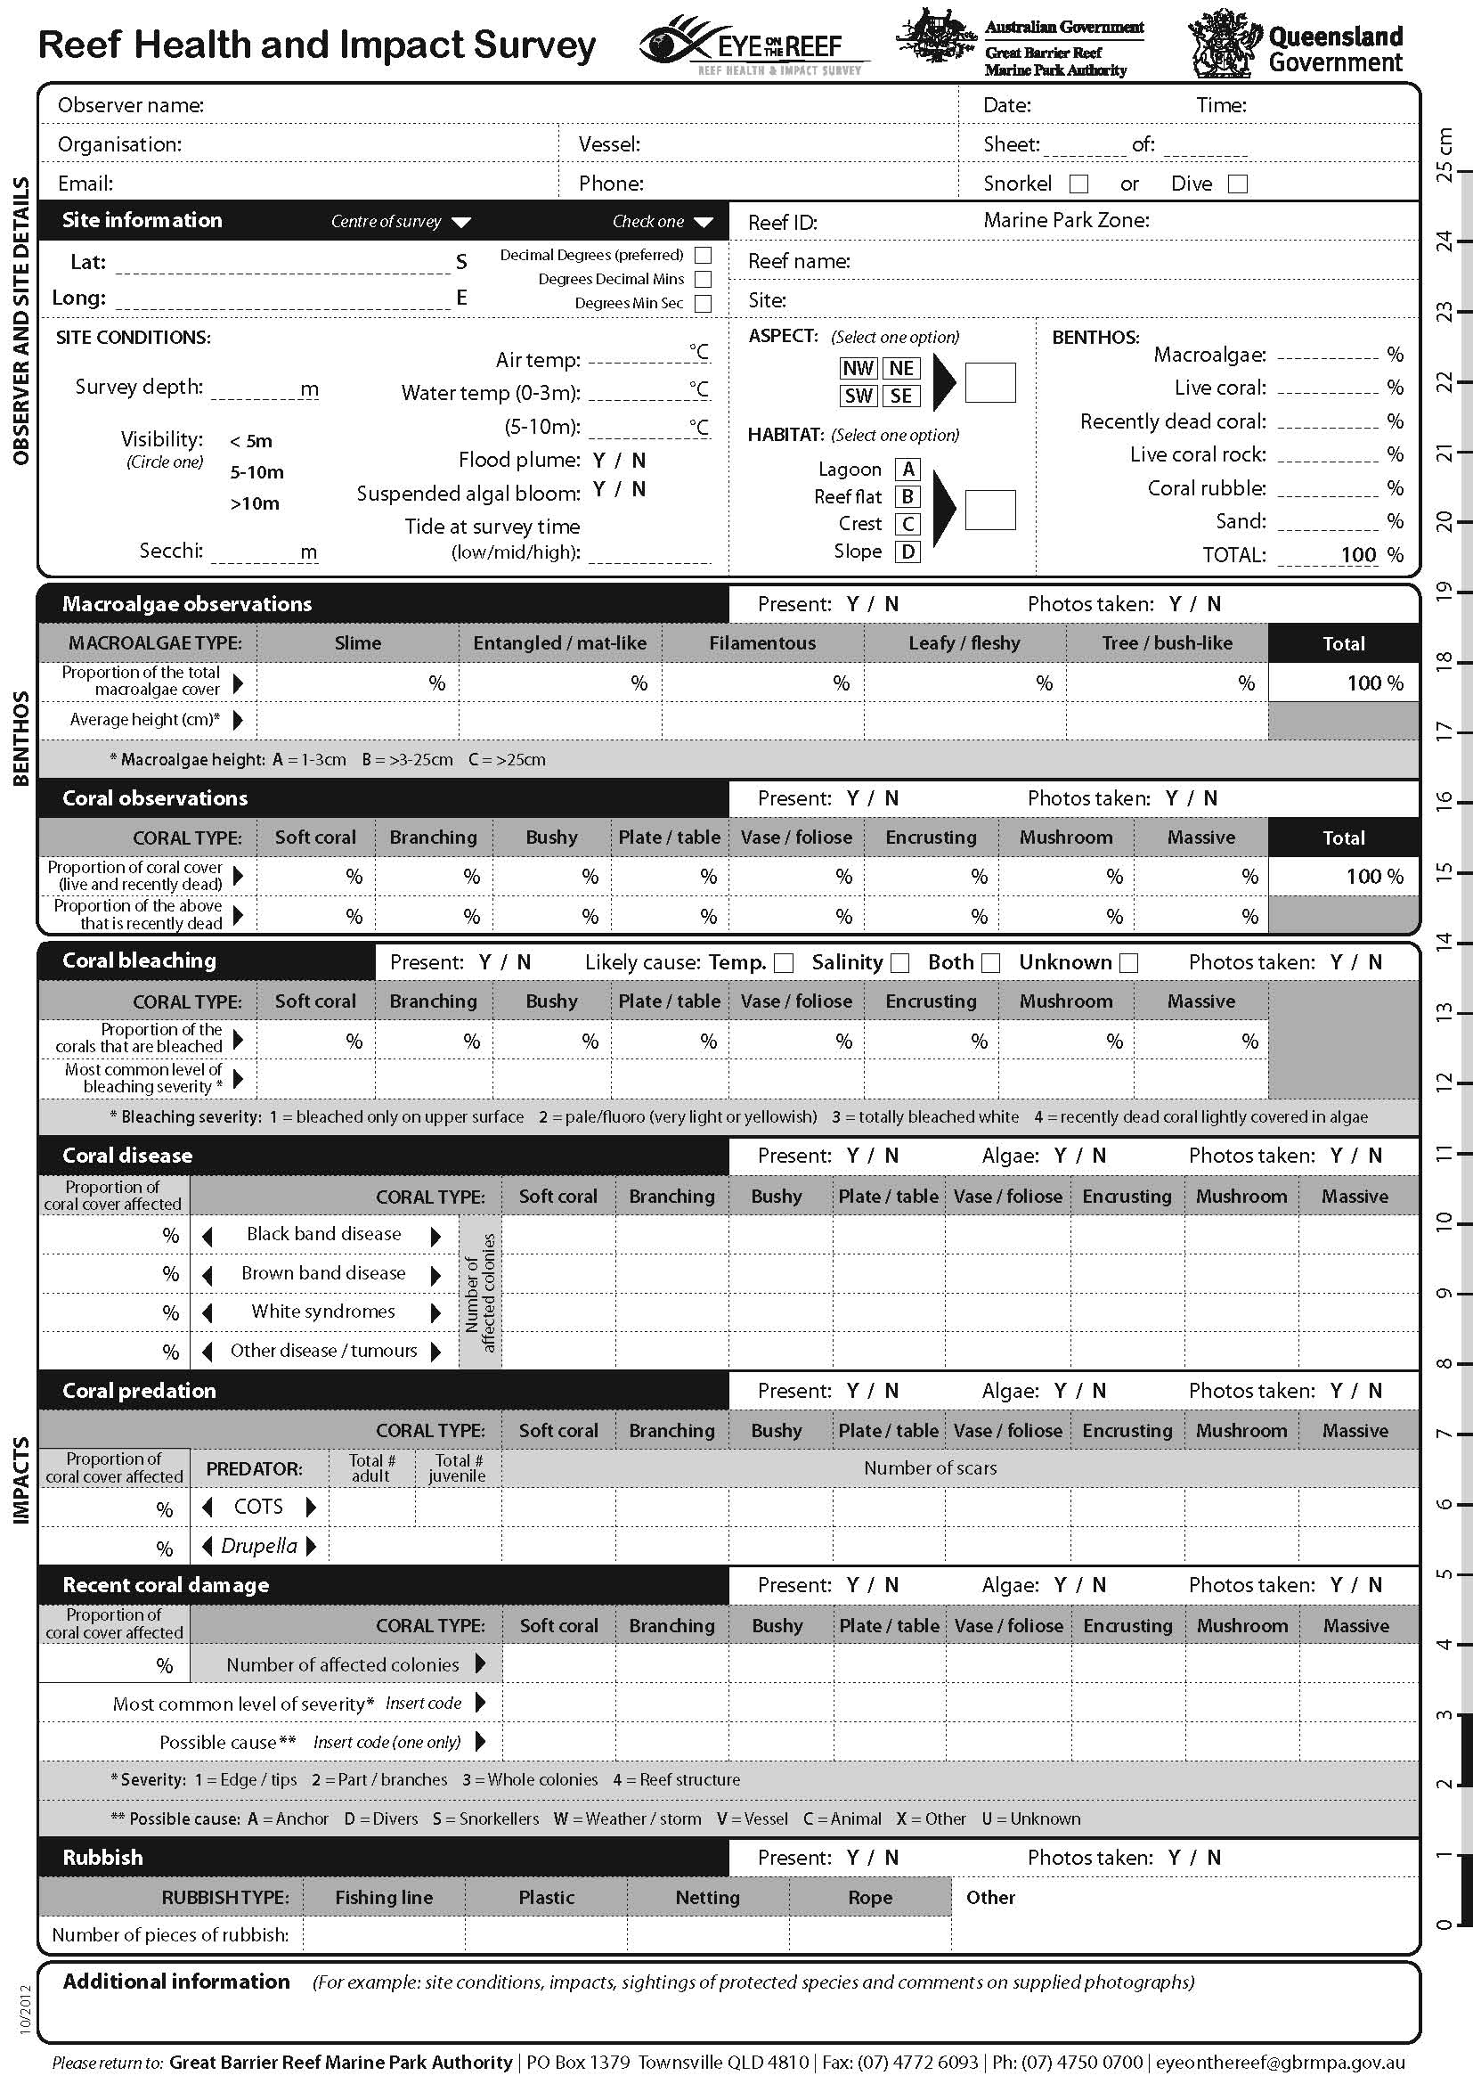
Appendix B — Survey protocol used in monitoring network

The protocol used by the monitoring network during site inspections can be completed by snorkelers or divers. It involves using a repeated Global Positioning System (GPS) tagged five metre radius point survey method (see image below). This method is used to assess a range of reef health indicators including coral and algal cover and the extent and severity of impacts such as coral bleaching, disease, rubbish, predation and anchor or storm damage (Appendix A). The protocol recognises the limited time that many participants have available to complete survey forms. One form will be completed for each point survey thus reducing the time taken to evaluate benthic cover and allowing ample time to accurately evaluate the presence or absence of the range of impacts included in the form. Ideally, observers will complete at least three point surveys at each site while remaining within one habitat type (e.g. reef slope or lagoon). Repeated surveys are conducted to enable statistical analysis of the data; however these surveys do not have to occur on the same day if time is limited.

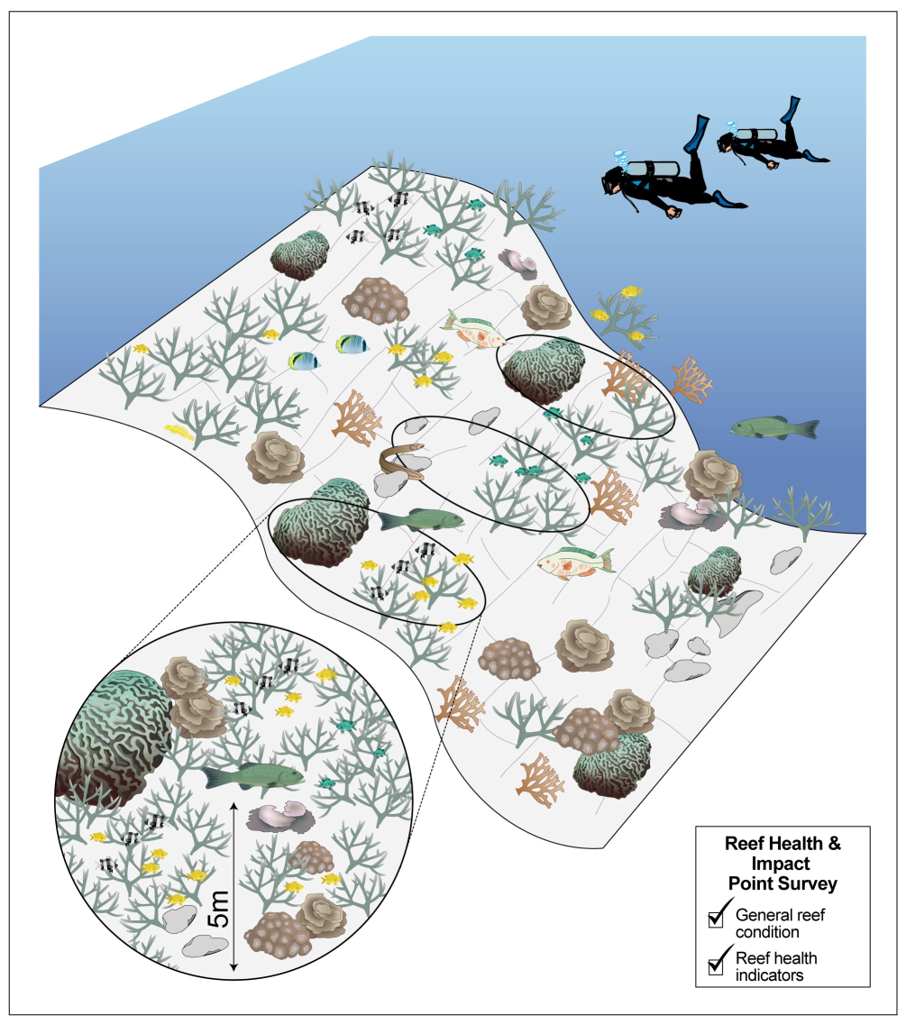

Protocol used by the monitoring network for site inspections. Observers use this protocol to assess reef condition and to detect and document impacts.

Risk is defined here as a measure of the likelihood of an event occurring multiplied by the consequences of the event if it were to occur.
The Reef Health Incident Response System is complemented by a resource kit for incident coordinators and other personnel tasked with responding to reef health incidents. The resource kit focuses on administrative implementation of incident management and contains relevant task lists, risk and impact assessment plans and templates needed to implement an effective and efficient collaborative response.
Please see the individual risk and impact assessment plans for an in-depth description of these various tools.
Australasian Fire Authority Council, 2004, Link to the Australasian Fire Authority Council website

