Bareboat Briefers
LearnING Guide

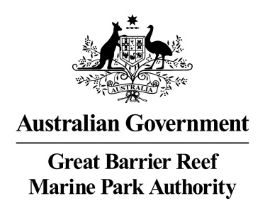

© Commonwealth of Australia 2016
Published by the Great Barrier Reef Marine Park Authority
ISBN 978-1-922126-74-0
A cataloguing record for this publication is available from the National Library of Australia
This work is copyright. Apart from any use as permitted under the Copyright Act 1968, no part may be reproduced by any process without the prior written permission of the Great Barrier Reef Marine Park Authority.
This publication should be cited as: Great Barrier Reef Marine Park Authority (2016). Bareboat Briefers Learning Guide. Great Barrier Reef Marine Park Authority, Townsville.
ACKNOWLEDGEMENTS
In developing the original Bareboat Briefers Learning Guide, the Great Barrier Reef Marine Park Authority acknowledges the support, advice and contributions of the Whitsunday Bareboat Operators Association, Barrier Reef Institute of TAFE, the Queensland Department of Environment and Resource Management (including the Queensland Parks and Wildlife Service), the Queensland Department of Employment, Economic Development and Innovation (including the Department of Primary Industries and Fisheries, and Queensland Boating and Fisheries Patrol), the Queensland Department of Transport and Main Roads (including Maritime Safety Queensland) and the Australian Maritime Safety Authority in the compilation of this publication, and acknowledges contributions by Bill Lipson, Bryony Barnett and Josh Gibson.

DISCLAIMER
While reasonable effort has been made to ensure that the contents of this publication are factually correct at the time of printing, the Commonwealth does not accept responsibility for the accuracy or completeness of the contents, and shall not be liable for any loss or damage that may be occasioned directly or indirectly through the use of, or reliance on, the contents of this publication.


Requests and enquiries concerning reproduction and rights should be addressed to:

Director, Communications and Parliamentary
2-68 Flinders Street
PO Box 1379
TOWNSVILLE QLD 4810
Australia
Phone: (07) 4750 0700
Fax: (07) 4772 6093
info@gbrmpa.gov.au

Comments and enquiries on this document are welcome and should be addressed to:
Director, Tourism and Stewardship
info@gbrmpa.gov.au
www.gbrmpa.gov.au

Introduction
The Whitsunday area is part of the world's largest World Heritage Area and is nestled within the Great Barrier Reef Marine Park. This unique, diverse and spectacular stretch of coastline is a fragile ecosystem. Creating respect and understanding among bareboat charterers about the significance and sensitivity of the coastline, islands and waterways is a great responsibility for briefing staff and plays an important role in protecting Australia's greatest natural asset.
The role of the Bareboat Briefer and Radio Operators is to ensure charterers can conduct their trip in an environmentally sustainable and safe manner. To promote and encourage safe and environmental best practices, briefing staff and Radio Operators require an understanding of the natural environment and local knowledge of the Whitsunday area applicable to bareboat charters.
The Bareboat Briefer has a key responsibility to assess the competency of charterers' boating skills to determine whether or not a sail guide may be required for the charter, and consequently ensuring the safety of the charterer and their passengers, the vessel they have chartered, and the unique environment they have come to experience.
A bareboat briefing course delivered through the unit of competency BSBCMM201 Communicate in the Workplace in the context of the Bareboat Briefers Learning Guide provides all you need to know in becoming a Bareboat Briefer for operations in the Whitsundays and about registering as a Bareboat Briefer or Bareboat Operations Radio Operator with the Great Barrier Reef Marine Park Authority (GBRMPA).
To facilitate delivery of the unit of competency, the Bareboat Briefers Learning Guide is divided into sections covering local knowledge, Marine Park management, responsible reef practices, marine safety and communications.

Table of Contents

A. TRAINING FOR WHITSUNDAY BAREBOAT BRIEFING STAFF 1
A.1. Bareboat briefing competency requirements 1
A.2. How to become a registered bareboat briefer or radio operator 1
B. LOCAL KNOWLEDGE 3
B.1. Briefing in a World Heritage Area 3
B.2. Topography 3
B.3. Anchorages and anchoring 4
B.3.1. Guidelines for anchoring – state of the tide 5
B.3.2. Guidelines for anchoring – swing circle 6
B.4. Tides and currents 6
B.5. Set, drift and leeway 7
B.6. Tidal calculations 8
B.7. Weather 8
B.8. Marine facilities 9
B.9. Area briefing 10
B.10. Day planning 10
B.10.1. Preparing a day plan 10
C. MARINE PARK MANAGEMENT AND RESPONSIBLE REEF PRACTICES 13
C.1. Section overview 13
C.2. Introduction 13
C.3. Part one – Marine Park management 14
C.3.1. The managers 14
C.3.2. The management tools 15
C.3.3. Zoning Plan 15
C.4. Whitsundays Planning Area 16
C.4.1. Special requirements 16
C.4.2. Managing the islands of the Whitsundays 17
C.4.3. Permits 17
C.5. The Environmental Management Charge 18
C.6. Education and research 18
C.6.1. When presenting information 18
C.7. Policy on managing bareboat operations in the Great Barrier Reef Marine Park 19
C.8. Whitsunday bareboat industry standards 20
C.9. Part two – Responsible Reef practices 20
C.9.1. Responsible Reef practices for all activities 21
C.10. Anchoring and mooring in the Whitsundays Planning Area 21
C.10.1. Mooring 21
C.10.2. No Anchoring Areas 22
C.10.3. What are the rules for No Anchoring Areas? 23
C.10.4. Responsible Reef Practices - anchoring 23
C.11. Fishing and protected fish species 24
C.11.1. Related links 25
C.11.2. Responsible Reef practices – fishing 25
C.11.3. Marine Parks Legal Requirements 26
C.11.4. Protected fish species 26
C.12. Whale and dolphin watching 26
C.12.1. Responsible Reef Practices – whale and dolphin watching 27
C.12.2. Interpretation and training 28
C.12.3. Reporting 28
C.12.4. Marine Parks legal requirements 28
C.13. Island visits 29
C.13.1. Responsible Reef practices – island visits 29
C.13.2. Marine Parks legal requirements 31
C.14. Turtle watching 32
C.14.1. Responsible Reef practices – turtle watching 32
C.14.2. Marine Parks legal requirements 33
C.15. Observing seabirds 34
C.15.1. Significant Bird Sites in the Whitsundays Planning Area 34
C.15.2. Where are the Significant Bird Sites? 34
C.15.3. When are people able to visit Significant Bird Sites in the Whitsundays? 34
C.15.4. How close can we get? 34
C.15.5. Responsible Reef Practices - bird watching 35
C.15.6. Marine Parks Legal Requirements 35
C.16. Dugong protection 36
C.16.1. Responsible Reef Practices – interactions with dugong 36
C.16.2. Reporting 36
C.16.3. Marine Parks Legal Requirements 36
D. MARINE SAFETY AND EMERGENCY PROCEDURES 37
D.1. Section overview 37
D.2. Introduction 38
D.3. The legislation 38
D.3.1. The Act 39
D.3.2. The Regulations 39
D.3.3. The Standards 39
D.4. Applying the Act to the Bareboat Industry 40
D.5. Understanding the legislation 40
D.5.1. Prescriptive versus Performance Approach 40
D.6. Vessel registration 41
D.7. Documentation and records 41
D.7.1. Onboard 41
D.7.2. Onshore 42
D.8. Safety equipment 42
D.9. Responsibilities 42
D.10. Operational areas 42
D.10.1. Related links 42
D.11. Marine incidents 42
D.12. Fleet support vessels 43
D.13. Workplace Health and Safety (WH&S) 43
D.14. Qualifications 44
D.15. Bareboat safety and safety equipment 44
D.15.1. Equipment List for Class ‘1F’ Ships Operating in Partially Smooth Waters and Restricted Offshore Areas (over 6 metres in measured length) 44
D.15.2. Distress signals and pyrotechnics for Restricted Off Shore Areas 45
D.15.3. Miscellaneous Equipment 46
D.15.4. Miscellaneous equipment 47
D.16. Safe operation/stowage 48
D.17. Crew security 48
D.18. Adverse conditions 49
D.19. Navigation/pilotage 49
D.20. Industry safety procedures 50
E. COMMUNICATION 52
E.1. Overview 52
E.1.1. Remember, it’s not what you say but how you say it. 52
E.2. Planning for effective communication 53
E.3. Effective briefing 55
E.3.1. A well-constructed briefing 55
E.3.2. The Briefer’s Rule 55
E.4. Timing your brief 56
E.4.1. Sequencing 56
E.4.2. Offer service 56
E.5. Debriefing 57
E.6. Communication barriers 57
E.6.1. Terminology 57
E.6.2. Language 57
E.6.3. Comfort 58
E.6.4. Be courteous 58
E.6.5. Irritating habits 59
E.6.6. Body language 59
E.6.7. Your voice 59
E.6.8. Client questions 59
E.7. The radio 59
E.7.1. Communication during the charter 60
E.7.2. Emergencies 60
E.7.3. Be assertive 60
E.7.4. Be clear and concise 61
E.7.5. Problem solving 61
E.7.6. Develop rapport 62
E.8. VHF marine repeaters 62
E.9. Planning for effective communication 63
E.10. Case studies 63
E.10.1. A vessel is lost 63
E.10.2. In the wrong place 63
E.10.3. Disorganised charterer 64
E.10.4. The experienced charterer 64
E.11. Put yourself in their shoes - activities 64
E.11.1. Scenario 1 64
E.11.2. Scenario 2 64
E.11.3. Scenario 3 - Fears 65
E.11.4. Scenario 4 - Determining entry level 65
E.12. Bareboat industry briefing proforma 65
E.12.1. Area brief 65
E.12.2. Onboard brief 66
E.12.3. Sailing/motoring brief 66
BIBLIOGRAPHY 67

TRAINING FOR WHITSUNDAY BAREBOAT BRIEFING STAFF

Bareboat briefing competency requirements
It is a requirement that the principal or operations manager, the briefer, and the radio operator are appropriately qualified and are registered with GBRMPA for bareboat operations in the Whitsundays.
By completing the unit of competency BSBCMM201 - Communicate in the workplace delivered in the context of the Bareboat Briefers Learning Guide, you will learn about the Whitsundays area, Marine Park management, best practices, marine safety and emergency procedures, and effective methods of communication.
As part of completing BSBCMM201, you will be required to attend information sessions and complete a range of assessments. Your knowledge and skills will be tested by short assessments which may include an assignment, oral and practical on-board assessment.
Please contact GBRMPA for details of approved Registered Training Organisations. Once you have successfully completed the unit of competency BSBCMM201 and all the required assessments, you will receive a Statement of Attainment. To meet the requirements for Bareboat Briefers and Radio Operators in the Whitsundays, you must also hold some additional qualifications to be able to register with GBRMPA.
To get the most from this learning guide, it is recommended that you review all sections and keep track of your progress using the progress sheet (Form 1 at the rear of this guide) as you work through all the sections.

How to become a registered bareboat briefer or radio operator
Bareboat briefing staff and radio operators are required by legislation (Great Barrier Reef Marine Park Regulations 1983) to register with GBRMPA. The following qualifications are required by the Regulations for a person to be assessed as appropriately qualified:
As a briefer, you are required to hold the following:
- Statement of Attainment in BSBCMM201 Communicate in the Workplace delivered in the context of the Bareboat Briefers Learning Guide (or equivalent)
- Marine Radio Operators Certificate of Proficiency
- Australian Yachting Federation (AYF) TL4 Certificate (or equivalent – see statutory declaration (Form 4 at the rear of this learning guide) for bareboats less than 15 metres long)
- Restricted Master Class 5 licence (if briefing for bareboats at least 15 metres long)
You must also:
- Complete a Briefing presentation evidence checklist (Form 2 at the rear of this learning guide) signed off by a registered Operations Manager (Form 2)
- Provide GBRMPA with copies of the above qualifications and a completed GBRMPA Registration Form (Form 3 at the rear of this learning guide).

As a Radio Operator, you are required to hold a:
- Statement of Attainment in BSBCMM201 Communicate in the Workplace delivered in the context of the Bareboat Briefers Learning Guide (or equivalent)
- Marine Radio Operators Certificate.
You must also:
Provide GBRMPA with a copy of your Statement of Attainment in BSBCMM201 Communicate in the Workplace, Marine Radio licence, and complete the GBRMPA registration form (Form 3 at the rear of this learning guide).
If you qualify as a registered briefer or radio operator, you will receive a pocket-sized card from GBRMPA verifying that you are appropriately qualified.

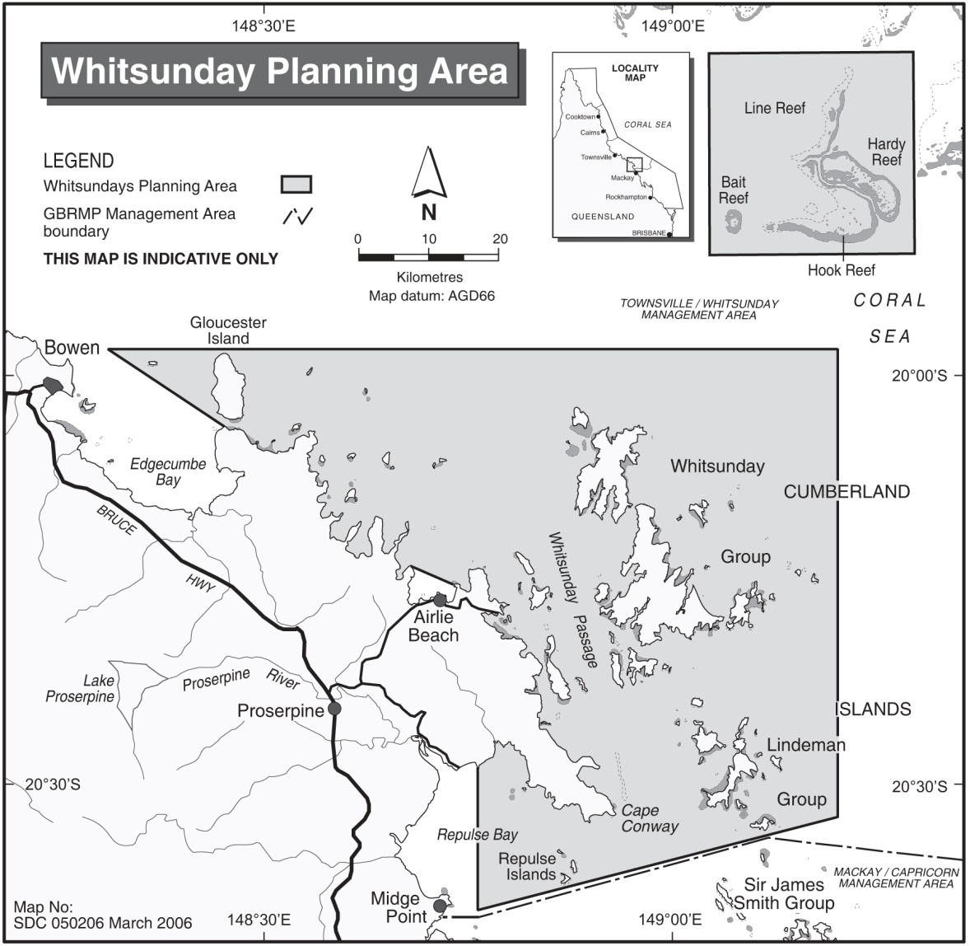
Figure 1: The Whitsunday Planning Area location map
The Whitsunday Planning Area covers waters and islands from Cape Gloucester in the north to Repulse and Thomas Islands in the south (see map). This Area represents about 1 per cent of the Great Barrier Reef Marine Park.

LOCAL KNOWLEDGE

Briefing in a World Heritage Area
The Whitsunday area is part of the World Heritage listed Great Barrier Reef Marine Park. This unique, diverse and spectacular stretch of coastline is a fragile ecosystem that brings nature to the doorstep of development and human recreational activities. The Bareboat Briefer has an important role to play in preserving and protecting this unique and diverse ecosystem. A Bareboat Briefer, by creating respect and understanding among bareboat charterers about the significance and sensitivity of the coastline, islands and waterways, can dramatically affect the way bareboat charterers behave, and in so doing increase charterers' enjoyment of this World Heritage Area. To promote and encourage safe and environmental best practices, briefing staff and Radio Operators require an understanding of the natural environment and local knowledge for the Whitsunday area applicable to bareboat charters.
The unit of competency BSBCMM201 delivered in accordance with the Bareboat Briefers Learning Guide will give you an understanding of the base level of knowledge for providing briefings to bareboat charterers. More detailed local knowledge information is available in 100 Magic Miles of the Great Barrier Reef by David Colfelt.
The best way to gain local knowledge is to gain experience by sailing in the Whitsundays. Most experienced briefers have accumulated months of boating experience amongst the Whitsunday islands.

Topography
The islands along the Queensland coastline that span from north of Mackay to south of Bowen are known as the Cumberland Group. There are over 130 islands and islets found in this combined island group: the Whitsunday Group, Anchor Islands, Repulse Islands, Lindeman Group and the Sir James Group.
Most of the islands lie within the six National Parks of the Whitsundays: Whitsunday, Gloucester, Molle, Lindeman and Repulse Islands and Holbourne Island. National Parks are managed by Queensland Parks and Wildlife Service (QPWS). The waters surrounding the islands are part of the Marine Park and are managed by GBRMPA.
The rocky islands of the Whitsundays are ‘continental’ islands – that is, they were once part of the continent of Australia. Changes in sea level during the ice ages saw the coastline shift, with water eventually drowning the rugged coast about 10,000 years ago creating the islands we see today.
Often rocky and steep, the highest island mountain, Hook Peak, stands at 450 metres. The high ridges, fiord-like anchorages and narrow valleys cause ‘bullets’ or accelerated gusts of wind that whistle down from the surrounding ridges and make for exciting sailing.
Fringing coral reef follows the contours of the land and is rarely found more than one hundred metres offshore. Although this aids navigation, sailors new to the area should be aware of the isolated outcrops of extensive coral such as the reef surrounding Langford Island. There are also a number of small rocky outcrops which may be awash at low tide such as Platypus Rock, Spitfire Rock and Surprise Rock. A number of these rock outcrops have navigation marks in place.

Anchorages and anchoring
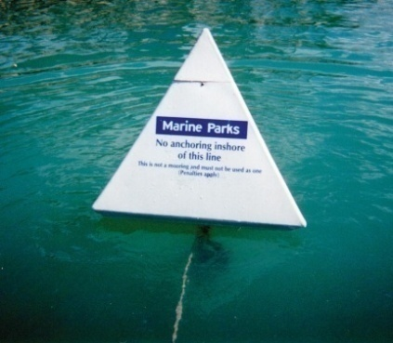
Anchoring practices and choosing the correct anchorage play an important role in protecting the environment and the safety of the vessel and charterers.
The anchorages of the Whitsundays are deservedly known as some of the best in Australia. The deep fiords that rim the islands provide unassailable protection to many beaches which are rimmed with coral reefs. A number of bays in the Whitsundays are fringed with coral reef, which is easily damaged through careless anchoring. The most sensitive bays have ‘no anchoring areas’ marked by a line of white pyramid-shaped buoys known as reef protection markers. Boats must anchor outside the ‘no anchoring areas’, and must not use the buoys as a mooring.
Reef protection marker
Because of the harsh nature of coral and its prevalence in the Whitsundays, it is strongly recommended that vessels use primarily chain. If using any rope, care should be taken to see that it does not become entangled amongst coral when there is a real chance that the rope may become damaged or even severed.
A simple demonstration of the use of some onboard spare line to take the strain off the chain, called a ‘snubber’, can prevent the unfortunate occupants of the forward cabin suffering from lack of sleep and paranoia as the chain rubs on the bottom.
Many of the Whitsunday anchorages are prone to the effect of ‘bullets’, accelerated wind gusts sometimes at twice the ambient wind strength, caused by the funnelling effects of the hills surrounding the anchorages. Sailors should be cautious when approaching these anchorages (particularly the northern anchorages of Hook Island) and make sure they have removed all sail well prior to entering. The last thing your charterers want to be worrying about are their sails as they enter an anchorage looking out for coral outcrops.
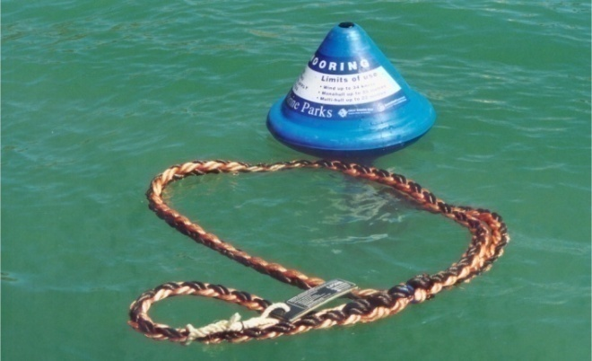
There are special blue beehive-shaped mooring buoys known as public moorings installed in many of the Whitsunday bays for use by boats of the appropriate size. These moorings play an important part in protecting corals and providing a safe way of visiting the area. Charterers should be sure to check vessel length and time limits before using a public mooring.
Public mooring buoy
It is common practice in the tropics to enter a coral anchorage with the sun reasonably high in the sky (between 11:00 am and 2:00 pm). Early morning or late afternoon approaches can be fraught with danger as the naked eye cannot pick up the presence of coral due to the low angle of the sun. Visitors should be made aware of the benefits of using Polaroid sunglasses to improve visibility.
The book 100 Magic Miles breaks the anchorages into logical sequence by areas. The book provides charts with general details and advice in the form of notes to follow. It is sometimes useful for briefers to have in the back of their minds a selection of anchorages that are likely to encompass all the requirements for a first-time visitor.
The following list is a useful selection of anchorages. Islands south of Hamilton Island are not included as time constraints and potential wind against tide make it difficult for an inexperienced first time visitor to combine a visit to both the northern and southern sections of the islands within a seven to ten day period.
Description of anchorage | Location of anchorage
All round, well protected natural anchorages | - Nara  - Macona  - Gulnare
All round, well protected man-made anchorages | - Hamilton Island Marina  - Hayman Island Marina  - Abel Point Marina
Strong south-easterly protection | - Cid Harbour  - Beach 25  - Bernie’s Beach
Moderate south-easterly protection | - Butterfly Bay area  - Stonehaven  - Blue Pearl Bay  - Eastern side of the islands
Strong northerly protection | - Beach 25  - Turtle Bay  - Chance Bay  - Dugong Inlet

Guidelines for anchoring – state of the tide
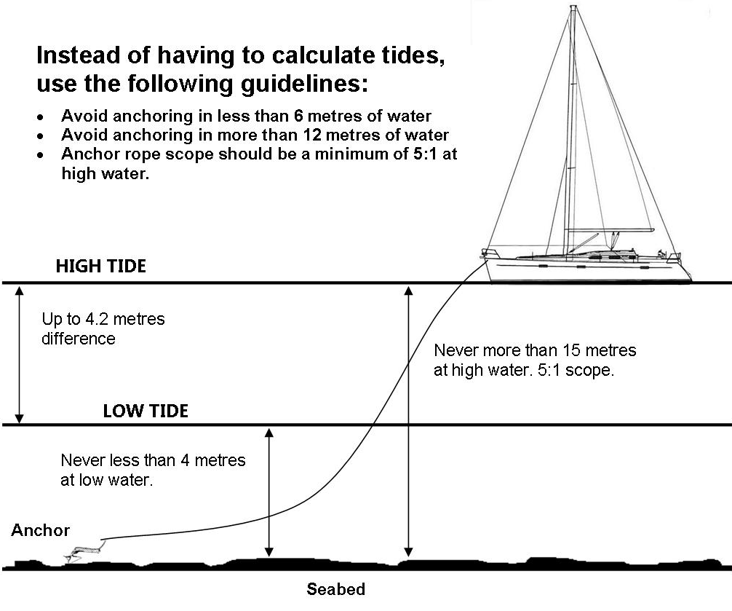
Figure 2 Guidelines for anchoring - state of the tide

Guidelines for anchoring – swing circle
Charterers need to account for a vessel's swing circle when selecting a location to anchor, and ensure that the shoreline, shallows, fringing reefs, rocks and other vessels or obstructions are well outside the area of anchor swing. Charterers should be made aware that when their vessel is anchored from a single anchor there is the potential for a 360 degree swing circle.
When anchoring at busy locations, encourage charterers to try and anchor next to similar vessels and those carrying similar anchoring tackle, and to check with other vessels how much scope they have down. The radius of the swing circle can generally be calculated at around 80 per cent of the scope paid out, allowing for sag in the anchor line. Charterers should allow for more than a single swing radius wherever possible.
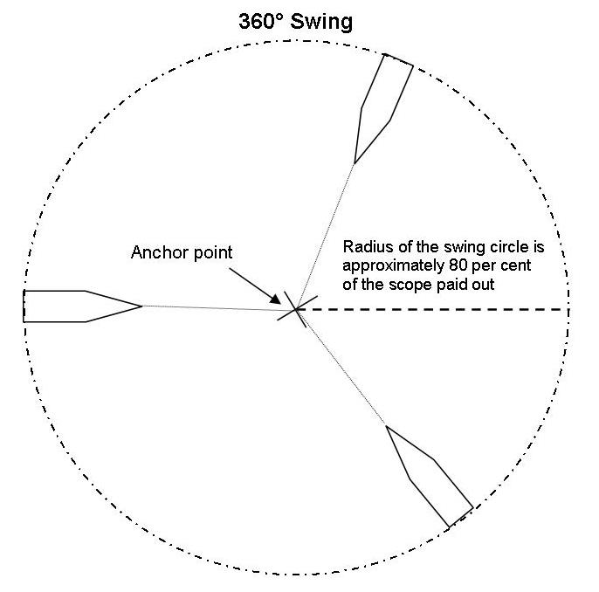
Figure 3 Guidelines for anchoring - swing circle
Charterers need to know:
- To avoid anchoring on coral
- Not to anchor inside No Anchoring Areas
- That Manta Ray Bay at the northern end of Hook Island is a No Anchoring Area that is not marked by Reef Protection Markers
- That in almost all situations it is best to anchor in between 6-12 metres at any state of the tide
- For anchoring, a minimum scope of five to one should always be maintained. If strong wind conditions prevail then care should be exercised to see that at high water a minimum scope of seven to one is always maintained
- That public moorings have a tag that describes the length of vessel that may be attached, the maximum wind conditions the mooring is designed to withstand, and the time limit for staying on the mooring, which must be adhered to.

Tides and currents
The substantial effect that tidal flow and range have on the waters of the Whitsundays can provide bareboat charterers with their greatest challenges.
The horizontal movement of the tide (flow or current) can exacerbate prevailing sea state, creating conditions that even the most ardent sailor finds uncomfortable. The vertical tidal movement (range), being reasonably large, necessitates care when determining a satisfactory depth of water for anchoring. Miscalculation can result in an unplanned grounding or dragging anchor due to an insufficient scope of chain. Making the bareboat charterer aware of these potential perils is one of the most important aspects of the briefing process.
The tidal flow trapped behind the Great Barrier Reef generally flows along the coast with the flooding tide to the south and the ebb to the north. The strength of the flow varies depending on your proximity to land. In open water within the Whitsunday Passage, the rate of flow may be as much as 2 knots. Where land masses are close together forming channels and passes, the tide accelerates like water down a funnel. Within these areas the flow may be as much as 5 knots (Solway Passage etc.).
When moving against a strong prevailing trade wind, the accelerated tidal flow (the flood tide against a south-easterly) can cause a very uncomfortable short steep sea. Provided you follow good seamanship practices the conditions should not cause danger to a bareboat. It can nevertheless bring progress to a complete standstill and make for wet and worrying sailing. Charterers should be warned of the pitfalls of sailing in strong winds with spring flood tides.
Areas where particular caution should be exercised include:
- Solway Passage
- Fitzalan passage and waters to the east
- Waters to the north-west of the entrance to Nara Inlet
- Waters adjacent to False Nara Inlet
- Northeast tip of Hook Island
- Southern entrance to Cid Harbour.

Set, drift and leeway
Knowledge of set, drift and leeway is particularly important for charterers in navigating safely. Set is the effect of the tidal flow or current. Drift is the distance the vessel is moved out of position by the current and leeway is the wind causing sideways movement, made by a vessel underway. Set, drift and leeway come into effect when a strong tidal flow running down the Whitsunday Passage combines with the wind to push the vessel sideways.
In light winds, a vessel may be moving at a speed of 3 knots towards the destination and 2 knots to leeward. During a passage from Pioneer Rocks to the entrance to Nara Inlet with an ebbing tide (heading north), you can appreciate how novice sailors often end up in Stonehaven or spend the last half hour desperately motoring into the wind to round the point of False Nara.
Preparing charterers for leeway can help them reach their anchorage on time and avoid a last minute panic as the sun sets. By demonstrating how to make allowances of as much as 10-15 degrees on their course they will have a much better chance of sailing the rhumb line. This is particularly applicable to smaller, slower vessels.
Areas of particular note where uncalculated leeway can endanger a vessel include:
- The southern reef off Daydream Island
- Reefs surrounding Langford and Black Islands
- The waters surrounding ‘the Beak’ close to the entrance to Shute Harbour.

Tidal calculations
Grounding incidents caused through a poor understanding of tidal range can not only be costly to the charterer and bareboat company, but also to the environment.
Explaining tidal calculations to inexperienced charterers requires care. The large tidal range for the Whitsundays (approximately 4.2 metres in the main islands) means it is critical that charterers have a good working knowledge of at least one method by which they can avoid grounding on a falling tide whilst at anchor.
All tidal calculations in the Whitsundays are taken with Shute Harbour as the Standard Port. To calculate the range for a given day is a simple matter of subtracting the height at low water from that at high water.
If your cruising takes you into areas south of Hamilton Island then it is wise to use the Mackay tidal times along with the ratio calculations provided to allow for the larger tide range as you move south. As an alternative, a reasonably accurate method for charterers is to simply add 50 per cent to the Shute Harbour range for all anchorages to the south of Hamilton Island.
As a rule of thumb, the following information should be fully understood by charterers. This is a minimum and will provide them with the ability to avoid grounding whilst at anchor.
Charterers need to know:
- How to use the tide tables to determine the times for high and low water on any given day
- How to determine the range of the tide for any given day.
Particular attention to tides should be exercised when visiting Tongue Point, Whitsunday Island and Black Island:
- A minimum 1 metre tide level at Tongue Point is required to access the beach. This site is popular with day visitors, so consider suitable tides outside of 10am to 2pm to escape the crowds.
- Always access Black Island from the north western side of the island – moorings make this an easier stop

Weather
The weather in the Whitsundays is predominantly controlled by a series of high pressure systems which cross the continent from west to east. Their position over the land changes approximately five degrees to the south as we progress from a winter to a summer pattern and reverses as summer moves to winter. This results in trade wind flows (southeast) between April and September. As summer approaches, the wind strength lessens and northerly winds predominate between October and March. The change of seasons is variable and the prudent sailor is warned to take into account the fickle nature of weather. Particular care should be taken in winter when a southerly change can arrive with little warning, making a southerly anchorage a lee shore.
Bareboat companies generally provide their clients with a morning and afternoon weather forecast. In addition, a weather forecast and synoptic situation is routinely broadcast at 08:03 and 14:03 on VHF repeater channels.
This broadcast is the Bureau of Meteorology’s forecast for the Bowen to St. Lawrence section of the Queensland coast. As Queensland’s weather comes predominantly from the south, the prudent bareboat operator will keep a close weather eye on what is happening. This is particularly relevant for strong south-easterly changes, as they invariably commence as strong wind warnings while crossing the south-east coast of the state before ranging northwards.
Briefers can access weather information from the Bureau of Meteorology website. This website includes weather, weather warnings, mean level sea charts, radar, satellite images and cyclone warnings and tracking.
Charter companies can help to make their clients’ holidays a success by recommending the best use of the prevailing conditions and informing them of the expected weather over the next three to four days.
The following practices suggest ways to make sensible use of the weather information and keep your charterers happy and safe:
- Light weather from the south-east, encourage visits to the eastern side of the islands. The wind may increase to 20 knots or more over the duration of the charter.
- Discourage an easy down-wind sail to the north of Hook Island when a strong south easterly has just set in. Charterers may then have to punch back to the south the next day in 20-30 knots of wind. In many instances charterers are stuck in the bullet northern anchorages with frequent ‘bullets’ until the wind abates.
- Suggest central locations between Nara and Hamilton Island and move north as the wind abates.
- Help charterers to determine the best time of the day to travel, considering wind-against-tide situations.
- Encourage sailing to the south of Hamilton Island when light northerlies are persistent for at least two days.
- Discourage sailing to the south of Hamilton Island if south-easterlies are in excess of 15 knots.
Naturally in all the above, the expertise of the charterer has to be assessed. For some, a thrash to windward in 20-30 knots is considered invigorating. During the months of October through to January it is not unusual to experience prolonged periods of northerly weather. This gives charterers the opportunity to visit some lesser frequented and particularly attractive anchorages on the southern end of Whitsunday Island and within the Lindeman Group.
Briefers should make clients aware that a southerly change can occur in the middle of the night. If there is any possibility of this happening it is advisable to seek proper shelter from the impending change. Weather forecasters are not thinking of yachtsmen in the Whitsundays when they mention a "change expected to occur in the morning". This often conveys the impression of sometime after dawn when, in Bureau terms, ‘morning’ is really meant to mean anything from midnight on.

Marine facilities
For many charterers, one of the major appeals of a cruising holiday in the Whitsundays is the added bonus of being able to savour some of Australia’s leading island resorts.
Explaining the available facilities along with the proper procedure for visiting resorts is a standard part of an area brief for the Bareboat Industry. Facilities, procedures and costs are continually changing, and you should endeavour to keep yourself abreast of the latest information. Become familiar with the different styles of resorts so that you can best match them to your client’s requirements. For example, the quiet casual nature of Palm Bay as compared to the five star formality of Hayman.
All expect charterers to make contact via VHF before visiting.

Area briefing
The following is a list of topics you are responsible for covering in an area briefing. The topics in this list are regarded as being the minimum that will need to be covered with charterers. Individual companies may have additional information that they wish to have covered:
- Charter limits
- Tides/calculations/dinghy onshore
- Tidal hazards (Solway/Fitzalan passages, wind against tide, etc.)
- Specific hazards (Surprise Rock, no anchoring area at Hamilton, etc.)
- 100 Magic Miles - layout, the anchorages
- Natural, totally protected anchorages
- Man-made, totally protected moorings and marinas
- Southern facing anchorages
- Northern facing anchorages
- Eastern side of the islands
- Resorts and marinas
- GBRMPA regulations:
  - Zoning Plan
  - No anchoring areas
  - Moorings
  - Infringement penalties.
- Refuelling and watering
- Island National Park regulations, facilities and walking tracks.

Day planning
The briefer plays an extremely valuable role in informing charterers of the importance of day planning.
By helping charterers to link together the most important navigational aspects with vessel performance, weather, and the crew’s wishes, a successful cruise should be accomplished. Explaining and drawing attention to the following preparation list will help to summarise many important aspects of the briefing.

Preparing a day plan
- Determine crew consensus (What do you want to do today?)
- Listen to weather report (strong/light, direction, changes, rain)
- Look up tidal information (neaps/springs, high and low water)
- Consult 100 Magic Miles (for specific anchorage details)
- Look at chart (distance to travel, tidal effects, hazards)
- Check zoning plan (can you undertake the activity in that area?)
- Estimate speed of vessel
- Advise Charter Base of intended plan (seek confirmation and local knowledge).
This information allows you to make a proper evaluation of your day’s plans and to determine whether they are realistic and take into account weather, time, tide and distance. The charterer should be able to use the latitude scale to make simple distance calculations on their chart. If you have also made the charterer conversant with the increased tidal effect of spring tides, and on how to read a chart, determine a compass course and the potential average speed of his vessel, then they are well prepared to determine an achievable day plan at the best possible time, having regard for the weather and tides.

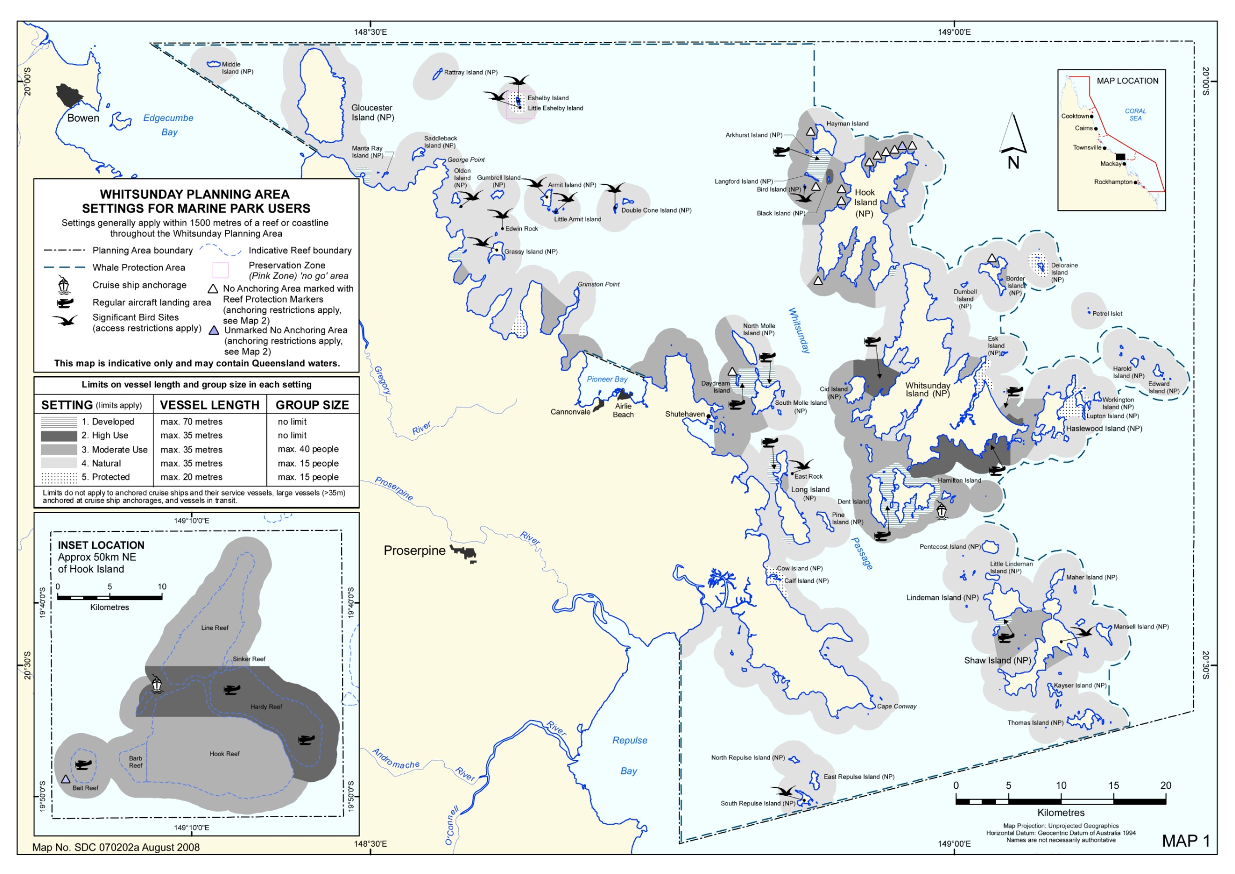
Figure 4 Whitsunday Planning Area Settings Map

MARINE PARK MANAGEMENT AND RESPONSIBLE REEF PRACTICES

Section overview
This section contains what you need to know about Marine Park management, and covers:
- How the Great Barrier Reef World Heritage Area is protected and managed
- Respective roles of the Commonwealth and State management and regulatory agencies
- The roles of Zoning Plans, Plans of Management and permits, and how they ensure the sustainable use of the Reef
- Legislation in place to manage and protect the Great Barrier Reef World Heritage Area at Commonwealth and state levels
- Strategies and actions to minimise human impact on the marine and island environments.
Understanding the management arrangements and communicating these to charterers is your responsibility and is crucial to the environmental sustainability of bareboat operations in the Whitsundays.

Introduction
The Great Barrier Reef World Heritage Area consists of one of the world’s largest systems of coral reefs, together with lagoon, seagrass, mangrove and estuarine communities. Stretching over 2300 kilometres along Australia’s north-east coastline, the Great Barrier Reef World Heritage Area covers 348 000km². It represents one of the most complex and biologically diverse systems on earth and contains critical habitats for a number of threatened and protected species.
The Great Barrier Reef has evolved over hundreds of thousands of years. Aboriginal people were the first Reef users and have had a close association with the Great Barrier Reef and surrounding area for many thousands of years. They developed a close cultural relationship with the marine environment and continue to live adjacent to, use, and maintain strong cultural links with the area.
Since European settlement, use of the area has grown and intensified to include tourism, commercial fishing, scientific research, shipping, and recreational pursuits such as boating, fishing and diving. During this period there has also been significant urban and rural development of the mainland adjacent to the Great Barrier Reef World Heritage Area.
The Whitsundays region from Bowen to Mackay, including Airlie Beach, is known for its spectacular island scenery, fringing and offshore reefs, and sheltered bays and beaches. The reefs and islands support a diverse range of animal and plant life including threatened species like humpback whales and dugongs. The area also contains important Aboriginal cultural sites and historic sites of European settlement days. For all these reasons, the region is a very important tourism destination and is attracting an increasing number of visitors.
The Whitsundays are the traditional home of the Ngaro Aboriginal people, with research suggesting they inhabited the Whitsundays for at least 9000 years before European settlement. Sites such as Nara Inlet Rock Art Shelter allow charterers to explore and learn more about their culture.
With similar vegetation types to that of the nearby mainland, the islands support similar animals, but with fewer species, as a result of their isolation, which reduced the number of new species being introduced. Animals found on the islands include birds, mammals, macropods, reptiles, spiders and insects. Foreign plants and animals were introduced to the islands to provide food resources and assist in early European settlement of the Whitsundays. Some of these, including goats, can still be seen today.
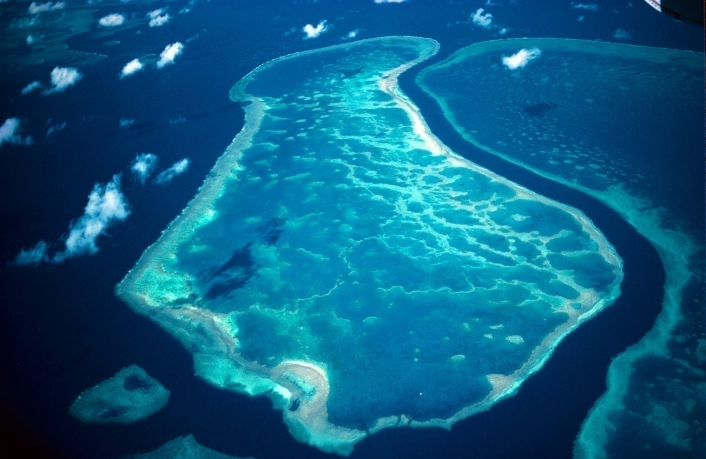
Management strategies have been put in place within and around the Whitsunday islands to protect natural, cultural and socio-economic values and to provide a range of visitor experiences. The waters and beaches of the area are jointly managed as effectively one Marine Park, also taking into account management of the adjacent island National Parks.

Part one – Marine Park management
A number of government agencies work together to help keep the Great Barrier Reef Marine Park and adjacent Great Barrier Reef Coast Marine Park healthy and to allow for the continued sustainable use of this special area.

The managers
GBRMPA, a Commonwealth statutory authority, is responsible for the care and development of the Great Barrier Reef Marine Park. This role includes planning, policy development, environmental impact assessment, permit administration and identification of research priorities.
The Queensland Department of National Parks, Sport and Racing (NPSR) works closely with GBRMPA in the day-to-day management of the Marine Park, as well as the Queensland Great Barrier Reef Coast Marine Park and island National Parks. The Field Management Program between GBRMPA and QPWS is delivered through rangers and conservation staff, who guide and monitor routine activities and daily operations in the Marine Park. They are also involved in enforcing Marine Park rules, by issuing on-the-spot fines for offences, taking court action for breaching rules (such as no fishing in ‘green’ zones) or initiating action to suspend and revoke permits for breaches of a permit condition or other permit-related offences.
Many other Australian and Queensland Government agencies are also closely involved in management and compliance activities, including the Queensland Department of Agriculture and Fisheries, the Queensland Boating and Fisheries Patrol, the Queensland Department of Transport and Main Roads (including Maritime Safety Queensland), Water Police, the Australian Border Force and the Australian Maritime Safety Authority.

The management tools
The Great Barrier Reef Marine Park Act 1975 was passed by the Australian Government in 1975, to provide a framework for protection of the Great Barrier Reef. In 1982, the Queensland Marine Parks Act 1982 was passed, to provide for complementary protection of the intertidal areas of the mainland and island coastlines.
In 1981, the Great Barrier Reef Marine Park and adjacent coastal areas and islands, many of them Queensland National Parks, were inscribed on the World Heritage List on the basis of their outstanding natural features and ecological integrity. Australia’s international obligations are "to protect, conserve present and bequeath the Great Barrier Reef World Heritage Area to future generations".
The Great Barrier Reef Marine Park Regulations 1983 provide further guidance in the management of the Marine Park, and there are a number of sections which specifically relate to the permitting and operation of bareboats in the Whitsundays. Briefers should ensure they understand sections on Bareboat Operations and Sewage Discharge.
A number of different management tools are used to ensure that the Great Barrier Reef Marine Park and the Queensland Great Barrier Reef Coast Marine Park are protected and activities in the area are sustainable.
The key aspect of management is working in partnership and cooperating with stakeholders and local communities to find common, mutually beneficial outcomes:
- State Marine Park protects many bays and all intertidal areas in the Whitsundays including beaches, estuaries and tidal rivers
- Commonwealth Marine Park protects areas seaward from the lowest astronomical tide (LAT) to the outer Barrier Reef
- Marine parks are subject to multiple-use zoning to allow for a wide variety of activities some of which include tourism and fishing (Recreational and Commercial)
- In most cases, the zoning is complimentary between the State and Commonwealth marine park.
A quick way to access management arrangements in an easily understood form is to visit the tourism Operators Handbook, OnBoard, on the GBRMPA website.

Zoning Plan
Zoning is one of the primary tools used to manage the Marine Park. Zoning provides protection for areas that are critical for maintaining a healthy environment, and sets a broad framework for the management of human use by designating areas where specific types of activities may take place (for example, trawling, fishing, collecting).
You are responsible for explaining how to interpret all zoning provisions for the locations your clients wish to visit. For the Whitsundays, zoning map number 10 (MPZ10) covers the region, and a copy of this is required on board the bareboat. Different zones are represented by different colours on the maps, and each zone has specific management objectives that determine which human activities may or may not take place in that zone.
For example:
- Pink - preservation zones, for example Eshelby Island, excludes all visitation and activities
- Light Blue - general use zones allow most commercial and recreational activities
- Green - marine national park zones, or what are commonly referred to as ‘look but don’t take’ areas - fishing, for example, is not allowed (other than traditional hunting, gathering and fishing)
- Yellow – conservation park zones allow limited activities (for example, collecting, snorkel spearfishing, fishing with one line, one hook)
- Public Appreciation Areas further limit some activities, for example spearfishing in some yellow zones.
Ask your charterer to look up the zoning of a reef, island or bay they wish to visit on the zoning maps, and check the Activities Guide for what they can and can't do in the zone, to help them understand how to use a zoning map. Remind them to do this each time they undertake an activity as they are responsible for their actions, and fines apply.

Whitsundays Planning Area
To manage sites of high use more effectively, the Great Barrier Reef Marine Park Authority has developed a number of Management Plans which complement the Zoning Plan, but are more detailed, providing extra tools for managing activities associated with tourism and recreation use.
The Whitsundays Plan of Management covers waters and islands from Cape Gloucester in the north to Repulse and Thomas Islands in the south. The Whitsundays Plan of Management is designed to preserve a range of opportunities and experiences. Through this Plan, the natural and cultural values of the Whitsunday Planning Area are protected and the number of tourism operations managed, along with the maximum group size to each setting area. There are specific management arrangements for some sensitive locations and some activities.
It is important that you understand in detail the particular management arrangements for the Whitsundays Planning Area in relation to bareboats.

Special requirements
Within the Whitsunday Planning Area, the overall setting of an area is managed by defining the size of group that can visit the area and the vessel length. See the Setting Areas map (Figure 4 on page 12) and the GBRMPA website at http://www.gbrmpa.gov.au/zoning-permits-and-plans/plans-of-management/whitsunday-plan-of-management/guide-to-visiting-the-whitsundays-plan-of-management-area-for-recreational-users/what-you-need-to-know
For Significant Bird Sites in the Whitsundays Planning Area, there are specific requirements about how frequently you may access the site and the activities you undertake. See:
- Whitsunday Planning Area Settings map (Figure 4 on page 12)
- Chapter C.14
- GBRMPA website at http://www.gbrmpa.gov.au/zoning-permits-and-plans/plans-of-management/whitsunday-plan-of-management/guide-to-visiting-the-whitsundays-plan-of-management-area-for-recreational-users/maps-and-zoning-information-for-whitsundays-plan-of-management

Depending on your style of operation, you may need to be aware of some special rules for the following activities:
- Anchoring and mooring (Chapter C.10), Motorised water sports (Chapter C.11) and Whale watching (Chapter C.14), and the GBRMPA website at http://www.gbrmpa.gov.au/zoning-permits-and-plans/plans-of-management/whitsunday-plan-of-management
- Some sites in the Whitsundays Planning Area have site-specific management arrangements in place that you should understand:
  - Blue Pearl Bay (Hayman Island). See GBRMPA website at http://www.gbrmpa.gov.au/corp_site/key_issues/tourism/blue_pearl_bay
  - Bauer Bay (South Molle Island). See GBRMPA website at http://www.gbrmpa.gov.au/zoning-permits-and-plans/site-specific-management/blue-pearl-bay,-hayman-island

Managing the islands of the Whitsundays
At some islands, visitor use is having an impact on the environment and affecting the quality of visitor experiences. The Whitsunday and Mackay Islands Visitor Management Strategy provides a policy framework for sustainable tourism and visitor use. It applies a system of visitor management settings to islands and sites to help guide management decision making, including permit assessment, site planning, facility development and presentation. Further information can be found at the following link on the NPSR website http://www.nprsr.qld.gov.au/managing/plans-strategies/whitsunday_and_mackay_islands_visitor_management_strategy_november_2007.html

Permits
The management of commercial operations within the Marine Park is ‘fine-tuned’ through a joint GBRMPA and NPSR permitting system. It is a legal requirement to obtain a permit to conduct many commercial (for example bareboat operations) and non-commercial (for example research) activities in the Marine Park and on island National Parks.
A permit is like a key to accessing the Great Barrier Reef Marine Park and Great Barrier Reef Coast Marine Park. Each one is unique, providing different levels and types of access. They are powerful legal documents and it is your responsibility to understand and comply with all parts of your Marine Parks permit.
The person(s) or company named on the permit (the permittee) is responsible for all operations under that permit. Because permits are granted with protection of the environment in mind, failure to adhere to your permit may result in severe penalties. Some of the important management arrangements contained within Marine Park regulations and permits for Whitsunday bareboat operations are:
- Must only operate between 19° 30’S and 21° 20’ S
- Must only operate the number of vessel permitted on the permit
- The permittee must provide on board zoning information relevant to the area of operation
- Must provide on board and on shore facilities for the disposal of garbage
- Must ensure the principal or senior staff member, the Bareboat Briefer and the Radio Operators are appropriately qualified and registered with the GBRMPA prior to operating
- A bareboat identifier must be displayed on the vessel
- Must only conduct the hiring of a bareboat in a Setting 1 area in the Whitsundays Plan of Management
- Must not hire the vessel with crew.

The Environmental Management Charge
The Environmental Management Charge (EMC) is a charge associated with most commercial activities operated under a Great Barrier Reef Marine Park permit, including tourism operations.
All visitors to the Marine Park participating in a tourist activity must pay the charge to the permit holder. Visitors must also pay when using a non-tourist vessel charter. The role of the permit holder is to collect and remit the charge to the GBRMPA by the due date. The EMC is linked with the Consumer Price Index (all groups) for Brisbane.
All funds received as EMC payments are applied directly to management of the Great Barrier Reef Marine Park. This money is a very important contribution to management of the Marine Park and is about 20 per cent of the GBRMPA's income.
The EMC funds are spent on all aspects of Marine Park management, from education and research to ranger patrols and policy development. Every aspect of Marine Park management that you see out on the Reef has been contributed to by the EMC payments.

Education and research
The Great Barrier Reef is, without doubt, one of the most remarkable, awe-inspiring classrooms on the planet.
As a Great Barrier Reef marine tourism operator, you not only provide tourists with the opportunity to explore one of the world's greatest living treasures, but you also play a crucial role in teaching them about its incredible ecosystem and World Heritage values.
Thanks to the internet, there's a vast body of knowledge, fascinating facts, and interesting research about the Reef at your very fingertips. But remember, there is more to interpretation than just facts - the more you can inspire and involve your audience, the more they will connect with the Great Barrier Reef.

When presenting information
- Be interesting, entertaining and passionate in your presentations, keep it short, involve your audience and enjoy yourself
- Use a variety of interpretative methods to get the message across
- Include interpretation as part of as many aspects of the operation as possible
- Use props and hands-on teaching aides to help increase audience participation and interest levels
- Include one key 'call to action' message in your presentation so that your clients are encouraged to help the Reef when they return home. Refer to the GBRMPA publication Reef Facts for Tour Guides for ideas on 'call to action' messages http://www-rc.gbrmpa.gov.au/__data/assets/pdf_file/0004/36670/Reef_Facts_Iss3R1_finalSm.pdf Include cultural, historical and environmental information relevant to your destination. Use specific examples of marine life that will be seen during the trip
- Be aware of cultural sensitivities (contact the region's traditional owners as appropriate)
- Advise on rules of the Reef, best practices and any dangers relevant to your destination
- Tailor the presentation to your audience - be aware of the different nationalities, languages, ages, physical disabilities, phobias and interests
- Spend time with your clients to ensure they have received the interpretative message
- Provide onboard reference materials for your clients
- Review and update your interpretation program at least annually.
Education is an integral part of managing the Great Barrier Reef World Heritage Area. GBRMPA produces a range of educational materials to aid understanding of the Marine Park and its management, and supports school education programs through the Reef HQ Aquarium in Townsville and GBRMPA website at http://www.gbrmpa.gov.au/learn-about-the-reef/resources-by-theme.

Policy on managing bareboat operations in the Great Barrier Reef Marine Park
The current policy is GBRMPA’s statement of intent about an issue. Policy works within the law and interprets the law for the particular circumstances. A clear outline of intent can provide guidance and predictable management for both officers of the managing agencies and users of the Marine Park.

The Policy on Managing Bareboat Operations in the Great Barrier Reef Marine Park July 2006 was prepared by GBRMPA in collaboration with the Queensland Government, following extensive stakeholder consultation, to guide management of bareboat operations in the Great Barrier Reef Marine Park.

The issues covered by the policy include bareboat operations, bareboat permits (divisibility, transferability, conversion, availability, allocation and latency management) Whitsunday Planning Area specific requirements, escorted bareboat flotilla tours, enforcement and compliance, use of public moorings and industry standards.

The policy is available on the GBRMPA website at
http://www.gbrmpa.gov.au/__data/assets/pdf_file/0006/3849/gbrmpa_ManagingBareboatOperationsPolicy_2006.pdf

Whitsunday bareboat industry standards
To ensure bareboat operations in the Whitsundays are sustainable, an industry standard has been developed and all bareboat operations in the Whitsundays are required to comply with the Whitsundays Bareboat Industry Standards. These standards set minimum levels of performance in a number of key areas.
- The following staff or personnel must be trained and registered:
  - The principal or a senior staff member (for example, Operations Manager)
  - The briefing staff
  - The Radio Operator.
- The operation must provide onboard and onshore facilities for the disposal of garbage.
- The operation must meet the bareboat identification requirements of the relevant authorities at all times when operating in the Marine Park.
- The operation must ensure that all its bareboats have Protection and Indemnity (public liability) cover to a minimum of $10,000,000.
- The operation must ensure that all its bareboats have onboard facilities to manage the discharge of sewage in accordance with regulation.
- The operation must ensure that all its bareboats are fully insured under a Comprehensive Hull and Machinery Policy, and have adequate land-based insurance protection.
- The operation must have access to a dedicated licensed radio base where the accredited operator has direct access to the charterer and the technical bareboat information at all times. This base must be manned between the hours of 8 am and 5 pm with the appropriate after-hours emergency numbers available (the radio base may be operated as part of the permitted operation, or by contractual arrangement with an alternative registered radio base).
- The operation must employ or have access to staffing, infrastructure and facilities to be able to maintain the bareboats in the fleet to a high standard (mechanical, structural and appearance).
- The operation must have adequate contingency planning procedures, staffing and resources to be able to cater for emergencies and all charter back-up services.
- The operation must comply with all the regulatory requirements of the relevant authorities.

Part two – Responsible Reef practices
Responsible Reef practices are designed to complement, rather than duplicate, legal requirements. All tourism operators and visitors are encouraged to adopt these practices as part of their activities.
There are responsible Reef practices for almost all of the activities in the Great Barrier Reef Marine Park. These are common sense guidelines aimed at helping you in your day-to-day operations, and are detailed in the GBRMPA's Responsible Reef Practices booklet, and on the GBRMPA website at http://www.gbrmpa.gov.au/visit-the-reef/responsible-reef-practices
Make sure you double-check Marine Parks legal requirements for each of these activities. A summary is provided with each set of responsible Reef practices. The legal requirements described are not necessarily exhaustive and may change from time-to-time.
Responsible Reef practices that focus on activities relevant to bareboat charters in the Whitsundays are listed below. Use the responsible Reef practices booklet, website and those listed in this guide to learn how you and your charterers can do the best when operating in the Great Barrier Reef Marine Park, whatever activity is being undertaken.

Responsible Reef practices for all activities
- Respect other people using the Great Barrier Reef World Heritage Area.
- Be aware of the effect of your activity on the environment and other people, and avoid conflicting activities in the same area.
- Take the time to learn about the Great Barrier Reef World Heritage Area and how to minimise the impact of your activities.
- Report all marine pollution, incidents and strandings to the relevant agency .
- Report any suspected breaches in law (including illegal fishing and collecting) to your nearest NPSR office.
- Report any marine mammal or turtle strandings to your nearest QPWS office.
- Report any oil spills or any form of marine pollution to Maritime Safety Queensland.
- You can help the Great Barrier Reef Marine Park by reporting incidents and suspected offences you have witnessed:
  - Complete an Incident Report Form (http://www.gbrmpa.gov.au/report-an-incident) and provide any additional information such as photographs, maps and charts when you see anything you don't think should be happening in the Marine Park.
  - Do not approach any suspected persons or request information from them if you witness a suspected breach of the law.
- Report any incidental sightings of interest through GBRMPA’s Eye on the Reef program. Details on how to record your sightings through the Eye on the Reef program using the Eye on the Reef app or accessing through the GBRMPA website at http://www.gbrmpa.gov.au/visit-the-reef/eye-on-the-reef
- Make a copy of the hotline numbers and have them handy onboard your vessel. Hotline numbers can be found on the GBRMPA website at http://www.gbrmpa.gov.au/report-an-incident

Marine Parks legal requirements
- Within seven days of you becoming aware that an activity your clients undertook resulted in an unintentional death, injury, trading, taking, keeping or moving of an animal protected under the Environment Protection and Biodiversity Conservation Act 1999 without a permit, you must notify the Secretary of the Department of the Environment.

Anchoring and mooring in the Whitsundays Planning Area
The Whitsunday reefs are outstanding for their coral cover and diversity. High visitation to these fringing reefs makes them vulnerable to damage by careless anchoring and vessel groundings.

Mooring
Tying up to a mooring, instead of anchoring, means that you are helping to protect the coral reefs of the Marine Park. Please use a mooring whenever you can and follow the responsible reef practices for moorings.
There are blue public moorings available for use throughout the Whitsundays Planning Area. You must use them according to the requirements marked on the colour-coded band and mooring tag.
Moorings have been installed throughout the Great Barrier Reef to both help take the pressure off the coral reefs and as a useful aid to the boating community. Encourage your clients to use a mooring, where available, in preference to dropping an anchor. Moorings are a more environmentally sustainable alternative to anchoring as they assist in avoiding damage to coral reef habitats.
What's more, with a mooring your clients can have safe access to some of the busiest and most attractive parts of the Reef. At times, public moorings can be in big demand so it is important that your clients observe their conditions of use and share this handy resource in a responsible manner.
The conditions of use are displayed on a colour-coded band on all public moorings, and on an engraved tag attached to the pick-up line. Before using a public mooring, your clients should check that the vessel fits the requirements of the mooring and the wind speed is below the maximum level.

Reporting
- Please report suspected illegal moorings, damaged public moorings or any misuse of moorings to the QPWS office, Whitsundays.

Marine Parks legal requirements
- You must not remove, misuse or damage public moorings.
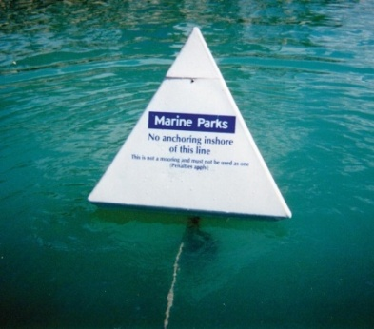
- You must comply with the time limit specified on each public mooring buoy.

No Anchoring Areas
Some reef areas that are particularly vulnerable to visitation have been designated No Anchoring Areas. These areas are marked by Reef Protection Markers (pyramid-shaped buoys with blue Marine Park labels). In some areas, where Reef Protection Markers can't be installed, operators must locate No Anchoring Areas by coordinates and landmarks.
No Anchoring Areas | Reef Protection Markers
Hook Island
East and West Butterfly Bay | Yes
Maureen's Cove | Yes
Luncheon Bay | Yes
Pinnacle Bay | Yes
North and South Stonehaven Bay | Yes
False Nara Inlet | Yes
Manta Ray Bay | No
Hayman Island
Blue Pearl Bay | Yes
Border Island
Cateran Bay | Yes
Daydream Island
Sunlovers Bay | Yes
Langford Island Reef | Yes
Bait Reef (parts of) | No

What are the rules for No Anchoring Areas?
When visiting a reef or bay that has a No Anchoring Area, your clients can help protect the coral reefs of that area by following a few simple rules:
- You cannot anchor inside a No Anchoring Area or inshore of the line of buoys
- You can enter No Anchoring Areas when approaching or leaving moorings or beaches, if safe navigation allows
- You cannot attach your vessel or aircraft to a Reef Protection Marker.
Anchoring is not restricted for the safety of life or if a vessel is threatened.

Responsible Reef Practices - anchoring
- Thoroughly brief your clients on correct anchoring procedures
- Use public moorings (B7_ZPDF) where available
- Share moorings with other operators wherever possible
- Anchor the boat a safe distance away from other boats
- Examine the nearby area before anchoring to find the best location to minimise reef damage
- Anchor away from turtle nesting beaches during the nesting and hatching seasons
- Use the correct anchor for your situation and environment (for example, small vessels could use reef picks)
- Use only as much chain as you need to hold the vessel, without compromising safety (remember that you will need to use more chain and line to anchor in deep water). Rope causes much less reef damage
- Keep a constant watch to make sure the anchor isn't dragging.

When setting your anchor
- Anchor in water deep enough to avoid your vessel grounding with the tide change
- Anchor in sand or in mud wherever possible
- Never anchor directly on coral
- Anchor away from fragile or sensitive areas including bird nesting areas, Indigenous heritage sites and shipwrecks
- Look out for the safety of any people in the water when dropping your anchor
- Never wrap the anchor rope or chain around bommies or large coral heads
- Set the anchor where possible, especially when close to coral - for example, send divers down to check that it's OK
- If anchoring ashore, carefully place the anchor to minimise shore and coastal damage (for example, do not anchor on sensitive sand dunes or tie your rope to a tree)
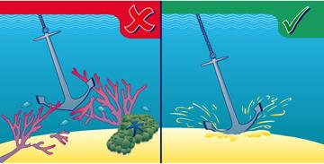
- If anchoring overnight, anchor before nightfall and double check the swing room.
Figure 5: Anchor in sand or mud wherever possible. Never anchor directly on coral.

When retrieving your anchor
- Motor towards the anchor when hauling it in
- Use a float recovery system to haul in the anchor
- Retrieve the anchor when the line is vertical
- If the anchor is stuck, consider using qualified divers or swimmers to check the situation and dislodge it, or disconnect the anchor and mark the site for proper retrieval later
- If the anchor is caught on the reef, free it by hand wherever possible
- Do not force the anchor free by motoring forward.

Marine Parks legal requirements
- You can generally anchor in most places in the Great Barrier Reef Marine Park, but you must not damage or remove coral
- You are required to comply with all designated 'No Anchoring Areas'
- There are specific management arrangements for anchoring in the Whitsundays Planning Areas:
  - You must take reasonable care not to damage coral
  - In the Whitsunday Planning Area, vessels between 35 metres and 70 metres in length can only anchor 1500 metres away from reefs or the coastline unless at a Setting 1 area or a designated cruise ship anchorage. Vessels greater than 70 metres can only anchor at a cruise ship anchorage or 1500 metres away from reefs or the coastline provided the ship is in a General Use Zone or Shipping Area.

Related links
- http://www.gbrmpa.gov.au/zoning-permits-and-plans/plans-of-management/whitsunday-plan-of-management/guide-to-visiting-the-whitsundays-plan-of-management-area-for-recreational-users/what-you-need-to-know for a guide on anchoring and mooring in the Whitsunday Planning Area.

Fishing and protected fish species
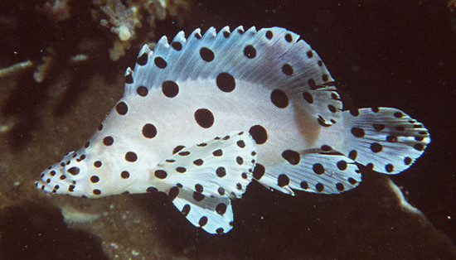
Fishing is a popular recreational pastime that allows people to spend time on the water with family and friends and to get in touch with the natural world. The Great Barrier Reef offers many exciting and different fishing opportunities.
As well as observing fishing regulations, it is important that those who fish adopt responsible fishing practices while out on the water. These practices help protect the natural environment, maintain the ecological balance of the Reef and contribute to improving its general health.
Barramundi cod
By explaining simple guidelines to charterers, you are helping to ensure that the Great Barrier Reef continues to be one of the best spots on earth to fish.

Related links
- https://www.daf.qld.gov.au/fisheries to find out about permits, closures, fishing rules, guides and species identification

Responsible Reef practices – fishing
- Advise your clients about all fishing regulations and best practices
- Provide interpretation about sustainable fishing practices, species identification and measurement, protected fish species (C.11.4) (such as maori wrasse, and barramundi cod). Explain why the Great Barrier Reef Marine Park is a special place and the reasons for its fishing arrangements.
When fishing
- Take only what you need, do not necessarily fish to the bag limit.
- Do not use pest or non-native fish for bait. Never release introduced species into the water.
- Do not fish where fish feeding takes place, for example as part of a tourist program.
- Do not fish near a commercial dive site or pontoon.
- Do not fish in known or suspected fish spawning aggregation sites.
- Fish a safe distance from marine animals (such as dolphins, whales, turtles and dugongs) and bird roosting or nesting areas.
- If you're unsure of the fish identity or size, release the fish immediately.
- Return all undersized and unwanted fish quickly to minimise injury.
- If you're keeping the fish, remove it from the hook or net immediately and kill it humanely.
- Do not litter - clean up all fishing gear (such as discarded tackle and line, and bait bags) and take it back to shore to dispose of it properly.
- Participate in fish monitoring and research programs where available.
When returning unwanted fish
- Minimise how long the fish is out of the water - keep fish in the water as much as possible and have your equipment close at hand. Very large fish should not be removed from the water.
- Do not leave fish on a hot, dry surface to thrash around.
- Place fish on a wet towel and cover them, especially the gills and eyes. The fish should not dry out and direct sunlight can damage their eyes.
- Handle fish gently - fully support its body, do not hold upright by the jaw, squeeze or kneel on the fish.
- Use wet hands or wet cloth when handling fish to minimise damage to their protective mucous coating.
- Remove the hook carefully and quickly using a pair of long nose pliers or a de-hooker to minimise tissue tearing. If the hook is difficult to remove, cut the line instead.
- Help fish recover before their release - gently release the fish head first into the water
- Use barbless hooks or those that are unlikely to become hooked in the gills or gut.
Reporting
Please report tagged fish, suspected illegal fishing incidents, fish kills (large numbers of dead fish) and entrapped marine animals.

Marine Parks Legal Requirements
- You must not 'take' protected fish species in the Great Barrier Reef Marine Park unless you have a Marine Parks permit to do so
- Note: 'Take' includes removing, gathering, killing or interfering with, or attempting to take. There may be special arrangements for Traditional Owners
- You must abide by the fishing requirements in the Zoning Plan:
  - General Use Zone (light blue) and Habitat Protection Zone (dark blue) - maximum of 3 lines/rods per person, 6 hooks in total
  - Conservation Park Zone (yellow) - 1 line/rod with 1 hook per person
  - Buffer Zone (olive green) - maximum 3 lines/rods per person, 6 hooks in total, trolling for pelagic species only
  - No fishing in the Scientific Research Zone (orange), Marine National Park Zone (green) or Preservation Zone (pink).
- You must abide by State Fishing regulations including species allowed, size limits, bag limits, protected species, tackle restrictions, and seasonal and area closures. (See Related Links)
- You must not discharge fresh fish parts, unless the fish were caught in the Marine Park
- Special requirements apply to spearfishing
- Within seven days of you becoming aware that an activity you undertook resulted in an unintentional death, injury, trading, taking, keeping or moving of a syngnathid (e.g. seahorse, pipefish, seadragon), a Freshwater Sawfish, a Whale Shark, a Grey Nurse Shark or a Great White Shark without a permit, you must notify the Secretary of the Department of the Environment.

Protected fish species
Several fish species that live in the Great Barrier Reef Marine Park are protected. You must not take protected fish species in the Great Barrier Reef Marine Park unless you have a Marine Parks permit.
Note: 'Take' includes removing, gathering, killing or interfering with, or attempting to take. There may be special arrangements for Traditional Owners.
Common Name/s or Examples | Species Name
Seahorses, pipefish, seadragons (all sizes) | All species in the Families Syngnathidae and Solenostomidae
Potato cod (all sizes) | Epinephelus tukula
Queensland grouper (all sizes) | Epinephelus lanceolatus
Maori wrasse | Cheilinus undulates
Barramundi cod | Cromileptes altivelis
Whale shark | Rhincodon typus
Grey nurse shark | Carcharias Taurus
Great white shark | Carcharias carcharias
All species of grouper, greater than 100 cm | Epinephelus

Whale and dolphin watching
Few wildlife experiences could compare to the sight of a massive whale majestically rising out of the water and flopping backwards, or that of a pod of dolphins playfully showing off their acrobatic skills.
The Great Barrier Reef is a vitally important breeding ground to about 30 species of whales and dolphins (or 'cetaceans'). One of the most commonly sighted whales are the massive humpbacks which make the trek to the Reef's warmer waters from Antarctica between May to September to court, mate, give birth or rear their calves.
It's critical for their continued survival that their 'nurseries' are available to them, free from any harassment, which may lead to calf mortality. Special whale protection areas have been established in these nursery areas to provide added protection.
As someone who shares the waters with the Reef's precious cetaceans, you have a responsibility to help protect them and yourself and to keep safe distances (refer to the whale approach distances diagram below).
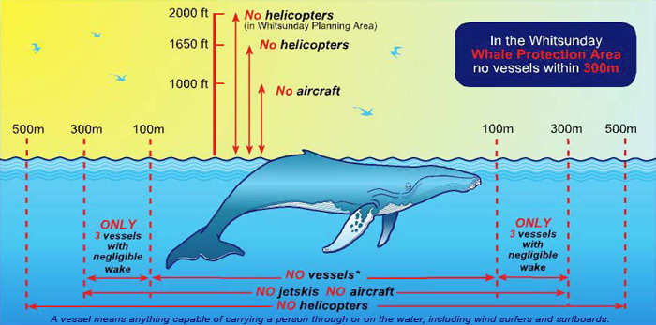
By explaining to charterers the responsible practices when in the vicinity of whales and dolphins, you're not only playing a big part in their conservation but you're also providing a safe environment to watch them.
Figure 6 Approach distances for whales

Responsible Reef Practices – whale and dolphin watching
When boating around whales
- Be alert and watch out for whales at all times, particularly during whale migration season (May to September)
- Post a lookout to keep an eye out for whales if they are suspected in the vicinity
- Use radio communications to manage vessel numbers around the whale, if there are other vessels nearby
- Keep clear of a whale's path so it isn't forced to change course
- Do not approach or disturb mothers and calves - never place a boat between them
- Always approach and leave whales from the side, moving in a parallel direction to the whale - do not approach it from the front or back
- When you're leaving an area where whales were present, turn the motor on, post a lookout, and move off slowly
- Slow down to minimise the risk of collision where whales have been sighted
- If your boat strikes a whale, ensure that your passengers and vessel are safe, note your location and continue your previous course - do not follow the whale
- Report any boat strikes and reassure your passengers that the relevant authorities have been contacted to assist the whale.

When boating around dolphins
- Follow all guidelines for boating around whales
- Do not intentionally drive through a pod of dolphins to try to get them to bow-ride - some dolphins don't bow ride, and can become disturbed near boats
- Maintain constant speed and direction when dolphins are bow riding.
When viewing whales and dolphins
- Use commonsense when viewing whales and dolphins - their behaviour is unpredictable.
- It is a legal requirement to keep moving at a constant slow speed if you're within 100 to 300 metres of a whale
- Never try to overtake whales or dolphins
- Avoid making sudden noise, speed or direction changes
- Be quiet when you are near a whale or dolphin
- Never encircle whales or dolphins - if other boats are present, be sure to leave a clear area for the animals to escape [this is a legal requirement]
- Let the whale or dolphin control the situation - do not try to round up or herd
- Do not touch or feed whales and dolphins [this is a legal requirement]
- Move away immediately if the whales or dolphins suddenly change behaviour and appear agitated. Behaviour that indicates that boats should move away includes:
  - Bumping the vessel
  - Rapid changes in swimming direction or speed
  - Erratic behaviour
  - Escape behaviour such as prolonged deep dives
  - Tail slapping or swishing.

Interpretation and training
- Brief your clients on whale and dolphin biology, ecology, behaviour and conservation in onboard interpretation programs.
- Brief your clients on the rules of whale watching and explain reasons behind such strict regulations.
- Display explanatory posters about whale watching and regulations.

Reporting
- Please report sick, injured, stranded or dead whales or dolphins. Please also report if your vessel accidentally strikes a whale. For details on how to report incidents see the GBRMPA website at http://www.gbrmpa.gov.au/report-an-incident

Marine Parks legal requirements
- All whales and dolphins in the Great Barrier Reef Marine Park are legally protected
- A specific permission on the tourism program permit is required to conduct whale watching activities - incidental encounters are not considered whale watching
- When you encounter whales or dolphins, either from a vessel, aircraft or in the water [these are all legal requirements], you:
  - Must not kill, take, injure and/or interfere with whales and dolphins. Interference includes harassing, chasing and herding
  - Must not restrict the path of a whale or dolphins
  - Must minimise noise when closer than 300 metres of a whale or dolphin
  - Must not intentionally touch or feed, or attempt to touch or feed, a whale or dolphin
  - Must not enter the water within 100 metres of a whale or within 50 metres of a dolphin
  - Must not approach closer than 30 metres to a whale or dolphin if you are in the water. If a whale or dolphin approaches you while you are in the water, move slowly, do not touch or swim towards it.
- When operating a vessel or aircraft (check safe distances diagram, Figure 6 on page 27):
  - A vessel must not approach closer than 100 metres of a whale, or 50 metres of a dolphin
  - If your vessel is closer than 300 metres of a whale or 150 metres of a dolphin it must be operated at a constant slow speed, if closer than 50 metres of a dolphin the vessel must not change course or speed suddenly
  - If there are three vessels within 300 metres of a whale or dolphin, all additional vessels must remain outside a 300 metres radius from the whale or dolphin
  - If a whale approaches close to your vessel, take all precautions to avoid a collision, either slow down and steer away from the animal, or place the engines in neutral and let the animal pass
  - Prohibited vessels (including jetskis) must not approach closer than 300 metres of a whale or dolphin
  - An aircraft must not operate below 1000 feet within a horizontal radius of 300 metres of a whale or dolphin
  - A helicopter must not operate below 1650 feet within a horizontal radius of 500 metres of a whale or dolphin and must not allow the aircraft to approach a whale or dolphin head on
  - If you accidentally strike a whale you must report it (C11b.1).
- When in the Whitsunday Planning Area, there are some additional rules in relation to whales [these are all legal requirements]:
  - A vessel must not approach closer than 300 metres of a whale in the Whitsunday Whale Protection Area
  - A helicopter must not approach below 2000 feet or within 1000 metres of a whale.
- When an individual whale or dolphin is declared by the Queensland Government to be of Special Interest, there are some additional rules:
  - A vessel or personal motorised watercraft must not approach closer than 500 metres of a special interest whale or dolphin
  - An aircraft must not approach below 2000 feet of a special interest whale or dolphin.
- Within 7 days of you becoming aware that an activity you undertook resulted in an unintentional death, injury, trading, taking, keeping or moving of a whale without a permit, you must notify the Secretary of the Department of the Environment.

Island visits
The islands of the Whitsundays are a picture perfect holiday destination. With many of the islands protected as National Park they are also refuges for abundant fauna and flora which are sensitive to human disturbance.

Responsible Reef practices – island visits
Most activities have environmental impacts, especially when you compound an individual’s impact by the estimated 1 million visitors to the Whitsundays every year.
By following the responsible park practices you and your guests can help:
- Prevent the spread of weeds and pests
- Reduce the risk of wildfire and burn injuries
- Protect animal habitat and food resources
- Maintain biodiversity and natural integrity of an area
- Allow others to enjoy the peace.
Responsible park practices are designed with the safety of you and the environment in mind. Many responsible park practices are backed up by the Nature Conservation Act and are a legal requirement.
Beachcombing
Take care of your group – beware of the sea and poisonous creatures!
Take care of the shore – be careful not to disturb creatures, leave rocks and shells as you found them.
Bushwalking
Parks offer a range of walking tracks from beginner to advanced level based on Australian Standards.
Know the track grades and match these with your group’s level of fitness and experience. Keep your group together, stay on the track and carry adequate drinking water.
Bush-toileting
Always use toilets where provided. If there are no toilets, bury all faecal waste and toilet paper in a hole at least 15 centimetres deep and at least 100 metres from campsites and watercourses.
Collecting
Activities to collect plants or trap animals are strictly controlled. Remember everything (living or dead) is protected in a national park.
Crocodiles
Crocodiles are dangerous. Obey warning signs and never take unnecessary risks in crocodile habitat.
Fire
Reduce the risk of wildfire when cooking, use a gas stove – remember open fires are not permitted. Be aware during planned burn season, and stay up to date with site closures.
Ship it in, ship it out!
The most visible sign of pollution, litter pollutes our waterways and kills thousands of marine animals every year. Keep all rubbish secure, including drink lids and cigarette butts and carry it out of the park.
Picnicking
Check what facilities are available and be considerate of other users. Be as self sufficient as possible, and take all rubbish with you.
Photography
A permit is required for commercial photographs taken on national park. Photographs taken by your clients as personal memories of their trip are not considered a commercial activity unless they wish to publish them in the future.
Respect Indigenous culture
Rock art and other sites in parks and forests represent thousands of years of living culture with special significance to Indigenous people. These sites are easily damaged and are irreplaceable. Look at them, enjoy them, but please do not touch or damage these sites.
Swimming
Many beaches around national parks are not patrolled. Be aware of hidden dangers such as submerged logs, rocks and unexpectedly strong currents. Think before your clients swim. If you decide to swim, protect the park. Never use soap, shampoo or toothpaste in any lagoon, lake or creek.
Wildlife encounters
Look after the bush so animals can continue to live here. Look but don’t touch! For their sake and yours do not feed wildlife. Human foods can harm native animals, and fed animals have been known to attack people.
In general
- Check with Queensland Parks and Wildlife (C20a.1) (QPW) for special requirements before visiting islands
- Be self-sufficient: few islands have water or facilities. Allow at least five litres of water a day for each person in your party.

Marine Parks legal requirements
- You must have a permit to camp on Commonwealth islands and island National Parks. Contact the Queensland Parks and Wildlife Service (QPWS).
- You must have a permit to conduct commercial activities on island National Parks. Contact QPWS
- You must have a permit to conduct a tourist program on Commonwealth islands and island National Parks
- Island Management Plans outline regulations and restrictions on specific islands within the World Heritage Area. These plans can be obtained from QPWS
- You must not bring any animals or introduce any plants to most islands and cays
- You must not feed native animals that are dangerous or capable of injuring a person, or where prohibited by notice
- You must not take, use or interfere with cultural or natural resources within an island National Park unless exempted by a licence or permit
- You must not light a campfire or remove wood from island National Parks or cays
- You must not possess any weapon including firearms on island National Parks
- Generators and compressors are not allowed on island National Parks without written permission from QPWS
- Amplified sound is not permitted on island National Parks.

Turtle watching
The Great Barrier Reef gives visitors some special opportunities to closely observe the life cycle of one of nature's most ancient and fascinating creatures, the marine turtle.
The Great Barrier Reef Marine Park is lucky enough to be a critical foraging and nesting area to six of the world's seven turtle species. Globally, marine turtle numbers are rapidly declining which makes the Great Barrier Reef even more significant. But our populations are by no means safe.
It's vital that you and your clients continue to be particularly careful when boating in areas known to have turtle populations or when you're watching turtle nesting.

Responsible Reef practices – turtle watching
- Brief your clients on turtle conservation, appropriate behaviour, and relevant rules and regulations
- Include key turtle information in interpretation programs for all clients
- Never touch, grab or lean on turtles, hatchlings or eggs
- Do not try to feed turtles
- Do not light campfires on turtle nesting beaches
- Anchor 1.5km from turtle nesting beaches, if safe to do so
- Avoid disturbance to nesting turtles and turtle hatchlings.
When viewing from boats
- Be on the lookout for surfacing turtles in areas known to have them (such as shallow reef flats and seagrass beds). Travel slowly in these areas, with no wake
- If a turtle is close to the vessel, engage neutral and allow the animal to move freely
- Communicate with any other vessels in the vicinity to avoid unduly disturbing the turtle
- Do not encircle or trap turtles with vessels. Allow an escape route
- Do not drive your vessel over a turtle
- Do not pursue turtles if they try to avoid the vessel or flee the area.
In the water
- Keep your distance from turtles, allowing them to continue their normal activities. For the best experience, swim calmly and slowly, and position yourself to the side of the turtle
- Do not cross in front of a turtle or make it alter its course
- Never corner a turtle - always leave a large escape route
- Avoid loud noises and sudden movements
- Never touch, grab or try to ride turtles
- Never approach a turtle that is feeding, sleeping, resting or mating
- If a turtle becomes agitated, back away. If a turtle moves away, don't pursue it
- During night dives, shine torches and other lights on the shell only, not the head. Avoid flash photography, especially head on.
When viewing turtle nesting
- Keep the group size small, for most situations have less than 20 people per guide
- Do not approach a turtle emerging from the water or moving up the beach
- On sighting a turtle emerging from the water, keep still and turn off all lights until laying begins
- Do not alter the environment in any way
- Limit the use of light by turning torches off whenever possible and viewing with ambient light. Turtles may get confused by artificial light and may not finish nesting
- Use low wattage torches (less than three-volt, two-cell) with red cellophane or a filter over the bulb
- Never shine lights directly onto turtles - angle the light towards the sand at the side of the turtle
- Stay well clear (at least 2 metres) of turtles nesting, covering their nest and moving up or down the beach - never stand in their pathway or make them alter their course
- Keep still and quiet - sudden movements will disturb the turtles
- Remain behind turtles as they dig and lay their eggs - do not stand in front or where they can see you
- Restrict use of flash photography to a minimum and only take flash photos during the egg laying phase. Always take these photos from behind the turtle
- Turn off all lights and no flash photography when the turtle is returning to the sea
- Remove lights and back away from the turtles if they appear stressed
- Watch where you step to avoid crushing eggs or hatchlings. Do not disturb or dig up nests.
When viewing hatching
- Stay well clear (at least 2 metres) of nests where hatchlings are emerging
- Watch where you step - you may accidentally crush hatchlings underfoot or cover them with sand
- Limit the use of light and never shine lights directly onto hatchlings. Hatchlings may become confused by artificial light and may not make it to the ocean
- Use low wattage torches (less than three-volt, two-cell) with red cellophane or a filter over the bulb
- Do not shine torches out to sea when hatchlings are in the water - this may cause the hatchlings to return to shore
- Allow hatchlings to dig themselves out of the nest and run to the sea without disturbance or assistance
- Do not touch or handle hatchlings
- Never interfere with natural events (for example, rescuing hatchlings from seabirds or predatory fish).
Reporting
- Please report entangled, sick, injured, stranded or dead turtles. Please also report if your vessel accidentally strikes a turtle. For details on how to report incidents see the GBRMPA website at http://www.gbrmpa.gov.au/report-an-incident

Marine Parks legal requirements
- You must not 'take' turtles or their eggs in the Great Barrier Reef Marine Park unless you have a Marine Parks permit
Note: 'Take' includes removing, gathering, killing or interfering with, or attempting to take. There may be special arrangements for Traditional Owners
- Within 7 days of you becoming aware that an activity you undertook resulted in an unintentional death, injury, trading, taking, keeping or moving of a turtle without a permit, you must notify the Secretary of the Department of the Environment.

Observing seabirds
The Great Barrier Reef is home to thousands of seabirds, with many islands filling a critical role as breeding and nesting sites. If you enjoy bird watching, be aware of protected areas and seasonal closures and take special care to ensure the safety of the birds.
Birds are particularly vulnerable during nesting and it's vital that special care is taken not to disturb them. Slight disturbances may scare the adult bird off the nest; and it can take only minutes for unattended eggs to overheat or for chicks to be eaten by predatory birds.
All seabirds are protected in Queensland and it is illegal to take any birds or their eggs.

Significant Bird Sites in the Whitsundays Planning Area
A number of the islands and rocks in the Whitsundays Planning Area are important nesting and roosting sites for seabirds, shorebirds and migratory bird. Birds are particularly sensitive to disturbance by humans during their nesting season.

Where are the Significant Bird Sites?
The Significant Bird Sites are mainly between Gloucester Island and the main Whitsunday group, but there are also some near Hayman Island, Long Island and Shaw Island (see Map 2 in Your Guide to visiting the Great Barrier Reef Marine Park and Great Barrier Reef Coast Marine Park in the Whitsundays).

When are people able to visit Significant Bird Sites in the Whitsundays?
Because roosting and nesting birds are very vulnerable to disturbance, there are some times of the year when you will not be able to visit these sites. For most sites, you must not visit between 1 October and 31 March (inclusive). There are five important islands that you must never visit (see table below).
Closed All Year | Closed between 1 October to 31 March (inclusive)
- Bird Island  - East Rock*  - Edwin Rock*  - Eshelby Island  - Little Eshelby Island | - Armit Island (south beach)  - Double Cone Island (west island)  - Grassy Island (south beach)  - Little Armit Island  - Olden Rock (south of Olden Island*)  - Shaw Island (beach east of Burning Point)  - South Repulse Island(west beach, excluding campsite)
*Boat Free Zone between 1 October and 31 December each year.

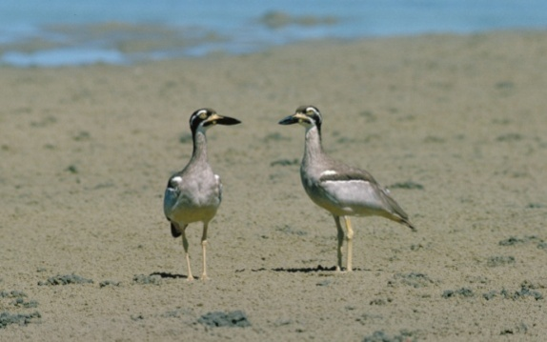
How close can we get?
During the restriction period it is best to stay well away from these islands or beaches. If you need to visit the waters around the islands during the restriction period then, when using a vessel, you must not approach at more than 6 knots within 200 metres of a Significant Bird Site. You must not land on the islands or beaches.
In addition, for three of the islands, East Rock, Edwin Rock and Olden Rock, there is a Boat Free Zone within 200 metres of high water mark between 1 October and 31 December each year.
If you operate an aircraft then you must not operate below 1500 feet (above ground or water) when within 1000 metres of a Significant Bird Site during the restriction period.

Responsible Reef Practices - bird watching
- Land and launch boats well away from any seabirds or shorebirds
- Do not pull dinghies up the beach into nesting areas
- Coordinate the timing of your visit to a bird site with other operators and visitors, minimising how many people are there at one time and how often a site is visited
- Always try to not disturb any birds
- Stay well clear of nesting and roosting shorebirds and seabirds. Remain low by crouching, keep quiet, move slowly and use existing cover
- Watch your step to avoid crushing camouflaged eggs and chicks
- Never try to touch birds, chicks or eggs
- Take particular care at the following sensitive times:
  - Late afternoon and early evening
  - The hottest part of the day
  - Wet and/or cold weather
  - Moonlit nights
  - when eggs, or naked/downy chicks are in their nests.
- If seabirds or shorebirds exhibit stressful behaviour (for example, raucous calling, swooping or 'dive bombing') back away and leave the area immediately
- Do not conduct activities that may disturb birds (for example, kite flying, volleyball, beach rugby, beach cricket)
- Do not use objects that flap or make noise (such as umbrellas or tarps) around nesting or roosting seabirds and shorebirds
- Do not sound horns, claxons, sirens or loudspeakers, and muffle the sound of your anchor chain
- Keep dogs well away from seabirds and shorebirds. Ensure the dogs are kept quiet and on a leash. Avoid taking them to beaches where there often are seabirds.

Marine Parks Legal Requirements
- No one can 'take' birds or their eggs in the Great Barrier Reef Marine Park unless they have a Marine Parks permit.
Note: 'Take' includes removing, gathering, killing or interfering with, or attempting to take. There may be special arrangements for Traditional Owners.
- You must abide by access and speed restrictions at Sensitive Locations at significant bird sites in the Whitsunday Planning Area
- Check your Marine Parks permit for seasonal seabird closures. No one can bring any animals (including dogs) to National Parks and most islands and cays
- Within 7 days of becoming aware that an activity undertaken resulted in an unintentional death, injury, trading, taking, keeping or moving of a bird without a permit, the Secretary of the Department of the Environment must be notified.

Dugong protection
We're very privileged to still be able to see the dugong or 'sea cow' in its natural habitat, and to have one of the world's largest dugong populations right here on our doorstep. Yet, it's a sight that can't be taken for granted. The Reef has seen a dramatic decline in dugong numbers over the last four decades - to the point where the Queensland government has listed it as 'vulnerable to extinction'.
You can be part of the effort to help reverse this worrying trend, particularly when you are boating. Dugongs are particularly vulnerable to being hit by speeding vessels and boating activities in dugong habitat may drive them away and disrupt their social system.
Please take special care when you're travelling through a dugong area - you'll not only increase your visitors' likelihood of spotting one of these magnificent creatures but you'll also help increase the dugong's chances of survival.

Responsible Reef Practices – interactions with dugong
- Be on the lookout for dugong when you're in areas that they are known to inhabit or feed (for example, shallow seagrass beds)
- Slow down your vessel to a no-wake speed (less than 10 knots) in these areas
- Do not approach within 50 metres of a dugong – if a dugong appears closer than 50 metres, move away from it very slowly
- Disengage your propeller, whenever possible, if a dugong appears near your boat
- Do not swim, dive or get in the water with a dugong
- Do not feed, touch, grab, chase or harass a dugong
- Avoid making loud noises and sudden movements when around dugong
- Never separate a female dugong from her calf, with a vessel or any other object
- Provide information about dugong in your onboard interpretation.

Reporting
- Please report entangled, sick, injured, stranded or dead dugong. Please also report if your vessel accidentally strikes a dugong. For details on how to report incidents: http://www.gbrmpa.gov.au/report-an-incident

Marine Parks Legal Requirements
- You must not 'take' dugong in the Great Barrier Reef Marine Park unless you have a Marine Parks permit
Note: 'Take' includes removing, gathering, killing or interfering with, or attempting to take. There may be special arrangements for Traditional Owners
- Within 7 days of you becoming aware that an activity you undertook resulted in an unintentional death, injury, trading, taking, keeping or moving of a dugong without a permit, you must notify the Secretary of the Department of the Environment.

MARINE SAFETY AND EMERGENCY PROCEDURES

Section overview
Important note: A review to the regulation of commercial vessels, including bareboats is underway.

The National System for Domestic Commercial Vessel Safety (the National System) commenced on 1 July 2013, underpinned by the Marine Safety (Domestic Commercial Vessel) National Law Act 2012 (the National Law).

A vessel that is for use in connection with a domestic, governmental or research activity will be a domestic commercial vessel subject to the National Law. This includes a class 4 leisure craft operation (such as a bareboat).

The National Law imposes certification requirements, including requiring that a DCV:
- be the subject of a certificate of survey;
- be operated under a certificate of operation; and
- be manned by crew to hold a National Law certificate of competency

unless the vessel is exempt, or is subject to ‘grandfathered’ arrangements (which will include many vessels that were operating prior to the commencement of the National System).

Through these certification requirements, the National Law requires compliance with certain safety standards. The safety standards that apply to bareboat operations, Parts E and F2 of the National Standard for Commercial Vessels (NSCV), deal with the design, construction and operational requirements for leisure craft, including requirements for briefers.

These standards are under review. Once amended, any new requirements standards will be reflected in this document.

This section will assist you to understand the practical application of the following Queensland state legislation:
- Transport Operations (Marine Safety) Act 1994
- Transport Operations (Marine Safety) Regulation 2004
- Transport Operations (Marine Safety-Bareboat Ships) Standard 2007
- Transport Operations (Marine Safety – Hire and Drive Ships) Standard 2007.
This will assist you to obtain knowledge of relevant industry safety procedures.
After reviewing this section it is expected that you will be able to:
- List potential workplace health and safety issues.
- List onboard legal registration/documentation requirements.
- Describe operational limits.
- Identify personal/company/charterer safety responsibilities whilst vessel is on charter.
- Demonstrate knowledge of procedures for maintaining crew safety/security whilst underway, in line with the WBOA Procedure Manual by listing procedures for ensuring bareboat crew safety/security.
- Demonstrate knowledge of standard industry-based emergency/safety procedures for a bareboat charter, in line with the WBOA Procedure Manual by listing procedures for emergency/safety situations.

Introduction
In 1994 the Queensland Government introduced a total restructuring of the State’s marine safety legislation with the introduction of the Transport Operations (Marine Safety) Act 1994. The major thrust of the Act and the supporting legislation, Transport Operations (Marine Safety) Regulations 2004 is to provide for a high degree of self-regulation by industry. This places increased responsibility on the commercial boating industry and its employees for the monitoring and upkeep of safety standards and practices for their operation.
In line with the Government’s consultation policy, the Whitsunday Bareboat Industry became instrumental in the development of a written Standard. The standards support the Act and provide ways of dealing with the safety issues of appropriately managing the operation of a bareboat ship and safety issues for the general safety obligation on persons involved with operation of ships to operate it safely. The standard does not deal with everything that must be done to discharge those obligations in relation to the safety issues with which this standard deals. Current Standards valid from 2007: Transport Operations (Marine Safety – Bareboat Ships) Standard 2007 and Transport Operations (Marine Safety – Hire and Drive Ships) Standard 2007.
In line with the Government’s consultation policy, the Whitsunday Bareboat Industry became instrumental in the development of a written Standard which, amongst other things (e.g. construction, survey), will determine the practical application of safety standards for the Queensland Bareboat Industry.
The legislation is under constant review and alterations can be expected to improve the Act, Regulation and keep abreast with changes within the Marine Industry.
Both employers and employees within the Bareboat Industry will need to be familiar with the practical application of the marine safely legislation, in particular, the legal responsibilities it imposes on their day-to-day operations and roles.
This section endeavours to take parts of the Act and Regulations that apply directly to bareboating and state them in layman’s term. If you require further clarification or detail you should always refer directly to the legislation.
Copies of the Act, Regulations and Standards can be obtained from the Queensland Government Printer and the Maritime Safety Queensland website:
- http://www.msq.qld.gov.au/About-us/Relevant-maritime-legislation-in-Queensland.aspx

The legislation
The Transport Operations (Marine Safety) Act 1994 and the Transport Operations (Marine Safety) Regulations 2004 provide the legislative framework and heads of power for the development of standards for safety at all levels of the (marine) industry, for regulating those matters which should be regulated, for enforcing those regulations and for fair and proper dealings with participants in the marine industry.

The Act
The Act applies to all ships, boats or water-craft with a home base in Queensland and includes:
- All ships connected with Queensland in or outside of Queensland waters
- All ships in a pilotage area or port
- All ships on Queensland intrastate voyages including when outside of Queensland waters
- All ships on interstate voyages while in Queensland waters
- All ships on overseas voyages while in Queensland waters.
Commercial vessel designers, builders and surveyors accredited by the administration will be obliged to comply with the Act and its subordinate legislation.
Detailed Regulations and Standards have been developed in line with the Act and through active consultation with the marine industry.
The prime objective of the Act is to provide a balance between regulating the marine industry to maintain safety whilst at the same time allowing the industry to develop its own effectiveness and efficiency. Queensland Transport recognizes that the industry does not have an unlimited budget to put in place marine safety facilities. The Act provides a balance between an acceptable standard of safety and cost, allowing industry to take responsibility for its own actions, and in the process, use its own ingenuity to meet the safety obligations of the Act.
Penalties for non-compliance are applicable within the Act and Regulations. Standards provide guidelines on how safety obligations can be satisfied.

The Regulations
The Regulations provide an extension of the Act, and provides detail for application of the provisions of the Act, and penalties for non-compliance. The Regulations deal with:
- Specific safety requirements for all commercial and recreational vessels
- Accreditation of builders, designers and surveyors and building of ships
- Licensing of Masters and crew of ships in Queensland
- Safe operation of ships
- Pilots and pilotage areas
- Authorities (Restricted Use of Flags, Crewing Permits)
- Other marine safety matters (Buoy Moorings, Aquatic Events).

The Standards
While the Act and Regulation are absolute legislation to which penalties for non-compliance apply, this is not the case with the Standards. The Bareboat Standards provide a best practice guide for ship owners, operators, masters and crew members on how to satisfy the general safety obligations of the Act. The Act and Regulations clearly prescribe the mandatory requirements.
Each of the Standards makes provision for a choice to be made (by owner, operator, master etc). The choice is between prescriptive rules laid down (in the Uniform Shipping Laws (USL) Code and National Standard for Commercial Vessels for example) or the application of a performance-based approach by selecting an alternative way of equipping their ships to meet the ordinary dangers of their operation. For commercial operations these apply primarily to Miscellaneous Equipment, Crewing and Design and Building.
Should the performance-based approach be chosen it may be necessary to demonstrate to a Court how the ship was operated safely should a marine incident occur.
A list of Standards can be found on the Maritime Safety Queensland website: http://www.msq.qld.gov.au/qt/msq.nsf/index/legislation.

Applying the Act to the Bareboat Industry
This section outlines some of the more important sections of the Act, Regulations and Standards as they apply to the day-to-day operation of bareboats.
The Act defines bareboats as ‘Class 1F Commercial Hire Ships’. For the Whitsundays, these vessels are broken into two operational areas determined by their size. Bareboats cannot be registered if under 6 metres in length. The maximum size is currently open ended.
Vessels over 6 metres and under 10 metres in length are generally limited to operations within the prescribed Partially Smooth Water (PSW) limits, also known as the Sheltered Water limits. Vessels of 10 metres and more in length may operate beyond PSW limits and within the prescribed restricted offshore limits (Whitsunday Area). For design and equipment purposes this is defined as ‘sea going operations’.
The vessel must be designed, built, stable and have proper safety equipment to the appropriate area of operation.
Whether complete access to these areas is given to the charterers is at the discretion of the operators. For example, even though the limit for ‘restricted offshore’ technically goes as far south as Mackay, there are few companies that allow their vessels to go this far because of the logistics of servicing a vessel in the event of a mechanical breakdown, etc. The same applies to the northern extremities of the area which stretch as far as Bowen.
Be aware that a vessel operating outside its designated area contravenes the Act and may place the insurance policy for the vessel in jeopardy and the operator at risk of litigation. Most insurance policies for bareboats only remain valid if the vessel is being used within its conditions of registration and its operational area. Charterers should be made very aware of this latter point along with their legal obligations to be at anchor from one hour before sunset until one hour after sunrise. These latter times may also be subject to individual companies adopting more conservative time frames for vessel movements.

Understanding the legislation
Apart from the mandatory requirements for safety and fire fighting equipment, the legislation allows operators to satisfy all other safety requirements using either a prescriptive or performance approach.

Prescriptive versus Performance Approach
The USL Code specifies a minimum vessel length of 10 metres for seagoing operations. An owner may choose to apply this prescriptive rule when designing, building and equipping a Class1F commercial hire ship (bareboat charter vessel) for operations within the prescribed restricted offshore limits of the Whitsunday area.
Alternatively an owner may choose to operate a vessel less than 10 metres in length beyond Partially Smooth Water limits. The ship designer, builder and/or marine surveyor may apply another rule or construction standard (performance based approach) to ascertain the sufficiency of the vessel for seagoing operations. In the event of an accident the owner, operator, designer, builder or surveyor may be required to justify their reasons for allowing the smaller vessel to be operated in that area.
Another area often not fully understood concerns the areas of operation for Class ‘1F Commercial Hire Ships’. The above-mentioned operational areas, up to and including the ‘prescribed offshore limits’, and the attendant vessel sizes assumes that the operator has chosen the ‘prescriptive method’ and taken the USL Code as the guide. This determines what vessel sizes can operate in which areas.
If the operator was to select the ‘performance method’ and equip his vessel with the mandatory safety equipment, he could operate any registered bareboat from 6 metres and upwards in any of the three designated operational areas. The difference being that, in the event of an accident, he may be required to justify his reasons for allowing a vessel smaller than that prescribed in an internationally accepted standard (USL Code) to venture into a particular operational area. The onus of responsibility to substantiate his actions falls squarely on his shoulders.

Vessel registration
All bareboats are required to be registered. The official registration number for the vessel is to be displayed on the stern or side in dark letters not less than 75 mm in height.
Tenders should have the word ‘TENDER’ and the ship’s registration number marked along the outside of the hull, above the water-line and in letters not less than 75 mm in height. They can also be placed inside the hull if it is not practical for them to be placed outside.
When 'Tender' vessels are moved from one vessel within a company to another a register or log book should be kept to identify which ‘tender’ is with which vessel. These tenders need to be marked with the owners name or business name, instead of the registration number, and with an individual identifying mark (for example, TENDER TO BAREBOAT COMPANY 1, TENDER TO BAREBOAT COMPANY 2). The position flotation statement for that tender must be carried on the vessel.
In the situation where a new vessel is brought into an operation and registration is delayed, the operator may make application to the Regional Harbour Master for an authority to use a restricted use flag to be issued. This provides an authority that may allow the vessel to operate until registration has been finalised.

Documentation and records
Whereas skippered vessels are required to keep complete servicing records for the vessel onboard, this is not practical in the case of bareboats. These records would normally be kept at the shore base and would include debriefing records, maintenance scheduling and history, etc.
The Regulations require that the following information is kept for each bareboat:

Onboard
- The certificate of Registration for the vessel
- Safety management plan
- Vessel operations manual
- Technical details manual (minimal requirements for charterers use).

Onshore
- Comprehensive technical manuals
- Complete maintenance records
- Certificates of compliance issued for vessels
- Test and service certificates for LPG equipment/installation, fire-fighting equipment, inflatable life rafts
- Ship Inspection Reports.

Safety equipment
Specific items of safety equipment are required to be carried on all bareboats (‘Class 1F ships’). Briefing staff should be familiar with these requirements and the operation and proper storage of this equipment (see Bareboat Safety and Safety Equipment for further detail). Charterers should be made aware of their legal responsibilities to only use distress signals in emergency situations. It is the responsibility of the owner or operator to see that at all times the correct equipment is onboard, well maintained and properly stowed. Where applicable, equipment should also comply with any legal requirements for inspection or age requirement. It is an offence to put to sea in a vessel that does not have the regulation safety equipment onboard.

Responsibilities
Under the Act (section 43) all persons involved in a ship’s operation, including owners, masters and crew all have an obligation to operate a ship safely. This obligation therefore carries on to the charterer (as master) once they are in control of the vessel. Owners and masters have an additional obligation to see that the vessel is in a safe and seaworthy condition. As intended, the Act is clearly laying the onus of responsibility for the seaworthy condition and safety equipment requirements of all vessels on owners and masters.

Operational areas
In the Whitsundays there are three distinct operational areas for bareboats:
- Smooth Water Limits
- Partially Smooth Water Limits
- Restricted Offshore Limits.

Related links
- http://www.msq.qld.gov.au/Waterways/Smooth-and-partially-smooth-water-limits/Swl-bowen-whitsunday-passage-repulse-bay.aspx for details and a map of smooth and partially smooth water limits for the Whitsunday area.

Marine incidents
Within the Act ‘marine incident’ covers a very wide range of occurrences. It can refer to serious injury or death, damage to a vessel, and damage caused by a vessel or a grounding incident (for specific detail refer to the Act). A ‘marine incident’ does not have to result in an accident but can also refer to a ‘close shave’, or ‘near miss’.
Masters of vessels (the charterer in this case) have a responsibility to report all marine incidents. There are specific time limits (48 hours) within which a report of the incident must be made. There are penalties for non-compliance. See section 125 of the Act for specific details.
Examples of reportable marine incidents that could occur to a bareboat are:
- A bareboat runs aground
- A bareboat does not observe properly the ‘rules of the road’ or International Rules for Prevention of Collision at Sea. An example is whilst passing through Solway Pass, it causes a large ferry to swerve to avoid collision, endangering the safety of the 200 passengers onboard. Masters of both vessels have a responsibility to report the incident
- Failure of onboard equipment causing loss of seaworthiness (steering, engine controls, rigging etc.)
- Serious injury to crew onboard or in the water
- Misuse of safety equipment
- Any collision.

Fleet support vessels
It is common for most medium-to-large charter operations to own a high-speed craft to service their vessels in the field. From 31 January 2000, commercial registration and licensing requirements apply to these vessels.

Workplace Health and Safety (WH&S)
WH&S legislation affects ALL Australian workplaces. Preventing or minimising exposure to risk is the means by which we can all meet the obligations of the WH&S Act.
Both employees and employers have a responsibility to see that the workplace is as safe as possible. This means that, as an employee, you are expected to make clients aware of potential hazards onboard a vessel and within your onshore facilities. You also have a responsibility to report rectifiable hazards to your employer. Employers have the same responsibilities and are also expected to make rectifications to minimise risks.
As an example, consider this: You are briefing a vessel and notice that the protective cover for a belt on the diesel engine is missing. This should be pointed out to the charterer and a report made to your employer. It then falls upon the employer to rectify the situation. In this instance, the particular problem is not extremely serious and could be rectified upon the vessel’s return.
A more serious example might be the protrusion of a bolt thread within the companionway. This might be caused by the installation of a new piece of deck gear. Unless the thread is filed flat there is a high risk that a crew member may receive a head injury. This should be reported and rectified before the vessel leaves port.
A more common situation where your responsibility to minimise risk would be exercised might be taking care to explain to the client the potential hazards inherent on any yacht, for example gybing, care with anchor winch, walking on a heeling deck. This decreases the risk of the client having an accident. The end result of these procedures is simple: A safer working environment for all concerned.

Qualifications
To brief a bareboat, the Marine Safety Standard requires demonstrated sufficient experience and knowledge, and if the ship’s length is less than 15 metres, a Restricted Coxswain’s licence, or if the ship’s length is 15 metres or more, a Restricted Master Class 5 licence.
In addition to the above qualifications, the Great Barrier Reef Marine Park Regulations 1983 (Commonwealth) require a briefer to hold:
- A Statement of Attainment from the Barrier Reef Institute of TAFE (39119QLD Course in Maritime Bareboat Briefing Operations) or equivalent
- A Restricted Radio Operator’s Certificate
- An Australian Yachting Federation TL4 Inshore Certificate or equivalent.
Radio operators must hold:
- A Statement of Attainment from the Barrier Reef Institute of TAFE (39119QLD Course in Maritime Bareboat Briefing Operations) or equivalent
- A Restricted Radio Operator’s Certificate.

Bareboat safety and safety equipment

Equipment List for Class ‘1F’ Ships Operating in Partially Smooth Waters and Restricted Offshore Areas (over 6 metres in measured length)
(SAFETY OBLIGATION)

Lifejackets
- One coastal lifejacket shall be provided for each person on board
- Lifejackets are to be fitted with an approved whistle.

Flotation equipment
Flotation equipment for vessels operating in restricted off-shore areas shall be:
Float off appliances sufficient to carry all onboard internally, in accordance with the following:
- Approved coastal inflatable life raft in a weather tight container, stowed on deck in a float free position, with hydrostatic release fitted, OR
- Approved Positive Flotation Tender, (PFT), OR
- In the case of ships less than 15 metres measured length, internal buoyancy as prescribed in section 10 appendix N of the USL Code.
Float off appliances for vessels operating in partially smooth waters shall be in accordance with the following:
- Buoyant appliances as per sect. 10 Appendix M of the USL Code and/or lifebuoys for 100 per cent compliment, OR
- Approved Positive Flotation Tender, (PFT) for 100% compliment, OR
- For vessels under 10 metres, internal buoyancy as prescribed in appendix. N of the USL Code.
Notes:
- Each lifebuoy above the minimum requirement is assumed to provide support for two persons.
- Approved shall mean "Approved by the Chief Executive, Maritime Division, Queensland Transport."
- A ship's tender which is required to have positive flotation is also required to be coloured in a way that helps to make it visible on the water. The tender should also be equipped with:
  - Two (2) oars/paddles
  - One (1) anchor
  - Two (2) red hand flares
  - Two (2) orange smoke flares
  - 'V' sheet
  - Grablines

Life buoys
- 15 metres and over: Two (2) life buoys
- 7 to 15 metres: One (1) life buoy with light
- Vessels under 7 metres: Lifebuoy not required.

Distress signals and pyrotechnics for Partially Smooth waters
- Two (2) red hand flares and two (2) orange smoke flares of an approved type
- Two (2) torches capable of use in an emergency situation
- 'V' sheet
- Lights, shapes and sound signals to be provided as required by the International Regulations for Preventing Collisions at Sea.

Distress signals and pyrotechnics for Restricted Off Shore Areas
- One (1) EPIRB
- Three (3) red parachute/rocket distress flares
- Two (2) red hand flares and one (1) orange smoke flare of an approved type
- Two (2) torches capable of use in an emergency situation
- Emergency portable lighting device for each person onboard
- 'V' sheet
- Lights, shapes and sound signals to be provided as required by the International Regulations for Preventing Collisions at Sea.

Portable fire extinguishers and other appliances
All fire extinguishers shall have a minimum rating of 2A30B(E) and be serviced every six months, in accordance with AS1851.
15 metres and over but less than 25 metres
- One readily available for use in the accommodation and service space.
Less than 25 metres
- Two, suitable for extinguishing oil fires, for use in each space containing propelling machinery.
Note: Where portable dry powder extinguishers are provided in either accommodation, service spaces or in machinery spaces, their number shall not exceed one half of the total number of extinguishers provided in either of those spaces. Where only one extinguisher is required in a space, it may be of the dry powder type.

Fire hose
15 metres and over but less than 25 metres
- One fire hose and nozzle capable of reaching all areas of the ship.
Note: Where portable dry powder extinguishers are provided in either accommodation, service spaces or in machinery spaces, their number shall not exceed one half of the total number of extinguishers provided in either of those spaces. Where only one extinguisher is required in a space, it may be of the dry powder type.

Fire buckets
10 metres and over but less than 25 metres
- Two, nine litre metal buckets with lanyards fitted of sufficient length to reach the water.
Under 10 metres
- One, nine litre metal bucket with lanyard fitted of sufficient length to reach the water.

Miscellaneous Equipment
Alternative A (SAFETY OBLIGATION)
Miscellaneous equipment as required in the Transport Operations (Marine Safety) Regulation 2004 and outlined in section 13 of the USL Code is not mandatory. However, to assist the operator in complying with their safety obligations, Queensland Transport recommends the following equipment be carried:
- Two (2) buckets - metal or heavy duty plastic with lanyards attached
- Signalling torch
- Compass (100 mm card)
- Hand lead line or depth sounder
- Clock and Barometer
- Anchors and cables in accordance with the USL Code, Section 13
- Radio installation in accordance with the USL Code
- A first aid kit to be housed in a watertight container, containing the following:

First aid kit contents | Quantity
Paracetamol tablets (500 mg in foil) | 2 pkt
Adhesive dressing strips 50's | 1 pkt
Conform bandage 5 cm | 2 pkt
Conform bandage 7.5 cm | 2 pkt
Forceps s/steel | 1
Antiseptic liquid 250 ml | 1
Non-adhesive dressing, small | 8
Non-adhesive dressing, large | 4
Scissors, s/steel | 1
Eyewash - 30 ml | 2
Safety pins packet of 5 | 1
Plastic kidney dish | 1
Wound dressing No. 14 | 3
Crepe bandage 10 cm | 2
Gauze swabs in packs of 3 | 4
Adhesive tapes | 1
Splinter probe | 1
Triangular bandages | 3
Sunscreen 15+ | 1
Stingose pump pack | 1
Eyepads | 5
Foil emergency blanket | 1
Disposable gloves packet of 10 | 1
Sterilised absorbent cotton wool | 2 packs
Clinical thermometer | 1
Hibitane solution or equivalent for coral/oyster cuts | 1 bottle
Cicatrin powder or equivalent for coral/oyster cuts | 1 pack
Sterilised absorbent cotton wool | 2 pkts
Copy of St Johns Ambulance manual | 1

Miscellaneous equipment
Alternative B (In accordance with the performance based approach)
An operator may equip a vessel in accordance with the USL Code, sections 13 (Miscellaneous Equipment) or the operator may choose to adopt the performance-based approach outlined in 7.2 of the Transport Operations (Marine Safety- Commercial and fishing ships Miscellaneous equipment) standard, as detailed below to:
- safely navigate the ship in expected weather conditions; and
- safely secure the ship in expected weather conditions, should it be disabled and afloat; and
- enable the ship to communicate with another ship, or a shore-based radio station, in expected weather conditions; and
- give safety, first aid and reasonable comfort to anyone on board the ship; and
- allow anyone unhindered access to and from the ship, including equipment to ensure a person does not accidentally fall off the ship; and
- secure the ship against movement caused by the weather and, in particular, water surges to enable:
- someone to embark or disembark safely; or
- cargo to be transferred to or from the ship safely; and
- indicate weather changes within the ships operational area.

Safe operation/stowage
Prior to the commencement of any briefing, the safety gear and its proper stowage should be checked by the briefer. During the briefing the charterer should be shown the location of all safety equipment. Its operation should be described and the clients encouraged to read any onboard safety instructions and operations procedures for the equipment.

Crew security
The often inexperienced nature of bareboat charterers means that effort should be made to familiarise clients with potential hazards caused by a rough sea and/or the deck of a heeling vessel. This may be as simple as making all the crew aware of the importance of maintaining one’s balance through the use of handholds, taking care whilst moving below, to methods for creating a more stable work platform whilst performing necessary deckwork (e.g. levelling the deck surface by heading off the wind while reefing in deteriorating conditions).
Children require special attention as adults may not be taking into account their differing safety needs due to:
- Poor swimming skills
- Undeveloped balance skills
- Lack of personal safety concepts.
Encourage parents to develop a simple set of rules which govern the child’s movement whilst underway and also at anchor. For instance, it is a good practice to confine the younger members of the crew to either a cabin down below or within the cockpit when activity is at its busiest (arriving and departing an anchorage). At these times crews need to be concentrating on a wide range of activities from navigation to sail setting. Once underway and in smooth conditions children may be allowed on deck (out of the cockpit) in the company of an adult. A simple jackstay could be set up with spare onboard line and charterers encouraged to provide harnesses for their younger crew. There are many schools of thought about what lengths parents should go to secure a child’s safety onboard. It is the briefer’s task to make parents aware of the potential hazards for small children and how they can minimise the risk, for example:
- Assisting safe movement above and below decks- companionway steps, handholds, heeling etc.
- Safety gear-life-jackets for children, jackstays, harnesses
- The dinghy- safe travel, loading, balance
- Setting some safety rules for kids
- ‘No go’ areas- anchor winch, primary winches, BBQ.
This doesn’t mean that a child should spend the entire trip enshrouded in a ‘Mae West’ and tethered to the base of the binnacle, but it does mean that all clients should be made aware that a child is more liable to incur injury if unsupervised and that, once overboard, the chances of a tragic outcome are very high.
Finally, mention should be made of a safe approach to swimming from the vessel. With children, a continuous watch should be kept and it is preferable that, even with adults, all members of crew should not be in the water at the same time.

Adverse conditions
In the Whitsundays, there are two types of common inclement weather situations that should be addressed during the briefing - rain and strong wind. Apart from making the vessel a little damp down below, the major cause for concern with rain is the loss of visibility. The Whitsundays are well known for sudden rain squalls which can quickly blot out visibility, while at the same time creating a rapid rise in wind strength.
Both can unsettle the nerves of even experienced yachtsmen. Potentially, a charterer is suddenly confronted with not only being unable to see the surrounding land/coral but the vessel may also be becoming un-manageable and require reefing. This is a sure fire recipe for disaster if the charterer has not pre-planned a response to the situation. The briefer can avert this uncomfortable position for his client by discussing the importance of always having a contingency plan in place such as:
- Encouraging a conservative approach to sail setting at all times in line with charterers’ experience and level of crewing
- Observing approaching rain, noting compass course and sighting nearest danger in plenty of time therefore alleviating the concern of proceeding with limited visibility
- How to heave-to to reduce forward movement
- Reefing in anticipation (‘better to be safe than sorry’).
Strong wind conditions generally only provide problems for two reasons. Firstly, the vessel feels out of control if too much sail is being used. Secondly, the crew may feel insecure due to rough conditions experienced in wind against tide or head seas. It is essential that charterers feel comfortable with the reefing process and understand that in most cases the initial reduction in sail area must be from the mainsail. This latter point is often not stressed enough. Consequently the headsail is often furled first. This has the effect of reducing heel but not weather helm .How charterers choose to approach rough sea conditions is very much a personal decision.
- Encourage skippers to take into consideration the comfort of the crew, keeping in mind that an enjoyable holiday is the aim of the charter and not a masochistic plunge to windward.
- Easing a course by ten degrees often has a dramatic effect on the general comfort level when pushing into a head sea.
- Other tactics that can be employed include motor sailing under reduced mainsail, seeking an alternative anchorage and anchoring for a break and a change of tide.

Navigation/pilotage
Owing to the numerous navigational marks, close proximity to land and clearly defined topographical features, navigation in the Whitsundays is primarily achieved with the use of pilotage. This is the use of known land- or water-based marks in close proximity to determine approximate position.
Briefers should not attempt to provide a lesson in coastal navigation techniques to charterers. Time does not allow it within the normal constraints of a briefing. If you feel that the client is incapable of safely navigating his way around the islands then it may be time to call upon the services of a sail guide, or to lengthen the briefing.
The following concepts need to be fully understood by the charterer to carry out basic pilotage:
- Orientating oneself using a chart/map/compass
- Identifying landmarks and hence position
- Measuring distance on a chart
- Using references – 100 Magic Miles, tidetables, IALA Marks
- Pre-planning.
The specific details of a local area briefing are covered in the Local Knowledge section.

Industry safety procedures
The Whitsunday Bareboat Operators Association (WBOA) has an ongoing commitment to developing safety procedures for all facets of bareboating. The procedures are documented in the WBOA Staff Procedure Manual, and to date they include comprehensive policies for dealing with:
- Heavy weather
- First aid
- Grounding
- Fire
- Pollution
- Man overboard- Instigating a search
- Keeping records - mechanical, marine incidents, radio, etc
- Medivac
- Rigging failure
- Disabled vessel
- Collision.
Staff who come into contact with charterers, whether directly or over the radio, should make themselves familiar with all the procedures. The Procedure Manual should be kept in an obvious location in the main office and close to the base radio.

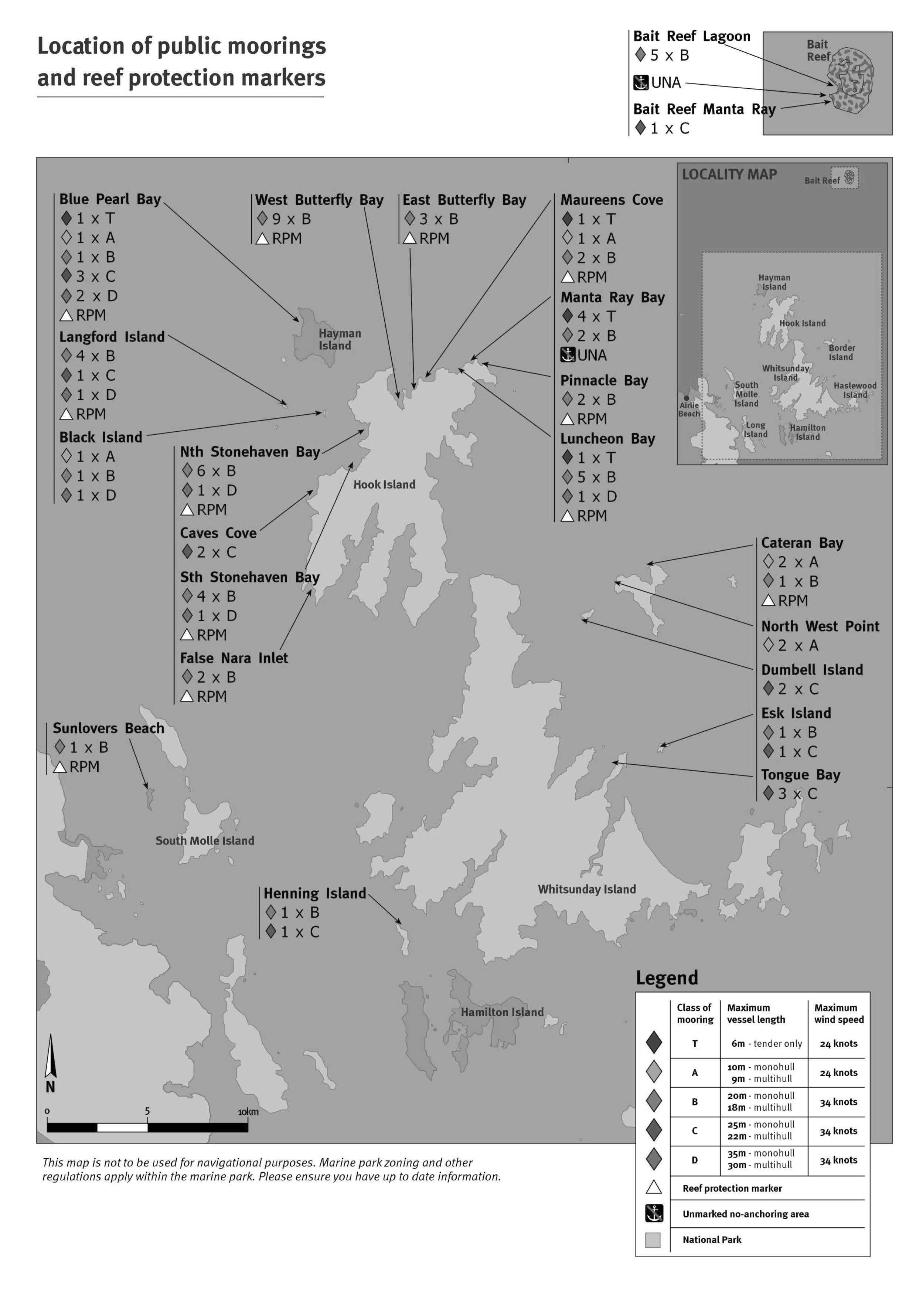

COMMUNICATION

Overview
The Whitsunday area is part of the World Heritage listed Great Barrier Reef Marine Park. This unique, diverse and spectacular stretch of coastline is a fragile ecosystem that brings nature to the door step of development and human recreational activities. Creating respect and understanding among bareboat charterers about the significance and sensitivity of the coastline, islands and waterways is a great responsibility for briefing staff. To promote and encourage safe and environmental best practices the Briefing staff and Radio Operators require an understanding of the natural environment and local knowledge for the Whitsunday waters applicable to bareboat charters.
This section outlines the minimum standard of communication skills required for successful bareboat briefing and associated radio operation.
It includes the use of communication and demonstration techniques you require to deliver a bareboat briefing in accordance with the industry best practice standards. Such techniques as:
- Using client feedback to determine level of boating competence
- Modifying presentations according to client needs
- Using client feedback to determine understanding
- Identifying barriers to good communication
- Giving a presentation in line with the Bareboat Industry briefing proforma
- Preparing for a briefing-company, client and vessel details.
As a bareboat operator, briefer or Radio Operator you are required to demonstrate knowledge of radio procedure in line with the WBOA Staff Procedure Manual. Procedures you are expected to demonstrate include:
- List procedures from Procedure Manual
- List responses to difficult calls

Remember, it’s not what you say but how you say it.
The sun blazed down out of a clear blue Whitsunday sky. Initially the crew of the Squallus listened intently in the cockpit to the briefer as he identified, by their correct names, all the components of the deck layout and demonstrated their purpose. After 20 minutes frazzling in the sun the charterers’ concentration level was at an end. Some of the crew, clearly hot and bored, drifted down below under the pretext of ‘packing the food’. The others were confused and threatened by what appeared to be a very complicated piece of machinery.
For the rest of the briefing the charterers feigned understanding. As they passed Funnel Bay on their first day out, and having forgotten the reefing process, they suffered a knockdown under full sail which scared everyone. At the insistence of some of the crew it was decided that they only use the sails in less than 15 knots of breeze. They may as well have hired a power vessel!
This may appear to be an extreme example of an unsuccessful briefing, but it demonstrates how bad communication and presentation can not only create poor customer relations, but can also lead to unnecessarily dangerous situations, and spoil what otherwise could have been a successful holiday.
Those involved in client contact within the Bareboat Industry are required to call upon a wide variety of communication skills. Diverse standards of client boating experience, language difficulties and time constraints are just some of the difficulties that can combine to put pressure upon briefing, radio and administration staff. Your ability to understand your client is paramount. It doesn’t necessarily follow that being a proficient sailor will make you an equally adept communicator.
We all have the ability to communicate with those around us in a way that is either clearly understood or totally confusing. We’ve all watched someone giving careful instructions only to see the trainee carry out exactly the opposite of what was intended. You probably even unconsciously thought how you might have done it better. You might have used clearer language, a friendlier approach, slowed down your presentation or provided a little more detail. If you start looking for those around you who are effective communicators, you’ll be well on the way to improving your own skills as a briefer.
The purpose of this module is to assist you to develop communication techniques that can be applied directly within the Bareboat Industry. Using tutorials, discussion and role play, you will gain first-hand knowledge of desirable communication methods.
This section of the Learning Guide should be read in its entirety prior to attending the lecture/tutorial. Ideally, after completion of this module, you will continue to improve your professional standing through regular personal analysis of your own communication techniques.

Planning for effective communication
Whether you are carrying out a vessel briefing, talking to a prospective client on the phone or dealing with a worried charterer on the radio, being well prepared will give you the edge. Nothing is more obvious than trying to talk with authority about something you know little about.
If you are new to bareboating you may be a little nervous at potentially having to deal with some awkward situations, either during a briefing or over the radio. Improving your own personal confidence will go a long way towards assisting you to provide an excellent standard of service and instilling confidence in your clients.
Adhering to the following guidelines can help increase your confidence and level of knowledge:
- Be prepared
- Become familiar with your briefing vessel
- Walk onboard noting any points that are liable to be of interest to the charterer (headroom, toilet/showers, size and number of bunks etc.)
- Observe details that may make the vessel easier or harder to operate for the average charterer (e.g. reefing/anchor systems, electrical switching systems, engine operation)
- Locate and familiarise yourself with ALL the onboard equipment that you will be required to demonstrate or display, particularly safety gear
- Know your company’s brochure. It contains plenty of important information specific to your company and is often the main piece of documentation that the charterer has relied upon to purchase the holiday
- Dress professionally-A picture tells a thousand words, and the charterer will make an assessment of you before you even speak. Dress to make his or her assessment favourable! A neat and clean uniform and deck shoes will certainly create initial confidence in your charterer.
- Become familiar with your company’s dress standard
- Determine your client’s entry level. The entry level of the charterers is a combination of the level of boating knowledge within the charter party along with any other human factors which may impede or result in a change to the normal progress of a briefing
- For example, someone from overseas with a limited grasp of English and a basic level of sailing expertise will require you to exercise care when giving verbal instructions. You may have to spend more time getting demonstrable feedback from your charterer to assure you of their understanding. Once familiar with the charterers' entry level you are well placed to pitch the briefing at their level of competence.
Other factors which might affect the entry level of your client might include:
- Physical impediments (hearing, restricted movement, sight, etc.)
- The presence of only one member of the crew with any experience.
To determine the entry level:
- Find out as much as you can before the brief about the chartering party’s past sailing experience, where they’ve come from and how they enjoyed their trip to the Whitsundays
- Make your questions part of a friendly discussion rather than rapidly firing off one question after another. The latter can often serve to make the charterer feel that his boating competence is being brought into question or that he is part of an inquisition!
- Gaining an initial insight into competence levels and characters will allow you to determine how long the briefing may take. Limited experience will generally mean at least three hours briefing time whereas a highly experienced group of past charterers may allow you to shorten certain aspects of your brief.
- Prior knowledge will also give you some information that allows you to establish empathy with your charterers as soon as they arrive. Ask them about their trip or home town
- Discuss their past boating experiences or details of the vessel they may have at home.
All this will serve to break the ice while at the same time providing you with further details about their boating background. If you still feel you do not have enough specific details to determine their yachting experience then ask questions that get you the right answers such as:
- Could you fill me in on your past boating experience (don’t just include sailing here but also power boats and dinghies. Any time on the water serves to teach boating skills)?
- Have you skippered vessels or just generally been crew (ask all charterers)?
- What experience does the crew have, if any? Understandably, with only one experienced charterer your briefing will then need to allow for a proper briefing of the crew.
Be flexible. Factors which are often beyond the control of either the briefer or client may also cause either a delay or change of plan. These might include:
- Time constraints (late in the day, shopping incomplete)
- Deteriorating weather (poor weather makes it harder to sail brief and in some instances inadvisable)
- Problems with the vessel (mechanical delays).
By the time you and your party step onboard you should have achieved:
- A friendly rapport with your charterers
- A sound basic knowledge of your product
- An appreciation of your charterers’ entry level.
Finally, in almost all instances your chartering party will regard you as a crucial source of local knowledge, a competent sailor and totally conversant with the vessel you are briefing. As important a reason as any to be properly prepared!

Effective briefing
As a Bareboat Briefer you play a pivotal role in the success of a charter. During a briefing you are the main link between the company and the charterers and the charterers and their vessel.
You not only control the potential success of the charter but, most importantly, you have a legal obligation to see that the charterer is fully versed in all the safety and environmental aspects of chartering a bareboat in the Whitsundays. That responsibility also extends to informing the hiring company if there is any doubt as to whether the charterer is capable of taking command of the vessel. The company can then arrange for a Sail Guide to assist the charter party.
If you’ve prepared properly (see Planning for Effective Communication), then you’re starting from a position of knowledge and you’re in control. It’s now just a matter of presenting your information effectively.

A well-constructed briefing
The correct learning environment
Put simply, this means is everyone comfortable, ready to listen, and have you got the vessel ready (are the requirements for the navigation and local waters briefing on the chart table, safety gear located and checked and all major systems on the yacht tested/inspected for proper operation)? Leaving a crew of six on a hot summer's day in the cramped confines of the cockpit without a bimini while you go looking for the area briefing texts will hardly create a positive learning experience.
Brief at the right level
Always allow for the client’s level of boating competence. You would not be endearing yourself to charterers with 10 years of sailing experience in coastal cruising if you asked them to demonstrate reefing the main if the system is identical to their own. A couple of simple questions will let you know the charterer’s level of understanding and locate any components that may be different to their own vessels. However you might feel, after the charterers’ answers, that have rarely reefed their own vessel and that it would be in their own best interests to assist you in a demonstration.
On the other hand inexperienced sailors are going to feel extremely unsure if you merely describe reefing without getting them to carry it out.

The Briefer’s Rule
Use the Briefer’s Rule -tell them what you are going to do, do it, and finally summarise what you’ve done.
Keep this motto in mind while carrying out your own demonstration and consider having the charterers assist you to reinforce your point. Then, to summarise certain areas of your brief while having your charterers feed back their level of understanding, have them provide a demonstration after your explanation/demonstration. This is particularly useful when applied to safety procedures.
The following could be demonstrated by the charterers:
- Correct operation of the VHF (do a test/imaginary call)
- Anchor winch operation (raise and lower the anchor)
- Reefing (put in the first reef/furl the headsail whilst underway)
- Operate the engine (start/stop/engage gears)
- Onboard appliances (operate the stove/toilet/etc.)
- Deck gear (load and tension/release the primary winches)
- Sailing (carry out basic sailing manoeuvres)
- Operate the dinghy.
All these operations should be done unassisted to both summarise your demonstration and feed back to you the charterer’s understanding. If time permits you may work other demonstrations by your clients into the brief.
Remember, you are missing one of the major objectives of your brief if you do not include the opportunity for your charterers to show you they know how to carry out major aspects of the vessel’s operation. Misuse of the VHF, inability to safely reef, and dragging anchors are only some of the results that can usually be attributed to briefings being either misunderstood or incomplete.

Timing your brief
Your clients will often have travelled for many hours, and some with cranky children, before they get to you. They will also be keen to get underway while at the same time, trying to draw together all the last minute details (provisioning, briefing, buying film, posting mail, dressing in cooler clothing). Attention spans, tiredness and worrying about other things can all reduce the effectiveness of the brief. Be aware of this and offer solutions for the charterers (e.g. do sail the next day to lessen impact, have breaks, finish all shopping prior to start, take a sail guide, and select a close convenient anchorage).

Sequencing
Develop a logical approach:
- Down below (bow to stern)
- On deck (cockpit to bow)
- Area brief
- Paper work
- Sail brief.
Try and have a short break between each portion of the brief, particularly if there are children involved or you can see attention spans waning (yawning, loss of concentration, fidgeting etc).

Offer service
As a representative, primarily for your company and secondarily for Australian tourism, you need to be able to:
- Show genuine concern for your client
- Appear pleasant and cordial at all times
- Look at things from your charterer’s point of view
- Offer assistance and solutions whenever possible.
Some mistake the above for sub service. They are no such thing. These are characteristics of someone who aspires to a high level of service. They help to create a pleasant working environment and one in which the client feels welcomed and comfortable.

Debriefing
Debriefing at the completion of a charter provides valuable feedback from your client. Be prepared to listen courteously and make note of suggestions. To view the debriefing as merely a formality and not an opportunity to continue to develop a positive rapport and reputation for your company is wasting an excellent opportunity.

Communication barriers
There are numerous barriers which can create an environment that either lessens or totally negates your ability to communicate clearly and effectively with a charterer. The most common are as follows

Terminology
If you have taken the trouble to discuss previous boating experience with your client this should not cause you problems. Boating terms can be extremely confusing and even intimidating to the novice. Never be afraid to ask your charterer if you are using terms that they find confusing. With experience you will easily be able to determine a suitable level of terminology.
Don’t get caught up in the ‘old fashioned sailor’s brigade’ who would insist that all ropes are called by their correct names and that the ‘pointy end’ is always referred to as the bow.
The aim of the briefing is to make the charterers comfortable onboard and familiar with the vessel’s operation. If they are happier referring to the starboard genoa sheet as the ‘right hand winch rope/line’ then let them do it! Proper terminology comes with years of experience. Now is not the time to be a stickler for yachting protocol.

Language
With the increasing numbers of international charterers it is becoming commonplace to brief charterers with varying degrees of competence with the English language. You need to adjust both the speed and the complexity of your language to suit. A German or Italian with a smattering of English will quickly be confused if you deliver your standard briefing at full pace. Slow down your presentation, simplify your language and get regular feedback from your charterers to ascertain that they have understood.
You might also choose to use more hands-on demonstration than normal to get your message across e.g. rather than describing the operation of the gas stove, have the charterers operate it after you have explained. You should allow for a longer brief than usual.

Comfort
Make sure that at all times your party is as comfortable as possible if you want to maximise their attention spans. Try not to talk for more than 10_15 minutes without a break or a change to a different activity. This will help to keep interest levels high. Make sure that the crew are seated or standing comfortably. Avoid long periods of time in direct sun. In summer, a break for a drink is greatly appreciated (non-alcoholic). Charterers from colder climes will almost always wish to change into cooler clothing.
Most companies do not allow smoking down below on vessels and this should be mentioned to charterers. Briefing staff should not smoke during a briefing.
Include everyone. It is not uncommon to find one or two of the crew have the majority of the boating experience onboard. This doesn’t mean that the rest of the crew is not keen to learn. In fact, to include everyone is to introduce them to what may become a lifetime of enjoyable boating and to make them a useful member of the crew. SAILING IS FUN! To be relegated to galley slave is no-one’s idea of a great holiday. Never fall into the trap of apportioning male and female roles onboard. Society demands an even-handed approach and, in fact, you may easily offend if you even lightly joke about gender roles.
In some rare instances (a large crew with plenty of experience onboard) and with everyone’s agreement, you may feel it necessary to send some of the crew to complete the shopping whilst the others are briefed. This should only be the onboard briefing and never the sail brief when all should take part. Keep in mind that the identification of all onboard safety equipment to ALL charterers is an important safety obligation for briefers.

Be courteous
You will meet a wide variety of sailors and would-be sailors while briefing. A few will be highly competent, many will be casual weekend sailors and some will be totally inexperienced. In nearly all cases they will be enthusiastic, keen to learn and not a little fearful of what to them is a ‘great adventure’.
Occasionally you will come across a client whose actions or attitudes are totally unsuitable or even downright rude. Grin and bear it. Never allow your negative emotions to surface and, it should go without saying, profanity is unacceptable in any circumstances. There are many ways to say ‘no’.
The charterer who is becoming irate that he is not going to get out of the marina that night will generally accept his fate when confronted with a smiling and commiserating briefer informing him that not only would he be jeopardising his insurance policy to travel after dark but also the safety of his wife and family. In the meantime you might also suggest some alternative activities for his family onshore. Safety at all times must be one of the driving forces behind your approach to many aspects of briefing.
Try to avoid using terms that are negative ("No, it is not possible"; "You are wrong"; "We don’t do that here"). Instead try a more positive response ("I’m not sure if we can do that but let me look into it for you"; "It’s a real shame that you can’t go there but have you thought of Palm Bay as an alternative?")
To join your client in ‘losing your cool’ merely creates a loggerhead situation from which it is extremely hard for either party to withdraw.

Irritating habits
Irritating habits are numerous and vary from positively unacceptable to mildly annoying. Some that come to mind and that are particularly applicable to a briefer include:
- The ‘know it all’
- Talking over the top of people
- Taking control all the time.

Body language
What you ‘say’ with your body may send a clearer message than what you say with your voice. Remember only up to one third of a message is conveyed verbally. The rest is up to non-verbal communication. Some of this non-verbal communication involves:
- Using your smile regularly to create a pleasant and friendly atmosphere and to re-assure an uncertain charterer.
- Respecting personal space. Human beings generally have an invisible ring around them within which they feel uncomfortable if a stranger enters. Down below on a yacht this can sometimes be a little hard to avoid. The situation can often be alleviated with a joke and friendly approach. Touching is a very intimate action and is often regarded as an invasion of one’s personal space.
- Using eye contact to re-assure people of your genuine interest and friendliness. To avoid eye contact may be perceived as a lack of confidence and even arrogance. Be aware that some cultures also regard eye contact as a sign of disrespect or rudeness.
- Demonstrating boating equipment.

Your voice
As much of your briefing will be done in close proximity to the charterers, it will rarely be necessary to raise your voice whilst down below or on deck. During the sail brief it may be necessary to give firm and audible instructions because of the increased noise level (wind/water etc.) or to convey urgency in safety situations. Avoid shouting and, in particular, using voice techniques (volume, intonation) that convey anger, annoyance, sarcasm etc. As mentioned earlier (Language, page 44) your pace of delivery may be too fast for some members of the crew and you should slow down and re-explain accordingly. This particularly applies when charterers are in a situation they may find a little unsettling or challenging (e.g. during a sail brief in stronger winds).

Client questions
Make sure that you allow a portion of your briefing time for questions. You may choose to do this at the end of each section of the brief (below decks, on deck, area and sailing) as this will allow your client to ask questions relating to that information that has just passed.
Encourage, and show interest in, their questions and if you are not sure of an answer agree to get a satisfactory response before the vessel departs on charter, or at a mutually agreed time.

The radio
Skilful communication over the radio comes with practice. It is important to realise that radio uses only one of the senses – hearing. As humans, we constantly make use of all our senses to communicate effectively. Therefore it becomes critical that what you say on the radio and how you say it provides the charterers with a clear and concise message.
Confusion can quickly come to the fore if radio reception is poor, your message is confusing or too technical, or either party becomes emotional.

Communication during the charter
Bareboat charters are often seen as an opportunity for people to get away... from phone calls, emails and other similar forms of communication. Charterers need to understand the importance of the VHF marine radio for their charter.

Charterers need to know:
- The correct way to use the various functions of the VHF marine radio fitted to the vessel they have chartered
- Your charter company's daily radio schedules, timing of weather schedules, what to do if the charterer misses scheduled radio contact, and what will happen if the charter is not able to be contacted
- What to do if the charterer needs to contact the charter company when the charter company office is unattended.

Emergencies
True emergencies are a rare occurrence in the Bareboat Industry. When they do occur you need to be prepared and have a set procedure for dealing with them. You should make yourself familiar with the WBOA Staff Procedure Manual which explains in detail the standard procedures for dealing with urgent and emergency situations.
Emergencies can come in many forms (cyclones, fire, sinking, medical, criminal, etc.). Commonly, what may initially appear to be an urgent situation is often a case of worry on the charterer’s part (e.g. anchor dragging, reefing in increasing wind, engine failing to start, etc.) and can be quickly alleviated with some re-assurance and clear instruction.
Learn to recognise the signs of a charterer making a distressed radio call (high pitched voice, fast talking, shortness of breath, emotiveness, etc.). In your response call you should take control and re-assure. Deliberately focus on remaining calm. This will rub off on the charterer. Speak slowly. Determine the exact nature of the emergency and the position of the vessel. Once you are sure of this information you can determine what emergency procedures need to be put in place (e.g. ambulance, fire fighting, evacuation).
The present position of the vessel allows you to assess whether the vessel is in immediate danger of grounding and gives the emergency services or service vessel an accurate point to head for. Try and make sure at least one other staff member is listening (two sets of ears are better than one!). If necessary, remind charterers of the safety equipment onboard and suggest they use it or at least have it to hand. Keep up regular contact with the vessel to reassure them and to keep them posted on any developments. Let them know that you are always ‘standing by’ if they want to call. DO NOT LEAVE THE RADIO. If you must, at the very least have someone stand in for you.

Be assertive
At times it may be necessary for you to remind charterers of company policy, safety requirements, or to even ‘draw the line’.
Instances where one of these actions may be necessary might include:
- Times at which vessels must be at anchor
- Sailing when imprudent (strong winds, wind against tide, sailing beyond capability)
- Incorrect anchorages
- Swearing/abuse on the radio.
In most instances you will be able to refer to what will have been covered in the briefing and suggest that this is adhered to. It is often useful to mention to charterers when regulations or policies are safety related (which is almost always the case) as this will often diffuse the situation and leave the client with no room to argue.
The right way -"John, it is very important that you relocate your vessel to a safer anchorage as soon as possible as you will find that, not only might it become very uncomfortable in Saba Bay tonight it, but it is also extremely dangerous with the wind blowing you onshore".
The wrong way – "I said on this morning’s sched that you shouldn’t anchor there. I would appreciate it if you took my advice in future. You had better move straight away".

Be clear and concise
This is especially important over the radio when you are giving instructions or determining the extent of a particular situation (e.g. a charterer expresses concern about getting his anchor to set in increasing wind conditions). In these instances the charterer is likely to be a little nervous and therefore less able to fully comprehend lengthy descriptions of say, the anchoring process, over the radio or answer three different questions fired at him simultaneously.
Ask single, short questions to build up a picture of the situation. Having positively identified the problem, go on to give any instructions in simple terms and, if possible, by getting the charterer to confirm the situation back to you and what he is going to do after you have instructed him (using the Briefers’ Rule) (E3b).

Problem solving
Probably the area that creates the most confusion and misunderstanding for both charterers and hirer alike is when determining the cause or type of a mechanical problem over the radio. Ask short and simple questions, using terminology that won’t confuse, to build up a picture of the problem. Explain that you are going to go through a simple testing procedure which should clarify the cause of the problem.
The charterer then understands you are going to approach it professionally with a planned approach. For example, in the case of a water pump not automatically priming and switching itself off, you might use a series of questions which eradicate all possible causes one at a time:
"Is any water being pumped when you switch the tap on?"
Unless the diaphragm on your pump has failed, which is very unlikely, no water being pumped almost certainly points to an empty tank or airlock. At this early stage it is very important to make sure you always have a good grasp of the symptoms before trying to diagnose the fault:
"How long have you been operating on your present water tank?"
To determine whether the water tank is empty, you might use the in-office vessel service manual to assist:
"Have you recently changed over water tanks?"
To determine whether an air lock has developed:
"So you’re saying that the pump is pumping water, but when you switch it off, the pump motor just keeps on running?"
This provides a summary of what the charterer seems to be saying and clarifies it in simple terms for them so they can confirm. It will also confirm the problem as probably being a failed micro switch:
"Ok, John, it appears you have a failed micro switch. It should only be a minor inconvenience, and you can override it by simply switching the pump off at the switchboard when you finish using the shower or sink".
Unless you are familiar with the vessel’s operation, for most mechanical problems it would probably be best to have a company mechanic on hand.

Develop rapport
Courteous and pleasant radio technique goes a long way to keeping your client happy out on the water. As your only means of communication once free of harbour, it provides an excellent opportunity for your company to continue to develop a positive relationship with your client. Provide friendly re-assurance when needed, smile while you are talking (you’ll be amazed how this can transform your voice) and continue to provide the same standard of service through your radio procedure that you did during the briefing.

VHF marine repeaters
The proper use of repeaters can only be achieved if their capabilities and positions are fully understood. Note that at present the following marine repeaters are in operation in the Whitsundays Ch. 81, Ch. 82. For ‘line of sight’ communication the following should be used Ch. 08, Ch. 10, Ch. 11, Ch. 77 or Ch. 74.
Repeaters are not for the exclusive use of the charter industry and, in reality, are community owned and for all to use. They are maintained by Volunteer Marine Rescue organisations along the Queensland coastline. Your client has been given special dispensation by the Australian Communications Authority for limited use of a VHF radio for communication with his company’s base station (this assumes that the charterer does not have his own personal radio license).
Make your clients aware of this and encourage them to be brief with their transmissions and to avoid using the radio for inter-vessel chatter.
Just as all VHF signals are ‘line of sight’, the repeaters also have a finite range. Become familiar with the range of each repeater and their areas of useful operation (see Appendix for map). Make sure your charterers are also aware of these limitations. As each repeater is battery powered, they are equipped with automatic cutouts which limit the time any one party can talk and the use of valuable power.

Planning for effective communication
The following topics focus on major aspects of good communication technique. They can be discussed in small groups and your findings should be presented to the course members.
- Apart from what you say, what other variable factors effect the success of your briefing (e.g. smoking - not generally tolerated and creates a passive threat to health)?
- Can you think of situations you have observed or been involved in where, due to lack of good communication, a mistake was made, inconvenience experienced or safety jeopardised (this needn’t be anything do with bareboating)? Discuss what communication skills/techniques could have been used to avoid the situation.
- List the most important aspects or key points of a vessel briefing. When can you afford to leave some lesser aspects of a briefing out and what would they be?
- Charterers often comment on the excellent radio operating techniques of particular companies. What skills/techniques do you feel they may be referring to?
- Providing an operation summary of some of the more important pieces of gear on a vessel can often help reinforce a procedure to a charterer and re-assure the briefer that nothing has been left out. Design a 3_6 point summary for the safe operation of a primary winch. What other vessel systems could benefit from a point-form summary?

Case studies
The following case studies can be used to stimulate discussion and help identify desirable responses to common situations.

A vessel is lost
- It is 3.30 p.m. in winter and a vessel has called up unable to determine its position. Wind is light from the southeast. The vessel departed Nara inlet at 1.00 p.m. on a falling tide (LW 1730h) to head back to Shute Harbour. You are concerned that you cannot get them to a safe anchorage before dark, let alone confirm their position. They have noted some buildings on an island to their southwest. From their log they can confirm an average speed of 3 knots.
- What further information do you need? What are your options? How do you re-assure the charterers? What VHF channel should you be on? Role-play a successful conclusion.
- What may have been missed during briefing?

In the wrong place
- A charterer calls up at 3.30 p.m. and asks to go into Gulnare. Tide is one hour from a spring low. The charterer is a keen fisherman and is on his/her last night before vessel return. The charterer was looking forward to fishing at Gulnare.
- Can you offer a solution that sees all parties happy? What must you communicate to the charterer (e.g. alternatives, problem with tide, lateness of day)? What response might cause client dissatisfaction/annoyance as opposed to a more positive reaction?

Disorganised charterer
- You’ve just arrived at the vessel to find only half the party onboard, some are off finishing; some shopping and others are taking in the sights of the new marina before proceeding onboard. You know that time is limited and that it is fast approaching 12.00 p.m.
- How can you diplomatically gain control of the situation, making the charterer aware of your constraints and putting the onus of responsibility back on the charterers shoulders?

The experienced charterer
- Two couples are being briefed when, after 10 minutes of cockpit demonstration, the one charterer with good prior sailing experience starts to show signs of impatience. You know that the others are all very inexperienced and will require as much tuition as you can give. On the other hand, you cannot afford to have the _skipper_ loose his cool. What can you do to keep all parties happy?

Put yourself in their shoes - activities
The aim of role-playing is to introduce real-life situations as authentically as possible within a classroom environment. This provides, excellent opportunity for participants to exchange views, improve technique and appreciate other points of view.

Scenario 1
A young couple has chartered a 28’ sailboat. They have limited experience, mainly dinghies and lack confidence. Their knowledge of correct terminology is limited. You have commenced the briefing and are now moving to the cockpit to start on deck. Your first demonstration is the operation of the winch.
Aim to adapt your level of instruction to their experience level by focusing on:
- Correct language
- Complex/simple explanations
- Best areas of presentation
- Improvements
- Feedback from charterers
- Other types of ‘confusing’ yacht gear.

Scenario 2
You are demonstrating the operation of a toilet to a group of four charterers on a 28’ yacht.
The heads is cramped and not all of the crew can see you at the same time. Role-play how you would deal with this situation and give a demonstration. Assume that none of the group has used a marine toilet before. Can you use a summary at the end?
Aim to adapt your level of instruction to their experience level and cater for the lack of room below on a small yacht and focus on:
- Complex/simple explanations
- Best areas for presentation
- Best technique for demonstration to all crew
- Faults caused by incorrect use.

Scenario 3 - Fears
It is a common for novice sailors to feel scared. Try to identify this fear early on and address it straight away.
One of the crew has expressed that he is worried that the yacht may ‘tip over’ in strong winds. Think about this reaction and how you as a briefer would deal with it. Aim to acknowledge concern, create confidence and give clear explanation. Focus on:
- Correct language
- Complex/simple explanations
- Best areas of presentation
- Improvements
- Other fears.

Scenario 4 - Determining entry level
In order to pitch your briefing at the right level you must first determine who you’re dealing with.
You’ve inspected the charterer’s booking details and found out as much as you can prior to their arrival. The charter party has just made themselves comfortable down below and is waiting for you to start. Determine the entry level of the group and then explain to them how the briefing will proceed. Aim to determine entry level and focus on:
- All necessary information obtained through questioning
- Developing a comfortable atmosphere/rapport.

Bareboat industry briefing proforma
The following is a generic checklist. It itemises a minimum number of areas that must be covered within a standard briefing. It is broken into the three major components -Area Brief, Onboard Brief and Sailing Brief/Motoring Brief.

Area brief
- Charter limits
- GBRMPA regulations
- Tides/calculations/dinghy onshore
- Tidal hazards (Solway/Fitzallen, wind against tide, etc.)
- Specific Hazards (Surprise Rock, No Anchoring Area at Hamilton etc.)
- 100 Magic Miles – layout, the anchorages
- Natural, totally protected anchorages
- Man made, totally protected anchorages / marinas
- Southern facing anchorages
- Northern facing anchorages
- Eastern side of the islands
- Resorts
- Day planning.

Onboard brief
Orientation
- Major compass headings and visible land marks
Below decks
- All safety/medical/emergency/maintenance gear
- Tankage and pumps (fuel/water/reserves)
- Galley equipment/stowage/operation
- Refrigeration
- Hot water
- Chart table/ancillary equipment
- Electrical systems-operation/main switches/equipment
- VHF operation
- Engine operation – including failures/alarms.
Above decks
- On deck safety/spare gear operation (man overboard, emergency steering, pumping, shut offs, spare anchor)
- Safe dinghy operation (including on/off vessel)
- Anchoring and anchoring gear
- Deck equipment (BBQ, mooring hook, snorkeling gear etc.)
- Sails/rig (operation, reefing, heavy weather, winches, failures).

Sailing/motoring brief
Sailing
- Leaving and entering port – fenders, dinghy, lines etc.
- Orientation-identify landmarks and navigational marks
- Setting sails/reefing demonstration
- Sailing demonstration/points of sail/manoeuvres/trimming
- Motor-sailing
- Mooring/anchoring demonstration (as required).
Motoring
- Leaving and entering port – fenders, dinghy, lines etc.
- Orientation-identify landmarks and navigational marks
- Close quarters manoeuvring/windage
- Use of engine controls and helm
- Mooring/anchoring demonstration (as required).

BIBLIOGRAPHY
Bates, John. 1990. The Last Islands. J. Bates, Airlie Beach, Australia
Beisler, F; Seheeres, H and Pinner, DS. 1993. Communication Skills (2nd Edition). Longman Cheshire, Melbourne, Australia.
Blackwood, Ray. 1997. The Whitsunday Islands – an historical dictionary. Central Queensland University Press, Rockhampton, Australia.
Colfelt, David.1997. 100 Magic Miles. Windward Publications, Berry, Australia.
Great Barrier Reef Marine Park Authority. 2006. Responsible Reef Practices for Tourism Operators in the Great Barrier Reef Marine Park. GBRMPA, Townsville, Australia.
Great Barrier Reef Marine Park Authority 1998, Great Barrier Reef Marine Park Manual, Great Barrier Reef Marine Park Authority, Townsville, Australia.
Great Barrier Reef Marine Park Authority 1997. Best Environmental Practices brochure, Great Barrier Reef Marine Park Authority, Townsville, Australia.
Great Barrier Reef Marine Park Authority. Onboard. The Tourism Operator's Handbook for the Great Barrier Reef. "Responsible Reef Practices". Available: http://www.gbrmpa.gov.au/onboard/home/high_standards/responsible_reef_practices. [1 February 2010].
Great Barrier Reef Marine Park Authority. Recreation – responsible ways to experience the Marine Park. Available: http://www.gbrmpa.gov.au/corp_site/key_issues/tourism/recreation. [1 February 2010]
International Convention for the Prevention of Pollution from Ships, 1973, as modified by the Protocol of 1978 relating thereto (MARPOL) 1991. International Maritime Organisation Publishing Service, London, United Kingdom.
Queensland Transport 1998. Equipment list for Class 1F Ships operating in Partially Smooth Waters and Restricted Off shore Areas. Queensland Transport, Brisbane, Australia.
Whitsunday Bareboat Operators Association, 1998. Whitsunday Bareboat Operators Association Procedure Manual. Whitsunday Bareboat Operators Association, Airlie Beach, Australia.
Whitsunday Bareboat Operators Association, 2000 . Whitsunday Bareboat Industry Learning. Great Barrier Reef Marine Park Authority, Townsville, Australia.

Commonwealth Legislation
Great Barrier Reef Marine Park Act 1975
Great Barrier Reef Marine Park Regulations 1983

Great Barrier Reef Zoning Plan 2004
Queensland Legislation
Fisheries Act 1994
Fisheries Regulation 2008
Marine Parks Act 2004
Marine Parks (Great Barrier Reef Coast) Zoning Plan 2004
Marine Parks Regulation 2006
Transport Operations (Marine Pollution) Act 1995
Transport Operations (Marine Pollution) Regulation 2008
Transport Operations (Marine Safety – Bareboat Ships) Standard 2007

Use this check sheet to make sure you have accessed all the information you require for your Bareboat Briefer Course.

Reference | Headings | Tick when complete
A. | TRAINING FOR WHITSUNDAY BAREBOAT BRIEFER STAFF
A.1. | Bareboat briefing competency requirements
A.2. | How to become a Registered Bareboat Briefer or Radio Operator
B. | LOCAL KNOWLEDGE
B.1. | Briefing in a World Heritage Area
B.2. | Topography
B.3. | Anchorages and anchoring
B.3.1. | Guidelines for anchoring – state of the tide
B.3.2. | Guidelines for anchoring – swing circle
B.4. | Tides and currents
B.5. | Set, drift and leeway
B.6. | Tidal calculations
B.7. | Weather
B.8. | Marine facilities
B.8.1. | Resort and marina information
B.9. | Area briefing
B.10. | Day planning
B.10.1. | Preparing a day plan
C. | MARINE PARK MANAGEMENT AND RESPONSIBLE REEF PRACTICES
C.1. | Section overview
C.2. | Introduction
C.3. | Part One – Marine Park Management
C.3.1. | The managers
C.3.2. | The management tools
C.3.3. | Zoning Plan
C.4. | Whitsundays Planning Area
C.4.1. | Special requirements
C.4.2. | Managing the islands of the Whitsundays
C.4.3. | Permits
C.5. | The Environmental Management Charge
C.6. | Education and research
C.6.1. | When presenting information
C.7. | Policy on Managing Bareboat Operations in the Great Barrier Reef Marine Park
C.8. | Whitsunday Bareboat Industry Standards
C.9. | Part Two – Responsible Reef Practices
C.9.1. | Responsible Reef Practices for all activities
C.10. | Anchoring and mooring in the Whitsundays Planning Area
C.10.1. | Mooring
C.10.2. | No Anchoring Areas
C.10.3. | What are the rules for No Anchoring Areas?
C.10.4. | Responsible Reef Practices - anchoring
C.11. | Fishing and protected fish species
C.11.1. | Related links
C.11.2. | Responsible Reef Practices – fishing
C.11.3. | Marine Parks Legal Requirements
C.11.4. | Protected fish species
C.12. | Whale and dolphin watching
C.12.1. | Responsible Reef Practices – whale and dolphin watching
C.12.2. | Interpretation and training
C.12.3. | Reporting
C.12.4. | Marine Parks Legal Requirements
C.13. | Island visits
C.13.1. | Responsible Reef Practices – island visits
C.13.2. | Marine Parks Legal Requirements
C.14. | Turtle watching
C.14.1. | Responsible Reef Practices – turtle watching
C.14.2. | Marine Parks Legal Requirements
C.15. | Observing seabirds
C.15.1. | Significant Bird Sites in the Whitsundays Planning Area
C.15.2. | Where are the Significant Bird Sites?
C.15.3. | When are people able to visit Significant Bird Sites in the Whitsundays?
C.15.4. | How close can we get?
C.15.5. | Responsible Reef Practices - bird watching
C.15.6. | Marine Parks Legal Requirements
C.16. | Dugong protection
C.16.1. | Responsible Reef Practices – interactions with dugong
C.16.2. | Reporting
C.16.3. | Marine Parks Legal Requirements
D. | MARINE SAFETY AND EMERGENCY PROCEDURES
D.1. | Section overview
D.2. | Introduction
D.3. | The legislation
D.3.1. | The Act
D.3.2. | The Regulations
D.3.3. | The Standards
D.4. | Applying the Act to the Bareboat Industry
D.5. | Understanding the legislation
D.5.1. | Prescriptive versus Performance Approach
D.6. | Vessel registration
D.7. | Documentation and records
D.7.1. | Onboard
D.7.2. | Onshore
D.8. | Safety equipment
D.9. | Responsibilities
D.10. | Operational areas
D.10.1. | Related links
D.11. | Marine incidents
D.12. | Fleet support vessels
D.13. | Workplace Health and Safety (WH&S)
D.14. | Qualifications
D.15. | Bareboat safety and safety equipment
D.15.1. | Equipment List for Class ‘1F’ Ships Operating in Partially Smooth Waters and Restricted Offshore Areas (over 6 metres in measured length)
D.15.2. | Distress signals and pyrotechnics for Restricted Off Shore Areas
D.15.3. | Miscellaneous Equipment
D.15.4. | Miscellaneous equipment
D.16. | Safe operation/stowage
D.17. | Crew security
D.18. | Adverse conditions
D.19. | Navigation/pilotage
D.20. | Industry safety procedures
E. | COMMUNICATION
E.1. | Overview
E.1.1. | Remember, it’s not what you say but how you say it.
E.2. | Planning for effective communication
E.3. | Effective briefing
E.3.1. | A well-constructed briefing
E.3.2. | The Briefer’s Rule
E.4. | Timing your brief
E.4.1. | Sequencing
E.4.2. | Offer service
E.5. | Debriefing
E.6. | Communication barriers
E.6.1. | Terminology
E.6.2. | Language
E.6.3. | Comfort
E.6.4. | Be courteous
E.6.5. | Irritating habits
E.6.6. | Body language
E.6.7. | Your voice
E.6.8. | Client questions
E.7. | The radio
E.7.1. | Communication during the charter
E.7.2. | Emergencies
E.7.3. | Be assertive
E.7.4. | Be clear and concise
E.7.5. | Problem solving
E.7.6. | Develop rapport
E.8. | VHF marine repeaters
E.9. | Planning for effective communication
E.10. | Case studies
E.10.1. | A vessel is lost
E.10.2. | In the wrong place
E.10.3. | Disorganised charterer
E.10.4. | The experienced charterer
E.11. | Put yourself in their shoes - activities
E.11.1. | Scenario 1
E.11.2. | Scenario 2
E.11.3. | Scenario 3 - Fears
E.11.4. | Scenario 4 - Determining entry level
E.12. | Bareboat industry briefing proforma
E.12.1. | Area brief
E.12.2. | Onboard brief
E.12.3. | Sailing/motoring brief

This page is intentionally left blank

This form must be signed by a bareboat company supervisor (Operations Manager or nominated, qualified, permanent member of staff) and the briefer, and sent with supporting documentation and the completed ‘Application for Registration’ (Form 3) to the Great Barrier Reef Marine Park Authority.

Briefing Presentation Evidence Checklist DATE: / /
Initial corresponding box for all briefing areas covered
AREA BRIEF: |  |  |  | BOAT BRIEF:
1 |  |  | Area Limits, Hours of Operation | Cabin
2 |  |  | Use of Chart & 100 Magic Miles | 1 |  |  | Vessel Operations Manual
3 |  |  | Tides | 2 |  |  | Switchboard Panel/Circuit Breakers
4 |  |  | Hazards | 3 |  |  | Battery Isolation Procedure
5 |  |  | Reef Protection Markers | 4 |  |  | Minimum Charging
6 |  |  | Public Moorings | 5 |  |  | Safety Gear- Flares, Fire ext. Life Jackets
7 |  |  | No Anchoring Areas | 6 |  |  | Stove & BBQ Operation – Gas Safety
8 |  |  | No Fishing Areas | 7 |  |  | Fridge Operation
9 |  |  | Excluded Areas | 8 |  |  | Toilets, Holding tanks & Shower Operation
10 |  |  | Marine Park Regulations | 9 |  |  | Fresh Water System & Changeover Valves
11 |  |  | Environmental Issues | 10 |  |  | Water Tanks Filled
12 |  |  | Anchoring / Mooring | 11 |  |  | Engine – Checks, Operation & Alarms
13 |  |  | No Rafting Up | Deck
14 |  |  | Resorts & Marinas | 1 |  |  | Anchor Windlass & Circuit Breaker
15 |  |  | Refuelling & Rewatering | 2 |  |  | Air & Fuel Shut-Off
16 |  |  | Prevention Of Collision Regulations | 3 |  |  | Emergency Steering
17 |  |  | Infringement Penalties | 4 |  |  | Lockers – Contents
18 |  |  | Return time | 5 |  |  | Securing Hatches/Windows
19 |  |  | Debriefing & Boat Check | 6 |  |  | Halyard and Sheet Identification
20 |  |  | Responsibility for Safety & Operation | 7 |  |  | Reefing – When & How
21 |  |  | Day Planning | 8 |  |  | Primary Winches - Load & Tension / Release
Radio |  |  |  | Tender
1 |  | Channels, Repeaters & Scanning |  | 1 |  |  | Outboard – Operation
2 |  | Schedule Times |  | 2 |  |  | Safety Gear
3 |  | Result of Missing Radio Schedules |  | 3 |  |  | Short Lining When Manoeuvring
4 |  | Radio Base Hours of Operation |  | Sail Test
5 |  | A/H Emergencies |  | 1 |  |  | Hoisting and Lowering Sails
6 |  | Prompt Reporting of Problems |  | 2 |  |  | Manoeuvring
7 |  | Medical Services |  | 3 |  |  | Tacking and Jibing
8 |  | Test Call by Charterer |  | 4 |  |  | Orientation / Course to Destination
Briefer Name: Briefer Signature:
Supervisor Name: Supervisor Signature
Name of Bareboat Company:
Company Address
Contact Phone Number

This page is intentionally left blank

Great Barrier Reef Marine Park Authority
Whitsunday Bareboat Briefing Staff
Application for Registration

Applicant Name:
Address:
Postcode:
Phone: mobile:
Fax: Email:
Company/s of Operation (if applicable):

Register of Qualifications
Attach certified copies of all relevant qualifications and fax or post with application to:
Great Barrier Reef Marine Park Authority (GBRMPA)
Tourism and Stewardship
PO BOX 1379
TOWNSVILLE QLD 4810

Fax: 07 4772 6093
Email: tourrec@gbrmpa.gov.au

Certificate | Date of Issue | Number | Office  Use
Statement of Attainment: BSBCMM201 –
Communicate in the workplace (delivered in
the context of the GBRMPA Bareboat
Briefers Learning Guide)
Marine Radio Operators Certificate of Proficiency

Additional Qualifications for Registration as Briefer
Australia Yachting Federation Certificate
(TL4) or equivalent (Statutory Declaration – Form 4)
Coxswains Certificate of Competency or Higher

Completed form: ‘Evidence of on-the-job assessment of briefing presentation signed by supervisor’

Signature of Applicant: Date: / /

For Office Use Only Endorsed by GBRMPA
Signature: Date: / /
Name:
Position

This page is intentionally left blank

Commonwealth of Australia
STATUTORY DECLARATION
Statutory Declarations Act 1959

I,_________________________________ of _________________________________, _______________________________(occupation) make the following declaration under the Statutory Declarations Act 1959 being that I hold the following competencies:
- Preparation for Sea
- Am able to prepare a yacht for sea, including engine checks, selection of sails, securing and stowage of all gear on deck and below.

- Deck work
- Can reef, shake out reefs and change sails to suit prevailing conditions.
- Can prepare an anchor, mooring warps and take charge on deck when mooring alongside, coming to a buoy, anchoring, weighing anchor and slipping from a buoy or an alongside berth.

- Navigation
- Am proficient in chart work and routine navigational duties on passage including:
- Taking and plotting visual fixes
- Use of electronic navigation equipment for position fixing
- Use of waypoints
- Working up DR and EP
- Estimating tidal heights and tidal streams
- Working out course to steer to allow for tidal stream, leeway and drift
- Knowledge of IALA buoyage
- Maintenance of navigational records
- Use of echo sounder and lead line

- Pilotage
- Can prepare and execute a pilotage plan for entry into, or departure from, harbour
- Understands the use of leading and clearing lines.
- Use of transits and soundings as aids to pilotage.

- Meteorology
- Know sources of forecast information
- Can interpret shipping forecasts and use a barometer as a forecasting aid.

- Rule of the Road
- Has a working knowledge of the International regulations for preventing Collisions at Sea

- Maintenance and Repair Work
- Understand and is able to carry out maintenance tasks.
- Know the properties and uses of common synthetic fibre ropes.

- Engines
- Know how to change fuel and water filters, pump impeller and to bleed the fuel system.

- Victualling
- Understand how to victual a yacht.
- Emergency Situations
- Am able to take correct action as skipper to recovery of man overboard.
- Understand distress flares and how to use a life raft.
- Can operate a radiotelephone in an emergency and send a distress message.
- Understand how to secure a tow.
- Understand rescue procedures including helicopter rescue.
- Yacht Handling Under Power
- Can bring a boat safely to and from an alongside berth, mooring buoy and anchor under various conditions of wind and tide.
- Yacht Handling Under Sail
(a) Can bring a boat safely to and from a mooring buoy and anchor under various conditions of wind and tide
(b) Can steer and trim sails effectively on all points of sailing
- Passage Making
- Can plan and make a coastal passage, taking account of relevant navigational hazards and limitations imposed by the type of boat and the strength of the crew.
- Night Cruising
- Have experienced sail cruising at night, including leaving and entering harbour.
- Understand the special consideration for pilotage plans, keeping a lookout and identifying marks by night.

If for any reason I am no longer proficient in any of the aforementioned competencies, I undertake to immediately cease operations as a bareboat briefer and to notify the Great Barrier Reef Marine Park Authority Permits Department immediately.

I understand that a person who intentionally makes a false statement in a statutory declaration is guilty of an offence under section 11 of the Statutory Declarations Act 1959, and I believe that the statements in this declaration are true in every particular.

_____________________________________________
Signature of person making the declaration

Declared at ___________________________________
(place), (day) , (month) (year)

Before me:

_____________________________________________
Signature

_____________________________________________
Full name

_____________________________________________
Qualification

_____________________________________________
Address

Commonwealth of Australia
STATUTORY DECLARATION
Statutory Declarations Act 1959

I, ______________________________of ___________________________________, ________________________ (occupation) make the following declaration under the Statutory Declarations Act 1959:

I declare that I have assessed ______________________________________ and confirm they have sufficient experience, skills and knowledge to provide an adequate briefing for the type and class of vessels hired, the ability to convey this information to participants, and are able to assess the competence of a client to safely navigate their vessel.

I understand that a person who intentionally makes a false statement in a statutory declaration is guilty of an offence under section 11 of the Statutory Declarations Act 1959, and I believe that the statements in this declaration are true in every particular.

_____________________________________________
Signature of person making the declaration

Declared at ___________________________________
(place), (day) , (month) (year)

Before me:

_____________________________________________
Signature

_____________________________________________
Full name

_____________________________________________
Qualification

_____________________________________________
Address

