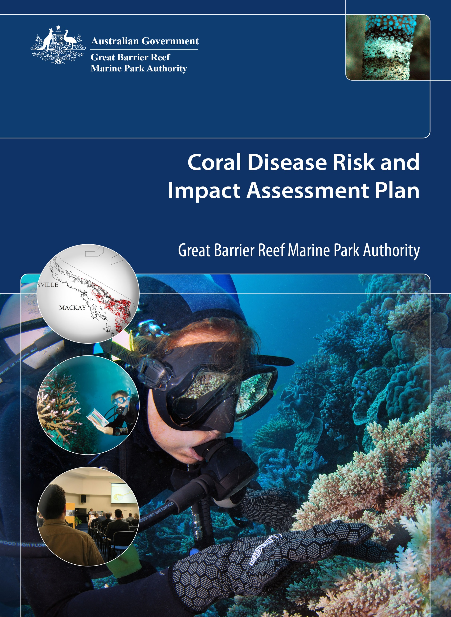

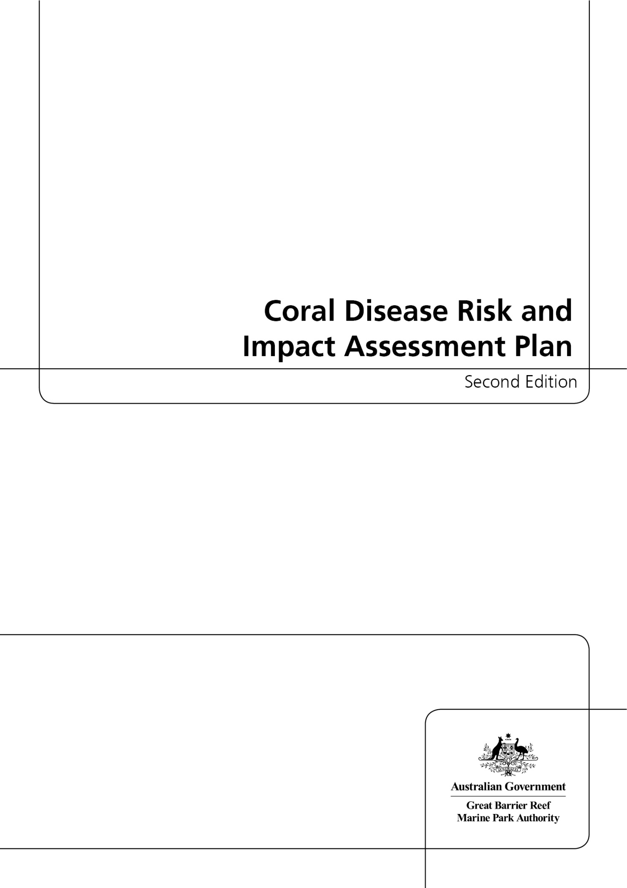

© Commonwealth of Australia 2013

Published by the Great Barrier Reef Marine Park Authority

Coral Disease Risk and Impact Assessment Plan Second Edition

ISSN 2200-2030

ISBN 978-1-922126-33-7 Second Edition (pdf)

This work is copyright. Apart from any use as permitted under the Copyright Act 1968,
no part may be reproduced by any process without the prior written permission of the
Great Barrier Reef Marine Park Authority.

Requests and enquiries concerning reproduction and rights should be addressed to:

Director, Communications and Parliamentary
2-68 Flinders Street
PO Box 1379
TOWNSVILLE QLD 4810
Australia

Phone: (07) 4750 0700
Fax: (07) 4772 6093
info@gbrmpa.gov.au

Comments and enquiries on this document are welcome and should be addressed to:
Director, Ecosystem Conservation and Resilience
info@gbrmpa.gov.au

www.gbrmpa.gov.au

Executive summary

While coral disease is often cryptic and has a lower profile than coral bleaching, it poses an equally significant threat to the Great Barrier Reef. These two impacts are not mutually exclusive as bleaching can greatly increase the susceptibility of corals to diseases. Under a changing climate, disease outbreaks are likely to increase in frequency and severity since: the pathogens that cause coral diseases are likely to become more virulent as sea temperatures increase and coral susceptibility to disease will increase due to increases in the frequency and severity of bleaching events and the frequency of severe cyclones. Since disease outbreaks of unprecedented severity and spatial extent, are likely in the future, reef managers have a responsibility to monitor, assess and respond to the socio-ecological impacts caused by coral disease and disease outbreaks.

This risk and impact assessment plan has been developed by the Great Barrier Reef Marine Park Authority (GBRMPA) in order to outline a strategic approach for monitoring coral disease risk and assessing disease impacts. It has three main components:

- Early warning system
- Incident response
- Communications strategy

The plan components follow on from each other and include both routine and responsive tasks. Early warning system tools are used to predict the likelihood of outbreaks of temperature-dependent diseases in the summer. In addition, participants in an in-water monitoring network check for disease year-round. Managers and researchers confirm reports of disease by conducting site inspections that determine the level of response required under GBRMPA's Reef Health Incident Response System (based on Australian standard incident response protocols). More detailed monitoring during incident response enables detailed reporting on the reef condition and severity of disease outbreaks. In the months and years that follow the disturbance, resilience-based management actions such as continued improvement of water quality inshore, can support the natural resilience of habitats in the Great Barrier Reef Marine Park at the whole-of-Reef scale. These actions can also increase the resilience of reef users to reef health incidents.

This plan is one of a number of risk and impact assessment plans that uses the three-component template (above) for incident response described within our overarching incident response system. The suite of plans renders a transparency and consistency to management decision-making during reef health events. This plan also serves to keep representatives from key partner institutions and the public aware of the technologies and protocols used to predict and monitor coral disease events, and the criteria used to determine how to communicate about the severity of disease impacts when outbreaks occur.

Contents

Introduction 1
1. Early warning system 3
Seasonal outlooks 4
Near real-time monitoring of outbreak likelihood 5
Monitoring network 6
Site inspections 8
2. Incident response 9
Assessment and monitoring 15
3. Communications strategy 17
Importance of management actions 20
Conclusion 20
References 22
Appendix A – Schedule of Coral Disease Risk and Impact Assessment Plan routine and responsive tasks 23
Appendix B – Early warning system tools, key references and further reading 26
Seasonal outlooks of outbreak risk 26
Near real-time monitoring of outbreak likelihood 26
Appendix C – Reef Health and Impact Survey reporting form 27
Appendix D —Locations of intensive survey sites for the coral disease and coral bleaching risk and impact assessment plans 28
Appendix E – Detailed maps of survey site locations in each cross-shelf transect 29
Appendix F – Great Barrier Reef Marine Park planning areas 31

Introduction

Coral diseases and coral disease outbreaks can be cryptic in comparison to visually spectacular coral bleaching events. Diseased colonies often die quickly and some coral diseases are more prevalent in summer (e.g. black band disease and white syndromes, see Bruno et al. 2007). This means that monitoring programs that visit sites once or twice yearly, or that do not undertake surveys when temperatures peak, can underestimate disease-induced mortality. As a result, the extent to which coral disease drives the community structures of reefs and their condition is somewhat unknown (Harvell et al. 2002) and probably under-appreciated since high percentages of diseased corals die (Sweatman et al. 2008; Osborne et al. 2011). Disease outbreaks often follow other impacts, for instance disturbances such as bleaching, flood plumes, and cyclones all reduce coral health due to injuries, loss of physiological resources or both. Reduced coral health leads to an increase in disease susceptibility.

Climate change is likely to decrease the resilience of the Great Barrier Reef and disease outbreaks contribute to those losses in resilience. Disease outbreaks are likely to increase in frequency and severity under a changing climate. This is because:
- bleaching events are expected to increase in frequency and severity
- rising sea temperatures will mean the pathogens that cause coral diseases are likely to become more virulent
- cyclones, floods, and stressors from human-related activities all increase the susceptibility of corals to diseases.
Since disease outbreaks of unprecedented severity and spatial extent are likely in the future, reef managers have a responsibility to monitor, assess and respond to the socio-ecological impacts of coral diseases and disease outbreaks. This expectation was outlined specifically in the Great Barrier Reef Outlook Report 2009 (GBRMPA 2009) and characterised as the need to assess ecosystem health and manage for resilience. Assessing impacts ensures managers have an up-to-date understanding of the vulnerability of the Great Barrier Reef Marine Park (the Marine Park). Managers can therefore distinguish between the effects of acute and chronic stressors (e.g. bleaching events and water quality, respectively) and target resilience-building management strategies and awareness raising communications efforts.

The risk and impact assessment plan has three primary components: 1) Early warning system, 2) Incident response, and 3) Communications strategy (Figure 1).

The risk and impact assessment plan is an operational document used year-round by GBRMPA staff. The plan is a transparent and consistent decision-making framework during disease events. It serves to keep representatives from key partner institutions, as well as the public, aware of the technologies and protocols used to predict and monitor disease outbreaks. It also describes the criteria that determine how we communicate about coral disease when outbreaks occur.

The plan includes both routine and responsive tasks and its components follow on from each other (Figure 1, Appendix A). When early warning system tools assess the likelihood of temperature-dependent diseases to be high, participants in a monitoring network ground-truth the predictions and report to managers. Throughout the rest of the year participants in the monitoring network report observations of all diseases seen at all sites they visit. Managers and researchers confirm reports of anomalously high disease prevalence by conducting site inspections that determine whether the level of disease exceeds one of three response level thresholds. Response levels are defined by the severity and spatial extent of the impacts and are described in detail in our Reef Health Incident Response System (based on Australian standard incident response protocols) section of the Plan (see page 11). Detailed monitoring during incident response enables detailed reporting on reef condition and the severity of disease impacts.

As with other disturbances to reef health, effective management response to disease outbreaks depends on clear and transparent communication between managers and senior decision-makers, stakeholders and the public. Communication is an overarching theme in the plan and is particularly important for coral disease outbreaks. This is due to the term ‘disease’ having a negative connotation and because most stakeholders and members of the public are more familiar with disturbances like bleaching events, cyclones, and floods than coral disease outbreaks. From this perspective, the plan plays a part in raising awareness of the threat that coral diseases pose to coral reefs and the industries and human communities that rely on and enjoy them. Further, communication efforts during and just after bleaching events can raise the public’s awareness of the importance of responsible behaviour in the Marine Park.

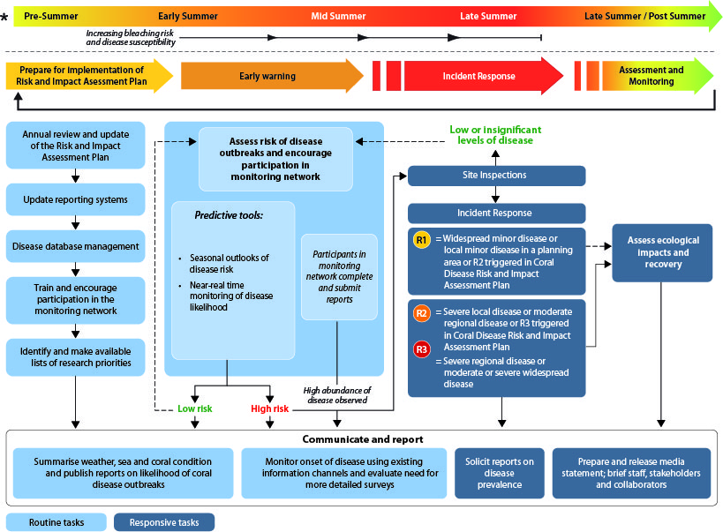

Figure 1: Plan schedule of routine and responsive tasks (see also Appendix A) is operational year-round but has a focus on the summer months when the likelihood of disease outbreaks increases. Plan components follow on from each other, though responsive tasks are only undertaken if the incident response is triggered. Response levels 2 and 3 activate efforts to assess and monitor impacts, which is conditionally activated under response level 1 (see also Figures 7 – 9).

Within this document, the objectives of each of the three primary components of the risk and impact assessment plan are outlined and the role each component plays in a timely and effective response to coral disease outbreaks is described in detail.

1. Early warning system

Outbreaks of diseases with known links to temperature (e.g. white syndromes and black band disease) are preceded by a series of conditions that can be used to assess the probability of an outbreak occurring, while the monitoring network can report on the prevalence of all common types of coral diseases. The early warning system uses:
1) climate forecasts that provide a seasonal outlook of the likelihood that outbreaks of temperature-dependent diseases (e.g. white syndromes and black band disease) will occur, 2) tools that enable near-real time monitoring of outbreak likelihood during the summer to target monitoring efforts, 3) a monitoring network to detect the early signs of disease outbreaks year-round, and 4) site inspections to ground-truth predictions or reports of anomalously high disease levels, in order to determine whether and which incident response thresholds have been reached. All four elements are briefly described below.

Seasonal outlooks

A number of factors are known to cause high sea temperatures in the Great Barrier Reef. In particular, delayed or weak development of the monsoonal trough over northern Australia during summer appears to be a strong precursor to the anomalously warm conditions that, if severe or prolonged, can cause coral bleaching and disease outbreaks. For example, research suggests the likelihood of outbreaks of white syndromes in summer is increased by warm winter temperatures (Heron et al. 2010, and Appendix B). Based on this premise, the National Oceanic and Atmospheric Administration’s (NOAA’s) Coral Reef Watch group produces a seasonal outlook that predicts the likelihood of outbreaks of white syndromes in the months that precede summer (Figure 2a). Given links between bleaching and disease susceptibility, the tools providing a seasonal outlook of conditions conducive to bleaching — NOAA’s Bleaching Outlook Product, and the Predictive Ocean Atmosphere Model for Australia sea surface temperature anomaly forecasts (see early warning system, Coral Bleaching Risk and Impact Assessment Plan, GBRMPA 2010) — are also useful for determining whether outbreaks of temperature-dependent diseases are likely. Based on an emerging understanding of the relationship between weather and sea temperatures for the Great Barrier Reef, tools to predict the likelihood of disease outbreaks are likely to advance in the coming years.

Near real-time monitoring of outbreak likelihood

Two integrated risk prediction models have been developed to assess the likelihood of outbreaks of white syndromes, and potentially black band disease (Figure 2b, c), during the summer months. These models are based on near real-time monitoring of remotely sensed sea surface temperature data. One model, developed and maintained by NOAA Coral Reef Watch, produces bi-weekly images depicting outbreak risk at 50-km resolution. Outbreak risk for the reefs within a 50-km pixel is a function of the current (summertime) temperature stress and whether winter temperatures for the pixel were anomalously warm (see Figure 2b).

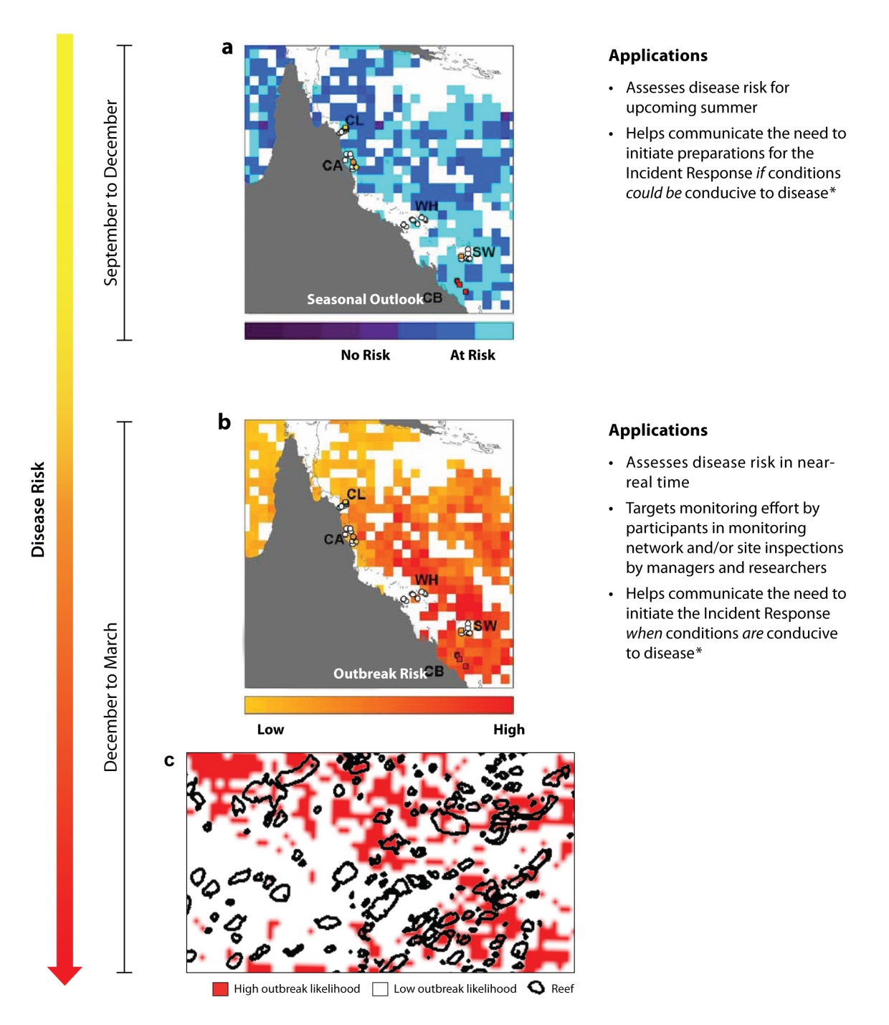
Figure 2: Tools used within the early warning system to predict the likelihood of outbreaks of diseases with known links to temperature and their applications for management decision-making. The NOAA Coral Reef Watch group developed and maintains a product showing the seasonal outlook of disease risk based on winter temperatures (a, shown as a hindcast prior to the 2002 outbreak of white syndromes in the southern Great Barrier Reef) as well as a product that assesses outbreak risk twice weekly during the summer months based on temperature stress (b, mid-summer 2002). CSIRO and James Cook University developed a model depicting outbreak likelihood at the scale of an individual reef (c, mid-summer 2002) as part of the ReefTemp product suite.

A complementary tool has been developed that assesses disease outbreak likelihood at ~1.5-km resolution. This tool is part of the ReefTemp product suite (Figure 2c) and was developed by James Cook University and the Commonwealth Scientific and Industrial Research Organisation (CSIRO) in collaboration with GBRMPA. The tool is based on an empirical regression model, which relates conditions (temperature stress and coral cover) at sites where outbreaks of white syndromes occurred in 2002 to disease abundance. This enables the monitoring of disease risk at the scale of an individual reef (Maynard et al. in press, Appendix B).

As with the seasonal outlooks described in the section above, the tools used to monitor the risk of coral bleaching from NOAA Coral Reef Watch and CSIRO also provide insight as to where disease outbreaks are likely to occur. Outbreak likelihood is high at locations where bleaching impacts are predicted and/or reported as being moderate or severe (Table 1 of the Coral Bleaching Risk and Impact Assessment Plan, GBRMPA).

Monitoring network

Detecting the early signs of a disease outbreak requires a wide network of observers on the Great Barrier Reef due to its size and because identifying the onset of a disease outbreak is likely to require multiple visits to a location. We rely on field reports provided by a monitoring network that includes Queensland Parks and Wildlife Service rangers, as well as trained volunteers. The network covers the entire Great Barrier Reef and includes regular reef users, such as dive professionals, tourism operators, fishers, researchers, community groups and other recreational users who voluntarily monitor and report (Appendix A) on conditions at reefs they visit.

Participants undertake a protocol (Figure 3) that can be completed by snorkellers or divers using a repeated Global Positioning System (GPS)-tagged five-metre radius point survey method. This method is used to assess a range of reef health indicators including coral and algal cover and the extent and severity of impacts like coral bleaching, disease, predation and anchor or storm damage. The revised protocol recognises the limited time that many participants have to complete survey forms. One form is completed for each point survey and observers complete at least three point surveys at each site whilst remaining within one habitat type (e.g. reef slope or lagoon). Repeated surveys are conducted to enable statistical analysis of the data; however these surveys do not have to occur on the same day if time is limited.

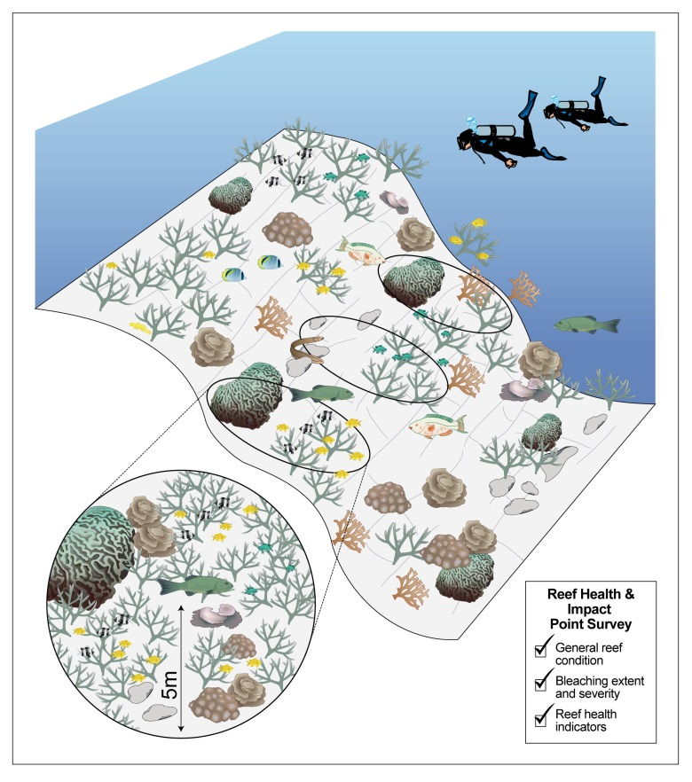

Figure 3: Protocol used in the monitoring network. Observers either diving or snorkelling use the protocol to assess reef condition and to detect the early signs of disease, as well as other impacts. The same protocol is used by researchers and managers when site inspections are conducted to either ground-truth predictions from the temperature monitoring tools or to further quantify disease following a report from a monitoring network participant.

During non-summer months, participants complete their reports opportunistically whenever they are out on the Reef. During the hotter summer months, surveys are undertaken on a weekly or fortnightly basis. We review these results weekly during the summer months (Table 1) to identify where coral disease has been sighted. Information is collated in the Eye on the Reef database and displayed as report files which can be viewed through Google EarthTM. This system displays information and visual representations for all the data collected at each reef in the Marine Park (Figure 4). Eye on the Reef reports are used to target site inspections in order to determine the severity and spatial extent of impacts. Reports of disease outbreaks from the monitoring network are verified through site inspections conducted by GBRMPA in partnership with trained staff from the Queensland Parks and Wildlife Service.
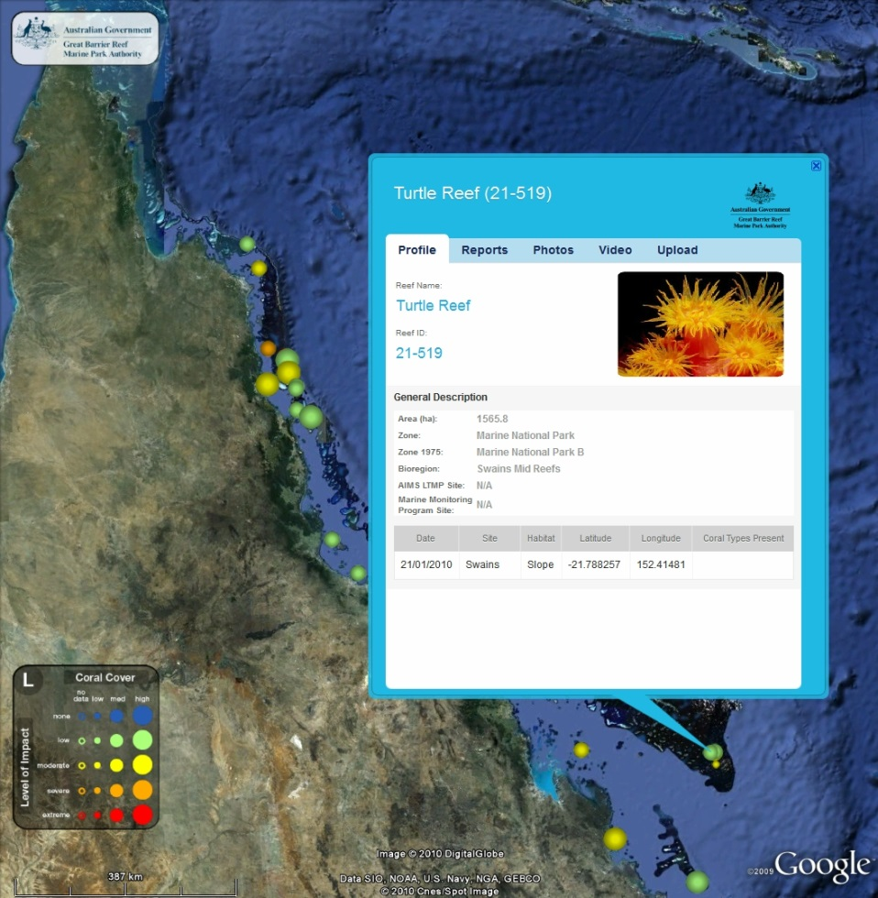

Figure 4: Sample output from GBRMPA’s new system facilitating rapid review and dissemination of reports from participants in the monitoring network. This example shows Turtle Reef and enables access to all reports for that and all other locations for which survey data is available.

Site inspections

Site inspections in the Marine Park involve a series of surveys at two depths using the method described in Appendix B. Site inspections are conducted on an as-needed basis at sites where:

- monitoring network participants have reported widespread minor impacts, or moderate or severe impacts over any scale (see Table 1)
- tools enabling near-real time monitoring of conditions indicate the risk of a reef health incident occurring is high (e.g. systems indicate that temperature stress is severe enough to cause coral disease)
- a ship grounding or oil spill has occurred.

If site inspections confirm moderate to severe localised impacts relating to any incident or widespread minor impacts relating to bleaching, disease outbreaks, flood plumes and/or cyclones, the incident response component of the Reef Health Incident Response System is activated.
Table 1: Levels of disease severity and extent. The Reef Health and Impact Survey (Figure 3 and Appendix C) and site inspections; (Reef Health and Impact Survey with 50m video transects) both result in data (average of disease cases/80m² or average of the percentage of colonies affected) that can be used to determine whether disease levels are minor, moderate, or severe. The matrix in Figure 5 of bleaching severity and spatial extent determines the response level threshold in the incident response.

Severity | Description
High outbreak risk | Bleaching impacts at a site are either moderate or severe (see Table 1, Coral Bleaching Risk and Impact Assessment Plan, GBRMPA 2010).  Outbreak risk assessed as high by the experimental NOAA Coral Reef Watch tool  Outbreak risk assessed as high by CSIRO’s ReefTemp tool at the end of the summer  Category 3 cyclone or above passed over half or more of a management region*
Minor impacts | An average of 1 case of the same type of disease/80m²  An average of 2 cases of disease (different types)/80m²  An average of 5% of the coral colonies affected by the same disease type  An average of 10% of the coral colonies affected by different disease types
Moderate impacts | An average of 2–3 cases of the same type of disease/80m²  An average of up to 5 cases of disease (different types)/80m²  An average of 10% of the coral colonies affected by the same disease type  An average of 15% of the coral colonies affected by different disease types
Severe impacts | An average of 4 or more cases of the same type of disease/80m²  An average of 6 or more cases of diseases (different types)/80m²  An average of 15% of the coral colonies affected by the same disease type  An average of 20% of the coral colonies affected by different disease types

Extent | Description
Local | Impacts present in less than 10 sites within one region*
Regional | Impacts present in more than 10 sites but confined to one region
Widespread | Impacts present in more than 10 sites in each of multiple regions
*Management regions, see Appendix G

2. Incident response

GBRMPA uses the Australasian Inter-service Incident Management System framework to coordinate the governance, planning, operations, logistics, financial and inter-agency liaison arrangements required to adequately respond to a reef health incident. Information gathered from the early warning system and site inspections helps us to understand the severity and spatial extent of impacts. Once the spatial extent and severity of the impact have been classified based on the standardised criteria for each incident, we use the matrix in Figure 5 to inform a detailed situation analysis.

The information presented within the situation analysis is assessed by the governance group to make a final decision on the required level of response. The governance group for bleaching responses is the GBRMPA executive management group and the incident coordinator.
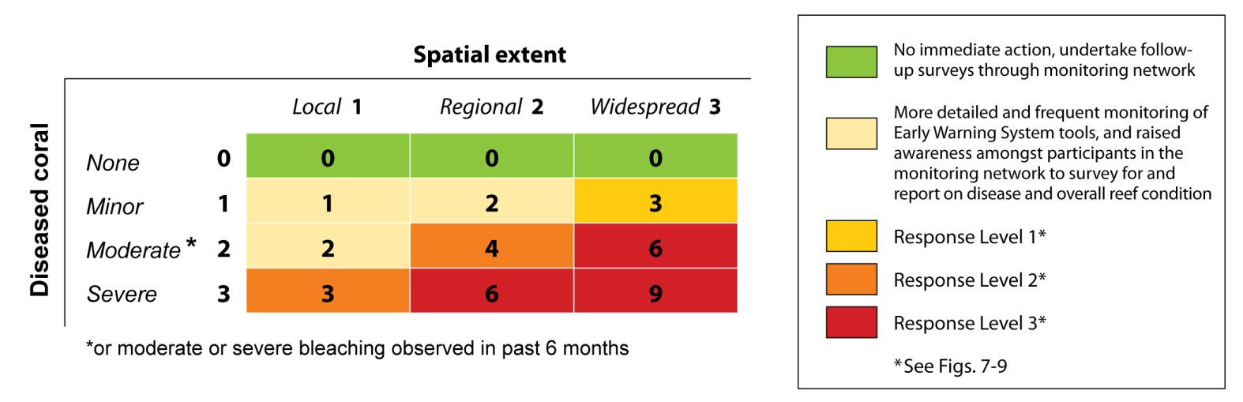

Figure 5: Matrix combining measures of disease severity and spatial extent (from Table 1) to inform the situation analysis (Figure 6), which results in the final decision as to which response level has been triggered (if any). Specific criteria for the levels of disease severity are described in detail in Table 1.

The situation analysis is assessed by the GBRMPA governance group (the executive management group, the incident coordinator and the scientific, communications and liaison, and stakeholder advisory groups), which makes a final decision on the required level of response (Figure 6). There are three potential response levels — 1, 2 and 3. Each increase in response level (from 1 to 3) correlates to a corresponding increase in the severity and spatial extent of the impacts as well as an increase in the management investment and resources required to effectively respond. The activation and conditional activation of the incident response framework varies according to each response level but the framework used for each of the three response levels is standardised for all reef health incidents.

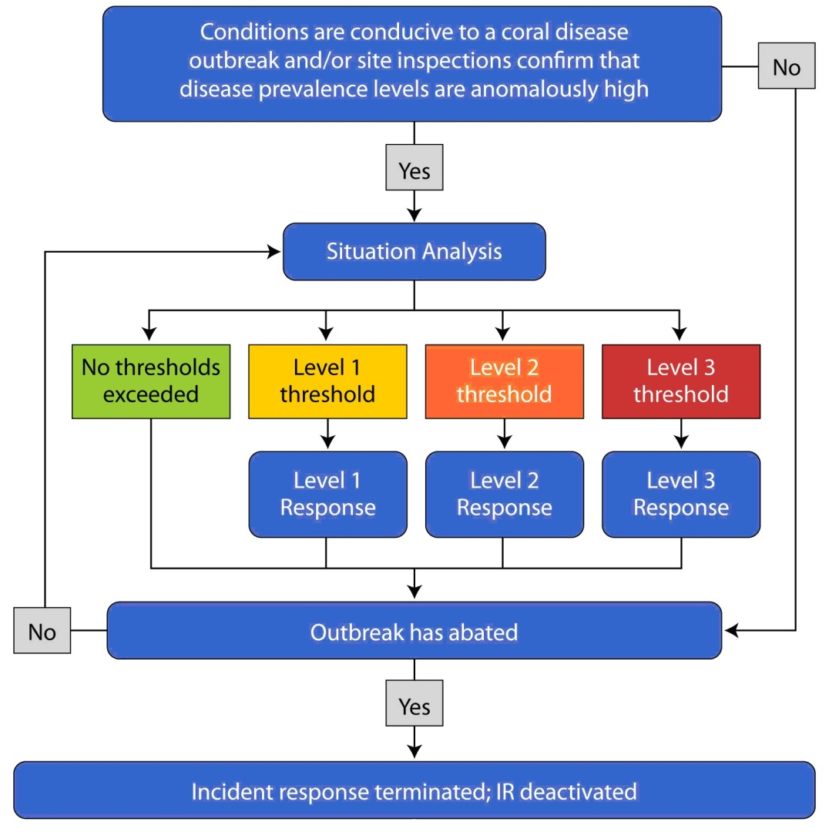
Figure 6: Incident response chain of events during a reef health event. The situation analysis is informed by the matrix seen in Figure 5 and is re-visited following responses if the high risk season has not passed.

Once the appropriate response level has been determined, the corresponding planning and resource provisions of the incident response are activated. Communication, liaison, and reporting tasks are activated for all response levels. For response level 1, which may lead to response levels 2 or 3 if impacts become more severe or extensive through time, the logistics for extensive underwater surveys are only conditionally activated, and budgeting, contracting, staff procurement, and impact mitigation/recovery surveys are not activated (Figure 7). Conditional activation is based upon the type of incident and the outcome of the situation analysis. For response level 2, vessel support and underwater surveys are activated, as are budgeting and administration. Contracting, staff procurement, and impact mitigation/recovery surveys are all conditionally activated (Figure 8). For response level 3, the entire incident response framework is activated (Figure 9).

The next section describes the approach and field survey protocols used to assess and monitor disease impacts when the situation analysis determines triggers for response levels 2 and 3 have been exceeded.

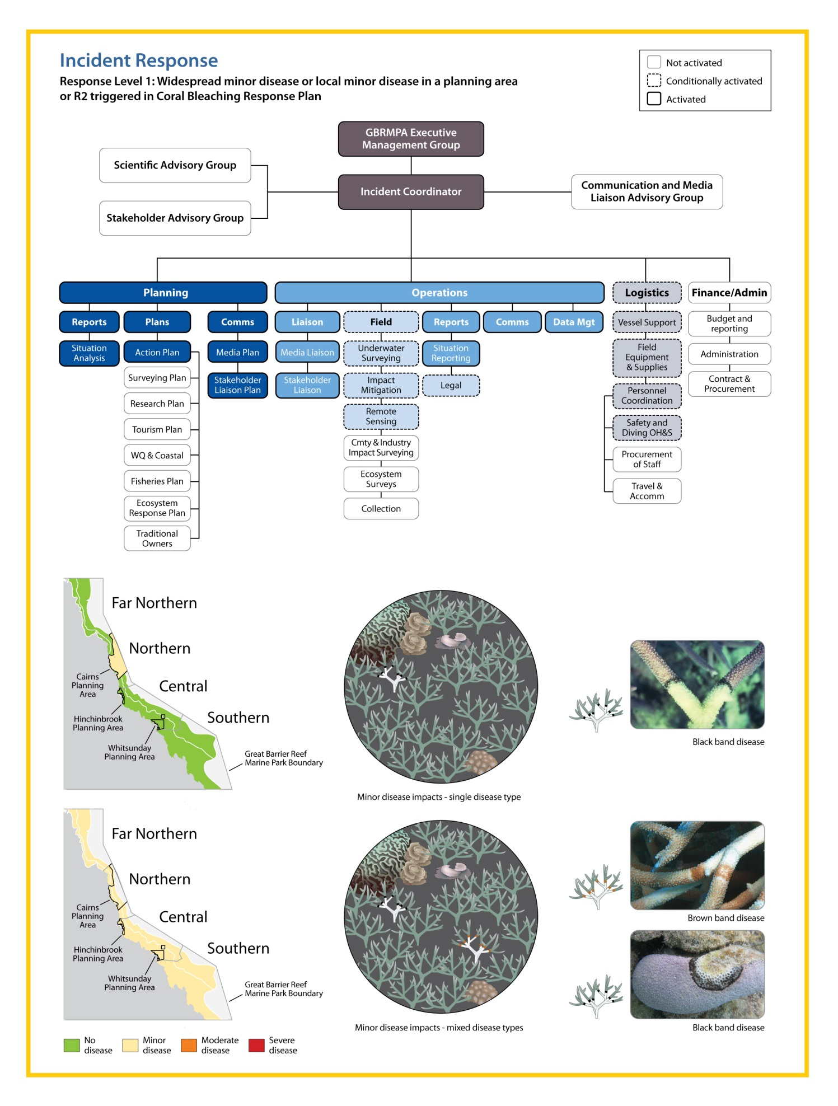
Figure 7: Response level 1 within the incident response. Activation and conditional activation of components are illustrated by the intensity of colour and border for each box within the diagram above. Scenarios shown in the maps are examples as are the disease types shown (i.e., local disease in a different planning area would result in the same management response, and so would different disease types). The response level 1 threshold can be reached due to the prevalence of a single disease type or numerous disease types.
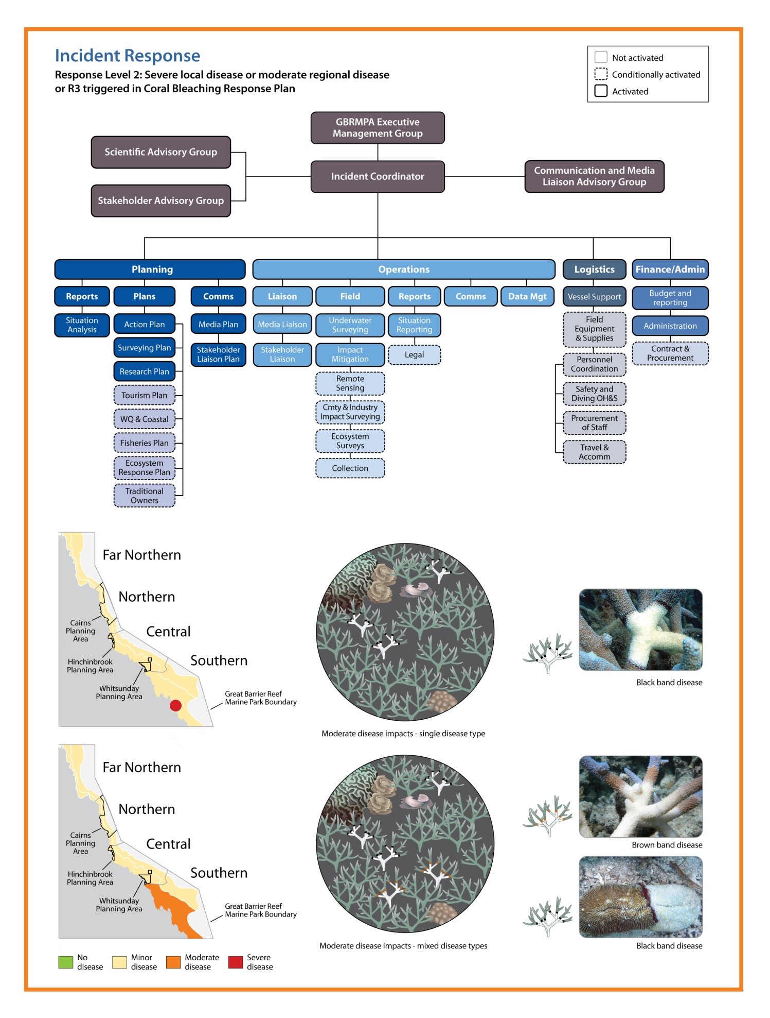
Figure 8: Response level 2 within the incident response. Activation and conditional activation of components are illustrated by the intensity of colour and border for each box within the diagram above. Scenarios shown in the maps are examples as are the disease types shown (i.e., local or moderate disease in a different region would result in the same management response, and so would different disease types). The response level 2 threshold can be reached due to the prevalence of a single disease type or numerous disease types.
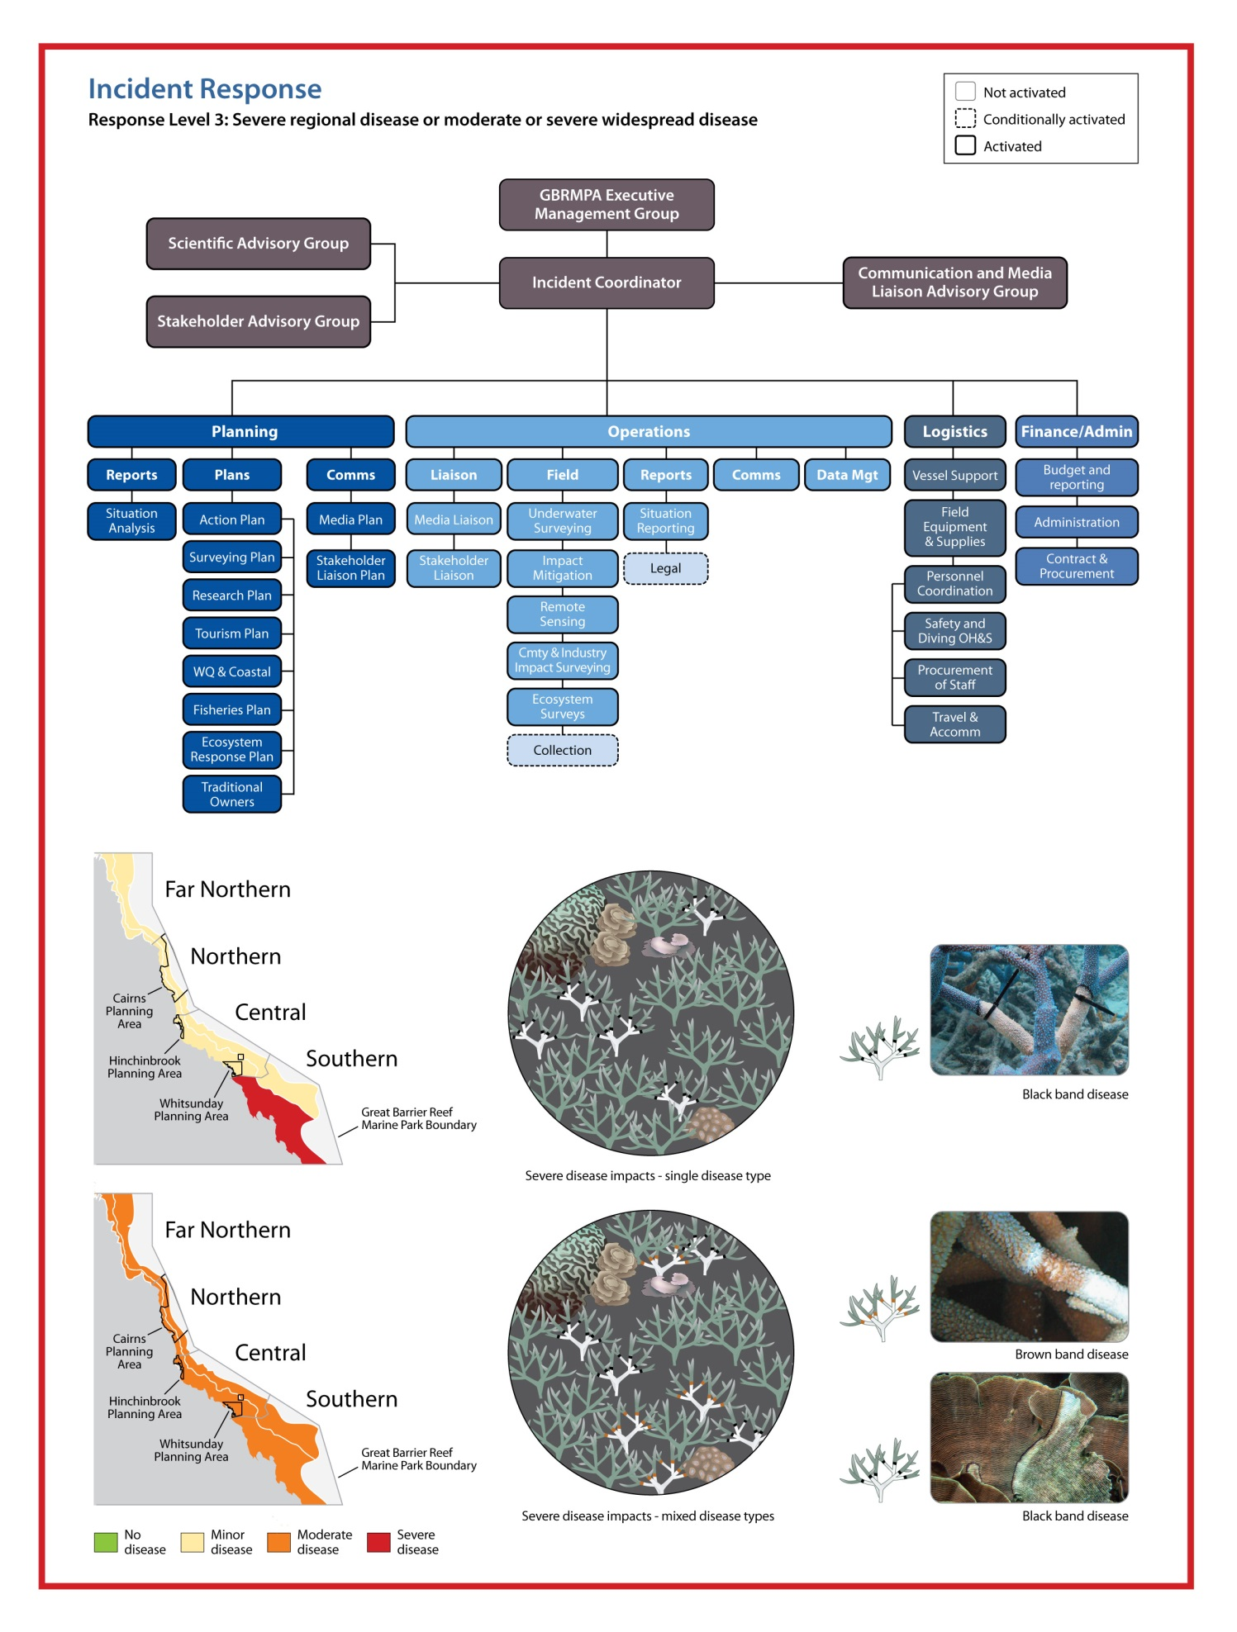
Figure 9: Response level 3 within the incident response. Activation and conditional activation of components are illustrated by the intensity of colour and border for each box within the diagram above. Scenarios shown in the maps are examples as are the disease types shown (i.e., severe disease in a different region would result in the same management response, and so would different disease types). The response level 3 threshold can be reached due to the prevalence of a single disease type or numerous disease types.

Assessment and monitoring

To accurately characterise the extent and severity of disease, disease-induced mortality and the associated longer-term ecological implications, three temporal surveys are undertaken: baseline, event and survival/mortality. By surveying sites that are also surveyed as part of the Australian Institute of Marine Science (AIMS) Long-term Monitoring Program, baseline surveys are not required. Consequently, managers can focus on the surveys during the outbreak to assess the severity of impacts, and six months and a year after the event to assess the ecological implications of outbreaks. In this sense, we take the lead on assessing impacts and the implications of coral disease in the year that follows the outbreak, while longer-term ecological monitoring surveys are coordinated and undertaken by the AIMS Long-term Monitoring Program. Assessing reef health and condition during and in the months that follow incidents also informs estimates of reef resilience, which enables the evaluation of various strategies that support the natural resilience of reefs.

The implications of disease on reef ecology include, but are not limited to, coral mortality, shifts in coral community structure, altered habitat composition and ecosystem flow-on effects. Disease outbreaks can also have implications for industries that depend on the Reef as well as associated human communities since disease can reduce the social or economic value of reef sites important to tourism operators, fishers, or recreational users. However, the science of monitoring the social and economic impacts of coral disease outbreaks is in its infancy. It is anticipated that monitoring will be undertaken in collaboration with members of the Association of Marine Park Tourism Operators and researchers. Lists of socio-economic indicators that managers gather information on will be developed in the near-term and then evolve as our understanding increases.

When the situation analysis (Figure 6) determines the thresholds for response levels 2 (Figure 8) or 3 (Figure 9) have been exceeded, managers undertake intensive in-water surveys at routine sites (surveyed during each event) and targeted sites (those most affected by disease). Previously documented outbreaks on the Great Barrier Reef have been localised, highlighting that in the coming years in-water surveys are most likely to target outbreak sites rather than the routine sites shown in Figure 10 (unless an outbreak is occurring at a routinely surveyed site). This re-emphasises the importance of the broad spatial coverage of the monitoring network that forms part of the early warning system and the newly developed report management and database system (Figure 4). Reports from the monitoring network will often form the baseline reports against which disease levels are assessed during the situation analysis (Figure 6). There is the potential though that Reef-wide outbreaks follow a severe spatially extensive bleaching event (Miller et al. 2009). If this occurs, surveys for disease can be undertaken with those surveys used to assess recovery from bleaching, given the lag time between when corals bleach and become affected by disease.

The plan lists 45 routine sites for intense in-water assessments (Figure 10, coordinates for sites in Appendix D). The sites represent cross-shelf as well as latitudinal gradients along the Great Barrier Reef. The site groupings are located at latitudes centred on Lizard Island, Cairns, Townsville, Whitsunday Islands and the Capricorn Bunker Group (Figure 11). Three inshore, three mid-shelf and three outer shelf reefs are surveyed in each transect.
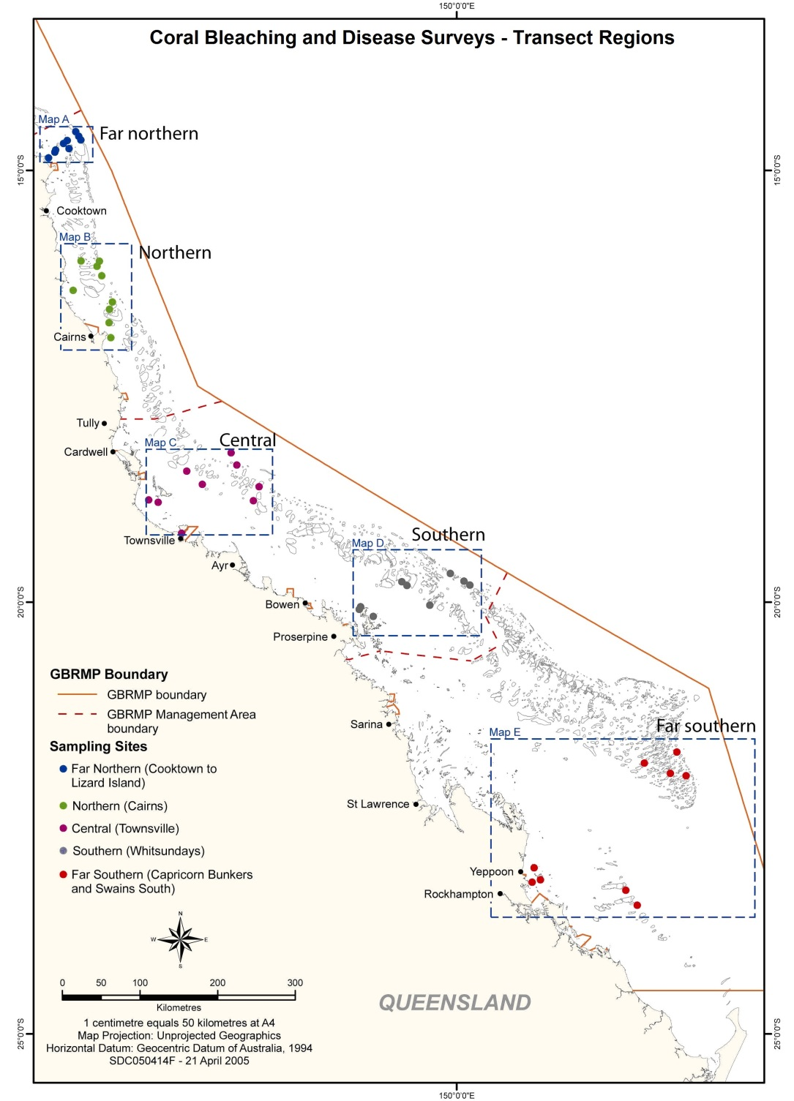
Figure 10: Plan monitoring sites routinely surveyed when response levels 2 or 3 are exceeded in this plan or the Coral Bleaching Risk and Impact Assessment Plan. High-resolution maps of each cross-shelf transect (Maps A – E) can be found in Appendix E.

At each site, three locations are surveyed on the reef crest (1 – 4 m) and lower reef slope (6 – 9 m), by a two-diver team that conduct the Reef Health and Impact Survey protocol (Figure 3) and record three 50 m video transects. The videos are later analysed by identifying the substrate and severity of disease impacts at five points within photo frames taken (40 frames/transect; Hill and Wilkinson 2004). The rapid assessment via the Reef Health and Impact Survey protocol provides information about the extent and severity of the disease outbreak in near real-time, which can be immediately communicated to senior management, government and the public.

The video transects, whilst requiring a more lengthy analysis, provide a long-term record, more detailed information and increased data resolution, which is useful for understanding the patterns and specificity of disease outbreaks. In addition, since the video is discontinuous, either photos taken from the video or each transect could be an independent statistical sample, ensuring the data can be used to help answer a variety of research questions. This monitoring protocol is used both during the disease outbreak and during the follow-up surveys conducted six months and a year after the event. The protocol is rigorous but also easy to teach and implement, with surveys at each site completed in less than two hours. The data from disease and recovery surveys is analysed independently, for purposes of reporting on the disease outbreak, but is loaded into the same database as the reports collected by participants in the monitoring network. The visual representation of the data facilitated by that system can aid in communicating the need for various management actions.

3. Communications strategy

As described here, responding to coral diseases strategically and effectively involves a combination of routine and responsive tasks implemented through an early warning system and, if a disease outbreak occurs, assessment and monitoring via incident response. All routine and responsive tasks rely on effective communication since disease outbreaks are likely to attract significant interest from the public, media and senior decision-makers (Table 2). The plan ensures timely and credible information on coral disease in the Great Barrier Reef Marine Park is available year-round. As a consequence, managers are able to prevent misleading or incorrect information from proliferating through various media sources. The plan ensures information on coral disease is available during outbreaks and when outbreaks are highly likely, as in the months that follow bleaching impacts that exceed the response level 2 or 3 threshold within the Coral Bleaching Risk and Impact Assessment Plan (GBRMPA).
Table 2: The frequency and timing of tasks associated with collating current information on coral diseases and effectively communicating when outbreaks occur. Tasks that appear in italics are common to both the disease and bleaching risk and impact assessment plans.
Frequency | Timing/trigger | Task
Weekly during summer, bi-monthly rest of year | Monday | - Check CSIRO ReefTemp and NOAA HotSpot and degree heating week maps on web
Weekly during summer, bi-monthly rest of year | Monday | - Check sea temperature graphs from AIMS weather stations and the experimental virtual bleaching stations from NOAA
Weekly during summer, bi-monthly rest of year | Monday | - Check NOAA and CSIRO near real-time tools predicting outbreak likelihood
Weekly during summer, bi-monthly rest of year | Monday | - Review reports from the monitoring network
Weekly during summer, bi-monthly rest of year | Monday | - Prepare briefing for internal meetings
Weekly/ fortnightly | Constant | - Monitor extent of disease outbreaks using existing information and evaluate for trends (i.e., change in spatial extent of outbreak or impact severity)
Weekly/ fortnightly | Constant | - Advise GBRMPA senior management and the Minister if worsening of conditions
Weekly/ fortnightly | Constant | - Announce web update and send brief report to senior management
Event-based | High disease outbreak risk* | - Actively solicit confirmatory reports from reliable sources on disease prevalence, including: participants in the monitoring network, day-to-day management field officers, AIMS, and other researchers
 | High disease outbreak risk* | - Alert relevant project coordinators and managers
 | High disease outbreak risk* | - Brief GBRMPA senior management
 | Response level 1, 2, or 3 (see Figures 8–10) triggered | - Brief GBRMPA executive and the Minister
 | Response level 1, 2, or 3 (see Figures 8–10) triggered | - Prepare media position, draft statement and consult with GBRMPA media coordinator and executive
 | Response level 1, 2, or 3 (see Figures 8–10) triggered | - Brief all GBRMPA staff, stakeholders and collaborators
 | Response level 1, 2, or 3 (see Figures 8–10) triggered | - Release media statement
 | Response level 1, 2, or 3 (see Figures 8–10) triggered | - Actively promote and solicit submissions of reports on disease sightings and prevalence levels to improve understanding of spatial extent of the outbreak
* See also Table 1

In addition to the task and reporting schedule outlined in Table 2, a briefing schedule for GBRMPA senior management, the Minister, and stakeholders is outlined in Table 3. This schedule ensures these groups are aware when delivery of reports can be expected.
Table 3: Targeted briefing schedule to communicate onset of high-risk season for temperature-dependent diseases (predetermined dates) and outbreak risk and occurrence throughout the year (date determined by reaching a trigger level). Asterisks denote triggers that will result in determining a media position and the release of a media statement (see also Table 3).

Approx. date | Trigger | Briefings
Approx. date | Trigger | Senior management | Minister | Stakeholders | Message
1 Dec | Annually | ^ | ^ | ^ | Summer approaching; Bleaching Risk and Impact Assessment Plan being implemented, high risk season for outbreaks of temperature-dependent diseases starting
 | High disease outbreak risk* | ^ | ^ |  | Temperatures unusually high or numerous reports of high disease prevalence in a region received; outbreak likelihood high
 | Response level 1 (see Figure 8)* | ^ | ^ | ^ | Widespread minor outbreak observed, and the areas most affected
 | Response levels 2 and 3 (see Figure 9 and 10)* | ^ | ^ | ^ | Moderate or severe outbreak observed at regional scale or widespread; areas worst affected and mortality likely
15 Feb | Annually | ^ |  |  | Implications for disease outbreak likelihood given the summary of any observed coral bleaching
31 March | No bleaching | ^ | ^ | ^ | Summer concluding; risk period for outbreaks of temperature-dependent diseases over; likelihood of outbreaks of temperature-dependent diseases low
 | Response levels 1, 2 and 3 (see Figures 8-10)* | ^ | ^ | ^ | Disease outbreaks observed, preliminary assessment of extent and severity; detailed surveys underway (if response level 2 or 3 triggered)
 | Moderate, major or severe impact (see Table 1) | ^ | ^ | ^ | Summary of full extent and severity of disease outbreaks; implications for affected regions and Great Barrier Reef

Importance of management actions

Disease outbreaks are expected to increase in frequency and severity as a result of climate change, making recovery processes increasingly important in the ability of reefs to persist as coral-dominated systems. Significantly, many human activities impose stresses on coral reefs that compound the risks imposed by disease outbreaks (and other reef health incidents) and can work to lengthen recovery timeframes. For example, chronic stress due to poor water quality can affect the recovery potential of reef communities as reproduction and larval recruitment in corals are particularly sensitive to environmental conditions. Through reducing compounding stressors, management actions help reefs cope with or recover from coral disease, which works to build the resilience of reefs to future climate-related disturbances.

By collaborating with researchers we are rapidly advancing our understanding of factors that increase the resilience of reefs, as measured by the capacity to resist, tolerate and cope with, and recover from climate-related disturbances. In particular, researchers are poised to increase our understanding of spatial variability in the likelihood that a site will be impacted by climate-related disturbances such as bleaching, disease outbreaks, floods and cyclones based on geographic location, community composition and thermal history. Increased knowledge of the spatial variability in factors that confer resilience to reefs may enable us to explicitly include resilience to climate change into management plans. Furthermore, knowledge of spatial variability in resilience factors enables assessments of the effectiveness of strategies implemented to support resilience.

In addition to measures to build ecosystem resilience, the risk and impact assessment plan can help build social and economic resilience to coral disease outbreaks. Resource users who are well informed of risks and are included in decision-making processes about strategies to address resource issues can be expected to much more resilient to resource impacts (Marshall and Marshall 2007). Similarly, community-based social marketing can encourage stewardship behaviours, (e.g. not anchoring on corals or disposing of fishing tackle on the Reef). Such communication efforts may be undertaken following reef health incidents like disease outbreaks in the future.

Conclusion

As disease outbreaks become more frequent and severe, impacts on the reef ecosystem and on reef users will become increasingly acute and apparent. This plan outlines the strategic approaches we employ to monitor disease risk and assess impacts when outbreaks occur. Specifically, the plan provides practical tools for monitoring, assessing and reducing disease risk and impacts. The three-component structure described here is based on a model proven successful in responding to bleaching events on the Great Barrier Reef and has been adopted by reef managers in Florida and Hawaii.

Coral disease is inherently linked to coral bleaching because bleaching increases the susceptibility of corals to disease outbreaks. This plan and the Coral Bleaching Risk and Impact Assessment Plan are united under the overarching Reef Health Incident Response System, which assists managers to evaluate and respond to cumulative and simultaneous impacts. The capacity to predict and respond to cumulative and simultaneous impacts will be further developed in the coming years as the capacity to monitor conditions that cause the range of reef health incidents increases. As with the other risk and impact assessment plans and the overarching Reef Health Incident Management System, this plan helps lay the foundations for an informed and adaptive approach to building the Reef’s resilience under a changing climate.

References

English S and Wilkinson (eds.) (2004) Survey manual for tropical marine resources, 2 ed., Australian Institute of Marine Science, Townsville.

GBRMPA (2010) Coral Bleaching Risk and Impact Assessment Plan. Great Barrier Reef Marine Park Authority, Townsville.

Harvell CD, Mitchell C, Ward J, et al. 2002. Climate warming and disease risks for terrestrial and marine biota. Science 296: 2158–62.

Heron SF, Willis BL, Skirving WJ, Eakin MC, Page CA, Miller IR (2010) Summer hot snaps and winter conditions: modeling white syndrome outbreaks on Great Barrier Reef Corals. PloS ONE [doi:10.1371/journal.pone.0012210]

Hill J and CR Wilkinson (2004) Methods for Ecological Monitoring of Coral Reefs. Australian Institute of Marine Science, Townsville.

Marshall PA and H Schuttenberg (2006) A Reef Managers Guide to Coral Bleaching, Great Barrier Reef Marine Park Authority, Townsville.

Marshall NA, Marshall PA. 2007. Conceptualizing and Operationalizing Social resilience with Commercial Fisheries in Northern Australia. Ecology and Society 12(1).
http://www.ecologyandsociety.org/vol12/iss1/art1/

Maynard JA, Anthony KRN, Harvell CD, Burgman MA, Beeden R, Lamb JB, Heron S, Willis BL (in press) Predicting outbreaks of a climate-driven coral disease in the Great Barrier Reef. Coral Reefs.

Miller J, Muller E, Rogers C, Waara R, Atkinson A, Whelan KRT, Patterson M, Witcher B (2009) Coral disease following a massive bleaching in 2005 causes a 60% decline in coral cover on reefs in the US Virgin Islands. Coral Reefs 28:925-937.

Osborne K, Dolman AM, Burgess SC, Johns KA (2011) Disturbance and the Dynamics of Coral Cover on the Great Barrier Reef (1995–2009). PLoS ONE 6(3): e17516. [doi:10.1371/journal.pone.0017516]

Sweatman H, Cheal A, Coleman G, Emslie M, Johns K, Jonker M, Miller I, Osborne K (2008) Long-term monitoring of the Great Barrier Reef, Status Report No. 8. Australian Institute of Marine Science.

Appendix A — Schedule of Coral Disease Risk and Impact Assessment Plan routine and responsive tasks

Some tasks are part of both this plan and the Coral Bleaching Risk and Impact Assessment Plan. This is due to the cost efficiency of having discussions about disease outbreaks and the revision and this plan while discussions are being held to prepare for summer and the increased likelihood of coral bleaching.

TIMING/  TRIGGER | TASK | EXPECTED OUTCOME | TICK WHEN COMPLETED
Pre-summer preparations and training
September | Seasonal outlook meeting | • Assessment of coral bleaching and coral disease risk for the approaching summer using POAMA, NOAA Bleaching Outlook, NOAA Disease Outlook.  • Preparations for coordinated response in the event of coral bleaching
Year-round | Communications processes in place (see Table 3) | Communications updated regularly on the status of reef condition
November | Yearly incident response planning meeting | Preparations for activation of incident response framework
November | Eye on the Reef training — Cairns, Port Douglas and Airlie Beach | Training of monitoring network in impact assessment and reporting
November | GBRMPA internal staff training in the Reef Health and Impact Survey monitoring protocol | Training of GBRMPA Townsville and regional staff in coral bleaching assessment and reporting
November | Refresher training first aid, CPR and oxygen provider training; updates of AS2299 diver medicals | Field staff suitably qualified and prepared in case response initiated
December | Review of seasonal outlook, meeting convened if high likelihood of coral bleaching and/or disease outbreaks | Meeting convened to refine coordinated response if there is a risk of coral bleaching and/or disease outbreaks
December | Brief senior management, Minister and stakeholders | Senior management, Minister and stakeholders aware of approaching season bleaching risk
December | Revise Coral Disease Risk and Impact Assessment Plan | Revised Coral Disease Risk and Impact Assessment Plan published by December
December | In-water rescue refresher training | Staff proficient in in-water rescue and safety
January | Keppels scheduled monitoring | Support for ongoing resilience and reef protection marker monitoring
January | Monitoring network training - southern region — Mackay, Yeppoon and Gladstone | Additional participants for the monitoring network recruited

Commencement of early warning system
December | Commence web based updates for seasonal outlook and coral disease risk — implications of current conditions reports on bleaching for disease | Communication of reef stressors to community through web on a monthly basis
December | Planning for Christmas closure period | • Assignment of duties over Christmas closure period  • Senior management notified of arrangements  • Minister advised if coral bleaching risk moderate – high
Year-round | Assess disease risk bi-monthly | • Check ReefTemp and NOAA Coral Reef Watch tools that assess outbreak likelihood  • Review reports from the monitoring network and update spatial layers  • Prepare briefings for internal meetings, round table  • Advise senior management of changes
February | Assess temperature trends and bleaching for summer and determine implications for disease outbreaks | • Senior management update on conditions  • Contact made with monitoring network participants in areas of interest

Outbreak reported — incident response initiation
Disease reported | Situation analysis conducted | Incident response situation analysis
Disease reported | Situation analysis reviewed | Level of incident response agreed (this includes nil response)
Incident response activated | Appointment of incident coordinator | Incident coordinator appointed to establish a response team
Incident response active | Notification of incident to relevant agencies | Heightened awareness of the incident amongst relevant agencies
Incident response active | Action plan developed | • Action plan identifies roles and responsibilities for coral bleaching response  • Action plan implemented and all sub plans, including communications plan, activated
Incident response active | Deploy operational teams | • Operational teams to manage incident deployed  • Incident managed effectively  • Emergency fast track permits authorised
High risk season passed | Incident response terminated, incident response deactivated | Incident debrief convened

Incident response terminated and long-term management implemented
Post event | Progress implementation of long-term impact management actions and adaptation plans | • Sectoral impact management plans implemented  • Management actions (e.g. special management areas) implemented
Post event | Preliminary report on the incident produced | Summary report of responses initiated for internal use
Post event | Formal incident report produced | Summary report of the extent and severity of the impact
Post event | Incident response revision and update | Review incident response implementation and incorporate feedback
Post event | Brief senior management, Minister and stakeholders | Senior management, Minister and stakeholders aware of summer impacts and reef recovery
April -  October | End of year (plan reviewed and re-initiated each November) updates | • End of season reports posted onto the web, including nil reports  • End of season summary emailed to participants of the monitoring network
Post event ongoing | Impact recovery monitoring | Monitoring of recovery from severe coral bleaching impacts

Appendix B — Early warning system tools, key references and further reading

Tools that form the early warning system within the risk and impact assessment plan have been developed by a number of agencies and research institutions, nearly all of which have worked in close collaboration with us. Each of these institutions has lead scientists who have published peer-reviewed publications on their work in the area of predicting bleaching and coral disease. Furthermore, each agency maintains their own website, which describes how the models and tools were developed and are meant to be interpreted. Key references and further reading providing technical details (websites) on the forecasting, monitoring and assessment support products are listed below, and divided into the same sub-sections seen in the early warning system section of the plan.

Seasonal outlooks of outbreak risk

Heron SF, Willis BL, Skirving WJ, Eakin CM, Page CA, et al. (2010) Summer Hot Snaps and Winter Conditions: Modelling White Syndrome Outbreaks on Great Barrier Reef Corals. PLoS ONE 5(8): e12210. doi:10.1371/journal.pone.0012210
http://coralreefwatch.noaa.gov/satellite/disease/dz_gbr.html

Near-real time monitoring of outbreak likelihood

Heron SF, Willis BL, Skirving WJ, Eakin CM, Page CA, et al. (2010) Summer Hot Snaps and Winter Conditions: Modelling White Syndrome Outbreaks on Great Barrier Reef Corals. PLoS ONE 5(8): e12210. doi:10.1371/journal.pone.0012210
http://coralreefwatch.noaa.gov/satellite/disease/dz_gbr.html

Maynard JA, Anthony KRN, Harvell CD, Burgman MA, Beeden R, Lamb JB, Heron S, Willis BL (in press) Predicting climate-driven coral disease outbreaks in the Great Barrier Reef.
http://www.cmar.csiro.au/remotesensing/reeftemp/web/ReefTemp_Disease.htm

Monitoring network — assessment tools

Beeden RJ, Willis BL, Raymundo LJ, Page CA, Weil E (2008) Underwater Cards for Assessing Coral Health on Indo- Pacific Reefs. Coral Reef Tareted Research and Capacity Building for Management Program, Global Environment Facility, the World Bank, the University of Queensland and ARC Centre of Excellence for Coral Reef Studies.
http://www.gefcoral.org/Publications/tabid/3260/language/en-US/Default.aspx

Raymundo LJ, Couch CS, Bruckner AW, Harvell CD, Work TM, Weil E, Woodley CM, Jordan-Dahlgren E, Willis BL, Sato Y, Aeby GS (2008) Coral Disease Handbook – Guidelines for Assessment Monitoring and Management. Coral Reef Tareted Research and Capacity Building for Management Program, Global Environment Facility, the World Bank and the University of Queensland.
http://www.gefcoral.org/Publications/tabid/3260/language/en-US/Default.aspx

Appendix C — Reef Health and Impact Survey form
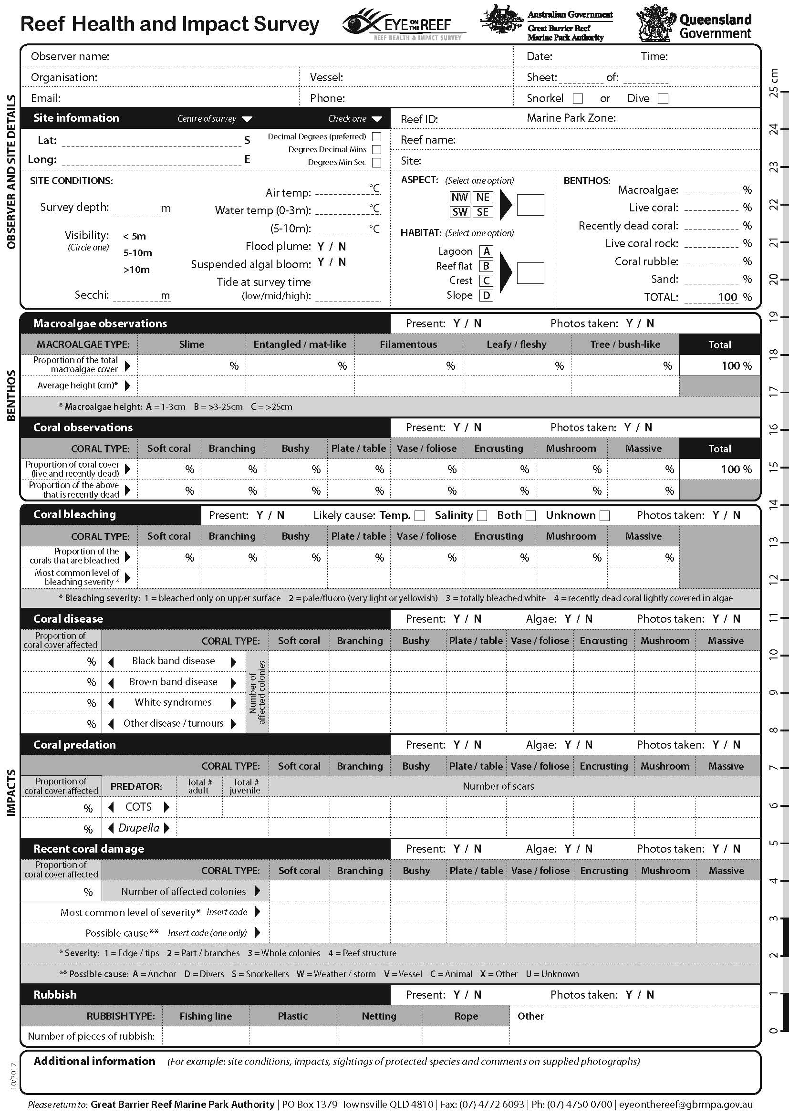

Appendix D — Locations of intensive survey sites for the coral disease and coral bleaching risk and impact assessment plans

I = Inner-shelf reef, M = Mid-shelf reef, O = Outer-shelf reef
Coordinates

 |  | Site coordinates (deg min)
Transect and region | Reef name | Latitude (S) | Longitude
Far northern  (Cooktown to  Lizard Island) | Martin Reef (I) | 14 45.566 | 145 22.586
Far northern  (Cooktown to  Lizard Island) | Linnet Reef (I) | 14 47.33 | 145 21.21
Far northern  (Cooktown to  Lizard Island) | Decapolis Reef (I) | 14 51.021 | 145 16.401
Far northern  (Cooktown to  Lizard Island) | MacGillivray Reef (M) | 14 39.02 | 145 29.65
Far northern  (Cooktown to  Lizard Island) | Nth Direction Island (M) | 14 44.784 | 145 31.02
Far northern  (Cooktown to  Lizard Island) | Lizard Island lagoon (M) | 14 41.661 | 145 27.935
Far northern  (Cooktown to  Lizard Island) | Yonge Reef (O) | 14 34.431 | 145 37.251
Far northern  (Cooktown to  Lizard Island) | Carter Reef (O) | 14 31.584 | 145 35.1
Far northern  (Cooktown to  Lizard Island) | No Name Reef (O) | 14 37.776 | 145 38.967
Northern  (Cairns) | Green Island (I) | 16 46.372 | 145 58.601
Northern  (Cairns) | Low Isles (I) | 16 23.189 | 145 34.356
Northern  (Cairns) | Fitzroy Island (I) | 16 55.384 | 145 59.765
Northern  (Cairns) | Mackay Reef (M) | 16 2.697 | 145 39.147
Northern  (Cairns) | Michaelmas Cay (M) | 16 33.09 | 146 3.241
Northern  (Cairns) | Hastings Reef (M) | 16 30.182 | 146 1.594
Northern  (Cairns) | St Crispin Reef (O) | 16 4.399 | 145 50.975
Northern  (Cairns) | Opal Reef (O) | 16 12.451 | 145 54.452
Northern  (Cairns) | Agincourt No.1 Reef (O) | 16 2.509 | 145 52.209
Central  (Townsville) | Pandora Reef (I) | 18 48.694 | 146 25.803
Central  (Townsville) | Havannah Island (I) | 18 50.04 | 146 32.482
Central  (Townsville) | Middle Reef (I) | 19 11.759 | 146 48.799
Central  (Townsville) | Davies Reef (M) | 18 48.679 | 147 40.231
Central  (Townsville) | Rib Reef (M) | 18 28.495 | 146 52.863
Central  (Townsville) | John Brewer Reef (M) | 18 37.358 | 147 5.045
Central  (Townsville) | Chicken Reef (O) | 18 39.348 | 147 43.43
Central  (Townsville) | Dip Reef (O) | 18 24.227 | 147 27.32
Central  (Townsville) | Myrmidon Reef (O) | 18 15.278 | 147 23.163
Southern  (Whitsundays) | Hayman Island (I) | 20 3.58 | 148 54.099
Southern  (Whitsundays) | Border Island (I) | 20 10.517 | 149 2.098
Southern  (Whitsundays) | Langford & Bird Island (I) | 20 4.78 | 148 52.614
Southern  (Whitsundays) | Reef 19131S (M) | 19 46.162 | 149 22.719
Southern  (Whitsundays) | Reef 19138S (M) | 19 48.5 | 149 25.58
Southern  (Whitsundays) | Reef 20104S (M) | 20 2.007 | 149 41.686
Southern  (Whitsundays) | Slate Reef 19159 (O) | 19 39.837 | 149 55.061
Southern  (Whitsundays) | Hyde Reef (O) | 19 44.488 | 150 5.187
Southern  (Whitsundays) | Rebe Reef (O) | 19 47.829 | 150 9.775
Far southern  (Capricorn Bunkers and Swains South) | Nth Keppel Island (I) | 23 5.187 | 150 54.311
Far southern  (Capricorn Bunkers and Swains South) | Middle Island (I) | 23 9.896 | 150 55.42
Far southern  (Capricorn Bunkers and Swains South) | Halfway Island (I) | 23 12.193 | 150 58.187
Far southern  (Capricorn Bunkers and Swains South) | Gannet Cay (M) | 21 58.743 | 152 28.955
Far southern  (Capricorn Bunkers and Swains South) | Chinaman Reef (M) | 22 0.116 | 152 40.119
Far southern  (Capricorn Bunkers and Swains South) | Reef 21529S (M) | 21 52.02 | 152 11.183
Far southern  (Capricorn Bunkers and Swains South) | Turner Cay (O) | 21 42.204 | 152 33.807
Far southern  (Capricorn Bunkers and Swains South) | Wreck Island (O) | 23 19.149 | 151 58.785
Far southern  (Capricorn Bunkers and Swains South) | One Tree Island (O) | 23 29.261 | 152 5.554

Appendix E — Detailed maps of survey site locations in each cross-shelf transect

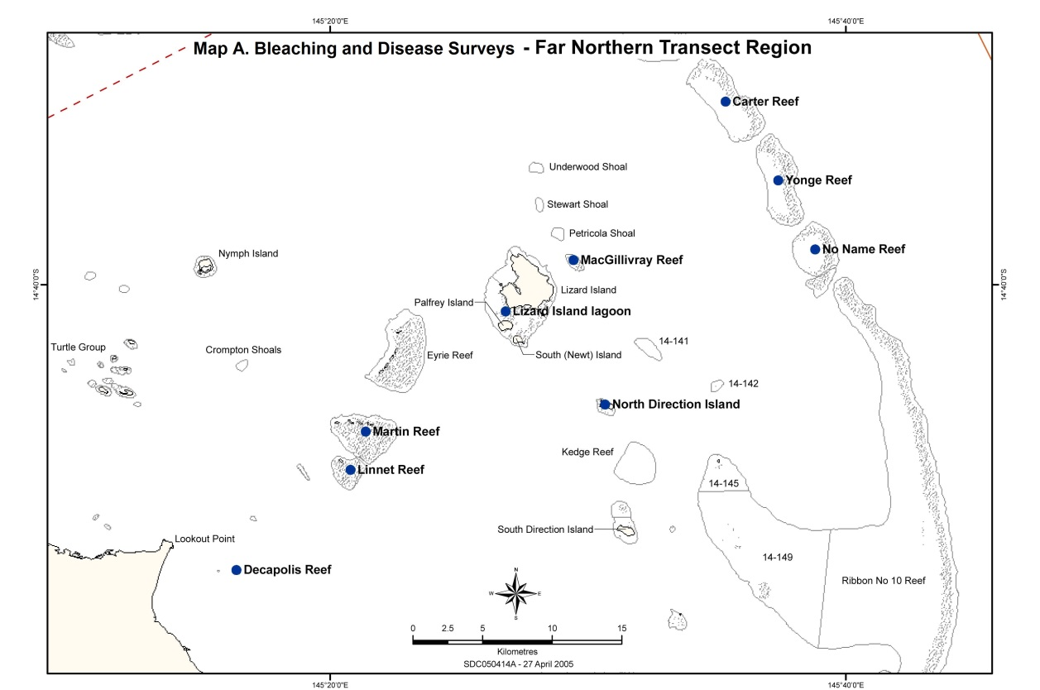
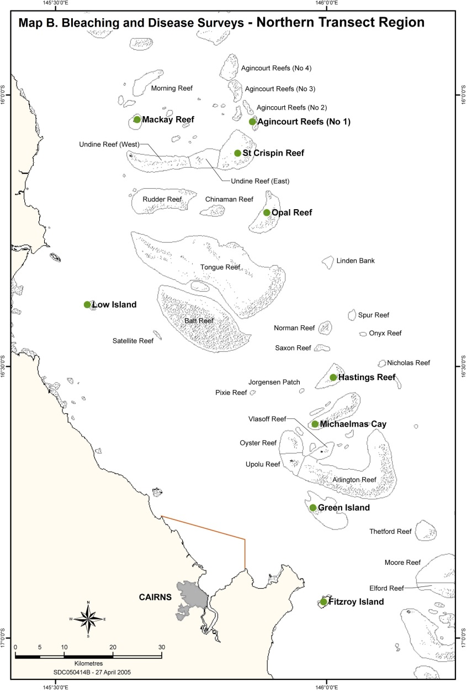
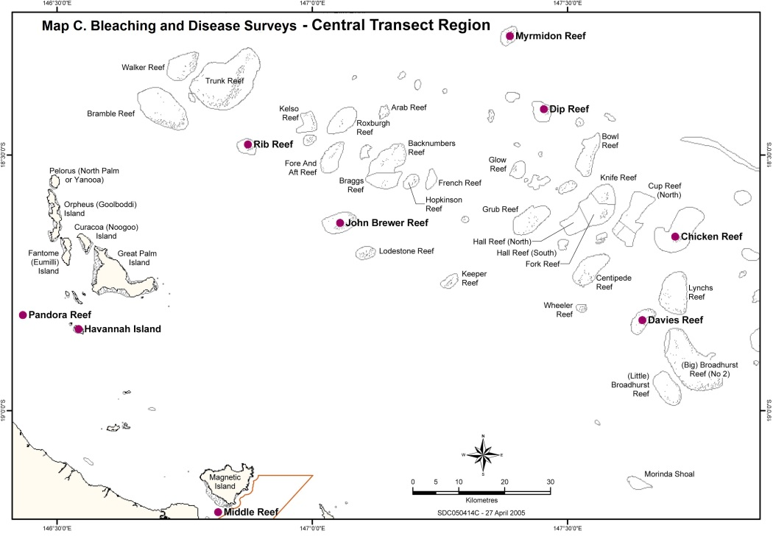
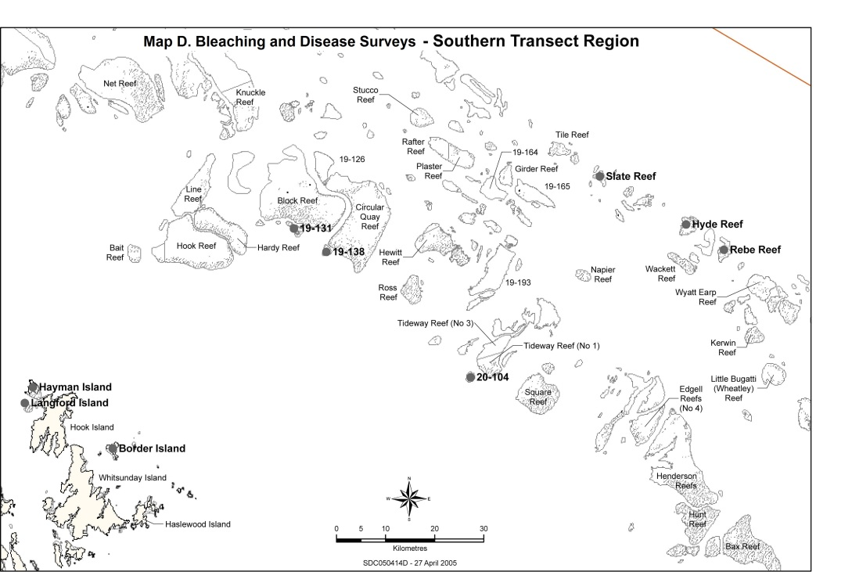

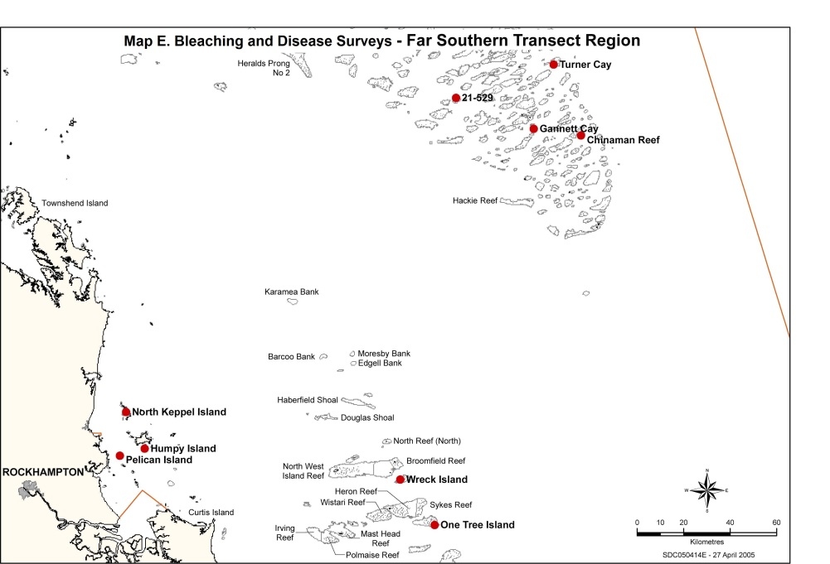

Appendix F — Great Barrier Reef Marine Park planning areas

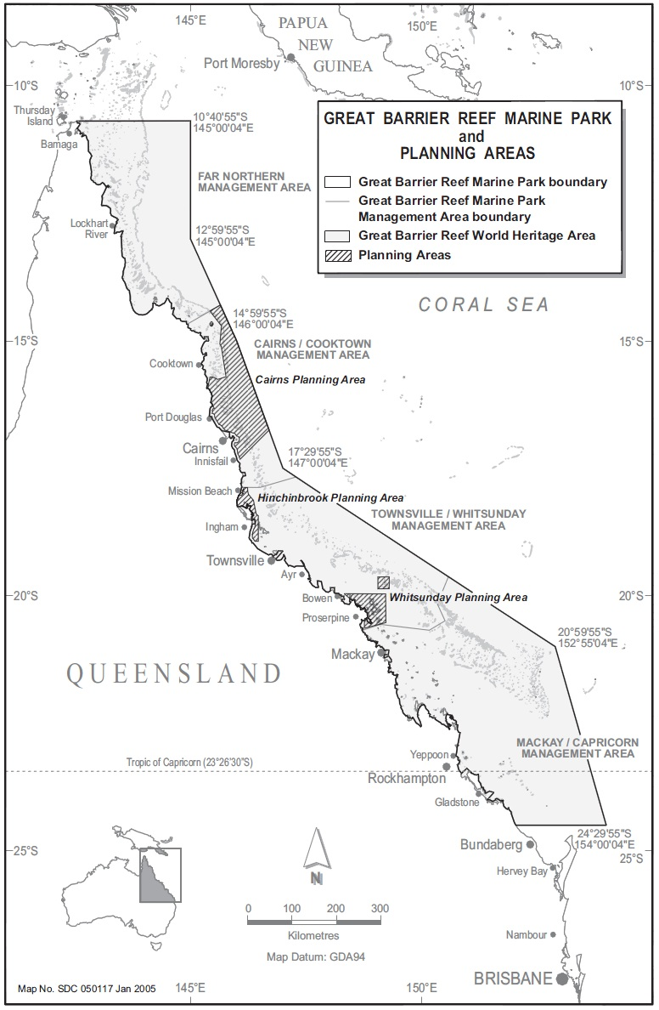

http://coralreefwatch.noaa.gov/satellite/research/dz_index.html
http://www.coralreefwatch.noaa.gov/satellite/baa/index.html
http://poama.bom.gov.au/experimental/poama15/sp_gbr.htm#ge_table
http://www.gbrmpa.gov.au/__data/assets/pdf_file/0003/46767/gbrmpa_CoralBleachingResPlan_2011.pdf
http://coralreefwatch.noaa.gov/satellite/disease/dz_gbr.html
http://www.cmar.csiro.au/remotesensing/ReefTemp/web/ReefTemp_Disease.htm
http://www.cmar.csiro.au/remotesensing/ReefTemp/web/ReefTemp.htm
http://www.cmar.csiro.au/remotesensing/ReefTemp/web/
Participation in the network extends from Port Douglas in the north to Bundaberg in the south (see ‘Assessment and Monitoring’).
Australasian Fire Authority Council, 2004, www.afac.com.au

