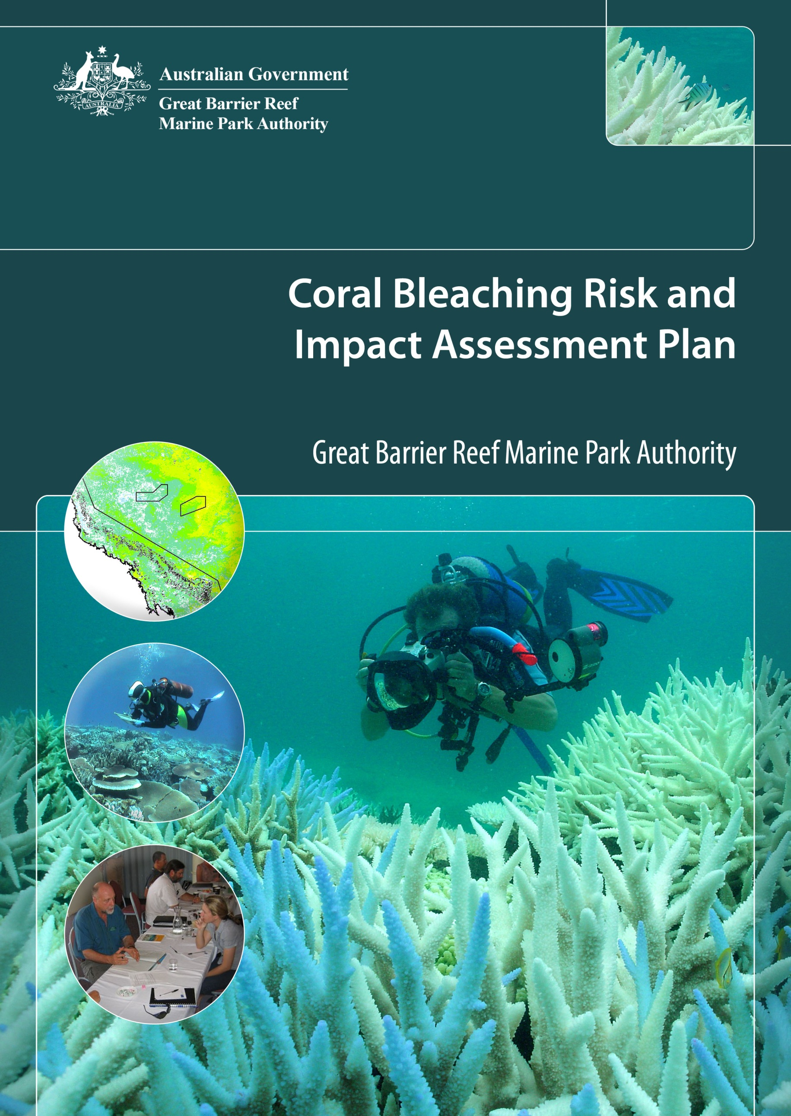

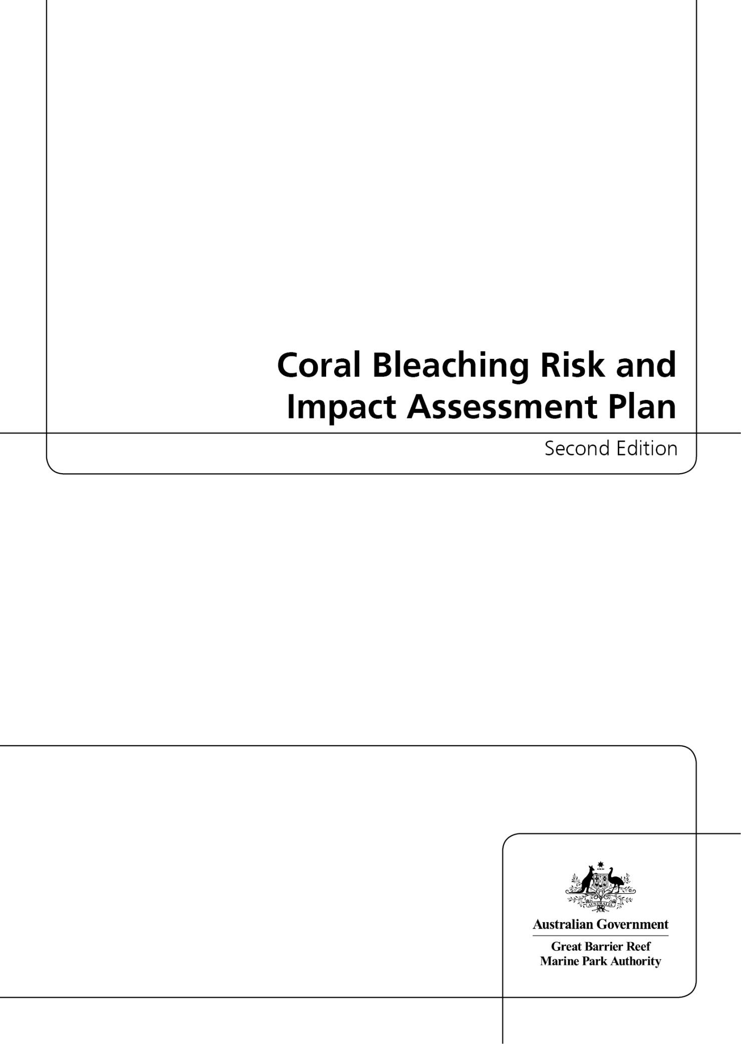

© Commonwealth of Australia 2013

Published by the Great Barrier Reef Marine Park Authority

Coral Bleaching Risk and Impact Assessment Plan Second Edition

ISSN 2200-2022

ISBN 978-1-922126-35-1 Second Edition (pdf)

This work is copyright. Apart from any use as permitted under the Copyright Act 1968,
no part may be reproduced by any process without the prior written permission of the
Great Barrier Reef Marine Park Authority.

Requests and enquiries concerning reproduction and rights should be addressed to:

Director, Communications and Parliamentary
2-68 Flinders Street
PO Box 1379
TOWNSVILLE QLD 4810
Australia

Phone: (07) 4750 0700
Fax: (07) 4772 6093
info@gbrmpa.gov.au

Comments and enquiries on this document are welcome and should be addressed to:
Director, Ecosystem Conservation and Resilience
info@gbrmpa.gov.au

www.gbrmpa.gov.au

Executive summary

There are a multitude of threats to coral reefs, but the increased frequency and severity of coral bleaching events under a changing climate is among the most pressing. The Great Barrier Reef Marine Park Authority (GBRMPA) first developed a coral bleaching response plan (now the risk and impact assessment plan) in 2002, as part of a response to a bleaching event that occurred in the late summer (February and March) of that year. Since then, we have coordinated implementation of the plan each summer — December to March — and reviewed and refined it annually. The plan outlines our strategic approach for monitoring bleaching risk and assessing coral bleaching impacts when events occur. Within this document, the objectives of each of the three primary components of the plan are outlined and described in detail:

- Early warning system
- Incident response
- Communications strategy

The plan includes related routine and responsive tasks. When bleaching is either predicted or initially reported under the early warning system, the in-water monitoring network ground-truths these predictions. GBRMPA, in conjunction with the Queensland Parks and Wildlife Service also conducts site inspections that determine the level of response required under the incident response component of the plan (based on the Australasian Inter-service Incident Management System). Thresholds for response levels (1, 2, or 3) in the incident response component are based on the severity of bleaching impacts as well as the spatial extent of the event. More detailed monitoring during the incident response component enables detailed reporting on reef condition and the severity of bleaching impacts, and works to target surveys to assess recovery. In the months and years that follow the disturbance, resilience-based management actions (e.g. continued improvement of water quality inshore) can support the natural resilience of habitats in the Marine Park at the whole-of-reef scale, and increase the resilience of reef users to reef health incidents.

We implement the plan throughout the summer season, rendering a transparency and consistency to management decision-making during bleaching events. The plan also serves to keep representatives from key partner institutions and the public aware of the technologies and protocols used to predict and monitor bleaching, and the criteria used to determine how to communicate about the severity of bleaching impacts when events occur. The plan is one of a number of risk and impact assessment plans that uses the three-component template (as above) for incident response described within our overarching Reef Health Incident Response System.

Contents

Introduction 1
1. Early warning system 2
Seasonal outlook 3
Monitoring network 7
Site inspections 9
2. Incident response 11
Assessment and monitoring 16
3. Communications strategy 18
Importance of management actions 21
Conclusion 21
References 23
Appendix A — Schedule of Coral Bleaching Risk and Impact Assessment Plan routine and responsive tasks for before, during and after the coral bleaching season. 24
Appendix B — Early warning system tools key references and further reading 27
Appendix C — Reef Health and Impact Point Survey reporting form 28
Appendix D — Locations of intensive survey sites 29
Appendix E — Detailed maps of survey site locations in each cross-shelf
transect …………………………………………………………………………………….. 30
Appendix F — Great Barrier Reef Marine Park planning areas 32

Introduction

Of the threats to the resilience of the Great Barrier Reef, expected increases in the frequency and severity of coral bleaching events under a changing climate is among the most pressing. While the Great Barrier Reef has a long history of recovery from major disturbances, such as the bleaching events of 1998 and 2002 and the cyclones and floods of 2008–09, the recovery capacity of the ecosystem is likely to diminish as disturbance frequencies increase. Consequently, the risk of coral bleaching each summer cannot be viewed in isolation. The legacy of impacts from previous years may render corals more susceptible to bleaching and disease. Since future bleaching events are inevitable, reef managers have a responsibility to monitor risk and assess the socio-ecological impacts of coral bleaching. This expectation was outlined specifically in the Great Barrier Reef Outlook Report 2009 (GBRMPA 2009) and characterised as the need to assess ecosystem health and manage for resilience. Assessing impacts ensures GBRMPA has an up-to-date understanding of the vulnerability of the Great Barrier Reef Marine Park (the Marine Park). We can therefore distinguish between the effects of acute and chronic stressors (e.g. bleaching events and water quality, respectively) and target resilience-building management strategies and awareness raising communications efforts.

During the summer season, we use this risk and impact assessment plan to provide a transparent and consistent decision-making framework during bleaching events. The plan serves to keep representatives from key partner institutions, as well as the public, aware of the technologies and protocols used to predict and monitor bleaching. It also describes the criteria that determine how we communicate about bleaching events when they occur.

The plan includes linked routine and responsive tasks (Figure 1, Appendix A). When early warning system tools predict bleaching, monitoring network participants ground-truth the predictions and report to managers. Managers and researchers confirm reports of bleaching by conducting site inspections that determine whether the level of bleaching exceeds one of three thresholds defined within the Reef Health Incident Response System (based on Australian standard incident response protocols) section of the plan. Thresholds for response levels 1, 2 and 3 (Figure 1) are defined by the severity and spatial extent of the impacts. More detailed monitoring during the incident response enables detailed reporting on reef condition and the severity of bleaching impacts, and works to target survey efforts to assess recovery. An effective management response to bleaching depends on clear and transparent communication between managers and senior decision-makers, stakeholders and the public. Further, communication efforts during and just after bleaching events can raise the public’s awareness of the importance of responsible behaviour in the Marine Park. Communication is, therefore, an overarching theme of the plan (Figure 1).

The Coral Bleaching Risk and Impact Assessment Plan has been developed in conjunction with A Global Protocol for Assessment and Monitoring of Coral Bleaching (prepared by The World Wildlife Fund for Nature, World Fish Centre and GBRMPA, Oliver et al. 2004) and A Reef Manager’s Guide to Coral Bleaching (an international collaborative effort led by GBRMPA, National Oceanic and Atmospheric Administration (NOAA) and the International Union for Conservation of Nature, Marshall and Schuttenberg 2006) to maximise comparability and consistency with bleaching responses in other regions.

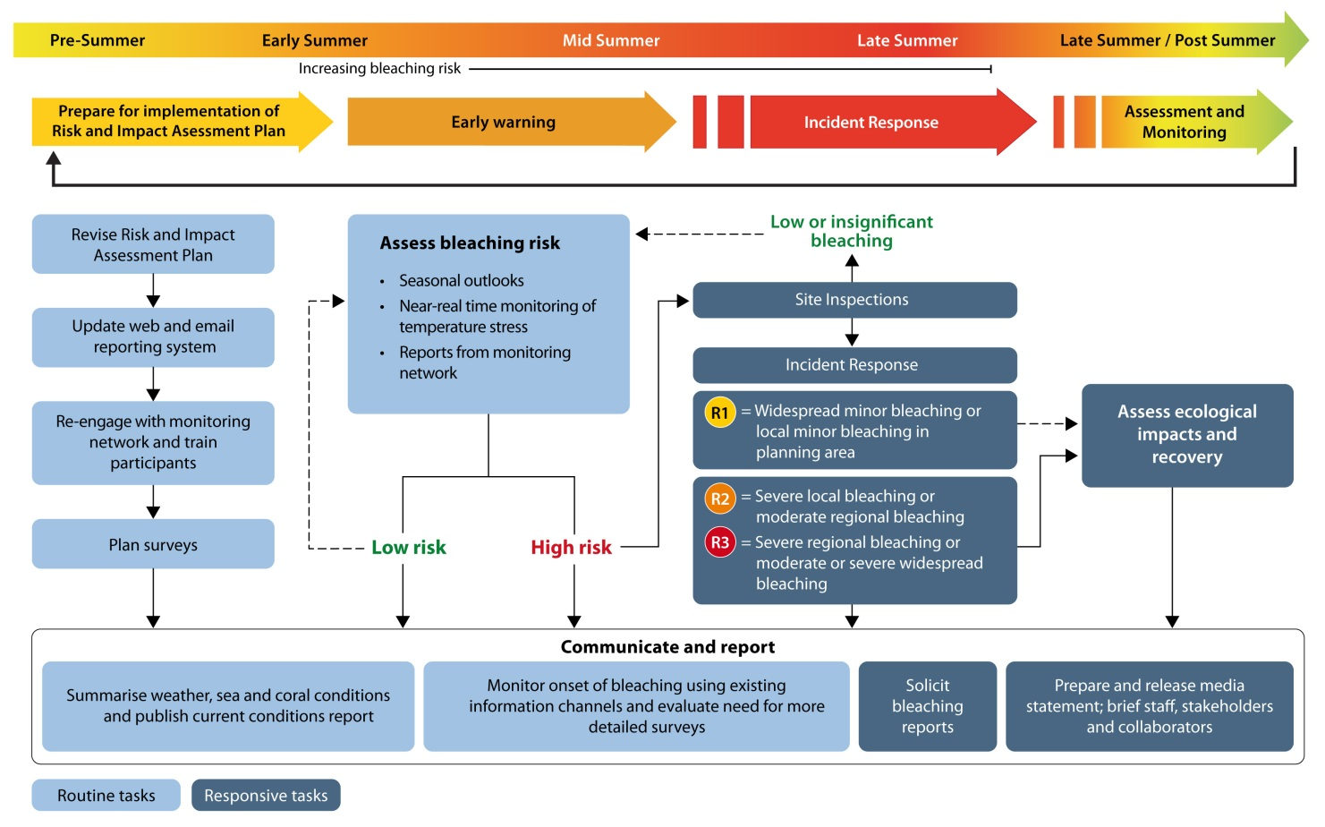

Figure 1: Risk and impact assessment plan schedule of routine and responsive tasks before, during, and after the coral bleaching season (see also Appendix A). Plan components follow on from each other, though responsive tasks are only undertaken if incident response is triggered. Response levels 2 and 3 activate efforts to assess and monitor impacts, which is conditionally activated under response level 1 (see also Figures 8–10).

Within this document, the objectives of each of the three primary components of the risk and impact assessment plan are outlined.

1. Early warning system

Mass coral bleaching is preceded by a series of conditions that can be used to assess the probability of an event occurring. The early warning system uses: 1) climate forecasts in the months that precede the summer to provide a seasonal outlook of the likelihood bleaching will occur, 2) tools that enable near real-time monitoring of temperature stress during the summer to target monitoring efforts, 3) a monitoring network to detect the early signs of bleaching, and 4) site inspections to ground-truth predictions or reports of bleaching and determine whether and which thresholds requiring incident response have been exceeded. All four elements are described briefly below.

Seasonal outlook

A number of factors are known to cause high sea temperatures in the Great Barrier Reef. In particular, delayed or weak development of the monsoonal trough over northern Australia during summer appears to be a strong precursor to the anomalously warm conditions that, if severe or prolonged, can cause coral bleaching. Based on an emerging understanding of the relationship between weather and sea temperatures for the Great Barrier Reef, current and forecast weather conditions can indicate whether conditions conducive to bleaching are likely. Two agencies —NOAA and the Bureau of Meteorology of Australia — use climate models to predict bleaching likelihood in the Great Barrier Reef Marine Park in the months that precede summer.

NOAA’s Coral Reef Watch group produces a thermal stress outlook based on sea surface temperature forecasts generated by the linear inverse model from NOAA’s earth system research laboratory (Liu et al. 2008). When forecast sea surface temperature exceeds bleaching thresholds over a long enough period to cause bleaching, the outlook maps display the bleaching potential as ‘watch’, ‘warning’, ‘alert level 1’ and ‘alert level 2’ (Figure 2a). The thermal stress outlook is an experimental product and is used as an indicator of potential general patterns rather than a precise predictor of thermal stress at any location — actual conditions vary due to model uncertainty, changes in climatic conditions and localised variability (see Appendix B for key references and further reading).

The probability of above average summer sea temperatures, and hence the likelihood of a mass bleaching event occurring, can also be forecast using the coupled ocean-atmosphere seasonal prediction system, POAMA (Predictive Ocean Atmosphere Model for Australia), developed by the Bureau of Meteorology and the Commonwealth Scientific and Industrial Research Organisation (CSIRO). Two operational forecast products are generated in real-time for the Great Barrier Reef region; monthly sea surface temperature anomalies, and the mean sea surface temperature anomalies in the region, termed the GBR Index (Figure 2b). Experimental forecasts of the likelihood of sea surface temperature anomalies values exceeding 0.6 degrees Celsius in the region (potential coral bleaching conditions) are also produced. These forecasts are for up to six months into the future, with significant skill in predictions up to three months ahead (Spillman and Alves 2009).

Near real-time monitoring of temperature stress

A number of environmental stresses can lead to coral bleaching. It is, however, well established that spatially extensive or mass bleaching events are caused by anomalously high sea temperatures (Hoegh-Guldberg 1999). Excessive and persistent sea temperature anomalies are a good indication that conditions are approaching levels known to be stressful to corals. Sea surface temperature anomalies and other measures of temperature stress can be monitored in near real-time during the summer via several different tools and information sources.

NOAA’s Coral Reef Watch group produces images at 50 kilometre resolution of the Australian region that show remotely sensed sea surface temperature anomalies (referred to as ‘hotspots’, Figure 2c) and the accumulation of heat stress, which is measured by degree heating weeks (DHW, Figure 2d) accumulated over the previous 12 weeks. A degree heating week is equal to 1 degree above the long-term maximum monthly mean, which serves as a useful bleaching threshold. Observations of minor to moderate bleaching are commonly made at sites where temperature stress exceeds 4 degree heating weeks and severe bleaching is often observed at sites that have experienced >8 degree heating weeks (see Appendix B for key references and further reading). NOAA’s Coral Reef Watch group also maintains 15 web-based ‘virtual bleaching stations’ for the Great Barrier Reef Marine Park. Graphs of temperature for the current year and each of the last 10 years are shown with respect to the maximum monthly mean (Figure 2g).

CSIRO marine and atmospheric research, in collaboration with the Bureau of Meteorology and GBRMPA, developed an interactive high-resolution (~1 kilometre) system for monitoring bleaching risk. This suite of tools, called ReefTemp, produces images that depict remotely sensed sea surface temperature and three measures of temperature stress: the sea surface temperature anomaly, the degree heating day, and the heating rate (Maynard et al. 2008) all at the scale of an individual reef (Figure 2e). During summer, ReefTemp is used to target the efforts of monitoring network participants and/or to target specific site inspections. The colour legends for each temperature stress metric depict bleaching risk as they have been calibrated to in situ observations of bleaching from the 2002 bleaching event in the central Great Barrier Reef (Figure 3). During the 2006 bleaching event in the southern Great Barrier Reef, managers found that the ReefTemp system could predict variability in bleaching response severity between islands and reefs separated by as little as 5 kilometres.

In situ measurements of local sea temperatures are available from a network of weather stations installed on the Great Barrier Reef and are maintained through collaboration between GBRMPA and the Australian Institute of Marine Science (AIMS; Figure 2f). These weather stations record water temperature at the surface and at 6-metre depth providing important information about depth-related variability, and a mechanism to ground truth ReefTemp outputs. ReefTemp and the weather stations are monitored regularly throughout the summer season. When reefs or reef regions within the Marine Park experience prolonged periods of excessively high temperatures, managers maintain close contact with a network of observers to ensure regular reports of reef condition are submitted and managers are alerted to early signs of bleaching.
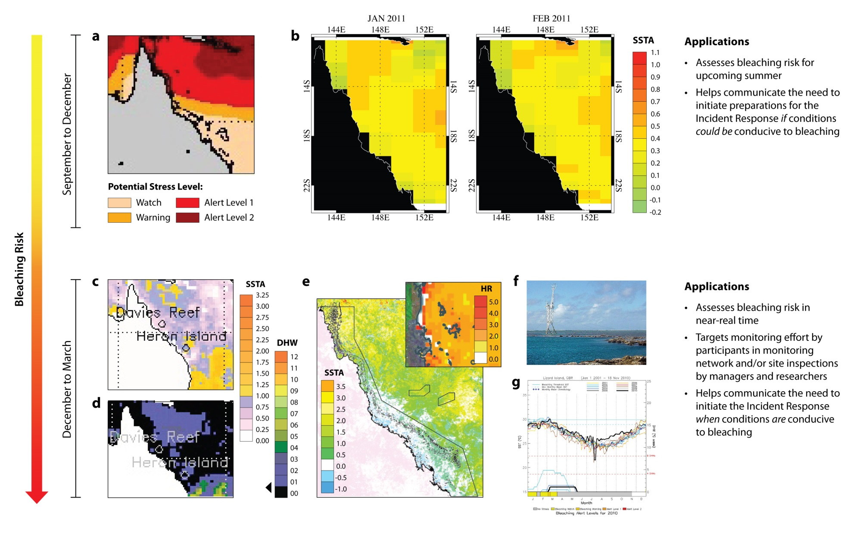
Figure 2: Tools used within the early warning system and their applications for management decision-making. NOAA’s bleaching outlook product (a) and the POAMA sea surface temperature anomaly forecasts (b) provide a seasonal outlook of bleaching risk in the months that precede summer. This year, the NOAA product (a) suggests conditions could be conducive to bleaching in the northern Great Barrier Reef, while POAMA forecasts suggest temperatures will be anomalously high in January and February, but not high enough to cause moderate or severe bleaching (see Table 1). GBRMPA staff will continue to monitor bleaching risk during the summer months as temperature stress can be monitored in near real-time using NOAA’s hotspot and degree heating week products (c, d — examples from February 2010) and at the scale of an individual reef using CSIRO’s ReefTemp (e — inset example is of the heating rate during the 2006 bleaching in the southern Great Barrier Reef). Data from AIMS/GBRMPA weather stations (f) and NOAA’s virtual bleaching stations (g) serve to confirm remotely sensed temperature data.

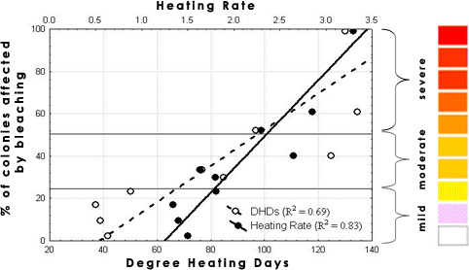

Figure 3: Colour gradations used within ReefTemp are based on the approximate number of degree heating days and the value for heating rate that related to mild (<25% colonies affected), moderate (26 – 50% affected), and severe (>50% affected) bleaching responses at sites surveyed in the central Great Barrier Reef in 2002 (from Maynard et al. 2008). <25% colonies affected is considered mild for this plan because some bleaching of susceptible taxa occurs annually, particularly in shallow water areas such as reef flats. Therefore, the colour-graded legends used in ReefTemp facilitate responses to bleaching events likely to cause some coral mortality.

Monitoring network

Detecting the early signs of a mass bleaching event requires a wide network of observers. This is due to the size of the Great Barrier Reef and because the initial onset of mass coral bleaching can range from gradual and patchy to rapid and uniform. We rely on field reports provided by a monitoring network that includes Queensland Parks and Wildlife Service rangers and trained volunteers. The network covers the entire Great Barrier Reef and includes regular reef users, such as dive professionals, tourism operators, fishers, researchers, community groups, and other recreational users who voluntarily monitor and report (Appendix A) on conditions at reefs they visit.

Participants undertake a protocol (Figure 4) that can be completed by snorkelers or divers using a repeated Global Positioning System (GPS)-tagged five-metre radius point survey method. This method is used to assess a range of reef health indicators including coral and algal cover and the extent and severity of impacts such as coral bleaching, disease, predation and anchor or storm damage. The revised protocol recognises the limited time that many participants have to complete survey forms. One form is completed for each point survey and observers complete at least three point surveys at each site whilst remaining within one habitat type (e.g. reef slope or lagoon). Repeated surveys are conducted to enable statistical analysis of the data; however these surveys do not have to occur on the same day if time is limited.
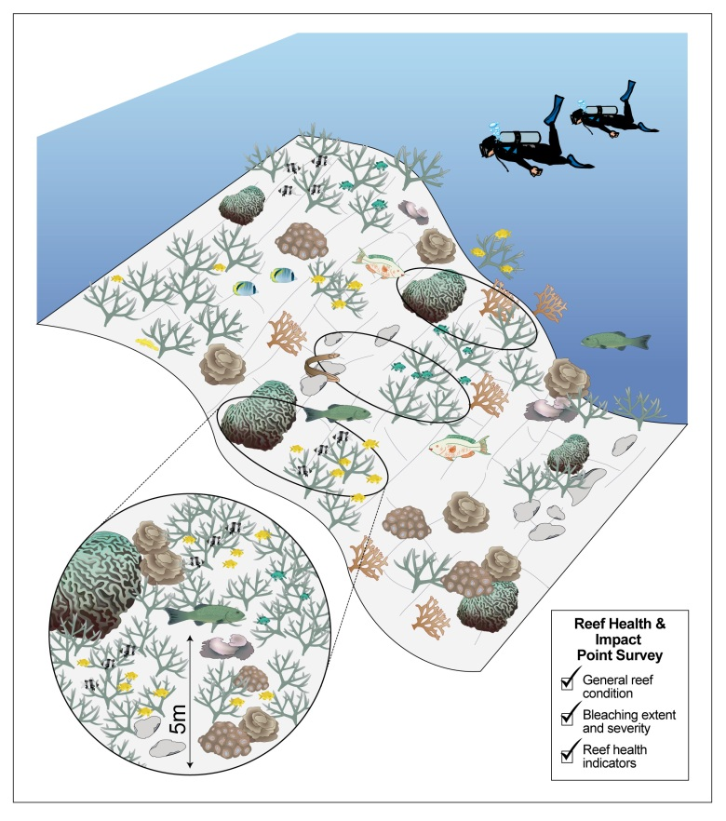
Figure 4: Protocol used in the monitoring network. Observers either diving or snorkelling use the protocol to assess reef condition and to detect the early signs of bleaching, as well as other impacts. The same protocol is used by researchers and managers when site inspections are conducted to either ground-truth predictions from the temperature monitoring tools or to further quantify bleaching following a report from a monitoring network participant.

During non-summer months, participants complete their reports opportunistically whenever they are out on the Reef. During the hotter summer months, surveys are undertaken on a weekly or fortnightly basis. We review these results weekly during the summer months (Table 1) to identify where coral bleaching has been sighted. Information is collated in the Eye on the Reef database and displayed as report files which can be viewed through Google EarthTM. This system displays information and visual representations for all the data collected at each reef in the Marine Park. Eye on the Reef reports are used to target site inspections in order to determine the severity and spatial extent of impacts. Reports of severe bleaching from the monitoring network are verified through site inspections conducted by GBRMPA in partnership with trained staff from the Queensland Parks and Wildlife Service.

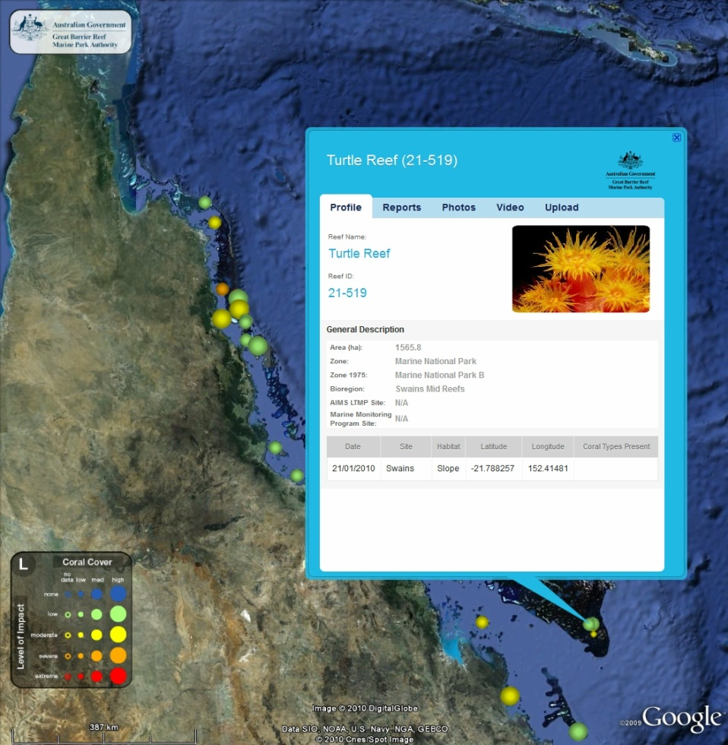

Figure 5: Sample output from GBRMPA’s new system facilitating rapid review and dissemination of reports from participants in the monitoring network. This example shows Turtle Reef and enables access to all reports for that and all other locations for which survey data is available.

Site inspections

Site inspections in the Marine Park involve a series of surveys at two depths using the method described in Appendix B. Site inspections are conducted on an as-needed basis at sites where:

- monitoring network participants have reported widespread minor impacts, or moderate or severe impacts over any scale (see Table 1)
- tools enabling near real-time monitoring of conditions indicate the risk of a reef health incident occurring is high (e.g. systems indicate that temperature stress is severe enough to cause coral bleaching).
- a ship grounding or oil spill has occurred.

If site inspections confirm moderate to severe localised impacts (relating to any incident) or widespread minor impacts (relating to bleaching, disease outbreaks, flood plumes and/or cyclones), the incident response component of the Reef Health Incident Response System is activated.

Table 1: Levels of bleaching severity and extent of bleaching. Below, reference to morphologies relates to data collected using the Reef Health and Impact Survey protocol, while reference to coral taxa relates to site inspections that complement the protocol with 50-metre video transects. Hence, both types of monitoring protocols result in data that can be used to determine the severity of bleaching impacts. Examples given within ‘minor impacts’ of morphologies and taxa that have high, low, and very low sensitivity to bleaching (see also Appendix C) work for both the ‘moderate impacts’ and ‘severe impacts’ sections. The matrix in Figure 6 of bleaching severity and spatial extent determines the response level triggered in the incident response.

Severity | Description
High bleaching risk | POAMA predicts sea surface temperature anomalies >0.6 ^{O}C for > 2 months  Degree heating days index >50 at multiple sites  Heating rate index >2 at multiple sites  Major flooding of coastal catchment imminent  Major cyclone passed over reef
Minor impacts | Severe bleaching of many (10–50 per cent) colonies of taxa (Acropora and Pocillopora), or morphologies (branching, bushy, tabular/plate) usually highly sensitive to bleaching)  Severe bleaching of some (<10 per cent) colonies of taxa (Montipora and Faviids) or morphologies with low sensitivity to bleaching (encrusting and mushroom)  Paling of colonies of taxa (Porites) or morphologies (massives) with very low sensitivity to bleaching  Severe bleaching of colonies of taxa or morphologies with low or very low sensitivity to bleaching but confined to reef flat
Moderate impacts | Bleaching extends deeper than reef flat and:  Severe bleaching of most (>50 per cent) colonies of taxa or morphologies usually highly sensitive to bleaching  Severe bleaching of many (10–50 per cent) colonies of taxa or morphologies with low sensitivity to bleaching below reef crest  Severe bleaching of some (<10 per cent) colonies of taxa or morphologies with very low sensitivity to bleaching  Some mortality of colonies of taxa or morphologies usually highly sensitive to bleaching but confined to reef flat
Severe impacts | Bleaching extends deeper than upper reef slope and:  Mortality of many (>50 per cent) colonies of taxa or morphologies usually highly sensitive to bleaching  Severe bleaching of most (>50 per cent) colonies of taxa or morphologies with low sensitivity to bleaching  Severe bleaching of many (10–50 per cent) colonies of taxa or morphologies with very low sensitivity to bleaching

Extent | Description
Local | Impacts present in less than 10 sites within one region*
Regional | Impacts present in more than 10 sites but confined to one region
Widespread | Impacts present in more than 10 sites in each of multiple regions
* Management regions, see Appendix F.

In summary, the early warning system works as a chain of events prior to and during the summer. Forecasting tools heighten alert levels prior to the summer season and tools that enable monitoring of temperature stress in near real-time target the efforts of the monitoring network. If site inspections confirm moderate to severe localised impacts or widespread minor bleaching (Table 1) then incident response is activated, though use of the tools and monitoring network within the early warning system continues until the high risk season has passed.

2. Incident response

GBRMPA uses the Australasian Inter-service Incident Management System framework to coordinate the governance, planning, operations, logistics, financial and inter-agency liaison arrangements required to adequately respond to a reef health incident.

Information gathered from the early warning system and site inspections helps us to understand the severity and spatial extent of impacts. Once the spatial extent and severity of the impact have been classified based on the standardised criteria for each incident, we use the matrix in Figure 6 to inform a detailed situation analysis.

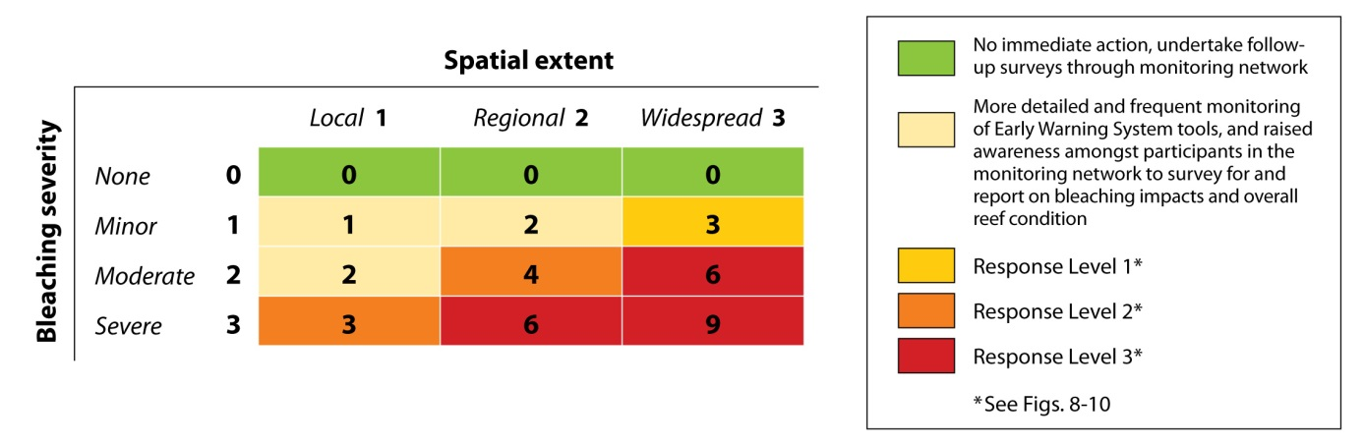
Figure 6: Matrix combining measures of bleaching severity and spatial extent (from Table 1) to inform the situation analysis (Figure 7), which results in the final decision as to which response level has been triggered (if any). Specific criteria for the levels of bleaching severity are described in detail in Table 1.

The situation analysis is assessed by GBRMPA’s governance group (the executive management group, the incident coordinator and the scientific, communications and liaison, and stakeholder advisory groups), which makes a final decision on the required level of response (Figure 7). There are three potential response levels — 1, 2 and 3. Each increase in response level (from 1 to 3) correlates to a corresponding increase in the severity and spatial extent of the impacts as well as an increase in the management investment and resources required to effectively respond. The activation and conditional activation of the incident response framework varies according to each response level but the framework used for each of the three response levels is standardised for all reef health incidents.

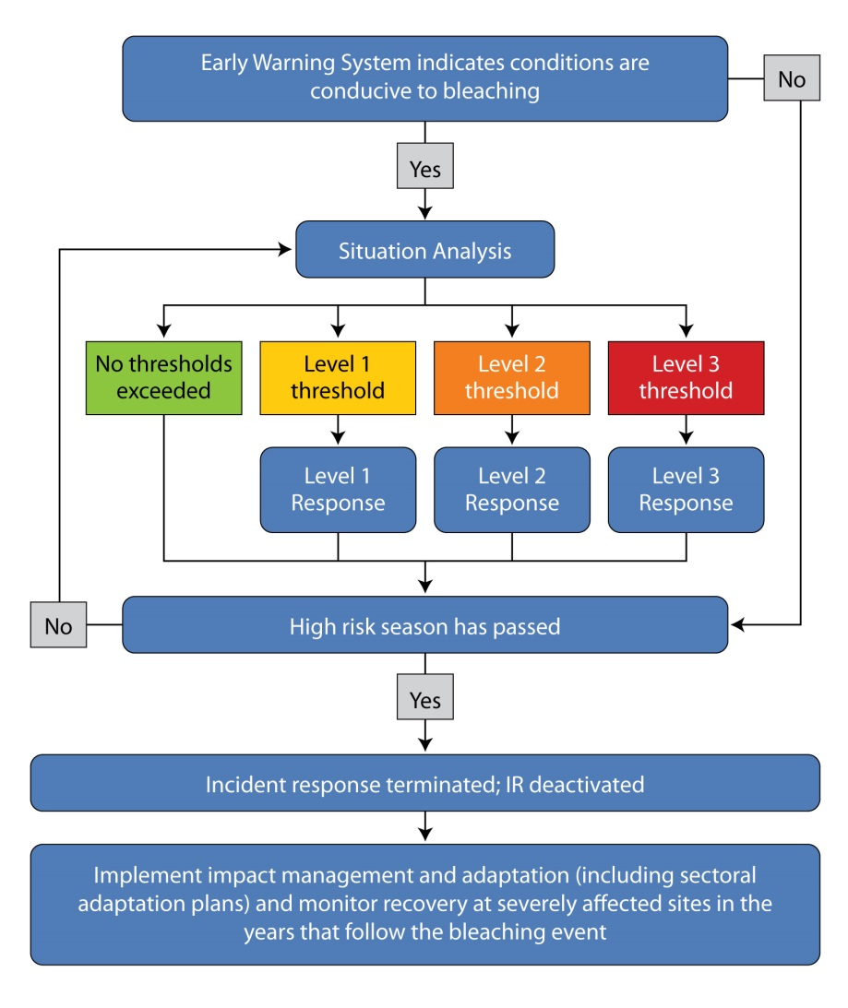
Figure 7: Incident response chain of events during a bleaching event. The situation analysis is informed by the matrix seen in Figure 6 and is revisited if the high risk season has not passed.

Once the appropriate response level has been determined, the corresponding planning and resource provisions of the incident response are activated. Communications, liaison, and reporting tasks are activated for all response levels. For response level 1, which may lead to response levels 2 or 3 if impacts become more severe or extensive through time, the logistics for extensive underwater surveys are only conditionally activated, and budgeting, contracting, staff procurement, and impact mitigation/recovery surveys are not activated (Figure 8). Conditional activation is based upon the type of incident and the outcome of the situation analysis. For response level 2, vessel support and underwater surveys are activated, as are budgeting and administration. Contracting, staff procurement, and impact mitigation/recovery surveys are all conditionally activated (Figure 9). For response level 3, the entire incident response framework is activated (Figure 10).
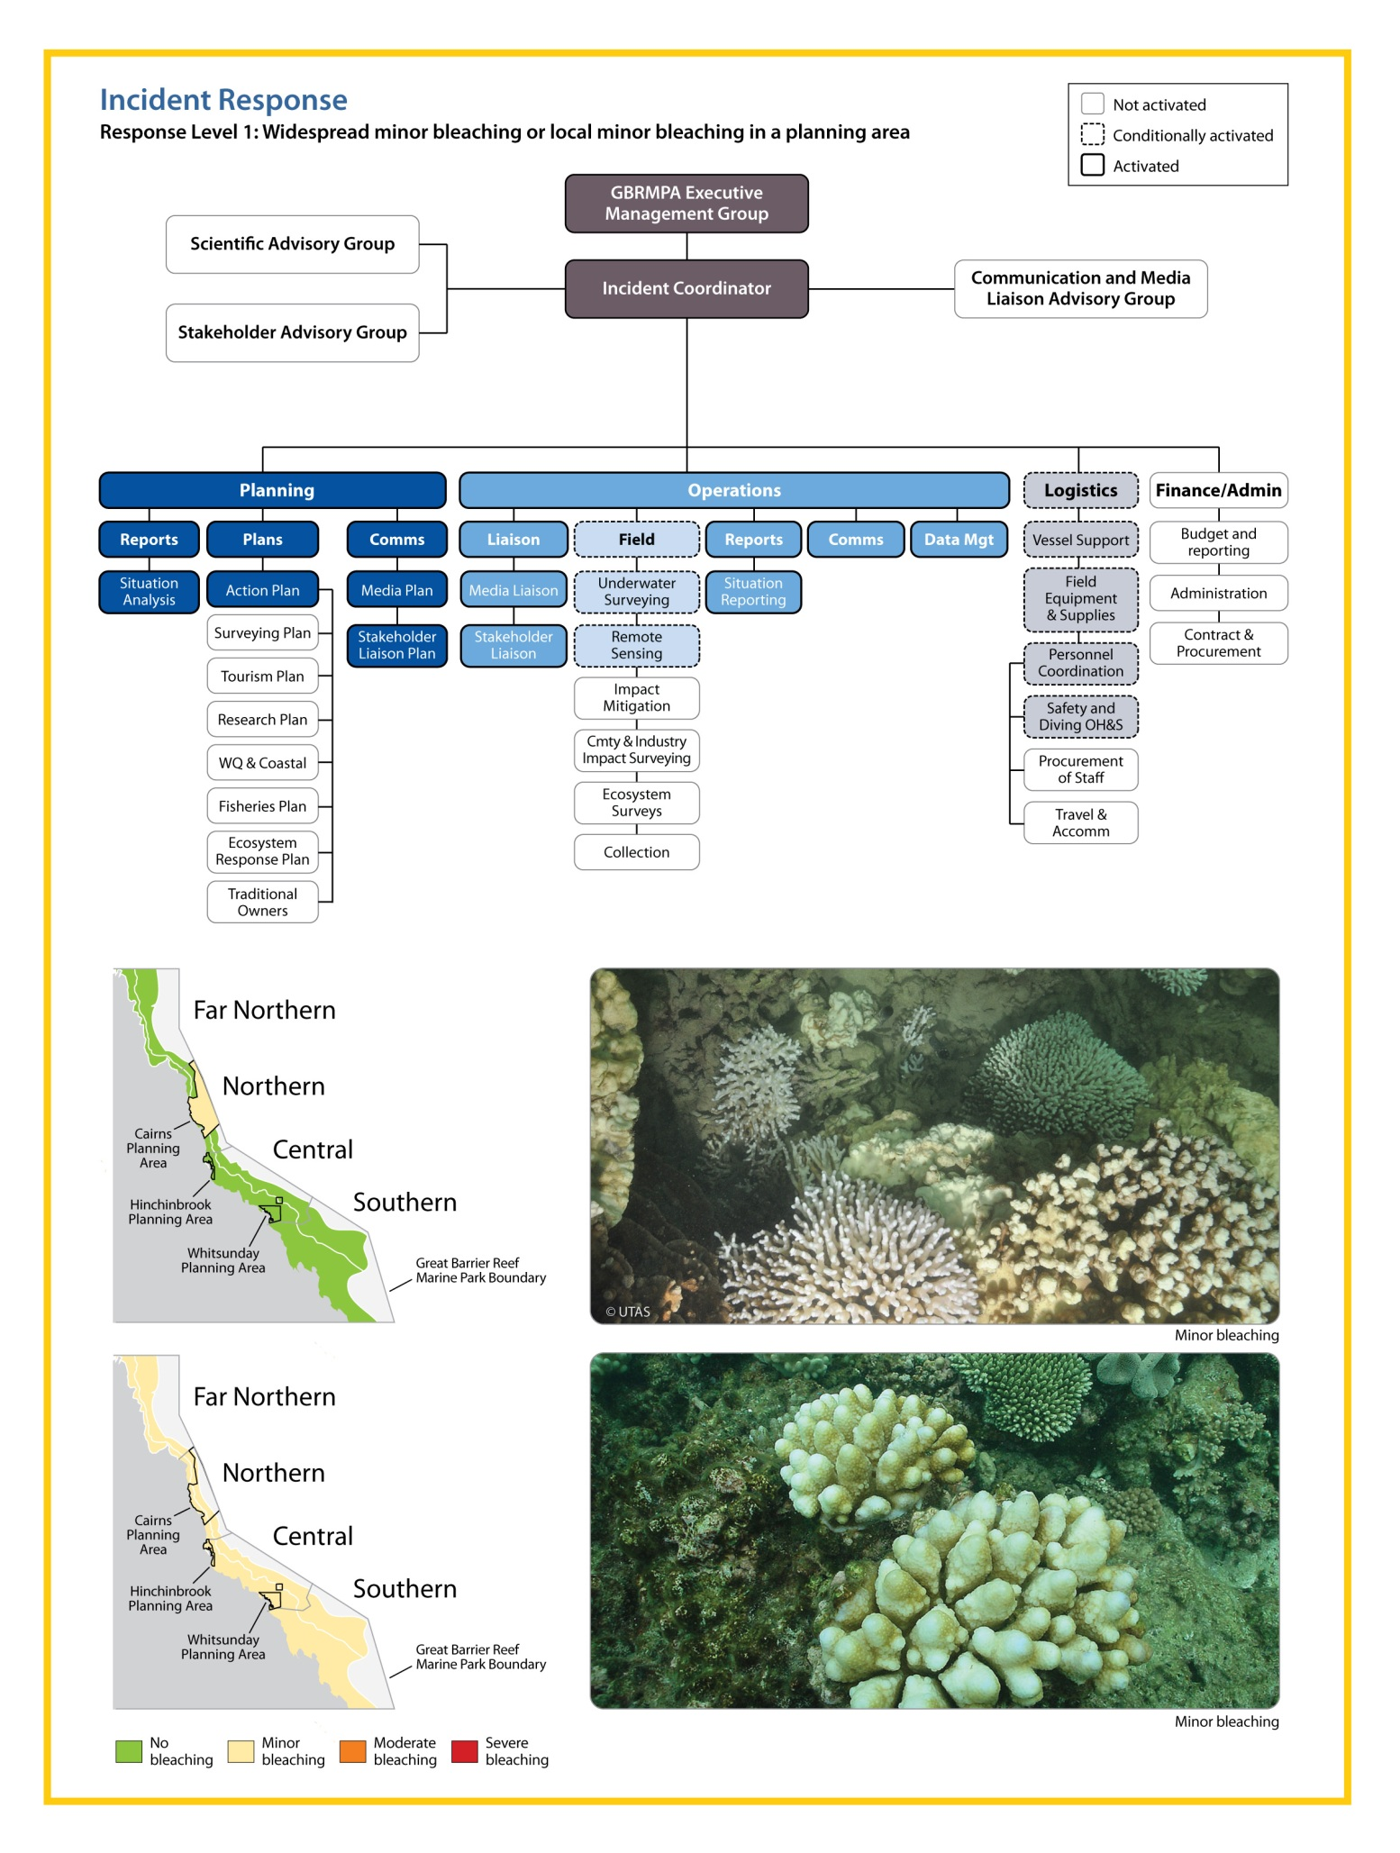
Figure 8: Response level 1 within the incident response. Activation and conditional activation of incident response components are illustrated by the intensity of colour and border for each box within the diagram above. Scenarios shown in the maps are examples (i.e., local bleaching in a different planning area would result in the same management response).
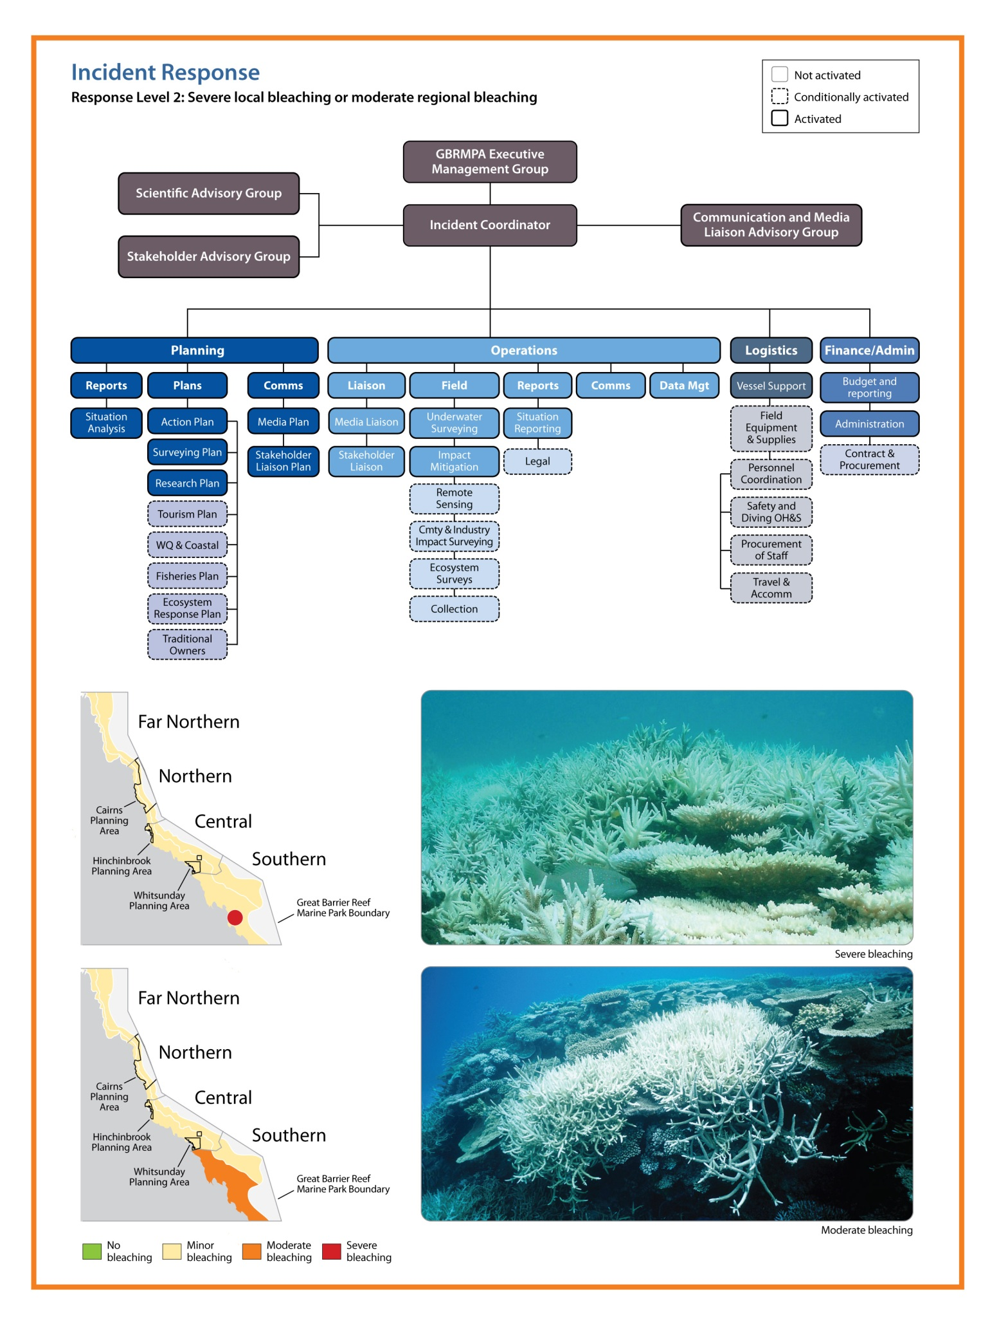
Figure 9: Response level 2 within the incident response. Activation and conditional activation of incident response components are illustrated by the intensity of colour and border for each box within the diagram above. Scenarios shown in the maps are examples (i.e., local severe bleaching or moderate bleaching in other regions would result in the same management response).
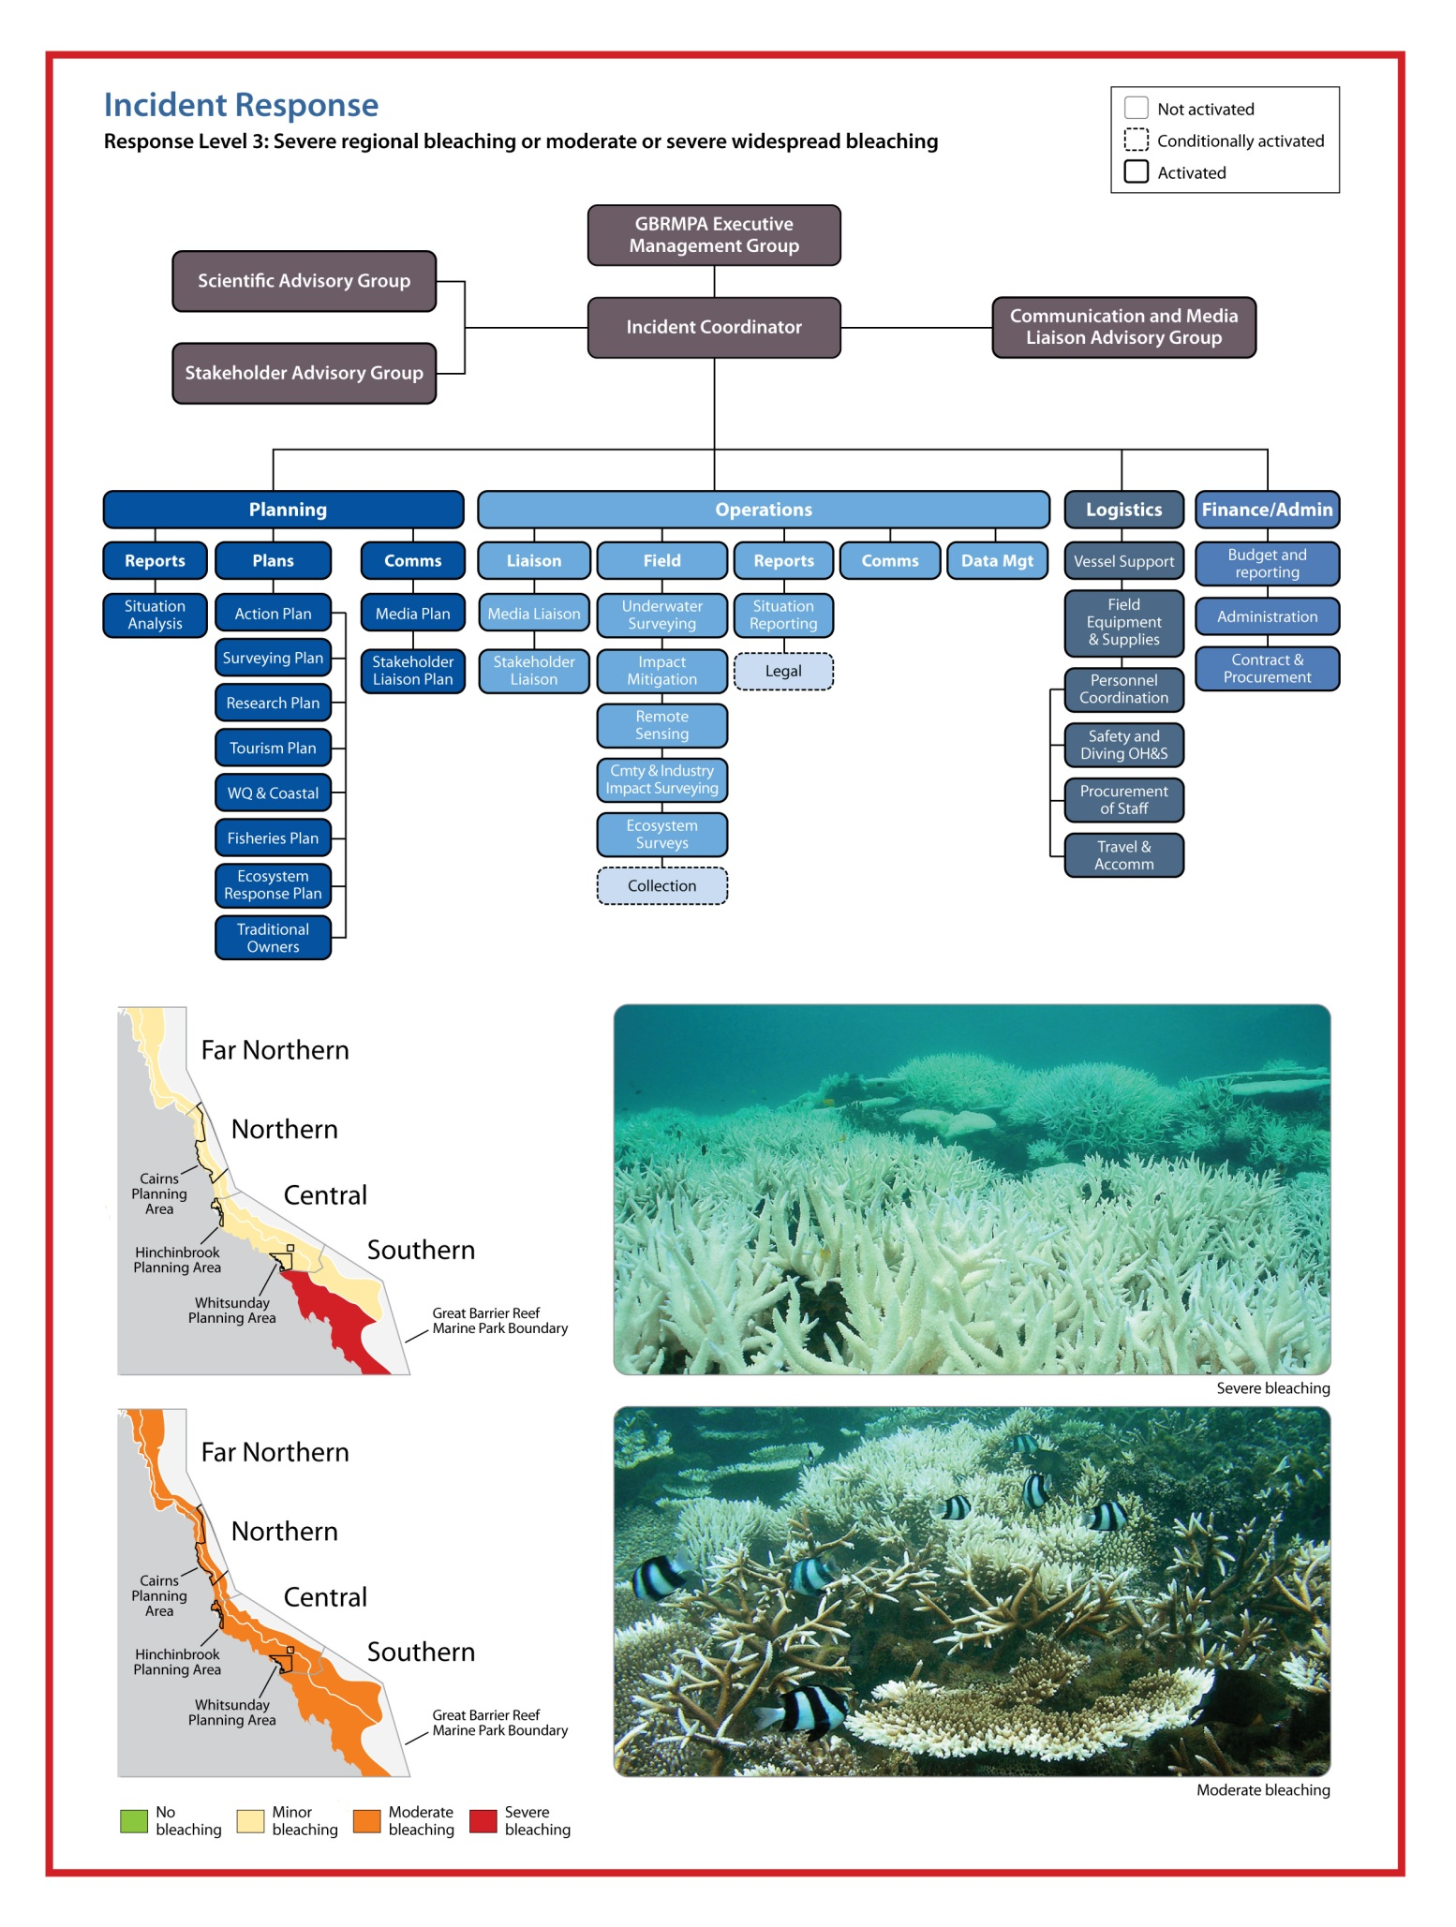
Figure 10: Response level 3 within the incident response. Activation and conditional activation of incident response components are illustrated by the intensity of colour and border for each box within the diagram above. Scenarios shown below are examples (i.e., severe bleaching in a different region would result in the same management response).

Assessment and monitoring

To accurately characterise the extent and severity of bleaching, bleaching-induced mortality and the associated longer-term ecological implications requires that three temporal surveys are undertaken: baseline, event and survival/mortality. By surveying sites that are also surveyed as part of the AIMS long-term monitoring program, baseline surveys are not required and managers can focus on the surveys during the event to assess the severity of bleaching impacts, and six months and a year after the event to assess the ecological implications of bleaching events. When recovery surveys are undertaken, surveys for disease are conducted concurrently because bleaching can greatly increase the susceptibility of corals to diseases (see Coral Disease Risk and Impact Assessment Plan, GBRMPA 2010). In this sense, we take the lead on assessing impacts and the implications of coral bleaching events in the year that follows the bleaching, while longer-term ecological monitoring surveys are coordinated and undertaken by the AIMS long-term monitoring program. Assessing reef health and condition during, and in the months that follow, incidents also informs estimates of reef resilience, which enables testing of the effectiveness of various strategies that support the natural resilience of reefs.

The implications of severe bleaching on reef ecology include but are not limited to coral mortality, shifts in coral community structure, altered habitat composition, and ecosystem flow-on effects. Severe bleaching also has implications for industries that depend on the reef as well as associated human communities since bleaching can reduce the social or economic value of reef sites important to tourism operators, fishers, or recreational users. Monitoring of the social and economic impacts of bleaching events is undertaken in collaboration with the Association of Marine Park Tourism Operators and researchers.

When the situation analysis (Figure 6) determines thresholds for response levels 2 (Figure 9) or 3 (Figure 10) have been reached, managers implement a two-tiered approach to assessment. Intensive in-water surveys at routine sites (surveyed during each event) and targeted sites (those most affected by bleaching) are conducted, in combination with aerial surveys that give broad reef coverage (Oliver et al. 2004). These surveys are conditionally activated for response level 1 (Figure 7) and may be undertaken depending on the outcome of the situation analysis.

The plan surveys 45 routine sites for intense in-water assessments (Figure 11, coordinates for sites in Appendix D). The sites represent cross-shelf as well as latitudinal gradients along the Great Barrier Reef. The site groupings are located at latitudes centred on Lizard Island, Cairns, Townsville, Whitsunday Islands and the Capricorn Bunker Group (Figure 11). Three inshore, three mid-shelf and three outer shelf reefs are surveyed in each transect.

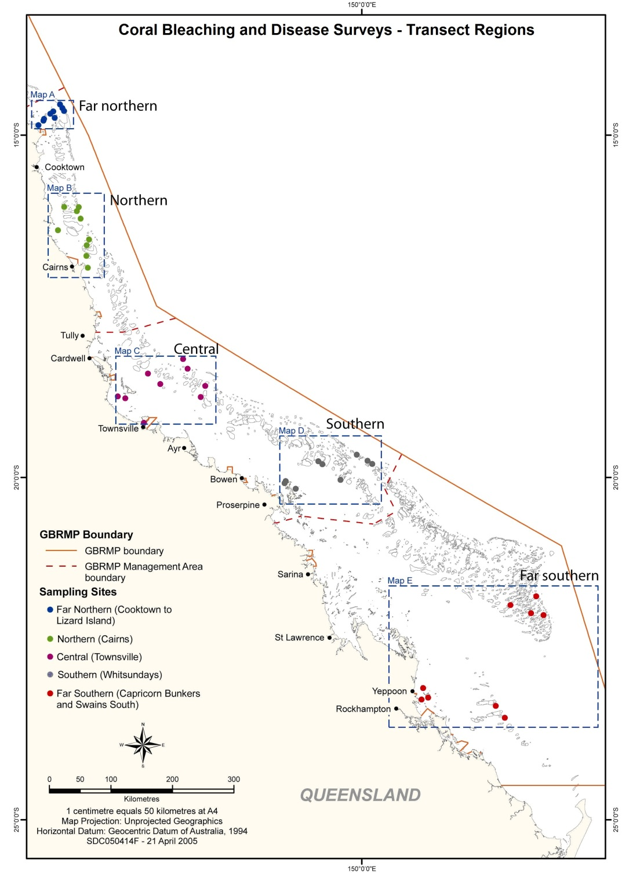

Figure 11: Plan monitoring sites routinely surveyed during a mass bleaching event. High-resolution maps of each cross-shelf transect (Maps A – E) can be found at Appendix F.

At each site, three locations are surveyed on the reef crest (1 – 4 m) and lower reef slope (6 – 9 m), by a two-diver team that conduct the Reef Health and Impact Survey protocol (see Figure 4) and record three 50 m video transects. The videos are later analysed by identifying the substrate, and bleaching severity, at five points within photo frames taken (40 frames/transect, see Hill and Wilkinson 2004). The rapid assessment via the Reef Health and Impact Survey protocol provides information about the extent and severity of the bleaching event in near real-time, which can be immediately communicated to senior management, government officials and the public (see Marshall and Schuttenberg 2006).

The video transects, while requiring a more lengthy analysis, provide a long-term record, more detailed information and increased data resolution, which is useful for understanding the patterns and specificity of bleaching events. In addition, since the video is discontinuous, either photos taken from the video or each transect could be an independent statistical sample, ensuring the data can be used to help answer a variety of research questions. The data from bleaching and recovery surveys is loaded into the same database as the reports collected by participants in the monitoring network (Figure 5). The visual representation of the data facilitated by that system can aid in communicating the need for various management actions.

While there have been recent developments in the use of satellites to measure spatially extensive bleaching events (Elvidge et al. 2004), this approach is still experimental and expensive relative to conducting in-water and aerial surveys. We have received free satellite imagery since 2008 through the Planet Action initiative developed by Spot Image. Currently, we are working in partnership with researchers from CSIRO and the University of Queensland to develop techniques for assessing climate change impacts based on the imagery the Planet Action initiative can provide.

3. Communications strategy

Responding to coral bleaching events strategically and effectively involves a combination of routine and responsive tasks implemented through an early warning system and, if a bleaching event occurs, assessment and monitoring via the incident response (see Figure 1). All routine and responsive tasks rely on effective communication, particularly since bleaching events attract significant interest from the public, media and senior decision-makers (see Table 3). The risk and impact assessment plan ensures timely and credible information on coral bleaching in the Great Barrier Reef Marine Park is available during and in the months and years that follow bleaching events. As a consequence, we are able to prevent misleading or incorrect information from proliferating through various media sources. This ensures that factually accurate assessments of reef condition are readily accessible by reef stakeholders, media and the general public during an incident.
Table 3: The frequency and timing of tasks associated with collating current bleaching information and effectively communicating during the bleaching season. Tasks that appear in italics are common to both the bleaching and disease risk and impact assessment plans.
Frequency | Timing/trigger | Task
Weekly | Monday | - Check CSIRO ReefTemp and NOAA hotspot and degree heating week maps on web
Weekly | Monday | - Check sea temperature graphs from AIMS weather stations and the experimental virtual bleaching stations from NOAA
Weekly | Monday | - Review weekly weather summary from the Bureau of Meteorology
Weekly | Monday | - Review reports from the monitoring network
Weekly | Monday | - Prepare briefing for internal meetings
Weekly/ fortnightly | Constant | - Monitor extent of bleaching using existing information and evaluate for trends (i.e., change in bleaching extent)
Weekly/ fortnightly | Constant | - Advise GBRMPA senior management and the Minister if worsening of conditions
Weekly/ fortnightly | Constant | - Announce web update and send brief report to senior management
Event-based | High bleaching risk* | - Actively solicit confirmatory bleaching reports from reliable sources, including: participants in the monitoring network, day-to-day management field officers, AIMS and other researchers
Event-based | High bleaching risk* | - Alert relevant project coordinators and managers
Event-based | High bleaching risk* | - Brief relevant GBRMPA staff
Event-based | Response level 1, 2, or 3 (see Figures 8–10) triggered. | - Brief GBRMPA executive and the Minister
Event-based | Response level 1, 2, or 3 (see Figures 8–10) triggered. | - Prepare media position, draft statement and consult with GBRMPA media coordinator and executive
Event-based | Response level 1, 2, or 3 (see Figures 8–10) triggered. | - Brief all GBRMPA staff, stakeholders and collaborators
Event-based | Response level 1, 2, or 3 (see Figures 8–10) triggered. | - Release media statement
Event-based | Response level 1, 2, or 3 (see Figures 8–10) triggered. | - Actively promote and solicit submissions to online bleaching reports to provide broad spatial coverage
* See also Table 1.

In addition to the task and reporting schedule outlined in Table 3 (see also Appendix A), a briefing schedule for GBRMPA senior management, the Minister, and stakeholders is outlined in Table 4. This schedule ensures these groups are aware when delivery of reports can be expected.
Table 4: Targeted briefing schedule to communicate onset of bleaching season (predetermined dates) and bleaching risk and occurrence throughout the bleaching season (date determined by reaching a trigger). Asterisks denote triggers that will result in determining a media position and the release of a media statement (see also Table 3).

Approximate date | Trigger¹ | Briefings
Approximate date | Trigger¹ | Senior management | Minister | Stakeholders | Message
1 December | Annually | ^ | ^ | ^ | Summer approaching; bleaching risk period; plan being implemented
20 December | Annually | ^ |  |  | Temperature trends for December; plans for Christmas break
 | High bleaching risk* | ^ | ^ |  | Temperatures unusually high; coral bleaching event probable
 | Response level 1 (see Figure 8)* | ^ | ^ | ^ | High temperatures recorded; widespread minor bleaching observed; and the areas most affected
 | Response levels 2 and 3 (see Figures 9 and 10) * | ^ | ^ | ^ | Very high temperatures recorded; moderate or severe bleaching observed at regional scale or widespread; areas worst affected and mortality likely
15 February³ | Annually | ^ |  |  | Temperature trends for first half of summer; summary of any observed coral bleaching
31 March | No bleaching | ^ | ^ | ^ | Summer concluding; bleaching risk period over; no significant bleaching observed
 | Response levels 1, 2 and 3 (see Figures 8-10)* | ^ | ^ | ^ | High water temperatures recorded; bleaching observed; preliminary assessment of extent and severity; detailed surveys underway (if response level 2 or 3 triggered)
30 May | Moderate, major or severe impact (see Table 1) | ^ | ^ | ^ | Summary of full extent and severity of bleaching; implications for affected regions and Great Barrier Reef

Importance of management actions

Bleaching events are expected to increase in frequency and severity as a result of climate change, making recovery processes increasingly important for reefs to persist as coral-dominated systems. Significantly, many human activities impose stresses on coral reefs that compound the risks imposed by coral bleaching and can work to lengthen recovery timeframes. For example, chronic stress due to poor water quality can affect the recovery potential of reef communities as reproduction and larval recruitment in corals are particularly sensitive to environmental conditions. Through reducing compounding stressors, management actions help reefs cope with or recover from coral bleaching events, which works to build the resilience of reefs to future climate-related disturbances.

Through collaborations with researchers, we are also rapidly advancing our understanding of factors that increase the resilience of reefs, as measured by the capacity to resist, tolerate and cope with, and recover from climate-related disturbances. In particular, researchers are poised to increase our understanding of spatial variability in the likelihood that a site will be impacted by climate-related disturbances like bleaching, disease outbreaks, floods and cyclones based on geographic location, community composition and thermal history. Increased knowledge of the spatial variability in factors that confer resilience to reefs may enable us to explicitly include resilience to climate change in management plans. Furthermore, knowledge of spatial variability in resilience factors enables assessments of the effectiveness of strategies implemented to support resilience.

In addition to measures to build ecosystem resilience, the plan can help build social and economic resilience to coral bleaching events. Resource users who are well-informed of risks and are included in decision-making processes about strategies to address resource issues can be expected to be much more resilient to resource impacts (Marshall and Marshall 2007). Similarly, community-based social marketing can encourage stewardship behaviours, (e.g. not anchoring on corals or disposing of fishing tackle on the reef). Such communications efforts may be undertaken following reef health incidents like bleaching in the future.

Conclusion

As bleaching events become more frequent and severe, impacts on the reef ecosystem and on reef users will become increasingly acute and apparent. This risk and impact assessment plan outlines the strategic approach that we are employing to tackle the challenge of climate-induced coral bleaching. Specifically, the plan provides practical tools for monitoring, assessing and reducing bleaching risk and impacts. The three-component structure described here is based on a model proven successful in responding to bleaching events on the Great Barrier Reef and has been adopted by reef managers in Florida and Hawaii.

Coral bleaching is inherently linked to coral disease because bleaching increases the susceptibility of corals to disease outbreaks. This plan and the Coral Disease Risk and Impact Assessment Plan are united under the overarching reef health incident response framework, which assists managers to evaluate and respond to cumulative and simultaneous impacts. The capacity to predict and respond to cumulative and simultaneous impacts will be further developed in the coming years as the capacity to monitor conditions that cause the range of reef health incidents increases. As with the other risk and impact assessment plans and the overarching Reef Health Incident Response System, this plan helps lay the foundations for an informed and adaptive approach to building the Reef’s resilience under a changing climate.

References

Elvidge CD, Dietz JB, Berkelmans R, Andrefouet S, Skirving WJ, Strong AE, and BT Tuttle (2004) Satellite observation of Keppel Islands (Great Barrier Reef) 2002 coral bleaching using IKONOS data. Coral Reefs, 23(1), 123-132.

English S and Wilkinson (eds.) (2004) Survey manual for tropical marine resources, 2 ed., Australian Institute of Marine Science, Townsville.

GBRMPA (2010) Coral Disease Risk and Impact Assessment Plan. Great Barrier Reef Marine Park Authority, Townsville.

Hill J and CR Wilkinson (2004) Methods for Ecological Monitoring of Coral Reefs. Australian Institute of Marine Science, Townsville.

Hoegh-Guldberg O (1999) Climate change, coral bleaching and the future of the world's coral reefs. Marine and Freshwater Research 50:839-866.

Hoegh-Guldberg O, Mumby PJ, Hooten AJ, Steneck RS, Greenfield P, Gomez E, Harvell CD, Sale PF, Edwards AJ, Caldeira K, Knowlton N, Eakin CM, Iglesias-Prieto R, Muthiga N, Bradbury RH, Dubi A, Hatziolos ME (2007) Coral Reefs Under Rapid Climate Change and Ocean Acidification. Science 318: 1737-1742.

Liu G, Matrosova LE, Penland C, Gledhill DK, Eakin CM, Webb RS, Christensen TRL, Heron SF, Morgan JA, Skirving WJ, Strong AE (2008) NOAA Coral Reef Watch Coral Bleaching Outlook System. Proceedings of the 11th International Coral Reef Symposium, Session 20.

Marshall PA and H Schuttenberg (2006) A Reef Managers Guide to Coral Bleaching, Great Barrier Reef Marine Park Authority, Townsville.

Marshall NA, Marshall PA. 2007. Conceptualizing and Operationalizing Social resilience with Commercial Fisheries in Northern Australia. Ecology and Society 12(1). http://www.ecologyandsociety.org/vol12/iss1/art1/

Maynard JA, Turner PJ, Anthony KRN, Baird AH, Berkelmans R, Eakin CM, Johnson JE, Marshall PA, Packer GR, Rea A, and BL Willis (2008) ReefTemp: an interactive monitoring system for coral bleaching using high-resolution SST and improved stress predictors. Geophysical Research Letters, 35, L05603, doi:10.1029/2007GL032175.

Maynard JA, Johnson JE, Marshall PA, Goby G and Spillman C (2009) A strategic framework for responding to coral bleaching events in a changing climate. Environmental Management 44:1-11.

Oliver, J, Marshall PA, Setiasih N, and L Hansen (2004) A global protocol for assessment and monitoring of coral bleaching. WorldFish Center and WWF Indonesia, Jakarta, Indonesia.

Spillman CM, Alves O (2009) Dynamical seasonal prediction of summer sea surface temperatures in the Great Barrier Reef. Coral Reefs, 28:197-206.

Appendix A — Schedule of Coral Bleaching Risk and Impact Assessment Plan routine and responsive tasks for before, during and after the coral bleaching season.

TIMING/  TRIGGER | TASK | EXPECTED OUTCOME | TICK WHEN COMPLETED
Pre-summer preparations and training
September | Seasonal outlook meeting | • Assessment of coral bleaching risk for the approaching summer  • Preparations for coordinated response in the event of coral bleaching
October –  May | Communications processes initiated (see Table 3) | Communications updated regularly on the status of coral bleaching
November | Incident response planning meeting | Preparations for activation of the incident response
November | Eye on the Reef training — Cairns, Port Douglas and Airlie Beach | Training of monitoring network in coral bleaching assessment and reporting
November | GBRMPA internal staff training in the Reef Health and Impact Survey monitoring protocol | Training of GBRMPA Townsville and regional staff in coral bleaching assessment and reporting
November | Refresher training first aid, CPR and oxygen provider training; updates of AS2299 diver medicals | Field staff suitably qualified and prepared in case response initiated
December | Review of seasonal outlook, meeting convened if high likelihood of coral bleaching | Meeting convened to refine coordinated response if there is a risk of coral bleaching
December | Brief senior management, Minister and stakeholders | Senior management, Minister and stakeholders aware of approaching season bleaching risk
December | Revise Coral Bleaching Risk and Impact Assessment Plan | Revised plan Coral Bleaching Risk and Impact Assessment Plan published by December
December | In-water rescue refresher training | Staff proficient in in-water rescue and safety
January | Keppels scheduled monitoring | Support for ongoing resilience and monitoring of no-anchoring areas
January | Monitoring network training for southern region — Mackay, Yeppoon and Gladstone | Additional participants for the monitoring network recruited

Commencement of early warning system
December | Commence web-based updates for seasonal outlook and coral bleaching risk — current conditions reports | Communication of reef stressors to community through web on a monthly basis
December | Planning for Christmas closure period | • Assignment of duties over Christmas closure period  • Senior management notified of arrangements  • Minister advised if coral bleaching risk moderate–high
December –  April | Assess bleaching risk weekly | • Check ReefTemp and NOAA hotspots on web  • Review weekly weather summary reports  • Review reports from the monitoring network and update spatial layers  • Review AIMS temperature graphs  • Prepare briefings for internal meetings, round table  • Advise senior management of changes
February | Assess temperature trends and bleaching for first half of summer | • Senior management update on conditions  • Contact made with monitoring network participants in areas of interest

Event reported – incident response initiation
Bleaching reported | Situation analysis conducted | Incident response situation analysis
Bleaching reported | Situation analysis reviewed | Level of incident response agreed (this includes nil response)
Incident response activated | Appointment of incident controller | Incident coordinator appointed to establish a response team
Incident response active | Notification of incident to relevant agencies | Heightened awareness of the incident amongst relevant agencies
Incident response active | Action plan developed | • Action plan identifies roles and responsibilities for coral bleaching response  • Action plan implemented and all sub plans including communications plan activated
Incident response active | Deploy operational teams | • Operational teams to manage incident deployed  • Incident managed effectively  • Emergency fast track permits authorised
High risk season passed | Incident response terminated, Incident response deactivated | Incident debrief convened

Incident response terminated and long-term management implemented
Post event | Progress implementation of long-term impact management actions and adaptation plans | • Sectoral impact management plans implemented  • Management actions (e.g. emergency Special Management Areas (SMAs)) implemented
Post event  April | Preliminary report on the incident produced | Summary report of responses initiated for internal use
Post event  May – June | Formal incident report produced | Summary report of the extent and severity of the impact
Post event | Incident response revision and update | Review incident response implementation and incorporate feedback
Post event | Brief senior management, Minister and stakeholders | Senior management, Minister and stakeholders aware of summer impacts and reef recovery
April –  October | End of season updates | • End of season reports posted onto the Web, including nil reports  • End of season summary emailed to participants of the monitoring network
Post event ongoing | Impact recovery monitoring | Monitoring of recovery from severe coral bleaching impacts

Appendix B — Early warning system tools, key references and further reading

Tools that form the early warning system within the risk and impact assessment plan have been developed by a number of agencies and research institutions, nearly all of which have worked in close collaboration with GBRMPA. Each of these institutions has scientists who have published peer-reviewed publications on their work in the area of predicting bleaching. The key references and further reading providing technical details (websites) on the products are listed below, and are divided into the same sub-sections seen in the early warning system section of the plan.

Seasonal outlooks of bleaching risk
Eakin CM, Morgan JA, Heron SF, Smith TB, Liu G, et al. (2010) Caribbean Corals in Crisis: Record Thermal Stress, Bleaching, and Mortality in 2005. PLoS ONE 5(11): e13969. doi:10.1371/journal.pone.0013969.

Skirving, W.J., A.E. Strong, G. Liu, F. Arzayus, C. Liu and J. Sapper (2006c). Extreme events and perturbations of coastal ecosystems. In L.L. Richardson & E.F. LeDrew [Eds.], Remote Sensing of Aquatic Coastal Ecosystem Processes. Remote Sensing and Digital Image Processing, Vol. 9, Springer. 11-26 pp.

Spillman CM, Hudson DA, Alves O (2010) Real-time seasonal SST predictions for the Great Barrier Reef during the summer of 2009/2010. CAWCR Research Letters, 4:11-19.

Spillman CM, Alves O, Hudson DA (2010) Seasonal prediction of thermal stress accumulation for coral bleaching in the tropical oceans. Monthly Weather Review, DOI: 10.1175/2010MWR3526.1.

Spillman CM, Alves O (2009) Dynamical seasonal prediction of summer sea surface temperatures in the Great Barrier Reef. Coral Reefs, 28:197-206.

NOAA Coral Reef Watch website: http://coralreefwatch.noaa.gov/satellite/methodology/methodology.html

Bureau of Meteorology POAMA web page: http://poama.bom.gov.au/experimental/poama15/sp_gbr.htm

Near real-time monitoring of temperature stress
Strong, A.E., F. Arzayus, W. Skirving and S.F. Heron (2006). Identifying Coral Bleaching Remotely via Coral Reef Watch - Improved Integration and Implications for Changing Climate. In J.T. Phinney, et al. [Eds.], Coral Reefs and Climate Change: Science and Management. Coastal and Estuarine Studies, Vol. 61, American Geophysical Union, Washington, DC. 163-180 pp.

Maynard JA, Turner PJ, Anthony KRN, Baird AH, Berkelmans R, Eakin CM, Johnson JE, Marshall PA, Packer GR, Rea A, and BL Willis (2008) ReefTemp: an interactive monitoring system for coral bleaching using high-resolution SST and improved stress predictors. Geophysical Research Letters, 35, L05603, doi:10.1029/2007GL032175.

Maynard JA, Johnson JE, Marshall PA, Goby G and Spillman C (2009) A strategic framework for responding to coral bleaching events in a changing climate. Environmental Management 44:1-11

Berkelmans R (2002) Time-integrated thermal bleaching thresholds of reefs and their variation on the Great Barrier Reef. Marine Ecology Progress Series 229:73-82

CSIRO ReefTemp web page: http://www.cmar.csiro.au/remotesensing/ReefTemp/web/ReefTemp_techinfo.htm

Appendix C — Reef Health and Impact Survey form

Note: In the coral bleaching section, corals have been listed left to right (soft coral to massives) from most to least susceptible to thermal bleaching (see also Table 1).
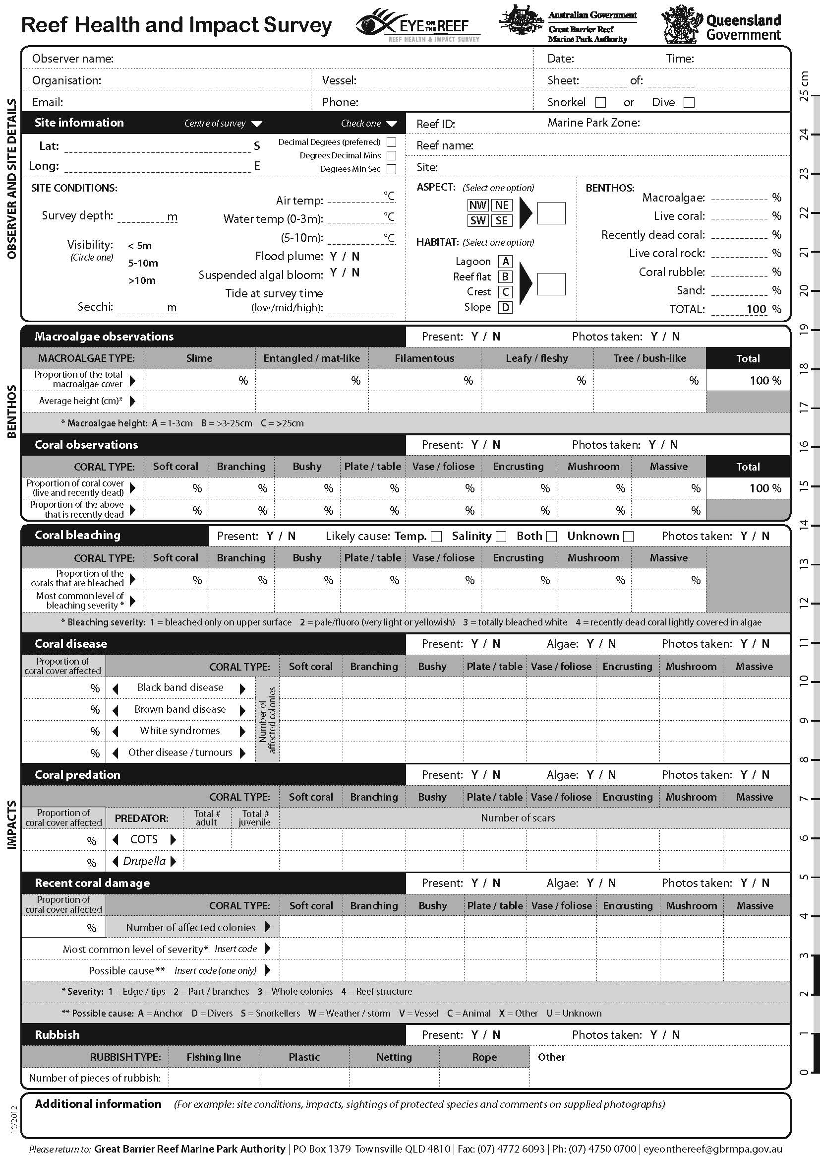

Appendix D — Locations of intensive survey sites
I = Inner-shelf reef, M = Mid-shelf reef, O = Outer-shelf reef
Coordinates

 |  | Site coordinates (deg min)
Transect and region | Reef name | Latitude (S) | Longitude
Far northern  (Cooktown to  Lizard Island) | Martin Reef (I) | 14 45.566 | 145 22.586
Far northern  (Cooktown to  Lizard Island) | Linnet Reef (I) | 14 47.33 | 145 21.21
Far northern  (Cooktown to  Lizard Island) | Decapolis Reef (I) | 14 51.021 | 145 16.401
Far northern  (Cooktown to  Lizard Island) | MacGillivray Reef (M) | 14 39.02 | 145 29.65
Far northern  (Cooktown to  Lizard Island) | Nth Direction Island (M) | 14 44.784 | 145 31.02
Far northern  (Cooktown to  Lizard Island) | Lizard Island lagoon (M) | 14 41.661 | 145 27.935
Far northern  (Cooktown to  Lizard Island) | Yonge Reef (O) | 14 34.431 | 145 37.251
Far northern  (Cooktown to  Lizard Island) | Carter Reef (O) | 14 31.584 | 145 35.1
Far northern  (Cooktown to  Lizard Island) | No Name Reef (O) | 14 37.776 | 145 38.967
Northern  (Cairns) | Green Island (I) | 16 46.372 | 145 58.601
Northern  (Cairns) | Low Isles (I) | 16 23.189 | 145 34.356
Northern  (Cairns) | Fitzroy Island (I) | 16 55.384 | 145 59.765
Northern  (Cairns) | Mackay Reef (M) | 16 2.697 | 145 39.147
Northern  (Cairns) | Michaelmas Cay (M) | 16 33.09 | 146 3.241
Northern  (Cairns) | Hastings Reef (M) | 16 30.182 | 146 1.594
Northern  (Cairns) | St Crispin Reef (O) | 16 4.399 | 145 50.975
Northern  (Cairns) | Opal Reef (O) | 16 12.451 | 145 54.452
Northern  (Cairns) | Agincourt No.1 Reef (O) | 16 2.509 | 145 52.209
Central  (Townsville) | Pandora Reef (I) | 18 48.694 | 146 25.803
Central  (Townsville) | Havannah Island (I) | 18 50.04 | 146 32.482
Central  (Townsville) | Middle Reef (I) | 19 11.759 | 146 48.799
Central  (Townsville) | Davies Reef (M) | 18 48.679 | 147 40.231
Central  (Townsville) | Rib Reef (M) | 18 28.495 | 146 52.863
Central  (Townsville) | John Brewer Reef (M) | 18 37.358 | 147 5.045
Central  (Townsville) | Chicken Reef (O) | 18 39.348 | 147 43.43
Central  (Townsville) | Dip Reef (O) | 18 24.227 | 147 27.32
Central  (Townsville) | Myrmidon Reef (O) | 18 15.278 | 147 23.163
Southern  (Whitsundays) | Hayman Island (I) | 20 3.58 | 148 54.099
Southern  (Whitsundays) | Border Island (I) | 20 10.517 | 149 2.098
Southern  (Whitsundays) | Langford & Bird Island (I) | 20 4.78 | 148 52.614
Southern  (Whitsundays) | Reef 19131S (M) | 19 46.162 | 149 22.719
Southern  (Whitsundays) | Reef 19138S (M) | 19 48.5 | 149 25.58
Southern  (Whitsundays) | Reef 20104S (M) | 20 2.007 | 149 41.686
Southern  (Whitsundays) | Slate Reef 19159 (O) | 19 39.837 | 149 55.061
Southern  (Whitsundays) | Hyde Reef (O) | 19 44.488 | 150 5.187
Southern  (Whitsundays) | Rebe Reef (O) | 19 47.829 | 150 9.775
Far southern  (Capricorn Bunkers and Swains South) | Nth Keppel Island (I) | 23 5.187 | 150 54.311
Far southern  (Capricorn Bunkers and Swains South) | Middle Island (I) | 23 9.896 | 150 55.42
Far southern  (Capricorn Bunkers and Swains South) | Halfway Island (I) | 23 12.193 | 150 58.187
Far southern  (Capricorn Bunkers and Swains South) | Gannet Cay (M) | 21 58.743 | 152 28.955
Far southern  (Capricorn Bunkers and Swains South) | Chinaman Reef (M) | 22 0.116 | 152 40.119
Far southern  (Capricorn Bunkers and Swains South) | Reef 21529S (M) | 21 52.02 | 152 11.183
Far southern  (Capricorn Bunkers and Swains South) | Turner Cay (O) | 21 42.204 | 152 33.807
Far southern  (Capricorn Bunkers and Swains South) | Wreck Island (O) | 23 19.149 | 151 58.785
Far southern  (Capricorn Bunkers and Swains South) | One Tree Island (O) | 23 29.261 | 152 5.554

Appendix E — Detailed maps of survey site locations in each cross-shelf transect

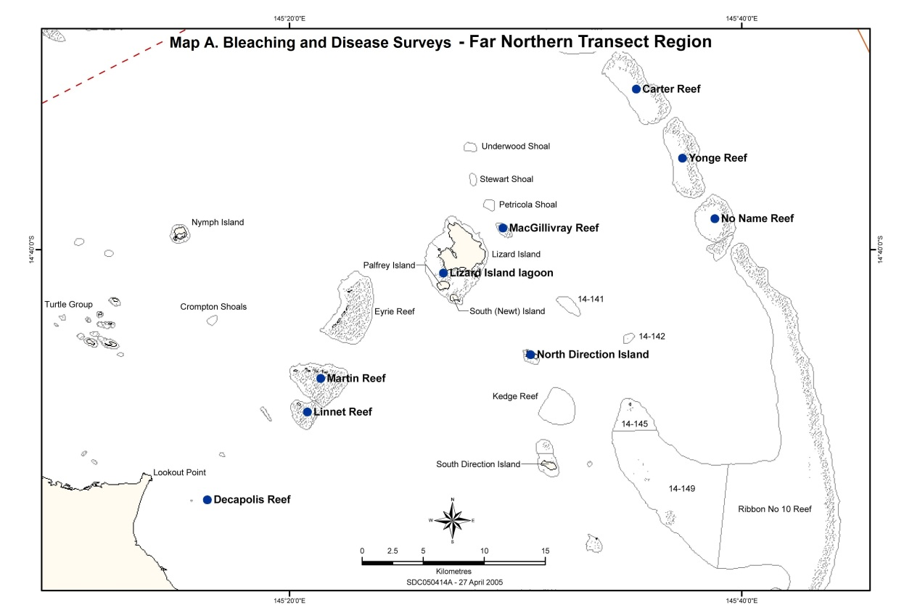
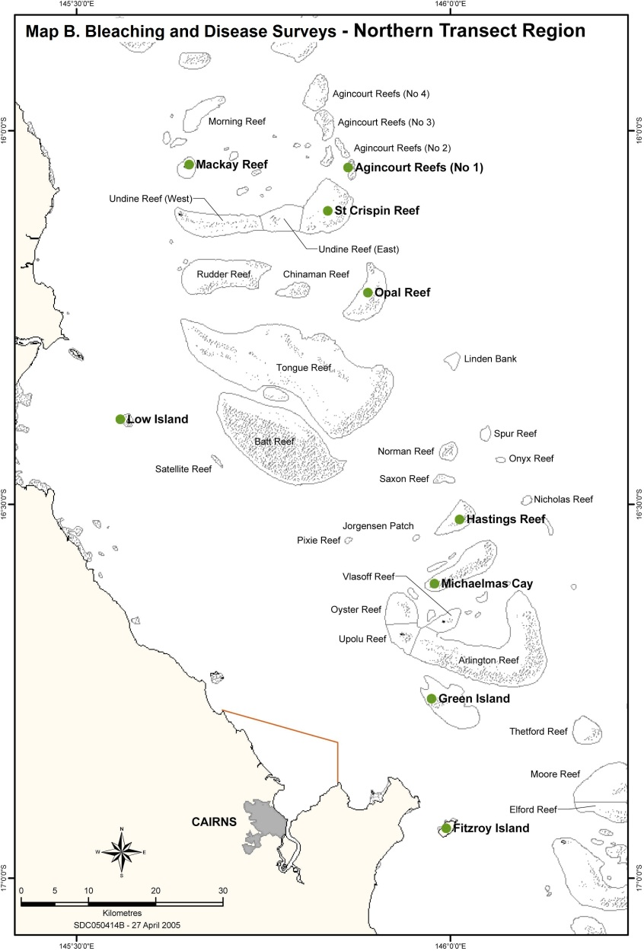
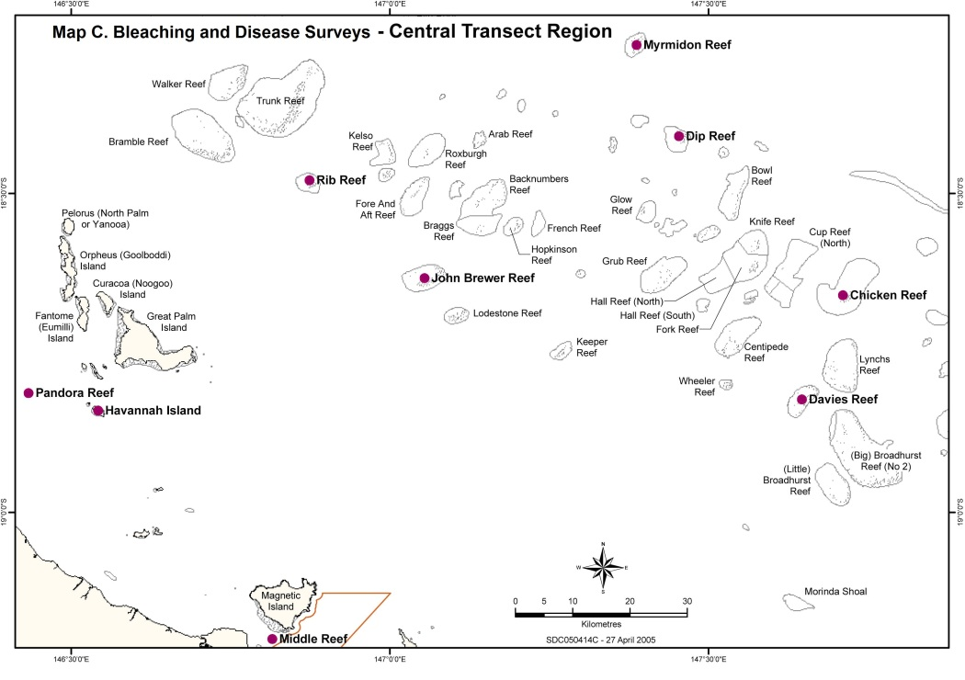
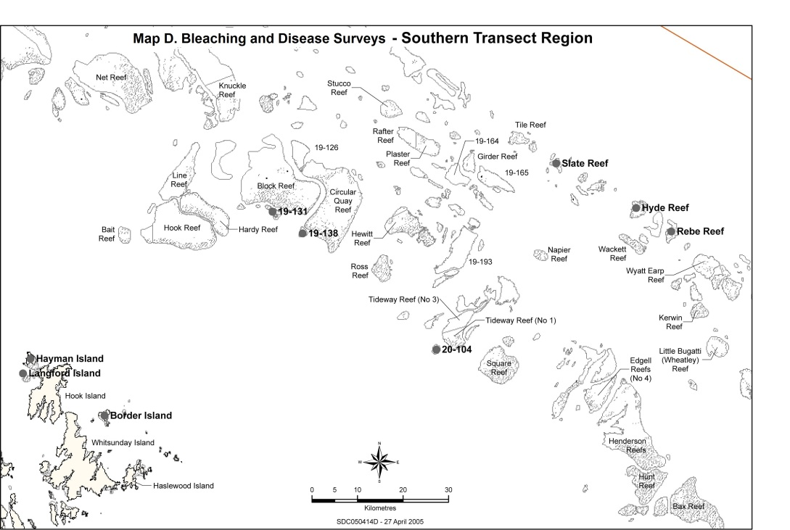

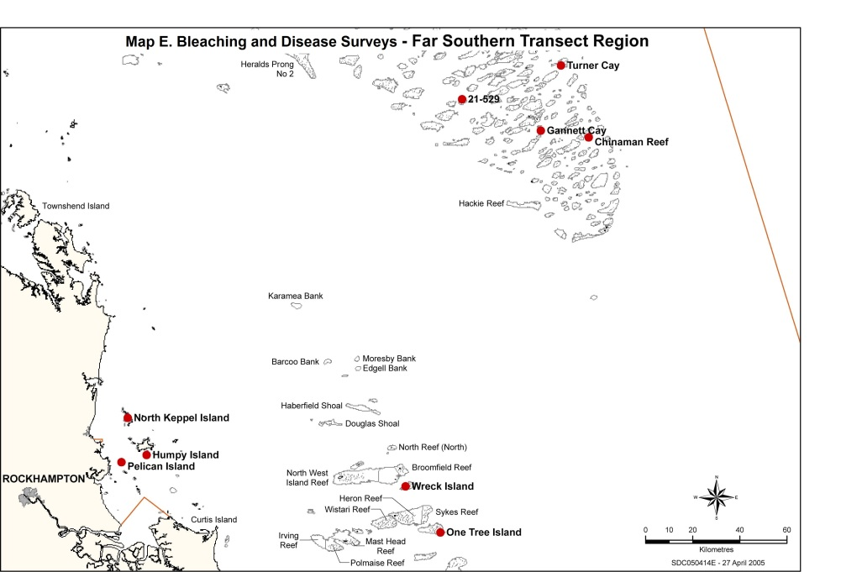

Appendix F — Great Barrier Reef Marine Park planning areas

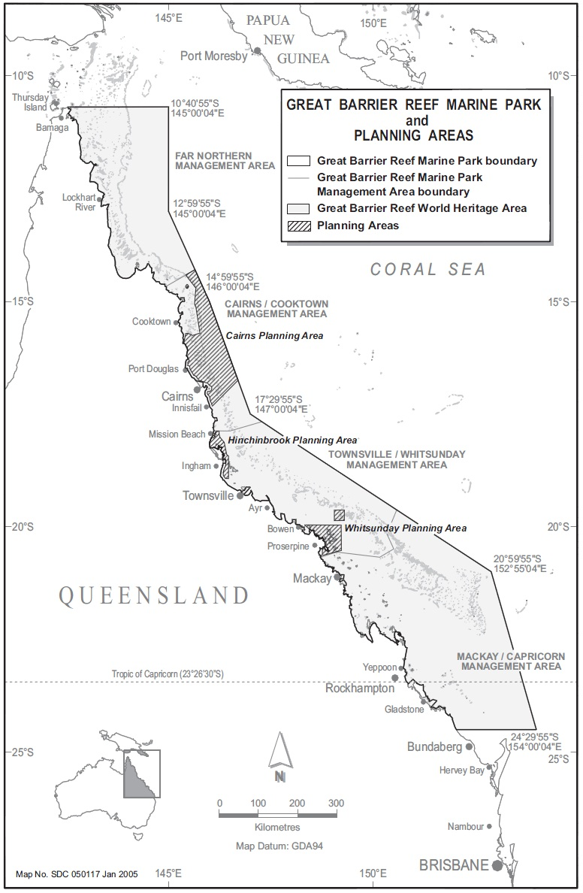

Australasian Fire Authority Council website, 2004, www.afac.com.au
http://coralreefwatch.noaa.gov/satellite/bleachingoutlook/outlook_messages/bleachingoutlook_20101026_for_2010novfeb.html#summary
http://www.bom.gov.au/oceanography/oceantemp/GBR_SST.shtml
http://poama.bom.gov.au/experimental/poama15/sp_gbr.htm
http://coralreefwatch.noaa.gov/satellite/current/products_hotspot.html
http://coralreefwatch.noaa.gov/satellite/current/products_dhw.html
http://www.coralreefwatch.noaa.gov/satellite/virtual_stations/gbr_virtualstations.html
http://www.cmar.csiro.au/remotesensing/reeftemp/web/ReefTemp.htm
http://data.aims.gov.au/awsqaqc/do/start.do
Participation in the network extends from Port Douglas in the north to Bundaberg in the south (see ‘Assessment and monitoring’).
Australasian Fire Authority Council website, 2004, www.afac.com.au

