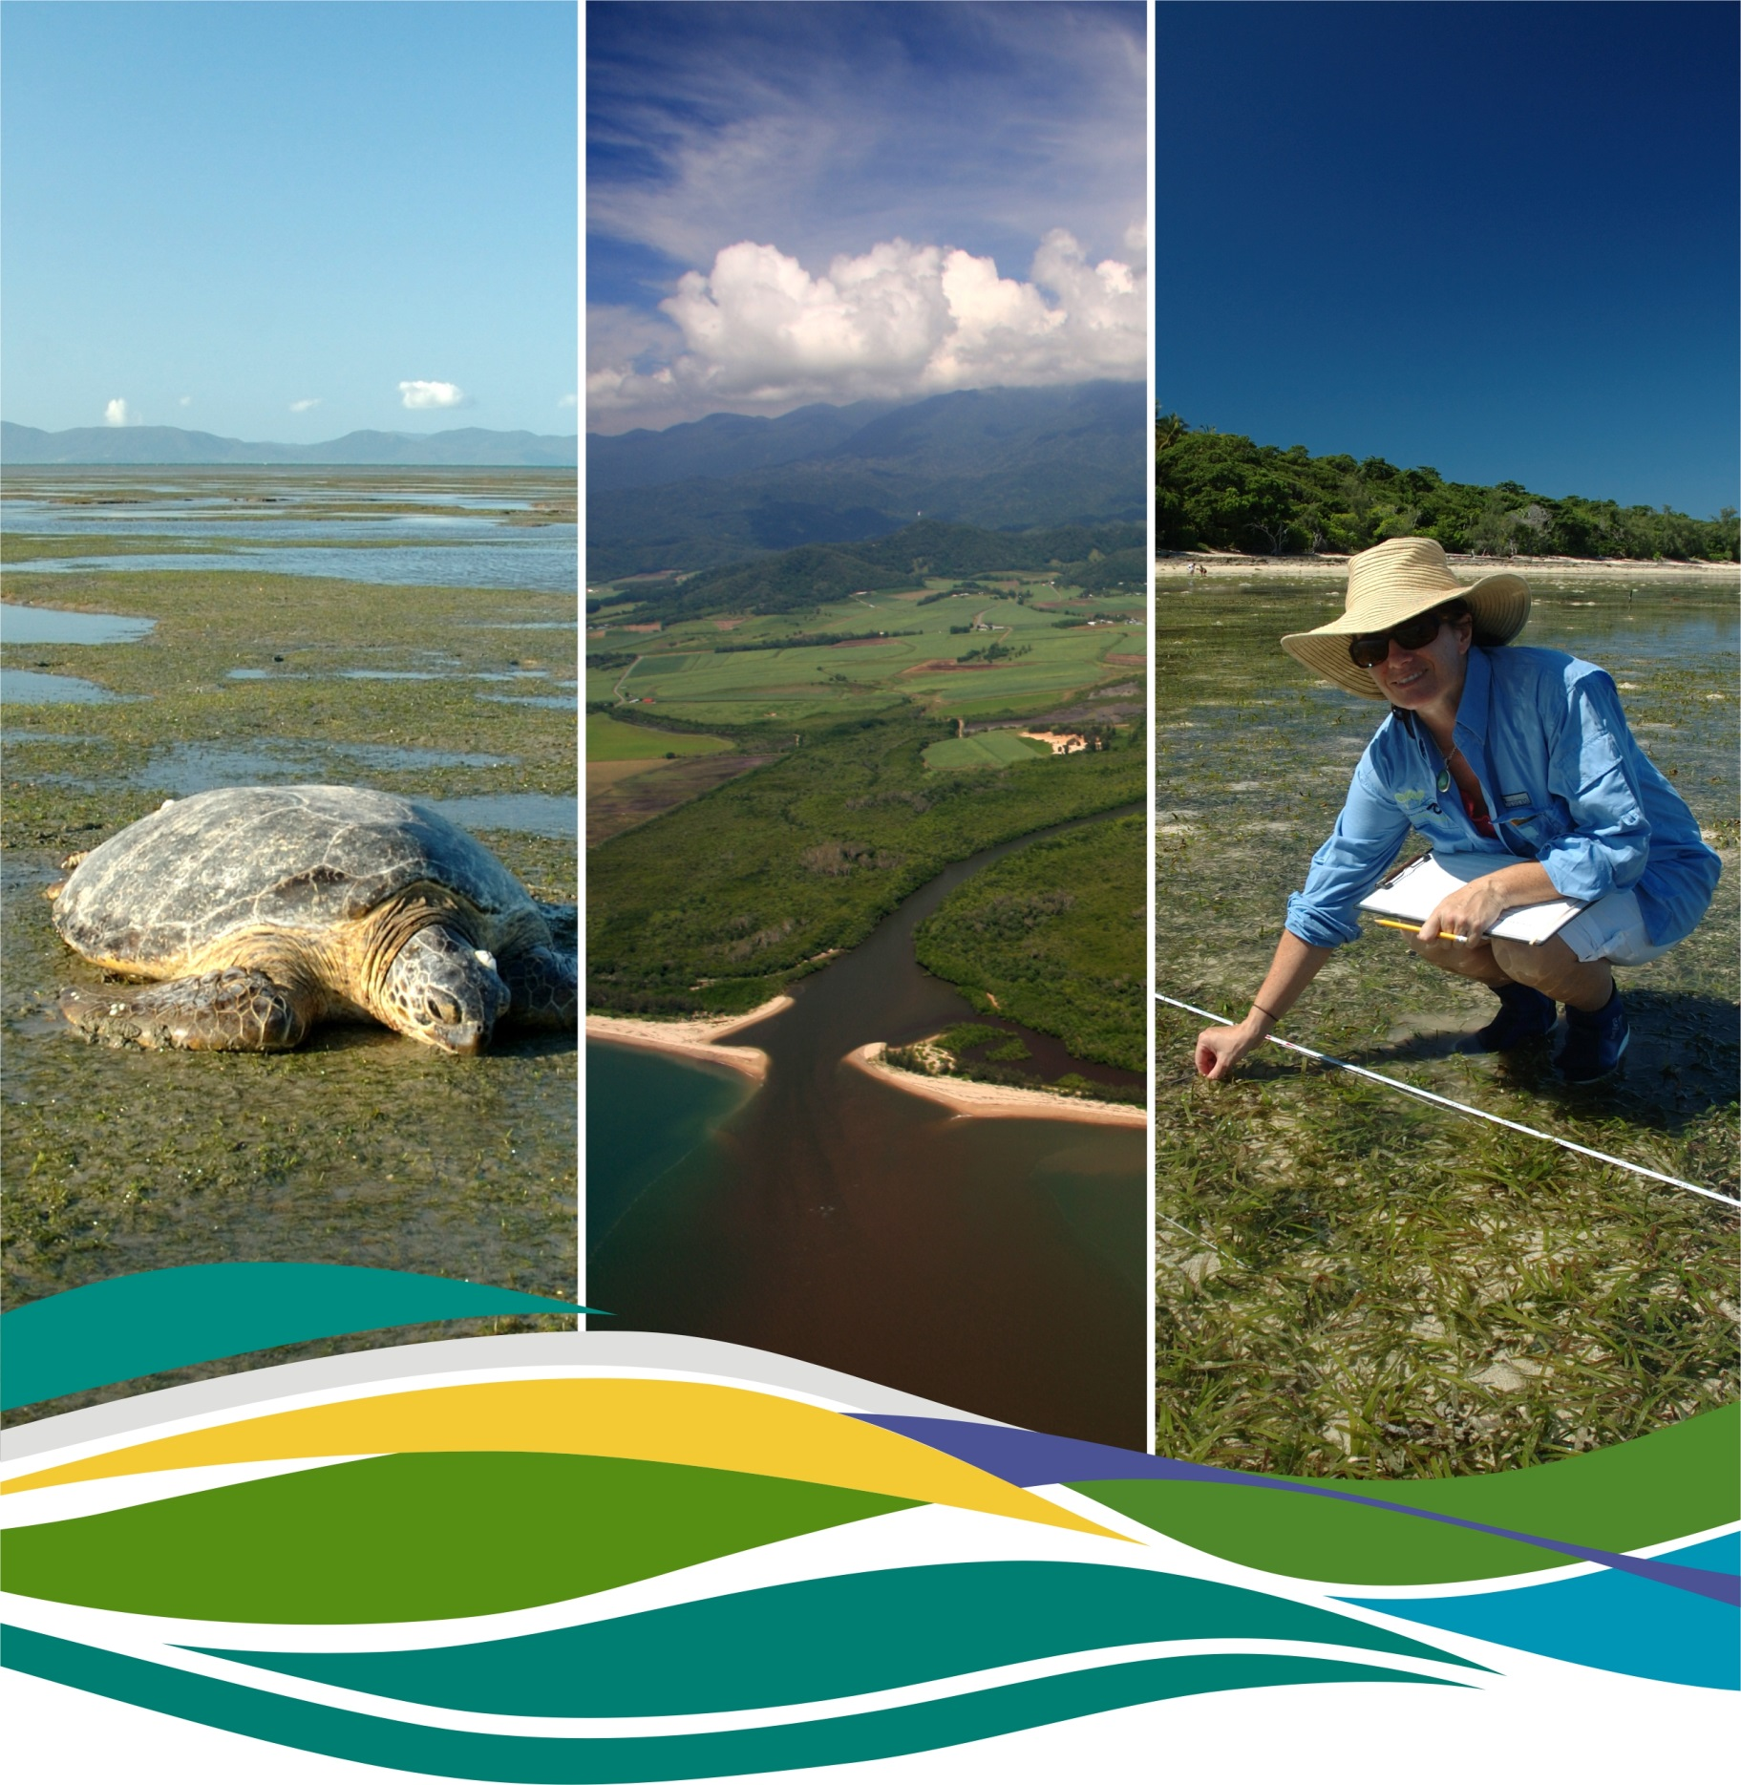

Reef Rescue
Marine Monitoring Program
Inshore Seagrass
ANNUAL REPORT
For the sampling period 1st July 2011 – 31st May 2012

Len McKenzie, Catherine Collier & Michelle Waycott

© 2014.

This report should be cited as:
McKenzie, L.J., Collier, C. and Waycott, M. (2014) Reef Rescue Marine Monitoring Program - Inshore Seagrass, Annual Report for the sampling period 1st July 2011 – 31st May 2012. TropWATER, James Cook University, Cairns. 176pp.

Published through James Cook University a research provider.

This publication is copyright. The Copyright Act 1968 permits fair dealing for study, research, information or educational purposes subject to inclusion of a sufficient acknowledgement of the source.

The views and opinions expressed in this publication are those of the authors and do not necessarily reflect those of the State of Queensland.

While reasonable effort has been made to ensure that the contents of this publication are factually correct, the State does not accept responsibility for the accuracy or completeness of the contents, and shall not be liable for any loss or damage that may be occasioned directly or indirectly through the use of, or reliance on, the contents of this publication.

This report has been peer reviewed by three external reviewers.

received April 2013, reviewed October 2013, accepted March 2014



Contents
Acronyms Used In This Report xiv
Acknowledgements xv
Executive summary 1
1. Introduction 3
Background 3
2. Methodolgy 6
Sampling design & site selection 6
Seagrass abundance, composition and distribution 9
Seagrass reproductive health 12
Seagrass tissue nutrients 13
Epiphyte and macro-algae abundance 14
Within seagrass canopy temperature 15
Seagrass canopy light 15
Rhizosphere sediment herbicides 17
Data analyses 17
Reporting Approach 17
Report card 19
Seagrass abundance 19
Seagrass reproductive effort 23
Seagrass nutrient status. 23
Seagrass index 24
3. Results & Discussion 25
GBR Summary 25
Status of the seagrass community 27
Status of the seagrass environment 30
Cape York 39
2011/12 Summary 39
Background 40
Status of the seagrass community 43
Status of the seagrass environment 47
Wet Tropics 53
2011/12 Summary 53
Background 54
Status of the seagrass community 56
Status of the seagrass environment 65
Burdekin 85
2011/12 Summary 85
Background 86
Status of the seagrass community 88
Status of the seagrass environment 94
Mackay Whitsunday 105
2011/12 Summary 105
Background 106
Status of the seagrass community 108
Status of the seagrass environment 115
Fitzroy 125
2011/12 Summary 125
Background 126
Status of the seagrass community 129
Status of the seagrass environment 135
Burnett Mary 145
2011/12 Summary 145
Background 146
Status of the seagrass community 146
Status of the seagrass environment 152
4. Conclusions 159
6. References 163
Appendix 1. 176

List of Figures
Figure 1. Conceptual diagram depicting threats to seagrass meadows and potential limitations to seagrass growth in inshore regions of the GBR related to changing water quality 3
Figure 2. General conceptual model of seagrass habitats in north east Australia 5
Figure 3. Illustration of seagrass recovery after loss and the categories of successional species over time 8
Figure 4. Key to symbols used for conceptual diagrams detailing impacts to seagrasses. 18
Figure 5. Relationship between sample size and the error in estimation of percentile values for seagrass abundance (% cover) in coastal and reef seagrass habitats in the Wet Tropics NRM 20
Figure 6. Median seagrass abundance (% cover) at Yule Point plotted against the 50th and 20th percentiles for coastal seagrass habitat in the Wet Tropics. 21
Figure 7. Median seagrass abundance (% cover) at Green Island plotted against the 50th and 10th percentiles for intertidal reef seagrass habitat in the Wet Tropics. 21
Figure 8. Report card of seagrass status indicators and index for the GBR 27
Figure 9. Average yearly seagrass abundance score (all sites and seasons pooled) for the GBR 27
Figure 10. Regional report card scores for seagrass abundance over the life of the MMP. 28
Figure 11. Proportion of sites where seagrass cover has declined >20% relative to the same season in previous year or meadow is absent. 29
Figure 12. Generalised trends in seagrass abundance for each habitat type (sites pooled) relative to the 95th percentile (equally scaled). 29
Figure 13. Regional report card scores for seagrass reproductive effort over the life of the MMP. 30
Figure 14. GBR median tissue nutrient concentrations (±Standard Error) in seagrass leaves for each habitat type (species pooled) over the entire monitoring program 31
Figure 15. GBR median tissue %N concentrations (±Standard Error) in Halodule uninervis leaves for each habitat type over the entire monitoring program 31
Figure 16. Regional report card scores for seagrass leaf tissue nutrient status (C:N) over the life of the MMP. 32
Figure 17. Elemental ratios (atomic) of seagrass leaf tissue C:N for each GBR habitat each year 32
Figure 18. Elemental ratios (atomic) of seagrass leaf tissue N:P and C:P for each GBR habitat each year 33
Figure 19. Epiphyte abundance (% cover) at each seagrass habitat monitored (sites pooled) 33
Figure 20. Macro-algae abundance (% cover) at each seagrass habitat monitored 34
Figure 21. Daily light (long-term average (dots) and 2011-2012 average (bars)) for intertidal sites (left) and subtidal sites (right). 35
Figure 22. Minimal light threshold exceedance at intertidal sites (left) and subtidal sites (right) including long-term average (dots) and 2011-2012 average (bars). 35
Figure 23. Annual average turbidity (2009-2012) and 2011-2012 reporting period average turbidity for seagrass meadows where turbidity loggers were deployed (top) and threshold exceedance (bottom). 36
Figure 24. Change in total seagrass cover and I_{d} at three subtidal sites from 2008 to 2011 (from Collier, et al. 2012b). 37
Figure 25. Change in total seagrass cover and I_{d} at three intertidal sites from 2008 to 2011 37
Figure 26. Conceptual diagram of reef seagrass habitat in the Cape York region 40
Figure 27. Conceptual diagram of coastal seagrass habitat in the Cape York region 41
Figure 28. Location of the Cape York region monitoring sites and seagrass species percent composition at each site since 2003. 42
Figure 29. Report card of seagrass status indicators and index for the Cape York NRM region 43
Figure 30. Seagrass abundance (% cover ± Standard Error) at inshore intertidal reef habitat (Archer Point) in the Cape York region from 2003 to 2012. 44
Figure 31. Mean percentage seagrass cover (all species pooled) (± Standard Error) at inshore intertidal reef habitat long-term monitoring sites in Cape York region at time of year. 44
Figure 32. Extent of area (100m radius of monitoring site) covered by seagrass at each inshore intertidal reef monitoring site. 45
Figure 33. Inshore intertidal reef habitat (Archer Point) seed bank (a), germinated seed abundance (b) and reproductive effort (c). 46
Figure 34. Elemental ratios (atomic) of seagrass leaf tissue C:N for the foundation species at inshore intertidal reef habitats (Archer Point) in the Cape York region each year 47
Figure 35. Elemental ratios (atomic) of seagrass leaf tissue N:P and C:P for the foundation species at inshore intertidal reef habitats (Archer Point) in the Cape York region each year 47
Figure 36. Long-term trend in mean abundance (% cover) (± Standard Error) of epiphytes and macro-algae at inshore intertidal reef habitats (Archer Point, sites pooled) in the Cape York region. 49
Figure 37. Within seagrass canopy temperature (°C) at inshore intertidal reef habitats (Archer Point) in the Cape York region over the 2011/12 monitoring period. 50
Figure 38. Monthly mean and maximum within seagrass canopy temperatures (°C) at inshore intertidal reef habitats (Archer Point), Cape York region. 50
Figure 39. Mean monthly daily maximum air temperature, total monthly rainfall (bar graph), mean monthly cloud cover (heavier line), and mean monthly 3pm wind speed (lighter line) recorded at Cooktown airport located 16km from Archer Point monitoring sites. 51
Figure 40. Average daily flow (ML day⁻¹) per month from the Annan River. 52
Figure 41. Conceptual diagram of coastal seagrass habitat (<15m) in the Wet Tropics region 54
Figure 42. Location of Wet Tropics region long-term monitoring sites and seagrass species composition at each site. 55
Figure 43. Conceptual diagram of reef seagrass habitat (<15m) in the Wet Tropics region 56
Figure 44. Report card of seagrass status indicators and index for the Wet Tropics NRM region 57
Figure 45. Changes in seagrass abundance (% cover ±Standard Error) at inshore intertidal coastal habitats in the Wet Tropics region from 2000 to 2012 57
Figure 46. Mean percentage seagrass cover (all species pooled) (± Standard Error) at inshore intertidal coastal habitats (Yule Point) at time of year. 58
Figure 47. Mean percentage seagrass cover (all species pooled) (± Standard Error) at inshore intertidal coastal habitats (Lugger Bay) at time of year. 58
Figure 48. Changes in seagrass abundance (% cover ±Standard Error) of inshore intertidal and subtidal reef habitats (Green Island) in the Wet Tropics region from 2001 to 2012. 59
Figure 49. Mean percentage seagrass cover (all species pooled) (± Standard Error) at inshore intertidal reef habitats (Green Island) at time of year. 59
Figure 50. Mean percentage seagrass cover (all species pooled) (± Standard Error) at inshore subtidal reef habitats (Green Island) at time of year. 59
Figure 51. Changes in seagrass abundance (% cover ±Standard Error) of inshore intertidal and subtidal reef habitats (Dunk Island) in the southern Wet Tropics region from 2007 to 2012. 60
Figure 52. Mean percentage seagrass cover (all species pooled) (± Standard Error) at inshore intertidal reef habitat (Dunk Island) at time of year. 60
Figure 53. Mean percentage seagrass cover (all species pooled) (± Standard Error) at inshore subtidal reef habitat (Dunk Island) at time of year. 60
Figure 54. Changes in seagrass abundance (% cover ±Standard Error) at inshore intertidal and subtidal reef habitats (Low Isles) in the northern Wet Tropics region from 2008 to 2012. 61
Figure 55. Mean percentage seagrass cover (all species pooled) (± Standard Error) at inshore intertidal (left) and subtidal (right) reef habitat (Low Isles) long-term monitoring sites at time of year 61
Figure 56. Extent of area (100m radius of monitoring site) covered by seagrass at inshore intertidal coastal and reef habitat monitoring sites in the northern Wet Tropics region. 63
Figure 57. Extent of area (100m radius of monitoring site) covered by seagrass at inshore intertidal coastal and reef monitoring sites in the southern Wet Tropics region. 63
Figure 58. Inshore intertidal coastal habitat seed bank (a), germinated seed abundance (b), and total seagrass reproductive effort (c) in the Wet Tropics region 64
Figure 59. Inshore intertidal reef habitat seed banks (a), germinated seed abundance (b), and total reproductive effort (c) in the Wet Tropics region. 64
Figure 60. Elemental ratios (atomic) of seagrass leaf tissue C:N for the foundation seagrass species examined at each inshore intertidal location in the Wet Tropics region each year 65
Figure 61. Elemental ratios (atomic) of seagrass leaf tissue N:P and C:P for the foundation seagrass species examined at each inshore intertidal location in the Wet Tropics region each year 66
Figure 62. Mean abundance (% cover) (± Standard Error) of epiphytes and macro-algae at inshore intertidal coastal habitats (sites pooled) in the Wet Tropics region 68
Figure 63. Mean abundance (% cover) (± Standard Error) of epiphytes and macro-algae at inshore intertidal reef habitats (sites pooled) in the Wet Tropics region. 68
Figure 64. Mean abundance (% cover) (± Standard Error) of epiphytes and macro-algae at inshore subtidal reef habitat (Green Island) in the central Wet Tropics region. 69
Figure 65. Mean abundance (% cover) (± Standard Error) of epiphytes and macro-algae at inshore subtidal reef habitat (Dunk Island) in the southern Wet Tropics region. 69
Figure 66. Mean abundance (% cover) (± Standard Error) of epiphytes and macro-algae at inshore intertidal habitat (Low Isles) in the northern Wet Tropics region. 69
Figure 67. Mean abundance (% cover) (± Standard Error) of epiphytes and macro-algae at inshore subtidal reef habitat (Low Isles) in the northern Wet Tropics region. 70
Figure 68. Within seagrass canopy temperature (°C) at inshore intertidal coastal (Yule Point and Lugger Bay) and reef (Low Isles, Green Island and Dunk Island) habitats within the Wet Tropics region over the 2011/12 monitoring period. 71
Figure 69. Long-term monthly mean and maximum within seagrass canopy temperatures (°C) at inshore intertidal coastal (Yule Point and Lugger Bay) and reef (Green Island and Dunk Island) habitats within the Wet Tropics region. 72
Figure 70. Within seagrass canopy temperature (°C) at inshore subtidal reef (Low Isles, Green Island, Dunk Island) habitats within the Wet Tropics over the 2011/12 monitoring period. 73
Figure 71. Monthly mean, maximum and minimum temperature at the inshore subtidal reef (Low Isles, Green Island and Dunk Island) habitats in the Wet Tropics 73
Figure 72. Monthly mean, maximum and minimum temperature at the inshore intertidal reef (Low Isles) habitat in the northern Wet Tropics region. 74
Figure 73. Daily light (28 day rolling average) at inshore intertidal (top) and subtidal (bottom) reef habitats (Low Isles) 75
Figure 74. Daily light (28 day rolling average) at inshore intertidal (top) and subtidal (bottom) reef habitats (Green Island) 75
Figure 75. Daily light (28 day rolling average) at inshore intertidal (top) and subtidal (bottom) reef habitats (Dunk Island) 76
Figure 76. Daily light (28 day rolling average) at inshore intertidal coastal (Yule Point) habitat in the Wet Tropics NRM 76
Figure 77. Turbidity (NTU, daily av) and light (daily sum, mol m⁻² d⁻¹) at inshore subtidal reef habitat (Green Island) since turbidity loggers have been deployed on site (October 2009 onwards) 77
Figure 78. Daily mean chlorophyll concentration (green line, ug L⁻¹), turbidity (brown line, NTU) at inshore subtidal reef habitat (Green Island) in the Wet Tropics Region. 77
Figure 79. Daily mean chlorophyll concentration (green line, ug L⁻¹), turbidity (brown line, NTU) at inshore subtidal reef habitat (Dunk Island) in the Wet Tropics Region. 78
Figure 80. Total monthly rainfall (bar graph) recorded at Port Douglas - Warner St, located approximately 11km from Yule Point monitoring sites. 79
Figure 81. Mean monthly daily maximum air temperature (black line), total monthly rainfall (grey bars), mean monthly cloud cover (black line), and mean monthly 3pm wind speed (grey line), for Green Island monitoring sites. 80
Figure 82. Total monthly rainfall (bar graph), recorded at Dunk Island. Mean monthly daily maximum air temperature, mean monthly cloud cover (heavier line), and mean monthly 3pm wind speed (lighter line) recorded at Innisfail, located approximately 48km from monitoring sites at Lugger Bay and Dunk Island. 81
Figure 83. Average daily flow (ML day⁻¹) per month from the main rivers impacting the seagrass monitoring sites in the Wet Tropics 83
Figure 84. Conceptual diagram of coastal habitat in the Burdekin region 86
Figure 85. Location of Burdekin region long-term monitoring sites in coastal (Bushland Beach and Shelley Beach) and reef (Picnic Bay and Cockle Bay, Magnetic Island) habitats, and the seagrass species composition at each site. 87
Figure 86. Conceptual diagram of fringing reef habitat in the Burdekin region 88
Figure 87. Report card of seagrass status indicators and index for the Burdekin NRM region 88
Figure 88. Changes in mean seagrass abundance (% cover ±Standard Error) at inshore intertidal coastal habitats in the Burdekin region from 2001 to 2012. 89
Figure 89. Mean percentage seagrass cover (all species pooled) (± Standard Error) at inshore intertidal coastal habitat long-term monitoring sites at time of year. 89
Figure 90. Changes in seagrass abundance (% cover ±Standard Error) at inshore intertidal and subtidal reef habitats in the Burdekin region from 2001 to 2012. 90
Figure 91. Mean percentage seagrass cover (all species pooled) (± Standard Error) at inshore intertidal reef habitat (Magnetic Island) long-term monitoring sites at time of year. 90
Figure 92. Mean percentage seagrass cover (all species pooled) (± Standard Error) at inshore subtidal reef habitat (Magnetic Island) long-term monitoring site at time of year. 91
Figure 93. Extent of area (within 100m radius of monitoring site) covered by seagrass at each inshore intertidal coastal (Townsville) and reef (Magnetic Island) habitat in the Burdekin region. 91
Figure 94. Inshore intertidal coastal habitat seed banks (a), germinated seed abundance (b), and total reproductive effort (c) in the Burdekin region. 93
Figure 95. Inshore intertidal reef habitat seed banks (a), germinated seed abundance (b), and total seagrass reproductive effort (c) in the Burdekin region. 94
Figure 96. Elemental ratios (atomic) of seagrass leaf tissue C:N for the foundation seagrass species examined at each inshore intertidal habitat in the Burdekin region each year 95
Figure 97. Elemental ratios (atomic) of seagrass leaf tissue N:P and C:P for the foundation seagrass species examined at each inshore intertidal habitat in the Burdekin region each year 95
Figure 98. Mean abundance (% cover) (± Standard Error) of epiphytes and macro-algae at inshore intertidal coastal habitats in the Burdekin region (sites pooled). 96
Figure 99. Mean abundance (% cover) (± Standard Error) of epiphytes and macroalgae at inshore intertidal reef habitats in the Burdekin region. 97
Figure 100. Mean abundance (% cover) (± Standard Error) of epiphytes and macro-algae at inshore subtidal reef habitats in the Burdekin region. 97
Figure 101. Within seagrass canopy temperature (°C) at inshore intertidal coastal (Bushland Beach and Shelley Beach) and reef (Picnic Bay and Cockle Bay, Magnetic Island) habitats within the Burdekin region over the 2011/12 monitoring period. 98
Figure 102. Monthly mean and maximum within seagrass canopy temperature (°C) at inshore intertidal coastal (Bushland Beach and Shelly Beach) and reef (Picnic Bay and Cockle Bay, Magnetic Island) habitats in the Burdekin region. 98
Figure 103. Within seagrass canopy temperature (°C) at inshore subtidal reef habitats (Picnic Bay, Magnetic Island) within the Burdekin region over the 2011/12 monitoring period. 99
Figure 104. Monthly mean, maximum and minimum temperature at inshore subtidal reef habitats (Picnic Bay, Magnetic Island) within the Burdekin region. 99
Figure 105. Daily light (28 day rolling average) at inshore intertidal reef habitats (Picnic Bay and Cockle Bay, Magnetic Island) in the Burdekin region 100
Figure 106. Daily light (28 day rolling average) at inshore intertidal coastal habitats (Bushland Beach and Shelley Beach) in the Burdekin region 101
Figure 107. Daily light (28 day rolling average) at inshore subtidal reef habitat (Picnic Bay, Magnetic Island) in the Burdekin region 101
Figure 108. Turbidity (NTU, daily average) and light (daily sum, mol m⁻² d⁻¹) at inshore subtidal reef habitats (Picnic Bay, Magnetic Island) in the Burdekin region. 102
Figure 109. Daily mean chlorophyll concentration (green line, ɥg L⁻¹), turbidity (brown line, NTU) inshore subtidal reef habitats (Picnic Bay, Magnetic Island) in the Burdekin region. 102
Figure 110. Mean monthly daily maximum temperature (line), total monthly rainfall (grey bars), mean monthly cloud cover (black line), and mean monthly 3pm wind speed (grey line) recorded at Townsville Airport. 103
Figure 111. Average daily flow (ML day⁻¹) per month from the Burdekin River impacting the seagrass monitoring sites in the Burdekin region. 104
Figure 112. Conceptual diagram of estuary habitat in the Mackay Whitsunday region 106
Figure 113. Location of Mackay Whitsunday region long-term monitoring sites and the seagrass species composition at each site. 107
Figure 114. Conceptual diagram of coastal habitat in the Mackay Whitsunday region 108
Figure 115. Conceptual diagram of reef habitat in the Mackay Whitsunday region 108
Figure 116. Report card of seagrass status indicators and index for the Mackay Whitsunday NRM region 109
Figure 117. Changes in seagrass abundance (% cover ±Standard Error) at inshore intertidal coastal habitats in the Mackay Whitsunday region from 1999 to 2012. 109
Figure 118. Mean percentage seagrass cover (all species pooled) (± Standard Error) at inshore intertidal coastal habitat long-term monitoring sites at time of year. 110
Figure 119. Changes in seagrass abundance (% cover ±Standard Error) at inshore intertidal estuarine habitats in the Mackay Whitsunday region from 1999 to 2012. 110
Figure 120. Mean percentage seagrass cover (all species pooled) (± Standard Error) at inshore intertidal estuarine habitat (Sarina Inlet) long-term monitoring sites at time of year. 111
Figure 121. Changes in seagrass abundance (% cover ±Standard Error) at inshore intertidal reef habitats in the Mackay Whitsunday region from 1999 to 2012. 111
Figure 122. Mean percentage seagrass cover (all species pooled) (± Standard Error) at inshore intertidal reef habitat (Hamilton Island) long-term monitoring sites at time of year (years pooled). 111
Figure 123. Extent of area (100m radius of monitoring site) covered by seagrass at each inshore intertidal coastal (Pioneer Bay) and reef (Hamilton Is) habitats in the Mackay Whitsunday region. 112
Figure 124. Extent of area (100m radius of monitoring site) covered by seagrass at inshore intertidal estuarine habitat (Sarina Inlet) monitoring sites. 114
Figure 125. Inshore intertidal coastal habitat seed banks (a), germinated seed abundance (b), and total reproductive effort (c) in the Mackay Whitsunday region. 114
Figure 126. Inshore intertidal estuary habitat seed banks (a), germinated seed abundance (b), and total reproductive effort (c) in the Mackay Whitsunday region. 115
Figure 127. Inshore intertidal reef habitat total reproductive effort in the Mackay Whitsunday region. 115
Figure 128. Elemental ratios (atomic) of seagrass leaf tissue C:N for the foundation seagrass species examined at each inshore intertidal habitat in the Mackay Whitsunday region each year 116
Figure 129. Elemental ratios (atomic) of seagrass leaf tissue N:P and C:P for the foundation seagrass species examined at each inshore intertidal habitat in the Mackay Whitsunday region each year 116
Figure 130. Mean abundance (% cover) (± Standard Error) of epiphytes and macro-algae at inshore intertidal coastal habitat (Pioneer Bay) in the Mackay Whitsunday region. 117
Figure 131. Mean abundance (% cover) (± Standard Error) of epiphytes and macro-algae at inshore intertidal estuarine habitat (Sarina Inlet) in the Mackay Whitsunday region. 118
Figure 132. Mean abundance (% cover) (± Standard Error) of epiphytes and macro-algae at inshore intertidal reef habitat (Hamilton Island) in the Mackay Whitsunday region. 118
Figure 133. Within seagrass canopy temperature (°C) at inshore intertidal coastal (Pioneer Bay), estuarine (Sarina Inlet) and reef (Hamilton Island) habitats in the Mackay Whitsunday region over the 2011/12 monitoring period. 119
Figure 134. Long-term monthly mean and maximum within seagrass canopy temperature (°C) at inshore intertidal coastal (Pioneer Bay), reef (Hamilton Island) and estuarine (Sarina Inlet) habitats in the Mackay Whitsunday region. 119
Figure 135. Daily light (28 day rolling average) at the inshore intertidal coastal (Pioneer Bay), estuary (Sarina Inlet) and reef (Hamilton Island) habitats in the Mackay Whitsunday region 120
Figure 136. Total monthly rainfall (grey bars) (post December 2004), mean monthly daily maximum temperature (black line), mean monthly cloud cover (black line), and mean monthly 3pm wind speed (grey line) for coastal habitats in Pioneer Bay. 121
Figure 137. Mean monthly daily maximum temperature (line), total monthly rainfall (bar), mean monthly cloud cover (heavy line), and mean monthly 3pm wind speed recorded at Hamilton Island, located 1.5km from monitoring sites. 122
Figure 138. Mean monthly daily maximum temperature (black line), total monthly rainfall (grey bars), mean monthly cloud cover (black line), and mean monthly 3pm wind speed (grey line) for Sarina Inlet monitoring sites. 123
Figure 139. Average daily flow (ML day⁻¹) per month from the main rivers impacting coastal and reef seagrass monitoring sites in the Mackay Whitsunday region 124
Figure 140. Average daily flow (ML day⁻¹) per month from the main river impacting estuarine seagrass monitoring sites in the Mackay Whitsunday region 124
Figure 141. Location of Fitzroy region long-term monitoring sites and the seagrass species composition at each site. 127
Figure 142. Conceptual diagram of coastal habitat in the Fitzroy region 128
Figure 143. Conceptual diagram of reef habitat in the Fitzroy region 128
Figure 144. Conceptual diagram of estuary habitat in the Fitzroy region 129
Figure 145. Report card of seagrass status indicators and index for the Fitzroy NRM region 129
Figure 146. Changes in seagrass abundance (% cover ±Standard Error) at inshore intertidal coastal habitats (Shoalwater Bay) in the Fitzroy region from 2001 to 2012. 130
Figure 147. Mean percentage seagrass cover (all species pooled) (± Standard Error) at inshore intertidal coastal habitats (Shoalwater Bay) in the Fitzroy region at time of year. 130
Figure 148. Changes in seagrass abundance (% cover ±Standard Error) at inshore intertidal estuarine habitats (Gladstone Harbour) in the Fitzroy region from 2005 to 2012. 131
Figure 149. Mean percentage seagrass cover (all species pooled) (± Standard Error) at inshore intertidal estuarine habitats (Gladstone Harbour) in the Fitzroy region at time of year. 131
Figure 150. Changes in seagrass abundance (% cover ±Standard Error) at inshore intertidal reef habitats (Great Keppel Island) in the Fitzroy region from 2005 to 2012. 131
Figure 151. Mean percentage seagrass cover (all species pooled) (± Standard Error) at inshore intertidal reef habitats (Great Keppel Island) in the Fitzroy region at time of year. 132
Figure 152. Extent of area (100m radius of monitoring site) covered by seagrass at each monitoring site at inshore intertidal coastal (Shoalwater Bay), reef (Great Keppel Island) and estuary (Gladstone Harbour) habitats in the Fitzroy region. 132
Figure 153. Inshore intertidal reef habitat average total reproductive effort in the Fitzroy region. 134
Figure 154. Inshore intertidal coastal habitat seed banks (a), germinated seed abundance (b), and total reproductive effort in the Fitzroy region. 134
Figure 155. Inshore intertidal estuary habitat seed banks (a), germinated seed abundance (b) and average total reproductive effort for all species (c) in the Fitzroy region. 135
Figure 156. Elemental ratios (atomic) of seagrass leaf tissue C:N for the foundation seagrass species examined at each inshore intertidal habitat in the Fitzroy region each year 135
Figure 157. Elemental ratios (atomic) of seagrass leaf tissue N:P and C:P for the foundation seagrass species examined at each inshore intertidal habitat in the Fitzroy region each year 136
Figure 158. Mean abundance (% cover) (± Standard Error) of epiphytes and macro-algae at inshore intertidal coastal habitats (Shoalwater Bay) in the Fitzroy region. 137
Figure 159. Mean abundance (% cover) (± Standard Error) of epiphytes and macro-algae at inshore intertidal estuarine habitats (Gladstone Harbour) in the Fitzroy region. 137
Figure 160. Mean abundance (% cover) (± Standard Error) of epiphytes and macro-algae at inshore intertidal reef habitats (Great Keppel Island) in the Fitzroy region. 138
Figure 161. Within seagrass canopy temperature (°C) at inshore intertidal coastal (Shoalwater Bay), reef (Great Keppel Island) and estuarine (Gladstone Harbour) habitats in the Fitzroy region over the 2011/12 monitoring period. 138
Figure 162. Monthly mean and maximum within seagrass canopy temperature (°C) at inshore intertidal coastal (Shoalwater Bay), reef (Great Keppel Island) and estuary (Gladstone Harbour) habitats within the Fitzroy region. 139
Figure 163. Daily light (28 day rolling average) at inshore intertidal coastal (Shoalwater Bay) and estuary (Pelican Banks) habitats in the Fitzroy region 139
Figure 164. Daily light (28 day rolling average) at inshore intertidal reef habitats (Great Keppel Island) in the Fitzroy region 140
Figure 165. Total monthly rainfall (grey bar), mean monthly daily maximum temperature and mean monthly 3pm wind speed at Shoalwater Bay. 141
Figure 166. Total monthly rainfall (grey bar), mean monthly daily maximum temperature and mean monthly 3pm wind speed for Great Keppel Island monitoring sites. 142
Figure 167. Total monthly rainfall (grey bars), mean monthly daily maximum temperature, and mean monthly 3pm wind speed from Gladstone Harbour monitoring sites. 143
Figure 168. Average daily flow (ML day⁻¹) per month from the Fitzroy River which would impact coastal and reef seagrass monitoring sites in the Fitzroy region 144
Figure 169. Average daily flow (ML day⁻¹) per month from the main rivers which would impact estuarine seagrass monitoring sites in the Fitzroy region 144
Figure 170. Conceptual diagram of estuary habitat in the GBR section of the Burnett Mary region 146
Figure 171. Location of Burnett Mary region long-term monitoring locations and the seagrass species composition at each site. 147
Figure 172. Report card of seagrass status indicators and index for the Burnett Mary NRM region 148
Figure 173. Changes in seagrass abundance (% cover ±Standard Error) at inshore intertidal estuarine habitats in Burnett Mary region from 1999 to 2012. 148
Figure 174. Mean percentage seagrass cover (all species pooled) (± Standard Error) at inshore estuary habitat (Urangan) in the southern Burnett Mary region at time of year. 149
Figure 175. Mean percentage seagrass cover (all species pooled) (± Standard Error) at inshore estuary habitat (Rodds Bay) in the southern Burnett Mary region at time of year. 149
Figure 176. Extent of area (100m radius of monitoring site) covered by seagrass at inshore intertidal estuary habitats (Rodds Bay and Urangan) in the Burnett Mary region. 151
Figure 177. Inshore intertidal estuary habitat seed banks (a), germinated seed abundance (b) and total reproductive effort (c) in the Burnett Mary region. 151
Figure 178. Elemental ratios (atomic) of seagrass leaf tissue C:N for the foundation seagrass species examined at each inshore intertidal estuary habitat in the Burnett Mary region each year 152
Figure 179. Elemental ratios (atomic) of seagrass leaf tissue N:P and C:P for the foundation seagrass species examined at each inshore intertidal estuary habitat in the Burnett Mary region each year 152
Figure 180. Mean abundance (% cover) (± Standard Error) of epiphytes and macro-algae at inshore intertidal estuary habitats (Rodds Bay and Urangan) in the Burnett Mary region. 153
Figure 181. Within seagrass canopy temperature (°C) at inshore intertidal estuary habitats (Rodds Bay and Urangan) in the Burnett Mary region over the 2011/2012 monitoring period. 154
Figure 182. Monthly mean and maximum within seagrass canopy temperature (°C) at insore intertidal estuary habitats (Rodds Bay and Urangan) in the Burnett Mary region. 154
Figure 183. Daily light (28 day rolling average) at estuarine locations in the inshore intertidal estuary habitats in the northern (Rodds Bay) and southern (Urangan) section of the Burnett Mary region 155
Figure 184. Mean monthly daily maximum temperature, total monthly rainfall (grey bar), and mean monthly 3pm wind speed for Urangan monitoring sites. 156
Figure 185. Mean monthly daily maximum temperature (black line), total monthly rainfall (grey bar), mean monthly cloud cover (heavy black line), and mean monthly 3pm wind speed (grey line) for Roods Bay monitoring sites. 157
Figure 186. Average daily flow (ML day⁻¹) per month from the Calliope River which would impact estuarine seagrass monitoring sites in Rodds Bay, northern Burnett Mary region 158
Figure 187. Average daily flow (ML day⁻¹) per month from the Mary River which would impact estuarine seagrass monitoring sites at Urangan, southern Burnett Mary region 158
Figure 188. Summary of GBR MMP inshore seagrass state illustrating abundance of foundation / colonising species, and seed banks from 2005 to 2012. 159
Figure 189. Seagrass stress response model outlining the sequence of changes that occur in response to increasing stress. 161

List of Tables
Table 1. Report card for seagrass status for the GBR and each NRM region: July 2011 – May 2012 1
Table 2. Response stages of seagrass meadows to external stressors and the indicator responses observed in Great Barrier Reef monitored seagrass meadows 4
Table 3. Reef Rescue MMP inshore seagrass long-term monitoring sites 10
Table 4. Samples collected at each monitoring site for each season 11
Table 5. Presence of foundation () and other (□) seagrass species in monitoring locations sampled in Reef Rescue MMP for plant tissue and reproductive health 12
Table 6. Minimum light requirements (MLR) derived from the literature (15-25%) were converted to daily irradiance from surface light at sites where surface light is also monitored. 17
Table 7. Seagrass percentage cover guidelines (“the seagrass guidelines”) for each site and the subregional guidelines (bold) for each NRM habitat 22
Table 8. Scoring threshold table to determine seagrass abundance status. 22
Table 9. Scores for late dry monitoring period reproductive effort average against long-term (2005-2009) GBR habitat average. 23
Table 10. Scores for leaf tissue C:N against guideline to determine light and nutrient availability. 24
Table 11. Area of seagrass shallower than 15m in each NRM region (from McKenzie 2010) within the boundaries of the Great Barrier Reef World Heritage Area 24
Table 12. Report card for seagrass status for the GBR and each NRM region: July 2011 – May 2012 26
Table 13. Long-term report card for seagrass abundance status for each habitat in each NRM region: July 2005 – May 2012 28
Table 14. Minimal light threshold exceedance for days below defined threshold 36
Table 15. Report card for seagrass status (community & environment) for the Cape York region: July 2011 – May 2012 39
Table 16. Area (ha) of seagrass meadow being monitored within 100m radius of each Archer Point site 45
Table 17. Seagrass leaf tissue nutrient, δ¹³C and δ¹⁵N concentrations from Cape York locations in the late dry 2011 and late wet 2012. 48
Table 18. Concentration of herbicides (mg kg⁻¹) in sediments of Cape York seagrass monitoring sites in late monsoon 2012. 49
Table 19. Report card for seagrass status (community & environment) for the Wet Tropics region: July 2011 – May 2012. 54
Table 20. Area (ha) of seagrass meadow within 100m radius of each intertidal site. 62
Table 21. Tissue nutrient ratios for all foundation species pooled for subtidal sites in the Wet Tropics. NB there was insufficient seagrass at the Dunk Island and Low Isles subtidal sites for analysis. 67
Table 22. Seagrass leaf tissue nutrient, δ¹³C and δ¹⁵N concentrations from Wet Tropics locations in the late dry 2011. 67
Table 23. Report card for seagrass status (community & environment) for the Burdekin region: July 2011 – May 2012. 85
Table 24. Area (ha) of seagrass meadow within 100m radius of each site. 92
Table 25. Seagrass leaf tissue nutrient, δ¹³C and δ¹⁵N concentrations from Burdekin locations in the late dry 2011. 96
Table 26. Concentration of herbicides (mg kg⁻¹) in sediments of Bowling Green Bay (Barratta Creek) seagrass monitoring sites in late monsoon 2012. 97
Table 27. Report card for seagrass status (community & environment) for the Mackay Whitsunday region: July 2011 – May 2012. 105
Table 28. Area (ha) of seagrass meadow within 100m radius of each site. 113
Table 29. Seagrass leaf tissue nutrient, δ¹³C and δ¹⁵N concentrations from Mackay Whitsunday locations in the late dry 2011. 117
Table 30. Report card for seagrass status (community & environment) for the Fitzroy NRM region: July 2011 – May 2012. 126
Table 31. Area (ha) of seagrass meadow within 100m radius of each monitoring site. 133
Table 32. Seagrass leaf tissue nutrient, δ¹³C and δ¹⁵N concentrations from Fitzroy locations in the late dry 2011. 137
Table 33. Report card for seagrass status (community & environment) for the Burnett Mary NRM region: July 2011 – May 2012. 145
Table 34. Area (ha) of seagrass meadow within 100m radius of each monitoring site. 150
Table 35. Seagrass leaf tissue nutrient, δ¹³C and δ¹⁵N concentrations from Urangan (Burnett Mary region) in the late dry 2011. 153
Table 36. Annual freshwater discharge (ML) for the major GBR Catchment rivers in proximity to the inshore seagrass sampling sites. 176
Table 37. Percent carbon in seagrass leaf tissue from published literature. 176

Acronyms Used In This Report
SEWPaC Australian Government Department of Sustainability, Environment, Water, Population and Communities
DAFF Department of Agriculture, Fisheries and Forestry
DERM Department of Environment and Resource Management
Fisheries QLD Fisheries Queensland (DAFF)
GBR Great Barrier Reef
GBRMPA Great Barrier Reef Marine Park Authority
JCU James Cook University
MMP Marine Monitoring Program
NRM Natural Resource Management
Paddock to Reef Paddock to Reef Integrated Monitoring, Modelling and Reporting Program

Acknowledgements
We thank our collaborators for their assistance with field collections, laboratory processing and data management: Naomi Smith, Rudi Yoshida, Rachel Amies, Miwa Takahashi, Louise Johns, Rob Coles, Phil Hales, Lloyd Sheppard and Christina Howley. We also thank the many volunteers who assisted with field monitoring in Archer Point, Townsville and Pioneer Bay.
We thank Jim Fourqurean, Rob Coles, and Katherine Martin for their guidance and scientific discussions regarding the program. We thank Range Control Officer (Department of Defence) for providing support and access to the Shoalwater Bay Training Area to conduct biannual monitoring. We thank the Traditional Owners of the Sea Countries we visited to conduct our monitoring.
River discharge data provided by the State of Queensland (Department of Environment and Resource Management) 2012. The conceptual diagram symbols are courtesy of the Integration and Application Network (ian.umces.edu/symbols/), University of Maryland Center for Environmental Science. Climate data courtesy of the Australian Bureau of Meteorology.

Executive summary
The Reef Rescue Marine Monitoring Program (herein referred to as the MMP) undertaken in the Great Barrier Reef (GBR) lagoon assesses the long-term effectiveness of the Australian and Queensland Government’s Reef Water Quality Protection Plan (Reef Plan) and the Australian Government’s Reef Rescue initiative. Established in 2005 to help assess the long-term status and health of GBR ecosystems the MMP is a critical component in the assessment of regional water quality as land management practices are improved across GBR catchments. The program forms an integral part of the Reef Plan Paddock to Reef Integrated Monitoring, Modelling and Reporting Program (P2R program) supported through Reef Plan and Reef Rescue. This report details the results of sampling that has occurred under the MMP to assess the status and identify responses to the environmental drivers of trends in the inshore seagrass ecosystems of the GBR lagoon.
Inshore seagrass meadows along the developed (agricultural/urban) coast of the GBR were in a vulnerable condition with declining trajectories prior to 2011. Following the extreme weather events of early 2011, inshore seagrass meadows throughout much of the GBR were in a dire condition after experiencing widespread and substantial losses. As a critical component of the GBR inshore ecosystems, the substantial loss of seagrass had devastating flow-on effects to the dugong and green turtle populations, which are highly dependent on seagrass as their primary food supply.
Throughout 2011/12, seagrass condition in the far north (Cape York and Wet Tropics) continued to decline, whereas seagrass condition in remaining NRM regions slightly improved, but remained in either a poor or very poor state (Table 1). Overall the system remains in low health status (very poor condition).
Table 1. Report card for seagrass status for the GBR and each NRM region: July 2011 – May 2012
. Values are indexed scores scaled from 0-100; ■ = very good (80-100), ■ = good (60 - <80), ■ = moderate (40 - <60), ■ = poor (20 - <40), ■ = very poor (0 - <20).
Region | Seagrass  Abundance | Reproductive  Effort | Nutrient status  (C:N ratio) | Seagrass Index
Cape York | 25 | 13 | 21 | 20
Wet Tropics | 13 | 3 | 21 | 13
Burdekin | 11 | 19 | 21 | 17
Mackay Whitsunday | 14 | 0 | 13 | 9
Fitzroy | 31 | 17 | 50 | 33
Burnett Mary | 5 | 0 | 47 | 18
GBR | 15 | 12 | 27 | 18
The capacity of seagrass meadows to recover following catastrophic disturbances, or survive unfavourable periods for growth, depends on the interaction between light availability, nutrient loads, suitable habitat and the availability of seeds or propagules to form the foundation of new populations. In the current reporting year, light availability improved relative to previous years at a number of locations and turbidity had reduced where measured. Runoff from adjacent catchments was less in 2011/12 than the previous year, which possibly reduced sediment loads and improved light available for seagrass growth. Coincident with improved light availability at most sites, 68% of the meadows which had declined in extent or were absent for some period over the previous 2-5 years, reappeared or expanded in early 2012. Locations where seagrass meadow extent increased relative to the previous monitoring period underwent a state change, primarily a consequence of the proliferation of colonising seagrass species such as Halophila ovalis, rather than recovery of foundation species.
Recovery, however, did not commence at all sites in 2011/12. Although light improved, it is possible that light levels may not have increased sufficiently (i.e. recovery thresholds higher than impact thresholds). There may also be other associated impacts, such as elevated nutrient concentrations, for which there is evidence at many sites. Seagrass leaf tissue nutrients for foundation species across the majority of GBR locations in late 2011 suggested P and N surplus to C requirements. The high tissue nutrient concentrations measured were likely a consequence of the elevated N, influenced by anthropogenic N sources such as fertiliser at the majority of sites within the influence of major rivers. The elevated nitrogen in the system would not be unexpected after a period of increased runoff. However, elevated N may increase epiphyte and macroalgae loads in the future, which could compromise the light available for photosynthesis and in turn reduce seagrass survival and capacity to produce a viable seed bank. This may leave the meadows vulnerable to further environmental perturbations from which some may then fail to recover after loss.
The presence of increasing seed banks in several locations over the current monitoring period will improve the capacity of the seagrass to recover, however it may take another 1-2 years for recovery to progress to the foundation species as reproductive effort has generally declined. There are some locations (e.g. Lugger Bay, Dunk Island, Great Keppel Island) which risk protracted recovery due to an absent seed bank, and where seagrass abundance and reproductive effort remain low.
With the onset of recovery from previous stressors, indications are that once re-established, seagrass meadows of the inshore GBR are expected to increase in abundance and distribution should environmental conditions remain favourable. Recovery processes will be key to maintaining the long-term health of these seagrass meadows. Unfortunately, the characteristics of seagrass meadows that confer resilience are not well understood, and require priority attention as we are challenged to maintain long-term resilience of these important ecosystems as other cumulative impacts worsen due to changes in disturbance regimes.

1. Introduction
A key component of Reef Rescue is the implementation of a long-term water quality and ecosystem monitoring program in the Great Barrier Reef lagoon. The Australian Government Department of Sustainability, Environment, Water, Population and Communities (SEWPaC) has responsibility for implementation of this program. Fisheries Queensland (DAFF) and James Cook University (JCU) were contracted to provide the inshore seagrass monitoring component. The key aims were to:
- Understand the status and trend of GBR intertidal seagrass (detect long-term trends in seagrass abundance, community structure, distribution, reproductive health, and nutrient status from representative inshore seagrass meadows),
- Identify response of seagrass to environmental drivers of change,
- Integrate reporting on GBR seagrass status including production of seagrass report card metrics for use in an annual Paddock to Reef report card.

Background
Seagrass are considered coastal canaries or coastal sentinels that can be monitored to detect human influences to coastal ecosystems (Orth et al. 2006a). Since 1990, seagrasses globally have been declining at a rate of 7% per year (Waycott et al. 2009). Multiple stressors are the cause of this decline, the most significant being degraded water quality. In seagrass ecosystems, nutrients and light are the most common limiting factors that control abundance and these factors are interrelated (see Waycott and McKenzie 2010). Indeed, the various threats to seagrass ecosystems along the coast of the GBR will cause a variety of impacts to seagrass growth (Grech et al. 2011; Figure 1). In the GBR system, seagrasses are at risk from a wide diversity of impacts, in particular where coastal developments occur (Grech et al. 2010).
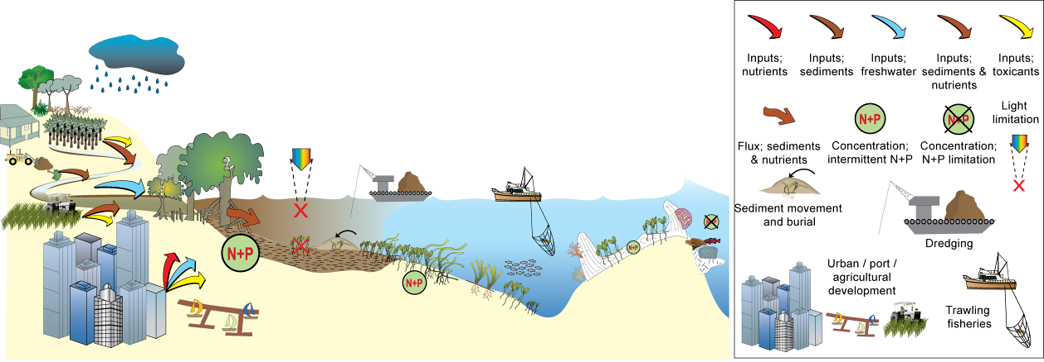
Figure 1. Conceptual diagram depicting threats to seagrass meadows and potential limitations to seagrass growth in inshore regions of the GBR related to changing water quality
(adapted from Waycott and McKenzie 2010).
As seagrasses are well recognised as integrators of environmental stressors, monitoring their status and trend can provide insight into the status of the surrounding environment (e.g. Dennison et al. 1997). In low nutrient, oligotrophic systems there is typically high light availability to the plants, while high nutrient, eutrophic ecosystems have little light reaching the benthos (Johnson et al. 2006). Monitoring of C:N:P ratios may be advantageous for the early detection of changes in nutrient regimes for environmentally sensitive seagrasses (Johnson, et al. 2006; Waycott and McKenzie 2010). Observations of trends in indicators such as C:N:P ratios or changes in seagrass meadow composition provide insight into the responses of seagrasses to environmental change (Waycott and McKenzie 2010). We have developed a matrix of comparison for these indicators (Table 2) and have evidence of seagrass responses in most categories. This framework, provides a structure for acknowledging and interpreting the variety of indicators being used to detect different types of environmental change.
Table 2. Response stages of seagrass meadows to external stressors and the indicator responses observed in Great Barrier Reef monitored seagrass meadows
(adapted from Waycott and McKenzie 2010) * utilised in Paddock to Reef reporting.
Indicator | Sub-lethal  (ecophysiological) | State change  (whole plant and population scale) | Population decline  (whole meadow scale)
Tissue nutrients | Ratios of key macronutrients change to indicate relative excesses (i.e. C:N*, C:P, N:P) | Limited by species variable upper threshold | -
Chlorophyll concentrations | Rapid short term changes observed | Limited by species variable upper threshold | -
Production of reproductive structures | - | Reduced flowering and fruiting, loss of seeds for meadow recovery seen as high variability among sites* | Threshold reached where no reproduction occurs
Change in plant morphology | - | Reduction in leaf area | Threshold reached
Community structure | - | Change in species composition | Loss of species
Change in species abundance (population structure) | - | Change in abundance of species (i.e. % cover)* | Reduction in effective population size
Change in meadow area | - | - | Reduction (or increase) in total meadow area
Recovery time from loss | Limited or no change | Measurably delayed | Potentially no recovery if threshold reached
In addition to the multiple stressors, the tropical seagrass ecosystems of the GBR are a complex mosaic of different habitat types comprised of multiple seagrass species (Carruthers et al. 2002) in which timing and mechanisms that capture their dynamism are relatively poorly understood. The seagrass ecosystems of the GBR, on a global scale, would be for the most part categorised as being dominated by disturbance opportunist species (e.g. Halophila, Halodule and Zostera) typically having low standing biomass and high turnover rates (Carruthers, et al. 2002; Waycott et al. 2007). In more sheltered areas, including in reef top or inshore protected areas, more persistent species are found, although are still relatively capable of being responsive to disturbance (Carruthers, et al. 2002; Waycott, et al. 2007; Collier and Waycott 2009). As a result, baseline condition of dynamic ecosystems requires a greater level of understanding of causes of dynamism although considerable insight into the causes and responses of ecosystems to perturbations can be inferred when these insights are gained. However, when comparing the species present in the coastal GBR, the area covered by this monitoring program, as well as the ecosystems and drivers themselves, monitoring approaches, thresholds and system drivers being studied in other coastal seagrass ecosystems around the world, which are predominantly in temperate Northern Hemisphere systems (Orth, et al. 2006a; Waycott, et al. 2009), few system wide parameters are comparable, as a result, monitoring the unique GBR seagrass system requires baseline understanding to be gained and not rely on models and predictions generated by systems elsewhere.
Healthy seagrass meadows in the GBR act as important resources as the primary food for dugong, green turtles, numerous commercially important fish species and as habitat for large number of invertebrates, fish and algal species (Carruthers, et al. 2002). Much of the connectivity in reef ecosystems depends on intact and healthy non-reef habitats, such as seagrass meadows (Waycott et al. 2011a). These non-reef habitats are particularly important to the maintenance and regeneration of populations, e.g., reef fish. Therefore, monitoring changes in seagrasses meadows can provide an indication of coastal ecosystem health and be used to improve our capacity to predict expected changes to reefs, mangroves and associated resources upon which coastal communities depend (Heck et al. 2008).
Approximately 3,063 km² of coastal seagrass meadows has been mapped in Great Barrier Reef World Heritage Area (GBRWHA) waters shallower than 15m, and in locations that can potentially be influenced by adjacent land use practices (McKenzie et al. 2010b). An additional 31,778 km² of the sea floor within the GBRWHA has some seagrass present (Coles et al. 2009a). This represents more than 50% of the total recorded area of seagrass in Australia (Green and Short 2003) and between 6% and 12% globally (Duarte et al. 2005) making the Great Barrier Reef’s seagrass resources globally significant. Monitoring of the major marine ecosystem types most at risk from land based sources of pollutants is being conducted to ensure that any change in their status is identified. Seagrass monitoring sites have been located as close as practically possible (dependent on historical monitoring and location of existing meadows) to river mouth and inshore marine water quality monitoring programs to enable correlation and concurrently collected water quality information.
There are 15 species of seagrass in the GBR (Waycott, et al. 2007). A high diversity of seagrass habitats is provided by extensive bays, estuaries, rivers and the 2600 km length of the Great Barrier Reef with its reef platforms and inshore lagoon. They can be found on sand or muddy beaches, on reef platforms and in reef lagoons, and on sandy and muddy bottoms down to 60 metres or more below Mean Sea Level (MSL). Seagrasses in the GBR can be separated into four major habitat types: estuary/inlet, coastal, reef and deepwater (Carruthers, et al. 2002) (Figure 2). All but the outer reef habitats are significantly influenced by seasonal and episodic pulses of sediment laden, nutrient rich river flows, resulting from high volume summer rainfall. Cyclones, severe storms, wind and waves as well as macro grazers (fish, dugongs and turtles) influence all habitats in this region to varying degrees. The result is a series of dynamic, spatially and temporally variable seagrass meadows.
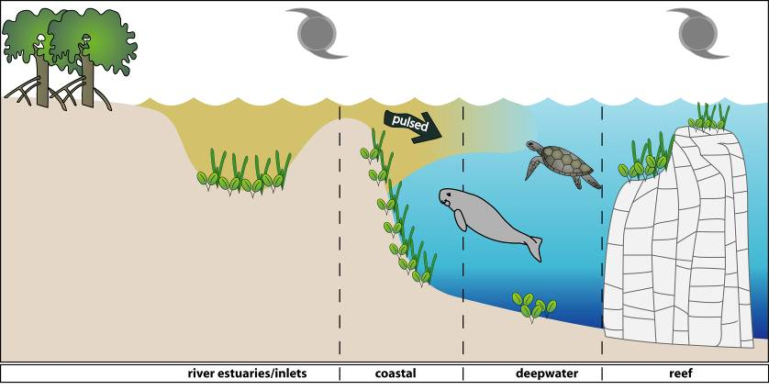
Figure 2. General conceptual model of seagrass habitats in north east Australia
(from Carruthers, et al. 2002)
The requirements for formation of healthy seagrass meadows are relatively clear as they are photosynthetic plants occupying a marine habitat. They require adequate light, nutrients, carbon dioxide, suitable substrate for anchoring along with tolerable salinity, temperature and pH (Waycott and McKenzie 2010). A number of indicators and thresholds of some of these requirements have been established for seagrass communities that are relevant to the GBR, and are monitored as part of the Reef Rescue Marine Monitoring Program.

2. Methodolgy
In the following, an overview is given of the sample collection, preparation and analyses methods. Detailed documentation of the methods used in the MMP, including quality assurance and quality control procedures, is available in a separate report, updated in May 2012 (McKenzie et al. 2010a).

Sampling design & site selection
The sampling design was selected for the detection of change in inshore seagrass meadows in response to improvements in water quality parameters associated to specific catchments or groups of catchments (Region) and to disturbance events.
One of the paramount requirements at the onset of the Marine Monitoring Program, apart from being scientifically robust, was that its findings must have broad acceptance and ownership by the North Queensland and Australian community. It was identified very early in development of Reef Rescue (previously know as the Reef Plan), that existing long-term monitoring programs (e.g. Seagrass-Watch) and legacy sites provided an excellent opportunity on which the inshore seagrass monitoring component could be based. In late 2004 all data collected within the GBR region as part of existing monitoring programs were supplied to Glenn De’ath (Senior Statistician, AIMS) for independent review. De’ath (2005) examined the available datasets to estimate expected performance of the monitoring program. Seagrass data included from 2000–2004 and was collected from 63 sites in 29 locations from Cooktown to Hervey Bay. Results concluded that the existing monitoring was providing valuable information about long-term trends and spatial differences, with changes in seagrass cover occurring at various spatial and temporal scales. The report recommended that the value of the monitoring would be greatly enhanced by adding more widely spread locations.
The meadows monitored within the MMP were selected by the GBRMPA, using advice from expert working groups. The selection of meadows was based upon two primary considerations:
- meadows were representative of seagrass habitats and seagrass communities across each region (based on Lee Long et al. 1993, Lee Long et al. 1997, Lee Long et al. 1998; McKenzie et al. 2000; Rasheed et al. 2003; Campbell et al. 2002; Goldsworthy 1994)
- sampling locations where possible include legacy sites (e.g. Seagrass-Watch, MTSRF) or sites where seagrass research had been focused (e.g. Dennison et al. 1995; Thorogood and Boggon 1999; Udy et al. 1999; Haynes et al. 2000a; Inglis 2000; Campbell and McKenzie 2001; Mellors 2003; Campbell and McKenzie 2004; Mellors et al. 2004; Limpus et al. 2005; McMahon et al. 2005; Lobb 2006).
To account for spatial heterogeneity of meadows within habitats, two sites were selected at each location. Meadows were selected using mapping surveys across the regions prior to site establishment. Representative meadows were those which covered the greater extent of the resource, were generally the dominant seagrass community type and were within GBR average abundances (based on Coles et al. 2001a; Coles et al. 2001c, 2001b, 2001d). Ideally mapping was conducted immediately prior to site positioning, however in most cases it was based on historic (>5yr) information. The final constraint on site selection was that the Minimum Detectable Difference (MDD) had to be below 20% (at the 5% level of significance with 80% power) (Bros and Cowell 1987).

From the onset, inshore seagrass monitoring for the MMP was focused primarily on lower littoral seagrass meadows due to:
- accessibility and cost effectiveness (limiting use of vessels and divers)
- Work Place Health and Safety due to dangerous marine animals (e.g., crocodiles, box jellyfish and irukandji)
- occurrence of meadows in estuarine, coastal and reef habitats across the entire GBR, and
- provides an opportunity for community involvement, ensuring broad acceptance and ownership of Reef Rescue by the Queensland and Australian community.
Although considered intertidal within the MMP, the meadows chosen for monitoring were in fact lower littoral (rarely not inundated) and sub littoral (permanently covered with water). This limited monitoring to the very low spring tides within small tidal windows (mostly 2-4hrs per day for 1-2 days per month for 6-8 months of the year). Traditional approaches using seagrass monitoring to assess water quality have been developed for subtidal meadows typified by small tidal ranges (e.g., Florida = 0.7m, Chesapeake Bay = 0.6m) and clear waters where the seaward edges of meadows were only determined by light (EHMP 2008). Unfortunately, depth range monitoring in subtropical/tropical seagrass meadows has not been as successful as initially expected (e.g. Moreton Bay ) and seagrass meadows within the Great Barrier Reef lagoon do not conform to traditional ecosystem models because of the system complexity (Carruthers, et al. 2002), including:
- a variety of habitat types (estuarine, coastal, reef and deepwater);
- a large variety of seagrass species with differencing life history traits and strategies;
- tidal ranges spanning 3.42m (Cairns) to 7.14m (Hay Point) (www.msq.qld.gov.au);
- a variety of substrates, from terrigenous with high organic content, to oligotrophic calcium carbonate;
- turbid nearshore to clearer offshore waters;
- large herbivorous marine mammals and reptiles influencing meadow community structure and landscapes;
- near absence of shallow subtidal meadows south of the Whitsundays due to the large tides which scour the seabed.
Deepwater (>15m) meadows across the GBR are predominately dominated by Halophila species and are highly variable in abundance and distribution (Lee Long et al. 2000). Due to this high variability they are generally not recommended for monitoring as the Minimum Detectable Difference (MDD) is very poor at the 5% level of significance with 80% power (McKenzie et al. 1998). Predominately stable lower littoral meadows of foundation species (e.g., Zostera) are best for determining significant change/impact (McKenzie et al. 1998). Nevertheless, where possible, shallow (<1.5m below Lowest Astronomical Tide) subtidal monitoring has been conducted since October 2009 at locations in the Burdekin and Wet Tropics regions. These sites were chosen as they were dominated by species similar to adjacent lower littoral meadows.
Due to the high diversity of seagrass species across the GBR, it was decided in consultation with GBRMPA to direct monitoring toward the foundation seagrass species across the seagrass habitats. A foundation species is the dominant primary producer in an ecosystem both in terms of abundance and influence, playing central roles in sustaining ecosystem services (Angelini et al. 2011). The activities of foundation species physically modify the environment and produce and maintain habitats that benefit other organisms that use those habitats. For the seagrass habitats assessed in the MMP, the foundation seagrass species were those species which typified the habitats both in abundance and structure when the meadow was considered in it's steady state (Figure 3). The foundation species were all di-meristematic leaf-replacing forms.

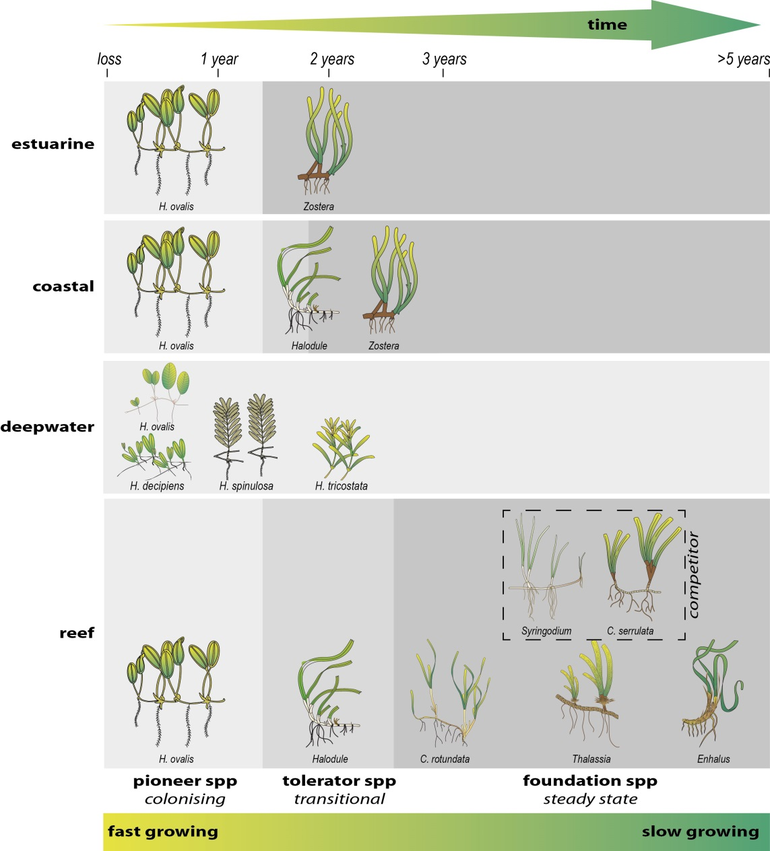
Figure 3. Illustration of seagrass recovery after loss and the categories of successional species over time
(from McKenzie et al. 2012). Recovery times based on Campbell and McKenzie (2004), McKenzie et al. (2010b), Birch and Birch (1984), McKenzie and Campbell (2003), Preen et al. (1995), Rasheed et al. (2014).
The timing of the monitoring within the MMP was decided by the GBRMPA, using advice from expert working groups. As the major period of runoff from catchments and agricultural lands was the tropical wet season/monsoon (December to April), monitoring was focussed on the late dry season (seagrass growing season) and late wet season to capture the status of seagrass prior and post wet.
Seagrass monitoring methods were conducted as per McKenzie et al. (2010). In early 2012, additional monitoring sites were established in the Cape York region north of Cooktown and within Bowling Green Bay (Burdekin region), with financial support from Reef Plan operations (Regional Services, DAFF). Forty five sites were monitored during the 2011/12 monitoring period (Table 3). This included seven coastal, five estuarine and nine reef locations (i.e. two-three sites at each location). At the reef locations in the Burdekin and Wet Tropics, intertidal sites were paired with a subtidal site (Table 3). A description of all data collected during the sampling period under the monitoring contract has been collated by Natural Resource Management (NRM) region, site, parameter, and the number of samples collected per sampling period is listed in Table 4. The seagrass species present at each monitoring site (including foundation seagrass species) is listed in Table 4.

Seagrass abundance, composition and distribution
Field survey methodology followed standardised protocols (McKenzie et al., 2003). At each location, with the exception of subtidal sites, sampling included two sites nested in a location. Subtidal sites were not replicated within locations. Intertidal sites were defined as a 50m x 50m area within a relatively homogenous section of a representative seagrass community/meadow (McKenzie et al., 2000). The sampling strategy for subtidal sites was modified to sample along 50m transects 2-3 m apart (aligned along the depth contour) due to logistics of SCUBA diving in waters of poor visibility. Monitoring at sites in the late dry (September/October 2011) and late monsoon (March/April 2012) of each year was conducted by a qualified and trained scientist. Monitoring conducted outside these periods was conducted by a trained scientist assisted by volunteers. At each site, during each survey, observers recorded the percent seagrass cover within a 50 cm × 50 cm quadrat every 5 m along three 50m transects, placed 25m apart. A total of 33 quadrats were sampled per site. Seagrass abundance was visually estimated as the fraction of the seabed (substrate) obscured by the seagrass species when submerged and viewed from above. This method was used because the technique has wider application and is very quick, requiring only minutes at each quadrat; yet it is robust and highly repeatable, thereby minimising among-observer differences. Quadrat percent cover measurements have also been found to be far more efficient in detecting differences in seagrass abundance than seagrass blade counts or measures of above- or below-ground biomass (Heidelbaugh and Nelson 1996). To improve resolution and allow greater differentiation at very low percentage covers (e.g. <3%), shoot counts (higher accurate at low densities) based on global species density maxima were used. For example: 1 pair of Halophila ovalis leaves in a quadrat = 0.1%; 1 shoot/ramet of Zostera in a quadrat = 0.2%. Seagrass species were identified as per Waycott et al. (2004). Additional information was collected at the quadrat level, although only included as narrative in this report, including: seagrass canopy height of the dominant strap leaved species; macrofaunal abundance; abundance of burrows (as an measure of bioturbation); presence of herbivory (e.g. dugong and sea turtle); a visual/tactile assessment of sediment composition (see McKenzie 2007); and observations on the presence of superficial sediment structures such as ripples and sand waves to provide evidence of physical processes in the area (see Koch 2001).
Mapping the edge of the seagrass meadow within 100m of each intertidal monitoring site was conducted in the late dry and late monsoon monitoring periods. Edge mapping was used to determine if changes in seagrass abundance were the result of the meadow shrinking/increasing in distribution or the plant increasing/decreasing in density, or both. Extent of seagrass within the mapping area was compared against each site's baseline (first measure).

Table 3. Reef Rescue MMP inshore seagrass long-term monitoring sites
. NRM region from www.nrm.gov.au. * = intertidal, ^=subtidal.
GBR region | NRM region  (Board) | Catchment | Monitoring location | Site |  | Latitude |  | Longitude |  | Seagrass community type
Far Northern | Cape York |  | Shelburne Bay  coastal | SR1* | Shelburne Bay | 11° | 53.233 | 142° | 54.851 | H. ovalis with H. uninervis/T. hemprichii
 |  |  |  | SR2* | Shelburne Bay | 11° | 53.251 | 142° | 54.938 | H. ovalis with H. uninervis/T. hemprichii
Far Northern | Cape York |  | Piper Reef  reef | FR1* | Farmer Is. | 12° | 15.352 | 143° | 14.020 | T. hemprichii with C. rotundata/H. ovalis
 |  |  |  | FR2* | Farmer Is. | 12° | 15.448 | 143° | 14.185 | T. hemprichii with C. rotundata/H. ovalis
Far Northern | Cape York | Normanby | Stanley Island  reef | ST1* | Stanley Island | 14° | 8.576 | 144° | 14.680 | H. ovalis/H. uninervis with T. hemprichii/C. rotundata
 |  |  |  | ST2* | Stanley Island | 14° | 8.547 | 144° | 14.588 | H. ovalis/H. uninervis with T. hemprichii/C. rotundata
Far Northern | Cape York | Normanby | Bathurst Bay  coastal | BY1* | Bathurst Bay | 14° | 16.082 | 144° | 13.961 | H. uninervis with H. ovalis/T. hemprichii/C. rotundata
 |  |  |  | BY2* | Bathurst Bay | 14° | 16.062 | 144° | 13.896 | H. uninervis with H. ovalis/T. hemprichii/C. rotundata
Far Northern | Cape York | Endeavour | Cooktown  reef | AP1* | Archer Point | 15° | 36.500 | 145° | 19.143 | H. univervis/ H. ovalis with Cymodocea/T. hemprichii
 |  |  |  | AP2* | Archer Point | 15° | 36.525 | 145° | 19.108 | H. univervis/H. ovalis with C. rotundata
Northern | Wet Tropics  (Terrain NRM) | Mossman | Low Isles  reef | LI1* | Low Isles | 16° | 23.11 | 145° | 33.88 | H.ovalis/H.uninervis
 |  |  |  | LI2^ | Low Isles | 16° | 22.97 | 145° | 33.85 | H.ovalis/H.uninervis
Northern | Wet Tropics  (Terrain NRM) | Barron  Russell -Mulgrave  Johnstone | Cairns  coastal | YP1* | Yule Point | 16° | 34.159 | 145° | 30.744 | H. uninervis with H. ovalis
 |  |  |  | YP2* | Yule Point | 16° | 33.832 | 145° | 30.555 | H. uninervis with H. ovalis
Northern | Wet Tropics  (Terrain NRM) | Barron  Russell -Mulgrave  Johnstone | Green Island  reef | GI1* | Green Island | 16° | 45.789 | 145° | 58.31 | C. rotundata/T. hemprichii with H. uninervis/H. ovalis
 |  |  |  | GI2* | Green Island | 16° | 45.776 | 145° | 58.501 | C. rotundata/T. hemprichii with H. uninervis/H. ovalis
 |  |  |  | GI3^ | Green Island | 16° | 45.29 | 145° | 58.38 | C. rotundata/ H. uninervis/C.serrulata/S.isoetifolium
Northern | Wet Tropics  (Terrain NRM) | Tully | Mission Beach  coastal | LB1* | Lugger Bay | 17° | 57.645 | 146° | 5.61 | H. uninervis
 |  |  |  | LB2* | Lugger Bay | 17° | 57.674 | 146° | 5.612 | H. uninervis
Northern | Wet Tropics  (Terrain NRM) | Tully | Dunk Island  reef | DI1* | Dunk Island | 17° | 56.6496 | 146° | 8.4654 | H. uninervis with T. hemprichii/ C. rotundata
 |  |  |  | DI2* | Dunk Island | 17° | 56.7396 | 146° | 8.4624 | H. uninervis with T. hemprichii/ C. rotundata
 |  |  |  | DI3^ | Dunk Island | 17° | 55.91 | 146° | 08.42 | H. uninervis / H. ovalis/ H.decipiens/C. serrulata
Central | Burdekin  (NQ Dry Tropics) | Burdekin | Magnetic island  reef | MI1* | Picnic Bay | 19° | 10.734 | 146° | 50.468 | H. uninervis with H. ovalis & Zostera/T. hemprichii
 |  |  |  | MI2* | Cockle Bay | 19° | 10.612 | 146° | 49.737 | C. serrulata/ H. uninervis with T. hemprichii/H. ovalis
 |  |  |  | MI3^ | Picnic Bay | 19° | 10.734 | 146° | 50.468 | H. uninervis with H. ovalis & Zostera/T. hemprichii
Central | Burdekin  (NQ Dry Tropics) | Burdekin | Townsville  coastal | SB1* | Shelley Beach | 19° | 11.046 | 146° | 45.697 | H. uninervis with H. ovalis
 |  |  |  | BB1* | Bushland Beach | 19° | 11.028 | 146° | 40.951 | H. uninervis with H. ovalis
Central | Burdekin  (NQ Dry Tropics) | Burdekin | Bowling Green Bay  coastal | JR1* | Jerona (Barratta Ck) | 19° | 25.380 | 147° | 14.480 | H. uninervis with Zostera/H. ovalis
 |  |  |  | JR2* | Jerona (Barratta Ck) | 19° | 25.281 | 147° | 14.425 | H. uninervis with Zostera/H. ovalis
Central | Mackay Whitsunday  (Reef Catchments) | Proserpine | Whitsundays  coastal | PI2* | Pioneer Bay | 20° | 16.176 | 148° | 41.586 | H. uninervis/ Zostera with H. ovalis
 |  |  |  | PI3* | Pioneer Bay | 20° | 16.248 | 148° | 41.844 | H. uninervis with Zostera/H. ovalis
Central | Mackay Whitsunday  (Reef Catchments) | Proserpine | Whitsundays  reef | HM1* | Hamilton Island | 20° | 20.7396 | 148° | 57.5658 | H. uninervis with H. ovalis
 |  |  |  | HM2* | Hamilton Island | 20° | 20.802 | 148° | 58.246 | Z. muelleri with H. ovalis/H. uninervis
Central | Mackay Whitsunday  (Reef Catchments) | Pioneer | Mackay  estuarine | SI1* | Sarina Inlet | 21° | 23.76 | 149° | 18.2 | Z. muelleri with H. ovalis (H. uninervis)
 |  |  |  | SI2* | Sarina Inlet | 21° | 23.712 | 149° | 18.276 | Z. muelleri with H. ovalis (H. uninervis)
Southern | Fitzroy  (Fitzroy Basin Association) | Fitzroy | Shoalwater Bay  coastal | RC1* | Ross Creek | 22° | 22.953 | 150° | 12.685 | Zostera muelleri with H. ovalis
 |  |  |  | WH1* | Wheelans Hut | 22° | 23.926 | 150° | 16.366 | Zostera muelleri with H. ovalis
Southern | Fitzroy  (Fitzroy Basin Association) | Fitzroy | Keppel Islands  reef | GK1* | Great Keppel Is. | 23° | 11.7834 | 150° | 56.3682 | H. uninervis with H. ovalis
 |  |  |  | GK2* | Great Keppel Is. | 23° | 11.637 | 150° | 56.3778 | H. uninervis with H. ovalis
Southern | Fitzroy  (Fitzroy Basin Association) | Boyne | Gladstone Harbour  estuarine | GH1* | Gladstone Hbr | 23° | 46.005 | 151° | 18.052 | Zostera muelleri with H. ovalis
 |  |  |  | GH2* | Gladstone Hbr | 23° | 45.874 | 151° | 18.224 | Zostera muelleri with H. ovalis
Southern | Burnett Mary  (Burnett Mary Regional Group) | Burnett | Rodds Bay  estuarine | RD1* | Rodds Bay | 24° | 3.4812 | 151° | 39.3288 | Zostera muelleri with H. ovalis
 |  |  |  | RD2* | Rodds Bay | 24° | 4.866 | 151° | 39.7584 | Zostera muelleri with H. ovalis
Southern | Burnett Mary  (Burnett Mary Regional Group) | Mary | Hervey Bay  estuarine | UG1* | Urangan | 25° | 18.053 | 152° | 54.409 | Zostera muelleri with H. ovalis
 |  |  |  | UG2* | Urangan | 25° | 18.197 | 152° | 54.364 | Zostera muelleri with H. ovalis
Table 4. Samples collected at each monitoring site for each season
. Activities include: SG = seagrass cover & composition, SM= seed monitoring, TN=tissue nutrients, EM=edge mapping, RH=reproductive health, SH=sediment herbicides, TL=temperature loggers, LL=light loggers. ^=subtidal.
Region | Catchment | Monitoring location |  | late dry Season (2011) |  |  |  |  |  |  | late monsoon Season (2012)
Region | Catchment |  |  | SG | SM | TN | EM | RH | TL | LL | SG | SM | EM | RH | SH | TL | LL
Cape York |  | Shelburne Bay | SR1 |  |  |  |  |  |  |  | 33 | 30 |  | 15*
Cape York |  | Shelburne Bay | SR2 |  |  |  |  |  |  |  | 33 | 30 |  | 15*
Cape York |  | Piper Reef | FR1 |  |  |  |  |  |  |  | 33 | 30 |  | 15*
Cape York |  | Piper Reef | FR2 |  |  |  |  |  |  |  | 33 | 30 |  | 15*
Cape York | Normanby | Stanley Island | ST1 |  |  |  |  |  |  |  | 33 | 30 |  | 15*
Cape York | Normanby | Stanley Island | ST2 |  |  |  |  |  |  |  | 33 | 30 |  | 15*
Cape York | Normanby | Bathurst Bay | BY1 |  |  |  |  |  |  |  | 33 | 30 |  | 15*
Cape York | Normanby | Bathurst Bay | BY2 |  |  |  |  |  |  |  | 33 | 30 |  | 15*
Cape York | Endeavour | Archer Point | AP1 | 33 | 30 | 3 |  | 15 |  |  | 33 | 30 |  | 15*
Cape York | Endeavour | Archer Point | AP2 | 33 | 30 | 3 |  | 15 |  |  | 33 | 30 |  | 15*
Wet Tropics | Mossman | Low Isles | LI1 | 33 | 30 | 3 |  | 15 |  |  | 33 | 30 |  | 15
Wet Tropics | Mossman | Low Isles | LI2^ | 33 | 30 | 3 |  | 15 |  |  | 33 | 30 |  | 15
Wet Tropics | Barron | Cairns | YP1 | 33 | 30 | 3 |  | 15 |  |  | 33 | 30 |  | 15*
Wet Tropics | Barron | Cairns | YP2 | 33 | 30 | 3 |  | 15 |  |  | 33 | 30 |  | 15*
Wet Tropics | Russell - Mulgrave, Johnstone | Green Island | GI1 | 33 | 30 | 3 |  | 15 |  |  | 33 | 30 |  | 15*
Wet Tropics | Russell - Mulgrave, Johnstone | Green Island | GI2 | 33 | 30 | 3 |  | 15 |  |  | 33 | 30 |  | 15*
Wet Tropics | Russell - Mulgrave, Johnstone | Green Island | GI3^ | 33 | 30 | 3 |  | 15 |  |  | 33 | 30 |  | 15
Wet Tropics | Tully | Mission Beach | LB1 | 33 | 30 | 3 |  | 15 |  |  | 33 | 30 |  | 15*
Wet Tropics | Tully | Mission Beach | LB2 | 33 | 30 | 3 |  | 15 |  |  | 33 | 30 |  | 15*
Wet Tropics | Tully | Dunk Island | DI1 | 33 | 30 | 3 |  | 15 |  |  | 33 | 30 |  | 15*
Wet Tropics | Tully | Dunk Island | DI2 | 33 | 30 | 3 |  | 15 |  |  | 33 | 30 |  | 15*
Wet Tropics | Tully | Dunk Island | DI3^ | 33 | 30 | 3 |  | 15 |  |  | 33 | 30 |  | 15
Burdekin | Burdekin | Magnetic Island | MI1 | 33 | 30 | 3 |  | 15 |  |  | 33 | 30 |  | 15*
Burdekin | Burdekin | Magnetic Island | MI2 | 33 | 30 | 3 |  | 15 |  |  | 33 | 30 |  | 15*
Burdekin | Burdekin | Magnetic Island | MI3^ | 33 | 30 | 3 |  | 15 |  |  | 33 | 30 |  | 15*
Burdekin | Burdekin | Townsville | SB1 | 33 | 30 | 3 |  | 15 |  |  | 33 | 30 |  | 15*
Burdekin | Burdekin | Townsville | BB1 | 33 | 30 | 3 |  | 15 |  |  | 33 | 30 |  | 15*
Burdekin | Burdekin | Bowling Green Bay | JR1 |  |  |  |  |  |  |  | 33 | 30 |  | 15*
Burdekin | Burdekin | Bowling Green Bay | JR2 |  |  |  |  |  |  |  | 33 | 30 |  | 15*
Mackay  Whitsunday | Proserpine | Whitsundays | PI2 | 33 | 30 | 3 |  | 15 |  |  | 33 | 30 |  | 15*
Mackay  Whitsunday | Proserpine | Whitsundays | PI3 | 33 | 30 | 3 |  | 15 |  |  | 33 | 30 |  | 15*
Mackay  Whitsunday | Proserpine | Hamilton Is. | HM1 | 33 | 30 | 3 |  | 15 |  |  | 33 | 30 |  | 15*
Mackay  Whitsunday | Proserpine | Hamilton Is. | HM2 | 33 | 30 | 3 |  | 15 |  |  | 33 | 30 |  | 15*
Mackay  Whitsunday | Pioneer | Mackay | SI1 | 33 | 30 | 3 |  | 15 |  |  | 33 | 30 |  | 15*
Mackay  Whitsunday | Pioneer | Mackay | SI2 | 33 | 30 | 3 |  | 15 |  |  | 33 | 30 |  | 15*
Fitzroy | Fitzroy | Shoalwater Bay | RC1 | 33 | 30 | 3 |  | 15 |  |  | 33 | 30 |  | 15*
Fitzroy | Fitzroy | Shoalwater Bay | WH1 | 33 | 30 | 3 |  | 15 |  |  | 33 | 30 |  | 15*
Fitzroy | Fitzroy | Great Keppel . | GK1 | 33 | 30 | 3 |  | 15 |  |  | 33 | 30 |  | 15*
Fitzroy | Fitzroy | Great Keppel . | GK2 | 33 | 30 | 3 |  | 15 |  |  | 33 | 30 |  | 15*
Fitzroy | Boyne | Gladstone | GH1 | 33 | 30 |  | * |  |  |  | 33* | 30*
Fitzroy | Boyne | Gladstone | GH2 | 33 | 30 |  | * |  |  |  | 33* | 30*
Burnett Mary | Burnett | Rodds Bay | RD1 | 33 | 30 | 3 |  |  |  |  | 33 | 30 |  | 15*
Burnett Mary | Burnett | Rodds Bay | RD2 | 33 | 30 | 3 |  |  |  |  | 33 | 30 |  | 15*
Burnett Mary | Mary | Hervey Bay | UG1 | 33 | 30 | 3 |  | 15 |  |  | 33 | 30 |  | 15*
Burnett Mary | Mary | Hervey Bay | UG2 | 33 | 30 | 3 |  | 15 |  |  | 33 | 30 |  | 15*

Table 5. Presence of foundation () and other (□) seagrass species in monitoring locations sampled in Reef Rescue MMP for plant tissue and reproductive health
. Habitat type is classified as Reef, Coast, and Estuary following the classification of Carruthers et al. (2002).
NRM Region | Catchment | Seagrass  Monitoring  location | Habitat type |  | C. rotundata | C. serrulata | H. decipiens | H. ovalis | H. uninervis | S. isoetifoilium | T. hemprichii | Z. muelleri
Cape York |  | Shelburne Bay | Coast | intertidal
Cape York |  | Piper Reef | Reef | intertidal
Cape York | Normanby | Stanley Reef | Reef | intertidal
Cape York | Normanby | Bathurst Bay | Coast | intertidal
Cape York | Endeavour | Archer Point | Reef | intertidal |  |  |  |  |  |  |  | *
Wet Tropics | Daintree | Low Isles | Reef | Intertidal
 |  |  |  | subtidal
Wet Tropics | Russell - Mulgrave, Johnstone | Yule Point | Coast | Intertidal |  |  |  |  |  |  |  | *
Wet Tropics | Russell - Mulgrave, Johnstone | Green Island | Reef | intertidal
 |  |  |  | subtidal
Wet Tropics | Tully | Lugger Bay | Coast | intertidal |  |  |  | *
Wet Tropics | Tully | Dunk Island | Reef | intertidal |  |  |  | *
 |  |  |  | subtidal
Burdekin | Herbert,  Burdekin | Magnetic Island | Reef | intertidal |  |  |  |  |  |  |  | *
 |  |  |  | subtidal
Burdekin | Herbert,  Burdekin | Townsville | Coast | intertidal
Burdekin | Herbert,  Burdekin | Bowling Green Bay | Coast | intertidal
Mackay Whitsunday | Proserpine | Pioneer Bay | Coast | intertidal
Mackay Whitsunday | Proserpine | Hamilton Island | Reef | intertidal
Mackay Whitsunday | Pioneer | Sarina Inlet | Estuary | intertidal
Fitzroy | Fitzroy | Shoalwater Bay | Coast | intertidal |  |  |  | * | *
Fitzroy | Fitzroy | Keppel Islands | Reef | intertidal
Fitzroy | Boyne | Gladstone | Estuary | intertidal |  |  |  |  | *
Burnett Mary | Burnett | Rodds Bay | Estuary | intertidal
Burnett Mary | Mary | Hervey Bay | Estuary | intertidal |  |  |  | *
Zostera muelleri = Zostera muelleri subsp. capricorni, as revision of Zostera capricorni (Jacobs et al. 2006) resulted in classification to subspecies. * indicates presence adjacent, but not within, 50m x 50m site.

Seagrass reproductive health
Seagrass reproductive health was assessed from samples collected in the late dry 2011 and late monsoon 2012 at locations identified in Table 4. Samples were processed according to standard methodologies (McKenzie, et al. 2010a).
In the field, 15 haphazardly placed cores (10cm diameter x 10cm depth) of seagrass were collected from an area adjacent (of similar cover and species composition) to each monitoring site. In the laboratory, reproductive structures (spathes, fruits, female and male flowers) of plants from each core were identified and counted for each samples and species. Reproductive effort was calculated as number of reproductive structures (fruits, flowers, spathes; species pooled) per core for analysis.
Seeds banks and abundance of germinated seeds were sampled according to standard methods (McKenzie, et al. 2010a) by sieving (2mm mesh) 30 cores (50mm diameter, 10cm depth) of sediment collected across each site and counting the seeds retained in each. For Zostera muelleri, where the seed are <1mm diameter, intact cores (18) were collected and returned to the laboratory where they were washed through a 710µm sieve and seeds identified using a hand lens/microscope.

Seagrass tissue nutrients
In late dry season (October) 2011, foundational seagrass species leaf tissue nutrient samples were collected from each monitoring site (Table 4, Table 5). For nutrient status comparisons, collections were recommended during the growth season (e.g. late dry when nutrient contents are at a minimum) (Mellors et al. 2005) and at the same time of the year and at the same depth at the different localities (Borum et al. 2004). Shoots from three haphazardly placed 0.25m² quadrats were collected from an area adjacent (of similar cover and species composition) to each monitoring site. Leaves were separated from the below ground material in the laboratory and epiphytic algae removed by gently scraping. Dried and milled samples were analysed according to McKenzie et al. (2010a). Elemental ratios (C:N:P) were calculated on a mole:mole basis using atomic weights (i.e., C=12, N=14, P=31).
Analysis of tissue nutrient data was based upon the calculation of the atomic ratios of C:N:P. The ratios of the most common macronutrients required for plant growth has been used widely as an indicator of growth status, in phytoplankton cultures this is known as the “Redfield” ratio of 106C:16N:P (Redfield et al. 1963). Seagrass and other benthic marine plants possess large quantities of structural carbon, resulting in ‘‘seagrass Redfield ratios’’ estimated to be between 550:30:1 (Atkinson and Smith 1983) and 474:24:1 (Duarte 1990). The magnitude of these ratios and their temporal changes allow for a broad level understanding of the physical environment of seagrass meadows. Like phytoplankton, seagrasses growing in eutrophic waters have C:N:P ratios that reflect elevated nitrogen and phosphorus levels (Duarte 1990). Plants residing in nutrient poor waters show significantly lower N:P ratios than those from nutrient rich conditions (Atkinson and Smith 1983). Comparing deviations in the ratios of carbon, nitrogen and phosphorous (C:N:P) retained within plant tissue has been used extensively as an alternative mean of evaluating the nutrient status of coastal waters (Duarte 1990).
Changing C:N ratios have been found in a number of experiments and field surveys to be related to light levels, as leaves with an atomic C:N ratio of less than 20, may suggest reduced light availability when N is not in surplus (Abal et al. 1994; Grice et al. 1996; Cabaço and Santos 2007; Collier et al. 2009). The ratio of N:P is also a useful indicator as it is a reflection of the “Redfield” ratios (Redfield, et al. 1963), and seagrass with an atomic N:P ratio of 25 to 30 can be determined to be ‘replete’ (well supplied and balanced macronutrients for growth) (Atkinson and Smith 1983; Fourqurean et al. 1997; Fourqurean and Cai 2001). N:P values in excess of 30 may potentially indicate P-limitation and less than 25 are considered to show N limitation (Atkinson and Smith 1983;Duarte 1990; Fourqurean et al. 1992b; Fourqurean and Cai 2001). The median seagrass tissue ratios of C:P is approximately 500 (Atkinson and Smith 1983), therefore deviation from this value is also likely to be indicative of some level of nutrient enriched or nutrient limited conditions. A combination of these ratios can indicate seagrass environments which are impacted by nutrient enrichment. Plant tissue which has a high N:P and low C:P indicates an environment of elevated (saturated) nitrogen.
Investigations of the differences in each individual tissue ratio within each of the species revealed that although tissue nutrient concentrations were extremely variable between locations and between years, by pooling species within habitat types trends were apparent (McKenzie and Unsworth 2009). As seagrass tissue nutrient ratios of the foundation species were generally not significantly different from each other at a site within each sampling period (McKenzie and Unsworth 2009), the tissue nutrient ratios were pooled at the request of the GBRMPA to assist with interpretation of the findings.
To identify the sources of the nitrogen and provide insight into the occurrence of carbon limitation associated with light limitation, leaf tissue were also analysed for nitrogen and carbon stable isotope ratios (δ¹⁵N and δ¹³C).
There are two naturally occurring atomic forms of nitrogen (N). The common form that contains seven protons and seven neutrons is referred to as ¹⁴N, and a heavier form that contains an extra neutron is called ¹⁵N: with 0.3663% of atmospheric N in the heavy form. Plants and animals assimilate both forms of nitrogen, and the ratio of ¹⁴N to ¹⁵N compared to an atmospheric standard (δ¹⁵N) can be determined by analysis of tissue on a stable isotope mass spectrometer using the following equation:
Seagrasses are passive indicators of δ¹⁵N enrichment, as they integrated the signature of their environment over time throughout their growth cycle. The various sources of nitrogen pollution to coastal ecosystems often have distinguishable ¹⁵N/¹⁴N ratios (Heaton 1986), and in regions subject to anthropogenic inputs of nitrogen, changes in the δ¹⁵N signature can be used to identify the source and distribution of the nitrogen (Costanzo 2001). Nitrogen fertilizer, produced by industrial fixation of atmospheric nitrogen results in low to negative δ¹⁵N signatures (i.e. δ¹⁵N ~0 - 1‰) (Udy and Dennison 1997a). In animal or sewage waste, nitrogen is excreted mainly in the form of urea, which favours conversion to ammonia and enables volatilization to the atmosphere. Resultant fractionation during this process leaves the remaining ammonium enriched in ¹⁵N. Further biological fractionation results in sewage nitrogen having a δ¹⁵N signature greater than 9 or ~10‰ (Lajtha and Marshall 1994; Udy and Dennison 1997b; Dennison and Abal 1999; Abal et al. 2001; Costanzo et al. 2001). Septic and aquaculture discharge undergo less biological treatment and are likely to have a signature closer to that of raw waste (δ¹⁵N ~5‰) (Jones et al. 2001).
Similar to N, there are two naturally occurring atomic forms of carbon (C), ¹³C and ¹²C, which are taken up during photosynthesis where ¹²C is the more abundant of the two, accounting for 98.89% of carbon. The ratio that ¹³C is taken up relative to ¹²C varies in time as a function of productivity, organic carbon burial and vegetation type. A measure of the ratio of stable isotopes ¹³C:¹²C (i.e. δ¹³C) is known as the isotopic signature, and reported in parts per thousand (per mil, ‰):
where the standard is an established reference material.
Experimental work has confirmed that seagrasses from high light, high productivity environments demonstrate (less negative) isotopic enrichment: i.e. low %C, low C:N, in contrast, more negative δ¹³C, may indicate that light is limited (Grice, et al. 1996; Fourqurean et al. 2005).

Epiphyte and macro-algae abundance
Epiphyte and macroalgae cover were measured according to standard methods (McKenzie, et al. 2010a). The total percentage of leaf surface area (both sides, all species pooled) covered by epiphytes and percentage of quadrat area covered by macroalgae, were measured each monitoring event. Values were compared against the GBR long-term average (1999-2010) calculated for each habitat type.
Increased epiphyte (the plants growing on the surfaces of slower-growing seagrass leaves (Borowitzka et al. 2006)) loads may result in shading of seagrass leaves by up to 65%, reducing photosynthetic rate and leaf densities of the seagrasses (Sand-Jensen 1977; Tomasko and Lapointe 1991; Walker and McComb 1992; Tomasko et al. 1996; Frankovich and Fourqurean 1997; Ralph and Gademann 1999; Touchette 2000). In seagrass meadows, increases in the abundance of epiphytes are stimulated by nutrient loading (e.g. Borum 1985; Silberstein et al. 1986; Neckles et al. 1994; Balata et al. 2008) and these increases in abundance have been implicated as the cause for declines of seagrasses during eutrophication (e.g. Orth and Moore 1983; Cambridge et al. 1986).
Given the observed relationships between nutrient loading and the abundance of epiphytes observed in seagrass ecosystems from around the world, and the perceived threat to water quality owing to human population, the abundance of epiphytes in seagrass meadows may prove to be a valuable indicator for assessing both the current status and trends of the GBR seagrass meadows. However, preliminary analysis of the relationship between seagrass abundance and epiphyte cover collected by the RRMMP and MTSRF did not identify threshold levels beyond which loss of abundance occurred (McKenzie 2008) suggesting further research and analysis.

Within seagrass canopy temperature
Autonomous iBTag™ submersible temperature loggers were deployed at all sites identified in Table 4. The loggers recorded temperature (accuracy 0.0625°C) within the seagrass canopy every 30-90 minutes. iBCod™22L submersible temperature loggers were attached to the permanent marker at each site above the sediment-water interface.
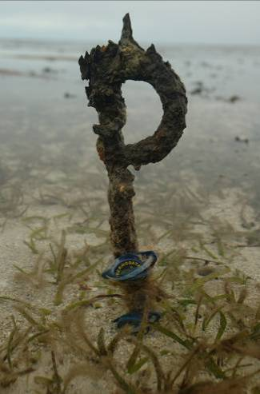
Autonomous iBTag™ submersible temperature loggers attached to permanent site marker at Green Island (GI1)

Seagrass canopy light
Submersible Odyssey™ photosynthetic irradiance autonomous loggers were attached to permanent markers at 15 intertidal locations and 4 subtidal sites from the Wet Tropics region to the Burnett Mary region (Table 4). Detailed methodology for the light monitoring (including cosine correction factors) can be found in McKenzie et al. (2010). Measurements were recorded by the logger every 30 minutes. Automatic wiper brushes cleaned the optical surface of the sensor every 15 minutes to prevent marine organisms fouling.
The deployment durations were variable, with some deployed since 2008 under a different program (MTSRF); however the light monitoring was expanded and incorporated into the MMP in late 2009. Data were patchy for a number of intertidal sites because visitation frequency was low (3- 6 months), which increases the risk of light logger or wiper unit failure and increases the gap in data if loggers do fail. Furthermore, there are some sites that are frequently accessed by the public and tampering is suspected in the disappearance of some loggers. For subtidal sites, and their associated intertidal sites (Picnic Bay, Dunk Island, Green Island and Low Isles, 8 sites in total), the logger replacement time was every 6 weeks so data gaps were fewer.
Loggers were calibrated against a certified reference Photosynthetically Active Radiation (PAR) sensor (LI-COR™ LI-192SB Underwater Quantum Sensor) using a stable light source (LiCor) enclosed in a casing that holds both the sensor and light source at a constant distance. Calibration is repeated after each deployment period of 6 weeks to 6 months.
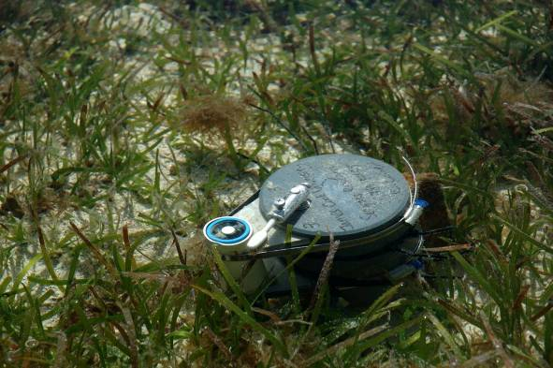
Submersible Odyssey™ photosynthetic irradiance autonomous logger deployed at Green Island.
Light data measured as instantaneous irradiance (µmol m⁻² s⁻¹) was converted to daily irradiance (I_{d}, mol m⁻² d⁻¹). I_{d} is highly variable in shallow coastal systems, being affected by incoming irradiance, the tidal cycle as well as water quality (Anthony et al. 2004). This high variability makes it difficult to ascertain trends in data. To aid with the visual interpretation of trends, I_{d} was then averaged over a 28 day period (complete tidal cycle). 28 days is also biologically meaningful, as it corresponds to the approximate duration over which leaves on a shoot are fully replaced by new leaves and it is the approximate time over which shoot density and biomass starts to decline following reductions in light (Collier et al. 2012a). 28 day averaged I_{d} are presented graphically against draft thresholds with different values for northern and southern communities as the dominant species and habitat types vary from north to south. Thresholds applied in the northern GBR (5 mol m⁻² s⁻¹) were developed for Halodule uninervis-dominated communities during episodic seagrass loss (Collier et al. 2012b). The threshold applied to southern GBR communities were developed for Zostera muelleri dominated communities over a 2 week rolling average using a range of experimental and monitoring approaches (Chartrand et al. 2012). These working thresholds describe light levels associated with short-term changes in seagrass abundance.
Also discussed is I_{d} relative to estimated minimum light requirements (MLR). MLR describes the light required for the long-term survival of seagrass meadows (Dennison 1987). It is frequently calculated from measurement of annual light availability at the deepest edge of seagrass meadow, beyond which seagrasses cannot survive. MLR is difficult to determine in the dynamic seagrass meadows of the GBR, which often have poorly defined meadow boundaries, and these boundaries vary over intra-annual cycles. MLR are usually reported as percent of surface irradiance (SI), even though this not the most meaningful representation of light requirements. The average MLR of 15-25% SI for tropical blady species (summarized in Lee et al. 2007) was converted to I_{d} using surface light data from Magnetic Island, Dunk Island, Green Island and Low Isles, which has been recorded at these sites since 2008. From this we estimate that the MLR equivalent to 15-25% SI is 4.7 to 7.9 mol photons m⁻² d⁻¹ (Table 6). Halophila species typically have a much lower MLR, around 5-10% SI (Lee et al. 2007), which is equivalent to 1.5 to 2.9 mol m⁻² d⁻¹ at the monitoring sites for which we have surface light data. There are other species that possibly have higher MLR than the range given here; for example, Zostera muelleri is thought to have an MLR greater than 30% Longstaff 2002.
Table 6. Minimum light requirements (MLR) derived from the literature (15-25%) were converted to daily irradiance from surface light at sites where surface light is also monitored.
Site | Average daily irradiance (mol m⁻² d⁻¹)
Site | 15% SI | 25% SI
Low Isles | 4.5 | 7.4
Green Island | 4.9 | 8.2
Dunk Island | 4.9 | 8.1
Magnetic Island | 4.6 | 7.7
AVERAGE | 4.7 | 7.9

Rhizosphere sediment herbicides
Sediment (approximately 250ml) for herbicide analysis was collected at selected monitoring sites in the Cape York and Burdekin regions (identified in Table 4). Along each of the three transects at each site, approximately 20ml of sediment was collected every 5m to a depth approximately equal to the depth of the rhizome layer (5cm). Three homogenised samples (one per each transect) were collected per site (detailed procedures are outlined in McKenzie, et al. 2010a). Frozen samples were then sent for analysis. Extraction, clean-up and analysis of the sediments for herbicides were conducted according to NATA approved methods developed by QHSS.

Data analyses
In this report results are presented to reveal temporal and spatial differences, however, detailed statistical analyses were restricted. We are working with the CSIRO Mathematics, Informatics and Statistics section to more fully interrogate the temporal and covariate components of the data as the time series of observations lengthen. Limited statistical analysis is currently presented (e.g. ANOVA, T-test). Prior to analysis (e.g. ANOVA) percent cover data was ArcSin square root transformed. Where data for the majority of months failed a normality test (Shapiro-Wilk), a non-parametric Kruskal-Wallis One Way ANOVA on Ranks was performed. A Tukeys pairwise multiple comparison was conducted post hoc to identify differences between sampling events.

Reporting Approach
Results and discussion of monitoring is presented firstly in a GBR general overview and then by the NRM regions identified in the GBR area. These discrete regions have been used for stratifying issues of land and catchment based resource management and used to report downstream impacts on the reef environment such as from the affect of water quality. There are 56 NRM regions identified in Australia, 15 are in Queensland and six are part of the coastal processes of the GBR. These regions are mostly based on catchments or bioregions using assessments from the National Land and Water Resources Audit. Regional plans have been developed for each of these setting out the means for identifying and achieving natural resource management targets and detailing catchment-wide activities addressing natural resource management issues including land and water management, biodiversity and agricultural practices. Seagrass habitat data forms part of these targets and activities.
Within each region, estuarine and coastal habitat boundaries were delineated based on the Queensland coastal waterways geomorphic habitat mapping, Version 2 (1:100 000 scale digital data) (Heap et al 2001). Reef habitat boundaries were determined using the AUSLIG (now the National Mapping Division of Geosciences Australia) geodata topographic basemap (1:100 000 scale digital data).
Conceptual diagrams have been used to illustrate the general seagrass habitats type in each region. Symbols/icons have been used in the conceptual diagrams to illustrate major controls, processes and threats/impacts (Figure 4).
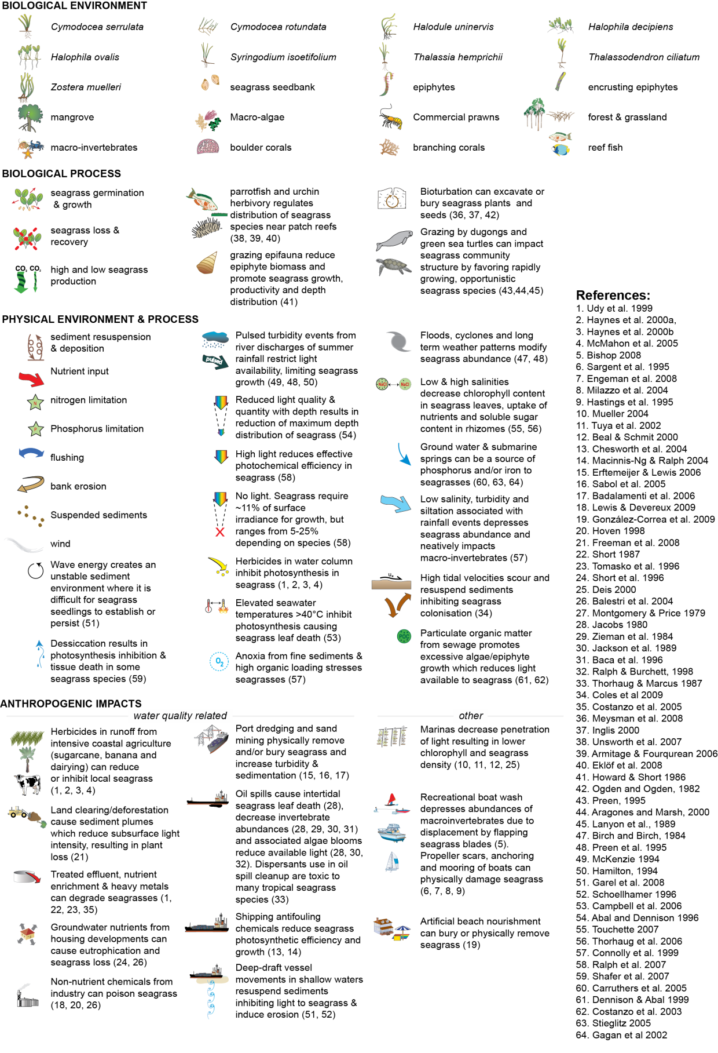
Figure 4. Key to symbols used for conceptual diagrams detailing impacts to seagrasses.
Udy, et al. 1999, Haynes, et al. 2000a, Haynes et al. 2000b, McMahon, et al. 2005, Bishop 2008, Sargent et al. 1995, Engeman et al. 2008, Milazzo et al. 2004, Hastings et al. 1995, Mueller 2004, Tuya et al. 2002, Beal and Schmit 2000, Chesworth et al. 2004, Macinnis-Ng and Ralph 2004, Erftemeijer and Lewis 2006, Sabol et al. 2005, Badalamenti et al. 2006, Lewis and Devereux 2009, González-Correa et al. 2009, Hoven 1998, Freeman et al. 2008, Short 1987, Tomasko, et al. 1996, Short et al. 1996, Deis 2000, Balestri et al. 2004, R and T 1979, Jacobs 1980, Zieman et al. 1984, Jackson et al. 1989, Baca et al. 1996, Ralph and Burchett 1998, Thorhaug and Marcus 1987, Coles et al. 2009b, Costanzo et al. 2005, Meysman et al. 2006, Inglis 2000, Unsworth et al. 2007, Armitage and Fourqurean 2006, Eklof et al. 2008, Howard and Short 1986, Ogden and Ogden 1982, Preen 1995, Aragones and Marsh 2000, Lanyon et al. 1989, Birch and Birch 1984, Preen, et al. 1995, McKenzie 1994, Hamilton 1994, Garel et al. 2008, Schoellhamer 1996, Campbell et al. 2006, Abal and Dennison 1996, Touchette 2000, Thorhaug et al. 2006, Connolly et al. 1999, Ralph et al. 2007, Shafer et al. 2007, Carruthers et al. 2005, Dennison and Abal 1999, Costanzo et al. 2003, Stieglitz 2005, Gagan et al. 2002,

Report card
Three indicators (presented as indexed scores) were selected by the GBRMPA, using advice from expert working groups and the Paddock to Reef Integration Team, for the seagrass report card:
- seagrass abundance
- reproductive effort
- nutrient status (seagrass tissue C:N ratio)
Seagrass abundance is used to indicate the state of the seagrass to resist stressors, reproductive effort to indicate the potential for the seagrass to recover from loss, and the nutrient status to indicate the condition of the environment in which the seagrass are growing in recognition of seagrass' role as a bioindicator.
The molar ratios of seagrass tissue carbon relative to nitrogen (C:N) were chosen as the indicator for seagrass nutrient status as an atomic C:N ratio of less than 20, may suggest either reduced light availability or nitrogen enrichment. Both of these deviations may indicate reduced water quality. Examination of the molar ratios of seagrass tissue carbon relative to nitrogen (C:N) between 2005 and 2008 explained 58% of the variance of the inter-site seagrass cover/abundance (McKenzie and Unsworth 2009).

Seagrass abundance
The status of seagrass abundance was determined using the seagrass abundance guidelines developed by McKenzie (2009). Individual site and subregional (habitat type within each NRM region) seagrass abundance guidelines were developed based on abundance data collected from individual sites and/or reference sites (McKenzie 2009). Guidelines for individual sites were only applied if the conditions of the site aligned with reference site conditions.
A reference site is a site whose condition is considered to be a suitable baseline or benchmark for assessment and management of sites in similar habitats. Ideally, seagrass meadows in near pristine condition with a long-term abundance database would have priority as reference sites. However, as near-pristine meadows are not available, sites which have received less intense impacts can justifiably be used. In such situations, reference sites are those where the condition of the site has been subject to minimal/limited disturbance for 3-5 years. The duration of 3-5 years is based on recovery from impact times (Campbell and McKenzie 2004).
No rigorous protocol is possible for the selection of reference sites and the process is ultimately iterative. The criteria for defining a minimally/least disturbed seagrass reference site is based on Monitoring River Health Initiative (1994) and includes some or all of the following:
- beyond 10km of a major river: as most suspended solids and particulate nutrients are deposited within a few kilometres of river mouths (McCulloch et al. 2003; Webster and Ford 2010; Bainbridge et al. 2012; Brodie et al. 2012).
- no major urban area/development (>5000 population) within 10km upstream (prevailing current)
- no significant point source wastewater discharge within the estuary
- has not been impacted by an event (anthropogenic or extreme climate) in the last 3-5 years
- where the species composition is dominated by the foundation species expected for the habitats (Carruthers, et al. 2002), and
- does not suggest the meadow is in recovery (i.e. dominated by early colonising).
The 80th, 50th and 20th percentiles were used to define the guideline values as these are recommended for water quality guidelines (Department of Environment and Resource Management 2009), and there is no evidence that this approach would not be appropriate for seagrass meadows in the GBR. By plotting the percentile estimates with increasing sample size, the reduction in error becomes apparent as it moves towards the true value (e.g. Figure 5).
Across the majority of reference sites, variance for the 50th and 20th percentiles was found to level off at around 15–20 samples (i.e. sampling events), suggesting this number of samples was sufficient to provide a reasonable estimate of the true percentile value. This sample size is reasonably close to the ANZECC 2000 Guidelines recommendation of 24 data values.
Nonlinear regressions (exponential rise to maximum, two parameter) were then fitted to percent cover percentile values at each number of sampling events using the following model:
where y is the seagrass cover percentile at each number of sampling events (x), a is the asymptotic average of the seagrass cover percentile, and b is the rate coefficient that determines how quickly (or slowly) the maximum is attained (i.e., the slope). The asymptotic average was then used as the guideline value for each percentile (Figure 5).
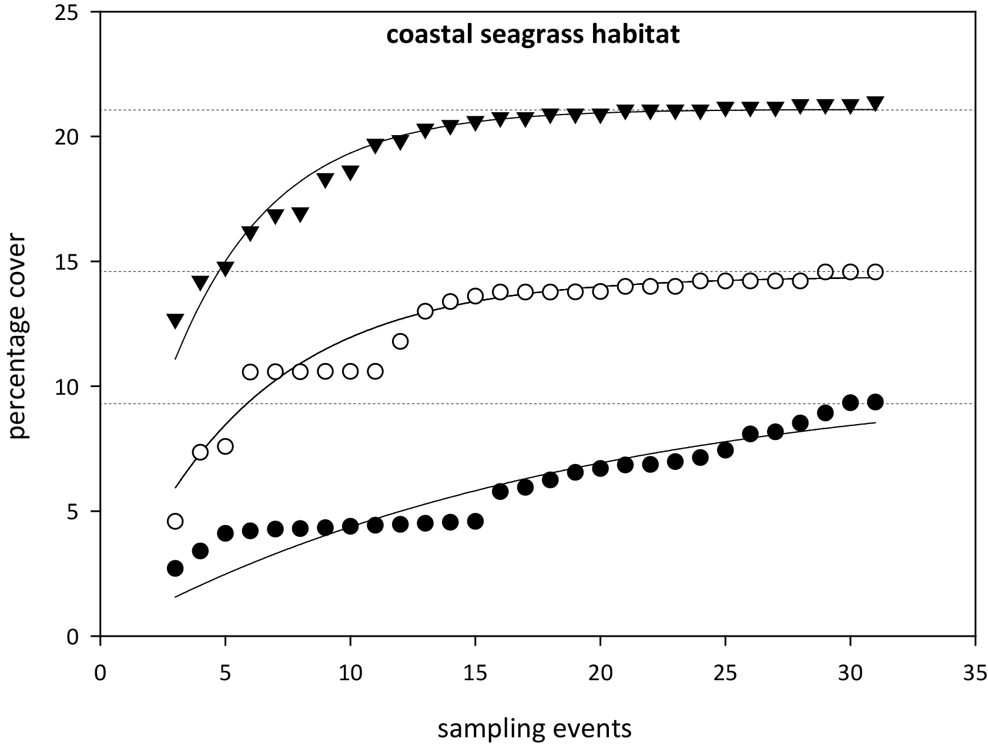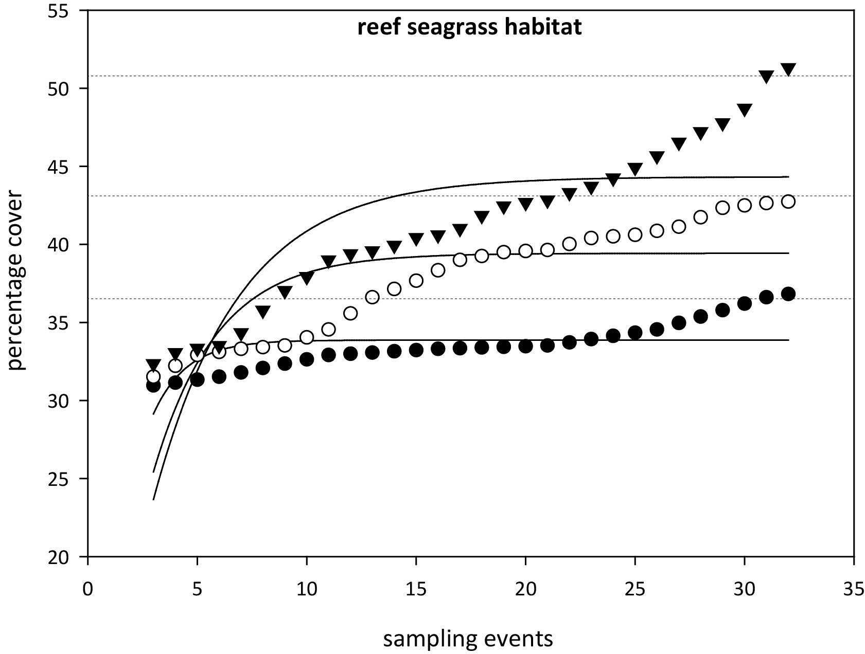
Figure 5. Relationship between sample size and the error in estimation of percentile values for seagrass abundance (% cover) in coastal and reef seagrass habitats in the Wet Tropics NRM
. = 75th percentile, ○ = 50th percentile,● = 20th percentile. Dashed lines are asymptotic averages for each percentile plot.
As sampling events occur every 3-6 months depending on the site, this is equivalent to 3-10 years of monitoring to establish percentile values. Based on the analyses, it was recommended that estimates of the 20th percentile at a reference site should be based on a minimum of 18 samples collected over at least three years. For the 50th percentile a smaller minimum number of samples (approximately 10–12) would be adequate but in most situations it would be necessary to collect sufficient data for the 20th percentile anyway. For seagrass habitats with low variability, a more appropriate guideline was the 10th percentile primarily the result of seasonal fluctuations (as nearly every seasonal low would fall below the 20th percentile). Percentile variability was further reduced within a habitat type of each region by pooling at least two (preferably more) reference sites to derive guidelines. The subregional guideline is calculated from the mean of all reference sites within a habitat type within a region.
Using the seagrass guidelines, seagrass state can be determined for each monitoring event at each site and allocated as good (median abundance at or above 50th percentile), moderate (median abundance below 50th percentile and at or above 20th percentile), poor (median abundance below 20th or 10th percentile). For example, when the median seagrass abundance for Yule Point is plotted against the 20th and 50th percentiles for coastal habitats in the Wet Tropics (Figure 6), it indicates that the meadows were in a poor condition in mid 2000, mid 2001 and mid 2006 (based on abundance).
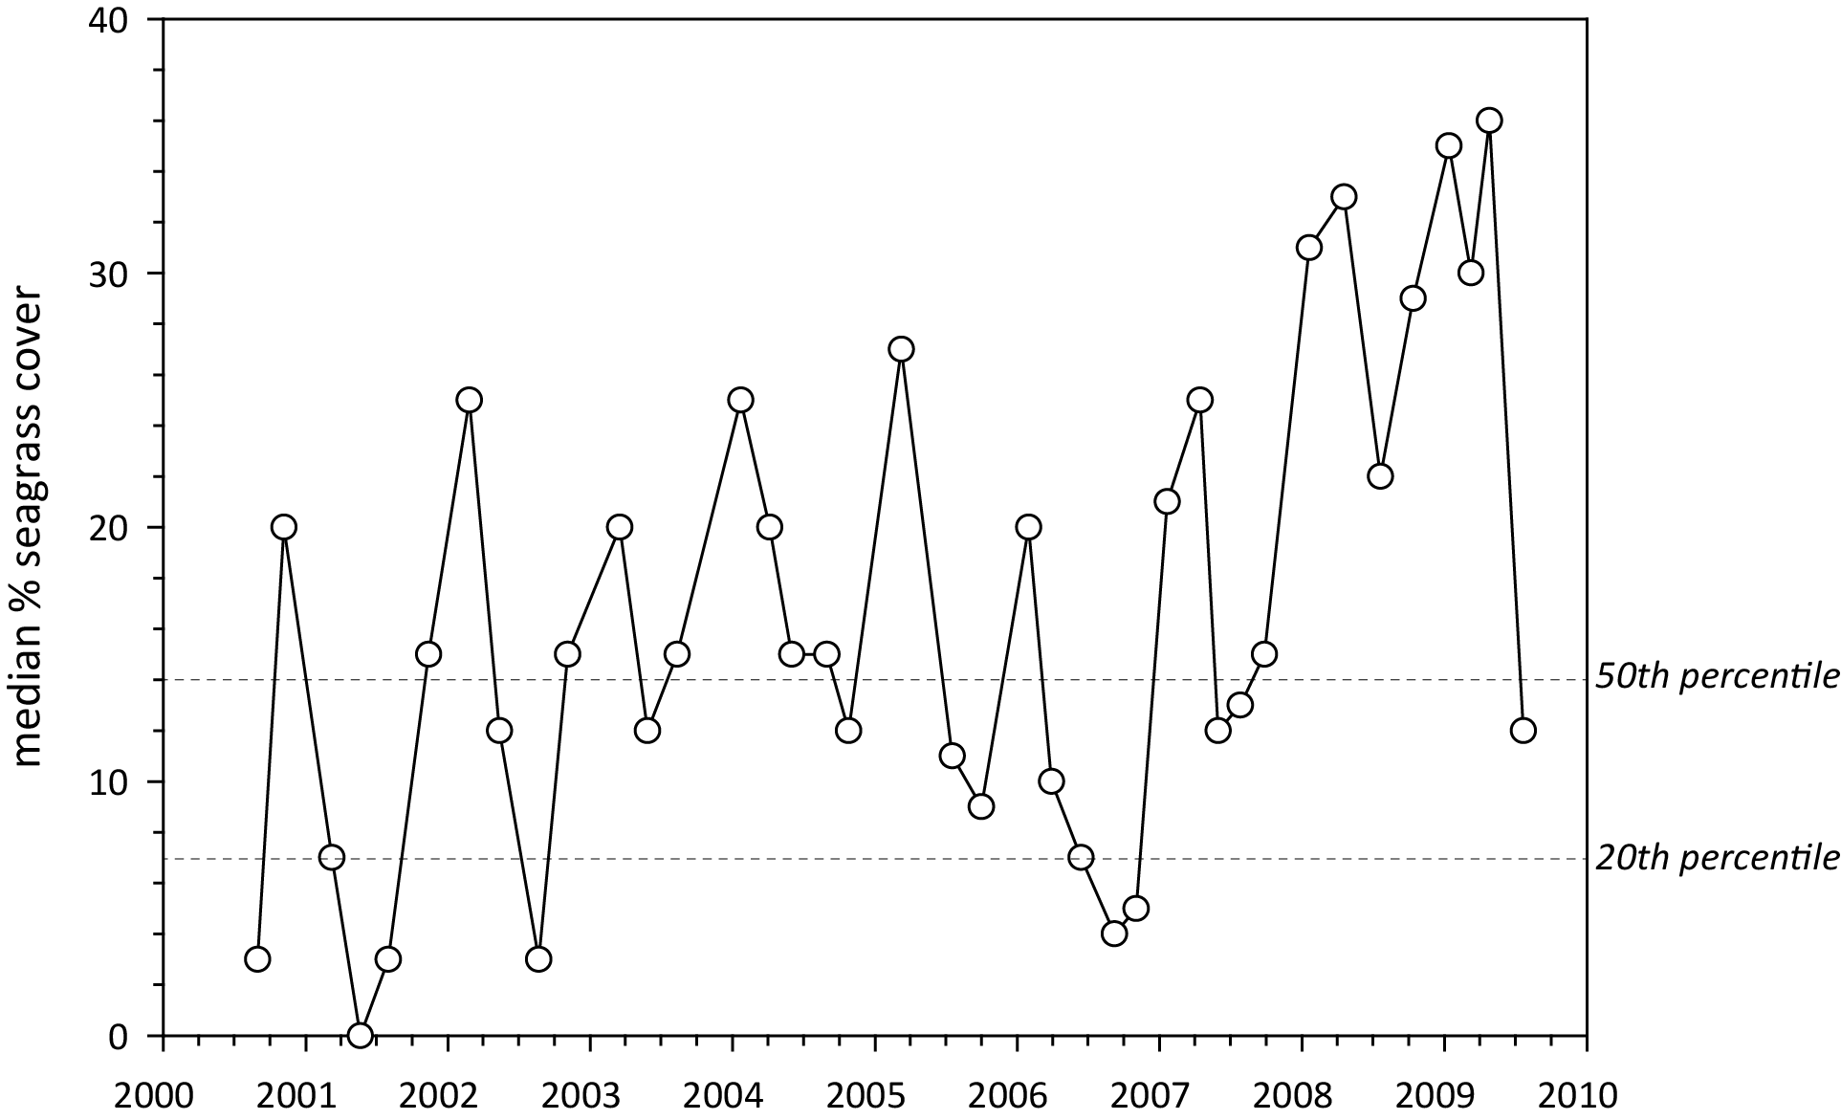
Figure 6. Median seagrass abundance (% cover) at Yule Point plotted against the 50th and 20th percentiles for coastal seagrass habitat in the Wet Tropics.
Similarly, when the median seagrass abundance for Green Island is plotted against the 20th and 50th percentiles for intertidal reef habitats in the Wet Tropics, it indicates that the meadows were in a poor condition in the middle of most years (based on abundance). However, the poor rating is most likely a consequence of seasonal lows in abundance. Therefore, in this instance, it was more appropriate to set the guideline at the 10th rather than the 20th percentile.
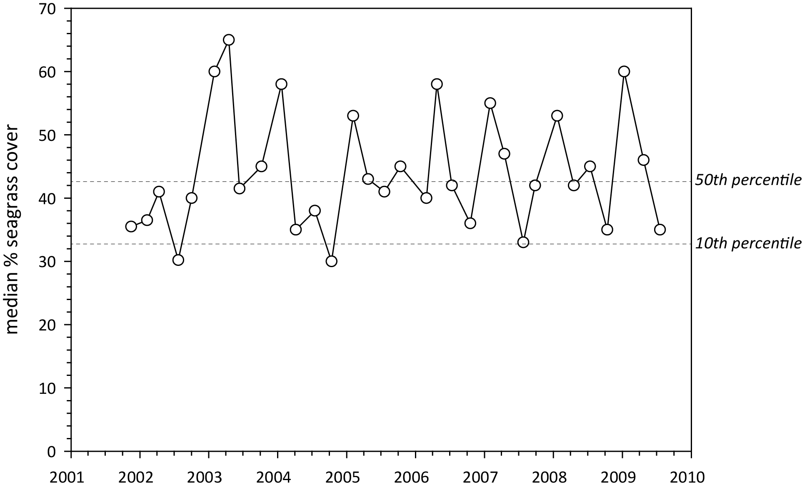
Figure 7. Median seagrass abundance (% cover) at Green Island plotted against the 50th and 10th percentiles for intertidal reef seagrass habitat in the Wet Tropics.
Using this approach, subregional seagrass abundance guidelines (hereafter known as “the seagrass guidelines”) were developed for each seagrass habitat types where possible (Table 7). If an individual site had 18 or more sampling events and no identified impacts (e.g., major loss from cyclone), an abundance guideline was determined at the site or location level rather than then using the subregional guideline from the reference sites (i.e. as more guidelines are developed at the sites level, they contribute to the subregional guideline).
After discussions with GBRMPA scientists and the Paddock to Reef integration team, the seagrass guidelines were further refined by allocating the additional categories of very good (median abundance at or above 75th percentile), and very poor (median abundance below 20th or 10th percentile and declined by >20% since previous sampling event). Seagrass state was then rescaled to a five point scale from 0 to 100 to allow integration with other components of the Paddock to Reef report card (Table 8).
Table 7. Seagrass percentage cover guidelines (“the seagrass guidelines”) for each site and the subregional guidelines (bold) for each NRM habitat
. Values in light grey not used. ^ denotes regional reference site, * from nearest adjacent region.
NRM region | Site | Habitat | percentile guideline
NRM region | Site | Habitat | 10th | 20th | 50th | 75th
Cape York | AP1^ | reef intertidal | 11 | 16.8 | 18.9 | 23.7
 | AP2 | reef intertidal | 11 |  | 18.9 | 23.7
 | NRM | reef intertidal | 11 | 16.8 | 18.9 | 23.7
Wet Tropics | LB | coastal intertidal |  | 6.6 | 12.9 | 14.8
 | YP1^ | coastal intertidal | 4.3 | 7 | 14 | 15.4
 | YP2^ | coastal intertidal | 5.7 | 6.2 | 11.8 | 14.2
 | NRM | coastal intertidal | 5 | 6.6 | 12.9 | 14.8
 | DI | reef intertidal | 27.5 |  | 37.7 | 41
 | GI1^ | reef intertidal | 32.5 | 38.2 | 42.7 | 45.5
 | GI2^ | reef intertidal | 22.5 | 25.6 | 32.7 | 36.7
 | NRM | reef intertidal | 27.5 | 31.9 | 37.7 | 41.1
Burdekin | BB1^ | coastal intertidal | 16.3 | 21.4 | 25.4 | 35.2
 | SB1^ | coastal intertidal | 7.5 | 10 | 16.8 | 22
 | NRM | coastal intertidal | 11.9 | 15.7 | 21.1 | 28.6
 | MI1^ | reef intertidal | 23 | 26 | 33.4 | 37
 | MI2^ | reef intertidal | 21.3 | 26.5 | 35.6 | 41
 | NRM | reef intertidal | 22.2 | 26.3 | 34.5 | 39
Mackay Whitsunday | SI | estuarine intertidal |  | 18 | 34.1 | 54
 | NRM | estuarine intertidal | 10.8* | 18* | 34.1* | 54*
 | PI2^ | coastal intertidal | 18.1 | 18.7 | 25.1 | 27.6
 | PI3^ | coastal intertidal | 6.1 | 7.6 | 13.1 | 16.8
 | NRM | coastal intertidal | 12.1 | 13.15 | 19.1 | 22.2
 | HM | reef intertidal | 22.2 |  | 34.5 | 39
 | NRM | reef intertidal | 22.2* | 26.2* | 34.5* | 39*
Fitzroy | GH | estuarine intertidal |  | 18 | 34.1 | 54
 | NRM | estuarine intertidal | 10.8* | 18* | 34.1* | 54*
 | RC1^ | coastal intertidal | 17.3 | 20.6 | 21.8 | 34.5
 | WH1^ | coastal intertidal | 13.1 | 14.4 | 18.8 | 22.3
 | NRM | coastal intertidal | 15.85 | 17.5 | 21.6 | 28.4
 | GK | reef intertidal | 22.2 |  | 34.5 | 39
 | NRM | reef intertidal | 22.2* | 26.2* | 34.5* | 39*
Burnett Mary | RD | estuarine intertidal |  | 18 | 34.1 | 54
 | UG1^ | estuarine intertidal | 10.8 | 18 | 34.1 | 54
 | UG2 | estuarine intertidal |  | 18 | 34.1 | 54
 | NRM | estuarine intertidal | 10.8 | 18 | 34.1 | 54

Table 8. Scoring threshold table to determine seagrass abundance status.
low = 10th or 20th percentile guideline (Table 7)
description | category | score | status
very good | 75-100 | 100 | 80 - 100
good | 50-75 | 75 | 60 - <80
moderate | low-50 | 50 | 40 - <60
poor | <low | 25 | 20 - <40
very poor | <low by >20% | 0 | 0 - <20

Seagrass reproductive effort
The reproductive effort of seagrasses provides an indication of the capacity of seagrasses to recover from the loss of an area of seagrass through the recruitment of new plants, i.e. the resilience of the population (Collier and Waycott 2009). Given the high diversity of seagrass species that occur in the GBR coastal zone (Waycott, et al. 2007), their variability in production of reproductive structures (e.g. Orth et al. 2006b), a metric that incorporates all available information on the production of flowers and fruits per unit area is the most useful.
The production of seeds also reflects a simple measure of the capacity of a seagrass meadow to recover following large scale impacts (Collier and Waycott 2009). As it is well recognized that coastal seagrasses are prone to small scale disturbances that cause local losses (Collier and Waycott 2009) and then recover in relatively short periods of time, the need for a local seed source is considerable. In the GBR, the production of seeds comes in numerous forms and seed banks examined at MMP sites are limited to foundational seagrass species (seeds >0.5mm diameter). At this time, seed banks have not been included in the metric for reproductive effort, but methods for future incorporation are currently being explored.
Using the annual mean of all species pooled in the late dry and comparing with the long-term (2005-2010) average for GBR habitat (coastal intertidal = 8.22±0.71, estuarine intertidal = 5.07±0.41, reef intertidal = 1.32±0.14), the reproductive effort was scored as the number of reproductive structures per core and the overall status determined (Table 9) as the ratio of the average number observed divided by the long term average.
Table 9. Scores for late dry monitoring period reproductive effort average against long-term (2005-2009) GBR habitat average.
description | Reproductive Effort  monitoring period / long-term | ratio | score | 0-100 score | status
very good | ≥4 | 4.0 | 4 | 100 | 80 - 100
good | 2 to <4 | 2.0 | 3 | 75 | 60 - <80
moderate | 1 to <2 | 1.0 | 2 | 50 | 40 - <60
poor | 0.5 to <1 | 0.5 | 1 | 25 | 20 - <40
very poor | <0.5 | 0.0 | 0 | 0 | 0 - <20

Seagrass nutrient status.
As changing leaf C:N ratios have been found in a number of experiments and field surveys to be related to available nutrient and light levels (Abal, et al. 1994; Grice, et al. 1996; Cabaço and Santos 2007; Collier, et al. 2009) they can be used as an indicator of the light that the plant is receiving relative to nitrogen availability or N surplus to light. With light limitation, seagrass plants are unable to build structure, hence the proportion of carbon in the leaves decreases relative to nitrogen. Experiments on seagrasses in Queensland have reported that a C:N ratio of less than 20, may suggest reduced light availability relative to nitrogen availability (Abal, et al. 1994; AM Grice, et al., 1996;). The light availability to seagrass is not necessarily an indicator of light in the water column, but an indicator of the light that the plant is receiving as available light can be highly impacted by epiphytic growth or sediment smothering photosynthetic leaf tissue. However, C:N must be interpreted with caution as the level of N can also influence the ratio in oligotrophic environments (Atkinson and Smith 1983; Fourqurean, et al. 1992b).
Support for choosing the elemental C:N ratio as the indicator also comes from preliminary analysis of MMP data in 2009 which found that the C:N ratio was the only nutrient ratio that showed a significant relationship (positive) with seagrass cover at coastal and estuarine sites. Seagrass tissue C:N ratios explained 58% of the variance of the inter-site seagrass cover data (McKenzie and Unsworth 2009).
Using the guideline ratio of 20:1 for the foundation seagrass species, C:N ratios were categorised on their departure from the guideline and transformed to a 0 to 100 score using equation 1:
equation 1
NB: C:N ratios >35 scored as 100, C:N ratios <10 scored as 0
The score was then used to represent the status to allow integration with other components of the report card (Table 10).
Table 10. Scores for leaf tissue C:N against guideline to determine light and nutrient availability.
description | C:N ratio range | value | Score () | status
very good | C:N ratio >30* | 30 | 100 | 80 - 100
good | C:N ratio 25-30 | 25 | 75 | 60 - <80
moderate | C:N ratio 20-25 | 20 | 50 | 40 - <60
poor | C:N ratio 15-20 | 15 | 25 | 20 - <40
very poor | C:N ratio <15* |  | 0 | 0 - <20

Seagrass index
The seagrass index is average score (0-100) of the three seagrass status indicators chosen for the Reef Rescue MMP. Each indicator is equally weighted as we have no preconception that it should be otherwise. To calculate the overall score for seagrass of the Great Barrier Reef (GBR), the regional scores were weighted on the percentage of GBRWHA seagrass (shallower than 15m) within that region (Table 11). Please note: Cape York was omitted from the GBR score due to insufficient sampling locations to adequately represent the entire region.
Table 11. Area of seagrass shallower than 15m in each NRM region (from McKenzie 2010) within the boundaries of the Great Barrier Reef World Heritage Area
. n/a denotes seagrass area not included in GBR total.
NRM | Area of seagrass (km²) | % of GBRWHA
Cape York | n/a ^{(1,843 km2)}
Wet Tropics | 201 | 0.16
Burdekin | 551 | 0.45
Mackay Whitsunday | 154 | 0.13
Fitzroy | 241 | 0.20
Burnett Mary | 73 | 0.06
GBRWHA | 1,220 | 1.00

3. Results & Discussion
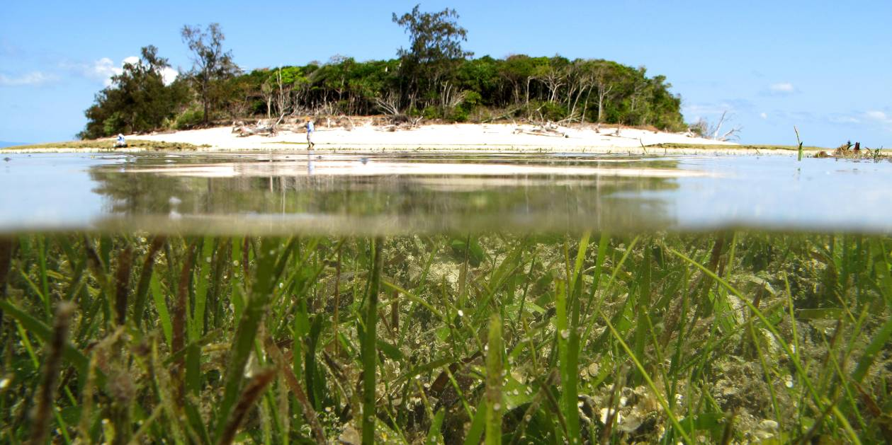

GBR Summary
Seagrass meadows are a critical component of the GBR nearshore ecosystems, supporting charismatic megafauna such as dugong and turtles, and the productivity of adjacent ecosystems including coral reefs and mangroves (Waycott et al. 2011b). Although the greatest area of seagrass in the GBRWHA is located in the deeper waters (>15m) of the lagoon (Coles, et al. 2009a), these meadows are relatively sparse, composed of structurally smaller, higher dynamic, and composed of colonising species (McKenzie et al. 2010c). In contrast, the inshore meadows are more abundant, structurally larger, composed of foundational species, and are the main feeding areas for dugong and green sea turtle (Sheppard et al. 2009; Lanyon, et al. 1989; McKenzie, et al. 2010c; Lavery et al. 2013). It is these inshore meadows that occur at the frontline of runoff and inshore water quality deterioration.
The long-term average seagrass percent cover at each of the inshore intertidal seagrass habitats of the GBR (prior to 2011) was 13% for estuarine, 16% for coastal, and 22% for reef. Seagrass species richness differs between locations and habitats in the GBR Region, with inshore reef habitats more specious than meadows at coastal or estuarine habitats. Intertidal seagrass meadow cover (as a percentage of the substrate covered by plant material) also varies between locations along the length of the GBR.
Prior to the extreme weather events of 2011, the inshore seagrass state had been gradually declining along the GBR developed coast. In 2006, meadows in the north were impacted by a tropical cyclone and associated flooding. However, it was not until 2009, that the level of decline became substantial across all habitats and meadows were in a vulnerable condition leading up to the events of 2011. Post the extreme weather events of 2011, the abundances of GBR inshore seagrass were the lowest recorded since monitoring was established. In the 2011/12 monitoring period, 87% of the RRMMP sites examined remained classified as poor or very poor in abundance (below the guidelines). In 2012, abundances began to increase with the onset of recovery, but continued to remain low. 68% of the meadows which had declined in extent or were absent for some period over the previous 2-5 years, started to reappear or increase area in early 2012. Much of this increase is possibly the result of clonal growth, persistent seed banks or translocation of vegetative fragments. Meadows that increased had undergone a state change to be dominated by colonising seagrass species rather than the foundation species. For recovery to progress to the foundation specie75
s may take another 1-2 years as reproductive effort has generally declined across the regions. The presence of improving seed banks in many locations will, however, improve the capacity of the seagrass to recover. There are some locations (e.g. Lugger Bay, Dunk Island, Great Keppel Island) which risk delayed recovery because they lack seed and seagrass abundance and reproductive effort remains low.
Improved light conditions in 2011/12 (i.e. higher than long-term average) will also assist seagrass recovery. Although light availability is lower in subtidal than intertidal and coastal than reef, light availability is largely increasing or stable.
Seagrass leaf tissue nutrients for foundation species across the majority of GBR habitats and locations in late 2011 suggested P and N surplus to C requirements. The high tissue nutrient concentrations measured across most locations were likely a consequence of the elevated N, where the primary source of N was possibly anthropogenically influenced by fertiliser. The only exception was Gladstone Harbour where N was limited relative to P. The elevated N in the system is possibly a consequence of increased runoff inputs over recent years. The elevated N may have also resulted in the slight increase in epiphyte abundance on the seagrass leaves in 2011/12. It would be expected that seagrass growth would increase with improving light availability, however, this may be offset by the increasing epiphytes.
Although extreme water temperatures were recorded in March/April 2012, within canopy sea temperatures in 2011/12 were generally similar or slightly cooler than previous monitoring periods. Climate varied across the monitoring locations, however higher than average rainfall from the Wet Tropics south resulted in higher than median discharges from catchments that discharge directly to the coast.
Overall there have been marginal increases in seagrass abundance and extent as the system remains in low health status (very poor condition) (Table 12). Regional monitoring results indicate the onset of recovery from previous stressors and once re-established, seagrass meadows would be expected to increase in abundance and distribution should environmental conditions remain favourable. Overall GBR scores (averaged across regions) show a marginal decline, which appear influenced by the decline in reproductive effort and relatively smaller increase in nutrient status (Figure 8).
Table 12. Report card for seagrass status for the GBR and each NRM region: July 2011 – May 2012
. Values are indexed scores scaled from 0-100; ■ = very good (80-100), ■ = good (60 - <80), ■ = moderate (40 - <60), ■ = poor (20 - <40), ■ = very poor (0 - <20).
Region | Seagrass  Abundance | Reproductive  Effort | Nutrient status  (C:N ratio) | Seagrass Index
Cape York | 25 | 13 | 21 | 20
Wet Tropics | 13 | 3 | 21 | 13
Burdekin | 11 | 19 | 21 | 17
Mackay Whitsunday | 14 | 0 | 13 | 9
Fitzroy | 31 | 17 | 50 | 33
Burnett Mary | 5 | 0 | 47 | 18
GBR | 15 | 12 | 27 | 18
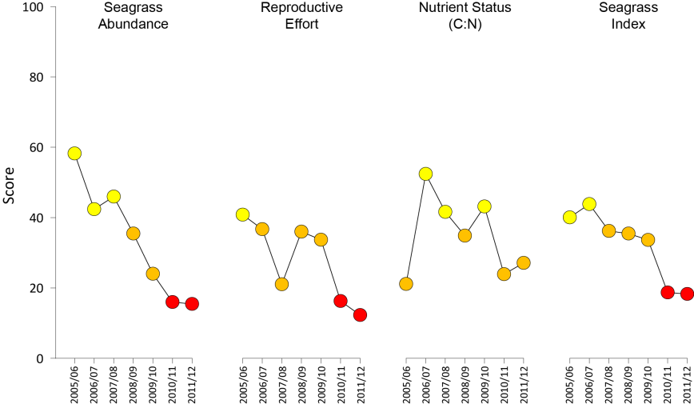
Figure 8. Report card of seagrass status indicators and index for the GBR
(averaged across NRM regions). Values are indexed scores scaled from 0-100; ■ = very good (80-100), ■ = good (60 - <80), ■ = moderate (40 - <60), ■ = poor (20 - <40), ■ = very poor (0 - <20).

Status of the seagrass community
At total of 45 sites were monitored in 2011/12, across three generalised habitat types. Coastal and reef habitats were monitored across most regions, including Cape York, Wet Tropics, Burdekin, Mackay Whitsunday and Fitzroy regions. Estuarine habitats were only monitored in the southern GBR regions from Mackay Whitsunday to Burnett Mary. More seagrass species occurred at reef habitats, that coastal or estuarine. The more dominant seagrass species monitored across the GBR included Halodule uninervis, Zostera muelleri, Cymodocea rotundata, Thalassia hemprichii and the colonising species Halophila ovalis.
Of the 45 sites monitored in the MMP across the GBR, only 30 were long-term (≥5 years), and all were lower littoral (intertidal). Of the 30 long-term monitoring sites examined in 2011/12, seagrass abundance at 87% of sites was classified as poor or very poor (below the seagrass guidelines) in late monsoon 2012. Based on the average score against the seagrass guidelines (determined at the site level), the abundance of seagrass in the GBR over the 2011/12 period was classified as very poor (all sites and seasons pooled) (Figure 9). The overall trend in seagrass abundance of the same 30 sites since they were monitored as part of the MMP, indicates a obvious decline over the last 6 monitoring periods (Figure 9).
Figure 9. Average yearly seagrass abundance score (all sites and seasons pooled) for the GBR
(± Standard Error). Median percentage cover at a site each monitoring event was scored relative to each site's guideline value, taking into account species and habitat.
The GBR seagrass abundance status in 2011/12 was the lowest since monitoring was established (Figure 9). The overall abundance score appears to be heavily influenced by the large decline experienced in the Wet Tropics (Figure 10). Conversely, all other regions increased in abundance in 2011/12, with the exception of the Burnett Mary which remained unchanged (Figure 10). This suggests the onset of recovery across most of the GBR inshore seagrass meadows.
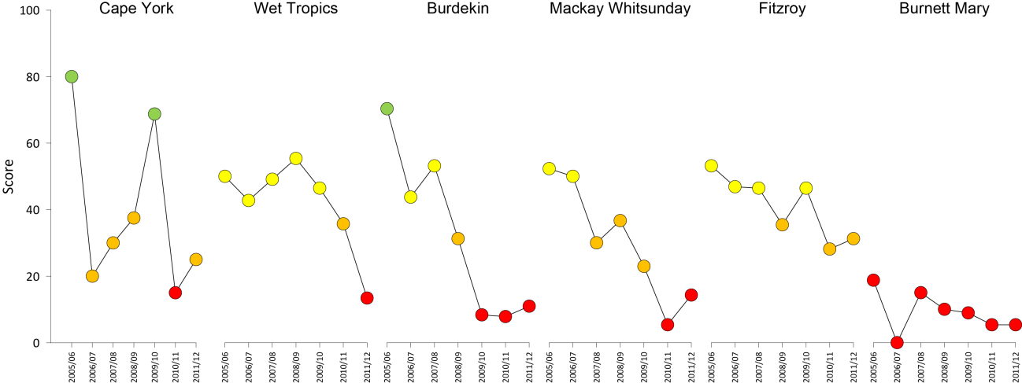
Figure 10. Regional report card scores for seagrass abundance over the life of the MMP.
For Paddock to Reef reporting scores are categorised in to a five point scale; ■ = very good (80-100), ■ = good (60 - <80), ■ = moderate (40 - <60), ■ = poor (20 - <40), ■ = very poor (0 - <20).
The decline in state was greatest in coastal habitats over the long-term, where abundance was initially good to very good in 2005/06, but declined to very poor in 2011/12 (Table 13).
Table 13. Long-term report card for seagrass abundance status for each habitat in each NRM region: July 2005 – May 2012
. Values are indexed scores scaled from 0-100; ■ = very good (80-100), ■ = good (60 - <80), ■ = moderate (40 - <60), ■ = poor (20 - <40), ■ = very poor (0 - <20). Overall GBR score is weighted, with the exclusion of Cape York.
NRM region | Habitat | 2005/06 | 2006/07 | 2007/08 | 2008/09 | 2009/10 | 2010/11 | 2011/12
Cape York | reef intertidal | 80 | 20 | 30 | 38 | 69 | 15 | 25
Wet Tropics | reef intertidal | 72 | 58 | 43 | 41 | 39 | 25 | 20
Wet Tropics | coastal intertidal | 38 | 32 | 55 | 70 | 54 | 46 | 7
Burdekin | reef intertidal | 59 | 59 | 75 | 38 | 6 | 9 | 19
Burdekin | coastal intertidal | 81 | 28 | 31 | 25 | 11 | 6 | 3
Mackay Whitsunday | reef intertidal | 0 | 25 | 6 | 13 | 6 | 6 | 13
Mackay Whitsunday | coastal intertidal | 63 | 88 | 54 | 63 | 56 | 8 | 17
Mackay Whitsunday | estuarine intertidal | 40 | 25 | 20 | 25 | 6 | 0 | 13
Fitzroy | reef intertidal | 0 | 0 | 13 | 6 | 6 | 13 | 6
Fitzroy | coastal intertidal | 81 | 81 | 100 | 75 | 81 | 31 | 25
Fitzroy | estuarine intertidal | 25 | 13 | 44 | 25 | 50 | 34 | 47
Burnett Mary | estuarine intertidal | 19 | 0 | 15 | 10 | 9 | 5 | 5
Great Barrier Reef (developed coast) |  | 58 | 42 | 46 | 35 | 24 | 16 | 15
In late dry 2011, 73% of the 30 long-term monitoring sites had declined >20% in cover relative to the same time in the previous year (Figure 11). In the late monsoon 2012, the number of sites declining was half that of the same time in 2011, which suggests the onset of recovery.
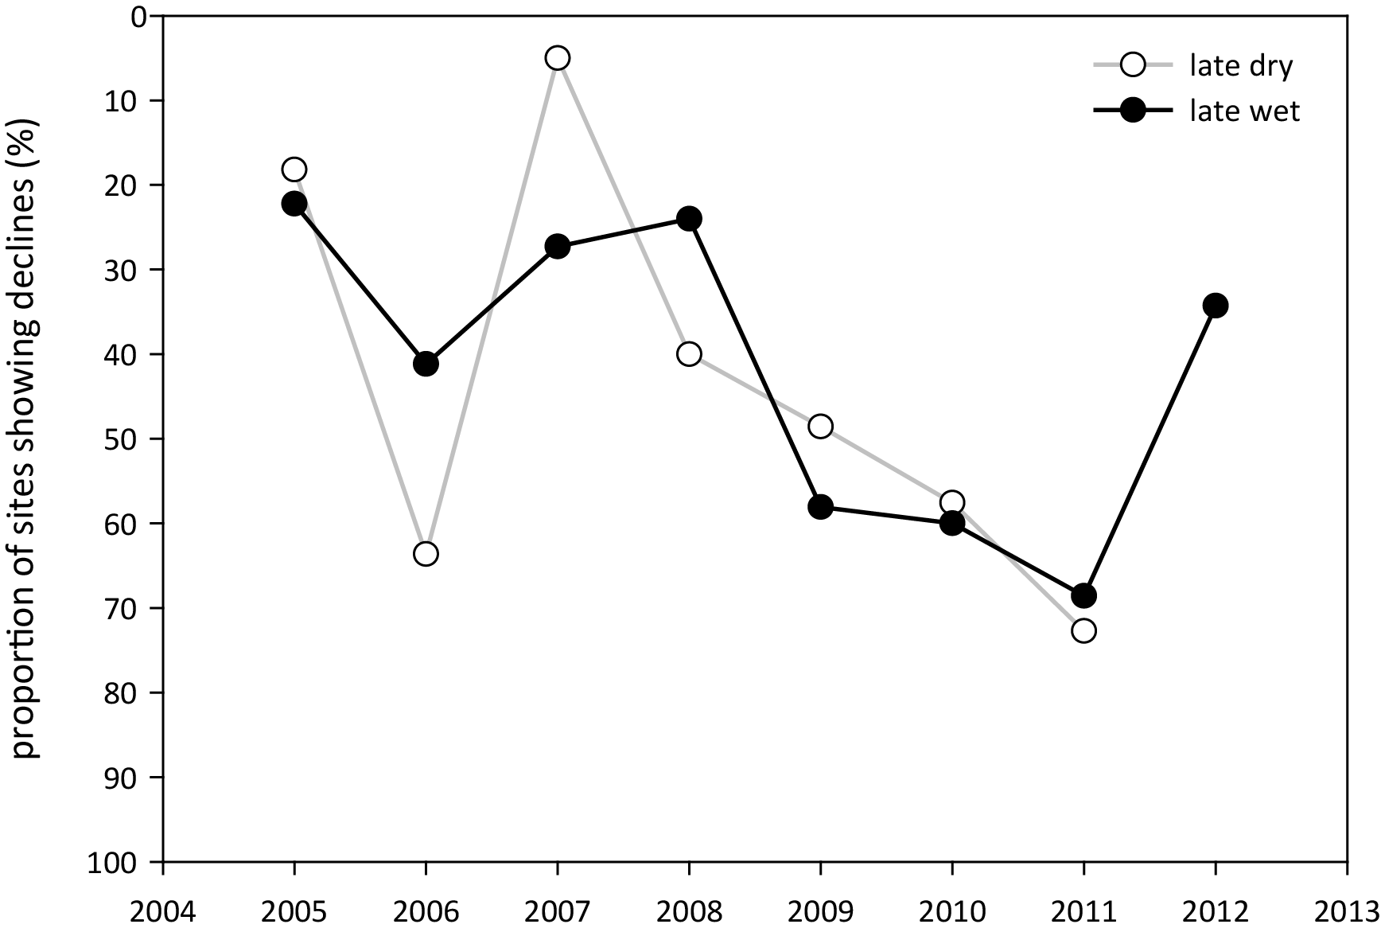
Figure 11. Proportion of sites where seagrass cover has declined >20% relative to the same season in previous year or meadow is absent.
Over the past decade, the patterns of seagrass abundance at each GBR habitat type have differed (Figure 12), however both reef and coastal habitats have declining trajectories since 2009. Seagrass abundance has fluctuated greatly in estuarine habitats; most often as a response to climate (e.g. rainfall, temperature and desiccation) and at smaller localised scales there have been some acute event related changes.
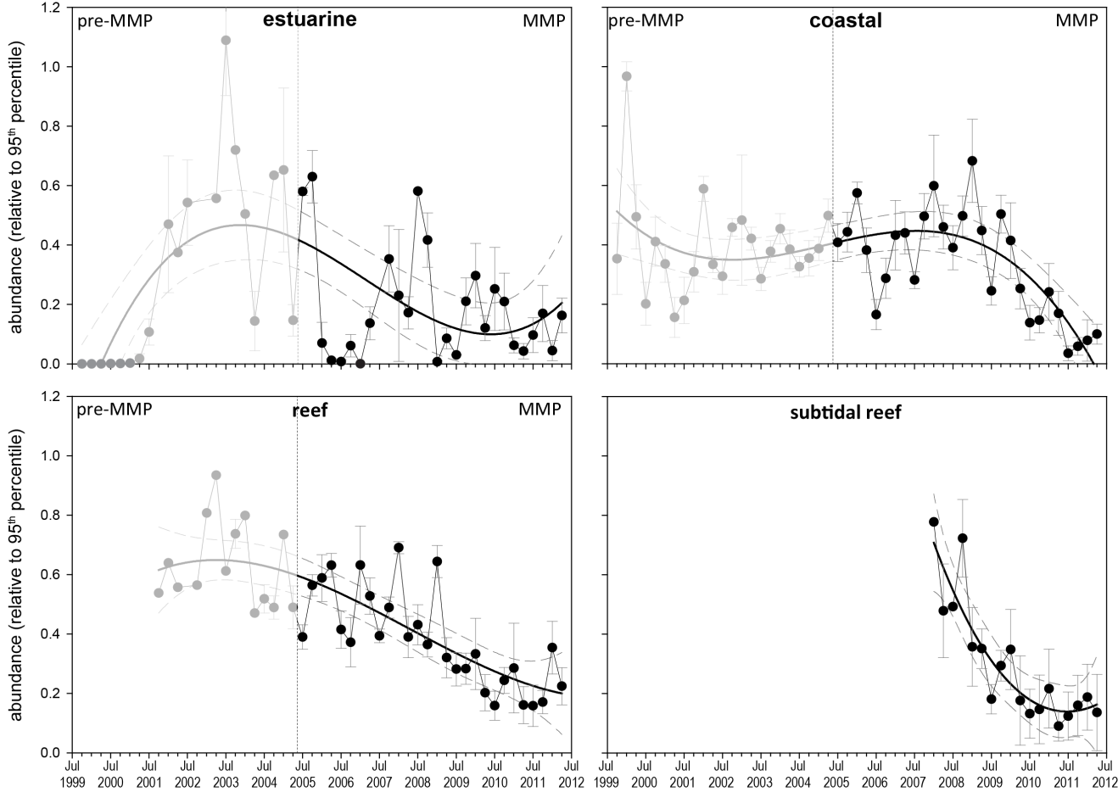
Figure 12. Generalised trends in seagrass abundance for each habitat type (sites pooled) relative to the 95th percentile (equally scaled).
The 95th percentile is calculated for each site across all data. Data prior and post implementation of the RRMMP displayed. Trendline is 3rd order polynomial, 95% confidence intervals displayed, estuary (8 sites) r² = 0.367, coastal (10 sites) r² = 0.399, reef (12 sites) r² =0.65, subtidal reef (4 sites) r² =0.807.
Seagrass abundance at estuarine monitoring sites continued to vary greatly seasonally (Figure 12), however abundances marginally increased in 2011/12. Conversely, seagrass abundance at coastal sites either declined or remained relatively low (Figure 12). Seagrass abundance at intertidal reef-platform meadows declined slightly at half the locations monitored in 2011/12, but increased at the others (Figure 12).
Abundance of intertidal seagrasses at most locations in 2011/12 was marginally lower or remained low (unchanged) from declines in early 2011. At these locations, there was also little or no expansion of the meadows as the plants were possibly in an establishment phase or hadn't recovered enough to progress to expansion phase. The declines measured in 2011/12 were mainly in the coastal meadows in northern Wet Tropics and Fitzroy regions, which appear the consequence of local scale disturbances (e.g. sediment or sand bank movement). In contrast, seagrass abundances observed in the estuarine meadows of the Fitzroy region in 2011/12 were some of the highest recorded since monitoring was established.
Locations where seagrass meadow extent increased relative to the previous monitoring period appears primarily a consequence of the proliferation of colonising seagrass species such as Halophila ovalis, rather than recovery of foundation species. Reproductive effort, representing per area estimates of the number of reproductive structures produced by any seagrass species during the sampling period, predominately declined (relative to the previous monitoring period) in 2011/12 (Figure 13). The only habitat where reproductive effort increased was in the intertidal reef sites of the Burdekin region.
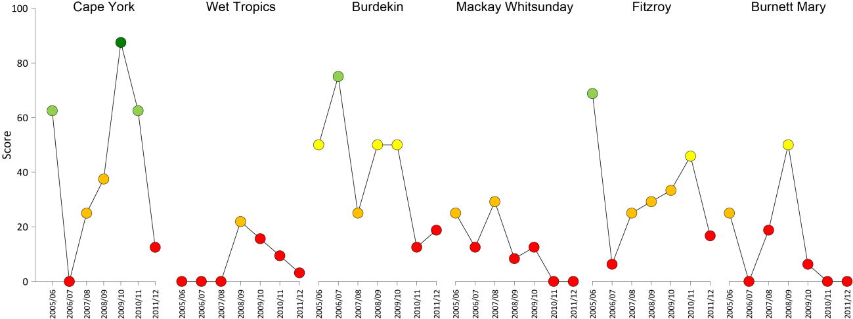
Figure 13. Regional report card scores for seagrass reproductive effort over the life of the MMP.
For Paddock to Reef reporting scores are categorised in to a five point scale; ■ = very good (80-100), ■ = good (60 - <80), ■ = moderate (40 - <60), ■ = poor (20 - <40), ■ = very poor (0 - <20).
In contrast, seed banks generally increased over the 2011/12, indicating high reproductive success from the previous year. The larger seed banks suggest an improved capacity to recover once conditions are suitable and the germination occurs. The locations where seed banks declined or remain absent (e.g., southern Wet Tropics and Fitzroy reef habitats), when coupled with poor reproductive health, suggests recovery may be slow and seagrass remain vulnerable to major disturbances. Observations of how seagrass meadows recover from recent poor ecological health will be important to evaluating the longer term capacity of seagrasses to recover from disturbance and therefore their resilience.

Status of the seagrass environment

Seagrass tissue nutrients
Tissue nutrient concentrations were variable both across and within habitats between years. It was necessary at some sites (refer Table 5) to pool across foundation species as the presence of individual species was not constant over time at all locations since monitoring was established. As tissue nutrient ratios between co-occurring foundation species are not significantly different (McKenzie, et al. 2012), by pooling across species and habitat types, some trends are apparent.
Tissue nutrient concentrations (%N and %P) appear to have increased since 2006 across all habitats (species pooled) (Figure 14). The 2005 values may be unreliable due to contamination of the samples during the grinding phase (see McKenzie et al. 2006) and should be interpreted with caution.
Figure 14. GBR median tissue nutrient concentrations (±Standard Error) in seagrass leaves for each habitat type (species pooled) over the entire monitoring program
. Dashed lines indicate global median values of 1.8% and 0.2% for tissue nitrogen and phosphorus, respectively (Duarte 1990).
Since 2005, median tissue nitrogen concentrations for all habitats have exceeded the global value of 1.8% (Duarte 1990; Schaffelke et al. 2005) (Figure 14). In 2011, median tissue phosphorus concentrations for all habitats remained above the global value of 0.2% (Duarte 1990; Schaffelke, et al. 2005), but decreased in coastal and estuarine habitats from the peaks reported in 2010 (Figure 14). Duarte (1990) suggested tissue nutrient concentrations less that the global average implied nutrient limitation to seagrass growth. Although some concerns have been raised as to accuracy of the global tissue nutrient values (Schaffelke, et al. 2005), nitrogen and phosphorus concentrations for reef habitats reached their highest level in 2011 since monitoring commenced (Figure 15).
Figure 15. GBR median tissue %N concentrations (±Standard Error) in Halodule uninervis leaves for each habitat type over the entire monitoring program
. Dashed line indicates critical nitrogen saturation level of 2.5% during the dry season (Lobb 2006).
Seagrass nutrient status scores (using only C:N) across the GBR NRM regions, improved in the Burdekin and southern NRMs (Fitzroy and Burnett Mary) from 2010 to 2011 (Figure 16). Although the largest decline occurred in Cape York, Mackay Whitsunday was the only region where nutrient status was very poor (Figure 16).
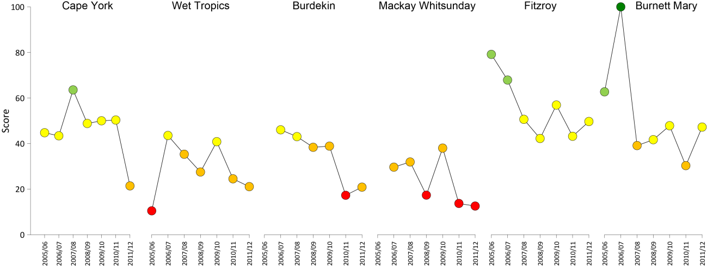
Figure 16. Regional report card scores for seagrass leaf tissue nutrient status (C:N) over the life of the MMP.
For Paddock to Reef reporting scores are categorised in to a five point scale; ■ = very good (80-100), ■ = good (60 - <80), ■ = moderate (40 - <60), ■ = poor (20 - <40), ■ = very poor (0 - <20).
Experiments on seagrasses in Queensland have suggested that at an atomic C:N ratio <20, may suggest reduced light availability (Abal, et al. 1994; Grice, et al. 1996). However, the level of N can also influence the ratio in oligotrophic environments (Atkinson and Smith 1983; Fourqurean, et al. 1992b). In 2011, all three habitat types (coast, reef and estuary) had C:N ratios <20. These levels have mostly declined since 2005, and continue to decline in reef habitats. The low C:N levels in 2011 potentially indicate reduced light availability (Figure 17), however the equivalent changes in tissue %N (Figure 14) across all habitats suggests the ratio is driven predominately by high (possibly elevated) N.
Figure 17. Elemental ratios (atomic) of seagrass leaf tissue C:N for each GBR habitat each year
(foundation species pooled). Horizontal dashed line on the C:N ratio panel represents the accepted guideline seagrass “Redfield” ratio of 20:1 (Abal, et al. 1994; Grice, et al. 1996). C:N ratios below this line may indicate reduced light availability and/or N enrichment.
Seagrass habitats across the GBR were consistently rich in nutrients relative to carbon with C:P ratios below 500, indicating a relatively large P pool (Figure 18). In 2011, N:P ratios in the leaf tissue increased across all habitats (Figure 18). Reef habitats had N:P ratios between 25 and 30, indicating seagrass to be nutrient replete (balanced macronutrients for growth), and potentially nutrient saturated. Within coastal habitats these levels increased in 2011, after declining in the previous 2 years (Figure 18). In estuary habitats, N:P ratios remained below 25, suggesting the enrichment in P remained greater than the N enrichment (Figure 18).
Figure 18. Elemental ratios (atomic) of seagrass leaf tissue N:P and C:P for each GBR habitat each year
(foundation species pooled) (± Standard Error). Horizontal shaded band on the N:P ratio panel represents the range of value associated with N:P balance ratio in the plant tissues, i.e. a seagrass “Redfield” ratio (Atkinson and Smith 1983; Duarte 1990; Fourqurean, et al. 1992b; Fourqurean and Cai 2001). N:P ratio above this band indicates P limitation, below indicates N limitation and within indicates replete (balanced). Horizontal dashed line on the C:P panel at 500 represents the value associated with C:P balance ratio in the plant tissues, C:P values <500 may indicate nutrient rich habitats (large P pool).
Across the majority of GBR habitats and locations, seagrass tissue nutrient concentrations for foundation species in late 2011 suggested P and N surplus to C requirements. The low C:N ratios measured across most locations was likely a consequence of the elevated N, where the low δ¹⁵N value in the leaf tissue suggested that their primary source of N was either from N₂ fixation or fertiliser. At three locations (Magnetic Island, Hamilton Island and Urangan) the higher δ¹⁵N values in the leaf tissue indicated some sewage influence. The only location where N was limited relative to P, was in the estuarine meadows of Gladstone Harbour.

Epiphytes and macro-algae
Epiphyte abundance was high or increasing in 2011/12, relative to the long-term average, at the majority of locations. Epiphyte abundance at coastal habitats increased above the long-term average (Figure 19), which may have been a consequence of the elevated N.
Figure 19. Epiphyte abundance (% cover) at each seagrass habitat monitored (sites pooled)
(±SE). Red line = GBR long-term average; estuarine = 25% coastal=17%, reef = 28%.
Macro-algae abundance continued to decline or remain low across all habitats and was below the GBR long-term average during the 2011/12 monitoring period (Figure 20).

Figure 20. Macro-algae abundance (% cover) at each seagrass habitat monitored
(sites pooled)(±SE). Red line = GBR long-term average; estuarine = 3.2%, coastal=4.7%, reef = 6.2%.

Light and turbidity
Daily light (I_{d}, mol m⁻² d⁻¹) reaching the top of the seagrass canopy was higher at most sites in the 2011/12 year compared to previous years (monitoring began 2008-2009 for most sites) (Figure 18). Mean I_{d} across the GBR for intertidal sites was 16.8 mol m⁻² d⁻¹ in 2011/12 compared to long-term average of 14.5 mol m⁻² d⁻¹ – a 14% increase. Sites in the Burdekin Dry Tropics (BDT; Shelley Beach and Bushland Beach) and in the Mackay Whitsundays (M-W; Pioneer Bay) had I_{d} that was well below the GBR-wide average for 2011/2012 at 8.7, 5.1 and 8.6 mol m⁻² d⁻¹, respectively. Furthermore, at these sites, I_{d} did not increase in 2011/2012 relative to previous years, which is against the GBR-wide trend, and minimum light thresholds were exceeded more frequently than at other sites (Figure 19). At Hamilton Island (M-W), Sarina Inlet (M-W) and Urangan (B-M), I_{d} was around the GBR-wide average while all other sites were above the GBR-wide average. Highest I_{d} occurred at Shoalwater Bay (20 mol m⁻² d⁻¹) in the Fitzroy region, and at Rodds Bay (22.9 mol m⁻² d⁻¹) in the Burnett-Mary region. Mean I_{d} across the GBR for subtidal sites (WT and BDT only) was 9.7 mol m⁻² d⁻¹ in 2011/2012 compared to the long-term average of 8 mol m⁻² d⁻¹, representing an increase of 17%. Of the subtidal sites, Magnetic Island (Picnic Bay), in the BDT had the lowest average I_{d} at 7.5 mol m⁻² d⁻¹.
Daily light in shallow habitats can be affected by water quality, cloudiness and the depth of the site, which affects the frequency and duration of exposure to full sunlight at low tide Anthony, et al. 2004; Fabricius et al. 2012b; however, the differences in I_{d} among seagrass sites is largely a reflection of site-specific differences in water quality. For example, turbidity at Green Island (WT) was lower than at Picnic Bay (BDT) (Figure 20), which is consistent with the trends in light at these sites. The spatial variability in I_{d} is also consistent with spatial patterns in water quality observed at larger spatial scales by remote sensing (Devlin et al. 2013) and by in situ water quality measurements at reef sites (Schaffelke et al. 2013) confirming the role of water quality in the observed patterns of canopy incident light. The temporal trend for increasing light in 2011/12 compared to previous years was also partly a result of improved water quality (e.g. turbidity was lower at the two turbidity monitoring sites, than previous years (Figure 20)). However, I_{d} was most notably elevated during the dry season when record high I_{d} occurred at a number of sites, particularly in the wet tropics. Reduced cloud cover in the dry season of 2011/12 compared to previous years, has most likely contributed to this trend.

Figure 21. Daily light (long-term average (dots) and 2011-2012 average (bars)) for intertidal sites (left) and subtidal sites (right).
NB: only 4 subtidal sites.
Figure 22. Minimal light threshold exceedance at intertidal sites (left) and subtidal sites (right) including long-term average (dots) and 2011-2012 average (bars).
Thresholds adapted from Collier et al. (2012b) for northern GBR Halodule uninervis dominated meadows and Chartrand et al. (2012) for southern GBR Zostera muelleri dominated meadows. NB: only 4 subtidal sites.

Table 14. Minimal light threshold exceedance for days below defined threshold
(5 mol m⁻² d⁻¹ (90-day average data)) – an approximate threshold enabling expansion of Halodule uninervis dominated meadows in northern GBR (Collier, et al. 2012b) and 6 mol m⁻² d⁻¹ for intertidal Zostera muelleri communities in the southern GBR (Chartrand, et al. 2012) including annual average, reporting year (1 May 2011-30 April 2012) and wet season (Jan-Mar).
Region | Location | Site | Threshold exceedance  (% days) |  | Jan-Mar
Region | Location | Site | Long-term | 2011-12 | Long-term | 2012
Wet Tropics | Low Isles | subtidal | 37.4 | 26.5 | 51.5 | NA
Wet Tropics |  | intertidal | 5.1 | 0 | 12.7 | 0
Wet Tropics | Yule Point | intertidal | 16.3 | 2.3 | 32.8 | NA
Wet Tropics | Green Island | subtidal | 9.8 | 3.5 | 14.6 | 0^
Wet Tropics |  | intertidal | 13.4 | 1.0 | 7.7 | NA
Wet Tropics | Dunk Island | subtidal | 30.0 | 19.6 | 34.3 | 22.8
Wet Tropics |  | intertidal | 5.3 | 5.0 | 7.3 | 4.5
Burdekin | Picnic Bay | subtidal | 43.1 | 24.5 | 55.4 | 28.2
Burdekin |  | intertidal | 11.3 | 3.5 | 17.2 | 2.2
Burdekin | Shelley Beach | intertidal | NA | NA | NA | NA
Burdekin | Bushland Beach | intertidal | 58.3 | 58.1 | 84.2 | 79.3
Burdekin | Cockle Bay | intertidal | 9.3 | 4.6 | 10.2 | 5.5
Mackay Whitsunday | Pioneer Bay | intertidal | 32.4 | 30.0 | 56.0 | 60.7
Mackay Whitsunday | Hamilton Island | intertidal | 15.0 | 20.5 | 9.7 | 8.2
Mackay Whitsunday | Sarina Inlet | intertidal | 28.2 | 16.7 | 35.4** | NA
Fitzroy | Shoalwater | intertidal | 4.3 | 4.3 | 7.7 | 10.3
Fitzroy | Great Keppel Is | intertidal | NA | NA | NA | NA
Fitzroy | Gladstone | intertidal | NA | NA | NA | NA
Burnett Mary | Rodds Bay | intertidal | 1.4 | 0 | NA | NA
Burnett Mary | Urangan | intertidal | 22.2 | 16.2 | 41.2 | 38.3
**2010 wet season data only
Figure 23. Annual average turbidity (2009-2012) and 2011-2012 reporting period average turbidity for seagrass meadows where turbidity loggers were deployed (top) and threshold exceedance (bottom).
Note, the turbidity logger at Dunk Island went missing after TC Yasi in 2011, so no data exists for the current reporting period. Turbidity threshold value (1.54 NTU) was derived by transforming the suspended solids trigger value (see Schaffelke et al. 2009).

The relationship between changes in seagrass cover and light availability at three of the subtidal monitoring sites (Green, Dunk and Magnetic Islands) was described in Collier et al. (2012b). This analysis was conducted for 2008 to 2011 when there was flood-driven loss of seagrass. In this analysis, three light metrics were related to changes in seagrass cover. The relationship between daily light and changes in abundance is presented below (Figure 24). The other light metrics (days below 3 mol m⁻² d⁻¹, and H_{sat}), showed even stronger relationships with changing seagrass abundance, however, these are not presented here as the methodology for their calculation is not included as part of the methods for the MMP. When the same analysis was applied for the paired intertidal sites, the relationships were not as clear (poor correlation, Figure 25). This is likely a consequence of the light metrics tested, rather than the absence of a relationship between light levels and changing abundance. For example, daily light (I_{d}) includes high light levels occurring before, during and after low tides and these do not convert to equivalent increases in photosynthetic rates (Petrou et al. 2013). We strongly recommend analysis of intertidal seagrass light-photosynthesis-growth responses (e.g. light response curves) as low light levels are a major driver of changing seagrass abundance, including intertidal seagrass meadows (Chartrand, et al. 2012). From a targeted approach, light metrics could be developed for intertidal seagrass meadows. These metrics could be included in routine reporting of light and seagrass relationships as an annual update of monitoring results. These analyses will be conducted when recruitment limitation is no longer assumed to be a major driver (as it is in 2011/12) of changes in abundance.
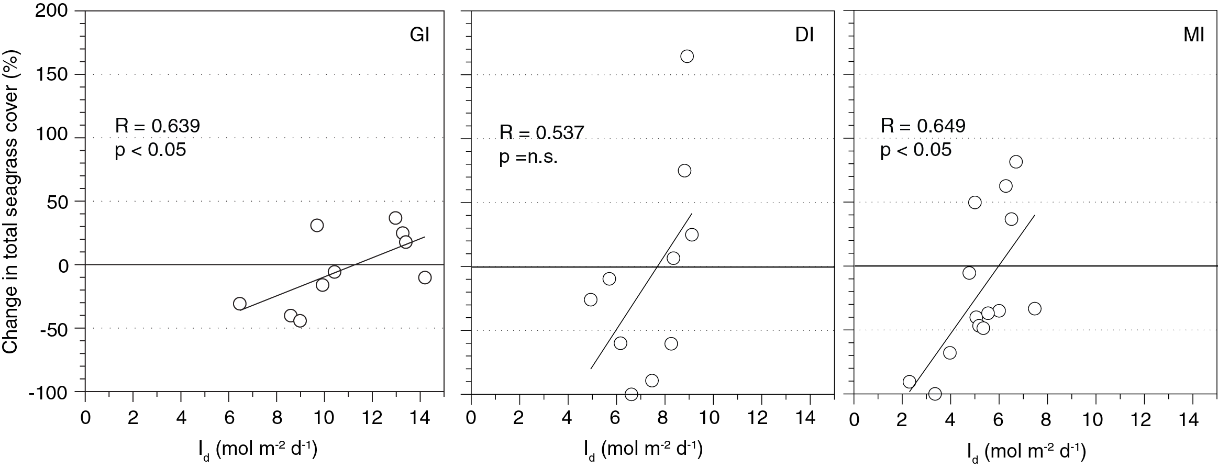
Figure 24. Change in total seagrass cover and I_{d} at three subtidal sites from 2008 to 2011 (from Collier, et al. 2012b).

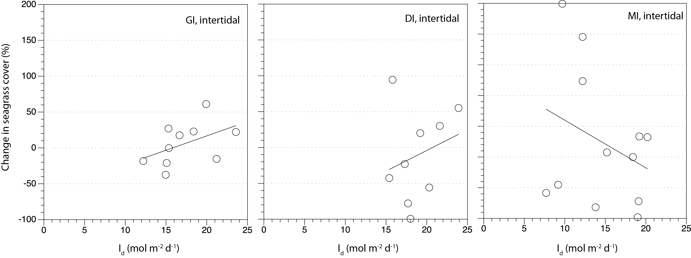
Figure 25. Change in total seagrass cover and I_{d} at three intertidal sites from 2008 to 2011

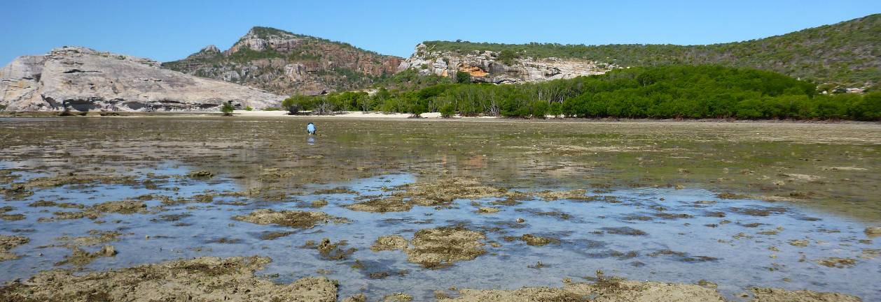

Cape York

2011/12 Summary
The majority of the land in Cape York Peninsula is relatively undeveloped and waters entering the GBR lagoon are perceived to be of a high quality. In April/May 2012, new monitoring locations were established across the region at two reef habitats and two coastal habitats. Seagrass growth on reef habitats in the region is primarily controlled by physical disturbance from waves/swell and associated sediment movement. Similarly, the dominant influence at coastal habitats is exposure to wind/wave disturbance, but with temperature extremes and pulsed terrigenous runoff from seasonal rains increasing stress and reducing seagrass growth. Seagrass status in 2011/12 is only interpreted from the Archer Point meadows in the south of the region, as insufficient data is available from the newly established sites. Seagrass abundance in 2011/12 was marginally lower than the previous monitoring period, but meadow extent remained stable. Halophila ovalis increased slightly in abundance and reproductive health declined, suggesting that there may have been a local disturbance (e.g. sediment movement). A persistent Halodule uninervis seed bank indicates a high recovery potential still exists in the location. Seagrass tissue nutrients in late 2011 indicated elevated nitrogen, suggesting anthropogenic N influence such as fertiliser. Adequate light was available for growth across the period and epiphyte abundance remained stable. No extreme within canopy temperatures were experienced over the 2011/12 period with temperatures similar to previous years. In general, climate over the monitoring period was drier, with clearer skies and calmer seas than the average meterological conditions. The annual freshwater discharge from the nearby (12 km) Annan River was lower in 2011/12 and no herbicides were found above detectable limits in the sediments of the meadows. Despite these potentially favourable conditions for seagrass, the status of seagrass condition in the region has declined from moderate in 2010/11 to poor (Table 15).
Table 15. Report card for seagrass status (community & environment) for the Cape York region: July 2011 – May 2012
Values are indexed scores scaled from 0-100; ■ = very good (80-100), ■ = good (60 - <80), ■ = moderate (40 - <60), ■ = poor (20 - <40), ■ = very poor (0 - <20).
Habitat | Abundance | Reproductive  Effort | Nutrient status  (C:N ratio) | Seagrass  Index
reef intertidal | 25 | 13 | 21 | 20
coastal intertidal | not monitored in late dry season
estuarine intertidal | not monitored
Cape York | 25 | 13 | 21 | 20

Background
Cape York Peninsula is the northernmost extremity of Australia. From its tip at Cape York it extends southward in Queensland for about 800 km, widening to its base, which spans 650 km from Cairns (east) to the Gilbert River (west). The largest rivers empty into the gulf, however there are several significant catchments which empty into the GBR. Major catchments of the region include Jacky Jacky Creek, the Olive, Pascoe, Lockhart, Stewart, Normanby, Jeannie, and Endeavour Rivers.
The region has a monsoonal climate with distinct wet and dry seasons with mean annual rainfall ranging from 1715 mm (Starke region) to 2159 mm (Lockhart River airport). Most rain falls between December and April. Mean daily air temperatures in the area range from 18 – 32°C. The prevailing winds are from the south east and persist throughout the year (Earth Tech 2005).
Cape York Peninsula is an area of exceptional conservation value and has cultural value of great significance to both Indigenous and non-Indigenous communities. The majority of the land is relatively undeveloped, therefore water entering the GBR lagoon is perceived to be of a high quality. Cattle station leases occupy about 52% of the total area, mostly located in central Cape York Peninsula but only around 33% are active leases. Indigenous land comprises about 22%, with a significant area of the West coast being held under Native title and other areas being under native title claim. The remainder is mostly declared as National Park including joint management areas with local traditional owners or under other conservations tenures e.g. nature refuges, conservation areas, wildlife reserves . Mining, agriculture, and commercial and recreational fishing are the major economic activities. All these activities have the potential to expand in this region and with this expansion the risk of increased pollutants.
Of the seagrass habitats types identified for the GBR (Figure 2), Reef Rescue MMP monitoring of seagrass meadows within this region only included fringing reef habitats up until 2012. In 2012, with the assistance of the Queensland Government's Reef Plan section of the Department of Agriculture, Fisheries and Forestry (DAFF), seagrass monitoring sites were also established on coastal habitats.
Fringing reef habitats in the Cape York region support diverse seagrass assemblages. Approximately 3% of all mapped seagrass meadows in the Cape York region are located on fringing-reefs (Coles et al., 2007). On fringing-reefs, physical disturbance from waves and swell and associated sediment movement primarily control seagrass growing in these habitats (Figure 26). Shallow unstable sediment, fluctuating temperature, and variable salinity in intertidal regions characterize these habitats. Sediment movement due to bioturbation and prevalent wave exposure creates an unstable environment where it is difficult for seagrass seedlings to establish or persist.
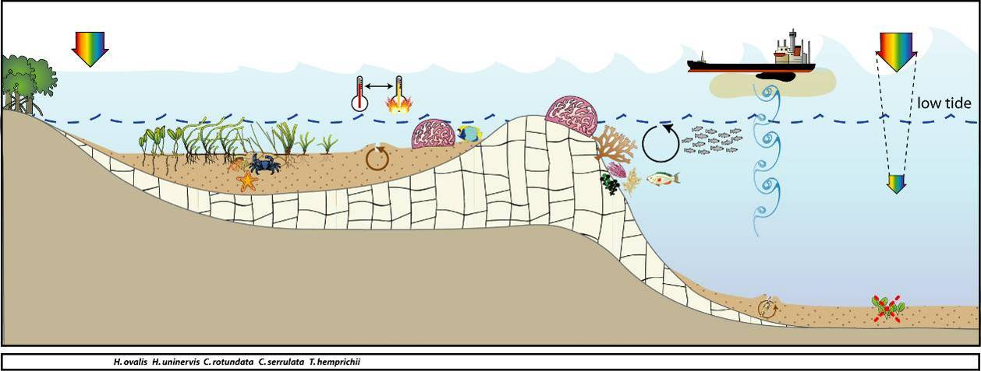
Figure 26. Conceptual diagram of reef seagrass habitat in the Cape York region
– major control is pulsed physical disturbance, salinity and temperature extremes: general habitat and seagrass meadow processes (see Figure 4 for icon explanation).
Seagrass meadows on inshore reef habitats were monitored at 3 locations, from the far north of the region (12.25°S), to the far south (15.6°S) (Figure 28). The most southern location (Archer Point) includes sites which have been monitored over the longest time period for the region. The monitoring sites at Archer Point were located in a protected section of bay adjacent to Archer Point, fringed by mangroves, approximately 15km south of Cooktown (Figure 28). There are two major rivers within the immediate region: the Endeavour and the Annan River. The Endeavour River is the larger of the two river systems and has a catchment area of approximately 992 km². The Annan River is located approximately 5 km south of Cooktown and extends inland from Walker Bay. The Annan River catchment area is approximately 850 km² (Hortle and Person 1990). The Eastern Kuku Yalanji are the traditional custodians of the land and sea country between Mowbray River (Port Douglas) and the Annan River.
In early 2012, two additional reef habitat locations were included for monitoring: Stanley Island and Piper Reef. Stanley Island is the northern most island within the Flinders Island group north of Bathurst Bay. It lies within the traditional land and sea country of the Yithuwarra people. The site is a fringing reef site also fringed with mangroves. The islands are influenced by the Princess Charlotte Bay catchment which has four river systems, the Normanby, Marrett, Bizant and North Kennedy Rivers. The Normanby River is the largest river draining into the GBR. The catchment is large covering 24,400 km² containing cattle leases (Kalpowar, Violetvale and Lilyvale) and Rinyirru (Lakefield) National Park. Piper Reef is approximately 45km north west of Portland Roads, 15 km off the mainland coast. It lies within the traditional sea country of the Kuuku Y’au people. It is influenced by coastal waters from the Olive and Pascoe Rivers along with the Temple Bay catchment. There are minor land use activities in these catchments with some small level housing on the Pascoe River at the Wattle Hills settlement.
In early 2012, seagrass coastal habitat locations paired with the new reef habitat locations, were included for monitoring, they include: Bathurst Head (paired with Stanley Island) and Shelburne Bay (paired with Piper Reef. The coastal seagrass meadows at Bathurst Head and Shelburne Bay are located on naturally dynamic intertidal sand banks. These meadows are dominated by Halodule uninervis with some Halophila ovalis and are often exposed to regular periods of disturbance from wave action and consequent sediment movement. The sediments in these locations are relatively unstable restricting seagrass growth and distribution. A dominant influence to these coastal meadows is exposure to wind/wave disturbance and terrigenous runoff from seasonal rains (Figure 27).
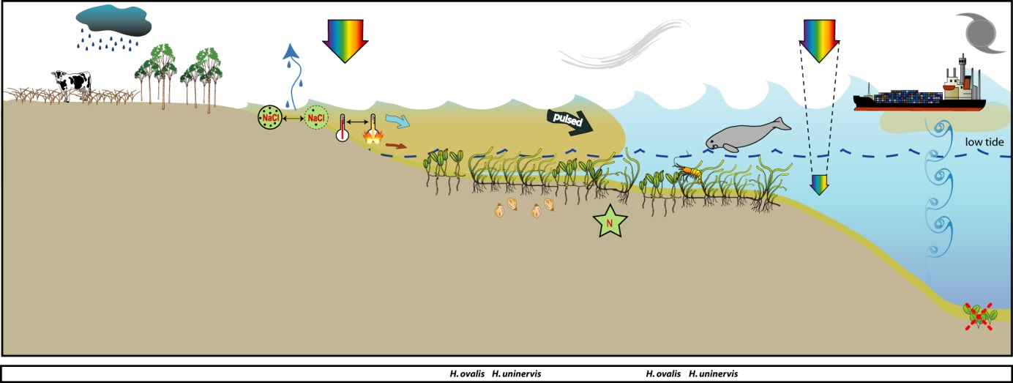
Figure 27. Conceptual diagram of coastal seagrass habitat in the Cape York region
– major control is pulsed terrigenous runoff, salinity and temperature extremes: general habitat, seagrass meadow processes and threats/impacts (see Figure 4 for icon explanation).

Figure 28. Location of the Cape York region monitoring sites and seagrass species percent composition at each site since 2003.
Please note: replicate sites within 500m of each other.
Bathurst Head is located just east of Combe Point in the Bathurst Bay area (also the traditional lands of the Yithuwarra people). It is a coastal site fringed by mangroves on the eastern edge of the bay. Shelburne Bay is located 112 km north of Lockhart River and 122 km southeast of Bamaga on the east coast of the GBR. It is the traditional land and sea country of the Wuthathi people. The bay has a limited catchment with two main rivers being the Harmer and Macmillian River. The catchment contains one of the least disturbed parabolic sand dunes areas in the world and is made up of seasonal wetlands and sand ridges. There was a pastoral lease issued in 1957in Shelburne Bay which was not renewed in 1999. There are no current land use activities occurring in this catchment. The area is prone to extreme weather with the cyclone database stating that 47 cyclones have tracked within 200km of Shelburne Bay between 1906 and 2007. The monitoring site at Shelburne Bay is approximately 5 km west of the mouth of the Harmer River.

Status of the seagrass community
The overall condition of inshore seagrass in the Cape York region declined from moderate in 2010/11 to poor in 2011/12 (Figure 29). Although abundances improved, the decline in condition was a result of declining reproductive effort and tissue nutrients. Seagrass abundance was very poor in 2010/11 and increased to poor in 2011/12. Reproductive effort declined from good in 2010/11 to very poor in 2011/12, indicating communities may have a relatively low potential for recovery from environmental disturbances compared to seagrass in other regions. Nutrient ratios of seagrass tissue similarly declined from moderate in 2010/11 to poor in 2011/12, reflecting local water quality conditions.
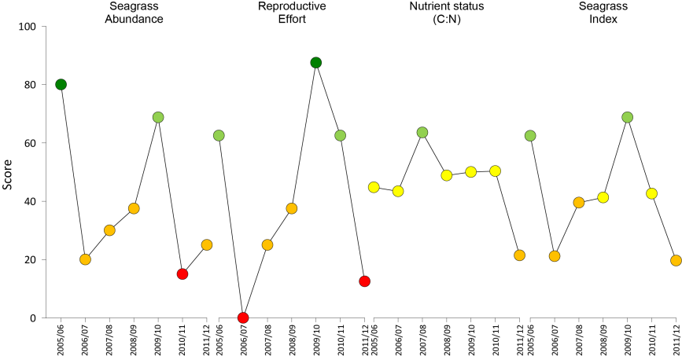
Figure 29. Report card of seagrass status indicators and index for the Cape York NRM region
(averages across habitats and sites). Values are indexed scores scaled from 0-100; ■ = very good (80-100), ■ = good (60 - <80), ■ = moderate (40 - <60), ■ = poor (20 - <40), ■ = very poor (0 - <20).

Seagrass abundance and composition

Reef habitat
Cape York region reef habitat seagrass cover long-term average was between 16% in the late dry and 17% in late monsoon season (Figure 30). Seagrass abundance declined by 20-55% over the 2011/12 monitoring period compared to the previous year.
Figure 30. Seagrass abundance (% cover ± Standard Error) at inshore intertidal reef habitat (Archer Point) in the Cape York region from 2003 to 2012.
Trendline is 3rd order polynomial, 95% confidence intervals displayed, r² = 0.53.
The Cape York region reef sites were dominated by Halodule uninervis and Halophila ovalis with varying amounts of Cymodocea rotundata (Figure 28). Although sites were only 50m apart, AP2 had slightly more Cymodocea and Thalassia present. Species composition has varied since sampling began in 2003 with the composition of Halophila ovalis fluctuating seasonally with increases in the late monsoon following disturbance.

Two new reef habitat monitoring locations were established in the northern and central sections of eastern Cape York region in May/June 2012. At Piper Reef in the north, monitoring sites were established on the reef platform adjacent to Farmer Island in the Thalassia hemprichii dominated meadow (with Cymodocea rotundata and Halophila ovalis). At Stanley Island in the central section of Cape York, adjacent to Princess Charlotte Bay, sites were established in the T. hemprichii /Halodule uninervis/H. ovalis dominated meadow located on the fringing reef in the bay between Cape Flinders and Nares Point.

In the late monsoon 2012, the Cape York reef habitat with the highest seagrass abundance was Piper Reef (16.7 ±1.6%), followed by Archer Point (9.0 ±1.9%) and Stanley Island (7.2 ±0.7%).
Since monitoring was established at Archer Point site 1 (AP1) in 2003, seagrass cover has generally followed a seasonal trend with higher abundance in late dry to monsoon period (Figure 31). The seasonal trend at Archer Point site 2 (AP2) is less apparent.
Figure 31. Mean percentage seagrass cover (all species pooled) (± Standard Error) at inshore intertidal reef habitat long-term monitoring sites in Cape York region at time of year.
NB: Polynomial trendline for all years pooled.
Seagrass meadow edge mapping was conducted within a 100m radius of both monitoring sites in the bay adjacent to Archer Point in October 2011 and April 2012 to determine if changes in abundance were a consequence of the meadow edges changing (Table 16). Since October 2009 at Archer Point, the landward edge of the meadow in the northern section of the bay (AP1) has fluctuated within years, but increased shoreward from the baseline. The shoreward extent of the seagrass meadow in the southern section of the bay (AP2) similarly fluctuated within and between years, but from October 2010 retracted from shore due to the appearance of a drainage channel from an adjacent creek (data not presented). Edge mapping of meadows at Piper Reef sites was conducted in May 2012, and seagrass covered 72% and 91% of the area (100m radius) of FR1 and FR2 monitoring sites respectively.
Table 16. Area (ha) of seagrass meadow being monitored within 100m radius of each Archer Point site
(AP1 and AP2). Value in parenthesis is % change from October 2005 baseline and description of change from previous mapping. Shading indicates decrease in meadow area since baseline.
Site | AP1 | AP2
October 2005  (baseline) | 3.667 | 3.710
April 2006 | 3.330  (-9.2%, decrease seaward) | 3.139  (-15.4%, decrease seaward)
October 2006 | 3.843  (4.8%, increase shoreward) | 3.5865  (-3.3%, increase shoreward)
April 2007 | 4.212  (14.9%, increase shoreward) | 4.0367  (8.8%, decrease seaward)
October 2007 | 4.173  (13.8%, decrease seaward) | 4.053  (9.28%, decrease seaward)
April 2008 | 3.905  (6.5%, decrease seaward) | 3.489  (-5.98%, decrease seaward)
October 2008 | 3.88  (5.7%, decrease seaward) | 3.57  (-3.73%, increase shoreward)
April 2009 | 3.36  (-8.3%, decrease seaward) | 3.26  (-12.14%, decrease seaward)
October 2009 | 3.70  (-1%, increase shoreward) | 3.55  (-4.2%, increase shoreward)
October 2010 | 3.97  (8.4%, increase shoreward) | 3.85  (3.7%, increase shoreward)
April 2011 | 3.88  (5.8%, decrease seaward) | 3.52  (-5.3%, decrease seaward)
October 2011 | 3.86  (5.2%, ) | 3.61  (-2.7%, increase shoreward)
April 2012 | 3.71  (1.2%, increase shoreward) | 3.50  (-5.6%, decrease seaward)
Figure 32. Extent of area (100m radius of monitoring site) covered by seagrass at each inshore intertidal reef monitoring site.

Coastal habitat
Monitoring sites were established at two coastal locations in the northern and central sections of eastern Cape York region in May/June 2012. At Shelburne Bay in the north, monitoring sites were located on the large intertidal sand flats in a H. ovalis/Halodule uninervis dominated meadow. At Bathurst Bay in the central section of Cape York, adjacent to Princess Charlotte Bay, sites were located in the Halodule uninervis dominated meadow. Five seagrass species were present in the Bathurst Bay meadows, whereas only three species were present at Shelburne Bay (Figure 28)
Seagrass abundance was higher at the sites in Bathurst Bay (14.8±1.2%) than Shelburne Bay (12.6±1%). Meadow edge mapping was only conducted at Shelburne Bay sites in April 2012, and although the meadow edge was within the 100m radius of one site (SR2), the edge did not directly impact the monitoring site as seagrass covered 95% of the total area.

Seagrass reproductive status
A Halodule uninervis seed bank persists at the Archer Point monitoring sites (Figure 33), however abundances in 2011/12 were lower in the late dry 2011 than the previous year. The abundance of germinated seeds fluctuates from year to year, but was higher in the late monsoon 2012 when seed banks were corresponding lower (Figure 33). Although Cymodocea plants are present across the sites, no seeds have been found since monitoring commenced. Total reproductive effort greatly reduced during the 2011 dry season and has remained low. Low dry season reproductive effort has previously occurred in 2006, which was also coincident with low seagrass abundance.
c.
Figure 33. Inshore intertidal reef habitat (Archer Point) seed bank (a), germinated seed abundance (b) and reproductive effort (c).
Seed bank presented as the total number of Halodule uninervis seeds per m² sediment surface and reproductive effort presented as the average number of reproductive structures per core (all species pooled).
The Archer Point sites, although reefal, are also strongly influenced by coastal processes and have experienced perturbations in recent years. The decline in seed bank and reproductive structures indicates a reduced capacity to recover following disturbance.
The new sites at Piper Reef and Shelburne bay in the far north of the region were sampled for seeds in May 2012. No seeds were found at Piper Reef, however a moderate seed bank (220 ±62 seeds m⁻²) and abundance of germinated seeds (238 ±56 m⁻²) were present in Bathurst Bay.

Status of the seagrass environment

Seagrass tissue nutrients
Foundation seagrass species (Halodule uninervis) at Archer Point in late dry season 2011 had molar C:N ratios well below 20 (Figure 35). This was the lowest C:N ratio recorded since monitoring was established.
Figure 34. Elemental ratios (atomic) of seagrass leaf tissue C:N for the foundation species at inshore intertidal reef habitats (Archer Point) in the Cape York region each year
(species pooled) (mean and SE displayed). Horizontal shaded band on the C:N ratio panel represents the accepted guideline seagrass “Redfield” ratio of 20:1 (Abal, et al. 1994; Grice, et al. 1996). C:N ratios below this line may indicate reduced light availability and/or N enrichment.
C:P ratios in 2011 were <500, indicating that the plants (Cymodocea rotundata and Halodule uninervis) were growing in an environment with a relatively small P pool, suggesting the habitat was nutrient poor (Figure 35). N:P ratios for the foundation species increased slightly since the previous monitoring period, however ratios were all between 25 and 30, indicating the plants remained replete (well supplied and balanced macronutrients for growth) (Figure 35). The reduction in both C:N and C:P ratios in 2011 are consistent with reduced light being available for photosynthesis, but could also have been caused by an increase in nutrients from the catchment providing elevated N and P. In contrast, the changes in ratio observed in in 2008, suggest that there was an increase in the availability of P, with a smaller increase in N availability as the N:P and C:P ratios declined to a greater extent than the C:N ratio.
Figure 35. Elemental ratios (atomic) of seagrass leaf tissue N:P and C:P for the foundation species at inshore intertidal reef habitats (Archer Point) in the Cape York region each year
(species pooled) (mean ± Standard Error). Horizontal shaded band on the N:P ratio panel represents the range of value associated with N:P balance ratio in the plant tissues, i.e. a seagrass “Redfield” ratio (Atkinson and Smith 1983; Duarte 1990; Fourqurean, et al. 1992b; Fourqurean and Cai 2001). N:P ratio above this band indicates P limitation, below indicates N limitation and within indicates replete (balanced). Shaded portion on the C:P panel ≤500 represents the value associated with C:P balance ratio in the plant tissues, C:P values <500 may indicate nutrient rich habitats (large P pool).
δ¹³C values for foundation species at Archer Point during the late dry (growing) season were all above the global average and within global ranges (Table 17), suggesting sufficient carbon available for growth. Similarly, as %C in the leaves was also above the literature median values, suggests adequate light available for growth. The low C:N ratio is likely a consequence of the elevated N, where the low δ¹⁵N value in the leaf tissue at Archer Point (Table 17) suggests that their primary source of N was either from N₂ fixation or fertiliser.
Table 17. Seagrass leaf tissue nutrient, δ¹³C and δ¹⁵N concentrations from Cape York locations in the late dry 2011 and late wet 2012.
Leaf tissues with low %C (see Table 37), low C:N (<20:1), and isotopically depleted δ¹³C may indicate that growth is light limited (Grice et al. 1996; Fourqurean et al. 2005). Shading indicates values lower than literature. CR=Cymodocea rotundata, HO=Halophila ovalis, HU=Halodule uninervis, TH=Thalassia hemprichii, ZM=Zostera muelleri.
Location | Species | %C | C:N | δ¹³C | δ¹⁵N | %C lit median | Global average | season
Archer Point | HU | 42.475 | 15.50 | -8.8±0.3 | 0.7±0.3 | 38.5 | -11.2 (-13.0 to -7.8) | late dry
Archer Point | ZM | 39.7 | 22.27 | -9.3 | 1.57 | 32 | -10.8 (-12.4 to -9.2) | late dry
Shelbourne Bay | HU | 39.6 | 15.50 | -14.6 | -2.9 | 38.5 | -11.2 (-13.0 to -7.8) | late wet
Shelbourne Bay | TH | 36.2 | 17.17 | -12.7 | -4.56 | 35.6 | -6.9 (-8.1 to -5.2) | late wet
Piper Reef | TH | 37.35 | 17.50 | -6.0±0.1 | 0.1±0.5 | 35.6 | -6.9 (-8.1 to -5.2) | late wet
Stanley Island | CR | 34.8 | 18.13 | -9.7 | -2.52 | 39 | -8.1 (-8.9 to -7.4) | late wet
Stanley Island | HO | 32.2 | 15.21 | -10 | 1.27 | 30.5 | -10 (-15.5 to -6.4) | late wet
Stanley Island | TH | 36.1 | 15.15 | -7.9 | -0.14 | 35.6 | -6.9 (-8.1 to -5.2) | late wet
Bathurst Bay | HO | 33.9 | 23.40 | -11.1± | 1.03 | 30.5 | -10 (-15.5 to -6.4) | late wet
Bathurst Bay | HU | 40.05 | 18.88 | -11.6±0.2 | 1.0±0.5 | 38.5 | -11.2 (-13.0 to -7.8) | late wet
Bathurst Bay | TH | 34.8 | 18.08 | -9.9 | 0.15 | 35.6 | -6.9 (-8.1 to -5.2) | late wet
δ¹³C values for foundation species were below the global average at most sites in the late wet season. This would be expected, as it may be a consequence of reduced growth during the onset of the senescent season, when light availability is naturally low (from the monsoon) and temperatures are declining.

Epiphytes and macro-algae
Epiphyte cover on seagrass leaf blades at Archer Point seasonally decreased during mid 2011 (Figure 36). Late dry 2011 and late monsoon 2012 abundances were similar to the 2010/11 monitoring period, remaining above the GBR long-term average for reef habitats (Figure 36).
Percentage cover of macro-algae was variable between years, but appears to have declined since 2007. Over the 2011/12 monitoring period, macro-algae cover remained below the GBR long-term average for reef habitats (Figure 36).
Figure 36. Long-term trend in mean abundance (% cover) (± Standard Error) of epiphytes and macro-algae at inshore intertidal reef habitats (Archer Point, sites pooled) in the Cape York region.
Red line = GBR long-term average; epiphytes=25%, macro-algae=3.2%.

Rhizosphere sediment herbicides
No herbicides were found above detectable limits in the sediments of the seagrass meadows at sites in the Cape York region in early May 2012 (Table 18).
Table 18. Concentration of herbicides (mg kg⁻¹) in sediments of Cape York seagrass monitoring sites in late monsoon 2012.
ND=not detectable above limit of 0.001 mg kg⁻¹
Site | Flumeturon | Diuron | Simazine | Atrazine | Desethyl Atrzine | Desisopropyl Atrzine | Hexazinone | Tebuthiuron | Ametryn | Prometryn | Bromacil | Imidacloprid | Terbutryn | Metolachlor
SR1 | ND | ND | ND | ND | ND | ND | ND | ND | ND | ND | ND | ND | ND | ND
SR2 | ND | ND | ND | ND | ND | ND | ND | ND | ND | ND | ND | ND | ND | ND
FR1 | ND | ND | ND | ND | ND | ND | ND | ND | ND | ND | ND | ND | ND | ND
FR2 | ND | ND | ND | ND | ND | ND | ND | ND | ND | ND | ND | ND | ND | ND
ST1 | ND | ND | ND | ND | ND | ND | ND | ND | ND | ND | ND | ND | ND | ND
ST2 | ND | ND | ND | ND | ND | ND | ND | ND | ND | ND | ND | ND | ND | ND
BY1 | ND | ND | ND | ND | ND | ND | ND | ND | ND | ND | ND | ND | ND | ND
BY2 | ND | ND | ND | ND | ND | ND | ND | ND | ND | ND | ND | ND | ND | ND

Within meadow canopy temperature
Autonomous temperature loggers were deployed at both Archer Point sites over the monitoring period. As the new Cape York sites were not established until May 2012, no data was available for the monitoring period. High temperatures (>35°C) were recorded from December 2011 to April 2012, coinciding with the low spring tides, with the highest temperature (35.9°C) recorded at 3pm on the 5 March 2012 (Figure 37). Average within meadow canopy temperatures have not changed significantly since 2007/08 (ANOVA, d.f.= 5,56,F=0.44, p =0.819), however temperatures were 0.5°C cooler in 2011/12 than the previous year (which was the warmest since monitoring established) (Figure 38). Number of days in 2011/12 with maximum within canopy temperatures >35°C were similar to 2010/11 (7 days >35°C in 2010/11, 6 days >35°C in 2011/12) (Figure 38), indicating that any losses are unlikely to be a consequence of extreme temperature events.
Figure 37. Within seagrass canopy temperature (°C) at inshore intertidal reef habitats (Archer Point) in the Cape York region over the 2011/12 monitoring period.
Figure 38. Monthly mean and maximum within seagrass canopy temperatures (°C) at inshore intertidal reef habitats (Archer Point), Cape York region.

Regional Climate
Climate in 2011/12 was cooler, drier, clearer and calmer than the previous 3-4 years. The mean maximum daily air temperature recorded in Cooktown during 2011/12 was 29.2°C; 0.3°C cooler than the 69 year average and 0.7°C cooler than the decade average (Figure 39). The highest recorded daily maximum air temperature in 2011/12 was 36.9°C, cooler than the recorded maximum of 41.7°C in 1958.
The 2011/12 monitoring period was slightly drier than average with a total rainfall of 1512mm. This was 24% lower than the 2010/11 rainfall (1980mm), similar to the decadal average (1475mm), but 10% lower than the 69 year mean annual rainfall (1684mm). The wettest monitoring period was 2005/06 with a total rainfall of 2321mm.
Mean annual monthly cloud cover in 2011/12 was lower than the previous period, and 10% lower than the decadal average. Mean monthly wind speed in 2011/12 was 21.4 km.hr⁻¹, this was slightly higher than 2010/11, but 3% calmer than the decadal average of 22 km.hr⁻¹.

Figure 39. Mean monthly daily maximum air temperature, total monthly rainfall (bar graph), mean monthly cloud cover (heavier line), and mean monthly 3pm wind speed (lighter line) recorded at Cooktown airport located 16km from Archer Point monitoring sites.
BOM station 031209, source www.bom.gov.au.

River discharge
The Annan River is the closest river (12km) to the seagrass monitoring sites adjacent to Archer Point, however exposure to elevated Total Suspended Solids, Chlorophyll-a and PSII herbicides was rated as low, with a nil probability of exceeding the GBR WQ Guidelines in 2010 (pers. comm. Michelle Devlin, JCU).
The annual freshwater discharge for the Annan River over the 2011/12 monitoring period (324,136 ML) was lower than the previous monitoring period (589,750 ML ), but equal to the long term median (1990-2012) (Figure 40). Highest flows in the Annan River over 2011/12 occurred from March to May 2012 (late monsoon), with peak average daily flows in March (156,775 ML day⁻¹)(Figure 40).

Figure 40. Average daily flow (ML day⁻¹) per month from the Annan River.
Annan River discharges recorded at Beesbike (DERM station 107003A, 15.68773S, 145.2085 E, Elev:115m) (source The State of Queensland (Department of Environment and Resource Management) 2012, watermonitoring.derm.qld.gov.au).

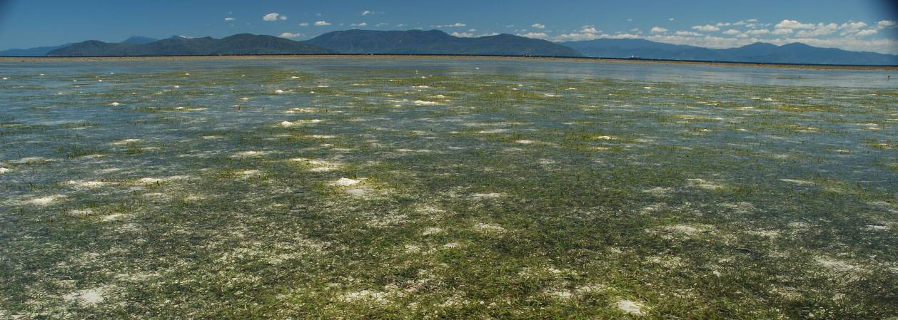

Wet Tropics

2011/12 Summary
The region includes two World Heritage Areas, however increases in intensive agriculture, coastal development and declining water quality have been identified as significant across the region. Seagrass monitoring was conducted on coastal and reef habitats. A dominant influence on these habitats is disturbance from wave action, sediment movement, elevated temperatures as well as seasonal terrigenous runoff. Nutrient concentrations are also generally low in reef habitats due to the carbonate nature of the sediments.
During the 2011/12 monitoring period, coastal seagrass abundance declined, however intertidal and subtidal reef abundances remained relatively stable (unchanged) from the low levels reported in early 2011. Meadow extent across most sites either declined or was lost as a consequence of the extreme weather events of early 2011. Over the 2011/12 monitoring period, there was little or no expansion of the meadows as the plants were in establishment phase (onset of recovery with appearance of seedlings) or hadn't recovered enough to progress to expansion phase (isolated seedlings with few ramets). Over the period seeds banks declined, but this may be a reflection of the higher germination and establishment of isolated plants/patches. Coastal reproductive status remained unchanged (at zero), however reef and subtidal reproductive status declined, indicating seed bank was the product of reproductive success the previous year.
Seagrass tissue nutrients in late 2011 remained similar across habitats to the previous monitoring period, suggesting P and N surplus to C requirements. The primary source of elevated nitrogen was either from N₂ fixation or fertiliser. Epiphyte abundance remained high relative to the long-term average, possibly a consequence of the elevated N. The canopy incident light environment improved in 2011/12, however this was primarily due to the high light levels in October/November 2011. The influence of these short term increases in light availability needs to be closely investigated and will requires specific attention.
No extreme water temperatures were recorded within the seagrass canopy over the monitoring period, and temperatures overall were similar to 2010/11. Climate across the region was on average wetter, cloudier and windier than the previous monitoring period. The increase in rainfall resulted in higher than median discharges from the major rivers in the Wet Tropics although this was approximately half the discharge over the 2010/11 period.
Overall the status of seagrass condition in the Wet Tropics has declined from poor in 2010/11 to very poor (Table 19). Monitoring results indicate the onset of recovery at some locations in early 2012 from previous stressors and once re-established, seagrass meadows are expected to increase in abundance and distribution should environmental conditions remain favourable.

Table 19. Report card for seagrass status (community & environment) for the Wet Tropics region: July 2011 – May 2012.
Values are indexed scores scaled from 0-100; ■ = very good (80-100), ■ = good (60 - <80), ■ = moderate (40 - <60), ■ = poor (20 - <40), ■ = very poor (0 - <20).
Habitat | Abundance | Reproductive  Effort | Nutrient status  (C:N ratio) | Seagrass  Index
reef intertidal | 20 | 6 | 38 | 21
coastal intertidal | 7 | 0 | 4 | 4
estuarine intertidal | not monitored
Wet Tropics | 13 | 3 | 21 | 13

Background
The Wet Tropics region covers 22,000 km² and land use practices include primary production such as cane and banana farming, dairying, beef, cropping and tropical horticulture (Commonwealth of Australia 2013e). Two types of seagrass habitats are monitored in the region: coastal and reef.
Reef Rescue monitoring occurs at two coastal seagrass habitat locations: Yule Point, in the north and Lugger Bay in the south of the region (Figure 42). The seagrass meadows at Yule Point and Lugger Bay are located on naturally dynamic intertidal sand banks, protected by fringing reefs. These meadows are dominated by Halodule uninervis with some Halophila ovalis and are often exposed to regular periods of disturbance from wave action and consequent sediment movement. The sediments in these locations are relatively unstable restricting seagrass growth and distribution. A dominant influence of these coastal meadows is terrigenous runoff from seasonal rains (Figure 41). The Barron, Tully and Hull Rivers are a major source of pulsed sediment and nutrient input to these monitored meadows.
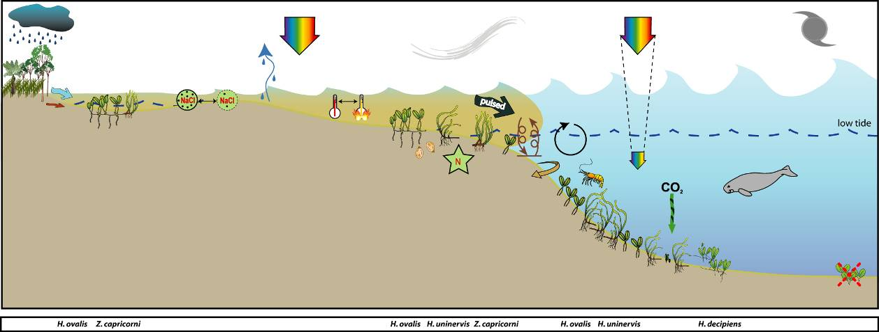
Figure 41. Conceptual diagram of coastal seagrass habitat (<15m) in the Wet Tropics region
– major control is pulsed terrigenous runoff, salinity and temperature extremes: general habitat, seagrass meadow processes and threats/impacts (see Figure 4 for icon explanation).
Monitoring of reef habitats occurs at three locations: Low Isles, Green Island and Dunk Island. Low Isles is located in the north of the region and the monitoring sites were paired (not replicated): intertidal and subtidal. Low Isles is an inshore reef located 15km south east of the Daintree River mouth. Low Isles refers to the 2 islets of Low Isles reef: Low Island (the cay) and Woody Island (predominantly Rhizophora forest). The intertidal site was located near the northern edge of the reef platform between Low Island and Woody Island. This area is dominated by Halodule uninervis and Halophila ovalis. The subtidal site was approximately 250 north of the intertidal site, in the eastern edge of the anchorage (Low Isles lagoon), and was dominated by Halophila ovalis and Halodule uninervis.

Figure 42. Location of Wet Tropics region long-term monitoring sites and seagrass species composition at each site.
Please note: replicate sites within 500m of each other; ^ denotes subtidal site.

Green Island is a mid shelf reef located 26km north east of Cairns and the Barron River mouth, in approximately the centre of the Wet Tropics region (Figure 42). Monitoring at Green Island occurs on the large intertidal reef-platform south west of the cay. The meadow is dominated by Cymodocea rotundata and Thalassia hemprichii with some Halodule uninervis and Halophila ovalis.
Dunk Island is an inshore continental island located in the southern section of the region (Figure 42). Intertidal monitoring sites are located on the sand spit between the main island and Kumboola Island. The subtidal site is located in the lee of the island, in front of the former Dunk Island resort. Shallow unstable sediment, fluctuating temperature, and variable salinity in intertidal regions characterize these habitats. Physical disturbance from waves and swell and associated sediment movement primarily control seagrass growing in these habitats (Figure 43). Reef seagrass habitats in the region are often adjacent to areas of high tourism use and boating activity with propeller and anchor scarring impacts. Globally, nutrient concentrations are generally low in reef habitats due to the coarse nature of the coral sand sediments. In these types of carbonate sediments the primary limiting nutrient for seagrass growth is generally phosphate (Short et al. 1990; Fourqurean et al. 1992a; Erftemeijer and Middelburg 1993). This is due to the sequestering of phosphate by calcium carbonate sediments. In this region seagrass meadows inhabiting the near shore inner reefs and fringing reefs of coastal islands inhabit a mixture of terrigenous and carbonate sediments, such as Green Island. Seagrasses at this location in the 1990’s were shown to be nitrogen limited (Udy, et al. 1999).
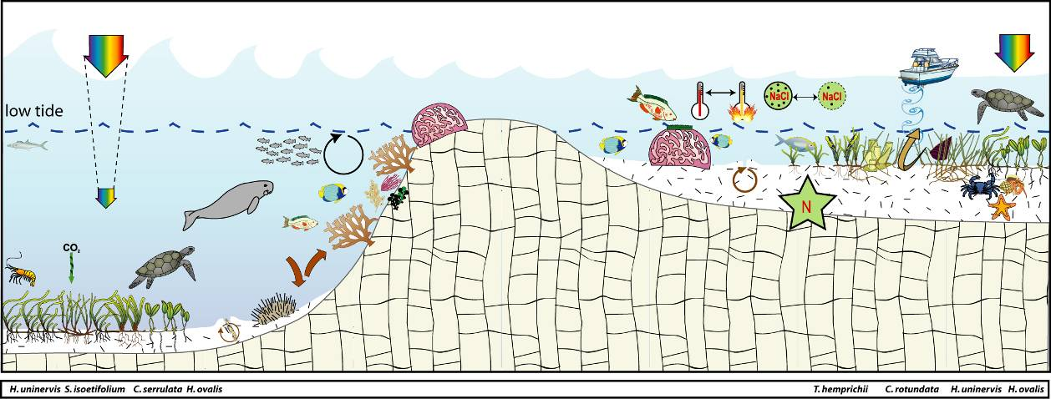
Figure 43. Conceptual diagram of reef seagrass habitat (<15m) in the Wet Tropics region
– major control is nutrient limitation, temperature extremes, light and grazing: general habitat, seagrass meadow processes and threats/impacts (see Figure 4 for icon explanation).

Status of the seagrass community
The overall condition of inshore seagrass in the Wet Tropics region declined in 2011/12 to very poor (Figure 44). This is due to declines in all three indictors over the monitoring period relative to 2010/11. The greatest decline in inshore seagrass abundance was in coastal habitats, which dropped from moderate in 2010/11 to very poor in 2011/12. Reproductive effort also declined across the region in 2011/12 and there is little evidence of recovery of meadows that were directly affected by Cyclone Yasi in 2010/11. The very low abundance coupled with very low reproductive effort of seagrass in the region indicates that meadows may be at risk from repeated impacts and are likely to take many years to fully recover. Leaf tissue nutrient ratios were rated poor overall and were indicative of poor water quality.
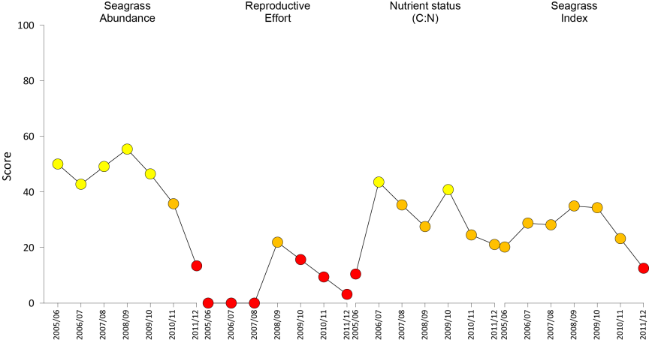
Figure 44. Report card of seagrass status indicators and index for the Wet Tropics NRM region
(averages across habitats and sites). Values are indexed scores scaled from 0-100; ■ = very good (80-100), ■ = good (60 - <80), ■ = moderate (40 - <60), ■ = poor (20 - <40), ■ = very poor (0 - <20).

Seagrass abundance and composition

Coastal habitat
The seagrass at Yule Point and Lugger Bay were representative of coastal (inshore) seagrass communities in the region and were dominated by Halodule uninervis and Halophila ovalis (Figure 42). Over the 2011/12 monitoring period, the proportion of Halophila ovalis declined from the previous monitoring period and Halodule uninervis dominated the species composition at Yule Point sites. Overall, seagrass cover at Yule Point during the 2011/12 monitoring period was the lowest recorded since monitoring was establish in August 2000. Similarly, the dry season abundances in 2011 were the lowest ever recorded at Yule Point (Figure 45).
The Lugger Bay intertidal sandbanks only expose during very low tides (<0.4m) and only Halodule uninervis has been reported within the sites (Figure 42). Seagrass meadows at Lugger Bay have fluctuated greatly since monitoring was established in late 2004, primarily from acute disturbances such as tropical cyclones. Seagrass cover declined in early 2010 and was completely lost in early 2011 following TC Yasi (Figure 45). No seagrass was observed within the long-term monitoring sites throughout 2011/12, although isolated plants were observed in the south eastern portion of the bay in late dry 2011, from which tissue samples were collected.
Although seagrass cover at Yule Point was low, over the past 12 months it continued to follow a seasonal trend with higher abundance over the period from late dry to monsoon (Figure 46).
Figure 45. Changes in seagrass abundance (% cover ±Standard Error) at inshore intertidal coastal habitats in the Wet Tropics region from 2000 to 2012
. Trendline is 3rd order polynomial (95% confidence intervals displayed) where Yule Pt r² = 0.223 and Lugger Bay r² = 0.408).
Figure 46. Mean percentage seagrass cover (all species pooled) (± Standard Error) at inshore intertidal coastal habitats (Yule Point) at time of year.
NB: Polynomial trendline for all years pooled.
Although seagrass was absent from Lugger Bay during 2011/12, historically seagrass abundance has followed a seasonal pattern with abundances increasing throughout the year until the monsoon (Figure 47).
Figure 47. Mean percentage seagrass cover (all species pooled) (± Standard Error) at inshore intertidal coastal habitats (Lugger Bay) at time of year.
NB: Polynomial trendline for all years pooled.

Inshore reef habitat
Dunk Island, Green Island, and Low Isles sites were on inshore reef platforms. Dunk Island is a continental island offshore from Mission Beach. Seagrass species at Dunk Island sites included H. uninervis and C. rotundata with T. hemprichii H. ovalis and C. serrulata (Figure 42). Green Island is on a mid shelf reef, approximately 27 km north east of Cairns. The sites were located on the reef platform south west of the cay and dominated by C. rotundata and T. hemprichii with some H. uninervis and H. ovalis (Figure 42). Low Isles is a reef platform located approximately 20km north east of Port Douglas on a mid-shelf reef. The intertidal site occurs on the northern side of the reef platform that separates Low Island and Woody Island, and is comprised of T. hemprichii, H. uninervis and H. ovalis. The subtidal site at Low Isles occurs in the shallow embayment that separates the two islands in the north and is located on mobile sands, which are dominated by the colonising species H. ovalis with some H. uninervis.
Seagrass abundance on the Green Island reef flat has slightly declined over the past 6 years and although changed little throughout the 2011/12 monitoring period, it appeared to follow a seasonal pattern, with high cover in the monsoon and low cover in the dry; no significant changes in species composition were observed (Figure 42, Figure 48, Figure 49). Conversely, subtidal seagrass at Green Island has changed little between years; however, the subtidal site has only been monitored since 2008 (Figure 48).
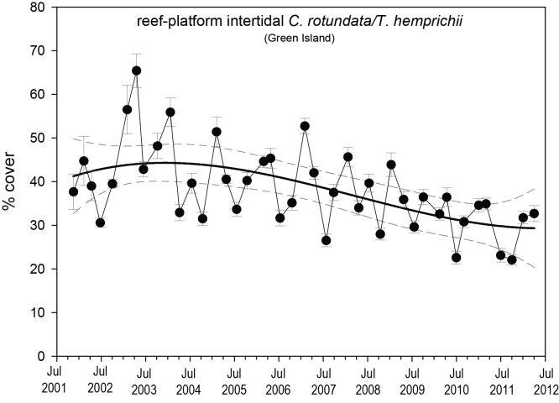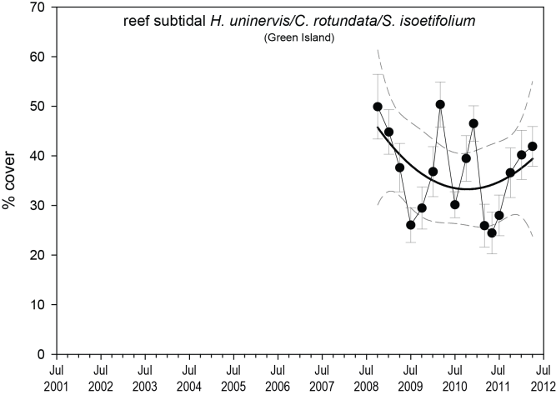
Figure 48. Changes in seagrass abundance (% cover ±Standard Error) of inshore intertidal and subtidal reef habitats (Green Island) in the Wet Tropics region from 2001 to 2012.
Trendline is 3rd order polynomial, 95% confidence intervals displayed, where intertidal r² = 0.334 and subtidal r² = 0.172.
Figure 49. Mean percentage seagrass cover (all species pooled) (± Standard Error) at inshore intertidal reef habitats (Green Island) at time of year.
NB: Polynomial trendline for all years pooled.
Figure 50. Mean percentage seagrass cover (all species pooled) (± Standard Error) at inshore subtidal reef habitats (Green Island) at time of year.
NB: Polynomial trendline for all years pooled.
Seagrass abundance at Dunk Island has been declining at both intertidal and subtidal sites since 2009 and was nearly completely lost in early 2011 following TC Yasi when the meadow was reduced to a few isolated shoots (Figure 51). By April 2012, the seagrass had shown little recovery as only isolated shoots were present. Prior to the extreme weather events of 2011, Dunk Island seagrass abundance has generally followed a seasonal pattern with abundances decreasing during the senescent season (Figure 52).
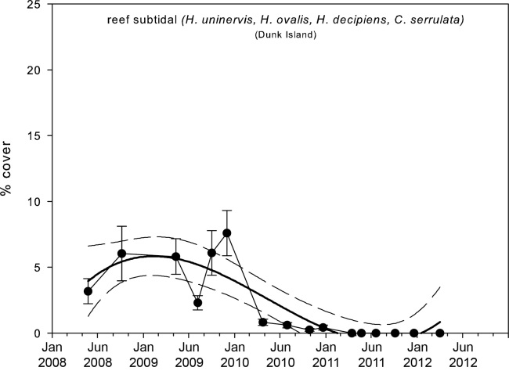
Figure 51. Changes in seagrass abundance (% cover ±Standard Error) of inshore intertidal and subtidal reef habitats (Dunk Island) in the southern Wet Tropics region from 2007 to 2012.
Trendline is 3rd order polynomial, 95% confidence intervals displayed, where intertidal r² = 0.888 and subtidal r² = 0.765.
Figure 52. Mean percentage seagrass cover (all species pooled) (± Standard Error) at inshore intertidal reef habitat (Dunk Island) at time of year.
NB: Polynomial trendline for all years pooled.
Figure 53. Mean percentage seagrass cover (all species pooled) (± Standard Error) at inshore subtidal reef habitat (Dunk Island) at time of year.
NB: Polynomial trendline for all years pooled.
Similar to Dunk Island, seagrass abundance at Low Isles has been declining at both intertidal and subtidal meadows since 2009 (Figure 54). Seagrass abundance at Low Isles has declined since monitoring began in 2008 but has shown some recovery over the past year (Figure 46). Abundance has increased slightly (from 2% to 4%) throughout the 2011/2012 monitoring period at the intertidal site; however, it remains considerably lower than when monitoring began in 2008 (when it was 18% cover). This has coincided with a drastic decline in T. hemprichii abundance at the intertidal sites, with both the intertidal and subtidal sites now dominated by the colonising H. ovalis. Seagrass cover declined to 0% at the subtidal site in the post-wet sampling of early 2012 (down from 2% at the same time the previous year).
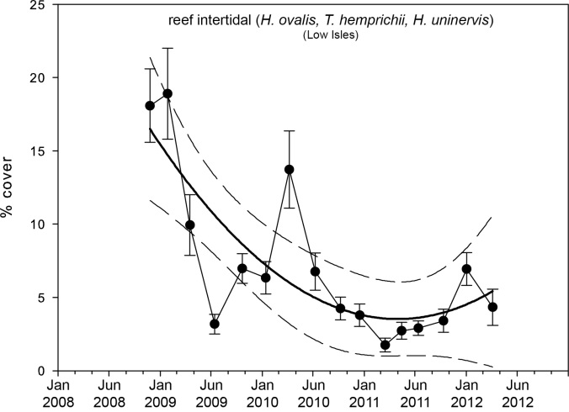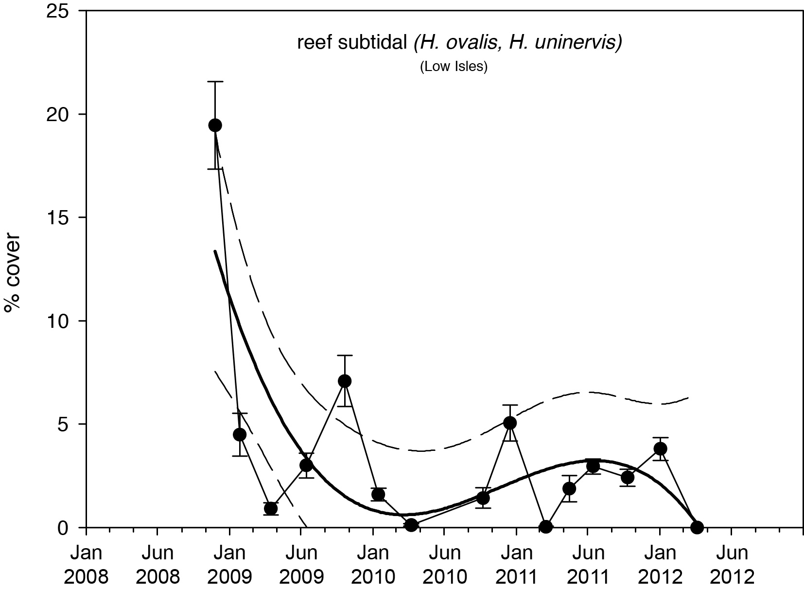
Figure 54. Changes in seagrass abundance (% cover ±Standard Error) at inshore intertidal and subtidal reef habitats (Low Isles) in the northern Wet Tropics region from 2008 to 2012.
Trendline is 3rd order polynomial (95% confidence intervals displayed) where intertidal r² = 0.567 and subtidal r² = 0.629).
Figure 55. Mean percentage seagrass cover (all species pooled) (± Standard Error) at inshore intertidal (left) and subtidal (right) reef habitat (Low Isles) long-term monitoring sites at time of year
. NB: Polynomial trendline for all years pooled.
With the exception of Low Isles, seagrass meadow edge mapping was conducted within a 100m radius of all intertidal monitoring sites in October/November and March/April of each year to determine if changes in abundance were a consequence of the meadow edges changing (Table 20).
In the northern locations, coastal meadow extent declined in late 2011, and then recovered to some degree in early 2012 (Figure 56). There were no detectable differences in the seagrass meadow edges at Green Island over the 2011/12 monitoring period (Table 20, Figure 57).
Over the 2011/12 monitoring period, the distribution of seagrass in the southern part of the region either continued to decrease or remain absent as a consequence of the extreme weather events of early 2011. At Lugger Bay, the distribution of the seagrass declined throughout 2010, and then was completely lost during the 2011 monsoon after Tropical Cyclone Yasi (Table 20, Figure 57). As of April 2012, no seagrass plants had recruited within the area of the monitoring site, however several patches had established in the south eastern part of the bay, approximately 700m from the sites. At Dunk Island, the remaining isolated plants in late 2011 continued to decline through early 2012 (Table 20, Figure 57).

Table 20. Area (ha) of seagrass meadow within 100m radius of each intertidal site.
Value in parenthesis is % change from baseline and description of change from previous mapping. Shading indicates decrease in meadow area since baseline. NA=no data available as site not established.
 | Yule Pt |  | Green Island |  | Lugger Bay |  | Dunk Island
 | YP1 | YP2 | GI1 | GI2 | LB1 | LB2 | DI1 | DI2
October 2005  (baseline) | 1.326 | 3.596 | 5.257 | 4.632 | 1.675 | 1.801 | NA | NA
April  2006 | 1.789  (34.9% increase shoreward) | 4.120  (14.6% increase shoreward) | 5.319  (1.2%, increase shoreward) | 4.647  (0.3%, negligible) | 1.085  (-35.2%, decrease landward) | 1.448  (-19.6%, decrease landward) | NA | NA
October  2006 | 1.768  (33.3% decrease overall) | 3.697  (2.8% decrease seaward) | 5.266  (0.2% decrease seaward) | 4.674  (0.9%, negligible) | 0.453  (-73%, decrease overall) | 0.561  (-68.8%, decrease overall ) | NA | NA
April  2007 | 2.452  (84.9% increase overall) | 3.735  (3.9% increase shoreward) | 5.266  (0.2%, no change) | 4.605  (-0.6%, negligible) | 0.953  (-43.1%, increase overall) | 1.167  (-35.2%, increase overall) | 3.278 | 3.972
October  2007 | 3.08  (132.3%, increase overall) | 4.422  (23%, increase overall) | 5.266  (0.2%, no change) | 4.674  (0.9%, negligible) | 1.183  (-29.4% increase overall) | 1.6  (-11.2% increase shoreward) | 3.479  (6.1% increase overall) | 4.19  (5.5% increase overall)
April  2008 | 2.861  (115.8%, decrease overall) | 4.724  (31.9%, increase overall) | 5.32  (1.2% increase shoreward) | 4.66  (0.6%, negligible) | 1.046  (-37.6% decrease seaward) | 1.442  (-19.9% decrease seaward) | 3.36  (2.5% decrease shoreward) | 4.425  11.4% increase overall)
October  2008 | 2.910  (119.4%, decrease shoreward) | 4.432  (23.2%, decrease overall) | 5.298  (0.8%, no change) | 4.682  (1.1%, negligible) | 1.607  (-4.1% increase overall) | 1.945  (8.0% increase shoreward) | 3.393  (3.5% increase overall) | 4.332  (9.1% decrease overall)
April  2009 | 2.463  (85.7%, decrease overall) | 4.712  (31.0%, increase overall) | 5.316  (1.1% negligible) | 4.703  (1.5%, negligible) | 1.218  (-27.3% decrease seaward) | 1.655  (-8.1% decrease seaward) | 3.34  (1.9% decrease shoreward) | 4.420  (11.3% increase overall)
October  2009 | 2.249  (-69.6%, decrease seaward) | 4.645  (-29.2%, negligible) | 5.288  (0.5%, no change) | 4.671  (0.9%, no change) | 1.256  (25% increase overall) | 1.567  (-13% decrease shoreward) | 3.412  (4.1% increase overall) | 4.371  (-10% negligible)
April  2010 | 1.634  (23.2%, decrease overall) | 4.464  (-24.1%, decrease overall) | 5.345  (1.6% negligible) | 4.675  (0.9%, no change) | 0.464  (-72.3% decrease overall) | 0.464  (-74.2% decrease overall) | 3.398  (-3.6%  no change) | 4.179  (-5.2% decrease shoreward)
October  2010 | 1.665  (25.6%, increase overall) | 4.243  (-18%, increase overall) | 5.285  (0.5% %, no change) | 4.612  (-0.4%, no change) | 0.151  (-91% decrease overall) | 0.151  (-91.6% decrease overall) | 3.429  (4.5%, increase overall) | 4.282  (7.8% increase overall)
April  2011 | 1.773  (33.7%, increase overall) | 4.367  (22.5%, increase overall) | 5.279  (0.4% %, no change) | 4.614  (-0.4%, no change) | 0  (-100%, loss of meadow) | 0  (-100%, loss of meadow) | 0  (-100%, loss of meadow) | 0.013  (-99.7% isolated patches)
October  2011 | 0.432  (-67.4, loss overall) | 2.027  (-43.6, loss overall) | 5.337  (1.5, negligible) | 4.706  (1.6, negligible) | 0  (meadow absent) | 0  (meadow absent) | 0.072  (-97.8, isolated patches) | 0.255  (-93.6, isolated patches)
April  2012 | 1.244  (-6.2, increase overall) | 3.602  (0.2, increase overall) | 5.312  (1.1, negligible) | 4.714  (1.8, negligible) | 0  (meadow absent) | 0  (meadow absent) | 0.019  (-99.4, isolated patches) | 0.151  (-96.2, isolated patches)
Figure 56. Extent of area (100m radius of monitoring site) covered by seagrass at inshore intertidal coastal and reef habitat monitoring sites in the northern Wet Tropics region.
Figure 57. Extent of area (100m radius of monitoring site) covered by seagrass at inshore intertidal coastal and reef monitoring sites in the southern Wet Tropics region.

Seagrass reproductive status
Seed banks and reproductive effort across the region declined over the monitoring periods (Figure 58, Figure 59). The only location with a seed bank present over the 2011/12 monitoring period was Yule Point with the largest seed banks observed July 2011 (127±76 seeds m⁻²). However the seed bank was reduced by 87% in October 2011, when the bulk of seeds germinated (evident by over a doubling in remnants of germinated seeds over the same period). At reef habitats, only remnants of germinated seeds were present at Dunk Island in October 2011 and April 2012 (Figure 59).

There has been little change in seagrass reproductive effort at coastal and reef sites during 2011/12, with the low values recorded in the previous year occurring again (Figure 58). The low reproductive effort is not associated with a loss in meadow extent (see above), but does appear coincident with the low abudance at the coastal and reef sites (except Green Island which has high abundance yet always has low reproductive effort). This may reflect the more chronic ongoing loss of meadow condition. The low seed bank and reproductive effort signals a reduced resilience, which is likely to be restored only after years of meadow development (i.e. increasing abundance through asexual propagation). Reproductive effort has been measured at WT reef subtidal sites since 2010 only, and in that time dry season values increased from 0.017 to 0.338 and wet season declined from 0.713 to 0.
c.
Figure 58. Inshore intertidal coastal habitat seed bank (a), germinated seed abundance (b), and total seagrass reproductive effort (c) in the Wet Tropics region
. Seed bank presented as the total number of Halodule uninervis seeds per m² sediment surface and reproductive effort presented as the average number of reproductive structures per core (all species pooled).
c.
Figure 59. Inshore intertidal reef habitat seed banks (a), germinated seed abundance (b), and total reproductive effort (c) in the Wet Tropics region.
Seed bank presented as the total number of seeds per m² sediment surface and reproductive effort presented as the average number of reproductive structures per core (all species pooled).
Reproductive effort across the whole Wet Tropics region is classified as very poor. This suggests that sites within the region will take longer to recover following disturbance and may be at risk from repeated impacts.

Status of the seagrass environment

Seagrass tissue nutrients
Within the Wet Tropics region, seagrasses in reef environments (Dunk Island and Green Island) had higher C:N ratios than those in coastal environments (Yule Point and Lugger Bay) (Figure 60). This pattern has been consistent across all years of monitoring. In 2011, C:N ratios were similar or lower in all seagrass habitats than reported in 2010. Levels of the C:N ratio below 20 may be considered as indicative of environments where light may be limiting to growth.
Figure 60. Elemental ratios (atomic) of seagrass leaf tissue C:N for the foundation seagrass species examined at each inshore intertidal location in the Wet Tropics region each year
(species pooled) (mean ± Standard Error). Horizontal shaded band on the C:N ratio panel represents the accepted guideline seagrass “Redfield” ratio of 20:1 (Abal, et al. 1994; Grice, et al. 1996). C:N ratios below this line indicate reduced light availability and/or N enrichment.
The late dry 2011, C:P ratios of the foundation seagrass species at Green Island, Yule Pt and Lugger Bay all remained below 500; indicating these sites were nutrient rich or had a large P pool (Figure 61). Values below 500 were consistently recorded at Lugger Bay since monitoring was established in 2008, indicating a nutrient rich environment. The N:P ratios of the foundation seagrass species at reef habitats in 2010 indicated environments were either N-limited (Green Island) or P-limited (Dunk Island). N:P ratios of the foundation seagrass species at coastal habitats in 2010 declined in the north, but increased in the south of he region. In the north at Yule Point, although the amount of N relative to P declined, the plants remained P-limited (Figure 61). Whereas in the south at Lugger Bay, the amount of N increased relative to P with the plants becoming replete (well supplied and balanced macronutrients for growth) in 2011. Overall results suggest the region demonstrates higher nutrient loading (elevated N).
Figure 61. Elemental ratios (atomic) of seagrass leaf tissue N:P and C:P for the foundation seagrass species examined at each inshore intertidal location in the Wet Tropics region each year
(species pooled) (mean ± Standard Error). Horizontal shaded band on the N:P ratio panel represents the range of value associated with N:P balance ratio in the plant tissues, i.e. a seagrass “Redfield” ratio (Atkinson and Smith 1983; Duarte 1990; Fourqurean, et al. 1992b; Fourqurean and Cai 2001). N:P ratio above this band indicates P limitation, below indicates N limitation and within indicates replete (balanced). Shaded portion on the C:P panel ≤500 represents the value associated with C:P balance ratio in the plant tissues, C:P values <500 may indicate nutrient rich habitats (large P pool).
In October 2011, tissue nutrient ratios were collected for the first time at the Low Isles intertidal site (but not subtidal, as there was insufficient plant material available), and at the Green Island subtidal site. C:N ratios of the foundation seagrass species were below 20 which may be considered as indicative of environments where light may be limiting to growth. C:P and N:P ratios were similarly low, indicating these sites were N-limited and had a large P pool (Table 21).

Table 21. Tissue nutrient ratios for all foundation species pooled for subtidal sites in the Wet Tropics. NB there was insufficient seagrass at the Dunk Island and Low Isles subtidal sites for analysis.
Location |  | C:N | N:P | C:P
Low Isles | Intertidal | 17.2 ±0.6 | 9.7 ± 0.1 | 166.6 ±7.3
Green Island | Subtidal | 18.5 ± 0.6 | 8.9 ± 0.2 | 165.4 ±6.7
δ¹³C values for foundation species at Yule Point and Green Island during the late dry (growing) season were all above the global average and within global ranges (Table 22), suggesting sufficient carbon available for growth. Similarly, as %C in the leaves was also above the literature median values, suggests adequate light available for growth. The low C:N ratio is likely a consequence of the elevated N, where the low δ¹⁵N value in the leaf tissue (Table 22) suggests that their primary source of N was either from N₂ fixation or fertiliser.
Table 22. Seagrass leaf tissue nutrient, δ¹³C and δ¹⁵N concentrations from Wet Tropics locations in the late dry 2011.
Leaf tissues with low %C (see Table 37), low C:N (<20:1), and isotopically depleted δ¹³C may indicate that growth is light limited (Grice et al. 1996; Fourqurean et al. 2005). Shading indicates values lower than literature. CR=Cymodocea rotundata, HU=Halodule uninervis, TH=Thalassia hemprichii.
Location | Species | %C | C:N | δ¹³C | δ¹⁵N | %C lit median | Global δ¹³C
Yule Point | HU | 44.9 | 10.65 | -10.4 | 0.64 | 38.5 | -11.2 (-13.0 to -7.8)
Green Island | CR | 42.475 | 18.10 | -7.8±0.2 | -0.22±0.54 | 39 | -8.1 (-8.9 to -7.4)
Green Island | HU | 41.6 | 20.14 | -7.5 | 1.45 | 38.5 | -11.2 (-13.0 to -7.8)
Green Island | TH | 40.36 | 17.31 | -7.0±0.1 | 1.72±0.26 | 35.6 | -6.9 (-8.1 to -5.2)

Epiphytes and macro-algae
Epiphyte cover on seagrass leaf blades at coastal sites was variable (Figure 62) and appears to fluctuate seasonally with higher values generally in the monsoon and late monsoon. Epiphyte cover has continued to remain high and predominately above the GBR long-term average at Yule Point over the last 4-5 years (Figure 62). At Lugger Bay however, the highly variable epiphyte cover remained below the GBR long-term average, until all seagrass was lost as a consequence of the extreme weather events of 2011 (Figure 62). Percentage cover of macro-algae at coastal sites was consistently lower than the GBR long-term average (Figure 62).
Figure 62. Mean abundance (% cover) (± Standard Error) of epiphytes and macro-algae at inshore intertidal coastal habitats (sites pooled) in the Wet Tropics region
. Red line = GBR long-term average; epiphytes=17%, macro-algae=4.7%.
Epiphyte cover at reef sites was variable and although not significant, it appears to be increasing at Green Island over the last 4-5 years (Figure 63). Abundances at Green Island were below the GBR long-term average for reef habitats during the 2011/12 monitoring period. At Dunk Island epiphytes remained below the GBR long-term average for the duration of the monitoring period as seagrass abundance was also very low (Figure 63). Macro-algae abundance remained relatively stable at Green Island with mean covers less than 10% (Figure 63), however at Dunk Island was near absent possibly as a consequence of the extreme weather of 2011 eroding much of the substrate.
Figure 63. Mean abundance (% cover) (± Standard Error) of epiphytes and macro-algae at inshore intertidal reef habitats (sites pooled) in the Wet Tropics region.
Red line = GBR long-term average; epiphytes=28%, macro-algae=6.2%.
At the Green Island subtidal site, epiphyte cover is relatively low and fluctuates only slightly, compared to epiphytes at the intertidal site. In contrast macroalgal cover is high and fluctuates more dramatically than the intertidal site due largely to seasonally varying filamentous algae. At the Dunk Island subtidal site, epiphyte cover and macroalgae abundance were elevated in 2009 and 2010 compared to the previous year, and compared to the intertidal site. However, during TC Yasi in early 2011 macroalgae abundance declined drastically, and due to complete seagrass loss, there are no epiphytes.
Figure 64. Mean abundance (% cover) (± Standard Error) of epiphytes and macro-algae at inshore subtidal reef habitat (Green Island) in the central Wet Tropics region.
Red line = GBR long-term average for subtidal sites; epiphytes=17%, macro-algae=4.7%.
Figure 65. Mean abundance (% cover) (± Standard Error) of epiphytes and macro-algae at inshore subtidal reef habitat (Dunk Island) in the southern Wet Tropics region.
Red line = GBR long-term average for subtidal sites; epiphytes=17%, macro-algae=4.7%.
At the Low Isles intertidal site, epiphyte cover is generally lower than the long-term average, while macro-algae abundance is generally high. At the subtidal site, occasional peaks in epiphyte abundance occur, but generally epiphytes and macroalgae cover remain low.
Figure 66. Mean abundance (% cover) (± Standard Error) of epiphytes and macro-algae at inshore intertidal habitat (Low Isles) in the northern Wet Tropics region.
Red line = GBR long-term average; epiphytes=17%, macro-algae=4.7%.
Figure 67. Mean abundance (% cover) (± Standard Error) of epiphytes and macro-algae at inshore subtidal reef habitat (Low Isles) in the northern Wet Tropics region.
Red line = GBR long-term average; epiphytes=17%, macro-algae=4.7%.

Within meadow canopy temperature
Temperature loggers were deployed within the seagrass canopy throughout the monitoring period at all intertidal and subtidal locations monitored in the region (Figure 68). Higher temperatures were typically experienced from December 2011 to March 2012 across the region. No extreme temperatures (>39°C) were recorded at any of the locations, however higher maximums were recorded at coastal sites. For example, but highest maximum measured across the region over the monitoring period (37.7°C) occurred in October 2011 at Yule Pt between 1:30-3:00pm on the 9th and 10th October 2011 (Figure 68). Although within canopy temperatures at coastal sites in 2011/12 were on average 0.2 - 0.5 deg lower than the previous 3 years, it wasn't significantly cooler (ANOVA, d.f.=3,44 F=0.33 p=0.81) (Figure 69).
At reef habitats, temperatures in 2011/12 were 0.1 - 0.3°C lower than the long-term average, however one of the highest temperatures ever recorded at Dunk Island (36.2°C) occurred for at least 30min on 4th April 2012 at 2:00pm (Figure 68). High temperatures were also experienced at Green Island when on the 5th March 2012, within canopy temperatures reached 36.9°C at 2:30pm and remained above 36°C until 5:30pm (Figure 68).
Low Isles
Figure 68. Within seagrass canopy temperature (°C) at inshore intertidal coastal (Yule Point and Lugger Bay) and reef (Low Isles, Green Island and Dunk Island) habitats within the Wet Tropics region over the 2011/12 monitoring period.
Figure 69. Long-term monthly mean and maximum within seagrass canopy temperatures (°C) at inshore intertidal coastal (Yule Point and Lugger Bay) and reef (Green Island and Dunk Island) habitats within the Wet Tropics region.

Water temperature at subtidal sites was less variable, with no extremes compared to intertidal sites as the deeper water column (2 - 4m) is well mixed and isn’t as readily affected by outside air temperature and heat transfer (Figure 70). Despite this, average water temperature is almost identical at intertidal and subtidal sites (Figure 71). As for intertidal sites, temperature at subtidal sites was slightly cooler (0.1-0.4°C) in 2011-2012 than the long-term average.

Figure 70. Within seagrass canopy temperature (°C) at inshore subtidal reef (Low Isles, Green Island, Dunk Island) habitats within the Wet Tropics over the 2011/12 monitoring period.
Figure 71. Monthly mean, maximum and minimum temperature at the inshore subtidal reef (Low Isles, Green Island and Dunk Island) habitats in the Wet Tropics
Figure 72. Monthly mean, maximum and minimum temperature at the inshore intertidal reef (Low Isles) habitat in the northern Wet Tropics region.

Canopy incident light
At the Low Isles subtidal site, for much of the time since 2008, I_{d} has been around or below the MLR for seagrasses with a long-term average I_{d} of 6.7 mol m⁻² d⁻¹ (Figure 73) but it was higher in 2011/12 at 9.1 mol m⁻² d⁻¹. In late 2011 (Nov-Dec), I_{d} was higher than any previous records, a result consistent amongst wet tropics sites. At this time some increase in seagrass cover occurred through 2011, but then declined to 0% at the end of the monitoring period (April 2012). Halophila ovalis was the dominant species at this site when monitoring began in 2008, and although it has a lower MLR than most other tropical species (1.5 to 2.9 mol m⁻² d⁻¹), short periods below MLR (around 14 days) lead to die-off in this species as it has little capacity to buffer from reduced photosynthetic C uptake given its small carbohydrate stores (Longstaff et al. 1999). The complete loss of seagrass in April 2012, could indicate that I_{d} fell below MLR for some time during Feb-Mar when loggers failed, but since I_{d} at other sites was not particularly low during this period (compared to other years), some other explanation is likely.
Daily irradiance (I_{d}) at the Low Isles intertidal site has been generally well above minimum light requirements and above light thresholds (MLR, ~4.7-7.9 mol m⁻² d⁻¹) with an average I_{d} of 15.9 mol m⁻² d⁻¹ (Figure 73). In 2011-2012, I_{d} was 24.9 mol m⁻² d⁻¹, which is well above the long-term average. This high I_{d} also occurred at other wet tropics intertidal sites, possibly reflecting not just improved water quality conditions, but reduced cloudiness in the dry season (Oct-Nov) when record high light levels occurred. However, there is no data available for Feb-Mar 2012 due to logger failure, and this can be a time of lower I_{d}. Coincident with elevated I_{d} through 2011/12 was a small increase in seagrass cover (predominantly H. ovalis) through 2011, followed by a small decline in the post wet 2012, with cover remaining slightly higher at the end of the current reporting period (4.3%), than in 2010/11 (2.7%).
I_{d} at the Green Island subtidal site is consistently high (long-term average is 11.8 mol m⁻² d⁻¹) and higher than MLR, and the light threshold (5 mol m⁻² d⁻¹). In 2011/12, I_{d} was higher than the long-term average at 12.9 mol m⁻² d⁻1. There is considerable intra-annual variability with peak I_{d} in summer months and lowest I_{d} in winter months. In contrast, I_{d} at the intertidal site is highly variable, but this does not follow such distinct seasonal trends since exposure during low tide has a strong influence on I_{d}. I_{d} at the Green Island intertidal site is consistently high, but was increased in 2011/12 (19.7 mol m⁻² d⁻¹) compared to the long-term average (17.6 mol m⁻² d⁻¹); however, this is biased slightly by a patchy dataset in 2011/12 due to ongoing logger failure.
I_{d} at the Dunk Island subtidal site has hovered around or just above Minimum light requirements (MLR, ~4.7-7.9 mol m⁻² d⁻¹) and the event-based light thresholds (5 mol m⁻² d⁻¹) since monitoring began and is likely to have contributed to low and declining abundance at this site. I_{d} was elevated in 2011/12 (9.1 mol m⁻² d⁻¹) compared to the long-term average (7.7 mol m⁻² d⁻¹) except in May 2012, when I_{d} dipped below thresholds. Seagrass remains at zero abundance within the monitoring site. At the intertidal site, I_{d} has been consistently high (long-term average 18.6 mol m⁻² d⁻¹) and remained high in 2011/12 at 18.3 mol m⁻² d⁻¹.
Figure 73. Daily light (28 day rolling average) at inshore intertidal (top) and subtidal (bottom) reef habitats (Low Isles)
, also showing approximate light threshold required for positive growth in Halodule uninervis dominated communities in the northern GBR (5 mol m⁻² d⁻¹) (Collier, et al. 2012b). NB threshold is based on 90 day average.
Figure 74. Daily light (28 day rolling average) at inshore intertidal (top) and subtidal (bottom) reef habitats (Green Island)
, also showing approximate light threshold required for positive growth in Halodule uninervis dominated communities in the northern GBR (5 mol m⁻² d⁻¹) (Collier, et al. 2012b). NB: 5 mol m⁻² d⁻¹ threshold was developed for ~90 day average, while 28 day average is presented here.
Figure 75. Daily light (28 day rolling average) at inshore intertidal (top) and subtidal (bottom) reef habitats (Dunk Island)
, also showing approximate light threshold required for positive growth in Halodule uninervis dominated communities in the northern GBR (5 mol m⁻² d⁻¹) (Collier, et al. 2012b). NB: 5 mol m⁻² d⁻¹ threshold was developed for ~90 day average, while 28 day average is presented here.

The available data set from Yule Point is relatively short and patchy. The long-term average I_{d} (13.4 mol m⁻² d-1) is on par with the GBR average for intertidal sites (14.5 mol m⁻² d⁻¹) but it was higher in 2011/12 (18.0 mol m⁻² d⁻¹). However, integrated physiological data (tissue nutrients) indicates that this site is nutrient rich (relative to growth requirements) and possibly light limited.
Figure 76. Daily light (28 day rolling average) at inshore intertidal coastal (Yule Point) habitat in the Wet Tropics NRM
, also showing approximate light threshold required for positive growth in Halodule uninervis dominated communities in the northern GBR (5 mol m⁻² d⁻¹) (Collier, et al. 2012b). NB: 5 mol m⁻² d⁻¹ threshold was developed for ~90 day average, while 28 day average is presented here.
Turbidity and chlorophyll at seagrass monitoring sites has not been reported in previous years. Loggers were installed in October 2009 and just over two years of data are available. At Green Island, turbidity and chlorophyll concentrations are generally below water quality guideline values, with exceedances being limited to very brief spikes. Only one year of data is available for Dunk Island as the logger went missing during TC Yasi (Feb 2011) and although the logger was temporarily replaced (Feb-Apr 2011), a long-term replacement could not be found. Turbidity at Dunk Island was generally higher than at Green Island in 2012, with larger spikes being more frequent. These spikes occur year round and are likely affected by runoff as well as resuspension (Fabricius, et al. 2012b). Turbidity does not correlate well with light availability to seagrass meadows (Figure 77) because water depth (tidal variation) and cloudiness can also strongly affect light to seagrass meadows (Anthony, et al. 2004), particularly in these shallow habitats.
Figure 77. Turbidity (NTU, daily av) and light (daily sum, mol m⁻² d⁻¹) at inshore subtidal reef habitat (Green Island) since turbidity loggers have been deployed on site (October 2009 onwards)
Figure 78. Daily mean chlorophyll concentration (green line, ug L⁻¹), turbidity (brown line, NTU) at inshore subtidal reef habitat (Green Island) in the Wet Tropics Region.
Additional panels are daily discharge (Russell Mulgrave, ML d⁻¹ x10⁻⁵) and daily wind speed. Horizontal green and red lines are the GBR Water Quality Guidelines values (Great Barrier Reef Marine Park Authority 2009). Turbidity trigger value (red line) was derived by transforming the suspended solids trigger value (see Schaffelke, et al. 2009).
Figure 79. Daily mean chlorophyll concentration (green line, ug L⁻¹), turbidity (brown line, NTU) at inshore subtidal reef habitat (Dunk Island) in the Wet Tropics Region.
Additional panels are daily discharge (Tully River, ML d⁻¹ x10⁻⁵) and daily wind speed. Horizontal green and red lines are the GBR Water Quality Guidelines values (Great Barrier Reef Marine Park Authority 2009). Turbidity trigger value (red line) was derived by transforming the suspended solids trigger value (see Schaffelke, et al. 2009). The turbidity logger went missing during TC Yasi on 3rd February 2011 and was temporarily replaced until April 2011.

Regional Climate
Climate across the region was on average cooler, wetter, cloudier and windier in 2011/12 than the previous decade.

Northern section (Low Isles and Yule Point)
The mean maximum daily air temperature recorded in Port Douglas and Low Island during 2011/12 was 28.8°C; this was 0.6°C lower than the 45 year average and 0.3°C lower than the decadal average (Figure 81). The highest recorded daily maximum air temperature in 2011/12 was 35.1°C.
2011/12 was a wet year relative to both the last decade and the long-term (2109mm, 45 year) average with 20% and 15% more rain than the long-term and decadal averages, respectively (Figure 81). Associated with the higher rainfall was an increase in cloud cover in 2011/12 with approximately 6% and 11% more cloud than the decadal and long-term averages (Figure 81). Mean wind speed was similarly higher in 2011/12 (26.2 km.hr⁻¹) than the decadal average (25.6 km.hr⁻¹), and 6% 14% higher than the long-term (45 year) average (Figure 81).
Figure 80. Total monthly rainfall (bar graph) recorded at Port Douglas - Warner St, located approximately 11km from Yule Point monitoring sites.
Mean monthly daily maximum air temperature (black line), mean monthly cloud cover (black line), and mean monthly 3pm wind speed (grey line) from Low Isles, located approximately 21km from Yule Point monitoring sites. Source: Port Douglas - Warner St (BOM station 31052), Low Isles (BOM station 31037) courtesy www.bom.gov.au.

Central section (Green Island)
The mean maximum daily air temperature recorded in Cairns during 2011/12 was 29.2°C; this was 0.2°C higher than the 70 year average and similar to the previous decadal average (Figure 81). The highest recorded daily maximum air temperature in 2011/12 was 35.8°C.
2011/12 was a wet year relative to both the last decade and the long-term (71 year) average with 26% and 24% more rain than the decadal and long-term averages, respectively (Figure 81). Cloud cover in 2011/12 with similar to both the long-term and decadal averages (Figure 81). Mean wind speed however was lower in 2011/12 (28.2 km.hr⁻¹) than the Green Island decadal average (31.5 km.hr⁻¹), but in Cairns was 21% higher than the long-term (69 year) average (Figure 81).
Figure 81. Mean monthly daily maximum air temperature (black line), total monthly rainfall (grey bars), mean monthly cloud cover (black line), and mean monthly 3pm wind speed (grey line), for Green Island monitoring sites.
Temperature pre-July 2010 and wind speed from Green Island (BOM station 31192). Temperature post-Jun 2010, rainfall post-Jun 2010, and cloud cover recorded at Cairns airport (BOM station 031011), located approximately 26km from Green Island monitoring sites. Source www.bom.gov.au.

Southern section (Lugger Bay and Dunk Island)
The mean maximum daily air temperature recorded in Innisfail during 2011/12 was 27.9°C; although the same as the long-term (104 year) average, it was but 0.5°C cooler than the decadal average (Figure 82). The highest recorded daily maximum air temperature in 2011/12 was 36.5°C.
2011/12 was a wet year relative to both the last decade and the long-term (2507mm, 40 year) records with approximately 29% and 23% more rain than the decadal and long-term medians (Figure 82). No comparison is possible with the previous year as no rainfall records were collected from February - March 2012 due to TC Yasi.
Associated with the higher rainfall was an increase in cloud cover in 2011/12 with 4% and 19% more cloud than the decadal and long-term averages, respectively (Figure 82). However, mean annual wind speed in 2011/12 (9.3 km.hr⁻¹), was 22% and 29% lower than both the decadal and long-term averages.
Figure 82. Total monthly rainfall (bar graph), recorded at Dunk Island. Mean monthly daily maximum air temperature, mean monthly cloud cover (heavier line), and mean monthly 3pm wind speed (lighter line) recorded at Innisfail, located approximately 48km from monitoring sites at Lugger Bay and Dunk Island.
Source : Dunk Island Resort (BOM station 32118), Innisfail (BOM station 032025), courtesy www.bom.gov.au.

River discharge
Several major rivers discharge into the coastal waters of the Wet Tropics and during floods their plumes extend to locations where seagrass monitoring sites occur. Discharged waters from Wet Tropics rivers travel predominately north: a consequence of the Coriolis effect and prevailing trade winds (Furnas 2003). During flood events, intertidal and inner reefs are inundated by waters laden in nitrogen and phosphorus species for periods of days to several weeks in the monsoon (Devlin et al. 2001).
Flood plume modelling estimates that Yule Point is within a zone impacted yearly (Devlin, et al. 2001). The major river impacting Yule Point would be the Barron. The Barron River discharges 0.1x10⁶ tonnes of fine sediment, 70 tonnes of phosphorus and 500 tonnes of nitrogen per year (from Table 1 in Brodie et al. 2009). During major flood events, plumes from the Russell-Mulgrave and Johnstone Rivers could also impact Yule Point. The Russell-Mulgrave discharges 0.21 x10⁶ tonnes of fine sediment, 320 tonnes of phosphorus and 2200 tonnes of nitrogen per year (Brodie, et al. 2009). The Johnstone discharges 0.26 x10⁶ tonnes of fine sediment, 580 tonnes of phosphorus and 2,250 tonnes of nitrogen per year (Brodie, et al. 2009).
In the southern section of the Wet Tropics region, the coastal seagrass meadows of Lugger Bay would be influenced primarily by the Tully and Murray Rivers (approximately 8 km and 15 km south of Lugger Bay respectively) (Devlin and Schaffelke 2009). Both the Tully and Murray Rivers have been labelled as medium/high risk to inshore areas by the Great Barrier Reef Marine Park Authority (Great Barrier Reef Marine Park Authority 2001). Of the two rivers, the Tully is the largest with an annual discharge of 0.12x10⁶ tonnes of fine sediment, 125 tonnes of phosphorus and 1,300 tonnes of nitrogen (Brodie, et al. 2009). The smaller river, the Murray, discharges 0.05x10⁶ tonnes of fine sediment, 58 tonnes of phosphorus and, 620 tonnes of nitrogen per year (Brodie, et al. 2009). The largest river in the region is the Herbert River, which is 60 km to the south and discharges 0.54 x10⁶ tonnes of fine sediment, 250 tonnes of phosphorus and 1,900 tonnes of nitrogen (Brodie, et al. 2009).
Devlin and Schaffelke (2009) reported that approximately 93% of seagrass meadows within the Tully marine area were inundated every year by freshwater-primary flood plumes, exposing the seagrass to intermittently high sediment and high nutrient concentrations for periods of days to weeks and potentially high loads of particles settling on the plants and seafloor. The exposure to elevated Total Suspended Solids, Chlorophyll-a and PSII herbicides was rated as high for most of the seagrass monitoring sites, although reef habitats in the north (e.g. Green Island) were low exposure for TSS and reef habitats in the south (e.g. Dunk Island) were high for Chlorophyll-a and PSII herbicides. Overall, sites in the south had a high probability of exceeding the GBR WQ Guidelines for TSS in 2010, while coastal sites in the north had a medium probability (pers. comm. Michelle Devlin, JCU).
Higher rainfall in 2011/12 resulted in higher than median discharges from the major rivers in the Wet Tropics, although this was approximately half the discharge over the 2010/11 monitoring period. (Figure 83).
Figure 83. Average daily flow (ML day⁻¹) per month from the main rivers impacting the seagrass monitoring sites in the Wet Tropics
(DERM station 110001D - Barron River at Myola, 16.79983333°S 145.61211111°E, Elev 345m; 111007A - Mulgrave River at Peets Bridge, 17.13336111°S 145.76455556°E, Elev 27.1m; 111101D - Russell River at Bucklands 17.38595°S 145.96726667°E, Elev10m; 113006A - Tully River at Euramo, 17.99213889°S 145.94247222°E, Elev 8.76m) (source The State of Queensland (DERM) 2012, watermonitoring.derm.qld.gov.au).

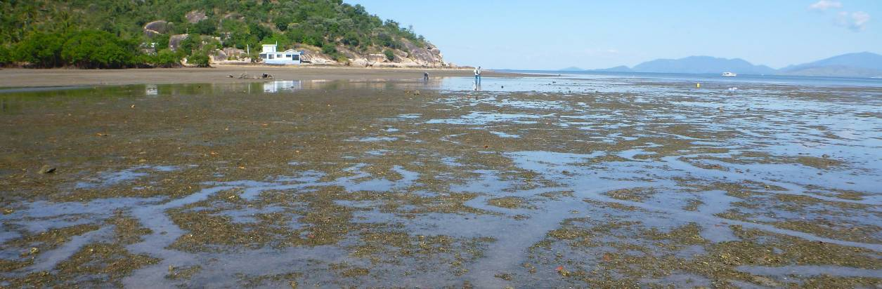

Burdekin

2011/12 Summary
Seagrass meadows in the Burdekin region are primarily structured by wind induced turbidity (resuspension) in the short term and by episodic riverine delivery of nutrients and sediment in the medium time scale. Disturbance from wave action, sediment movement and elevated temperatures are also dominant influences. Nutrient loadings in reef habitats are generally low: primarily nitrogen limited with secondary phosphate limitation. Rainfall in the region is lower than other regions within tropical Queensland. Seagrass abundance in coastal habitats remained low (unchanged) from declines in early 2011, however, abundance at reef habitats increased; primarily a consequence of the proliferation of the colonising seagrass species Halophila ovalis. Seagrass reproductive status declined in coastal habitats, which also manifested in the further decline in meadow extent in 2011/12. Conversely, reproductive status increased in intertidal reef habitats, primarily a consequence of colonising seagrasses, which was reflected in the increased meadow extent. Seed banks remained unchanged in reef habitats, but increased in coastal habitats, suggesting an improved capacity to recover once conditions are suitable. Seagrass tissue nutrients in late 2011 were similar across habitats, suggesting P and N surplus to C requirements. The nutrient ratios indicated elevated nitrogen, suggesting anthropogenic N influences such as fertiliser, although there appeared some sewage influence at Magnetic Island. Epiphytes in coastal habitats remained high on average over the monitoring period, but at reef habitats either declined slightly or remained unchanged. Adequate light was available for growth across the period as the light environment improved, although there was limited data for coastal habitats due to equipment failure. Extreme water temperatures were recorded within the seagrass canopy over the monitoring period during April 2012, and temperatures across all habitats were slightly warmer in 2011/12 than 2010/11. Climate across the region was on average wetter, with clearer skies and calmer seas than the previous monitoring period. The high rainfall resulted in the 6th consecutive year that the discharge from the Burdekin River was above median flow. Overall the status of seagrass condition in the Burdekin region improved slightly in 2011/12, but still remained very poor (Table 23).
Table 23. Report card for seagrass status (community & environment) for the Burdekin region: July 2011 – May 2012.
Values are indexed scores scaled from 0-100; ■ = very good (80-100), ■ = good (60 - <80), ■ = moderate (40 - <60), ■ = poor (20 - <40), ■ = very poor (0 - <20).
Habitat | Abundance | Reproductive  Effort | Nutrient status  (C:N ratio) | Seagrass  Index
reef intertidal | 19 | 38 | 28 | 28
coastal intertidal | 3 | 0 | 14 | 6
estuarine intertidal | not monitored
Burdekin | 11 | 19 | 21 | 17

Background
The Burdekin region, includes an aggregation of the Burdekin, Don, Haughton and Ross River catchments and several smaller coastal catchments, all of which empty into the Great Barrier Reef lagoon (Commonwealth of Australia 2013a). Because of its geographical location, rainfall in the region is lower than other regions within tropical Queensland. Annual rainfall averages approximately 1,150 mm from on average 91 rain days. However, there is considerable variation from year-to-year due to the sporadic nature of tropical lows and storms. Approximately 75% of the average annual rainfall is received during December to March (Scheltinga and Heydon 2005).
Major threats to seagrass meadows in the region include: coastal development (reclamation); changes to hydrology; water quality declines (particularly nutrient enrichment or increased turbidity); downstream effects from agricultural (including sugarcane, horticultural, beef), industrial (including refineries) and urban centres (Scheltinga and Heydon 2005; Haynes et al. 2001). All four generalised seagrass habitats are present within the Burdekin region, and Reef Rescue MMP monitoring occurs at both coastal and reef seagrass habitat locations.
The coastal sites are located on naturally dynamic intertidal sand flats and are subject to sand waves and erosion blowouts moving through the meadows. The Bushland Beach and Shelley Beach area (Figure 85) is a sediment deposition zone, so the meadow must also cope with incursions of sediment carried by long shore drift. Sediments within this habitat are mud and sand that have been delivered to the coast during the episodic peak flows of the creeks and rivers (notably the Burdekin) in this area. While episodic riverine delivery of freshwater nutrients and sediment is a medium time scale factor in structuring these coastal seagrass meadows, it is the wind induced turbidity of the costal zone that is likely to be a major short term driver (Figure 84). In these shallow coastal areas waves generated by the prevailing SE trade winds are greater than the depth of water, maintaining elevated levels of suspended sediments, limiting the amount of light availability for photosynthesis during the trade season. Intertidal seagrasses can survive this by photosynthesizing during periods of exposure, but must also be able to cope with desiccation. Another significant feature in this region is the influence of ground water. The meadows are frequented by dugongs and turtles as witnessed by feeding trails and scars.
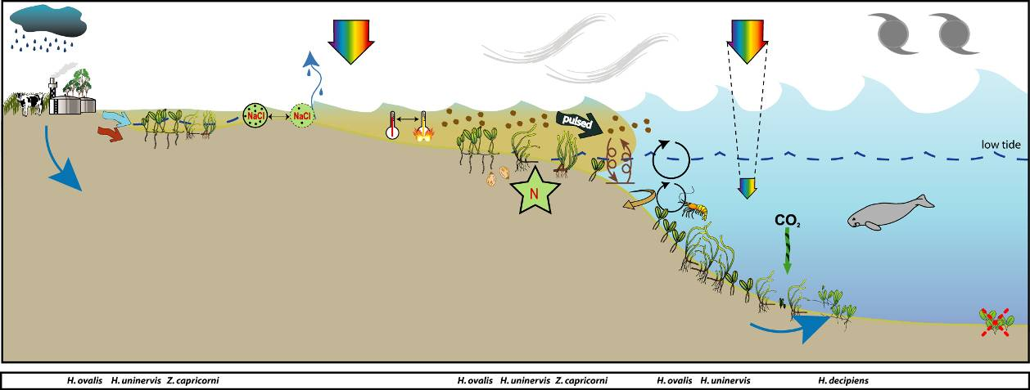
Figure 84. Conceptual diagram of coastal habitat in the Burdekin region
- major control is wind and temperature extremes, general habitat, seagrass meadow processes and threats/impacts (see Figure 4 for icon explanation).
The reef habitats are mainly represented by fringing reefs on the many continental islands within this area. Most fringing reefs have seagrass meadows growing on their intertidal flats. Nutrient supply to these meadows is by terrestrial inputs via riverine discharge, re-suspension of sediments and groundwater supply (Figure 86).
Figure 85. Location of Burdekin region long-term monitoring sites in coastal (Bushland Beach and Shelley Beach) and reef (Picnic Bay and Cockle Bay, Magnetic Island) habitats, and the seagrass species composition at each site.
The meadows in reef habitats are typically composed of zones of seagrasses: Cymodocea serrulata and Thalassia hemprichii often occupy the lower intertidal/subtidal area, blending with Halodule uninervis (wide leaved) in the middle intertidal region. Halophila ovalis and Halodule uninervis (narrow leaved) inhabit the upper intertidal zone. Phosphate is often the nutrient most limiting to reefal seagrasses (Short, et al. 1990;Fourqurean, et al. 1992b). Experimental studies on reef top seagrasses in this region however, have shown seagrasses to be nitrogen limited primarily with secondary phosphate limitation, once the plants have started to increase in biomass (Mellors 2003). In these fringing reef top environments fine sediments are easily resuspended by tidal and wind generated currents making light availability a driver of meadow structure.
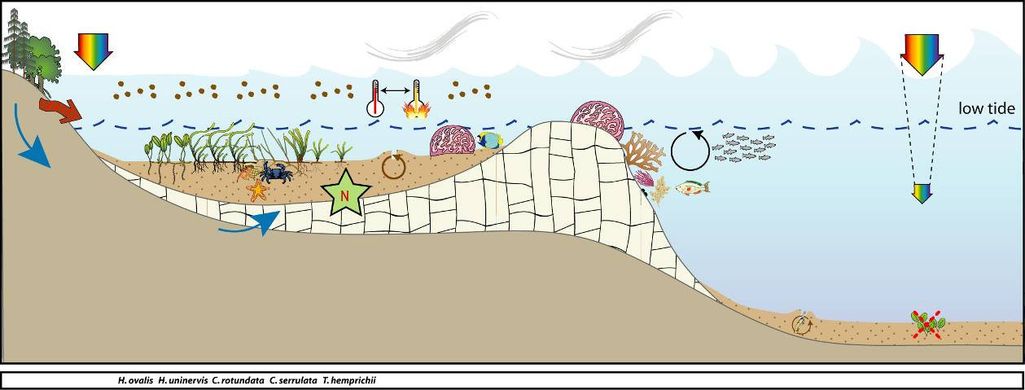
Figure 86. Conceptual diagram of fringing reef habitat in the Burdekin region
- major control is nutrient supply (groundwater), light and shelter: general habitat and seagrass meadow processes (see Figure 4 for icon explanation).

Status of the seagrass community
The overall condition of inshore seagrass in the Burdekin region remained very poor in 2011/12, despite increases in all indicators (Figure 87). The nutrient content of seagrass tissue was the only indictor which improved from very poor in 2010/11 to poor in 2011/12.
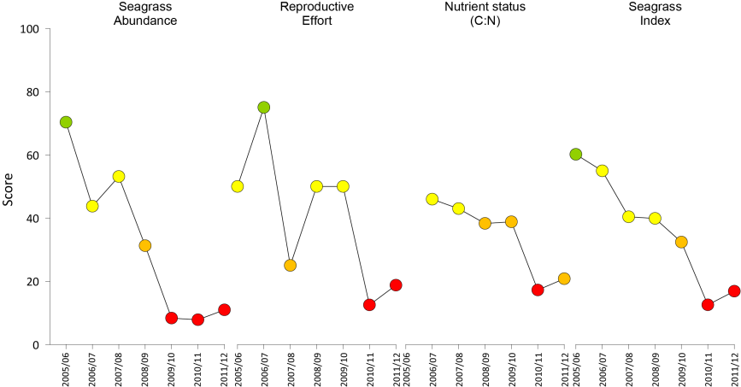
Figure 87. Report card of seagrass status indicators and index for the Burdekin NRM region
(averaged across sites). Values are indexed scores scaled from 0-100; ■ = very good (80-100), ■ = good (60 - <80), ■ = moderate (40 - <60), ■ = poor (20 - <40), ■ = very poor (0 - <20).

Seagrass abundance and composition

Coastal habitat
Meadows at coastal sites adjacent to Townsville (Bushland Beach and Shelley Beach) remained dominated by Halodule uninervis with small amounts of Halophila ovalis over the 2011/12 period (Figure 85). Seagrass cover has decreased at both sites since 2009 and the meadows were either absent or only a few isolated shoots remained after TC Yasi in February 2011 (Figure 88). Seagrass cover remained below 1% throughout the 2011/12 period, with little evidence of recovery.
Figure 88. Changes in mean seagrass abundance (% cover ±Standard Error) at inshore intertidal coastal habitats in the Burdekin region from 2001 to 2012.
Trendline is 3rd order polynomial, 95% confidence intervals displayed, r² = 0.648.
Since monitoring was established, both Bushland Beach and Shelley Beach have displayed a seasonal pattern in seagrass cover; high in monsoon and low in the dry season (Figure 89).
The recently established sites in Bowling Green Bay were a mixture of H. uninervis dominated, or Zostera muelleri dominated (Figure 85). Mean seagrass abundance was below 7% cover at both sites in April 2012 (JR1 = 6.7±0.6%, JR2 = 1.7±0.3%).
Figure 89. Mean percentage seagrass cover (all species pooled) (± Standard Error) at inshore intertidal coastal habitat long-term monitoring sites at time of year.
NB: Polynomial trendline for all years pooled.

Inshore reef habitat
Intertidal reef habitats are monitored on the fringing reef platforms of Magnetic Island, which during the 2011/12 monitoring period were dominated by the colonising species Halodule uninervis (Picnic Bay ) or Halophila ovalis (Cockle Bay). Since late 2009, the seagrass meadow at Cockle Bay (MI2) which was once dominated by Cymodocea serrulata and Thalassia hemprichii has undergone a state change to become dominated by H. ovalis (Figure 85). Conversely, in 2010 the species composition at Picnic Bay changed from H. ovalis to H. uninervis dominated, suggesting the meadow was recovering from disturbances in 2009/10 (Figure 85). Seagrass abundance declined to it's lowest level in early 2001 following the impacts of TC Yasi (Figure 90). Since July 2011, seagrass abundance has progressively increased, indicating the onset of recovery.
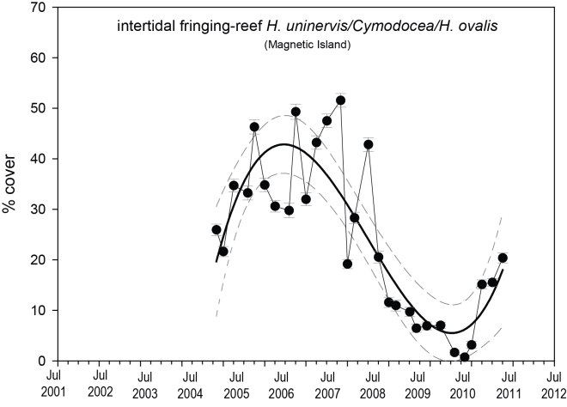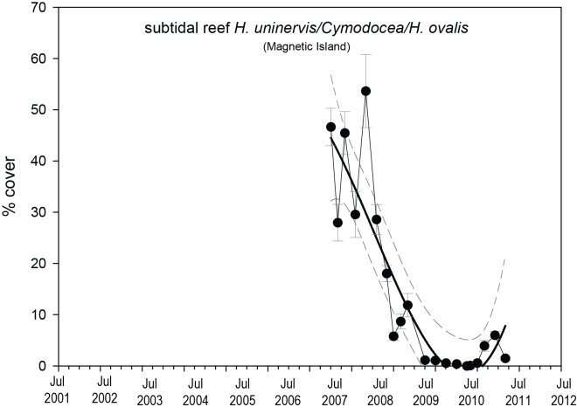
Figure 90. Changes in seagrass abundance (% cover ±Standard Error) at inshore intertidal and subtidal reef habitats in the Burdekin region from 2001 to 2012.
Trendline is 3rd order polynomial, 95% confidence intervals displayed, intertidal r² = 0.746 and subtidal r² = 0.828.
The subtidal meadow beyond the reef crest on the eastern side of the bay was a dense (48% cover) mixed species meadow of H. uninervis, C. serrulata, and H. spinulosa when monitoring began in January 2008. After considerable intra-annual variability in 2008, density has continued to decline, with large reductions in seagrass cover occurring during the wet seasons to a low of 0% cover in April 2011. These losses were associated with extreme low light conditions (Collier, et al. 2012b). However, during the 2011/2012 monitoring period, cover increased from 0% to 2% of mixed species (largely H. uninervis and H. decipiens). This increase was likely due to germination from seed, as seedlings, in some cases with seeds attached, were found within the monitoring site.
Since monitoring was established, all reef habitat sites have displayed a seasonal pattern in seagrass cover; high in late dry-monsoon and low in the dry season (Figure 91, Figure 92).
Figure 91. Mean percentage seagrass cover (all species pooled) (± Standard Error) at inshore intertidal reef habitat (Magnetic Island) long-term monitoring sites at time of year.
NB: Polynomial trendline for all years pooled.
Figure 92. Mean percentage seagrass cover (all species pooled) (± Standard Error) at inshore subtidal reef habitat (Magnetic Island) long-term monitoring site at time of year.
NB: Polynomial trendline for all years pooled.

Seagrass meadows edge mapping was conducted within a 100m radius of all monitoring sites in October/November and March/April of each year to determine if changes in abundance were a consequence of the meadow edges changing (Table 24). Over the past two to three years, significant changes have occurred across the region with all seagrass meadows reducing in size and changing in landscape from continuous, to patchy, to isolated patches and finally to isolated shoots with the loss of meadow cohesion (Figure 93).
Figure 93. Extent of area (within 100m radius of monitoring site) covered by seagrass at each inshore intertidal coastal (Townsville) and reef (Magnetic Island) habitat in the Burdekin region.
Table 24. Area (ha) of seagrass meadow within 100m radius of each site.
Value in parenthesis is % change from the October 2005 baseline and description of change from previous mapping. Shading indicates decrease in meadow area since baseline.
 | Magnetic Island |  | Townsville
 | MI1 | MI2 | BB1 | SB1
October 2005  (baseline) | 2.933 | 4.104 | 5.312 | 4.303
April  2006 | 3.398  (15.9%, increase shoreward) | 4.342  (5.8, increase shoreward) | 5.312  (no change) | 3.485  (-19.1 decrease seaward)
October  2006 | 1.723  (-41.2% decrease seaward) | 4.112  (0.2, negligible) | 5.312  (no change) | 2.861  (-33.5 decrease seaward)
April  2007 | 2.587  (-11.8%, increase shoreward) | 4.141  (0.9%, increase shoreward) | 5.113  (-3.7, decrease seaward) | 3.939  (-8.5 increase shoreward)
October  2007 | 3.119  (6.3%, increase shoreward) | 4.144  (1.0%, increase shoreward) | 5.221  (-1.7,increase shoreward) | 4.529  (-5.2 increase shoreward)
April  2008 | 2.69  (-8.3%, decrease seaward) | 4.191  (2.1%, increase shoreward) | 5.08  (-4.4, decrease seaward) | 2.095  (-51.3 decrease overall)
October  2008 | 2.76  (-5.9%, increase shoreward) | 4.320  (5.3%, increase shoreward) | 5.264  (-0.9%, increase shoreward) | 1.648  (-61.7%, decrease overall)
April  2009 | 2.677  (-8.7%, decrease seaward) | 5.179  (26.2%, increase shoreward) | 2.275  (-57.2%, decrease seaward) | 1.178  (-72.6%, decrease overall)
October  2009 | 3.885  (32.4%, increase seaward) | 3.525  (-14.1%, decrease overall) | 4.645  (-12.6%, increase seaward) | 2.728  (-36.6%, increase overall)
April  2010 | 2.560  (-12.7%, decrease overall) | 2.086  (-49.2%, decrease overall) | 2.483  (-46.4%, decrease seaward) | 2.066  (-52%, decrease overall)
October  2010 | 2.287  (-22%, decrease seaward) | 3.975  (-3.2%, increase overall) | 1.116  (-79%, isolated patches) | 3.579  (-16.8%, increase overall)
April  2011 | 1.111  (-62.1%, isolated patches) | 1.146  (-72.1%, isolated patches) | 2.542  (-52.2%, isolated patches) | 0.248  (-94.2%, isolated patches)
October  2011 | 2.204  (-24.8, isolated patches) | 3.996  (-2.6, isolated patches) | 2.105  (-60.4, isolated patches) | 0.873  (-79.7, isolated patches)
April  2012 | 2.466  (-15.9, isolated patches) | 4.086  (-0.4, isolated patches) | 1.116  (-79, isolated patches) | 0.873  (-79.7, isolated patches)

Seagrass reproductive status
Seed banks remained low across the region over the monitoring period at both coastal and reef habitat (Figure 94, Figure 95). The abundance of germinated seeds at reef habitats in mid 2011 remained high, indicating recent recruitment (Figure 95). Reproductive effort overall is high for coastal sites in the Burdekin region; however, since 2010 reproductive effort has been considerably reduced compared to previous years and it was lower in 2011/12 than in 2010/11. Despite this, reproductive effort is higher in the Burdekin than in most other coastal regions, particularly during the late dry season. At subtidal sites, reproductive effort has declined only slightly since 2010 from 4.4 to 3.3 in the dry and 4.1 to 3.1 in the wet season.
c.
Figure 94. Inshore intertidal coastal habitat seed banks (a), germinated seed abundance (b), and total reproductive effort (c) in the Burdekin region.
Seed bank presented as the total number of seeds per m² sediment surface and reproductive effort presented as the average number of reproductive structures per core (all species pooled).
c.
Figure 95. Inshore intertidal reef habitat seed banks (a), germinated seed abundance (b), and total seagrass reproductive effort (c) in the Burdekin region.
Seed bank presented as the total number of seeds per m² sediment surface and reproductive effort presented as the average number of reproductive structures per core (all species pooled).
Reproductive effort across the Burdekin region is classified as very poor. This suggests that sites within the region will take longer to recover following major disturbances and may be at risk from repeated impacts.

Status of the seagrass environment

Seagrass tissue nutrients
Seagrass leaf tissue C:N ratios across the region remained below 20 in 2011 (Figure 96). Decreasing C:N ratios across the region since 2006 may indicate decreasing light availability or N loading.
Figure 96. Elemental ratios (atomic) of seagrass leaf tissue C:N for the foundation seagrass species examined at each inshore intertidal habitat in the Burdekin region each year
(species pooled)(mean ± Standard Error). Horizontal shaded band on the C:N ratio panel represents the accepted guideline seagrass “Redfield” ratio of 20:1 (Abal, et al. 1994; Grice, et al. 1996). C:N ratios below this line indicate reduced light availability and/or N enrichment.
The tissue nutrient status (tissue C:P) across region indicates that both habitats remained nutrient rich, containing a large P pool (Figure 97). The tissue N:P ratio increased across habitats in the region in 2011 due to increasing N, with the reef habitats remaining replete (well supplied and balanced macronutrients for growth) and coastal habitats becoming P-limited (Figure 97). This suggests that although a large P pool may be present, it is small relative to an increasing N pool.
Figure 97. Elemental ratios (atomic) of seagrass leaf tissue N:P and C:P for the foundation seagrass species examined at each inshore intertidal habitat in the Burdekin region each year
(species pooled) (mean ± Standard Error). Horizontal shaded band on the N:P ratio panel represents the range of value associated with N:P balance ratio in the plant tissues, i.e. a seagrass “Redfield” ratio (Atkinson and Smith 1983; Duarte 1990; Fourqurean, et al. 1992b; Fourqurean and Cai 2001). N:P ratio above this band indicates P limitation, below indicates N limitation and within indicates replete (balanced). Shaded portion on the C:P panel ≤500 represents the value associated with C:P balance ratio in the plant tissues, C:P values <500 may indicate nutrient rich habitats (large P pool).
δ¹³C values for Halodule uninervis (foundation species) and Halophila ovalis at Magnetic Island during the late dry (growing) season were above or at the global average and within global ranges (Table 25), suggesting sufficient carbon available for growth. Similarly, as %C in the H. uninervis leaves was also above the literature median values, suggests adequate light available for growth. The low C:N ratio is likely a consequence of the elevated N, where the low δ¹⁵N value in the H. uninervis leaf tissue (Table 25) suggests that their primary source of N was either from N₂ fixation or fertiliser. The slightly elevated δ¹⁵N in the H. ovalis leaf tissue suggests some sewage influence in their primary source of N.
Table 25. Seagrass leaf tissue nutrient, δ¹³C and δ¹⁵N concentrations from Burdekin locations in the late dry 2011.
Leaf tissues with low %C (see Table 37), low C:N (<20:1), and isotopically depleted δ¹³C may indicate that growth is light limited (Grice, et al. 1996; Fourqurean, et al. 2005). Shading indicates values lower than literature. HO=Halophila ovalis, HU=Halodule uninervis, TH=Thalassia hemprichii, ZM=Zostera muelleri.
Location | Species | %C | C:N | δ¹³C | δ¹⁵N | %C lit median | Global δ¹³C | season
Magnetic Is | HO | 39.5 | 13.44 | -10.8 | 1.88 | 30.5 | -10 (-15.5 to -6.4) | late dry
Magnetic Is | HU | 44.567 | 12.62 | -9.8±0.2 | 0.96±0.04 | 38.5 | -11.2 (-13.0 to -7.8) | late dry
Jerona | ZM | 39.7 | 14.90 | -13.9 | -4.87 | 32 | -10.8 (-12.4 to -9.2) | late wet
δ¹³C values for foundation species were below the global average at Jerona in the late wet season. This would be expected, as it may be a consequence of reduced growth during the onset of the senescent season, when light availability is naturally low (from the monsoon) and temperatures are declining.

Epiphytes and macroalgae
Epiphyte cover on seagrass leaf blades at coastal sites was highly variable (Figure 98) and was similar over the 2011/12 monitoring period (above GBR long-term average) compared to the previous two monitoring periods, regardless of the extremely low seagrass cover. Percentage cover of macro-algae at coastal sites has remained low over the past couple of years (Figure 98), below the GBR long-term average.
Figure 98. Mean abundance (% cover) (± Standard Error) of epiphytes and macro-algae at inshore intertidal coastal habitats in the Burdekin region (sites pooled).
Red line = GBR long-term average; epiphytes=17%, macro-algae=4.7%.
Epiphyte cover at reef habitats was similar over the 2011/12 monitoring period to the previous monitoring period, however it was slightly higher during the late dry-monsoon. Macro-algae increased above the GBR average fort he first time in 2 years. There does not appear to be any clear long-term trend in abundance (Figure 99).
Figure 99. Mean abundance (% cover) (± Standard Error) of epiphytes and macroalgae at inshore intertidal reef habitats in the Burdekin region.
Red line = GBR long-term average; epiphytes=28%, macro-algae=6.2%.
Figure 100. Mean abundance (% cover) (± Standard Error) of epiphytes and macro-algae at inshore subtidal reef habitats in the Burdekin region.
Red line = GBR long-term average; epiphytes=17%, macro-algae=4.7%.

Rhizosphere sediment herbicides
No herbicides were found above detectable limits in the sediments of the seagrass meadows in Bowling Green Bay on the 7th April 2012 (Table 26).
Table 26. Concentration of herbicides (mg kg⁻¹) in sediments of Bowling Green Bay (Barratta Creek) seagrass monitoring sites in late monsoon 2012.
ND=not detectable above limit of 0.001 mg kg⁻¹.
Site | Flumeturon | Diuron | Simazine | Atrazine | Desethyl Atrzine | Desisopropyl Atrzine | Hexazinone | Tebuthiuron | Ametryn | Prometryn | Bromacil | Imidacloprid | Terbutryn | Metolachlor
JR1 | ND | ND | ND | ND | ND | ND | ND | ND | ND | ND | ND | ND | ND | ND
JR2 | ND | ND | ND | ND | ND | ND | ND | ND | ND | ND | ND | ND | ND | ND

Within meadow canopy temperature
Within canopy water temperature was monitored at all coastal and reef-platform sites over the monitoring period (Figure 101). Extreme temperatures (>40°C) were recorded at Picnic Bay on the 3rd April 2012 when the water temperatures remained at 41.1°C for at least 30min between 2-3 pm. Mean temperatures were mostly within the 21 – 31°C range, with highest mean temperatures in February 2012 (Figure 102). At the reef subtidal site, average temperatures are almost identical to the adjacent intertidal site; however, variability is considerably less, with mixing ensuring that water temperature remains relatively constant. The 2011/12 monitoring period was 0.2-0.3°C warmer at reef habitats than the previous monitoring period and long-term average. Temperatures at coastal habitats were 0.5 deg warmer than the previous monitoring period and the long-term average.
Figure 101. Within seagrass canopy temperature (°C) at inshore intertidal coastal (Bushland Beach and Shelley Beach) and reef (Picnic Bay and Cockle Bay, Magnetic Island) habitats within the Burdekin region over the 2011/12 monitoring period.
Figure 102. Monthly mean and maximum within seagrass canopy temperature (°C) at inshore intertidal coastal (Bushland Beach and Shelly Beach) and reef (Picnic Bay and Cockle Bay, Magnetic Island) habitats in the Burdekin region.

Figure 103. Within seagrass canopy temperature (°C) at inshore subtidal reef habitats (Picnic Bay, Magnetic Island) within the Burdekin region over the 2011/12 monitoring period.
Figure 104. Monthly mean, maximum and minimum temperature at inshore subtidal reef habitats (Picnic Bay, Magnetic Island) within the Burdekin region.

Canopy incident light and turbidity
Light data from the coastal sites in the BDT are very patchy, due to ongoing logger and/or wiper failure. Daily irradiance (I_{d}, mol m⁻² d⁻¹) at Bushland Beach has been 5.1 mol m⁻² d⁻¹ on average and was exactly the same in 2011/12. I_{d} frequently falls below the threshold values for extended periods of time, and this was repeated in the early months of 2012 when I_{d} was <5 mol m⁻² d⁻¹ for more than 3 months. I_{d} is generally higher at Shelley Beach (8.3 mol m⁻² d⁻1, based on very few data) but falls well below the GBR average for intertidal sites (14.5 mol m⁻² d⁻¹). As for Bushland Beach, light conditions were not considerably improved in 2011/12 (8.7 mol m⁻² d⁻¹) and there has been almost no indication of seagrass recovery at these sites.
At reef sites, I_{d} was considerably higher in 2011/12 compared to previous years. At the Picnic Bay intertidal site, long-term I_{d} (is 15.6 mol m⁻² d⁻¹) is on par with the GBR long-term average (14.5 mol m⁻² d⁻¹), but it was higher in 2011/12 (19 mol m⁻² d⁻¹). Similarly, at the Cockle Bay intertidal site, I_{d} in 2011/12 (19.8 mol m⁻² d⁻¹) was higher than the long-term average for this site (17.1 mol m⁻² d⁻¹). At both sites, I_{d} fell below the 5 mol m⁻² d⁻¹ threshold for only very brief periods, and the 28-day average did not exceed the threshold at all during 2011/12. Elevated I_{d} in 2011/12 has coincided with increasing seagrass cover at these sites, however I_{d} alone – being well above thresholds, on average –cannot explain the changes in seagrass abundance including loss in previous years.
In contrast I_{d} at the reef subtidal site has been low since monitoring began, and generally hovers around the light threshold with the long-term average being 5.8 mol m⁻² d⁻¹. Lowest I_{d} has typically occurred during the wet season months. Changes in seagrass abundance, including complete seagrass loss has correlated with I_{d} (Collier, et al. 2012b). However in 2011/12, I_{d} was higher (7.5 mol m⁻² d⁻¹) and the 28-day average fell below the threshold for just periods in 2012, particularly in May 2012. This has coincided with the return of seagrass to the site, albeit at very low densities (2% compared to 0% in previous year).
Turbidity at the Picnic Bay subtidal site frequently exceeds the water quality guideline value (1.54 NTU) with large increases in turbidity occurring throughout the year, and often in association with increased river discharge, but also due to wind or tidally-driven resuspension (Fabricius et al. 2012a). In contrast, chlorophyll concentration generally sits below the guideline value (0.54 μg L⁻¹), but it does exceed the guideline for short periods, often associated with riverine discharge.
Figure 105. Daily light (28 day rolling average) at inshore intertidal reef habitats (Picnic Bay and Cockle Bay, Magnetic Island) in the Burdekin region
, also showing approximate light threshold required for positive growth in Halodule uninervis dominated communities in the northern GBR (5 mol m⁻² d⁻¹)(Collier, et al. 2012b). NB threshold is based on 90-day average.

Figure 106. Daily light (28 day rolling average) at inshore intertidal coastal habitats (Bushland Beach and Shelley Beach) in the Burdekin region
, also showing approximate light threshold required for positive growth in Halodule uninervis dominated communities in the northern GBR (5 mol m⁻² d⁻¹)(Collier, et al. 2012b). NB threshold is based on 90-day average.
Figure 107. Daily light (28 day rolling average) at inshore subtidal reef habitat (Picnic Bay, Magnetic Island) in the Burdekin region
, also showing approximate light threshold required for positive growth in Halodule uninervis dominated communities in the northern GBR (5 mol m⁻² d⁻¹)(Collier, et al. 2012b). NB threshold is based on 90 day average.

Figure 108. Turbidity (NTU, daily average) and light (daily sum, mol m⁻² d⁻¹) at inshore subtidal reef habitats (Picnic Bay, Magnetic Island) in the Burdekin region.
Figure 109. Daily mean chlorophyll concentration (green line, ɥg L⁻¹), turbidity (brown line, NTU) inshore subtidal reef habitats (Picnic Bay, Magnetic Island) in the Burdekin region.
Additional panels are daily discharge (Burdekin River, ML d⁻¹ x10⁻⁵) and daily wind speed (Townsville airport). Horizontal green and red lines are the GBR Water Quality Guidelines values (Great Barrier Reef Marine Park Authority 2009). Turbidity trigger value (1.54 NTU red line) was derived by transforming the suspended solids trigger value (see Schaffelke, et al. 2009).

Regional Climate
Climate across the Burdekin region (Townsville and Magnetic Island) in 2011/12 was cooler, wetter, and slightly calmer the previous decade.
The mean maximum daily air temperature recorded in Townsville during 2011/12 was 28.9°C; this was similar to the long-term (72 year) average and 0.5°C cooler than the decade average (Figure 110). The highest recorded daily maximum temperature in 2011/12 was 35.4°C.
Although the annual rainfall for 2011/12 was lower than the previous 3 years, it remained a wet year relative to both the last decade and the long-term (73 year) average with approximately 34% and 22% more rain, respectively (Figure 110). Cloud was 12% higher than long-term (70 year) but similar to the decadal average (Figure 110). Mean wind speed in 2011/12 was 23.8 km.hr⁻¹, this was higher than 2010/11, 14% higher than the long-term, but slightly lower than the decade average (Figure 110).
Figure 110. Mean monthly daily maximum temperature (line), total monthly rainfall (grey bars), mean monthly cloud cover (black line), and mean monthly 3pm wind speed (grey line) recorded at Townsville Airport.
Townsville Airport (BOM station 032040, source www.bom.gov.au) is located approximately 11km from coastal (Townsville) and reef (Magnetic Island) monitoring sites, and 53km from Jerona (Bowling Green Bay) monitoring sites.

River discharge
In the Burdekin region, the most significant river impacting seagrass meadows adjacent to Townsville is the Burdekin River. Modelling of the plumes associated with specific weather conditions has demonstrated that inshore areas between Townsville and Cooktown regularly experience extreme conditions associated with plumes. However, inshore areas north of the Burdekin River (including Magnetic Island) receive riverine waters on a less frequent basis, perhaps every two to three years (Wolanski and Jones 1981; Maughan et al. 2008). The Burdekin River has the largest annual exports of sediment, phosphorus and nitrogen of any catchment in the GBR, with an annual discharge of 4.6x10⁶ tonnes of fine sediment, 2,030 tonnes of phosphorus and 12,100 tonnes of nitrogen (Brodie, et al. 2009). During episodic flooding, high concentrations of dissolved nutrients are experienced off Townsville and in Bowling Green Bay, up to 50 km north of the Burdekin River mouth, for periods of up to three weeks (Maughan, et al. 2008).
The exposure of the seagrass monitoring sites adjacent to Townsville and Magnetic Island to elevated Total Suspended Solids and Chlorophyll-a was rated as high, whereas PSII herbicides were rated as low. Overall, coastal sites had a medium to high probability of exceeding the GBR WQ Guidelines in 2010 (pers. comm. Michelle Devlin, JCU).
2011/12 was the 6th consecutive year that the discharge from the Burdekin River was above median flow. Approximately 90% of the annual discharge occurred from February to April 2012, with peak discharge in March 2012 (8,965,451 ML)( Figure 111).
Figure 111. Average daily flow (ML day⁻¹) per month from the Burdekin River impacting the seagrass monitoring sites in the Burdekin region.
(DERM station 120006B - Burdekin River at Clare, 19.75856°S 147.24362°E, Elev 29m) (source The State of Queensland Department of Environment and Resource Management 2012, watermonitoring.derm.qld.gov.au).

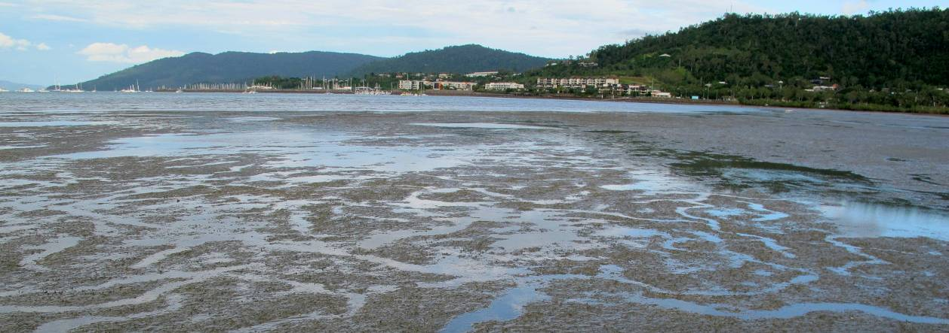

Mackay Whitsunday

2011/12 Summary
Intertidal seagrass meadows are found on the large sand/mud banks of sheltered bays and coastal fringes of the Mackay Whitsunday region; they are also present on top of the offshore fringing reefs. Key environmental drivers include exposure, desiccation and variable flood runoff during the wet season. Seagrass meadows are monitored at reef, coastal and estuarine locations in the Mackay Whitsunday region.
Seagrass abundances in coastal habitats declined throughout much of 2011, however seagrass abundance in reef and estuary habitats remained mostly unchanged at very low levels with only marginal increases in early 2012. Although seagrass reproductive status declined across the region in 2011/12, seagrass meadow extent increased in early 2012. This was primarily the result of seedlings - evident from the presence of larger numbers of germinated seeds. The increased seed banks also suggested the meadows are in a colonising mode and recovery is expected to continue.
Seagrass tissue nutrients in late 2011 were similar across habitats, suggesting P and N surplus to C requirements. The nutrient ratios indicated elevated nitrogen, suggesting anthropogenic N influences such as fertiliser, although there appeared some sewage influence at the site adjacent to the storm water drain on Hamilton Island. This was also reflected in the increased epiphyte loading across the region.
No extreme water temperatures were recorded within the seagrass canopy over the monitoring period, and temperatures overall were cooler than both the previous period and the long-term average. The canopy incident light environment was either similar or improved in 2011/12. Climate across the region was on average wetter and cloudier than the previous decade in the north, and windier in the south. The high rainfall resulted in the 6th consecutive year that the discharge from the major rivers in the region were above median flow. Overall the status of seagrass condition in the Mackay Whitsunday region improved slightly in 2011/12, but still remained very poor (Table 27).
Table 27. Report card for seagrass status (community & environment) for the Mackay Whitsunday region: July 2011 – May 2012.
Values are indexed scores scaled from 0-100; ■ = very good (80-100), ■ = good (60 - <80), ■ = moderate (40 - <60), ■ = poor (20 - <40), ■ = very poor (0 - <20).
Habitat | Abundance | Reproductive  Effort | Nutrient status  (C:N ratio) | Seagrass  Index^
reef intertidal | 13 | 0 | 11 | 8
coastal intertidal | 17 | 0 | 14 | 10
estuarine intertidal | 13 | 0 | 12 | 8
Mackay Whitsunday | 14 | 0 | 13 | 9

Background
The Mackay Whitsunday region comprises an area of almost 940,000 ha and includes the major population centres of Mackay, Proserpine, Airlie Beach and Sarina; encompassing the Proserpine, O’Connell, Pioneer and Plane Creek river systems (Commonwealth of Australia 2013d). The region’s climate is humid and tropical with hot wet summers and cool dry winters. Annual rainfall varies significantly with as much as 3000 mm a year in elevated sections of the coastal ranges. Most (~70%) of the region’s rainfall occurs between December and March. Average daily temperatures for Mackay range between 23° and 31°C in January and 11° and 22°C in July. The south-easterly trades are the prevailing winds, with occasional gale force winds occurring during cyclonic and other storm events (Mackay Whitsunday Natural Resource Management Group Inc 2005). The major industries in the Mackay Whitsunday region are agriculture and grazing, tourism, and fishing and aquaculture. Reef Plan monitoring sites are located on three of the generalised seagrass habitats represented in the region, including estuarine, coastal and reef.
Estuarine seagrass habitats in the Mackay Whitsunday region tend to be on the large shallow sand/mud banks of sheltered estuaries. Runoff through the catchments connected to these estuaries is variable, though the degrees of variability is moderate compared to the high variability of the Burdekin and the low variability of the Tully (Brodie 2004). Seagrass in this habitat must cope with extremes of flow, associated sediment and freshwater loads from December to April when 80% of the annual discharge occurs (Figure 112).
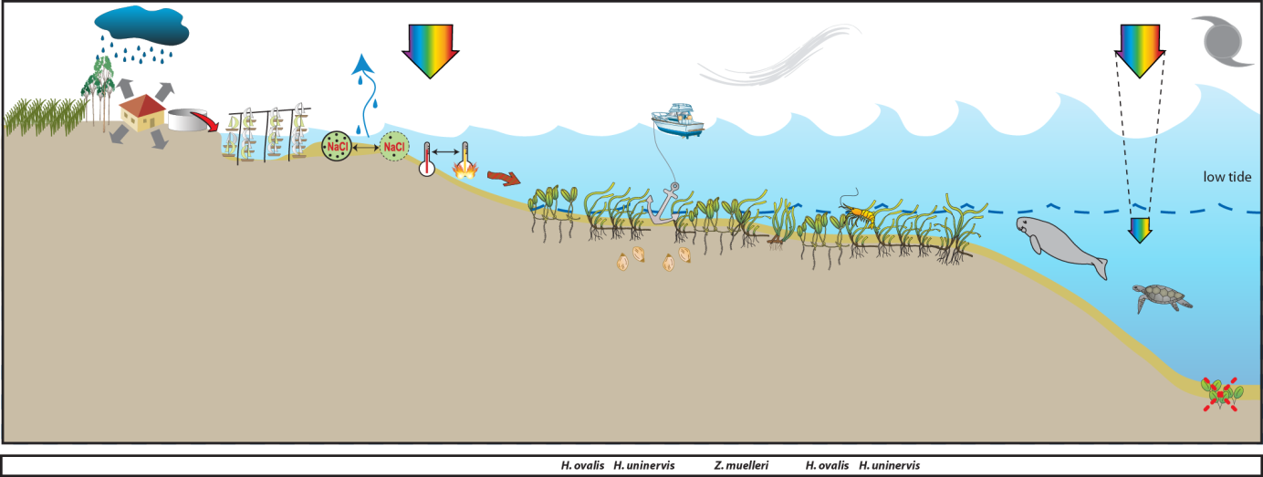
Figure 112. Conceptual diagram of estuary habitat in the Mackay Whitsunday region
: general habitat and seagrass meadow processes (see Figure 4 for icon explanation).
Coastal seagrass habitats are found in areas such as the leeward side of inshore continental islands and in north opening bays. These areas offer protection from the south-easterly trades. Potential impacts to these habitats are issues of water quality associated with urban, marina development and agricultural land use (Figure 114). Monitoring sites of intertidal coastal seagrass habitat were located on the sand/mud flats adjacent to Cannonvale in southern Pioneer Bay (Figure 113).
Figure 113. Location of Mackay Whitsunday region long-term monitoring sites and the seagrass species composition at each site.
Please note: replicate sites within 500m of each other.

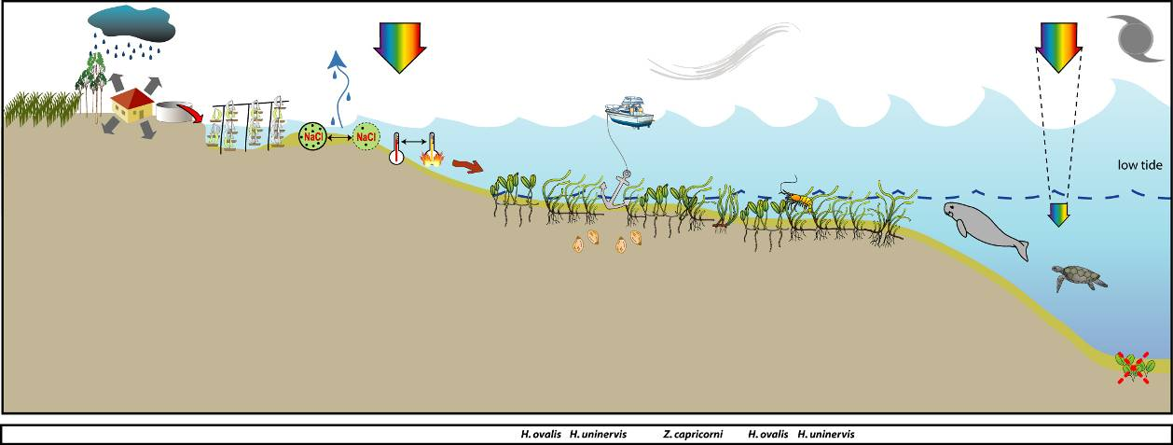
Figure 114. Conceptual diagram of coastal habitat in the Mackay Whitsunday region
– major control is shelter and temperature extremes: general habitat, seagrass meadow processes and threats/impacts (see Figure 4 for icon explanation).
Reef habitat seagrass meadows are found intertidally on the top of the coastal fringing reefs or fringing reefs associated with the many islands in this region. The drivers of these habitats is exposure, and desiccation (intertidal meadows) (Figure 115). Major threats would be increased tourism activities including marina and coastal developments.
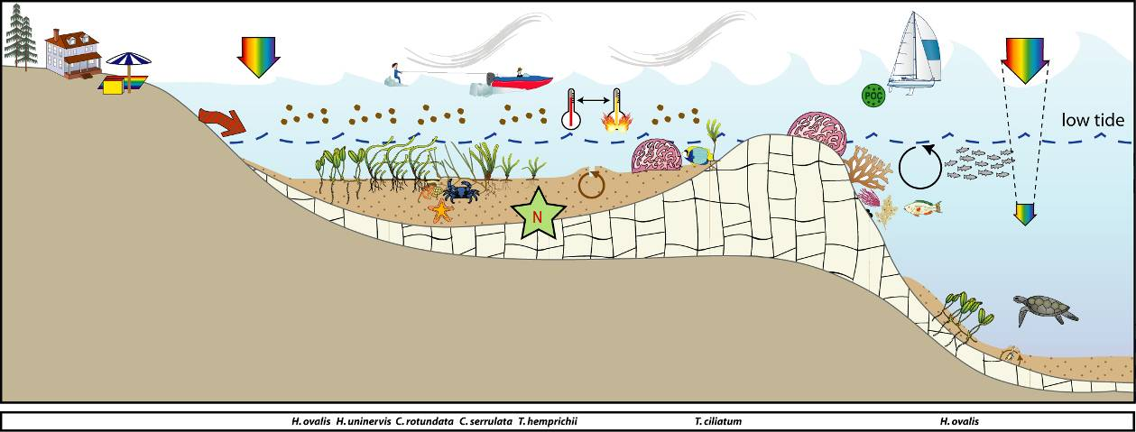
Figure 115. Conceptual diagram of reef habitat in the Mackay Whitsunday region
- major control is light and temperature extremes: general habitat, seagrass meadow processes and threats/impacts (see Figure 4 for icon explanation).

Status of the seagrass community
The overall condition of inshore seagrass in the Mackay Whitsunday region remained very poor in 2011/12, having progressively declined since monitoring began in 2005/06 (Figure 116). The very poor rating for seagrass overall is a result of very poor reproductive effort and increased nutrient enrichment of seagrass tissue across all habitats. There were modest increases in abundance at most sites. However, the very poor nutrient status of seagrass tissue reflected local water quality conditions and together with the very poor rating of reproductive effort, raises concerns about the ability of local seagrass meadows to recover from previous environmental disturbances.
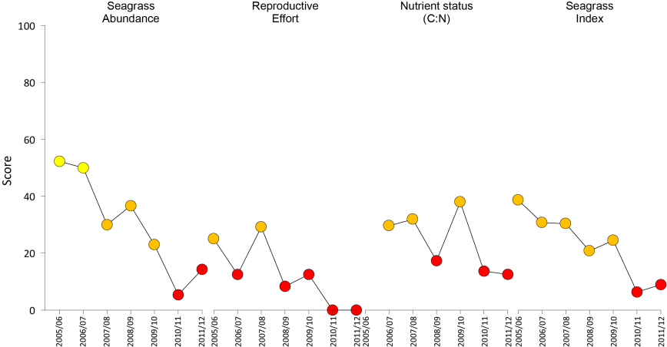
Figure 116. Report card of seagrass status indicators and index for the Mackay Whitsunday NRM region
(averaged across sites). Values are indexed scores scaled from 0-100; ■ = very good (80-100), ■ = good (60 - <80), ■ = moderate (40 - <60), ■ = poor (20 - <40), ■ = very poor (0 - <20).

Seagrass abundance and composition

Coastal habitat
The coastal seagrass monitoring sites were located on shallow sand/mud flats adjacent to Cannonvale in southern Pioneer Bay. Seagrass species and abundance has fluctuated at the coastal sites between and within years indicating disturbance regimes at longer time periods than annually (Figure 117). Abundances during the 2011 calendar year remaining at the lowest levels since 1999, however in early 2012 abundances had increased. The meadows were dominated by Halodule uninervis and Zostera muelleri mixed with Halophila ovalis. Species composition has changed over the past decade of monitoring (Figure 113), with the composition of Z. muelleri in the Pioneer Bay site 2 (PI2) fluctuating greatly. Since the late monsoon 2011, the seagrass meadows were predominately H. uninervis (Figure 113).
A seasonal pattern in abundance has continued to be observed at Pioneer Bay, with abundances increasing throughout the year to the monsoon (Figure 118).
Figure 117. Changes in seagrass abundance (% cover ±Standard Error) at inshore intertidal coastal habitats in the Mackay Whitsunday region from 1999 to 2012.
Trendline is 3rd order polynomial, 95% confidence intervals displayed, r² = 0.418.
Figure 118. Mean percentage seagrass cover (all species pooled) (± Standard Error) at inshore intertidal coastal habitat long-term monitoring sites at time of year.
NB: Polynomial trendline for all years pooled.

Estuary habitat
The estuarine monitoring sites are located on an intertidal sand/mud bank in Sarina Inlet south of Mackay. These sites are normally dominated by Zostera muelleri with some Halophila ovalis and Halodule uninervis (Figure 113). Seagrass cover has fluctuated greater since monitoring was established in early 2005, with seagrass dramatically declining in the late wet season of 2006, and recovering within 18 months, to only subsequently decline in 2008 (Figure 119). Seagrass cover increased slightly over the 2011/12 monitoring period, but still remained below 3% on average (Figure 119). Although there is insufficient spread of sampling across months within years, and the meadow state has fluctuated within and between years, the seagrass abundance appears greater in the late dry than late monsoon (Figure 120).
Figure 119. Changes in seagrass abundance (% cover ±Standard Error) at inshore intertidal estuarine habitats in the Mackay Whitsunday region from 1999 to 2012.
Trendline is 2nd order polynomial, 95% confidence intervals displayed, r² = 0.211.
Figure 120. Mean percentage seagrass cover (all species pooled) (± Standard Error) at inshore intertidal estuarine habitat (Sarina Inlet) long-term monitoring sites at time of year.
NB: Trendline for all years pooled.

Inshore reef habitat
The reef monitoring sites located on a fringing reef at Catseye Bay (Hamilton Island) were dominated by Halodule uninervis or Zostera muelleri with some Halophila ovalis (Figure 113). The site at the eastern end of Catseye Bay (HM2) was dominated by Z. muelleri and the site at the western end (HM1) was dominated by H. uninervis. Seagrass cover slightly improved over the 2011/12 monitoring period (Figure 121). Seagrass cover appears to increase during each year until the monsoon, however due to the paucity of data the seasonal pattern cannot be confirmed (Figure 122).
Figure 121. Changes in seagrass abundance (% cover ±Standard Error) at inshore intertidal reef habitats in the Mackay Whitsunday region from 1999 to 2012.
Trendline is 3rd order polynomial, 95% confidence intervals displayed, r² = 0.683.
Figure 122. Mean percentage seagrass cover (all species pooled) (± Standard Error) at inshore intertidal reef habitat (Hamilton Island) long-term monitoring sites at time of year (years pooled).
Seagrass meadow edge mapping was conducted within a 100m radius of all monitoring sites in September/October and March/April of each year (Table 28) to determine if changes in abundance were a consequence of the meadow edges changing. Over the past 12 months, meadows across the region all increased relative to the previous monitoring period (Table 28, Figure 124). The meadows on Hamilton Island expanded to their greatest extent since 2007 (Figure 123) and the estuarine meadows at Sarina Inlet nearly triple the extent of the previous period (Table 28, Figure 124).
Figure 123. Extent of area (100m radius of monitoring site) covered by seagrass at each inshore intertidal coastal (Pioneer Bay) and reef (Hamilton Is) habitats in the Mackay Whitsunday region.
Table 28. Area (ha) of seagrass meadow within 100m radius of each site.
Value in parenthesis is % change from the baseline (bold) and description of change from previous mapping. Shading indicates decrease in meadow area since baseline. NA=no data available as site not established.
 | Pioneer Bay |  | Hamilton Island |  | Sarina Inlet
 | PI2 | PI3 | HM1 | HM2 | SI1 | SI2
October 2005 (baseline) | 3.432 | 2.432 | NA | NA | 3.374 | 3.747
April  2006 | 3.534  (3.0%,  increase shoreward) | 2.026  (-16.7%, decrease shoreward) | NA | NA | 1.726  (-48.8%, decrease seaward) | 2.46  (-34. %,3 decrease shoreward)
October  2006 | 3.812  (11.1%, increase shoreward) | 3.891  (60%,  increase shoreward) | NA | NA | 4.425  (31.2%, increase shoreward) | 3.679  (-1.8%,  decrease seaward)
April  2007 | 4.193  (22.2%, increase shoreward) | 4.418  (81. %,  increase shoreward) | NA | NA | 4.092  (21.0%, increase shoreward) | 3.536  (-5.6%,  decrease seaward)
October  2007 | 4.145  (20.8%, decrease seaward) | 4.159  (71%,  decrease seaward) | 0.810 | 0.164 | 4.736  (40.4%, increase overall) | 4.739  (26.5%,  increase overall)
April  2008 | 4.068  (18.5%, decrease seaward) | 4.183  (72%,  increase shoreward) | 0.917  (13.2 %,  increase shoreward) | 0.05  (69.2%,  decrease overall) | 1.608  (52.4%, decrease overall) | 1.821  (51.4%,  decrease overall)
October  2008 | 4.094  (19.3%, increase shoreward) | 4.300  (76.8%, increase shoreward) | 0.763  (5.8 %,  decrease overall) | 0.09  (44.4%,  increase overall) | 3.58  (6.15%, increase overall) | 3.732  (0.4%,  increase overall)
April  2009 | 4.471  (30.2%, increase shoreward) | 4.430  (82.2%, negligible) | 0.687  (15.2 %, decrease overall) | 0.06  (64.1%,  decrease overall) | 1.661  (50.8%, decrease overall) | 1.409  (62.4%, decrease overall)
October  2009 | 5.247  (52.9%, increase shoreward) | 4.814  (97.9%, increase shoreward) | 0.491  (-39.4%, decrease overall) | 0.023  (-85.8%, decrease overall) | 2.467  (26.9%, increase overall) | 2.393  (36.1%,  increase overall)
April  2010 | 4.615  (34.5%, decrease seaward) | 3.539  (45.5%, decrease seaward) | 0.356  (-56%,  decrease overall) | 0.016  (-89.7%, decrease overall) | 0.698  (-253.5%, decrease overall) | 0.916  (-161.2%, decrease overall)
October  2010 | 5.071  (47.8%, increase shoreward) | 5.063  (108.2%, increase shoreward) | 0.715  (-11.7%,  increase overall) | 0.052  (-68.4%, increase overall) | 1.393  (-58.7%, increase overall) | 1.191  (-68.2%, increase overall)
April  2011 | 1.544  (-55%, decrease seaward) | 1.001  (-58.8%, decrease seaward) | 0.400  (-50.7%,  decrease overall) | 0.019  (-88.6%, decrease overall) | 0.559  (-83.4%, decrease overall) | 0.241  (-93.6%, decrease overall)
October  2011 | 1.140  (-66.8%, decrease seaward) | 0.822  (-66.2, decrease seaward) | 0.866  (6.8%, increase shoreward) | 0.038  (-76.8%, increase overall) | 3.804  (12.7%, increase overall) | 3.599  (-3.9%, increase overall)
April  2012 | 2.432  (-29.1%, increase shoreward) | 2.571  (5.7%, increase shoreward) | 1.479  (82.6%, increase shoreward) | 0.0378  (-77.2%, no change) | 2.62  (-22.4%, decrease overall) | 2.627  (-29.9%, decrease overall)
Figure 124. Extent of area (100m radius of monitoring site) covered by seagrass at inshore intertidal estuarine habitat (Sarina Inlet) monitoring sites.

Seagrass reproductive status
Seed banks across the region recovered slightly over the 2011/12 monitoring period (except at reef sites) (Figure 125, Figure 126). However, reproductive structure remained low, which is consistent with the low abundance throughout the Mackay Whitsunday region.
c.
Figure 125. Inshore intertidal coastal habitat seed banks (a), germinated seed abundance (b), and total reproductive effort (c) in the Mackay Whitsunday region.
Seed bank presented as the total number of seeds per m² sediment surface and reproductive effort presented as the average number of reproductive structures per core (all species pooled).

c.
Figure 126. Inshore intertidal estuary habitat seed banks (a), germinated seed abundance (b), and total reproductive effort (c) in the Mackay Whitsunday region.
Seed bank presented as the total number of seeds per m² sediment surface and reproductive effort presented as the average number of reproductive structures per core (all species pooled).
Figure 127. Inshore intertidal reef habitat total reproductive effort in the Mackay Whitsunday region.
Reproductive effort presented as the average number of reproductive structures per core (all species pooled).
Reproductive effort across the whole Mackay Whitsunday region is classified as very poor in 2011 and declining compared to previous years. This suggests that sites within the region will take longer to recover following larger scale disturbance and may be at risk from repeated impacts.

Status of the seagrass environment

Seagrass tissue nutrients
Seagrass tissue C:N ratios in the Mackay Whitsunday region have all remained below 20 since 2007 (Figure 128), and all changed little in 2011 compared to 2010, indicating reduced light availability or possibly elevated N.
Figure 128. Elemental ratios (atomic) of seagrass leaf tissue C:N for the foundation seagrass species examined at each inshore intertidal habitat in the Mackay Whitsunday region each year
(species pooled) (mean ± Standard Error). Horizontal shaded band on the C:N ratio panel represents the accepted guideline seagrass “Redfield” ratio of 20:1 (Abal, et al. 1994; Grice, et al. 1996). C:N ratios below this line may indicate reduced light availability and/or N enrichment.
The C:P ratios of foundation seagrass species in the Mackay Whitsunday region all remained below 500 in 2011 across all habitats (Figure 129). This indicates meadows have a relatively large P pools (nutrient rich). N:P ratios within the Mackay Whitsunday region increased across all habitats in 2011 indicating elevated N, however there is no consistent long-term trend (Figure 129). In 2010, N:P ratios all increased to either above 25 or 30, indicating plants were either replete (well supplied and balanced macronutrients for growth) or possibly P limited.
Figure 129. Elemental ratios (atomic) of seagrass leaf tissue N:P and C:P for the foundation seagrass species examined at each inshore intertidal habitat in the Mackay Whitsunday region each year
(species pooled) (mean ± Standard Error). Horizontal shaded band on the N:P ratio panel represents the range of value associated with N:P balance ratio in the plant tissues, i.e. a seagrass “Redfield” ratio (Atkinson and Smith 1983; Duarte 1990; Fourqurean, et al. 1992b; Fourqurean and Cai 2001). N:P ratio above this band indicates P limitation, below indicates N limitation and within indicates replete (balanced). Shaded portion on the C:P panel ≤500 represents the value associated with C:P balance ratio in the plant tissues, C:P values <500 may indicate nutrient rich habitats (large P pool).
δ¹³C values for foundation species at reef (Hamilton Island) and estuarine (Sarina Inlet) habitats during the late dry (growing) season were all above the global average and within global ranges (Table 17), suggesting sufficient carbon available for growth. Similarly, as %C in the leaves was also above the literature median values, suggests adequate light available for growth. The low C:N ratio is likely a consequence of the elevated N, where the low δ¹⁵N value in the leaf tissue of Zostera muelleri (Table 17) suggests that their primary source of N was either from N₂ fixation or fertiliser. The slightly elevated δ¹⁵N in the leaf tissue of Halodule uninervis suggests sewage may contribute to the primary source of N, which would be likely as the H. uninervis meadow is immediately adjacent to several storm water drains from the main resort.
Table 29. Seagrass leaf tissue nutrient, δ¹³C and δ¹⁵N concentrations from Mackay Whitsunday locations in the late dry 2011.
Leaf tissues with low %C (see Table 37), low C:N (<20:1), and isotopically depleted δ¹³C may indicate that growth is light limited (Grice, et al. 1996; Fourqurean, et al. 2005). Shading indicates values lower than literature. HU=Halodule uninervis, ZM=Zostera muelleri.
Location | Species | %C | C:N | δ¹³C | δ¹⁵N | %C lit median | Global δ¹³C
Hamilton Island | HU | 45.4 | 9.81 | -10.2 | 1.44 | 38.5 | -11.2 (-13.0 to -7.8)
Hamilton Island | ZM | 42.5 | 13.77 | -9.3 | 0.74 | 32 | -10.8 (-12.4 to -9.2)
Sarina Inlet | ZM | 43.14 | 12.05 | -10.0±0.1 | 0.59±0.26 | 32 | -10.8 (-12.4 to -9.2)

Epiphytes and macro-algae
Epiphyte cover on seagrass leaf blades was variable within years, but was generally higher in 2011/12 than the previous 3-4 years (Figure 130, Figure 131, Figure 132). Although epiphyte cover appears seasonal, with higher abundance in the late monsoon of each year, cover at coastal sites over the 2011/12 period was the highest reported in a decade (Figure 130). Epiphyte cover increased above the GBR habitat average at the estuarine sites (Sarina Inlet) for the first time in two years in early 2012 (Figure 131).
Percentage cover of macro-algae at all habitats during the 2011/12 monitoring period remained below the GBR long-term average for each respective habitat (Figure 130, Figure 131, Figure 132).
Figure 130. Mean abundance (% cover) (± Standard Error) of epiphytes and macro-algae at inshore intertidal coastal habitat (Pioneer Bay) in the Mackay Whitsunday region.
Red line = GBR long-term average; epiphytes=17%, macro-algae=4.7%.
Figure 131. Mean abundance (% cover) (± Standard Error) of epiphytes and macro-algae at inshore intertidal estuarine habitat (Sarina Inlet) in the Mackay Whitsunday region.
Red line = GBR long-term average; epiphytes=25%, macro-algae=3.2%.
Figure 132. Mean abundance (% cover) (± Standard Error) of epiphytes and macro-algae at inshore intertidal reef habitat (Hamilton Island) in the Mackay Whitsunday region.
Red line = GBR long-term average; epiphytes=28%, macro-algae=6.2%.

Within meadow canopy temperature
Temperature loggers were deployed at all sites monitored in the region (Figure 133). Unfortunately, no data is available at Hamilton Island between November 2011 and February 2012 due to logger failure. Within canopy temperature at coastal and estuarine locations (Figure 133) generally follows a similar pattern. No extreme temperatures (>40°C) were recorded over the last 12 months. Maximum temperatures peaked several times throughout the year at all locations, generally during the time of low spring tide (Figure 133). The highest within canopy temperature was 36.7°C, recorded at Pioneer Bay on the 5th March 2012 between 2:00 - 3:00pm and at Sarina Inlet on the 6^{t}h February 2012 between 5:00 - 6:00pm. Within canopy temperatures across the region were cooler than both the previous period and the long-term averages.
Mean within canopy temperatures monitored at Pioneer Bay were within the 20 – 30°C range, with highest mean temperatures in February 2012. Over the 2011/12 period, temperatures at Pioneer Bay were 0.2-0.3°C cooler than both the long term and 2010/11.Hamilton Island within canopy temperatures were slightly lower within the 20-28°C range and highest temperatures in March 2012. At Sarina Inlet, within canopy temperatures were slightly cooler within 18-29°C range and the warmest month on average was February 2012, similar to Pioneer Bay (Figure 134). Within canopy temperatures on average were 0.3°C cooler over the last monitoring period than the previous monitoring period.
Figure 133. Within seagrass canopy temperature (°C) at inshore intertidal coastal (Pioneer Bay), estuarine (Sarina Inlet) and reef (Hamilton Island) habitats in the Mackay Whitsunday region over the 2011/12 monitoring period.
Figure 134. Long-term monthly mean and maximum within seagrass canopy temperature (°C) at inshore intertidal coastal (Pioneer Bay), reef (Hamilton Island) and estuarine (Sarina Inlet) habitats in the Mackay Whitsunday region.

Canopy incident light
Light data from the Mackay Whitsunday region were patchy, particularly for the estuarine and coastal sites where logger/wiper failure can occur, but loggers also often disappear, possibly due to tampering by the public. At Pioneer Bay, I_{d} was on average 8.6 mol m⁻² d⁻¹ which slightly above the long-term average (8.1 mol m⁻² d⁻¹), but considerably lower than intertidal average for the GBR (14.5 mol m⁻² d⁻¹). During the 2010 wet season, average I_{d} was below MLR for an extended period (4 months) (Error! Reference source not found.). This is consistent with large declines in seagrass percent cover during the 2010 wet season. At Sarina Inlet, I_{d} is on average 12.3 mol m⁻² d⁻¹ and during 2011/12 was 16.2 mol m⁻² d⁻¹ but there is insufficient data to relate light with changes in seagrass abundance (Error! Reference source not found.).
At Hamilton Island, I_{d} is consistently high, being, on average, 16.7 mol m⁻² d⁻¹ and this continued during 2011/12 being 16.9 mol m⁻² d⁻¹ (Figure 135). There was a short reduction in I_{d} in the late 2010/11 wet season but this was just a short aberration with highest recorded I_{d} following in November 2011.

Figure 135. Daily light (28 day rolling average) at the inshore intertidal coastal (Pioneer Bay), estuary (Sarina Inlet) and reef (Hamilton Island) habitats in the Mackay Whitsunday region
, also showing approximate light threshold required for positive growth in Halodule uninervis dominated communities in the northern GBR (5 mol m⁻² d⁻¹)(Collier, et al. 2012b). NB: threshold is based on 90-day average.

Regional Climate
Climate across the Mackay Whitsunday region during the 2011/12 monitoring period was in general cooler than experienced over the previous decade. In the north it was also wetter and cloudier, but in the south it was winder than the north relative to the previous decade.

Inshore coastal habitats (Pioneer Bay)
The closest meteorological station to Pioneer Bay is Proserpine airport (27.4km). The mean maximum daily air temperature recorded at Proserpine during 2011/12 was 28.5°C, this was similar to both the decadal and long-term (24 year) averages (Figure 137). The highest recorded daily maximum temperature in 2011/12 was 35.8 °C.
2011/12 was a dry year with total rainfall (1766mm) lower than the previous 4 periods (Figure 137). Mean wind speed in 2011/12 was 21.9 km.hr⁻¹, which was higher than 10/11, similar to the long-term (22 year), but 23% lower than the decadal average. 2011/12. Mean cloud cover was also higher 13% and 6% in 2011/12 than both the decadal and long-term (22 year) averages, respectively (Figure 137).
Figure 136. Total monthly rainfall (grey bars) (post December 2004), mean monthly daily maximum temperature (black line), mean monthly cloud cover (black line), and mean monthly 3pm wind speed (grey line) for coastal habitats in Pioneer Bay.
Rainfall recorded at Proserpine Post Office (BOM station 33316, source www.bom.gov.au), located 18km from Pioneer Bay monitoring sites. All other recordings from Hamilton Island (BOM station 033106, source www.bom.gov.au), approximately 28km from Pioneer Bay monitoring sites.

Inshore reef habitats (Hamilton Island)
The mean maximum daily air temperature recorded at Hamilton Island during 2011/12 was 25.9°C. Although similar to the previous period, it was 0.6°C and 0.8°C cooler than decadal and long-term (17yrs) averages, respectively (Figure 137). The highest recorded daily maximum temperature in 2011/12 was 32.8 °C.
2011/12 was a wet year (1642mm), with 17% more rain than the decadal average. It was however 9% drier than the long-term (26yrs) and was approximately half the annual total of the previous period (Figure 137). Mean wind speed in 2011/12 was 29.5 km.hr⁻¹, this was on average 8% lower than the previous decade and 7% higher than the long-term (17 year) (Figure 137).
Figure 137. Mean monthly daily maximum temperature (line), total monthly rainfall (bar), mean monthly cloud cover (heavy line), and mean monthly 3pm wind speed recorded at Hamilton Island, located 1.5km from monitoring sites.
Source: BOM station 033106, www.bom.gov.au.

Inshore estuarine habitats (Sarina Inlet)
The mean maximum daily air temperature recorded in Mackay (27km from monitoring location) during 2011/12 was 26.9°C, this was 1.0°C warmer than 10/11, 0.5°C cooler than decade, and similar to long-term (62yrs) average. The highest recorded daily maximum temperature in 2011/12 was 34.2°C.
Rainfall in Mackay in 2011/12 (1447mm) was half that of 2010/11, but similar to decade and long-term (63yrs) averages (Figure 138). In 2011/12 the Plane Creek Sugar Mill (9.5km from monitoring location) reported the second highest rainfall (2421mm) in the last 2 decades. Although lower than the 2010/11 total rainfall (3569mm), it was 40% higher than the 100 year average (1711mm). Cloud cover at Mackay was lower than the previous period, but similar to decade and long-term (60yrs) averages. Mean wind speed at Mackay in 2011/12 (24.8 km.hr⁻¹), which was on average much higher (42%) than 2010/11, the decade (9%) and long-term (13%) wind speeds (Figure 138).
Figure 138. Mean monthly daily maximum temperature (black line), total monthly rainfall (grey bars), mean monthly cloud cover (black line), and mean monthly 3pm wind speed (grey line) for Sarina Inlet monitoring sites.
Total monthly rainfall recorded at Plane Creek Sugar Mill (BOM station 033059, source www.bom.gov.au), located 10km from Sarina Inlet monitoring sites. Temperature, cloud cover, and wind speed recorded at Mackay Airport (BOM station 033045, source www.bom.gov.au), approximately 28km from Sarina Inlet monitoring sites.

River discharge
Several large rivers discharge into the coastal waters of the Mackay Whitsunday and during floods their plumes extend to locations where seagrass monitoring sites occur. In the north, primary-secondary flood waters from the Proserpine and O'Connell Rivers extend from Repulse Bay to include Hamilton Island (50 km to the north) and secondary-tertiary flood waters extend to Pioneer Bay (85 km to the north). No major river discharges into Sarina Inlet where the estuarine seagrass monitoring sites are located, and there was no flow data available for Plane Creek which flows into the Inlet. However it could be expected that flows from the Pioneer River during floods could travel south for some extent to expose Sarina Inlet (30 km to the south) to primary-secondary plumes.
The exposure of the seagrass monitoring sites to elevated Total Suspended Solids was rated as medium in 2010, whereas chlorophyll-a and PSII herbicide exposure was rated as high. Overall, the probability of exceeding the GBR WQ Guidelines for chlorophyll-a at estuarine sites was high, reef sites was medium-high and coastal sites was medium (pers. comm. Michelle Devlin, JCU).
The period 2011/12 was the 6th consecutive year above median volumes of freshwater were discharged from the major rivers in the region. The estimated volume discharged from the Proserpine River over the monitoring period was 50,817 ML, where 88% of the volume discharged occurred between February and April 2012, with the greatest average flows in March (1,028 ML day⁻¹) (Figure 139).
The 2011/12 volumes discharged from the O'Connell and Pioneer Rivers was just under half the volume discharged in 2010/11. Between 77 - 90% of total volume discharged from the O'Connell and Pioneer Rivers respectively occurred between January and March 2012, with the greatest discharges in March (Figure 139, Figure 140).
Figure 139. Average daily flow (ML day⁻¹) per month from the main rivers impacting coastal and reef seagrass monitoring sites in the Mackay Whitsunday region
(DERM station 122005A - Proserpine River at Proserpine, 20.39166667°S 148.59833333°E, Elev 7m; 124001B - O'Connell River at Stafford's Crossing 20.65255556°S 148.573°E, Elev:0m) (source The State of Queensland (Department of Environment and Resource Management) 2012, watermonitoring.derm.qld.gov.au).

Figure 140. Average daily flow (ML day⁻¹) per month from the main river impacting estuarine seagrass monitoring sites in the Mackay Whitsunday region
(DERM station 125016A - Pioneer River at Dumbleton Weir T/W 21.14236111°S 149.07625°E, Elev 10m) (source ©The State of Queensland (Department of Environment and Resource Management) 2012, watermonitoring.derm.qld.gov.au).

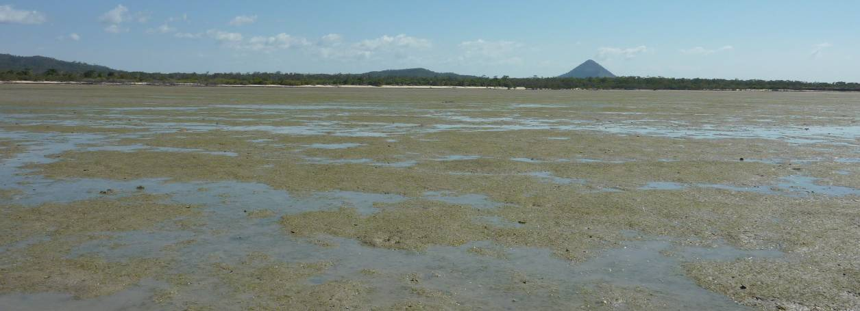

Fitzroy

2011/12 Summary
Intertidal seagrass meadows in the Fitzroy region are located on the large sand/mud banks in sheltered areas of the region’s estuaries and coasts, and occur on the fringing reef flat habitats of offshore islands. All three habitat types are monitored. Environmental drivers include high turbidity and desiccation (which is linked primarily to the large tide regime).
Although seagrass abundance was low at reef habitats prior to the extreme weather events of 2011, it remained low throughout 2011/12 and meadow extent declined. The extent of the meadows in coastal and reef habitats remained stable in 2011/12, however seagrass abundance declined in the coastal meadows and increased in estuarine meadows. The decline in the coastal meadows may be a consequence of local scale disturbances, evident by the increase of the colonising species Halophila ovalis. The seagrass abundances observed at the estuarine meadows in 2011/12 were some of the highest recorded since monitoring was established in the region. Although reproductive health declined relative to the previous monitoring period, an increase in the seed banks at estuary and coast locations indicates a high recovery potential. Seed banks remain absent at reef sites, which coupled with very poor reproductive health, suggests these meadows are struggling to recover and remain vulnerable.
Seagrass leaf tissue nutrients varied between habitats across the region. Seagrass tissue ratios suggest N limitation in estuary habitats, while P and N were surplus to C requirements in coast and reef habitats. The primary source of elevated nitrogen in coastal habitats was possibly anthropogenically influenced by fertiliser. Epiphyte abundance remained relatively unchanged, except on reef habitats where it increased to pre-2010 values. Adequate light was available for growth at coastal habitats, however there was limited data for reef and estuarine habitats due to equipment failure.
Extreme water temperatures (>38°C) were recorded within the seagrass canopy over the monitoring period across the region, with the highest in March 2012, however temperatures were on average cooler in 2011/12 than 2010/11. Climate across the region was on average wetter nearshore and windier at the reef habitats than the previous decade. Higher rainfall across the catchments resulted in 2011/12 being the 3rd consecutive period where the total discharge from the major rivers was above the long-term median. Overall the status of seagrass condition in the Burdekin region improved slightly in 2011/12, but still remained poor (Table 30).

Table 30. Report card for seagrass status (community & environment) for the Fitzroy NRM region: July 2011 – May 2012.
Values are indexed scores scaled from 0-100; ■ = very good (80-100), ■ = good (60 - <80), ■ = moderate (40 - <60), ■ = poor (20 - <40), ■ = very poor (0 - <20).
Habitat | Abundance | Reproductive  Effort | Nutrient status  (C:N ratio) | Seagrass  Index
reef intertidal | 6 | 25 | 17 | 16
coastal intertidal | 25 | 0 | 46 | 24
estuarine intertidal | 47 | 25 | 87 | 53
Fitzroy | 31 | 17 | 50 | 33

Background
The Fitzroy region covers an area of nearly 300,000 km². It extends from Nebo in the north to Wandoan in the south, and to the Gemfields in the west and encompasses the major systems of the Fitzroy, Boyne, and Calliope rivers as well as the catchments of the smaller coastal streams of the Capricorn and Curtis Coasts (Commonwealth of Australia 2013c). The Fitzroy River is the largest river system running to the east coast of Australia. The Boyne and Calliope Rivers drain the southern part of the region, entering the GBR lagoon at Gladstone. The region covers ten percent of Queensland’s land area and is home to approximately 200,000 people. It is one of the richest areas in the state in terms of land, mineral and water resources and supports grazing, irrigated and dryland agriculture, mining, forestry and tourism land uses (Christensen et al. 2006). Agricultural production constitutes the largest land use in Central Queensland, with nearly 90% of the land under agricultural production. Concomitant with this land use is the usual concern of the quality of the water that is entering the GBR lagoon. While streams further north deliver water to the lagoon every year, about once per decade the Fitzroy floods to an extent that affects the Reef. However, the smaller annual flows deliver sediments and nutrients affecting coastal habitats.
The Fitzroy region experiences a tropical to subtropical humid to semi arid climate. Annual median rainfall throughout the region is highly variable, ranging from about 600 mm annually at Emerald to more than 800 mm along the coast, and over 1000mm in the north, where coastal ranges trap moist on-shore airflow. Most rain falls in the summer, with many winters experiencing no rain at all. Because of the tropical influence on rainfall patterns, heavy storms can trigger flash flooding, and occasional cyclones wreak havoc.
Reef Rescue monitoring sites within this region are located in coastal, estuarine or fringing-reef seagrass habitats. Coastal sites are monitored in Shoalwater Bay (Figure 141) and are located on the large intertidal flats of the north western shores of Shoalwater Bay. The remoteness of this area (due to its zoning as a military exclusion zone) represents a near pristine environment, removed form anthropogenic influence. In contrast, the estuarine sites are located within Gladstone Harbour: a heavily industrialized port. Reef sites are located at Monkey Beach, Great Keppel Island (Figure 141).
The Shoalwater Bay monitoring sites are located in a bay which is a continuation of an estuarine meadow that is protected by headlands. A feature of the region is the large tidal amplitudes and consequent strong tidal currents (Figure 142). As part of this tidal regime, large intertidal banks are formed which are left exposed for many hours. Pooling of water in the high intertidal, results in small isolated seagrass patches 1-2m above Mean Sea Level (MSL).
Figure 141. Location of Fitzroy region long-term monitoring sites and the seagrass species composition at each site.
Please note: some replicate sites within 500m of each other.

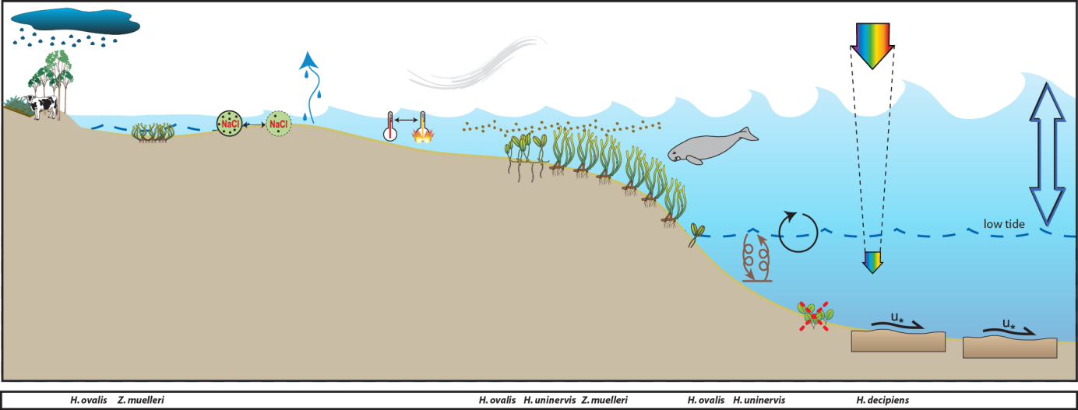
Figure 142. Conceptual diagram of coastal habitat in the Fitzroy region
– major control is pulsed light, salinity and temperature extremes: general habitat, seagrass meadow processes and threats/impacts (see Figure 4 for icon explanation).
Inshore reef habitat seagrass meadows are uncommon throughout the region, and are restricted to fringing reefs associated with islands in this region. Inshore turbidity in high due to the large tides, which also restrict seagrass to shallow banks. The drivers of these habitats are light and temperatures extremes and benthic sheer from the large tides (Figure 143). The monitoring sites are located on the shallow fringing reef in Monkey Beach, on the south-western shores of Great Keppel Island (Figure 141).
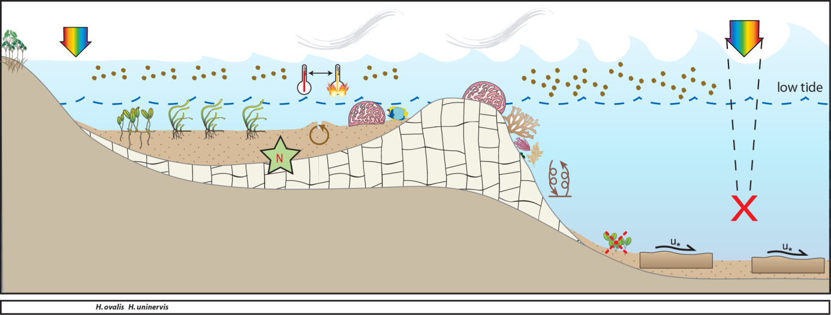
Figure 143. Conceptual diagram of reef habitat in the Fitzroy region
- major control is light and temperature extremes and benthic shear from tidal currents: general habitat, seagrass meadow processes and threats/impacts (see Figure 4 for icon explanation).
Estuarine seagrass habitats in the southern Fitzroy region tend to be intertidal, on the large sand/mud banks in sheltered areas of the estuaries. Tidal amplitude is not as great as in the north and estuaries that are protected by coastal islands and headlands support meadows of seagrass. These habitats feature scouring, high turbidity and desiccation (linked to this large tide regime), and are the main drivers of distribution and composition of seagrass meadows in this area (Figure 144 ). These southern estuary seagrasses (Gladstone, Port Curtis) (Figure 141) are highly susceptible to impacts from local industry and inputs from the Calliope River. Port Curtis is highly industrial with the world’s largest alumina refinery, Australia’s largest aluminium smelter and Queensland’s biggest power station. In addition, Port Curtis contains Queensland’s largest multi-cargo port (Port of Gladstone) with 50 million tonnes of coal passing through the port annually.
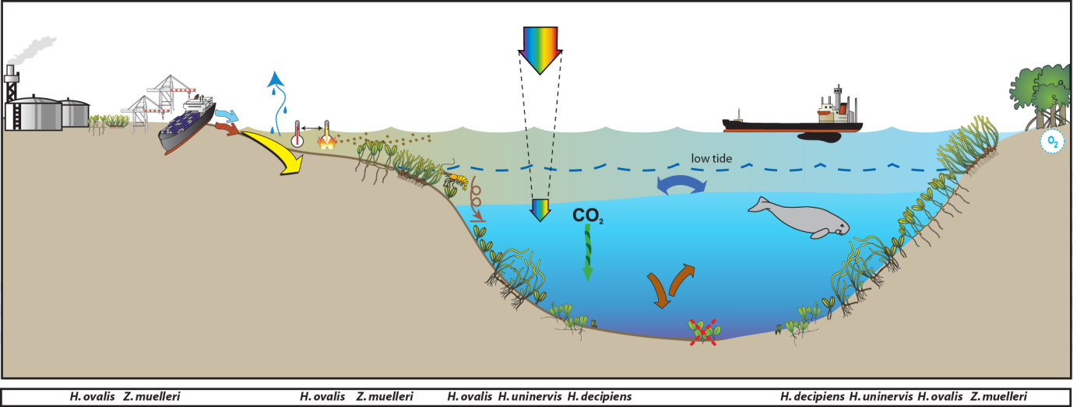
Figure 144. Conceptual diagram of estuary habitat in the Fitzroy region
– major control variable rainfall and tidal regime: general habitat, seagrass meadow processes and threats/impacts (see Figure 2 for icon explanation).

Status of the seagrass community
The condition of inshore seagrass in the Fitzroy region remained poor in 2011/12, driven largely by a decline in seagrass reproduction to very poor (Figure 145). Seagrass abundance remained relatively stable across habitats and was rated poor overall in 2011/12. Reproductive effort was very poor, suggesting a low capacity to recover from disturbance. The nutrient status of seagrass tissue was moderate overall and variations between habitats reflected differences in nutrient and light availability.
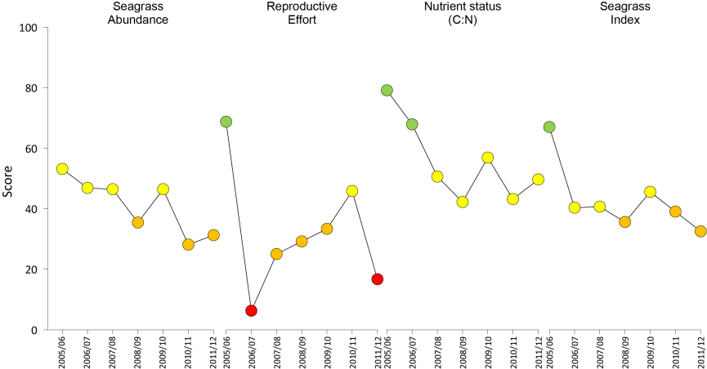
Figure 145. Report card of seagrass status indicators and index for the Fitzroy NRM region
(averaged across sites). Values are indexed scores scaled from 0-100; ■ = very good (80-100), ■ = good (60 - <80), ■ = moderate (40 - <60), ■ = poor (20 - <40), ■ = very poor (0 - <20).

Seagrass abundance and composition

Coastal
Coastal meadows monitored in Shoalwater Bay at Ross Creek (RC1) and Wheelans Hut (WH1) remained dominated by Zostera muelleri, but over the monitoring period the higher contributions of the colonising species Halophila ovalis may indicate a level of disturbance across the meadows (Figure 141). Over the 2011/12 monitoring period, the declines in seagrass abundance experienced at the coastal sites since 2009 appear to have abated (Figure 146).
Figure 146. Changes in seagrass abundance (% cover ±Standard Error) at inshore intertidal coastal habitats (Shoalwater Bay) in the Fitzroy region from 2001 to 2012.
Trendline is 3rd order polynomial, 95% confidence intervals displayed, r² = 0.667.
Since monitoring was established, Shoalwater Bay seagrass abundance has shown little within year variance, within only a slight indication of lower abundances during the monsoon (Figure 147).
Figure 147. Mean percentage seagrass cover (all species pooled) (± Standard Error) at inshore intertidal coastal habitats (Shoalwater Bay) in the Fitzroy region at time of year.
NB: Polynomial trendline for all years pooled.

Estuary
Gladstone Harbour estuarine sites were located in a large Zostera muelleri dominated meadow (Figure 141) on the extensive intertidal Pelican Banks at the southern end of Curtis Island. Species composition has remained stable; however abundance has differed greatly within and between years (Figure 148). Abundances observed in late 2011 were some of the highest recorded since monitoring was established in 2005, and although in early 2012 abundances declined, they remained nearly twice as high as experienced the same time in the previous year (Figure 148). Estuarine seagrasses appear to change seasonally, increasing throughout the year until the late monsoon (Figure 149).
Figure 148. Changes in seagrass abundance (% cover ±Standard Error) at inshore intertidal estuarine habitats (Gladstone Harbour) in the Fitzroy region from 2005 to 2012.
Trendline is 3rd order polynomial, 95% confidence intervals displayed, r² = 0.072.
Figure 149. Mean percentage seagrass cover (all species pooled) (± Standard Error) at inshore intertidal estuarine habitats (Gladstone Harbour) in the Fitzroy region at time of year.
NB: Polynomial trendline for all years pooled.

Inshore reef habitat
The monitoring sites at Great Keppel Island (GK1 and GK2) differ greatly from the inshore sites, being composed predominately of H. uninervis on sand substrate (Figure 141). Although seagrass abundance has continued to remain low since monitoring was established in 2007 (Figure 150), abundances are relatively higher in the late dry than the last monsoon (Figure 151).
Figure 150. Changes in seagrass abundance (% cover ±Standard Error) at inshore intertidal reef habitats (Great Keppel Island) in the Fitzroy region from 2005 to 2012.
Trendline is 3rd order polynomial, 95% confidence intervals displayed, r² = 0.416.
Figure 151. Mean percentage seagrass cover (all species pooled) (± Standard Error) at inshore intertidal reef habitats (Great Keppel Island) in the Fitzroy region at time of year.
NB: Polynomial trendline for all years pooled.
Seagrass meadow edge mapping was conducted within a 100m radius of all monitoring sites in September/October and March/April of each year (Table 31) to determine if changes in abundance were a consequence of the meadow edges changing. The coastal meadows in Shoalwater Bay (RC1 and WH1) have remained stable in extent since monitoring began, however the meadows at the reef (Great Keppel Island) habitat have decreased overall (Figure 152). At Great Keppel Island, the meadows reduced by 30% and 50% (at sites GK1 and GK2 respectively) from early to late 2011 (Table 31, Figure 152). The Gladstone Harbour meadow, which was absent in early 2006, has since recovered and stabilised over the last two years (Table 31, Figure 152), with only a minor fluctuations during the 2011/12 monitoring period.
Figure 152. Extent of area (100m radius of monitoring site) covered by seagrass at each monitoring site at inshore intertidal coastal (Shoalwater Bay), reef (Great Keppel Island) and estuary (Gladstone Harbour) habitats in the Fitzroy region.
Table 31. Area (ha) of seagrass meadow within 100m radius of each monitoring site.
Value in parenthesis is % change from the baseline and description of change from previous mapping. Shading indicates decrease in area since baseline. NA=no data available as site not established.
 | Shoalwater Bay |  | Gladstone Harbour |  | Great Keppel Island
Date | RC1 | WH1 | GH1 | GH2 | GK1 | GK2
October 2005 (baseline) | 5.38 | 5.397 | 5.394 | 5.174 | NA | NA
April  2006 | 5.38  (No change) | 5.397  (No change) | 0  (-100%, meadow absent) | 0  (-100%, Meadow absent) | NA | NA
October  2006 | 5.396  (0.3%, increase shoreward) | 5.397  (No change) | 5.394  (meadow recovered) | 5.394  (4.3%, Meadow recovered) | NA | NA
April  2007 | 5.384  (0.01%, increase shoreward) | 5.397  (No change) | 5.394  (meadow recovered) | 5.174  (0.01%, decrease seaward) | NA | NA
October  2007 | 5.396  (0.3%, negligible) | 5.397  (No change) | 4.179  (-22.5%, decrease overall) | 4.733  (-8.5%, decrease seaward) | 2.513 | 3.998
April  2008 | 5.396  (0.3%, stable) | 5.397  (No change) | 4.487  (-16.8%, increase overall) | 5.087  (-1.7%, increase shoreward) | 0.526  (-79.1%, decrease overall) | 2.368  (-40.8%,decrease overall)
October  2008 | 5.396  (0.3%, stable) | 5.397  (No change) | 5.074  (-5.9%, increase overall) | 4.829  (-6.7%, decrease seaward) | 0.933  (-62.9%, increase overall) | 3.201  (-19.9%, increase overall)
April  2009 | 5.396  (0.3%, stable) | 5.397  (No change) | 5.027  (-6.8%, decrease shoreward) | 5.281  (2.1%, increase shoreward) | 1.814  (-27.8%, increase overall) | 2.234  (-44.1%, decrease overall)
October  2009 | 5.396  (no change) | 5.397  (no change) | 4.742  (-12.1%, decrease overall) | 4.997  (-3.4%, decrease overall) | 2.444  (-2.8%, increase overall) | 3.712  (-7.2%, increase overall)
April  2010 | 5.396  (no change) | 5.397  (no change) | 5.158  (-4.4%, increase overall) | 5.301  (2.5%, increase overall) | 2.384  (-5.1%, decrease shoreward) | 3.821  (-4.4%, increase overall)
October  2010 | 5.396  (no change) | 5.397  (no change) | 5.179  (-4.0%, increase overall) | 5.098  (-2.3, decrease overall) | 0.933  (-62.9%, decrease overall) | 3.770  (-5.7%, decrease overall)
April  2011 | 5.396  (no change) | 5.397  (no change) | 4.941  (-8.4%, decrease overall) | 4.927  (-1.5%, decrease overall) | 0.382  (-84.8%, decrease overall) | 2.805  (-29.9%, decrease overall)
October  2011 | 5.396  (no change) | 5.397  (no change) | 4.761  (-11.7%, decrease overall) | 4.843  (-6.4%, decrease overall) | 0.292  (-88.4%, isolated patches) | 1.306  (-67.3%, isolated patches)
April  2012 | 5.396  (no change) | 5.397  (no change) | 4.816  (-10.7%, decrease overall) | 4.901  (-5.3%, decrease overall) | 0.292  (no change) | 1.306  (no change)

Seagrass reproductive status
Seed banks continued to persist across coastal and estuarine habitats in the region in 2011/12 (Figure 154, Figure 155) suggests the meadows have a reasonable capacity to recover following disturbance. Evidence of seedling germination was also observed with the remnants of germinated seeds. Reproductive effort remained low or even declined (coastal sites dry season, estuary wet season) in 2011/12 despite a replenishment of seed banks.

Figure 153. Inshore intertidal reef habitat average total reproductive effort in the Fitzroy region.
Reproductive effort presented as the average number of reproductive structures per core (all species pooled).
c.
Figure 154. Inshore intertidal coastal habitat seed banks (a), germinated seed abundance (b), and total reproductive effort in the Fitzroy region.
Seed bank presented as the total number of seeds per m² sediment surface and reproductive effort presented as the average number of reproductive structures per core (all species pooled).

c.
Figure 155. Inshore intertidal estuary habitat seed banks (a), germinated seed abundance (b) and average total reproductive effort for all species (c) in the Fitzroy region.
Seed bank is represented as the total number of whole seeds per m² sediment surface. Germinated seeds is the total number of seed cases/pericarp per m² sediment surface.

Status of the seagrass environment

Seagrass tissue nutrients
Seagrass growing in the Fitzroy region at Great Keppel Island appear to differ in the relative compositions of carbon to nitrogen (C:N < 20) (Figure 156). Plants in Shoalwater Bay have remained low in carbon relative to nitrogen in 2011, which may indicate either reduced light availability or elevated N. C:N ratios at Great Keppel Island similarly remained below 20 in 2011, however in Gladstone Harbour the increase in C:N has continued possibly indicating sufficient light availability or decreasing N in 2011.
Figure 156. Elemental ratios (atomic) of seagrass leaf tissue C:N for the foundation seagrass species examined at each inshore intertidal habitat in the Fitzroy region each year
(species pooled) (mean ± Standard Error). Horizontal shaded band on the C:N ratio panel represents the accepted guideline seagrass “Redfield” ratio of 20:1 (Abal, et al. 1994; Grice, et al. 1996). C:N ratios below this line may indicate reduced light availability and/or N enrichment.
At coastal and reef habitats in the Fitzroy region, C:P ratios remained below 500 in 2011, indicating nutrient rich habitats (large P pool) (Figure 157). At Gladstone Harbour, C:P ratios remained above 500, indicating a nutrient poor environment (Figure 157). Conversely, N:P ratios for foundation species declined in late dry 2011 in estuarine sites, indicating an decrease in N (Figure 157). N:P ratios at coastal sites increased above 25 in late dry 2011 (Figure 157); indicating the plants were replete (well supplied and balanced macronutrients for growth) due to elevated N. At reef habitats in the Fitzroy region, N:P ratios increased above 30 in late dry 2011 (Figure 157); indicating that the environment was saturated with N and the plants possibly P-limited.
Figure 157. Elemental ratios (atomic) of seagrass leaf tissue N:P and C:P for the foundation seagrass species examined at each inshore intertidal habitat in the Fitzroy region each year
(species pooled) (mean ± Standard Error). Horizontal shaded band on the N:P ratio panel represents the range of value associated with N:P balance ratio in the plant tissues, i.e. a seagrass “Redfield” ratio (Atkinson and Smith 1983; Duarte 1990; Fourqurean, et al. 1992b; Fourqurean and Cai 2001). N:P ratio above this band indicates P limitation, below indicates N limitation and within indicates replete (balanced). Shaded portion on the C:P panel ≤500 represents the value associated with C:P balance ratio in the plant tissues, C:P values <500 may indicate nutrient rich habitats (large P pool).
δ¹³C values for foundation species at coastal habitat (Shoalwater Bay) during the late dry (growing) season were all above the global average and within global ranges (Table 32), suggesting sufficient carbon available for growth. Similarly, as %C in the leaves was also above the literature median values, suggests adequate light available for growth. The low C:N ratio is likely a consequence of the elevated N, where the low δ¹⁵N value in the leaf tissue of Zostera muelleri suggests that the primary source of N was influenced by anthropogenic sources such as fertiliser.

Table 32. Seagrass leaf tissue nutrient, δ¹³C and δ¹⁵N concentrations from Fitzroy locations in the late dry 2011.
Leaf tissues with low %C (see Table 37), low C:N (<20:1), and isotopically depleted δ¹³C may indicate that growth is light limited (Grice, et al. 1996; Fourqurean, et al. 2005). Shading indicates values lower than literature. ZM=Zostera muelleri.
Location | Species | %C | C:N | δ¹³C | δ¹⁵N | %C lit median | Global δ¹³C
Shoalwater Bay | ZM | 40.083 | 18.36 | -9.3±0.1 | 0.72±0.15 | 32 | -10.8 (-12.4 to -9.2)

Epiphytes and Macro-algae
Epiphyte cover on seagrass leaf blades across the region were variable between habitats, however macro-algae cover remained low below the GBR long-term average for all habitats (Figure 158, Figure 159, Figure 160). At coastal sites (Shoalwater Bay), epiphyte cover remained below the GBR long-term average over the 2011/12 monitoring period and continued to decline (Figure 158).
Figure 158. Mean abundance (% cover) (± Standard Error) of epiphytes and macro-algae at inshore intertidal coastal habitats (Shoalwater Bay) in the Fitzroy region.
Red line = GBR long-term average; epiphytes=17%, macro-algae=4.7%.
At estuarine sites (Gladstone), epiphyte cover peaked in July 2011 to the highest levels recorded for the location (49% cover) (Figure 159). However, this is possibly a seasonal occurrence as high abundances are generally observed from Jul - October each year.
Figure 159. Mean abundance (% cover) (± Standard Error) of epiphytes and macro-algae at inshore intertidal estuarine habitats (Gladstone Harbour) in the Fitzroy region.
Red line = GBR long-term average; epiphytes=25%, macro-algae=3.2%.
At reef sites (Great Keppel Island), epiphyte cover had been declining since early 2009, with abundances below the GBR average since early 2010. However in early 2012, abundance increased to just above the GBR average (Figure 159). Whether this is a seasonal occurrence or a change in trend is currently unknown (Figure 160).
Figure 160. Mean abundance (% cover) (± Standard Error) of epiphytes and macro-algae at inshore intertidal reef habitats (Great Keppel Island) in the Fitzroy region.
Red line = GBR long-term average; epiphytes=28%, macro-algae=6.2%.

Within meadow canopy temperature
Temperature loggers were successfully deployed at all monitoring sites over the monitoring period (Figure 161). Mean within canopy temperature monitored at Shoalwater Bay and Great Keppel Island ranged from 18 - 29°C, while at Gladstone harbour it ranged from 17-28°C. The lowest mean temperatures across the region occurred in June/July and highest in January/February. Extreme temperatures (>38) were recorded across the region, with maximum temperatures reaching 39.3°C in Gladstone harbour (GH2, March 2012). Temperatures were on average cooler than the previous period in the north of the region by 0.4°C in Shoalwater Bay and 0.2°C at Great Keppel Island. Mean within canopy temperatures were 0.2 – 0.4°C cooler across the north of region than the previous two monitoring periods (2009/10 and 2010/11) (Figure 162). Mean within canopy temperatures in Gladstone were similar to both the pervious period and the long-term (Figure 162).
Figure 161. Within seagrass canopy temperature (°C) at inshore intertidal coastal (Shoalwater Bay), reef (Great Keppel Island) and estuarine (Gladstone Harbour) habitats in the Fitzroy region over the 2011/12 monitoring period.
Figure 162. Monthly mean and maximum within seagrass canopy temperature (°C) at inshore intertidal coastal (Shoalwater Bay), reef (Great Keppel Island) and estuary (Gladstone Harbour) habitats within the Fitzroy region.

Canopy incident light
Shoalwater Bay has the highest I_{d} of all GBR sites being, on average 20.3 mol m⁻² d⁻¹. High canopy light levels continued through the 2011/12 (average 20 mol m⁻² d⁻¹), with a decline occurring in early 2012 (Figure 163). Seagrass abundance declined in 2009 and 2010 and although I_{d} do not exist for the whole of that period, I_{d} is unlikely to correlate with declines given the generally high values at this site. I_{d} at Keppel Island has remained largely above MLR, with average I_{d} being 14.9 mol m⁻² d⁻¹ There is insufficient data for the 2011/12 period to assess incident light levels. At Pelican Banks in Gladstone Harbour, there is again insufficient light data for 2011/12
Figure 163. Daily light (28 day rolling average) at inshore intertidal coastal (Shoalwater Bay) and estuary (Pelican Banks) habitats in the Fitzroy region
, also showing approximate light threshold required for positive growth in Zostera muelleri dominated communities in the southern GBR (6 mol m⁻² d⁻¹)(Chartrand, et al. 2012). NB threshold is based on 2 week average.
Figure 164. Daily light (28 day rolling average) at inshore intertidal reef habitats (Great Keppel Island) in the Fitzroy region
, also showing approximate light threshold required for positive growth in Zostera muelleri dominated communities in the southern GBR (6 mol m⁻² d⁻¹)(Chartrand, et al. 2012). NB: threshold is based on 2 week average.

Regional Climate
Climate across the north of the region during the 2011/12 monitoring period was on average wetter than the previous decadal average. Although it was a wet year in the south of the region, it was below the decadal average. Reef habitats were windier in 2011/12, but inshore it was slightly calmer that the last decade on average.

Inshore coastal habitat (Shoalwater Bay)
The mean maximum daily air temperature recorded at Williamson during 2011/12 was 27.7°C, this was 0.3°C warmer than the previous period and 0.7°C warmer than the previous 7 year average (Figure 166). The highest recorded daily maximum air temperature in 2011/12 was 34.2 °C.
2011/12 was a drier than the previous period with approximately 40% lower average rainfall. It was also the lowest rainfall in the last 4 monitoring periods, but 7% higher relative to both the long-term (7 year) average (Figure 166). Mean wind speed in 2011/12 was 15.0 km.hr⁻¹, this was higher than the previous monitoring period (Figure 166).
Figure 165. Total monthly rainfall (grey bar), mean monthly daily maximum temperature and mean monthly 3pm wind speed at Shoalwater Bay.
Post May 2005 recorded at Williamson, Shoalwater Bay (BOM station 033260, source www.bom.gov.au), located 10km from the monitoring sites. Prior to May 2005, observations recorded at Yeppoon (BOM station 033106, source www.bom.gov.au), approximately 96km from monitoring sites.

Inshore reef habitat (Great Keppel Island)
The mean maximum daily air temperature recorded in Yeppoon during 2011/12 was 25.3°C, this was 0.6°C cooler than the decade average and 0.5°C cooler than the long-term (19 year) average (Figure 166). The highest recorded daily maximum air temperature in 2011/12 was 34.2 °C.
2011/12 was a wet period with the total rainfall at Svendsen Beach (1019mm) the 6th consecutive year above the median (Figure 166). Mean wind speed in 2011/12 at Yeppoon was 18.5 km.hr⁻¹, which was 8% higher than both the long-term and decade average (Figure 166).
Figure 166. Total monthly rainfall (grey bar), mean monthly daily maximum temperature and mean monthly 3pm wind speed for Great Keppel Island monitoring sites.
Rainfall recorded at Svendsen Beach, (BOM station 033260, source www.bom.gov.au), located 4.5km from the monitoring sites. Temperature and wind speed recorded at Yeppoon (BOM station 033106, source www.bom.gov.au), approximately 22km from monitoring sites.

Inshore estuarine habitat (Gladstone Harbour)
The mean maximum daily air temperature recorded in Gladstone during 2011/12 monitoring period was 27.9°C, this was 0.6°C higher than the previous period, but similar to the long-term (55 year) and decade averages (Figure 167). The highest recorded daily maximum temperature in 2011/12 was 36.7°C. 2011/12 remained a wet monitoring period, being the 5th consecutive year with above median rainfall. However, total rainfall was 40% drier than 2010/11, and 10% below than decadal and LT (40 year) averages (Figure 167). Mean wind speed in 2011/12 was 21.0 km.hr⁻¹, this was higher than the previous monitoring period but, but 5% bellow than decadal average (Figure 167).
Figure 167. Total monthly rainfall (grey bars), mean monthly daily maximum temperature, and mean monthly 3pm wind speed from Gladstone Harbour monitoring sites.
Rainfall recorded at Southend Curtis Island (BOM station 039241, source www.bom.gov.au), located 1km from monitoring sites. Temperature and wind speed recorded at Gladstone Airport (BOM station 039123, source www.bom.gov.au), located approximately 13km from monitoring sites.

River discharge
Several rivers discharge into the coastal waters of the Fitzroy, but the largest by far is the Fitzroy River and during floods its plumes extend 100's of km north to locations where coastal and reef seagrass monitoring sites occur. Primary-secondary flood waters from the Fitzroy River extend into Shoalwater Bay (200 km to the north) and secondary-tertiary flood waters extend out to Great Keppel Island (34 km to the north).
The exposure of the seagrass monitoring sites in Shoalwater Bay to elevated Total Suspended Solids and PSII herbicides was rated as High in 2010, whereas chlorophyll-a exposure was rated as medium. The exposure of the seagrass meadows on the reef flat at Great Keppel Island to Total Suspended Solids, chlorophyll-a and PSII herbicides however, was rated as medium. Overall, the probability of exceeding the GBR WQ Guidelines for chlorophyll-a at coastal and reef sites was high and medium, respectively (pers. comm. Michelle Devlin, JCU).
The rivers that discharge into Gladstone Harbour are the Calliope and the Boyne, which are within 10 km of the estuarine monitoring sites on Pelican Banks (Port Curtis). During floods, freshwater-primary flood waters extend out to the sites, and the exposure of the seagrass to elevated Total Suspended Solids and PSII herbicides was rated as High in 2010, whereas chlorophyll-a exposure was rated as medium. The probability of exceeding the GBR WQ Guidelines at these sites for TSS and chlorophyll-a was medium and high, respectively (pers. comm. Michelle Devlin, JCU).
2011/12 was the 3rd consecutive period where the total discharge from the Fitzroy and Calliope Rivers was above the long-term medians (Figure 168, Figure 169). Approximately 85% of the volume discharged from the Fitzroy River was between February and April 2012, with the highest volume in March (Figure 168). In the Calliope River, approximately 85% of the volume discharged during the 2011/12 period occurred earlier Fitzroy, between January and March 2012. Highest flows in the Calliope River were on average 2660 ML day⁻¹, in January 2012 (Figure 169).
Figure 168. Average daily flow (ML day⁻¹) per month from the Fitzroy River which would impact coastal and reef seagrass monitoring sites in the Fitzroy region
(DERM station 130005A - Fitzroy River at The Gap, 23.08897222°S 150.10713889°E, Elev 0m)(source ©The State of Queensland (DERM) 2012, watermonitoring.derm.qld.gov.au).
Figure 169. Average daily flow (ML day⁻¹) per month from the main rivers which would impact estuarine seagrass monitoring sites in the Fitzroy region
(DERM stations 132001A - Calliope River at Castlehope 23.98498333°S 151.09756389°E, Elev:21m; 133005A (source the State of Queensland (DERM) 2012, watermonitoring.derm.qld.gov.au).

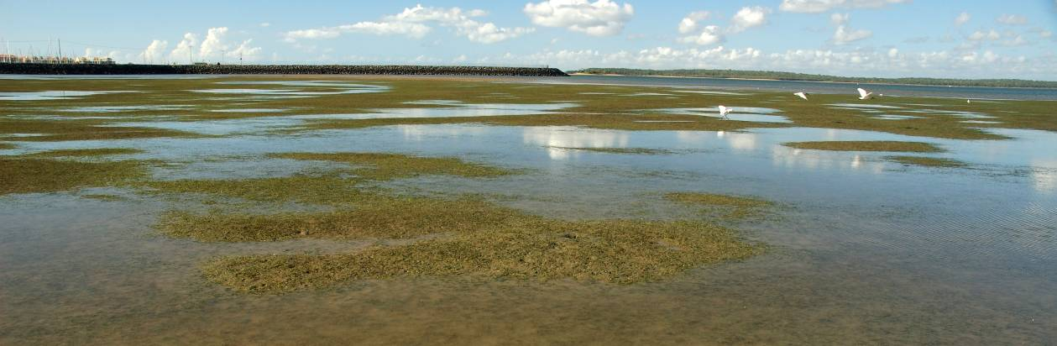

Burnett Mary

2011/12 Summary
Only intertidal estuarine seagrass meadows located in bays protected from SE winds and wave action were monitored in the Burnett Mary region. The main ecological drivers in these environments are temperature and desiccation stress, flood runoff and turbidity. Seagrasses are monitored at locations in the north and south of the Burnett Mary Region.
Seagrass abundance across the region remained at very low levels (i.e. minimum effective population size) throughout the 2011/12 monitoring period. As reproductive health of the meadows declined in 2011/12 relative to the previous monitoring period, the increase in the extent of the southern meadows (Urangan) would have been primarily the result of clonal growth. However, the increase in seed banks across the region suggest the meadows are "primed" to recover should conditions remain favourable.
Seagrass tissue nutrients in late 2011 were similar across the region, suggesting P and N surplus to C requirements. The nutrient ratios indicated slightly elevated nitrogen, where the primary source at Urangan was possibly sewage. Epiphyte abundance was higher at Urangan than Rodds Bay (in the north) possibly a consequence of the elevated N. Adequate light was available for growth across the period as the light environment improved, although there was limited data for some of the monitoring period due to equipment failure.
Climate across the region was on average wetter and warmer in the north of the region, and cooler and windier in the south than the previous decade. Extreme water temperatures were recorded in March 2012 within the seagrass canopy in the northern meadows, however temperatures across the region were slightly cooler in 2011/12 than 2010/11. Although rainfall was not higher, 2011/12 was the 5th consecutive year with above median discharge from the Mary River. Overall the status of seagrass condition in the Burnett Mary region improved slightly in 2011/12, but still remained very poor (Table 33).
Table 33. Report card for seagrass status (community & environment) for the Burnett Mary NRM region: July 2011 – May 2012.
Values are indexed scores scaled from 0-100; ■ = very good (80-100), ■ = good (60 - <80), ■ = moderate (40 - <60), ■ = poor (20 - <40), ■ = very poor (0 - <20).
Habitat | Abundance | Reproductive  Effort | Nutrient status  (C:N ratio) | Seagrass  Index
coastal intertidal | not monitored
estuarine intertidal | 5 | 0 | 47 | 18
Burnett Mary | 5 | 0 | 47 | 18

Background
The Burnett-Mary region covers an area of 88,000km² and supports a population of over 257,000 people, largely in the main centres of Bundaberg, Maryborough, Gympie and Kingaroy. The region is comprised of a number of catchments including the Baffle Creek, Kolan, Burnett, Burrum and Mary Rivers (Commonwealth of Australia 2013b). Only the northern most catchment of the Burnett Mary region, the Baffle Basin, is within the GBR. Meadows in the north of the Burnett Mary region generally face low levels of anthropogenic threat, and monitoring sites are located within Rodd’s Bay (Figure 171). The only other location that is monitored within this region is in the south, at Urangan (Hervey Bay) (Figure 171) . This location is adjacent to the Urangan marina and in close proximity to the mouth of the Mary River.
Estuarine habitats occur in bays that are protected from the south easterly-winds and consequent wave action. The seagrasses in this area must survive pulsed events of terrestrial run-off, sediment turbidity and drops in salinity. Estuary seagrasses in the region are susceptible to temperature related threats and desiccation due to the majority being intertidal (Figure 170).
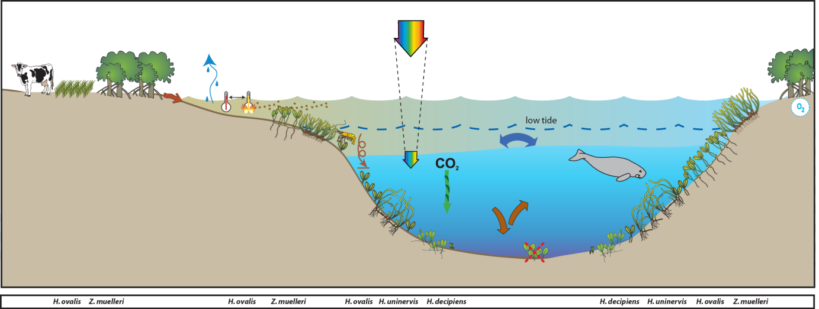
Figure 170. Conceptual diagram of estuary habitat in the GBR section of the Burnett Mary region
– major control is shelter from winds and physical disturbance: general habitat and seagrass meadow processes (see Figure 4 for icon explanation).

Status of the seagrass community
The overall condition of inshore seagrass in the Burnett Mary region remained very poor in 2011/12, reflecting very poor abundance and reproductive effort of seagrass meadows (Figure 172). Seagrass condition has generally been declining since 2005-2006; however, the indicators driving the condition assessment have varied over the monitoring period. Seagrass abundance and reproductive effort were very poor throughout the region in 2011/12, which may indicate a reduced capacity of local meadows to recover from environmental disturbances. The nutrient concentrations of seagrass tissue increased from poor in 2010/11 to moderate in 2011/12, which is indicative of improving water quality following the 2010/11 flood events in the region.

Figure 171. Location of Burnett Mary region long-term monitoring locations and the seagrass species composition at each site.
Please note: replicate sites are within 500m of each other.

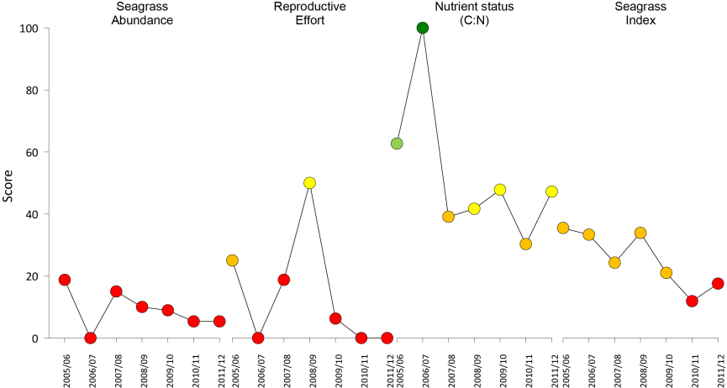
Figure 172. Report card of seagrass status indicators and index for the Burnett Mary NRM region
(averaged across sites). Values are indexed scores scaled from 0-100; ■ = very good (80-100), ■ = good (60 - <80), ■ = moderate (40 - <60), ■ = poor (20 - <40), ■ = very poor (0 - <20).

Seagrass abundance and composition
The estuarine seagrass habitats in the south of the region were dominated by Zostera muelleri with small components of Halophila ovalis over the monitoring period (Figure 171). Although the meadows showed significant recovery over the 2010 calendar year, in early 2011 they declined to small isolated patches which by early 2012 had begun to increase (Figure 173).
Figure 173. Changes in seagrass abundance (% cover ±Standard Error) at inshore intertidal estuarine habitats in Burnett Mary region from 1999 to 2012.
Urangan trendline is 3rd order polynomial, 95% confidence intervals displayed, r² = 0.339. Rodds Bay trendline is 2nd order polynomial, 95% confidence intervals displayed, r² = 0.721.

In the north of the region at Rodds Bay, the greater contribution of the colonising species H. ovalis indicated that the meadows were in early stages of recovery (Figure 171). However, after November 2011, seagrass was absent from one of the sites (RD2) (Figure 173).
Since monitoring was established at this location in 1998, the Urangan meadow has come and gone on an irregular basis. It is unknown if this is a long-term pattern. Within years however, a seasonal pattern is apparent across both sites, with greater abundance in the late dry season (Figure 174). Abundance is also significantly higher during the late dry season in Rodds Bay, however the dataset has become limited with the recent losses (Figure 175).
Figure 174. Mean percentage seagrass cover (all species pooled) (± Standard Error) at inshore estuary habitat (Urangan) in the southern Burnett Mary region at time of year.
NB: Polynomial trendline for all years pooled.

Figure 175. Mean percentage seagrass cover (all species pooled) (± Standard Error) at inshore estuary habitat (Rodds Bay) in the southern Burnett Mary region at time of year.
NB: Polynomial trendline for all years pooled.
Seagrass meadow edge mapping was conducted within a 100m radius of all monitoring sites in September/October and March/April of each year (Table 34) to determine if changes in abundance were a consequence of the meadow edges changing. Over the last 12 months the seagrass meadows at Urangan increased after significantly losses occurred in early 2011 (Figure 176, Table 34). In late 2011, the isolated patches of seagrass that had appeared at Rodds Bay sites the previous year, continued to expand. However seagrass was lost from one of the Rodds Bay monitoring sites and reduced to isolated shoots at the other by late monsoon 2012 (Figure 176, Table 34).
Table 34. Area (ha) of seagrass meadow within 100m radius of each monitoring site.
Value in parenthesis is % change from baseline and direction of change from previous mapping. Shading indicates decrease in meadow area since baseline. NA=no data available as site not established.
 | Urangan (Hervey Bay) |  | Rodds Bay
 | UG1 | UG2 | RD1 | RD2
October 2005  (baseline) | 5.266 | 5.326 | NA | NA
April  2006 | 0  (meadow absent) | 0  (meadow absent) | NA | NA
October  2006 | 0  (meadow absent) | 0  (meadow absent) | NA | NA
April  2007 | 0  (meadow absent) | 0  (meadow absent) | NA | NA
October  2007 | 0.003  (-99.9%, increase overall) | 0  (meadow absent) | 0.96 | 3.573
April  2008 | 0.386  (-92.7%, increase overall) | 1.559  (-70.7%, increase overall) | 1.291  (34.5%, increase seaward) | 3.511  (-1.7%, decrease shoreward)
October  2008 | 0.343  (-93.5%, negligible) | 2.778  (-47.8%, increase overall) | 1.207  (25.8%, decrease shoreward) | 3.618  (1.3%, increase seaward)
April  2009 | 0.044  (-99.2%, decrease overall) | 0.470  (-91.2%, decrease overall) | 0  (meadow absent) | 3.527  (0.4%, negligible)
October  2009 | 0.333  (-93.7%, increase overall) | 0.998  (-81.3%, increase overall) | 0.041  (95.8%, increase overall) | 2.770  (22.5%, decrease shoreward)
April  2010 | 1.812  (-65.6%, increase overall) | 3.730  (-30%, increase overall) | 0  (meadow absent) | 0  (meadow absent)
October  2010 | 1.426  (-72.9%, decrease overall) | 3.726  (-30%, negligible) | 0.541  (-43.7, increase overall) | 0  (meadow absent)
April  2011 | 0.296  (-94.4%, decrease overall) | 2.035  (-61.8%, decrease overall) | 0.199  (-79.3, decrease overall) | 0.082  (-97.7%, isolated patches)
October  2011 | 0.356  (-93.2% negligible change) | 2.300  (-56.8%, decrease overall) | 0.293  -69.5%, increase overall) | 0.073  (-98% isolated patches)
April  2012 | 0.458  (-91.3% negligible change) | 2.879  (-46%, increase overall) | 0  (meadow absent) | 0  (meadow absent)

Figure 176. Extent of area (100m radius of monitoring site) covered by seagrass at inshore intertidal estuary habitats (Rodds Bay and Urangan) in the Burnett Mary region.

Seagrass reproductive status
Seed banks were found for the first time in 5 years across the region (Figure 177). Both seeds banks and evidence of germinated seeds were found in late dry 2011 and late monsoon 2012 at Rodds Bay sites. In the late monsoon 2012, seeds banks and evidence of germinated seeds were also found at Urangan sites. This is likely a consequence of the improved sampling for Zostera muelleri seeds using 750ɥm mesh sieves since late monsoon 2011. No Halodule uninervis seeds have been found in the region since monitoring commenced.
Reproductive effort across the Burnett Mary region was classified as very poor in 2010 and remained unchanged throughout 2011/12 (Figure 177). This suggests that meadows within the region will take longer to recover following disturbance and may be at risk from repeated impacts.
c.
Figure 177. Inshore intertidal estuary habitat seed banks (a), germinated seed abundance (b) and total reproductive effort (c) in the Burnett Mary region.
Seed bank presented as the total number of seeds per m² sediment surface and reproductive effort presented as the average number of reproductive structures per core (all species pooled).

Status of the seagrass environment

Seagrass tissue nutrients
In 2011, C:N ratios remained below 20 for both Rodds Bay and Urangan (Hervey Bay) (Figure 178), indicative of either a low light environment or increasing N pool.
Figure 178. Elemental ratios (atomic) of seagrass leaf tissue C:N for the foundation seagrass species examined at each inshore intertidal estuary habitat in the Burnett Mary region each year
(species pooled) (mean ± Standard Error). Horizontal shaded band on the C:N ratio panel represents the accepted guideline seagrass “Redfield” ratio of 20:1 (Abal, et al. 1994; Grice, et al. 1996). C:N ratios below this line may indicate reduced light availability and/or N enrichment.
The late dry season 2011 C:P ratios of seagrass remained below 500 at Rodds Bay, indicating a nutrient rich environment with a relatively large P pool (Figure 179). At Urangan in the south of the region, C:P ratios increased, suggested a declining P pool (Figure 179). Tissue ratios of N:P ratio either remained stable (Rodds Bay) or increased (Urangan) in 2011 indicating N enrichment (Figure 179).
Figure 179. Elemental ratios (atomic) of seagrass leaf tissue N:P and C:P for the foundation seagrass species examined at each inshore intertidal estuary habitat in the Burnett Mary region each year
(species pooled) (mean ± Standard Error). Horizontal shaded band on the N:P ratio panel represents the range of value associated with N:P balance ratio in the plant tissues, i.e. a seagrass “Redfield” ratio (Atkinson and Smith 1983; Duarte 1990; Fourqurean, et al. 1992b; Fourqurean and Cai 2001). N:P ratio above this band indicates P limitation, below indicates N limitation and within indicates replete (balanced). Shaded portion on the C:P panel ≤500 represents the value associated with C:P balance ratio in the plant tissues, C:P values <500 may indicate nutrient rich habitats (large P pool).
δ¹³C values for Zostera muelleri (foundation species) and Halophila ovalis at estuarine habitats (Urangan) during the late dry (growing) season were all above or at the global average and within global ranges (Table 35), suggesting sufficient carbon available for growth. Similarly, as %C in the leaves was also above the literature median values, suggests adequate light available for growth. The low C:N ratios are likely a consequence of the elevated N, where the elevated δ¹⁵N value in the leaf tissue of both species suggests some sewage influence in their primary source of N.
Table 35. Seagrass leaf tissue nutrient, δ¹³C and δ¹⁵N concentrations from Urangan (Burnett Mary region) in the late dry 2011.
Leaf tissues with low %C (see Table 37), low C:N (<20:1), and isotopically depleted δ¹³C may indicate that growth is light limited (Grice, et al. 1996; Fourqurean, et al. 2005). Shading indicates values lower than literature. HO=Halophila ovalis, ZM=Zostera muelleri.
Location | Species | %C | C:N | δ¹³C | δ¹⁵N | %C lit median | Global δ¹³C
Urangan | HO | 36.9 | 15.89 | -10.5 | 4.55 | 30.5 | -10 (-15.5 to -6.4)
Urangan | ZM | 41.033 | 17.80 | -8.9±0.2 | 3.11±0.5 | 32 | -10.8 (-12.4 to -9.2)

Epiphytes and macro-algae
Epiphyte cover on the seagrass leaf blades at Urangan was highly variable over the years of monitoring, irrespective of seagrass abundance. At Rodds Bay however, epiphyte cover in 2011/12 was lower than previous years and remained lower than the GBR long-term average for estuary habitats (Figure 180). Percentage cover of macro-algae has continued to remain low at Urangan, however there was a brief increase above the GBR long-term average in February 2012 (Figure 180).
Figure 180. Mean abundance (% cover) (± Standard Error) of epiphytes and macro-algae at inshore intertidal estuary habitats (Rodds Bay and Urangan) in the Burnett Mary region.
Red line = GBR long-term average; epiphytes=25%, macro-algae=3.2%.

Within canopy temperature
Within canopy temperatures were monitored at Rodds Bay and Urangan (Hervey Bay) over the past 12 months (Figure 181). Extreme temperatures (>38°C) were recorded in the north of the region at on 5th March 2012 at Rodds Bay site 1 (39.5°C,1:00 - 1:30pm) (Figure 181). Mean within canopy temperatures monitored at Urangan and Rodds Bay were within 16 - 28°C range, with highest mean temperatures in January and February 2012. Mean within canopy temperatures for the 2011/12 monitoring period at Rodds Bay (23.3°C) were 0.2°C higher than the previous period. Overall, however, mean within canopy temperatures across the region for the period were between 0.3 - 0.5°C cooler than the last 5 periods (Figure 182).
Figure 181. Within seagrass canopy temperature (°C) at inshore intertidal estuary habitats (Rodds Bay and Urangan) in the Burnett Mary region over the 2011/2012 monitoring period.
Figure 182. Monthly mean and maximum within seagrass canopy temperature (°C) at insore intertidal estuary habitats (Rodds Bay and Urangan) in the Burnett Mary region.

Canopy incident light
There is limited light data available for Rodds Bay due to in situ light logger failure and low deployment frequency. Based on the limited data available, daily irradiance (I_{d}) is the highest of all monitoring sites, being, on average 22.9 mol m⁻² d⁻¹. I_{d} was 24.8 mol m⁻² d⁻¹ in 2011/12, but given the patchy data prior to 2011/12 it isn’t possible to assess interannual trends. At Urangan in 2011/12, I_{d} was 16.7 mol m⁻² d⁻¹, with insufficient data to assess longer-term averages.
Figure 183. Daily light (28 day rolling average) at estuarine locations in the inshore intertidal estuary habitats in the northern (Rodds Bay) and southern (Urangan) section of the Burnett Mary region
, also showing approximate light threshold required for positive growth in Zostera muelleri dominated communities in the southern GBR (6 mol m⁻² d⁻¹)(Chartrand, et al. 2012). NB: threshold is based on 2 week average.

Regional Climate
Climate across the Mary Burnett region varied between the northern and southern locations over the 2011/12 monitoring period. In the north the climate was drier and windier than the decadal annual average, whereas in the south it was cooler, wetter, and windier than the previous decade.

Inshore estuary in southern section (Urangan)
The mean maximum daily air temperature recorded in Hervey Bay during the 2011/12 monitoring period was 25.8°C. Although similar to the previous monitoring period, it was 0.4 °C cooler than the decade and long-term (13 year) averages. The highest recorded daily maximum air temperature in 2011/12 was 33.5°C.
2011/12 was a wet monitoring period (1691mm), compared to the previous period. It was also 50% wetter relative to the decade and long-term (13 year) averages (Figure 184). Most rainfall occurred from December 2011 to March 2012, and March was the wettest month. Mean monthly wind speed during 2011/12 was 18.7 km.hr⁻¹, this was higher than the previous monitoring period but 5% below the decade and long-term (13 year) averages (Figure 184).
Figure 184. Mean monthly daily maximum temperature, total monthly rainfall (grey bar), and mean monthly 3pm wind speed for Urangan monitoring sites.
Recorded at Hervey Bay Airport (BOM station 040405, source www.bom.gov.au), approximately 3km from Urangan monitoring sites.

Inshore estuary in northern section (Rodds Bay)
The mean maximum daily air temperature recorded at Seventeen Seventy (approximately 27km from Rodds Bay monitoring sites ) in 2011/12 monitoring period was 32.2°C; this was 0.2°C higher than the previous period but similar to both the long-term (26 year) and decade averages (Figure 185). The highest recorded daily maximum temperature in 2011/12 was 32.2°C.
2011/12 was a drier than average year and the first time in 5 years that the total rainfall at Bustard Head went below median rainfall. The total rainfall over the monitoring period (821mm) was approximately half the volume in 10/11, 18% lower than decade average and 27% lower than the annual rainfall for the last 100 yrs. The amount of cloud in 2011/12 was on average similar to the annual average for the decade, but 36% higher than long-term (24yrs) annual average. Mean wind speed in 2011/12 (24.5 km.hr⁻¹) was the highest in the last decade, and 17% higher than the long-term (24yrs) annual average (Figure 185).
Figure 185. Mean monthly daily maximum temperature (black line), total monthly rainfall (grey bar), mean monthly cloud cover (heavy black line), and mean monthly 3pm wind speed (grey line) for Roods Bay monitoring sites.
Temperature and cloud cover recorded at Seventeen Seventy (BOM station 039314, source www.bom.gov.au), approximately 27km from Rodds Bay monitoring sites. Rainfall (grey bar), recorded at Bustard Head Lighthouse (BOM station 039018, source www.bom.gov.au), approximately 12km from Rodds Bay monitoring sites.

River discharge
Several large rivers discharge into the coastal waters of the Burnet Mary region and during floods their plumes extend to locations where seagrass monitoring sites are located. In the north, no major rivers discharge directly into Rodds Bay where the estuarine seagrass monitoring sites are located, however it could be expected that flood waters from the Calliope and Boyne Rivers would travel slightly southward exposing Rodds Bay (41 km to the south) to plumes. 2011/12 was the 3rd consecutive period where the total discharge from the Calliope River was above the long-term median (Figure 186).
In the south of the region, the Mary River is the most dominant river and as the Urangan seagrass monitoring sites are located within 14 km of the river mouth, they are frequently impacted (Campbell and McKenzie 2003). 2011/12 was the 5th consecutive year with above median discharges from the Mary River. The volume discharged over the period (2,507,985 ML) was approximately 50% less than for the previous monitoring period (Figure 187).
Figure 186. Average daily flow (ML day⁻¹) per month from the Calliope River which would impact estuarine seagrass monitoring sites in Rodds Bay, northern Burnett Mary region
(DERM station 132001A - Calliope River at Castlehope 23.98498333°S 151.09756389°E, Elev:21; 133005A)(source the State of Queensland (Department of Environment and Resource Management) 2012, watermonitoring.derm.qld.gov.au).
Figure 187. Average daily flow (ML day⁻¹) per month from the Mary River which would impact estuarine seagrass monitoring sites at Urangan, southern Burnett Mary region
(DERM station 138001A - Mary River at Miva Lat:25.95332924°S:152.4956601 °E, Elev 0m) (source the State of Queensland (Department of Environment and Resource Management) 2012, watermonitoring.derm.qld.gov.au).

4. Conclusions
The report card of inshore seagrass state (from Cooktown south) for the Great Barrier Reef, has shown a sequential decline since 2006 (Figure 188). Although some locations in the Wet Tropics and Burdekin regions experienced declines in early 2006 as a consequence of Tropical Cyclone Larry, most recovered within 1-2 years, with the exception of the coastal sites in southern Wet Tropics where recovery was protracted. In late 2008, locations in the northern Wet Tropics and Burdekin regions were in a moderate state of health with abundant cover and seed banks. In contrast, locations in the southern GBR in Mackay Whitsunday and Burnett Mary regions were in a poor state, with low abundance, reduced reproductive effort and small or absent seed banks. In 2009 with the onset of the La Niña, the decline in seagrass state steadily spread across the Burdekin region and to locations within the Fitzroy and Wet Tropics where discharges from large rivers and associated catchments occurred. The only locations where seagrass state was better was at locations with relatively little catchment input, such as Gladstone Harbour and Shoalwater Bay (Fitzroy region), Green Island (Wet Tropics), and Archer Point (Cape York). By 2010, seagrasses of the GBR were in a poor state with declining trajectories in seagrass abundance, reduced meadow extent, limited or absent seed production and increased epiphyte loads at most locations. These symptoms would have made the seagrass populations particularly vulnerable to large episodic disturbances, as demonstrated by the widespread and substantial losses documented after the floods and cyclones of early 2011.
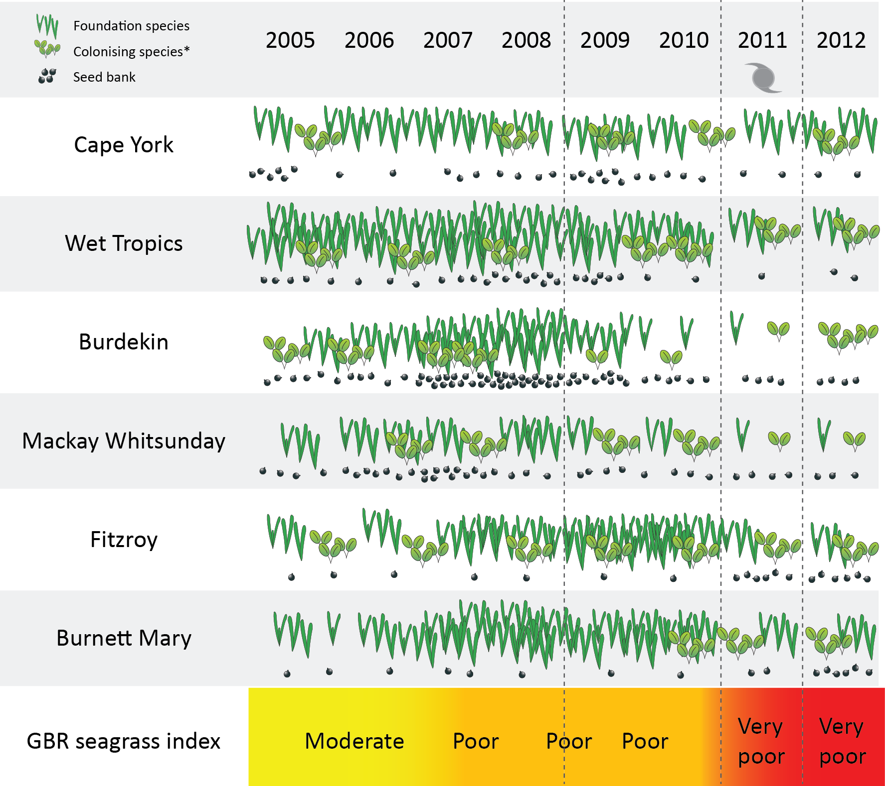
Figure 188. Summary of GBR MMP inshore seagrass state illustrating abundance of foundation / colonising species, and seed banks from 2005 to 2012.
Following the extreme weather events of early 2011, seagrass habitats across the GBR further declined, with severe losses reported from the Wet Tropics, Burdekin, Mackay Whitsunday and Burnett Mary regions. By late 2011, the onset of seagrass recovery was observed across some regions, however a state change had occurred and colonising species dominated many habitats. By 2012, recovery was protracted and a few locations showed little if any signs of recovery; particularly those severely impacted by TC Yasi. The report card (index score) for GBR inshore seagrass in 2011/12 was very poor, the lowest since the MMP was established.
There was increasing evidence that water quality degradation within the seagrass meadows of the inshore GBR prior to the episodic disturbances of 2011 may have reduced their resilience. Light availability is one of the primary forcing factors in seagrass growth and persistence. From 2009, reduced canopy light to low and limiting light levels was reported in seagrass meadows across the GBR, and, coincident with this, nutrients (N and P) increasing relative to plant requirements. The strong correlation between seagrass abundance and light availability has been demonstrated for subtidal meadows Collier, et al. 2012b. In previous years (2009-2011), these reduced water quality conditions have led to unprecedented seagrass loss. At intertidal sites, daily light measurements of light can be “swamped” by light during low tide. This gives the appearance that light levels are in excess of light requirements (above MLR and thresholds), and yet seagrass declines have occurred throughout the GBR at intertidal and subtidal monitoring sites. There are a number of possible explanations for this: 1. High light during low tide “light window” does not directly translate into increased photosynthetic C incorporation due to reduced photosynthetic efficiency at very high light and C-limitation. There is a strong need to quantify the usable light range and the effect of widely fluctuating light levels of photosynthetic efficiency; 2. Synergistic environmental impacts of the low tide environment increase their vulnerability to more moderate levels of light stress.
Water quality variables (e.g. turbidity, chlorophyll a and CDOM) are the primary light attenuating factors and knowing the cause of low light conditions enables targeted management to reduce impacts on seagrass meadows. However, seagrasses can survive in high turbidity sites, by being restricted to shallow areas where light reaches the canopy during low tide. Therefore, direct water quality measures and light are complimentary indicators, each with their own benefits to the interpretation of monitoring data, and management of water quality impacts. Direct measurement of water quality variables is not currently and routinely incorporated into the program for seagrass sites.
In the current reporting year, light availability has improved relative to previous years at a number of sites. Turbidity was also reduced at the two seagrass sites where turbidity was measured. Runoff has also reduced over this period, and this has likely reduced sediment loads and suspended sediment concentrations. However turbidity can be influenced by a number of factors, including wind and tide-driven resuspension of sediments Fabricius, et al. 2012b.
Coincident with improved light availability at most sites, has been some seagrass recovery. However, recovery did not occur at all sites. Even though light is higher, it is possible that light levels have not improved sufficiently to allow for increases in seagrass abundance (i.e. recovery thresholds higher than impact thresholds). There may also be other associated impacts, such as elevated nutrient concentrations, for which there is evidence at many sites.
This monitoring program includes indicators that represent various stages of impact/stress, including early warning indicators (tissue nutrients) through to advanced levels of impact (changes in meadow area, or localised loss) (Figure 189).
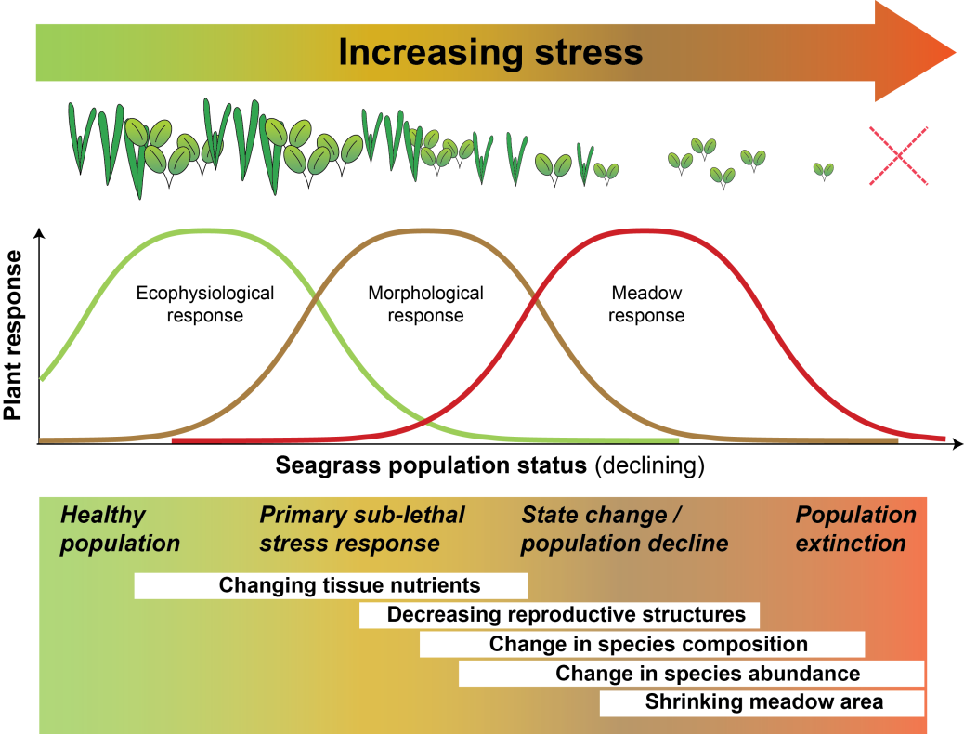
Figure 189. Seagrass stress response model outlining the sequence of changes that occur in response to increasing stress.
Adapted from Waycott and McKenzie (2010).
Results to date from the MMP have demonstrated a cascade of seagrass population responses to stressors analogous to the stress response model, including: leaf tissue N and P increasing above global average in all habitats since 2006 and 2010 respectively, and in surplus to C, have indicated N enrichment; variable but declining reproductive effort and seed banks indicating low capacity to recover from loss; decreasing abundance and extent since 2009, reaching minimum in early 2011; change population state with foundation species replaced by colonising.
The substantial loss of inshore seagrass of the GBR from reduced water quality, as a result of floods and cyclones, has had significant flow-on effects to the dugong and green turtle populations which are highly dependent on the local seagrass meadows which provide their primary food supply (Preen et al. 1995; Preen and Marsh 1995). Malnutrition is known to make the animals prone to disease and other mortality factors. As a consequence of the widespread loss of seagrass along the east coast of Queensland in early 2011, stranding rates of turtles and dugong increased during that year across the GBR (581 and 101 individuals respectively; data courtesy StrandNet, accessed 17 January 2013). These were the highest mortality rates since records commenced in 1998. Unfortunately, the trend of increased turtle and dugong mortality rates is likely to continue until the coastal seagrass meadows have recovered (or turtle and dugong populations decline to a sustainable level). The flow-on effects of seagrass loss to other associated fauna or fisheries is less obvious in subtropical and tropical systems, as it may not immediately manifest or cause community shifts rather than losses. For example, declines in one species of penaeid prawn from seagrass loss were balanced by an increase in another species of penaeid prawn or finfish (Connolly et al. 1999). The consequences of seagrass loss are not only limited to associated fauna, but as environmental engineers, declines in seagrass can have broader consequences related to coastal processes, such as carbon capture and nutrient dynamics, sediment stabilisation, and habitat connectivity (Waycott et al. 2007).
Recovery of seagrass populations from such declines may take many years and there are a number of factors that will facilitate recovery, including seed banks, connectivity and improvement in environmental conditions such as light available for photosynthesis. It was estimated that recovery of meadows may be slow(>5 years) in the southern Wet Tropics, moderate (2-5 years) in the Burdekin and fair (1-3 years) in the Fitzroy regions (McKenzie et al 2012).
The capacity of seagrass meadows to naturally recover community structure following disturbance will involve the interaction between light availability, nutrient loads and the availability of seeds to form the foundation of new populations. At present, the improving light availability across GBR habitats and region would be advantageous to the recovery potential of GBR seagrass meadows. However, elevated N may increase epiphyte and macroalgae abundance in the near future, which could compromise the light available for photosynthesis and in turn reduce plant survival and capacity to produce a viable seed bank (van Katwijk et al. 2010). This may in turn leave the meadows vulnerable to further environmental perturbations from which some may then fail to recover after loss.

6. References
Abal, E.G., and Dennison, W.C. 1996, Seagrass depth range and water quality in southern Moreton Bay, Queensland, Australia. Marine and Freshwater Research, 47(6), 763-771.
Abal, E.G., Dennison, W.C., and Greenfield, P.F. 2001, Managing the Brisbane River and Moreton Bay: An integrated research/management program to reduce impacts on an Australian estuary. Water Science and Technology, 43, 57-70.
Abal, E.G., Loneragan, N.R., Bowen, P., Perry, C.J., Udy, J.W., and Dennison, W.C. 1994, Physiological and morphological responses of the seagrass Zostera capricorni Aschers. to light intensity. Journal of Experimental Marine Biology and Ecology, 178(1), 113-129.
Angelini, C., Altieri, A.H., Silliman, B.R., and Bertness, M.D. 2011, Interactions among Foundation Species and their Consequences for Community Organization, Biodiversity, and Conservation. BioScience, 61(10), 782-789.
Anthony, K.R.N., Ridd, P.V., Orpin, A.R., Larcombe, P., and Lough, J. 2004, Temporal variation of light availability in coastal benthic habitats: effects of clouds, turbidity, and tides. Limnology and Oceanography, 49(6), 2201-2211.
ANZECC. 2000, Australian and New Zealand guidelines for fresh and marine water quality.
Aragones, L.V., and Marsh, H. 2000, Impact of dugong grazing and turtle cropping on tropical seagrass communities. Pacific Conservation Biology, 5, 277-288.
Armitage, A.R., and Fourqurean, J.W. 2006, The short-term influence of herbivory near patch reefs varies between seagrass species. Journal of Experimental Marine Biology and Ecology, 339, 65-74.
Atkinson, M.J., and Smith, S.V. 1983, C:N:P ratios of benthic marine plants. Limnology and Oceanography, 28(3), 568-574.
Baca, B.J., Snedaker, S.C., Dodge, R.E., Knap, A.H., and Sleeter, T.D. 1996, The effects of crude oil and dispersed crude oil on tropical ecosystems: Long-term seagrass, mangrove, and coral studies. Oceans Conference Record (IEEE), 1, 469-486.
Badalamenti, F., Di Carlo, G., D’Anna, G., Gristina, M., and Toccaceli, M. 2006, Effects of dredging on population dynamics of Posidonia oceanica (L.) Delile in the Mediterranean Sea: The case study of Capo Feto (SW Sicily, Italy). Hydrobiologia, 555, 253–261.
Bainbridge, Z., Wolanski, E., Lewis, S., and Brodie, J. 2012, Fine sediment and nutrient dynamics related to particle size and floc formation in a Burdekin River flood plume, Australia. Marine Pollution Bulletin, 65, 236-248.
Balata, D., Bertocci, I., Piazzi, L., and Nesti, U. 2008, Comparison between epiphyte assemblages of leaves and rhizomes of the seagrass Posidonia oceanica subjected to different levels of anthropogenic eutrophication. Estuarine, Coastal and Shelf Science, 79(3), 533-540. doi: http://dx.doi.org/10.1016/j.ecss.2008.05.009
Balestri, E., Benedetti-Cecchi, L., and Lardicci, C. 2004, Variability in patterns of growth and morphology of Posidonia oceanica exposed to urban and industrial wastes: Contrasts with two reference location. Journal of Experimental Marine Biology and Ecology, 308, 1–21.
Beal, J.L., and Schmit, B.S. (2000). The effects of dock height on light irradiance (PAR) and seagrass (Halodule wrightii and Syringodium filiforme) cover. In SA Bortone (Ed.), Seagrasses: Monitoring, Ecology, Physiology and Management (pp. 49–63). Boca Raton, Florida: CRC.
Birch, W., and Birch, M. 1984, Succession and pattern of tropical intertidal seagrasses in Cockle Bay, Queensland, Australia: a decade of observations. Aquatic Botany, 19, 343-367.
Bishop, M.J. 2008, Displacement of epifauna from seagrass blades by boat wake. Journal of Experimental Marine Biology and Ecology, 354, 111–118.
Borowitzka, M.A., Lavery, P.S., and van Keulen, M. (2006). Epiphytes of seagrasses. In WD Larkum, RJ Orth & CM Duarte (Eds.), Seagrasses: Biology, Ecology and Conservation. Dordrecht: Springer.
Borum, J. 1985, Development of epiphytic communities on eelgrass (Zostra marina) along a nutrient gradient in a Danish estuary. Marine Biology, 87, 211–218.
Borum, J., Duarte, C.M., Krause-Jensen, D., and Greve, T.M. (2004). European seagrasses: an introduction to monitoring and management. Copenhagen: The M&MS project.
Brodie, J. (2004). Mackay Whitsunday Region: State of the Waterways Report 2004 ACTFR Report No. 02/03 for the Mackay Whitsunday Natural Resource Management Group. Yownsville: ACTFR, James Cook University.
Brodie, J., Waterhouse, J., Lewis, S.E., Bainbridge, Z.T., and Johnson, J. (2009). Current loads of priority pollutants discharged from Great Barrier Reef Catchments to the Great Barrier Reef. ACTFR Report Number 09/02. Townsville: Australian Centre for Tropical Freshwater Research.
Brodie, J.E., Kroon, F.J., Schaffelke, B., Wolanski, E.C., Lewis, S.E., Devlin, M.J., Bohnet, I.C., Bainbridge, Z.T., Waterhouse, J., and Davis, A.M. 2012, Terrestrial pollutant runoff to the Great Barrier Reef: An update of issues, priorities and management responses. Marine Pollution Bulletin, 65(4–9), 81-100. doi: 10.1016/j.marpolbul.2011.12.012
Bros, W.E., and Cowell, B.C. 1987, A technique for optimising sample size (replication). Journal of Experimental Marine Biology and Ecology, 114, 63-71.
Cabaço, S., and Santos, R. 2007, Effects of burial and erosion on the seagrass Zostera noltii. Journal of Experimental Marine Biology and Ecology, 340, 204-212.
Cambridge, M.L., Chiffings, A.W., Brittan, C., Moore, L., and McComb, A.J. 1986, The loss of seagrass in Cockburn Sound, Western Australia. II. Possible causes of seagrass decline. Aquatic Botany, 24, 269-285.
Campbell, S.J., and McKenzie, L.J. 2001, Seagrass and algal abundance in the Whitsundays region. Status Report.
Campbell, S.J., and McKenzie, L.J. 2004, Flood related loss and recovery of intertidal seagrass meadows in southern Queensland, Australia. Estuarine, Coastal and Shelf Science, 60(3), 477-490.
Campbell, S.J., McKenzie, L.J., and Kerville, S.P. 2006, Photosynthetic responses of seven tropical seagrasses to elevated seawater temperature. Journal of Experimental Marine Biology and Ecology, 330, 455-468.
Campbell, S.J., Roder, C.A., McKenzie, L.J., and Lee Long, W.J. 2002, Seagrass resources in the Whitsunday region 1999 and 2000. DPI Information Series QI02043, 50.
Carruthers, T.J.B., Dennison, W.C., Longstaff, B.J., Waycott, M., Abal, E.G., McKenzie, L.J., and Lee Long, W.J. 2002, Seagrass habitats of north east Australia: models of key processes and controls. Bulletin of Marine Science, 71(3), 1153-1169.
Carruthers, T.J.B., van Tussenbroek, B.I., and Dennison, W.C. 2005, Influence of submarine springs and wastewater on nutrient dynamics of Caribbean seagrass meadows. Estuarine , Coastal and Shelf Science, 64, 191-199.
Chartrand, K.M., Ralph, P.J., Petrou, K., and Rasheed, M.A. 2012, Development of a light-based seagrass management approach for the Gladstone Western basin dredging program. 126.
Chesworth, J.C., Donkin, M., and Brown, M.T. 2004, The interactive effects of the antifouling herbicides Irgarol 1051 and Diuron on the seagrass Zostera marina (L.). Aquatic Toxicology, 66, 293-305.
Christensen, S., Rodgers, C., and Fitzroy Basin Association, I. (2006). Central Queensland strategy for sustainability : 2004 and beyond. . Rockhampton, Qld: Fitzroy Basin Association.
Coles, R., McKenzie, L., De’ath, G., Roelofs, A., and Long, W.L. 2009a, Spatial distribution of deepwater seagrass in the inter-reef lagoon of the Great Barrier Reef World Heritage Area. Mar Ecol Prog Ser, 392, 57-68.
Coles, R., McKenzie, L.J., De'ath, G., Roelofs, A., and Lee Long, W.J. 2009b, Spatial distribution of deepwater seagrass in the inter-reef lagoon of the Great Barrier Reef World Heritage Area. Marine Ecology Progress Series, 392, 57-68. doi: 10.3354/meps08197
Coles, R.G., McKenzie, L.J., Mellors, J.E., and Yoshida, R.L. 2001a, Validation and GIS of seagrass surveys between Cairns and Bowen – October/November 1987. CD Rom.
Coles, R.G., McKenzie, L.J., and Yoshida, R.L. 2001b, Validation and GIS of seagrass surveys between Bowen and Water Park Point– March/April 1987. CD Rom.
Coles, R.G., McKenzie, L.J., and Yoshida, R.L. 2001c, Validation and GIS of seagrass surveys between Cape York and Cairns - November 1984. CD Rom.
Coles, R.G., McKenzie, L.J., and Yoshida, R.L. 2001d, Validation and GIS of seagrass surveys between Water Park Point and Hervey Bay – October/November 1988. CD Rom.
Collier, C., and Waycott, M. 2009, Drivers of change to seagrass distributions and communities on the Great Barrier Reef: Literature review and gaps analysis. Report to the Marine and Tropical Sciences Research Facility.
Collier, C.J., Lavery, P.S., Ralph, P.J., and Masini, R.J. 2009, Shade-induced response and recovery of the seagrass Posidonia sinuosa. Journal of Experimental Marine Biology and Ecology, 370(1–2), 89-103. doi: http://dx.doi.org/10.1016/j.jembe.2008.12.003
Collier, C.J., Waycott, M., and Giraldo-Ospina, A. 2012a, Responses of four Indo-West Pacific seagrass species to shading. Marine Pollution Bulletin, 65(4-9), 342-354.
Collier, C.J., Waycott, M., and McKenzie, L.J. 2012b, Light thresholds derived from seagrass loss in the coastal zone of the northern Great Barrier Reef, Australia. Ecological Indicators, 23(0), 211-219. doi: 10.1016/j.ecolind.2012.04.005
Commonwealth of Australia. (2013a). Burdekin Natural Resource Management region, http://www.nrm.gov.au/about/nrm/regions/qld-burd.html Retrieved 18 February 2014, from http://www.nrm.gov.au/about/nrm/regions/qld-burd.html
Commonwealth of Australia. (2013b). Burnett Mary Natural Resource Management region, http://www.nrm.gov.au/about/nrm/regions/qld-bmar.html Retrieved 18 February 2014, from http://www.nrm.gov.au/about/nrm/regions/qld-fitz.html
Commonwealth of Australia. (2013c). Fitzroy Natural Resource Management region, http://www.nrm.gov.au/about/nrm/regions/qld-fitz.html Retrieved 18 February 2014, from http://www.nrm.gov.au/about/nrm/regions/qld-fitz.html
Commonwealth of Australia. (2013d). Mackay Whitsunday Natural Resource Management region, http://www.nrm.gov.au/about/nrm/regions/qld-mwhs.html Retrieved 18 February 2014, from http://www.nrm.gov.au/about/nrm/regions/qld-mwhs.html
Commonwealth of Australia. (2013e). Wet Tropics Natural Resource Management region, http://www.nrm.gov.au/about/nrm/regions/qld-wetr.html Retrieved 18 February 2014, from http://www.nrm.gov.au/about/nrm/regions/qld-wetr.html
Connolly, R., Jenkins, G., and Loneragan, N. (1999). Seagrass Dynamics and fisheries sustainability. In A Butler & P Jernacoff (Eds.), Seagrasses in Australia (pp. 25-64). Melbourne: CSIRO.
Costanzo, S.D. (2001). Development of indicators for assessing and monitoring nutrient influences in coastal waters. PhD University of Queensland, Brisbane, Australia.
Costanzo, S.D., O'Donnohue, M.K., and Dennison, W.C. 2003, Assessing the seasonal influence of sewage and agricultural nutrient inputs in a subtropical river estuary. Estuaries And Coasts, 26(4A), 857–865.
Costanzo, S.D., O'Donohue, M.J., Dennison, W.C., Loneragan, N.R., and Thomas, M. 2001, A new approach for detecting and mapping sewage impacts. Marine Pollution Bulletin, 42(2), 149-156.
Costanzo, S.D., Udy, J., Longstaff, B., and Jones, A. 2005, Using nitrogen stable isotope ratios (δ¹⁵N) of macroalgae to determine the effectiveness of sewage upgrades: changes in the extent of sewage plumes over four years in Moreton Bay, Australia. Marine Pollution Bulletin, 51, 212–217.
De’ath, G. (2005). Water Quality Monitoring: From River to Reef. Townsville: AIMS.
Deis, D.R. (2000). Monitoring the effects of construction and operation of a marina on the seagrass Halophila decipiens in Ft. Lauderdale, Florida. In SA Bortone (Ed.), Seagrasses: Monitoring, Ecology, Physiology and Management (pp. 147–155). Boca Raton, FL, USA: CRC.
Dennison, W.C. 1987, Effects of light on seagrass photosynthesis, growth and depth distribution. Aquatic Botany, 27, 15-26.
Dennison, W.C., and Abal, E.G. (1999). Moreton Bay Study: a scientific basis for the healthy waterways campaign. Brisbane: South East Queensland Regional Water Quality Management Team.
Dennison, W.C., Longstaff, B.J., and O'Donohue, M.J. (1997). Seagrasses as Bio-indicators. In S Hillman & S Raaymakers (Eds.), Karumba dredging 1996 - Environmental Monitoring Report. EcoPorts Monograph Series No.6 (pp. 255). Brisbane: Ports Corporation of Queensland.
Dennison, W.C., O'Donnohue, M.K., and Abal, E.G. (1995). An assessment of nutrient bioindicators using marine plants in the region of Pioneer Bay, Airlie Beach, Queensland. Dry season sampling, September 1995. Brisbane: Marine Botany Section, Department of Botany, University of Queensland.
Department of Environment and Resource Management. (2009). Queensland Water Quality Guidelines, Version 3. ISBN 978-0-9806986-0-2.
Devlin, M., Collier, C., McKenzie, L., Petus, C., and Waycott, M. (2013). Large scale water quality impacts on seagrass communities in the Great Barrier Reef. Paper presented at the CERF 2013, 22nd Biennial Conference of the Coast al and Estuarine Research Federation Abstracts. 3-7 November 2013, , San Diego, California, USA. Session SCI-042A.
Devlin, M., and Schaffelke, B. 2009, Spatial extent of riverine flood plumes and exposure of marine ecosystems in the Tully coastal region, Great Barrier Reef. Marine and Freshwater Research, 60, 1109–1122.
Devlin, M., Waterhouse, J., Taylor, J., and Brodie, J. 2001, Flood plumes in the Great Barrier Reef: Spatial and temporal patterns in composition and distribution.
Duarte, C.M. 1990, Seagrass nutrient content. Marine Ecology Progress Series, 67(1), 201-207.
Duarte, C.M., Middelburg, J., and Caraco, N. 2005, Major role of marine vegetation on the oceanic carbon cycle. Biogeosciences, 2(1-8).
Earth Tech. (2005). Cape York Peninsula Natural Resource Management Plan: Cape York Interim Advisory Group (February 2005).
EHMP. (2008). Ecosystem Health Monitoring Program 2006-07: Annual Technical Report. Brisbane: South East Queensland Healthy Waterways Partnership.
Eklof, J.S., de la Torre-Castro, M., Gullstrom, M., Uku, J., Muthiga, N., Lyimo, T., and Bandeira, S.O. 2008, Sea urchin overgrazing of seagrasses: A review of current knowledge on causes, consequences, and management. Estuarine Coastal And Shelf Science, 79(4), 569-580. doi: 10.1016/j.ecss.2008.05.005
Engeman, R., Duquesnel, J.A., Cowan, E.M., Smith, H.T., Shwiff, S.A., and Karlin, M. 2008, Assessing boat damage to seagrass bed habitat in a Florida Park from a bioeconomics perspective. Journal of Coastal Research, 24(2), 527-532.
Erftemeijer, P.L.A., and Lewis, R.R.R. 2006, Environmental impacts of dredging on seagrasses: A review. Marine Pollution Bulletin, 52(12), 1553-1572. doi: 10.1016/j.marpolbul.2006.09.006
Erftemeijer, P.L.A., and Middelburg, J.J. 1993, Sediment-nutrient interactions in tropical seagrass beds - a comparison between a terrigenous and a carbonate sedimentary environment in South Sulawesi (Indonesia). Marine Ecology Progress Series, 102(1-2), 187-198.
Fabricius, K., De'Ath, G., Humphrey, C., Zagorskis, I., and Schaffelke, B. 2012a, Intr-annual variation in turbidity in response to terrestrial runoff on near-shore coral reefs of the Great Barrier Reef. Estuarine, Coastal and Shelf Science, 3, 458-470.
Fabricius, K., De'Ath, G., Humphrey, C., Zagorskis, I., and Schaffelke, B. 2012b, Intra-annual variation in turbidity in response to terrestrial runoff on near-shore coral reefs of the Great Barrier Reef. Estuarine, Coastal and Shelf Science, 3(1), 458-470.
Fourqurean, J.W., and Cai, Y. 2001, Arsenic and phosphorus in seagrass leaves from the Gulf of Mexico. Aquatic Botany, 71(4), 247-258. doi: http://dx.doi.org/10.1016/S0304-3770(01)00193-0
Fourqurean, J.W., Escorcia, S.P., Anderson, W.T., and Zieman, J.C. 2005, Spatial and seasonal variability in elemental content, delta C-13, and delta N-15 of Thalassia testudinum from South Florida and its implications for ecosystem studies. Estuaries, 28(3), 447-461.
Fourqurean, J.W., Moore, T.O., Fry, B., and Hollibaugh, J.T. 1997, Spatial and temporal variation in C:N:P ratios, Î´15N, and Î´13C of eelgrass Zostera marina as indicators of ecosystem processes, Tomales Bay, California, USA. Marine Ecology Progress Series, 157, 147-157. doi: 10.3354/meps157147
Fourqurean, J.W., Zieman, J.C., and Powell, G.V.N. 1992a, Phosphorus limitation of primary production in Florida Bay: Evidence from C:N:P ratios of the dominant seagrass Thalassia testudinum. Limnology & Oceanography, 37(1), 162-171.
Fourqurean, J.W., Zieman, J.C., and Powell, G.V.N. 1992b, Relationships between porewater nutrients and seagrasses in a subtropical carbonate environment. Marine Biology, 114(1), 57-65. doi: 10.1007/bf00350856
Frankovich, T.A., and Fourqurean, J.W. 1997, Seagrass epiphyte loads along a nutrient availability gradient, Florida Bay, USA. Marine Ecology Progress Series, 159, 37-50.
Freeman, A.S., Short, F.T., Isnain, I., Rasak, F.A., and Coles, R.G. 2008, Seagrass on the edge: Land-use practices threaten coastal seagrass communities in Sabah, Malaysia. Biological Conservation, 141, 2993-3005.
Furnas, M. (2003). Catchment and corals: terrestrial runoff to the Great Barrier Reef. Townville Queensland: Australian Institute of Marine Science.
Gagan, M.K., Ayliffe, L.K., Opdyke, B.N., Hopley, D., Scott-Gagan, H., and Cowley, J. 2002, Coral oxygen isotope evidence for recent groundwater fluxes to the Australian Great Barrier Reef. Geophysical Research Letters, 29(20), 1982.
Garel, E., López Fernández, L., and Collins, M. 2008, Sediment resuspension events induced by the wake wash of deep-draft vessels. Geo-Marine Letters, 28(4), 205-211.
Goldsworthy, P.M. (1994). Seagrasses. In L Benson, P Goldsworthy, R Butler & J Oliver (Eds.), Townsville Port Authority Capital Dredging Works 1993: Environmental Monitoring Program (pp. 89-115). Townsville: Townsville Port Authority.
González-Correa, J.M., Fernández-Torquemada, Y., and Sánchez-Lizaso, J.L. 2009, Short-term effect of beach replenishment on a shallow Posidonia oceanica meadow. Marine Environmental Research, 68, 143–150.
Great Barrier Reef Marine Park Authority. (2001). Great Barrier Reef catchment water quality action plan, a report to ministerial council on targets for pollutant loads. Townsville: Great Barrier Reef Marine Park Authority.
Great Barrier Reef Marine Park Authority. (2009). Water quality guidelines for the Great Barrier Reef Marine Park. Revised edition 2010. Townsville Great Barrier Reef Marine Park Authority.
Grech, A., Coles, R., Waycott, M., Rasheed, M., and McKenzie, L. 2010, Risk Assessment for Coastal Seagrass Habitats of the Great Barrier Reef World Heritage Area: Outputs from the Risk Assessment Working Group.
Grech, A., Coles, R.G., and March, H. 2011, A broad-scale assessment of the risk to coastal seagrasses from cumulative threats. Marine Policy, 35, 560-567.
Green, E.P., and Short, F.T. (Eds.). (2003). World Atlas of Seagrasses. Berkeley. USA: University of California Press,.
Grice, A.M., Loneragan, N.R., and Dennison, W.C. 1996, Light intensity and the interactions between physiology, morphology and stable isotope ratios in five species of seagrass. Journal of Experimental Marine Biology and Ecology, 195, 91-110.
Hamilton, L.J. 1994, Turbidity in the northern Great Barrier Reef lagoon in the wet season, March 1989. Australian Journal of Marine and Freshwater Research, 45, 585-615.
Hastings, K., Hesp, P., and Kendrick, G.A. 1995, Seagrass loss associated with boat moorings at Rottnest Island, Western Australia. Ocean and Coastal Management, 26(3), 225-246.
Haynes, D., Brodie, J., Christie, C., Devlin, M., Michalek-Wagner, K., Morris, S., Ramsay, M., Storrie, J., Waterhouse, J., and Yorkston, H. (2001). Great Barrier Reef Water Quality Current Issues. . Townsville: Great Barrier Reef Marine Park Authority.
Haynes, D., Müller, J., and Carter, S. 2000a, Pesticide and Herbicide Residues in Sediments and Seagrasses from the Great Barrier Reef World Heritage Area and Queensland Coast. Marine Pollution Bulletin, 41(7-12), 279-287.
Haynes, D., Ralph, P., Prange, J., and Dennison, B. 2000b, The impact of the herbicide diuron on photosynthesis in three species of tropical seagrass. Marine Pollution Bulletin, 41(7-12), 288-293.
Heaton, T.H.E. 1986, Isotopic studies of nitrogen pollution in the hydrosphere and atmosphere: a review. Chemical Geology, 59, 87-102.
Heck, K.L.J., Carruthers, T.J.B., Duarte, C.M., Hughes, A.R., Kendrick, G., Orth, R.J., and Williams, S.W. 2008, Trophic transfers from seagrass meadows subsidize diverse marine and terrestrial consumers. [review]. Ecosystems, 11(7), 1198-1210. doi: 10.1007/s10021-008-9155-y
Heidelbaugh, W.S., and Nelson, W.G. 1996, A power analysis of methods for assessment of change in seagrass cover. Aquatic Botany, 53(3-4), 227-243.
Hortle, K., and Person, R. 1990, Fauna of the Annan River System, far North Queensland, with reference to the Impact of Tin Mining. I. Fishes. Marine and Freshwater Research, 41(6), 677-694. doi: http://dx.doi.org/10.1071/MF9900677
Hoven, H.M. 1998, Eelgrass (Zostera marina L.) as a sentinel accumulator of lead in Portsmouth Harbor, New Hampshire – Maine. Diss Abstr Int B Sci Eng, 59, 4600.
Howard, R.K., and Short, F.T. 1986, Seagrass growth and survivorship under the influence of epiphytic grazers. Aquatic Botany, 24, 287-302.
Inglis, G.J. 2000, Variation in the recruitment behaviour of seagrass seeds: implications for population dynamics and resource management. Pacific Conservation Biology, 5, 251-259.
Jackson, J.B.C., Cubit, J.D., Keller, B.D., Batista, V., Burns, K., Caffey, H.M., Caldwell, R.L., Garrity, S.D., Getter, C.D., Gonzalez, C., Guzman, H.M., Kaufmann, K.W., Knap, A.H., Levings, S.C., Marshall, M.J., Steger, R., Thompson, R.C., and Weil, E. 1989, Ecological effects of a major oil spill on Panamanian coastal marine communities. Science, 243, 37-44.
Jacobs, R.P.W.M. 1980, Effects of the `Amoco Cadiz' oil spill on the seagrass community at Roscoff with specil reference to the benthic infauna. Marine Ecology Progress Series, 2, 207-212.
Jacobs, S.W.L., Les, D.H., and Moody, M.L. 2006, New combinations in Australasian Zostera (Zosteraceae). Telopea, 11(2), 127-128.
Johnson, M.W., Heck, K.L., and Fourqurean, J.W. 2006, Nutrient content of seagrasses and epiphytes in the northern Gulf of Mexico: Evidence of phosphorus and nitrogen limitation. Aquatic Botany, 85(2), 103-111.
Jones, A.B., O'Donohue, M.J., Udy, J., and Dennison, W.C. 2001, Assessing Ecological Impacts of Shrimp and Sewage Effluent: Biological Indicators with Standard Water Quality Analyses. Estuarine, Coastal and Shelf Science, 52(1), 91-109.
Koch, E.W. (2001). What can sediments tell us about seagrass habitats? In LJ McKenzie, S Campbell, C Roder, J Bité & R Coles (Eds.), Local Eyes: Global Wise, Proceedings of the 1st International Seagrass-Watch volunteers Forum, Hervey Bay 12th-15th October 2001 (Vol. 1, pp. 59-62). Cairns: Marine Plant Ecology Group, DPI.
Lajtha, K., and Marshall, J. (1994). Sources of variation in the stable isotope composition of plants. In K Lajtha & R Michener (Eds.), Stable Isotopes in Ecology and Environmental Sciences (pp. 1–21). Oxford: Blackwell Scientific Publications.
Lanyon, J., Limpus, C.J., and Marsh, H. (1989). Dugongs and turtles: grazers in the seagrass system. In AWD Larkum, AJ McComb & SA Shepherd (Eds.), Biology of Seagrasses: A treatise on the biology of seagrasses with special reference to the Australian region (pp. 610-634). New York: Elsevier.
Lavery, P.S., Mateo, M.-Á., Serrano, O., and Rozaimi, M. 2013, Variability in the Carbon Storage of Seagrass Habitats and Its Implications for Global Estimates of Blue Carbon Ecosystem Service. Plos One, 8(9), e73748. doi: 10.1371/journal.pone.0073748
Lee, K.-S., Park, S.R., and Kim, Y.K. 2007, Effects of irradiance, temperature, and nutrients on growth dynamics of seagrasses: A review. Journal of Experimental Marine Biology and Ecology, 350, 144-175.
Lee Long, W.J., Coles, R.G., and McKenzie, L.J. 2000, Issues for Seagrass conservation management in Queensland. Pacific Conservation Biology, 5(4), 321-328.
Lee Long, W.J., McKenzie, L.J., and Coles, R.G. 1997, Seagrass communities in the Shoalwater Bay Region, Queensland - Spring (September) 1995 and Autumn (April) 1996. 38.
Lee Long, W.J., McKenzie, L.J., Roelofs, A.J., Makey, L.J., Coles, R.G., and C.A., R. 1998, Baseline Survey of Hinchinbrook Region Seagrasses - October (Spring) 1996. Research publication No. 51. 26.
Lee Long, W.J., Mellors, J.E., and Coles, R.G. 1993, Seagrasses between Cape York and Hervey Bay, Queensland, Australia. Australian Journal of Marine and Freshwater Research, 44, 19-32.
Lewis, M.A., and Devereux, R. 2009, Non-nutrient anthropogenic chemicals in seagrass ecosystems: fate and effects. Environmental Toxicology and Chemistry, 28(3), 644–661.
Limpus, C.J., Limpus, D.J., Arthur, K.E., and Parmenter, C.J. (2005). Monitoring Green Turtle Population Dynamics in Shoalwater Bay:2000 - 2004. GBRMPA Research Publication No 83 Townsville: Great Barrier Reef Marine Park Authority.
Lobb, K.F. (2006). Broad scale coastal nutrient assessment of the inshore Great Barrier Reef using carbon and nitrogen in marine plants and sediments. Bachelor of Science with Honours, The University of Queensland, Brisbane.
Longstaff, B.J. (2002). Investigations into the light requiements of seagraes in Northeast Australia. PhD Thesis. Department of Botany: University of Queensland Brisbane.
Longstaff, B.J., Loneragan, N.R., O'Donohue, M.J., and Dennison, W.C. 1999, Effects of light deprivation on the survival and recovery of the seagrass Halophila ovalis (R.Br.) Hook. Journal of Experimental Marine Biology and Ecology, 234, 1-27.
Macinnis-Ng, C.M.O., and Ralph, P.J. 2004, In situ impact of multiple pulses of metal and herbicide on the seagrass, Zostera capricorni. Aquatic Toxicology, 67(3), 227-237.
Mackay Whitsunday Natural Resource Management Group Inc. (2005). Mackay Whitsunday Natural Resource Management Plan. http://nrmonline.nrm.gov.au/catalog/mql:2229 Retrieved 18 February 2014
Maughan, M., Brodie, J., and Waterhouse, J. (2008). What river impacts this reef? A simple exposure model. Paper presented at the Proceedings of Water Down Under 2008, incorporating 31st Hydrology and Water Resources Symposium and 4th International Conference on Water Resources and Environment Research, 14-17 April 2008, Adelaide.
McCulloch, M., Pailles, C., Moody, P., and Martin, C.E. 2003, Tracing the source of sediment and phosphorus into the Great Barrier Reef lagoon. Earth and Planetary Science Letters, 210, 249-258.
McKenzie, L.J. 1994, Seasonal changes in biomass and shoot characteristics of a Zostera capricorn Aschers. dominant meadow in Cairns Harbour, northern Queensland. Australian Journal of Marine and Freshwater Research, 45, 1337-1352.
McKenzie, L.J. (2007). Relationships between seagrass communities and sediment properties along the Queensland coast. Progress report to the Marine and Tropical Sciences Research Facility. . Cairns Reef and Rainforest Research Centre Ltd.
McKenzie, L.J. (2008). Relationships between seagrass communities and epiphyte assemblages along the Queensland coast. Marine and Tropical Sciences Research Facility Milestone Report, Project 3.7.1c Progress Report #3, 11th June 2008. Cairns: RRRC.
McKenzie, L.J. (2009). Observing change in seagrass habitats of the GBR– Seagrass-Watch monitoring: Deriving seagrass abundance indicators for regional habitat guidelines,. In LJ McKenzie & M Waycott (Eds.), Marine and Tropical Sciences Research Facility Milestone and Progress Report #3, 2008-2009 (ARP 3) Project 1.1.3 Report 3, 11th June 2000. http://www.rrrc.org.au/publications/downloads/113-QDPIF-McKenzie-L-2009-June-Milestone-Report.pdf accessed 27 August 2010. (pp. 7-1). Cairns: RRRC.
McKenzie, L.J., and Campbell, S. 2003, Seagrass resources of the Booral Wetlands and the Great Sandy Straits. 28.
McKenzie, L.J., Collier, C.J., and Waycott, M. 2012, Reef Rescue Marine Monitoring Program: Inshore seagrass, annual report for the sampling period 1st September 2010-31st May 2011. 230pp.
McKenzie, L.J., Lee Long, W.J., Coles, R., and Roder, C.A. 2000, Seagrass watch: community based monitoring of seagrass resources. [Biol. Mar. Medit.]. Biologica Marina Mediterranea, 7(2), 393-396.
McKenzie, L.J., Lee Long, W.J., Roelofs, A., Roder, C.A., and Coles, R. (1998). Port of Mourilyin seagrass monitoring - first four years. EcoPorts Monograph Serie No. 15. Brisbane: Ports Corporation of Queensland.
McKenzie, L.J., Mellors, J., Waycott, M., Unsworth, R., and Collier, C. (2010a). Intertidal seagrass monitoring. In RRRC Ltd. (Ed.), Reef Rescue Marine Monitoring Program: Quality Assurance/Quality Control Methods and Procedures Manual. Report prepared for the Great Barrier Reef Marine Park Authority. (pp. 42-56). Cairns: Reef & Rainforest Research Centre Ltd.
McKenzie, L.J., Mellors, J.E., Waycott, M., Udy, J., and Coles, R.G. (2006). Intertidal Monitoring. In B Schaffelke & J Waterhouse (Eds.), Water Quality and Ecosystem Monitoring Program - Reef Water Quality Protection Plan. Final Report August 2006 (revised November 2006). (Vol. 2, pp. 230 -275). Townsville: CRC Reef Research.
McKenzie, L.J., and Unsworth, R.K.F. (2009). [Reef Rescue Marine Monitoring Program: Intertidal Seagrass, Final Report 2008/2009].
McKenzie, L.J., Unsworth, R.K.F., and Waycott, M. 2010b, Reef Rescue Marine Monitoring Program: Intertidal Seagrass, Annual Report for the sampling period 1st September 2009 – 31st May 2010. 136.
McKenzie, L.J., Yoshida, R.L., Grech, A., and Coles, R. (2010c). Queensland seagrasses. Status 2010 - Torres Strait and East Coast. Cairns: Fisheries Queensland (DEEDI).
McMahon, K.M., Bengston-Nash, S., Eaglesham, G.K., Mueller, J., Duke, N.C., and Winderlich, S. 2005, Herbicide contamination and the potential impact to seagrass meadows in Hervey Bay, Queensland, Australia. Marine Pollution Bulletin, 51, 325-334.
Mellors, J., Waycott, M., and Marsh, H. 2005, Variation in biogeochemical parameters across intertidal seagrass meadows in the central Great Barrier Reef region. Marine Pollution Bulletin, 51(1-4), 335-342. doi: 10.1016/j.marpolbul.2004.10.046
Mellors, J.E. (2003). Sediment and nutrient dynamics in coastal intertidal seagrass of north eastern tropical Australia. PhD Thesis. School of Tropical Environment Studies and Geography: James Cook University, Townsville.
Mellors, J.E., Waycott, M., and Marsh, H. 2004, Variation in biogeochemical parameters across intertidal seagrass meadows in the central Great Barrier Reef region. Marine Pollution Bulletin, in press.
Meysman, F.J.R., Middelburg, J.J., and Heip, C.H.R. 2006, Bioturbation: a fresh look at Darwin’s last idea. Trends in Ecology & Evolution, 21(12), 688-695.
Milazzo, M., Badalamenti, F., Ceccherelli, G., and Chemello, R. 2004, Boat anchoring on Posidonia oceanica beds in a marine protected area (Italy, western Mediterranean): effect of anchor types in different anchoring stages. Journal of Experimental Marine Biology and Ecology, 299(1), 51-62.
Monitoring River Health Initiative. (1994). River Bioassessment Manual, National River Processes and Management Program, Tasmania. http://www.environment.gov.au/water/publications/environmental/rivers/nrhp/bioassess.html, accessed 10 February 2014.
Mueller, B. 2004, Quality of Halodule wrightii growing near marinas. Bios, 75(2), 53-57.
Neckles, H., Koepfler, E., Haas, L., Wetzel, R., and Orth, R. 1994, Dynamics of epiphytic photoautotrophs and heterotrophs in Zostera marina (eelgrass) microcosms: Responses to nutrient enrichment and grazing. Estuaries, 17, 597–605.
Ogden, J.C., and Ogden, N.B. 1982, A preliminary study of two representative seagrass communities in Palau, Western Caroline Islands (Micronesia). Aquatic Botany, 12, 229-244.
Orth, R.J., Carruthers, T.J.B., Dennison, W.C., Duarte, C.M., Fourqurean, J.W., Heck, K.L., Randall Hughes, A., Kendrick, G.A., Judson Kenworthy, W., Olyarnik, S., Short, F.T., Michelle, W., and Williams, S.L. 2006a, A global crisis for seagrass ecosystems. BioScience, 56, 987-996.
Orth, R.J., Harwell, M.C., and Inglis, G.J. (2006b). Ecology of seagrass seeds and dispersal strategies. In AWD Larkum, RJ Orth & CM Duarte (Eds.), Seagrasses: Biology, Ecology and Conservation (pp. 113-133). Dordrecht: Springer.
Orth, R.J., and Moore, K.A. 1983, Chesapaeke Bay: An unprecedented decline in submerged aquatic vegetation. Science, 222, 51-53.
Petrou, K., Jimenez-Denness, I., Chartrand, K., McCormack, C., Rasheed, M., and Ralph, P. 2013, Seasonal heterogeneity in the photophysiological response to air exposure in two tropical intertidal seagrass species. Marine Ecology Progress Series, 482, 93-106. doi: 10.3354/meps10229
Preen, A.R. 1995, Impacts of dugong foraging on seagrass habitats: observational and experimental evidence for cultivation grazing. Marine Ecology Progress Series, 124, 201-213.
Preen, A.R., Lee Long, W.J., and Coles, R.G. 1995, Flood and cyclone related loss, and partial recovery, of more than 1,000 km² of seagrass in Hervey Bay, Queensland,Australia. Aquatic Botany, 52, 3-17.
R, M.J., and T, P.M. 1979, Release of trace metals by sewage sludge and the subsequent uptake by members of a turtle grass mangrove ecosystem. Environ Sci Technol, 13, 546–549.
Ralph, P.J., and Burchett, M.D. 1998, Impact of petrochemicals on the photosynthesis of Halophila ovalis using chlorophyll fluorescence. Marine Pollution Bulletin, 36(6), 429-436.
Ralph, P.J., Durako, M.J., Enriquez, S., Collier, C.J., and Doblin, M.A. 2007, Impact of light limitation on seagrasses. Journal of Experimental Marine Biology and Ecology, 350(1-2), 176-193.
Ralph, P.J., and Gademann, R. (1999). Photosynthesis of the seagrass Posidonia australis Hook. f and associated epiphytes, measured by in situ fluorescence analysis. In D Walker & F Wells (Eds.), The seagrass flora and fauna of Rottnest Island, Western Australia (pp. 63–71). Perth: West Australian Museum.
Rasheed, M.A., McKenna, S.A., Carter, A.B., and Coles, R.G. 2014, Contrasting recovery of shallow and deep water seagrass communities following climate associated losses in tropical north Queensland, Australia. Marine Pollution Bulletin(0). doi: http://dx.doi.org/10.1016/j.marpolbul.2014.02.013
Rasheed, M.A., Thomas, R., Roelofs, A.J., Neil, K.M., and Kerville, S.P. (2003). Port Curtis and Rodds Bay seagrass and benthic macro-invertebrate community baseline survey, November/December 2002. DPI Information Series QI03058. Cairns: DPI.
Redfield, A.C., Ketchum, B.H., and Richards, F.A. (Eds.). (1963). The influence of organisms on the composition of seawater. New York: Wiley Interscience.
Sabol, B., Shafer, D., and Lord, E. (2005). Dredging effects on eelgrass (Zostera marina) distribution in a New England small boat harbor, Technical Report ERDC/EL-TR-05-8. Vicksburg, MS, USA.: Army Engineer Waterways Experimental Station.
Sand-Jensen, K. 1977, Effects of epiphytes on eelgrass photsynthesis. Aquatic Botany, 3, 55-63.
Sargent, F., Leary, T., Crewz, D., and Kruer, C. 1995, Scarring of Florida's Seagrasses: Assessment and Management options. Florida Marine Research Institute, 43pp.
Schaffelke, B., Anthony, K., Blake, J., Brodie, J., Collier, C., Devlin, M., Fabricius, K., Martin, K., McKenzie, L.J., Negri, A., Ronan, M., Thompson, A., and Warne, M. (2013). Marine and coastal ecosystem impacts Synthesis of evidence to support the Reef Water Quality Scientific Consensus Statement 2013 (pp. 47). Brisbane: Department of the Premier and Cabinet, Queensland Government.
Schaffelke, B., Mellors, J., and Duke, N.C. 2005, Water quality in the Great Barrier Reef region: responses of mangrove, seagrass and macroalgal communities. Marine Pollution Bulletin, 51(1-4), 279-296. doi: 10.1016/j.marpolbul.2004.10.025
Schaffelke, B., Thompson, A., Carleton, J., Davidson, J., Doyle, J., Furnas, M., Gunn, K., Skuza, M., Wright, M., and Zagorskis, I. (2009). Reef Rescue Marine Monitoring Program. Final Report of AIMS Activities 2008/09. Report for Reef and Rainforest Research Centre. . Townsville: Australian Institute of Marine Science.
Scheltinga, D.M., and Heydon, L. (Eds.). (2005). Report on the Condition of Estuarine, Coastal and Marine Resources of the Burdekin Dry Tropics Region, Commissioned by the Burdekin Dry Tropics Board. . Townsville: Cooperative Research Centre for Coastal Zone, Estuary and Waterway Management.
Schoellhamer, D.H. 1996, Anthropogenic sediment resuspension mechanisms in a shallow microtidal estuary. Estuarine and Coastal Shelf Science, 43(5), 533-548.
Shafer, D.J., Sherman, T.D., and Wyllie-Echeverria, S. 2007, Do desiccation tolerances control the vertical distribution of intertidal seagrasses? Aquatic Botany, 87, 161–166.
Sheppard, J.K., Jones, R.E., Marsh, H., and Lawler, I.R. 2009, Effects of Tidal and Diel Cycles on Dugong Habitat Use. The Journal of Wildlife Management, 73(1), 45-59. doi: 10.2193/2007-468
Short, F.T. 1987, Effects of sediment nutrients on seagrasses: Literature review and mesocosm experiment. Aquatic Botany, 27, 41-57.
Short, F.T., Burdick, D.M., Granger, S., and Nixon, S.W. (1996). Long-term decline in eelgrass, Zostera marina L., linked to increased housing development. In RCP J. Kuo, D.I. Walker and H. Kirkman (Ed.), Seagrass Biology Proceedings, International Workshop (pp. 291 - 298). Nedlands, Western Australia: Sciences UWA.
Short, F.T., Dennison, W.C., and Capone, D.G. 1990, Phosphorus-limited growth of the tropical seagrass Syringodium filiforme in carbonate sediments. Marine Ecology Progress Series, 62(1-2), 169-174.
Silberstein, K., Chiffings, A.W., and McComb, A.J. 1986, The loss of seagrass in Cockburn Sound, Western Australia. III. The effect of epiphytes on productivity of {IPosidonia australis} Hook.F. Aquatic Botany, 24, 355-371.
Stieglitz, T. 2005, Submarine groundwater discharge into the near-shore zone of the Great Barrier Reef, Australia. Marine Pollution Bulletin, 51(1-4), 51-59.
Thorhaug, A., and Marcus, J. 1987, Oil Spill Clean-up: The effect of three Dispersants on three Subtropical/Tropical Seagrasses. Marine Pollution Bulletin, 18(3), 124-126.
Thorhaug, A., Richardson, A.D., and Berlyn, G.P. 2006, Spectral reflectance of Thalassia testudinum (Hydrocharitaceae) seagrass: low salinity effects. American Journal of Botany, 93(1), 110-117.
Thorogood, J., and Boggon, T. (1999). Pioneer Bay environmental monitoring program. Fourth monitoring event, November 1999. Wellington Point, Brisbane: FRC Coastal Resource & Environmental.
Tomasko, D.A., Dawes, C.J., and Hall, M.O. 1996, The effects of anthropogenic nutrient enrichment on turtle grass (Thalassia testudinum) in Sarasota Bay, Florida. Estuaries And Coasts, 19, 448–456.
Tomasko, D.A., and Lapointe, B.E. 1991, Productivity and biomass of Thalassia Testudinum as related to the water column nutrient availability and epiphyte levels: Field observations and experimental studies. Marine Ecology Progress Series, 75, 9-17.
Touchette, B.W. 2000, Review of nitrogen and phosphorous metabolism in seagrasses. Journal of Experimental Marine Biology and Ecology, 250, 133-167.
Tuya, F., Martín, J.A., and Luque, A. 2002, Impact of a marina construction on a seagrass bed at Lanzarote (Canary Islands). Journal of Coastal Conservation, 8, 157-162.
Udy, J.W., and Dennison, W.C. 1997a, Growth and physiological responses of three Seagrass species to elevated sediment nutrients in Moreton Bay, Australia. Journal of Experimental Marine Biology and Ecology, 217(2), 253-277.
Udy, J.W., and Dennison, W.C. 1997b, Physiological responses of seagrasses used to identify anthropogenic nutrient inputs. Marine and Freshwater Research, 48(7), 605-614. doi: http://dx.doi.org/10.1071/MF97001
Udy, J.W., Dennison, W.C., Lee Long, W.J., and McKenzie, L.J. 1999, Responses of seagrass to nutrients in the Great Barrier Reef, Australia. Marine Ecology Progress Series, 185, 257-271.
Unsworth, R.K.F., Taylor, J.D., Powell, A., Bell, J.J., and Smith, D.J. 2007, The contribution of parrotfish (scarid) herbivory to seagrass ecosystem dynamics in the Indo-Pacific. Estuarine, Coastal and Shelf Science, 74, 53-62
Walker, D.I., and McComb, A.J. 1992, Seagrass decradation in Australian coastal waters. Marine Pollution Bulletin, 25, 191-195.
Waycott, M., Collier, C., McMahon, K., Ralph, P.J., McKenzie, L.J., Udy, J.W., and Grech, A. (2007). Vulnerability of seagrasses in the Great Barrier Reef to climate change - Chapter 8: . In JE Johnson & PA Marshall (Eds.), Climate Change and the Great Barrier Reef: A Vulnerability Assessment, Part II: Species and species groups (pp. 193-236). Townsville: Great Barrier Reef Marine Park Authority
Waycott, M., Duarte, C.M., Carruthers, T.J.B., Orth, R.J., Dennison, W.C., Olyarnik, S., Calladine, A., Fourqurean, J.W., Heck Jr., K.L., Hughes, A.R., Kendrick, G.A., Kenworthy, W.J., Short, F.T., and Williams, S.L. 2009, Accelerating loss of seagrasses across the globe threatens coastal ecosystems. Proceedings of the National Academy of Sciences USA, 106(30), 12377-12381. doi: doi:10.1073/pnas.0905620106
Waycott, M., and McKenzie, L.J. (2010). Final report project 1.1.3 and 3.7.1 to the Marine and Tropical Sciences Research Facility: Indicators and thresholds of concern for seagrass ecosystem health for the Great Barrier Reef. Cairns, Australia: Reef and Rainforest Research Centre Limited.
Waycott, M., McKenzie, L.J., Mellors, J.E., Ellison, J.C., Sheaves, M.T., Collier, C., Schwarz, A.-M., Webb, A., Johnson, J., and Payri, C.E. (2011a). Vulnerability of mangroves, seagrasses and intertidal flats in the tropical Pacific to climate change. In JD Bell, JE Johnson & AJ Hobday (Eds.), Vulnerability of fisheries and aquaculture in the Pacific to climate change (pp. 97-168). Noumea, New Caledonia: Secretariat of the Pacific Community.
Waycott, M., McKenzie, L.J., Mellors, J.E., Ellison, J.C., Sheaves, M.T., Collier, C., Schwarz, A.-M., Webb, A., Johnson, J., and Payri, C.E. (2011b). Vulnerability of mangroves, seagrasses and intertidal flats in the tropical Pacific to climate change. In JD Bell, JE Johnson & AJ Hobday (Eds.), Vulnerability of Tropical Pacific Fisheries and Aquaculture to Climate Change. Noumea, New Caledonia: Secretariat of the Pacific Community.
Waycott, M., McMahon, K.M., Mellors, J.E., Calladine, A., and Kleine, D. (2004). A guide to tropical seagrasses of the Indo-West Pacific. Townsville: James Cook University.
Webster, I., and Ford, P. 2010, Delivery, deposition and redistribution of fine sediments within macrotidal Fitzroy Estuary/Keppel Bay: southern Great Barrier Reef, Australia. Continental Shelf Research, 30, 793–805.
Wolanski, E., and Jones, M. 1981, Physical properties of Great Barrier Reef lagoon waters near Townsville. I. Effects of Burdekin River floods
Australian Journal of Marine and Freshwater Research, 32(3), 305-319.
Zieman, J.C., Orth, R., Phillips, R.C., Thayer, G., and Thoraug, A. (1984). The effect of oil on seagrass ecosystems. In J Cairns Jr & AL Buikema Jr (Eds.), Restoration of habitats impacted by oil spills (pp. 37-64): Butterworth Publishers.

Appendix 1.

Table 36. Annual freshwater discharge (ML) for the major GBR Catchment rivers in proximity to the inshore seagrass sampling sites.
Shaded cells highlight years for which river flow exceeded the median annual flow as estimated from available long-term time series for each river. Discharge data supplied by the Queensland Department of Natural Resources and Mines. Long-term medians were estimated from annual totals available on watermonitoring.derm.qld.gov.au accessed 31 October 2012.
Region | River | 2002/03 | 2003/04 | 2004/05 | 2005/06 | 2006/07 | 2007/08 | 2008/09 | 2009/10 | 2010/11 | 2011/12
Cape York | Annan | 59,471 | 515,628 | 174,222 | 452,715 | 229,380 | 338,619 | 186,316 | 362,420 | 589,750 | 324,136
Wet Tropics | Daintree | 127,169 | 1,400,606 | 477,383 | 1,207,002 | 765,822 | 885,151 | 655,839 | 1,113,249 | 1,713,729 | 975,243
Wet Tropics | Barron | 113,644 | 950,206 | 392,223 | 745,779 | 471,359 | 1,582,470 | 781,081 | 539,064 | 1,863,407 | 767,367
Wet Tropics | Mulgrave | 333,262 | 1,132,754 | 432,522* | 1,014,701 | 757,914 | 938,122 | 689,845 | 605,863 | 1,438,894 | 1,058,817
Wet Tropics | Russell | 615,927 | 1,345,243 | 990,734 | 1,299,019 | 1,276,654 | 1,075,370 | 1,213,227 | 1,041,182 | 1,907,137 | 1,216,785
Wet Tropics | Tully | 1,442,043 | 3,283,940 | 2,200,706 | 3,624,129 | 4,149,772 | 3,232,667 | 3,769,840 | 2,570,984 | 6,958,103 | 3,701,218
Burdekin | Burdekin | 2,092,834 | 1,516,194 | 4,328,246 | 2,191,850 | 9,170,162 | 27,970,750 | 30,090,023 | 7,906,079 | 34,757,120 | 14,961,549
Mackay Whitsunday | Proserpine | 18,910 | 9,845 | 24,505 | 20,348 | 43,249 | 75,667 | 66,522 | 49,421 | 35,0222 | 50,817
Mackay Whitsunday | O'Connell | 23,236 | 23,973 | 75,989 | 88,756 | 179,843 | 259,030 | 192,640 | 320,234 | 591,395 | 278,689
Mackay Whitsunday | Pioneer | 113,270 | 49,212 | 193,382 | 57,608 | 704,714 | 1,302,429 | 838,343 | 1,148,971 | 3,289,829 | 1,205,517
Fitzroy | Fitzroy | 2,548,473 | 1,288,096 | 903,484 | 666,210 | 872,680 | 12,414,788 | 2,165,686 | 10,960,959 | 38,537,354 | 7,236,571
Fitzroy | Calliope | 286,313 | 106,400 | 22,124 | 9,282 | 2,925 | 184,410 | 81,824 | 295,814 | 569,216 | 167,905
Burnett Mary | Burnett | 542,264 | 222,392 | 128,857 | 73,747 | 34,206 | 15,116 | 17,232 | 881,956 | 8,668,223 | 536,328
Burnett Mary | Mary | 687,570 | 622,992 | 212,062 | 261,343 | 32,424 | 1,388,322 | 1,133,417 | 1,517,694 | 4,996,312 | 2,507,985

Table 37. Percent carbon in seagrass leaf tissue from published literature.
Species | %C | Citiation | Location
Cymodocea rotundata | 38.9 | Yamamuro & Chirapart 2005 | Trang, Thailand
Cymodocea serrulata | 42.7 | Grice et al. 1996 | Green Island
 | 38 | Atkinson & Smith (1984) | Cockle Bay
 | 40.4 | median
Halodule uninervis | 40.9 | Grice et al. 1996 | Green Island
 | 36 | Atkinson & Smith (1984) | N Queensland
 | 38.5 | median
Halophila ovalis
 | 32 ± 0.5 | McMahon (2005) | Moreton Bay - Aug
 | 29 ± 0.4 | McMahon (2005) | Moreton Bay - Jan
 | 30.5 | median
Thalassia hemprichii | 32..61 | Erftemeijer and Herman 1994 | Kudingareng, Indonesia
 | 35.58 | Erftemeijer and Herman 1994 | Barang Lompo, South Sulawesi, Indonesia
 | 37.4 | Koike et al (1987) | Port Moresby, PNG
 | 40.4 | Koike et al (1987) | Port Moresby, PNG
 | 33 | Atkinson & Smith (1984) | Cockle Bay
 | 33.5 | Yamamuro & Chirapart 2005
 | 35.6 | median
Zostera muelleri (capricorni) | 32 | Atkinson & Smith (1984) | Pallerenda
 | 32 ±04 | McMahon (2005) | Urangan - April
 | 25 ±1.8 | McMahon (2005) | Urangan -Dec
 | 32 | median
Global | 33.6 ±0.31 | Duarte 1990

The Fisheries Queensland (DAFF) contract was novated to James Cook University (JCU) on 17th December 2012.

