CSIRO Digital Productivity & Land and Water Flagships

Review of the Marine Monitoring Program (MMP)

FINAL REPORT
Petra Kuhnert, Yang Liu, Brent Henderson, Jeffrey Dambacher, Emma Lawrence and Frederieke Kroon
CSIRO Digital Productivity Flagship
CSIRO Land and Water Flagship

Report No. EP149350
2 February 2015

Client: Great Barrier Reef Marine Park Authority (GBRMPA)

Citation
Kuhnert, P.M., Liu, Y., Henderson, B., Dambacher, J., Lawrence, E. and Kroon, F. (2015) Review of the Marine Monitoring Program (MMP), Final Report for the Great Barrier Reef Marine Park Authority (GBRMPA), CSIRO, Australia.
Copyright and disclaimer
© 2015 CSIRO To the extent permitted by law, all rights are reserved and no part of this publication covered by copyright may be reproduced or copied in any form or by any means except with the written permission of CSIRO.
Important disclaimer
CSIRO advises that the information contained in this publication comprises general statements based on scientific research. The reader is advised and needs to be aware that such information may be incomplete or unable to be used in any specific situation. No reliance or actions must therefore be made on that information without seeking prior expert professional, scientific and technical advice. To the extent permitted by law, CSIRO (including its employees and consultants) excludes all liability to any person for any consequences, including but not limited to all losses, damages, costs, expenses and any other compensation, arising directly or indirectly from using this publication (in part or in whole) and any information or material contained in it.

Contents
Acknowledgments x
Executive summary xi
Part I Overview of the Marine Monitoring Program 23
1 Introduction 25
2 Conceptual Models 29
2.1 Overview of Qualitative Modelling Approach 29
2.2 Inshore Coral Reef and Water Quality Sub-Program 30
2.3 Inshore Seagrass Sub-Program 33
2.4 Flood Plume and Remote Sensing Sub-Program 36
2.5 Key Indicators and Patterns of Correlation 39
Part II Analysis of Indicators and Metrics 41
3 Pressure Indicators for Monitoring 43
3.1 Coral Reef and Water Quality Marine Monitoring Program 43
3.2 Inshore Seagrass Monitoring Program 72
3.3 Pesticide Marine Monitoring Program 97
3.4 Flood Plume and Remote Sensing Monitoring Program 109
4 Metrics 115
4.1 Coral Metrics 115
4.2 Seagrass Metrics 126
4.3 Water Quality Metrics 134
4.4 Other Potential Metrics to Consider 134
Part III Sampling Design 137
5 General Overview of Sample Design in the MMP 139
6 Coral Reef and Water Quality Marine Monitoring Program 141
6.1 Overview of the Coral Monitoring Program 141
6.2 Overview of the Inshore water quality monitoring program 142
7 Inshore Seagrass Monitoring Program 145
7.1 Overview of the inshore seagrass monitoring program 145
8 Pesticide marine Monitoring Program 147
8.1 Overview of the pesticide marine monitoring program 147
9 Flood Plume and Remote Sensing Monitoring Program 154
9.1 Overview of the flood plume monitoring program 154
9.2 Overview of the remote sensing monitoring program 158
Part IV Data Management, Reporting and Provenance 160
10 Overview 162
10.1 Inshore coral and water quality sub-program 162
10.2 Seagrass sub-program 163
10.3 Pesticide sub-program 163
Part V Discussion and Implications for the MMP 168
11 Overview 170
11.1 Sample Design and Integration 170
11.2 Linkages between the qualitative modelling and statistical explorations of the data 172
11.3 Reporting and Provenance 176
11.4 Specific options relating to the individual sub-programs 177
References 180
Appendix A Power Analysis 184
Appendix B Seagrass Classification Trees 211
Appendix C Seasonality and Trend Analysis 231
Appendix D Trends in Pesticides 271

Figures
Figure 1: Alternative signed digraph model of coral ecosystems in the GBRWHA. Abbreviations shown in the nodes of the digraph are defined in Table 1. Alternative models based on presence (Model i) or absence (Model ii) of links from FOS to Turb and MA are shown. 31
Figure 2: Alternative signed digraph models of seagrass ecosystems in the GBRWHA. Abbreviations are defined in Table 3. Alternative models based on presence-absence of link from DIN to SG. 34
Figure 3: Alternative signed digraph models of inshore plankton communities in the GBRWHA. Alternative models based on presence/absence of links from ZP to PP, and from WCLA to PP. Abbreviations are defined in Table 5. 37
Figure 4: Water quality logger data availability for (a) turbidity and (b) chlorophyll. 47
Figure 5: Time series of the median turbidity logger data, where red lines show the seasonal trend in the data. 48
Figure 6: Time series of the median chlorophyll logger data, where red lines show the seasonal trend in the data and blue lines indicate the long term trend. 48
Figure 7: Power results for (a) Barren Island, (b) Cape Tripbulation, (c) Daydream Island, (d) Double Cone Island, (e) Double Island and (f) Dunk Island North investigating 15 water quality parameters collected for the MMP. 52
Figure 8: Power results for (a) Fairlead Buoy, (b) Fitzroy Island West, (c) Frankland Group West, (d) Geoffrey Bay, (e) Green Island and (e) High Island West investigating 15 water quality parameters collected for the MMP. 53
Figure 9: Power results for (a) Humpy and Halfway Islands, (b) Pandora, (c) Pelican Island, (d) Pelorus and Orpheus Islands West, (e) Pine Island and (e) Port Douglas investigating 15 water quality parameters collected for the MMP. 54
Figure 10: Power results for (a) Snapper Island North and (b) Yorkeys Knob investigating 15 water quality parameters collected for the MMP. 55
Figure 11: Summary of data availability for the water quality satellite data for each site through time. 56
Figure 12: Time series of remotely sensed chlorophyll for each site monitored with the seasonal trend in red overlayed. 57
Figure 13: Time series of remotely sensed TSS for each site monitored with the seasonal trend in red overlayed. 58
Figure 14: Data availability for coral cover at the family and genus levels for hard coral, soft coral and algal species. 59
Figure 15: Variable importance ranking identified through the Random Forest modelling which shows for each variable included in the model, the node purity when each variable is added to the model. 60
Figure 16: Trends in Acroporidae cover by reef plotted as (a) a scatterplot smoother and (b) box plots. A scatterplot smoother is overlayed on each figure. Multiple points shown for each year represent samples taken at each transect, depth and site. 61
Figure 17: : Pruned classification tree produced from coral and algal assemblage data. Terminal nodes are shaded red(HC – hard coral), blue (SC – soft coral) or green (MA – macroalgae) and indicate the classification assigned to observations residing in these terminal nodes. Primary splits are highlighted above each split and the size of each split is indicative of the importance of the split (i.e. longer splits are more important than shorter ones). The blue boxes house the surrogate information for a selection of highly associated surrogates. Their correlations (or associations, A) are shown next to each split. The cross-validated error rate for this model is 0.920 (SD = 0.043). 66
Figure 18: Terminal Nodes (a) node 2, (b) node 6, (c) node 15, (d) node 28, (e) node 117 , (f) node 119. The top figure of each sub-figure shows the raw proportions (y-axis) of benthic composition (HC – hard coral, SC – soft coral and MA – macroalgae) residing in each terminal node of the tree. The bottom figure of each sub-figure shows the bootstrapped proportions and 95% percentile intervals relating to the benthic composition. 67
Figure 19: Terminal Nodes (a) node 232, (b) node 233, (c) node 236 and (d) node 237. The top figure of each sub-figure shows the raw proportions (y-axis) of benthic composition (HC – hard coral, SC – soft coral and MA – macroalgae) residing in each terminal node of the tree. The bottom figure of each sub-figure shows the bootstrapped proportions and 95% percentile intervals relating to the benthic composition. 68
Figure 20: Summary of benthic proportions as predicted by the classification tree in Figure 17. The legend to the left shows a spectrum of colours representing proportions that range between 0 (white) and 1 (red). The image central in this figure shows the proportion of hard coral (HC), macroalgae (MA) and soft coral (SC) predicted by each terminal node (y-axis) of the tree. 69
Figure 21: Sites summarising the classifications from the classification tree. Maps show the sites where (a) hard coral dominates, (b) soft coral dominates and (c) macroalgae dominates. 70
Figure 22: Partial dependence plots that show the relationship between (a) catchment, (b) the wet season chlorophyll (75th percentile), (c) depth and (d) wet season median turbidity (75th percentile) and the benthic composition as a proportion. 71
Figure 23: The seagrass community summarised by habitat across all years of sampling. 73
Figure 24: Temporal pattern of seagrass communities across habitat types represented as a stacked barplot. Blue shaded bars indicate foundation species while red shaded bars indicate pioneer species. 74
Figure 25: Order of sites beginning with the lowest probability of presence (Lugger Bay) to the highest probability of presence of seagrass (Wheelans Hut). Estimates shown are the probability of presence overlayed with 95% confidence intervals. 79
Figure 26: Results from the generalised additive model that show (a) the yearly non-linear trend term and (b) the seasonal pattern that highlights changes in the probability of presence of seagrass from the coastal intertidal habitat. 80
Figure 27: Pruned classification trees for coastal intertidal sites for (a) all the data (cross-validated error rate) and (b) the late dry season only (cross-validated error rate). Surrogate splits are shown in blue text for splits where missing data reside. The cross-validated error rate was 82
Figure 28: Summary of nodes from the classification tree produced (a) for all of the data and (b) the late dry period. Each figure shows the composition of seagrass as a grade of colour ranging from white (no seagrass) to red (100% seagrass) for each species comprising the composition. Seagrass species are shown on the x-axis and terminal nodes are shown on the y-axis. 83
Figure 29: Order of sites beginning with the lowest probability of presence (Rodds Bay) to the highest probability of presence of seagrass (Pelican Banks) at the estuarine intertidal sites. Estimates shown are the probability of presence overlayed with 95% confidence intervals. 84
Figure 30: Results from the generalised additive model that show (a) the yearly non-linear trend term and (b) the seasonal pattern that highlights changes in the probability of presence of seagrass from the estuarine intertidal habitat. 85
Figure 31: Pruned classification tree produced from the estuarine intertidal sites which has a cross-validated relative error of . 86
Figure 32: Summary of nodes from the classification tree produced on the estuarine intertidal data. This figure shows the composition of seagrass as a grade of colour ranging from white (no seagrass) to red (100% seagrass) for each species comprising the composition. Seagrass species are shown on the x-axis and terminal nodes are shown on the y-axis. 87
Figure 33: Order of sites beginning with the lowest probability of presence (Hamilton Island) to the highest probability of presence of seagrass (Green Island) at the reef intertidal sites. Estimates shown are the probability of presence overlayed with 95% confidence intervals. 89
Figure 34: Results from the generalised additive model that show (a) the yearly non-linear trend term and (b) the seasonal pattern that highlights changes in the probability of presence of seagrass from the reef intertidal habitat. 90
Figure 35: Pruned classification tree on reef intertidal sites (all data). Boxed splits showcase the surrogate splits used in the model. 91
Figure 36: Pruned classification tree for reef intertidal sites during the late dry period. Boxed splits showcase the surrogate splits used in the model. 91
Figure 37: Summary of nodes from the reef intertidal classification tree produced (a) for all of the data and (b) the late dry period. 92
Figure 38: Results from the generalised additive model that show (a) the smooth term for the 2 week lagged flow, (b) the 6 week lagged temperature, (c) light and (d) the seasonal pattern that highlights changes in the probability of presence of seagrass from the reef subtidal habitat. 95
Figure 39: Classification tree produced for the reef subtidal habitat. Boxed splits indicate surrogate splits used to partition observations when missing values are encountered. 96
Figure 40: Summary of nodes of classification tree for reef subtidal sites. 97
Figure 41. Linear trend in PSII at 12 locations. The black line represents the overall trend; the blue and red lines are trends in wet and dry seasons respectively. 101
Figure 42 Trend and seasonality estimates for PSII concentration (combined herbicide equivalent factor). 103
Figure 43: Log PSII-HEQ concentration against the log average daily lagged discharge. Blue points represent samples taken in the wet season while red samples were taken in the dry season. 104
Figure 44. Partial residual plot for logged flow (a) with the flow-site interaction term and (b) without the flow-site interaction term. 105
Figure 45. Sensitivity of current pesticide monitoring to potential future changes for a range of rate increases simulated across a 6 year period. 108
Figure 46. Rates of detecting a change in PSII concentration at all sites, assuming 20% p.a. increase in PSII concentration for 6 years. 109
Figure 47. A summary of the flood plume data provided for the review consisting of a pairwise plot of the data summarising the NRM regions sampled (coloured boxplots on the top row of this figure); the distribution of light, CDOM, TSS and chlorophyll across each NRM region (bottom 10 triangular plots); and the pairwise correlation of each of the 4 parameters at each of the NRM regions (upper 6 figures that list correlations). 110
Figure 48: A summary of light availability by (a) river and (b) transect. The colours simply refer to the different rivers and transects plotted. 111
Figure 49. Gradient effect in the Tully to Sister Transect. 112
Figure 50: Phytoplankton sampling by date and NRM region. 113
Figure 51. Variable importance ranking from the random forest analysis for the Diatomaceae group. The x-axis represents the node purity when a variable (on the y-axis) is excluded from the model. Important variables appear towards the top of this figure and yield large node purity measures. 114
Figure 52: Summary of power in detecting declines in coral cover at a depth of 2m over a 9 year time period based on changes of 5%, 10%, 20% and 30%. High power to detect change is indicated in red. 124
Figure 53: Summary of power in detecting increases in macroalgae cover at a depth of 2m over a 9 year time period based on changes of 5%, 10%, 20% and 30%. High power to detect change is indicated in red. 125
Figure 54: Summary of power in detecting declines in juvenile density at a depth of 2m over a 9 year time period based on changes of 5%, 10%, 20% and 30%. High power to detect change is indicated in red. 126
Figure 55: Power curves for detecting declines in nutrient status for each habitat and for a range of declines. 129
Figure 56: Exploratory plots of (a) nutrient status by year, (b) median seagrass abundance by year and (c) reproductive effort by year. 130
Figure 57: Spatial summary of the power to detect declines in nutrient status of 5% (topleft), 10% (top right), bottom left and bottom right. The legend in each figure represents the power to detect a change and ranges from red to blue. 131
Figure 58: Power curves for investigating the power to detect declines in abundance for each habitat. 132
Figure 59: Spatial summary of the power to detect declines in seagrass abundance of 5% (topleft), 10% (top right), bottom left and bottom right. 132
Figure 60: Power curves showing the power to detect declines in reproductive effort. 133
Figure 61: Spatial summary of the power to detect declines in reproductive effort of 5% (topleft), 10% (top right), bottom left and bottom right. 133
Figure 62: Map of the GBR showing the regions for open coastal waters, mid-shelf and off-shore locations. 134
Figure 63: PSII data availability plot 2005-2013. 150
Figure 64. Within-transect variation in TSS across the sites sampled. 157

Tables
Table 1: Abbreviations used in the signed digraphs of Figure 1. Those highlighted with an asterisk (*) are currently monitored during coral surveys. 31
Table 2: Predictions of qualitative response to positive input to (a) suspended solids, (b) dissolved inorganic nitrogen, (c) pesticides, (d) high water temperature, and (e) freshwater for the models in Figure 1. Ambiguous predictions with a relatively high probability of sign determinacy (0.85) are enclosed in parentheses, and “?” denotes those with a low probability. 32
Table 3: Abbreviations used in the signed digraphs of Figure 2. Those highlighted by an asterisk are currently monitored during seagrass surveys. 34
Table 4: Predictions of qualitative response to positive input to (a) water temperatures above critical threshold, (b) dissolved inorganic nitrogen, (c) turbidity, (d) herbicides and (d) background sediment regime for alternative models i and ii (Figure 2). Ambiguous predictions with a relatively high probability of sign determinacy (0.85) are enclosed in parentheses, and “?” denotes those with a low probability. Those with asterisks are measured by the MMP. 35
Table 5: Abbreviations used in the signed diagraphs of Figure 3. Those highlighted by an asterisk are currently monitored during flood plume surveys. 37
Table 6: Predictions of qualitative response to positive input to (a) wet season versus dry season, and (b) wave energy for alternative models i-iv (Figure 3); ambiguous predictions with a relatively high probability of sign determinacy (0.85) are enclosed in parentheses, and “?” denotes those with a low probability. Model variables are outlined in Table 5. Those with asterisks are measured by the MMP. 38
Table 7: Summary of water quality and sediment data collected for examining drivers of change in benthic communities. Note, sediment particles surveyed are not listed in this table as they were seen to be highly correlated with TC, OC and TN. Specific details related to the sampling of these parameters are outlined in Thompson et al. (2010) 44
Table 8: Summary of potential explanatory variables. 45
Table 9. Sampling frequency of water quality data. 46
Table 10: Average annual increase/decrease in water quality logger median chlorophyll. Increases are highlighted by a (+) while decreases are highlighted by a (-). Bold font represents statistically significant changes at the 0.05 level 49
Table 11: Percent variation explained at a subset of sites sampled in the MMP partitioned by different temporal resolutions for the logger median turbidity. 50
Table 12: Percent variation explained at a subset of sites sampled in the MMP partitioned by different temporal resolutions for the logger median chlorophyll. 50
Table 13. Summary of trend analysis for Acroporidae cover fit using a general linear model. The slope estimate represents the estimated coefficient of the trend term fit in the model. P-values in black indicate significant increase or decrease at the 0.05 level of significance. The last column of this table indicates whether a significant increase or decrease was estimated. 63
Table 14 : Summary of results from the mixed model fit to the Acroporidae data. 64
Table 15: Variable importance ranking for the coral model. Logger data that are shown in this table consist of the median ntu during the last wet season (ntu.medWS) and the average ntu during the last wet season (ntu.avgWS), where M, 75 and 95 represent the 50th, 75th and 95th percentiles. Satellite data that are shown in this table consist of the last wet season chlorophyll measures (chlWS) and the last wet season TSS measures (tssWS), where M, 75 and 95 represent the 50th, 75th and 95th percentiles. 65
Table 16: Overview of the seagrass community structure observed at the 18 sites in the MMP. 72
Table 17: Summary of sites within each seagrass habitat. 73
Table 18: Summary of the environmental covariates created for the seagrass dataset that were matched to the samples collected. 75
Table 19: Summary of parameter estimates from the generalised additive model that includes a spatial term (Location) and two temporal terms (year and month) to investigate the probability of presence of seagrass for coastal intertidal sites. This model explains 37.9% of the variation in the data. 79
Table 20: Variable importance summary produced from a classification tree fit to the coastal intertidal presence/absence data. Importance values are scaled to the maximum, where a value of 1.0 indicates the variable with the highest importance. Only variables with importance values greater than 0 are shown in this table. All other variables are assumed to have no importance. 80
Table 21: Variable importance ranking for the classification tree fit to seagrass compositional data collected at the coastal intertidal habitat. Importance values are scaled to the maximum, where a value of 1.0 indicates the variable with the highest importance. Only variables with importance values greater than 0 are shown in this table. All other variables are assumed to have no importance. 81
Table 22: Summary of parameter estimates from the generalised additive model that includes a spatial term (Location) and two temporal terms (year and month) to investigate the probability of presence of seagrass for estuarine intertidal sites. This model explains 39.4% of the variation in the data. 84
Table 23: Variable importance summary produced from a classification tree fit to the estuarine intertidal presence/absence data. Importance values are scaled to the maximum, where a value of 1.0 indicates the variable with the highest importance. Only variables with importance values greater than 0 are shown in this table. All other variables are assumed to have no importance. 85
Table 24: Variable importance ranking for the classification tree fit to seagrass compositional data collected at the estuarine intertidal habitat. Importance values are scaled to the maximum, where a value of 1.0 indicates the variable with the highest importance. Only variables with importance values greater than 0 are shown in this table. All other variables are assumed to have no importance. 86
Table 25: Summary of parameter estimates from the generalised additive model that includes a spatial term (Location) and two temporal terms (year and month) to investigate the probability of presence of seagrass for reef intertidal sites. This model explains 30.2% of the variation in the data. 88
Table 26: Variable importance summary produced from a classification tree fit to the reef intertidal presence/absence data. Importance values are scaled to the maximum, where a value of 1.0 indicates the variable with the highest importance. Only variables with importance values greater than 0 are shown in this table. All other variables are assumed to have no importance. 89
Table 27: Variable importance ranking for the reef intertidal model. 90
Table 28: Summary of parameter estimates from the generalised additive model that includes a spatial term (Location) and two temporal terms (year and month) to investigate the probability of presence of seagrass for reef sub-tidal sites. This model explains 44.1% of the variation in the data. 93
Table 29: Variable importance summary produced from a classification tree fit to the reef sub-tidal presence/absence data. Importance values are scaled to the maximum, where a value of 1.0 indicates the variable with the highest importance. Only variables with importance values greater than 0 are shown in this table. All other variables are assumed to have no importance. 94
Table 30: Variable importance ranking for the reef subtidal model. Only variables with importance values greater than 0 are shown in this table. All other variables are assumed to have no importance. 94
Table 31. Pesticides specified under the MMP for analysis (Bentley et al. (2012)) 99
Table 32: Analysis of variance of linear model for PSII Herbicide equivalent index. 100
Table 33. Linear temporal trends in PSII-HEQ estimated from the model. We highlight estimates in bold font that were significant at the 0.05 level of significance in bold font and their corresponding significance. A positive significant trend is indicated by (+) while a negative (significant) trend is indicated by (-). The analysis performed on the log response and the analysis was produced with and without outliers removed from Orpheus Island (Orph) and Sarina Inlet (SI). 102
Table 34: Percent deviance explained for the models fit to each site and summarised in Figure 43. 104
Table 35: Analysis of variance of the log-linear model for PSII. 105
Table 36 The power to detect rates of increase in pesticide use from 5-30% per annum based on a level of significance (α) of 0.05. Values in the non-shaded areas is the power of detecting a change in PSII concentration for the six and three year periods investigated. 107
Table 37. A summary of how the light data was collected across the region sampled. 111
Table 38: Summary of parameters used in the growth rate parameters for Acroporidae, other hard corals and soft corals. 118
Table 39: Summary of the minimum declines/increases that can be detected with at least 90% power and 5% level of significance based on the current sampling design. ND indicates a decline is undetectable. The power to detect higher declines/increases of 30% or 50% are shown in bold font. 123
Table 40: Summary of the minimum declines that can be detected after 8 years of sampling with at least 90% power and 5% level of significance based on the current sampling design. ND indicates a decline is undetectable. 128
Table 41. Pesticides specified under the MMP for analysis (Bentley et al. (2012)) 149
Table 42: Summary of 12 sites sampled as part of the pesticide monitoring program for the GBR. 150
Table 43: Summary of indicators of coral that were examined as part of the qualitative analyses. This table outlines the indicators that were monitored and analysed and highlights which were important through the statistical models developed. Note, an asterisk indicates that some of these indicators were collected through other sub-programs of the MMP but could not be integrated for analysis. 173
Table 44: Summary of indicators of seagrass that were examined as part of the qualitative analyses. This table outlines the indicators that were monitored and analysed and highlights which were important through the statistical models developed. 174
Table 45: Summary of indicators of flood plumes that were examined as part of the qualitative analyses. This table outlines the indicators that were monitored and analysed and highlights which were important through the statistical models developed. 176

Acknowledgments
We acknowledge the participation of the Marine Monitoring Program providers during this review process with their assistance in supplying data and information in the form of reports, papers and email, phone and workshop discussions. In particular we would like to acknowledge Christie Bentley , Vittorio Brando, Catherine Collier, Eduardo Da Silva , Michelle Devlin, , Len McKenzie, Jochen Mueller , Chris Paxman , Britta Schaffelke, Thomas Schroeder, Angus Thompson and Michelle Waycott. We also acknowledge the comments and suggestions made by Melissa Dobbie, Katherine Martin and the external anonymous reviewer that kindly reviewed an earlier draft of this report.

Executive summary
The Great Barrier Reef (GBR) World Heritage Area covers an area of 348,000 km² and is bordered by a 423,000 km² catchment that discharges into the GBR lagoon. To improve the quality of water entering the Great Barrier Reef, the Australian and Queensland Governments jointly released the Reef Water Quality Protection Plan (the Reef Plan) in 2003 (State of Queensland and Commonwealth of Australia, 2003). The Reef Plan was updated in 2009 (Reef Water Quality Protection Plan Secretariat, 2009) and more recently in 2013 (Reef Water Quality Protection Plan Secretariat, 2013).
Progress towards Reef Plan goal and targets is assessed through an annual Report Card, which is produced through the Paddock to Reef Integrated Monitoring, Modelling and Reporting Program (Paddock to Reef Program) (Carroll et al., 2012). This Program was created in 2009 and aims to integrate existing and newly developed monitoring and modelling activities at the Paddock, Catchment and Marine scale. The Marine component, called the Marine Monitoring Program (MMP), monitors the condition of inshore water quality and aims to link this to changes in the health of key inshore environments (coral reefs and seagrass).
The current MMP has two core themes, consisting of five sub-programs in total. The first theme is the inshore GBR water quality monitoring program and comprises (i) monitoring of water quality using grab samples during flood events, (ii) ambient monitoring of water quality using grab samples, loggers and passive samplers, and (iii) remote sensing of pollutant flood plumes and GBR waters. The second program represents the inshore GBR biological monitoring and comprises (i) monitoring of seagrass abundance and health monitoring, and (ii) monitoring of coral reef health. It is important to highlight that the MMP (and its individual components) do not actively address several key attributes of a benchmark environmental monitoring program (Hedge et al., 2014). Most notably the MMP is not explicitly underpinned by a set of clearly stated objectives, shared conceptual models that characterise current understanding of the impact of drivers or linkages between programs, an overarching statistical design and a clear adaptive review cycle. Some of that underpinning thinking has obviously happened but it is not front and centre, and it has not been communicated widely.
The objectives of the review were to:
1 | Organise and participate in 3 workshops in Townsville with MMP Providers, whereby  - Conceptual models were to be reviewed and a qualitative model was to be developed for the MMP  - Refinement of the scope of the task deliverables was to be achieved and datasets were obtained from MMP providers  - Draft findings and the discussion and interpretation of results was presented.
2 | Develop a qualitative model for the Reef Rescue Marine Monitoring Program (MMP) linking water quality, seagrass and coral condition and test indicator selection.
3 | Extract and integrate datasets from the Research Provider’s own data and from the other contractors involved in the MMP, including the Australian Institute of Marine Science, James Cook University and The University of Queensland (MMP Providers) that are suitable for analyses using the statistical software program ‘R’. The statistical analysis must include other relevant environmental datasets identified and agreed to in the second workshop.
4 | Develop appropriate statistical models that can assess water quality, seagrass and coral status with estimates of uncertainty using Generalized Additive Models (GAM) and classification and regression trees (CART). Identify critical spatial and/or temporal gaps (or redundancies) in the monitoring design for each set of data and identify environmental drivers of change.
5 | Examine whether water quality, seagrass and coral metrics are sensitive to existing indicators to determine whether the metrics need to be re-evaluated utilising tools such as GAM and CART. Propose an approach of metric integration for reporting.
6 | Conduct a multivariate analysis of water quality, seagrass and coral data using CART to determine if (i) there is power in such an analysis to determine trends in the data and determine tipping points (or thresholds), and (ii) whether there is scope to identify alternative metrics for water quality, seagrass and coral. Consider the spatial and temporal design and whether there are any gaps or redundancies.
7 | Evaluate the existing marine monitoring design for improved confidence in reporting progress towards Reef Plan goals, noting that the design will need to consider existing monitoring sites. Sampling design methods such as the Generalized Random Tessellation Stratified (GRTS) design will be considered to ensure spatial balance and provide flexibility in the sample design to accommodate future changes in monitoring effort, funding and scope.
8 | Share data and analysis methods with other components of the MMP as required.
9 | Provide the Draft and Final Reports and Financial Statement.

In response to these objectives, this review has delivered the following:
A | Qualitative models for the Reef Rescue MMP were developed for water quality, seagrass and coral condition. Indicators were tested through the analysis of each model. It is important to note that a unified model linking each qualitative model could not be achieved as this is mathematically intractable. This can be likened to an overparametrised statistical model. A model of this size in this qualitative framework becomes ambiguous and not useful. More complex modelling frameworks such as Atlantis (Fulton et al., 2011) may need to be explored by GBRMPA at a later date if a unified model is required.
B | Extracted and integrated datasets from the MMP providers were obtained. Relevant CSIRO collected data, namely from the remotely sensed program of the MMP, was utilised where possible.
C | An analysis of trends in water quality, seagrass and coral were completed, where drivers of change were identified using methods such as Generalised Additive Models (GAM), Generalised Linear and Mixed Models (GLMs and GLMM) and Classification and Regression Trees (CART).
D | An evaluation of the MMP monitoring design was achieved where appropriate data and information was made available. Statistical design methods such as the generalised random tessellation stratified (GRTS) design could not be investigated as insufficient information was provided.
E | Presentation of findings from the review at an MMP workshop in addition to providing draft and final reports and financial statements.
F | Examination of report card metrics (water quality, seagrass and coral) through a power analysis to determine if the metrics developed for the report card are useful. Methods for investigating the sensitivity of indicators with respect to indicators and the exploration of how the metrics could be integrated were not achieved due to the time frame of this work and issues with the implementation of metrics.
G | We conducted a multivariate analysis of seagrass and coral data (separately) which included water quality data and potential drivers of change to examine differences in species composition and important variables with important split points that could be explored further and considered as potential metrics.
H | We conducted separate power analyses on all metrics using a bootstrap simulation method to determine the power to detect a change. We considered alternative metrics that could be included as part of the report card, namely the PSII-HEQ index.
I | Data, analysis and methods have been shared with providers where requested and deemed appropriate.

Considerations for the Marine Monitoring Program:
1 | Sample Design and Integration

This integration agenda needs to be considered as a priority and critical to the thinking around this is a key set of overarching objectives that integrate each of the sub-programs reviewed in this report. While each program component has their own set of objectives, there does not appear to be any documented and shared MMP-wide monitoring objectives. This is an important touchstone for any integrated monitoring program. It is also what drives the feedback loop and adaptive review cycle. Frameworks such as the Driver-Pressure-State-Impact-Response (DPSIR) may provide useful lenses to structure that thinking around the MMP. These frameworks can help provide clarity around the monitoring objectives.
MMP wide monitoring objectives represent the one component of this program that is lacking and as a result we recommend that GBRMPA revisit the objectives put in place by the individual sub-programs to ensure integration is front and centre of the MMP. More specifically, the MMP as a whole will need to clearly articulate
- What exact metrics they want to monitor,
- Over which regions,
- Over what timeframes, and
- What size change they want to detect
While we can draw on the strengths of a probability based design to assist with structuring a design that achieves a stronger spatial representation, eliminates bias and can accommodate the logistical constraints of a complex sampling program such as the MMP, it would require substantial effort and collaboration amongst the MMP providers, working closely with a statistician. While it may be suggested that the designs or monitoring sites that are in place cannot be changed, or would not look any different if redesigned partially or fully, we question the representativeness of the samples taken, given that the entire region that falls into scope for monitoring was not considered in constructing each design. To assist GBRMPA in considering alternative designs that will aid the integration process, we present three suggestions for the program.
- Complete Re-design of the MMP
  - This requires defining the objectives for monitoring that includes the indicators, timeframes for sampling, the size of change they are trying to detect and months of the year or points in time where monitoring should occur.
  - Taking into account the analyses performed in this review to determine whether a rotating panel design be incorporated, whereby some sites are visited 3-5 years versus every year.
  - Providing a GIS shapefile of all regions that fall into scope for monitoring (not just the region where samples are currently undertaken).
  - Providing a budget for monitoring so a cost-benefit analysis may be factored into the redesign of the program.
  - Using GRTS to draw the sites for sampling, noting that anywhere within the defined shapefiles could be selected and where objectives overlap across the sub-programs, the different groups would be required to monitor the same sites at the same times of the year.
Advantages: Achieves integration and a stronger spatial representation of the entire region, representativeness, and maximises information for given cost of sampling effort.
Disadvantages: This would make most of the sampling performed in the past fairly redundant and requires a significant amount of co-operation between groups and potentially increases costs, particularly for those sub-programs where “convenient” sites have been chosen.

- Partial Re-design 1:
- Retain a small number of the existing sites in each of the programs and supplement these with some sites (using the same process as outlined in #1) selected using GRTS or some other unbiased probabilistic method.
- Address the questions and requirements of a-e in 1.
Advantages: Has the advantage of continuing with the trends already collected at some sites but allows for some integrated and unbiased sites.
Disadvantages: While this option sounds attractive, the power to detect change is less because the legacy sites (i.e. the old ones) have only a small weight in the estimation process.

- Partial Re-design 2:
- Integrate two or three of the sub-programs which have the most in common.
- Address the questions and requirements of a-e in 1.
Advantages: Least costly option as the programs will be utilising a large portion of their historical data.
Disadvantages: The MMP will not be “integrative” in the sense that all programs integrate in terms of their sampling design, analysis and reporting. Representativeness and spatial balance will be in question for the reasons outlined in this review.

2 | Linkages between qualitative modelling and statistical explorations

One of the objectives of this review was the development of qualitative models for water quality, seagrass and coral condition that identified important indicators for assessing change.
A summary of indicators explored for the coral, seagrass and flood plume sub-programs are shown below. This table highlights (1) the indicators that were identified by the qualitative model (QM) as being important, (2) which indicators were collected by the individual sub-programs and analysed, and (3) exhibited some relationship with the coral data analysed. While some of the indicators referenced by the models are collected in other programs, these may have been difficult to integrate with the data collected and were therefore excluded from the analysis. At the end of each summary table we provide a summary of the indicators that should be continued in the monitoring of each sub-program.

Summary of indicators of coral that were examined as part of the qualitative analyses. This table outlines the indicators that were monitored and analysed and highlights which were important as identified through the statistical models developed. Note, an asterisk indicates that some of these indicators were either collected through other sub-programs of the MMP or not provided to us at the time of analysis and could not be integrated for analysis. The symbol ^{ŧ} indicates that the indicator was monitored/reported but in a qualitative way which could not be incorporated easily in a statistical analysis
Indicator | Identified by QM | Collected and Assessed? | Identified through Statistical Analyses
Bleaching | Y | N^{ŧ} | Could not be assessed. This information was not provided quantitatively for it to be considered in a statistical analysis.
COTS | Y | N^{ŧ} | Could not be assessed. This information was not provided quantitatively for it to be considered in a statistical analysis.
Coral recruitment (coral cover) | Y | Y | Did not specifically analyse this metric in terms of exploring sensitivities to coral cover.
DIN | Y | Y | Could not assess as we could not link the grab samples with the coral samples due to the mismatch with sampling.
Disease | Y | N^{ŧ} | Could not be assessed. This information was not provided quantitatively for it to be considered in a statistical analysis.
Flocculated organic sediments | N | N
Fresh Water | Y | N
Herbivore | N | N
Macroalgae | Y | Y | Broad relationships explored as a composition with coral which demonstrated correlations with hard coral and soft coral groups e.g. macroalgae was more dominant around hard coral compared to soft corals.
Pesticides* | Y | N
Porifera | Y | N
Phytoplankton* | N | N
Suspended Solids | Y | N
Turbidity* | N | Y | Both logger and satellite data was available for analysis. Logger data in particular was seen to be important in predicting the composition of corals and macro-algae (broad scale).
Water Column Light Availability* | N | N
High Water Temperature* | Y | N | While it is acknowledged that there are temperature loggers at most reefs, the data from other sub-programs made available to us could not be integrated for a statistical analysis.
Chlorophyll | N | Y | Both logger and satellite data was available for anlaysis. Satellite chlorophyll data was highlighted as potentially important in predicting the composition of corals and macroalgae.
Implications to Monitoring of Corals: Of the indicators that could be assessed as part of this program, we suggest continued monitoring/acquisition of macroalgae, turbidity logger data and chlorophyll satellite data. The chlorophyll logger data was not highlighted as important in the statistical models investigated. This could be largely due to the sparseness of the data collected.
Summary of indicators of seagrass that were examined as part of the qualitative analyses. This table outlines the indicators that were monitored and analysed and highlights which were important through the statistical models developed.
Indicator | Identified by QM | Collected and Assessed? | Identified through Statistical Analyses
Background sediment regime | Y | Y | Seagrass Abundance:  Sediment was highlighted as an important environmental predictor of the coastal intertidal sites and reef intertidal sites.
DIN | Y | Y | We were given %N, TN, C:N ratios and N:P ratios but none of these were highlighted as important in any of our models (or were ranked low in variable importance rankings).
Epiphytes | Y | Y | Seagrass Abundance:  Epiphytes were highlighted as a strong environmental predictor of the coastal intertidal sites and reef intertidal sites.  Epiphytes were also identified as potentially important for estuarine intertidal sites.
Mid-sized herbivores | N | N
Scrapers | N | N
Seagrass abundance | Y | Y | We examined the abundance through the two component model that modelled the presence or absence of seagrass and given presence, the composition of seagrass species. Key relationships are outlined in other parts of this table.
Seagrass r/k | Y | Y | We did not investigate this indicator specifically in our modelling.
Turbidity | N | N
Consumers of seagrass fruits and seeds | N | N
Dugong | N | N
Predators | N | N
Structural damage and erosion | N | N
Herbicide | Y | Y | Seagrass Abundance:  PSII-HEQ (integrated from the pesticide sub-program) was highlighted as a potentially important environmental predictor at reef subtidal sites.
Seagrass Flowers and fruits | Y | Y | We did not investigate this indicator specifically in our modelling.
Seagrass Seeds | Y | Y | We did not investigate this indicator specifically in our modelling.
Turtles | N | N
Temperature > or < threshold | N | Y | Seagrass Abundance:  Temperature highlighted as a strong predictor for the estuarine intertidal sites.  Temperature was identified as a potentially important predictor at the coastal intertidal sites.  Presence/Absence:  Temperature highlighted as a potentially important environmental predictor at estuarine intertidal, coastal intertidal sites and reef subtidal sites.
Flow | N | Y | Presence/Absence:  Flow highlighted as a potentially important environmental predictor at reef intertidal sites and reef sub-tidal sites.
Algae Cover | N | Y | Presence/Absence:  Algae highlighted as a potentially important environmental predictor for reef intertidal, estuarine intertidal, coastal intertidal and reef subtidal sites.
Light | Y  (within model links) | Y | Presence/Absence:  Algae highlighted as a potentially important environmental predictor for reef subtidal sites.

Implications to Monitoring of Seagrass: Of the indicators that could be assessed as part of this program, we suggest continued monitoring/acquisition of sediment, epiphytes, herbicides and in particular the PSI-HEQ index, temperature, flow, algae cover and light. The components of nitrogen, namely %N, TN, C:N and N:P ratios were not highlighted as important in any of the statistical models explored for this data.
Summary of indicators of flood plumes that were examined as part of the qualitative analyses. This table outlines the indicators that were monitored and analysed and highlights which were important through the statistical models developed.
Indicator | Identified by QM | Collected and Assessed? | Identified through Statistical Analyses
COTS larvae | N | N
Particulate Nitrogen | Y | Y | Collected but the data was not provided.
River runoff | Y | Y | Flow was not identified as important but this may be due to the survey design.
Turbidity | Y | N
Zooplankton | Y | N
DIN | Y | Y | Collected but the data was not provided.
Phytoplankton | Y | Y | Modelling of compositional data attempted but did not produce anything, possibly due to the small time series of data provided and potentially the survey design.  Diatoms were investigated separately as this was one of the more dominant groups. Both Nitrogen and phosphorous were identified as potential important predictors.
Wet versus Dry | Y | Y
SS | Y | Y | Chlorophyll, CDOM and TSS associated non-linearly with light availability. TSS is the most important predictor of light availability, being positively related to light. Chlorophyll and TSS are related and therefore in the presence of TSS, chlorophyll is not a significant predictor of TSS.
Chlorophyll | N | Y
CDOM | N | Y
Light | Y | Y
Implications to Monitoring of Flood Plumes: Of the indicators that could be assessed as part of this program, we suggest continued monitoring/acquisition of nitrogen, phosphorous, TSS, chlorophyll, CDOM and light. It is difficult to determine whether other indicators highlighted from the qualitative analysis should be discarded from monitoring or kept due to the survey design. As such, we are unable to comment confidently on their continued use until the survey design is reassessed.

3 | Reporting and Provenance
Transparency needs to be given greater consideration. Data collected under the auspices of the MMP should be stored and accessible centrally. It is acknowledged that there are research sensitivities to be managed carefully but that data and the methods used to acquire, analyse and report on that data need to be transparent and repeatable. Provenance and audit trails should be given more weight.
More emphasis also needs to be placed on the metrics to ensure that they convey information that can adequately detect trends with reasonable power. While we did not have time to assess the individual metrics in terms of their sensitivities to identified drivers or indicators, from our investigations into the metrics and their construction, it is clear that they need to be peer reviewed, validated, outline methodology that is clear and readily implemented. The metrics produced for the report card also need some evaluation. For example, water quality is assessed at different scales through grab samples during flood events (flood plume monitoring program), water quality loggers (coral monitoring program), passive samplers (pesticide monitoring program), remote sensing of flood plume extents (flood plume monitoring program) and remote sensing of coastal water quality (remote sensing program). Yet, only the remote sensing of coastal water quality currently features in the marine report card. This could potentially narrow the focus in terms of water quality in the GBR as water quality includes constituents and chemicals other than turbidity and chlorophyll.

4 | Implications for the Coral and Water Quality sub-program
- The coral cover change metric needs to be revisited and fixed due to the issues noted in previous sections. The metrics overall indicated that changes could be detected for most sites analysed.
- Clearer descriptions and methodologies used to develop each of the metrics is warranted.
- A clearer description of the process that led to the suite of core sites that are being used to report on drivers of water quality is required.
- Both the grab sample and logger surveys be retained but with the following considerations:
- The grab samples be used for validation purposes for remote sensing data for example, as conducted by Brando et al. (2014) and incorporated into the report card to summarise water quality.
- The grab samples be used solely for investigating local scale trends for specific parameters (DOC, PN, DIN, TDN, DIP and PP) as identified by the bootstrap simulation study. While the power to detect trends in most parameters was reasonable (given that only 3 samples per year were collected), the number of samples is insufficient to determine the actual condition or state. See point 4 below.
- Consider integrating the grab samples into the WQ metric to provide more information about trends on a finer scale as an alternative metric for the water quality component of the report card.
- Do not link grab sample data with coral surveys to investigate potential drivers as 3 samples per year is insufficient to draw any conclusions from. Any trends identified using this data are most likely reflecting only local processes around the specific reefs monitored, so it is unlikely that these trends will be able to be related to the annual loads data. Alternatively, consider a more comprehensive survey design for this component of the program.
- Make use of the logger data for drawing conclusions about turbidity and chlorophyll in relation to coral communities.

5 | Implications for the Seagrass sub-Program
        - Clearer objectives that refer to the types of species and meadows targeted need to be specified for this program. It is also important to clearly state what is meant by the term “representativeness”.
        - Recommend comparing samples taken by volunteers versus trained scientists to gain some knowledge about the potential bias in sampling efforts.
        - Quite strong patterns emerged with each of the habitat models highlighting a mixture of spatial and environmental variables that were important in either predicting seagrass composition or seagrass presence/absence. Given these relationships, it is recommended that these variables are continually monitored to assist in understanding the collapses in seagrass that occur in addition to the compositions that result, when seagrass recovers. Linkages with other programs e.g. the flood plume monitoring program will also be important given some of the relationships identified in this report and summarised below. A summary of these important variables/indicators is provided below:
          - Space was important for evaluating the seagrass composition at some habitats (reef intertidal, coastal intertidal, reef subtidal) but not others (estuarine intertidal). For estuarine intertidal sites, temperature dominated.
          - Algae, temperature and light appeared consistently important in modelling the presence/absence of seagrass.
          - Flow is important for understanding the presence/absence for sub-tidal sites.
          - Epiphytes are a dominant environmental predictor for composition.
          - Temperature was dominant in models of presence/absence and composition.
          - Sediment was highlighted as being important for some sites (reef intertidal).
        - Of the seagrass metrics explored, reproductive effort had the least power and requires further investigation to determine how the metric could be improved for reporting. The remaining metrics showcase varying power depending on the characteristics of sites and it is unclear whether this is due to population crashes or just an ability to detect change at these sites. Further investigations regarding these metrics are recommended.

6 | Implications for the Pesticide sub-Program

- Revisit the survey design for pesticides to ensure sites are representative of the broader region that inferences are to be based on. The location of sites may be biased towards high load areas provided inclusion probabilities are managed correctly.
- Consider replication at the site level for each sample period. At present, there is no or limited replication which prevents the estimation of within site variability.
- Consider the volunteer impact in the current survey design.
- Consider the potential integration with the seagrass monitoring sites. At present, two of the sites overlap. We recommend increasing this number if this is possible.
- Analyses demonstrated that sampling should be conducted in both the wet and dry seasons to ensure long term trend detection. However within seasons, high frequency sampling is not required and the current sampling regime implemented could remain for all the locations. We do suggest revisiting the sampling regime in the future to determine whether it is worthwhile dropping sites in the dry due to the low values measured and little or no variability determined through the statistical techniques examined.
- The PSII-HEQ index should be incorporated into the GBR report card given the bootstrap simulation study showed its ability to detect changes.
- A strong relationship with discharge was noted in the analyses and we would recommend adjusting for flow prior to examining changes, ensuring that flows are standardise to account for variability among rivers. Linkages with the flood plume groups is obvious in this context and recommended. There is an opportunity here, through refining the flood plume monitoring objectives, to compare pesticides in flood plumes over time, which is not part of the current pesticide monitoring program.
- A stronger sense of the pesticide application rate would be valuable in linking catchment action to what is observed in coastal waters. We would also advise that within this component of the MMP, discharge is examined more carefully and used more directly in how pesticides are carried through flood plumes. We would suggest attempting to integrate more with the flood plume component of the MMP to establish clearer objectives across both programs.

7 | Implications for the Flood Plume and Remote Sensing sub-Programs

- The survey design for the flood plume component of the MMP needs to be revisited as a priority. Consider sampling sites outside the flood plume in the redesign of this program to ensure there is some basis for comparison from year to year. In designing this program, a clear set of objectives need to be defined as a collaborative effort between GBRMPA and the MMP providers, particularly if integration is a focus and linkages are sought.
- Proper consideration around the methods used to analyse the data will be important for the survey design and is recommended.
- Clear linkages between light, TSS, CDOM and Chl were identified through analyses conducted. Given linkages to other programs, we recommend continued monitoring of these data. Extending this methodology to incorporate remotely sensed observations (and linking in with the remote sensing program is recommended) and may also allow the flood plume program to construct spatial maps of light availability that could correlate reasonably well with water type.
- Continued surveying of phytoplankton is recommended, although this needs to be considered with a revision of the survey design.
Structure of the Report:
The following sections of the report provide a review and analysis of each of the 5 programs based on the best available information that was provided to us by the MMP providers at the time of the review. The report is structured into parts, with the first part providing an overview of the MMP in addition to outlining the qualitative models developed for the inshore coral reef and water quality sub-program, the inshore seagrass sub-program and the flood plume and remote sensing sub-program. The second part of this report presents an analysis of indicators and metrics for each sub-program, where a series of statistical models are outlined for the analysis of different aspects of the data collected. These models range from general linear models, generalised additive models and mixed models and classification and regression trees. The third part to this report discusses the sampling designs of the respective sub-programs and provides suggested improvements and further investigations to each design with the overarching aim of integration. Part IV of this report discusses data management, reporting and provenance and provides some guidance for future storage, reporting and communication of data and information arising from each of the sub-programs. We finalise the report with a discussion for consideration as the MMP moves forward.

Part I Overview of the Marine Monitoring Program

Introduction
The Great Barrier Reef (GBR) World Heritage Area covers an area of 348,000 km² and is bordered by a 423,000 km² catchment that discharges into the GBR lagoon. Since European settlement, riverine fluxes of terrestrial pollutants to the GBR lagoon have increased substantially for suspended sediment, nitrogen, phosphorus and pesticides (Kroon et al., 2013, Kroon et al., 2012). These increased fluxes of terrestrial pollutants have resulted in a decline in lagoon water quality, and associated detrimental impacts on coastal and marine ecosystems (Schaffelke et al., 2013).
To improve the quality of water entering the Great Barrier Reef, the Australian and Queensland Governments jointly released the Reef Water Quality Protection Plan (the Reef Plan) in 2003 (State of Queensland and Commonwealth of Australia, 2003). The Reef Plan was updated in 2009 (Reef Water Quality Protection Plan Secretariat, 2009) and more recently in 2013 (Reef Water Quality Protection Plan Secretariat, 2013). The long-term goal of Reef Plan is to ‘ensure that by 2020 the quality of water entering the reef from broad scale land use has no detrimental impact on the health and resilience of the Great Barrier Reef’. To achieve this goal, the Reef Plan 2013 includes targets for land management and water quality improvement by 2018.
Progress towards Reef Plan goal and targets is assessed through an annual Report Card, which is produced through the Paddock to Reef Integrated Monitoring, Modelling and Reporting Program (Paddock to Reef Program) (Carroll et al., 2012). This Program was created in 2009 and aims to integrate existing and newly developed monitoring and modelling activities at the Paddock, Catchment and Marine scale. The Marine component, called the Marine Monitoring Program (MMP), monitors the condition of inshore water quality and aims to link this to changes in the health of key inshore environments (coral reefs and seagrass). The MMP in its current form was first established in 2005 to support Reef Plan, but builds on monitoring activities that have been conducted in the GBR World Heritage Area since the early 1990s (e.g. see Wooldridge et al.(2006)).
The current MMP has two core themes, consisting of five sub-programs in total. The first theme is the inshore GBR water quality monitoring program and comprises (i) monitoring of water quality using grab samples during flood events, (ii) ambient monitoring of water quality using grab samples, loggers and passive samplers, and (iii) remote sensing of pollutant flood plumes and GBR waters. The second program represents the inshore GBR biological monitoring and comprises (i) monitoring of seagrass abundance and health monitoring, and (ii) monitoring of coral reef health. It is important to highlight that the MMP (and its individual components) do not actively address several key attributes of a benchmark environmental monitoring program (Hedge et al., 2014). Most notably the MMP is not explicitly underpinned by a set of clearly stated objectives, shared conceptual models that characterise current understanding of the impact of drivers or linkages between programs, an overarching statistical design and a clear adaptive review cycle. Some of that underpinning thinking has obviously happened but it is not front and centre, and it has not been communicated widely.
To ascertain whether the adoption of improved land management practices results in desired improvements of downstream water quality and ecosystems in the GBR lagoon, sustained monitoring at appropriate spatio-temporal scales is required. To be (cost-)effective, monitoring should be driven by (i) the development of critical questions and objectives, (ii) a conceptual understanding of linkages between desired outcomes and land-based pollution, (iii) robust statistical design, and (iv) adaptive review cycles (Lindenmayer and Likens, 2009). In complex systems such as coral reefs, this would maximize the probability of detecting trends following management intervention, which could take years to decades even in comprehensively monitored systems (Darnell et al., 2012, Meals et al., 2010). Importantly, consideration of desired outcomes for inshore environments in monitoring programs will focus efforts towards detecting change in relevant metrics.
The objectives of the review were to:
- Organise and participate in 3 workshops in Townsville with MMP Providers, whereby
  - Conceptual models were to be reviewed and a qualitative model was to be developed for the MMP
  - Refinement of the scope of the task deliverables was to be achieved and datasets were obtained from MMP providers
  - Draft findings and the discussion and interpretation of results was presented.
- Develop a qualitative model for the Reef Rescue Marine Monitoring Program (MMP) linking water quality, seagrass and coral condition and test indicator selection.
- Extract and integrate datasets from the Research Provider’s own data and from the other contractors involved in the MMP, including the Australian Institute of Marine Science, James Cook University and The University of Queensland (MMP Providers) that are suitable for analyses using the statistical software program ‘R’. The statistical analysis must include other relevant environmental datasets identified and agreed to in the second workshop.
- Develop appropriate statistical models that can assess water quality, seagrass and coral status with estimates of uncertainty using Generalized Additive Models (GAM) and classification and regression trees (CART). Identify critical spatial and/or temporal gaps (or redundancies) in the monitoring design for each set of data and identify environmental drivers of change.
- Examine whether water quality, seagrass and coral metrics are sensitive to existing indicators to determine whether the metrics need to be re-evaluated utilising tools such as GAM and CART. Propose an approach of metric integration for reporting.
- Conduct a multivariate analysis of water quality, seagrass and coral data using CART to determine if (i) there is power in such an analysis to determine trends in the data and determine tipping points (or thresholds), and (ii) whether there is scope to identify alternative metrics for water quality, seagrass and coral. Consider the spatial and temporal design and whether there are any gaps or redundancies.
- Evaluate the existing marine monitoring design for improved confidence in reporting progress towards Reef Plan goals, noting that the design will need to consider existing monitoring sites. Sampling design methods such as the Generalized Random Tessellation Stratified (GRTS) design will be considered to ensure spatial balance and provide flexibility in the sample design to accommodate future changes in monitoring effort, funding and scope.
- Share data and analysis methods with other components of the MMP as required.
- Provide the Draft and Final Reports and Financial Statement.

In response to these objectives, this review has delivered the following:
- Qualitative models for the Reef Rescue MMP were developed for water quality, seagrass and coral condition. Indicators were tested through the analysis of each model. It is important to note that a unified model linking each qualitative model could not be achieved as this is mathematically intractable. This can be likened to an overparametrised statistical model. A model of this size in this qualitative framework becomes ambiguous and not useful. More complex modelling frameworks such as Atlantis (Fulton et al., 2011) may need to be explored by GBRMPA at a later date if a unified model is required.
- Extracted and integrated datasets from the MMP providers were obtained. Relevant CSIRO collected data, namely from the remotely sensed program of the MMP, was utilised where possible.
- An analysis of trends in water quality, seagrass and coral were completed, where drivers of change were identified using methods such as Generalised Additive Models (GAM), Generalised Linear and Mixed Models (GLMs and GLMM) and Classification and Regression Trees (CART).
- An evaluation of the MMP monitoring design was achieved where appropriate data and information was made available. Statistical design methods such as the generalised random tessellation stratified (GRTS) design could not be investigated as insufficient information was provided.
- Presentation of findings from the review at an MMP workshop in addition to providing draft and final reports and financial statements.
- Examination of report card metrics (water quality, seagrass and coral) through a power analysis to determine if the metrics developed for the report card are useful. Methods for investigating the sensitivity of indicators with respect to indicators and the exploration of how the metrics could be integrated were not achieved due to the time frame of this work and issues with the implementation of metrics.
- We conducted a multivariate analysis of seagrass and coral data (separately) which included water quality data and potential drivers of change to examine differences in species composition and important variables with important split points that could be explored further and considered as potential metrics.
- We conducted separate power analyses on all metrics using a bootstrap simulation method to determine the power to detect a change. We considered alternative metrics that could be included as part of the report card, namely the PSII-HEQ index.
- Data, analysis and methods have been shared with providers where requested and deemed appropriate.

Conceptual Models

Overview of Qualitative Modelling Approach

Model Structure and Analysis
The construction of a qualitative model requires a general description of an ecosystem’s boundaries, components and interactions. While it is not necessary to have detailed measurements on the size of the components or interaction strength, it is imperative to understand the direction or sign of the interactions. Lacking this knowledge will lead to different model structures that could represent the ecosystem of interest and so is a reflection of the uncertainty about the ecosystem. The variables and relationships in a qualitative model are portrayed by a sign-directed graph or signed digraph. Their construction provides a rapid way to capture and visualize knowledge about ecological interactions. A link from one variable to another ending in an arrow represents a positive direct effect, for example reproduction supported by the consumption of prey. A link ending in a filled circle, in contrast, represents a negative direct effect, such as death from predation. All pairwise ecological relationships can be described in this manner: predator-prey (+, -), competition (-, -), mutualism (+, +), commensalism (+, 0), or amensalism (-, 0). From the product of these links, negative and positive feedback cycles are formed. Links that directly connect a variable to itself are termed self-effects. A negative self-effect denotes self-regulation; common forms include density-dependent growth or intraspecific competition for space or a limiting resources. In general, a model variable can be considered to have a negative self-effect if, in the absence of the influence of other variables in the modelled system, the variable tends to settle upon a familiar, or equilibrium, level. For many of the models developed in this work, physical or environmental factors or processes that were included within the models as variables, received negative self-effects to denote their control by phenomenon outside of the model system (e.g., suspended solids are controlled, in part, by riverine inputs and also mixing from storm energy, neither of which are included in specific models). Based on the structure of a signed digraph model, an analysis of its feedback properties provides insight into the system’s expected behaviour and dynamics, both in terms of its potential for stability and in predictions of how it can respond to a sustained change or perturbation.
The adjoint of the community matrix is used to predict the impact of a sustained input or press perturbation to the system (Dambacher et al., 2002). This involves a summation of all direct and indirect effects on each variable in a way that relates all paths from the input variable to a given response variable. In practice, elements of the adjoint matrix show the relative impact that an increase to a specific input variable (i.e., a positive press perturbation) has on the other variables in the system. Where inputs to a variable are negative (i.e., a negative press perturbation), then the signs of the adjoint matrix predictions are switched.
When all direct and indirect effects contributing to a response have the same sign, then the sign of the adjoint matrix prediction is completely determined. But where there are both positive and negative effects, then the predicted response is ambiguous. Assessment of a likely response sign is achievable, however, through a weighted prediction matrix (W), which is constructed by dividing each element of the adjoint matrix by the total number of contributing cycles, as calculated in an absolute feedback matrix. Weighted prediction values range from 0 (highly indeterminate sign) to 1 (fully determinant sign). Simulation studies have been used to derive a probabilistic interpretation of sign determinacy based on weighted predictions (Dambacher et al., 2003, Hosack et al., 2008), and in this work we apply a cut-off in probability of 85% sign determinacy to distinguish between predictions with a relatively high or low level of sign determinacy.

Model development
Signed digraph models were developed in consultation with the Great Barrier Reef (GBR) marine monitoring program (MMP) providers through a series of workshops that were followed up by one-on-one discussions and subsequent revisions. Workshops were separately convened to focus on inshore plankton communities, seagrass ecosystems and coral ecosystems. In the natural process of model building there initially is much effort directed toward defining the spatial and temporal scale of the model, and a corresponding resolution of the essential model variables and processes. Reaching a shared understanding of the context underpinning the modelling exercise is typically a difficult task, and is even more so when workshop participants are from multiple disciplines. Nevertheless, the various workshops were successful in developing models to address many of the core issues of concern to the MMP. It is recognized, however, that not every aspect or detail of the complex ecosystems associated with the MMP can be adequately addressed within these few signed digraph models. Rather, they are meant to document, at a very general level, the dynamics of the systems involved and focus attention on likely cause-effect relationships between monitoring variables.
Analysis of the signed digraph models proceeded by considering the main drivers or sources of perturbations to each system. For each system modelled the MMP providers identified a set of perturbations scenarios that were used as a basis to derive qualitative model predictions. Model predictions were collated for modelled variables that are measured by the MMP. Response predictions were used to identify patterns of correlation across the alternative models and across the different perturbation scenarios that might be useful in the interpretation of monitoring data. The main purpose of this approach, as applied in this review of the MMP, is to lend a causative and if possible, novel, interpretation to observed relationships in the MMP data.

Inshore Coral Reef and Water Quality Sub-Program

Qualitative Model of Coral Ecosystems
Models of coral reef ecosystems were based on dynamics associated with recruitment of corals, interactions with competitors, and a range of environmental and anthropogenic factors that limit coral growth (Figure 1). Coral growth is increased by recruitment and available light in the water column; and while corals suppress growth of macro algae, macro algae in turn can limit successful establishment of coral recruits. Porifera (sponges) negatively affect both corals and coral recruitment, and crown of thorns starfish are shown as the principle consumer of coral. Disease and bleaching are also shown to have negative impact on coral growth. Macro algae are limited by populations of herbivorous fishes, which in turn can be depressed by high levels of turbidity. Flocculated organic sediments play a central role in suppressing corals and coral recruits, and favouring their porifera competitors. The main drivers to the system include suspended solids, dissolved inorganic nitrogen and high water temperatures. Two alternative models were based on the presence or absence of positive links from flocculated organic sediments to turbidity and macroalgae.

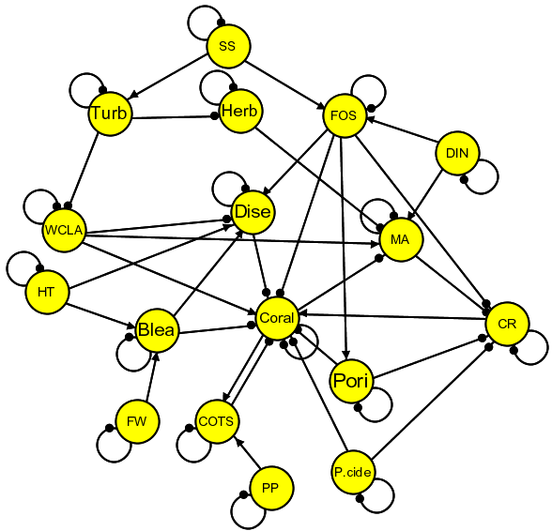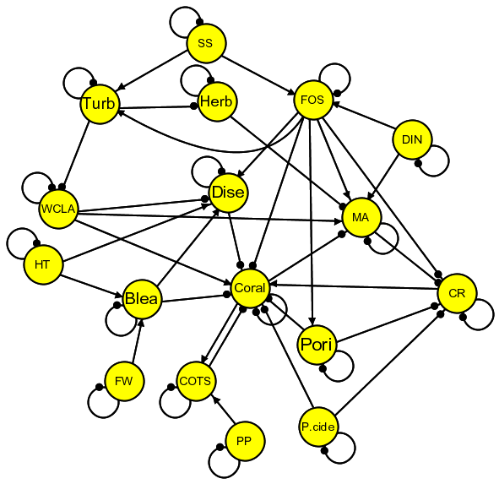
Model i Model ii
Figure 1: Alternative signed digraph model of coral ecosystems in the GBRWHA. Abbreviations shown in the nodes of the digraph are defined in Table 1. Alternative models based on presence (Model i) or absence (Model ii) of links from FOS to Turb and MA are shown.

Table 1: Abbreviations used in the signed digraphs of Figure 1. Those highlighted with an asterisk (*) are currently monitored during coral surveys.
Label | Description |  | Label | Description
Blea | Bleaching |  | MA* | Macroalgae
COTS | Crown of thorns starfish |  | P.cide | Pesticides
CR* | Coral recruitment |  | Pori | Porifera
DIN* | Dissolved inorganic nitrogen |  | PP | Phytoplankton
Dise | Disease |  | SS* | Suspended solids
FOS | Flocculated organic sediments |  | Turb* | Turbidity
FW | Fresh Water |  | WCLA | Water column light availability
Herb | Herbivore |  | HT | High water temperature

Table 2: Predictions of qualitative response to positive input to (a) suspended solids, (b) dissolved inorganic nitrogen, (c) pesticides, (d) high water temperature, and (e) freshwater for the models in Figure 1. Ambiguous predictions with a relatively high probability of sign determinacy (0.85) are enclosed in parentheses, and “?” denotes those with a low probability.

 |  | Model i | Model ii
(a) Input to SS | MA | (+) | (+)
 | Pori | + | +
 | Dise | + | +
 | Coral | (-) | (-)
 | CR | (-) | (-)
 | COTS | (-) | (-)
 | Blea | 0 | 0
(b) Input to DIN | MA | + | (+)
 | Pori | + | +
 | Dise | + | +
 | Coral | - | (-)
 | CR | - | (-)
 | COTS | - | (-)
 | Blea | 0 | 0
(c) Input to COTS | MA | + | +
 | Pori | 0 | 0
 | Dise | 0 | 0
 | Coral | - | -
 | CR | - | -
 | COTS | + | +
 | Blea | 0 | 0
(d) Input to P.cide | MA | + | +
 | Pori | 0 | 0
 | Dise | + | +
 | Coral | - | -
 | CR | - | -
 | COTS | - | -
 | Blea | 0 | 0

Table 2 cont.

 |  | Model i | Model ii
(e) Input to HT | MA | + | +
 | Pori | 0 | 0
 | Dise | + | +
 | Coral | - | -
 | CR | - | -
 | COTS | - | -
 | Blea | + | +
(f) Input to FW | MA | + | +
 | Pori | 0 | 0
 | Dise | + | +
 | Coral | - | -
 | CR | - | -
 | COTS | - | -
 | Blea | + | +

Qualitative predictions for response of variables in both coral models are identical (Table 2), and show a consistent pattern of a positive correlation between corals and coral recruitment and a negative correlation between these two variables and macro algae. This is in line with a classic pattern of these variables forming alternative ecosystem states, whereby healthy coral communities are accompanied by relatively low abundance of macro algae, or alternatively, high levels of macrophytes persist in the presence of degraded coral communities. This pattern is apparent across all perturbation scenarios in Tables 2a-f. Additional patterns that can be useful for interpreting monitoring data include the predicted response of porifera and coral disease. Here inputs to suspended solids or dissolved inorganic nitrogen are both predicted to increase porifera and the incidence of disease in corals, while only coral disease is predicted to increase across the other perturbations in Table 2. Coral bleaching is positively correlated with disease only for inputs to high temperatures and increased levels of freshwater.

Inshore Seagrass Sub-Program

Qualitative Model of seagrass Ecosystems
Seagrass ecosystems were modelled based on seagrass recruitment dynamics and composition of seagrass species and growth forms (Figure 2). Seagrass flowers and fruits lead to seed production from which seagrass develop and mature. Dugongs shift the composition of the seagrass community to pioneer species (i.e., r versus k life history strategy) and growth forms, which tend to have a reduced biomass. Seagrass provides a surface upon which epiphytic algae grow, while epiphytes in turn can limit the growth of seagrass by shading seagrass leaves. Seagrass is consumed by dugongs, turtles and mid-sized herbivores. Seagrass seeds are consumed by a wide range of consumers and epiphytes are consumed by scrapers. Upon this basic feedback system are numerous pressures on the system associated with sediment regime, nutrient inputs, water temperature, water clarity, herbicides, and physical disturbances. The background sediment regime captures a number of important processes and conditions, whereby relatively small amount of sediment deposition with a moderate amount of organics sustains or promotes the growth of seagrass. Departure from this background regime, however, commonly occurs where there is an excessive rate of sedimentation, or where the sediments have a relatively high level of organics---i.e., seagrass growth is generally limited to sediments containing <17% organic matter. A key mechanism here is that soils with high levels of organics are prone to developing high concentrations of sulfides, which limits seagrass growth through toxic effects on the roots. Two alternative models were based on the presence or absence of a positive link from DIN to seagrass, which was deemed uncertain by workshop participants.

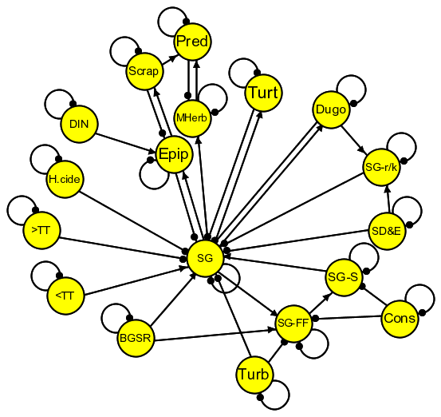  Model i | 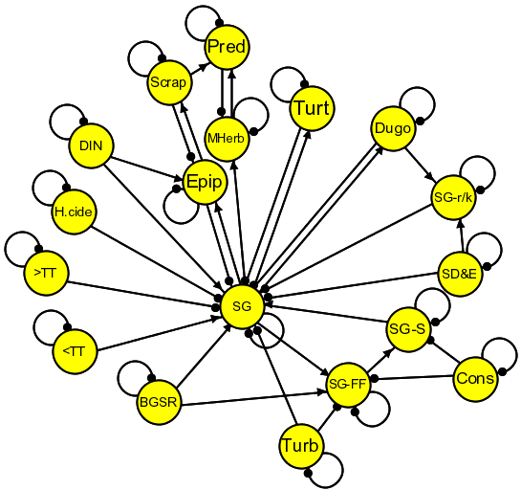  Model ii
Figure 2: Alternative signed digraph models of seagrass ecosystems in the GBRWHA. Abbreviations are defined in Table 3. Alternative models based on presence-absence of link from DIN to SG.

Table 3: Abbreviations used in the signed digraphs of Figure 2. Those highlighted by an asterisk are currently monitored during seagrass surveys.
Label | Description |  | Label | Description
BGSR* | Background sediment regime |  | Cons | Consumers of seagrass fruits and seeds
DIN* | Dissolved inorganic nitrogen |  | Dugo | Dugong
Epip* | Epiphytes |  | H.cide* | Herbicide
MHerb | Mid-sized herbivores |  | Pred | Predators
Scrap | Scrapers |  | SD&E | Structural damage and erosion
SG* | Seagrass abundance |  | SG-FF* | Seagrass flowers and fruits
SG-r/k* | ratio of r and k seagrass growth form or species |  | SG-S* | Seagrass seeds
Turb* | Turbidity |  | Turt | Turtles
<TT* | Temperature below critical threshold |  | >TT* | Temperature above critical threshold
Table 4: Predictions of qualitative response to positive input to (a) water temperatures above critical threshold, (b) dissolved inorganic nitrogen, (c) turbidity, (d) herbicides and (d) background sediment regime for alternative models i and ii (Figure 2). Ambiguous predictions with a relatively high probability of sign determinacy (0.85) are enclosed in parentheses, and “?” denotes those with a low probability. Those with asterisks are measured by the MMP.
 |  | Model i | Model ii
(a) Input to >TT* | Epip* | - | -
 | Dugo | - | -
 | SG* | - | -
 | SG-r/k* | - | -
 | SG-FF* | - | -
 | SG-S* | - | -
(b) Input to DIN* | Epip* | + | (+)
 | Dugo | - | ?
 | SG* | - | ?
 | SG-r/k* | - | ?
 | SG-FF* | - | ?
 | SG-S* | - | ?
(c) Input to Turb* | Epip* | - | -
 | Dugo | - | -
 | SG* | - | -
 | SG-r/k* | - | -
 | SG-FF* | - | -
 | SG-S* | - | -
(d) Input to H.cide* | Epip* | - | -
 | Dugo | - | -
 | SG* | - | -
 | SG-r/k* | - | -
 | SG-FF* | - | -
 | SG-S* | - | -
(e) Input to BGSR* | Epip* | + | +
 | Dugo | + | +
 | SG* | + | +
 | SG-r/k* | + | +
 | SG-FF* | + | +
 | SG-S* | + | +

Qualitative predictions for response of variables in the models for seagrass ecosystems (Table 4) are generally consistent across both alternative models, except for ambiguous predictions associated with model ii for an input to dissolved inorganic nitrogen (Table 2b). Response predictions for all monitored variables are positive correlated with each other except for model i with an input to dissolved inorganic nitrogen. Here the response of epiphytes is predicted to be negatively correlated with all other monitored variables. Thus this correlation pattern has the potential to discern this perturbation source from the others. The utility of this correlation, however, is reliant on there being little or no enrichment effect to seagrass from an increase in dissolved inorganic nitrogen, which is the basis of the difference in structure between models i and ii.

Flood Plume and Remote Sensing Sub-Program

Qualitative Model of Inshore plankton communities
General models of plankton communities in inshore regions of the GBR (Figure 3) are based on dynamics associated with seasonal patterns of river runoff. Relatively high levels of river runoff in the wet season leads to increased levels of particulate nitrogen, dissolved inorganic nitrogen, suspended solids, and turbidity. Turbidity is also increased by levels of suspended solids and wave energy. Phytoplankton are dependent on dissolved inorganic nitrogen as the key limiting nutrient for growth, but are also limited by available light in the water column. Here, dissolved organic nitrogen is considered as implicit within the link from dissolved inorganic nitrogen to phytoplankton. Additionally, dissolved inorganic phosphorous and silicon, and variation in water temperature were not considered as important limiting factors for phytoplankton growth. The growth of zooplankton is controlled by levels of phytoplankton. Zooplankton contributes back to the pool of dissolved inorganic nitrogen either directly, through excretion, or indirectly via their natural rate of mortality, which contributes to a pool of water-column detritus and subsequent decomposition (NB: this indirect route through detritus is subsumed within the zooplankton –to-dissolved inorganic nitrogen link). COTS larvae are depicted as benefiting from consumption of phytoplankton via an increased rate of survival, but as their abundance is relatively small they do not inflict an appreciable rate of mortality on phytoplankton. Key uncertainties in model links include whether turbidity diminishes available light in the water column and whether or not phytoplankton is significantly limited by predation from zooplankton communities. Developing models with and without these links resulted in four alternative models for inshore plankton communities (Figure 3).
While the models in Figure 3 are focused on the seasonal dynamics (i.e., wet- versus dry-season) of the entire inshore community of plankton, a concern was raised by one of the workshop participants that these models did not address smaller-scale dynamics of flood plumes (Jon Brodie, pers. com.). While it is entirely feasible to develop models that address these dynamics, it proved impossible to convene key MMP providers to do so.

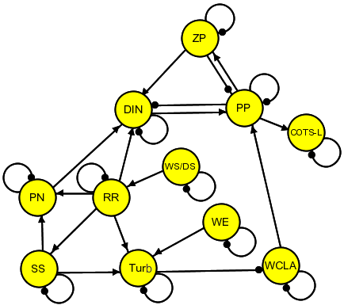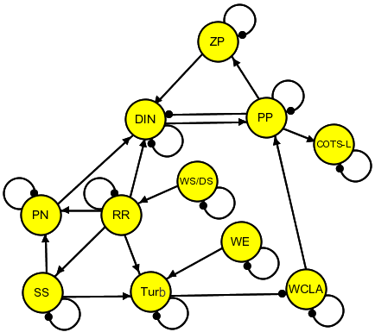
Inshore plankton model i Inshore plankton model ii
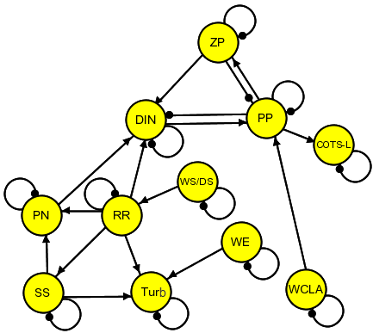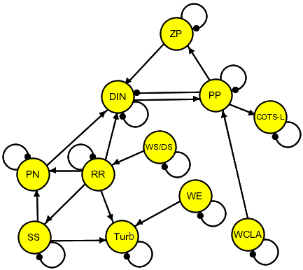
Inshore plankton model iii Inshore plankton model iv
Figure 3: Alternative signed digraph models of inshore plankton communities in the GBRWHA. Alternative models based on presence/absence of links from ZP to PP, and from WCLA to PP. Abbreviations are defined in Table 5.

Table 5: Abbreviations used in the signed diagraphs of Figure 3. Those highlighted by an asterisk are currently monitored during flood plume surveys.
Label | Description |  | Label | Description
COTS-L | Crown of thorns starfish larvae |  | DIN* | Dissolved inorganic nitrogen
PN* | particulate nitrogen |  | PP | Phytoplankton
RR | River runoff |  | SS | Suspended solids
Turb* | Turbidity |  | WS/DS | Wet season versus dry season
ZP | Zooplankton |  | WCLA* | Water column light availability
 |  |  | WE | Wave Energy

Table 6: Predictions of qualitative response to positive input to (a) wet season versus dry season, and (b) wave energy for alternative models i-iv (Figure 3); ambiguous predictions with a relatively high probability of sign determinacy (0.85) are enclosed in parentheses, and “?” denotes those with a low probability. Model variables are outlined in Table 5. Those with asterisks are measured by the MMP.
 |  | Model i | Model ii | Model iii | Model iv
(a) Input to WS/DS | ZP | ? | ? | + | +
 | DIN* | (+) | (+) | + | +
 | PP | ? | ? | + | +
 | PN* | + | + | + | +
 | RR* | + | + | + | +
 | Turb* | + | + | + | +
(b) Input to WE | ZP | - | - | 0 | 0
 | DIN* | ? | ? | 0 | 0
 | PP | - | - | 0 | 0
 | PN* | 0 | 0 | 0 | 0
 | RR* | 0 | 0 | 0 | 0
 | Turb* | + | + | + | +

Qualitative predictions for response of variables in the models for the inshore plankton community are generally consistent across the four alternative models (Table 6). For a shift from dry- to wet-season conditions (i.e., positive input to WS/DS in Table 6a), all variables monitored generally increase, or have ambiguous responses. For an increase in wave energy (i.e., positive input to WE in Table 6b) non-zero or unambiguous responses occur only for zooplankton, phytoplankton and turbidity in models i and ii. In models iii and iv, only turbidity has a non-zero response prediction, and the biological variable are isolated from any effects of increased wave energy, which highlights the importance of the role of turbidity in regulating plankton productivity through water column light.
For input to WS/DS the results in predictions in Table 6a suggest a positive relationship between turbidity and all other monitored variables (i.e., those with an asterisk in the table). Accordingly, all other monitored variables are predicted to have a positive correlation in their responses to a shift to wet season conditions. For an increase in wave energy, however, the correlation between turbidity and all other monitored variables is predicted to be zero (or ambiguous for correlation with DIN in models i and ii).

Key Indicators and Patterns of Correlation
The preceding analyses of the qualitative models suggest key indicators and patterns of correlation that would be useful in interpreting monitoring data.
Coral reef ecosystems
- Model predictions suggest a consistent pattern of a positive correlation between corals and coral recruitment and a negative correlation between these two variables and macro algae.
- Porifera and coral disease are both predicted to increase in response to increased levels of suspended solids and dissolved inorganic nitrogen, while only coral disease is predicted to increase for inputs to COTS, pesticide, high water temperature and freshwater.
- Coral bleaching is positively correlated with disease for inputs to high water temperature and increased levels of freshwater.
Seagrass ecosystems
- Response predictions for all monitored variables (i.e., epiphytes, seagrass, seagrass r/k, seagrass fruits and flowers, seagrass seeds) are positively correlated with each other for all perturbation scenarios, except for an input to dissolved inorganic nitrogen, which increases epiphytes and decreases all other variables.
Inshore plankton communities
- For a shift from dry- to wet-season conditions, all monitored variables (i.e., dissolved inorganic nitrogen, particulate nitrogen, river runoff, turbidity) generally increase.
- For increase in wave energy, non-zero or unambiguous responses occur only for zooplankton, phytoplankton and turbidity in models i and ii, while in models iii and iv, only turbidity has a non-zero response prediction.
- For an increase in wave energy, the correlation between turbidity and all other monitored variables is predicted to be zero (or ambiguous for correlation with DIN in models i and ii).

Part II Analysis of Indicators and Metrics

Pressure Indicators for Monitoring

Coral Reef and Water Quality Marine Monitoring Program

Summary and Preparation of Available Data
Coral compositional data was provided by AIMS at the genus (114) and family (33) levels for hard and soft coral and algal communities. This information was provided for each of the 32 Reefs using the survey design described in Section 6 of Part III, where surveys were conducted across 8 visits between 2005 and 2012 (noting that not all sites were visited during all 8 time periods). Two sites were visited for each reef, with the exception to Snapper Island North and South, where 3 sites were surveyed. At each site, surveys of coral composition were taken across five 50m transects and at two different depths (2m or 5m), and these were estimated as a percentage for each genus or family level identified. We were also provided with cover composition for the broader groupings of hard coral, soft coral and macro-algae cover for each reef, site, and depth and transect spanning the same sampling period.
Sediment consisting of the composition of different particles of sediment ranging from grades of silt, sand to coarse sand was provided for each reef and site across visits, starting from 2006. Total carbon (TC), organic carbon (OC) and total nitrogen (TN) content were also provided. A principal components analysis and correlation analysis on the sediment data indicated high correlations between the sediment composition and TC, OC, and TN. For parsimony and ease of analyses and presentation in sections below, TC, OC and TN were used in place of the sediment composition.
Water quality data was surveyed in two different ways within this program. The first captured water quality measurements using grab samples, while the second were measured through a continuous logger. The water quality grab samples represented an integrated sample of water quality (i.e. integrated across different depths that the samples were taken). Water quality measurements were sampled for the water quality parameters outlined in Table 7. Water quality logger data was provided continuously for each coral site between 2006 and 2013 and measured samples of average and median turbidity (ntu) and average and median chlorophyll. A third set of water quality data based on remote sensing technology was provided to aid in a comparison between the 3 methods. The remotely sensed water quality data (3km x 3km) was a synthesised version provided by CSIRO that summarised chlorophyll and total suspended sediment (TSS) for each reef across a number of days between 2002 and 2012.
The integration of the water quality data with the coarl and algal assemblage data was challenging due to the different times and frequency that sampling took place. The three sources of water quality data and one sediment database were integrated with the coral assemblages for the purpose of conducting statistical analyses of coral and algal groups and to test whether certain factors that were identified in the qualitative modelling development in Section 2 of Part I are important in detecting shifts in community composition or changes in composition for key coral families across the 32 reefs in the GBR lagoon.

Table 7: Summary of water quality and sediment data collected for examining drivers of change in benthic communities. Note, sediment particles surveyed are not listed in this table as they were seen to be highly correlated with TC, OC and TN. Specific details related to the sampling of these parameters are outlined in Thompson et al. (2010)
Grab Samples |  |  |  | Remote Sensing | Logger | Sediment
Chlorophyll | DIP | TDP | PP | Chlorophyll | Chlorophyll | TC
SI(OH)₄ | NH₄ | NH₄ (Hand) | NO₂ | TSS | Turbidity | OC
NO₃ | TDN | PN | DOC |  |  | TN
POC | DIN | NOx

Prior to integration we calculated a wet season lag that comprised of summing samples taken from January through to the start of coral sampling for that year. This was only calculated for water quality logger and satellite data. Lags were not created for the grab sample data and in fact, grab sample data was ultimately excluded from the analysis due to the sparse nature of sampling, which resulted in a reduced dataset for analysis due to the infrequent nature in the way the data was sampled. Furthermore, we do not think it is suitable to create lags or utilise the grab samples collected the year prior to sampling as we feel that 3 samples are not representative of the entire period and therefore cannot adequately explore drivers of change in coral communities given the current sampling regime. Therefore, for the purpose of assessing drivers of change in the analysis of benthic communities and dominant coral families, we could only use the logger and remote sensing data. In terms of assessing drivers of change that were highlighted by the qualitative models in Section 2 of Part I, this implies that we can only assess suspended sediment, turbidity and chlorophyll.
For any parametric analyses conducted on this integrated dataset, we needed to exclude any row that has missing data with the exception to non-parametric methods like Classification and Regression Trees (CART) (Breiman et al., 1984), a method that can easily accommodate missing data. The resulting data (both at the family and genus level) has hard coral, soft coral and macro-algae compositions for each reef i, site j, and visit k. Table 8 summarises the potential explanatory variables that were matched to the coral and algal community data to create a dataset for exploration and analysis in subsequent sections of this report.

Table 8: Summary of potential explanatory variables.
Variable | Description |  | Variable | Description
Water Quality - Satellite |  |  | Water Quality – Logger
chlWS.M | Wet season chlorophyll (median) |  | ntu.avgWS.M | Wet season average turbidity (median)
chlWS.75 | Wet season chlorophyll (75th percentile) |  | ntu.avgWS.75 | Wet season average turbidity (75th percentile)
chlWS.95 | Wet season chlorophyll (95th percentile) |  | ntu.avgWS.95 | Wet season average turbidity (95th percentile)
tssWS.M | Wet season TSS (median |  | chl.avgWS.M | Wet season average chlorophyll (median)
tssWS.75 | Wet season TSS (75th percentile) |  | chl.avgWS.75 | Wet season average chlorophyll (75th percentile)
tssWS.95 | Wet season TSS (95th percentile) |  | chl.avgWS.95 | Wet season average chlorophyll (95th percentile)
Nutrients |  |  | ntu.medWS.M | Wet season median turbidity (median)
Total Carbon | Total Carbon |  | ntu.medWS.75 | Wet season median turbidity (75th percentile)
Organic Carbon | Organic Carbon |  | ntu.medWS.95 | Wet season median turbidity (95th percentile)
Total Nitrogen | Total Nitrogen |  | chl.medWS.M | Wet season median chlorophyll (median)
Spatial Variables |  |  | chl.medWS.75 | Wet season median chlorophyll (75th percentile)
Latitude | Latitude |  | chl.medWS.95 | Wet season median chlorophyll (95th percentile)
Longitude | Longitude
Catchment | Catchment (6 regions – Burdekin, Daintree, Fitzroy, Johnstone, Proserpine and Tully)
Depth | 2m or 5m

Comparison between the Grab Sample, Logger and Satellite Data
Prior to embarking on the assessment of drivers and their ability to detect changes in benthic compositions, we first explored the efficiency in water data collected through the three regimes described above (grab sample, logger and remote sensing). The purpose of this assessment was to determine whether certain seasonal patterns or trends could be estimated across the three sampling regimes and identify the need for this continued sampling into the future and for what purpose. The water quality data made available for this analysis is summarised in Table 9, and shows the extent of sampling that took place for each regime. It is clear from Table 9 that the sampling frequency for the grab samples is quite poor in comparison to the logger and remote sensing data. A detailed analysis of each set of data follows to explore the utility of each dataset in terms of exploring trends in benthic composition.

Table 9. Sampling frequency of water quality data.
Data | Number of Reefs | Data temporal coverage | Sampling frequency | Sampling months
WQ logger | 14 | 2006-2013 | daily | -
WQ grab samples | 20 | 2005-2013 | 3 times per year | Feb, Jun, Oct
Satellite | 32 | 2002-2012 | 4-10 times per month | -

WQ Logger Data
Figure 4 summarises the availability of logger turbidity and chlorophyll data. The figures show that there is good coverage of the turbidity data across time and space and limited data available for chlorophyll. Figure 5 and Figure 6 show time series plots of turbidity and chlorophyll data respectively for each site surveyed as part of this program.
We explored fitting Generalised Additive Models (GAM) to both the turbidity and chlorophyll data to investigate within year and between year patterns in the data using the approaches set out by Hastie and Tibshirani (1990) and Wood (2006). We used the mgcv package in R (Wood, 2006) to explore all the models presented in this section. GAMs were chosen instead of simple linear models as they allow for flexible, smooth terms to be included into the model which are useful for capturing seasonal and long term trends in the data, in addition to representing any flexible relationships between covariates deemed to be predictive in the model.
In Figure 5 a GAM with a smoothing spline is overlayed on to the turbidity data to summarise the changes over time. Figure 6 also contains a linear term overlayed on the time series for chlorophyll for ease of visualisation.
We also performed a statistical trend analysis (non-linear), which included seasonality, on the water quality logger data for chlorophyll using a GAM that is outlined below. Although the turbidity data is largely event driven, which may be partially explained by season, Figure 5 shows that the data has a low signal-to-noise ratio and the observed patterns we see in this figure are inconsistent through time. No meaningful seasonality relationships and a consistent trend could be identified for turbidity. As a result, Appendix C only contains the results from performing these analyses for the chlorophyll data for each site.
A GAM was applied to the chlorophyll data ( ) with flexible, smooth terms to capture any trends or long term changes in the level of the time series in addition to any seasonality or within-year variation. We can mathematically express this model as
where β is the intercept, $f_{season}$ and $f_{trend}$ are smooth functions for the seasonal and trend components, and $x_{1}$ and $x_{2}$ are covariates that indicate the within-year and between year times. In this model, chlorophyll is modelled on the raw scale with errors that are Normally distributed. Modelling results are presented in Appendix C. The left panel of each graph represents the seasonal variation (within-year variation) of the water quality time series while the right panel shows the long term trend over the entire time period. The y-axis of each figure shows the contribution of each term to the fit of the model (i.e. how the chlorophyll response changes). Note that at Daydream Island, Pandora, Pelican Island and Pine Island, the data is shorter than one year so there is no seasonality estimates provided.
While the non-linear trend component $f_{trend}\left(x_{2}\right)$ is useful. We also extracted the linear component of that trend and calculated the average annual change in chlorophyll during the period of sampling. This result is summarised in Table 10 which shows the estimate median chlorophyll per annum for each site and whether a significant increase or decrease was noted.

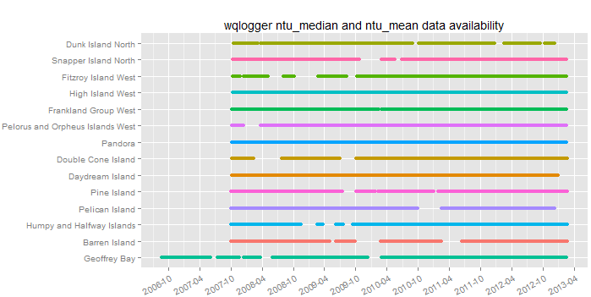
(a)
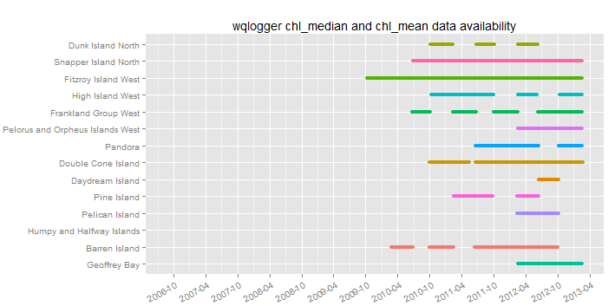
(b)
Figure 4: Water quality logger data availability for (a) turbidity and (b) chlorophyll.

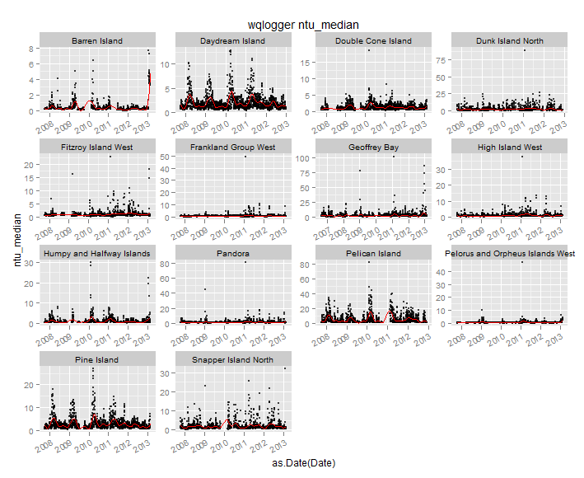
Figure 5: Time series of the median turbidity logger data, where red lines show the seasonal trend in the data.
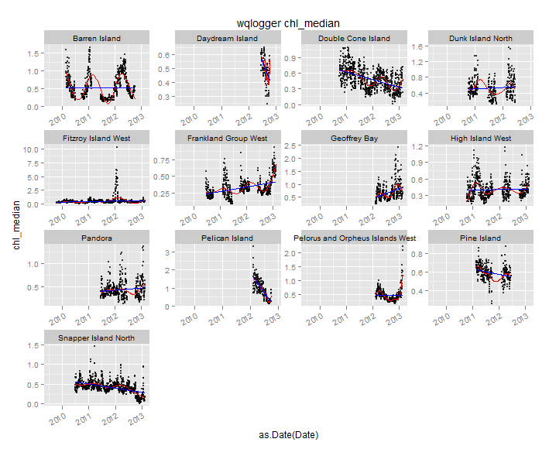
Figure 6: Time series of the median chlorophyll logger data, where red lines show the seasonal trend in the data and blue lines indicate the long term trend.

Table 10: Average annual increase/decrease in water quality logger median chlorophyll. Increases are highlighted by a (+) while decreases are highlighted by a (-). Bold font represents statistically significant changes at the 0.05 level
Site | Estimate of median chlorophyll per annum | Increase (+)/Decrease (-)
Barren Island | 0.0619 | +
Daydream Island | -0.2622 | -
Double Cone Island | -0.1394 | -
Dunk Island North | -0.0292 | -
Fitzroy Island West | 0.0898 | +
Frankland Group West | 0.0710 | +
Geoffrey Bay | 0.3549 | +
High Island West | 0.1328 | +
Pandora | 0.0521 | +
Pelican Island | -1.6114 | -
Pelorus and Orpheus Islands West | 0.5589 | +
Pine Island | -0.0714 | -
Snapper Island North | -0.1137 | -

Generalised additive models were fit to the logger median turbidity and median chlorophyll at a subset of sites, where more complete time series are collected, namely Barren Island, Double Cone Island, Snapper Island North and High Island West. We decompose the variability in both constituents temporally to investigate the proportion of the variability arising from the different time scales. Results are displayed in Table 11 and Table 12. In these tables, the overall trend is the temporal trend in turbidity and chlorophyll respectively, across the entire period of record. The yearly pattern represents the seasonal effect, the monthly pattern and weekly pattern variation estimates represent seasonality at a finer time scale. Since turbidity is event driven and much noisier, little of its variation can be explained by temporal variables. This may be related to discharge, but this information was not available at the time of analysis and not tested. For chlorophyll, however, trend and seasonality contribute a relatively large portion to the variation, depending on the location. We also see that the effect of finer scale seasonality (monthly and weekly) is minimal. This analysis shows that in addition to trend, seasonality explains some portion of the variation. However, seasonality at finer time scales has very little effect.

Table 11: Percent variation explained at a subset of sites sampled in the MMP partitioned by different temporal resolutions for the logger median turbidity.
Turbidity Median |  | Barren Island | Double Cone Island | Snapper Island North | Fitzroy Island West
The overall trend | Day of the period of record | 21.6% | 12.1% | 6.1% | 3.9%
Yearly pattern | Day of the year (1-366) | 14.0% | 8.4% | 8.6% | 3.3%
Monthly pattern | Day of the month (1-31) | 1.9% | 1.5% | 0.5% | 1.1 %
Weekly pattern | Day of the week (1-7) | <1% | <1% | <1% | 0.05%

Table 12: Percent variation explained at a subset of sites sampled in the MMP partitioned by different temporal resolutions for the logger median chlorophyll.
Chlorophyll Median |  | Barren Island | Double Cone Island | Snapper Island North | Fitzroy Island West
The overall trend | Day of the period of record | 69.1% | 42.1% | 40.1% | 23.7%
Yearly pattern | Day of the year (1-366) | 53.3% | 11.4% | 11.9% | 17.9%
Monthly pattern | Day of the month (1-31) | 0.09% | 0.1% | 0.2% | 0.2 %
Weekly pattern | Day of the week (1-7) | <1% | <1% | <1% | <1%

Grab Sample Data
The water quality grab samples are only sampled three times per year in February, June and October between 2005 and 2013. While we would expect to see strong trends and seasonality patterns in this type of data, we are unlikely to see these effects at a fine scale (e.g. daily or monthly) due to the coarse nature of sampling. Broad trends (e.g. yearly) may be observed (as can be seen through the power analysis conducted in this section) but it is important to understand that the water quality grab samples are not representative of “water quality data” across the region as they can be highly variable particularly at high frequencies. Furthermore, the way in which these samples have been collected makes it difficult to integrate with benthic community samples, as very few samples have been collected across time within a year. As highlighted above, it also does not make sense to create lags of the data due to the sparse nature of sampling.
Given the above restrictions, we examined the feasibility of detecting broad scale trends (i.e. yearly) using a bootstrap approach. This approach attempts to examine the ability to detect declines with sizes ranging between 1% and 50% based on grab sample data collected at the 20 reefs. The bootstrap procedure consists of:
- Extracting the data for a particular water quality parameter and site;
- Fitting a linear model with a broad scale trend term (i.e. yearly) with Gaussian errors to the log transformed constituent;
- Extracting the residuals;
- Bootstrapping the residuals and imposing a new trend to determine whether a broad scale trend across years could be detected and with what power based on a significance level () of 0.05.
The results are shown in Figures 7-10, which highlight the power (y-axis) for determining a specific decline (x-axis) for each of the water quality grab sample parameters explored in each of the 20 sites. Appendix A provides a more detailed summary of the analysis in a table for each water quality parameter. Cells highlighted in yellow indicate that at least 90% power was achieved.
The bootstrap power results highlight varying levels of power for the range of water quality parameters measured. At nearly all sites, it appears that DOC, PN, DIN, TDN, DIP and PP have reasonable power to detect broad scale (i.e. annual) trends at small declines, while NH4, NO2, NO3 and NOx have much lower power to detect similar declines. While this analysis indicates that this type of data has the capacity to detect broad scale declines for some water quality parameters, it still remains difficult to integrate this data with the benthic samples that have been collected at a more frequent time scale for the reasons outlined above. As such, we recommend that either the data in its current form be
- used for validation purposes for remote sensing data for example, as conducted by Brando et al. (2014) and incorporated into the report card to summarise water quality; or
- used solely for the purpose of investigating broad scale trends for specific parameters (DOC, PN, DIN, TDN, DIP and PP) as identified by the bootstrap analysis and potentially considered as an alternative metric for the water quality component of the report card .
The value of (2) needs to be considered carefully and compared with the existing metrics due to the scale at which the data is collected.

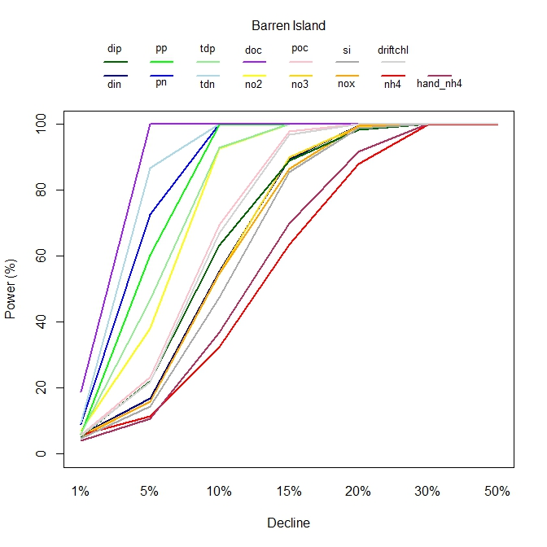  (a) | 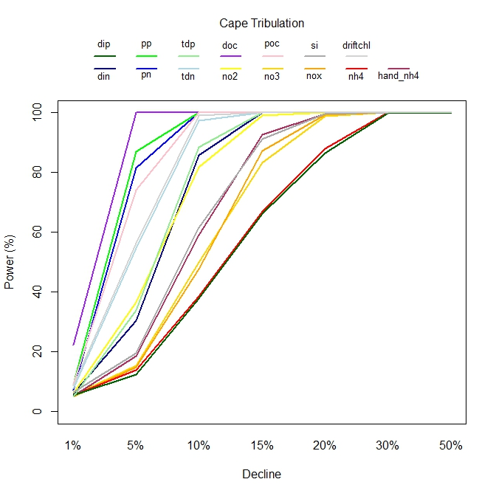  (b)
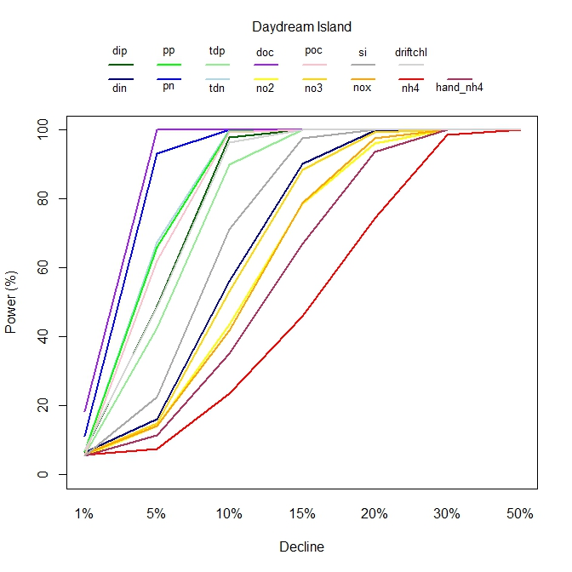  (c) | 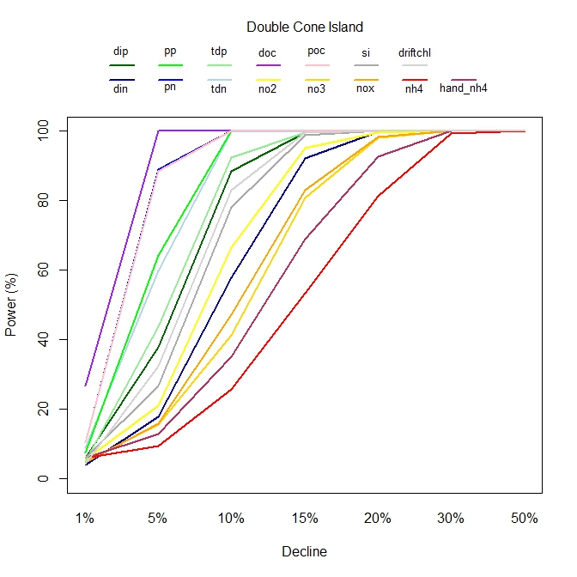  (d)
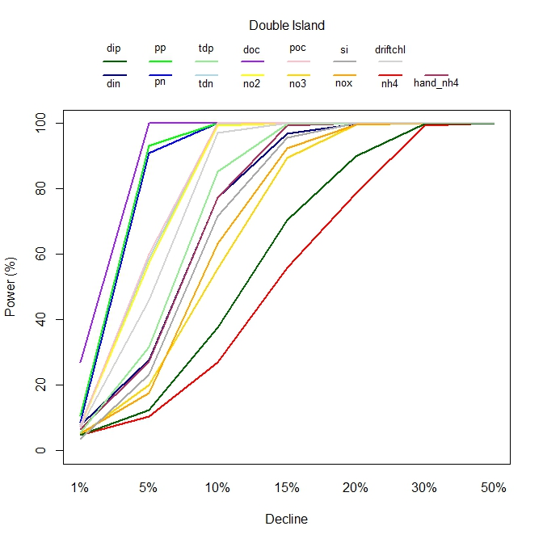  (e) | 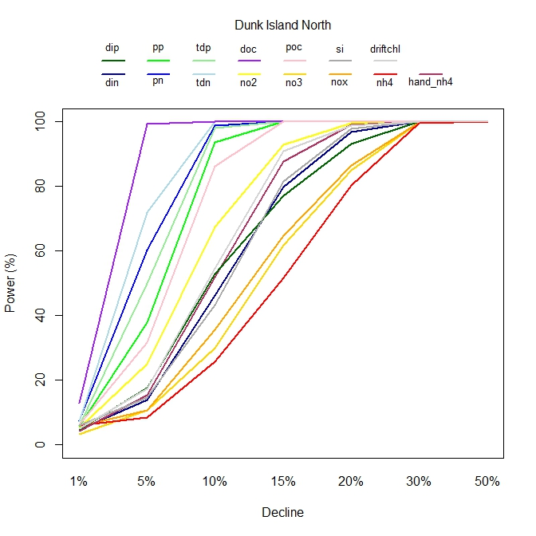  (f)
Figure 7: Power results for (a) Barren Island, (b) Cape Tripbulation, (c) Daydream Island, (d) Double Cone Island, (e) Double Island and (f) Dunk Island North investigating 15 water quality parameters collected for the MMP.

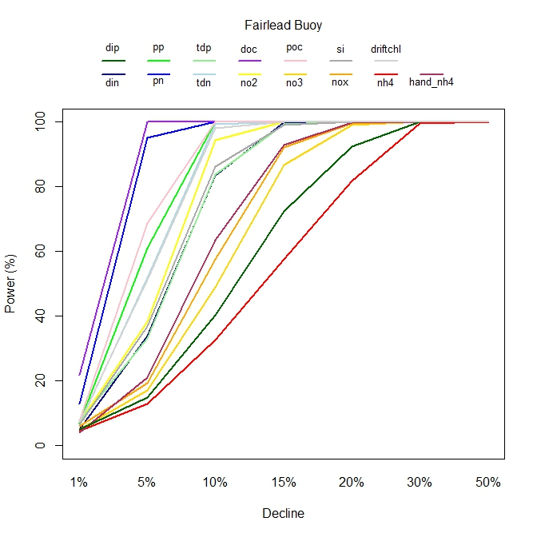  (a) | 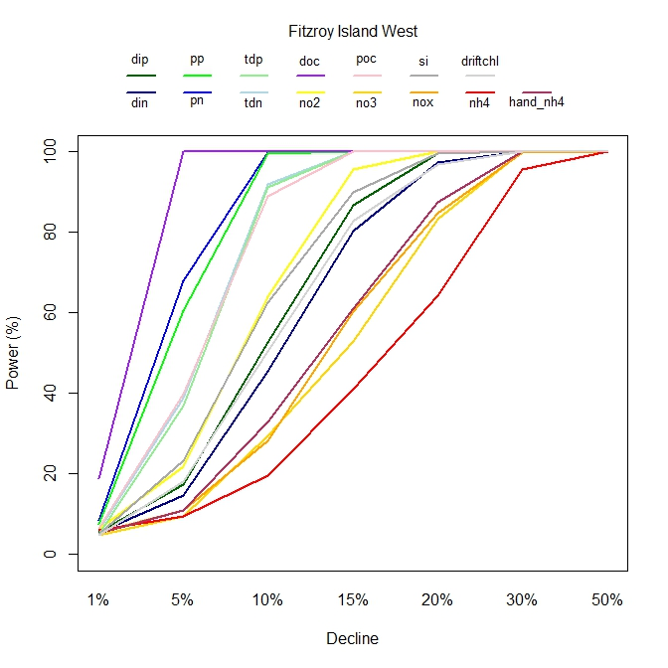  (b)
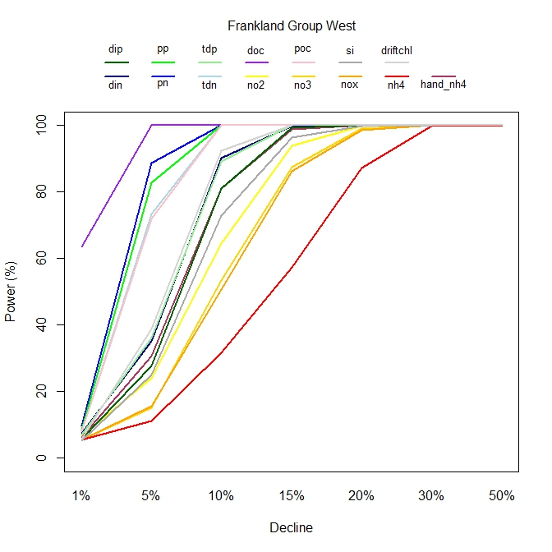  (c) | 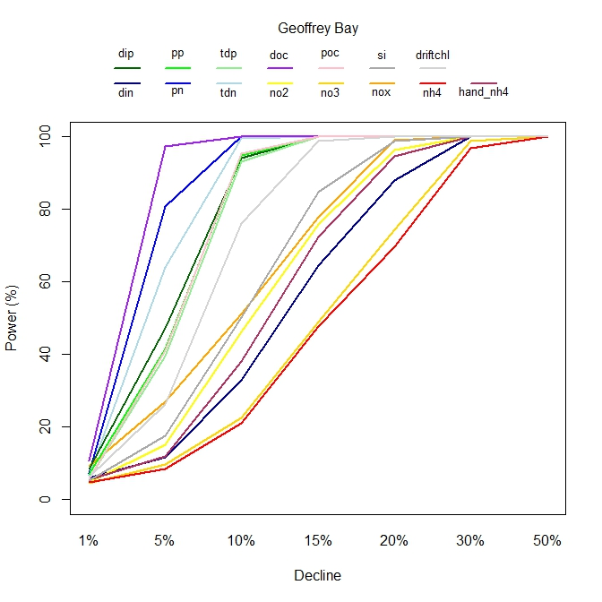  (d)
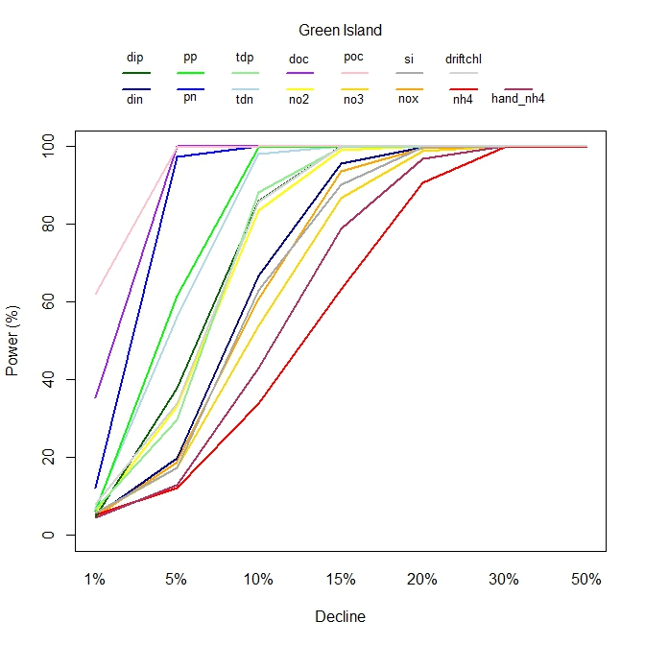  (e) | 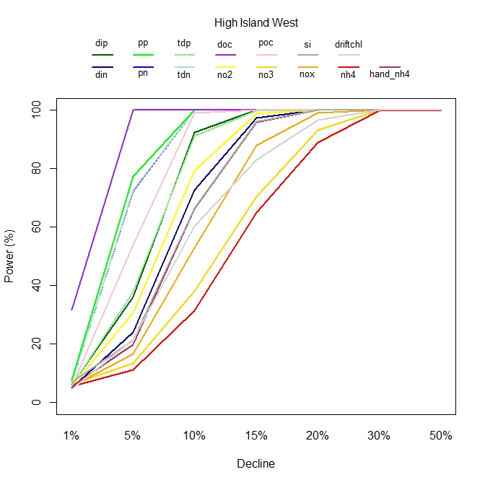
Figure 8: Power results for (a) Fairlead Buoy, (b) Fitzroy Island West, (c) Frankland Group West, (d) Geoffrey Bay, (e) Green Island and (e) High Island West investigating 15 water quality parameters collected for the MMP.

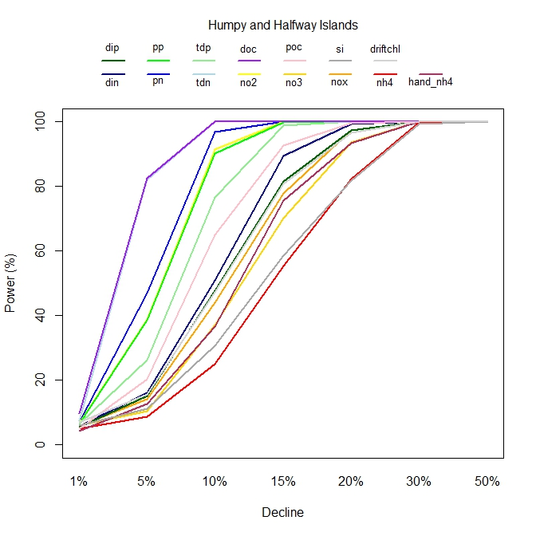  (a) | 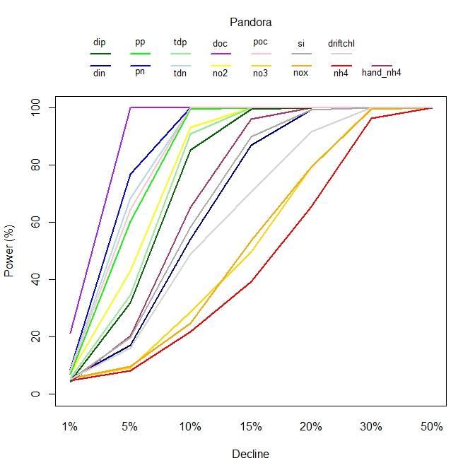  (b)
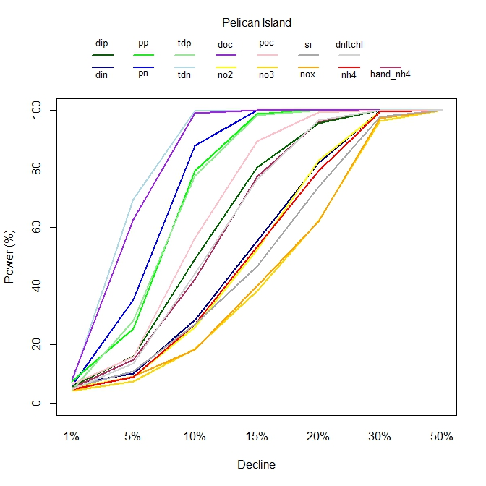  (c) | 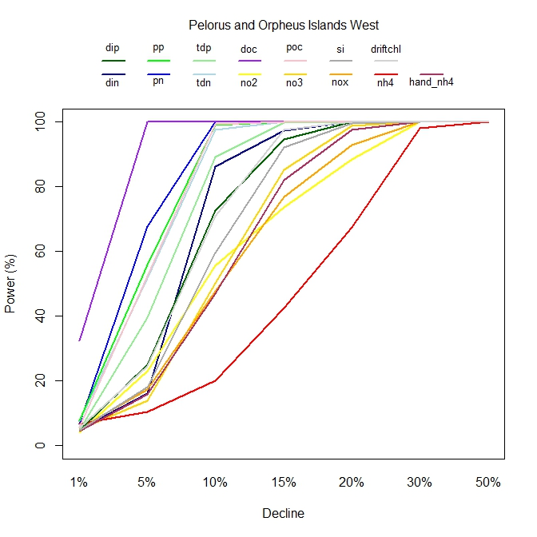  (d)
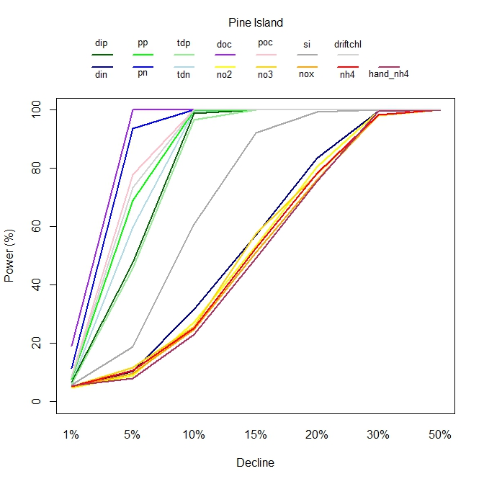  (e) | 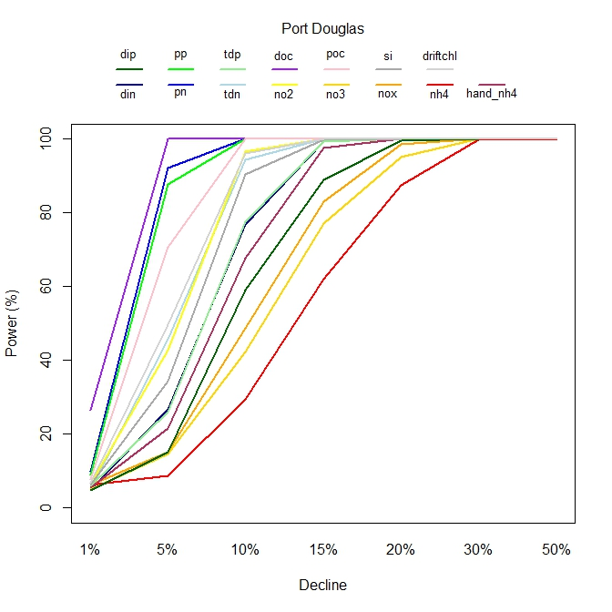  (f)
Figure 9: Power results for (a) Humpy and Halfway Islands, (b) Pandora, (c) Pelican Island, (d) Pelorus and Orpheus Islands West, (e) Pine Island and (e) Port Douglas investigating 15 water quality parameters collected for the MMP.

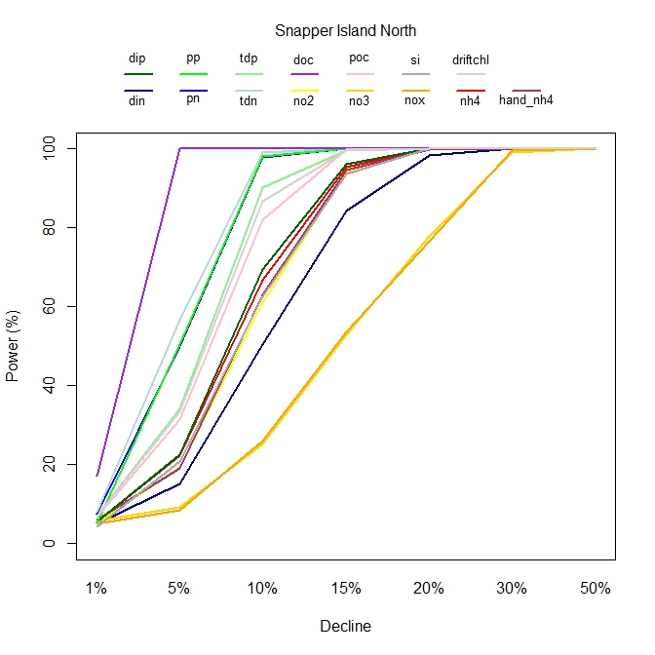  (a) | 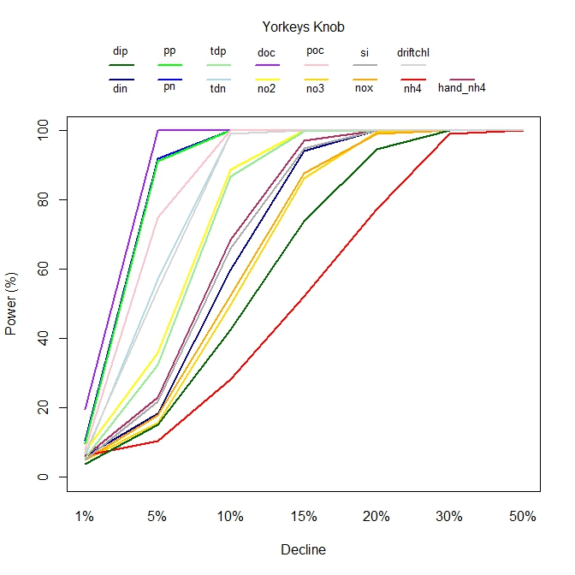  (b)
Figure 10: Power results for (a) Snapper Island North and (b) Yorkeys Knob investigating 15 water quality parameters collected for the MMP.

WQ Satellite Data
The remotely sensed products of chlorophyll and TSS provide a very rich source of data for the MMP as shown by Figure 11. Figure 12 and Figure 13 show time series plots for chlorophyll and TSS for each site where MMP monitoring was conducted. For many of the sites there was a distinct seasonal pattern shown. It is also clear that some sites exhibited much more variability than others.
We fitted a GAM to the remote sensing data, with the aim of capturing any trends or long term changes in the level of the time series, in addition to examining whether any seasonal or within-year variation was important. The GAM structure is similar to what was implemented for logger data analysis. The results are shown in Appendix C. In each set of figures, the left panel represents the seasonal variation (within-year variation) of the satellite water quality series; and the right panel shows the trend of the water quality parameter throughout the entire time period. We see that chlorophyll and TSS have opposite seasonality (i.e. chl is low in winter and high in summer, whereas TSS is low in summer and high in winter). In order to summarise the non-linear trend in the data, we extracted the linear component from the model and examined this for significance. We found that although increases were noted for chlorophyll for all sites, none of these estimates were significant at the 5% level of significance. Furthermore, while only some TSS sites showed an increase, none of the estimates from the model were statistically significant at 0.05 level.
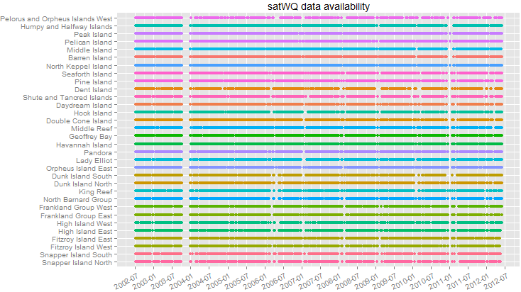
Figure 11: Summary of data availability for the water quality satellite data for each site through time.

Spatio-temporal analysis of Acroporidae

In this section, we explore space-time relationships for the most dominant coral family Acroporidae, which comprises 80.7% of the samples taken across all reefs. We chose this specific family to analyse as it represents the most common coral species in the reefs sampled. While AIMS chose to include other families in with Acroporidae when conducting their analyses, we chose to only analyse the Acroporidae family as it is the only family that is distributed consistently across space and therefore is a more representative coral family of the entire GBR coral condition and will provide a more consistent pattern of drivers of change, should any be important. This analysis also presents a precursor to a more comprehensive multivariate analysis that we showcase in Section 3.1.4, where we analyse the coral and algal compositions and how these vary in space, across time and with respect to the water quality drivers captured by this program. It also provides advice on the inshore coral monitoring program in terms of the spatial and temporal sampling undertaken that is described more in Part III of this report.
The statistical methods we used for this exploration included general linear models, Random Forests (Breiman, 2001), generalised additive models (GAM) (Hastie and Tibshirani, 1990, Wood, 2006) and generalised additive mixed models (GAMM) (Wood, 2006, Pineheiro and Bates, 2000). General linear models are the most simplest of models to consider as they assume a linear structure between the dependent variable and potential covariates (or independent variables) and assume normality in errors. More flexible models may be considered through GAMs as shown in earlier sections with the turbidity and chlorophyll modelling, while random effects can be included in a mixed modelling structure. The latter can be important if we are considering variation among sites or regions for example that are representative of the population as a whole. All three statistical modelling approaches are parametric, that is, they assume a parametric form or a distribution to model the error structure. A popular non-parametric approach that can be used to identify important variables and provide robust predictions is Random Forests. Like decision trees, which are explored in further sections below, Random Forests constructs many trees (either classification or regression based) and performs a weighted combination (or averaging) of trees to arrive at a prediction. The process of “averaging” leads to a better prediction, however at the compromise of having no model. Some sense of a covariate’s contribution to the model can be determined through partial dependence plots, where a covariate’s contribution to the model fit (and hence it’s relationships with the response) can be explored be examining the predictions from the many models fitted, while holding the remaining variables constant at a median or mean for example. These plots are similar to a smoothing spline produced in a GAM, but a much less smooth. Variable importance rankings can be derived from the Random Forest greedy algorithm to highlight important variables used to inform the prediction in the model. These concepts are explored more deeply in Breiman (2001). We use the randomForest package in R to construct the random forest of trees examined for key coral families. Note that in all modelling undertaken, we checked all model assumptions using standard diagnostics to determine if all spatial and temporal dependencies were captured in the model.

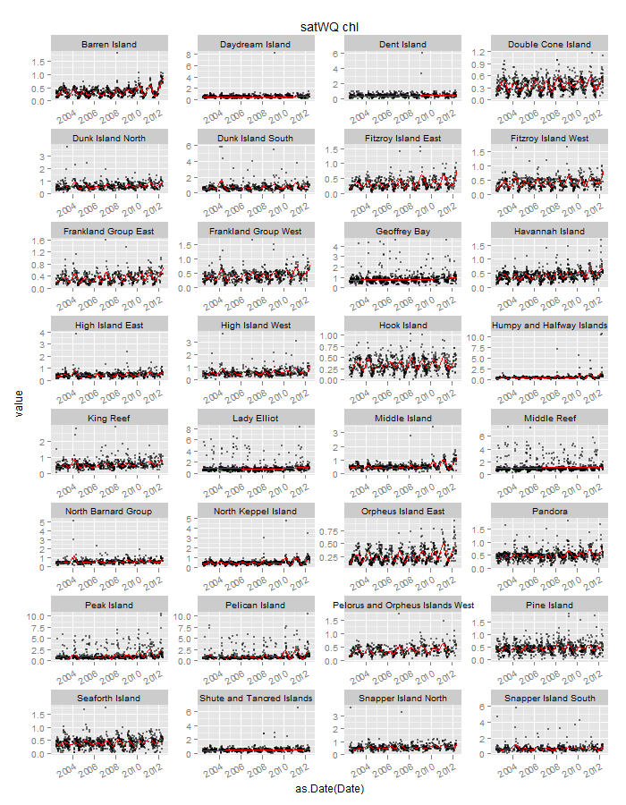
Figure 12: Time series of remotely sensed chlorophyll for each site monitored with the seasonal trend in red overlayed.

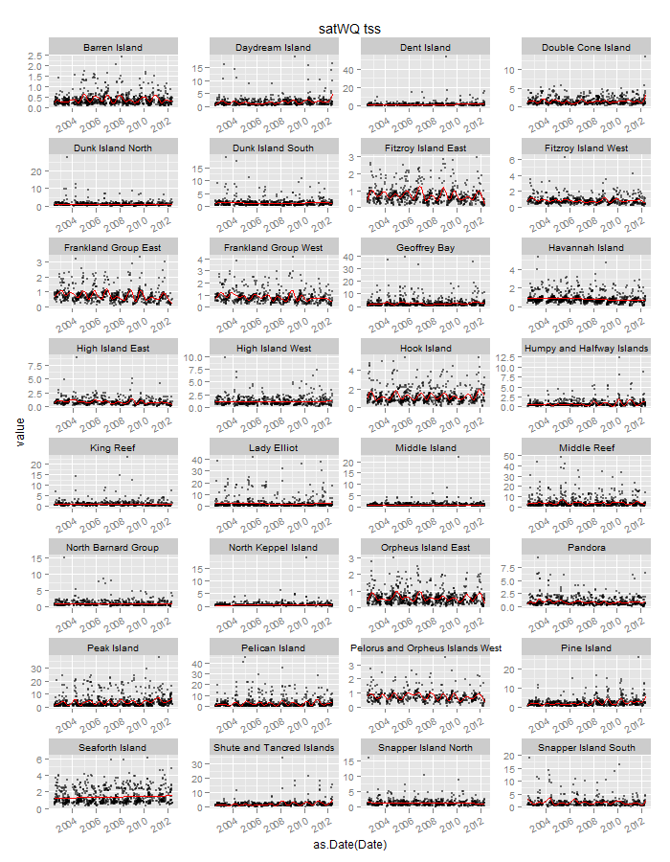
Figure 13: Time series of remotely sensed TSS for each site monitored with the seasonal trend in red overlayed.

Exploratory Analysis
We conducted a number of analyses to investigate the spatial and temporal trends for the Acroporidae family. In particular, the objectives of this investigation were two-fold: (1) to investigate spatial and temporal (2005-2012) patterns of coral cover for individual reefs and the entire GBR region, and (2) to identify the main spatial contributions (region, reef, site and transect) that may inform subsequent analyses conducted in Section 3.1.4 that follows. Figure 14 provides a summary of the availability for coral cover at the family and genus levels for hard, soft coral and algal species in a single image for each suite of data collected.

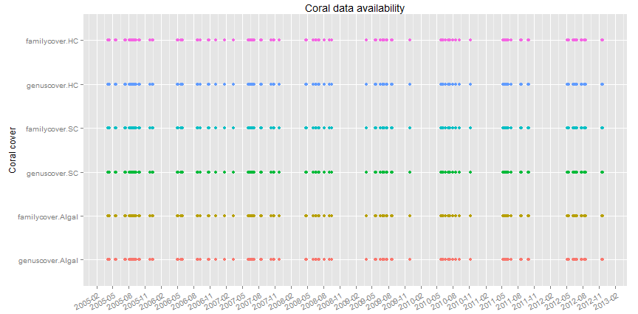
Figure 14: Data availability for coral cover at the family and genus levels for hard coral, soft coral and algal species.
Figure 16 displays time series plots for Acroporidae at the reef level. The monitoring data was recorded yearly at each reef, site, depth and transect. The multiple measurements (black points) in a year represent samples from different sites, depths and transects. One objective of the subsequent spatial and temporal analysis is to determine whether Site and Transect are statistically significant or not given the observed coral coverage. Averages over sites and transects may be taken if these factors have minimal impact. Time series plots over the full time record are presented as annual boxplots (Figure 16(b)) which summarise the data compactly, capturing the range of variability, and providing a sense of the changes that may be occurring. In Figure 16(b), variation due to sites, depths and transects within a reef is represented by the size of each box. At Barren Island and Daydream Island for instance, the variations are minimal, whereas at Humpy and Halfway Island, Pelican Island and Snapper Island North, the variations are large. The most important feature to take from Figure 16 is that the cover of the hard coral family, Acroporidae varies significantly from reef to reef. In both figures, we see neither a significant increase nor decrease over the 7 year period at more than half of the reefs. This suggests that it may be worth sampling some sites every 3-5 years, rather than every year. The choice of sites will need to be undertaken collaboratively between GBRAMPA and the MMP providers, taking into account these results and a very refined set of objectives that encapsulate the core aim of the program i.e. integration.

Analysis of Temporal and Spatial Trends

Temporal trends were fitted to cover corresponding to the Acroporidae family at the GBR wide scale using a general linear model with cover on the log scale. In addition to this analysis, Random Forests was used to identify important predictors.

Figure 15 shows that 16 coral sites are sampled less than once a year whereas other sites are sampled more frequently. Sampling frequency does not appear to have an obvious impact on the ability to detect a trend. Table 13 contains estimates for the linear trends from models fit to each of the reefs. All trend estimates are minimal with 19 out of 32 models exhibiting a trend term that was not significant. However the linear trends need to be treated cautiously. Some non‐linearity can be seen in the time series plots. This does not indicate that the linear trend is invalid but it does highlight that other features of the trend are important and that the linear trend calculated over different subsets of the data could deliver different results. The Random Forest analysis highlights that spatial variables (Reef and Latitude) are very important in explaining the variation in the percent cover of Acroporidae (Figure 15) and this purely highlights that there is a strong spatial component to the data. In this analysis, we also included a temporal factor Date, which appears to have less impact on the coral Acroporidae coverage than the spatial variables. In addition, reef when compared with depth, site and transect is the most important spatial variable as it yields the highest node purity as highlighted by Figure 15.
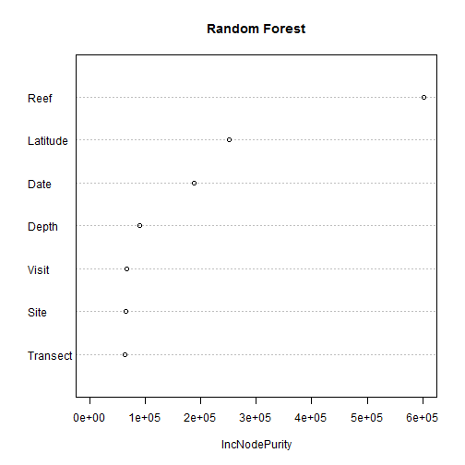
Figure 15: Variable importance ranking identified through the Random Forest modelling which shows for each variable included in the model, the node purity when each variable is added to the model.

We conducted a secondary analysis of the data to determine the variation in coral Acroporidae coverage that can be explained by spatial and temporal variables using a general linear model fit to the log of Acroporidae. Results from the fit of those models show that 43% of the variation is explained by the Reef term in the model, compared to 3.9% of the variation explained by the temporal term. This confirms that the sampling frequency for some sites could be conducted every 3-5 years due to the slowly time-varying nature of coral coverage.
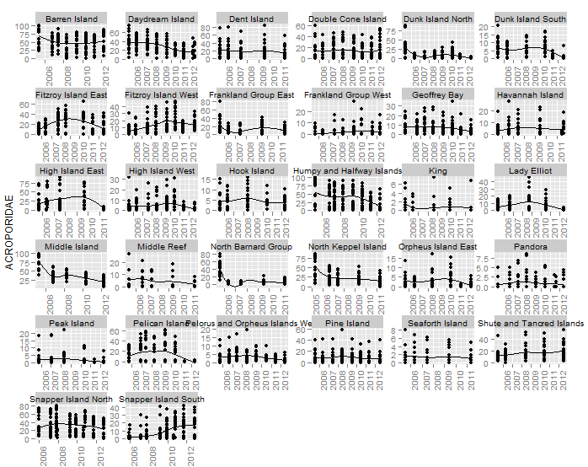
(a)

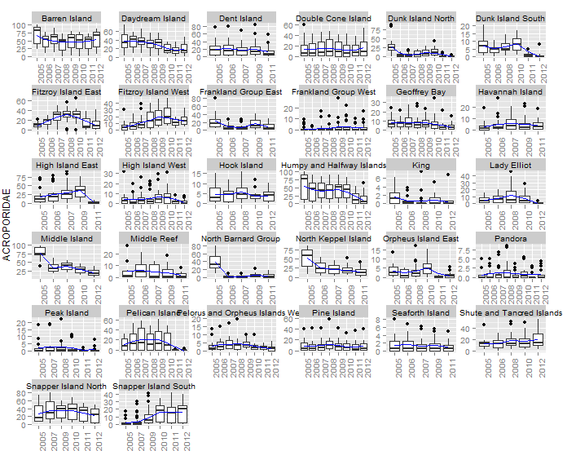
(b)
Figure 16: Trends in Acroporidae cover by reef plotted as (a) a scatterplot smoother and (b) box plots. A scatterplot smoother is overlayed on each figure. Multiple points shown for each year represent samples taken at each transect, depth and site.

The above spatial-temporal analysis is a GBR wide analysis. The reality is that spatial and temporal contributions are likely to differ between reefs, as we have seen in the time series plots. The space and time interaction can be verified using an analysis of variance. The significance of the space and time interaction term confirms that there is a relationship in space and through time that highlights differences in Acroporidae. However, this interaction term does not necessarily imply that the trends at individual reefs are significant. In fact, they are not (over the time period 2005-2012) and according to Table 13 and Figure 16 these relationships are different from oneanother as can be seen by the non-linear trends shown for each reef but it does not imply that the trends at individual reefs are significant, and in fact they are not (over the time period 2005-2012). In Table 13 we show the estimate of the trend (slope estimate) and corresponding p-value where we test to see if the trend is significant. The last column highlights whether the trend detected represented an increase or decrease. We can then conclude that more infrequent sampling may be appropriate for longer term coral monitoring.
From the Random Forest and generalised additive model analyses, it is evident that only the spatial term is significant. In this section we conduct a secondary analysis to investigate the significance of various spatial components, i.e. whether the within-reef spatial variables, i.e. transect and site, are also significant. We fit a generalised additive mixed model using Acroporidae as the response (on the log-scale), where a linear trend term is used to represent the fixed effect and Reef, Site within Reefs and Transect within Sites and Reefs are included as random effects in the model. Note that a small value (0.1) was added to the response to ensure the log transformation could be taken. The general structure of the model can be represented as follows.
Where represents the response variable for the i-th group and j-th observation, represents the fixed-effect coefficients, represents the fixed effect covariates for the j-th observation and i-th group, represent the random-effect coefficients for group and represents the random effect regressors. The variances, and covariances represent the variances and covariances respectively among the random effects and the errors are distributed iid according to a Normal distribution.
The analysis showed that both Site and Transect have no obvious effect on Acroporidae. This agrees with the random forest result in Figure 15. As a result from this analysis, we can consider averaging across sites and transects since they are not significant. In a secondary analysis, where we consider fitting the following model
consisting of a fixed intercept and slope ( ) and a random intercept and slope ( ) and with random effects as specified previously, we find there is still no estimable trend after taking averages over site and transect. The resulting model achieved a good fit, however Table 14 shows that the trend term is non-significant (Reef slope).

Table 13. Summary of trend analysis for Acroporidae cover fit using a general linear model. The slope estimate represents the estimated coefficient of the trend term fit in the model. P-values in black indicate significant increase or decrease at the 0.05 level of significance. The last column of this table indicates whether a significant increase or decrease was estimated.
Reef | Slope estimate | p-value for trend | Increase/Decrease
Geoffrey Bay | -2.14E-08 | 0.0022 | Decrease
Havannah Island | 3.25E-09 | 0.7130 | -
Lady Elliot | -1.65E-08 | 0.1243 | -
Middle Reef | -1.99E-08 | 0.1446 | -
Orpheus Island East | -7.41E-09 | 0.0667 | -
Pandora | -5.33E-10 | 0.7736 | -
Pelorus & Orpheus Islands W | -9.45E-09 | 0.0090 | Decrease
Barren Island | -4.95E-08 | 0.0752 | -
Humpy and Halfway Islands | -1.59E-07 | <0.001 | Decrease
Middle Island | -2.14E-07 | <0.001 | Decrease
North Keppel Island | -1.58E-07 | <0.001 | Decrease
Peak Island | -8.55E-09 | 0.0804 | -
Pelican Island | -7.52E-08 | 0.0005 | Decrease
Daydream Island | -1.13E-07 | <0.001 | Decrease
Dent Island | -3.17E-08 | 0.2630 | -
Double Cone Island | -2.80E-09 | 0.8675 | -
Hook Island | -3.12E-09 | 0.4961 | -
Pine Island | -4.25E-09 | 0.6989 | -
Seaforth Island | -2.46E-09 | 0.3608 | -
Shute & Tancred Islands | 3.28E-08 | 0.0330 | Increase
Snapper Island North | -2.73E-08 | 0.2087 | -
Snapper Island South | 7.94E-08 | <0.001 | Increase
Fitzroy Island East | -1.97E-09 | 0.9043 | -
Fitzroy Island West | 4.84E-08 | <0.001 | Increase
Frankland Group East | -2.86E-08 | 0.1345 | -
Frankland Group West | 7.38E-09 | 0.1187 | -
High Island East | -5.61E-08 | 0.1160 | -
High Island West | -5.39E-09 | 0.4436 | -
Dunk Island North | -7.02E-08 | <0.001 | Decrease
Dunk Island South | -2.05E-08 | <0.001 | Decrease
King | -2.83E-09 | 0.1315 | -
North Barnard Group | -1.12E-07 | <0.001 | Decrease

Table 14 : Summary of results from the mixed model fit to the Acroporidae data.
Random Effects:
Variable | Variance | Std. Dev
Reef (intercept) | 1.608 | 1.268
Reef (slope) | 0.013 | 0.112
Fixed Effects:
Variable | Estimate | Std. Error | t-value | p-value
Intercept | 2.085 | 0.244 | 8.54 | 0.037
Slope | -0.080 | 0.028 | -2.83 | 0.892

Analysis of CORAL and Macroalgal assemblages with potential water quality drivers
An analysis using classification trees was performed on three different types of assemblage data to determine what drivers of water quality, sediment and spatial patterns could be used to explain changes in the composition of hard coral, soft coral and macroalgae. The analysis performed in Section 3.1.3 that examined spatial and temporal drivers was used to inform this analysis.
The method used to perform this exploration is the classification tree approach proposed by Kuhnert et al. (2012), which has been specifically developed for compositional data. This methodology is akin to a multinomial logistic model, where data is rearranged into a site by species matrix, where each row consists of a unique site and species with a weight that corresponds to the proportion of that species appearing at the sampling site. The classification tree approach proposed by Breiman et al. (1984) can then be used to analyse the data, where predictions from the model represent the predicted benthic composition. Variable importance rankings highlighting the important variables can also be achieved. Kuhnert et al. (2012) introduced a bootstrap method to investigate the uncertainty in the predicted composition (Kuhnert and Mengersen, 2003) which can used to construct partial dependence plots showing the relationship between covariates to the predicted composition.
The assemblage data analysed consisted of: (1) broad categorisations of hard coral, soft coral and macroalgae (3 categories); (2) family level analyses (33 categories); and (3) genus level analyses (114 categories). Based on the analysis performed in Section 3.1.3, we averaged across transects and noted that this did not provide a tree with any splits at the genus and family levels. As the number of categories increases due to the finer levels of categorisation (genus and family), the ability of the tree to partition observations into groups that yield similar benthic composition becomes much more difficult. We therefore present the broad level categorisations here. These analyses are by no means final and represent a preliminary analysis of the data that needs further refinement in terms of their interpretation and ensuring the models themselves make biological sense.

Broad Categorisations
Figure 17 presents a pruned tree produced from 841 records from 6 catchments in the GBR based on spatial, water quality and sediment drivers as potential predictors. See Table 8 for a summary of variables used as potential predictors for this model. This tree is pruned using cross-validation and the 1 standard error rule. Larger splits in the figure represent splits that were considered important by the algorithm. The model yields a cross-validated error rate of 0.920 +/0.043 and contains splits on spatial variables (Catchment NRM, Latitude and Longitude), depth, the 75th percentile of the median turbidity during the last wet season (ntu.medWS.75) and the 75th percent of the median chlorophyll during the last wet season (chlWS.75). Variable importance rankings are shown in Table 15 only for covariates where the variable importance ranking was greater than 0. Note, although sediment data was included in the model, it was not identified as important. Variables shown in Table 15 are scaled to the variable having the highest importance (i.e. Catchment) and are interpreted on a scale of 0 to 1, where a 1 indicates the variable with the highest importance and a 0 indicating, no importance. While there is no specific guide or cutoff in terms of importance, we can say that the most important variables in this model are spatial (Catchment, Longitude and Latitude), followed by turbidity logger data, depth and satellite data (chlorophyll and TSS).
Table 15: Variable importance ranking for the coral model. Logger data that are shown in this table consist of the median ntu during the last wet season (ntu.medWS) and the average ntu during the last wet season (ntu.avgWS), where M, 75 and 95 represent the 50th, 75th and 95th percentiles. Satellite data that are shown in this table consist of the last wet season chlorophyll measures (chlWS) and the last wet season TSS measures (tssWS), where M, 75 and 95 represent the 50th, 75th and 95th percentiles.
Catchment | Longitude | Latitude | ntu.medWS.75 | ntu.medWS.95 | ntu.avgWS95
1.000 | 0.8118 | 0.5657 | 0.3695 | 0.2677 | 0.1886
ntu.avgWS.M | chlWS.95 | chlWS.75 | Depth | chlWS.M | tssWS.95
0.1835 | 0.1025 | 0.1024 | 0.1010 | 0.0934 | 0.0144
tssWS.75
0.0043

The classification tree which is shown in Figure 17 consists of 10 terminal nodes, coloured either red (hard coral), blue (soft coral) or green (macroalgae), depending on the classification assigned by the classification tree methodology. Detailed information about the assemblage composition for samples falling into each terminal node are summarised by Figure 18, which show the proportion of each assemblage group (HC, MA and SC) observed in that terminal node and the bootstrap estimate of the proportions with a 95% bootstrap percentile to show the variation between benthic categories. To make a prediction, an assemblage record needs to be run down the tree, addressing the conditions of each split until it reaches a terminal node. For example, if a new record contained the following information,
Catchment | ntu.medWS.75 | Longitude | Latitude | chlWS.75 | Depth
Burdekin | 1.7 | 150 | -18 | 0.9 | 2
we could use the tree to determine the compositional cover of the benthic assemblage at this site (Figure 18) and an overall classification (Figure 17). For the example provided above, we can obtain a predicted classification of soft coral (node 119 of Figure 17). To explore the predicted composition at this node, we refer to Figure 18(f), which shows the raw proportions based on samples from the training set falling into this node and the predicted bootstrap proportions for each benthic category. This figure shows that while there is a higher proportion of soft coral appearing at this node (which leads to the classification of soft coral), there is a small proportion of hard coral present (~0.2) with an even smaller proportion of macroalgae (<0.05). The estimated diversity, a measure of how diverse (D=1) or homogenous (D=0) a community is at a node of a tree, appears in the title of Figure 18(f). It highlights a value of 0.321, indicating that the node is likely to be dominated by one category, which in this instance is soft corals.
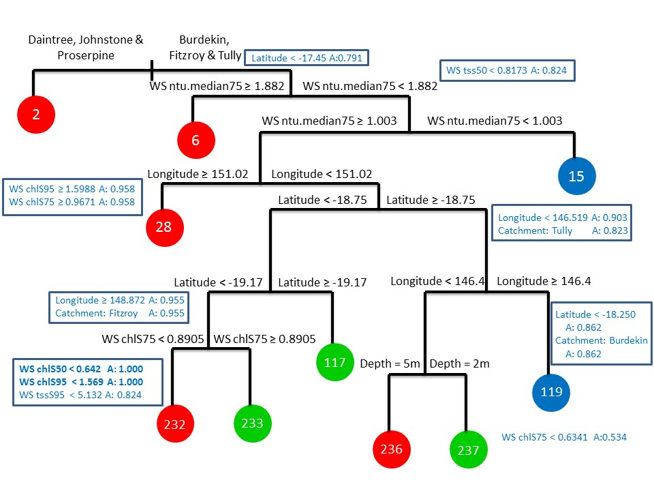
Figure 17: : Pruned classification tree produced from coral and algal assemblage data. Terminal nodes are shaded red(HC – hard coral), blue (SC – soft coral) or green (MA – macroalgae) and indicate the classification assigned to observations residing in these terminal nodes. Primary splits are highlighted above each split and the size of each split is indicative of the importance of the split (i.e. longer splits are more important than shorter ones). The blue boxes house the surrogate information for a selection of highly associated surrogates. Their correlations (or associations, A) are shown next to each split. The cross-validated error rate for this model is 0.920 (SD = 0.043).
While Figure 17 shows primary (first) splits, there are a number of surrogate splits (highlighted by the blue boxes) that can be used in place of the primary split if certain information cannot be obtained. In these instances, the surrogate splits identified are usually splits that have a high association with the primary split. As a result, surrogate splits also help to inform variable importance rankings, so while a variable may appear in a variable importance table (e.g. Table 15) it may not appear in the tree as a primary split. This can be useful when you have many highly correlated variables presenting as possible predictors for the model.
Figure 20 provides a summary of the tree presented in Figure 17 and shows the predicted proportion of hard coral (HC), soft coral (SC) and macroalgae (MA) across the 10 terminal nodes of the tree. The legend to the left of the figure represents a colour spectrum of proportions, ranging between 0 (white) and 1 (red). The model shows dominance of hard coral species at a number of terminal nodes (y-axis on Figure 20) of the tree (nodes 2, 6, 28, 232 and 236). Where there are reasonably high levels of hard coral cover there appears to be soft coral and/or macroalgae also evident but at much lower proportions (nodes 2 and 28). Where macroalgae dominates (nodes 235, 117 and 237), there is evidence of hard coral but in lower proportions and no soft coral evident. High proportions of soft coral appear to be associated with hard coral species only. This is also demonstrated in Figure 18 and Figure 19. In particular, we see in these figures that there is some confidence in the predicted composition at some terminal nodes (nodes 2 and 6) but less confidence (wider bootstrap confidence intervals) in others (remaining nodes).

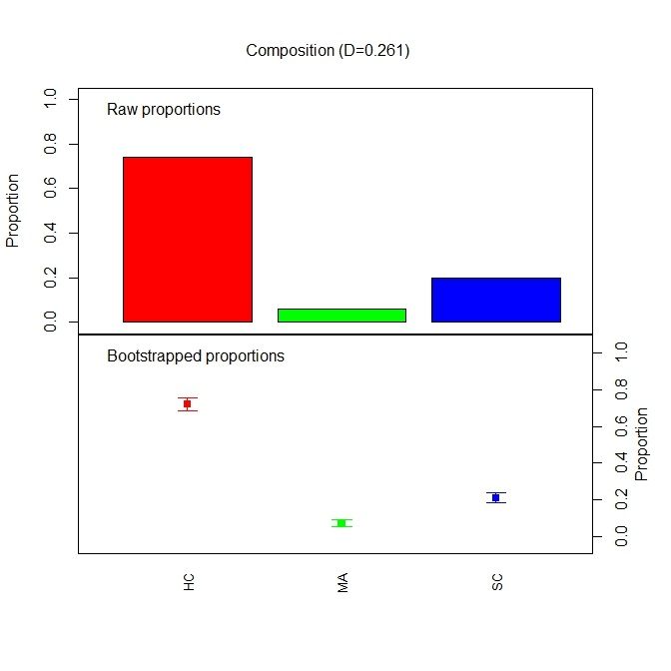  (a) | 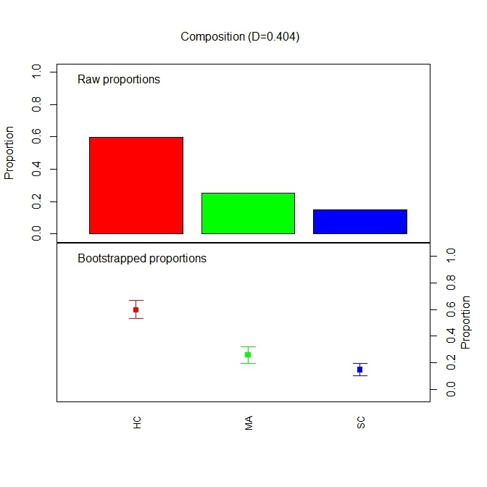  (b)
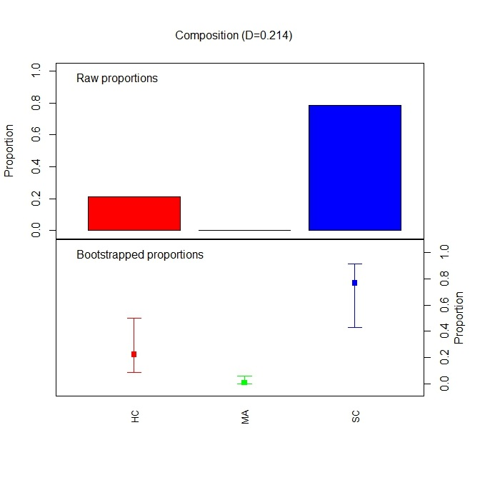  (c) | 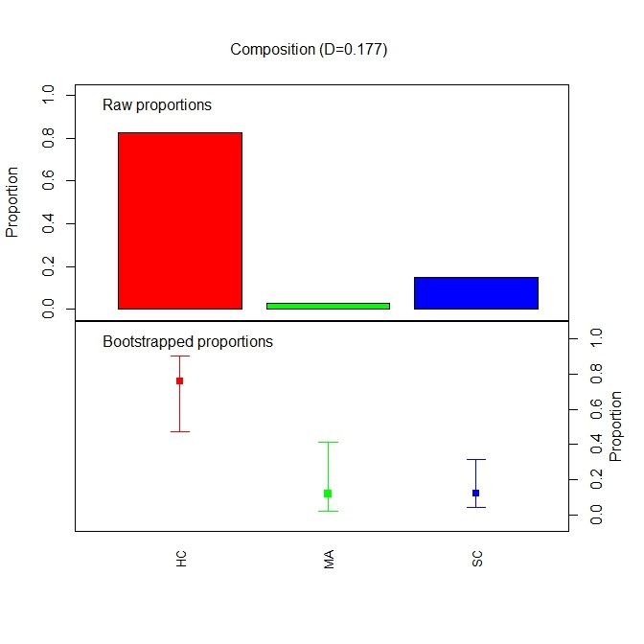  (d)
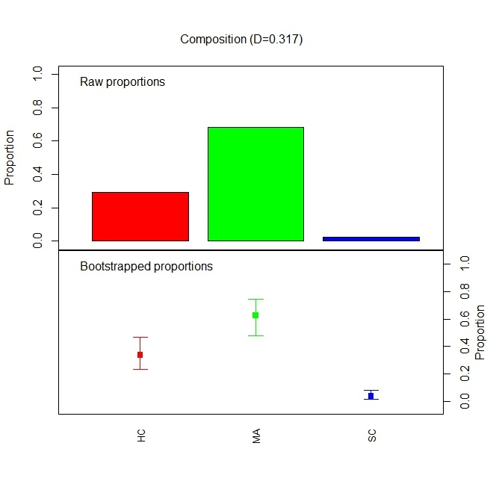  (e) | 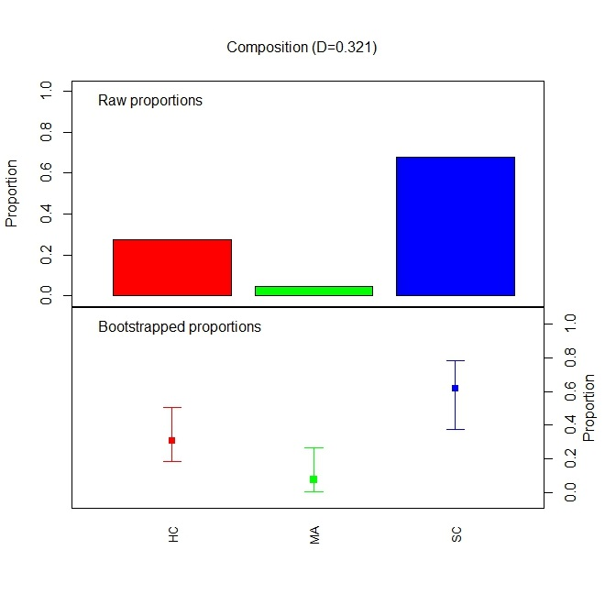  (f)
Figure 18: Terminal Nodes (a) node 2, (b) node 6, (c) node 15, (d) node 28, (e) node 117 , (f) node 119. The top figure of each sub-figure shows the raw proportions (y-axis) of benthic composition (HC – hard coral, SC – soft coral and MA – macroalgae) residing in each terminal node of the tree. The bottom figure of each sub-figure shows the bootstrapped proportions and 95% percentile intervals relating to the benthic composition.

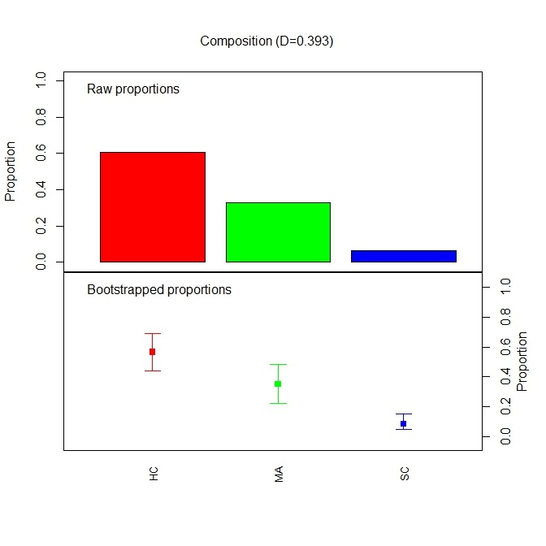  (a) | 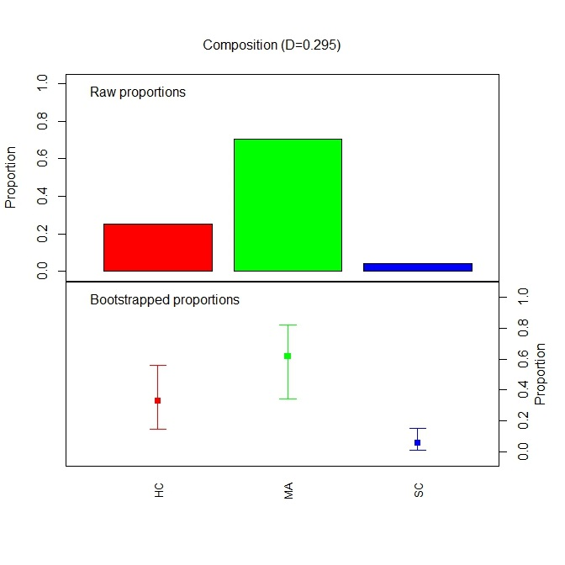  (b)
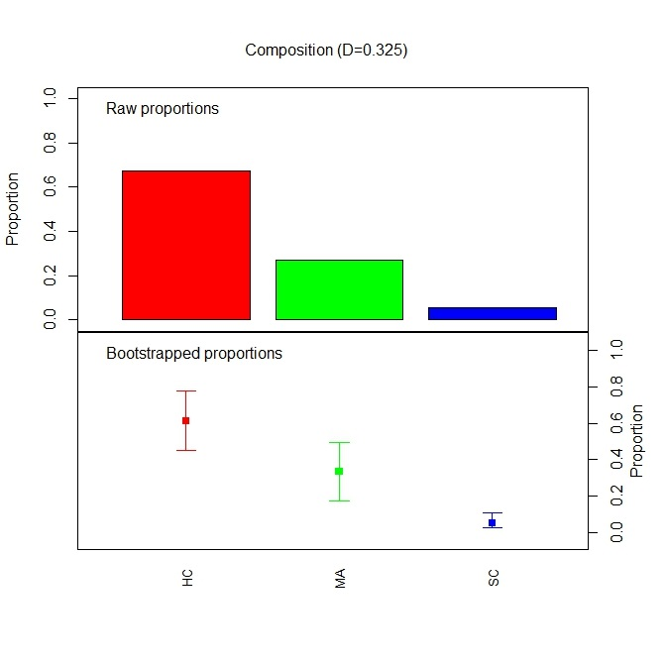  (c) | 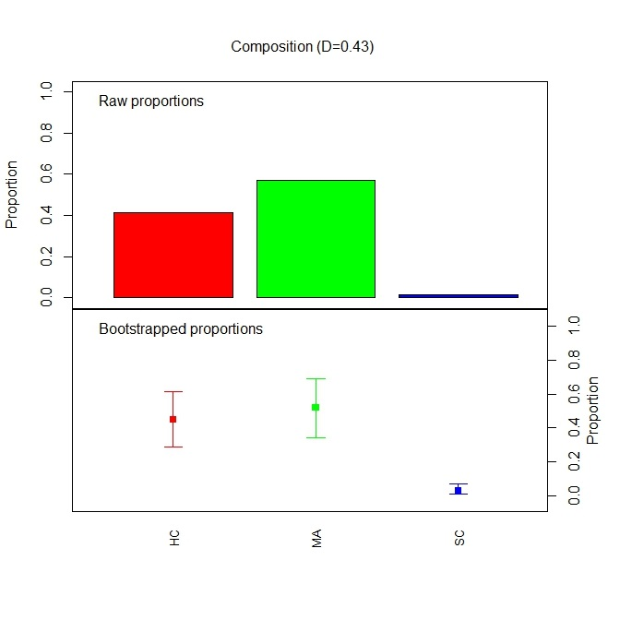  (d)
Figure 19: Terminal Nodes (a) node 232, (b) node 233, (c) node 236 and (d) node 237. The top figure of each sub-figure shows the raw proportions (y-axis) of benthic composition (HC – hard coral, SC – soft coral and MA – macroalgae) residing in each terminal node of the tree. The bottom figure of each sub-figure shows the bootstrapped proportions and 95% percentile intervals relating to the benthic composition.

Figure 21 presents maps summarising the results from the tree and shows sites where hard coral (Figure 21a), soft coral (Figure 21b) and macroalgae (Figure 21c) dominate. We see from this figure that hard coral species dominate the assemblage right along the coastline, with soft coral finding its niche at one particular spot near the Burdekin.
Partial dependence plots can be produced as another visual aid to assist in the interpretation of the classification tree in the same way that smooth terms are plotted for a generalised additive model (GAM) or coefficients in a general linear model are interpreted. However, instead of the relationships appearing as a straight line (linear model) or a smooth relationship (GAM), the relationships produced from the tree model are piecewise linear and this is due to the bootstrapping approach and greedy tree algorithm used to construct them. Partial dependence is a term that is used to examine the dependence or relationship between each covariate in the model and the response, which in this case is the benthic composition. For more detail on how they are constructed, see Breiman (2001) and Kuhnert and Mengersen (2003).

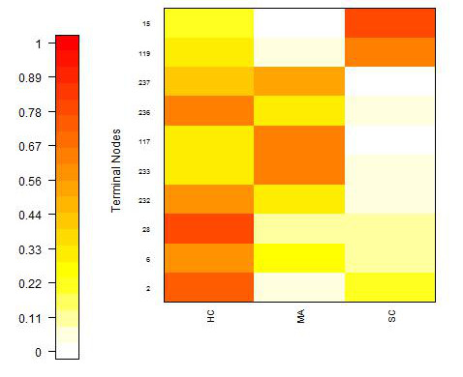
Figure 20: Summary of benthic proportions as predicted by the classification tree in Figure 17. The legend to the left shows a spectrum of colours representing proportions that range between 0 (white) and 1 (red). The image central in this figure shows the proportion of hard coral (HC), macroalgae (MA) and soft coral (SC) predicted by each terminal node (y-axis) of the tree.
Figure 22 illustrates 4 sets of partial dependence plots from the classification tree fit. Partial dependence plots for continuous variables are shown as line graphs, while line segments (similar to boxplots) are shown for categorical variables. Figure 22a shows how each of the catchments vary in terms of their benthic composition and we note that there is considerable variability in compositions across all catchments. Figure 22b shows the partial dependence plot for wet season chlorophyll satellite data evaluated at the 75th percentile. While some slight trends (e.g. as chlorophyll increases, we see an increase in the proportion of hard coral) are observed, the errors are reasonably large. This is also true for the wet season median turbidity logger data taken at the 75th percentile (Figure 22d). Finally, depth appears quite variable between and within benthic communities (Figure 22d). The estimated proportion of coverage is consistent between the two different depths but the uncertainty in the predicted pattern is large. Note that depth was not highly ranked as an important predictor in the variable importance rankings and it did appear as a split lower in the tree model and could be revaluated in terms of its ability to partition benthic groups in the tree.
Overall, we can see from this analysis that apart from spatial influences in the model, the logger turbidity data and the chlorophyll satellite data appeared to be important in predicting coral and algal composition at the broad scale. As noted previously, the grab sample data could not be investigated in this type of analysis as it was sampled too infrequently to be aggregated with the coral and algal assemblage data.

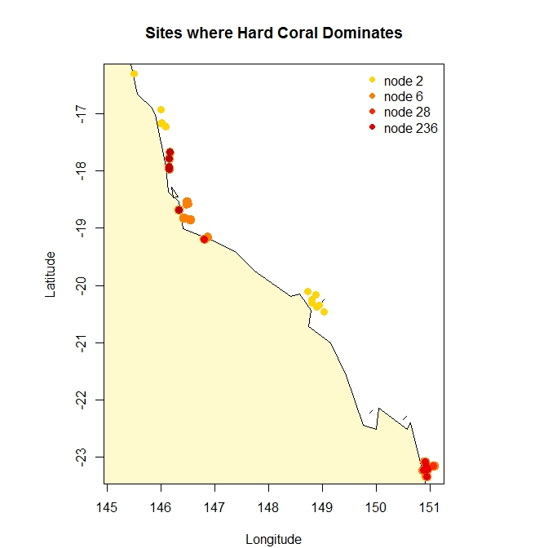  (a) | 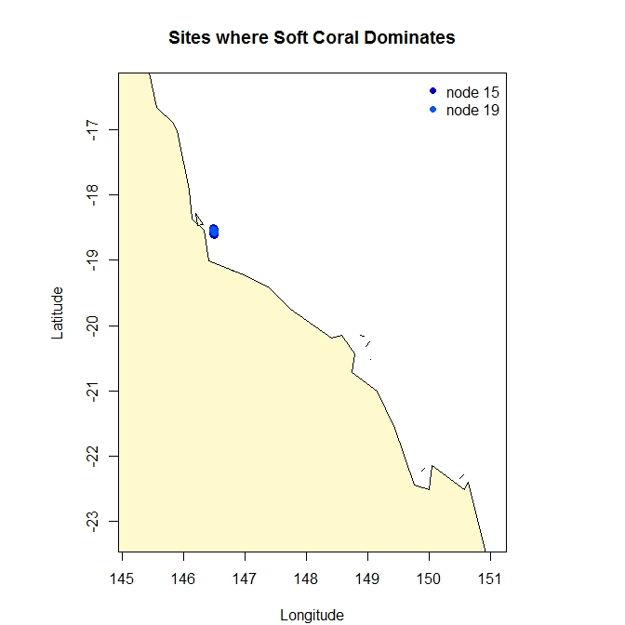  (b) | 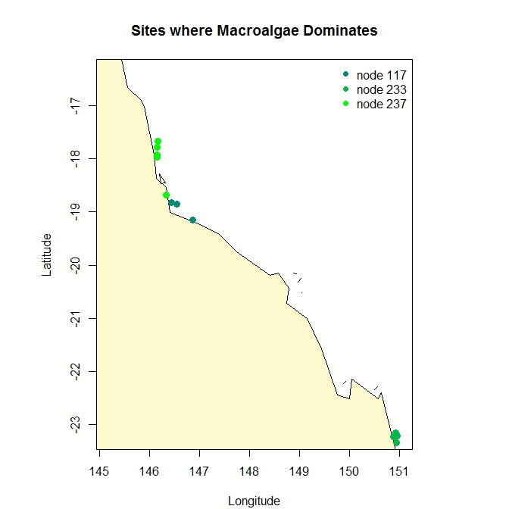  (c)
Figure 21: Sites summarising the classifications from the classification tree. Maps show the sites where (a) hard coral dominates, (b) soft coral dominates and (c) macroalgae dominates.

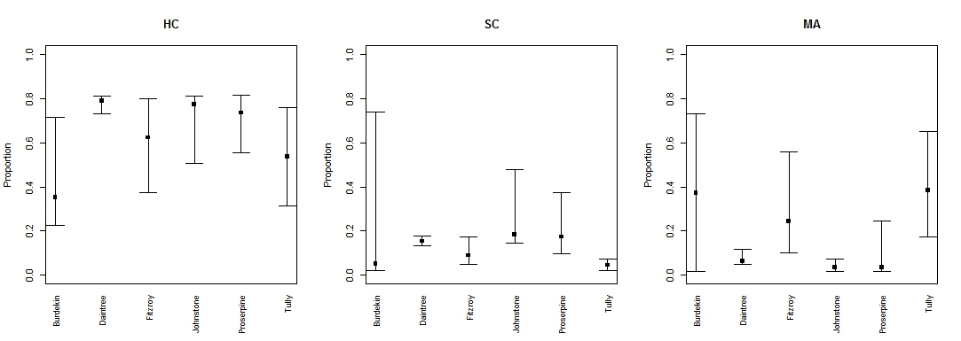
(a)
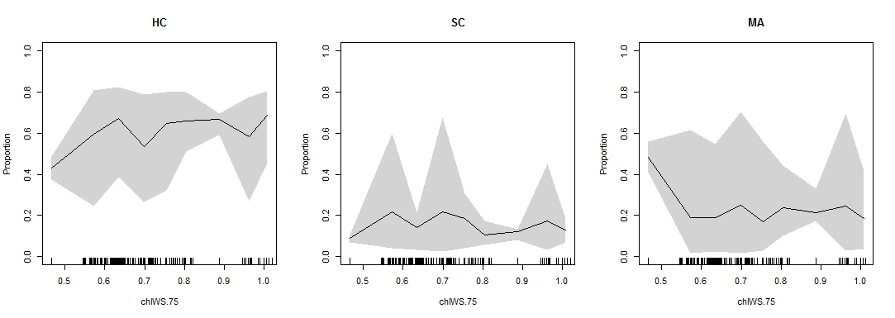
(b)
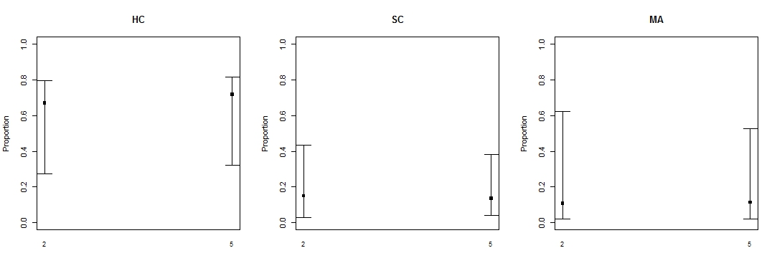
(c)
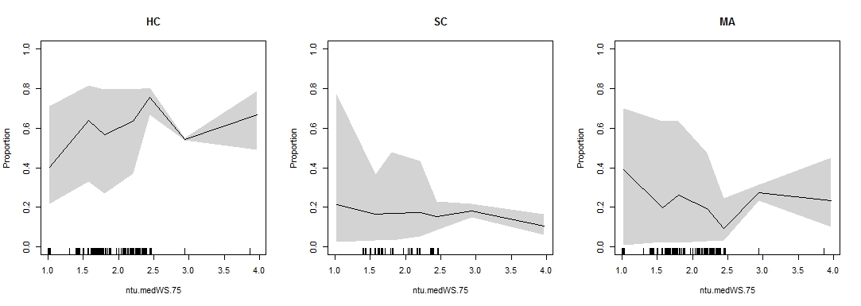
(d)
Figure 22: Partial dependence plots that show the relationship between (a) catchment, (b) the wet season chlorophyll (75th percentile), (c) depth and (d) wet season median turbidity (75th percentile) and the benthic composition as a proportion.

Inshore Seagrass Monitoring Program

Overview of the Data
The survey design for seagrass is outlined in Section 7, Part III, with the sites surveyed divided into four habitats: Estuarine Intertidal; Coastal Intertidal; Reef Intertidal and Reef Subtidal. Seagrass species monitored for this program were partitioned into foundation species, that are slow growing and represent a dominant primary producer, and pioneer species which are colonising and generally fast growing (Table 16). The foundation species consist of Cymodocea rotundata (CR), Cymodocea serrulata (CS), Enhalus acoroides (EA), Syringodium isoetifolium (SI), Thalassia hemprichii (TH), and Zostera capricorni (ZC). The pioneer species consist of Halophila decipiens (HD), Halophila ovalis (HO), Halodule pinifolia (HP), Halophila spinulosa (HS) and Halodule univervis (HU). From Table 17 we see that Z.capricorni and H.univervis and H.ovalis appear to be captured at most sites surveyed in the MMP.
Table 16: Overview of the seagrass community structure observed at the 18 sites in the MMP.
Site | Seagrass Community Structure
Site | Foundation |  |  |  |  |  | Pioneer
Site | CR | CS | EA | SI | TH | ZC | HD | HO | HP | HS | HU
AP
BB
DI
GH
GI
GK
HM
LB
LI
MI
PI
RC
RD
SB
SI
UG
WH
YP

Table 17: Summary of sites within each seagrass habitat.
Habitat | Sites
Estuarine Intertidal | Pelican Banks (GH), Rodds Bay (RD), Sarina Inlet (SI), Urangan (UG)
Coastal Intertidal | Bushland Beach (BB), Lugger Bay (LB), Pioneer Bay (PI), Ross Creek (RC), Shelley Beach (SB), Wheelans Hut (WH), Yule Point (YP)
Reef Intertidal | Archer Point (AP), Dunk Island (DI), Green Island (GI), Monkey Point (GK), Hamilton Island (HM), Low Isles (LI), Picnic Bay (MI)
Reef Subtidal | Dunk Island (DI), Green Island (GI), Low Isles (LI), Picnic Bay (MI)

Figure 23 summarises the seagrass community within each habitat across all years, while Figure 24 provides a temporal pattern of changing seagrass communities across habitats. We see a shift from foundation to pioneer species through time within the different habitats explored.

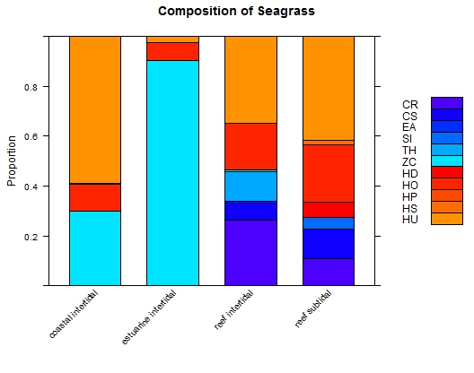
Figure 23: The seagrass community summarised by habitat across all years of sampling.

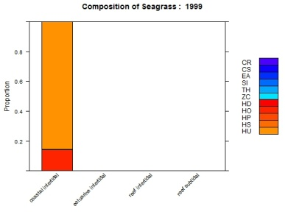  (a) | 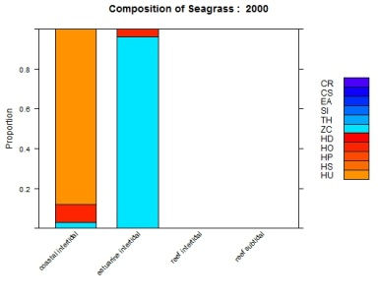  (b) | 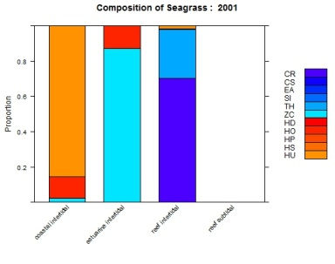  (c) | 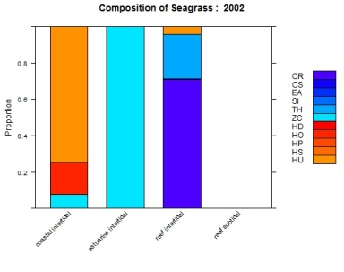  (d) | 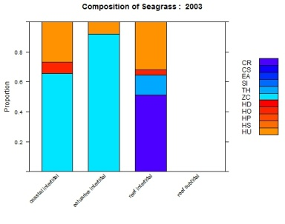  (e)
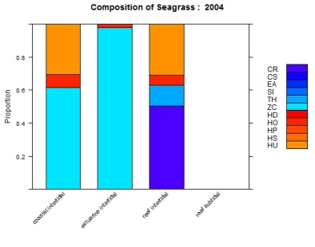  (f) | 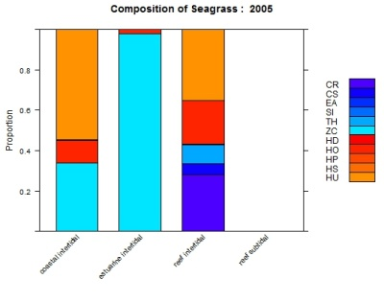  (g) | 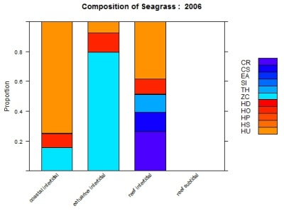  (h) | 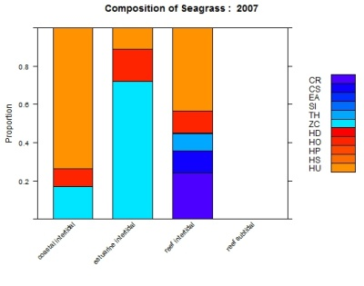  (i) | 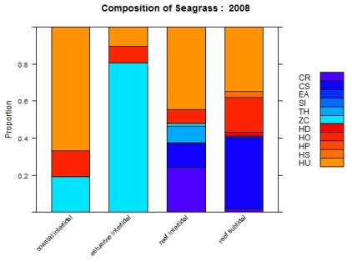  (j)
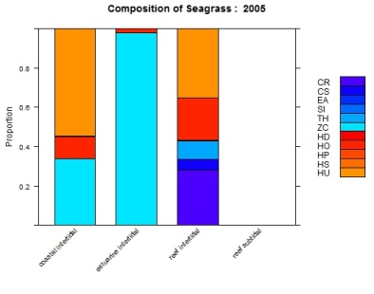  (k) | 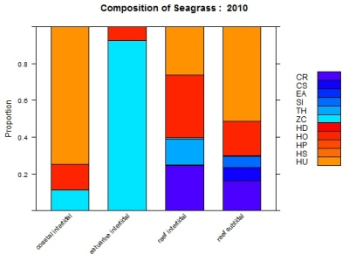  (l) | 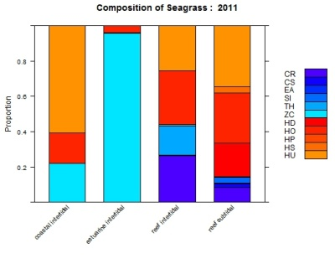  (m) | 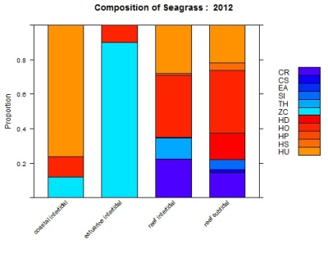  (n)
Figure 24: Temporal pattern of seagrass communities across habitat types represented as a stacked barplot. Blue shaded bars indicate foundation species while red shaded bars indicate pioneer species.

Summary and Preparation of Available Data
The seagrass data comprised a number of separate files that housed the compositional surveys, site specific details, nutrient data, reproductive data, flow, PSII herbicide index arising from the pesticide component of the MMP in addition to light and temperature data from a few different sources, all of which needed to be merged in a single file for analysis. This was challenging and required some discussion to ensure we had matched data correctly. As the frequency of sampling for these potential covariates did not align with the seagrass surveys, missing data was produced during the merge of these datasets. We also spent considerable time constructing lagged temperature and light covariates to represent the potential lagged response in seagrass composition through time. After discussion with the seagrass MMP providers, lags considered consisted of 2 weeks, 4 weeks, 6 weeks and 3 months with 50th, 75th and 90th percentiles calculated across each of those lagged intervals. A list of the potential covariates created for this analysis is shown in Table 18.
Table 18: Summary of the environmental covariates created for the seagrass dataset that were matched to the samples collected.
Covariate | Description |  | Covariate | Description
Epiphytes | % Epiphytes |  | lagL2w.50, lag2w.75, lagL2w.90, LagL2w.max | Light lag at 2 weeks (50th, 75th, 90th percentile, maximum)
Algae.cover | %Algae Cover |  | lagL4w.50, lagL4w.75, lagL4w.90, lagL4w.max | Light lag at 4 weeks (50th, 75th, 90th percentile, maximum)
Sediment | Sediment category (17 groups) |  | lagL6w.50, lagL6w.75, lagL6w.90, lagL6w.max | Light lag at 6 weeks (50th, 75th, 90th percentile, maximum)
PercN | % Nitrogen |  | lagL3m.50, lagL3m.75, lagL3m.90, lagL3m.max | Light lag at 3 months (50th, 75th, 90th percentile, maximum)
PercP | % Phosphorous |  | Temp.AVG, Temp.MAX | Average and maximum temperatures
TotalC | Total Carbon |  | lagTA2w.50, lagTA2w.75, lagTA2w.90, lagTA2w.max | Average Temperature lag at 2 weeks (50th, 75th, 90th percentile, maximum)
TotalP | Total Phosphorous |  | lagTA4w.50, lagTA4w.75, lagTA4w.90, lagTA4w.max | Average Temperature lag at 4 weeks (50th, 75th, 90th percentile, maximum)
TotalN | Total Nitrogen |  | lagTA6w.50, lagTA6w.75, lagTA6w.90, lagTA6w.max | Average Temperature lag at 6 weeks (50th, 75th, 90th percentile, maximum)
Table 18 cont.: Summary of the environmental covariates created for the seagrass dataset that were matched to the samples collected.
Covariate | Description |  | Covariate | Description
C.N | C:N Ratio |  | lagTA3m.50, lagTA3m.75, lagTA3m.90, lagTA3m.max | Average Temperature lag at 3 months (50th, 75th, 90th percentile, maximum)
C.P | C:P Ratio |  | lagTM2w.50, lagTM2w.75, lagTM2w.90, lagTM2w.max | Maximum Temperature lag at 2 weeks (50th, 75th, 90th percentile, maximum)
N.P | N:P Ratio |  | lagTM4w.50, lagTM4w.75, lagTM4w.90, lagTM4w.max | Maximum Temperature lag at 4 weeks (50th, 75th, 90th percentile, maximum)
Light | Daily light (mol m² d¹) from 2008-2013 |  | lagTM6w.50, lagTM6w.75, lagTM6w.90, lagTM6w.max | Maximum Temperature lag at 6 weeks (50th, 75th, 90th percentile, maximum)
Flow | Flow (ML/day) |  | lagTM3m.50, lagTM3m.75, lagTM3m.90, lagTM3m.max | Maximum Temperature lag at 3 months (50th, 75th, 90th percentile, maximum)
PSII | PSII Herbicide index |  | Flowlag2w.tot, Flowlag2w.50, Flowlag2w.max | Flow lag at 2 weeks (total, 50th percentile, maximum).
PSIIlag2w.50, PSIIlag2w.max | PSII Index 2 week lag (50th percentile & maximum) |  | PSIIlag4w.50, PSIIlag4w.max | PSII Index 4 week lag (50th percentile & maximum)
PSIIlag6w.50, PSIIlag6w.max | PSII Index 6 week lag (50th percentile & maximum) |  | PSIIlag3m.50, PSIIlag3m.max | PSII Index 3 month lag (50th percentile & maximum)

The merged dataset consisted of a record taken at each quadrat within transect for each site surveyed. While averaging across transects could be considered, this would mean that some covariates, for example sediment, could not be investigated since sediment composition changed considerably across each transect. As a result, our preliminary investigations considered the entire dataset consisting of 31,814 records captured across 19 locations and 10 regions.

Seagrass Compositional Analysis
A classification tree analysis using the approach developed by Kuhnert et al. (2012) and recently applied in Olson et al. (2014) was applied to the seagrass compositional data collected across the four habitats (coastal intertidal, estuarine intertidal, reef intertidal and reef subtidal). The methodology takes the compositions observed for each of the foundation and pioneer species and rearranges the data such that each row represents a single seagrass species with a weight representing the proportion observed. Details outlining the classification tree methodology are described below in further detail.
Compositional modelling does assume that there is no loss to seagrass over the time period investigated. Therefore to deal with seagrass loss, where the system potentially collapses, a two-component or Hurdle model may be considered. This model considers the presence or absence of any seagrass and the relevant factors that relate to seagrass loss through a logistic regression or classification tree model. Then conditional on seagrass being present, we can then model the composition using the method developed and described in Kuhnert et al. (2012). For examples of implementations of two component models, see Kuhnert et al. (2005) and Martin et al. (2005). For this seagrass analysis, it is important to understand that these types of models require consultation and collaboration with seagrass experts to determine whether the splits are valid from a biological perspective. The models that follow may be viewed as preliminary models that require further iterations and refinement before presenting final models that can be used for inference.
Classification trees as described earlier in this section, represent a non-parametric tool that are well suited for large datasets, many predictor variables and missing data. Splits consisting of a variable and a split location are formed from the predictor variables and are based on a split criterion, namely the Gini index of diversity (Breiman et al., 1984) that aims to partition the data into homogeneous groups. A large tree is grown where a small number of homogeneous observations reside in each terminal node. Cross-validation is used to prune the tree back and snip back splits that do not contribute to the overall fit of the model in terms of the cross-validated error rate. A nested subset of trees is produced, each one smaller than the previous with the optimal tree representing the tree yielding the lowest cross-validated error rate, or a tree slightly smaller in size that is within 1 standard error of the tree yielding the minimum (known as the 1 standard error (SE) tree). Predictions are formed by running observations down the tree until a terminal node is reached where a composition is predicted (i.e. the proportion of each seagrass is predicted by the series of splits that led to the terminal node) and a predicted class, representing the species yielding the highest proportion is identified. Surrogate splits representing alternative splits to the primary split that have a high association are also identified by the model. These assist in the event of missing data by partitioning data down the tree when a primary split cannot be used. Bootstrap methods using the methods of Kuhnert and Mengersen (2003) are used to derive errors around the predicted compositional proportions. Partial dependence plots can be developed from the bootstrap sampling and are useful for identifying relationships between the predictor variable and seagrass composition.
Two component models were applied to seagrass data collected within the four habitats surveyed using the spatial and environmental predictor variables extracted for the analysis. Three models were explored within each habitat. These consisted of (1) a two-component model fit to the data using all of the predictor variables; (2) a two component model fit to the late dry season data only with all of the predictor variables; and (3) a two component model fit with nutrient data excluded to explore the impact of nutrients in the model. These subset of models were decided through consultation with the seagrass MMP providers prior to and during the second MMP workshop. The results for models 1) and 2) only are presented in the sections below with detailed node summaries for the models appearing in Appendix B. Note, all trees that excluded nutrient data (model 3) had model fits that were no different to the trees fit to all of the data (model 1) and are therefore not reproduced below. Trees for the late dry period could only be produced for the coastal and reef intertidal habitats. Models developed for the presence or absence of seagrass consisted of a logistic regression (Hosmer and Lemeshow, 2005). This type of modelling allowed us to examine the changes through time and across seasons to determine where collapses may have occurred. Accompanying this model is a classification tree analysis to examine important spatial, environmental and biological predictors. These are difficult to include in the logistic regression due to the amount of missing information present. Once again, further consultation with seagrass experts on the results from the modelling will be required to finalise these relationships. Note that in all modelling undertaken, we checked all model assumptions by examining the residuals from the model to determine if all spatial and temporal dependencies were captured.

Coastal Intertidal
The coastal intertidal data comprises 13,198 samples collected at Bushland Beach, Lugger Bay, Pioneer Bay, Ross Creek, Shelley Beach, Wheelan’s Hut and Yule Point between 1999 and 2012. Of these surveys, 2,383 did not record any seagrass present across the quadrats and transects visited. Three species of seagrass dominate in this region and consist of Z.capricorni, H.ovalis and H.univervis.
We explored fitting a two-component model to the seagrass data captured at coastal intertidal sites. We first considered fitting a generalised additive model with a binomial error structure (i.e. logistic regression) to the presence or absence of seagrass and then conditional on seagrass being present, we modelled the seagrass composition at sites where seagrass was observed. Each model is presented below in more detail.
The presence/absence model considered a smooth trend term across years in addition to a seasonal term to account for variation within a year. The location of samples was chosen as a fixed effect in this model to examine the presence/absence at each location sampled. Fitting a smooth interaction term to Latitude and Longitude was problematic due to the location of sites for this habitat. The results from fitting this model to the probability of presence of seagrass is shown in Table 19, where estimates for each parameter in the model are shown along with an estimate of the standard error and p-value. Smooth terms that are represented in the model are presented with their effective degrees of freedom (edf) and the corresponding p-value. The estimates in this table indicate that there are strong spatial and temporal characteristics of this data in explaining the probability of presence of seagrass at coastal intertidal sites. In fact, the location covariate indicates that compared to the Bushland Beach site (baseline used for comparison), both Lugger Bay and Shelley Beach have a considerably lower probability of seagrass occurring compared to all other sites. Compared to Bushland Beach, Lugger Bay has a probability of presence of 0.563 (95%CI = [0.53,0.60]), while Shelley Beach has a probability of presence of 0.633 (95%CI = [0.60,0.66]). Some of the sites that contained higher probabilities of seagrass presence were Ross Creek and Wheelans Hut. When compared to Bushland Beach, we observed that Ross Creek has a probability of presence of 0.995 (95%CI = [0.991,0.998]), while Wheelans Hut has a probability of presence of 0.997 (95%CI = [0.994,0.999]). Based on this analysis, we could rank locations based on their probability of presence of seagrass to find an order of sites from the lowest probability to highest probability. This is demonstrated in Figure 25.
Other potential covariates were considered, particularly those that were identified as important through a classification tree analysis (not shown). The variable importance ranking produced from this analysis is shown below in Table 20. The highest ranking covariates are year and location, indicating that space and time are important in predicting the presence or absence of seagrass. Other environmental variables are also important and were included into the analysis as linear terms. Due to the amount of missingness however, this resulted in an analysis on fewer records and produced an analysis that was not very interpretable. Figure 26 shows the smooth yearly and seasonal terms that were fit in the model. It is very evident in Figure 26(a) that there was a decline in the probability of presence of seagrass throughout the 14 year period with significant declines occurring between 2000 and 2001 and more recently, 2011 and 2012. The seasonal pattern shows quite a bit of variability between months with peaks that correspond to increases in the probability of presence occurring in March/April, June/July and October. This term is not as influential as the long term trend term, as can be seen by the y-axis, which shows a much narrower scale for the seasonal component of the model compared to the long term trend component. Nevertheless, a seasonal pattern does exist.

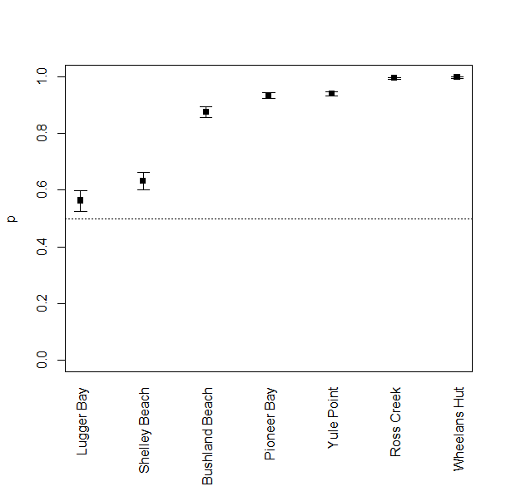
Figure 25: Order of sites beginning with the lowest probability of presence (Lugger Bay) to the highest probability of presence of seagrass (Wheelans Hut). Estimates shown are the probability of presence overlayed with 95% confidence intervals.
Table 19: Summary of parameter estimates from the generalised additive model that includes a spatial term (Location) and two temporal terms (year and month) to investigate the probability of presence of seagrass for coastal intertidal sites. This model explains 37.9% of the variation in the data.
Coefficients | Estimate/edf | SE/df | p-value
Intercept | 1.955 | 0.092 | <0.001
Location (Baseline = Bushland Beach)
Lugger Bay | -1.701 | 0.109 | <0.001
Pioneer Bay | 0.704 | 0.112 | < 0.001
Ross Creek | 3.415 | 0.352 | < 0.001
Shelley Beach | -1.411 | 0.108 | < 0.001
Wheelans Hut | 4.016 | 0.462 | < 0.001
Yule Point | 0.791 | 0.108 | < 0.001
Smooth Terms
s(Year) | 8.958 |  | < 0.001
s(month) | 7.430 |  | 0.0002

Table 20: Variable importance summary produced from a classification tree fit to the coastal intertidal presence/absence data. Importance values are scaled to the maximum, where a value of 1.0 indicates the variable with the highest importance. Only variables with importance values greater than 0 are shown in this table. All other variables are assumed to have no importance.
Year |  | Location | Latitude | Longitude | lagTM3m.max |  | Month | Algae Cover | lagTA3m.50
1.00 |  | 0.69 | 0.18 | 0.18 | 0.08 |  | 0.08 | 0.08 | 0.06
lagTM3m.50 |  | Light | lagTA3m.75 | lagTA3m.90 | Sediment |  | PercP | TotalP | N.P
0.06 |  | 0.04 | 0.03 | 0.03 | 0.02 |  | 0.01 | 0.01 | 0.01
Temp.AVG |  | lagTA6w.50 | C.P | PercN | lagTA4w.75 |  | lagTA4w.90 | lagTA4w.max
0.01 |  | 0.01 | 0.01 | 0.01 | 0.002 |  | 0.002 | 0.002
 | 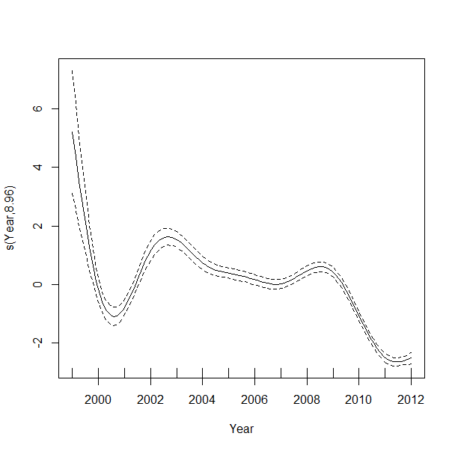  (a) |  |  |  |  | 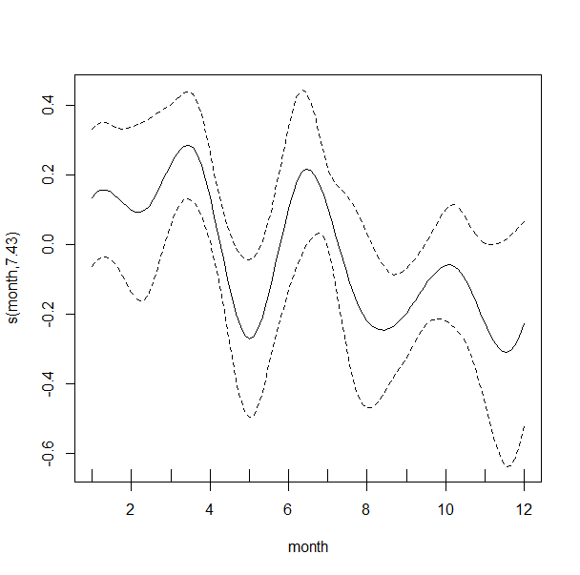  (b)
Figure 26: Results from the generalised additive model that show (a) the yearly non-linear trend term and (b) the seasonal pattern that highlights changes in the probability of presence of seagrass from the coastal intertidal habitat.
To investigate patterns in seagrass composition given that seagrass is present, a classification tree was fit to the coastal intertidal seagrass data with spatial, nutrient and environmental data used as potential predictors for the seagrass composition in this habitat. The tree shown in Figure 27a has 12 splits with a cross-validated error rate of . The majority of the splits in this tree are spatial, with additional splits on season, epiphytes and temperature calculated at different lags. The variable importance identifies Latitude and Longitude as being most important followed by NRM region, sediment, epiphytes and temperature variables created at different lags (Table 21). Note that the conceptual models presented in Section 2 of Part I highlighted the importance of sediment in seagrass composition so this analysis supports that notion. The first surrogate split for each primary split are shown in blue for splits where missing data reside. In some instances, particularly for the temperature and light data, missing data were still present but no surrogate split was identified. In these instances, data was partitioned towards the node with the largest proportion of observations.
Focussing on the late dry season in Figure 27b, results in a tree with one split on region that partitions the Fitzroy from the Burdekin, Mackay Whitsunday and the Wet Tropic Regions. The predicted seagrass species for the Fitzroy region is Z.capricorni, while for the right node in the tree, H.univervis is predicted.
Table 21: Variable importance ranking for the classification tree fit to seagrass compositional data collected at the coastal intertidal habitat. Importance values are scaled to the maximum, where a value of 1.0 indicates the variable with the highest importance. Only variables with importance values greater than 0 are shown in this table. All other variables are assumed to have no importance.
Latitude | Longitude | NRM Region | Sediment | Epiphytes | lagTA3m.75
1.000 | 1.000 | 0.9434 | 0.0635 | 0.0126 | 0.0116
lagTA3m.max | Season | lagTM3m.max | lagTM3m.50 | lagTA3m.90 | lagTA3m.50
0.0107 | 0.0106 | 0.0059 | 0.0054 | 0.0051 | 0.0049
lagTM3m.90 | lagTM3m.75 | Algae Cover
0.0037 | 0.0026 | 0.0014

Figure 28 summarises the nodes from both trees. These figures show the seagrass species on the x-axis and the terminal node number on the y-axis, with boxes of colour that represent the proportion of that species residing in the terminal node. Shades of red indicate high proportions of seagrass while shades of yellow indicate low proportions of seagrass, with white representing no seagrass predicted. For the entire dataset, we observe that Z.capricorni appears in higher proportions compared to any other species in node 2 of the tree. We also note that H.univervis appears in high proportions in nodes 49, 13, 115, 29 and 57. H.ovalis dominates node 56. For the late dry period we find that Z.capricorni dominates node 2 while H.univervis dominates node 3.
Node summaries and bootstrap predictions are displayed in Appendix B. For each node, we present the summarised proportion composition of seagrass residing in that node (top bar chart), and the bootstrapped proportions with 95% confidence intervals (bottom). We also show the partial dependence plots for some of the predictors from the model for dominant seagrass species, Z.capricorni, H.univervis and H.ovalis (see Figure B-5, Appendix B). These figures show how the proportion of each species of seagrass behaves with changes to the predictor variable of interest. For continuous variables like Epiphytes, a line plot overlayed with a shaded region representing the 95% bootstrapped confidence interval is shown. For categorical variables such as NRM region, points are produced with 95% confidence intervals overlayed as segments. From the figures presented in Appendix B, there appears to be a slight increase in H.univervis and slight decreases in Z.capricorni and H.ovalis with increasing average temperature of the last 3 month period (Figure B-5b; Appendix B). We also observe slight increases in all three species with increasing percentage of Epiphytes, although the uncertainty around those trends is quite large. We note differences in seagrass composition across the NRM regions. However differences between seasons is far less pronounced. Differences in seagrass distribution for the three species of seagrass is evident across NRM regions but not so pronounced when comparing seasons. There appears to be less uncertainty around the distribution of H.ovalis however.
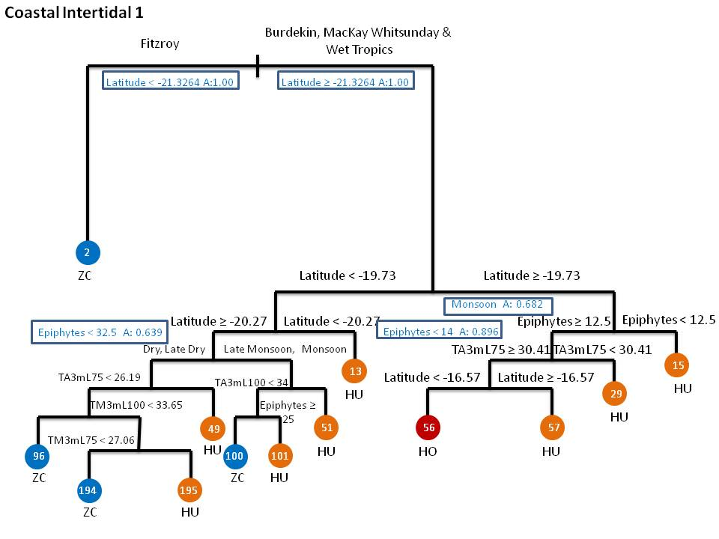
(a)
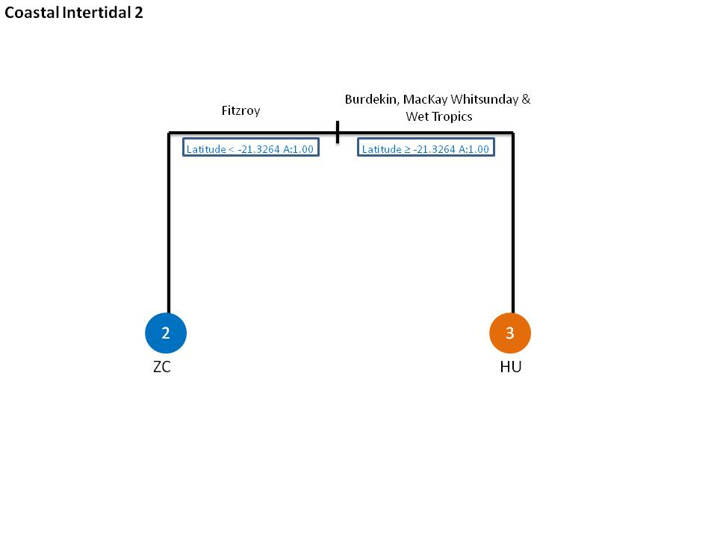
(b)
Figure 27: Pruned classification trees for coastal intertidal sites for (a) all the data (cross-validated error rate) and (b) the late dry season only (cross-validated error rate). Surrogate splits are shown in blue text for splits where missing data reside. The cross-validated error rate was

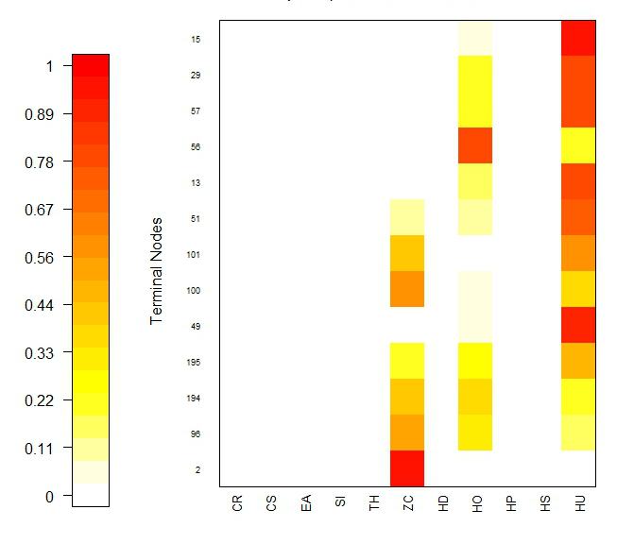  (a) | 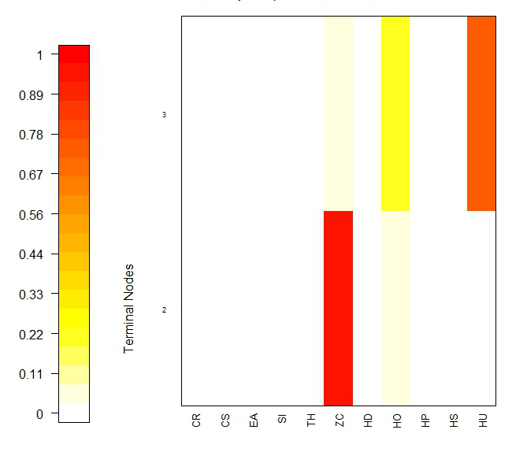  (b)
Figure 28: Summary of nodes from the classification tree produced (a) for all of the data and (b) the late dry period. Each figure shows the composition of seagrass as a grade of colour ranging from white (no seagrass) to red (100% seagrass) for each species comprising the composition. Seagrass species are shown on the x-axis and terminal nodes are shown on the y-axis.

Estuarine Intertidal
The estuarine intertidal data comprises 7,207 observations with data collected from Pelican Banks, Rodds Bay, Sarina Inlet and Urangan. Data collected spans 12 years of data collected between 2000 and 2012. Seagrass was absent at 3,118 sites that were surveyed across this period. Seagrass species observed consist of Z.capricorni, H.univervis and H.ovalis.
A two component model was fit to the estuarine intertidal data where a generalised additive model was fit to the presence or absence of seagrass within this habitat and a classification tree was fit to the seagrass composition, conditional on seagrass being present.
The presence/absence model considered a smooth trend term across years in addition to a seasonal term to account for variation within a year. The location of samples was chosen as a fixed effect in this model to examine the presence/absence at each location sampled. As for the coastal intertidal habitat, fitting a smooth interaction term to Latitude and Longitude was problematic due to the location of sites for this habitat. The results from fitting this model to the probability of presence of seagrass is shown in Table 22, where estimates for each parameter in the model is shown along with an estimate of the standard error and p-value. This model explains 39.4% of the variation in the data. Smooth terms that are represented in the model are presented with their effective degrees of freedom (edf) and the corresponding p-value. The estimates in this table once again indicate that there are strong spatial and temporal characteristics of this data in explaining the probability of presence of seagrass at estuarine intertidal sites.
Estimates of a location effect show some differences in the proportion of seagrass present when compared to the Pelican Banks site. Compared to Pelican Banks, Rodds Bay, Sarina Inlet and Urangan are showing decreases in the proportion of seagrass observed with estimates of 0.466 (95%CI = [0.40,0.53]) for Rodds Bay, 0.785 (95%CI = [0.78,0.86]) for Sarina Inlet and 0.476 (95%CI = [0.42,0.53]) for Urangan. Based on this analysis, we could rank locations based on their probability of presence of seagrass to find an order of sites from the lowest probability to highest probability. This is demonstrated in Figure 29.

Table 22: Summary of parameter estimates from the generalised additive model that includes a spatial term (Location) and two temporal terms (year and month) to investigate the probability of presence of seagrass for estuarine intertidal sites. This model explains 39.4% of the variation in the data.
Coefficients | Estimate/edf | SE | p-value
Intercept | 3.959 | 0.160 | <0.001
Location (Baseline = Pelican Banks)
Rodds Bay | -4.096 | 0.130 | <0.001
Sarina Inlet | -2.401 | 0.131 | < 0.001
Urangan | -4.056 | 0.128 | < 0.001
Smooth Terms
s(Year) | 8.895 |  | < 0.001
s(month) | 8.000 |  | <0.001

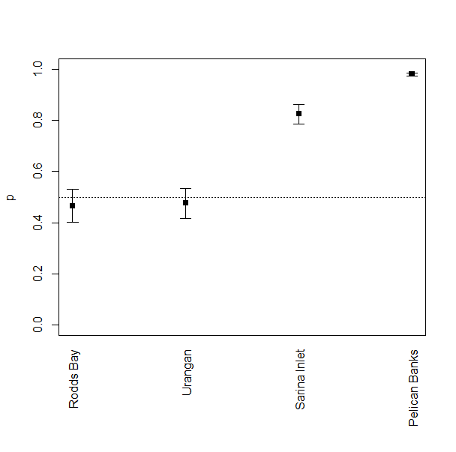
Figure 29: Order of sites beginning with the lowest probability of presence (Rodds Bay) to the highest probability of presence of seagrass (Pelican Banks) at the estuarine intertidal sites. Estimates shown are the probability of presence overlayed with 95% confidence intervals.
The smooth terms in the model (Figure 30) are showing quite a strong yearly pattern with a marked rise in seagrass presence between 2002 and 2004 before dropping off considerably and showing little movement in either direction (increase or decrease from 2007 onwards). The seasonal pattern shows a small increase in proportion during January and February before dipping down towards April and increasing rapidly from May through to August. A decrease in the proportion of seagrass at this habitat is then noted from September onwards.

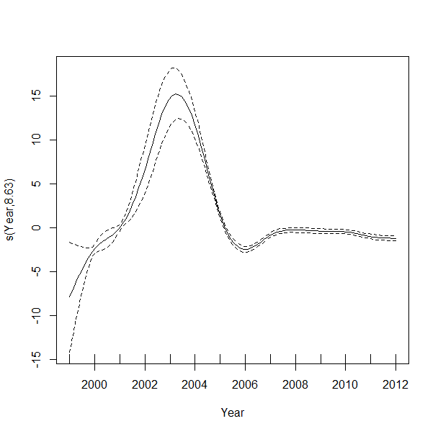  (a) | 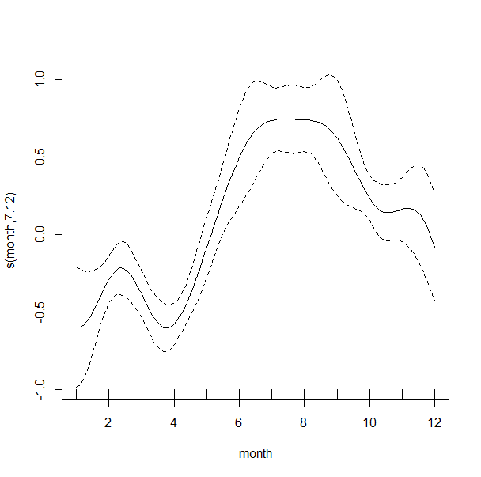  (b)
Figure 30: Results from the generalised additive model that show (a) the yearly non-linear trend term and (b) the seasonal pattern that highlights changes in the probability of presence of seagrass from the estuarine intertidal habitat.
Other potential covariates were considered, particularly those that were identified as important through a classification tree analysis (not shown). The variable importance ranking produced from this analysis is shown below in Table 23. The highest ranking covariates are latitude, year, longitude and location, with the seasonal term showing only minimal importance. As was the case for the coastal intertidal model, the environmental predictors were less important. Of this group of variables the lagged temperature variables (lagTA3m.50, Temp.AVG, lagTM2w.75 and Temp.MAX) were highlighted by this model.
Table 23: Variable importance summary produced from a classification tree fit to the estuarine intertidal presence/absence data. Importance values are scaled to the maximum, where a value of 1.0 indicates the variable with the highest importance. Only variables with importance values greater than 0 are shown in this table. All other variables are assumed to have no importance.
Latitude | Year | Longitude | Location | Month | lagTA3m.50 | Temp.AVG | lagTM2w.75
1.00 | 0.99 | 0.97 | 0.90 | 0.22 | 0.21 | 0.15 | 0.14
Temp.MAX | Algae.cover | lagTA2w.50 | lagTA2w.75 | lagTM3m.90 | lagTA3m.75 | lagTM3m.50 | lagTM2w.90
0.14 | 0.12 | 0.12 | 0.11 | 0.10 | 0.09 | 0.09 | 0.084
lagTM3m.75 | lagTM3m.max | lagTM4w.50 | lagTA6w.90 | C.P | N.P | lagTM4w.90 | lagTM6w.50
0.07 | 0.06 | 0.06 | 0.05 | 0.05 | 0.05 | 0.05 | 0.05
lagTM6w.75 | C.N | Sediment | lagTA6w.max | PercN | lagTA4w.75 | lagTA3m.90 | PercP
0.05 | 0.03 | 0.03 | 0.02 | 0.02 | 0.01 | 0.01 | 0.01
TotalP
0.01
The classification tree fit to the estuarine intertidal data is shown in Figure 31. This figure shows 7 splits that are largely dominated by spatial variables but also temperature (at a variety of lags) and season. The variable importance ranking for this model highlights the average and maximum temperatures with the highest level of importance followed by longitude and latitude, season and temperature calculated at different lags. The cross-validated error rate for this model is
The estuarine intertidal model shows initial splits on latitude. Sites south of 22.58 degrees are split by maximum temperature. Sites north of 22.58 degrees are further split on average temperature. Average temperature lower than 21.48 degrees is then partitioned based on dry versus late dry periods. Terminal nodes summarising the seagrass compositions are shown in Appendix B.
Table 24: Variable importance ranking for the classification tree fit to seagrass compositional data collected at the estuarine intertidal habitat. Importance values are scaled to the maximum, where a value of 1.0 indicates the variable with the highest importance. Only variables with importance values greater than 0 are shown in this table. All other variables are assumed to have no importance.
Avg. Temp | Max Temp | Longitude | Latitude | Season | lagTM6w.50
1.000 | 1.000 | 0.9102 | 0.9102 | 0.8040 | 0.4969
lagTM2w.50 | lagTM4w.50 | Epiphytes | lagTA2w.90 | lagTA3m.50 | lagTM6w.75
0.3384 | 0.2856 | 0.2509 | 0.1978 | 0.1978 | 0.1329
lagTA2w.75 | lagTA2w.50 | lagTA4w.75
0.0528 | 0.0528 | 0.0528

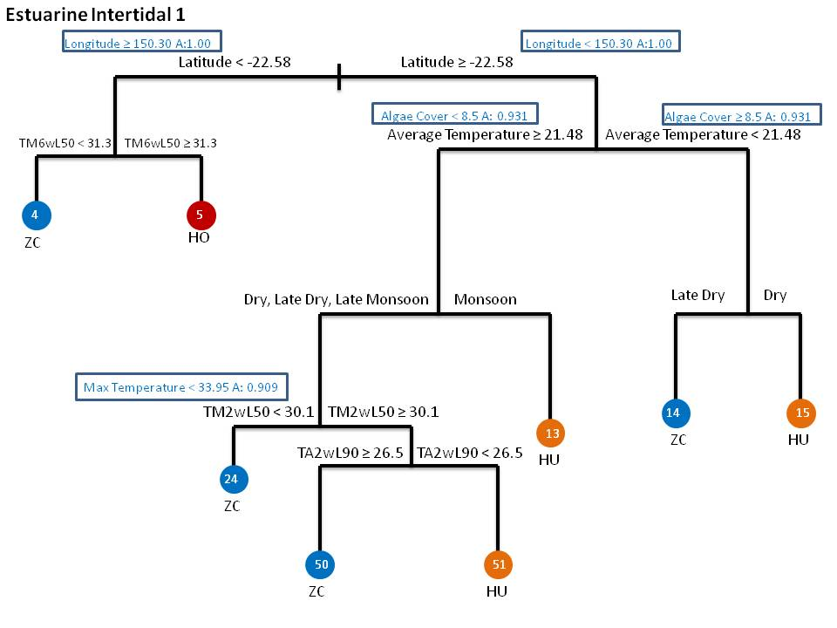
Figure 31: Pruned classification tree produced from the estuarine intertidal sites which has a cross-validated relative error of .

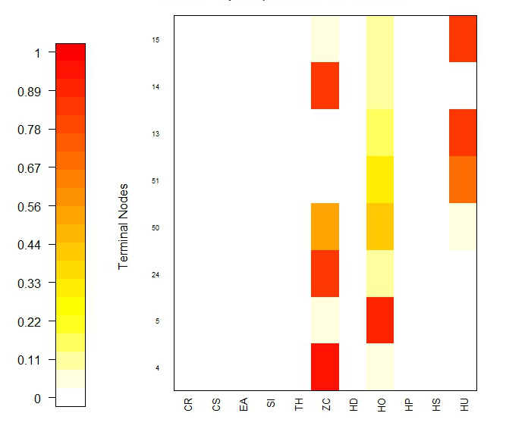
Figure 32: Summary of nodes from the classification tree produced on the estuarine intertidal data. This figure shows the composition of seagrass as a grade of colour ranging from white (no seagrass) to red (100% seagrass) for each species comprising the composition. Seagrass species are shown on the x-axis and terminal nodes are shown on the y-axis.

Appendix B (Figure B-8) provides a series of partial dependence plots constructed from the estuarine intertidal model showing the contribute of average temperature (Figure B-8a), lagged average temperature taken at 2 weeks, lagTA2w.90 (Figure B-8b) and lagged median temperature taken across a 2 week interval, lagTM2w.50 (Figure B-8c). In the latter two variables the 90th and 50th percentiles respectively, were taken. These variables were chosen as we were interested in determining whether any relationship exists between the higher ranking environmental variables and the composition of seagrass at estuarine intertidal sites. The patterns for each variable in Figure B-8 are quite difficult to decipher and is most likely an indication of their lower ranking in the model. Only the 3 prominent seagrass species are shown (Z.capricorni or ZC, H.univervis or HU and H.ovalis or HO). Overall, it appears that as the average temperature increases, there is an increase (although rather slight and difficult to say definitively when considering the error) in ZC. The remaining two temperature variables appear too variable to comment.
Figure 32 summarises the terminal nodes of the estuarine intertidal tree and shows that Z.capriocorni clearly dominates the seagrass composition at nodes 4, 24 and 14, while H.ovalis dominates at node 3 and H.univervis dominates at nodes 13 and 15.

Reef Intertidal
The reef intertidal data comprises 9,056 observations spanning records from 2001 and 2012, with 1,808 records surveyed exhibiting no seagrass. Seagrass species that dominate this habitat include C.rotundata, C.serrulata, T.hemprichii, Z.capricorni, H.ovalis and H.univervis. Locations comprising reef intertidal sites consisted of Archer Point, Cockle Bay, Dunk Island, Green Island, Hamilton Island, Low Isles, Monkey Point and Picnic Bay.
A two component model was fit to the reef intertidal data where a generalised additive model was fit to the presence or absence of seagrass within this habitat and a classification tree was fit to the seagrass composition, conditional on seagrass being present.
The presence/absence model considered a smooth trend term across years in addition to a seasonal term to account for variation within a year. The location of samples was chosen as a fixed effect in this model to examine the presence/absence at each location sampled. As for the previous two habitats modelled, fitting a smooth interaction term to Latitude and Longitude was problematic due to the location of sites for this habitat. The results from fitting this model to the probability of presence of seagrass is shown in Table 25, where estimates for each parameter in the model is shown along with an estimate of the standard error and p-value. This model explains 30.2% of the variation in the data. Smooth terms that are represented in the model are presented with their effective degrees of freedom (edf) and the corresponding p-value. The estimates in this table show that there are strong spatial and temporal characteristics of this data in explaining the probability of presence of seagrass at estuarine intertidal sites.
Estimates of a location effect show some differences in the proportion of seagrass present across sites, particularly in comparison to Archer Point. Cockle Bay (Est = 0.941, 95%CI = [0.92,0.95]), Green Island (Est = 0.998, 95%CI = [0.995,0.999]) and Low Isles (Est = 0.861, 95%CI = [0.83,0.89]) all show a much higher probability of presence of seagrass compared to Archer Point (Est = 0.845, 95%CI = [0.82,0.87]),. Sites showing a lower probability of presence of seagrass consist of Dunk Island (Est = 0.689, 95%CI = [0.66,0.74]), Hamilton Island (Est = 0.582, 95%CI = [0.53,0.64]), and Monkey Point (Est = 0.653, 95%CI = [0.53,0.64]). Based on this analysis, we could rank locations based on their probability of presence of seagrass to find an order of sites from the lowest probability to highest probability (Figure 33).
Table 25: Summary of parameter estimates from the generalised additive model that includes a spatial term (Location) and two temporal terms (year and month) to investigate the probability of presence of seagrass for reef intertidal sites. This model explains 30.2% of the variation in the data.
Coefficients | Estimate/edf | SE | p-value
Intercept | 1.697 | 0.099 | <0.001
Location (Baseline = Archer Point)
Cockle Bay | 1.072 | 0.139 | <0.001
Dunk Island | -0.861 | 0.106 | <0.001
Green Island | 4.333 | 0.364 | <0.001
Hamilton Island | -1.367 | 0.119 | <0.001
Low Isles | 0.126 | 0.131 | 0.334
Monkey Point | -1.066 | 0.119 | <0.001
Picnic Bay | 0.021 | 0.121 | 0.863
Smooth Terms
s(Year) | 7.987 |  | < 0.001
s(month) | 8.000 |  | <0.001

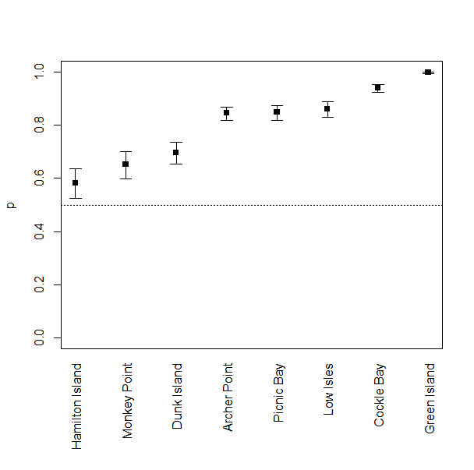
Figure 33: Order of sites beginning with the lowest probability of presence (Hamilton Island) to the highest probability of presence of seagrass (Green Island) at the reef intertidal sites. Estimates shown are the probability of presence overlayed with 95% confidence intervals.
The variable importance ranking from fitting a classification tree (not shown) to the presence or absence of seagrass at reef intertidal sites is shown in Table 27. The results highlight that spatial variables (location, longitude and latitude) and year are important in predicting the probability of presence of seagrass within this habitat. Of the environmental variables, flow and algae cover are important but in comparison to the spatial and temporal variables, their contribution is quite qeak. The seasonal term is also not listed in the variable importance ranking, suggesting that there is no effect due to season. This is confirmed by Figure 34, when you compare the y-axis scale for the two smooth terms fit in the model. While there is some variation amongst seasons, the contribution is so minor compared to the smooth yearly trend. This trend highlights a slow decline from 2001 onwards, although the actual baseline estimate at 2001 is quite uncertain, based on the wide confidence intervals.
Table 26: Variable importance summary produced from a classification tree fit to the reef intertidal presence/absence data. Importance values are scaled to the maximum, where a value of 1.0 indicates the variable with the highest importance. Only variables with importance values greater than 0 are shown in this table. All other variables are assumed to have no importance.
Location |  | Year | Longitude | Latitude |  | Flowlag2w.50 | Algae.cover | Flowlag2w.tot | Flow
1.00 |  | 0.40 | 0.37 | 0.36 |  | 0.07 | 0.07 | 0.04 | 0.03
PSIIlag6w.50 |  | PSIIlag6w.max | lagTM4w.75 | Temp.AVG |  | lagTA2w.max | lagTA4w.50 | lagTA4w.75 | lagTA4w.max
0.02 |  | 0.02 | 0.02 | 0.02 |  | 0.01 | 0.01 | 0.01 | 0.01
laTgM2w.50 |  | Flowlag2w.max | PSIIlag3m.50 | lagTA2w.50 |  | lagTA2w.75 | lagTA2w.90 | PSIIlag3m.max
0.01 |  | 0.01 | 0.01 | 0.01 |  | 0.01 | 0.01 | 0.01
 | 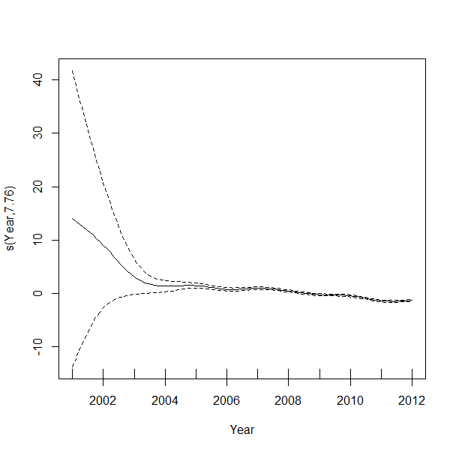  (a) |  |  |  | 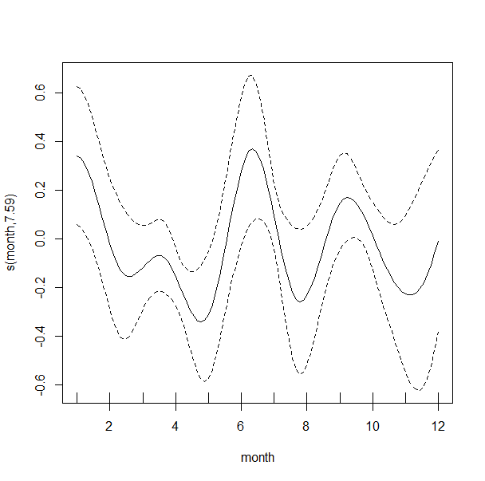  (b)
Figure 34: Results from the generalised additive model that show (a) the yearly non-linear trend term and (b) the seasonal pattern that highlights changes in the probability of presence of seagrass from the reef intertidal habitat.
A classification tree was fit to the reef intertidal data using all of the data (Figure 35) and focussing on the late dry samples (Figure 36). Figure 35 shows a large decision tree containing 24 splits created on spatial variables (NRM region, latitude and longitude), epiphytes, maximum and average temperatures and their respective lags, sediment, season and PSII herbicides. The cross-validated error rate for this model is The variable importance ranking is summarised in Table 27 and highlights spatial variables as being most important. Sediment and epiphytes appear the most important of the environmental variables considered.
Table 27: Variable importance ranking for the reef intertidal model.
Latitude | Longitude | NMR Region | Sediment | Epiphytes | lagTA3m.max
1.000 | 1.000 | 0.8351 | 0.1964 | 0.1629 | 0.0473
lagTA4w.90 | lagTM4w.75 | lagTM4w.50 | Algae Cover | lagTM6w.50 | lagTM3m.max
0.0372 | 0.0321 | 0.0258 | 0.0256 | 0.0253 | 0.0172
lagTM3m.75 | lagTA2w.75 | lagTA6w.90 | lagTA2w.90 | Light | lagTA6w.max
0.0162 | 0.0155 | 0.0155 | 0.0155 | 0.0155 | 0.0132
lagTA3m.90 | Avg Temp | Season | PSIIlag3m.max | lagTA4w.max | Max Temp
0.0112 | 0.0101 | 0.0089 | 0.008 | 0.008 | 0.008
lagTM6w.max | lagTA6w.75 | PSIIlag6w.max | PSIIlag6w.50 | lagTA3m.75 | Flowlag2w.tot
0.008 | 0.005 | 0.003 | 0.003 | 0.003 | 0.0027
Flowlag2w.50 | lagTA6w.50 | lagTM6w.90 | lagTM4w.90
0.0027 | 0.0019 | 0.0011 | 0.0011

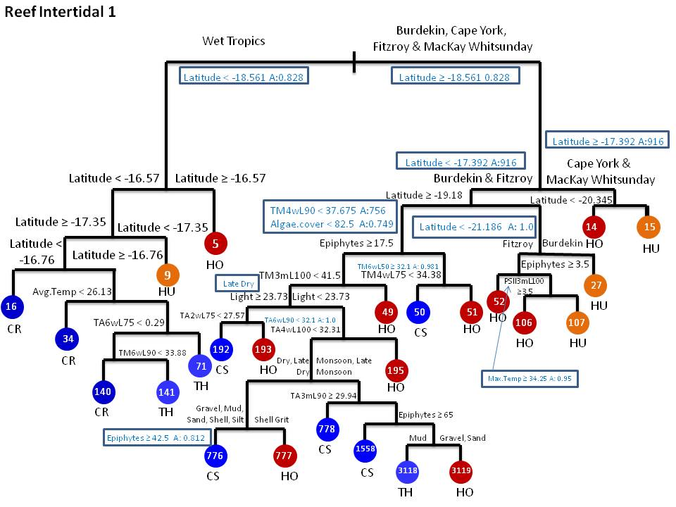
Figure 35: Pruned classification tree on reef intertidal sites (all data). Boxed splits showcase the surrogate splits used in the model.

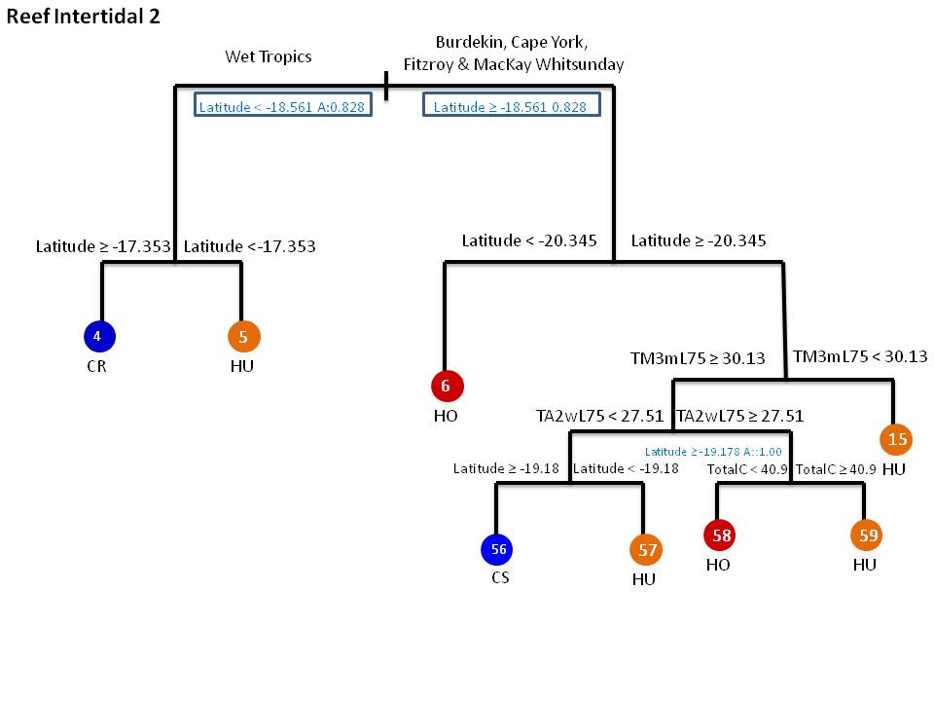
Figure 36: Pruned classification tree for reef intertidal sites during the late dry period. Boxed splits showcase the surrogate splits used in the model.

A summary of terminal nodes and partial dependence plots are shown in Appendix B (Figures B-9 to B-18). Of the terminal nodes in the tree shown in Figure 35, C.rotunda dominates node 16, while C.serrulata clearly dominates a series of nodes (192, 776, 778 and 50). H.univervis, dominates nodes 27 and 15. This can also be visualised in the summaries provided in Figure 37a that highlights the seagrass species and their proportions (graduation of colour from white to red) for each node of the tree when all the data was utilised.
Partial dependence plots for the model where all data are utilised are displayed in Figures B-14 and B-15 of Appendix B for a subset of the predictor variables and seagrass species. We observe from these plots that C.serrulata tends to increase with increasing percentages of Epiphytes, while C.rotundata has a tendancy to decrease. However the error is quite large indicating some uncertainty in the assessment. The majority of the temperature predictor variables show fluctuations in proportions of seagrass depending on species and lagged temperature. Increases in the proportion of T.hemprichii are noted for increasing average temperature for 2 week, 4 week and 6 week lags. Response to light is evident for some species, particularly C.rotundata, H.univervis and H.ovalis. We see that decreases in C.rotundata and T.hemprichii and H.univervis are noted as light becomes higher while H.ovalis tends to increase quite quickly as light levels become high. Changes in proportions of seagrass species are evident across regions, with little differences between seasons, apart from noting changes in variability. Differences in proportions are noted for different sediment compositions as can be seen in Figure B-15(e) of Appendix B.
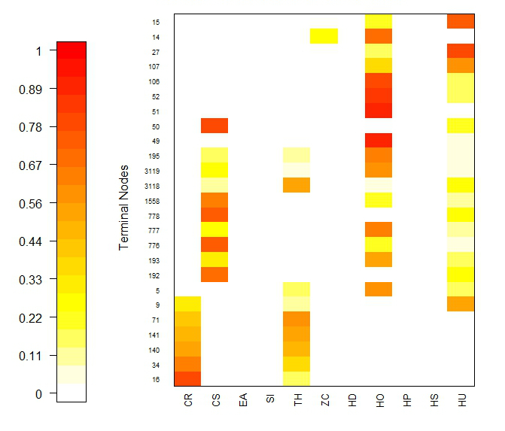  (a) | 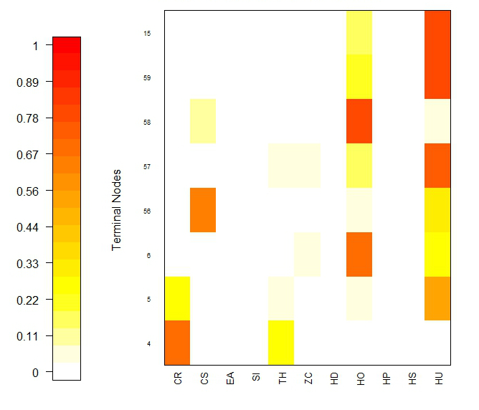  (b)
Figure 37: Summary of nodes from the reef intertidal classification tree produced (a) for all of the data and (b) the late dry period.

The classification tree produced for the late dry period is a subtree of the tree produced for all the data and consists of 7 splits. Figure 37b shows the corresponding image plot, highlighting the seagrass species dominating each node of the tree and their respective proportions. The pattern (although broader due to the fewer nodes represented by the tree) is similar to Figure 37a.
Partial dependence plots are also produced for the tree grown for the late dry period. These are shown in Figure B-18 in Appendix B and show strong relationships between H.ovalis and average and maximum temperature taken at 2 week and 3 month lags, respectively. Increases in the average and the maximum temperatures over these lags show a decrease in the proportion of H.ovalis, while increases in C.serrulata are noted for increasing lagged 3 monthly maximum temperatures. Differences in proportions are also noted at the regional level for some of the seagrass species investigated.

Reef Subtidal
Data extracted for the reef subtidal sites consist of 2,353 records and consists of seagrass species C.rotundata, C.serrulata, S. isoetifolium, H.decipiens, H.ovalis, H. spinulosa and H.univervis. Of these surveys, 931 did not observe seagrass. Locations surveyed in reef subtidal areas consisted of Dunk Island, Green Island, Low Isles and Picnic Bay.
A two component model was fit to the reef subtidal data where a generalised additive model was fit to the presence or absence of seagrass within this habitat. A classification tree was also fit to the seagrass composition, conditional on seagrass being present, although we do not show the results. The tree was only used to examine important variables that we may want to include in the logistic regression.
The presence/absence model considered a fixed linear trend to accommodate changes across years in addition to a smooth seasonal term to account for variation within a year. In this model we did not fit a location effect as this was not significant at the 5% level of significance. In fact, based on the results from fitting a classification tree to the presence/absence of seagrass at reef sub-tidal sites, there were a number of environmental variables that dominated the variable importance ranking. In Table 29 , we see that lagged flow and flow itself were important in predicting the presence/absence of seagrass. Furthermore, lagged temperature variables, light and year were also highlighted as being important. As such, we investigated fitting a model with smooth representation of these terms (where possible). The result is the GAM presented in Table 28, which explains 44.1% of the variation in the data. Smooth terms that are represented in the model are presented with their effective degrees of freedom (edf) and the corresponding p-value.

Table 28: Summary of parameter estimates from the generalised additive model that includes a spatial term (Location) and two temporal terms (year and month) to investigate the probability of presence of seagrass for reef sub-tidal sites. This model explains 44.1% of the variation in the data.
Coefficients | Estimate/edf | SE | p-value
Intercept | 6.132 | 0.903 | <0.001
Year | -1.467 | 0.240 | <0.001
Smooth Terms
s(month) | 6.327 |  | <0.001
s(log(Flowlag2w.50) | 8.999 |  | <0.001
s(lagTM6w.50) | 8.989 |  | <0.001
s(Light) | 9.000 |  | <0.001

The smooth terms from the model are shown in Figure 38. From this figure, both the smoothed light term and lagged flow term appear to be very important terms in the model as the scale of the y-axis yield a much broader range than the other terms investigated. Figure 38a indicate changes in seagrass presence/absence depending on the median lagged flow. Lower proportions of seagrass are noted at either end of the lagged flow spectrum suggesting that there may be tipping points at past low and high flow events. The lagged temperature signal shown in Figure 38b indicates a cyclical pattern that increases as the lagged (6 week) median temperature increases, suggesting that the probability of seagrass is higher as median temperature over the last 6 weeks increases. The relationship with light patterns is shown in Figure 38c and indicates that as light levels increase, particularly from 0 to approximately 5, we see a decrease in the probability of presence of seagrass. Depending on the level of light patterns, this probability fluctuates until the relationship remains constant (but with wider confidence intervals) and suggests lower probabilities of seagrass are likely.
Table 29: Variable importance summary produced from a classification tree fit to the reef sub-tidal presence/absence data. Importance values are scaled to the maximum, where a value of 1.0 indicates the variable with the highest importance. Only variables with importance values greater than 0 are shown in this table. All other variables are assumed to have no importance.
Flowlag2w.50 | Flowlag2w.tot | Location | Flow | lagTM3m.50 | lagTM6w.50 | Light | Year
1.00 | 0.85 | 0.74 | 0.69 | 0.59 | 0.42 | 0.30 | 0.27
Algae.Cover | lagTM4w.90 | Latitude | Longitude | month | lagTM4w.max | lagTM6w.max | lagTM6w.90
0.14 | 0.13 | 0.11 | 0.11 | 0.10 | 0.08 | 0.08 | 0.05
lagTM3m.75 | lagTM2w.75 | lagTA2w.50 | lagTM2w.90
0.05 | 0.02 | 0.02 | 0.02
Finally, the seasonal pattern which is shown in Figure 38d, indicates changes in seagrass presence/absence throughout the year, with decreases noted between April to June and September through to November and increases at other times. This is most likely related to temperature and light availability during changes to season. Interactions between these variables should be considered in subsequent iterations of these models if the MMP providers find these patterns interesting and wish to explore further.
A classification tree for the reef subtidal sites is presented in Figure 39, showing splits on latitude, NRM region, maximum temperature at lags of 4 weeks and 3 months and PSII herbicides. The cross-validated error rate is . Figure 40 shows a summary of the compositions predicted across the nodes of the tree, where colours represent the probability of presence (white to red) of the seagrass species predicted. This figure highlights that C.serrulata (CS), H.univervis (HU) and H.decipiens (HD) dominate the predictions.
The variable importance ranking for the model is shown in Table 30 and highlights spatial variables (latitude, longitude and NRM Region) being important, followed by temperature and PSII. A summary of compositions at terminal nodes of the tree is presented in Appendix B.
Table 30: Variable importance ranking for the reef subtidal model. Only variables with importance values greater than 0 are shown in this table. All other variables are assumed to have no importance.
Latitude | Longitude | NMR Region | lagTM3m.max | lagTA4w.50 | lagTM3m.90
1.000 | 1.000 | 0.2609 | 0.1942 | 0.1516 | 0.1178
lagTM4w.50 | PSII | lagTA2w.75 | lagTA2w.90 | lagTA2w.50 | lagTM2w.75
0.1138 | 0.0595 | 0.0595 | 0.0595 | 0.0552 | 0.0524
lagTM4w.90 | lagTM2w.max | lagTM6w.max | Flowlag2w.tot
0.0524 | 0.0524 | 0.0524 | 0.0481

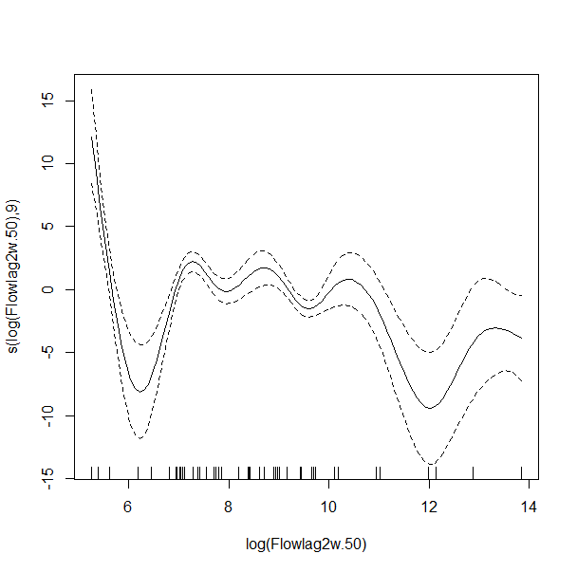  (a) | 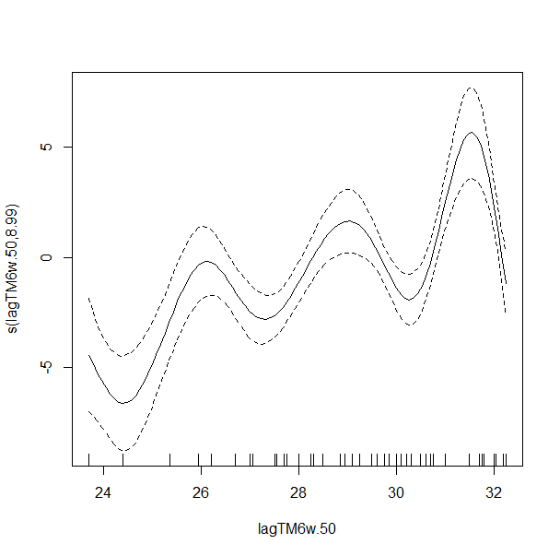  (b)
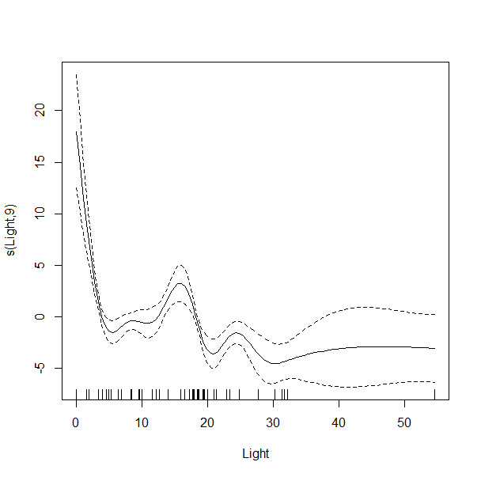  (c) | 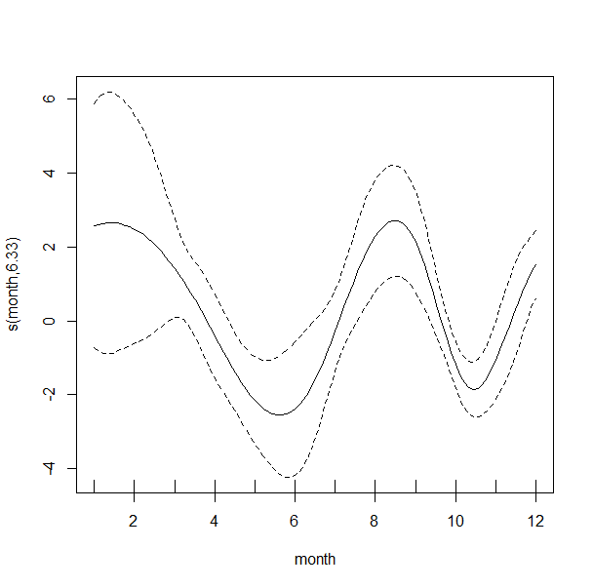  (d)
Figure 38: Results from the generalised additive model that show (a) the smooth term for the 2 week lagged flow, (b) the 6 week lagged temperature, (c) light and (d) the seasonal pattern that highlights changes in the probability of presence of seagrass from the reef subtidal habitat.
Appendix B presents the partial dependence plots for a subset of predictor variables from this model (Figures B-21) for 4 seagrass species. Results show that there is quite a bit of variability in proportions as lagged temperature increases for C.serrulata, H.univervis and H.decipiens. Little variability is noted for H.ovalis. Declines in H.univervis is noted for the lagged maximum 3 monthly temperature. Some differences in proportions are noted for the Burdekin catchment sites compared to the Wet Tropics sites.

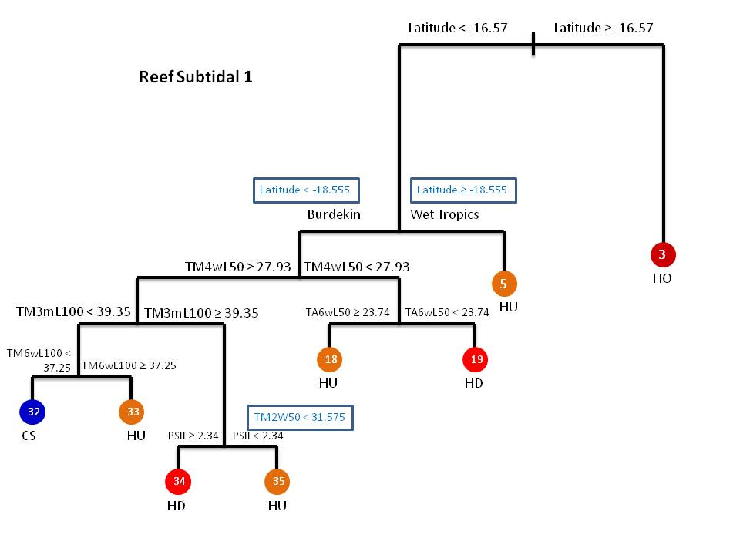
Figure 39: Classification tree produced for the reef subtidal habitat. Boxed splits indicate surrogate splits used to partition observations when missing values are encountered.

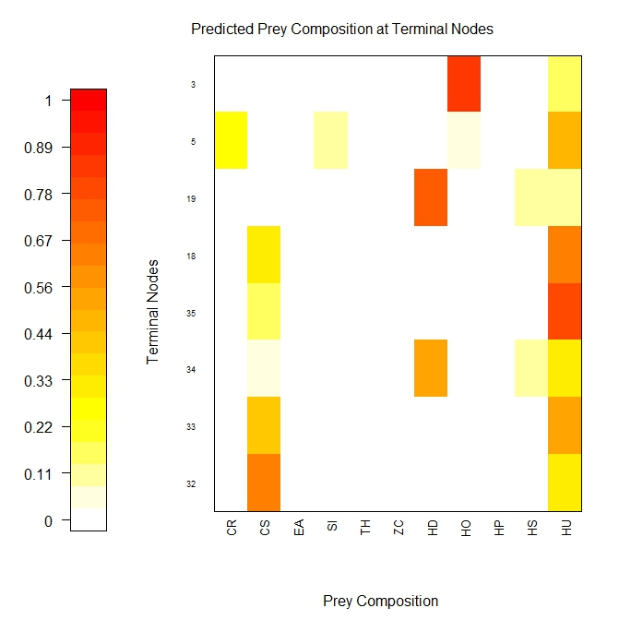
Figure 40: Summary of nodes of classification tree for reef subtidal sites.

Pesticide Marine Monitoring Program
Our assessment and review is focussed on what pesticides are routinely monitored, where and when they are monitored, and the ability to detect potential changes or confirm relationships with key drivers from that monitoring data. For an overview of the sample design for this program, see Section 8, Part III of this report.
Pesticides, herbicides and fungicides offer the distinct advantage that they detect change in land management practice when compared to substances that are naturally occurring, such as chlorophyll or TSS, where there is a need to isolate the anthropogenic contribution from the naturally occurring contribution. The use of specific pesticides may also change quickly, perhaps through cessation or substitution with alternative pesticides, and this change may be apparent in the water quality data. This offers the potential to link catchment management with reef water quality, though the lack of information on application rates limits our understanding of catchment management in practice.
Pesticides should be the first to show any effect of changes in land management practice. Unlike chlorophyll and turbidity, which can be present in waterways as low levels naturally, herbicides represent a direct indictor of human influence. As such, Photosystem II (PSII) herbicides have been priority chemicals monitored in the GBR. These herbicides are outlined in Table 31 and consist of Bromacil, Tebuthiuron, Terbutryn, Flumeturon, Ametryn, Prometryn, Atrazine, Propazine, Simazine, Hexazinone, Desethylatrazine, Desisopropylatrazine and Diuron.
The PSII herbicide concentrations (ηg/L), expressed as PSII herbicide equivalent concentrations (PSII-HEq) (ηg/L), are calculated using the following formula
where is the relative potency factor (REP) for PSII herbicide, with respect to the PSII herbicide diuron (the reference PSII herbicide). A REP of 1 infers that the PSII herbicide is equally as potent as diuron, whereas a REP of greater than 1 (or less than 1) indicates that it is greater (or smaller) than diuron. Therefore, the PSII-HEQ concentration of a given grab or passive sample is the sum of the individual REP-corrected concentrations of each individual PSII herbicide ($C_{i}$, ηg/L) detected in each sample. The primary focus on PSII pesticides under the MMP makes strong sense given their predominant use in agriculture. The PSII-HEQ is a valuable summary measure because it provides a natural way to consider the aggregate effect on a common basis. The relative potency of individual pesticides used in the creation of the original index has remained consistent since the baseline year 2008-09. Bentley et al. (2012) note the potential benefit from reviewing and updating the potency database by including new data and introducing additional PSII herbicides now in use. We are supportive of the periodic review of this database, and acknowledge that may require the recalculation of PSII-HEQ index values in order to manage the transition between scoring systems.
While the PSII-HEQ is the headline pesticide index, the concentrations of individual pesticides, herbicides and fungicides are important because they provide the ability to detect the change in some land management practices and contrast different application rates and usage between different catchments. As such, we focus on the analysis of the PSII-HEQ index.

Summary and Preparation of Available Data
Data provided to us for review consisted of monthly pesticide samples taken from 12 sites from June 2005 through to December 2012 for the insecticides, herbicides and fungicides specified under the MMP and outlined in Table 2 of Bentley et al. (2012). We provide a summarised version of that table here which lists each pesticide along with a description in Table 31. The choice of pesticides was based on past literature, pesticides that were recognised as being a potential risk, the affordability and capability of analytical methods and whether pesticides were likely to be accumulated within one of the passive sampling techniques (Bentley et al., 2012). The final list of pesticides were chosen in consultation with GBRMPA. Pesticide data was provided for 12 sites identified in the design phase of the MMP (See Section 8, Part III of this report for a summary of the sample design). These consisted of Sarina Inlet, Pioneer Bay, Orpheus Island, North Keppell, Normanby, Magnetic Island, Low Island, Inner Whitsundays and Hamilton Islands, Green Island, Fitzroy, Dunk Island and an AIMS site. Accompanying the pesticide data was flow data from a relevant river that was deemed to intersect with the pesticide sites monitored. River flows investigated corresponded to the Russell-Mulgrave Rivers (Fitzroy and Normanby sites), Barron River (Fitzroy and Green Island sites), Haughton River (Cape Cleveland site), Tully River (Dunk Island site), Mossman River (Low Isle site), Burdekin River (Magnetic Island site), Fitzroy River (North Keppel site), Herbert River (Orpheus Island site), O’Connell and Pioneer Rivers (Outer Whitsundays site), Proserpine River (Pioneer Bay site) and Sandy Creek (Sarina Inlet site). Flow was recorded in mega-litres (ML) per day. See Table 42 in Section 8 for a summary of the 12 sites sampled and their abbreviations that will be used in subsequent tables and figures.

Table 31. Pesticides specified under the MMP for analysis (Bentley et al. (2012))
Pesticide | Decription | Pesticide | Decription
Bifenthrin | Pyrethroid insecticide | Diazinon | Organophosphate insecticide
Fenvalerate | Pyrethroid insecticide | Fenamiphos | Organophosphate insecticide
Bromacil | PSII herbicide-uracil | Prothiophos | Organophosphate insecticide
Tebuthiuron | PSII herbicide-thiadazolurea | Chlordane | Organochlorine insecticide
Terbutryn | PSII herbicides-methylthiotriazine | DDT | Organochlorine insecticide
Flumeturon | PSII herbicide-phenylurea | Dieldrin | Organochlorine insecticide
Ametryn | PSII herbicide-methylthiotriazine | Endosulphan | Organochlorine insecticide
Prometryn | PSII herbicide-methylthiotriazine | Heptachlor | Organochlorine insecticide
Atrazine | PSII herbicide-chlorotriazine | Lindane | Organochlorine insecticide
Propazine | PSII herbicide-chlorotriazine | Hexachlorobenzene | Organochlorine fungicide
Simazine | PSII herbicide-chlorotriazine | Imidacloprid | Nicotinoid insecticide
Hexazinone | PSII herbicide- triazinone | Trifluralin | Dintiroaniline
Desethylatrazine | PSII herbicide breakdown product (also active) | Pendimethalin | Dinitroaniline herbicide
Desisopropylatrazine | PSII herbicide breakdown product (also active) | Propiconazole | Conazole fungicide
Diuron | PSII herbicide - pheynylurea | Tebuconazole | Conazole fungicide
Oxadiazon | Oxadiazolone herbicide | Metolachlor | Chloracetanilide herbicide
Chlorfenvinphos | Organophosphate insecticide | Propoxur | Carbamate insecticide
Chlorpyrifos | Organophosphate insecticide
Note: Bromacil was included in the list of target analytes from 2009-2010; Imidacloprid and terbutryn were routinely analysed from 2011-2012 (Bentley et al. 2012).

Space-Time Analysis
Sampling resources need to spread across space and time in a monitoring program. This is determined by where we monitor and when we monitor it. Knowledge of the “sources of variation” in pesticide concentrations allows us to identify the variable contributing the most and better methods for characterising it. These sources of variation should drive how sampling resources are placed across space and time. This is ultimately a trade-off. Where the spatial variation is large it makes sense to sample at more sites. Similarly, where the temporal variation is large, it is important to sample more regularly over time in order to better characterise changes over time.
The pesticide data collected allows us to consider the space-time contributions and trade-off for the MMP. We focus only solely on the PSII-HEQ concentration given its aggregated importance and use statistical methods to decompose the log (PSII-HEQ) concentration into contributions from (i) season, year, month and (ii) site.
The significance of space and time variables and their interaction can be checked by an analysis of variance. Note that in all modelling undertaken for the PSII-HEQ index, we checked all model assumptions using standard diagnostics to determine if all spatial and temporal dependencies were captured in the model.
The model may be represented as:
Where represents the location that PSII was sampled for record , represents the season the sample was taken and represents the year-month factor. The result from the analysis is summarised in Table 32. From this analysis, we can see that the spatial term (Site) has a significant effect on PSII-HEQ concentration. The significance of the temporal component stems predominantly from the seasonal term in the model, while the long term GBR wide effect, represented by the year-month factor, is minimal in comparison. The interaction terms show that the Seasonality effect varies across sites, whereas the trend component, represented by the year-month factor is much less variable across space.
Table 32: Analysis of variance of linear model for PSII Herbicide equivalent index.
Variable | Df | SS | MS | F value | p-value
Year-Month | 1 | 712 | 712 | 1.23 | 0.27
Site | 11 | 297433 | 27039 | 46.61 | <0.001
Season | 1 | 46295 | 46295 | 79.8 | <0.001
Site x Year-Month | 11 | 2391 | 149 | 0.47 | 0.96
Site x Season | 11 | 248488 | 22590 | 38.94 | <0.001
Residuals | 7605 | 4411873 | 580

Temporal factors, primarily season, have a significant effect on PSII-HEQ concentration as illustrated by Figure 42. Differences between sites are clear from the different vertical scales. Note, while we could have constrained the y-axis in producing this figure, the plots would be difficult to interpret, especially in terms of examining the variability with a site. We apply the generalised additive modelling framework (GAMs) to the logged PSII-HEQ concentration data. The model structure is the same as what we used for the water quality logger data analysis. We also extract the linear component of the temporal trend and plotted these trends in Figure 41, with their significance listed in Table 33. We note some significant increases in pesticide concentrations in these tables, which may prompt further investigation and potentially lead to closing these sites to further monitoring.
For example, 7 out of 12 sites showed a significant positive increase when both the wet and dry season were combined. Only two sites (Pioneer Bay and Outer Whitsunday) showed a significant negative decrease during this period. In the wet seasons, 5 out of the 12 sites exhibited a significant positive increase, while 6 sites showed a significant decrease. Note that the decreasing trend term for Sarina Inlet was not significant once the outlier was removed. In the dry season, 10 of the 12 sites showed a significant positive increase, while only Pioneer Bay was the only site that exhibited a significant negative trend.
A generalised additive model was also fit to the logged transformed PSII-HEQ data (analysis not shown). This model included a site (Site) by season (Season) interaction, a smooth term for the year factor (Year) and a seasonality term represented by month and is expressed below
The fitted model, with all these terms included explained 46% of the variation in the data. Both the smoothed time variable, represented by year and the seasonal term, represented by month was significant in this model. Figure 42 shows the trend and seasonal components extracted from this model and indicate that a significant and meaningful trend in PSII-HEQ concentration can be detected over the long term. The seasonal effect also supports the preceding analysis, where the wet and dry seasons were separated as it suggests a change in the characterisation of PSII-HEQ as we move through the months of the year.

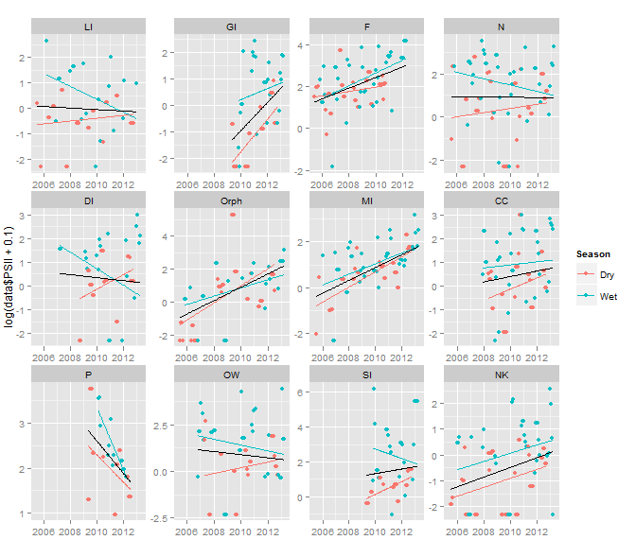
Figure 41. Linear trend in PSII at 12 locations. The black line represents the overall trend; the blue and red lines are trends in wet and dry seasons respectively.

Table 33. Linear temporal trends in PSII-HEQ estimated from the model. We highlight estimates in bold font that were significant at the 0.05 level of significance in bold font and their corresponding significance. A positive significant trend is indicated by (+) while a negative (significant) trend is indicated by (-). The analysis performed on the log response and the analysis was produced with and without outliers removed from Orpheus Island (Orph) and Sarina Inlet (SI).
Site | Trend (All years: wet + dry) | Trend (Wet seasons) | Trend (Dry seasons)
All sites | 0.1116 (+) | 0.0577 (+) | 0.1441 (+)
LI | -0.0297 | -0.2534 (-) | 0.0288
GI | 0.5261 (+) | 0.2066 (+) | 0.5133 (+)
F | 0.2565 (+) | 0.3097 (+) | 0.1405 (+)
N | -0.0001 | -0.1476 (-) | 0.1397 (+)
DI | -0.0634 | -0.3471 (-) | 0.3622 (+)
Orph | 0.4049 (+) | 0.2500 (+) | 0.4116 (+)
Orph (Outliers removed) | 0.3889 (+) | 0.2459 (+) | 0.3509 (+)
MI | 0.2806 (+) | 0.2316 (+) | 0.2914 (+)
CC | 0.1141 (+) | 0.0640 | 0.1952 (+)
P | -0.3569 (-) | -0.6909 (-) | -0.3455 (-)
OW | -0.0841 (-) | -0.1564 (-) | 0.1041 (+)
SI | 0.1319 (+) | -0.2737 (-) | 0.1836 (+)
SI (Outliers removed) | 0.0238 (+) | -0.0841 | 0.1836 (+)
NK | 0.1885 (+) | 0.1591 (+) | 0.1743 (+)

The smoothed time variable (represented by year) in the generalised additive model appears to be also significant. This suggests that a meaningful trend in PSII concentration (combined herbicide equivalent factor) can be detected for longer term monitoring. The seasonal term represented by month is also significant which support the above analysis separating wet and dry seasons. Trend and seasonal terms are illustrated in Figure 42.
These two analyses show the importance of individual specific variates (i.e. season and site) and the interactions between time and space. The analyses therefore indicate that there is a requirement to sample both wet and dry seasons because long-term trends in both seasons can be detected. However, within a season, there is no requirement for high-frequency sampling as this is not needed for long-term trend detection. Increasing the number of monitoring sites over the spatial extent of the pesticide monitoring program will also strengthen results.

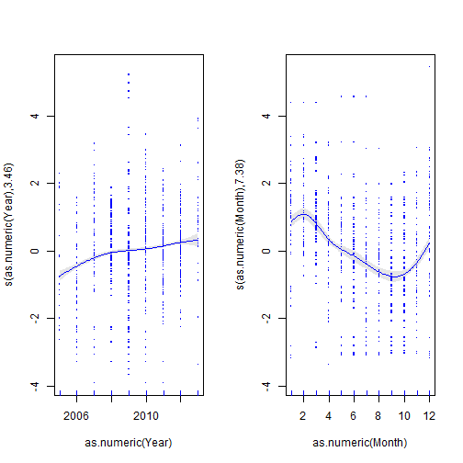
Figure 42 Trend and seasonality estimates for PSII concentration (combined herbicide equivalent factor).

Relationship to discharge
The majority of pesticides are exported during large events. River discharge is thus expected to be a driver of the observed pesticide contribution, though it is complicated by the fact that discharge from a range of different rivers will overlap. Moreover, there are additional complexities as the observed pesticide concentrations are time integrated and they depend on antecedent discharge.
To investigate the strength of this linkage we focus on PSII-HEQ concentrations and consider discharge as the average daily or the maximum daily value over the observed discharge. Figure 43 presents the log PSII–HEQ concentration plotted against the log average daily discharge. Note, we add a small value to the data to accommodate zeros in the transformation. Blue points represent samples taken in the wet season while red samples were taken in the dry season. There is a clear strong positive correlation between concentration and discharge as indicated by the smoothing splines overlayed on each plot. We fit a GAM to the logged PSII-HEQ for each site as follows
To consider the lagged effect of discharge, we used the past months average flow in the model, which is represented by the term, . Other lags of flow that considered shorter and longer time periods were also considered, however the difference between them was minimal. The deviance explained for the generalised additive models fit to each site is shown in Table 34. This table highlights the strength in the smooth relationship that was fit to each site shown in Figure 43, where high percent deviances explained (GI, Orph, MI, OW and NK) indicate quite strong relationships between the PSI-HEQ (log-scale) and lagged discharge.

Table 34: Percent deviance explained for the models fit to each site and summarised in Figure 43.
Site | Deviance explained (%) |  | Site | Deviance explained (%)
All sites | 23.8 |  | MI | 54.4
LI | 46.5 |  | CC | 37.9
GI | 50.2 |  | P | 32
F | 29.9 |  | OW | 55.9
N | 13.8 |  | SI | 35.7
DI | 30.4 |  | NK | 61.4
Orph | 77.6

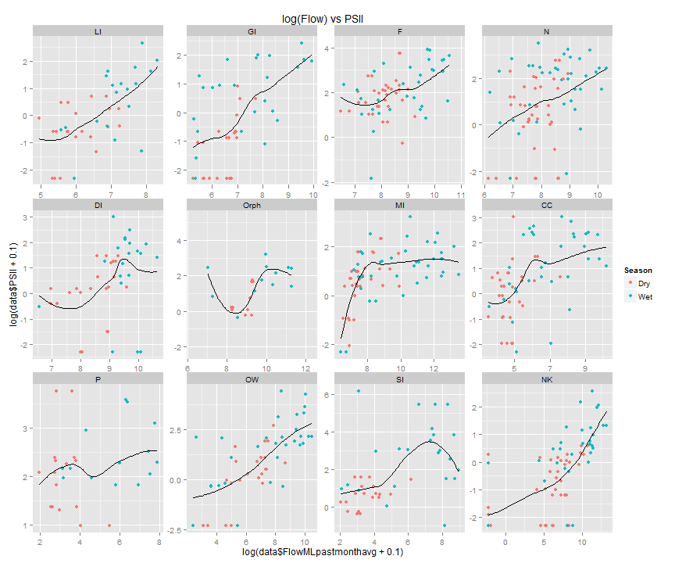
Figure 43: Log PSII-HEQ concentration against the log average daily lagged discharge. Blue points represent samples taken in the wet season while red samples were taken in the dry season.
As a secondary analysis, we also considered modelling the entire dataset and included a space-time interaction term in addition to the lagged discharge term already included in the model. Again the flow used in this model is the previous month average, which reflects the lag response in PSII HEQ concentrations to flow. The results from this model fit show that the temporal, spatial and interaction terms explain the same variation as the previous space-time analysis summarised in Table 34. However, flow is identified as a strong significant effect in addition to the interaction between flow and site. Therefore, a strong relationship between flow and PSII concentration is evident, which varies according to site. We investigate these relationships in a generalised additive modelling framework, where we include a smooth term for log flow.
Table 35: Analysis of variance of the log-linear model for PSII.
Variable | Df | SS | MS | F value | p-value
Year-Month | 1 | 106 | 106.1 | 100.39 | <0.001
Site | 11 | 4860 | 441.8 | 417.88 | <0.001
Season | 1 | 1535 | 1534.6 | 1451.37 | <0.001
log(Flow) | 1 | 1573 | 1572.6 | 1487.38 | <0.001
Year-Month x Site | 11 | 554 | 50.4 | 47.66 | <0.001
Site x Season | 11 | 395 | 35.9 | 33.97 | <0.001
Site x log(Flow) | 11 | 514 | 46.8 | 44.23 | <0.001
Residuals | 7042 | 7446 | 1.1

The GAM suggests a strong flow effect on the logged PSII concentration. Visually, the flow effect can be illustrated as a partial residual plot shown in Figure 44, which allows you to examine the residuals from a particular component fit in the model, which in this case is logged flow. The x-axis represents the logged flow and the y-axis is the flow effect in addition to the residuals of the model, which are also presented on the log scale. This model captures the relationship between logged flow and logged PSII concentration after taking all the remaining effects into consideration. The result is a strong positive correlation between flow and PSII concentration.
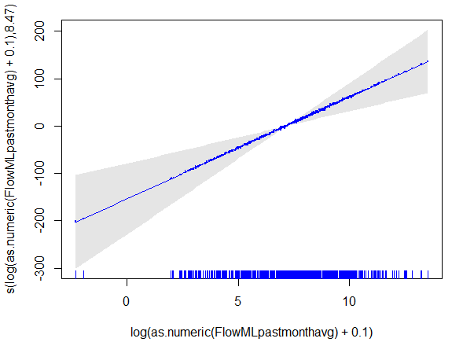  (a) | 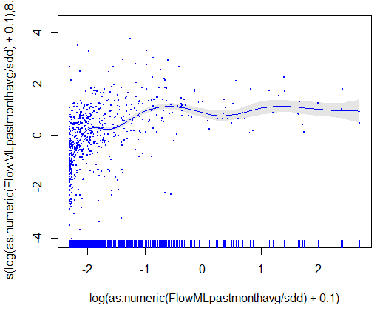  (b)
Figure 44. Partial residual plot for logged flow (a) with the flow-site interaction term and (b) without the flow-site interaction term.
To emphasise the effect of the interaction between flow and site, Figure 44 (a) should be compared with Figure 44 (b), which plots the residuals from the generalised additive model without the flow-site interaction term. This plot is from the model without the flow-site interaction term and represents a GBR wide analysis investigating the flow effect. Figure 44(b) is the result of standardising the flows, since discharge varies widely across the rivers in the region. The result is much less pronounced (scale on the y-axis is significantly less) and illustrates the importance of standardising flow otherwise we may falsely observe a strong positive correlation when one does not really exist. The terrestrial run-off sampling provides an important characterisation of pesticides carried in flood plumes and terrestrial run-off. This is currently arguably more a research activity. There is an opportunity here, through refining the flood plume monitoring objectives, to compare pesticides in flood plumes over time, which is not part of the current pesticide monitoring program.
A stronger sense of the pesticide application rate would be valuable in linking catchment action to what is observed in coastal waters. This is particularly useful when there are changes, e.g. a pesticide is no longer used, because it will be of interest to see time frames for concentrations to diminish, or perhaps for new pesticides or alternative pesticides to be recognised. We would also advise that within this component of the MMP, discharge is examined more carefully and used more directly in how pesticides are carried through flood plumes. We would suggest attempting to integrate more with the flood plume component of the MMP to establish clearer objectives across both programs.

Sensitivity of current monitoring to potential future changes
We conducted a bootstrap power analysis to investigate whether trends in PSII concentration of a given magnitude could be detected. This is based on the bootstrap methodology (Davison and Hinkley, 1997) which is a popular method of statistical inference that resamples the data in order to generate alternative plausible observations.
The power analysis is based on the observed time series for the 12 sites monitored. At the highest level we estimate the variability in residual PSII concentrations, impose a series of known trends and estimate our ability to detect each of those changes in the face of that residual variability. The approach consists of the following steps for each site and reef.
- A generalised additive model is used to estimate a smooth long term trend in the observed PSII concentrations.
- This trend is removed from the observed data and the residual PSII concentrations are used to characterise the variability in PSII concentrations.
- A specific increase of α percent per annum on the natural scale is considered and used to define a linear trend on the log PSII scale (which is the scale where the trend analyses are conducted).
- Add the new trend to the residual log PSII concentrations time series, with the original trend removed. Since the generalised additive model was fitted to the logged PSII concentration, the new trend is also logged before adding to PSII time series.
- Fit a linear regression model to the new log PSII time series and test whether the slope of the regression line is significantly different from zero.
- Resample the residual log PSII time series before adding the trend. Repeat 4 and 5 to obtain a distribution of p-values for test of slope.
- Repeat the above with different α.

Table 36 summarises the results from the bootstrap power analysis where a simulation study was investigated for each site to determine the power (white cells) required to detect a rate of increase of a certain magnitude over a three and six year period for a 5% level of significance. As a guide, power greater than 90% (or 0.9) indicates reasonable power to detect the rate investigated. Lower powers will be an indication that the site as it is currently monitored may need to be revisited in terms of its ability to detect changes in PSII. As a result, the design of the sampling program may need to be revisited for sites exhibiting low power. We can see in Table 36 that detecting small rates of increase (between 5% and 10% per annum) are difficult to detect for all sites. For moderate increases (20% per annum), there is an ability to detect these changes in a few sites (F, LI, DI, CC and P) although most have a power of around 50%. Detecting a 30% decline is more apparent across all sites at the 5% level of significance with the exception to Orpheus Island (with or without outliers removed) and Sarina Inlet (with or without outliers removed). This suggests that for both Orpheus Island and Sarina Inlet it will be difficult to observed increases in PSII over a 6 year time frame. In terms of a shorter time frame, say 3 years, the only sites where we will be able to observe reasonable power of detecting a 30% increase is Dunk Island, although the power is limited to approximately 70%. It is important to note that the simulation study conducted here to examine power provides an indication of the ability to detect a trend (i.e. a rate of increase) for each site examined. The results are based on a specified power (90%) and level of significance (0.05) and can change depending on how we set these parameters of the simulation. While the simulation study is indicative of the types of trends we should see at these sites, it may happen that when we formally test through a statistical model (e.g. Table 33) that quantifies trends (both linear and non-linear), the result is different. This can come about purely because of the random nature of the site being examined, something that cannot be controlled in a simulation study.

Table 36 The power to detect rates of increase in pesticide use from 5-30% per annum based on a level of significance (α) of 0.05. Values in the non-shaded areas is the power of detecting a change in PSII concentration for the six and three year periods investigated.
Site | Rate of increase (% p.a.)
Site | 6 years |  |  |  | 3 years
Site | 5 | 10 | 20 | 30 | 30
LI | 0.074 | 0.189 | 0.578 | 0.872 | 0.585
GI | 0.067 | 0.13 | 0.327 | 0.618 | 0.329
F | 0.133 | 0.398 | 0.893 | 0.998 | 0.346
N | 0.081 | 0.154 | 0.500 | 0.833 | 0.120
DI | 0.089 | 0.193 | 0.536 | 0.862 | 0.680
Orph | 0.046 | 0.047 | 0.048 | 0.046 | 0.045
Orph  (Outliers removed) | 0.054 | 0.056 | 0.055 | 0.061 | 0.044
MI | 0.061 | 0.108 | 0.368 | 0.848 | 0.132
CC | 0.100 | 0.206 | 0.558 | 0.832 | 0.217
P | 0.084 | 0.179 | 0.506 | 0.814 | 0.712
OW | 0.066 | 0.121 | 0.331 | 0.624 | 0.241
SI | 0.056 | 0.094 | 0.191 | 0.356 | 0.206
SI (Outliers removed) | 0.066 | 0.097 | 0.177 | 0.401 | 0.198

The bootstrap power analysis has highlighted that the pesticide monitoring program is sensitive to changes in PSII concentration but this depends on the rate of increase we are wishing to detect and the time frame we would like to observe this over. We found that it is more likely to detect a change in PSII concentration when the rate of change is higher or the duration of change is longer. The sensitivity of the monitoring program to change varies between sites. It appears difficult to identify a change in PSII concentration at Orpheus Island (Orph) regardless of the rate and duration of change, although we were able to formally estimate a trend in the GAM analysis shown in Table 33 for the reasons explained above. We also observe through the power analysis that Low Isles, Fitzroy Island, Normanby Island, Dunk Island, Magnetic Island, Cape Cleveland and Pioneer Bay would have the highest detection rates. The extreme duplicates in Orpheus and Sarina Inlet data were treated as outliers. Together, 51 outliers were removed for comparison and the showed that there is no significant change in the detection rates of PSII HEQ concentrations at Orpheus and Sarina Inlet.
Figure 45 and Figure 46 visually illustrate the power in detecting an increase in PSII concentration at all sites. Figure 45 shows the detection rate for a range of rate increases explored at each of the sites (outliers removed where required), while Figure 46, assumes a linear rate of increase in PSII concentration of 20% p.a. for 6 years. Figure 45 shows that it is generally much easier to detect a bigger change in PSII concentration, but we also notice that Orpheus Island (black line) is significantly less sensitive to the size of change. Among all locations, Fitzroy has the highest detection rates (green line) whereas Orpheus Island has the lowest. Nevertheless, the current pesticide monitoring regime is able to detect potential future changes in PSII concentration, especially long term major changes for a selection of the sites examined. Figure 46 suggests that there is no obvious spatial trend in the sensitivity of current monitoring program to potential future changes according to region.

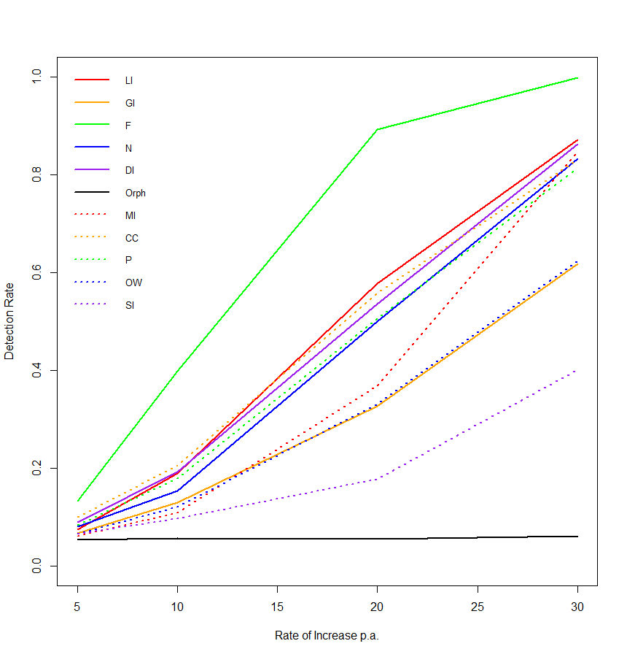
Figure 45. Sensitivity of current pesticide monitoring to potential future changes for a range of rate increases simulated across a 6 year period.

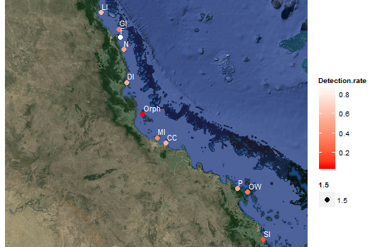
Figure 46. Rates of detecting a change in PSII concentration at all sites, assuming 20% p.a. increase in PSII concentration for 6 years.

Flood Plume and Remote Sensing Monitoring Program

Summary and Preparation of Available Data
Remote sensing provides a “suitable and cost-effective technique for monitoring coastal water quality” (Brando et al., 2013). The information has the potential to provide synoptic views of the spatial distribution of chlorophyll (CHL), colour dissolved organic matter (CDOM) and total suspended sediment (TSS) concentrations as well as water clarity of near-surface water. The information can also help identify patterns of spatial variation over scales of hundreds of metres to hundreds of kilometres, and at temporal scales of days to years. It can also assist management agencies to make more informed decisions.
MODIS data is obtained for the entire GBR using MODIS instrumentation, which is carried by two satellites, Terra and Aqua, providing the morning and afternoon overpasses. NASA provides operational processing of the daily coverage of the MODIS data to different levels of calibration (level 0: raw counts, level 1B: calibrated radiance, level 2: orbital swatch granules, level 3: global gridded products). This information is processed from level 1B onwards if NASA level 1B to higher level (chlorophyll and TSS) processing is found to be insufficiently accurate in the GBR lagoon waters. Commencing in January 2012, marine water quality assessments for chlorophyll and TSS can be accessed through the Marine Water Quality Dashboard in the eReefs program (http://www.bom.gov.au/marinewaterquality/), which is a tool to access and visualise a range of water quality parameters in the GBR region. The Bureau of Meteorology receives daily satellite data on the frequency of light which is used to determine the water colour and temperature in the region. The water colour information is then compared to sediments, chlorophyll and dissolved organic matter measurements to determine the relationships between the satellite images and the actual water in the reef. Specific details relating to the processing of the MODIS imagery is outlined in Brando et al. (2013).
The flood plume data that was provided to us in sufficient time for analysis consisted of the diffuse attenuation coefficient for photosynthetically active radiation (Kd (par)), which we term from here on in as “light”, colour dissolved organic matter (CDOM), total suspended sediment (TSS) and chlorophyll that was obtained during events. As outlined in the survey design section, this was obtained for four NRM regions consisting of the Burdekin, Burnett-Mary, Fitzroy and Wet Tropics and over the two wet periods spanning 2011/2012 and 2012/2013. Figure 47 summarises the data provided for the analysis. It represents a pairwise plot of the data summarising the NRM regions sampled (coloured boxplots on the top row of this figure); the distribution of light, CDOM, TSS and chlorophyll across each NRM region (bottom 10 triangular plots); and the pairwise correlation of each of the 4 parameters at each of the NRM regions (upper 6 figures that list correlations). In addition to obtaining light, CDOM and TSS data, compositional samples of phytoplankton taxa, which were identified to group were also obtained over the same period. A total of 14 groups of phytoplankton were identified and these consisted of Chrysophyceae, Coccolithophorids, Cryptophyceae, Cyanbacteria, Diatomaceae, Dinoflagellates, Euglenophyceae, Prasinophyceae, Raphidophyceae, Silicoflagellates along with some other broader grouping structures. The most dominant phytoplankton group surveyed was Diatomaceae, which has been the focus of analyses in the following sections.

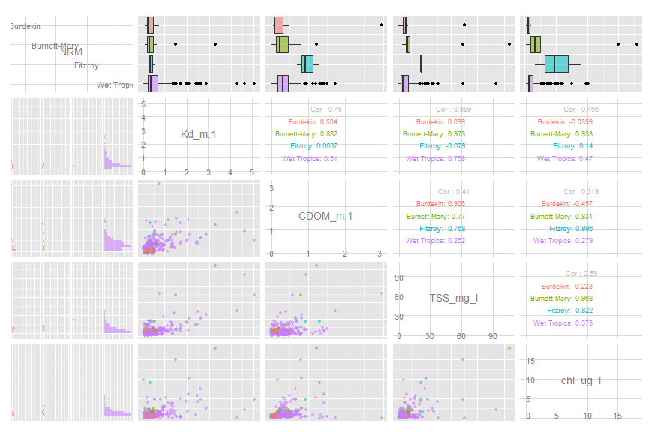
Figure 47. A summary of the flood plume data provided for the review consisting of a pairwise plot of the data summarising the NRM regions sampled (coloured boxplots on the top row of this figure); the distribution of light, CDOM, TSS and chlorophyll across each NRM region (bottom 10 triangular plots); and the pairwise correlation of each of the 4 parameters at each of the NRM regions (upper 6 figures that list correlations).

The flood plume data analysis is preliminary as we had many queries relating to the data that were only addressed at the later stages of the project. As such, we cannot provide specific suggestions regarding the spatial and temporal replication necessary to move forward. While we can provide some general advice and suggestions for improvement to the program to assist in addressing these types of questions, we have mainly concentrated on two main components of the analysis: light and phytoplankton. Further discussions surrounding these analyses and the implications for this component of the MMP are required to provide a more comprehensive analysis of the program. These analyses are outlined in the following section.

Light Analysis
Light is an important limiting factor for primary production and plant growth, and plays a critical role in determining the biological response to nutrient enrichment. Kirk (1994) suggested that Chlorophyll-a, TSS and CDOM contribute to light attenuation. Light data is not exhaustively available but collected at some sites and transects and at some times. The data availability is summarised in Figure 48 and Table 37.
Table 37. A summary of how the light data was collected across the region sampled.
Transect | Tully to Sisters | Northern Herbert | Southern Herbert | Palm Is Barge | Murray River | Franlins | Burdekin to Palm Is | Offshore | Gladstone to Heron | Fraser Is | Mary to Burnett river
River | Tully | Herbert |  |  | Murray | Russell-Mulgrave | Burdekin | Fitzroy | Burnett | Mary
NRM | Wet Tropics |  |  |  |  |  | Burdekin | Fitzroy | Burnett-Mary

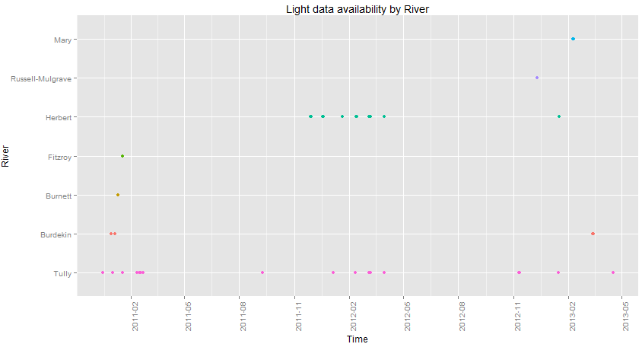  (a) | 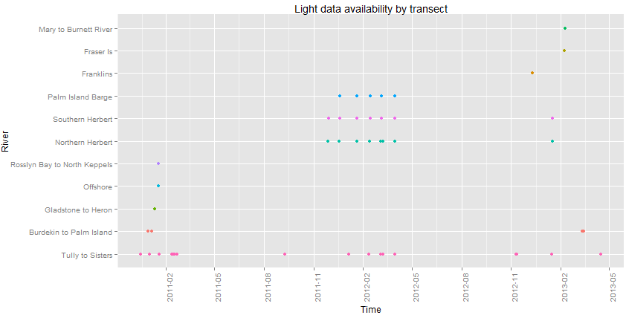  (b)
Figure 48: A summary of light availability by (a) river and (b) transect. The colours simply refer to the different rivers and transects plotted.

A linear mixed model was considered for all the light data that considers regions, rivers with regions and transects within rivers and regions as nested random effects. Note that in all modelling undertaken for the light data, we checked all model assumptions using standard diagnostics to determine if all spatial and temporal dependencies were captured in the model.
This is important because transects/rivers within a river/NRM region cannot be compared as a factorial effect – for instance, comparing transect 1 averaged across the 8 rivers or 4 NRMs to transect 2 averaged across the 8 rivers or 4 NRMs does not make sense. We can write down the model as follows:
$$y_{ijk}=μ+s\left({time}_{ijk}\right)+{NRM }_{i}+{River}_{j\left(i\right)}+{Transect}_{k\left(ij\right)}+e_{ijk},$$
where the time component is the fixed effect, ${River}_{j(i)}$ is the nested random effect of rivers within an NRM region, ${Transect}_{k(ij)}$ is the nested random effect of transects within a river, and $e_{ijk}$ are the Normally distributed errors. The model was fit in R using the gamm4 package using restricted maximum likelihood to estimate the variances.
While there is some imbalance in the number of transects within rivers and regions, the nested random effect (transect within river within region) has a standard deviation of 0.1997 and the “river within region” effect has a standard deviation of 0.1570. This indicates the importance of variability within the transect, and possibly reflects the variation along gradients. Figure 49 presents a measure of light (Kd) (y-axis) along a surface salinity gradient (x-axis). While Kd decreases with increasing salinity there is considerable variability in the relationship.
Due to the better data availability at the Wet Tropics compared to other NRM regions as shown in Figure 45, this analysis was repeated for this region separately and leads to similar conclusions. In this instance the estimated standard deviations were 0.2582 and 0.1109 respectively, indicating even greater within transect variability.
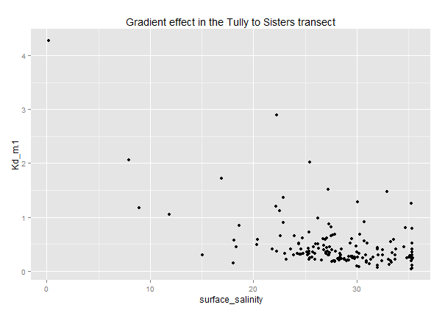
Figure 49. Gradient effect in the Tully to Sister Transect.

Models for light availability have been considered in the flood plume program, where light attenuation, as measured by Kd(par), is considered linearly dependent on chlorophyll-a (CHL), total suspended sediment (TSS) and colour dissolved organic matter (CDOM) concentrations. The model can be represented as
$⁡log(Kd\left(PAR\right))=CDOM+TSS+CHL$
A linear model is considered for all the light data on the log response scale. The model explains 33% of the variation in light availability, with chlorophyll notably marginally insignificant and possibly due to its correlation with TSS. Extending this model to allow for smooth nonlinear functions of chlorophyll-a, total suspended sediment and colour dissolved organic matter improves our ability to predict light, with the explained variation increasing to 78.4%. This non-linear model has the general form:
$$⁡log(Kd\left(PAR\right))=s(CDOM)+s(TSS)+s(CHL)$$
Models were also considered that averaged the daily data across transects but are not reported here. Light models were also considered for the Wet Tropics only, given the magnitude of the data available.
Across all analyses TSS appears to be the most important predictor of light availability, with TSS positively related to Kd (Par). Chlorophyll-a was not found to be a significant predictor in the presence of TSS.
These preliminary analyses have used chlorophyll-a, total suspended sediment and colour dissolved organic matter from grab samples. One extension from this modelling is to incorporate remote sensing data. If relationships can be constructed using that data then there is the ability to have spatial maps of light availability. These would be expected to correlate reasonably well with water type.

Phytoplankton
Phytoplankton data has been collected over the last three years, though not routinely with all flood plume sampling and with a greater focus on the Wet Tropics. The phytoplankton sampling regime is summarised in Figure 50.

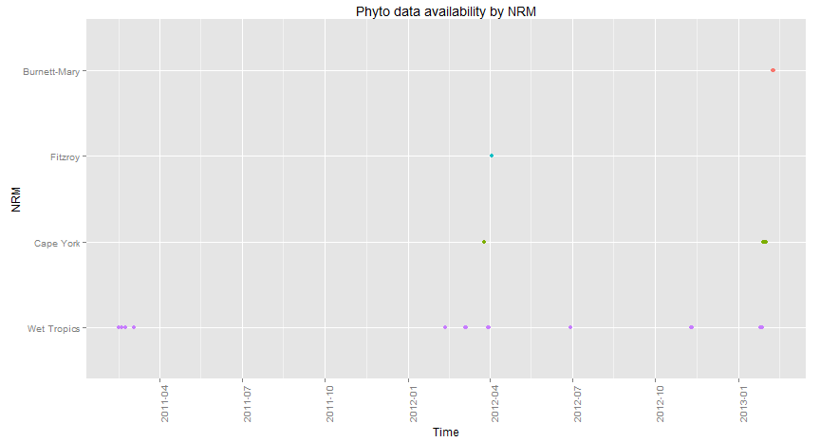
Figure 50: Phytoplankton sampling by date and NRM region.

Compositional models were considered for the phytoplankton data with the aim of linking the observed composition to potential water quality drivers. A model was possible for finer taxa but was very simple and has a large error. A model for broader groupings (e.g. diatoms, freshwater taxa etc) did not produce a tree. There are several possible reasons for this, including the length of the time series (3 years), the mismatch in scales for water quality data given that lags are important, and the fact that the method converts the cells per L to proportions that sum to 1 (i.e. cell size is not considered).
Diatoms were considered in more detail, with the spatial and temporal sources of variation considered through a mixed model analysis. Statistically significant differences between transects (and rivers) were identified but much more substantial variability existed within transects. This simply reflects the highly variable nature of phytoplankton cell counts. Random Forests was used to identify the most predictive water quality variables. Figure 51 shows the variable importance ranking for nutrients and highlights the potential importance of total and particulate N and P. The model only explains approximately 25% of variation for diatoms on the log scale.
It is noted that these models are based on event only data, which potentially reduces the range of the phytoplankton and its apparent predictability.

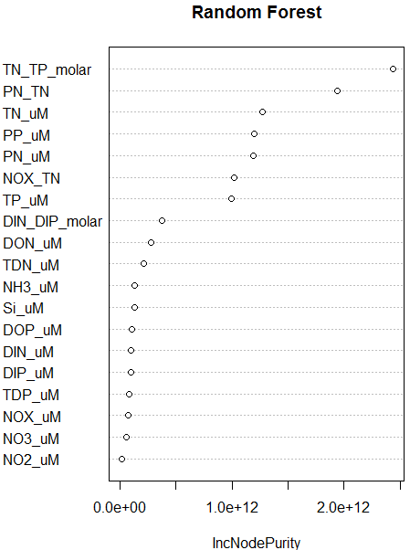
Figure 51. Variable importance ranking from the random forest analysis for the Diatomaceae group. The x-axis represents the node purity when a variable (on the y-axis) is excluded from the model. Important variables appear towards the top of this figure and yield large node purity measures.

Metrics
Report cards represent a mechanism for assessing annual progress from a nominated baseline to a specifed target. For the Reef Water Quality Protection Plan (or ReefPlan) (Reef Water Quality Protection Plan Secretariat, 2013) , the report card provides an overall assessment of the status of the reef and the ability to meet the ReefPlan goals . The information provided in the Reefplan consists of a structured layer of reporting, using metrics to summarise and communicate findings. The marine component of the GBR report card consists of a disc that summarises the health of the marine ecosystem through three monitored components: seagrass status, inshore water quality and coral status. While flood plume dynamics represents a component of the MMP, it is not explicitly incorporated into the report card and used to assess the status of marine condition. Furthermore, although pesticides are monitored, they are not included in the report card summaries.
As part of the assessment of the MMP, we examined the report card metrics that comprised the marine component of the GBR report card. We focussed on the ability of the metrics to detect a change using a bootstrap power analysis, similar to what was presented in previous chapters. While it was envisaged that we would examine the relationships between these metrics and a range of predictors and investigate methods for combining metric scores, we were unable to complete this analysis in the time frame provided. As such we recommend that the metrics and the aggregation of scores be the focus of a subsequent study. This study should aim to finalise the suite of metrics to be included in the report card and the corresponding methodology for aggregating metrics to provide an overall score of marine condition. It is also recommended that these activities be well documented and published in peer review journals.

Coral Metrics
Four metrics are used to assess the coral reef status and resilience in the report card: (1) coral cover, (2) macroalgae cover, (3) density of hard coral juveniles and (4) the rate of increase in hard coral cover or coral change. A fifth metric (settlement of coral spat) was proposed in earlier reports but is no longer included in any assessments due to high variability in settlement between years (Thompson et al., 2010b).
The development of the metrics is based on work conducted by Thompson et al. (2010a) (baseline assessment), and revised later by Thompson et al. (2011). The latter revisions resulted in the development of a number of decision rules which were based on discussions held at stakeholder workshops (Thompson et al. (2011), p15) but are seen to approximate “the lower central and upper thirds of coral covers observed for the communities monitored”.
The aggregation of indicator scores to Reef and Regional Assessments is performed by aggregating over scores for each indicator and reef combination. As these are assigned a score of “-“, neutral or “+”, reefs can obtain scores between -4 and +4 (or -5 to +5 where settlement is monitored). Regional scores were achieved by converting the qualitative assessments to quantitative scores using the method outlined in Thompson et al.(2011):
- Convert qualitative scores to: positive = 2, neutral = 1 and negative = 0.
- Average across reefs and divided by 2 to standardize scores between 0 and 1.
- Convert to a five point assessment uniformly across the range 0-1:
  - 0-0.2, very poor, colour red
  - >0.2 to 0.4, poor, colour orange
  - >0.4 to 0.6, moderate, colour yellow
  - >0.6 to 0.8, good, colour light green
  - >0.8 to 1.0, very good, colour dark green

Coral Cover
The coral cover metric has been derived from a combination of hard and soft coral cover abundance. It has been proposed that this metric is a useful measure of coral sustainability as the “recruitment and subsequent growth of colonies is sufficient to compensate for losses resulting from disturbances” (Thompson et al., 2011).
The calculation of coral cover is based on visits conducted at each catchment and reef. Although the visits correspond to a particular year of monitoring, sampling may span different months through the year due to seasonal differences and logistic constraints. If we let
for each catchment and reef surveyed, then we can calculate the average combined cover across sites and transects as
(1)
Where a combined abundance for each visit and depth is greater than 50%, a positive (+) assessment is assigned. If the abundance lies between 25-50%, a neutral score is assigned and less than 25%, a negative score (-1) is assigned. These categorisations have been chosen subjectively with the intent on approximating the lower, central and upper thirds of hard and soft coral cover that was observed in 2005. Mathematically this can be written as
(2)
The aggregation of scores to reef and regional assessments are obtained by averaging the score across depths, and depths and reefs respectively.

Cover Change
Cover change represents the rate of increase in the cover of hard corals and was highlighted as an important metric as it represents a direct measure of recovery potential (Thompson et al., 2011). The metric utilises growth rates derived from a Gompertz growth equation using data collected on inshore reefs (Thompson and Dolman, 2010). Using this model, growth rate estimates were produced for soft () and hard corals (), with a particular focus on the hard coral family Acroporidae (). The growth equations, which are outlined in Thompson and Dolman (2010a) are shown below. Rates of increase that were above the upper confidence interval of predicted change were assigned a positive (+) assessment, those within the confidence intervals were assigned a neutral assessment and those below the lower confidence interval of predicted change were assigned a negative (-) assessment.
Growth Equations:
(3)

The growth rate parameters presented in Table 38 were estimated by Thompson and Dolman (2010b) using data surveyed from 28 reefs, two depths between the years 2005 and 2007. Some of the parameters used in the derivation of the metric match up with the estimates presented in Thompson and Dolman (2010b), while other parameters appear to be additions to the model or simply not presented in their paper, which would allow their validation.
It is unclear from Thompson et al. (2011) what level of confidence was used in the assessments of cover change. Their 2010 paper only presents the growth rate estimates (embedded in the text) and does not provide any estimates of confidence around these. It is also unclear whether the prediction intervals used to develop the cover change metric include a bias correction due to the log transformation used in the model. As highlighted by El-Shaarawi and Lin (2007), “unbiased estimators on one scale will become biased under a non-linear transformation to another scale”. A more appropriate method to account for bias is either through a Bayesian formulation of the model, or alternatively, introducing a bias correction like (El-Shaarawi and Lin, 2007) in the estimation of the mean and corresponding prediction interval. El-Shaarawi and Lin (2007) presents an approach of bias correction for the estimation of the log-normal mean and prediction intervals with an application to water quality that could be used to inform the cover change metric.

Table 38: Summary of parameters used in the growth rate parameters for Acroporidae, other hard corals and soft corals.
Growth Rate Parameters | Description | Estimate | Comments
Acroporidae
r_{Acr} | Estimate of the growth rate parameter for Acroporidae. | 0.9330 | This parameter appears in the Thompson and Dolman 2010 paper.
r_{AcrL} | Lower confidence interval limit for the growth rate of Acroporidae. | 0.3409 | It is unclear if this “lower limit” represents the lower limit of a 95% confidence interval on the natural scale.
r_{AcrU} | Upper confidence interval limit for the growth rate of Acroporidae. | 1.5250 | It is unclear if this “upper limit” represents the upper limit of a 95% confidence interval on the natural scale.
w_{AcMa} | Density dependent feedback for macroalgae in the model for Acroporidae. | 0.0714 | This parameter does not appear in Equation 1.
Other Hard Corals
r_{OthC} | Estimate of the growth rate parameter for other hard corals. | 0.3495 | This parameter appears in the Thompson and Dolman 2010 paper.
r_{OthCL} | Lower confidence interval limit for the growth rate of other hard corals | 0.2205 | It is unclear if this “lower limit” represents the lower limit of a 95% confidence interval on the natural scale.
r_{OthCU} | Upper confidence interval limit for the growth rate of other hard corals. | 0.4785 | It is unclear if this “upper limit” represents the upper limit of a 95% confidence interval on the natural scale.
w_{OthC} | Density dependent feedback for macroalgae in the model of other hard corals. | 1.0128 | This parameter does not appear in Equation 1.
Soft Corals
r_{SC} | Estimate of the growth rate parameter for other hard corals. | 0.7292 | This parameter appears in the Thompson and Dolman 2010 paper.
r_{SCL} | Lower confidence interval limit for the growth rate of other hard corals | 0.4110 | It is unclear if this “lower limit” represents the lower limit of a 95% confidence interval on the natural scale.
r_{SCU} | Upper confidence interval limit for the growth rate of other hard corals. | 1.0474 | It is unclear if this “upper limit” represents the upper limit of a 95% confidence interval on the natural scale.
w_{SC} | Density dependent feedback for macroalgae in the model of other hard corals. | 4.0132 | This parameter does not appear in Equation 1.

We found it difficult to replicate the methodology for producing the cover change metric based on the information provided in the Thompson et al. (2011) report and the paper by Thompson and Dolman (2010). The R code that was provided to us contained the script used to create the metric from the surveyed data, yet the workings in this script did not represent the general description provided in the report, particularly the decision rules used to assess coral cover change. Prediction intervals were calculated but as identified above, the prediction intervals are calculated incorrectly. In general, for a simple linear model expressed as
a prediction interval based on normal theory assumptions can be formed on using the following expression
and is an estimator for representing the model error variance. As logs are used to linearise the growth equations in Thompson and Dolman (Thompson et al., 2011), a bias correction is also required in the above formulation.
If we assumed that these intervals were calculated correctly, then the following equations outline the methods used to construct the change metric for each site, depth, region and visit.
- Growth equations are established for Acroporidae and “other” hard corals separately using the growth equations outlined in Thompson and Dolman (2011). We let and represent the predictions arising from models fit to percent cover of Acroporidae and other hard corals respectively.
- We let and represent the lower and upper prediction intervals (presumably 95% intervals and assuming the calculation is correct) from the growth models in Thompson and Dolman (2012).
- Obtain a lower and upper prediction interval for “hard coral” by summing the lower and upper prediction intervals, respectively for Acroporidae and other hard coral:
- Calculate the observed hard coral cover that is adjusted for the period between samples and call this .
- To evaluate whether the observed and adjusted hard coral cover lies inside the lower and upper hard coral “prediction” intervals, calculate the deviations between the observed and adjusted hard coral cover as
- Score a 0 if both and are negative. Score a 0.5 if the observed value lies within the interval (or is positive and is negative. Score a 1 if both and are positive.
There are two issues with this metric that make it difficult to assess in terms of its ability to adequately assess change in coral cover and based on these findings we do not examine this metric in our simulations. We outline these issues below:
- It is unclear why two separate models are fit, one to Acroporidae (the dominant hard coral species) and “other” hard corals since a prediction interval for “hard coral” is the goal of this metric. We can only assume that a single growth equation cannot be applied to each, hence the reason for utilising two growth equations. However, adding up lower and upper prediction intervals from two separate growth equations is not statistically valid. While the program may be finding that this metric is a good indicator of coral cover change, they are obtaining the results for the wrong reason as the methods are incorrect. The concept this program is proposing seems perfectly valid but they may want to consider an alternative approach for modelling hard coral cover (whether through a mixture model or compositional analysis or simply through hard coral cover) and forming prediction intervals appropriately. Alternatively, the program could simply consider fitting a model to hard coral cover with a trend term (linear or smooth) and examine the coefficient or shape of that term to inform on cover change through time.
- The prediction intervals and the deviations from what is observed are symmetric when logs have been taken to model Acroporidae and other hard corals. This again relates back to the incorrect calculation of the prediction intervals. We would not expect these intervals to be symmetric.

Macroalgae Cover
The assumption that macroalgae on coral reefs is linked with coral mortality has resulted in the development of a macroalgae cover metric (Thompson et al., 2011). As high macroalgal cover has been suggested as a proxy for nutrient availability, the abundance of macroalgal cover has been proposed to provide an indication of the sustainability of corals.
The calculation of the macroalgae cover scores () can be summarised as follows:
where represents the survey visit and represents the depth that the samples were taken. Note, this calculation differs from the descriptions provided in Thompson et al. (2011) but reflects the actual calculations used in the report card.

Juvenile Density
The abundance of juvenile corals was chosen as the fourth metric for corals as it is seen to provide an indication of recovery following a disturbance (Thompson et al., 2011). The juvenile density score is calculated from the density of juvenile colonies per square metre of available substrate at each of the two depths sampled. More specifically, the calculation is represented as:
If the depth sampled is 2m, then
The scores denoted by an asterisk (*) represent definitions that are reflected in the code used to derive the juvenile density scores for the report card but are different to those reflected in Thompson et al. (2011) fortunately, the 0.5 difference does not impact the scores in this instance.

Assessment of the metrics
We performed a simulation study to determine whether a trend (increasing/decreasing depending on what is more relevant) of a given magnitude could be detected from the data comprising each metric based on the current sampling regime implemented. Note, the simulation study (or power analysis) that we conducted provides an indication of the likely chance of detecting a decrease (or increase). There may be some instances where we fit specific trend models to the metric and identify a significant trend.

Power Analysis for Trend Detection in Coral Cover
We conducted a simulation study to investigate whether trends, of a given magnitude could be detected for the data comprising each metric. The rationale behind this is if the power to detect either an increase or decline was low for the sampling periods surveyed for a given level of significance, then it would be difficult to see this change in any summary score developed from the data.
The power analysis consisted of the following steps:
- Select a level of significance, , percent decrease/increase, per annum where a change is sought and the number of years n over which this decline/increase is sought.
- Extract the relevant data for each reef to perform the analysis, separated by the depths of 2m and 5m.
- Fit a GLM to the log of the response with visit as the predictor and extract the residuals. The residuals, now represent the data (or variation in the data) after removing the trend.
- Decide on
- For
- Sample with replacement from the residuals for an n year period.
- Impose a geometric trend of size on the bootstrapped residuals and let this be.
- For each depth, fit a GLM to with visit as the predictor:
- Extract the coefficient for and corresponding p-value for the t-test that tested for significance.
- Calculate:
- Calculate:

Power Analyses
A summary of the minimum declines in juvenile density and coral cover or increases in macroalgae that can be detected with at least 90% power is shown in Table 39 with detailed summaries appearing in Appendix A. In this table, declines greater than 30% are highlighted in bold. We can see that for the three metrics investigated that reasonable power can be achieved to detect declines in both juvenile density and coral cover across most sites. The ability to detect increases in macroalgae cover however is much more difficult for most of the sites with only reasonable power achieved once increases are above 30% or even above 50%. For some sites, the power to detect an increase was not defined because the proportion of macroalgae found at that site at year 1 was negligible or equalled zero.
Figure 52 - Figure 54 provides a summary of the power to detect declines or increases at a 2m depth for each of the three metrics investigated. Figure 52 shows the power of detecting declines in coral cover at a 2m depth across the GBR region. We can see that as the declines increase, the power to detect these declines also increases (maroon). However for some sites the power to achieve these declines is still limited (yellow and green). Figure 53 displays the power of detecting increases in macroalgae cover and shows the difficulty in achieving high power to detect increases for many of the sites unless the increases are substantial. Finally, Figure 54 shows the power to detect declines across the GBR in juvenile density at 2m. For the majority of sites, power can be achieved with declines from 10% onwards.

Table 39: Summary of the minimum declines/increases that can be detected with at least 90% power and 5% level of significance based on the current sampling design. ND indicates a decline is undetectable. The power to detect higher declines/increases of 30% or 50% are shown in bold font.
Site | Juvenile Density |  | Macroalgae Cover |  | Coral Cover
Site | 2m | 5m | 2m | 5m | 2m | 5m
Barren | 20% | 30% | ND | ND | 15% | 10%
Daydream | 20% | 20% | 50% | 50% | 10% | 10%
Dent | 10% | 20% | >50% | 30% | 10% | 5%
Double Cone | 15% | 15% | ND | 30% | 5% | 5%
Dunk Is N | 30% | 30% | >50% | >50% | 30% | 20%
Dunk Is S | 20% | 20% | >50% | >50% | 30% | 15%
Fitzroy Is E | 15% | 10% | 30% | ND | 15% | 10%
Fitzroy Is W | 15% | 10% | >50% | ND | 15% | 10%
Frankland GE | 20% | 10% | >50% | >50% | 20% | 15%
Frankland GW | 15% | 15% | >50% | 50% | 10% | 5%
Geoffrey Bay | 10% | 15% | 30% | 30% | 10% | 5%
Havannah Island | 5% | 10% | >50% | >50% | 10% | 10%
High Island E | 30% | 30% | ND | ND | 20% | 15%
High Island W | 15% | 15% | ND | 50% | 5% | 10%
Hook Island | 10% | 15% | >50% | >50% | 5% | 5%
Humpy | 10% | 15% | >50% | >50% | 30% | 5%
King | 20% | 30% | 30% | 50% | 30% | 15%
Lady Elliot | 10% | 10% | 50% | >50% | 30% | 10%
Middle Is | 30% | 30% | >50% | ND | 15% | 10%
Middle Reef | 15% | N/A | 50% | N/A | 5% | N/A
Nth Banard Gp | 30% | 50% | >50% | >50% | 50% | 50%
Nth Keppel Is | 20% | 15% | 50% | >50% | 15% | 5%
Orpheus Is E | 30% | 20% | ND | ND | 50% | 50%
Pandora | 30% | 30% | 30% | 30% | 20% | 15%
Peak Is | 20% | 15% | 50% | 50% | 20% | 5%
Pelican Is | 50% | 15% | >50% | >50% | 50% | 5%

Table 39 cont.
Site | Juvenile Density |  | Macroalgae Cover |  | Coral Cover
Site | 2m | 5m | 2m | 5m | 2m | 5m
Pelorus & Orpheus Is W | 15% | 10% | 30% | ND | 10% | 5%
Pine | 10% | 15% | 10% | 20% | 5% | 5%
Seaforth Is | 10% | 10% | 15% | 20% | 5% | 5%
Shute & Tancred | 10% | 15% | 50% | 20% | 5% | 5%
Snapper Is N | 20% | 20% | 20% | >50% | 15% | 10%
Snapper Is S | 30% | 15% | 30% | 30% | 10% | 5%

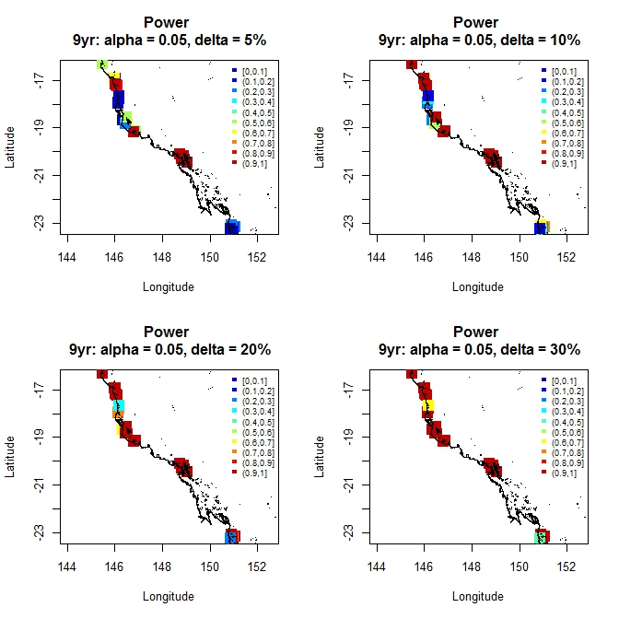
Figure 52: Summary of power in detecting declines in coral cover at a depth of 2m over a 9 year time period based on changes of 5%, 10%, 20% and 30%. High power to detect change is indicated in red.

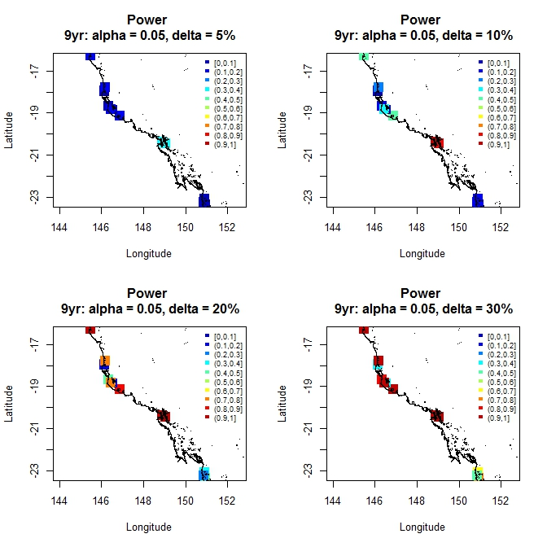
Figure 53: Summary of power in detecting increases in macroalgae cover at a depth of 2m over a 9 year time period based on changes of 5%, 10%, 20% and 30%. High power to detect change is indicated in red.

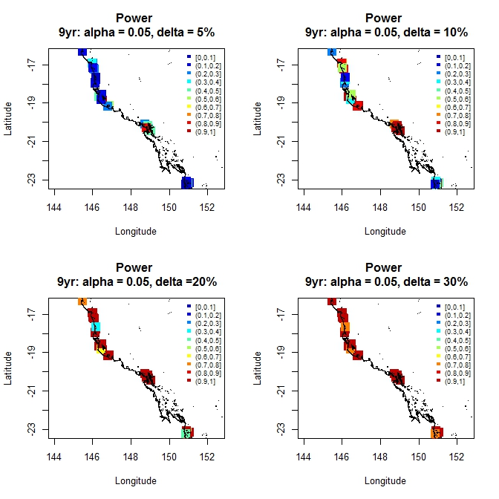
Figure 54: Summary of power in detecting declines in juvenile density at a depth of 2m over a 9 year time period based on changes of 5%, 10%, 20% and 30%. High power to detect change is indicated in red.

Seagrass Metrics
The reporting of seagrass condition, trend and resilience is outlined in McKenzie et al. (2012) and presented in the GBR report card and supporting documents (Kelsey et al., 2011). Three metrics were discussed and vetted at stakeholder workshops with the Paddock to Reef Integration team. The first metric was derived around seagrass abundance, the second around reproductive effort and the third around nutrient status (or seagrass tissue C:N ratio). Scores are developed for each metric and then aggregated across sites with equal weighting to provide a score for each NRM region. Scores from each NRM region, with the exception to Cape York were then weighted by seagrass meadow area prior to being assigned a seagrass ranking for the GBR. Cape York was excluded from the score due to insufficient sampling locations adequately representing the region. Each of these metrics are described in detail below.

Nutrient Status
Nutrient status is assessed through the atomic C:N ratio, which is an indicator of the light received relative to nitrogen availability. Atomic ratios of C:N less than 20 suggest reduced light availability or nitrogen enrichment which can adversely affect the growth of seagrass. The score is based on foundation species only and is represented as . We use this score to examine the power of detecting a decline in nutrient status at each site within habitat.

Seagrass Abundance
The seagrass abundance metric is based on percent cover, which is then compared against a set of guidelines that were developed by McKenzie (2012) using reference sites. Here, a reference site represents a suitable baseline for the assessment of sites appearing in similar habitats. Criteria used for selecting a reference site were based on the Monitoring River Health Initiative (1994) with no other rigorous protocols available. The median percent cover is computed for each year and site before comparing to the 50th and 20th percentiles from reference sites (see Table 6 in McKenzie et al. (2012)) and subsequently assigning a score. To evaluate the metric, we use the median percent cover calculated for each site to determine whether we can detect declines of a given magnitude.

Reproductive Effort
Reproductive effort measures the capacity of seagrass to recover and therefore its overall resilience. In the construction of this metric, seeds are not incorporated. The metric calculation is based on the number of reproductive structures (fruits, flowers, spathes), which is then averaged across cores for the late dry season to form . This average is then divided by a long term average. However, it is unclear from the documentation what this long term average represents. We therefore use to determine whether we can detect declines of a given magnitude.

Assessment of the metrics
We performed a simulation study to determine whether a decreasing trend of a given magnitude could be detected from the data comprising each metric based on the current sampling regime implemented. An exploratory plot of the metrics for each site through time is produced in Figure 56.

Power Analysis for Trend Detection in Seagrass Cover
We conducted a simulation study to investigate whether trends, of a given magnitude could be detected for the data comprising each metric. The rationale behind this is if the power to detect a decline was low for the sampling periods surveyed for a given level of significance, then it would be difficult to see this change in any summary score developed from the data.

Power Analyses
Power analyses were conducted for each seagrass metric using the methodology described in in Section 4.1.5. Table 40 summarises the minimum declines that can be detected with at least 90% power along with maps (Figure 57, Figure 58, and Figure 60) showing the location of sites and the power that can be achieved for declines of 5%, 10%, 20% and 30%. We also present exploratory figures (Figure 56) showing each metric at each site through time to determine visually, if any patterns exist in the data. Some patterns, namely declines are indicated by these plots. For example, sites BB, RC, RD and WH show declines in nutrient status through time. Decreasing median abundance at sites such as GI, MI and RD is also suggested by this figure. Declines in reproductive effort were less noticeable visually in the plots produced for each site. Detailed power analyses are presented in Appendix A, figures A22-A24.

Table 40: Summary of the minimum declines that can be detected after 8 years of sampling with at least 90% power and 5% level of significance based on the current sampling design. ND indicates a decline is undetectable.
Site | Nutrient Status | Abundance | Reproductive Effort
Coastal Intertidal
Bathurst Bay (BB) | >5% | >30% | >30%
Lugger Bay (LB) | >30% | >30% | >50%
Pioneer Bay (PI) | >15% | >30% | >50%
Ross Creek (RC) | >5% | >5% | >50%
Shelburne Bay (SB) | >50% | >30% | >50%
Wheelans Hut (WH) | >10% | >5% | >30%
Yule Point (YP) | >30% | >30% | >50%
Estuarine Intertidal
Pelican Banks (GH) | >10% | >30% | >50%
Rodds Bay (RD) | >10% | >20% | >30%
Sarina Inlet (SI) | >20% | >30% | >30%
Urangan (UG) | >30% | >30% | >50%
Reef Intertidal
Archer Point (AP) | >15% | >20% | >50%
Dunk Island (DI) | >5% | >15% | >50%
Green Island (GI) | >5% | >1% | >50%
Monkey Point (GK) | >10% | >20% | >50%
Hamilton Island (HM) | >20% | >20% | >50%
Low Isles (LI) | N/A | >5% | >50%
Cockle Bay (MI) | >20% | >20% | >50%
Reef Subtidal
Dunk Island (DI) | N/A | >10% | N/A
Green Island (GI) | N/A | >5% | N/A
Low Isles (LI) | N/A | >15% | N/A
Cockle Bay (MI) | N/A | >30% | N/A

Of the 3 metrics investigated, it is clear that reproductive effort has the least power and requires further investigation to determine how the metric could be improved for reporting. For the remaining two metrics, some sites have higher power than others. For example of the coastal intertidal sites, the minimum decline detectable for nutrient status and abundance is greater than 30% for Lugger Bay, Shelburne Bay, Yule Point, Sarina Inlet and Urangan. This suggests at these sites that it may be difficult to detect declines with any reasonable level of power. The two inputs into the power analysis that contributes to the declines are the variability in the data collected and the estimate at t=0 that the declines were based on. In the case of all of these sites, the estimate at t=0 was low or zero, making it difficult to detect declines if little seagrass existed. It is recommended that further discussions are had in relation to these sites to determine whether these results are simply due to population crashes following floods and cyclones.
Power curves are presented in Figure 55, Figure 58, and Figure 60 for nutrient status, median abundance and reproductive effort. A separate curve is drawn for each site investigated and these are coloured to distinguish between sites. In each series of plots we see that there are some sites that have low power to detect declines. For example, the power to detect declines in reproductive effort was quite poor across all sites and all habitats with the exception to sites BB and WH in the coastal intertidal habitat and sites RD and SI in the estuarine intertidal habitat.

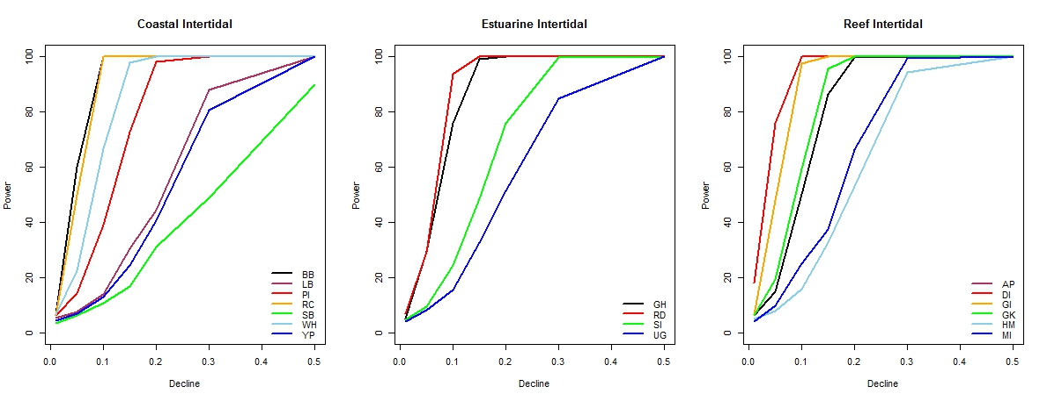
Figure 55: Power curves for detecting declines in nutrient status for each habitat and for a range of declines.

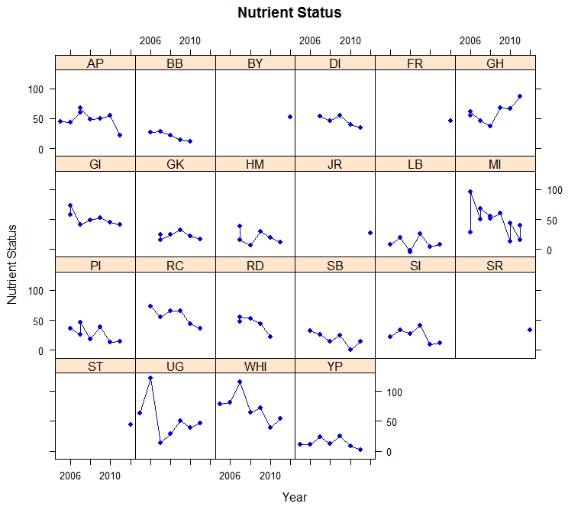  (a) | 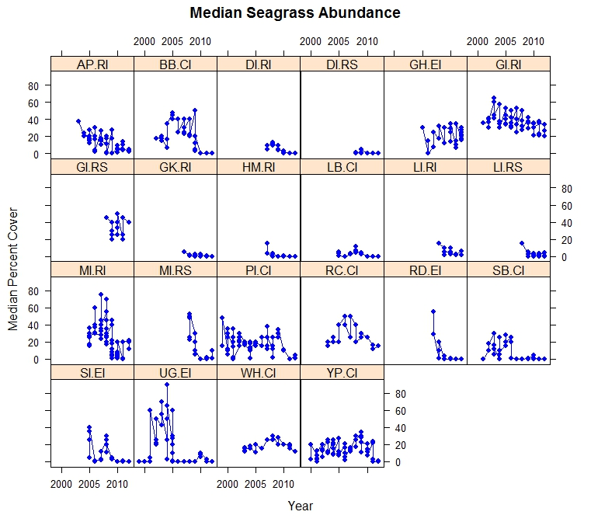  (b) | 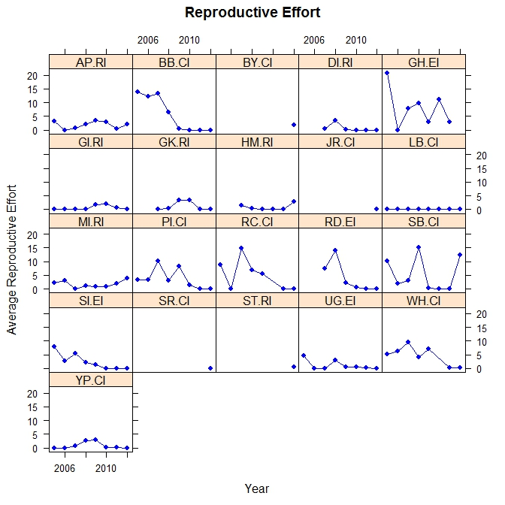  (c)
Figure 56: Exploratory plots of (a) nutrient status by year, (b) median seagrass abundance by year and (c) reproductive effort by year.

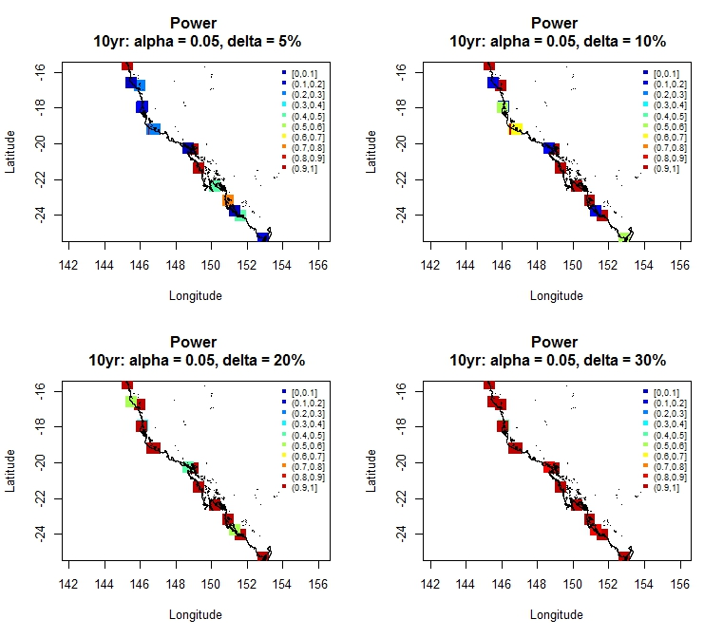
Figure 57: Spatial summary of the power to detect declines in nutrient status of 5% (topleft), 10% (top right), bottom left and bottom right. The legend in each figure represents the power to detect a change and ranges from red to blue.

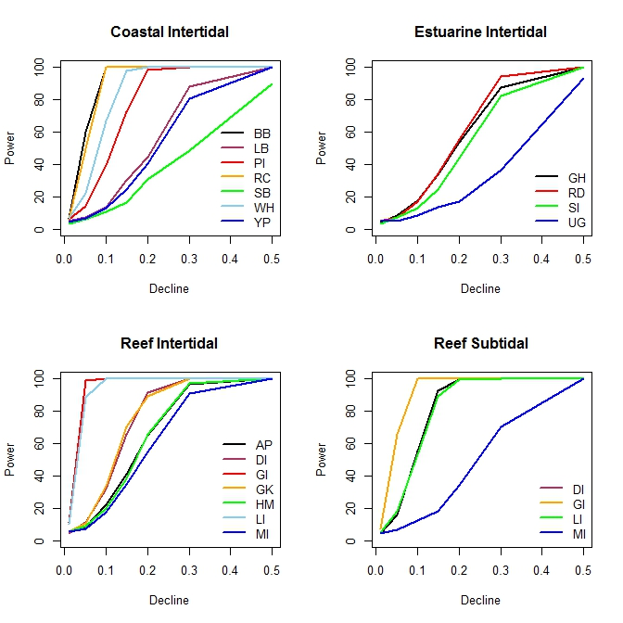
Figure 58: Power curves for investigating the power to detect declines in abundance for each habitat.
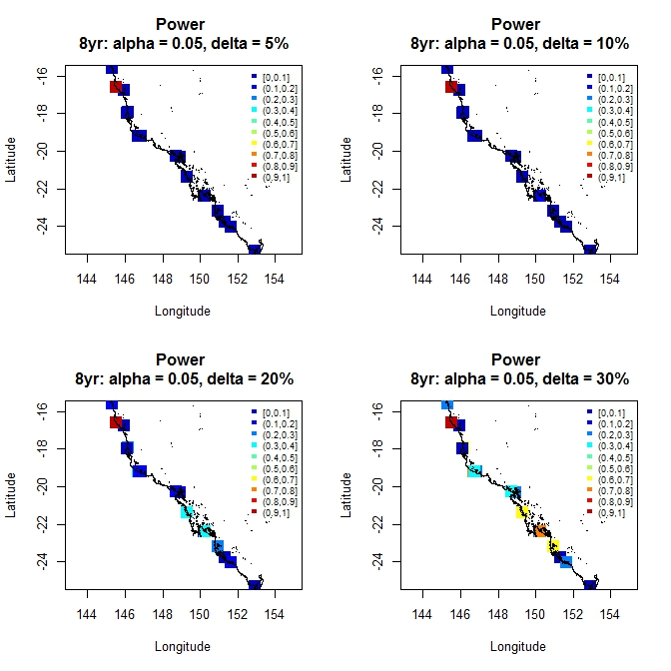
Figure 59: Spatial summary of the power to detect declines in seagrass abundance of 5% (topleft), 10% (top right), bottom left and bottom right.
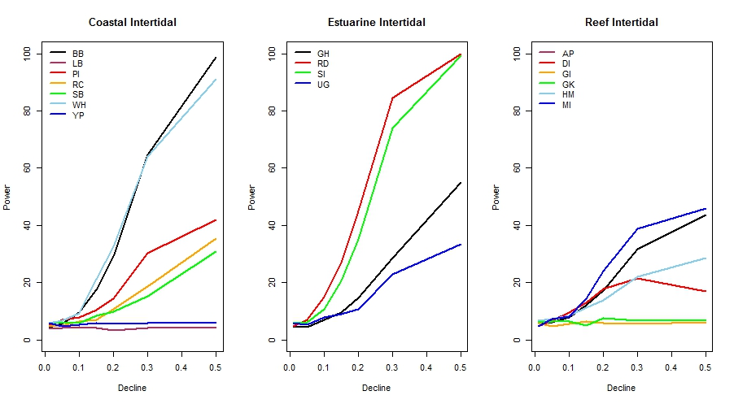
Figure 60: Power curves showing the power to detect declines in reproductive effort.

Figure 61: Spatial summary of the power to detect declines in reproductive effort of 5% (topleft), 10% (top right), bottom left and bottom right.

Water Quality Metrics
The metrics for reporting for marine water quality are based on remote sensing data and in particular, the assessment of the exceedance of water quality guidelines for chlrophyll and TSS. This is determined by comparing the annual or seasonal mean to the guideline thresholds. The surface area where the mean concentration exceeded the guideline values is expressed as relative area (%) of the water body. This relative extent of exceedance of the guidelines (REEG) is then used as the indicator data for marine water quality. For each of the reporting regions, this data are presented as separate values for 4 types of water bodies: (1) enclosed coastal waters, (2) open coastal waters, (3) midshelf waters and (4) offshore waters. These are shown in Figure 62. Only the REEG values for the inshore water body are considered for the metrics calculations (RWQPP, 2011a, RWQPP, 2011b).

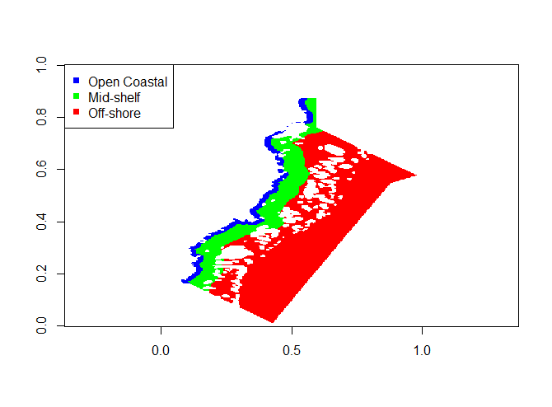
Figure 62: Map of the GBR showing the regions for open coastal waters, mid-shelf and off-shore locations.

Water quality is assessed as the percent area that does not exceed the guideline values for the inshore water body at a regional level. The overall GBR water quality score is calculated by combining the regional scores and weighting them by their areal contribution to the GBR. The Paddock to Reef marine water quality index (P2R_WQI) is calculated for each region, as well for the whole GBR, and represents the average of the metric scores for the two component (chlorophyll and TSS) indicators.

Other Potential Metrics to Consider
The PSII-HEQ metric that was discussed in Section 3.3 is a potential metric to consider in the reporting of marine condition. As it has been explored in terms of a power analysis in earlier sections, we will not duplicate the analysis here. In Bentley et al. (2012), there is an attempt at creating a reporting metric that could be used for reporting and incorporated into the report card. In this report, the PSII-Herbicide Equivalent Index is compared to 5 categories (concentration levels) that correspond to different levels of effect ((Bentley et al., 2012), Section 3.8, Table 8). These are assigned colours to provide a visual representation of concentration amounts. There is merit in revisiting this categorisation because the categories may not highlight differences in low-mid level effects because the colours focus on separating the more important but less frequent higher concentrations. This probably makes the most sense between category 3 and category 4, given that no biological effects are demonstrated for category 5.
As such, we recommend carefully considering its contribution to the assessment of marine condition and forming part of the report card assessment as we believe it provides a valuable contribution to the condition of the reef.

Part III Sampling Design

General Overview of Sample Design in the MMP
Prior to taking on this review, we envisaged that the MMP had some integration components in place. At the very minimum, we had assumed the five sub-programs of the MMP were connected jointly by specific sites, similar objectives and/or sampling timeframes. However, after becoming familiar with the different sub-programs through written reports and separate phone and face to face discussions, it became apparent that this was not the case. The biggest cause for concern in the way the sites have been selected for the sub-programs is not the lack of integration but the potential for bias. Selecting sites by hand (even if they are thought to be representative of other areas) means that any inference drawn about the trending condition/s through time apply to only those sites, rather than being representative of the entire region of interest (something the MMP should be striving to achieve). To monitor or draw valid conclusions about the entire region, all sites within the region of interest should have some chance of being selected in the sample. The caveat to this is that selecting sites in a less rigorous manner is acceptable where an appropriate and accurate model can be developed (model-based estimation) to describe the indicators being estimated. Developing such models is time consuming and relies on the availability of accurate fine-scale environmental covariates which are in practice rarely available for the entire region of interest.
While there is a big emphasis on “integration” in the MMP and determining whether the sub-programs could be better integrated using statistical methods such as the Generalized Random Tessellation Stratified or GRTS design (Stevens and Olsen, 2004), an extensive amount of work would be required to make this happen and reshape the program into one that is integrated, both spatially and temporally. While GRTS could be used to eliminate much of the bias in site selection for the individual sub-programs, this would not be a trivial exercise. One of the biggest advantages of GRTS is that it offers a probability-based approach (all sites have a chance of being selected) to site selection where the sites are spatially balanced. To achieve this spatial balance new sites would need to be selected across the entire MMP. While there is the potential to build in “legacy sites” (sites that are currently being monitored) these sites need to make up a small proportion of the total number otherwise the desired spatial balance is not achieved. To select GRTS sites GBRMPA would need to define the boundaries of all areas in the GBR that are “in-scope” for monitoring. It would be a massive undertaking for GBRMPA to sit down with all the MMP providers and collectively define the boundaries of the areas that need to be monitored. Furthermore, a unified set of objectives that included the scope of the study being monitored and outline of sampling plans would need to be achieved in a collaborative manner. Given the current level of collaboration and co-operation that is being achieved by the program, we suspect that this would be difficult to achieve.
The following sections provide an overview of each of the 5 programs as we currently view them. This has been synthesised from numerous reports from each of the programs and discussions held at workshops and phone meetings. We provide some broad level conclusions about each program and suggest some strategies for achieving integration in the future, depending on the level of support and funding received for this activity.

Coral Reef and Water Quality Marine Monitoring Program

Overview of the Coral Monitoring Program
Four Natural Resource Management (NRM) regions are the focus of the coral and water quality monitoring program. These consist of the Wet Tropics, Burdekin, Mackay Whitsunday and Fitzroy. As outlined in Thompson et al. (2010b), reefs were selected along a gradient of exposure to run-off. Multiple sites were selected within reef to account for the spatial heterogeneity of the coral communities. The samples are stratified by depth to address concerns raised in a pilot study indicating differences in community with depth (Sweatman et al., 2007). Five replicate transects are also introduced to account for the fine scale spatial variability within each site and depth.
A rotating panel design has been used to increase sampling efficiency by sampling some sites every year and others every second year. Reefs within each region were assigned ‘core’ or ‘cycle’ reefs. At core reefs all benthic community sampling methods were conducted annually while at cycle reefs sampling was undertaken every other year. Coral recruitment estimates were not included in the latter.

As outlined by Thompson et al. (2010b), reefs that were monitored were selected by GBRMPA, using advice from expert working groups. The selection of reefs was based upon two primary considerations:
- Sampling locations in each catchment of interest that were spread along a perceived gradient of influence away from a priority river;
- Sampling locations were selected where there was either an existing coral reef community or evidence of past coral reef development.
In the Wet Tropics region, where well-developed reefs existed on more than one aspect of an island, two reefs were included in the design. Thompson et al. (2010b) show the placement of these survey sites.

As outlined in Thompson et al. (2010b), five separate sampling methodologies were implemented to characterise the benthic communities of inshore coral reefs. The methodologies consisted of photo point intercept transects or (PPIT); juvenile coral surveys; scuba search transects that provided information about the status of coral health; and hard coral recruitment surveys that involved deploying tiles for an “expected settlement period” to determine the number of recruitments.

Discussion
Overall, the inshore coral monitoring program is well designed as
- It accounts for spatial heterogeneity of benthic communities within reefs through the selection of two sites;
- Samples are stratified by depth to address concerns raised in a pilot study indicating differences in community with depth;
- Fine scale variability was accounted for by the use of five replicate transects; and
- A rotating panel design was used to increase sampling efficiency by sampling some sites every year and others every second year.
GBRMPA could potentially investigate dropping the number of core sites (currently 14 sites sampled every year) and adding in additional non-core sites (currently 16 sites sampled every second year) to increase spatial coverage. In fact, it may be worth sampling some sites every 3-5 years and this is supported by the space-time analyses investigated in Section 3.1, which revealed that the trend terms fitted in the model were far less important than the spatial terms.
There were a number of questions that arose around the implementation of the design that were not clear in the material presented at the time of review. Specifically:
- Are the locations selected representative (or supposed to be) of other locations in the region or is the inference just about the particular suite of chosen gradients of interest?
- How many other sites could have potentially been selected in an equivalent manner? The general nature of the objective would suggest that all inshore coral reef communities should have been considered in the sample design phase. However, this is difficult to decipher without knowing the complete extent of the area being considered for this program. These questions should be discussed, with responses carefully outlined in the survey design for the program.
- Why were some non-core sites sampled for 3 consecutive years in recent years? Also, why is Snapper Island South sampled every year but labelled as a non-core site? This data could be used to see the effect of dropping those sites/samples on the sample estimates and variances.
- It would be interesting to look at the analysis that resulted in the dropping of sites early on in the piece. Perhaps these results would indicate that it isn’t worth increasing the spatial spread of points/sites. We were unable to test this as the data was not provided, despite requesting it from the providers.
While in general, the program design is well established, there are two obvious improvements that GBRMPA should consider:
- Ensure that the sites selected are representative (i.e. chosen in an unbiased manner) of the entire area that inferences are being made; and
- Determine that the current sampling efficiency is maximised. That is, would it be better to drop some sites to every three or less years and supplement with additional sites to increase the spatial balance?
These could be achieved in a second phase with GRTS and other additional datasets that were not provided to us at the time of analysis, although a key element to this would be collaboration between GBRMPA, the MMP providers and the personnel undertaking the sample design.

Overview of the Inshore water quality monitoring program
The objective of the inshore water quality monitoring program is to describe the spatial patterns and temporal trends in marine water quality (suspended sediments and nutrients) in high risk (inshore) areas of the Great Barrier Reef lagoon. A secondary objective is to determine local water quality by autonomous instruments for high-frequency measurements at selected inshore reef sites where coral monitoring is carried out.
The program itself makes use of automated high-frequency data loggers and a less frequent grab sampling approach (approximately 2-3 time per year) where water samples from research vessels were taken and analysed at a laboratory. We refer to the former set of data as “WQ logger data” and the second set of data collected as “WQ grab samples”. Water quality parameters monitored consist of dissolved and particulate nutrients and carbon, suspended solids, chlorophyll-a, salinity, turbidity and temperature.
There are 14 fixed sampling locations spanning four Natural Resource Management (NRM) regions. Sites are congruent with the 14 core sites of the inshore coral reef monitoring component of the MMP. Within each region, sites were selected along a gradient of exposure to runoff. At these sites, detailed manual and instrumental water sampling was undertaken in addition to annual surveys of reef status. This also included assessments of coral recruitment (see Thompson et al. (2010b) for more details). Sampling was also conducted at 6 open water stations of the “AIMS Cairns Transect” to extend an existing long-term dataset initiated in 1989 by AIMS. However sampling at these sites is infrequent (2-3 times a year). Logger data primarily consisted of turbidity and chlorophyll measurements, while the grab samples acquired consisted of discrete water samples of dissolved and particulate nutrients and carbon that have been collected from a range of depths through the water column. Water quality parameters consisted of ammonium (NH4), nitrate (NO2), nitrate (NO3), phosphate (PO4), silicate (Si(OH)4), dissolved organic nitrogen (DON), dissolved organic phosphorus (DOP), dissolved organic carbon (DOC), particulate organic nitrogen (PN), particulate phosphorus (PP), particulate organic carbon (POC), suspended solids (SS) and chlorophyll-a. For details relating to the sampling techniques and laboratory analyses see Schaffelke et al. (2013) and GBRMPA (2013).

Discussion
The overlap of the 14 sampled sites in this program with the core sites in the coral monitoring program is an attractive attribute of this design. It is unclear however, whether these 14 sites provide a good representation of water quality at high risk (inshore) areas of the GBR lagoon (as stated in the objectives). More specifically:
- What would be the effect of slightly moving these sites, on the results?
- Could the sites have been selected in a more random manner?
The comparison of the grab samples and logger data in Section 3.1 that were collected as part of this program has highlighted that the ability to detect trends depends on the constituent being sampled and the way in which it was sampled. While the grab sample data, in theory, is quite rich in information, only 3 samples per year were collected for each site surveyed. These measurements were taken as a “representative” sample for water quality in the year of sample for the site surveyed. While we understand that these types of samples are expensive to collect and require significant time and resources to obtain, their representativeness over the region at lagged intervals is questionable. The bootstrap simulation analysis conducted in Section 3.1 highlighted varying levels of power for the range of water quality parameters measured. For determining local scale trends, the use of grab sample measurements for specific parameters seems reasonable. As a secondary consideration, the grab samples could be used for validation purposes for remote sensing information. We found the grab samples difficult to link with the inshore coral samples taken, due to the infrequent nature of sampling and as such, could not use it to determine drivers of change. Logger data highlighted that trends were difficult to disentangle for turbidity, while for chlorophyll, both the trend and seasonality contribute to explaining the variation in the data. Trends in chlorophyll also varied substantially through space. The broad scale compositional analysis conducted in Section 3.1 highlighted the importance of turbidity as a driver in describing the coral compositions and suggests that its continued use in the program is worthwhile for exploring patterns in coral composition.

In summary, we recommend that
      - A clearer description of the process that led to the suite of core sites that are being used to report on drivers of water quality is required.
      - While the selected inshore water quality sites will result in reasonable temporal trends as can be seen in the analyses in Section 3.1, it is difficult to assess whether the spatial variability captured is adequate to represent “high risk areas of the GBR lagoon”. The data from the Cairns transect which has been regularly sampled since 1989 provides an excellent long-term dataset for six sites. It is noted that in 2008/9 five of the original 11 sites were dropped based on a statistical analysis that indicated that this reduced number of stations would provide enough information for a robust time series analysis. It would have been valuable to see this analysis to gain a more thorough understanding of the spatial variability captured by the six versus eleven sites.
- Both the grab sample and logger surveys be retained but with the following considerations:
- The grab samples be used for validation purposes for remote sensing data for example, as conducted by Brando et al. (2014) and incorporated into the report card to summarise water quality.
- The grab samples be used solely for investigating local scale trends for specific parameters (DOC, PN, DIN, TDN, DIP and PP) as identified by the bootstrap simulation study. While the power to detect trends in most parameters was reasonable (given that only 3 samples per year were collected), the number of samples is insufficient to determine the actual condition or state. See point 4 below.
- Consider integrating the grab samples into the WQ metric to provide more information about trends on a finer scale as an alternative metric for the water quality component of the report card.
- Do not link grab sample data with coral surveys to investigate potential drivers as 3 samples per year is insufficient to draw any conclusions from. Any trends identified using this data are most likely reflecting only local processes around the specific reefs monitored, so it is unlikely that these trends will be able to be related to the annual loads data. Alternatively, consider a more comprehensive survey design for this component of the program.
- Make use of the logger data for drawing conclusions about turbidity and chlorophyll in relation to coral communities.

Inshore Seagrass Monitoring Program

Overview of the inshore seagrass monitoring program
The inshore seagrass monitoring program has been operating as part of the Marine Monitoring Program (MMP) since 2005, following a detailed assessment of the monitoring design being undertaken using Seagrass-Watch sites (McKenzie et al., 2012) and expert advice. The key aims of this component of the program are to:
- Understand the status and trend of GBR intertidal seagrass (detect long-term trends in seagrass abundance, community structure, distribution, reproductive health, and nutrient status from representative inshore seagrass meadows);
- Identify the response of seagrass to environmental drivers of change; and
- Report on Great Barrier Reef (GBR) seagrass status. This includes the production of seagrass report card metrics for use in the annual Paddock to Reef report card.
Four habitats were chosen for the sampling design (estuarine intertidal, coastal intertidal, reef intertidal and reef subtidal), where two sites were selected at each location within habitats. During the early stages of planning only intertidal seagrass meadows were considered due to their accessibility and cost effectiveness. However, seagrass meadows in the GBR lagoon have processes that are much more complex (Carruthers et al., 2002) due to their habitat types, tidal ranges, differences in substrate types and location in turbid waters. This sampling design was therefore created to account for spatial heterogeneity of meadows within habitats (McKenzie et al., 2012). Note, although this is stated in the report by McKenzie et al. (2012), the dataset provided for the review had surveys conducted at 1 or 3 sites in some locations. Within each site, “representative” seagrass meadows were chosen and as outlined in McKenzie et al. (2012) were (1) based on covering a greater extent of the resource, (2) are generally the dominant seagrass community type and are (3) of average abundance. Mapping of seagrass meadows at each location was based on historic information over the previous 5 years for most sites. Monitoring occurred during the late dry and late wet seasons to capture changes in seagrass habitats prior to and post major periods of runoff.
McKenzie et al. (2012) outline the monitoring methods used to sample seagrass meadows in the GBR lagoon. During the 2010/11 sampling period, 34 sites were monitored using 3 x 50 metre transects within each site. Only the reef intertidal site at Hamilton Island had 5 transects placed. Sampling occurred at 9 near shore sites (coastal intertidal and estuarine intertidal) and 7 offshore reef intertidal locations. Sub-tidal sites were paired with intertidal sites at offshore reef locations in the Burdekin and Wet Tropics regions. A summary of sites selected within each habitat is listed in Table 17 (Section 3.2, Part II). Seasons sampled were the dry (June-August), late dry (September-November), monsoon (December – February) and late monsoon (March-May).

Discussion
Overall this monitoring program has a relatively large number of sites monitored on a regular basis which will lead to an important time series covering a large area. Recent moves to incorporate intertidal and subtidal seagrass meadows in the Cape York region north of Cooktown and within Bowling Green Bay (Burdekin region) is a positive improvement on the study design.. However, it was not clear from the reports if monitoring subtidal seagrass meadows is a stated objective of the MMP. There were a large number of constraints imposed on the selection of sites. Those that are imposed for safety reasons are unavoidable, however relaxing other constraints may result in a less biased sample (if the sites selected differ from those that were not, which they obviously do). Essentially in this case the sites selected could be considered to be representative of them or other sites that fitted all of the constraints imposed.

In summary, we recommend that
- Clearer objectives need to be clearly specified for this program. Specifically,
        - It is important to be upfront in the objectives that there is a large section of seagrass meadows that would fall in the defined objectives but did not meet the constraints. This could be done by rewording the objectives from intertidal seagrass to accessible intertidal seagrass beds that are a certain size and satisfy certain criteria.
        - It is important to clearly state what is meant by the term “representativeness”. As stated in the reports, "representative meadows” were selected using mapping surveys across the regions prior to site establishment. “Representative meadows” are those which cover a greater extent of the resource, are generally the dominant seagrass community type and are of average abundance. In a sampling framework representative refers to a subset of a statistical population that accurately reflects the members of the entire population. A representative sample should be an unbiased indication of what the population is like. In this case the use of the term “representative” has quite a different meaning and could be perceived incorrectly. The chosen meadows would be considered representative if all meadows falling in the sample frame had some chance of selection but this was not the case here. The term seems to be carried over from previous research.
        - Why were the only sample locations considered ones with existing seagrass-Watch or MTSRF long-term data available? Is it to ease the sample burden? This is a potential limitation of the design depending on how the Seagrass-Watch and MTSRF sites were selected.
        - Although considered intertidal within the MMP, the meadows chosen for monitoring were in fact lower littoral (rarely not inundated) and sub littoral (permanently covered with water). The objectives refer to intertidal seagrass only. Is this a mismatch between the monitoring design and objectives or just a terminology issue? Perhaps the objectives have changed over time and the program objectives need to be updated?
        - Due to the high diversity of seagrass species across the GBR, it was decided in consultation with GBRMPA to direct monitoring toward the foundation seagrass species across the seagrass habitats. As a result the objectives should refer to foundation seagrass species.
- Implications for monitoring that may need to be considered. More specifically, these include,
        - Monitoring at the sites in the late dry (September/October 2009) and late monsoon (March/April 2010) of each year was conducted by a qualified and trained scientist. Monitoring conducted outside these periods was conducted at some intertidal locations by trained/certified local stakeholders/community volunteers and at subtidal sites by a trained scientist assisted by volunteers (only a scientist conducted assessments). What is the potential “observer effect”? i.e. how similar would we expect the results to be if collected by a trained scientist versus a volunteer under the same conditions? If the potential for differing results is great then some calibration experiments could be performed.

Pesticide marine Monitoring Program

Overview of the pesticide marine monitoring program
Pesticide monitoring activities have been undertaken in the GBR since 2005. The objectives of the pesticide monitoring program as described in the initial expression of interest for Great Barrier Reef World Heritage Area monitoring were to:
- Determine long-term (decadal) trends in near shore water quality within the GBR lagoon, particularly in near shore habitats directly affected by runoff from Category 1 river systems
- Determine long-term (decadal) trends in levels of organic pollutants (pesticides, herbicides, fungicides) in near shore waters and sediments of the GBR lagoon, particularly in areas affected by runoff from Category 1 river systems.
Throughout this review we often refer to the pesticide monitoring program but it should be recognised that we are collectively referring to the monitoring of pesticides, herbicides, and fungicides in the near shore waters.
There are two components to the pesticide monitoring program. The first is the routine monitoring of pesticides at 12 fixed sites, where the aim of this component is to assess spatial and temporal trends in the concentrations of specific organic chemicals. This is achieved using time-integrated passive sampling techniques primarily through the routine monitoring at specific sites. The second component of the pesticide monitoring program is the targeted monitoring of pesticides in flood plumes generated by terrestrial run-off. The aims of this component are to assess: (1) temporal and spatial variation during the wet season within a region, and (2) differences between time-integrated and point-in-time concentration estimates. We outline each of these components below.

Routine monitoring
Passive samplers are deployed at twelve inshore GBR sites across five Natural Resource Monitoring Regions (Wet Tropics, Burdekin, Mackay, Whitsunday and Fitzroy) and spanning near 1000km of coastline. See Bentley et al. (2012) for a map of the region with the location of monitoring sites. Passive sampling techniques implemented included the polar organic chemical samplers or EDs that target PSII herbicides such as atrazine and non-polar organic chemical samplers (PDMS or SPMDs) that target organic chemicals that are more hydrophobic. This style of monitoring has been conducted at these locations across a 7 year period, with some sites only monitored for 3 years.
The selection of sampling sites was based on a number of scientific criteria. These include (1) that the site must be representative of an inshore reef location, (2) the site is co-located in proximity to sites used by MMP bio-monitoring activities such as seagrass monitoring, (3) the site should not be impacted by specific local point sources such as anti-foulants from boats or inlets of treated or untreated wastewater and (4) the sampling site can be maintained for a long period. Sampling is undertaken by volunteers from various community groups, agencies and tourist operations and represents a key feature of the routine pesticide monitoring program.
The monitoring year for routine sampling begins in May and ends in April the following year. Within this sampling period, samples are broken up into dry sampling periods (May through to October) and wet sampling periods (November through to April). Within each deployment period in the dry season, samplers are deployed for two months (maximum of three deployment periods each monitoring year). Within each deployment period in the wet season, samplers are deployed for one month (maximum of six deployment periods within each monitoring year). The maximum number of samples which should be obtained from each location within each monitoring year is nine.
All twelve sites are routinely monitored in both the dry and wet periods using EDs while six of these sites have additional PDMS samplers deployed during the wet season consisting of three sites located in the Wet Tropics region, two in the Burdekin region and one in the Mackay Whitsunday region. Normanby Island (located in the Wet Tropics) is the only site which is monitored year-round using PDMS in both the dry and wet period. SPMDs are also deployed at this site only. Details of the temporal and spatial nature of sites sampled appears in Bentley et al. (2012).

Terrestrial run-off and flood plume sampling
A total of thirty-six 1 L grab samples were collected to monitor terrestrial run-off from three NRM regions: Cape York, Wet Tropics and the Burdekin regions. Wet season sampling during flood plumes was undertaken on transects extending from three major rivers in these regions, which consisted of the Normanby River (Cape York), the Tully River and the Herbert River (both in the Wet Tropics, but some southern locations bordering on the Burdekin region).Polar passive samplers (EDs) were deployed at three sites additional to the routine monitoring sites in two transects extending from the Herbert River, and grab samples collected at these sites also.
Terrestrial run-off assessments conducted in the Wet Tropics and Burdekin regions during the wet season have used a combination of time-integrated passive sampling (EDs) (at three sites additional to the routine monitoring sites) and 1 L grab water sampling. Sampling is typically taken after peak discharge. Refer to Table 5 in the Annual Report.(Bentley et al., 2012)
Passive sampling techniques are frequently used for large scale studies with recurring events to ensure these events are captured and to allow the assessment of temporal trends in concentrations in systems over long term. They provide cost effective, time-integrated monitoring of both temporal and spatial variation in exposure in the often remote locations encountered on the Reef.
Different types of organic chemicals need to be targeted using different passive sampling phases as identified in Section 8.1.1. Detailed specifications of these sampling techniques are described in section 3.2.4 of the QAQC report (Great Barrier Reef Marine Park Authority, 2013).

Pesticides measured
The insecticides, herbicides and fungicides specified under the MMP are outlined in Table 2 of Bentley et al. (2012). We provide a summarised version of that table here which lists each pesticide along with a description in Table 31. The choice of pesticides was based on past literature, pesticides that were recognised as being a potential risk, the affordability and capability of analytical methods and whether pesticides were likely to be accumulated within one of the passive sampling techniques (Bentley et al., 2012). The final list of pesticides were chosen in consultation with GBRMPA.

Table 41. Pesticides specified under the MMP for analysis (Bentley et al. (2012))
Pesticide | Decription | Pesticide | Decription
Bifenthrin | Pyrethroid insecticide | Diazinon | Organophosphate insecticide
Fenvalerate | Pyrethroid insecticide | Fenamiphos | Organophosphate insecticide
Bromacil | PSII herbicide-uracil | Prothiophos | Organophosphate insecticide
Tebuthiuron | PSII herbicide-thiadazolurea | Chlordane | Organochlorine insecticide
Terbutryn | PSII herbicides-methylthiotriazine | DDT | Organochlorine insecticide
Flumeturon | PSII herbicide-phenylurea | Dieldrin | Organochlorine insecticide
Ametryn | PSII herbicide-methylthiotriazine | Endosulphan | Organochlorine insecticide
Prometryn | PSII herbicide-methylthiotriazine | Heptachlor | Organochlorine insecticide
Atrazine | PSII herbicide-chlorotriazine | Lindane | Organochlorine insecticide
Propazine | PSII herbicide-chlorotriazine | Hexachlorobenzene | Organochlorine fungicide
Simazine | PSII herbicide-chlorotriazine | Imidacloprid | Nicotinoid insecticide
Hexazinone | PSII herbicide- triazinone | Trifluralin | Dintiroaniline
Desethylatrazine | PSII herbicide breakdown product (also active) | Pendimethalin | Dinitroaniline herbicide
Desisopropylatrazine | PSII herbicide breakdown product (also active) | Propiconazole | Conazole fungicide
Diuron | PSII herbicide - pheynylurea | Tebuconazole | Conazole fungicide
Oxadiazon | Oxadiazolone herbicide | Metolachlor | Chloracetanilide herbicide
Chlorfenvinphos | Organophosphate insecticide | Propoxur | Carbamate insecticide
Chlorpyrifos | Organophosphate insecticide
Note: Bromacil was included in the list of target analytes from 2009-2010; Imidacloprid and terbutryn were routinely analysed from 2011-2012 (Bentley et al. 2012).

Discussion
There is strong continuity in the routine pesticide monitoring sites with many of the 12 sites having data collected up to 9 times per year and fairly consistently since 2005 (Figure 63). The sites which are summarised in Table 42, are described as being representative of the inshore reef location for their NRM region, and while strong and logical sites, the rationale for their selection from a broader GBR perspective is not entirely clear. The existing site selection clearly associates with different regional agricultural practices but some sites are representing large areas, e.g. North Keppel Island for the Fitzroy. It is very difficult to select sites that are “representative” of a region in an unbiased manner without providing all sites that are possible candidates for monitoring with a non-zero chance of selection (design-based survey design). These probabilities do not need to be equal but they do need to be known and non zero. This for instance would allow more conveniently located sites a high probability of inclusion than more remote sites. The implication of this is that the way sites have been selected will allow us to make inferences about status and trend for the 12 sites selected but not extend those to inferences about the broader GBR region.

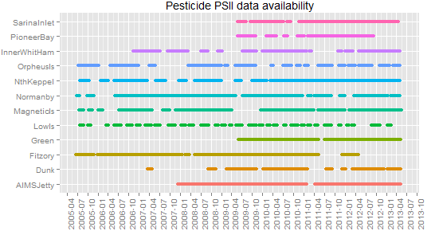
Figure 63: PSII data availability plot 2005-2013.
Within this component of the MMP it is not possible to isolate the within site variability, spatial variability across the region (beyond the 12 selected sites) or variability that may be due to measurement error. Some replication at the site level for each sample period would enable us to estimate the within site variability. The replication would come from deploying multiple passive samplers at a site and generating repeat samples. There is no need for this to be exhaustive. Replication can occur for a subset of sites and times and still be valuable. If the differences between these samples is high, then the within site variability is high. Where multiple passive samplers are deployed close to each other and at scale where there changes are not expected, this allows us to estimate the measurement error. If the within site variability or measurement error is high, there is a much greater chance that the single location used may be inaccurate or misleading. It has become clear late in this review that some replicate passive samplers are used with approximately 10% analysed in duplicate from random sites (Christie Bentley pers comm). While these replicates samples are not identified in the data made available to us, their routine incorporation in the pesticide monitoring program is positive and endorsed.
Table 42: Summary of 12 sites sampled as part of the pesticide monitoring program for the GBR.
NRM Region | Site Name | Site Abbreviation |  | NRM Region | Site Name | Site Abbreviation
Wet Tropics | Low Isles | LI |  | Burdekin | Orpheus Island | Orph
 | Green Island | GI |  |  | Magnetic Island | MI
 | Fitzroy Island | F |  |  | Cape Cleveland | CC
 | Normanby Island | N |  | Mackay Whitsunday | Pioneer Bay | P
 | Dunk Island | DI |  |  | Outer Whitsunday | OW
Fitzroy | North Keppel Island | NK |  |  | Sarina Inlet | SI

Given a key focus of the pesticide monitoring program is about detecting change in pesticide usage (quantity, type etc) it makes sense to choose sites or areas that are sensitive to change. This might relate to the side of the island sampled or placing some sites closer to river mouths or flood plumes if they are expected to change more rapidly. Sampling more proximally to the river mouth is also more likely to give a more representative assessment of the pesticide input to the entire region, though input from high concentration and flow rivers (e.g. Barratta Creek) and hotspots will also be an important factor (Christie Bentley pers comm). Sites with low concentrations and limited or no seasonal differences (e.g. Outer Whitsundays, Dunk Island, Orpheus Island, Green Island or Magnetic Island) should be considered in this light.
Rotating panel designs (Fuller, 1999, McDonald, 2003) may offer a way of improving the spatial coverage and representation for the same cost. In such a design, more sites will be considered as part of the monitoring program but some sites will be rotated out for some years and rotated in for others. The fact the sites can occur in multiple years will allow temporal comparisons to be made while providing better spatial coverage. The different temporal sampling intensities in the monitoring program across the wet season (monthly) and dry season (bi-monthly) summer (wet season) is supported in Figure 41, Section 3.3 which shows the additional variability in the summer wet season. This could potentially be emphasized further in the program by increasing the focus further on the wet, possibly by rotating the dry season sampling out at some sites or by not doing it.
Participation of volunteers from various community groups, agencies and tourist operations is a key feature of the routine pesticide monitoring program. As the monitoring takes place in some remote locations then the success of the program is currently totally reliant on volunteers. This has implications for the sites selected. Costs and logistics of sampling appear to constrain further sites from being added to the routine monitoring program. While some sites could potentially be rotated in or out across different years, continuity is recognised as important for maintaining committed volunteers. If a site is “rotated out” for a year or two the danger is that it will be forgotten. There may be merit in paying reliable personnel to conduct the sampling, though that decision would demand further consideration and in all likelihood a cost-benefit analysis.
Two of the routine pesticide sites overlap with the seagrass monitoring and provide an avenue for considering potential pesticide impacts on seagrass. This appears to have only been investigated in a limited way to this point. If any further sites are identified they should consider integration in mind. The discussion of some ‘super sites’ appears to be encouraging thinking as it offers the ability to link the water quality (pesticide concentrations) with the ecological impact for seagrass or coral.
The consistency of returning to the same sites up to 9 times a year allows a meaningful analysis and interpretation of temporal trends at these 12 sites.
In summary, we recommend that,
- Revisiting the survey design for pesticides to ensure sites are representative of the broader region that inferences are to be based on. The location of sites may be biased towards high load areas provided inclusion probabilities are managed correctly. This type of sampling could be undertaken in two ways:
  - Using a shapefile to outline the boundary of all areas that fall within a sample and then, using an area sample design (such as GRTS (Stevens and Olsen, 2004) to select sites that are representative of the region).
  - List all possible sites (pinpointing specific latitude and longitude) and selecting from this list at random while satisfying inclusion probabilities to ensure sites with high loads are selected more frequently than others.
The advantage of the first approach is that spatial balance can be achieved more easily and it is more difficult to miss sites just because they do not have a name or label identifying them.
- Consider replication at the site level for each sample period. At present, there is no or limited replication which prevents the estimation of within site variability.
- Consider the volunteer impact in the current survey design. If we asked three different volunteers to deploy a sampler in a particular location, would we get the same readings? If not, the data may need to be standardized or calibrated for a “volunteer effect”. We recommend a separate study be commissioned that investigates the impact of volunteers to the sample design.
- Consider the potential integration with the seagrass monitoring sites. At present, two of the sites overlap. We recommend increasing this number if this is possible.

Flood Plume and Remote Sensing Monitoring Program
The flood plume and remotely sensing programs both characterise GBR water quality over large spatial scales. While the flood plume monitoring program is event-driven, both programs utilise remote sensing data and are therefore considered together in this section of the report. Note, while every effort was made to analyse and provide advice on the outputs from the remote sensing program, due to the time restrictions and spatial and temporal extent of the data, in addition to its size (as noted in the contract prior to commencing), we were unable to conclude anything from this program and suggest it be revisited in forthcoming reviews of the MMP, with the appropriate consideration given for analysis.

Overview of the flood plume monitoring program
The sampling of flood plumes in the GBR was undertaken as part of the MMP with additional funding from the GBR Extreme Weather Response Program (EWRP) in 2010-2011 implemented by the GBRMPA. The long term goals of this task are to
- assess the concentrations and transport of major land sourced pollutants to the Great Barrier Reef lagoon;
- assess the spatial and temporal variation in near surface concentrations of suspended solids, turbidity and CDOM and chlorophyll-a during available river plumes in the Great Barrier Reef catchment using remote sensing ;
- assess the quantity of chemical pollutants that are transported to the GBR from selected rivers during ambient and flood events; and
- quantify the exposure of reef ecosystems to these land based contaminants.
Flood plumes are typically sampled along the salinity gradient and in transects radiating out from the river mouth. Additional samples are taken between river mouths if adjacent rivers are in flood and plumes may intersect. There is some regional targeting of flood plumes each year, with different rivers and regions receiving priority. Within the year, sampling is dependent on which rivers are flooding, the nature of the flood event, and the ability to rapidly deal with the logistical constraints and mobilise boats. The majority of the samples are collected from within the flood plume, though it is not always visually obvious at the time of sampling and some samples are taken outside the edge.
Plume grab sampling is generally carried out on small vessels that take surface water samples from multiple sites for a suite of water quality measurements. The sampling locations depend on which rivers were flooding and the area of the flood plume, but generally, samples were collected in a series of transects heading out from the mouth of the Tully, Burdekin and Fitzroy rivers. The timing of the sampling depended on the type of event and the logistics of vessel deployment but was collected inside the visible area of the flood plume. In addition, some samples were taken outside the flood plume for comparison.
Data collected comprised surface samples and depth profiles. The surface samples were collected at each site using a bucket in the top 1 metre of water, where nutrient samples consisting of dissolved and particulate nutrients, chlorophyll, phaeophytin, total suspended solids (TSS), coloured dissolved organic matter (CDOM), pesticides (PS-II herbicides) and phytoplankton counts. Note, phytoplankton counts and pesticide concentrations are collected at a subset of sites. The depth profiles were taken at each site in Tully and Fitzroy transects with a SeaBird profiler, collecting depth profiles of salinity, temperature, dissolved oxygen and light attenuation. Salinity profiles were taken at all sites. Devlin et al. (2012) provides a detailed description of the sampling regime, sites visited and data collected.
As an indication of the regional focus, three main regions were sampled under the MMP and the EWRP in 2010-11, see Devlin et al. (2012) for details. A summary of the sampling undertaken in each of the regions is outlined below.
Fitzroy (Jan-Mar 2011)
- Samples are collected in response to the flood condition of the Fitzroy and other southern rivers. Samples were taken in a number of different transects, moving from the mouth of the Fitzroy along the Keppel Island reef system to the bottom end of the Whitsunday Islands reef system and south to Gladstone to Heron Island.
- Passive samplers deployed for pesticide and sediment:
Where: Middle Reef, Miall, North Keppel Island, Halfway and Clam.
When: first deployment is 2nd Jan – 8th Feb 2011, Fitzroy River peaked on 5th Jan 2011. Second deployment is 8th Feb or 21st Feb – 4th Mar 2011 depending on the site.
- Grab sampling was also undertaken at 11 sites in the Fitzroy plume extending into the Mackay Whitsunday region on 19th January 2011.
Burdekin (Jan 2011)
- Sampling trips were completed three times in January 2011 extending from the Palm Island group north of the Burdekin, Magnetic Island and the Burdekin River mouth.
- Sampling of the Burdekin River flood plumes (also examining the dispersal of suspended sediments and dissolved and particulate nutrients through the plume waters):
When: Dec/Jan 2010-11, 2, 9 and 21 days after the flood peak (flood event between 24th Dec 2010 and 18th Jan 2011, peak on 28th Dec 2010)
Where: Burdekin River mouth and north of the mouth from Magnetic Island to the Palm Islands.
- When and where (more detailed description): Samples were collected in the flood plume at sites at 2, 9 and 21 days after the flood peak.
- The initial flood plume sampling sites on 30 December 2010 (2 days after the peak) were located along the plume salinity gradient from the river mouth. This transect was repeated approximately three weeks (21 days) later (18 January 2011) to capture changes in plume dynamics.
- A far-field sampling transect was also completed (9 days after the peak, 6 January 2011) from Magnetic Island to the Palm Island Group to capture the visible extent of the northward plume boundary.
- Pesticide grab samples were taken in plumes from the Burdekin River on 30 December 2010.
Tully (Nov-Apr 2011)
- When: Nov 2010 – Mar 2011, frequent sampling
- Where: 17 sites in the Tully marine area located between Goold Island in the south, to Sisters Island in the north including sites at the Tully and Hull River mouths, additional coastal locations, Dunk Island and Bedarra Island. Note that five of those sampling periods occurred just after the highest flow period in February 2011, at approximately 3 day intervals for a period of two weeks. A small number of samples were collected around the Frankland Island reefs (adjacent to the Russell-Mulgrave catchment) in late December 2010.
- The sampling area includes areas within a high to moderate flood plume exposure area from the Tully-Murray River identified by water quality exceedances during previous wet seasons and an area of high frequency of plume coverage.
Remote sensed imagery (i.e. Ocean colour satellite imagery) is used in combination with in situ sampling of flood plumes. This can provide additional data related to the movement and composition of flood plumes in GBR waters and estimate both the extent and frequency of plume (surface) exposure on GBR ecosystems.
The three main products which are generated through the use of remote sensing imagery for the flood plume monitoring component of the MMP are
- Maps of flood plume frequency and movement;
- Mapping the transport of surface pollutants within plume waters; and
- Mapping plume water types.
The first of these extracts remote sensing data during high flow events. Using true colour classification techniques and algorithms, the full extent of the surface river flood plumes is determined. Where individual flood plumes merge an analysis of colour differences from the different plumes is used to distinguish. Overlaying flood plume imagery across the wet season provides insight into the frequency and movement of flood plumes across the regions. Cloud cover is a known constraint for remotely sensed imagery utilised here. In terms of mapping the transport of surface pollutants, exposure to key pollutants (TSS, DIN, PSII) is represented by scaling end of catchment pollutant loads to identify proportional catchment contributions, and weighting those contributions by the frequency and number of flood plumes to create a pixel-wise estimate of the pollutant exposure. These surface exposure values are categorised as “very high”, “high”, “moderate” and “low”. The final product that maps plume water types characterises remotely sensed L2 MODIS products (chlorophyll-a, colour dissolved organic matter, nLw_667, bbp_551) and ocean colour. The classification algorithm used seeks the best discrimination between three surface water types (Devlin et al., 2012):
- The primary plume water is characterised by high sediment values light limitation, low salinity and is typically associated with the very near-shore areas and the initial stages of plume formation.
- The secondary plume water is characterised by moderately elevated sediment and sufficient light and nutrients to support higher phytoplankton production. It is identified by high concentrations of chlorophyll-a and elevated colour dissolved organic matter.
- The tertiary plume water is characterised by elevated coloured dissolved and detrital matter, and while less than primary and secondary water types is still above the ambient dry season values
The extent and frequency of these water types are routinely computed and maps depicting the frequency of occurrence of primary, secondary and tertiary water types are produced. Due to the limited presence of the tertiary water type, the frequency map is generally not calculated. The water type product is viewed as a key summary product derived from multiple lower level remote sensing products that relates to important flood plume characteristics. It is available at a regular time steps (certainly when compared to the mapping the transport of surface pollutants within plume waters which are calculated retrospectively once end of catchment loads are estimated) is viewed as the basis for an important stratification within and across regions.

Discussion
Flood plume monitoring provides a key link between land-based activity and a potential harm to seagrass, coral and other important GBR ecosystem components. Unlike other monitoring programs in the MMP, the survey design has changed on a yearly basis. Some of this reflects that this program is event driven, it requires a rapid logistical response, and priority regions are selected on an annual basis. There has also been a strong history of support from additional activity (e.g. EWRP or other campaigns) which is positive, but makes it more difficult to establish “what is part of the core flood plume monitoring?”. This may inadvertently give the sense that it is more of a research program than some of the other monitoring programs.
Transect sampling is a natural and efficient way to sample across the flood plume. It is difficult to make universal assessments on grab sampling resources and effort within transects versus between and across river sampling. There is substantial variability within water quality transects identified and this is demonstrated by Figure 64 which shows the within transect variation in TSS. This is expected to some extent given the gradients (salinity and others) that the transects traverse but does cause us to question whether summarising the plume by an average or median concentration is appropriate or representative given the likely sequencing of water quality concentrations along the transect using simple dilution arguments. A greater focus on sampling outside the flood plume would play the role of a ‘control’ and enhance benchmarking changes within the plume with the broader region. While we acknowledge that there are specific logistical and budgetary constraints, it would be useful for all GBR catchments to be considered each year as part of a ‘routine’ consideration of plumes. There are advantages in people knowing what to expect each year. Spatial gaps in Figure 6-7 of Devlin et al. (2012) draws attention to the regional focus and are best avoided if at all possible.

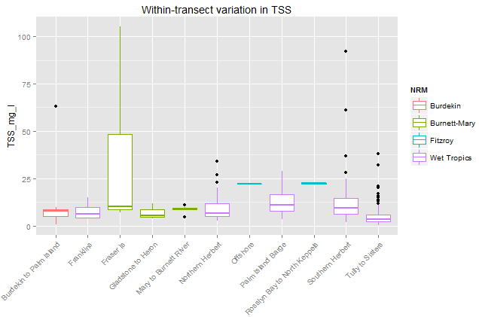
Figure 64. Within-transect variation in TSS across the sites sampled.

In summary, we recommend that
- The survey design for the flood plume component of the MMP be revisited. As highlighted above, the design for this program changes on a yearly basis, with no consistency from year to year. While we understand the nature of sampling, i.e. it is largely event driven, some aspects of the survey design could be maintained to ensure repeatability and provide a basis for comparison that can be used to examine trends over time. In designing this program, a clear set of objectives need to be defined as a collaborative effort between GBRMPA and the MMP providers.
- Consider sampling sites outside the flood plume in the redesign of this program to ensure there is some basis for comparison from year to year.
- Some consideration around the methods used to analyse the data will be important for the survey design. As highlighted in the discussion above, taking a median or average across samples does not appear to be providing an accurate measure of constituents measures across the flood plume due to the variable nature of the samples collected.
- Consideration needs to be given to how the flood plume monitoring program integrates with information provided by the remote sensing program to determine how this information can be utilised efficiently. It appears that both programs utilise remotely sensed observations but are disjoint in their summaries. How can the monitoring efforts of both programs be utilised in a cost efficient way? This will need to be discussed amongst the providers and GBRMPA when considering the core set of objectives.

Overview of the remote sensing monitoring program
Remote sensing provides a “suitable and cost-effective technique for monitoring coastal water quality” (Brando et al., 2013). The information has the potential to provide synoptic views of the spatial distribution of chlorophyll (CHL), colour dissolved organic matter (CDOM) and total suspended sediment (TSS) concentrations as well as water clarity of near-surface water. The information can also help identify patterns of spatial variation over scales of hundreds of meters to hundreds of kilometres, and at temporal scales of days to years represents a second. It can also assist management agencies to make more informed decisions.
MODIS data is obtained for the entire GBR using MODIS instrumentation, which is carried by two satellites, Terra and Aqua, providing the morning and afternoon overpasses. NASA provides operational processing of the daily coverage of the MODIS data to different levels of calibration (level 0: raw counts, level 1B: calibrated radiance, level 2: orbital swatch granules, level 3: global gridded products). This information is processed from level 1B onwards if NASA level 1B to higher level (chlorophyll and TSS) processing is found to be insufficiently accurate in the GBR lagoon waters. Commencing in January 2012, marine water quality assessments for chlorophyll and TSS can be accessed through the Marine Water Quality Dashboard in the eReefs program (http://www.bom.gov.au/marinewaterquality/), which is a tool to access and visualise a range of water quality parameters in the GBR region. The Bureau of Meteorology receives daily satellite data on the frequency of light which is used to determine the water colour and temperature in the region. The water colour information is then compared to sediments, chlorophyll and dissolved organic matter measurements to determine the relationships between the satellite images and the actual water in the reef. Specific details relating to the processing of the MODIS imagery is outlined in Brando et al. (2013).
The spatio-temporal nature of the remotely sensed water quality monitoring available is determined by satellite characteristics and weather (e.g. cloud cover). Processing obviously plays some role but there is very limited ability to alter the monitoring design. Water quality products from new or emerging satellites may allow changes to be made in the future, and the transition to those needs to be planned for and managed carefully given the life expectancy of the MODIS Aqua and Terra satellites.
Water quality is currently assessed in terms of the proportion of guideline exceedances. This does not consider the magnitude or duration of those exceedances. An exceedance by 5% is treated the same as an exceedance by 50%. Alternative metrics that recognise the magnitude or duration more directly may be possible but would need to be balanced against their complexity and the additional computational burden.
Water quality guidelines are taken as fixed across the year or season. The reality is that there are times of the year or event sequencing that are more likely to exceed guidelines than others. Future evolutions of the remote sensing water quality program should consider using more dynamic guidelines because they will improve the identification of conditions that differ from our expectation and that may demand additional management intervention.
No additional analysis was possible for the remote sensing data in the time and resourcing available. A power analysis was considered for determining our ability to detect a change. While possible it is more involved than other site-based power analyses conducted in this report given the strong spatial structure in the data and that need to preserve some of that in any bootstrap resampling methodology.

Part IV Data Management, Reporting and Provenance

Overview
The management, storage and consistency of data, coupled with the reporting of information and overall provenance of the program and the respective components is critical to a well-managed and designed, analysed and reported monitoring program. We examine each of the 5 sub-programs of the MMP in terms of their current ability to capture, store, present and report information in a clear and concise way that is in line with good practice of a marine monitoring program. Each program will be evaluated separately with some concluding remarks and suggested improvements that GBRMPA should consider.

Inshore coral and water quality sub-program
Information relating to the coral and water quality program is disseminated through an annual report and peer reviewed publications, of which Thompson et al. (2011) and Thompson and Dolman (2010) are examples.
The reports that focus on corals, provides an annual time series of benthic community structure for inshore reefs and an accompanying statistical analysis on the relationship between coral and water quality. These relationships are examined using univariate models (GLM mixed model) with predicted trends, confidence intervals and standard multivariate methods for analysing compositional data e.g. ordination techniques, stacked bar plots. With the latter, there have been no investigations into the spatial relationships between coral communities and their environmental setting. As the analysis in Part II has identified strong spatial patterns, it is important to acknowledge these and determine how much of the variation is explained by spatial information as opposed to other information such as water quality and sediment. This information is also helpful in determining adequacy of the survey design which the program may need to repute.
The assessment of coral community condition for the inshore reefs monitored appears in the report card itself. We have provided a summary and critique of the metrics outlined in reports (Thompson et al., 2011, Thompson et al., 2010a) in Part II. The metrics are based on a baseline assessment as outlined in Thompson et al. (2010a) and then revised to enhance the sensitivity of the assessment to change. In the 2011 report, the overall condition included the aggregation of the four metrics constructed: coral cover, macroalgal cover, change and juvenile hard density. Regional estimates of these metrics are then derived from the aggregation of assessments from the reefs within each region as outlined in an earlier section of this report.
Overall, reporting metrics are not well documented for some of the metrics. Although the metrics are described in the annual reports, the level of detail provided is insufficient for someone to replicate. As the metrics are intended to inform policy makers, to aid in their decision making about the status of the reef, it is important to have a metric that is clearly articulated, can easily be replicated and has been assessed for its sensitivity to changes in coral and macroalgae cover, cover change and changes in juvenile density. Furthermore, as refinements of the metrics have been provided across the years, the changes made to these metrics are difficult to disentangle as they are embedded in annual reports spanning these periods. There are also mismatches between the report and what is actually implemented and reported.
In terms of the data that was delivered for this review, better storage and communication of the data collected through meta-data should be made available as part of this program. The data consisted of separate files containing the coral and water quality samples and was not integrated in any way. Considerable time was spent understanding the data delivered and integrating the different sources of data that were captured at different temporal frequencies to ensure its validity in the review. It would be ideal in the future for a consistent suite of information to be stored and maintained to ensure consistency in the data collected from year to year. Methods for integrating the coral and water quality data should be standard practice if relationships are to be explored between coral composition/metrics and water quality data.

Seagrass sub-program
The seagrass sub-program, survey design and capture of data was outlined in two reports that we received prior to embarking on the review of the program (McKenzie et al., 2012, McKenzie, 2007). A number of Powerpoint presentations were also provided to assist in understanding the program. The reports outlined the sampling design implemented, the data collected, seagrass metrics developed and used in reporting. Unlike the inshore coral and water quality sub-program, this program has focused on the metrics developed for the report card and has used exploratory methods for examining the seagrass data collected.
Little has been reported on any analyses conducted as part of this program and as such, this results in separate datasets (e.g. seagrass, light, temperature, sediment) being collected but not integrated in any formal way. Methods for integrating these different sources of data should be considered moving forward in collaboration with the types of analyses that the seagrass MMP wish to explore. Accompanying meta-data for these datasets (and the integrated one) should be supplied to GBRMPA to ensure future investigations and reviews can happen seamlessly.
In terms of the reporting metrics, there needs to be a clearer outline of these metrics that are put forward for peer review to ensure repeatability, ability to detect change and acceptance. While some metrics were fairly straight forward to implement, others such as the reproductive status/effort required some further explanation that was not available in the reports.

Pesticide sub-program
The Pesticide component of the MMP produces an annual report. However, it does not currently feature in the GBR Report Card. The report describes the routine sampling performed at the 12 sites in addition to sites chosen during flood plumes and gives a strong account of the pesticide monitoring program.
In terms of reporting around the routine sampling activities, there is a strong focus on PSII pesticides and the PSII Herbicide index. The key reporting parameters are the maximum PSII-HEq concentration (PSII-HEq Max) within each monitoring year and the average PSII-HEq during the wet season (PSII-HEq Wet Avg) at each site (Bentley et al., 2012). The temporal trends in PSII-HEq Max and PSII-HEq Wet Avg are broken down to the contributing pesticides from totals (Appendix G from Bentley et al. (2012) that are presented in Figure 1 of Bentley et al. (2012) for individual pesticides at monitoring sites. For other pesticides and herbicides that were detectable through sampling, their maximum concentrations are tabulated. Measured concentrations for individual pesticides are compared to the Water Quality Guideline Trigger Values that have been developed by GBRMPA in reference to the ANZECC Water Quality Guidelines (ANZECC & ARMCANZ, 2000).
Average and maximum PSII-HEq concentrations for each year are compared to past annual average and maximum concentrations respectively, and reported across the regions. Wet versus dry concentrations are also compared. Discharge from contributing rivers and catchments is considered, but not analysed, and put in the context of long term discharge records. These comparisons are made annually, with the total annual discharge compared to the long term average discharge in order to create a ratio. Daily river discharge and PSII-HEq at nearby routine monitoring sites are also compared graphically.
Reporting of pesticides from terrestrial run-off and flood plume monitoring is also a focus. PSII-HEq concentrations from different sites within each river transect are compared graphically to flow rates for each river. Comparisons are also made against the same five effect categories used in the routine sampling. PSII-HEq concentrations and individual pesticide concentrations (both indexed and other) are also tabulated.
There are some good visualisations of the data collected. The comparisons are graphical or rely on concentrations. The data are under-analysed and stronger conclusions would follow from additional statistical treatment as explored in an earlier section of this report. Kennedy et al. (2011) investigated spatial and temporal trends in PSII herbicides for subset of sites. There is an opportunity to look at this data for all sites and make a broader assessment of changes in PSII. The potential to make stronger quantitative statements between river discharge and observed pesticide concentrations from the routine monitoring is something that could be explored through statistical analysis that is integrated as part of this program.
From a broader MMP perspective it is worth considering if pesticides could be included in the water quality metric given that they are an important component and are one where change is likely to be identified more readily. At present, the water quality metrics have a very narrow focus (chlorophyll and TSS) and would benefit from the inclusion of pesticides given their likely impact to seagrass and coral communities.
Finally, there needs to be a more comprehensive approach towards data storage to ensure all data is stored and maintained in a consistent manner from year to year. It is also recommended that meta data accompany any data collected to ensure a clear and concise summary of the information collected.

Flood Plume Characteristics
While the flood plume monitoring program does not feature in the report card, the annual report gives a comprehensive account of the flood plume monitoring program and is a primary communication vehicle. There are some strong visualisations and graphics that feature strongly. It also provides some valuable analysis and description of terrestrial loads being exported, with some useful comparisons and contrasts between regions and rivers.
Pesticide concentrations are reported through the pesticide monitoring program annual report. There are two main methods for flood water quality reporting: Water Quality Index (WQI) and flood plume mapping based on water quality information from remote sensing algorithms.
A WQI has been created in the past as a summary metric, though appears to be less in favour now (Michelle Devlin pers comm. 2014). The index considers 8 water quality variables: TSS, Chlorophyll-a, dissolved inorganic nitrogen (DIN) and phosphorus (DIP), particulate nitrogen (PN) and particulate phosphorous (PP), dissolved organic nitrogen (DON) and dissolved organic phosphorus (DOP). Each water quality variable is standardised (calculating the Z score) by subtracting the mean of all sites divided by the standard deviation. The standardised values are summed over the eight variables for each reef. A reef with a high WQI will typically have high concentrations of most of the variables that form the index. The WQI can be examined in different ways by changing the spatial or temporal extent (e.g. contrast for example sites based on 2011 data only, for sites based on all the water quality data from that region through time, or for sites based on all water quality data collected within the flood plume sampling program (1991 – 2011)). The process for calculating the WQI is summarised in Devlin et al. (2012)
Despite the comprehensiveness of the annual report there are several opportunities for improvements that could be considered. There is an opportunity for deeper integration with the coral and seagrass monitoring components given that the surface exposure mapping and modelling is potentially a key stressor. This has been considered by overlaying exposure and water types on key seagrass and coral locations but more formal links should be considered and examined quantitatively. This feels consistent with a primary focus of the flood plume monitoring program, which should be to locally characterise exposure to water quality. The ability to compare and contrast the nature of flood plumes over time should also be of interest.
Greater clarity on the temporal dimension of the sampling would be of benefit. For instance, tables of means, standard deviations, minimums, maximum all depend on when they are taken during event plume. Comparisons are weaker if not taken at similar times, for instance if there is a delay getting a boat out for some reason during an event. More generally it is important to be mindful of sampling differences in any comparisons.
There are general opportunities to extend useful graphical arguments in flood plume monitoring program documents and make them more fully quantitative through data analysis. For instance, formally linking flow and the plume water quality response will assist in determining when the relationship is real.
The interest in phytoplankton is acknowledged but there is a limited focus through annual reports. This may simply reflect the relative maturity of that part of the flood plume monitoring program. It appears important to clarify potential impacts for the GBR ecosystem (particularly COTS and seagrass) if the phytoplankton focus is to continue or else consider just using integrated CHL-a as surrogate.
The water quality index does have merit but could benefit from some additional investigation. For instance, it is noted that relative differences for skewed data may be highly variable and their effect might need to be tested. Correlations between variables could be readily considered by using a multivariate distance metric rather than basing the index on the summed individual deviations for each water quality parameter. More generally the reference sites used for the mean and the standard deviation emphasise the differences that occur across space but not the differences over time. This needs to be assessed more carefully in light of priorities.
Model-based maps of the water quality concentration that use remote sensing and in situ data simultaneously could be considered, most notably for TSS and CHL. This type of approach was outlined recently by Brando et al. (2013) and is strongly endorsed as a method to integrate different data sources in ways that respect their relative uncertainties and spatial support.
There are opportunities for improving the surface exposure modelling. The current score or scale based on the number of plumes is arbitrary. It assumes linearity and it is possible to obtain the same overall exposure score in multiple ways. A scale with inherent biophysical meaning should be preferred as it is more directly meaningful.
Rather than reweight the proportional load data by the number of plumes, hydrodynamic modelling might be used more extensively in the flood plume monitoring program. It would take end of catchment outputs and develop a measure of surface exposure by considering how those loads are distributed throughout the region. For conservative pollutants this would closely follow the modelling of dilution.
If hydrodynamic models are not feasible, spatio-temporal models that empirically link the within plume concentrations to antecedent discharge and dynamics may be of merit and provide some ability to predict expected concentrations. This can be used to draw attention to situations where there are substantial deviations between the observed and the expected concentrations. If these links are strong enough it may even be possible to derive flow-adjusted plumes and compare those over time according their composition and magnitude.
The water quality type is a composite measure of water quality based on remotely sensed CDOM, CHL and TSS. It is a useful product that provides a good visual summary but there is an opportunity for a stronger emphasis on contrasting temporal differences in water quality, i.e. across years or different times of the year. The water type does not consider plumes directly and does not incorporate grab sample data other than for some validation.

Remote Sensing
To assist management agencies to make more informed decisions, the remote sensing program provides management-relevant products (providing water quality compliance information for environmental reporting) from remote sensing data.
Water quality maps are presented for the seasonal median (calculated for each pixel in the region from the valid, i.e. cloud free and error free, daily observations) maps for chlorophyll and TSS are presented for each region. Seasonal maps that indicate the number of valid observations used for calculating the median values are also produced. The wet and dry season median maps of water clarity expressed as Secchi Depth are still under development but likely to part of future phases.
The number of image observations per pixel varies from 30 to 90. Images undergo fairly strict quality control with images with cloud or cloud shadow, low view and illumination angles, and high errors all limiting the final number of images available. Due to higher cloud cover, the number of observations is lower in wet seasons.
Freshwater extent maps are also presented (links to flood plume) using the salinity data from the remote sensing program. CDOM is a useful tracer of terrestrial discharge of low salinity waters but remote sensing algorithms do not differentiate between the sources of CDOM and is biased. However, the study by Schroeder et al. (2012) shows that non-runoff related sources are usually much lower.
The compliance to water quality guidelines is assessed for chlorophyll and TSS retrieved from MODIS Aqua imagery. For each reporting region, the compliance with water quality guidelines for CHL and TSS are presented as maps illustrating: (i) The exceedance of the guidelines, determined by comparing the mean values for the year and season to the Guideline thresholds, and (ii) The exceedance frequency, calculated as a ratio of the number of days where the concentration exceeded the threshold to the number of days with data for that period.
Marine water quality assessments for CHL and TSS are now delivered through the eReefs marine water quality dashboard (Bureau of Meterology, 2014).
The spatio-temporal nature of the remotely sensed water quality monitoring available is determined by satellite characteristics and weather (e.g. cloud cover). Processing obviously plays some role but there is very limited ability to alter the monitoring design. Water quality products from new or emerging satellites may allow changes to be made in the future, and the transition to those needs to be planned for and managed carefully given the life expectancy of the MODIS Aqua and Terra satellites.
Water quality is currently assessed in terms of the proportion of guideline exceedances. This does not consider the magnitude or duration of those exceedances. An exceedance by 5% is treated the same as an exceedance by 50%. Alternative metrics that recognise the magnitude or duration more directly may be possible but would need to be balanced against their complexity and the additional computational burden.
Water quality guidelines are taken as fixed across the year or season. The reality is that there are times of the year or event sequencing that are more likely to exceed guidelines than others. Future evolutions of the remote sensing water quality program should consider using more dynamic guidelines because they will improve the identification of conditions that differ from our expectation and that may demand additional management intervention.
No additional analysis was possible for the remote sensing data in the time and resourcing available. A power analysis was considered for determining our ability to detect a change. While possible it is more involved than other site-based power analyses conducted in this report given the strong spatial structure in the data and that need to preserve some of that in any bootstrap resampling.

Part V Discussion and Implications for the MMP

Overview
The MMP plays a critical role in monitoring and assessing the health of key GBR ecosystems, particularly coral reefs and seagrass communities, and the condition of inshore water quality. It is a key vehicle for assessing progress towards GBR targets under the Reef Water Quality Protection Plan.
There is without question strong value in the monitoring that the MMP has undertaken since inception in 2005. A wealth of monitoring data has been created, changes observed and documented through reports and the report card, and systems understanding improved. However, the components of the MMP have to some extent developed independently since its inception in 2005. This independence largely reflects the fact that different agency and research groups have taken charge of these components. While there have been integration efforts and a growing recognition that deeper integration (e.g. through shared sites) should evolve, this has not resulted in substantial integration to this point. There is differing maturity in the MMP components, with programs like the coral and water quality being very routine and consistent, while others, such as the flood plume monitoring program, are still maturing and refining objectives.

Sample Design and Integration
This integration agenda needs to be considered as a priority and critical to the thinking around this is a key set of overarching objectives that integrate each of the sub-programs reviewed in this report. While each program component has their own set of objectives, there does not appear to be any documented and shared MMP-wide monitoring objectives. This is an important touchstone for any integrated monitoring program. It is also what drives the feedback loop and adaptive review cycle. The integrated monitoring framework developed and outlined by Hedge et al. (2014) provides a timely overview on how this can be achieved. Their nine essential monitoring functions range from defining integrated monitoring objectives to the development of conceptual models, collection, management and analysis of data and the reporting, communication and review of the program. Frameworks such as the Driver-Pressure-State-Impact-Response (DPSIR) may provide useful lenses to structure that thinking around the MMP. These frameworks can help provide clarity around the monitoring objectives. For instance, while GBR water quality condition or state is important in its own right, the pressures it can place on coral, seagrass and other biological components of the system is likely to be of higher importance.
MMP wide monitoring objectives represent the one component of this program that is lacking and as a result we recommend that GBRMPA revisit the objectives put in place by the individual sub-programs to ensure integration is front and centre of the MMP. More specifically, the MMP as a whole will need to clearly articulate
- What exact metrics they want to monitor,
- Over which regions,
- Over what timeframes, and
- What size change they want to detect
As highlighted in Part III of this review, while we can draw on the strengths of designs like GRTS sampling design to assist with structuring a design that is spatially balanced, can eliminate bias and can accommodate the logistical constraints of a complex sampling program such as the MMP, it would require substantial effort and collaboration amongst the MMP providers, working closely with a statistician. While it may be suggested that the designs or monitoring sites that are in place cannot be changed, or would not look any different if redesigned partially or fully, we question the representativeness of the samples taken, given that the entire region that falls into scope for monitoring was not considered in constructing each design. To assist GBRMPA in considering alternative designs that will aid the integration process, we present three suggestions for change.
- Complete redesign of the MMP
  - This requires defining the objectives for monitoring that includes the indicators, timeframes for sampling, the size of change they are trying to detect and months of the year or points in time where monitoring should occur.
  - Taking into account the analyses performed in this review to determine whether a rotating panel design be incorporated, whereby some sites are visited 3-5 years versus every year.
  - Providing a GIS shapefile of all regions that fall into scope for monitoring (not just the region where samples are currently undertaken).
  - Providing a budget for monitoring so a cost-benefit analysis may be factored into the redesign of the program.
  - Using GRTS to draw the sites for sampling, noting that anywhere within the defined shapefiles could be selected and where objectives overlap across the sub-programs, the different groups would be required to monitor the same sites at the same times of the year.
  - Advantages: Achieves integration and a stronger spatial representation of the entire region, representativeness, and maximises information for given cost of sampling effort.
Disadvantages: This would make most of the sampling performed in the past fairly redundant and requires a significant amount of co-operation between groups and potentially increase costs, particularly for those sub-programs where “convenient” sites have been chosen.
- Partial Re-design 1:
- Retain a small number of the existing sites in each of the programs and supplement these with some sites (using the same process as outlined in #1) selected using GRTS or some other unbiased probabilistic method.
- Address the questions and requirements of a-e in 1.
- Advantages: Has the advantage of continuing with the trends already collected at some sites but allows for some integrated and unbiased sites.
Disadvantages: While this option sounds attractive, the power to detect change is less because the legacy sites (i.e. the old ones) have only a small weight in the estimation process.
- Partial redesign 2:
  - Integrate two or three of the sub-programs which have the most in common.
  - Address the questions and requirements of a-e in 1.
  - Advantages: Least costly option as the programs will be utilising a large portion of their historical data.
Disadvantages: The MMP will not be “integrative” in the sense that all programs integrate in terms of their sampling design, analysis and reporting. Representativeness and spatial balance will be in questions for the reasons outlined in this review.

Linkages between the qualitative modelling and statistical explorations of the data
One of the objectives of this review was the development of qualitative models for water quality, seagrass and coral condition that identified important indicators for assessing change. These models were presented in Section 2 of Part I of this report and we revisit them here to determine linkages between these models and the statistical analyses conducted for each sub-program of the MMP.
Table 43 provides a summary of indicators explored for the coral sub-program and highlights those that were identified by the qualitative model (QM) as being an important indicators, highlights which indicators were collected and analysed and exhibited some relationship with the coral data analysed. While some of the indicators referenced by the models are collected in other programs, these may have been difficult to integrate with the data collected and were therefore excluded from the analysis. These indicators are highlighted by an asterisk. Similar tables are constructed for seagrass (Table 44) and flood plumes (Table 46). Overall there appears to be some synergies between what was highlighted as important by the qualitative models and indicators that were identified through the statistical analyses.
In terms of seagrass abundance and composition, it is quite clear that epiphytes, light and temperature play an important role in not only the presence or absence of seagrass but also the composition of the different seagrass species when seagrass was present. For the qualitative models of seagrass, light availability plays a critical role in the influence of turbidity and epiphytes in limiting seagrass growth through shading, and is implicit within the negative links to seagrass.
Indicators for coral were explored in a limited capacity since the grab samples could not be integrated into any of the analyses, therefore preventing the exploration of some of the nutrients with coral and macroalgae cover. Despite this, the logger and satellite data for turbidity and chlorophyll could be examined and identified relationships between the coral and macroalgal assemblages (Table 43).
Finally, the exploration of the flood plume data and relationships with phytoplankton was limited by the sampling design, particularly for the phytoplankton dataset. As a result, limited relationships could be identified when comparing with phytoplankton compositions. However, water quality relationships, particularly with nitrogen and phosphorous could be linked with diatoms, one of the more dominant phytoplankton groups. The exploration of light, chlorophyll, CDOM and suspended solids also identified some interesting relationships which can be explored through the qualitative models. Given the relationships identified between these variables and potential links between light and seagrass, it would be important to continue monitoring this information into the future.

Table 43: Summary of indicators of coral that were examined as part of the qualitative analyses. This table outlines the indicators that were monitored and analysed and highlights which were important through the statistical models developed. Note, an asterisk indicates that some of these indicators were collected through other sub-programs of the MMP but could not be integrated for analysis.
Indicator | Identified by QM | Collected and Assessed? | Identified through Statistical Analyses
Bleaching | Y | N
COTS | Y | N
Coral recruitment (coral cover) | Y | Y | Did not specifically analyse this metric in terms of exploring sensitivities to coral cover.
DIN | Y | Y | Could not assess as we could not link the grab samples with the coral samples due to the mismatch with sampling.
Disease | Y | N
Flocculated organic sediments | N | N
Fresh Water | Y | N
Herbivore | N | N
Macroalgae | Y | Y | Broad relationships explored as a composition with coral which demonstrated correlations with hard coral and soft coral groups e.g. macroalgae was more dominant around hard coral compared to soft corals.
Pesticides* | Y | N
Porifera | Y | N
Phytoplankton* | N | N
Suspended Solids | Y | N
Turbidity* | N | Y | Both logger and satellite data was available for analysis. Logger data in particular was seen to be important in predicting the composition of corals and macro-algae (broad scale)
Water Column Light Availability* | N | N
High Water Temperature* | Y | N
Chlorophyll | N | Y | Both logger and satellite data was available for anlaysis. Satellite chlorophyll data was highlighted as potentially important in predicting the composition of corals and macroalgae.
Table 44: Summary of indicators of seagrass that were examined as part of the qualitative analyses. This table outlines the indicators that were monitored and analysed and highlights which were important through the statistical models developed.
Indicator | Identified by QM | Collected and Assessed? | Identified through Statistical Analyses
Background sediment regime | Y | Y | Seagrass Abundance:  Sediment was highlighted as an important environmental predictor of the coastal intertidal sites and  reef intertidal sites.
DIN | Y | Y | We were given %N, TN, C:N ratios and N:P ratios but none of these were highlighted as important in any of our models (or were ranked low in variable importance rankings).
Epiphytes | Y | Y | Seagrass Abundance:  Epiphytes were highlighted as a strong environmental predictor of the coastal intertidal sites and reef intertidal sites.  Epiphytes were also identified as potentially important for estuarine intertidal sites.
Mid-sized herbivores | N | N
Scrapers | N | N
Seagrass abundance | Y | Y | We examined the abundance through the two component model that modelled the presence or absence of seagrass and given presence, the composition of seagrass species. Key relationships are outlined in other parts of this table.
Seagrass r/k | Y | Y | We did not investigate this indicator specifically in our modelling.
Turbidity | N | N
Consumers of seagrass fruits and seeds | N | N
Dugong | N | N
Predators | N | N
Structural damage and erosion | N | N
Table 44 cont.:
Indicator | Identified by QM | Collected and Assessed? | Identified through Statistical Analyses
Herbicide | Y | Y | Seagrass Abundance:  PSII-HEQ (integrated from the pesticide sub-program) was highlighted as a potentially important environmental predictor at reef subtidal sites
Seagrass Flowers and fruits | Y | Y | We did not investigate this indicator specifically in our modelling.
Seagrass Seeds | Y | Y | We did not investigate this indicator specifically in our modelling.
Turtles | N | N
Temperature > or < threshold | N | Y | Seagrass Abundance:  Temperature highlighted as a strong predictor for the estuarine intertidal sites.  Temperature was identified as a potentially important predictor at the coastal intertidal sites.  Presence/Absence:  Temperature highlighted as a potentially important environmental predictor at estuarine intertidal, coastal intertidal sites and reef subtidal sites.
Flow | N | Y | Presence/Absence:  Flow highlighted as a potentially important environmental predictor at reef intertidal sites and reef  sub-tidal sites.
Algae Cover | N | Y | Presence/Absence:  Algae highlighted as a potentially important environmental predictor for reef intertidal, estuarine intertidal, coastal intertidal and reef subtidal sites.
Light | Y  (within model links) | Y | Presence/Absence:  Algae highlighted as a potentially important environmental predictor for reef subtidal sites.

Table 45: Summary of indicators of flood plumes that were examined as part of the qualitative analyses. This table outlines the indicators that were monitored and analysed and highlights which were important through the statistical models developed.
Indicator | Identified by QM | Collected and Assessed? | Identified through Statistical Analyses
COTS larvae | N | N
Particulate Nitrogen | Y | Y
River runoff | Y | Y | Flow was not identified as important but this may be due to the survey design.
Turbidity | Y | N
Zooplankton | Y | N
DIN | Y | Y
Phytoplankton | Y | Y | Modelling of compositional data attempted but did not produce anything, possibly due to the small time series of data provided and potentially the survey design.  Diatoms were investigated separately as this was one of the more dominant groups. Both Nitrogen and phosphorous were identified as potential important predictors.
Wet versus Dry | Y | Y
SS | Y | Y | Chlorophyll, CDOM and TSS associated non-linearly with light availability. TSS is the most important predictor of light availability, being positively related to light. Chlorophyll and TSS related and therefore in the presence of TSS, chlorophyll is not a significant predictor of TSS.
Chlorophyll | N | Y
CDOM | N | Y
Light | Y | Y

Reporting and Provenance
Transparency needs to be given greater consideration. Data collected under the auspices of the MMP should be stored and accessible centrally. It is acknowledged that there are research sensitivities to be managed carefully but that data and the methods used to acquire, analyse and report on that data need to be transparent and repeatable. Provenance and audit trails should be given more weight. More emphasis also needs to be placed on the metrics and ensuring that they convey information that can adequately detect trends with reasonable power. While we did not have time to assess the individual metrics in terms of their sensitivities to identified drivers or indicators, from our investigations into the metrics and their construction, it is clear that they need to be peer reviewed, validated, outlining methodology that is clear and able to be implemented. The metrics produced for the report card also need some evaluation. For example, water quality is assessed at different scales through grab samples during flood events (flood plume monitoring program), water quality loggers (coral monitoring program), passive samplers (pesticide monitoring program), remote sensing of flood plume extents (flood plume monitoring program) and remote sensing of coastal water quality (remote sensing program). Yet, only the remote sensing of coastal water quality currently features in the marine report card. This could potentially narrow the focus in terms of water quality in the GBR as water quality includes constituents and chemicals other than turbidity and chlorophyll. In our analyses we identified a role for the water quality grab samples in highlighting trends through time and potentially being incorporated into the report card to accommodate a broader range of constituents. It also makes sense for pesticides to be included, particularly since their impacts on coral and seagrass communities would have the greatest effect. We encourage the GBRMPA to investigate the utility of incorporating these other constituents into the report card as part of a second phase to determine each constituent’s potential as a reporting component.

Specific options relating to the individual sub-programs

Coral and Water Quality
- The coral cover change metric needs to be revisited and fixed due to the issues noted in previous sections. The metrics overall indicated changes could be detected for most sites analysed.
- Clearer descriptions and methodologies used to develop each of the metrics.
- A clearer description of the process that led to the suite of core sites that are being used to report on drivers of water quality is required.
- While the selected inshore water quality sites will result in reasonable temporal trends as can be seen in the analyses in Section 3.1, it is difficult to assess whether the spatial variability captured is adequate to represent “high risk areas of the GBR lagoon”. The data from the Cairns transect which has been regularly sampled since 1989 provides an excellent long-term dataset for six sites. It is noted that in 2008/9 five of the original 11 sites were dropped based on a statistical analysis that indicated that this reduced number of stations would provide enough information for a robust time series analysis. It would have been valuable to see this analysis to gain a more thorough understanding of the spatial variability captured by the six versus eleven sites.
- Both the grab sample and logger surveys be retained but with the following considerations:
- The grab samples be used for validation purposes for remote sensing data for example, as conducted by Brando et al. (2014) and incorporated into the report card to summarise water quality.
- The grab samples be used solely for investigating local scale trends for specific parameters (DOC, PN, DIN, TDN, DIP and PP) as identified by the bootstrap simulation study. While the power to detect trends in most parameters was reasonable (given that only 3 samples per year were collected), the number of samples is insufficient to determine the actual condition or state. See point 4 below.
- Consider integrating the grab samples into the WQ metric to provide more information about trends on a finer scale as an alternative metric for the water quality component of the report card.
- Do not link grab sample data with coral surveys to investigate potential drivers as 3 samples per year is insufficient to draw any conclusions from. Any trends identified using this data are most likely reflecting only local processes around the specific reefs monitored, so it is unlikely that these trends will be able to be related to the annual loads data. Alternatively, consider a more comprehensive survey design for this component of the program.
- Make use of the logger data for drawing conclusions about turbidity and chlorophyll in relation to coral communities.

Seagrass
        - Clearer objectives that refer to the types of species and meadows targeted need to be specified for this program. It is also important to clearly state what is meant by the term “representativeness”.
        - Recommend comparing samples taken by volunteers versus trained scientists to gain some knowledge about the potential bias in sampling efforts.
        - Quite strong patterns emerged with each of the habitat models highlighting a mixture of spatial and environmental variables that were important in either predicting seagrass composition or seagrass presence/absence. Given these relationships, it is recommended that these variables are continually monitored to assist in understanding the collapses in seagrass that occur in addition to the compositions that result, when seagrass recovers. Linkages with other programs e.g. the flood plume monitoring program will also be important given some of the relationships identified in this report and summarised below. A summary of these important variables/indicators is provided below:
          - Space was important for evaluating the seagrass composition at some habitats (reef intertidal, coastal intertidal, reef subtidal) but not others (estuarine intertidal). For estuarine intertidal sites, temperature dominated.
          - Algae, temperature and light appeared consistently important in modelling the presence/absence of seagrass.
          - Flow is important for understanding the presence/absence for sub-tidal sites.
          - Epiphytes are a dominant environmental predictor for composition.
          - Temperature was dominant in models of presence/absence and composition.
          - Sediment highlighted important for some sites (reef intertidal).
        - Of the seagrass metrics explored, reproductive effort has the least power and requires further investigation to determine how the metric could be improved for reporting. The remaining metrics showcase varying power depending on the characteristics of sites and it is unclear whether this is due to population crashes or just an ability to detect change at these sites. Further investigations regarding these metrics are recommended.

Pesticides
- Revisit the survey design for pesticides to ensure sites are selected in an unbiased manner.
- Consider replication at the site level for each sample period. At present, there is no or limited replication which prevents the estimation of within site variability.
- Consider the volunteer impact in the current survey design.
- Consider the potential integration with the seagrass monitoring sites. At present, two of the sites overlap. We recommend increasing this number if this is possible.
- Analyses demonstrated that sampling should be conducted in both the wet and dry seasons to ensure long term trend detection. However within seasons, high frequency sampling is not required and the current sampling regime implemented could remain for all the locations. We do suggest revisiting the sampling regime in the future to determine whether it is worthwhile dropping sites in the dry due to the low values measured and little or no variability determined through the statistical techniques examined.
- The PSII-HEQ index should be incorporated into the GBR report card given the bootstrap simulation study showed its ability to detect changes.
- A strong relationship with discharge was noted in the analyses and we would recommend adjusting for flow prior to examining changes, ensuring that flows are standardise to account for variability among rivers. Linkages with the flood plume groups is obvious in this context and recommended. There is an opportunity here, through refining the flood plume monitoring objectives, to compare pesticides in flood plumes over time, which is not part of the current pesticide monitoring program.
- A stronger sense of the pesticide application rate would be valuable in linking catchment action to what is observed in coastal waters. We would also advise that within this component of the MMP, discharge is examined more carefully and used more directly in how pesticides are carried through flood plumes. We would suggest attempting to integrate more with the flood plume component of the MMP to establish clearer objectives across both programs.

Flood plume and Remote sensing
- The survey design for the flood plume component of the MMP needs to be revisited as a priority. Consider sampling sites outside the flood plume in the redesign of this program to ensure there is some basis for comparison from year to year. In designing this program, a clear set of objectives need to be defined as a collaborative effort between GBRMPA and the MMP providers, particularly if integration is a focus and linkages are sought.
- Proper consideration around the methods used to analyse the data will be important for the survey design and is recommended.
- Clear linkages between light, TSS, CDOM and Chl were identified through analyses conducted. Given linkages to other programs, we recommend continued monitoring of these data. Extending this methodology to incorporate remotely sensed observations (and linking in with the remote sensing program is recommended) and may also allow the flood plume program to construct spatial maps of light availability that could correlate reasonably well with water type.
- Continued surveying of phytoplankton is recommended, although with a revision of the survey design.

References
ANZECC & ARMCANZ. 2000. National Water Quality Management Strategy,. Available: http://www.environment.gov.au/topics/water/water-quality/national-water-quality-management-strategy [Accessed 15 April 2014].
BENTLEY, C., DEVLIN, M., PAXMAN, C., CHUE, K. L. & MUELLER, J. 2012. Pesticide monitoring in inshore waters of the Great Barrier Reef using both time-integrated and event monitoring techniques (2011-2012). Queensland: The National Research Centre for Environmental Toxicology, The University of Queensland.
BRANDO, V., DEVLIN, M., DOBBIE, M., MCNEIL, A., SCHAFFELKE, B. & SCHROEDER, T. 2014. Developing integrated assessment metrics for reporting of water quality in the Great Barrier Reef lagoon. Report to the Reef Rescue Water Quality Research & Development Program. Cairns: Reef and Rainforest Research Centre Limited.
BRANDO, V., SCHROEDER, T., DEKKER, A. G. & CLEMENSTON, L. 2013. Reef Rescue Marine Monitoring Program: Assessment of Terrestrial Run-off entering the reef and inshore marine water quality monitoring using earth observation data. Canberra: CSIRO Land and Water.
BREIMAN, L. 2001. Random Forests. Machine Learning, 45, 5-32.
BREIMAN, L., FRIEDMAN, J., STONE, C. J. & OLSHEN, R. A. 1984. Classification and Regression Trees, USA, Chapman and Hall.
BUREAU OF METEROLOGY. 2014. eReefs Marine Water Quality Dashboard [Online]. Australian Government. Available: http://www.bom.gov.au/marinewaterquality/ [Accessed 16 April 2014.
CARROLL, C., WATERS, D., VARDY, S., SILBURN, D. M., ATTARD, S., THORBUN, P. J., DAVIS, A. M., HALPIN, N., SCHMIDT, M., WILSON, B. & CLARK, A. 2012. A paddock to reef monitoring and modelling framework for the Great Barrier Reef: Paddock and catchment component. Marine Pollution Bulletin, 65, 136-149.
CARRUTHERS, T. J. B., DENNISON, W. C., LONGSTAFF, B. J., WAYCOTT, M., ABAL, E. G., MCKENZIE, L. J. & LEE LONG, W. J. 2002. Seagrass habitats of northeast Australia: models of key processes and controls. Bulletin of Marine Science, 71, 1153-1169.
DAMBACHER, J. M., H.W., L. & ROSSIGNOL, P. A. 2002. Relevance of community structure in assessing indeterminacy of ecological predictions. Ecology, 83, 1372-1385.
DAMBACHER, J. M., H.W., L. & ROSSIGNOL, P. A. 2003. Qualitative predictions in model ecosystems. Ecological Modelling, 161, 79-93.
DARNELL, R., HENDERSON, B., KROON, F. J. & KUHNERT, P. M. 2012. Statistical power of detecting trends in total suspended sediment loads to the Great Barrier Reef. Marine Pollution Bulletin, 65, 203-209.
DAVISON, A. C. & HINKLEY, D. V. 1997. Bootstrap methods and their application, UK, Cambridge University Press.
DEVLIN, M., WENGER, A., WATERHOUSE, J., ALVAREZ-ROMERO, J., ABBOTT, B. & TEIXEIRA DA SILVA, E. 2012. Reef Rescue Marine Monitoring Program: Flood Plume Monitoring Annual Report 2010-11: Incorporating results from the Extreme Weather Response Program flood plume monitoring, Final Report. Townsville.: Australian Centre for Tropical Freshwater Research, James Cook University.
EL-SHAARAWI, A. H. & LIN, J. 2007. Interval estimation for log-normal mean with applications to water quality. Environmetrics, 18, 1-10.
FULLER, W. A. 1999. Environmental surveys over time. Journal of Agricultural, Biological and Environmental Statistics, 4, 331-345.
FULTON, E. A., LINK, J., KAPLAN, I. C., JOHNSON, P., SAVINA-ROLLAND, M., AINSWORTH, C., HORNE, P., GORTON, R., GAMBLE, R. J., SMITH, T. & SMITH, D. 2011. Lessons in modelling and management of marine ecosystems: the Atlantis experience. Fish and Fisheries, 12, 171-188.
GREAT BARRIER REEF MARINE PARK AUTHORITY 2013. Reef Rescue Marine Monitoring Program Quality Assurance and Quality Control Manual. Townsville: GBRMPA.
HASTIE, T. J. & TIBSHIRANI, R. J. 1990. Generalized Additive Models, CRC, Chapman and Hall.
HEDGE, P., MOLLOY, F., SWEATMAN, H., HAYES, K. R., DAMBACHER, J. M., CHANDLER, J., GOOCH, M., CHINN, A., BAX, N. & WALSHE, T. 2014. An integrated monitoring framework for the Great Barrier Reef World Heritage area, Draft Report.
HOSACK, G. R., HAYES, K. R. & DAMBACHER, J. M. 2008. Assessing model structure uncertainty through an analysis of system feedback and Bayesian networks. Ecological Applications, 18, 1070-1082.
HOSMER, D. W. & LEMESHOW, S. 2005. Applied logistic regression, Second Edition, New York, USA, Wiley.
KELSEY, H., MARTIN, K., BRANDO, V., THOMPSON, A., MCKENZIE, L., WAYCOTT, M., SCHAFFELKE, B. & YORKSTON, H. 2011. Reef Rescue Marine Monitoring Program, Year 2 (2009/2010) GBR Report Card - Description of Indicators and metric Calculation Process. Townsville: Great Barrier Reef Marine Park Authorty.
KENNEDY, K., SCHROEDER, T., SHAW, M., HAYNES, D., LEWIS, S., BENTLEY, C., PAXMAN, C., CARTER, S., BRANDO, V., BARTKOW, M. E., HEARN, L. & MUELLER, J. F. 2011. Long-term monitoring of photosystem-II herbicides - correlation with freshwater extent explored as a novel technique to monitor improvement in water quality entering the Great Barrier Reef, Australia. Marine Pollution Bulletin, Special Issue Reef Continuum, doi:10.1016/j.marpolbul.2011.10.029.
KIRK, J. T. O. 1994. Light and photosynthesis in aquatic ecosystems, UK, Cambridge University Press.
KROON, F. J., KUHNERT, P. M., HENDERSON, B., WILKINSON, S., KINSEY-HENDERSON, A., ABBOTT, B., BRODIE, J. E. & TURNER, R. 2012. River loads of suspended solids, nitrogen, phosphorus and herbicides delivered to the Great Barrier Reef lagoon. Marine Pollution Bulletin, 65, 167-181.
KROON, F. J., TURNER, R., SMITH, R., WARNE, M., HUNTER, H., BARTLEY, R., WILKINSON, S., LEWIS, S., WATERS, D. & CARROLL, C. 2013. Chapter 4: Sources of sediment, nutrients, pesticides and other pollutants Scientific Consensus Statement. Brisbane: Reef Water Quality Protection Plan Secretariat, Department of Premier and Cabinet, Queensland Government.
KUHNERT, P. M., DUFFY, L. M., YOUNG, J. W. & OLSON, R. J. 2012. Predicting fish diet composition using a bagged classification tree approach: a case study using yellowfin tuna (Thunnus albacares). Marine Biology, 159, 87-100.
KUHNERT, P. M., MARTIN, T., MENGERSEN, K. & POSSINGHAM, H. P. 2005. Assessing the impacts of grazing levels on bird density in woodland habitat: a Bayesian approach using expert opinion. Environmetrics, 16, 717-747.
KUHNERT, P. M. & MENGERSEN, K. 2003. Reliability measures for local nodes assessment in classification trees. Journal of Computational and Graphical Statistics, 12, 398-416.
LINDENMAYER, D. B. & LIKENS, G. E. 2009. Adaptive monitoring: a new paradigm for long-term research and monitoring. Trends in Ecology and Evolution, 24, 482-486.
MARTIN, T., KUHNERT, P. M., MENGERSEN, K. & POSSINGHAM, H. P. 2005. The power of expert opinion in ecological models: a Bayesian approach examining the impact of livestock grazing on birds. Ecological Applications, 15, 266-280.
MCDONALD, T. 2003. Review of Environmental monitoring methods: Survey Design. Environmental Monitoring and Assessment, 85, 277-292.
MCKENZIE, L., COLLIER, C. & WAYCOTT, M. 2012. Reef Rescue Marine Monitoring Program - Inshore Seagrass, Annual Report for the sampling period 1st July 2010-31st May 2011. Cairns: Fisheries Queensland.
MCKENZIE, L. J. 2007. Relationships between seagrass communities and sediment properties along the Queensland coast. Progress report to the Marine and Tropical Sciences Research Facility. Cairns: Reef and Rainforest Research Centre Ltd.
MEALS, D. W., DRESSING, S. A. & DAVENPORT, T. E. 2010. Lag time in water quality response to best management practices: A Review. Journal of Environmental Quality, 39, 85-96.
MONITORING RIVER HEALTH INITIATIVE 1994. River Bioassessment Manual. In: PROGRAM, N. R. P. A. M. (ed.). Tasmania.
OLSON, R. J., DUFFY, L. M., KUHNERT, P. M., GALVAN-MAGANA, F., BOCANEGRA-CASTILLO, N. & ALATORRE-RAMIREZ, V. 2014. Decadal diet shift in yellowfin tuna (Thunnus albacares) suggests broad-scale food web changes in the eastern tropical Pacific Ocean. Marine Ecology Progress Series, 497, 157-178.
PINEHEIRO, J. C. & BATES, D. M. 2000. Mixed effects Models in S and S-Plus, New York, USA., Springer.
REEF WATER QUALITY PROTECTION PLAN SECRETARIAT 2009. Reef Water Quality Protection Plan 2009: For the Great Barrier Reef World Heritage Area and Adjacent Catchments. Brisbane, Australia: Queensland Department of Premier and Cabinet.
REEF WATER QUALITY PROTECTION PLAN SECRETARIAT 2013. Reef Water Quality Protection Plan 2013: Securing the health and resilience of the Great Barrier Reef World Heritage Area and adjacent catchments. Brisbane, Australia.: Queensland Department of Premier and Cabinet.
RWQPP 2011a. Great Barrier Reef First Report Card 2009 Baseline. Reef Water Quality Protection Plan, Reef Water Quality Protection Plan Secretariat. The State of Queensland.
RWQPP 2011b. Reef Water Quality Protection Plan. First Report: 2009 Baseline. Reef Water Quality Protection Plan Secretariat, The State of Queensland.
SCHAFFELKE, B., ANTHONY, K., BLAKE, J., BRODIE, J. E., COLLIER, C., DEVLIN, M., FABRICIUS, K., MARTIN, K., MCKENZIE, L., NEGRI, A., RONAN, M., THOMPSON, A. & WARNE, M. 2013. Chapter 1. Marine and coastal ecosystem impacts. Scientific Consensus Statement. Brisbane: Queensland Department of Premier and Cabinet.
SCHROEDER, T., DEVLIN, M. J., BRANDO, V., DEKKER, A. G., BRODIE, J. E., CLEMENSTON, L. & MCKINNA, L. 2012. Inter-annual variability of wet season freshwater plume extent into the Great Barrier Reef lagoon based on satellite coastal ocean colour observations. Marine Pollution Bulletin, 65, 210-223.
STATE OF QUEENSLAND AND COMMONWEALTH OF AUSTRALIA 2003. Reef Water Quality Protection Plan for Catchments adjacent to the Great Barrier Reef World Heritage Area. Brisbane, Australia: Queensland Department of Premier and Cabinet.
STEVENS, D. L. & OLSEN, A. R. 2004. Spatially balanced sampling of natural resources. Journal of the American Statistical Association, 99, 262-278.
SWEATMAN, H., THOMPSON, A., DELEAN, S., DAVIDSON, J. & NEALE, S. 2007. Status of inshore reefs of the Great Barrier Reef 2004. Townsville: Australian Institute of Marine Science.
THOMPSON, A., COSTELLO, P., DAVIDSON, J., LOGAN, M., SCHAFFELKE, B., TAKAHASHI, M. & UTHICKE, S. 2011. Reef Rescue Marine Monitoring Program, Final Report of AIMS Activities 2011 Inshore coral reef monitoring. Report for Great Barrier Reef marine Park Authority. Townsville: Australian Institute of Marine Science.
THOMPSON, A., DAVIDSON, J., SCHAFFELKE, B. & SWEATMAN, H. 2010a. Reef Rescue Marine Monitoring Program. Final Report of AIMS Activities - Inshore coral reef monitoring 2009/10. Report for Reef and Rainforest Research Centre. Townsville: Australian Institute of Marine Science,.
THOMPSON, A., DAVIDSON, J., UTHICKE, S., SCHAFFELKE, B., PATEL, F. & SWEATMAN, H. 2010b. Reef Rescue Marine Monitoring Program. Report of AIMS Activities - Inshore coral reef monitoring 2010. Report for Reef and Rainforest Research Centre.: Australian Institute of Marine Science.
THOMPSON, A. & DOLMAN, A. M. 2010. Coral bleaching: one disturbance too many for near-shore reefs of the Great Barrier Reef. Coral Reefs, 29, 637-648.
WOOD, S. N. 2006. Generalized additive models: an introduction with R, Boca Raton, FL, Chapman and Hall.
WOOLRIDGE, S., BRODIE, J. E. & FURNAS, M. 2006. Exposure of inner-shelf reefs to nutrient enriched runoff entering the Great Barrier Reef lagoon: post-European changes and the design of water quality targets. Marine Pollution Bulletin, 52, 1467-1479.

Power Analysis
- Coral and Water Quality Metrics
- Juvenile Density
Table A- 1: Power analysis conducted at each coral site for the juvenile density metric at 2m over a 9 year period, where for varying levels of decline ranging from 1% to 50%. The initial percent coverage for each site is indicated by . Cells highlighted in yellow indicate power of at least 90%.
Site | p₀ | Decline
Site | p₀ | 1% | 5% | 10% | 15% | 20% | 30% | 50%
Barren | 2.43 | 0.056 | 0.132 | 0.453 | 0.843 | 0.991 | 1.000 | 1.000
Daydream | 9.20 | 0.064 | 0.130 | 0.396 | 0.712 | 0.927 | 1.000 | 1.000
Dent | 17.09 | 0.072 | 0.361 | 0.900 | 0.999 | 1.000 | 1.000 | 1.000
Double Cone | 10.76 | 0.040 | 0.251 | 0.798 | 0.999 | 1.000 | 1.000 | 1.000
Dunk Is N | 16.80 | 0.045 | 0.083 | 0.222 | 0.497 | 0.762 | 0.985 | 1.000
Dunk Is S | 6.91 | 0.058 | 0.110 | 0.300 | 0.662 | 0.930 | 1.000 | 1.000
Fitzroy Is E | 22.19 | 0.054 | 0.274 | 0.715 | 0.984 | 1.000 | 1.000 | 1.000
Fitzroy Is W | 26.51 | 0.054 | 0.329 | 0.866 | 1.000 | 1.000 | 1.000 | 1.000
Frankland GE | 17.65 | 0.049 | 0.115 | 0.363 | 0.736 | 0.967 | 1.000 | 1.000
Frankland GW | 10.90 | 0.057 | 0.285 | 0.824 | 0.998 | 1.000 | 1.000 | 1.000
Geoffrey Bay | 7.14 | 0.061 | 0.507 | 0.933 | 1.000 | 1.000 | 1.000 | 1.000
Havannah Island | 4.70 | 0.114 | 0.975 | 1.000 | 1.000 | 1.000 | 1.000 | 1.000
High Island E | 12.14 | 0.045 | 0.075 | 0.183 | 0.350 | 0.557 | 0.918 | 0.999
High Island W | 8.41 | 0.056 | 0.161 | 0.599 | 0.942 | 1.000 | 1.000 | 1.000
Hook Island | 12.43 | 0.070 | 0.409 | 0.954 | 1.000 | 1.000 | 1.000 | 1.000
Humpy | 12.20 | 0.070 | 0.470 | 0.983 | 1.000 | 1.000 | 1.000 | 1.000
King | 3.06 | 0.053 | 0.105 | 0.391 | 0.743 | 0.952 | 1.000 | 1.000
Lady Elliot | 16.36 | 0.079 | 0.440 | 1.000 | 1.000 | 1.000 | 1.000 | 1.000
Middle Is | 10.70 | 0.049 | 0.063 | 0.168 | 0.318 | 0.578 | 0.945 | 1.000
Middle Reef | 22.26 | 0.069 | 0.285 | 0.884 | 1.000 | 1.000 | 1.000 | 1.000
Nth Banard Gp | 24.32 | 0.053 | 0.076 | 0.122 | 0.216 | 0.351 | 0.767 | 1.000
Nth Keppel Is | 9.02 | 0.055 | 0.119 | 0.351 | 0.693 | 0.937 | 1.000 | 1.000
Orpheus Is E | 3.84 | 0.047 | 0.122 | 0.307 | 0.584 | 0.819 | 0.992 | 0.998
Pandora | 0.45 | 0.053 | 0.153 | 0.394 | 0.569 | 0.641 | 0.756 | 0.608
Table A-1 cont.
Site | p₀ | Decline
Site | p₀ | 1% | 5% | 10% | 15% | 20% | 30% | 50%
Peak Is | 2.33 | 0.058 | 0.157 | 0.494 | 0.899 | 0.996 | 1.000 | 1.000
Pelican Is | 9.09 | 0.050 | 0.064 | 0.139 | 0.231 | 0.429 | 0.785 | 0.981
Pelorus & Orpheus Is W | 7.59 | 0.059 | 0.183 | 0.584 | 0.952 | 1.000 | 1.000 | 1.000
Pine | 11.93 | 0.076 | 0.483 | 0.991 | 1.000 | 1.000 | 1.000 | 1.000
Seaforth Is | 13.85 | 0.072 | 0.425 | 0.909 | 1.000 | 1.000 | 1.000 | 1.000
Shute & Tancred | 23.57 | 0.128 | 0.877 | 1.000 | 1.000 | 1.000 | 1.000 | 1.000
Snapper Is N | 19.54 | 0.069 | 0.123 | 0.415 | 0.815 | 0.994 | 1.000 | 1.000
Snapper Is S | 8.48 | 0.042 | 0.114 | 0.231 | 0.491 | 0.778 | 0.994 | 1.000

Table A- 2: Power analysis conducted at each coral site for the juvenile density metric at 5m over a 9 year period, where for varying levels of decline ranging from 1% to 50%. The initial percent coverage for each site is indicated by . Cells highlighted in yellow indicate power of at least 90%.
Site | p₀ | Decline
Site | p₀ | 1% | 5% | 10% | 15% | 20% | 30% | 50%
Barren | 12.32 | 0.057 | 0.093 | 0.239 | 0.545 | 0.798 | 1.000 | 1.000
Daydream | 23.48 | 0.050 | 0.167 | 0.493 | 0.894 | 0.999 | 1.000 | 1.000
Dent | 12.95 | 0.071 | 0.694 | 1.000 | 1.000 | 1.000 | 1.000 | 1.000
Double Cone | 18.36 | 0.054 | 0.194 | 0.601 | 0.974 | 1.000 | 1.000 | 1.000
Dunk Is N | 32.47 | 0.054 | 0.084 | 0.216 | 0.434 | 0.683 | 0.995 | 1.000
Dunk Is S | 9.67 | 0.055 | 0.153 | 0.455 | 0.765 | 0.949 | 1.000 | 1.000
Fitzroy Is E | 27.80 | 0.078 | 0.485 | 0.996 | 1.000 | 1.000 | 1.000 | 1.000
Fitzroy Is W | 25.75 | 0.084 | 0.722 | 1.000 | 1.000 | 1.000 | 1.000 | 1.000
Frankland GE | 18.70 | 0.062 | 0.335 | 0.938 | 1.000 | 1.000 | 1.000 | 1.000
Frankland GW | 9.15 | 0.063 | 0.269 | 0.712 | 1.000 | 1.000 | 1.000 | 1.000
Geoffrey Bay | 9.82 | 0.069 | 0.297 | 0.872 | 0.998 | 1.000 | 1.000 | 1.000
Havannah Island | 5.18 | 0.109 | 0.354 | 1.000 | 1.000 | 1.000 | 1.000 | 1.000
High Island E | 21.40 | 0.055 | 0.101 | 0.283 | 0.526 | 0.793 | 0.998 | 1.000
High Island W | 13.71 | 0.047 | 0.198 | 0.698 | 0.988 | 1.000 | 1.000 | 1.000
Hook Island | 10.41 | 0.124 | 0.998 | 1.000 | 1.000 | 1.000 | 1.000 | 1.000
Humpy | 8.37 | 0.060 | 0.370 | 0.976 | 1.000 | 1.000 | 1.000 | 1.000

Table A-2 cont.
Site | p₀ | Decline
Site | p₀ | 1% | 5% | 10% | 15% | 20% | 30% | 50%
King | 20.35 | 0.062 | 0.219 | 0.358 | 0.624 | 0.888 | 1.000 | 1.000
Lady Elliot | 14.54 | 0.055 | 0.416 | 0.957 | 1.000 | 1.000 | 1.000 | 1.000
Middle Is | 8.95 | 0.048 | 0.099 | 0.218 | 0.444 | 0.755 | 1.000 | 1.000
Middle Reef | N/A
Nth Banard Gp | 46.34 | 0.064 | 0.079 | 0.133 | 0.261 | 0.444 | 0.829 | 1.000
Nth Keppel Is | 1.25 | 0.061 | 0.215 | 0.680 | 0.977 | 1.000 | 1.000 | 1.000
Orpheus Is E | 10.41 | 0.056 | 0.089 | 0.253 | 0.593 | 0.900 | 1.000 | 1.000
Pandora | 1.44 | 0.039 | 0.157 | 0.352 | 0.550 | 0.668 | 0.914 | 0.831
Peak Is | 3.28 | 0.068 | 0.188 | 0.542 | 0.912 | 1.000 | 1.000 | 1.000
Pelican Is | 7.42 | 0.052 | 0.241 | 0.599 | 0.923 | 0.999 | 1.000 | 1.000
Pelorus & Orpheus Is W | 19.76 | 0.076 | 0.372 | 0.996 | 1.000 | 1.000 | 1.000 | 1.000
Pine | 21.07 | 0.066 | 0.325 | 0.769 | 0.995 | 1.000 | 1.000 | 1.000
Seaforth Is | 12.82 | 0.106 | 0.944 | 1.000 | 1.000 | 1.000 | 1.000 | 1.000
Shute & Tancred | 21.43 | 0.066 | 0.329 | 0.879 | 1.000 | 1.000 | 1.000 | 1.000
Snapper Is N | 10.75 | 0.060 | 0.143 | 0.401 | 0.728 | 0.966 | 1.000 | 1.000
Snapper Is S | 3.57 | 0.057 | 0.260 | 0.706 | 0.982 | 1.000 | 1.000 | 1.000

- Macroalgae Cover
Table A- 3: Power analysis conducted at each coral site for the macroalgae cover metric at 2m over a 9 year period, where for varying levels of increases ranging from 1% to 50%. The initial percent coverage for each site is indicated by . Cells highlighted in yellow indicate power of at least 90%.
Site | p₀ | Increase
Site | p₀ | 1% | 5% | 10% | 15% | 20% | 30% | 50%
Barren | 0.00 | 0.057 | 0.047 | 0.050 | 0.055 | 0.054 | 0.054 | 0.065
Daydream | 0.44 | 0.052 | 0.048 | 0.121 | 0.198 | 0.320 | 0.550 | 0.920
Dent | 0.38 | 0.046 | 0.122 | 0.359 | 0.661 | 0.907 | 1.000 | 1.000
Double Cone | 0.00 | 0.050 | 0.058 | 0.042 | 0.043 | 0.054 | 0.060 | 0.103
Dunk Is N | 18.75 | 0.059 | 0.053 | 0.093 | 0.168 | 0.278 | 0.417 | 0.618
Dunk Is S | 39.09 | 0.047 | 0.050 | 0.071 | 0.139 | 0.199 | 0.324 | 0.493
Fitzroy Is E | 0.125 | 0.057 | 0.066 | 0.453 | 0.326 | 0.539 | 0.901 | 1.000
Fitzroy Is W | 0.00 | 0.049 | 0.046 | 0.044 | 0.052 | 0.052 | 0.052 | 0.076
Frankland GE | 0.06 | 0.034 | 0.051 | 0.076 | 0.100 | 0.122 | 0.283 | 0.578
Frankland GW | 0.125 | 0.059 | 0.062 | 0.083 | 0.138 | 0.196 | 0.349 | 0.831
Geoffrey Bay | 35.75 | 0.065 | 0.147 | 0.470 | 0.697 | 0.887 | 0.998 | 1.000
Havannah Island | 30.44 | 0.049 | 0.060 | 0.097 | 0.113 | 0.168 | 0.319 | 0.656
High Island E | 0.00 | 0.047 | 0.047 | 0.043 | 0.044 | 0.056 | 0.057 | 0.060
High Island W | 0.00 | 0.055 | 0.056 | 0.049 | 0.051 | 0.053 | 0.050 | 0.046
Hook Island | 0.06 | 0.049 | 0.059 | 0.059 | 0.103 | 0.135 | 0.287 | 0.776
Humpy | 0.06 | 0.045 | 0.052 | 0.060 | 0.063 | 0.102 | 0.178 | 0.400
King | 42.81 | 0.055 | 0.126 | 0.299 | 0.532 | 0.776 | 0.996 | 1.000
Lady Elliot | 2.44 | 0.065 | 0.071 | 0.177 | 0.310 | 0.460 | 0.816 | 1.000
Middle Is | 0.125 | 0.052 | 0.058 | 0.071 | 0.080 | 0.102 | 0.119 | 0.307
Middle Reef | 0.63 | 0.050 | 0.085 | 0.125 | 0.216 | 0.340 | 0.603 | 0.954
Nth Banard Gp | 0.81 | 0.039 | 0.053 | 0.082 | 0.098 | 0.077 | 0.190 | 0.396
Nth Keppel Is | 10.16 | 0.069 | 0.067 | 0.139 | 0.210 | 0.352 | 0.639 | 0.998
Orpheus Is E | 0.00 | 0.044 | 0.052 | 0.055 | 0.051 | 0.045 | 0.045 | 0.065
Pandora | 57.91 | 0.050 | 0.133 | 0.311 | 0.531 | 0.767 | 0.990 | 1.000
Peak Is | 63.56 | 0.061 | 0.093 | 0.195 | 0.320 | 0.491 | 0.795 | 0.999
Pelican Is | 24.50 | 0.056 | 0.066 | 0.108 | 0.186 | 0.290 | 0.492 | 0.888
Pelorus & Orpheus Is W | 0.063 | 0.060 | 0.174 | 0.270 | 0.469 | 0.700 | 0.986 | 1.000

Table A-3 cont.
Site | p₀ | Increase
Site | p₀ | 1% | 5% | 10% | 15% | 20% | 30% | 50%
Pine | 15.44 | 0.086 | 0.376 | 0.934 | 1.000 | 1.000 | 1.000 | 1.000
Seaforth Is | 11.13 | 0.064 | 0.368 | 0.810 | 0.999 | 1.000 | 1.000 | 1.000
Shute & Tancred | 0.50 | 0.054 | 0.092 | 0.146 | 0.243 | 0.416 | 0.766 | 1.000
Snapper Is N | 2.68 | 0.050 | 0.188 | 0.489 | 0.774 | 0.942 | 0.999 | 1.000
Snapper Is S | 0.842 | 0.056 | 0.103 | 0.264 | 0.515 | 0.769 | 1.000 | 1.000

Table A- 4: Power analysis conducted at each coral site for macroalgae cover metric at 5m over a 9 year period, where for varying levels of increases ranging from 1% to 50%. The initial percent coverage for each site is indicated by . Cells highlighted in yellow indicate power of at least 90%.
Site | p₀ | Increase
Site | p₀ | 1% | 5% | 10% | 15% | 20% | 30% | 50%
Barren | 0.00 | 0.041 | 0.051 | 0.065 | 0.038 | 0.055 | 0.054 | 0.070
Daydream | 0.19 | 0.050 | 0.075 | 0.129 | 0.208 | 0.339 | 0.613 | 0.988
Dent | 0.19 | 0.054 | 0.095 | 0.281 | 0.553 | 0.791 | 0.997 | 1.000
Double Cone | 0.06 | 0.037 | 0.075 | 0.171 | 0.336 | 0.539 | 0.973 | 1.000
Dunk Is N | 0.19 | 0.059 | 0.055 | 0.066 | 0.093 | 0.123 | 0.206 | 0.447
Dunk Is S | 10.27 | 0.049 | 0.058 | 0.079 | 0.125 | 0.189 | 0.297 | 0.504
Fitzroy Is E | 0.00 | 0.042 | 0.058 | 0.064 | 0.052 | 0.050 | 0.051 | 0.116
Fitzroy Is W | 0.00 | 0.047 | 0.047 | 0.055 | 0.054 | 0.047 | 0.050 | 0.084
Frankland GE | 0.25 | 0.048 | 0.069 | 0.082 | 0.135 | 0.236 | 0.387 | 0.777
Frankland GW | 0.69 | 0.051 | 0.062 | 0.114 | 0.193 | 0.341 | 0.591 | 0.963
Geoffrey Bay | 34.56 | 0.052 | 0.205 | 0.452 | 0.602 | 0.767 | 0.964 | 1.000
Havannah Island | 47.13 | 0.034 | 0.082 | 0.124 | 0.153 | 0.242 | 0.368 | 0.619
High Island E | 0.00 | 0.055 | 0.048 | 0.049 | 0.047 | 0.047 | 0.047 | 0.073
High Island W | 0.69 | 0.048 | 0.075 | 0.114 | 0.214 | 0.304 | 0.539 | 0.908
Hook Island | 0.13 | 0.060 | 0.058 | 0.076 | 0.136 | 0.199 | 0.449 | 0.866
Humpy | 0.19 | 0.053 | 0.048 | 0.069 | 0.113 | 0.158 | 0.261 | 0.563
King | 22.06 | 0.038 | 0.081 | 0.132 | 0.237 | 0.403 | 0.594 | 0.949
Lady Elliot | 0.81 | 0.044 | 0.051 | 0.102 | 0.181 | 0.267 | 0.474 | 0.891
Middle Is | 0.00 | 0.043 | 0.051 | 0.051 | 0.049 | 0.058 | 0.042 | 0.054

Table A-4 cont.
Site | p₀ | Increase
Site | p₀ | 1% | 5% | 10% | 15% | 20% | 30% | 50%
Middle Reef | N/A
Nth Banard Gp | 0.38 | 0.065 | 0.049 | 0.077 | 0.094 | 0.151 | 0.253 | 0.552
Nth Keppel Is | 3.94 | 0.057 | 0.064 | 0.096 | 0.143 | 0.227 | 0.373 | 0.789
Orpheus Is E | 0.00 | 0.060 | 0.063 | 0.053 | 0.048 | 0.041 | 0.052 | 0.059
Pandora | 43.88 | 0.046 | 0.142 | 0.333 | 0.546 | 0.769 | 0.968 | 1.000
Peak Is | 22.94 | 0.046 | 0.085 | 0.136 | 0.269 | 0.457 | 0.804 | 0.996
Pelican Is | 8.94 | 0.058 | 0.066 | 0.095 | 0.196 | 0.283 | 0.427 | 0.818
Pelorus & Orpheus Is W | 0.00 | 0.052 | 0.056 | 0.055 | 0.045 | 0.054 | 0.054 | 0.092
Pine | 2.99 | 0.063 | 0.159 | 0.439 | 0.706 | 0.929 | 1.000 | 1.000
Seaforth Is | 4.00 | 0.052 | 0.169 | 0.466 | 0.805 | 0.971 | 1.000 | 1.000
Shute & Tancred | 0.19 | 0.058 | 0.210 | 0.543 | 0.896 | 1.000 | 1.000 | 1.000
Snapper Is N | 2.45 | 0.068 | 0.072 | 0.084 | 0.108 | 0.151 | 0.255 | 0.534
Snapper Is S | 0.24 | 0.049 | 0.087 | 0.209 | 0.379 | 0.620 | 0.926 | 1.000

- Coral Cover
Table A- 5: Power analysis conducted at each coral site for the coral cover metric at 2m over a 9 year period, where for varying levels of decline ranging from 1% to 50%. The initial percent coverage for each site is indicated by . Cells highlighted in yellow indicate power of at least 90%.
Site | p₀ | Decline
Site | p₀ | 1% | 5% | 10% | 15% | 20% | 30% | 50%
Barren | 64.38 | 0.060 | 0.272 | 0.744 | 0.994 | 1.000 | 1.000 | 1.000
Daydream | 47.98 | 0.084 | 0.770 | 1.000 | 1.000 | 1.000 | 1.000 | 1.000
Dent | 62.29 | 0.193 | 0.665 | 1.000 | 1.000 | 1.000 | 1.000 | 1.000
Double Cone | 45.13 | 0.126 | 0.993 | 1.000 | 1.000 | 1.000 | 1.000 | 1.000
Dunk Is N | 44.90 | 0.053 | 0.079 | 0.157 | 0.337 | 0.579 | 0.955 | 1.000
Dunk Is S | 19.26 | 0.057 | 0.100 | 0.278 | 0.522 | 0.760 | 1.000 | 1.000
Fitzroy Is E | 19.69 | 0.038 | 0.172 | 0.524 | 0.942 | 1.000 | 1.000 | 1.000
Fitzroy Is W | 59.69 | 0.093 | 0.666 | 1.000 | 1.000 | 1.000 | 1.000 | 1.000
Frankland GE | 42.31 | 0.055 | 0.117 | 0.372 | 0.743 | 0.986 | 1.000 | 1.000
Frankland GW | 41.63 | 0.134 | 0.888 | 1.000 | 1.000 | 1.000 | 1.000 | 1.000
Geoffrey Bay | 21.31 | 0.078 | 0.583 | 1.000 | 1.000 | 1.000 | 1.000 | 1.000
Havannah Island | 15.19 | 0.089 | 0.679 | 1.000 | 1.000 | 1.000 | 1.000 | 1.000
High Island E | 49.19 | 0.058 | 0.159 | 0.502 | 0.858 | 0.997 | 1.000 | 1.000
High Island W | 64.53 | 0.233 | 1.000 | 1.000 | 1.000 | 1.000 | 1.000 | 1.000
Hook Island | 50.54 | 0.642 | 1.000 | 1.000 | 1.000 | 1.000 | 1.000 | 1.000
Humpy | 64.56 | 0.052 | 0.079 | 0.229 | 0.425 | 0.706 | 0.996 | 1.000
King | 3.44 | 0.040 | 0.121 | 0.331 | 0.468 | 0.766 | 0.989 | 0.999
Lady Elliot | 21.50 | 0.051 | 0.076 | 0.203 | 0.396 | 0.685 | 0.998 | 1.000
Middle Is | 78.50 | 0.054 | 0.296 | 0.786 | 0.998 | 1.000 | 1.000 | 1.000
Middle Reef | 57.63 | 0.072 | 0.985 | 1.000 | 1.000 | 1.000 | 1.000 | 1.000
Nth Banard Gp | 57.25 | 0.049 | 0.054 | 0.115 | 0.196 | 0.350 | 0.614 | 0.994
Nth Keppel Is | 51.01 | 0.053 | 0.222 | 0.668 | 0.968 | 1.000 | 1.000 | 1.000
Orpheus Is E | 53.88 | 0.035 | 0.073 | 0.180 | 0.299 | 0.511 | 0.885 | 1.000
Pandora | 7.07 | 0.046 | 0.224 | 0.513 | 0.706 | 0.927 | 1.000 | 1.000
Peak Is | 17.88 | 0.067 | 0.158 | 0.483 | 0.864 | 0.992 | 1.000 | 1.000
Pelican Is | 37.06 | 0.048 | 0.068 | 0.109 | 0.116 | 0.206 | 0.434 | 0.908
Pelorus & Orpheus Is W | 37.50 | 0.067 | 0.559 | 1.000 | 1.000 | 1.000 | 1.000 | 1.000

Table A-5 cont.
Site | p₀ | Decline
Site | p₀ | 1% | 5% | 10% | 15% | 20% | 30% | 50%
Pine | 40.75 | 0.206 | 1.000 | 1.000 | 1.000 | 1.000 | 1.000 | 1.000
Seaforth Is | 32.99 | 0.201 | 1.000 | 1.000 | 1.000 | 1.000 | 1.000 | 1.000
Shute & Tancred | 47.38 | 0.289 | 1.000 | 1.000 | 1.000 | 1.000 | 1.000 | 1.000
Snapper Is N | 47.83 | 0.047 | 0.340 | 0.882 | 1.000 | 1.000 | 1.000 | 1.000
Snapper Is S | 18.37 | 0.069 | 0.581 | 0.991 | 1.000 | 1.000 | 1.000 | 1.000

Table A- 6: Power analysis conducted at each coral site for the coral cover metric at 5m over a 9 year period, where for varying levels of decline ranging from 1% to 50%. The initial percent coverage for each site is indicated by . Cells highlighted in yellow indicate power of at least 90%.
Site | p₀ | Decline
Site | p₀ | 1% | 5% | 10% | 15% | 20% | 30% | 50%
Barren | 94.75 | 0.061 | 0.497 | 0.999 | 1.000 | 1.000 | 1.000 | 1.000
Daydream | 55.06 | 0.068 | 0.619 | 1.000 | 1.000 | 1.000 | 1.000 | 1.000
Dent | 59.40 | 0.147 | 1.000 | 1.000 | 1.000 | 1.000 | 1.000 | 1.000
Double Cone | 80.63 | 0.281 | 1.000 | 1.000 | 1.000 | 1.000 | 1.000 | 1.000
Dunk Is N | 45.13 | 0.048 | 0.112 | 0.348 | 0.706 | 0.955 | 1.000 | 1.000
Dunk Is S | 46.74 | 0.055 | 0.280 | 0.791 | 1.000 | 1.000 | 1.000 | 1.000
Fitzroy Is E | 36.39 | 0.065 | 0.428 | 0.998 | 1.000 | 1.000 | 1.000 | 1.000
Fitzroy Is W | 49.19 | 0.087 | 0.825 | 1.000 | 1.000 | 1.000 | 1.000 | 1.000
Frankland GE | 28.01 | 0.062 | 0.240 | 0.783 | 1.000 | 1.000 | 1.000 | 1.000
Frankland GW | 70.25 | 0.199 | 1.000 | 1.000 | 1.000 | 1.000 | 1.000 | 1.000
Geoffrey Bay | 23.38 | 0.145 | 1.000 | 1.000 | 1.000 | 1.000 | 1.000 | 1.000
Havannah Island | 17.06 | 0.110 | 0.777 | 1.000 | 1.000 | 1.000 | 1.000 | 1.000
High Island E | 36.38 | 0.072 | 0.329 | 0.881 | 1.000 | 1.000 | 1.000 | 1.000
High Island W | 33.73 | 0.077 | 0.655 | 1.000 | 1.000 | 1.000 | 1.000 | 1.000
Hook Island | 45.70 | 0.236 | 1.000 | 1.000 | 1.000 | 1.000 | 1.000 | 1.000
Humpy | 52.63 | 0.147 | 0.988 | 1.000 | 1.000 | 1.000 | 1.000 | 1.000
King | 16.375 | 0.062 | 0.264 | 0.871 | 1.000 | 1.000 | 1.000 | 1.000
Lady Elliot | 46.69 | 0.079 | 0.467 | 1.000 | 1.000 | 1.000 | 1.000 | 1.000
Middle Is | 80.88 | 0.078 | 0.540 | 1.000 | 1.000 | 1.000 | 1.000 | 1.000

Table A-6 cont.
Site | p₀ | Decline
Site | p₀ | 1% | 5% | 10% | 15% | 20% | 30% | 50%
Middle Reef | N/A
Nth Banard Gp | 49.00 | 0.040 | 0.069 | 0.135 | 0.281 | 0.454 | 0.847 | 1.000
Nth Keppel Is | 55.88 | 0.105 | 1.000 | 1.000 | 1.000 | 1.000 | 1.000 | 1.000
Orpheus Is E | 43.31 | 0.069 | 0.077 | 0.151 | 0.264 | 0.410 | 0.800 | 1.000
Pandora | 18.06 | 0.066 | 0.300 | 0.841 | 0.998 | 1.000 | 1.000 | 1.000
Peak Is | 33.56 | 0.122 | 0.966 | 1.000 | 1.000 | 1.000 | 1.000 | 1.000
Pelican Is | 38.94 | 0.142 | 0.950 | 1.000 | 1.000 | 1.000 | 1.000 | 1.000
Pelorus & Orpheus Is W | 41.28 | 0.108 | 0.946 | 1.000 | 1.000 | 1.000 | 1.000 | 1.000
Pine | 47.77 | 0.177 | 0.999 | 1.000 | 1.000 | 1.000 | 1.000 | 1.000
Seaforth Is | 19.84 | 0.306 | 1.000 | 1.000 | 1.000 | 1.000 | 1.000 | 1.000
Shute & Tancred | 35.17 | 0.359 | 1.000 | 1.000 | 1.000 | 1.000 | 1.000 | 1.000
Snapper Is N | 48.25 | 0.071 | 0.550 | 1.000 | 1.000 | 1.000 | 1.000 | 1.000
Snapper Is S | 50.64 | 0.200 | 1.000 | 1.000 | 1.000 | 1.000 | 1.000 | 1.000

- Water Quality Grab Samples
Table A- 7: Power analysis conducted at each water quality site for DRIFTCHL, where for varying levels of decline ranging from 1% to 50%. The initial water quality measurement for each site is indicated by . Cells highlighted in yellow indicate power of at least 90%.
Site | y₀ | Decline
Site | y₀ | 1% | 5% | 10% | 15% | 20% | 30% | 50%
Barren Island | 0.137 | 0.056 | 0.219 | 0.669 | 0.969 | 1.000 | 1.000 | 1.000
Cape Tribulation | 0.283 | 0.088 | 0.564 | 0.990 | 1.000 | 1.000 | 1.000 | 1.000
Daydream Is | 0.460 | 0.072 | 0.484 | 0.963 | 1.000 | 1.000 | 1.000 | 1.000
Double Cone Is | 0.459 | 0.044 | 0.324 | 0.829 | 0.994 | 1.000 | 1.000 | 1.000
Double Island | 0.141 | 0.069 | 0.461 | 0.971 | 1.000 | 1.000 | 1.000 | 1.000
Dunk Is North | 0.300 | 0.051 | 0.174 | 0.545 | 0.908 | 0.987 | 1.000 | 1.000
Fairlead Buoy | 0.554 | 0.072 | 0.512 | 0.980 | 1.000 | 1.000 | 1.000 | 1.000
Fitzroy Is West | 0.252 | 0.048 | 0.182 | 0.503 | 0.827 | 0.969 | 1.000 | 1.000
Frankland Group West | 0.218 | 0.058 | 0.389 | 0.923 | 1.000 | 1.000 | 1.000 | 1.000
Geoffrey Bay | 0.537 | 0.063 | 0.263 | 0.760 | 0.988 | 1.000 | 1.000 | 1.000
Green Island | 0.128 | 0.080 | 0.339 | 0.858 | 0.999 | 1.000 | 1.000 | 1.000
High Island W | 0.264 | 0.046 | 0.216 | 0.603 | 0.829 | 0.965 | 1.000 | 1.000
Humpy & Halfway Islands | 0.189 | 0.070 | 0.157 | 0.471 | 0.808 | 0.966 | 1.000 | 1.000
Pandora | 0.352 | 0.052 | 0.161 | 0.490 | 0.707 | 0.915 | 1.000 | 1.000
Pelican Island | 0.255 | 0.048 | 0.137 | 0.443 | 0.764 | 0.965 | 1.000 | 1.000
Pelorus and Orpheus Is W | 0.286 | 0.055 | 0.244 | 0.710 | 0.976 | 1.000 | 1.000 | 1.000
Pine Island | 0.504 | 0.082 | 0.734 | 1.000 | 1.000 | 1.000 | 1.000 | 1.000
Port Douglas | 0.246 | 0.068 | 0.497 | 0.960 | 1.000 | 1.000 | 1.000 | 1.000
Snapper Is North | 0.292 | 0.071 | 0.333 | 0.867 | 0.996 | 1.000 | 1.000 | 1.000
Yorkey’s Knob | 0.706 | 0.070 | 0.540 | 0.991 | 1.000 | 1.000 | 1.000 | 1.000

Table A- 8: Power analysis conducted at each water quality site for DIP, where for varying levels of decline ranging from 1% to 50%. The initial water quality measurement for each site is indicated by . Cells highlighted in yellow indicate power of at least 90%.
Site | y₀ | Decline
Site | y₀ | 1% | 5% | 10% | 15% | 20% | 30% | 50%
Barren Island | 2.52 | 0.052 | 0.221 | 0.632 | 0.888 | 0.984 | 1.000 | 1.000
Cape Tribulation | 2.63 | 0.054 | 0.124 | 0.379 | 0.662 | 0.865 | 0.997 | 1.000
Daydream Is | 4.03 | 0.068 | 0.490 | 0.979 | 1.000 | 1.000 | 1.000 | 1.000
Double Cone Is | 4.62 | 0.061 | 0.378 | 0.884 | 0.996 | 1.000 | 1.000 | 1.000
Double Island | 2.44 | 0.048 | 0.124 | 0.376 | 0.705 | 0.900 | 0.998 | 1.000
Dunk Is North | 2.55 | 0.049 | 0.177 | 0.529 | 0.771 | 0.931 | 0.999 | 1.000
Fairlead Buoy | 2.87 | 0.051 | 0.148 | 0.404 | 0.724 | 0.924 | 1.000 | 1.000
Fitzroy Is West | 3.66 | 0.056 | 0.173 | 0.527 | 0.867 | 0.994 | 1.000 | 1.000
Frankland Group West | 2.75 | 0.058 | 0.276 | 0.811 | 0.992 | 1.000 | 1.000 | 1.000
Geoffrey Bay | 3.31 | 0.084 | 0.471 | 0.941 | 1.000 | 1.000 | 1.000 | 1.000
Green Island | 2.64 | 0.048 | 0.378 | 0.860 | 0.999 | 1.000 | 1.000 | 1.000
High Island W | 2.76 | 0.061 | 0.360 | 0.923 | 1.000 | 1.000 | 1.000 | 1.000
Humpy & Halfway Islands | 2.91 | 0.055 | 0.152 | 0.476 | 0.815 | 0.974 | 1.000 | 1.000
Pandora | 2.92 | 0.046 | 0.320 | 0.851 | 0.996 | 1.000 | 1.000 | 1.000
Pelican Island | 3.08 | 0.057 | 0.162 | 0.492 | 0.804 | 0.956 | 1.000 | 1.000
Pelorus and Orpheus Is W | 2.907 | 0.047 | 0.249 | 0.726 | 0.947 | 0.999 | 1.000 | 1.000
Pine Island | 3.88 | 0.067 | 0.478 | 0.988 | 1.000 | 1.000 | 1.000 | 1.000
Port Douglas | 2.40 | 0.048 | 0.151 | 0.591 | 0.890 | 0.994 | 1.000 | 1.000
Snapper Is North | 3.34 | 0.054 | 0.225 | 0.694 | 0.961 | 1.000 | 1.000 | 1.000
Yorkey’s Knob | 3.35 | 0.039 | 0.152 | 0.426 | 0.739 | 0.947 | 1.000 | 1.000

Table A- 9: Power analysis conducted at each water quality site for TDP, where for varying levels of decline ranging from 1% to 50%. The initial water quality measurement for each site is indicated by . Cells highlighted in yellow indicate power of at least 90%.
Site | y₀ | Decline
Site | y₀ | 1% | 5% | 10% | 15% | 20% | 30% | 50%
Barren Island | 25.88 | 0.062 | 0.466 | 0.929 | 0.999 | 1.000 | 1.000 | 1.000
Cape Tribulation | 23.79 | 0.051 | 0.340 | 0.885 | 1.000 | 1.000 | 1.000 | 1.000
Daydream Is | 30.10 | 0.058 | 0.426 | 0.898 | 0.999 | 1.000 | 1.000 | 1.000
Double Cone Is | 25.21 | 0.050 | 0.438 | 0.923 | 0.995 | 1.000 | 1.000 | 1.000
Double Island | 22.61 | 0.054 | 0.316 | 0.852 | 0.997 | 1.000 | 1.000 | 1.000
Dunk Is North | 19.41 | 0.061 | 0.499 | 0.981 | 1.000 | 1.000 | 1.000 | 1.000
Fairlead Buoy | 25.55 | 0.074 | 0.332 | 0.837 | 0.993 | 1.000 | 1.000 | 1.000
Fitzroy Is West | 5.18 | 0.051 | 0.369 | 0.911 | 1.000 | 1.000 | 1.000 | 1.000
Frankland Group West | 19.90 | 0.069 | 0.361 | 0.891 | 0.999 | 1.000 | 1.000 | 1.000
Geoffrey Bay | 17.15 | 0.058 | 0.395 | 0.931 | 1.000 | 1.000 | 1.000 | 1.000
Green Island | 20.43 | 0.067 | 0.298 | 0.881 | 0.998 | 1.000 | 1.000 | 1.000
High Island W | 19.28 | 0.058 | 0.378 | 0.912 | 0.998 | 1.000 | 1.000 | 1.000
Humpy & Halfway Islands | 26.68 | 0.066 | 0.263 | 0.766 | 0.987 | 1.000 | 1.000 | 1.000
Pandora | 19.62 | 0.055 | 0.346 | 0.910 | 0.999 | 1.000 | 1.000 | 1.000
Pelican Island | 20.38 | 0.046 | 0.281 | 0.776 | 0.983 | 1.000 | 1.000 | 1.000
Pelorus and Orpheus Is W | 29.30 | 0.047 | 0.396 | 0.891 | 0.998 | 1.000 | 1.000 | 1.000
Pine Island | 20.77 | 0.061 | 0.458 | 0.966 | 1.000 | 1.000 | 1.000 | 1.000
Port Douglas | 21.72 | 0.059 | 0.259 | 0.775 | 0.992 | 1.000 | 1.000 | 1.000
Snapper Is North | 5.60 | 0.071 | 0.341 | 0.902 | 0.996 | 1.000 | 1.000 | 1.000
Yorkey’s Knob | 19.97 | 0.056 | 0.324 | 0.868 | 0.998 | 1.000 | 1.000 | 1.000

Table A- 10: Power analysis conducted at each water quality site for PP, where for varying levels of decline ranging from 1% to 50%. The initial water quality measurement for each site is indicated by . Cells highlighted in yellow indicate power of at least 90%.
Site | y₀ | Decline
Site | y₀ | 1% | 5% | 10% | 15% | 20% | 30% | 50%
Barren Island | 1.47 | 0.060 | 0.603 | 0.998 | 1.000 | 1.000 | 1.000 | 1.000
Cape Tribulation | 2.00 | 0.092 | 0.870 | 1.000 | 1.000 | 1.000 | 1.000 | 1.000
Daydream Is | 2.20 | 0.067 | 0.659 | 0.996 | 1.000 | 1.000 | 1.000 | 1.000
Double Cone Is | 2.28 | 0.076 | 0.642 | 1.000 | 1.000 | 1.000 | 1.000 | 1.000
Double Island | 1.27 | 0.107 | 0.932 | 1.000 | 1.000 | 1.000 | 1.000 | 1.000
Dunk Is North | 2.32 | 0.057 | 0.379 | 0.937 | 1.000 | 1.000 | 1.000 | 1.000
Fairlead Buoy | 3.01 | 0.071 | 0.611 | 1.000 | 1.000 | 1.000 | 1.000 | 1.000
Fitzroy Is West | 1.78 | 0.075 | 0.606 | 0.995 | 1.000 | 1.000 | 1.000 | 1.000
Frankland Group West | 1.46 | 0.084 | 0.828 | 1.000 | 1.000 | 1.000 | 1.000 | 1.000
Geoffrey Bay | 3.02 | 0.069 | 0.415 | 0.949 | 1.000 | 1.000 | 1.000 | 1.000
Green Island | 1.08 | 0.063 | 0.614 | 0.998 | 1.000 | 1.000 | 1.000 | 1.000
High Island W | 2.03 | 0.078 | 0.772 | 1.000 | 1.000 | 1.000 | 1.000 | 1.000
Humpy & Halfway Islands | 1.34 | 0.064 | 0.385 | 0.902 | 0.997 | 1.000 | 1.000 | 1.000
Pandora | 2.01 | 0.069 | 0.602 | 0.995 | 1.000 | 1.000 | 1.000 | 1.000
Pelican Island | 2.19 | 0.075 | 0.255 | 0.793 | 0.987 | 1.000 | 1.000 | 1.000
Pelorus and Orpheus Is W | 1.62 | 0.077 | 0.558 | 0.990 | 1.000 | 1.000 | 1.000 | 1.000
Pine Island | 2.30 | 0.077 | 0.690 | 0.998 | 1.000 | 1.000 | 1.000 | 1.000
Port Douglas | 1.47 | 0.089 | 0.876 | 1.000 | 1.000 | 1.000 | 1.000 | 1.000
Snapper Is North | 3.25 | 0.053 | 0.503 | 0.981 | 1.000 | 1.000 | 1.000 | 1.000
Yorkey’s Knob | 5.75 | 0.098 | 0.911 | 1.000 | 1.000 | 1.000 | 1.000 | 1.000

Table A- 11: Power analysis conducted at each water quality site for SI, where for varying levels of decline ranging from 1% to 50%. The initial water quality measurement for each site is indicated by . Cells highlighted in yellow indicate power of at least 90%.
Site | y₀ | Decline
Site | y₀ | 1% | 5% | 10% | 15% | 20% | 30% | 50%
Barren Island | 68.68 | 0.048 | 0.145 | 0.475 | 0.854 | 0.987 | 1.000 | 1.000
Cape Tribulation | 75.38 | 0.065 | 0.195 | 0.615 | 0.912 | 0.995 | 1.000 | 1.000
Daydream Is | 21.00 | 0.055 | 0.226 | 0.712 | 0.976 | 1.000 | 1.000 | 1.000
Double Cone Is | 16.80 | 0.059 | 0.267 | 0.780 | 0.987 | 1.000 | 1.000 | 1.000
Double Island | 68.88 | 0.036 | 0.232 | 0.717 | 0.955 | 0.999 | 1.000 | 1.000
Dunk Is North | 160.02 | 0.061 | 0.147 | 0.433 | 0.815 | 0.979 | 1.000 | 1.000
Fairlead Buoy | 96.62 | 0.065 | 0.369 | 0.863 | 0.991 | 1.000 | 1.000 | 1.000
Fitzroy Is West | 64.36 | 0.051 | 0.232 | 0.624 | 0.898 | 0.994 | 1.000 | 1.000
Frankland Group West | 68.68 | 0.053 | 0.251 | 0.728 | 0.962 | 0.998 | 1.000 | 1.000
Geoffrey Bay | 87.15 | 0.052 | 0.175 | 0.502 | 0.848 | 0.988 | 1.000 | 1.000
Green Island | 44.41 | 0.057 | 0.173 | 0.631 | 0.902 | 0.997 | 1.000 | 1.000
High Island W | 83.62 | 0.070 | 0.214 | 0.665 | 0.961 | 0.999 | 1.000 | 1.000
Humpy & Halfway Islands | 14.13 | 0.059 | 0.112 | 0.307 | 0.585 | 0.817 | 0.992 | 1.000
Pandora | 76.44 | 0.050 | 0.198 | 0.582 | 0.900 | 0.992 | 1.000 | 1.000
Pelican Island | 22.53 | 0.052 | 0.109 | 0.269 | 0.467 | 0.738 | 0.979 | 1.000
Pelorus and Orpheus Is W | 56.92 | 0.049 | 0.181 | 0.595 | 0.922 | 0.996 | 1.000 | 1.000
Pine Island | 23.96 | 0.057 | 0.188 | 0.608 | 0.922 | 0.992 | 1.000 | 1.000
Port Douglas | 60.34 | 0.063 | 0.343 | 0.903 | 0.998 | 1.000 | 1.000 | 1.000
Snapper Is North | 115.16 | 0.043 | 0.208 | 0.624 | 0.937 | 1.000 | 1.000 | 1.000
Yorkey’s Knob | 101.64 | 0.050 | 0.218 | 0.660 | 0.949 | 1.000 | 1.000 | 1.000

Table A- 12: Power analysis conducted at each water quality site for NH4, where for varying levels of decline ranging from 1% to 50%. The initial water quality measurement for each site is indicated by . Cells highlighted in yellow indicate power of at least 90%.
Site | y₀ | Decline
Site | y₀ | 1% | 5% | 10% | 15% | 20% | 30% | 50%
Barren Island | 0.22 | 0.058 | 0.114 | 0.325 | 0.635 | 0.880 | 0.998 | 1.000
Cape Tribulation | 4.78 | 0.054 | 0.138 | 0.385 | 0.670 | 0.878 | 1.000 | 1.000
Daydream Is | 1.83 | 0.058 | 0.075 | 0.236 | 0.460 | 0.744 | 0.985 | 1.000
Double Cone Is | 0.21 | 0.061 | 0.095 | 0.258 | 0.534 | 0.812 | 0.993 | 1.000
Double Island | 2.96 | 0.047 | 0.104 | 0.269 | 0.558 | 0.785 | 0.993 | 1.000
Dunk Is North | 3.12 | 0.060 | 0.085 | 0.257 | 0.516 | 0.803 | 0.996 | 1.000
Fairlead Buoy | 2.72 | 0.046 | 0.128 | 0.327 | 0.576 | 0.818 | 0.994 | 1.000
Fitzroy Is West | 2.21 | 0.061 | 0.094 | 0.196 | 0.410 | 0.643 | 0.956 | 1.000
Frankland Group West | 3.84 | 0.054 | 0.112 | 0.316 | 0.574 | 0.871 | 0.998 | 1.000
Geoffrey Bay | 3.91 | 0.047 | 0.084 | 0.211 | 0.476 | 0.697 | 0.969 | 1.000
Green Island | 2.80 | 0.053 | 0.123 | 0.338 | 0.633 | 0.907 | 0.997 | 1.000
High Island W | 3.87 | 0.056 | 0.113 | 0.314 | 0.650 | 0.890 | 0.997 | 1.000
Humpy & Halfway Islands | 0.21 | 0.050 | 0.088 | 0.249 | 0.553 | 0.822 | 0.997 | 1.000
Pandora | 4.22 | 0.047 | 0.082 | 0.217 | 0.393 | 0.654 | 0.962 | 1.000
Pelican Island | 0.31 | 0.047 | 0.089 | 0.270 | 0.535 | 0.794 | 0.995 | 1.000
Pelorus and Orpheus Is W | 3.94 | 0.068 | 0.104 | 0.200 | 0.426 | 0.674 | 0.980 | 1.000
Pine Island | 0.23 | 0.052 | 0.106 | 0.252 | 0.527 | 0.784 | 0.984 | 1.000
Port Douglas | 1.98 | 0.063 | 0.088 | 0.295 | 0.620 | 0.874 | 0.998 | 1.000
Snapper Is North | 1.81 | 0.054 | 0.223 | 0.667 | 0.953 | 1.000 | 1.000 | 1.000
Yorkey’s Knob | 2.46 | 0.063 | 0.104 | 0.281 | 0.521 | 0.774 | 0.989 | 1.000

Table A- 13: Power analysis conducted at each water quality site for Hand NH4, where for varying levels of decline ranging from 1% to 50%. The initial water quality measurement for each site is indicated by . Cells highlighted in yellow indicate power of at least 90%.
Site | y₀ | Decline
Site | y₀ | 1% | 5% | 10% | 15% | 20% | 30% | 50%
Barren Island | 0.07 | 0.040 | 0.106 | 0.368 | 0.700 | 0.916 | 1.000 | 1.000
Cape Tribulation | 0.17 | 0.053 | 0.185 | 0.591 | 0.927 | 0.995 | 1.000 | 1.000
Daydream Is | 2.08 | 0.054 | 0.115 | 0.350 | 0.669 | 0.935 | 1.000 | 1.000
Double Cone Is | 0.75 | 0.061 | 0.130 | 0.352 | 0.689 | 0.926 | 1.000 | 1.000
Double Island | 0.07 | 0.064 | 0.272 | 0.774 | 0.992 | 1.000 | 1.000 | 1.000
Dunk Is North | 0.23 | 0.043 | 0.155 | 0.519 | 0.877 | 0.990 | 1.000 | 1.000
Fairlead Buoy | 0.40 | 0.041 | 0.211 | 0.635 | 0.929 | 0.998 | 1.000 | 1.000
Fitzroy Is West | 1.90 | 0.053 | 0.109 | 0.328 | 0.611 | 0.875 | 1.000 | 1.000
Frankland Group West | 0.49 | 0.063 | 0.308 | 0.810 | 0.987 | 1.000 | 1.000 | 1.000
Geoffrey Bay | 1.05 | 0.056 | 0.120 | 0.381 | 0.724 | 0.945 | 1.000 | 1.000
Green Island | 0.07 | 0.046 | 0.129 | 0.429 | 0.789 | 0.969 | 1.000 | 1.000
High Island W | 0.07 | 0.054 | 0.199 | 0.663 | 0.959 | 0.999 | 1.000 | 1.000
Humpy & Halfway Islands | 0.07 | 0.042 | 0.127 | 0.367 | 0.755 | 0.934 | 1.000 | 1.000
Pandora | 0.52 | 0.042 | 0.204 | 0.651 | 0.960 | 0.999 | 1.000 | 1.000
Pelican Island | 0.32 | 0.052 | 0.148 | 0.423 | 0.772 | 0.961 | 1.000 | 1.000
Pelorus and Orpheus Is W | 0.85 | 0.045 | 0.158 | 0.470 | 0.821 | 0.975 | 1.000 | 1.000
Pine Island | 13.37 | 0.054 | 0.080 | 0.231 | 0.492 | 0.756 | 0.995 | 1.000
Port Douglas | 0.07 | 0.056 | 0.215 | 0.676 | 0.976 | 1.000 | 1.000 | 1.000
Snapper Is North | 0.32 | 0.060 | 0.19 | 0.629 | 0.945 | 0.997 | 1.000 | 1.000
Yorkey’s Knob | 0.07 | 0.061 | 0.231 | 0.684 | 0.970 | 1.000 | 1.000 | 1.000

Table A- 14: Power analysis conducted at each water quality site for NO2, where for varying levels of decline ranging from 1% to 50%. The initial water quality measurement for each site is indicated by . Cells highlighted in yellow indicate power of at least 90%.
Site | y₀ | Decline
Site | y₀ | 1% | 5% | 10% | 15% | 20% | 30% | 50%
Barren Island | 0.25 | 0.071 | 0.382 | 0.926 | 0.999 | 1.000 | 1.000 | 1.000
Cape Tribulation | 0.49 | 0.062 | 0.367 | 0.817 | 0.990 | 1.000 | 1.000 | 1.000
Daydream Is | 0.09 | 0.054 | 0.142 | 0.434 | 0.786 | 0.961 | 1.000 | 1.000
Double Cone Is | 0.08 | 0.055 | 0.211 | 0.664 | 0.951 | 0.996 | 1.000 | 1.000
Double Island | 0.06 | 0.074 | 0.574 | 0.993 | 1.000 | 1.000 | 1.000 | 1.000
Dunk Is North | 1.04 | 0.053 | 0.249 | 0.674 | 0.928 | 0.996 | 1.000 | 1.000
Fairlead Buoy | 0.11 | 0.073 | 0.383 | 0.943 | 1.000 | 1.000 | 1.000 | 1.000
Fitzroy Is West | 0.12 | 0.062 | 0.218 | 0.639 | 0.955 | 1.000 | 1.000 | 1.000
Frankland Group West | 0.25 | 0.068 | 0.241 | 0.644 | 0.938 | 0.998 | 1.000 | 1.000
Geoffrey Bay | 2.50 | 0.048 | 0.152 | 0.463 | 0.759 | 0.963 | 1.000 | 1.000
Green Island | 0.06 | 0.060 | 0.332 | 0.834 | 0.989 | 1.000 | 1.000 | 1.000
High Island W | 0.09 | 0.056 | 0.307 | 0.793 | 0.988 | 1.000 | 1.000 | 1.000
Humpy & Halfway Islands | 0.19 | 0.068 | 0.388 | 0.914 | 1.000 | 1.000 | 1.000 | 1.000
Pandora | 0.07 | 0.072 | 0.431 | 0.932 | 1.000 | 1.000 | 1.000 | 1.000
Pelican Island | 0.26 | 0.053 | 0.090 | 0.261 | 0.523 | 0.828 | 0.996 | 1.000
Pelorus and Orpheus Is W | 0.09 | 0.041 | 0.230 | 0.557 | 0.735 | 0.883 | 0.999 | 1.000
Pine Island | 5.04 | 0.049 | 0.090 | 0.272 | 0.535 | 0.805 | 0.996 | 1.000
Port Douglas | 0.12 | 0.065 | 0.427 | 0.965 | 1.000 | 1.000 | 1.000 | 1.000
Snapper Is North | 0.14 | 0.053 | 0.193 | 0.610 | 0.940 | 1.000 | 1.000 | 1.000
Yorkey’s Knob | 0.31 | 0.076 | 0.358 | 0.886 | 0.999 | 1.000 | 1.000 | 1.000

Table A- 15: Power analysis conducted at each water quality site for NO3, where for varying levels of decline ranging from 1% to 50%. The initial water quality measurement for each site is indicated by . Cells highlighted in yellow indicate power of at least 90%.
Site | y₀ | Decline
Site | y₀ | 1% | 5% | 10% | 15% | 20% | 30% | 50%
Barren Island | 0.25 | 0.055 | 0.160 | 0.548 | 0.898 | 0.993 | 1.000 | 1.000
Cape Tribulation | 0.19 | 0.055 | 0.153 | 0.499 | 0.832 | 0.988 | 1.000 | 1.000
Daydream Is | 0.17 | 0.061 | 0.150 | 0.531 | 0.883 | 0.993 | 1.000 | 1.000
Double Cone Is | 0.41 | 0.051 | 0.157 | 0.414 | 0.808 | 0.980 | 1.000 | 1.000
Double Island | 1.05 | 0.049 | 0.200 | 0.556 | 0.895 | 0.996 | 1.000 | 1.000
Dunk Is North | 4.63 | 0.034 | 0.107 | 0.299 | 0.618 | 0.850 | 0.997 | 1.000
Fairlead Buoy | 0.13 | 0.050 | 0.171 | 0.489 | 0.868 | 0.990 | 1.000 | 1.000
Fitzroy Is West | 2.18 | 0.049 | 0.095 | 0.294 | 0.530 | 0.832 | 0.999 | 1.000
Frankland Group West | 0.85 | 0.055 | 0.152 | 0.534 | 0.874 | 0.989 | 1.000 | 1.000
Geoffrey Bay | 0.60 | 0.046 | 0.097 | 0.225 | 0.490 | 0.744 | 0.988 | 1.000
Green Island | 0.11 | 0.054 | 0.173 | 0.538 | 0.867 | 0.988 | 1.000 | 1.000
High Island W | 0.46 | 0.063 | 0.133 | 0.382 | 0.704 | 0.931 | 1.000 | 1.000
Humpy & Halfway Islands | 1.36 | 0.059 | 0.105 | 0.370 | 0.701 | 0.935 | 1.000 | 1.000
Pandora | 0.69 | 0.055 | 0.091 | 0.286 | 0.498 | 0.794 | 0.997 | 1.000
Pelican Island | 0.12 | 0.042 | 0.076 | 0.186 | 0.384 | 0.622 | 0.963 | 1.000
Pelorus and Orpheus Is W | 0.68 | 0.051 | 0.138 | 0.501 | 0.853 | 0.987 | 1.000 | 1.000
Pine Island | 0.12 | 0.053 | 0.116 | 0.258 | 0.576 | 0.780 | 0.980 | 1.000
Port Douglas | 0.12 | 0.050 | 0.146 | 0.422 | 0.771 | 0.951 | 1.000 | 1.000
Snapper Is North | 2.37 | 0.057 | 0.091 | 0.253 | 0.528 | 0.779 | 0.991 | 1.000
Yorkey’s Knob | 0.56 | 0.051 | 0.156 | 0.497 | 0.862 | 0.995 | 1.000 | 1.000

Table A- 16: Power analysis conducted at each water quality site for TDN, where for varying levels of decline ranging from 1% to 50%. The initial water quality measurement for each site is indicated by . Cells highlighted in yellow indicate power of at least 90%.
Site | y₀ | Decline
Site | y₀ | 1% | 5% | 10% | 15% | 20% | 30% | 50%
Barren Island | 64.22 | 0.094 | 0.866 | 1.000 | 1.000 | 1.000 | 1.000 | 1.000
Cape Tribulation | 58.64 | 0.078 | 0.546 | 0.972 | 0.999 | 1.000 | 1.000 | 1.000
Daydream Is | 104.45 | 0.068 | 0.674 | 1.000 | 1.000 | 1.000 | 1.000 | 1.000
Double Cone Is | 77.93 | 0.090 | 0.597 | 0.998 | 1.000 | 1.000 | 1.000 | 1.000
Double Island | 32.32 | 0.080 | 0.587 | 0.996 | 1.000 | 1.000 | 1.000 | 1.000
Dunk Is North | 41.01 | 0.072 | 0.720 | 1.000 | 1.000 | 1.000 | 1.000 | 1.000
Fairlead Buoy | 53.00 | 0.068 | 0.519 | 0.992 | 1.000 | 1.000 | 1.000 | 1.000
Fitzroy Is West | 115.59 | 0.061 | 0.388 | 0.919 | 1.000 | 1.000 | 1.000 | 1.000
Frankland Group West | 40.00 | 0.081 | 0.734 | 1.000 | 1.000 | 1.000 | 1.000 | 1.000
Geoffrey Bay | 40.47 | 0.068 | 0.639 | 0.996 | 1.000 | 1.000 | 1.000 | 1.000
Green Island | 53.28 | 0.071 | 0.561 | 0.981 | 1.000 | 1.000 | 1.000 | 1.000
High Island W | 58.37 | 0.069 | 0.727 | 1.000 | 1.000 | 1.000 | 1.000 | 1.000
Humpy & Halfway Islands | 62.55 | 0.074 | 0.821 | 1.000 | 1.000 | 1.000 | 1.000 | 1.000
Pandora | 37.37 | 0.086 | 0.685 | 0.998 | 1.000 | 1.000 | 1.000 | 1.000
Pelican Island | 70.25 | 0.072 | 0.697 | 0.998 | 1.000 | 1.000 | 1.000 | 1.000
Pelorus and Orpheus Is W | 47.02 | 0.075 | 0.517 | 0.976 | 1.000 | 1.000 | 1.000 | 1.000
Pine Island | 139.37 | 0.066 | 0.597 | 0.995 | 1.000 | 1.000 | 1.000 | 1.000
Port Douglas | 37.23 | 0.050 | 0.457 | 0.943 | 1.000 | 1.000 | 1.000 | 1.000
Snapper Is North | 109.37 | 0.079 | 0.565 | 0.990 | 1.000 | 1.000 | 1.000 | 1.000
Yorkey’s Knob | 35.57 | 0.061 | 0.570 | 0.989 | 1.000 | 1.000 | 1.000 | 1.000

Table A- 17: Power analysis conducted at each water quality site for PN, where for varying levels of decline ranging from 1% to 50%. The initial water quality measurement for each site is indicated by . Cells highlighted in yellow indicate power of at least 90%.
Site | y₀ | Decline
Site | y₀ | 1% | 5% | 10% | 15% | 20% | 30% | 50%
Barren Island | 11.57 | 0.089 | 0.726 | 1.000 | 1.000 | 1.000 | 1.000 | 1.000
Cape Tribulation | 11.87 | 0.072 | 0.816 | 1.000 | 1.000 | 1.000 | 1.000 | 1.000
Daydream Is | 14.02 | 0.113 | 0.932 | 1.000 | 1.000 | 1.000 | 1.000 | 1.000
Double Cone Is | 13.54 | 0.105 | 0.890 | 1.000 | 1.000 | 1.000 | 1.000 | 1.000
Double Island | 12.47 | 0.088 | 0.908 | 1.000 | 1.000 | 1.000 | 1.000 | 1.000
Dunk Is North | 13.67 | 0.076 | 0.603 | 0.988 | 1.000 | 1.000 | 1.000 | 1.000
Fairlead Buoy | 18.19 | 0.128 | 0.951 | 1.000 | 1.000 | 1.000 | 1.000 | 1.000
Fitzroy Is West | 10.96 | 0.085 | 0.679 | 0.998 | 1.000 | 1.000 | 1.000 | 1.000
Frankland Group West | 9.12 | 0.097 | 0.887 | 1.000 | 1.000 | 1.000 | 1.000 | 1.000
Geoffrey Bay | 18.41 | 0.073 | 0.808 | 1.000 | 1.000 | 1.000 | 1.000 | 1.000
Green Island | 7.74 | 0.122 | 0.974 | 1.000 | 1.000 | 1.000 | 1.000 | 1.000
High Island W | 11.26 | 0.070 | 0.723 | 1.000 | 1.000 | 1.000 | 1.000 | 1.000
Humpy & Halfway Islands | 11.94 | 0.070 | 0.470 | 0.967 | 1.000 | 1.000 | 1.000 | 1.000
Pandora | 11.99 | 0.087 | 0.769 | 1.000 | 1.000 | 1.000 | 1.000 | 1.000
Pelican Island | 12.62 | 0.059 | 0.354 | 0.878 | 0.999 | 1.000 | 1.000 | 1.000
Pelorus and Orpheus Is W | 11.77 | 0.067 | 0.677 | 0.999 | 1.000 | 1.000 | 1.000 | 1.000
Pine Island | 16.91 | 0.114 | 0.935 | 1.000 | 1.000 | 1.000 | 1.000 | 1.000
Port Douglas | 13.27 | 0.100 | 0.921 | 1.000 | 1.000 | 1.000 | 1.000 | 1.000
Snapper Is North | 18.99 | 0.076 | 0.500 | 0.977 | 1.000 | 1.000 | 1.000 | 1.000
Yorkey’s Knob | 25.83 | 0.108 | 0.919 | 1.000 | 1.000 | 1.000 | 1.000 | 1.000

Table A- 18: Power analysis conducted at each water quality site for DOC, where for varying levels of decline ranging from 1% to 50%. The initial water quality measurement for each site is indicated by . Cells highlighted in yellow indicate power of at least 90%.
Site | y₀ | Decline
Site | y₀ | 1% | 5% | 10% | 15% | 20% | 30% | 50%
Barren Island | 813.69 | 0.188 | 1.000 | 1.000 | 1.000 | 1.000 | 1.000 | 1.000
Cape Tribulation | 598.94 | 0.223 | 1.000 | 1.000 | 1.000 | 1.000 | 1.000 | 1.000
Daydream Is | 483.97 | 0.184 | 1.000 | 1.000 | 1.000 | 1.000 | 1.000 | 1.000
Double Cone Is | 455.18 | 0.267 | 1.000 | 1.000 | 1.000 | 1.000 | 1.000 | 1.000
Double Island | 597.86 | 0.270 | 1.000 | 1.000 | 1.000 | 1.000 | 1.000 | 1.000
Dunk Is North | 729.91 | 0.129 | 0.993 | 1.000 | 1.000 | 1.000 | 1.000 | 1.000
Fairlead Buoy | 662.57 | 0.219 | 1.000 | 1.000 | 1.000 | 1.000 | 1.000 | 1.000
Fitzroy Is West | 669.42 | 0.188 | 1.000 | 1.000 | 1.000 | 1.000 | 1.000 | 1.000
Frankland Group West | 655.09 | 0.636 | 1.000 | 1.000 | 1.000 | 1.000 | 1.000 | 1.000
Geoffrey Bay | 641.32 | 0.107 | 0.973 | 1.000 | 1.000 | 1.000 | 1.000 | 1.000
Green Island | 572.08 | 0.353 | 1.000 | 1.000 | 1.000 | 1.000 | 1.000 | 1.000
High Island W | 620.54 | 0.316 | 1.000 | 1.000 | 1.000 | 1.000 | 1.000 | 1.000
Humpy & Halfway Islands | 709.82 | 0.096 | 0.826 | 0.999 | 1.000 | 1.000 | 1.000 | 1.000
Pandora | 629.58 | 0.214 | 1.000 | 1.000 | 1.000 | 1.000 | 1.000 | 1.000
Pelican Island | 737.55 | 0.079 | 0.627 | 0.991 | 1.000 | 1.000 | 1.000 | 1.000
Pelorus and Orpheus Is W | 660.25 | 0.325 | 1.000 | 1.000 | 1.000 | 1.000 | 1.000 | 1.000
Pine Island | 582.51 | 0.192 | 0.999 | 1.000 | 1.000 | 1.000 | 1.000 | 1.000
Port Douglas | 611.81 | 0.264 | 1.000 | 1.000 | 1.000 | 1.000 | 1.000 | 1.000
Snapper Is North | 752.13 | 0.172 | 0.999 | 1.000 | 1.000 | 1.000 | 1.000 | 1.000
Yorkey’s Knob | 599.09 | 0.197 | 1.000 | 1.000 | 1.000 | 1.000 | 1.000 | 1.000

Table A- 19: Power analysis conducted at each water quality site for POC, where for varying levels of decline ranging from 1% to 50%. The initial water quality measurement for each site is indicated by . Cells highlighted in yellow indicate power of at least 90%.
Site | y₀ | Decline
Site | y₀ | 1% | 5% | 10% | 15% | 20% | 30% | 50%
Barren Island | 214.39 | 0.057 | 0.233 | 0.695 | 0.978 | 1.000 | 1.000 | 1.000
Cape Tribulation | 81.08 | 0.093 | 0.742 | 1.000 | 1.000 | 1.000 | 1.000 | 1.000
Daydream Is | 76.13 | 0.054 | 0.619 | 0.993 | 1.000 | 1.000 | 1.000 | 1.000
Double Cone Is | 84.17 | 0.104 | 0.884 | 1.000 | 1.000 | 1.000 | 1.000 | 1.000
Double Island | 48.52 | 0.074 | 0.601 | 0.999 | 1.000 | 1.000 | 1.000 | 1.000
Dunk Is North | 98.75 | 0.062 | 0.316 | 0.861 | 0.999 | 1.000 | 1.000 | 1.000
Fairlead Buoy | 107.55 | 0.077 | 0.686 | 0.999 | 1.000 | 1.000 | 1.000 | 1.000
Fitzroy Is West | 94.17 | 0.064 | 0.399 | 0.890 | 0.999 | 1.000 | 1.000 | 1.000
Frankland Group West | 71.07 | 0.080 | 0.719 | 1.000 | 1.000 | 1.000 | 1.000 | 1.000
Geoffrey Bay | 121.71 | 0.057 | 0.411 | 0.952 | 1.000 | 1.000 | 1.000 | 1.000
Green Island | 0.081 | 0.620 | 0.997 | 1.000 | 1.000 | 1.000 | 1.000 | 1.000
High Island W | 93.69 | 0.055 | 0.539 | 0.990 | 1.000 | 1.000 | 1.000 | 1.000
Humpy & Halfway Islands | 114.48 | 0.051 | 0.204 | 0.649 | 0.927 | 0.996 | 1.000 | 1.000
Pandora | 87.44 | 0.081 | 0.646 | 0.999 | 1.000 | 1.000 | 1.000 | 1.000
Pelican Island | 162.99 | 0.064 | 0.159 | 0.563 | 0.895 | 0.992 | 1.000 | 1.000
Pelorus and Orpheus Is W | 65.17 | 0.057 | 0.524 | 0.993 | 1.000 | 1.000 | 1.000 | 1.000
Pine Island | 88.52 | 0.088 | 0.779 | 1.000 | 1.000 | 1.000 | 1.000 | 1.000
Port Douglas | 63.81 | 0.078 | 0.707 | 1.000 | 1.000 | 1.000 | 1.000 | 1.000
Snapper Is North | 128.72 | 0.068 | 0.315 | 0.821 | 0.997 | 1.000 | 1.000 | 1.000
Yorkey’s Knob | 171.67 | 0.081 | 0.748 | 1.000 | 1.000 | 1.000 | 1.000 | 1.000

Table A- 20: Power analysis conducted at each water quality site for DIN, where for varying levels of decline ranging from 1% to 50%. The initial water quality measurement for each site is indicated by . Cells highlighted in yellow indicate power of at least 90%.
Site | y₀ | Decline
Site | y₀ | 1% | 5% | 10% | 15% | 20% | 30% | 50%
Barren Island | 0.07 | 0.057 | 0.168 | 0.554 | 0.895 | 0.995 | 1.000 | 1.000
Cape Tribulation | 1.15 | 0.059 | 0.304 | 0.858 | 0.999 | 1.000 | 1.000 | 1.000
Daydream Is | 2.63 | 0.066 | 0.162 | 0.561 | 0.902 | 0.997 | 1.000 | 1.000
Double Cone Is | 1.02 | 0.040 | 0.178 | 0.578 | 0.920 | 0.997 | 1.000 | 1.000
Double Island | 0.07 | 0.077 | 0.276 | 0.774 | 0.967 | 0.998 | 1.000 | 1.000
Dunk Is North | 0.23 | 0.047 | 0.140 | 0.462 | 0.797 | 0.968 | 1.000 | 1.000
Fairlead Buoy | 0.40 | 0.051 | 0.339 | 0.836 | 0.997 | 1.000 | 1.000 | 1.000
Fitzroy Is West | 4.27 | 0.056 | 0.147 | 0.455 | 0.803 | 0.972 | 1.000 | 1.000
Frankland Group West | 1.74 | 0.075 | 0.351 | 0.902 | 0.998 | 1.000 | 1.000 | 1.000
Geoffrey Bay | 1.39 | 0.061 | 0.117 | 0.328 | 0.646 | 0.880 | 1.000 | 1.000
Green Island | 0.34 | 0.050 | 0.199 | 0.666 | 0.955 | 0.998 | 1.000 | 1.000
High Island W | 0.30 | 0.051 | 0.240 | 0.727 | 0.972 | 1.000 | 1.000 | 1.000
Humpy & Halfway Islands | 0.07 | 0.058 | 0.161 | 0.509 | 0.893 | 0.992 | 1.000 | 1.000
Pandora | 0.52 | 0.054 | 0.171 | 0.541 | 0.869 | 0.992 | 1.000 | 1.000
Pelican Island | 0.54 | 0.065 | 0.103 | 0.285 | 0.554 | 0.821 | 0.997 | 1.000
Pelorus and Orpheus Is W | 1.70 | 0.051 | 0.162 | 0.863 | 0.973 | 1.000 | 1.000 | 1.000
Pine Island | 33.75 | 0.047 | 0.104 | 0.317 | 0.570 | 0.834 | 0.996 | 1.000
Port Douglas | 0.07 | 0.051 | 0.267 | 0.769 | 0.992 | 1.000 |  | 1.000
Snapper Is North | 0.32 | 0.050 | 0.152 | 0.504 | 0.841 | 0.982 | 1.000 | 1.000
Yorkey’s Knob | 0.07 | 0.060 | 0.184 | 0.598 | 0.941 | 0.999 | 1.000 | 1.000

Table A- 21: Power analysis conducted at each water quality site for NOx, where for varying levels of decline ranging from 1% to 50%. The initial water quality measurement for each site is indicated by . Cells highlighted in yellow indicate power of at least 90%.
Site | y₀ | Decline
Site | y₀ | 1% | 5% | 10% | 15% | 20% | 30% | 50%
Barren Island | 0.50 | 0.053 | 0.160 | 0.545 | 0.865 | 0.994 | 1.000 | 1.000
Cape Tribulation | 0.68 | 0.050 | 0.149 | 0.477 | 0.871 | 0.992 | 1.000 | 1.000
Daydream Is | 0.26 | 0.060 | 0.141 | 0.417 | 0.789 | 0.975 | 1.000 | 1.000
Double Cone Is | 0.08 | 0.047 | 0.160 | 0.472 | 0.830 | 0.983 | 1.000 | 1.000
Double Island | 0.06 | 0.052 | 0.175 | 0.633 | 0.924 | 0.995 | 1.000 | 1.000
Dunk Is North | 5.67 | 0.057 | 0.107 | 0.357 | 0.647 | 0.865 | 0.998 | 1.000
Fairlead Buoy | 0.13 | 0.059 | 0.193 | 0.575 | 0.920 | 0.996 | 1.000 | 1.000
Fitzroy Is West | 2.30 | 0.056 | 0.109 | 0.282 | 0.603 | 0.847 | 0.998 | 1.000
Frankland Group West | 1.10 | 0.054 | 0.156 | 0.506 | 0.863 | 0.986 | 1.000 | 1.000
Geoffrey Bay | 0.04 | 0.092 | 0.270 | 0.511 | 0.777 | 0.989 | 1.000 | 1.000
Green Island | 0.06 | 0.048 | 0.189 | 0.607 | 0.936 | 0.995 | 1.000 | 1.000
High Island W | 0.09 | 0.054 | 0.166 | 0.528 | 0.878 | 0.990 | 1.000 | 1.000
Humpy & Halfway Islands | 1.55 | 0.058 | 0.141 | 0.440 | 0.777 | 0.974 | 1.000 | 1.000
Pandora | 0.69 | 0.056 | 0.097 | 0.247 | 0.536 | 0.792 | 0.995 | 1.000
Pelican Island | 0.26 | 0.045 | 0.091 | 0.184 | 0.401 | 0.620 | 0.974 | 1.000
Pelorus and Orpheus Is W | 0.68 | 0.052 | 0.173 | 0.476 | 0.768 | 0.928 | 0.999 | 1.000
Pine Island | 0.12 | 0.051 | 0.097 | 0.247 | 0.512 | 0.762 | 0.984 | 1.000
Port Douglas | 0.12 | 0.062 | 0.152 | 0.488 | 0.830 | 0.985 | 1.000 | 1.000
Snapper Is North | 2.51 | 0.050 | 0.084 | 0.261 | 0.537 | 0.765 | 0.994 | 1.000
Yorkey’s Knob | 0.56 | 0.051 | 0.179 | 0.525 | 0.876 | 0.991 | 1.000 | 1.000

- Seagrass Metrics
- Nutrient Status
Table A- 22: Power analysis conducted at each water quality site for nutrient status, where for varying levels of decline ranging from 1% to 50%. The initial water quality measurement for each site is indicated by . Cells highlighted in yellow indicate power of at least 90%. Where N/A is listed, no data was available.
Site | y₀ | Decline
Site | y₀ | 1% | 5% | 10% | 15% | 20% | 30% | 50%
Coastal Intertidal
BB | 26.52 | 0.068 | 0.602 | 1.000 | 1.000 | 1.000 | 1.000 | 1.000
LB | 8.56 | 0.054 | 0.076 | 0.140 | 0.305 | 0.446 | 0.881 | 1.000
PI | 36.55 | 0.064 | 0.145 | 0.392 | 0.728 | 0.980 | 1.000 | 1.000
RC | 73.71 | 0.064 | 0.498 | 1.000 | 1.000 | 1.000 | 1.000 | 1.000
SB | 32.69 | 0.037 | 0.065 | 0.108 | 0.168 | 0.311 | 0.488 | 0.898
WH | 79.13 | 0.068 | 0.226 | 0.668 | 0.979 | 1.000 | 1.000 | 1.000
YP | 10.71 | 0.046 | 0.070 | 0.131 | 0.246 | 0.406 | 0.807 | 0.999
Estuarine Intertidal
GH | 55.40 | 0.052 | 0.295 | 0.760 | 0.992 | 1.000 | 1.000 | 1.000
RD | 48.19 | 0.071 | 0.292 | 0.937 | 1.000 | 1.000 | 1.000 | 1.000
SI | 22.42 | 0.047 | 0..095 | 0.246 | 0.485 | 0.760 | 0.998 | 1.000
UG | 62.67 | 0.042 | 0.082 | 0.155 | 0.328 | 0.515 | 0.849 | 1.000
Reef Intertidal
AP | 44.75 | 0.064 | 0.151 | 0.502 | 0.865 | 0.997 | 1.000 | 1.000
DI | 53.54 | 0.181 | 0.758 | 1.000 | 1.000 | 1.000 | 1.000 | 1.000
GI | 58.22 | 0.069 | 0.481 | 0.976 | 1.000 | 1.000 | 1.000 | 1.000
GK | 24.62 | 0.064 | 0.193 | 0.595 | 0.955 | 1.000 | 1.000 | 1.000
HM | 38.40 | 0.052 | 0.079 | 0.160 | 0.329 | 0.532 | 0.944 | 1.000
LI | N/A
MI | 28.42 | 0.042 | 0.099 | 0.250 | 0.376 | 0.663 | 0.995 | 1.000
- Abundance
Table A- 23: Power analysis for seagrass abundance, where for varying levels of decline ranging from 1% to 50%. The initial seagrass abundance measure for each site is indicated by .Cells highlighted in yellow indicate power of at least 90%.
Site | y₀ | Decline
Site | y₀ | 1% | 5% | 10% | 15% | 20% | 30% | 50%
Coastal Intertidal
BB | 18 | 0.047 | 0.075 | 0.138 | 0.268 | 0.436 | 0.838 | 1.000
LB | 5 | 0.060 | 0.066 | 0.138 | 0.248 | 0.410 | 0.796 | 1.000
PI | 15 | 0.051 | 0.062 | 0.162 | 0.292 | 0.492 | 0.867 | 1.000
RC | 20 | 0.052 | 0.408 | 0.952 | 1.000 | 1.000 | 1.000 | 1.000
SB | 0* | 0.049 | 0.058 | 0.129 | 0.233 | 0.378 | 0.745 | 0.999
WH | 12.5 | 0.069 | 0.671 | 0.999 | 1.000 | 1.000 | 1.000 | 1.000
YP | 3 | 0.041 | 0.072 | 0.171 | 0.355 | 0.544 | 0.869 | 1.000
Estuarine Intertidal
GH | 30 | 0.040 | 0.084 | 0.176 | 0.337 | 0.539 | 0.876 | 1.000
RD | 55 | 0.052 | 0.078 | 0.173 | 0.343 | 0.555 | 0.942 | 1.000
SI | 4 | 0.036 | 0.076 | 0.133 | 0.249 | 0.440 | 0.825 | 1.000
UG | 0* | 0.054 | 0.050 | 0.089 | 0.137 | 0.175 | 0.367 | 0.932
Reef Intertidal
AP | 38 | 0.050 | 0.087 | 0.224 | 0.413 | 0.651 | 0.963 | 1.000
DI | 5 | 0.045 | 0.113 | 0.318 | 0.659 | 0.916 | 1.000 | 1.000
GI | 35 | 0.116 | 0.985 | 1.000 | 1.000 | 1.000 | 1.000 | 1.000
GK | 5 | 0.057 | 0.108 | 0.339 | 0.703 | 0.893 | 1.000 | 1.000
HM | 15 | 0.056 | 0.095 | 0.202 | 0.384 | 0.659 | 0.972 | 1.000
LI | 5 | 0.105 | 0.887 | 1.000 | 1.000 | 1.000 | 1.000 | 1.000
MI | 30 | 0.057 | 0.074 | 0.180 | 0.351 | 0.547 | 0.906 | 1.000
Reef Subtidal
DI | 5 | 0.045 | 0.161 | 0.555 | 0.925 | 0.996 | 1.000 | 1.000
GI | 45 | 0.077 | 0.658 | 1.000 | 1.000 | 1.000 | 1.000 | 1.000
LI | 1 | 0.055 | 0.186 | 0.529 | 0.888 | 0.993 | 1.000 | 1.000
MI | 5 | 0.049 | 0.069 | 0.127 | 0.182 | 0.346 | 0.701 | 0.999
- Reproductive Effort
Table A- 24: Power analysis for reproductive effort, where for varying levels of decline ranging from 1% to 50%. The initial seagrass abundance measure for each site is indicated by .Cells highlighted in yellow indicate power of at least 90%.
Site | y₀ | Decline
Site | y₀ | 1% | 5% | 10% | 15% | 20% | 30% | 50%
Coastal Intertidal
BB | 14 | 0.045 | 0.056 | 0.097 | 0.176 | 0.293 | 0.647 | 0.988
LB | 0* | 0.039 | 0.043 | 0.046 | 0.041 | 0.034 | 0.041 | 0.044
PI | 3.3 | 0.050 | 0.069 | 0.079 | 0.104 | 0.144 | 0.303 | 0.419
RC | 8.8 | 0.049 | 0.051 | 0.066 | 0.069 | 0.108 | 0.186 | 0.355
SB | 10.27 | 0.055 | 0.063 | 0.059 | 0.084 | 0.099 | 0.154 | 0.309
WH | 5.2 | 0.058 | 0.067 | 0.094 | 0.211 | 0.326 | 0.642 | 0.910
YP | 0* | 0.059 | 0.049 | 0.054 | 0.059 | 0.057 | 0.058 | 0.060
Estuarine Intertidal
GH | 20.8 | 0.048 | 0.046 | 0.070 | 0.097 | 0.147 | 0.286 | 0.549
RD | 7.37 | 0.048 | 0.070 | 0.150 | 0.269 | 0.451 | 0.845 | 1.000
SI | 8 | 0.060 | 0.062 | 0.108 | 0.206 | 0.351 | 0.741 | 0.992
UG | 4.57 | 0.059 | 0.052 | 0.079 | 0.089 | 0.108 | 0.230 | 0.333
Reef Intertidal
AP | 3.17 | 0.056 | 0.061 | 0.079 | 0.121 | 0.172 | 0.316 | 0.437
DI | 0.4 | 0.047 | 0.067 | 0.097 | 0.129 | 0.179 | 0.214 | 0.169
GI | 0.1 | 0.059 | 0.048 | 0.055 | 0.064 | 0.058 | 0.057 | 0.061
GK | 0.17 | 0.061 | 0.064 | 0.066 | 0.050 | 0.075 | 0.068 | 0.071
HM | 1.57 | 0.068 | 0.073 | 0.085 | 0.113 | 0.138 | 0.222 | 0.286
LI | N/A
MI | 2.2 | 0.048 | 0.073 | 0.081 | 0.143 | 0.242 | 0.389 | 0.460

Seagrass Classification Trees
- Coastal Intertidal
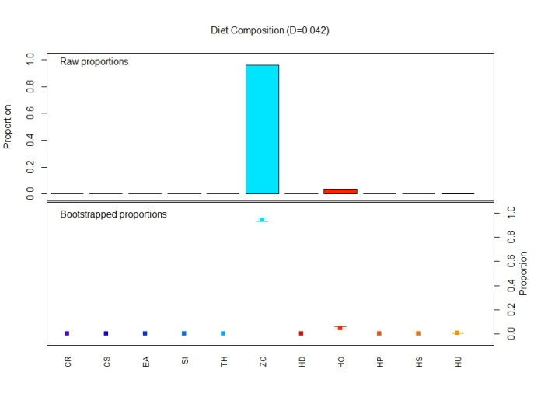  (a) | 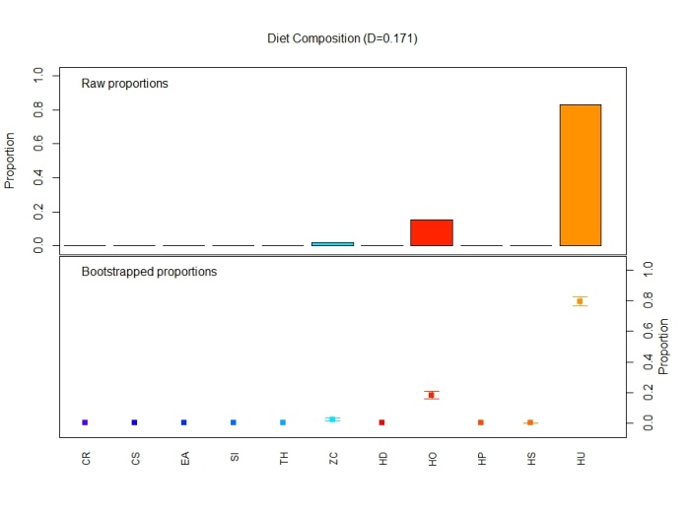  (b)
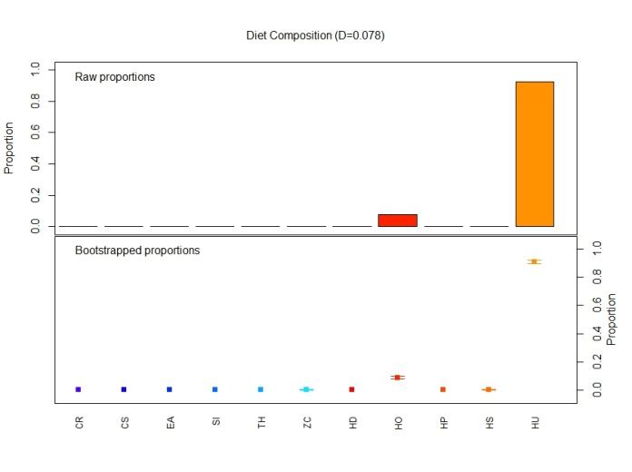  (c) | 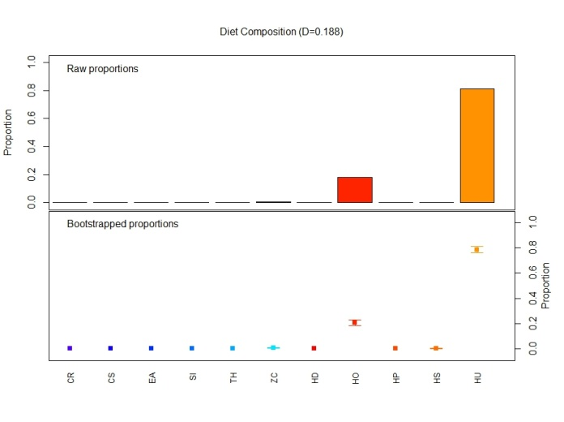  (d)
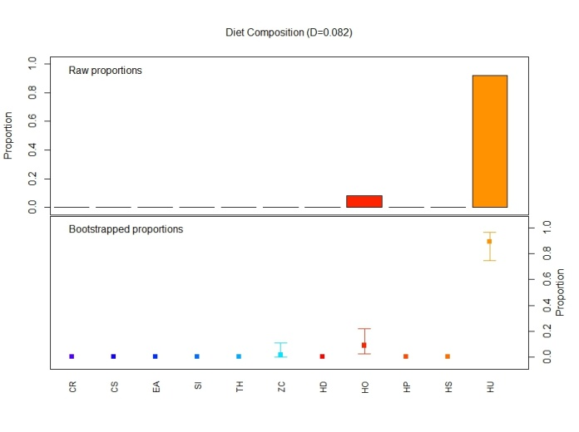  (e) | 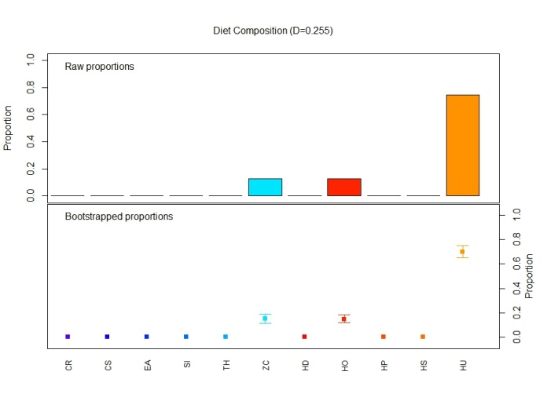  (f)
Figure B- 1: Summaries for the classification tree produced on all of the data for (a) node 2, (b) node 13, (c) node 15, (d) node 29, (e) node 49 and (f) node 51. Note, the word “diet” is an artefact from the package used to create these figures and should be ignored.

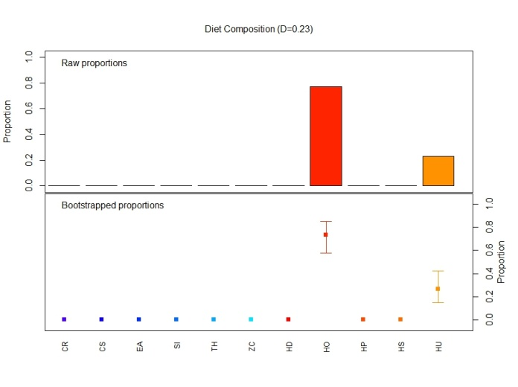  (a) | 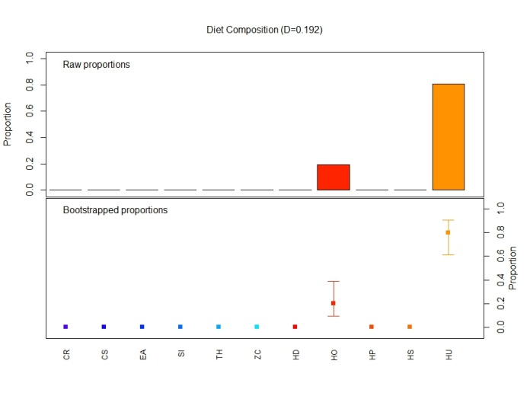  (b)
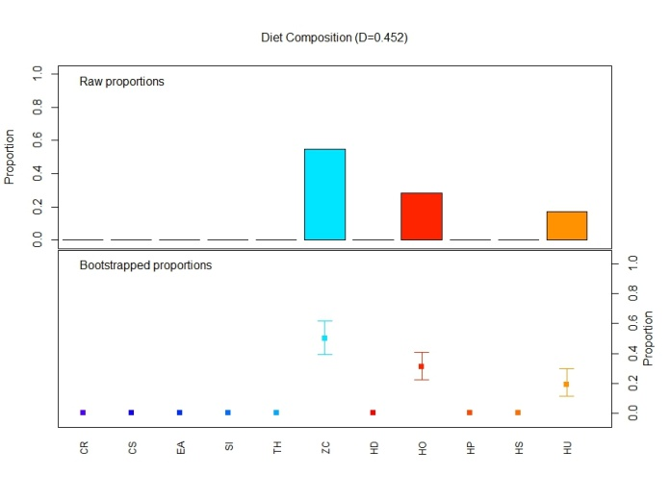  (c) | 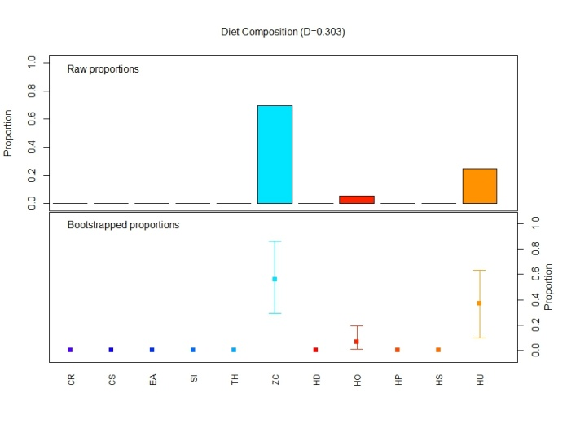  (d)
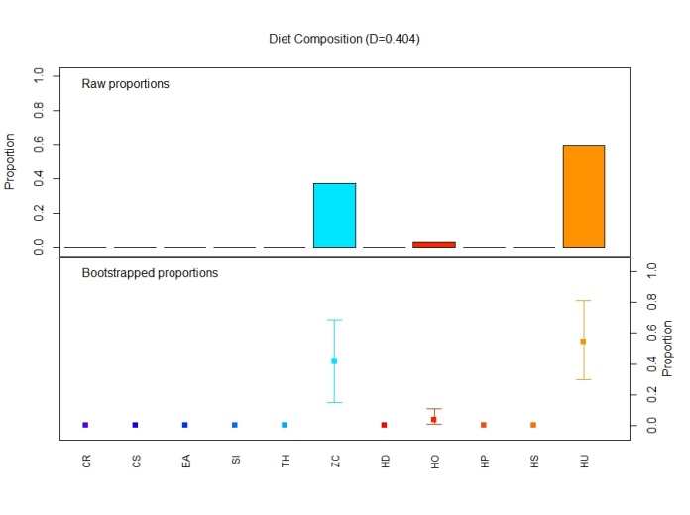  (e) | 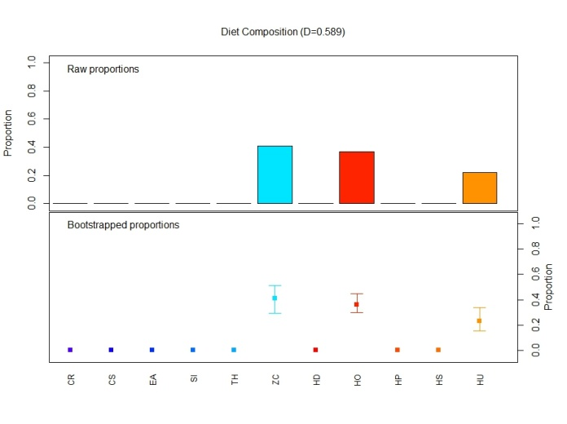  (f)
Figure B- 2: Summaries for the classification tree produced on all of the data for (a) node 56, (b) node 57, (c) node 96, (d) node 100, (e) node 101 and (f) node 194. Note, the word “diet” is an artefact from the package used to create these figures and should be ignored.

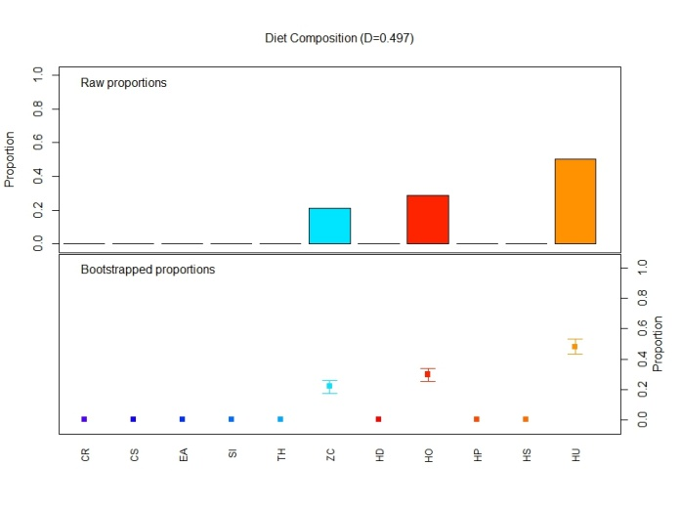
Figure B- 3: Summary of node 195 from the classification tree produced on all of the data. Note, the word “diet” is an artefact from the package used to create these figures and should be ignored.

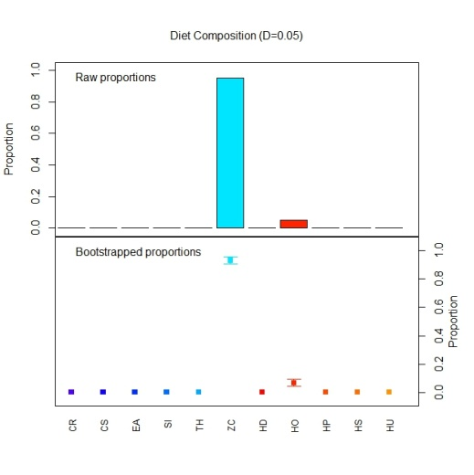  (a) | 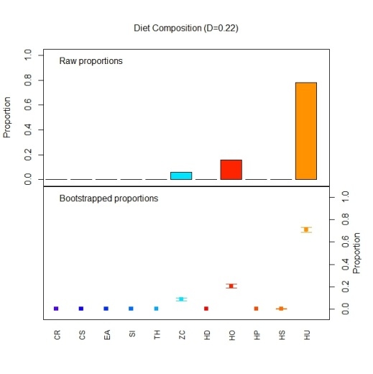  (b)
Figure B- 4: Summary of nodes from the classification tree produced for the late dry period for (a) node2 and (b) node 3. Note, the word “diet” is an artefact from the package used to create these figures and should be ignored.

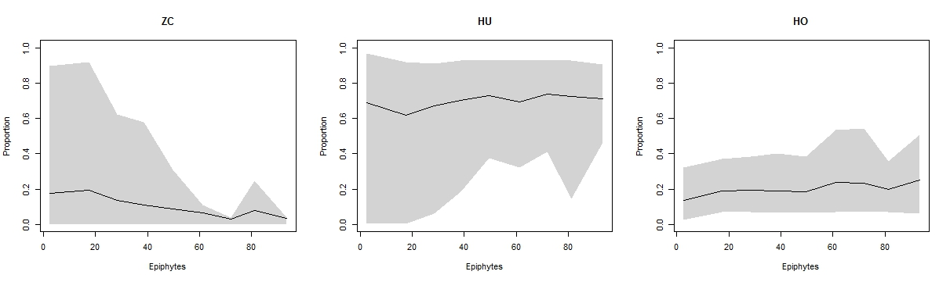
(a)
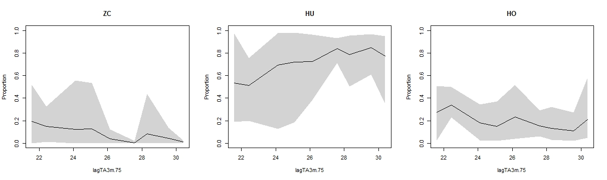
(b)
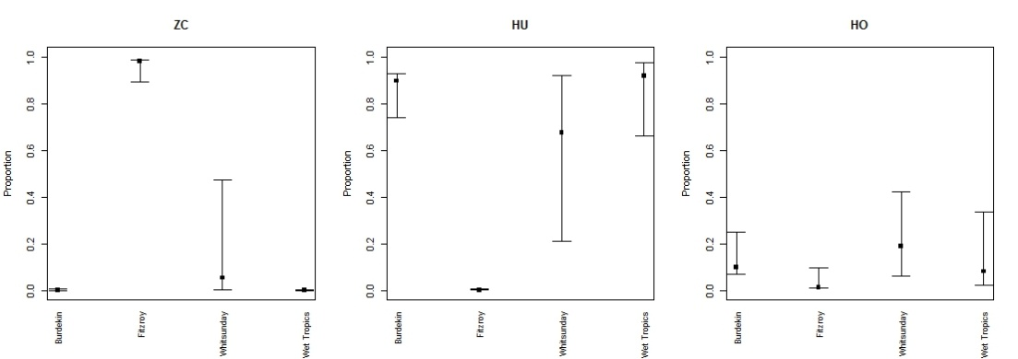
(c)
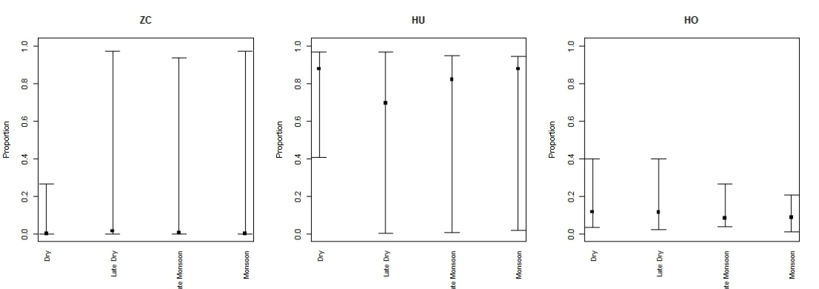
(d)
Figure B- 5: Partial dependence plots showing the contribution of (a) Epiphytes, (b) lagTA3m.75, (c) NRM region and (d) season.

- Estuarine Intertidal
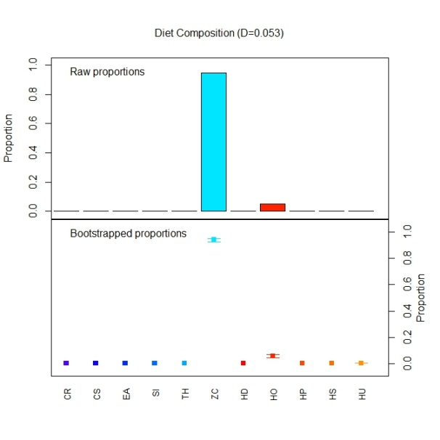  (a) | 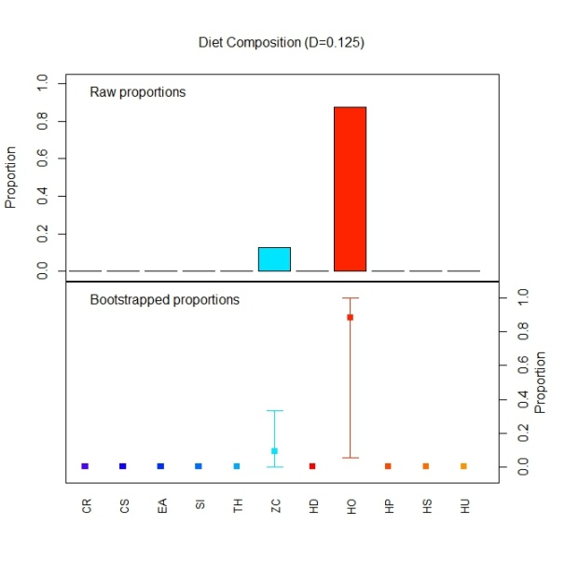  (b)
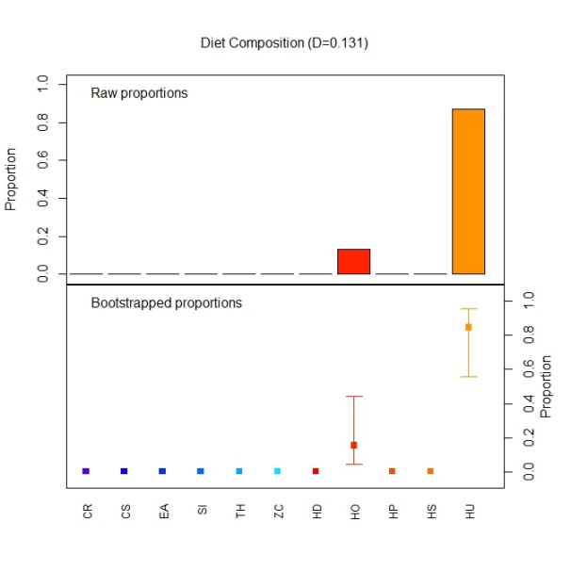  (c) | 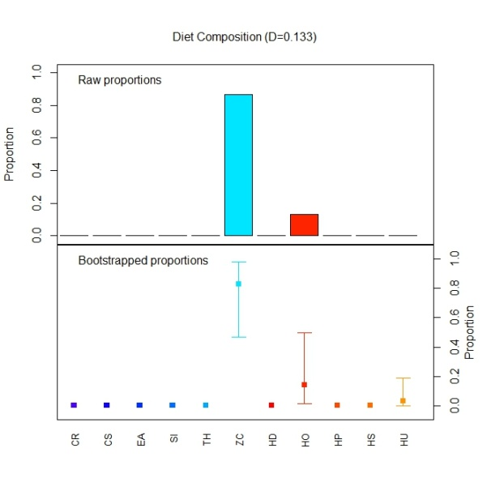  (d)
Figure B- 6: Node summaries from a classification tree fit to the estuarine intertidal data for (a) node 4, (b) node 5, (c) node 13 and (d) node 14. Note, the word “diet” is an artefact from the package used to create these figures and should be ignored.

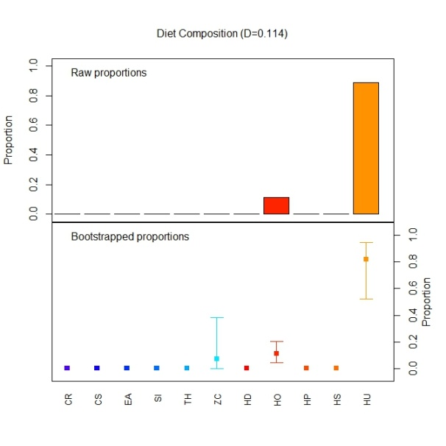  (a) | 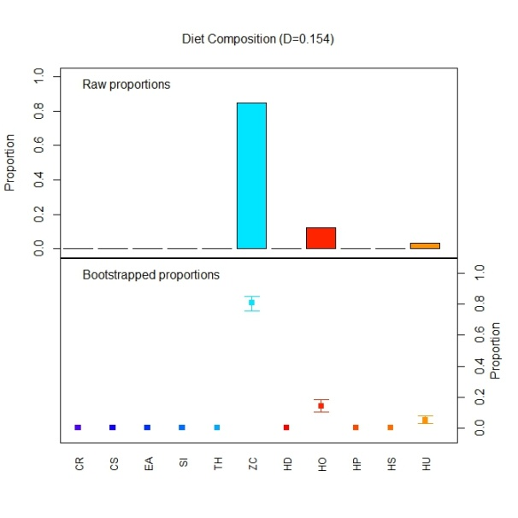  (b)
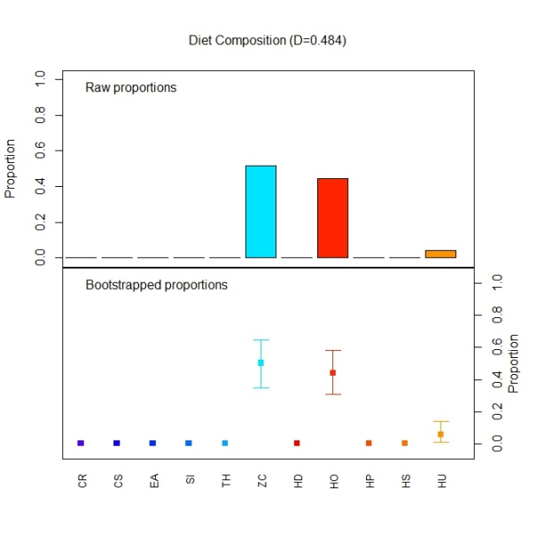  (c) | 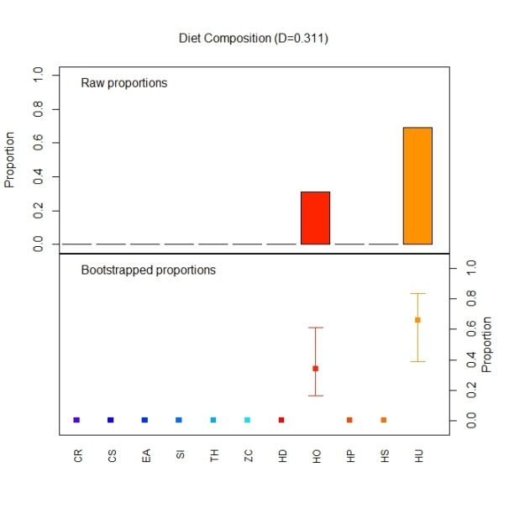  (d)
Figure B- 7: Node summaries from a classification tree fit to the estuarine intertidal data for (a) node 15, (b) node 24, (c) node 50 and (d) node 51. Note, the word “diet” is an artefact from the package used to create these figures and should be ignored.

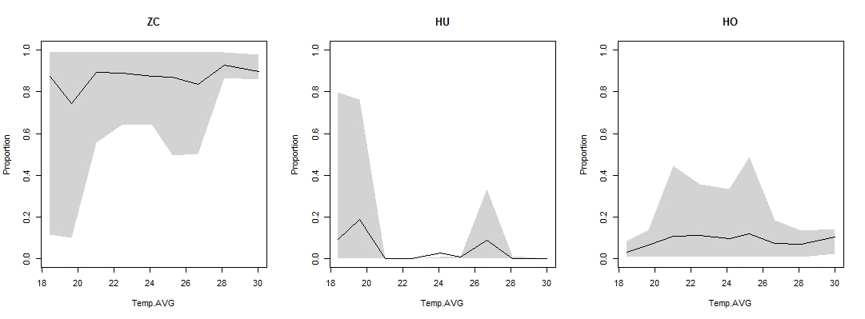
(a)
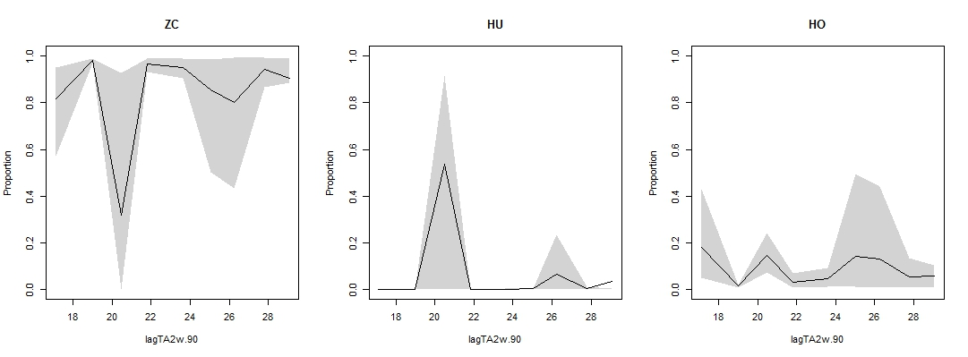
(b)
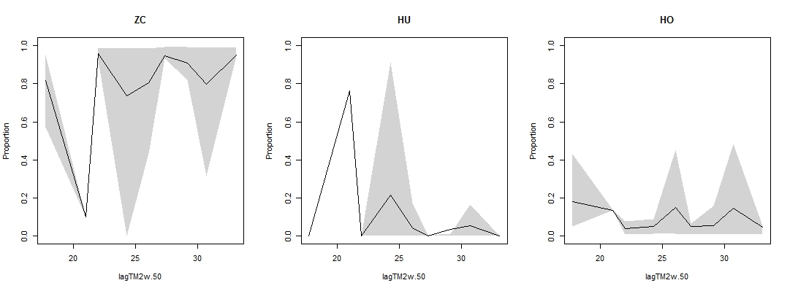
(c)
Figure B- 8: Partial dependence plots showing the contribution of (a) Average Temperature (b) lagTA2w.90 and (c) lagTM2w.50.

- Reef Intertidal

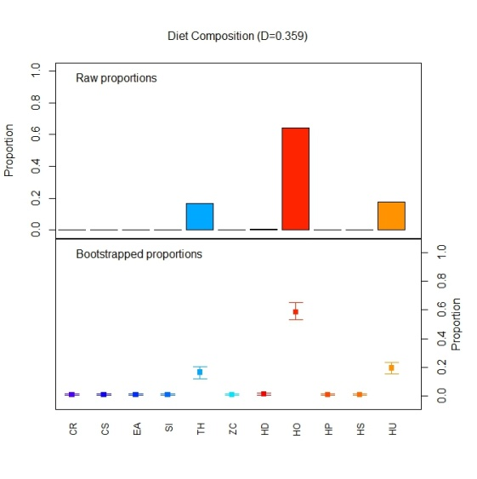  (a) | 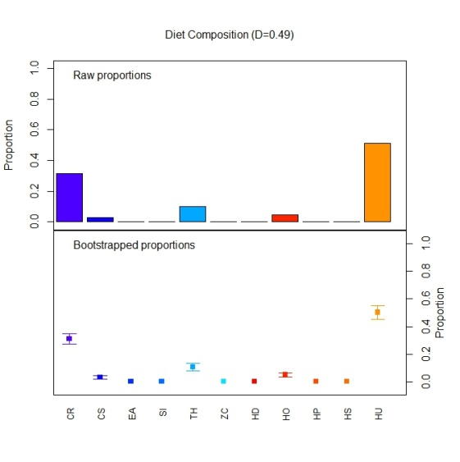  (b)
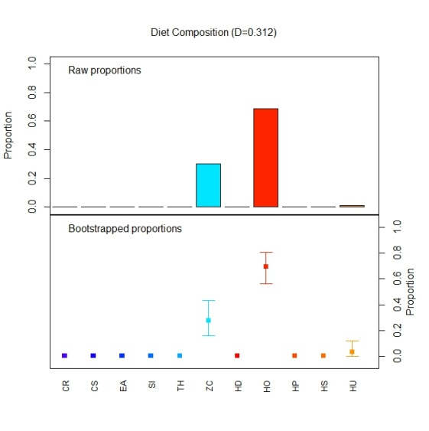  (c) | 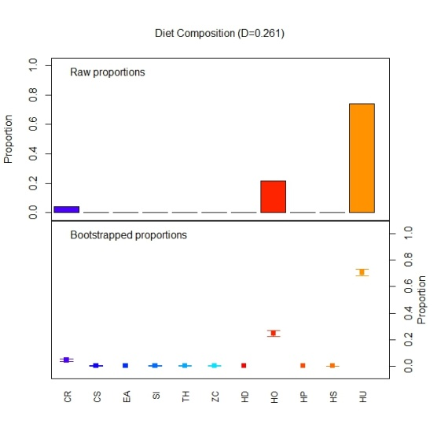  (d)
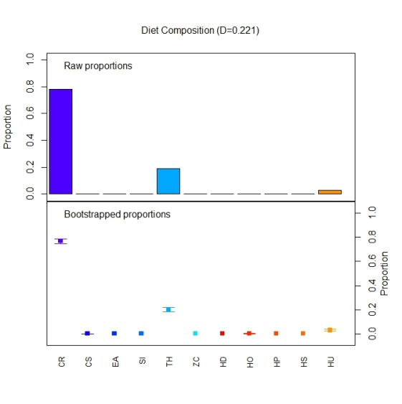  (e) | 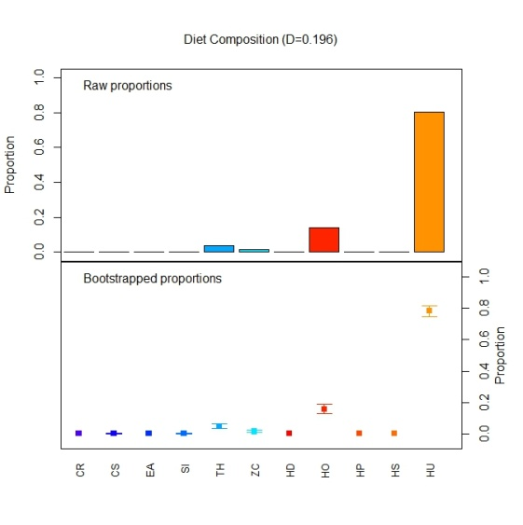  (f)
Figure B- 9: Node summaries from a classification tree fit to the reef intertidal data for (a) node 5, (b) node 9, (c) node 14, (d) node 15, (e) node 16 and (f) node 27. Note, the word “diet” is an artefact from the package used to create these figures and should be ignored.

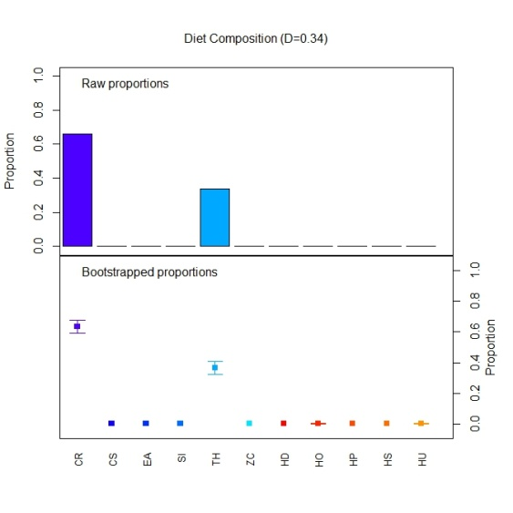  (a) | 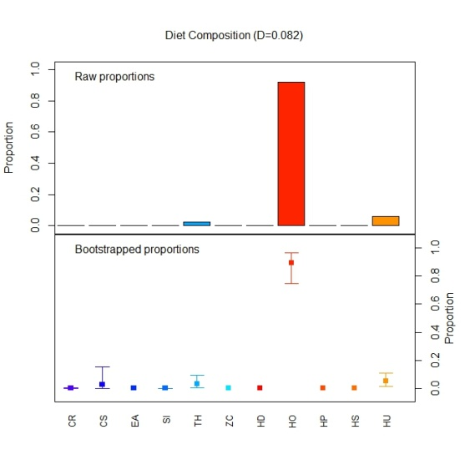  (b)
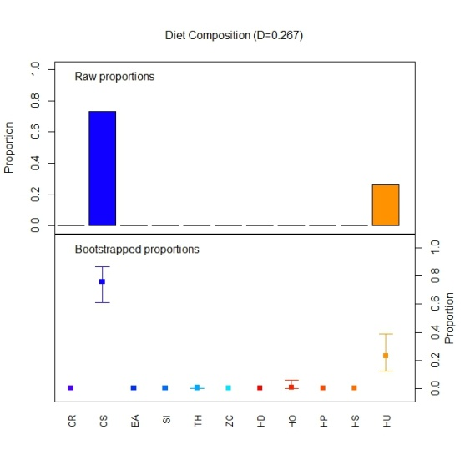  (c) | 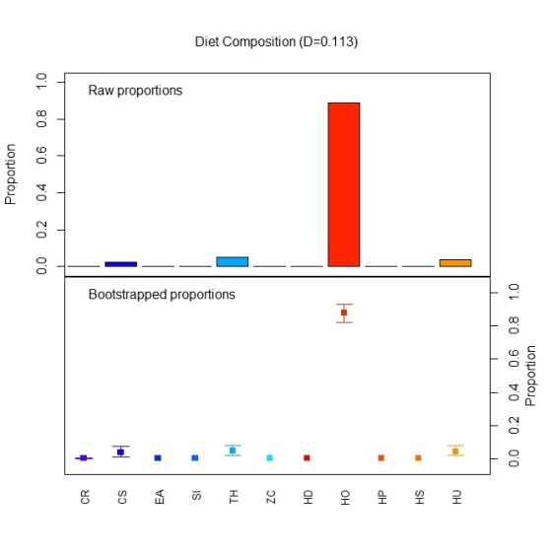  (d)
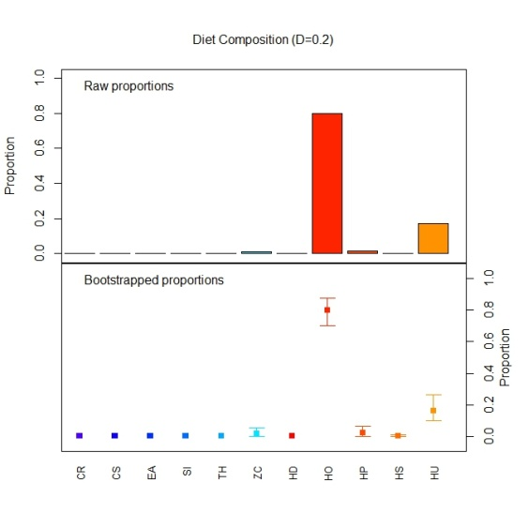  (e) | 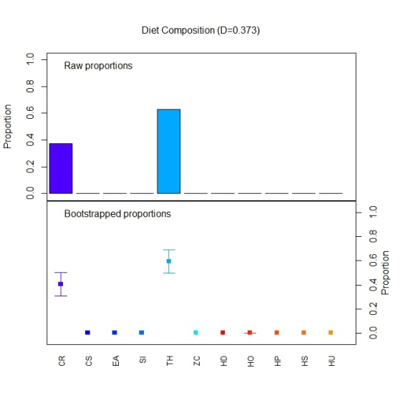  (f)
Figure B- 10: Node summaries from a classification tree fit to the reef intertidal data for (a) node 34, (b) node 49, (c) node 50, (d) node 51, (e) node 52 and (f) node 71 . Note, the word “diet” is an artefact from the package used to create these figures and should be ignored.

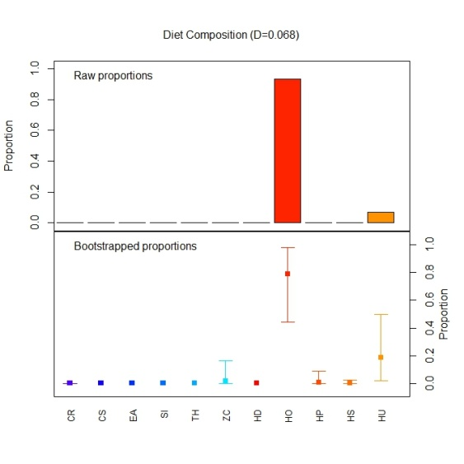  (a) | 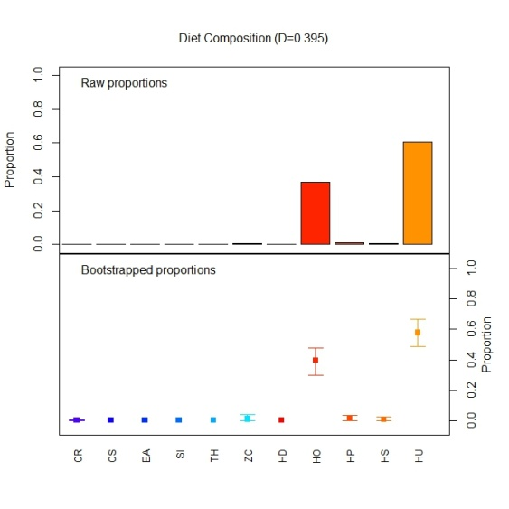  (b)
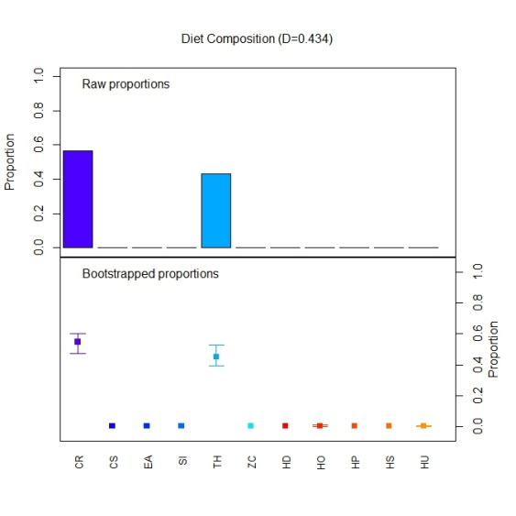  (c) | 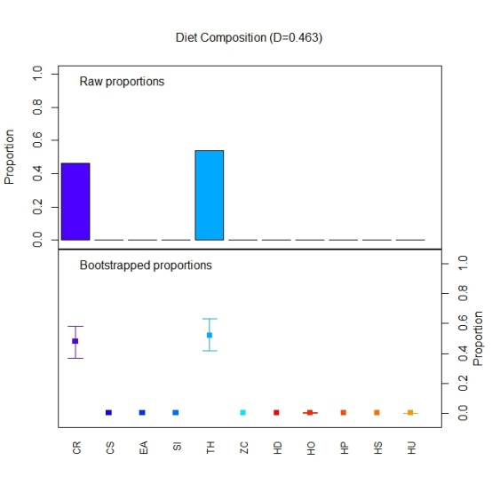  (d)
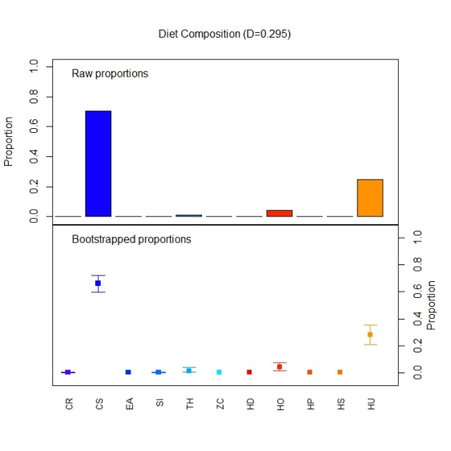  (e) | 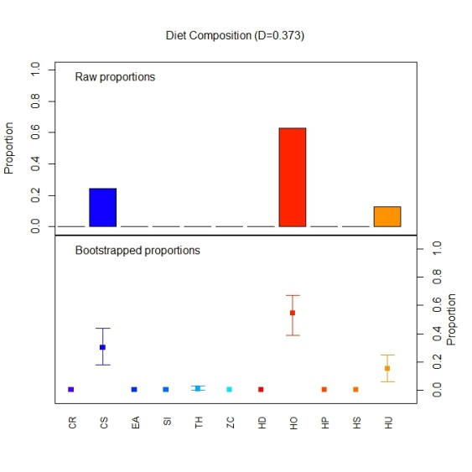  (f)
Figure B- 11: Node summaries from a classification tree fit to the reef intertidal data for (a) node 106, (b) node 107, (c) node 140, (d) node 141, (e) node 192 and (f) node 193 . Note, the word “diet” is an artefact from the package used to create these figures and should be ignored.

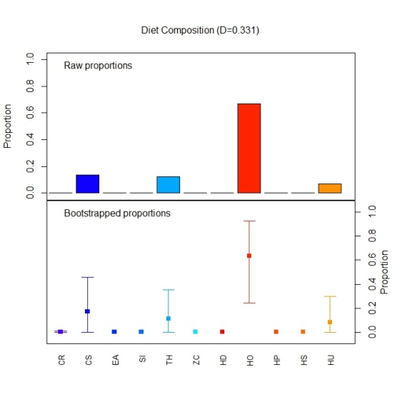  (a) | 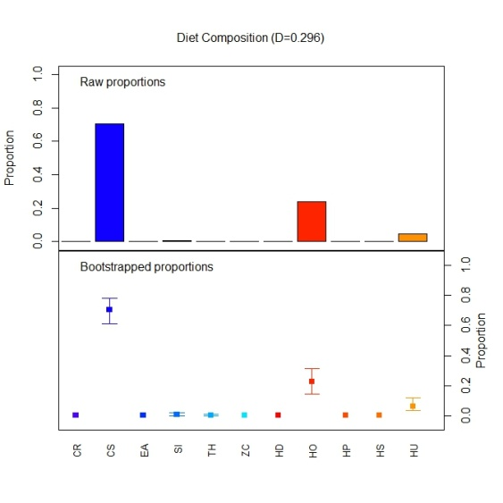  (b)
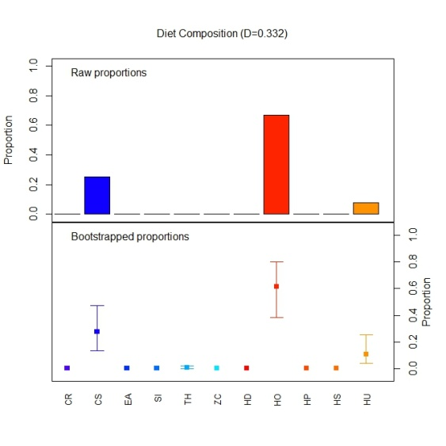  (c) | 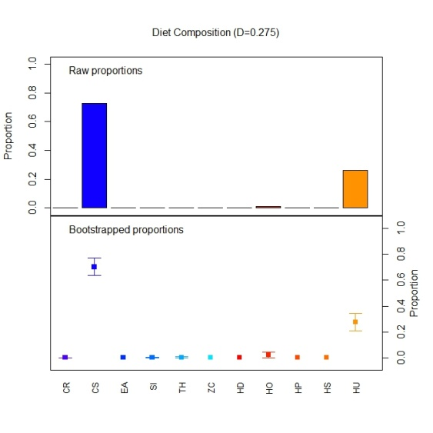  (d)
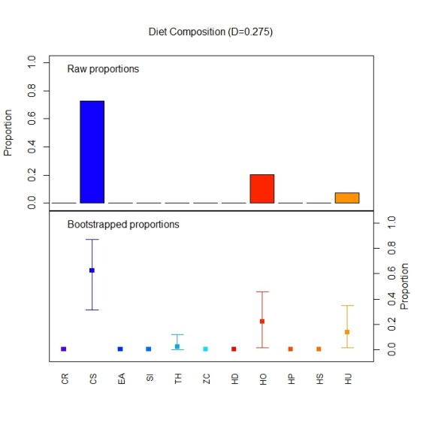  (e) | 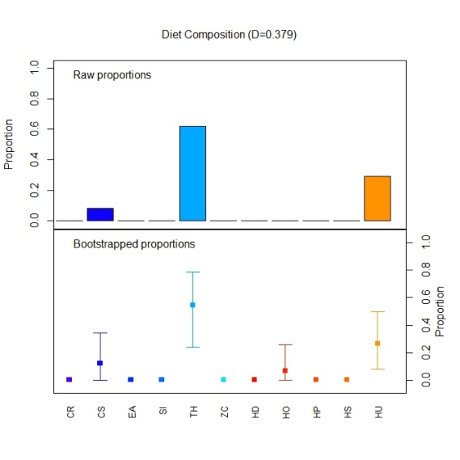  (f)

Figure B- 12: Node summaries from a classification tree fit to the reef intertidal data for (a) node 195, (b) node 776, (c) node 777, (d) node 778 , (e) node 1558 and (f) node 3118. Note, the word “diet” is an artefact from the package used to create these figures and should be ignored.

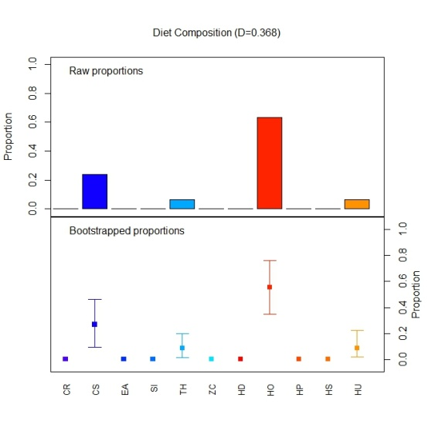
Figure B- 13: Node summaries from a classification tree fit to the reef intertidal data for node 3119. Note, the word “diet” is an artefact from the package used to create these figures and should be ignored.

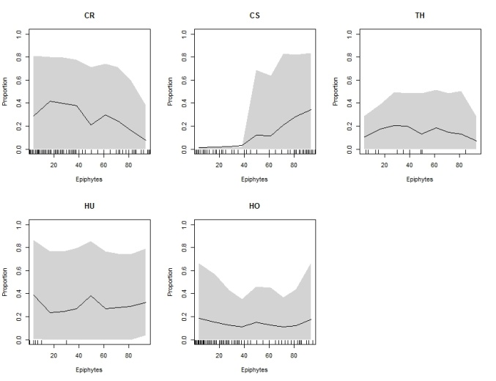  (a) | 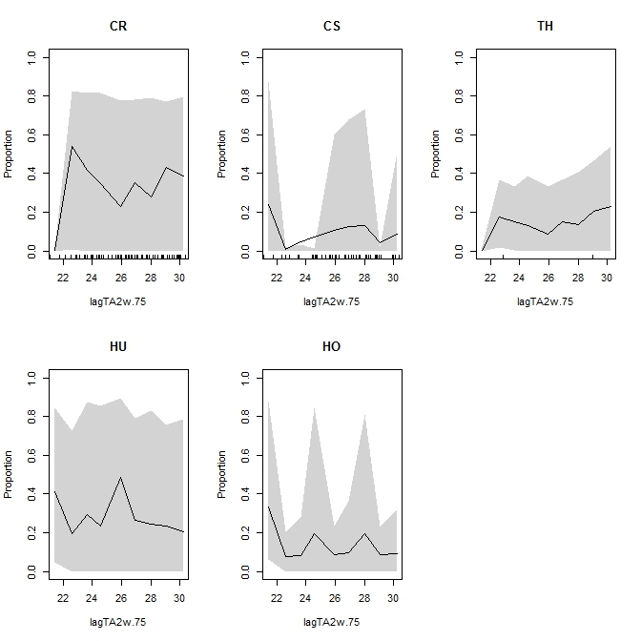  (b)
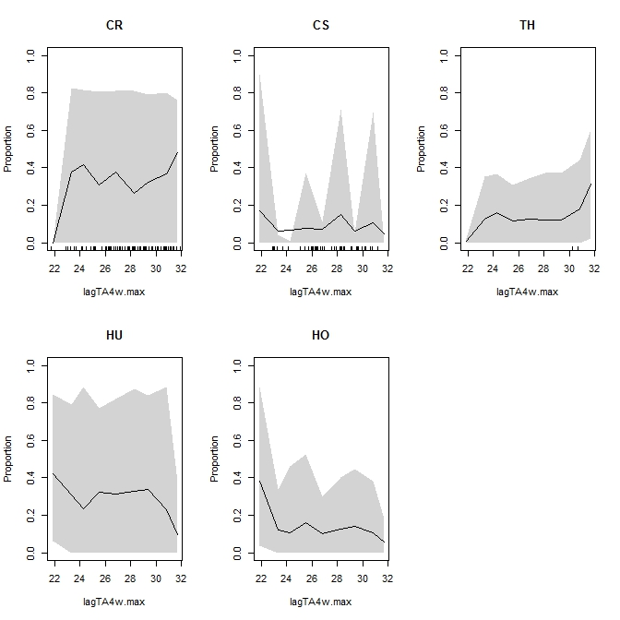  (c) | 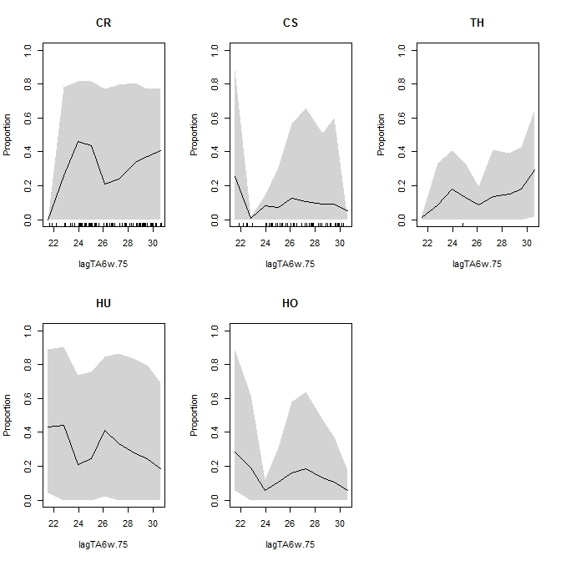  (d)
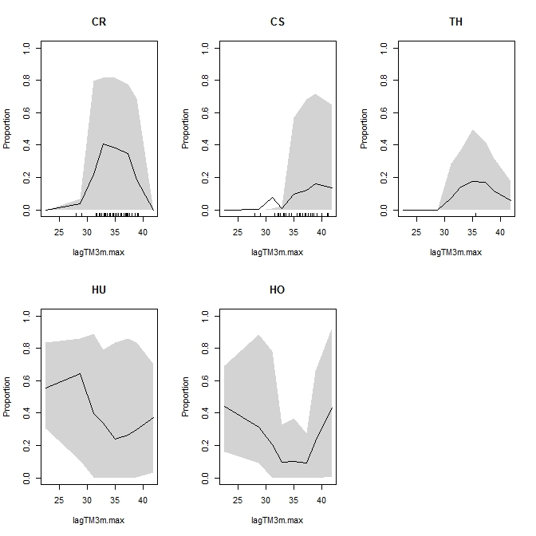  (e) | 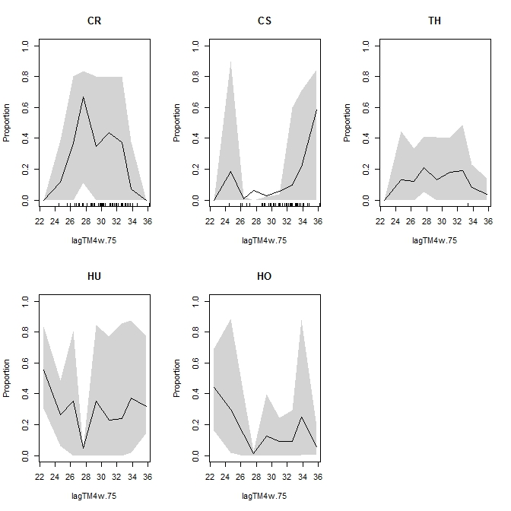  (f)

Figure B- 14: Partial dependence plots for (a) epiphytes, (b) lagTA2w.75, (c) lagTA4w.max, (d) lagTA6w.75, (e) lagTM3m.max and (f) lagTM4w.75.

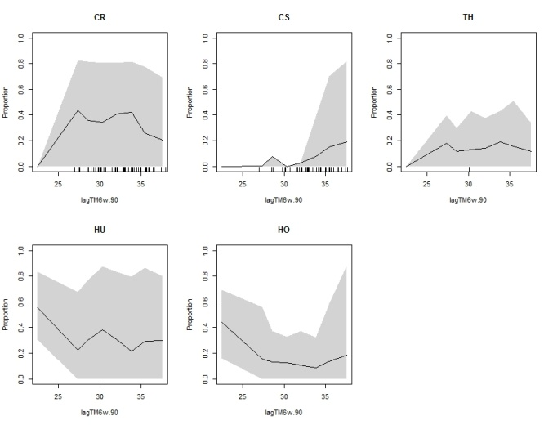  (a) | 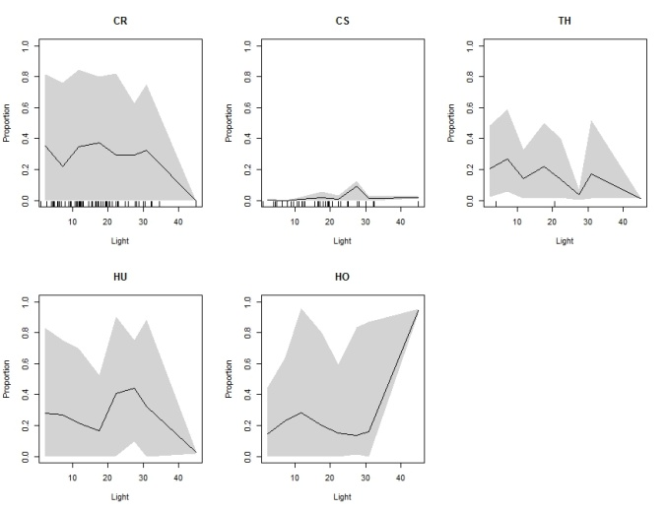  (b)
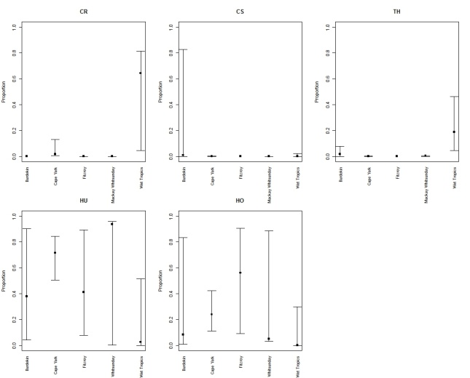  (c) | 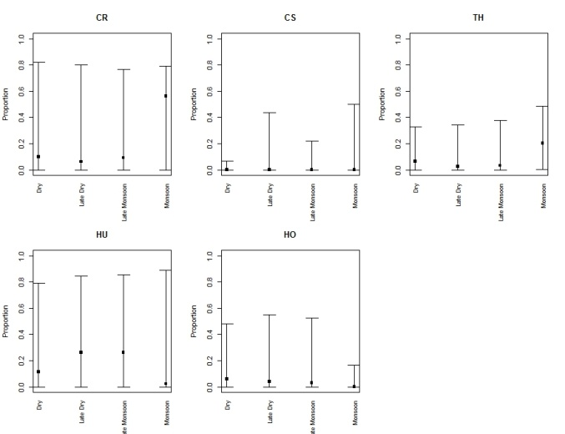  (d)
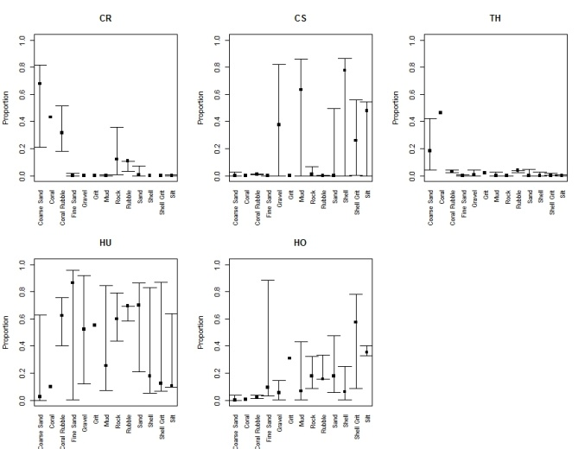  (e) | 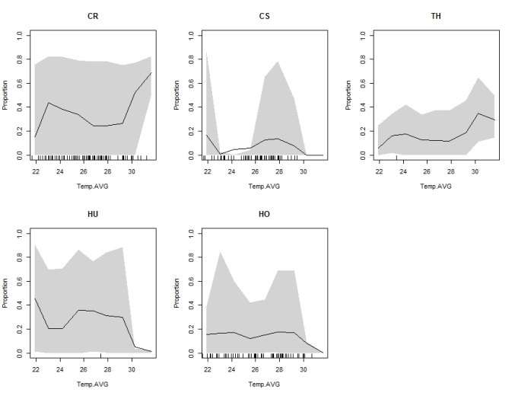  (f)
Figure B- 15: Partial dependence plots for (a) lagTM6w.90, (b) Light, (c) NRM Region, (d) season, (e) Sediment and (f) average temperature.

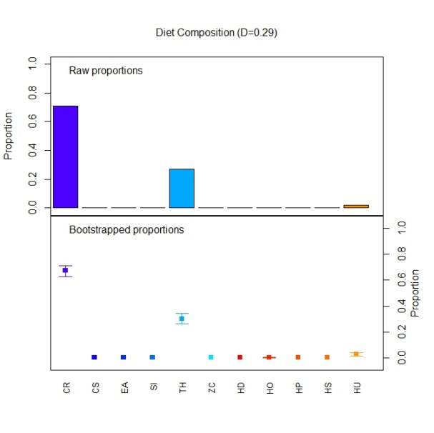  (a) | 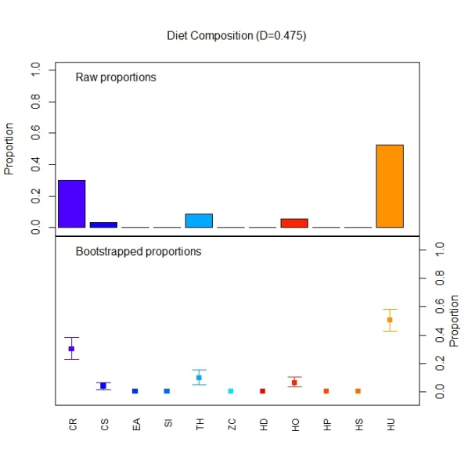  (b)
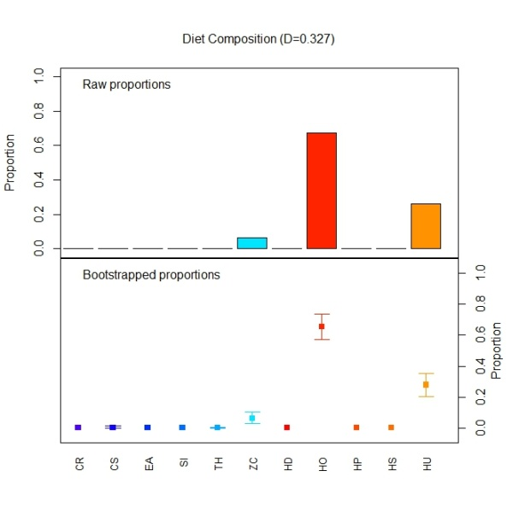  (c) | 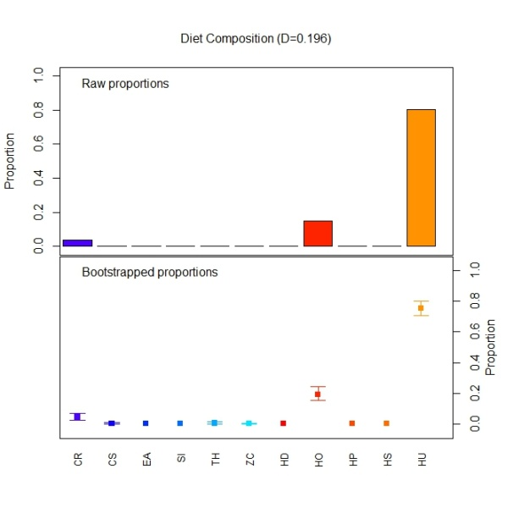  (d)
Figure B- 16: Node summaries from a classification tree fit to the reef intertidal data for the late dry period for (a) node 4, (b) node 5, (c) node 6, and (d) node 15. Note, the word “diet” is an artefact from the package used to create these figures and should be ignored.

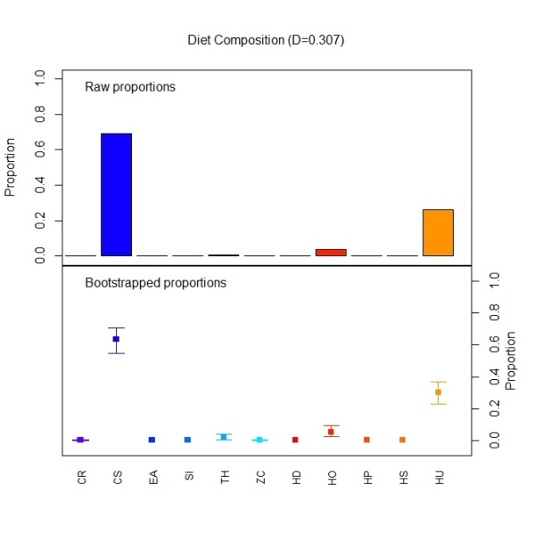  (a) | 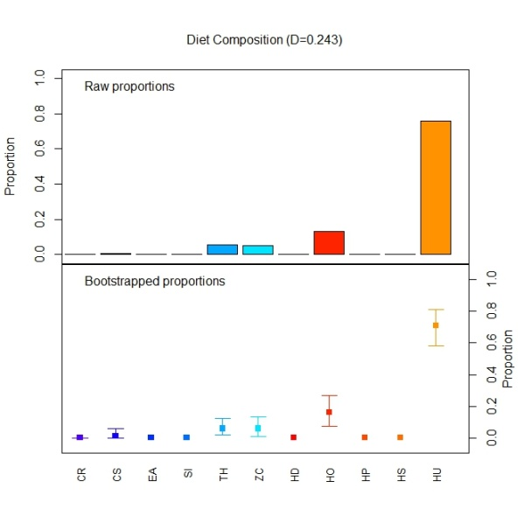  (b)
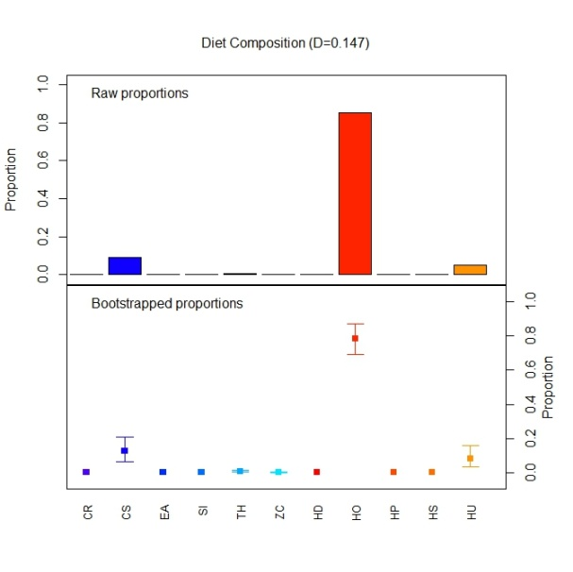  (c) | 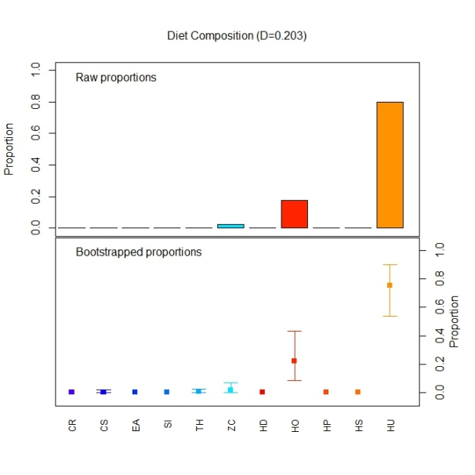  (d)

Figure B- 17: Node summaries from a classification tree fit to the reef intertidal data for the late dry period for (a) node 56, (b) node 57, (c) node 58, and (d) node 59. Note, the word “diet” is an artefact from the package used to create these figures and should be ignored.

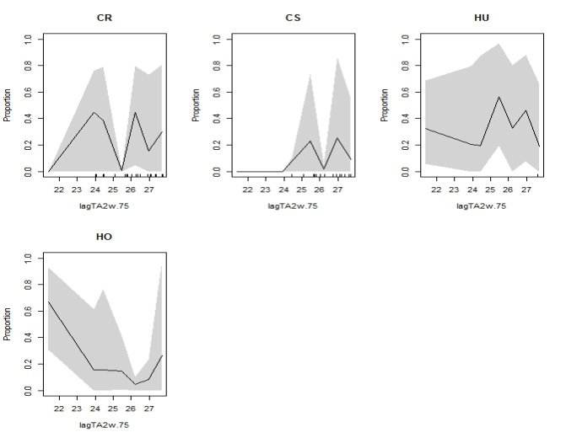  (a) | 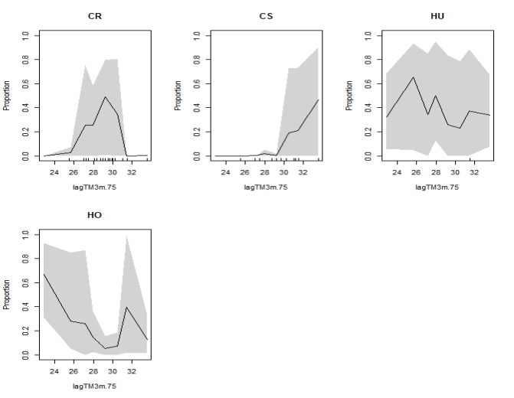  (b)
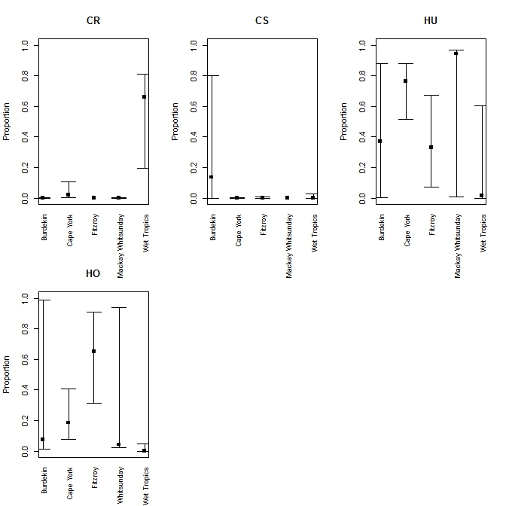
(c)

Figure B- 18: Partial dependence plots for the late dry period showing patterns in (a) lagTA2w.75, (b) lagTM3m.75 and (c) NRM region.

- Reef Subtidal
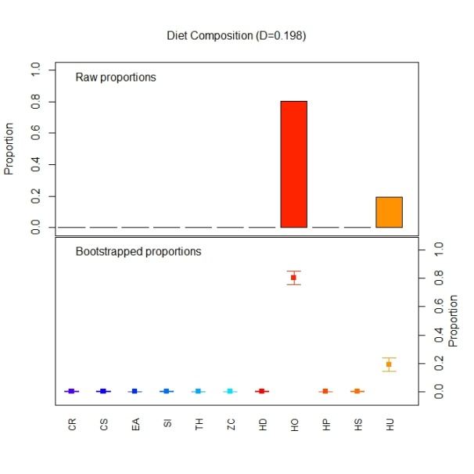  (a) | 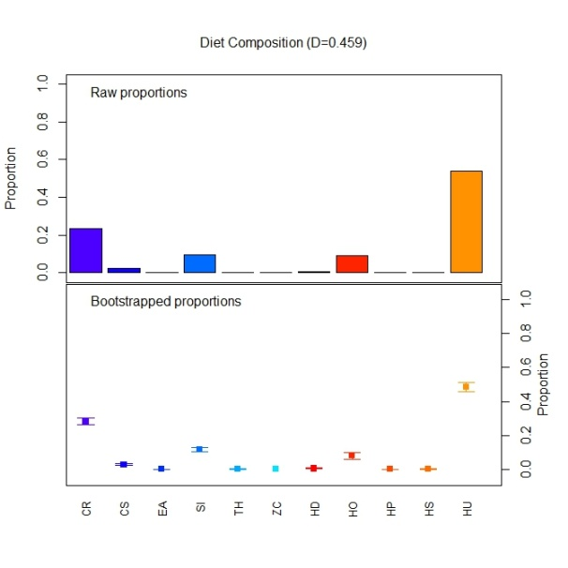  (b)
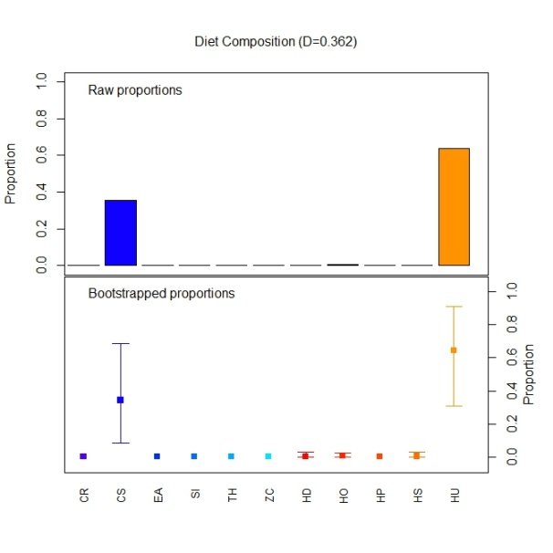  (c) | 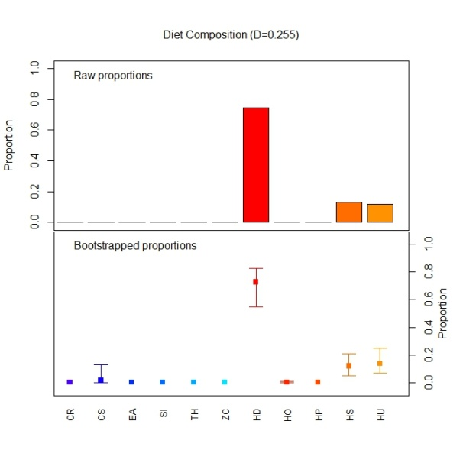  (d)
Figure B- 19: Node summaries from a classification tree fit to the reef subtidal data for the late dry period for (a) node 3, (b) node 5, (c) node 18, and (d) node 19. Note, the word “diet” is an artefact from the package used to create these figures and should be ignored.

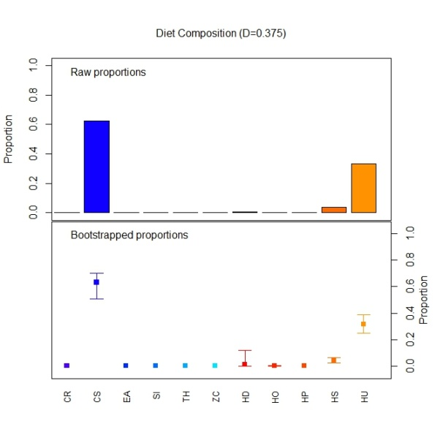  (a) | 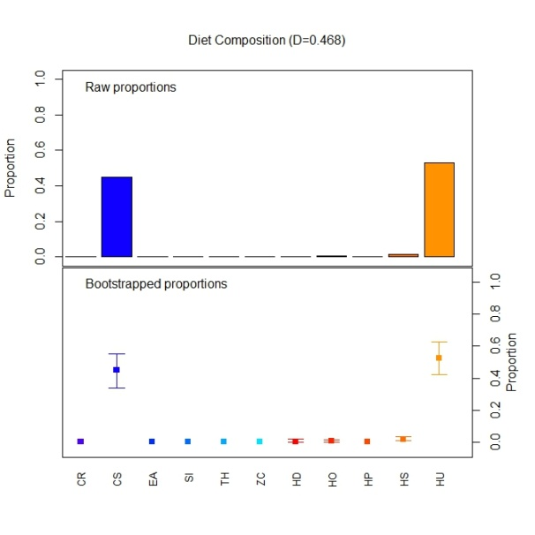  (b)
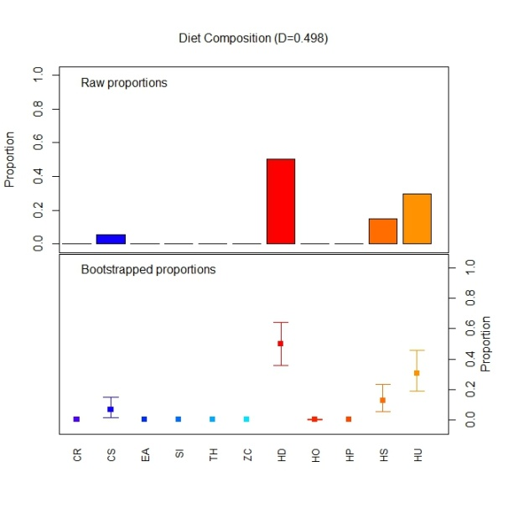  (c) | 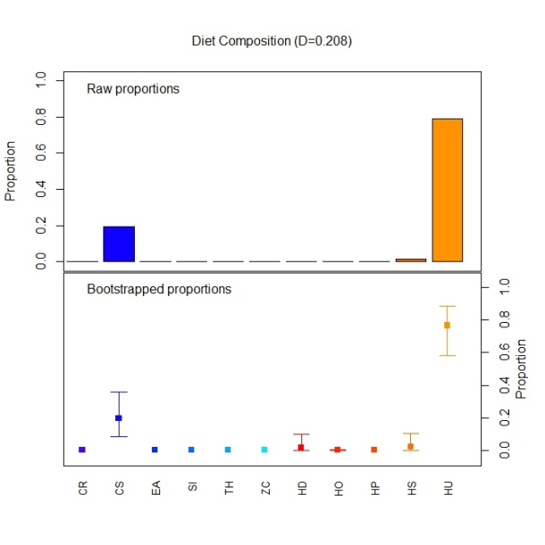  (d)

Figure B- 20: Node summaries from a classification tree fit to the reef subtidal data for the late dry period for (a) node 32, (b) node 33, (c) node 34, and (d) node 35. Note, the word “diet” is an artefact from the package used to create these figures and should be ignored.

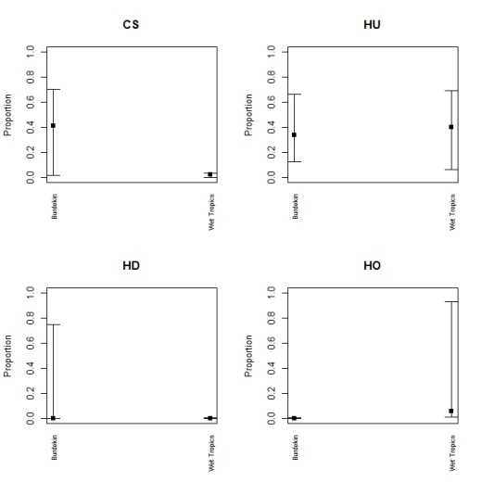  (a) | 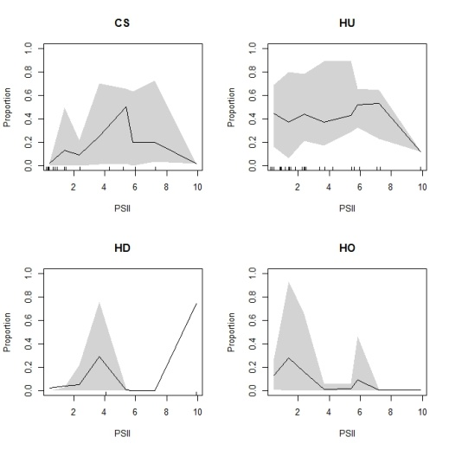  (b)
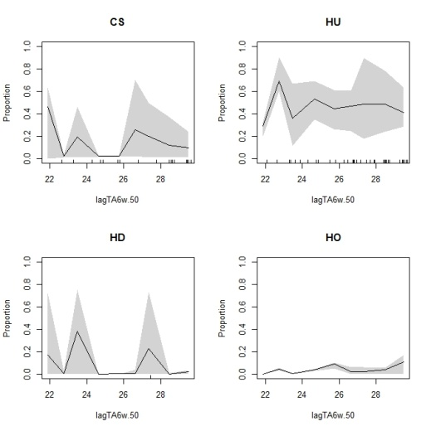  (c) | 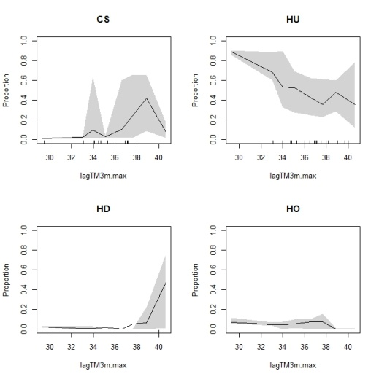  (d)
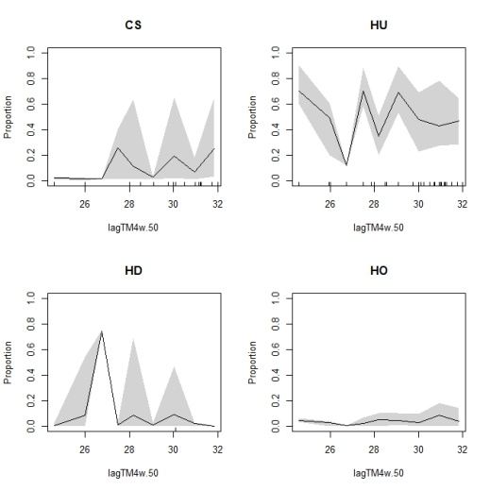  (e) | 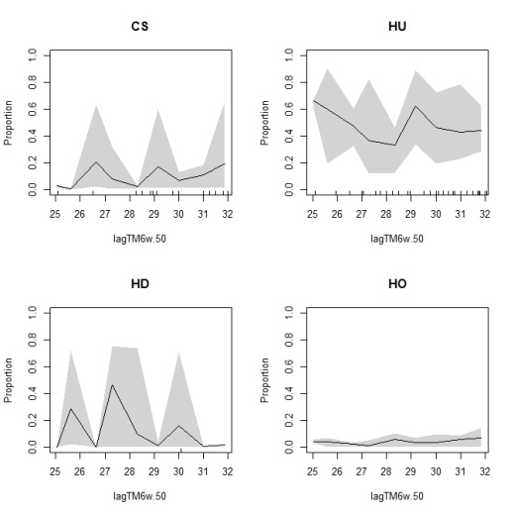  (f)
Figure B- 21: Partial dependence plots for reef subtidal sites for(a) NRM region, (b) PSII, (c) lagTA6w.50, (d) lagTM3m.max, (e) lagTM4w.50 and (f) lagTM6w.50.

Seasonality and Trend Analysis
- Water Quality Logger Data
- Chlorophyll

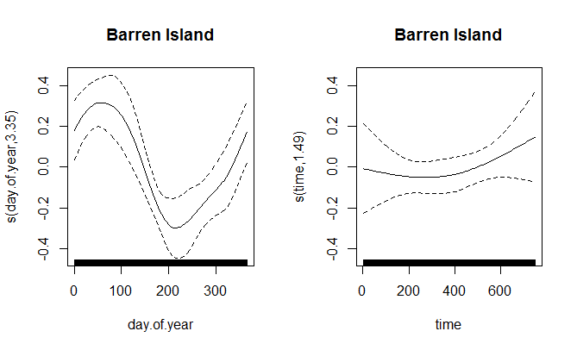

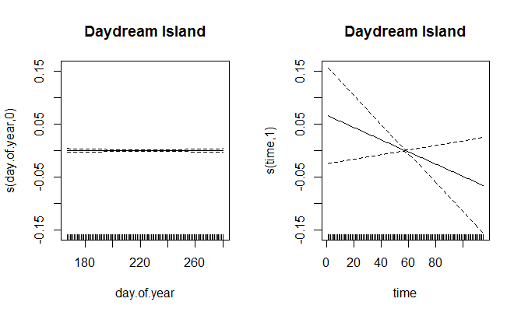
Figure C- 1: Seasonal trends and long term trends for the ntu logger data at Barren Island (top) and Daydream Island (bottom).

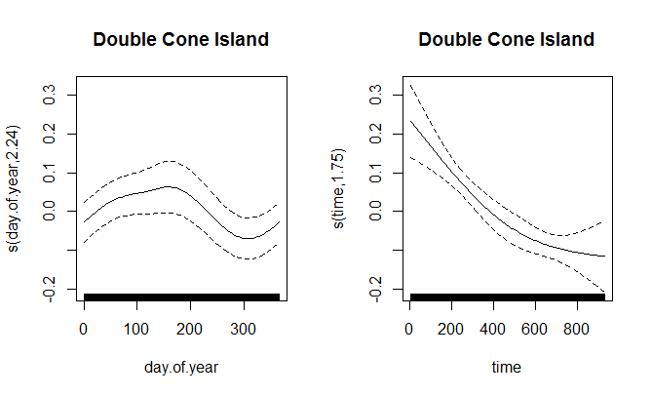

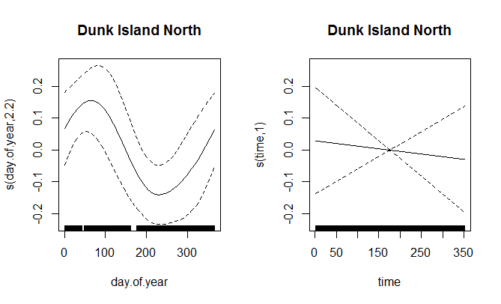
Figure C- 2: Seasonal trends and long term trends for the ntu logger data at Double Cone Island (top) and Dunk Island (bottom).

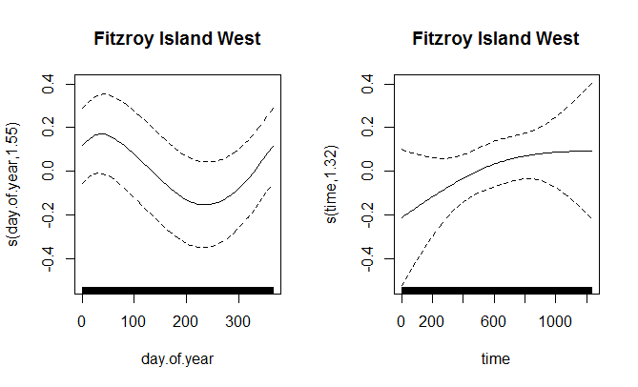

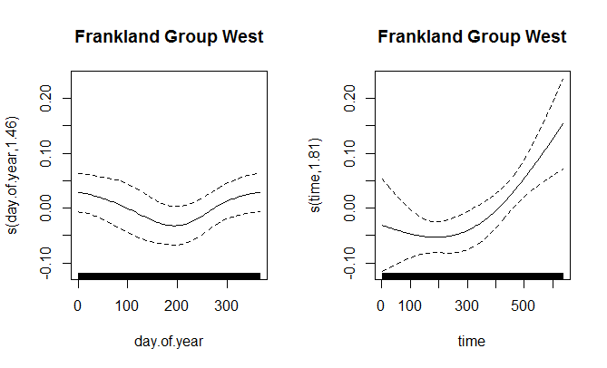
Figure C- 3: Seasonal trends and long term trends for the ntu logger data at Fitzroy Island West (top) and Frankland Group West (bottom).

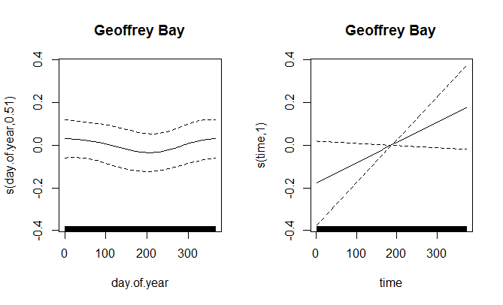

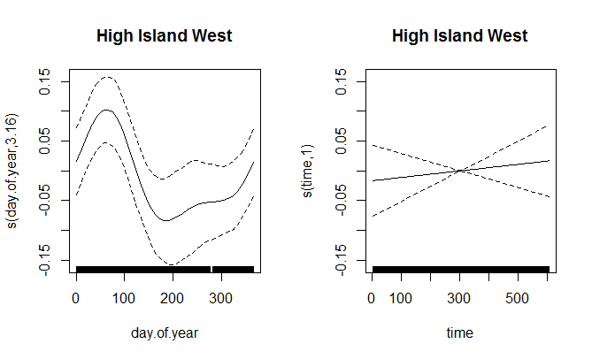
Figure C- 4: Seasonal trends and long term trends for the ntu logger data at Geoffrey Bay (top) and High Island West (bottom).

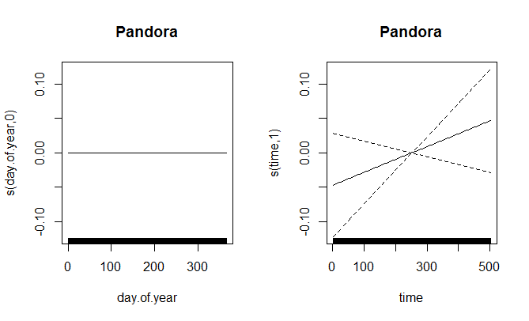

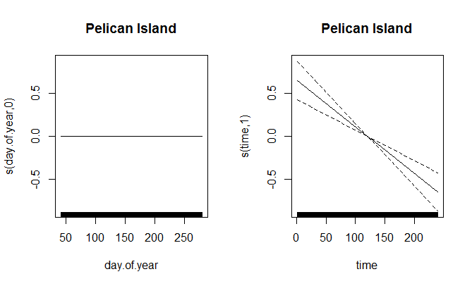
Figure C- 5: Seasonal trends and long term trends for the ntu logger data at Pandora (top) and Pelican Island (bottom).

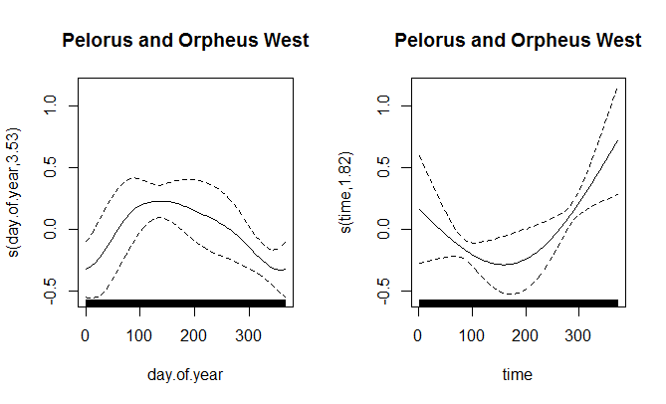

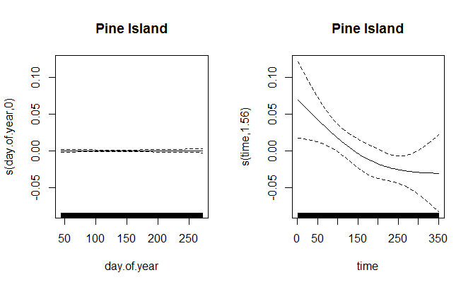
Figure C- 6: Seasonal trends and long term trends for the ntu logger data at Pelorus and Orpheus West (top) and Pine Island (bottom).

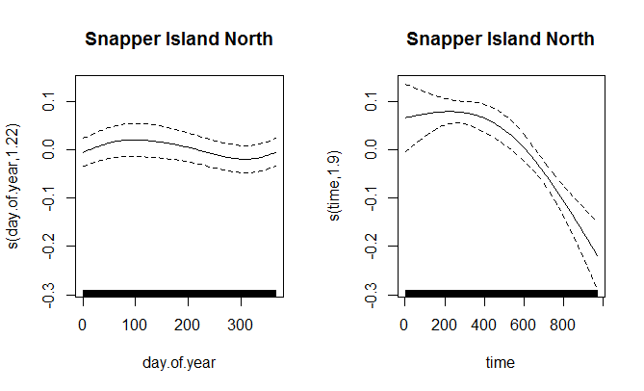
Figure C- 7: Seasonal trends and long term trends for the ntu logger data at Snapper Island North.

- Remote Sensing Data

- Chlorophyll

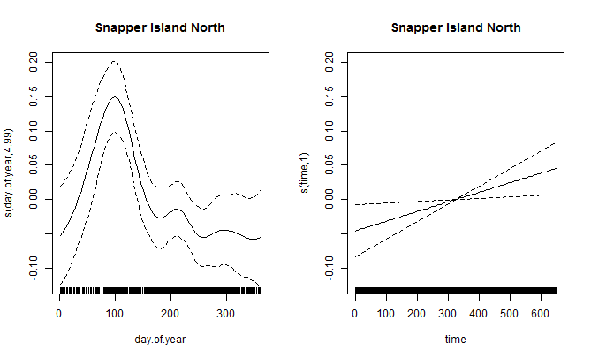

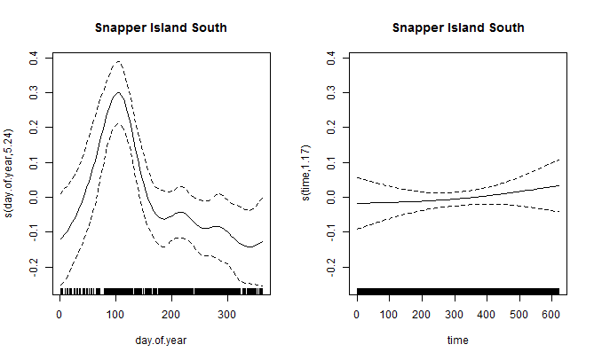
Figure C- 8: Seasonal trends and long term trends for the remote sensing data at Snapper Island North (top) and Snapper Island South (bottom).

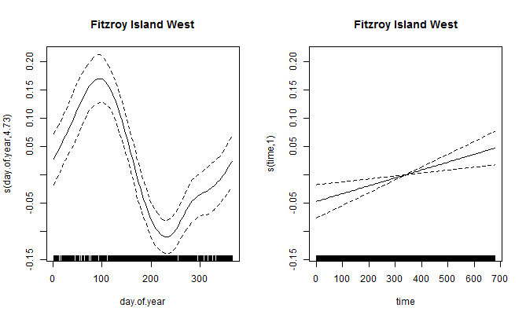

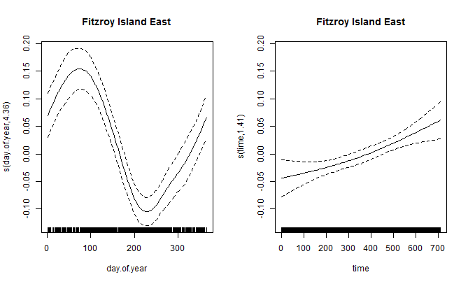
Figure C- 9: Seasonal trends and long term trends for the remote sensing data at Fitzroy Island West (top) and Fitzroy Island East (bottom).

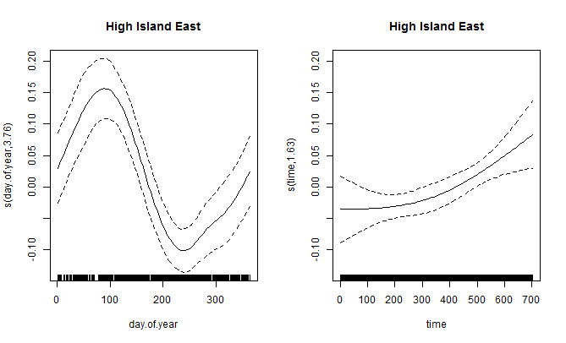

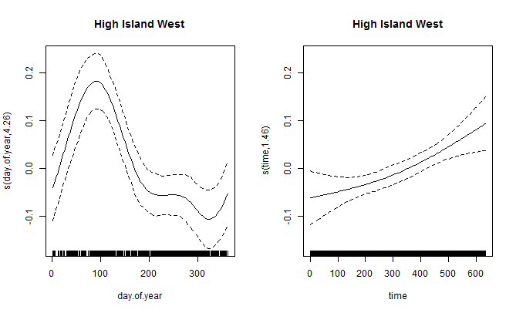
Figure C- 10: Seasonal trends and long term trends for the remote sensing data at High Island East (top) and High Island West (bottom).

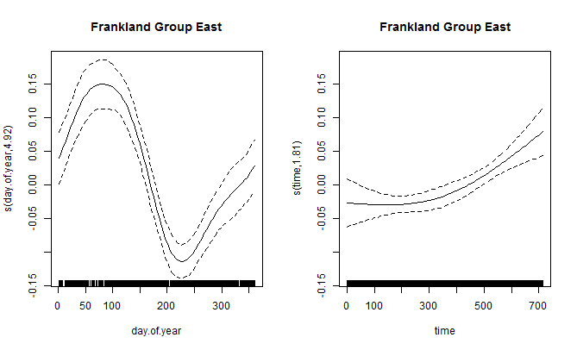

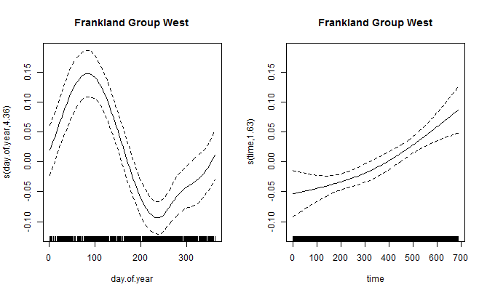
Figure C- 11: Seasonal trends and long term trends for the remote sensing data at Frankland Group East (top) and Frankland Group West (bottom).

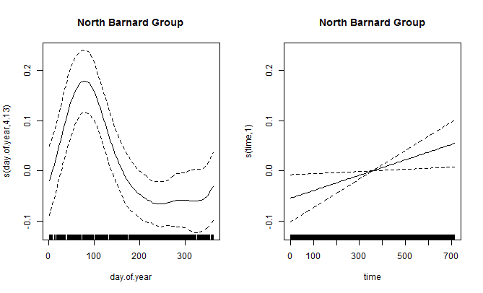

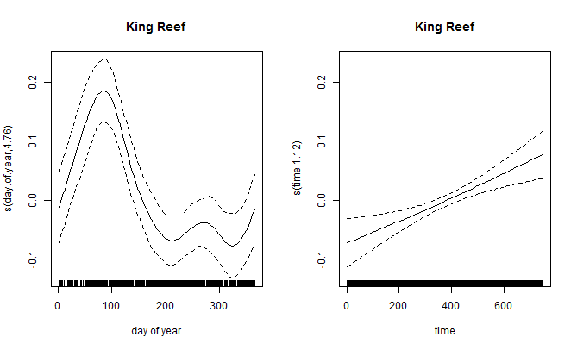
Figure C- 12: Seasonal trends and long term trends for the remote sensing data at North Barnard Group (top) and King Reef (bottom).

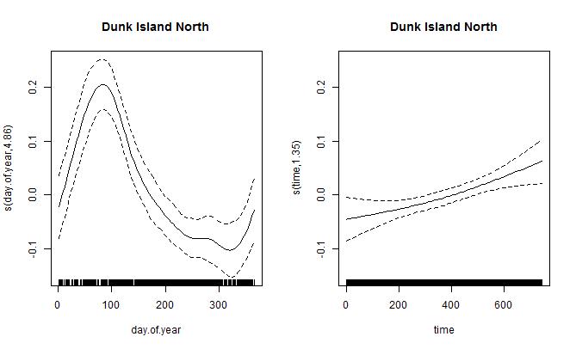

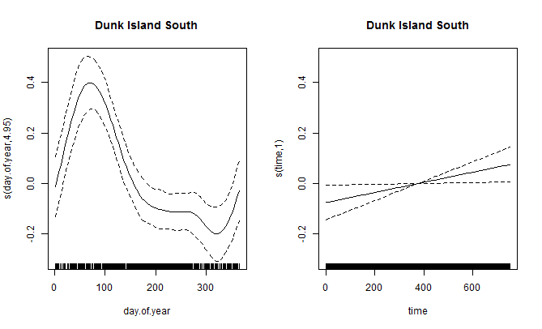
Figure C- 13: Seasonal trends and long term trends for the remote sensing data at Dunk Island North (top) and Dunk Island South (bottom).

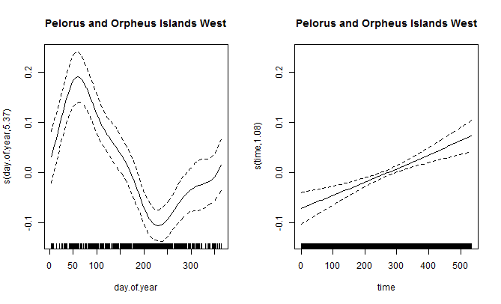

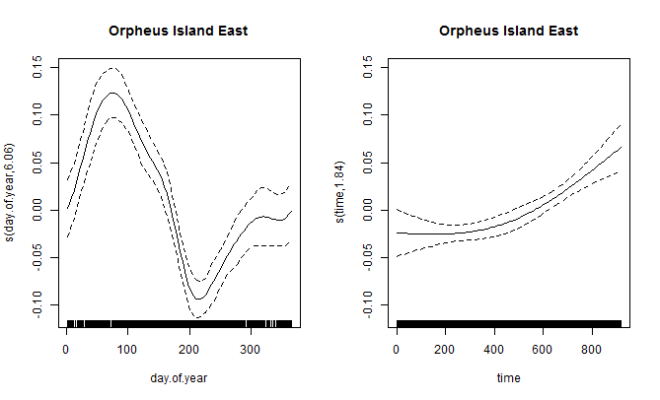
Figure C- 14: Seasonal trends and long term trends for the remote sensing data at Pelorus and Orpheus Islands West (top) and Orpheus Island East (bottom).

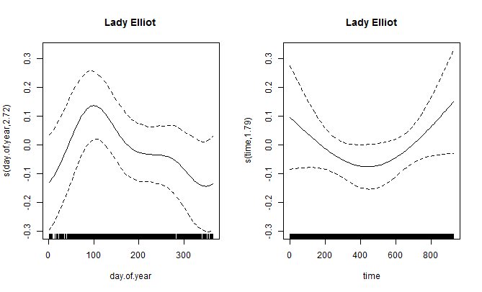

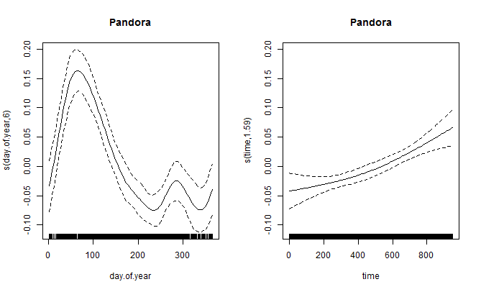
Figure C- 15: Seasonal trends and long term trends for the remote sensing data at Lady Elliot (top) and Pandora (bottom).

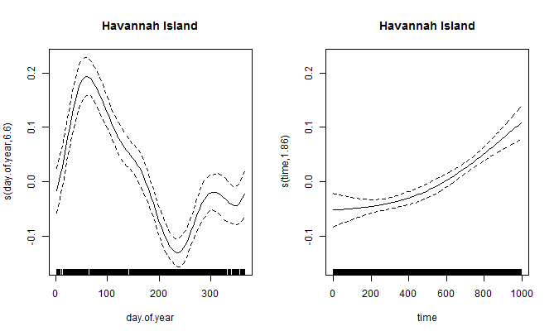

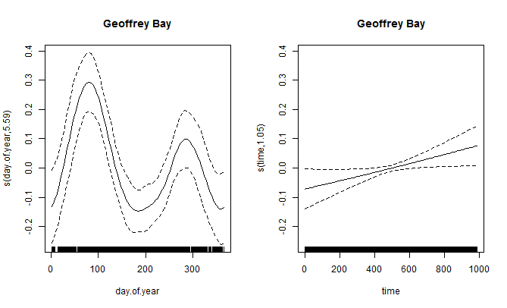
Figure C- 16: Seasonal trends and long term trends for the remote sensing data at Havannah Island (top) and Geoffrey Bay (bottom).

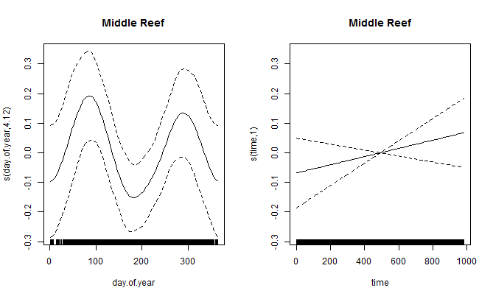

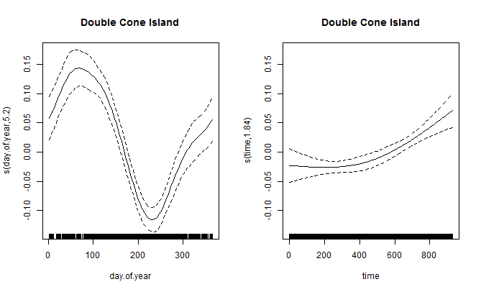
Figure C- 17: Seasonal trends and long term trends for the remote sensing data at Middle Reef (top) and Double Cone Island (bottom).

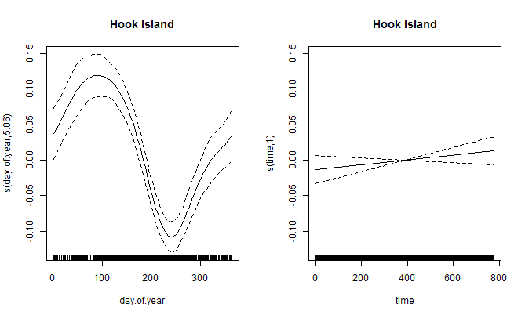

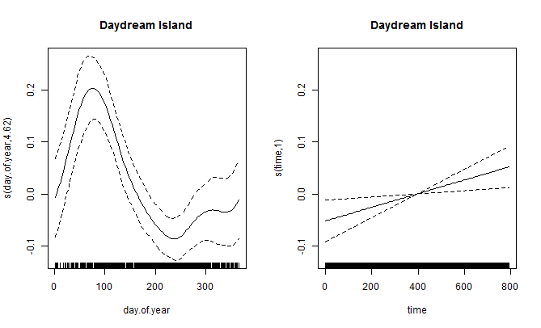
Figure C- 18: Seasonal trends and long term trends for the remote sensing data Hook Island (top) and Daydream Island (bottom).

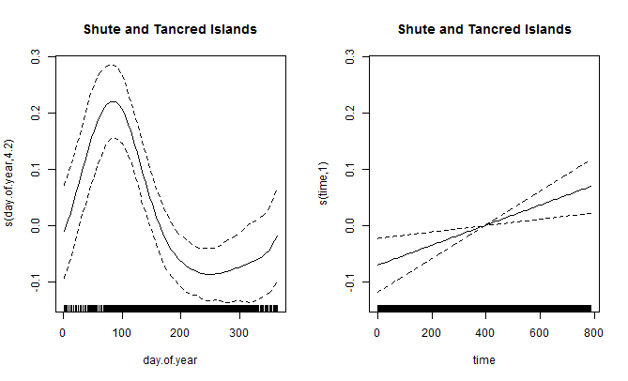

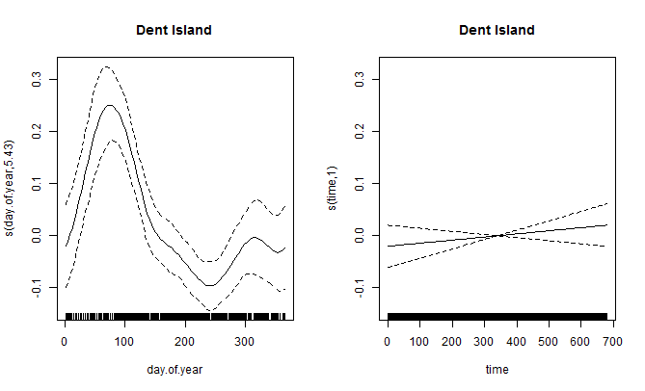
Figure C- 19: Seasonal trends and long term trends for the remote sensing data Shute and Tancred Islands (top) and Dent Island (bottom).

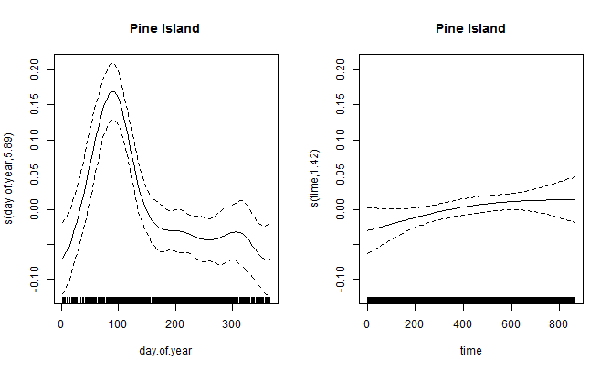

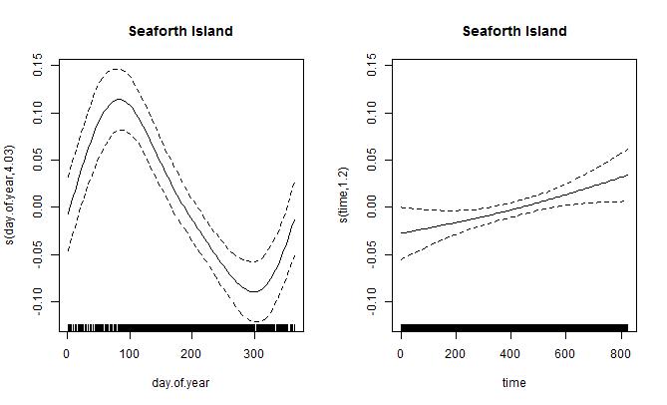
Figure C- 20: Seasonal trends and long term trends for the remote sensing data Pine Island (top) and Seaforth Island (bottom).

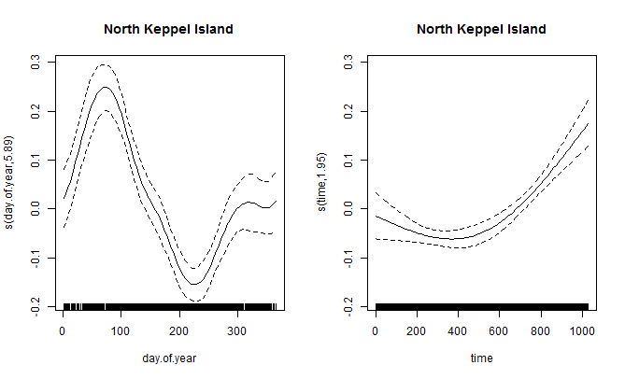

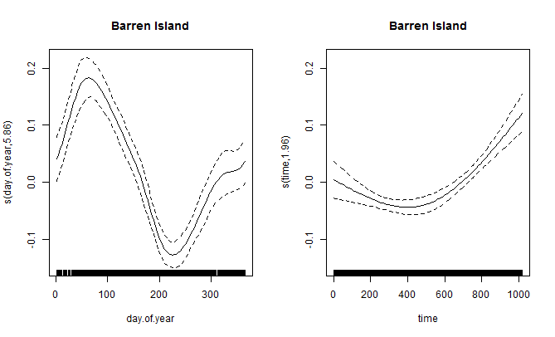
Figure C- 21: Seasonal trends and long term trends for the remote sensing data North Keppel Island (top) and Barren Island (bottom).

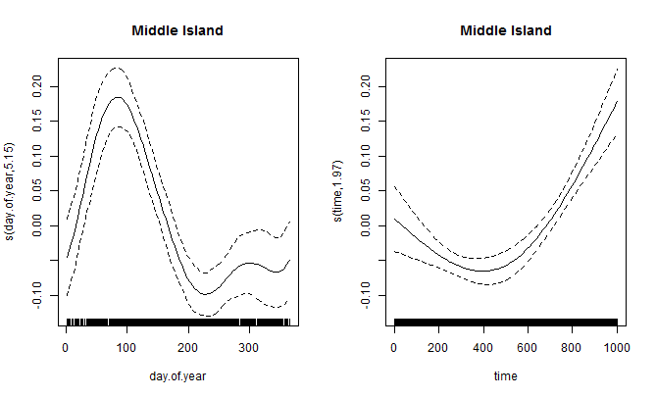

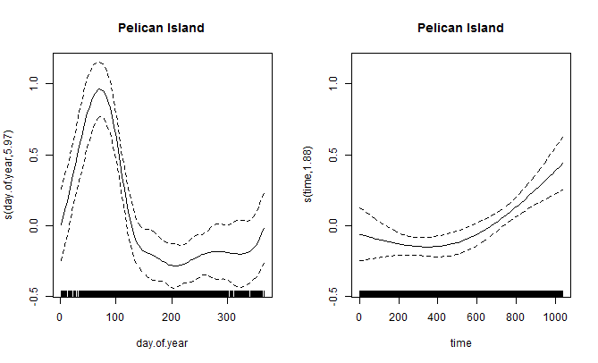
Figure C- 22: Seasonal trends and long term trends for the remote sensing data Middle Island (top) and Pelican Island (bottom).

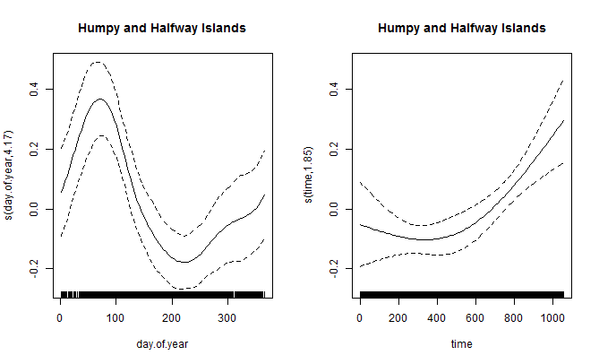

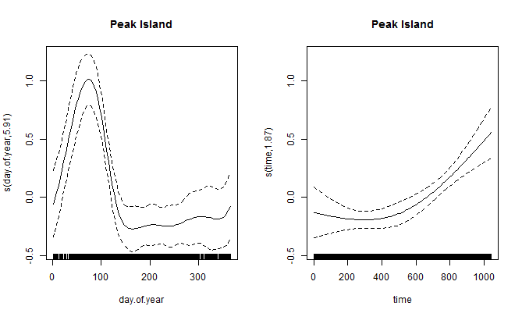
Figure C- 23: Seasonal trends and long term trends for the remote sensing data Humpy and Halfway Islands (top) and Peak Island (bottom).

- TSS

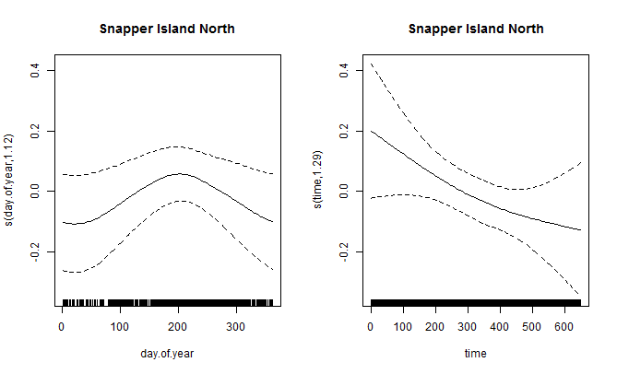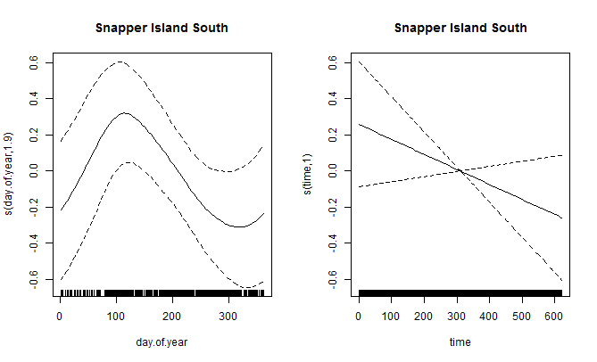

Figure C- 24: Seasonal trends and long term trends for the remote sensing data at Snapper Island North (top) and Snapper Island South (bottom).

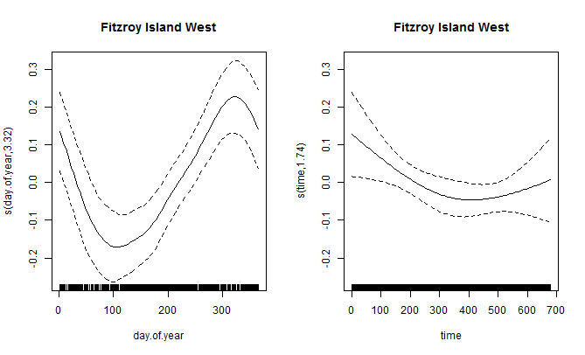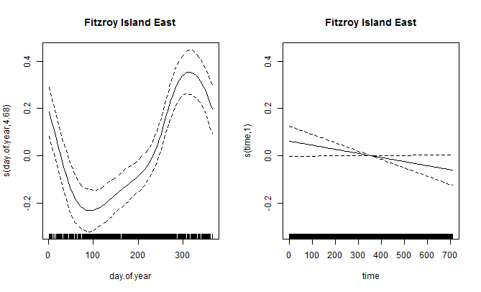

Figure C- 25: Seasonal trends and long term trends for the remote sensing data at Fitzroy Island West (top) and Fitzroy Island East (bottom).
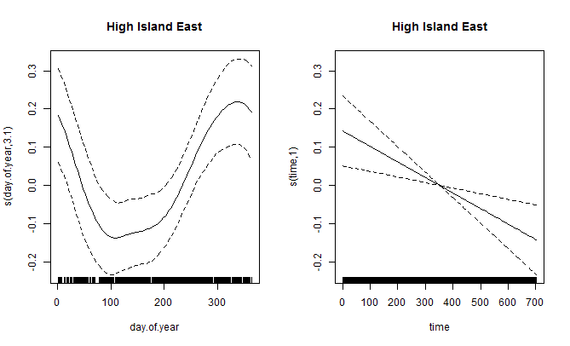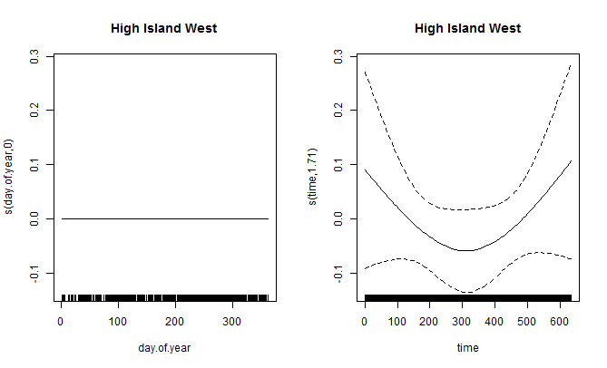

Figure C- 26: Seasonal trends and long term trends for the remote sensing data at High Island East (top) and High Island West (bottom).
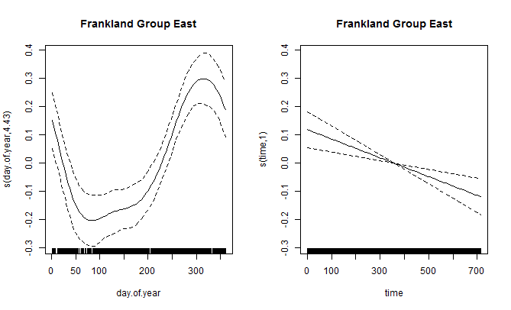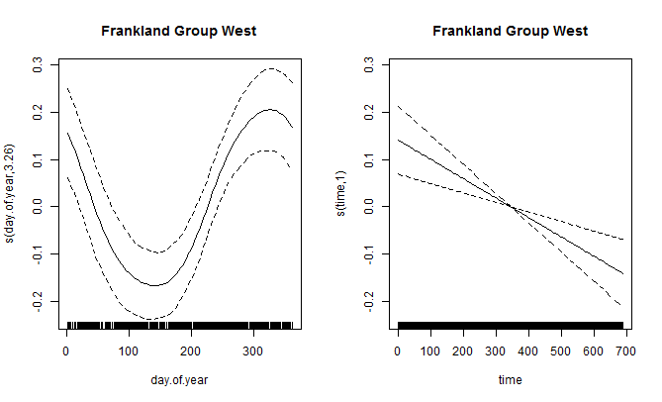

Figure C- 27: Seasonal trends and long term trends for the remote sensing data at Frankland Group East (top) and Frankland Group West (bottom).
Figure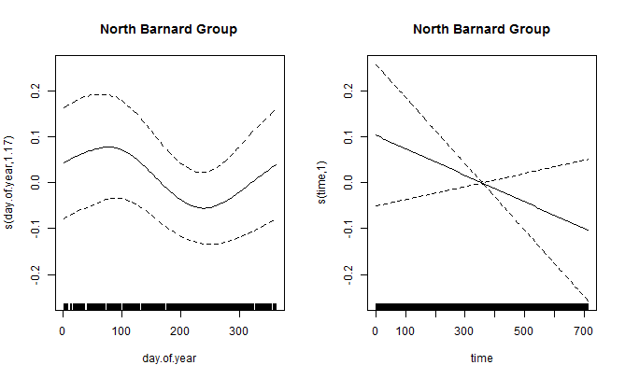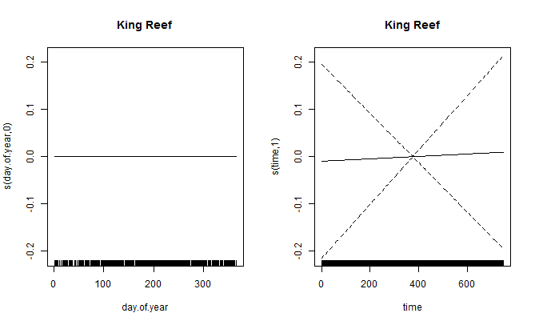

Figure C- 28: Seasonal trends and long term trends for the remote sensing data at North Barnard Group (top) and King Reef (bottom).
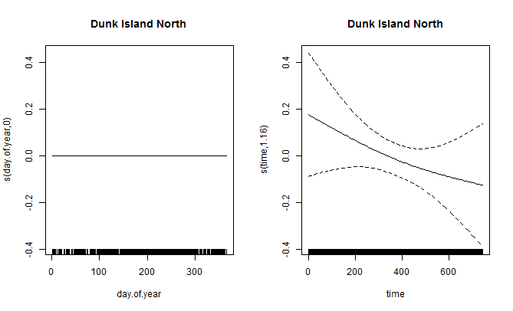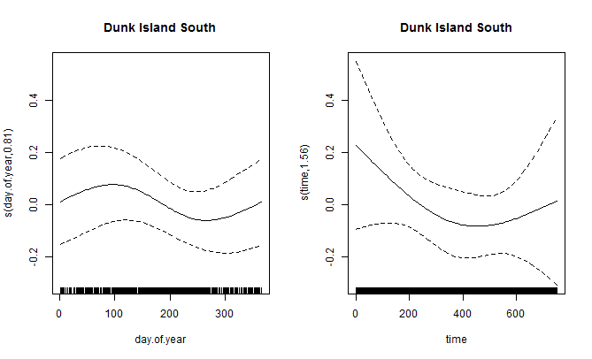

Figure C- 29: Seasonal trends and long term trends for the remote sensing data at Dunk Island North (top) and Dunk Island South (bottom).
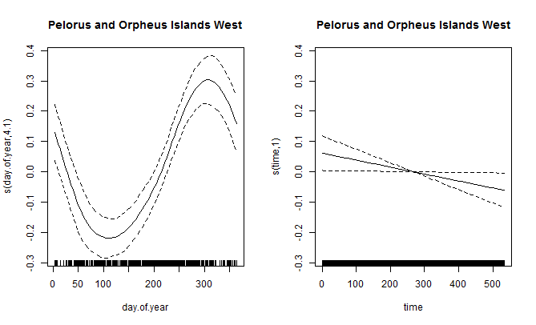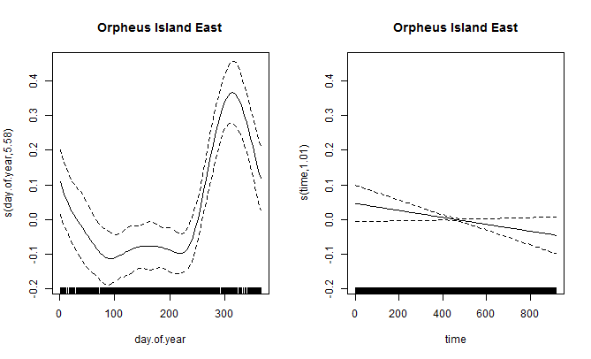

Figure C- 30: Seasonal trends and long term trends for the remote sensing data at Pelorus and Orpheus Islands West (top) and Orpheus Island East (bottom).
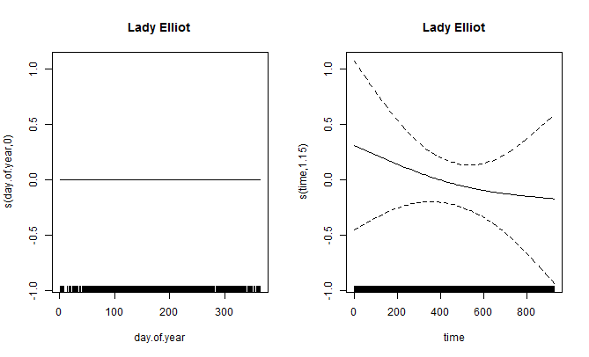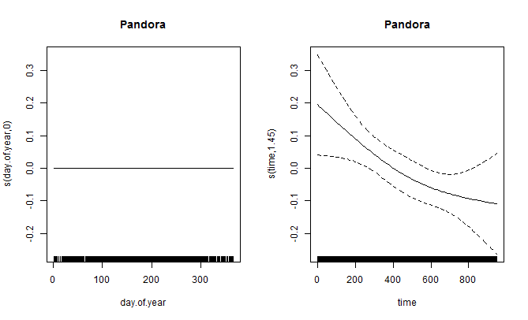

Figure C- 31: Seasonal trends and long term trends for the remote sensing data at Lady Elliot (top) and Pandora (bottom).
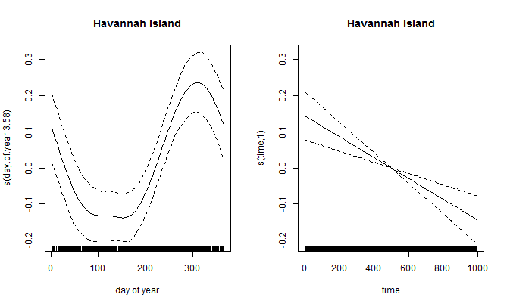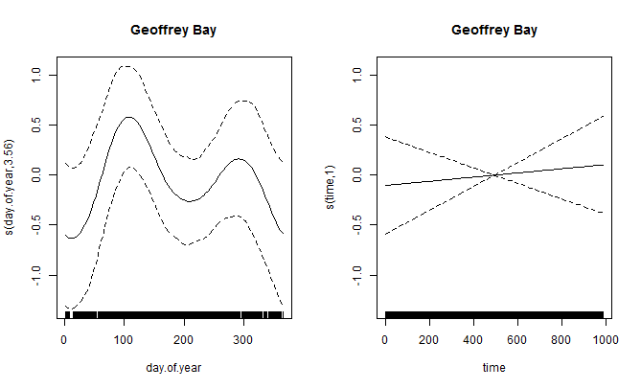

Figure C- 32: Seasonal trends and long term trends for the remote sensing data at Havannah Island (top) and Geoffrey Bay (bottom).
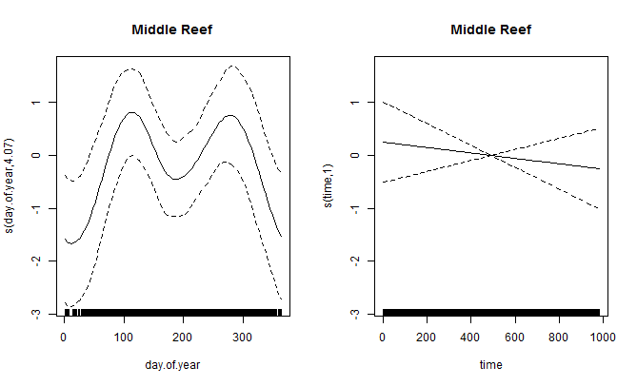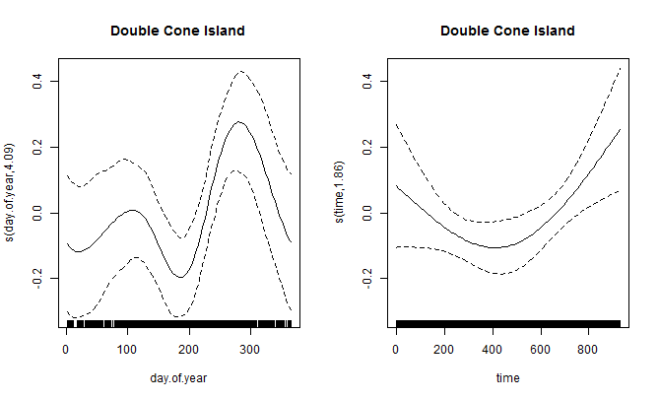

Figure C- 33: Seasonal trends and long term trends for the remote sensing data at Middle Reef (top) and Double Cone Island (bottom).
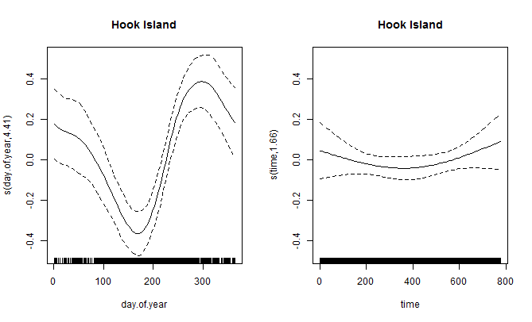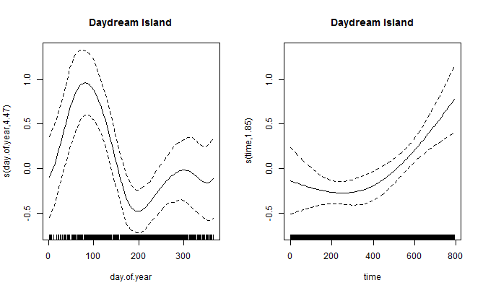

Figure C- 34: Seasonal trends and long term trends for the remote sensing data at Hook Island (top) and Daydream Island (bottom).
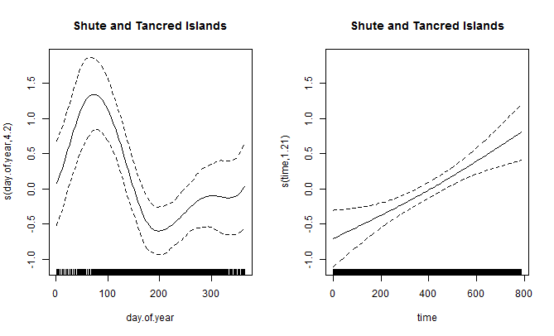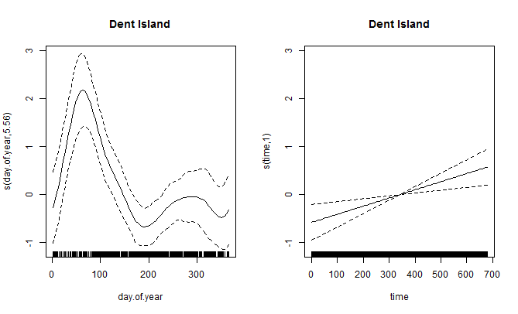

Figure C- 35: Seasonal trends and long term trends for the remote sensing data at Shute and Tancred Islands (top) and Dent Island (bottom).
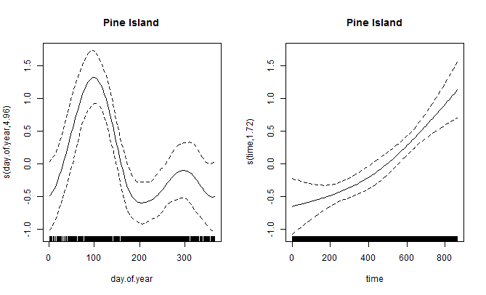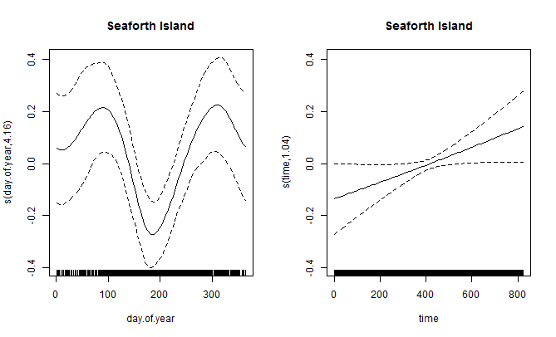

Figure C- 36: Seasonal trends and long term trends for the remote sensing data at Pine Island (top) and Seaforth Island (bottom).
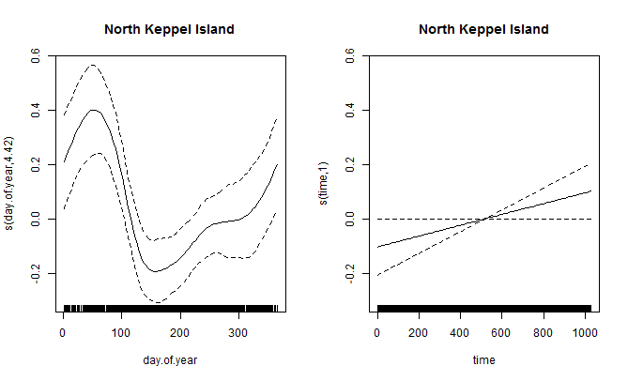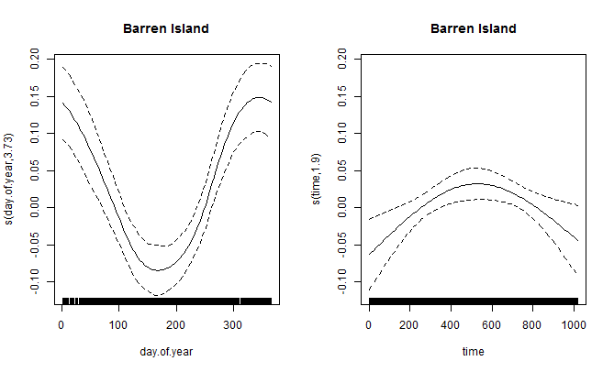

Figure C- 37: Seasonal trends and long term trends for the remote sensing data at North Keppel Island (top) and Barren Island (bottom).
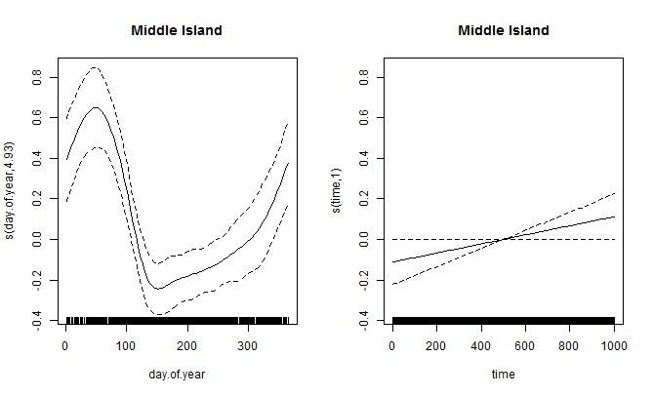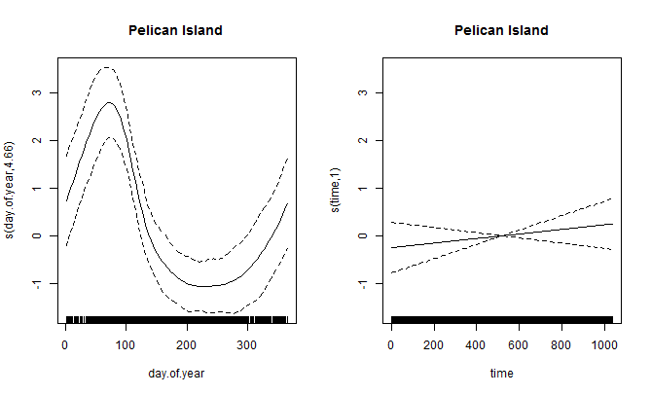

Figure C- 38: Seasonal trends and long term trends for the remote sensing data at Middle Island (top) and Pelican Island (bottom).
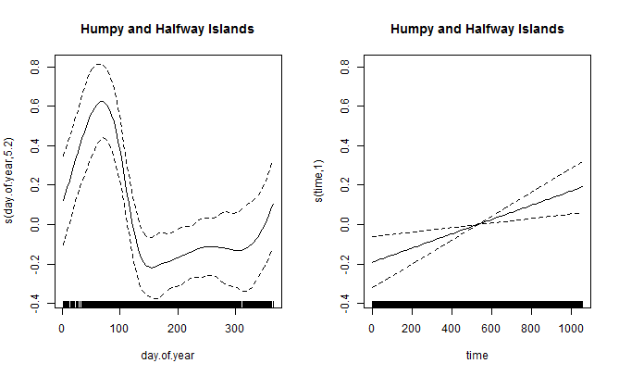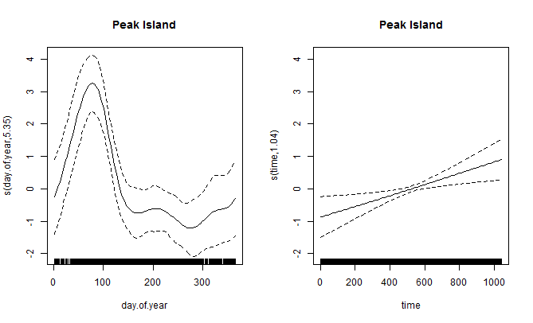
Figure C- 39: Seasonal trends and long term trends for the remote sensing data at Humpy and Halfway Islands (top) and Peak Island (bottom).

Trends in Pesticides

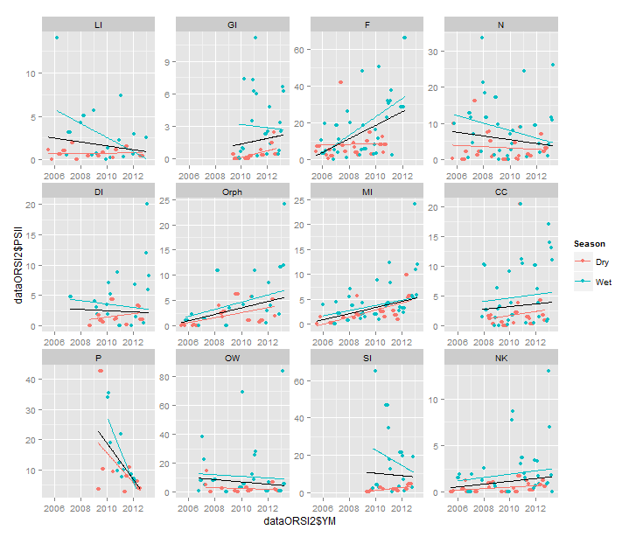
Figure D 1: Trend lines fitted to dry (red) and wet (blue) season PSII data with an overall trend (black) fitted. Outliers were removed from the Orpheus and Sarina Inlet datasets.

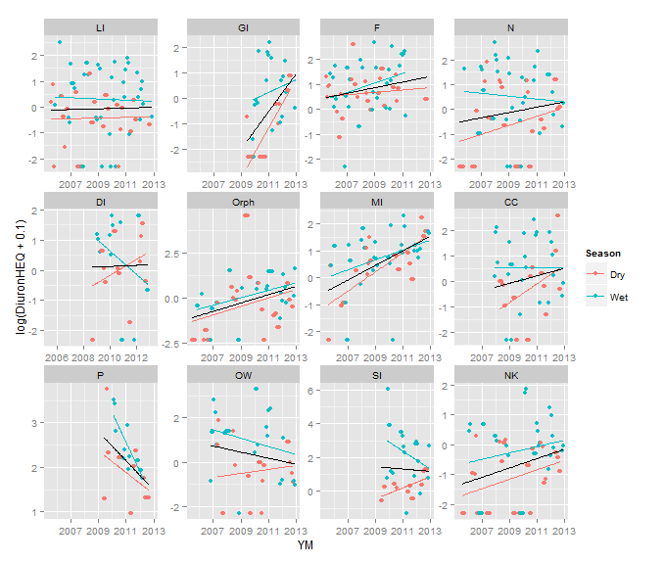
Figure D 2: Trend lines fitted to dry (red) and wet (blue) season Diuron data with an overall trend (black) fitted. Outliers were removed from the Orpheus and Sarina Inlet datasets.

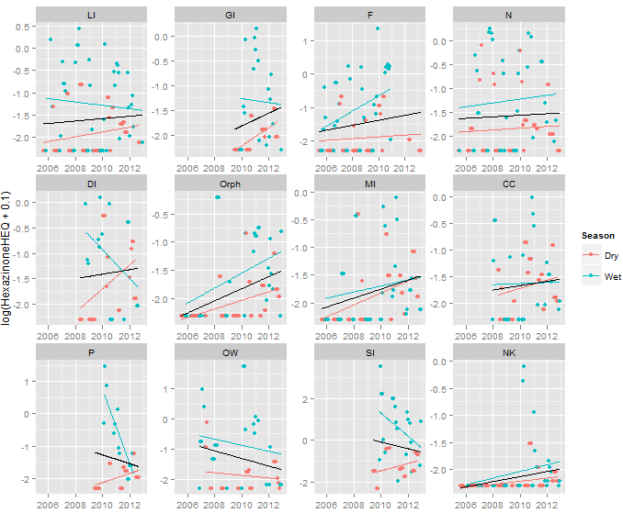
Figure D 3: Trend lines fitted to dry (red) and wet (blue) season Hexazinone data with an overall trend (black) fitted. Outliers were removed from the Orpheus and Sarina Inlet datasets.

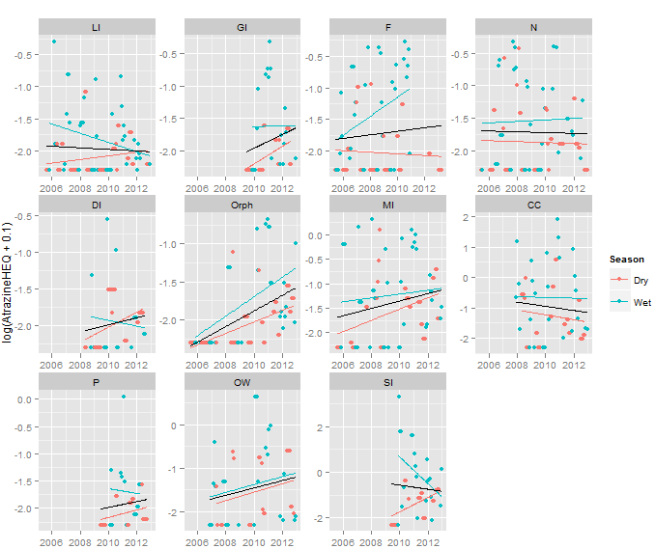
Figure D 4: Trend lines fitted to dry (red) and wet (blue) season Atrazine data with an overall trend (black) fitted. Outliers were removed from the Orpheus and Sarina Inlet datasets.

CONTACT US  t 1300 363 400  +61 3 9545 2176  e enquiries@csiro.au  w www.csiro.au  Your CSIRO  Australia is founding its future on science and innovation. Its national science agency, CSIRO, is a powerhouse of ideas, technologies and skills for building prosperity, growth, health and sustainability. It serves governments, industries, business and communities across the nation. |  | For further information  Digital Productivity  Petra Kuhnert  t +61 8 8303 8775 4567  e petra.kuhnert@csiro.au  w www.csiro.au/businessunit-flagshipname  Digital Productivity  Brent Henderson  t +61 2 6216 4567  e brent.henderson@csiro.au  w www.csiro.au/businessunit-flagshipname

