Great Barrier Reef Marine Park Authority annual report 2015–16
© Commonwealth of Australia (Great Barrier Reef Marine Park Authority) 2016
Published by the Great Barrier Reef Marine Park Authority
ISSN 0155-8072
The Great Barrier Reef Marine Park Authority Annual Report 2015–16 is licensed by the Commonwealth of Australia for use under a Creative Commons By Attribution 4.0 International licence with the exception of the Coat of Arms of the Commonwealth of Australia, the logo of the Great Barrier Reef Marine Park Authority, any other material protected by a trademark, content supplied by third parties and any photographs. For licence conditions see: http://creativecommons.org/licences/by/4.0

This report can be viewed from http://www.gbrmpa.gov.au/about-us/corporate-information/annual-report
Prepared by: Great Barrier Reef Marine Park Authority
Designed by: Aussie Web Solutions Pty Ltd
Printing standards
Printed on Impress Satin archival-quality paper, which meets the printing standards for documents presented to the Australian Parliament. This report has been printed using environmentally responsible print techniques and carbon neutral paper stock.
This publication should be cited as:
Great Barrier Reef Marine Park Authority 2016, Annual Report 2015–16, GBRMPA, Townsville.
Comments and questions regarding this document are welcome and should be addressed to:
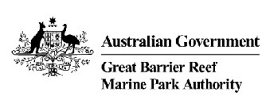
Great Barrier Reef Marine Park Authority
2–68 Flinders Street
(PO Box 1379)
Townsville QLD 4810, Australia
Phone: (07) 4750 0700
Fax: (07) 4772 6093
Email: info@gbrmpa.gov.au
www.gbrmpa.gov.au

Letter of transmittal
Great Barrier Reef Marine Park Authority
PO Box 1379
TOWNSVILLE QLD 4810
10 October 2016
The Hon. Josh Frydenberg MP
Minister for the Environment and Energy
PO Box 6022
House of Representatives
Parliament House
CANBERRA ACT 2600
Dear Minister
In accordance with subsection 53(1) of the Great Barrier Reef Marine Park Act 1975, I submit the annual report of the Great Barrier Reef Marine Park Authority for the year ended 30 June 2016.
The report has been prepared for the purposes of section 46 of the Public Governance, Performance and Accountability Act 2013, which requires that an annual report be given to the entity’s responsible Minister for presentation to the Parliament.
It has been prepared in accordance with the requirements for annual reports for departments, executive agencies and other non-corporate Commonwealth entities, as approved by the Joint Committee of Public Accounts and Audit under subsection 70(2) of the Public Service Act 1999.
This annual report has been prepared in line with the Resource Management Guide No. 135 — Annual reports for non-corporate Commonwealth entities, updated by the Department of Finance in July 2016. In accordance with Section 10 of the PGPA Rule 2014 (Fraud Rule) and the Commonwealth Fraud Control Policy (Fraud Policy), the agency has prepared fraud risk assessments and fraud control plans and has in place appropriate fraud prevention, detection, investigation, reporting and data collection processes and procedures. We have also taken all reasonable measures to minimise the incidence of fraud and to investigate and recover the proceeds of fraud against the agency.
Yours sincerely
Russell Reichelt
Chairman
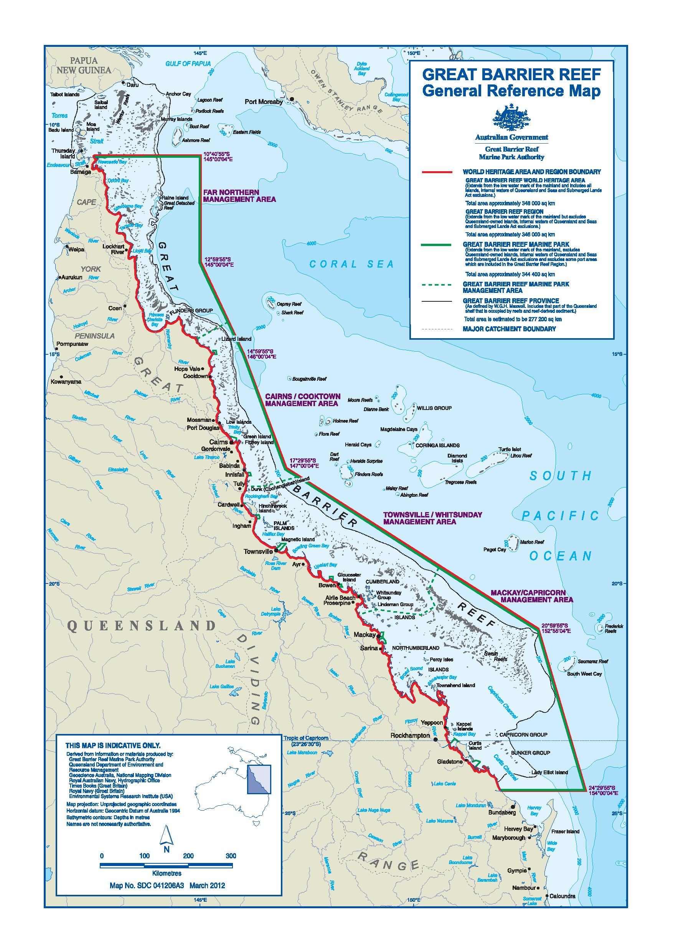
Figure 1: Map of the Great Barrier Reef Region
Contents
Letter of transmittal iii
Introduction 1
Chairman’s review 3
Overview 12
Organisational structure 14
Responsible Minister 14
Legislative framework 15
Finances overview 16
Staff overview 18
Performance 19
Introduction 19
Purpose 19
Results 21
Goal 1: Protect and restore the Reef’s biodiversity 21
1.1 Reef 2050 Integrated Monitoring and Reporting program 21
1.2 Marine Monitoring Program 24
1.3 Strategic management of dredge material 25
1.4 improving the permissions system 27
1.5 Marine debris 29
1.6 Eye on the Reef program 32
1.7 Crown-of-thorns starfish management program 33
1.8 Reef recovery 35
1.9 Reef health incidence response system 41
1.10 Indigenous partnerships 43
Goal 2: Safeguard the Reef’s heritage 48
2.1 Implementing the Reef 2050 Plan 48
2.2 Science coordination and engagement 50
2.3 Social and economic programs 51
2.4 Indigenous targets under the Reef 2050 Plan 52
2.5 Heritage strategy 53
2.6 Engagement with international agencies, organisations and forums 55
2.7 Commonwealth islands management 56
Goal 3: Ensure use of the Marine Park is ecologically sustainable and benefits current and future generations 58
3.1 Implementing the permission system 58
3.2 Management of defence activities 65
3.3 Field Management Program 66
3.4 Whitsundays Plan of Management review 86
3.5 Strategic engagement 87
3.6 Reef Guardian program 89
3.7 High Standard Tourism program 92
3.8 Tourism stewardship 95
3.9 Tourism management 96
3.10 Recreational fishing 99
3.11 Advisory committees 100
3.12 Reef HQ Great Barrier Reef Aquarium 103
3.13 Promote the values of the Reef 105
3.14 Regulatory reform 112
3.15 Policy reform 113
4 Management and accountability 115
4.1 Great Barrier Reef Marine Park Authority Board 115
4.2 Senior executive 118
4.3 Audit Committee 119
4.4 Risk management 122
4.5 Advisory committees 123
4.6 Strategic and operational plans 123
4.7 External scrutiny 125
4.8 Management of human resources 126
4.9 Assets management 129
4.10 Purchasing 130
5 Finances 132
Appendix A:Agency resource statement and resources for outcomes 175
Appendix B:Staffing overview 177
Appendix D:Freedom of information 180
Appendix E:Ecologically sustainable development and environmental performance 182
Appendix F:Papers and presentations by agency staff 187
Appendix G:Queensland Government financials 194
Acronyms 205
Glossary 206
List of requirements 207

Tables
Table 1: Comparison of permit decisions versus agreed targets in the Portfolio Budget Statement 1.1 59
Table 2: Alleged permission non-compliances reported to the Great Barrier Reef Marine Park Authority, 2015–16 61
Table 3: Actions taken to resolve reported permission non-compliances, 2015–16 62
Table 4: Part 5 activities notified or directions granted, 2015–16 62
Table 5: Commonwealth offences reported in the Great Barrier Reef Marine Park, by management area, 2015–16 74
Table 6: Assessments and compliance actions (not prosecutions), by management area, 2015–16 80
Table 7: Court actions, by management area, 2015–16 82
Table 8: Relevance of community and stakeholder engagement activities to Annual Operating Plan projects, 2015–16 88
Table 9: Meetings of the Great Barrier Reef Marine Park Authority Board, 2015–16 118
Table 10: Meetings of the Great Barrier Reef Marine Park Authority Audit Committee, 2015–16 120
Table 11: Great Barrier Reef Marine Park Authority resource statement 2015–16 175
Table 12: Expenses and resources for outcome 1 176
Table 13: Employee overview, as at 30 June 2016 177
Table 14: Workplace diversity figures, as at 30 June 2016 178
Table15: Media advertising organisations used in 2015–16 179
Figures
Figure 1: Map of the Great Barrier Reef Region iv
Figure 2: Organisational structure as at 30 June 2016 14
Figure 3: Revenue by source 2015–16 17
Figure 4: Expenses by category 2015–16 17
Figure 5: Overview of Reef 2050 Plan actions and reporting leads, by theme 48
Figure 6: Governance arrangements for the Reef 2050 Plan 49
Figure 7: Type and number of current permissions managed by the Great Barrier Reef Marine Park Authority, as at 30 June 2016 60
Figure 8: Administrative actions taken for environmental management charge non-compliance, 2011–12 to 2015–16 63
Figure 9: Number of possible Commonwealth offences reported to the joint Field Management Program, 2006–07 to 2015–16 74
Figure 10: Information reports received each year, 2006–07 to 2015–16 79
Figure 11: Prosecutions following compliance actions, 2012–13 to 2015–16 81
Figure 12: Illegal recreational fishing incidents in Marine National Park Zones 83
Figure 13: Percentage of visits* to the Great Barrier Reef Marine Park undertaken on high standard tourism operations 94
Figure 14: Tourist visits* to the Great Barrier Reef Marine Park since 2005–06. This includes full-day and part-day visitors, and passengers exempt from the environmental management charge. 98
Figure 15: The agency’s website and social media statistics for 2015–16 110
Figure 16: Strategic planning process 124

Case studies
Case study 1: Monitoring for the future 23
Case study 2: Don’t let your litter bug our Reef 31
Case study 3: Marine park zoning is helping to protect the Reef 39
Case study 4: Summer of coral bleaching 42
Case study 5: Australia’s eighth Traditional Use of Marine Resources Agreement 46
Case study 6: Multi-agency response to an oil spill 68
Case study 7: Award-winning collaboration key to Reef management 71
Case study 8: Celebrating 40 years of managing the Great Barrier Reef 106

Introduction
In this annual report
The Great Barrier Reef Marine Park Authority’s Annual Report 2015–16 complies with the requirements for annual reports outlined by the Department of Finance in its Resource Management Guide No. 135: Annual reports for non-corporate Commonwealth entities. It includes the agency’s annual performance statement, detailing its performance against criteria as published in both the agency’s Corporate Plan 2015–2020 and the Portfolio Budget Statement for 2015–16.
Following the introduction and Chairman’s review, the annual report comprises six chapters:
Overview
Performance
Management and accountability
Finances
Appendices
Acronyms and index.
The Overview provides corporate background to the agency including its role and functions. It also provides a summary of financial performance and a staff overview.
The Performance chapter details the actions taken by the agency in 2015–16 to meet its stated outcome of the long-term protection, ecologically sustainable use, understanding and enjoyment of the Great Barrier Reef for all Australians and the international community, through the care and development of the Marine Park.
This chapter is presented in three parts under the agency’s three objectives, as outlined in the agency’s Portfolio Budget Statement. It details how the agency has met the deliverables and key performance indicators that relate to the objectives (referred to as goals).
The first part addresses Goal 1: Protect and restore the Reef’s biodiversity.
The second part addresses Goal 2: Safeguard the Reef’s heritage.
The third part addresses Goal 3: Ensure use of the Marine Park is ecologically sustainable and benefits current and future generations.
The Management and accountability chapter covers the delivery of the management framework that supports effective functioning of the agency. This includes corporate governance, statutory and advisory committees, management and training, work health and safety, asset management, corporate services and management of consultants.
The Finances chapter delivers an analysis of financial performance and a detailed financial statement.
The Appendices comprise the agency resource statement, a staffing overview, information on advertising and marketing, freedom of information, ecologically sustainable development and environmental performance, a list of staff papers and presentations, and Queensland Government financials.
The Acronyms and index comprise a list of acronyms, a glossary, the list of requirements and an alphabetical index.

Chairman’s review
The Great Barrier Reef Marine Park Authority celebrated its 40th anniversary during 2015–16 and welcomed the World Heritage Committee’s decision not to list the Great Barrier Reef as World Heritage in Danger.
Both were important milestones, recognising and endorsing the efforts of our organisation, governments, industries and communities who work tirelessly to protect the Reef.
In delivering the world heritage decision — and in an unprecedented show of support — many countries spoke strongly of a deep desire to protect the Reef and praised Australia’s efforts and innovation in the field of coral reef management.
It was heartening to hear the international community’s support, confirming the Great Barrier Reef is both an Australian icon and a much-loved natural area throughout the world.
Forty years of management
Since the agency’s establishment under the Great Barrier Reef Marine Park Act 1975, our objective has been the long-term protection of the Reef.
We assess risks to the Reef, work with partners and research providers, and educate the community about the Reef’s natural beauty and the actions needed to protect it. We take our role in protecting the Reef very seriously.
Since our inception, there has been a shift in understanding of the key pressures affecting the Reef. We now have a more comprehensive risk management approach, which assesses not only pressures from direct use, but also pressures, such as climate change, coming from outside our jurisdiction. Effective Reef management requires increased research and education, and continuous innovation in our current systems of management.
A reliable constant over 40 years of Reef management has been the strong desire by all Australians and the international community to ensure this precious marine area is protected for future generations.
The Great Barrier Reef is one of the world’s most iconic natural areas. Locally, it is known as ‘the Reef’. At 344,400 square kilometres, the Great Barrier Reef Marine Park is bigger than Italy, spans 2300 kilometres of coastline and contains 3000 reefs connected in a massive coral reef ecosystem. The Reef includes iconic species such as whales, turtles and dugongs, and diverse plants and habitats that sustain this unique profusion of life.
With more than two million tourists each year — and over a million Australians living along the Reef’s coastline — the Reef is part of Australia’s identity and vital for communities and industries.
Priority actions to protect the Reef
With accumulating pressures clearly affecting the Reef now, there is no room for business as usual. Better management systems are vital to lower the risks and build the resilience of the Reef ecosystem.
We are striving for tangible outcomes for the Reef over the short, medium and longer term and across the three key pillars of our work — knowledge, regulation, stewardship — all of which are essential elements of Reef protection.
The key is to ‘plan long term, but act now’ and be adaptable to changing circumstances.
Our short-term focus is sustaining day-to-day on-ground management, which is critical to maintaining Reef resilience. Our ‘here and now’ actions are delivering immediate benefits. Examples include intelligence-based ranger patrols to reduce risks from accidental damage by boating and shipping, preventing damage through lack of compliance with our protected area rules, and partnering with the tourism industry to control the highly destructive crown-of-thorns starfish — a natural predator, which has increased to unnatural levels through human-caused changes to its environment.
Spatial management tools are delivering benefits to Reef health over the medium term. For example, research indicates that our Zoning Plan is making a positive difference to biodiversity 12 years after it came into effect. There are now more and bigger fish being found in protected zones, which produces a spill-over effect of fish from no-take areas (33.4 per cent of the Marine Park) into areas of the park that are open to fishing.
Our Marine Park plans of management set special protection measures in very popular, high-use areas — notably the regions around Cairns and the Whitsundays. Measures include limits to the number of commercial vessels in some areas and installation of marker buoys to show where anchoring is permitted and where anchoring is prohibited to protect coral. These plans help to manage risks of overuse, protect vulnerable species and prevent these areas being ‘loved to death’.
We are developing policies to halt and reverse ecosystem decline by enabling environmental decisions to include assessment of the impacts of cumulative pressures affecting the Reef. We are also embedding the principle of net benefit to the ecosystem in our decision-making to foster actions that deliver an overall improvement in the Reef’s condition.
To ensure a healthy Reef in the long term, we must support programs to reduce greenhouse gas emissions and encourage everyone to reduce their carbon footprint. These practices will help build Reef resilience in the face of rising pressures from climate change. These efforts are detailed in our climate change action plans, which began in 2007.
Overarching framework — Reef 2050 Plan
The Reef 2050 Long-term Sustainability Plan (Reef 2050 Plan), endorsed by the Australian and Queensland governments, brings together government and non-government sectors in a framework to implement and improve protection measures for the Great Barrier Reef.
Submitted to the UNESCO World Heritage Centre in March 2015, the plan was considered at the 39th session of the World Heritage Committee in June–July 2015.
It draws on information in the Great Barrier Reef Marine Park Authority’s Outlook Report 2014 and the strategic assessment of the same year, and was developed collaboratively by government, industries and communities, with input from public consultation.
The Reef 2050 Plan sets out the important foundation programs that must be sustained and augmented with additional actions to achieve the outcomes and targets described for seven themes — ecosystem health, biodiversity, heritage, water quality, community benefits, economic benefits and governance.
The Marine Park Authority is implementing many of the foundation programs and more than half of the actions in the plan. This includes working with the Queensland Government to develop and implement the Reef 2050 Integrated Monitoring and Reporting Program, which received $8 million in establishment funding through the Australian Government’s Reef Trust in 2015–16.
This monitoring program is central to assessing the effectiveness of the Reef 2050 Plan. It covers all aspects of the Reef’s environment, including its biophysical attributes, heritage, social, economic and cultural values. The Marine Park Authority is leading the marine component of the program while the Queensland Government will focus on the catchment.
This is the first time Reef monitoring and reporting has been considered in an integrated, region-wide way — crucial to informing management across the Reef and its catchment. It will provide a sound basis for reporting on the health of the Reef and the progress towards achieving the goals of the Reef 2050 Plan over the long term.
Coral bleaching
The 2015–16 reporting period was one of the most challenging years for the health of the Great Barrier Reef, with the most severe mass coral bleaching on record.
Bleaching occurs when corals are stressed, in this case from high water temperatures over a prolonged period of time. If these above-average temperatures last only a few months the bleached corals can survive and regain their colour a month or two after temperatures fall to normal. If the hot conditions last more than a few months the corals may die. If coral mortality occurs, recovery of reefs is possible, but only as a result of reproduction and growth of young coral which may take decades.
According to the Bureau of Meteorology, the Reef recorded its highest average sea surface temperatures for February to June 2016 since records began in 1900.
Over summer, we worked with research partners — particularly the Queensland Parks and Wildlife Service, the Australian Institute of Marine Science, James Cook University, the Reef and Rainforest Research Centre and the tourism industry — to survey the extent and severity of bleaching. This included some 2600 reef health and impact surveys of 186 reefs throughout the Marine Park.
This work was our largest-ever series of surveys — our Eye on the Reef program provided the tools needed to quantify the extent of bleaching and mortality. During the bleaching event, the agency’s incident response system was put into action and worked well to bring the surveys and reporting into a single framework.
We found more than 22 per cent of coral died as a result of the bleaching event. Eighty-five per cent of this mortality occurred in the 600 kilometre stretch between the tip of Cape York and just north of Lizard Island. Overall, the area south of Cairns escaped significant coral mortality. It was clear in the reported results that bleaching impacts were highly variable from reef to reef — even in the highly affected areas. In the far north, the impacts were greater in the coastal areas and less severe in the far offshore areas.
These in-water surveys will resume in October 2016 to assess recovery rates of live bleached corals.
This mass bleaching was a strong reminder of how external pressures can impact the Great Barrier Reef and of the importance of doing all we can to support the Reef’s resilience. The agency kept communities and the tourism industry fully informed of the latest developments through public forums and through the Marine Tourism Incident Response Group.
After the bleaching event, our teams worked with local communities and more widely with industries that depend on the Reef for their livelihoods, like tourism, to support local reef recovery. This work included supporting local community initiatives that encouraged fishers and spearfishers not to take plant-eating fish. These fish play an important role in controlling algae which, if too plentiful, may compete with recovering corals.
Pro-vision Reef, the peak body for the marine aquarium collection fishery in Queensland has, under the terms of its Stewardship Action Plan, voluntarily agreed not to collect in areas north of Cairns that were affected by severe coral bleaching.
Protecting habitats
The Marine Park Authority is focused on the long-term protection of the Reef, and we work daily to reduce other incremental changes and accumulating impacts on the Reef.
Last year, the disposal of spoil from capital dredging works (such as building new shipping channels) was prohibited in the Marine Park. This year, in response to unprecedented coral bleaching, the agency’s Board approved an additional policy to protect coral reef habitats from dredging — that is, avoiding direct impacts when considering new marine infrastructure or the expansion of existing marine infrastructure. These new policies are actions under the Reef 2050 Plan to reduce the impacts of ports and dredging.
Work is also progressing on a major project to strengthen permissions compliance which will have a long-term positive effect on Marine Park values.
Field management
The agency works closely with the Queensland Government work to manage the vast Great Barrier Reef World Heritage Area, totalling almost 350,000 square kilometres. This cooperation, authorised by a Ministerial Agreement dating from 1979, has proven to be very effective.
Under this agreement, the agency and the Queensland Parks and Wildlife Service operate a joint Field Management Program for the Great Barrier Reef Marine Park and Great Barrier Reef Coast Marine Park. The program reports annually to the Great Barrier Reef Ministerial Forum on its progress. It is subject to a review every five years.
This year, the collaboration under this program was recognised with a 2015 Prime Minister’s Award for Excellence in Public Sector Management. The field management team also received a silver award and the collaboration award from the Institute of Public Administration Australia.
The joint Field Management Program operates in the Marine Park around the clock, and staff strive to improve in all areas across their range of responsibilities — education, monitoring and enforcement.
An exciting new development in reef management is the use of modern ‘eyes in the sky’.
As part of their work to protect turtles at the remote Raine Island, unmanned aerial vehicles (drones) were trialled for counting seabirds and green turtles and to map the island. Cooperation between field management staff and the Great Barrier Reef Foundation on this project has proven valuable.
Preliminary results found the drones were highly effective in mapping the island at a very high resolution and did not disrupt animals. Further trials will occur in the coming year to test drones under different conditions. This technology is likely to become a common tool for the program, as it allows staff to undertake activities more efficiently and to expand their capability.
Field teams responded to a 10–15 tonne fuel oil spill near Cape Upstart in July 2015. This saw around 500 hours of staff time, and a multi-agency response, to clean up oil washed ashore on Hinchinbrook Island, the Palm Island Group and the mainland.
During the reporting period, 1240 possible offences were reported within the World Heritage Area through the joint Field Management Program and its partners such as Maritime Border Command, the Queensland Parks and Wildlife Service, and Queensland Boating and Fisheries Patrol. Of these, 46 per cent were dealt with through compliance actions such as advisory letters, caution notices and warning notices. More serious matters were dealt with through infringement notices or court action.
There were 971 reported Commonwealth offences in the Great Barrier Reef Marine Park. This is the highest number of possible offences since the creation of the Marine Park, pressing the need to step-up education about zoning rules and deterrence.
For the first time, the agency issued an enforceable direction — barring a twice-convicted commercial fisher from anchoring in a green zone to prevent further illegal fishing by this person.
The reporting period was also the first full year in which on-the-spot warnings, known as Commonwealth caution notices, were issued. This system was introduced to empower inspectors so they could warn fishers about low-risk alleged non-compliant behaviour at the point of detection — thereby reducing the double-handling of information.
Permissions system
We are working to improve the permission system for commercial operators — both to streamline the administrative process for users and maintain high environmental standards.
This large undertaking is taking place between 2015 and 2020 and has involved the revision of key policies and guidelines. It will also result in new guidance material and updates to our Environmental Impact Management Policy to make the basis for decisions clearer to permit applicants and the public.
The improved permission system will also ensure better integration with processes relating to the Environment Protection and Biodiversity Conservation Act 1999 (EPBC Act) and address Australian National Audit Office recommendations to improve transparency and consistency in decision-making. During the first round of public consultation we received valuable feedback that was used to inform our work to improve the system. Further consultation will occur next financial year.
Day-to-day work in managing permits also continued — at the end of the reporting period, the agency was managing 5856 permissions. Most of the permissions granted this year were for tourist programs, charter vessel and aircraft, research, moorings and facilities.
Traditional Owners
We work closely with Traditional Owner groups, the traditional custodians of the Great Barrier Reef for more than 60,000 years, particularly through Traditional Use of Marine Resources Agreements.
These agreements outline how we work with Traditional Owners to manage sea country, and cover almost one quarter of the Marine Park area. This year we saw the addition of the newest agreement, with Gunggandji Traditional Owners.
In 2015–16, the agency developed seven three-year contracts with Traditional Use of Marine Resources Agreement groups to support the development and implementation of sea country priorities, such as setting sustainable limits on the take of dugong and turtle, and reducing the negative effects on the condition of these two key species.
Traditional Owners also participate in training, knowledge sharing, and compliance. This includes the successful Indigenous Ranger Compliance Enhancement program, which is increasing the number of people detecting and reporting illegal activities.
By working with Traditional Owners, we are strengthening the protection and restoration of the Reef’s biodiversity, recognising that their culture cannot be separated from the environment.
Marine debris
With support from the Australian Government’s Reef Trust, we ran a two-year $700,000 project to minimise the source and occurrence of marine debris.
We partnered with Tangaroa Blue Foundation and Eco Barge Clean Seas to undertake on-ground clean-ups that removed about 30 tonnes of marine debris (comprising more than 300,000 pieces) from coastal and island habitats, and developed education materials.
More than 4000 people have taken part in clean-ups and marine debris information activities, showing how coastal communities care about their local environment and, importantly, stopping this debris from entering the ocean.
Crown-of-thorns starfish
We continued efforts to protect coral cover at key tourism and high value conservation sites by culling the coral-eating crown-of-thorns starfish. This is another activity that forms part of our day-to-day work to reduce cumulative impacts and boost Reef resilience.
With funding from the Australian Government’s Reef Trust, we worked with the Reef and Rainforest Research Centre and the Association of Marine Park Tourism Operators to successfully protect coral cover at 21 high value tourism and ecologically important reefs, making up an area of more than 900 square kilometres.
Data from our agency, the Association of Marine Park Tourism Operators and the Australian Institute of Marine Science’s Long-term Monitoring Program indicated the control program was effective. More than 75 per cent of the region’s reefs where crown-of-thorns control work took place had more than 25 per cent coral cover. Only one reef was at 10 per cent coral cover.
We aim to maintain minimum average coral cover well above 10 per cent, which has been identified as a critical ‘resilience’ threshold, below which coral may not recover.
Protecting heritage
Indigenous, cultural, historic and built heritage is a key part of the Great Barrier Reef’s values and protecting heritage is an important focus for our work.
The agency is developing cultural protocols to guide management of Indigenous heritage, and is partnering with Traditional Owners to determine how to store, handle and manage Indigenous knowledge appropriately.
In conjunction with the Queensland Department of Environment and Heritage Protection, we developed conservation management plans for six key historic shipwrecks to identify and document heritage values and protect these sites.
International engagement
Marine protected area management practitioners and policy makers continue to show a strong interest in the Reef and our management.
This year, we welcomed and assisted 17 international delegations from around the world, including Norway, Jamaica, Korea, the Philippines, Japan, Germany, Indonesia and India.
Staff also participated in international conferences and events, providing invaluable opportunities to share knowledge and best practices in response to the impacts of climate change, particularly among coral reef protected area managers around the world.
Working together
Working with local communities in the Great Barrier Reef catchment is an important part of our work. We seek input on Reef-wide management and local issues through our 12 Local Marine Advisory Committees between Cooktown and Bundaberg.
Our network of Reef Guardians — schools, councils, farmers, graziers, fishers — is engaged in encouraging positive environmental work along the entire Reef catchment.
This year, the Reef Guardian Farmers and Graziers program refocused on building leadership and influencing communities. Two workshops were held with 30 participants to build their leadership skills and to help them foster stewardship in their communities or sectors.
Managing use
The agency continued its review of the Whitsundays Plan of Management 1998, which complements Marine Park zoning by addressing issues specific to an area in greater detail.
A range of stakeholder consultation occurred this year. All proposed amendments to the plan were approved by the Marine Park Authority Board on 22 June 2016. The review will continue in 2016–17, with public consultation scheduled for early 2017.
Site management arrangements for Lady Musgrave Reef in the Capricorn Cays were also finalised.
Education and communication
We continue to place a strong focus on communication and education, recognising its importance in raising awareness about the Reef and the importance of protecting it.
Our 40th anniversary provided a springboard for a range of events throughout the year to mark the occasion, culminating with a community day in Townsville.
Our national education centre — Reef HQ Great Barrier Reef Aquarium — achieved a significant milestone this year by welcoming its four millionth visitor since it opened, almost 30 years ago. In total, the aquarium received 140,268 visitors this year.
The aquarium’s Reef videoconferencing program also continues to grow, providing virtual outreach to nearly every corner of the globe. This year, it delivered 53 Reef videoconferences to more than 2300 students around Australia and the world, including the United States, Mexico, Canada, Japan, China and Korea.
Our website continues to attract a high volume of visitors — more than 855,800 visits in the past 12 months, an 11.4 per cent increase from the previous year — and is complemented by six social media channels with more than 60,000 followers.
We post a variety of content online — from near-real time images of the Reef to information about our organisation, our work, our people and our partners — and we are delighted to reach and engage with our online community who care about the Reef.
Financial performance
The agency’s 2015–16 financial report shows that, as at 30 June 2016, the agency had an operating deficit of $2.562 million, including depreciation. This result was due to the cost of litigation, relating to the 2010 grounding of the 225 metre-long bulk carrier Shen Neng 1. The agency obtained approval from the Minister for Finance for an operating loss for this reporting period.
The year ahead
In the year ahead, we will continue implementing the Reef 2050 Plan and, importantly, further establish the monitoring and reporting program that will track its progress. This reporting program is vital to openly and accurately inform the national and international community and the World Heritage Committee on the plan’s progress.
In addition, we will seek to develop and release consultation policies and guidelines that support the revised direction for Reef management — those that consider cumulative impacts and net benefits.
Following the most serious coral bleaching to occur on the Reef, there will be a continued focus on monitoring and reporting Reef health as well as on building the resilience of this natural wonder.
Thank you
In presenting this annual report, I acknowledge and thank all our staff, executive management team and the Marine Park Authority Board for their efforts over the last year.
Their knowledge, dedication and ongoing support is central to our work in protecting this great natural icon. We are fortunate to have passionate staff with strong and diverse skills.
I also extend that same thanks to our management partners, Traditional Owners, scientists, researchers, Reef industries and communities who work with us towards a common goal.
The Great Barrier Reef belongs to us all. We all have a role in ensuring future generations can continue to explore, enjoy, and engage with this wonderful natural treasure.
Dr Russell Reichelt
Chairman

Overview
The Great Barrier Reef Marine Park Authority (the agency) is an Australian Government statutory authority within the Environment portfolio.
The agency is responsible for managing one of the world’s premier natural resources, the Great Barrier Reef Marine Park. The vision which drives its work is a healthy Great Barrier Reef for future generations.
The agency implements a range of policies and programs, management strategies and legislative measures to work towards the following mission (or purpose):
The long-term protection, ecologically sustainable use, understanding and enjoyment of the Great Barrier Reef for all Australians and the international community, through the care and development of the Marine Park.
Delivery of the mission is supported by four goals:
1. Protect and restore the Reef’s ecosystem health and biodiversity
2. Safeguard the Reef’s heritage values
3. Ensure ecologically sustainable use and benefits for current and future generations
4. Reduce cumulative impacts.
These goals drive the delivery of the program outlined in the agency’s Portfolio Budget Statement, improving the outlook for the Great Barrier Reef. This program contributes to the agency’s outcome through the implementation of actions that aim to protect, manage and restore the Great Barrier Reef’s ecosystem health, biodiversity and heritage values — ensuring use of the Marine Park is ecologically sustainable and benefits current and future generations.
To deliver the four goals, the agency uses a number of tools, including legislation, zoning plans, plans of management, permissions, policies and strategies, formal agreements and site management arrangements. Various management approaches are used, including education and awareness, planning, environmental impact assessment, monitoring, stewardship programs, habitat protection and restoration works, and compliance and enforcement.
Management is enhanced through partnership arrangements with Traditional Owners, the community, business, industry, scientists and government. The Field Management Program, a jointly funded program, is a cooperative partnership with the Queensland Government. It undertakes activities to support operational and routine day-to-day management in the Marine Park, the adjacent Queensland Government Great Barrier Reef Coast Marine Park and on national park islands.
The agency’s management program builds on the strong foundational arrangements already in place to protect biodiversity and heritage values and provide for ecologically sustainable use. The agency continues these arrangements and draws on the recommendations of the Strategic Assessment Program Report — it is committed to adopting a suite of measures to strengthen management and the resilience of the Great Barrier Reef ecosystem. The agency’s actions to protect and manage the Great Barrier Reef contribute to the delivery of the Australian and Queensland governments’ Reef 2050 Long-term Sustainability Plan (Reef 2050 Plan).
The agency’s management program is built around three key strategies:
Ensure best available knowledge is captured and used to inform management decisions. All decisions made by the agency, in the pursuit of protecting the Reef, are underpinned by sound, reliable and timely knowledge. The agency strives to reduce cumulative impacts by building a holistic understanding of ecological processes over different scales and time. This means accessing and capturing the best available science and up-to-date data from a network of science providers, both nationally and internationally. It also means drawing on traditional ecological knowledge and information from the wider community.
Deliver effective and efficient environmental regulation. The agency is the primary environmental regulator for protecting the Great Barrier Reef Region. Its role is to set the standards necessary to provide certainty about where uses may occur, the types of activities allowed and the conditions under which activities may proceed. The agency does this by using a combination of management tools and approaches, including zoning plans, plans of management, permits, economic mechanisms, education, compliance and enforcement.
Strengthen engagement. The agency works with Traditional Owners, the community, business, industry and government to influence best practice and find pragmatic solutions to achieve the primary goal of long-term protection of the Reef. By establishing ongoing and collaborative working relationships, the agency instils a sense of collective stewardship. This approach creates a strong foundation for maintaining a balance between protecting the Reef, managing competing demands and supporting sustainable use.

Organisational structure
The agency’s organisational structure is shown in Figure 2.
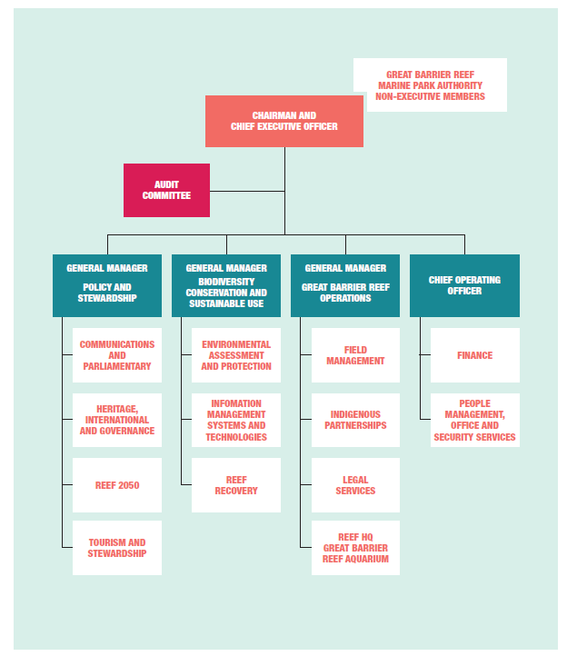
Figure 2: Organisational structure as at 30 June 2016

Responsible Minister
As Minister for the Environment, the Hon. Greg Hunt MP, was responsible for the Great Barrier Reef Marine Park Authority as at 30 June 2016.

Legislative framework
The agency is established by the Great Barrier Reef Marine Park Act 1975 (Marine Park Act) as an Australian Government statutory authority. The objects of the Marine Park Act are set out in section 2A, and the specific functions of the Great Barrier Reef Marine Park Authority are defined in sections 7 and 7A.
The Great Barrier Reef Marine Park consists of areas declared by the Great Barrier Reef (Declaration of Amalgamated Marine Park Area) Proclamation 2004 made under the Marine Park Act.
Other Acts administered by the agency are:
Great Barrier Reef Marine Park (Environmental Management Charge — Excise) Act 1993
Great Barrier Reef Marine Park (Environmental Management Charge — General) Act 1993.
Regulation in force under the Marine Park Act:
Great Barrier Reef Marine Park Regulations 1983.
The agency also administers the Great Barrier Reef Marine Park Zoning Plan 2003 and the following plans of management:
Cairns Area Plan of Management 1998
Hinchinbrook Plan of Management 2004
Shoalwater Bay (Dugong) Plan of Management 1997
Whitsundays Plan of Management 1998.
The agency’s statutory Board has four part-time members and a full-time chair who is also the agency head for the purposes of the Public Services Act 1999 and the Accountable Authority for the purposes of the Public Governance, Performance and Accountability Act 2013.
Amendments to legislation during 2015–16
There were no significant amendments to legislation administered by the agency in the 2015–16 financial year.
Minor consequential amendments were made to the Great Barrier Reef Marine Park Regulations 1983 by the Acts and Instruments (Framework Reform) (Consequential Amendments) Regulation 2016. The amendments replaced all references to the Federal Register of Legislative Instruments under the Legislative Instruments Act 2003 with references to the Federal Register of Legislation under the Legislation Act 2003.
These amendments are consequential on Part 4 (Federal Register of Legislative Instruments) of the Legislative Instruments Act 2003 being repealed by the Acts and Instruments (Framework Reform) Act 2015, and section 15A of the Legislation Act 2003 providing for the Federal Register of Legislation.

Finances overview
Total operating revenue for 2015–16 was $51.734 million. Appropriation for 2015–16 of $28.217 million was $1.072 million more than the 2014–15 appropriation, with higher special appropriation received. Revenue by source is outlined in Figure 3.
Own source income includes support for the continuation of the agency’s work and measures to improve the outlook for the Great Barrier Reef being funded from the National Landcare Programme and Reef Trust. This is included in funding from ‘related entities’. Related entities are bodies that either form part of the Australian Government or are controlled by the Australian Government. In Figure 3, ‘related entity’ refers primarily to funds received from the Department of the Environment.
Own source income for 2015–16 was $23.517 million, $0.653 million more than in 2014–15. Significant funding was received for ‘Ensuring the resilience of the Reef’, for the Marine Monitoring Program and the Land and Sea Country Partnerships program, as part of the Australian Government's National Landcare Programme. Funding was received from Reef Trust for the Marine Debris Project, for targeted crown-of-thorns starfish control and for specialised compliance training for Indigenous rangers.
The Australian and Queensland governments provided matching funding for field management of the Marine Park, which was implemented in partnership with the Queensland Department of National Parks, Sport and Racing, and renewed in 2015 for a further five years.
The operating expense of managing the Marine Park in 2015–16 was $54.351 million. Employee expenses were slightly higher, with the appointment of four specialised Indigenous rangers in 2015. Expenses for suppliers were $0.826 million more than 2014–15, with significant expenditure on litigation. The expenses by category are outlined in Figure 4.
The agency had an approved operating deficit of $2.562 million in 2015–16, including the unfunded depreciation expense.
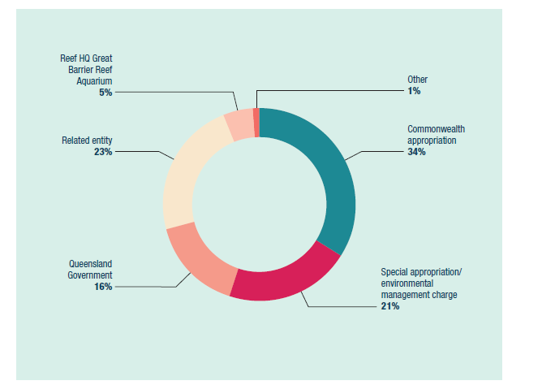
Figure 3: Revenue by source 2015–16
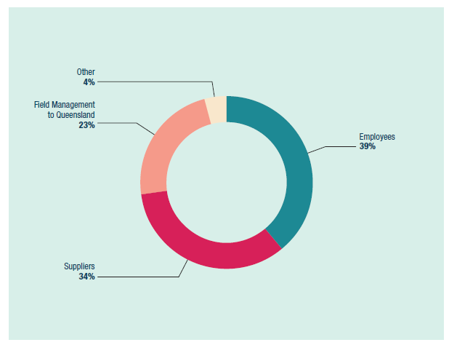
Figure 4: Expenses by category 2015–16

Staff overview
The Executive Management Group consists of the Chairman and three Senior Executive Service Band 1 General Managers:
Policy and Stewardship
Biodiversity Conservation and Sustainable Use
Great Barrier Reef Operations.
The Chief Operating Officer, an Executive Level 2 officer, is also a member of the Executive Management Group.
The number of employees in the agency was 208 at 30 June 2016, a decrease from 214 at 30 June 2015. (See Appendix B for an overview of staffing, employee numbers, and staff composition and location at 30 June 2016).
The staff figure for 30 June 2016 includes fixed-term and non-ongoing positions.
The agency also employs casual staff to work in the Reef HQ Great Barrier Reef Aquarium, which operates seven days a week. In addition, about 155 volunteers assist in the day-to-day operation of the aquarium.

Performance

Introduction
This annual performance statement is completed under s39(1)(a) of the Public Governance, Performance and Accountability Act 2013 for the 2015–16 financial year, and accurately presents the Great Barrier Reef Marine Park Authority’s (the agency’s) performance in accordance with s39(2) of the Act.
The report is based on the Portfolio Budget Statement 2015–16 and the aligned strategies from our Corporate Plan 2015–2020.

Purpose
The agency’s primary purpose is to ensure the long-term protection, ecologically sustainable use, understanding and enjoyment of the Great Barrier Reef for all Australians and the international community through the care and development of the Marine Park (Outcome 1).
The agency also works to protect and conserve the world heritage values of the Great Barrier Reef.
Outcome 1 will be delivered through three objectives:
Protecting and restoring the Reef’s ecosystem health and biodiversity
Safeguarding the Reef’s heritage
Ensuring use of the Marine Park is ecologically sustainable and benefits current and future generations.
The Portfolio Budget Statement details the deliverables and key performance indicators for the year against the three objectives, while the Corporate Plan lists three strategies to achieve these (see Box 1).
In 2015–16, the agency delivered a range of policies and programs, strategies and legislative measures to implement its purpose.
Box 1 The agency’s key performance indicators from the Portfolio Budget Statement and strategies from the Corporate Plan:
PORTFOLIO BUDGET STATEMENT: Program 1.1 key performance indicators
Objective 1: Protect and restore the Reef’s ecosystem health and biodiversity
- Reduce local impacts affecting the condition of key species and habitats.
- Improving trends in water quality for end-of-catchment waters against the trigger levels outlined in the Reef Water Quality Guidelines.
Objective 2: Safeguard the Reef’s heritage
- Enhanced identification, understanding, recognition, protection and conservation of the Reef’s heritage values.
Objective 3: Ensure use of the Marine Park is ecologically sustainable and benefits current and future generations
- Improved uptake of best practice and stewardship in activities that contribute to the health and resilience of the Marine Park.
- Declining incidence of illegal fishing.
- Improved inclusion in management decisions of knowledge about the Reef’s values, their condition and impacts.
CORPORATE PLAN
Strategy 1: Ensure the best available knowledge is captured and used to inform management decisions
Performance outcome: Authority decisions and actions are informed by best available knowledge and information and contribute to attainment of outcomes for the Reef’s values.
Performance measures:
1.1 Proportion of assessment grades and trends against the Region’s values for which the level of confidence has increased as reported in each five-yearly Great Barrier Reef Outlook Report.
1.2 Proportion of National Environmental Science Programme-funded projects that are addressing the Great Barrier Reef Marine Park Authority’s science needs.
1.3 Proportion of Great Barrier Reef Marine Park Authority committees which have community or industry representation.
Strategy 2: Effective and efficient environmental regulation
Performance outcome: The impacts of human activity on the Great Barrier Reef are reduced through effective environmental regulation.
Performance measures:
2.1 Proportion of reported offences where a compliance action was taken.
2.2 Proportion of the Marine Park managed in accordance with an accredited Traditional Use of Marine Resources Agreement or an Indigenous Land Use Agreement.
2.3 Standard permits assessed within agreed timeframes (agreed with permittees).
Strategy 3: Strengthen engagement
Performance outcome: Environmental outcomes for the Great Barrier Reef are improved through the communication and adoption of sustainable best practices.
Performance measures:
3.1 Number of participants within Great Barrier Reef Marine Park Authority stewardship programs [for example High Standard Tourism, Eye on the Reef, Reef Guardians, Sea Country Partnerships].
3.2 Proportion of visitors to the Great Barrier Reef that use tourism operators which have been accredited as ‘high standard operators’.
3.3 Proportion of visitors to Reef HQ Great Barrier Reef Aquarium that participate in talks and tours that deliver key messages about risks to the Great Barrier Reef.
3.4 An improved understanding and appreciation of the Reef by users, visitors and residents, as measured by social research indicators.

Results
The ‘Objectives’ in the Portfolio Budget Statement are called ‘Goals’ in the Corporate Plan. The term ‘Goals’ is used throughout this report and reporting is made against each goal.
The report provides a list of the programs and activities within each goal, aligned with the Portfolio Budget Statement deliverables and the Corporate Plan performance criteria and strategies. The results of the program or activity against the performance criteria and purpose are then described.
An analysis of progress against purpose is included in each program or activity. Overall, the agency has made good progress against its primary purpose. Most programs and activities proceeded as designed in 2015–16, although emerging issues and resource constraints in some areas necessitated program changes.

Goal 1: Protect and restore the Reef’s biodiversity

1.1 Reef 2050 Integrated Monitoring and Reporting program
REPORTING REQUIREMENTS
This aligns with performance criteria for:
PBS Program 1.1: Protect and restore the Reef’s ecosystem health and biodiversity.
Deliverables:
- Develop a suite of standards, thresholds and limits to maintain ecosystem health and biodiversity.
- Identify and implement a program of regionally based on-ground/in-park restoration actions.
- Implement actions under the National Landcare Programme and through the Reef Trust (for the Land and Sea Country Partnerships program, Marine Monitoring Program, Reef Resilience Programme and the Marine Debris Project).
Performance criteria:
- Reduce local impacts affecting the condition of key species and habitats.
- Improving trends in water quality for end-of-catchment waters against trigger levels outlined in the Reef Water Quality Guidelines.
Corporate Plan Strategy 1: Ensure the best available knowledge is captured and used to inform management decisions, Performance measures 1.1, 1.2 and 1.3 (see Box 1).

Results against performance criteria
The agency is leading an integrated Reef-wide monitoring and reporting program (see also Case study 1), which will underpin delivery of the Reef 2050 Long-term Sustainability Plan (Reef 2050 Plan). The program’s purpose is to evaluate whether management actions are on track to meet targets, objectives and outcomes set out in the Reef 2050 Plan.
This ambitious program brings together monitoring, modelling and reporting activities across the Great Barrier Reef and its catchment. It covers all aspects of the Reef’s environment, including its biophysical attributes, and heritage, social, economic and cultural values.
In July 2015, the Australian Minister for the Environment, the Hon. Greg Hunt MP, committed $8 million to the program’s establishment and to capture information critical to understanding pressures affecting the Reef’s health. The program will report on changes in the Reef’s environment, inform the assessment of key threats and future risks, and ensure efforts are focused on actions that deliver measurable results.
The Reef 2050 Integrated Monitoring and Reporting Program steering group is overseeing design and implementation of the initiative. The group comprises monitoring providers and government representatives, and is co-chaired by the agency’s Chairman, and the Director-General of the Queensland Government Department of Environment and Heritage Protection.
The steering group met three times this year. A strategy outlining the program’s purpose, scope, principles and partnership approach was released in October 2015. On the advice of the steering group, three working groups have been established to address the program’s design, reporting products and data management systems. Working groups have met individually and jointly over this period. Key achievements include:
establishing a committed partnership
scoping work required to deliver the program and its implementation
auditing existing monitoring programs, reporting products and data systems, and mapping these to Reef 2050 Plan themes
auditing, aligning and refining indicators to report on outcomes for Reef 2050 Plan themes
integrating and aligning a number of core monitoring programs at a range of scales
investing in key monitoring programs critical to the delivery of the Reef 2050 Plan.
Case study 1: Monitoring for the future
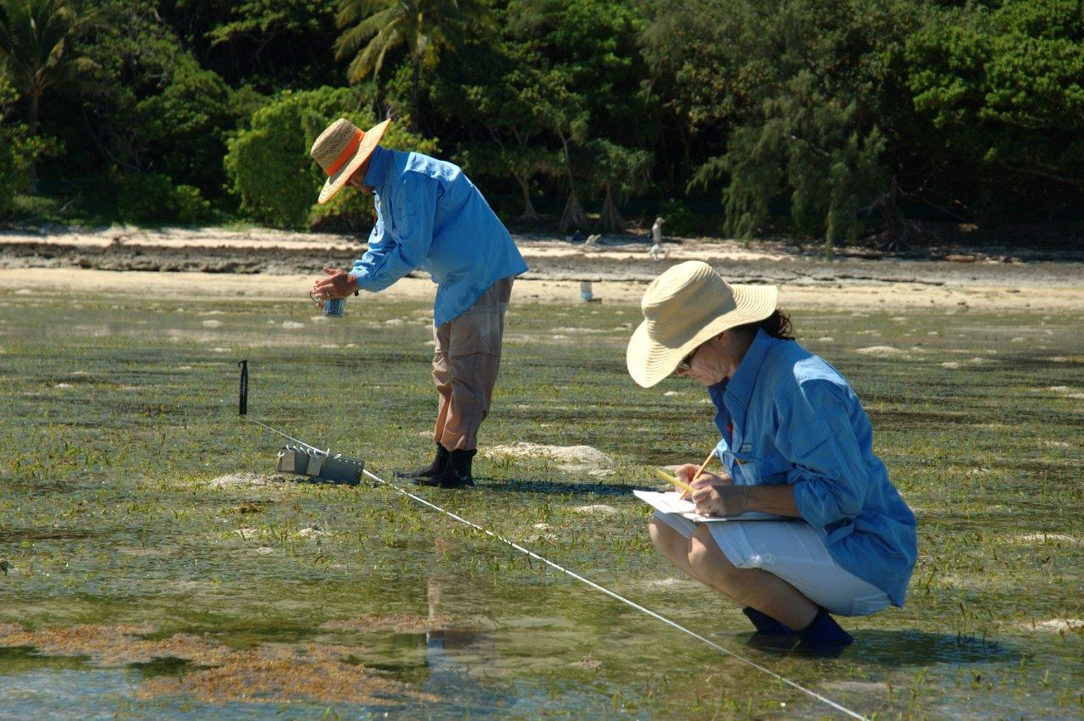
Above: The Reef Integrated Monitoring and Reporting Program will provide an overall picture of what is happening across all aspects of the Reef
Early detection of trends and changes in the Great Barrier Reef’s environment is critical for effective management and protection of the Reef.
The Reef 2050 Integrated Monitoring and Reporting Program involves the development of the first coordinated and integrated monitoring and modelling framework for the Reef and its catchment.
This framework builds upon existing programs, which will ensure monitoring and modelling is connected, from the catchments and coasts, to the Reef itself. It will provide an overall picture of what is happening across all aspects of the Reef’s environment, including its natural and physical attributes, heritage values, and its social, economic and cultural aspects.
The program is a key component of the Reef 2050 Plan, a long-term plan to manage and protect the Great Barrier Reef. The 35-year plan was developed by the Australian and Queensland governments in 2015, in partnership with Traditional Owners and tourism, fishing, ports, agriculture, local government, and research and conservation sectors.
The monitoring and reporting program will not only inform management, but also keep the national and international community updated on whether the Reef 2050 Plan is on track to maintain and improve the condition of the Reef’s values.
Results from the monitoring program will inform key reporting publications, including annual report cards and the agency’s five-yearly Great Barrier Reef Outlook Report — the principal guide to reviewing the Reef 2050 Plan.
The program is also identifying monitoring gaps and investing in a number of key monitoring programs critical to the delivery of the Reef 2050 Plan, including dugong, fish, coral and seagrass surveys, and socioeconomic monitoring.
By providing clear and regular updates on the condition of the Reef’s values — together with the pressures affecting it — the agency can track progress towards the Reef 2050 Plan targets and outcomes, and contribute to securing the future of one of the world’s most prized natural assets.

Analysis of performance against purpose
Program funding was delayed this year, which delayed the commissioning of a number of tasks associated with the program’s establishment.

1.2 Marine Monitoring Program
REPORTING REQUIREMENTS
This aligns with performance criteria for:
PBS Program 1.1: Protect and restore the Reef’s ecosystem health and biodiversity.
Deliverables:
- Develop a suite of standards, thresholds and limits to maintain ecosystem health and biodiversity.
- Implement actions under the National Landcare Programme and through the Reef Trust (for the Land and Sea Country Partnerships program, Marine Monitoring Program, Reef Resilience Programme and the Marine Debris Project).
Performance criteria:
- Reduce local impacts affecting the condition of key species and habitats.
- Improving trends in water quality for end-of-catchment waters against trigger levels outlined in the Reef Water Quality Guidelines.
Corporate Plan Strategy 1: Ensure the best available knowledge is captured and used to inform management decisions, Performance measures 1.1, 1.2 and 1.3 (see Box 1).

Results against performance criteria
The agency manages and coordinates the delivery of the Marine Monitoring Program, which helps assess the effectiveness of actions under the Reef Water Quality Protection Plan. The plan seeks to ensure that by 2020 the quality of water entering the Reef from broadscale land use has no detrimental impact on the health and resilience of the Great Barrier Reef. The Marine Monitoring Program collects valuable information on long-term changes in the condition of inshore water quality, seagrass and coral reefs.
The program is co-funded by the Australian Department of the Environment, and research partners including the Australian Institute of Marine Science, James Cook University and the University of Queensland.
After a 2013 review of the Marine Monitoring Program, it was expanded to include:
inshore coral data from the long-term monitoring program (Australian Institute of Marine Science)
data from Seagrass Watch (James Cook University)
monitoring of a greater range of pesticides (University of Queensland)
monitoring of additional subtidal seagrass sites (Field Management Program; James Cook University)
more intensive water quality monitoring in four focus areas: the Russell–Mulgrave, Tully and Burdekin rivers and rivers in the Mackay–Whitsundays region (Australian Institute of Marine Science; James Cook University)
meteorological data (Bureau of Meteorology).
Information from the Marine Monitoring Program was combined with data collected at the paddock and catchment level to produce the Reef Plan Report Card 2014, published in September 2015. The report card summarises the health of the Great Barrier Reef and its catchments, and the actions underway to reduce the levels of pollutants.
A synthesis of marine results that accompanied the report card described the condition and trend of inshore water quality, coral reefs and seagrass meadows over the past decade.
The marine results revealed the condition of inshore water quality, seagrass meadows and coral reefs was poor in 2013–14. The overall trend of the Reef condition remained poor, but showed an improving trajectory after the low point in 2011–12, in the wake of severe tropical cyclone Yasi.
In 2015–16, the Marine Monitoring Program became a core component of the Reef 2050 Integrated Monitoring and Reporting Program. Such targeted monitoring through a fully integrated program will improve the ability to evaluate the progress towards Reef 2050 Plan outcomes and targets, and inform investment of resources in areas of greatest risk.
Yearly technical reports from the Marine Monitoring Program also provide the best available scientific updates between the five-yearly outlook reporting cycles. Key outputs from the program informed other initiatives, including Reef recovery plans, the development of indicators and standards for coral reef and seagrass health, and the regional report cards for Mackay–Whitsundays and the Wet Tropics.

Analysis of performance against purpose
As a result of the revised program, monitoring sites are better aligned to improve detection of sediment, nutrient and pesticide loads at river mouths. This will improve the agency’s ability to assess the effectiveness of efforts to reduce land-based run-off into the Reef. The increased sampling effort has, however, been at the cost of the broader spatial coverage of the program.

1.3 Strategic management of dredge material
REPORTING REQUIREMENTS
This aligns with performance criteria for:
PBS Program 1.1: Protect and restore the Reef’s ecosystem health and biodiversity.
Deliverable:
- Develop a suite of standards, thresholds and limits to maintain ecosystem health and biodiversity.
Performance criteria:
- Reduce local impacts affecting the condition of key species and habitats.
Corporate Plan Strategy 2: Effective and efficient environmental regulation.

Results against performance criteria
In 2015–16, the agency approved an updated dredging and spoil disposal policy to reflect the ban on capital dredge spoil disposal in the Marine Park, implemented in June 2015 through the Great Barrier Reef Marine Park Regulations 1983.
The policy also reflects commitments made under the Reef 2050 Plan.
In response to the unprecedented level of coral bleaching across the Great Barrier Reef during 2016, the agency also approved a new policy to protect coral reef habitats from dredging. The policy states the agency’s priority is to avoid direct impacts on coral reef habitats when considering new marine infrastructure or the expansion of existing marine infrastructure.
The policy also states the agency is unlikely to grant permissions that involve capital dredging of living coral reef and the underlying reef structure for new marine infrastructure, or the expansion of existing marine infrastructure. The policy does not affect maintenance dredging of existing marine infrastructure.
These new policies — together with the actions under the Reef 2050 Plan (to reduce the impacts of ports and dredging and to improve the sustainability of industries), and the 2015 ban on the disposal of capital dredging material in the park — will have a long-term positive effect on Marine Park values.
The agency was also involved in the development of The establishment of a future NESP dredging research investment framework under the National Environmental Science Programme Tropical Water Quality Hub. Staff took part in a workshop with key researchers and stakeholders to identify the future knowledge needs for improved management of dredging activities in the Reef. The workshop distilled a research framework to prioritise future program investment in dredging research, and to build upon dredging synthesis reports and other resources published in recent years.
The framework, once implemented, will:
define the scope of work required to develop and apply improved sediment transport models for the Reef’s lagoon
identify and quantify the type and extent of ecological impacts, especially of maintenance dredging activities
identify management options, including innovative approaches to improving Reef management.
Implementation of studies identified by this framework will help us further understand dredging-related pressures and dredging sediment transport pathways, and the risks associated with disposal of dredge material on land.
The agency also provided input to guiding documents being developed during the year, in accordance with commitments made under Reef 2050:
A code of practice for port-related dredging activities, led by Ports Australia
A maintenance dredging strategy, led by the Queensland Department of Transport and Main Roads
Port master planning guidelines, led by the Queensland Department of State Development.

Analysis of performance against purpose
There are no significant factors to report.

1.4 improving the permissions system
REPORTING REQUIREMENTS
This aligns with performance criteria for:
PBS Program 1.1: Protect and restore the Reef’s ecosystem health and biodiversity.
Deliverable:
- Develop a suite of standards, thresholds and limits to maintain ecosystem health and biodiversity.
Performance criteria:
- Reduce local impacts affecting the condition of key species and habitats.
Corporate Plan Strategy 2: Effective and efficient environmental regulation.

Results against performance criteria
Improving the permission system is a five-year project to enhance initiatives to streamline the administrative process for users of the Marine Park, while maintaining high environmental standards.
Under the Great Barrier Reef Marine Park Zoning Plan 2003, the Marine Park is managed as a multiple-use area. The plan aims to protect and conserve the biodiversity within a network of highly protected zones, while providing opportunities for ecologically sustainable use.
As part of these arrangements, many activities cannot be conducted without written permission from the agency. For each permit application, the agency assesses the nature and scale of activities and makes a determination based on the potential impact of those activities on the values of the Marine Park.
The improving the permission system project started in January 2015 to improve consistency within the system and to make the basis for decisions clearer to permit applicants and the public. It seeks to address commitments in the Great Barrier Reef Region Strategic Assessment Program Report to improve the permission system, and recommendations from the Australian National Audit Office in August 2015.
The project is being delivered in two phases to minimise disruptions to Marine Park users and maximise business certainty. The first phase is expected to be implemented from 1 July 2017. This phase focuses on addressing the recommendation of the Australian National Audit Office to improve transparency and consistency in decision-making.
This project is expected to make key changes to the way the permission system operates. It includes a major revision of the Environmental Impact Management policy and revocation of the Structures Policy. New guidelines will be provided including a publication on how the agency assesses and decides on permit applications.
Amendments to the Great Barrier Reef Marine Park Regulations 1983 will also, at a minimum:
establish assessment levels and the ability to collect fees for complex applications, such as those requiring an environmental impact statement
require public advertising for proposals that might have significant effects on matters of national environmental significance under the Environment Protection and Biodiversity Conservation Act 1999 (EPBC Act)
deliver any other critical improvements to the permission system, such as those arising from the Australian National Audit Office performance audit findings.
Between October and December 2015, public consultation was undertaken on proposed amendments to the Great Barrier Reef Marine Park Regulations that govern permitting decisions. A summary of public feedback, and the agency’s proposed response, was published in March 2016.
At least 57 per cent of respondents supported all proposed changes. A client satisfaction survey also revealed that, although 53 per cent of respondents are generally satisfied with the existing system, they would welcome improvements.
Areas identified by respondents as needing improvement included transparency of decision-making, availability of information on how decisions are made, and consistent application of compliance actions.
The agency estimates the proposed streamlining measures to the permission system should generate about $3 million in savings annually to businesses, individuals and communities.
In May 2016, the Minister gave in-principle approval to proceed with proposed amendments to the Great Barrier Reef Marine Park Regulations. In June 2016, the Great Barrier Reef Marine Park Authority Board approved the release of a draft revised Environmental Impact Management policy for public comment, which will be released early in 2016–17.

Permission compliance
When permission for activities in the Marine Park is granted, it is subject to conditions that the agency is responsible for enforcing. Strategies or actions to enforce compliance range from education and assisted self-regulation, to stronger mechanisms. There are also formal delegations or authorisations in place which the agency can use to take action in response to a breach of permit conditions.
The Strategic Assessment Program Report and the agency’s Corporate Plan commit to strengthening monitoring and management of compliance risks associated with permission requirements, and complement recommendations made by the Australian National Audit Office audit.
During 2015–16, the agency continued to implement its Strengthening permissions compliance action plan 2015–2020, which focuses on the following key areas:
legislation and permissions systems
education and communication
monitoring and reporting
enforcement (including administrative and educational actions).
Key achievements against this plan during 2015–16 included:
an internal policy for the agency’s permissions compliance framework drafted, including associated procedures and templates
the Compliance framework — environmental management charge report finalised
the permits and environmental management charge guide sent to all permittees
continued development of systems to support permission compliance activities, including document management and reporting.

Analysis of performance against purpose
Staff movements contributed to the entity’s performance in achieving its purpose for improving the permission system.
Progress on reducing impacts is expected from 1 July 2017, after the first phase of the permissions system project is implemented. However, progress also depends on the development of supporting tools (for example, ecological standards and thresholds), cumulative impact management policy, environmental offsets guidelines and integrated monitoring.

1.5 Marine debris
REPORTING REQUIREMENTS
This aligns with performance criteria for:
PBS Program 1.1: Protect and restore the Reef’s ecosystem health and biodiversity.
Deliverables:
- Develop a suite of standards, thresholds and limits to maintain ecosystem health and biodiversity.
- Implement actions under the National Landcare Programme and through the Reef Trust (for the Land and Sea Country Partnerships program, Marine Monitoring Program, Reef Resilience Programme and the Marine Debris Project).
Performance criteria:
- Reduce impacts affecting condition of key species and habitats.
- Improve trends in water quality.
Corporate Plan Strategy 3: Strengthen engagement, Performance measure 3.1 (see Box 1).

Results against performance criteria
During 2015–16, the agency implemented a project under the Australian Government’s Reef Trust to minimise the source and occurrence of marine debris in the Reef by focusing on education and awareness-raising activities, and on-ground removal of litter.
The project delivered on the Reef Trust’s Outcome 3: Improve and protect marine biodiversity, including the reduction of the crown-of-thorns starfish and the protection of listed threatened and migratory species, such as dugongs and turtles.
The $700,000 project ran over two years, and funding concluded on 30 June 2016. More than 4000 people were involved through the life of the project, increasing stakeholder engagement on the issue of marine debris, or litter. The agency used its stakeholder networks including Reef Guardian Councils, schools, tourism operators, and Local Marine Advisory Committees to achieve results.
Support was provided to two key marine debris removal groups — Tangaroa Blue Foundation and Eco Barge Clean Seas — to continue on-ground removal of marine debris and build on their capacity to work within the region (see Case study 2).
Through this project, approximately 30 tonnes of marine debris (comprising more than 300,000 pieces) were removed from coastal and island habitats. This has reduced the likelihood of Marine Park species coming into contact with marine debris.
As part of the project, Reef Guardian Councils were offered the opportunity to host workshops to reduce marine debris at its source. As a result, Tangaroa Blue Foundation facilitated eight workshops, which used data collected from the Great Barrier Reef Clean-up and the Australian Marine Debris Initiative database to identify the types and sources of marine debris in each region. This will enable communities to target actions that minimise debris entering the Marine Park. More than 100 community members and representatives from local action groups and councils participated in the workshops to develop targeted action plans for each region.
There were also 13 grants for marine debris community art installations given to Reef Guardian Councils. These installations were designed to raise awareness within communities around marine debris.
In addition, portable water refill stations have been purchased, for delivery in the latter half of 2016, for public use at Reef Guardian and community events. This will also promote reduction in the use of plastic bottles in the community, and raise further awareness about the issues associated with single-use plastics.
Case study 2: Don’t let your litter bug our Reef
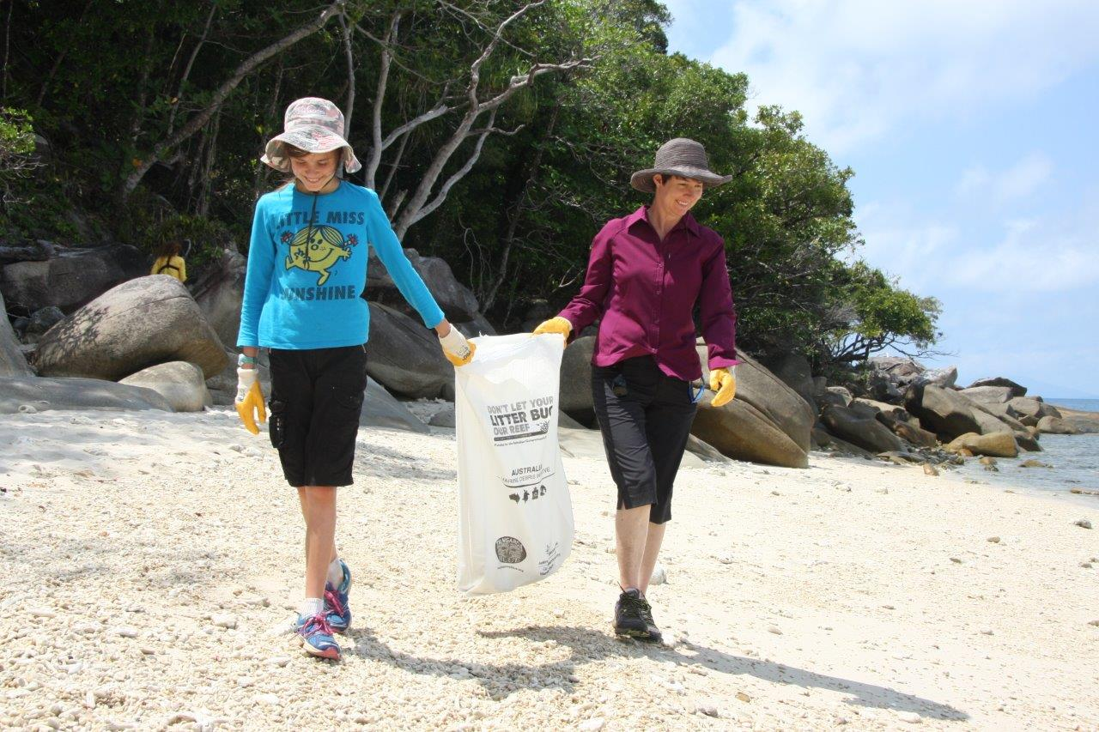
Above: Local volunteers taking part in the Great Barrier Reef Clean-up at Fitzroy Island
About 30 tonnes of marine debris were stopped from entering the Great Barrier Reef Marine Park through an initiative of the agency.
Supported by the Australian Government’s Reef Trust, the two-year project sought to actively remove marine debris from coastal areas. The project also raised awareness in the local community, empowering people to expand their efforts to stop marine debris at its source.
The agency enlisted expert marine debris removal groups Tangaroa Blue Foundation and Eco Barge Clean Seas to facilitate on-ground clean-ups within the Reef catchment. Reef Guardian Schools also lent a hand, conducting clean-ups at Future Leader Eco Challenge events.
All marine debris removed was entered into the Australian Marine Debris Database. This will help inform a more comprehensive overview of the marine debris found along the coast.
In October 2015, the agency, Tangaroa Blue Foundation, Eco Barge Seas, Reef Guardian Councils and local community groups took part in the Great Barrier Reef Clean-up. At more than 30 locations between Cooktown and Bundaberg, 1000 volunteers removed more than 117,000 individual items, totalling more than 12 tonnes of rubbish. The most common items found included plastic lids, bottles and pieces, aluminium cans, cigarette butts, broken glass and balloons.
The debris, rubbish and litter collected no longer poses an entanglement and ingestion risk to marine life, and will not smother coral or become a navigational hazard.
The clean-ups also raised awareness and reminded people not to let their litter ‘bug our Reef’ — the tagline of this community awareness project.
Reef Guardian Councils and local community groups then joined forces in eight locations along the Reef coast to identify common marine debris items in their area, and plan actions to reduce litter before it enters the environment.
Thirteen Reef Guardian Councils also raised awareness of marine debris by producing artworks, signs and sculptures about marine debris, to be installed, to help educate their local community.
An aerial survey from Cooktown to Cape York has been completed, and Traditional Owners have been engaged to increase capacity for removing marine debris.

Analysis of performance against purpose
The operating environment supported the delivery of the program results. By using existing partners and networks, including Tangaroa Blue, Eco Barge, Reef Guardian Councils, Local Marine Advisory Committees and the Queensland Parks and Wildlife Service, delivery of the project was enhanced.

1.6 Eye on the Reef program
REPORTING REQUIREMENTS
This aligns with performance criteria for:
PBS Program 1.1: Protect and restore the Reef’s ecosystem health and biodiversity.
Deliverables:
- Develop a suite of standards, thresholds and limits to maintain ecosystem health and biodiversity.
- Identify and implement a program of regionally based on-ground/in park restoration actions.
- Implement actions under the National Landcare Programme and through the Reef Trust (for the Land and Sea Country Partnerships program, Marine Monitoring Program, Reef Resilience Programme and the Marine Debris Project).
Performance criteria:
- Reduce impacts affecting condition of key species and habitats.
- Improve trends in water quality.
Corporate Plan Strategy 1: Ensure the best available knowledge is captured and used to inform management decisions, Performance measures 1.1 and 1.3; and Strategy 3: Strengthen engagement, Performance measure 3.1 (see Box 1).

Results against performance criteria
Eye on the Reef is an environmental monitoring, education and stewardship program that relies on partnerships with scientists, the tourism industry, Marine Park rangers and other Reef users.
Information gathered through the program provides critical knowledge to inform management actions that will support and improve the resilience of the Reef. Since its inception in 1997, the Eye on the Reef program has expanded to four assessment and monitoring programs: Sightings, Rapid monitoring, Tourism weekly monitoring, and Reef health and impact surveys.
In 2015–16, 137 individuals or organisations submitted 5163 surveys across the Marine Park, encompassing 270 reefs. This information is collated and reported through the Eye on the Reef database. This spatial database and the monitoring network help deliver timely information about the condition of Reef values.
In the reporting period, tourism staff and Reef visitors recorded 2276 sightings of interesting and iconic marine species through the Eye on the Reef Sightings Network. This included 245 humpback whales, 208 green turtles and 11 whale sharks.
The agency also continued a multi-year maintenance contract to improve the database, including the Eye on the Reef smartphone application. This year, the application was enhanced to enable users to report the density of crown-of-thorns starfish sightings.
During the 2016 coral bleaching event, the Eye on the Reef system was used extensively to assess and track the extent and severity of the bleaching. System mapping products were used to communicate the level of bleaching to a variety of internal and external stakeholders. Between February and June 2016, volunteers, tourism staff and other professionals conducted 2436 reef health and impact surveys, which were used to inform and guide management actions during the event. Without the Eye on the Reef network, protocols and database, the 2016 coral bleaching response would have been severely limited.
During the reporting period, the agency also conducted training workshops with members of the tourism industry to increase their capacity to monitor and report on reef health.
Twelve workshops, conducted at three locations each quarter, attracted 157 tourism staff from 19 operators to learn about identification and interpretation of Reef organisms. The workshops were designed to help marine tourism staff provide accurate interpretation of the Reef to Marine Park visitors and to ensure high-quality data was provided to the Eye on the Reef program. In addition, 76 tourism staff from 19 operators in three locations attended six in-water events for specific training in underwater survey techniques. Management of the Eye on the Reef program included continued delivery of training materials, courses and mentoring work.

Analysis of performance against purpose
Targeted training of key stakeholders, such as the tourism industry, has led to improved uptake of best practice and stewardship activities, which contribute to ensuring the Marine Park is used in an ecologically sustainable way.
Data entry support for the Eye on the Reef database was increased during the 2016 coral bleaching event to ensure timely information processing. The database also received extensive work to improve its capabilities to handle events where large amounts of data are required to be processed.

1.7 Crown-of-thorns starfish management program
REPORTING REQUIREMENTS
This aligns with performance criteria for:
PBS Program 1.1: Protect and restore the Reef’s ecosystem health and biodiversity.
Deliverables:
- Develop a suite of standards, thresholds and limits to maintain ecosystem health and biodiversity.
- Identify and implement a program of regionally based on-ground/in-park restoration actions.
- Implement actions under the National Landcare Programme and through the Reef Trust (for the Land and Sea Country Partnerships program, Marine Monitoring Program, Reef Resilience Programme and the Marine Debris Project).
Performance criteria:
- Reduce impacts affecting condition of key species and habitats.
- Improve trends in water quality.
Corporate Plan Strategy 1: Ensure the best available knowledge is captured and used to inform management decisions, Performance measures 1.1 and 1.3; and Strategy 3: Strengthen engagement, Performance measure 3.1 (see Box 1).

Results against performance criteria
The crown-of-thorns starfish management program helps to protect coral cover on high priority reefs from this native coral predator. Predation by the crown-of-thorns starfish was the second major cause of a decline in coral cover between 1985 and 2012.
The agency is adopting a holistic response to crown-of-thorns starfish management. In the short term, this means reducing the severity of crown-of-thorns starfish outbreaks through targeted culling. In the long term, this includes actions such as reducing the frequency of future outbreaks by improving the quality of the water entering the Reef lagoon.
In June 2015, $7 million was committed under a Reef Trust memorandum of understanding with the Australian Department of the Environment, to support culling until June 2018. The agency contracted the Reef and Rainforest Research Centre to protect priority reefs offshore of Cairns and Port Douglas, and to assist research into more efficient methods of crown-of-thorns starfish control, such as integrated pest management approaches.
The Association of Marine Park Tourism Operators — subcontracted by the Reef and Rainforest Research Centre — successfully protected coral cover at 21 high-value tourism and ecologically important reefs, making up an area of more than 900 square kilometres. During 2015–16, the association completed 24 ten-day control voyages using the vessel Hero and culled more than 30,000 starfish.
The agency works with Association of Marine Park Tourism Operators, and the tourism industry more broadly, to encourage tourism operations to engage in management and be strong stewards for the Marine Park. Tourism operators monitor the reefs they visit regularly for crown-of-thorns starfish and, where possible, undertake their own site-based control programs under a Marine Parks permit.
In February 2016, data showed more than 75 per cent of reefs in the region that were being controlled had more than 25 per cent coral cover. Only one reef was at 10 per cent. For the purposes of managing Reef resilience, managers seek to maintain minimum average coral cover of well above 10 per cent, which has been identified as a critical ‘resilience’ threshold, below which coral may not recover.
In April 2016, a further $6 million was committed to support culling activities under a second vessel control program until June 2019, as part of the Reef Trust. This will help address the southern progression of the outbreak to reefs offshore Innisfail and Townsville.

Analysis of performance against purpose
The Australian Government’s funding of the crown-of-thorns starfish management program, through the Reef Trust, has made it possible for the agency to work with partners to ensure that tactical in-water control is undertaken in high-value areas.
The agency classified the crown-of-thorns starfish management program as a priority project, and staffing resources were reallocated to deliver the project.
The agency was able to improve its overarching program management through the following means:
The Field Management Program (which comprises the agency and Queensland Parks and Wildlife Service) conducted 2998 manta tow surveys (covering 537 kilometres) and 655 reef health and impact surveys at 31 reefs. The manta tow surveys are a broadscale form of in-water surveying where staff are towed behind a vessel.
The Eye on the Reef database is used to record sightings of crown-of-thorns starfish, the health of the coral cover at reefs where control is occurring, and the number of starfish culled.
The control program is continuously improved by adopting new research and technologies, such as the National Environmental Science Programme’s work on an integrated pest management approach.
An AusTender process to secure a service provider for the second vessel control program was delayed because of the Australian Government caretaker conventions in May–June 2016.

1.8 Reef recovery
REPORTING REQUIREMENTS
This aligns with performance criteria for:
PBS Program 1.1: Protect and restore the Reef’s ecosystem health and biodiversity.
Deliverables:
- Develop a suite of standards, thresholds and limits to maintain ecosystem health and biodiversity.
- Identify and implement a program of regionally based on-ground/in-park restoration actions.
Performance criteria:
- Reduce local impacts affecting the condition of key species and habitats.
- Improve trends in water quality for end-of-catchment waters against the trigger levels outlined in the Reef Water Quality Guidelines.
Corporate Plan Strategy 3: Strengthen engagement.

Results against performance criteria
Through a range of measures, the agency’s Reef Recovery section works to address the main threats to the health and resilience of the Great Barrier Reef as defined in the Outlook Report 2014.

Climate change
Climate change is recognised as the greatest threat to the long-term health of the Reef. The agency is continuing to implement, as resources allow, its second climate change action plan, the Great Barrier Reef Climate Change Adaptation Strategy and Action Plan 2012–2017, which outlines how it will improve the resilience of the Reef to better cope with stress, and reduce the negative effects of climate change.
Ongoing efforts also support integration of some key agency activities, actions and targets into the Reef 2050 Plan and the Reef Recovery program, including the pilot Reef Recovery Plan for the Mackay–Whitsundays. To support this work:
crown-of-thorns starfish control was used as a coral resilience strategy
in-water surveys of high-use tourism sites were conducted in the Whitsundays
the potential benefits and feasibility of interventions, for example coral restoration, for building the resilience of vulnerable species and habitats were explored.
The agency continued to provide advice on topics such as climate change implications for the Reef, ecosystem resilience, reef health and current conditions, and development proposals and permit assessments. This included advising key decision makers that the long-term future of coral reef ecosystems, including the Great Barrier Reef, hinges on strong global action on climate change. For example, the agency:
with the Great Barrier Reef Foundation and research partners, contributed to a review of ocean acidification and its implications for the Great Barrier Reef
with the Great Barrier Reef Foundation and research partners, developed a research framework linking science to potential management strategies, and co-authored a manuscript that has been accepted for publication in the Journal of Environmental Management
started collaboration with an Advance Queensland Fellowship recipient on a coral resilience project titled ‘Maximising GBR resilience by integrating physiology, evolutionary biology and macroecology’.
In addition, the agency assembled a significant incident response to assess the extent and severity of the Reef’s worst-ever coral bleaching event. (See also Case study 4)

Water quality
Environmental values and water quality objectives for all Great Barrier Reef marine waters have been, or are in the process of being, gazetted by the Queensland Government, based on Great Barrier Reef Marine Park Water Quality Guidelines.
During the reporting period, development and subsequent gazettal of environmental values and water quality objectives were completed for three regions (Cape York, Whitsundays and Burdekin) through Queensland’s Environment Protection (Water) Policy 2009.
The agency provided referral, assessment and approval advice on 20 EPBC Act development applications that had the potential to impact water quality of the Great Barrier Reef. Conditions placed on these developments required there be a net benefit delivered to Reef ecosystems.
It is critical that management of the catchment, including agriculture, vegetation management and aquaculture, is undertaken in a way that delivers net downstream improvements to the water quality in the Marine Park. The agency testified at two parliamentary inquiries:
the Australian Government’s Joint Select Committee on Northern Australia Inquiry into Opportunities for Expanding the Aquaculture Industry in Northern Australia
the Queensland Government Agriculture and Environment Committee’s review of Vegetation Management (Reinstatement) and Other Legislation Amendment Bill 2016.
Testimony at each of these inquiries detailed how existing, or proposed, regulatory frameworks provided the requisite degree of protection for the plants and animals of the Marine Park. It also emphasised how the application of this legislation was providing, or would provide, significant outcomes for the health of Reef ecosystems.

Coastal development
Coastal ecosystems are critical to the health of the Great Barrier Reef, as they connect the land and the sea. The health of ecosystems — including their extent and the way they function — can in turn have a big impact on the health of the Reef.
Presentations to key stakeholders on the importance of restoring and reconnecting coastal ecosystems form an essential part of the agency’s coastal ecosystems work (see also Appendix F).
The agency delivered 21 presentations to a range of local, national and international stakeholders about the coastal ecosystems program during 2015–16. These presentations outlined the agency’s development of a ‘whole-of-systems’ approach, which has helped identify locations for on-ground systems repair activities that will maximise results for inshore marine ecosystems. These presentations have also brought together many catchment stakeholders into a collective management network.
All natural resource management groups in the catchment have adopted a suite of tools developed by the agency — namely, hydrological connectivity maps, known as blue maps, and ecological process calculator outputs. The groups are using these tools in regional planning activities to guide outcomes for the Reef (except Cape York, as data was unavailable). The Queensland Government has agreed to be the custodian of blue maps, and continues to contemporise them to incorporate current conditions (for example, in-stream dams and barriers).
The agency continues to work closely with the Queensland Government to consolidate tools for managing catchment impacts and promoting systems repair actions. These include developing a whole-of-catchment management framework and incorporating the agency’s ecological process calculator into the Queensland Government’s wetlands decision support system (which will be expanded from wetlands to the greater Reef ecosystem).

Fishing impacts

Working with industry
The agency continued to work cooperatively with commercial and recreational fishing industry stakeholders and Fisheries Queensland to manage and monitor fisheries in and adjacent to the Marine Park. This included providing regular updates to peak industry bodies and representatives about the 2016 coral bleaching event in the Marine Park. The agency also cooperated with the Queensland Parks and Wildlife Service and commercial net fishers to ensure the laws for net fishing to protect dugongs in the inshore area of Bowling Green Bay mirrored Marine Park laws.

Advising at workshops and working group meetings
The agency attended and provided expert advice at the annual Fisheries Queensland stock status workshop. This included providing advice to Fisheries Queensland about the conduct of the revised East Coast Spanish mackerel stock assessment and the independent review of the inaugural Queensland shark stock assessment. In addition, the agency was represented in the Coral Reef Fin Fish Fishery Working Group, led by Fisheries Queensland. This working group provided advice about the total allowable commercial catch level for coral trout for 2016–17. The agency also participated in the Queensland Sea Cucumber Fishery industry liaison meeting in June 2016.

Participating in fisheries research
Agency staff co-authored a peer-reviewed paper published in Ecological Applications in February 2016. The paper, ‘A critique of claims for negative impacts of marine protected areas on fisheries’, strongly refuted previous published claims critical of the impacts that the internationally acclaimed 2004 rezoning of the Marine Park would have on fisheries (see Case study 3).
The agency also provided expert input as part of the Queensland Fisheries Research Advisory Committee to guide investment by the Fisheries Research and Development Corporation in fisheries-related research.

Providing advice to government
At the Australian Government level, the agency advised the Department of the Environment on ecologically sustainable management arrangements for fisheries operating in the Marine Park, including the Mud Crab Fishery, under the EPBC Act. The agency also met with members of the expert scientific panel to advise on the Commonwealth Marine Reserves Review.
The agency provided detailed submissions to the Queensland Government fisheries review and the Productivity Commission inquiry into the regulation of Australian marine fisheries and aquaculture sectors.
Case study 3: Marine park zoning is helping to protect the Reef
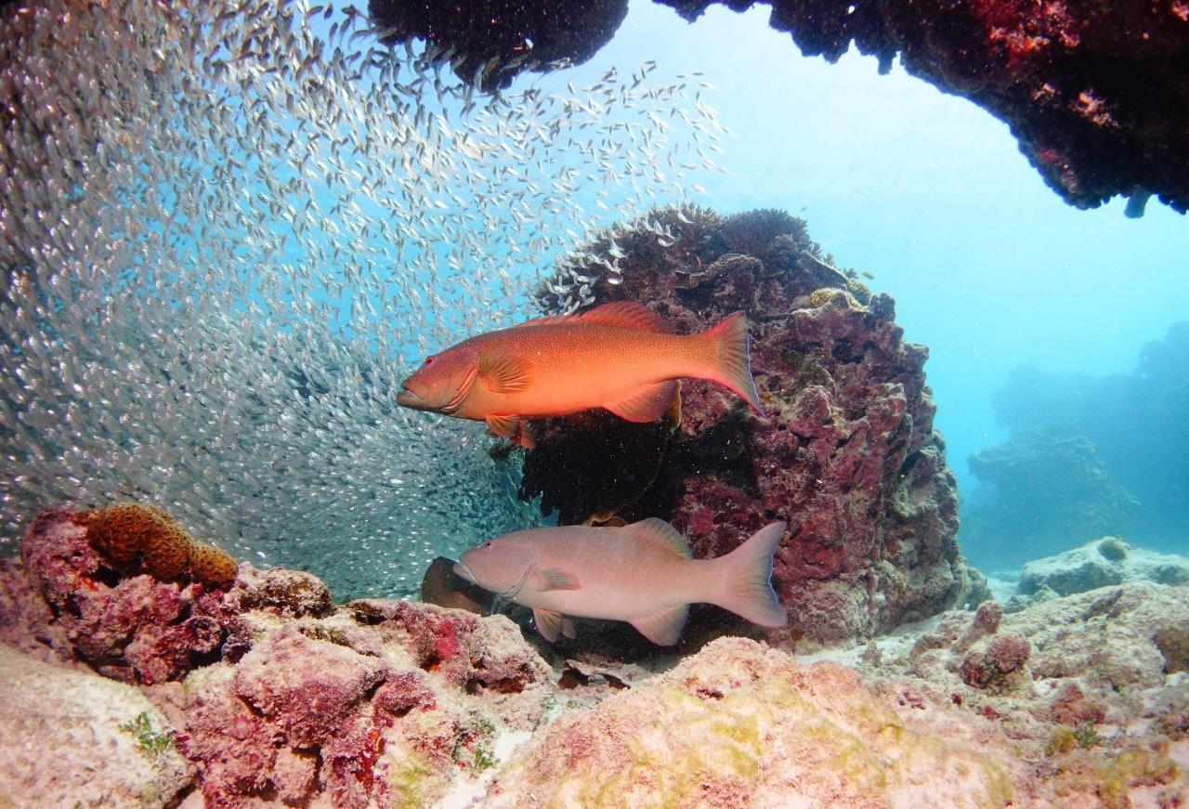
Above: Research shows coral trout are two to three times more abundant in green zones than in areas open to fishing
Marine park zoning is an important tool for managing marine areas, with zoning plans being used in the Great Barrier Reef Marine Park since 1983.
The current Great Barrier Reef Marine Park Zoning Plan 2003 was introduced in July 2004 after a comprehensive five-year consultation process. It aims to better protect and conserve the Reef ecosystem through ecologically sustainable use, and increased no-take areas from 4.6 per cent to 33.5 per cent of the Marine Park.
Today, there are a number of programs assessing the effects of zoning, and early indications show it is working.
Fish numbers and the average size of targeted species are increasing. For example, research by the Australian Institute of Marine Science and James Cook University found coral trout are now two to three times more abundant in green zones than in areas open to fishing. The average size of this popular target fish in green zones has also increased markedly.
Bigger fish produce more eggs, and greater numbers of fish in no-fishing areas increase the supply of fish larvae to areas open to fishing. Zoning design also facilitates dispersal by maintaining connectivity between reef networks, therefore increasing resilience.
Other research indicates reduced frequency of crown-of-thorns starfish outbreaks and coral disease in areas closed to fishing.
Surveys of seagrass show a large percentage of its habitat falls within marine national park and habitat protection zones. This is significant, given seagrass is a vital component of the ecosystem and principal food source for dugongs and green turtles.
These results are important, as for the Reef — one of the world’s most diverse and remarkable ecosystems — managing sustainable use to ensure its environmental protection is critical.
There are eight zones of activity applied throughout the Marine Park, ranging from general use, habitat protection, conservation and marine national park areas, to preservation, scientific research, buffer and Commonwealth Island zones.
Severe penalties apply for those breaching zoning rules, and compliance patrols run day and night. Recreational fishers caught fishing in a marine national park (green) zone can expect an $1800 infringement notice or court prosecution.

Protecting biodiversity
The agency engaged an underwater acoustics consultancy to deliver a discussion and options paper summarising a range of leading practice policy, and providing information on underwater noise and its effects on some species. The paper is being reviewed by an independent technical expert, and is a first step towards developing underwater noise guidelines for the Great Barrier Reef.
Drawing on input from a range of local representatives, the agency is also developing a pilot reef recovery plan for the Mackay, Whitsunday and Isaac marine natural resource regions. Reef recovery plans encourage stakeholders to work together on activities that will benefit the health of the Reef in their local area. This plan, scheduled for release in late 2016, will be supported by online resources linking to technical and other information about the actions in the plan.
The agency provided advice and practical contributions to fieldwork on biological markers for turtle health checks for the Rivers to Reef to Turtles project, and on the structure (age and gender) of inshore dolphin populations. Additionally, the agency has commissioned updated modelling software, enabling managers to explore the effectiveness of potential future management strategies for northern Great Barrier Reef green turtles.
The agency has also contributed to a range of external processes related to biodiversity conservation, including the development of a national vessel strike (on marine animals) strategy, revision of the national recovery plan for marine turtles, and activities associated with the national plan of action for the conservation and management of sharks.

Analysis of performance against purpose
Significant resources, including staff time, were required for the response to the 2016 mass coral bleaching event, which resulted in reduced capacity to progress other planned activities (see Section 1.9). In addition, there is no longer any dedicated funding to support implementation of the Great Barrier Reef Climate Change Adaptation Strategy and Action Plan 2012–2017; therefore, capacity to achieve the planned targets was limited.
Release of the coastal ecosystems position statement has been delayed, to allow outputs from the Queensland Government partnership and the whole-of-systems management framework to be included in the statement. These outputs were not ready in 2015–16.
Because of resourcing constraints, no further vulnerability assessments under the Biodiversity Conservation Strategy were conducted this year for at-risk species or habitats, and the progress against targets in the Biodiversity Conservation Strategy 2013 was not reviewed.

1.9 Reef health incidence response system
REPORTING REQUIREMENTS
This aligns with performance criteria for:
PBS Program 1.1: Protect and restore the Reef’s ecosystem health and biodiversity.
Deliverables:
- Develop a suite of standards, thresholds and limits to maintain ecosystem health and biodiversity.
Performance criteria:
- Reduce local impacts affecting the condition of key species and habitats.
Corporate Plan Strategy 1: Ensure the best available knowledge is captured and used to inform management decisions, Performance measure 1.1 (see Box 1).

Results against performance criteria
In 2015, the agency undertook forward planning for a possible widespread bleaching event, as a result of predictions of a high coral bleaching risk in early 2016 by the Bureau of Meteorology and the United States National Oceanic and Atmospheric Administration.
The forward planning included a pre-summer workshop with research and government partners to conduct a seasonal risk assessment (for example, bleaching, floods, cyclones) and planning for the possible activation of the reef health incidence response system. This system allows for monitoring and reporting on environmental conditions, developing contingency arrangements, drafting survey plans and communications material, liaising with and coordinating external partners, and providing refresher training for staff and tourism industry participants in survey techniques.
The predicted heat stress eventuated during the high-risk summer period, resulting in the worst-ever coral bleaching event to affect the Great Barrier Reef (see Case study 4). Coral is also under significant pressure from crown-of-thorns starfish predation, and other cumulative pressures and legacy impacts.
In early 2016, the agency activated response level 3 (the highest level) under the reef health incidence response system and convened an incident management team to oversee the agency’s response to the bleaching. The agency redirected resources so a full response could be implemented, including a Reef-wide assessment through the agency’s largest-ever series of in-water surveys across the Marine Park.
The agency worked to keep stakeholders and the broader community informed across developments through briefings and public forums, media interviews, weekly website updates, e-newsletters and YouTube videos. The agency also participated in a national taskforce to study the bleaching event.
The agency is partnering with other agencies and stakeholders to consider potential management actions to support recovery, including the Marine Tourism Incident Response Group. The agency is also liaising with the Australian Department of Agriculture and Fisheries and fishing industry representatives about impacts from the bleaching event on fishing activities, and how those activities might be better managed to reduce further stress to corals.

Analysis of performance against purpose
There are no significant factors to report.
Case study 4: Summer of coral bleaching
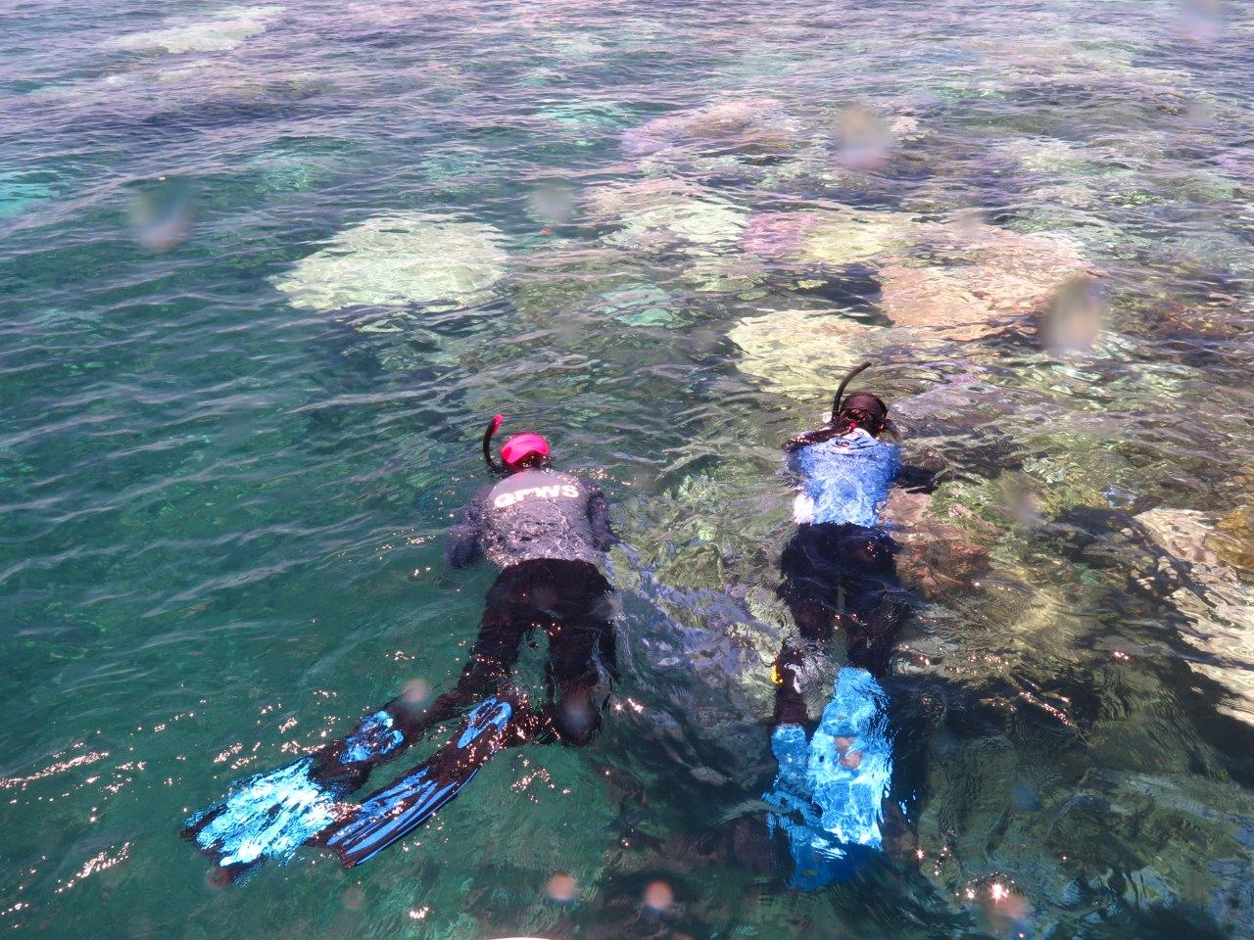
Above: Extensive in-water surveys were conducted to assess the extent and severity of coral bleaching in 2016
Since 2014, corals have bleached severely in most tropical regions across the world in the longest mass coral bleaching event ever recorded.
According to preliminary findings, the event resulted in 22 per cent of coral dying on the 3000 reefs of the Great Barrier Reef, with most of the mortality occurring north of Cooktown.
The bleaching was triggered by prolonged heat stress, causing corals to expel the colourful, symbiotic organisms that live inside their tissue. These organisms, called zooxanthellae, normally mask the underlying white skeleton.
Under the presence of a strong El Niño weather pattern, sea temperatures from February to June 2016 across much of the Reef were a degree or more above their long-term monthly averages, exceeding all previous temperature records.
The El Niño, which typically produces hot, dry and still conditions, came on top of an underlying trend of ocean warming caused by climate change, resulting in an unprecedented level of mass bleaching on the Great Barrier Reef.
In-water surveys, conducted by the agency with the Queensland Parks and Wildlife Service and the Australian Institute of Marine Science, showed that 85 per cent of the die-off occurred between the tip of Cape York and just north of Lizard Island, 250 kilometres north of Cairns.
The impact on reefs between Port Douglas and Cairns varied considerably, from no mortality to high levels of die-off. The 1300 kilometre stretch between Cairns and the bottom boundary of the Marine Park near Bundaberg experienced varying levels of bleaching, from severe to minor, however it escaped significant rates of mortality.
In response to the mass bleaching, the agency triggered its Coral Bleaching Risk and Impact Assessment Plan, conducting its largest ever in-water monitoring effort. The agency formed an incident management team to coordinate and undertake surveys, logistics, mapping and data analysis. Overall, staff from the agency and its partners conducted 2641 in-water surveys of 186 reefs.
To assess coral condition, at least nine different sites on each coral reef were surveyed, to take into account natural variability such as wave action, depth and different reef habitat.
The data was complemented by in-water and aerial surveys carried out by science partners, and information from a network of tourism industry operators and Indigenous rangers.
The agency also undertook extensive stakeholder and broader communications during the bleaching event. This included hosting local forums along the Great Barrier Reef coast, conducting media interviews and Facebook Live sessions, publishing weekly website updates, including maps and other resources, YouTube videos and Reef in Brief e-newsletters.
The agency also undertook preparations to assess recovery rates and survivorship through further surveys in coming months.
The global coral bleaching event has shown the potential of climate change to cause harm that cannot be mitigated through local management or adaptation.

1.10 Indigenous partnerships
REPORTING REQUIREMENTS
This aligns with performance criteria for:
PBS Program 1.1: Protect and restore the Reef’s ecosystem health and biodiversity.
Deliverables:
- Develop a suite of standards, thresholds and limits to maintain ecosystem health and biodiversity.
- Identify and implement a program of regionally based on-ground/in park restoration actions.
- Implement actions under the National Landcare Programme and through the Reef Trust (for the Land and Sea Country Partnerships program, Marine Monitoring Program, Reef Resilience Programme and the Marine Debris Project).
- Number of Traditional Use of Marine Resources Agreements or Indigenous Land Use Agreements in place (8)
Performance criteria:
- Reduce local impacts affecting the condition of key species and habitats.
Key performance indicator:
- Percentage of the Marine Park managed in accordance with an accredited Traditional Use of Marine Resources Agreement or an Indigenous Land Use Agreement (23 per cent).
Corporate Plan Strategy 1: Ensure the best available knowledge is captured and used to inform management decisions, and Strategy 3: Strengthen engagement.

Results against performance criteria
More than 70 Aboriginal and Torres Strait Islander Traditional Owner clan groups have continuing relationships with the Great Barrier Reef Region and its natural resources, dating back more than 60,000 years.
The agency works in partnership with Traditional Owner groups to manage sea country, primarily through the Land and Sea Country Partnerships program.
In 2015–16, several key activities specifically contributed to the performance criteria:
monitoring of key seagrass habitats and mangroves
monitoring of seabirds, turtles, dugongs and snubfin dolphins, in partnership with managers and researchers
rescuing and rehabilitating stranded turtles
mapping and protecting cultural heritage sites
educating people about Traditional Use of Marine Resources Agreement sustainable hunting systems and strengthening compliance
compliance training and participating in joint patrols (air, water and land), to identify and report non-compliant activities occurring within the Marine Park, including within Traditional Use of Marine Resources Agreement areas (for example, illegal fishing, poaching).

Traditional Use of Marine Resources Agreements
The Australian Government Reef Programme contributes $2 million a year to improve the agency’s Land and Sea Country Partnerships program, which is done partly through the development of Traditional Use of Marine Resources Agreements.
These agreements describe how individual Traditional Owner groups wish to manage traditional use of marine resources in their sea country areas, and incorporate specific management strategies for:
the conservation and sustainable use of key species and habitats
maintenance and protection of significant heritage values, including important places, traditional ecological knowledge, culture and language
research and monitoring of sea country, including partnerships with the agency, and other leading research institutes and researchers
leadership and governance, including knowledge management
education and information exchange
compliance.
In 2015–16, the agency developed three-year contracts for the development and implementation of seven Traditional Use of Marine Resources Agreements. This supports implementation of sea country priorities, such as setting sustainable limits on the take of dugong and turtle, and reducing the negative effects on the condition of these two key species. The newest Gunggandji agreement provides for no-take of turtle and dugong in three key areas: Green Island, Michaelmas Cay and Fitzroy Island (see Case study 5).
There are currently eight Traditional Use of Marine Resources Agreements in place, covering 24.6 per cent of the total Marine Park coastline. Engagement with Traditional Owners and partnerships through the program strengthen the protection and restoration of the Reef’s biodiversity, recognising culture cannot be separated from the environment. Our partnership with Traditional Owners incorporates shared science, knowledge and environmental management for the ongoing protection of the Great Barrier Reef.
In May 2016, the Girringun Region Sea Country Conference brought together Traditional Owners to celebrate 10 years of the Girringun agreement and discuss the future of sea country management, ranger training and issues of concern (for example, climate change).
In the same month, more than 40 Woppaburra Traditional Owners gathered on North Keppel Island (Konomie — their ancestral island) for their largest ever on-country Traditional Use of Marine Resources Agreement meeting. For a number of the Traditional Owners, it was the first time they had stepped foot on their ancestral island.
During the reporting period, Lama Lama Traditional Owners travelled to Townsville to meet with researchers from the Australian Institute of Marine Science and James Cook University, and Reef managers. The meetings laid the groundwork for developing a science and research strategy, which will support partnerships with researchers, research training opportunities, and increase research and monitoring in the Princess Charlotte Bay region.
As part of a Traditional Use of Marine Resources Agreement, Yuku Baja Muliku Traditional Owners ran a Career Pathways Junior Ranger camp over three days in September 2015. Twenty-eight children and 10 Yuku Baja Muliku Elders travelled from Cooktown to Cairns, and completed a series of marine-based activities, including visiting the Fitzroy Island Turtle Hospital and participating in activities with Yirrgandji Traditional Owners.
The agency also delivered compliance education and training to 81 Aboriginal and Torres Strait Islander people during the reporting year, to increase the capacity of communities to identify and report illegal activities.
The best available knowledge and information to help attain positive outcomes for the Reef’s values includes traditional ecological knowledge and an understanding of how Traditional Owners want to protect their sea country for the long term. This has been enabled through Traditional Use of Marine Resources Agreements. In 2015–16, three meetings with the Indigenous Reef Advisory Committee contributed to the attainment of knowledge and information to:
develop guidelines for the protection of Indigenous heritage values
scope the development of an Indigenous heritage strategy, and the sharing of culturally sensitive information to better inform management
draft a policy on the Traditional Use of Marine Resources.
Case study 5: Australia’s eighth Traditional Use of Marine Resources Agreement
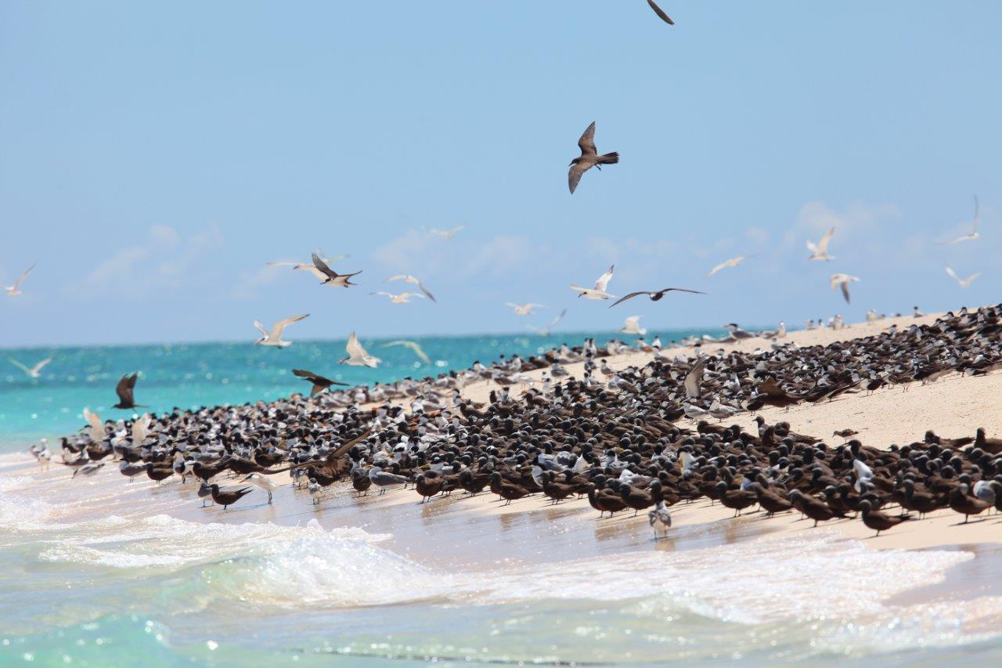
Above: The waters adjacent to Michaelmas Cay in the far north are covered by a Traditional Use of Marine Resources Agreement with Gunggandji Traditional Owners
A formal Traditional Use of Marine Resources Agreement with Gunggandji Traditional Owners of the Yarrabah region was accredited by the Australian and Queensland governments on 28 June 2016.
It is the eighth sea country agreement signed under the Traditional Use of Marine Resources Agreement program and covers 86 square kilometres of the Great Barrier Reef Marine Park. It is the second agreement to be completely offshore.
The Gunggandji Marine Resources Agreement covers three key areas: the waters adjacent to Green Island, Michaelmas Cay and Fitzroy Island. Under the agreement, the Traditional Owners have stipulated no-take of turtle or dugong in these areas.
These sites are also popular boating, snorkelling and diving destinations in the Cairns region. Michaelmas Cay is recognised as an important seabird nesting site, with up to 20,000 breeding pairs in residence at any one time. It is also home to one of the largest breeding colonies of sooty terns in Queensland.
The Gunggandji and Yirrganydji Traditional Owners, whose country is between Cairns and Port Douglas, have shared interests in Michaelmas Cay and will work together under two Traditional Use of Marine Resources Agreements to manage the area in accordance with traditional lores and customs.
The Great Barrier Reef Marine Park Authority, along with the Queensland Government, provided guidance and support to Gunggandji Traditional Owners to develop the agreement. This was funded by the agency and the Australian Government’s Reef Programme, enabling Traditional Owners to meet and decide upon important matters such as protection and conservation of important species, compliance, and hunting protocols.
Implementation of the accredited agreement will now occur, in partnership with the agency and the Queensland Government, through specialised training to Indigenous rangers, joint patrols, community engagement and on-country activities.

Indigenous Ranger Compliance Enhancement program — Reef Trust
The National Dugong and Turtle Protection Plan 2014–2017 aims to increase the protection of dugong and turtle populations of far north Queensland and the Torres Strait from the threats of poaching, illegal hunting and marine debris.
Under this plan, the agency has designed, and is implementing, the Indigenous Ranger Compliance Enhancement program to protect dugong and turtles through increased education and specialised compliance training. This program has employed four Indigenous compliance officers over two years, and is upskilling another 24 existing Indigenous community rangers whose areas covers Rollingstone near Townsville to the northern tip of Queensland (including the western cape and Torres Strait).
The participating rangers are enrolled in a nationally accredited Certificate IV in Government Investigations, and are being mentored and assessed in classroom and field exercises. Participation in this course will enable Indigenous rangers to develop compliance skills and apply for inspector powers under the Great Barrier Reef Marine Park Act 1975 (the Marine Park Act).
In October 2015, the Indigenous rangers received intensive theoretical and field-based training over six days at the Yuku Baja Muliku Ranger base south of Cooktown. Participation and attendance was 100 per cent. Learnings from this course have since been applied in the field, with rangers participating in compliance activities and patrols with various regulatory agencies.
In June 2016, the agency coordinated a two-day workshop at the Cairns Magistrates Court to provide trainees with an opportunity to hear from magistrates, defence lawyers, investigators and field operation staff about the duties expected of rangers and their role in the prosecution process.

Analysis of performance against purpose
The development of Traditional Use of Marine Resources Agreements is reliant upon Traditional Owner agreement and governance. The agency is not in control of these factors and can only support the development process. Face-to-face consultation and enduring partnerships are needed. The agency strives to support this; however, the geographic spread of some Traditional Owners and remote locations is a continuous challenge.

Goal 2: Safeguard the Reef’s heritage

2.1 Implementing the Reef 2050 Plan
REPORTING REQUIREMENTS
This aligns with performance criteria for:
PBS Program 1.1: Safeguard the Reef’s heritage.
Deliverables:
- Develop and implement strategies to safeguard Indigenous heritage, historic heritage and other heritage values within a comprehensive management framework.
Performance criteria:
- Enhanced identification, understanding, recognition, protection and conservation of the Reef's heritage values.
Corporate Plan Strategy 1: Ensure the best available knowledge is captured and used to inform management decisions, Performance measures 1.1, 1.2 and 1.3 (see Box 1).

Results against performance criteria
The Reef 2050 Plan provides an overarching framework for the Reef’s protection and management for the next 35 years.
It sets clear outcomes and targets to guide investments and actions required to build the Reef’s health and resilience.
The agency is responsible for the delivery of more than half of the Reef 2050 Plan’s actions and many of its foundational management programs (see Figure 5).
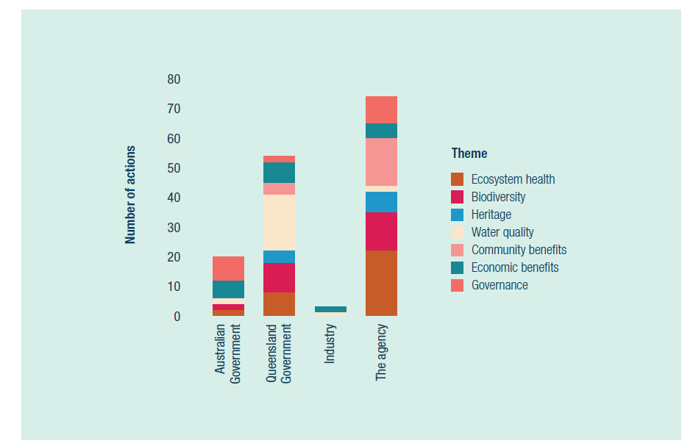
Figure 5: Overview of Reef 2050 Plan actions and reporting leads, by theme
Throughout the year, the agency continued to work with the Queensland Office of the Great Barrier Reef, the Australian Department of the Environment, Traditional Owners and stakeholders on implementing the Reef 2050 Plan. This includes the following:
Preparation of the first annual report for the Reef 2050 Plan, which will summarise progress made in implementing actions in the 12 months since the launch of the plan in March 2015. Key agency actions include education and on-ground projects to reduce marine debris; implementing the Raine Island Recovery Project; Reef Guardian program activities; conservation management plans for historic shipwrecks; and promotion of Great Barrier Reef maritime heritage values. The report will include the third Reef 2050 Implementation Strategy, which examines the key focus areas for mid-2016 to mid-2017.
Development of an investment framework that outlines public and private investment to support implementation of the Reef 2050 Plan. The investment framework is being developed and implemented in a phased approach. Phase one was released in 2015 and provided a snapshot of current investment by government and non-government sectors. Phase two, completed in December 2015, involved prioritising the actions listed in the Reef 2050 Plan. Phase three is underway and will examine options available to diversify income sources.
The agency is also contributing to a report for UNESCO on the implementation of the Reef 2050 Plan. Due in December 2016, the report will document progress to date.
Governance arrangements for the Reef 2050 Plan have now been formalised and implemented (see Figure 6). Each committee is supported by a secretariat from either the agency (Reef 2050 Integrated Monitoring and Reporting Program), the Australian Department of the Environment (Independent Expert Panel) or the Queensland Government Office of the Great Barrier Reef (Reef 2050 Advisory Committee).
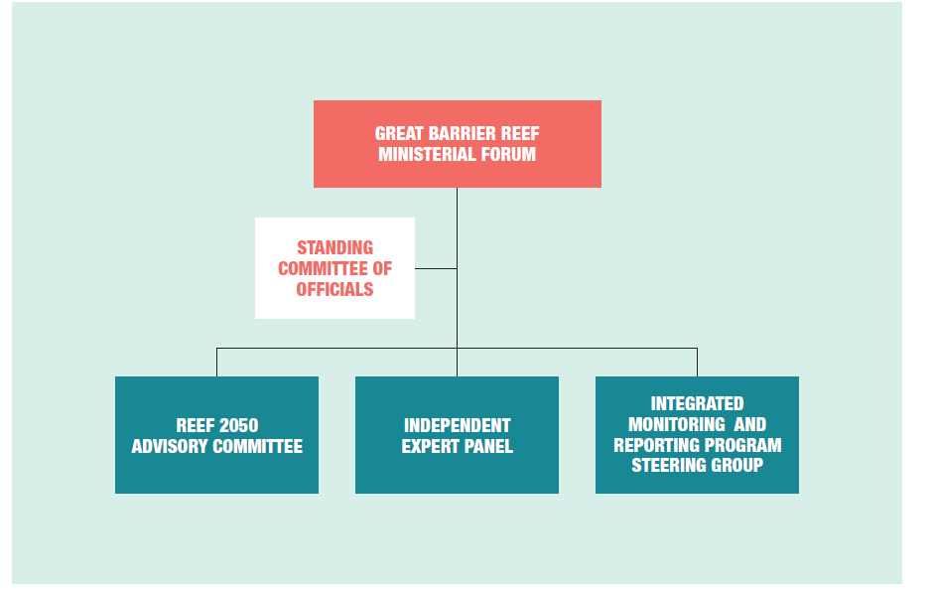
Figure 6: Governance arrangements for the Reef 2050 Plan
The Reef 2050 Advisory Committee facilitates engagement with industry and the broader community on the implementation and review of the Reef 2050 Plan. The committee provides strategic advice on the implementation of Reef 2050 actions, stakeholder priorities, and highlights any emerging cross-sectoral issues that need to be addressed. Members include representatives of Traditional Owners, industry and non-government organisations. The inaugural Chairman is the Hon. Penelope Wensley AC, former Governor of Queensland and former Australian Ambassador for the Environment.
The Independent Expert Panel brings together scientific expertise from a diverse range of disciplines to advise governments on Reef science matters. The panel has created a pathway for government to access independent scientific advice, supporting better decision-making across a range of operational and policy topics. The inaugural Chairman is Professor Ian Chubb, former Australian Chief Scientist.
The Reef 2050 Integrated Monitoring and Reporting Program steering group provides advice on what is required for an effective integrated monitoring, modelling and reporting program for the Reef 2050 Plan. The steering group guides the program’s development and operation, and provides advice to the Ministerial Forum on monitoring and reporting requirements for the Great Barrier Reef. It is co-chaired by the Chairman of the agency and the Director-General of the Queensland Department of Environment and Heritage Protection. Members include senior officials from government agencies and monitoring organisations.

Analysis of performance against purpose
Of the 74 Reef 2050 Plan actions being led by the agency, most are in place or on track to be completed within the identified timeframe; only one is delayed. The delayed action entails creating a Great Barrier Reef Plan register, with all management plans recorded to simplify understanding of management arrangements. Work has commenced on this project, but due to competing priorities the revised completion date is December 2016.

2.2 Science coordination and engagement
REPORTING REQUIREMENTS
This aligns with performance criteria for:
PBS Program 1.1: Safeguard the Reef’s heritage.
Deliverables:
- Develop and implement strategies to safeguard Indigenous heritage, historic heritage and other heritage values within a comprehensive management framework.
Performance criteria:
- Enhanced identification, understanding, recognition, protection and conservation of the Reef's heritage values.
Corporate Plan Strategy 1: Ensure the best available knowledge is captured and used to inform management decisions, Performance measures 1.1, 1.2 and 1.3 (see Box 1).

Results against performance criteria
Research funded by the National Environmental Science Programme has delivered on a number of priority science needs for the agency identified in our Science strategy and information needs 2014–2019, which identifies research required for management.
The program’s Tropical Water Quality Hub has supported several of the agency’s priority projects, including the development of the Reef 2050 Integrated Monitoring and Reporting Program and delivery of actions in the Reef 2050 Plan, including improved governance arrangements for the Reef, increased participation by Traditional Owners and better understanding of cumulative impacts on the Reef.
The program’s Marine Biodiversity Hub has funded research into protected species of high interest to the agency, including hammerhead sharks, grey nurse sharks and sawfish, and pressures on the marine environment, such as the risk of ship strike to dolphins, dugongs, turtles and whales. The agency has also provided input to future research priorities for both the Tropical Water Quality Hub and the Marine Biodiversity Hub.
The agency provided in-kind support to an Advance Queensland Research Fellowship examining the recovery rate of reefs. This research is highly relevant to the agency’s management needs, particularly in the wake of the 2016 coral bleaching event.
In the reporting period, the agency worked with major partners, including the Great Barrier Reef Foundation and the CSIRO, to synergise research priorities. The agency continued to be represented on committees and boards of major science programs, partnerships and advisory bodies, including the Australian Research Council Centre of Excellence for Coral Reef Studies, the Great Barrier Reef Foundation, the National Environmental Science Programme’s Tropical Water Quality Hub, and the National Marine Science Committee. The agency also continues to provide valuable user input to major scientific data tools, such as e-Reefs and e-Atlas.
This year, the agency’s science seminar series delivered informative and relevant presentations to more than 260 attendees from within the agency and external organisations.

Analysis of performance against purpose
Implementation of the Reef 2050 Integrated Monitoring and Reporting Program affected the agency’s science coordination capacity in 2015. The monitoring program is a priority project and resources were allocated accordingly. Science coordination resources increased in early 2016, with the recruitment of a dedicated staff member.

2.3 Social and economic programs
REPORTING REQUIREMENTS
This aligns with performance criteria for:
PBS Program 1.1: Safeguard the Reef’s heritage.
Deliverables:
- Develop and implement strategies to safeguard Indigenous heritage, historic heritage and other heritage values within a comprehensive management framework.
Performance criteria:
- Enhanced identification, understanding, recognition, protection and conservation of the Reef's heritage values.
Corporate Plan Strategy 1: Ensure the best available knowledge is captured and used to inform management decisions, Performance measures 1.1, 1.2 and 1.3 (see Box 1).

Results against performance criteria
The Great Barrier Reef Region Strategic Assessment Program Report identified the need to better understand and protect the social and economic benefits derived from the environment.
In 2015–16, several areas contributed to the development of social and economic programs.
Draft social impact assessment guidelines were incorporated into the agency’s policy, planning and regulatory framework, and formed the basis for policy guidance on the management of cumulative impacts.
As part of the Reef 2050 Integrated Monitoring and Reporting Program, significant progress has been made in identifying indicators for human dimension themes of the Reef 2050 Plan, including community and economic benefits themes. These indicators will be used for monitoring and reporting at Reef-wide and regional scales, and form the basis for tracking progress towards targets and outcomes under the Reef 2050 Plan.
The agency collaborates with social scientists who study the Reef and is an active participant in National Environmental Science Programme projects. These collaborations have led to the implementation of a Social Science Network, which brings scientists and managers together to discuss Reef-related projects and programs.
During the 2015–16 reporting period, the agency also prioritised developing and trialling novel approaches to how the aesthetic qualities of the Great Barrier Reef are monitored and assessed. This project has been funded within the National Environmental Science Programme for 2016–17.

Analysis of performance against purpose
The agency is ensuring the best available information is captured to inform decision-making. Through a collaborative approach, the agency is advancing its understanding of the Reef’s human dimensions (such as community and economic benefits).

2.4 Indigenous targets under the Reef 2050 Plan
REPORTING REQUIREMENTS
This aligns with performance criteria for:
PBS Program 1.1: Safeguard the Reef’s heritage.
Deliverables:
- Develop and implement strategies to safeguard Indigenous heritage, historic heritage and other heritage values within a comprehensive management framework.
Performance criteria:
- Enhanced identification, understanding, recognition, protection and conservation of the Reef's heritage values.
Corporate Plan Strategy 1: Ensure the best available knowledge is captured and used to inform management decisions, and Strategy 3: Strengthen engagement, Performance measure 3.1 (see Box 1).

Results against performance criteria
Traditional Owners are becoming increasingly interested in using marine resource agreements, which capture and record Indigenous cultural heritage. This has been demonstrated by two new Traditional Owner groups formally requesting assistance to develop a Traditional Use of Marine Resources Agreement.
It is essential to establish an effective and meaningful partnership with Traditional Owners, to protect cultural and heritage values, conserve biodiversity and increase the Reef’s resilience. The Land and Sea Country Partnerships program engages Indigenous communities along the length of the Reef in the management and sustainability of the Reef’s marine resources. The program is reported as part of the Land and Sea Country Partnerships program (see Section 1.10). Strategies to safeguard Indigenous heritage include:
developing and implementing Traditional Use of Marine Resources Agreements (eight implemented to date)
cultural heritage mapping under the Port Curtis Coral Coast Traditional Use of Marine Resources Agreement and the Gladstone Healthy Harbour Partnership
meeting with advisory committees and Traditional Owners to develop guidelines to better protect Indigenous heritage values
developing an Indigenous Heritage Strategy to improve understanding and protection of Indigenous heritage values in the Great Barrier Reef Region.

Analysis of performance against purpose
There are no significant factors to report.

2.5 Heritage strategy
REPORTING REQUIREMENTS
This aligns with performance criteria for:
PBS Program 1.1: Safeguard the Reef’s heritage.
Deliverables:
- Develop and implement strategies to safeguard Indigenous heritage, historic heritage and other heritage values within a comprehensive management framework.
Performance criteria:
- Enhanced identification, understanding, recognition, protection and conservation of the Reef’s heritage values.
Corporate Plan Strategy 1: Ensure the best available knowledge is captured and used to inform management decisions.

Results against performance criteria
In 2015–16, the agency made structural changes by creating a new section — Heritage, International and Governance. This new section takes a holistic approach to heritage, and allows the agency to better fulfil its obligations under the Marine Park Act and respond to issues identified in the Great Barrier Reef Outlook Report and progress actions under the Reef 2050 Plan.

Recognising and protecting Catalina heritage
In February 2016, the agency was represented at a memorial service by the Royal Australian Air Force (RAAF) to honour the crew of Catalina A24-25, which crashed in waters south of Cairns during World War Two.
The wreckage of the aircraft was found in 2013 and was confirmed to be the Catalina A24-25 which crashed on 28 February 1943, killing all 11 personnel on board.
A commemorative plaque has been placed at the Catalina memorial in Cairns.
The agency, in consultation with the RAAF, has declared the site a Maritime Cultural Heritage Special Management Area.

Conservation management plans for historic shipwrecks
In 2015–16, the agency partnered with the Queensland Department of Environment and Heritage Protection to develop conservation management plans for six key historic shipwrecks — Yongala (1911), Gothenburg (1875), Llewellyn (1919), Foam (1893), HMCS Mermaid (1829) and HMS Pandora (1791). Research is being done to make sure each conservation management plan is underpinned by the most up-to-date information on the state of the heritage values at each site. These plans will not only ensure heritage values are identified and documented, but also protected through robust decision-making and planning processes for generations to come.

Promotion of Great Barrier Reef maritime heritage values
To ensure the ongoing protection and conservation of maritime heritage values, it is important to ensure decision-makers and the community understand the important role these values play in contributing to the outstanding universal value of the Great Barrier Reef. This year, the agency began work on a guide to the shipwrecks of Magnetic Island to promote maritime heritage values to the local community. Additionally, 28 marine park managers and university students participated in a maritime archaeology course delivered by the agency and the Queensland Department of Environment and Heritage Protection, with the support of the Museum of Tropical Queensland. The course provided training on archaeological principles and science, archaeological surveying and search techniques specific to historic shipwrecks and maritime cultural heritage management practices.

Cultural protocols to guide appropriate management of Indigenous heritage
Traditional Owners are the primary source of information on their heritage values and how these values are best managed. A project to develop cultural protocols to guide management of Indigenous heritage, funded under the Reef 2050 Integrated Monitoring and Reporting Program, will build on the agency’s work for its cultural heritage information management system to develop protocols for managing culturally sensitive information.
The agency will partner with Traditional Owners to determine how to store, handle and manage Indigenous knowledge appropriately. There are more than 70 Traditional Owner groups with authority for sea country management in the Great Barrier Reef World Heritage Area. The agency has a formal working relationship with more than half of these groups, and will work with them to establish data-sharing agreements. A new Indigenous Heritage Steering Committee has been established to govern the two-year project.

Building capacity for enhanced heritage protection and management
The agency joined the Queensland Department of Environment and Heritage to deliver the internationally recognised Australasian Institute of Maritime Archaeology and the Nautical Archaeology Society field course in Townsville in November 2015, and again in June 2016. Twenty-eight staff collectively attended these training courses.
The Nautical Archaeology Society, an international society based in the United Kingdom, helps to advance education in maritime archaeology by teaching a structured training scheme to divers and non-divers around the world. The scheme was designed and developed by maritime archaeologists and recreational divers to teach basic archaeological skills, and to foster an appreciation of the value and fragility of maritime cultural heritage.
The Townsville course was a two-day general introduction to maritime archaeology, focusing on aspects such as predisturbance or non-intrusive surveys of shipwreck sites. The course structure included archaeological principles and sciences, materials and conservation, ship construction, surveying and search techniques, site position-fixing and remote sensing. It also covered state, territory and Commonwealth legislation.
This training will assist both Australian and state government staff to undertake enhanced heritage protection in the field and through regulatory processes.

Analysis of performance against purpose
There are no significant factors to report.

2.6 Engagement with international agencies, organisations and forums
REPORTING REQUIREMENTS
This aligns with performance criteria for:
PBS Program 1.1: Safeguard the Reef’s heritage.
Deliverables:
- Develop and implement strategies to safeguard Indigenous heritage, historic heritage and other heritage values within a comprehensive management framework.
Performance criteria:
- Enhanced identification, understanding, recognition, protection and conservation of the Reef’s heritage values.
Corporate Plan Strategy 3: Strengthen engagement, Performance measure 3.4 (see Box 1).

Results against performance criteria
In 2015–16, the agency welcomed and assisted 17 international delegations from around the world, including Norway, Jamaica, Korea, the Philippines, Japan, Germany, Indonesia and India.
These visitors, representing marine protected area management practitioners and policy makers, were shown how the Marine Park is managed, with a focus on zoning rules, compliance measures, crown-of-thorns starfish control, and fisheries. These exchanges are valuable in building capacity on subjects such as building coral reef resilience, and world heritage protection and management.
The agency also provided technical assistance to 13 international institutions on the subject of environmental management.
The agency participated in the 30th International Coral Reef Initiative General Meeting, the 5th International Tropical Marine Ecosystems Management Symposium, the Big Ocean Partnerships 7th Network Business Meeting, and the 13th International Coral Reef Symposium. These major international meetings and forums represent invaluable opportunities to share knowledge and best practices in response to the impacts of climate change, particularly among coral reef area managers around the world.
Two agency staff attended a think tank on the Human Dimensions of Large-scale Marine Protected Areas, facilitated by the Big Ocean network and the United States National Oceanic and Atmospheric Administration. The ‘human dimensions’ (social, cultural, political, economic and institutional aspects) of natural resource management increasingly feature in the science that underpins protected area management, and the agency is recognised internationally as a leader in this area.
Two agency representatives also joined colleagues from the Australian Department of the Environment and the Queensland Government to attend a preparatory workshop with the World Heritage Centre and the International Union for the Conservation of Nature in Switzerland. The workshop discussed an update on progress of the Reef 2050 Plan, due to be delivered to the World Heritage Centre in December 2016.

Analysis of performance against purpose
There are no significant factors to report.

2.7 Commonwealth islands management
REPORTING REQUIREMENTS
This aligns with performance criteria for:
PBS Program 1.1: Safeguard the Reef’s heritage.
Deliverables:
- Develop and implement strategies to safeguard Indigenous heritage, historic heritage and other heritage values within a comprehensive management framework.
Performance criteria:
- Enhanced identification, understanding, recognition, protection and conservation of the Reef’s heritage values.
Corporate Plan Strategy 2: Effective and efficient environmental regulation.

Results against performance criteria
The agency manages cultural and Indigenous heritage on island national parks and Commonwealth-owned islands. This includes developing heritage management plans to protect significant sites, and active maintenance and restoration at some locations. During the reporting period, significant progress was made on preparing a Low Island Heritage Management Plan in conjunction with the Australian Maritime Safety Authority. The management plan will protect the cultural heritage (including the historic functioning lighthouse) and Indigenous heritage. Implementation of the existing Dent Island Lightstation and Lady Elliot Island Lightstation heritage management plans continues, such as painting the exterior of the Lady Elliot Lighthouse.
During 2015–16, annual building, asbestos, and natural resource management audits were completed for the three Commonwealth islands that have Commonwealth heritage-listed buildings on them — Dent Island, Lady Elliot Island and Low Isles.
Most of Lady Elliot Island is leased to Lady Elliot Resort, with the Australian Maritime Safety Authority leasing a small section for operation of the Aid to Navigation system. Amended lease arrangements relating to implementation of the Lady Elliot Island Ecosystem Resilience Plan are being developed with the resort.
Lady Elliot Island is one of the most significant seabird breeding sites in the World Heritage Area, and it also supports nesting green turtles. A draft Lady Elliot Island Ecosystem Resilience Plan is being prepared with the resort to maintain and improve the island habitat, which has been heavily modified from past land use. Some aspects of the plan are already being implemented, such as annual vegetation monitoring surveys. The resort has also established a plant nursery to cultivate hundreds of Pisonia and other native cay species, which are being planted by volunteers.

Analysis of performance against purpose
There are no significant factors to report.

Goal 3: Ensure use of the Marine Park is ecologically sustainable and benefits current and future generations

3.1 Implementing the permission system
REPORTING REQUIREMENTS
This aligns with performance criteria for:
PBS Program 1.1: Ensure use of the Marine Park is ecologically sustainable and benefits current and future generations.
Deliverables:
- Implement the policy, planning and regulatory framework for the sustainable use of the Marine Park.
- Deliver the 2015–16 Annual Business Plan for Field Management.
- Number of permits issued (650).
Performance criteria:
- Improved inclusion in management decisions of knowledge about the Reef’s values, their condition and impacts.
Corporate Plan Strategy 2: Effective and efficient environmental regulation, Performance measures 2.1 and 2.3 (see Box 1).

Results against performance criteria

Permission system
The permission system is established under the Marine Park Act. Section 2A(3)(d) of the Act states that ‘in order to achieve its objects, this Act regulates, including by a system of permissions, use of the Great Barrier Reef Marine Park in ways consistent with ecosystem-based management and the principles of ecologically sustainable use’.

Reef Management System
The Reef Management System is a database application designed to provide simple and seamless functionality to manage permissions for all the activities that occur within the World Heritage Area. The system allows internal staff and external permission holders to manage a range of legislative and regulatory requirements.
During 2015–16, phase three development of the Reef Management System provided better functionality, delivering full integration with the agency’s electronic documents and records management system and geospatial components. Access was enabled for Queensland Parks and Wildlife Service staff, and the system was prepared for migration to a new database platform.

Permits managed
Each permit can include multiple permissions, and each permission may have multiple conditions. At 30 June 2016, 1293 permits were being managed. Of these, almost 90 per cent are categorised as being lower risk, level-one permits, such as those for commercial tourism operations that provide scuba diving and non-motorised water sports activities. The remaining 10 per cent of permits are categorised as level two (for example, heli-pontoons), level three (for example, sewage and aquaculture discharge) or level four (complex or large-scale projects that may have a significant impact on the Marine Park) assessments. All permits and applications under assessment are published on the agency’s website.
Many of the current permits require several post-permit management actions, which is time-intensive. For example, some of the more complex level-four permits may generate an environmental management plan, a removal plan, a schedule of works, a sampling and analysis plan, or a sampling and analysis report for dredging. Most of the plans will require an assessment, negotiation and, ultimately, written approval by the delegate within the agency.

New applications
During 2015–16, the agency received 424 applications and granted 327 permits. About 77 per cent of permits issued were lower risk, standard level-one permits. During the reporting period, no new level-four applications were received, and one level-four decision was made.
Table 1 provides a summary of permit decisions against agreed targets compared to previous years.
Table 1: Comparison of permit decisions versus agreed targets in the Portfolio Budget Statement 1.1
Indicator | 2012–13 | 2013–14 | 2014–15 | 2015–16
Permit applications received per annum | 489 | 507 | 472 | 413
Permits issued per annum: target (achievement) | 650 (552 permits, including camping permits) | 650 (449 permits, not including camping permits*) | 650 (332 permits, not including camping permits*) | 650 (327 permits, not including camping permits*)
Level one (low risk) permits issued | Not applicable | 382 (91%) | 308 (93%) | 242 (77%)
* The agency used to report on camping permits issued for Commonwealth islands by the Queensland Parks and Wildlife Service. In 2012–13, camping bookings became electronic and were no longer a reportable line item. The target number of permits issued per annum should have been changed to reflect this, but was not.

Multiple permissions
At the end of the reporting period, the agency was managing 5856 permissions. Figure 7 represents the total number of current permissions in the Marine Park. Most of the permissions granted were for tourist programs, charter vessel and aircraft, research, moorings and facilities. Facilities include structures such as barge ramps, boat ramps, jetties, marinas, pipelines, pontoons, snorkel trails and marker buoys.
Of the 327 permits granted during the reporting period, 1234 individual permissions were issued.
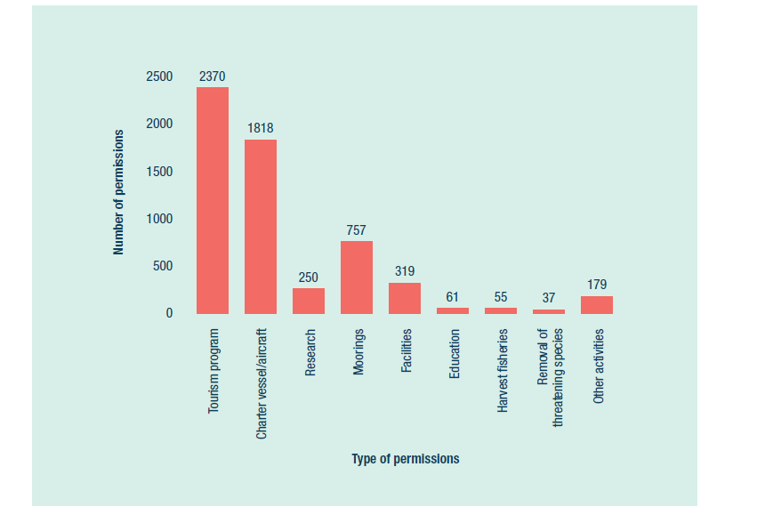
Figure 7: Type and number of current permissions managed by the Great Barrier Reef Marine Park Authority, as at 30 June 2016

Traditional Use of Marine Resources Agreements
The agency accredited one Traditional Use of Marine Resources Agreement, as assessed against regulation 89 of the Great Barrier Reef Marine Park Regulations. These agreements now cover a total of 45,200 square kilometres of sea country and involve 16 Traditional Owner groups (see Section 1.10 for more detail).

Post-decision monitoring and compliance
The agency undertook a suite of monitoring and administrative compliance activities in 2015–16, including:
performing targeted field inspections
monitoring of permitted use
ensuring permitted facilities are well maintained
delivering education designed to promote self-regulation.
Environmental site supervision was also conducted at priority sites, and was typically linked to an approved schedule of works or an environmental management plan, or to supervise and ensure permit condition compliance.
One environmental site supervisory trip was taken to oversee dredging activities. The team made three on-site visits, which usually involved a general familiarisation of the site and on-site discussions with the proponent/permittee.
During 2015–16, several staff participated in training about environmental impact assessment, environmental auditing and compliance.
Tables 2 and 3 summarise the permissions-related, reported non-compliances and actions taken to address non-compliant behaviour.
Table 2: Alleged permission non-compliances reported to the Great Barrier Reef Marine Park Authority, 2015–16
Permit non-compliance (alleged) | Number
Failure to maintain ECO certification | 5
Failure to comply with Queensland or Australian government legislation | 2
Failure to make a booking | 17
Failure to display AIN/VIN/BIN, permit or research | 6
Failure to comply with MNA/VNA/FNA/ENA | 8
Operating outside permitted zones and locations | 5
Other permit condition contravention | 4
Failure to submit, or comply with, a management plan | 3
Failure to submit a bond | 5
Failure to execute a deed | 11
Failure to maintain a facility | 32
Failure to install | 28
Failure to submit a schedule of works or conduct an environmental site supervision | 2
Exceeding limits | 21
Failure to report/notify | 53
Use of unpermitted methodology | 5
Failure to remove equipment | 1
Unpermitted take of protected species | 4
Failure to display mooring reference number | 6
Failure to commence operations | 63
Total | 281
AIN = Aircraft identification number; BIN = Bareboat identification number; ENA = Equipment notification approval; FNA = Facility notification approval; MNA = Mooring notification approval; VIN = Vessel identification number; VNA = Vehicle notification approval
Table 3: Actions taken to resolve reported permission non-compliances, 2015–16
Compliance actions taken | Number
No action — alleged non-compliance unsubstantiated | 19
Referral — not within jurisdiction, or Queensland Parks and Wildlife Service to action | 7
Surrender of permission | 2
Update mooring notification approval | 1
Referral to delegate — under continuation | 9
Permittee education | 18
Environmental site supervision | 1
Extension of time | 34
Advisory letter | 116
Intention to revoke letter — commencing operation | 2
Revocation of permission — commencing operations | 7
Total | 216

Notifications and directions
During the reporting period, the agency was notified, or gave directions for, 11 Part 5 activities under the Great Barrier Reef Marine Park Zoning Plan 2003, as outlined in Table 4.
Table 4: Part 5 activities notified or directions granted, 2015–16
Activity | Number
Defence activities | 2
Maintenance of navigational aids | 2
Management activities | 5
Urgent works on essential public services | 2

Environmental management charge
Implementing the environmental management charge, which is placed on most commercial activities, including visitors using tourism operations in the Marine Park, continues to be a priority. The agency has reviewed a formal set of environmental management charge guidelines for permittees to ensure best practice and transparent management of the revenue.
The standard tourist program charge was reinstated to the full charge after a three-year reduction that started in 2012. On 1 April 2016, the standard tourist program charge per person per day increased from $6.00 to $6.50, and from $3.00 to $3.25 for part-day tours of less than three hours.
During the year, the agency undertook 489 environmental management charge administrative compliance actions. Since 2011, there have been substantial improvements to the management of this charge. These improvements have allowed better auditing and the ability to take action when required in relation to non-compliances (Figure 8). As a result, there has been a steady decline in environmental management charge non-compliance actions.
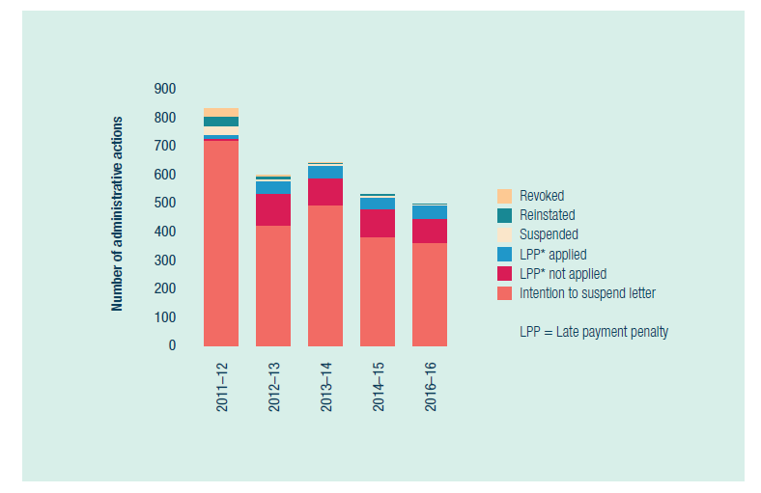
Figure 8: Administrative actions taken for environmental management charge non-compliance, 2011–12 to 2015–16

Coordination with the EPBC Act
The agency has continued to implement the 2009 memorandum of understanding with the Australian Department of the Environment, in relation to the integration and application of the EPBC Act and the Marine Park Act.
This memorandum helps to integrate and streamline the application and assessment processes when approvals and permissions are required under both Acts, through establishing agreed-to administrative arrangements.
In 2015–16, the agency advised the Australian Department of the Environment on 20 referrals and approved projects.

Applications refused, reconsidered and appealed
In 2015–16, no applications for permits were refused by the delegate. This is because the agency works closely with applicants to ensure they apply for a permission that is acceptable to the agency. As such, many applications change and evolve during the assessment period into applications that are eventually approved.
During the reporting period, the agency received one request for a reconsideration of an initial permit application decision, and one request for a statement of reasons. The reconsideration resulted in the variation of conditions to the existing permit.
One application was made during the reporting period for an internal reconsideration of a decision on an application for a secondary-service determination. If a service is declared by the agency to be a secondary service, this may affect the obligations of certain permittees to collect the environmental management charge from visitors to the Marine Park. On reconsideration, the original decision — to refuse the application — was upheld, with the effect that the services subject to the application are not secondary services under regulation 137 of the Great Barrier Reef Marine Park Regulations.
One application was made during the reporting period for the agency to reconsider a decision on the revocation of permissions, as a result of not commencing operations in the Marine Park within the time specified in the permit. A decision on that reconsideration had yet to be made by the end of the reporting period.

Administrative Appeals Tribunal
Two applications were made to the Administrative Appeals Tribunal during the reporting period:
An application for review of an infringement notice was dismissed on the basis the Administrative Appeals Tribunal did not have jurisdiction to consider the application.
An application for review of a decision to refuse an application made for a secondary-service determination under regulation 137 of the Great Barrier Reef Marine Park Regulations. It is expected that a hearing will take place in 2016–17.
Two Administrative Appeals Tribunal applications made before 2015–16 were finalised during the reporting period:
An application for review of a decision by the agency to release certain documents under the Freedom of Information Act 1982. The Administrative Appeals Tribunal made a decision giving effect to an agreement by the parties to resolve the matter. The documents in question have now been released to the freedom of information applicant.
An application for review of a decision by the agency to refuse an application for a permission was dismissed by the Administrative Appeals Tribunal by the consent of both parties.
One application made before 2015–16 remains outstanding. An application for review of a decision by the Privacy Commissioner was made about alleged breaches of the Privacy Act 1988 by the agency. The matter was heard in February 2016 and the Administrative Appeals Tribunal has reserved its decision.

Analysis of performance against purpose
The number of permits issued has progressively decreased during the past four years. The target contained in Table 1 was calculated based on the inclusion of camping permits for Commonwealth islands. The permit issuing process was made electronic in 2013–14 and the target should have been changed to reflect this.
The downturn in issued permits also reflects the agency’s focus on post-permit management and strengthening the permission compliance system. A team of people is dedicated to post-permit management of higher risk applications to ensure proper and orderly management of the Marine Park.
There is also a significant amount of time spent on engaging with permittees to ensure the best outcome for the Marine Park. During 2015–16, more level-two permits were granted than in previous years. This required more resources and time for processing, and accounts for the overall reduction in number of permits issued.
There were a number of factors that contributed to the agency’s performance to achieve its purpose. Staff were reallocated towards strengthening the permissions system project, and there was high staff turnover, with a number of new officers that required training. Due to the coral bleaching event in 2016, the agency received a higher than usual number of non-standard research applications.

3.2 Management of defence activities
REPORTING REQUIREMENTS
This aligns with performance criteria for:
PBS Program 1.1: Ensure use of the Marine Park is ecologically sustainable and benefits current and future generations.
Deliverables:
- Implement partnership, stewardship, education and communications programs.
Performance criteria:
- Improved uptake of best practice and stewardship in activities that contribute to the health and resilience of the Marine Park.
Corporate Plan Strategy 3: Strengthen engagement.

Results against performance criteria
The agency maintained a strong working relationship with the Australian Department of Defence throughout the year.
Staff provided advice to the Department of Defence on ways to avoid or minimise impacts from a number of defence operations and exercises in the Marine Park. The department seeks to reinforce its awareness and understanding of the importance of operating in a World Heritage Area to visiting militaries during joint exercises.
In June–July 2015, an agency staff member undertook a 10-day secondment to Exercise Talisman Sabre 2015 to work with the Department of Defence environment team in Shoalwater Bay Training Area (central Queensland) and Fog Bay (Northern Territory).
The officer worked with the Department of Defence’s environmental management group responsible for ensuring that all environmental protection measures associated with the exercise were implemented. This group had an on-ground supervisory role to ensure the standard operational procedures were adhered to, and to advise military commanders on environmental mitigation and avoidance measures.
In June 2016, the agency hosted an annual meeting in Townsville, which was attended by several branches of the Department of Defence, agency staff and Queensland Parks and Wildlife Service. The group discussed environmental risk assessment procedures in the lead-up to large defence exercises, including initial planning for Talisman Sabre 2017.
Held on alternate years, the Talisman Sabre series of exercises is a major Australian and United States military training exercise that focuses on the planning and conduct of mid-intensity high-end warfighting. It can involve up to 30,000 Australian and United States defence personnel. Closer engagement with the Department of Defence will take place ahead of the next Talisman Sabre exercise at Shoalwater Bay in July 2017.
At the annual meeting, staff also focused on collaborative research opportunities, including the use of drones and new defence capabilities requiring environmental assessment.
The agency also made substantive progress towards updating the memorandum of understanding with the Department of Defence for 2016–2020. This formalises commitments to ensure ongoing communication and cooperation on the conduct of defence activities within the Marine Park.

Analysis of performance against purpose
There are no significant factors to report.

3.3 Field Management Program
REPORTING REQUIREMENTS
This aligns with performance criteria for:
PBS Program 1.1: Ensure use of the Marine Park is ecologically sustainable and benefits current and future generations.
Deliverables:
- Implement the policy, planning and regulatory framework for the sustainable use of the Marine Park.
- Deliver the 2015–16 Annual Business Plan for Field Management.
- Implement partnership, stewardship, education and communications programs.
- Number of reef health and impact surveys achieved (620).
Performance criteria:
- Improved uptake of best practices and stewardship in activities that contribute to the health and resilience of the Marine Park.
- Improved inclusion in management decisions of knowledge about the Reef's values, their condition and impacts.
- Declining incidence of illegal fishing.
Corporate Plan Strategy 2: Effective and efficient environmental regulation, Performance measure 2.1 (see Box 1).

Results against performance criteria
The Field Management Program is delivered jointly by the agency and the Queensland Parks and Wildlife Service and is responsible for planning and executing field operations in the Commonwealth and Queensland Marine Parks (including Commonwealth islands) and on island national parks within the Great Barrier Reef World Heritage Area. These activities are delivered over an area that covers 348,000 square kilometres, and that stretches approximately 2300 kilometres in length, with more than 1050 islands.
The core business of the program is:
delivering practical, on-ground conservation actions that protect and maintain well-functioning marine and island ecosystems
checking for changes to ecological and heritage values
responding to incidents
welcoming people, including the provision of recreation and tourism opportunities, facilities and information
upholding compliance.
Traditional Owner engagement and involvement in field management is an intrinsic part of program delivery.
The program is the principal driver and coordinator of compliance in the World Heritage Area. It uses a range of tools (regulatory and otherwise), including compliance measures, planning, environmental assessment, communication, education and stewardship.
Performance indicators highlight joint Field Management Program achievements against nine high-level strategies derived from the Field Management Annual Business Plan, jointly approved by the Director-General of the Queensland Department of the Premier and Cabinet and the Chairman of the Great Barrier Reef Marine Park Authority.
In 2015–16, 25 performance indicator targets (73 per cent) were achieved, six performance indicator targets (18 per cent) were not achieved but demonstrated significant progress, and three performance indicator targets (nine per cent) were not achieved or had no significant progress.

Coastal bird monitoring
Implementation of the new Coastal Bird Monitoring and Information Strategy 2015–2020 began with 203 bird surveys at 134 locations (93 essential, 24 significant and 86 incidental/extra surveys). Key findings included the following:
The highest-ever breeding effort for vulnerable red-tailed tropicbirds on Raine Island was recorded in 2015–16, with 129 breeding pairs counted — an increase from 121 in 2014–15.
Seven active little tern breeding locations were located.
There were 147 different bird species recorded in the Reef, including 11 species that are listed as vulnerable, endangered or critically endangered in state or Australian legislation.

Incident management response
During the reporting period, the joint Field Management Program responded quickly to environmental incidents such as oil spills, groundings, coral bleaching, marine animal strandings and cyclones.
The program assessed the environmental risk associated with 93 vessel events that had the potential to cause environmental harm, including 26 groundings, 15 sinkings and eight spills. This resulted in the need for a field response to 17 incidents, with five requiring site assessments of damage. Six official ‘order to remove’ notices were issued.
On 17 July 2015, the program responded to a 10–15 tonne fuel oil spill that occurred near Cape Upstart, south of Townsville. Clean-up activities during July and August comprised about 1900 hours of Queensland Parks and Wildlife Service and agency staff time. The multi-agency response, led by Maritime Safety Queensland, included program staff locating the oil slick, and conducting a clean-up when the oil washed ashore on Hinchinbrook Island, the Palm Island group and the mainland (see Case study 6).
The program was also heavily involved in the 2016 coral bleaching response, with staff fulfilling roles in the incident management team and conducting in-water surveys. Of the 17 vessel-based surveys completed, nine were on field management vessels. Program staff conducted 561 of the 1070 reef health and impact surveys that assessed the extent and severity of bleaching across the Reef.
Case study 6: Multi-agency response to an oil spill
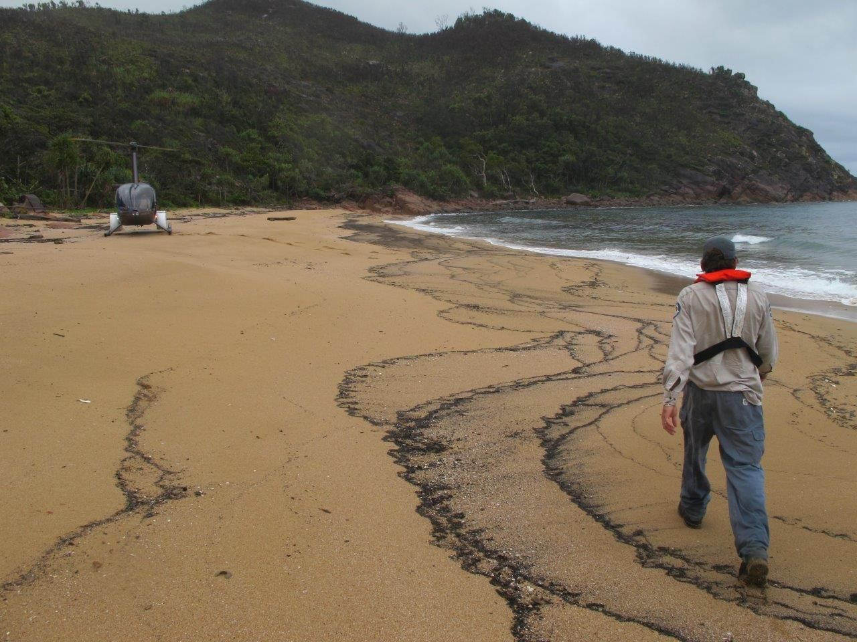
Above: A Queensland Parks and Wildlife Service ranger inspects northern Mulligan’s Beach at Hinchinbrook Island during the Cape Upstart oil spill response
An oil spill in July 2015 in the Great Barrier Reef Marine Park prompted a multi-agency clean-up response and investigation into the source of the incident.
A recreational fisherman initially reported an oil slick offshore from Alva Beach near Ayr on 16 July. Seven days later, clumps of oil began washing ashore at Hinchinbrook Island, Taylor’s Beach, Forrest Beach and the Palm Island group.
In response to the oil detection, an incident management team was immediately formed, led by Maritime Safety Queensland. The team involved field management staff from the Great Barrier Reef Marine Park Authority, Queensland Parks and Wildlife Service, and the Queensland departments of Environment and Heritage Protection, and Transport and Main Roads, as well as RoadTek.
At its peak, the on-ground team numbered nearly 120 people, and was bolstered with support from local councils, Girringun Aboriginal Rangers, the Queensland Police and Green Army volunteers.
The team undertook field operations, including foreshore assessment and clean-up; surveys of oil and collection of oiled wildlife through vessel, quad and helicopter monitoring; and logistical support to partner agencies.
Over two weeks, clean-up crews collected an estimated 10–15 tonnes of oil on islands and mainland beaches between Palm and Hinchinbrook islands.
Immediately after the oil spill, the agency began a major investigation with Maritime Safety Queensland and the Australian Maritime Safety Authority to identify the source. The investigation team tracked down 17 ships that were in the area immediately before the spill, and then checked onboard records, interviewed crews and took oil samples from those ships for analysis. The evidence collected will be used to further pursue the matter in 2016–17.
The oil spill at Cape Upstart affected a small number of animals — two seabirds and one juvenile flatback turtle died from exposure to the oil, and a juvenile flatback turtle was rehabilitated and released back into the Marine Park.
When an oil spill occurs in the Marine Park, it is managed under the National Plan for Maritime Environmental Emergencies and the Queensland Coastal Contingency Action Plan. The national plan arrangements enable pollution incidents to be dealt with through a range of activities, including monitoring and assessment, control and recovery options, shoreline clean-up and remediation, and response to affected or threatened wildlife.

Field data technology
Specialised software developed for use in the field as a field reporting system continues to result in more efficient and consistent reporting. Initial development focused on patrol and compliance reporting, and improvements made during the reporting period increased functionality and user friendliness.
Customised tablets are used on program vessels to gather information about activities and events. Data collected can be matched with vessel tracks transmitted from the vessel monitoring system units installed on vessels. During 2015–16, there were 990 trips entered, comprising 2507 activities and 3756 events.
The system recorded 1406 vessel days at sea, which were delivered across the Field Management Program’s 20 vessels. For the two primary vessels, Reef Ranger recorded 244 days at sea, while the ageing Reef Heron recorded 116 days at sea.

Trialling drones for field management
As part of the Raine Island Recovery Project, unmanned aerial vehicles (drones) were trialled to determine whether they could be used to count seabirds and green turtles, and to map the island. Working with a team from the Auckland University of Technology, staff spent three days experimenting to determine the impact of drones on the nesting seabirds.
The drones were flown at increasing heights from 20 metres to 120 metres, and the behaviour and any flight responses from nesting birds within predetermined sections of the island were recorded. Preliminary results indicate that, for most species, parents sitting on eggs or with young chicks would not leave the nest, but attendant birds might take flight and then settle again once the drone had gone past. The drones were highly effective in mapping the island at a very high resolution.
Further work is being planned in 2016–17 to test the drones under different conditions, and one program officer has received training to operate the equipment. Drones are likely to become an increasingly common tool for the program to undertake activities more efficiently and to expand capability.

Raine Island
BHP Billiton, through the Great Barrier Reef Foundation, has committed $5.45 million to the Raine Island Recovery Project. The project is a five-year, $7.95 million collaboration between BHP Billiton, the Queensland Government, the Marine Park Authority, Wuthathi and Kemer Kemer Meriam Nation (Ugar, Mer, Erub) Traditional Owners and the Great Barrier Reef Foundation. It aims to protect and restore the island’s critical habitat to ensure the future of key marine species, including green turtles and seabirds. Funding started during the reporting period.
Project staff and partners spent 52 days on Raine Island in 2015–16, during which:
40 adult female green turtles were rescued
high-resolution imagery and topographic data were captured
an additional 200 metres of fencing was installed; there is now 1000 metres of fencing, which is estimated to have saved more than 400 adult green female turtles from falling off the cliff
- the beach re-profiling was monitored; results indicate positive outcomes so far, including
- a stable beach profile
- a more even distribution of turtle nests across the beach
- all nests being located above inundation levels
- less clutch destruction
- higher emergence success
minimal impacts on seabirds.
Case study 7: Award-winning collaboration key to Reef management
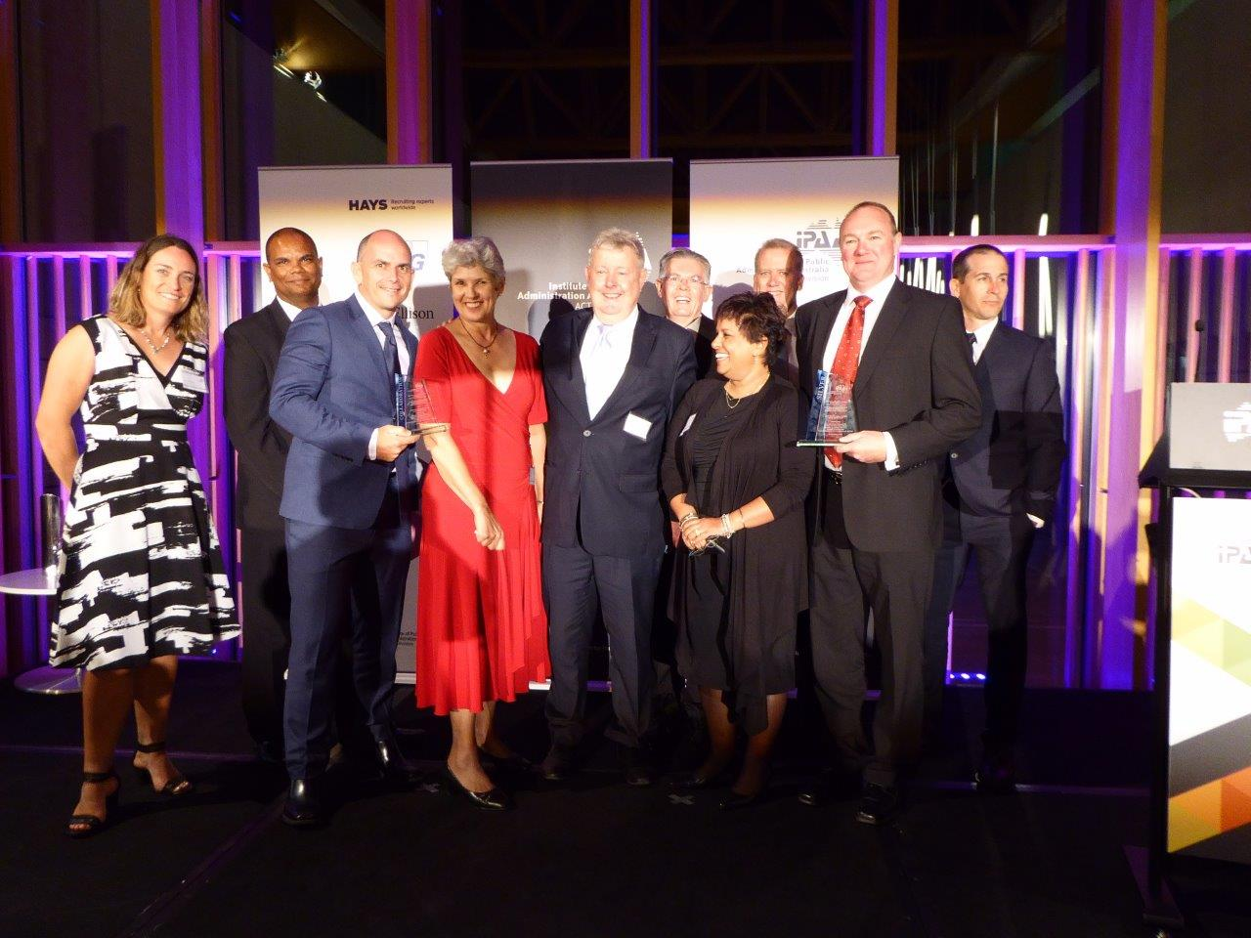Above: Staff from the Marine Park Authority and the Queensland Parks and Wildlife Service accept the Prime Minister’s Award for Excellence in Public Sector Management
This year, the Great Barrier Reef Marine Park Authority’s collaboration with the Queensland Parks and Wildlife Service was recognised with a 2015 Prime Minister’s Award for Excellence in Public Sector Management.
The joint Field Management Program was honoured with a silver award and the collaboration award at the awards night in Canberra, held by the Institute of Public Administration Australia, in November 2015.
The annual awards recognise and encourage innovation and best practice in government.
The $17 million joint Field Management Program delivers practical on-ground actions to protect and maintain well-functioning marine and island ecosystems that support economic, traditional and recreational use of the Great Barrier Reef World Heritage Area.
The program is the frontline of marine and island national park management of the Great Barrier Reef. Key responsibilities include surveying reefs and islands, delivering conservation actions, responding to incidents, maintaining visitor facilities, and upholding compliance with Marine Park zoning.
The collaboration award captured the essence of the 37-year-old program.
Since 1979, the Australian and Queensland governments have formally worked together to ensure an integrated and collaborative approach to manage marine and land environments within the World Heritage Area.
In the past year, the joint Field Management Program benefited from significant in-field productivity gains, including from a new offshore capable patrol vessel, the Reef Ranger.
The program also ramped up its efforts against illegal fishing and recorded the highest-ever number of recreational fishing offences since the creation of the Marine Park.
Judges praised the program’s strategic alignment, its outcomes focus, and its planning and governance arrangements.

Reef health and impact surveys and crown-of-thorns starfish surveillance
The program conducted 1982 reef health and impact surveys across 183 reefs, including 655 associated with the crown-of-thorns starfish management program and 561 associated with the coral bleaching response. As part of crown-of-thorns starfish surveillance, the program undertook 2998 individual broadscale manta tows (in-water surveys) across 31 reefs, surveying approximately 537 kilometres of the Reef.
Of reefs that have crown-of-thorns starfish outbreaks, 18 exceeded threshold levels (which measure the ratio of their population to coral cover) and were identified for follow-up control by teams from the Association of Marine Park Tourism Operators.

Fire needs of long unburnt islands in Broad Sound Islands National Park
The program undertook a fire-needs analysis of islands within Broad Sound Islands National Park to make recommendations for the management of these and other islands in the Reef where fire has been absent for some time. Queensland Parks and Wildlife Service rangers and Queensland Herbarium staff visited 10 islands to verify vegetation maps and identify fire needs for the maintenance of healthy ecosystems. Indications are that some islands require planned burns to maintain or restore ecosystem health, along with pest plant control; others need pest animals removed before burning; and some require no fire management. The final report and fire strategy will be produced in 2016–17.

Mitirinchi Island habitat restoration
A wildfire at Mitirinchi Island National Park in 2011 destroyed much of the unique Pisonia forest and habitat for nesting black noddies and lesser frigatebirds. The island is one of Australia’s few continental islands with Pisonia forest (others are coral cays) and is a historically significant seabird breeding site, supporting up to 10,000 black noddy pairs and 600 lesser frigatebird pairs. Numbers using the island collapsed after the wildfire because of the lack of nesting habitat for the noddies and because frigatebirds could probably no longer scavenge food from the noddies.
In 2015–16, 240 Pisonia cuttings were planted. Revegetation is challenging because of the very thin soil across the rocky substrate and generally dry conditions. Of 300 cuttings planted between 2012 and 2015, just 23 have survived to date. However, rehabilitation of the Pisonia forest and seabird nesting habitat is proceeding well, and small Pisonia trees that survived the fire are also growing well and flowering in 2015.

Field Management Foundation Program
The Field Management Foundation Program began in 2014 as a way of improving productivity and engagement of field management staff. It includes a five-day live-in training, which provides a solid foundation in the theory and practice of managing and protecting the Reef, and includes class-based modules, networking opportunities and field trips.
The course is continually improved to ensure it covers contemporary practices and issues. After two successful courses in 2014–15, which saw 36 staff participate, a further 53 staff participated in three courses during 2015–16. Two more courses are being planned for 2016–17.
The program included presentations from the agency, Queensland Parks and Wildlife Service, James Cook University, the Australian Institute of Marine Science, the Association of Marine Park Tourism Operators, and a commercial fisher. The field trip to Magnetic Island, which included a Wulgurukaba Traditional Owner guest speaker, provided an insight to the natural and cultural diversity of the Marine Park.

Surveillance
The joint Field Management Program coordinates vessel, aerial and land-based surveillance activities across the World Heritage Area. A cooperative multi-agency approach to patrolling allows a broad range of compliance management tools to be applied in an efficient whole-of-government manner.
Across the participating agencies, there were 735 dedicated compliance patrol vessel days, 13 land-based days and 90 days of targeted chartered flights (across all partner agencies) during the reporting period.

Incidents and offences
During the reporting period, 1240 possible offences were reported from across the Commonwealth and Queensland jurisdictions of the World Heritage Area. Of these, 46 per cent were dealt with through compliance actions such as advisory letters, caution notices and warning notices. More serious matters were dealt with through infringement notices or court action. Figure 9 and Table 5 show details of possible Commonwealth offences. Figure 9 shows the number of Commonwealth offences reported each year since 2006–07.
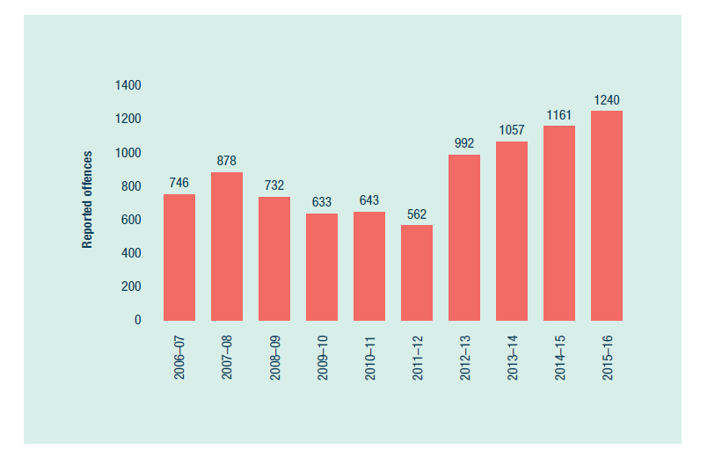
Figure 9: Number of possible Commonwealth offences reported to the joint Field Management Program, 2006–07 to 2015–16
Table 5 shows the 971 reported Commonwealth offences that occurred in the Great Barrier Reef Marine Park. This is the highest number of possible offences since the creation of the Marine Park.
Table 5: Commonwealth offences reported in the Great Barrier Reef Marine Park, by management area, 2015–16
Activity | Offence | Far Northern | Cairns–Cooktown | Townsville–Whitsunday | Mackay–Capricorn | Other | Total
Commercial fishing (general) | Breach of permit: failure to report/notify | 4 | 0 | 0 | 0 | 0 | 4
Commercial fishing (general) | Breach of permit: failure to submit/comply with a management plan | 3 | 0 | 0 | 0 | 0 | 3
Commercial fishing (general) | Fishing: collecting | 1 | 0 | 0 | 0 | 0 | 1
Commercial fishing (general) | Fishing: crabbing | 0 | 0 | 0 | 4 | 0 | 4
Commercial fishing (general) | Fishing: line fishing | 1 | 2 | 1 | 4 | 0 | 8
Commercial fishing (general) | Fishing: netting | 0 | 2 | 1 | 1 | 0 | 4
Commercial fishing (general) | Fishing: trawling | 0 | 1 | 1 | 0 | 0 | 2
Commercial fishing (general) | Maritime incident: groundings | 2 | 2 | 0 | 0 | 0 | 4
Commercial fishing (general) | Maritime incident: pollution/discharge | 1 | 1 | 0 | 0 | 0 | 2
Commercial fishing (general) | Moorings offence: other | 0 | 1 | 0 | 0 | 0 | 1
Commercial fishing (general) | Plan of Management: Cairns | 0 | 1 | 0 | 0 | 0 | 1
Commercial fishing (general) | Unattached dory: collecting | 8 | 0 | 0 | 0 | 0 | 8
Commercial fishing (general) | Unattached dory: line fishing | 3 | 5 | 0 | 10 | 0 | 18
Commercial fishing (general) | Unpermitted activity: collecting | 0 | 2 | 0 | 0 | 3 | 5
Commercial fishing (general) | Unpermitted activity: restricted access areas | 0 | 0 | 1 | 2 | 0 | 3
Commercial fishing (general) | Wildlife: bycatch | 0 | 0 | 1 | 1 | 0 | 2
Commercial fishing (general) | Wildlife: non-traditional take | 2 | 0 | 0 | 1 | 0 | 3
Foreign fishing | Fishing: collecting | 2 | 0 | 0 | 0 | 0 | 2
Government | Unpermitted activity: other | 0 | 0 | 1 | 0 | 0 | 1
Recreational | Fishing: crabbing | 0 | 0 | 0 | 1 | 0 | 1
Recreational | Fishing: line fishing | 1 | 118 | 179 | 128 | 0 | 426
Recreational | Fishing: netting | 0 | 1 | 2 | 0 | 0 | 3
Recreational | Fishing: spearfishing | 1 | 30 | 24 | 31 | 0 | 86
Recreational | Historical shipwrecks | 0 | 0 | 1 | 0 | 0 | 1
Recreational | Maritime incident: groundings | 0 | 0 | 2 | 0 | 0 | 2
Recreational | Moorings offence: unpermitted | 0 | 1 | 2 | 0 | 0 | 3
Recreational | Moorings offence: other | 0 | 1 | 6 | 0 | 0 | 7
Recreational | Plan of Management: Cairns | 0 | 7 | 0 | 0 | 0 | 7
Recreational | Plan of Management: Whitsunday | 0 | 0 | 8 | 0 | 0 | 8
Recreational | Unpermitted activity: collecting | 0 | 1 | 1 | 0 | 0 | 2
Recreational | Unpermitted activity: commercial activity (tourist) | 0 | 2 | 1 | 4 | 0 | 7
Recreational | Unpermitted activity: domestic animals in protected area | 0 | 1 | 0 | 0 | 0 | 1
Recreational | Unpermitted activity: littering | 0 | 0 | 1 | 0 | 0 | 1
Recreational | Unpermitted activity: restricted access areas | 0 | 3 | 7 | 10 | 0 | 20
Recreational | Unpermitted activity: other | 0 | 2 | 1 | 0 | 1 | 4
Recreational | Wildlife: interaction with cetacean | 0 | 1 | 1 | 0 | 0 | 2
Recreational | Wildlife: non-traditional take | 0 | 0 | 1 | 0 | 0 | 1
Recreational | Other | 0 | 0 | 0 | 3 | 0 | 3
Research | Breach of permit: exceeding limits | 0 | 1 | 0 | 0 | 0 | 1
Research | Breach of permit: failure to display permit or VNA | 0 | 0 | 1 | 0 | 0 | 1
Research | Breach of permit: failure to report/notify | 0 | 0 | 1 | 0 | 0 | 1
Research | Breach of permit: use of unpermitted methodology | 0 | 0 | 0 | 0 | 1 | 1
Research | Breach of permit: other | 0 | 0 | 0 | 0 | 36 | 36
Research | Fishing: collecting | 1 | 0 | 0 | 0 | 0 | 1
Research | Fishing: line fishing | 0 | 2 | 0 | 0 | 0 | 2
Research | Maritime incident: groundings | 0 | 1 | 0 | 0 | 0 | 1
Research | Wildlife: non-traditional take | 1 | 15 | 0 | 0 | 0 | 16
Shipping | Operating outside permitted zones or locations | 0 | 1 | 0 | 0 | 0 | 1
Shipping | Line fishing | 0 | 1 | 0 | 0 | 0 | 1
Shipping | DSA breach | 2 | 2 | 0 | 0 | 0 | 4
Shipping | Pollution/discharge | 0 | 0 | 1 | 1 | 0 | 2
Tourism industry | Breach of permit: exceeding limits | 0 | 4 | 4 | 0 | 1 | 9
Tourism industry | Breach of permit: failure to display AIN/VIN or research on vessel | 0 | 0 | 2 | 1 | 0 | 3
Tourism industry | Breach of permit: failure to display mooring reference number | 0 | 5 | 0 | 0 | 0 | 5
Tourism industry | Breach of permit: failure to display permit or VNA | 1 | 0 | 0 | 1 | 2 | 4
Tourism industry | Breach of permit: failure to execute deed | 0 | 0 | 0 | 0 | 3 | 3
Tourism industry | Breach of permit: failure to install | 0 | 1 | 0 | 0 | 0 | 1
Tourism industry | Breach of permit: failure to maintain facility | 0 | 0 | 2 | 0 | 0 | 2
Tourism industry | Breach of permit: failure to make a booking | 0 | 21 | 2 | 0 | 0 | 23
Tourism industry | Breach of permit: failure to report/notify | 0 | 0 | 1 | 0 | 0 | 1
Tourism industry | Breach of permit: failure to submit a bond | 0 | 0 | 1 | 0 | 0 | 1
Tourism industry | Breach of permit: operating outside permitted zones or locations | 0 | 1 | 9 | 2 | 0 | 12
Tourism industry | Breach of permit: other | 0 | 14 | 9 | 6 | 1 | 30
Tourism industry | Environmental charge | 0 | 1 | 0 | 3 | 0 | 4
Tourism industry | Line fishing | 0 | 1 | 0 | 5 | 0 | 6
Tourism industry | Maritime incident: groundings | 0 | 2 | 6 | 1 | 0 | 9
Tourism industry | Maritime incident: pollution/discharge | 0 | 1 | 4 | 4 | 0 | 9
Tourism industry | Moorings offence: unpermitted | 0 | 6 | 8 | 3 | 1 | 18
Tourism industry | Moorings offence: other | 0 | 1 | 11 | 0 | 0 | 12
Tourism industry | Plan of Management: Cairns | 0 | 7 | 0 | 0 | 0 | 7
Tourism industry | Plan of Management: Hinchinbrook | 0 | 0 | 1 | 0 | 0 | 1
Tourism industry | Plan of Management: Whitsunday | 0 | 0 | 5 | 0 | 0 | 5
Tourism industry | Unpermitted activity: commercial activity (tourist) | 0 | 4 | 14 | 5 | 0 | 23
Tourism industry | Unpermitted activity: littering | 0 | 0 | 1 | 0 | 0 | 1
Tourism industry | Unpermitted activity: unlawful take | 0 | 0 | 1 | 0 | 0 | 1
Tourism industry | Unpermitted activity: other | 0 | 3 | 1 | 2 | 0 | 6
Tourism industry | Wildlife: interaction with cetacean | 0 | 3 | 2 | 0 | 0 | 5
Traditional activity | Fishing: spearfishing | 0 | 4 | 0 | 0 | 0 | 4
Traditional activity | Wildlife: hunting | 0 | 10 | 2 | 0 | 0 | 12
Traditional activity | Wildlife: non-traditional take | 4 | 2 | 2 | 0 | 0 | 8
Other | Breach of permit: other | 0 | 2 | 0 | 0 | 0 | 2
Other | Fishing: line fishing | 0 | 1 | 0 | 0 | 0 | 1
Other | Fishing: netting | 0 | 2 | 0 | 0 | 0 | 2
Other | Moorings offence: unpermitted | 0 | 1 | 10 | 0 | 0 | 11
Other | Other | 0 | 0 | 0 | 1 | 0 | 1
Total |  | 38 | 305 | 344 | 235 | 49 | 971
AIN = Aircraft identification number; VIN = Vessel identification number; VNA = Vehicle notification approval

Information reports
During the reporting period, 273 information reports (Figure 10), relating to a wide variety of issues and activities, were recorded and analysed. They enable greater understanding, and enhance responses to ongoing compliance issues and emerging trends in the World Heritage Area. Of these reports, 139 related to illegal recreational fishing activity. Illegal recreational activity continues to be high, with the trend reflecting the long-term increase in illegal recreational fishing.
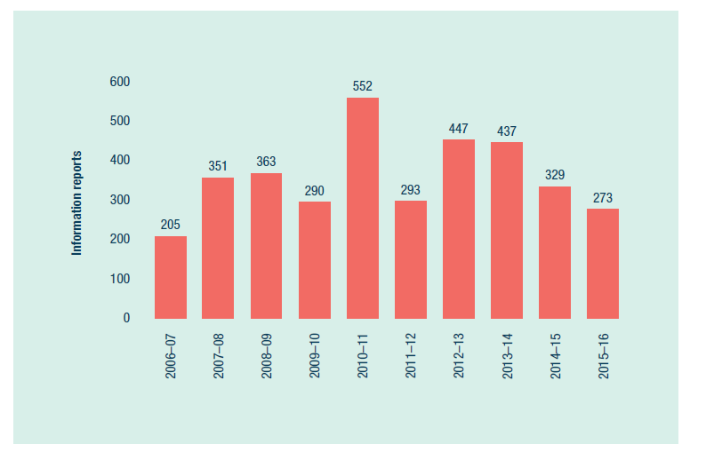
Figure 10: Information reports received each year, 2006–07 to 2015–16

Compliance actions and outcomes
Table 6 details the assessments and compliance actions (other than prosecutions) undertaken in 2015–16. The individual circumstances of each matter are assessed and considered before a decision on appropriate action is made.
Table 6: Assessments and compliance actions (not prosecutions), by management area, 2015–16
Action | Far Northern | Cairns–Cooktown | Townsville–Whitsunday | Mackay–Capricorn | Other | Total
Advisory letter (Commonwealth Department of Public Prosecutions) | 1 | 0 | 0 | 1 | 0 | 2
Advisory letter (agency) | 20 | 121 | 132 | 113 | 0 | 386
Advisory letter (state) | 0 | 4 | 11 | 20 | 0 | 35
Ceased by executive | 0 | 0 | 1 | 0 | 0 | 1
Caution notice (Commonwealth) | 0 | 16 | 71 | 13 | 0 | 100
Infringement notice (Commonwealth) | 0 | 8 | 5 | 9 | 0 | 22
Infringement notice (state) | 0 | 0 | 11 | 2 | 0 | 13
Insufficient evidence | 3 | 3 | 17 | 2 | 0 | 25
No further action (Commonwealth Department of Public Prosecutions) | 2 | 0 | 2 | 0 | 0 | 4
No further action other | 7 | 30 | 60 | 14 | 0 | 111
No further action (Queensland Parks and Wildlife Service) | 0 | 5 | 1 | 0 | 0 | 6
No offence | 4 | 7 | 17 | 3 | 0 | 31
Public education process | 0 | 1 | 3 | 2 | 0 | 6
Recorded for information | 0 | 0 | 4 | 1 | 0 | 5
Referred to management | 0 | 0 | 1 | 1 | 0 | 2
Referred to other agency | 9 | 2 | 3 | 10 | 0 | 24
State warning notice | 0 | 0 | 28 | 22 | 0 | 50
Unable to locate offender | 0 | 1 | 3 | 13 | 0 | 17
Total | 46 | 198 | 370 | 226 | 0 | 840

As in previous years, a significant number were addressed with an advisory letter. More serious matters were dealt with by way of infringement notices or court action.
Commonwealth caution notices were issued for the first time in 2015–16. There has been strong use of the caution notice system by marine park inspectors, with 100 notices being issued in the first year for conservation park zone fishing offences (regulation 73 under the Great Barrier Reef Marine Park Regulations) and Marine National Park Zone trolling of fishing line offences (regulation 73BA). This system was introduced to empower inspectors to be involved in decision-making, provide immediate consequences for alleged non-compliant behaviour, and reduce the double handling of information.
An upward trend in prosecutions has been observed from 2012–13 to 2015–16 (Figure 11).
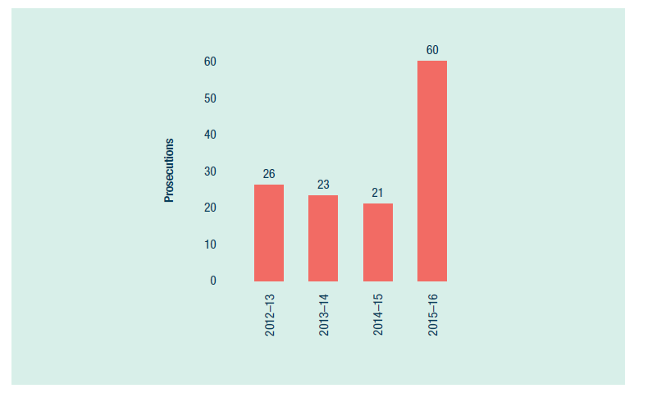
Figure 11: Prosecutions following compliance actions, 2012–13 to 2015–16
The Australian Government Director of Public Prosecutions accepted 54 briefs of evidence, resulting in 60 successful prosecutions, totalling fines of $100,900 (Table 7). These prosecutions related to illegal commercial fishing activities, including collecting, line fishing and unattached dories.
More significant offences included the following:
The master of a mother vessel, with an unattached dory (small, shallow boat) in the Marine National Park Zone near Bax and Hunt reefs was convicted and fined $3500. The dory operator fishing in the Marine National Park Zone was also convicted and fined $7500. These offences were detected by a Maritime Border Command aerial surveillance flight.
The master of a mother vessel, with two unattached dories in the Marine National Park Zone at Cayley Reef was convicted and fined $2000. The two dory operators fishing in the Marine National Park Zone were also convicted and fined $8000. These offences were detected during an agency helicopter surveillance patrol.
Three commercial operators were convicted and fined $4000 each in relation to the commercial collection of coral from a Marine National Park Zone near Rodds Peninsula. This offence was detected by a Queensland Parks and Wildlife Service vessel patrol.

Table 7: Court actions, by management area, 2015–16
Activity | Far Northern |  | Cairns–Cooktown |  | Townsville–Whitsunday |  | Mackay–Capricorn |  | Other |  | Total
Activity | No. | Fines ($) | No. | Fines ($) | No. | Fines ($) | No. | Fines ($) | No. | Fines ($) | No. | Fines ($)
Fishing: collecting | 20 | 4000 | 0 | 0 | 0 | 0 | 3 | 12,000 | 0 | 0 | 23 | 16,000
Fishing: line fishing | 1 | 0 | 4 | 16,750 | 0 | 0 | 12 | 35,800 | 0 | 0 | 17 | 52,550
Fishing: unattached dory — line fishing | 0 | 0 | 12 | 10,050 | 2 | 11,000 | 5 | 9800 | 0 | 0 | 19 | 30,850
Other | 0 | 0 | 1 | 1500 | 0 | 0 | 0 | 0 | 0 | 0 | 1 | 1500
Total | 21 | 4000 | 17 | 28,300 | 2 | 11,000 | 20 | 57,600 | 0 | 0 | 60 | 100,900

Enforceable direction
During 2015–16, a commercial operator with two convictions against the Marine Park Act became the first person to be issued with an enforceable direction by the agency. The direction imposes a series of restrictions on the fisher that are intended to prevent any future offences.
Under the Marine Park Act, an enforceable direction can be issued to ensure a person’s future compliance with the Act, and to require that person to take specific actions to prevent environmental harm that may be caused by their conduct. A failure to comply with the direction is a contravention of a civil penalty provision, with a maximum penalty of $108,000.
The commercial fisher has been ordered to refrain from a number of activities in a Marine National Park (green) Zone, including anchoring a vessel or being on board an anchored vessel, or operating a vessel at a speed of five knots or less. The commercial fisher had twice been convicted for offences in zones where fishing is prohibited. These offences occurred only a few months apart.
Reducing illegal commercial and recreational fishing is a key priority for the agency, and the enforceable direction is a clear message to people who flout the rules. Under the enforceable direction, the same restrictions will apply to any vessel that the fisher is responsible for, whether the fisher is on board the vessel or not.

Recreational fishing compliance
Recreational fishing in no-fishing zones continues to be the most frequently detected offence in the World Heritage Area. The upwards trend in recreational fishing non-compliance was first identified through intelligence analysis in 2012 (Figure 12). Despite concerted effort and focus on this issue since 2012, offence numbers have continued to rise.
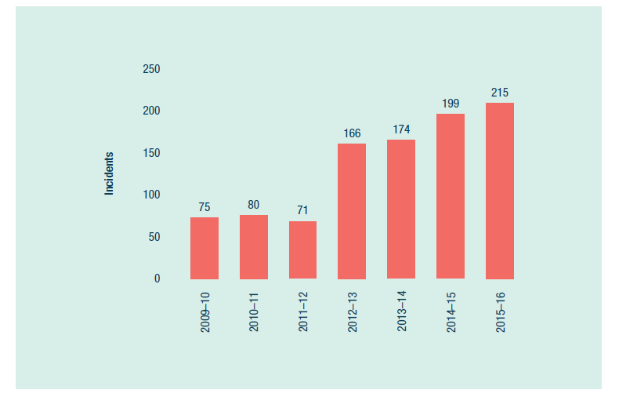
Figure 12: Illegal recreational fishing incidents in Marine National Park Zones
A multi-agency workshop, led by the Field Management Program and held with an expert consultant in June 2016, brought together a wide range of officers and experts to discuss the issues and find the best way to address the ongoing problem of illegal recreational fishing. As a result of the workshop, a project plan is currently being developed for implementation in 2016–17 to address this issue.
The initial phase of the project has started to further develop an integrated and coordinated approach to educate recreational fishers about zoning and its benefits to improve awareness and voluntary compliance.
Targets for measuring success will include:
a reduction in the incidence of illegal recreational fishing in the World Heritage Area
an increase in the awareness of recreational fishers and the community about sustainable fishing
an increase in the awareness of recreational fishers in relation to compliance management of the World Heritage Area
an increase in the protection of fish stocks and fish habitats, thereby reducing the ecological impact of the compliance problem.

Vessel monitoring system
Expansion of the commercial fishing vessel monitoring trial continued during 2015–16, with vessel monitoring devices fitted on eight commercial fishing vessels, three primary vessels and five dories. These trials are voluntary and the support of commercial operators to trial new technologies is welcomed. More devices are to be fitted during 2016–17, and trial results will be included in a joint discussion paper with the Queensland Government Department of Agriculture and Fisheries.

Sharing management experiences
The joint Field Management Program welcomed 12 groups of domestic visitors and two groups of international visitors, with tours of the compliance operations centre and presentations on compliance activities. International visitors included delegates from the Forests and Environment Department of the Government of Tamil Nadu in India, and from Koror State in Palau in the western Pacific Ocean. Domestic visitors included Australian Maritime Safety Authority officers, Marine Park Authority Board members, Girringun Land and Sea Rangers, Queensland Water Police officers, Maritime Safety Queensland officers, Queensland Parks and Wildlife Service rangers from Moreton Bay, and officers from the Australian Department of the Environment.

Stewardship
The program continues to encourage and build capacity and partnerships with volunteer and conservation organisations to help implement conservation initiatives and monitoring programs. The training of community groups to respond to marine animal strandings has been successful, with a further 110 volunteers training during the reporting period, bringing the total number to almost 430 trained volunteers in 17 locations.
Volunteers accounted for 57 per cent of responses to reported marine strandings during 2015–16, consistent with maintaining or increasing the number of responses (59 per cent in 2014–15, 46 per cent in 2013–14, 18 per cent in 2012–13). A Great Barrier Reef Marine Animal Strandings Volunteer Network newsletter was developed and distributed to volunteers in December 2015 and June 2016 to share information.
An online training program for marine animal strandings was also produced, reducing the need for resource-intensive face-to-face training and enabling people to readily obtain the necessary skills. The program is widely available for interested people, such as volunteers, community groups, Traditional Owners and Indigenous ranger groups.
The program continues to work with volunteers as part of the long-running campground host volunteer program on North West Island and Lady Musgrave Island. During the reporting period, 136 volunteers assisted in the management of campgrounds and associated facilities.

Indigenous engagement in field management
The program continues to strengthen and develop partnerships with Traditional Owners along the Great Barrier Reef coastline. There has been an expansion in the number and range of field management activities being conducted by Traditional Owners in conjunction with program staff. In 2015–16, Traditional Owners spent 544 person-days on field management vessels in the northern Great Barrier Reef, a further increase from 348 days in 2014–15 and 143 days in 2013–14. This included participating in routine patrols; specific island or marine management projects for pests, fire and infrastructure; compliance; incident response; commitments under formal agreements such as Indigenous Land Use Agreements; site inspections; and seabird monitoring.
Wuthathi and Kemer Kemer Meriam Nation (Ugar, Mer, Erub) Traditional Owner groups played a key management and governance role as members of the Raine Island reference group. Traditional Owners were also employed for 92 days to help with recovery actions on all of the five Raine Island trips undertaken in the reporting period.
After a successful trial in 2014–15, Queensland Parks and Wildlife Service entered into a works and services agreement with Girringun Land and Sea Rangers for the Girringun Traditional Use of Marine Resources Agreement area, offshore of Cardwell. The agreement provides for program activities to be delivered jointly by the Queensland Parks and Wildlife Service and Girringun rangers. Together, the rangers undertook compliance patrols, implemented fire and pest programs, installed reef protection markers, maintained island visitor infrastructure and assisted with the Cape Upstart oil spill and coral bleaching incident response.

Analysis of performance against purpose
There are no significant factors to report.

3.4 Whitsundays Plan of Management review
REPORTING REQUIREMENTS
This aligns with performance criteria for:
PBS Program 1.1: Ensure use of the Marine Park is ecologically sustainable and benefits current and future generations.
Deliverables:
- Implement the policy, planning and regulatory framework for the sustainable use of the Marine Park.
- Deliver the 2015–16 Annual Business Plan for Field Management.
- Implement partnership, stewardship, education and communications programs.
Performance criteria:
- Declining incidence of illegal fishing.
Corporate Plan Strategy 2: Effective and efficient environmental regulation.

Results against performance criteria
The agency continued its review of the Whitsundays Plan of Management 1998, which sets out the rules for specific activities in this area of the Marine Park.
The plan of management is a key tool for protecting biodiversity in the Whitsundays region and its beauty, while managing multiple uses and experiences. In preparing proposed amendments, the agency consulted a range of stakeholders.
In August 2015, the agency visited representatives from three families who form part of the Ngaro Traditional Owner group. The visit was highly successful in progressing discussion and engagement with this stakeholder group.
The review, which started in 2014, has been supported by a partnership with Queensland Parks and Wildlife Service. All proposed amendments to the Whitsundays Plan of Management were approved by the Great Barrier Reef Marine Park Authority Board on 22 June 2016. This was a major milestone for the project, allowing the legal drafting to start.
The review will continue in 2016–17. Public consultation is scheduled for early 2017.

Analysis of performance against purpose
There are no significant factors to report.

3.5 Strategic engagement
REPORTING REQUIREMENTS
This aligns with performance criteria for:
PBS Program 1.1: Ensure use of the Marine Park is ecologically sustainable and benefits current and future generations.
Deliverables:
- Implement the policy, planning and regulatory framework for the sustainable use of the Marine Park.
- Deliver the 2015–16 Annual Business Plan for Field Management.
- Implement partnership, stewardship, education and communications programs.
Performance criteria:
- Improved uptake of best practices and stewardship in activities that contribute to the health and resilience of the Marine Park.
- Improved inclusion in management decisions of knowledge about the Reef's values, their condition and impacts.
- Declining incidence of illegal fishing.
Corporate Plan Strategy 3: Strengthen engagement, Performance measure 3.1 (see Box 1).

Results against performance criteria
Strategic engagement activities were used to promote the agency’s work, focusing on:
sharing knowledge
encouraging leadership and innovation
facilitating improved compliance with legislation, zoning, policy and permits
creating and maintaining partnerships
developing community capacity to support the agency.
Staff from the Tourism and Stewardship section conducted, partnered, or attended 344 community and stakeholder engagement activities across the Great Barrier Reef Region. These activities provided opportunities to influence the actions of more than 22,500 participants to help maintain the health of the Great Barrier Reef and adjacent coastal ecosystems.
This work is striving to further integrate stakeholder engagement activities across projects to optimise efficiency and outcomes. Planning and evaluation tools have been developed to support integrated planning and to prioritise these activities. Table 8 shows successful integration is occurring, with many of the 344 community and engagement activities contributing to outputs for more than one project.
Table 8: Relevance of community and stakeholder engagement activities to Annual Operating Plan projects, 2015–16
Project — Annual Operating Plan, 2015–16 | No. of relevant engagement activities | Estimated number of participants
Eye on the Reef | 26 | 499
Reef Guardian Schools | 88 | 9032
Reef Guardian Councils | 36 | 675
Reef Guardian Farmers and Graziers | 17 | 277
Reef Guardian Fishers and recreational fishing | 26 | 2636
Marine debris | 29 | 2409
Strategic engagement (whole-of-agency relevance) | 118 | 9668
Community Access Points (for zoning information) | 17 | 154
Crown-of-thorns starfish control | 25 | 414
High Standard Tourism Operators | 7 | 1521
Tourism Reef Advisory Committee | 8 | 325
Local Marine Advisory Committees | 60 | 2060
Total | 457 | 29,669

The delivery of the Marine Debris Project, funded by the Australian Government’s Reef Trust, was a good example of the value of integrating a new project with existing partnership networks and activities such as Reef Guardians and Local Marine Advisory Committees. This enabled operational efficiency and outcomes that otherwise would not have been possible in the project timeframe. More than 2400 participants were involved in 29 activities that focused on reducing marine debris threats to Reef health.
A community partnership to rehabilitate a wetland in Mission Beach secured funding to plant trees, control weeds, monitor improvements and educate locals about the importance of the wetland to coastal ecosystem connectivity to Reef resilience. This collaboration, which includes a local school, council, national resource management groups, Traditional Owners and other interested community members, is now self-sustaining.
It provides a clear example of stewardship resulting from collaborative action to address an issue of relevance to the local community. The agency played a key role in facilitating this partnership and project when it began in 2013, and remains a partner in the group.

Analysis of performance against purpose
The proposed Tourism and Stewardship Engagement and Communication strategy was postponed to enable it to incorporate and build on the market research arising from the agency’s brand positioning project currently taking place.
Many of the stakeholder engagement activities that contribute to the agency’s strategic engagement with the community are part of the Critical Operational Support for Reef Resilience project, funded by the Australian Government Reef Programme.

3.6 Reef Guardian program
REPORTING REQUIREMENTS
This aligns with performance criteria for:
PBS Program 1.1: Ensure use of the Marine Park is ecologically sustainable and benefits current and future generations.
Deliverables:
- Implement the policy, planning and regulatory framework for the sustainable use of the Marine Park.
- Deliver the 2015–16 Annual Business Plan for Field Management.
- Implement partnership, stewardship, education and communications programs.
- Number of Reef Guardian schools (250).
Performance criteria:
- Improved uptake of best practices and stewardship in activities that contribute to the health and resilience of the Marine Park.
- Improved inclusion in management decisions of knowledge about the Reef's values, their condition and impacts.
- Declining incidence of illegal fishing.
Key performance indicator:
- Student participants within the Reef Guardian Schools program (113,000).
Corporate Plan Strategy 3: Strengthen engagement, Performance measures 3.1 and 3.2 (see Box 1).

Results against performance criteria
The Reef Guardian program creates awareness and understanding of Reef issues, encourages local leadership on environmental projects and recognises people’s efforts to improve the health of the Reef catchment.
This leadership was fostered through two ‘communicating with influence’ training workshops, which were attended by 30 people from Reef Guardian Farmers and Graziers, Reef Guardian Councils, members of advisory committees, and staff from partner organisations. The training aimed to build leadership skills among participants and to help them foster stewardship in their communities or sectors. Feedback was very positive —participants rated the day’s value as 4.8 out of 5.0 on average.

Reef Guardian Schools
Throughout Queensland, there are currently 280 schools with 121,546 students who are active Reef Guardians. The number of schools has been capped at 320, to ensure the delivery of quality initiatives that are focused on the key threats to the Reef.
The Reef Guardian network meetings, an annual event that connects teachers and schools to environmental partnership opportunities, were held for the first time in conjunction with Local Marine Advisory Committee meetings.
Reef Guardian Schools facilitated an update of the science curriculum units, which align with the Australian Curriculum. These curriculum units are available on the agency’s website and on the Queensland Government Department of Education’s Learning Place, which provides digital tools, resources and online spaces for teaching and learning, collaboration and networking. The units are also available on Scootle, which provides teachers with digital learning items aligned to core areas of the Australian Curriculum. These educational tools were promoted to teachers at annual Reef Guardian networking meetings, at conferences and at school staff meetings. The agency also provided a poster for schools to display, which included a code for direct access.
Additional achievements this year included:
The delivery of 10 Future Leaders Eco Challenges that provided day-long, hands-on workshops and activities for students, with a focus on local, environmental on-ground projects aimed at improving the health and resilience of the Reef.
The presentation of 10 Ripples of Change awards. These grants are awarded to schools to implement environmental initiatives. The projects winners were all focused on the five key threats to the Great Barrier Reef.
The production of five Reef Beat videos. These elaborated on the key threats to the Reef.

Reef Guardian Councils
Through Reef Guardian Councils, the agency was able to improve the uptake of best practice and stewardship in activities that contribute to the health and resilience of the Marine Park.
The agency assisted the 16 Reef Guardian Councils to develop annual Reef Guardian Council action plans that align with the Reef 2050 Plan. The councils also produced milestone reports. These publications included a four-page summary report and a 42-page full program report, both of which highlighted the strong collaborations between local councils and the agency. Councils implemented the action plans and used them to promote their activities to their wider communities.
The agency had ongoing engagement with the Reef Guardian Council Steering Committee and working group members, and hosted two meetings.
The agency undertook continuous monitoring and evaluation of the Reef Guardian Councils program, which included a program review session at the working group meeting in May 2016. As part of proposed improvements, the agency adopted the suggestion of offering briefing sessions for incoming councils after the local government elections in March 2016. Four briefings were delivered in the reporting period.
The agency reviewed the Reef Guardian Council's memorandum of understanding after the local government election. As of 30 June 2016, the revised memorandum of understanding had been distributed to all Reef Guardian Councils, including to the Tablelands Regional Council, which expressed a desire to re-join the program. Four councils returned to the program in the reporting period.

Reef Guardian Farmers and Graziers
The agency recognised six new Reef Guardian Farmers and Graziers in 2015–16, through a simple and refined interview process.
The Reef Guardian Farmers and Graziers program has developed selection criteria and activities that will identify and build leadership and influence of participants within their community.

Reef Guardian Fishers
During the year, the Reef Guardian Fishers program gained new entrants, enabling it to reflect a more diverse range of fisheries. The program includes 17 fishing operations from reef line, net, trawl and aquarium fishers. Given the range of fishing activities that occur in the Marine Park, the program is considering including a wider range of participants who demonstrate stewardship initiatives and actions that contribute to Reef recovery objectives.
The large-mesh gillnet fishers in the Reef Guardian Fishers program have been instrumental in developing, defining and implementing operational best practice in the gillnet fishery. Best practice principles are reflected in an industry ‘pledge’ and the findings of the draft Fisheries Research and Development Corporation research project Net Fishing and Species of Conservation Interest.
Pro-vision Reef, the peak body for the marine aquarium collection fishery in Queensland has, under the terms of its Stewardship Action Plan, agreed not to collect in areas north of Cairns that were affected by severe coral bleaching. The organisation also agreed to link future voluntary industry responses to major environmental disturbances directly to response level triggers under the agency’s Coral Bleaching Risk and Impact Assessment Plan.
In June 2016, the Sea Cucumber Association, which includes all active sea cucumber fishers in the Marine Park, agreed to not (at this time) pursue a reopening of the black teatfish fishery, as the primary habitat of this species is in the severely bleached coral reef areas north of Cooktown. This was despite evidence that the black teatfish stock has recovered strongly. Although these fishers are not members of the Reef Guardian Fishers program, they collectively agreed that this stewardship response to the severe coral bleaching event was the responsible thing to do.
The agency also explored industry interest in a pilot Reef Guardian Aquaculture program, and considered the type of stewardship action plan that would be needed to meet Reef Guardian principles.

Analysis of performance against purpose

Reef Guardian Schools
The Reef Guardian Schools program provided Ripples of Change grants to 10 schools for $500 each, as seed funding for projects that support Reef health.
The reassignment of several Reef Guardian Schools under Tagai College resulted in a reduction in the overall number of schools in the program, though overall student numbers remained stable.
Ten Reef Guardian Future Leaders Eco Challenges were held along the coast, covering all regions except for the far northern management area.

Reef Guardian Councils
Reef Guardian Council involvement in the Marine Debris Project, via on-ground action and awareness raising, strengthened the agency’s engagement with councils and the wider Reef Guardian program.

Reef Guardian Farmers and Graziers
The agency continues to develop strategies to transition the Reef Guardian Farmers and Graziers program to more effectively and sustainably address corporate objectives. The scope has broadened to develop a delivery model that can be applied to individuals in any sector, not only agriculture.

Reef Guardian Fishers
The Reef Guardian Fishers program was adjusted in response to extended staff illness. Staff focused on consultation on how to best manage net-free areas and proposed fisheries management reform by the Queensland Government.

3.7 High Standard Tourism program
REPORTING REQUIREMENTS
This aligns with performance criteria for:
PBS Program 1.1: Ensure use of the Marine Park is ecologically sustainable and benefits current and future generations.
Deliverables:
- Implement the policy, planning and regulatory framework for the sustainable use of the Marine Park.
- Deliver the 2015–16 Annual Business Plan for Field Management.
- Implement partnership, stewardship, education and communications programs.
Performance criteria:
- Improved uptake of best practices and stewardship in activities that contribute to the health and resilience of the Marine Park.
- Improved inclusion in management decisions of knowledge about the Reef's values, their condition and impacts.
- Declining incidence of illegal fishing.
Key performance indicator:
- Percentage of visitors to the Reef using tourism operators accredited as High Standard Operators (55 per cent).
Corporate Plan Strategy 3: Strengthen engagement, Performance measures 3.1 and 3.2 (see Box 1).

Results against performance criteria

High Standard Tourism program
The agency is committed to ensuring improved conservation outcomes in the Marine Park through the High Standard Tourism program, established in 2004. A high standard tourism operator has demonstrated their commitment to ecologically sustainable use by achieving independent (and voluntary) ECO Certification through Ecotourism Australia. The agency continues to work with Ecotourism Australia to ensure the integrity of the High Standard Tourism program. Ecotourism Australia conducts regular audits of its members, which include high standard tourism operators.
In 2015–16, three new operators received ECO Certification, bringing total operators in the program to 67. More certified operators mean more businesses are using best practice and stewardship activities, which contribute to the health and resilience of the Marine Park. High standard tourism operators carry more than 69 per cent of tourists to the Marine Park.
To increase participation in the High Standard Tourism program, the agency offers incentives. In the reporting period, 30 fifteen-year permits were granted to high standard tourism operations, and all operations were listed on the agency website.
In 2016, another organisation applied to the agency to be recognised as a certification scheme for the High Standard Tourism program. A panel, comprising representatives from the Queensland Tourism Industry Council, Tourism and Events Queensland, Queensland Parks and Wildlife Service, and the agency, assessed the application and recommended approval of the scheme.
In May 2016, tourism operators participated in an online survey administered by the agency, which sought feedback on aspects of the High Standard Tourism program. Survey results highlighted the need to adequately recognise operations with ECO Certification, through promotion and incentives, and to improve industry awareness of the program. Initial work has included the creation of a world heritage poster for tourism operators to help provide interpretative content to Marine Park visitors.

Tourism conferences
The agency attended the Global Eco Asia-Pacific Tourism Conference in Rottnest Island, Western Australia, in November 2015. Agency staff facilitated a ‘Tourism in protected areas’ masterclass, and delivered a presentation, ‘Navigating to protect world heritage — the Great Barrier Reef experience’.
The agency also attended the annual Australian Tourism Exchange trade show with Ecotourism Australia, which was held on 15–19 May 2016 on the Gold Coast. The trade show attracted more than 2300 delegates, including 840 travel wholesalers and retailers (buyers) from more than 30 countries. A total of 41 Reef tourism operators were represented at the exchange — of these, 31 had ECO Certification and are recognised as high standard tourism operators.

Analysis of performance against purpose
The agency’s ability to deliver on this program was affected by the amendments to the Whitsundays Plan of Management being a higher priority.
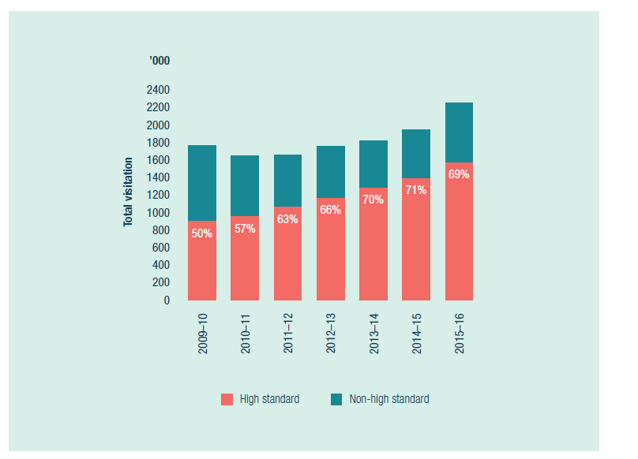
*Excludes stand-alone coral viewing activities and scenic flights.
Source: Great Barrier Reef Marine Park Authority environmental management charge records.
Figure 13: Percentage of visits* to the Great Barrier Reef Marine Park undertaken on high standard tourism operations

3.8 Tourism stewardship
REPORTING REQUIREMENTS
This aligns with performance criteria for:
PBS Program 1.1: Ensure use of the Marine Park is ecologically sustainable and benefits current and future generations.
Deliverables:
- Implement the policy, planning and regulatory framework for the sustainable use of the Marine Park.
- Deliver the 2015–16 Annual Business Plan for Field Management.
- Implement partnership, stewardship, education and communications programs.
Performance criteria:
- Improved uptake of best practices and stewardship in activities that contribute to the health and resilience of the Marine Park.
- Improved inclusion in management decisions of knowledge about the Reef's values, their condition and impacts.
- Declining incidence of illegal fishing.
Corporate Plan Strategy 3: Strengthen engagement, Performance measures 3.1, 3.2 and 3.4 (see Box 1)

Results against performance criteria
The agency works closely with the tourism industry to encourage stewardship of the Great Barrier Reef. It is also a key partner in the protection and management of the Great Barrier Reef.
In the event of an environmental incident relevant to the marine tourism industry, the Great Barrier Reef Marine Tourism Coordination Framework for Environmental Incidents sets out a mechanism to coordinate and facilitate responses. During the 2016 coral bleaching event, the Marine Tourism Incident Response Group met regularly to coordinate messaging about the coral bleaching event and to consider industry actions.
The response group comprises the agency, Queensland Parks and Wildlife Service, the Queensland Tourism Industry Council, Tourism and Events Queensland, and the Association of Marine Park Tourism Operators. As the bleaching event mostly affected the Reef north of Port Douglas, Tropical Tourism North Queensland was invited to be part of the response group.
Throughout the coral bleaching event, the agency prioritised engagement with stakeholders. Staff delivered public information sessions in association with quarterly Local Marine Advisory Committee meetings. This included information sessions in the far north — the area that experienced the most severe bleaching.
More broadly, engagement with the Whitsundays tourism industry and the community also took place through targeted consultation on proposed amendments to the Whitsundays Plan of Management.
Industry relationships were maintained with key tourism organisations, including the Queensland Tourism Industry Council, Tourism and Events Queensland, the Association of Marine Park Tourism Operators, the Cod Hole and Ribbon Reef Association, the Whitsundays Charter Boat Industry Association, and Whitsundays Bareboat Operations. The agency visited the southern section of the Great Barrier Reef, including Lady Elliot Island, in May 2016, and tourism presentations were given to the Burnett and Gladstone Local Marine Advisory Committees. Individual operators were also engaged throughout 2015–16.
To enable tourism operators to easily understand rules that affect them while operating in the Marine Park, the agency maintains the Onboard Tourism Operators Handbook website. This website was incorporated into the agency’s corporate website in June 2016, and the information is being progressively refreshed.
The agency appointed a consultancy to gather extensive and in-depth input from the tourism industry about the design and implementation of a proposed Reef Guides program, which will be trialled in 2016–17. This program will provide training and career development opportunities for tourism guides, while setting a new international benchmark for guiding and interpretation of the Reef’s outstanding universal value.
An online Reef Discovery Course will form the first level of standardised training for aspiring tourism industry personnel who are seeking to improve their knowledge base about the Great Barrier Reef and their presentation skills. Further career development stages of the Reef Guides program will be trialled in 2016–17.

Analysis of performance against purpose
The agency placed a high priority on the coral bleaching response and on progressing amendments to the Whitsundays Plan of Management. This required reallocation of personnel from the agency’s Tourism and Stewardship section.
Section staff also provided extensive assistance to the Whitsundays Plan of Management review process, including the development of amendments and engagement with the tourism industry, the community and specific stakeholders. This reduced the ability to engage with the tourism industry more generally throughout the year.

3.9 Tourism management
REPORTING REQUIREMENTS
This aligns with performance criteria for:
PBS Program 1.1: Ensure use of the Marine Park is ecologically sustainable and benefits current and future generations.
Deliverables:
- Implement the policy, planning and regulatory framework for the sustainable use of the Marine Park.
- Deliver the 2015–16 Annual Business Plan for Field Management.
- Implement partnership, stewardship, education and communications programs.
Performance criteria:
- Improved uptake of best practices and stewardship in activities that contribute to the health and resilience of the Marine Park.
- Improved inclusion in management decisions of knowledge about the Reef's values, their condition and impacts.
- Declining incidence of illegal fishing.
Corporate Plan Strategy 2: Effective and efficient environmental regulation, and Strategy 3: Strengthen engagement.

Results against performance criteria
During 2015–16, the agency continued to implement the policy, planning and regulatory framework for the sustainable tourism and recreational use of the Marine Park.
The agency refined the draft Cruise Ship Policy, and the Office of Best Practice Regulation considered a preliminary assessment in February 2016, which resulted in a regulation impact statement not being required. Consultation on the draft policy began with Traditional Owners, through their Traditional Use of Marine Resources Agreement steering committees.
In April 2016, the Tourism Reef Advisory Committee provided advice to the agency on its draft Tourism Management Strategy. The committee recommended the agency focus its tourism expertise on high-priority tourism matters, such as the amendments to the Whitsundays Plan of Management — the Whitsunday Islands being a popular tourism destination, receiving 43 per cent of all visitors to the Marine Park. In addition, the committee advised the agency that the Tourism Management Strategy should aim to showcase the agency’s partnership with industry.
As part of its policy on managing bareboat operations in the Marine Park, the agency requires all bareboat (self-sail vessels) operations to ensure their briefing staff are appropriately qualified. The accreditation of the dedicated course in Maritime Bareboat Briefing Operations expired during the year. As a result, the agency worked with the Australian Skills Qualification Authority, the Australian Department of Education and Training, and registered training organisations in the Whitsundays to meet training requirements for bareboat briefers. The agency now accepts a statement of attainment (BSBCMM201 ‘Communicate in the workplace’), delivered in the context of the Bareboat Briefers Learning Guide, as a core requirement for appropriate qualification. This reduces the agency’s ongoing costs, as it no longer has to obtain national accreditation for a dedicated course. In June 2016, the agency updated the Bareboat Briefers Learning Guide as supporting material for ongoing training.
The agency continued to provide internal staff and tourism operators with advice on all tourism policies, including advice on moorings, and on reasonable use requirements and allocation processes for special tourism permissions.
The environmental management charge visitation numbers (see Figure 14) were analysed every six months. There was a significant increase in visitation in 2015–16, especially to the Whitsundays.
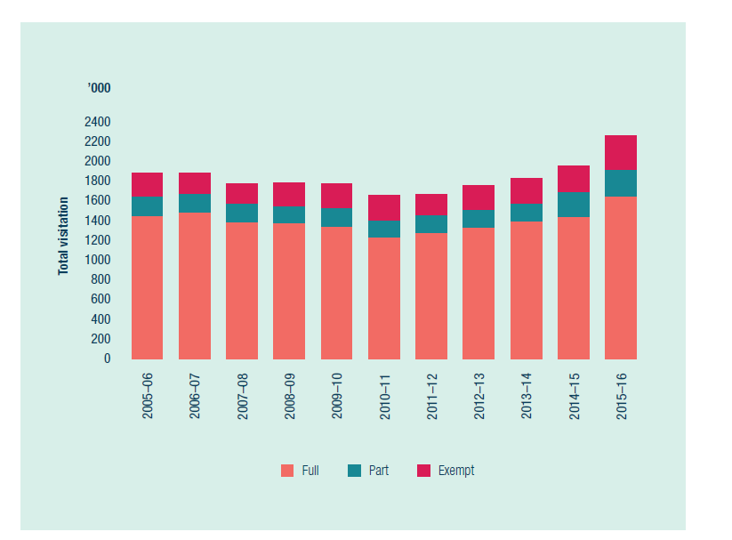
*These figures do not include stand-alone coral viewing activities and scenic flights. Source: Great Barrier Reef Marine Park Authority environmental management charge records.
Figure 14: Tourist visits* to the Great Barrier Reef Marine Park since 2005–06. This includes full-day and part-day visitors, and passengers exempt from the environmental management charge.

Analysis of performance against purpose
The agency placed a high priority on progressing amendments to the Whitsundays Plan of Management. This required contributions from the agency’s Tourism and Stewardship section to assist with the amendments, and to engage with the tourism industry, the community and specific stakeholders such as the superyacht industry. This reduced the ability to progress the Cruise Ship Policy and Tourism Management Strategy throughout the year.
Site management arrangements for Lady Musgrave Reef in the Capricorn Cays were finalised in November 2015. These arrangements apply to recreational and tourism use and protect species such as green and loggerhead turtles, ecosystems of conservation significance, and Indigenous and European heritage and cultural values. They also aim to minimise impacts on amenity and to support sustainable tourism.

3.10 Recreational fishing
REPORTING REQUIREMENTS
This aligns with performance criteria for:
PBS Program 1.1: Ensure use of the Marine Park is ecologically sustainable and benefits current and future generations.
Deliverables:
- Implement the policy, planning and regulatory framework for the sustainable use of the Marine Park.
- Deliver the 2015–16 Annual Business Plan for Field Management.
- Implement partnership, stewardship, education and communications programs.
Performance criteria:
- Improved uptake of best practices and stewardship in activities that contribute to the health and resilience of the Marine Park.
- Improved inclusion in management decisions of knowledge about the Reef's values, their condition and impacts.
- Declining incidence of illegal fishing.
Corporate Plan Strategy 3: Strengthen engagement, Performance measure 3.1 (see Box 1).

Results against performance criteria
Recreational fishing leaders in each of the three net-free areas introduced by the Queensland Government were encouraged to adopt a locally developed catch-and-effort monitoring program to demonstrate and encourage active stewardship.
Engagement with recreational fishers in the Mackay and Rockhampton net-free areas contributed to the development of a region-specific code of conduct that reflects resource stewardship. The code promotes bag-limit reductions and differential size limits for iconic inshore species to maximise the quality of the fishing experience while ensuring sustainable use. Fishers are keen to take on this stewardship challenge.
Leaders within the recreational fishing community along the Great Barrier Reef coast who actively promote stewardship and respect for all users of fisheries resources have been identified as potential Reef Guardians.
The agency also continued to service Community Access Points — a network of 293 businesses, including bait and tackle shops, visitor information centres and partner agencies along the Great Barrier Reef coast that stock and communicate information about the Marine Park. The information they distribute to the public raises awareness of zoning rules.
The agency also participated in major marine and fisheries public shows and events, and the Celebrate the Reef event, to promote the importance of best practices and stewardship.

Analysis of performance against purpose
The agency’s capacity to fully deliver to Community Access Points over the reporting period was limited, particularly in remote areas, due to staffing reprioritisation.

3.11 Advisory committees
REPORTING REQUIREMENTS
This aligns with performance criteria for:
PBS Program 1.1: Ensure use of the Marine Park is ecologically sustainable and benefits current and future generations.
Deliverables:
- Implement the policy, planning and regulatory framework for the sustainable use of the Marine Park.
- Deliver the 2015–16 Annual Business Plan for Field Management.
- Implement partnership, stewardship, education and communications programs.
Performance criteria:
- Improved uptake of best practices and stewardship in activities that contribute to the health and resilience of the Marine Park.
- Improved inclusion in management decisions of knowledge about the Reef's values, their condition and impacts.
- Declining incidence of illegal fishing.
Corporate Plan Strategy 1: Ensure the best available knowledge is captured and used to inform management decisions, Performance measure 1.3; and Strategy 3: Strengthen engagement, Performance measure 3.1 (see Box 1).

Results against performance criteria

Tourism Reef Advisory Committee
The Tourism Reef Advisory Committee was established in 2014. Members are appointed for a three-year term. The committee advises the agency about tourism matters relating to the management of the Marine Park, including the Great Barrier Reef Outlook Report 2014, and implementation of the Great Barrier Reef Region Strategic Assessment and Program Report, and the Reef 2050 Plan.
In 2015–16, the committee helped the agency to improve uptake of best practice and stewardship in the Marine Park by providing specific advice on:
best practice for wildlife interactions
improvements to the High Standard Tourism program, including ways for the industry to better present World Heritage Area values to visitors
ways to better engage with industry, through the Eye on the Reef program
ways to advocate for Reef resilience, using the Eye on the Reef and crown-of-thorns starfish management program.
The committee provided a standing item on the status of the marine tourism industry. This provides insights into the Reef’s social and economic values, which increase the chance of these values being included in management decisions.
In addition, the committee helped the agency to strengthen engagement — in particular, to deliver effective environmental regulation — by advising on:
cumulative effects of intensive use
net benefits and offsets policy principles, and the tourism sector plan (for example, Reef 2050 Plan initiatives)
amendments to the Whitsundays Plan of Management
the Tourism Management Strategy
how to improve the permissions system.
The Tourism Reef Advisory Committee met twice — in November 2015 and April 2016. After each meeting, the committee provided advice to the agency about its work programs and initiatives, especially from a tourism and recreational perspective. This advice was also made publicly available as a communique on the agency’s website.

Local Marine Advisory Committees
The 2015–2018 Local Marine Advisory Committee term started in July 2015. There are 12 committees, made up of 205 members and management partners, which represent community interests from Cape York to the Burnett region. Each committee meets five times per year. They advise the Marine Park Authority on management of the Marine Park. They also provide an avenue for local communities to discuss areas of concern directly with the agency. Members of the committees represent a range of groups, including Traditional Owners, fishers, conservationists, councils, farmers, port operators, shipping representatives and tourism operators.
In October 2015, 23 members took part in the Local Marine Advisory Committee Chairs’ meeting. This meeting provided an opportunity to discuss the agency’s priority work programs, and to discuss current priorities for the community. One of the outcomes of this meeting was a decision to update the committees’ terms of reference, which have since been published and distributed.
The March 2016 committee meetings were combined with the Reef Guardian Networking meetings, to strengthen partnerships between the Local Marine Advisory Committees and the Reef Guardian schools and councils.
Many Local Marine Advisory Committee members took part in Reef clean-up events held in October 2015, facilitated by Tangaroa Blue and Eco Barge (see Section 1.5). The Burnett Local Marine Advisory Committee members facilitated a self-managed clean-up and collected almost two tonnes of debris at the event.
During the year, the Local Marine Advisory Committees implemented a wide range of projects in their local regions:
The Cape York committee provided a data logger that can be used to record the marine debris collected during beach clean-ups.
The Douglas committee organised a consultant to develop a risk assessment framework for unseaworthy vessels moored in Dickson Inlet.
The Cairns committee subsidised a reef trip for underprivileged children as part of a Reef education package.
The Cassowary Coast committee updated the information in a local fishing and boating brochure.
The Hinchinbrook committee supported a group of volunteers at a marine debris removal activity.
The Townsville committee supported a community event that provided knowledge and examples for the community to learn about Reef recovery.
The Bowen–Burdekin committee supplied sun-safe shirts to its members, so they can wear them to events.
The Whitsunday committee subsidised the costs for more than 12 locals to become trained in seagrass monitoring.
The Mackay committee promoted and participated in a Healthy Soil Symposium.
The Capricorn Coast committee reprinted a brochure that provides local information about sustainable fishing practices and zoning, and is distributed to bait and tackle shops.
The Gladstone committee held a video competition about the five key threats to the Reef.
The Burnett committee facilitated a community event, at which the film Bag it — is your life too plastic? was screened.

Analysis of performance against purpose
The Tourism Reef Advisory Committee is competency-based. Members provide a cross-section of stakeholder expertise and interests in areas relevant to tourism and recreational use of the Great Barrier Reef. The committee has an independent chair, and a charter of operations, including terms of reference. These arrangements ensure the advice to the agency is robust and considered from a range of perspectives of operation and experience of tourism in the Marine Park.
The members also have significant networks across the tourism industry in the Great Barrier Reef, through which they are able to encourage stewardship and best practice approaches.
The agency contributed to the Tourism Reef Advisory Committee’s performance by providing secretariat services to organise meetings, prepare papers and draft minutes. The independent chair is paid, as required under the Remuneration Tribunal Guidelines for appointments after 30 June 2014. Members provide their time free of charge, with the agency paying travel costs when required.

3.12 Reef HQ Great Barrier Reef Aquarium
REPORTING REQUIREMENTS
This aligns with performance criteria for:
PBS Program 1.1: Ensure use of the Marine Park is ecologically sustainable and benefits current and future generations.
Deliverables:
- Implement partnership, stewardship, education and communications programs.
- Number of Reef HQ Aquarium visitors (122,000).
Performance criteria:
- Improved uptake of best practice and stewardship in activities that contribute to the health and resilience of the Marine Park.
Key performance indicator:
- Percentage of visitors to Reef HQ Aquarium that participate in talks and tours that deliver key messages about the risks to the Great Barrier Reef (63 per cent).
Corporate Plan Strategy 3: Strengthen engagement, Performance measures 3.3 and 3.4 (see Box 1).

Results against performance criteria
As a result of well-targeted marketing and public relations strategies, key messages about the Reef HQ Great Barrier Reef Aquarium’s operations reached more than seven million people during 2015–16. The aquarium is the Australian Government’s National Education Centre for the Great Barrier Reef, where people learn how they can help to protect and conserve the Reef.
By providing educational and informational services about the Marine Park, the aquarium ensures the community and stakeholders have a clear understanding of the value of the Great Barrier Reef, the threats to its sustainable future and their role in protecting it. The aquarium achieves this through world-class living exhibits, complemented by thematic and interactive educational experiences, which raise awareness and encourage behavioural change within the community.
The aquarium’s membership program continues to grow — as at 30 June 2016, the aquarium had 16,076 members. This equates to eight per cent of the Townsville population and is a clear demonstration of how highly valued the facility is within the north Queensland region.
Reef HQ Great Barrier Reef Aquarium welcomed 140,268 visitors during 2015–16. This is an excellent operational result, built on the back of positive visitation trends to the Townsville – north Queensland region. On 11 June 2016, the aquarium received its four millionth visitor.
Of the total visitors during the reporting period, 99,430 people (71 per cent) participated in the aquarium’s formal talks and tours that deliver key messages about risks to the Reef.
The aquarium uses an electronic survey tool to gauge guest satisfaction, thoughts and options; 1914 guests responded to this visitor survey in 2015–16, which provided some positive feedback:
80 per cent of respondents rated their overall aquarium experience as good or very good
70 per cent of respondents agreed or strongly agreed that they had an improved understanding of Reef issues because of their visit to the aquarium
71 per cent of respondents agreed or strongly agreed that they had a better understanding of how they can help the Reef because of their visit to the aquarium.
As part of efforts to promote responsible Reef practices, the aquarium hosted a Hooked on Fishing program during the Easter school holidays in 2016. Activities, targeted at children and their parents, involved a fishing simulator and casting demonstrations, and included messages about how to handle fish, and rules about zoning, catch size, bag limits and protected fish species.
The aquarium’s videoconferencing program also continues to grow, providing virtual outreach to nearly every corner of the globe. Used as an educational tool, the Reef videoconferencing is cutting-edge technology that enables a living reef to be virtually projected into classrooms around the world, with live sessions delivered by a marine biologist from the aquarium. The interactive program also enables students to learn firsthand about the issues affecting the Reef.
In 2015–16, the aquarium delivered 53 Reef videoconferences to more than 2300 students around Australia and the world, including the United States, Mexico, Canada, Japan, China and Korea. In recognition of its high-quality content and delivery, the outreach education program received a Pinnacle Award from the Center for Interactive Learning and Collaboration in the United States. Each year, the centre gives Pinnacle Awards to organisations that receive outstanding scores on program evaluations submitted by educators.
The Reef HQ Great Barrier Reef Aquarium turtle hospital also continues to play a key role in raising community awareness about threatened species and encouraging behavioural change that will benefit these animals. It promotes the C.A.R.E (Conserve. Act. Rehabilitate. Educate) philosophy. More than 32,570 people participated in the turtle hospital tour during 2015–2016, taking the total number of people to more than 176,000 since the hospital opened in 2009.
More than 209 marine turtles have received care at the hospital since it opened. As at 30 June 2016, the hospital had three turtles in care (green, hawksbill and flatback species), and 87 turtles have been released after being rehabilitated. During the Celebrate the Reef event (see Case study 8), the aquarium released two rehabilitated green turtles back into the Marine Park, using the opportunity to deliver a unique and powerful educational experience about issues surrounding threatened turtle species.
The aquarium is also taking a lead role in an initiative to position Townsville and the north Queensland region as a destination of excellence for faculty-led study-abroad teaching and learning. During 2015–16, the aquarium helped deliver specialised study-abroad programs to 250 students from American universities and Japanese super science high schools. This involved providing students with in-water training on the rapid reef health indicator survey methodology, using the aquarium’s 2.5 million-litre coral reef exhibition.
The aquarium’s energy consumption was down 51.3 per cent compared with the 2005–06 baseline, when energy saving retrofit actions began. During 2015–16, the aquarium used 1187 megawatt-hours of electricity from the grid. The aquarium’s solar power station produced 321 megawatt-hours, offsetting the total energy consumption by 20 per cent.
The aquarium has been recognised by Ecotourism Australia for demonstrating commitment to quality and environmental responsibility. The aquarium has maintained its triple-tier ECO Certification (Advanced Ecotourism, Climate Action Business and Respecting Our Culture certification), and is one of only 15 organisations in Australia to have achieved this. The aquarium was recognised as a Green Travel Leader during 2015–16 because it has maintained its ECO Certification for more than 10 years.

Analysis of performance against purpose
There are no significant factors to report.

3.13 Promote the values of the Reef
REPORTING REQUIREMENTS
This aligns with performance criteria for:
PBS Program 1.1: Ensure use of the Marine Park is ecologically sustainable and benefits current and future generations.
Deliverables:
- Implement the policy, planning and regulatory framework for the sustainable use of the Marine Park.
- Deliver the 2015–16 Annual Business Plan for Field Management.
- Implement partnership, stewardship, education and communications programs.
Performance criteria:
- Improved uptake of best practice and stewardship in activities that contribute to the health and resilience of the Marine Park.
- Improved inclusion in management decisions of knowledge about the Reef's values, their condition and impacts.
- Declining incidence of illegal fishing.
Corporate Plan Strategy 3: Strengthen engagement, Performance measure 3.4 (see Box 1).

Results against performance criteria
The Communications and Parliamentary section supports the agency’s core objectives by providing strategic communication advice and planning, and liaising with the Australian Department of the Environment and the Minister’s office. The section is responsible for event management, media and issues management, maintaining digital communication channels, producing key publications, and internal communication activities. In 2015–16, the section led the internal and external celebrations of the agency’s 40th anniversary (see Case study 8).
Case study 8: Celebrating 40 years of managing the Great Barrier Reef
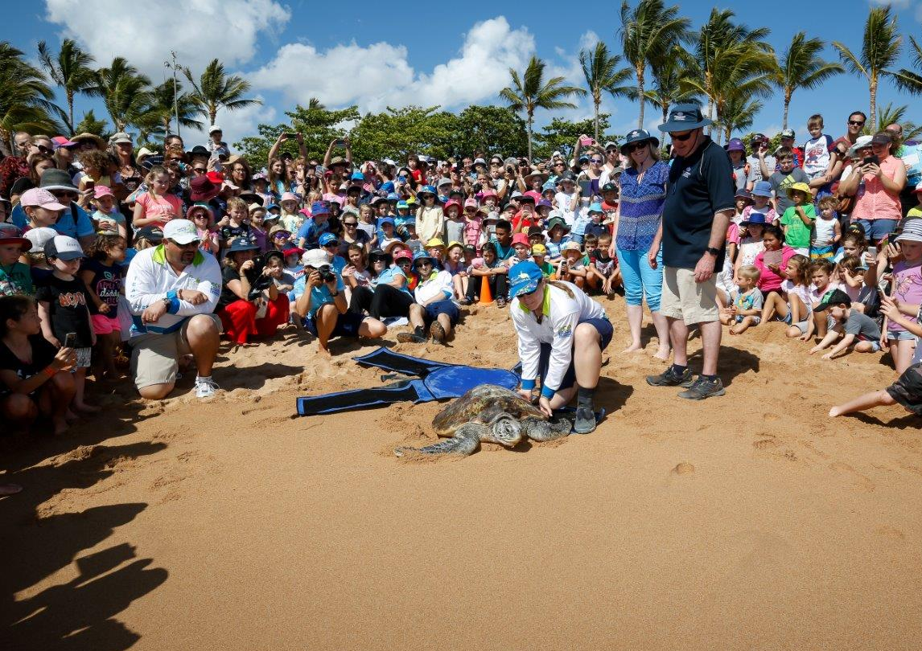
Above: In October 2015, the agency hosted theCelebrate the Reef community event in Townsville to mark 40 years of Reef management
This year the agency celebrated a significant milestone — its 40th year of managing and protecting the Great Barrier Reef Marine Park.
In 1975, after the community fought for stronger protections for the Reef, the Australian Government created the Great Barrier Reef Marine Park Act 1975 to establish a multiple-use Marine Park and an agency to manage the area.
To mark the anniversary, the agency developed a series of new displays at Reef HQ Great Barrier Reef Aquarium and held a number of events with the community, stakeholders and staff in October 2015.
Celebrations with staff, key stakeholders and management partners highlighted some of the agency’s achievements, such as zoning, an expanded Field Management Program, the aquarium’s success, and major reports on the Reef’s health and management. The occasions also recognised the importance of long-term partnerships for successfully managing the Marine Park.
On Saturday 17 October, more than 2000 Townsville residents attended Celebrate the Reef, a free community event at Jezzine Barracks.
The day started with the Townsville Great Barrier Reef Clean-up at Rowes Bay. More than 50 volunteers collected 100 kilograms of marine debris from the beach, helping to reach a milestone of five million pieces of marine debris removed and recorded for the Australian Marine Debris Database.
Later in the morning, two turtles — ‘Ross’ and ‘MJ’ — that had been recovering at Reef HQ turtle hospital were released at Strand Beach.
The event, which included activities, displays and talks from agency teams and Marine Park partners, also featured the Great Barrier Reef Foundation’s ReefBlitz 2015, with 1000 people participating in citizen science surveys during the day.
The 40-year celebrations provided the opportunity to publicly acknowledge and thank the long-term work by agency staff, partners, the wider community, Traditional Owners, other government agencies and industry.

Parliamentary services
The Minister for the Environment and the Australian Department of the Environment are key stakeholders. The agency maintains strong relationships with each by providing formal briefings, responses to correspondence, and advice on the management and protection of the Great Barrier Reef.
During 2015–16, the agency prepared 45 briefs and submissions for the Minister on a variety of issues. Topics included the Whitsundays Plan of Management and superyachts, the health of the Reef and coral bleaching, legal action over the 2010 Shen Neng 1 grounding, the 40th anniversary events, and strengthening the permissions system. The agency provided draft responses for 36 letters to the Minister from people interested in the status, health and protection of the Reef.
The agency works with the department and regularly contributes to portfolio responses, questions on notice and related matters. In 2015–16, the agency provided responses to 90 questions on notice, with topics including recruitment, staffing, coral bleaching, offshore dumping permits and seagrass. The agency contributed to 171 coordination requests from the department, including responses to requests from other government departments for input.

Communication strategies
The agency uses a corporate communication strategy to provide a high-level framework to help implement the Corporate Plan 2015–2020, which:
outlines the agency’s key priorities and focus until 2020, and the key tools and channels used by the agency to raise its profile
promotes stewardship and compliance with zoning rules
helps to manage issues and communicate internally.
Specific communication plans for major programs and activities fall under the overarching corporate communications plan. These specific plans outline the objectives, audiences, channels and tactics, to ensure the communication team’s efforts are coordinated and strategic in supporting the agency’s work.

Brand positioning project
During 2015–16, the agency began a six-month project to review the agency’s brand and how it is positioned, including:
how the agency implements and communicates its vision, management approach and outcomes
how the agency is perceived externally and what it stands for.
The project involves research with staff, stakeholders and the general public. It will provide benchmark data, enabling the agency to assess the effectiveness of its communications, engagement and education programs.

Key publications
The agency’s publications team continued to deliver targeted published materials, including zoning maps and the annual report. The team also delivered a special 40th anniversary exhibit at Reef HQ Great Barrier Reef Aquarium.

Reef in Brief newsletter
More than 1400 subscribers receive the agency’s primary stakeholder e-newsletter, Reef in Brief. It summarises hot topics, key work being done, and programs and achievements. In 2015–16, 23 editions were distributed, including 10 special editions to keep stakeholders informed of coral bleaching.
During the year, the agency reviewed its approach to e-newsletters. In 2016–17, the format of Reef in Brief will change, and the agency will produce additional stakeholder-specific
e-newsletters.

Digital communications
The agency’s 2015–16 digital communication strategy continued the agency’s approach to website content and social media, with plans to make more significant changes to projects and strategies in 2016–17. The strategy focused on building engagement across the agency’s digital channels, improving and reducing content on the website, and looking for future innovations that can add value to the agency’s digital presence.

Website
The annual project plan outlines how the agency’s website will be maintained, developed and enhanced. In 2015–16, key work included:
modifying the home page to improve navigation
adding new home page banners to promote content
using online flipbooks to better present electronic publications
adding the ‘Learn about the Reef’ menu for educational content
migrating the Onboard website to the new public server
investigating mobile applications through partnerships.
The website continues to receive a high level of traffic — it received more than 855,800 visits in the past 12 months, which is an 11.4 per cent increase from the previous 12 months. Online traffic varies from month to month, and 67.6 per cent of users are return visitors.
The most popular content pages are the home page, and pages on Reef facts, zoning, animals, and careers. On average, users spend more than three minutes on the site, browsing through content.
More and more users are also accessing the website from mobile devices, with more than 125,900 accesses from tablets and mobile phones in the past year.
Accessibility and usability continue to be a key focus addressing whole-of-government reporting requirements, as stated in the Digital Service Standard mandated by the Digital Transition Office. These requirements seek to ensure everyone, regardless of location or ability, can access government materials online. Further information on accessibility can be found on the agency’s website.

Social media
The agency runs six social media platforms: Facebook, Instagram, Twitter, LinkedIn, YouTube and Flickr. These contemporary online communication tools are key channels for the agency to promote its work and raise awareness about the Reef to a wide audience in Australia and around the world. The social media platforms are also a great two-way communication channel with key audiences.
The agency’s key social media channel — Facebook — grew from 34,000 followers to 49,000 followers in 2015–16. Interaction is highest for content that is visual and informative. The agency started using the new Facebook Live streaming capabilities for topics such as turtle hospital behind-the-scenes footage, coral bleaching, and a tie-in to the movie Finding Dory.
The first Facebook Live was about the turtle hospital — 6317 viewers watched the footage. There were 121 live viewers and 659 comments, shares and likes. More than 155,000 unique viewers watched the live question and answer on coral bleaching, and more than 1000 viewers ‘liked’, commented on or shared the video.
Spikes in growth on Facebook during the past 12 months aligned with coral bleaching announcements; however, there has been a constant increase in growth since the agency began using cross-platform content from Instagram. Interestingly, most Australian followers are based in Melbourne and Sydney, with only a small group in the Great Barrier Reef catchment. This knowledge has enabled the agency to target its posts to capture a larger audience.
Instagram was added to the agency’s suite of social media channels in June 2015 and is used to share spectacular Reef-related photos and videos that users tag with the hash tags #LoveTheReef and #GBRMarinePark. The Instagram account now has more than 7000 followers. This channel will aim to showcase the beauty and experiences available in the Marine Park through the eyes of visitors.
Twitter is used to promote news from the agency, as well as photos and stories about the Marine Park. At 30 June 2016, there were 3516 followers.
In 2014–15, LinkedIn was added to the agency’s suite of social media channels as a professional, stakeholder-focused social network to share corporate information, including reports, consultation, key events, and recruitment. Currently, there are more than 500 followers.
The agency’s YouTube channel has over 180 videos about Reef management, plants, animals and habitats. New videos were added about coral bleaching, the work of Indigenous rangers, a TEDx presentation in Townville by an agency staff member, and the Great Barrier Reef Clean-up.
Finally, the agency uses photo sharing through Flickr to provide a platform for photo albums to be integrated into the website.
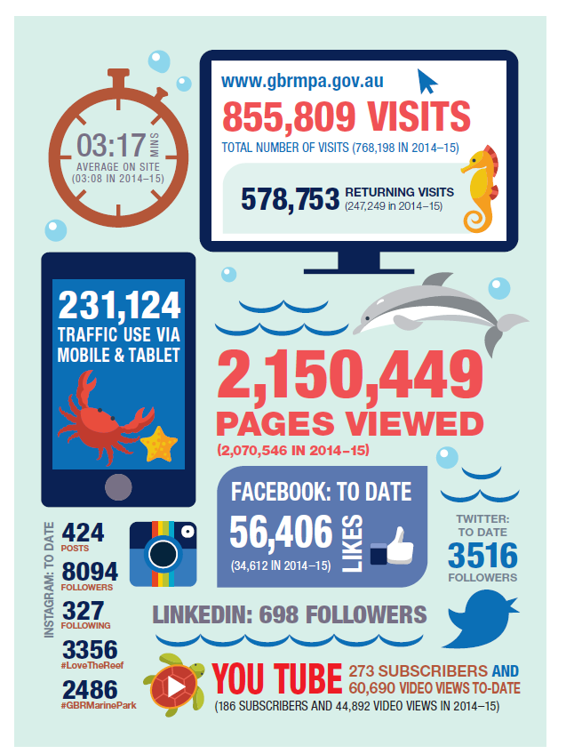
Figure 15: The agency’s website and social media statistics for 2015–16

Media and issues management
Media interest in the future of the Great Barrier Reef and its management remained high in 2015–16, particularly during the coral bleaching event and the Cape Upstart oil spill.
During the past 12 months, the agency distributed 92 media releases and alerts to local, state and national media. Topics that were covered extensively included the agency’s surveys on coral bleaching, the Great Barrier Reef Clean-up and the Celebrate the Reef event, various Reef Guardian School events, and a rise in fishing offences.
The agency also participated in a monthly interview segment with ABC Radio in Townsville, featuring experts discussing Reef issues in detail. During 2015–16, topics included the Cape Upstart oil spill, marine debris, and practices that occurred before the declaration of the Marine Park.

Public information unit
The public information unit provides information services to the agency, the public and stakeholders through publications, responses to email and phone enquiries, and receiving visitors at its head office.
In 2015–16, the public information unit answered 15,273 phone calls. The most common enquiries were about environmental management charges, permits and permit applications, and requests for zoning maps. Some 4943 emails were received, covering a range of topics — most commonly, these included requests for educational resources from students and teachers, general Marine Park use queries, and requests for zoning maps. More than 4129 customers presented to the front office counter at Townsville headquarters.
The agency distributed 88,222 zoning maps and tools to help Marine Park users comply with zoning rules and permitted activities. These were supplied to recreational users and Community Access Points — a network of marine outlets and visitor information centres along the central and north Queensland coast.
The most requested maps covered the Cairns, Innisfail and Townsville coasts, and the Whitsunday and Capricorn regions. The most requested Reef management publications were the Great Barrier Reef Outlook Report 2014 and the Strategic Assessment Report.

Community events
Community engagement and education via event attendance enables the agency to share information about Reef health, management and zoning, and engage with people interested in the Reef. Events at which the agency had a booth or presence included:
Townsville Fishing and Outdoor Expo
Townsville Defence Expo
Townsville Celebrate the Reef community day
BCF Deeragun club night — zoning briefing
Townsville City Council World Wetlands Day
Reef out the Rubbish
Reef Check Australia community events
Great Barrier Reef Clean-up community day
Australian Tourism Exchange
St Lawrence Wetlands Weekend
ADEX Asia Dive Expo
Boyne Tannum Hookup
World Science Festival
World Wetlands Day Pallarenda
Moranbah Rotary Home and Leisure Expo
Sarina Community Nursery open day
Kurrimine Beach Creek and Outer Reef Fishing and Spearfishing Competition
Tight Lines Fishing Classic
Whitsundays Reef Festival
Rockhampton NAIDOC Expo.

Internal communications
The agency established a draft framework for internal communication, including strategies, to ensure the flow of information between sections. The agency produces an internal e-newsletter, with 26 editions distributed in 2015–16. It focused on providing updates from the executive, and information for staff relevant to their work. An internal seminar series was also rolled out as a way to share knowledge and information about the agency’s work managing the Reef. Eleven internal seminars took place covering coastal ecosystems, updates on improving the permission system, plans of management, coral bleaching, and Reef 2050 Plan policies for the Great Barrier Reef.

Analysis of performance against purpose
A delay in the start of the brand positioning project pushed back the availability of data which assesses improved understanding and appreciation of the Reef.

3.14 Regulatory reform
REPORTING REQUIREMENTS
This aligns with performance criteria for:
PBS Program 1.1: Ensure use of the Marine Park is ecologically sustainable and benefits current and future generations.
Deliverables:
- Implement the policy, planning and regulatory framework for the sustainable use of the Marine Park.
- Deliver the 2015–16 Annual Business Plan for Field Management.
- Implement partnership, stewardship, education and communications programs.
Performance criteria:
- Improved uptake of best practice and stewardship in activities that contribute to the health and resilience of the Marine Park.
- Improved inclusion in management decisions of knowledge about the Reef's values, their condition and impacts.
- Declining incidence of illegal fishing.
Corporate Plan Strategy 2: Effective and efficient environmental regulation.

Results against performance criteria
The agency continues to support whole-of-government regulatory reform activities, including the Regulator Performance Framework, which aims to reduce the cost of unnecessary or inefficient regulation imposed on individuals, business and community organisations.
The Regulator Performance Framework mainly covers the agency’s permissions system and compliance activities, which come under the Marine Park Act, and its work as co-regulator for the Environment Protection (Sea Dumping) Act 1981.
A summary of the first assessment report against the framework is available on the agency’s website.

Analysis of performance against purpose
There are no significant factors to report.

3.15 Policy reform
REPORTING REQUIREMENTS
This aligns with performance criteria for:
PBS Program 1.1: Ensure use of the Marine Park is ecologically sustainable and benefits current and future generations.
Deliverables:
- Implement the policy, planning and regulatory framework for the sustainable use of the Marine Park.
- Deliver the 2015–16 Annual Business Plan for Field Management.
- Implement partnership, stewardship, education and communications programs.
Performance criteria:
- Improved uptake of best practice and stewardship in activities that contribute to the health and resilience of the Marine Park.
- Improved inclusion in management decisions of knowledge about the Reef's values, their condition and impacts.
- Declining incidence of illegal fishing.
Corporate Plan Strategy 2: Effective and efficient environmental regulation.

Results against performance criteria
The agency is leading development of a suite of new policy documents to deliver a strong, consistent approach for assessing and managing cumulative impacts, and maintaining and enhancing the condition of the Reef’s values and ecosystem processes.
These documents include policies on cumulative impact management and the delivery of net environmental benefits, together with guidance on the application of offsets. The recommendation to develop these policies was an outcome of the comprehensive strategic assessment of the Great Barrier Reef Region.
The policies are being drafted as Reef 2050 Plan policy documents, and are being developed collaboratively with the Australian Department of the Environment and the Queensland Government through the Office of the Great Barrier Reef. The intent is for policies to apply across the Great Barrier Reef World Heritage Area and its adjacent catchment.
During 2015–16 the agency undertook targeted consultation with Traditional Owners and stakeholders to develop case studies to inform the development of policy principles and implementation pathways. The agency also undertook a review of Australian and international literature relevant to net benefits, cumulative impacts and offsetting for the environment. The review focused on highlighting elements and principles of contemporary theory and practice as the basis for developing an effective policy framework for the Great Barrier Reef.
The agency is planning to release draft policy documents for public consultation in late 2016.
During 2015–16 the agency also started a review of all external policy documents.

Analysis of performance against purpose
The development of policies as a unified suite of documents to be adopted by the Australian and Queensland governments has required extensive consultation with Australian and Queensland government agencies. This has resulted in the extension of timeframes for development beyond those originally proposed for agency policies. It also resulted in the agency’s external policy document review being deferred until 2017.

4 Management and accountability
The Great Barrier Reef Marine Park Authority’s (the agency’s) governance framework for the 2015–16 reporting period is based on the legislative requirements of the Great Barrier Reef Marine Park Act 1975 (the Marine Park Act), the Public Governance, Performance and Accountability Act 2013 (PGPA Act) and the Public Service Act 1999.
The agency reports to the Australian Minister for the Environment. The Great Barrier Reef Marine Park Authority Board (Marine Park Authority Board) oversees the agency, which is structured into three branches: Biodiversity Conservation and Sustainable Use, Great Barrier Reef Operations, and Policy and Stewardship (see also Organisational structure).
The agency uses the best available scientific information to guide its work, and engages with experts and the community — including through two Reef Advisory Committees and 12 Local Marine Advisory Committees.
The main office is in Townsville, with regional offices in Cairns, Mackay and Rockhampton to ensure a close connection with those communities. A small office in Canberra provides a key liaison function with the Minister’s office and the Department of the Environment portfolio, and other Australian Government agencies.

4.1 Great Barrier Reef Marine Park Authority Board
The Chairman and Board members are chosen by the Australian Minister for the Environment and are appointed by the Governor-General.
The Marine Park Act requires that the Board includes a member with knowledge of, or experience in, the tourism industry; a member nominated by the Queensland Government; and an Indigenous person with knowledge of, or experience concerning, Indigenous issues relating to the Marine Park.
Membership of the Board

Dr Russell Reichelt
Russell Reichelt is Chairman and Accountable Authority of the Great Barrier Reef Marine Park Authority.
Russell Reichelt joined the agency in 2007 as Chairman and Chief Executive after an extensive career in marine science and management.
He began diving on the Great Barrier Reef as a teenager in 1968. He then worked as a research scientist at the Australian Institute of Marine Science in the 1980s, studying the ecology of coral reefs, particularly the crown-of-thorns starfish.
Dr Reichelt has a PhD in marine science and has served as Chief Executive Officer of the Australian Institute of Marine Science, Chairman of the Fisheries Research and Development Corporation, and as a member of Australia’s State of the Environment Committee. He has previously chaired the National Oceans Advisory Group, CSIRO’s Wealth from Oceans Flagship Advisory Committee, and Seafood Services Australia Ltd.
He is a Fellow of the Australian Academy of Technological Sciences and Engineering; the Institute of Marine Engineering, Science and Technology (United Kingdom); and the Australian Institute of Company Directors. He holds an honorary position of Adjunct Professor at James Cook University, Townsville, and the University of Queensland.
Dr Reichelt is a Board member for both the Great Barrier Reef Foundation and the Australian Maritime Safety Authority.
He was reappointed Chairman of the Marine Park Authority Board on 1 November 2012 for a second five-year term, concluding on 31 October 2017.

Ms Melissa George
Melissa George is a Wulgurukaba Traditional Owner whose land and sea country includes Magnetic Island and the greater Townsville region.
She has been actively involved in protecting and managing land and sea through community natural resource management projects, and liaising with, and advising, the Queensland and Australian governments. Ms George has been a member of the Australian Government’s Indigenous Advisory Committee (EPBC Act) since 2002, and the committee’s chair since 2006.
She was reappointed as a member of the Marine Park Authority Board on 22 November 2012 for a five-year term, concluding on 21 November 2017.

Mr Tony Mooney AM
Tony Mooney has extensive experience in infrastructure, economic development, community engagement and regional government.
He served as a Townsville City councillor for 31 years, 19 of them as mayor, concluding in 2008. During his time as mayor, he oversaw a period of unprecedented sustainable urban and infrastructure development. In 2008, Mr Mooney was appointed to the Board of Ergon Energy and, in 2009, was appointed to the Board of Townsville Enterprise Limited.
Mr Mooney received a Centenary Medal in 2001 for distinguished service to local government and, in 2011, was appointed a Member of the Order of Australia for service to local government and to the community of Townsville through his work for a range of tourism, business and infrastructure organisations.
He was appointed as a member of the Marine Park Authority Board on 7 December 2011 for a five-year term. In April 2016, Mr Mooney advised the Governor-General of his resignation from the agency’s Board.

Ms Margie McKenzie
Margie McKenzie has extensive senior managerial and ownership experience in the Queensland marine tourism industry. She is currently the managing director of a marine tourism consulting company in Cairns; has been a scuba diving instructor for 30 years, most of which was on the Great Barrier Reef; and is an active instructor examiner with RAID (an online diver training program).
Ms McKenzie was a working partner in one of Australia’s largest dive training and reef experience companies based in Cairns; has been the general manager of Dive Queensland — a non-profit association committed to promoting and developing the diving industry in Queensland — for 18 years; and spent seven years as the general manager of Scuba Schools International.
As a certified practising accountant, Ms McKenzie has specialised in assisting tourism and small business in developing into profitable enterprises.
She was appointed as a member of the Marine Park Authority Board on 16 May 2013 for a five-year term, concluding on 15 May 2018.

Mr Dave Stewart
Dave Stewart was appointed Director-General of the Queensland Department of the Premier and Cabinet in February 2015. One of his highlights as Director-General has been participating in the community Champion program for Indigenous communities, where he regularly visited communities in the Gulf of Carpentaria and assisted them with accessing much-needed government services. He is passionate about regional Queensland, and engaging directly with residents, business, government and community leaders.
After a long career in local government, and engineering construction in Australia and the United Kingdom, he joined the Queensland Government in 2006 as Deputy Coordinator-General in the Department of Infrastructure and Planning, where he was responsible for delivering major water and road projects. From June 2008, he was the Director-General of Queensland Transport and then the Department of Transport and Main Roads, overseeing the integration of organisations to a new customer-focused model. His primary responsibility was transport leadership, including strategic policy and planning, system stewardship, infrastructure delivery and service delivery. He has also been the Secretary for Transport for New South Wales, where he led about 27,000 people, shaping planning, policy and delivery of public transport, roads and freight across the state.
Mr Stewart is a civil engineer and holds master’s degrees in business and engineering science. He completed an executive program at Harvard University, United States, looking at private sector involvement in infrastructure delivery. He is a Fellow of Engineers Australia, and an Honorary Fellow, Chartered Institute of Transport and Logistics.
He was appointed as the Queensland Government’s representative member of the Marine Park Authority Board on 23 July 2015 for a three-year term, concluding on 22 July 2018.

Professor Emma Johnston
Emma Johnston is an award-winning scientist, educator and communicator, and is Professor of Marine Ecology and Ecotoxicology and Pro Vice-Chancellor (Research) at the University of New South Wales. Professor Johnston investigates human impacts in marine ecosystems, with a particular emphasis on stress ecology, invasion biology and the development of biomonitoring tools. She has published more than 100 refereed papers in coastal ecology. She graduated with a BSc (Hons) from the University of Melbourne in 1997, and a PhD from the University of Melbourne in 2002.
Professor Johnston has led more than 20 major research projects for industry, government, the Australian Research Council and the Australian Antarctic Science Program. From 2010–2014, she was an Australian Research Fellow for the Australian Research Council, and in 2012 she became inaugural Director of the flagship Sydney Harbour Research Program for the Sydney Institute of Marine Science. She is currently the lead author of the Australian Government’s state of the environment report coastal chapter.
Professor Johnston has received a string of awards, including the inaugural Australian Academy of Science Nancy Millis Medal (2014), the Eureka Prize for the public communication of science (2015), and the Hynes Award from the Canadian Rivers Institute (2016). She is a senior adviser to government and industry, and is Vice-President, Science and Technology Australia.
She was appointed as a member of the Marine Park Authority Board on 5 May 2016 for a five-year term, concluding on 4 May 2021.
Board meeting schedule
During 2015–2016, the Marine Park Authority Board held five meetings (Table 9).
Table 9: Meetings of the Great Barrier Reef Marine Park Authority Board, 2015–16
Meeting | Date | Location | Attendance
MPA 238 | 15 July 2015 | Brisbane | Russell Reichelt, Margie McKenzie, Tony Mooney AM
MPA 239 | 9 September 2015 | Townsville | Russell Reichelt, Melissa George, Tony Mooney AM, Dave Stewart
MPA 240 | 11 December 2015 | Townsville | Russell Reichelt, Melissa George, Margie McKenzie, Tony Mooney AM
MPA 241 | 16 March 2016 | Brisbane | Russell Reichelt, Margie McKenzie, Tony Mooney AM, Dave Stewart
MPA 242 | 22 June 2016 | Cairns | Russell Reichelt, Emma Johnston, Margie McKenzie, Dave Stewart
MPA = Marine Park Authority

4.2 Senior executive
Bruce Elliot — General Manager, Biodiversity Conservation and Sustainable Use. The branch comprises the following sections:
Environmental Assessment and Protection
Information Management Systems and Technologies
Reef Recovery.
Simon Banks — General Manager, Great Barrier Reef Operations. The branch comprises the following sections:
Field Management
Indigenous Partnerships
Legal Services
Reef HQ Aquarium.
Margaret Johnson — General Manager, Policy and Stewardship. The branch comprises the following sections:
Communications and Parliamentary
Heritage, International and Governance
Reef 2050
Tourism and Stewardship.
Belinda Jago — Chief Operating Officer and Chief Finance Officer. The Chairman’s Office area comprises the following sections:
Finance
People Management, Office and Security Services.
An organisational chart depicting the senior executives and their responsibilities is in the Overview section of this report, Figure 1.

4.3 Audit Committee
The agency’s Accountable Authority has established an Audit Committee in compliance with section 45 of the PGPA Act and PGPA Rule section 17 Audit Committees for Commonwealth Entities.
The Audit Committee provides independent assurance and assistance to the Accountable Authority and the Marine Park Authority Board on the agency’s risk, control and compliance framework, and its financial and performance reporting responsibilities.
The Audit Committee comprised the following members during 2015–2016:
Roy Peterson, member and Chairman
Phillip Fogarty, member and Queensland Government nominee (Department of the Premier and Cabinet)
Margie McKenzie, member and Marine Park Authority Board representative
Michael O’Keeffe, member.
During 2015–2016, the Audit Committee held four meetings (Table 10).
Table 10: Meetings of the Great Barrier Reef Marine Park Authority Audit Committee, 2015–16
Meeting | Date | Location | Attendance
AC 68 | 27 August 2015 | Townsville | Roy Peterson, Phillip Fogarty, Michael O’Keeffe
AC 69 | 5 November 2015 | Townsville | Roy Peterson, Phillip Fogarty, Margie McKenzie, Michael O’Keeffe
AC 70 | 18 February 2016 | Townsville | Roy Peterson, Phillip Fogarty, Margie McKenzie, Michael O’Keeffe
AC 71 | 1 June 2016 | Townsville | Roy Peterson, Phillip Fogarty, Margie McKenzie
AC = Audit Committee
Observers and guests attending Audit Committee meetings included:
Great Barrier Reef Marine Park Authority Chairman
General Manager, Policy and Stewardship
Chief Operating Officer/Chief Finance Officer
General Manager, Great Barrier Reef Operations
Director, Reef 2050
Director, Heritage, International and Governance
Director, Environmental Assessment and Protection
Director, Legal Services
Director, People Management, Office and Security Services
Chief Information Officer
Director, Communications and Parliamentary
Finance Manager
Manager, Governance Support
Manager, Strategic Planning
Manager, Employee Relations
Project Manager, Governance Support
representatives from the Australian National Audit Office
internal audit service provider.
Business activities of the Audit Committee addressed:
financial statements
financial management
internal audit
external audit
internal controls and compliance management
legislative and policy compliance
environmental management charge and sustainable funding
court-imposed fines
policies and procedures
corporate governance, including risk management and fraud risk management
corporate planning and reporting processes.
Functions and responsibilities
Functions and responsibilities are set out in the Audit Committee’s Charter of Operation, reflecting requirements under the PGPA Act and regulations. The charter covers the committee’s functions in relation to:
- financial reporting
- reviewing the financial statements and providing advice to the Accountable Authority
- adequacy of key internal controls and management sign-off
reviewing consistency with information provided in the annual report
- performance reporting
- systems and procedures for developing, measuring and reporting performance measures
- reviewing proposed performance reporting
recording performance
- risk oversight and management
- risk management framework
- managing major risks
fraud control
- systems of internal control
- internal control framework
- Accountable Authority instructions and other policies and procedures
- information security infrastructure
- delegations
- business continuity management
- ethical and lawful behaviour
- internal audit
legislative and policy compliance
- other responsibilities
- reviewing governance arrangements periodically
parliamentary committee reports and external reviews.
Members of the Audit Committee are expected to understand and observe the legal requirements of the PGPA Act and regulations. Members are also expected to:
act in the best interests of the agency
apply good analytical skills, objectivity and good judgement
express opinions constructively and openly, raise issues that relate to the Audit Committee’s responsibilities and pursue independent lines of enquiry
contribute the time required to review provided meeting papers.
Internal audit reports
During 2015–2016, internal audits undertaken in accordance with the strategic internal audit plan included:
payment card management
PGPA Act compliance
information and records management
security management
workplace health and safety management.

4.4 Risk management
The agency continued its work in 2015–16 to improve the risk management framework by integrating new guidance material and tools into the everyday business activities of the agency.
Improvement work is ongoing and guided by an overarching plan, with progress regularly monitored by the Audit Committee.
The internal and external audit functions continue to provide independent assurance to the agency on the integrity and reliability of operational and financial risk mitigation arrangements in place.
Fraud control
The fraud control policy and plan is consistent with the Australian Government fraud control framework, and gives effect to the fraud control provisions of the PGPA Act and Rule 10 of the Public Governance, Performance and Accountability Rule 2014.
The fraud control policy and plan is also aligned to AS8001–2008 Fraud and corruption control, and the better practice guidance developed by the Australian National Audit Office.
In 2015–16, the agency continued implementation of treatments to give effect to its fraud control policy and plan, aimed at further reducing the incidence of and opportunity for fraud. Progress updates were collated every three months and provided to the agency’s Audit Committee for oversight. Mandatory awareness training for all staff was also rolled out in 2015–16, contributing to a greater awareness of fraud and fraud risk among workers.
Collectively, the fraud risk assessment, and corresponding fraud control policy and plan, continue to:
facilitate appropriate fraud prevention, detection, investigation, reporting and data collection in a way that meets the specific needs of the agency
reduce the incidence of fraud in the agency as much as is reasonably practicable
facilitate the process to recover the proceeds of fraud against the agency.
Two enquiries regarding suspected fraud were made to the fraud liaison officer during 2015–16. These were pursued via the agency’s regulatory compliance mechanisms.

4.5 Advisory committees
The agency has a number of committees that provide support and strategic advice, including 12 Local Marine Advisory Committees. Other committees may be appointed from time to time to deal with specific issues. All committees have terms of reference and procedures established by the agency. Their composition and membership is reviewed as necessary.
The agency’s Reef advisory committees were established to advise about actions that could be taken to address risks to the Marine Park.
The Tourism Reef Advisory Committee met on 26–27 November 2015 and 21–22 April 2016.
The Indigenous Reef Advisory Committee met on 30 September–1 October 2015, 17– 18 February 2016 and 23–24 May 2016.
The Reef advisory committees are competency-based, and comprise a cross-section of stakeholder interests with expertise and experience in relevant areas. Each committee includes members appointed as representatives of particular groups or sectors (for example, industry, recreational, government), or for their linkages to Traditional Owner groups. Staff of the relevant branch and sections work closely with the Reef advisory committees to ensure policy development and strategic direction are developed in consultation with stakeholders.
In addition, 12 Local Marine Advisory Committees operate along the Great Barrier Reef catchment. Representing community interests from Cape York south to the Burnett region, Local Marine Advisory Committees provide an avenue for local communities to discuss areas of concern directly with the agency. The committees also have input into the management of the Marine Park, and undertake activities that contribute to its long-term protection.
The committees are listed and reported on in Section 3.11.
Each Local Marine Advisory Committee meets five times a year. Members are appointed for a three-year term, with the current term beginning in July 2015 and ending at the end of June 2018.

4.6 Strategic and operational plans
The agency carries out planning at strategic and operational levels. In 2015–16, the agency’s strategic and operational planning was influenced by the commitments in the Reef 2050 Plan, the recommendations in the Great Barrier Reef Region Strategic Assessment Program Report, and the findings of the Great Barrier Reef Outlook Report 2014. The strategic planning process is shown in Figure 16.
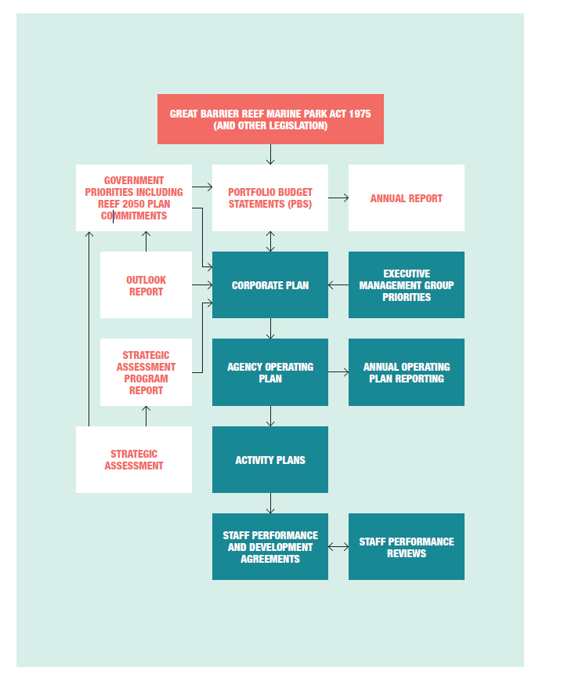
Figure 16: Strategic planning process
Corporate Plan 2015–2020
The agency’s Corporate Plan 2015–2020 is based on the outcomes of the strategic planning process, and outlines the direction and priorities of the agency. It focuses on delivering outcomes required by legislation, especially the Marine Park Act, through the achievement of four goals:
protect and restore the Reef’s ecosystem health and biodiversity
safeguard the Reef’s heritage
ensure ecologically sustainable use and benefits for current and future generations
reduce cumulative impacts.
To achieve these goals, the agency delivers its management program under three main strategies:
Strategy 1: Ensure the best available knowledge is captured and used to inform management decisions, aimed at reducing cumulative impacts.
Strategy 2: Effective and efficient environmental regulation, to set the standards necessary to provide certainty about where uses may occur, the types of activities allowed and the conditions under which activities may proceed in the Marine Park.
Strategy 3: Strengthen engagement with community, industry and other government stakeholders to maintain a balance between protecting the Reef, managing competing demands and supporting sustainable use.

Annual operating plans
The Corporate Plan is supported by an agency operating plan. This plan sets out detailed actions to achieve the agency’s goals.
Service Charter 2011–2015
The Service Charter outlines the agency’s goals, aims and customers, and its commitments to customers. The agency aims to provide appropriate services to meet all of its commitments and continue to develop services as new issues arise. The Service Charter will be reviewed regularly in line with these changes.
The Service Charter is available on the agency’s website.
Ethical standards
The agency is committed to the Australian Public Service Values and Code of Conduct set out in the Public Service Act, which is an integral part of the people management framework. It is incorporated in the agency’s Corporate Plan and the Enterprise Agreement 2011–2014.
Information on ethical standards is provided to staff through the agency’s intranet, induction procedures and the internal newsletter, Chairman’s Update.

4.7 External scrutiny
The Great Barrier Reef Marine Park Authority Audit Committee Charter of Operation and other documents reflect the requirements for audit committees under the PGPA Act.
Benchmark International Group Pty Ltd was contracted to provide internal audit services for 2015–16. Internal audit work was in accordance with an agreed strategic internal audit plan. The agency’s Audit Committee is reported in Section 4.3.
In line with the Australian Government's focus on accountability and corporate governance, audit activity concentrated on areas of high risk, the adequacy of existing control frameworks and compliance with the provisions of the PGPA Act.
There were no judicial decisions that significantly affected the agency’s operations during 2015–16.
Australian National Audit Office reports
Moore Stephens, under contract to the Australian National Audit Office, undertook the external audit of the agency’s 2015–16 financial statements (see Part 5, Finances).
The agency was included in the following Auditor-General reports tabled in Parliament during 2015–16:
No. 3 — Regulation of Great Barrier Reef Marine Park Permits and Approvals.
The following Auditor-General reports of 2015–16 can contain recommendations of relevance to the agency:
No. 1 — Procurement Initiatives to Support Outcomes for Indigenous Australians
No. 33 — Defence Management of Credit Cards
Commonwealth Ombudsman
No complaints were made to the Ombudsman in the 2015–16 financial year.

4.8 Management of human resources
People management effectiveness
The People Management, Office and Security Services section provides a range of services for:
payroll
recruitment
work health and safety
learning and development
dive operations and training
security management
office and facility services
workplace relations management, which includes high-level advice and assistance to managers and supervisors regarding workforce planning, performance management and case management matters.
The section proactively supports line areas to meet business objectives as outlined in the annual operating plan.
Training and staff development
The agency spent $210,000 on learning and development in 2015–16. This included the costs of training courses, conference attendance, formal qualifications, study fee reimbursements and professional memberships.
The implementation of an in-house corporate (face-to-face) training program contributed to an expansion of development opportunities during 2015–16. This program, combined with the newly launched eLearning system, provides value-for-money options matched to core public service skills, mandatory training and career development.
Specialised in-house training included first aid, dive and resuscitation, emergency response, health and safety, and a variety of field-based skills.
The agency maintains its support of employees’ professional development, with time off for face-to-face study and reimbursement of professional fees upon successful completion of a semester of study.
Work health and safety
The agency’s working environment varies from contemporary office to remote camping. Officers conduct extensive fieldwork that includes boat patrols, diving surveys, underwater construction, engineering and water quality management. The agency’s broad community consultation involves officers liaising with schools, landholders, tourism operators, the fishing industry and Traditional Owners (including in remote locations).
During 2015–16, 46 incident reports were lodged by employees — two claims for compensation were submitted to, and accepted by, Comcare.
The agency continues to provide an employee assistance program to enable support for work and family matters, with 16 staff and family members using this service (totalling 49.75 clinical delivery hours) between 1 July 2015 and 30 June 2016.
Quarterly workplace inspections have been conducted by the agency’s work units, which were reported to the Work Health and Safety Committee and Executive Management Group.
During the reporting period, significant investment was put into revising and updating general work health and safety arrangements, including providing three automatic external defibrillators, an evacuation chair (for assisting injured or disabled people navigate the fire stairs) and one oxygen resuscitation kit. Employees are continuing to receive training for the safe and effective use of the new safety equipment.
Additional training was provided for emergency response, first aid, harassment referral contract officers, and health and safety representation. Emergency procedures were reviewed and fire drills were conducted.
In April 2016, 75 employees received a free influenza vaccination.
Dive safety and operations
A full suite of in-house training courses has been introduced in an effort to increase the percentage of divers with current qualifications on the agency’s dive register. Since its introduction in November 2014, the currency rate on the register has increased from 49 per cent to 80 per cent. In-house training has been primarily targeted to fulfil the requirements of the dive register with regard to first aid, cardiopulmonary resuscitation and oxygen courses, in addition to required yearly rescue refreshers.
All the requirements for maintaining currency on the dive register are now facilitated in-house by the dive officer, with the exception of dive medicals. This efficiency gain is being rolled out to non-divers in an effort to widen the first responder capabilities of all agency staff. Further courses are being added as demand dictates.
The agency’s dive register has been increased in scope to include snorkellers, and records of their current skill assessment and medical evaluations. In an effort to more comprehensively comply with the diving operations manual, water skills assessments have been reintroduced as annual minimum mandatory requirements in conjunction with medical evaluations. The introduction of snorkel swims as a prerequisite for working as agency snorkellers brings the agency’s requirements closer in line with best practice and makes interagency cooperation simpler and more efficient.
Staffing statistics
The agency had 208 employees as at 30 June 2016. Of these, 151 people were employed at Australian Public Service levels 1–6; 53 were employed at Executive Level 1 or 2; and four were employed at Senior Executive Service levels, including the Chief Executive. More information is provided in the staffing overview table in Appendix B.
Workplace diversity
Workplace diversity data for the agency’s employees is in Appendix B. The agency’s workplace diversity program seeks to ensure:
annual operating plans (section) and long-term strategic plans (corporate) acknowledge the diverse backgrounds of employees and their current and potential contribution to the agency
the suite of terms and employment conditions enshrined in the agency’s Enterprise Agreement assists employees to balance their work, family, caring and lifestyle responsibilities and preferences
the Australian Public Service values remain central to the agency’s culture.
Providing access for people with disabilities
The agency’s disability action plan includes applying the principle of reasonable adjustment to office access and accommodation. Ergonomic assessments are conducted, and equipment is provided, to suit the needs of the individual.
The agency’s main building in Townsville, which includes the field management office, conference room, meeting rooms and Reef HQ Great Barrier Reef Aquarium, are wheelchair accessible. The Rockhampton and Canberra offices are also wheelchair accessible.
The 2015–16 workplace diversity data identified that 1.9 per cent of employees have some form of disability.
Employment agreements
The agency’s Enterprise Agreement 2011–2014 was introduced in November 2011. Negotiations for the next enterprise agreement are well progressed, with implementation of the agreement expected in late 2016.
Consistent with government policy, all non-senior executive service employees are covered by the enterprise agreement. The current agreement provides salaries to cover classifications ranging from an Australian Public Service 1 to Executive Level 2, including a specific legal officer classification.
The salary range for non-senior executive service employees is $34,970 for Australian Public Service Level 1 to $132,801 for Executive Level 2.
Non-salary benefits provided to employees include:
payment of one work-related professional association membership fee for ongoing employees, exempt from fringe benefits tax
access to salary packaging of vehicles and superannuation for all ongoing employees, exempt from fringe benefits tax
a healthy lifestyle allowance of $150 per financial year to help meet the cost of activities or equipment that maintain health and fitness.
Senior executive remuneration
At 30 June 2016, all Senior Executive Service employees were remunerated by way of section 24(1) determinations under the Public Service Act. The average salary for employees covered by section 24(1) determination was $199,999.
More information on senior executive remuneration is included in Part 5, Finances.
Performance pay
The agency does not operate a performance pay scheme.

4.9 Assets management
There are five significant components of the agency’s asset management:
office fit-out
Reef HQ Great Barrier Reef Aquarium
Commonwealth islands land and properties
field management equipment
information management systems and technology.
During the reporting period, work on the aquarium was funded and completed under the departmental capital budget. Work continued on the implementation of major information management systems and technology projects.
The agency has capital management plans in place for the aquarium, office fit-out, information management systems and technology, and field management equipment.

4.10 Purchasing
Delegations
The PGPA Act and Public Governance, Performance and Accountability Rules confer powers and functions on the Accountable Authority that may be delegated. The Accountable Authority has, in writing, delegated certain powers and functions to officials. The delegate does not have the power to subdelegate without a specific provision in legislation.
Accountable Authority instructions
Accountable Authority instructions are the primary mechanism for an Accountable Authority to set out the processes to promote the proper use of Australian Government resources, including relevant money and property by officials in their agency.
The agency’s Accountable Authority instructions comply with requirements of the PGPA Act and ensure compliance with Australian Government procurement guidelines.
Consultants and contracts
Annual reports contain information about actual expenditure on contracts for consultancies. Information on the value of contracts and consultancies is available on the AusTender website.
Consultancies
During 2015–16, 24 new consultancy contracts were entered into involving total actual expenditure of $6.773 million. In addition, 11 ongoing consultancy contracts were active during the reporting period, involving total actual expenditure of $3.159 million.
Consultants are engaged when specialist expertise is not available within the agency or where an independent assessment is considered desirable. In 2015–16, this included marine research, organisational management advice, information systems management and technology services, the Reef 2050 Integrated Monitoring and Reporting Program, services for the crown-of-thorns starfish management program and the Marine Monitoring Program, and development and implementation of Traditional Use of Marine Resources Agreements.
Competitive tendering and contracting
In accordance with the Commonwealth Procurement Rules 2014, whole of government policies including the Indigenous Procurement Policy, and the agency’s purchasing guidelines — and depending on the estimated values of the tender — the selection and engagement of consultants may involve open tender, prequalified tender, limited tender or, where appropriate, direct engagement of a recognised and pre-eminent expert.
Exempt contracts
During 2015–16, no contract was exempted by the Accountable Authority from publication in AusTender.
Access by Auditor-General
All contracts were provided for the Auditor-General to have access to the contractor’s premises.
Procurement initiatives to support small businesses
The agency supports small business participation in the Australian Government procurement market. Small and medium enterprises (SMEs) and small enterprise participation statistics are available on the Department of Finance’s website.
The agency procurement practices support SMEs in ways that are consistent with paragraph 5.4 of the Commonwealth Procurement Rules, including consideration of SMEs capabilities and their commitment to Townsville and regional markets, and through such practices as electronic systems or use of payment cards that facilitate on-time payment performance.
Grant programs
Information on grants awarded by the agency during 2015–16 is available on the agency’s website.
During 2015–16, the agency administered the following grants programs:
Ripples of Change — Reef Guardian Schools award
Marine debris grants to local government councils in Queensland
Aboriginal and Torres Strait Islanders in Marine Science.

5 Finances
Independent Auditors Report 133
Statement by Officers 135
Statement of Comprehensive Income 136
Statement of Financial Position 137
Statement of Change in Equity 138
Cash Flow Statement 139
Administered Schedule of Comprehensive Income 140
Administered Schedule of Assets and Liabilities 141
Administered Reconciliation Schedule 142
Administered Cash Flow Statement 142
Table of Contents - Notes 143
Notes to and forming part of the Financial Statements 144

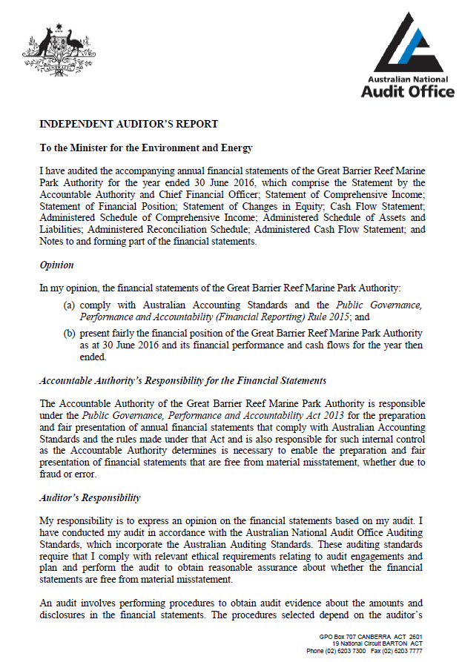

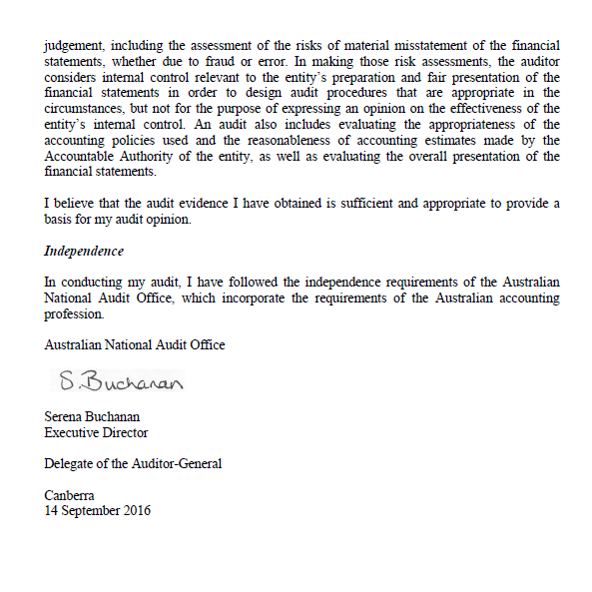

GREAT BARRIER REEF MARINE PARK AUTHORITY
STATEMENT BY THE ACCOUNTABLE AUTHORITY AND CHIEF FINANCIAL OFFICER
In our opinion, the attached financial statements for the year ended 30 June 2016 comply with subsection 42(2} of the Public Governance, Performance and Accountability Act 2013 (PGPA Act), and are based on properly maintained financial records as per subsection 41(2} of the PGPA Act.
In our opinion, at the date of this statement ,there are reasonable grounds to believe that the Great Barrier Reef Marine Park Authority will be able to pay its debts as and when they fall due.


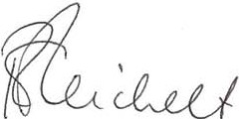

Russell Reichelt Accountable Authority
14/09/2016
Belinda Jago
Chief Financial Officer
14/09/2016

Statement of Comprehensive Income
for the period ended 30 June 2016
 | Notes | 2016 $'000 | 2015 $'000 | Original Budget $'000
NET COST OF SERVICES
Expense
Employee Benefits | 1.1A | 21,242 | 20,484 | 20,675
Supplier | 1.1B | 18,261 | 17,435 | 12,340
Grants |  | 75 | 12 | 20
Depreciation | 3.2A | 2,118 | 1,908 | 1,900
Write-down and impairment of financial assets |  | 2 | - | -
Losses from asset disposal | 3.2A | 16 | 5 | -
Cost of goods sold |  | 196 | 149 | 149
Payments to Queensland Government for Field Management Program | 5.5 | 12,441 | 12,457 | 12,226
Total Expenses |  | 54,351 | 52,450 | 47,310
Own-source Income
Own-source revenue
Sale of goods and rendering of services | 1.2A | 3,004 | 2,967 | 3,020
Receipts from Queensland Government for Field Management Program | 5.5 | 8,372 | 8,372 | 8,372
Grants received from Government | 1.2B | 12,014 | 11,450 | 8,700
Other revenue | 1.2C | 127 | 75 | 1,400
Total own-source revenue |  | 23,517 | 22,864 | 21,492
Gains
Other | 1.2D | 55 | 55 | 54
Total gains |  | 55 | 55 | 54
Total own-source income |  | 23,572 | 22,919 | 21,546
Net (cost of)/contribution by services |  | (30,779) | (29,531) | (25,764)
Revenue from Government | 1.2E | 28,217 | 27,145 | 25,784
Total Revenue from Government |  | 28,217 | 27,145 | 25,784
Surplus/(Deficit) attributable to the Australian Government |  | (2,562) | (2,386) | 20
OTHER COMPREHENSIVE INCOME  Items not subject to subsequent reclassification to net cost of services  Changes in asset revaluation surplus |  | - | (465) | -
Total comprehensive income/(loss) attributable to the Australian Government |  | (2,562) | (2,851) | 20

The above statement should be read in conjunction with the accompanying notes.
Budget Variances Commentary  Statement of Comprehensive Income for not-for-profit Reporting Entities | Affected line items and statement
Expenses  GBRMPA received additional funding during the 2015/16 for Crown of Thorns Starfish Outbreak (CoTS) $2.000m and Reef Integrated Monitoring and Reporting (RIMRP) $1.114m. The Reef and Rainforest Research Centre deliver the CoTS program under contractual arrangements. The RIMRP expenses involves contracting  other Government agencies and universities to undertake monitoring work . GBRMPA also incurred  $2.300m in legal expenses for litigation in the Federal Court (see Contingency note) | Expenses - Supplier
Revenue  GBRMPA received additional funding for Crown of Thorns Starfish $2.000m, Reef Integrated Monitoring and Reporting $1.114m and Specialised Indigenous Rangers program $0.600m during the 2015/16 financial year. Expected revenue from Federal Court case has been adjourned till September 2016 (see Contingency note). Special Appropriation was $2.400m above original budget figure due to increase in tourism visitation numbers and increase in daily Environment Management Charge. | Grants received from Government  Other revenue  Revenue from Government

Statement of Financial Position
as at 30 June 2016
 | Notes | 2016 $'000 | 2015 $'000 | Original Budget $'000
ASSETS
Financial Assets
Cash and cash equivalents | 3.1A | 489 | 132 | 324
Trade and other receivables | 3.1B | 11,627 | 11,486 | 11,631
Total financial assets |  | 12,116 | 11,618 | 11,955
Non-Financial Assets
Buildings | 3.2A | 16,774 | 16,688 | 17,765
Leasehold improvements | 3.2A | 33 | 471 | -
Property, plant and equipment | 3.2A | 2,206 | 2,328 | 2,523
Intangibles | 3.2A | 2,218 | 2,307 | 2,332
Inventories | 3.2B | 73 | 339 | 62
Prepayments |  | 290 | 1,019 | 266
Total non-financial assets |  | 21,594 | 23,152 | 22,948
Total assets |  | 33,710 | 34,770 | 34,903
LIABILITIES
Payables
Suppliers |  | 4,370 | 3,613 | 2,495
Other payables | 3.3A | 155 | 658 | 173
Permit bonds | 3.3B | 258 | 263 | 263
Total payables |  | 4,783 | 4,534 | 2,931
Provisions
Employee provisions | 6.1A | 6,059 | 5,593 | 6,551
Provision for make good |  | 83 | 74 | 382
Total provisions |  | 6,142 | 5,667 | 6,933
Total liabilities |  | 10,925 | 10,201 | 9,864
Net assets |  | 22,785 | 24,569 | 25,039
EQUITY
Contributed equity |  | 23,145 | 22,367 | 14,569
Reserves |  | 13,168 | 13,168 | 22,209
Retained surplus (accumulated deficit) |  | (13,528) | (10,966) | (11,739)
Total equity |  | 22,785 | 24,569 | 25,039

The above statement should be read in conjunction with the accompanying notes.
Budget Variances Commentary  Statement of Financial Position for not-for-profit Reporting Entities | Affected line items and statement
Liabilities  The variance is due to timing. Settlement is usually made within 30 days of the receipt of goods and/or services and accompanying tax invoice or according to the terms and conditions of the contract. | Payables - Suppliers
Equity  Refer to Statement of Changes in Equity commentary | Equity - Contributed equity and reserves

Statement of Changes in Equity
for the period ended 30 June 2016
 | Notes | 2016 $'000 | 2015 $'000 | Original Budget $'000
CONTRIBUTED EQUITY
Opening balance
Balance carried forward from previous period |  | 22,367 | 21,592 | 13,791
Adjusted opening balance |  | 22,367 | 21,592 | 13,791
Transactions with owners
Contributions by owners
Equity injection - Appropriations
Departmental capital budget |  | 778 | 775 | 778
Total transactions with owners |  | 778 | 775 | 778
Closing balance as at 30 June |  | 23,145 | 22,367 | 14,569
RETAINED EARNINGS
Opening balance
Balance carried forward from previous period |  | (10,966) | (8,580) | (11,759)
Adjusted opening balance |  | (10,966) | (8,580) | (11,759)
Comprehensive income
Surplus/(Deficit) for the period |  | (2,562) | (2,386) | 20
Other comprehensive income |  | - | - | -
Total comprehensive income |  | (2,562) | (2,386) | 20
Closing balance as at 30 June |  | 13,528) | (10,966) | (11,739)
ASSET REVALUATION RESERVE
Opening balance
Balance carried forward from previous period |  | 13,168 | 13,633 | 22,209
Adjusted opening balance |  | 13,168 | 13,633 | 22,209
Comprehensive income
Other comprehensive income |  | - | (465) | -
Total comprehensive income |  | - | (465) | -
Closing balance as at 30 June |  | 13,168 | 13,168 | 22,209
TOTAL EQUITY
Opening balance
Balance carried forward from previous period |  | 24,569 | 26,645 | 24,241
Adjusted opening balance |  | 24,569 | 26,645 | 24,241
Comprehensive income
Surplus/(Deficit) for the period |  | (2,562) | (2,386) | 20
Other comprehensive income |  | - | (465) | -
Total comprehensive income |  | (2,562) | (2,851) | 20
Transactions with owners
Contributions by owners
Equity injection - Appropriations |  | - | - | -
Departmental capital budget |  | 778 | 775 | 778
Total transactions with owners |  | 778 | 775 | 778
Closing balance as at 30 June |  | 22,785 | 24,569 | 25,039

The above statement should be read in conjunction with the accompanying notes.
Accounting Policy
Equity injections
Amounts appropriated which are designated as 'equity injections' for a year (less any formal reductions) and Departmental Capital Budgets (DCBs) are recognised directly

Budget Variances Commentary  Statement of changes in Equity for not-for-profit Reporting Entities | Affected line items and statement
Equity  Capital and Reserves amount were incorrectly stated in the original budget with $8.576m to be transferred from Asset Revaluation Reserves to Contributed Equity. | Equity - Contributed equity and reserves

Cash Flow Statement
for the period ended 30 June 2016
 | Notes | 2016 $'000 | 2015 $'000 | Original Budget $'000
OPERATING ACTIVITIES
Cash received
Appropriations |  | 27,962 | 27,145 | 24,384
Receipts from Government |  | 12,014 | 11,478 | 8,700
Sale of Goods and rendering of services |  | 3,320 | 3,670 | 3,140
GST received from debtors |  | 106 | 112 | 1,000
Receipts from Queensland Government for Field Management Program |  | 8,372 | 8,372 | 8,372
Section 72 receipts transferred from OPA |  | 1,733 | 1,303 | -
Other |  | - | - | 1,400
Total cash received |  | 53,507 | 52,080 | 46,996
Cash used
Grants |  | 75 | 12 | 20
Employees |  | 21,313 | 21,899 | 20,380
Suppliers |  | 17,040 | 16,250 | 13,730
GST paid to suppliers |  | 1,747 | 1,525 | 120
Payments to Queensland Government for Field Management Program |  | 12,441 | 12,457 | 12,226
Total cash used |  | 52,616 | 52,143 | 46,476
Net cash from/(used by) operating activities | 5.4A | 891 | (63) | 520
INVESTING ACTIVITIES
Cash used
Purchase of property, plant and equipment |  | 1,312 | 904 | 1,298
Total cash used |  | 1,312 | 904 | 1,298
Net cash from/(used by) investing activities |  | (1,312) | (904) | (1,298)
FINANCING ACTIVITIES
Cash received
Contributed equity |  | 775 | 775 | 778
Total cash received |  | 778 | 775 | 778
Net Cash from/(used by) Financing activities |  | 778 | 775 | 778
Net increase/(decrease) in cash held |  | 357 | (192) | -
Cash and cash equivalents at the beginning of the reporting period |  | 132 | 324 | 324
Cash and cash equivalents at the end of the reporting period | 3.1A | 489 | 132 | 324

The above statement should be read in conjunction with the accompanying notes.
Budget Variances Commentary  Cash flow statement for not-for-profit Reporting Entities | Affected line items and statement
Cashflow  Special Appropriation was $2.400m above original budget figure due to increased tourism visitation numbers and increase in daily Environment Management Charge.  GBRMPA received additional funding during the 2015/16 for Crown of Thorns Starfish Outbreak (CoTS) $2.000m and Reef Integrated Monitoring and Reporting (RIMRP) $1.114m.  GST cash received or payable input into original budget incorrectly offset by a reduction in supplier payments. | Cash Received - Appropriations  Cash Received - Receipts from Government  GST receivable and payable

Administered Schedule of Comprehensive Income
for the period ended 30 June 2016
Original
2016 2015 Budget
Notes $'000 $'000 $'000
INCOME  Revenue  Non-taxation revenue  Environmental management charge 2.1A 10,856  Fines and infringement notices 2.1A 89  Rent from island properties 2.1A 339  Total non-taxation revenue 11,284  Total revenue 11,284  Total income 11,284  Net (cost of)/contribution by services 11,284  OTHER COMPREHENSIVE INCOME  Items not subject to subsequent reclassification to net cost of services  Changes in asset revaluation surplus -  Total other comprehensive income -  Total comprehensive income/(loss) 11,284  The above schedule should be read in conjunction with the accompanying notes. |  | 5,660 8,400  232 -  245 285
 |  | 6,137 8,685
 |  | 6,137 8,685
 |  | 6,137 8,685
 |  | 6,137 8,685
 |  | (5,270) -
 |  | (5,270) -
 |  | 867 8,685
Budget Variances Commentary  Statement of Comprehensive Income for not-for-profit Reporting Entities | Affected line items and statement
Revenue  Environmental Management Charge increased on 1st April 2015 from $4.00 to $6.00. Tourism visitation numbers also increased during the financial year.  Fines and infringements are not a budget item which the GBRMPA expects to receive any income from. | Environmental management charge Fines and infringement notices
12 12 16 16GLACT 16GLACT

Administered Schedule of Assets and Liabilities
as at 30 June 2016
 |  | 2016 | 2015 | Original
 |  | 2016 | 2015 | Budget
Notes |  | $'000 | $'000 | $'000
ASSETS |  |  | 1,649 | 1,000
Financial Assets |  |  | 1,649 | 1,000
Receivables - Environmental management charge | 4.1A 2,331 |  | 1,649 | 1,000
Receivables - CDPP Court ordered fines | 4.1A | 706 | 729 | 740
Receivables - Rental Income | 4.1A | 20 | - | -
Total financial assets | 3,057 |  | 2,378 | 1,740
Non-Financial Assets |  |  | 3,880 | 9,150
Island properties | 4.2A 3,982 |  | 3,880 | 9,150
Total non-financial assets | 3,982 |  | 3,880 | 9,150
Total assets administered on behalf of Government | 7,039 |  | 6,258 | 10,890
LIABILITIES |  |  | 1,649 | 1,000
Payables |  |  | 1,649 | 1,000
Environmental management charge payable to Commonwealth | 4.3A 2,331 |  | 1,649 | 1,000
CDPP court ordered fines payable to Commonwealth | 4.3A | 706 | 729 | 740
Rental income payable to Commonwealth | 4.3A | 20 | - | -
Total payables | 3,057 |  | 2,378 | 1,740
Total liabilities administered on behalf of Government | 3,057 |  | 2,378 | 1,740
Net assets/(liabilities) | 3,982
Net assets/(liabilities) |  |  | 3,880 | 9,150
The above schedule should be read in conjunction with the accompanying notes.
Budget Variances Commentary  Statement of Financial Position for not-for-profit Reporting Entities |  | Affected line items and statement
Assets |  | Financial Assets - Environmental management charge
The original budget was not updated to reflect the increase in Environmental Management Charge receivable
from $4.00 to $6.00 on 1st April 2015. Subsequently on 1st April 2016, the charge has increased from
$6.00 to $6.50.
The Island properties were revalued as at 30 June 2015 and missed the original budget (see note 4.2A). |  | Non-financial assets - Island properties
Liabilities
The original budget was not updated to reflect the increase in Environmental Management Charge payable |  | Payables - Environmental management charge
from $4.00 to $6.00 on 1st April 2015. Subsequently on 1st April 2016, the charge has increased from
$6.00 to $6.50.

-
Administered Reconciliation Schedule
Notes |  | 2016  $'000 | 2015  $'000
Opening assets less liabilities as at 1 July |  | 3,880 | 9,150
Net (cost of)/contribution by services
Income |  | 11,284 | 6,137
Transfers (to)/from the Australian Government:
Appropriation transfers from Official Public Account
Annual appropriations |  | - | -
Appropriation transfers to Official Public Account
Transfers to OPA |  | (11,284) | (6,137)
Recognition of rent in-lieu of capital improvements |  | 102 | -
Administered revaluations taken to reserves |  | - | (5,270)
Closing assets less liabilities as at 30 June |  | 3,982 | 3,880
The above schedule should be read in conjunction with the accompanying notes.
Accounting Policy
Administered Cash Transfers to and from the Official Public Account
Revenue collected by the GBRMPA for use by the Government is administered revenue. Collections are transferred to the Official Public Account (OPA) maintained by the Department of Finance. Conversely, cash is drawn from the OPA to make payments under Parliamentary appropriation on behalf
of the Government. These transfers to and from the OPA are adjustments to the administered cash held by the GBRMPA on behalf of the
Government and reported as such in the schedule of administered cash flows and in the administered reconciliation schedule.
Administered Cash Flow Statement
for the period ended 30 June 2016
2016  Notes $'000 |  |  | 2015  $'000
OPERATING ACTIVITIES  Cash received  Rent from island properties Infringement notices Environmental management charge  Total cash received  Cash used  Suppliers  Total cash used Net cash flows from/(used by) operating activities  Cash and cash equivalents at the beginning of the reporting period Island property improvements by Lessee  Cash from the Official Public Account  Appropriations  Cash to Official Public Account  Appropriations Other  Cash and cash equivalents at the end of the reporting period  The above statement should be read in conjunction with the accompanying notes. | 237  89  10,856  11,182  -  -  5.4B 11,182  - 102  -  -  10,856  326  11,182  - |  | 245  232  5,660
 |  |  | 6,137
 |  |  | 132
 |  |  | 132
 |  |  | 6,005
 |  |  | 132
 |  |  | -
 |  |  | -
 |  |  | -
5,660
477
 |  |  | 6,137
 |  |  | -

Table of contents – notes
Overview 144
Financial performance 148
  - Expenses 148
  - : Own source revenue and gains 149
Income and expenses administered on behalf of government 150
2.1: Administered – Income 150
Financial position 151
  - : Financial assets 151
  - : Non-financial assets 152
3.2: Payables 155
Assets and liabilities administered on behalf of government 156
  - : Administered – financial assets 156
  - : Administered – non-financial assets 156
  - : Administered – payables 157
Funding 158
  - : Appropriations 158
  - : Regulatory charging summary 161
  - : Net cash appropriation arrangements 161
  - : Cash flow reconciliation 162
  - : Field management special account 163
People and relationships 164
  - : Employee provisions 164
  - : Senior management personnel remuneration 165
  - : Related party disclosures 165
Managing uncertainties 166
  - : Contingent assets and liabilities 166
  - : Financial instruments 167
  - : Administered – financial instruments 169
  - : Fair value measurements 170
  - : Administered – fair value measurements 173

Overview
Objectives of the Great Barrier Reef Marine Park Authority
The Great Barrier Reef Marine Park Authority (GBRMPA) is an Australian Government controlled non-corporate entity. It is a not-for-profit entity. Under the Great Barrier Reef Marine Park Act 1975, the Authority is responsible for managing one of the world's premier natural resources - the Great Barrier Reef Marine Park.
The GBRMPA is included in the Department of Environment Portfolio: Program 1.1: Improving the outlook for the Great Barrier Reef.
The GBRMPA has only one outcome; to ensure the long-term protection, ecologically sustainable use, understanding and enjoyment of the Great Barrier Reef for all Australians and the international community through the care and development of the Marine Park. All financials are reported under this one outcome.
This outcome is supported by three objectives -
- Protecting and restoring the Reef's ecosystem health and biodiversity,
- Safeguarding the Reef's heritage, and ensuring use of the Marine Park is ecologically sustainable; and
- Benefits current and future generations.
The GBRMPA, the Queensland Government and a range of Australian Government agencies jointly manage the Marine Park. This close collaboration is critically important for effectively managing such a large, diverse and complex marine area.
The continued existence of the GBRMPA in its present form and with its present programs is dependent on Government policy and on continued funding by Parliament for the GBRMPA's administration and programs.
GBRMPA activities contributing toward this outcome are classified as either departmental or administered. Departmental activities involve the use of assets, liabilities, income and expenses controlled or incurred by the GBRMPA in its own right. Administered activities involve the management or oversight by the GBRMPA, on behalf of the Government, of items controlled or incurred by the Government.
The GBRMPA conducts the following administered activities on behalf of the Government:
a) Collection of the Environmental Management Charge (EMC) and Fines; and
b) Management of Commonwealth Islands land, Heritage Buildings and lease revenue.
Basis of Preparation of the Financial Statements
The financial statements are general purpose financial statements and are required by section 42 of the Public Governance, Performance and Accountability Act 2013 .
The financial statements and notes have been prepared in accordance with:
- Financial Reporting Rule (FRR) for reporting periods ending on or after 1 July 2015; and
- Australian Accounting Standards and Interpretations issued by the Australian Accounting Standards Board (AASB) that apply for the reporting period.
The financial statements have been prepared on an accrual basis and in accordance with the historical cost convention, except for certain assets and liabilities at fair value. Except where stated, no allowance is made for the effect of changing prices on the results or the financial position.
The financial statements are presented in Australian dollars and values are rounded to the nearest thousand dollars dollars unless otherwise specified.
Unless an alternative treatment is specifically required by an accounting standard or the FRR, assets and liabilities are recognised in the statement of financial position when and only when it is probable that future economic benefits will flow to the entity or a future sacrifice of economic benefits will be required and the amounts of the assets or liabilities can be reliably measured. However, assets and liabilities arising under executory contracts are not recognised unless required by an accounting standard. Liabilities and assets that are unquantifiable are reported in the contingencies note.
Unless alternative treatment is specifically required by an accounting standard, income and expenses are recognized in the statement of comprehensive income when and only when the flow, consumption or loss of economic benefits has occurred and can be reliably measured.
Significant Accounting Judgements and Estimates
In the process of applying the accounting policies listed in this note, the GBRMPA has made the following judgements that have the most significant impact on the amounts recorded in the financial statements: The fair value of buildings, plant and equipment has been taken to be the depreciated replacement cost or market value as determined by an independent valuer.
No accounting assumptions or estimates have been identified that have a significant risk of causing a material adjustment to the carrying amounts of assets and liabilities within the next reporting period.

New Australian Accounting Standards
Adoption of New Australian Accounting Standard Requirements
No accounting standard has been adopted earlier than the application date as stated in the standard.
The following new standards/revised standards/Interpretations/amending standards were issued prior to the signing of the statement by the accountable authority and chief financial officer, were applicable to the current reporting period and had a material effect on the GBRMPA's financial statements:
AASB 2015-6 Amendments to Australian Accounting Standards - July 2015 (Principal) - Extending Related Party Disclosures to Not-for-Profit Public Sector Entities [AASB 10, AASB 124 & AASB 1049]
Following the release by the AASB of amendments to AASB 124 Related Party Disclosures, not-for-profit public sector entities at all levels of Government will be required to provide related party disclosures in the same way as their for-profit counterparts. The changes are contained in the amending standard AASB 2015-6. As this is a significant change, AASB 2015-6 does not require comparative disclosures in the first year of application and contains detailed implementation guidance. The likely impact is the Agency may be required to identify and disclose transactions with key management personnel that occur outside the persons capacity as an ordinary taxpayer, or that involving a benefit not available to the general public. Information about related party transactions between GBRMPA and it's Government related entities may be required to be quantified and disclosed where they are individually or collectively significant.
When transitional provisions apply, all changes in accounting policy are made in accordance with their respective transitional provision.
All other new standards/revised standards/Interpretations/amending standards that were issued prior to the sign off date and are applicable to the current reporting period did not have a material effect, and are not expected to have a future material effect, on the GBRMPA's financial statements.
Future Australian Accounting Standard Requirements
The following new standards/revised standards/Interpretations/amending standards were issued by the Australian Accounting Standards Board prior to the signing of the statement by the accountable authority and chief finance officer, which are expected to have a material impact on the GBRMPA's financial statements for future reporting period(s):
AASB 15 Revenue from Contracts with Customers - October 2015 (Compilation) (Effective date 1 Jan 2018)
AASB 15 replaces the previous revenue Standards: AASB 118 Revenue and AASB 111 Construction Contracts. AASB 15 also replaces the related Interpretations on revenue recognition: AASB Interpretation 13 Customer Loyalty Programmes, AASB Interpretation 15 Agreements for the Construction of Real Estate, AASB Interpretation 18 Transfers of Assets from Customers, AASB Interpretation 113 Revenue - Barter Transactions Involving Advertising Services and AASB Interpretation 1042 Subscriber Acquisition Costs in the Telecommunications Industry. With the exception of Interpretation 1042, which was developed to address a specific interpretative issue in Australia, each of the standards and interpretations being replaced by AASB 15 correspond to IASB standards and interpretations being replaced by IFRS 15. Changes include:
– establishes principles for reporting information about the nature, amount, timing and uncertainty of revenue and cash flows arising from an entity’s contracts with customers, with revenue recognised as 'performance obligations' are satisfied; and
– will apply to contracts of NFP entities that are exchange transactions. AASB 1004 Contributions will continue to apply to non-exchange transactions until the Income for NFP project is completed.
AASB 2014-5 Amendments to Australian Accounting Standards arising from AASB 15 (not yet fully compiled) (Effective date 1 Jan 2018)
This Standard gives effect to the consequential amendments to Australian Accounting Standards (including Interpretations) arising from the issuance of AASB 15.
AASB 2016-3 Amendments to Australian Accounting Standards – Clarifications to AASB 15 (not yet fully compiled) (Effective date 1 Jan 2018)
This Standard amends AASB 15 Revenue from Contracts with Customers to clarify the requirements on identifying performance obligations, principal versus agent considerations and the timing of recognising revenue from granting a licence. In addition, it provides further practical expedients on transition to AASB 15.
AASB 16 Leases (Effective date 1 Jan 2019)
AASB 16 addresses this issue by bringing all leases onto the balance sheet of lessees, thereby increasing the transparency surrounding such arrangements and making the lessee’s balance sheet better reflect the economics of its transactions.
The GBRMPA's expected initial application date is when the accounting standard becomes operative at the beginning of the GBRMPA's reporting period.
All other new standards/revised standards/Interpretations/amending standards that were issued prior to the sign off date and are applicable to future reporting period(s) are not expected to have a future material impact on the GBRMPA's financial statements.

Budgetary Reporting of Major Variances (AASB1055)
The Budget variances reporting commentary provides a comparison between the original budget provided to Parliament
in May 2015 and the final financial outcome in the 2015-16 financial statements. The budget is not audited and does not reflect additional budget estimates provided in the 2015-16 Portfolio Additional Estimates Statements (PAES) or the revised budget provided as part of the 2016-17 Portfolio Budget Statements (PBS). However, major changes in budget have been explained as part of the variance analysis where relevant.
The actuals are prepared in accordance with Australian Accounting Standards. Variances are considered to be 'major' where:
- the variance between budget and actual is greater than +/-10% of the budget for the line items; and
- the variance between budget and actual is greater than +/-2% of the relevant budget base.
The relevant budget bases are:
Departmental
– Total Expenses

Administered
– Total Income
– Total Assets
– Total Liability
Variance explanations will also be provided where there have been major changes to business activities that may not be numerically material but by nature may assist users in understanding underlying business changes that may have occurred since the original budget was released.
Where a revised budget has been presented to Parliament, the GBRMPA may include variance explanations of major variances between the revised budget and actual amounts where they are considered relevant to an assessment of the discharge of accountability and to an analysis of the performance of the GBRMPA.
Revenues, expenses and assets are recognised net of GST except:
- where the amount of GST incurred is not recoverable from the Australian Taxation Office; and
- for receivables and payables.

Reef HQ
The Reef HQ building was funded as a Commonwealth–State Bicentennial project, through the Great Barrier Reef Wonderland Association Incorporated (the Association) on land leased from the Townsville Port Authority. Following the winding up of the Association in September 2001 the lease arrangement for the land is now between the Great Barrier Reef Marine Park Authority and the Townsville Port Authority for $1.

Insurance
The GBRMPA is insured for risks through the Governments insurable managed fund 'Comcover'. This includes insurance cover for the operation of Reef HQ aquarium. Workers compensation is insured through Comcare Australia.

Events After the Reporting Period

Departmental
There was no subsequent event that had the potential to significantly affect the ongoing structure and financial activities of the GBRMPA.
Administered
There was no subsequent event that had the potential to significantly affect the ongoing structure and financial activities of the GBRMPA.

Financial Performance This section analyses the financial performance of Great Barrier Reef Marine Park Authority for the year ended 2016

1.1: Expenses

1.1A: Employee Benefits
2016 2015
Notes $'000 $'000

Wages and salaries 15,934 15,492
Superannuation
Defined contribution plans 1,652 1,506
Defined benefit plans 1,272 1,228
Leave and other entitlements 2,310 2,169
Separation and redundancies1 - 39
Other Employee benefits 65 46
Fringe Benefit Tax 9 4

Total employee benefits 21,242 20,484

1. GBRMPA restructuring decision made in April/May 2014 with 17 staff accepting voluntary redundancies. Supplementary appropriation for redundancies from Government of $420,000 was received in 2013/14 and additional appropriation of $449,000 was received in 2014/15.

Accounting Policy
Accounting policies for employee related expenses is contained in the People and relationships section.

1.1B: Suppliers Goods and services supplied or rendered
Consultants | 5,768 |  | 6,521
Contractors | 966 |  | 240
Travel | 1,746 |  | 1,828
IT Services | 642 |  | 513
Utilities | 625 |  | 695
Employment agency temporary staff | 422 |  | 299
Aircraft and vessel charter costs | 992 |  | 1,009
Telephone and communications | 732 |  | 506
Legal fees | 2,118 |  | 1,514
Reef HQ general expenses | 604 |  | 753
External audit fees | 55 |  | 55
Other general expenses | 2,089 |  | 1,871
Total goods and services supplied or rendered | 16,759 |  | 15,804
Goods supplied | 840 |  | 995
Services rendered | 15,919 |  | 14,809
Total goods and services supplied or rendered | 16,759 |  | 15,804
Other Suppliers Operating lease rentals in connection with
External Parties
Minimum lease payments | 1,296 |  | 1,251
Workers compensation premiums | 206 |  | 380
Total other suppliers | 1,502 |  | 1,631
Total suppliers | 18,261 |  | 17,435

Leasing commitments
The GBRMPA in its capacity as lessee has seven (7) commercial property leases throughout Queensland. Under the WOAG procurement program, GBRMPA lease fleet vehicles and multi-function photocopiers.
Commitments for minimum lease payments in relation to non-cancellable

operating leases are payable as follows:
Within 1 year | 628 |  | 567
Between 1 to 5 years  More than 5 years | 374  - |  | 282  -

Total operating lease commitments 1,002 849

Accounting Policy
Leased assets are amortised over the period of the lease. Lease payments are allocated between the principal component and the interest expense. Operating lease payments are expensed on a straight-line basis which is representative of the pattern of benefits derived from the leased assets.

1.2 Own-Source Revenue and Gains
 | Notes | 2016  $'000 |  | 2015  $'000
Own-Source Revenue
1.2A: Sale of Goods and Rendering of Services
Sale of goods |  | 380 |  | 360
Rendering of services |  | 2,352 |  | 2,257
Permit Assessment Fees | 5.2 | 272 |  | 350
Total sale of goods and rendering of services |  | 3,004 |  | 2,967

Accounting Policy
Revenue from the sale of goods is recognised when:
- the risks and rewards of ownership have been transferred to the buyer;
- the entity retains no managerial involvement or effective control over the goods;
Receivables for goods and services, which have 30 day terms, are recognised at the nominal amounts due less any impairment allowance account. Collectability of debts is reviewed at end of the reporting period. Allowances are made when collectability of the debt is no longer probable.
1.2B: Grants received from Government  Crown of Thorns Starfish Control1 | 1,600 |  | 2,800
Ensuring the Resilience of the Great Barrier Reef1 | 4,000 |  | 4,000
Reef Rescue Land & Sea Country Partnership1 | 2,000 |  | 2,000
Reef Rescue Marine Monitoring Program1 | 2,350 |  | 2,300
Marine Debris1 | 350 |  | 350
Reef Integrated Marine Monitoring and Reporting Program1 | 1,114 |  | -
Specialised Indigenous Rangers Program2 | 600 |  | -
Total other revenue | 12,014 |  | 11,450
1. Funding received directly from Department of Environment
2. Funding received directly from Prime Minister and Cabinet
1.2C: Other Revenue
Other revenue | 113 |  | 75
Sale of assets | 14 |  | -
Total other revenue | 127 |  | 75
1.2D: Gains
Resources received free of charge - external audit services | 55 |  | 55
Total gains | 55 |  | 55

Accounting Policy
Resources Received Free of Charge
Resources received free of charge are recognised as revenue when, and only when, a fair value can be reliably determined and the services would have been purchased if they had not been donated. Use of those resources is recognised as an expense. Resources received free of charge are recorded as either revenue or gains depending on their nature.
Sale of Assets
Gains from disposal of assets are recognised when control of the asset has passed to the buyer.

1.2E: Revenue from Government
Appropriations
Departmental appropriation |  | 8,989 |  | 13,113
Departmental special appropriation |  | 10,856 |  | 5,660
Field management program | 5.5 | 8,372 |  | 8,372

Total revenue from Government 28,217 27,145

Accounting Policy
Revenue from Government
Amounts appropriated for departmental appropriations for the year (adjusted for any formal additions and reductions) are recognised as Revenue from Government when the entity gains control of the appropriation, except for certain amounts that relate to activities that are reciprocal in nature in which case revenue is recognised only when it has been earned. Appropriations receivable are recognised at their nominal amounts.
Special Appropriation
The GBRMPA, as agent for the Commonwealth, collects an Environmental Management Charge (EMC) from permit holders. Amounts collected are paid into the Official Public Account (OPA). The GBRMPA receives an equivalent amount via a special appropriation for its operations. Special appropriation is recognised when the GBRMPA has the right to receive the revenue and it can be reliably measured. This is deemed to occur when monies are received by the GBRMPA from permit holders.

Income and Expenses Administered on Behalf of Government
This section analyses the activities that the Great Barrier Reef Marine Park Authority does not control but administers on behalf of the Government. Unless otherwise noted, the accounting policies adopted are consistent with those applied for departmental reporting.
2.1 Administered - Income
Notes |  | 2016  $'000 | 2015  $'000
REVENUE |  |  | 5,660
2.1A Non-Taxation Revenue |  |  | 5,660
Environmental management charge |  | 10,856 | 5,660
Infringement notices |  | 89 | 232
Rent from island properties |  | 339 | 245
Total non-taxation revenue |  | 11,284 | 6,137
Rental income commitments |  |  | 371
The Great Barrier Reef Marine Park Authority in its capacity as lessor manages two le | ases on behalf of the Commonwealth. |  | 371
Dent Island 15 year lease to Hamilton West Pty Ltd expiring 31 January 2029 with an | option to extend for 2 terms at 15 years each term |  | 371
Lady Elliot Island 10 year lease to Reef Resort Management Pty Ltd expiring 30 Novemb | er 2025 with an option to extend for another 10 years |  | 371
Commitments for rental income are receivable as follows: |  |  | 371
Within 1 year |  | 371 | 371
Between 1 to 5 years |  | 1,484 | 1,484
More than 5 years |  | 1,725 | 2,096
Total rental income commitments receivable |  | 3,580 | 3,951
Accounting Policy
All administered revenues are revenues relating to ordinary activities performed by the GBRMPA on behalf of the Australian Government. As such, administered appropriations are not revenues of the individual entity that oversees distribution or expenditure of the funds as directed.

The GBRMPA, as agent for the Commonwealth, collects an Environmental Management Charge (EMC) from tourist operators to use the Marine Park. Amounts collected are paid into the OPA. The GBRMPA receives an equivalent amount via a Special Appropriation for its operations under Section 65A of the GBRMP Act. Special appropriation is recognised when the GBRMPA has the right to receive the revenue and it can be reliably measured. This is deemed to occur when monies are received by the GBRMPA from permit holders.

Other revenue received is from QLD Government State Penalties Enforcement Registry (SPER) that administer the recovery of fines debts.

Revenue is generated from rent that is charged under leases associated with the use of the land including a number of heritage listed lighthouse properties. The rent revenue is recognised when the amount of revenue can be reliably measured and the transaction has been completed and recorded.

Financial Position This section analyses the Great Barrier Reef Marine Park Authority's assets used to conduct its operations
and the operating liabilities incurred as a result.
Employee related information is disclosed in the People and Relationships section.

3.1 Financial Assets

A: Cash and Cash Equivalents
2016 2015
Notes $'000 $'000

Cash on Hand or on deposit 489 132

Total cash and cash equivalents 489 132
Accounting Policy
Cash is recognised at its nominal amount. Cash and cash equivalents includes:
    - cash on hand;
    - cash held by outsiders; and
    - cash in special accounts.

3.1B: Trade and Other Receivables
Goods and services receivables  Goods and services receivables |  | 60 |  | 85
Total goods and services receivables |  | 60 |  | 85
Appropriations receivable
Appropriations receivable | 5.1C | 9,969 |  | 9,508
Field Management special account | 5.5 | 1,224 |  | 1,347
Total appropriations receivable |  | 11,193 |  | 10,855
Other Receivables
GST receivable from the Australian Taxation Office (net) |  | 353 |  | 342
Other |  | 21 |  | 204
Total other receivables |  | 374 |  | 546
Total trade and other receivables (gross) |  | 11,627 |  | 11,486
Receivables are expected to be recovered  No more than 12 months |  | 11,627 |  | 11,486
Total trade and other receivables (net) |  | 11,627 |  | 11,486
Trade and other receivables (gross) aged as follows
Not Overdue |  | 11,543 |  | 11,419
Overdue by
0 to 30 days |  | 9 |  | 48
31 to 60 days |  | 71 |  | 6
61 to 90 days |  | 1 |  | 2
More than 90 days |  | 3 |  | 12
Total trade and other receivables (gross) |  | 11,627 |  | 11,487
Credit terms for goods and services were within 30 days (2015: 30 days).

Accounting Policy
Loans and receivables
Trade receivables, loans and other receivables that have fixed or determinable payments that are not quoted in an active market are classified as ‘loans and receivables’. Loans and receivables are measured at amortised cost using the effective interest method less impairment.
Interest is recognised by applying the effective interest rate.
Impairment of Financial Assets
Financial assets are assessed for impairment at the end of each reporting period.
Financial assets carried at amortised cost -if there is objective evidence that an impairment loss has been incurred for loans and receivables, the amount of the loss is measured as the difference between the asset's carrying amount and the present value of estimated future cash flows
discounted at the asset's original effective interest rate. The carrying amount is reduced by way of an allowance account. The loss is recognised in
the Statement of Comprehensive Income.

3.2 Non-Financial Assets
3.2A: Reconciliation of the Opening and Closing Balances of Property, Plant and Equipment and Intangibles

Reconciliation of the opening and closing balances of property, plant and equipment and intangibles 2016
 |  | Leasehold | Plant & | Computer
 | Buildings  $'000 | Improvements  $'000 | Equipment  $'000 | Software  $'000 | Total  $'000
As at 1 July 2015
Gross book value | 16,688 | 500 | 2,339 | 4,960 | 24,487
Accumulated depreciation and impairment | - | (29) | (11) | (2,653) | (2,693)
Net book value 1 July 2015 | 16,688 | 471 | 2,328 | 2,307 | 21,794
Additions
Purchase or internally developed | 487 | - | 293 | 175 | 955
Work in progress | - | - | 117 | 240 | 357
Revaluations and impairments recognised in other comprehensive income | - | - | - | - | -
Transfers between classes | (64) | (15) | 79 | - | -
Depreciation | (337) | (432) | (845) | (504) | (2,118)
Other movements1 | - | 9 | 250 | - | 259
Disposals  Other | - | - | (16) | - | (16)
Net book value 30 June 2016 | 16,774 | 33 | 2,206 | 2,218 | 21,231
Net book value as of 30 June 2016 represented by
Gross book value | 17,111 | 493 | 2,774 | 5,041 | 25,419
Accumulated depreciation and impairment | (337) | (460) | (568) | (2,823) | (4,188)
Net book value 30 June 2016 | 16,774 | 33 | 2,206 | 2,218 | 21,231
1. Reinstatement of asset disposed of in 2014/15 and increase in Leasehold Make Good provision Kelleher place
Impairments recognised of $0 (2015: $312) for property, plant and equipment.
No property, plant and equipment is expected to be sold or disposed of within the next 12 months.

Revaluations of non-financial assets
In the current year a desktop valuation review was completed by Pickles Valuation Services (PVS: Certified Practising Valuer - API#65533 and Registered QLD Valuer #2124).
For assets classified as having Level 2 inputs, PVS compared the Written Down Value (WDV) of the assets against similar assets in the most appropriate active market. This enabled PVS to ascertain that the WDV was materially in line with observable market data. For assets that PVS were unable to be valued by identifiable observable market data an alternative approach was utilised. These assets were valued by the cost approach method, a depreciated replacement cost (DRC) approach, utilising Level 3 Inputs. In doing so, the PVS review ensured the estimated replacement cost, total useful lives (TUL), and remaining useful lives (RUL) were in line with industry standards to ensure the DRC calculation was reliable. PVS have relied upon previous valuation and asset lives data to conduct this review.
In 2014/15 an independent valuer (PVS) visited our sites and conducted revaluations on Buildings, Leasehold Improvements and Plant & Equipment.
No changes were made in 2015/16 for buildings (2015 decrement: $269,000), plant and equipment (2015 decrement: $335,000) and leasehold improvements (2015 increment: $139,000). All increments and decrements are transferred to the asset revaluation surplus by asset class and included in the equity section of the statement of financial position.
No increment/decrement were expensed (2015: Nil).

3.2 Non-Financial Assets (cont)
3.2A (Cont'd): Reconciliation of the Opening and Closing Balances of Property, Plant and Equipment

Reconciliation of the opening and closing balances of property, plant and equipment 2015
 |  | Leasehold | Plant & | Computer
 | Buildings  $'000 | Improvements  $'000 | Equipment  $'000 | Software  $'000 | Total  $'000
As at 1 July 2014
Gross book value | 18,674 | 875 | 3,553 | 4,621 | 27,723
Accumulated depreciation and impairment | (843) | (152) | (733) | (2,169) | (3,897)
Net book value 1 July 2014 | 17,831 | 723 | 2,820 | 2,452 | 23,826
Additions
Purchase or internally developed | 99 | 7 | 285 | 218 | 609
Work in progress | 119 | - | 102 | 74 | 295
Revaluations and impairments in other comprehensive income | (269) | 139 | (335) | - | (465)
Transfers between classes | (21) | - | (4) | 25 | -
Depreciation | (821) | (90) | (535) | (462) | (1,908)
Other movements1 | - | 3 | - | - | 3
Disposals  Other | (250) | (311) | (5) | - | (566)
Net book value 30 June 2015 | 16,688 | 471 | 2,328 | 2,307 | 21,794
Net book value as of 30 June 2015 represented by
Gross book value | 16,688 | 500 | 2,339 | 4,960 | 24,487
Accumulated depreciation and impairment | - | (29) | (11) | (2,653) | (2,693)
Net book value 30 June 2015 | 16,688 | 471 | 2,328 | 2,307 | 21,794
1. Increase in Make Good provision that is amortised over the Lease Term.

3.2 Non-Financial Assets (cont)

Accounting Policy
Assets are recorded at cost on acquisition except as stated below. The cost of acquisition includes the fair value of assets transferred in exchange and liabilities undertaken. Financial assets are initially measured at their fair value plus transaction costs where appropriate.
Asset Recognition Threshold
Purchases of property, plant and equipment are recognised initially at cost in the statement of financial position, except for purchases costing less than $5,000, which are expensed in the year of acquisition (other than where they form part of a group of similar items which are significant in total).
The initial cost of an asset includes an estimate of the cost of dismantling and removing the item and restoring the site on which it is located. This is particularly relevant to 'make good' provisions in property leases taken up by the GBRMPA where there exists an obligation to restore the property to its original condition. These costs are included in the value of the GBRMPA's leasehold improvements with a corresponding provision for the 'make good' recognised.
Make Good
The GBRMPA currently has 1 (2015: 1) agreement for the leasing of premises which have provisions requiring the entity to restore the premises to their original condition at the conclusion of the lease. The GBRMPA has made a provision to reflect the present value of this obligation.
Revaluations
Following initial recognition at cost, property plant and equipment were carried at fair value less subsequent accumulated depreciation and accumulated impairment losses. Valuations were conducted with sufficient frequency to ensure that the carrying amounts of assets do not differ materially from the assets' fair values as at the reporting date. The regularity of independent valuations depends upon the volatility of movements in market values for the relevant assets.
Revaluation adjustments were made on a class basis. Any revaluation increment was credited to equity under the heading of asset revaluation surplus except to the extent that it reversed a previous revaluation decrement of the same asset class that was previously recognised in the surplus/deficit. Revaluations decrements for a class of assets were recognised directly in the surplus/deficit except to the extent that they reverse a previous revaluation increment for that class.
Any accumulated depreciation as at the revaluation date is eliminated against the gross carrying amount of the asset and the asset restated to the revalued amount.
Depreciation
Depreciable property, plant and equipment assets are written-off to their estimated residual values over their estimated useful lives to the GBRMPA using, in all cases, the straight-line method of depreciation.
Depreciation rates (useful lives), residual values and methods are reviewed at each reporting date and necessary adjustments are recognised in the current, or current and future reporting periods, as appropriate.
Depreciation rates applying to each class of depreciable assets are based on the following useful lives:
 | 2016 | 2015
Buildings | 5 - 50 years | 5 - 50 years
Leasehold improvements | Lease Term | Lease term
Plant and equipment | 3 to 20 years | 3 to 20 years

Impairment
All assets were assessed for impairment at 30 June 2016. Where indications of impairment exist, the asset's recoverable amount is estimated and an impairment adjustment made if the asset's recoverable amount is less than its carrying amount.
The recoverable amount of an asset is the higher of its fair value less costs to sell and its value in use. Value in use is the present value of the future cash flows expected to be derived from the asset. Where the future economic benefit of an asset is not primarily dependent on the asset's ability to generate future cash flows, and the asset would be replaced if the GBRMPA were deprived of the asset, its value in use is taken to be
its depreciated replacement cost.

3.2 Non-Financial Assets (cont)
Derecognition
An item of property, plant and equipment is derecognised upon disposal or when no further future economic benefits are expected from its use or disposal.
Intangibles
The GBRMPA's intangibles comprise purchased software for internal use. These assets are carried at cost less accumulated amortisation and and accumulated impairment losses. Intangibles costing less than $5,000 are expensed in the year of acquisition.
Software is amortised on a straight-line basis over its anticipated useful life. The useful lives of the GBRMPA's software is 3 to 10 years (2014-15: 3 to 8 years).
All software assets were assessed for indications of impairment as at 30 June 2016.

3.2B: Inventories Inventories held for sale
2016 2015
Notes $'000 $'000

Reef HQ shop 73 89

Total inventories held for sale 73 89
Reef HQ aquarium live fish - 250

Total inventories 73 339

No inventory held for sale was recognised as an expense (2015: Nil)
All Reef HQ shop inventories are expected to be sold or distributed in the next 12 months.
No items of inventory were recognised at fair value less cost to sell. Reef HQ aquarium live fish was re-instated as plant & equipment 2015-16.
Accounting Policy
Inventories held for sale are valued at the lower of cost and net realisable value. Inventories acquired at no cost or nominal consideration are initially measured at current replacement cost at the date of acquisition.

3.3 Payables

3.3A: Other payables
2016 2015
Notes $'000 $'000

Wages and salaries 62 515
Superannuation 12 95
Amounts owed to Commonwealth 81 48

Total other payables 155 658

Other payables expected to be settled
No more than 12 months 155 658

Total other payables 155 658

3.3B: Permit bonds
Cash Bonds held on behalf of Permit Holders 258 263

Total permit bonds 258 263


Assets and Liabilities Administered on Behalf of the Government
This section analyses assets used to conduct operations and the operating liabilities incurred as a result the Great Barrier Reef Marine Park Authority does not control but administers on behalf of e Government. Unless otherwise noted, the accounting policies adopted are consistent with those applied for departmental reporting.
4.1 Administered - Financial Assets
2016 2015
Notes $'000 $'000
4.1A Fees and Fines Receivables  Receivables - Environmental management charge 2,331  Receivables - CDPP Court ordered fines 706  Receivables - Rental Income 20  Total fees and fines receivable 3,057  Receivables are aged as follows  Not Overdue 2,351  Overdue by more than 90 days 706  Total receivables 3,057 | 1,649  729  -
 | 2,378
1,649
729
 | 2,378
Accounting Policy
Loans and receivables
Administered receivables include amounts due to be collected from tourist operators in relation to the Environmental Management Charge and fee and fines payable to the Commonwealth that are administered by QLD Government State Penalties Enforcement Registry (SPER).
4.2 Administered - Non-Financial Assets
4.2A: Reconciliation of the Opening and Closing Balances of Property, Plant and Equipment Reconciliation of the opening and closing balances of property, plant and equipment for 2016
Land &
Buildings Total
$'000 $'000
As at 1 July 2015
Gross book value 3,880 3,880
Total as at 1 July 2015 3,880 3,880
Additions 102 102
Total as at 30 June 2016 3,982 3,982
Total as at 30 June 2016 represented by
Gross book value 3,982 3,982
Total as at 30 June 2016 3,982 3,982
No indications of impairment were found for the Island properties.
The Island properties are not expected to be sold or disposed of within the next 12 months.

Revaluations of non-financial assets
During 2014/15, an independent valuer (PVS) conducted the revaluations.
No revaluations were conducted in 2015/16 for Island properties (2015: $5,270,000 decrement).
All increments and decrements are transferred to the asset revaluation surplus by asset class and included in the equity section of the statement of financial position. No increment/decrement was expensed (2015: Nil).

4.2 Administered - Non-Financial Assets (cont)
Reconciliation of the opening and closing balances of property, plant and equipment for 2015
Land &
Buildings Total
$'000 $'000
As at 1 July 2014
Gross book value 9,150 9,150
Total as at 1 July 2014 9,150 9,150
Revaluations and impairments recognised in other comprehensive income (5,270) (5,270)
Total as at 30 June 2015 3,880 3,880
Total as at 30 June 2015 represented by
Gross book value 3,880 3,880
Total as at 30 June 2015 3,880 3,880
Accounting Policy
Property, plant and equipment
Administered property, plant and equipment include island properties valued at fair value. Lighthouse and other adjacent properties are heritage listed therefore no depreciation is recorded against the asset. The Island properties are valued in accordance with AASB116 by an independent valuer. Valuations are deemed to occur on 30 June of each year. From 1 July 2015, the islands are valued in accordance with their restricted use under lease agreements.
4.3 Administered - Payables
2016 2015
Notes $'000 $'000
4.3A: Suppliers  Environmental management charge payable to the Commonwealth 2,331  CDPP court ordered fines payable to the Commonwealth 706  Rental income payable to the Commonwealth 20  Total suppliers 3,057  Supplier payables expected to be settled  No more than 12 months 3,057  Total supplier 3,057  Settlement was usually made within 30 days (2015: 30 days) | 1,649  729  -
 | 2,378
 | 2,378
 | 2,378
Accounting Policy
Liabilities
Administered liabilities include amounts collected from tourist operators in relation to the Environmental Management Charge and rent and fines to be transferred to the OPA.

Funding This section identifies the Great Barrier Reef Marine Park Authority's funding structure.

5.1 Appropriations

5.1A: Annual Appropriations ('Recoverable GST exclusive')
Annual Appropriations for 2016
Appropriation Act  Annual |  | PGPA Act |  | Total | Appropriation  applied in 2016 (current and |  | Section 51 determinations5  $'000
Appropriation  $'000 | AFM2  $'000 | Section 74  $'000 | Section 75  $'000 | appropriation  $'000 | prior years)  $'000 | Variance3  $'000 | Section 51 determinations5  $'000
Departmental
Ordinary annual services | 17,361 | - 23,572 | - 40,933 | 40,106 | 827 | -
Other services  Equity | - | - | - - |  | -  - | -  -
Total departmental | 17,361 | - 23,572 | - 40,933 | 40,106 | 827 | -


Notes
Administered
Ordinary annual services
Administered items | - | - |  | - | - | - | - | -
Total administered | - | - |  | - | - | - | - | -

- In 2015-2016, there were no appropriations that have been quarantined.
- In 2015-2016, there was no adjustment that met the recognition criteria of a formal addition or reduction in revenue (in accordance with FRR Part 6 Div 3) but at law the appropriations had not been amended before the end of the reporting period.
- In 2015-2016, there were no material differences.

5.1A: Annual Appropriations ('Recoverable GST exclusive')
Annual Appropriations for 2015
Appropriation Act  Annual |  | PGPA Act |  | Total | Appropriation  applied in 2015 (current and |  | Section 51 determinations5  $'000
Appropriation  $'000 | AFM2  $'000 | Section 74  $'000 | Section 75  $'000 | appropriation  $'000 | prior years)  $'000 | Variance3  $'000 | Section 51 determinations5  $'000
Departmental
Ordinary annual services | 21,485 | - 24,794 | - 46,279 | 47,547 | (1,268) | -
Other services  Equity | - | - | - - |  | -  - | -  -
Total departmental | 21,485 | - 24,794 | - 46,279 | 47,547 | (1,268) | -


Notes
Administered
Ordinary annual services
Administered items | - | - |  | - | - | - | - | -
Total administered | - | - |  | - | - | - | - | -

- In 2014-2015, there were no appropriations that have been quarantined.
- In 2014-2015, there was no adjustment that met the recognition criteria of a formal addition or reduction in revenue (in accordance with FRR Part 6 Div 3) but at law the appropriations had not been amended before the end of the reporting period.
- In 2014-2015, there were no material differences.

5.1: Appropriations (cont)

5.1B: Departmental and Administered Capital Budgets ('Recoverable GST exclusive')
 | 2016 Capital Budget Appropriations |  |  | Capital Budget Appropriations applied in 2016  (current and prior years)
 | Appropriation Act | PGPA Act | Total Capital  Budget  Appropriations Payments for non- Payments for other Total payments Variance  $'000 financial assets2 $'000 purposes $'000 $'000 $'000
 | Annual Capital Budget  $'000 | Section 75  $'000

Departmental
Ordinary annual services - Departmental Capital Budget1

778

- 778

778 778 -

Notes
- Departmental and Administered Capital Budgets are appropriated through Appropriation Acts (No.1,3&5). They form part of ordinary annual services, and are not separately identified in the Appropriation Acts. For more information on ordinary annual services appropriations, please see Note 27A: Annual Appropriations.
- Payments made on non-financial assets include purchase of assets, expenditure on assets which has been capitalised and costs incurred to make good an asset to its original condition.
 | 2015 Capital Budget Appropriations |  |  | Capital Budget Appropriations applied in 2015  (current and prior years)
 | Appropriation Act | PGPA Act | Total Capital  Budget  Appropriations Payments for non- Payments for other  $'000 financial assets2 $'000 purposes $'000 Total payments $'000 Variance $'000
 | Annual Capital Budget  $'000 | Section 75  $'000

Departmental
Ordinary annual services - Departmental Capital Budget1

775

- 775

775 775 -

Notes
- Departmental and Administered Capital Budgets are appropriated through Appropriation Acts (No.1,3&5). They form part of ordinary annual services, and are not separately identified in the Appropriation Acts. For more information on ordinary annual services appropriations, please see Note 5.1A: Annual Appropriations.
- Payments made on non-financial assets include purchase of assets, expenditure on assets which has been capitalised and costs incurred to make good an asset to its original condition.

5.1 Appropriations (cont)

5.1C: Unspent Annual Appropriations ('Recoverable GST exclusive')

Departmental

2016 2015
$'000 $'000

Appropriation Act (No. 1) 2013-14 - 7,121
Appropriation Act (No. 1) 2014-15 5,644 1,727
Special Appropriation Act (s65A GBRMP Act) 2014-15 - 660
Appropriation Act (No. 1) 2015-16 4,276 -
Special Appropriation Act (s65A GBRMP Act) 2015-16 49 -

Total departmental 9,969 9,508

5.1D: Special Appropriations Applied ('Recoverable GST exclusive')
Appropriation applied
2016 2015
Authority $'000 $'000
Great Barrier Reef Marine Park Act s.65A, Departmental 10,856 5,660 Unlimited Amount
Operations of the Great Barrier Reef Marine Park Authority
Total 10,856 5,660

5.2 Regulatory Charging Summary

Expenses
2016 2015
$'000 $'000

Departmental | 2,254 |  | 2,029
Total expenses | 2,254 |  | 2,029
Revenue  Departmental | 272 |  | 350
Total revenue | 272 |  | 350

Cost recovered activities
1. Regulation of tourist access to the Reef through a system of permits and approval of major projects involving the Marine Park

5.3 Net Cash Appropriation Arrangements

 | 2016 |  | 2015
 | $'000 |  | $'000
Total comprehensive income/(loss) less depreciation/amortisation expenses
previously funded through revenue appropriations | (444) |  | (943)
Plus depreciation/amortisation expenses previously funded through revenue appropriation | (2,118) |  | (1,908)
Total comprehensive income/(loss) - as per the Statement of  Comprehensive Income | (2,562) |  | (2,851)

1. From 2010-11, the Government introduced net cash appropriation arrangements, where revenue appropriation for depreciation/amortisation expenses ceased. Entities now receive a separate capital budget provided through equity appropriations. Capital budgets are to be
appropriated in the period when cash payment for capital expenditure is required.

5.4 Cash Flow Reconciliation

5.4A Cash Flow Reconciliation
 | 2016 | 2015
Notes | $'000 | $'000

Reconciliation of cash and cash equivalents as per statement of financial position to cash flow statement Cash and cash equivalents as per
Cash flow statement | 489 |  | 132
Statement of financial position | 489 |  | 132

Discrepancy - -
Reconciliation of net cost of services to net cash from/(used by) operating activities
Net (cost of)/contributions by services |  | (30,779) | (29,531)
Revenue from Government | 1.2E | 28,217 | 27,145

Adjustments for non-cash items
Depreciation/amortisation | 3.2A | 2,118 | 1,908
Asset transferred to/from inventory | 3.2A | (250) | 250
Net write down of non-financial assets | 3.2A | 16 | 5

Movements in assets and liabilities Assets
(Increase)/Decrease in net receivables | 3.1B | (141) | 1,215
(Increase)/Decrease in inventories | 3.2B | 266 | (277)
(Increase)/Decrease in prepayments |  | 729 | (753)

Liabilities
Increase/(Decrease) in supplier payables |  | 757 |  | 1,516
Increase/(Decrease) in other payables | 3.3A | (503) |  | (1,342)
Increase/(Decrease) in permit bonds | 3.3B | (5) |  | (30)
Increase/(Decrease) in employee provisions | 6.1A | 466 |  | (169)
eNet cash from/(used by) operating activities 891 (63)

5.4B Administered Cash Flow Reconciliation

2016 2015
Notes $'000 $'000
Reconciliation of cash and cash equivalents as per administered schedule of assets and liabilities to administered Cash Flow Stateme  Cash and cash equivalents as per  Schedule of administered cash flows -  Schedule of administered asset and liabilities -  Discrepancy -  Reconciliation of net cost of services to net cash from/(used by) operating activities  Net (cost of)/contribution by services 11,284  Adjustments for non-cash items  Island properties improvements by Lessee 4.2A (102)  Changes in assets / liabilities Assets  (Increase)/Decrease in net receivables 4.1A (679)  Liabilities  Increase/(Decrease) in supplier payables -  Increase/(Decrease) in environmental management charge payable to Commonwealth 4.3A 682  Increase/(Decrease) in CDPP Court order fines payable to Commonwealth 4.3A (23)  Increase/(Decrease) in rental income payable to Commonwealth 4.3A 20  Net cash from/(used by) operating activities 11,182 | nt  -  -
 | -
6,137

-

(615)

(155)
641
(3)
 | 6,005

5.5 Field Management Special Account
The Special Account is used for the facilitation of payments for and on behalf of the GBRMPA and the Queensland Government Department of National Parks, Recreation, Sport and Racing (DNPRSR).
Establishing Instrument: Great Barrier Reef Marine Park Act 1975 ; section 49 Purpose: Great Barrier Reef Marine Park Act 1975 ; section 51(2):
    - the management, protection or maintenance of the Great Barrier Reef World Heritage Area;
    - purposes incidental to the management, protection or maintenance of the Great Barrier Reef World Heritage Area;
    - meeting the expenses of administering the account.
The guiding principles agreed between the Commonwealth and Queensland Governments under the Great Barrier Reef Intergovernmental Agreement 2015 are:

A collaborative and cooperative approach is fundamental to the effective long-term protection, conservation and management of the Great Barrier Reef as this is beyond the power and remit of either jurisdiction;
- The precautionary principle will be applied to protecting the environmental, World Heritage and National Heritage values of the Great Barrier Reef including its Outstanding Universal value;
- The marine and land environments within and adjacent to the Great Barrier Reef World Heritage Area will be managed in an integrated manner consistent with ecosystem-based management and the principles of ecologically sustainable use;
- Economic growth and the long-term health of the Great Barrier Reef ecosystem are interconnected, and actions or changes
in one can impact on the other and must be taken into account, in particular
  - population growth and economic development increases the demand for resource and recreational use of the Great Barrier Reef
  - land-use activities in the catchment, and urban development can have adverse impacts on the quality of water entering the Great Barrier Reef, and
  - regulation of activities that exploit marine resources, measures for protection of marine parks, or initiatives to reduce external pressures on the ecosystem can have regional and local social and economic effects, and improve the long term viability of the region
- Trends in the health, use of and risks to the environment of the Great Barrier Reef ecosystem, including its Outstanding Universal Value will be regularly monitored and reported to ensure decisions are soundly based;
- Co-ordinated long-term monitoring and research and the collection and sharing of marine-based biological, physical, social and economic data is fundamental;
- Regular, periodic review of the resources necessary for the long-term management of the marine and national parks within
the Great Barrier Reef World Heritage Area will be undertaken; and
- Initiatives should be delivered through a concerted response across all levels of government with shared funding arrangements of joint Commonwealth-State initiatives agreed on a case-by-case basis.

Great Barrier Reef Field Management Account1
Departmental | 2016 | 2015
Cash Balance brought forward from previous period | 312 | 678
Prior Year funds held in the OPA | 1,311,685 | 1,346,505
Total cash available for Field Management Program | 1,311,997 | 1,347,183
Increases
Payments from Queensland Government | 8,372,000 | 8,372,000
Appropriation1 | 8,372,000 | 8,372,000
Receipts from external parties | 66,536 | 90,530
Sale of assets | 12,727 | -
Total increases | 16,823,263 | 16,834,530
Available for payments | 18,135,260 | 18,181,713
Decreases
Payments made to Queensland Government | 12,441,202 | 12,456,919
Payments made to employees and suppliers | 4,386,664 | 4,333,789
Bank Fees | 55 | 57
Capital expenditure | 83,125 | 78,951
Total decreases | 16,911,046 | 16,869,716
Total balance carried to the next period and represented by: | 1,224,214 | 1,311,997
Funds held in the OPA | 1,223,963 | 1,311,685
Cash Balance | 251 | 312
1. Appropriation: Public Governance, Performance and Accountability Act 2013 section 80.

Accounting Policy
Except for expenditure on fixtures upon land owned by or under the direct control of the Commonwealth or the GBRMPA, payments to the Queensland Department of National Parks, Recreation, Sport and Racing (DNPRSR) for the Field Management Program are fully expensed in the year of payment.

This section describes a range of employment and post employment benefits provided to our people and our relationships with other key people.
People and relationships

Employee Provisions
 | Notes | 2016  $'000 |  | 2015  $'000
6.1A: Employee Provisions
Leave |  | 6,056 |  | 5,567
Other |  | 3 |  | 26
Total employee provisions |  | 6,059 |  | 5,593
Employee provision are expected to be settled
No more than 12 months |  | 4,997 |  | 4,607
More than 12 months |  | 1,062 |  | 986
Total employee provisions |  | 6,059 |  | 5,593
Accounting Policy
Liabilities for 'short-term employee benefits' (as defined in AASB 119 Employee Benefits ) and termination benefits expected within twelve months of the end of reporting period are measured at their nominal amounts.
The nominal amount is calculated with regard to the rates expected to be paid on settlement of the liability.
Other long term employee benefits are measured as net total of the present value of the defined benefit obligation at the end of the reporting period period minus the fair value at the end of the reporting period of plan assets (if any) out of which the obligation are to be settled directly.
Leave
The liability for employee benefits includes provision for annual leave and long service leave. No provision has been made for sick leave as all sick leave
is non-vesting and the average sick leave taken in future years by employees of the GBRMPA is estimated to be less than the annual entitlement for sick leave.
The leave liabilities are calculated on the basis of employees' remuneration at the estimated salary rates that will be applied at the time the leave is taken, including the GBRMPA's employer superannuation contribution rates to the extent that the leave is likely to be taken during service rather than paid out on termination.
The estimate of the present value of the liability takes into account attrition rates and pay increases through promotion and inflation.
Superannuation
The GBRMPA staff are members of the Public Sector Superannuation Scheme (PSS) or the PSS accumulation plan (PSSap).
The PSS is a defined benefit schemes for the Australian Government. The PSSap is a defined contribution scheme.
The liability for defined benefits is recognised in the financial statements of the Australian Government and is settled by the Australian Government in due course. This liability is reported by the Department of Finance administered schedules and notes.
The GBRMPA makes employer contributions to the employees' superannuation scheme at rates determined by an actuary to be sufficient to meet the current cost to the Government. The GBRMPA accounts for contributions as if they were contributions to defined contribution plans.
The liability for superannuation recognised as at 30 June represents outstanding contributions for the final fortnight of the year.

6.2 Senior Management Personnel Remuneration

Short-term employee benefits
2016 2015
$ $

Salary | 1,034,263 |  | 948,533
Performance bonuses  Motor vehicle and other allowances | -  65,509 |  | -  40,899
Total short-term employee benefits | 1,099,772 |  | 989,432

Post-employment benefits
Superannuation 185,552 169,084

Total post-employment benefits 185,552 169,084

Other long-term employee benefits
Annual leave | 74,226 |  | 61,280
Long service leave | 31,282 |  | 25,826

Total other long-term employee benefits 105,508 87,106
Total senior executive remuneration benefits 1,390,832 1,245,622

- The total number of senior management personnel that are included in the above table are 9 individuals (2015: 7 individuals).
- From 2015-16, there is no minimum threshold amount, previously $180,000, therefore the GBRMPA Board Members appointed by the Minister of Environment under the GBRMPA Act 1975 are now included with 2015 figures revised.

6.3 Related Party Disclosures

Loans to Key Management Personnel or Key Management Personnel-Related Entities
In 2015-16, no loans were made to key management personnel or key management personnel-related entities (2015: Nil)

Other Transactions with Key Management Personnel or Key Management Personnel-Related Entities
In 2015-16, no grants were made to key management personnel or key management personnel-related entities (2015: Nil)

Managing Uncertainties This section analyses how the Great Barrier Reef Marine Park Authority manages financial risks
within its operating environment.

7.1A Contingent Assets and Liabilities

Contingent assets
The GBRMPA has no Contingent assets for the 2015-16 financial year (2014-15: Nil)

Contingent Liabilities
The GBRMPA has no Contingent liability for the 2015-16 financial year (2014-15: Nil)

Unquantifiable Contingent Assets
On 3 April 2010, the Chinese owned bulk carrier, Shen Neng 1 , grounded on Douglas Shoal within the Great Barrier Reef Marine Park. Douglas Shoal is a reef shoal located 90 kilometres off the central coast of Queensland. The Shen Neng 1 traversed a significant area of Douglas Shoal over 3-12 April 2010 before being re-floated. The damage to Douglas Shoal comprises both physical and contaminant damage. The grounding created large depressions of rubble across Douglas Shoal as well as leaving behind large concentrations of toxic anti-fouling paint, in particular tributyltin (TBT) (banned in Australia in 2008).
The Commonwealth of Australia, acting through the Great Barrier Reef Marine Park Authority, commenced proceedings in March 2013 against the
shipowner of the Shen Neng 1 . The Commonwealth claims damages for remediation of Douglas Shoal. The hearing is listed for four weeks commencing 5 September 2016 in the Federal Court in Brisbane.
Legal Services expenditure during the 2011-12, 2012-13, 2013-14 and 2015-16 financial years may be recoverable through a costs order against the shipowner if successful in the abovementioned proceedings. The Legal Services expenditure is disclosed as an unquantifiable contingent asset for the purposes of these financial statements.

Unquantifiable Contingent Liabilities
The Great Barrier Reef Marine Park Authority was joined as a party to the Administrative Appeal Tribunal proceedings Mathew Golding and the Office of the Information Commissioner 2015/0782. The applicant alleges that the Great Barrier Reef Marine Park Authority interfered with his privacy contrary to the Privacy Act 1988 . The applicant seeks damages for economic loss and non-economic loss.
The proceedings were heard in the Hobart Registry of the Administrative Appeals Tribunal in February 2016. The decision is reserved.

Significant Remote Contingencies
The GBRMPA has no Significant Remote Contingencies for the 2015-16 financial year (2014-15: Nil)

Administered - Contingent Assets and Liabilities

Contingent Assets and Liabilities
The GBRMPA has no Contingent assets and Liabilities for the 2015-16 financial year (2014-15: Nil)

Accounting Policy
Contingent liabilities and contingent assets are not recognised in the statement of financial position but are reported in the relevant schedules and notes. They may arise from uncertainty as to the existence of a liability or asset or represent an asset or liability in respect of which the amount cannot be reliably measured. Contingent assets are disclosed when settlement is probable but not virtually certain and contingent liabilities are disclosed when settlement is greater than remote.

7.2 Financial Instruments
 | 2016  $'000 |  | 2015  $'000
7.2A: Categories of Financial Instruments
Financial Assets
Cash and cash equivalents | 489 |  | 132
Receivables for goods and services | 60 |  | 85
Other receivables | 21 |  | 204
Total loans and receivables | 81 |  | 289
Total financial assets | 570 |  | 421
Financial Liabilities
Financial liabilities measured at amortised cost
Trade Creditors | 4,370 |  | 3,613
Other | 155 |  | 658
Total financial liabilities measured at amortised cost | 4,525 |  | 4,271
Total financial liabilities | 4,525 |  | 4,271
7.2B: Credit Risk

Loans and receivables

The GBRMPA is exposed to minimal credit risk as loans and receivables were cash and trade receivables. The maximum exposure to credit risk was the risk that arises from potential default of a debtor. This amount is equal to the total amount of trade receivables (2016: $60,000 and 2015: $85,000).
The GBRMPA has assessed the risk of the default on payment and has allocated Nil in 2016 (2015: Nil) to an impairment allowance account The GBRMPA held no collateral to mitigate against credit risk.

7.2C: Liquidity Risk
The GBRMPA's financial liabilities are payables and other non-interest bearing liabilities. The exposure to liquidity risk is based on the notion that GBRMPA will encounter difficulty in meeting its obligations associated with financial liabilities. This is highly unlikely as the GBRMPA is appropriated funding from the Australian Government and GBRMPA manages its budgeted funds to ensure that it has adequate funds to meet payments as they fall due. In addition, GBRMPA has policies in place to ensure timely payments are made when due and has no past experience of default.
The GBRMPA had no derivative financial liabilities in either 2016 or 2015

7.2D: Market Risk
The GBRMPA held basic financial instruments that did not expose the entity to certain market risks, such as 'Currency risk' and 'Other price risk'.

7.2 Financial Instruments

Accounting Policy
Financial Assets
The GBRMPA classifies its financial assets in the following category:
    - loans and receivables.
The classification depends on the nature and purpose of the financial assets and is determined at the time of initial recognition. Financial assets are recognised and derecognised upon trade date.
Effective Interest Method
The effective interest method is a method of calculating the amortised cost of a financial asset and of allocating interest income over the relevant period. The effective interest rate is the rate that exactly discounts estimated future cash receipts through the expected life of the financial asset, or, where appropriate, a shorter period.
Income is recognised on an effective interest rate basis except for financial assets that are recognised at fair value through profit or loss.
Loans and receivables
Trade receivables, loans and other receivables that have fixed or determinable payments that are not quoted in an active market are classified as ‘loans and receivables’. Loans and receivables are measured at amortised cost using the effective interest method less impairment. Interest is recognised by applying the effective interest rate.
Impairment of Financial Assets
Financial assets are assessed for impairment at the end of each reporting period.
Financial assets carried at amortised cost - if there is objective evidence that an impairment loss has been incurred for loans and receivables or held to maturity investments held at amortised cost, the amount of the loss is measured as the difference between the asset's carrying amount and the present value of estimated future cash flows discounted at the asset's original effective interest rate. The carrying amount is reduced by way of an allowance account. The loss is recognised in the Statement of Comprehensive Income.
Financial Liabilities
Financial liabilities are classified as either financial liabilities ‘at fair value through profit or loss’ or other financial liabilities. Financial liabilities are recognised and derecognised upon
Other financial liabilities, including borrowings, are initially measured at fair value, net of transaction costs. These liabilities are subsequently measured at amortised cost using the effective interest method, with interest expense recognised on an effective yield basis.
The effective interest method is a method of calculating the amortised cost of a financial liability and of allocating interest expense over the relevant relevant period. The effective interest rate is the rate that exactly discounts estimated future cash payments through the expected life of the financial liability, or, where appropriate, a shorter period.
Supplier and other payables are recognised at amortised cost. Liabilities are recognised to the extent that the goods or services have been received (and irrespective of having been invoiced).

7.3 Administered - Financial Instruments
Notes | 2016 | 2015
Notes | $'000 | $'000
7.3A: Categories of Financial Instruments |  | 1,649
Financial Assets |  | 1,649
Loans and receivables |  | 1,649
Receivables - Environmental management charge | 2,331 | 1,649
Receivables - CDPP Court ordered fines | 706 | 729
Receivables - Rental Income | 20 | -
Total | 3,057 | 2,378
Carrying amount of financial assets | 3,057 | 2,378
7.3B: Credit Risk |  | de  tion,  sk'.
The administered activities of the GBRMPA were not exposed to a high level of credit risk as the majority of financial assets were cash and tra |  | de  tion,  sk'.
receivables. The GBRMPA manages its credit risk by undertaking background and credit checks prior to allowing a debtor relationship. In addi |  | de  tion,  sk'.
the GBRMPA has policies and procedures that guide employees debt recovery techniques that are applied. |  | de  tion,  sk'.
The GBRMPA held no collateral to mitigate against credit risk. |  | de  tion,  sk'.
7.3C: Liquidity Risk |  | de  tion,  sk'.
The GBRMPA's financial liabilities are payables and other non-interest bearing liabilities. The exposure to liquidity risk is based on the |  | de  tion,  sk'.
notion that GBRMPA will encounter difficulty in meeting its obligations associated with financial liabilities. This is highly unlikely as the |  | de  tion,  sk'.
GBRMPA is appropriated funding from the Australian Government and GBRMPA manages its budgeted funds to ensure that it has adequate |  | de  tion,  sk'.
funds to meet payments as they fall due. In addition, GBRMPA has policies in place to ensure timely payments are made when due and |  | de  tion,  sk'.
has no past experience of default. |  | de  tion,  sk'.
The GBRMPA had no derivative financial liabilities in in both the current and prior financial year. |  | de  tion,  sk'.
7.3D: Market Risk |  | de  tion,  sk'.
The GBRMPA held basic financial instruments that did not expose the entity to certain market risks, such as 'Currency risk' and 'Other price ri |  | de  tion,  sk'.

7.4 Fair Value Measurements
The following tables provide an analysis of assets and liabilities that are measured at fair value. The different levels of the fair value hierarchy are defined below.
Level 1: Quoted prices (unadjusted) in active markets for identical assets or liabilities that the entity can access at measurement date. Level 2: Inputs other than quoted prices included within Level 1 that are observable for the asset or liability, either directly or indirectly. Level 3: Unobservable inputs for the asset or liability.
Accounting Policy
The GBRMPA deems transfers between levels of the fair value hierarchy to have occurred at 30 June 2016.
7.4A: Fair Value Measurements
Fair value measurements For Levels 2 and 3 fair value at the end of the reporting period measurements

Non-financial assets

Category
2016 2015 (Level
$'000 $'000 1, 2 or 3)

Valuation technique(s)1

Inputs used

Buildings 16,774 16,688 Level 3 Cost approach
Reference is made to
professional publications such as Rawlinson’s and
Cordell’s construction cost
handbooks

Leasehold improvements | 33 | 471 | Level 3 | Cost approach | Reference is made to  professional publications such as Rawlinson’s and  Cordell’s construction cost  handbooks
Other property, plant and equipment | 910 | 808 | Level 2 | Market approach | Market data derived from observed transactions
 | 1,296 | 1,418 | Level 3 | Cost approach | Replacement costs based on professional  judgement and information provided  by GBRMPA

Total non-financial assets | 19,013 | 19,385
Total fair value measurements of assets in the statement of financial position | 19,013 | 19,385
1. The following valuation techniques were used:
Cost approach: based on the amount required to replace the service potential of an asset
Market approach: based on market transactions involving identical or similar assets or liabilities
The GBRMPA procured valuation services from Pickles and relied on valuation models provided by Pickles. Pickles re-tests the valuation model every 12 months. Pickles provided written assurance to the GBRMPA that the model developed is in compliance with AASB 13.

7.4 Fair Value Measurements (cont)

7.4B: Reconciliation from Recurring Level 3 Fair Value Measurements

Recurring Level 3 fair value measurements - reconciliation for assets
 |  |  |  | Non-financial assets
 | Buildings |  | Leasehold Improvements | Plant and equipment |  |  | Total
 | 2016 | 2015 | 2016 | 2015 2016 | 2015 | 2016 |  | 2015
 | $'000 | $'000 | $'000 | $'000 $'000 | $'000 | $'000 |  | $'000
As at 1 July | 16,688 | 7,484 | 471 | 143 1,418 | 1,767 | 18,577 |  | 9,394
Purchases | 408 | 218 | - | 7 56 | 89 | 464 |  | 314
Disposals | - | (250) | - | (311) - | (24) | - |  | (585)
Total gains/(losses) recognised in other comprehensive income1 | - | (1,924) | - | 139 - | (634) | - |  | (2,419)
Transfers to Level 32 |  | 12,030 |  | 580 | 220 |  |  | 12,830
Transfers out of Level 33 | 15 | (49) | (15) | - | - |  |  | (49)
Other movements | - | - | 9 | 3 - | - | 9 |  | 3
Depreciation | (337) | (821) | (432) | (90) (178) | - | (947) |  | (911)
Total as at 30 June | 16,774 | 16,688 | 33 | 471 1,296 | 1,418 | 18,103 |  | 18,577
1. These gains/(losses) are gross revaluations presented in the other comprehensive income
2. Transfers to Level 3 - items transferred due to change in methodology
3. Transfers out of Level 3 - items transferred to Intangibles

7.5 Administered - Fair Value Measurements
The following tables provide an analysis of assets and liabilities that are measured at fair value. The different levels of the fair value hierarchy are defined below.

Level 1: Quoted prices (unadjusted) in active markets for identical assets or liabilities that the entity can access at measurement date. Level 2: Inputs other than quoted prices included within Level 1 that are observable for the asset or liability, either directly or indirectly. Level 3: Unobservable inputs for the asset or liability.

7.5A: Administered Fair Value Measurements
Fair value measurements  at the end of the reporting period  Category  2016 2015 (Level  $'000 $'000 1, 2 or 3) |  | For Levels 2 and 3 fair value  measurements  Valuation  technique(s)1 Inputs used
Non-financial assets  Land & Buildings 3,372 3,270  Land & Buildings 610 610  Total non-financial assets 3,982 3,880  Total fair value measurements of assets in the statement of financial position 3,982 3,880  1. The following valuation techniques were used:  Income approach: based on future amounts (eg cash flows or income and expenses) that are converted (discounted) to a single present value Market approach: based on market transactions involving identical or similar assets or liabilities  The GBRMPA procured valuation services from Pickles and relied on valuation models provided by Pickles. Pickles re-tests the valuation model every 12 months. Pickles provided written assurance to the GBRMPA that the model developed is in compliance with AASB 13. | Level 3  Level 2 | Rental details  and  Income capitalisation  approach rates  Adjusted transactions and  Market approach sales data

7.5 Administered - Fair Value Measurements (cont)
7.5B: Administered Reconciliation from Recurring Level 3 Fair Value Measurements Recurring Level 3 fair value measurements - reconciliation for assets
 | Non-financial assets
 | Land & Buildings  2016  $'000 | 2015  $'000 | Total  2016  $'000 | 2015  $'000
As at 1 July | 3,270 | 8,540 | 3,270 | 8,540
Additions | 102 | - | 102 | -
Revaluations | - | (5,270) | - | (5,270)
Total as at 30 June | 3,372 | 3,270 | 3,372 | 3,270

Appendix A: Agency resource statement and resources for outcomes
Table 11 shows the resource statement for 2015–16 for the Great Barrier Reef Marine Park Authority. The agency’s expenses and resources for outcome 1 are listed in appenTable 12.
Table 11: Great Barrier Reef Marine Park Authority resource statement 2015–16
Resources | Actual available appropriation for 2015–16  $'000  (a) | Payments made 2015–16  $'000  (b) | Balance remaining 2015–16  $'000  (a) – (b)
Ordinary annual services¹ | - | - | -
Departmental appropriation² | 43,585 | 33,616 | 9,969
Total | 43,585 | 33,616 | 9,969
Total ordinary annual services (A) | 43,585 | 33,616 | -
Other services³ | - | - | -
Departmental non-operating | - | - | -
Equity injections | 0 | 0 | 0
Total | 0 | 0 | 0
Total other services (B) | 0 | 0 | -
Total available annual | - | - | -
appropriations and payments | 43,585 | 33,616 | -
Special appropriations | - | - | -
Special appropriations limited by criteria/entitlement | - | - | -
Special appropriation Great Barrier Reef Marine Park Act | 10,856 | 10,856 | -
Total special appropriations (C) | 10,856 | 10,856 | -
Special accounts⁴ | - | - | -
Opening balance | 1,312 | - | -
Appropriation receipts⁵ | 8,372 | - | -
Non-appropriation receipts to special accounts | 8,451 | - | -
Payments made | - | 16,911 | -
Total special account (D) | 18,135 | 16,911 | 1,224
Total resourcing and payments | - | - | -
A+B+C+D | 72,576 | 61,383 | -
Less appropriations drawn from annual or special appropriations above and credited to special accounts | 8,372 | 8,372 | -
Total net resourcing and payments for GBRMPA | 64,204 | 53,011 | -
GBRMPA = Great Barrier Reef Marine Park Authority
¹ Appropriation Bill (No.1) 2015–16. This may also include Prior Year departmental appropriation and S.74 relevant agency receipts.
² Includes an amount of $0.778 million in 2015–16 for the Departmental Capital Budget. For accounting purposes, this amount has been designated as ‘contributions by owners’.
³ Appropriation Bill (No.2) 2015–16
⁴ Does not include ‘Special Public Money’ held in accounts like Other Trust Monies accounts. Services for other government and non-agency Bodies accounts, or Services for Other Entities and Trust Moneys Special accounts.
⁵ Appropriation receipts from GBRMPA annual and special appropriations for 2015–16 included above.

Table 12: Expenses and resources for outcome 1
Outcome 1: (The long term protection, ecologically sustainable use, understanding and enjoyment of the Great Barrier Reef for all Australians and the international community, through the care and development of the Marine Park) | Budget* 2015–16  $'000  (a) | Actual expenses  2015–16  $'000  (b) | Variation  2015–16  $'000  (a) – (b)
Program 1.1: (Great Barrier Reef Marine Park Authority) | - | - | -
Departmental expenses | - | - | -
Departmental appropriation¹ | 23,463 | 24,411 | −948
Special appropriations | 10,000 | 10,856 | −856
Special accounts | 16,784 | 16,911 | −127
Expenses not requiring appropriation in the budget year | 4,955 | 2,173 | 2,782
Total for program 1.1 | 55,202 | 54,351 | 851
Total expenses for outcome 1 | 55,202 | 54,351 | 851

 | Budget*  2015–16 | Actual  2015–16
Average staffing level (number) | 207 | 198
* Full year budget, including any subsequent adjustment made to the 2015–16 Budget.
¹ Departmental appropriation combines ‘Ordinary annual services (Appropriation Bill No.1)’ and ‘Revenue from independent sources (s74)’.

Appendix B: Staffing overview
The following tables provide an overview of full-time and part-time, ongoing and non-ongoing employees at all classification levels (Table 13), and workplace diversity figures (Table 14), as at 30 June 2016.
Table 13: Employee overview, as at 30 June 2016
a. Ongoing employees
Classification | Female |  | Male |  | Total
Classification | Full-time | Part-time | Full-time | Part-time | Total
APS1 | 0 | 0 | 1 | 0 | 1
APS2 | 10 | 3 | 2 | 0 | 15
APS3 | 11 | 2 | 2 | 0 | 15
APS4 | 15 | 3 | 6 | 0 | 24
APS5 | 16 | 1 | 8 | 1 | 26
APS6 | 22 | 6 | 24 | 1 | 53
EL1 | 17 | 5 | 14 | 0 | 36
EL2 | 7 | 0 | 7 | 0 | 14
SES1 | 1 | 0 | 2 | 0 | 3
CEO | 0 | 0 | 0 | 0 | 0
Total | 99 | 20 | 66 | 2 | 187
b. Non-ongoing employees
Classification | Female |  | Male |  | Total
Classification | Full-time | Part-time | Full-time | Part-time | Total
APS1 | 0 | 0 | 1 | 0 | 1
APS2 | 2 | 0 | 0 | 0 | 2
APS3 | 3 | 0 | 0 | 0 | 3
APS4 | 4 | 0 | 2 | 0 | 6
APS5 | 0 | 1 | 0 | 0 | 1
APS6 | 3 | 1 | 0 | 0 | 4
EL1 | 0 | 1 | 2 | 0 | 3
EL2 | 0 | 0 | 0 | 0 | 0
SES1 | 0 | 0 | 0 | 0 | 0
CEO | 0 | 0 | 1 | 0 | 1
Total | 12 | 3 | 6 | 0 | 21
APS = Australian Public Service; CEO = Chief Executive Officer; EL = Executive Level; SES = Senior Executive Service
As at 30 June 2016, the total number of employees was 208. The total number of employees in 2014–15 was 193, while the total number in 2013–14 was 214.
The agency’s main offices are in Townsville, where 186 employees were based as at 30 June 2016. In addition, there were 12 employees in the Cairns office, three employees in Mackay, three employees in Rockhampton (one on leave without pay) and four employees in Canberra.
Table 14: Workplace diversity figures, as at 30 June 2016
Classification | Total | Women |  | ATSI |  | NESB |  | NESB1 |  | NESB2 |  | PWD
Classification | Total | No. | % | No. | % | No. | % | No. | % | No. | % | No. | %
APS1 | 2 | 0 | 0 | 0 | 0 | 0 | 0 | 0 | 0 | 1 | 50 | 0 | 0
APS2 | 17 | 15 | 88 | 0 | 0 | 1 | 6 | 1 | 6 | 1 | 6 | 0 | 0
APS3 | 18 | 16 | 88 | 1 | 6 | 0 | 0 | 0 | 0 | 0 | 0 | 0 | 0
APS4 | 30 | 22 | 73 | 2 | 7 | 1 | 3 | 2 | 7 | 2 | 7 | 0 | 0
APS5 | 27 | 18 | 66 | 1 | 4 | 2 | 7 | 1 | 4 | 2 | 7 | 0 | 0
APS6 | 57 | 32 | 56 | 4 | 7 | 4 | 7 | 5 | 9 | 5 | 9 | 1 | 2
EL1 | 39 | 23 | 59 | 3 | 8 | 4 | 10 | 5 | 13 | 4 | 10 | 3 | 8
EL2 | 14 | 7 | 50 | 1 | 7 | 3 | 21 | 2 | 14 | 1 | 7 | 0 | 0
SES1 | 3 | 1 | 33 | 0 | 0 | 0 | 0 | 0 | 0 | 0 | 0 | 0 | 0
CEO | 1 | 0 | 0 | 0 | 0 | 0 | 0 | 0 | 0 | 0 | 0 | 0 | 0
Total | 208 | 134 | 64 | 12 | 6 | 15 | 7 | 16 | 8 | 16 | 8 | 4 | 2
APS = Australian Public Service; ATSI = Aboriginal or Torres Strait Islander; CEO = Chief Executive Officer; EL = Executive Level; NESB = Non-English speaking background; NESB1 = Non-English speaking background, second generation (mother); NESB2 = Non-English speaking background, second generation (father); No. = number; PWD = People with a disability; SES = Senior Executive Service

Appendix C: Advertising and marketing

During 2015–16, the agency undertook advertising campaigns. Details of costs are summarised in Table 15.
Zoning education: The agency ran print advertisements in the monthly recreational fishing magazine, Fish & Boat, to raise awareness about the zoning rules in place in the Marine Park.
In addition, the agency ran zoning awareness advertisements in regional newspapers and on radio along the Great Barrier Reef coast in the days before the June 2015 school holidays. Additionally, a zoning awareness advertisement was placed in the 2015–16 edition of the Queensland Recreational Boating and Fishing Guide.
Reef HQ Great Barrier Reef Aquarium marketing: A range of promotional advertising was undertaken to promote the aquarium, the national education centre for the Great Barrier Reef. This included mainstream and social media promotions, email newsletters and a Yellow Pages listing.
Reef Guardians program: To promote the success of local stewardship initiatives, a one-page advertisement and one-page advertorial were placed in the Qantas Spirit of Australia magazine. This was booked through Adcorp.
Great Barrier Reef Clean-up: The agency promoted the Great Barrier Reef Clean-up through 10 regional newspaper advertisements over four weeks, and two television advertisements over five regional Channel Seven markets.
Celebrate the Reef event: The agency promoted its 40th anniversary event, Celebrate the Reef, through local television, radio and newspaper advertising. There was also an on-site radio broadcast on the day of the event.
Table15: Media advertising organisations used in 2015–16
Advertising campaign and media organisations | Amount  2015–16 | Amount  2014–15
Zoning education, Mitchell Communications Group | $3327 | $8799
Reef HQ Great Barrier Reef Aquarium marketing, Mitchell Communications Group | $23,500 | $37,690
Reef HQ Great Barrier Reef Aquarium marketing, Townsville Enterprise | $3080 | $8370
Reef HQ Great Barrier Reef Aquarium marketing, Dentsu Mitchell Media Australia | $22,925
Reef Guardians program, Qantas Spirit of Australia magazine | $6600
Great Barrier Reef Clean-up, Adcorp Australia | $40,026
Great Barrier Reef Clean-up, Dentsu Mitchell Media Australia | $9316
Celebrate the Reef event, Mitchell Communications Group | $10,368

Appendix D: Freedom of information
The Freedom of Information Act 1982 (FOI Act) provides the community with the right of access to documents held by Australian Government agencies.
This right of access is limited only by certain exceptions and exemptions, which are contained in the FOI Act. Under the FOI Act, to request access to information an application must:
1. be made in writing
2. state that the request is an application for the purposes of the FOI Act
3. provide enough information about the document(s) for a responsible officer of the agency to identify it (them)
4. provide an address in Australia at which notices under the FOI Act may be sent to the applicant.
FOI requests should be sent to:
The FOI Officer
C/- Legal Services
Great Barrier Reef Marine Park Authority
PO Box 1379
TOWNSVILLE QLD 4810
Australia
Alternatively, they can be lodged via email to FOI@gbrmpa.gov.au.
Freedom of information requests can also be delivered to the agency’s Townsville office at 2-68 Flinders Street, Townsville, QLD, 4810.
If the applicant decides to proceed with a request, charges may also be payable for the time spent searching for and retrieving relevant documents, decision-making time, photocopying and postage, etc. In the event that the agency decides that an applicant is liable to pay a charge for processing a request, the applicant would be notified of the preliminary assessment of the charge and have the opportunity to contend that the charge should not be imposed, or should be reduced.
If any difficulty arises in identifying a document or in providing access in the form requested, an officer of the agency will contact the applicant with a view to resolving the difficulty. In consultation with the applicant, documents will be made available by mail to the address specified by the applicant or at the official freedom of information access point.
The authorised decision-makers in respect of a request made under the FOI Act for the agency are the Chairman, the general managers, the director of legal services and the senior legal officers.
Documents released under the FOI Act are listed on the agency’s disclosure log, located at www.gbrmpa.gov.au/home/freedom-of-information-requests/foi. This does not include those documents excepted under section 11C of the FOI Act.
Freedom of information operations
During the 2015–16 financial year, the agency received five requests for access to documents under the FOI Act. Of those, two applications were granted partial access, one application was refused, one was deemed invalid and one is still being processed.

Appendix E: Ecologically sustainable development and environmental performance
Section 516A of the Environment Protection and Biodiversity Conservation Act 1999 (the EPBC Act) requires Australian Government organisations to report on the organisation’s contribution to ecologically sustainable development as well as the environmental performance of the organisation. Section 516A also promotes development of a framework that integrates environmental, economic and social considerations and helps improve the environmental and ecologically sustainable development performance of Australian Government agencies.
The following is a summary of activities by the Great Barrier Reef Marine Park Authority (the agency) in 2015–16 in accordance with section 516A of the EPBC Act.
- How the activities of the organisation and the administration of legislation by the organisation accord with the principles of ecologically sustainable development (section 516A(6)(a))
The following activities of the agency accord with the principles of ecologically sustainable development:
administering and enforcing the Great Barrier Reef Marine Park Act 1975 (Marine Park Act), which explicitly recognises these principles
- working with the Australian Department of the Environment, other agencies and stakeholders to promote ecologically sustainable development focused on:
- ensuring the long-term protection, ecologically sustainable use, understanding and enjoyment of the Great Barrier Reef for all Australians and the international community through the control, care and development of the Great Barrier Reef Marine Park
providing policy advice to the Environment Minister to ensure the agency’s environment policies are mutually supportive.
During 2015–16, the agency progressed development of an integrated Reef-wide monitoring and reporting program. This program will underpin delivery of the Australian and Queensland governments’ Reef 2050 Long-term Sustainability Plan (Reef 2050 Plan), which provides an overarching strategy for managing the Great Barrier Reef. The program’s purpose is to evaluate whether management actions are on track to meet targets, objectives and outcomes set out in the Reef 2050 Plan.
The range of activities presented in the Performance chapter of this annual report include activities that accord with the principle of integrating environmental, social, and economic considerations. In addition, the day-to-day business of the agency — ensuring the long-term sustainability of biodiversity of the Great Barrier Reef — is achieved by managing the Zoning Plan, which was introduced on 1 July 2004 in consultation with stakeholders, communities and agencies.
The following activities accord with the principles of ecologically sustainable development, especially by employing or promoting the use of the precautionary principle:
making decisions under the Marine Park Act
releasing publications on climate change and the Great Barrier Reef
making information readily available on the agency’s external website
working with the Department of the Environment and other agencies to progress implementation of the Reef 2050 Plan for the Great Barrier Reef.
The following agency activities accord with the principles of ecologically sustainable development by aiming to promote conservation of the environment for the benefit of future generations:
- contributing to the conservation of biodiversity
- develop the Great Barrier Reef Biodiversity Conservation Strategy 2013
- encourage integrated coastal management and improve knowledge on the role that coastal ecosystems play in the health of the Great Barrier Reef
- continue to address the remaining impacts of fishing and illegal fishing and poaching
- improve the quality and extent of information on the Great Barrier Reef’s water quality
- continue the implementation of the Marine Monitoring Program — a component of the Paddock to Reef program under the Reef Plan
contribute to the conservation of biodiversity in marine ecosystems, including through continued implementation of the Representative Areas program
- protecting the world heritage values of Australia’s Great Barrier Reef through:
- regulation, including the consideration of proposed actions predominantly in, or adjacent to, the Great Barrier Reef and the Wet Tropics of Queensland World Heritage Area
communication and education, including the active promotion of the world heritage values of the Great Barrier Reef.
- working in partnership with stakeholder groups, directly or through programs, including:
- the Reef Guardians program, which includes fishers and farmers
- the Reef Guardian Councils program, which aims to encourage councils to get involved in environmental projects
- the Traditional Owners, by developing sustainable traditional use of marine resources practices
the advisory groups, which assist in the management of particular issues in Marine Park locations and operational programs.
The following agency activities accord with the principles of ecologically sustainable development by aiming to improve valuation, pricing and incentive mechanisms:
implementing an accreditation program for tourism operators
- working in partnership with Great Barrier Reef businesses and industry to improve their acceptance and valuation of environmental and social costs and benefits; activities in 2015–16 included:
- partnership with industry associations through community monitoring programs
targeted consultation on offsets that provide a net environmental benefit.
- How the outcomes specified in a relevant Appropriations Act contribute to ecologically sustainable development (section 516A(6)(b))
The outcome for the agency is:
The long-term protection, ecologically sustainable use, understanding and enjoyment of the Great Barrier Reef for all Australians and the international community, through the care and development of the Marine Park.
This outcome is explicit in providing for ecologically sustainable use of the Marine Park and is achieved through the delivery of three objectives:
- to protect and restore the Great Barrier Reef’s ecosystem health and biodiversity
- to safeguard the Reef’s heritage
- to ensure use of the Marine Park is ecologically sustainable and benefits current and future generations.
A comprehensive assessment of work undertaken under these three objectives during 2015–16 is provided in the Performance chapter of this annual report.
- Effect of the organisation’s activities on the environment (section 516A(6)(c))
The agency is responsible for managing one of the world’s premier natural resources through the care and development of the Great Barrier Reef Marine Park. The agency manages the Marine Park as a multiple-use area, and permits such uses as are ecologically sustainable, and as are permitted by legislation.
In conjunction with its partners, the agency maintained compliance and enforcement activities during 2015–16, with funding provided by both the Australian and Queensland governments for field management.
The agency worked with the community, local councils, volunteer Local Marine Advisory Committees and Reef Guardian schools to undertake rubbish removal from sensitive sites, reduce dumping, and encourage positive environmental behaviour.
- Measures being taken by the organisation to minimise the impact of its activities on the environment (section 516A(6)(d))
The agency maintains a strong commitment to continuous improvement of its own environmental performance. The agency conducts environmental audits of its operations to maximise efficient use of resources, reduction of waste, and to build environmental awareness among its employees and volunteers.
Reef HQ Aquarium has benefited from the implementation of three stages of energy reduction, resulting in the installation of energy efficient lighting, the reduction of peak energy demand, and the investment in renewable energy.
The installation of a 153 kilowatt peak photovoltaic system was completed and commissioned in 2011–12, while phase two (44 kilowatts) was commissioned in early 2013–14. The most recent commissioning of additional solar panels has taken the aquarium’s roof-mounted photovoltaic system to 216 kilowatt, the largest solar power installation within a tourism attraction in Queensland. In 2015–16, the aquarium’s energy consumption was down 51.3 per cent (a reduction in emissions of 1175 tonnes carbon dioxide equivalent) on the 2005–06 baseline when the aquarium began energy saving retrofit actions.
In the reporting period, the aquarium’s solar power station produced 321 megawatt hours, offsetting its total energy consumption by 20 per cent. It is expected the target of 50 per cent will be exceeded in future years, through continued measures that increase energy efficiency. During the year, there have been modifications to the aquarium’s heating, ventilation and air conditioning systems to further increase energy efficiency.
Other measures in place in the last year include:
using the environmental management system
using waste handling systems to reduce the volume of recycling going to landfill
using an automated office lighting system in the main Townsville building to reduce energy consumption
operating a green office committee to raise awareness of environmental management within the office
maintaining the triple-tier Ecotourism Australia’s ECO Certification of Reef HQ Great Barrier Reef Aquarium for Advanced Ecotourism, Climate Action Business and Respecting our Culture — the aquarium is one of only 15 organisations nationwide to achieve this
choosing environmentally sustainable building materials for Reef HQ Great Barrier Reef Aquarium exhibits
taking Australian Greenhouse Office specifications on fuel consumption targets into account when making vehicle leasing decisions
using hybrid energy vehicles for fleet use, and using only ethanol-inclusive fuels (E10) in those vehicles
undertaking pest control using methods designed to minimise environmental impact
using energy efficient multi-function devices (photocopiers, printers, scanners) and programming them for duplex printing to reduce paper usage
sending photocopier toner cartridges, disused desktop phones and disused mobile phones for recycling
collecting fluorescent tubes, batteries and cardboard waste for recycling
actively encouraging staff to recycle office paper and cardboard, which is collected by a local recycling company
recycling packaging and envelopes
placing used paper hand towels with cardboard recycling
printing corporate publications on recycled paper, if feasible
providing documents electronically where possible to reduce paper usage
using recycled toilet paper and hand towels in toilets, and using dual-flush toilets as a water conservation measure
achieving significant fuel efficiencies through use of the new field management compliance vessel Reef Ranger.
5. Mechanisms for reviewing and increasing the effectiveness of these measures (section 516A(6)(e))
Close analysis of the energy performance helps the agency determine how it can most effectively adopt the minimum energy performance measures to meet its needs and the Australian Government’s targets. In future, this information will be provided directly to the portfolio Minister.
In considering lease arrangements for future office accommodation, the agency is taking into account the need to include a green lease schedule.
The agency has an environmental management system, which continues to provide the foundation for managing the significant environmental aspects and compliance with legal and other requirements, and is a mechanism for continuous improvement in environmental performance.
The agency’s Greenhouse Gas Reduction Strategy is based on the acknowledgment that climate change is a major threat to the long-term resilience of the Reef and the commitment to reduce the agency’s carbon footprint.
Together, the environmental management system and the Greenhouse Gas Reduction Strategy focus on the agency’s business practices, including alterations to:
waste disposal
building operations
business processes
employee practices
air conditioning
travel
chemical use.

Appendix F: Papers and presentations by agency staff
Brodie, J., Lewis, S., Wooldridge, S., Bainbridge, Z., Waterhouse, J. and Honchin, C. 2015, Ecologically relevant targets for pollutant discharge from the drainage basins of the Fitzroy Region, Great Barrier Reef. Tropwater Report No. 15/66, Centre for Tropical Water & Aquatic Ecosystem Research TropWATER), Townsville.
Clark, T.R., Leonard, N.D., Zhao, J., Brodie, J., McCook, L.J., Wachenfeld, D.R., Duc Nguyen, A., Markham, H.L. and Pandolfi, J.M. 2016, Historical photographs revisited: A case study for dating and characterizing recent loss of coral cover on the inshore Great Barrier Reef, Scientific Reports 6: 19285.
Collier, C., Langlois, L., Zemoi, R., Martin, K. and McKenzie, L. 2016, Developing and refining biological indicators for condition assessments in an integrated monitoring program. Report to the National Environmental Science Programme. Reef and Rainforest Research Limited, Cairns.
Cvitanovic, C., Hobday, A.J., van Kerkhoff, L., Wilson, S.K., Dobbs, K. and Marshall, N.A. 2015, Improving knowledge exchange among scientists and decision-makers to facilitate the adaptive governance of marine resources: A review of knowledge and research needs, Ocean & Coastal Management 112: 25-35.
Dale, A., Vella, K., Potts, R., Voyce, B., Stevenson, B., Cottrell, A., King, D., Babacan, H., Boon, H., Gooch, M., Pert, P. 2016, Chapter 2: Applying social resilience concepts and indicators to support climate adaptation in tropical North Queensland, Australia, in Climate Adaptation Governance in Cities and Regions: Theoretical Fundamentals and Practical Evidence, ed J. Knieling, Wiley-Blackwell, Chichester, UK, pp. 21-44.
Dale, A.P.,Vella, K., Pressey, R.L., Brodie, J., Gooch, M., Potts, R. and Eberhard, R. 2016, Monitoring and adaptively reducing system-wide governance risks facing the GBR: Final report. Reef and Rainforest Research Centre Limited, Cairns.
Dichmont, C.M., Dutra, L.X.C., Owens, R., Jebreen, E., Thompson, C., Deng, R.A., van Putten, I.E., Pascual, R., Dambacher, J.M., Warne, M.S.J., Quinn, R.H., Thébaud, O., Bennett, J., Read, M., Wachenfeld, D., Davies, J., Garland, A., Dunning, M., Collier, C., Waycott, M. and Playford, J. 2016, A generic method of engagement to elicit regional coastal management options, Ocean and Coastal Management 124: 22-32.
Frisch, A.J., Cameron, D.S., Pratchett, M.S., Williamson, D.H., Williams, A.J., Reynolds, A.D., Hoey, A.S., Rizzari, J.R., Evans, L., Kerrigan, B., Muldoon, G., Welch, D.J. and Hobbs, J.-A. (in press), Key aspects of the biology, fisheries and management of coral grouper, Reviews in Fish Biology and Fisheries doi: 10.1007/s11160-016-9427-0.
Fuentes, M.P.B., Chambers, L., Chin, A., Dan, P., Dobbs, K., Marsh, H., Poloczanska, E.S., Maison, K., Turner, M. and Pressey, R.L. 2016, Adaptive management of marine megafauna in a changing climate, Mitigation and Adaptation Strategies for Global Change 212: 209-224.
Goldberg, J., Marshall, N., Birtles, A., Case, P., Bohensky, E., Curnock, M., Gooch, M., Parry-Husbands, H., Pert, P., Tobin, R., Villani, C. and Visperas, B. 2016, Climate change, the Great Barrier Reef and the response of Australians, Palgrave Communications 2: 15046.
Hock, K., Wolff, N.H., Beeden, R., Hoey, J., Condie, S.A., Anthony, K.R.N., Possingham, H.P. and Mumby, P.J. 2016, Controlling range expansion in habitat networks by adaptively targeting source populations, Conservation Biology 30: 856-866.
Hughes, T.P., Cameron, D.S., Chin, A., Connolly, S.R., Day, J.C., Jones, G.P., McCook, L., McGinnity, P., Mumby, P.J., Pears, R.J., Pressey, R.L., Russ, G.R., Tanzer, J., Tobin, A. and Young, M.A.L. 2016, A critique of claims for negative impacts of Marine Protected Areas on fisheries, Ecological Applications 262: 637-641.
Jones, K., Ariel, E., Burgess, G. and Read, M. 2016, A review of fibropapillomatosis in Green turtles (Chelonia mydas), The Veterinary Journal 212: 48-57.
Maynard, J.A., Beeden, R., Puotinen, M., Johnson, J.E., Marshall, P., van Hooidonk, R., Heron, S.F., Devlin, M., Lawrey, E., Dryden, J., Ban, N., Wachenfeld, D. and Planes, S. 2015, Great Barrier Reef no-take areas include a range of disturbance regimes, Conservation Letters 9: 191-199.
Peirson, W., Davey, E., Jones, A., Hadwen, W., Bishop, K., Beger, M., Capon, S., Fairweather, P., Creese, B., Smith, T.F., Gray, L. and Tomlinson, R. 2015, Opportunistic management of estuaries under climate change: A new adaptive decision-making framework and its practical application, Journal of Environmental Management 163: 214-223.
Puotinen, M., Maynard, J.A., Beeden, R., Radford, B. and Williams, G.J. 2016, A robust operational model for predicting where tropical cyclone waves damage coral reefs, Scientific Reports 6: 26009.
Schaffelke, B., Brinkman, R., Dobbs, K., Jones, R., Kane, K., Negri, A. and Rasheed, M. 2016, The establishment of a future NESP dredging research investment framework: NESP TWQ Hub Project 1.9, Reef and Rainforest Research Centre Limited, Cairns.
Thomas, S., Thyer, S., Cooper, R., Hope, E. and Laming, R. 2016, Bioassay using juvenile mysids for rapid assessment of seawater: A case study from Reef HQ Aquarium (Townsville, Australia), International Journal of Fisheries and Aquaculture 83: 28-41.
Thorne-Vicatos, N. 2015, Hey RIM professional – why should you undertake ongoing education and training?, IQ – The RIM Professionals Australasia Quarterly 31: 14.
Thurstan, R.H., Buckley, S.M. and Pandolfi, J.M. 2016, Using commercial and recreational fisher knowledge to reconstruct historical catch rates for Queensland snapper (Chrysophrys auratus), Spanish mackerel (Scomberomorus commerson) and coral trout (Plectropomus spp.): Long-term data for incorporation into future stock assessments, Fisheries Research and Development Corporation.
Udyawer, V., Read, M., Hamann, M., Simpfendorfer, C.A. and Heupel, M.R. 2015, Effects of environmental variables on the movement and space use of coastal sea snakes over multiple temporal scales, Journal of Experimental Marine Biology and Ecology 473: 26-34.
Van Putten, I.E., Dichmont, C.M., Dutra, L.X.C., Thébaud, O., Deng, R.A., Jebreen, E., Owens, R., Pascual, R., Read, M. and Thompson, C. 2016, Objectives for management of socio-ecological systems in the Great Barrier Reef Region, Australia, Regional Environmental Change 165: 1417-1431.
Waterhouse, J., Brodie, J., Lewis, S. and Audas, D. 2016, Land-sea connectivity, ecohydrology and holistic management of the Great Barrier Reef and its catchments: Time for a change, Ecohydrology & Hydrobiology 16: 45-57.
Presentations
Audas, D. 2016, ‘Coastal ecosystems and the Great Barrier Reef’, 13th International Coral Reef Symposium, Honolulu, Hawaii, 19–24 June 2016.
Banks, S. 2016, ‘Welcoming superyachts: Protecting the Great Barrier Reef while providing for superyacht access’, 2016, Australian Superyacht and Marine Export conference (ASMEX), Sanctuary Cove, Gold Coast, 16-18 May 2016.
Cameron, D. 2015, ‘Fisheries management in the GBR: A GBRMPA perspective’, Cairns Local Marine Advisory Committee meeting, 15 September 2015.
Dobbs, K. 2016, ‘GBRMPA’s Regulatory framework’, Tamil Nadu delegate, Townsville, 16 March 2016.
Dobbs, K. 2016, ‘Strengthening the Permission System: A five-year project led by the Environmental Assessment and Protection section’, TUMRA Coordinators meeting, Mission Beach, 22 May 2016.
Elliott, B. 2015, ‘The Great Barrier Reef’, House Environment Committee, 1 October 2015.
Garvin, S. 2016, ‘Reef Guardian Council briefing’, Hinchinbrook Shire Council Chambers, 24 May 2016.
Garvin, S. 2016, ‘Reef Guardian Council briefing’, Townsville City Council Community Health and Environment Committee, Council Chambers, 15 June 2016.
Garvin, S. and Cook, J. 2016, ‘Reef Guardian Council briefing’, Bundaberg Shire Council Chambers, 29 June 2016.
Garvin, S. and Thompson, C. 2016, ‘Reef Guardian Council briefing’, Mackay Regional Council Meeting, Mackay Council Chambers, 1 June 2016.
Gibson, J. 2015, ‘Reef 2025 Integrated Monitoring and Reporting Program: Great Barrier Reef World Heritage Area Component — next steps’, RIMReP Steering Group 1, Brisbane, 17 July 2015.
Gibson, J. 2015, ‘Reef Integrated Monitoring and Reporting Program’, Independent Expert Panel meeting, Brisbane, 10 August 2015.
Gibson, J. 2015, ‘RIMReP’, Reef 2050 Reef Advisory Committee Meeting 1, Brisbane, 14 August 2015.
Gibson, J. 2015, ‘RIMReP’, Reef Advisory Committee meeting, Brisbane, 15 October 2015.
Gibson, J. 2016, ‘Reef 2050 progress report on actions implementation’, Reef Advisory Committee Meeting 3, Brisbane, 14 April 2016.
Gibson, J. 2016, ‘Reef 2050 policy principles’, Reef 2050 Advisory Committee meeting, Brisbane, 14 April 2016.
Gibson, J. 2016, ‘Key elements for Reef 2050 policies’, Tourism Reef Advisory Committee, Townsville, 21 April 2016.
Gibson, J. 2016, ‘Reef 2050 Integrated Monitoring and Reporting Program update’, Reef 2050 Advisory Committee Meeting 4, Pullman Hotel, Brisbane, 9 June 2016.
Gooch, M. 2016, ‘Human dimensions of large-scale marine protected areas: Great Barrier Reef case study’, Big Oceans Think Tank, Honolulu, February 2016.
Gooch, M. 2016, ‘Review: Monitoring and reporting on human dimensions’, Program Design Working Group of the Reef 2050 Integrated Monitoring and Reporting Program, Brisbane, March 2016.
Gooch, M. 2016, ‘Human dimensions of the Reef 2050 Integrated Monitoring and Reporting Program’, James Cook University, April 2016.
Gooch, M. 2016, ‘Results of the reporting products survey’, Reef Advisory Committee meeting 4, Brisbane, May 2016.
Gooch, M. 2016, ‘Reporting on the human dimensions of the Reef 2050 Integrated Monitoring and Reporting Program’, workshop on aligning regional and Reef-wide reporting, Townsville, June 2016.
Harman, S. 2016, ‘Spatial planning and statutory processes’, University of Queensland, 12 July 2016.
Harman, S. 2015, ‘Whitsundays Plan of Management: 2015 review’, Whitsundays Local Marine Advisory Committee, July 2015.
Harman, S. 2015, ‘Reviewing the Whitsundays Plan of Management’, Social Science Networking Group, 28 August 2015.
Harman, S. 2015, ‘Update on the Whitsundays Plan of Management review’, Whitsundays Local Marine Advisory Committee, 1 September 2015.
Harman, S. and Johannesen, L. 2016, ‘Plans of management’, Queensland Parks and Wildlife Service, Maritime Safety Queensland and Queensland Boating and Fisheries Patrol, Airlie Beach, 5 July 2016.
Johannesen, L. 2016, ‘Whitsundays Plan of Management review’, Whitsundays Local Marine Advisory Council, 12 July 2016.
Martin, K. 2016, ‘Reef Water Quality Protection Plan and the Marine Monitoring Program’, Program Design Working Group meeting, 16 March 2016.
Molloy, F. 2015, ‘Adaptive management of the Great Barrier Reef’, Australian Marine Science Association Annual Conference, Geelong, 5–9 July 2015.
Molloy, F. 2015, ‘Integrated Monitoring for the GBRWHA’, University of Queensland postgraduate visit, ReefHQ, Townsville, 14 July 2015.
Molloy, F. 2015, ‘Reef Integrated Monitoring and Reporting Program: Great Barrier Reef World Heritage Area component’, RIMReP Steering Group meeting, Brisbane, 17 July 2015.
Molloy, F. 2015, ‘Integrated Monitoring and Reporting Program’, AIMS/GBRMPA Mini-Symposium, Australian Institute of Marine Science, Cape Ferguson, 20 August 2015.
Molloy, F. 2015, ‘Reef Integrated Monitoring and Reporting Program: Working Group Chairs Plenary’, Reef 2050 Integrated Monitoring and Reporting Program Working Group Chairs Plenary meeting, Museum of Tropical Queensland, Townsville, 26 August 2015.
Molloy, F. 2015, ‘Reef Integrated Monitoring and Reporting Program: Program Design and Synthesis & Reporting Working Groups meeting’, RIMReP Program Design and Synthesis and Reporting Working Groups meeting, Brisbane, 7 September 2015.
Molloy, F. 2015, ‘Reef 2050 and RIMReP’, Presentation to Caribbean High Commissioner, Townsville, 10 December 2015.
Molloy, F. 2015, ‘A pilot Reef recovery plan for the Mackay-Whitsunday region’, Port Curtis Coral Coast TUMRA meeting, 17 December 2015.
Molloy, F. 2015, ‘Reef Integrated Monitoring and Reporting Program (RIMReP)’, Port Curtis Coral Coast TUMRA meeting, 17 December 2015.
Molloy, F. 2015, ‘Cumulative impact assessment and achieving overall improvement in the health of the Great Barrier Reef’, Port Curtis Coral Coast TUMRA meeting, 17 December 2015.
Molloy, F. 2015, ‘Reef 2050 Plan’, Port Curtis Coral Coast TUMRA meeting, 17 December 2015.
Quincey, R. 2015, ‘Compliance management in the Great Barrier Reef World Heritage Area’, AIMS/GBRMPA Mini-Symposium, Australian Institute of Marine Science, Cape Ferguson, 20 August 2015.
Reichelt, R. 2015, ‘The Great Barrier Reef: A great future’, Developing Northern Australia Conference: Economically, Socially and Sustainably, Rydges Southbank, Townsville, 21 July 2015.
Reichelt, R. 2015, ‘Valuing our world class asset: The Great Barrier Reef’, Queensland Futures Institute Summit, Hilton Hotel, Brisbane, 5 August 2015.
Reichelt, R. 2015, ‘The impacts of climate change on our common ocean heritage’, 2015 Paris Climate Conference (COP21), Stade du France, Paris, 5 December 2015.
Reichelt, R. 2015, ‘Managing for resilience’, International Union for Conservation of Nature (IUCN), World Heritage Centre, December 2015.
Reichelt, R. 2015, ‘Reef Integrated Monitoring and Reporting Program (RIMReP)’, International Union for Conservation of Nature IUCN), World Heritage Centre, December 2015.
Reichelt, R. 2016, ‘Reef Integrated Monitoring and Reporting Program (RIMReP)’, Great Barrier Reef Foundation breakfast, Brisbane, 23 March 2016.
Reichelt, R. 2016, ‘Coral bleaching’, Australian Tourism Exchange, Gold Coast, 18 May 2016.
Reichelt, R. 2016, ‘Coral bleaching’, Reef Trust Innovative Financial Mechanisms Panel workshop, Sydney, 21 March 2016.
Reichelt, R. 2016, ‘2016 coral bleaching in the Great Barrier Reef Marine Park’, Great Barrier Reef Foundation, May 2016.
Ruxton, J.E., 2015, ‘Marine Park management information resources’, James Cook University postgraduate Marine Protected Areas student visit, ReefHQ, Townsville, 1 December 2015.
Schauble, C. 2015, ‘Mackay Whitsunday Reef Recovery Plan: Mackay LMAC’, Mackay Local Marine Advisory Committee meeting, Canegrowers Building, Mackay, 22 August 2015.
Thorne-Vicatos, N. 2015, ‘Implementation of the early disposal policy for scanned records’, Panel discussion host, 2015 RIMPA: Queensland Local Government & Corporations Chapter Queensland Symposium: Mobility and Content: What does it all mean?, Palm Cove, 14–16 October 2015.
Vains, J. 2016, ‘Reef 2050 Policy development’, Queensland Interdepartmental Committee meeting, 2 February 2016.
Wachenfeld, D. 2015, ‘Protecting the Great Barrier Reef in the 21st Century: Challenges and opportunities’, James Cook University, 26 October 2015.
Wachenfeld, D. 2016, ‘Great Barrier Reef 2016 bleaching event’, Gladstone Community meeting, Gladstone, 11 May 2016.
Wachenfeld, D. 2016, ‘Great Barrier Reef 2016 bleaching event’, Gladstone Local Marine Advisory Committee meeting, 11 May 2016.
Wachenfeld, D. 2016, ‘Great Barrier Reef 2016 bleaching event’, Girringun Sea Country Conference, 21 May 2016.
Wachenfeld, D. 2016, ‘Great Barrier Reef 2016 bleaching event’, Reef2050 Plan Reef Advisory Committee meeting, 9 June 2016.
Wachenfeld, D. 2016, ‘Great Barrier Reef 2016 bleaching event’, Department of Defence meeting, Museum of Tropical Queensland, Townsville, 9 June 2016.
Wachenfeld, D. 2016, ‘Protecting the Great Barrier Reef in the 21st Century: Managing complexity and risk in uncertainty’, 13th International Coral Reef Symposium, Honolulu, Hawaii, 19–24 June 2016.
Wachenfeld, D. 2016, ‘Reef Recovery Plans for the Great Barrier Reef Marine Park — Managing Local Pressures in a Global Context’, 13th International Coral Reef Symposium, Honolulu, Hawaii, 19–24 June 2016.

Appendix G: Queensland Government financials
Department of National Parks, Sport and Racing
GREAT BARRIER REEF JOINT FIELD MANAGEMENT PROGRAM
Statement of Revenue and Expenditure
for the year ended 30 June 2016
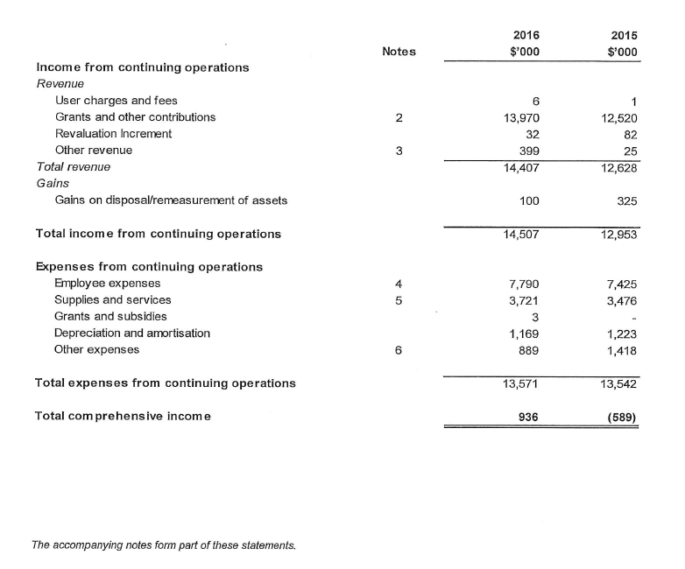

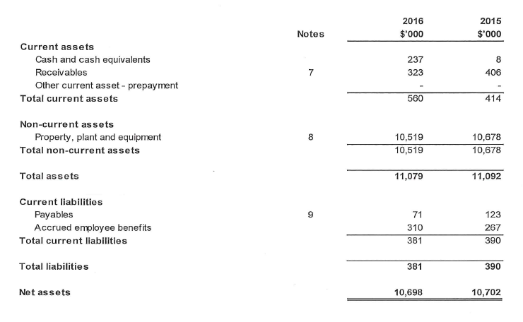
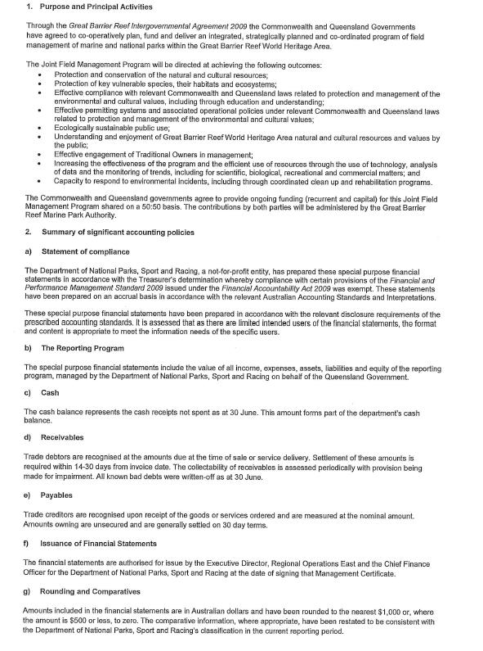
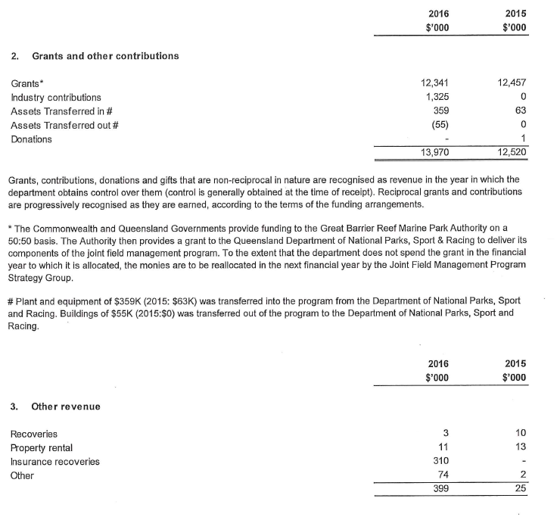

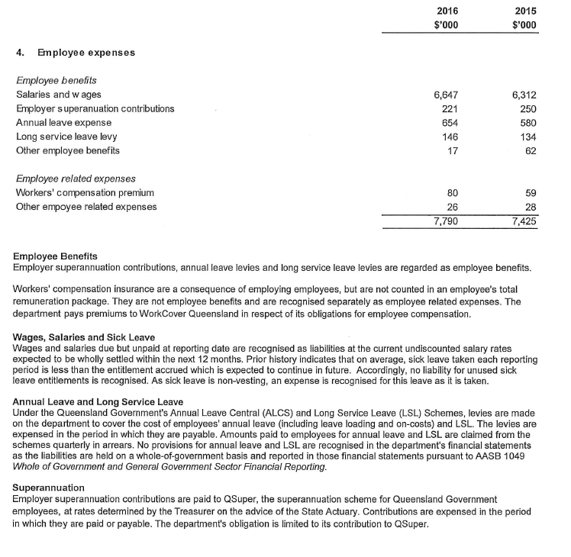

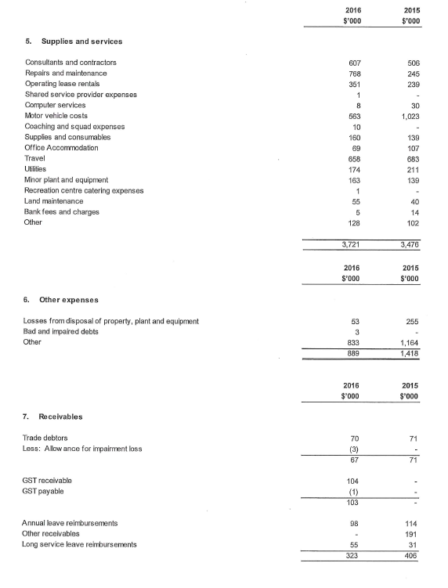

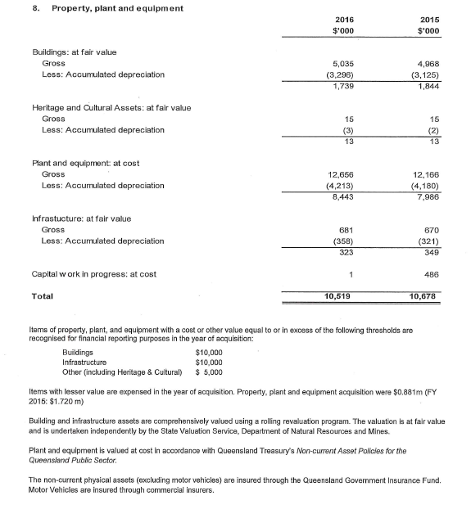

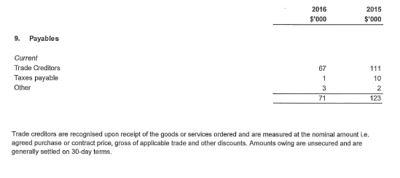

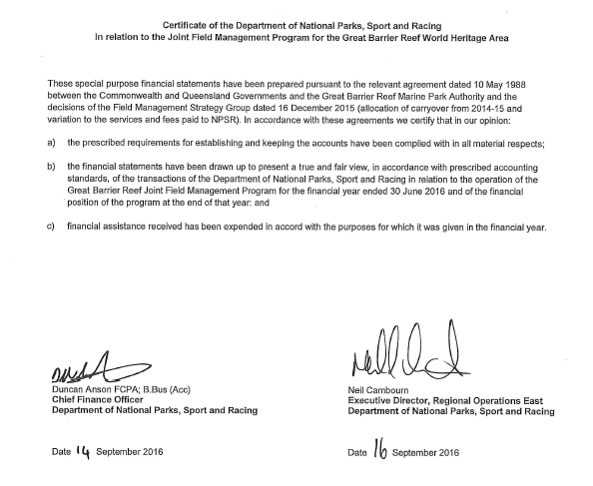

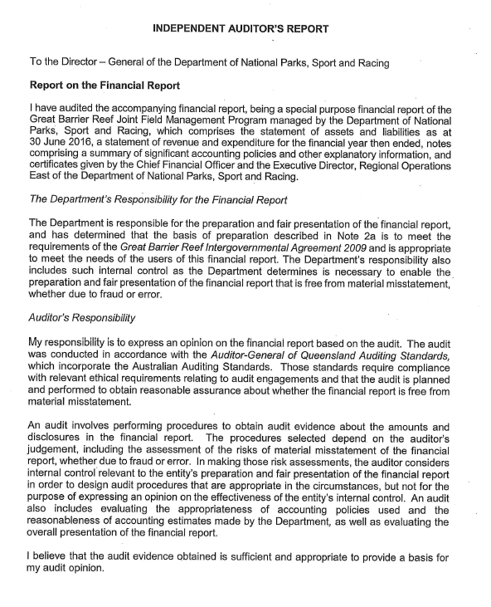

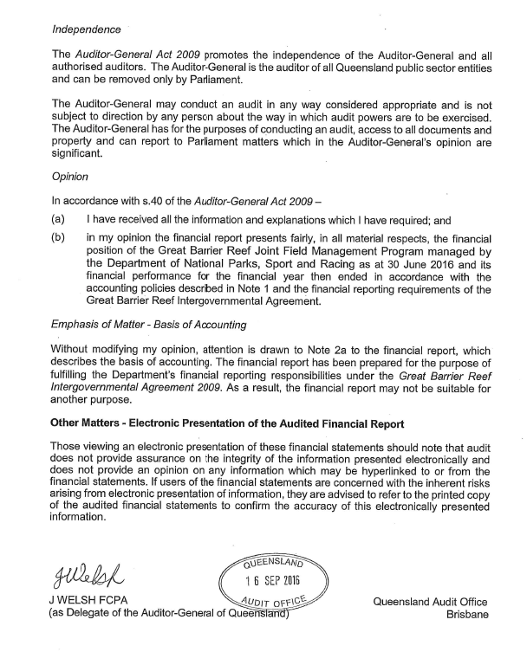

Acronyms
APS Australian Public Service
ATSI Aboriginal or Torres Strait Islander
C.A.R.E Conserve. Act. Rehabilitate. Educate.
CSIRO Commonwealth Scientific and Industrial Research Organisation
EPBC Act Environment Protection and Biodiversity Conservation Act 1999
FOI Act Freedom of Information Act 1982
GBR Great Barrier Reef
GBRMPA Great Barrier Reef Marine Park Authority
GST Goods and services tax
NESB Non-English speaking background
MNP Marine National Park
PGPA Act Public Governance, Performance and Accountability Act 2013
PWD People with a disability
RAAF Royal Australian Air Force
SES Senior Executive Service
UNESCO United Nations Educational, Scientific and Cultural Organisation

Glossary
Biodiversity — the variability among living organisms from all sources, including terrestrial, marine and other aquatic ecosystems, and the ecological complexes of which they are part
Bycatch — the unwanted fish, sea creatures, etc. caught in nets along with the targeted species
Ecosystem resilience — the capacity of an ecosystem to recover from disturbance or withstand ongoing pressures
Environmental management charge — a charge associated with some commercial activities in the Great Barrier Reef Marine Park, including tourism operations, non-tourist charter operations, and facilities. The activities are undertaken with permission granted by the Great Barrier Reef Marine Park Authority.
Matters of national environmental significance — defined under the Environment Protection and Biodiversity Conservation Act 1999 as listed threatened species and ecological communities, migratory species protected under international agreements, Ramsar wetlands of international importance, the Commonwealth marine environment, world heritage properties, National Heritage places, Great Barrier Reef Marine Park, and nuclear actions. Any action that will have, or is likely to have, a significant impact on a matter of national environmental significance requires approval from the Australian Environment Minister.
Outstanding universal value — Under the World Heritage Convention, a property is considered to have outstanding universal value if it is of ‘cultural and/or natural significance, which is so exceptional as to transcend national boundaries and to be of common importance for present and future generations of all humanity’
Plan of management — a plan prepared for intensively used, or particularly vulnerable, groups of islands and reefs and for the protection of vulnerable species or ecological communities
Portfolio Budget Statement — a statement to inform Senators, Members of Parliament and the public of the proposed allocation of resources to government outcomes by agencies within the portfolio
Traditional Use of Marine Resources Agreement — a formal agreement that describes how a Traditional Owner group works in partnership with the Australian and Queensland governments to manage traditional use activities on their sea country
Vulnerability assessment — a risk assessment and decision-support tool that evaluates sensitivity, exposure, and adaptive capacity of systems to inform adaptation planning

List of requirements
Part of report | Description | Requirement | Page
Letter of transmittal | A copy of the letter of transmittal signed and dated by accountable authority on date final text approved | Mandatory | iii
Aids to access | Table of contents | Mandatory | v–viii
Aids to access | Alphabetical index | Mandatory | N/A
Aids to access | Glossary of abbreviations and acronyms | Mandatory | 206–206
Aids to access | List of requirements | Mandatory | 207–211
Aids to access | Details of contact officer | Mandatory | ii
Aids to access | Entity’s website address | Mandatory | ii
Aids to access | Electronic address of report | Mandatory | ii
Review by accountable authority | Review by the accountable authority | Mandatory | 3–11
Overview of the entity | Role and functions | Mandatory | 12–13, 144–147
Overview of the entity | Organisational structure | Mandatory | 14
Overview of the entity | Ootcomes and programmes | Mandatory | 3–11, 13–13, 144–147
Overview of the entity | Purposes | Mandatory | 19
Overview of the entity | Portfolio structure | Portfolio departments – mandatory | 1–2, 20–21
Overview of the entity | Where the outcomes and programmes administered by the entity differ from any Portfolio Budget Statement, Portfolio Additional Estimates Statement or other portfolio estimates statement that was prepared for the entity for the period, include details of variation and reasons for change | If applicable, Mandatory | 12, 20–21
Report on performance
Part of report | Description | Requirement | Page
Annual performance statements | Annual performance statement | Mandatory | 19–114
Report on financial performance | Discussion and analysis of financial performance. | Mandatory | 16–17, 132–174
Report on financial performance | Table summarising total resources and total payments | Mandatory | 175–176
Report on financial performance | If there may be significant changes in the financial results during or after the previous or current reporting period, information on those changes, including: the cause of any operating loss of the entity; how the entity has responded to the loss and the actions that have been taken in relation to the loss; and any matter or circumstances that it can reasonably be anticipated will have a significant impact on the entity’s future operation or financial results | If applicable, Mandatory. | 10, 16–17
Management and accountability
Part of report | Description | Requirement | Page
Corporate governance | Compliance with fraud systems | Mandatory | 122
Corporate governance | Fraud risk assessments and fraud control plans | Mandatory | 122–123
Corporate governance | Mechanisms for preventing, detecting incidents of, investigating or otherwise dealing with, and recording or reporting fraud | Mandatory | 122–123
Corporate governance | Measures taken to deal with fraud | Mandatory | 122–123
Corporate governance | Structures and processes to implement principles and objectives of corporate governance | Mandatory | 115–119
Corporate governance | Significant issues reported to Minister on non‑compliance with finance law and remedies taken | If applicable, Mandatory | N/A
External scrutiny | Most significant developments in external scrutiny and the entity’s response | Mandatory | 125–126
External scrutiny | Judicial decisions and decisions of administrative tribunals and by the Australian Information Commissioner | If applicable, Mandatory | 64, 126
External scrutiny | Reports by the Auditor‑General a Parliamentary Committee, or the Commonwealth Ombudsman | If applicable, Mandatory | 126
External scrutiny | Capability reviews | If applicable, Mandatory | N/A
Management of human resources | assessment of effectiveness in managing and developing employees to achieve entity objectives | Mandatory | 126–129
Management of human resources | Statistics on APS employees | Mandatory | 128, 177–178
Management of human resources | Enterprise agreements, individual flexibility arrangements, Australian workplace agreements, common law contracts and determinations | Mandatory | 128–129
Management of human resources | Number of SES and non‑SES employees | Mandatory | 16, 128, 177
Management of human resources | Salary ranges for APS employees | Mandatory | 129, 165
Management of human resources | Non‑salary benefits for employees | Mandatory | 129
Management of human resources | Performance pay | If applicable, Mandatory | 129
Assets management | An assessment of effectiveness of assets management | If applicable, mandatory | N/A
Purchasing | An assessment of entity performance against the Commonwealth Procurement Rules | Mandatory | 130–131
Consultants | A summary statement detailing the number of new contracts engaging consultants entered into during the period; the total actual expenditure on all new consultancy contracts entered into during the period (inclusive of GST); the number of ongoing consultancy contracts that were entered into during a previous reporting period; and the total actual expenditure in the reporting year on the ongoing consultancy contracts (inclusive of GST | Mandatory | 130
Consultants | A statement that “During [reporting period], [specified number] new consultancy contracts were entered into involving total actual expenditure of $[specified million]. In addition, [specified number] ongoing consultancy contracts were active during the period, involving total actual expenditure of $[specified million]” | Mandatory | 130
Consultants | A summary of the policies and procedures for selecting and engaging consultants and the main categories of purposes for which consultants were selected and engaged | Mandatory | 130
Consultants | A statement that “Annual reports contain information about actual expenditure on contracts for consultancies. Information on the value of contracts and consultancies is available on the AusTender website.” | Mandatory | 130
Australian National Audit Office access clauses | If an entity entered into a contract with a value of more than $100 000 (inclusive of GST) and the contract did not provide the Auditor‑General with access to the contractor’s premises, the report must include the name of the contractor, purpose and value of the contract, and the reason why a clause allowing access was not included in the contract | If applicable, Mandatory | N/A
Exempt contracts | If an entity entered into a contract or there is a standing offer with a value greater than $10 000 (inclusive of GST) which has been exempted from being published in AusTender because it would disclose exempt matters under the FOI Act, the annual report must include a statement that the contract or standing offer has been exempted, and the value of the contract or standing offer, to the extent that doing so does not disclose the exempt matters | If applicable, Mandatory | N/A
Small business | A statement that “[Name of entity] supports small business participation in the Commonwealth Government procurement market. Small and Medium Enterprises (SME) and Small Enterprise participation statistics are available on the Department of Finance’s website.” | Mandatory | 131
Small business | An outline of the ways in which the procurement practices of the entity support small and medium enterprises. | Mandatory | 131
Small business | If the entity is considered by the Department administered by the Finance Minister as material in nature—a statement that “[Name of entity] recognises the importance of ensuring that small businesses are paid on time. The results of the Survey of Australian Government Payments to Small Business are available on the Treasury’s website.” | If applicable, Mandatory | N/A
Financial statements | Annual financial statements | Mandatory | 132–174
Other mandatory information | Statement of advertising campaigns | If applicable, Mandatory | 179
Other mandatory information | If no advertising campaigns, a statement to that effect | If applicable, Mandatory | N/A
Other mandatory information | Information on grants being available on the agency’s website | If applicable, Mandatory | 131
Other mandatory information | Mechanisms for disability reporting, including reference to website for further information | Mandatory | 128
Other mandatory information | Website reference to Information Publication Scheme | Mandatory | 180–181
Other mandatory information | Correction of material errors in previous annual report | If applicable, mandatory | N/A
Other mandatory information | Information required by other legislation | Mandatory | 182

The mission (or purpose) in the agency’s Corporate Plan 2015–2020 is consistent with the outcome outlined in the agency’s Portfolio Budget Statement.
Three of the goals in the agency’s Corporate Plan 2015–2016 are consistent with the objectives outlined in the agency’s Portfolio Budget Statement 2015–16. The fourth goal was included in the agency’s Corporate Plan after the agency’s Portfolio Budget Statement was finalised.
As identified in the Australian Government Environment Portfolio Budget Statement 2015–16, p 217.
As identified in the Great Barrier Reef Marine Park Authority Corporate Plan 2015–2020.
Data was from the reef health and impact survey undertaken by the Association of Marine Park Tourism Operators and the agency, and independent data from the Australian Institute of Marine Science’s Long-term Monitoring Program.

