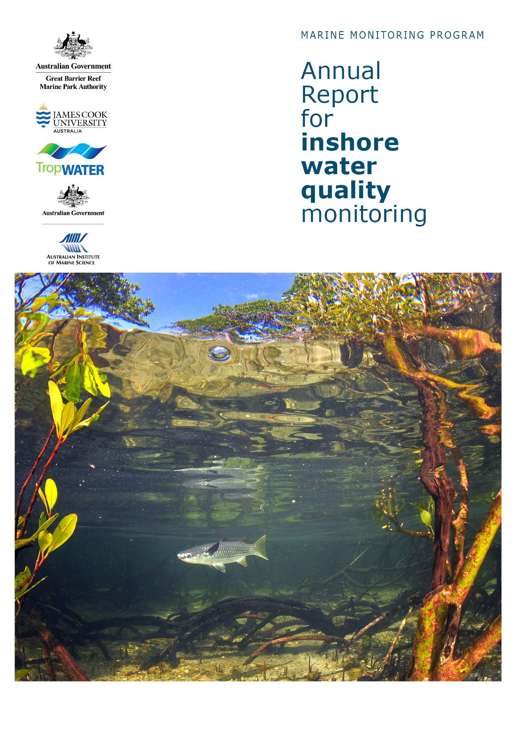
2 0 1 4 - 2 0 1 5

Christian Lønborg, Michelle Devlin, Jane Waterhouse, Richard Brinkman, Paul Costello, Eduardo da Silva, Johnston Davidson, Kevin Gunn, Murray Logan, Caroline Petus, Britta Schaffelke, Michele Skuza, Hemerson Tonin, Dieter Tracey, Margaret Wright, Irena Zagorskis

Australian Institute of Marine Science
PMB No 3
Townsville MC, Qld 4810
and
TropWATER- Centre for Tropical Water and Aquatic Ecosystem Research
James Cook University
Townsville, Qld 4811

© Copyright Australian Institute of Marine Science (AIMS) and JCU TropWATER 2016
All rights are reserved and no part of this document may be reproduced, stored or copied in any form or by any means whatsoever except with the prior written permission of AIMS.

National Library of Australia Cataloguing-in-Publication entry:
ISBN 9781925088113

This report should be cited as:
Lønborg C, Devlin M, Waterhouse J, Brinkman R, Costello P, da Silva E, Davidson J, Gunn K, Logan M, Petus C, Schaffelke B, Skuza M, Tonin H, Tracey D, Wright M and Zagorskis I (2016). Marine Monitoring Program: Annual Report for inshore water quality monitoring: 2014 to 2015. Report for the Great Barrier Reef Marine Park Authority. Australian Institute of Marine Science and JCU TropWATER, Townsville 229pp.

Front cover image: Dunk Island, mullet in mangroves © Matt Curnock, 2012.

DISCLAIMER
While reasonable efforts have been made to ensure that the contents of this document are factually correct, AIMS JCU do not make any representation or give any warranty regarding the accuracy, completeness, currency or suitability for any particular purpose of the information or statements contained in this document. To the extent permitted by law AIMS shall not be liable for any loss, damage, cost or expense that may be occasioned directly or indirectly through the use of or reliance on the contents of this document.

Direct Enquiries to –
Dr. Christian Lønborg
Phone: +61 7 4753 4351
Fax: +61 7 4772 5852
Email: c.lonborg@aims.gov.au
Web: www.aims.gov.au

Contents
1. Executive Summary 1
1.1 The program 1
1.2 Methods 1
1.3 Drivers, activities, impacts and pressures 1
1.4 Exposure of the Great Barrier Reef lagoon to river discharge 2
1.5 Trends in key water quality indicators 3
1.6 Conclusions 5
2. Preface 7
3. Introduction 8
4. Methods summary 11
4.1 Overview 11
4.2 Sampling design 11
4.3 Water quality sampling methods 15
4.4 In-situ loggers 16
4.5 Data analyses – ambient water quality 16
4.6 Data analysis – wet season water quality 16
4.7 Remote-sensing based plume modelling, water type classification and spatial plume risk maps 17
4.8 Load mapping 20
4.9 ‘Zones of influence’ for river plumes 21
5. Results and discussion 22
5.1 Overview 22
5.2 Drivers, activities, impacts and pressures 2014-15 22
5.2.1 Cyclone activity 22
5.2.2 Rainfall 23
5.2.3 Freshwater discharge 25
5.3 Exposure of the GBR lagoon to river water 27
5.3.1 Zones of influence of individual rivers 27
5.3.2 River plume exposure and plume water type maps 27
5.3.3 Level of potential risk to Great Barrier Reef ecosystems 2014-15 31
5.3.4 Loading maps for dissolved inorganic nitrogen, particulate nitrogen and sediment 36
5.4 Regional reports 46
5.4.1 Wet Tropics Region: Barron Daintree sub-region 47
5.4.2 Wet Tropics Region: Russell-Mulgrave focus area 52
5.4.3 Wet Tropics Region: Tully focus area 61
5.4.4 Burdekin focus area 68
5.4.5 Mackay Whitsunday focus area 76
5.5 Report Card water quality metric 2014-15 81
6. Discussion and conclusions 86
6.1 Long-term changes in water quality 86
6.2 Water quality characteristics in 2014-15 87
6.3 Conclusions 90
Acknowledgements 91
7. Case study: Detecting decadal changes in the water quality of Great Barrier Reef waters using the Cairns Time Series (CaTS) transect 92
7.1 Scope 92
7.2 Introduction 92
7.3 Results 93
7.4 Discussion 101
8. Case study: Progressing toward validated river plume potential risk maps 102
8.1 Scope 102
8.2 Introduction 102
8.3 Methods 103
8.4 Results 106
8.5 Discussion and conclusions 111
9. References 116
Appendix 1: Water quality monitoring methods 125
Appendix 2: Additional Information 165
Appendix 3: QA/QC Information 209
Appendix 4: Scientific publications and presentations associated with the program, 2014-15 215

List of Figures and Tables
Figure 3-1: The Great Barrier Reef Marine Park, major marine ecosystems (coral reefs and surveyed seagrass beds), NRM regions and marine NRM regions (delineated by dark grey lines) and major rivers. 8
Figure 4-1: Sampling locations of the MMP water quality monitoring sampled from 2015 onwards. Refer to Figure 3-1 for river names. See Table 4-1 for details of the monitoring activities undertaken at each location. NRM region boundaries are represented by coloured catchment areas. 12
Figure 4-2: Summary description of the wet season water quality products derived from remote sensing information in the MMP. 18
Figure 4-3: Conceptual scheme of the risk framework proposed in Petus et al. (2014a) used for developing the spatial risk maps. 19
Figure 4-4: Risk matrix in function of the magnitude and the likelihood of the river plume risk. Risk categories I, II, III, IV (reproduced from Petus et al., 2014b). 20
Figure 4-5: Conceptual model for DIN concentration load mapping. Note: 6cc = 6 colour class classification. See text for explanation. 21
Figure 5-1: DPSIR framework used to guide the structure of the MMP, derived from the Great Barrier Reef Strategic Assessment, 2015. The aspects highlighted in yellow are included in this report. 22
5.2.2 Figure 5-2: Trajectories of Tropical Cyclones affecting the Great Barrier Reef in 2014-15 and in previous years (2006 to 2014). Rainfall 23
Figure 5-3: Average daily rainfall (mm/day) in the GBR catchment. a) long-term annual average (1961 – 1990), b) 2014-15, c) the difference between the long term and annual rainfall patterns. 24
Figure 5-4: Annual average wet season rainfall (December 2014 - April 2015), as compared to the long-term wet season rainfall average (1961 – 1990). Red bars denote catchments with rainfall below the long-term average, blue above the long-term average. 24
Figure 5-5: Long-term total discharge in million litres (ML) (hydrological year: 1 October to 30 September) for the 35 main GBR Rivers. Source: DNRM, http://watermonitoring.dnrm.qld.gov.au/host.htm. 25
Figure 5-7: Map showing the frequency of river plumes in the 2014-15 wet season (22 weeks) of all colour classes (1 to 6), where the highest frequency is shown in orange, and the lowest frequency is shown in blue. 29
Figure 5-8: Map showing the frequency of Primary, Secondary and Tertiary plume water types in the 2014-15 wet season (22 weeks), where the highest frequency is shown in orange, and the lowest frequency is shown in blue. 30
Figure 5-9: Mean water quality concentrations and standard deviation across the six colour classes and the corresponding water types (P: Primary; S: Secondary; T: Tertiary): comparison between the mean multi-annual values (2002-03 to 2014-15; circles with error bars) and the 2014-15 values (blue rectangles). Only data collected in the Wet Tropics is used in the Diuron plot due to the reduced number of PSII herbicide samples available for the Dry Tropics. 31
Figure 5-10: Map of potential risk from GBR river plumes in 2014-15, where class I is the lowest potential risk (blue) and class IV is the highest potential risk (dark red). Risk categories are defined as a combination of the plume frequency (5 categories: 0-0.2, 0.2-0.4, 0.4-0.6, 0.6-0.8, 0.8-1.0) and plume water type (3 categories: Primary, Secondary and Tertiary) as presented in Figure 5-7 and 5-8. 33
Figure 5-11: Dissolved inorganic nitrogen (DIN, µg/L) concentration in the GBR lagoon 2003 water year (c.a., 1 October to 30 September). ‘Max.’ stands for the highest DIN concentration. Named rivers are those with load data available and grey lines are the NRM region boundaries. 38
Figure 5-12: Dissolved inorganic nitrogen (DIN, µg/L) over the GBR lagoon 2004-2015 water years (c.a., 1 October to 30 September). ‘Max.’ stands for the highest DIN concentration. Dots represent rivers with load data available and grey lines are the NRM region boundaries. 39
Figure 5-13: River contributions (x-axis) to the dissolved inorganic nitrogen mass to four marine NRM regions (plot head name) in 2003 (left column) and 2011 (right column). Shading groups rivers in the same NRM region: Wet Tropics - red, Burdekin - blue, Mackay-Whitsunday – yellow, Fitzroy - green. The left panel show data for the 2002-03 water year (c.a., from 1 Oct to 30 Sep), and right panel for the 2010-11 water year. 41
Figure 5-14: Particulate nitrogen (PN, µg/L) over the GBR lagoon 2003 water year (c.a., 1 October to 30 September). ‘Max.’ stands for the highest PN concentration. Named rivers are those with load data available and grey lines are the NRM region boundaries. 42
Figure 5-15: Particulate nitrogen (PN, µg/L) over the GBR lagoon 2004-2015 water year (c.a., 1 October to 30 September). ‘Max.’ stands for the highest PN concentration. Dots represent rivers with load data available and grey lines are the NRM region boundaries. 43
Figure 5-16: Total suspended solids (TSS, mg/L) over the GBR lagoon 2003 water year (c.a., 1 October to 30 September). ‘Max.’ stands for the highest TSS concentration. Named rivers are those with load data available and grey lines are the NRM region boundaries. 44
Figure 5-17: Total suspended sediments (TSS, µg/L) over the GBR lagoon 2004-2015 water year (c.a., 1 October to 30 September). ‘Max.’ stands for the highest TSS concentration. Dots represent rivers with load data available and grey lines are the NRM region boundaries. 45
Figure 5-18: MMP water quality sampling sites in the Barron Daintree sub-region shown with (left) wet season plume frequency 2003 to 2015 (Primary + Secondary; where 1.0 represents 22 weeks, December to March) and (right) water body boundaries. 48
Figure 5-19: Combined discharge for the Barron and Daintree Rivers. Daily (blue) and annual (October to September, red symbols) discharge volumes shown. Red dashed line represents long-term median of the combined annual discharge. 48
Figure 5-20: Cumulative exposure index for the Barron River in 2014-15 (left). Results for 2010-11 (right) are shown for context. The colour bar indicates the calculated cumulative exposure (concentration x days) above 1% of the incoming concentration. The colour bar is capped at 20 Conc.Days. Contours show 0.1, 1.0 and 10.0 Conc.Days exposure levels. 49
Figure 5-21: Measured Barron River discharge and loads (at Myola gauge) for (A) total suspended solids (sediment), (B) dissolved inorganic nitrogen (DIN), (C) particulate nitrogen (PN) and (D) particulate phosphorus (PP) from 2006/07 to 2014/15. Data from the Department of Science Information Technology and Innovation’s Great Barrier Reef Catchment Loads Monitoring Program (compiled from: Joo et al., 2012; Turner et al., 2012, 2013; Wallace et al., 2014, 2015, in press; Garzon-Garcia et al., 2015). 49
Figure 5-22: Temporal trends in water quality variables for the Barron Daintree sub-region. a) water quality index, b) chlorophyll a, c) total suspended solids, d) nitrate/nitrite, e) Secchi depth, f) particulate nitrogen, g) particulate phosphorus, h) particulate organic carbon and i) dissolved organic carbon. Water quality index colour coding: dark green- ‘very good’; light green-‘good’; yellow – ‘moderate; orange – ‘poor’; red – ‘very poor’. The water quality index is the aggregate of variables plotted in b - h and calculated as described in Appendix 1.2.3. Trends in POC and DOC values are plotted here (i, j); threshold levels have yet to be established. Trends in manually sampled water quality variables are represented by blue lines with blue shaded areas defining 95% confidence intervals of those trends accounting for the effects of wind, waves and tides after applying x-z detrending, black dots represent observed data. Trends of records from ECO FLNTUSB instruments are represented in red, individual records are not displayed. Dashed reference lines indicate guideline values. 51
Figure 5-23: MMP sampling sites in the Russell-Mulgrave focus area, shown with (left) wet season plume frequency 2003 to 2015 (Primary + Secondary; where 1.0 represents 22 weeks, December to March) and (right) the water body boundaries. 52
Figure 5-24: Combined discharge for the North and South Johnstone, Russell and Mulgrave Rivers. Daily (blue) and annual (October to September, red symbols) discharge shown. Red dashed line represents the long-term median of the combined annual discharge. 53
Figure 5-25: Cumulative exposure index for the Russell-Mulgrave River in 2014-15 (left). Results for 2010-11 (right) are shown for context. The colour bar indicates the calculated cumulative exposure (concentration x days) above 1% of the incoming concentration. The colour bar is capped at 20 Conc.Days. Contours show 0.1, 1.0 and 10.0 Conc.Days exposure levels. 53
Figure 5-26: Measured Johnstone River discharge and loads (combined from the North Johnstone at Tung Oil and South Johnstone at Central Mill monitoring sites) for (A) total suspended solids (sediment), (B) dissolved inorganic nitrogen (DIN), (C) particulate nitrogen (PN) and (D) particulate phosphorus (PP) from 2006-07 to 2014-15. Data from the Department of Science Information Technology and Innovation’s Great Barrier Reef Catchment Loads Monitoring Program (compiled from: Joo et al., 2012; Turner et al., 2012, 2013; Wallace et al., 2014, 2015, in press; Garzon-Garcia et al., 2015). 54
Figure 5-27: Temporal trends in water quality for the Russell-Mulgrave sub-region. a) water quality index, b) chlorophyll a, c) total suspended solids, d) nitrate/nitrite, e) Secchi depth, f) particulate nitrogen, g) particulate phosphorus, h) particulate organic carbon and i) dissolved organic carbon. Water quality index colour coding: dark green- ‘very good’; light green-‘good’; yellow – ‘moderate; orange – ‘poor’; red – ‘very poor’. The Water Quality Index is the aggregate of variables plotted in b - h and calculated as described in Appendix 1.2.3. Trends in POC and DOC values are plotted here (i, j); threshold levels have yet to be established. Trends in manually sampled water quality variables are represented by blue lines with blue shaded areas defining 95% confidence intervals of those trends accounting for the effects of wind, waves and tides, black dots represent observed data. Trends of records from ECO FLNTUSB instruments are represented in red, individual records are not displayed. Dashed reference lines indicate guideline values. 55
Figure 5-28: Boxplot for the water quality parameters sampled at the Russell-Mulgrave sites in the current wet season compared to all data sampled since 2005-06 wet season. In the boxplot bold line stands for median, rectangles are for the 25th and 75th percentiles and vertical line for 5th and 95th percentile. The p-value is from a Kruskal-Wallis Rank Sum test among plume water types. Dots stand for data points (nudge was added for data visualization) and red dashed line stands for the water quality guidelines for open coastal waters. Plume water type 1, 2 and 3 stands for Primary, Secondary and Tertiary, respectively. 60
Figure 5-29: MMP sampling sites in the Tully focus area, shown with (left) wet season plume frequency 2003 to 2015 (Primary + Secondary; where 1.0 represents 22 weeks, December to March) and (right) the water body boundaries. 61
Figure 5-30: Combined discharge for Tully and Herbert Rivers. Daily (blue) and annual (October to September, red) discharge shown. Red dashed line represents the long-term median of the combined annual discharge. 62
Figure 5-31: Cumulative exposure index for the Tully River in 2014-15 (left). Results for 2010-11 (right) are shown for context. The colour bar indicates the calculated cumulative exposure (concentration x days) above 1% of the incoming concentration. The colour bar is capped at 20 Conc.Days. Contours show 0.1, 1.0 and 10.0 Conc.Days exposure levels. 62
Figure 5-32: Measured Tully River (at Euramo gauge) discharge and loads for (A) total suspended solids (sediment), (B) dissolved inorganic nitrogen (DIN), (C) particulate nitrogen (PN) and (D) particulate phosphorus (PP) from 2006/07 to 2014/15. Data from the Department of Science Information Technology and Innovation’s Great Barrier Reef Catchment Loads Monitoring Program (compiled from: Joo et al., 2012; Turner et al., 2012, 2013; Wallace et al., 2014, 2015, in press; Garzon-Garcia et al., 2015). 63
Figure 5-33: Measured Herbert River discharge (at the Ingham gauge) and loads for (A) total suspended solids (sediment), (B) dissolved inorganic nitrogen (DIN), (C) particulate nitrogen (PN) and (D) particulate phosphorus (PP) from 2006/07 to 2014/15. Data from the Department of Science Information Technology and Innovation’s Great Barrier Reef Catchment Loads Monitoring Program (compiled from: Joo et al., 2012; Turner et al., 2012, 2013; Wallace et al., 2014, 2015, in press; Garzon-Garcia et al., 2015). 63
Figure 5-34: Temporal trends in water quality for the Tully sub-region. a) water quality index, b) chlorophyll a, c) total suspended solids, d) nitrate/nitrite, e) Secchi depth, f) particulate nitrogen, g) particulate phosphorus, h) particulate organic carbon and i) dissolved organic carbon. Water quality index colour coding: dark green- ‘very good’; light green-‘good’; yellow – ‘moderate; orange – ‘poor’; red – ‘very poor’. The water quality index is the aggregate of variables plotted in b - h and calculated as described in Appendix 1.2.3. Trends in POC and DOC values are plotted here (i, j); threshold levels have yet to be established. Trends in manually sampled water quality variables are represented by blue lines with blue shaded areas defining 95% confidence intervals of those trends accounting for the effects of wind, waves and tides, black dots represent observed data. Trends of records from ECO FLNTUSB instruments are represented in red, individual records are not displayed. Dashed reference lines indicate guideline values. 65
Figure 5-35: Boxplot for the parameters sampled at the Tully sites in the current wet season compared to all data sampled since 2005-06 wet season. In the boxplot bold line stands for median, rectangles are for the 25th and 75th percentiles and vertical line for 5th and 95th percentile. The p-value is from a Kruskal-Wallis Rank Sum test among plume water types. Dots represent data points (nudge was added for data visualisation) and red dashed line stands for the water quality guidelines for open coastal waters. Plume water type 1, 2 and 3 stands for Primary, Secondary and Tertiary, respectively. 68
Figure 5-36: MMP sampling sites in the Burdekin focus area shown with (left) wet season plume frequency 2003 to 2015 (Primary + Secondary; where 1.0 represents 22 weeks, December to March) and (right) the water body boundaries. 69
Figure 5-37: Discharge for the Burdekin River. Daily (blue) and annual (October to September, red) discharge shown. Red dashed line represents the long-term median annual discharge. 70
Figure 5-38: Cumulative exposure index for the Burdekin River in 2014-15 (left), results for 2010-11 (right) are shown for context. The colour bar indicates the calculated cumulative exposure (concentration x days) above 1% of the incoming concentration. The colour bar is capped at 20 Conc.Days. Contours show 0.1, 1.0 and 10.0 Conc.Days exposure levels. 70
Figure 5-39. Measured Barratta Creek discharge and loads (at Northcote gauge) for (A) total suspended solids (sediment), (B) dissolved inorganic nitrogen (DIN), (C) particulate nitrogen (PN) and (D) particulate phosphorus (PP) from 2006-07 to 2014-15. Data from the Department of Science Information Technology and Innovation’s Great Barrier Reef Catchment Loads Monitoring Program (compiled from: Turner et al., 2012, 2013; Wallace et al., 2014, 2015, in press; Garzon-Garcia et al., 2015) and TropWATER (Bainbridge et al., 2007, 2008; unpublished data). 71
Figure 5-40. Measured Burdekin River discharge (at the Clare gauge) and loads for (A) total suspended solids (sediment), (B) dissolved inorganic nitrogen (DIN), (C) particulate nitrogen (PN) and (D) particulate phosphorus (PP) from 2006-07 to 2014-15. Data from the Department of Science Information Technology and Innovation’s Great Barrier Reef Catchment Loads Monitoring Program (compiled from: Joo et al., 2012; Turner et al., 2012, 2013; Wallace et al., 2014, 2015, in press; Garzon-Garcia et al., 2015). 71
Figure 5-41: Temporal trends in water quality for the Burdekin focus area. a) Water Quality Index, b) chlorophyll a, c) total suspended solids, d) nitrate/nitrite, e) Secchi depth, f) particulate nitrogen, g) particulate phosphorus, h) particulate organic carbon and i) dissolved organic carbon. Water quality index colour coding: dark green- ‘very good’; light green-‘good’; yellow – ‘moderate; orange – ‘poor’; red – ‘very poor’. The water quality index is the aggregate of variables plotted in b - h and calculated as described in Appendix 1.2.3. Trends in POC and DOC values are plotted here (i, j); threshold levels have yet to be established. Trends in manually sampled water quality variables are represented by blue lines with blue shaded areas defining 95% confidence intervals of those trends accounting for the effects of wind, waves and tides, black dots represent observed data. Trends of records from ECO FLNTUSB instruments are represented in red, individual records are not displayed. Dashed reference lines indicate guideline values. 73
Figure 5-42: Boxplot for the parameters sampled at the Burdekin sites in the current wet season compared to all data sampled since 2005-06 wet season. In the boxplot bold line stands for median, rectangles are for the 25th and 75th percentiles and vertical line for 5th and 95th percentile. The p-value is from a Kruskal-Wallis Rank Sum test among plume water types. Dots represent data points (nudge was added for data visualization) and red dashed line stands for the water quality guidelines for open coastal waters. Plume water type 1, 2 and 3 stands for Primary, Secondary and Tertiary, respectively. 75
Figure 5-43: MMP sampling sites in the Mackay Whitsunday focus area shown with (left) wet season plume frequency 2003 to 2015 (Primary + Secondary; where 1.0 represents 22 weeks, December to March) and (right) the water body boundaries. 76
Figure 5-44: Combined discharge for the O'Connell, Proserpine and Pioneer Rivers. Daily (blue) and annual (October to September, red) discharge shown. Red dashed line represents the long-term median of the combined annual discharges. 77
Figure 5-45: Cumulative exposure index for the O'Connell River in 2014-15 (left), results for 2010-11 (right) are shown for context. The colour bar indicates the calculated cumulative exposure (concentration x days) above 1% of the incoming concentration. The colour bar is capped at 20 Conc.Days. Contours show 0.1, 1.0 and 10.0 Conc.Days exposure levels. 77
Figure 5-46. Measured O’Connell River discharge (at the Stafford’s Crossing/Caravan Park gauge) and loads for (A) total suspended solids (sediment), (B) dissolved inorganic nitrogen (DIN), (C) particulate nitrogen (PN) and (D) particulate phosphorus (PP) from 2006/07 to 2014/15. Data from the Department of Science Information Technology and Innovation’s Great Barrier Reef Catchment Loads Monitoring Program (compiled from: Joo et al., 2012; Wallace et al., in press; Garzon-Garcia et al., 2015). 78
Figure 5-47. Measured Pioneer River discharge (at the Dumbleton gauge) and loads for (A) total suspended solids (sediment), (B) dissolved inorganic nitrogen (DIN), (C) particulate nitrogen (PN) and (D) particulate phosphorus (PP) from 2006/07 to 2014/15. Data from the Department of Science Information Technology and Innovation’s Great Barrier Reef Catchment Loads Monitoring Program (compiled from: Joo et al., 2012; Turner et al., 2012, 2013; Wallace et al., 2014, 2015, in press; Garzon-Garcia et al., 2015). 78
Figure 5-48. Measured Sandy Creek discharge (at the Homebush gauge) and loads for (A) total suspended solids (sediment), (B) dissolved inorganic nitrogen (DIN), (C) particulate nitrogen (PN) and (D) particulate phosphorus (PP) from 2009/10 to 2014/15. Data from the Department of Science Information Technology and Innovation’s Great Barrier Reef Catchment Loads Monitoring Program (compiled from: Turner et al., 2012, 2013; Wallace et al., 2014, 2015, in press; Garzon-Garcia et al., 2015). 79
Figure 5-49: Temporal trends in water quality for the Mackay Whitsunday focus-region. a) Water Quality Index, b) chlorophyll a, c) total suspended solids, d) nitrate/nitrite, e) Secchi depth, f) particulate nitrogen, g) particulate phosphorus, h) particulate organic carbon and i) dissolved organic carbon. Water quality index colour coding: dark green- ‘very good’; light green-‘good’; yellow – ‘moderate; orange – ‘poor’; red – ‘very poor’. The water quality index is the aggregate of variables plotted in b - h and calculated as described in Appendix 1.2.3. Trends in POC and DOC values are plotted here (i, j); threshold levels have yet to be established. Trends in manually sampled water quality variables are represented by blue lines with blue shaded areas defining 95% confidence intervals of those trends accounting for the effects of wind, waves and tides, black dots represent observed data. Trends of records from ECO FLNTUSB instruments are represented in red, individual records are not displayed. Dashed reference lines indicate guideline values. 80
Figure 5-50: Trend in water quality from 2005-06 to 2014-15. The overall water quality score is the average of the weighted component scores for chlorophyll a and total suspended solids. Values are indexed scores scaled from 0-100; ■ = very good (81-100), ■ = good (61 - 80), ■ = moderate (41 - 60), ■ = poor (21 - 40), ■ = very poor (0 - 20). NB: Scores are unitless. 85
Figure 7-1: The Cairns Time Series (CaTS) oceanographic transect based in the central Great Barrier Reef (GBR) lagoon (16-17°S; 145-146° E). The yellow dots show the 6 occupied during the period 1989 to 2015, and the red the stations were discontinued in 2008. 94
Figure 7-2: Temporal trends in a) salinity, b) temperature, c) chlorophyll a (Chl-a) and total suspended solids (TSS). Black dots indicate field observations and blue line represents the trend line fitted by Generalized additive mixed effects models (GAMMs). 94
Figure 7-3: Long term trends in a) phosphate (HPO₄^{2–}), b) ammonium (NH₄⁺), c) nitrate/nitrite (NO_{X}), d) silicate (SiO₄), e) NO_{X} to HPO₄^{2–} molar ratio, f) SiO₄ to NO_{X} molar ratio and g) SiO₄ to HPO₄^{2–} molar ratio. Black dots indicate field observations and blue line represents the trend line fitted by generalized additive mixed effects models (GAMMs). 97
Figure 7-4: Temporal trends in the concentrations of a) particulate organic carbon (POC), b) nitrogen (PN) and c) phosphorus (PP) over the 26 years period is shown with variations in the a) POC to PN, b) POC to PP and c) PN to PP elemental stoichiometry. Black dots indicate field observations and blue line represents the trend line fitted by generalized additive mixed effects models (GAMMs). 99
Figure 7-5: The 26 years trend in the concentrations of a) dissolved organic carbon (DOC), b) nitrogen (DON) and c) phosphorus (DOP) are shown with the variations in the d) DOC:DON, e) DOC:DOP and e) DON:DOP molar ratios. Black dots indicate field observations and blue line represents the trend line fitted by generalized additive mixed effects models (GAMMs). 100
Figure 8-1: Conceptual model the satellite risk framework presented in this study, data sources and main processes. 105
Figure 8-2: a) Seagrass abundance (% cover) and b) proportion of macroalgae in the algal communities at each reef collected though out the MMP. GH: Gladstone Harbor, SB: Shoalwater Bay, MP: Middle point and PKI: Peak Island. Black line with white circles represents the averaged values per NRM regions and light grey lines values of each monitored sites. Interpolated data are symbolised with dashed grey lines. Multi-annual trends are indicated with a black arrow. 108
Figure 8-3: Changes in (Δ, top) and mean multi-annual (M, bottom) seagrass cover compared to Risk Scores (MS) at the: a and c) site and b and d) NRM scales. MP: Midge Point and GH: Gladstone Harbour. Wt: Wet Tropics, MW: Mackay-Whitsundays, Fitz.: Fitzroy Burd.: Burdekin and BM: Burnett-Mary. Determination coefficient and p values calculated without considering the outlier sites (indicated by grey dots). 111
Figure 8-4: Multi-annual (2005-2014) changes in (Δ, top) and mean multi-annual (M, bottom) proportion of macroalgae in the algal community compared to Risk Scores (RS) at the: a and c) site and b and d) NRM scales. ns. non-significant. The dotted line in c) indicate an initial risk score threshold of about 0.2 below which there is rarely high proportion of macroalgae in the algal communities at the reef sites. 112
Figure 8-5: Multi-annual risk map for GBR seagrass ecosystems from river plume exposure. 113

Table 4-1: Description of the water quality (WQ) stations sampled by AIMS and JCU in 2014-15. 13
Table 4-2: Sampling frequency over the calendar year. x = sampling by AIMS, x = sampling by JCU, blue shading indicates the period where up to five additional flood-response sampling trips may occur depending on timing and location of high flow events. 14
Table 4-3: List of parameters sampled in the ambient and wet season water quality monitoring. 15
Table 5-1: Wet season discharge (ML; million litres) of the main GBR rivers (c.a., November 2014 to April 2015, inclusive), compared against the previous four wet seasons and long-term (LT) median discharge (1970-2000). 26
Table 5-2: Areas (km²) and percentage (%) of the GBR lagoon exposed to different categories of surface river plume frequency and river plume-related risk within the GBR and each NRM. 34
Table 5-3: Areas (km²) and percentage (%) of the coral reefs exposed to different categories of surface river plume frequency and river plume-related risk within the GBR and each NRM region. 34
Table 5-4: Areas (km²) and percentage (%) of surveyed, deepwater modelled and total (surveyed plus deepwater modelled) seagrass exposed to different categories of surface river plume frequency and river plume-related risk within the GBR and each NRM region. 35
Table 5-5: Russell-Mulgrave sites: Spearman Correlation Coefficient calculated using the mean value of each WQ parameter sampled per transect when all sites sampled since 2005-06 wet season are combined. Water Quality parameters tested were: light attenuation (Kd(PAR)), coloured dissolved organic matter (CDOM), dissolved inorganic nitrogen (DIN), dissolved inorganic phosphorus (DIP), particulate nitrogen (PN), particulate phosphorus (PP), reactive silica (Si) and chlorophyll-a (Chl-a), and they were tested against river discharge, W-E wind component, N-S wind component, surface salinity and chlorophyll-a. Significant (p<0.05) correlation coefficients >0.6 or <-0.6 are highlighted. 59
Table 5-6: Tully sites: Spearman Correlation Coefficient calculated using the mean value of each parameter sampled per transect when all sites sampled since 2005-06 wet season are combined. Water quality parameters tested were: light attenuation (Kd(PAR)), coloured dissolved organic matter (CDOM), dissolved inorganic nitrogen (DIN), dissolved inorganic phosphorus (DIP), particulate nitrogen (PN), particulate phosphorus (PP), reactive silica (Si) and chlorophyll-a (Chl-a), and they were tested against river discharge, W-E wind component , N-S wind component, surface salinity and chlorophyll-a. Significant (p<0.05) correlation coefficients >0.6 or <-0.6 are highlighted. 67
Table 5-7: Burdekin sites: Spearman Correlation Coefficient calculated using the mean value of each parameter sampled per transect when all sites sampled since 2005-06 wet season are combined. Water quality parameters tested were: light attenuation (Kd(PAR)), coloured dissolved organic matter (CDOM), dissolved inorganic nitrogen (DIN), dissolved inorganic phosphorus (DIP), particulate nitrogen (PN), particulate phosphorus (PP), reactive silica (Si) and chlorophyll-a (Chl-a), and they were tested against river discharge, W-E wind component, N-S wind component , surface salinity and chlorophyll-a. Significant (p<0.05) correlation coefficients >0.6 or <-0.6 are highlighted. 74
Table 5-8: Results from remote sensing data of Chl-a and TSS for the 2016 Report Card, based on GBRMPA monitoring year of 1 May 2014 to 30 April 2015. 83
Table 5-9: Calculation of weighted scores using remote sensing data of Chl-a and TSS for the 2016 Report Card, based on GBRMPA monitoring year of 1 May 2014 to 30 April 2015. 84
Table 5-10: Calculation of weighted scores using remote sensing data of Chl a and TSS for the 2015 Report Card, based on GBRMPA monitoring year of 1 May 2014 to 30 April 2015. 84
Table 8-1: Key remote sensing methods and products developed through MMP funding and used to develop the present Satellite Risk Framework. 103
Table 8-2: Contaminant concentration in each plume water type (TSSp_{CCx}, Chl-ap_{CCx}, PSIIp_{CCx}) is compared by ratio to published ecological threshold values for consequences and effects (TSSt_{CCx}, Chl-at_{CCx}, PSIIt_{CCx}). Ratios are summed (R_{CCx}) and normalised across plume water type in order to calculate a Magnitude Score for each plume water type (MS_{CCx}). A linear model applied on the data to estimate the multi-annual mean PSII herbicide concentrations per plume water type and the Wet Tropics data are used as surrogate for the GBR. 107
Table 8-3: Magnitude Score (MS_{CCx}) of each plume water type, Likelihood Score (LS_{CCx}) at the seagrass sites locations and Risk Scores (RS_{site} and RS_{NRM}) at the seagrass site and NRM scales. 109
Table 8-4: Magnitude Score (MSCCx) of each plume water type, Likelihood Score (LSCCx) at the seagrass sites locations and Risk Scores (RS_{site} and RS_{NRM}) at the coral site and NRM scales. 110
Table 8-5: Risk Score thresholds associated with loss of seagrass cover. The thresholds were derived from Figure 8-3a (dotted lines). 112

Appendices: List of Figures and Tables
Appendix 1: Water quality monitoring methods
Figure A1 1: conceptual scheme of the risk framework proposed in Petus et al. (2014a). 139
Figure A1 2: Risk matrix in function of the magnitude and the likelihood of the river plume risk. 140
Figure A1 3: Theoretical example of the production of an annual risk map and the results for 2 pixels (P1 and P2) in the GBR at a river mouth, their classification, and final risk classification. 140
Figure A1 4: Marine boundaries used for the GBR Marine Park (a), each NRM region and the coral reefs ecosystems. 142
Figure A1 5: Marine boundaries used for the GBR Marine Park (a), each NRM region and the seagrass ecosystems. NRM layers derived from: GBRMPA, 2013, GBR feature shapefiles and seagrass layers from DAFF, Feb. 2013; and enlargements around (b) the Tully-Herbert Rivers and (c) the Burdekin Rivers. Spatial distribution of the surveyed seagrasses bed is an historical layer composed from all meadows examined between 1984 and 2008 (see reports at: http://www.seagrasswatch.org/meg.html). 142
Figure A1 6: Conceptual model for DIN concentration load mapping. See text for explanation. 144
Figure A1 7: Relationship between river discharge (megaliters, ML) and distance (km) between river mouth and the outer edge of tracer plume as obtained from the eReefs hydrodynamic model for the GBR. Dashed lines stand for CI 95%. Red dot stands for point excluded from the regression model. 145
Figure A1 8: The Great Barrier Reef Marine Park (Queensland, Australia), major rivers included in the model, the delimitation of the Natural Resource Management (NRM) regions, and the sampling sites (colour density indicates recurrent sampling). 146
Figure A1 9: In-situ dissolved inorganic nitrogen concentration (a), depth of the mixing layer (b), superficial salinity (c) and plume area (d) per colour class, measured over 13 wet seasons (c.a., December to April inclusive) from 2002/03 to 2014/15 wet season. Boxplot presents the median (dark black line), 25th and 75th percentile values (rectangle) and 5th and 95th percentile values (vertical lines). Nudge was applied to data on x-axis for better data visualization. 148
Figure A1 10: Median DIN mass and percent contribution across the six-colour class. Error bars represent 95%CI (see text for explanation). 149
Figure A1 11: Relationship between in-situ DIN concentration (µg/L) and salinity opportunistically measured at the surface in river plume waters over the GBR lagoon (2002-2003 to 2014-2015 wet season) under river discharge > 75th percentile (see text for explanation). 150
Figure A1 12: Potential DIN uptake (red line) derived from the ratio between in-situ DIN concentration x salinity (black solid line, as in Figure A1 11) and the theoretical dilution model (black dashed line, derived from Eq. 4). 151
Figure A1 13: In-situ particulate nitrogen concentration (a) and total suspended solids (b) per colour class, measured over 13 wet seasons (c.a., December to April inclusive) from 2002/03 to 2014/15 wet season. Boxplot presents the median (dark black line), 25th and 75th percentile values (rectangle) and 5th and 95th percentile values (vertical lines). Nudge was applied to data on x-axis for better data visualisation. 154
Figure A1 14: Median mass of particulate nitrogen (a) and total suspended solids (b), and their per-cent contribution across the six-colour class. Error bars stand for 95%CI (see text for explanation). 157
Figure A1 15: Relationship between DIN load (ton) against the relative DIN mass (ton) in plume waters (see text for explanation). 159

Table A1-1: Trigger values from the Water Quality Guidelines for the Great Barrier Reef Marine Park (GBRMPA 2010) and the Queensland Water Quality Guidelines (DERM 2009). Please note that the guideline values provided by DERM are 80th percentile guidelines. 129
Table A1-2: Summary of statistical analysis techniques exploring spatial and temporal variation applied to the water quality parameters sampled within the wet 2014-15 wet season. 134
Table A1 3: Plume water types as described in e.g., Devlin et al. (2012a), Álvarez-Romero et al. (2013) and Petus et al (2014b) 137
Table A1 4: Frequency categories used to categorise the multi-annual maps of frequency of occurrence of plume water types (TC and L2 methods). 141
Table A1 5: Recalculation of the plume class interval for rescaling the size of each of the six colour classes. 146
Table A1 6: End-of-catchment dissolved inorganic nitrogen loads (DIN, ton/year) from 2003 to 2015 water years (c.a., from October, 2002 to September, 2015). 152
Table A1 7: Total wet season river discharge (GL) from 2003 to 2015 water years (c.a., from October, 2002 to September, 2015). 153
Table A1 8: End-of-catchment particulate nitrogen loads (PN, ton/year) from 2003 to 2015 water years (c.a., from October, 2002 to September, 2015). 155
Table A1 9: End-of-catchment sediment loads (TSS, ton/year) from 2003 to 2015 water years (c.a., from October, 2002 to September, 2015). 156
Table A1 10: Annual dissolved inorganic nitrogen mass (tonne) in the river loads, and in the plume waters, when the total DIN mass is calculated by a simple multiplication of DIN concentration, plume area and the mixing layer depth (Total DIN mass), and when a dilution factor based on salinity is also taken into account (Relative DIN mass). 158

Figure A1 1: conceptual scheme of the risk framework proposed in Petus et al. (2014a). 139
Figure A1 2: Risk matrix in function of the magnitude and the likelihood of the river plume risk. 140
Figure A1 3: Theoretical example of the production of an annual risk map and the results for 2 pixels 140
Figure A1 4: Marine boundaries used for the GBR Marine Park (a), each NRM region and the coral reefs ecosystems. 142
Figure A1 5: Marine boundaries used for the GBR Marine Park (a), each NRM region and the seagrass ecosystems. 142
Figure A1 6: Conceptual model for DIN concentration load mapping. See text for explanation. 144
Figure A1 7: Relationship between river discharge (megaliters, ML) and distance (km) between river mouth and the outer edge of tracer plume as obtained from the eReefs hydrodynamic model for the GBR. Dashed lines stand for CI 95%. Red dot stands for point excluded from the regression model. 145
Figure A1 8: The Great Barrier Reef Marine Park (Queensland, Australia), major rivers included in the model, the delimitation of the Natural Resource Management (NRM) regions, and the sampling sites (colour density indicates recurrent sampling). 146
Figure A1 9: In-situ dissolved inorganic nitrogen concentration (a), depth of the mixing layer (b), superficial salinity (c) and plume area (d) per colour class, measured over 13 wet seasons (c.a., December to April inclusive) from 2002/03 to 2014/15 wet season. Boxplot presents the median (dark black line), 25th and 75th percentile values (rectangle) and 5th and 95th percentile values (vertical lines). Nudge was applied to data on x-axis for better data visualization. 148
Figure A1 10: Median DIN mass and percent contribution across the six-colour class. Error bars represent 95%CI (see text for explanation). 149
Figure A1 11: Relationship between in-situ DIN concentration (µg/L) and salinity opportunistically measured at the surface in river plume waters over the GBR lagoon (2002-2003 to 2014-2015 wet season) under river discharge > 75th percentile (see text for explanation). 150
Figure A1 12: Potential DIN uptake (red line) derived from the ratio between in-situ DIN concentration x salinity (black solid line, as in Figure A1 11) and the theoretical dilution model (black dashed line, derived from Eq. 4). 151
Figure A1 13: In-situ particulate nitrogen concentration (a) and total suspended solids (b) per colour class, measured over 13 wet seasons (c.a., December to April inclusive) from 2002/03 to 2014/15 wet season. Boxplot presents the median (dark black line), 25th and 75th percentile values (rectangle) and 5th and 95th percentile values (vertical lines). Nudge was applied to data on x-axis for better data visualisation. 154
Figure A1 14: Median mass of particulate nitrogen (a) and total suspended solids (b), and their per-cent contribution across the six-colour class. Error bars stand for 95%CI (see text for explanation). 157
Figure A1 15: Relationship between DIN load (ton) against the relative DIN mass (ton) in plume waters (see text for explanation). 159

Appendix 2: Additional Information
Table A2 1: Relative annual freshwater discharge (fraction of long-term median) for the major GBR Catchment rivers influencing the sampling sites of the MMP Inshore Water Quality Monitoring Program. 166
Table A2 2: The 75th and 95th percentile flow (ML/day) for the major GBR rivers (Long-term flow calculated from daily discharges between 1970 to 2000 obtained from DNRM). 167
Table A2 4:Summary statistics for direct water sampling data from inshore lagoon sites from June 2014-June 2015. 171
Table A2 5: Summary of turbidity (NTU) data from ECO FLNTUSB instruments 183
Table A2 6: Summary of data collected during the 2014-2015 wet season under the MMP program. 194
Table A2 16: Interim water quality index for each water quality sampling location, calculated using AIMS wet and dry season samples. 196

Continuous in situ measurements of chlorophyll fluorescence and turbidity were performed at 15 sites using WET Labs ECO FLNTUSB Combination Fluorometer and Turbidity Sensors; salinity and temperature loggers were deployed at eight locations, with three of these being placed in close proximity to Russell-Mulgrave, Tully and Burdekin river mouths (Figure 4-1, Table 4-1; Figure A2 5). Additional temperature loggers are also deployed at all MMP inshore coral reef monitoring sites (reported in Thompson et al., 2015). 16
Figure A2 1: Long-term total wet season discharge (top figure) (1 October to 30 September) and flow rates (bottom figure) for the Russell-Mulgrave River 168
Figure A2 2: Long-term total wet season discharge (top figure) (1 October to 30 September) and flow rates (bottom figure) for the Tully River 169
Figure A2 3: Long-term total wet season discharge (top figure) (1 October to 30 September) and flow rates (bottom figure) for the Burdekin River 170
Figure A2 4: Time series of daily means of chlorophyll (green line) and turbidity (red line) collected by ECO FLNTUSB instruments. 186
Figure A2 5: Time series of daily means of temperature (red line) and salinity (blue line) derived from the Sea-Bird Electronics (SBE) CTD profilers. 192
Figure A2 15: Mixing plots for DIN in the Russell-Mulgrave, Tully and Burdekin regions for 2014-15. Sites are colour coded to identify location on maps and sampling date relative to river flow over wet season. Freshwater end were estimated from all samples collected at salinity < 5 in each region. 203
Figure A2 16: Mixing plots for DIP in the Russell-Mulgrave, Tully and Burdekin regions for 2014-15. Sites are colour coded to identify location on maps and sampling date relative to river flow over wet season. Freshwater end were estimated from all samples collected at salinity < 5 in each region. 204
Figure A2 17: Mixing plots for Kd(PAR) in the Russell-Mulgrave, Tully and Burdekin regions for 2014-15. Sites are colour coded to identify location on maps and sampling date relative to river flow over wet season. Freshwater end were estimated from all samples collected at salinity < 5 in each region. 205
Figure A2 18: Mixing plots for TSS in the Russell-Mulgrave, Tully and Burdekin regions for 2014-15. Sites are colour coded to identify location on maps and sampling date relative to river flow over wet season. Freshwater end were estimated from all samples collected at salinity < 5 in each region. 206
Figure A2 19: Mixing plots for Chl-a in the Russell-Mulgrave, Tully and Burdekin regions for 2014-15. Sites are colour coded to identify location on maps and sampling date relative to river flow over wet season. Freshwater end were estimated from all samples collected at salinity < 5 in each region. 207
Figure A2 20: Mixing plots for CDOM in the Russell-Mulgrave, Tully and Burdekin regions for 2014-15. Sites are colour coded to identify location on maps and sampling date relative to river flow over wet season. Freshwater end were estimated from all samples collected at salinity < 5 in each region. 208

Appendix 3: QA/QC Information
Table A3 1: Limit of detection (LOD) for analyses of marine water quality parameters. 210
Table A3 2: Summary of coefficients of variation (CV, in %) of replicate measurements (N) of a standard or reference material. 211
Table A3 3: Summary of average recovery of known analyte concentrations. 212
Table A3 4: Summary of average Z-scores of replicate measurements (N) of a standard or reference material. 212
Table A3 5: Comparison of instrument readings of wet filter blanks to actual sample readings 213

Figure A3 1: Match-up of instrument readings of turbidity (NTU) from field deployments of WET Labs Eco FLNTUSB Combination Fluorometer and Turbidity Sensors with values from standard laboratory analysis of concurrently collected water samples. 214

Executive Summary

The program
The management of water quality remains an essential requirement to ensure the long-term protection of the coastal and inshore ecosystems of the Great Barrier Reef (GBR) (Commonwealth of Australia, 2015). The land management initiatives under the Australian and Queensland Government's Reef Water Quality Protection Plan (Reef Plan) and the Reef 2050 Long Term Sustainability Plan (Reef 2050 Plan) are key actions to improve the water quality entering the GBR. The goal of Reef Plan is “To ensure that by 2020 the quality of water entering the reef from broadscale land use has no detrimental impact on the health and resilience of the Great Barrier Reef.”
This report summarises the results of water quality monitoring activities, carried out by the Australian Institute of Marine Science (AIMS) and James Cook University (JCU) as part of the Marine Monitoring Program (MMP) in 2014-15, with reference to previous data from 2005 to 2014.

Methods
The objective of the MMP is to assess trends in ecosystem health and resilience indicators for the GBR in relation to water quality and its linkages to end-of-catchment loads. The focus of this report is on assessing temporal and spatial trends in inshore marine water quality, and linking river discharge and pollutant concentrations to end-of-catchment loads. The inshore water quality monitoring component is designed for the detection of change in the inshore GBR lagoon in response to changes in end-of-catchment loads. Until the end of 2014, water quality monitoring for a range of water quality parameters included total suspended solids and dissolved and particulate nutrients was carried out in four Natural Resource Management (NRM) regions: Wet Tropics (comprising three sub-regions), Burdekin, Mackay Whitsunday and Fitzroy. After a review of the program in 2013 and 2014, a new sampling design was adopted in 2015 and more intensive sampling was focussed in three NRM regions: Wet Tropics (comprising two sub-regions, or “focus areas”), Burdekin and Mackay Whitsunday. As before, sampling locations were selected along gradients of exposure to land runoff to ensure representativeness of a range of environmental conditions. Sampling of six open water stations along the ‘Cairns Transect’ is also continued in the new design for the implicit value of the long-term data set it provides, starting in 1989. The revised program design includes monthly sampling of transects in the focus areas year round, with higher frequency sampling in the wet season which also captures flood events. The more frequent sampling in the wet season, combined with analyses of remote sensing data and exposure models, provides information for characterising the spatial and temporal variability of land-sourced contaminant transport associated with flood plumes.

Drivers, activities, impacts and pressures
The 2014-15 wet season was characterised by a late wet season start (mid-January), with below median rainfall and flow. The total GBR river inputs were less than 800,000 ML, making it the fourth driest year in 15 years.
Two major cyclones brought intense rainfall to the southern GBR catchments (Category 5 Cyclone Marcia, landfall on 20 February 2015 near Rockhampton) and the far north (Category 3 Cyclone Nathan, landfall on 20 March 2015 north of Cooktown). While these storms did not result in any above-median flood signal in the regions where the MMP water quality monitoring is undertaken, the Fitzroy River reached peak of 172,000 ML/day (long-term median is 2,000 ML/day) during the passage of ex-Tropical Cyclone Marcia.
End of catchment pollutant loads measured in 2014-15 showed distinct variations between the regions, with the Wet Tropics, Fitzroy and Burnett Mary regions dominating the dissolved inorganic nitrogen (DIN), particulate nitrogen (PN) and particulate phosphorus (PP) loads across the GBR. The greatest TSS loads were measured from the Burdekin and Fitzroy regions, with relatively small total suspended solids (TSS) loads from the Cape York and Mackay Whitsunday regions. The largest PSII herbicide loads were measured from the Wet Tropics region, followed by the Mackay Whitsunday region. To provide context for the water quality monitoring results, end of catchment loads are considered in this report, and presented for the rivers influencing each sampling region in the Regional results (Section 6).

Exposure of the Great Barrier Reef lagoon to river discharge
This year, the estimate of river plume exposure using remote sensing imagery was complemented by a cumulative exposure estimate using numerical tracer experiments within the eReefs hydrodynamic model. These tracer maps indicate the spatial extent of influence of individual rivers and can help to identify where rivers are likely to have influenced other areas. The tracer maps confirmed that the areas exposed to river plumes in 2014-15 were much smaller for all focus areas compared to the extreme wet season of 2010-11.
The tracer maps are complemented by plume exposure maps that can be used to provide context for changes in the local inshore water quality in the light of changes in the delivery of runoff from certain catchments. Characterisation of plume water types using remote sensing imagery is used assess the broadscale water quality composition of river plumes. Plumes are classified into three water types: Primary - very high turbidity, low salinity (0 to 10 ppt), and very high values of colour dissolved organic matter (CDOM) and TSS; Secondary - intermediate salinity, elevated CDOM concentrations, and reduced TSS due to sedimentation, where phytoplankton growth is prompted by the increased light (due to lower TSS) and high nutrient availability delivered by the river plume; Tertiary - exhibits no or low TSS associated with the river plume, and above-ambient concentrations of chlorophyll a (Chl-a) and CDOM. The plume types are also related to water quality concentrations and colour classes using True Colour imagery.
The 2014-15 plume water type maps illustrate a well-documented inshore to offshore spatial pattern, with the highest frequency of Primary plume waters in the coastal areas and offshore areas most frequently exposed to Tertiary plume water types. For example, the total GBR area exposed to Primary plume waters (i.e. colour classes 1-4) in 2014-15 was calculated to be around 15,980 km², which is 48% of the areas exposed to Primary plume water in the 2010-11 wet season, the wettest recorded period over the course of the MMP.
River plume frequency maps are used to assess the frequency that an area was exposed to plume waters over the wet season on a weekly basis. For example, if a particular area is inundated by plume waters in three weeks during a wet season (c.a., December to April, inclusive, which corresponds to 22 weeks), the frequency for that area is c.a., 3/22. The plume frequency maps are categorised in five equally-spaced classes to represent different levels of exposure to plume waters. The frequency maps follow similar patterns to previous years but the higher frequency areas are more constrained to the inshore areas.
The plume water type maps and plume frequency maps can be overlaid with information on the presence or distribution of GBR ecosystems (coral reefs and seagrass) to help identify ecosystems which may experience acute or chronic high exposure to contaminants in river plumes and thus, help to evaluate the susceptibility of GBR ecosystems to land-sourced contaminants. The lowest risk categories (I and II) are characterised by low frequency of the Primary and Secondary plume types, and the highest risk categories (III and IV) are characterised by high frequency of Primary and Secondary plume types. The risk categories have not been validated against ecological data yet, so they represent theoretical levels of risk. In addition, the information is based on surface plume maps, which does not necessarily represent exposure to benthic communities in a flood event.
In 2014-15, it is estimated that 62% of the GBR coral reefs were potentially exposed to river plume waters, but very few (<3%) were in the high potential risk categories from river plume exposure (III and IV). However, it is estimated that 97% and 94% of the GBR surveyed seagrass (coastal) and deep-water (> 15 metres) modelled seagrasses respectively, were exposed to river plumes with 10% in the high potential risk category. Of the surveyed seagrass meadows exposed to highest risk categories (III and IV), 95% were in the Fitzroy region, followed by the Wet Tropics (92%), Burdekin (83%), Mackay Whitsunday (58%) and Cape York (52%) regions (areas are shown in Table 5-4). Only a small proportion of deepwater modelled seagrass were in the higher risk categories.
An ocean colour based model has been under development to estimate the dispersion of individual parameters including DIN, TSS and PN delivered by river plumes to GBR waters. This model combines in-situ data, Moderate Resolution Imaging Spectroradiometer (MODIS satellite) imagery and modelled annual end-of-catchment loads from the GBR catchments. In the model, monitored end-of-catchment loads provide the amount of each parameter delivered to the GBR, in-situ data provides the pollutant mass in river plumes, and satellite imagery provides the direction and intensity of pollutant mass dispersed over the GBR lagoon. The eReefs hydrodynamic model also provides an estimate of the boundary of plume extent in the wet season (tracer maps). This model produces annual maps of average DIN, TSS and PN concentration in the GBR waters. The maps are presented as a time series from 2004 to 2015 and can be used to assess the concentration of pollutants from river plumes and assess relative contributions of pollutants from individual rivers to different NRM regions.

Trends in key water quality indicators
This report provides detailed information on the temporal trends of water quality indicators relative the Water Quality Guidelines for the GBR, throughout the year.
The key water quality indicators are aggregated into a site-specific Water Quality Index, which is summarised at the scale of NRM regions to give a general overview of major trends in the water quality along sections of the northern, central and southern GBR (Figure i). The regional Water Quality Index is currently based on a selected set of variables for which GBR water quality guidelines are available and uses data from permanent sites that were sampled from 2005-2015 and the new sites established in 2015. The index provides a useful representation of water quality condition in the inshore GBR, however, it is important to note that a more comprehensive index would encompass a much wider range of variables and all sampling sites in a region to capture a wider range of conditions along environmental gradients. For example, the index does not reflect the marked increases measured in dissolved organic carbon over the monitoring period 2005 to 2015 in all regions, because no suitable guidelines are available for these indicators. In this year’s index calculation dissolved oxidised nitrogen (NO_{x}) was included for the first time, to reflect the changes found in this variable over the MMP sampling period. In addition, the data collected prior to implementation of the new monitoring design this year was dominated by dry season conditions; the incorporation of more wet season data in the future is likely to present a different perspective of overall water quality conditions.

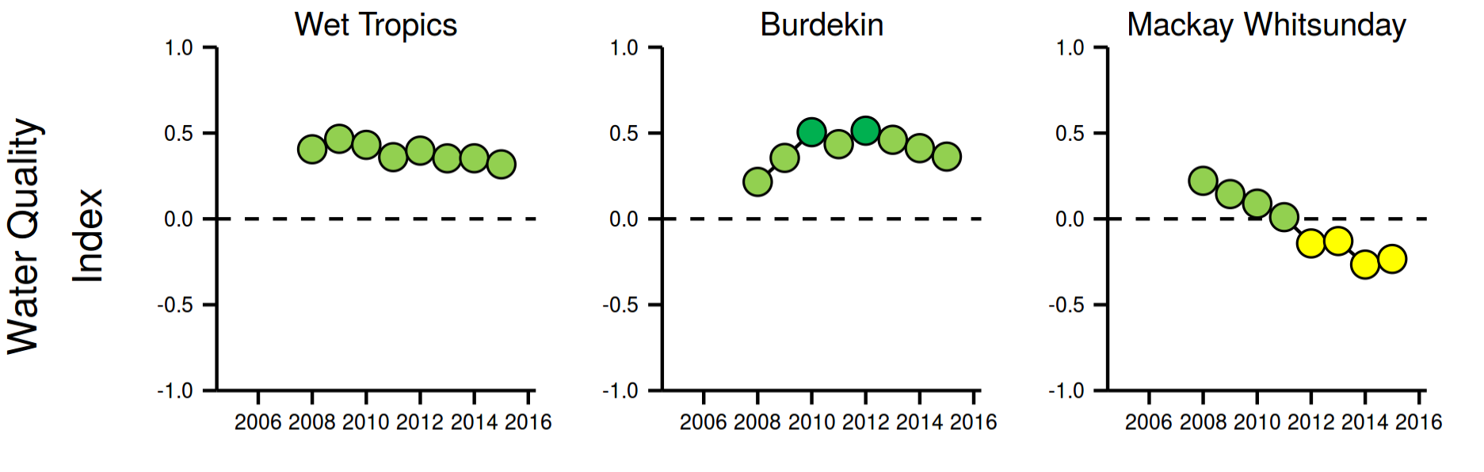
Figure i. Results of the site-specific Water Quality Index from 2006-07 to 2014-15 for the Wet Tropics, Burdekin and Mackay Whitsunday regions. The Water Quality Index aggregates scores for five variables: concentrations of dissolved oxidised nitrogen, particulate nitrogen and phosphorus, chlorophyll-a and a combined water clarity indicator (total suspended solids, turbidity and Secchi depth), relative to Guideline values (GBRMPA 2010, DERM 2009). . Water Quality Index colour coding: dark green- ‘very good’; light green-‘good’; yellow – ‘moderate; orange – ‘poor’; red – ‘very poor’.
The Water Quality Index (dominated by dry season data until now) has maintained ‘good’ index scores in the Wet Tropics region throughout the program, despite increased concentrations of dissolved organic carbon, NO_{x} and in turbidity levels. The multi-year trends of the wet season water quality showed a reduction in concentrations of dissolved nutrients and particulate phosphorus after 2012, when river flow returned to lower values than experienced in the previous years.
The overall water quality at sites in the Burdekin region showed initial improvements at the start of the monitoring program, and has remained more or less stable over the last several years with continuous overall index scores of ‘good’ or ‘very good’ since 2008 at all sites. It should be noted that these ‘good’ or ‘very good’ scores are not reflecting the increased concentrations of dissolved organic carbon, NO_{x} and in turbidity levels. The multi-year trends of the wet season water quality showed a reduction in concentrations of dissolved nutrients and coloured dissolved organic matter (a proxy for freshwater inputs) after 2012, when river flow returned to lower values.
Water quality in the Mackay Whitsunday region has steadily declined over the course of the MMP monitoring and returned a ‘moderate’ index score for the fourth consecutive year. As indicated by the increased turbidity levels and concentrations of organic carbon and NO_{X}, this decline most likely reflects the impacts of above-median river flows in this region from 2007 onwards, along with the likely exposure to runoff from the neighbouring large catchments of the Burdekin Rivers.
Water quality monitoring data collected in the wet season also contributes to the understanding of variability associated with periods of elevated river discharge and cyclonic activity. Correlations between water quality parameters and discharge, wind, salinity and Chl-a were calculated focus each focus area, with the most significant correlations between discharge, salinity and Chl-a for different parameters. Box-plots were also used to describe transport of water quality parameters across plume water types with significant differences varying between focus areas and the 2014-15 or long term datasets. For those parameters with guidelines, several parameters were constantly above the thresholds in plume water types in the 2014-15 and long term (2005 to 2015) data set; these characteristics varied between focus areas and summarised in the regional results (Section 6).
As part of the Reef Plan Report Card, Chl-a and TSS concentrations are assessed using remote sensing information to define a Water Quality Metric. The metric is derived from the relative area of the inshore water body in the Wet Tropics, Burdekin, Mackay Whitsunday NRM regions that exceeds the annual mean guideline value. Information for Cape York and the Burnett Mary regions is not sufficiently validated with field data so there is a high degree of uncertainty in scores derived from remote sensing in these regions. The overall metric score was assessed as ‘moderate’ in 2014-15 (Figure A1-2). The trend for the overall metric score reflects the cumulative impacts of multiple floods and cyclones since 2007-08. Components scores for concentrations of Chl-a and TSS were ‘poor’ and ‘moderate’ respectively in 2014-15 (Figure A1-2).

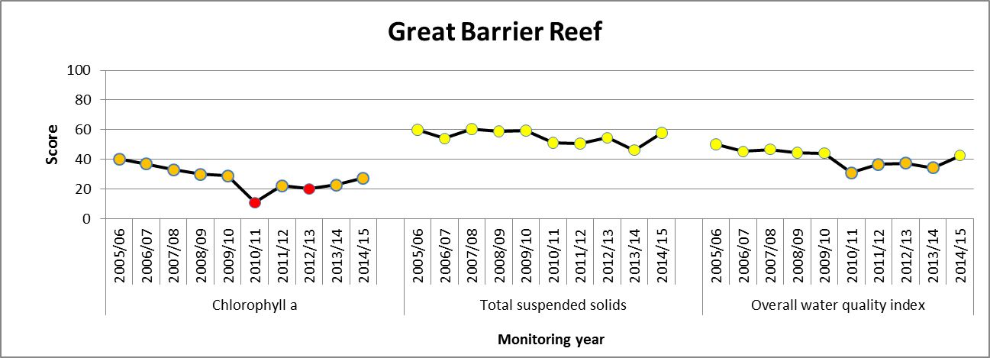
Figure ii. Trend in water quality from 2005-06 to 2014-15. The overall water quality score is the average of the weighted component scores for chlorophyll a and total suspended solids. Values are indexed scores scaled from 0-100; ■ = very good (81-100), ■ = good (61 - 80), ■ = moderate (41 - 60), ■ = poor (21 - 40), ■ = very poor (0 - 20). NB: Scores are unitless.

Conclusions
River discharge in the 2014-15 sampling period was below median discharge in most rivers in the GBR catchments, except for the southern parts of the GBR. This resulted in a reduced area of influence from river plumes in the GBR compared to previous sampling years. However, this did not necessarily result in improvements in water quality parameters, with many parameters showing stable or increasing concentrations.
The general increase measured in turbidity over the monitoring period suggests that the water transparency has decreased, thereby reducing the light available for plankton and coral symbiont and seagrass productivity. These increased turbidity levels are strongly influenced by variations in the inflow of particles from the catchment and resuspension by wind, currents and tides. Overall, this does not necessarily mean that concentrations of total suspended solids have increased, but the proportion of smaller particles and dissolved compounds that increase turbidity have increased over the period.
Plankton biomass production in the GBR is considered to be limited by the availability of nitrogen. An increase in readily available dissolved oxidised nitrogen (NO_{x}) concentrations, as found over the monitoring period, is therefore unexpected. We offer two plausible explanations: either the plankton community is obtaining enough nitrogen from other sources (e.g. ammonium or dissolved organic nitrogen), or their growth is limited by other factors than nitrogen (e.g. light). The increases in turbidity, suggest that plankton growth might be light-limited and the plankton community is not able to use the extra NO_{x}. As this NO_{x} is not used within the coastal area it will be exported further offshore, where it may promote plankton production.
Over the monitoring period, an increase in the organic carbon concentrations was found in all regions. Organic carbon constitutes the major carbon source for heterotrophic microbial growth in marine pelagic systems and increases in organic carbon have previously been shown to promote microbial activity and coral diseases. The observed increases in organic carbon in the inshore GBR lagoon may have several probable, though not necessarily mutually exclusive, explanations: either the coral and plankton community have increased primary production or they are directing more of their production towards organic carbon release, or there is an enhanced export of organic carbon from the catchment, e.g. as eroded soils.
Our finding of increased concentrations of dissolved organic carbon, NO_{x} and increases in turbidity levels in all regions suggest that the mechanisms controlling the carbon and nutrient cycle in the GBR lagoon have undergone changes. The coincidence of these changes with a period of elevated runoff as a result of high rainfall in previous years implies the responsiveness of these fundamental cycles to terrestrial inputs.
Sustained improvements in the marine water quality of the inshore GBR are not yet observed in the MMP water quality program even though there has been good progress in improving land management practices, and with river discharge at or below the long-term median in the last two years. This highlights the complexity of the relationship between river inputs and ambient water quality and the expected slow response timeframe. Continued water quality monitoring of the coastal and inshore GBR lagoon will be fundamental to determine and track long-term changes in response to management actions and interventions, for example those under Reef Plan and the Reef 2050 Plan.

Preface
Management of human pressures on regional and local scales, such as enhanced nutrient runoff and overfishing, is vital to provide corals and reef organisms with the optimum conditions to cope with global stressors, such as climate change and ocean acidification (Bellwood et al., 2004, Marshall and Johnson 2007, Carpenter et al., 2008, Mora 2008, Hughes et al., 2010). The management of water quality remains a strategic priority for the Great Barrier Reef Marine Park Authority (GBRMPA) to ensure the long-term protection of the coastal and inshore ecosystems of the GBR (GBRMPA 2014 a, b). A key policy is the Reef Water Quality Protection Plan (Reef Plan; Anon 2013), now a key component of the Reef 2050 Long Term Sustainability Plan (Reef 2050 Plan; Commonwealth of Australia, 2015), the latter which provides the overarching framework for the integrated management of the Great Barrier Reef World Heritage Area (GBRWHA).
The Marine Monitoring Program (MMP), formerly known as the Reef Plan MMP, was designed and developed by the GBRMPA in collaboration with science agencies and is currently funded by the Australian Government Reef Programme. A summary of the MMP’s overall goals and objectives and a description of the sub-programs are available at http://www.gbrmpa.gov.au/managing-the-reef/how-the-reefs-managed/reef-2050-marine-monitoring-program and http://e-atlas.org.au/rrmmp. The MMP was established in 2005 to help assess the long-term status and health of Great Barrier Reef (GBR) ecosystems and is a critical component in the assessment of regional water quality as land management practices are improved across GBR catchments. The MMP forms an integral part of the Paddock to Reef Integrated Monitoring, Modelling and Reporting Program (Paddock to Reef program) which is a key action of Reef Plan and is designed to evaluate the efficiency and effectiveness of program implementation, and report on progress towards the Reef Plan and Reef 2050 Plan goals and targets. A key output of the Paddock to Reef program is an annual report card, including an assessment of GBR water quality and ecosystem condition to which the MMP contributes assessments and information. The first Annual Reef Plan Report Card for 2009 (Anon. 2011) serves as a baseline for future assessments, and report cards for 2010, 2011 and 2012/13 have since been released (available at www.reefplan.qld.gov.au).
Inshore water quality monitoring in the MMP includes ambient and event sampling (Schaffelke et al. 2013; Devlin et al. 2014; Johnson et al., 2011; Martin et al., 2014) and is carried out in partnership with the other MMP components including pesticide monitoring (Bentley et al., 2013), coral monitoring (Thomson et al., 2014) and seagrass monitoring (McKenzie et al., 2014).
The Australian Institute of Marine Science (AIMS) and James Cook University (JCU) entered into a co-investment agreement with GBRMPA in February 2014 to provide monitoring activities under the MMP for the 2014-15 monitoring year. The water quality monitoring activities in the current contract period of the MMP are built on activities established under previous arrangements from 2005 to 2014 through the expansion of monitoring in four focus regions.

Introduction
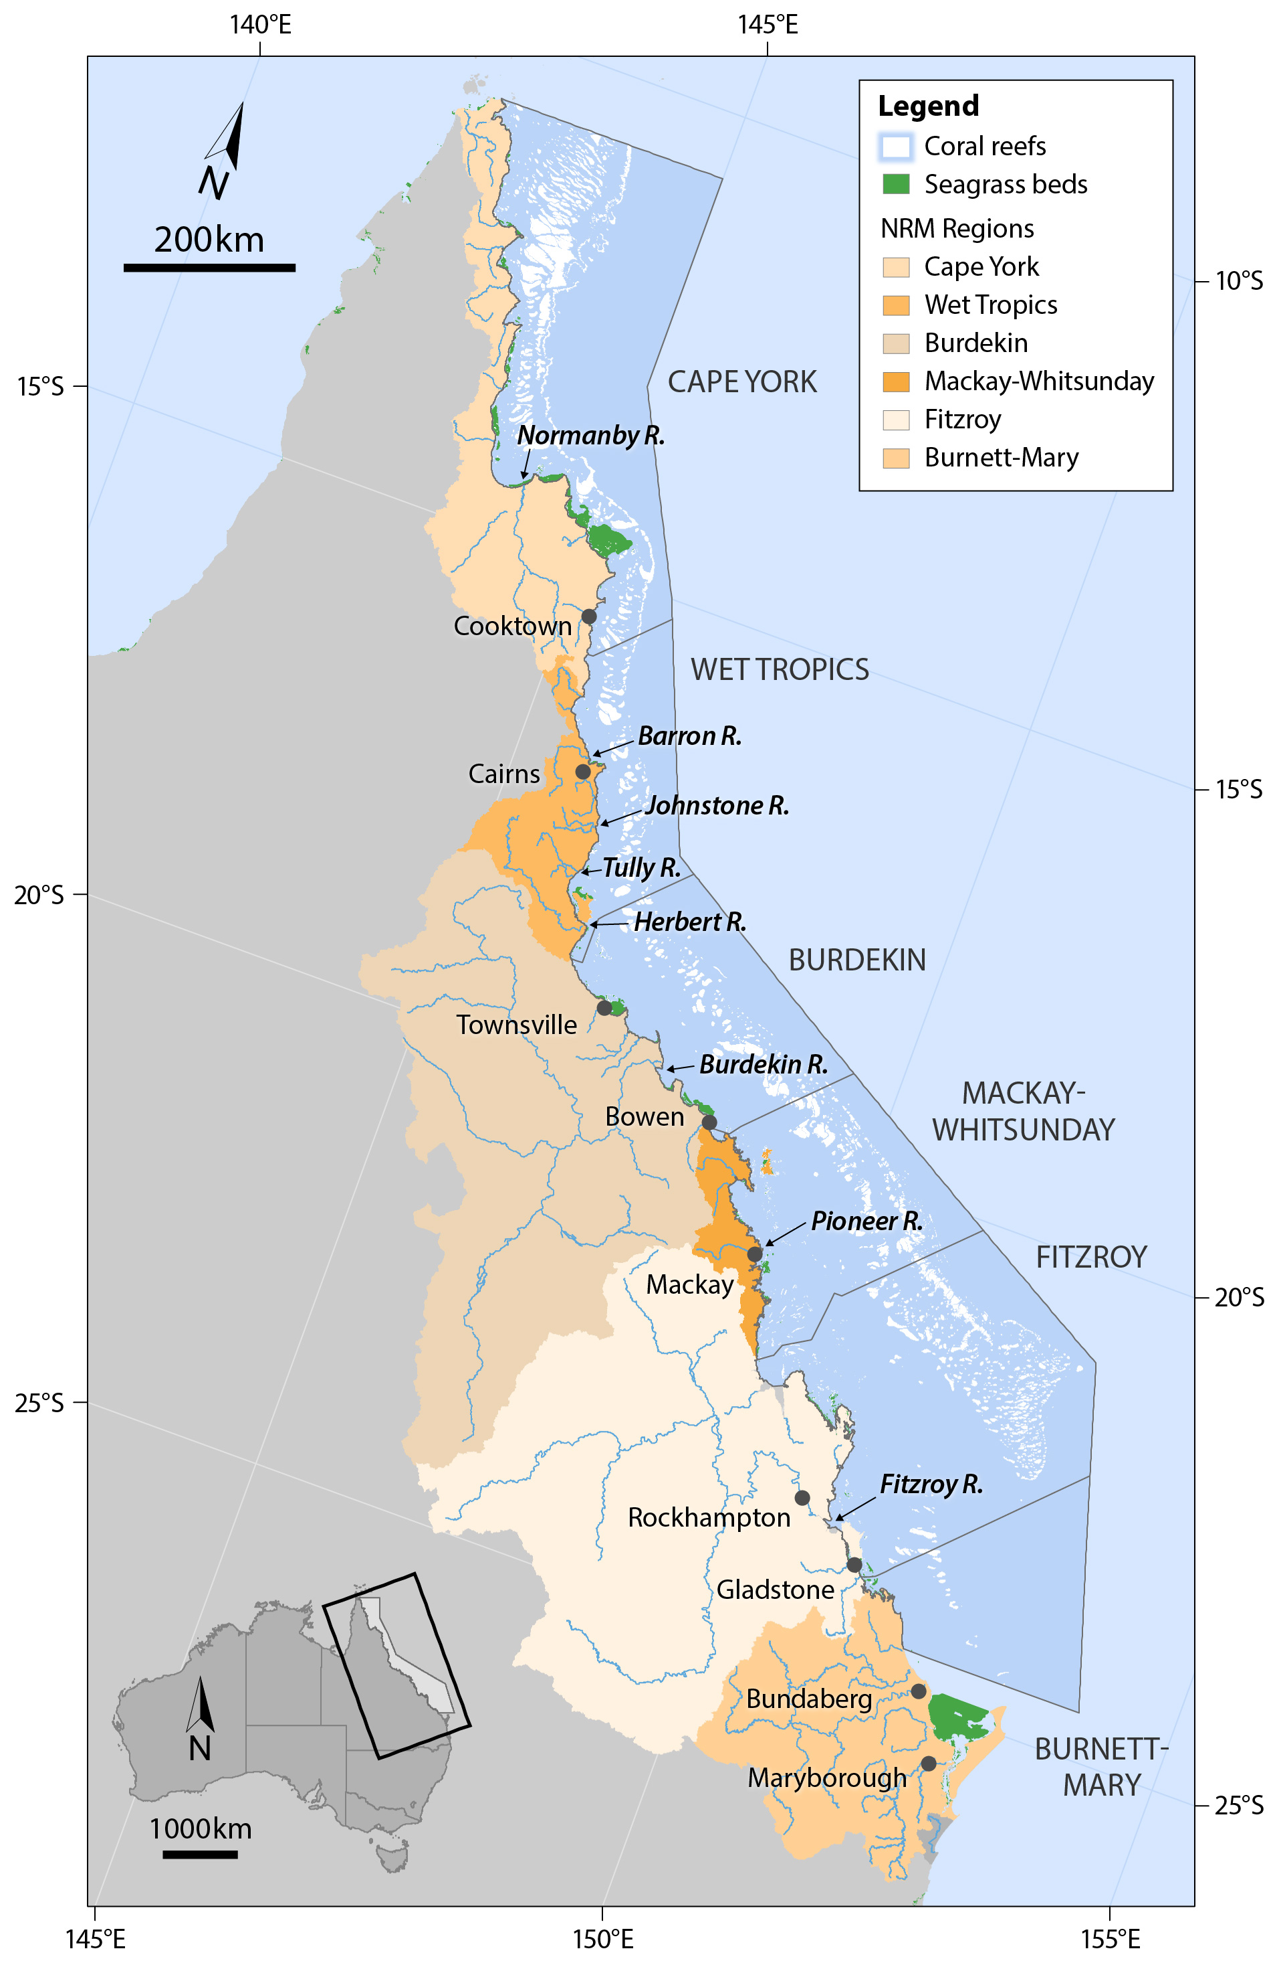
The GBR is the most extensive reef system in the world and comprises over 2,900 km² of coral reefs. It also includes large areas of seagrass meadows, estimated to be over 43,000 km² from surveys of intertidal areas and predictive modelling of deepwater seagrass beds using knowledge of environmental variables (Figure 3-1). Thirty five major rivers drain into the GBR, all of which vary considerably in length, catchment area, and flow frequency and intensity. Rivers discharging into the GBR lagoon are the main source of land-based pollutants (i.e., sediments, nutrients and pesticides) in the GBR. The actual distribution and movement of the individual pollutants varies considerably between the wet (north of Townsville) and dry tropic rivers (Devlin et al., 2011; Devlin et al., 2013; Brodie et al., 2013a, 2013b).
Figure 3-1: The Great Barrier Reef Marine Park, major marine ecosystems (coral reefs and surveyed seagrass beds), NRM regions and marine NRM regions (delineated by dark grey lines) and major rivers.
The GBR catchment is divided into six Natural Resource Management (NRM) regions (Figure 3-1), each defined by a set of land use, biophysical and socio-economic characteristics. The Cape York region is largely undeveloped and is considered to have the least impact on GBR ecosystems from existing land-based activities (Brodie et al. 2013b). In contrast, the Wet Tropics, Burdekin, Mackay Whitsunday, Fitzroy and the Burnett Mary regions are characterised by more extensive agricultural land uses including sugarcane, grazing, bananas and other horticulture, cropping, mining and urban development, and contribute to discharge of sediments, nutrients and pesticides to the GBR during the wet season (Waterhouse et al., 2012; Brodie et al., 2013b).
Coastal areas around the world are under increasing pressure from human population growth, intensifying land use and urban and industrial development. As a result, increased loads of suspended sediment, nutrients and pollutants, such as pesticides and other chemicals, invariably enter coastal waters and may lead to a decline in estuarine and coastal marine water quality. Water quality in the GBR is influenced by an array of factors including diffuse source land-based runoff, point source pollution, and extreme weather conditions. It is well documented that sediment and nutrient loads carried by rainfall-driven land runoff into the coastal and inshore zones of the GBR have increased since European settlement (e.g., Kroon et al., 2012; Waters et al., 2014). Nutrients are necessary to sustain the biological productivity of the GBR, and are supplied by a number of processes and sources such as upwelling of nutrient-enriched deep water from the Coral Sea and nitrogen fixation, for example, by (cyano-) bacteria (Furnas et al., 2011). However, land runoff is the largest source of new nutrients to the inshore GBR (ibid.), especially during monsoonal flood events (Devlin and Schaffelke 2009). These nutrients augment the regional stocks of nutrients already stored in biomass or detritus (Furnas et al., 2011), which are continuously recycled to supply nutrients for marine plants and bacteria (Furnas et al., 2005, 2011).
Water quality parameters in the GBR vary along cross-shelf, seasonal and latitudinal gradients (e.g. Schaffelke et al., 2012a, 2013; previous MMP reports, Devlin et al., in press; Thompson et al., 2014) reflecting differences in inputs and transport. There is also high variability between years, driven by La Nina and El Nino cycles. Elevated concentrations of dissolved inorganic nitrogen (DIN) in coastal waters has been linked to fertilised agriculture (predominantly sugarcane) in the Wet Tropics region, while high total suspended solids (TSS) concentrations are mainly linked to grazing activities in the Dry Tropics and in particular the Burdekin catchment (Brodie et al., 2008, 2012, 2013a, 2013b; Brodie and Waterhouse 2012; Joo et al., 2012; Kroon 2012; Maughan and Brodie 2009; Waterhouse et al., 2012; Waterhouse et al., 2014, 2015, Waters et al., 2014).
Concern about these negative effects of land runoff triggered the formulation of the Reef Plan for catchments adjacent to the GBRWHA by the Australian and Queensland governments in 2003 (Anon. 2003; 2009). Reef Plan was revised and updated in 2009 and 2013 (Anon. 2013). More recently, UNESCO raised concerns regarding the current state and management of the GBRWHA which led to the development of the Reef 2050 Plan to “ensure the GBR continues to improve on its Outstanding Universal Value every decade between now and 2050 to be a natural wonder for each successive generation to come”. The Reef 2050 Plan actions and initiatives aim to improve land management practices that are expected to result in measurable positive changes in the downstream water quality of creeks and rivers. These actions and initiatives should, with time, also lead to improved water quality in the coastal and inshore GBR (see Brodie et al., 2012 for a discussion of expected time lags in the ecosystem response). Given that the benthic communities on inshore reefs of the GBR show clear responses to gradients in water quality, especially of water turbidity, sedimentation rate and nutrient availability (e.g. Thompson et al., 2010; Uthicke et al., 2010), improved land management practices have the potential to reduce levels of chronic environmental stresses that impact on coral reef communities. However, recent assessments raise the question whether these actions will be sufficient to ensure the resilience of the GBR ecosystems into the future (Bartley 2014a,b; Kroon et al., 2014).
Reef Plan actions also include the establishment of the Paddock to Reef integrated monitoring, modelling and reporting program, extending from the paddock to the Reef, to assess the effectiveness of the implementation of Reef Plan actions. The MMP is an integral part of this monitoring providing physicochemical and biological data to investigate the effects of changes in inputs from the GBR catchments on marine water quality, and assess the condition of inshore ecosystems.
Monitoring the impacts of land based runoff into the GBR includes more intense sampling during the wet season and high flow events to characterise the input of terrestrially sourced pollutants delivered through river discharge to the GBR (Devlin et al., 2012; Devlin et al., 2013; Johnson et al., 2011). The information gathered under the current MMP inshore water quality sampling program has improved our understanding of the spatial distribution and temporal variability of water quality in the coastal and inshore GBR. This includes detailed information about the temporal/spatial trends in water quality around inshore coral reefs, detailed information about water quality in flood plumes (both included in this report), coral cover and composition (separate report by Thompson et al., 2015), seagrass health and extent (McKenzie et al., 2015) and information about herbicide levels in the inshore GBR (separate report by University of Queensland, Gallen et al., 2015).
The present report combines the results of the AIMS and JCU Water Quality Monitoring into an integrated report. This better reflects the monitoring design, which is based on co-location of sampling sites, and the overarching objective of the MMP to: Assess trends in ecosystem health and resilience indicators for the Great Barrier Reef in relation to water quality and its linkages to end-of-catchment loads”. This objective supports the ongoing progress toward Reef Plan’s single long-term goal for the marine environment “To ensure that by 2020 the quality of water entering the reef from broadscale land use has no detrimental impact on the health and resilience of the Great Barrier Reef.”
The overarching objective of the inshore water quality monitoring program is to “Assess temporal and spatial trends in inshore marine water quality and link pollutant concentrations to end-of-catchment loads”. The specific objectives are to:
- monitor, assess and report the three dimensional extent and duration of flood plumes and link concentrations of suspended sediment, nutrients and pesticides to end-of-catchment loads;
- monitor, assess and report trends in inshore concentrations of sediment, chlorophyll a, nutrients and pesticides against the Water Quality Guidelines for the Great Barrier Reef Marine Park (or other water quality guidelines if appropriate);
- monitor, assess and report trends in turbidity and light attenuation for key GBR inshore habitats against established thresholds and/or guidelines; and
- monitor, assess and report the extent, frequency and intensity of impacts on Great Barrier Reef inshore seagrass meadows and coral reefs from flood plumes and link to end-of-catchment loads.

The program methods and results in 2014-15 are presented in this report with regional and GBR-wide interpretation.

Methods summary

Overview
This section provides an overview of the sampling design and indicators that are monitored as part of the program. More details of the data collection, preparation, and analytical methods are presented in Appendix 1 and in a separate QA/QC report, updated annually (GBRMPA 2015c). The QA/QC report covers the objectives and principles of analyses, step-by-step sample analysis procedures, instrument performance, data management and analyses, and quality control measures.

Sampling design
The MMP inshore water quality monitoring is designed to quantify temporal and spatial variation in inshore water quality conditions. To facilitate the identification of relationships between the end-of-catchment loads and water quality it is essential that the environmental setting of each monitoring location is adequately described.
From 2005 to 2014 the following design was used to determine the trends in water quality, and included a specific ambient water quality program conducted by AIMS, and a wet season monitoring program conducted by JCU:
- Chlorophyll a and turbidity continuously monitored with in-situ loggers at 14 stations across the Wet Tropics, Burdekin and Mackay Whitsunday regions (see Table 4-1);
- 20 stations which were sampled 3 times a year (wet, early and late dry seasons) across the Wet Tropics, Burdekin and Mackay Whitsunday regions (see Table 4-1);
- Wet season sampling stations in most NRM areas (Normanby, Russell-Mulgrave, Tully, Herbert, Burdekin and Fitzroy) (9 to 15 sites per location); and
- Flood sampling in response to high flow conditions across all of the NRM regions (where relevant) (most frequently in Tully, Russell-Mulgrave, Burdekin, Fitzroy and Normanby).

In 2014-15, the GBRMPA led a review of the MMP design, which resulted in a new sampling design for the inshore water quality monitoring program, intended to increase the potential for detection of links between end-of-catchment loads and marine water quality. The design focuses on four focus areas – the Russell-Mulgrave, Tully and Burdekin Rivers and rivers in the Mackay Whitsunday region. This report covers the initial year for this integrated design which formally commenced in February 2015.
Three of the focus areas are targeted for intensive sampling - Russell-Mulgrave, Tully and Burdekin, and were chosen as priority areas based on water quality risk assessments reported elsewhere (Brodie et al., 2013b) and availability/quality of long-term data. The Tully River catchment is also the ideal location to assess the long-term effectiveness of Reef Plan as data can be collected every year as it is the wettest catchment in Australia. Repeated sampling in the Tully focus area also adds value to the long-term data set collected in this area from 1994 to 2012 (Devlin and Schaffelke 2009). Additional reporting for the Barron-Daintree sub-region of the Wet Tropics is also included due to the continued collection of data in the long term Cairns transect.
The sites in each focus area are selected along water quality gradients (exposure to runoff). This was largely determined by increasing distance from a river mouth in a northerly direction to reflect the predominantly northward flow of surface water forced by the prevailing south-easterly winds (Larcombe et al., 1995; Brinkman et al., 2011). Most of the ambient sampling sites that were monitored from 2005 to 2014 are included, allowing for the continuation of the valuable long-term time series. Most areas are sampled more frequently (typically between 5 to 10 times) to improve the ability to detect and interpret trends in water quality in key areas in relation to end of catchment loads, and provide data for the validation of the eReefs model suite.
Figure 4-1, Table 4-1 and Table 4-2 provide an overview of the geographic locations of the current sampling sites.
The list of parameters sampling in the program is provided in Table 4-3, and includes:
- Continuous measurement of salinity at 8 stations;
- Continuous measurement of Chlorophyll a and turbidity at 15 stations;
- 32 stations sampled during the year with more frequent sampling during the wet season; and
- 27 additional stations sampled during high flow conditions (flood response).
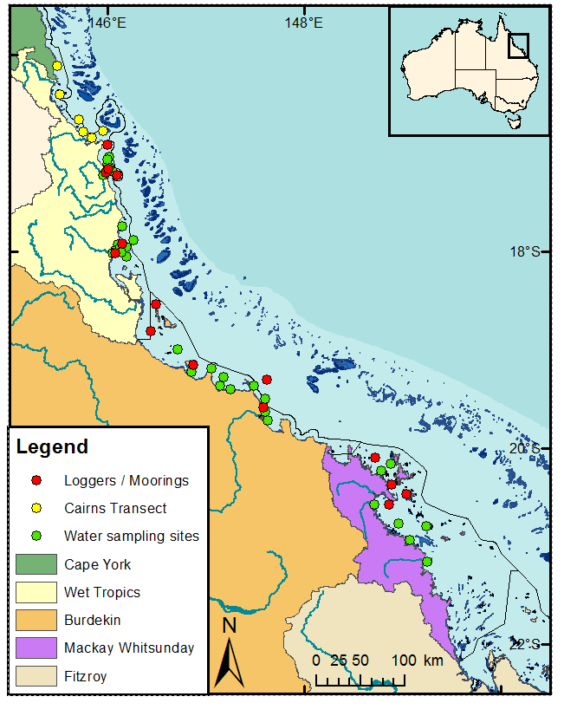
Temperature is also continuously monitored at 33 stations (as part of the inshore coral reef monitoring program.
Figure 4-1: Sampling locations of the MMP water quality monitoring sampled from 2015 onwards. Refer to Figure 3-1 for river names. See Table 4-1 for details of the monitoring activities undertaken at each location. NRM region boundaries are represented by coloured catchment areas.

Table 4-1: Description of the water quality (WQ) stations sampled by AIMS and JCU in 2014-15. Stations in bold font were part of the ambient monitoring design from 2005-2014. See Table 4-3 for the parameters collected.
NRM region | Location | Loggers |  | Routine sampling throughout the year with higher frequency in wet season |  | Flood response sampling
NRM region | Location | Turbidity and chlorophyll | Salinity | AIMS and JCU | AIMS only | JCU only
Wet Tropics | Cairns Long-term transect
Wet Tropics | Cape Tribulation |  |  |  | √
Wet Tropics | Port Douglas |  |  |  | √
Wet Tropics | Double Island |  |  |  | √
Wet Tropics | Yorkey's Knob |  |  |  | √
Wet Tropics | Fairlead Buoy |  |  |  | √
Wet Tropics | Green Island |  |  |  | √
Wet Tropics | Russell Mulgrave Focus Area
Wet Tropics | Fitzroy Island West | √ |  |  | √
Wet Tropics | RM2 |  |  |  |  | √
Wet Tropics | RM3 |  |  | √
Wet Tropics | RM4 |  |  |  |  | √
Wet Tropics | High Island East |  |  |  |  | √
Wet Tropics | Normanby Island |  |  |  |  | √
Wet Tropics | Frankland Group West (Russell Island) | √ |  | √
Wet Tropics | High Island West | √ | √ | √
Wet Tropics | Palmer Point |  |  |  |  | √
Wet Tropics | Russell-Mulgrave River mouth mooring | √ | √ | √
Wet Tropics | Russell-Mulgrave River mouth |  |  |  |  | √
Wet Tropics | Russell-Mulgrave junction [River] |  |  |  |  | √
Wet Tropics | Tully Focus Area
Wet Tropics | King Reef |  |  |  |  | √
Wet Tropics | East Clump Point |  |  | √
Wet Tropics | Dunk Island North | √ | √ | √
Wet Tropics | South Mission Beach |  |  |  |  | √
Wet Tropics | Dunk Island South East |  |  | √
Wet Tropics | Between Tam O'Shanter and Timana |  |  | √
Wet Tropics | Hull River mouth |  |  |  |  | √
Wet Tropics | Bedarra Island |  |  | √
Wet Tropics | Triplets |  |  |  |  | √
Wet Tropics | Tully River mouth mooring | √ | √ | √
Wet Tropics | Tully River |  |  |  |  | √
Burdekin | Burdekin Focus Area
Burdekin | Pelorus and Orpheus Island West | √ |  | √
Burdekin | Pandora Reef | √ |  | √
Burdekin | Cordelia Rocks |  |  |  |  | √
Burdekin | Magnetic Island (Geoffrey Bay) | √ |  | √
Burdekin | Inner Cleveland Bay |  |  |  |  | √
Burdekin | Cape Cleveland |  |  |  |  | √
Burdekin | Haughton 2 |  |  | √
Burdekin | Haughton River mouth |  |  |  |  | √
Burdekin | Barratta Creek |  |  |  |  | √
Burdekin | Yongala IMOS NRS | √ | √ |  | √
Burdekin | Cape Bowling Green |  |  |  |  | √
Burdekin | Plantation Creek |  |  |  |  | √
Burdekin | Burdekin River mouth mooring | √ | √ | √
Burdekin | Burdekin Mouth 2 |  |  |  |  | √
Burdekin | Burdekin Mouth 3 |  |  |  |  | √
Mackay Whitsunday | Whitsunday focus area
Mackay Whitsunday | Double Cone Island | √ |  | √
Mackay Whitsunday | Hook Island W |  |  |  |  | √
Mackay Whitsunday | North Molle Island |  |  |  |  | √
Mackay Whitsunday | Pine Island | √ |  | √
Mackay Whitsunday | Seaforth Island | √ |  | √
Mackay Whitsunday | OConnell River mouth |  |  | √
Mackay Whitsunday | Repulse Islands dive mooring | √ | √ | √
Mackay Whitsunday | Rabbit Island NE |  |  |  |  | √
Mackay Whitsunday | Brampton Island |  |  |  |  | √
Mackay Whitsunday | Sand Bay |  |  |  |  | √
Mackay Whitsunday | Pioneer River mouth |  |  |  |  | √

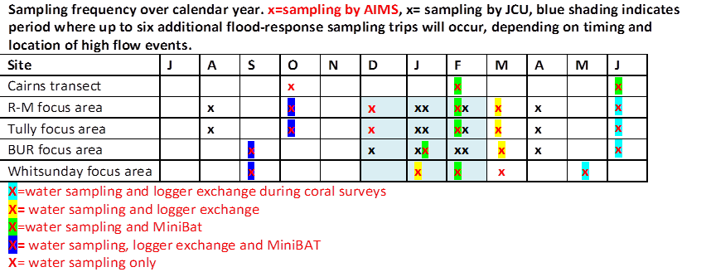
Table 4-2: Sampling frequency over the calendar year. x = sampling by AIMS, x = sampling by JCU, blue shading indicates the period where up to five additional flood-response sampling trips may occur depending on timing and location of high flow events.
Table 4-3: List of parameters sampled in the ambient and wet season water quality monitoring. Note that +/- signs identifying the charge of the nutrient ions were omitted for brevity. * Sampled not at all sites.
Condition | Parameter | Abbreviation | Units of Measure
Physico-chemical | Salinity | Salinity | PSU
Physico-chemical | Temperature | Temperature | Celsius degree
Physico-chemical | Light (underwater attenuation)* | Kd(PAR) | m⁻¹
Physico-chemical | Total Suspended Solids | TSS | mg/L
Physico-chemical | Coloured Dissolved Organic Matter | CDOM | m⁻¹
Physico-chemical | Turbidity | Tur | NTU
Nutrients² | Ammonium¹ | NH₄ | µg/L
Nutrients² | Nitrite¹ | NO₂ | µg/L
Nutrients² | Nitrate¹ | NO₃ | µg/L
Nutrients² | dissolved inorganic phosphate | DIP | µg/L
Nutrients² | Silica | Si | µg/L
Nutrients² | dissolved organic carbon | DOC | µg/L
Nutrients² | dissolved organic nitrogen | DON | µg/L
Nutrients² | dissolved organic phosphorus | DOP | µg/L
Nutrients² | particulate organic carbon | POC | µg/L
Nutrients² | particulate nitrogen | PN | µg/L
Nutrients² | particulate phosphorus | PP | µg/L
Productivity | Chlorophyll-a | Chl-a | µg/L
Pesticides | Photosystem II inhibiting herbicide | PSII herbicides | ng/L
¹ note that dissolved inorganic nitrogen (DIN) is the sum of NO₂, NO₃ and NH₄ and NO_{X} is the sum of NO₂ and NO₃

Water quality sampling methods
A detailed description of methodologies is provided in Appendix 1. At each of the sampling locations (see Table 4-1), vertical profiles of water temperature, salinity, chlorophyll, and turbidity were measured with a Conductivity Temperature Depth profiler (CTD). The CTD casts are used to characterise the water column and for example, identify how well mixed the water column is and record any stratification. Immediately following the CTD cast, discrete water samples were collected with Niskin bottles. Samples collected by AIMS were collected from the surface, 1m from the seabed, while at some of the stations sampled by JCU during the wet season only surface water was collected. Sub-samples taken from the Niskin bottles were analysed for a broad suite of water quality parameters (Table 4-2).
In addition to the vessel-based sampling, water samples for analyses of chlorophyll a and total suspended solids were also collected three times a year by diver-operated Niskin bottle sampling close to the autonomous water quality instruments (see below), for validation purposes.
During the wet season the underwater light extinction coefficient (Kd, m⁻¹) was also calculated using the Lambert-Beer equation on the CTD light profile with a summary of the parameters collected in the program provided in Table 4-2.
The three main facets of the focused wet season monitoring are the collection of in-situ data (November to April), extraction and processing of remotely sensed data for mapping and modelling river plumes, and integration of both in-situ and remote sensed data reflected in the surface loading maps.
In situ sampling data is made available for the validation of existing models (e.g. eReefs) and regionally based remote sensing algorithms (Brando et al., 2008; Brando et al., 2010b; Brando et al., 2009).

In-situ loggers
Continuous in situ measurements of chlorophyll fluorescence and turbidity were performed at 15 sites using WET Labs ECO FLNTUSB Combination Fluorometer and Turbidity Sensors; salinity and temperature loggers were deployed at eight locations, with three of these being placed in close proximity to Russell-Mulgrave, Tully and Burdekin river mouths (Figure 4-1, Table 4-1; Figure A2 1). Additional temperature loggers are also deployed at all MMP inshore coral reef monitoring sites (reported in Thompson et al., 2015).
The chlorophyll logger data are used for trend analyses and for assessing relationships with coral reef health and not for comparison against guidelines because the uncertainty is higher than for other measures.

Data analyses – ambient water quality
Generalised additive mixed effects models were fitted to environmental variables for each NRM region, or focus area, to identify the presence and consistency of trends. More detailed descriptions of the statistical methods and data summaries are presented in Appendix 1.5.
Water quality data were summarised as a simple water quality index, which is based on comparisons with existing water quality guidelines (DERM 2009, GBRMPA 2010), to generate an overall assessment of water quality for the five sampling areas (Barron Daintree – Cairns transect, Russell-Mulgrave, Tully, Burdekin and Mackay Whitsunday). Note that intensive flood sampling data has not been incorporated to the index due to inconsistencies in the frequency of data collection - some flood plumes were sampled 10 times in some years, while AIMS collected samples 3 times a year. Therefore, including the historic JCU data would skew the whole data set and trends, giving a false representation of annual water quality conditions. Detail of the methods used for the calculation of the site-specific Water Quality Index is presented in Appendix, A1.6.

Data analysis – wet season water quality
Data sampled in flood plumes are used for several purposes: to characterise river plumes in terms of expected concentrations of the water quality parameters; to investigate the transport and/or transformation of parameters when they are discharged into the GBR lagoon; to identify where measured values were above the water quality guideline values; and to inform the assessment of potential risk of water quality to coral reefs and seagrass ecosystems.
For the plume maps, a simple data extraction was performed (see method in Appendix A1.10 – Load Mapping), so that water quality parameters measured in plume waters can be associated to each plume water type (i.e., to each six colour classes and/or Primary, Secondary or Tertiary water types).
The transport and/or transformation of water quality parameters were investigated by using mixing plots. Each water quality parameter, grouped by sampling events, is plotted against salinity, so that conservative or non-conservative behaviour can be identified. The concentrations of some water quality parameters in plumes are directly related to the degree of mixing between the fresh and salt water. If the changes in concentration result only from the dilution associated with mixing, the constituents are said to behave conservatively (Devlin et al., 2001). In order to investigate any potential influence of river discharge and wind on the water quality parameters, a correlation table was produced comparing each water quality parameter, grouped by river, against river discharge and wind, looking at both longitudinal and latitudinal components. Chlorophyll a (Chl-a) was also included in this comparison due its importance as a water quality indicator for the GBR.
Correlations were calculated using the Spearman's rank correlation coefficient because the majority of the variables did not present normal distribution. The number of sampled sites and their location has varied over the sampling years, so the analysis aimed at reducing the data variability by averaging water quality parameters by transect in the analysis. For example, all values for DIN sampled in a particular day at the Tully sites were averaged and compared against the Tully River discharge and both wind components for that day.
Further detail of the methods used for the wet season water quality analysis is presented in Appendix A1.7.

Remote-sensing based plume modelling, water type classification and spatial plume risk maps
Understanding the exposure of the GBR ecosystems and resulting changes in ecosystem health conditions is important to facilitate management of the GBR to respond to anthropogenic pressures under a changing climate. The remote sensing component of the MMP wet season monitoring produces several products as illustrated in Figure 4-2, including maps of river plume extent, frequency of occurrence and water type classification, and models that summarise transport of land-sourced contaminants and describe water quality concentrations within wet season conditions. A product that integrates these methods into a single risk assessment framework is presented (and detailed as a case study in Section 8), which could be used as a future routine reporting product for the MMP to evaluate the susceptibility of GBR key ecosystems to exposure to river plumes and pollutants.
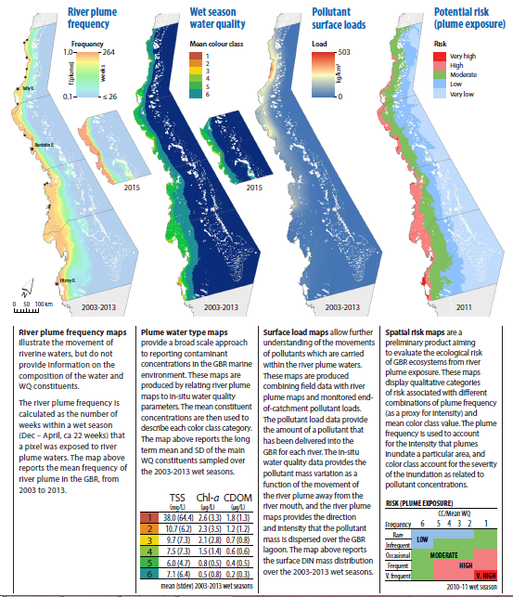
Figure 4-2: Summary description of the wet season water quality products derived from remote sensing information in the MMP.

Figure 4-3: Conceptual scheme of the risk framework proposed in Petus et al. (2014a) used for developing the spatial risk maps.
In the GBR river plume risk framework, the ‘risk’ corresponds to an exposure to land-sourced pollutants concentrated in river plume waters (Figure 4-3). This report focuses on the TSS, DIN, dissolved inorganic phosphorus (DIP) and Diuron concentrations, as well as on the light levels (K_{d}(PAR)) measured in plume waters. ‘The magnitude of the risk’ correspond to the intensity quantified as concentration, level or load of pollutant discharged through the river plume and mapped through the Primary, Secondary, Tertiary plume water types. The ‘likelihood of the risk’ can be estimated by calculating the frequency of occurrence of river plumes or specific plume water type. The potential risk from river plume exposure for GBR ecosystems is finally ranked (I to IV) assuming that ecological consequences will increase linearly with the pollutant concentrations and frequency of river plume exposure. The potential risk categories are then a combination of the plume frequency (five categories: 0-0.2, 0.2-0.4, 0.4-0.6, 0.6-0.8, 0.8-1) and plume water type (3 categories: Primary, Secondary and Tertiary) based on the risk matrix modified from Castillo et al. (2012) (Figure 4-4).
The methods for these products are all described in further detail in Appendix A1.7, A1.8, A1.9 and A1.11.

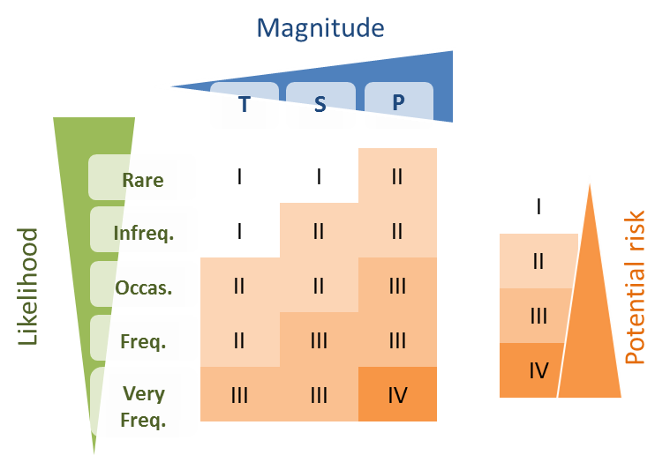
Figure 4-4: Risk matrix is a function of the magnitude and the likelihood of the river plume risk. Risk categories I, II, III, IV (reproduced from Petus et al., 2014b).

Load mapping
An ocean colour based model has been under development to estimate the dispersion of DIN ($DIN={\text{NH}}_{\text{4}}^{\text{+}}\text{+}{\text{NO}}_{\text{2}}^{\text{-}}\text{+}{\text{NO}}_{\text{3}}^{\text{-}}$) delivered by river plumes to GBR waters (da Silva et al., in prep.). This model, built on Álvarez-Romero et al. (2013), combines in-situ data, Moderate Resolution Imaging Spectroradiometer (MODIS satellite) imagery and modelled annual end-of-catchment DIN loads from the GBR catchments. In the model, monitored end-of-catchment DIN loads provide the amount of DIN delivered to the GBR, in-situ data provides the DIN mass in river plumes, and satellite imagery provides the direction and intensity of DIN mass dispersed over the GBR lagoon. The eReefs hydrodynamic model also provides an estimate of the boundary of plume extent in the wet season. This model produces annual maps of average DIN concentration in the GBR waters. Maps are in a raster format, which is a spatial data model that defines space as an array of equally sized cells arranged in rows and columns (ESRI, 2010).
The main modifications applied to the method presented in Álvarez-Romero et al. (2013) are: the qualitative assessment of pollutant dispersion in river plumes is replaced by a relationship between in-situ DIN mass and the six colour classes in the river plume maps; the cost-distance function used in Álvarez-Romero et al. (2013) to reproduce the shape of each individual river plume is replaced by the path-distance function, which is also available in ArcMap Spatial Analyst (ESRI 2010); and a DIN decay function is applied to DIN mass exported from the rivers to account for potential biological uptake.
The model has four main components: (a) modelling of individual river plumes; (b) DIN dispersion function; (c) DIN decay function; and (d) mapping of DIN concentration over the GBR lagoon. The conceptual model in Figure 4-5 shows how each model component is set up and how they are combined to produce the DIN dispersion maps. The basic idea of the DIN dispersion maps is to produce river plume maps, like those produced for the GBR (see Remote Sensing section in this report), for each individual river in the model. The end-of-catchment load of each river can then be dispersed over its individual river plume. To control this dispersion, a relationship based on the mass proportion of DIN in each plume colour class determined at the GBR scale is used. To account for potential DIN uptake, the ratio between an in-situ DIN x salinity relationship and the theoretical DIN decay due to dilution (i.e., freshwater – marine water mixing) is used. This ratio defines a DIN decay coefficient, which is multiplied by the dispersed DIN load. After the load has been dispersed over each individual river plume, and corrected for DIN uptake, the resultant dispersed DIN from each river is summed together to represent the total annual DIN dispersion over the GBR lagoon discharged by the rivers. In the following these four major steps are presented, starting with the generation of individual river plumes.
The method developed for the dispersion of land-based DIN was also applied for particulate nitrogen (PN) and TSS. Details of the methods used for this study are presented in Appendix A1.11.
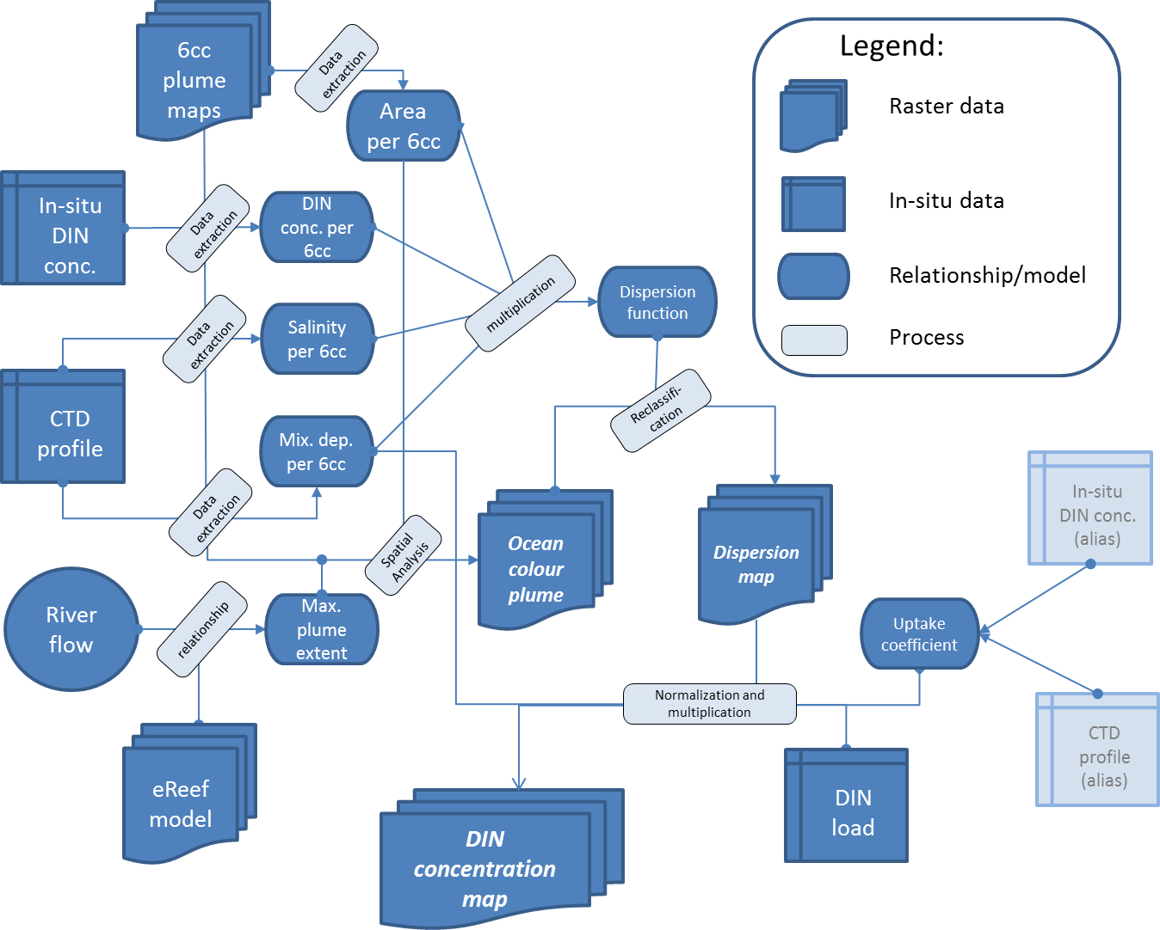
Figure 4-5: Conceptual model for DIN concentration load mapping. Note: 6cc = 6 colour class classification. See text for explanation.

‘Zones of influence’ for river plumes
Hydrodynamic models provide a valuable tool for identifying, quantifying and communicating the spatial impact of discharges from various rivers into the GBR lagoon. For the MMP, hindcast simulations were performed for the 2014-15 wet season, defined as 01 November 2014 until 31 March 2015. River-tagged passive tracers were released from each of the major gauged rivers discharging in to the GBR. For this report the extent of influence of the Barron, Russell-Mulgrave, Tully, Burdekin and O’Connell Rivers was examined. The discharge concentration of each river’s unique tracer was set at 1.0 at the river mouth, while the starting tracer concentration in the GBR Lagoon (time = 0 for each wet season) was set to 0.0.
Details of the methods used for the eReef tracer study are presented in Appendix A1.11.

Results and discussion

Overview
The design of the MMP and the structure of the reporting follows a Driver-Pressure-State-Impact-Response framework (Figure 5-1) derived from GBR Outlook reporting. Each of the three sections in this chapter -drivers, pressures, state- present the monitoring data in summarised, mostly graphical form that we considered as being most informative for a general audience. More detailed data are included in Appendix 2.
Cause
Affect
Provides

Figure 5-1: DPSIR framework used to guide the structure of the MMP, derived from the Great Barrier Reef Strategic Assessment, 2015. The aspects highlighted in yellow are included in this report.

Drivers, activities, impacts and pressures 2014-15
    - Cyclone activity
The 2014-15 wet season was characterised by neither El Niño nor La Niña climatic conditions, and Queensland tropical cyclone activity was near long term average conditions. After a late start to the wet season, flood events occurred in the Wet Tropics in mid-February and mid-March 2015, in the Burdekin in mid-December 2014 and end of January 2015, and in the Mackay Whitsunday region in mid-January 2015. Over this period two major cyclones developed in North Queensland, bringing intense rainfall; Tropical Cyclone Marcia reached a Category 5 Severe Tropical Cyclone on 20 February 2015 before making landfall at Shoalwater Bay (north of Yeppoon, Fitzroy region), and Tropical Cyclone Nathan made landfall as a Category 3 cyclone on 20 March 2015 near Cape Flattery at Yarranden, north of Cooktown (Cape York region) (Figure 5-2). The passage of Ex-Tropical Cyclone Marcia brought heavy rains in the South Queensland and Ex-Tropical Cyclone Nathan affected more the area of the Gulf of Carpentaria. As they were far away from the focus areas monitored in the MMP, these storms did not result in an above median flood signal in the monitored areas this wet season (see Freshwater Discharge below).
Figure 5-2 shows the cyclones that have crossed the GBR coast in the ten years since the MMP began in 2005. Nine of these cyclones have been Category 3 or above, and have affected the health of the GBR. All of the Category 5 cyclones that affected the GBR since 1970 have occurred in the last decade (including Tropical Cyclones Larry, Hamish, Yasi, Ita and Marcia). Many of these cyclones have caused widespread flooding from intensive rainfall events in many parts of the GBR catchment.
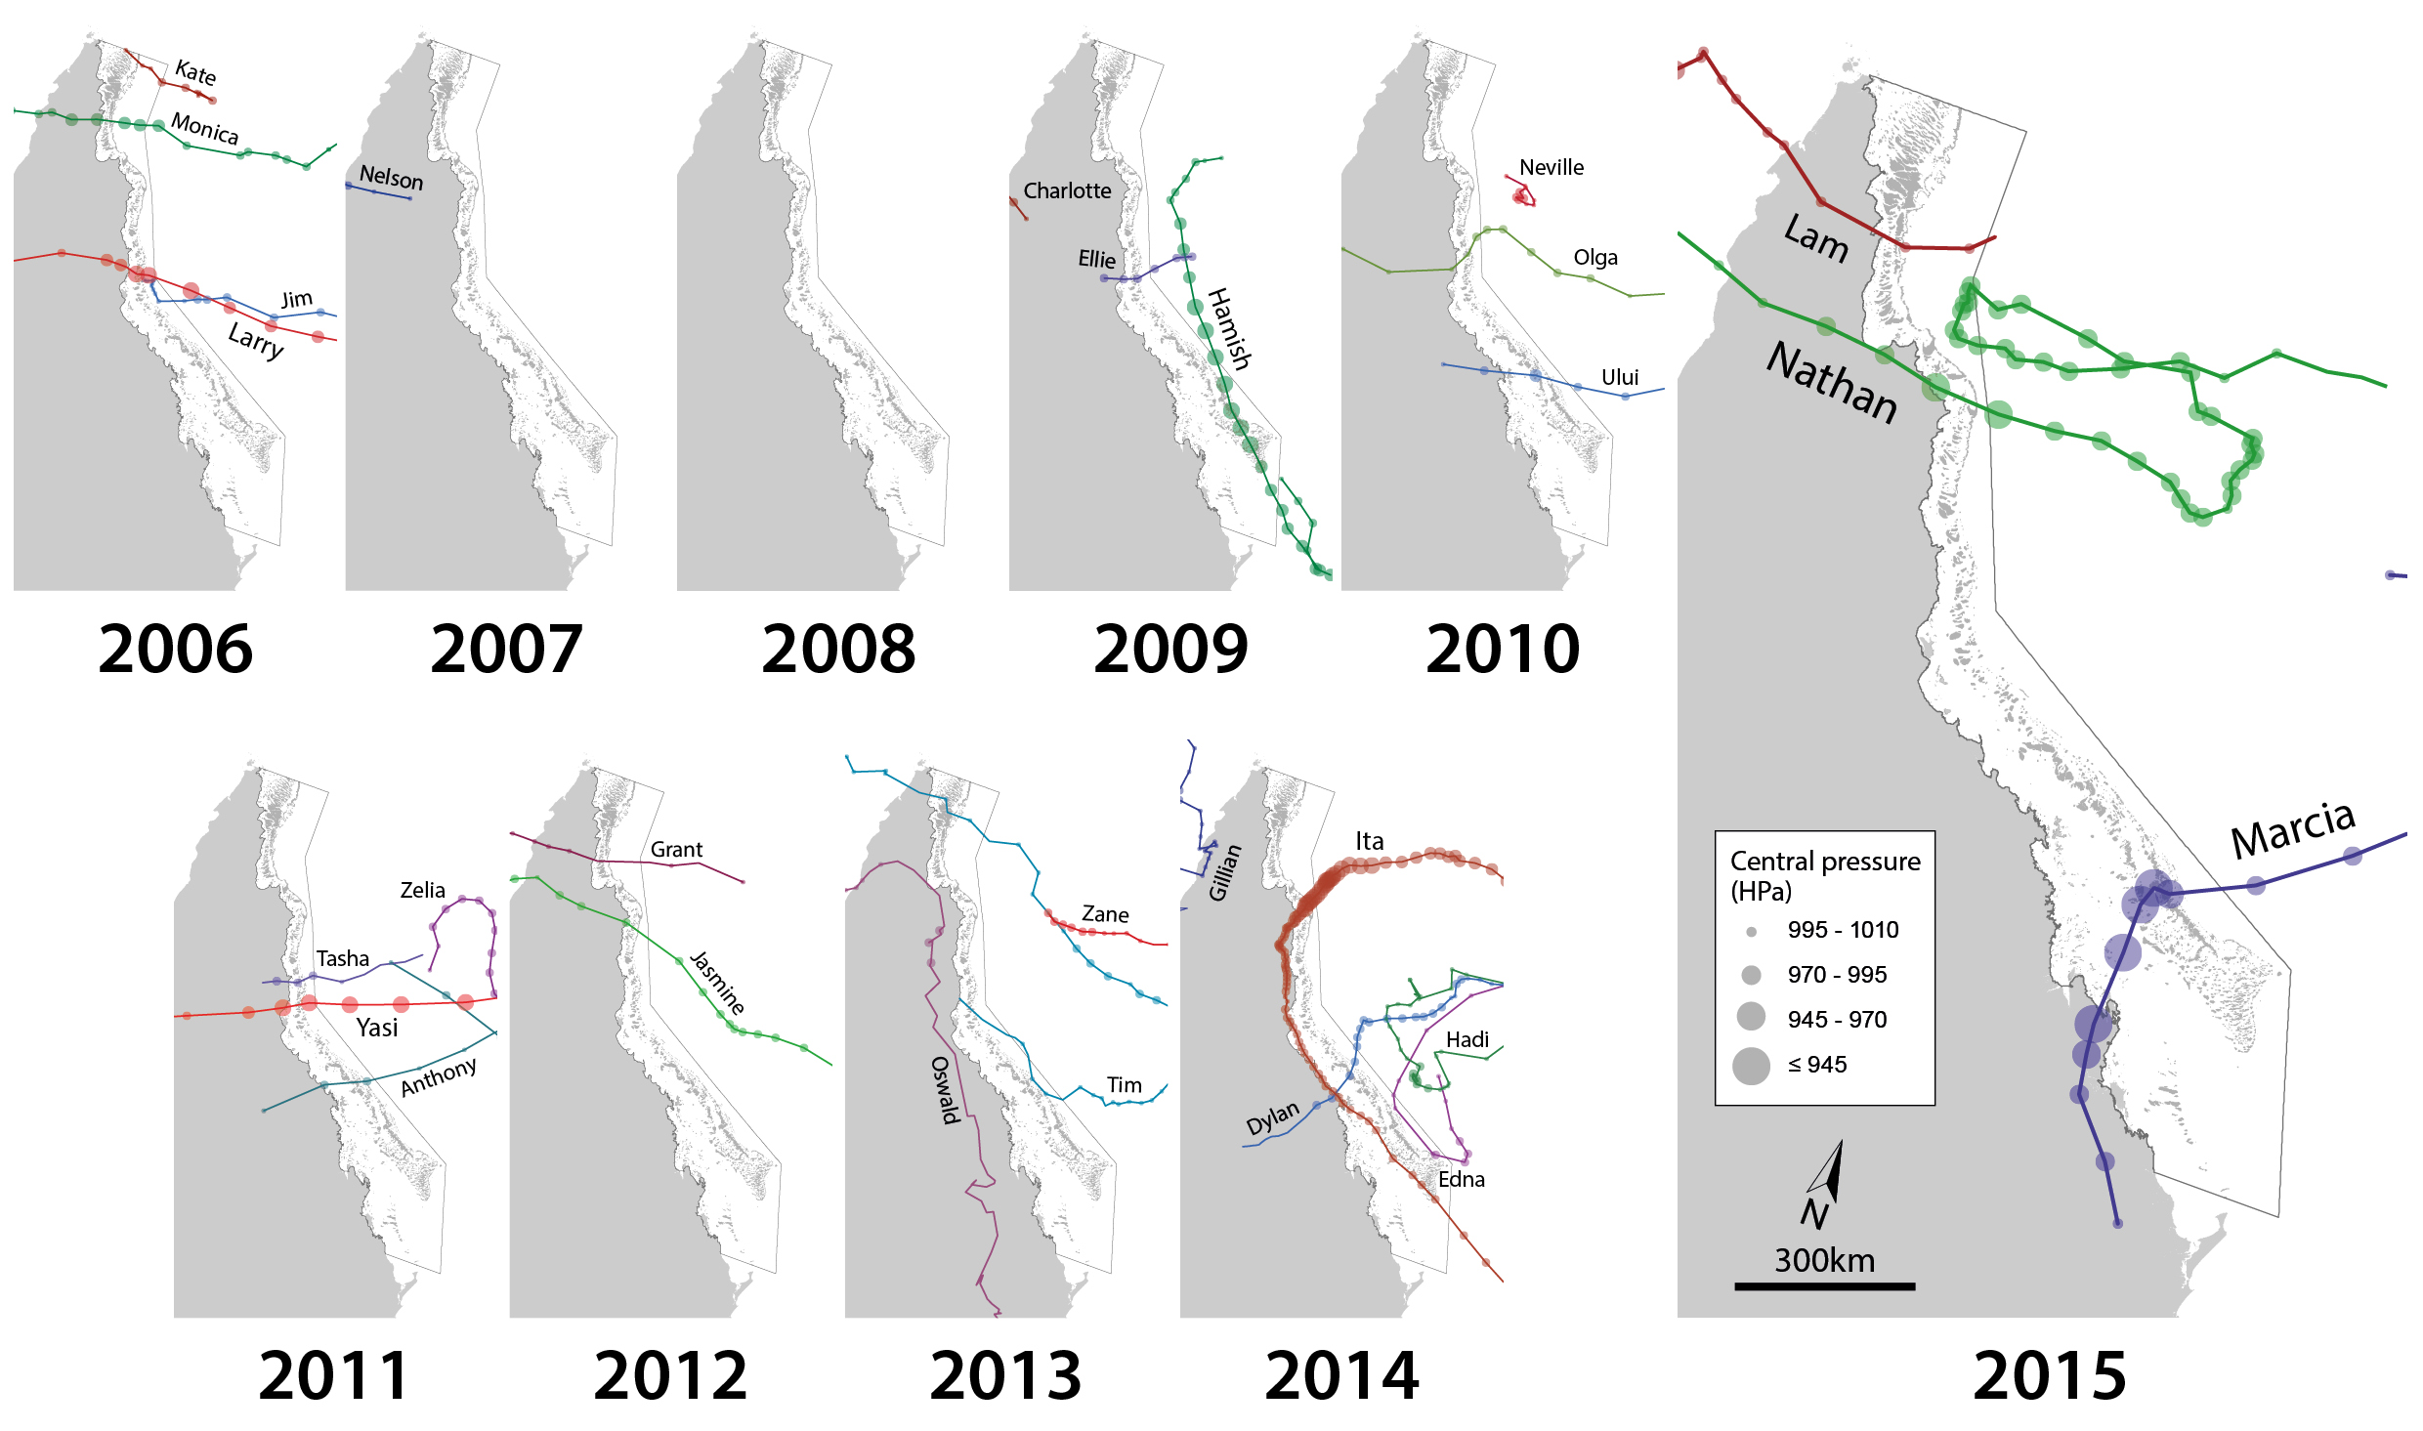
Figure 5-2: Trajectories of Tropical Cyclones affecting the Great Barrier Reef in 2014-15 and in previous years (2006 to 2014).

    - Rainfall
Annual rainfall across the central and northern GBR catchments was below average in 2014-15 with the greatest differences in the Wet Tropics catchments (Figure 5-3 and Figure 5-4, Table A2-1). The southern catchments typically had above average daily rainfall, most likely associated with Tropical Cyclone Marcia.

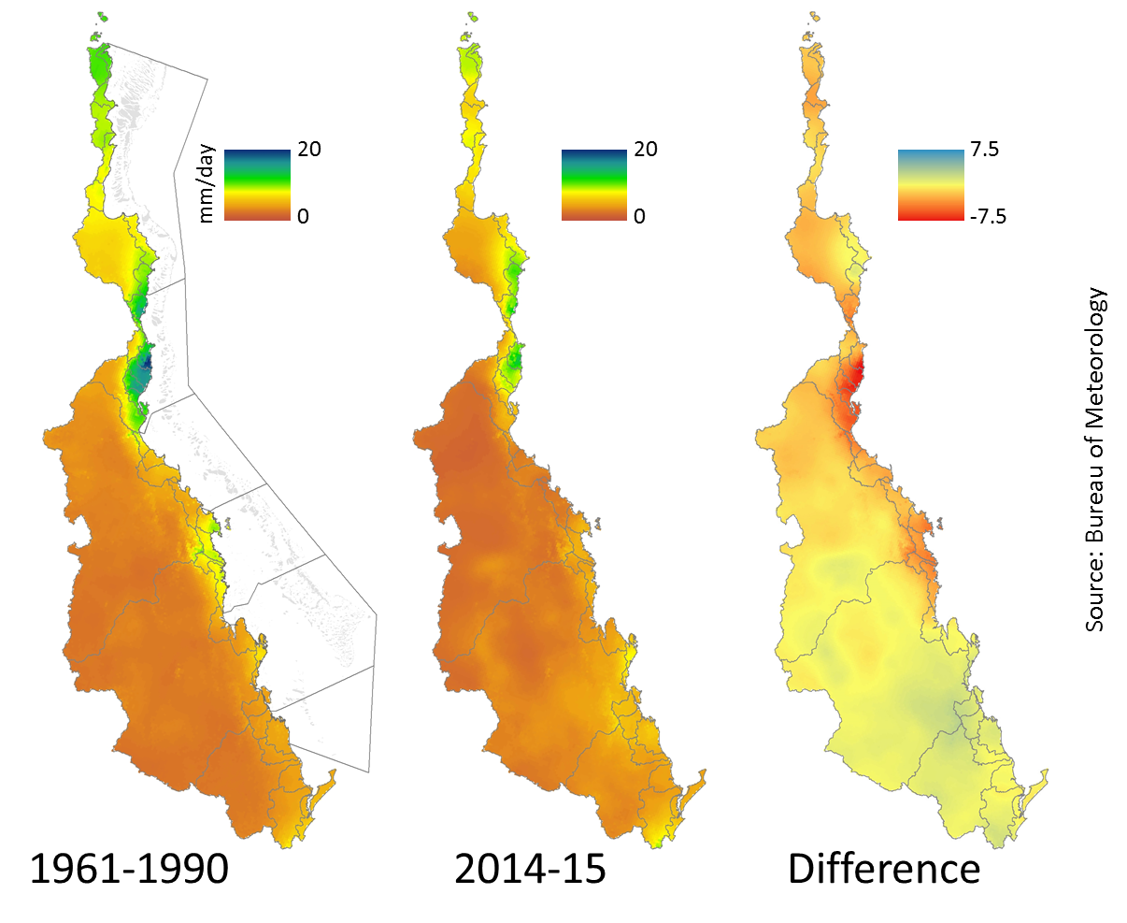
Figure 5-3: Average daily rainfall (mm/day) in the GBR catchment. a) long-term annual average (1961 – 1990), b) 2014-15, c) the difference between the long term and annual rainfall patterns.
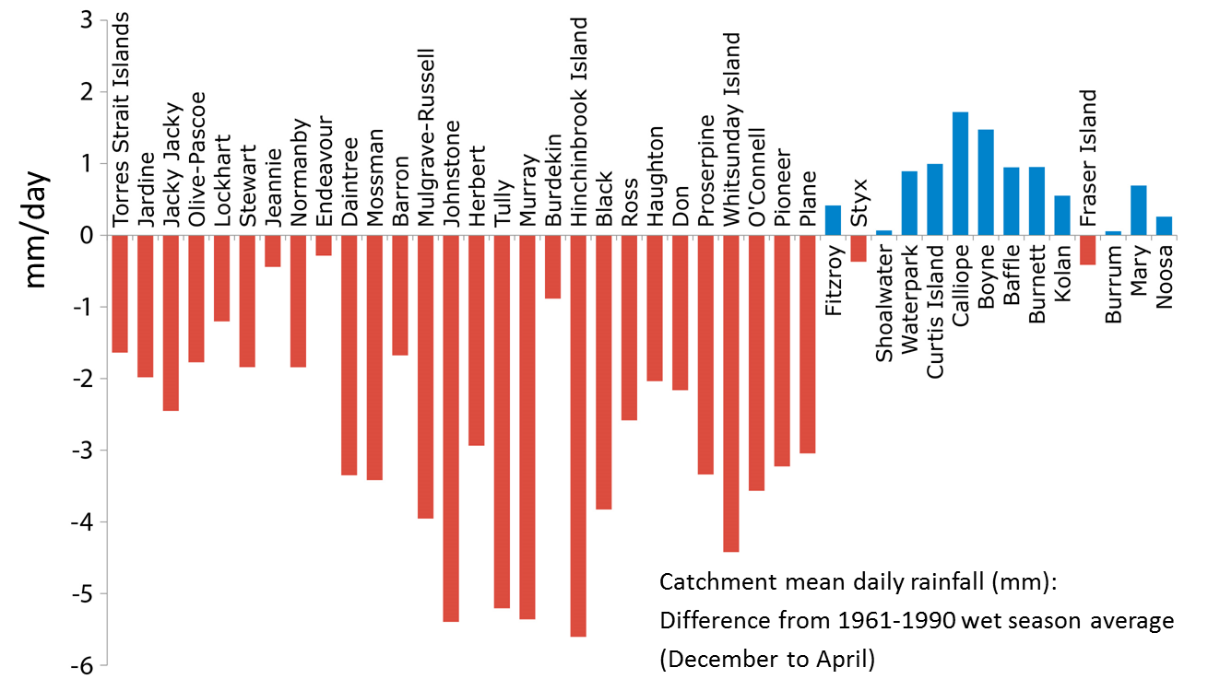
Figure 5-4: Annual average wet season rainfall (December 2014 - April 2015), as compared to the long-term wet season rainfall average (1961 – 1990). Red bars denote catchments with rainfall below the long-term average, blue above the long-term average.

    - Freshwater discharge
Wet season and annual (based on hydrological year) freshwater discharge for the major GBR catchments, relative to long term medians, are presented in Figure 5-5, Table 5-1 and in Appendix 2 (Table A2 3), and in Appendix 2 (Table A2-1). Wet season discharge for the main sampled catchments are included in Appendix 2 (Figures A2-1 to A2-3). Overall, the 2014-15 sampling period was characterised by a late wet season start (mid-January) and few moderate episodic flows, placing the 2014-15 wet season below the long-term median and ranked as the fourth smallest discharge (approximately 14×10⁶ ML) over the last 15 years. The total wet season flow from the GBR catchments (from approx. 1 November 2014 to 30 April 2015) was similar to the levels in the period between 2000 and 2007 (Figure 5-5).
However, river discharges above the long-term median occurred in the southern GBR, with the Burnett River recording a total wet season discharge of 723,081 ML, more than 3 times its long term median, and the Mary River had a total wet season discharge of 899,142 ML, between 1.5 and 2 times its long term median. All of the other major rivers had a total wet season discharge less than 1.5 times their long term median (Table 5-1).
The peak flows in the Russell-Mulgrave River were on 8 February 2015 (68,261 ML) and 12 March 2015 (49,647 ML). The Tully River had two major peak flows - 15 February 2015 (46,579 ML) and 11 March 2015 (66,291 ML). The Burdekin River had two peak flows on 14 December 2014 (19,559 ML) and 24 March 2015 (68,815 ML).
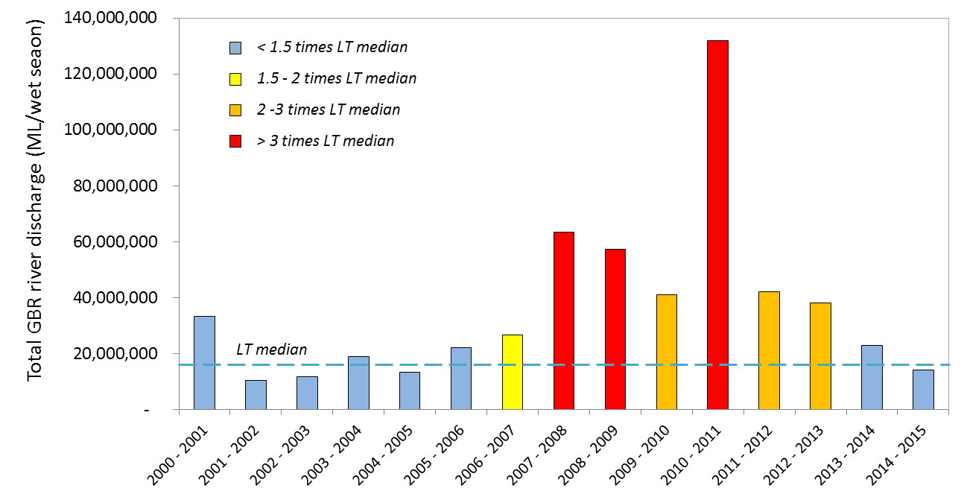
Figure 5-5: Long-term total discharge in million litres (ML) (hydrological year: 1 October to 30 September) for the 35 main GBR Rivers. Source: DNRM, http://watermonitoring.dnrm.qld.gov.au/host.htm.

Table 5-1: Wet season discharge (ML; million litres) of the main GBR rivers (c.a., November 2014 to April 2015, inclusive), compared against the previous four wet seasons and long-term (LT) median discharge (1970-2000). Colours indicate levels above the long-term median: yellow for 1.5 to 2 times; orange for 2 to 3 times, and red for greater than 3 times. Data source: DNRM. –, data not available.
NRM region | River | LT median | 2010 - 2011 | 2011 - 2012 | 2012 - 2013 | 2013 - 2014 | 2014 - 2015
Cape York | Pascoe | 1,142,458 | 1,877,760 | 691,628 | 770,637 | 1,484,349 | 563,039
Cape York | Stewart | 220,612 | 368,703 | 101,761 | 87,708 | 220,909 | 50,288
Cape York | Normanby | - | 5,862,830 | 1,090,140 | 1,776,332 | 2,484,483 | 1,489,203
Cape York | Annan | 219,963 | 485,961 | 266,446 | 129,570 | 194,612 | 246,939
Wet Tropics | Daintree | 556,590 | 1,429,899 | 744,055 | 501,552 | 1,457,002 | 584,369
Wet Tropics | Barron | 411,935 | 1,753,305 | 551,025 | 226,406 | 435,098 | 269,818
Wet Tropics | Mulgrave | 440,347 | 1,315,073 | 751,882 | 277,064 | 638,290 | 391,564
Wet Tropics | Russell | 632,309 | 1,293,058 | 815,652 | 413,715 | 876,330 | 381,250
Wet Tropics | North Johnstone | 1151907.908 | 2,881,043 | 1,327,523 | 697,401 | 1,415,172 | 718,749
Wet Tropics | South Johnstone | 558,969 | 1,305,473 | 627,572 | 321,335 | 530,425 | 224,138
Wet Tropics | Tully | 1,894,102 | 4,642,874 | 1,445,101 | 1,576,555 | 2,378,541 | 1,127,201
Wet Tropics | Herbert | 2,610,493 | 10,563,954 | 3,331,307 | 2,255,089 | 3,212,676 | 671,729
Burdekin | Burdekin | 4,669,849 | 33,885,815 | 14,333,639 | 3,110,624 | 1,162,570 | 619,369
Burdekin | Don | 51,062 | 785,986 | 197,426 | 151,384 | 85,851 | 46,247
Mackay Whitsunday | Proserpine | 14,770 | 336,045 | 47,309 | 31,284 | 2,481 | -
Mackay Whitsunday | O'Connell | 137,245 | 568,859 | 261,755 | 102,193 | 86,110 | 19,451
Mackay Whitsunday | Pioneer | 214,496 | 3,110,184 | 1,109,102 | 933,400 | 503,558 | 91,079
Mackay Whitsunday | Sandy | 111,143 | 608,377 | 342,215 | 244,717 | 88,778 | 29,229
Mackay Whitsunday | Carmila | 29,863 | 84,405 | 53,424 | 42,330 | 24,824 | 3,252
Fitzroy | Fitzroy | 2,691,509 | 35,886,042 | 6,479,801 | 8,307,530 | 1,501,365 | 2,667,055
Burnett-Mary | Burnett | 171,904 | 8,175,217 | 468,541 | 6,750,996 | 171,113 | 723,081
Burnett-Mary | Mary | 496,172 | 5,671,760 | 2,627,321 | 5,243,992 | 361,989 | 899,142
Notes for the river discharge data presented in Table 5-1:
Values were obtained from DNRM (http://watermonitoring.dnrm.qld.gov.au/host.htm); Values are in Megalitres per wet season (i.e., 1-Nov to 30-Apr) for each river gauge station.
Kalpower Crossing station (Normanby River) starts on the 9th of December, 2005, so no LT median is presented for this river.
Daily discharge for Euramo site (Tully River) from July, 2011 to November, 2012 and from October, 2014 to August, 2015 were estimated from Gorge station (Tully River) using:
Euramo discharge = Gorge discharge * 3.5941.
Daily discharge for Pioneer river now includes Miriani station, allowing flow record since 1977-11-09. Dumbleton and Miriani stations are correlated by the following equation:
Dumbleton discharge = Miriani discharge * 1.4276.
All data from the Ross gauge station, which ceased in 2007-08-01 with no substitute in the same river, was replaced by Bohle gauge station.
Boyne gauge station was ceased in 2012-06-30 with no substitute in the vicinities of the closed station.
Proserpine gauge station was ceased in 2014-06-03 with no substitute in the vicinities of the closed station.
Rocky Cr gauge station was ceased in 2014-11-19 with no substitute in the vicinities of the closed station.
Endeavour gauge station was ceased in 2015-05-10 with no substitute in the vicinities of the closed station.

Exposure of the GBR lagoon to river water
    - Zones of influence of individual rivers
Total cumulative exposure of shelf waters in the MMP focus regions during the 2014-2015 wet season were calculated using numerical tracer experiments within the eReefs hydrodynamic model, and are presented in the Regional Results for each of the MMP water quality focus regions. These tracer maps indicate the spatial extent of influence of individual rivers and confirm the patterns seen in the plume exposure maps derived from remote sensing imagery. The 2014-15 wet season was generally much drier and the river flow in most regions was close to or below the long-term median (see above, Section 5.2).
The results of the tracer simulations confirmed that the areas exposed to the water from individual rivers in 2014-15 were much smaller for all focus regions than during the extreme wet season of 2010-11. The tracer maps are useful in complementing the overall plume exposure maps as they allow quantification of the footprint of individual rivers, and the level of exposure to river water within this footprint. This information can be used to provide context for any changes in the local inshore water quality in the light of changes in the delivery of runoff from certain catchments. However, only the eReefs model will, in the future, allow for the full consideration of the loads of nutrients and suspended sediments from individual rivers in the interpretation of changes in inshore water quality.
    - River plume exposure and plume water type maps
The annual frequency maps predict the GBR marine areas affected by river plume waters as well as the spatial distribution and frequencies of occurrence of the three GBR plume water types (Primary, Secondary, and Tertiary) during the wet season 2014-15 (Figure 5-6, Figure 5-7). Note that this mapping exercise only identifies the surface river plume waters, plume water types, and is not identifying scale or extent of the impact across all GBR ecosystems.
The plume water type maps provide information on the type/composition of river plume (through the Primary, Secondary, and Tertiary water type classification) and on the frequency of occurrence (or likelihood) of these plume water types. The plume water types have further been classified into six categories (or colour classes) with classes 1 to 4 corresponding to Primary waters, class 5 to Secondary waters and class 6 to Tertiary waters. This classification allows a fine special scale characterisation of the plume water constituents. Thee maps illustrate a well-documented inshore to offshore spatial pattern (e.g., Devlin et al., 2015), with coastal areas experiencing the highest frequency of occurrence of Primary plume waters and offshore areas less frequently exposed to plume and, when exposed, more frequently reached by the Tertiary water type of river plumes.
A summary of water quality parameters in the six colour classes in 2014-15 is shown in Figure 5-8 and detailed characteristics are provided in Table A2-3. Most of key water quality parameters in both the long-term dataset (2003 to 2015) and in the reporting year 2014-15, including Kd(PAR, photosynthetic active radiation), TSS and DIN, followed published trends i.e., decreasing values from the Primary to the Tertiary plume water type.
While Devlin et al. (2012a) reported higher Chl-a concentration in the Secondary water type in comparison to the Primary water type, this wet season showed higher mean Chl-a concentrations in the Primary water type than in the Secondary water type, with mean values of about 2 μg L⁻¹ in the Primary water type (1.05 ± 0.54 μg L⁻¹) and 1 μg L⁻¹ in the Secondary (0.73 ± 0.54 μg L⁻¹). This wet season was characterised by low rainfall and consequent river discharge, resulting in river plumes that were not well developed, and therefore the sampling sites did not receive high riverine influence (colour class 1, near the river mouth) and also had low representation in colour classes 2 and 3 (Table A2-3). The standard deviations are high on these concentrations, particularly for the nutrients. The elevated chlorophyll-a concentrations measured in the Primary waters could be explained by the presence of freshwater phytoplankton or other vegetation detritus transported offshore by GBR rivers, or the time-lag between the in-situ chlorophyll-a measurements and satellite measurement (weekly composites), allowing settlement of the heaviest sediments (Bainbridge et al., 2012) and thus more light for productivity. Devlin et al. (2013) reported a peak of chlorophyll-a concentration in samples located in transition zones between the Primary and Secondary water types which would be driven by a reduction in both TSS and Kd(PAR) values as well as regular nutrients inputs. Regardless the few data sampled for chlorophyll-a this wet season, higher values were observed in colour class 3. Further analyses are required to validate this assumption.
The results for PSII herbicides were relatively low in 2014-15 and are shown for context for the Wet Tropics region only in Figure 5-8; only a small number of samples were available for the Burdekin region. Lewis et al. (2009) reported that the concentrations of PSII herbicides on the GBR typically exhibit a linear decline across the salinity gradient (i.e., from Primary to Tertiary water types, or from colour class 1 to 6). While Diuron values generally followed expected trends with mean Diuron concentrations in Primary and Secondary respectively of about 20 ng L⁻¹ and concentrations measured in tertiary plume waters of about 6 ng L⁻¹, there is high variability around the mean diuron concentration across the Primary water type (colour class 1 to 4, see Table A2-3). Full results of the pesticide sampling are presented in Gallen et al. (2016).

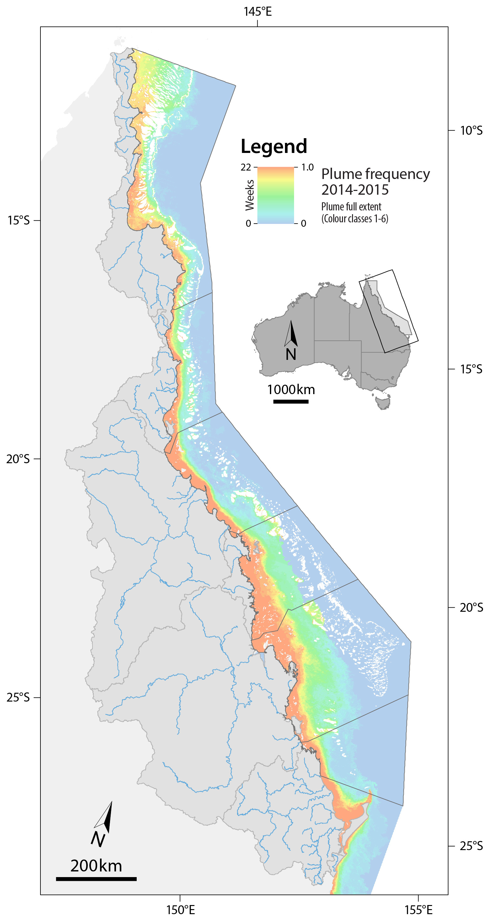
Figure 5-6: Map showing the frequency of river plumes in the 2014-15 wet season (22 weeks) of all colour classes (1 to 6), where the highest frequency is shown in orange, and the lowest frequency is shown in blue.
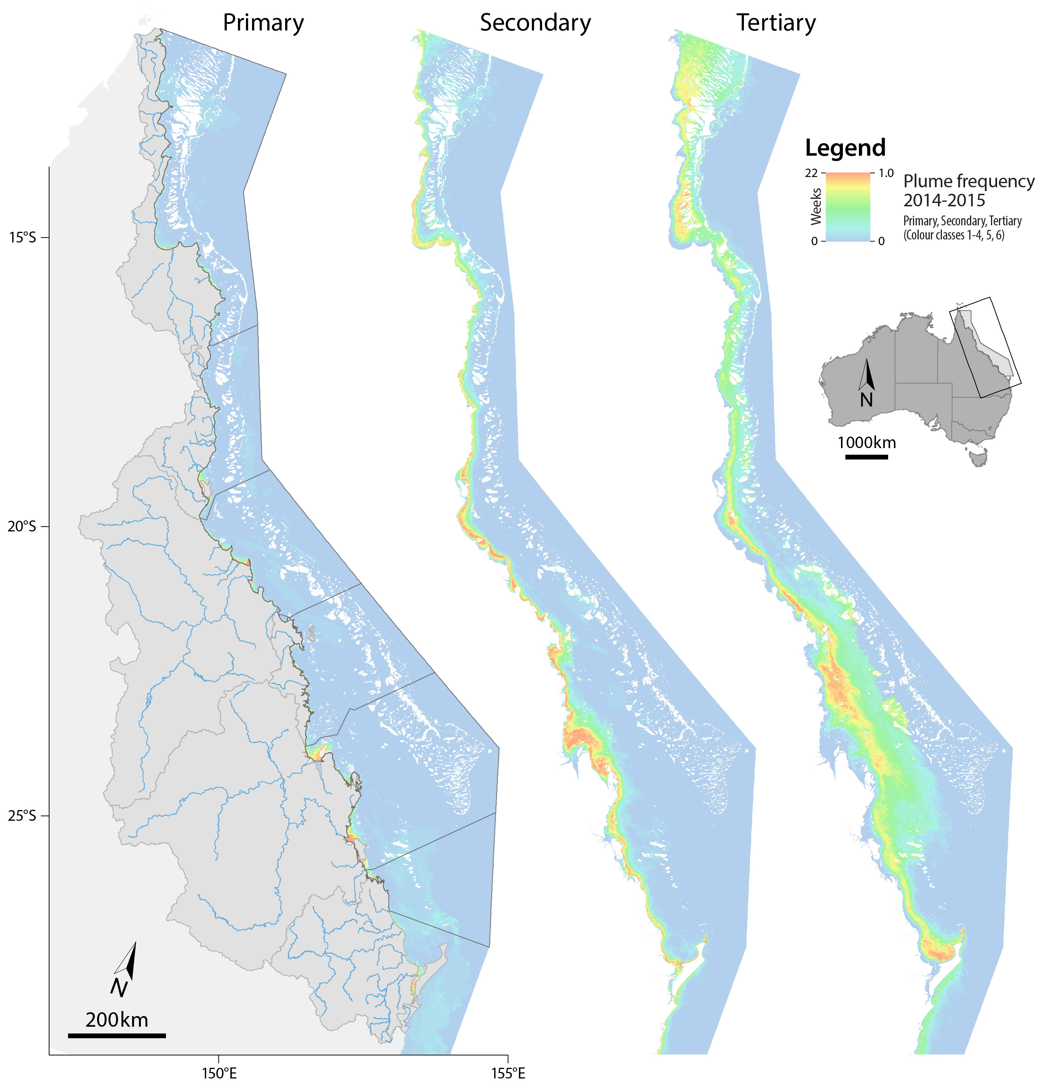
Figure 5-7: Map showing the frequency of Primary, Secondary and Tertiary plume water types in the 2014-15 wet season (22 weeks), where the highest frequency is shown in orange, and the lowest frequency is shown in blue.

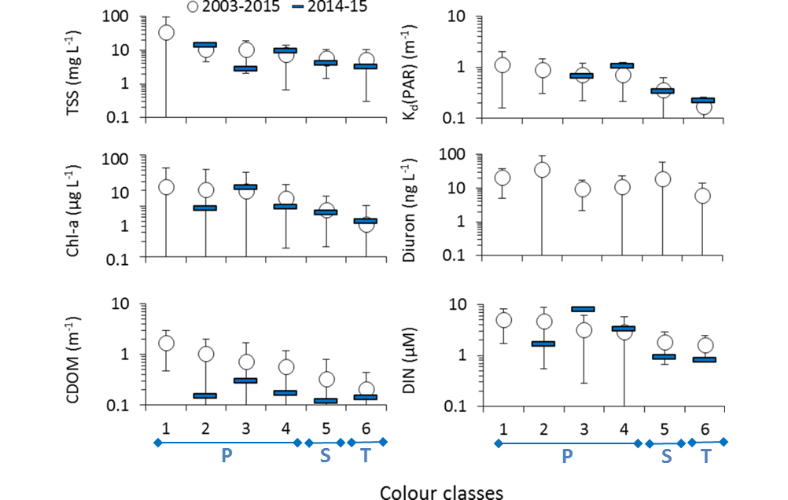
Figure 5-8: Mean water quality concentrations and standard deviation across the six colour classes and the corresponding water types (P: Primary; S: Secondary; T: Tertiary): comparison between the mean multi-annual values (2002-03 to 2014-15; circles with error bars) and the 2014-15 values (blue rectangles). Only data collected in the Wet Tropics is used in the Diuron plot due to the reduced number of PSII herbicide samples available for the Dry Tropics.

    - Level of potential risk to Great Barrier Reef ecosystems 2014-15
As described in Section 4.7, the river plume maps and plume water type maps can be overlaid with information on the presence or distribution of GBR ecosystems. This method can help identify ecosystems which may experience acute or chronic high exposure to contaminants in river plumes (exposure assessment) and thus, help to evaluate the susceptibility of GBR ecosystems to land-sourced contaminants. The framework to produce river plume risk maps for seagrass and coral ecosystems is based on a simplified risk matrix assuming that ecological responses will increase linearly with the pollutant concentrations and frequency of river plume exposure and was shown in Figure 4-3 and Figure 4-4.
Measuring the magnitude of the river plume risk to coral reefs and seagrass beds can be challenging because of the combination of different stressors in river plume waters, the difficulty in sampling a plume sufficiently to characterise it fully to assess its effects, and the inherent complexity of hydrodynamics in the region. Devlin et al. (2012b) underscored the need to develop risk models that incorporate the cumulative effects of pollutants. Detailed methods of how these figures are derived are included in Appendix A1.9. The actual risk is not validated against ecological health data and is at this stage theoretical. The lowest risk categories (I and II) are characterised by low frequency of the Primary and Secondary plume types, and the highest risk categories (III and IV) are characterised by high frequency of Primary and Secondary plume types.
It is important to note that: (i) Any results obtained in the Cape York NRM should be considered with care. Cape York is a shallow and optically complex environment where the true colour method hasn’t been fully validated; and (ii) Only surface areas inside the GBR marine boundaries are reported. It is also acknowledged that this assessment does not take into account current condition of GBR ecosystems, and long term impacts on these communities. For example, it is recognised that inshore communities may be adapted to plume type and exposure history, so the highest risk of an ecological response could be during large events when Primary/Secondary waters extend into otherwise low risk (Tertiary) areas. In the future, these maps could be presented in the context of a longer term mean or median result, and present the current year in context of likely impacts, i.e., the predicted impacts are proportional to the deviation from the mean when past some biological threshold.
Coastal areas have the highest frequency of occurrence of Primary plume waters (see section 5.3.1) and thus coastal ecosystems are most potentially exposed to the highest risk categories (category III and IV). Inversely, offshore areas are less frequently exposed to plume waters and, when exposed, are more likely reached by the Tertiary plume water type. Thus, offshore ecosystems are most potentially exposed to lower river plume risk categories. Inshore ecosystems are located in transitional zones seeing an alternation of plume water types and frequencies depending on the wet season characteristics.
Figure 5-9 presents the potential river plume risk map of the 2014-15 wet season, showing that the GBR lagoon was most exposed to the lowest categories of potential river plume risk (category I and II). Approximately 53% of the total area of the GBR was exposed to surface river plume waters, with only 7% exposed to the higher risk categories (category III and IV) (Table 5-2). The proportion of each NRM region exposed to river plumes ranged from 37% in the Burnett Mary region to 58% in Cape York (note low confidence) and 50% in the Fitzroy region. However, the proportion of the regions in the highest potential risk categories (III and IV) were much lower with 2% of the Burnett Mary region, 5% of Cape York and 8% of the Cape York region.
Figure 5-9: Map of potential risk from GBR river plumes in 2014-15, where class I is the lowest potential risk (blue) and class IV is the highest potential risk (dark red). Risk categories are defined as a combination of the plume frequency (5 categories: 0-0.2, 0.2-0.4, 0.4-0.6, 0.6-0.8, 0.8-1.0) and plume water type (3 categories: Primary, Secondary and Tertiary) as presented in Figure 5-7 and Figure 5-8.

Table 5-2: Areas (km²) and percentage (%) of the GBR lagoon exposed to different categories of surface river plume frequency and river plume-related risk within the GBR and each NRM. Surface areas south of the GBR Marine Park boundary (Hervey Bay) are not included.
NRM |  | Total | Risk category |  |  |  | Total exposed | Total non exposed
 |  | Total | I | II | III | IV | Total exposed | Total non exposed
GBR | area | 348,753 | 69,788 | 90,232 | 21,352 | 2,296 | 183,669 | 165,084
GBR | % | 100% | 20% | 26% | 6% | 1% | 53% | 47%
Cape York | area | 96,316 | 23,219 | 27,258 | 4,771 | 207 | 55,455 | 40,861
Cape York | % | 100% | 24% | 28% | 5% | 0% | 58% | 42%
Wet Tropics | area | 31,949 | 12,355 | 4,730 | 2,927 | 211 | 20,223 | 11,726
Wet Tropics | % | 100% | 39% | 15% | 9% | 1% | 63% | 37%
Burdekin | area | 46,967 | 12,213 | 9,325 | 2,934 | 391 | 24,863 | 22,104
Burdekin | % | 100% | 26% | 20% | 6% | 1% | 53% | 47%
Mackay Whitsunday | area | 48,949 | 6,320 | 15,629 | 4,047 | 207 | 26,203 | 22,746
Mackay Whitsunday | % | 100% | 13% | 32% | 8% | 0% | 54% | 46%
Fitzroy | area | 86,860 | 15,681 | 20,230 | 5,932 | 1,221 | 43,064 | 43,796
Fitzroy | % | 100% | 18% | 23% | 7% | 1% | 50% | 50%
Burnett Mary | area | 37,712 | 0 | 13,060 | 741 | 60 | 13,861 | 23,851
Burnett Mary | % | 100% | 0% | 35% | 2% | 0% | 37% | 63%
Table 5-3 presents the areas (km²) and percentage (%) of coral reefs exposed to different categories of potential river plume risk within each NRM, exhibiting a wide range of exposure (areas, % and categories of risk). In 2014-15, it was estimated that 62% of GBR coral reefs were exposed to the lowest categories of potential river plume risk (I and II) and only a very small area of reefs (<1% of the area) were in the highest risk category (class IV). The assessment indicates that only coral reefs in the Mackay Whitsunday and Fitzroy regions were potentially exposed to category III risk from river plume exposure, however these areas were also small (3%).
Table 5-3: Areas (km²) and percentage (%) of the coral reefs exposed to different categories of surface river plume frequency and river plume-related risk within the GBR and each NRM region. Surface areas south of the GBR marine park boundary (Hervey Bay) are not included.
Coral reefs |  | Total | Risk category |  |  |  | Total exposed | Total non exposed
 |  | Total | I | II | III | IV | Total exposed | Total non exposed
GBR | area | 24,075 | 9,769 | 4,594 | 416 | 34 | 14,813 | 9,262
GBR | % | 100% | 41% | 19% | 2% | 0% | 62% | 38%
Cape York | area | 10,332 | 6,174 | 3,410 | 128 | 2 | 9,714 | 618
Cape York | % | 100% | 60% | 33% | 1% | 0% | 94% | 6%
Wet Tropics | area | 2,418 | 1,731 | 23 | 36 | 0 | 1,790 | 628
Wet Tropics | % | 100% | 72% | 1% | 2% | 0% | 74% | 26%
Burdekin | area | 2,966 | 995 | 222 | 23 | 0 | 1,239 | 1,727
Burdekin | % | 100% | 34% | 7% | 1% | 0% | 42% | 58%
Mackay Whitsunday | area | 3,196 | 388 | 263 | 99 | 0 | 751 | 2,445
Mackay Whitsunday | % | 100% | 12% | 8% | 3% | 0% | 23% | 77%
Fitzroy | area | 4,880 | 482 | 396 | 124 | 32 | 1,034 | 3,846
Fitzroy | % | 100% | 10% | 8% | 3% | 1% | 21% | 79%
Burnett Mary | area | 284 | 0 | 280 | 4 | 0 | 284 | 0
Burnett Mary | % | 100% | 0% | 98% | 2% | 0% | 100% | 0%
Table 5-4 presents the areas (km²) and percentage (%) of seagrass beds (surveyed, deep-water modelled and total (surveyed + deep-water modelled) exposed to different categories of potential river plume risk within each NRM, exhibiting a wide range of exposure (areas, % and categories of risk). In 2014-15 GBR surveyed seagrass beds were mostly exposed to the medium categories of potential river plume risk (categories II and III). Exposure categories for deep-water modelled seagrass were more variable but were predominantly exposed to the lowest categories of potential river plume risk (I and II).
It is estimated that 97% of the GBR surveyed seagrasses were exposed to surface river plumes, with most of them in the potential risk categories II and III from the river plume exposure. The largest areas of coastal seagrasses exposed to river plumes were located in the Cape York (97% but note low confidence), Burdekin (97%) and Fitzroy (95%) regions. Excluding the Cape York region, surveyed seagrasses of the Burdekin and Fitzroy regions had the highest potential risk from river plume exposure 83% and 95 % respectively).
For deep-water modelled seagrass, 94% were exposed to surface river plumes, with most of them (92%) in the lowest potential risk categories (I and II). In all NRM regions, 90 to 100% of deep-water modelled seagrass areas were exposed to river plumes, except in the Burdekin where the proportion of meadows exposed was about 74%. Note that seagrass meadows in Hervey Bay (outside of the GBR southern boundary) were not included in the risk analysis. There were no deep-water modelled seagrass in the highest risk category, and a relatively small proportion was in the potential risk category III in the Fitzroy and Mackay Whitsunday regions (5% and 13% respectively).
The assessment of the total seagrass area (see Table 5-4) indicates that while 94% of the seagrasses were potentially exposed to surface river plumes, a majority of these were in the lowest risk categories (I and II).
Table 5-4: Areas (km²) and percentage (%) of surveyed, deepwater modelled and total (surveyed plus deepwater modelled) seagrass exposed to different categories of surface river plume frequency and river plume-related risk within the GBR and each NRM region. Surface areas south of the GBR Marine Park boundary (Hervey Bay) are not included.
Total seagrass |  | Total | Risk category |  |  |  | Total exposed | Total non exposed
 |  | Total | I | II | III | IV | Total exposed | Total non exposed
GBR | area | 3,814 | 246 | 1,031 | 2,029 | 379 | 3,684 | 130
GBR | % | 100% | 6% | 27% | 53% | 10% | 97% | 3%
Cape York | area | 2,438 | 245 | 861 | 1,173 | 98 | 2,377 | 61
Cape York | % | 100% | 10% | 35% | 48% | 4% | 97% | 3%
Wet Tropics | area | 204 | 1 | 2 | 142 | 44 | 190 | 14
Wet Tropics | % | 100% | 1% | 1% | 70% | 22% | 93% | 7%
Burdekin | area | 621 | 0 | 92 | 409 | 105 | 605 | 16
Burdekin | % | 100% | 0% | 15% | 66% | 17% | 97% | 3%
Mackay Whitsunday | area | 231 | 0 | 76 | 102 | 33 | 211 | 20
Mackay Whitsunday | % | 100% | 0% | 33% | 44% | 14% | 91% | 9%
Fitzroy | area | 247 | 0 | 0 | 150 | 85 | 235 | 12
Fitzroy | % | 100% | 0% | 0% | 61% | 34% | 95% | 5%
Burnett-Mary | area | 74 | 0 | 1 | 52 | 14 | 66 | 8
Burnett-Mary | % | 100% | 0% | 1% | 70% | 19% | 90% | 10%

Table 5-4 continued…
Offshore seagrass |  | Total | Risk category |  |  |  | Total exposed | Total non exposed
 |  | Total | I | II | III | IV | Total exposed | Total non exposed
GBR | area | 31,632 | 12,121 | 17,162 | 387 | 0 | 29,669 | 1,963
GBR | % | 100% | 38% | 54% | 1% | 0% | 94% | 6%
Cape York | area | 9,459 | 3,270 | 5,973 | 49 | 0 | 9,292 | 167
Cape York | % | 100% | 35% | 63% | 1% | 0% | 98% | 2%
Wet Tropics | area | 4,661 | 2,891 | 1,421 | 14 | 0 | 4,326 | 335
Wet Tropics | % | 100% | 62% | 30% | 0% | 0% | 93% | 7%
Burdekin | area | 5,459 | 2,858 | 1,157 | 0 | 0 | 4,016 | 1,443
Burdekin | % | 100% | 52% | 21% | 0% | 0% | 74% | 26%
Mackay-Whitsundays | area | 220 | 0 | 192 | 28 | 0 | 220 | 0
Mackay-Whitsundays | % | 100% | 0% | 87% | 13% | 0% | 100% | 0%
Fitzroy | area | 5,560 | 3,101 | 2,175 | 281 | 0 | 5,557 | 3
Fitzroy | % | 100% | 56% | 39% | 5% | 0% | 100% | 0%
Burnett-Mary | area | 6,301 | 0 | 6,242 | 15 | 0 | 6,257 | 44
Burnett-Mary | % | 100% | 0% | 99% | 0% | 0% | 99% | 1%
Total seagrass |  | Total | Risk category |  |  |  | Total exposed | Total non exposed
 |  | Total | I | II | III | IV | Total exposed | Total non exposed
GBR | area | 35,447 | 12,367 | 18,193 | 2,415 | 379 | 33,354 | 2,093
GBR | % | 100% | 35% | 51% | 7% | 1% | 94% | 6%
Cape York | area | 11,896 | 3,515 | 6,834 | 1,222 | 98 | 11,669 | 227
Cape York | % | 100% | 30% | 57% | 10% | 1% | 98% | 2%
Wet Tropics | area | 4,865 | 2,893 | 1,423 | 156 | 44 | 4,516 | 349
Wet Tropics | % | 100% | 59% | 29% | 3% | 1% | 93% | 7%
Burdekin | area | 6,066 | 2,858 | 1,249 | 409 | 105 | 4,621 | 1,445
Burdekin | % | 100% | 47% | 21% | 7% | 2% | 76% | 24%
Mackay-Whitsundays | area | 451 | 0 | 270 | 130 | 33 | 433 | 18
Mackay-Whitsundays | % | 100% | 0% | 60% | 29% | 7% | 96% | 4%
Fitzroy | area | 5,801 | 3,101 | 2,175 | 432 | 85 | 5,792 | 9
Fitzroy | % | 100% | 53% | 37% | 7% | 1% | 100% | 0%
Burnett-Mary | area | 6,374 | 0 | 6,242 | 67 | 14 | 6,323 | 51
Burnett-Mary | % | 100% | 0% | 98% | 1% | 0% | 99% | 1%

    - Loading maps for dissolved inorganic nitrogen, particulate nitrogen and sediment
This section presents the results for the loading maps for DIN, PN and sediment (evaluated as TSS) in plume waters. A detailed description of the methodology and loading maps, their potential uses and limitations are presented in Appendix A1.10.
- Mapping annual DIN concentration in the GBR 2003-2015
The model-predicted DIN export to GBR lagoon is examined by its annual concentration (DIN, µg/L) over 13 years (Figure 5-10 and Figure 5-11). These maps provide an estimate of how far DIN can travel in GBR waters, and the areas more likely to have higher DIN concentration. The areas covered by model-predicted DIN vary over the 13 years analysed. Overall, years with very large river discharge (> 65,000,000 ML), which occurred in 2008, 2009 and 2011, resulted in larger areas of DIN transport and exposure across the GBR. This is in agreement with previous observations about plumes in the GBR, where larger river discharge leads to larger extent of river plumes (e.g., Álvarez-Romero et al., 2013; Brodie et al., 2012; Devlin et al., 2012a, 2012b).
Although the number of contributing rivers did not change over the modelled years, the extent of land-sourced DIN influence was greater in the Wet Tropics and Burdekin NRM regions compared to the Mackay-Whitsunday and Fitzroy regions (note that river loads from the Cape York and Burnett-Mary NRM regions were not included in the model). Similar trends have been observed on the distribution and movement of other land-sourced pollutants and they were attributed to rainfall and land uses differences (Devlin et al., 2012b, 2013).
The highest model-predicted DIN concentration was observed in 2011, followed by 2012 and 2009, with maximums of 268 µg/L, 197 µg/L and 172 µg/L, respectively. The areas presenting higher DIN concentration were relatively constant over the years, with higher DIN values observed in the Wet Tropics and Mackay-Whitsunday NRM regions than the other regions. Even though the Burdekin River is responsible on average for > 36% of the DIN load accounted in the model, it is also responsible for 60% of the total discharge. The large Burdekin River discharge results in large plumes and consequently, relatively low DIN concentrations. The Wet Tropics NRM region is characterised by large areas of cropping lands (predominately sugarcane) in the coastal areas, and the Johnstone and Tully catchments together possess more than 80% of the total banana crop and 27% of the sugarcane plantation in this region (Waterhouse et al., 2014).
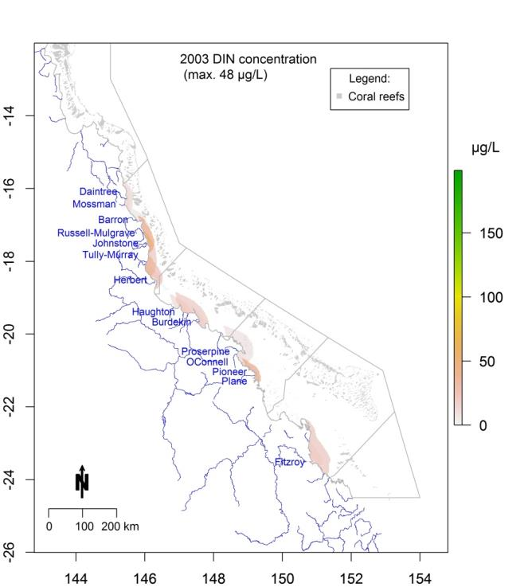
Figure 5-10: Dissolved inorganic nitrogen (DIN, µg/L) concentration in the GBR lagoon 2003 water year (c.a., 1 October to 30 September). ‘Max.’ stands for the highest DIN concentration. Named rivers are those with load data available and grey lines are the NRM region boundaries.

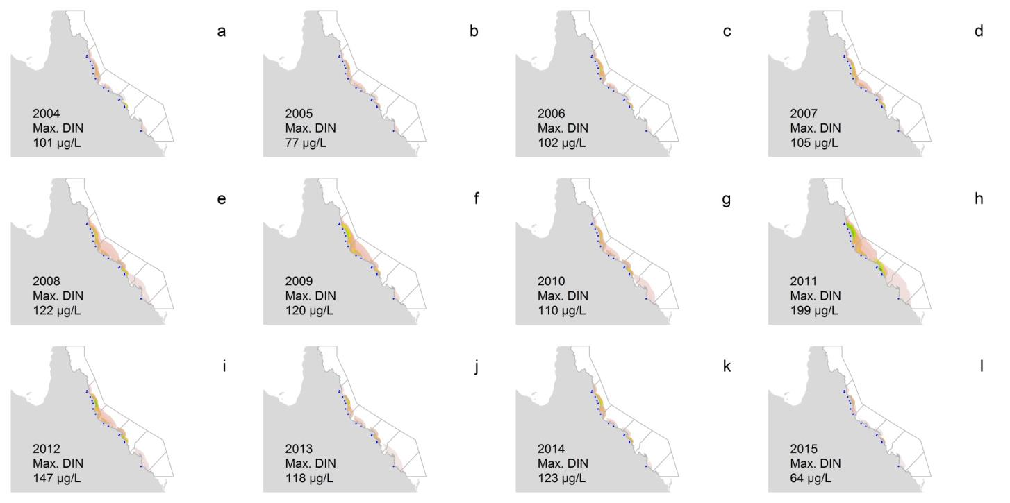
Figure 5-11: Dissolved inorganic nitrogen (DIN, µg/L) over the GBR lagoon 2004-2015 water years (c.a., 1 October to 30 September). ‘Max.’ stands for the highest DIN concentration. Dots represent rivers with load data available and grey lines are the NRM region boundaries.

The preferential northward movement of the river plumes can result in increased model-predicted DIN concentration in areas that may not directly receive high DIN loads from their catchments. The contribution of DIN from rivers to the waters of each NRM region was determined by the amount of DIN exported from each river that reaches a particular NRM region, divided by the total amount of DIN in that region. Two periods were considered- the 2002-03 and 2010-11 water years (Figure 5-12), which represent the two extreme years of DIN loads discharged into the GBR lagoon over the 13 years analysed (3,029 tonnes and 29,958 tonnes, respectively). If a river presents a DIN contribution of 100% to a particular NRM region, which is the case for the Fitzroy River (Figure 5-12g and Figure 5-12h), this means that no other river included in the model contributes DIN to that NRM region.
Overall, rivers located within a marine NRM region were the main contributors to the presence of DIN in its waters, although this varied between years. For example, of the total DIN mass in the Burdekin NRM waters in 2002-03 (c.a., 589 tonnes), 76% came from the Burdekin River and 14% from the Haughton River, the two main rivers of the NRM region, and 6% from the Herbert River, 4% from the Proserpine River and <1% from the O'Connell River. In the 2010-11 season, the Burdekin River contributed 27% of the DIN in the Wet Tropics region due to the large Burdekin River discharge/plume (Figure 5-12b). Similar patterns occurred in the Mackay Whitsunday region when in 2010-11 16% of DIN in its waters was derived from the Fitzroy River. Conversely in 2002-03, the Fitzroy River had no DIN contribution to Mackay Whitsunday region.
These results indicate that the northward plume transport has the potential to increase the DIN load impact into zones outside of the NRM region. For example, the contribution of DIN loadings from the Burdekin River combined with the high DIN concentrations from the Wet Tropic rivers is in agreement with the supporting theories of land-based eutrophication as a potential trigger for crown-of-thorns starfish outbreaks (Brodie et al., 2005; Wooldridge 2009; Uthicke et al., 2015; Wooldridge 2009; Wooldridge et al., 2015).

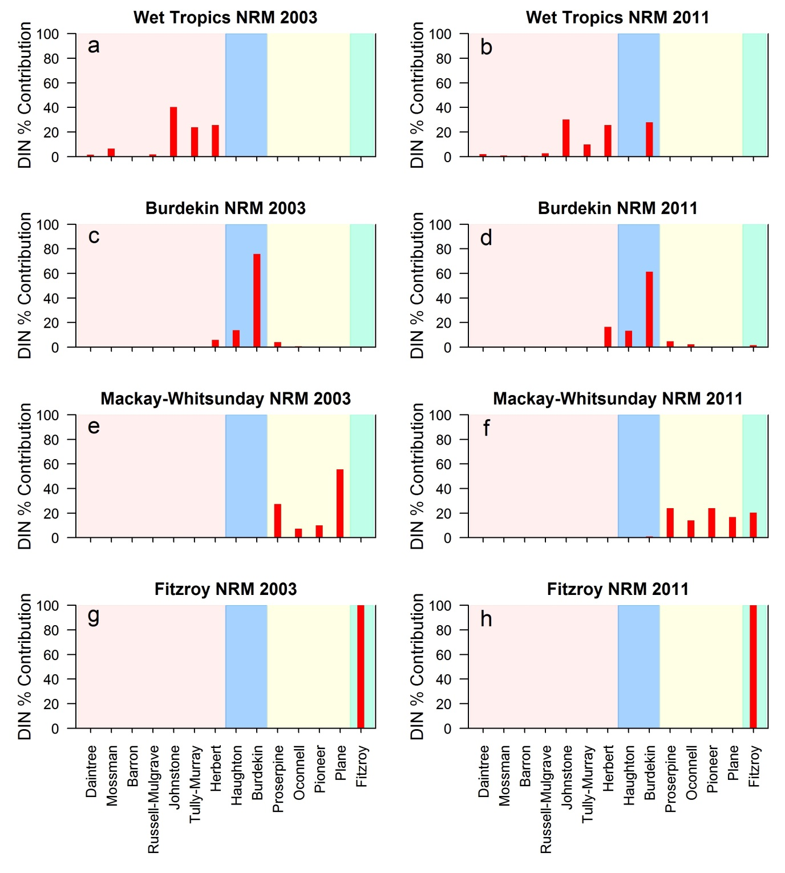
Figure 5-12: River contributions (x-axis) to the dissolved inorganic nitrogen mass to four marine NRM regions (plot head name) in 2003 (left column) and 2011 (right column). Shading groups rivers in the same NRM region: Wet Tropics - red, Burdekin - blue, Mackay-Whitsunday – yellow, Fitzroy - green. The left panel show data for the 2002-03 water year (c.a., from 1 Oct to 30 Sep), and right panel for the 2010-11 water year.

- Mapping annual average PN and TSS concentrations in the GBR 2003-2015
The same model developed for DIN dispersion was used to produce maps for the land-sourced PN and TSS in the GBR, except that the decay function was not included.
The model-predicted PN export to GBR lagoon is examined by its annual concentration (PN, µg/L) over 13 years (Figure 5-13 and Figure 5-14). These maps provide an estimate of how far PN can travel in GBR waters, and areas more likely to present high PN concentration. The areas covered by model-predicted PN vary over the 13 years analysed. As observed for DIN, years with large river discharge (> 65,000,000 ML) resulted in larger areas of PN extended across the GBR. The highest model-predicted PN concentration was observed in 2011, followed by 2008 and 2012, with maximums of 354 µg/L, 261 µg/L and 244 µg/L, respectively. The areas showing high PN concentration were relatively constant over the years, with high PN values observed in the Wet Tropics region. During years with large flows high PN areas high concentrations were also observed in the Burdekin and Mackay Whitsunday regions.
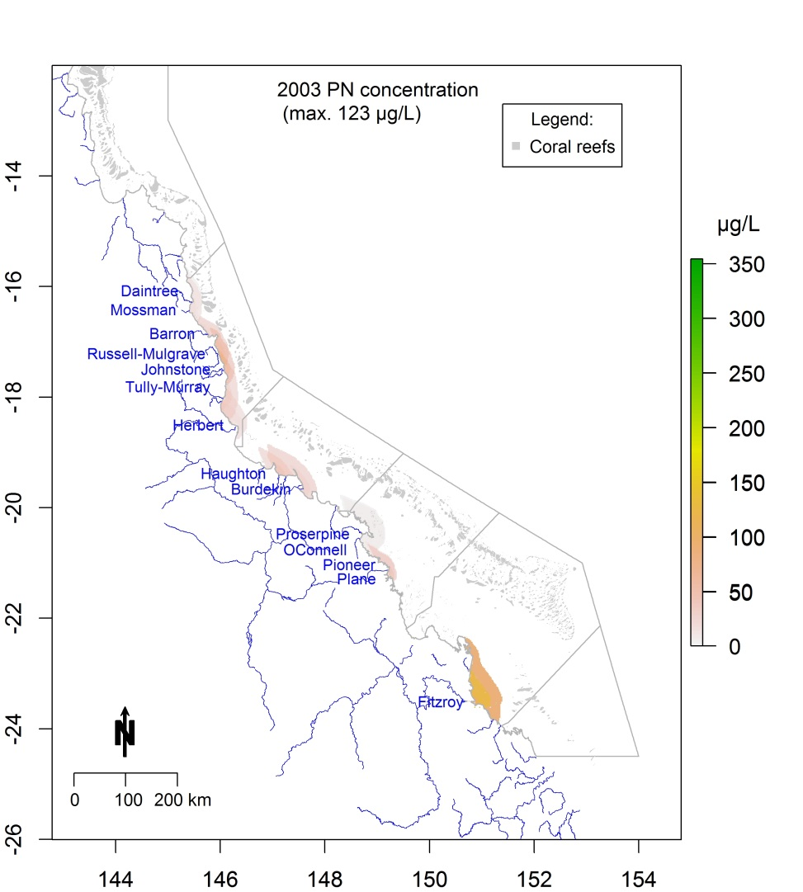

Figure 5-13: Particulate nitrogen (PN, µg/L) over the GBR lagoon 2003 water year (c.a., 1 October to 30 September). ‘Max.’ stands for the highest PN concentration. Named rivers are those with load data available and grey lines are the NRM region boundaries.

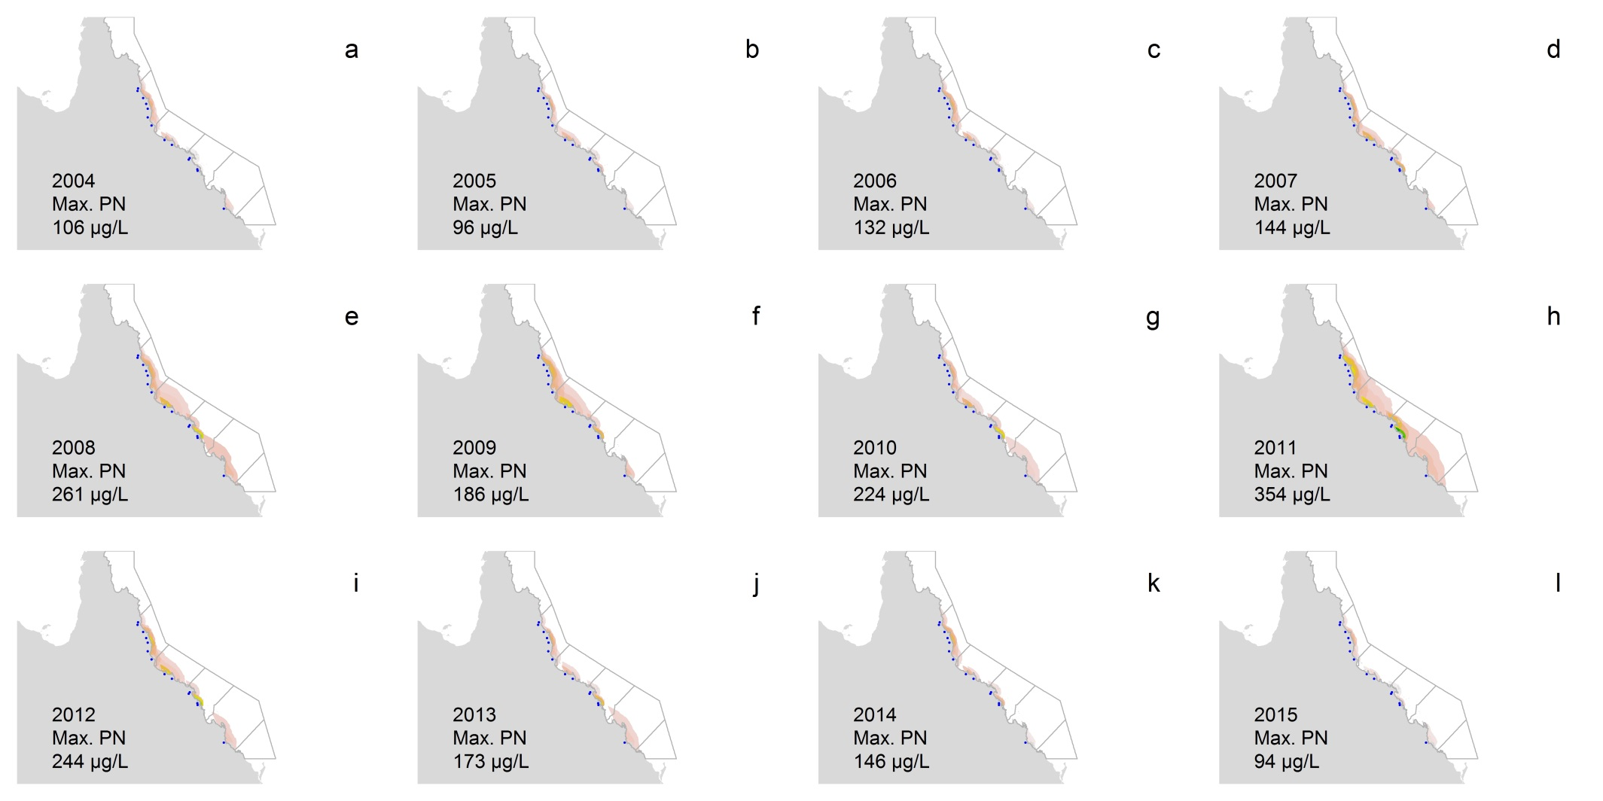
Figure 5-14: Particulate nitrogen (PN, µg/L) over the GBR lagoon 2004-2015 water year (c.a., 1 October to 30 September). ‘Max.’ stands for the highest PN concentration. Dots represent rivers with load data available and grey lines are the NRM region boundaries.

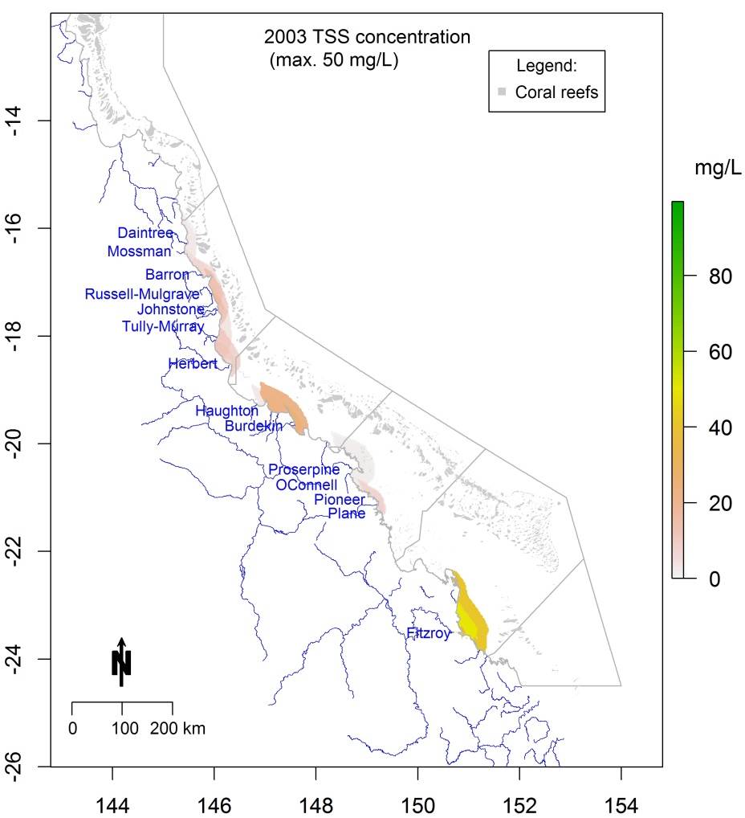
The model-predicted TSS export to the GBR lagoon was examined by its annual concentration over 13 years (
Figure 5-15) with similar patterns as observed for DIN and PN in relation to river discharge. The highest model-predicted TSS concentration was observed in 2011, followed by 2007 and 2008, with maximums of 100 mg/L, 84 mg/L and 78 mg/L, respectively. The areas with high TSS concentration were more variable over the years compared to the DIN and PN assessments. High TSS values were observed in the Wet Tropics region over all of the years analysed, but high values were also observed in the Burdekin region in several years including 2005, 2007 and 2013, and in Mackay Whitsunday in 2010, 2011 and 2012 (Figure 5-16).

Figure 5-15: Total suspended solids (TSS, mg/L) over the GBR lagoon 2003 water year (c.a., 1 October to 30 September). ‘Max.’ stands for the highest TSS concentration. Named rivers are those with load data available and grey lines are the NRM region boundaries.

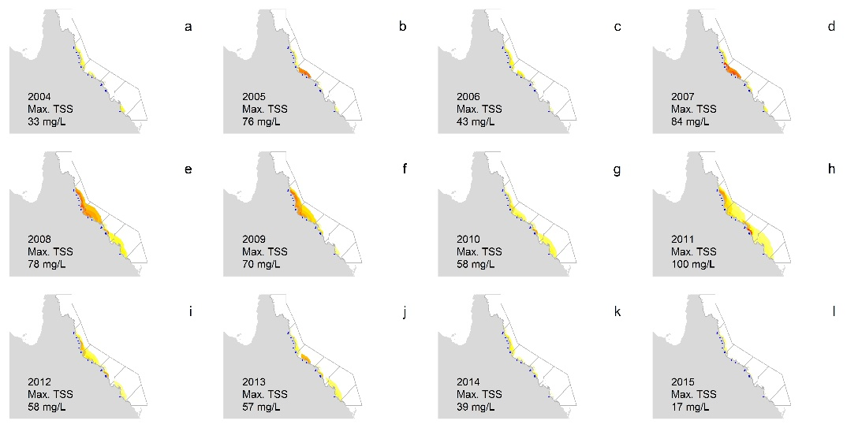
Figure 5-16: Total suspended sediments (TSS, µg/L) over the GBR lagoon 2004-2015 water year (c.a., 1 October to 30 September). ‘Max.’ stands for the highest TSS concentration. Dots represent rivers with load data available and grey lines are the NRM region boundaries.

Regional reports
The following sections provide detailed trend analysis of key water quality constituents and other environmental drivers within each region. For the Wet Tropics region, data are presented for sub-regions corresponding to major catchments.
Specifically, the information provided here is focused on identification and interpretation of inter-annual trends observed in the environmental attributes monitored. For each region the following information is included and discussed:
- A map of the water quality monitoring locations and the water bodies they are located in; a second map that categorises the long-term exposure of the area to flood plumes derived from satellite imagery representing the proportion of time within wet season over 2007-2015 during which optical properties were consistent with Primary or Secondary plume water type characteristics.
- A figure providing time-series of the discharge from local rivers that influenced the region.
- A figure providing regional trends in key water quality parameters and the resultant trend in the water quality index, based on ambient sampling.

Site-specific data and additional information tables are presented in Appendix 2 (referred to by Figure and Table numbers prefixed “A2”) and may be referred to where specific detail is required. These more detailed data summaries include:
- Table A2-1 Summary of the relative annual discharge for the major GBR catchment rivers.
- Table A2-2 Annual summaries of the 75th and 95th percentile flow of the major GBR rivers.
- Table A2-3 Summary statistics for each direct water sampling variable from each monitoring location.
- A set of figures (Figure A2-1 to A2-3) providing flow rates and long-term total wet season discharge of major rivers (Russell-Mulgrave, Tully and Burdekin).
- Table A2-4 Annual summaries of direct water sampling data.
- Table A2-5 Annual summaries of WET Labs ECO FLNTUSB Combination Fluorometer and Turbidity Sensor-derived turbidity for each monitoring location.
- Figure A2-4 Time-series of temperature, Chlorophyll a and turbidity derived from WET Labs ECO FLNTUSB Combination Fluorometer and Turbidity Sensors.
- Figure A2-5 Time-series of temperature and salinity derived from the Sea-Bird Electronics (SBE) CTD profilers deployed at 8 stations.
- Table A2-6 Summary of data collected during the 2014-2015 wet season.
- A set of tables (Table A2-7 to A2-15) providing outputs from correlation tables exploring the significant correlations between pairs of water quality parameters and then against wind and river discharge.
- A set of figures (Figure A2-6 to A2-14) showing partial plots of water quality variables against river discharge for focus regions (Russell-Mulgrave, Tully and Burdekin).
- Table A2- 16 Interim water quality index for each water quality sampling location.
- A set of figures (Figure A2-15 to A2-20) showing mixing plots for important water quality variables (DIN, DIP, Kd, TSS, Chl a, CDOM) for focus regions (Russell-Mulgrave, Tully and Burdekin).

    - Wet Tropics Region: Barron Daintree sub-region

Overview
The Barron Daintree sub-region is primarily influenced by discharge from the Daintree, Mossman and Barron catchments and to a lesser extent, by other Wet Tropics rivers south of the sub-region (Brodie et al., 2013). The Daintree catchment has an area of 2,107 km² and has a high proportion of protected areas (56% natural/minimise use lands and 32% forestry). Remaining area consists of 7% grazing and to a lesser extent, sugarcane and urban areas. The Mossman catchment has an area of 479 km² and consists of 76% natural/minimal use lands, 10% sugarcane and smaller areas of grazing and urban land uses. The Barron catchment has an area of 2189 km² and consists of 29% natural/minimal use lands, 31% grazing, 18% forestry, 11% cropping including bananas and sugarcane, and smaller areas of dairy and urban land uses (Terrain NRM, 2015). The Barron River is the most hydrologically modified river in the Wet Tropics region and is heavily regulated by water supply infrastructure.
Until the end of 2014, seven stations were sampled three times per year to determine the regional water quality. Under the revised MMP water quality sampling design implemented in 2015 the Snapper Island site was discontinued and this sub-region therefore now contains the six open water sites of the ‘Cairns long-term water quality transect’, which are sampled three times a year. Most of the sampling locations in this region are frequently exposed to Secondary plume waters (Figure 5-17, definitions of exposure categories in caption). Two Cairns transect stations in Trinity Inlet are exposed to Primary or Secondary plume waters most days during the wet season, while the two stations in the midshelf water body (Green and Double, Figure 5-17) are rarely exposed to Primary or Secondary plume waters.
Over the period 2006 to 2012, annual combined discharge for both the Daintree and Barron Rivers has been at, or slightly above, median levels in most years with major floods of the Barron River in 2008 and again in 2011 when the Daintree River also flooded (Figure 5-18, Table A2-1). The 2008 and 2011 floods were the highest flows recorded for the Barron over the last 14 years (at least 3 times the long-term median) (Table A2-1). The annual discharge of the Daintree River for the 2014 water year was three times the long-term median, the highest in the past 14 years, and was strongly influenced by Cyclone Ita (Figure 5-18, Table A2-1). The discharge in the 2015 water year was similar to the long-term median discharge.

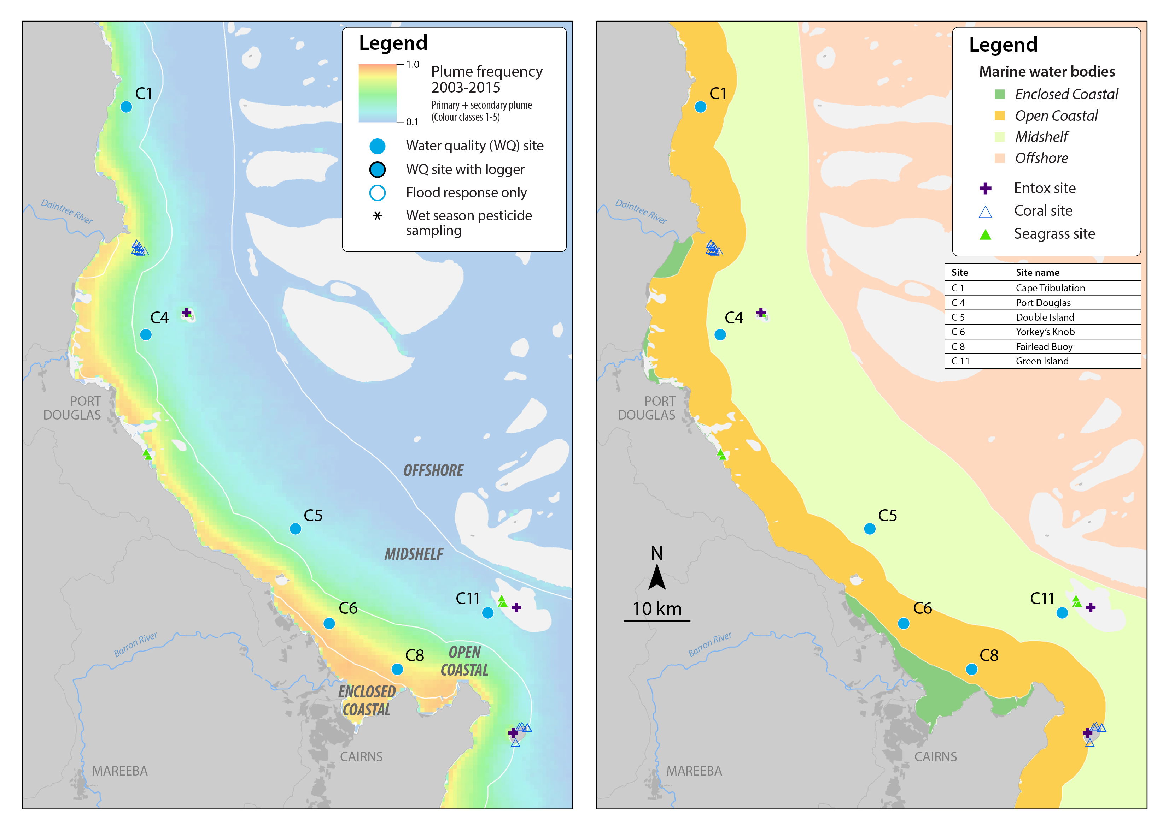
Figure 5-17: MMP water quality sampling sites in the Barron Daintree sub-region shown with (left) wet season plume frequency 2003 to 2015 (Primary + Secondary; where 1.0 represents 22 weeks, December to March) and (right) water body boundaries.

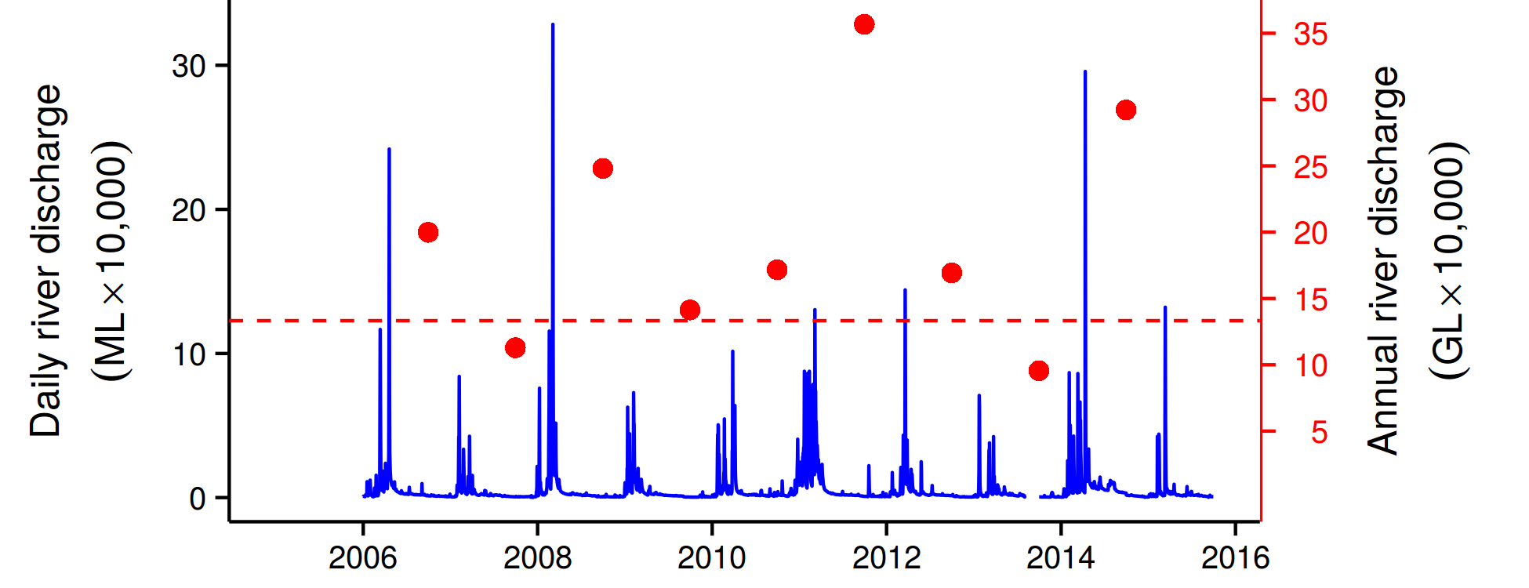
Figure 5-18: Combined discharge for the Barron and Daintree Rivers. Daily (blue) and annual (October to September, red symbols) discharge volumes shown. Red dashed line represents long-term median of the combined annual discharge.
The estimated zone of influence for the Barron River is shown in Figure 5-19, supporting the conclusions above regarding freshwater discharge in 2014-15.
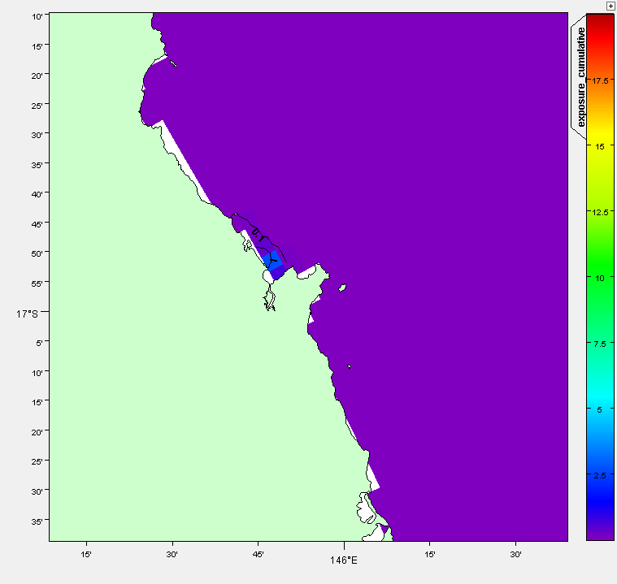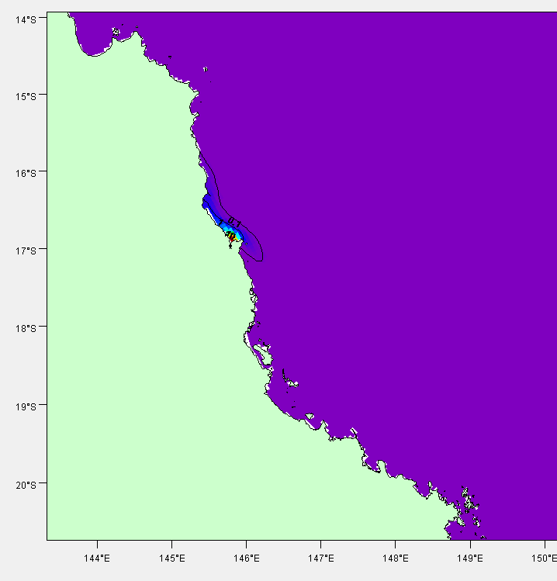
Figure 5-19: Cumulative exposure index for the Barron River in 2014-15 (left). Results for 2010-11 (right) are shown for context. The colour bar indicates the calculated cumulative exposure (concentration x days) above 1% of the incoming concentration. The colour bar is capped at 20 Conc.Days. Contours show 0.1, 1.0 and 10.0 Conc.Days exposure levels.
Measured end-of-catchment loads and river discharge for the Barron River from 2006-07 to 2014-15 are shown in Figure 5-20. Of the Barron, Daintree and Mossman Rivers, only the Barron River (at the Myola gauge) has been routinely monitored. Overall the Barron River is a relatively small contributor of discharge, sediments and nutrients in the Wet Tropics region as it has a relatively small catchment area with areas of lower rainfall (dry tropical). The Tinaroo Dam on the Barron River also captures a large proportion of the flow (and associated constituents) in the upper section of the catchment. The 2014-15 wet season had relatively lower discharge and constituent loads relative to previous years of monitoring over the 2006-07 to 2014-15 period (Figure 5-20). The 2014-15 loads of TSS, PN and PP were similar across the monitored sites in the Wet Tropics with the exception of the Johnstone, while the DIN loads from the Barron River are much lower than the other rivers, a reflection of the lower area of fertilised cropping in the Barron River (below dam).
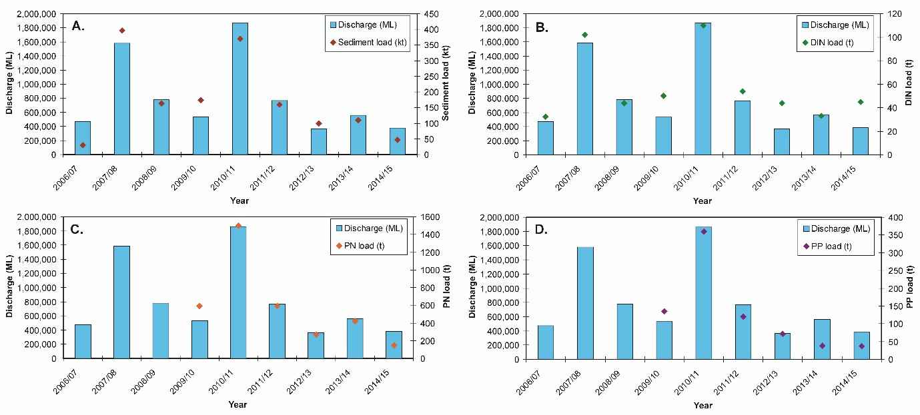
Figure 5-20: Measured Barron River discharge and loads (at Myola gauge) for (A) total suspended solids (sediment), (B) dissolved inorganic nitrogen (DIN), (C) particulate nitrogen (PN) and (D) particulate phosphorus (PP) from 2006/07 to 2014/15. Data from the Department of Science Information Technology and Innovation’s Great Barrier Reef Catchment Loads Monitoring Program (compiled from: Joo et al., 2012; Turner et al., 2012, 2013; Wallace et al., 2014, 2015, in press; Garzon-Garcia et al., 2015).

Ambient water quality
When analysing the water quality trend in Barron Daintree sub-region it should be noted that the Snapper Island site was discontinued in 2015. The data collected at this site in previous years are for consistency still included in the long-term analysis. In the new sampling design there are no longer any chlorophyll a and turbidity sensors operated in this sub-region; the turbidity data to 2014 presented in Figure 5-21, are only shown for reference.
The Water Quality Index in this sub-region remained ‘good’, although declined slightly since 2009 (Figure 5-21). Concentrations of Chl-a, TSS and PN were higher at the start of the MMP sampling in 2005-06, then declined slightly, and increased again after the major Barron River floods in 2008 (Figure 5-21b,c,f). Highest concentrations of Chl-a, PN, SS and particulate phosphorus (PP) were observed in 2014-15, with the predicted overall trend-line for Chl-a, PP and TSS exceeding water quality guidelines (guideline) (GBRMPA 2010). Secchi depth showed a steady decline since the beginning of the monitoring program, reaching a new minimum in 2015 with levels throughout the monitoring period being non-compliant with the guideline (Figure 5-21e).
The concentrations of dissolved oxidised nitrogen (NO_{x}) steadily increased over the course of the monitoring program, with the overall trend-line approaching the guideline value in 2013 where it remains (Figure 5-21d). The concentrations of particulate organic carbon (POC) has increased slightly, while the concentrations of dissolved organic carbon (DOC) steadily increased over the course of the monitoring period with levels approaching a stable level during the wet season of 2012–13 (Figure 5-21j).

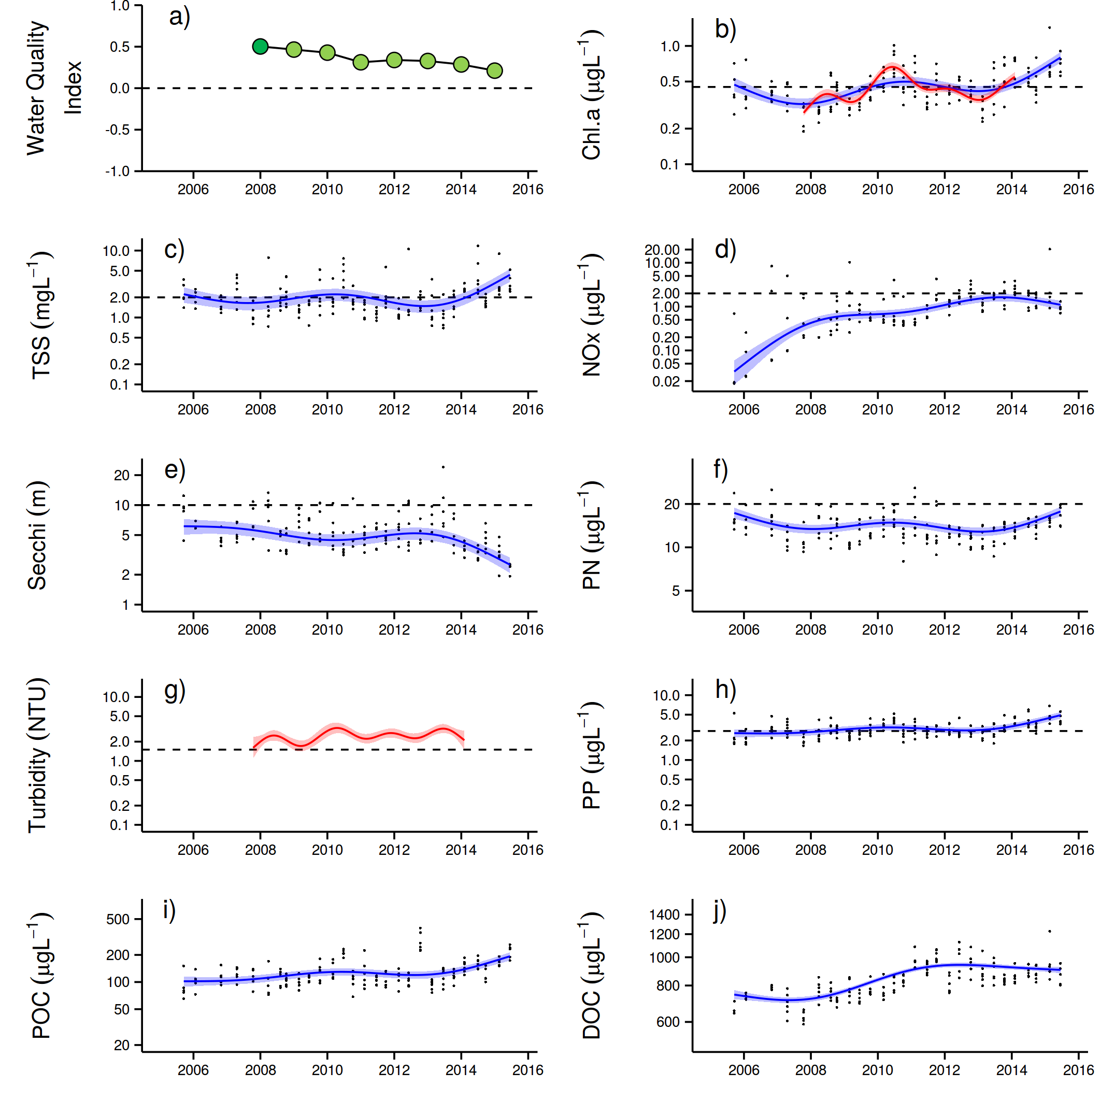
Figure 5-21: Temporal trends in water quality variables for the Barron Daintree sub-region. a) water quality index, b) chlorophyll a, c) total suspended solids, d) nitrate/nitrite, e) Secchi depth, f) particulate nitrogen, g) particulate phosphorus, h) particulate organic carbon and i) dissolved organic carbon. Water quality index colour coding: dark green- ‘very good’; light green-‘good’; yellow – ‘moderate; orange – ‘poor’; red – ‘very poor’. The water quality index is the aggregate of variables plotted in b - h and calculated as described in Appendix 1.2.3. Trends in POC and DOC values are plotted here (i, j); threshold levels have yet to be established. Trends in manually sampled water quality variables are represented by blue lines with blue shaded areas defining 95% confidence intervals of those trends accounting for the effects of wind, waves and tides after applying x-z detrending, black dots represent observed data. Trends of records from ECO FLNTUSB instruments are represented in red, individual records are not displayed. Dashed reference lines indicate guideline values.

Wet season water quality
Wet season sampling in flood events is currently not conducted in the Barron Daintree sub-region as part of the MMP.
    - Wet Tropics Region: Russell-Mulgrave focus area

Overview
The Russell-Mulgrave focus area is primarily influenced by discharge from the Russell-Mulgrave and Johnstone Basins and to a lesser extent, by other rivers south of the focus area, such as the Burdekin (Brodie et al., 2013). The Russell-Mulgrave Basins contain a high proportion of upland National Park and forest (72%), with 13% of the area used for sugarcane production on the coastal floodplain (Terrain NRM, 2015). The Johnstone Basin has an area of 2,326 km² and has a relatively high proportion of natural/minimal use lands (55%). The remaining area contains 16% grazing, 12% sugarcane and smaller areas of dairy (in the upper catchment), bananas and other crops, and urban land uses (Terrain NRM, 2015).
Three stations were sampled three times per year in this focus area until the end of 2014 to determine regional water quality. Following the implementation of the new MMP water quality sampling design in 2015, 12 sampling stations are sampled in this sub-region up to 10 times per year, with six stations during both the dry and wet season and six only during major floods (Table 4-1). The sampling stations in this new design are located in a transect from the river mouth to open coastal waters, representing a gradient in water quality. Five stations are affected to a varying degree by Primary and Secondary plume water types, while the remaining seven stations are located in the midshelf water body which is rarely exposed to Primary or Secondary plume waters (Figure 5-22).

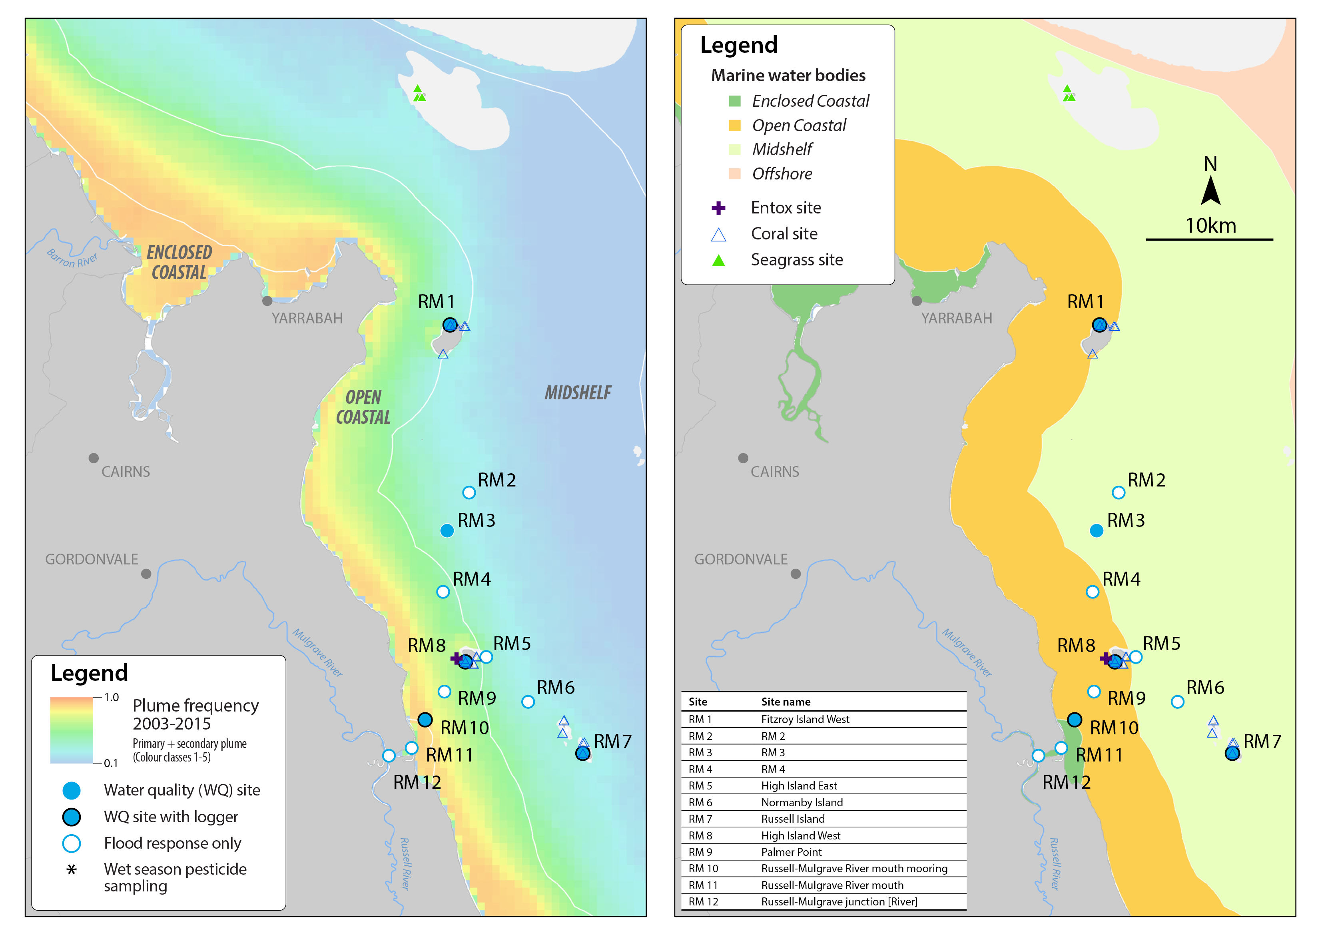
Figure 5-22: MMP sampling sites in the Russell-Mulgrave focus area, shown with (left) wet season plume frequency 2003 to 2015 (Primary + Secondary; where 1.0 represents 22 weeks, December to March) and (right) the water body boundaries.
The 2014-15 wet season in the central GBR was characterised by many smaller episodic flows but no extended large flow associated with a cyclonic period. The Wet Tropics area had a total wet season flow below the long-term median with discharge from both the Russell (381,250 ML) and the Mulgrave Rivers (391,564 ML) below the long term median (Table A2-5). The Johnstone River also had lower discharge than the long-term median. Heavy and consistent rain was experienced in the Wet Tropics region later in the wet season, peaking in late March (Figure 5-23).
Over the period 2006 to 2015, the annual combined discharge for both the Russell-Mulgrave and Johnstone Rivers was at, or slightly above, median levels in most years with major floods seen after the passing of tropical cyclones Larry in 2006, Tasha in late 2010 and Yasi in 2011 (Figure 5-23, Table A2-1). Discharge volumes in the 2014 and 2015 water years were just above the long-term median (Table A2-1).

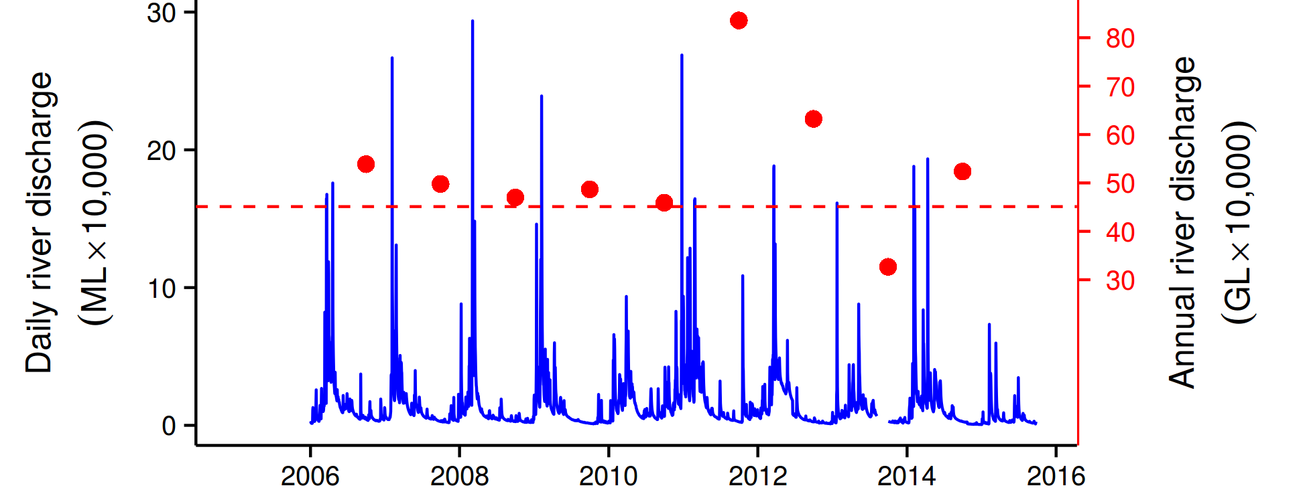
Figure 5-23: Combined discharge for the North and South Johnstone, Russell and Mulgrave Rivers. Daily (blue) and annual (October to September, red symbols) discharge shown. Red dashed line represents the long-term median of the combined annual discharge.
The estimated zone of influence for the Russell-Mulgrave River is shown in Figure 5-24, showing a much more constrained zone of influence in 2014-15 compared to the large events of 2010-11.
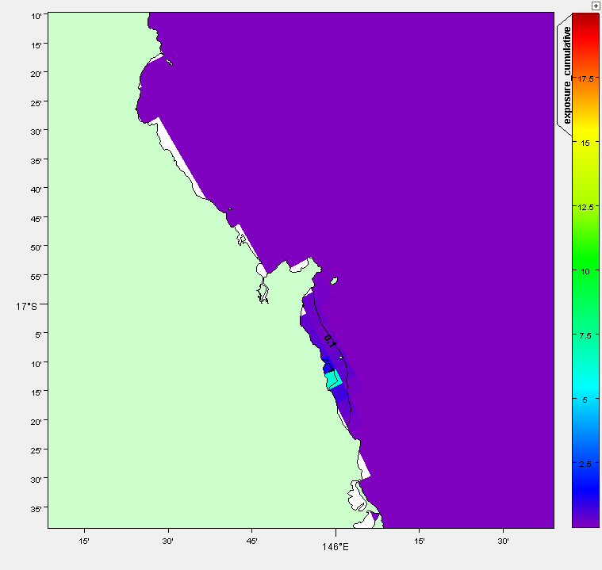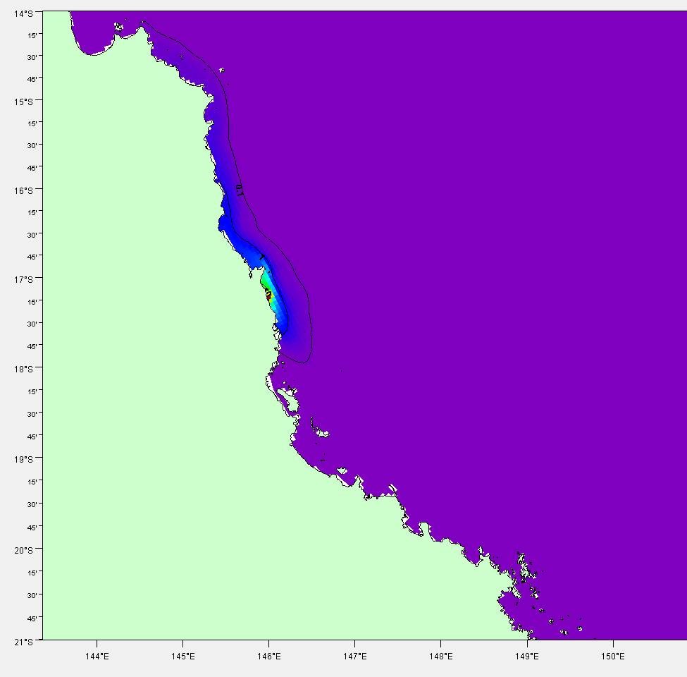
Figure 5-24: Cumulative exposure index for the Russell-Mulgrave River in 2014-15 (left). Results for 2010-11 (right) are shown for context. The colour bar indicates the calculated cumulative exposure (concentration x days) above 1% of the incoming concentration. The colour bar is capped at 20 Conc.Days. Contours show 0.1, 1.0 and 10.0 Conc.Days exposure levels.

Within the Russell/Mulgrave and Johnstone Basins, only the Johnstone River (at the Tung Oil (North Johnstone) and Central Mill (South Johnstone) gauge) has been routinely monitored and results here are presented for the discharge and loads from both sites added together (total). It is noted that the Russell-Mulgrave monitoring site was also established in 2014-15, although these loads are not reported here due to the low discharge year and lack of comparison with previous years.
Overall, the Johnstone River is a relatively large contributor of discharge, sediments and nutrients in the Wet Tropics region as it has a relatively large and wet catchment area with areas of cropping on high slopes. The 2014-15 season had relatively lower discharge and constituent loads relative to previous years of monitoring over the 2006-07 to 2014-15 period (Figure 5-25). In 2014-15 loads of TSS, DIN, PN and PP delivered from the Johnstone River were much higher than the other monitored sites in the Wet Tropics. In the larger wet seasons the Johnstone is among the larger contributors of constituent loads from the Wet Tropics, although the Herbert River has higher TSS and nutrient loads, and the Tully River has higher loads of DIN. However, it should be noted that these measurements are taken at the gauging stations and in the case of the Johnstone Basin, the vast majority of the fertilised cropping is below the gauged area and hence the loads of DIN (and possibly particulate nutrients) would be underestimated for this basin.
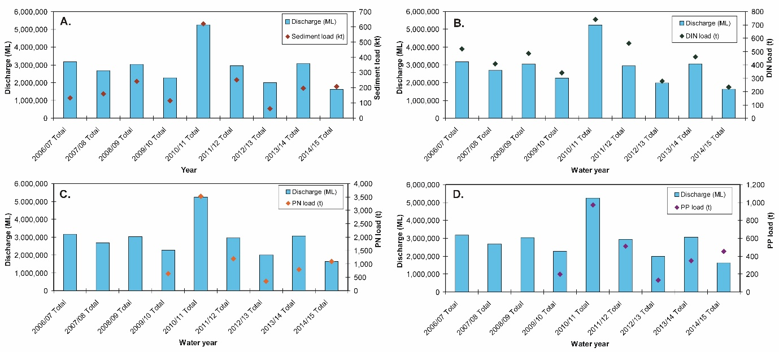
Figure 5-25: Measured Johnstone River discharge and loads (combined from the North Johnstone at Tung Oil and South Johnstone at Central Mill monitoring sites) for (A) total suspended solids (sediment), (B) dissolved inorganic nitrogen (DIN), (C) particulate nitrogen (PN) and (D) particulate phosphorus (PP) from 2006-07 to 2014-15. Data from the Department of Science Information Technology and Innovation’s Great Barrier Reef Catchment Loads Monitoring Program (compiled from: Joo et al., 2012; Turner et al., 2012, 2013; Wallace et al., 2014, 2015, in press; Garzon-Garcia et al., 2015).

Ambient water quality
When analysing the water quality trend in this region it should be noted that one logger station has changed location, and that the number of water sampling sites and frequency of sampling has increased from 2015. Some of these new sites are placed further inshore and they are therefore affected by Primary and Secondary plume waters which may influence the results.
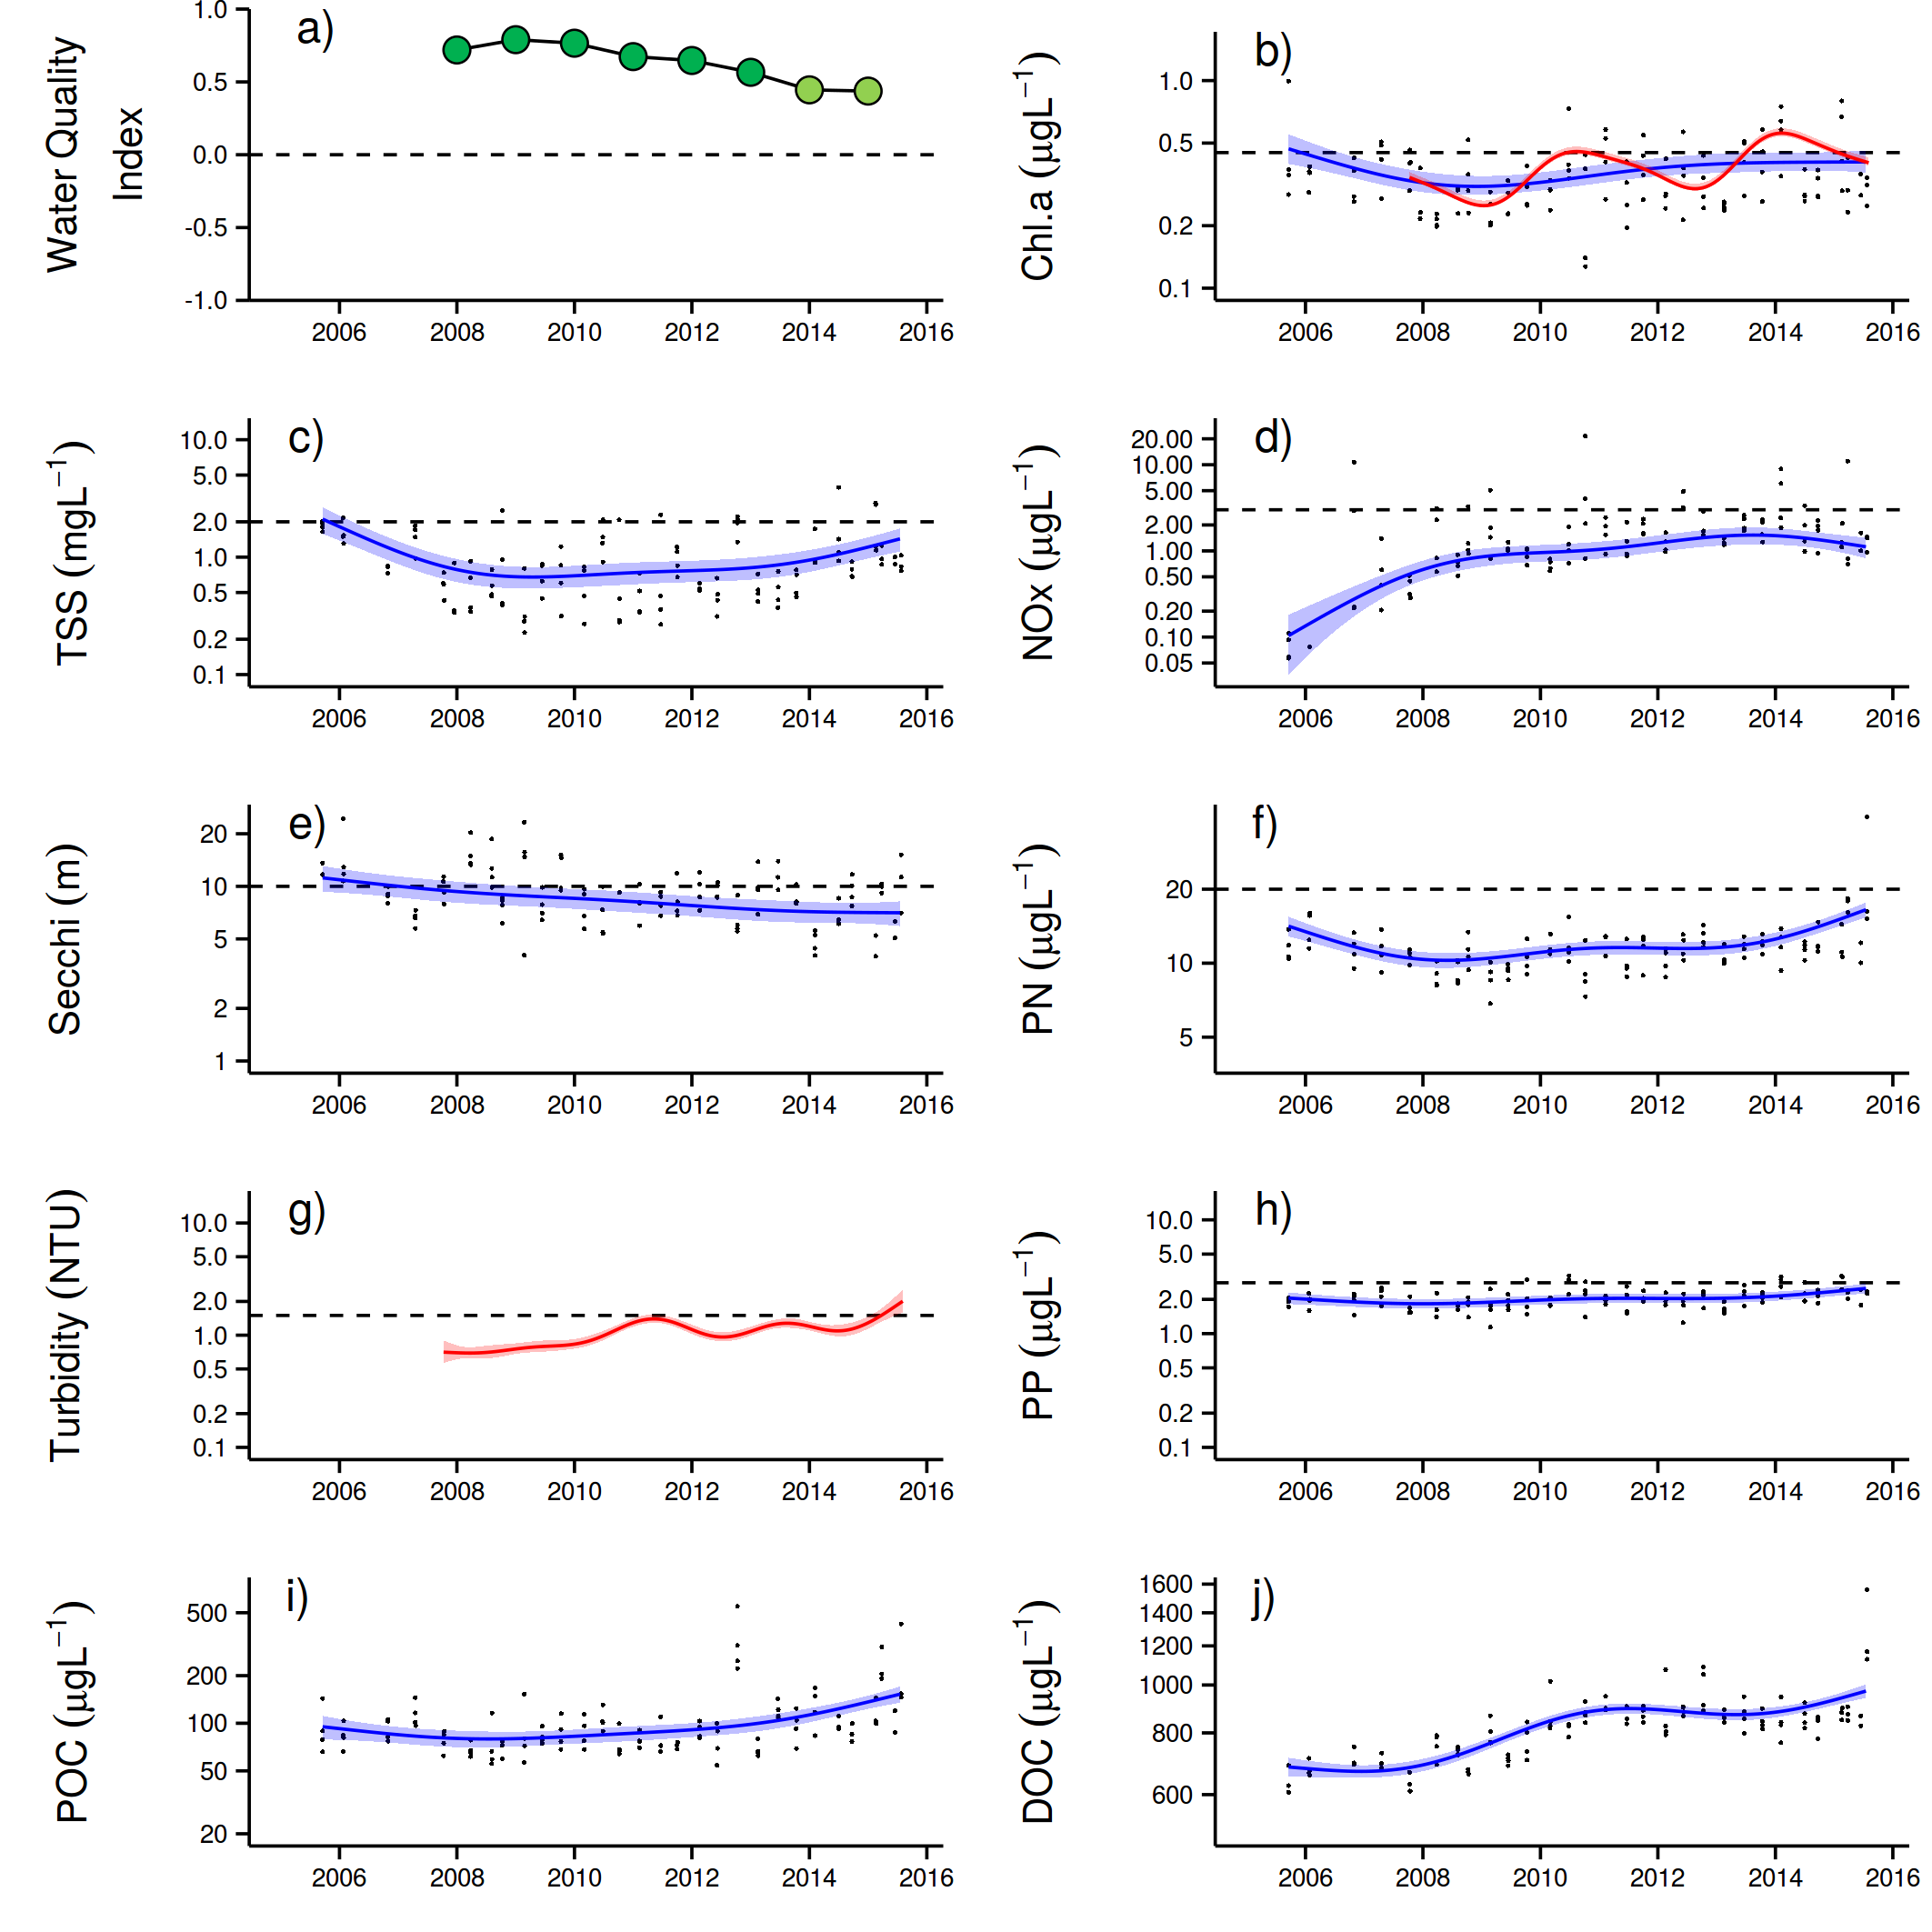
The Water Quality Index in this focus area remained relatively stable maintaining scores of ‘good’ (Figure 5-26a). Concentrations of Chl-a), TSS, PN and PP were close to or below guideline levels at the beginning of the MMP sampling in 2005-06, then declined, prior to slight increases during the major flood period in 2011 with more or less stable levels until 2015 (Figure 5-26,c,f,h). The predicted overall trendline for Chl-a was at or above the guideline from 2011 onwards; the trendlines for TSS and PP approached the guideline in 2014, while PN was below (Figure 5-26). The concentrations of dissolved oxidised nitrogen (NO_{x}) steadily increased over time, approaching the Queensland guideline in 2012 where it has remained since (Figure 5-26d). Secchi depth showed a slight decline since the beginning of the monitoring program to levels now exceeding the guideline (Figure 5-262e).
Figure 5-26: Temporal trends in water quality for the Russell-Mulgrave sub-region. a) water quality index, b) chlorophyll a, c) total suspended solids, d) nitrate/nitrite, e) Secchi depth, f) particulate nitrogen, g) particulate phosphorus, h) particulate organic carbon and i) dissolved organic carbon. Water quality index colour coding: dark green- ‘very good’; light green-‘good’; yellow – ‘moderate; orange – ‘poor’; red – ‘very poor’. The Water Quality Index is the aggregate of variables plotted in b - h and calculated as described in Appendix 1.2.3. Trends in POC and DOC values are plotted here (i, j); threshold levels have yet to be established. Trends in manually sampled water quality variables are represented by blue lines with blue shaded areas defining 95% confidence intervals of those trends accounting for the effects of wind, waves and tides, black dots represent observed data. Trends of records from ECO FLNTUSB instruments are represented in red, individual records are not displayed. Dashed reference lines indicate guideline values.

The concentrations of particulate organic carbon (POC) remained stable over the monitoring period, while the dissolved organic carbon (DOC) concentrations showed a steep continued increase over the same period (Figure 5-26j).
Instrumental chlorophyll (chl) and turbidity records show more pronounced fluctuations than the manual sampling data (Figure 5-26b,g). The chl trendline exceeded the annual guideline during the wet season 2011-12 and again in 2013-2014 (Figure 5-26b).The turbidity values showed increasing level which are now exceeding the guideline values. The small “kick” seen in the turbidity trend during the 2014-15 season is most likely due to an additional sensor that is now placed close to the Russell-Mulgrave river mouths, which have higher turbidity levels (Figure 5-26g).
The TSS and turbidity in this region showed different temporal trends (Figure 5-26c and g). While TSS is measured as dry mass on a filter (0.4 µm poresize), turbidity is measured by the loggers as total light absorption and scattering. The TSS does therefore neither account for material passing the filter nor for the optical properties of particles; therefore the nature of the measurements different (Bowers et al., 2011). The difference in trends between these measures indicates that the size spectrum/composition of the optical active particle fraction may have changed over the monitoring period.

Wet season water quality
Almost all input of materials discharged by rivers takes place in the wet season and leads to strong gradients in concentrations of, and transformations among, water quality parameters in plume environments (Devlin and Brodie 2005). In general, the fate of the organic matter and its constituent nitrogen, phosphorus and carbon, is mineralisation, uptake, sinking and dilution. If changes in the water quality parameters concentration result only from the dilution associated with mixing, the constituents are said to behave conservatively. Non-conservative behaviour can include the biological uptake from dissolved to a particulate stage, sedimentation of particulate matter and the mineralisation or desorption of particulate to dissolved species (Devlin and Brodie 2005). Conservative or non-conservative behaviour can be observed on mixing plot by testing the linearity of the relationship between the concentration of the water quality parameter and an index of conservative mixing, usually salinity (Devlin et al., 2001). Conservative mixing presents a straight line from high values at the river mouth and low values at the edge of the river plume.
Besides river discharge, wind is another environmental parameter that not only affects the fate of the plume constituents by changing its direction of propagation, but also causing resuspension in shallow waters that brings sediment and associated material into the water column. In the absence of wind stress, plumes move in a northerly direction from the river mouth in accordance with Coriolis forcing. In times of low wind stress the plumes disperse well offshore and can reach beyond the main barrier reefs on the outer shelf into the Coral Sea (Devlin and Brodie, 2005).
As a general behaviour presented in Devlin and Brodie (2005), most TSS deposits from the plume close to the river mouth, often within a few kilometres of the mouth. Thus most of the particulate nutrient material will also be lost from the water column in this zone. In contrast there is almost no loss of dissolved nutrients, except by dilution, in the plumes until salinities rise to above 25 ppt. The main reason for lack of biological uptake and phytoplankton growth appears to be the elevated turbidity in the early stages of the plume and the consequent light limitation. The implications of the contrasting behaviour of particulate nutrients and dissolved nutrients are that nutrients discharged from rivers in dissolved form are transported great distances in the plume. They thus have the ability to influence biological activity on much of the inner-shelf of the GBR. Nutrients discharged in a particulate form are trapped near the coast and probably do not have a major influence on, for example, most of the inner-shelf coral reefs.
Data collected in the wet season has also contributed to the understanding of the variability associated with the period of elevated flow and cyclonic activity. The Russell-Mulgrave focus area has been sampled every year since 2010.
Comparing and contrasting data across sampling periods in wet season conditions is difficult due to the high variability of the water quality data in response to river flow and prevailing weather conditions. Therefore, in-situ data sampled in flood plumes were compared within the 2014-15 wet season only, by using mixing plots. The concentrations of some water quality parameters in plumes are directly related to the degree of mixing between the fresh and salt water. Salinity mixing plots for the data collected in the 2014-15 wet season for each sampling event at the Tully, Russell-Mulgrave and Burdekin sites are presented for DIN, DIP, Kd(PAR), TSS, Chl-a, PN, PP and CDOM (Figures A2-15 to A2-20).
The corresponding end-of–catchment water quality concentrations for each sampling date are not available to produce a proper mixing plot. Average values, calculated from long-term data (since 2006) where salinity was below 5 ppt were used instead. The Russell-Mulgrave focus area exhibited some typical mixing plots with reduction of water quality parameters moving away from the river mouth, when enough data points, covering the range of salinity (i.e., from 0 to 35 ppt), were sampled. Typical conservative dilution patterns (see Devlin and Brodie, 2005) were observed for DIN and for CDOM to some degree (restricted to the sampling done on 7 January 2015). Interesting to note that CDOM is used as proxy for salinity, but the data collected this wet season in the Russell-Mulgrave focus area did not show such a relationship.
Dissolved inorganic phosphorus and Kd(PAR) also showed reductions in concentrations moving away from the river mouth (Figure A2-16 and A2-17), but concentrations showed a non-conservative behaviour. DIP showed rapid reductions, possibly associated with biological uptake, and Kd(PAR) presented a two-step reduction probably associated with sediment settling out of the river mouth (Figure A2-18) and a posterior drop associated with reduction in Chl-a concentrations at salinity > 30 ppt (Figure A2-19).
As expected, Chl-a and TSS did not present conservative behaviour. TSS dropped quickly out of the river mouth due to particles settling, remaining constant after that (Figure A2-18). Chl-a had a more variable pattern compared to the other water quality parameters, presenting slight increase in concentrations at low salinity (approx. 10 ppt) and reduction at salinity > 30 ppt (Figure A2-19). PN and PP had similar pattern to TSS, as solids they showed rapid reduction just after the river mouth.
To investigate the potential control of discharge and wind on the parameters, a Spearman correlation coefficient was determined (
Table 5-5). In this analysis, mean parameter values per transect/day sampled since the 2005-06 wet season were used to reduce data variability associated with changes in site location and site number. Overall river discharge showed positive correlation with DIN, PN, PP and Si, suggesting the higher the river discharge, the higher the concentrations. Wind components, and therefore eventual resuspension events or currents, advecting the superficial water mass, did not correlate with any of the analysed parameters, suggesting eventual resuspension events or currents, advecting the superficial water mass, do not exert linear control on these parameters.
Salinity was included in this analysis to investigate its correlation against CDOM. The test result suggests the greater the salinity the lower the CDOM concentration, as expected (Schroeder, 2012). When satellite algorithms can cope with the complexity of coastal waters, it can be a good way to delineate plume extent. Chl-a correlated with DIN, PP and Si, being the greater the concentration of these water quality constituents, the greater the Chl-a concentration. Dissolved inorganic nitrogen and Si are essential nutrients for phytoplankton growth, and PP is more likely to be related to the incorporation of phosphorus in the pool of new organic matter due to phytoplankton production (Bainbridge et al., 2012).

Table 5-5: Russell-Mulgrave sites: Spearman Correlation Coefficient calculated using the mean value of each WQ parameter sampled per transect when all sites sampled since 2005-06 wet season are combined. Water Quality parameters tested were: light attenuation (Kd(PAR)), coloured dissolved organic matter (CDOM), dissolved inorganic nitrogen (DIN), dissolved inorganic phosphorus (DIP), particulate nitrogen (PN), particulate phosphorus (PP), reactive silica (Si) and chlorophyll-a (Chl-a), and they were tested against river discharge, W-E wind component, N-S wind component, surface salinity and chlorophyll-a. Significant (p<0.05) correlation coefficients >0.6 or <-0.6 are highlighted.
 | Kd(PAR) | CDOM | TSS | DIN | DIP | PN | PP | Si | Chl-a
Discharge | 0.38 | 0.42 | -0.29 | 0.66 | 0.37 | 0.67 | 0.68 | 0.88 | 0.51
W-E wind component | -0.58 | 0.11 | -0.40 | -0.15 | 0.12 | 0.42 | -0.09 | -0.27 | 0.16
N-S wind component | 0.55 | -0.16 | 0.38 | 0.15 | -0.10 | -0.46 | -0.03 | -0.06 | -0.12
Salinity | -0.20 | -0.78 | -0.24 | -0.84 | -0.28 | -0.14 | -0.54 | -0.94 | -0.42
Chl-a | 0.37 | 0.27 | 0.18 | 0.68 | 0.53 | 0.15 | 0.74 | 0.71 | 1.00

One of the key applications of the water quality parameters sampled in plume waters is to determine how far and at what concentrations land-sourced nutrients and sediment are likely to be observed in the GBR lagoon. This information can be used in dispersion models like the loading maps presented in Section 5.3.4.
Box-plots were used to describe the transport of water quality parameters across plume waters. Box-plots were produced by aggregating in-situ values measured within each plume water type (i.e., Primary, Secondary and Tertiary, see data extraction in Section 4.8). Data is summarised by the median and quantiles within each plume water type. Also a comparison against the guidelines and the result of a Kruskal-Wallis Rank Sum test (as p-value) are provided (Figure 5-27).
Plume water types work as a proxy for terrestrial discharge influence. Primary waters are for river plumes in the initial stage of development when less mixing has occurred between freshwater and sea water, and Tertiary plume waters are characterised by a greater presence of sea water. Therefore it is expected that water constituents discharged into the GBR may have higher concentrations in Primary waters than in Tertiary waters.
For a wet season with reduced river discharge as occurred in 2014-15, a reduced contribution form land-based contaminants would be expected. Indeed, only one parameter sampled in this wet season, DIN, presented significant difference among the plume types (Figure 5-27g). All the other parameters sampled in 2014-15 wet season showed no significant difference among water types. It is important to account for this when assessing relationships between water quality parameters and plume types because most of these parameters do not give 'colour' to the water, so plume types do not necessarily represent differences in water quality parameters. There is also great data variability due to environmental conditions on the sampling dates, mainly due to river discharge and wind. However, wind did not influence the water quality parameters investigated in the Russell-Mulgrave focus area (Table 5-5). Therefore, models using a relationship between water quality parameters and plume types must constrain data comparison to that sampled under flood events (e.g., when river discharge is greater than 75th percentile, which was the threshold used in the load mapping, see Section 4.8).
For long-term data comparison, the Russell-Mulgrave sites showed some parameters with significant differences in concentrations among the plume water types, such as Kd(PAR) for the long-term comparison (data set from 2005 to 2015, Figure 5-27b), DIN for both comparisons (i.e., only 2014-15 data set and 2005 to 2015 data set, Figure 5-27g, h) and PP for 2005 to 2015 data set (Figure 5-27n). For the other parameters no significant difference was observed in concentrations among the plume water types, suggesting these parameters do not undergo much transformation and remain stable for long distances. In terms of the median in-situ measurement compared against guideline values, for those water constituents with guidelines, TSS, DIN, and Chl-a were constantly above the thresholds in any plume water type in both comparisons (i.e., 2014-15 data set and 2005 to 2015 data set).

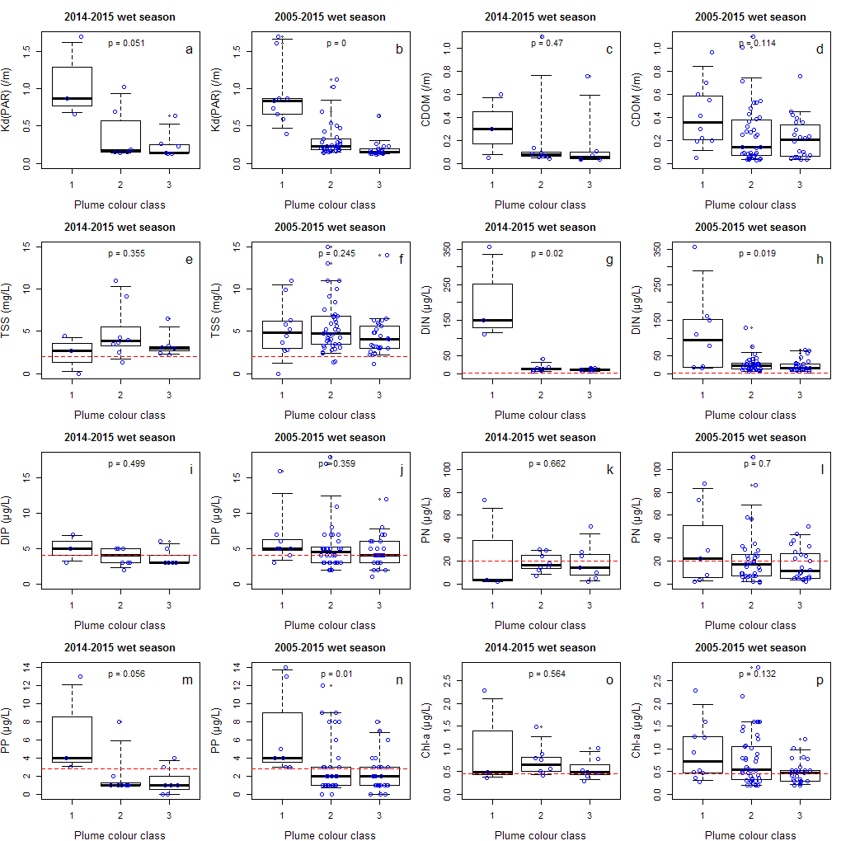
Figure 5-27: Boxplot for the water quality parameters sampled at the Russell-Mulgrave sites in the current wet season compared to all data sampled since 2005-06 wet season. In the boxplot bold line stands for median, rectangles are for the 25th and 75th percentiles and vertical line for 5th and 95th percentile. The p-value is from a Kruskal-Wallis Rank Sum test among plume water types. Dots stand for data points (nudge was added for data visualization) and red dashed line stands for the water quality guidelines for open coastal waters. Plume water type 1, 2 and 3 stands for Primary, Secondary and Tertiary, respectively.

    - Wet Tropics Region: Tully focus area

Overview
The Tully focus area is primarily influenced by discharge from the Tully, Murray and Herbert Rivers, and to a lesser extent, by the Burdekin River in large flow years (Brodie et al., 2013). The Tully River Basin has an area of 1,685 km² and has a high proportion of natural/minimal use lands (75%). The remaining area is comprised of 12% sugarcane, 4% bananas, 5% grazing, and smaller areas of forestry, other crops and urban land uses. The Murray River Basin has an area of 1,115 km² and also has a high proportion of natural/minimal use lands (64%). The remaining area is comprised of 14% sugarcane, 10% forestry, 6% grazing and smaller areas of bananas, other crops, and urban land uses. The Herbert River Basin has an area of 9,842 km² and consists of 27% natural/minimal use lands, 56% grazing, 8% sugarcane and smaller areas of forestry.
One station was sampled in this focus area three times per year until the end of 2014. After the implementation of the new MMP water quality sampling design in 2015, the Tully focus area includes 11 sampling stations which are sampled up to 10 times per year, with six stations during both the dry and wet season and five only during the wet season (Table 4-1). The sampling locations in this new design are located in a river mouth to open coastal water transect representing a gradient in water quality. Nine of the stations are dominantly influenced by Primary and Secondary plume water types, with only two stations located outside of the typical influence of Primary and Secondary plume water types (Figure 5-28).

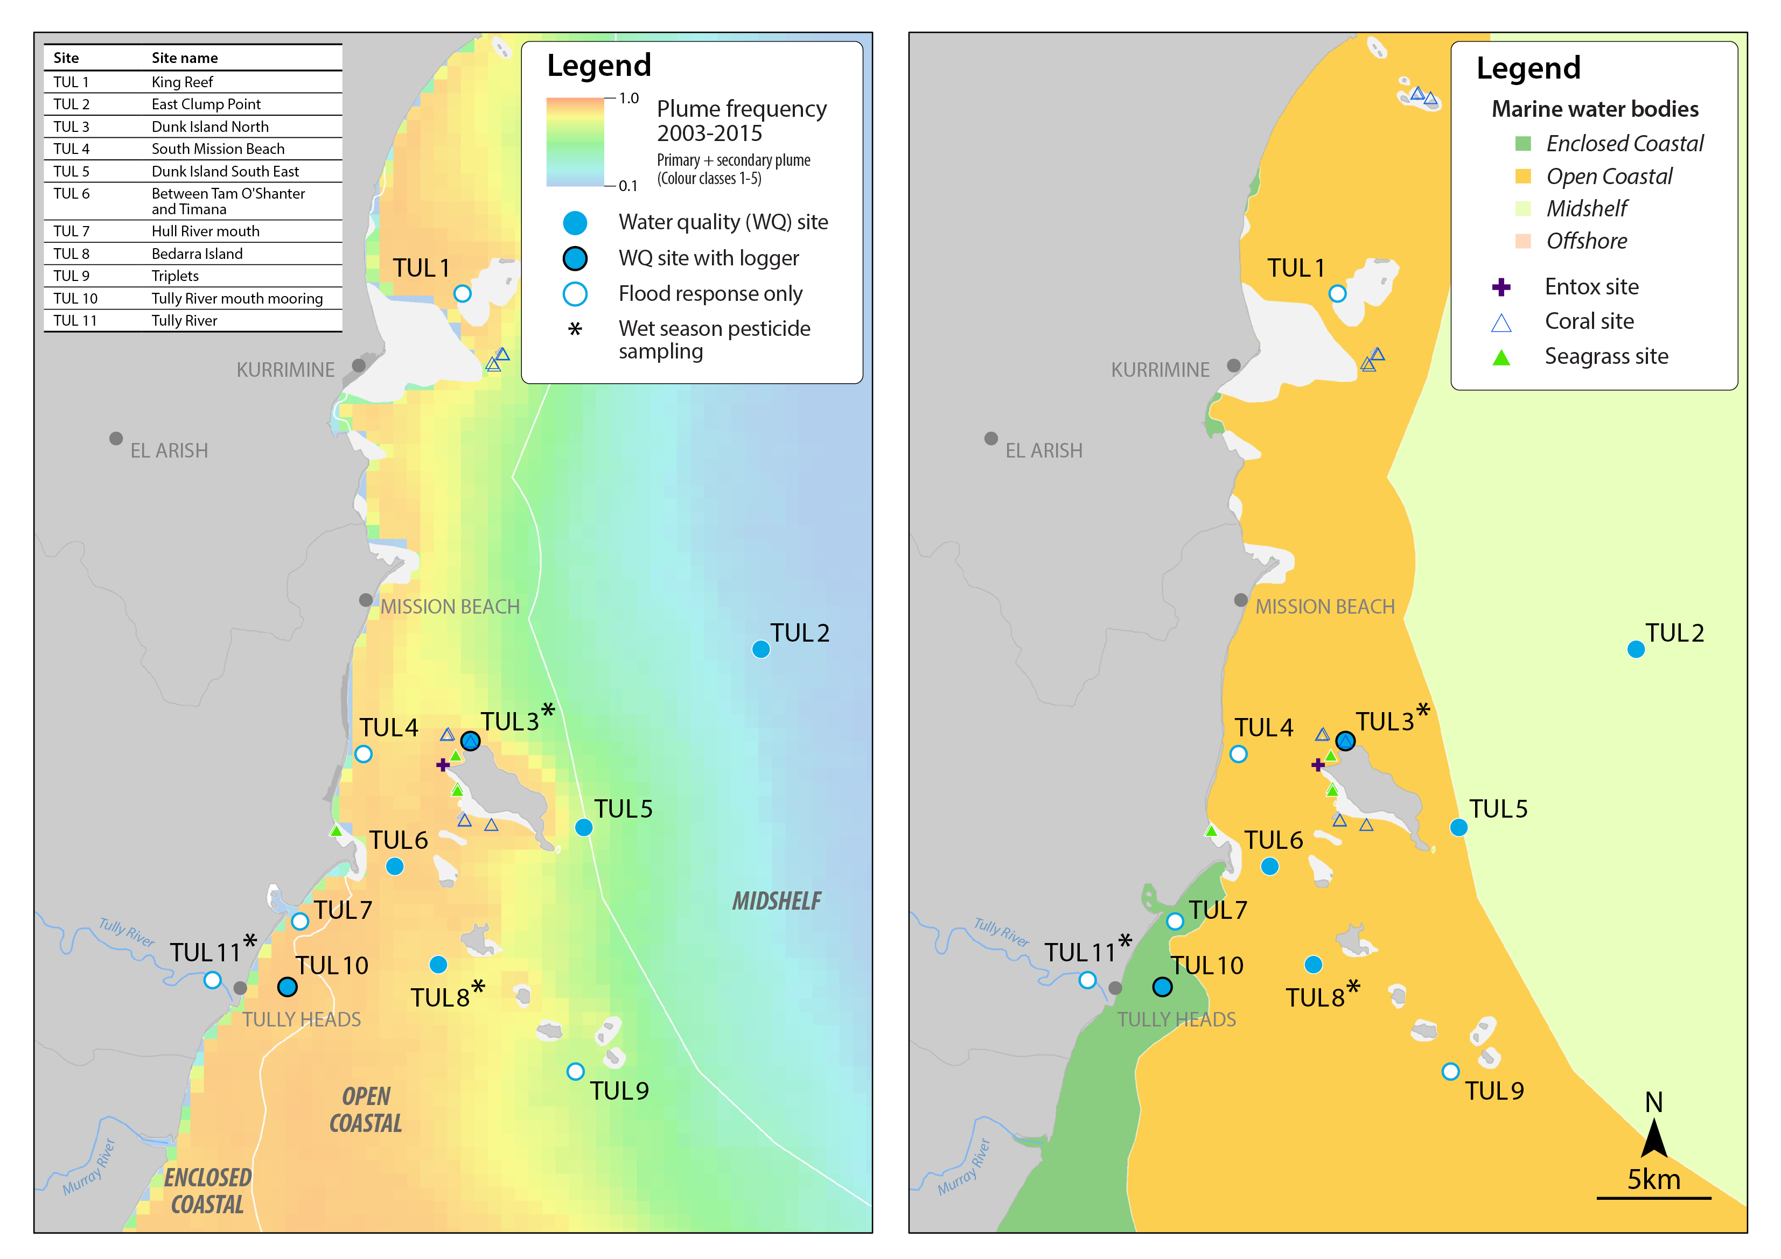
Figure 5-28: MMP sampling sites in the Tully focus area, shown with (left) wet season plume frequency 2003 to 2015 (Primary + Secondary; where 1.0 represents 22 weeks, December to March) and (right) the water body boundaries.
Over the period 2006 to 2012, annual combined discharge for both the Tully and Herbert Rivers (Figure 5-29) has been at, or slightly above, median levels in 2 years, due to the major floods of the Tully River in 2011 and of the Herbert River in 2009 and 2011 (Table A2-1). The 2014-15 wet season was characterised by many smaller episodic flows but no extended large flow. Heavy and consistent rain also continued in the Wet Tropics region later in the wet season, peaking in late March. The Tully and Herbert Rivers had substantially lower flow than the long term median (Figure 5-25) with a total discharge of just over 1,000,000 ML over the total wet season.

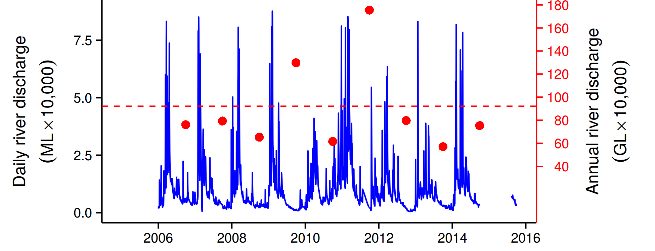
Figure 5-29: Combined discharge for Tully and Herbert Rivers. Daily (blue) and annual (October to September, red) discharge shown. Red dashed line represents the long-term median of the combined annual discharge.
The estimated zone of influence for the Tully River is shown in Figure 5-30, showing a much more constrained zone of influence in 2014-15 compared to the large events of 2010-2011.
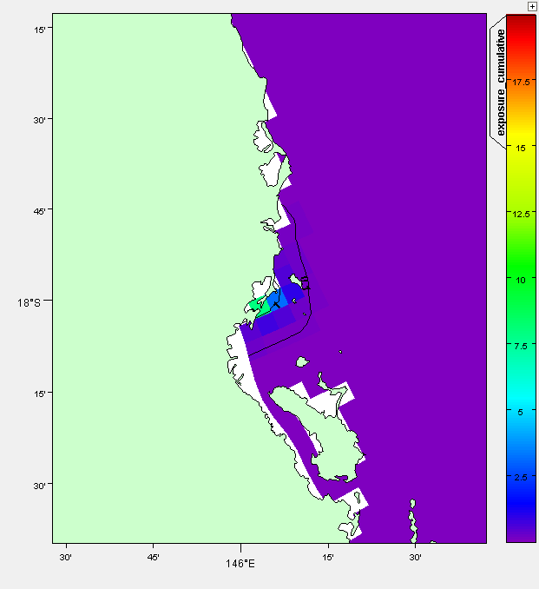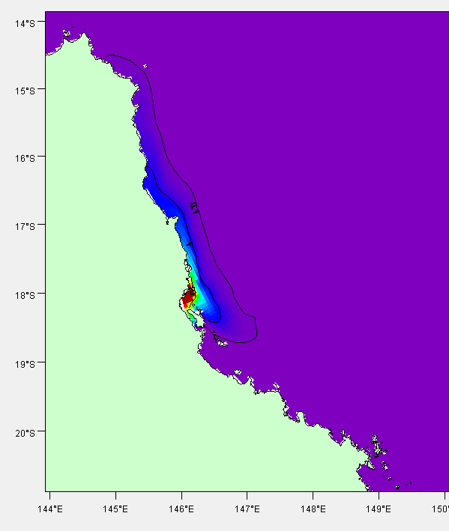
Figure 5-30: Cumulative exposure index for the Tully River in 2014-15 (left). Results for 2010-11 (right) are shown for context. The colour bar indicates the calculated cumulative exposure (concentration x days) above 1% of the incoming concentration. The colour bar is capped at 20 Conc.Days. Contours show 0.1, 1.0 and 10.0 Conc.Days exposure levels.
The Tully River (Euramo gauge) and Herbert River (Ingham gauge) are the two routinely monitored sites in the Tully, Murray and Herbert Basins. The Herbert River is a relatively large contributor of discharge, TSS and nutrients while the Tully River is a large contributor of DIN in the Wet Tropics region. In particular, the Herbert River has a large grazing area in the upper part of the catchment which is situated in a relatively drier area which contributes a high proportion of TSS and particulate nutrients. The sugarcane lands in the Herbert and Tully regions contribute large amounts of DIN to the loads from the rivers. Both rivers contain a sizable area of cropping land below the gauging stations where these measurements were taken and it would be expected that the loads from the basins would be considerable higher. In the 2014-15 season both rivers had their lowest discharge over the 9 years of record and hence the constituent loads were also lower compared to previous years of monitoring over the 2006-07 to 2014-15 period (Figure 5-31 and Figure 5-32).
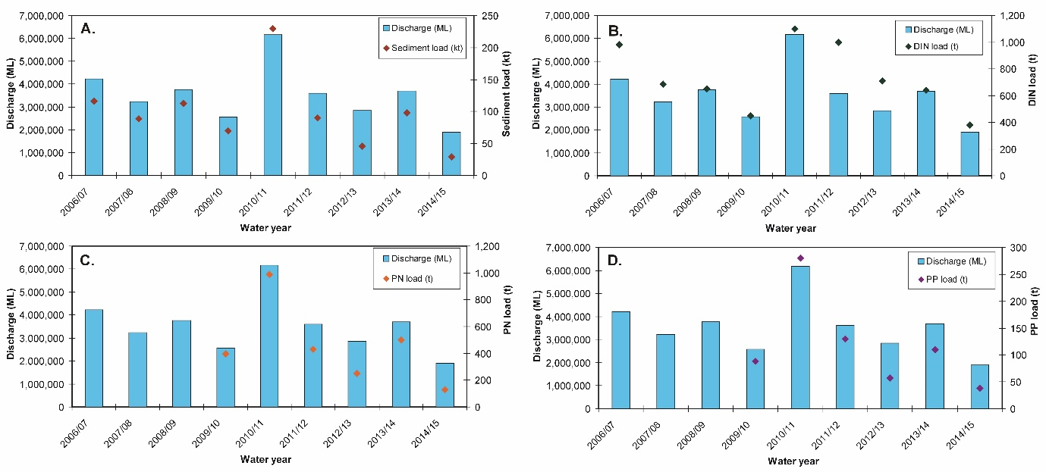
Figure 5-31: Measured Tully River (at Euramo gauge) discharge and loads for (A) total suspended solids (sediment), (B) dissolved inorganic nitrogen (DIN), (C) particulate nitrogen (PN) and (D) particulate phosphorus (PP) from 2006/07 to 2014/15. Data from the Department of Science Information Technology and Innovation’s Great Barrier Reef Catchment Loads Monitoring Program (compiled from: Joo et al., 2012; Turner et al., 2012, 2013; Wallace et al., 2014, 2015, in press; Garzon-Garcia et al., 2015).

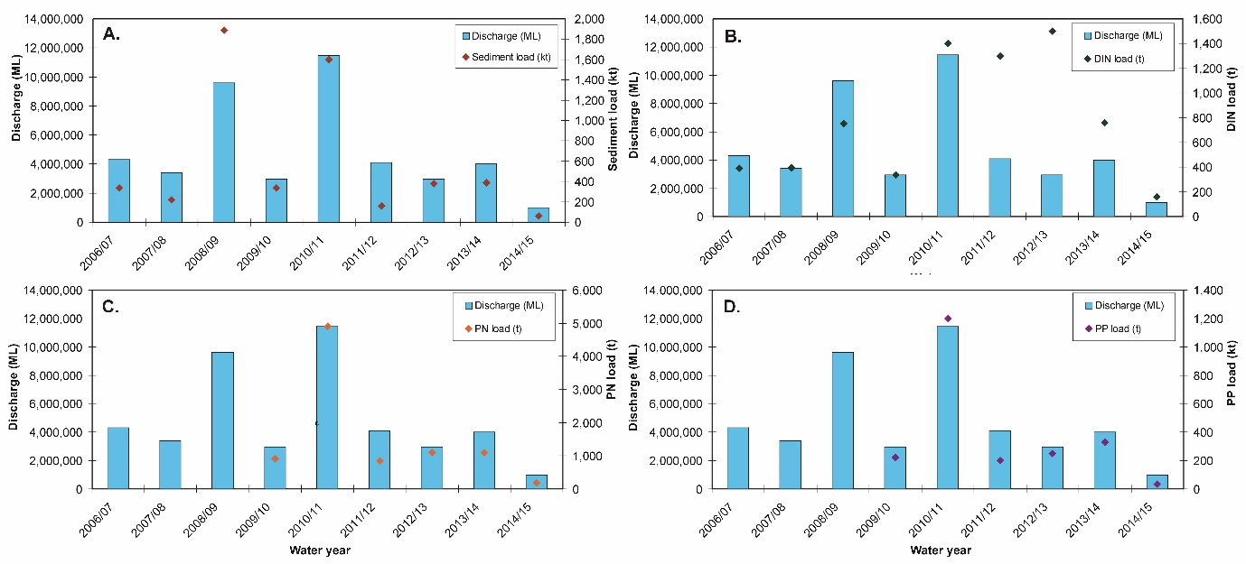
Figure 5-32: Measured Herbert River discharge (at the Ingham gauge) and loads for (A) total suspended solids (sediment), (B) dissolved inorganic nitrogen (DIN), (C) particulate nitrogen (PN) and (D) particulate phosphorus (PP) from 2006/07 to 2014/15. Data from the Department of Science Information Technology and Innovation’s Great Barrier Reef Catchment Loads Monitoring Program (compiled from: Joo et al., 2012; Turner et al., 2012, 2013; Wallace et al., 2014, 2015, in press; Garzon-Garcia et al., 2015).

Ambient water quality
When analysing the water quality trend in this region it should be noted that the location of some of the loggers have changed (TUL 3 and 6), and that the number of water sampling sites and frequency of sampling has increased during 2015. Some of these new sites are placed further inshore and they are therefore affected by primary and secondary plume-type waters.
The site-specific Water Quality Index has been stable over the past seven years, maintaining a ‘moderate’ rating (Figure 5-33:a). Trends in concentrations of Chl-a, PN and PP showed distinct cycles, with periods of high values in 2006-07, 2011-12 and 2013-14 (Figure 5-33:b,f,h). Trend-lines for PP were almost entirely above water quality guidelines (guideline) until 2015, while Chl-a trend-lines exceeded or was near or above the guideline since the beginning of the monitoring program (Figure 5-33:b, h). Concentrations of TSS were generally above guideline values (around 1 ug/L) throughout the program, decreasing until 2013 but with an upward trend in 2014-2015 (Figure 5-33:c). The concentrations of NO_{x} showed increasing concentrations that exceeded the guideline from 2011 to 2014 (Figure 5-33:d). Secchi depth remained relatively stable with a long-term average of about 5m, which exceeds the guideline (Figure 5-33:e).
The concentrations of POC have remained more or less stable over the monitoring period, while the DOC concentrations have shown an increase until 2012 where after it has remained relatively stable (Figure 5-33:i,j).
The instrumental Chl-a and turbidity records showed more pronounced fluctuations than the manual sampling data (Figure 5-26b,g). The trend-lines of Chl-a showed distinct maxima above the guideline during the wet seasons of 2011 and 2014 (Figure 5-33:b). The turbidity showed overall levels around twice the guideline levels, steadily increasing over the course of the monitoring period with peak levels in 2011-2012 and 2014 (Figure 5-33:g).
The TSS and turbidity (NTU) showed different temporal trends (Figure 5-33:c and g), which is mainly due to that they measure different properties, as described above (see Russell-Mulgrave focus area). This difference in trends indicates that the size spectrum/composition of the optical active particle fraction has changed over the monitoring period.
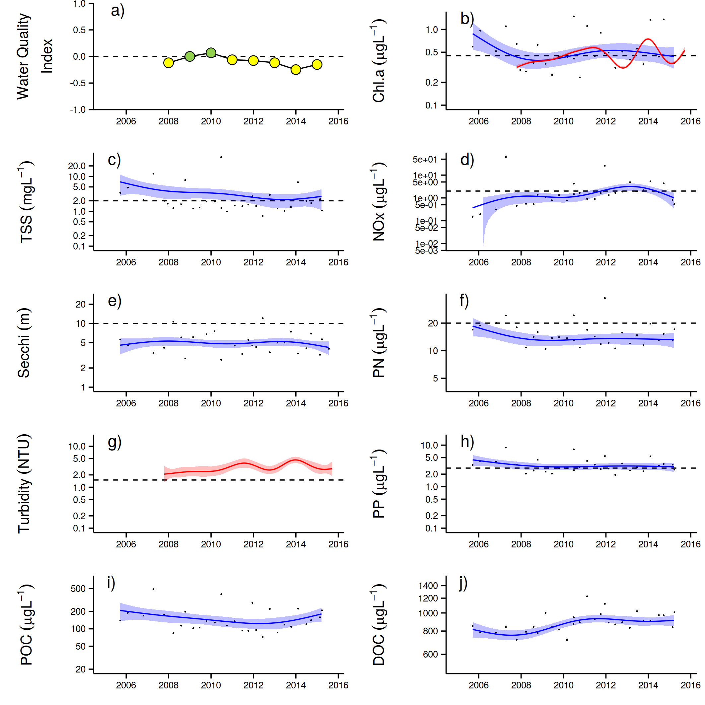
Figure 5-33: Temporal trends in water quality for the Tully sub-region. a) water quality index, b) chlorophyll a, c) total suspended solids, d) nitrate/nitrite, e) Secchi depth, f) particulate nitrogen, g) particulate phosphorus, h) particulate organic carbon and i) dissolved organic carbon. Water quality index colour coding: dark green- ‘very good’; light green-‘good’; yellow – ‘moderate; orange – ‘poor’; red – ‘very poor’. The water quality index is the aggregate of variables plotted in b - h and calculated as described in Appendix 1.2.3. Trends in POC and DOC values are plotted here (i, j); threshold levels have yet to be established. Trends in manually sampled water quality variables are represented by blue lines with blue shaded areas defining 95% confidence intervals of those trends accounting for the effects of wind, waves and tides, black dots represent observed data. Trends of records from ECO FLNTUSB instruments are represented in red, individual records are not displayed. Dashed reference lines indicate guideline values.

Wet season water quality
Data collected in the wet season has also contributed to the understanding of the variability associated with the period of elevated flow. The Tully and Murray Rivers have now been sampled every year from 2006 (i.e., 2005-2006 wet season, Table A2-2) adding to a significantly valuable long-term data set for the Tully focus area (1994 – 2015).
Details of samples collected in the wet season can be found in Appendix A2-6, which details statistical summary of the water quality parameters collected at each focus area, over the 2014-15 wet season.
Salinity mixing plots for the data collected in the 2014-15 wet season at the Tully sites at each sampling event are presented for DIN, DIP, K_{d}(PAR), TSS, Chl-a and CDOM (Figures A2-15 to A2-20).
The corresponding end-of–catchment water quality concentrations at each sampling date are not available to produce proper mixing plots for the Tully focus area. Average values, calculated from long-term data (since 2006) where salinity was below 5 ppt were used instead. The Tully data exhibited variable mixing patterns in water quality concentrations, which typically decreased from low to high salinity. Sampling can target the flow peaks, however many of the sites had salinity > 30 ppt, thus limiting the ability to determine the dilution mixing process across the salinity gradient. Linear dilution patterns were observed in some events for DIN and CDOM, indicating their conservative behaviour in plume waters. However this has to be interpreted with caution due to the reduced number of events sampled and the weak coverage of the full salinity gradient.
Dissolved inorganic phosphorus and Kd(PAR) also showed reductions in concentrations moving away from the river mouth (Figure A2-16 and A2-17), but followed a non-conservative behaviour. DIP showed rapid reduction, possibly associated with biological uptake, and posterior stabilisation. Kd(PAR) showed a two-step reduction probably associated to sediment settling out of the river mouth (Figure A2-18) and a posterior drop associated to reduction in Chl-a concentrations at salinity > 30 ppt (Figure A2-19), thus presenting a similar pattern to the Russell-Mulgrave focus area.
As expected, Chl-a and TSS did not present conservative behaviour. TSS dropped out quickly from the river mouth due to particles settling, and remained constant after that (Figure A2-18). Chl-a had a more variable pattern compared to the other water quality parameters, showing a slight increase at low salinity (approx. 10 ppt) and wide variability at salinity > 30 ppt (Figure A2-19). PN and PP had similar pattern to TSS, showing rapid reduction just after the river mouth. Again these patterns must be interpreted with caution due to the reduced number of events sampled and the weak coverage of the full salinity gradient.
To investigate the potential control of discharge and wind on the parameters sampled in the Tully focus area, a Spearman correlation coefficient was determined (Table 5-6: ). In this analysis, the mean parameter values per transect/day sampled since the 2005-06 wet season were used to reduce data variability that may be associated with changes in site location and site number. Overall river discharge showed a positive correlation with CDOM, DIN, and Si, suggesting the higher the river discharge, the higher the concentrations. Wind components, and therefore eventual resuspension events or currents, advecting the superficial water mass, did not correlate with any of the analysed parameters.
Salinity was included in this analysis to investigate its correlation against CDOM. The test result suggests the greater the salinity, the lower the CDOM concentration, as expected (Schroeder, 2012). Chl-a did not show correlation with any of the major macro nutrients, but only against CDOM. This result is difficult to explain and requires further investigation.

Table 5-6: Tully sites: Spearman Correlation Coefficient calculated using the mean value of each parameter sampled per transect when all sites sampled since 2005-06 wet season are combined. Water quality parameters tested were: light attenuation (Kd(PAR)), coloured dissolved organic matter (CDOM), dissolved inorganic nitrogen (DIN), dissolved inorganic phosphorus (DIP), particulate nitrogen (PN), particulate phosphorus (PP), reactive silica (Si) and chlorophyll-a (Chl-a), and they were tested against river discharge, W-E wind component , N-S wind component, surface salinity and chlorophyll-a. Significant (p<0.05) correlation coefficients >0.6 or <-0.6 are highlighted.
 | Kd(PAR) | CDOM | TSS | DIN | DIP | PN | PP | Si | Chl-a
Discharge | 0.16 | 0.79 | -0.13 | 0.63 | 0.24 | 0.05 | 0.47 | 0.84 | 0.51
W-E wind component | -0.24 | -0.18 | 0.04 | -0.13 | -0.02 | -0.19 | -0.55 | -0.51 | -0.03
N-S wind component | -0.14 | -0.20 | 0.11 | -0.40 | -0.05 | 0.24 | -0.18 | -0.56 | -0.06
Salinity | -0.32 | -0.66 | -0.04 | -0.65 | -0.44 | 0.20 | -0.36 | -0.95 | -0.31
Chl-a | 0.50 | 0.65 | 0.13 | 0.38 | -0.05 | 0.45 | 0.27 | -0.03 | 1

The same set of box-plots used in the Russell-Mulgrave focus area were produced for the Tully focus area, aiming to describe the transport of water quality parameters across plume waters. Box-plots were produced by aggregating in-situ values measured within each plume water type (i.e., Primary, Secondary and Tertiary). Data is summarised by the median and quantiles within each plume water type. A comparison against the guidelines and the result of a Kruskal-Wallis Rank Sum test (as p-value) are provided (Figure 5-34).
Significant differences in concentrations among the plume water types were evident for Kd(PAR) (Figure 5-34a), TSS (Figure 5-34e) and PP (Figure 5-34m), with higher values in Primary waters and lower in Tertiary waters. In the long-term comparison, these parameters plus DIP, CDOM and PP presented significant differences among water types, suggesting most of the parameters (6 in 8) exhibit some kind of transformation in the long-term, resulting in a significant gradient across plume water. In terms of the median in-situ measurement compared against guideline values, for those water constituents with guidelines, DIN, and PN were constantly above the thresholds in any plume water type in both comparisons (i.e., 2014-15 data set and 2005-2015 data set).
In general, the median concentrations of the parameters were lower in 2014-15 compared to those calculated for the 2005-2015 wet seasons. This result suggests that the below long-term median total GBR discharge observed in the 2014-15 wet season (Figure 5-5), resulted in less terrestrial input, which was mainly observed in the Primary waters. The Secondary and especially the Tertiary waters did not vary much between the two periods compared. This is a result of the mixing process that increases the sea water contribution to the plume waters, and therefore the water constituents are more representative of the sea water. A similar comparison was not performed to the Russell-Mulgrave data set due to the low representation of samples in Primary water in the 2014-15 wet season.
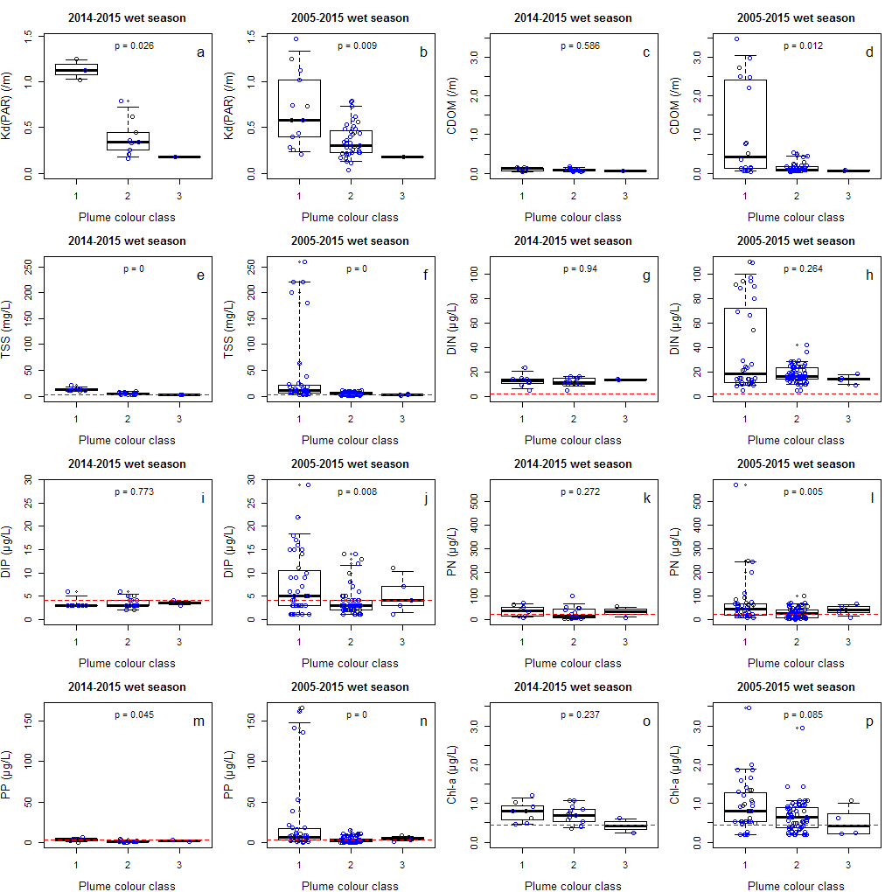
Figure 5-34: Boxplot for the parameters sampled at the Tully sites in the current wet season compared to all data sampled since 2005-06 wet season. In the boxplot bold line stands for median, rectangles are for the 25th and 75th percentiles and vertical line for 5th and 95th percentile. The p-value is from a Kruskal-Wallis Rank Sum test among plume water types. Dots represent data points (nudge was added for data visualisation) and red dashed line stands for the water quality guidelines for open coastal waters. Plume water type 1, 2 and 3 stands for Primary, Secondary and Tertiary, respectively.

    - Burdekin focus area

Overview
The Burdekin region is one of the two large dry tropical catchment regions adjacent to the GBR, with cattle grazing as the primary land use on over 95% of the catchment area (NQDT, 2016). There is also intensive irrigated sugarcane on the floodplains of the Burdekin and Haughton Rivers. Fluctuations in climate and cattle numbers greatly affect the state and nature of vegetation cover, and, therefore, the susceptibility of soils to erosion and off-site transport of suspended sediments and associated nutrients. Three stations were sampled in the Burdekin focus area three times per year until the end of 2014. The new MMP water quality sampling design in 2015 now includes 15 stations that are sampled up to nine times per year, with six stations sampled during both the dry and wet season and nine only during the wet season (Table 4-1). The sampling locations in this new design are located in a river mouth to open coastal water transect representing a gradient in water quality, with ten stations dominantly affected by Primary and Secondary plume water types, and five stations located in the mid-shelf water body which is less likely to be exposed to the Secondary plume water type (Figure 5-35).

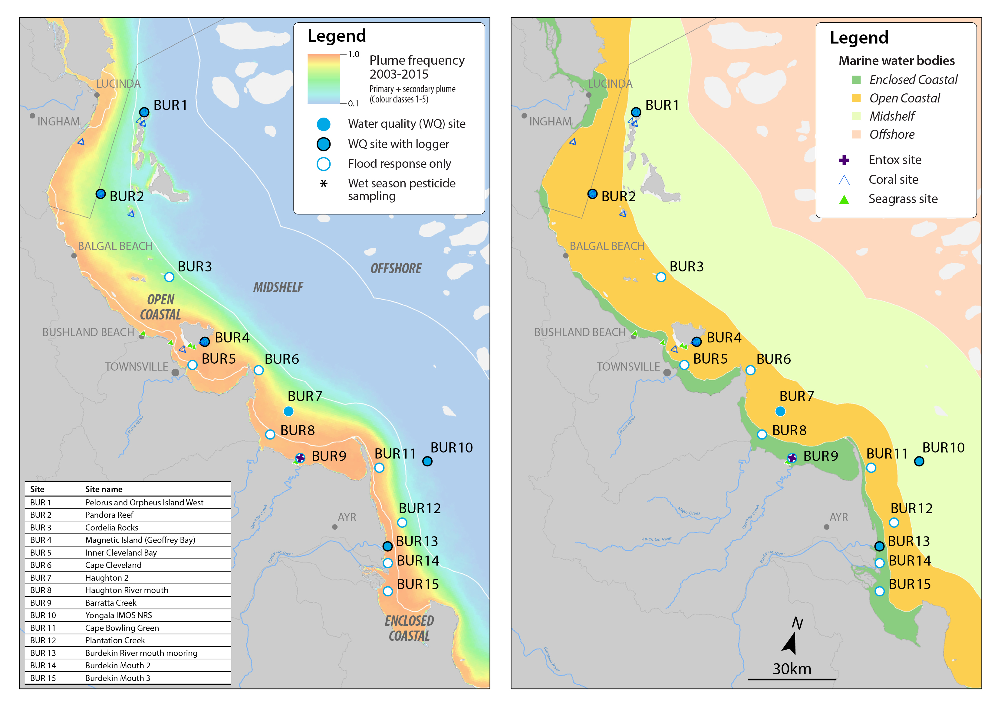
Figure 5-35: MMP sampling sites in the Burdekin focus area shown with (left) wet season plume frequency 2003 to 2015 (Primary + Secondary; where 1.0 represents 22 weeks, December to March) and (right) the water body boundaries.
Rainfall for the Burdekin Basin was very low in 2014-15 and below the long term average in all catchments. This is reflected in the substantively lower flow than the long term median in the Burdekin River (Figure 5-36) with a total discharge of just under 1,000,000 ML over the total wet season. This contrasts substantively with the flow conditions between 2007 to 2012 (Table A2-1) when annual discharge from the Burdekin River was above median levels. Below the long-term median discharges were found in the later years (2013, 2014 and 2015) (Figure 5-36). The 2011 flood was the third largest on record, at almost six times the long-term median discharge (Table A2-1).

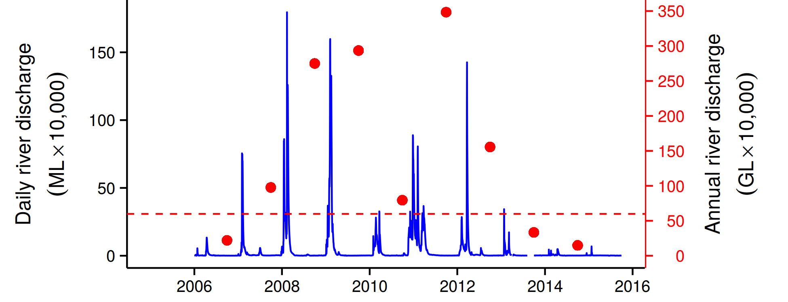
Figure 5-36: Discharge for the Burdekin River. Daily (blue) and annual (October to September, red) discharge shown. Red dashed line represents the long-term median annual discharge.
The estimated zone of influence for the Burdekin River is presented in Figure 5-37, showing a substantially constrained zone of influence in 2014-15 compared to the large events of 2010-11, and correlated with below long term median discharge.

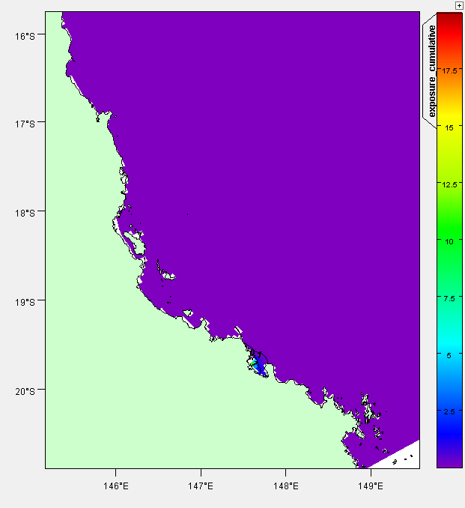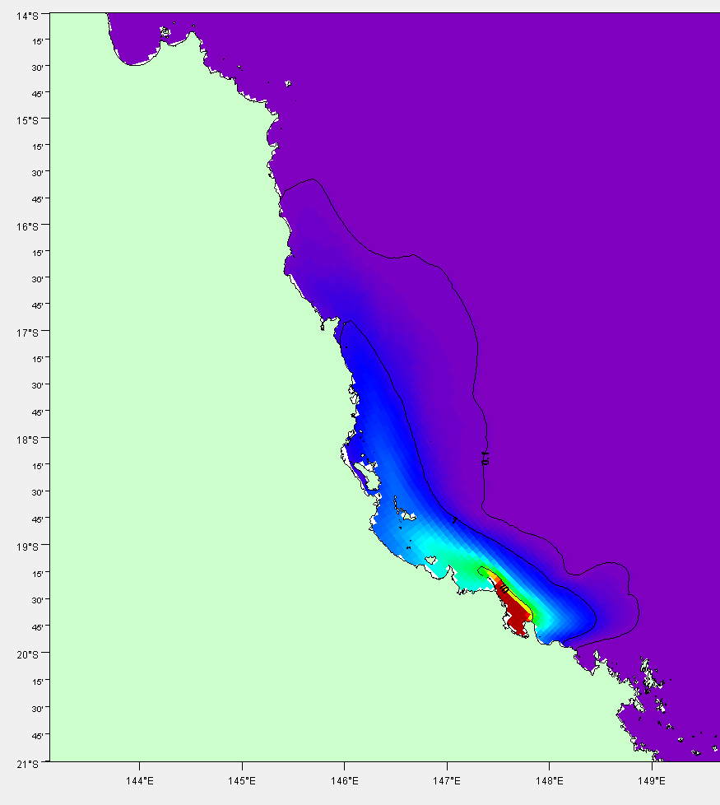
Figure 5-37: Cumulative exposure index for the Burdekin River in 2014-15 (left), results for 2010-11 (right) are shown for context. The colour bar indicates the calculated cumulative exposure (concentration x days) above 1% of the incoming concentration. The colour bar is capped at 20 Conc.Days. Contours show 0.1, 1.0 and 10.0 Conc.Days exposure levels.
The Burdekin River (Clare gauge) and Barratta Creek (Northcote gauge) are the two routinely monitored sites in the Burdekin and Haughton Basins, although the Haughton River at Powerline gauge has also recently been established. The Burdekin River is a major contributor of discharge, TSS and nutrients to the region while Barratta Creek is a very small catchment but has relatively high concentrations of DIN and herbicides (due to the relative large area of cropping in the catchment) albeit much lower constituent loads. In the 2014-15 season both streams had their lowest discharge over the 9 years of record and hence the constituent loads were also generally lower compared to previous years of monitoring over the 2006-07 to 2014-15 period (Figure 5-38 and Figure 5-39). The exception is the DIN loads in Barratta Creek which is influenced by relatively large volumes of irrigation tailwater runoff and hence the loads remain similar despite variability in discharge.

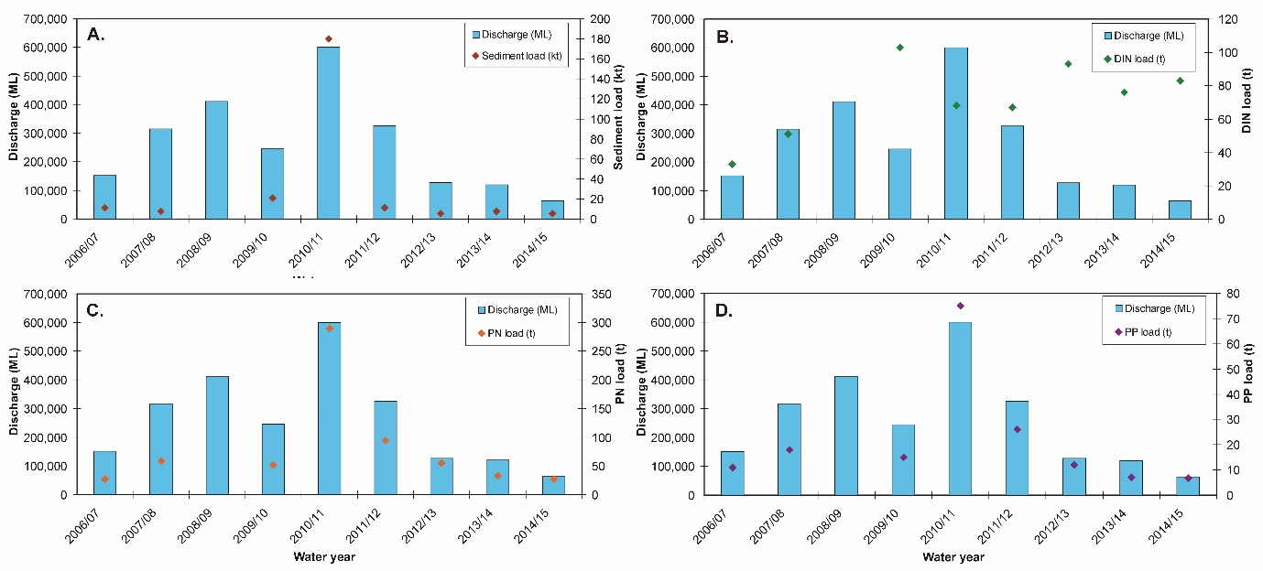
Figure 5-38. Measured Barratta Creek discharge and loads (at Northcote gauge) for (A) total suspended solids (sediment), (B) dissolved inorganic nitrogen (DIN), (C) particulate nitrogen (PN) and (D) particulate phosphorus (PP) from 2006-07 to 2014-15. Data from the Department of Science Information Technology and Innovation’s Great Barrier Reef Catchment Loads Monitoring Program (compiled from: Turner et al., 2012, 2013; Wallace et al., 2014, 2015, in press; Garzon-Garcia et al., 2015) and TropWATER (Bainbridge et al., 2007, 2008; unpublished data).

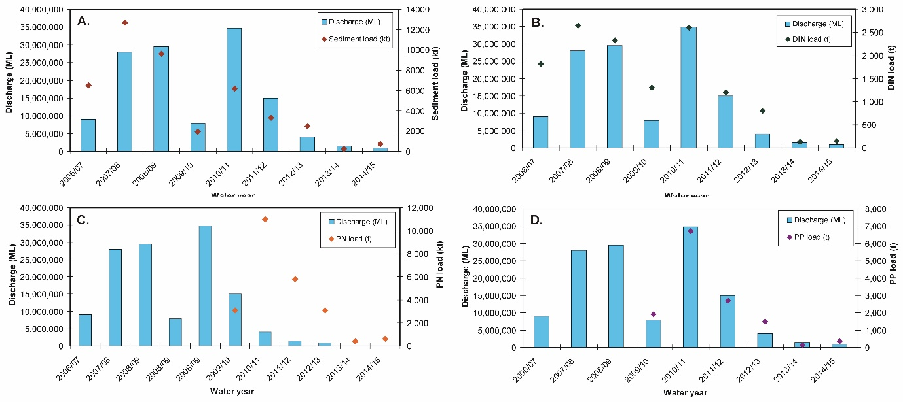
Figure 5-39. Measured Burdekin River discharge (at the Clare gauge) and loads for (A) total suspended solids (sediment), (B) dissolved inorganic nitrogen (DIN), (C) particulate nitrogen (PN) and (D) particulate phosphorus (PP) from 2006-07 to 2014-15. Data from the Department of Science Information Technology and Innovation’s Great Barrier Reef Catchment Loads Monitoring Program (compiled from: Joo et al., 2012; Turner et al., 2012, 2013; Wallace et al., 2014, 2015, in press; Garzon-Garcia et al., 2015).

Ambient water quality
The location of some of the loggers have changed in this region (BUR13), and the number of water sampling sites and frequency of sampling increased during 2015. Some of the new sites are placed further inshore and they are therefore affected by Primary and Secondary plume waters which will influence assessment of longer term trends.
The site-specific Water Quality Index in this region has been relatively stable over the monitoring period, oscillating between ‘good’ and ‘very good’ ratings (Figure 5-40a). Trends in concentrations of Chl-a declined at the beginning of the sampling program and thereafter remained stable until 2015 when the trend-line r was near or above the guideline. The trends in TSS, PN and PP declined slightly over the course of the program, with a period of slightly increased values in the latter three variables around 2011-12 (Figure 5-40b, c, f, h), likely influenced by Cyclone Yasi and extreme flooding of the Burdekin and local rivers in 2011 (Figure 5-40 and Table A2-1). From 2007 onwards, the overall trend-lines for TSS, PN and PP were below water quality guidelines (GBRMPA 2010). The concentrations of NO_{x} increased sharply after the first major flood event in 2008 and have since remained at levels close to or above the Queensland guideline (3 ug/L) (Figure 5-40d). Secchi depth has remained non-compliant with the guideline values over the whole sampling period, with a decreasing trend since 2014, which is most likely due to the increased amount of stations close to the Burdekin River mouth as part of the new sampling program (Figure 5-40e).
The concentrations of particulate organic carbon (POC) have remained relatively stable over the monitoring period, while the dissolved organic carbon (DOC) concentrations increased until 2011, and thereafter remained stable (Figure 5-40i, j).
Instrumental chl and turbidity records showed more pronounced fluctuations than the manual sampling data (Figure 5-40b, g). The trend-lines of Chl-a showed distinct maxima above the guideline during the wet seasons of 2008-09, 2011-12 and 2013-14 (Figure 5-40b). The turbidity record increased over the monitoring period with maxima above the guideline in 2011, 2013, 2014 and 2015 (Figure 5-40g). The TSS and turbidity data showed different temporal trends, with TSS decreasing and turbidity increasing, indicating that the size spectrum/composition of the optical active particle fraction has changed over the monitoring period.

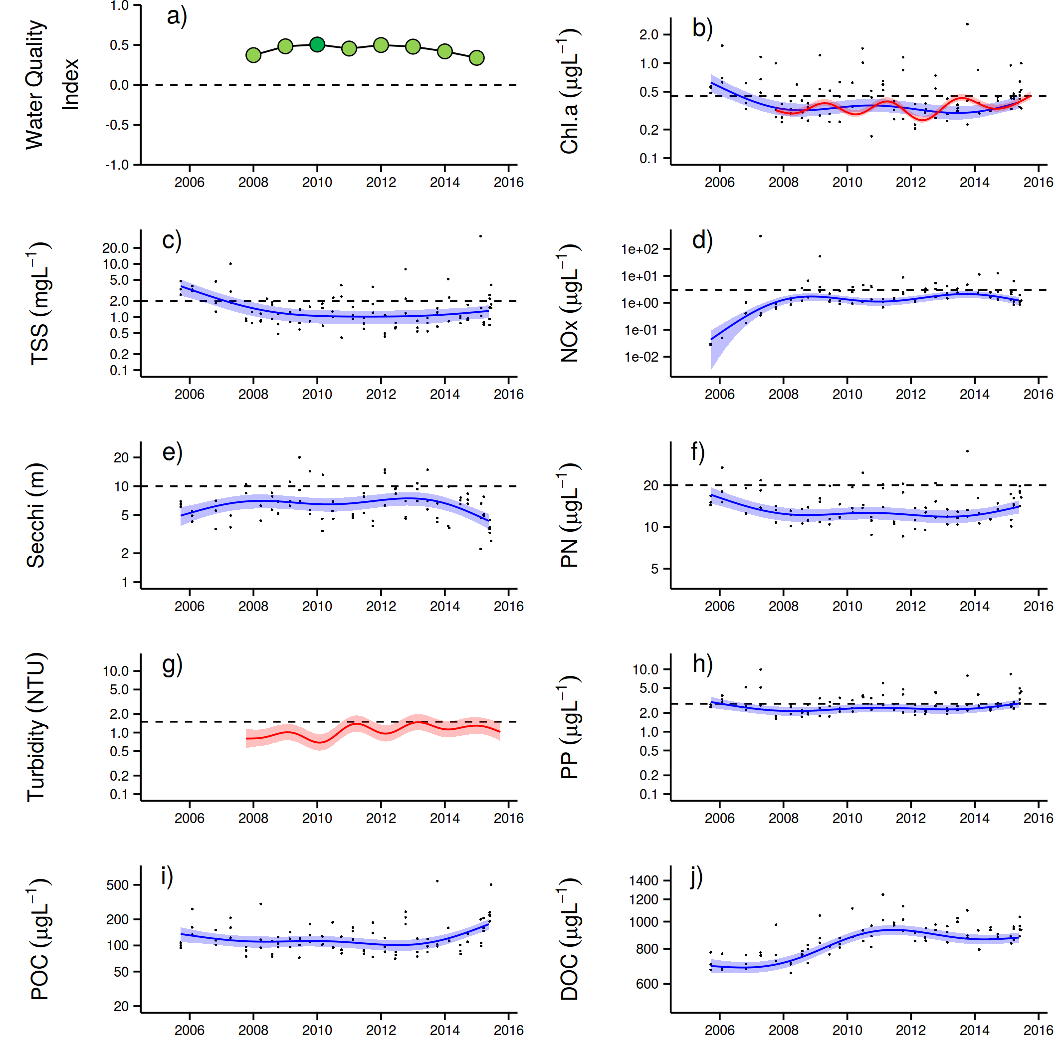
Figure 5-40: Temporal trends in water quality for the Burdekin focus area. a) Water Quality Index, b) chlorophyll a, c) total suspended solids, d) nitrate/nitrite, e) Secchi depth, f) particulate nitrogen, g) particulate phosphorus, h) particulate organic carbon and i) dissolved organic carbon. Water quality index colour coding: dark green- ‘very good’; light green-‘good’; yellow – ‘moderate; orange – ‘poor’; red – ‘very poor’. The water quality index is the aggregate of variables plotted in b - h and calculated as described in Appendix 1.2.3. Trends in POC and DOC values are plotted here (i, j); threshold levels have yet to be established. Trends in manually sampled water quality variables are represented by blue lines with blue shaded areas defining 95% confidence intervals of those trends accounting for the effects of wind, waves and tides, black dots represent observed data. Trends of records from ECO FLNTUSB instruments are represented in red, individual records are not displayed. Dashed reference lines indicate guideline values.

Wet season water quality
Data collected in the wet season has also contributed to the understanding of the variability associated with the period of elevated flow and cyclonic activity. The Burdekin River was previously sampled in 2010, 2011 and 2013 (Table A2-6).
Details of samples collected in the wet season can be found in Appendix A2-6, including a statistical summary of the water quality parameters collected over the 2014-15 wet season. Salinity mixing plots for the data collected at Burdekin sites in the 2014-15 wet season for each sampling event are presented for DIN, DIP, K_{d}(PAR), TSS, Chl-a, PN, PP and CDOM (Figures A2-15 to A2-20).
As for the other focus areas, end-of–catchment parameter concentrations at each sampling date were not available to produce proper mixing plots for the Burdekin focus area. Average values, calculated from long-term data (since 2006) where salinity was below 5 ppt were used instead. The Burdekin sites were sampled in two events, mid-February and end of March, and they did not capture any flood event. As a result, sites were not exposed to freshwater, with salinity > 30 ppt, thus limiting the description of the dilution mixing process across the salinity gradient. The only observation from these mixing plots is that all parameters, except CDOM and Chl-a, were relatively constant over the sampled sites.
To investigate potential the control of discharge and wind on the water quality parameters sampled in the Burdekin focus area, a Spearman correlation coefficient was determined (Table 5-7: ). In this analysis, mean parameter values per transect/day sampled since the 2005-06 wet season were used to reduce data variability associated with changes in site location and site number. Overall, river discharge presented a negative correlation with Kd(PAR) and Si, suggesting the higher the river discharge, the lower the concentrations. The N-S wind component, and therefore eventual resuspension events or currents, advecting the superficial water mass, correlated negatively with CDOM and PP, suggesting that the stronger the southerly winds, the lower the concentration of these parameters.
Salinity was included in this analysis to investigate its correlation against CDOM. The results suggest the greater the salinity, the lower the CDOM concentration, as expected (Schroeder, 2012). Chl-a did not present a correlation with any of the major macro nutrients, but did against CDOM.
Table 5-7: Burdekin sites: Spearman Correlation Coefficient calculated using the mean value of each parameter sampled per transect when all sites sampled since 2005-06 wet season are combined. Water quality parameters tested were: light attenuation (Kd(PAR)), coloured dissolved organic matter (CDOM), dissolved inorganic nitrogen (DIN), dissolved inorganic phosphorus (DIP), particulate nitrogen (PN), particulate phosphorus (PP), reactive silica (Si) and chlorophyll-a (Chl-a), and they were tested against river discharge, W-E wind component, N-S wind component , surface salinity and chlorophyll-a. Significant (p<0.05) correlation coefficients >0.6 or <-0.6 are highlighted.
 | Kd(PAR) | CDOM | TSS | DIN | DIP | PN | PP | Si | Chl-a
Discharge | -0.66 | 0.55 | -0.19 | 0.41 | 0.15 | -0.19 | 0.59 | -0.60 | -0.23
W-E wind component | -0.50 | 0.60 | -0.10 | 0.47 | 0.04 | -0.57 | 0.48 | 0.10 | -0.15
N-S wind component | -0.50 | -0.66 | 0.35 | -0.33 | -0.37 | 0.41 | -0.62 | -0.15 | 0.06
Salinity | 0.54 | -0.78 | 0.24 | -0.58 | 0.11 | 0.08 | -0.64 | -0.07 | 0.39
Chl-a | 0.54 | -0.18 | 0.19 | 0.21 | -0.27 | 0.55 | -0.38 | -0.07 | 1.00

Box plots were used for the Burdekin sites to describe the transport of parameters across plume waters. Box-plots were produced by aggregating in-situ values measured within each plume water type (i.e., Primary, Secondary and Tertiary). Data is summarised by the median and quantiles within each plume water type. A comparison against the guidelines and the result of a Kruskal-Wallis Rank Sum test (as p-value) are provided (Figure 5-41).

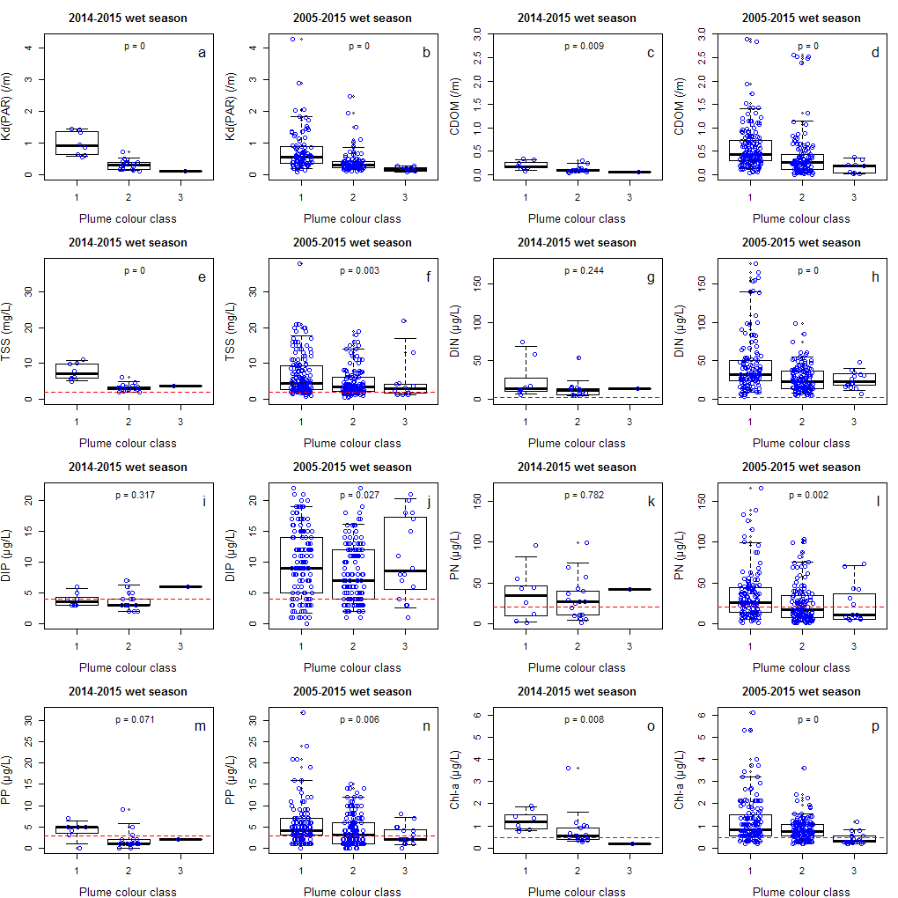
Figure 5-41: Boxplot for the parameters sampled at the Burdekin sites in the current wet season compared to all data sampled since 2005-06 wet season. In the boxplot bold line stands for median, rectangles are for the 25th and 75th percentiles and vertical line for 5th and 95th percentile. The p-value is from a Kruskal-Wallis Rank Sum test among plume water types. Dots represent data points (nudge was added for data visualization) and red dashed line stands for the water quality guidelines for open coastal waters. Plume water type 1, 2 and 3 stands for Primary, Secondary and Tertiary, respectively.

For a wet season with reduced river discharge such as 2014-15, a reduced contribution from land-based contaminants would be expected. Indeed, DIP, PP, DIN and PN did not show a significant difference among the plume water types. In contrast, all parameters presented a significant difference among water types in the long-term comparison. This pattern, compared to those observed for the Russell-Mulgrave and Tully sites, suggest that parameters in the Burdekin plumes undergo more transformation than those in the other two plumes. However this observation requires further investigation because the length of the Burdekin transect is longer (c.a., 200 km) than the length of the transects in the Russell-Mulgrave and Tully focus areas (about 40 km). Longer distance to travel gives more chance for transformation processes to take place.
    - Mackay Whitsunday focus area

Overview
The Mackay Whitsunday Region is located in the central section of the GBR and comprises four major river basins, the Proserpine, O’Connell, Pioneer and Plane Basins. The region is also potentially influenced by runoff from the Burdekin and Fitzroy Rivers during extreme events or through longer-term transport and mixing. The climate in this region is wet or mixed wet and dry tropical with the catchment land use dominated by agriculture broadly divided into grazing in the upper catchments and sugarcane cultivation on the coastal plains (Brodie et al., 2003; GBRMPA 2012). In addition, there are expanding urban areas along the coast.
Three stations were sampled three times per year in the Mackay Whitsunday region until the end of 2014. As part of the new MMP water quality sampling design in 2015, there are now 11 stations sampled up to five times per year, with eight stations sampled during both the dry and wet season and three only during the wet season (Table 4-1). The sampling locations in this new design are located in a river mouth to open coastal water transect representing a gradient in water quality. Five stations are likely to be dominated by Primary and Secondary plume waters, and six stations are located in areas which are less likely to be exposed to Primary and Secondary plume waters (Figure 5-42).

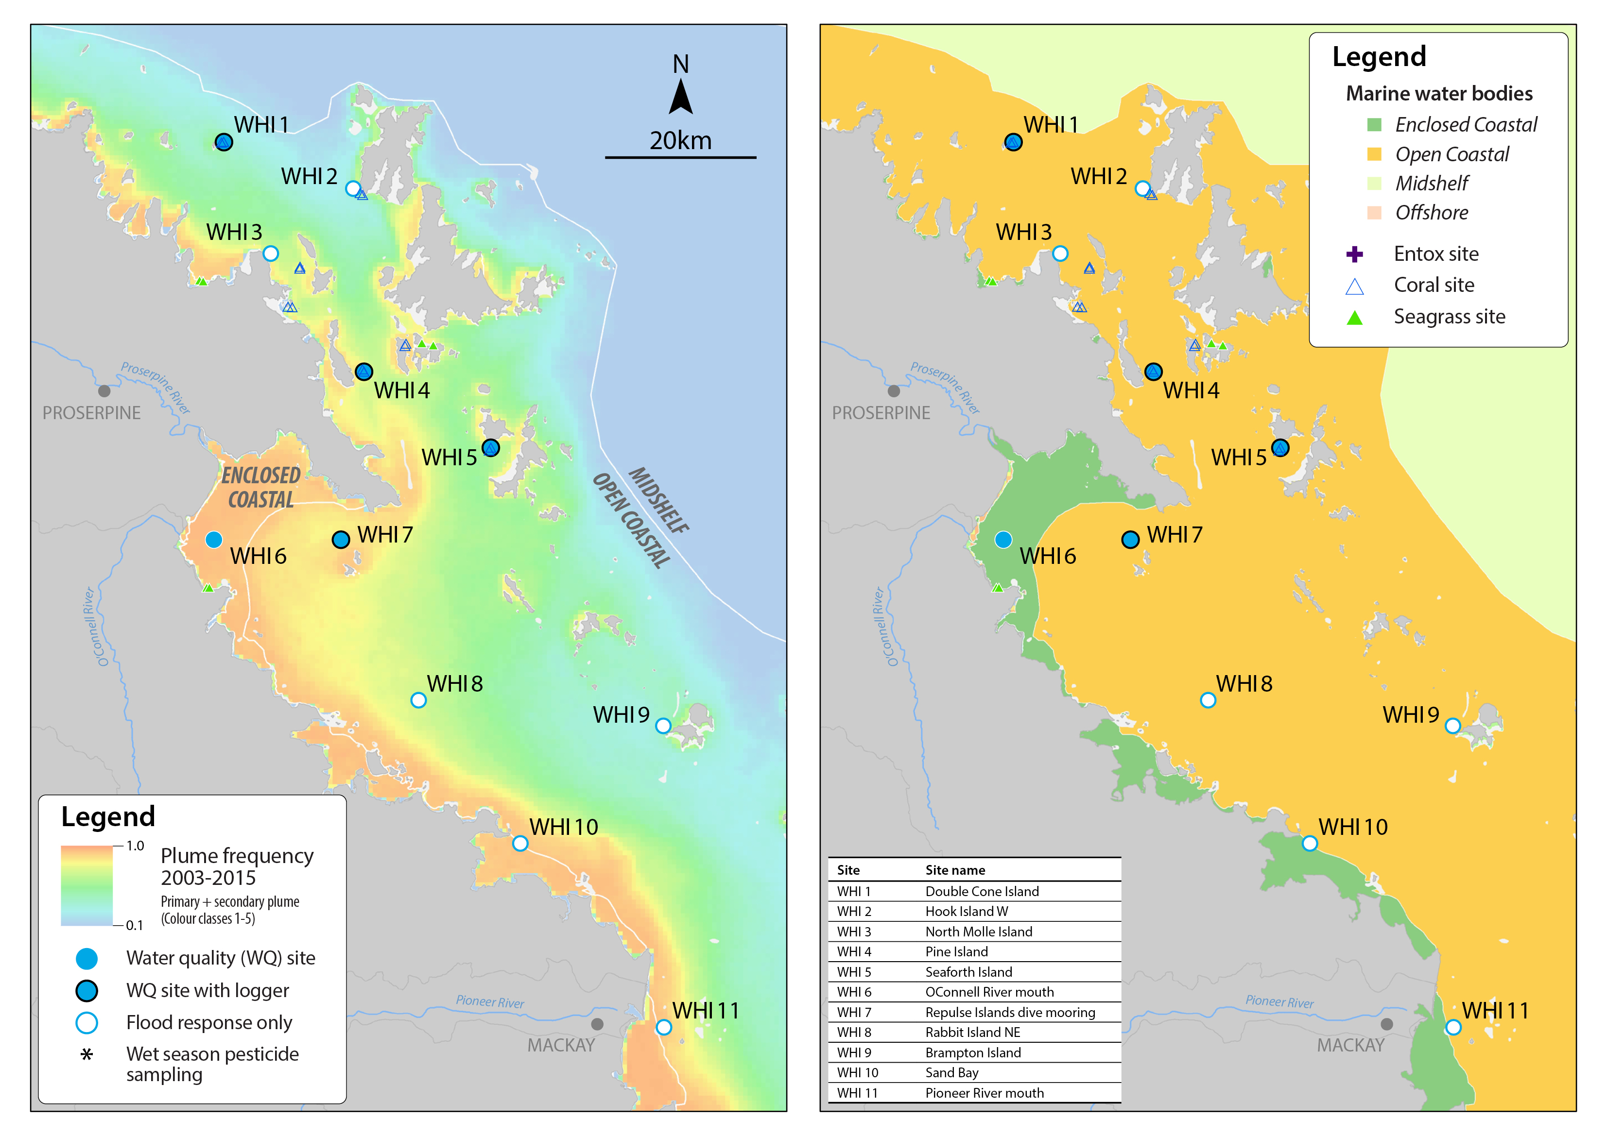
Figure 5-42: MMP sampling sites in the Mackay Whitsunday focus area shown with (left) wet season plume frequency 2003 to 2015 (Primary + Secondary; where 1.0 represents 22 weeks, December to March) and (right) the water body boundaries.
Over the period 2007 to 2013, annual discharge from the Proserpine, O’Connell and Pioneer Rivers was above median levels (Figure 5-43, Table A2-1). Extreme floods (more than 3 times the long term median) were recorded for the O’Connell River in 2011, the Pioneer River in 2008 and 2010 to 2013, and the Proserpine River each year 2008 to 2013 (Table A2-1). The 2011 flood was the largest on record for the Proserpine River and the third largest for the O’Connell River. The combined annual discharge from the O'Connell, Proserpine and Pioneer Rivers during 2014-15 were above the long-term median flows (Figure 5-43).

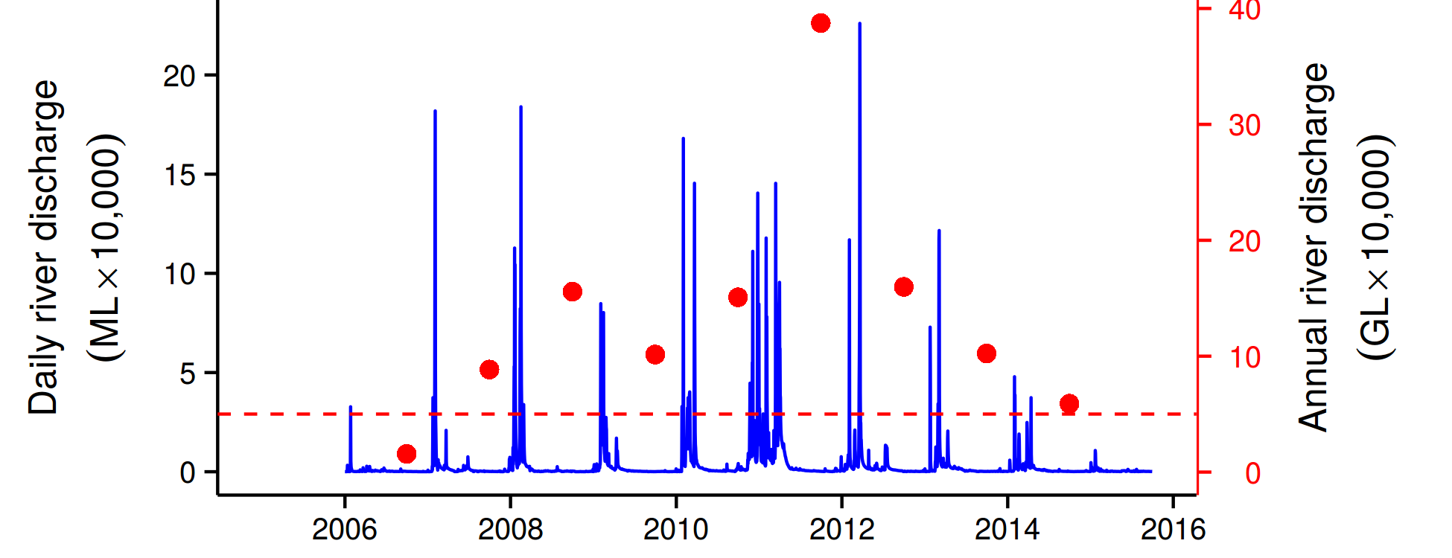
Figure 5-43: Combined discharge for the O'Connell, Proserpine and Pioneer Rivers. Daily (blue) and annual (October to September, red) discharge shown. Red dashed line represents the long-term median of the combined annual discharges.
Only the O’Connell River is included in the hydrodynamic model, and the estimated zone of influence is shown in Figure 5-44. The model shows a very limited zone of influence in 2014-15, and correlated is with the discharges well below the long term median.

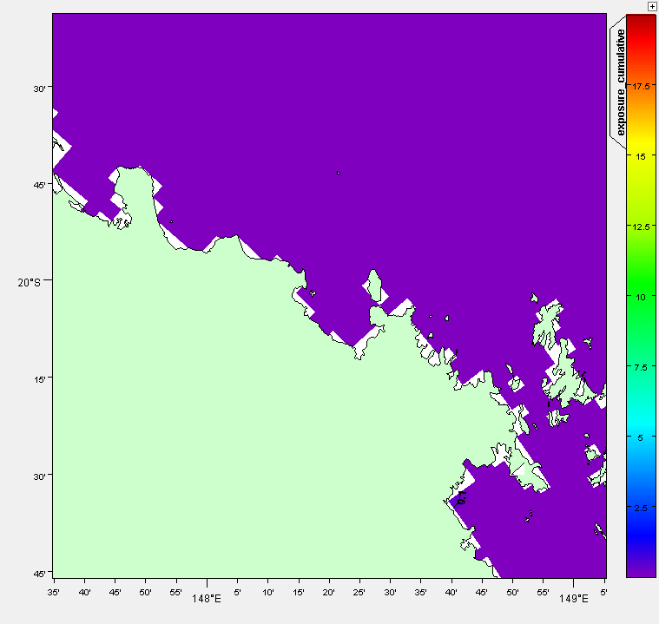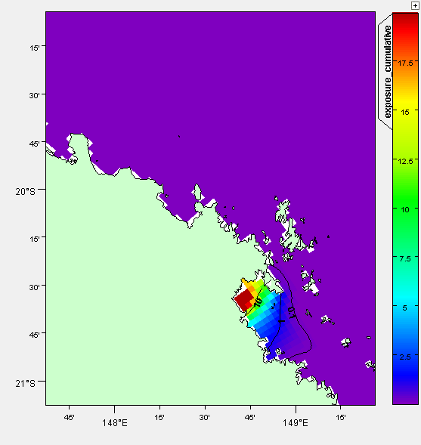
Figure 5-44: Cumulative exposure index for the O'Connell River in 2014-15 (left), results for 2010-11 (right) are shown for context. The colour bar indicates the calculated cumulative exposure (concentration x days) above 1% of the incoming concentration. The colour bar is capped at 20 Conc.Days. Contours show 0.1, 1.0 and 10.0 Conc.Days exposure levels.
The O’Connell River (Caravan Park gauge), Pioneer River (Dumbleton gauge) and Sandy Creek (Homebush gauge) are the three routinely monitored sites in the Proserpine, O’Connell, Pioneer and Plane Basins. The Pioneer River is a major contributor of discharge, sediments and nutrients to the region of the monitored sites, although it is worth pointing out that this monitoring site also captures the largest area (of the monitored sites) while Sandy Creek is a much smaller catchment area. For the purposes of the MMP, the total loads of sediment and nutrients are the most important parameter, although in terms of catchment management the loads contribute per area is an important consideration. In the 2014-15 season the streams had their lowest discharge over the monitoring record and hence the constituent loads were also generally lower compared to previous years of monitoring (Figure 5-45, Figure 5-46 and Figure 5-47).
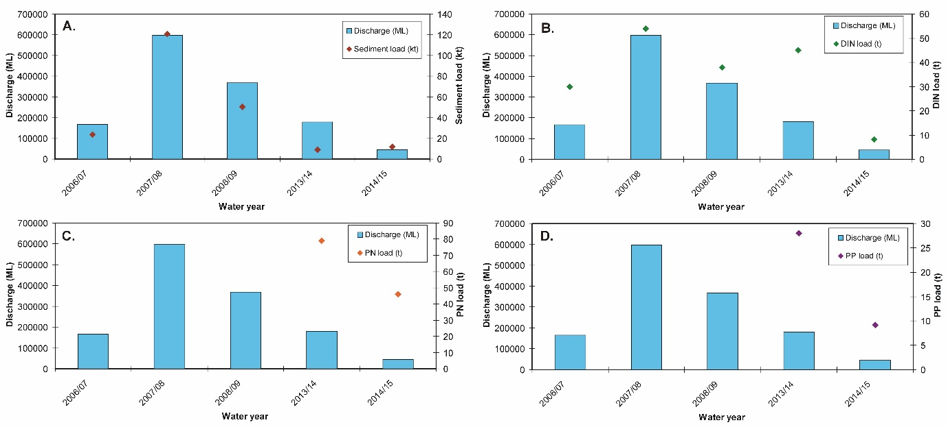
Figure 5-45. Measured O’Connell River discharge (at the Stafford’s Crossing/Caravan Park gauge) and loads for (A) total suspended solids (sediment), (B) dissolved inorganic nitrogen (DIN), (C) particulate nitrogen (PN) and (D) particulate phosphorus (PP) from 2006/07 to 2014/15. Data from the Department of Science Information Technology and Innovation’s Great Barrier Reef Catchment Loads Monitoring Program (compiled from: Joo et al., 2012; Wallace et al., in press; Garzon-Garcia et al., 2015).

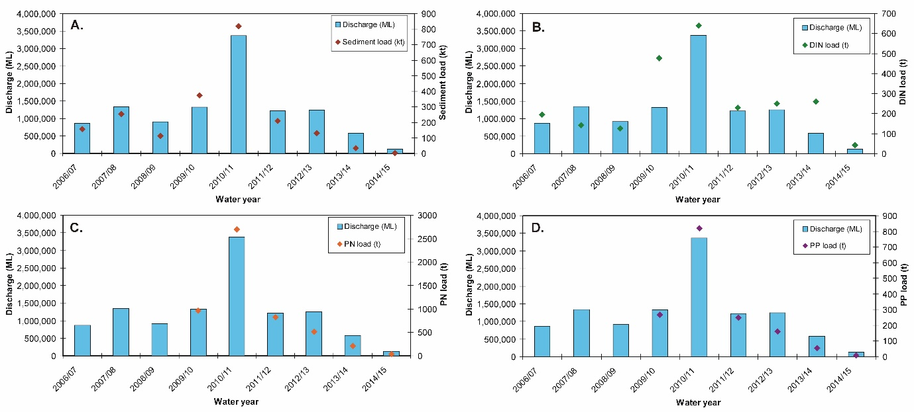
Figure 5-46. Measured Pioneer River discharge (at the Dumbleton gauge) and loads for (A) total suspended solids (sediment), (B) dissolved inorganic nitrogen (DIN), (C) particulate nitrogen (PN) and (D) particulate phosphorus (PP) from 2006/07 to 2014/15. Data from the Department of Science Information Technology and Innovation’s Great Barrier Reef Catchment Loads Monitoring Program (compiled from: Joo et al., 2012; Turner et al., 2012, 2013; Wallace et al., 2014, 2015, in press; Garzon-Garcia et al., 2015).

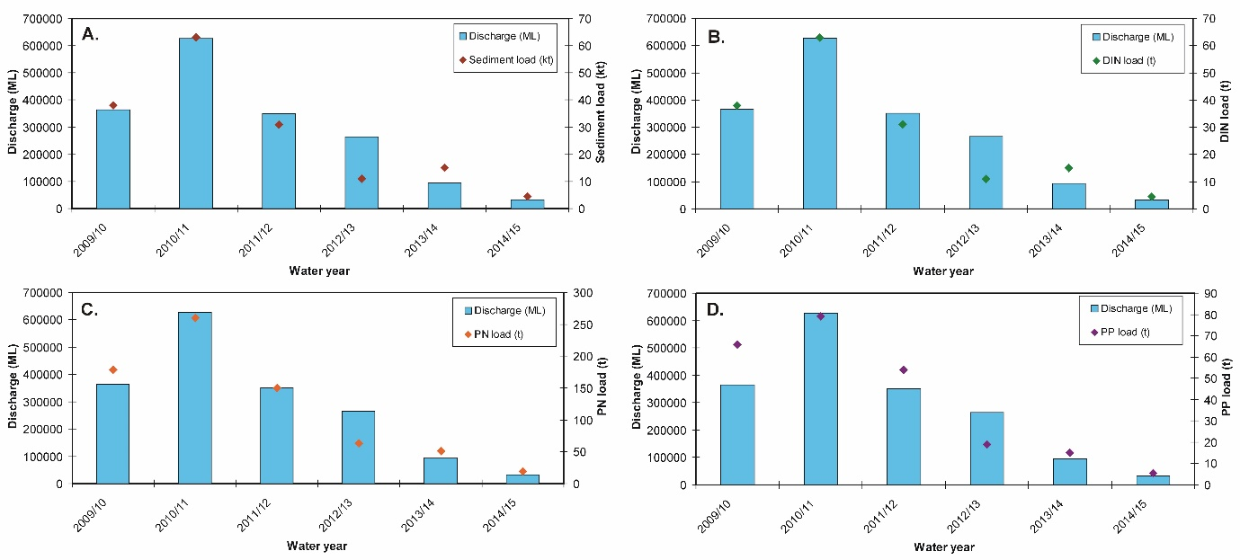
Figure 5-47. Measured Sandy Creek discharge (at the Homebush gauge) and loads for (A) total suspended solids (sediment), (B) dissolved inorganic nitrogen (DIN), (C) particulate nitrogen (PN) and (D) particulate phosphorus (PP) from 2009/10 to 2014/15. Data from the Department of Science Information Technology and Innovation’s Great Barrier Reef Catchment Loads Monitoring Program (compiled from: Turner et al., 2012, 2013; Wallace et al., 2014, 2015, in press; Garzon-Garcia et al., 2015).

Ambient water quality
The site-specific Water Quality Index in this sub-region has declined since 2008 to the current ‘moderate’ rating (Figure 5-48a). Trends in concentrations of Chl-a, TSS and PP have increased since 2008. The concentrations of Chl-a were generally just above water quality guidelines (guideline), while TSS and PP rose above guideline values from 2011(Figure 5-48b, c, h). The overall trend for PN was stable (Figure 5-48f). The concentrations of NO_{x} increased sharply after the first above-median river flows in 2007 and has since increased further with the trend-line approaching above guideline values (Figure 5-48d). Secchi depth has declined steadily since 2008 remaining at levels non-compliant with the guideline (Figure 5-48e).
The concentrations of POC have remained more or less stable over the monitoring period, while the DOC concentrations have shown a steep continued increase over the same period (Figure 5-48i, j).
Instrumental chl and turbidity records showed more pronounced fluctuations but generally followed the same trend as the manual sampling data (Figure 5-48b, g). The trend-line of the instrumental turbidity record was above the guideline for most of the monitoring period, with an slight upward trend from 2012; this broadly mirrors the increase in TSS to above guideline levels in 2009 and corresponding decline in Secchi depth, with all three indicators of water “clarity” continuing to not comply with the guideline (Figure 5-48c, e, g).

Wet season water quality
No flood events occurred in the 2014-15 wet season so no flood response sampling was completed.
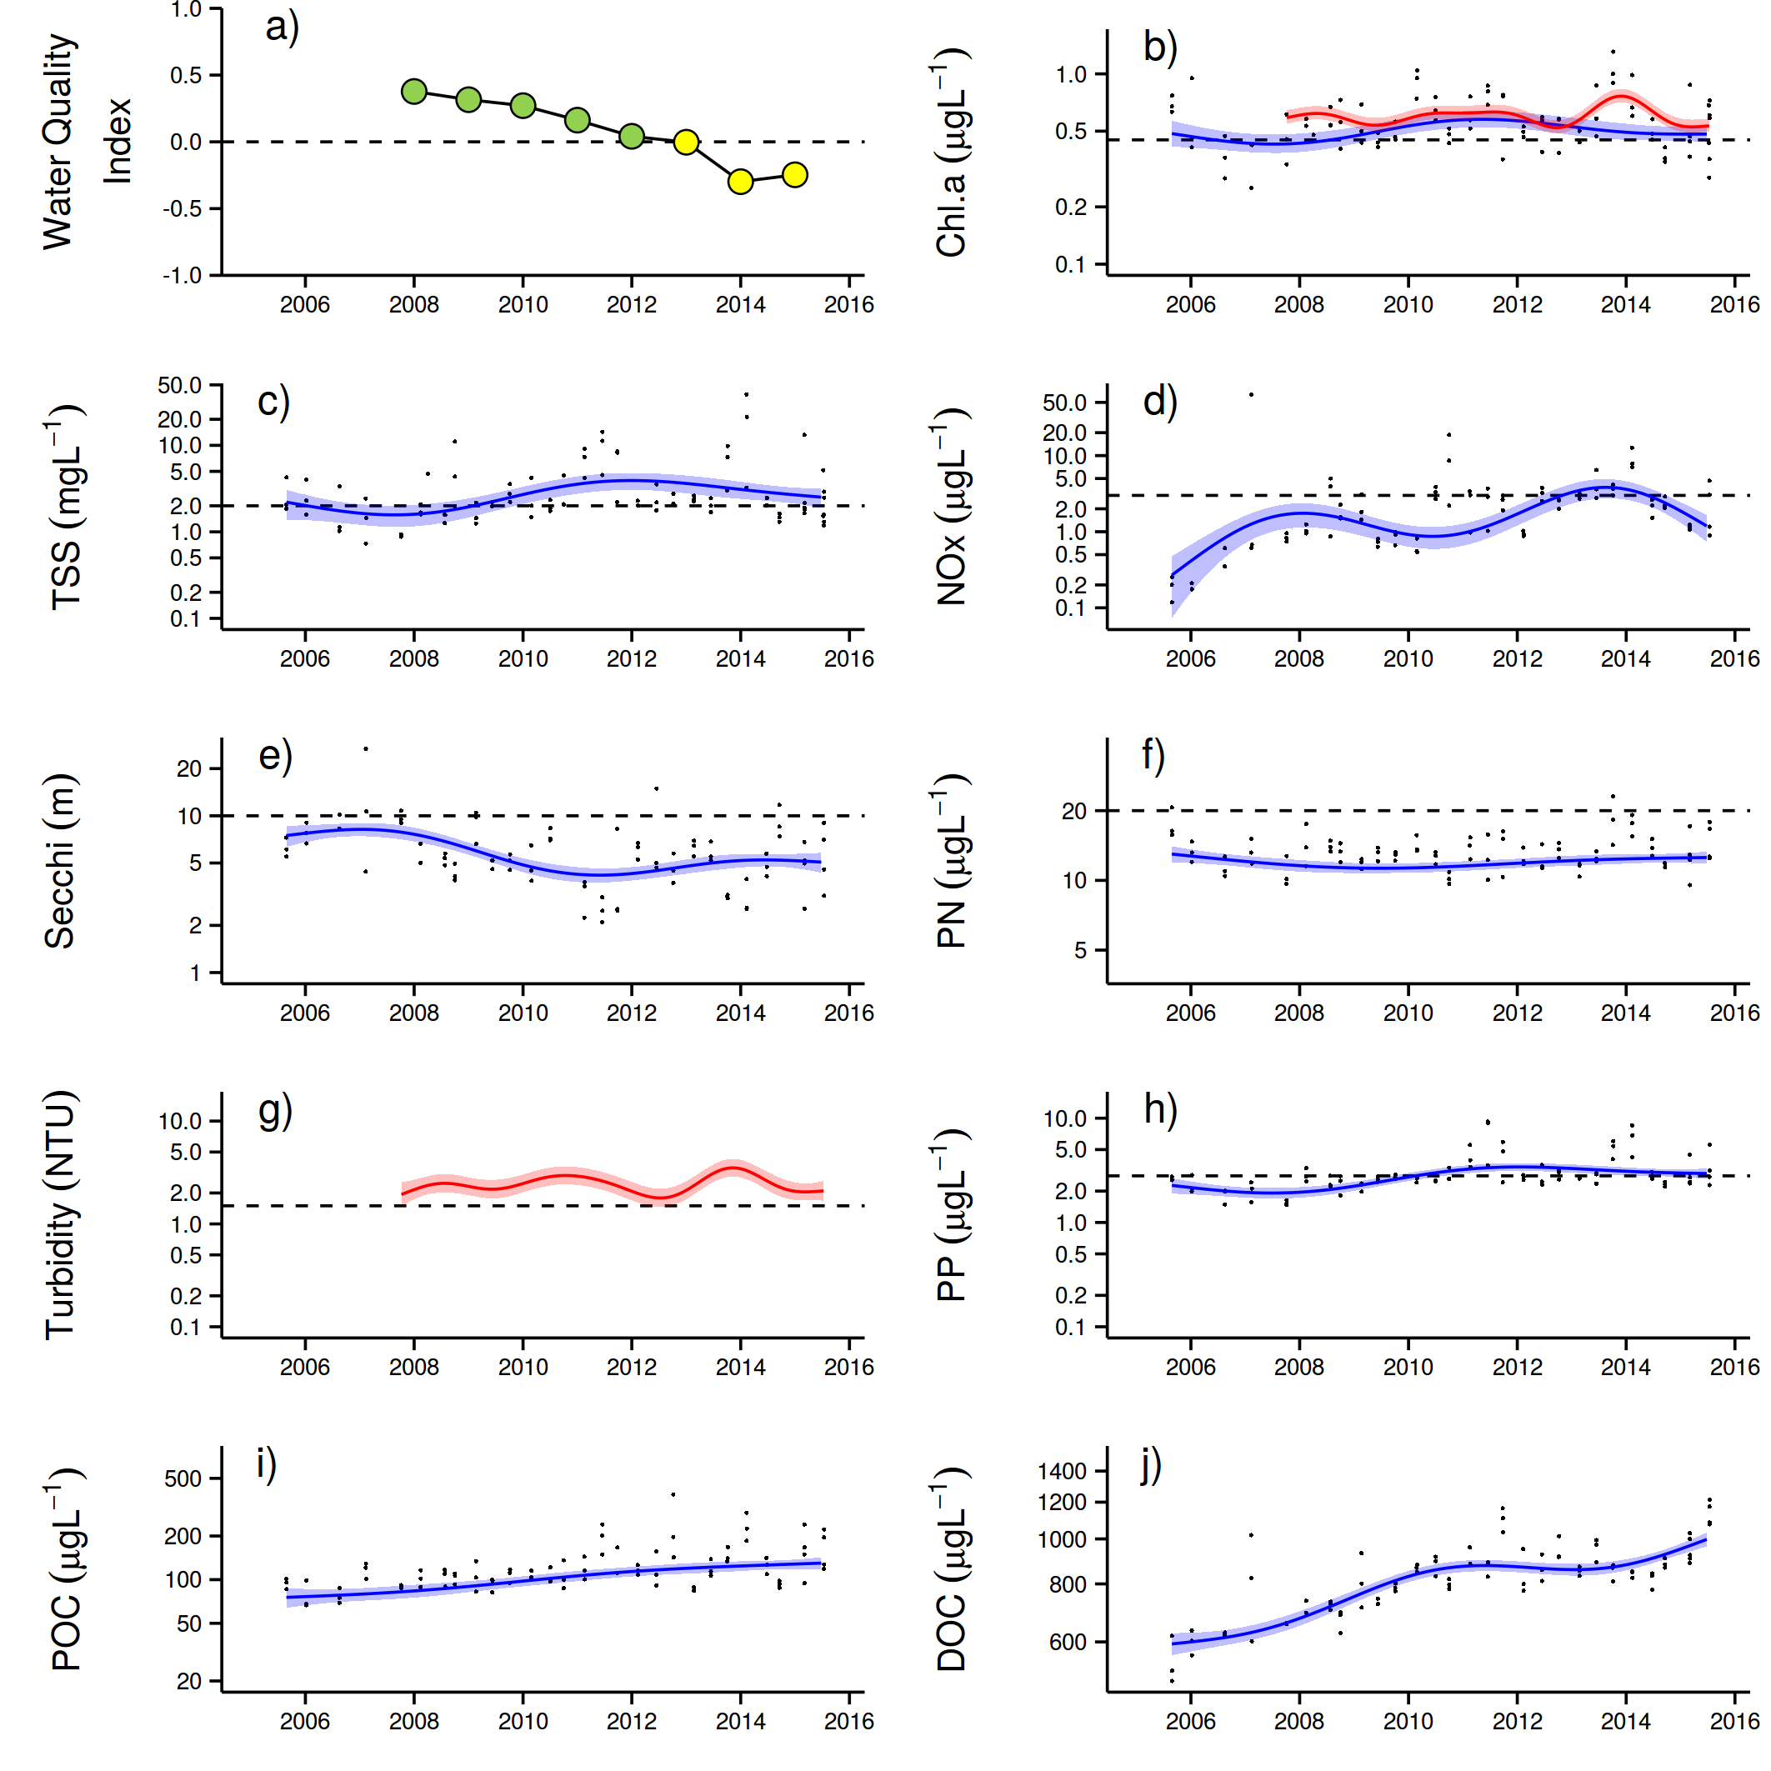
Figure 5-48: Temporal trends in water quality for the Mackay Whitsunday focus-region. a) Water Quality Index, b) chlorophyll a, c) total suspended solids, d) nitrate/nitrite, e) Secchi depth, f) particulate nitrogen, g) particulate phosphorus, h) particulate organic carbon and i) dissolved organic carbon. Water quality index colour coding: dark green- ‘very good’; light green-‘good’; yellow – ‘moderate; orange – ‘poor’; red – ‘very poor’. The water quality index is the aggregate of variables plotted in b - h and calculated as described in Appendix 1.2.3. Trends in POC and DOC values are plotted here (i, j); threshold levels have yet to be established. Trends in manually sampled water quality variables are represented by blue lines with blue shaded areas defining 95% confidence intervals of those trends accounting for the effects of wind, waves and tides, black dots represent observed data. Trends of records from ECO FLNTUSB instruments are represented in red, individual records are not displayed. Dashed reference lines indicate guideline values.

Report Card water quality metric 2014-15
Inshore water quality for the GBR Report Card is currently assessed by remote sensing of Chl-a and TSS data in the inshore water body.
In preparation of the 2016 Report Card, the Reef Plan Independent Science Panel (ISP) expressed concerns with the water quality metric currently used in the Reef Plan Report Card. This followed unresolved issues in 2014-15 reporting. The metric is calculated using Ocean Colour remote sensing data for Chl-a and TSS (based on NAP, non-algal particles) in the 'inshore water body' — as used by GBRMPA, and defined in De'ath and Fabricius (2008). The foundation remote sensing data is processed by the Bureau of Meteorology, and the Marine Water Quality remote sensing workflow is documented on the Bureau’s website and in an operations bulletin (Bureau of Meteorology, 2015). The process to produce the Reef Plan Report Card Marine Water Quality metric is summarised below.
- Step 1: Calculation of the relative area of the inshore water body where the annual mean value exceeds the GBRMPA Water Quality (WQ) Guideline value for Chl-a and TSS in each marine NRM region.
- Step 2: Allocation of a score for Chl-a and TSS which is the relative area of the inshore water body where the annual mean value (on a per pixel basis) does not exceed the WQ Guideline value. (e.g. if annual mean value exceeded the WQ Guideline value in 80% of the inshore water body, the regional score is 0.2).
- Step 3: Calculation of a combined Chl-a and TSS score using the mean of the Chl-a and TSS scores calculated in Step 2.
- Step 4: Calculation of a GBR wide score. A weighting is applied to the scores in Step 2 which is based on the proportion of the GBR coastal area that is in the NRM region. For example, 13% of the GBR coastal area is in the Wet Tropics NRM region, and so the score calculated in Step is multiplied by 0.13 to give a weighted score. A weighting of zero is applied to Cape York and Burnett Mary NRM regions due to low confidence in the data in these regions (established at the MMP workshop 11 August 2011). The final GBR score is the sum of all of the weighted regional scores.
The concerns are summarised very briefly below and were reviewed in more detail by the ISP in their meeting in April 2016.
Concerns with the accuracy of Chl-a concentrations derived from Ocean Colour remote sensing
- Extracting Chl-a concentrations from remotely sensed reflectance data is notoriously challenging in optically complex (case II) coastal waters like the GBR lagoon and the limitations of the remote sensing data must be understood in order to efficiently use these data as a monitoring tool. These limitations have been well documented by CSIRO in past (see examples of references in Bureau of Meteorology, 2014).
- Analyses in the GBR and from around the world show that there is a trend toward an increase of uncertainties in the satellite Chl-a concentration when the TSS concentration increases and the bottom depth decreases (see review in Petus et al. 2015); with preliminary thresholds values estimated around an NAP (proxy for TSS) of 2 mg L⁻¹ (which is the GBR water quality guideline trigger value for TSS in the open coastal and midshelf water body) and depth less than 25 metres (Petus et al. 2015).
Proportion of valid observations
- Cloud cover is an important influence in the availability of remote sensing data. Valid observations are made less than 40% of the time using the current GBR algorithms for Chl-a and TSS, which has significant implications when assessing the exceedance of thresholds (described in CSIRO MMP reporting and GBR relative risk assessment; Maynard et al. 2015).
- The percentage of valid observations should be factored into any assessment of remote sensing data of water quality concentrations to factor in the spatial and temporal variability of retrievals. This data is readily available and should be considered in metric calculations.
Shortcomings in the metric calculation
- The current metric is based on annual or seasonal averages over a large area. This means it is relatively insensitive to temporal (i.e. inter-annual) change, which is a major objective of the MMP and Paddock to Reef program. The area also currently does not separate the enclosed coastal water body which has different guidelines and is likely to have Chl-a estimates with a high uncertainty.
- The deviation from guideline trigger values is only done on a binary basis, i.e. the annual mean value of a pixel exceeds or complies with guidelines trigger value. This again leads to the metric being insensitive to change in areas where values are much higher than the trigger (i.e. needs a large change to get close to the guidelines) but conversely also leads to high variability in areas where values are very close to the guideline (ie neighbouring pixels that have very similar actual means may get opposite scores if they are just compliant or juts exceeding). A ‘distance from guidelines’ approach is used in the MMP site-specific water quality index (see Thompson et al. 2015).

In response to some of these concerns, TropWATER JCU conducted a preliminary review of the water quality metric presented in the 2015-16 Reef Plan Report Card, focusing on issues highlighted by the Reef Plan ISP associated with data confidence of remotely sensed data in inshore areas. It has been hypothesised that the highly turbid and shallow waters, with limited data validation, and temporal and spatial variability in the number of valid observations, can bias the marine water quality metric calculation. In order to test this hypothesis, highly turbid and shallow inshore areas were excluded in the metric computation. For this purpose, enclosed coastal waters as defined by the GBRMPA shapefile were used as a proxy for highly turbid and shallow areas. The results of the assessment are presented in Tracey et al. (2016). The report constrains the evaluation of the exclusion of enclosed coastal waters to changes to the annual and seasonal temporal trend of the marine water quality metric for the GBR. While the results did show some differences in the regional assessments, exclusion of the enclosed coastal water body did not make a significant difference to the actual metric results. The ISP therefore decided to maintain the current approach to the water quality metric for the 2016 Reef Plan Report Card.
It was out of the scope of that investigation to provide improvements to the remote sensing data acquisition, algorithms, and/or development of alternative method for the metric calculation, however, these tasks are recommended as part of more extensive work required over a wider time frame (8-10 months) to improve the sensitivity of the current metric to changes in drivers, activities and pressures in the catchments and the GBR.The following results are presented in line with the contractual obligations for 2014-15.
The relative area of the inshore water body where the annual mean value that exceeded the Water Quality Guideline value for Chl-a and TSS for each marine NRM region is shown in Table 5-8.
Table 5-8: Results from remote sensing data of Chl-a and TSS for the 2016 Report Card, based on GBRMPA monitoring year of 1 May 2014 to 30 April 2015.
Region | Relative area (%) of the water body where annual mean value exceeds the WQ Guideline value
Region | Chlorophyll a |  |  | Total Suspended Solids
Region | Inshore | Midshelf | Offshore | Inshore | Midshelf | Offshore
Cape York | 91 | 24 | 1 | 46 | 6 | 7
Wet Tropics | 93 | 23 | <1 | 40 | 5 | <1
Burdekin | 71 | 6 | <1 | 44 | <1 | 0
Mackay Whitsunday | 53 | 7 | 4 | 31 | 10 | 8
Fitzroy | 81 | 10 | 1 | 50 | 4 | 2
Burnett Mary | 97 | 10 | 0 | 23 | <1 | <1

The results for Chl-a are summarised below:
- The annual mean Chl-a water quality guideline was exceeded in a large proportion (at least 71% and up to 91%) of the inshore water body in all of the marine NRM regions.
- The exceedance of the annual mean Chl-a water quality guideline in the midshelf water body varied between regions, from 6-7% in the Burdekin and Mackay Whitsunday regions, to 23-24% in the Cape York and Wet Tropics regions.
- The exceedance of the annual mean Chl-a water quality guideline in the offshore water body was relatively low for all NRM regions (<4%).
The results for TSS are summarised below:
- The annual mean TSS water quality guideline was exceeded in 40-50% of the inshore water body in all regions except for Mackay Whitsunday (31%) and Burnett Mary (23%) regions.
- The exceedance of the annual mean TSS water quality guideline in the midshelf water body was less than 10% across all regions.
- The exceedance of the annual mean TSS water quality guideline in the offshore water body was low for all NRM regions (all less than 8%), with less than 1% of the area with recorded exceedances in the Wet Tropics, Burdekin and Burnett Mary regions.
A score for each region for Chl-a and TSS is calculated using the area of the region that did not exceed the annual Water Quality Guideline in the inshore water body. These scores are then weighted by multiplying the result by the proportion of the total inshore water body represented in each region. However, the Cape York and Burnett Mary regions are not weighted due to high uncertainties in the data due to limited validation of the remote sensing algorithm in those locations. The results for this step are shown in Table 5-9.

Table 5-9: Calculation of weighted scores using remote sensing data of Chl-a and TSS for the 2016 Report Card, based on GBRMPA monitoring year of 1 May 2014 to 30 April 2015.
Region | Water body | % of GBR coastal Area | Chl a Scores | Chl a Weighted Score | TSS Scores | TSS Weighted Score
Cape York | Inshore | 0 | 9 | 0.0 | 54 | 0.0
Wet Tropics | Inshore | 13 | 7 | 0.9 | 60 | 7.6
Burdekin | Inshore | 21 | 29 | 6.2 | 56 | 12.0
Mackay Whitsunday | Inshore | 27 | 47 | 12.8 | 69 | 18.8
Fitzroy | Inshore | 39 | 19 | 7.5 | 50 | 19.4
Burnett Mary | Inshore | 0 | 3 | 0.0 | 77 | 0.0
GBR |  | 100 | 27 | 27.4 | 8 | 57.8
A combined Chl-a and TSS score for each Region is then calculated using the mean of the Chl-a and TSS scores that were calculated in Table 5-9. The final GBR score is the sum of all of the weighted regional scores, shown in Table 5-10. The overall metric score was assessed as ‘moderate’ in 2014-15. Component scores for concentrations of Chl-a and TSS were ‘poor’ and ‘moderate’ respectively in 2014-15. These results indicate that the Chl-a scores were in the ‘very poor’ category for the Wet Tropics and Fitzroy regions, ‘poor’ for the Burdekin region and ‘moderate’ for the Mackay Whitsunday region. The TSS results indicate that the TSS scores were in the ‘moderate’ category for the Wet Tropic, Burdekin, and Fitzroy regions, and ‘good’ in the Mackay Whitsunday region.
Table 5-10: Calculation of weighted scores using remote sensing data of Chl a and TSS for the 2015 Report Card, based on GBRMPA monitoring year of 1 May 2014 to 30 April 2015.

Region | Chlorophyll a | TSS | WQ Index |  | Colour key
Cape York | n/a | n/a | n/a |  | Score | Category
Wet Tropics | 7 | 60 | 33 |  | 81 - 100 | very good
Burdekin | 29 | 56 | 42 |  | 61 - < 80 | good
Mackay Whitsunday | 47 | 69 | 58 |  | 41 - < 60 | moderate
Fitzroy | 19 | 50 | 35 |  | 21 - < 40 | poor
Burnett Mary | n/a | n/a | n/a |  | 0 - <20 | very poor
GBR | 27 | 58 | 43

The trend for the overall metric score is shown in Figure 5-49 and reflects the cumulative impacts of multiple floods and cyclones since 2007-08. However, further investigation of the use of this metric and possible alternative methods is recommended as a matter of priority for the MMP to improve the sensitivity of the final score to river discharge and pollutant load characteristics.

Figure 5-49: Trend in water quality from 2005-06 to 2014-15. The overall water quality score is the average of the weighted component scores for chlorophyll a and total suspended solids. Values are indexed scores scaled from 0-100; ■ = very good (81-100), ■ = good (61 - 80), ■ = moderate (41 - 60), ■ = poor (21 - 40), ■ = very poor (0 - 20). NB: Scores are unitless.

Discussion and conclusions
Local environmental conditions, such as water quality, clearly influence the benthic communities found on coastal and inshore reefs of the GBR. Collectively, these reefs differ markedly from those found in clearer, offshore waters (e.g. Done 1982; Wismer et al., 2009). The premise underpinning Reef 2050 Plan is that contaminant loads delivered by rivers sufficiently alter the environmental conditions in inshore waters of the GBR to suppress ecological resilience.
In this report, we have provided spatial and temporal trends of water quality indicators in the GBR in four focus areas. The water quality changed in response to the magnitude of river flows, end of catchment loads of sediments and nutrients, and correlations of salinity and distance. These are all important factors in driving marine water quality concentrations.

Long-term changes in water quality
The results for 2014-15 followed typical patterns of water quality in the inshore GBR which generally shows clear gradients away from river mouths, with higher levels of most indicators close to the coast. These gradients are influenced over short time periods by flood events and sediment resuspension, and over longer time periods by a complex interplay of physical forcing and biological transformation processes (see Schaffelke et al., 2013 and references therein). Such gradients and processes are a part of the natural GBR ecosystem, albeit under far lower levels of input of runoff-derived pollutants than at present. An analysis of five years of MMP water quality data showed significant variability (Schaffelke et al., 2012a) between years and locations. Most variation was explained by temporal factors (seasons, years and river flow), highlighting the extremely variable climate of the ecosystem, with regional aspects (such as latitude, land use on adjacent catchments, proximity to rivers and resuspension) explaining a smaller, albeit significant, amount of the variation.
Turbidity is caused by suspended particles (e.g. clay and organic matter) and controls both sunlight absorption and scattering. Since European settlement, the GBR lagoon has received increased sediment and nutrient loads from the catchment (Kroon et al., 2012; Belperio and Searle 1988). The general increase measured in turbidity over the monitoring period suggests that the water transparency has decreased, thereby reducing the light available for plankton and coral symbiont growth. Turbidity is recognised as influencing settlement preferences of coral larvae, but also coral health in general (Mundy and Babcock 1998; Baird et al., 2003; Rogers 1979; Pollock et al., 2014; Schaffelke et al., 2013) and is thereby an important factor in governing coral community composition.
Turbidity in the GBR lagoon is strongly influenced by variations in the input of particles from the catchment and resuspension by wind, currents and tides (Fabricius et al., 2014). It is becoming increasingly apparent that the additional flux of fine sediment imported by rivers remains in the coastal zone for periods of months to years leading to chronically elevated turbidity and rates of sedimentation (e.g. Lambrechts et al., 2010; Thompson et al., 2012; Fabricius et al., 2014; Logan et al., 2013, 2014). While the turbidity loggers showed increased levels over the monitoring period the same was not evident for concentrations of suspended solids. This is likely linked with the difference in methods. While the suspended solids are measured as dry mass of particles on a filter (0.4 µm pore-size), the turbidity measured by the optical instruments is the total light absorption and scattering. The difference in trends of these two estimates of turbidity suggests that the size spectrum/composition of the material has changed over the monitoring period with the material passing a 0.4 µm filtered (e.g. colloidal particles) having a larger role in determining the underwater light climate (Bowers and Binding 2006).
Plankton biomass production in the GBR is considered to be limited by the availability of nitrogen. An increase in readily available dissolved oxidised nitrogen (NO_{x}) concentrations, as found over the monitoring period, is therefore unexpected. This has two likely causes: either the plankton community is obtaining enough nitrogen from other sources (e.g. ammonium) or their growth is limited by other factors than nitrogen such as light. The increases in turbidity (discussed above), suggest that less light is available for plankton growth which could cause a light-limited situation whereby the plankton community is not able to use the extra NO_{x} for biomass growth. As this NO_{x} is not used within the coastal area it will be exported to the adjacent ocean, where it could fuel plankton production. It is the transport of coastal nutrients to the midshelf GBR that has been hypothesised to initiate COTS outbreaks (e.g. Brodie et al., 2005). These outbreaks are a major contributor to loss of coral cover on the GBR (e.g. Osborne et al., 2011; De’ath et al. 2012).
Over the monitoring period, an increase in the dissolved organic carbon (DOC) concentrations was found in all regions. DOC constitutes the major carbon source for heterotrophic microbial growth in marine pelagic systems (e.g. Lønborg et al., 2011) and increases in DOC have previously been shown to promote microbial activity and coral diseases (Kline et al., 2006, Kuntz et al., 2005). Increases in DOC as found here could have several probable, though not necessarily mutually exclusive, explanations: either the coral and plankton community have increased primary production or they are directing more of their production towards DOC release or there is an enhanced export from the catchment area.
A large fraction of DOC present in the GBR is derived from marine primary producers and any increases in plankton community production would result in elevated DOC concentrations. As time series measurements of primary production are not available for the GBR, we cannot assess if changes in the productivity could explain the increased DOC concentrations. Plankton communities have been shown to increase their DOC production in response to environmental stress (e.g. changing light and nutrient conditions) and changes in the plankton community structure (e.g. Thornton 2014; Church et al., 2002). As more nitrogen is available for growth (measured increase in NO_{X} concentrations) and phosphate is present at non-limiting levels, it suggests that nutrient stress is unlikely to cause the increased DOC levels. Our observations of increased turbidity suggest that less light is available for primary production and a lower microbial DOC production would therefore be expected, indicating that increased productivity is an unlikely explanation for the elevated concentrations. Previous studies have also found that increased DOC levels could be associated with changes in the plankton community driven by climate variability (e.g. increased temperature) (Church et al., 2002).
Globally it has been recognised that DOC loads from catchments to coastal waters increased over the last decades, which has been linked with changing land use (e.g. land clearing), precipitation patterns/chemistry and increased temperature (Lennon et al., 2013; Reader et al., 2014). Unfortunately there are no data available on the DOC loads from GBR rivers, and we cannot quantify whether these changed over the monitoring period.
Our long term monitoring shows that large-scale changes in the water quality of the GBR lagoon have taken place, with the data clearly showing increases in the levels of key parameters (organic carbon, NO_{x} and turbidity) in all regions. These findings show that the mechanisms controlling the carbon and nutrient cycle in the GBR lagoon have undergone changes, however, the extent and implications of these changes is not fully understood.

Water quality characteristics in 2014-15
The main findings for each NRM region are highlighted below.
Wet Tropics
- The 2014-15 wet season had relatively lower discharge and constituent loads relative to previous years of monitoring over the 2006-07 to 2014-15 period.
Ambient water quality
- The site-specific Water Quality Index in this sub-region maintained a ‘moderate’ to ‘good’ rating.
- The concentrations of dissolved oxidised nitrogen (NO_{x}) have increased over the course of the monitoring program.
- Dissolved organic carbon (DOC) concentrations have increased over the course of the monitoring period.
- The turbidity values showed increasing levels which are exceeding the guideline values. This is most likely to associated with changes to the particle size distribution of particulate material (more fine material), rather than overall increases in sediment loads.
- Secchi depth is variable and shows in some areas a decline, while others have a relatively stable level. This variability results in that the levels are non-compliant with the guideline in some areas and exceeding the guidelines in others.
Wet season water quality
- The Russell-Mulgrave focus area exhibited typical mixing plots with reduction of water quality parameters moving away from the river mouth. The Tully data exhibited variable mixing patterns in water quality concentrations, which typically decreased from low to high salinity. For both focus areas, Chl-a and TSS did not present conservative behaviour (as expected); TSS dropped quickly out of the river mouth due to particles settling, remaining constant after that and Chl-a had a more variable pattern compared to the other water quality parameters, presenting slight increase in concentrations at low salinity (approx. 10 ppt) and reduction at salinity > 30 ppt.
- In the Russell Mulgrave focus area, river discharge showed positive correlation with DIN, PN, PP and Si, suggesting the higher the river discharge, the higher the concentrations of these parameters. For Tully, positive correlations were observed for CDOM, DIN and Si. For both areas, wind components, and therefore eventual resuspension events or currents advecting the superficial water mass did not correlate with any of the analysed parameters.
- In the Tully focus area the median concentrations of the parameters were lower in 2014-15 compared to those calculated for the long term (2005-2015) wet seasons. This result suggests that the below long-term median total GBR discharge observed in the 2014-15 wet season resulted in less terrestrial input, which was mainly observed in the Primary waters. The Secondary and especially the Tertiary waters did not vary much between the two periods compared. This is a result of the mixing process that increases the sea water contribution to the plume waters, and therefore the water constituents are more representative of the sea water. A similar comparison was not performed for the Russell-Mulgrave data set due to the low representation of samples in Primary water in the 2014-15 wet season.
Burdekin
- In the 2014-15 season the Burdekin and Haughton Rivers had their lowest discharge over the 9 years of record and hence the constituent loads were also generally lower compared to previous years of monitoring over the 2006-07 to 2014-15 period. The exception is the DIN loads in Barratta Creek which is influenced by relatively large volumes of irrigation tailwater runoff and hence the loads remain similar despite variability in discharge.
Ambient water quality
- The site-specific Water Quality Index in this region has been relatively stable over the monitoring period, oscillating between ‘good’ and ‘very good’ ratings.
- The concentrations of NO_{x} increased sharply after the first major flood event in 2008 and have since remained at levels close to or above the Queensland guideline.
- Dissolved organic carbon (DOC) concentrations have increased over the course of the monitoring period.
- The turbidity record increased over the monitoring period with maxima above the guideline in 2011, 2013, 2014 and 2015.
- Secchi depth has remained non-compliant with the guideline values over the whole sampling period, with a decreasing trend since 2014.
Wet season water quality
- The Burdekin sites were sampled in two events, mid-February and end of March, and they did not capture any flood event. As a result, sites were not exposed to freshwater, with salinity > 30 ppt, thus limiting the description of the dilution mixing process across the salinity gradient. The only observation from these mixing plots is that all parameters, except CDOM and Chl-a, were relatively constant over the sampled sites.
- River discharge showed a negative correlation with Kd(PAR) and Si, suggesting the higher the river discharge, the lower the concentrations. The N-S wind component, and therefore eventual resuspension events or currents advecting the superficial water mass, correlated negatively with CDOM and PP, suggesting that the stronger the southerly winds, the lower the concentration of these parameters.
Mackay Whitsunday
- In the 2014-15 season the rivers in the Mackay Whitsunday region had their lowest discharge over the monitoring record and hence the constituent loads were also generally lower compared to previous years of monitoring.
Ambient water quality
- The site-specific Water Quality Index in this sub-region has declined since 2008 to the current ‘moderate’ rating.
- Trends in concentrations of Chl-a, TSS and PP have increased since 2008 coincident with sustained high flows of the adjacent rivers.
- The concentrations of NO_{x} increased sharply after the first above-median river flows in 2007 and has since increased further with the trend-line approaching above guideline values
- The DOC concentrations have shown a steep continued increase over the monitoring period.
- The trend-line of the instrumental turbidity record was above the guideline for most of the monitoring period, with a slight upward trend from 2012.
- Secchi depth has declined steadily since 2008 remaining at levels non-compliant with the guideline.
Wet season water quality
- No flood events occurred in the 2014-15 wet season so no flood response sampling was completed.

Conclusions
This report has presented the combined results of the ambient and flood response inshore water quality monitoring program for the first time. The transition to the new sampling strategy in 2014-15 has presented challenges in terms of combining the datasets and determination of the most appropriate analyses for the new data. When interpreting the long term trends in water quality it is important to keep in mind that this change in sampling strategy, with more frequent sampling during the wet season and more sites further inshore, will by itself influence the long trend, presenting challenges for the detection of improvement or decline in the water quality conditions.
The implementation and coordination of the new sampling design is and will continue to be a time consuming task. More time than anticipated is still needed to coordinate the very frequent sampling over a very large geographical area, however, the increased frequency provides substantial benefits for the statistical rigour of the program.
The results of the program varied between the focus areas, with variable responses to the relatively low river discharges and end of catchment pollutant loads in 2014-15. Overall, the frequency and extent of river plumes was constrained compared to previous years. Based on the in-situ monitoring results, the Wet Tropics region had a ‘moderate’ to ‘very good’ rating for the site-specific Water Quality Index, despite increasing levels of turbidity and NO_{x}, DOC. This is in contrast to a ‘poor’ overall rating for the current Report Card water quality metric, with ‘very poor’ for Chl-a and ‘moderate’ for TSS. For the Burdekin region the site-specific Water Quality Index showed a relatively stable overall rating of ‘good’ to ‘very good’, not reflecting the increasing levels of turbidity and NO_{x}, DOC. The score for the current Report Card water quality metric was ‘moderate’ overall, but ‘poor’ for Chl-a. In the Mackay-Whitsunday region the site-specific Water Quality Index has declined since 2008 to the current ‘moderate’ rating, which contrary to the other regions, generally replicates the changes in turbidity and NO_{x}, DOC. The score for the current Report Card water quality metric was ‘moderate’ overall, but ‘good’ for TSS.
The differences between the results of the Report Card metric and the site-specific Water Quality Index highlight the need to review the methods for developing an overall metric that represents water quality conditions in the GBR through this sampling program, and is sensitive enough to reflect changes in annual river discharge characteristics. In addition, there are still significant uncertainties in the knowledge of factors and process that control the processing and transformation of key water quality variables (e.g. nitrogen) in the GBR. It is therefore important that more in-depth understanding of which biogeochemical processes control the changes in water quality is progressed. Improved understanding of these aspects will also assist in the revision of a representative water quality metric.
Sustained improvements in the marine water quality of the inshore GBR are not yet observed in the MMP water quality program, even though there has been good progress in improving land management practices, and river discharge at or below the long-term median in the last two years. This highlights the complexity of the relationship between river inputs and ambient water quality and the expected slow response timeframe. Continued water quality monitoring of the coastal and inshore GBR lagoon will be fundamental to determine and track long-term changes in response to management actions and interventions, for example those under Reef Plan and the Reef 2050 Plan.

Acknowledgements
We acknowledge the Australian Government funding under the Australian Government Reef Programme and specifically thank the Great Barrier Reef Marine Park Authority and Department of Environment for financial and technical support under this program. Thank you to Katherine Martin and Carol Marshall for your project management.
We thank all the amazing people involved in our field work and all who have helped us through sampling of in some very extreme conditions. We particularly thank Jason Shearer and Bec Rowlands from Mission Beach Charters who have been involved in our long-term sampling of the Tully and Russell-Mulgrave marine waters, and the crew of the RV Cape Ferguson. We also thank Ed Butler, Johanna Johnson and a number of anonymous reviewers for their detailed reviews that improved the previous reports on which this current instalment builds. We also acknowledge the valuable contributions to data collection, sampling integrity and reporting of Miles Furnas and John Carlton, over the first few years of the monitoring program.
Thank you to the TropWATER laboratory and AIMS Analytical Technology staff, who have analysed thousands of samples for us.
Thank you to CSIRO, particularly Thomas Schroeder and Vittorio Brando, who have provided advice and data for our ocean colour mapping. Thanks to BOM for the implementation of the WQ dashboard where we can now access remote sensed data.

Case study: Detecting decadal changes in the water quality of Great Barrier Reef waters using the Cairns Time Series (CaTS) transect
Authors: Christian Lønborg, Miles Furnas, Murray Logan & Britta Schaffelke

Scope
Data from the Cairns Time Series (CaTS) oceanographic transect in the central Great Barrier Reef (GBR) lagoon (16-17°S) is used to conduct a statistical evaluation of the long-term changes, variability and trends in key chemical and biological oceanographic properties of GBR waters. The CaTS, which was initiated in 1989, is to our knowledge one of the longest-running oceanographic time series in coral reef systems and thus provides continuous information on changes in this part of the GBR lagoon.

Introduction
In most seas, a large proportion of the inputs of suspended solids, inorganic and organic nutrients to coastal waters are coming from land-based sources, including rivers, groundwater, the atmosphere and point sources, and from exchange with offshore waters (Jickells, 1998). These fluxes have been altered due to human activity leading to increased pressure on coastal ecosystems worldwide (e.g. Seitzinger et al., 2005; Statham, 2012). Long-term ocean time-series stations which measure physical, chemical and biological variables provide crucial data for assessing the ecological health and status of water bodies and changes occurring under climatic and anthropogenic pressures. But the analysis of such datasets have also revealed that long time series records (> 20 years) are necessary to statistically resolve trends and distinguish real trends from background natural variability (Rudnick and Davis 2003; Henson et al., 2016). Especially in coastal systems where marked short (hourly to daily) and long (years to decades) term variability is observed in physical, chemical and biological variables, long periods are required to differentiate statistically significant trends from random events.
The GBR is the largest contiguous coral reef ecosystem in the world and due to its size and significance the GBR provides a global reference point for coral reef ecosystems facing threats. While the GBR coral reefs themselves have been investigated in some detail the biogeochemistry of the pelagic ecosystem is poorly understood. Land run off is the largest source of new nutrient to the GBR (Furnas 2011) and previous studies have shown that inshore corals are subject to elevated levels of nutrients, pCO₂ and higher total suspended solids concentrations due to loads, is a consequence of terrestrial runoff (e.g. Alongi and McKinnon 2004, Furnas et al., 2011; Schaffelke et al., 2013; Uthicke et al., 2014; Thompson et al., 2013 and 2014).
In this case study, we use data from the Cairns Time Series (CaTS) oceanographic transect in the Cairn/Cooktown Management area (16-17°S) to conduct a statistical evaluation of the long-term changes, variability and trends in key chemical and biological oceanographic properties of GBR waters. While previous studies have made it possible to infer the spatio-temporal variability and dynamics of inorganic and organic nutrients (e.g. Furnas et al., 2011) no study to our knowledge has reported on the detailed long term (>20 year) trends in chemical and biological oceanographic properties of GBR waters. This study goes a step further than the previous CaTS case study presented in the 2012-13 AIMS MMP report (Thompson et al., 2013), by not only updating this former analysis but it will also in the future provide data (see next steps in discussion section) identify the major drivers of these trends.

Results
The Cairns Time Series (CaTS) oceanographic transect is based in the in the Cairn/Cooktown Management area (16-17°S; 145-146° E) (Figure 7-1). As most of the sites of the CaTS are located close to shore the water movement is primarily to the north, driven by the predominant south-east wind regime. The CaTS includes sites located along an onshore/offshore transect (C8 to C11) which include both shallow coastal sites and deeper open lagoon sites and a north/south transect (C1 to C7) with sites directly affected by the Barron and Daintree Rivers (Figure 7-1). Stations C3 lies just off the mouth of the Daintree River while stations C6 to C8 lie in the lee of Cape Grafton near the mouth of the Barron River and Trinity Inlet (Figure 7-1).
A total of 70 of cruises were conducted from 19 February 1989 to June 2015. Each CaTS site was typically visited three times per year (12 out of the 26 years) but sampling varied from one to four visits per year, with regular sampling three times a year since 2007. From 2008 until June 2015 only six of the initial 11 sites were continued to be sampled after a statistical analysis indicated that this reduced number of stations would provide enough information for a robust time series analysis.
Generalised additive mixed effects models (GAMMs; Wood 2006) were used to decompose the irregularly spaced time series into its trend cycles (long-term) components. GAMMs are an extension of additive models (which allow flexible modelling of non-linear relationships by incorporating penalized regression spline types of smoothing functions into the estimation process), in which the degree of smoothing of each smooth term (and by extension, the estimated degrees of freedom of each smoother) is treated as a random effect and thus estimable via its variance as with other effects in a mixed modelling structure (Wood 2006). For each water quality indicator, the indicator was modelled against a thin-plate smoother for date and a cyclical cubic regression spline (maximum of 5 knots). Spatial and temporal autocorrelation in the residuals was addressed by including sampling locations as a random effect and imposing a first order continuous-time auto-regressive correlation structure (Pinheiro and Bates 2000). Water quality measurements are likely to be influenced by the physical conditions at the time of sampling. All GAMMs were fitted using the mgcv (Wood 2006; Wood 2011) package in R 3.0.1 (R Development Core Team, 2013).

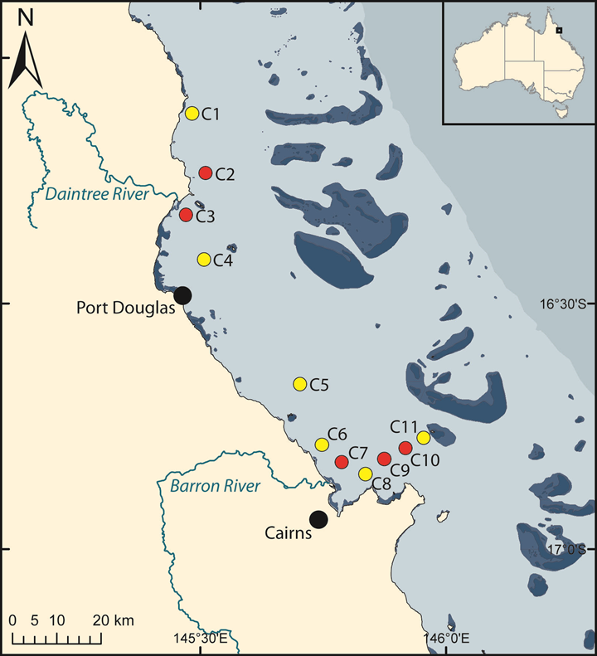
Figure 7-1: The Cairns Time Series (CaTS) oceanographic transect based in the central Great Barrier Reef (GBR) lagoon (16-17°S; 145-146° E). The yellow dots show the 6 occupied during the period 1989 to 2015, and the red the stations were discontinued in 2008.

Trends in salinity, temperature, chlorophyll and total suspended solids from 1989 to 2015 – Over the 26 years study period salinity varied between 25.7 and 37.1 (average ± stdev; 34.6 ± 1.0) and water temperature between 20.7 and 30.6◦C (26.3 ± 2.1◦C) (Figure 7-2a-b). Salinity and temperature showed opposing seasonal patterns, with salinity maxima and temperature minimum during the late dry season (August to October) and the opposite found during the wet season (December to February) (Figure 7-2a-b). The trend analysis on the salinity and temperature datasets indicates that they have stayed reasonably constant over the last 26 years (Figure 7-2a-b).
Chlorophyll a (Chl-a) concentrations for the whole dataset showed maxima (up to 3.0 µg L^{–1}) during the early dry season, which were on average 13% and 68% higher than concentrations in the wet and late dry season. The more than two decade long data set reveals a dynamic ecosystem with relatively large yearly and spatial changes in chl a concentrations (Figure 7-2c). The long-term trends show periods of decreasing (from 1992 to 1993 and again from 1999 to 2001), relatively constant (2002 to 2007) and increasing (1994 to 1998, 2007 to 2015) concentrations of Chl-a standing stocks, with a new maxima reached in 2015 (Figure 7-2c).

Figure 7-2: Temporal trends in a) salinity, b) temperature, c) chlorophyll a (Chl-a) and total suspended solids (TSS). Black dots indicate field observations and blue line represents the trend line fitted by Generalized additive mixed effects models (GAMMs).
Total suspended solids (TSS) concentrations ranged between less than 0.1 mg L⁻¹ up to concentrations of 33.8 mg l⁻¹(2.4 ± 2.7 mg L⁻¹) (Figure 7-2d). TSS levels measured in the water column are heavily influenced by the wind-driven resuspension events, but the GAMMs removed the effects of wind allowing us to determine impacts of other drivers, such as river runoff (See appendix 1.5 for details). The long-term GAMM analysis showed that TSS concentrations increased from 1989 until the early 2000s, which was followed by a period of decline which lasted until 2013, when levels again started to increase to a very high value of 5 mg L⁻¹ (Figure 7-2 d).
Changes in inorganic nutrients concentrations from 1989 to 2015 – The CaTS is generally characterised by low concentrations of dissolved inorganic nutrients compared with levels found in e.g. many temperate coastal systems. For the entire dataset phosphate (HPO₄⁻²) concentrations ranged from below the detection limit up to 0.85 µmol L^{–1} (0.06 ± 0.04 µmol L^{–1}), while nitrate/nitrite (NO_{x}) and ammonium (NH₄⁺) concentrations varied from below the detection limit up to 7.3 µmol L⁻¹ (0.20 ± 0.09 µmol L⁻¹) and 0.53 µmol L^{–1} (0.04 ± 0.06 µmol L^{–1}), respectively (Figure 7-3a-c). This shows that NO₃⁻/ NO₂⁻ is the dominating dissolved inorganic nitrogen species in the study area. Our seasonal data showed that dissolved inorganic nutrients reached higher levels during the wet season compared with the late and early dry seasons. The long-term trends in HPO₄⁻² reveal one period with a large decrease in the early 1990’s (from 1992 to 1993), since then the concentrations have generally increased, although with some variations (oscillations vary between 3 and 5 years) in the concentrations (Figure 7-3a). The measurements of NH₄⁺ was only commenced in 1997, with some few gap years (1999, 2004 and 2005). Despite this, our GAMM analysis showed both periods of increasing (late 1990’s, early 2000s and from 2013 onwards) and declining (between 2003 and 2012) concentrations (Figure 7-3b). The long term NO₃⁻/ NO₂⁻ CaTS data (Figure 7-3c), show distinct periods of declining (e.g. early 1990’s) and increasing concentrations (e.g. 1990s, and again in the mid and late 2000’s) (Figure 7-3b). The SiO₄ concentrations ranged between values below the detection limit up to 60.1 µmol L^{–1} (5.2 ± 4.8 µmol L^{–1}) (Figure 7-3d). The highest concentrations were consistently found at the stations which were closest to mouths of the largest rivers (Barron and Daintree rivers), reflecting the inputs of high-Si freshwater runoff into this zone and its subsequent mineralization in the coastal sediments. The initial stable SiO₄ levels were followed by oscillations (increase and decrease), which took place over longer periods (more than 5 years) than found for the analysis of inorganic nitrogen and phosphate (between 3 and 5 years) (Figure 7-3a-c).
The stoichiometric ratios of the molar inorganic nutrient concentrations, is often used to determine the ultimate limiting nutrients by comparing the average phytoplankton biomass ratios (termed the “Redfield ratio”), which is expressed as the relative abundances of carbon, nitrogen, phosphorus and silicate (C₁₀₆:N₁₆:P₁:Si₁₆) (Redfield 1958). On the basis of the inorganic phosphate, nitrogen (DIN, the sum of NO₃⁻/ NO₂⁻ and where available NH₄⁺) and silicate concentrations average molar ratios were obtained. The DIN: HPO₄⁻² ratio at CaTS ranged from 1 to 24, with an average of 1.1 ± 1.9, which indicates a strong N-limitation of the system as also suggested in previous studies (Furnas et al., 2005; Schaffelke et al., 2012a). Both the Si: DIN and Si: HPO₄⁻² ratios varied widely with values between 1 and 6940 (272 ± 502) for Si: DIN, and from 1 to 3066 (137 ± 226) for Si: HPO₄⁻². These ratios are far above the 1:1 Redfield Si:N ratio of diatom, and is mainly due to the very low concentrations of N and P species and considerably higher concentration of silicate, suggesting that Si availability is not limiting diatom growth as also found previously (Furnas et al., 2011). Cyanobacteria, the dominant primary producers in GBR waters, do not require silica. On a seasonal scale the DIN: HPO₄⁻² ratio was highest in the wet followed by the early and late dry seasons, while the other ratios were highest in the early dry followed by the wet and late dry seasons. The long term trends in the molar ratios showed that up to around 2008, the DIN: HPO₄⁻² and Si: DIN ratios were rather stable where after it increased and decreased, respectively (Figure 7-3e-f). The Si: HPO₄⁻² ratio was more dynamic with the initial decline followed by an increase until 1996, where after another long term decline was found until around 2008 when another increase and following decrease was found (Figure 7-3g).

Figure 7-3: Long term trends in a) phosphate (HPO₄^{2–}), b) ammonium (NH₄⁺), c) nitrate/nitrite (NO_{X}), d) silicate (SiO₄), e) NO_{X} to HPO₄^{2–} molar ratio, f) SiO₄ to NO_{X} molar ratio and g) SiO₄ to HPO₄^{2–} molar ratio. Black dots indicate field observations and blue line represents the trend line fitted by generalized additive mixed effects models (GAMMs).

Changes in particulate organic matter from 1989 to 2015 –The measurement of particulate organic carbon (POC) was initiated in 2005 and the concentrations varied over the 10 years period between 2 and 30 µmol L^{–1} (9 ± 4 µmol L^{–1} (Figure 7-4a). Particulate nitrogen (PN) and phosphorus (PP) were measured since 1989 with concentrations varying between 0.4 and 11.0 µmol L^{–1} for PN and between 0.01 and 0.88 µmol L^{–1} for PP (Figure 7-4a). Over a seasonal cycle the particulate pool had highest concentrations during the early dry followed by the wet and late dry season (data not shown). The POC concentrations showed highly fluctuating concentrations with an overall increasing trend over the last 10 years (Figure 7-4a). Over the 25 year period PN showed a systematic increase from 1989 until 2003, where after a decrease was seen between 2003 and 2004, with concentrations thereafter staying at stable levels (Figure 7-4b). From the initiation of the time series the PP concentrations showed an oscillating pattern (increase and decrease) over approximate 5 years periods (Figure 7-4c).
On average the C:N:P stoichiometry of the suspended particulate fraction was 115:14:1, which slightly higher but not significantly different compared from the Redfield ratio (106:16:1, Redfield 1958), suggesting predominate a plankton origin of this material. The ratios did not show any difference on a seasonal scale (data not shown), but variability was found on the inter-annual time scales. Overall the GAMM analysis showed that over the last 10 years the POC:PON and POC:PP ratios increased and decreased respectively (Figure 7-4d and e). The PN:PP ratio showed both periods of overall decreases (early 1990’s, early 2000s) increases (between 1992 and 2000) and periods of relatively stable levels (2005 to 2015) (Figure 7-4f).
Trends in dissolved organic matter from 1989 to 2015 – The dissolved organic matter pool constitutes the largest fraction of organic carbon, nitrogen and phosphorus species at the stations of the CaTS and the GBR lagoon in general (Furnas et al. 2011; Schaffelke et al. 2012). Dissolved organic carbon (DOC) ranged from 43 to 140 µmol l⁻¹ (average: 66 ± 12 µmol l⁻¹), being on average 7 times higher than POC (Figure 7-5a). DON and DOP dominate the TDN and TDP pools, accounting for an average 95% and 85% of the total dissolved pools, respectively. The dissolved organic nutrient concentrations varied from values below the detection limit up to a maximum of 26 µmol L^{–1} (average: 66 ± 12 µmol l⁻¹) for DON and up to 4.61 µmol L^{–1} for DOP (Figure 7-5c). The three DOM pools showed contrasting seasonal patterns with DOC reaching on average highest concentrations during the early and lowest during the late dry season, DON reached highest levels during the wet and lowest during the late dry season, while DOP reached higher concentrations during the late dry and lowest during early dry season. These patterns are not easily explained. A recent global analysis of DOM in coastal waters used element–element plots (e.g. DOC vs. DON) to demonstrate that the time course of the DOC, DON and DOP three DOM pools is are parallel through the seasonal cycle in coastal waters (Lønborg & Álvarez-Salgado 2012). As we did not obtain any significant linear relationships at CaTS between the three pools suggests that the production and degradation pathways of the C, N and P in DOM are decoupled in this system. The average C:N:P stoichiometry of the bulk pool was 743:77:1 which was significantly greater than the Redfield ratio. The DOC:DON was highly variable over yearly and inter-annual time scales with no clear long-term pattern (Figure 7-5d). The DOC:DOP on the other hand showed a large initial increase (until 2007) followed by a decrease (until 2009), where after the ratios where mainly stable (Figure 7-5e). Contrary to this the DON:DOP ratio did remained relatively stable over the 26 years period (Figure 7-5e).

Figure 7-4: Temporal trends in the concentrations of a) particulate organic carbon (POC), b) nitrogen (PN) and c) phosphorus (PP) over the 26 years period is shown with variations in the a) POC to PN, b) POC to PP and c) PN to PP elemental stoichiometry. Black dots indicate field observations and blue line represents the trend line fitted by generalized additive mixed effects models (GAMMs).

Figure 7-5: The 26 years trend in the concentrations of a) dissolved organic carbon (DOC), b) nitrogen (DON) and c) phosphorus (DOP) are shown with the variations in the d) DOC:DON, e) DOC:DOP and e) DON:DOP molar ratios. Black dots indicate field observations and blue line represents the trend line fitted by generalized additive mixed effects models (GAMMs).

Discussion
Our analyses of more than two decades of continuous sampling from coastal waters of the Great Barrier Reef point to to a stable system which has not experienced much change over the last 26 years in the overall water quality. Some of the variables showed no change (e.g. Particulate phosphorus), other a multi-year pattern (e.g. chlorophyll), particulate nitrogen increased and dissolved organic carbon concentrations increased.
Evidence of the long-term changes in the GBR water quality has until now mainly been indirect (i.e. historical changes in biological communities and/or coral geochemical records) although comparison of secchi disc reading from the 1928-29 with more recent readings have provided some evidence that mean visibility in near surface waters is now half what it was (Wolanski and Spagnol, 2000).
Uncertainty in what controls the cycling of key water quality variables (e.g. nitrogen) in the GBR is currently large. Long term data sets, such as the one presented here can therefore provide confidence that a management policy has provided a sufficient improvement in the water quality. Our results suggest that overall no major decline or improvement in the water quality has taken place in the Cairns Transect region over the last 26 years. This casts some doubt on if the policy changes happening on land is translated into changes in the marine environment. Therefore if we want to better manage and understand the impact of policy changes on the marine water quality we need improved process knowledge with respect to carbon, nitrogen and phosphorus cycling on land, in rivers/lakes and in the marine system. Such knowledge will be required for effective support of policy developments.
The next step is to conduct a detailed statistical analysis to determine which environmental factors (e.g. land clearing, river discharge) drive the trends found in water quality. Thereafter the results will be written up for publication in a peer reviewed journal.

Case study: Progressing toward validated river plume potential risk maps
Authors: Caroline Petus, Michelle Devlin, Angus Thompson, Len McKenzie, Eduardo Teixeira da Silva, Catherine Collier, Dieter Tracey and Katherine Martin

Scope
Remote sensing products have been developed to map the spatial extent, composition and frequency of occurrence of river plumes in the Great Barrier Reef (GBR) and, coupled with in-situ data are used to document water quality conditions associated with the river plumes (Table 8.1). There is, however, a need to incorporate these remote sensing products into risk assessment frameworks as management decision tools. A simple Satellite Risk Framework was recently developed to generate maps of ‘potential’ risk to seagrass and coral reef ecosystems in the GBR (Petus et al., 2014a and this report). This framework was based on a “magnitude vs. likelihood” risk management approach and GBR plume water types mapped from satellite imagery. The current study aimed to test the significance and refine the methods of the Satellite Risk Framework. It compared predicted pollutant concentrations in river plumes to published biological thresholds for adverse biological responses, and combined this information with measures of seagrass and coral health. This study supports future attempts to predict and prioritize management of the sources of contaminants in the GBR and mitigate impact that reduced water quality levels may have on the overall health of seagrasses and coral reefs. The results presented here are currently under review for publication in the special issue of the remote sensing journal: “Remote Sensing for Coral Reef Monitoring” (Petus et al., in review).

Introduction
Time series of MODIS plume water type maps can help progress river plume risk assessment for the GBR by clustering water masses with different concentrations and proportions of land-sourced contaminants. A simple framework to produce river plume risk maps for seagrass and coral ecosystems from satellite images was, thus, recently proposed (Petus et al., 2014b). This framework (hereafter Satellite Risk Framework) was based on established risk management approach (magnitude x likelihood approach) and a risk matrix that assumed that adverse biological responses from GBR seagrass and coral ecosystems will increase with contaminant concentrations and frequency of exposure to river plume (Figure A1 1, Figure A1 2 and see Table A1 3, for a description of the GBR plume water types: CC1 to CC6: Primary, CC5: Secondary and CC: Tertiary).
In this study, it was decided to work with river plume products derived from MODIS true color data to test the validity of the Satellite Risk Framework to identify ecological risk for the GBR ecosystems. This study focused on the key land-sourced contaminants for the GBR seagrasses and coral reefs, i.e., total suspended sediments (TSS), Dissolved Inorganic Nitrogen (DIN) and PSII herbicides (Brodie et al., 2014). It builds on methods and remote sensing products developed through MMP funding (Table 8-1), as well as recent case studies undertaken in the GBR (Petus et al., 2014a,b); but focused on broader spatial and temporal scales (GBR-wide and decadal). This study compared predicted pollutant concentrations in river plumes to published biological thresholds for adverse biological responses, and combined this information with long-term measures of seagrass and coral ecosystem health available through the MMP.
The assumption of the Satellite Risk Framework (Petus et al., 2014a) were tested i.e.: (i) levels of contaminants in plume waters exceed published ecological thresholds and decrease from the inshore to offshore plume water types, and; (ii) the ecosystem responses are linked to the local water quality conditions i.e., adverse biological responses are correlated to increased contaminant concentrations (magnitude of the risk) and frequency of exposure to the contaminants (likelihood of the risk).
Table 8-1: Key remote sensing methods and products developed through MMP funding and used to develop the present Satellite Risk Framework.
Product | Management outcome | Spatial and temporal resolution
River plume maps | Illustrate the movement of riverine waters, but do not provide information on the composition of the water and WQ constituents | Spatial resolution  - GBR-wide scale  - NRM regions  Temporal resolution:  - Daily  - Weekly composites  - Seasonal composites: focusing on the tropical wet season (December to April).  -Multi-annual composites (mean of several wet seasons)
Contaminant maps | Plume water types are associated with different levels and combination of pollutants and, in combination with in-situ WQ information, provide a broad scale approach to reporting contaminant concentrations in the GBR marine environment.
Potential river plume risk maps | Preliminary product aiming to evaluate the potential risk of GBR ecosystems from river plume exposure
Exposure assessment of the coral reefs and seagrass meadows | Assess the exposure of key GBR ecosystems to plume exposure and potential risk from the river plume exposure.

Methods
Supervised classification using spectral signatures
Daily MODIS Level-0 data are acquired from the NASA Ocean Colour website (http://oceancolour.gsfc.nasa.gov) and converted into true colour images with a spatial resolution of about 500 ×500 m using SeaWiFS Data Analysis System (SeaDAS; Baith et al., 2001). The true-colour images are then spectrally enhanced (from red-green-blue to hue-saturation-intensity colour system) and classified to six colour categories (colour class 1 (CC1) to 6 (CC6)) through a supervised classification using spectral signatures from plume water in the GBR (Álvarez-Romero et al., 2013). The six colour classes are further reclassified into three flood plume water types (primary, secondary, tertiary) corresponding to the three water types defined by e.g., Devlin and Schaffelke (2009) and Devlin et al. (2012a).
Mapping of the GBR plume water types
The method of Álvarez-Romero et al. (2013) was used to classify 10 years of GBR MODIS images and to produce weekly plume water type maps for the wet season 2005 (i.e., December 2004 to April 2005) to the wet season 2014 (i.e., December 2013 to April 2014) and create a multi-annual composite maps (2005 to 2014). The Cape York region was removed from this analysis as it is a shallow environment where the remote sensing methods have been problematic.
In-situ water Quality data in plume waters
Average concentrations of TSS, PSII and Chl-a in each plume water type were calculated for every wet season (from 2005 to 2014), by comparing the weekly plume water type composite maps and in-situ water quality measurements collected as part of the Wet Season Program of the MMP. In-situ water quality values were assigned to weekly water masses CC1 to CC6 based on their location and data extraction were performed using the statistical software package R 3.1. The mean multi-annual value (mean of several wet seasons ± standard error) was then calculated for each water type over the 2005-2014 sampling period (Figure 8-1A).
Biological health data
Seagrass monitoring under the MMP and Seagrass-Watch occurred from 2005 to 2014 at 23 locations inside the marine park boundary (McKenzie et al., 2012, 2014). The late dry season cover data were selected in this study to capture the status of seagrass post wet season. A high macroalgal cover is widely accepted as an indicator of reef degradation. Macroalgae data from the Coral Reef Monitoring of the MMP were used here as an indicator of coral reef responses to plume exposure. We considered the proportion of the total cover of algae on a reef that is comprised of macroalgae (MAp), as opposed to the cover of macroalgae per se, as this allows the standardisation of macroalgae cover for space occupied by corals, loose sediments and other reef biota.

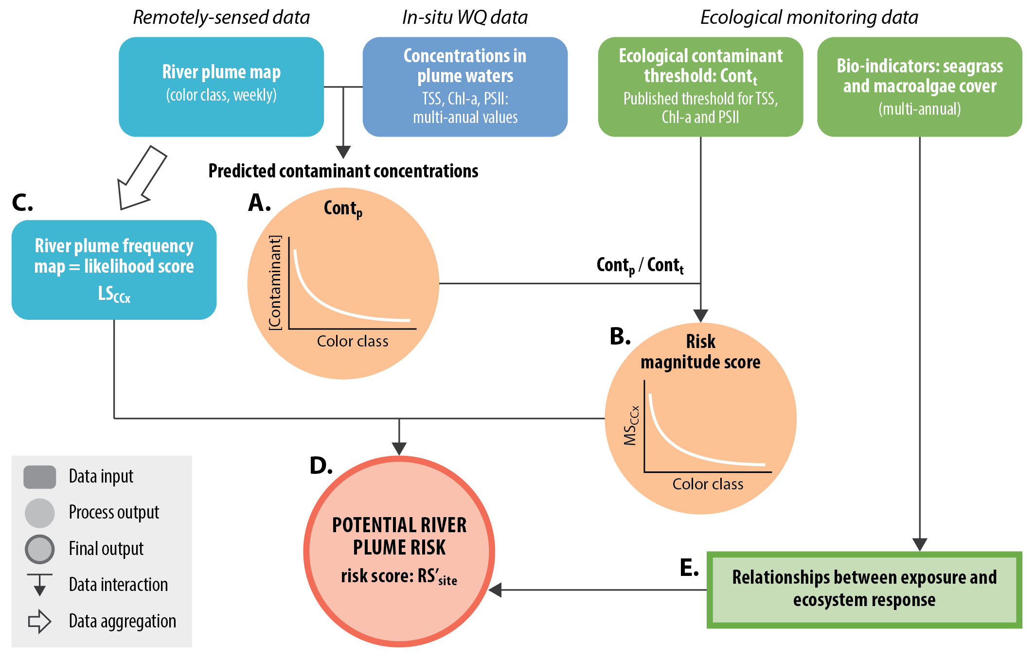
Figure 8-1: Conceptual model of the satellite risk framework presented in this study, data sources and main processes.

Magnitude Score
Ratios between predicted TSS, PSII herbicide and Chl-a concentrations in river plumes and ecological thresholds were calculated and summed for each plume water type. The ecological thresholds used were those published in Brodie et al. (2013b), i.e., TSS = 7 mg L⁻¹, Chl-a = 0.45 µg L⁻¹ and PSII = 0.1 µg L⁻¹. A cumulative risk magnitude score was then calculated for each plume water type by normalising across plume water types (hereafter Magnitude Score or MS_{CCx}) (Figure 8-1B).
Likelihood Score
The likelihood of exposure to each color class at the seagrass and coral sites locations was extracted from the multi-annual water type frequency maps using ArcMap. A 3 × 3 km buffer was created around each monitoring sites and the multi-annual (2005 - 2014) frequency values value of each pixel was extracted from the buffered area. Each seagrass and coral monitoring site was then assigned a multi-annual Likelihood Score based on the averaged values extracted (LS_{CCx}) (Figure 8-1C).
Risk Score
The probability of exceeding ecological thresholds concentrations from exposure to river plumes i.e., the ‘potential’ river plume risk to seagrass and coral reef ecosystems was estimated by multiplying each respective MS_{CCx} by its LS_{CCx} (Magnitude x Likelihood scores) and normalising over all monitored sites (Rs’_{site}) (Figure 8-1D).
Relationships between exposure risk and ecosystem response
The seagrass and macroalgae cover data available through the MMP were used as bio-indicators of ecosystem response to test the initial validity of the risk maps (Figure 8-1E). The long-term (2005 to 2014) response of seagrass and coral ecosystem to river plume exposure was evaluated by calculating (i) the changes in seagrass cover and proportion of macroalgae in the algal communities across years 2005 and 2014 (∆BioIndicator) and (ii) the mean multi-annual seagrass cover and MAp (MBioIndicator). Finally, the hypothesis that long-term (2005 to 2014) responses of coral reefs and seagrass meadows will be influenced by contaminant concentrations and frequency of exposure to the contaminant concentrations were investigated by correlating biological bio-indicator responses to their risk score at the site and NRM regional scales (RS’_{NRM}).

Results
The multi-annual risk map shows that the area of high potential risk is confined to the coastal waters.
Contaminant concentrations across river plumes water types
Mean multi-annual concentrations of TSS and Chl-a were over the ecological thresholds in all plume water types, except in CC6 where RS_{CC6} was scored as zero (Table 8-2). However, estimated mean PSII concentrations were all under PSII = 0.1. Ratios of contaminant concentrations against ecological thresholds increased across the plume water gradient (toward the inshore CC1 plume water type). Mean concentrations of TSS and Chl-a were more than 1.5 and 4.0 times higher than threshold concentrations in the CC3, respectively, and about 5 times higher in the CC1. As a results, the normalised Magnitude Score increased from the offshore (MS_{CC6} = 0) to the inshore (MS_{CC1} = 10) plume waters, with a sharp increase of the Magnitude Score in the CC1 vs. CC2 or CC3 (MS_{CC2/ CC3} = 5).
Seagrass meadows and proportion of macroalgae in the algal communities
Seagrass meadows of the GBR showed declining trajectories since 2005 throughout all of the regions of the GBR (a: black arrows and Table 8-3). Maximum changes in seagrass across the studied period (2005 to 2014) were measured in the Burnett-Mary NRM region with a loss of 43.20% of cover, though the mean multi-annual cover was maintained at about 12% (M_{BM}). Minimum changes were measured in the Mackay-Whitsundays (Δ_{MW}= -7.05%) and the Wet Tropics (Δ_{MW}= -7.50%). Mean multi-annual cover for both these regions were about 15.33% and 14.98% respectively. At the site level, maximum changes were measured at the Urangan site (Table 8-3: Δ_{UG} =-54.10%) and minimum changes at the Gladstone Harbour site (Δ_{GH} = -1.40%).
The proportion of macroalgae in coral reef algal communities (MAp) was highly variable through time and between regions (Figure 8-2b: black arrows and Table 8-4) compared to that of seagrass meadows. The Fitzroy region showed a clear increasing trend of MAp across the years 2005 to 2014 (Δ_{Fi} = + 32.7%) and the highest mean multi-annual proportion of the GBR regions (M_{Fi} = 41.0%). Increasing trends were also observed at the Wet Tropic reefs (Δ_{WT} = + 7.8%), while a decrease in the proportion of macroalgae was measured in the Burdekin region (Δ_{Bu} = - 11.1%). No trend could be observed on the Mackay-Whitsunday reefs (Δ_{MW} = + 2.5%), with macroalgae only common at the Pine Island and Seaforth Island sites where it has maintained a reasonably consistent representation in the algal communities (Δ_{PI} = 8.9%, Δ_{SI} = 7.0 %, M_{PI} = 31.0% and M_{SI} = 31.8%).
Table 8-2: Contaminant concentration in each plume water type (TSSp_{CCx}, Chl-ap_{CCx}, PSIIp_{CCx}) is compared by ratio to published ecological threshold values for consequences and effects (TSSt_{CCx}, Chl-at_{CCx}, PSIIt_{CCx}). Ratios are summed (R_{CCx}) and normalised across plume water type in order to calculate a Magnitude Score for each plume water type (MS_{CCx}). A linear model applied on the data to estimate the multi-annual mean PSII herbicide concentrations per plume water type and the Wet Tropics data are used as surrogate for the GBR.
 | Tertiary | Secondary | Primary
 | CC6 | CC5 | CC4 | CC3 | CC2 | CC1
TSS (mg L⁻¹) | 5.66 | 6.10 | 7.33 | 10.62 | 10.52 | 33.97
Chl-a (µg L⁻¹) | 0.42 | 0.86 | 1.44 | 1.95 | 2.14 | 2.41
PSII (µg L⁻¹) | 0.01 | 0.01 | 0.02 | 0.03 | 0.03 | 0.04
ET_{TSS} | 7
ET_{Chl-a} | 0.63
ET_{PSII} | 0.1
R_{TSS} | 0.8 | 0.9 | 1.0 | 1.52 | 1.50 | 4.85
R_{Chla} | 0.9 | 1.9 | 3.2 | 4.33 | 4.76 | 5.36
R_{PSII} | 0.1 | 0.1 | 0.2 | 0.3 | 0.3 | 0.4
ΣR | 1.8 | 2.9 | 4.4 | 6.2 | 6.6 | 10.6
MS | 0 | 1 | 3 | 5 | 5 | 10

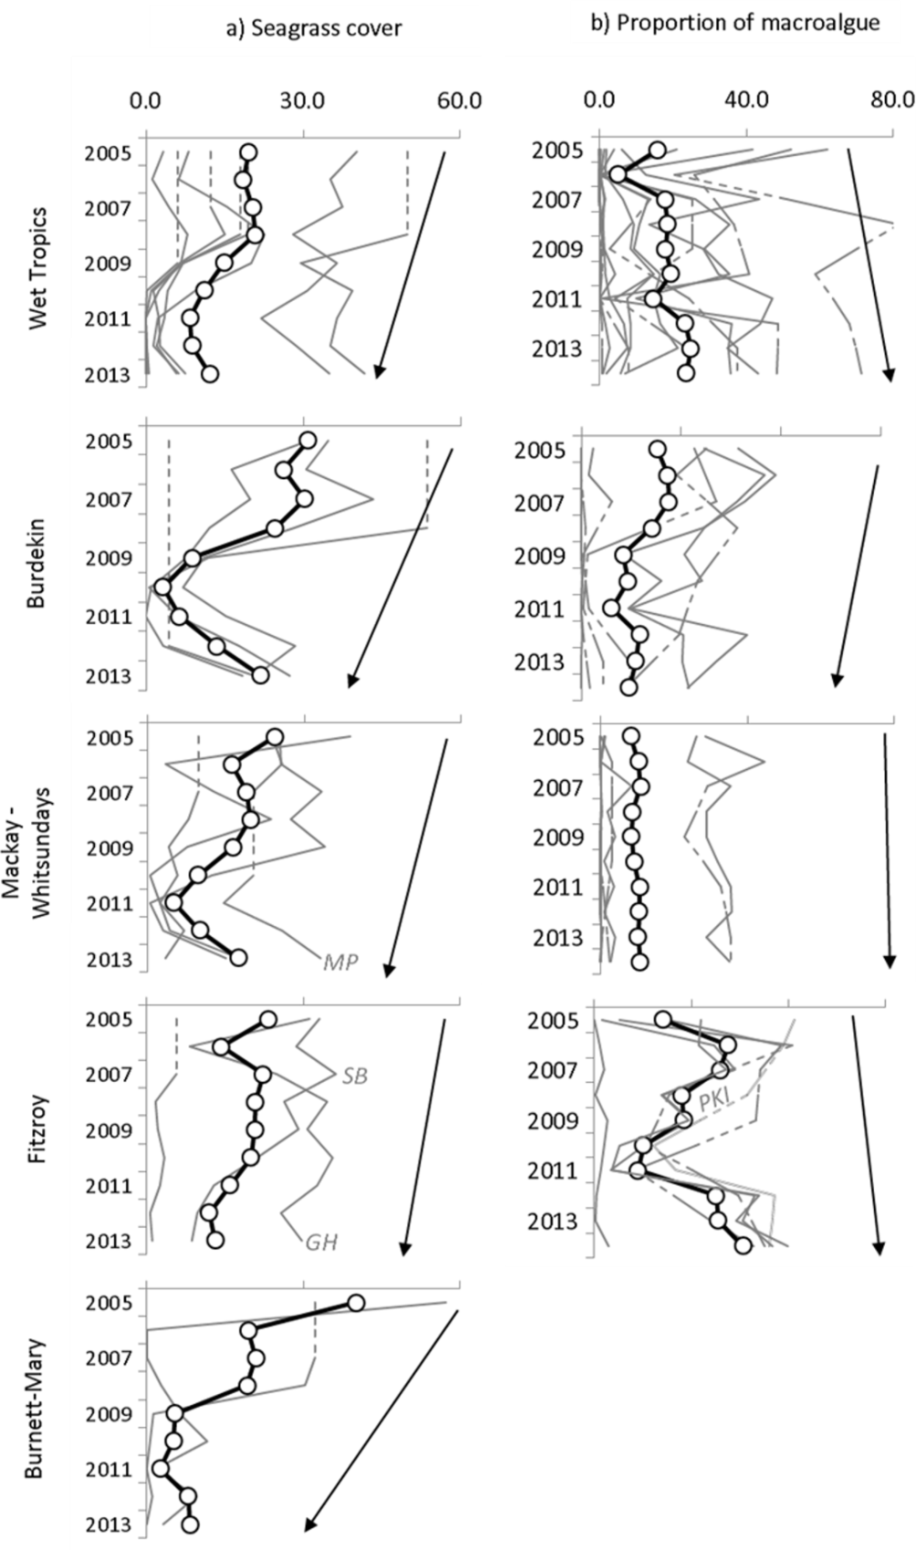

Figure 8-2: a) Seagrass abundance (% cover) and b) proportion of macroalgae in the algal communities at each reef collected though out the MMP. GH: Gladstone Harbor, SB: Shoalwater Bay, MP: Middle point and PKI: Peak Island. Black line with white circles represents the averaged values per NRM regions and light grey lines values of each monitored sites. Interpolated data are symbolised with dashed grey lines. Multi-annual trends are indicated with a black arrow.
Multi-annual changes in seagrass cover across sites were negatively correlated to their risk scores (Table 8-3: Δ_{site} and RS_{site}); but Gladstone Harbour and Midge Point were outliers of the observed relationship (Figure 8-3a: R² = 0.47, p < 0.05). At the regional (NRM) scale, no significant relationship was found between Δ_{NRM} and RS_{NRM} (Table 8-3 and Figure 8-3b, R² = 0.61, ns.). However, the relatively lower loss of cover in the Wet Tropics and Mackay Whitsunday regions (Δ_{WT} = -7.50% and Δ_{MW}= -7.05%) were associated with the lowest regional Risk Scores (RS_{WT} = 0.11 and RS_{MW}= 0.25). Inversely, the higher loss in cover observed in the Burnett-Mary region (Δ_{BM} = -43.20%) was associated with the highest Risk Score (RS_{BM} = 0.59). No significant relationships were found between the mean multi-annual seagrass cover values and the risk scores at the site and regional scales (Figure 8-3c and Figure 8-3d).
Table 8-3: Magnitude Score (MS_{CCx}) of each plume water type, Likelihood Score (LS_{CCx}) at the seagrass sites locations and Risk Scores (RS_{site} and RS_{NRM}) at the seagrass site and NRM scales.
Colour Class |  | CC1 | CC2 | CC3 | CC4 | CC5 | CC6 | Risk Scores |  | seagrass cover
Magnitude score MS_{CCx:} |  | 10 | 5 | 3 | 3 | 1 | 0 | RS_{site} | RS_{NRM}
Likelihood Score: |  | LS_{CC1} | LS_{CC2} | LS_{CC3} | LS_{CC4} | LS_{CC5} | LS_{CC6} | RS_{site} | RS_{NRM} | Δ_{site} | Δ_{NRM} | M_{site} | M_{NRM}
Burdekin  (Bu) | JR | 0.18 | 0.31 | 0.11 | 0.20 | 0.04 | 0.00 | 1.00 | 0.47 |  | -17.53 | 6.21 | 18.40
Burdekin  (Bu) | MI | 0.00 | 0.01 | 0.01 | 0.15 | 0.74 | 0.01 | 0.25 |  | -13.80 |  | 24.37
Burdekin  (Bu) | MI^ | 0.00 | 0.00 | 0.01 | 0.12 | 0.78 | 0.01 | 0.23 |  | -26.20 |  | 30.88
Burdekin  (Bu) | TSV | 0.01 | 0.07 | 0.04 | 0.33 | 0.39 | 0.00 | 0.42 |  | -12.60 |  | 12.13
Burnett-Mary  (BM) | RD | 0.06 | 0.15 | 0.11 | 0.38 | 0.09 | 0.00 | 0.65 | 0.59 | -32.30 | -43.20 | 14.50 | 12.42
Burnett-Mary  (BM) | UG | 0.05 | 0.07 | 0.05 | 0.32 | 0.37 | 0.00 | 0.52 |  | -54.10 |  | 10.34
Fitzroy  (Fi) | GH | 0.03 | 0.18 | 0.17 | 0.47 | 0.06 | 0.00 | 0.71 | 0.43 | -1.40 | -10.13 | 28.19 | 18.12
Fitzroy  (Fi) | GK | 0.01 | 0.01 | 0.01 | 0.09 | 0.74 | 0.05 | 0.24 |  | -4.60 |  | 3.28
Fitzroy  (Fi) | SWB | 0.02 | 0.05 | 0.02 | 0.15 | 0.61 | 0.00 | 0.33 |  | -24.40 |  | 22.88
Mackay-Whits.  (MW) | HM | 0.00 | 0.00 | 0.00 | 0.01 | 0.72 | 0.11 | 0.14 | 0.25 | -6.20 | -7.05 | 6.63 | 15.33
Mackay-Whits.  (MW) | MP | 0.01 | 0.04 | 0.05 | 0.32 | 0.35 | 0.00 | 0.37 |  | 9.40 |  | 22.70
Mackay-Whits.  (MW) | PI | 0.00 | 0.01 | 0.01 | 0.06 | 0.65 | 0.01 | 0.17 |  | -10.30 |  | 19.64
Mackay-Whits.  (MW) | SI | 0.03 | 0.07 | 0.03 | 0.19 | 0.33 | 0.00 | 0.33 |  | -21.10 |  | 12.32
Wet Tropics  (WT) | DI | 0.00 | 0.01 | 0.01 | 0.11 | 0.69 | 0.04 | 0.22 | 0.11 | -12.10 | -7.50 | 6.83 | 14.98
Wet Tropics  (WT) | DI^ | 0.00 | 0.00 | 0.01 | 0.08 | 0.65 | 0.12 | 0.18 |  | -5.40 |  | 3.44
Wet Tropics  (WT) | GI | 0.00 | 0.01 | 0.00 | 0.01 | 0.19 | 0.27 | 0.01 |  | -5.10 |  | 32.69
Wet Tropics  (WT) | GI^ | 0.00 | 0.01 | 0.00 | 0.01 | 0.16 | 0.30 | 0.00 |  | -8.10 |  | 42.48
Wet Tropics  (WT) | LB | 0.00 | 0.02 | 0.02 | 0.23 | 0.53 | 0.01 | 0.29 |  | -3.20 |  | 2.69
Wet Tropics  (WT) | LI | 0.00 | 0.00 | 0.00 | 0.02 | 0.20 | 0.50 | 0.02 |  | -12.30 |  | 10.53
Wet Tropics  (WT) | LI^ | 0.00 | 0.00 | 0.00 | 0.02 | 0.13 | 0.42 | 0.00 |  | -12.00 |  | 11.01
Wet Tropics  (WT) | YP | 0.00 | 0.00 | 0.00 | 0.05 | 0.60 | 0.10 | 0.13 |  | -1.80 |  | 10.20

Multi-annual trends in MAp were highly variable both through time and between regions (Figure 8-2b) and the interactions between risk scores and multi-annual changes in MAp were more complex (Table 8-4 and Figure 8-4a). At the site scale, a slight increase of the Δsite with increased RSsite values was observable, but was not significant (Figure 8-4a, R² = 0.04, ns.). At the regional scale, trends were clearer though still not significant (Figure 8-4a, R² = 0.52, ns.). Relatively stable multi-annual trends in the MAp cover of the Mackay Whitsunday or loss of MAp cover in the Wet Tropics and Burdekin regions were associated with the similar low regional Risk Scores (Table 8-4 and Figure 8-4b: RS_{NRM} = 0.18 – 0.32). Inversely, the increasing trend in MAp cover observed in the Fitzroy region was associated with the highest Risk Scores (RS_{Fitz.} = 0.58). Stronger relationships were observed by considering the mean multi-annual MAp values rather than the MAp changes across years 2005 to 2014 (Figure 8-4c and Figure 8-4d vs. Figure 8-4a and Figure 8-4b). Significant relationships were observed and suggested an increase of the multi-annual proportion of macroalgae with increased risk magnitude scores, at both the site (Figure 8-4c, R² = 0.42, p <0.05) and regional scales (Figure 8-4d, R² = 0.96, p <0.05).
Table 8-4: Magnitude Score (MSCCx) of each plume water type, Likelihood Score (LSCCx) at the seagrass sites locations and Risk Scores (RS_{site} and RS_{NRM}) at the coral site and NRM scales.
Colour Class |  | CC1 | CC2 | CC3 | CC4 | CC5 | CC6 | Risk Scores |  | MAp cover
Magnitude score MS_{CCx:} |  | 10 | 5 | 3 | 3 | 1 | 0 | RS_{site} | RS_{NRM}
Likelihood Score: |  | LS_{CC1} | LS_{CC2} | LS_{CC3} | LS_{CC4} | LS_{CC5} | LS_{CC6} | RS_{site} | RS_{NRM} | Δ_{site} | Δ_{NRM} | M_{site} | M_{NRM}
Burdekin  (Bu) | GB | 0.00 | 0.00 | 0.01 | 0.14 | 0.77 | 0.04 | 0.49 | 0.32 | -6.95 | -11.13 | 50.81 | 24.08
Burdekin  (Bu) | HI | 0.00 | 0.01 | 0.00 | 0.06 | 0.36 | 0.46 | 0.14 |  | -36.51 |  | 20.43
Burdekin  (Bu) | LE | 0.01 | 0.01 | 0.01 | 0.22 | 0.62 | 0.03 | 0.59 |  | -32.18 |  | 43.20
Burdekin  (Bu) | MR | 0.00 | 0.01 | 0.02 | 0.21 | 0.69 | 0.01 | 0.59 |  | 14.25 |  | 8.17
Burdekin  (Bu) | OIE | 0.00 | 0.00 | 0.00 | 0.05 | 0.31 | 0.43 | 0.09 |  | 3.28 |  | 1.07
Burdekin  (Bu) | PAN | 0.00 | 0.01 | 0.01 | 0.05 | 0.51 | 0.35 | 0.20 |  | -19.69 |  | 44.82
Burdekin  (Bu) | POIW | 0.00 | 0.01 | 0.00 | 0.06 | 0.32 | 0.46 | 0.11 |  | -0.11 |  | 0.05
Fitzroy  (Fi) | BI | 0.01 | 0.01 | 0.00 | 0.05 | 0.22 | 0.42 | 0.13 | 0.58 | 5.68 | 32.73 | 2.70 | 41.00
Fitzroy  (Fi) | HHI | 0.02 | 0.02 | 0.01 | 0.16 | 0.55 | 0.23 | 0.53 |  | 69.93 |  | 40.69
Fitzroy  (Fi) | MI | 0.01 | 0.01 | 0.01 | 0.12 | 0.71 | 0.09 | 0.50 |  | 59.87 |  | 46.21
Fitzroy  (Fi) | NKI | 0.01 | 0.01 | 0.01 | 0.12 | 0.55 | 0.24 | 0.39 |  | 35.36 |  | 51.53
Fitzroy  (Fi) | PKI | 0.04 | 0.03 | 0.04 | 0.25 | 0.63 | 0.01 | 0.92 |  | -10.26 |  | 61.59
Fitzroy  (Fi) | PLI | 0.03 | 0.05 | 0.04 | 0.33 | 0.53 | 0.03 | 1.00 |  | 35.78 |  | 43.24
Mackay Whitsunday  (MW) | DDI | 0.00 | 0.00 | 0.00 | 0.03 | 0.70 | 0.16 | 0.24 | 0.18 | 1.67 | 2.54 | 2.86 | 9.87
Mackay Whitsunday  (MW) | DI | 0.00 | 0.00 | 0.00 | 0.02 | 0.75 | 0.08 | 0.27 |  | -1.15 |  | 0.33
Mackay Whitsunday  (MW) | DCI | 0.00 | 0.00 | 0.00 | 0.01 | 0.39 | 0.47 | 0.05 |  | 0.25 |  | 0.14
Mackay Whitsunday  (MW) | HI | 0.00 | 0.00 | 0.00 | 0.02 | 0.40 | 0.43 | 0.07 |  | -0.15 |  | 2.03
Mackay Whitsunday  (MW) | PI | 0.00 | 0.00 | 0.00 | 0.01 | 0.70 | 0.16 | 0.21 |  | 8.88 |  | 31.04
Mackay Whitsunday  (MW) | SI | 0.00 | 0.00 | 0.00 | 0.01 | 0.67 | 0.22 | 0.19 |  | 7.03 |  | 31.80
Mackay Whitsunday  (MW) | STI | 0.00 | 0.00 | 0.00 | 0.02 | 0.67 | 0.14 | 0.21 |  | 1.26 |  | 0.87
Wet Tropics  (WT) | SIN | 0.01 | 0.01 | 0.00 | 0.06 | 0.51 | 0.24 | 0.26 | 0.20 | 36.92 | 7.78 | 30.62 | 18.24
Wet Tropics  (WT) | SIS | 0.01 | 0.01 | 0.00 | 0.05 | 0.45 | 0.34 | 0.21 |  | 0.61 |  | 2.66
Wet Tropics  (WT) | FIE | 0.00 | 0.01 | 0.00 | 0.01 | 0.25 | 0.37 | 0.00 |  | 0.66 |  | 0.48
Wet Tropics  (WT) | FIW | 0.00 | 0.01 | 0.00 | 0.01 | 0.42 | 0.38 | 0.08 |  | 1.12 |  | 1.39
Wet Tropics  (WT) | FGE | 0.00 | 0.01 | 0.00 | 0.04 | 0.23 | 0.43 | 0.04 |  | 37.13 |  | 17.14
Wet Tropics  (WT) | FGW | 0.00 | 0.01 | 0.00 | 0.04 | 0.21 | 0.39 | 0.03 |  | 3.06 |  | 11.46
Wet Tropics  (WT) | HIE | 0.00 | 0.00 | 0.00 | 0.07 | 0.40 | 0.38 | 0.16 |  | 7.75 |  | 2.27
Wet Tropics  (WT) | HIW | 0.00 | 0.01 | 0.00 | 0.09 | 0.56 | 0.25 | 0.29 |  | 3.91 |  | 7.43
Wet Tropics  (WT) | DIN | 0.00 | 0.01 | 0.01 | 0.15 | 0.66 | 0.08 | 0.46 |  | -5.94 |  | 28.55
Wet Tropics  (WT) | DIS | 0.00 | 0.01 | 0.01 | 0.13 | 0.68 | 0.08 | 0.43 |  | -3.85 |  | 37.22
Wet Tropics  (WT) | K | 0.00 | 0.00 | 0.01 | 0.07 | 0.59 | 0.21 | 0.26 |  | 9.33 |  | 61.78
Wet Tropics  (WT) | NBG | 0.00 | 0.00 | 0.01 | 0.05 | 0.58 | 0.22 | 0.23 |  | 2.70 |  | 17.83

Discussion and conclusions
This study confirms that levels of TSS and Chl-a in river plume waters exceed published ecological thresholds, except in the most offshore CC6 plume water type (x% of the area of plume extent); and generally decrease from the inshore to offshore plume water types (Table 8-2). Estimated mean PSII levels in river plume waters were under the concentration thresholds for biological response in all plume water types and the potential risk from exposure to PSII in river plume waters was scored as zero in the Risk Scores. However, the persistence of herbicides in coastal waters should be noted (Wilkinson et al., 2015), and the concern that sublethal chronic impacts can occur at low concentrations (Negri et al., (=2015), albeit generally lower than those detected here.
The area of high potential risk is a small percentage of the whole of the marine park however; its importance should not be underestimated as a consequence as there are many crucially important services provided to the GBR from this coastal section. Comparing risk framework outputs with with measures of seagrass and coral ecosystem health is important to validate theoretical risk thresholds. The Satellite Risk Framework and Risk Scores presented in this study were successful in demonstrating where water conditions are, on average, associated with adverse ecological responses in the GBR. The correlation between the multi-annual changes in coastal seagrass cover and Risk Scores at the site level (Figure 8-3a) help in refining multiannual risk thresholds associated with loss of seagrass cover (Table 8-5).
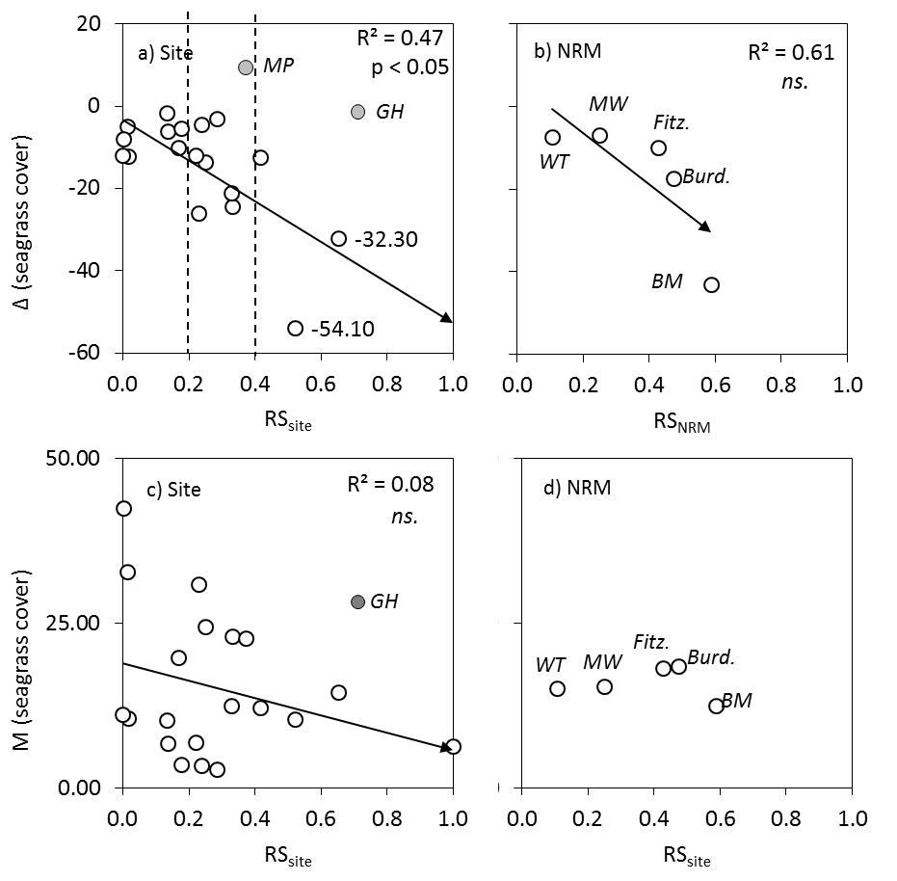
Figure 8-3: Changes in (Δ, top) and mean multi-annual (M, bottom) seagrass cover compared to Risk Scores (MS) at the: a and c) site and b and d) NRM scales. MP: Midge Point and GH: Gladstone Harbour. WT: Wet Tropics, MW: Mackay-Whitsundays, Fitz.: Fitzroy Burd.: Burdekin and BM: Burnett-Mary. Determination coefficient and p values calculated without considering the outlier sites (indicated by grey dots).

Figure 8-4: Multi-annual (2005-2014) changes in (Δ, top) and mean multi-annual (M, bottom) proportion of macroalgae in the algal community compared to Risk Scores (RS) at the: a) and c) site, and b) and d) NRM scales. ns. non-significant. The dotted line in c) indicate an initial risk score threshold of about 0.2 below which there is rarely high proportion of macroalgae in the algal communities at the reef sites.

Table 8-5: Risk Score thresholds associated with loss of seagrass cover. The thresholds were derived from Figure 8-3a (dotted lines).
Risk | I | II | III
RS | 0 - 0.2 | 0.2 - 0.4 | > 0.4
Δcover | + / -12 | -12 / -30 | > -30

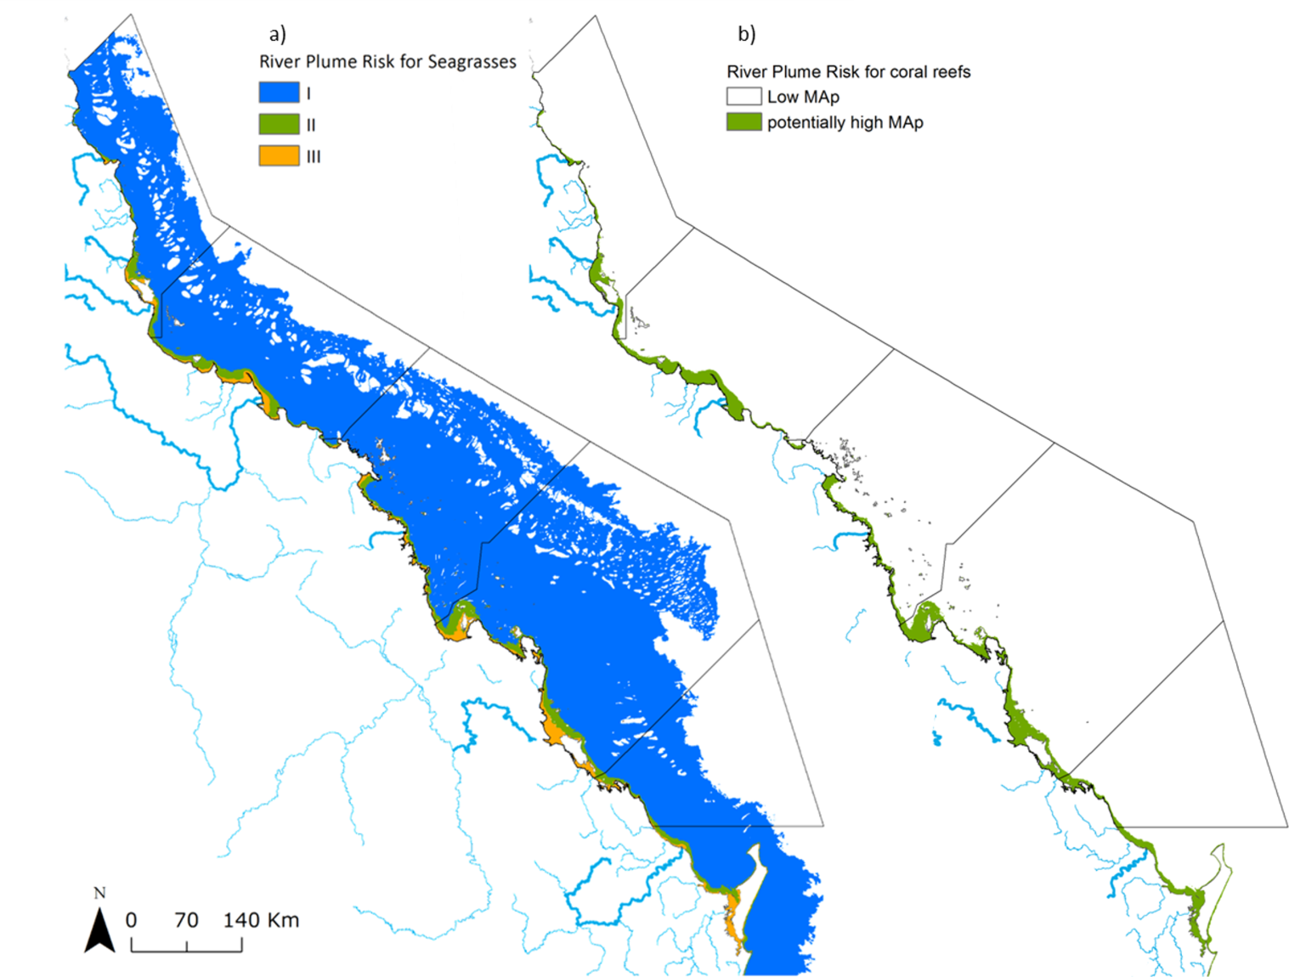
Figure 8-5: Multi-annual risk map for GBR seagrass ecosystems from river plume exposure.
This allows the development of an exposure map for the GBR seagrass ecosystems validated against seagrass health data (Figure 8-5a). Furthermore, the results of this initial analysis provided evidence that the river plume exposure does influence macroalgae communities and a multi-annual Risk Score threshold of about 0.2 can be proposed (which correlates to X floods per year), above which a high proportion of macroalgae in the algal communities at the reef sites can be expected (Figure 8-4c, dotted line and Figure 8-5b). This result helps to further resolve the area of high water column concentrations of chlorophyll, and total suspended solids previously identified as having higher abundance of macroalgae (De’ath and Fabricius, 2010).
This study focused on multi-annual analyses to test the initial validity of the maps produced from the Satellite Risk Framework. However, underlying ecological processes that govern short term and small-scale fluctuations in seagrass and macroalgae cover were not resolved by the present study. For example, seagrass meadow responses at Gladstone Harbour and Midge Point deviated from the general response to long-term exposure to river plume (Figure 8-3a), highlighting the complexity of the relationships existing between ecosystem response and water quality condition. The Gladstone Harbour site is at a location with relatively little catchment input and is characterised by a good multi-annual state of seagrass cover, while the beginning of seagrass recovery has been observed at Midge Point since 2010 (Figure 8-2a, Fitzroy region: ‘GH’ and Mackay Whitsunday region: ‘MW’). Specific resilience characteristics of seagrass species assemblages at each monitored sites, as well as other environmental conditions within seagrass meadows also influence the response of individual sites within the regional groupings. Environmental conditions such as the cyclonic activity (McKenzie et al., 2015), temperature and salinity (Collier et al., 2014), bathymetry and sediment type (Ganthy et al., 2013), tide currents and wave exposure (see references in Schaffelke et al., 2013) or the zonal location of the meadows may have also contributed to the response of seagrass meadows. For example, it has been observed though remote sensing mapping of water quality conditions that very shallow intertidal GBR meadows, which receive light before, during, and immediately after low tide, had lowest losses in area than other subtidal species (Petus et al., 2014b).
The plume water types are characterised through the mapping of river plumes by MODIS true colour images recorded during the wet season, as it is typically during these periods of high flow that water quality is measured as a gradient from the inshore to the offshore boundaries of river plumes (Álvarez-Romero et al., 2013). At the whole GBR scale, restricting the analysis to wet season months also minimises the occurrence of “false” river plume areas associated with wind-driven re-suspension of sediments during the strong trade winds typical of the dry season (Álvarez-Romero et al., 2013). However, in shallow coastal areas of the GBR, muddy sediments can be re-suspended by wind, waves and tidal currents (Lambrechts et al., 2010), increasing the turbidity levels in the coastal waters and resulting in misclassification of some of the pixels. Tidal effects may also have a role in turbidity and resuspension. This could explain the relatively high Risk Score calculated at the shallow Gladstone Harbour site (Figure 8-3a) for example, where very little cover loss were observed at this site characterised by relatively little catchment input (McKenzie et al., 2015). The Gladstone Harbour seagrass meadows are also intertidal meadows, which could lead to lower losses in cover at this site than other subtidal sites at similar plume exposure levels, and further explain the result observed.
The lack of consistent increase in macroalgae within algal communities over the period of increased risk of exposure to flood plumes (Figure 8-4a), along with observed high levels of variability at individual reefs over time (Figure 8-2b) indicate the influence of processes not directly linked to the water quality parameters summarized by the Risk Score. A number of factors, including the suitability of the substrate and grazing pressure are understood to influence the abundance of macroalgae on coral reefs (e.g. Schaffelke et al., 2005; Hugues et al., 2005). The consideration of these factors was beyond the scope of this study though they will likely have added to the variability in community responses observed. Similarly the macroalgae considered represent the grouping of a high number of species that would be expected to have differing responses environmental conditions, and so potentially obscured mean effects.
The test for an increase in macroalgae relative to the change in Risk Score was also confounded by strong gradient in macroalgae abundance revealed by the relationship between macroalgae representation in the algal community and the Risk Score. Several of the more offshore reefs received little additional exposure over the period of this study and the consistently low cover of macroalgae implied these reefs are beyond some threshold that allows macroalgae to flourish. Conversely high representation of macroalgae at many of the more inshore reefs prior to the onset of the wet period of 2008-2012 suggest that those algal communities were not environmentally limited (Figure 8-2b). In addition the relationship between the increased Risk Score and a macroalgae response should not be expected to be uniformly linear due to the myriad of interactions between flood exposure and other processes operation to control not just algae but all species within these complex ecosystems.
As an example, turbidity and chlorophyll a concentration, as a proxy for nutrient availability, are aggregated into the Risk Score, however, these two factors can have competing influences on macroalgae. There is ample evidence that availability of nutrients is positively related to macroalgae abundance, but only where sufficient light is available (Schaffelke, 1999), meaning, that in the highly turbid conditions experienced in a plume, the reduction in light availability may outweigh any influence of enhanced nutrient supply. The observed reduction in macroalgae following large flood events on the reefs with high magnitude exposure risk following large floods of the Fitzroy River support this interpretation. Despite this short term variability in macroalgae commuities as a direct response to flood exposure the general increase in macroalgae cover on reefs in the Fitzroy region corresponded to a high Risk Score in this region (Figure 8-4b). Exposure to flood plumes in this region appears to have been both a cause of coral mortality but also a vector for the maintenance of water quality conditions suitable to the subsequent colonization and maintenance of high macroalgae cover.
Results obtained are encouraging, and next steps should focus on progressing toward the production of annual risk maps for GBR ecosystems. These annual risk maps would inform on the seasonal water quality context of GBR ecosystems and would provide the temporal scale necessary to resolve processes that govern short term fluctuations in seagrass and macroalgae cover. For example, they would help to determine the number of consecutive years a coral/seagrass ecosystem need to receive a certain category of risk to see a shift in species response as a result of being exposed to reduced water quality in plume waters. Such short term assessment has been initiated in the GBR, with preliminary results suggesting that exposure to plume waters from 10 to 60 % of the wet season, and during two consecutive wet seasons, could result in a significant loss of seagrass cover (> 50%, see Collier et al., 2014). Plume exposure thresholds varied as a function of the cross-shelf location of the seagrass habitat and the ambient water quality conditions, but recovery processes after these losses were not resolved. Finally, the use of multidimensional statistics would help to progress understanding of the mechanisms of influence of the key water quality parameters associated with river plume waters, as well as additional external (e.g., environmental or competitive pressures) and internal (e.g., physiology) on seagrass and macroalgae responses.
In the present study, ecological thresholds above which potential impacts of plume exposure on ecosystems have been observed were defined following Brodie et al., 2013. However, only limited information is available to draw conclusions, for example, on the effects of the exposure to sediments, nutrients (measured as Chl-a concentrations) on seagrass health. Experiments on responses of GBR key species to interactive effects to these water quality parameters should be carried out to progress the development of final risk thresholds for GBR seagrass and coral reefs. Additional indicators of coral reef condition should also be considered in later analyses following the risk framework presented here. As risk metrics are adapted and improved with continual validation and reduced uncertainty, it will be possible to incorporate these products into applied management actions as useful tools to monitor water quality impacts on ecosystem health.

References
Alongi DM, McKinnon AD (2005) The cycling and fate of terrestrially-derived sediments and nutrients in the coastal zone of the Great Barrier Reef shelf. Marine Pollution Bulletin 51: 239–52.
Álvarez-Romero JG, Devlin MJ, Teixeira da Silva E, Petus C, Ban N, Pressey RJ, Kool J, Roberts S, Cerdeira WA, Brodie J (2013) A novel approach to model exposure of coastal-marine ecosystems to riverine flood plumes based on remote sensing techniques. J Environ Manage 119:194–207.
Anon. (1997) Directory of Autoanalyser Methods, Bran and Luebbe GmbH, Norderstedt, Germany.
Anon (2003) Reef Water Quality Protection Plan for catchments adjacent to the Great Barrier Reef World Heritage Area. The State of Queensland and Commonwealth of Australia. Queensland Department of Premier and Cabinet, Brisbane. 43 pp.
Anon. (2009) Reef Water Quality Protection Plan 2009. For the Great Barrier Reef World Heritage Area and adjacent catchments. The State of Queensland and Commonwealth of Australia. Queensland Department of the Premier and Cabinet, Brisbane. 30 pp.
Anon. (2010) Paddock to Reef Integrated Monitoring, Modelling and Reporting Program Design (DRAFT). Version 12 February 2010. The State of Queensland, Queensland Department of the Premier and Cabinet, Brisbane. 93 pp.
Anon. (2011) Reef Water Quality Protection Plan. First Report 2009 Baseline. The State of Queensland and Commonwealth of Australia. Queensland Department of Premier and Cabinet, Brisbane. 140 pp. Available at www.reefplan.qld.gov.au.
Anon. (2013) Reef Water Quality Protection Plan 2013.Securing the health and resilience of the Great Barrier Reef World Heritage Area and adjacent catchments. The State of Queensland. Reef Water Quality Protection Plan Secretariat, Brisbane. 34 p. Available at www.reefplan.qld.gov.au.
Baird AH, Marshall PA (2002) Mortality, growth and reproduction in scleractinian corals following bleaching on the Great Barrier Reef. Marine Ecology Progress Series 237:133-141.
Bartley R, Bainbridge ZT, Lewis SE, Kroon FJ, Wilkinson SN, Brodie JE, Silburn DM (2014a) Relating sediment impacts on coral reefs to watershed sources, processes and management: A review. Science of The Total Environment 468–469:1138-1153.
Bartley R, Corfield JP, Hawdon AA, Kinsey-Henderson AE, Abbott BN, Wilkinson SN, Keen RJ (2014b) Can changes to pasture management reduce runoff and sediment loss to the Great Barrier Reef? The results of a 10-year study in the Burdekin catchment, Australia. The Rangeland Journal 36:67-84.
Belperio, AP, Searle, DE, (1988). Terrigenous and carbonate sedimentation in the Great Barrier Reef province. In: J, D.L., H, R.H. (Eds.), Carbonate to Clastic Facies Changes. Developments in Sedimentology. Elsevier Science Publishers, Amsterdam, pp. 143–174.
Bellwood DR, Hughes TP, Folke C, Nyström M (2004) Confronting the coral reef crisis. Nature 429:827-833.
Bowers DG, Binding CE (2006) Optical properties of mineral suspended particles in the sea: a review and synthesis. Estuarine, Coastal and Shelf Science 67: 219-230.
Bowers DG, Braithwaite KM, Nimmo-Smith WAM, Graham GW (2011) Optical efficiency of flocs in shelf seas and estuaries. Estuarine, Coastal and Shelf Science 91: 341-350.
Brando VE, Blondeau-Patissier D, Schroeder T, Dekker AG, Clementson L (2011) Reef Rescue Marine Monitoring Program: Assessment of terrestrial run-off entering the Reef and inshore marine water quality monitoring using earth observation data. Final Report for 2010/11 Activities. CSIRO, Canberra. 201pp.
Brando VE, Devlin MJ, Dobbie M, McNeil A, Schaffelke B, Schroeder T (2013). Developing integrated assessment metrics for reporting of water quality in the Great Barrier Reef lagoon. Report to the Reef Rescue Water Quality Research & Development Program. Reef and Rainforest Research Centre Limited, Cairns. 53pp.
Brinkman R, Herzfeld M, Andrewartha J, Rizwi F, Steinberg C, Spagnol S (2011) Hydrodynamics at the whole of GBR scale. AIMS Final Project Report MTSRF Project 2.5i.1, June 2011. Report to Reef and Rainforest Research Centre. Australian Institute of Marine Science, Townsville. 42 pp.
Brinkman R, Tonin H, Furnas M, Schaffelke B, Fabricius K (2014) Targeted analysis of the linkages between river runoff and risks for crown-of-thorns starfish outbreaks in the Northern GBR Australian Institute of Marine Science. June 2014.
Brodie J, Waterhouse J, Maynard J, Bennett J, Furnas M, Devlin M, Lewis S, Collier C, Schaffelke B, Fabricius K, Petus C, da Silva E, Zeh D, Randall L, Brando V, McKenzie L, O’Brien D, Smith R, Warne MSJ, Brinkman R, Tonin H, Bainbridge Z, Bartley R, Negri A, Turner RDR, Davis A, Bentley C, Mueller J, Álvarez-Romero JG, Henry N, Waters D, Yorkston H, Tracey D. (2013). Assessment of the relative risk of water quality to ecosystems of the Great Barrier Reef. A report to the Department of the Environment and Heritage Protection, Queensland Government, Brisbane. TropWATER Report 13/28, Townsville, Australia.
Brodie J, De’ath G, Devlin M, Furnas MJ, Wright M (2007) Spatial and temporal patterns of near-surface chlorophyll a in the Great Barrier Reef lagoon. Marine and Freshwater Research 58: 342-353.
Brodie J, Fabricius K, De’ath G, Okaji K, (2005) Are increased nutrient inputs responsible for more outbreaks of crown-of-thorns starfish? An appraisal of the evidence. Marine Pollution Bulletin, 51(1), 266-278.
Brodie J, Wolanski E, Lewis S, Bainbridge Z (2012) An assessment of residence times of land-sourced contaminants in the Great Barrier Reef lagoon and the implications for management and reef recovery. Marine Pollution Bulletin 65: 267-279.
Brodie JE, McKergow LA, Prosser IP, Furnas MJ, Hughes AO, Hunter H (2003) Sources of sediment and nutrient exports to the Great Barrier Reef World Heritage Area. Australian Centre for Marine and Tropical Freshwater Research Report No. 03/11. James Cook University, Townsville.
Carpenter KE, Abrar M, Aeby G, Aronson RB, Banks S, Bruckner A, Chiriboga A, Cortes J, Delbeek JC, DeVantier L, Edgar GJ, Edwards AJ, Fenner D, Guzman HM, Hoeksema BW, Hodgson G, Johan O, Licuanan WY, Livingstone SR, Lovell ER, Moore JA, Obura DO, Ochavillo D, Polidoro BA, Precht WF, Quibilan MC, Reboton C, Richards ZT, Rogers AD, Sanciangco J, Sheppard A, Sheppard C, Smith J, Stuart S, Turak E, Veron JEN, Wallace C, Weil E, Wood E (2008) One-Third of Reef-Building Corals Face Elevated Extinction Risk from Climate Change and Local Impacts. Science 321:560-563.
Castillo ME, Baldwin EM, Casarin RS, Vanegas GP, Juarez MA, (2012). Characterisation of Risks in Coastal Zones: A Review. Clean – Soil, Air, Water 40 (9), 894–905.
Church MJ, Ducklow HW, Karl DM (2002) Multiyear increases in dissolved organic matter inventories a Station ALOHA in the North Pacific Subtropical Gyre. Limnology and Oceanography 47:1-10.
Collier C, Devlin M, Langlois L, Petus C, McKenzie L, Texeira da Silva E, McMahon K Adams M, O’Brien K, Statton J, Waycott M (2014) Thresholds and indicators of declining water quality as tools for tropical seagrass management. Report to the National Environmental Research Program. Reef and Rainforest Research Centre Limited, Cairns. 46pp.
Commonwealth of Australia (2015). Reef 2050 Long-Term Sustainability Plan. http://www.environment.gov.au/marine/gbr/publications/reef-2050-long-term-sustainability-plan.
Cooper TF, Ridd PV, Ulstrup KE, Humphrey C, Slivkoff M, Fabricius KE (2008) Temporal dynamics in coral bioindicators for water quality on coastal coral reefs of the Great Barrier Reef. Marine and Freshwater Research 59:703-716.
Cooper TF, Uthicke S, Humphrey C, Fabricius KE (2007) Gradients in water column nutrients, sediment parameters, irradiance and coral reef development in the Whitsunday Region, central Great Barrier Reef. Estuarine, Coastal and Shelf Science 74:458-470.
Crawley MJ (2007) The R Book.. Imperial College London at Silwood Park. UK.
Darnell R, Henderson B, Kroon FJ, Kuhnert P (2012) Statistical power of detecting trends in total suspended sediment loads to the Great Barrier Reef. Marine Pollution Bulletin 65:203-209.De'ath G, Fabricius KE (2008) Water Quality of the Great Barrier Reef: Distributions, Effects on Reef Biota and Trigger Values for the Protection of Ecosystem Health. Research Publication No. 89. Great Barrier Marine Park Authority, Townsville, 104pp.
De'ath G, Fabricius KE (2010) Water quality as a regional driver of coral biodiversity and macroalgae on the Great Barrier Reef. Ecological Applications 20:840–850.
Department of Environment and Resource Management (2009) Queensland Water Quality Guidelines, Version 3. 167 p. Available at www.derm.qld.gov.au. ISBN 978-0-9806986-0-2.
Devlin M, Lewis S, Davis A, Smith R, Negri A, Thompson M, Poggio M (2015). Advancing our understanding of the source, management, transport and impacts of pesticides on the Great Barrier Reef 2011-2015. A report for the Queensland Department of Environment and Heritage Protection. Tropical Water & Aquatic Ecosystem Research (TropWATER) Publication, James Cook University, Cairns, 134 pp.
Devlin M, McKinna LW, Álvarez-Romero J, Petus C, Abott B, Harkness P, Brodie J (2012) Mapping the pollutants in surface plume waters in the Great Barrier Reef, Australia. Marine Pollution Bulletin 65:224-235.
Devlin MJ, Brodie J, (2005) Terrestrial discharge into the Great Barrier Reef Lagoon: nutrient behavior in coastal waters. Marine pollution bulletin 51, 9-22.
Done TJ (1982) Patterns in the distribution of coral communities across the central Great Barrier Reef. Coral Reefs 1:95-107.
Fabricius KE (2005) Effects of terrestrial runoff on the ecology of corals and coral reefs: Review and synthesis. Marine Pollution Bulletin 50: 125–146.
Fabricius KE, Logan M, Weeks S, Brodie J, (2014) The effects of river run-off on water clarity across the central Great Barrier Reef. Marine Pollution Bulletin 84, 191-200.
Falkowski PG, Jokiel PL, Kinzie RA (1990) Irradiance and corals. In Dubinsky Z (ed) Ecosystems of the world 25: Coral Reefs. Elsevier, New York, pp 89-107.
Furnas M, Alongi D, McKinnon AD, Trott L, Skuza M (2011) Regional-scale nitrogen and phosphorus budgets for the northern (14ºS) and central (17ºS) Great Barrier Reef shelf ecosystem. Continental Shelf Research 31:1967-1990.
Furnas M, Brinkman R, Fabricius K, Tonin H, Schaffelke B (2013) Linkages between river runoff, phytoplankton blooms and primary outbreaks of crown-of-thorns seastars in the Northern GBR. Chapter 3 in Waterhouse et al. Assessment of the relative risk of water quality to ecosystems of the Great Barrier Reef. Department of the Environment and Heritage Protection, Queensland Government, Brisbane.
Furnas MJ, Mitchell AW, Skuza M (1995) Nitrogen and Phosphorus Budgets for the Central Great Barrier Reef Shelf. Research Publication No. 36. Great Barrier Reef Marine Park Authority, Townsville.
Furnas MJ, Mitchell AW, Skuza M, Brodie J (2005) In the other 90%: Phytoplankton responses to enhanced nutrient availability in the Great Barrier Reef lagoon. Marine Pollution Bulletin 51: 253-256 .
Gallen C, Devlin M, Thompson K, Paxman C, Mueller J (2015) Pesticide monitoring in inshore waters of the Great Barrier Reef using both time-integrated and event monitoring techniques (2014-2015). The University of Queensland, The National Research Centre for Environmental Toxicology (Entox).
Ganthy F, Sottolichio A, Verney R (2013). Seasonal modification of tidal flat sediment dynamics by seagrass meadows of Zostera noltii (Bassin d’Arcachon, France). Journal of Marine Systems. 109-110.
Garzon-Garcia A, Wallace R, Huggins R, Turner RDR, Smith RA, Orr D, Ferguson B, Gardiner R, Thomson B, Warne MStJ (2015) Total suspended solids, nutrient and pesticide loads (2013–2014) for rivers that discharge to the Great Barrier Reef – Great Barrier Reef Catchment Loads Monitoring Program. Department of Science, Information Technology and Innovation. Brisbane.
Great Barrier Reef Marine Park Authority (2010) Water Quality Guidelines for the Great Barrier Reef Marine Park. Revised Edition 2010. Great Barrier Reef Marine Park Authority, Townsville. 100pp.
Great Barrier Reef Marine Park Authority (2012) Informing the outlook for Great Barrier Reef coastal ecosystems. Great Barrier Reef Marine Park Authority, Townsville.
Great Barrier Reef Marine Park Authority (2014a) Great Barrier Reef Region Strategic Assessment. Great Barrier Reef Marine Park Authority, Townsville
Great Barrier Reef Marine Park Authority (2014b) Great Barrier Reef Outlook Report 2014, Great Barrier Reef Marine Park Authority, Townsville.
Great Barrier Reef Marine Park Authority (2015) Reef Rescue Marine Monitoring Program quality assurance and quality control manual. Great Barrier Reef Marine Park Authority, Townsville.
Haynes D, Muller J, Carter S (2000a). Pesticide and herbicide residues in sediments and seagrasses from the Great Barrier Reef World Heritage Area and Queensland coast. Marine Pollution Bulletin 41, 279-281.
Haynes D, Ralph P, Prange J, Dennison B (2000b). The Impact of the Herbicide Diuron on Photosynthesis in Three Species of Tropical Seagrass. Marine Pollution Bulletin 41, 288-293.
Henson S, Beaulieu C, Lampitt R (2016) Global Change Biology 22, 1561–1571.
Holmes RM, Aminot A, Kérouel R, Hooker BA, Peterson BJ (1999) A simple and precise method for measuring ammonium in marine and freshwater ecosystems. Can. J. Fish. Aquat. Sci. 56: 1801-1808.
Hughes TP, Rodrigues MJ, Bellwood DR, Ceccarelli D, Hoegh-Guldberg O, McCook L, Moltschaniwskyj N, Pratchett MS, Steneck RS, Willis B (2007). Phase Shifts, Herbivory, and the Resilience of Coral Reefs to Climate Change. Current Biology 17:360-365.
Hughes TP, Graham NAJ, Jackson JBC, Mumby PJ, Steneck RS (2010) Rising to the challenge of sustaining coral reef resilience. Trends in Ecology and Evolution 25(11):633-642.
Jeffrey SW, Humphrey GF (1975) New spectrophotometric equations for determining chlorophylls a,b,b₁ and c₂ in higher plants, algae and natural phytoplankton. Biochemie und Physiologie der Pflanzen 167: 191-194.
Jickells TD (1998) Nutrient biogeochemistry of the coastal zone. Science 281: 217- 222.
Joo M, Raymond MAA, McNeil VH, Huggins R, Turner RDR, Choy S (2012) Estimates of sediment and nutrient loads in 10 major catchments draining to the Great Barrier Reef during 2006–2009. Marine Pollution Bulletin 65: 150-166.
Kline DL, Kuntz NM, Breitbart M, Knowlton N, Rohwer F (2006) Role of elevated organic carbon levels and microbial activity in coral mortality. Marine Ecology Progress Series 314: 119–125.
Kroon FJ, Kuhnert PM, Henderson BL, Wilkinson SN, Kinsey-Henderson A, Abbott B, Brodie JE, Turner RDR (2012) River loads of suspended solids, nitrogen, phosphorus and herbicides delivered to the Great Barrier Reef lagoon. Marine Pollution Bulletin 65:167–181.
Kroon FJ, Schaffelke B, Bartley R (2014) Informing policy to protect coastal coral reefs: Insight from a global review of reducing agricultural pollution to coastal ecosystems. Marine Pollution Bulletin 85:33-41.
Kuntz N, Kline D, Sandin S, Rohwer F (2005) Pathologies and mortality rates caused by organic carbon and nutrient stressors in three Caribbean coral species. Marine Ecology Progress Series 294:173–180
Lambrechts J, Humphrey C, McKinna L, Gourge O, Fabricius K,E, Meht AJ., Lewis S, Wolanski E.(2010) Importance of wave-induced bed liquefaction in the fine sediment budget of Cleveland Bay, Great Barrier Reef. Estuarine Coastal and Shelf Sciences 89 (2), 154-162.
Lennon JT, Hamilton SK, Muscarella ME, Grandy AS, Wickings K, Jones SE (2013) A source of terrestrial organic carbon to investigate the browning of aquatic ecosystems. PLoS ONE 8: e75771. doi:10.1371/journal.pone.0075771.
Logan M, Fabricius K, Weeks S, Canto M, Noonan S, Wolanski E, Brodie J, (2013) The relationship between Burdekin River discharges and photic depth in the central Great Barrier Reef. Report to the National Environmental Research Program. Reef and Rainforest Research Centre Limited, Cairns. 29 pp.
Logan M, Fabricius K, Weeks S, Rodriguez A, Lewis S, Brodie J, (2014) Tracking coastal turbidity over time and demonstrating the effects of river discharge events on regional turbidity in the GBR: Southern and Northern NRM Regions. Report to the National Environmental Research Program. Reef and Rainforest Research Centre Limited, Cairns.
Lønborg C, Álvarez-Salgado XA (2012) Recycling versus export of bioavailable dissolved organic matter in the coastal ocean and efficiency of the continental shelf pump. Global Biogeochemical Cycles 26: Doi:10.1029/2012GB004353.
Lønborg C, Álvarez-Salgado XA, Martínez-Garcia S, Teira E (2011) Carbon cycling and bacterial growth efficiency in a coastal upwelling system (NW Iberian Peninsula). Aquatic Microbial Ecology 63, 183-191.
McKenzie LJ, Collier CJ, Langlois LA, Yoshida R.L, Smith N, Takahashi M, Waycott M (2015) Marine Monitoring Program - Inshore Seagrass, Annual Report for the sampling period 1st June 2013 – 31st May 2014. TropWATER, James Cook University, Cairns. 225pp.
Marshall PA, Johnson JE (2007) The Great Barrier Reef and climate change: vulnerability and management implications. In: Johnson JE, Marshall PA (eds) Climate change and the Great Barrier Reef. Great Barrier Reef Marine Park Authority and the Australian Greenhouse Office, Australia, pp 774-801.
Mora C (2008) A clear human footprint in the coral reefs of the Caribbean. Proceedings of the Royal Society B 275: 767-773.
Mundy CN, Babcock R C (1998). Role of light intensity and spectral quality in coral settlement: implications for depth-dependent settlement?. Journal of Experimental Marine Biology and Ecology, 223(2), 235-255.
Negri AP, Flores F, Mercurio P, Mueller JF, Collier CJ (2015) Lethal and sub-lethal chronic effects of the herbicide diuron on seagrass. Aquatic Toxicology 165, 73-83.
Oksanen J, Guillaume Blanchet F, Kindt R, Legendre P, Minchin PR, O’Hara RB, Simpson GL, Solymos P, Stevens MHH, Wagner H (2013) vegan: community ecology package. R package version 2.0-8. http://CRAN.R-project.org/package=vegan.
Osborne K, Dolman AM, Burgess SC, Johns KA (2011) Disturbance and the Dynamics of Coral Cover on the Great Barrier Reef (1995–2009). PLoS ONE 6:e17516.
Parsons, T.R., Maita, Y., Lalli, C.M. (1984). A Manual of Chemical and Biological Methods for Seawater Analysis. Oxford, Pergamon Press.
Petus C, Devlin M, Thompson A., McKenzie L, Teixeira da Silva E, Collier C, Tracey D, Martin K ( in review). Estimating the exposure of coral reefs and seagrass meadows to land-sourced contaminants in river flood plumes of the Great Barrier Reef: validating a simple Satellite Risk Framework with Environmental Data. Remote Sensing.
Petus C, Teixera da Silva E, Devlin M, Álvarez-Romero J, Wenger A (2014a). Using MODIS data for mapping of water types within flood plumes in the Great Barrier Reef, Australia: towards the production of river plume risk maps for reef and seagrass ecosystems. Journal of environmental management 137, 163-177.
Petus C, Collier C, Devlin M, Rasheed M, McKenna S (2014b). Using MODIS data for understanding changes in seagrass meadow health: A case study in the Great Barrier Reef (Australia). Marine environmental research 98, 68–85.
Pinheiro JC, Bates DM (2000) Mixed-Effects Models in S and S-PLUS, Statistics and Computing Series, Springer-Verlag, New York, NY.
R Development Core Team (2013). R: A language and environment for statistical computing. R Foundation for Statistical Computing, Vienna, Austria.
Reader HE, Stedmon CA, Kritzberg ES (2014) Seasonal contribution of terrestrial organic matter and biological oxygen demand to the Baltic Sea from three contrasting river catchments. Biogeosciences 11: 3409-3419.
Redfield AC, Ketchum BK, Richards FA (1963) The influence of organisms on the composition of sea–water. In: The Sea vol. 2, The Composition of Sea Water: Comparative and Descriptive Oceanography, Ed. Hill M.N. Wiley–Interscience, pp. 26– 77.
Rudnick DL, Davis RE (2003) Red noise and regime shifts. Deep Sea Research Part I 50: 691–699
Ryle, V. D., Mueller, H. R., Gentien, P (1981). Automated analysis of nutrients in tropical sea waters. AIMS Technical Bulletin, Oceanography Series No. 3, Australian Institute of Marine Science, Townsville. 24 pp.
Sakamoto, Y., Ishiguro, M., and Kitagawa G. (1986). Akaike Information Criterion Statistics. D. Reidel Publishing Company.
Schaffelke B, Anthony K, Blake J, Brodie J, Collier C, Devlin M, Fabricius K, Martin K, McKenzie L, Negri A, Ronan M, Thompson A, Warne M (2013). Supporting evidence to Scientific consensus statement: Land use impacts on Great Barrier Reef water quality and ecosystem condition. Chapter 1, Marine and Coastal ecosystem impacts, Reef Water Quality Protection Plan Secretariat, Brisbane. Available at: www.reefplan.qld.gov.au
Schaffelke B, Carleton J, Skuza M, Zagorskis I, Furnas MJ (2012a) Water quality in the inshore Great Barrier Reef lagoon: Implications for long-term monitoring and management. Marine Pollution Bulletin 65: 249-260. DOI: 10.1016/j.marpolbul.2011.10.031
Schaffelke B, Carleton J, Costello P, Davidson J, Doyle J, Furnas M, Gunn K, Skuza M, Wright M, Zagorskis I (2012b) Reef Rescue Marine Monitoring Program. Final Report of AIMS Activities 2011/12– Inshore Water Quality Monitoring. Report for the Great Barrier Reef Marine Park Authority. Australian Institute of Marine Science, Townsville 94pp.
Schaffelke B, Thompson A, Carleton J, Davidson J, Doyle J, Furnas M, Gunn K, Skuza M, Wright M, Zagorskis I (2009) Reef Rescue Marine Monitoring Program. Final Report of AIMS Activities 2008/09. Report for Reef and Rainforest Research Centre. Australian Institute of Marine Science, Townsville. 146pp.
Schaffelke B, Mellors J, Duke NC (2005) Water quality in the Great Barrier Reef region: responses of mangrove, seagrass and macroalgal communities. Marine Pollution Bulletin 51:279-296.
Schaffelke B (1999) Short-term nutrient pulses as tools to assess responses of coral reef macroalgae to enhanced nutrient availability. Marine Ecology Progress Series 1999:305-310.
Schiller A, Herzfeld M, Brinkman R, Rizwi F, Andrewartha J (2015) Cross-shelf exchanges between the Coral Sea and the Great Barrier Reef lagoon determined from a regional-scale numerical model, Continental Shelf Research 109: 150-163.
Seitzinger SP, Harrison JA, Dumont E, Beusen AHW, Bouwman AF (2005) Sources and delivery of carbon, nitrogen, and phosphorus to the coastal zone: an overview of Global Nutrient Export from Watersheds (NEWS) models and their application. Global Biogeochemical Cycles 19: http://dx.doi.org/10.1029/2005GB002606.
Statham PJ (2012) Nutrients in estuaries e an overview and the potential impacts of climate change. Science of the total Environment 434: 213-227.
Thornton DCO (2014) Dissolved organic matter (DOM) release by phytoplankton in the contemporary and future ocean European Journal of Phycology 49: 20-46.
Thompson A, Costello P, Davidson J, Logan M, Schaffelke B, Takahashi M, Uthicke S (2012) Reef Rescue Marine Monitoring Program. Final Report of AIMS Activities 2011 Inshore coral reef monitoring. Report for Great Barrier Reef Marine Park Authority. Australian Institute of Marine Science, Townsville
Thompson A, Schaffelke B, De’ath G, Cripps E, Sweatman H (2010) Water Quality and Ecosystem Monitoring Programme-Reef Water Quality Protection Plan. Synthesis and spatial analysis of inshore monitoring data 2005-08. Report to the Great Barrier Reef Marine Park Authority. Australian Institute of Marine Science, Townsville. 81pp.
Thompson A, Schaffelke B, Logan M, Costello P, Davidson J, Doyle J, Furnas M, Gunn K, Liddy M, Skuza M, Uthicke S, Wright M and Zagorskis I (2013) Reef Rescue Marine Monitoring Program. Annual Report of AIMS Activities 2012 to 2013– Inshore water quality and coral reef monitoring. Report for the Great Barrier Reef Marine Park Authority. Australian Institute of Marine Science, Townsville. 182 pp.
Thompson A, Lønborg C, Costello P, Davidson J, Logan M, Furnas M, Gunn K, Liddy M,
Skuza M, Uthicke S, Wright M, Zagorskis I, Schaffelke B (2014) Marine Monitoring Program. Annual Report of AIMS Activities 2013 to 2014– Inshore water quality and coral reef monitoring. Report for the Great Barrier Reef Marine Park Authority. Australian Institute of Marine Science, Townsville.160 pp.
Turner R, Huggins R, Wallace R, Smith R, Vardy S, Warne MStJ (2012) Sediment, Nutrient and Pesticide Loads: Great Barrier Reef Catchment Loads Monitoring 2009-2010, Department of Science, Information Technology, Innovation and the Arts, Brisbane.
Turner R, Huggins R, Wallace R, Smith R, Vardy S, Warne MStJ (2013) Loads of sediment, nutrients and pesticides discharged from high priority Queensland rivers in 2010-2011. Great Barrier Reef Catchment Loads Monitoring Program, Department of Science, Information Technology, Innovation and the Arts, Brisbane.
Tracey D, Waterhouse J, da Silva E (2016) Preliminary investigation of alternative approaches for the Reef Plan Report Card Water Quality Metric. A Report to the Great Barrier Reef Marine Park Authority as part of the Reef Plan Marine Monitoring Program Inshore Water Quality Program. Unpublished report, July 2016.
Uthicke S, Furnas M, Lønborg C (2014) Coral reefs on the edge? Carbon Chemistry on inshore GBR Reefs. PloS One 9: doi:10.1371/journal.pone.0109092.
Uthicke S, Thompson A, Schaffelke B (2010) Effectiveness of benthic foraminiferal and coral assemblages as water quality indicators on inshore reefs of the Great Barrier Reef, Australia. Coral Reefs 29:209-225.
Valderrama JC (1981) The simultaneous analysis of total nitrogen and total phosphorus in natural waters. Marine Chemistry 10: 109-122.
Wallace R, Huggins R, Smith R, Turner R, Vardy S, Warne, M. St. J. 2014. Total suspended solids, nutrient and pesticide loads (2011–2012) for rivers that discharge to the Great Barrier Reef – Great Barrier Reef Catchment Loads Monitoring Program 2011–2012. Department of Science, Information Technology, Innovation and the Arts. Brisbane.
Wallace R, Huggins R, Smith RA, Turner RDR, Garzon-Garcia A, Warne MStJ (2015) Total suspended solids, nutrient and pesticide loads (2012–2013) for rivers that discharge to the Great Barrier Reef – Great Barrier Reef Catchment Loads Monitoring Program 2012–2013. Department of Science, Information Technology and Innovation. Brisbane.
Wallace R, Huggins R, King O, Gardiner R, Thomson B, Orr D, Ferguson B, Taylor C, Severino Z, Smith RA, Warne MStJ, Turner RDR, Mann RM (In press) Total suspended solids, nutrient and pesticide loads (2014–2015) for rivers that discharge to the Great Barrier Reef – Great Barrier Reef Catchment Loads Monitoring Program. Department of Science, Information Technology and Innovation. Brisbane.
Waters DK, Carroll C, Ellis R, Hateley L, McCloskey GL, Packett R, Dougall C, Fentie B (2014) Modelling reductions of pollutant loads due to improved management practices in the Great Barrier Reef catchments-Whole of GBR, Technical Report, Volume 1, Queensland Department of Natural Resources and Mines, Toowoomba, Queensland (ISBN: 978-1- 7423-0999)
Wilkinson AD, Collier CJ, Flores F, Negri AP (2015) Acute and additive toxicity of ten photosystem-II herbicides to seagrass. Scientific Reports 5: 17443.
Wismer S, Hoey AS, Bellwood DR (2009) Cross-shelf benthic community structure on the Great Barrier Reef: relationships between macroalgal cover and herbivore biomass. Marine Ecology Progress Series 376: 45-54.
Wolanski E, Spagnol S (2000) Pollution by mud of Great Barrier Reef coastal waters. Journal of Coastal Research 16: 1151– 1156.
Wood SN (2006) Generalized Additive Models: An Introduction with R. Chapman & Hall/CRC
Wood SN (2011) Fast stable restricted maximum likelihood and marginal likelihood estimation of semiparametric generalized linear models. Journal of the Royal Statistical Society (B) 73(1):3-36.
Wright S, Jeffrey S (2006) Pigment Markers for Phytoplankton Production. In: The Handbook of Environmental Chemistry, Volume 2N/2006. Springer, Berlin Heidelberg, p 71-104.

Appendix 1: Water quality monitoring methods

Direct water sample collection, preparation and analyses
At each of the water quality monitoring locations (Figure 4-1, in main report text), vertical profiles of water temperature and salinity were measured with a Conductivity Temperature Depth profiler (CTD) (Sea-Bird Electronics SBE25 or SBE19) to characterise the water column, e.g. to identify and record any stratification. The CTD was fitted with a fluorometer (WET Labs) and a beam transmissometer (Sea Tech, 25cm, 660nm) for concurrent chlorophyll and turbidity measurements. CTD data are not reported here but were used for the interpretation of water sample results.
Immediately following the CTD cast, discrete water samples were collected from two to three depths through the water column with Niskin bottles. Sub-samples taken from the Niskin bottles were analysed for chlorophyll a, total suspended solids and the following species of dissolved and particulate nutrients and carbon:
- chlorophyll a = Chl.a
- total suspended solids = TSS
- ammonium= NH₄,
- nitrite= NO₂,
- nitrate= NO₃,
- phosphate/filterable reactive phosphorus= PO₄,
- silicate/filterable reactive silicon= Si(OH)₄,
- dissolved organic carbon= DOC,
- dissolved organic nitrogen= DON,
- dissolved organic phosphorus= DOP,
- coloured dissolved organic matter (CDOM),
- particulate organic carbon= POC,
- particulate organic nitrogen= PN,
- particulate phosphorus= PP.

(note that +/- signs identifying the charge of the nutrient ions were omitted for brevity).

Subsamples were also taken for laboratory salinity measurements using a Portasal Model 8410A Salinometer. Temperatures were measured with reversing thermometers from 2 depths.
In addition to the ship-based sampling, water samples for chlorophyll a and total suspend solids were collected by diver-operated Niskin bottle sampling close to the autonomous water quality instruments (see below). These water samples were processed in the same way as the ship-based samples.
The sub-samples for dissolved nutrients were immediately hand-filtered through a 0.45-µm filter cartridge (Sartorius Mini Sart N) into acid-washed (10% HCl) screw-cap plastic test tubes and stored frozen (-18ºC) until later analysis ashore. Separate samples for DOC analysis were filtered, acidified with 100 μL of AR-grade HCl and stored at 4ºC until analysis. Separate sub-samples for Si(OH)₄ were filtered and stored at room temperature until analysis.
Dissolved Inorganic nutrients (NH₄, NO₂, NO₃, PO₄, Si(OH)₄) concentrations were determined by standard wet chemical methods (Ryle et al. 1981) implemented on a segmented flow analyser (Anon. 1997) after return to the AIMS laboratories. NO₂ + NO₃, is reported as NO_{x} (oxidised nitrogen). Analyses of total dissolved nutrients (TDN and TDP) were carried out using persulphate digestion of water samples (Valderrama 1981), which are then analysed for inorganic nutrients, as above.
At the Cairns Transect to avoid potential contamination during transport and storage, analysis of ammonium concentrations in triplicate subsamples per Niskin bottle were also immediately carried out on board the vessel using a fluorometric method based on the reaction of ortho-phthal-dialdehyde (OPA) with ammonium (Holmes et al. 1999). These samples were analysed on fresh unfiltered seawater samples using specially cleaned glassware; AIMS experience shows that the risk of contaminating ammonium samples by filtration, transport and storage is high. If available, the NH₄ values measured at sea were used for the calculation of DIN.
Dissolved organic carbon (DOC) concentrations were measured by high temperature combustion (720ºC) using a Shimadzu TOC-L carbon analyser. Prior to analysis, CO₂ remaining in the acidified sample water was removed by sparging with O₂ carrier gas.
The sub-samples for chlorophyll a and particulate matter determinations were collected by vacuum filtration on pre-combusted glass-fibre filters (Whatman GF/F). Filters were wrapped in pre-combusted aluminium foil envelopes and stored at -18ºC until analyses
Chlorophyll a concentrations were measured fluorometrically using a Turner Designs 10AU fluorometer after grinding the filters in 90% acetone (Parsons et al., 1984). The fluorometer was calibrated against chlorophyll a extracts from log-phase diatom cultures. The extract chlorophyll a concentrations were determined spectrophotometrically using the wavelengths and equation specified by Jeffrey and Humphrey (1975).
The particulate organic carbon content (POC) and particulate nitrogen content (PN) of material collected on filters was determined by high temperature combustion (950ºC) using a Shimadzu TOC-L carbon analyser fitted with a TNM-L Total Nitrogen unit and a SSM-5000A solid sample module. Filters containing sampled material were placed in pre-combusted (950ºC) ceramic sample boats. Inorganic C on the filters (e.g. CaCO₃) was removed by acidification of the sample with 2M hydrochloric acid and warming to near dryness. The filter was then introduced into the sample oven (950ºC), purged of atmospheric CO₂ and the remaining organic matter was then combusted in stream of “Zero Air”. Total Organic Carbon (as CO₂) was then quantified by IRGA and total bound Nitrogen (TNb, as Nitrogen Oxides) was quantified by chemiluminescence. The analyses were standardised using certified reference materials.
Particulate phosphorus (PP) was determined spectrophotometrically as inorganic P (PO₄: Parsons et al. 1984) after digesting the particulate matter in 5% potassium persulphate (Furnas et al. 1995). The method was standardised using orthophosphoric acid and dissolved sugar phosphates as the primary standards.
Sub-samples for total suspended solids (TSS) were collected on pre-weighed 0.4 µm polycarbonate filters. TSS concentrations were determined gravimetrically from the difference in weight between loaded and unloaded 0.4 µm polycarbonate filters (47 mm diameter, GE Water & Process Technologies) after the filters had been dried overnight at 60ºC.
Details about method performance and QA/QC procedures are given in Appendix 3.

Autonomous Water Quality Loggers
Instrumental water quality monitoring (Figure 4-1, Table 4-1 in main report text) was undertaken using WET Labs ECO FLNTUSB Combination Fluorometer and Turbidity Sensors. These were deployed at 5m below the water surface. The ECO FLNTUSB Combination instruments were deployed year round and perform simultaneous in situ measurements of chlorophyll fluorescence, turbidity and temperature.
The fluorometer monitors chlorophyll concentration by directly measuring the amount of chlorophyll fluorescence emission, using LEDs (centred at 455 nm and modulated at 1 kHz) as the excitation source. The fluorometer measures fluorescence from a number of chlorophyll pigments and their degradation products which are collectively referred to as “chlorophyll”, in contrast to data from the direct water sampling which specifically measures “chlorophyll a”. Optical interference, and hence an overestimation of the true “chlorophyll” concentration, can occur if fluorescent compounds in dissolved organic matter are abundant (Wright and Jeffrey 2006), for example in waters affected by flood plumes (see also Appendix 2). Throughout this report the instrument data are referred to as “chlorophyll”, in contrast to data from the direct water sampling which measures specifically “chlorophyll a”. A blue interference filter is used to reject the small amount of red light emitted by the LEDs. The light from the sources enters the water at an angle of approximately 55–60 degrees with respect to the end face of the unit. The red fluorescence emitted (683 nm) is detected by a silicon photodiode positioned where the acceptance angle forms a 140-degree intersection with the source beam. A red interference filter discriminates against the scattered excitation light.
Turbidity is measured simultaneously by detecting the scattered light from a red (700 nm) LED at 140 degrees to the same detector used for fluorescence. The instruments were used in ‘logging’ mode and recorded a data point every 10 minutes for each of the three parameters, which was a mean of 50 instantaneous readings.
Pre- and post-deployment checks of each instrument included measurements of the maximum fluorescence response, the dark count (instrument response with no external fluorescence, essentially the ‘zero’ point). After retrieval from the field locations, the instruments were cleaned and data downloaded and converted from raw instrumental records into actual measurement units (µg L⁻¹ for chlorophyll fluorescence, NTU for turbidity, ºC for temperature) according to standard procedures by the manufacturer. Deployment information and all raw and converted instrumental records were stored in an Oracle-based data management system developed by AIMS. Records are quality-checked using a time-series data editing software (WISKI©-TV, Kisters). Instrumental data were validated by comparison with chlorophyll and suspended solid concentration obtained by analyses of water samples collected close to the instruments, which was carried out at each change-over (see Appendix 2).

Salinity and Temperature Profilers
The CTD (Conductivity-Temperature-Depth) profilers measure salinity and temperature in a vertical profile through the water column at each sample site in parallel with the discrete water sample grabs. AIMS uses several Sea-Bird Electronics (SBE) CTD profilers, which are also be fitted with additional sensors such as fluorometers, transmissometers or PAR (Photosynthetically Available Radiation) sensors. Annual calibrations of the profiler instrumentation are carried out by specialised laboratories, such as CSIRO CMAR in Hobart, or Sea-Bird Electronics and WET Labs in the USA. These calibration values are included within the SBE configuration files.
Pre-trip CTD checks are carried out at AIMS. These include checking the physical status of the sensors and cables. The C-T (Conductivity-Temperature) cell is also kept ‘soaked’ in de-ionised water for at least 1 hr prior to use. The CTD is connected to the SBE program SeaTerm, where communications are checked and the ‘display status’ command provides a battery power check and memory available. Batteries are replaced once voltage drops below 11.2V, and the CTD memory is cleared prior to a trip.
Pre deployment of the CTD profiler on board the boat, the CTD is secured to the boat cable. Tygon tubing is removed from the CTD to allow flush water to drain from the C-T cell, and protective caps removed from the other sensors. To activate logging, the magnetic switch is moved to the on position, and the CTD cage is lowered into the water sitting at the surface below the surface. A three minute ‘soak’ of the CTD begins, to allow sensors to equilibrate and air bubbles to be flushed by the pump.
The profile is commenced at a rate no greater than 0.5 m s⁻¹ to achieve a minimum sensor scan rate of 8 scans m⁻¹ vertically. The CTD is sent to near bottom, ensuring it does not impact with the seabed, and retrieved to the surface where the switch is turned off. After completion of casts the Tygon tubing is fitted back on, and the C-T cell filled with water.
Post deployment, when on board RV Cape Ferguson the CTD is reconnected to the laptop and the SBE SeaTerm program is run to upload the data, or upon returning to shore when deployed on the RV Aquarius. The SBE configuration file is used to plot the CTD profile using SeasaveV7, to ensure the CTD is functioning and data capture was successful. The CTD output as hex files or xml are stored in a folder labelled by cruise number and containing the configuration file.
Upon return to AIMS the CTD files for each cruise are loaded onto the Reef Plan MMP central data storage area, where they are batch processed using the program SBEDataProcessing-Win32. Processing includes Data Conversion (from hex or xml to ascii output, and using the configuration file) and processing modules including Wild Edit, Loop Edit and Bin Averaging.
- Comparison with trigger values from the GBR Water Quality Guidelines
The Water Quality Guidelines for the Great Barrier Reef Marine Park (GBRMPA 2010) provides a useful framework to interpret the water quality values obtained at the twenty sampling locations and to identify areas/locations with potential water quality issues. Table A1-1 gives a summary of the Guidelines for seven water quality variables in four cross-shelf water bodies. The MMP inshore monitoring locations are mostly located in the Open coastal water body, with four sites (Franklands West, Palms West, Pandora and Barren) located in the Midshelf water body, which has the same Guideline trigger values.
The relevant trigger values from Queensland Water Quality Guidelines (DERM 2009) are used in the GBR Guidelines for the enclosed coastal water body (Table A1-1). The Queensland guidelines also identify trigger values for dissolved inorganic nutrients in marine waters. At present, trigger values for dissolved inorganic nutrients are not defined for the GBR lagoon as in the GBR lagoon dissolved inorganic nutrients are rapidly cycled through uptake and release by biota and are variable on very small spatial and temporal scales (Furnas et al., 2005, 2011). Due to this high variability, their concentrations did not show as clear spatial patterns (De’ath and Fabricius 2008) or correlations with coral reef attributes as the other water quality parameters that were included in the Guidelines, and are considered to integrate nutrient availability over time (De’ath and Fabricius 2008, 2010).
May want to say something about defaulting to Qld guidelines when there aren’t any and why this can be sub-optimal - eg, although this is the current process, concentrations in marine environment are generally higher/lower so GBR specific guidelines should be developed.
Table A1-1: Trigger values from the Water Quality Guidelines for the Great Barrier Reef Marine Park (GBRMPA 2010) and the Queensland Water Quality Guidelines (DERM 2009). Please note that the guideline values provided by DERM are 80th percentile guidelines.
 |  | Enclosed coastal^{Qld} |  | Open coastal |  | Midshelf |  | Offshore
Parameter | Unit | Wet Tropics | Central Coast | Wet Tropics | Central Coast | Wet Tropics | Central Coast | Wet Tropics | Central Coast
Chlorophyll a | μg L⁻¹ | 2.0 | 2.0 | 0.45 | 0.45 | 0.45 | 0.45 | 0.40 | 0.40
Particulate nitrogen | μg L⁻¹ | n/a | n/a | 20.0 | 20.0 | 20.0 | 20.0 | 17.0 | 17.0
Particulate phosphorus | μg L⁻¹ | n/a | n/a | 2.8 | 2.8 | 2.8 | 2.8 | 1.9 | 1.9
Suspended solids | mg L⁻¹ | n/a | 15.0 | 2.0 | 2.0 | 2.0 | 2.0 | 0.7 | 0.7
Turbidity | NTU | 10.0 | 6.0 | 1.5* | 1.5* | 1.5* | 1.5* | <1^{Qld} | <1^{Qld}
Secchi | m | 1.0 | 1.5 | 10.0 | 10.0 | 10.0 | 10.0 | 17.0 | 17.0
NO_{x}^{Qld} | μg L⁻¹ | 10.0 | 3.0 | 2.0 | 3.0 | 2.0 | 2.0 | 2.0 | 2.0
PO₄^{Qld} | μg L⁻¹ | 5.0 | 6.0 | 4.0 | 6.0 | 4.0 | 6.0 | 4.0 | 5.0
* The turbidity trigger value for opens coastal and midshelf water bodies (1.5 NTU) was derived for the MMP reporting by transforming the suspended solids trigger value in the Guidelines (2 mg L⁻¹) using an equation based on a comparison between direct water samples and instrumental turbidity readings (see Appendix 3 and Schaffelke et al., 2009).

Summary statistics and data presentation
Values for water quality parameters at each monitoring location were calculated as depth-weighted means by trapezoidal integration of the data from discrete sampling depths. This included the samples collected by divers directly above the reef surface and the depth-profile station collected from the research vessel. Summary statistics for each of the 20 locations over all sampling years of these depth-weighted mean values are presented as tables in Appendix 2. Concentrations were compared to Guideline trigger values (guideline, GBRMPA 2010, DERM 2009) for the following water quality constituents: chlorophyll a, particulate nitrogen (PN), particulate phosphorus (PP), total suspended solids (TSS), Secchi depth, oxidised nitrogen (NO_{x}) and phosphate (PO₄).
Daily averages of the chlorophyll fluorescence and turbidity levels measured by the ECO FLNTUSB instruments at each of 14 core locations are presented as line graphs in Appendix 2 (Figure A2-4). Annual means and medians of turbidity were also calculated for each site based on the DERM “water year” (1 October to 30 September) and compared with the guideline.
In the main report, temporal trends are reported for selected key water quality variables (chlorophyll, TSS, Secchi depth, turbidity, NO_{x}, PN, PP) on a region or sub-region level. The Wet Tropics NRM region was subdivided into three sub-regions to reflect the different catchments influencing part of the Region: Barron Daintree sub-region, Johnstone Russell-Mulgrave sub-region and Herbert Tully sub-region. The Burdekin, and Mackay Whitsunday NRM regions were reported on the regional levels (using the marine boundaries of each NRM region, as provided by the GBRMPA).
Generalised additive mixed effects models (GAMMs; Wood 2006) were used to decompose the irregularly spaced time series into its trend cycles (long-term) and periodic (seasonal) components. GAMMs are an extension of additive models (which allow flexible modelling of non-linear relationships by incorporating penalized regression spline types of smoothing functions into the estimation process), in which the degree of smoothing of each smooth term (and by extension, the estimated degrees of freedom of each smoother) is treated as a random effect and thus estimable via its variance as with other effects in a mixed modelling structure (Wood 2006).
For each water quality indicator within each (sub-) region, the indicator was modelled against a thin-plate smoother for date and a cyclical cubic regression spline (maximum of 5 knots) for month of the year. Spatial and temporal autocorrelation in the residuals was addressed by including sampling locations as a random effect and imposing a first order continuous-time auto-regressive correlation structure (Pinheiro and Bates, 2000).
Water quality measurements are likely to be influenced by the physical conditions at the time of sampling. For water parameters that are sampled infrequently, variations in these physical conditions can add substantial noise to the data that can reduce detection and confidence in the underlying temporal signals.
All GAMMs were fitted using the mgcv (Wood 2006; Wood 2011) package in R 3.0.1 (R Development Core Team, 2013).

Interim site-specific water quality index
In the current Paddock to Reef Report Cards (e.g., Anon. 2013), water quality assessments are based only on the MMP broad-scale monitoring using ocean colour remote sensing imagery that covers a larger area than the 20 fixed sampling locations reported here (Brando et al., 2011). A recent project completed a proof-of-concept for an integrated assessment framework for the reporting of GBR water quality using a spatio-temporal statistical process model that combines all MMP water quality data and discussed reasons for differences between the different measurement approaches (manual sampling, in situ data loggers, remote sensing; Brando et al. 2013). However, for this report, the focus is on interpreting trends in site-specific water quality, which is well described by the instrumental monitoring of turbidity and chlorophyll and by the parallel manual sampling that connects the instrumental measurements to the broader suite of variables (nutrients, dissolved and suspended organic matter, suspended particulates etc.) that influence the health, productivity and resilience of coral reefs. The application of remote sensing data will remain useful to assess the broader water quality in the inshore GBR lagoon.
We developed a simple water quality index to generate an overall assessment of water quality at each of the water quality sampling locations. The index is based on all available data using four-year running means as a compromise between having sufficient data for the assessment and the ability to show trends. The index is different to that reported in Schaffelke et al., (2012b) as we now include a scaling step that moves beyond a simple binary compliance vs non-compliance assessment. The index aggregates scores given to seven indicators, in comparison with the GBR Water Quality Guidelines (GBRMPA 2010) and Queensland Water Quality Guidelines (DERM 2009). The seven indicators, comprising five indicator groups were:

- Total suspended solids concentration, TSS, in water samples; Secchi depth; and turbidity measurements by FLNTUSB instruments, where available.
- Chlorophyll a (Chl a) concentration in water samples;
- Particulate nitrogen (PN) concentrations in water samples;
- Particulate phosphorus (PP) concentrations in water samples.
- Dissolved oxidised nitrogen (NOx) concentrations in water samples; for this variable only Queensland guideline were available
The six individual indicators are a subset of the comprehensive suite of water quality variables measured in the MMP inshore water quality program. They have been selected because Guideline trigger values (guideline, GBRMPA 2010) are available for these measures and they can be considered as relatively robust indicators, integrating a number of bio-physical processes. Total suspended solids, turbidity and Secchi depth are indicators for the clarity of the water, which is influenced by a number of oceanographic factors, such as wind, waves and tides as well as by total suspended solids carried into the coastal zone by rivers. Chlorophyll a concentration is widely used as a proxy for phytoplankton biomass as a measure of the productivity of a system or its eutrophication status and is used to indicate nutrient availability (Brodie et al., 2007). Particulate nutrients (PN, PP) are a useful indicator for nutrient stocks in the water column (predominantly bound in phytoplankton and detritus as well as adsorbed to fine sediment particles) but are less affected by small-scale variability in space and time than dissolved nutrients (Furnas et al., 2005, 2011). In this year’s report we have included NO_{x} in our index calculation even though only Queensland guideline are available. The Queensland guideline values used here are the 80th percentiles which are considered to be high compared to the values normally found in the GBR lagoon hence, a score based on the compliance with the Queensland guideline does not properly reflect the significant changes that we have observed in the NO_{x} concentrations over the course of the monitoring program. Despite these significant limitations we believe it to be more valuable to include these measurements than not at all considering the increased NO_{x} concentrations. But it has to be emphasised that it is pivotal for the reliability of the index to establish GBRMPA guideline for NO_{x} (amongst others) specifically developed for coral reefs. The current index has obvious limitations, and a future version could therefore potentially apply a shorter average steps (e.g. two instead of four-year running means) and include other potential useful variables such as total nitrogen and phosphorus.

Steps in the calculation of the index:
- Calculate four mean values for each of the six indicators (i.e. all values from 2005-08, 2006-09, 2007-10, 2008-11, 2009-12, 2010-13 and 2011-14 respectively).
- Calculate the proportional deviations (ratios) of these running mean values (V) from the associated guideline as the difference of binary logarithms (log_2 n) of values and guidelines:
Ratio = log_2V - log_2 guideline
Binary logarithm transformations are useful for exploring data on powers of 2 scales and thus are ideal for generating ratios of two numbers in a manner that will be symmetrical around 0. Ratios of 1 and -1, respectively, signify a doubling and a halving compared to the guideline. Hence, a ratio of 0 indicates a running mean that is the same as its guideline, ratios < 0 signify running means that exceeded the guideline and ratios >0 means that complied with the guideline.
- Ratios exceeding 1 or -1 (more than twice or half the guideline) were capped at 1 to bind the water quality index scales to the region -1 to 1.
- A combined turbidity ratio was generated by averaging the ratios of Secchi, SS and turbidity (where available).
- The water quality index for each site per four year period was calculated by averaging the ratios of PP, PN, NOx, Chla and the combined turbidity ratio.
- In accordance with other GBR Report Card indicators (see Anon. 2011), the water quality index scores (ranging from -1 to 1) were converted to a “traffic light” colour scheme for reporting whereby:
  - <-0.66 to -1 equates to “very poor” and is coloured red
  - < -0.33to -0.66 equates to “poor” and is coloured orange
  - < 0 to -0.33 equates to “moderate” and is coloured yellow
  - >0 to 0.5 equates to “good”, and is coloured light green
  - >0.5 to 1 equates to “very good” and is coloured dark green.
- For the regional or sub-regional summaries, the index scores of all sampling locations within a (sub-)region were averaged and converted into the colour scheme as above.
The aggregated scores for each region or sub-region are in the main report, while site-specific indices for all years are in Appendix 2 (Table A2-16).

Validation and analysis of wet season water quality and exposure maps
Two strategies were adopted to analyse the sampled wet season data, one focused on the spatial variability and the other focused on the understanding of the influence of discharge and wind on the ewater quality parameters when data from 2006 to 2015 wet seasons were combined.. Firstly, mixing plots were produced for each WQ parameter grouped by sampling events. Secondly, a correlation table was produced comparing each water quality parameter, grouped by river, against two supporting parameters (i.e., wind and river discharge). Chlorophyll-a was also included in this comparison due its importance as a WQ metric for the GBR. Correlations were calculated using the Spearman's rank correlation coefficient because the majority of the variables did not present normal distribution. The number of sampled sites and their location has varied over the sampled years, so aimed at reducing the data variability in the Spearman analysis WQ parameters were averaged by sampling day-transect.
The analysis of the WQ parameters sampled in flood plume waters are quite descriptive, and its main objective is to characterize the plume maps, i.e., to provide the range of the WQ parameters expected for each plume water type (either the six colour classes maps or for the Primary, Secondary and Tertiary plume types). Once this characterisation is complete, the plume maps can be used to estimate transport of land-based contaminates (see, e.g., section 4.8 in this report) and also for the risk maps (see for example section 5.3.3 in this report). The plume maps characterization is attained by data extraction, when match-ups between sampled date and the corresponding weekly plume map are performed at site location basis. Match-ups were performed using extract in the raster package (Hijmans et al., 2015) with bilinear interpolation method in R 3.2.4, which interpolates from the values of the four nearest raster cells (R Development Core Team, 2015). Data extracted was used to produce box-plots comparing the concentrations of water quality parameters against plume types. Box plots were used to compare data sample in the current wet season (2014-15) against data sampled since 2006.

Table A1-2: Summary of statistical analysis techniques exploring spatial and temporal variation applied to the water quality parameters sampled within the wet 2014-15 wet season.
Statistical approach | Data set used and method | Outcome
Mixing plots | 2014-15 water quality data grouped by sampling events against salinity. Lower salinity point taken by average NRM value < 5 PSU. | Scatter plots identifying superficial concentration, salinity and depth mixing profiles and water quality parameter reduction from a potential freshwater value (presented in appendices)
Correlation table | The Spearman's rank correlation was computed for all 2006 to 2015 water quality. | Explore the correlated water quality concentration data against river discharge and wind; all wet season data combined.
Match-ups in-situ data and plume water type | Data extracted with bilinear interpolation. | Range of in-situ water quality concentrations within each plume water type.

Mapping of river plumes using classification into water types.
Remote sensing imagery is a useful assessment tool in the monitoring of river flood plumes (hereafter river plumes) in the GBR. Combined with in situ WQ sampling the use of remote sensing is a valid and practical way to estimate both the extent and frequency of river plume exposure on GBR ecosystems. Ocean colour imagery provides synoptic-scale information regarding the movement and composition of river plumes. Thus, in the past seven years, remote sensing imagery combined with in situ sampling of river plumes has provided an essential source of data related to the movement and composition of river plumes in GBR waters (e.g., Bainbridge et al., 2012; Brodie et al.; 2010; Devlin et al.; 2012a, b; Schroeder et al., 2012).
Our efforts to improve remote sensing methods are continuing and this MMP report in 2014-15 builds on methods and framework developed in the previous MMP reports (Devlin et al., 2015). Our technical efforts have focused on:
- Improving and fully automating the production of pollutants load maps (TSS, DIN, pesticides; Álvarez-Romero et al., 2013).
- Improving our capacity to monitor the exposure of GBR ecosystems to risk from river plumes exposure using the remote sensing products developed. A case study was carried out (section 8) and aimed to refine the satellite framework in the Great Barrier Reef by comparing predicted areas at risk from river plumes with seagrass and coral ecosystem responses monitored through the MMP (see MMP seagrass report, Collier et al. in press; Petus et al., in review). This study enabled multiannual risk magnitude thresholds associated with loss of seagrass cover to be refined and generated a first validated map of river plume exposure risk for the Great Barrier Reef seagrass ecosystems. A preliminary exposure risk map for Great Barrier Reef coral reefs was also developed.
Following recommendations from the 2012-13 MMP report, we mapped marine areas exposed to river plumes using MODIS true colour (TC) images and the TC method extensively presented in Álvarez-Romero et al., (2013), and used in Devlin et al., (2013) and Petus et al., (2014b). The TC method is based on classification of spectrally enhanced quasi-true colour MODIS images (Álvarez-Romero et al., 2013). This method exploits the differences in colour between the turbid river plumes and the marine ambient water, and between respective water types inside the river plumes (Álvarez-Romero et al., 2013).
Three distinct plume water types have been described within GBR river plumes (from the inshore to the offshore boundary of river plumes). They are characterized by varying salinity levels, spectral properties and colours summarized in Table A1-3, and different WQ concentrations (Devlin et al., 2012a, Álvarez-Romero et al., 2013 and Petus et al., 2014b).
- The Primary water type presents very high turbidity, low salinity (0 to 10 ppt; Devlin et al., 2010), and very high values of CDOM and Total Suspended Sediment (TSS). Turbidity levels limit light penetration in Primary waters, inhibiting primary production and limiting chl-a concentration.
- The Secondary water type is characterised by intermediate salinity, elevated CDOM concentrations, and reduced TSS due to sedimentation (Bainbridge et al., 2012). In this water type (middle salinity range: 10 to 25 ppt; Devlin et al., 2010), the phytoplankton growth is prompted by the increased light (due to lower TSS) and high nutrient availability delivered by the river plume.
- The Tertiary water type occupies the external region of the river plume. It exhibits no or low TSS associated with the river plume, and above-ambient concentrations of chl-a and CDOM. This water type can be described as being the transition between Secondary water and marine ambient water, and have salinity lower than the marine waters (typically defined by salinity ≥ 35 ppt; e.g., Pinet, 2000).

Supervised classification using spectral signatures
Daily MODIS Level-0 data are acquired from the NASA Ocean Colour website (http://oceancolour.gsfc.nasa.gov) and converted into true colour images with a spatial resolution of about 500 ×500 m using SeaWiFS Data Analysis System (SeaDAS; Baith et al., 2001). The true-colour images are then spectrally enhanced (from red-green-blue to hue-saturation-intensity colour system) and classified to six colour categories through a supervised classification using spectral signatures from plume water in the GBR. The six colour classes are further reclassified into three flood plume water types (primary, secondary, tertiary) corresponding to the three water types defined by e.g., Devlin and Schaffelke (2009) and Devlin et al., (2012a).

Production of weekly Plume water type maps
The sediment-dominated waters or primary water type are defined as corresponding to colour classes 1 to 4 of Álvarez-Romero et al., (2013). The chl-a-dominated waters or secondary water type are defined as corresponding to the bluish-green waters (i.e., colour class 5 from Álvarez-Romero et al., 2013) and the tertiary water type is defined as corresponding to the colour class 6 of Álvarez-Romero et al., (2013) (see Table A 3). The full extent of the plume is defined as the combination of the Primary; Secondary and Tertiary plume water surfaces.
This supervised classification was used to classify 10 years of daily MODIS images (from December 2003 to April 2015 and focused on the summer wet season i.e., December to April inclusive). Weekly plume water composites were then created to minimise the image area contaminated by dense cloud cover and intense sun glint (Álvarez-Romero et al., 2013).

Production of annual and multi-annual Plume water type maps
Weekly composites are thus overlaid in ArcGIS (i.e., presence/absence of ’this’ water type) and normalized, to compute annual normalised frequency maps of occurrence of water type (hereafter annual frequency maps). Pixel (or cell) values of these maps range from 1 to 22 (normalized value of 0.45 – 1) ; with a value of 22 meaning that ‘this’ pixel has been exposed 22 weeks out of 22 week of ‘this’ years’ wet season (December to April 2003 to 2015) to ‘this’ plume water type. Finally, annual frequency maps are overlayed in ArcGIS to create multi-annual (2003-2015) normalised frequency composites of occurrence of plume water types (hereafter multi-annual frequency maps).

Water quality concentrations in river plumes
Additional information on plume water quality can be extracted from these plume and plume water type maps by reporting the characteristics of the corresponding in-situ wet season water quality data with the colour class or plume water type frequency values. Several land-sourced pollutants are investigated through match-ups between in-situ data and the six plume colour class maps, including the Dissolved inorganic nitrogen (DIN), dissolved inorganic phosphorus (DIP), TSS, chl-a, Kd and CDOM. Comparisons between weekly plume water composites (Primary, Secondary, and Tertiary,) and in-situ physical and water quality measurements collected during the wet seasons 2007 to 2013 as part of the GBR Marine Monitoring Program were performed. In-situ values were assigned to each weekly plume water type (colour classes 1 to 6) based on their location, , and the data extraction is done at weekly basis, i.e., the smallest temporal resolution of the plume maps. Mean values and standard deviations were calculated.

Table A1 3: Plume water types as described in e.g., Devlin et al. (2012a), Álvarez-Romero et al. (2013) and Petus et al (2014b) and detailing the water quality and optical properties (e.g., Clarke et al.,1970; Morel and Prieur,1977; Froidefond et al., 2002; McClain, 2009), and the mean TSS, chl-a and Kd(PAR) which define the plume characteristics within each plume type concentrations (modified from Devlin et al., 2013b).
Colour classes | Type | Description | Colour properties | Mean concentrations (Devlin et al., 2013)
1 to 4 | Primary | Sediment-dominated waters: characterised by high values of CDOM and TSS, with TSS concentrations dropping out rapidly as the heavier particulate material flocculates and settles to the sea floor (Devlin and Brodie, 2005; Brodie and Waterhouse, 2009). Turbidity levels limit the light (K_{d}PAR) in these low salinity waters, inhibiting production and limiting chl-a concentrations. | Greenish-brown to beige waters: Sediment particles are highly reflective in the red to infra-red wavelengths of the light spectrum. Sediment-dominated waters have a distinctive brown/beige colour, depending upon the concentration and mineral composition of the sediments. | TSS: 36.8±5.5 mg L⁻¹  chl-a: 0.98 ± 0.2 μg L⁻¹  Kd(PAR): 0.73 ± 0.54 m⁻¹
5 | Secondary | Chlorophyll-a-dominated waters: characterised by aelevated CDOM with reduced TSS due to sedimentation. In this region, the increased light in comparison to primary water type condition (but still under marine ambient conditions) and nutrient availability prompt phytoplankton growth measured by elevated chl-a concentrations. | Bluish-green waters: Due to this green pigment, chlorophyll /phytoplankton preferentially absorb the red and blue portions of the light spectrum (for photosynthesis) and reflect green light. Chl-a-dominated waters will appear from blue-green to green, depending upon the type and density of the phytoplankton population. | TSS:8.9 ± 18.1 mg l⁻¹ chl-a: 1.3 ± 0.6 μg L⁻¹ Kd(PAR): 0.39 ± 0.20 m⁻¹
6 | Tertiary | CDOM-dominated waters: offshore region of the plume that exhibits no or low TSS that has originated from the flood plume and above ambient concentrations of chl-a and CDOM. This region can be described as being the transition between secondary water type and marine ambient conditions. | Dark yellow waters: CDOM are highly absorbing in the blue spectral domain. CDOM-dominated waters have a distinctive dark yellow colour. | TSS:2.9 ± 3.2 mg l⁻¹ chl-a: 0.7 ± 0.3 μg l⁻¹ Kd(PAR): 0.24 ± 0.02 m⁻¹
Full extent of the plume = Primary + Secondary + Tertiary

Estimating the level of exposure to flood plumes of GBR ecosystems (coral reefs and seagrass meadows and validation of numerical hydrodynamics modelling of flood plumes
The river plume maps and plume water type maps (see Section 5.3) can be overlaid with information on the presence or distribution of ‘contamination receptors’, i.e., GBR ecosystems susceptible to the land-sourced contaminants. This method can help identify ecosystems which may experience acute or chronic high exposure to land-sourced contaminants. For example, Petus et al., (2014b) mapped the occurrence of turbid water masses in Cleveland Bay (Burdekin marine region, GBR) in each wet season between 2007 and 2011 and compared the results to MMP seagrass health monitoring data. This analysis indicated that the decline in seagrass meadow area and biomass were positively linked to high occurrence of turbid water masses and confirmed the impact that decreased clarity can have on seagrass health in the GBR.
Petus et al. (2014a) proposed “a framework to produce river plume risk maps for seagrass and coral ecosystems based on a simplified risk matrix assuming that ecological responses will increase linearly with the pollutant concentrations and frequency of river plume exposure”. This framework used MODIS Level-2 satellite data processed by the NASA algorithms implemented in the SeaWiFS Data Analysis System (SeaDAS, Baith et al., 2001). MODIS data were used to characterize external boundaries of river plumes and different water types or aggregation of water types, within GBR river plumes using supervised classification of the MODIS Level 2 data and a combination of CDOM, Chl-a and TSS (estimated from two remote sensing proxies) threshold values. In the previous MMP reports, it was decided to work with river plume products derived from MODIS true colour satellite data (Álvarez-Romero et al., 2013) instead of the L2 to progress the risk framework proposed in Petus et al., (2014a).
Petus et al., (2014b) assumed that the magnitude of risk for the GBR seagrass beds and coral reefs from river plume exposure will increase from the Tertiary waters to the Primary core of river plumes. Classification of surface waters into Primary, Secondary, and Tertiary water types can thus provide a mechanism to cluster cumulative WQ stressors into three (ecologically relevant) broad categories of risk magnitude. At the multi-annual scale, the changes in the frequency of occurrence of these surface water types help understanding the likelihood of the different categories of risk magnitude. Annual maps of frequency of Primary, Secondary, and Tertiary water types in the GBR lagoon summarise the combined likelihood and magnitude of the river plume risk over a defined period of time. In combination with ecosystem maps, these maps provide the basis to assess potential ecological consequences imposed by different levels and frequency of exposure to land-sourced contaminants in river plumes (i.e., magnitude of risk).
Thus, in summary, the risk of a particular ecosystem (e.g., in the GBR, seagrass meadows or coral reefs) to be affected by a particular stressor (in this case land-sourced pollutants associated with river plumes) can be assessed by evaluating (Figure A1-1):
- The likelihood of the risk, i.e., how likely a particular stressor is to happen. This can be estimated by calculating the frequency of occurrence of river plumes or specific plume water type;
- The magnitude of the risk, i.e., in river plume risk analysis, the intensity quantified as concentration, level or load of pollutant discharge through the river plume; and
- The ecological consequences of the risk, i.e., the extent of the ecological impact for a particular ecosystem given a combination of magnitude and likelihood of occurrence of the stressor.
Figure A1 1: conceptual scheme of the risk framework proposed in Petus et al. (2014a).

In the GBR river plume risk framework, the potential ‘risk’ corresponds to an exposure to land-sourced pollutants concentrated in river plume waters (Figure A1-1). ‘The magnitude of the risk’ correspond to the intensity quantified as concentration, level or load of pollutant discharged through the river plume and mapped through the Primary, Secondary, Tertiary water types. The ‘likelihood of the risk’ can be estimated by calculating the frequency of occurrence of river plumes or specific plume water type. The potential risk from river plume exposure for GBR ecosystems is finally ranked (I to IV) assuming that ecological consequences will increase linearly with the pollutant concentrations and frequency of river plume exposure (Figure A1-2).
The annual Primary, Secondary and Tertiary frequency maps (see Section 5.3, produced through methods described in Appendix 1-8) are grouped into frequency levels or likelihood levels (rare to very frequent) based on Table A1-4. An annual “potential” risk maps was produced for the wet season 2014-15. Each 2014-15 likelihood map (Primary, Secondary and Tertiary) is attributed a “potential” risk level (I to IV) using the simplified risk matrix (Figure A1-2).The three reclassified water type maps are finally combined to create an annual river plume risk map. The maximum risk category value of each cell/likelihood map is selected to keep the highest potential risk level (Figure A1-3). A 8-pixel Majority Filter (two times), the Boundary Clean function of ArcGIS and manual cleaning of the maps are used to smooth the final results. The term ‘potential’ is used as risk maps haven’t been yet validated against ecological health data to confirm the ecological consequences of the risk, i.e., the risk ranking Figure A1-2 (I, II, III, IV) given a combination of magnitude and likelihood is, at this stage, theoretical.

Figure A1 2: Risk matrix in function of the magnitude and the likelihood of the river plume risk. Risk categories I, II, III, IV (modified from Petus et al., 2014b).

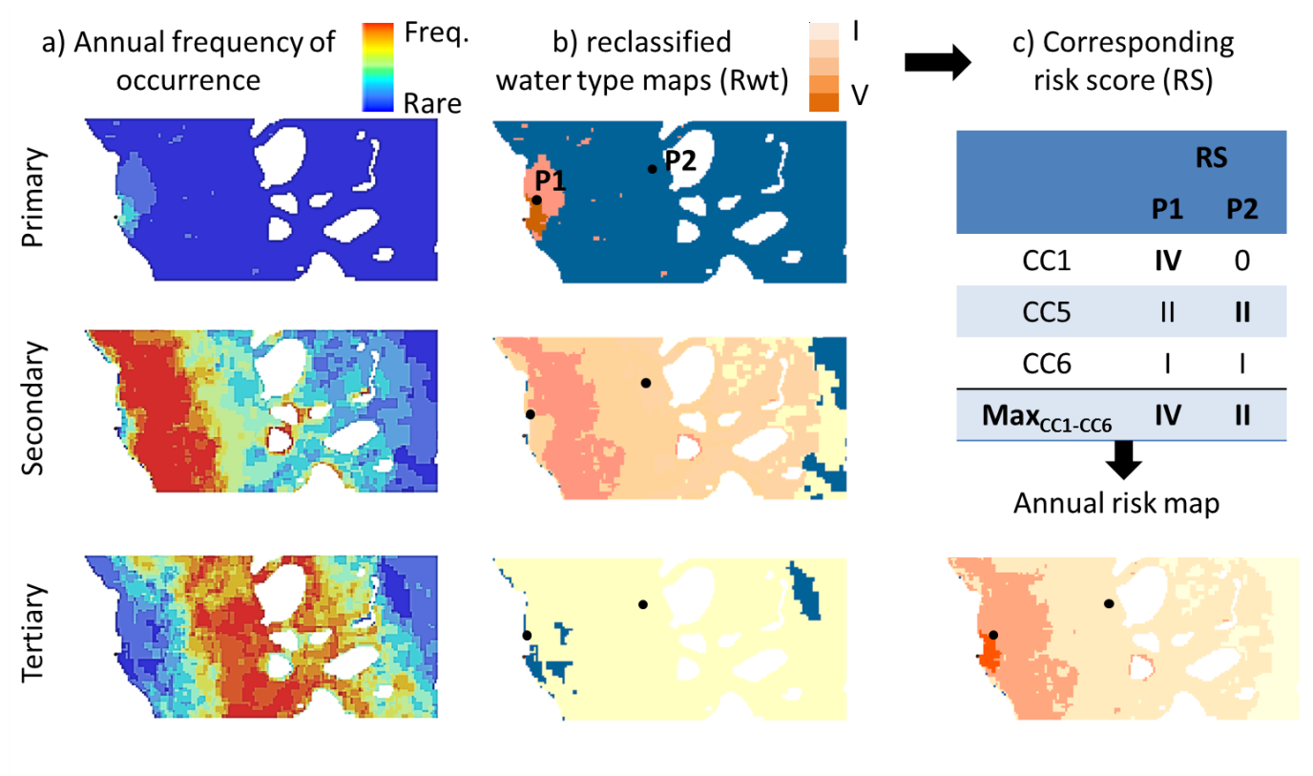
Figure A1 3: Theoretical example of the production of an annual risk map and the results for 2 pixels (P1 and P2) in the GBR at a river mouth, their classification, and final risk classification.

Table A1 4: Frequency categories used to categorise the multi-annual maps of frequency of occurrence of plume water types (TC and L2 methods).
Likelihood | Rare | Infrequent | Occasional | Frequent | Very frequent
Frequency: number of weeks per wet season [normalized value] | 1-4  [>0 – 0.2] | >4 – 8  [>0.2 – 0.4] | >8 – 13  [>0.4 – 0.6] | >13 – 17  [>0.6 – 0.8] | >17 – 22  [>0.8 – 1.0]

A risk does not exist unless (i) the stressor has the inherent ability to cause one or more adverse effects, and (ii) it co-occurs or comes into contact with an ecological component (i.e., organisms, populations, communities, or ecosystems; US EPA, 1998) susceptible to the stressor. Ecological consequences of the risk will primarily be a function of the presence/absence of GBR ecosystems subjected to different occurrence and magnitude of risk (i.e. potential risk score).
Community characteristics such as the sensitivity and resilience of particular seagrass or coral communities, including the resilience associated with their natural levels of exposure to pollutants, are additional parameters that must be considered when scoring the risk from river plume exposure. However, the consequence of the exposure of species is complicated by the influence of the combined stressors and additional external influences including weather and climate conditions and the ecological significance of pollutant concentrations are mostly unknown at a regional or species level (Brodie et al., 2013).
In this report, we simply describe the area (km²) and percentage (%) of coral reefs and seagrass meadows potentially exposed to river plume and to different categories of potential risk from river plume exposure. Areas of GBR waters within each marine NRM region exposed to different categories of river plume and river plume risk are also reported in recognition of other important habitats and populations that exist in these areas (Brodie et al., 2013). Figure A1-4 and Figure A1-5 present the marine boundaries used for the GBR Marine Park, each NRM region and the seagrass and coral reefs ecosystems. We assumed in this study that the shapefile can be used as a representation of the actual seagrass distribution. It is known however that absence on the composite map does not definitively equate to absence of seagrass and may also indicate unsurveyed areas. Spatial distribution of the deep water seagrass is a statistically modelled probability of seagrass presence (using generalized additive models (GAMs) with binomial error and smoothed terms in relative distance across and along the GBR) in GBRWHA waters >15m depth, based on ground-truthing of each data point. For details on approach, see Coles et al. (2009).

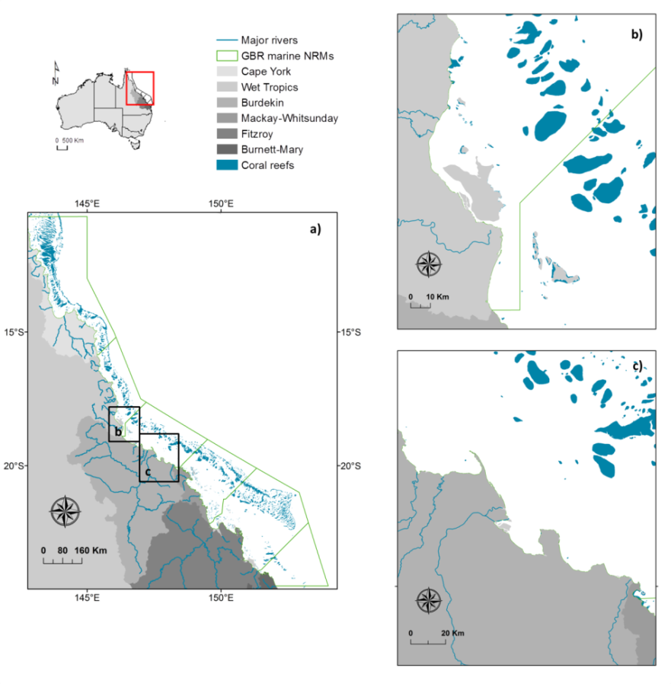
Figure A1 4: Marine boundaries used for the GBR Marine Park (a), each NRM region and the coral reefs ecosystems. Coral Reef and NRM layers derived from: GBRMPA, 2013, GBR feature shapefiles and enlargements around (b) the Tully-Herbert Rivers and (c) the Burdekin River.
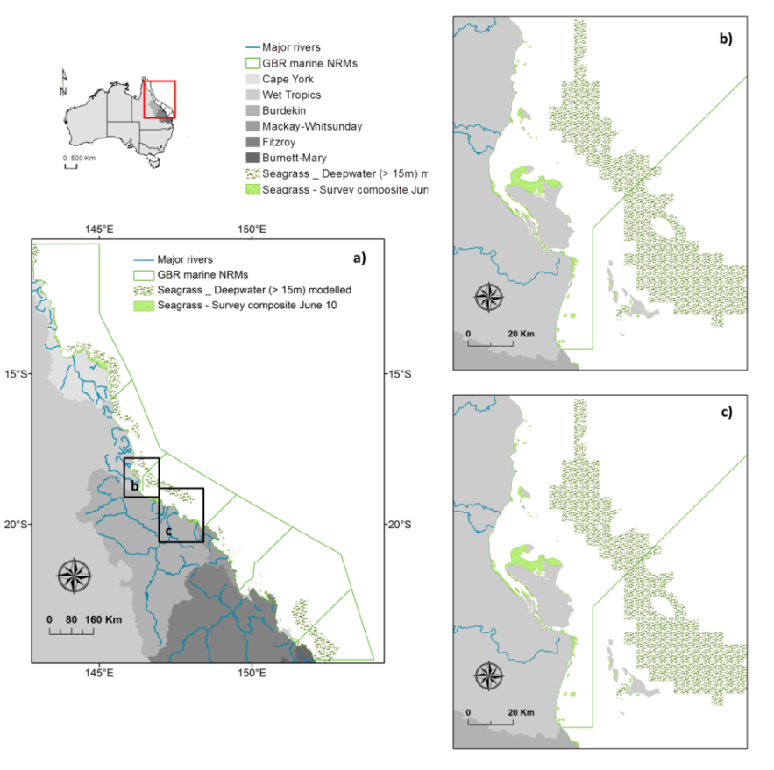
Figure A1 5: Marine boundaries used for the GBR Marine Park (a), each NRM region and the seagrass ecosystems. NRM layers derived from: GBRMPA, 2013, GBR feature shapefiles and seagrass layers from DAFF, Feb. 2013; and enlargements around (b) the Tully-Herbert Rivers and (c) the Burdekin Rivers. Spatial distribution of the surveyed seagrasses bed is an historical layer composed from all meadows examined between 1984 and 2008 (see reports at: http://www.seagrasswatch.org/meg.html).

Mapping the superficial dispersion of land-sourced nitrogen and sediment in the Great Barrier Reef: an Ocean Colour based approach

An accurate quantification of DIN exposure in the GBR lagoon is highly desirable to identify the main areas under the highest exposure so that land-based management efforts can be targeted to specific regions. While previous studies have attempted to characterise the varying levels of DIN exposure within the GBR (e.g., Álvarez-Romero et al., 2013; Devlin et al., 2012a, 2012b), they have been limited by a lack of reliable catchment loading data and relative lower control of its dispersal mechanisms by not using in-situ measured data. For example, those limitations in Devlin et al. (2012a, 2012b), such as not account for differential patterns of diffusion and deposition of nitrogen in the coastal waters and the use of artificial boundaries in exposure levels (i.e., boundaries of marine Natural Resources Management (NRM) regions), resulted in some areas being associated/assigned with higher or lower exposure levels that those expected or reported. Álvarez-Romero et al. (2013) improved the dispersion mechanism of the nitrogen using satellite information, but this work provides the likelihood of nitrogen exposures and not its mass distribution over the GRB. Although the likelihood of nitrogen exposure suits to identify high risk exposure areas, it does not allow evaluating potential land-based management actions on the reduction of nitrogen discharge.
An ocean colour based model has been under development to estimate the dispersion of dissolved inorganic nitrogen ($DIN={\text{NH}}_{\text{4}}^{\text{+}}\text{+}{\text{NO}}_{\text{2}}^{\text{-}}\text{+}{\text{NO}}_{\text{3}}^{\text{-}}$) delivered by river plumes to the Great Barrier Reef (hereafter GBR) waters (da Silva et al., in prep.). This model, built on Álvarez-Romero et al. (2013), combines in-situ data from the Marine Monitoring Program, Moderate Resolution Imaging Spectroradiometer (MODIS satellite) imagery and modelled annual end-of-catchment DIN loads from the GBR watersheds. In the model, loads provide the amount of DIN delivered along the GBR, in-situ data provides the DIN mass in river plumes, and satellite imagery provides the direction and intensity of DIN mass dispersed over the GBR lagoon. This model produces annual maps of average DIN concentration in the GBR waters. Maps are in a raster format, which is a spatial data model that defines space as an array of equally sized cells arranged in rows and columns (ESRI, 2010).
The main modifications applied to the method presented in Álvarez-Romero et al. (2013) are: the qualitative assessment of pollutant dispersion in river plumes is replaced by a relationship between in-situ DIN mass and the six colour classes in the river plume maps; the cost-distance function used in Álvarez-Romero et al. (2013) to reproduce the shape of each individual river plume is replaced by the path-distance function, which is also available in ArcMap Spatial Analyst (ESRI 2010); and a DIN decay function is applied to DIN mass exported from the rivers to account for potential biological uptake.
Our model has four main components: (a) modelling of individual river plumes; (b) DIN dispersion function; (c) DIN decay function; and (d) mapping of DIN concentration over the GBR lagoon. The conceptual model in Figure 4-5: A1 6 shows how each model component is set up and how they are combined to produce the DIN dispersion maps. The basic idea of the DIN dispersion maps is to produce river plume maps, like those produced for the GBR (see Remote Sensing section in this report), for each individual river in the model. Doing that, the end-of-catchment load of each river can be dispersed over its individual river plume. To control this dispersion a relationship based on the mass proportion of DIN in each plume colour class determined at GBR scale is used. To account for potential DIN uptake, the ratio between an in-situ DIN x salinity relationship and the theoretical DIN decay due to dilution (i.e., freshwater – marine water mixing) is used. This ratio defines a DIN decay coefficient, which is multiplied by the dispersed DIN load. After the load has been dispersed over each individual river plume, and corrected for DIN uptake, the resultant dispersed DIN from each river is summed together to represent the total annual DIN dispersion over the GBR lagoon discharged by the rivers. In the following these four major steps are presented, starting with the generation of individual river plumes.
Figure A1 6: Conceptual model for DIN concentration load mapping. See text for explanation.
(a) Modelling Individual River Plume (Ocean Colour Plume)
The modelling of individual river plumes uses weekly river plume maps (i.e., raster files, see Remote Sensing section of this report), the path-distance tool in ArcMap Spatial Analyst (ESRI, 2010) and a relationship between river discharge and plume extent obtained from a highly resolved hydrodynamic model for the GBR.
Path-distance tool determines the minimum accumulative travel cost from a source to each cell location in a raster (ESRI, 2010). For the path-distance tool, the point coordinates of the river mouths, a surface raster indicating the impedance for the plume movement, and a surface raster indicating the main direction of plume propagation are provided. For all rivers, a propagation direction of 315° Azimuth is selected to account for the prevailing wind (i.e., trade winds) and sea current direction in the wet season (Brinkman et al., 2014; Luick et al., 2007a). Future development of this model, which will incur in smaller time step (it can be as short as a week, small temporal resolution of our plume maps), will allow to incorporate different directions of plume propagation as a function of main wind direction in a week. The weekly river plume maps are used to provide the surface raster. This surface is calculated as the reciprocal (1/x) of the plume mode per wet season. In the plume calculation, the colour classes are inverted, so class 6 is placed close to the coast, class 5 is the second closest to the coast and so on. This inversion of the plume values is done so when calculating the reciprocal it produces higher travel cost close to the coast and slower travel cost at the outer edge of the plume, aiming to reproduce the increasing size of plume types from the inner class to the outer classes (see river plume maps in the Remote Sensing section of this report).
Defining the edge of each river plume (i.e., its area of influence) is critical to calculate the dispersion of DIN load. To do that, a discharge-plume distance relationship is derived from the dispersion of virtual tracers in a highly resolved hydrodynamic model (eReefs, Brinkman et al., 2014). In this approach, currently under development (Wolff et al., 2014, in prep.), the river plume influence is defined as the area where tracer concentration is equivalent to or below salinity 36, which corresponds to at least 5% hydrodynamic model simulation time (c.a., form December to April, inclusive). The maximum plume extent is set as a maximum distance between the river mouth and the outer edge of the plume influence area. Equation 1 (Figure A1 7) presents the discharge-distance relationship, which is used to determine the maximum extent of the modelled individual river plume (Dist, km) as a function of its total wet season discharge (Disch, in mega-litters, ML).
$Dist=-2.720∙{10}^{-13}∙{Disch}^{2}+2.028∙{10}^{-5}∙Disch+58.84$ (Eq. 1)
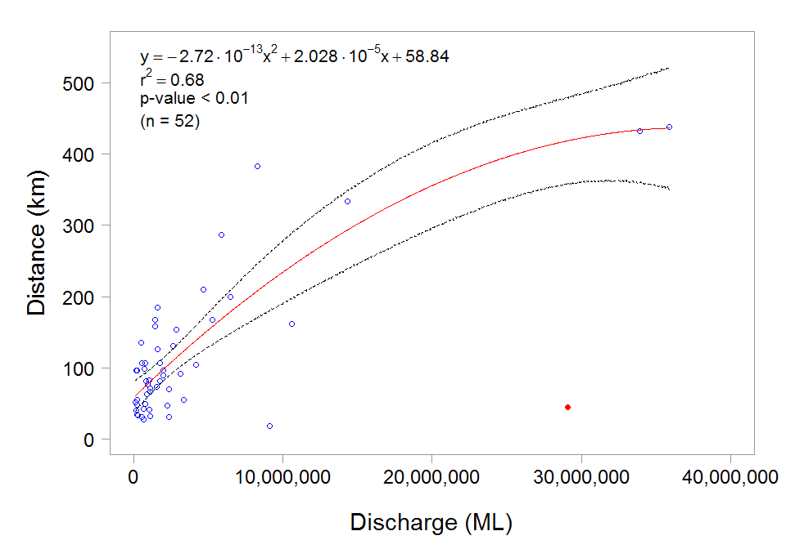
Figure A1 7: Relationship between river discharge (megaliters, ML) and distance (km) between river mouth and the outer edge of tracer plume as obtained from the eReefs hydrodynamic model for the GBR. Dashed lines stand for CI 95%. Red dot stands for point excluded from the regression model.

The edge of the plume influence area (i.e., Pd_{max}) is used to recalculate the modelled plume (MP), resulting in an ocean colour plume (OCP) as indicated below:
$OCP=1+\frac{MP}{{{Pd}_{max}}/5}$. (Eq. 2)
In Equation 2, '1' changes the lowest value of the ocean colour plume at the river mouth from 0 to 1 (i.e., the first colour class), and '5' adjusts the quotient MP/Pd_{max} to result in a OCP equal to 6 at the outer edge of the plume (i.e., when OCP = Pd_{max}). Thus, ocean colour plume (OCP) has values varying from 1 at the river mouth to 6 at the edge of the plume, similar to the river plume maps.
Although the path distance captures the general shape of the river plumes when compared to those plumes produced by the hydrodynamic model (data not shown), it fails to distinguish each individual colour class. To correct that, the proportion between the median of the plume areas in the six-colour class maps is used to rescale the size of each six-colour class in the ocean colour plume (Table A1 5).
Table A1 5: Recalculation of the plume class interval for rescaling the size of each of the six colour classes.
Plume interval | Plume area median (2003-15) | Cumulative area | % in total | % increment | Recalculated plume interval
1 - 2 | 2149 | 2149 | 0.75 | 0.75 | 1.0000 | - | 1.0448
2 - 3 | 4253 | 6402 | 2.22 | 1.48 | 1.0449 | - | 1.1335
3 - 4 | 2218 | 8620 | 3.00 | 0.77 | 1.1336 | - | 1.1797
4 - 5 | 15526 | 24146 | 8.39 | 5.39 | 1.1798 | - | 1.5034
5 - 6 | 106585 | 130731 | 45.42 | 37.03 | 1.5035 | - | 3.7255
6 - 7 | 157065 | 287796 | 100.00 | 54.58 | 3.7256 | - | 7.0000

(b) DIN dispersion function
The DIN dispersion function is a raster surface that represents how much of the land-sourced DIN ends up in each colour class over the ocean colour plumes. The DIN dispersion function is based on the proportion of DIN mass among each colour class, and uses three sources of data: (i) the river plume maps with six-colour class; (ii) in-situ DIN concentration, and (ii) Conductivity-Temperature-Depth (CTD) vertical profiles. The latest two datasets have been opportunistically collected in river plume waters over the GBR lagoon as part of the water quality program under the Reef Rescue MMP (Figure A1 8:).
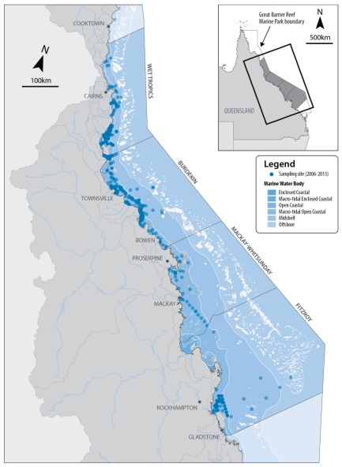
Figure A1 8: The Great Barrier Reef Marine Park (Queensland, Australia), major rivers included in the model, the delimitation of the Natural Resource Management (NRM) regions, and the sampling sites (colour density indicates recurrent sampling).
The CTD profiles are used to determine the depth of the mixing layer for each colour class and also the surface salinity. The depth of the mixing layer is determined based on the mixing between the marine water and the freshwater, which creates a gradient in concentration. It is assumed that freshwater is diluted with the marine water at the same rate as DIN, so mixing depth can be used to estimate total DIN mass throughout the water column under plume water influence. Using salinity variation from CTD vertical profiles to estimate the conservative mixing between freshwater and marine water, the appropriate mixing depth (D, in meters) becomes:
$D=\frac{1}{\left({SAL}_{max}-{SAL}_{min}\right)}\int_{0}^{Z_{max}}{\left({SAL}_{max}-{SAL}_{z}\right)d_{Z}}$, (Eq. 3)
where SAL_{max} and SAL_{min} stand for the maximum and minimum salinity, respectively, in the mixing gradient from surface to the bottom. The integral is the sum of the salinity difference from the salinity at depth Z to the maximum depth. This represents the sum of the total mass of freshwater throughout the water column. Dividing this sum by the maximum salinity difference, it is as though the total mass of the freshwater in the entire water column was compressed into a layer D thick of freshwater.
The river plume maps are used to calculate the area of each colour class and also for the match-ups between in-situ data (DIN concentration and CTD profiles) and the colour classes. The match-ups are done on a weekly basis, which is the smallest temporal resolution of the river plume maps (Álvarez-Romero et al., 2013). Match-ups are performed using extract in the raster package (Hijmans et al., 2015) with bilinear interpolation method in R 3.2.4, which interpolates from the values of the four nearest raster cells (R Development Core Team, 2015). Only data sampled during flood regimes (c.a., flow exceeding the 75th percentile of daily long-term wet season flow, from 1970 to 2000) are used in the match-ups, as these data better represent the biogeochemical and transport processes for DIN. Figure A1 9: presents the variation of DIN concentration, superficial salinity, mixing depth layer and plume area grouped by the six-colour classes. Due to the skewed nature of these four variables, the median value is used as a measurement of the central tendency rather than the mean.
Because we do not have sufficient in situ DIN data to calibrate each river individually, we made the assumption that DIN behaviour (exponential decay) is consistent across plumes. Although DIN data sampled in the flood river plumes were not evenly distributed over the GBR lagoon, they were representative of its major portion and of those areas that experience large rainfall and higher nitrogen loads (Figure A1 8:). Further work (and monitoring data) is needed to develop regionally specific pollutant dispersion models.
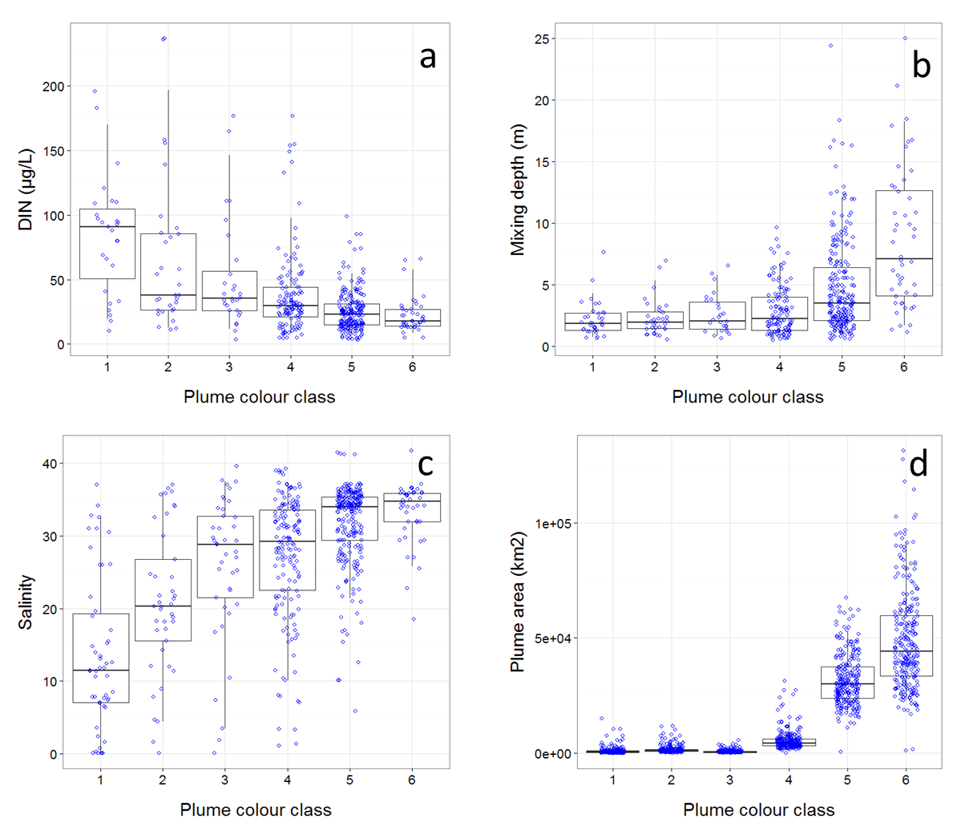
Figure A1 9: In-situ dissolved inorganic nitrogen concentration (a), depth of the mixing layer (b), superficial salinity (c) and plume area (d) per colour class, measured over 13 wet seasons (c.a., December to April inclusive) from 2002/03 to 2014/15 wet season. Boxplot presents the median (dark black line), 25th and 75th percentile values (rectangle) and 5th and 95th percentile values (vertical lines). Nudge was applied to data on x-axis for better data visualization.

The depth of the mixing layer, the in-situ DIN concentration and the area of each plume colour class are then used to estimate the DIN mass in each colour class by simple multiplication. The measured in-situ DIN concentration in plume waters is resultant of a mixing gradient between freshwater and marine water. To account for this mixing, a simple dilution model based on salinity is used. For example, under salinity half way between marine and freshwater, 50% of the total measured in-situ DIN concentration is assumed to be attributed to the river discharge. Figure A1 10: shows the DIN mass variation over the six-colour class. To account for the error associated with each variable included in the DIN mass calculation, the 95%CI is calculated as two times the median absolute deviation (Harding et al., 2014) for each set of data and then transferred to the DIN mass per colour class by using basic rules for error propagation.
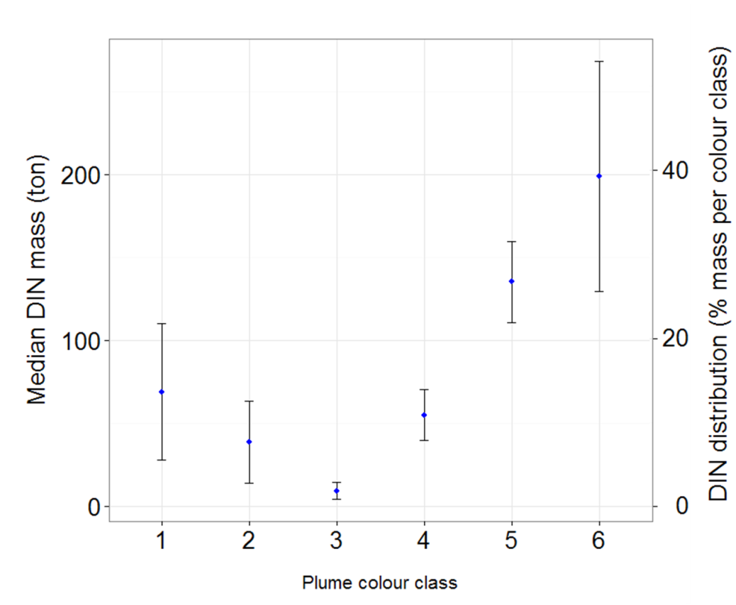
Figure A1 10: Median DIN mass and percent contribution across the six-colour class. Error bars represent 95%CI (see text for explanation).

Therefore, the values of 1 to 6 in the ocean colour plumes (raster file) are converted into DIN mass, as per Figure A1 10: . Values of DIN mass are then normalized by dividing each cell-raster value by the sum of all the values in the raster. This resulted in an annual normalized DIN dispersion map (or DIN dispersion function, no unity) for each river, in which the sum of the cell-raster values is equal to one. Multiplying the load of each river by its respective DIN dispersion function, a map of mass dispersion is produced.

(c) DIN decay function
To account for potential biological uptake of the DIN load discharged by rivers to the GBR lagoon, the variation of in-situ DIN concentration against salinity was compared to the theoretical variation of DIN due to the mixing process between freshwater and marine water. The best relationship between DIN concentration and salinity is presented in Figure A1 11:, which shows an exponential DIN decay.
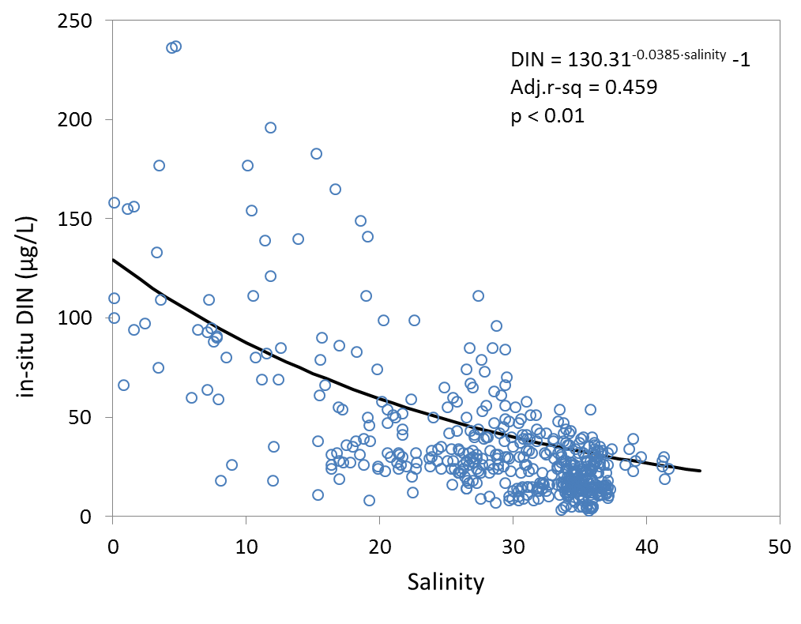
Figure A1 11: Relationship between in-situ DIN concentration (µg/L) and salinity opportunistically measured at the surface in river plume waters over the GBR lagoon (2002-2003 to 2014-2015 wet season) under river discharge > 75th percentile (see text for explanation).

The theoretical dilution model (Middelburg and Nieuwenhuize, 2001, Eq. 4) is used to determine the potential DIN concentration at any salinity given the end-member DIN concentrations.
$DIN=f×{DIN}_{m}+\left(1-f\right)×{DIN}_{r}$ , (Eq. 4)
where DIN_{m} and DIN_{r} are the in-situ DIN concentrations in the marine water (at salinity 36, to be consistent with plume area definition) and at the river mouth (salinity 0), respectively. And f is the marine water fraction, which is calculated as:
$f=\frac{S-S_{r}}{S_{m}-S_{r}}$ , (Eq. 5)
where S is the sample salinity, S_{m} stands for the marine salinity (i.e., 36) and S_{r} the river mouth salinity (i.e., 0).
For this theoretical model, a steady-state was assumed, which might not be the case for river plumes, but represents a first approach to include DIN uptake in this model. In Figure A1 12: both models are plotted together, and the ratio between them is associated to a potential DIN uptake (red line). The DIN uptake function reduces the DIN load dispersed over the GBR as a multiplicative coefficient, c.a., 1 - Potential DIN uptake.
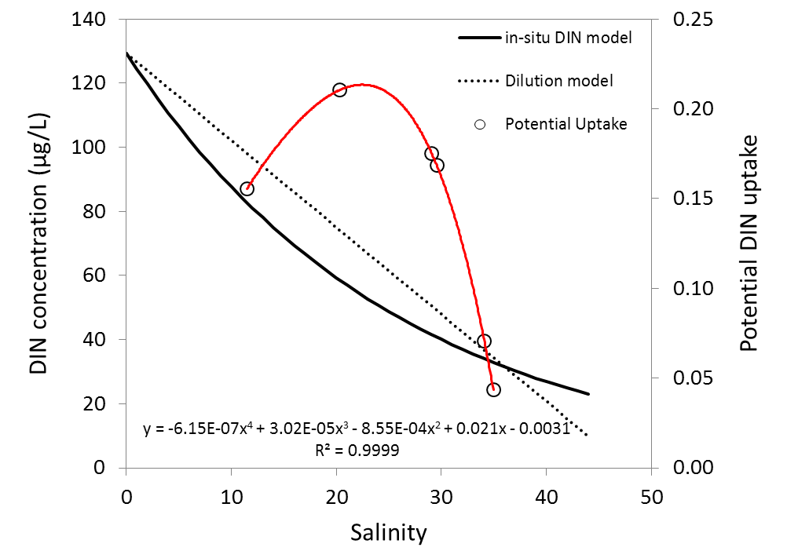
Figure A1 12: Potential DIN uptake (red line) derived from the ratio between in-situ DIN concentration x salinity (black solid line, as in Figure A1 11:) and the theoretical dilution model (black dashed line, derived from Eq. 4).

(d) Mapping of DIN concentration over the GBR lagoon
Using the maps of mass dispersion and accounting for the cell-raster size and the depth of the mixing layer for each colour class, a map for the spatial DIN concentration is constructed. DIN concentration maps are calculated for each river per year, and annual composite maps are produced by the sum of all river DIN concentration maps within each year.
In this report, we use modelled annual DIN loads for rivers along the GBR. The modelled loads are generated in Lewis et al. (2014) for catchments of the Wet Tropics, Burdekin and Mackay Whitsunday Natural Resource Management (NRM) regions. Briefly, modelled DIN loads are calculated using existing load monitoring data to develop a relationship between the measured loads with flow volumes (at river monitoring sites) and amount of fertilizer applied to calculate the percentage of applied nitrogen fertiliser lost as DIN. This relationship is then applied to upscale loads for the entire catchment area. DIN loads for the Fitzroy River have been calculated based on available monitoring data from (Packett et al., 2009) and AIMS (unpublished data) for the period 2002/03 to 2005/06 and for the 2006/07 to 2012/15 period we used the loads reported by the GBR Catchment Loads Monitoring Program (Joo et al., 2012; Turner et al., 2013; Wallace et al., 2015). The rivers/catchments (Figure A1 8:) where modelled DIN load and basin discharge data were available for the 13 years are presented in Table A1 6: and Table A1 7: , respectively.
The temporal incompatibility between the annual end-of-catchment DIN loads and the seasonal in-situ DIN, depth of the mixing layers and the river plume maps could not be explicitly resolved in the model. Whereas DIN river load represents the total annual DIN delivered by rivers into the GBR (c.a., from October to September, inclusive), the plume maps from satellite imagery, mixing depth and in-situ DIN concentration in flood plume waters are constrained to the wet season period (c.a., December to April, inclusive). Considering that 78% of the annual river discharge occurs over the wet season period (DNRM, http://watermonitoring.dnrm.qld.gov.au/host.htm), the plume maps, mixing depth and in-situ DIN in plume waters, potentially represent the majority of the environmental condition when most of the end-of-catchment DIN load is delivered to the GBR waters.

Table A1 6: End-of-catchment dissolved inorganic nitrogen loads (DIN, ton/year) from 2003 to 2015 water years (c.a., from October, 2002 to September, 2015).
River | NRM* region | 2003 | 2004 | 2005 | 2006 | 2007 | 2008 | 2009 | 2010 | 2011 | 2012 | 2013 | 2014 | 2015
Daintree | Wet Tropics | 20 | 221 | 75 | 193 | 120 | 150 | 120 | 232 | 361 | 220 | 153 | 470 | 170
Mossman | Wet Tropics | 82 | 182 | 119 | 204 | 118 | 108 | 77 | 99 | 111 | 85 | 66 | 106 | 32
Barron | Wet Tropics | 6 | 48 | 19 | 38 | 21 | 79 | 38 | 24 | 92 | 37 | 14 | 29 | 17
Russell-Mulgrave | Wet Tropics | 280 | 970 | 434 | 760 | 597 | 707 | 549 | 534 | 1,199 | 822 | 437 | 711 | 443
Johnstone | Wet Tropics | 488 | 689 | 846 | 1,536 | 1,326 | 1,292 | 1,935 | 1,484 | 3,798 | 2,219 | 1,386 | 2,043 | 975
Tully-Murray | Wet Tropics | 289 | 686 | 461 | 770 | 824 | 631 | 721 | 573 | 1,240 | 758 | 596 | 754 | 369
Herbert | Wet Tropics | 351 | 1,407 | 563 | 1,632 | 1,633 | 1,260 | 3,821 | 1,132 | 4,525 | 1,648 | 1,149 | 1,544 | 385
Haughton | Burdekin | 87 | 190 | 264 | 312 | 610 | 776 | 1,210 | 524 | 1,030 | 749 | 209 | 235 | 42
Burdekin | Burdekin | 477 | 353 | 1,007 | 531 | 2,326 | 6,426 | 6,944 | 1,820 | 8,391 | 3,738 | 818 | 347 | 199
Proserpine | Mackay Whitsunday | 20 | 27 | 64 | 72 | 161 | 363 | 211 | 176 | 337 | 121 | 118 | 116 | 18
O'Connell | Mackay Whitsunday | 41 | 43 | 132 | 156 | 323 | 447 | 393 | 578 | 1,177 | 558 | 212 | 179 | 38
Pioneer | Mackay Whitsunday | 50 | 11 | 99 | 38 | 503 | 721 | 546 | 684 | 1,736 | 749 | 556 | 304 | 63
Plane | Mackay Whitsunday | 162 | 34 | 232 | 20 | 528 | 1,113 | 681 | 1,110 | 2,061 | 1,223 | 835 | 316 | 102
Fitzroy | Fitzroy | 674 | 382 | 363 | 135 | 176 | 1,580 | 367 | 2,061 | 3,900 | 947 | 920 | 150 | 150
Total annual DIN load |  | 3,029 | 5,242 | 4,678 | 6,396 | 9,265 | 15,653 | 17,613 | 11,033 | 29,958 | 13,873 | 7,470 | 7,304 | 2,852
* Natural Resource Management

Table A1 7: Total wet season river discharge (GL) from 2003 to 2015 water years (c.a., from October, 2002 to September, 2015).
River | NRM* region | 2003 | 2004 | 2005 | 2006 | 2007 | 2008 | 2009 | 2010 | 2011 | 2012 | 2013 | 2014 | 2015
Daintree | Wet Tropics | 80 | 1,243 | 362 | 980 | 556 | 760 | 530 | 984 | 1,430 | 744 | 502 | 1,457 | 584
Mossman | Wet Tropics | 103 | 274 | 156 | 276 | 175 | 230 | 183 | 251 | 358 | 257 | 172 | 308 | 123
Barron | Wet Tropics | 88 | 818 | 265 | 523 | 309 | 1,447 | 640 | 430 | 1,753 | 551 | 226 | 435 | 270
Russell-Mulgrave | Wet Tropics | 487 | 1,932 | 887 | 1,461 | 1,443 | 1,695 | 1,559 | 1,420 | 2,608 | 1,568 | 691 | 1,515 | 773
Johnstone | Wet Tropics | 494 | 1,937 | 1,171 | 2,037 | 2,080 | 2,119 | 2,381 | 1,729 | 4,187 | 1,955 | 1,019 | 1,946 | 943
Tully-Murray | Wet Tropics | 657 | 2,535 | 1,254 | 2,447 | 2,871 | 2,593 | 3,094 | 1,953 | 5,190 | 1,678 | 1,683 | 2,557 | 1,161
Herbert | Wet Tropics | 491 | 2,769 | 845 | 2,858 | 3,503 | 3,033 | 9,092 | 2,558 | 10,564 | 3,331 | 2,255 | 3,213 | 672
Haughton | Burdekin | 61 | 158 | 237 | 274 | 568 | 793 | 1,091 | 476 | 1,019 | 660 | 192 | 230 | 33
Burdekin | Burdekin | 1,885 | 1,337 | 4,108 | 1,799 | 8,656 | 27,131 | 29,091 | 7,662 | 33,886 | 14,334 | 3,111 | 1,163 | 619
Proserpine | Mackay Whitsunday | 15 | 7 | 22 | 18 | 38 | 70 | 60 | 44 | 336 | 47 | 31 | 2 | 7
O'Connell | Mackay Whitsunday | 23 | 24 | 76 | 85 | 167 | 252 | 185 | 312 | 569 | 262 | 102 | 86 | 19
Pioneer | Mackay Whitsunday | 96 | 37 | 187 | 21 | 786 | 1,324 | 858 | 1,243 | 3,110 | 1,109 | 933 | 504 | 91
Plane | Mackay Whitsunday | 46 | 10 | 69 | 6 | 152 | 360 | 186 | 361 | 608 | 342 | 245 | 89 | 29
Fitzroy | Fitzroy | 2,542 | 1,288 | 903 | 547 | 871 | 12,210 | 1,982 | 10,907 | 35,886 | 6,480 | 8,308 | 1,501 | 2,667
Total wet season River discharge |  | 7,068 | 14,367 | 10,542 | 13,331 | 22,174 | 54,017 | 50,934 | 30,329 | 101,504 | 33,317 | 19,469 | 15,004 | 7,984
* Natural Resource Management

The same model developed for DIN dispersion was used, except that the decay function was not included. Match-ups of PN and TSS against six colour classes were performed as done for DIN and their concentrations are presented in Figure A1 13: .
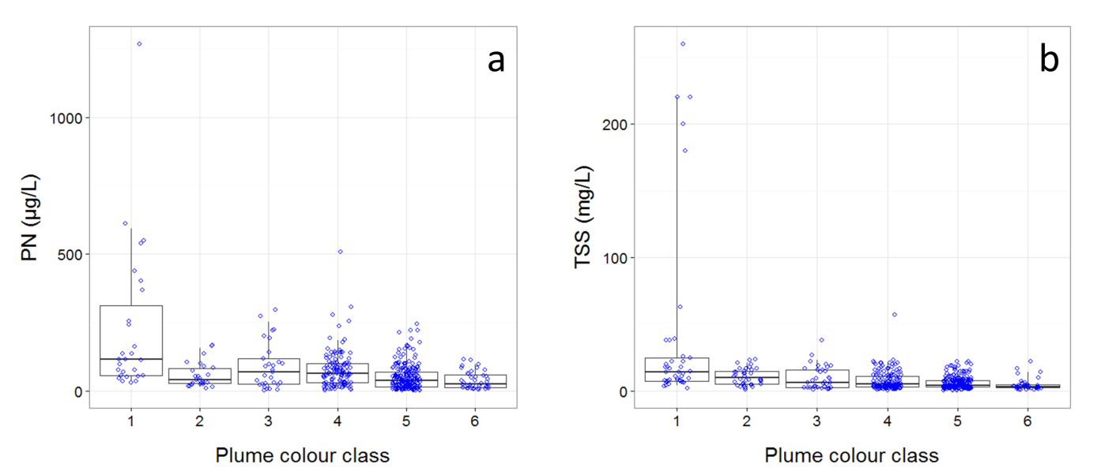
Figure A1 13: In-situ particulate nitrogen concentration (a) and total suspended solids (b) per colour class, measured over 13 wet seasons (c.a., December to April inclusive) from 2002/03 to 2014/15 wet season. Boxplot presents the median (dark black line), 25th and 75th percentile values (rectangle) and 5th and 95th percentile values (vertical lines). Nudge was applied to data on x-axis for better data visualisation.

Using concentrations for PN and TSS per colour class plus mixing depth layer, plume area and salinity as presented in Figure A1 9: , the mass of PN and TSS per colour class was determined (Figure A1 14: ). Then, similarly to DIN concentration maps, PN and TSS maps were produced for each river per year, and annual composite maps produced by the sum of all rivers PN and TSS concentration maps within each year. The modelled annual PN and TSS loads for rivers along the GBR (same methodology as for DIN loads) are presented in Table A1 8: and Table A1 9: , respectively.

Table A1 8: End-of-catchment particulate nitrogen loads (PN, ton/year) from 2003 to 2015 water years (c.a., from October, 2002 to September, 2015).
River | NRM* region | 2003 | 2004 | 2005 | 2006 | 2007 | 2008 | 2009 | 2010 | 2011 | 2012 | 2013 | 2014 | 2015
Daintree | Wet Tropics | 24 | 259 | 88 | 225 | 141 | 177 | 142 | 275 | 430 | 262 | 182 | 560 | 202
Mossman | Wet Tropics | 98 | 215 | 140 | 241 | 140 | 127 | 90 | 115 | 127 | 97 | 76 | 122 | 37
Barron | Wet Tropics | 15 | 131 | 54 | 106 | 56 | 210 | 96 | 59 | 218 | 87 | 34 | 68 | 39
Russell-Mulgrave | Wet Tropics | 334 | 1,156 | 518 | 905 | 711 | 843 | 654 | 637 | 1,430 | 980 | 521 | 848 | 528
Johnstone | Wet Tropics | 397 | 558 | 691 | 1,250 | 1,098 | 1,043 | 1,505 | 1,129 | 2,811 | 1,642 | 1,026 | 1,512 | 722
Tully-Murray | Wet Tropics | 350 | 828 | 555 | 926 | 990 | 759 | 867 | 690 | 1,489 | 910 | 716 | 906 | 443
Herbert | Wet Tropics | 195 | 843 | 340 | 1,003 | 1,000 | 803 | 2,352 | 742 | 2,916 | 1,062 | 740 | 995 | 248
Haughton | Burdekin | 239 | 522 | 722 | 855 | 1,669 | 2,121 | 3,309 | 1,432 | 2,810 | 2,042 | 570 | 640 | 115
Burdekin | Burdekin | 651 | 481 | 1,369 | 720 | 3,159 | 8,736 | 9,452 | 2,480 | 11,390 | 5,074 | 1,110 | 470 | 270
Proserpine | Mackay Whitsunday | 37 | 48 | 113 | 127 | 288 | 656 | 377 | 325 | 615 | 222 | 216 | 213 | 32
O'Connell | Mackay Whitsunday | 66 | 68 | 210 | 248 | 515 | 717 | 620 | 937 | 1,882 | 892 | 338 | 286 | 61
Pioneer | Mackay Whitsunday | 72 | 16 | 143 | 55 | 723 | 1,038 | 783 | 990 | 2,500 | 1,080 | 801 | 438 | 91
Plane | Mackay Whitsunday | 237 | 50 | 339 | 30 | 775 | 1,643 | 997 | 1,651 | 3,046 | 1,808 | 1,234 | 467 | 151
Fitzroy | Fitzroy | 3,900 | 700 | 280 | 300 | 645 | 8,460 | 1,380 | 4,291 | 17,000 | 3,040 | 4,300 | 230 | 500
Total annual PN load |  | 6,613 | 5,875 | 5,562 | 6,991 | 11,910 | 27,334 | 22,623 | 15,755 | 48,663 | 19,197 | 11,866 | 7,755 | 3,438
* Natural Resource Management

Table A1 9: End-of-catchment sediment loads (TSS, ton/year) from 2003 to 2015 water years (c.a., from October, 2002 to September, 2015).
River | NRM* region | 2003 | 2004 | 2005 | 2006 | 2007 | 2008 | 2009 | 2010 | 2011 | 2012 | 2013 | 2014 | 2015
Daintree | Wet Tropics | 6 | 352 | 41 | 349 | 150 | 293 | 187 | 275 | 466 | 75 | 158 | 284 | 117
Mossman | Wet Tropics | 5 | 52 | 18 | 46 | 29 | 38 | 30 | 61 | 89 | 54 | 38 | 115 | 42
Barron | Wet Tropics | 21 | 44 | 29 | 50 | 29 | 28 | 19 | 25 | 26 | 20 | 16 | 25 | 8
Russell-Mulgrave | Wet Tropics | 17 | 143 | 59 | 115 | 64 | 245 | 117 | 75 | 287 | 116 | 45 | 90 | 52
Johnstone | Wet Tropics | 70 | 234 | 106 | 185 | 144 | 187 | 140 | 145 | 288 | 198 | 105 | 171 | 106
Tully-Murray | Wet Tropics | 131 | 179 | 223 | 405 | 353 | 307 | 388 | 264 | 570 | 333 | 208 | 307 | 146
Herbert | Wet Tropics | 65 | 151 | 103 | 173 | 185 | 150 | 167 | 138 | 274 | 167 | 132 | 167 | 82
Haughton | Burdekin | 141 | 679 | 276 | 830 | 820 | 685 | 1,924 | 646 | 2,500 | 910 | 635 | 853 | 213
Burdekin | Burdekin | 26 | 56 | 81 | 93 | 187 | 252 | 340 | 149 | 307 | 223 | 62 | 70 | 13
Proserpine | Mackay Whitsunday | 755 | 384 | 4,338 | 884 | 7,195 | 14,806 | 10,855 | 1,938 | 6,200 | 3,300 | 2,500 | 220 | 500
O'Connell | Mackay Whitsunday | 12 | 15 | 35 | 38 | 90 | 213 | 116 | 111 | 204 | 73 | 72 | 70 | 11
Pioneer | Mackay Whitsunday | 18 | 18 | 57 | 66 | 145 | 215 | 170 | 308 | 581 | 275 | 104 | 88 | 19
Plane | Mackay Whitsunday | 17 | 4 | 33 | 12 | 172 | 265 | 175 | 277 | 638 | 276 | 204 | 112 | 23
Fitzroy | Fitzroy | 57 | 12 | 81 | 7 | 193 | 440 | 237 | 489 | 833 | 495 | 338 | 128 | 41
Total annual TSS load |  | 7,068 | 1,800 | 600 | 250 | 140 | 425 | 4,530 | 404 | 3,564 | 7,000 | 1,320 | 2,500 | 52
* Natural Resource Management

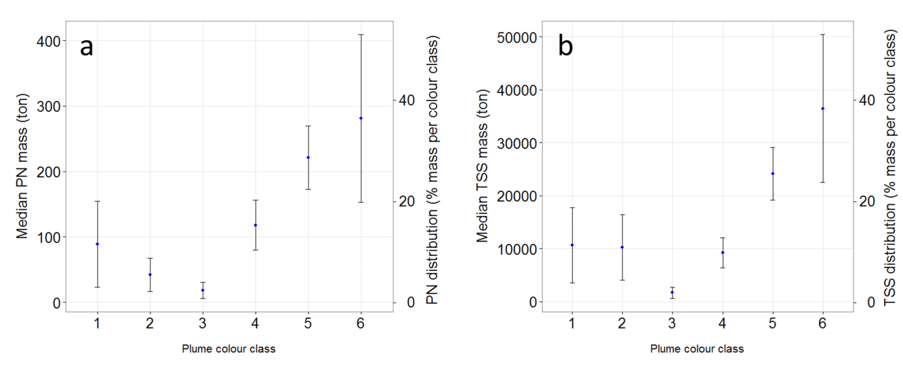
Figure A1 14: Median mass of particulate nitrogen (a) and total suspended solids (b), and their per-cent contribution across the six-colour class. Error bars stand for 95%CI (see text for explanation).

General in-situ DIN behaviour in plume waters and a critical overview of the DIN dispersion map modelling.
DIN behaviour across the six colour classes presented in Figure A1 9: a show reducing concentrations moving further from the river mouth, mainly due to dispersion and biological uptake. Dissolved inorganic nitrogen in the GBR waters up to salinity 20-25 ppt commonly displays conservative mixing behaviour (i.e., dilution) (Devlin and Brodie, 2005). However, salinity in plume colour-class 2 is 21.0 ± 9.9 ppt (mean ± 1 SD), so the conservative behaviour is taken over by an exponential decay when DIN is considered over the whole plume extent. After classes 2-3, the plume waters experience reduction of suspended sediment and consequently light conditions improve, favouring primary production and DIN consumption (Bainbridge et al., 2012; Devlin et al., 2012a, 2012b; Devlin and Brodie, 2005). Therefore, the behaviour presented by in-situ DIN concentration through the river plume account for those processes.
Other processes that may affect DIN concentrations in plume waters can be nitrogen fixation by (cyano-) bacteria (Trichodesmium) and upwelling of nutrient-enriched deep water from the Coral Sea (Furnas et al., 2011). However, land runoff is the largest source of new nutrients to the inshore GBR, especially during monsoonal flood events (Furnas et al., 2011). Moreover, upwelling intrusions are spatially restricted to the Central GBR subsurface waters (Berkelmans et al., 2010), and therefore not captured by the superficial in-situ DIN data. Nitrogen fixation is likely to occur across the whole plume area, adding equally to the measured in-situ DIN, and not affecting the general behaviour depicted in the DIN function. Otherwise if intense fixation due to Trichodesmium blooms and denitrification, followed by decomposition would result in locally elevated DIN concentrations (Devlin and Brodie, 2005; Furnas et al., 2011), the use of median as to describe the central tendency of DIN data across plume colour classes would likely remove this effect.
We note that although the highest concentrations are usually associated with water in the colour class 1 (i.e., close to the river mouth, see Figure A1 9: a), the largest mass of DIN is in colour class 6 (more than 35%, Figure A1 10: ). This is due to the large volume of colour class 6 compared to the other colour classes (Figure A1 9: d). While the DIN contribution from the rivers reaching plume colour class 6 are minor compared to that reaching colour class 1, its larger area and deeper mixing layer results in a larger DIN mass.
The base for the DIN dispersion model is the calculation of the DIN mass in plume waters over 13 years. Here we present a comparison between the DIN mass against the annual DIN load and also against its fraction in plume water that is likely to be land-sourced (based on a simple dilution model). This comparison is presented in Table A1 10: . If the dilution model is not applied, the DIN mass in plume waters (c.a., simple multiplication of DIN concentration by plume area and the mixing layer depth) is on average 1.3 times greater than the annual DIN load. When a dilution factor is accounted for, assuming that part of the measured in-situ DIN is land-sourced and the other part is a background concentration, the DIN mass in plume waters represent less than 10% of that relative to the annual watershed input. This number suggests that dispersing the annual DIN load over a median plume size may overestimate the final DIN concentration in the GBR lagoon. This problem can be partially solved if a smaller time frame is used, one that approaches the plume waters residence time. Although an estimation of the plume residence time can be obtained from a hydrodynamic model, we do not have DIN loads in a timeframe shorter than annual.
Table A1 10: Annual dissolved inorganic nitrogen mass (tonne) in the river loads, and in the plume waters, when the total DIN mass is calculated by a simple multiplication of DIN concentration, plume area and the mixing layer depth (Total DIN mass), and when a dilution factor based on salinity is also taken into account (Relative DIN mass).
Water year | Load* | Total DIN mass (tonne) | Relative DIN mass (tonne) | Total/Load | Relative/Load
2003 | 3,029 | 8,168 | 505 | 2.70 | 0.17
2004 | 5,242 | 9,773 | 584 | 1.86 | 0.11
2005 | 4,678 | 8,776 | 501 | 1.88 | 0.11
2006 | 6,396 | 9,896 | 532 | 1.55 | 0.08
2007 | 9,265 | 6,864 | 393 | 0.74 | 0.04
2008 | 15,653 | 7,607 | 468 | 0.49 | 0.03
2009 | 17,613 | 8,510 | 489 | 0.48 | 0.03
2010 | 11,033 | 8,073 | 472 | 0.73 | 0.04
2011 | 29,958 | 9,990 | 728 | 0.33 | 0.02
2012 | 13,873 | 6,503 | 435 | 0.47 | 0.03
2013 | 7,470 | 10,781 | 615 | 1.44 | 0.08
2014 | 7,304 | 9,674 | 596 | 1.32 | 0.08
2015 | 2,852 | 9,572 | 540 | 3.36 | 0.19

A simple plot between DIN load against relative DIN mass (Figure A1 15: ), shows there is a weak correlation between these two variables. On the calculation of DIN mass, the only parameter that varied over the 13 years is the area of the plumes; in-situ DIN concentration, salinity and the mixing layer depth are constant for all years due to the lack of data. This suggests that plume area variation is not enough to explain DIN concentrations over the GBR lagoon. Future versions of this model should therefore include smaller time scale resolution for superficial salinity, depth of mixing layer and in-situ DIN concentration.
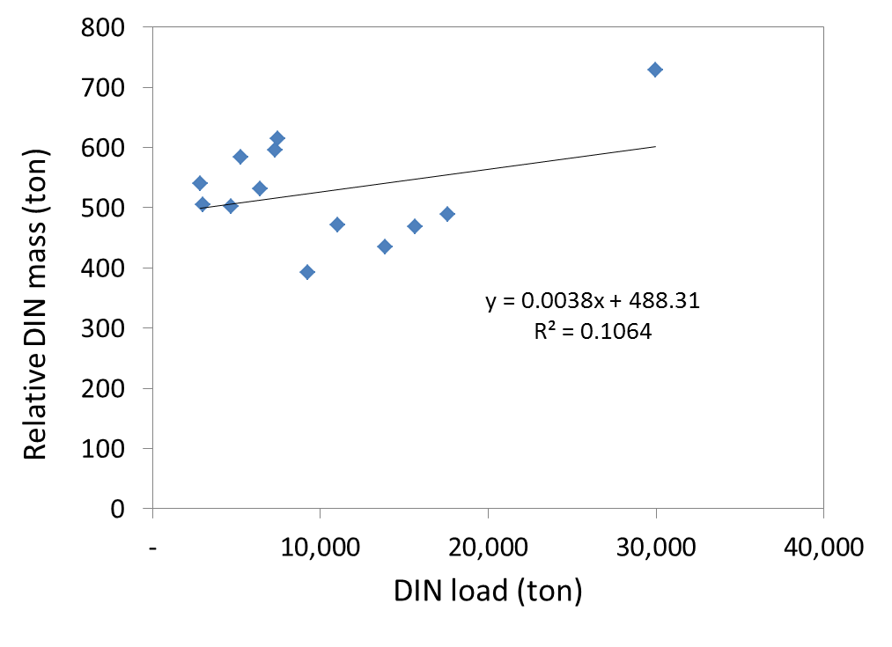
Figure A1 15: Relationship between DIN load (ton) against the relative DIN mass (ton) in plume waters (see text for explanation).

Moreover, simulation exercises using virtual tracers in a hydrodynamic model suggest that on an annual basis, the water constituents discharged by rivers can travel further than the edge of colour class six, reaching distances up to 800 km far from the river mouth (Luick et al., 2007b). This potential long-distance transport of water constituents has not been considered in the current DIN dispersion model, which would require a complex biogeochemical model able to capture the process controlling variations in the DIN concentration. Nevertheless, this model represents the first attempt to map land-sourced contaminates dispersion over the GBR lagoon.

General in-situ PN and TSS behaviour in plume waters and a critical overview of their dispersion map modelling.
The different behaviour exhibited by DIN compared to PN and TSS against six-colour class reflects the nature of these constituents: the dissolved form reduces from its source mainly due to dispersion and biological uptake, whereas the particulate form is more affected by dispersion and the settling processes. For the particulate phases, TSS and PN are deposited mainly within colour class 1 and then remain at similar values or even increase by colour class 6 (Figure A1 14: ). The faster reduction in PN and TSS in colour class 1 is due to flocculation and sedimentation. Concentration reduction from 450 mg/L to 140 mg/L within 4 km from the river mouth has been observed for TSS, for instance (Bainbridge et al., 2012). However, finer sediments and associated PN can be transported further offshore in plume waters (Bainbridge et al., 2012). There is also the additional source of PN from the remobilisation of inorganic nitrogen via phytoplankton uptake. Bainbridge et al. (2012) postulated that at late stages of plume development the PN is mostly suspended organic particulate matter from organisms generated within the plume rather than PN input from the river.
Although dispersion load maps were produced for particulate nitrogen (PN) and total suspended solids (TSS), it is important to note there is a higher uncertainty in these two maps compared to the DIN map. Two main sources of uncertainties are: (i) the modelled end of basin loads for TSS and PN are not as reliable as DIN loads because of the way hydrology is represented in the model, and (b) there is difference in scale between processes controlling TSS and PN variations and what is mapped in plume waters. For example, most of the particles fall out in the proximal zone of the river mouth, when salinity is normally < 5 PSU within colour class 1. Colour class 1 is the smallest resolution for characterizing plume waters at their initial stage of development and encompasses salinity up to 20 PSU. Therefore by taking a median value to estimate TSS and PN concentrations in this water, we underestimate the sedimentation that particles suffer after discharged into the GBR lagoon. Further, the potential addition of PN and TSS to the plume water due to resuspension and potential biological production may result in overestimating the actual river contribution to areas further away from the river mouth.

References
Álvarez-Romero, J.G., Devlin, M., Teixeira da Silva, E., Petus, C., Ban, N.C., Pressey, R.L., Kool, J., Roberts, J.J., Cerdeira-Estrada, S., Wenger, A.S., Brodie, J., 2013. A novel approach to model exposure of coastal-marine ecosystems to riverine flood plumes based on remote sensing techniques. J. Environ. Manage. 119, 194–207. doi:10.1016/j.jenvman.2013.01.036
Bainbridge, Z.T., Wolanski, E., Álvarez-Romero, J.G., Lewis, S.E., Brodie, J.E., 2012. Fine sediment and nutrient dynamics related to particle size and floc formation in a Burdekin River flood plume, Australia. Mar. Pollut. Bull., The Catchment to Reef Continuum: Case studies from the Great Barrier Reef 65, 236–248. doi:10.1016/j.marpolbul.2012.01.043
Berkelmans, R., Weeks, S.J., Steinberg, C.R., 2010. Upwelling linked to warm summers and bleaching on the Great Barrier Reef. Limnol. Oceanogr. 55, 2634–2644. doi:10.4319/lo.2010.55.6.2634
Brinkman, R., Tonin, H., Furnas, M., Schaffelke, B., Fabricius, K., 2014. Targeted analysis of the linkages between river runoff and risks for crown-of-thorns starfish outbreaks in the Northern GBR, Australian Institute of marine Science. Townsville, AU.
Brodie, J., Fabricius, K., De’ath, G., Okaji, K., 2005. Are increased nutrient inputs responsible for more outbreaks of crown-of-thorns starfish? An appraisal of the evidence. Mar. Pollut. Bull., Catchment to Reef: Water Quality Issues in the Great Barrier Reef Region 51, 266–278. doi:10.1016/j.marpolbul.2004.10.035
Brodie, J.E., Kroon, F.J., Schaffelke, B., Wolanski, E.C., Lewis, S.E., Devlin, M.J., Bohnet, I.C., Bainbridge, Z.T., Waterhouse, J., Davis, A.M., 2012. Terrestrial pollutant runoff to the Great Barrier Reef: An update of issues, priorities and management responses. Mar. Pollut. Bull., The Catchment to Reef Continuum: Case studies from the Great Barrier Reef 65, 81–100. doi:10.1016/j.marpolbul.2011.12.012
da Silva, E.T., Mark, B., Dieter, T., Devlin, M., Wolff, N., Lewis, S., Petus, C., Brodie, J., in prep. Mapping the Superficial Dispersion of Land-sourced Nitrogen in the Great Barrier Reef Marine Park: an Ocean Color Based Approach.
Devlin, M., McKinna, L., Álvarez-Romero, J.G., Petus, C., Abott, B., Harkness, P., Brodie, J., 2012a. Mapping the pollutants in surface riverine flood plume waters in the Great Barrier Reef, Australia. Mar. Pollut. Bull., The Catchment to Reef Continuum: Case studies from the Great Barrier Reef 65, 224–235. doi:10.1016/j.marpolbul.2012.03.001
Devlin, M., Schroeder, T., McKinna, L., Brodie, J., Brando, V., Dekker, A., 2012b. Monitoring and mapping of flood plumes in the Great Barrier Reef based on in-situ and remote sensing observations., in: Advances in Environmental Remote Sensing to Monitor Global Changes. CRC Press, Boca Raton.
Devlin, M.J., Brodie, J., 2005. Terrestrial discharge into the Great Barrier Reef Lagoon: nutrient behavior in coastal waters. Mar. Pollut. Bull., Catchment to Reef: Water Quality Issues in the Great Barrier Reef Region 51, 9–22. doi:10.1016/j.marpolbul.2004.10.037
Devlin, M.J., Wenger, A., Petus, C., da Silva, E.T., DeBose, J., Álvarez-Romero, J., 2013. Reef Rescue Marine Monitoring Program. Final report of JCU activities 2011/12: flood plumes and extreme weather monitoring for the Great Barrier Reef Marine Park Authority (Report). James Cook University.
ESRI, 2010. ArcGIS 10.0. Environmental Systems Research Institute (ESRI). Redlands, CA.
Furnas, M., Alongi, D., McKinnon, D., Trott, L., Skuza, M., 2011. Regional-scale nitrogen and phosphorus budgets for the northern (14°S) and central (17°S) Great Barrier Reef shelf ecosystem. Cont. Shelf Res. 31, 1967–1990. doi:10.1016/j.csr.2011.09.007
Harding, B., Tremblay, C., Cousineau, D., 2014. Standard errors: A review and evaluation of standard error estimators using Monte Carlo simulations. Quant. Methods Phycol. 10, 107–123.
Hijmans, R.J., Etten, J. van, Mattiuzzi, M., Sumner, M., Greenberg, J.A., Lamigueiro, O.P., Bevan, A., Racine, E.B., Shortridge, A., 2015. raster: Geographic Data Analysis and Modeling.
Joo, M., Raymond, M.A.A., McNeil, V.H., Huggins, R., Turner, R.D.R., Choy, S., 2012. Estimates of sediment and nutrient loads in 10 major catchments draining to the Great Barrier Reef during 2006–2009. Mar. Pollut. Bull., The Catchment to Reef Continuum: Case studies from the Great Barrier Reef 65, 150–166. doi:10.1016/j.marpolbul.2012.01.002
Lewis, S.E., Brodie, J.E., Endo, G., Lough, J., Furnas, M., Bainbridge, Z.T., 2014. Synthesizing historical land use change, fertiliser and pesticide usage and pollutant load data in the regulated catchments to quantify baseline and changing loads exported to the Great Barrier Reef. (No. 14/2014), TropWATER Report. James Cook University, Townsville, AU.
Luick, J.L., Mason, L., Hardy, T., Furnas, M.J., 2007a. Circulation in the Great Barrier Reef Lagoon using numerical tracers and in situ data. Cont. Shelf Res. 27, 757–778. doi:10.1016/j.csr.2006.11.020
Luick, J.L., Mason, L., Hardy, T., Furnas, M.J., 2007b. Circulation in the Great Barrier Reef Lagoon using numerical tracers and in situ data. Cont. Shelf Res. 27, 757–778. doi:10.1016/j.csr.2006.11.020
Middelburg, J., Nieuwenhuize, J., 2001. Nitrogen Isotope Tracing of Dissolved Inorganic Nitrogen Behaviour in Tidal Estuaries. Estuar. Coast. Shelf Sci. 53, 385–391. doi:10.1006/ecss.2001.0805
Packett, R., Dougall, C., Rohde, K., Noble, R., 2009. Agricultural lands are hot-spots for annual runoff polluting the southern Great Barrier Reef lagoon. Mar. Pollut. Bull. 58, 976–986. doi:10.1016/j.marpolbul.2009.02.017
R Development Core Team, 2015. R: a language and environment for statistical computing [WWW Document]. GBIF.ORG. URL http://www.gbif.org/resource/81287 (accessed 5.20.15).
Scott A Wooldridge, T.J.D., 2009. Improved water quality can ameliorate effects of climate change on corals. Ecol Appl 19: 1492-1499. Ecol. Appl. Publ. Ecol. Soc. Am. 19, 1492–9. doi:10.1890/08-0963.1
Turner, R., Huggins, R., Wallace, R., Smith, R., Vardy, S., Warne, M.S.J., 2013. Total suspended solids, nutrient and pesticide loads (2010-2011) for rivers that discharge to the Great Barrier Reef Great Barrier Reef Catchment. Loads monitoring 2010-2011. (No. Volume 2013, Number 1), Water Sciences Technical Report. The State of Queensland (Science, Information Technology, Innovation and the Arts ), Brisbane, Australia.
Uthicke, S., Logan, M., Liddy, M., Francis, D., Hardy, N., Lamare, M., 2015. Climate change as an unexpected co-factor promoting coral eating seastar (Acanthaster planci) outbreaks. Sci. Rep. 5, 8402. doi:10.1038/srep08402
Wallace, R., Huggins, R., Smith, R.A., Turner, R.D.R., Garzon-Garcia, A., Warne, M.S.J., 2015. Total suspended solids, nutrient and pesticide loads (2012–2013) for rivers that discharge to the Great Barrier Reef – Great Barrier Reef Catchment Loads Monitoring Program 2012–2013. Department of Science, Information Technology and Innovation, Brisbane.
Wallace, R., Huggins, R., King, O., Gardiner, R., Thomson, B., Orr, D., Ferguson, B., Taylor, C., Severino, Z., Smith, R.A., Warne, M.St.J., Turner, R.D., Mann, R.M. (in review). Total suspended solids, nutrient and pesticide loads (2014–2015) for rivers that discharge to the Great Barrier Reef – Great Barrier Reef Catchment Loads Monitoring Program. Department of Science, Information Technology and Innovation, Brisbane.
Waterhouse, J., Brodie, J., Tracey, D., Lewis, S., Hateley, L., Brinkman, R., Furnas, M., Wolff, N., da Silva, E., O’Brien, D., McKenzie, L., 2014. Assessment of the relative risk of water quality to ecosystems of the Wet Tropics Region, Great Barrier. A report to Terrain NRM, Innisfail. (No. 14/27), TropWATER Report. James Cook University, Townsville, AU.
Wolff, N., da Silva, E.T., Tonin, H., Brinkman, R., Lewis, S., Devlin, M., Anthony, K., Mumby, P., in prep. Exposure of the Great Barrier Reef to riverine dissolved inorganic nitrogen inputs.
Wolff, N., Devlin, M., da Silva, E.T., Brinkman, R., Petus, C., Tracey, D., Tonin, H., Stephen, L., Mumby, P., Anthony, K., 2014. Impacts of terrestrial runoff on the vulnerability of the Great Barrier Reef., in: The 22nd Ocean Optics Conference. Portland, ME.
Wooldridge, S.A., 2009. Water quality and coral bleaching thresholds: Formalising the linkage for the inshore reefs of the Great Barrier Reef, Australia. Mar. Pollut. Bull. 58, 745–751. doi:10.1016/j.marpolbul.2008.12.013
Wooldridge, S.A., Brodie, J.E., Kroon, F.J., Turner, R.D.R., 2015. Ecologically based targets for bioavailable (reactive) nitrogen discharge from the drainage basins of the Wet Tropics region, Great Barrier Reef. Mar. Pollut. Bull. 97, 262–272. doi:10.1016/j.marpolbul.2015.06.007

Validation of numerical hydrodynamics modelling of flood plumes
Hydrodynamic models provide a valuable tool for identifying, quantifying and communicating the spatial impact of discharges from various rivers into the GBR lagoon. Hydrodynamic models can simulate the three-dimensional transport and fate of material delivered to the marine environment, and deliver benefits over traditional static observations of river plume distributions. Whilst aerial and remote sensing can track the visual extent of river plumes, it is generally difficult to quantify the contribution of individual rivers to the overall observed spatial impact. The impact of the rivers is often confounded by a number of factors including: plumes from adjacent rivers which spatially overlap and mix; inputs of low salinity tropical water advected from the north and low surface salinity due to rainfall, which is rapidly mixed. Numerical models provide a number of solutions to this problem. During flood events, discharges of freshwater are resolved by the model’s salinity solution. Passive tracers overcome the problems of using salinity alone as a tracer, as they allow the freshwater from the individual rivers to be tagged and assessed. Passive tracers act as virtual markers, and are conservatively advected and diffused in an identical fashion to physical variables such as temperature and salinity, but play no dynamic role in physical or biogeochemical processes. Importantly, simulation of the transport of unique tracers ‘released’ from different rivers enables the identification of marine regions influenced by individual catchments, and provides insight into the mixing and retention of river water along various regions with in the GBR lagoon
As part of the eReefs project (http://ereefs.org.au/ereefs) a regional implementation of a 3-dimensional, baroclinic hydrodynamic model has been developed for the GBR. Outputs from the model include three-dimensional distributions of velocity, temperature, salinity, density, passive tracer concentrations, mixing coefficients and sea-level. Inputs required by the model include forcing due to wind, atmospheric pressure gradients, surface heat and rainfall fluxes and open-boundary conditions such as tides, low frequency ocean currents and riverine inputs. The model is described in detail in Schiller et al., 2015, and for this study we used outputs from the regional ~4 km horizontal spatial resolution model.
For this study, hindcast simulations were performed for the wet season, which we considered to be the period from 01 November 2014 until 31 March 2015 of the following year. River-tagged passive tracers were released from each of the major gauged rivers between discharging in to the GBR. For this study we examined the influence of the Baron, Russell-Mulgrave, Tully, Burdekin and O’Connell Rivers. The discharge concentration of each river’s unique tracer was set at 1.0 at the river mouth, while the starting tracer concentration in the GBR Lagoon (time = 0 for each wet season) was set to 0.0.

River exposure index
Model simulations of the 3-dimensional distributions of passive tracers were analysed to produce weekly estimates of cumulative exposure to tracers above a threshold of 1% of the source concentration.
Here we define a cumulative exposure index that integrates the tracer concentration above a defined threshold. It is a cumulative measurement of the exposure concentration and duration of exposure to dissolved inputs from individual river sources. It is expressed as Concentration x Days (Conc.Days)
For every location in the model domain cumulative exposure is calculated as follows:
$$\text{Conc.Days}=\sum_{t=0}^{T}{{\text{Conc}}_{exceedance}*t}$$
where
$${\text{Conc}}_{exceedance}=\left\{\begin{aligned}{\text{Conc(t) - Conc}}_{threshold}, \text{where Conc(t)}{>\text{Conc}}_{threshold} \\ & \\ 0, & \text{where Conc(t)}{≤\text{Conc}}_{threshold}\end{aligned}\right.$$
and Conc_{threshold} is the defined here as 1% of the source concentration, Conc(t) represents the time-varying tracer concentration, and t is time in days from the beginning of the wet season (t₀ = 01 November), and T_{end of wet season} = 31 March. Cumulative exposure is calculated for each grid point in the model domain.
Using this representation, the exposure index integrates both concentration above a defined threshold and the duration of exposure. For example, an exposure of 20 days at a concentration of 1% above the threshold would produce an index value of 0.2, which is equivalent to 10 days exposure at 2% above the concentration threshold. This index provides a consistent approach to assess relative differences in exposure of GBR shelf waters to inputs from various rivers. Spatial maps of river exposure indices were calculated for each of the target rivers simulated by the model.

Appendix 2: Additional Information

Table A2 1: Relative annual freshwater discharge (fraction of long-term median) for the major GBR Catchment rivers influencing the sampling sites of the MMP Inshore Water Quality Monitoring Program. Shaded cells highlight years for which river flow exceeded the median annual flow as estimated from available long-term time series for each river (LT median; from October 1970 to September 2000): yellow= 1.5 to 2-times LT median, orange= 2 to 3-times LT median, red= >3-times LT median. Records for the 2015 water year are incomplete (to August 2015). Discharge data were supplied by the Queensland Department of Natural Resources and Mines (gauging station codes given after river names). *** Indicates years for which >15% of daily flow estimates were not available, ** similarly indicate years for which >15% of daily flow was not available but these missing records are likely have been zero flow and so annual flow estimates are valid, whereas an * indicates that between 5% and 15% of daily observations were missing. Discharge data were supplied by the Queensland Department of Natural Resources and Mines (gauging station codes given after river names).
Region | River | Median discharge (ML) | 2001 | 2002 | 2003 | 2004 | 2005 | 2006 | 2007 | 2008 | 2009 | 2010 | 2011 | 2012 | 2013 | 2014 | 2015
Wet Tropics | Daintree (108002A) | 727,872 | 1.4* | 0.1*** | 0.2 | 2.0 | 0.7 | 1.7 | 1.0 | 1.2 | 0.9 | 1.7 | 2.3 | 1.3 | 0.9 | 3.2 | 1.1
Wet Tropics | Barron (110001D) | 529,091 | 1.6 | 0.3 | 0.2 | 1.8 | 0.7 | 1.4 | 0.8 | 3.0 | 1.5 | 0.9 | 3.6 | 1.5 | 0.5 | 1.1 | 0.7
Wet Tropics | Mulgrave (111007A) | 728,917 | 1.1*** | 0.3 | 0.5 | 1.6 | 0.6*** | 1.3 | 1.0 | 1.3 | 1.0 | 1.0 | 2.1 | 1.5 | 0.7 | 1.3 | 0.8
Wet Tropics | Russell (111101D) | 995,142 | 1.2 | 0.4 | 0.6 | 1.4 | 1.0 | 1.3 | 1.3 | 1.1 | 1.2 | 1.3 | 1.7 | 1.3 | 0.8 | 1.3 | 0.7
Wet Tropics | North Johnstone (112004A) | 1,764,742 | 1.2 | 0.4 | 0.5 | 1.3 | 0.8 | 1.2 | 1.2 | 1.1 | 1.1 | 1.0 | 2.0 | 1.7 | 0.8 | 1.2 | 0.0
Wet Tropics | South Johnstone (112101B) | 850,463 | 0.9* | 0.4 | 0.4 | 0.5 | 0.6 | 1.2 | 1.0 | 0.9 | 1.2 | 0.8 | 1.8 | 1.1 | 0.6 | 0.9 | 0.5
Wet Tropics | Tully (113006A) | 2,944,018 | 1.2 | 0.4 | 0.5 | 1.1 | 0.7 | 1.2 | 1.3 | 1.1 | 1.2 | 1.0 | 2.1 | 1.2 | 1.0 | 1.2 | 0.1
Wet Tropics | Herbert (116001E/F) | 3,041,440 | 1.5 | 0.3 | 0.2 | 1.1 | 0.4 | 1.3 | 1.3 | 1.1 | 3.1 | 1.0 | 3.8 | 1.4 | 1.0 | 1.3 | 0.3
Burdekin | Burdekin (120006B) | 5,312,986 | 1.6 | 0.8 | 0.4 | 0.3 | 0.8 | 0.4 | 1.8 | 5.2 | 5.5 | 1.5 | 6.6 | 2.9 | 0.6 | 0.3 | 0.2
Mackay Whitsunday | OConnell (124001B) | 150,788 | 1.0 | 0.6 | 0.2* | 0.2*** | 0.5 | 0.6 | 1.1 | 1.7 | 1.3 | 2.2 | 3.9 | 1.9 | 0.7 | 0.6 | 0.1
Mackay Whitsunday | Pioneer (125007A) | 355,584 | 2.1 | 0.6 | 0.3 | 0.1 | 0.6 | 0.2 | 2.0 | 3.7 | 2.3 | 3.3 | 9.2 | 3.7 | 2.6 | 1.4 | 0.3

Table A2 2: The 75th and 95th percentile flow (ML/day) for the major GBR rivers (Long-term flow calculated from daily discharges between 1970 to 2000 obtained from DNRM).
Region | River | 75th %ile (ML/day) | 95th %ile (ML/day) | No days exceed 75th %ile | No days exceed 95th %ile
Cape York | Pascoe | 8,261 | 29,619 | 55 (in 173) | 12 (in 173)
Cape York | Stewart | 1,185 | 5,909 | 41 (in 176) | 9 (in 176)
Cape York | Normanby* | - | - | - | -
Cape York | Annan | 1,298 | 5,435 | 60 (in 181) | 4 (in 181)
Wet Tropics | Daintree | 3,920 | 13,194 | 69 (in 180) | 25 (in 180)
Wet Tropics | Barron | 2,104 | 15,560 | 26 (in 181) | 4 (in 181)
Wet Tropics | Mulgrave | 3,070 | 10,512 | 64 (in 181) | 9 (in 181)
Wet Tropics | Russell | 4,242 | 17,238 | 71 (in 181) | 9 (in 181)
Wet Tropics | N Johnstone | 8,173 | 24,417 | 51 (in 181) | 11 (in 181)
Wet Tropics | S Johnstone | 3,534 | 10,589 | 45 (in 181) | 6 (in 181)
Wet Tropics | Tully | 13,560 | 44,087 | 57 (in 179) | 13 (in 179)
Wet Tropics | Herbert | 13,692 | 82,704 | 46 (in 181) | 7 (in 181)
Burdekin | Burdekin | 17,789 | 190,403 | 16 (in 181) | 0 (in 181)
Burdekin | Don | 101 | 2,992 | 48 (in 181) | 4 (in 181)
Mackay Whitsunday | Proserpine* | - | - | - | -
Mackay Whitsunday | Oconnell | 428 | 3,876 | 29 (in 181) | 6 (in 181)
Mackay Whitsunday | Pioneer | 1,288 | 11,393 | 83 (in 181) | 10 (in 181)
Mackay Whitsunday | Sandy | 163 | 3,526 | 55 (in 181) | 6 (in 181)
Mackay Whitsunday | Carmila | 84 | 857 | 31 (in 181) | 4 (in 181)
Fitzroy | Fitzroy | 9,219 | 133,340 | 41 (in 181) | 0 (in 181)
Burnett Mary | Burnett | 786 | 5,326 | 81 (in 181) | 0 (in 181)
Burnett Mary | Mary | 1,746 | 14,284 | 25 (in 181) | 7 (in 181)
* Notes about the river discharge data presented in Table A2-2
Values were obtained from DNRM (http://watermonitoring.dnrm.qld.gov.au/host.htm);
Values are in Megalitres per wet season (i.e., 1 November to 30 April) for each river gauge station.
Kalpower Crossing station (Normanby River) starts on the 9th of December, 2005, so no LT median is presented for this river.
Daily discharge for Euramo site (Tully River) from July, 2011 to November, 2012 and from October, 2014 to August, 2015 were estimated from Gorge station (Tully River) using: Euramo Disch = Gorge Disch * 3.5941.
Daily discharge for Pioneer river now includes Miriani station, allowing flow record since 1977-11-09.
Dumbleton and Miriani stations are correlated by the following equation: Dumbleton Disch = Miriani Disch * 1.4276.
All data from the Ross gauge station, which ceased in 2007-08-01 with no substitute in the same river, was replaced by Bohle gauge station.
Boyne gauge station was ceased in 2012-06-30 with no substitute in the vicinities of the closed station.
Prosepine gauge station was ceased in 2014-06-03 with no substitute in the vicinities of the closed station.
Rocky Cr gauge station was ceased in 2014-11-19 with no substitute in the vicinities of the closed station.
Endevour gauge station was ceased in 2015-05-10 with no substitute in the vicinities of the closed station.

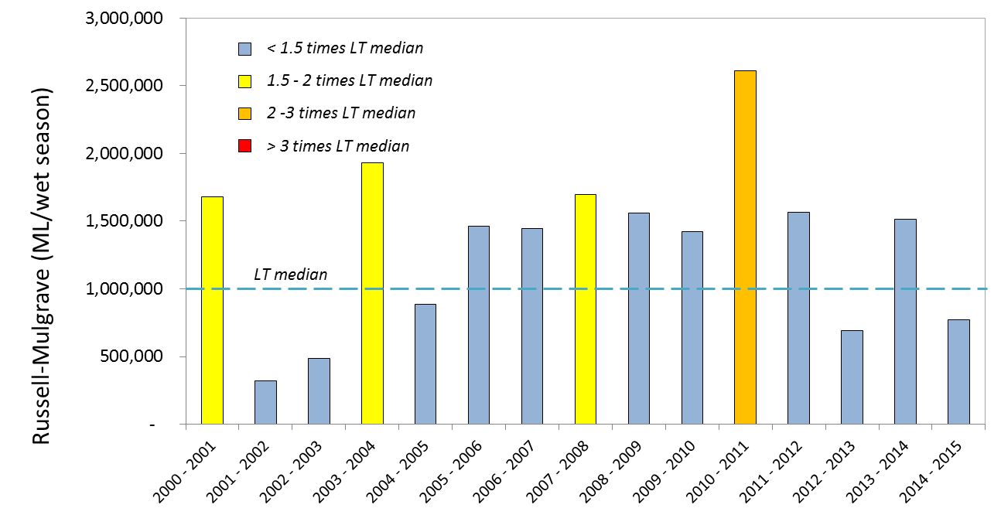
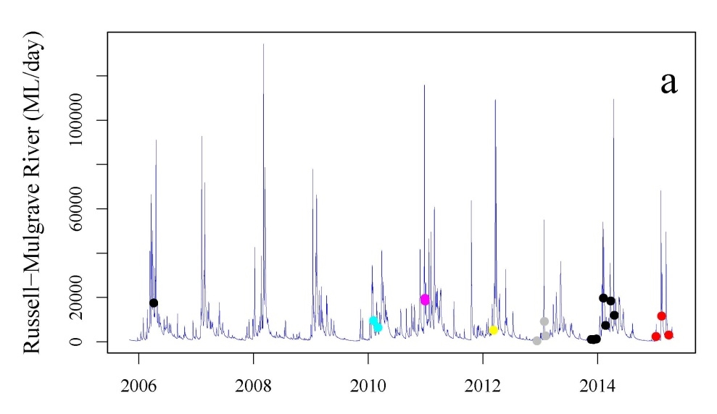
Figure A2 2: Long-term total wet season discharge (top figure) (1 October to 30 September) and flow rates (bottom figure) for the Russell-Mulgrave River
are shown. The timing associated with the wet season sampling over the 2006 to 2015 period is also indicated in the bottom figure, with different colours representing each sampling event. (Source: DNRM, http://watermonitoring.dnrm.qld.gov.au/host.htm)

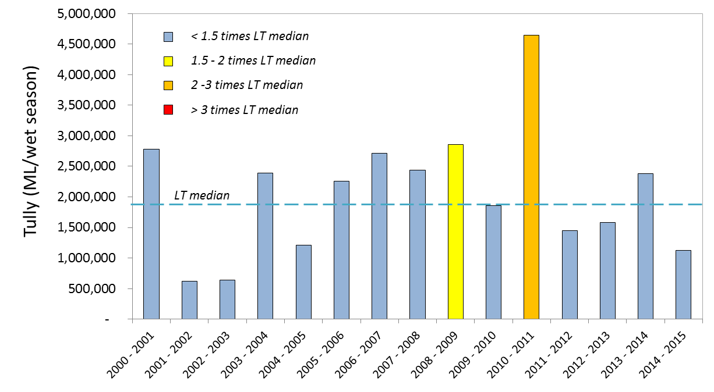
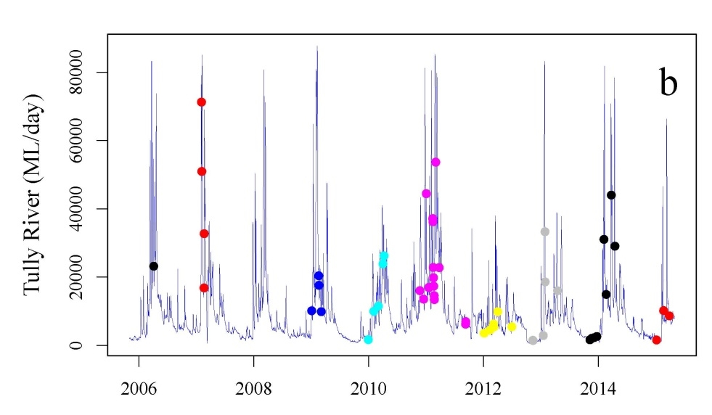
Figure A2 3: Long-term total wet season discharge (top figure) (1 October to 30 September) and flow rates (bottom figure) for the Tully River
are shown. The timing associated with the wet season sampling over the 2006 to 2015 period is also indicated in the bottom figure with different colours representing each sampling event. (Source: DNRM, http://watermonitoring.dnrm.qld.gov.au/host.htm)
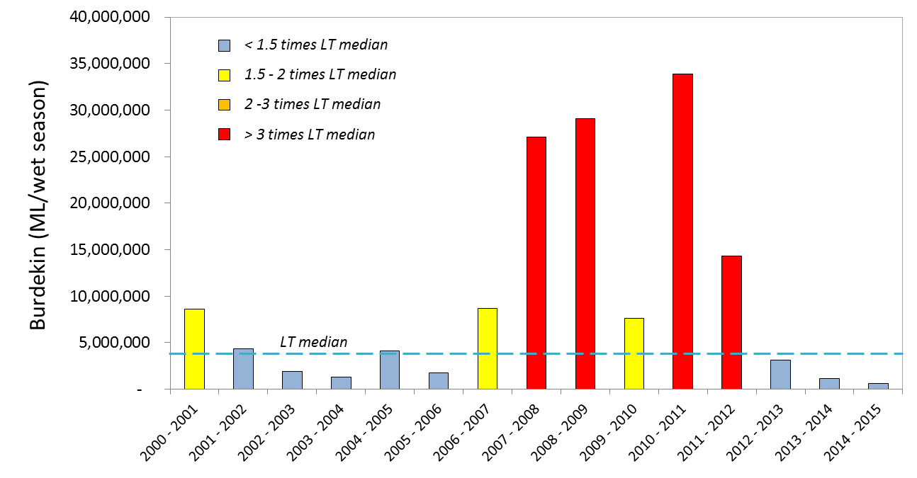
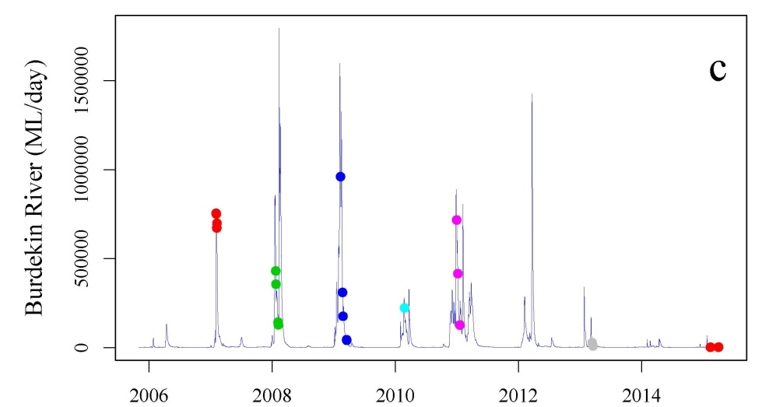
Figure A2 4: Long-term total wet season discharge (top figure) (1 October to 30 September) and flow rates (bottom figure) for the Burdekin River
are shown. The timing associated with the wet season sampling over the 2006 to 2015 period is also indicated in the bottom figure, with different colours representing each sampling event. (Source: DNRM, http://watermonitoring.dnrm.qld.gov.au/host.htm

Table A2 3:Summary statistics for direct water sampling data from inshore lagoon sites from June 2014-June 2015.
N= number of sampling occasions. Data are in mg L⁻¹ for total suspended solids (TSS) and m for Secchi depth. All other parameters are in µg L⁻¹ (see main report for abbreviations. Averages that exceed available water quality guidelines (DERM 2009, GBRMPA 2010) are shaded in red.
Region | Reef |  | Chla (µgL⁻¹) | DIN (µgL⁻¹) | DOC (mgL⁻¹) | DON (µgL⁻¹) | DOP (µgL⁻¹) | NOx (µgL⁻¹) | PN (µgL⁻¹) | PO4 (µgL⁻¹) | POC (mgL⁻¹) | PP (µgL⁻¹) | Secchi (m) | TSS (mgL⁻¹)
Wet Tropics | Cape Tribulation | N | 4 | 4 | 4 | 4 | 4 | 4 | 4 | 4 | 4 | 4 | 4 | 4
Wet Tropics | Cape Tribulation | Mean | 0.56 | 1.37 | 932.55 | 81.31 | 4.82 | 1.01 | 14.7 | 2 | 168.51 | 3.95 | 4.38 | 2.85
Wet Tropics | Cape Tribulation | Median | 0.59 | 1.44 | 937.31 | 78.02 | 4.94 | 1.01 | 14.55 | 1.96 | 155.33 | 3.96 | 4.5 | 2.41
Wet Tropics | Cape Tribulation | 5th | 0.43 | 0.94 | 886.31 | 68.9 | 3.28 | 0.61 | 13.1 | 1.66 | 138.82 | 2.97 | 2.15 | 1.24
Wet Tropics | Cape Tribulation | 20th | 0.48 | 1.17 | 911 | 72.3 | 3.65 | 0.63 | 13.44 | 1.74 | 142.13 | 3.17 | 2.6 | 1.36
Wet Tropics | Cape Tribulation | 80th | 0.65 | 1.59 | 956.01 | 89 | 6.04 | 1.38 | 15.9 | 2.25 | 189.62 | 4.74 | 6.2 | 4.16
Wet Tropics | Cape Tribulation | 95th | 0.66 | 1.69 | 972.13 | 98.32 | 6.19 | 1.4 | 16.51 | 2.41 | 216.66 | 4.92 | 6.42 | 5.07
Wet Tropics | Cape Tribulation | Guideline | 0.45 | 4 |  |  |  | 2 | 20 |  |  | 2.8 | 10 | 2
Wet Tropics | Snapper North | N | 3 | 3 | 3 | 3 | 3 | 3 | 3 | 3 | 3 | 3 | 3 | 3
Wet Tropics | Snapper North | Mean | 0.51 | 2.16 | 888.18 | 76.1 | 4.17 | 1.68 | 14.25 | 2.9 | 153.92 | 3.24 | 3.5 | 2.05
Wet Tropics | Snapper North | Median | 0.53 | 2.33 | 882.49 | 83.13 | 3.81 | 1.85 | 14.22 | 2.84 | 155.21 | 2.97 | 3.5 | 1.89
Wet Tropics | Snapper North | 5th | 0.47 | 1.31 | 855.68 | 61.3 | 3.41 | 1.2 | 13.72 | 2.53 | 139.55 | 2.92 | 3.05 | 1.8
Wet Tropics | Snapper North | 20th | 0.49 | 1.65 | 864.62 | 68.58 | 3.54 | 1.42 | 13.89 | 2.63 | 144.77 | 2.93 | 3.2 | 1.83
Wet Tropics | Snapper North | 80th | 0.54 | 2.7 | 910.61 | 85.02 | 4.73 | 1.97 | 14.6 | 3.15 | 163.33 | 3.48 | 3.8 | 2.24
Wet Tropics | Snapper North | 95th | 0.55 | 2.89 | 924.67 | 85.97 | 5.19 | 2.03 | 14.79 | 3.3 | 167.38 | 3.74 | 3.95 | 2.41
Wet Tropics | Snapper North | Guideline | 0.45 | 4 |  |  |  | 2 | 20 |  |  | 2.8 | 10 | 2
Wet Tropics | Port Douglas | N | 4 | 4 | 4 | 4 | 4 | 4 | 4 | 4 | 4 | 4 | 4 | 4
Wet Tropics | Port Douglas | Mean | 0.44 | 2.3 | 877.43 | 74.54 | 3.78 | 2.02 | 13.56 | 2.44 | 137.95 | 3.08 | 3.75 | 1.77
Wet Tropics | Port Douglas | Median | 0.4 | 1.81 | 853.43 | 69.72 | 3.54 | 1.6 | 13.84 | 2.36 | 132.53 | 2.97 | 4 | 1.84
Wet Tropics | Port Douglas | 5th | 0.3 | 0.94 | 823.53 | 64.87 | 3.42 | 0.63 | 12.62 | 1.89 | 121.24 | 2.6 | 2.72 | 1.57
Wet Tropics | Port Douglas | 20th | 0.32 | 1.37 | 825.79 | 65.47 | 3.46 | 1.14 | 13.25 | 2.08 | 122.66 | 2.78 | 3.4 | 1.7
Wet Tropics | Port Douglas | 80th | 0.54 | 3.03 | 919.47 | 81.68 | 4 | 2.74 | 13.97 | 2.78 | 151.08 | 3.33 | 4.2 | 1.86
Wet Tropics | Port Douglas | 95th | 0.65 | 4.36 | 964.94 | 90.96 | 4.47 | 4.01 | 14.09 | 3.11 | 162.26 | 3.71 | 4.42 | 1.86
Wet Tropics | Port Douglas | Guideline | 0.45 | 4 |  |  |  | 2 | 20 |  |  | 2.8 | 10 | 2
Wet Tropics | Double | N | 4 | 4 | 4 | 4 | 4 | 4 | 4 | 4 | 4 | 4 | 4 | 4
Wet Tropics | Double | Mean | 0.41 | 1.49 | 856.59 | 81.91 | 4.62 | 1.22 | 13.04 | 2.43 | 118.7 | 2.69 | 4.88 | 1.47
Wet Tropics | Double | Median | 0.46 | 1.48 | 847.5 | 74.2 | 4.64 | 1.31 | 13.15 | 2.36 | 121.77 | 2.77 | 4.5 | 1.45
Wet Tropics | Double | 5th | 0.21 | 1.2 | 796.42 | 71.26 | 4.04 | 0.69 | 11.97 | 1.82 | 89.52 | 1.87 | 3 | 1.17
Wet Tropics | Double | 20th | 0.32 | 1.25 | 809.87 | 71.92 | 4.16 | 0.87 | 12.31 | 1.98 | 104.84 | 2.22 | 3 | 1.29
Wet Tropics | Double | 80th | 0.53 | 1.73 | 899.67 | 88.82 | 5.09 | 1.6 | 13.81 | 2.86 | 133.78 | 3.2 | 6.6 | 1.64
Wet Tropics | Double | 95th | 0.56 | 1.81 | 929.47 | 103.36 | 5.18 | 1.61 | 13.94 | 3.16 | 143.57 | 3.41 | 7.27 | 1.79
Wet Tropics | Double | Guideline | 0.45 | 7 |  |  |  | 3 | 20 |  |  | 2.8 | 10 | 2
Wet Tropics | Green | N | 4 | 4 | 4 | 4 | 4 | 4 | 4 | 4 | 4 | 4 | 4 | 4
Wet Tropics | Green | Mean | 0.37 | 1.49 | 844.28 | 71.05 | 5.4 | 1.07 | 11.59 | 2.14 | 96.77 | 1.91 | 8 | 0.84
Wet Tropics | Green | Median | 0.26 | 1.56 | 838.24 | 66.36 | 5.23 | 1.14 | 11.17 | 2.1 | 88.99 | 1.69 | 6.75 | 0.76
Wet Tropics | Green | 5th | 0.14 | 1.12 | 817.3 | 64.11 | 4.31 | 0.54 | 10.04 | 1.6 | 73.8 | 1.18 | 3.8 | 0.38
Wet Tropics | Green | 20th | 0.17 | 1.29 | 817.66 | 65.12 | 4.73 | 0.85 | 10.57 | 1.66 | 75.09 | 1.28 | 4.7 | 0.55
Wet Tropics | Green | 80th | 0.53 | 1.72 | 868.49 | 75.11 | 6.01 | 1.32 | 12.43 | 2.61 | 115.33 | 2.45 | 10.8 | 1.09
Wet Tropics | Green | 95th | 0.74 | 1.78 | 879.72 | 84.56 | 6.74 | 1.49 | 13.72 | 2.75 | 130.63 | 2.95 | 13.95 | 1.4
Wet Tropics | Green | Guideline | 0.45 | 7 |  |  |  | 3 | 20 |  |  | 2.8 | 10 | 2
Wet Tropics | Yorkey's Knob | N | 4 | 4 | 4 | 4 | 4 | 4 | 4 | 4 | 4 | 4 | 4 | 4
Wet Tropics | Yorkey's Knob | Mean | 0.75 | 1.76 | 946.52 | 61.51 | 4.97 | 1.37 | 18.21 | 2.31 | 196.06 | 5.56 | 2.25 | 4.79
Wet Tropics | Yorkey's Knob | Median | 0.8 | 1.96 | 897.83 | 60.7 | 4.94 | 1.36 | 17.69 | 2.2 | 186.76 | 5.59 | 2.25 | 4.52
Wet Tropics | Yorkey's Knob | 5th | 0.4 | 1.17 | 787.02 | 55.3 | 4.48 | 0.93 | 13.45 | 1.98 | 116.33 | 3.78 | 1.57 | 2.02
Wet Tropics | Yorkey's Knob | 20th | 0.49 | 1.57 | 845.64 | 55.58 | 4.55 | 1.04 | 15.39 | 1.99 | 150.36 | 4.69 | 1.8 | 2.75
Wet Tropics | Yorkey's Knob | 80th | 1.03 | 2.04 | 1027.92 | 67.12 | 5.38 | 1.69 | 20.82 | 2.58 | 238.03 | 6.44 | 2.7 | 6.73
Wet Tropics | Yorkey's Knob | 95th | 1.04 | 2.08 | 1174.17 | 68.86 | 5.51 | 1.81 | 23.68 | 2.79 | 288.8 | 7.29 | 2.92 | 7.95
Wet Tropics | Yorkey's Knob | Guideline | 0.45 | 4 |  |  |  | 2 | 20 |  |  | 2.8 | 10 | 2
Wet Tropics | Fairlead Buoy | N | 4 | 4 | 4 | 4 | 4 | 4 | 4 | 4 | 4 | 4 | 4 | 4
Wet Tropics | Fairlead Buoy | Mean | 1.02 | 2.65 | 894.78 | 76.04 | 5.33 | 1.12 | 19.28 | 2.47 | 237.78 | 7.13 | 1.55 | 8.22
Wet Tropics | Fairlead Buoy | Median | 0.9 | 2.32 | 898.83 | 72.56 | 4.96 | 1.15 | 19.42 | 2.42 | 247.55 | 7.14 | 1.5 | 8.59
Wet Tropics | Fairlead Buoy | 5th | 0.44 | 1.5 | 822.23 | 71.79 | 4.28 | 0.74 | 14.96 | 2.19 | 153.01 | 4.99 | 1.24 | 3.26
Wet Tropics | Fairlead Buoy | 20th | 0.52 | 1.82 | 841.19 | 72.08 | 4.36 | 0.89 | 17.16 | 2.23 | 194.14 | 5.52 | 1.38 | 4.86
Wet Tropics | Fairlead Buoy | 80th | 1.48 | 3.34 | 949.99 | 78.61 | 6.16 | 1.37 | 21.46 | 2.69 | 285.34 | 8.75 | 1.7 | 11.72
Wet Tropics | Fairlead Buoy | 95th | 1.78 | 4.24 | 961.67 | 85.18 | 6.91 | 1.47 | 23.41 | 2.8 | 308.88 | 9.28 | 1.92 | 12.65
Wet Tropics | Fairlead Buoy | Guideline | 0.45 | 4 |  |  |  | 2 | 20 |  |  | 2.8 | 10 | 2
Wet Tropics | Fitzroy West | N | 5 | 5 | 5 | 5 | 5 | 5 | 5 | 5 | 5 | 5 | 5 | 5
Wet Tropics | Fitzroy West | Mean | 0.34 | 2.75 | 958.24 | 78.53 | 4.14 | 1.72 | 13.47 | 2.99 | 123.3 | 2.39 | 9.25 | 1.07
Wet Tropics | Fitzroy West | Median | 0.23 | 3.01 | 901.76 | 74.18 | 4.73 | 1.74 | 10.79 | 2.67 | 99.03 | 1.98 | 9.5 | 1.01
Wet Tropics | Fitzroy West | 5th | 0.2 | 1.56 | 757.02 | 52.19 | 1.21 | 0.36 | 9.94 | 1.6 | 71.78 | 1.62 | 8.15 | 0.72
Wet Tropics | Fitzroy West | 20th | 0.2 | 2.04 | 796.33 | 61.9 | 3.57 | 0.62 | 10.22 | 1.99 | 81.6 | 1.62 | 8.6 | 0.78
Wet Tropics | Fitzroy West | 80th | 0.45 | 3.51 | 1018.61 | 85.39 | 5.57 | 2.69 | 15.59 | 3.73 | 159.66 | 3.15 | 10 | 1.41
Wet Tropics | Fitzroy West | 95th | 0.63 | 3.76 | 1317.5 | 118.98 | 5.6 | 3.19 | 20.81 | 4.94 | 204.43 | 3.55 | 10 | 1.42
Wet Tropics | Fitzroy West | Guideline | 0.45 | 4 |  |  |  | 2 | 20 |  |  | 2.8 | 10 | 2
Wet Tropics | High West | N | 5 | 5 | 5 | 5 | 5 | 5 | 5 | 5 | 5 | 5 | 5 | 5
Wet Tropics | High West | Mean | 0.49 | 0.88 | 972.54 | 75.71 | 4.31 | 2.49 | 15.33 | 2.35 | 143.17 | 2.71 | 5.62 | 2.09
Wet Tropics | High West | Median | 0.36 | 0.88 | 952.89 | 76.52 | 4.6 | 1.04 | 13.99 | 1.53 | 126.6 | 2.51 | 5.5 | 1.7
Wet Tropics | High West | 5th | 0.26 | 0.77 | 858.18 | 68.48 | 1.82 | 0.59 | 10.5 | 1.15 | 82.15 | 2.41 | 4.57 | 1.04
Wet Tropics | High West | 20th | 0.26 | 0.81 | 902.67 | 71.12 | 3.16 | 0.66 | 10.8 | 1.29 | 88.99 | 2.45 | 4.8 | 1.16
Wet Tropics | High West | 80th | 0.58 | 0.96 | 1034.56 | 80.61 | 5.57 | 3.74 | 19.32 | 3.09 | 190.73 | 2.89 | 6.4 | 2.91
Wet Tropics | High West | 95th | 0.98 | 1 | 1114.41 | 81.79 | 6.39 | 6.41 | 22.02 | 4.69 | 227.39 | 3.29 | 6.85 | 3.64
Wet Tropics | High West | Guideline | 0.45 | 4 |  |  |  | 2 | 20 |  |  | 2.8 | 10 | 2
Wet Tropics | Franklands West | N | 6 | 6 | 6 | 6 | 6 | 6 | 6 | 6 | 6 | 6 | 6 | 6
Wet Tropics | Franklands West | Mean | 0.34 | 1.57 | 887.76 | 77.92 | 4.71 | 0.92 | 15.89 | 2.56 | 152.61 | 2.29 | 8.08 | 1.05
Wet Tropics | Franklands West | Median | 0.3 | 1.58 | 857 | 75.89 | 5.03 | 0.9 | 11.92 | 1.97 | 105.32 | 2.13 | 7.5 | 0.93
Wet Tropics | Franklands West | 5th | 0.16 | 1 | 808.66 | 60.51 | 2.15 | 0.5 | 9.62 | 1.78 | 60.17 | 1.66 | 5.25 | 0.55
Wet Tropics | Franklands West | 20th | 0.18 | 1.07 | 817.52 | 67.6 | 4.37 | 0.69 | 9.72 | 1.82 | 69.77 | 1.66 | 6 | 0.82
Wet Tropics | Franklands West | 80th | 0.5 | 2.07 | 862.57 | 91.26 | 5.74 | 1.06 | 23.22 | 2.29 | 284.91 | 2.98 | 9.5 | 1.22
Wet Tropics | Franklands West | 95th | 0.57 | 2.11 | 1060.72 | 96.86 | 6.44 | 1.41 | 27.54 | 4.76 | 291.23 | 3.14 | 12.12 | 1.78
Wet Tropics | Franklands West | Guideline | 0.45 | 4 |  |  |  | 2 | 20 |  |  | 2.8 | 10 | 2
Wet Tropics | Dunk North | N | 5 | 5 | 5 | 5 | 5 | 5 | 5 | 5 | 5 | 5 | 5 | 5
Wet Tropics | Dunk North | Mean | 0.5 | 2.92 | 951.2 | 74.28 | 5.05 | 1.42 | 14.81 | 1.67 | 168.05 | 3.24 | 4.6 | 1.75
Wet Tropics | Dunk North | Median | 0.55 | 2.92 | 919.32 | 73.07 | 5.28 | 1.2 | 14.09 | 1.69 | 149.55 | 3.01 | 4 | 1.81
Wet Tropics | Dunk North | 5th | 0.34 | 2.16 | 841.39 | 67 | 3.6 | 0.42 | 11.02 | 1.14 | 103.83 | 2.61 | 3.2 | 1.07
Wet Tropics | Dunk North | 20th | 0.43 | 2.41 | 867.35 | 68.57 | 4.37 | 0.64 | 11.8 | 1.26 | 106.49 | 2.63 | 3.8 | 1.23
Wet Tropics | Dunk North | 80th | 0.6 | 3.43 | 1022.29 | 79.5 | 5.82 | 2.12 | 17.53 | 2.09 | 222.21 | 3.76 | 5.7 | 2.3
Wet Tropics | Dunk North | 95th | 0.6 | 3.68 | 1105.64 | 83.25 | 6.19 | 2.74 | 19.62 | 2.17 | 258.17 | 4.19 | 6.3 | 2.36
Wet Tropics | Dunk North | Guideline | 0.45 | 4 |  |  |  | 2 | 20 |  |  | 2.8 | 10 | 2
Burdekin | Palms West | N | 5 | 5 | 5 | 5 | 5 | 5 | 5 | 5 | 5 | 5 | 5 | 5
Burdekin | Palms West | Mean | 0.38 | 2.52 | 865.68 | 80.61 | 5.03 | 1.47 | 12.73 | 2.02 | 127.2 | 2.42 | 7.25 | 0.99
Burdekin | Palms West | Median | 0.37 | 2.52 | 866.2 | 81.17 | 5.35 | 1.28 | 12.81 | 2.1 | 124.98 | 2.19 | 7.5 | 0.9
Burdekin | Palms West | 5th | 0.3 | 1.88 | 777.49 | 71.56 | 3.65 | 0.68 | 10.21 | 1.67 | 76.14 | 1.81 | 4.3 | 0.51
Burdekin | Palms West | 20th | 0.35 | 2.09 | 807.21 | 74.09 | 4.32 | 0.76 | 10.39 | 1.87 | 79.06 | 1.94 | 5.2 | 0.59
Burdekin | Palms West | 80th | 0.41 | 2.95 | 924.35 | 87.36 | 5.87 | 2.11 | 15.1 | 2.2 | 174.45 | 2.81 | 9.4 | 1.19
Burdekin | Palms West | 95th | 0.48 | 3.16 | 953.12 | 88.89 | 5.94 | 2.53 | 15.13 | 2.25 | 181.38 | 3.34 | 9.85 | 1.75
Burdekin | Palms West | Guideline | 0.45 | 7 |  |  |  | 3 | 20 |  |  | 2.8 | 10 | 2
Burdekin | Pandora | N | 6 | 6 | 6 | 6 | 6 | 6 | 6 | 6 | 6 | 6 | 6 | 6
Burdekin | Pandora | Mean | 0.52 | 3.82 | 917.97 | 80.55 | 4.83 | 1.63 | 15.23 | 2.37 | 207.44 | 3.59 | 4.04 | 2.21
Burdekin | Pandora | Median | 0.53 | 3.82 | 950.51 | 79.72 | 5.24 | 0.69 | 14.45 | 2.49 | 199.28 | 2.95 | 4 | 1.65
Burdekin | Pandora | 5th | 0.23 | 1.79 | 805.53 | 73.93 | 3.39 | 0.37 | 13.02 | 1.74 | 134.9 | 2.39 | 1.46 | 0.86
Burdekin | Pandora | 20th | 0.3 | 2.47 | 856.07 | 74.46 | 3.66 | 0.37 | 13.81 | 1.74 | 152.29 | 2.43 | 2.24 | 1.39
Burdekin | Pandora | 80th | 0.59 | 5.17 | 966.54 | 83.05 | 5.71 | 2.2 | 17.39 | 2.88 | 233.73 | 4.09 | 5.8 | 2.49
Burdekin | Pandora | 95th | 0.85 | 5.85 | 1011.18 | 91.61 | 6.13 | 4.51 | 17.48 | 3 | 316.99 | 6.11 | 6.7 | 4.64
Burdekin | Pandora | Guideline | 0.45 | 7 |  |  |  | 3 | 20 |  |  | 2.8 | 10 | 2
Burdekin | Magnetic | N | 5 | 5 | 5 | 5 | 5 | 5 | 5 | 5 | 5 | 5 | 5 | 5
Burdekin | Magnetic | Mean | 0.53 | 4.54 | 948.01 | 73.73 | 4.83 | 3.83 | 15.56 | 2.71 | 156.36 | 3.59 | 3.88 | 1.35
Burdekin | Magnetic | Median | 0.51 | 4.54 | 969.55 | 77.47 | 5.01 | 3.19 | 15.71 | 2.48 | 151.35 | 3.51 | 4 | 1.39
Burdekin | Magnetic | 5th | 0.34 | 1.73 | 878 | 35.56 | 3.89 | 1.27 | 12.39 | 2.02 | 101.21 | 3.04 | 2.65 | 0.98
Burdekin | Magnetic | 20th | 0.38 | 2.67 | 919.5 | 56.97 | 4.3 | 1.78 | 13.71 | 2.06 | 112.23 | 3.23 | 3.1 | 1.18
Burdekin | Magnetic | 80th | 0.7 | 6.42 | 985.14 | 91.98 | 5.43 | 5.63 | 17.47 | 3.27 | 198.48 | 3.92 | 4.7 | 1.6
Burdekin | Magnetic | 95th | 0.73 | 7.36 | 987.87 | 106.67 | 5.51 | 7.3 | 18.52 | 3.74 | 218.51 | 4.26 | 4.92 | 1.62
Burdekin | Magnetic | Guideline | 0.45 | 7 |  |  |  | 3 | 20 |  |  | 2.8 | 10 | 2
Haughton | Haughton | N | 1 | 1 | 1 | 1 | 1 | 1 | 1 | 1 | 1 | 1 | 1 | 1
Haughton | Haughton | Mean | 0.4 | NaN | 1035.18 | 78.55 | 4.21 | 0.5 | 17.31 | 1.86 | 226.84 | 3.74 | 4.5 | 2.2
Haughton | Haughton | Median | 0.4 |  | 1035.18 | 78.55 | 4.21 | 0.5 | 17.31 | 1.86 | 226.84 | 3.74 | 4.5 | 2.2
Haughton | Haughton | 5th | 0.4 |  | 1035.18 | 78.55 | 4.21 | 0.5 | 17.31 | 1.86 | 226.84 | 3.74 | 4.5 | 2.2
Haughton | Haughton | 20th | 0.4 |  | 1035.18 | 78.55 | 4.21 | 0.5 | 17.31 | 1.86 | 226.84 | 3.74 | 4.5 | 2.2
Haughton | Haughton | 80th | 0.4 |  | 1035.18 | 78.55 | 4.21 | 0.5 | 17.31 | 1.86 | 226.84 | 3.74 | 4.5 | 2.2
Haughton | Haughton | 95th | 0.4 |  | 1035.18 | 78.55 | 4.21 | 0.5 | 17.31 | 1.86 | 226.84 | 3.74 | 4.5 | 2.2
Haughton | Haughton | Guideline | 0.45 | 7 |  |  |  | 3 | 20 |  |  | 2.8 | 10 | 2
Mackay Whitsunday | Double Cone | N | 4 | 4 | 4 | 4 | 4 | 4 | 4 | 4 | 4 | 4 | 4 | 4
Mackay Whitsunday | Double Cone | Mean | 0.24 | 1.16 | 896.16 | 83.39 | 5.38 | 1.29 | 11.57 | 2.71 | 116.54 | 2.81 | 7.67 | 0.74
Mackay Whitsunday | Double Cone | Median | 0.21 | 1.16 | 814.01 | 73.92 | 4.17 | 1.44 | 10.9 | 2.86 | 98.92 | 1.85 | 7.5 | 0.83
Mackay Whitsunday | Double Cone | 5th | 0.15 | 1.16 | 798.85 | 71.45 | 3.82 | 1.02 | 10.03 | 2.36 | 71.68 | 1.85 | 7.05 | 0.46
Mackay Whitsunday | Double Cone | 20th | 0.18 | 1.16 | 803.9 | 72.27 | 3.93 | 1.16 | 10.32 | 2.53 | 80.76 | 1.85 | 7.2 | 0.65
Mackay Whitsunday | Double Cone | 80th | 0.28 | 1.16 | 971.98 | 92.6 | 6.58 | 1.46 | 12.7 | 2.91 | 148.79 | 3.58 | 8.1 | 0.87
Mackay Whitsunday | Double Cone | 95th | 0.35 | 1.16 | 1050.97 | 101.95 | 7.79 | 1.46 | 13.59 | 2.94 | 173.73 | 4.45 | 8.4 | 0.89
Mackay Whitsunday | Double Cone | Guideline | 0.45 | 7 |  |  |  | 3 | 20 |  |  | 2.8 | 10 | 2
Mackay Whitsunday | Daydream | N | 2 | 2 | 2 | 2 | 2 | 2 | 2 | 2 | 2 | 2 | 2 | 2
Mackay Whitsunday | Daydream | Mean | 0.42 | 1.31 | 836.03 | 67.88 | 5.48 | 1.54 | 11.95 | 2.83 | 133.09 | 2.25 | 7.25 | 1.33
Mackay Whitsunday | Daydream | Median | 0.42 | 1.31 | 836.03 | 67.88 | 5.48 | 1.54 | 11.95 | 2.83 | 133.09 | 2.25 | 7.25 | 1.33
Mackay Whitsunday | Daydream | 5th | 0.25 | 1.31 | 824.23 | 67.7 | 3.95 | 1.03 | 10.56 | 2.78 | 88.48 | 1.81 | 5.23 | 0.7
Mackay Whitsunday | Daydream | 20th | 0.3 | 1.31 | 828.16 | 67.76 | 4.46 | 1.2 | 11.02 | 2.8 | 103.35 | 1.96 | 5.9 | 0.91
Mackay Whitsunday | Daydream | 80th | 0.53 | 1.31 | 843.9 | 68.01 | 6.5 | 1.87 | 12.88 | 2.87 | 162.83 | 2.54 | 8.6 | 1.75
Mackay Whitsunday | Daydream | 95th | 0.59 | 1.31 | 847.84 | 68.07 | 7.01 | 2.04 | 13.35 | 2.89 | 177.7 | 2.68 | 9.28 | 1.95
Mackay Whitsunday | Daydream | Guideline | 0.45 | 7 |  |  |  | 3 | 20 |  |  | 2.8 | 10 | 2
Mackay Whitsunday | Pine | N | 4 | 4 | 4 | 4 | 4 | 4 | 4 | 4 | 4 | 4 | 4 | 4
Mackay Whitsunday | Pine | Mean | 0.5 | 1.74 | 927.99 | 64.91 | 4.7 | 1.54 | 11.56 | 2.95 | 116.18 | 2.42 | 6.33 | 2.35
Mackay Whitsunday | Pine | Median | 0.53 | 1.74 | 833.52 | 58.96 | 3.76 | 1.25 | 11.07 | 2.9 | 107.9 | 2.47 | 6.5 | 1.6
Mackay Whitsunday | Pine | 5th | 0.34 | 1.74 | 788.38 | 56.67 | 3.66 | 1.09 | 10.51 | 2.84 | 79.93 | 2.15 | 5.15 | 1.06
Mackay Whitsunday | Pine | 20th | 0.42 | 1.74 | 803.43 | 57.44 | 3.7 | 1.14 | 10.7 | 2.86 | 89.25 | 2.26 | 5.6 | 1.14
Mackay Whitsunday | Pine | 80th | 0.59 | 1.74 | 1033.66 | 71.19 | 5.52 | 1.87 | 12.32 | 3.02 | 141.44 | 2.59 | 7.1 | 3.27
Mackay Whitsunday | Pine | 95th | 0.62 | 1.74 | 1133.73 | 77.3 | 6.4 | 2.19 | 12.94 | 3.09 | 158.22 | 2.66 | 7.4 | 4.71
Mackay Whitsunday | Pine | Guideline | 0.45 | 7 |  |  |  | 3 | 20 |  |  | 2.8 | 10 | 2
Mackay Whitsunday | Seaforth | N | 2 | 2 | 2 | 2 | 2 | 2 | 2 | 2 | 2 | 2 | 2 | 2
Mackay Whitsunday | Seaforth | Mean | 0.51 | NaN | 1003.43 | 75.95 | 5.21 | 1.77 | 11.92 | 3.33 | 126.3 | 2.93 | 4.75 | 2.23
Mackay Whitsunday | Seaforth | Median | 0.51 |  | 1003.43 | 75.95 | 5.21 | 1.77 | 11.92 | 3.33 | 126.3 | 2.93 | 4.75 | 2.23
Mackay Whitsunday | Seaforth | 5th | 0.46 |  | 928.69 | 60.46 | 4.38 | 1.54 | 9.66 | 3.22 | 93.61 | 2.8 | 4.52 | 1.78
Mackay Whitsunday | Seaforth | 20th | 0.48 |  | 953.6 | 65.62 | 4.66 | 1.61 | 10.41 | 3.25 | 104.5 | 2.85 | 4.6 | 1.93
Mackay Whitsunday | Seaforth | 80th | 0.54 |  | 1053.25 | 86.28 | 5.77 | 1.92 | 13.42 | 3.4 | 148.09 | 3.02 | 4.9 | 2.54
Mackay Whitsunday | Seaforth | 95th | 0.55 |  | 1078.17 | 91.45 | 6.05 | 2 | 14.17 | 3.44 | 158.99 | 3.06 | 4.98 | 2.69
Mackay Whitsunday | Seaforth | Guideline | 0.45 | 7 |  |  |  | 3 | 20 |  |  | 2.8 | 10 | 2
Repulse | Repulse | N | 3 | 3 | 3 | 3 | 3 | 3 | 3 | 3 | 3 | 3 | 3 | 3
Repulse | Repulse | Mean | 0.76 | NaN | 1074.26 | 72.5 | 5.41 | 1.05 | 16.71 | 4.01 | 209.59 | 3.91 | 2 | 5.04
Repulse | Repulse | Median | 0.66 |  | 1074.26 | 72.5 | 5.41 | 1.05 | 16.71 | 4.01 | 209.59 | 3.91 | 2 | 3.5
Repulse | Repulse | 5th | 0.43 |  | 959.41 | 57.95 | 4.13 | 0.56 | 15.41 | 3.76 | 181.73 | 3.45 | 1.55 | 1.94
Repulse | Repulse | 20th | 0.5 |  | 997.69 | 62.8 | 4.56 | 0.72 | 15.84 | 3.84 | 191.01 | 3.6 | 1.7 | 2.46
Repulse | Repulse | 80th | 1 |  | 1150.83 | 82.2 | 6.26 | 1.38 | 17.58 | 4.17 | 228.16 | 4.21 | 2.3 | 7.32
Repulse | Repulse | 95th | 1.17 |  | 1189.11 | 87.05 | 6.68 | 1.54 | 18.02 | 4.25 | 237.45 | 4.37 | 2.45 | 9.22
Repulse | Repulse | Guideline | 0.45 | 7 |  |  |  | 3 | 20 |  |  | 2.8 | 10 | 2
Fitzroy | Barren | N | 2 | 2 | 2 | 2 | 2 | 2 | 2 | 2 | 2 | 2 | 2 | 2
Fitzroy | Barren | Mean | 0.19 | 2.23 | 800.37 | 75.67 | 4.22 | 1.42 | 9.12 | 1.62 | 71.3 | 1.48 | 17 | 15.56
Fitzroy | Barren | Median | 0.19 | 2.23 | 800.37 | 75.67 | 4.22 | 1.42 | 9.12 | 1.62 | 71.3 | 1.48 | 17 | 15.56
Fitzroy | Barren | 5th | 0.11 | 2.23 | 800.37 | 75.67 | 4.22 | 1.42 | 9.12 | 1.62 | 71.3 | 1.48 | 17 | 1.59
Fitzroy | Barren | 20th | 0.14 | 2.23 | 800.37 | 75.67 | 4.22 | 1.42 | 9.12 | 1.62 | 71.3 | 1.48 | 17 | 6.25
Fitzroy | Barren | 80th | 0.24 | 2.23 | 800.37 | 75.67 | 4.22 | 1.42 | 9.12 | 1.62 | 71.3 | 1.48 | 17 | 24.87
Fitzroy | Barren | 95th | 0.27 | 2.23 | 800.37 | 75.67 | 4.22 | 1.42 | 9.12 | 1.62 | 71.3 | 1.48 | 17 | 29.52
Fitzroy | Barren | Guideline | 0.45 | 7 |  |  |  | 3 | 20 |  |  | 2.8 | 10 | 2
Fitzroy | Keppels South | N | 2 | 2 | 2 | 2 | 2 | 2 | 2 | 2 | 2 | 2 | 2 | 2
Fitzroy | Keppels South | Mean | 0.25 | 1.21 | 790.54 | 75.72 | 3.44 | 0.85 | 12.16 | 2.27 | 106.73 | 1.72 | 12 | 0.55
Fitzroy | Keppels South | Median | 0.25 | 1.21 | 790.54 | 75.72 | 3.44 | 0.85 | 12.16 | 2.27 | 106.73 | 1.72 | 12 | 0.55
Fitzroy | Keppels South | 5th | 0.19 | 1.21 | 790.54 | 75.72 | 3.44 | 0.85 | 12.16 | 2.27 | 106.73 | 1.72 | 12 | 0.2
Fitzroy | Keppels South | 20th | 0.21 | 1.21 | 790.54 | 75.72 | 3.44 | 0.85 | 12.16 | 2.27 | 106.73 | 1.72 | 12 | 0.32
Fitzroy | Keppels South | 80th | 0.28 | 1.21 | 790.54 | 75.72 | 3.44 | 0.85 | 12.16 | 2.27 | 106.73 | 1.72 | 12 | 0.79
Fitzroy | Keppels South | 95th | 0.3 | 1.21 | 790.54 | 75.72 | 3.44 | 0.85 | 12.16 | 2.27 | 106.73 | 1.72 | 12 | 0.91
Fitzroy | Keppels South | Guideline | 0.45 | 7 |  |  |  | 3 | 20 |  |  | 2.8 | 10 | 2
Fitzroy | Pelican | N | 2 | 2 | 2 | 2 | 2 | 2 | 2 | 2 | 2 | 2 | 2 | 2
Fitzroy | Pelican | Mean | 0.41 | 1.96 | 883.3 | 85.82 | 2.8 | 0.59 | 16.71 | 5.67 | 162.25 | 4.32 | 2.5 | 2.42
Fitzroy | Pelican | Median | 0.41 | 1.96 | 883.3 | 85.82 | 2.8 | 0.59 | 16.71 | 5.67 | 162.25 | 4.32 | 2.5 | 2.42
Fitzroy | Pelican | 5th | 0.39 | 1.96 | 883.3 | 85.82 | 2.8 | 0.59 | 16.71 | 5.67 | 162.25 | 4.32 | 2.5 | 1.61
Fitzroy | Pelican | 20th | 0.4 | 1.96 | 883.3 | 85.82 | 2.8 | 0.59 | 16.71 | 5.67 | 162.25 | 4.32 | 2.5 | 1.88
Fitzroy | Pelican | 80th | 0.43 | 1.96 | 883.3 | 85.82 | 2.8 | 0.59 | 16.71 | 5.67 | 162.25 | 4.32 | 2.5 | 2.96
Fitzroy | Pelican | 95th | 0.43 | 1.96 | 883.3 | 85.82 | 2.8 | 0.59 | 16.71 | 5.67 | 162.25 | 4.32 | 2.5 | 3.23
Fitzroy | Pelican | Guideline | 0.45 | 7 |  |  |  | 3 | 20 |  |  | 2.8 | 10 | 2

Table A2 :Summary statistics for direct water sampling data from inshore lagoon sites from August 2005-June 2015.
N= number of sampling occasions. Data are in mg L⁻¹ for total suspended solids (TSS) and metres for Secchi depth. All other parameters are in µg L⁻¹ (see main report for abbreviations). Long-term averages that exceed available water quality guidelines (DERM 2009, GBRMPA 2010) are shaded in red.
Region | Reef |  | Chla (µgL⁻¹) | DIN (µgL⁻¹) | DOC (mgL⁻¹) | DON (µgL⁻¹) | DOP (µgL⁻¹) | NOx (µgL⁻¹) | PN (µgL⁻¹) | PO4 (µgL⁻¹) | POC (mgL⁻¹) | PP (µgL⁻¹) | Secchi (m) | TSS (mgL⁻¹)
Wet Tropics | Cape Tribulation | N | 27 | 27 | 27 | 27 | 27 | 27 | 27 | 27 | 27 | 27 | 27 | 27
Wet Tropics | Cape Tribulation | Mean | 0.42 | 1.56 | 831.02 | 76.72 | 4.76 | 0.79 | 12.72 | 2.5 | 117.64 | 2.85 | 6.75 | 1.57
Wet Tropics | Cape Tribulation | Median | 0.41 | 1.51 | 869.7 | 80.71 | 4.31 | 0.68 | 12.28 | 2.46 | 107.12 | 2.56 | 6.5 | 1.27
Wet Tropics | Cape Tribulation | 5th | 0.23 | 0.57 | 619.3 | 45.37 | 1.53 | 0.01 | 9.4 | 0.43 | 77.4 | 1.94 | 3.1 | 0.61
Wet Tropics | Cape Tribulation | 20th | 0.29 | 0.75 | 719.4 | 60.04 | 2.38 | 0.28 | 10.36 | 1.64 | 91 | 2.06 | 4.8 | 0.78
Wet Tropics | Cape Tribulation | 80th | 0.54 | 1.79 | 927.73 | 93.25 | 6.09 | 1.36 | 14.75 | 3.29 | 143.63 | 3.45 | 9.6 | 1.87
Wet Tropics | Cape Tribulation | 95th | 0.72 | 2.58 | 990.08 | 105.4 | 8.03 | 1.53 | 18.55 | 3.64 | 181.67 | 4.45 | 11 | 3.28
Wet Tropics | Cape Tribulation | Guideline | 0.45 | 4 |  |  |  | 2 | 20 |  |  | 2.8 | 10 | 2
Wet Tropics | Snapper North | N | 25 | 25 | 25 | 25 | 25 | 25 | 25 | 25 | 25 | 25 | 25 | 25
Wet Tropics | Snapper North | Mean | 0.38 | 3.27 | 848.02 | 79.58 | 3.72 | 2.48 | 11.94 | 2.87 | 110.28 | 2.42 | 5.58 | 1.35
Wet Tropics | Snapper North | Median | 0.32 | 2.84 | 825.44 | 83.13 | 3.36 | 1.87 | 12.05 | 2.98 | 100.96 | 2.41 | 5 | 1.29
Wet Tropics | Snapper North | 5th | 0.21 | 1.03 | 680.25 | 45.71 | 1.74 | 0.21 | 7.79 | 0.98 | 58.62 | 1.32 | 3.08 | 0.47
Wet Tropics | Snapper North | 20th | 0.27 | 1.65 | 769.48 | 61.69 | 2.34 | 1.14 | 9.87 | 1.98 | 77.29 | 1.79 | 4 | 0.85
Wet Tropics | Snapper North | 80th | 0.5 | 4.86 | 934.69 | 92.36 | 5 | 4.06 | 13.95 | 3.5 | 145.9 | 2.98 | 7.2 | 1.7
Wet Tropics | Snapper North | 95th | 0.54 | 6.87 | 1066.09 | 113.69 | 6.67 | 5.89 | 18.19 | 4.81 | 174.51 | 3.3 | 9 | 2.4
Wet Tropics | Snapper North | Guideline | 0.45 | 4 |  |  |  | 2 | 20 |  |  | 2.8 | 10 | 2
Wet Tropics | Port Douglas | N | 28 | 28 | 28 | 28 | 28 | 28 | 28 | 28 | 28 | 28 | 28 | 28
Wet Tropics | Port Douglas | Mean | 0.38 | 1.24 | 809.77 | 73.01 | 4.15 | 0.81 | 12.61 | 2.35 | 106.37 | 2.54 | 6.34 | 1.42
Wet Tropics | Port Douglas | Median | 0.35 | 0.9 | 800.94 | 72.15 | 3.45 | 0.58 | 12.59 | 2.26 | 99.51 | 2.45 | 5.75 | 1.44
Wet Tropics | Port Douglas | 5th | 0.23 | 0.18 | 633.49 | 36.72 | 1.81 | 0.01 | 9.24 | 0.62 | 67.61 | 1.5 | 3.17 | 0.65
Wet Tropics | Port Douglas | 20th | 0.26 | 0.62 | 730.1 | 54.19 | 2.18 | 0.14 | 10.62 | 1.73 | 83.74 | 2.16 | 4.2 | 0.94
Wet Tropics | Port Douglas | 80th | 0.44 | 1.62 | 888.62 | 94.76 | 4.74 | 1.26 | 14.2 | 3.18 | 123.75 | 3.04 | 8.6 | 1.86
Wet Tropics | Port Douglas | 95th | 0.68 | 3.4 | 985.01 | 115.62 | 7.14 | 1.64 | 17.14 | 3.7 | 161.62 | 3.6 | 10.65 | 2.21
Wet Tropics | Port Douglas | Guideline | 0.45 | 4 |  |  |  | 2 | 20 |  |  | 2.8 | 10 | 2
Wet Tropics | Double | N | 27 | 27 | 27 | 27 | 27 | 27 | 27 | 27 | 27 | 27 | 27 | 27
Wet Tropics | Double | Mean | 0.39 | 1.16 | 810.8 | 75.95 | 4.83 | 0.74 | 11.62 | 2.12 | 103.52 | 2.37 | 7.35 | 1.24
Wet Tropics | Double | Median | 0.35 | 1.19 | 787.06 | 75.11 | 4 | 0.35 | 11.86 | 2.06 | 100.29 | 2.3 | 6.75 | 1.15
Wet Tropics | Double | 5th | 0.18 | 0.07 | 673.16 | 39.46 | 2.4 | 0.01 | 8.09 | 0.42 | 63.35 | 1.52 | 3.12 | 0.52
Wet Tropics | Double | 20th | 0.27 | 0.34 | 721.22 | 62.02 | 2.96 | 0.02 | 9.8 | 1.19 | 76.45 | 1.91 | 4 | 0.94
Wet Tropics | Double | 80th | 0.52 | 1.77 | 911.06 | 92.28 | 5.46 | 1.33 | 13.15 | 3.13 | 117.89 | 2.92 | 10 | 1.41
Wet Tropics | Double | 95th | 0.6 | 2.75 | 991.94 | 107.52 | 8.16 | 2.08 | 13.93 | 4.04 | 157.67 | 3.42 | 13.88 | 2.06
Wet Tropics | Double | Guideline | 0.45 | 7 |  |  |  | 3 | 20 |  |  | 2.8 | 10 | 2
Wet Tropics | Green | N | 28 | 28 | 28 | 28 | 28 | 28 | 28 | 28 | 28 | 28 | 28 | 28
Wet Tropics | Green | Mean | 0.29 | 1.6 | 790.76 | 74.76 | 5.14 | 0.97 | 9.91 | 2.17 | 78.39 | 1.65 | 12.11 | 0.49
Wet Tropics | Green | Median | 0.24 | 1.45 | 807.17 | 79.88 | 4.42 | 0.74 | 9.75 | 2.04 | 73.54 | 1.55 | 12.25 | 0.39
Wet Tropics | Green | 5th | 0.13 | 0.37 | 595.5 | 43.29 | 2.24 | 0.09 | 7.37 | 1.17 | 46.61 | 0.91 | 4.85 | 0.1
Wet Tropics | Green | 20th | 0.14 | 0.62 | 701.67 | 58.76 | 2.6 | 0.39 | 8.16 | 1.57 | 56.05 | 1.12 | 8 | 0.17
Wet Tropics | Green | 80th | 0.37 | 2.18 | 875.51 | 92.61 | 7.2 | 1.63 | 11.37 | 2.8 | 92.19 | 2.1 | 15.6 | 0.79
Wet Tropics | Green | 95th | 0.69 | 3.84 | 926.55 | 104.41 | 9.2 | 2.21 | 12.78 | 3.49 | 130 | 2.53 | 18.65 | 1.14
Wet Tropics | Green | Guideline | 0.45 | 7 |  |  |  | 3 | 20 |  |  | 2.8 | 10 | 2
Wet Tropics | Yorkey's Knob | N | 28 | 28 | 28 | 28 | 28 | 28 | 28 | 28 | 28 | 28 | 28 | 28
Wet Tropics | Yorkey's Knob | Mean | 0.61 | 1.43 | 839.54 | 73.62 | 5.2 | 0.9 | 16.3 | 2.15 | 152.73 | 4.08 | 3.68 | 3.12
Wet Tropics | Yorkey's Knob | Median | 0.56 | 1.08 | 791.65 | 72.35 | 4.53 | 0.64 | 15.84 | 1.99 | 147.48 | 3.84 | 3 | 2.48
Wet Tropics | Yorkey's Knob | 5th | 0.33 | 0.25 | 627.37 | 37.52 | 1.92 | 0.01 | 12.02 | 0.64 | 106.05 | 2.79 | 2 | 1.33
Wet Tropics | Yorkey's Knob | 20th | 0.43 | 0.62 | 742.73 | 55.46 | 2.81 | 0.24 | 13.1 | 1.24 | 111.36 | 3.19 | 2.5 | 1.9
Wet Tropics | Yorkey's Knob | 80th | 0.75 | 2 | 943.73 | 93.36 | 6.57 | 1.5 | 18.38 | 3.16 | 177.09 | 4.69 | 5 | 4.89
Wet Tropics | Yorkey's Knob | 95th | 1.07 | 2.91 | 1095.8 | 105.36 | 10.74 | 2.47 | 23.6 | 3.98 | 244.38 | 5.72 | 6.82 | 6.75
Wet Tropics | Yorkey's Knob | Guideline | 0.45 | 4 |  |  |  | 2 | 20 |  |  | 2.8 | 10 | 2
Wet Tropics | Fairlead Buoy | N | 28 | 28 | 28 | 28 | 28 | 28 | 28 | 28 | 28 | 28 | 28 | 28
Wet Tropics | Fairlead Buoy | Mean | 0.61 | 1.47 | 842.07 | 76.45 | 5.04 | 0.72 | 16.54 | 2.18 | 174.14 | 4.6 | 3.35 | 4.27
Wet Tropics | Fairlead Buoy | Median | 0.49 | 1.29 | 865.47 | 75.33 | 4.25 | 0.52 | 16.68 | 2.28 | 158.6 | 4.4 | 3 | 2.88
Wet Tropics | Fairlead Buoy | 5th | 0.32 | 0.4 | 644.48 | 37.22 | 1.51 | 0.01 | 11.17 | 0.54 | 102.38 | 2.45 | 1.5 | 0.73
Wet Tropics | Fairlead Buoy | 20th | 0.39 | 0.58 | 744.29 | 59.1 | 3 | 0.05 | 14.01 | 1.19 | 124.19 | 3.05 | 2 | 1.83
Wet Tropics | Fairlead Buoy | 80th | 0.76 | 2.49 | 936.89 | 91.62 | 5.94 | 1.33 | 19.33 | 2.85 | 232.5 | 5.77 | 4.4 | 6.25
Wet Tropics | Fairlead Buoy | 95th | 1.18 | 2.93 | 1011.4 | 105.46 | 9.78 | 1.77 | 22.29 | 3.97 | 277.34 | 7.91 | 7.25 | 10.9
Wet Tropics | Fairlead Buoy | Guideline | 0.45 | 4 |  |  |  | 2 | 20 |  |  | 2.8 | 10 | 2
Wet Tropics | Fitzroy West | N | 30 | 30 | 30 | 30 | 30 | 30 | 30 | 30 | 30 | 30 | 30 | 30
Wet Tropics | Fitzroy West | Mean | 0.33 | 3.1 | 817.74 | 74.37 | 4.93 | 1.92 | 11.26 | 2.49 | 97.57 | 2.03 | 8.82 | 0.93
Wet Tropics | Fitzroy West | Median | 0.33 | 2.46 | 819.08 | 72.36 | 4.53 | 1.78 | 10.79 | 2.5 | 88.12 | 1.85 | 9 | 0.9
Wet Tropics | Fitzroy West | 5th | 0.14 | 0.68 | 610.98 | 39.51 | 0.77 | 0.1 | 7.22 | 0.87 | 58.29 | 1.3 | 5.03 | 0.27
Wet Tropics | Fitzroy West | 20th | 0.2 | 1.26 | 684.8 | 54.59 | 2.07 | 0.51 | 9.47 | 1.47 | 66.27 | 1.6 | 7.1 | 0.56
Wet Tropics | Fitzroy West | 80th | 0.41 | 3.93 | 897.16 | 91.52 | 5.91 | 2.6 | 12.54 | 3.35 | 110.55 | 2.43 | 10 | 1.32
Wet Tropics | Fitzroy West | 95th | 0.6 | 8.4 | 988.5 | 110.41 | 7.95 | 5.74 | 15.84 | 4.42 | 190.06 | 3.1 | 12.7 | 1.77
Wet Tropics | Fitzroy West | Guideline | 0.45 | 4 |  |  |  | 2 | 20 |  |  | 2.8 | 10 | 2
Wet Tropics | High West | N | 30 | 30 | 30 | 30 | 30 | 30 | 30 | 30 | 30 | 30 | 30 | 30
Wet Tropics | High West | Mean | 0.47 | 2.95 | 852.46 | 76.27 | 4.83 | 2.05 | 12.9 | 2.31 | 115.59 | 2.64 | 6.44 | 1.37
Wet Tropics | High West | Median | 0.38 | 2.25 | 852.98 | 78.96 | 4.56 | 1.5 | 12.19 | 2.18 | 103.02 | 2.46 | 6 | 1.09
Wet Tropics | High West | 5th | 0.25 | 0.74 | 641.39 | 46.58 | 1.87 | 0.17 | 8.62 | 1.07 | 68.71 | 1.77 | 2.3 | 0.37
Wet Tropics | High West | 20th | 0.29 | 1.27 | 727.04 | 59.82 | 2.41 | 0.6 | 10.61 | 1.38 | 79.9 | 2.16 | 4 | 0.71
Wet Tropics | High West | 80th | 0.74 | 3.9 | 955.22 | 91.45 | 6.65 | 2.69 | 15.61 | 3.05 | 143.64 | 3.2 | 8.9 | 2.17
Wet Tropics | High West | 95th | 1.04 | 5.87 | 1095.5 | 103.99 | 7.42 | 6.67 | 18.96 | 4.46 | 207.68 | 3.89 | 11.7 | 2.89
Wet Tropics | High West | Guideline | 0.45 | 4 |  |  |  | 2 | 20 |  |  | 2.8 | 10 | 2
Wet Tropics | Franklands West | N | 31 | 31 | 31 | 31 | 31 | 31 | 31 | 31 | 31 | 31 | 31 | 31
Wet Tropics | Franklands West | Mean | 0.36 | 1.88 | 806.83 | 75.43 | 4.75 | 1.16 | 12.09 | 2.31 | 100.46 | 2.06 | 9.33 | 0.75
Wet Tropics | Franklands West | Median | 0.31 | 1.84 | 838.65 | 76.33 | 4.29 | 0.95 | 10.76 | 2.41 | 84.08 | 1.99 | 9 | 0.72
Wet Tropics | Franklands West | 5th | 0.17 | 0.87 | 648.66 | 46.59 | 1.21 | 0.18 | 7.98 | 0.86 | 56.22 | 1.24 | 5 | 0.17
Wet Tropics | Franklands West | 20th | 0.22 | 1.06 | 712.93 | 63.49 | 2.85 | 0.61 | 9.54 | 1.38 | 68.16 | 1.6 | 6 | 0.37
Wet Tropics | Franklands West | 80th | 0.5 | 2.55 | 866.11 | 89.8 | 6.65 | 2.05 | 13.78 | 3.04 | 107.35 | 2.39 | 12.8 | 1.06
Wet Tropics | Franklands West | 95th | 0.7 | 2.91 | 893.73 | 106.67 | 8.51 | 2.38 | 19.75 | 3.32 | 235.58 | 3.1 | 13 | 1.63
Wet Tropics | Franklands West | Guideline | 0.45 | 4 |  |  |  | 2 | 20 |  |  | 2.8 | 10 | 2
Wet Tropics | Dunk North | N | 32 | 32 | 32 | 32 | 32 | 32 | 32 | 32 | 32 | 32 | 32 | 32
Wet Tropics | Dunk North | Mean | 0.56 | 2.65 | 896.81 | 79 | 4.94 | 1.7 | 15.44 | 2.15 | 149.37 | 3.38 | 4.92 | 2.3
Wet Tropics | Dunk North | Median | 0.43 | 2.02 | 878.06 | 75.86 | 4.48 | 1.24 | 13.98 | 2.28 | 116.28 | 2.9 | 4.75 | 1.36
Wet Tropics | Dunk North | 5th | 0.19 | 0.36 | 711.37 | 47.66 | 2.11 | 0.01 | 9.61 | 0.67 | 73.15 | 1.77 | 2.35 | 0.61
Wet Tropics | Dunk North | 20th | 0.3 | 1.19 | 771.47 | 66.2 | 2.38 | 0.32 | 11.6 | 1.33 | 92.21 | 2.31 | 3.08 | 1.11
Wet Tropics | Dunk North | 80th | 0.75 | 3.27 | 998.2 | 96.12 | 6.36 | 2.03 | 19.96 | 2.86 | 192.23 | 4.4 | 6.3 | 2.38
Wet Tropics | Dunk North | 95th | 1.46 | 7.54 | 1180.09 | 109.76 | 8.66 | 5.44 | 24.42 | 3.28 | 278.89 | 6.03 | 8.3 | 7.3
Wet Tropics | Dunk North | Guideline | 0.45 | 4 |  |  |  | 2 | 20 |  |  | 2.8 | 10 | 2
Burdekin | Palms West | N | 31 | 31 | 31 | 31 | 31 | 31 | 31 | 31 | 31 | 31 | 31 | 31
Burdekin | Palms West | Mean | 0.4 | 2.66 | 814.24 | 76.15 | 5.36 | 1.44 | 11.63 | 2.44 | 90.57 | 2.15 | 8.35 | 0.86
Burdekin | Palms West | Median | 0.36 | 1.7 | 833.62 | 76.35 | 5.19 | 1.06 | 10.96 | 2.44 | 91.82 | 2.01 | 8.5 | 0.68
Burdekin | Palms West | 5th | 0.16 | 0.65 | 652.05 | 37 | 1.81 | 0.06 | 7.58 | 0.82 | 52.29 | 1.32 | 4 | 0.21
Burdekin | Palms West | 20th | 0.2 | 1.17 | 722.56 | 59.98 | 3 | 0.47 | 9.12 | 1.51 | 61.28 | 1.54 | 6.1 | 0.4
Burdekin | Palms West | 80th | 0.51 | 3.02 | 898.9 | 91.94 | 6.24 | 2 | 14.83 | 3.07 | 118.49 | 2.65 | 9.4 | 1.1
Burdekin | Palms West | 95th | 0.79 | 8.38 | 958.72 | 100.77 | 7.07 | 2.63 | 17.34 | 3.85 | 132.29 | 3.48 | 14.1 | 2.01
Burdekin | Palms West | Guideline | 0.45 | 7 |  |  |  | 3 | 20 |  |  | 2.8 | 10 | 2
Burdekin | Pandora | N | 32 | 32 | 32 | 32 | 32 | 32 | 32 | 32 | 32 | 32 | 32 | 32
Burdekin | Pandora | Mean | 0.39 | 3.12 | 857.23 | 80.27 | 4.9 | 1.89 | 12.55 | 2.69 | 105.04 | 2.61 | 6.9 | 1.32
Burdekin | Pandora | Median | 0.32 | 2.62 | 859.09 | 79.96 | 4.61 | 1.42 | 11.28 | 2.57 | 95.85 | 2.27 | 6.25 | 0.95
Burdekin | Pandora | 5th | 0.15 | 0.61 | 666.82 | 46.47 | 1.09 | 0.01 | 9.33 | 1.11 | 68.1 | 1.68 | 3.03 | 0.21
Burdekin | Pandora | 20th | 0.25 | 1.52 | 750.74 | 71.33 | 2.17 | 0.37 | 10.31 | 1.74 | 80.68 | 1.81 | 4.5 | 0.61
Burdekin | Pandora | 80th | 0.56 | 5.31 | 952.49 | 94.51 | 6.72 | 3.52 | 16.52 | 3.31 | 135.97 | 3.19 | 9.3 | 1.53
Burdekin | Pandora | 95th | 0.84 | 6.7 | 1030.37 | 103.84 | 8.02 | 5.11 | 18.44 | 3.99 | 158.03 | 4.26 | 11.65 | 3.47
Burdekin | Pandora | Guideline | 0.45 | 7 |  |  |  | 3 | 20 |  |  | 2.8 | 10 | 2
Burdekin | Magnetic | N | 33 | 33 | 33 | 33 | 33 | 33 | 33 | 33 | 33 | 33 | 33 | 33
Burdekin | Magnetic | Mean | 0.61 | 4.97 | 920.73 | 82.28 | 5.08 | 3.22 | 16.89 | 3.35 | 155.19 | 3.66 | 4.4 | 2.23
Burdekin | Magnetic | Median | 0.52 | 3.18 | 903.02 | 87.84 | 4.73 | 2.05 | 16.41 | 3.25 | 147.94 | 3.49 | 4 | 1.58
Burdekin | Magnetic | 5th | 0.25 | 0.82 | 706.97 | 39.04 | 1.3 | 0.06 | 11.12 | 1.5 | 73.31 | 1.8 | 2 | 0.54
Burdekin | Magnetic | 20th | 0.32 | 1.41 | 782.07 | 67.51 | 3.16 | 0.64 | 13.06 | 2.44 | 102.02 | 2.43 | 2.6 | 0.92
Burdekin | Magnetic | 80th | 0.75 | 8.93 | 991.13 | 102.35 | 7.05 | 5.25 | 18.93 | 4.26 | 195.63 | 4.35 | 5.8 | 3.19
Burdekin | Magnetic | 95th | 1.11 | 11.4 | 1228.7 | 108.66 | 8.83 | 8.8 | 25.25 | 5.25 | 283.84 | 6.48 | 7.97 | 4.66
Burdekin | Magnetic | Guideline | 0.45 | 7 |  |  |  | 3 | 20 |  |  | 2.8 | 10 | 2
Haughton | Haughton | N | 1 | 1 | 1 | 1 | 1 | 1 | 1 | 1 | 1 | 1 | 1 | 1
Haughton | Haughton | Mean | 0.4 | NaN | 1035.18 | 78.55 | 4.21 | 0.5 | NaN | 1.86 | NaN | 3.74 | 4.5 | 2.2
Haughton | Haughton | Median | 0.4 |  | 1035.18 | 78.55 | 4.21 | 0.5 |  | 1.86 |  | 3.74 | 4.5 | 2.2
Haughton | Haughton | 5th | 0.4 |  | 1035.18 | 78.55 | 4.21 | 0.5 |  | 1.86 |  | 3.74 | 4.5 | 2.2
Haughton | Haughton | 20th | 0.4 |  | 1035.18 | 78.55 | 4.21 | 0.5 |  | 1.86 |  | 3.74 | 4.5 | 2.2
Haughton | Haughton | 80th | 0.4 |  | 1035.18 | 78.55 | 4.21 | 0.5 |  | 1.86 |  | 3.74 | 4.5 | 2.2
Haughton | Haughton | 95th | 0.4 |  | 1035.18 | 78.55 | 4.21 | 0.5 |  | 1.86 |  | 3.74 | 4.5 | 2.2
Haughton | Haughton | Guideline | 0.45 | 7 |  |  |  | 3 | 20 |  |  | 2.8 | 10 | 2
Mackay Whitsunday | Double Cone | N | 30 | 30 | 30 | 30 | 30 | 30 | 30 | 30 | 30 | 30 | 30 | 30
Mackay Whitsunday | Double Cone | Mean | 0.46 | 2.75 | 811.78 | 76.02 | 4.92 | 1.55 | 12.49 | 3.18 | 114.74 | 2.64 | 6.42 | 1.57
Mackay Whitsunday | Double Cone | Median | 0.44 | 1.73 | 823.8 | 73.92 | 4.09 | 1.03 | 12.23 | 3.23 | 112.57 | 2.43 | 6.5 | 1.26
Mackay Whitsunday | Double Cone | 5th | 0.16 | 0.85 | 603.23 | 45.45 | 2 | 0.04 | 8.61 | 1.83 | 76.71 | 1.38 | 3.25 | 0.49
Mackay Whitsunday | Double Cone | 20th | 0.26 | 1.05 | 682.54 | 59.55 | 3.15 | 0.52 | 10.45 | 2.2 | 85.45 | 1.86 | 5 | 0.84
Mackay Whitsunday | Double Cone | 80th | 0.57 | 3.25 | 938.74 | 82.86 | 5.43 | 1.85 | 14.74 | 4.03 | 133.34 | 3.09 | 7.5 | 2.22
Mackay Whitsunday | Double Cone | 95th | 0.98 | 8.78 | 1018.91 | 118.22 | 10.29 | 4.15 | 16.31 | 4.95 | 164.85 | 4.6 | 10.88 | 3.68
Mackay Whitsunday | Double Cone | Guideline | 0.45 | 7 |  |  |  | 3 | 20 |  |  | 2.8 | 10 | 2
Mackay Whitsunday | Daydream | N | 27 | 27 | 27 | 27 | 27 | 27 | 27 | 27 | 27 | 27 | 27 | 27
Mackay Whitsunday | Daydream | Mean | 0.57 | 4.08 | 803.48 | 79.67 | 5.39 | 2.44 | 13.13 | 3.51 | 120.32 | 2.93 | 5.77 | 2.62
Mackay Whitsunday | Daydream | Median | 0.57 | 2.47 | 841.09 | 82.21 | 4.03 | 1.68 | 13.68 | 3.5 | 101.28 | 2.7 | 4.75 | 1.84
Mackay Whitsunday | Daydream | 5th | 0.24 | 0.99 | 586.88 | 51.26 | 1.88 | 0.03 | 9.21 | 1.61 | 75.24 | 1.74 | 2 | 0.65
Mackay Whitsunday | Daydream | 20th | 0.41 | 1.38 | 706.28 | 67.68 | 3.37 | 0.55 | 10.95 | 2.51 | 83.67 | 2.13 | 3.5 | 1.43
Mackay Whitsunday | Daydream | 80th | 0.73 | 3.96 | 905.23 | 91.94 | 6.42 | 2.37 | 14.47 | 4.63 | 142.28 | 3.15 | 9 | 3.14
Mackay Whitsunday | Daydream | 95th | 0.92 | 11.51 | 938.51 | 106.76 | 11.12 | 6.42 | 17.56 | 5.56 | 255.04 | 6.02 | 9.88 | 7.18
Mackay Whitsunday | Daydream | Guideline | 0.45 | 7 |  |  |  | 3 | 20 |  |  | 2.8 | 10 | 2
Mackay Whitsunday | Pine | N | 29 | 29 | 29 | 29 | 29 | 29 | 29 | 29 | 29 | 29 | 29 | 29
Mackay Whitsunday | Pine | Mean | 0.59 | 6.17 | 826.54 | 82.99 | 4.84 | 3.58 | 13.53 | 3.97 | 119.22 | 3.19 | 5.11 | 3.42
Mackay Whitsunday | Pine | Median | 0.55 | 3.31 | 809.02 | 79.36 | 4.02 | 1.61 | 13.34 | 3.81 | 109.28 | 2.75 | 5 | 2.34
Mackay Whitsunday | Pine | 5th | 0.38 | 0.8 | 609.69 | 56.66 | 1.6 | 0.17 | 9.64 | 2.27 | 69.47 | 1.88 | 1.5 | 1.09
Mackay Whitsunday | Pine | 20th | 0.46 | 1.57 | 735.83 | 61.5 | 3.41 | 0.5 | 11.88 | 2.73 | 88.43 | 2.3 | 3 | 1.48
Mackay Whitsunday | Pine | 80th | 0.74 | 8.34 | 922.07 | 97.88 | 6.38 | 4.58 | 15.46 | 5.35 | 145.81 | 3.58 | 7 | 4.61
Mackay Whitsunday | Pine | 95th | 0.84 | 24.46 | 1013.74 | 116.13 | 8.44 | 15.89 | 17.97 | 6.61 | 189.12 | 6.45 | 8.75 | 9.76
Mackay Whitsunday | Pine | Guideline | 0.45 | 7 |  |  |  | 3 | 20 |  |  | 2.8 | 10 | 2
Mackay Whitsunday | Seaforth | N | 2 | 2 | 2 | 2 | 2 | 2 | 2 | 2 | 2 | 2 | 2 | 2
Mackay Whitsunday | Seaforth | Mean | 0.51 | NaN | 1003.43 | 75.95 | 5.21 | 1.77 | NaN | 3.33 | NaN | 2.93 | 4.75 | 2.23
Mackay Whitsunday | Seaforth | Median | 0.51 |  | 1003.43 | 75.95 | 5.21 | 1.77 |  | 3.33 |  | 2.93 | 4.75 | 2.23
Mackay Whitsunday | Seaforth | 5th | 0.46 |  | 928.69 | 60.46 | 4.38 | 1.54 |  | 3.22 |  | 2.8 | 4.52 | 1.78
Mackay Whitsunday | Seaforth | 20th | 0.48 |  | 953.6 | 65.62 | 4.66 | 1.61 |  | 3.25 |  | 2.85 | 4.6 | 1.93
Mackay Whitsunday | Seaforth | 80th | 0.54 |  | 1053.25 | 86.28 | 5.77 | 1.92 |  | 3.4 |  | 3.02 | 4.9 | 2.54
Mackay Whitsunday | Seaforth | 95th | 0.55 |  | 1078.17 | 91.45 | 6.05 | 2 |  | 3.44 |  | 3.06 | 4.98 | 2.69
Mackay Whitsunday | Seaforth | Guideline | 0.45 | 7 |  |  |  | 3 | 20 |  |  | 2.8 | 10 | 2
Repulse | Repulse | N | 3 | 3 | 3 | 3 | 3 | 3 | 3 | 3 | 3 | 3 | 3 | 3
Repulse | Repulse | Mean | 0.76 | NaN | 1074.26 | 72.5 | 5.41 | 1.05 | NaN | 4.01 | NaN | 3.91 | 2 | 5.04
Repulse | Repulse | Median | 0.66 |  | 1074.26 | 72.5 | 5.41 | 1.05 |  | 4.01 |  | 3.91 | 2 | 3.5
Repulse | Repulse | 5th | 0.43 |  | 959.41 | 57.95 | 4.13 | 0.56 |  | 3.76 |  | 3.45 | 1.55 | 1.94
Repulse | Repulse | 20th | 0.5 |  | 997.69 | 62.8 | 4.56 | 0.72 |  | 3.84 |  | 3.6 | 1.7 | 2.46
Repulse | Repulse | 80th | 1 |  | 1150.83 | 82.2 | 6.26 | 1.38 |  | 4.17 |  | 4.21 | 2.3 | 7.32
Repulse | Repulse | 95th | 1.17 |  | 1189.11 | 87.05 | 6.68 | 1.54 |  | 4.25 |  | 4.37 | 2.45 | 9.22
Repulse | Repulse | Guideline | 0.45 | 7 |  |  |  | 3 | 20 |  |  | 2.8 | 10 | 2

Table A2 4: Summary of turbidity (NTU) data from ECO FLNTUSB instruments
N= number of daily means in the annual time series (October to September); SE= standard error; “% d> trigger” refers to the percentage of days within the annual record with mean values above the trigger values in the GBRMPA Water Quality Guidelines for the Great Barrier Reef Marine Park (GBRMPA 2010). Red shading highlights the annual means that are above the trigger value. The turbidity trigger value (1.5 NTU) was derived by transforming the suspended solids trigger value in the Guidelines (2 mg L⁻¹) using an equation based on a comparison between direct water samples and instrumental turbidity readings (see Appendix 2). “% d> 5 NTU” refers to the percentage of days above 5 NTU, a threshold suggested by Cooper et al. (2007, 2008) above which hard corals are likely to experience photo-physiological stress
 |  | Oct2007 - Sept2008 |  |  |  |  |  | Oct2008 - Sept2009 |  |  |  |  |  | Oct2009 - Sept2010
Region | Reef | N | Annual Mean | SE | Annual Median | %d > Trigger | %d > 5 Trigger | N | Annual Mean | SE | Annual Median | %d > Trigger | %d > 5 Trigger | N | Annual Mean | SE | Annual Median | %d > Trigger | %d > 5 Trigger
Wet Tropics | Snapper North | 353 | 2.20 | 0.12 | 1.38 | 46 | 8 | 365 | 1.87 | 0.12 | 1.26 | 37 | 6 | 197 | 3.21 | 0.23 | 1.90 | 59 | 21
Wet Tropics | Fitzroy West | 249 | 0.85 | 0.05 | 0.70 | 6 | 1 | 173 | 0.89 | 0.10 | 0.70 | 6 | 1 | 356 | 0.88 | 0.05 | 0.67 | 9 | 1
Wet Tropics | High West | 356 | 0.81 | 0.03 | 0.67 | 6 | 1 | 365 | 0.84 | 0.03 | 0.69 | 8 | 0 | 365 | 1.20 | 0.07 | 0.78 | 18 | 3
Wet Tropics | Franklands West | 357 | 0.49 | 0.01 | 0.42 | 2 | 0 | 365 | 0.63 | 0.02 | 0.54 | 4 | 0 | 352 | 0.71 | 0.03 | 0.52 | 6 | 1
Wet Tropics | Dunk North | 277 | 2.17 | 0.16 | 1.06 | 36 | 13 | 244 | 2.34 | 0.20 | 1.19 | 38 | 9 | 130 | 3.09 | 0.31 | 1.39 | 47 | 18
Burdekin | Palms West | 258 | 0.50 | 0.01 | 0.48 | 0 | 0 | 365 | 0.74 | 0.04 | 0.56 | 7 | 1 | 363 | 0.60 | 0.03 | 0.52 | 2 | 1
Burdekin | Pandora | 358 | 0.96 | 0.04 | 0.71 | 13 | 1 | 365 | 1.17 | 0.14 | 0.74 | 10 | 2 | 365 | 1.10 | 0.05 | 0.85 | 17 | 1
Burdekin | Magnetic | 266 | 2.07 | 0.17 | 1.09 | 35 | 9 | 365 | 2.33 | 0.24 | 1.31 | 42 | 8 | 291 | 1.79 | 0.09 | 1.26 | 41 | 5
Mackay Whitsunday | Double Cone | 199 | 1.15 | 0.07 | 0.84 | 17 | 2 | 273 | 1.42 | 0.07 | 0.99 | 30 | 2 | 360 | 1.74 | 0.09 | 1.19 | 40 | 2
Mackay Whitsunday | Daydream | 359 | 2.01 | 0.10 | 1.40 | 45 | 8 | 365 | 1.99 | 0.08 | 1.48 | 49 | 7 | 365 | 2.42 | 0.11 | 1.82 | 59 | 9
Mackay Whitsunday | Seaforth | NA | NA | NA | NA | NA | NA | NA | NA | NA | NA | NA | NA | NA | NA | NA | NA | NA | NA
Mackay Whitsunday | Pine | 296 | 3.12 | 0.18 | 2.20 | 68 | 15 | 289 | 3.12 | 0.17 | 2.18 | 66 | 18 | 258 | 3.50 | 0.28 | 1.80 | 62 | 17
Mackay Whitsunday | Repulse | NA | NA | NA | NA | NA | NA | NA | NA | NA | NA | NA | NA | NA | NA | NA | NA | NA | NA
Fitzroy | Barren | 364 | 0.37 | 0.02 | 0.25 | 2 | 0 | 333 | 0.46 | 0.03 | 0.25 | 6 | 0 | 221 | 0.47 | 0.05 | 0.27 | 4 | 1
Fitzroy | Keppels South | 362 | 0.88 | 0.06 | 0.41 | 17 | 1 | 142 | 0.89 | 0.09 | 0.46 | 11 | 1 | 365 | 1.26 | 0.15 | 0.53 | 17 | 4
Fitzroy | Pelican | 363 | 5.08 | 0.36 | 2.15 | 55 | 33 | 363 | 3.42 | 0.24 | 1.21 | 44 | 22 | 365 | 5.50 | 0.50 | 1.60 | 52 | 28

Table A2-5 Continued
 |  | Oct2010 - Sept2011 |  |  |  |  |  | Oct2011 - Sept2012 |  |  |  |  |  | Oct2012 - Sept2013
Region | Reef | N | Annual Mean | SE | Annual Median | %d > Trigger | %d > 5 Trigger | N | Annual Mean | SE | Annual Median | %d > Trigger | %d > 5 Trigger | N | Annual Mean | SE | Annual Median | %d > Trigger | %d > 5 Trigger
Wet Tropics | Snapper North | 365 | 2.46 | 0.18 | 1.40 | 44 | 10 | 366 | 2.40 | 0.17 | 1.24 | 38 | 10 | 365 | 2.98 | 0.22 | 1.33 | 44 | 15
Wet Tropics | Fitzroy West | 365 | 1.26 | 0.12 | 0.74 | 16 | 4 | 274 | 1.21 | 0.08 | 0.78 | 17 | 3 | 267 | 1.08 | 0.12 | 0.76 | 8 | 1
Wet Tropics | High West | 365 | 1.56 | 0.15 | 0.82 | 21 | 5 | 366 | 1.08 | 0.08 | 0.64 | 14 | 2 | 365 | 1.55 | 0.10 | 0.93 | 24 | 5
Wet Tropics | Franklands West | 365 | 1.14 | 0.15 | 0.54 | 13 | 4 | 366 | 0.88 | 0.07 | 0.54 | 9 | 2 | 365 | 0.96 | 0.06 | 0.67 | 12 | 1
Wet Tropics | Dunk North | 229 | 3.32 | 0.39 | 1.36 | 44 | 17 | 220 | 2.91 | 0.26 | 1.17 | 40 | 17 | 285 | 3.67 | 0.29 | 1.26 | 41 | 23
Burdekin | Palms West | 263 | 1.17 | 0.21 | 0.68 | 17 | 1 | 366 | 0.69 | 0.03 | 0.60 | 4 | 0 | 365 | 0.90 | 0.06 | 0.60 | 7 | 2
Burdekin | Pandora | 365 | 1.70 | 0.23 | 0.89 | 25 | 6 | 366 | 1.31 | 0.10 | 0.88 | 17 | 3 | 365 | 1.60 | 0.09 | 1.07 | 24 | 7
Burdekin | Magnetic | 365 | 2.79 | 0.30 | 1.48 | 49 | 11 | 366 | 2.30 | 0.15 | 1.37 | 44 | 9 | 365 | 4.00 | 0.42 | 1.92 | 65 | 15
Mackay Whitsunday | Double Cone | 332 | 1.47 | 0.05 | 1.27 | 39 | 1 | 366 | 1.31 | 0.04 | 1.05 | 28 | 0 | 365 | 1.75 | 0.07 | 1.31 | 41 | 2
Mackay Whitsunday | Daydream | 365 | 2.56 | 0.10 | 2.04 | 67 | 8 | 366 | 1.73 | 0.06 | 1.43 | 46 | 2 | 314 | 2.75 | 0.11 | 2.19 | 65 | 13
Mackay Whitsunday | Seaforth | NA | NA | NA | NA | NA | NA | NA | NA | NA | NA | NA | NA | NA | NA | NA | NA | NA | NA
Mackay Whitsunday | Pine | 336 | 3.34 | 0.13 | 2.72 | 82 | 18 | 231 | 2.20 | 0.08 | 1.92 | 66 | 4 | 365 | 3.21 | 0.13 | 2.42 | 71 | 18
Mackay Whitsunday | Repulse | NA | NA | NA | NA | NA | NA | NA | NA | NA | NA | NA | NA | NA | NA | NA | NA | NA | NA

Table A2-5 Continued
 |  | Oct2013 - Sept2014 |  |  |  |  |  | Oct2014 - Sept2015
Region | Reef | N | Annual Mean | SE | Annual Median | %d > Trigger | %d > 5 Trigger | N | Annual Mean | SE | Annual Median | %d > Trigger | %d > 5 Trigger
Wet Tropics | Snapper North | 127 | 1.98 | 0.28 | 1.11 | 29 | 6 | 0 | NaN | NA | NA | NaN | NaN
Wet Tropics | Fitzroy West | 348 | 1.13 | 0.09 | 0.74 | 13 | 2 | NA | NA | NA | NA | NA | NA
Wet Tropics | High West | 213 | 1.27 | 0.14 | 0.77 | 16 | 3 | 169 | 1.74 | 0.12 | 1.16 | 34 | 6
Wet Tropics | Franklands West | 358 | 0.97 | 0.07 | 0.61 | 10 | 1 | NA | NA | NA | NA | NA | NA
Wet Tropics | Dunk North | 357 | 3.94 | 0.26 | 1.76 | 56 | 23 | 210 | 2.93 | 0.26 | 1.24 | 44 | 18
Burdekin | Palms West | 356 | 0.73 | 0.04 | 0.59 | 4 | 1 | 220 | 0.78 | 0.02 | 0.72 | 2 | 0
Burdekin | Pandora | 278 | 1.72 | 0.10 | 1.14 | 31 | 6 | 226 | 1.44 | 0.08 | 1.08 | 25 | 2
Burdekin | Magnetic | 355 | 2.88 | 0.13 | 2.05 | 68 | 14 | 219 | 2.13 | 0.12 | 1.56 | 55 | 7
Mackay Whitsunday | Double Cone | 281 | 1.96 | 0.11 | 1.51 | 50 | 4 | 252 | 1.52 | 0.14 | 1.08 | 24 | 2
Mackay Whitsunday | Daydream | 353 | 2.57 | 0.14 | 1.81 | 60 | 8 | NA | NA | NA | NA | NA | NA
Mackay Whitsunday | Seaforth | NA | NA | NA | NA | NA | NA | 126 | 1.94 | 0.08 | 1.67 | 58 | 0
Mackay Whitsunday | Pine | 353 | 3.84 | 0.25 | 2.61 | 76 | 23 | 127 | 2.38 | 0.10 | 2.11 | 76 | 2
Mackay Whitsunday | Repulse | NA | NA | NA | NA | NA | NA | 128 | 4.60 | 0.27 | 3.83 | 91 | 34

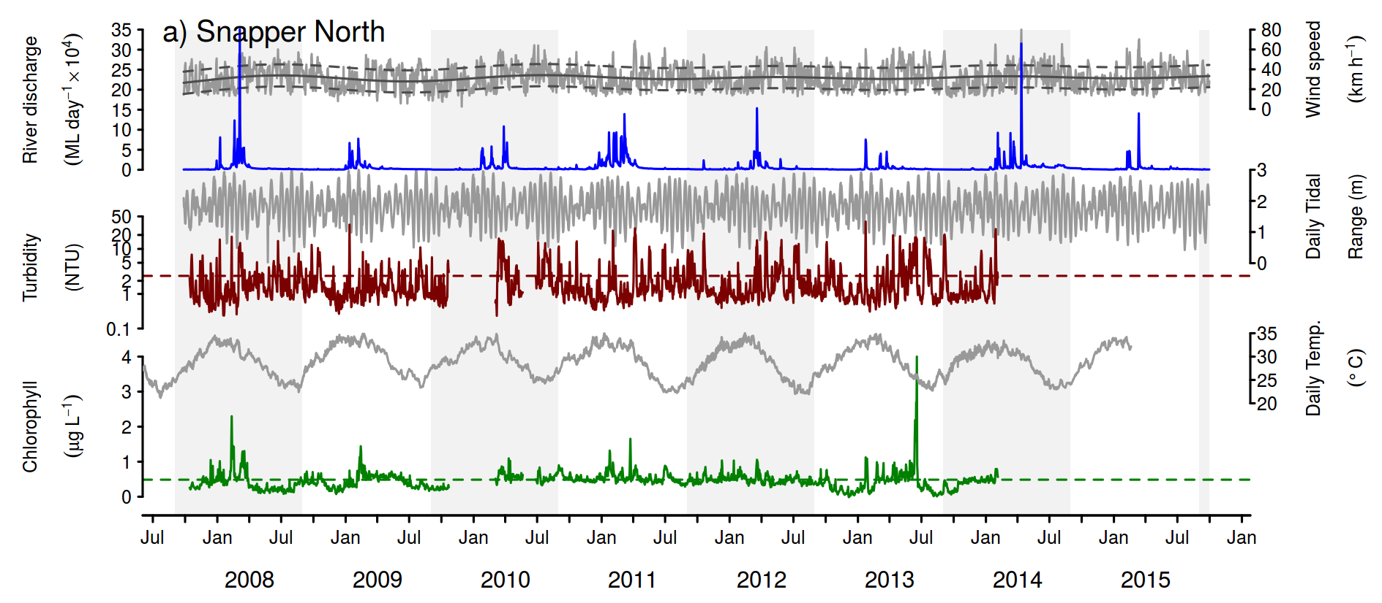
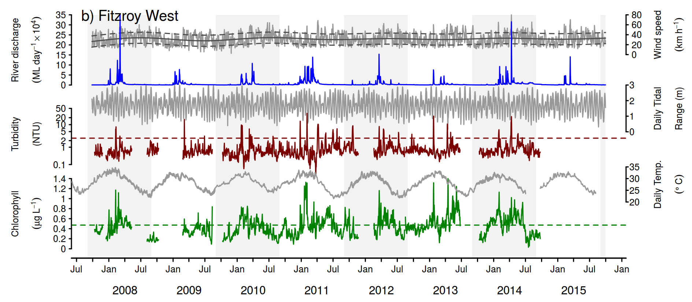
Figure A2 5: Time series of daily means of chlorophyll (green line) and turbidity (red line) collected by ECO FLNTUSB instruments.
Additional panels represent daily discharge from nearest rivers (blue line) and daily wind speeds (grey line,) from the nearest weather stations. Horizontal green and red lines are the GBR Water Quality Guidelines values (GBRMPA 2010). Turbidity trigger value (red line, 1.5 NTU) was derived by transforming the suspended solids trigger value (see Schaffelke et al., 2009). Plots a-n represent locations of FLNTUUSB instruments; a) Snapper North, b) Fitzroy West, c) High West, d) Franklands West, e) Dunk North, f) Palms West, g) Pandora, h) Magnetic, i) Double Cone, j) Daydream, k) Pine, l) Barren, m) Keppels South, n) Pelican.

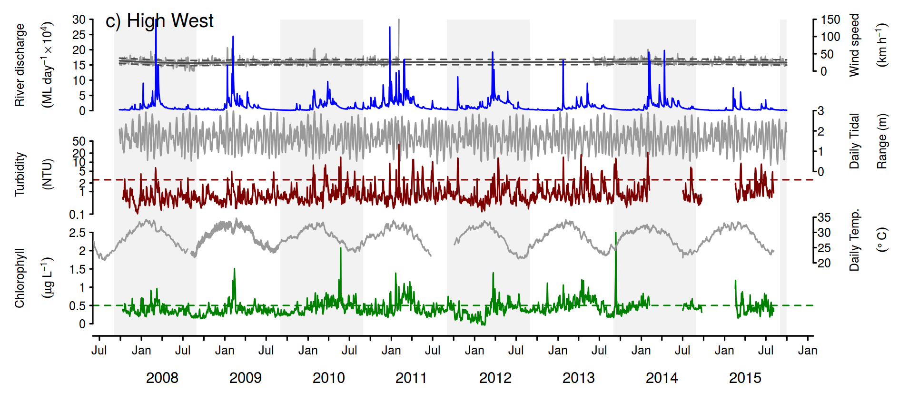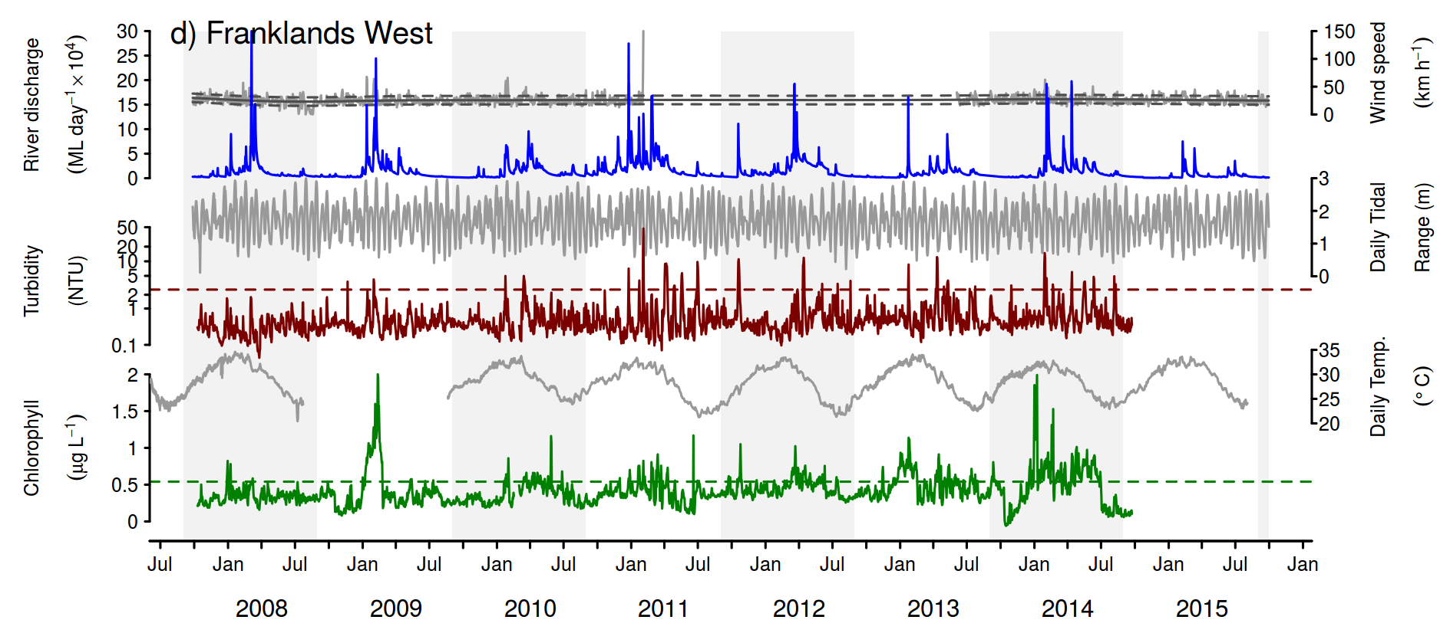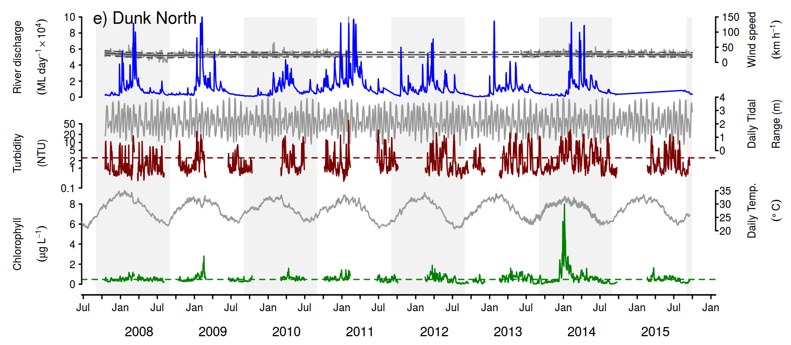
Figure A2-4: Continued - c) High West, d) Franklands West, e) Dunk North

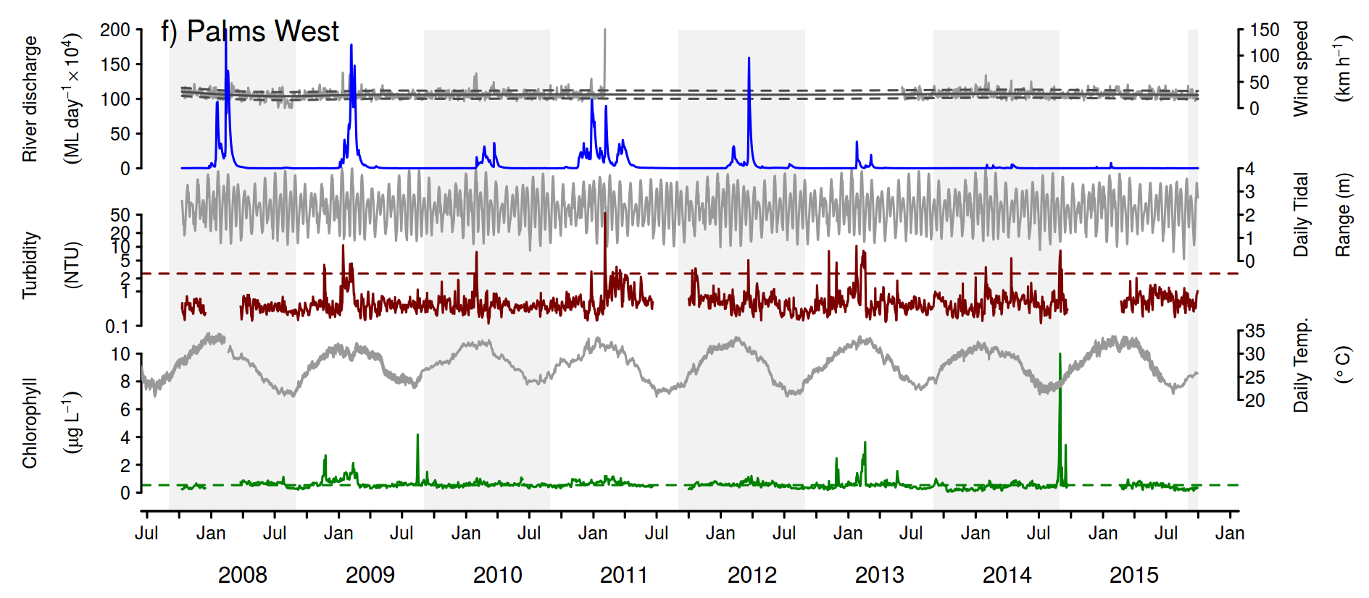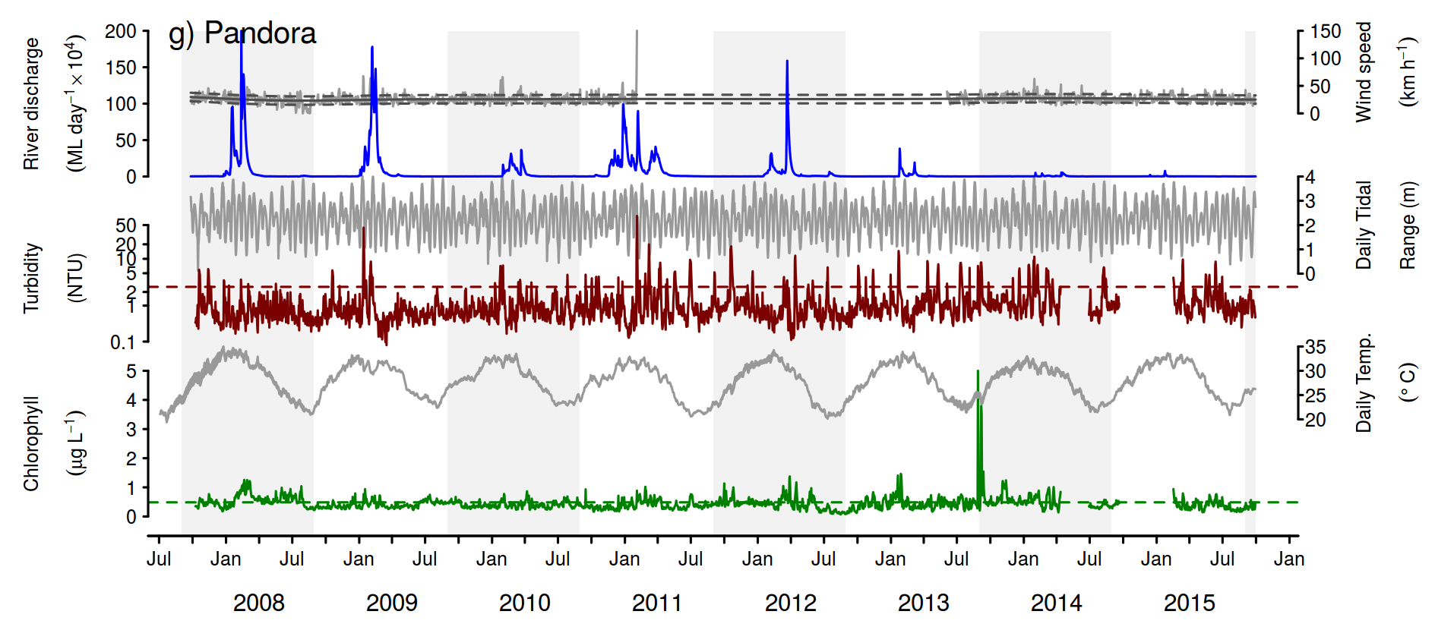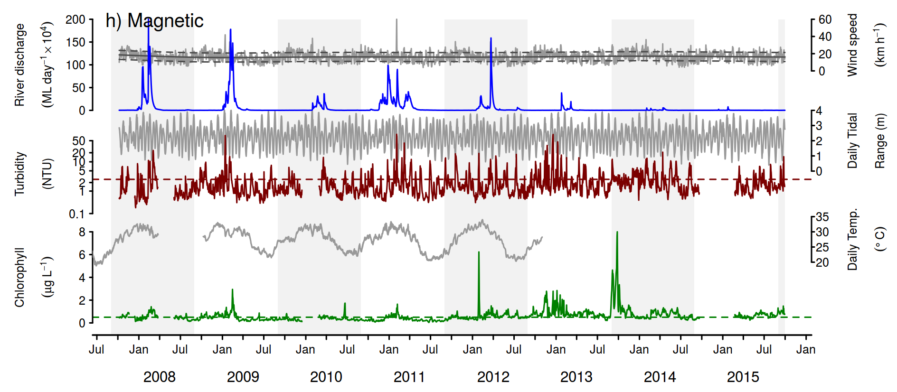

Figure A2-4: Continued - f) Palms West, g) Pandora, h) Magnetic

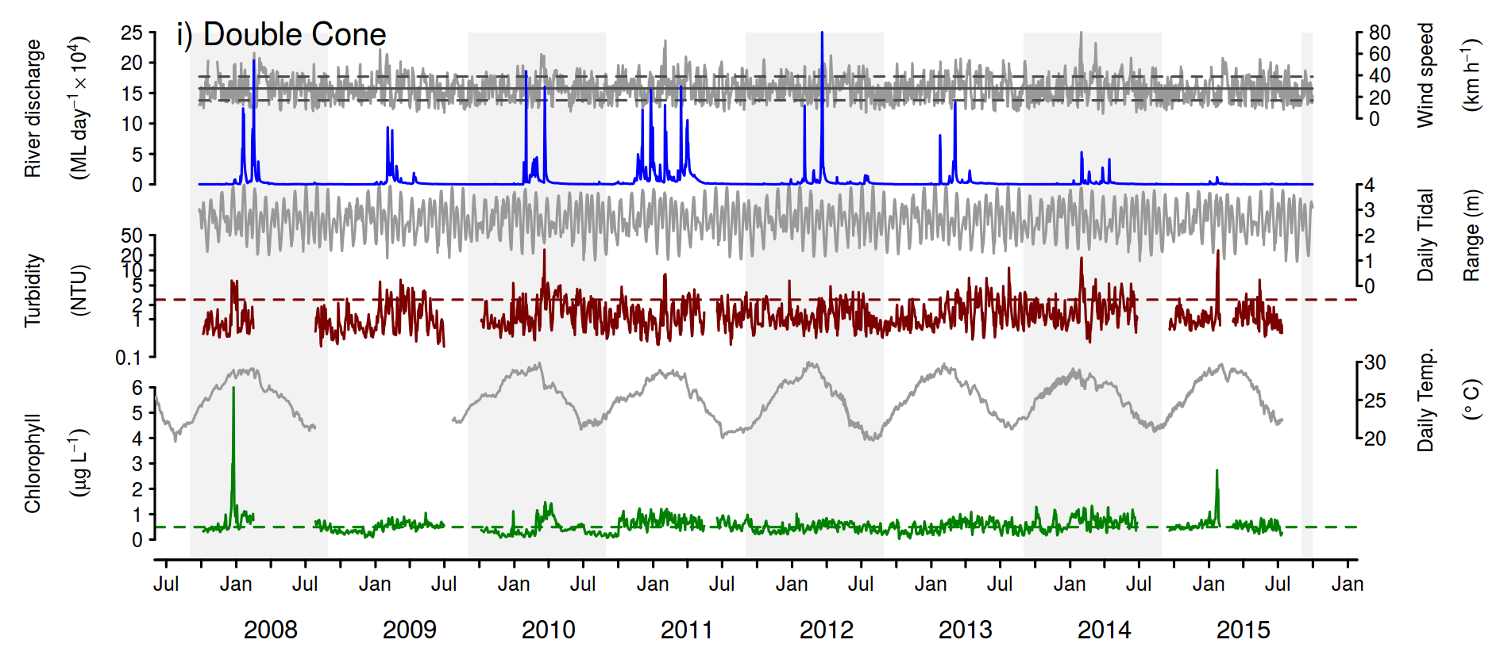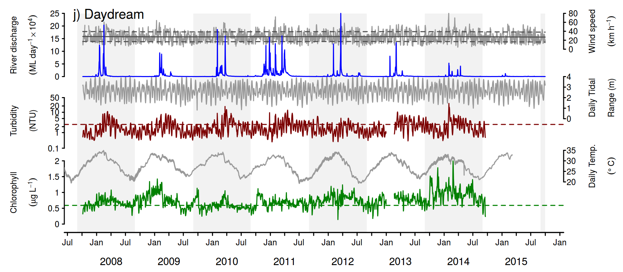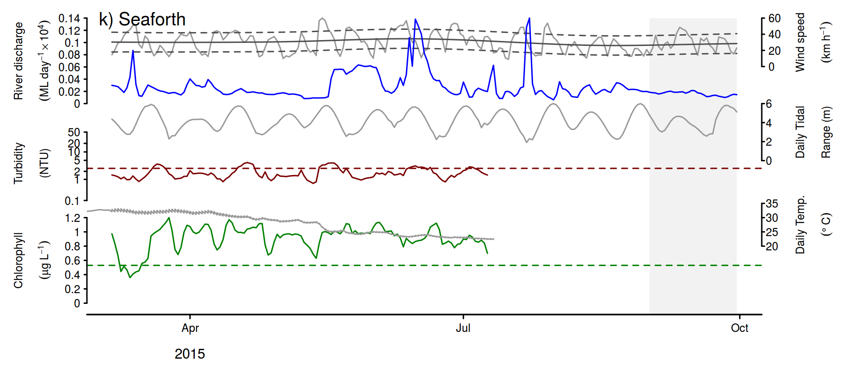
Figure A2-4: Continued - i) Double Cone, j) Daydream Is, k) Seaforth

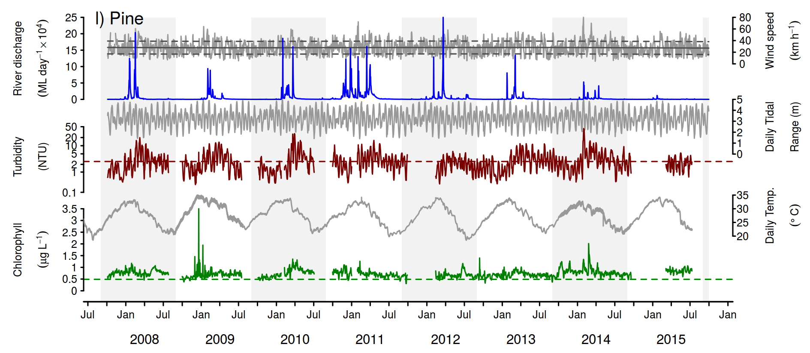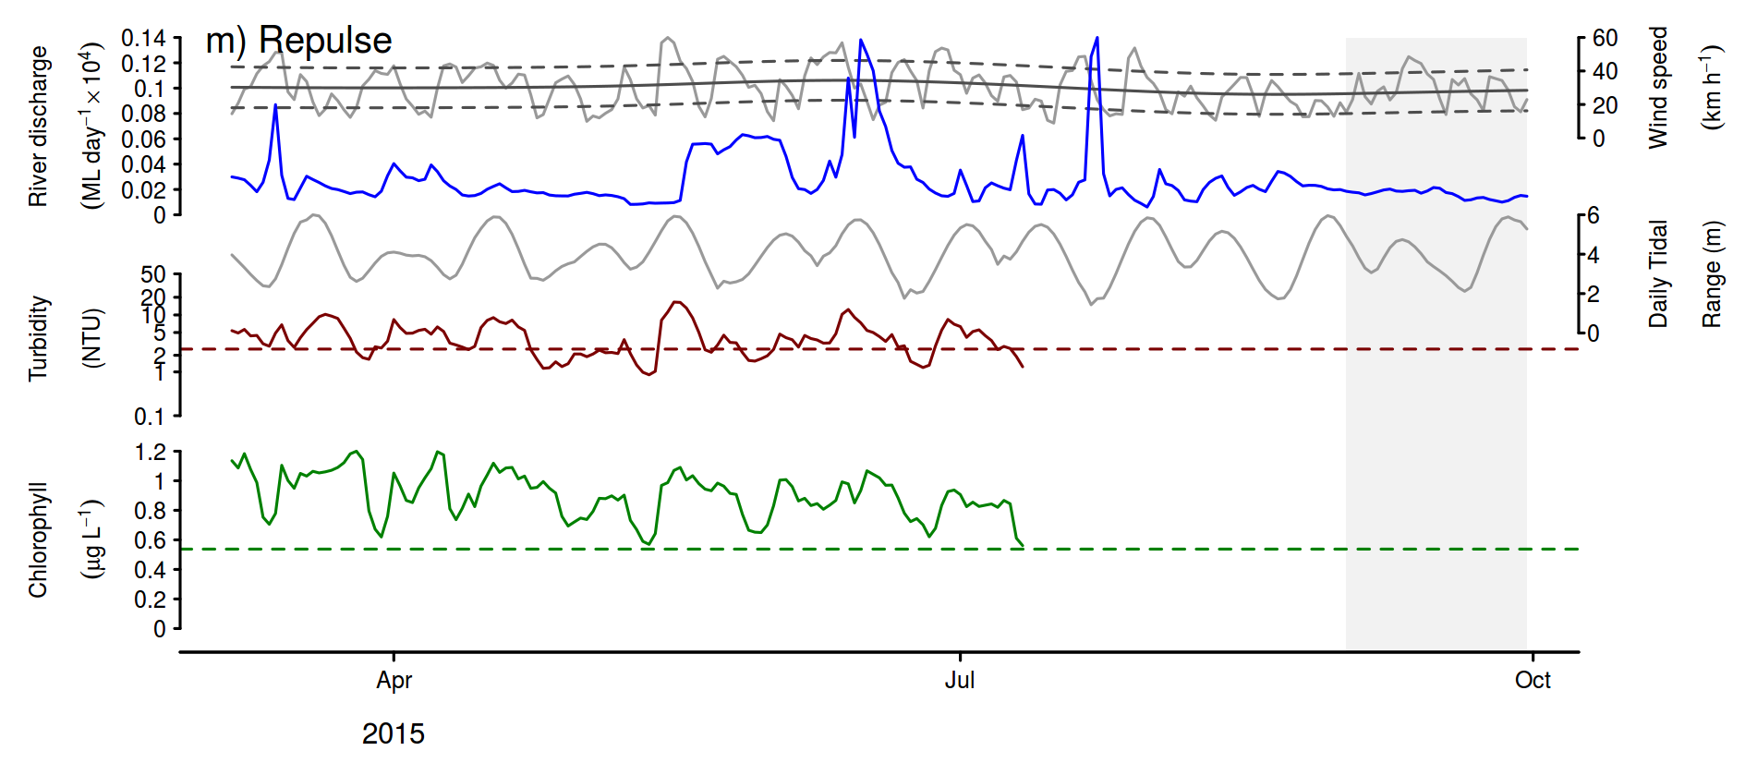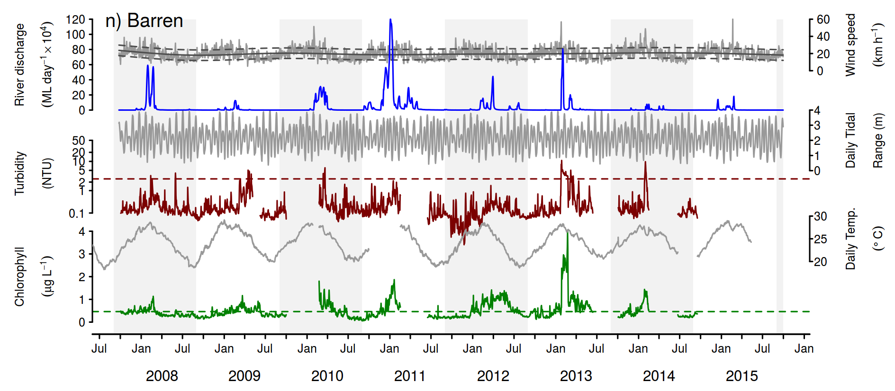
Figure A2-4: Continued - L) Pine, j) Repulse, k) Barren

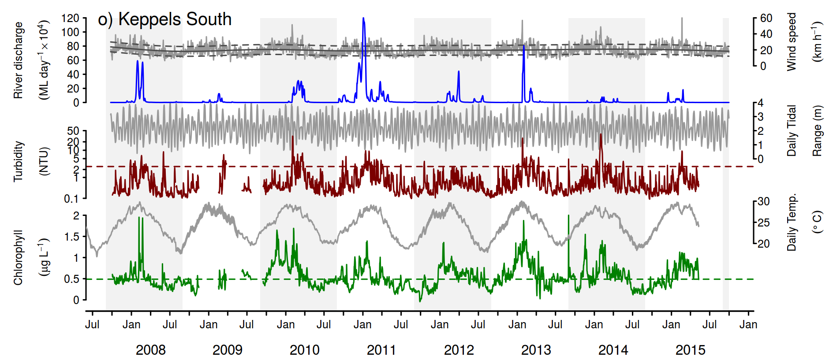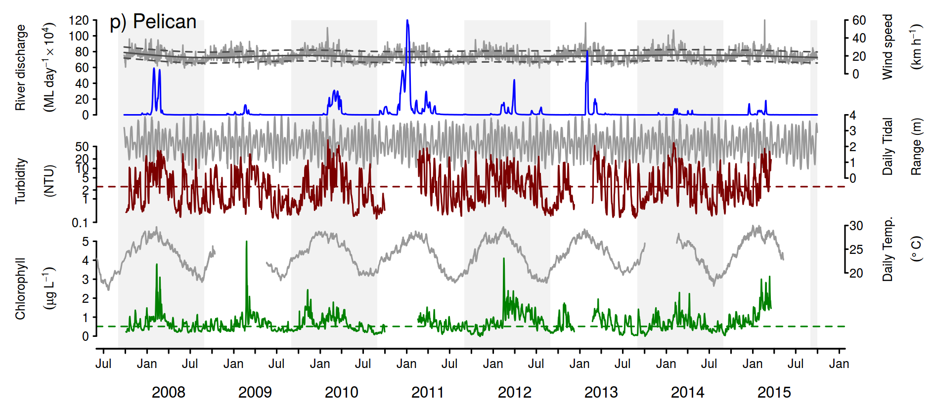
Figure A2-4: Continued - o) Keppels south, p) Peilcan.

Figure A2 6: Time series of daily means of temperature (red line) and salinity (blue line) derived from the Sea-Bird Electronics (SBE) CTD profilers.
Plots a-f represent locations of SBE CTD profilers; a) Russell-Mulgrave River mouth, b) High Island, c) Tully River mouth, d) Dunk Island, e) Burdekin River mouth, f) Repulse Island and g) Pine Island. The arrow in b), e) and f) indicates when the position of the instrument was moved to the shallower location.
Figure A2-5 Continued - f) Repulse Island and g) Pine Island.

Table A2 5: Summary of data collected during the 2014-2015 wet season under the MMP program.
Minimum (min), maximum (max), mean, median, standard deviation (SD) and the number of samples are calculated over multiple sites and multiple dates within each river plume water surface and are provided as a guidance of the range of values within each sampling transect. Samples taken at the bottom at some Burdekin sites are also presented. Highlighted values are for above guideline thresholds.

Parameters | Stats | Russell-Mulgrave | Tully | Burdekin (surface) | Burdekin (bottom)
Temperature (˚C) | Min. | 26.10 | 27.60
Temperature (˚C) | Max. | 29.80 | 30.40
Temperature (˚C) | Mean | 28.56 | 29.19
Temperature (˚C) | Median | 28.90 | 29.20
Temperature (˚C) | SD | 0.96 | 0.61
Temperature (˚C) | Count | 20 | 29 | 0 | 0
Salinity (PSU) | Min. | 0.20 | 1.20 | 35.80 | 36.30
Salinity (PSU) | Max. | 36.60 | 36.20 | 37.50 | 37.10
Salinity (PSU) | Mean | 27.51 | 32.63 | 36.65 | 36.67
Salinity (PSU) | Median | 35.20 | 35.50 | 36.60 | 36.60
Salinity (PSU) | SD | 13.02 | 8.29 | 0.46 | 0.27
Salinity (PSU) | Count | 23 | 29 | 27 | 9
Underwater Light Extinction Coefficient (/m) | Min. | 0.13 | 0.10 | 0.08
Underwater Light Extinction Coefficient (/m) | Max. | 1.70 | 1.44 | 1.98
Underwater Light Extinction Coefficient (/m) | Mean | 0.57 | 0.54 | 0.61
Underwater Light Extinction Coefficient (/m) | Median | 0.45 | 0.39 | 0.36
Underwater Light Extinction Coefficient (/m) | SD | 0.47 | 0.40 | 0.53
Underwater Light Extinction Coefficient (/m) | Count | 20 | 29 | 15 | 0
Coloured Dissolved Organic Matter (/m) | Min. | 0.04 | 0.03 | 0.03 | 0.05
Coloured Dissolved Organic Matter (/m) | Max. | 1.20 | 1.84 | 0.22 | 0.13
Coloured Dissolved Organic Matter (/m) | Mean | 0.29 | 0.20 | 0.09 | 0.08
Coloured Dissolved Organic Matter (/m) | Median | 0.09 | 0.11 | 0.08 | 0.07
Coloured Dissolved Organic Matter (/m) | SD | 0.37 | 0.33 | 0.05 | 0.03
Coloured Dissolved Organic Matter (/m) | Count | 21 | 28 | 22 | 7
Total Suspended Solids (mg/L) | Min. | 0.00 | 1.90 | 1.10 | 0.70
Total Suspended Solids (mg/L) | Max. | 11.00 | 12.00 | 21.00 | 7.90
Total Suspended Solids (mg/L) | Mean | 4.13 | 4.77 | 7.02 | 3.89
Total Suspended Solids (mg/L) | Median | 3.30 | 3.60 | 4.35 | 3.60
Total Suspended Solids (mg/L) | SD | 2.86 | 2.84 | 5.05 | 1.98
Total Suspended Solids (mg/L) | Count | 23 | 29 | 26 | 9
Chlorophyll-a (µg/L) | Min. | 0.23 | 0.20 | 0.20 | 0.20
Chlorophyll-a (µg/L) | Max. | 2.28 | 3.62 | 1.31 | 0.98
Chlorophyll-a (µg/L) | Mean | 0.73 | 0.92 | 0.70 | 0.55
Chlorophyll-a (µg/L) | Median | 0.55 | 0.76 | 0.68 | 0.46
Chlorophyll-a (µg/L) | SD | 0.46 | 0.72 | 0.29 | 0.26
Chlorophyll-a (µg/L) | Count | 23 | 29 | 27 | 9
Dissolved Inorganic Nitrogen (µg/L) | Min. | 5.00 | 4.00 | 5.00 | 10.00
Dissolved Inorganic Nitrogen (µg/L) | Max. | 364.00 | 185.00 | 29.00 | 26.00
Dissolved Inorganic Nitrogen (µg/L) | Mean | 74.43 | 26.00 | 13.22 | 15.44
Dissolved Inorganic Nitrogen (µg/L) | Median | 15.00 | 12.00 | 13.00 | 15.00
Dissolved Inorganic Nitrogen (µg/L) | SD | 108.88 | 42.21 | 4.81 | 4.56
Dissolved Inorganic Nitrogen (µg/L) | Count | 23 | 29 | 27 | 9
Dissolved Inorganic Phosphorus (µg/L) | Min. | 2.00 | 2.00 | 2.00 | 2.00
Dissolved Inorganic Phosphorus (µg/L) | Max. | 10.00 | 7.00 | 6.00 | 5.00
Dissolved Inorganic Phosphorus (µg/L) | Mean | 4.26 | 3.97 | 3.56 | 3.33
Dissolved Inorganic Phosphorus (µg/L) | Median | 4.00 | 4.00 | 3.00 | 3.00
Dissolved Inorganic Phosphorus (µg/L) | SD | 1.76 | 1.35 | 1.12 | 1.12
Dissolved Inorganic Phosphorus (µg/L) | Count | 23 | 29 | 27 | 9
Total Nitrogen (µg/L) | Min. | 113.00 | 107.00 | 87.00 | 121.00
Total Nitrogen (µg/L) | Max. | 647.00 | 409.00 | 257.00 | 225.00
Total Nitrogen (µg/L) | Mean | 212.09 | 156.79 | 148.19 | 150.33
Total Nitrogen (µg/L) | Median | 137.00 | 144.00 | 140.00 | 134.00
Total Nitrogen (µg/L) | SD | 156.04 | 57.07 | 29.44 | 34.71
Total Nitrogen (µg/L) | Count | 23 | 29 | 27 | 9
Total Phosphorus (µg/L) | Min. | 4.00 | 4.00 | 4.00 | 5.00
Total Phosphorus (µg/L) | Max. | 20.00 | 25.00 | 15.00 | 9.00
Total Phosphorus (µg/L) | Mean | 9.13 | 8.52 | 8.07 | 6.56
Total Phosphorus (µg/L) | Median | 8.00 | 8.00 | 7.00 | 6.00
Total Phosphorus (µg/L) | SD | 4.80 | 3.92 | 2.35 | 1.42
Total Phosphorus (µg/L) | Count | 23 | 29 | 27 | 9
Particulate Nitrogen (µg/L) | Min. | 1.00 | 1.00 | 1.00 | 1.00
Particulate Nitrogen (µg/L) | Max. | 73.00 | 99.00 | 100.00 | 64.00
Particulate Nitrogen (µg/L) | Mean | 20.35 | 31.14 | 32.52 | 21.33
Particulate Nitrogen (µg/L) | Median | 14.00 | 27.00 | 30.00 | 17.00
Particulate Nitrogen (µg/L) | SD | 19.01 | 26.25 | 27.65 | 21.41
Particulate Nitrogen (µg/L) | Count | 23 | 29 | 27 | 9
Particulate Phosphorus (µg/L) | Min. | 0.00 | 0.00 | 0.00 | 0.00
Particulate Phosphorus (µg/L) | Max. | 14.00 | 9.00 | 7.00 | 4.00
Particulate Phosphorus (µg/L) | Mean | 3.48 | 2.64 | 2.15 | 1.22
Particulate Phosphorus (µg/L) | Median | 2.00 | 2.00 | 1.00 | 1.00
Particulate Phosphorus (µg/L) | SD | 3.93 | 2.26 | 1.85 | 1.09
Particulate Phosphorus (µg/L) | Count | 23 | 28 | 27 | 9
Silica (mg/L) | Min. | 2.00 | 2.00 | 1.00 | 1.00
Silica (mg/L) | Max. | 160.00 | 213.00 | 16.00 | 8.00
Silica (mg/L) | Mean | 35.41 | 24.79 | 5.59 | 4.22
Silica (mg/L) | Median | 5.50 | 8.00 | 5.00 | 4.00
Silica (mg/L) | SD | 55.43 | 48.78 | 2.94 | 1.99
Silica (mg/L) | Count | 22 | 29 | 27 | 9

Table A2 6: Interim water quality index for each water quality sampling location, calculated using AIMS wet and dry season samples.
Summary of four-year running means and calculation of the index. See Section 2.2 for details on index calculation. Data range = from start of the program (2005 for direct water sampling data or 2007 for water quality instruments) to September of each respective year (June for 2015). Red shaded cells are running means that did not comply with the GBRMPA Water Quality Guidelines for the Great Barrier Reef Marine Park and Queensland guideline values (DERM 2009, GBRMPA 2010). Values that did not comply with the Guidelines received a score of “1”; those that did comply were scored as “0”. The scores for suspended solids, turbidity and Secchi depth were averaged for a “combined turbidity score”. The sum of these combined scores and the scores for PN, PP and chlorophyll yielded a total score per site. This total score was converted into a percentage rating and colour-coded (see Section 2.2. for details). Empty cells indicate data not available
 |  | Depth-weighted means |  |  |  |  |  |  | Indicator scores
Reef | Date range | NOx | PN | PP | Chl a | SS | Secchi | Turbidity | NOx | PN | PP | Chl a | SS | Secchi | Turbidity | Combined Turbidity | Total score | Scaled score
Cape Tribulation | 2003-2006 | 0.01 | 0.87 | 0.06 | 0.31 | 1.9 | 10 |  | 1 | 0.71 | 0.62 | 0.54 | 0.07 | 0 |  | 0.07 | 2.94 | 0.59
Cape Tribulation | 2004-2007 | 0.02 | 0.84 | 0.06 | 0.29 | 1.57 | 10 |  | 1 | 0.77 | 0.58 | 0.61 | 0.35 | 0 |  | 0.35 | 3.31 | 0.66
Cape Tribulation | 2005-2008 | 0.03 | 0.9 | 0.08 | 0.33 | 1.79 | 7.5 |  | 1 | 0.67 | 0.18 | 0.43 | 0.16 | -0.42 |  | 0.16 | 2.44 | 0.49
Cape Tribulation | 2006-2009 | 0.04 | 0.88 | 0.08 | 0.33 | 1.65 | 6.63 |  | 1 | 0.69 | 0.23 | 0.45 | 0.28 | -0.59 |  | 0.28 | 2.65 | 0.53
Cape Tribulation | 2007-2010 | 0.04 | 0.9 | 0.08 | 0.39 | 1.44 | 6.72 |  | 1 | 0.67 | 0.1 | 0.22 | 0.48 | -0.57 |  | 0.48 | 2.47 | 0.49
Cape Tribulation | 2008-2011 | 0.04 | 0.98 | 0.09 | 0.46 | 1.54 | 6.3 |  | 1 | 0.54 | -0.02 | -0.02 | 0.37 | -0.67 |  | 0.37 | 1.88 | 0.38
Cape Tribulation | 2009-2012 | 0.04 | 0.93 | 0.09 | 0.44 | 1.22 | 6.39 |  | 1 | 0.63 | 0.07 | 0.05 | 0.72 | -0.65 |  | 0.72 | 2.47 | 0.49
Cape Tribulation | 2010-2013 | 0.05 | 0.91 | 0.09 | 0.45 | 1.23 | 7.17 |  | 1 | 0.64 | 0.06 | 0.01 | 0.7 | -0.48 |  | 0.7 | 2.41 | 0.48
Cape Tribulation | 2011-2014 | 0.07 | 0.88 | 0.09 | 0.42 | 1.19 | 7.29 |  | 0.94 | 0.7 | -0.02 | 0.1 | 0.75 | -0.46 |  | 0.75 | 2.48 | 0.5
Cape Tribulation | 2012-2015 | 0.09 | 0.84 | 0.1 | 0.4 | 1.45 | 7.29 |  | 0.68 | 0.77 | -0.08 | 0.16 | 0.46 | -0.46 |  | 0.46 | 2 | 0.4
Snapper North | 2003-2006
Snapper North | 2004-2007 | 0.01 | 1.36 | 0.1 | 0.29 | 1.58 | 4 |  | 1 | 0.07 | -0.21 | 0.63 | 0.34 | -1 |  | 0.34 | 1.82 | 0.36
Snapper North | 2005-2008 | 0.07 | 0.86 | 0.08 | 0.31 | 1.24 | 6.75 | 2.09 | 0.96 | 0.74 | 0.22 | 0.56 | 0.69 | -0.57 | -0.48 | 0.11 | 2.58 | 0.52
Snapper North | 2006-2009 | 0.13 | 0.81 | 0.07 | 0.29 | 1.2 | 6.43 | 2.1 | 0.13 | 0.81 | 0.3 | 0.62 | 0.74 | -0.64 | -0.48 | 0.13 | 2 | 0.4
Snapper North | 2007-2010 | 0.13 | 0.84 | 0.07 | 0.31 | 1.12 | 6.8 | 2.2 | 0.09 | 0.76 | 0.3 | 0.53 | 0.83 | -0.56 | -0.55 | 0.14 | 1.81 | 0.36
Snapper North | 2008-2011 | 0.16 | 0.82 | 0.07 | 0.36 | 1.27 | 6.45 | 2.29 | -0.2 | 0.79 | 0.31 | 0.31 | 0.66 | -0.63 | -0.61 | 0.03 | 1.24 | 0.25
Snapper North | 2009-2012 | 0.19 | 0.84 | 0.07 | 0.36 | 1.25 | 5.64 | 2.34 | -0.45 | 0.76 | 0.28 | 0.31 | 0.68 | -0.83 | -0.64 | 0.02 | 0.93 | 0.19
Snapper North | 2010-2013 | 0.21 | 0.83 | 0.07 | 0.36 | 1.25 | 5.73 | 2.44 | -0.54 | 0.79 | 0.32 | 0.32 | 0.67 | -0.8 | -0.7 | -0.01 | 0.87 | 0.17
Snapper North | 2011-2014 | 0.23 | 0.82 | 0.08 | 0.4 | 1.35 | 5.05 | 2.57 | -0.69 | 0.8 | 0.26 | 0.19 | 0.56 | -0.99 | -0.78 | -0.11 | 0.45 | 0.09
Snapper North | 2012-2015 | 0.21 | 0.84 | 0.08 | 0.4 | 1.41 | 4.92 | 2.6 | -0.54 | 0.77 | 0.15 | 0.18 | 0.51 | -1 | -0.79 | -0.14 | 0.42 | 0.08
Port Douglas | 2003-2006 | 0.02 | 1.09 | 0.06 | 0.29 | 1.68 | 9.5 |  | 1 | 0.39 | 0.52 | 0.65 | 0.25 | -0.07 |  | 0.25 | 2.81 | 0.56
Port Douglas | 2004-2007 | 0.01 | 1.07 | 0.07 | 0.28 | 1.57 | 8.67 |  | 1 | 0.42 | 0.42 | 0.67 | 0.35 | -0.21 |  | 0.35 | 2.85 | 0.57
Port Douglas | 2005-2008 | 0.02 | 0.92 | 0.06 | 0.28 | 1.38 | 8.5 |  | 1 | 0.64 | 0.5 | 0.69 | 0.54 | -0.23 |  | 0.54 | 3.36 | 0.67
Port Douglas | 2006-2009 | 0.03 | 0.9 | 0.07 | 0.28 | 1.36 | 7.89 |  | 1 | 0.66 | 0.39 | 0.69 | 0.56 | -0.34 |  | 0.56 | 3.31 | 0.66
Port Douglas | 2007-2010 | 0.03 | 0.9 | 0.07 | 0.32 | 1.23 | 7.2 |  | 1 | 0.67 | 0.27 | 0.49 | 0.7 | -0.47 |  | 0.7 | 3.13 | 0.63
Port Douglas | 2008-2011 | 0.03 | 0.89 | 0.08 | 0.36 | 1.23 | 6.71 |  | 1 | 0.68 | 0.22 | 0.32 | 0.7 | -0.58 |  | 0.7 | 2.91 | 0.58
Port Douglas | 2009-2012 | 0.04 | 0.89 | 0.08 | 0.38 | 1.31 | 6.12 |  | 1 | 0.68 | 0.13 | 0.26 | 0.61 | -0.71 |  | 0.61 | 2.68 | 0.54
Port Douglas | 2010-2013 | 0.05 | 0.87 | 0.08 | 0.4 | 1.35 | 6.17 |  | 1 | 0.72 | 0.14 | 0.19 | 0.56 | -0.7 |  | 0.56 | 2.6 | 0.52
Port Douglas | 2011-2014 | 0.06 | 0.85 | 0.09 | 0.42 | 1.43 | 5.96 |  | 1 | 0.75 | 0.08 | 0.09 | 0.49 | -0.75 |  | 0.49 | 2.41 | 0.48
Port Douglas | 2012-2015 | 0.1 | 0.86 | 0.09 | 0.42 | 1.54 | 5.71 |  | 0.45 | 0.73 | 0.02 | 0.11 | 0.38 | -0.81 |  | 0.38 | 1.69 | 0.34
Double | 2003-2006 | 0.01 | 0.91 | 0.05 | 0.37 | 1.38 | 14 |  | 1 | 0.65 | 0.92 | 0.28 | 0.54 | 0.49 |  | 0.54 | 3.38 | 0.68
Double | 2004-2007 | 0.01 | 0.93 | 0.06 | 0.36 | 1.33 | 9.5 |  | 1 | 0.62 | 0.65 | 0.31 | 0.59 | -0.07 |  | 0.59 | 3.18 | 0.64
Double | 2005-2008 | 0.01 | 0.91 | 0.06 | 0.35 | 1.18 | 11 |  | 1 | 0.66 | 0.53 | 0.38 | 0.76 | 0.14 |  | 0.76 | 3.33 | 0.67
Double | 2006-2009 | 0.02 | 0.81 | 0.06 | 0.32 | 1.19 | 9.5 |  | 1 | 0.82 | 0.51 | 0.5 | 0.75 | -0.07 |  | 0.75 | 3.57 | 0.71
Double | 2007-2010 | 0.02 | 0.8 | 0.07 | 0.32 | 1.16 | 8.67 |  | 1 | 0.83 | 0.36 | 0.51 | 0.79 | -0.21 |  | 0.79 | 3.49 | 0.7
Double | 2008-2011 | 0.02 | 0.81 | 0.07 | 0.37 | 1.16 | 8.09 |  | 1 | 0.82 | 0.3 | 0.3 | 0.79 | -0.31 |  | 0.79 | 3.21 | 0.64
Double | 2009-2012 | 0.03 | 0.79 | 0.08 | 0.38 | 1.14 | 7.12 |  | 1 | 0.86 | 0.26 | 0.25 | 0.81 | -0.49 |  | 0.81 | 3.18 | 0.64
Double | 2010-2013 | 0.05 | 0.81 | 0.08 | 0.39 | 1.21 | 7 |  | 1 | 0.83 | 0.2 | 0.21 | 0.73 | -0.51 |  | 0.73 | 2.96 | 0.59
Double | 2011-2014 | 0.08 | 0.8 | 0.08 | 0.44 | 1.2 | 6.62 |  | 1 | 0.83 | 0.13 | 0.04 | 0.74 | -0.59 |  | 0.74 | 2.74 | 0.55
Double | 2012-2015 | 0.1 | 0.82 | 0.08 | 0.41 | 1.28 | 6.67 |  | 1 | 0.8 | 0.13 | 0.15 | 0.64 | -0.58 |  | 0.64 | 2.72 | 0.54
Green | 2003-2006 | 0.01 | 0.62 | 0.05 | 0.19 | 1.12 | 22 |  | 1 | 1 | 0.88 | 1 | 0.84 | 1 |  | 0.84 | 4.72 | 0.94
Green | 2004-2007 | 0.02 | 0.61 | 0.04 | 0.17 | 0.88 | 19.33 |  | 1 | 1 | 1 | 1 | 1 | 0.95 |  | 1 | 5 | 1
Green | 2005-2008 | 0.04 | 0.67 | 0.05 | 0.25 | 0.74 | 15.83 |  | 1 | 1 | 0.84 | 0.87 | 1 | 0.66 |  | 1 | 4.71 | 0.94
Green | 2006-2009 | 0.04 | 0.64 | 0.05 | 0.22 | 0.56 | 15.33 |  | 1 | 1 | 0.95 | 1 | 1 | 0.62 |  | 1 | 4.95 | 0.99
Green | 2007-2010 | 0.04 | 0.67 | 0.05 | 0.23 | 0.33 | 13.7 |  | 1 | 1 | 0.94 | 0.95 | 1 | 0.45 |  | 1 | 4.89 | 0.98
Green | 2008-2011 | 0.05 | 0.7 | 0.05 | 0.28 | 0.34 | 12.67 |  | 1 | 1 | 0.77 | 0.67 | 1 | 0.34 |  | 1 | 4.44 | 0.89
Green | 2009-2012 | 0.06 | 0.68 | 0.05 | 0.28 | 0.3 | 12.38 |  | 1 | 1 | 0.77 | 0.66 | 1 | 0.31 |  | 1 | 4.43 | 0.89
Green | 2010-2013 | 0.07 | 0.71 | 0.05 | 0.29 | 0.35 | 11.46 |  | 1 | 1 | 0.76 | 0.64 | 1 | 0.2 |  | 1 | 4.4 | 0.88
Green | 2011-2014 | 0.1 | 0.72 | 0.06 | 0.33 | 0.4 | 10.5 |  | 1 | 1 | 0.69 | 0.44 | 1 | 0.07 |  | 1 | 4.12 | 0.82
Green | 2012-2015 | 0.1 | 0.73 | 0.06 | 0.33 | 0.51 | 10.29 |  | 1 | 0.97 | 0.71 | 0.46 | 1 | 0.04 |  | 1 | 4.14 | 0.83
Yorkey's Knob | 2003-2006 | 0.01 | 1.48 | 0.14 | 0.59 | 4.26 | 3.5 |  | 1 | -0.05 | -0.6 | -0.4 | -1 | -1 |  | -1 | -1.06 | -0.21
Yorkey's Knob | 2004-2007 | 0.02 | 1.35 | 0.13 | 0.55 | 3.6 | 3.33 |  | 1 | 0.09 | -0.51 | -0.28 | -0.85 | -1 |  | -0.85 | -0.56 | -0.11
Yorkey's Knob | 2005-2008 | 0.02 | 1.25 | 0.12 | 0.5 | 2.81 | 4.17 |  | 1 | 0.19 | -0.35 | -0.16 | -0.49 | -1 |  | -0.49 | 0.19 | 0.04
Yorkey's Knob | 2006-2009 | 0.03 | 1.22 | 0.12 | 0.52 | 2.91 | 4 |  | 1 | 0.23 | -0.41 | -0.2 | -0.54 | -1 |  | -0.54 | 0.08 | 0.02
Yorkey's Knob | 2007-2010 | 0.03 | 1.1 | 0.12 | 0.52 | 2.73 | 3.75 |  | 1 | 0.38 | -0.4 | -0.21 | -0.45 | -1 |  | -0.45 | 0.33 | 0.07
Yorkey's Knob | 2008-2011 | 0.03 | 1.12 | 0.12 | 0.58 | 3.06 | 3.96 |  | 1 | 0.35 | -0.43 | -0.36 | -0.61 | -1 |  | -0.61 | -0.06 | -0.01
Yorkey's Knob | 2009-2012 | 0.04 | 1.15 | 0.13 | 0.62 | 3.06 | 3.67 |  | 1 | 0.32 | -0.51 | -0.46 | -0.62 | -1 |  | -0.62 | -0.27 | -0.05
Yorkey's Knob | 2010-2013 | 0.06 | 1.12 | 0.12 | 0.6 | 2.75 | 3.96 |  | 1 | 0.36 | -0.46 | -0.41 | -0.46 | -1 |  | -0.46 | 0.03 | 0.01
Yorkey's Knob | 2011-2014 | 0.09 | 1.12 | 0.13 | 0.64 | 2.66 | 4.12 |  | 0.61 | 0.35 | -0.47 | -0.5 | -0.41 | -1 |  | -0.41 | -0.42 | -0.08
Yorkey's Knob | 2012-2015 | 0.11 | 1.12 | 0.13 | 0.62 | 2.58 | 3.67 |  | 0.32 | 0.36 | -0.55 | -0.46 | -0.37 | -1 |  | -0.37 | -0.69 | -0.14
Fairlead Buoy | 2003-2006 | 0.01 | 1.15 | 0.09 | 0.47 | 2.68 | 5.5 |  | 1 | 0.32 | 0.06 | -0.06 | -0.42 | -0.86 |  | -0.42 | 0.9 | 0.18
Fairlead Buoy | 2004-2007 | 0.01 | 1.17 | 0.11 | 0.44 | 2.75 | 3.75 |  | 1 | 0.28 | -0.23 | 0.02 | -0.46 | -1 |  | -0.46 | 0.61 | 0.12
Fairlead Buoy | 2005-2008 | 0.01 | 1.17 | 0.11 | 0.47 | 2.7 | 4.5 |  | 1 | 0.29 | -0.3 | -0.06 | -0.43 | -1 |  | -0.43 | 0.5 | 0.1
Fairlead Buoy | 2006-2009 | 0.02 | 1.12 | 0.12 | 0.47 | 3.1 | 4.06 |  | 1 | 0.35 | -0.4 | -0.06 | -0.63 | -1 |  | -0.63 | 0.26 | 0.05
Fairlead Buoy | 2007-2010 | 0.02 | 1.14 | 0.14 | 0.49 | 3.82 | 3.65 |  | 1 | 0.32 | -0.62 | -0.14 | -0.93 | -1 |  | -0.93 | -0.37 | -0.07
Fairlead Buoy | 2008-2011 | 0.03 | 1.16 | 0.14 | 0.55 | 4.46 | 3.69 |  | 1 | 0.3 | -0.68 | -0.3 | -1 | -1 |  | -1 | -0.68 | -0.14
Fairlead Buoy | 2009-2012 | 0.04 | 1.18 | 0.15 | 0.56 | 4.42 | 3.35 |  | 1 | 0.27 | -0.72 | -0.31 | -1 | -1 |  | -1 | -0.75 | -0.15
Fairlead Buoy | 2010-2013 | 0.06 | 1.21 | 0.15 | 0.56 | 4.06 | 3.24 |  | 1 | 0.24 | -0.7 | -0.31 | -1 | -1 |  | -1 | -0.78 | -0.16
Fairlead Buoy | 2011-2014 | 0.08 | 1.15 | 0.14 | 0.6 | 3.6 | 3.53 |  | 0.86 | 0.31 | -0.63 | -0.41 | -0.85 | -1 |  | -0.85 | -0.71 | -0.14
Fairlead Buoy | 2012-2015 | 0.09 | 1.16 | 0.16 | 0.66 | 4.3 | 3.11 |  | 0.63 | 0.3 | -0.82 | -0.56 | -1 | -1 |  | -1 | -1.44 | -0.29
Fitzroy West | 2003-2006 | 0.01 | 0.82 | 0.05 | 0.4 | 1.59 | 11.5 |  | 1 | 0.79 | 0.81 | 0.16 | 0.33 | 0.2 |  | 0.33 | 3.09 | 0.62
Fitzroy West | 2004-2007 | 0.09 | 0.81 | 0.05 | 0.35 | 1.26 | 10.67 |  | 0.71 | 0.82 | 0.75 | 0.35 | 0.67 | 0.09 |  | 0.67 | 3.31 | 0.66
Fitzroy West | 2005-2008 | 0.06 | 0.82 | 0.06 | 0.37 | 1.16 | 9.67 | 0.84 | 1 | 0.8 | 0.49 | 0.29 | 0.79 | -0.05 | 0.84 | 0.82 | 3.4 | 0.68
Fitzroy West | 2006-2009 | 0.08 | 0.74 | 0.06 | 0.32 | 1.02 | 10.11 | 0.88 | 0.82 | 0.94 | 0.59 | 0.48 | 0.97 | 0.02 | 0.77 | 0.87 | 3.69 | 0.74
Fitzroy West | 2007-2010 | 0.08 | 0.74 | 0.06 | 0.31 | 0.92 | 8.95 | 0.88 | 0.78 | 0.94 | 0.53 | 0.54 | 1 | -0.16 | 0.77 | 0.88 | 3.68 | 0.74
Fitzroy West | 2008-2011 | 0.11 | 0.74 | 0.06 | 0.3 | 0.85 | 9.05 | 0.94 | 0.39 | 0.94 | 0.53 | 0.59 | 1 | -0.14 | 0.67 | 0.83 | 3.29 | 0.66
Fitzroy West | 2009-2012 | 0.14 | 0.75 | 0.06 | 0.28 | 0.85 | 8.77 | 1.05 | 0.03 | 0.93 | 0.57 | 0.66 | 1 | -0.19 | 0.51 | 0.75 | 2.94 | 0.59
Fitzroy West | 2010-2013 | 0.15 | 0.79 | 0.06 | 0.3 | 0.84 | 8 | 1.08 | -0.1 | 0.86 | 0.52 | 0.58 | 1 | -0.32 | 0.48 | 0.74 | 2.61 | 0.52
Fitzroy West | 2011-2014 | 0.2 | 0.79 | 0.07 | 0.33 | 0.78 | 8.05 | 1.15 | -0.5 | 0.86 | 0.47 | 0.46 | 1 | -0.31 | 0.39 | 0.69 | 1.99 | 0.4
Fitzroy West | 2012-2015 | 0.18 | 0.84 | 0.07 | 0.36 | 0.96 | 8.05 | 1.16 | -0.34 | 0.76 | 0.35 | 0.33 | 1 | -0.31 | 0.37 | 0.68 | 1.78 | 0.36
High West | 2003-2006 | 0.02 | 0.99 | 0.08 | 0.41 | 2.22 | 10.25 |  | 1 | 0.53 | 0.22 | 0.14 | -0.15 | 0.04 |  | -0.15 | 1.75 | 0.35
High West | 2004-2007 | 0.02 | 0.93 | 0.08 | 0.37 | 1.83 | 8.83 |  | 1 | 0.62 | 0.26 | 0.26 | 0.13 | -0.18 |  | 0.13 | 2.27 | 0.45
High West | 2005-2008 | 0.06 | 0.97 | 0.08 | 0.47 | 1.45 | 8.58 | 0.88 | 1 | 0.56 | 0.16 | -0.07 | 0.46 | -0.22 | 0.77 | 0.62 | 2.27 | 0.45
High West | 2006-2009 | 0.1 | 0.91 | 0.08 | 0.45 | 1.33 | 7.89 | 0.82 | 0.48 | 0.66 | 0.15 | 0 | 0.59 | -0.34 | 0.87 | 0.73 | 2.02 | 0.4
High West | 2007-2010 | 0.1 | 0.87 | 0.08 | 0.45 | 1.13 | 7 | 0.89 | 0.55 | 0.71 | 0.13 | -0.01 | 0.83 | -0.51 | 0.75 | 0.79 | 2.17 | 0.43
High West | 2008-2011 | 0.12 | 0.88 | 0.09 | 0.48 | 1.15 | 6.45 | 1.06 | 0.21 | 0.7 | 0.03 | -0.1 | 0.8 | -0.63 | 0.51 | 0.65 | 1.5 | 0.3
High West | 2009-2012 | 0.13 | 0.83 | 0.09 | 0.44 | 1.04 | 6 | 1.14 | 0.12 | 0.79 | 0.08 | 0.04 | 0.95 | -0.74 | 0.4 | 0.67 | 1.71 | 0.34
High West | 2010-2013 | 0.13 | 0.87 | 0.08 | 0.46 | 1.1 | 5.77 | 1.23 | 0.11 | 0.71 | 0.11 | -0.04 | 0.86 | -0.79 | 0.28 | 0.57 | 1.46 | 0.29
High West | 2011-2014 | 0.19 | 0.89 | 0.09 | 0.5 | 1.15 | 5.55 | 1.38 | -0.41 | 0.68 | 0.04 | -0.15 | 0.8 | -0.85 | 0.12 | 0.46 | 0.61 | 0.12
High West | 2012-2015 | 0.2 | 0.94 | 0.08 | 0.5 | 1.52 | 5.96 | 1.34 | -0.47 | 0.6 | 0.09 | -0.15 | 0.4 | -0.75 | 0.16 | 0.28 | 0.37 | 0.07
Franklands West | 2003-2006 | 0.01 | 0.86 | 0.06 | 0.31 | 1.23 | 13 |  | 1 | 0.74 | 0.67 | 0.56 | 0.7 | 0.38 |  | 0.7 | 3.66 | 0.73
Franklands West | 2004-2007 | 0.03 | 0.77 | 0.06 | 0.26 | 1.01 | 11.5 |  | 1 | 0.9 | 0.71 | 0.78 | 0.99 | 0.2 |  | 0.99 | 4.37 | 0.87
Franklands West | 2005-2008 | 0.04 | 0.8 | 0.06 | 0.35 | 0.89 | 10.4 | 0.45 | 1 | 0.83 | 0.58 | 0.38 | 1 | 0.06 | 1 | 1 | 3.79 | 0.76
Franklands West | 2006-2009 | 0.06 | 0.74 | 0.05 | 0.31 | 0.7 | 11.25 | 0.55 | 1 | 0.94 | 0.73 | 0.54 | 1 | 0.17 | 1 | 1 | 4.2 | 0.84
Franklands West | 2007-2010 | 0.07 | 0.75 | 0.06 | 0.32 | 0.59 | 10.35 | 0.6 | 0.98 | 0.93 | 0.6 | 0.47 | 1 | 0.05 | 1 | 1 | 3.98 | 0.8
Franklands West | 2008-2011 | 0.09 | 0.76 | 0.06 | 0.37 | 0.67 | 9.91 | 0.71 | 0.72 | 0.91 | 0.52 | 0.3 | 1 | -0.01 | 1 | 1 | 3.45 | 0.69
Franklands West | 2009-2012 | 0.09 | 0.73 | 0.06 | 0.33 | 0.56 | 9.86 | 0.8 | 0.61 | 0.97 | 0.54 | 0.46 | 1 | -0.02 | 0.9 | 0.95 | 3.53 | 0.71
Franklands West | 2010-2013 | 0.1 | 0.8 | 0.07 | 0.35 | 0.66 | 9.05 | 0.88 | 0.55 | 0.83 | 0.43 | 0.36 | 1 | -0.14 | 0.76 | 0.88 | 3.05 | 0.61
Franklands West | 2011-2014 | 0.12 | 0.82 | 0.07 | 0.4 | 0.66 | 8.7 | 0.96 | 0.31 | 0.79 | 0.37 | 0.17 | 1 | -0.2 | 0.65 | 0.82 | 2.47 | 0.49
Franklands West | 2012-2015 | 0.1 | 0.9 | 0.07 | 0.38 | 0.75 | 8.42 | 0.94 | 0.56 | 0.66 | 0.3 | 0.23 | 1 | -0.25 | 0.68 | 0.84 | 2.59 | 0.52
Dunk North | 2003-2006 | 0.01 | 1.28 | 0.11 | 0.72 | 3.22 | 5 |  | 1 | 0.16 | -0.31 | -0.68 | -0.69 | -1 |  | -0.69 | -0.52 | -0.1
Dunk North | 2004-2007 | 0.01 | 1.28 | 0.11 | 0.6 | 2.58 | 5 |  | 1 | 0.16 | -0.28 | -0.41 | -0.37 | -1 |  | -0.37 | 0.1 | 0.02
Dunk North | 2005-2008 | 0.08 | 1.28 | 0.13 | 0.64 | 3.11 | 5.2 | 2.24 | 0.87 | 0.16 | -0.52 | -0.5 | -0.64 | -0.94 | -0.58 | -0.61 | -0.6 | -0.12
Dunk North | 2006-2009 | 0.07 | 1.15 | 0.12 | 0.56 | 2.77 | 5 | 2.39 | 0.93 | 0.31 | -0.35 | -0.32 | -0.47 | -1 | -0.67 | -0.57 | 0 | 0
Dunk North | 2007-2010 | 0.08 | 1.08 | 0.11 | 0.49 | 2.39 | 5.39 | 2.37 | 0.75 | 0.4 | -0.23 | -0.13 | -0.25 | -0.89 | -0.66 | -0.46 | 0.34 | 0.07
Dunk North | 2008-2011 | 0.1 | 1.07 | 0.11 | 0.56 | 2.87 | 5 | 2.48 | 0.53 | 0.42 | -0.32 | -0.32 | -0.52 | -1 | -0.73 | -0.62 | -0.31 | -0.06
Dunk North | 2009-2012 | 0.12 | 1.08 | 0.11 | 0.54 | 2.33 | 4.68 | 2.79 | 0.25 | 0.4 | -0.23 | -0.26 | -0.22 | -1 | -0.89 | -0.56 | -0.39 | -0.08
Dunk North | 2010-2013 | 0.14 | 1.08 | 0.1 | 0.54 | 2.16 | 4.99 | 2.86 | -0.02 | 0.4 | -0.21 | -0.25 | -0.11 | -1 | -0.93 | -0.52 | -0.59 | -0.12
Dunk North | 2011-2014 | 0.17 | 1.11 | 0.11 | 0.61 | 2.25 | 4.7 | 3.54 | -0.28 | 0.37 | -0.31 | -0.44 | -0.17 | -1 | -1 | -0.58 | -1.24 | -0.25
Dunk North | 2012-2015 | 0.17 | 1.1 | 0.11 | 0.55 | 1.66 | 4.92 | 3.58 | -0.25 | 0.38 | -0.22 | -0.29 | 0.27 | -1 | -1 | -0.37 | -0.76 | -0.15
Palms West | 2003-2006 | 0.01 | 1.01 | 0.07 | 0.5 | 2.18 | 7.75 |  | 1 | 0.5 | 0.31 | -0.16 | -0.12 | -0.37 |  | -0.12 | 1.53 | 0.31
Palms West | 2004-2007 | 0.02 | 0.92 | 0.07 | 0.41 | 1.61 | 8.17 |  | 1 | 0.63 | 0.44 | 0.13 | 0.31 | -0.29 |  | 0.31 | 2.51 | 0.5
Palms West | 2005-2008 | 0.02 | 0.86 | 0.06 | 0.4 | 1.16 | 7.7 | 0.54 | 1 | 0.74 | 0.48 | 0.16 | 0.78 | -0.38 | 1 | 0.89 | 3.27 | 0.65
Palms West | 2006-2009 | 0.12 | 0.83 | 0.06 | 0.42 | 1 | 8.19 | 0.67 | 0.86 | 0.79 | 0.51 | 0.1 | 1 | -0.29 | 1 | 1 | 3.26 | 0.65
Palms West | 2007-2010 | 0.12 | 0.84 | 0.06 | 0.4 | 0.75 | 8.56 | 0.65 | 0.89 | 0.77 | 0.51 | 0.17 | 1 | -0.23 | 1 | 1 | 3.33 | 0.67
Palms West | 2008-2011 | 0.11 | 0.86 | 0.07 | 0.46 | 0.82 | 8.05 | 0.74 | 0.96 | 0.73 | 0.31 | -0.03 | 1 | -0.31 | 1 | 1 | 2.96 | 0.59
Palms West | 2009-2012 | 0.13 | 0.83 | 0.07 | 0.44 | 0.78 | 8.18 | 0.77 | 0.77 | 0.79 | 0.31 | 0.03 | 1 | -0.29 | 0.97 | 0.98 | 2.88 | 0.58
Palms West | 2010-2013 | 0.09 | 0.84 | 0.07 | 0.4 | 0.75 | 8.45 | 0.81 | 1 | 0.77 | 0.32 | 0.16 | 1 | -0.24 | 0.89 | 0.94 | 3.2 | 0.64
Palms West | 2011-2014 | 0.11 | 0.8 | 0.07 | 0.41 | 0.74 | 8.59 | 0.81 | 0.94 | 0.84 | 0.31 | 0.15 | 1 | -0.22 | 0.88 | 0.94 | 3.18 | 0.64
Palms West | 2012-2015 | 0.12 | 0.77 | 0.06 | 0.34 | 0.65 | 8.96 | 0.77 | 0.81 | 0.89 | 0.5 | 0.39 | 1 | -0.16 | 0.96 | 0.98 | 3.57 | 0.71
Pandora | 2003-2006 | 0.01 | 0.96 | 0.08 | 0.57 | 2.74 | 5.5 |  | 1 | 0.58 | 0.12 | -0.34 | -0.46 | -0.86 |  | -0.46 | 0.9 | 0.18
Pandora | 2004-2007 | 0.01 | 0.9 | 0.08 | 0.48 | 2.29 | 5.67 |  | 1 | 0.66 | 0.16 | -0.08 | -0.2 | -0.82 |  | -0.2 | 1.55 | 0.31
Pandora | 2005-2008 | 0.03 | 0.95 | 0.09 | 0.46 | 2.01 | 6 | 1.1 | 1 | 0.59 | 0.08 | -0.03 | -0.01 | -0.74 | 0.45 | 0.22 | 1.86 | 0.37
Pandora | 2006-2009 | 0.11 | 0.89 | 0.08 | 0.41 | 1.65 | 6.81 | 1.14 | 0.99 | 0.69 | 0.25 | 0.15 | 0.27 | -0.55 | 0.39 | 0.33 | 2.41 | 0.48
Pandora | 2007-2010 | 0.15 | 0.84 | 0.07 | 0.35 | 1.24 | 7.89 | 1.09 | 0.51 | 0.76 | 0.32 | 0.36 | 0.69 | -0.34 | 0.47 | 0.58 | 2.53 | 0.51
Pandora | 2008-2011 | 0.15 | 0.9 | 0.08 | 0.37 | 1.09 | 7.75 | 1.23 | 0.53 | 0.67 | 0.21 | 0.28 | 0.88 | -0.37 | 0.29 | 0.58 | 2.27 | 0.45
Pandora | 2009-2012 | 0.16 | 0.86 | 0.08 | 0.33 | 0.73 | 8.27 | 1.3 | 0.44 | 0.73 | 0.26 | 0.46 | 1 | -0.27 | 0.2 | 0.6 | 2.49 | 0.5
Pandora | 2010-2013 | 0.15 | 0.9 | 0.08 | 0.34 | 0.73 | 8.27 | 1.33 | 0.55 | 0.67 | 0.16 | 0.42 | 1 | -0.27 | 0.18 | 0.59 | 2.39 | 0.48
Pandora | 2011-2014 | 0.16 | 0.91 | 0.08 | 0.34 | 0.74 | 7.64 | 1.52 | 0.45 | 0.66 | 0.11 | 0.39 | 1 | -0.39 | -0.02 | 0.49 | 2.1 | 0.42
Pandora | 2012-2015 | 0.17 | 0.89 | 0.09 | 0.37 | 1.18 | 7.09 | 1.5 | 0.33 | 0.68 | 0.04 | 0.27 | 0.77 | -0.5 | 0 | 0.38 | 1.69 | 0.34
Magnetic | 2003-2006 | 0.01 | 1.79 | 0.13 | 1.28 | 3.5 | 4 |  | 1 | -0.32 | -0.58 | -1 | -0.81 | -1 |  | -0.81 | -1.71 | -0.34
Magnetic | 2004-2007 | 0.02 | 1.7 | 0.15 | 1.09 | 4.07 | 3.33 |  | 1 | -0.25 | -0.74 | -1 | -1 | -1 |  | -1 | -1.99 | -0.4
Magnetic | 2005-2008 | 0.15 | 1.5 | 0.15 | 0.85 | 4 | 4 | 2.72 | 0.52 | -0.07 | -0.7 | -0.91 | -1 | -1 | -0.86 | -0.93 | -2.1 | -0.42
Magnetic | 2006-2009 | 0.18 | 1.38 | 0.13 | 0.73 | 3.21 | 4.28 | 2.51 | 0.26 | 0.05 | -0.52 | -0.7 | -0.68 | -1 | -0.75 | -0.71 | -1.63 | -0.33
Magnetic | 2007-2010 | 0.2 | 1.22 | 0.12 | 0.58 | 2.78 | 4.7 | 2.21 | 0.1 | 0.23 | -0.41 | -0.37 | -0.47 | -1 | -0.56 | -0.52 | -0.96 | -0.19
Magnetic | 2008-2011 | 0.22 | 1.16 | 0.12 | 0.58 | 2.5 | 4.68 | 2.33 | -0.05 | 0.3 | -0.36 | -0.38 | -0.32 | -1 | -0.64 | -0.48 | -0.97 | -0.19
Magnetic | 2009-2012 | 0.2 | 1.11 | 0.11 | 0.53 | 1.84 | 4.86 | 2.29 | 0.08 | 0.37 | -0.22 | -0.23 | 0.12 | -1 | -0.61 | -0.25 | -0.24 | -0.05
Magnetic | 2010-2013 | 0.21 | 1.07 | 0.11 | 0.52 | 1.85 | 4.98 | 2.64 | 0.05 | 0.42 | -0.27 | -0.21 | 0.11 | -1 | -0.82 | -0.35 | -0.37 | -0.07
Magnetic | 2011-2014 | 0.29 | 1.12 | 0.12 | 0.57 | 1.91 | 4.34 | 2.88 | -0.45 | 0.35 | -0.39 | -0.35 | 0.07 | -1 | -0.94 | -0.44 | -1.28 | -0.26
Magnetic | 2012-2015 | 0.29 | 1.1 | 0.11 | 0.54 | 1.65 | 4.56 | 2.87 | -0.46 | 0.38 | -0.32 | -0.27 | 0.27 | -1 | -0.93 | -0.33 | -1 | -0.2
Haughton | 2003-2006
Haughton | 2004-2007
Haughton | 2005-2008
Haughton | 2006-2009
Haughton | 2007-2010
Haughton | 2008-2011
Haughton | 2009-2012
Haughton | 2010-2013
Haughton | 2011-2014
Haughton | 2012-2015
Double Cone | 2003-2006 | 0.01 | 1.05 | 0.09 | 0.69 | 2.26 | 6.25 |  | 1 | 0.45 | 0.07 | -0.62 | -0.18 | -0.68 |  | -0.18 | 0.73 | 0.15
Double Cone | 2004-2007 | 0.02 | 0.92 | 0.07 | 0.5 | 1.49 | 7.83 |  | 1 | 0.63 | 0.34 | -0.17 | 0.43 | -0.35 |  | 0.43 | 2.23 | 0.45
Double Cone | 2005-2008 | 0.03 | 0.92 | 0.07 | 0.49 | 1.38 | 8.3 | 1.28 | 1 | 0.63 | 0.38 | -0.14 | 0.53 | -0.27 | 0.23 | 0.38 | 2.26 | 0.45
Double Cone | 2006-2009 | 0.08 | 0.92 | 0.07 | 0.47 | 1.33 | 7.44 | 1.31 | 1 | 0.64 | 0.4 | -0.07 | 0.59 | -0.43 | 0.2 | 0.39 | 2.37 | 0.47
Double Cone | 2007-2010 | 0.08 | 0.91 | 0.07 | 0.46 | 1.28 | 6.94 | 1.41 | 1 | 0.65 | 0.37 | -0.03 | 0.65 | -0.53 | 0.09 | 0.37 | 2.37 | 0.47
Double Cone | 2008-2011 | 0.09 | 0.94 | 0.08 | 0.51 | 1.78 | 6.25 | 1.49 | 1 | 0.61 | 0.14 | -0.17 | 0.17 | -0.68 | 0.01 | 0.09 | 1.67 | 0.33
Double Cone | 2009-2012 | 0.09 | 0.91 | 0.09 | 0.49 | 1.89 | 5.5 | 1.48 | 1 | 0.65 | 0.06 | -0.13 | 0.08 | -0.86 | 0.02 | 0.05 | 1.64 | 0.33
Double Cone | 2010-2013 | 0.1 | 0.89 | 0.09 | 0.47 | 1.84 | 6 | 1.49 | 1 | 0.69 | 0.03 | -0.07 | 0.12 | -0.74 | 0.01 | 0.06 | 1.71 | 0.34
Double Cone | 2011-2014 | 0.17 | 0.95 | 0.1 | 0.51 | 2 | 5.82 | 1.6 | 0.35 | 0.59 | -0.11 | -0.17 | 0 | -0.78 | -0.1 | -0.05 | 0.61 | 0.12
Double Cone | 2012-2015 | 0.16 | 0.93 | 0.1 | 0.45 | 1.54 | 6.04 | 1.62 | 0.42 | 0.62 | -0.07 | -0.01 | 0.38 | -0.73 | -0.11 | 0.13 | 1.09 | 0.22
Daydream | 2003-2006 | 0.01 | 1.13 | 0.07 | 0.53 | 1.94 | 7.5 |  | 1 | 0.34 | 0.31 | -0.23 | 0.04 | -0.42 |  | 0.04 | 1.46 | 0.29
Daydream | 2004-2007 | 0.02 | 1.04 | 0.06 | 0.39 | 1.73 | 10.75 |  | 1 | 0.46 | 0.48 | 0.22 | 0.21 | 0.1 |  | 0.21 | 2.37 | 0.47
Daydream | 2005-2008 | 0.04 | 1 | 0.07 | 0.42 | 1.59 | 9.42 | 2.27 | 1 | 0.51 | 0.43 | 0.08 | 0.33 | -0.09 | -0.6 | -0.14 | 1.89 | 0.38
Daydream | 2006-2009 | 0.08 | 0.98 | 0.07 | 0.49 | 1.88 | 8.17 | 2.13 | 1 | 0.54 | 0.36 | -0.11 | 0.09 | -0.29 | -0.5 | -0.21 | 1.58 | 0.32
Daydream | 2007-2010 | 0.09 | 0.94 | 0.08 | 0.55 | 1.98 | 7.2 | 2.08 | 1 | 0.6 | 0.27 | -0.28 | 0.01 | -0.47 | -0.47 | -0.23 | 1.35 | 0.27
Daydream | 2008-2011 | 0.13 | 0.91 | 0.08 | 0.6 | 2.16 | 5.4 | 2.16 | 0.77 | 0.65 | 0.12 | -0.42 | -0.11 | -0.89 | -0.52 | -0.32 | 0.81 | 0.16
Daydream | 2009-2012 | 0.12 | 0.91 | 0.1 | 0.63 | 3.03 | 4.59 | 2.18 | 0.78 | 0.64 | -0.17 | -0.47 | -0.6 | -1 | -0.54 | -0.57 | 0.21 | 0.04
Daydream | 2010-2013 | 0.15 | 0.9 | 0.1 | 0.62 | 2.84 | 4.41 | 2.18 | 0.5 | 0.66 | -0.21 | -0.45 | -0.51 | -1 | -0.54 | -0.52 | -0.02 | 0
Daydream | 2011-2014 | 0.29 | 0.95 | 0.12 | 0.64 | 3.5 | 4.05 | 2.42 | -0.43 | 0.59 | -0.4 | -0.5 | -0.81 | -1 | -0.69 | -0.75 | -1.49 | -0.3
Daydream | 2012-2015 | 0.27 | 0.95 | 0.12 | 0.6 | 3.33 | 4.42 | 2.41 | -0.35 | 0.58 | -0.35 | -0.43 | -0.73 | -1 | -0.68 | -0.71 | -1.25 | -0.25
Pine | 2003-2006 | 0.02 | 1.11 | 0.07 | 0.52 | 2.17 | 7.25 |  | 1 | 0.36 | 0.29 | -0.22 | -0.12 | -0.46 |  | -0.12 | 1.32 | 0.26
Pine | 2004-2007 | 0.38 | 1.03 | 0.07 | 0.5 | 2.07 | 6.38 |  | -0.84 | 0.48 | 0.28 | -0.16 | -0.05 | -0.65 |  | -0.05 | -0.29 | -0.06
Pine | 2005-2008 | 0.28 | 1.03 | 0.08 | 0.54 | 1.84 | 6.9 | 3.24 | -0.38 | 0.48 | 0.22 | -0.26 | 0.12 | -0.54 | -1 | -0.44 | -0.38 | -0.08
Pine | 2006-2009 | 0.25 | 1 | 0.08 | 0.56 | 2.02 | 6.44 | 3.25 | -0.19 | 0.52 | 0.21 | -0.3 | -0.02 | -0.64 | -1 | -0.51 | -0.28 | -0.06
Pine | 2007-2010 | 0.23 | 0.97 | 0.08 | 0.58 | 2.1 | 5.89 | 3.09 | -0.12 | 0.55 | 0.15 | -0.37 | -0.07 | -0.76 | -1 | -0.53 | -0.31 | -0.06
Pine | 2008-2011 | 0.16 | 0.95 | 0.09 | 0.6 | 2.57 | 5.61 | 3.23 | 0.46 | 0.59 | -0.03 | -0.41 | -0.36 | -0.83 | -1 | -0.68 | -0.07 | -0.01
Pine | 2009-2012 | 0.16 | 0.94 | 0.11 | 0.62 | 3.84 | 4.61 | 3.2 | 0.39 | 0.6 | -0.26 | -0.47 | -0.94 | -1 | -1 | -0.97 | -0.7 | -0.14
Pine | 2010-2013 | 0.2 | 0.95 | 0.11 | 0.61 | 4.05 | 4.34 | 2.95 | 0.09 | 0.59 | -0.34 | -0.45 | -1 | -1 | -0.98 | -0.99 | -1.09 | -0.22
Pine | 2011-2014 | 0.36 | 0.97 | 0.13 | 0.64 | 5.19 | 3.7 | 3.34 | -0.73 | 0.55 | -0.55 | -0.51 | -1 | -1 | -1 | -1 | -2.23 | -0.45
Pine | 2012-2015 | 0.32 | 0.98 | 0.12 | 0.61 | 4.71 | 4.19 | 3.21 | -0.59 | 0.55 | -0.46 | -0.44 | -1 | -1 | -1 | -1 | -1.94 | -0.39
Seaforth | 2003-2006
Seaforth | 2004-2007
Seaforth | 2005-2008
Seaforth | 2006-2009
Seaforth | 2007-2010
Seaforth | 2008-2011
Seaforth | 2009-2012
Seaforth | 2010-2013
Seaforth | 2011-2014
Seaforth | 2012-2015 | 0.14 | 0.67 | 0.1 | 0.56 | 1.72 | 5 | 1.66 | 0.57 | 1 | -0.13 | -0.31 | 0.21 | -1 | -0.15 | 0.03 | 1.15 | 0.23
Repulse | 2003-2006
Repulse | 2004-2007
Repulse | 2005-2008
Repulse | 2006-2009
Repulse | 2007-2010
Repulse | 2008-2011
Repulse | 2009-2012
Repulse | 2010-2013
Repulse | 2011-2014
Repulse | 2012-2015 | 0.11 | 1.3 | 0.11 | 1.23 | 9.86 | 1.5 | 4.96 | 0.91 | 0.14 | -0.28 | -1 | -1 | -1 | -1 | -1 | -1.23 | -0.25
Barren | 2003-2006 | 0.01 | 1.03 | 0.06 | 0.18 | 1.09 | 2.2 |  | 1 | 0.47 | 0.67 | 1 | 0.87 | -1 |  | 0.87 | 4.01 | 0.8
Barren | 2004-2007 | 0.02 | 1.06 | 0.06 | 0.24 | 0.82 | 11.07 |  | 1 | 0.43 | 0.59 | 0.88 | 1 | 0.15 |  | 1 | 3.9 | 0.78
Barren | 2005-2008 | 0.04 | 1.05 | 0.07 | 0.33 | 0.71 | 11.8 | 0.44 | 1 | 0.44 | 0.46 | 0.47 | 1 | 0.24 | 1 | 1 | 3.36 | 0.67
Barren | 2006-2009 | 0.05 | 0.99 | 0.06 | 0.3 | 0.59 | 11.17 | 0.4 | 1 | 0.53 | 0.5 | 0.58 | 1 | 0.16 | 1 | 1 | 3.61 | 0.72
Barren | 2007-2010 | 0.06 | 0.98 | 0.07 | 0.37 | 0.43 | 12.56 | 0.45 | 1 | 0.55 | 0.43 | 0.3 | 1 | 0.33 | 1 | 1 | 3.27 | 0.65
Barren | 2008-2011 | 0.11 | 0.9 | 0.07 | 0.36 | 0.42 | 11.78 | 0.44 | 0.97 | 0.67 | 0.43 | 0.32 | 1 | 0.24 | 1 | 1 | 3.4 | 0.68
Barren | 2009-2012 | 0.12 | 0.85 | 0.06 | 0.32 | 0.34 | 12.09 | 0.38 | 0.85 | 0.76 | 0.49 | 0.48 | 1 | 0.27 | 1 | 1 | 3.57 | 0.71
Barren | 2010-2013 | 0.14 | 0.86 | 0.07 | 0.37 | 0.31 | 11.95 | 0.49 | 0.62 | 0.73 | 0.4 | 0.27 | 1 | 0.26 | 1 | 1 | 3.02 | 0.6
Barren | 2011-2014 | 0.17 | 0.84 | 0.07 | 0.35 | 0.32 | 11.65 | 0.48 | 0.36 | 0.76 | 0.38 | 0.38 | 1 | 0.22 | 1 | 1 | 2.89 | 0.58
Barren | 2012-2015 | 0.14 | 0.83 | 0.07 | 0.32 | 0.22 | 12.45 | 0.49 | 0.61 | 0.78 | 0.46 | 0.48 | 1 | 0.32 | 1 | 1 | 3.32 | 0.66
Keppels South | 2003-2006 | 0.01 | 1.03 | 0.07 | 0.48 | 1.37 | 14.25 |  | 1 | 0.47 | 0.45 | -0.09 | 0.55 | 0.51 |  | 0.55 | 2.38 | 0.48
Keppels South | 2004-2007 | 0.04 | 0.96 | 0.07 | 0.5 | 1.16 | 12.17 |  | 1 | 0.58 | 0.31 | -0.14 | 0.79 | 0.28 |  | 0.79 | 2.54 | 0.51
Keppels South | 2005-2008 | 0.03 | 1.08 | 0.09 | 0.69 | 1.1 | 9.8 | 1.14 | 1 | 0.4 | 0.09 | -0.61 | 0.86 | -0.03 | 0.39 | 0.63 | 1.5 | 0.3
Keppels South | 2006-2009 | 0.07 | 1.02 | 0.08 | 0.56 | 0.86 | 9.75 | 0.93 | 1 | 0.48 | 0.23 | -0.32 | 1 | -0.04 | 0.69 | 0.84 | 2.24 | 0.45
Keppels South | 2007-2010 | 0.08 | 1.14 | 0.1 | 0.79 | 0.72 | 7.94 | 1.15 | 1 | 0.32 | -0.11 | -0.81 | 1 | -0.33 | 0.39 | 0.69 | 1.1 | 0.22
Keppels South | 2008-2011 | 0.09 | 1.12 | 0.1 | 0.75 | 0.76 | 8.1 | 1.19 | 1 | 0.35 | -0.11 | -0.73 | 1 | -0.3 | 0.34 | 0.67 | 1.18 | 0.24
Keppels South | 2009-2012 | 0.12 | 0.99 | 0.09 | 0.58 | 0.62 | 9.68 | 1.06 | 0.85 | 0.53 | 0.05 | -0.36 | 1 | -0.05 | 0.5 | 0.75 | 1.82 | 0.36
Keppels South | 2010-2013 | 0.13 | 1.01 | 0.09 | 0.61 | 0.73 | 8.95 | 1.16 | 0.77 | 0.5 | -0.07 | -0.44 | 1 | -0.16 | 0.38 | 0.69 | 1.45 | 0.29
Keppels South | 2011-2014 | 0.14 | 0.88 | 0.08 | 0.37 | 0.72 | 9.55 | 1.19 | 0.58 | 0.7 | 0.17 | 0.27 | 1 | -0.07 | 0.33 | 0.66 | 2.37 | 0.47
Keppels South | 2012-2015 | 0.14 | 0.88 | 0.08 | 0.33 | 0.55 | 10.05 | 1.08 | 0.59 | 0.71 | 0.27 | 0.44 | 1 | 0.01 | 0.47 | 0.74 | 2.74 | 0.55
Pelican | 2003-2006 | 0.01 | 1.03 | 0.08 | 0.39 | 2.28 | 8 |  | 1 | 0.47 | 0.2 | 0.21 | -0.19 | -0.32 |  | -0.19 | 1.69 | 0.34
Pelican | 2004-2007 | 0.02 | 1.28 | 0.14 | 0.49 | 4.99 | 5.83 |  | 1 | 0.16 | -0.68 | -0.11 | -1 | -0.78 |  | -1 | -0.63 | -0.13
Pelican | 2005-2008 | 0.13 | 1.43 | 0.16 | 0.81 | 4.36 | 6.1 | 7.09 | 0.7 | 0 | -0.8 | -0.85 | -1 | -0.71 | -1 | -1 | -1.94 | -0.39
Pelican | 2006-2009 | 0.18 | 1.36 | 0.15 | 0.75 | 4.13 | 4.81 | 5.08 | 0.24 | 0.07 | -0.71 | -0.73 | -1 | -1 | -1 | -1 | -2.13 | -0.43
Pelican | 2007-2010 | 0.31 | 1.5 | 0.16 | 1.02 | 3.73 | 4.06 | 5.12 | -0.54 | -0.07 | -0.83 | -1 | -0.9 | -1 | -1 | -0.95 | -3.4 | -0.68
Pelican | 2008-2011 | 0.33 | 1.5 | 0.15 | 1.03 | 4.34 | 4.25 | 5.22 | -0.61 | -0.07 | -0.7 | -1 | -1 | -1 | -1 | -1 | -3.38 | -0.68
Pelican | 2009-2012 | 0.27 | 1.32 | 0.13 | 0.83 | 3.78 | 3.91 | 4.93 | -0.34 | 0.12 | -0.52 | -0.88 | -0.92 | -1 | -1 | -0.96 | -2.58 | -0.52
Pelican | 2010-2013 | 0.24 | 1.34 | 0.14 | 0.93 | 4.06 | 3.86 | 5.32 | -0.15 | 0.09 | -0.65 | -1 | -1 | -1 | -1 | -1 | -2.72 | -0.54
Pelican | 2011-2014 | 0.14 | 1.19 | 0.13 | 0.68 | 4.23 | 3.55 | 5.6 | 0.58 | 0.27 | -0.56 | -0.59 | -1 | -1 | -1 | -1 | -1.3 | -0.26
Pelican | 2012-2015 | 0.12 | 1.08 | 0.13 | 0.62 | 2.73 | 3.32 | 5.34 | 0.84 | 0.41 | -0.52 | -0.47 | -0.45 | -1 | -1 | -0.73 | -0.47 | -0.09

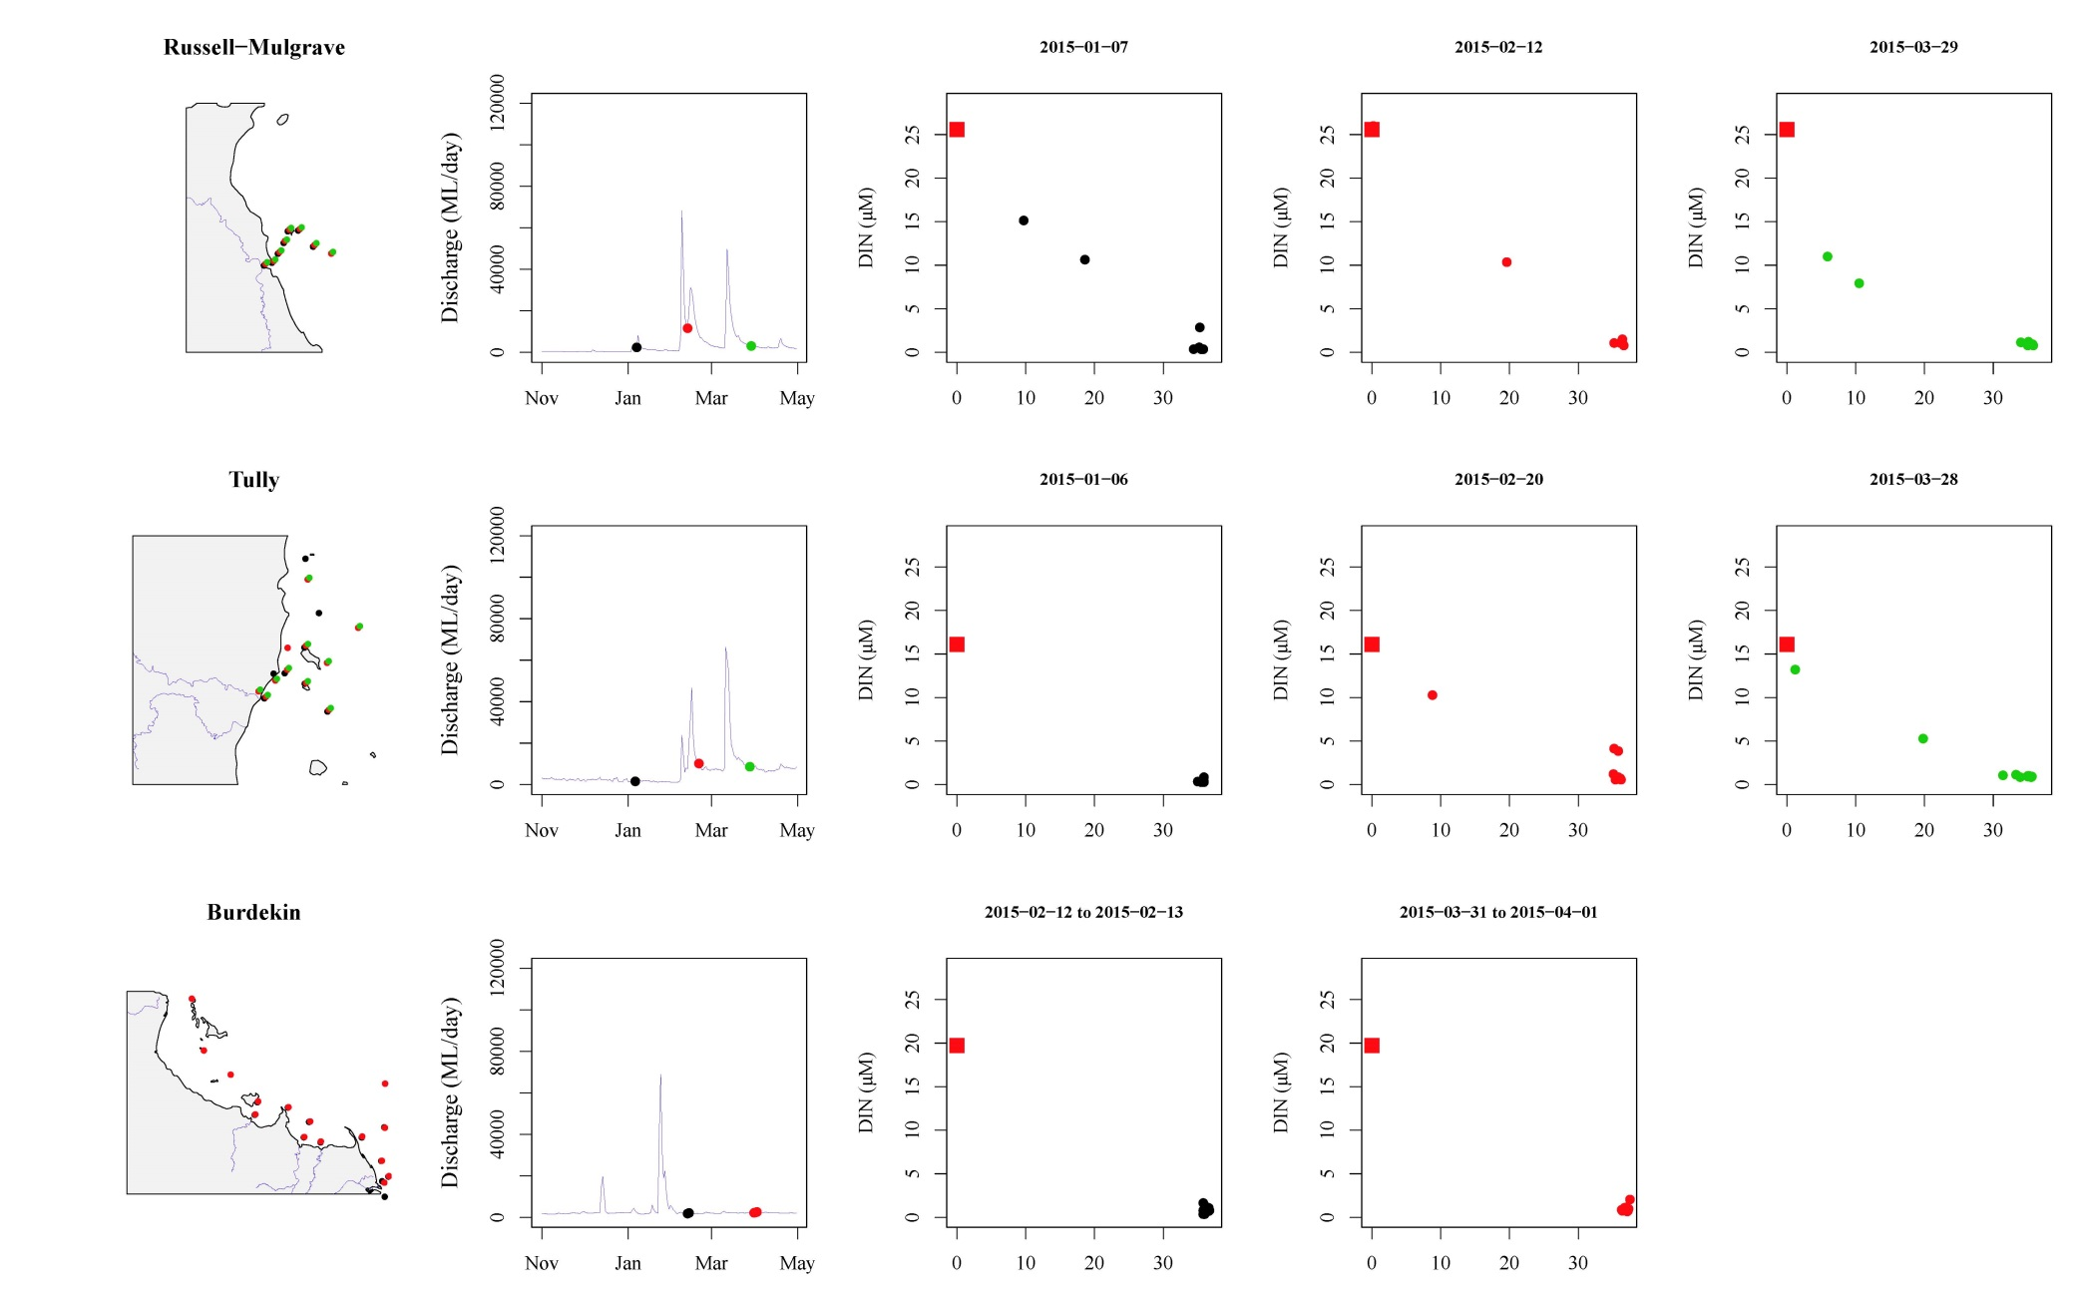
Figure A2 7: Mixing plots for DIN in the Russell-Mulgrave, Tully and Burdekin regions for 2014-15. Sites are colour coded to identify location on maps and sampling date relative to river flow over wet season. Freshwater end were estimated from all samples collected at salinity < 5 in each region.

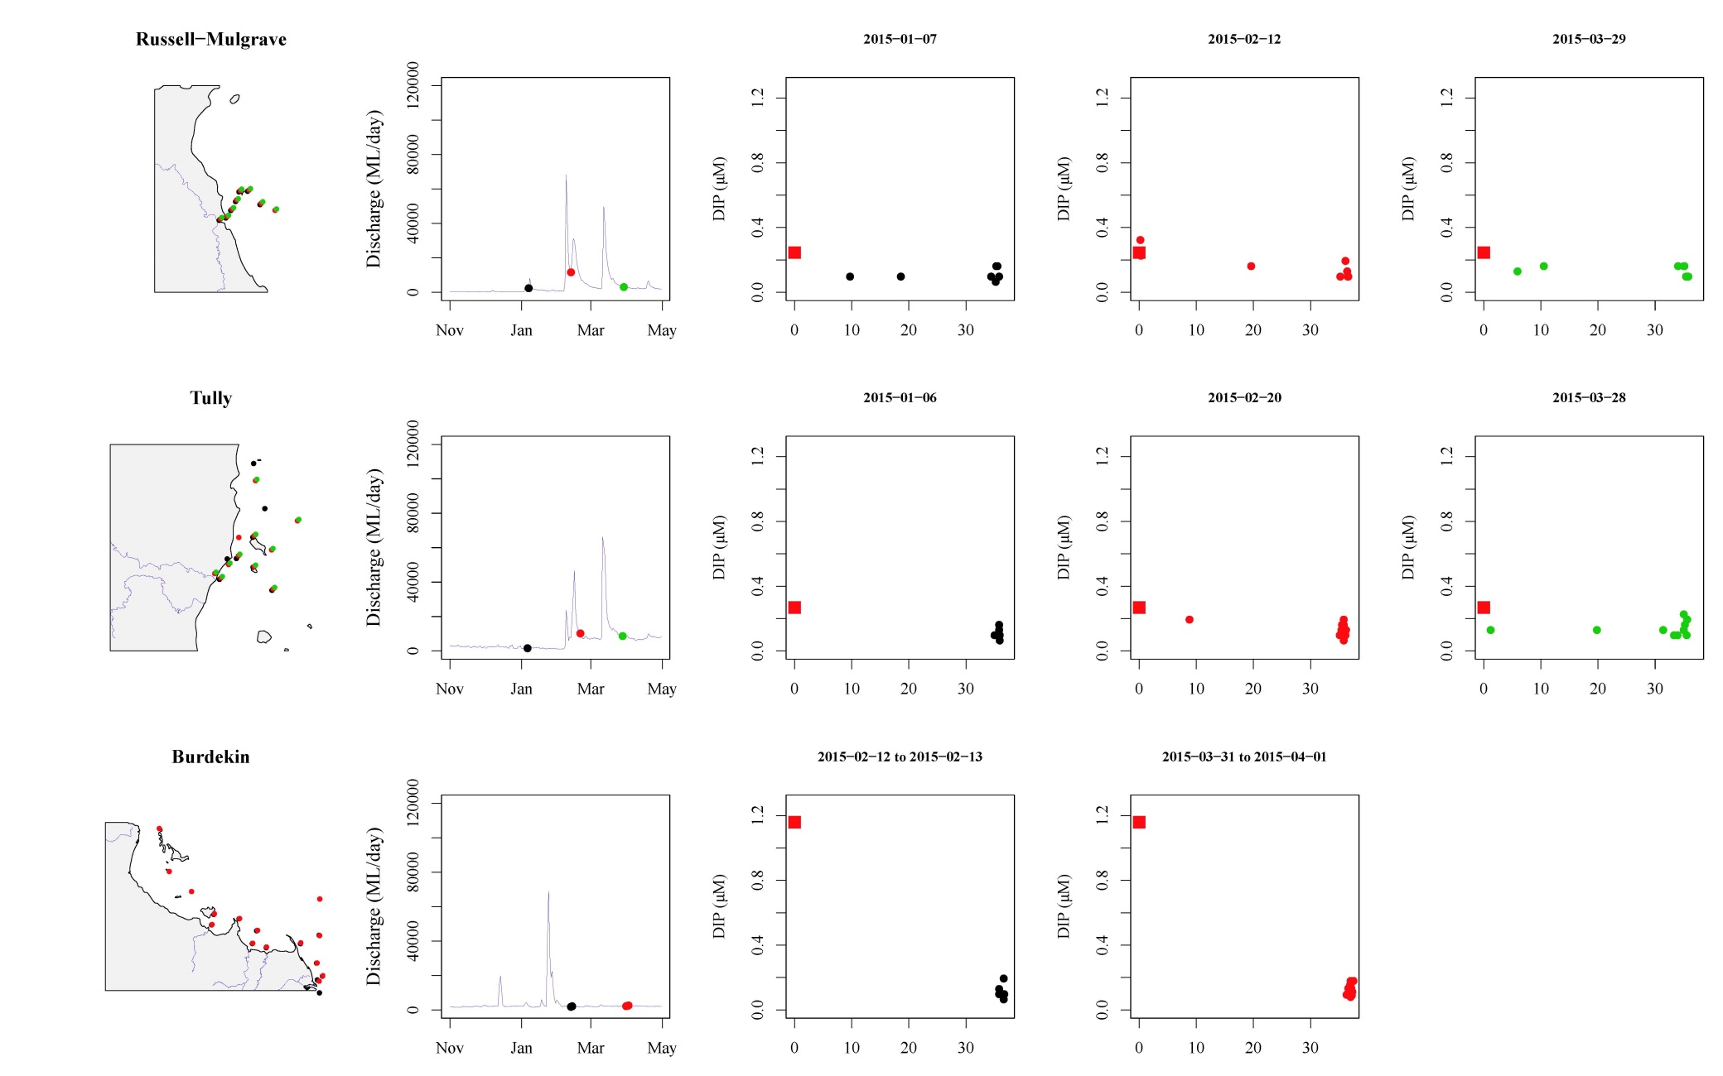
Figure A2 8: Mixing plots for DIP in the Russell-Mulgrave, Tully and Burdekin regions for 2014-15. Sites are colour coded to identify location on maps and sampling date relative to river flow over wet season. Freshwater end were estimated from all samples collected at salinity < 5 in each region.

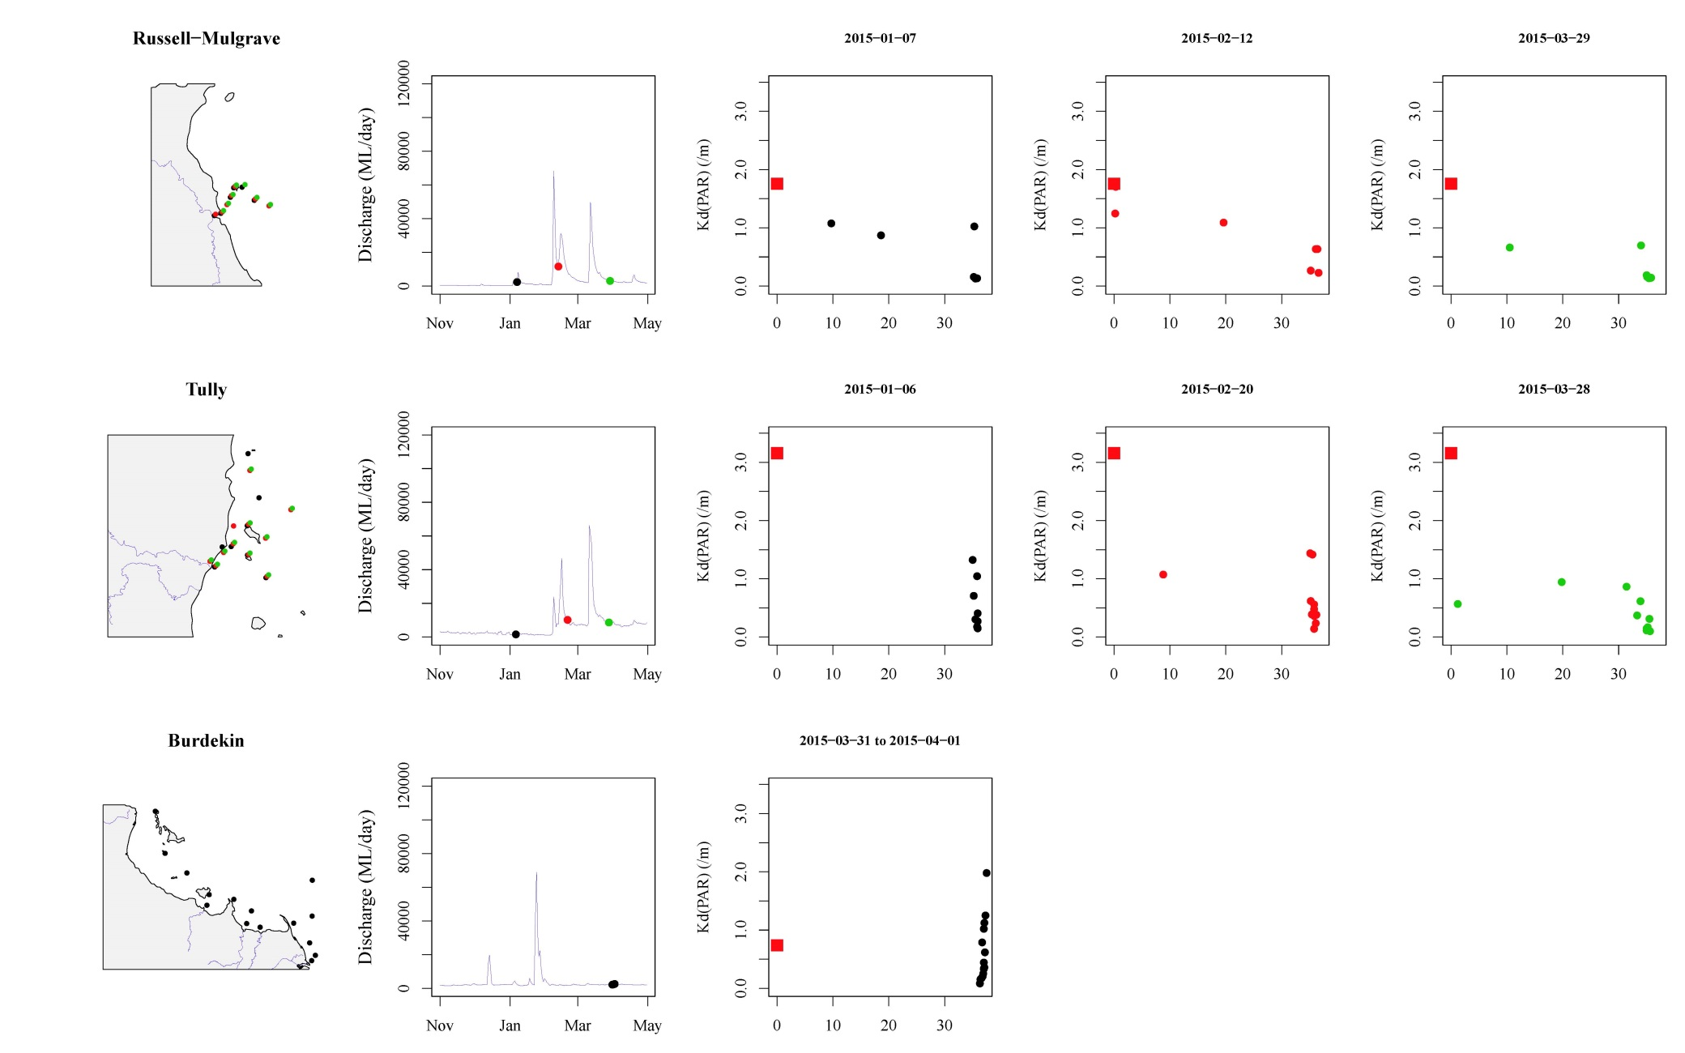
Figure A2 9: Mixing plots for Kd(PAR) in the Russell-Mulgrave, Tully and Burdekin regions for 2014-15. Sites are colour coded to identify location on maps and sampling date relative to river flow over wet season. Freshwater end were estimated from all samples collected at salinity < 5 in each region.

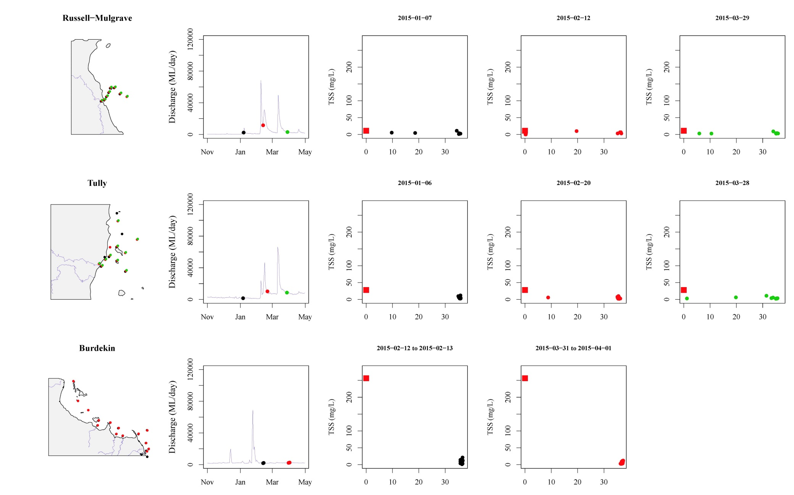
Figure A2 10: Mixing plots for TSS in the Russell-Mulgrave, Tully and Burdekin regions for 2014-15. Sites are colour coded to identify location on maps and sampling date relative to river flow over wet season. Freshwater end were estimated from all samples collected at salinity < 5 in each region.

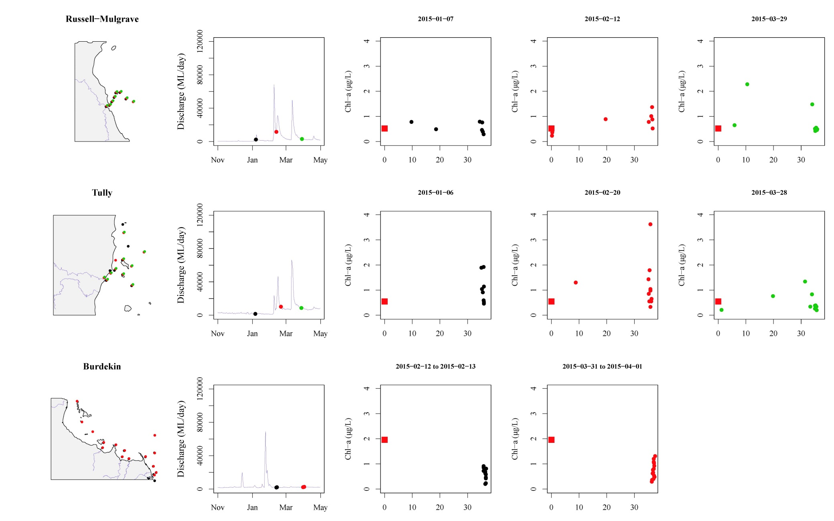
Figure A2 11: Mixing plots for Chl-a in the Russell-Mulgrave, Tully and Burdekin regions for 2014-15. Sites are colour coded to identify location on maps and sampling date relative to river flow over wet season. Freshwater end were estimated from all samples collected at salinity < 5 in each region.

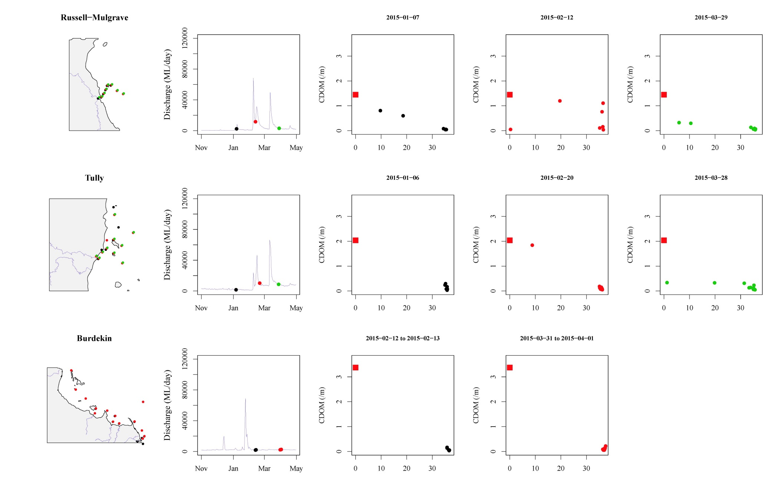
Figure A2 12: Mixing plots for CDOM in the Russell-Mulgrave, Tully and Burdekin regions for 2014-15. Sites are colour coded to identify location on maps and sampling date relative to river flow over wet season. Freshwater end were estimated from all samples collected at salinity < 5 in each region.

Appendix 3: QA/QC Information
Method performance and QA/QC information for water quality monitoring activities
Information pertaining to quality control and assurance generally includes the assessment of the limit of detection (LOD), measurements of accuracy (e.g. using reference materials to assess recovery of known amount of analyte) and precision (the repeated analyses of the same concentration of analyte to check for reproducibility).

Limits of detection
Limit of Detection (LOD) or detection limit, is the lowest concentration level that can be determined to be statistically different from a blank (99% confidence). LOD of water quality parameters sampled under the MMP are summarised below:

Table A3 1: Limit of detection (LOD) for analyses of marine water quality parameters.

Parameter (analyte) | LOD
NO2 | 0.28 µg L⁻¹*
NO3+ NO2 | 0.42 - 0.70 µg L⁻¹*
NH4 | 0.84 - 0.98 µg L⁻¹*
NH4 by OPA | 0.14 µg L⁻¹
TDN | 0.56 – 0.70 µg L⁻¹*
PN | 1.0 µg filter⁻¹
PO4 | 0.62 – 0.93 µg L⁻¹*
TDP | 0.62 – 1.24 µg L⁻¹*
PP | 0.09 µg L⁻¹
Si | 1.4 µg L⁻¹*
DOC | 0.1 mg L⁻¹
POC | 1.0 µg filter⁻¹
Chlorophyll a | 0.004 µg L⁻¹
SS | 0.1 mg filter⁻¹
Salinity | 0.03 PSU
*LOD for analysis of dissolved nutrients is estimated for each individual analytical batch, the range given is the range of LODs from batches analysed with samples collected in 2014/15.

Precision
The variation between results for replicate analyses of standards or reference material is used as a measure for the precision of an analysis. Reproducibility of samples was generally within a CV of 20%, with the majority of analyses delivering precision of results within 10%.

Table A3 2: Summary of coefficients of variation (CV, in %) of replicate measurements (N) of a standard or reference material.
Parameter (analyte) | CV (%) | N
NO2 | 2-61* | 2-4
NO3+ NO2 | 4-25* | 2-4
NH4 | 1-34* | 3-4
TDN | 2-21* | 4-6
PN | 9-15 | 54-56
PO4 | 3-23* | 3-4
TDP | 3-35* | 4-6
PP | 6 | 7
Si | 2-22* | 3-4
DOC | 2-6* | 14-29
POC | 8-9** | 54-56
Chlorophyll a | 1.1 | 35
SS | n/a***
Salinity | <0.1 | 2-6
*Precision for analysis of dissolved nutrients is estimated for each individual analytical batch, the range given is the range of CVs from batches analysed with samples collected in 2014/15.; ** two different reference materials used in each batch; ***n/a= no suitable standard material available for analysis of this parameter.

Accuracy
Analytical accuracy is measured as the recovery (in %) of a known concentration of a certified reference material or analyte standard (where no suitable reference material is available, e.g. for PP), which is usually analysed interspersed between samples in each analytical run. The recovery of known amounts of reference material is expected to be within 90-110% (i.e. the percent difference should be ≤ 20%) of their expected (certified) value for results to be considered accurate. The accuracy of analytical results for PN, PP, POC, chlorophyll, SS and salinity was generally within this limit (Table A3-3). Analytical results for PP are adjusted using a batch-specific recovery factor that is determined with each sample batch.

Table A3 3: Summary of average recovery of known analyte concentrations.
Parameter (analyte) | Average recovery (%) | N
PN | 105-106 | 54-56
PP | 95* | 7
POC | 106-113 | 54-56
Chlorophyll a | 102 | 35
SS | n/a**
Salinity | 100 | 5
*PP: data are adjusted using a batch-specific efficiency factor (recovery); **n/a= no suitable reference material available for analysis of this parameter
The accuracy of analytical results for dissolved nutrients is being assessed using z-scores of the results returned from analysis of NLLNCT certified reference material (National Low-Level Nutrient Collaborative Trials, run every year by the Queensland Health Forensic and Scientific Services, QHFSS- AIMS is a formal participant of these trials). According to the NLLNCT instructions, accuracy is deemed good if results are within 1 z-score and satisfactory if results are within 2 z-scores. In each analytical batch, two bottles with different concentrations were analysed. In 2014/15 we used bottles #5 and #7 from Round 19 of the NLLNCT. For the #5 bottle (lower concentrations) all nutrient analyses z-scores were within 1 z-score (Table A3-4) and, hence, accuracy was deemed good. For the #7 bottle (higher concentrations) all but one nutrient analyses z-scores were within 2 z-score (Table A3-4) and, hence, accuracy was deemed satisfactory. To assure that the monitoring results were accurate, additional QA/QC samples were included in all batches (e.g. in-house reference seawater that allows for batch to batch comparison, added nutrient spikes) which usually return acceptable results.

Table A3 4: Summary of average Z-scores of replicate measurements (N) of a standard or reference material.
Accuracy of analysis of dissolved nutrients is estimated for each individual analytical batch, the range given is the range of average Z-scores from batches analysed with samples collected in 2014/15.
Parameter (analyte) | Z-score for  bottle #7 * | Z-score for  bottle #5 * | N
NOx | -0.1 to 0.37 | -0.56 to 0.4 | 2
NH4 | -0.19 to 0.32 | 0.43 to 0.51 | 2
TDN | -1.82 to 0.06 | 0.79 to 0.85 | 3
PO4 | -3.61 to -1.76 | 0.07 to 1.35 | 2
TDP | -1.92 to -0.52 | 0.61 to 1.14 | 3
Si | -0.97 to 0.50 | -0.4 to 0.04 | 2
* NLLNCT reference samples round 19, bottles #5 and #7 analysed with samples collected in 2014/15.

Procedural blanks
Wet filter blanks (filter placed on filtration unit and wetted with filtered seawater, then further handled like samples) were prepared during the on-board sample preparation to measure contamination during the preparation procedure for PN, PP, POC and chlorophyll. The instrument readings (or actual readings, in case of chlorophyll) from these filters were compared to instrument readings from actual water samples. On average, the wet filter blank values were below 2% of the measured values for chlorophyll a (Chl) (Table A3-5) and we conclude that contamination due to handling was minimal.
Wet filter blanks (as well as filter blanks using pre-combusted filters) for PN, PP and POC generally returned measureable readings, which indicates that the filter material contains phosphorus and organic carbon. The blank values are relatively constant and were subtracted from sample results to adjust for the inherent filter component.
Wet filter blanks for SS analysis (filter placed on filtration unit and wetted with filtered seawater, rinsed with distilled water, then further handled like samples) were prepared during the on-board sample preparation. The mean weight difference of these filter blanks (final weight - initial filter weight) was 0.00010 g (n=32). This value indicated the average amount of remnant salt in the filters (“salt blank”). The salt blank was about 5% of the average sample filter weight (Table A3-5). This value was included in the calculation of the amount of suspended solids per litre of water by subtraction from the sample filter weight differences.

Table A3 5: Comparison of instrument readings of wet filter blanks to actual sample readings
 | PP  (absorbance readings) | PN  (instrument readings) | Chl  (µg L⁻¹) | SS  (mg filter⁻¹) | POC  (µg filter⁻¹)
Average of blank readings | 0.003 | 0.71 | 0.004 | 0.10 | 5.51
N of blank readings | 40 | 70 | 51 | 32 | 70
Average of sample readings | 0.100 | 5.61 | 0.52 | 2.39 | 44.31
N of sample readings | 477 | 488 | 535 | 460 | 487
Average of blanks as % of average sample readings | 2.98% | 12.58% | 0.76% | 4.3% | 12.4%

Validation by alternative methods

Validation of ECO FLNTUSB instrument data
Direct water samples were collected and analysed (see Appendix 1- Materials and Methods for details) for comparison to instrument data acquired at the time of manual sampling.
Turbidity was validated against suspended solids concentrations in the water column. While the turbidity loggers measure the total light absorption and scattering, suspended solids are a measure of the particle dry mass on a filter (0.4 µm pore-size). The relationship between optically measured turbidity and total suspended solids analysed on filters was good (Figure A3-1), and the linear equation [TSS (mgL⁻¹)] = 1.3 x FLNTUSB Turbidity (NTU)] has been used for conversion between these two variables. The equation has been the same in last year’s (Thompson et al., 2013, 2014). Though these relationships are valid it should be remembered that the two variables are measures of two different things which do not necessarily co-vary.
Using this equation, the SS trigger value in the Guidelines of 2.0 mg L⁻¹ (GBRMPA 2010) translates into a turbidity trigger value of 1.5 NTU.

Figure A3 1: Match-up of instrument readings of turbidity (NTU) from field deployments of WET Labs Eco FLNTUSB Combination Fluorometer and Turbidity Sensors with values from standard laboratory analysis of concurrently collected water samples.

Appendix 4: Scientific publications and presentations associated with the program, 2014-15

Publications
Davies C.H., Coughlan A., Hallegraeff G., Ajani P., Armbrecht L., Bonham P., Brett S., Brinkman R., Burford M., Clementson L., Coad P., Coman F., Davies D., Dela-Cruz J., Devlin M., Edgar S., Eriksen R., Furnas M., Hassler C., Hill D., Ingleton T., Jameson I., Leterme S.C., Lønborg C., McLaughlin J., McEnnulty F., Miller M., Murray S., Nayar S., Patten R., Pritchard T., Proctor R. Purcell-Meyerink D., Raes E., Rissik D.,Rubio A., Ruszczyk J., Slotwinski A., Tattersall K., Thompson P., Thomson P., Tonks M., Trull T.W., Uribe-Palomino J., Swadling K., Zammit A., Richardson A.J., Waite A.M., Yauwenas R. in press. The Australian phytoplankton database - abundance and biovolume. Sci.Data (in press).
Devlin, M., Petus, C., Teixeira da Silva, E., Tracey. D., Wolff, N., Waterhouse, J., Brodie, J. (2015). Water Quality and River Plume monitoring in the Great Barrier Reef: An Overview of Methods Based on Ocean Colour Satellite Data. Remote Sens. 2015, 7, 12909-12941; doi:10.3390/rs71012909
Furnas, M., Schaffelke, B., & McKinnon, A. D. (2014). Selective evidence of eutrophication in the Great Barrier Reef: Comment on Bell et al.(2014). Ambio, 43(3), 377-378.
Petus C, Devlin M, Thompson A., McKenzie L, Teixeira da Silva E, Collier C, Tracey D, Martin K. (2016). Estimating the exposure of coral reefs and seagrass meadows to land-sourced contaminants in river flood plumes of the Great Barrier Reef: validating a simple Satellite Risk Framework with Environmental Data. Remote Sensing.
Petus, C., Collier, C., Devlin, M. Rasheed, M., McKenna, S. (2014). Using MODIS data for understanding changes in seagrass meadow health: a case study in the Great Barrier Reef (Australia). Marine Environmental Research 98: 68-85.
Petus, C., Teixeira da Silva,E., Devlin, M., Wenger, A.,Álvarez-Romero, J. G. (2014). Using MODIS data for mapping of water types within river plumes in the Great Barrier Reef, Australia: towards the production of river plume risk maps for reef and seagrass ecosystems. Journal of Environmental Management 137: 163-177.
Thompson A, Brando VE, Schaffelke B, Schroeder T (2014) Coral community responses to declining water quality: Whitsunday Islands, Great Barrier Reef, Australia. Coral Reefs 33:923-938
Uthicke, S., Furnas, M., & Lønborg, C. (2014). Coral Reefs on the Edge? Carbon Chemistry on Inshore Reefs of the Great Barrier Reef. PloS one, 9(10), e109092.

Presentations:
Devlin, M., Petus, C., Teixeira da Silva, E., Tracey. D., Wolff, N., Brodie, J., Waterhouse, J., Martin, K. (2015) Improvements to water quality monitoring through the inclusion of ocean colour products correlated with in-situ water quality gradients for the Great Barrier Reef. In: Posters from the International Ocean Colour Science meeting. From: IOCS 2015: Second International Ocean Colour Science Meeting, 15-18 June 2015, San Francisco, CA, USA.

http://www.environment.gov.au/marine/gbr/reef2050
http://www.bom.gov.au/environment/activities/mwqd/info.shtml

