FROM BLUEPRINT TO ACTION
GREAT BARRIER REEF BLUEPRINT FOR RESILENCE: PROGRESS REPORT

Great Barrier Reef Marine Park Authority logo

October 2018

© Commonwealth of Australia 2018
Published by the Great Barrier Reef Marine Park Authority
ISBN 9780648096580

This document is licensed by the Commonwealth of Australia for use under a Creative Commons By Attribution 4.0 International licence with the exception of the Coat of Arms of the Commonwealth of Australia, the logo of the Great Barrier Reef Marine Park Authority, any other material protected by a trademark, content supplied by third parties and any photographs. For licence conditions see: http://creativecommons.org/licences/by/4.0

While all efforts have been made to verify facts, the Great Barrier Reef Marine Park Authority takes no responsibility for the accuracy of information supplied in this publication.

Aboriginal and Torres Strait Islander readers are advised this publication may contain names and images of deceased persons.

A catalogue record for this publication is available from the National Library of Australia

This publication should be cited as:
Great Barrier Reef Marine Park Authority 2018, From blueprint to action: Great Barrier Reef blueprint for resilience: progress report, GBRMPA, Townsville.

Unless otherwise noted all images are © to the Great Barrier Reef Marine Park Authority

Comments and questions regarding this document are welcome and should be addressed to:
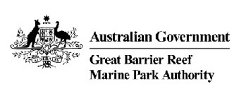
Great Barrier Reef Marine Park Authority
280 Flinders Street
(PO Box 1379)
Townsville QLD 4810, Australia

Phone: (07) 4750 0700
Fax: (07) 4772 6093
Email: info@gbrmpa.gov.au
www.gbrmpa.gov.au

The Great Barrier Reef Marine Park Authority acknowledges the continuing sea country management and custodianship of the Great Barrier Reef by Aboriginal and Torres Strait Islander Traditional Owners whose rich cultures, heritage values, enduring connections and shared efforts protect the Reef for future generations.
'Let us be a generation of action and restoration. We must ensure the universal songlines of the Great Barrier Reef continue to endure for many generations to come.'
Great Barrier Reef Marine Park Authority Indigenous Reef Advisory Committee, 2017

CONTENTS

INTRODUCTION 1
CONTEXT 1
STATE OF THE REEF 2
PRIORITY INTIATIVES 5
Building a resilience network 6
Dramatically enhancing compliance 8
Ramping up crown-of-thorns starfish control 10
Protecting key species for Reef recovery 11
Reef restoration 13
Fostering partnerships for action and innovation 17
Adapting policy and legislation 22
Developing decision-support systems 23
Building awareness and support 24
Education and awareness activities 26
MAINTAINING MOMENTUM 26
FURTHER INFORMATION 28

INTRODUCTION

The year 2017 marked a new sense of urgency and a change in direction for managing the future of Australia’s Great Barrier Reef.

Prompted by the dramatic loss of coral cover during the preceding two years, the Great Barrier Reef Marine Park Authority (the Authority) assembled Traditional Owners, marine park rangers, managers, scientists, industry representatives, and government and non-government organisations for a dedicated summit to address the crisis.

Working with the goal of improving the capacity of corals to resist and recover (known as resilience) from climate-related impacts, the summit released the Reef Blueprint in December 2017 which identifies the most promising initiatives to guide future actions.

With forecasts of worsening conditions affecting the entire Great Barrier Reef system in coming decades, the Blueprint recognises the need for solutions that can be developed quickly and applied to large areas.

This progress report examines the first year of actions by the Authority towards achieving the initiatives since the summit in May 2017. It will be circulated to summit participants and published on the Authority’s website.

Although the challenge is immense, the Blueprint has already contributed to securing unprecedented levels of funding to develop and implement innovative and timely strategies. It has also helped galvanise collaboration and resilience-building efforts across the Reef community.

While the road ahead is long, the Authority stands proud of its achievements and the successes of our partners since the release of the Blueprint.

The immediate efforts described in this progress report are critical to sustain the Reef as a functioning ecosystem while the key threats of climate change and water quality are tackled in the longer-term.

CONTEXT

In May 2017, Authority convened regional, national and international experts for an event first — the Reef Summit. With the World Heritage-listed Great Barrier Reef facing unprecedented pressures, the express purpose was to identify actions, above and beyond existing measures, for tackling the challenges facing the Reef.

Like all coral reefs globally, the Reef has been subject to the impacts of compounding pressures from a range of sources, most significantly climate change. Fortunately, however, the Great Barrier Reef has a long history of world-class conservation management.

For over 40 years it has been the Authority’s great privilege to lead these management efforts, in collaboration with its many partners, on behalf of Australia and the world. The challenge now is to maintain and strengthen successful strategies while developing and adopting new technologies and innovative measures. These efforts must combine to build the resilience of corals and keep them functioning to the point where the whole ecosystem can survive while the threat of climate change is tackled.

Critically, these actions must occur with urgency. Climate-related impacts are emerging faster than expected and with a frequency too rapid to allow corals time to recover. Immediate action is needed in Australia and around the world to restrict global temperature increases to 1.5 degrees Celsius, in line with the more ambitious aim of the Paris Agreement.

Priority support must also continue for the Queensland communities working to improve water quality along the Reef's catchment areas. Targets have been established that require major on-ground work and changes to existing practices in order to control the damaging high-risk sources of nutrients, sediments and pesticides flowing into the Reef.

As reaffirmed in the updated Reef 2050 Long-Term Sustainability Plan, we must grow and foster our partnerships. The Blueprint is a part of this overarching strategy and reflects its commitment to uniting actions across the Reef community to achieve a coordinated, collaborative and holistic approach to protecting the Reef; and mitigating the impact of cumulative pressures.

Now, more than ever, it is crucial that we work together to share our knowledge and resources, align our actions and bring new expertise to the table. We must learn from and support each other in our mission to secure the future of our Great Barrier Reef and its outstanding universal value.

With forecasts of worsening conditions affecting the whole Reef system in coming decades, the Blueprint recognises the need for solutions that can be developed quickly and applied to large areas.

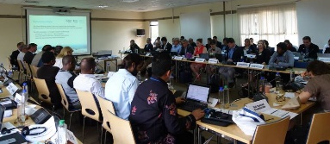
Effort at the international scale: International Coral Reef Initiative meeting, Kenya 2017

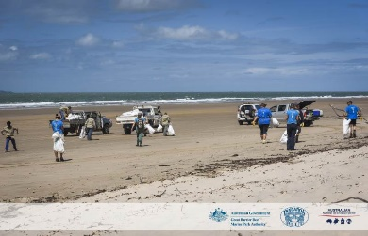
Effort at the local scale: Tangaroa Blue marine debris clean up, Farnborough, Yeppoon region, photographer: Christian Miller

STATE OF THE REEF

In 2018 the health of the Great Barrier Reef remains deeply concerning

The Australian Institute of Marine Science (AIMS) long-term monitoring program update for 2017–18 indicates coral cover is simultaneously declining across all regions of the Marine Park – a finding that is unprecedented.

This finding reflects the cumulative impacts of a range of threats to the Reef’s health, including a decade of severe climate-related weather events; the effects of poor, but improving, water quality from the Reef’s catchment; a crown-of-thorns starfish outbreak since 2010, and increasing coral disease.

Of these, climate change poses the biggest and most immediate threat to the Reef’s survival with rising sea temperatures forecasted to bring destructive marine heatwaves; increasingly frequent and severe storms damaging reef structures; and more droughts and floods affecting the amount and quality of water run-off into coastal catchment areas.

Mass coral bleaching and a severe tropical cyclone have impacted 80 per cent of the Great Barrier Reef since 2016, resulting in an estimated loss of at least 50 per cent of the Reef’s shallow water corals. For the first time since regular monitoring began in 1985, all three regions of the Reef - north, central and south - have declining coral cover. However, the extent of the impact is highly variable at the scale of the entire Reef, as well as in regions and individual reefs. Areas of remaining healthy coral are critical for the Reef tourism industry and long-term ecological recovery.

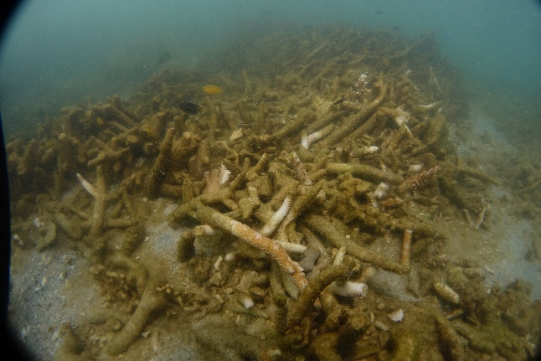
Coral devastation at Blue Pearl Bay in the Whitsundays after tropical cyclone Debbie in 2017

The full impacts of recent events are only beginning to be fully realised. Emerging data indicates fish species dependent on coral reefs for food and habitat are in subsequent decline.
Comprehensive reporting on the Great Barrier Reef's health is challenging. The system covers a vast 348,000 square kilometres and many of the most severe impacts are in the most remote areas. Like the patterns of destruction caused by a bushfire or cyclone on land, the effect of multiple and often overlapping impacts on the Reef vary widely. The latest reef survey results from AIMS confirm the highly variable patterns of disturbance and recovery across the Reef.

AIMS conducts in-water surveys of different regions of the Great Barrier Reef on a two year cycle. It did not survey the Northern region and the Whitsunday area during the past 12 months. This means the 2017 impacts of tropical cyclone Debbie and coral bleaching events in the north have not yet been fully assessed.

- In the northern region (from Cooktown north) data from early 2017 indicated that mean coral cover had dropped to about 10 per cent, which is less than half of what it was in 2013. This was caused by two severe cyclones, an ongoing outbreak of crown-of-thorns starfish and severe coral bleaching in 2016. In early 2017 aerial surveys by James Cook University reported further severe bleaching on some reefs in this region but these impacts have yet to be assessed by AIMS in-water surveys.

- In the central region (Cooktown to Bowen) data has been assessed for the
2017–18 period. Results show the mean level of coral cover has dropped from 22 per cent in 2016 to 14 per cent in 2018. This decline is attributed to coral bleaching and the continued southwards spread of the crown-of-thorns starfish outbreak. Corals in this region had recovered rapidly up to 2016 following the devastating impacts of cyclone Yasi in 2011.

- In the southern region (from Bowen south) mean coral cover dropped from
33 per cent in 2017 to 25 per cent in 2018. Reefs in this region were not exposed to extreme sea surface temperatures in 2016 or 2017, but an intense outbreak of crown-of-thorns starfish was recorded on the southern Swain reefs in late 2017 resulting in an overall decline in coral cover. This decline followed a period of strong recovery after severe tropical cyclone Hamish caused extensive damage in 2009.
Despite this damage, some areas of good to moderate coral still remain. And although there were above average sea surface temperatures in many areas of the Reef during the summer of 2017–18, only minor coral bleaching events were reported. One exception was a report of moderate bleaching in the Capricorn-Bunker group.

The absence of a severe weather event over the last summer is good news. However, the full impacts of other recent events are now only beginning to be fully realised. Emerging data from the ARC Centre for Excellence for Coral Reef Studies at James Cook University indicates fish species, dependent on coral reefs for food and habitat, are in subsequent decline. The finding suggests that interrelated losses in species diversity and abundance are likely to be occurring throughout the Reef ecosystem.

As of April 2018, average sea surface temperatures had returned to normal across the majority of the Reef with only small areas of above average temperatures. The latest forecast from the United States National Oceanic and Atmospheric Administration shows widespread coral bleaching is no longer occurring in all three ocean basins — Atlantic, Pacific and Indian — indicating a likely end to the global coral bleaching event.

It should be noted that dramatic declines in coral cover have occurred in some parts of the Reef before, but never on this scale. With changes happening faster than predicted and with the forecast of decades of worsening conditions ahead, coral reefs that need between 10 to 30 years to recuperate from related impacts will be in a constant state of recovery.

As the intervals between disturbances shorten, our greatest concern is that damage to the ecosystem will outpace its ability to recover.

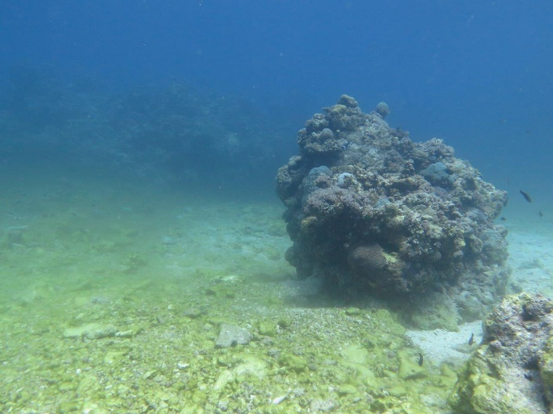
The coral at No Name Reef near Lizard Island was destroyed during tropical cyclone Ita in 2014

Today, the future of the Great Barrier Reef is no longer just in the hands of Australians. As a nation we can and must support efforts to build its resilience, including the fast-tracking of actions in water catchment areas and reducing our own contribution to greenhouse gas emissions. We must call for support from the international community too. Global warming trends need to be curbed urgently for this precious World Heritage Area to survive.
The future state of the Great Barrier Reef relies on immediate international action to urgently reduce global warming. This must happen in parallel to Australia fast-tracking resilience-building actions in the Reef’s catchment and waters.

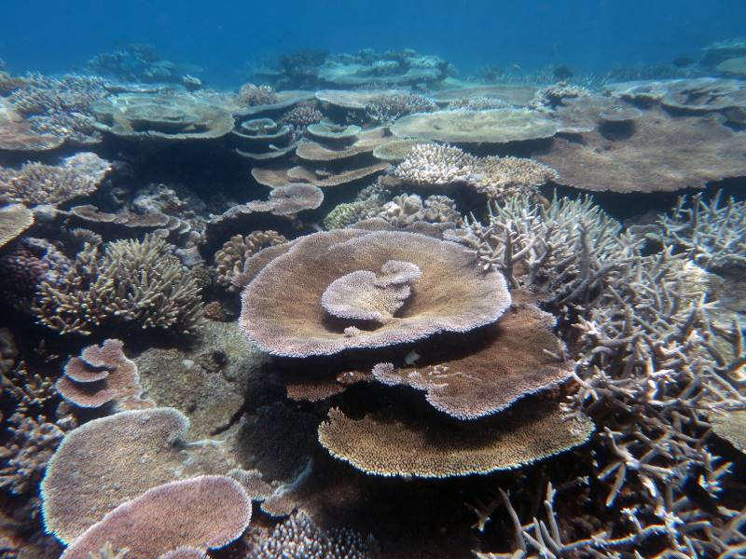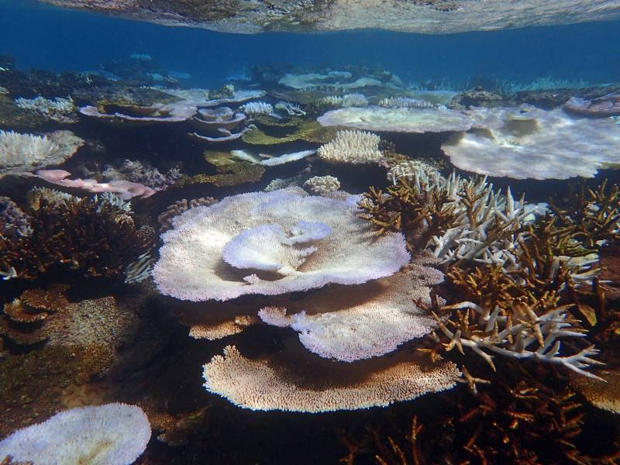
Opal Reef before and after bleaching in 2016 © Taylor Simpkins, coral bleaching 2016

PRIORITY INTIATIVES

The Blueprint outlined four broad themes for building resilience which, together, signalled a change to the Authority’s management practices. The tried and true methods of reef conservation remain, but they are joined by a suite of additional actions which explicitly focus on helping corals withstand and recover from disturbances. The approach is delivered by 10 key initiatives:

BUILDING A RESILIENCE NETWORK

- Identifying and protecting a resilience network

DELIVERING ON-GROUND ACTIONS TO ENHANCE RESILIENCE
- Dramatically enhancing compliance
- Ramping up crown-of-thorns starfish control
- Protecting key species for reef recovery
- Active, localised restoration

EMPOWERING PEOPLE TO BE PART OF THE SOLUTION
- Accelerating actions to address climate change
- Fostering partnerships for action and innovation

FOSTERING CHANGE
- Adapting policy and legislation
- Developing decision-support systems
- Building awareness and support

This progress report highlights efforts on the implementation of these initiatives since the Reef Summit in May 2017. Outcomes for each initiative are framed as vision statements. Actions described under each initiative are a subset of a much broader suite of actions underway to protect the Great Barrier Reef. Information on the full suite of actions by the Authority and its many partners can be found in Further Information, page 28.

Building a resilience network
Vision for 2020
A resilience network has been identified, evaluated, and is the focus of additional management efforts.
Why is it important?
Building a resilience network allows us to strategically target efforts on coral reefs that are of greatest value to the future of the Reef as a whole. When fully realised, it will enable us to maximise system-wide benefits through targeted actions.
Highlight
Collaborative efforts are underway to identify coral reefs that are naturally more resilient and those which make the greatest contribution to the Reef’s health.
A decision-support tool is being developed that can evaluate a complex array of quantitative and qualitative data for specific reefs or groups of reefs.
Action update
- A project to develop an ‘Interim Resilience Network Decision-Support Tool’ is being led by the Authority and the University of Queensland in partnership with CSIRO, AIMS and James Cook University. Efforts are well underway and have an initial focus on identifying reefs which support the Reef’s ecological resilience. To date, information from key data sets and key experts, has been collected, collated and analysed. Data layers in the form of maps for thermal stress, wave exposure, cyclone exposure, water quality, light availability and connectivity across the Reef, are now being finalised.

- The ‘prototype’ decision support tool and report are expected to be finalised this year. Findings from using the tool will inform the project’s next steps, including broader engagement with partners on reefs that best support not only ecological values, but social, cultural and economic values. These sites will then be evaluated to identify the best resilience-building areas to safeguard into the future.

Building a resilience network enables us to deliver system-wide benefits through targeted actions.

Building a resilience network
Despite wide-spread declines in coral cover, some reefs and some parts of reefs, continue to retain good cover.
Understanding why some reefs are more resilient to disturbances enables us to target efforts towards supporting corals that better ‘resist’ or withstand disturbances.
We also know some sites are disproportionately more important to the Reef's overall resilience. For example, some reefs make a relatively higher contribution to the coral larval supply of downstream reefs, while other reefs may be more important to the community for cultural or economic reasons.
Identifying which reefs best support ecological, social, cultural and economic values will allow us to focus resources on safeguarding sites that will deliver maximum returns for the whole Reef system and Reef-dependent communities.
The resilience network will not include changes to the Great Barrier Reef Zoning Plan 2003 — instead, it will function as an interconnected network of reefs complementing the zoning network. It will direct the focus of many of the targeted efforts outlined in this progress report, particularly crown-of-thorns starfish control, restoration and compliance, to build resilience within the Marine Park.

Understanding why some reefs are more resilient to disturbances enables us to target resources towards actions that better support corals.
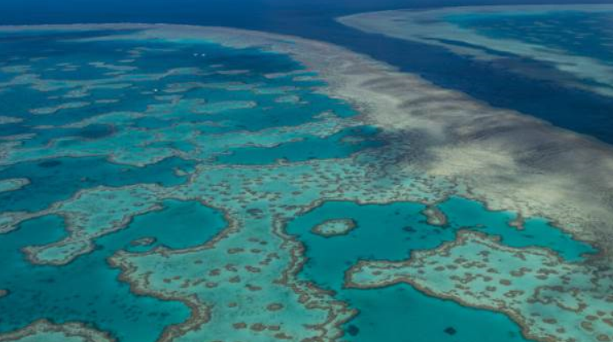
Aerial view of Hardy Reef, photographer: Jumbo Aerial Photography

Dramatically enhancing compliance
Vision for 2020
The benefits of marine parks zoning to the resilience of coral reefs is maximised through high levels of compliance.
Why is it important?
No-take zones play a central role in supporting Reef health and resilience.
Long-term monitoring shows that fish and coral in no-take zones recover faster after disturbances including cyclones, crown-of-thorns starfish outbreaks and coral disease.
The effectiveness of no-take zones depends on strong compliance by Reef users, making this initiative one of the best investments in Reef resilience.
Highlight
A significant milestone in 2018 was increased funding for the Australian and Queensland governments’ Joint Field Management Program on the Great Barrier Reef.
The program will grow from a joint base commitment of over $17 million per year to $38 million by 2022. The staged release of funds allows for a considered and sustained expansion of front line compliance activities including a second 24 metre patrol vessel Reef Resilience capable of operating Reef-wide.
This funding recognises the critical role of the field management team and will see an increased number of officers educating the public and enforcing compliance measures. The funds will also be used to drive innovations in compliance and the adoption of new technology.
Action update
- The implementation of vessel monitoring systems on all commercial fishing vessels is on track for completion by 2020 as part of the Queensland Sustainable Fisheries Strategy. This includes the availability of industry rebates for vessel monitoring units and the establishment of a dedicated vessel monitoring compliance team to ensure compliance with zoning and other rules.
- Compliance risk and threat assessments have been updated to include the effects of mass bleaching events and the field management team continues to incorporate priority areas for Reef resilience and recovery into its surveillance planning.
- Expansion of the on-water presence of marine park rangers and other partners is already underway and includes the recent appointment of 21 Aboriginal and Torres Strait Islander rangers as marine park inspectors. Training started for a further 23 rangers in May 2018.
- A dedicated recreational fishing communications project has begun with compliance blitzes, specifically targeting anglers poaching from no-take zones, focusing efforts on non-compliance hotspots.
- New technologies are being adopted including the use of unmanned aerial vehicles (UAVs) to enhance surveillance capacity of field officers. There is also funding to purchase additional UAVs.
- Improvements to marine park rangers’ reporting systems and compliance management databases are underway. A new compliance operation centre is being built, equipped with up-to-date technology, to enhance operations planning and delivery.
A doubling of field management resources over the next five years will see a sustained expansion of compliance activities including more rangers on the water and a second 24 metre patrol vessel.

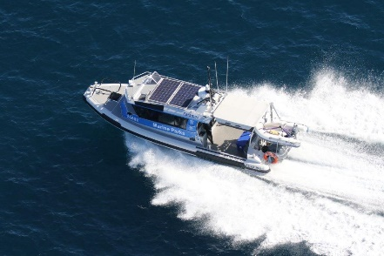
Karamea vessel underway in the Capricorn Bunker Group
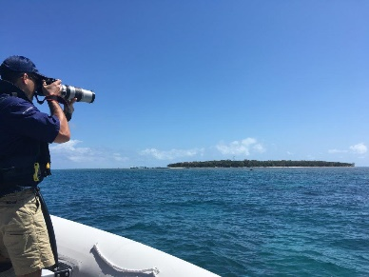
Joint Field Management Program field operations compliance officer undertaking surveillance at Green Island
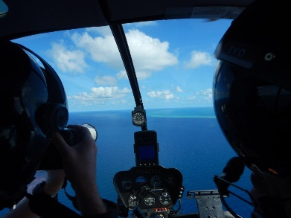
Joint Field Management Program field operations compliance officer undertaking a helicopter surveillance flight

Ramping up crown-of-thorns starfish control
Vision for 2020
The crown-of-thorns starfish population is suppressed to minimise coral predation and maximise coral cover.
Why is it important?
Crown-of-thorns starfish outbreaks are a major source of coral mortality across the Great Barrier Reef, driving coral declines at a scale comparable to bleaching and cyclone events. However — unlike bleaching and cyclones — crown-of-thorns starfish outbreaks can be predicted and controlled. It is one of the most scalable and feasible actions for reducing coral mortality and preventing further declines.

Highlights
In April 2018 the Australian Government committed $58 million over six years, as part of the Reef Trust — Great Barrier Reef Foundation Partnership — to ramp up crown-of-thorns starfish control. This funding was in addition to an extra $10.4 million announced in January 2018 and $14.4 million announced in August 2017 to expand the program.
Under these arrangements, the number of starfish control vessels will triple in line with the summit participants' call for an ‘all-out attack’.
This increased capability, along with improved underwater surveillance and the latest scientific research, will enhance protection of live coral cover and the integrity of the overall ecosystem.
Action update
- The Crown-of-thorns Starfish Strategic Management and Contingency Plan is being finalised for publication. The Authority continues to work closely with science and industry stakeholders to ensure crown-of-thorns starfish management is based on the best available science and that resources are directed to sites which produce the best outcomes for system-wide resilience.
- An open tender process has been completed, and the Authority has established a Panel of Suppliers to deliver the additional vessels and trained crews for expanding the control program.
- Collaboration with the research community* through the National Environmental Science Program’s Integrated Pest Management project has enabled a number of new initiatives to further enhance the effectiveness of crown-of-thorns starfish surveillance and control. This includes the use of scientific modelling to identify ecologically-critical reefs that can help the Reef recover from impacts. Reefs with the strongest capacity to spread coral larvae to other reefs are being targeted as part of control efforts.
- Coral and starfish density thresholds are now used to inform vessel schedules and cull efforts. These important thresholds provide the target levels of culling necessary to ensure that coral growth outpaces its consumption by starfish.
- The capacity for rangers to undertake crown-of-thorns starfish surveillance to inform the control program has increased following additional investment in the Joint Field Management Program.
- Improvements have been made to the data management, synthesis and reporting of crown-of-thorns starfish surveillance and culling data delivered by marine park rangers and crown-of-thorns starfish control vessels. This includes the development of a new data capture tool to manage the information coming in from the vessels, and a new data visualisation tool to track progress in outbreak control and inform program management.
- The Authority has improved its program evaluation practices by surveying starfish numbers and coral cover on reefs where there is no culling. These figures are compared with results from culled reefs. The extra monitoring started in October 2017 and will be conducted annually for three years.

* The AIMS, CSIRO, James Cook University, Reef and Rainforest Research Centre, the University of Sydney and the University of Queensland.

Increased funding now makes an all-out assault on crown-of-thorns starfish possible.
Scuba divers inject white vinegar into crown-of-thorns starfish in efforts to cull the current outbreak

Protecting key species for Reef recovery
Vision for 2020
Species with a key role in assisting reef recovery following disturbance are identified and protected from unsustainable pressures.
Why is it important?
Ensuring that ‘reef recovery species’ — species that make the biggest contribution to reef resilience — are not subject to unsustainable pressures is a key element of resilient-based management.

Highlights
The University of Queensland is leading work on the identification of species that are critically important to maintaining and assisting ecosystem functioning including recovery processes.
Action update
- A framework has been established for examining which species are the most important to Reef functioning. It includes: documenting ecosystem processes and functions and identifying the species most important to them; examining threats to these species based on their sensitivity and exposure to pressures; developing a species importance index and a threat index to determine vulnerability; assessing potential options to improve management of these species; and making recommendations.
- Collation and synthesis of existing material is underway and workshops with scientists and managers have been convened, with an initial focus on the biological processes that support Reef health and resilience.
The project brings together experts in science and management and is being carried out under the Department of the Environment and Energy’s National Environment Science Program. The outcomes from this project will be publicly available in mid–2019.
Researchers are investigating which species are most important to the ecological processes supporting Reef functioning and recovery.

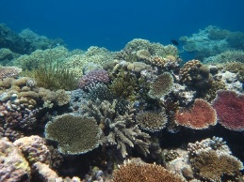
Moore Reef south east of Cairns. Some species, including Acropora plate corals, contribute disproportionately to the recovery of coral cover following disturbances
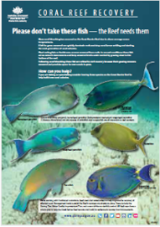
Some species are key to preventing algae from proliferating on coral reefs following disturbances

Reef restoration

Vision for 2020
Coordinated restoration trials are in place at demonstration sites, providing opportunities to test, evaluate and — where appropriate — scale-up restoration methods to ecologically relevant scales.
Why is it important?
The increasing frequency and severity of climate-related disturbances on the Great Barrier Reef are overwhelming the ecosystem's own ability to recover. We need to find extra ways to protect and enhance reef recovery processes.

Highlights
In January 2018 the Australian Government announced $6 million in funding to develop a Reef Restoration and Adaptation Program. Its role is to investigate the best science and technology options for helping the Reef recover and adapt to the changing environment. In April 2018, the Australian Government committed a further $100 million to build on design work by the program. The goal is to develop solutions that can be logistically and feasibly deployed on a large scale. The program is highly multi-disciplinary incorporating many elements of biology as well as engineering, economics, and social sciences.
A number of other smaller scale restoration projects are also trialling new technologies and mobilising efforts across community, industry and science to help reefs better withstand and recover from disturbances.
Action update
- The Reef Restoration and Adaptation Program is underway with the first stage assessing the feasibility and risks of a broad range of potential ideas and techniques to build resilience and assist recovery. Led by AIMS and CSIRO, and in conjunction with a range of partners*, this work will inform longer-term research and development on coral reef restoration techniques that can be applied to the Great Barrier Reef and coral reefs globally.
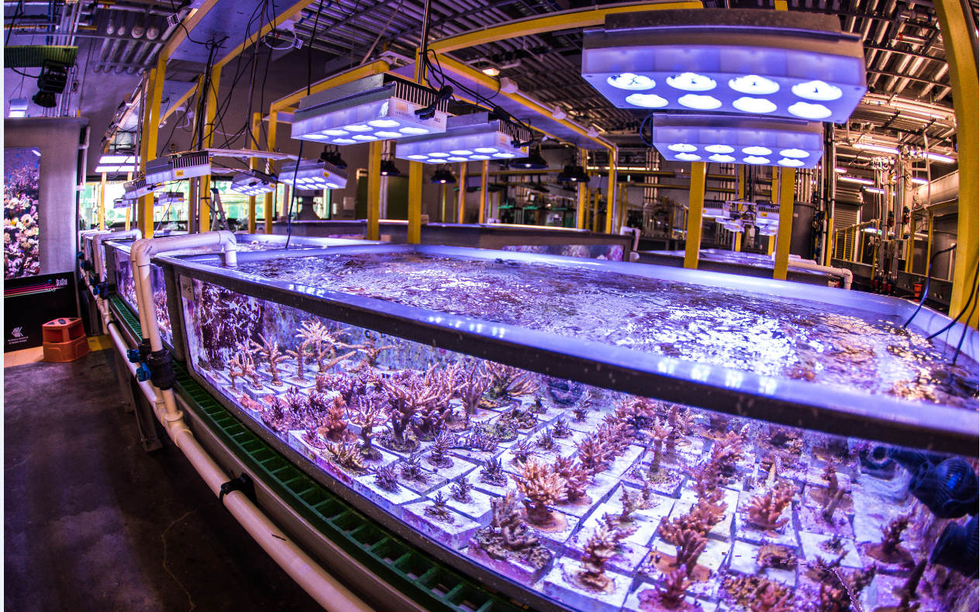
Coral research within the Australian Institute of Marine Science’s national sea simulator © Australian Institute of Marine Science, photographer: Christian Miller

- Work on the ground-breaking Raine Island Recovery Project to restore the world’s largest green turtle hatchery has continued in 2018. The project's on-ground restoration and conservation work is delivered through a collaboration between BHP, the Queensland Government, the Authority, the Wuthathi and Kemer Kemer Meriam Nation Traditional Owners, and the Great Barrier Reef Foundation.
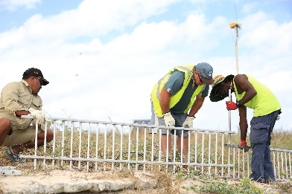
Rangers building a fence that has prevented nesting turtles from toppling over a cliff at Raine Island, photographer: Styledia Public Relations
- Further trials of larval re-seeding to enhance coral growth occurred at Heron Island in November 2017. This followed additional funds from the Australian Government to develop this technique. The trials also included the collection of natural coral spawn slicks for restoring the Reef. Re-seeding involves collecting millions of coral larvae (baby coral) and rearing them, before releasing them onto natural reefs to accelerate regeneration. The project is a partnership between Southern Cross University, the Authority and the Great Barrier Reef Foundation.
- The remediation of Douglas Shoal, funded through compensation, is expected to provide valuable lessons to support broader Reef recovery and restoration efforts. Contracting of planning, advisory and management services for remediation works on the area impacted by the grounding of the bulk carrier Shen Neng 1 are underway. Environmental monitoring prior to any pilot remediation is expected to start in 2019.
- The addition of more marine parks rangers and vessels, following recent funding increases to the Australian and Queensland government's joint Field Management Program, is set to have a flow on effect for on-ground restoration works. Planning and preparations are already underway for more reef health surveys and boosted reef and island restoration and recovery efforts.
- The Reef and Rainforest Research Centre is investing $2.2 million in Australian Government funds into trialling new technology for reducing the heat stress that causes coral bleaching. The Reef Havens proposal is combining science and engineering to develop equipment for mixing and cooling water on reef sites. The pilot is at Moore Reef near Cairns.
- The Indigenous Reef Advisory Committee continued their interest in reef restoration activities and progress through a focussed discussion on the Reef Restoration and Adaptation Program with AIMS, encouraging further discussion and consultation with Traditional Owners as the program develops and ideas are applied in the Marine Park.
- Great Barrier Reef Recovery Magnetic Island is a local initiative where Queensland Parks and Wildlife Service has been working with partners such as Reef Ecologic Pty Ltd and SeaLink Queensland, and teaming with community members, to restore the health of coral reefs around Magnetic Island. The group has research permits allowing the controlled collection of seaweed in order to give future corals more space to grow and juvenile corals room to settle. They are targeting nearshore reefs.
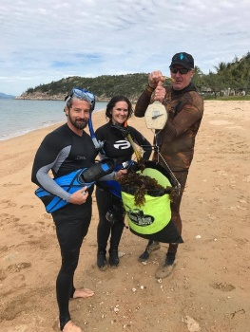
Community restoration effort on Magnetic Island to remove algae from coral reefs © Reef Ecologic
*Other partners include the Authority, the Great Barrier Reef Foundation, James Cook University, the University of Queensland and the Queensland University of Technology.
Over $100 million has been committed to develop reef restoration solutions that can be logistically and feasibly deployed at a large scale.
Accelerating actions to address climate change
Vision for 2020
The Great Barrier Reef and coral reefs globally are a focus of policy discourse and programs to reduce carbon emissions. Great Barrier Reef communities and industries are demonstrating leadership in emission reduction efforts and climate change adaptation.
Why is it important?
Climate change is the single biggest threat to the Great Barrier Reef's future survival.
There is an urgent need to curb global warming as climate-related disturbances outpace the Reef's ability to recover.

Highlights
Calls to dramatically reduce the production of greenhouse gas emissions are being heard and translating into tangible actions.
The range of activities to reduce greenhouse emissions and make the transition to a low carbon economy is now gaining momentum across individuals, communities, the corporate sector and governments.
Action update
- A mid-term review of the Reef 2050 Plan in July 2018 recognised the critical need to identify and accelerate priority actions to support the Reef’s health and resilience. The Great Barrier Reef Ministerial Forum approved an updated Reef 2050 Plan, which now has a stronger focus on climate change as a key pressure. The Ministerial Forum also endorsed the new Reef 2050 Water Quality Improvement Plan 2017-2022, which better aligns its targets with the Reef 2050 Plan.
- In June 2018, the Northern Australia Infrastructure Facility announced support for a $516 million conditional loan for a large-scale solar and hydro project in North Queensland. This project is seen as an important part of the energy market’s transition to lower emissions renewable energy sources.
- The Australian Government's Clean Energy Finance Corporation (CEFC) continued investing in clean energy projects announcing its 10th investment in a large-scale wind project in May 2018. The project brings CEFC’s overall commitment to wind generation to more than $700 million since it began investing in 2013.
- In September 2017, the Queensland Government committed to achieving zero net emissions by 2050; and generating 50 per cent of the state's energy using renewable sources by 2030. Its Climate Transition and Climate Adaptation Strategies detail how it will transition to a zero net emissions future that supports jobs, industries, communities and the environment, while preparing for the future impacts of a changing climate.
- Citizens of the Great Barrier Reef continued to build an online global movement for community action on climate change and reef conservation during 2018. Campaigns such as these have heightened awareness of the consequences of global warming on coral reef ecosystems and the need for urgent action.
- The Authority is in the final stages of drafting its official position statement on climate change threats to the Great Barrier Reef. With climate change acknowledged as the biggest single threat to the ecosystem, the statement will encourage the strongest possible actions to curb its effects.
Many actions are needed to save the Great Barrier Reef. It is only the combined effect of all actions — big and small — that will overcome the threat of climate change.
The momentum to curb climate change is building but we need to reduce greenhouse gas emissions faster in order to give the Great Barrier Reef and reefs worldwide the best chance of survival. Only the strongest possible action on climate change — consistent with pursuing efforts to limit the increase in global average temperature to 1.5 degrees Celsius above pre-industrial levels — will significantly reduce the risks and impacts of climate change on the Great Barrier Reef. This target reflects the more ambitious goal agreed by almost 200 nations under the Paris Agreement.

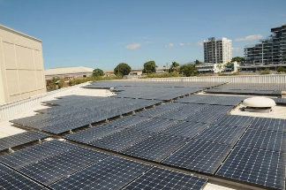
Solar panels on the Authority’s education centre, Reef HQ Aquarium, Townsville

Fostering partnerships for action and innovation

Vision for 2020
Individuals, industries and communities are aware of the challenges facing the Reef, participate in efforts to protect it, and are inspiring intergenerational change.
Why is it important?
Managing the Reef involves Traditional Owners, government agencies, Reef users, industry, researchers and the community. Only a collective effort can ensure the survival of the Great Barrier Reef.
Highlights
The call for urgent action in response to the mass bleaching events of 2016–17 has been heard. People are rallying behind efforts to tackle threats, large and small, to the Reef. There is a rapidly growing groundswell of support within the community and across institutions, not just for taking action, but for working together to maximise resources and achieve widespread collective change. New funding is supporting these coordination efforts and the building of stronger networks to fast-track proven approaches, share knowledge, generate new ideas and trial new approaches.
Action update
This progress report is unable to list the large and increasing number of people and projects working to protect the Reef. While the following details are only a small sample, the Authority will continue to value and promote the work of many more partners during the coming year.
- In April 2018 funding of $444 million was committed to the establishment of the Reef Trust — Great Barrier Reef Foundation Partnership. The grant includes funds for engaging Traditional Owners and the broader community in Reef protection actions. This Partnership will support the delivery of four Blueprint initiatives: crown-of-thorns starfish control; Reef restoration; partnerships for action and innovation, and decision support tools; in addition to driving improvements in water quality.
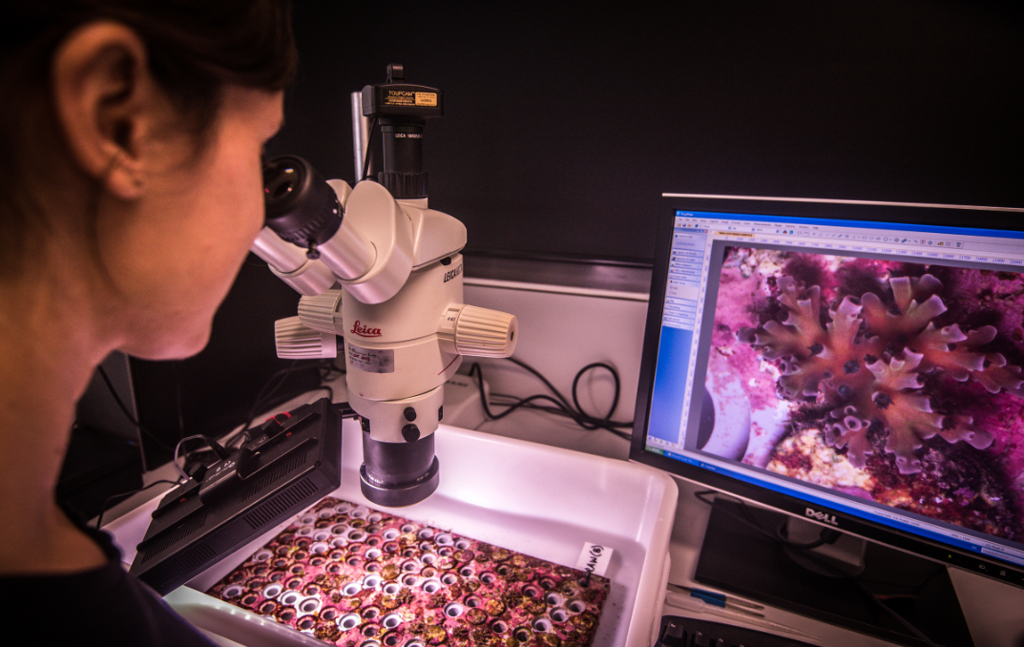
Working with scientific partners, © Australian Institute of Marine Science, photographer: Christian Miller
- Australia is a founding member of the International Coral Reef Initiative (ICRI) which is an informal partnership between nations and organisations that strives to preserve coral reefs and related ecosystems. ICRI contributed to the Reef Summit and shared its outcomes with ICRI members. From mid–2018 to mid–2020 the Authority, partnering with Monaco and Indonesia, is the Secretariat for ICRI. Australia’s emphasis is on sharing and collaborating with international partners to build scientific capacity and innovation in reef management in the face of increasing impacts of climate change. The Blueprint guides this approach. Australia will also host the ICRI General Meeting in 2019 with a theme of ‘managing for resilience’.

- The Reef Islands Initiative was launched in April 2018 to establish a network of climate change refuges for protecting critical habitats and species across five Great Barrier Reef islands. Led by the Great Barrier Reef Foundation, it will be delivered through a range of partnerships including with the Authority, Queensland Parks and Wildlife Service, Traditional Owners, research organisations and tourism operators. Lady Elliot Island is the first island to be included in the project.
- The draft Aboriginal and Torres Strait Islander Heritage Strategy was released for public comment with Traditional Owners, community members, industry bodies, Indigenous organisations and government agencies providing advice on the draft strategy and its actions. The strategy seeks to work in partnership with Traditional Owners to keep the Reef and Indigenous heritage strong, safe and healthy for future generations.
- Partnerships with Traditional Owners are delivering benefits for Aboriginal and Torres Strait Islander communities and the Reef. This includes the recent Traditional Use of Marine Resources Agreement between Mandubarra Aboriginal Land and Sea Inc. and the Australian and Queensland governments covering 1500 square kilometres of sea country between Innisfail and Cardwell. This 10-year agreement supports Traditional Owners involvement in compliance management, research, education and youth-focussed activities.
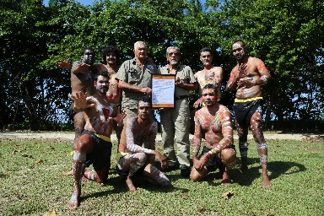
Mandubarra Traditional Owners celebrate their first Traditional Use of Marine Resources Agreement
- Great Barrier Reef Legacy launched its Search for the Super Coral Expedition in November 2017. The venture gave free and rare access to the northernmost reaches of the Great Barrier Reef for 10 teams of scientists studying climate-related impacts and searching for the most resilient corals. The not-for-profit group also gave free access to multi-media technicians to promote international coverage and awareness of threats to the Reef.
- In May 2018 the Australian Government called for tenders to coordinate and deliver marine debris clean-up activities, as well as promote education and awareness of ways to reduce and prevent marine debris in the Great Barrier Reef. Funding of up to $5.5 million has been made available for this work over the next five years.
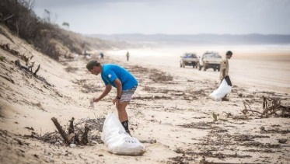
Marine debris clean up post tropical cyclone Marcia, Nine Mile Beach, Yeppoon, photographer: Tangaroa Blue
- Not-for-profit group Tangaroa Blue has continued its efforts to reduce marine debris with the launch of a new App in June 2018. The Australian Marine Debris Initiative (AMDI) app provides a platform for citizen scientists and AMDI partners to contribute data from their clean-up activities to the AMDI database. The information is used to track marine debris and litter so the flow of rubbish can be traced and tackled at its source.
- In November 2017, Reef Ecologic led a three-week capacity building program for coral reef managers and leaders from across the world as part of the Australian Awards International Coral Reef Management and Leadership Program. This fellowship supports leaders and professionals to help individuals and organisations tackle the challenges facing coral reefs globally. Partners included the Department of Foreign Affairs and Trade, the International Union for the Conservation of Nature (IUCN), the Authority, and James Cook University.
- The last 12 months has seen the ongoing involvement of school children in activities to reduce threats to the Reef. This includes annual Future Leaders Eco Challenges held in August and September in regional centres along the Reef’s coastline. In partnership with local communities, the challenge forms part of the Reef Guardian Schools Program which includes over 270 schools, 120,000 students and 7,400 teachers.
- The Authority has continued to partner with local government authorities through its Reef Guardian program. With 18 Reef Guardian Councils between Bundaberg and Cooktown covering almost 900,000 people spread over 300,000 square kilometres, these efforts aim to foster collaboration, support new initiatives and share collective learnings. This includes supporting the Local Government Association of Queensland to advance cross-council initiatives that contribute to Reef 2050 Plan targets.
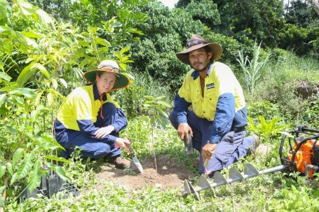
Reef Guardian Council staff in the Douglas region working on controlling wetland weeds, photographer: Pine Creek Pictures 2015
- The new term of Local Marine Advisory Committees started in July 2018 with about 180 community members volunteering their time to provide advice and input on the management of the Marine Park as well as encouraging and participating in actions to protect the Great Barrier Reef. There are 12 Local Marine Advisory Committees extending along the Great Barrier Reef’s coastline from Cooktown to Bundaberg. Members represent a diverse range of interests and backgrounds and are appointed for a three-year term.
- The 2018 Reef Guardians stewardship grants program has provided seed-funding to communities for bringing people together, from a variety of ages and sectors, to participate in local Reef protection projects. Examples include: student reef restoration activities on Magnetic Island; coral monitoring and coral bleaching awareness on Cape York; and monitoring by sport fishers of fish species in local inshore areas. These projects demonstrate that everyone can contribute to the future of the Reef.
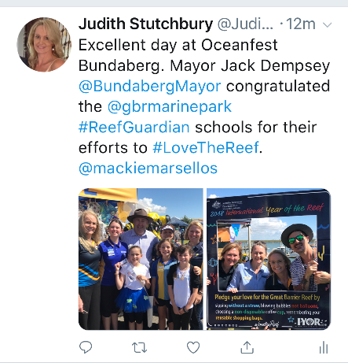
Burnett LMAC member and Reef Guardian school teacher Judith Stutchbury spreading the word at a local event alongside the Authority
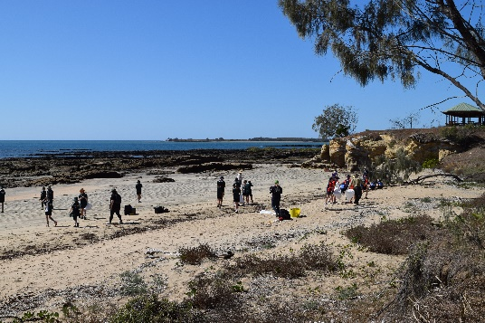
Teaching students about sustainability at Future Leaders Eco Challenges, which form part of the Reef Guardian Schools program
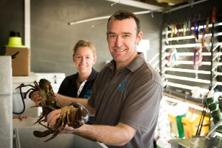
Fresh Island Seafood Hamilton Island are Reef Guardian Fishers, © Tropix Photography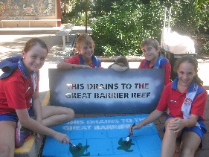
Reef Guardian School students from Home Hill State School stencil Reef protection messages on the drains in their school grounds
The call for urgent action is being heard. People are rallying behind efforts to tackle threats, large and small, to the Reef.

Adapting policy and legislation
Vision for 2020
Government policy supports resilience-based management of the Great Barrier Reef by facilitating appropriate interventions, innovations and participation by communities and businesses.
Why is it important?
Policy and legislation determine how the regulatory and decision-making roles of government and organisations are performed.
It is important for Marine Park policy and legislation to function as 'enablers' to enhance the delivery of appropriate interventions, innovations and participation for building Reef resilience.
Highlights
A key outcome of the Reef Summit was recognition of the need to develop a contemporary policy framework for restoration interventions in the Marine Park.
In February 2018, the Authority released its Draft Reef intervention Guidelines and Draft Reef Intervention Guidelines — Supporting Information. These provide guidance to marine park assessment officers and applicants when considering an application to conduct intervention activities for improving the resilience of coral reef habitats in the Great Barrier Reef Marine Park.
Action update
- The draft guidelines provide greater clarity on how the Authority ensures these projects do not have an adverse impact on the biodiversity, heritage, social or economic values of the Marine Park.
- The Authority sought comment on the draft guidelines in early 2018. Submissions have been analysed and it is anticipated that the guidelines will be finalised by the end of 2018.
- The Authority is developing position statements on climate change, water quality, coastal ecosystems, sustainable fishing and marine debris.
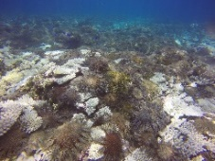
The Authority is leading the intervention to control crown-of-thorns starfish outbreaks, photographer: Sascha Taylor (Queensland Parks and Wildlife Service) taken in the Swain Reefs

Developing decision-support systems
Vision for 2020
Timely and salient information is publicly available through decision-support systems to inform future-focussed adaptive resilience-based management.
Why is it important?
Managing for resilience requires an understanding of the cause-and-effect relationships between drivers and pressures on the state of the system, forecasting tools to inform planning and actions, and monitoring and diagnostic tools to adjust actions.

Highlights
The design phase of the Reef 2050 Integrated Monitoring Program — which will bring together modelling, monitoring and reporting programs across the Great Barrier Reef and the catchment — is nearing completion. This significant milestone is the result of dedicated efforts by over 17 partner organisations and a range of experts across disciplines.
In April 2018, the Australian Government committed an additional $40 million to support the program's transition from the design phase into an operational system.
Action update
- A comprehensive report is being prepared on the program’s recommended design, which will include a cost-benefit and trade-off analysis using a structured decision-making process. Design work is being led by AIMS and the Authority and is being supported by eight expert groups.
- A new website for the program was launched in March 2018 to improve access to information on its development. This includes an overview of the program’s scope and partners, together with updates on work underway to support its development.
- The Authority is working collaboratively with scientists from the University of Queensland to develop a prototype decision support system to help prioritise reefs for enhanced management attention, including for Zoning Plan compliance and crown-of-thorns control to support ecosystem resilience. This project is funded by the Authority, the Department of Environment and Energy and the National Environmental Sciences Program.
Improving the accessibility and timeliness of information to guide Reef actions and ensuring management is underpinned by the best available science.

Building awareness and support
Vision for 2020
Efforts to protect and build resilience of the Great Barrier Reef — including in-park management and efforts to address external drivers, such as climate change and degraded water quality — are actively supported by all sectors of society.
Why is it important?
Improving the outlook for the Great Barrier Reef requires action at local, regional and international levels. Engaging the broadest possible range of individuals, businesses and community groups in efforts to reduce threats, build resilience and protect the Reef is the key to building momentum for direct action and influencing others to take action.
Highlights
Awareness and momentum for action are increasing as Reef partners and the broader community work together in promoting clear and consistent messages about the urgent need to tackle climate change, improve water quality and build Reef resilience through on-ground actions in the Marine Park.
Action update
- The use of targeted digital campaigns aimed at reducing threats to the Reef is growing. For example, Citizens of the Great Barrier Reef has launched digital campaigns targeting local and regional efforts to curb the presence of single-use plastics on the Great Barrier Reef, and international efforts to limit the production of greenhouse gas emissions.
- The International Coral Reef Initiative (ICRI) declaration of 2018 as International Year of the Reef (IYOR) has called the global community to make pledges for support to encourage greater awareness of the threats facing coral ecosystems and adopt simple actions to protect them. The Authority has driven the IYOR pledge campaign through media releases. Facebook live question and answer sessions, and promotion at events to encourage stakeholders, including Reef Guardian program participants, to get involved. At Reef HQ Aquarium in Townsville there is an IYOR world map featuring everyday actions to help protect the Reef, plus a pledge wall. A suite of multi-audience materials has also been produced and distributed to over 30 Reef partners and used to promote the simple, individual actions people can take to protect the Reef.
- New and innovative approaches to widen public engagement are being developed for Australian and international audiences such as the use of in-water classrooms by Reef HQ Aquarium and the variety of multi-media communications supported by Great Barrier Reef Legacy.
- Growing partnerships across industry sectors and with the community are helping to make threat reduction efforts good for business, as well as the environment. On a local level, the ‘Straw No More Campaign’ is seeing private citizens combine with local councils, food businesses, online campaigners, tourism operators — including the Association of Marine Park Tourism Operators — and Local Marine Advisory Committees to cut the amount of plastics entering Reef waters.
- As a result of extra funding for the Australian and Queensland governments’ Joint Field Management Program, the next five years will see a growing capacity for marine park rangers to undertake education and awareness activities, including more targeted communication campaigns.
- New funding is being channelled into establishing more multi-partner projects, programs and forums. These aim to generate shared understanding, the pooling of resources and greater ownership of the outcomes. Examples include the Reef Trust — Great Barrier Reef Foundation Partnership; the Reef Restoration and Adaptation Program; and the Reef Integrated Monitoring and Reporting Program.
- Increased collaboration between Reef partners has established greater consensus on the key issues affecting the Reef, and improved the coordination efforts of partners to document and communicate outcomes to the public. These actions can be seen in preparations for the 2019 Outlook Report, Reef report cards, and the production of joint media statements, articles and online cross-postings.
- Increasing Reef stewardship activities and the telling and sharing of stories are helping people understand the broader personal, social, cultural and intergenerational imperatives of protecting the Reef while also teaching them practical ways to contribute. Such measures can be seen in the Authority’s media promotions of the Aboriginal and Torres Strait Islander Ranger’s program, the Reef Guardians Future Leaders Eco Challenges, and through partner’s media showcasing the many actions underway to protect the Reef.
The telling and sharing of stories about actions to protect the Reef is helping people understand the broader personal, social, cultural and intergenerational imperatives of protecting the World Heritage Area.
Targeted communication campaigns are raising awareness and promoting grassroots efforts to curb major threats to the Reef.
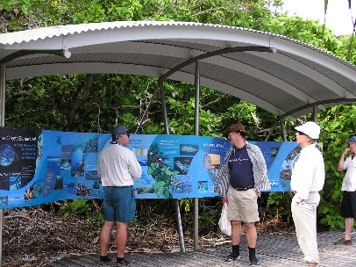

Education and awareness activities

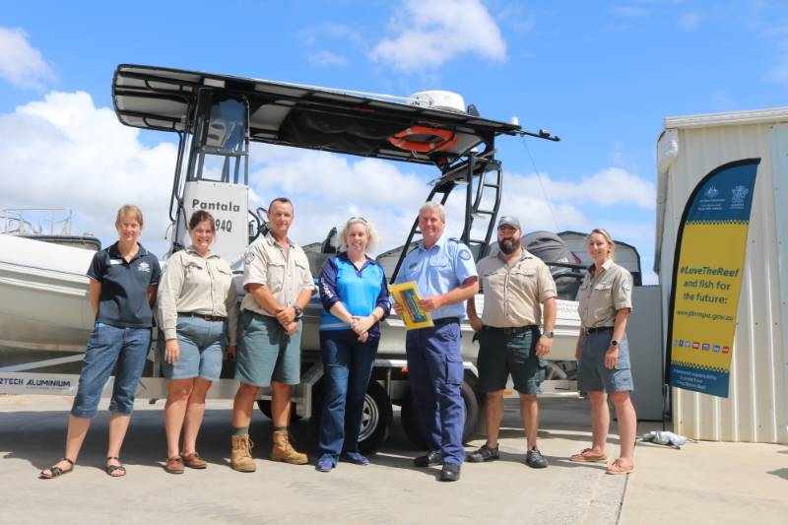

Launch of compliance campaign in Gladstone

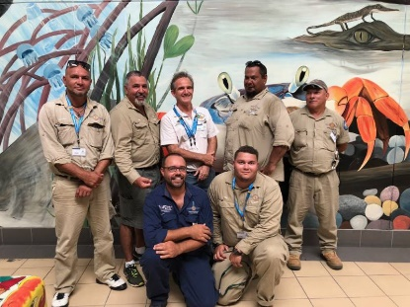

Girringun rangers help to protect the Reef

MAINTAINING MOMENTUM

The Blueprint’s underlying message is one of urgency and the actions highlighted in this progress report reflect the rallying of efforts and groundswell of support to tackle threats, large and small, to the Reef.
One of the Authority’s key challenges is to not only maintain this momentum, but sustain enhanced levels of effort over the long term.
There are no short-term fixes and we must implement strategies that not only dramatically improve the Reef’s resilience, but also support the resilience of individuals, organisations and the broader community in their efforts to deliver positive and lasting environmental change.
The Authority’s call to join us in our mission to protect the Reef’s future remains strong. So too does our commitment to ongoing support for our many partners and their collective efforts.
We look forward to continuing to work with you to protect the Great Barrier Reef’s future.
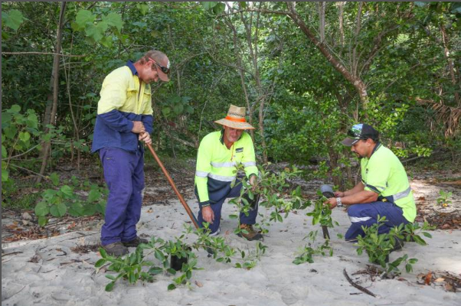
Reef Guardian Council program participants planting shrubs at Four Mile Beach, Port Douglas, photographer: Pine Creek 2015

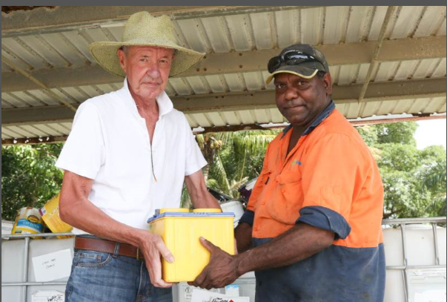
Reef Guardian Council staff recycle batteries at a Port Douglas region landfill site, photographer: Pine Creek 2015

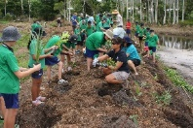
Students from Mission Beach State School, a Reef Guardian School, and project partners work together to restore a local wetland

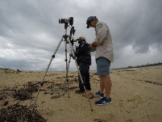
Girringun and Queensland Parks and Wildlife rangers monitor sea birds

FURTHER INFORMATION

The Blueprint and this progress report focus on actions to build the resilience of coral reefs. These initiatives form part of broader management efforts across the Reef, its catchment, nationally, and globally to tackle key threats and protect the Great Barrier Reef.

Further information on the Blueprint can be sourced in the following documents.

Reef Summit: Managing for a resilient Great Barrier Reef Marine Park

Reef Summit: Summary of proceedings and outputs, June 2017

Reef Blueprint: Great Barrier Reef Blueprint for resilience

Information on the Authority’s full suite of management arrangements can be found in the corporate plan and annual report, with Blueprint actions incorporated into work plans.

Great Barrier Reef Marine Park Authority Corporate Plan 2018 – 19

Great Barrier Reef Marine Park Authority Annual Report 2016 – 17

Information on the collaborative effort of Reef partners can be found in the Reef 2050 Long-Term Sustainability Plan (2015 and 2018 editions) and supporting documentation.

Reef 2050 Long-Term Sustainability Plan

Reef 2050 Long-Term Sustainability Plan July 2018

We must continue to accelerate efforts to reduce global greenhouse gas emissions in parallel to delivering local actions to strengthen the Reef's resilience.

The Great Barrier Reef Marine Park Authority acknowledges the contribution from partners and the community.

Great Barrier Reef Marine Park Authority's website address
Great Barrier Reef Marine Park Authority logo

