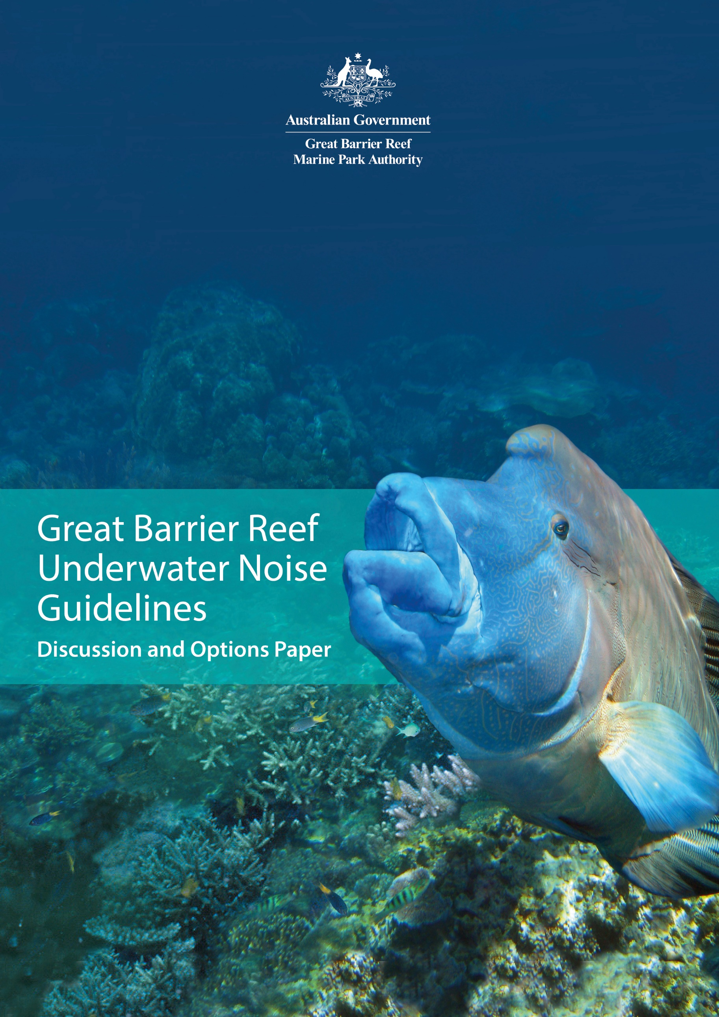

Great Barrier Reef Underwater Noise Guidelines

Version 1.0

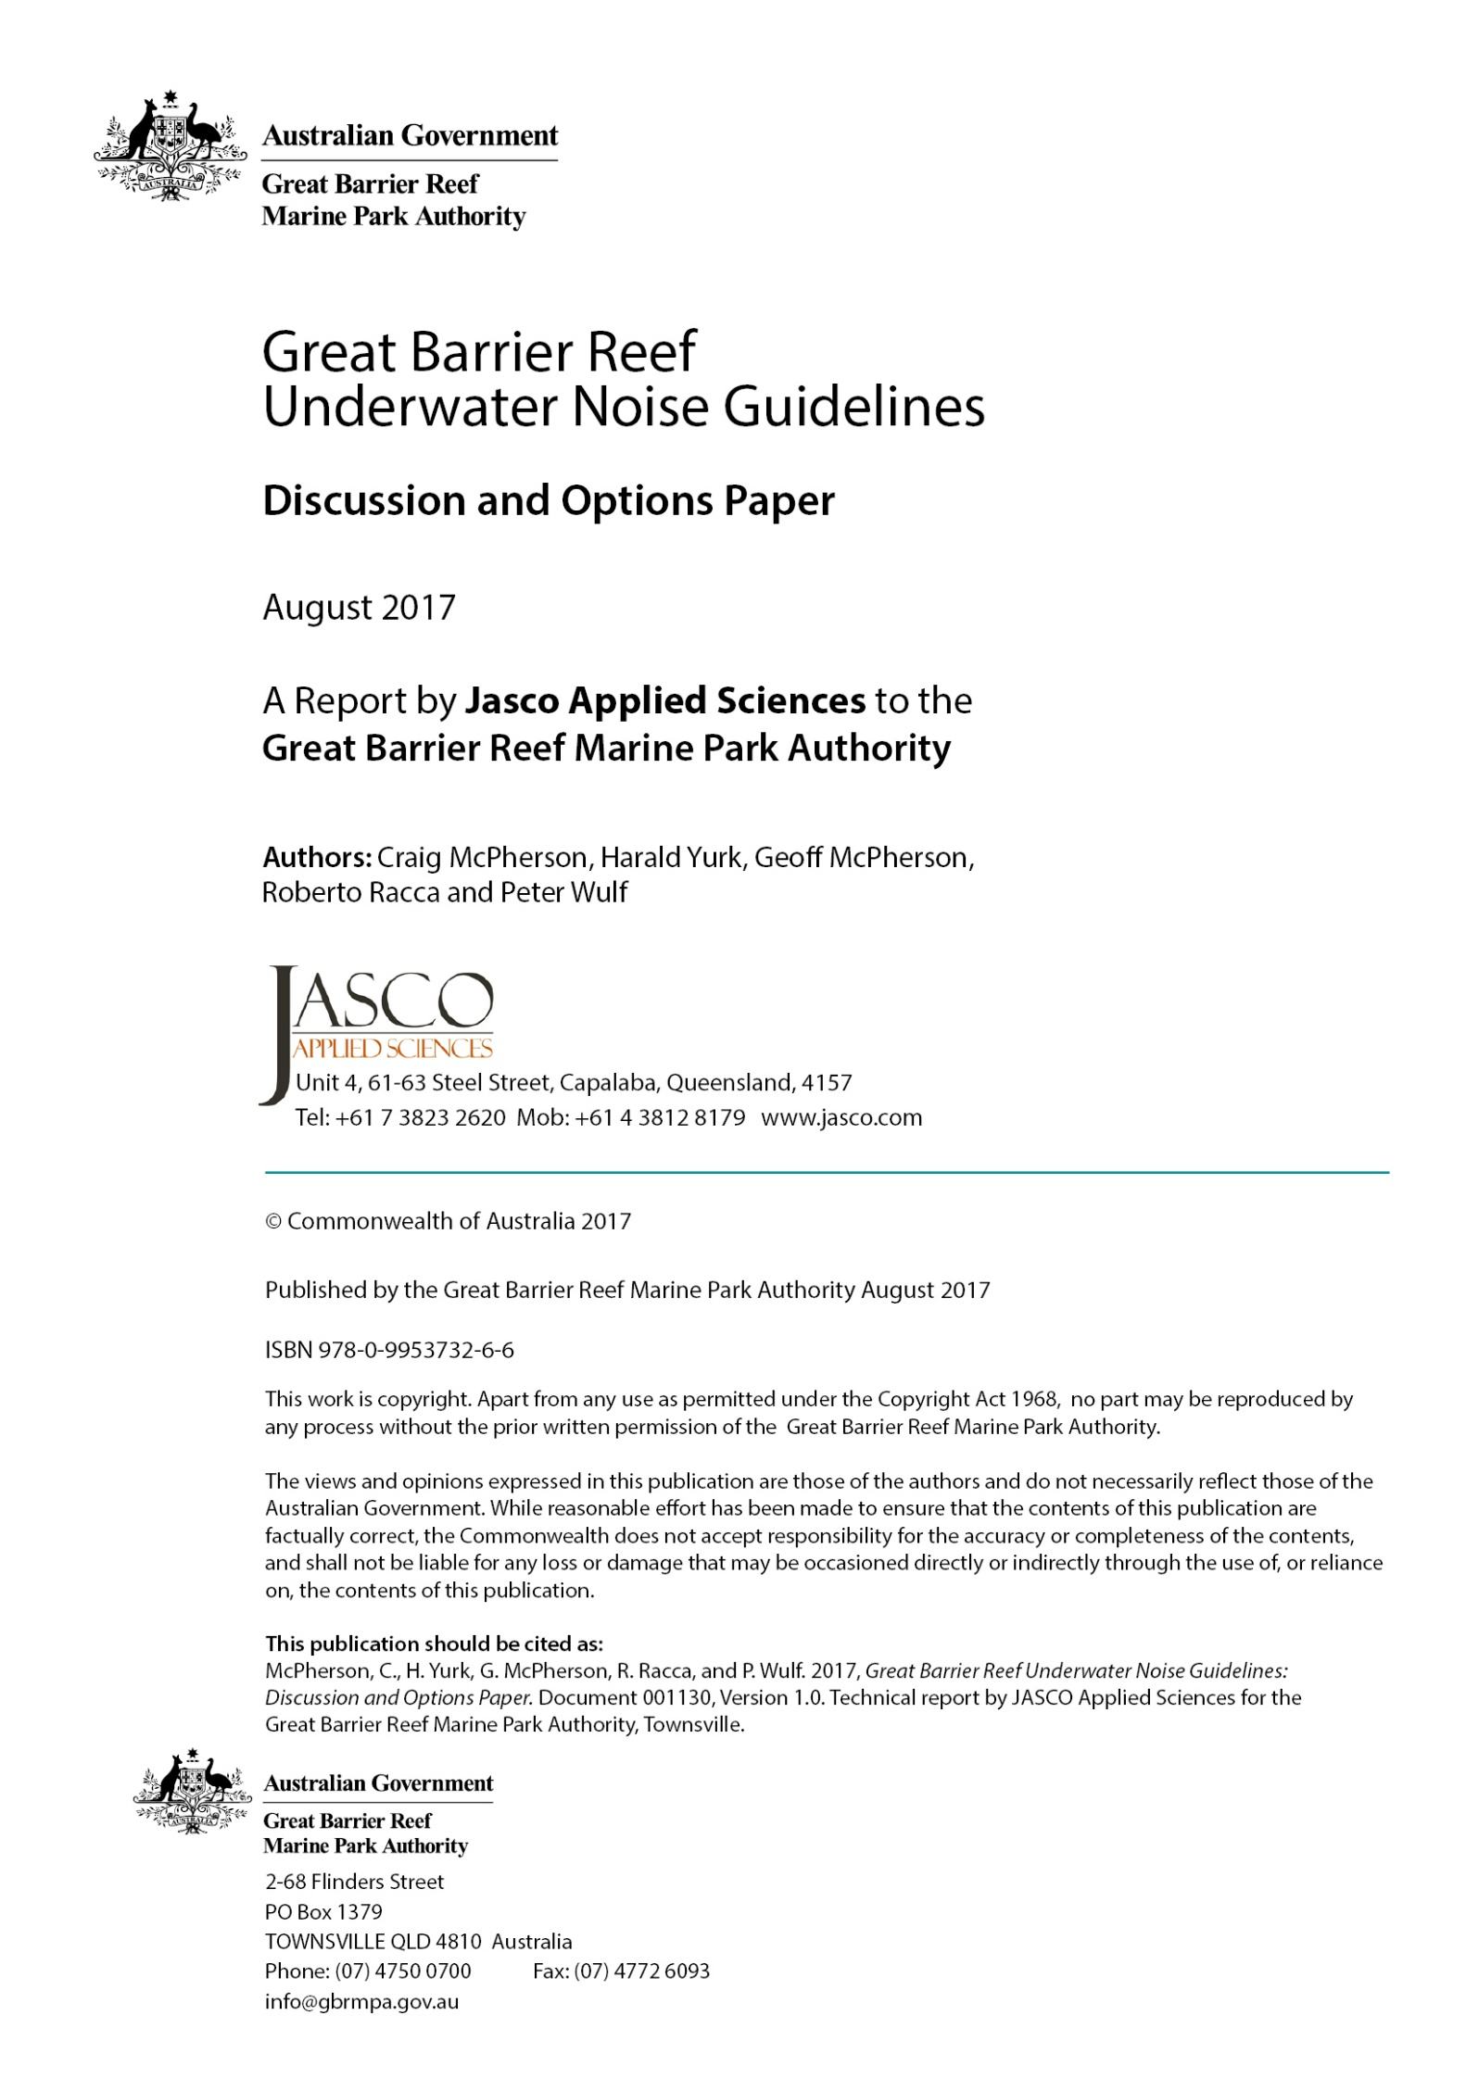
Contents
Executive summary 1
1. Introduction 3
2. Policy 4
2.1. Policy context 4
2.2. Domestic law and policy related to underwater noise 4
2.2.1. Australian legal mechanisms 5
2.2.2. Environment Protection and Biodiversity Conservation Act 1999 (Cth) 5
2.2.3. Great Barrier Reef Marine Park Act 1975 (Cth) 6
2.2.4. National Offshore Petroleum Safety and Environmental Management Authority 7
2.2.5. Queensland legislation 8
2.2.6. South Australia underwater piling noise guidelines 8
2.2.7. Shipping regulation 8
2.2.8. Particularly sensitive sea area 9
2.3. International law and policy related to underwater noise 9
2.3.1. International Maritime Organisation 9
2.3.2. International Council for the Exploration of the Sea 10
2.3.3. Convention on the Conservation of Migratory Species of Wild Animals 10
2.3.4. Convention on Biological Diversity 11
2.3.5. Australia’s involvement in the development of international law and policy on underwater noise 12
2.3.6. Europe 13
2.3.6.1. Overview 13
2.3.6.2. Collaborations 15
2.3.7. Germany 16
2.3.8. Denmark and Greenland 16
2.3.9. United Kingdom 16
2.3.10. Ireland 17
2.3.11. New Zealand 17
2.3.12. United States of America 18
2.3.13. Canada 18
2.4. ISO standards 19
3. Policy options 21
3.1. Options relating to development process 21
3.2. Options relating to impact assessment criteria 22
3.3. Options relating to risk assessment 23
3.4. Options relating to technical guidance notes 23
3.5. Options for updating policy and guidance notes 24
3.6. Options for GBRMPA developing the scientific understanding for appropriate management 25
4. Marine fauna acoustic impact criteria 26
4.1. Introduction and background 26
4.2. Background on threshold criteria for acoustic injury in marine mammals 27
4.3. Background on threshold criteria for behavioural disturbance in marine mammals 28
5. Risk assessment processes 30
5.1. Background 30
5.2. Risk assessment process 30
5.3. Biological consequences of sound exposure – PCAD/PCoD framework 30
5.4. Application of PCoD Framework to evaluate population consequences 32
6. Assessment guidelines and mitigation methods 33
6.1. Exclusions 33
6.2. Key concepts 34
6.3. Pile driving 35
6.3.1. Assessment guidelines 35
6.3.2. Example projects 36
6.3.3. Mitigation methods 36
6.4. Shipping, dredging, and geophysical sources 37
6.4.1. Shipping and dredging assessment guidelines 37
6.4.2. Geophysical source assessment guidelines 38
6.4.3. Example projects 38
6.4.4. Mitigation methods 40
6.5. Aggregate and cumulative sound exposure 41
6.5.1. Background 41
6.5.2. Assessment of aggregate and cumulative exposure 43
6.5.3. Example projects 44
6.5.4. Mitigation of aggregate and cumulative exposure 45
7. Summary technical guidance 46
7.1. Risk assessment process 47
7.1.1. Scientific considerations 48
7.2. Assessment of particular activities 48
7.3. Modelling 49
7.4. Ambient noise characterisation 50
7.4.1. Purpose 50
7.4.2. Summary 51
7.5. Radiated noise measurement 51
7.5.1. Background 52
7.5.1.1. Temporal sampling 52
7.5.1.2. Spatial sampling 52
7.5.2. Summary 53
7.5.2.1. Example report outline 53
7.5.3. Considerations for specific sources 54
7.5.3.1. Shipping 54
7.5.3.2. Dredging 54
7.5.3.3. Pile Driving 54
7.6. Cumulative assessment 55
7.7. Mitigation methods 56
7.7.1. Pile driving 56
7.7.2. Shipping 56
7.7.3. Cumulative mitigation 57
Glossary 58
Literature cited 65
Appendix A. General introduction to underwater noise A-1
A.1. Sound characteristics A-1
A.2. Particle motion A-2
A.3. Metrics A-3
A.3.1. Sound metrics A-3
A.3.2. Source level A-6
A.4. Types of sound A-8
A.5. Propagation of sound A-8
Appendix B. Sources of underwater noise B-1
B.1. Vessels B-1
B.1.1. Vessel noise sources B-2
B.1.2. Bulk- carrier acoustic signatures B-4
B.1.3. High speed tourist ferries B-7
B.1.4. Outboard powered vessels B-8
B.1.5. Prawn trawlers B-9
B.1.6. Diesel powered troll vessels B-10
B.2. Dredging B-10
B.3. Pile driving B-13
B.3.1. Impact pile driving B-13
B.3.2. Vibratory pile driving B-15
B.3.3. Pile drilling B-16
B.4. Rock dumping B-16
B.5. Blasting B-16
B.6. Geotechnical exploration B-17
B.6.1. Chirp sub-bottom profilers B-18
B.6.2. Sparkers B-19
B.6.3. Boomers B-19
B.7. Civilian sonar B-20
B.7.1. Overview B-20
B.7.2. Side-scan sonar B-20
B.7.3. Multibeam sonar B-20
B.8. Underwater communication systems B-25
B.9. Renewable power generators B-25
B.10. Defence B-26
B.11. Helicopters and aircraft B-26
Appendix C. Soundscapes within the world heritage area C-1
C.1. Overview C-1
Appendix D. Overview of hearing of key reef species D-1
D.1. Summary D-1
D.2. Marine mammals D-1
D.2.1. Marine mammal hearing with a focus on cetaceans D-3
D.2.2. Mysticetes D-4
D.2.3. Odontocetes D-5
D.2.4. Dugongs D-7
D.3. Sea turtles D-9
D.4. Fish D-9
D.4.1. Background D-9
D.4.2. Hearing D-11
D.4.3. Acoustic association with reefs D-13
D.5. Elasmobranchs D-14
D.6. Invertebrate taxa D-15
D.6.1. Substrate vibration detection D-15
D.6.2. Water particle movement and pressure change detection D-15
Appendix E. Overview of sound production of key reef species E-1
E.1. Marine mammals E-1
E.2. Fish E-2
E.3. Turtles E-3
Appendix F. Summary of effects of noise on marine fauna F-1
F.1. Marine mammals F-3
F.1.1. Overview F-3
F.1.2. Acoustic masking F-4
F.1.3. Behavioural disturbance F-5
F.1.4. Non-auditory effects F-7
F.1.5. Temporary and permanent hearing loss F-8
F.1.6. Reduction of prey availability or ability to find prey F-9
F.2. Fish F-9
F.2.1. Overview F-9
F.2.2. Mortality and temporary hearing loss F-10
F.2.3. Behaviour F-10
F.2.4. Masking F-11
F.3. Elasmobranchs F-13
F.4. Marine reptiles F-13
F.4.1. Turtles F-13
F.4.2. Sea snakes F-13
F.5. Invertebrate taxa F-13
F.5.1. Effects on behaviour F-14
F.5.2. Bivalves F-15
Appendix G. Underwater acoustic modelling G-1
G.1. Requirement for modelling G-2
G.2. Metrics G-2
G.2.1. Assessing sound exposure level G-2
G.3. Required inputs to a propagation model include: G-3
G.3.1. Input assumptions G-4
G.4. Overview G-4
G.5. Relevance and applicability of modelling G-5
G.6. Discussion topics G-5
G.6.1. Particle motion G-5
G.6.2. Frequency range G-5
G.6.3. Modelled frequencies G-6
G.6.4. Receiver depths G-6
G.6.5. Transects G-6
G.6.6. Reverberation G-6
G.7. Source models G-7
G.7.1. Pile driving G-7
G.7.2. Vessel and dredge sources G-7
G.8. Propagation models G-8
G.9. Accuracy quantification G-9
G.10. Animal exposure assessment G-10
G.10.1. Frequency weighting G-10
G.10.2. Animats G-10
G.11. Animal listening and communication space and detection of source G-11
G.11.1. Listening area G-11
G.11.2. Communication space G-13
G.11.3. Method for computing zone of audibility G-14
Appendix H. Underwater acoustic measurement H-1
H.1. Data representations H-1
H.2. Baseline / ambient H-2
H.2.1. Long-term studies H-3
H.2.2. Program design process H-3
H.2.3. Program duration H-4
H.2.4. Factors for consideration H-4
H.2.5. Examples H-7
H.2.6. Ambient / marine mammal reporting H-13
H.3. Radiated noise sources H-15
H.3.1. Temporal sampling H-15
H.3.2. Spatial sampling H-16
H.3.3. Comparison with modelling results H-16
H.3.4. Summary case study H-16
H.3.5. Example report outline H-17
H.3.6. Shipping H-17
H.3.7. Dredging H-23
H.3.8. Pile driving H-23
H.3.9. Sampling locations H-24
H.3.10. Validation of mitigation systems H-27

Figures
Figure 1. Flow diagram depicting the PCAD model developed by NRC (2005) reprinted with permission from the National Academies Press, Washington, DC. 31
Figure 2. Sample frames from the time-lapse animation of vessel noise in the study area (MacGillivray et al. 2014b). 42
Figure 3. Example of Monthly Mean Commercial Vessel Traffic SPL Noise Levels assessed according to Resident Killer Whale Audiogram-weighting. Figure A-26 Scenario S4 from MacGillivray et al. (2014a). 42

Figure A-1. Compression and rarefaction phases of a travelling sound wave. A-1
Figure A-2. Comparing pressure differences of various sound sources occurring in the ocean using the Pascal scale (left) and the referential decibel scale (right). A-2
Figure A-3. Sound level metrics. A-4
Figure A-4. Plot of an ambient noise power spectrum and corresponding 1/3-octave band levels. Frequency is plotted on a log scale so 1/3-octave bands are wider at higher frequencies. A-7
Figure B-1. Spectrogram of a container ship transiting Haro Strait at 22.4 kn (Warner et al. 2014). B-2
Figure B-2. TWMBR recorded mean 1/3-octave-band source levels for different vessel types (Hemmera Envirochem Inc. et al.). © JASCO. B-4
Figure B-3. Measured ship source levels and averaged level (Hallet 2004). B-5
Figure B-4. Representative 1/3-octave source levels for five bulk-carriers recorded by McKenna et al. (2012). B-6
Figure B-5. Broadband source level compared to ship speed B-7
Figure B-6. Spectrogram of a 34 m jet powered catamaran travelling at 27.4 kn, extract from Figure 2 in Allen et al. (2012). B-8
Figure B-7. The 5.8 m 115 hp powered MV Sand Lance’s 1/3-octave spectrum levels at three speeds (Figures 1 and 13, Kipple and Gabriele 2003). B-9
Figure B-8. 1/3-octave sound spectrum of a Belgian prawn trawler under towing load at 750 rpm (Figure 9 in Fontenye 1973). B-9
Figure B-9. Sound sources for main dredging types (Figure 4 in World Organisation of Dredging Associations 2013). B-11
Figure B-10. Comparison between 1/3-octave band levels for suction dredges. See Table B-1 for vessel specifications (Zykov et al. 2007). B-12
Figure B-11. Photo of a temporary pile being driven by a hydraulic impact hammer during construction of a highway bridge in Queensland, Australia (from Erbe 2009). B-14
Figure B-12. Example of waveform, power spectrum and spectrogram of pulsed sounds produced by impact pile driving. Panel (a) shows a pile driving pressure pulse (blue), with horizontal lines indicating the peak pressure (red) and 90% rms pressure (black). Panel (b) shows the acoustic frequency spectrum. Panel (c) shows the spectrogram of a series of pile driving pulses. © JASCO. B-14
Figure B-13. Example of broadband levels (peak and rms) and spectrogram of two intervals of non-pulsed (continuous) sounds produced during vibro-hammering (Racca et al. 2007). © JASCO. B-15
Figure B-14. Estimated source levels (SLs) for rock dumping. Extrapolated levels above 10 kHz are shown as dot-dashed lines. © JASCO. B-16
Figure B-15. Estimated pressure wave at 1 m from an explosive charge buried 3 m in bedrock, for 6 kg and 12 kg of ammonium nitrate/fuel oil (ANFO). © JASCO. B-17
Figure B-16. Estimated source levels (SLs) from an explosive charge buried 3 m in bedrock, for 6 kg and 12 kg of ammonium nitrate/fuel oil (ANFO). © JASCO. B-17
Figure B-17. Knudsen Chirp 3260 sub-bottom profiler: Maximum-over-depth broadband (3.5, 12, and 200 kHz) sound pressure levels around the source. Bathymetry contours (m) are shown in blue (Zykov et al. 2012). B-18
Figure B-18. Knudsen Chirp 3260 sub-bottom profiler: Vertical cross-section of the broadband (3.5, 12, and 200 kHz) sound pressure levels, up to 22 km from the source (Zykov et al. 2012). B-19
Figure B-19. Calculated beam pattern for the transducer of the Kongsberg Simrad EM 120 multibeam sonar at 12 kHz (Zykov 2012). The beam power function is shown relative to the on-axis level using the Robinson projection. B-21
Figure B-20. Calculated beam pattern vertical slice for the Kongsberg Simrad EM 120 multibeam sonar at 12 kHz (Zykov 2012). B-21
Figure B-21. Kongsberg EM 122 multibeam sonar Maximum-over-depth (12 kHz) sound pressure levels around the source in 109 m (left) and 385 m (right). Bathymetry contours (m) are shown in blue (Zykov et al. 2012). B-22
Figure B-22. Kongsberg EM 122 multibeam sonar: Vertical cross-section of the (12 kHz) sound pressure levels, up to 10 km from the source in 109 m (top) and 385 m (bottom) (Zykov et al. 2012). B-23
Figure B-23. Maximum extension of distances to specific maximum-over-depth root-mean-square (rms) sound pressure level (SPL) thresholds around the vessel while it was operating the multibeam sonar (Zykov 2012). B-25
Figure B-24. Ray-path diagram for air-water propagation from an airborne source. Source: Gales (1982), based on Urick (1972). B-27
Figure B-25. Derived 1/3-octave band levels at the water surface, directly below helicopters flying at an altitude of 300 m. Source: (Richardson et al. 1995), Figure 6.4. B-28
Figure C-1. Broadband and decade-band sound pressure levels (SPL) (above), spectrogram of underwater sound (below), JASCO AMAR deployment at Wheeler Reef, 27 April to 29 July 2013. © JASCO. C-2
Figure D-1. Modelled audiogram of a minke whale from Ketten and Mountain (2012). D-4
Figure D-2. The standard audiogram for the bottlenose dolphin (from Brill et al. 2001, after Johnson 1967). D-5
Figure D-3. Comparison of audiograms measured from Pacific bottlenose dolphins (filled triangles) and Atlantic bottlenose dolphins (open circles). Asterisks denote significant differences between the two populations (from Houser et al. 2008). D-6
Figure D-4. Audiogram of the Indo-Pacific humpback dolphin studied (Li et al. 2012) and the spectrum density of the background noise in the experimental pool. D-6
Figure D-5. AEP audiograms measured over three years from a captive false killer whale in Kaneohe Bay, Hawaii. The fourth curve shows the average value of all three audiograms (from Yuen et al. 2005). D-7
Figure D-6. Representative audiogram of resident killer whale adapted by H. Yurk, J. Wood, and D. Bain. In SMRU Ltd (2014). D-7
Figure D-7. Behavioural audiograms for two manatees (Stormy and Dundee). Ambient noise in the pool where the audiograms were measured is also shown on the graph (from Gerstein et al. 1999). D-8
Figure D-8. Third order polynomial curves fit to sirenian, pinniped, and odontocete audiograms taken from the literature. Shallow water and noise curves are taken from Urick (1983) and Gerstein et al. (1999). D-8
Figure D-9. Part of 'Crossing the Blue Highway', a poster by Russell Kelley (www.byoguides.com) published by the Australian Coral Reef Society (Kelley). D-10
Figure D-10. Auditory sensitivity of settlement stage Plectropomus leopardus (from Wright et al. (2008)). D-12
Figure D-11. Auditory thresholds for reef species (filled circle) and pelagic species (open circle) (Figure 4, (Wright et al. 2009)). D-12
Figure D-12. Spot-lined sardine from Akamatsu et al. (2003), a species closely related to the Reef Sardinella sirm. D-13
Figure F-1. Schematic diagram showing hypothetical zones of impact around a high energy underwater sound source (at centre) and listing the potential effects upon a receiving animal, assuming spherical spreading. PTS = Permanent Threshold Shift; TTS = Temporary Threshold Shift, in National Parks and Wildlife Service (2014), after NRC (2005). F-3
Figure G-1. Schematic representation of changes in listening area around a marine mammal. G-12
Figure H-1. Broadband and decade-band sound pressure levels (SPL) (above), spectrogram of underwater sound (below) (McPherson et al. 2016a). © JASCO H-8
Figure H-2. (Above) 1/3-octave-band sound pressure levels (SPL) in quartiles. (Below) Quartile 1 min exceedances and power spectral density levels. Dashed lines are the limits of prevailing noise from the Wenz curves (McPherson et al. 2016a). © JASCO. H-8
Figure H-3. Daily cumulative sound exposure level (SEL (24 h)) distributions. H-9
Figure H-4. Vessel detections each hour (vertical axis) versus date (horizontal axis) at eight stations—B5 to WN80—25 Jul to 23 Oct 2014. H-9
Figure H-5. Mean daily bowhead whale call counts H-10
Figure H-6. Summer 2014 daily bowhead call detections in the northeastern Chukchi Sea H-11
Figure H-7. Time series of daily bowhead whale call counts and broadband SPL (from top to bottom) at PLN40, CLN120, B15, and W30 (Delarue et al. 2015). © JASCO. H-12
Figure H-8. Hourly (expressed as an index) and daily presence of automatically detected Omura’s whales at a single acoustic monitoring station in the Timor Sea (McPherson et al. 2016a) © JASCO. H-12
Figure H-9. Spectrogram of humpback whale vocalisations recorded at Wheeler Reef. H-13
Figure H-10. Typical geometry of sound source characterisation (SSC) measurements and the associated terminology. Abbreviations: BS, broadside, CPA, closest point of approach; and EF, endfire. © JASCO. H-18
Figure H-11. Grades A and B hydrophone geometry. ANSI Standard (ANSI/ASA S12.64/Part 1 R2014 2009). Figure 1 reprinted from ANSI/ASA S12.64-2009. R2014/Part 1 Quantities and Procedures for Description and Measurement of Underwater Sound from Ships – Part 1: General Requirements, with the permission of the Acoustical Society of America, 1305 Walt Whitman Road, Suite 300, Melville, NY 11747 H-19
Figure H-12. Power spectral density at multiple distances from drillship operations in the Arctic. (Report Figure 3.13, Austin and Li (2016)). © JASCO. H-20
Figure H-13. Hourly SPLs in decade frequency bands (24 July to 4 October 2015 UTC) at 1 km (0.6 mi) from Shell’s Burger J drillsite in the Chukchi Sea. (Report Figure 3.6, Austin and Li (2016)). © JASCO. H-20
Figure H-14. 1/3­octave band source level for the Polar Pioneer drilling (Report Figure 3.15 Austin and Li (2016)). © JASCO. H-21
Figure H-15. SPL versus range recorded at seven ranges while the Polar Pioneer was (a) drilling and (b) involved in MLC construction (Report Figure 3.12 Austin and Li (2016)). © JASCO. H-21
Figure H-16. Radiated Noise Level and Monopole Source Level of a container ship, 339 m in length, 46 m in breadth and with an 11.9 m draft travelling at an average speed of 20.1 kn. © JASCO. H-22
Figure H-17. Power spectral density (1 Hz bins) of a container ship, 339 m in length, 46 m in breadth and with an 11.9 m draft travelling at an average speed of 20.1 kn. © JASCO. H-22
Figure H-18. Power spectral density spectrogram showing CPA and measurement window, of a container ship, 339 m in length, 46 m in breadth and with an 11.9 m draft travelling at an average speed of 20.1 kn. © JASCO. H-23
Figure H-19. AMAR stations (green circles) and pile locations (red triangles) in Tappan Zee Reach. Distances shown on the map are measured upriver and downriver from the test piles. Coordinates are NY State Plane East (NAD83). Figure 12 from Martin et al. (2012a). © JASCO. H-25
Figure H-20. Background sound levels during short-range monitoring at Test Pile 4A, 12 May 2012, annotated with events from JASCO logs. Figure 24 from (Martin et al. 2012a). © JASCO. H-26
Figure H-21. Spectrogram of background sound levels at Station 10 throughout the PIDP. All dates are UTC. Figure 27 from Martin et al. (2012a). © JASCO. H-26
Figure H-22. Plots of received sound levels for impact pile driving at Test Pile 2B, 16 May 2012, with MENCK MHU 270T hydraulic impact hammer and an Isolation Casing and Bubble System. (Top Left) Short-range monitoring at 35.4 ft horizontal distance. (Top Right) Long-range monitoring at Station 4. (Bottom Left) Long-range monitoring at Station 6. (Bottom Right) Long-range monitoring at Station 8. Figure 85 from Martin et al. (2012a). © JASCO. H-27
Figure H-23. Plots of received sound levels for vibratory pile driving at Test Pile 2A, 16 May 2012. (Top Left Short-range monitoring at 34.1 ft horizontal distance. (Top Right) Long-range monitoring at Station 4. (Bottom Left) Long-range monitoring at Station 6. (Bottom Right) Long-range monitoring at Station 8. Figure 115 from Martin et al. (2012a). © JASCO. H-27
Figure H-24. Mean 1/3-octave band NAS attenuation as measured at short-range (33 ft) from impact hammer pile driving. Attenuation levels are averaged over different airflow/pressure settings. Figure 36 from (Martin et al. 2012a). © JASCO. H-28

Tables
Table 1. Example marine fauna acoustic impact criteria. 26
Table 2. An excerpt of the mitigation table from Maglio and Joint Working Group ACCOBAMS-ASCOBANS (2014) that gives an overview of pile driving mitigation. 37

Table A-1. Nominal 1/3-octave band centre frequencies from 10 Hz to 8 kHz. A-7
Table B-1. Suction dredges specifications. B-13
Table B-2. Knudsen Chirp 3260 sub-bottom profiler: Maximum (R_{max}, m) and 95% (R_{95%}, m) horizontal distances from the source to modelled maximum-over-depth sound level thresholds (3.5, 12, and 200 kHz simultaneously), with and without M-weighting applied (Zykov et al. 2012). B-19
Table B-3. Kongsberg Simrad EM 120 multibeam sonar parameters, operating at 12 kHz (Zykov 2012). A 2° beamwidth was assumed for all model scenarios. B-21
Table B-4. Kongsberg EM 122 multibeam sonar: Maximum (R_{max}, m) and 95% (R_{95%}, m) horizontal distances from the source to modelled maximum-over-depth sound level thresholds (12 kHz), with and without M-weighting applied. B-24
Table D-1. Marine mammal species of occurrence in the GBRWHA (Department of Environment 2016). D-2
Table E-1. Species present within the World Heritage Area (DoE 2016) and approximate vocalisation ranges. E-1
Table F-1. Source and Effects (Adapted from Boyd et al. (2008), including non-auditory health effects Wright et al. (2007), and specialised for the context of the sources considered in this paper and relevance to the Reef. F-1
Table G-1. Underwater sound propagation models available from the Ocean Acoustics Library ([NOAA] National Oceanic and Atmospheric Administration 2017). G-8
Table G-2. Domains of applicability of underwater sound propagation models (from Etter (1996)). Currently 2000 Hz is typically used as the cut off.: Domains of applicability of underwater sound propagation models (from Etter (1996)). Currently 2000 Hz is typically used as the cut off. G-8

Executive summary
The purpose of this discussion and options paper is to inform the process of developing a guideline for considering and managing the impacts of anthropogenic underwater noise on the Great Barrier Reef’s marine fauna.
The paper contains:
- An exploration of international and domestic policy contexts and examples.
- Potential options for how GBRMPA might progress towards development and implementation of underwater noise policy and guidelines for the Great Barrier Reef.
- Suggested technical guidance around underwater noise impact assessments (based on leading practice internationally), as might be incorporated into documents used by assessors and activity proponents.
- Reference summaries on the characteristics, sources and measurement and modelling of underwater noise, along with the acoustic characteristics of Great Barrier Reef animals and the impacts underwater noise can have on them.
Key findings include:
- Currently, specific policy and guidance for managing the impacts of underwater noise in the Great Barrier Reef is lacking.
- Underwater noise management policy and the application of such policy is less advanced in Australia compared to regulatory developments within the international arena.
- There are good opportunities to learn from and use the guidelines already developed (and continuing to evolve) overseas as a basis for Great Barrier Reef policy/guidelines.
- GBRMPA has some existing legislative avenues for managing underwater noise within the Great Barrier Reef Marine Park that could support design and implementation of policy and guidance materials. However, in relation to the parts of the Great Barrier Reef World Heritage Area that do not fall within the Marine Park, the EPBC Act is a critical tool and GBRMPA is not the primary agency responsible for its implementation. While GBRMPA’s incidental powers in relation to the EPBC Act are broad in theory, they may be difficult to use in practice in relation to underwater noise.
- There is much we do not yet know about the acoustic characteristics of the Great Barrier Reef’s animals, soundscapes and propagation environments—and there are limits to the transferability of information from other environments and locations. These are important considerations during design and implementation of underwater noise guidelines and impact assessment and management processes.
- It is likely that GBRMPA will need to develop its own expertise and access external technical expertise (e.g. via a working group) in developing policy guidance for managing the impacts of underwater noise in the Great Barrier Reef — regardless of which approach it takes (other than adopting a ‘no formal impact assessment criteria, onus on all proponents’ option).
- The potential approaches to initial development of underwater noise policy/guidelines for the Great Barrier Reef Marine Park vary in complexity and associated resource (time, people, money) intensity. The authors do not espouse a preferred option. However, if achieving at least initial policy/guidelines is important in a relatively short timeframe (e.g. within two-three years) then an acceptable approach would be to select (guided by experts) combinations of existing material used internationally (e.g. impact assessment criteria) and compile them. It would be optimal to allow for evolution of the policy/guideline (or certain specifications within it) through time so that new scientific and good practice information can be incorporated as it becomes available.
- Opportunities for additional policy advances and complementarity in guidance and approaches for managing underwater noise within the Great Barrier Reef Marine Park and Great Barrier Reef World Heritage Area could be explored with other agencies, including the Department of the Environment and the Australian Maritime Safety Authority. For example, such approaches could be developed around EPBC Act assessment requirements and ship speed limits near sensitive locations for marine species or adherence to IMO guidelines.
- While the study of the effects of noise on the majority of marine fauna is a rapidly expanding and largely unexplored field, there is sufficient scientific understanding to urge a precautionary approach to noise exposure and its potential impacts.
- Using information from elsewhere it is possible to clearly define the underwater noise sources typically present in the Great Barrier Reef World Heritage Area. Numerical modelling can predict to a good degree of confidence the sound fields that result when these sources are active, though few if any direct measurements exist to date.
- While scientific knowledge exists on the sound production and hearing of a number of species of at-risk fauna present within the Great Barrier Reef World Heritage Area, given the number of species present on the reef, there are still many unknowns.
- Measurement and modelling techniques for underwater sound are well defined and commonly practiced per recognised standards.

Introduction
JASCO Applied Sciences (JASCO) and associated subject matter experts were commissioned to prepare a discussion and options paper to underpin the Great Barrier Reef Marine Park Authority’s (GBRMPA’s) development of an assessment guideline for considering and managing the impacts of anthropogenic underwater noise on Great Barrier Reef (the Reef) species.
The discussion and options paper has concentrated on:
- An overview of policies and legislation relating to underwater noise, clarifying the jurisdictional context GBRMPA operates in, and highlighting leading practice examples, along with current reviews
- Policy options for GBRMPA to pursue, inspired by the presented international policies and regulations
- Risk assessment approaches for underwater noise, determining levels of acceptable change, and important considerations for assessors
- Possible assessment guidelines for key activities or operations that are a source of underwater noise, and associated physical mitigation methods or requirements
- Providing a summary technical guidance, expanded upon in appendices
The terminology relating to mitigation in the scope of work related to physical methods to reduce underwater noise. Management focused techniques to reduce the effect of underwater noise on marine fauna, which are typically temporal or spatial mitigation measures, were not within the scope of work. Similarly, no recommendations for specific marine fauna impact criteria, and associated marine fauna mortality, hearing damage (permanent and temporary shift related), and behavioural effect ranges have been made. However, clear outlines of policies relating to these criteria and the concepts behind them are introduced.
The limited work done in the field of bio-acoustics within the Reef has impacted the ability of this paper to be succinct and practically focused on the Reef. This lack of knowledge is significant in relation to the effects of sound on marine fauna in the context of the Reef environment, soundscapes within the Reef and the audiology and acoustic behaviour of its marine fauna. This report, therefore, has typically collated a relevant distillation of the global current scientific knowledge to provide the relevant information.
The field of underwater bio-acoustics, including the audiology of marine fauna and the effects of sound on marine fauna is extremely broad, relatively lightly studied and rapidly evolving. In many cases, particularly in relation to the effects of sound on marine fauna, it is constantly evolving to address many outstanding unknowns, and it is not possible to crystallise the state of knowledge in succinct summaries. However, where scientifically justifiable and possible, this paper provides such summaries in relation to the context of the Reef. A detailed gap analysis was not undertaken in this study, however where information gaps are clear they have been stated.
This paper also includes background information on the:
- Sources of underwater noise relating to the key Reef activity sectors of ports, shipping, recreation, tourism, research, fishing and defence. This has focused on sources of noise that are either demonstrated to, or are likely to, have an effect on marine fauna.
- Acoustic soundscapes of the Reef and their variability
- Hearing of key Reef species
- Sound production of key Reef species
- Effects of noise on marine life, providing a summary concentrating on the underwater noise sources relevant to the Reef and those likely to cause effects
- Methods to measure and model underwater sound

Policy

Policy context
This section sets out the legal and policy regimes established in Australia and internationally to manage and mitigate underwater noise from a range of sectors. These include legislation, regulations, policies and guidelines that can be used either directly or as a reference in defining a framework for management of underwater noise in the Great Barrier Reef World Heritage Area (World Heritage Area) and Great Barrier Reef Marine Park (Marine Park).
The applicable domestic regulatory instruments include the:
- Environment Protection and Biodiversity Conservation Act 1999 (Cth) (EPBC)
- Great Barrier Reef Marine Park Act 1975 (Cth) (Marine Park Act), Great Barrier Reef Marine Park Regulations 1983 (Cth) and Great Barrier Reef Marine Park Zoning Plan 2003
- Offshore Petroleum and Greenhouse Gas Storage Act 2006 (Cth) and Offshore Petroleum and Greenhouse Gas Storage (Environment) Regulations 2009 (Cth)
- Environmental Protection Policy (Noise) 2008 (Qld)
There is also a range of international legal and policy mechanisms to which GBRMPA can refer as conceptual directives to enhance the management of underwater noise in the World Heritage Area and Marine Park. These include:
- Several Conventions and Agreements including: Convention on the Conservation of Migratory Species of Wild Animals, Convention on Biological Diversity, Convention for the Protection of the Marine Environment of the North-East Atlantic (OSPAR Convention), Agreement on the Conservation of Small Cetaceans of the Baltic and North Seas (ASCOBANS), Agreement on the Conservation of Cetaceans of the Black Sea, Mediterranean Sea and Contiguous Atlantic Area (ACCOBAMS), and the Helsinki Commission
- International laws, regulations and policy (including guidance notes) from the European Union and its individual countries, and countries including, but not limited to, Canada, the United States, Greenland, New Zealand and Ireland
A combination of the current and proposed regimes from the presented international regulations could be used as foundation to develop a Guidance Note for proponents of operations and other stakeholders as to the required extent of assessment of underwater noise propagating within the World Heritage Area and the Marine Park. Importantly, this reference based process would accommodate adaptively any advances in the science of underwater noise and its effects on marine life through amendments to the Guidance Note and, if required, corresponding updates to policy and regulation.

Domestic law and policy related to underwater noise
The Commonwealth and Queensland Governments undertook a Strategic Assessment of the World Heritage Area in 2012-2013 and finalised the reports in 2014 (Department of State Development 2014, Great Barrier Reef Marine Park Authority 2014). Part of that assessment discussed the impact of underwater noise from a range of sources. In 2015, the Commonwealth and Queensland Governments released the Reef 2050 Long-Term Sustainability Plan (Reef 2050 Plan; Commonwealth of Australia 2015). The Reef 2050 Plan establishes a long-term vision for the management of the World Heritage Area. It sets out several actions to be undertaken, including Action BA25 the development of a “guideline specific to the Great Barrier Reef on assessing and managing impacts of underwater noise on species.” The development of this discussion and options paper contributes to progressing this action.

Australian legal mechanisms
The legal framework for regulating coastal waters in Australia is somewhat clouded by its jurisdictional complexities. The Commonwealth Government has sovereignty from the low water mark outwards, and exercises this control through a number of authorities (e.g. Great Barrier Reef Marine Park Authority, Australian Fisheries Management Authority) while the State Government has jurisdiction over catchments, coastal developments, inshore and offshore islands and many of the commercial, recreational and indigenous fisheries (Wulf 2004). There is a complex array of legislation and agencies acting on Commonwealth, State, regional and local levels seeking to protect the World Heritage Area and within it, the Marine Park. These jurisdictional issues could present obstacles in the management of underwater noise in the Marine Park (less so in the World Heritage Area) unless the underlying terms of reference are clearly understood. For example, ports adjacent to the Marine Park are outside the direct jurisdiction of GBRMPA; the next section, however, suggests how GBRMPA can require the assessment of underwater noise within their jurisdiction and potentially also for operations outside its boundaries.

Environment Protection and Biodiversity Conservation Act 1999 (Cth)
In the last 40 years, several statutory regimes have been enacted, and/or courts have used non-specific acts to fulfil Australia’s national and international obligations. The laws have improved the legal framework within which the issue of underwater noise in the World Heritage Area and Marine Park can be addressed. The Environment Protection and Biodiversity Conservation Act 1999 (Cth) (EPBC Act) is a very powerful legislative instrument in this respect. It was enacted to regulate environmental issues that are of national significance to Australia (with reference here to Marine Park and Commonwealth Waters) rather than only of state and local concern, as well as meeting global obligations under frameworks such as the World Heritage Convention.
The objects of the EPBC Act are defined in that document’s s 3, particularly s 3(1)(a). The EPBC Act allows the Commonwealth to regulate actions that have, or are likely to have, a significant impact on the environmental values associated with Commonwealth property, and/or on a matter of national environmental significance. This Act applies to world heritage properties, (for example World Heritage Area and Wet Tropics); national heritage, Ramsar wetlands; migratory species protected under international agreements; nationally threatened species and communities; Marine Park, Commonwealth Marine Areas; and any additional matter specified by regulation.
An “action” is defined broadly in the EPBC Act and includes, for example, a project, a development, an undertaking, an activity or a series of activities, or an alteration of any of these. For the World Heritage Area and Marine Park an action will require approval, whether it occurs inside or outside the Marine Park, if it has, will have, or is likely to have a significant impact on the environment in the Marine Park. Actions include, but are not limited to (in the context of the World Heritage Area and Marine Park), the construction, expansion, alteration or demolition of structures, infrastructure or facilities; industrial processes; storage or transport of hazardous materials; waste disposal; earthworks; impoundment; and research activities.
The concept of a “significant impact” is important when determining if the EPBC Act is triggered. When the EPBC Act was enacted, the Commonwealth did not to define “significant.” In Booth v Bosworth (2001) 114 FCR 39, Branson J, defined a “significant impact” as an impact that is “important, notable or of consequence having regard to its context or intensity.” Following amendments to the EPBC Act, a significant impact is now defined using exactly the same wording used by Branson J. Whether or not an action is likely to have a significant impact depends upon the sensitivity, value, and quality of the environment, which is impacted, and upon the intensity, duration, magnitude and geographic extent of the impacts. To be “likely”, it is not necessary for a significant impact to have a greater than 50% chance of happening; it is sufficient that it have a real or not remote chance or possibility. If there is scientific uncertainty about the impacts of an action and potential effects are serious or irreversible, the precautionary principle is applicable (see s 391 of the EPBC Act). Accordingly, a lack of scientific certainty about the potential impacts of an action will not in itself justify a decision that the action is not likely to have a significant impact on the environment.
When assessing whether an action is likely to have a significant impact on the World Heritage Area or Marine Park, the Commonwealth and a proponent must consider if there is a real chance or possibility that the action will:
- Modify, destroy, fragment, isolate or disturb an important, substantial, sensitive or vulnerable area of habitat or ecosystem component such that an adverse impact on marine ecosystem health, functioning or integrity in the World Heritage Area or Marine Park results
- Have a substantial adverse effect on a population of a species or cetacean including its life cycle (for example, breeding, feeding, migration behaviour, life expectancy) and spatial distribution
- Result in a substantial change in air quality or water quality (including temperature) which may adversely impact on biodiversity, ecological health or integrity or social amenity or human health
- Result in a known or potential pest species being introduced or becoming established in the World Heritage Area or Marine Park
- Result in persistent organic chemicals, heavy metals, or other potentially harmful chemicals accumulating in the marine environment so that biodiversity, ecological integrity, or social amenity or human health may be adversely affected
- Have a substantial adverse impact on heritage values of the World Heritage Area or Marine Park, including damage or destruction of an historic shipwreck ([DoE] Department of Environment 2013)
Furthermore, an action to be conducted in areas that are fishing zones managed under the law of the Commonwealth because of an agreement made under the Fisheries Management Act 1991 (Cth) that has or will have or is likely to have a significant impact on the environment in coastal waters as defined in the EPBC can also potentially trigger the Act.
An underwater noise -related policy statement associated with the EPBC Act is EPBC Act Policy Statement 2.1–Interaction between offshore seismic exploration and whales (DEWHA 2008). Its aim is to:
- Provide practical standards to minimise the risk of acoustic injury to whales in the vicinity of seismic survey operations.
- Provide a framework that minimises the risk of biological consequences from acoustic disturbance from seismic survey sources to whales in biologically important habitat areas or during critical behaviours.
- Provide guidance to both proponents of seismic surveys and operators conducting seismic surveys about their legal responsibilities under the Environment Protection and Biodiversity Conservation Act 1999 (EPBC Act).
This brief overview of the EPBC shows that the Act has a broad-based power as a regulatory instrument that the GBRMPA can activate through the Commonwealth Department of the Environment. Through the EPBC the Commonwealth has the power to require the assessment of underwater noise for proposed projects in the World Heritage Area and Marine Park or in surrounding areas from which effects could be felt within these regions.

Great Barrier Reef Marine Park Act 1975 (Cth)
The vast majority of the World Heritage Area is managed through the provisions of the Great Barrier Reef Marine Park Act 1975 (Cth) (Marine Park Act), and Great Barrier Reef Marine Park Regulations 1983 (Cth) and Zoning Plan. The Marine Park Act and the responsibilities of the GBRMPA extend over the whole Marine Park, generally up to low water on the Queensland coastline and islands.
The Marine Park Act and its regulations and the Zoning Plan have primacy over conflicting provisions of both Commonwealth and Queensland legislation, except in relation to the navigation of ships and aircraft, which is discussed below. Constitutionally, the Queensland Government has responsibility within the area for those waters which were internal waters at the time of Federation and for all islands above the low water mark within the outer boundaries of the Marine Park, except for those few which are owned by the Commonwealth. There are some exceptions to this, primarily in areas where there are existing or potential port facilities.
Since the site was inscribed on the World Heritage list, the Marine Park Act has been amended to provide for: increased powers for inspectors; increased penalties; extended search and seizure powers outside the Marine Park: powers to remedy actual damage or prevent possible damage; recovery of costs of clean-up operations from convicted offenders; and permission for the GBRMPA to assist other institutions and individuals in environmental issues (Wulf 2004). Whilst plenary rights for land and water management remain with the Queensland Government, the head of power is vested in the Commonwealth to ensure that values of environmental sustainability are legislatively implemented.
The GBRMPA does not have any direct control over actions that occur within port exclusion zones, amongst others. While the EPBC Act has provisions that allow for Commonwealth regulation of activities inside port exclusion zones, regulations made under the Marine Park Act are only able to regulate activities occurring in the area of the Marine Park surrounding port exclusion zones. Under s 66 of the Act, the Governor General may enact regulations required or permitted by the Act. Under S 66(2), GBRMPA has power of (o) regulating the use of vessels in, and the passage of vessels through, the Marine Park; (ue) providing for the protection and conservation of protected species in the Marine Park; and (v) providing for any matter incidental to or connected with any of the foregoing. Provisions within s 66 have been used in the past for the development of regulations related to aquaculture both within and outside the Marine Park although it is unlikely that specific regulations would be brought into force in relation to example any specific activities related to port operations in the Marine Park such as anchoring for ships.
Importantly, s 66(7) specifically relates to regulations pertaining to navigation in the Marine Park. The section states that a
A provision of the regulations regulating navigation in the Marine Park does not have any force or effect to the extent to which it is inconsistent with a law of the Commonwealth, but such a provision shall not be taken for the purposes of this subsection to be inconsistent with such a law if it can be complied with without contravention of that law.
Given the above, the GBRMPA potentially has legislative powers to regulate underwater noise in the Marine Park through a number of mechanisms for both large and small-impact activities. S 37AB of the Marine Park Act requires the GBRMPA to prevent or minimise harm to the Marine Park and as such, the Marine Park Act allows the Governor General to pass laws, regulations and procedures to manage potential impacts. Moreover, for projects that are controlled actions under the EPBC, particularly those occurring for example, within port exclusion zones, require the GRBMPA to consider s 37AB of the Marine Park Act. Alternatively, the GBRMPA can manage activities that may have small impact activities solely through the issuance of permits and pursuant to s 66(2) of the Marine Park Act. Whichever process, the Marine Park Act provided sufficient mechanism to control underwater noise both within and outside the Marine Park.

National Offshore Petroleum Safety and Environmental Management Authority
The National Offshore Petroleum Safety and Environmental Management Authority (NOPSEMA) is responsible for monitoring and enforcing compliance with the Offshore Petroleum and Greenhouse Gas Storage Act 2006 (Cth) and Offshore Petroleum and Greenhouse Gas Storage (Environment) Regulations 2009 (Cth) in Commonwealth waters. The regulations relate to the undertaking on activities including for example seismic survey activities for offshore projects. While it is understood that mining and geological storage operations are prohibited within the Marine Park pursuant to 38AA and 38AB of the Marine Park Act, it is nonetheless informative to consider the regulatory criteria for seismic surveys as a paradigm for the design of an impact assessment regime for the management of impulse underwater noise such as could be generated by pile driving.
The Offshore Petroleum and Greenhouse Gas Storage (Environment) Regulations 2009 (Cth) require that offshore petroleum activities in Commonwealth waters be carried out in a manner consistent with the principles of ecologically sustainable development and in accordance with an approved environmental management plan. The proponent is required to prepare and have approved an environmental management plan prior to commencement of any activity. The Offshore Petroleum and Greenhouse Gas Storage (Environment) Regulations 2009 (Cth) do not prescribe a specific approach to the assessment of environmental risk (e.g. acoustic exposure thresholds). Proponents are expected nonetheless to provide measures that adequately manage and mitigate impacts specific to their projects. There is also a requirement to comply with the provisions of the EPBC and EPBC Act Policy Statement 2.1–Interaction between offshore seismic exploration and whales: Industry guidelines.

Queensland legislation
Under Queensland law, noise is regulated by the Environmental Protection Policy (Noise) 2008.The Policy is established under the Environmental Protection Act 1994 (Qld). The law applies to Queensland issues and is focused on terrestrial noise. There is no reference in the Policy to underwater noise, nor is there any reference to underwater noise in any other piece of Queensland legislation and local government codes.

South Australia underwater piling noise guidelines
The South Australian Department of Planning, Transport and Infrastructure (DPTI) have developed Underwater Piling Noise Guidelines. The Guidelines apply to any proposed piling activity to be undertaken in state waters that have the potential to impact significantly on marine mammals. The aims of the Guidelines are to provide:
- Advice to DPTI staff and contractors on their legal responsibilities under the EPBC
- Practical management and mitigation measures to minimise the risk of injury to occur in marine mammals within the vicinity of piling activities
- A framework that minimises the risk of significant impacts to occur on marine mammals in biologically important habitats or during critical behaviours (e.g. breeding and calving)
The Guideline has developed mitigation measures that are adapted from Policy Statement 2.1 (DEWHA 2008). A range of these mitigation measures would be suitable for potential inclusion in policy guidance for the Reef, and indeed some have been included previously in project approvals within the World Heritage Area. The framework includes the concept of safety zones, standard management and mitigation procedures, and additional management and mitigation measures. Importantly, the Guidelines require that an underwater noise impact assessment be conducted when the impacts of the piling activity on listed marine mammal species are likely to be significant.
While these Guidelines specifically relate to piling, they do provide guidance for the establishment of similar procedures for piling activities within, or in proximity to, the World Heritage Area and Marine Park.

Shipping regulation
Shipping in Australia is regulated by the Australian Maritime Safety Authority, the Australian shipping representative on the International Maritime Organisation (IMO), of which Australia was a founding member. Australia has been involved in regulation of shipping noise since 2008, when the Commonwealth Government introduced a proposal to IMO for a new work program on minimising incidental noise from commercial shipping operations into the marine environment to reduce potential adverse impacts on marine life. Also, see Section 2.3.1.

Particularly sensitive sea area
Particularly Sensitive Sea Area (PSSA) is an area of the marine environment that needs special protection through action by the IMO because of its significance for recognised ecological, socio-economic, cultural heritage or scientific attributes that may be at risk of damage from international shipping activities. In 1990, the World Heritage Area became the world’s first PSSA and is now one of 18 PSSAs internationally. The area was extended to the Torres Strait in 2005. Vessels 70 m or more in length, and all loaded oil tankers, chemical carriers and liquefied gas carriers regardless of length, are required to use a licensed coastal pilot in compulsory coastal pilotage areas including the Inner Route (from Cape York to Cairns); Great North East Channel; Torres Strait; Hydrographer’s Passage; and Whitsundays. While not specifically targeted to underwater noise, the PSSA allows for speed limits to be set in certain areas, which aligns with the goals of the IMO as outlined in Section 2.3.1.

International law and policy related to underwater noise
The issue of underwater noise and its effects on marine biodiversity has received increasing attention at the international level. Recognition by a number of international and regional agencies, commissions and organisations has led to establishment of a range of legislation, policy, procedures and other guidelines. Entities paying attention to underwater noise include: the IMO, Convention on the Conservation of Migratory Species of Wild Animals, the Convention on Biological Diversity, the International Whaling Commission (IWC), the United Nations General Assembly (UN), the International Union for Conservation of Nature (IUCN), the European Parliament and European Union, the Convention for the Protection of the Marine Environment of the North-East Atlantic, and the Convention on the Protection of the Marine Environment of the Baltic Sea Area, ASCOBANS (Agreement on the Conservation of Small Cetaceans of the Baltic and North Seas) and ACCOBAMS (Agreement on the Conservation of Cetaceans of the Black Sea, Mediterranean Sea and Contiguous Atlantic Area). Specific governments have also established various regimes related to underwater noise, including a number focused on seismic surveys (Genesis 2015), which are only addressed here if the policy regime can be applied or extended to types of activities able to occur in the Great Barrier Reef.
The following provides an overview of relevant established documents and regimes and their potential use by the GBRMPA in the development of policy and guidance for the assessment of underwater noise in the Marine Park/World Heritage Area.

International Maritime Organisation
At an international level, shipping and maritime transport are covered by several treaties and resolutions of the International Maritime Organization (IMO). The United Nations Convention on the Law of the Sea (UNCLOS – originally promulgated in 1958 and re-written in 1982) is the primary piece of legislation. The UNCLOS is considered the “constitution of the sea”, and includes the general rights and obligations of nations (flag states, coastal states, port states). The IMO is also responsible for a significant amount of other conventions about, inter alia, safety at sea, traffic regulations and pollution prevention.
UNCLOS has recognised underwater noise as a marine pollutant. Article 1 of UNCLOS defines marine pollution as:
‘the introduction by man, directly or indirectly, of substances or energy into the marine environment, including estuaries, which results or is likely to result in such deleterious effects as harm to living resources and marine life, hazards to human health, hindrance to marine activities, including fishing and other legitimate uses of the sea, impairment of quality for use of sea water and reduction of amenities.’
Australia is a signatory to UNCLOS and has incorporated Articles from that legislation in numerous national Acts.
UNCLOS and other IMO documents regulate the safety and security of shipping and the prevention of marine pollution by ships. As mentioned in Section 2.2.8, the IMO recognised the World Heritage Area as the first Particularly Sensitive Sea Area (PSSA) in 1990 at the request of the Commonwealth Government. In April 2014, the IMO Marine Environment Protection Committee approved and invited Member Governments to use the Guidelines for the Reduction of Underwater Noise from Commercial Shipping to Address Adverse Impacts on Marine Life (IMO 2014). The non-mandatory Guidelines apply to commercial shipping and are intended to provide general advice about reducing underwater noise to designers, shipbuilders and ship operators (IMO 2014).
All documents related to the IMO are collated on the Australian Maritime Safety Authority (AMSA) webpage, https://imo.amsa.gov.au/. The IMO Committees, including the Marine Environment Protection Committee, are often presented with substantial findings from scientific research that bear a high relevance to the objectives of IMO (2015).
Given that the GBRMPA has no intrinsic power to require specific noise limiting designs for ships operating in the area (Section 6.4.4), it could seek to work with Commonwealth Departments and Agencies to secure a commitment that any ships that might use the Marine Park should comply with the Guideline, similarly to the aims of the European Union (EU) Maritime Strategy Framework Directive (Section 2.3.6).
The Guideline also refer to limiting ship speed as a very effective operational measure for reducing underwater noise, especially at regimes below the cavitation inception speed. With respect to ship speed (Section 6.4.4), the GBRMPA could work with the Commonwealth Departments and Agencies using its powers under S66(2)(o) of the Marine Park Act to limit ship speeds particularly in areas where underwater noise may significantly impact marine species, again similarly to the EU (Section 2.3.6). Any regulation would need to fully assess the economic, environmental, health, safety and social aspects of the mandated measures.

International Council for the Exploration of the Sea
The International Council for the Exploration of the Sea (ICES) is a global organisation that develops science and advice to support the sustainable use of the oceans. The 20 countries belong to ICES are Belgium, Canada, Denmark, Estonia, Finland, France, Germany, Iceland, Ireland, Latvia, Lithuania, the Netherlands, Norway, Poland, Portugal, Russia, Spain, Sweden, the United Kingdom, and the United States.
The information relating to ICES has been drawn from Nolet (2017). ICES is developing guidance on the impacts of underwater noise, either directly addressing the issue as it relates to each noise-producing activity, or including noise in the range of impacts caused by specific human activities in the marine environment, particularly wind farm development.
Relevant reports include:
- http://www.ices.dk/sites/pub/Publication%20Reports/Expert%20Group%20Report/acom/2014/WGMME/wgmme_2014.pdf
- http://ec.europa.eu/environment/nature/conservation/species/whales_dolphins/docs/ices_second_report.pdf

Convention on the Conservation of Migratory Species of Wild Animals
The Convention on the Conservation of Migratory Species of Wild Animals (CMS) aims to conserve terrestrial, marine and avian migratory species throughout their range. It is an intergovernmental treaty, achieved under the aegis of the United Nations Environment Program that is concerned with the conservation of wildlife and habitats on a global scale.
At the Ninth Conference of the Parties in December 2008, substantial consideration was given to the issue of ocean noise and its impact upon cetaceans. Resolution 9.9: Migratory Marine Species identifies “marine noise impacts” as one of the “multiple, cumulative and often synergistic threats” to cetaceans. During this event, the Secretariat adopted Resolution 9.19: Adverse Anthropogenic Marine/Ocean Noise Impacts on Cetaceans and Other Biota, specifically notes the developments within ASCOBANS and ACCOBAMS on ocean noise and disturbance, and urges special care to be taken to control the emission of man-made noise. Resolution 9.19 called for the adoption of migration measures for high intensity active naval sonar, requiring to consult with relevant stakeholders on issues of best practice, to undertake further research regarding sources and impacts of ocean noise and, in particular, to “endeavour to develop provisions for the effective management of anthropogenic noise in the Convention’s agreements and other relevant bodies and conventions”.
In November 2011, the Conference of the Parties at its Tenth Meeting, Bergen developed a resolution entitled “Further Steps to Abate Underwater Noise Pollution for the Protection of Cetaceans and Other Migratory Species.” Resolution 10.24 was especially relevant as it includes specific action items as follows:
- Urges Parties to ensure that Environmental Impact Assessments take full account of the effects of activities on cetaceans and to consider potential impacts on marine biota and their migration routes and consider a more holistic ecological approach already at a strategic planning stage
- Recommends that Parties apply Best Available Techniques (BAT) and Best Environmental Practice (BEP) including, where appropriate, clean technology, in their efforts to reduce or mitigate marine noise pollution; and further recommends that Parties use, as appropriate, noise reduction techniques for offshore activities such as: air-filled coffer dams, bubble curtains or hydro-sound dampers, or different foundation types (such as floating platforms, gravity foundations or pile drilling instead of pile driving)
- Encourages Parties to integrate the issue of anthropogenic noise into the management plans of marine protected areas (MPAs) where appropriate, in accordance with international law, including UNCLOS
- Invites the private sector to assist in developing mitigation measures and/or alternative techniques and technologies for coastal offshore and maritime activities in order to minimise noise pollution of the marine environment to the highest extent possible
This is an important resolution for the purposes of the regulatory infrastructure the GBRMPA wishes to develop, considering that migratory species are listed as a matter of national environmental significance under the EPBC.
CMS formed a Joint Noise Working Group of CMS, ACCOBAMS and ASCOBANS, with Draft Terms of Reference distributed in AC20/Doc.3.2.1.b (S), 25 July 2013. Activities of the Joint Working Group are discussed in Section 2.3.6.2.
The first meeting of the Sessional Committee of the CMS Scientific Council (ScC-SC1) in April 2016 included an update on current work to develop ‘CMS family’ environmental impact assessment guidelines for noise-generating offshore industries. The intention is that the same guidelines can be adopted by ASCOBANS and ACCOBAMS in 2016, and by CMS in 2017.
As outlined in CMS Notification 2016/031, the draft “CMS Family Guidelines on Environmental Impact Assessments for Marine Noise-generating Activities” were made available for final comments by Focal Points and members of the advisory bodies and relevant working groups of CMS, ACCOBAMS and ASCOBANS. This occurred at http://www.cms.int/en/guidelines/cms-family-guidelines-EIAs-marine-noise, and input was requested by 15 February 2017. The plan after this was that the resulting version and draft resolution will be presented to the 2nd Meeting of the Sessional Committee of the Scientific Council (ScC-SC2, July 2017) and subsequently to the 12th Meeting of the Conference of the Parties to CMS (COP12, October 2017) for adoption. The guidelines and the resources supplied with them represent a valuable resource.

Convention on Biological Diversity
The Convention on Biological Diversity was introduced at the United Nations Conference on Environment and Development (the Rio "Earth Summit") on 5 June 1992 and entered into force on 29 December 1993. The Convention is ratified via the EPBC Act.
In October 2014, the Conference of the Parties passed Decision XII/23 on Marine and Coastal Biodiversity: Impacts on marine and coastal biodiversity of anthropogenic underwater noise and ocean acidification. The decision called for parties to develop “appropriate measures to avoid, minimise and mitigate the potential significant adverse impacts of anthropogenic underwater noise on marine and coastal biodiversity.” Activities proposed included conducting impact assessments for operations that may have significant adverse impacts on noise-sensitive species, carrying out monitoring, and accounting for noise considerations in the establishment and development of management plans for marine protected areas.
The CBD’s Subsidiary Body on Scientific Technical and Technological Advice (SBSTTA) had their 20th meeting on 20th April 2016 (https://www.cbd.int/doc/?meeting=sbstta-20) where they submitted an updated report entitled “Scientific synthesis of the impacts of underwater noise on marine and coastal biodiversity and habitats” (see UNEP/CBD/SBSTTA/20/INF/8, Harding (2016)). This report is an update of the report of the same name UNEP/CBD/SBSTTA/16/INF/12 submitted in 2012 as part of SBSTTA 16. The contents of the underwater noise section of the SBSTTA 20 report are very similar to that contained with the present paper’s Appendices, but expand upon future research needs. The SBSTTA report was released publicly just prior to the completion of this paper.
Recommendation XX/5 adopted at SBSTTA 20 suggested that the CBD Conference of Parties at its 13th meeting in December 2016 adopt a decision that (among other things):
- Takes note of the updated report entitled “Scientific synthesis of the impacts of underwater noise on marine and coastal biodiversity and habitats”, and invites Parties, other Governments and relevant organizations to make use of this information, as appropriate, within their competencies, and in accordance with national legislation and international agreements.
- Recalls decision XII/23,in particular paragraph 3, and invites Parties, other Governments and competent organizations, including the International Maritime Organization, the Convention on the Conservation of Migratory Species of Wild Animals,2 the International Whaling Commission, other relevant stakeholders, and indigenous peoples and local communities, as appropriate, within their competencies, and in accordance with national legislation and international laws, to further collaborate and share their experiences on the application of measures, in line with the precautionary approach ,in line with the preamble to the Convention, to avoid, minimize and mitigate the significant adverse impacts of anthropogenic underwater noise on marine and coastal biodiversity, including the measures specified in paragraph 3 of the same decision, and requests the Executive Secretary, subject to the availability of resources, to continue his work on the compilation, synthesis and dissemination of these experiences, including scientific research on the adverse impacts of underwater noise on marine and coastal biodiversity, and, based on scientifically identified needs, to develop and share, in collaboration with Parties, other Governments and relevant organizations, practical guidance and toolkits on measures to avoid, minimize and mitigate these impacts, and to make this compilation, as well as the guidance and toolkits referred to above, available for consideration by the Subsidiary Body on Scientific, Technical and Technological Advice.
As with CMS, this is important international context for work on developing underwater noise policy and guidelines for the Great Barrier Reef.

Australia’s involvement in the development of international law and policy on underwater noise
Australia has had significant involvement in the development of international law and policy on underwater noise. In 2012, Australia was a party to the Convention on Biological Diversity Subsidiary Body on Scientific Technical and Technological Advice (SBSTTA) which developed and ratified the Scientific Synthesis on the impacts of underwater noise on marine and coastal biodiversity and habitats (Convention on Biological Diversity 2012). The key conclusions from the meeting were:
- The underwater world is subject to a wide array of human-made noise from activities such as commercial shipping, oil and gas exploration and the use of various types of sonar
- Anthropogenic noise in the marine environment has increased markedly over the last 100 or so years as the human use of the oceans has grown and diversified
- Anthropogenic noise has gained recognition as an important stressor for marine life and is now acknowledged as a global issue that needs addressing
- Sound is extremely important to many marine animals and plays a key role in communication, navigation, orientation, feeding and the detection of predators
- A variety of marine animals are known to be affected by anthropogenic noise. Negative impacts for at least 55 marine species (cetaceans, teleost fish, marine turtles and invertebrates) have been reported in scientific studies to date
- A wide range of increased levels of sound on marine fauna have been documented
- There are increasing concerns about the long-term and cumulative effects of noise on marine biodiversity
The SBSTTA note clearly establishes Australia’s commitments to addressing the impacts on marine life of underwater sound.

Europe

Overview
In Europe, the policy landscape is composed of contributions from the following:
- European Union (EU)
- Helsinki Commission
- Convention for the Protection of the Marine Environment of the North-East Atlantic (OSPAR Convention)
- Agreement on the Conservation of Small Cetaceans of the Baltic and North Seas (ASCOBANS)
- Agreement on the Conservation of Cetaceans of the Black Sea, Mediterranean Sea and Contiguous Atlantic Area (ACCOBAMS)
Summary descriptions of the related agreements are provided below.
Maritime Strategy Framework Directive
The EU has noted in the past that marine protected areas were in no way safeguarded from the impacts of underwater noise from shipping due to the long range of propagation of sound in the sea. Given that expanding the sizes of marine protected areas (within limits dictated by practical use of the oceans) would not effectively curb the impact of underwater noise, the EU recognised that the most appropriate approach was to control marine acoustic pollution at the source. A program to reduce the sound from shipping is underway through EU and IMO initiatives.
In June 2008, the European Union (EU) established the Maritime Strategy Framework Directive (MSFD). The MSFD is a non-binding law which aims to make a significant contribution to the preservation, protection and restoration of EU marine ecosystems, including pollution reduction. Article 3 of the MSFD includes underwater anthropogenic noise within its definition of pollution and states:
Pollution means the direct or indirect introduction into the marine environment, as a result of human activity, of substances or energy, including human-induced marine underwater noise, which results or is likely to result in deleterious effects such as harm to living resources and marine ecosystems, including loss of biodiversity, hazards to human health, the hindering of marine activities, including fishing, tourism and recreation and other legitimate uses of the sea, impairment of the quality for use of sea water and reduction of amenities or, in general, impairment of the sustainable use of marine goods and services.
The MSFD aims to achieve good environmental status in EU marine waters by 2020. According to the Directive, EU Member States should undertake a series of steps to progressively achieve this good environmental status which should ensure the maintenance of ecologically healthy, clean and productive seas as well as reducing adverse human impacts on marine ecosystems. Criteria and methodological standards on Good Environmental Status (GES) of marine waters were published in 2010 (Commission Decision 2010/477/EU).
The MSFD considers a multitude of anthropogenic “stressors” and their potentially cumulative effects. Member states are requested to develop an ecosystem-based approach to the management of human activities, enabling a sustainable use of marine goods and services. The objective is to achieve and maintain “good environmental status” by 2020, measured by eleven descriptors, with the last referring to underwater noise. Two indicators were defined for Descriptor 11 (Noise/Energy): Indicator 11.1.1 on low and mid-frequency impulsive sounds and Indicator 11.2.1 on continuous low-frequency sound (ambient noise).
A briefing document within the Common Implementation Strategy for the Marine Strategy Framework Directive ‘Monitoring Guidance for Underwater Noise in European Seas’ (Dekeling et al. 2014a, 2014b, 2014c) provides guidance enabling European Member States to initiate programmes for underwater noise monitoring. This guidance includes stipulations for a registry of impulsive noise sound occurrences, and monitoring guidance for ambient noise through modelling or measurement.
Helsinki Commission (HELCOM)
HELCOM aims to protect the marine environment of the Baltic Sea from all sources of pollution through intergovernmental co-operation involving Denmark, Estonia, Finland, Germany, Latvia, Lithuania, Poland, Russia, Sweden and the European Community. Project CORESET (2010-2013) developed a set of core indicators to assess the effectiveness of the implementation of the Baltic Sea Action Plan and the MSFD. One indicator relates to underwater noise and its impacts on marine mammals.
Under the EU Environment Policy and Governance program, the European Commission is currently funding the Baltic Sea Information on the Acoustic Soundscape (BIAS) project to establish and implement standards and tools for the management of underwater noise, in accordance with the MSFD.
The Convention for the Protection of the Marine Environment of the North-East Atlantic 1992 (OSPAR Convention)
The OSPAR Convention provides for international cooperation on the protection of the marine environment of the northeast Atlantic. The OSPAR Commission includes 15 EU countries and the European Commission. The mission of OSPAR is to conserve marine ecosystems and safeguard human health in the North-East Atlantic by preventing and eliminating pollution; by protecting the marine environment from the adverse effects of human activities; and by contributing to the sustainable use of the seas.
OSPAR is working with other international organisations (e.g. the Agreement on the Conservation of Small Cetaceans of the Baltic and North Seas, ASCOBANS) to investigate the problems associated with underwater noise and identify future actions to address underwater noise (OPSAR Commision 2015-2016).
The Environmental Impact of Human Activities Committee (EIHA) 2014 agreed to adopt the EU technical sub group monitoring guidance for underwater noise in European seas as the OSPAR guidelines for undertaking coordinated monitoring of noise (OSPAR Agreement 2014‐08).
The Agreement on the Conservation of Small Cetaceans of the Baltic and North Seas (ASCOBANS)
ASCOBANS was signed by eight countries bordering the Baltic and North Seas. The Agreement focuses on habitat deterioration and anthropogenic disturbances to small cetaceans. ASCOBANS specifically requires that all parties address underwater noise in their planning processes. The Parties passed a resolution in 2009 (Resolution 6.2) focusing on noise from offshore construction activities for renewable energy production. Individual countries such as Belgium, Germany, France and Poland have developed and implemented their own National regulations and guidelines.
The Agreement on the Conservation of Cetaceans of the Black Sea, Mediterranean Sea and Contiguous Atlantic Area (ACCOBAMS)
ACCOBAMS was signed by eight countries bordering the Black Sea, Mediterranean Sea, and contiguous Atlantic waters.
ACCOBAMS has been very active in the field of underwater noise, publishing extensive guidelines in 2010 (ACCOBAMS Resolution 4.17) (ACCOBAMS Permanent Secretariat 2010), and providing an updated Guidance on underwater noise mitigation measures in 2014 (Maglio and Joint Working Group ACCOBAMS-ASCOBANS 2014). The guidance focuses on seismic surveys (airguns), offshore construction (pile driving), military sonar, and the use or disposal of explosives. The 2014 Guidance states that while it is currently allowing the IMO provisions to address continuous noise, future updates of the ACCOBAMS guide will address continuous noise sources as well.

Collaborations
Many of the existing inter-governmental organisations have collaborated to address the issue of underwater noise, including CMS, ACCOBAMS,OSPAR, IMO, the EU and ASCOBANS (ASCOBANS 2014). In 2012, the working groups on underwater noise serving the ACCOBAMS and ASCOBANS Agreements were merged, and in 2014, CMS was also included.
The Joint Working Group has stated that it will address the mandates of relevant Resolutions of all three organizations, such as CMS Res.9.19, CMS Res.10.24, ACCOBAMS Res.3.10, ACCOBAMS Res.4.17, ASCOBANS Res.6.2 and ASCOBANS Res.7.2, along with any relevant Resolutions still to be passed.
The tasks of this working group (ASCOBANS 2016) are of importance to the process that GBRMPA is conducting, and the results will be of relevance to any guidelines developed for the World Heritage Area. A summary of some of the relevant functions are included below for reference:
I. Update and complete information on:
- Relevant activities and developments in other international bodies (both regional and global) and under the EU Marine Strategy Framework Directive
- Relevant developments and new literature especially with respect to technologies aimed at mitigating the propagation of marine noise and noise sources that may present a threat to marine life and how cetaceans are affected
II. Improve existing guidelines based on new scientific findings, detailing available mitigation measures, alternative technologies and standards required for achieving the conservation goals of the treaties, in particular by:
- Updating and structuring the recommendations in the ACCOBAMS and ASCOBANS noise guidelines and making them applicable globally
- Updating the guidance on relevant mitigation technologies and management measures, and their effectiveness and cost
- Continuing to consult stakeholders for advice on operational constraints to take into account
- Recommending appropriate biological indicators and thresholds
III. Provide advice on:
- Collaboration with other international bodies, such as OSPAR, HELCOM, CBD, IMO and IWC
- Requirements of the relevant other regulations to which countries have elected to adhere with respect to underwater noise, such as European Directives (i.e. the Marine Strategy Framework Directive and the Habitats Directive)
- Opportunities for influencing decisions of other relevant bodies in order to achieve more effective protection of marine life from impacts of underwater noise
See Section 2.3.2 for information on the CMS Secretariat’s recent work (on behalf also of the ASCOBANS and the ACCOBAMS Secretariats) to progress development of environmental impact guidelines.

Germany
Germany has developed substantial regulation focused on pile driving, primarily due to the construction of windfarms in German waters. The Federal Nature Conservation Act (BNatschG) forms the legal basis for protection of individual marine mammals in Germany. As defined under BNatschG, and differently from most other policies, injury is considered to include temporary impairment such as temporary threshold shifts (TTS). The BNatshG also includes protections for disturbance, which in turn encompasses behavioural responses, stress and masking.
Unlike other legislation, the German regulation prescribes fixed levels at a given distance that operators are required not to exceed, namely 160 dB re 1 µPa2.s single impulse SEL and 190 dB re 1 µPa PK-PK at a range of 750 m ([BMU] Bundesministerium für Umwelt 2014), which would limit an SEL of 140 dB re 1 µPa².s (a level associated with disturbance in the German regulations) to within 8 km of a pile driving site. While these requirements were aimed at preventing injury or death, they also provided a means to account for cumulative impacts of other nearby activities.
This legislation was introduced initially as a reference value, due to the lack of technology to make it achievable, however became mandatory in 2014, as reliable adherence to the thresholds became possible due to the availability and application of advanced noise reduction systems.

Denmark and Greenland
Denmark and Greenland, while both part of the Danish Kingdom, have different socioeconomic conditions and local regulations. The regulations for seismic surveys in Greenland are among the most stringent at present.
Seismic surveys – Greenland
While part of the Danish Kingdom, Greenland is not part of the European Union (EU), thus the EU Habitats Directive does not apply. Stringent regulations have been driven by the pristine nature of the marine environment in Greenland, and the importance to the economy of fishing (Kyhn et al. 2011).
The most singular and relevant aspect of the Greenland regulatory framework is that cumulative impacts across multiple surveys need to be assessed and included in the Environmental Impact Assessment (EIA). This requires the use of common noise estimation models among potentially multiple operators and the coordination of all activities, which in turn requires early notification of intentions by the companies. Licensees pay a fee that goes partially to a common fund that is used for environmental studies (strategic impact studies). The conditions for permitting also include field monitoring to better inform future EIAs, which is uncommon in typical regulations.
The Greenland paradigm, with due adaptation to activities other than seismic surveys, is an important concept to consider for GBRMPA.
Pile driving–Denmark
In response to the EU MSFD and other directives, in 2014 Denmark commissioned a working group to discuss pile driving. They also have animal welfare obligations to avoid permanent threshold shifts (PTS).

United Kingdom
The UK Marine Policy Statement recognises that underwater noise can have adverse effects on the marine environment. The policy states that "man-made sound emitted within the marine environment can potentially affect marine organisms in various ways. It has the potential to mask biologically relevant signals; it can lead to a variety of behavioural reactions, affect hearing and injure or even kill marine life".
The Joint Nature Conservation Committee (JNCC) is a statutory body that advises the United Kingdom Government. The JNCC has released a pile driving protocol for minimising the risk of injury to marine mammals (JNCC 2010b), and a similar guideline for seismic surveys (JNCC 2010a). Under JNCC requirements, a proponent needs to assess what species are present at different periods of the year, and consider seasonal timing. The Best Available Technique (BAT) has to be employed within the constraints of commercial affordability and practicality. Under the JNCC there are similar requirements to NOPSEMA with regard to marine mammal observer (MMO) and PAM operators’ training and work schedules, location (viewing platform) and equipment.
The JNCC guidelines for pile driving address minimising the risk of injury to marine mammals, but exclude fish, and are generic in nature. Some aspects, such as the recommendations for PAM equipment, are worthy of consideration for inclusion into guidelines for the World Heritage Area. The seismic surveys guidelines, on the other hand, are not considered useful due in part to their specificity to UK species and operations, but especially because of issues that have been raised with the JNCC criteria in literature (Parsons et al. 2009, Wright and Cosentino 2015).

Ireland
Ireland protects marine mammals within its territorial waters through the Wildlife Acts 1976 to 2012, and within the 200 Nm Exclusive Economic Zone through Regulation 71 of the European Communities (Birds and Natural Habitats) Regulations 2011 (S.I. No. 477 of 2011). Under previous European Communities regulations Ireland’s Department of the Environment, Heritage and Local Government, through review and consultation with key stakeholders, developed a Code of Practice for the Protection of Marine Mammals during Acoustic Seafloor Surveys in Irish Waters in August 2007. In 2014 this was updated and renamed ‘Guidance to Manage the Risk to Marine Mammals from Man-made Sound Sources in Irish Waters’ (National Parks and Wildlife Service 2014).
Ireland also acknowledges the European Communities (Marine Strategy Framework) Regulations 2011 (i.e., S.I. 249 of 2011), which requires Member States to take necessary measures to achieve or maintain good environmental status (GES) in the marine environment by the year 2020 at the latest.
The current Irish Guidance is based on the Southall et al. (2007) impact criteria, however it acknowledges the following:
‘While the current scientific literature provides some guidance for management and conservation purposes, ongoing flexibility will be necessary in (a) the evaluation of specific cases of anthropogenic sound introduction into the marine environment and (b) the continued development of guidance measures to mitigate the potential impacts of such events.’

New Zealand
New Zealand does not have any specific policies for underwater noise exposure of marine fauna although underwater noise is recognised as an impact under the Resource Management Act 1991.
In 2012, the New Zealand Department of Conservation released the Code of Conduct for Minimising Acoustic Disturbance to Marine Mammals from Seismic Survey Operations: Reference Document, which provided background information and guidance on the undertaking of seismic surveys in New Zealand water. This Code was initially voluntary. In 2013, the Department of Conservation released the 2013 Code of Conduct for Minimising Acoustic Disturbance to Marine Mammals from Seismic Survey Operations (the Code) (New Zealand Department of Conservation 2013). The Department recommends referring to the 2012 Reference Document when complying with the 2013 Code. The Code is given effect under the Marine Mammals Protection Act 1978 and Exclusive Economic Zone and Continental Shelf (Environmental Effects) Act 2012. The Code is currently under review (Department of Conservation 2015), with updates expected to be made public in 2016.
The Code addresses geophysical sound sources that are used within the World Heritage Area, and discussions are underway as to its application to other impulsive sources such as pile driving. The Code could be a useful regional document for informing the development of policy/guidelines for the consideration of underwater noise within the Marine Park/World Heritage Area.

United States of America
The Endangered Species Act provides protection of endangered species (including marine mammals). The National Marine Sanctuaries Act protects marine environments with special national significance based on conservation, recreational, ecological, historical, scientific, cultural, archaeological, educational or aesthetic qualities. The Marine Mammal Protection Act (1972, amended in 2007) specifically protects marine mammals from anthropogenic noise. It is administered by the National Marine Fisheries Service (NMFS) and the Fish and Wildlife Service. The latter has jurisdiction over species such as manatees, polar bears, walrus and sea otters.
The NMFS has taken the more active role in issues related to underwater noise. In conjunction with the National Oceanic and Atmospheric Administration (NOAA), it has produced and periodically updated in response to rounds of public consultation input a guidance document for assessing the effects of anthropogenic sound on marine mammals (NOAA 2010, NOAA 2013, NOAA 2015, NOAA 2016c). While still in draft format, this document provides direction on the legal and policy regimes the United States of America currently proposes to follow. The associated public comments are also an important part of the discussion, as they highlight the potential limitations of the Guidance.
NMFS (2012a, 2012b, 2012c) and the California Department of Transportation (Buehler et al. 2015) have also produced technical guidance on the assessment and mitigation of the hydroacoustic effects of pile driving on marine mammals and fish. The Alaskan Department of Transport has commissioned a study on piling that is currently being completed (Warner et al. 2017).
NOAA has a 10 year Strategy (NOAA 2016a) that started in Phase 1 with the creation of CetMap and SoundMap, tools that aim to assist in evaluating the impacts of man-made noise on cetacean species. Phase 2, the creation of an Ocean Noise Strategy Framework, has commenced. From a management perspective, this is designed to result in management actions to reduce the acute, chronic, and cumulative effects of noise. One of the Strategy efforts in 2013-2014 was to support the adoption of the IMO guidelines for quiet commercial vessels.
These documents will be a valuable resource when developing policy and guidance for the Marine Park/World Heritage Area given the United States of America’s significant involvement and forward-looking attitude in managing underwater noise.
Additionally, Green Marine, a voluntary environmental certification program for the North American marine industry exists, http://www.green-marine.org/. It describes itself as a ‘rigorous, transparent and inclusive initiative that addresses key environmental issues through its 12 performance indicators’. Participants in the program include ship owners, ports, terminals, shipyards and Seaway corporations operating in Canada or in the United States. One of the key performance indicators is underwater noise, and the objective is to manage underwater noise sources at all times to reduce impacts to marine mammals (Green Marine 2017).

Canada
There are currently no comprehensive federal laws or standards to regulate ocean noise in Canada; however, through Fisheries and Oceans Canada (DFO) and the Department of National Defence (DND), Canada has specific guidelines for mitigating ocean noise impacts produced by underwater seismic surveys and sonar (World Wildlife Fund Canada 2013).
Shipping impacts could be managed through the Canada Shipping Act (SC 2001, c 26, s 6(c)) and Canada Marine Act ((S.C. 1998, c. 10) sections 56 and 58). Seismic surveys are managed through DFO’s Statement of Canadian Practice: Mitigation of Seismic Sound in the Marine Environment (Seismic Statement) (Canada-Nova Scotia Offshore Petroleum Board 2007).
The Canadian Environmental Assessment Act (CEAA) (2012, S.C.2012, c. 19, s. 52.) is the principal piece of federal legislation by which the environmental effects of human undertakings are assessed. Ocean noise has been assessed as an environmental effect of projects conducted in marine environments that have undergone an environmental assessment under CEAA. The CEAA can be used in conjunction with the Species at Risk Act (SARA) (SC 2002, c 29.), and regulators can impose conditions on project approval to mitigate noise impacts. Mitigation measures imposed in this manner are variable and are not imposed by regulation.
The Canadian Oceans Act (SC 1996, c 31, s.35.) and the Marine Environmental Quality guidelines provisions within it have been raised as a possible method to set criteria for noise exposure that should not be exceeded.
Some of the concepts within these regulations, and their implementation, will be a valuable resource when developing policy and guidance for the Marine Park/World Heritage Area, particularly around the manner in CEAA and SARA are implemented.

ISO standards
Measuring sound
Australia is a participating country in the ISO Standards Technical Committee for Acoustics, ISO/TC 43. This includes a Subcommittee for underwater acoustics (ISO/TC 43/SC 3).
The current Working Groups within this Subcommittee are:
- ISO/TC 43/SC 3/WG 1 Measurement of underwater sound from ships
- ISO/TC 43/SC 3/WG 2 Underwater acoustical terminology
- ISO/TC 43/SC 3/WG 3 Measurement of radiated noise from marine pile driving
- ISO/TC 43/SC 3/WG 4 Standard-target method of calibrating active sonars
Standards and research projects under the direct responsibility of ISO/TC 43/SC 3 Secretariat that are currently being developed and pursued are:
- ISO/CD 17208-2 Underwater acoustics -- Quantities and procedures for description and measurement of underwater noise from ships -- Part 2: Determination of source levels
- ISO/DIS 18405.2 Underwater acoustics -- Terminology
- ISO/DIS 18406 Underwater acoustics -- Measurement of underwater radiated sound from percussive pile driving
- ISO/NP 20073 Standard-target method of calibrating active sonars for imaging and measuring scattering
These Standards, once finalised, will be of clear relevance to GBRMPA. No timeline has yet been publicised for their completion. Currently the only Standard that has been published by the Subcommittee is ISO/PAS 17208-1:2012, Acoustics–Quantities and procedures for description and measurement of underwater sound from ships. Part 1: General requirements for measurements in deep water, which is based upon ANSI/ASA S12.64/Part 1 R2014 (2009). This Standard is referenced for vessel measurement in the World Heritage Area, and is discussed in Appendix H.3.6.
Reducing impacts
ISO/TC 43/SC 3 members are also part of a Joint Working Group under the responsibility of another technical committee: ISO/TC 8/SC 2/JWG 1, Joint ISO/TC 8/SC 2–ISO/TC 43/SC 3 WG: Protecting marine ecosystem from underwater irradiated noise.
Australia is not a direct participant or observer of the Standard for Marine Environment Protection (ISO/TC 8/SC 2), but may be able to access the information through involvement in ISO/TC 43/SC 3. This Standard would, when developed, be of significant value to GBRMPA.
Since 2005, there have been attempts to achieve a consensus on a standard for passive acoustic monitoring of marine mammals in relation to mitigation of operational activities. The working group ‘Underwater Passive Acoustic Monitoring (PAM) for bioacoustic applications’ has not made formal progress to date, but its goal has recently been updated and it is again moving forward in collaboration with US Federal agencies. Its scope, however, is focused on towed array PAM, primarily for seismic survey mitigation.

Policy options
International regulation and guidance polices for underwater noise control are varied (Section 2.3); in comparison, Australia has fairly limited specific guidance or regulation (Section 2.2). Noise pollution management is a rapidly advancing field of knowledge, with regulators at both a government and an intra-governmental level internationally driving significant advances in its development. Research and collaboration have been fostered by international conferences such as The Effects of Noise on Aquatic Life (http://www.an2016.org/), which is supported by industry sponsors and governmental agencies including:
- The Exploration and Production (E&P) Sound & Marine Life Joint Industry Programme;
- National Science Foundation (NSF)
- National Oceanic and Atmospheric Administration (NOAA) (including the National Marine Fisheries Service (NMFS)
- US Military (Naval Facilities Engineering Command, Living Marine Resources (LMR) Program, Chief of Naval Operations)
These conferences are designed to bring together scientists, regulators, environmentalists and industry to learn about and discuss issues related to the effects that man-made noise has on aquatic organisms. They introduce participants to the most recent research data and regulatory issues related to the effects of man-made noise.
The commitment of regulators to update their policies in response to advances in the field, and their effort to engage subject matter experts in the process, are exemplified in current initiatives by NOAA in the USA (Section 2.3.12) and the Department of Conservation in NZ (Section 2.3.11). An update of the seminal work on exposure criteria by Southall et al. (2007), used as the basis for impact assessment guidelines in many jurisdictions, including the EPBC Act Policy Statement 2.1 (DEWHA 2008), is also currently under way, with publication expected in 2016.
Section 2.2 outlined the relevant overarching legal and policy regimes in Australia, while Section 2.3 introduced, in an international context, both the overarching legal mechanisms and the policies or guidance that exist underneath them for various jurisdictions. Section 2.2.3, Great Barrier Reef Marine Park Act 1975, shows evidence that GBRMPA has legislative powers to regulate underwater noise in the Marine Park through a number of mechanisms for controlled actions and permitted activities. The CBD Decision XII/23 (Section 2.3.4) also provides the impetus to require the application of “appropriate measures to avoid, minimise and mitigate the potential significant adverse impacts of anthropogenic underwater noise on marine and coastal biodiversity.”
All policy-focused information in this paper is concentrated in Sections 2 and 3. This section outlines options for GBRMPA in terms of underwater noise policies and guidance that could be set up under the existing domestic overarching legal and policy regimes, and aims to provide a bridge between science and policy. The options presented are inspired by the international policies and guidance in Section 2.3, but framed in a manner pertinent to the World Heritage Area. The options are supported by the subsequent scientific and technical sections and appendices, which provide the necessary background on marine fauna and guidance on methods of quantifying underwater noise.

Options relating to development process
A protocol of consultation with stakeholders who will utilise or be affected by any policies and/or guidelines on underwater noise is an important part of the development process. Formal requirements around some characteristics are likely to apply (e.g. public comment periods). Options for conveying information to stakeholders at a timely stage should be considered, as this could frame and influence how the policies are developed. Stakeholder engagement could consist of:
- Public notification of the development of any policies or guidelines, including the expected process timeline
- Public engagement in the process, which could include:
  - Broad engagement of the relevant scientific community
  - Specific engagement of stakeholder representatives
- Attendance by GBRMPA delegate(s) at conferences such as the Effects of Noise on Aquatic Life, Society for Marine Mammalogy, Australian Acoustical Society, which could also involve:
  - Convening of conference workshops to assist in the process, similar to that held by New Zealand at the Society for Marine Mammalogy Conference in 2016 (New Zealand Department of Conservation In Prep)
  - Presentation of talks on the process
- Submissions to the CBD, and attendance of representatives at underwater noise related CBD meetings
Once the policy/guidelines have been developed, communication to stakeholders, including proponents, could include the options below. Early engagement/communication with operators and proponents likely can provide important opportunity to raise concerns and issues about underwater noise management and associated requirements.
- Provision of public technical guidance notes
- Provision of technical guidance notes specific to activities
- Outline of the revision process for the policy/guidelines and how these are applied
- Clarity around the application of any policy/guidelines, including how operators may have to abide by future updates in an ongoing fashion

Options relating to impact assessment criteria
The criteria used to assess or limit the impact of noise on marine fauna (Section 4) could be considered the primary underpinning factor and scientific rationale for policies or guidance related to underwater noise. This is where regulatory interest typically focuses, as outlined in Section 2.3. These criteria are typically developed by experts in the field, taking into consideration information on marine fauna hearing (Appendix D), sound production (Appendix E), and effects of noise (Appendix F). They use relevant metrics (Appendix A) and relate to different sources of underwater noise (Appendix B).
Options GBRMPA could pursue related to impact assessment criteria include:
- Adopt no formal impact assessment criteria, but rather put the onus on all proponents to select, justify and apply different criteria that allows risk and impact to be minimised, possibly abiding by the As Low As Reasonably Practical (ALARP) concept
  - This could place a large burden on GBRMPA’s assessment team
  - Small proponents applying for permits will potentially struggle to comply
  - This could create significant confusion and conflict between GBRMPA and proponents, increasing workload and extending the process of assessment
- Adopt selected combinations of existing criteria as applied internationally, using a process that ensures relevance to the species present within the Marine Park/World Heritage Area
  - The process of criteria selection could be conducted:
    - Internally
    - Externally through contracting a subject-matter expert
    - Externally through the convening of an expert technical working group, which is likely to lead to increased confidence and acceptance
  - Definition of set criteria would provide certainty to proponents and GBRMPA
  - Given that many regulations are subject to evolution as new scientific evidence emerges, this option is likely to provide rapidly usable and scientifically justifiable criteria
  - Clear attribution and acknowledgement of the sources for the selected criteria is essential, along with any knowledge of review processes currently active
  - The adopted criteria could be defined as interim criteria pending a cycle of trialling and feedback involving proponents
  - Adopted criteria could potentially be made obsolete when external regulatory frameworks on which they are based are updated; a review process that triggers upon publication of third-party updates should be considered
- GBRMPA could develop its own criteria, based upon current scientific understanding and focused on the Marine Park/World Heritage Area
  - The process of criteria selection could be conducted:
    - Internally through hiring an underwater noise and related policy specialist to work for GBRMPA
    - Externally through contracting a subject matter expert, possibly overseen by an underwater noise and related policy specialist
    - Externally through the convening of an expert technical working group, which is likely to lead to increased confidence and acceptance of the criteria; this could possibly be overseen by an underwater noise and related policy specialist

Options relating to risk assessment
GBRMPA has an existing risk assessment framework that is currently under review. This report presents an option for risk assessment that has been developed specifically in relation to underwater noise (Section 5), and integrates concepts drawn from the included appendices.
Options relating to the risk assessment outline included in this document could involve:
- No action, GBRMPA continues using current methods
- Consideration during the GBRMPA risk assessment framework review process, and:
  - Possible incorporation of underwater noise aspects generally into the revised framework
  - Development within the framework of specific risk assessment sections for underwater noise — derived from those presented in Sections 5 and 7.1.
Policy and guidelines are not likely required for each step of the risk assessment process, though clear communication of expectations should be considered. Components which may or may not require the issuing of specific guidelines could include mitigation methods. Mitigation, whether implemented as a physical method or in terms of spatial-temporal considerations, is a key element within the risk assessment process. Given that there is no single approach for it and the solution may be closely dependent on the nature and site of an operation, defining expectations might be more appropriate than fixed guidelines.

Options relating to technical guidance notes
The concept of specific technical guidance notes is applied by a number of regulators, including the USA (Section 2.3.12). Guidance notes set out the technical factors that should (or must) be considered or abided by when modelling or measuring specific sources of underwater sound. Similar guidance notes could also be developed for mitigation methods whether technical or spatial-temporal, including protocols for using Marine Fauna Observers and Passive Acoustic Monitoring for mitigation.
This report presents technical details relating to the modelling (Appendix G) and measurement (Appendix H) of underwater noise. These have been presented in a manner that could, if GBRMPA desired, be rapidly developed into technical guidance notes. Potential guidance notes that could be developed from the information presented in this report include:
- Guidance note on underwater acoustic modelling (Appendix G)
- Guidance note on the measurement and characterisation of ambient noise (Appendix H.2)
- Guidance note on how to conduct measurement and characterisation of radiated noise sources (Appendix H.3). This includes the validation of acoustic modelling results and the effectiveness of noise mitigation techniques
Options pertaining to technical guidance notes, assuming GBRMPA is interested in investigating them further, could involve:
- Developing a better understanding of the use and application of such guidance notes.
- Developing the guidance notes from this report by GBMRPA through an extraction and editing process, with possible review process by a technical expert
- Development of guidance notes by a technical working group, using the information presented in this report as a starting point (this process could be convoluted, due to the length of time committees can sometimes take to make decisions)

Options for updating policy and guidance notes
An important consideration in the life cycle of policy or guidance notes relating to a rapidly evolving field (such as underwater bio-acoustics) is their review and update. This process is currently underway for a number of regulators including NOAA and NZ’s DOC, the Danish Ministry of the Environment. The concept of updating EPBC Act Policy Statement 2.1 (DEWHA 2008) is included in the Policy Statement, which states that ‘updates and amendments will occur’ as ‘... our knowledge of whales and the impacts of sound improve’. However, it has not been updated since its creation in 2008.
GBRMPA could consider the following options for review of any policy or guidance notes:
- No reviews occur; the result of the guideline development process is static
- Annual update reviews could occur, likely starting with a high-level status assessment that could trigger a more detailed review. These reviews would likely be best conducted by scientists with experience in the field, and could be conducted by:
  - Internal reviewers
  - External reviewer(s) / technical working group
- Biennial update reviews could occur, in detail or at higher level that could trigger a more detailed review, as required. These reviews would likely be best conducted by scientists with experience in the field, and could be conducted using the following timing options:
- At an arbitrarily chosen convening date best suited to the GBRMPA administrative cycle
- After the publication of the proceedings of the latest biennial Effects of Noise on Aquatic Life conference to allow their inclusion in the discussion
- The reviews could be conducted by:
- Internal reviewers
- External reviewer(s) / technical working group
- Reviews could occur in a comprehensive manner on an ‘as needed’ basis determined through expert consultation when some substantial change or update in knowledge appears in the literature or global regulatory scene
Review processes could also cover different aspects of policy or guidance notes, or ignore specific ones depending upon the defined remit. Options for inclusions within the review remit could include:
- All aspects of impact assessment criteria, and other policy or guidance notes
- Different review schedules for different components, e.g. review of Assessment Criteria / Effects of noise on marine fauna to occur on a more regular basis then technical requirements for modelling/monitoring.
Application of updated policy or guidance notes to operations that are ongoing should also be considered as part of the development process. Options for this could include:
- Policy or guidance notes for a permitted project remain static over either the lifecycle of the project or major phases of it
- Proponents of long duration activities are required to adjust their ongoing practices to meet the updated policy or guidance notes.

Options for GBRMPA developing the scientific understanding for appropriate management
Developing and maintaining a high scientific and technical level of subject matter understanding within GBRMPA would assist in the overall process. Options for this could include items such as one of more of the following:
- Regular attendance at select scientific conferences such as Effect of Noise on Aquatic Life;
- Participation in the CBD-hosted meetings which relate to underwater noise
- Commissioning regular reviews and updates of the report appendices relating to hearing (Appendix D), sound production (Appendix E), and effects of noise on marine fauna (Appendix F)
- Review of this paper’s appendices and included background literature by relevant staff
- Training of relevant staff by subject matter experts with courses tailored to GBMRPA needs.

Marine fauna acoustic impact criteria

Introduction and background
This section provides an overview of acoustic injury, harassment or disturbance impact criteria for marine fauna currently in use or being developed in other jurisdictions, with a view to helping guide the development of similar criteria for use in the Marine Park/World Heritage Area. Because of the large amount of uncertainty in defining broadly applicable thresholds for impact, this section will not attempt to recommend any particular set of assessment criteria but will provide a summary of necessary information on the benefits and shortfalls of those already developed.
Some jurisdictions have developed numerical exposure thresholds (expressed in dB for a specific sound level metric) at which injury, harassment or disturbance in all effected animals is expected to occur. Hitherto, other jurisdictions have relied on a case-by-case assessment of impact due to differences among animal populations, circumstantial variation in habitat structure and use by animals, and other relevant ecological determinants of animal response to sound. These criteria have primarily focused on marine mammals, however some criteria exist for turtles, fish, fish eggs and plankton. No criteria exist for invertebrates or elasmobranchs.
The goal of establishing marine fauna acoustic impact is that of standardising the impact assessment process and providing reliable guidance to project proponents in determining an appropriate set of assessment studies commensurate with the risk of impact scale and severity. From the standpoint of the regulatory agency, assessment criteria enable a consistent review and evaluation of assessment studies provided by proponents or permittees.
The task of developing reliable impact assessment criteria for acoustic injury in marine life (such as the onset of hearing threshold shift, whether temporal (TTS) or permanent (PTS) i.e. hearing loss) has been achieved by many jurisdictions. These have been be somewhat easier to develop and less prone to dispute than criteria for assessing impacts on perception (auditory masking) and behavioural disturbance (Southall et al. 2007, NOAA 2010, NOAA 2013, NOAA 2015, NMFS 2016, NOAA 2016c). Criteria for non-auditory effects of exposure to noise have not been developed. Table 1 provides an overview of published sources of impact assessment criteria currently in use. None of these, however, are uniformly recognised as standards for impact assessment.
Table 1. Example marine fauna acoustic impact criteria.
Marine Fauna | Injury (Mortality, Permanent and Temporary Threshold Shift) | Behaviour
Marine Mammals | JNCC (2010b)  Kyhn et al. (2011)  NOAA (2010, 2013, 2015, 2016c).  NMFS (2016)  Southall et al. (2007)  Tougaard et al. (2015)  Vedenev and Shatravin (2014)  Wood et al. (2012) | Lucke et al. (2014)  NMFS (2014)  Southall et al. (2007)  Tougaard et al. (2015)  Vedenev and Shatravin (2014)  Wood et al. (2012)
Turtles | Popper et al. (2014) | NSF (2011; impulsive only)  Popper et al. (2014)
Fish, Fish Eggs, and Plankton | Popper et al. (2014) | Popper et al. (2014)

The focus of Sections 4.2 and 4.3 is on threshold criteria for acoustic injury or behavioural disturbance in marine mammals. Research has focused on marine mammals out of all marine fauna, due both to their status as charismatic marine megafauna and their well-known use of sound. While the present discussion paper considers all marine fauna, the process of developing appropriate criteria for fauna other than marine mammals is in its relative infancy. Therefore, expanded detail is only provided for the marine mammal criteria.

Background on threshold criteria for acoustic injury in marine mammals
Physiological evidence provides some guidance for the determination of acoustic injury. The level of acoustic pressure and duration of exposure that causes some form of injury to the inner ear could be equated to a threshold criterion. The exact determination of that level or duration, however, evades accurate scientific description. For example, while the pressure level and duration causing TTS can be assessed experimentally for some species that are under human care, it can only be inferred for other species that are encountered only in the wild. Furthermore, the actual level and duration at which PTS or permanent hearing loss occurs cannot be determined experimentally without actually causing injury, which makes these figures ethically impossible to obtain. Finally, prolonged exposures to sound pressure levels that induce TTS but are still below the inferred threshold for PTS will also cause physiological changes to the hearing apparatus similar to permanent damage (Kujawa and Liberman 2009).Thus for sufficiently long exposures, those levels should be considered thresholds for PTS.
The limit at which sound pressure levels will not cause permanent hearing loss over time remains undetermined; this is an important consideration when assessing the effects of continuous sounds at high levels (e.g. in areas with high marine traffic or where drilling takes place). Because of the level of uncertainty in determining accurate thresholds for acoustic injury, some jurisdictions (e.g. some EU states) have adopted TTS onset as the conservative threshold for acoustic injury while others (e.g. the United States) continue to use inferred onset of PTS as the threshold.
The inferred PTS threshold criteria currently used in the USA for sound exposure impact on marine mammals have been confirmed recently, as explained below. These thresholds were originally set in 1995 and later adjusted based on opinions by an expert panel (High Energy Seismic Survey Team 1999). The thresholds, however, cannot be traced back directly to well established scientific evidence. The previous PTS onset thresholds are expressed as sound pressure levels (SPL) and distinguish between cetaceans (180 dB re 1 µPa) and pinnipeds (190 dB re 1 µPa).
In 2007 a number of researchers studying underwater sound and its impact on marine life recommended a new set of criteria for marine mammals (Southall et al. 2007) that use dual thresholds based on sound exposure levels (SEL) and PK for both impulse and non-impulse sounds. SEL is a measure of accumulated sound energy and as such more in line with expected physiological effects on hearing for mammals exposed to moderate or loud sounds over periods of time. PK is a better indicator for acoustic injury during exposure to short but very loud impulsive sounds (e.g. pile driving and seismic surveys).
The Southall et al. criteria also considered the hearing sensitivity of tested species at different frequencies and assigned species to functional hearing groups based either on existing audiograms of specimen living in human care or on assumed hearing sensitivities of species for which no actual audiograms are available, based on relatedness to tested species. The approach taken by Southall and colleagues therefore made greater use of available published scientific evidence in developing exposure thresholds for injury. Later efforts to define more advanced criteria proposed by US legislators (NOAA 2013, NOAA 2015) considered the work by Southall and colleagues as the basis for their proposed criteria.
Even though the available data on hearing sensitivities of marine mammals has increased considerably since the original criteria were published by Southall et al. in 2007, many species’ hearing abilities remain untested. Further uncertainty is associated with hearing under natural conditions of background noise (referred to as perception) which is only tested in very few marine mammal species. The final draft US proposed criteria (NOAA 2016c), and the accepted criteria, are based on a 2015 US NAVY report by J. Finneran (included in NOAA 2016) that includes the most recent data on hearing sensitivity, but is still very limited in scope. The NOAA criteria in their successive iterations were consequently still based in large parts on expert opinion and as such are subject of debate (e.g. Tougaard et al. 2015).
In August 2016, after substantial public and expert input into three draft versions and based largely on the above-mentioned literature (NOAA 2013, 2015, 2016b), NMFS finalised technical guidance for assessing the effect of anthropogenic sound on marine mammal hearing (NMFS 2016). The guidance describes injury criteria with new thresholds and frequency weighting functions for the five hearing groups described by Finneran and Jenkins (2012).
Other jurisdictions, including the UK and other parts of the EU, Canada, New Zealand and others, have established sets of guidelines to mitigate noise impact but may not refer to specific acoustic thresholds for acoustic injury. In most jurisdictions, the use of animal exclusions zones (EZ) around anthropogenic noise sources is the standard approach taken to mitigate noise impact, whether an acoustic threshold is used to derive the exclusion radius or a fixed distance is prescribed.
There is, however, a difference in legislation between different jurisdictions with regard to when mitigation has to take place. Most jurisdictions except for the US require sound mitigation measurements to be in place during operations such as pile driving or seismic operations. In the US, the proponents of an operation that could not be mitigated to levels of no expected impact may apply for an incidental take authorisation (ITA) for all species that are listed under the Marine Mammal Protection Act but are not considered threatened or endangered. An ITA allows the operation to ensonify an area to levels risking PTS and TTS in a limited number of marine mammals that are set by the regulator (National Marine Fisheries Service, NMFS). Permits may not be granted if the number of expected takes is deemed too high, and, in general, proponents are encouraged to use mitigation to reduce them. For large operations, NMFS may, as a condition for the granting of an ITA, request that studies be conducted on the potential effects of the takes so that knowledge may be advanced by the process to the benefit of future conservation.

Background on threshold criteria for behavioural disturbance in marine mammals
Behavioural responses to underwater sound are difficult to determine because animals vary widely in their response type and strength, and the same species exposed to the same sound may react differently (Nowacek et al. 2004, Gomez et al. 2016, Southall et al. 2016). An individual’s response to a stimulus is influenced by the context in which the animal receives the stimulus and how relevant the individual perceives the stimulus to be. A number of biological and environmental factors can affect an animal’s response—behavioural state (e.g. foraging, travelling or socialising), reproductive state (e.g., female with or without calf, or single male), age (juvenile, sub-adult, adult), and motivational state (e.g., hunger, fear of predation, courtship) at the time of exposure as well as perceived proximity, motion, and biological meaning of the sound and nature of the sound source.
In the US, the Interim Acoustic Threshold Guidelines require from proponents of operations to either maintain SPLs below determined acoustic thresholds distinguishing between pulse and non-pulse sound sources, or apply for ITAs in case the species that may be harassed by the sounds is not threatened or endangered. In many other jurisdictions, the focus is again on mitigation using animal exclusion zones around sound sources rather than regulating the exceedance of acoustic thresholds. German legislation ([BMU] Bundesministerium für Umwelt 2014) and the upcoming Draft NZ Seismic Code (Department of Conservation 2015) require that fixed sound level limits be maintained at specific distances.
Southall et al. (2007) proposed a scale of severity for behavioural responses of marine mammals to be linked to SPL levels in an assumed dose-response relationship; in the wake of that recommendation, discussions have been focused on the possible effects of behavioural disturbance on the health of populations (Boyd et al. 2008). These discussions, whose arguments will be further described in Section 5, have also resulted in the interpretation of behavioural disturbance in terms of population effects and the development of disturbance assessment criteria based on the percentage of animals expected to respond at the exceedance of given sound pressure levels (Wood et al. 2012).
In recent years, the impact of shipping noise on marine mammals has become a greater concern in many jurisdictions, but so far only the EU has attempted to regulate the noise output from shipping. As already mentioned in Section 2, in 2008 and following years the EU Commission released a Framework Strategy aimed at achieving good environmental status in EU territorial waters by the year 2020. Among other targets, the Strategy aims for all member states to implement shipping noise regulations that require monitoring and maintaining below a stated limit the underwater sound level in two 1/3-octave bands at frequencies at which shipping noise is prominent (the reason for using measurements in 1/3-octave bands is explained in the section on hearing in Appendix D). The approach has since received some critical reviews for being too narrowly focused to assess accurately the impact on marine mammals because the noise output of ships is much more broadband than the frequencies targeted in the strategy and some marine mammal species have considerable auditory sensitivity at higher frequencies. As mentioned previously, some other countries, such as Canada, have a record of assessing the potential impacts of shipping activities associated with developments in terms of their acoustic impact.
One of the serious problems with defining behavioural disturbance criteria is the fact that behavioural responses may not always be a reliable indicator for disturbance. Behavioural responses associated with noise exposure vary among species and populations. For example studies have shown that certain species, such as harbour porpoises (Dähne et al. 2013) and most beaked whales (Pirotta et al. 2012, Deruiter et al. 2013) show much more pronounced behavioural responses to sound exposure than other marine mammals.
The problem of uncertainty in the indicator value of behavioural response is further aggravated by varying responses of the same animals in different places and behavioural states (Richardson et al. 1999). This means that even a graded response approach as proposed by Wood et al. (2012) to measure percentage of responding animals to noise exposure may be heavily biased by the location and behavioural state of the animals during the assessment.
The impact assessment thresholds and metrics GBRMPA chooses to adopt for assessing potential impact from projects will depend upon the policy tools, methods of assessment and mitigation approaches that are eventually selected. Therefore, specific recommendations in this regard are not in the scope of the present paper. They should be reached through a process of consultation with subject matter experts as the regulatory guidance framework is defined.

Risk assessment processes

Background
To establish how hazardous the effects of exposure to underwater noise are for individuals, groups or populations it is possible to use a risk assessment framework to determine the effective size of each impact.
Risk assessment frameworks for noise impact developed by expert overseas committees (NRC 2005, Boyd et al. 2008), included Australian scientists, were primarily meant to function as tools to focus and speed up research efforts on mitigation and reduction efforts of acoustic impact on marine mammals. These conceptual models have more recently been reinterpreted by some researchers in the field into quantitative conservation management tools to assess impact of noise on marine mammals.
While this section focuses on frameworks as applied to marine mammals, it is possible to apply them to all species. The frameworks have been developed and applied primarily to marine mammals due to the attention placed on them as ‘charismatic marine megafauna’, while other species, such as fish, have until recently received less focus.
While the best efforts were made to structure this section in relation to currently knowledge, while under review additional literature became available, including publications from the National Academies of Sciences (2016) and Nowacek and Southall (2016). Incorporation of the latest information when developing a risk assessment process is vital.

Risk assessment process
Boyd et al. (2008) proposed a hierarchical four step risk assessment process to address the hazard from sound exposure during seismic operations while attempting to minimise uncertainty in the assessment of risk. The four steps were:
- Hazard identification: includes assessment of the physical properties of the noise signature and its propagation, timing, and a description of the specific effects of noise exposure in marine mammals. This step may comprise both quantitative and qualitative risk assessments.
- Dose-response assessment: includes a closer evaluation of the conditions under which sound exposure causes an effect in marine mammals with an emphasis on the quantitative relationship between the exposure dose and the behavioural response of the animal. This step can be as specific as the available data on the animals allow – age, sex, reproductive state, and seasonal behaviour patterns.
- Exposure assessment: involves data on the population at risk and may specify migration routes or habitat preferences in which exposure can occur including specifics on timing and duration of presence in particular areas of high exposure risk.
- Risk characterisation: is in principle an attempt to integrate information gathered in steps 1-3 in order to estimate the likelihood that exposure risk and associated hazards occur, which also needs to include a comprehensive discussion of the uncertainties associated with this estimate.

Biological consequences of sound exposure – PCAD/PCoD framework
Step 3 of the of the risk assessment procedure described by Boyd et al. (2008) is expressed formally by a framework known as Population Consequences of Acoustic Disturbance (PCAD), later expanded into Population Consequences of Disturbance (PCoD). PCAD was introduced in 2005 by an expert committee whose goal was to develop a conceptual tool focussed on determining the biological significance of disruptive effects or impacts of noise on the survival and reproduction of marine mammal populations. The terms ‘biological significant activities’ or ‘impact’ are used in the US Marine Mammal Protection Act (MMPA 2007).
The PCAD framework is primarily concerned with the potential fitness consequences of noise exposure. It assumes that high hazard identification accuracy can, in principle, be achieved for any circumstance in which marine mammals are exposed to anthropogenic noise.
The PCAD/PCoD approach, while mentioning acoustic injury and other physiological impacts of the individual, is primarily concerned with the question of how to translate impacts on individuals into consequences for the population.
An expanded version of PCoD, the Population Consequences of Multiple Stressors (PCoMS) framework is described in National Academies of Sciences (2016).
Figure 1 depicts the different steps of the PCAD/PCoD model framework.
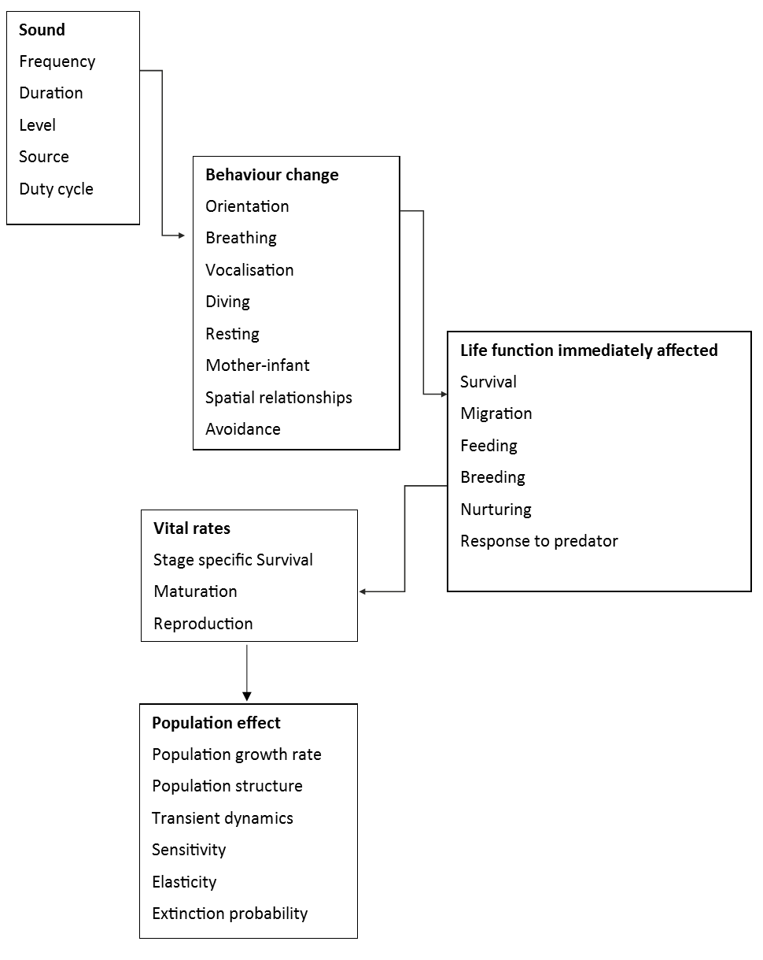
Figure 1. Flow diagram depicting the PCAD model developed by NRC (2005) reprinted with permission from the National Academies Press, Washington, DC.
Uncertainty with regard to cause and effect increases and potentially cumulates between each of the steps, but especially between ‘Behaviour Change’, ‘Life Function Immediately Affected’ and ‘Vital Rates’. Only limited data exist for most populations that allow estimation of accurate transfer functions between these steps (New et al. 2013, New et al. 2014).
The adapted version of the framework (PCoD), which is intended to include disturbances other than acoustic impact (Harwood et al. 2014), uses less detail in the description of each step depicted in the flow chart, but allows for more than one pathway to connect steps. In particular, PCoD makes a distinction between acute and chronic effects, e.g. ‘Behaviour Change’ can directly lead to changes in ‘Vital Rates’ or can have a delayed effect on ‘Vital Rates’ via the step ‘Health Effects’ that replaces ‘Life Function Immediately Affected’ in the PCoD model. As in the conceptual model, data that would tie behaviour change to health effects and vital rates are scarce and only exist for very few populations for which long-term studies on population dynamics and life tables are available. To overcome the data scarcity, Harwood et al. (2014) used an expert opinion solicitation process to translate chronic effects of behaviour change into changes in vital rates.

Application of PCoD Framework to evaluate population consequences
An Expert Working Group (EWG) convened by BP and Shell (Southall et al. 2014) to consider seismic surveys recommended a five stage process that attempted to integrate the risk assessment approach developed by Boyd et al. (2008) with the PCoD model assumptions introduced by Harwood et al. (2014). The stages included:
- A description of the acoustic source and quantification of the ocean ensonification due to a seismic survey (i.e. determine type of seismic survey and technical specifications)
- An assessment of the protected marine mammal species distribution (i.e. determine animal density per year and specific area)
- An estimation of the noise exposure (i.e. integrate acoustic propagation modelling with animal movement modelling)
- An estimation of biological effects (i.e. determine potential injury and behavioural disturbance using relevant metrics of SEL (accumulated) and SPL)
- A risk assessment of the likelihood of significant effects to occur during or as a result of seismic surveys (i.e. determine severity of exposures resulting in injury based on a PBR (Potential Biological Removal) approach and determine severity of exposure resulting in disturbance based on percent of population affected, duration of disturbance and adverse effect assessment involving PCoD assumptions of biological significance
One persistent criticism of the use of expert solicitation to assess disturbance effects in animals is that is very difficult, if not impossible, to accurately assess levels of error (uncertainty) around risk assessment findings without conducting experimental verification.
This section can be further developed through consideration of the Population Consequences of Multiple Stressors (PCoMS) framework.
Section 7.1 provides a suggested risk assessment process that incorporates the information above.
Progress is being made on quantifying transfer functions from acoustic exposure impact risk to individual and population health effects such as risk of reproductive loss or reduction; this new knowledge will become increasingly available for the development of impact assessment guidelines. Considering this, it is important to apply an adaptive management strategy for noise impact risk assessment that should lean to the conservative when the transfer function uncertainty is highest. This would also entail not specifying fixed sound pressure level thresholds to acoustic disturbance unless it is known that a threshold is the absolute lowest level at which disturbance may occur. It is preferable otherwise to use a cohort specific proportional approach to effect assessment, using lowest threshold levels for the cohorts with the highest vulnerability and greatest impact on effective population size (e.g. mothers with calves, followed by juveniles, followed by females in reproductive age followed by males in reproductive age and so on). One would then estimate the numbers of affected cohorts using scaled thresholds and weigh the overall impact based on the relevance of each cohort to population health.

Assessment guidelines and mitigation methods
This section outlines suggested methods to assess the impacts from key activities or operations that are a source of underwater noise, and associated physical mitigation methods or requirements. Pile driving, shipping, dredging, and geophysical sources are included, as is a brief examination of aggregate and cumulative exposure. Exclusions, and reasons for them, are outlined below.

Exclusions
Assessment methods for other sources of noise
- Not all sources of noise outlined in Appendix B are included, as this discussion paper has focused on the key activities that are conducted regularly and are likely to result in an effect. Operations from defence activities are also excluded.
Management techniques
- Temporal or spatial mitigation measures to reduce the impact on marine fauna are not addressed, as these are management techniques, rather than underwater noise specific considerations.
Impact criteria
- Practices that are associated with specific marine fauna impact criteria, and associated marine fauna mortality, hearing damage (permanent and temporary shift related), and behavioural effect ranges are not addressed. See discussion of these in Section 4.
Observers and operational passive acoustic monitoring
- Practices associated with the implementation of dynamic marine fauna mitigation management, such as Marine Fauna Observers (MFO) and mitigation based real-time Passive Acoustic Monitoring (PAM), are not addressed in detail.
- These are typically defined as part of the Referral process.
- Similarly to the NZ Seismic code process (Department of Conservation 2015), if GBRMPA wants to review these practices it should form a specific working group because of their complex nature and the way that proponents implement them. Numerous examples exist for MFO and PAM requirements: MMPA (2007), Kyhn et al. (2011), Daly and Harrison (2012), Government of South Australia (2012), New Zealand Department of Conservation (2013), Government of South Australia (2012), and DEWHA (2008).
- While MFOs are commonly used within Australian waters, PAM is relatively recent. PAM for mitigation is the focus of an ISO working group led by Aaron Thode (Section 2.4), and was a well-attended workshop at the 2015 Biology of Marine Mammals Conference (New Zealand Department of Conservation In Prep).
The development of performance standards and methods of achieving the three latter out of scope items above) are key amongst many of the policies outlined in Section 2.3 ‘International law and policy related to underwater noise’. An example of this is the workshop that was held by the New Zealand Department of Conservation the 21st Biennial Conference of the Society for Marine Mammalogy in December 2015, New Zealand Department of Conservation (In Prep), which is part of the New Zealand seismic code development process (Department of Conservation 2015).

Key concepts
Southall et al. (2014) provide a useful precis of some current leading practice underwater noise assessment and mitigation concepts in their Analytical Framework For Assessing Potential Effects Of Seismic Airgun Surveys On Marine Mammals In The Gulf Of Mexico:
Estimates of potential effects have often been based on simplistic acoustic impact “thresholds” where a single received sound level is equated with the predicted occurrence of injury or disturbance, often without considering species-typical aspects of hearing, physiology, or behaviour. Analytical approaches have, until quite recently, narrowly focused on potential effects of discrete acoustic events without considering the biological or ecological implications of potential effects, aggregate exposures, or longer-term, larger-scale habitat issues.
Recently, progress in assessing the potential effects of anthropogenic disturbance on marine life has led to several significant realisations. These include:
- Recognition that industrial activities occur within complex acoustic environments that include other human and natural sound sources;
- Geographic scales over which assessments should occur are broader than previously considered;
- The probability of negative effects is strongly species-dependent and context-dependent (especially for behavioural effects); and
- The relative magnitude of potential impacts must be evaluated within a biological-significance framework that incorporates key species-specific parameters such as population status, distribution patterns, adaptability, and variability and uncertainty in these and other parameters.”
This background is important when considering how to draw on international leading practice assessment guidelines and mitigation requirements in developing similar tools for the Great Barrier Reef context. For example, not all the legislation outlined in Section 2 represents leading practice, or are relevant to the Marine Park/World Heritage Area.
Peer-reviewed literature that includes recommendations and suggestions for generalised leading practices in management, assessment and control of underwater noise include André et al. (2009), Hatch and Fristrup (2009), Simmonds et al. (2014), Williams et al. (2015). Other publications also address more specific concerns such as ‘Active sonar, beaked whales and European regional policy’ (Dolman et al. 2011), and ‘Responsible practices for minimizing and monitoring environmental impacts of marine seismic surveys with an emphasis on marine mammals’ (Nowacek et al. 2013). While Nowacek et al. (2013) is specific to seismic surveys, there are many concepts in it which are applicable to other sources of anthropogenic noise.
The Nowacek et al. (2013) work has been developed further in Nowacek and Southall (2016). This document presents “a practical guide to responsible and effective planning of offshore geophysical surveys and other forms of environmental imaging. It offers a structured, systematic evaluation and decision making framework for industry, regulators, and scientists” to quote from the executive summary. The document outlines a process which commences with a pre-survey screening of proposed activities and the local environment, and then moves into a series of practices for planning, implementation, and evaluation of mitigation and monitoring activities. This document represents a valuable resource.
Examples contained within this Section have been selected for their demonstration of a process relevant to those outlined in this paper and leading practice methodology, any technical results appearing within the real-life examples given should be viewed as illustrative.
Mitigation approaches can take five key forms:
- Use of the quietest possible technology to achieve the required project aims
- Physical methods to reduce the source level
- Physical methods to reduce the transmission of sound beyond the source
- Reduce the potential exposure of marine fauna to injurious or behaviourally disturbing levels through exclusion zones
- Mitigate aggregate and cumulative exposure to marine fauna

Pile driving

Assessment guidelines
To develop leading practice underwater noise assessment guidelines for pile driving, consideration should be given to NOAA (2012a, 2012b, 2012c), Buehler et al. (2015), and ACCOBAMS Permanent Secretariat (2010), at a minimum.
The common themes are that the following should occur:
- Determining ambient (background) sound levels (NMFS 2012a, Buehler et al. 2015)
- Modelling of the generated sound field in relation to geological and oceanographic features (depth/temperature profile, water depth, coastal and seafloor characteristics) should occur (ACCOBAMS Permanent Secretariat 2010, NMFS 2012c)
  - Modelling must consider both the instantaneous sound fields (PK, SEL and SPL as appropriate) and extended time periods (accumulated SEL)
  - Modelling should consider the cumulative source scenario that is likely to exist – i.e. multiple sources.
- Assessing alternative technologies, and where these techniques are shown to reduce noise and/or risk, should be adopted where prudent and feasible. (Applicable for sources where these are relevant) (ACCOBAMS Permanent Secretariat 2010, Buehler et al. 2015)
- Application of mitigation methods to reduce noise must be identified, their performance predicted through acoustic modelling where feasible, and applied if prudent and feasible (ACCOBAMS Permanent Secretariat 2010, Buehler et al. 2015)
- Noise monitoring stations at given distances from the source area should be set up to monitor for both local (source) and long range noise levels and verify modelled/predicted levels (ACCOBAMS Permanent Secretariat 2010, NMFS 2012b, Buehler et al. 2015), which should include measuring particle motion (Popper et al. 2014, Nedelec et al. 2016). Appendix H.3.8 describes this in detail.
Not specifically addressed in literature in relation to pile driving, but demonstrated in leading practice assessments, is modelling to determine the effect on marine fauna (beyond typically injury and behavioural assessments), including methods such as:
- Determining the maximum Zone Of Audibility (ZOA)
- The impact on listening area (Appendix G.11.1) and communication space (Appendix G.11.2)
Some guidelines, such as the Government of South Australia (2012) piling guidelines include fixed shut-down zones. It states that ‘compliance with the noise exposure thresholds may be demonstrated through noise modelling or empirical measurements of a similar piling activity, i.e. similar piling rig and marine environment’. Due to the typical lack of knowledge of the marine environment -- particularly the geoacoustics, but also the soundscape, and the noise footprints from piles in World Heritage Area waters -- compared to highly characterised and understood operations (Buehler et al. 2015), use of modelling alone should not be considered good industry practice.
The EU is implementing the recommendations of (Dekeling et al. 2014a) as part of meeting the requirements of Commission Decision 2010/477/EU. One of the indicators described for Descriptor 11 (Noise/Energy) was Indicator 11.1.1 on low and mid-frequency impulsive sounds. This includes creating a register of sound sources such as airguns, pile driving, explosives, and sonar working at relevant frequencies and some acoustic deterrent devices. Additional sources recommended for inclusion are boomers, sparkers, and scientific echo sounders. The main aim of the registry is to provide an overview of all loud sounds, including military if possible. The purpose of the registry is to provide a quantified assessment of the spatial and temporal distribution of impulsive noise sources, throughout the year, in regional seas; this assessment can be used to help decide policy targets and to establish the baseline for the current situation. Once a baseline and targets have been set, the register can be used for management purposes (e.g. regulating planning and licensing activities) and to assist in marine spatial planning, incorporating displacement mitigation guidelines and reducing the potential for cumulative impacts.

Example projects
Examples of where components of leading practice guidelines have been implemented previously are provided for context using examples familiar to the authors.
One leading practice example of ambient monitoring, modelling (including assessment of mitigation techniques) and measurement (including validating the mitigation techniques) and accompanying environmental assessment can be found in the work programs commissioned as part of the New NY Bridge (Tappan Zee Bridge Replacement Project) http://www.newnybridge.com/environmental-doc/.
The project acoustic modelling and monitoring (of ambient and pile driving activities) are presented in MacGillivray et al. (2011), and Martin et al. (2012a). The project also reported monthly with a public pile driving summary and underwater noise monitoring results, with the report available publicly on the project webpage.
The New NY Bridge project focused on fish. However, the measurement techniques are applicable to all marine fauna. Additional leading practice modelling examples are provided in Wladichuk et al. (2014), and Wladichuk et al. (2015) for piling operations.

Mitigation methods
Mitigation of the noise of pile driving activities has proven to be an effective way of reducing the impact on marine fauna, including marine mammals (e.g. Nehls et al. 2016). There have been substantial reviews conducted on leading practice mitigation methods for quieting including source attenuation (e.g., bubble curtains, cofferdams, hydro sound dampers), and new pile designs (e.g., double-walled pile, lower radial expansion pile). CSA Ocean Sciences Inc. (2014) states that there is no single solution evident with regard to through-ground transmission of sound and other very site-specific issues such as water depth, currents, and substrate type. An overview of what mitigation methods are able to achieve is summarised in detail in CSA Ocean Sciences Inc. (2014), Maglio and Joint Working Group ACCOBAMS-ASCOBANS (2014), and Buehler et al. (2015), and due to the detailed nature of the topic it is recommended that these publicly accessible source documents be referred to.
Mitigation does not simply consist of technology to reduce the sound levels, but also alternative technologies, such as using sources that make less noise. Further evaluation of methods, expected achievements, and the path forwards is provided in the German regulations ([BMU] Bundesministerium für Umwelt 2014).
Ramp-up is a commonly applied mitigation strategy. However, the effectiveness of the ramp-up or soft start procedures have not been experimentally demonstrated. A recent study that investigated ramp-up of seismic airguns experimentally as part of the BRAHSS project are also not conclusive with regard to the deterrence effect of the ramp-up procedure (Dunlop et al. 2016). This study is conducted on migrating whales, and relates to a mobile source, and its applicability to resident animals and a stationary source (such as pile driving), could be limited.
Given a lack of clear experimental evidence it would be misleading to suggest ramp-up or soft start as a means of choice for noise impact mitigation in the absence of other measures. Having said that, soft start or ramp-up cannot be said to be detrimental and could well provide a modicum of additional mitigation should a few animals be unavoidably present despite all applicable spatial and temporal separation measures.
To provide context, a section of the mitigation table from Maglio and Joint Working Group ACCOBAMS-ASCOBANS (2014) is reproduced in Table 2. It should be noted that these noise reduction values are specific to European environments, and potentially do not consider particle motion.
Mitigation methods are constantly evolving as the technology improves, and therefore the values presented in Table 2, while valid at present, will likely be surpassed through future improvements in techniques or new methods. Assessment of mitigation methods in relation to the location that they will be applied in using techniques such as acoustic modelling is an important part of the process in determining the optimal method to apply.
Table 2. An excerpt of the mitigation table from Maglio and Joint Working Group ACCOBAMS-ASCOBANS (2014) that gives an overview of pile driving mitigation.
Mitigation Technology | Approximate Noise Reduction (for systems summarised in 2014)
Big Air Bubble Curtain.  A large bubble curtain consists of a hose with drilled holes, supplied with compressed air. The hose is placed on the seabed and the air escaping from the holes forms the bubble screen. | Single bubble curtain :  - 12 dB (SEL), 14 dB (peak)  - 11 dB (SEL) 15 dB (peak)  Double bubble curtain :  - 17 dB (SEL), 21 dB (peak)
Little Air Bubble Curtain  A little bubble curtain can be customised and placed much closer to the noise source than the big bubble curtain. It may consist of a rigid frame placed around the source. Several configurations are possible. | Several tests :  - 12 dB (SEL), 14 dB (peak)  - 11-13 dB (SEL)  - 4-5 dB (SEL)  - 14 dB (SEL), 20 dB (peak)
Hydro Sound Damper.  This technology consists of fishing nets with small balloon filled with gas and foam–tuned to resonant frequencies- fixed to it. It can be applied in different ways. | 4-14 dB (SEL)
Cofferdam.  The cofferdam consists of a rigid steel tube surrounding the pile. Once the pile is stabbed into the cofferdam, the water is pumped out | up to 22 dB (SEL) and 18 dB (Peak)
Noise Mitigation Screen.  The NMS is a double layered screen, filled with air. Between the pile and screen there is a multi level and multi size bubble injection system. | 5–20 dB reduction (SEL)
BEKA shells  - Double steel wall with polymer filling  - Inner and outer bubble curtain  - Acoustic decoupling (vibration absorber) | 6-8 dB (SEL)

Shipping, dredging, and geophysical sources

Shipping and dredging assessment guidelines
Leading practice guidelines for assessment of shipping and dredging, similarly to pile driving, would include
- Determining ambient (background) sound levels
  - Long-term studies such as those outlined in Appendix H.2 are essential for sources with long-term operational considerations
- Modelling of the generated sound field(s) in relation to geological and oceanographic features (depth/temperature profile, water depth, coastal and seafloor characteristics)
  - Modelling must consider both the instantaneous sound fields (SEL and SPL) and extended time periods (accumulated SEL)
  - Modelling should consider the cumulative source scenario that is likely to exist – i.e. multiple sources
- Modelling to determine the effect on marine fauna (beyond typically injury and behavioural assessments), including methods such as:
  - Determining the maximum Zone Of Audibility (ZOA)
  - The impact on listening area (Appendix G.11.1) and communication space (Appendix G.11.2)
- Measurement studies to validate the modelling studies (Appendix H.3.6)
- Assessing alternative technologies, and where these techniques are shown to reduce noise and/or risk, should be adopted where prudent and feasible. (Applicable for sources where these are relevant)

Geophysical source assessment guidelines
Depending upon the specific geophysical source (particularly for sonar sources), its operational use (particularly from a spatial-temporal viewpoint), the assessment methods outlined below might not be required. In these cases operational mitigation as described in policies such as National Parks and Wildlife Service (2014) might be more practical.
Leading practice guidelines for assessment of geophysical sources (including multibeam sonar) are derived from those presented for pile driving in Section 6.3.1, summarised below for completeness:
- Determining ambient (background) sound levels
- Modelling of the generated sound field(s) in relation to geological and oceanographic features (depth/temperature profile, water depth, coastal and seafloor characteristics)
  - Modelling must consider both the instantaneous sound fields (SEL and SPL) and extended time periods (accumulated SEL)
  - Modelling should consider the cumulative source scenario that is likely to exist – i.e. multiple sources.
- Modelling to determine the effect on marine fauna (beyond typically injury and behavioural assessments), may be relevant in some instances (likely not relevant for sonar), and include methods such as:
  - Determining the maximum Zone Of Audibility (ZOA)
  - The impact on listening area (Appendix G.11.1) and communication space (Appendix G.11.2)
- Measurement studies to validate the modelling studies (Appendix H.3.6)
- Assessing alternative technologies, and where these techniques are shown to reduce noise and/or risk, should be adopted where prudent and feasible. (Applicable for sources where these are relevant)

Example projects
Due to the variable nature of requirements for assessments, no set guidelines exist, but rather methods that are appropriate to the needs identified. However, examples of where some of the above items have previously been implemented are provided, using examples familiar to the authors.
Construction and Operations
Leading practice assessment methodologies for the modelling of Terminal Vessel Construction and Operations, including maintenance dredging, container ship approach to and berthing, are demonstrated in Wladichuk et al. (2014). This work included modelling of the estimated absolute sound levels, along with the Zone Of Audibility.
Further examples of dredging assessment can be found in Matthews and Frouin-Mouy (2014) and Wladichuk et al. (2015). Examples of assessment of blasting can be found in Matthews and Frouin-Mouy (2014).
Port Operations
A leading practice example of a port that is leading the way in terms of underwater noise management of vessels is Vancouver Fraser Port Authority (VFPA) as described in Appendix H.3.6.2.
Along with characterising every vessel entering and leaving the port, the PoV intends to issue ‘Certificates of Vessel Underwater Acoustic Source Level Measurement’ as a free service to all vessels, for the limited purpose of understanding approximate underwater noise emission levels of vessels.
The certificate will present Monopole Source Levels (spectra and broadband), Radiated Noise Levels (spectra and broadband), frequency weighted Monopole Source Levels by marine mammal species group, and a ranking of the vessel in terms of noise performance within its vessel class.
VFPA is investigating incentives to encourage vessels that perform well within a similar vessel class, with the aim of decreasing the presence of vessels with higher noise levels. Further information about the ‘Enhancing Cetacean Habitat and Observation’, or ECHO program, are available on the PoV webpage: https://www.portvancouver.com/environment/water-land-wildlife/marine-mammals/echo-program/.
Construction Vessel and Sonar Operations
Leading practice assessment methodologies for the modelling of the construction of a natural gas pipeline are demonstrated in Zykov et al. (2013), including accounting for season variation, and the following operations:
- Instantaneous sound exposure from individual vessels and side-scan sonar
- Aggregate instantaneous sound exposure from a group of vessels operating in the vicinity of each other
- Cumulative sound exposure for 24 hours of typical operations
The project modelled 28 scenarios for individual vessels, 20 scenarios for vessel groups, and 3 cumulative scenarios.
Geophysical and Sonar Surveys
Leading practice assessment methodologies for the modelling of these sources are demonstrated in Zykov (2013). This study estimated source levels, beam configuration, and sound exposure levels from a set of low energy equipment used in geophysical surveys.
The low energy equipment types modelled in a per-pulse and cumulative fashion were:
- Single beam echosounder
- Multibeam echosounder
- Side-scan sonar
- Sub-bottom profiler
- Boomer
A good example of an all-encompassing body of work relating to a geophysical (in this case seismic) survey can be found in the seismic survey activities conducted at Sakhalin Island, as described in a special theme section of the Endangered Species Journal, titled ‘Seismic survey and western grey whales’ http://www.int-res.com/journals/esr/esr-specials/seismic-survey-and-western-grey-whales/. This project is included as a case study within Nowacek and Southall (2016) as an example of a ‘Robust Integrated Monitoring and Mitigation of Surveys in the Feeding Habitat of an Endangered Species’.
- Monitoring and impact mitigation during a 4D seismic survey near a population of grey whales off Sakhalin Island, Russia (Bröker et al. 2015)
- Monitoring the grey whale sound exposure mitigation zone and estimating acoustic transmission during a 4-D seismic survey, Sakhalin Island, Russia (Racca et al. 2015)
- Delineation of a coastal grey whale feeding area using opportunistic and systematic survey effort (Muir et al. 2015b)
- Distance from shore as an indicator of disturbance of grey whales during a seismic survey off Sakhalin Island, Russia (Muir et al. 2015a)
- Grey whale densities during a seismic survey off Sakhalin Island, Russia (Muir et al. 2016)
- Behavioural responses of western grey whales to a 4-D seismic survey off north-eastern Sakhalin Island, Russia (Gailey et al. 2016)

Mitigation methods
The discussion of mitigation in this section focuses on vessels, and can be readily applied to dredging. Mitigation for geophysical sources is not addressed in detail, however ramp-up, as outlined in Section 6.3.3, and spatial and temporal mitigation, along with shut-down zones, are typically applied (DEWHA 2008, National Parks and Wildlife Service 2014).
The 2014 Australian Senate Report on the Great Barrier Reef (Environment and Communications References Committee 2014), specifically Section 7 Shipping, noted a 'strong reluctance' of industry to mention underwater noise as a marine pollutant that could 'alter habitats of marine animals and potentially mask communications for species that rely on sound to mate, feed, avoid predators and navigate'. The Report noted several suggestions to mitigate shipping noise.
The April 2014 International Maritime Organisation 'Guidelines addressed noise mitigation for commercial shipping to address adverse impacts on marine life' by recognising ISO standards for measurement of shipping noise and improved ship design and maintenance to help reduce noise.
Shipping classification societies have been developing noise reduced classes to mitigate shipping noise impact through vessel design such as DNV-Silent Class. The CSIRO RV New Investigator was built to DNV-Silent-R class in order to reduce impact of the vessel on fish stocks when conducting research on fish populations. Conferences and workshops continue on potential design changes to reduce noise given that the major source of vessel noise is propeller cavitation reflecting a fuel inefficiency and increased cost to shipping. Speed reduction is usually considered as an immediate source of noise mitigation.
The European AQUO Project (Audoly and Rousset 2015) in the scope of the FPZ European Research Framework was developed to provide practical guidelines and solutions to mitigate underwater noise from shipping. It has suggested for broad mitigation measures for shipping. They included structural changes to vessel propeller and machinery systems (including internal hull isolation and vibration dampening of components) as well as track changes, vessel speed and vessel distance distribution along specific waterways.
One of the most practical current implementation measures for the mitigation of shipping noise is that being conducted by the Port of Vancouver (PoV), as described in Section 6.4.3 and Appendix H.3.6.2. The mitigation strategy from the PoV proposes to use financial incentives to encourage vessels that perform well within a similar vessel class, with the aim of decreasing the presence of vessels with higher noise levels.
The Australian Senate Report on the Reef (Environment and Communications References Committee 2014) listed spatial-temporal options for mitigation of noise of shipping (commercial and tourism based). Avoiding spawning localities for reef fishes known to use sound during spawning behaviours was one of these options. Commercially important coral trout and narrow-barred Spanish mackerel are known to produce sounds associated with courtship (Appendix E.2). The locations of a number of the key spawning aggregation sites within the Reef are known for Spanish mackerel (Munro 1942, McPherson 1981, 1989, Buckworth et al. 2007, Tobin et al. 2014). Shipping transit avoidance, including tourist ferry and smaller vessel approach, of known spawning locations at critical times of the year and day/night would reduce masking noise impacts at times when social communication is important. This applies to all fish; it is currently thought that all fish utilise sound in some way (Appendix D.4).
Options could also include spatial-temporal periods when coral, other invertebrate and fish larval settlement processes with clearly demonstrated requirements for orientation to the sound of reefs, indeed specific reef sub types (Appendix F.2.4), would be readily masked by shipping noise.
While propeller cavitation causes bubble formation with subsequent noise associated with bubble diameter, high-speed passenger ferries and outboard powered vessels direct propulsion and auxiliary engine exhaust underwater within the propeller hub or from waterline outlets to improve passenger comfort. The exhaust systems generate additional air bubbles into the propeller cavitation air bubble stream. Reducing exhaust into the propeller stream would also offer opportunity to mitigate noise.

Aggregate and cumulative sound exposure

Background
In addition to considering specific operations in the assessment and mitigation of possible sound exposure effects, leading practices applicable to the World Heritage Area should include a comprehensive overview of the activities taking place across a region of interest over an extended period of time and their spatial and temporal relation to the presence and distribution of valued species in the area.
Assessing the cumulative effects of multiple stressors is a top priority problem in marine ecology, according to the U.S. National Academies of Sciences, Engineering and Medicine, specifically the Committee on the Assessment of the Cumulative Effects of Anthropogenic Stressors on Marine Mammals; Ocean Studies Board; Division on Earth and Life Studies (National Academies of Sciences 2016). This report is the fifth report in a series, proceeded by four reports from the U.S National Research Council (1994, 2000, 2003, 2005). It states that “Cumulative effects must be evaluated in environmental assessments of planned activities, but this evaluation is equally important for selecting management actions once populations or ecosystems are found to be at risk of adverse impacts”.
An assessment of the aggregate (from multiple activities occurring concurrently; Figure 2) and cumulative (from one or more activities accruing over time; Figure 3) sound exposure levels and their progression over time can lead to the formulation of effective mitigation strategies that rely on the scheduling of operations relative to each other and relative to the lifecycles of biological receptors. Used in combination with the activity specific sound reduction methods described in earlier sections, this approach results in the most effective management of acoustic exposure for the ecosystems of a region.
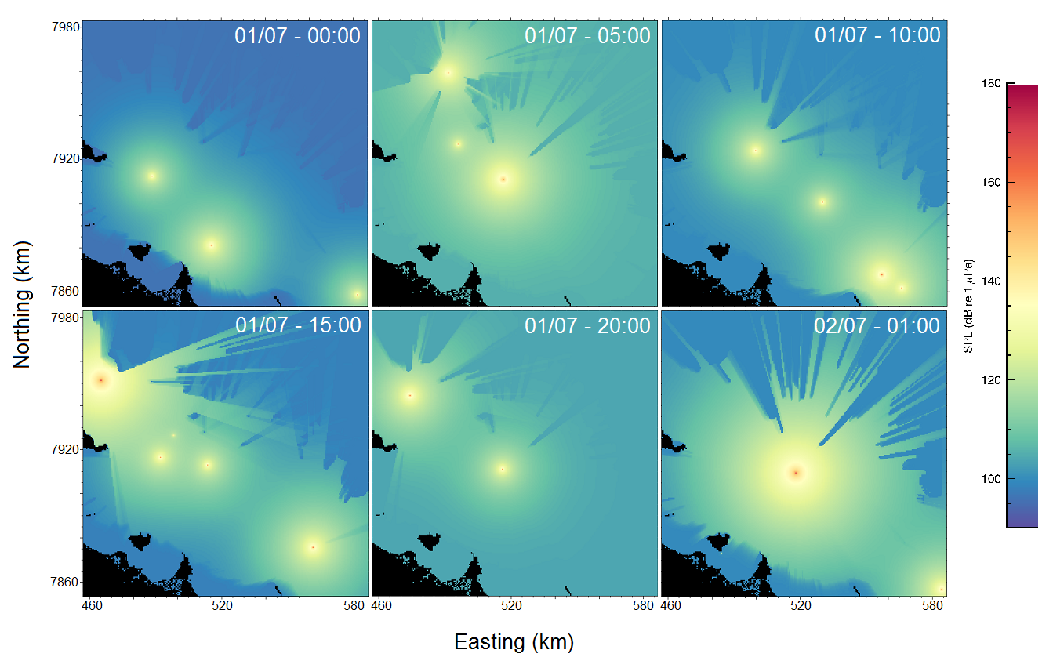
Figure 2. Sample frames from the time-lapse animation of vessel noise in the study area (MacGillivray et al. 2014b).
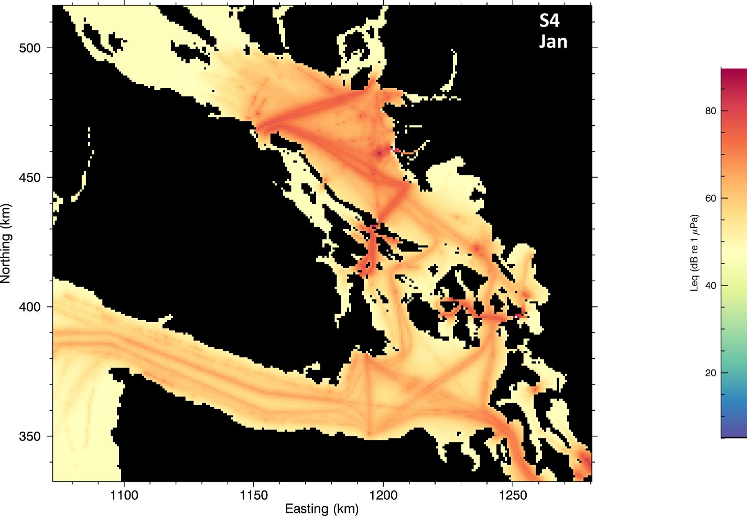
Figure 3. Example of Monthly Mean Commercial Vessel Traffic SPL Noise Levels assessed according to Resident Killer Whale Audiogram-weighting. Figure A-26 Scenario S4 from MacGillivray et al. (2014a).
Initiatives undertaken by various international agencies and groups can be viewed as models of current leading practices for the assessment and management of underwater sound exposure from a spatially and temporally comprehensive standpoint.
In collaboration with a multidisciplinary group of experts NOAA developed the Cetacean & Sound Mapping (CetSound) framework (cetsound.noaa.gov/cetsound), which combines tools for mapping the sound exposure (SoundMap) and cetacean distribution (CetMap) across the entire coastal economic exclusion zone (EEZ) of the United States of America based on the best available science and estimation methods. CetSound is the first phase in the formulation of an Ocean Noise Strategy framework for species-focused acoustic habitat management and characterisation of soundscapes (cetsound.noaa.gov/ons).
Separately, a recent effort by a working group convened by the University of California (Fleishman et al. 2016) produced both (i) a qualitative framework for estimating aggregate effects that might be applied when empirical data are insufficient to parametrise a quantitative model, and (ii) a case study demonstrating the quantitative estimation of aggregate and cumulative sound exposure from multiple sources for a population of migrating bowhead whales (Balaena mysticetus) both in the presence and absence of reaction by the animals to the sound (Ellison et al. 2016).
The EU is implementing the recommendations of (Dekeling et al. 2014c) as part of meeting the requirements of Commission Decision 2010/477/EU. One of the indicators described for Descriptor 11 (Noise/Energy) was Indicator 11.2.1 on continuous low-frequency sound, which would include aggregate exposure to shipping noise as a prominent component in virtually any open ocean ecosystem. All these approaches, however, must be considered in the appropriate context as noted by Williams et al. (2015):
Nevertheless, any area-based management framework will require recognition of internal and external factors that affect ecosystem integrity (Jameson et al. 2002, Hatch and Fristrup 2009), and must include the ability to adapt as new information on stressors becomes available (McCook et al. 2010).

Assessment of aggregate and cumulative exposure
There are no generally acknowledged standards for assessment of cumulative exposure to underwater sound. To some extent it is even impossible to dissociate the assessment of exposure from that of effects, since reaction by an animal to sound may influence the levels it receives over time. A detailed discussion on this is provided in National Academies of Sciences (2016). A detailed quantitative estimation method is described in Streever et al. (2012), and Fleishman et al. (2016), and exemplified in a case study by Ellison et al. (2016). It provides a stepwise approach that is transferable among sound sources, habitats, species and populations and can be taken as a current guideline:
- Identify the target(s) of assessment, whether a species, population, or class (e.g., sex or age class)
- Identify the spatial and temporal bounds of the assessment, which should be biologically meaningful
- Identify continuous and impulsive sources of sound occurring within the assessment boundaries. These sources may occur in different locations and may vary during the assessment period
- Estimate which of these sources are likely to create stressors to the target
- Model and aggregate sound ﬁelds generated by individual sources during a deﬁned period of time
- Simulate movements of animals through the aggregated sound ﬁelds
- Estimate the cumulative sound exposure levels for each modelled animal over the assessment period
- Sum the dosimetric exposure measure for each modelled animal to estimate both the population-level exposure to each sound source and the aggregated exposure to all sources
An important decision point in implementing this approach is whether or not to introduce avoidance of sound in the animal movement simulation, and how such a response should be parametrised (threshold level, probability of reaction, degree of aversion, tendency to return to original path/location, etc.) Such a choice must be guided by best available knowledge or rational estimation of a species’ behaviour and must be exercised prudently, as the outcome of the assessment can be drastically influenced by sound aversion in terms of indicators such as overall sound exposure whilst may be relatively unaffected in terms of other metrics such as length of path and therefore energy expenditure (Ellison et al. 2016).

Example projects
For context and demonstration, leading practice examples of monitoring and modelling studies, (key parts of the aggregate and cumulative exposure assessment process) are included below.
Monitoring
An example of a leading practice wide area acoustic monitoring program was that completed as part of the Chukchi Sea Environmental Studies Program. This program was included in an example of good practice in baseline monitoring and stakeholder engagement in Nowacek and Southall (2016). The aim was to document baseline ambient noise conditions, characterise sounds produced by oil and gas exploration activities, and address knowledge gaps about spatial and temporal distributions, habitat use, calling behaviour, and migration paths of several Chukchi Sea marine mammal species based on acoustic detections of their vocalisations. The program occurred over 70,000 km2 of the Chukchi Sea and involved 22 to 50 recorders each summer, and 5-15 each winter.
The annual reports for this program were comprehensive, averaging over 220 pages (Delarue et al. 2015). A special issue of the Continental Shelf Research journal detailing the research for the program from September 2007–July 2011 was published (Hannay et al. 2013); all reports are available online.
Cumulative Noise Exposure Modelling
Leading practice assessment methodologies for a Regional Monthly Cumulative Noise Exposure modelling study are demonstrated in MacGillivray et al. (2014a) and MacGillivray et al. (2016). These examples include the creation of maps of underwater commercial vessel traffic noise in the area of interest for different seasons, based on a cumulative sound energy model. For MacGillivray et al. (2014a), completed as part of the Roberts Bank Terminal 2 (RBT2) project Environmental Impact Statement submitted as part of requirements of the proponent under the CEAA (Section 2.3.13), An existing conditions scenario (2012) and three future scenarios (2030) for a single project were considered as follows:
- S1: Existing commercial vessel traffic
- S2: Future commercial vessel traffic with no new projects except the project of concern, and future incremental vessel traffic associated with the project (includes existing and expected conditions)
- S3: Future commercial vessel traffic due to certain and foreseeable projects without the project of concern, or incremental vessel traffic associated with project of concern (includes existing and expected conditions)
- S4: Future commercial vessel traffic due to certain and foreseeable projects, with project of concern and incremental shipping traffic associated with project of concern (includes existing and expected conditions)
The three future scenarios were produced by adding commercial vessel traffic density forecasts for reasonably certain and foreseeable projects to the existing conditions scenario.
The Vancouver Fraser Port Authority (VFPA) initiated the Enhancing Cetacean Habitat and Observation (ECHO) program which is “aimed at better understanding and managing the impact of cumulative shipping activities on at-risk whales throughout the southern coast of British Columbia” (Port of Vancouver 2016). This program had specific concerns regarding underwater noise, which have been addressed through an updated version of the aforementioned model framework MacGillivray et al. (2016).
An example of the application of BP and Shell funded Expert Working Group (EWG)’s analytical framework to estimate the risk to marine mammal populations from seismic operations in the Gulf of Mexico (Southall et al. 2014) can be found in the Programmatic Environmental Impact Statement for the Gulf of Mexico by the U.S. Bureau of Ocean Energy Management (BOEM) (https://www.boem.gov/GOM-Multisale-EIS/#Final-Programmatic-EIS)(Zeddies et al. 2015).
Other examples include the assessment of impacts on animal listening and communication space as part of these large scale EIS processes (Matthews et al. 2015, Hannay et al. 2016).
Daily Temporal Noise Exposure
MacGillivray et al. (2014a) also provide an example of leading practice assessment methodologies for a Focused Daily Temporal Noise Exposure modelling study.
They created a temporal model of underwater commercial vessel traffic sound pressure levels in areas of high use by a species of particular concern (southern resident killer whales) in 1-minute steps over two 24-hour periods (one day in winter and one day in summer) to inform assessment of exposure to noise. One existing conditions scenario (S1) and three future scenarios are considered (S2 to S4) as above.
The three future scenarios are prepared by adding simulated vessel tracks to the existing conditions scenario to represent commercial vessel traffic density forecasts for reasonably certain and foreseeable projects.

Mitigation of aggregate and cumulative exposure
The application of mitigation measures at a systematic level, which can achieve a reduction of sound exposure at specific times and locations by altering the temporal and possibly spatial interrelation of activities in the region, is a secondary intervention layer. This is overlaid on the acoustic mitigation of individual activities as previously discussed. Where compatible with the objectives of an operation and its optimal execution (for example, not requiring changes likely to result in a much lengthened construction period and subsequent prolonging of disturbance), reducing the sound injection into the ecosystem from each activity can only have beneficial results.
That said, the ability to reduce the synergetic effects of multiple sound sources or to isolate their sound output temporally from critical periods in the lifecycle of sensitive species is a very effective tool in reducing negative effects. In many geographic regions, the ability to conduct operations may be severely constrained by conditions such as ice cover. However, activities in the Great Barrier Reef are subject to fewer seasonal restrictions to the execution of most operations, so there is much greater scope for flexibility in the selection of activity scheduling.
Planning of activities in a comprehensive manner in order to mitigate aggregate and cumulative exposure requires considerably greater organisational effort and technical sophistication by regulators and scientific advisers compared to single-activity approaches. The process must be driven by the ability to realistically storyboard the prospective operations (both temporary and ongoing) and model their acoustic footprints with accuracy so that the effect of changes in the relative scheduling can be gauged. Key requirements to enable an effective design of concurrent operations for optimal management of acoustic exposure are:
- A process of coordinated and timely submission and updating of operational plans for all potential activities to take place in a region
- Access to historical acoustic monitoring records for existing sound sources to which new footprint estimates are to be added
- A comprehensive understanding of the distribution and seasonal biology of the relevant species.

Summary technical guidance
This section summarises information relevant to underwater noise studies and assessment methods that could be required of proponents seeking approvals and permits to operate within the Marine Park, but also to assist in the thought process of what might be integrated into the broader management of activities within the Marine Park/World Heritage Area.
The section sets out suggestions for text that could be provided to proponents who require information to guide their approach to underwater noise related activities. In doing so it summarises the information presented in previous sections and the appendices, as relevant. Links to other sections and the appendices are not included here, as the concept is to provide content that could be used in isolation from the rest of this paper. (Detailed information with referencing is provided in the relevant sections and appendices).
The section runs through suggested guidance on risk assessments, common requirements, modelling, ambient noise characterisation, radiated noise measurement, and cumulative assessment and mitigation. It focuses on large-scale activities and anthropogenic noise sources likely to cause an effect on marine fauna. This includes all types of vessels, dredging, pile driving, rock dumping, blasting, geotechnical exploration, civilian sonar, underwater acoustic communication systems, renewable power generation, defence activities, and helicopters or aircraft.
Exclusions
- Sources of noise unlikely to cause effects on marine fauna are not included, such as those associated with:
  - Oceanographic research, including but not limited to Acoustic Doppler Current Profilers (ADCPs), acoustic locator beacons, and close range imaging sonar
  - Ecological research, such as acoustic tags
  - Bycatch mitigation pingers and depredation mitigation devices, which are used to mitigate bycatch of marine mammals in fishing equipment or Queensland shark control apparatus
- The terminology with respect to mitigation used in the scope of work provided to the authors related to physical methods to reduce underwater noise. Therefore, management-focused techniques to reduce the effect of underwater noise on marine fauna (typically temporal or spatial mitigation measures) have not been addressed.
- Similarly, no recommendations for specific marine fauna impact criteria, and associated marine fauna mortality, hearing damage (permanent and temporary shift related), and behavioural effect ranges have been made (see Section 3).
The content of this section has been developed from current leading practice concepts and contexts, which, as summarised in Southall et al. (2014), have progressed from relying primarily on simplistic acoustic impact ‘thresholds’ (where a single received sound level is equated with the predicted occurrence of injury or disturbance, often without considering species-typical aspects of hearing, physiology, or behaviour). These simplistic methods were associated with analytical processes narrowly focused on potential effects of discrete acoustic events without considering the biological or ecological implications of potential effects, aggregate exposures, or longer-term, larger-scale habitat issues.
Considerations taken into account in developing the advice in this section include:
- Recognition that industrial activities occur within complex acoustic environments that include other human and natural sound sources
- Geographic scales over which assessments (of underwater noise) should occur are broader than previously considered
- The probability of negative effects is strongly species-dependent and context-dependent (especially for behavioural effects)
- The relative magnitude of potential impacts (and associated risk) must be evaluated within a biological-significance framework that incorporates key species-specific parameters such as population status, distribution patterns, adaptability, and variability and uncertainty in these and other parameters

Risk assessment process
Using the information outlined in Section 5, we suggest a risk assessment process for generic sources consisting of the following stages:
- Identification of the spatial and temporal bounds of the assessment, which should be biologically relevant. This consists of an assessment of the marine fauna present within the identified boundaries, including their presence and distribution, to identify the targets of the assessment (species or population)
- Identification and detailed description of the acoustic source(s) (continuous and/or impulsive) occurring within the assessment boundaries, and their temporal characteristics/use. For a comprehensive assessment it should apply to combinations of existing, proposed and combined potential sources.
- Consideration of mitigation methods throughout the risk assessment process
- Quantification of the ocean ensonification due to the source; including physically realistic propagation modelling
- An estimation of the noise exposure for marine fauna; including methods such as:
  - Quantitative or qualitative assessment of exposure
  - Integration of acoustic propagation modelling with animal movement modelling
  - Estimating zone of audibility
- An estimation of biological effects including injury and behavioural disturbance using relevant metrics
- A risk assessment of the likelihood that significant effects will occur as a result of the noise exposure, which could involve:
  - Determining the severity of exposures resulting in injury based on a population effects measure, such as the PBR (Potential Biological Removal) approach used in the USA.
  - Determining the severity of exposures resulting from disturbance, based on parameters such as percent of population affected, duration of disturbance and adverse effect assessment involving PCoD assumptions of biological significance.
  - Population effects measures computed as additive components taking into account factors such as food scarcity, entanglement risk, and increased predation risk due to temporal or spatial habitat infringement. This step could consider PCoMS.
- Consider any relevant policy/guidance on cumulative impact management in the Marine Park/World Heritage Area and review outcomes of stage 7 considering how impacted (e.g. stressed) animals are already from other pressures.
Essential in this process are:
- Explicit descriptions of any data gaps and the associated assumptions made in the impact analysis
- Explicit and quantified description of uncertainty around the results of the impact analysis
- Details of the steps taken when uncertainty could not be quantified and indications of the data that would be needed
Solicitation of expert advice from a technical group that acts as a sounding board during the process would be very valuable. For example, the quantification of uncertainty would be an essential consideration for this group.

Scientific considerations
Important scientific considerations while conducting the risk assessment are that the most recent or most widely accepted science relating to the following is utilised and included:
- Hearing ability of marine fauna relevant to the assessment
- Sound production of marine fauna relevant to the assessment
- The effect of noise on marine fauna relevant to the assessment
This information is critical to providing the justification for the evaluation of the effects of noise in relation to the project.

Assessment of particular activities
Leading guidelines for a comprehensive assessment of underwater noise that apply across activities such as pile driving, shipping and dredging and geophysical sources are summarised below. While there are commonalities between all activities, differences in the requirements will exist depending upon the temporal and spatial scale of the proposed activity. This is particularly relevant for sonar based operations, in which case operational mitigation as described in National Parks and Wildlife Service (2014) might be more practical.
This section provides specific examples of options for assessment of particular activities, relating to the risk assessment process outlined in Section 7.1. These examples are designed to provide options that could be applied, and not all of these steps are appropriate in all cases. The EIM Policy and Application Guidelines currently applied by GBRMPA establish five levels of assessment, with increasing information requirements. The assessment examples have been compiled in relation to the most detailed assessment process with the highest level of information requirements.
The provided examples relate to pile driving, shipping/dredging, and geophysical activities that could occur within the Marine Park/World Heritage Area. The highlighted activities have been selected due to the high possibility of their occurrence, although importantly, the methodologies are also relevant to the majority of the other anthropogenic noise sources within the Marine Park/World Heritage Area. These activity-related assessments would form part of the greater underwater noise risk assessment process.
Leading practice guidelines for common aspects of assessment for the afore-mentioned sources would include:
- Determining ambient (background) sound levels on an appropriate (and justifiable) spatial and temporal scale in relation to the activity
- Modelling of the generated sound field in relation to geological and oceanographic features (depth/temperature profile, water depth, coastal and seafloor characteristics) should occur.
  - Modelling should follow the requirements outlined in Section 7.3
  - Modelling must consider both the instantaneous sound fields (SEL and SPL) and extended time periods (accumulated SEL)
  - Modelling must consider the cumulative source scenario that is likely to exist – i.e. multiple sources
- Modelling to determine the effect on marine fauna (beyond typically injury and behavioural assessments), including methods such as:
  - Determining the maximum Zone Of Audibility (ZOA)
  - The impact on listening area and communication space, if relevant should be included.
- Assessing alternative technologies, and where these techniques are shown to reduce noise and/or risk, should be adopted where prudent and feasible. (Applicable for sources where these are relevant)
- Application of mitigation methods to reduce noise must be identified, their performance predicted through acoustic modelling where feasible, and applied if prudent and feasible
- Measurement studies to validate the modelling studies, using methodologies outlined in Section 7.5 for radiated noise sources

Modelling
Information in this section represents a summary of Appendix G.
Acoustic modelling is used to determine the ‘footprint’ of anthropogenic acoustic sources. Modelling adds to the comprehension of the acoustic footprint of a specific source in a specific bathymetric environment with unique environmental parameters, such as sound speed profile and geology. This is because every individual acoustic footprint is different due to variables including:
- Source details
- bathymetry
- substrate
- sound profile, which is dependent upon temperature and salinity profiles that may be seasonally variable
The overall objective of underwater noise modelling in the EIA process is to predict the extent of underwater noise a particular activity will generate in the surrounding area and then to assess the likely impact of that noise. More formally, the aim is to model the received noise level (RL) at a given point (or points), based on the sound source level (SL) of the noise source, and the amount of sound energy which is lost as the sound wave propagates from the source to the receiver (propagation loss; PL).
Recommended assessment metrics and methods include:
- For impulsive sources:
  - Peak pressure per impulse
  - SPL / fast time SPL per impulse
  - SEL per impulse (1 second) and accumulated over operation length/24 h period
- For continuous sources:
  - SPL/fast time SPL (over specified time period)
  - SEL accumulated over operation length/24 h period
Individual modelling assessments must consider all relevant variables including but not limited to:
- Physical source characteristics
- Source location
- Bathymetry
- Substrate geoacoustic properties (ideally to several hundred metres depth within the seafloor)
- Sound speed profile, which is dependent upon temperature and salinity profiles that may be seasonally variable
Additional information that must be incorporated into the model includes:
- Depth sampling locations distributed through the water column, with enough points to accurately estimate the sound field depending on the depth of water
- Sufficient representation of the conditions across the area of operation, considering parameter extremes in addition to the most common conditions
- An indication of the quality and resolution of the underlying environmental data include the currency of the data
- Biologically relevant frequencies
- Considering and inclusion of reverberation if possible
When undertaking the modelling, the following must occur:
- Explicitly state and justify all assumptions
- Identify and quantify uncertainty in the accuracy of the final model, or provide a sensitivity analysis to assess vulnerability of results to differences in uncertain variables
- Justify, preferably numerically, any selection of certain points as locations for worst-case scenario modelling
Reporting should include:
- Justification for the model type or types (e.g., ray, parabolic, etc.) selected
- Provide distances to isopleths and maximum-over-depth and 95% radii for relevant metrics
- Ensonified area within isopleths and maximum-over-depth radii and 95% for 24-hour (or duration of activity, whichever is shorter) sound exposure levels (accumulated SEL)
- Levels (peak pressure (PK), fast weighted SPL, 1s SEL and 24-hour/activity SEL) at specific ‘receivers’ at representative, but logistically viable, biologically relevant depths. These should include those that could be verified through measurement programs.
- Isopleths must cover the range of interest (e.g., above 120 dB SEL, 100 dB SPL (fast time) and 200dB PK in 10 dB increments), with particular focus on the levels defined by the applied impact assessment criteria

Ambient noise characterisation
Information in this section represents a summary of Appendix H, in particular Section H.2.
In order to assess the likely implications of underwater noise generated by a proposed activity in addition to the presence and use of the area by marine fauna, it is important to characterise the existing soundscape in which it will occur. Baseline studies of ambient noise provide this information. A summary of key advice is outlined below.

Purpose
A leading practice long-term ambient characterisation program will quantify the following:
- Total ocean noise, which will include the quantification of contributions from geophony related sources (wind, waves etc.)
- Daily contribution per anthropogenic source, compared to total sound levels
- Detections per hour and per day of sources such as:
  - Vessels
  - Construction activities
  - Geophysical surveys
  - Marine mammals
- Presence of fish and invertebrates, including chorusing events.
- Detector performance statistics.
Programs can have many goals, which can include:
- Ecological assessments
- Defining the temporal extent of migrations and species presence
- Approximating any migration routes (if possible) and timings
- Refining information about the vocalisation characteristics of species in the area
- Localisation and tracking of marine mammals
- Assessment of soundscape indices

Summary
To achieve leading practice in ambient noise measurement
- Ensure that the objectives of the measurements are clear and that the monitoring and deployment configuration is appropriate for those objectives
- Ensure that the temporal sampling regime is appropriate for the objectives, and that the duration and duty cycle are appropriately chosen
- Ensure that the spatial sampling regime is appropriate for the objectives, and that the locations of monitoring stations are appropriately chosen
- Ensure that the instrumentation is correctly specified for the application (for example, in terms of frequency range, dynamic range and self-noise)
- Ensure the deployment minimises measurement artefacts and pseudo-noise
- Document and justify choice of data analysis methodology in terms of:
  - Metrics – arithmetic mean and exceedance percentiles are recommended
  - Statistical representation of data – representing dispersion of data by use of analysis such as box-plots, and cumulative distributions
  - Anthropogenic activity (if required)
  - Marine fauna presence (if required)
  - Ecological assessment (if required)
- Specific representations should include at a minimum:
  - Percentile plots (1-minute average) of 1/3-octave band levels and power spectral density
  - SPL in several frequency bands (decade or other relevant bands)
  - Power spectral density spectrogram of measured sound levels
- Record all relevant auxiliary data and metadata including data which may correlate with acoustic data (ship traffic data, weather data, etcetera)

Radiated noise measurement
Information in this section represents a summary of Appendix H, in particular Section H.3.
Radiated noise studies provide critical information to inform evaluations of impact. A summary of key advice in relation to leading practice is provided below.

Background
Radiated noise is the sound radiated by a specific source. This is distinct from ambient noise, which is the noise received from many indistinguishable sources.
The noise source in question could be a source such as a ship, a dredge, a development or a port. The noise of interest could be construction noise (for example, marine pile driving or drilling), or it could be noise radiated during operation. To characterise the noise radiated by the source, it is necessary to consider a number of factors:
- Frequency content
- Temporal variation
- Source directivity
- Near-field and far field
- Source level metrics including
  - Received level at a fixed location
  - Radiated noise level
  - Source level
Typically, a program relating specifically to the measurement of radiated noise sources is referred to as a Sound Source Characterisation (SSC) program if the source hasn’t been measured before, or a Sound Source Verification (SSV) program if the point is to verify modelled results.

Temporal sampling
To characterise the source output as a function of time, measurements need to be undertaken for an extended period which covers the expected output variation of the source. This is best undertaken with an autonomous recorder at a fixed range.

Spatial sampling
To empirically determine the propagation loss for deriving the source level of the source, essential for validating modelling results, sampling over a sufficient spatial scale is required. Leading practice is typically a series of autonomous recorders (acceptable minimum of 3) stationed along a linear transect from the source, simultaneously measuring the radiated noise along a transect. The specific positioning of these recorders should be defined to sample locations to span the expected distances of important sound level thresholds. The spacing of the monitoring stations horizontally should be logarithmic in distance from the source of interest.
The deployment of multiple autonomous recorders is not always feasible, and in these scenarios, good practice should involve a combination of at minimum a single autonomous recorder with a mobile measurement platform. The mobile measurement platform, such as a small vessel, moves along a linear transect away from the source, stopping to measure at a number of ranges from the source. While conducting measurements from a mobile source, such as a vessel, considerations must be given to noise from the mobile source, and the measurement system used.
High flow environments require specialist techniques.

Summary
Summary of considerations to achieve leading practice in radiated noise measurement (SSC or SSV):
- Ensure that the objectives of the measurements are clear and that the monitoring and deployment configuration is appropriate for those objectives
- Ensure that the source output metrics are appropriate for the objectives, and that the measurement configuration enables the chosen metrics to be derived
- Ensure that the instrumentation is correctly specified for the application (for example, in terms of frequency range, dynamic range and self-noise)
- Ensure the deployment minimises measurement artefacts and pseudo-noise
- If a source level is calculated, ensure that an appropriate propagation model is used which accounts for the relevant physical propagation phenomena
- Ensure that the measurements satisfy the requirements of the objectives such that:
  - the instrumentation is correctly specified for the application in terms of frequency range, dynamic range and self-noise
  - spatial sampling is appropriate to ensure far-field conditions and (if required) to provide an empirical check on propagation
  - the temporal sampling captures any variation in acoustic output using fixed (static) recording position(s)
- Document and justify choice of data analysis methodology in terms of:
  - Metrics – arithmetic mean and exceedance percentiles are recommended
  - Statistical representation of data – representing dispersion of data by use of analysis such as box-plots, and cumulative distributions
- Specific representations should include at a minimum:
  - Percentile plots (1-minute average) of 1/3-octave band levels and power spectral density
  - SPL spectra in 1/3-octave bands for Radiated Noise Level and Monopole Source Level
  - SPL in several frequency bands (decade or other relevant bands)
  - Power spectral density spectrogram of measured sound levels, ideally showing the acoustic closest point of approach.
- Record all relevant auxiliary data and metadata including data which may correlate with acoustic data (operations data, locations of sampling and source points, weather data, etc.)

Example report outline
The typical report should include:
- an introduction describing the project and its objectives
- a methodology section that describes measurement positions, measurement equipment, metrics, and the methods used to manage measurement data
- a complete report of measured data, including determination of the source levels
- a report of the performance of attenuation systems, if applicable (particularly for piling)
- modelling of the sound footprint, if applicable, to validate distances to thresholds
- a list of abbreviations and glossary
- and an analysis of the data with respect to any specific orders from GBRMPA

Considerations for specific sources

Shipping
The ANSI standard measurement guidelines for vessels in shallow water is currently being developed. Until then, the deep water standard, (ANSI/ASA S12.64/Part 1 R2014 2009), should be utilised and adapted for specific scenarios. The placement of a single hydrophone system on the seafloor that the vessel transits past, and travels over or extremely close to during the transit, is the recommended methodology for shallow water.
The characterisation measurements program should be designed to account for local environmental influences on sound propagation, including local bathymetry, seabed geoacoustic information and ocean sound speed profile. These parameters are not addressed in the vessel source measurement standard that focusses on emission levels measured close to the vessel. The quantification of the impact of particle motion on fish should also be considered.

Dredging
Refer to shipping, Section 7.5.3.1.

Pile Driving
A number of measurement or characterisation guidelines exist for pile driving, including those from the California Department of Transportation (Buehler et al. 2015), and National Oceanic and Atmospheric Administration (2012b). These include recommendations such as that the recording system should sample at a rate of at least 44 kHz, have a dynamic range of at least 80 dB, and meet numerous other specifications for precision professional data recording.
In addition to the general methods outlined for radiated noise studies, particle motion should also be measured. This is likely to be most effective through an autonomous recording station.
Pile driving monitoring recorders should carefully consider sensitivity and hydrophone choice. Dual channel systems with different sensitivities are highly recommended.
Real-time systems are useful for instant level verification, and these can be either telemetered, or used from a mobile measurement platform. They should be used in conjunction with the aforementioned sampling methods.
Consideration of measurement sampling positions is critical for pile driving, and can include the following:
- Safety for the operator and instrumentation
  - Hearing damage is a concern for operator, or damage of instrumentation
- Consistency with other studies,
  - Using a consistent reference distance such as 10m for all measurement programs
  - This might have to sometimes be 20m due to the physical size of some mitigation systems
- Measurement positions as described previously
  - The minimum number of measurement locations to establish attenuation rates is three
- Measurement depth – depth of hydrophone in water column
  - Determined through consideration of typical depth of species of concern, effects of surface proximity or bottom on measurement
  - Recommended to ensure avoid any measurements at depths of less than 1m
  - In water that is more than 1 metre deep and less than 3 meters deep, a single measurement at low-depth is appropriate to characterise hydroacoustic pressures in the water column
- Two measurements, one at 1 m below the surface and one positioned 1 m from the bottom are normally sufficient to characterise acoustic pressures in the water column. A third measurement at mid-depth may be added or may be used as an alternative to the position 1 m from the surface, depending on the depth of the water and the expected location of fish (or marine fauna) in the water column.
- Environmental factors at the job site
- Pile driving scenario
- Measuring at distances aligned with impact threshold requirements

Cumulative assessment
Information in this section primarily derived from Sections 5.4 and 6.5.2.
Leading practices extend beyond considering specific operations in the assessment and mitigation of possible sound exposure effects. Those applicable to the World Heritage Area should include a comprehensive overview of the activities taking place across a region of interest over an extended period of time and their spatial and temporal relation to the presence and distribution of valued species in the area. An assessment of the aggregate (from multiple activities occurring concurrently and cumulative (from one or more activities accruing over time) sound exposure levels and their progression over time is essential.
There are no generally acknowledged standards for assessment of cumulative exposure to underwater sound. To some extent it is even impossible to dissociate the assessment of exposure from that of effects, since reaction by an animal to sound may influence the levels it receives over time. A detailed quantitative estimation method described in Streever et al. (2012), and Fleishman et al. (2016), and exemplified in a case study by Ellison et al. (2016) provides a stepwise approach that is transferable among sound sources, habitats, species and populations and can be taken as a current guideline:
- Identify the target of assessment, whether a species, population, or class (e.g., sex or age class)
- Identify the spatial and temporal bounds of the assessment, which should be biologically meaningful
- Identify continuous and impulsive sources of sound occurring within the assessment boundaries. These sources may occur in different locations and may vary during the assessment period.
- Estimate which of these sources are likely to create stressors to the target
- Model and aggregate sound ﬁelds generated by individual sources during a deﬁned period of time
- Simulate movements of animals through the aggregated sound ﬁelds
- Estimate the cumulative sound exposure levels for each modelled animal over the assessment period
- Sum the dosimetric exposure measure for each modelled animal to estimate both the population-level exposure to each sound source and the aggregated exposure to all sources
An important decision point in implementing this approach is whether or not to introduce avoidance of sound in the animal movement simulation. As well as how such a response should be parametrised (threshold level, probability of reaction, degree of aversion, tendency to return to original path/location, etcetera.). Such a choice must be guided by best available knowledge or rational estimation of a species’ behaviour. And it must be exercised prudently, as the outcome of the assessment can be drastically influenced by sound aversion in terms of indicators such as overall sound exposure but may be relatively unaffected in terms of other metrics such as length of path and therefore energy expenditure (Ellison et al. 2016).

Mitigation methods
Physical strategies for mitigation of sound associated with individual sources are only applicable for certain sources, such as pile driving, shipping and dredging. Where this is not possible, and for other sources such as geophysical sources, mitigation is best through spatial-temporal management of activities or fauna, which are not addressed here.

Pile driving
Information in this section represents a summary of Section 6.3.3.
Mitigation of pile driving activities has proven to be an effective way of reducing the impact on marine fauna. There have been substantial reviews conducted on leading practice mitigation methods for quieting including source attenuation (e.g., bubble curtains, cofferdams, hydro sound dampers), and new pile designs (e.g., double-walled pile, lower radial expansion pile). CSA Ocean Sciences Inc. (2014) states that there is no single solution evident with regard to through-ground transmission of sound and other very site-specific issues such as water depth, currents, and substrate type. What mitigation methods can achieve (CSA Ocean Sciences Inc. 2014, Maglio and Joint Working Group ACCOBAMS-ASCOBANS 2014, Buehler et al. 2015) is detailed enough that these publicly accessible source documents should be referred to directly.
Ramp-up or soft start has not been demonstrated to have value experimentally, and therefore it would be misleading to suggest ramp-up or soft start as a means of choice for noise impact mitigation in the absence of other measures. Despite this, soft start or ramp-up is most likely not detrimental and could well provide a modicum of additional mitigation should a few animals be unavoidably present despite all applicable spatial and temporal separation measures.
Mitigation does not simply consist of technology to reduce the sound levels, but also alternative technologies, such as using sources that make less noise.

Shipping
Information in this section represents a summary of Section 6.4.4.
The April 2014 International Maritime Organisation Guidelines addressed noise mitigation for commercial shipping to address adverse impacts on marine life by recognising ISO standards for measurement of shipping noise and improved ship design and maintenance to help reduce noise.
Financial incentives for quiet vessels are being explored by ports that are characterising every vessel entering and leaving them.
Physical mitigation methods include:
- Reducing exhaust into the propeller stream
- Structural changes to vessel propeller and machinery systems (including internal hull isolation and vibration dampening of components)
Operational mitigation methods include:
- Reducing speed, and therefore propeller cavitation
- Track changes
- Vessel distance distribution

Cumulative mitigation
Information in this section represents a summary of Section 6.5.4.
Acoustic mitigation of individual activities is the first stage of underwater noise mitigation. The second stage is mitigation measures applied at a systemic level, thus achieving reduction of sound exposure at specific times and locations by altering the temporal and possibly spatial interrelation of activities in the region.
An example of cumulative mitigation would be considering simultaneous activities in a development to determine if combined they would adversely impact marine fauna, and if so, altering the timing of the activities to reduce any impacts.

Glossary
1/3-octave-band
Non-overlapping passbands that are one-third of an octave wide (where an octave is a doubling of frequency). Three adjacent 1/3-octave-bands comprise a one octave-band. 1/3-octave-bands become wider in geometric progression with increasing frequency, each having a width of 26% of its nominal centre frequency. Also see octave.
90%-energy time window
The time interval over which the cumulative energy rises from 5% to 95% of the total pulse energy. This interval contains 90% of the total pulse energy. Symbol: T₉₀.
90% sound pressure level (SPL(T₉₀))
The root-mean-square sound pressure levels calculated over the 90%-energy time window of a pulse. Used only for pulsed sounds.
A-weighting
Frequency-selective weighting for human hearing in air that is derived from the inverse of the idealised 40-phon equal loudness hearing function across frequencies.
absorption
The conversion of acoustic energy into heat, which is captured by insulation.
acoustic impedance
The ratio of the sound pressure in a medium to the rate of alternating flow of the medium through a specified surface due to the sound wave.
ambient noise
All-encompassing sound at a given place, usually a composite of sound from many sources near and far (ANSI S1.1-1994 R2004), e.g., shipping vessels, seismic activity, precipitation, sea ice movement, wave action, and biological activity.
animat
An artificial animal, a contraction of animal-materials. In this context it specifically includes virtual simulations.
attenuation
The gradual loss of acoustic energy from absorption and scattering as sound propagates through a medium.
audiogram
A graph of hearing threshold level (sound pressure levels) as a function of frequency, which describes the hearing sensitivity of an animal over its hearing range.
audiogram weighting
The process of applying an animal’s audiogram to sound pressure levels to determine the sound level relative to the animal’s hearing threshold (HT). Unit: dB re HT.
auditory weighting function (frequency-weighting function)
Auditory weighting functions account for marine mammal hearing sensitivity. They are applied to sound measurements to emphasize frequencies that an animal hears well and de-emphasize frequencies they hear less well or not at all (Southall et al. 2007, Finneran and Jenkins 2012, NOAA 2013).
azimuth
A horizontal angle relative to a reference direction, which is often magnetic north or the direction of travel. In navigation it is also called bearing.
background noise
Total of all sources of interference in a system used for the production, detection, measurement, or recording of a signal, independent of the presence of the signal (ANSI S1.1-1994 R2004). Ambient noise detected, measured, or recorded with a signal is part of the background noise.
bandwidth
The range of frequencies over which a sound occurs. Broadband refers to a source that produces sound over a broad range of frequencies (e.g., seismic airguns, vessels) whereas narrowband sources produce sounds over a narrow frequency range (e.g., sonar) (ANSI/ASA S1.13-2005 R2010).
bar
Unit of pressure equal to 100 kPa, which is approximately equal to the atmospheric pressure on Earth at sea level. 1 bar is equal to 10^{6 Pa} or 10^{11 µPa}.
broadband sound level
The total sound pressure level measured over a specified frequency range. If the frequency range is unspecified, it refers to the entire measured frequency range.
broadside direction
Perpendicular to the travel direction of a source. Compare with endfire direction.
cavitation
A rapid formation and collapse of vapour cavities (i.e., bubbles or voids) in water, most often caused by a rapid change in pressure. Fast-spinning vessel propellers typically cause cavitation, which creates a lot of noise.
cetacean
Any animal in the order Cetacea. These are aquatic, mostly marine mammals and include whales, dolphins, and porpoises.
compressional wave
A mechanical vibration wave in which the direction of particle motion is parallel to the direction of propagation. Also called primary wave or P-wave.
confined explosives
Explosives detonated within a substrate, including ice, as opposed to unconfined explosives that are detonated in open water, not within a substrate.
continuous sound
A sound whose sound pressure level remains above ambient sound during the observation period (ANSI/ASA S1.13-2005 R2010). A sound that gradually varies in intensity with time, for example, sound from a marine vessel.
critical ratio
The difference between the sound pressure level of a masked tone, which is barely audible, and the spectrum level of the background noise at similar frequencies. Unit: decibel (dB).
critical band
The auditory bandwidth within which background noise strongly contributes to masking of a single tone. Unit: hertz (Hz).
decibel (dB)
One-tenth of a bel. Unit of level when the base of the logarithm is the tenth root of ten, and the quantities concerned are proportional to power (ANSI S1.1-1994 R2004).
duty cycle
The time when sound is periodically recorded by an acoustic recording system.
endfire direction
Parallel to the travel direction of a source. See also broadside direction.
ensonified
Exposed to sound.
equal-loudness contour
A curve or curves that show, as a function of frequency, the sound pressure level required to cause a given loudness for a listener having normal hearing, listening to a specified kind of sound in a specified manner (ANSI S1.1-1994 R2004).
far-field
The zone where, to an observer, sound originating from an array of sources (or a spatially-distributed source) appears t
fast Fourier transform (FFT)
A computationally efficiently algorithm for computing the discrete Fourier transform.
frequency
The rate of oscillation of a periodic function measured in cycles-per-unit-time. The reciprocal of the period. Unit: hertz (Hz). Symbol: f. 1 Hz is equal to 1 cycle per second.
functional hearing group
Grouping of marine mammal species with similar estimated hearing ranges. Southall et al. (2007) proposed the following functional hearing groups: low-, mid-, and high-frequency cetaceans, pinnipeds in water, and pinnipeds in air.
geoacoustic
Relating to the acoustic properties of the seabed.
Global Positioning System (GPS)
A satellite based navigation system providing accurate worldwide location and time information.
harmonic
A sinusoidal sound component that has a frequency that is an integer multiple of the frequency of a sound to which it is related. For example, the second harmonic of a sound has a frequency that is double the fundamental frequency of the sound.
hearing threshold
The sound pressure level that is barely audible for a given individual in the absence of significant background noise during a specific percentage of experimental trials.
hertz (Hz)
A unit of frequency defined as one cycle per second.
high-frequency cetacean (HFC)
The functional hearing group that represents odontocetes specialised for using high frequencies.
hydrophone
An underwater sound pressure transducer. A passive electronic device for recording or listening to underwater sound.
intermittent sound
A level of sound that abruptly drops to the background noise level several times during the observation period.
impulsive sound
Sound that is typically brief and intermittent with rapid (within a few seconds) rise time and decay back to ambient levels (NOAA 2013, ANSI S12.7-1986 R2006). For example, seismic airguns and impact pile driving.
low-frequency cetacean (LFC)
The functional hearing group that represents mysticetes (baleen whales).
masking
Obscuring of sounds of interest by sounds at similar frequencies.
median
The 50th percentile of a statistical distribution.
mid-frequency cetacean (MFC)
The functional hearing group that represents some odontocetes (dolphins, toothed whales, beaked whales, and bottlenose whales).
M-weighting
The process of band-pass filtering loud sounds to reduce the importance of inaudible or less-audible frequencies for broad classes of marine mammals. “Generalized frequency weightings for various functional hearing groups of marine mammals, allowing for their functional bandwidths and appropriate in characterizing auditory effects of strong sounds” (Southall et al. 2007).
mysticete
Mysticeti, a suborder of cetaceans, use their baleen plates, rather than teeth, to filter food from water. They are not known to echolocate, but use sound for communication. Members of this group include rorquals (Balaenopteridae), right whales (Balaenidae), and the grey whale (Eschrichtius robustus).
non-impulsive sound
Sound that is broadband, narrowband or tonal, brief or prolonged, continuous or intermittent, and typically does not have a high peak pressure with rapid rise time (typically only small fluctuations in decibel level) that impulsive signals have (ANSI/ASA S3.20-1995 R2008). For example, marine vessels, aircraft, machinery, construction, and vibratory pile driving.
octave
The interval between a sound and another sound with double or half the frequency. For example, one octave above 200 Hz is 400 Hz, and one octave below 200 Hz is 100 Hz.
odontocete
The presence of teeth, rather than baleen, characterizes these whales. Members of the Odontoceti are a suborder of cetaceans, a group comprised of whales, dolphins, and porpoises. The toothed whales’ skulls are mostly asymmetric, an adaptation for their echolocation. This group includes sperm whales, killer whales, belugas, narwhals, dolphins, and porpoises.
otariid
A common term used to describe members of the Otariidae, eared seals, commonly called sea lions and fur seals. Otariids are adapted to a semi-aquatic life; they use their large fore flippers for propulsion. Their ears distinguish them from phocids. Otariids are one of the three main groups in the superfamily Pinnipedia; the other two groups are phocids and walrus.
parabolic equation method
A computationally-efficient solution to the acoustic wave equation that is used to model transmission loss. The parabolic equation approximation omits effects of back-scattered sound, simplifying the computation of transmission loss. The effect of back-scattered sound is negligible for most ocean-acoustic propagation problems.
particle velocity
The physical speed of a particle in a material moving back and forth in the direction of the pressure wave. Unit: meters per second (m/s). Symbol: v.
PCAD
Population Consequence of Acoustic Disturbance Framework (PCAD)
PCoD
Population Consequence of Disturbance (PCoD)
peak sound pressure level (PK)
The maximum instantaneous sound pressure level, in a stated frequency band, within a stated period. Unit: decibel (dB).
peak-to-peak sound pressure level (PK-PK)
The difference between the maximum and minimum instantaneous sound pressure levels. Unit: decibel (dB).
percentile level, exceedance
The sound level exceeded n% of the time during a measurement.
permanent threshold shift (PTS)
A permanent loss of hearing sensitivity caused by excessive noise exposure. PTS is considered auditory injury.
phocid
A common term used to describe all members of the family Phocidae. These true/earless seals are more adapted to in-water life than are otariids, which have more terrestrial adaptations. Phocids use their hind flippers to propel themselves. Phocids are one of the three main groups in the superfamily Pinnipedia; the other two groups are otariids and walrus.
pinniped
A common term used to describe all three groups that form the superfamily Pinnipedia: phocids (true seals or earless seals), otariids (eared seals or fur seals and sea lions), and walrus.
point source
A source that radiates sound as if from a single point (ANSI S1.1-1994 R2004).
pressure, acoustic
The deviation from the ambient hydrostatic pressure caused by a sound wave. Also called overpressure. Unit: pascal (Pa). Symbol: p.
pressure, hydrostatic
The pressure at any given depth in a static liquid that is the result of the weight of the liquid acting on a unit area at that depth, plus any pressure acting on the surface of the liquid. Unit: pascal (Pa).
pulsed sound
Discrete sounds with durations less than a few seconds. Sounds with longer durations are called continuous sounds.
received level
The sound level measured at a receiver.
rms
root-mean-square.
shear wave
A mechanical vibration wave in which the direction of particle motion is perpendicular to the direction of propagation. Also called secondary wave or S-wave. Shear waves propagate only in solid media, such as sediments or rock. Shear waves in the seabed can be converted to compressional waves in water at the water-seabed interface.
signature
Pressure signal generated by a source.
sound
A time-varying pressure disturbance generated by mechanical vibration waves travelling through a fluid medium such as air or water.
sound exposure
Time integral of squared, instantaneous frequency-weighted sound pressure over a stated time interval or event. Unit: pascal-squared second (Pa²·s) (ANSI S1.1-1994 R2004).
sound exposure level (SEL)
A measure related to the sound energy in one or more pulses. Unit: dB re 1 µPa²·s.
sound field
Region containing sound waves (ANSI S1.1-1994 R2004).
sound intensity
Sound energy flowing through a unit area perpendicular to the direction of propagation per unit time.
sound pressure level (SPL)
The decibel ratio of the time-mean-square sound pressure, in a stated frequency band, to the square of the reference sound pressure (ANSI S1.1-1994 R2004).
For sound in water, the reference sound pressure is one micropascal (p₀ = 1 µPa) and the unit for SPL is dB re 1 µPa:
SPL =
Unless otherwise stated, SPL refers to the root-mean-square sound pressure level (SPL).
sound pressure spectrum
The mean square acoustic signal pressure in 1 Hz bins. Unit: µPa²/Hz, or µPa²·s.. signal power per unit frequency as measured at a single frequency. Unit: µPa²/Hz, or µPa²·s.
sound pressure spectrum level
The decibel level (10log₁₀) of the power spectrum density, usually presented in 1 Hz bins. Unit: dB re 1 µPa²/Hz.
sound speed profile
The speed of sound in the water column as a function of depth below the water surface.
source level (SL)
The theoretical sound pressure level or sound exposure level at 1 metre from an ideal point source that radiates the same total sound power as the actual source.
Unit: dB re 1 μPa @ 1 m or dB re 1 µPa²·s @ 1 m.
In most cases this is not the sound level that would be measured 1m from an actual sound source; it is derived mathematically from measurements taken at a much greater distance.
spectrogram
A visual representation of acoustic amplitude versus time and frequency.
spectrum
An acoustic signal represented in terms of its power (or energy) distribution versus frequency.
surface duct
The upper portion of a water column within which the sound speed profile gradient causes sound to refract upward and therefore reflect off the surface resulting in sound propagation with reduced loss than if the duct condition did not exist. This enhanced propagation only occurs between a source and receiver that are both in the duct and only for frequencies higher than some cut-off dependent on duct depth.
Temporary threshold shift (TTS)
Temporary reduction of hearing sensitivity caused by excessive noise exposure.
transmission loss (TL)
The decibel reduction in sound level between two stated points that results from sound spreading away from an acoustic source subject to the influence of the surrounding environment. Also called propagation loss.
wavelength
Distance over which a wave completes one oscillation cycle. Unit: metre (m). Symbol: λ.

Literature cited
[BMU] Bundesministerium für Umwelt, N.u.R. 2014. Concept for the protection of harbour porpoises from sound exposures during the construction of offshore wind farms in the German North Sea (sound protection concept). ASCOBANS Advisory Committee Meeting, September 29 to October 1, 2014, Gothenburg, Sweden. http://www.ascobans.org/sites/default/files/document/AC21_Inf_3.2.2.a_German_Sound_Protection_Concept.pdf.
[Caltrans] California Department of Transportation. 2004. Fisheries and Hydroacoustic Monitoring Program Compliance Report. San Francisco - Oakland Bay Bridge East Span Seismic Safety Project. Document Number EA 012023, 04-SF-80 KP 12.2/KP 14.3, 04-ALA-80 KP 0.0/KP 2.1 Technical report by Strategic Environmental and Illingworth & Rodkin, Inc. for Caltrans District 4. 148 pp. http://ocr.org/pdfs/papers/2004_pile_driving_impacts.pdf.
[CNSOBP] Canada-Nova Scotia Offshore Petroleum Board. 2007. Statement of Canadian Practice with respect to the Mitigation of Seismic Sound in the Marine Environment. http://www.cnsopb.ns.ca/pdfs/statement-of-canadian-practice.pdf.
[DEWHA] Department of the Environment, W., Heritage and the Arts. 2008. EPBC Act Policy Statement 2.1 - Interaction Between Offshore Seismic Exploration and Whales. In: Department of the Environment, W., Heritage and the Arts. 14 pp.
[DoE] Department of Environment. 2013. Matters of National Environmental Significance, Significant Impact Guidelines 1.1, Environment Protection and Biodiversity Conservation Act 1999. Australian Government, Canberra.
[DoE] Department of Environment. 2016. EPBC Act Protected Matters Search Tool (webpage). http://www.environment.gov.au/erin/ert/epbc/index.html (Accessed 30 March 2016).
[IMO] International Maritime Organisation. 2015. New information on impact of underwater noise from ships on fish and invertebrates, MEPC 68/INF.26. In: Marine Environment Protection Committee (ed.). International Maritime Organisation. 4 p.
[IMO] International Maritime Organization. 2014. Guidelines for the Reduction of Underwater Noise from Commercial Shipping to Address Adverse Impacts on Marine Life. Report Number MEPC.1/Circ.833, London. 8 pp. http://www.intertanko.com/upload/98595/Guidelines%20For%20The%20Reduction%20Of%20Underwater%20Noise.pdf.
[ISO] International Organization for Standardization. 2017. ISO/DIS 18405.2:2017. Underwater acoustics—Terminology. Geneva. https://www.iso.org/standard/62406.html.
[IWC] International Whaling Commission. 2007. Report of the Scientific Committee. Annex K. Report of the Standing Working Group on Environmental Concerns. Journal of Cetacean Research and Management (Suppl.) 9: 227-296.
[JNCC] Joint Nature Conservation Committee. 2010a. JNCC guidelines for minimising the risk of injury and disturbance to marine mammals from seismic surveys. Aberdeen, UK. 16 pp.
[JNCC] Joint Nature Conservation Committee. 2010b. Statutory nature conservation agency protocol for minimising the risk of injury to marine mammals from piling noise. [JNCC] Joint Nature Conservation Committee, Aberdeen, United Kingdom. https://www.gov.uk/government/uploads/system/uploads/attachment_data/file/50006/jncc-pprotocol.pdf.
[MMC] Marine Mammal Commission. 2007. Marine mammals and noise: A sound approach to research and management. A Report to Congress from the Marine Mammal Commission. http://www.mmc.gov/reports/workshop/pdf/fullsoundreport.pdf.
Marine Mammal Protection Act of 1972 as Amended. 2007. United States Pub. L. No. 92-522, 16 U.S.C. 1361 (Oct. 21, 1972). http://www.nmfs.noaa.gov/pr/laws/mmpa/text.htm.
[NMFS] National Marine Fisheries Service. 2014. Marine Mammals: Interim Sound Threshold Guidance (webpage). National Marine Fisheries Service, National Oceanic and Atmospheric Administration, U.S. Department of Commerce. http://www.westcoast.fisheries.noaa.gov/protected_species/marine_mammals/threshold_guidance.html (Accessed June 1, 2016).
[NMFS] National Marine Fisheries Service. 2016. Technical Guidance for Assessing the Effects of Anthropogenic Sound on Marine Mammal Hearing: Underwater Acoustic Thresholds for Onset of Permanent and Temporary Threshold Shifts. U.S. Department of Commerce, NOAA. NOAA Technical Memorandum NMFS-OPR-55. 178 pp. http://www.nmfs.noaa.gov/pr/acoustics/Acoustic%20Guidance%20Files/opr-55_acoustic_guidance_tech_memo.pdf.
[NOAA] National Oceanic and Atmospheric Administration and [NMFS] National Marine Fisheries Service. 2010. Interim sound threshold guidance (webpage). NOAA - National Marine Fisheries Services, September 2010. http://www.nwr.noaa.gov/Marine-Mammals/MM-sound-thrshld.cfm.
[NOAA] National Oceanic and Atmospheric Administration. 2012a. Guidance document: Data collection methods to characterize underwater background sound relevant to marine mammals in coastal nearshore waters and rivers of Washington and Oregon. U.S. Department of Commerce, [NMFS] National Marine Fisheries Service, 5 pp. Memorandum from NMFS Northwest Region and Northwest Fisheries Science Center.
[NOAA] National Oceanic and Atmospheric Administration. 2012b. Guidance document: Data collection methods to characterize impact and vibratory pile driving source levels relevant to marine mammals. U.S. Department of Commerce, National Marine Fisheries Service, 7 pp. Memorandum from NMFS Northwest Region and Northwest Fisheries Science Center.
[NOAA] National Oceanic and Atmospheric Administration. 2012c. Guidance document: Sound propagation modeling to characterize pile driving sounds relevant to marine mammals. Memorandum from NMFS Northwest Region and Northwest Fisheries Science Center, 6 pp. U.S. Department of Commerce, National Marine Fisheries Service.
[NOAA] National Oceanic and Atmospheric Administration. 2013. Draft guidance for assessing the effects of anthropogenic sound on marine mammals: Acoustic threshold levels for onset of permanent and temporary threshold shifts, December 2013, 76 pp. Silver Spring, Maryland: NMFS Office of Protected Resources. http://www.nmfs.noaa.gov/pr/acoustics/draft_acoustic_guidance_2013.pdf.
[NOAA] National Oceanic and Atmospheric Administration. 2015. Draft guidance for assessing the effects of anthropogenic sound on marine mammal hearing: Underwater acoustic threshold levels for onset of permanent and temporary threshold shifts, July 2015, 180 pp. Silver Spring, Maryland: NMFS Office of Protected Resources. http://www.nmfs.noaa.gov/pr/acoustics/draft%20acoustic%20guidance%20July%202015.pdf.
[NOAA] National Oceanic and Atmospheric Administration. 2016a. Underwater Noise and Marine Life (webpage). http://cetsound.noaa.gov/index (Accessed 5 April 2016).
[NOAA] National Oceanic and Atmospheric Administration. 2016b. Document Containing Proposed Changes to the NOAA Draft Guidance for Assessing the Effects of Anthropogenic Sound on Marine Mammal Hearing: Underwater Acoustic Threshold Levels for Onset of Permanent and Temporary Threshold Shifts, p. 24. http://www.nmfs.noaa.gov/pr/acoustics/draft_guidance_march_2016_.pdf.
[NOAA] National Oceanic and Atmospheric Administration. 2016c. Draft Guidance for Assessing The Effects of Anthropogenic Sound on Marine Mammal Hearing: Underwater Acoustic Threshold Levels for Onset Permanent and Temporary Threshold Shifts, March 2016, 24 pp. Silver Spring, Maryland: NMFS Office of Protected Resources. http://www.nmfs.noaa.gov/pr/acoustics/draft_guidance_march_2016_.pdf.
[NOAA] National Oceanic and Atmospheric Administration. 2017. Ocean Acoustics Library (webpage). NOAA - National Marine Fisheries Services, May 2017. http://oalib.hlsresearch.com/.
[NPS] National Park Service. 2010. Zion National Park Utah. Soundscape Management Plan. September 2010. U.S. Department of the Interior. https://www.nps.gov/zion/learn/management/upload/ZNP-Soundscape-Plan_Sep_2010.pdf.
[NRC] National Research Council. 2000. Marine Mammals and Low-Frequency Sound: Progress since 1994. National Academy Press, Washington, DC.
[NRC] National Research Council. 2003. Ocean Noise and Marine Mammals. National Research Council (U.S.), Ocean Studies Board, Committee on Potential Impacts of Ambient Noise in the Ocean on Marine Mammals. The National Academies Press, Washington, DC. http://www.nap.edu/openbook.php?record_id=10564.
[NRC] National Research Council. 2005. Marine Mammal Populations and Ocean Noise: Determining when Ocean Noise Causes Biologically Significant Effects. National Academy Press, Washington, DC.
[NRC] National Research Council (US). 1994. Low-frequency sound and marine mammals: current knowledge and research needs. National Academies Press, Washington, DC. 75 pp.
[NSF] National Science Foundation (U.S.), U.S. Geological Survey, and [NOAA] National Oceanic and Atmospheric Administration (U.S.). 2011. Final Programmatic Environmental Impact Statement/Overseas. Environmental Impact Statement for Marine Seismic Research Funded by the National Science Foundation or Conducted by the U.S. Geological Survey. National Science Foundation, Arlington, VA.
[WODA] World Organisation of Dredging Associations. 2013. Technical Guidance on: Underwater Sound in Relation to Dredging. 8 pp. http://www.dredging.org/media/ceda/org/documents/resources/cedaonline/2013-06-woda-technicalguidance-underwatersound_lr.pdf.
ACCOBAMS Permanent Secretariat. 2010. Guidelines To Address The Impact Of Anthropogenic Noise On Cetaceans In The ACCOBAMS Area. In: Agreement on the Conservation of Cetaceans in the Black Sea Mediterranean Sea and Contigous Atlantic Area. Resolution 4.17 http://www.accobams.org/images/stories/Guidelines/guidelines%20to%20address%20the%20impact%20of%20anthropogenic%20noise%20on%20cetaceans%20in%20the%20accobams%20area.pdf.
Aguilar Soto, N., M. Johnson, P.T. Madsen, P.L. Tyack, A. Bocconcelli, and J. Fabrizio Borsani. 2006. Does intense ship noise disrupt foraging in deep-diving Cuvier's beaked whales (Ziphius cavirostris) ? Marine Mammal Science 22(3): 690-699.
Akamatsu, T., A. Nanami, and H.Y. Yan. 2003. Spotlined sardine Sardinops melanostictus listens to 1-kHz sound by using its gas bladder. Fisheries Science 69(2): 348-354. http://dx.doi.org/10.1046/j.1444-2906.2003.00628.x.
Allen, J.K., M.L. Peterson, G.V. Sharrard, D.L. Wright, and S.K. Todd. 2012. Radiated noise from commercial ships in the Gulf of Maine: implications for whale/vessel collisions. Journal of the Acoustical Society of America 132(3): EL229-EL235. http://www.ncbi.nlm.nih.gov/pubmed/22979837.
Allen, S. and D.A. Demer. 2003. Detection and characterization of yellowfin and bluefin tuna using passive-acoustical techniques. Fisheries Research 63(3): 393-403. http://www.sciencedirect.com/science/article/pii/S0165783603000961.
Anderson, J.J. 1990. Assessment of the risk of pile driving to juvenile fish. Proceedings of the 15th Annual Member's Conference, Deep Foundations Institute, 10-12 October 1990. Deep Foundations Institute, Seattle, Washington, pp. 1-11.
Andersson, M.H. and T. Johansson. 2016. Assessment of marine mammal impact zones for use of military sonar in the Baltic Sea. In The Effects of Noise on Aquatic Life II. Springer. 37-45.
Ando-Mizobata, N., K. Ichikawa, N. Arai, and H. Kato. 2014. Does Boat Noise Affect Dugong (Dugong dugon) Vocalization? Mammal Study 39(2): 121-127. http://dx.doi.org/10.3106/041.039.0208.
Andre, M., K. Kaifu, M. Sole, M. van der Schaar, T. Akamatsu, A. Balastegui, A.M. Sanchez, and J.V. Castell. 2016. Contribution to the Understanding of Particle Motion Perception in Marine Invertebrates. Adv Exp Med Biol 875: 47-55. NLM.
André, M., M. Morell, M. Alex, M. Solé Carbonell, M.C.R.M. Van der Schaar, L. Houégnigan, S.A. Zaugg, and J.V. Castell Balaguer. 2009. Best practices in management, assessment and control of underwater noise pollution. Laboratory of Applied Bioacoustics (LAB), Technical University of Catalonia (UPC). 105 pp.
Andrew, R.K., B.M. Howe, J.A. Mercer, and M.A. Dzieciuch. 2002. Ocean ambient sound: Comparing the 1960s with the 1990s for a receiver off the California coast. Acoustics Research Letters Online 3(2): 65-70.
ANSI S12.7-1986. R2006. American National Standard Methods for Measurements of Impulsive Noise. American National Standards Institute, New York.
ANSI S1.1-1994. R2004. American National Standard Acoustical Terminology. American National Standards Institute, New York.
ANSI/ASA S1.13-2005. R2010. American National Standard Measurement of Sound Pressure Levels in Air. American National Standards Institute and Acoustical Society of America, New York.
ANSI/ASA S3.20-1995. R2008. American National Standard Bioacoustical Terminology. American National Standards Institute and Acoustical Society of America, New York.
ANSI/ASA S12.64/Part 1 R2014. 2009. American National Standard Quantities and Procedures for Description and Measurement of Underwater Sound from Ships Part 1: General Requirements. American National Standards Institute and Acoustical Society of America, New York.
Arveson, P.T. and D.J. Vendittis. 2000. Radiated noise characteristics of a modern cargo ship. Journal of the Acoustical Society of America 107(1): 118-129.
ASCOBANS. 2014. Underwater Noise (webpage). UNEP/ASCOBANS Secretariat. http://www.ascobans.org/en/species/threats/underwater-noise (Accessed 5 April 2016).
ASCOBANS. 2016. Underwater Noise Working Group (webpage). UNEP/ASCOBANS Secretariat, 12 January 2016. http://www.ascobans.org/en/working_group/underwater_noise (Accessed 5 April 2016).
Au, W.W., J.K. Ford, J.K. Horne, and K.A.N. Allman. 2004. Echolocation signals of free-ranging killer whales (Orcinus orca) and modeling of foraging for chinook salmon (Oncorhynchus tshawytscha). Journal of the Acoustical Society of America 115(2): 901-909. http://www.beamreach.org/research/acoustics/AuFordHorneEcholocation.pdf.
Au, W.W.L. and M.C. Hastings. 2008. Principles of Marine Bioacoustics. Springer. 510 pp. http://link.springer.com/book/10.1007%2F978-0-387-78365-9.
Au, W.W.L. and M. Richlen. 2009. The soundscape of a nearshore reef near an urban center. Journal of the Acoustical Society of America 126(4): 2269-2269. http://scitation.aip.org/content/asa/journal/jasa/126/4/10.1121/1.3249290.
Audoly, C. and C. Rousset. 2015. European project for achieving quieter oceans by shipping noise footprint reduction. Proceedings of Meetings on Acoustics 21(1): 070012. http://scitation.aip.org/content/asa/journal/poma/21/1/10.1121/1.4904407.
Austin, M. 2014. Underwater noise emissions from drillships in the Arctic. Underwater Acoustics 2014. Rhodes, Greece.
Austin, M. and Z. Li. 2016. Marine Mammal Monitoring and Mitigation During Exploratory Drilling by Shell in the Alaskan Chukchi Sea, July–October 2015: Draft 90-day report. In: Ireland, D.S. and L.N. Bisson (eds.). Underwater Sound Measurements. LGL Rep. P1363D. Report from LGL Alaska Research Associates Inc., LGL Ltd., and JASCO Applied Sciences Ltd. For Shell Gulf of Mexico Inc, National Marine Fisheries Service, and U.S. Fish and Wildlife Service. 188 pp + appendices pp. http://www.nmfs.noaa.gov/pr/permits/incidental/oilgas/shellchukchi_2015iha_monrep.pdf.
Barber, J.R., K.R. Crooks, and K.M. Fristrup. 2010. The costs of chronic noise exposure for terrestrial organisms. Trends in Ecology & Evolution 25(3): 180-189.
Barkaszi, M., M. Butler, R. Compton, A. Unietis, and B. Bennet. 2012. Seismic survey mitigation measures and marine mammal observer reports. US Department of the Interior, Bureau of Ocean Energy Management, Gulf of Mexico OCS Region, New Orleans, LA OCS Study BOEM. Volume 15. Document Number 2012-015. 28 pp.
Barlow, J. 1988. Harbor porpoise, Phocoena phocoena, abundance estimation for California, Oregon, and Washington. I: Ship surveys. Fishery Bulletin 86: 417-432.
Bartol, S.M., J.A. Musick, and M.L. Lenhardt. 1999. Auditory evoked potentials of the loggerhead sea turtle (Caretta caretta). Copeia: 836-840.
Bartol, S.M. and D.R. Ketten. 2006. Turtle and tuna hearing. In: Swimmer, Y. and R. Brill. Volume December 2006. NOAA Technical Memorandum NMFS-PIFSC-7. 98-103 pp. http://www.sefsc.noaa.gov/turtles/TM_NMFS_PIFSC_7_Swimmer_Brill.pdf#page=108.
Bassett, C. 2010. Underwater Ambient Noise at a Proposed Tidal Energy Site in Puget Sound. Master of Science Thesis. University of Washington. 73 pp.
Bassett, C., B. Polagye, M. Holt, and J. Thomson. 2012. A vessel noise budget for Admiralty Inlet, Puget Sound, Washington (USA). Journal of the Acoustical Society of America 132(6): 3706-3719.
Beranek, L.L. 1993. Acoustical Measurements. New York. Acoustical Society of America.
Bertucci, F., E. Parmentier, G. Lecellier, A.D. Hawkins, and D. Lecchini. 2016. Acoustic indices provide information on the status of coral reefs: an example from Moorea Island in the South Pacific. Scientific Reports 6.
Blackwell, S.B., C.S. Nations, T.L. McDonald, A.M. Thode, D. Mathias, K.H. Kim, C.R. Greene, Jr., and A.M. Macrander. 2015. Effects of airgun sounds on bowhead whale calling rates: evidence for two behavioral thresholds. PLoS ONE 10(6): e0125720. http://journals.plos.org/plosone/article?id=10.1371/journal.pone.0125720.
Bleckmann, H., T. Breithaupt, R. Blickhan, and J. Tautz. 1991. The time course and frequency content of hydrodynamic events caused by moving fish, frogs, and crustaceans. Journal of Comparative Physiology A 168(6): 749-757. http://dx.doi.org/10.1007/BF00224363.
Boyd, I., B. Brownell, D. Cato, C. Clark, D. Costa, P. Evans, J. Gedamke, R. Gentry, R. Gisiner, et al. 2008. The effects of anthropogenic sound on marine mammals: A draft research strategy. European Marine Board Position Paper 13. Joint Marine Board-European Science Foundation and National Science Foundation workshop, Oxford, UK. http://archives.esf.org/fileadmin/Public_documents/Publications/MBpp13.pdf.
Boyd, I.L., G. Frisk, E. Urban, P. Tyack, J. Ausubel, S. Seeyave, D. Cato, B. Southall, M. Weise, et al. 2011. An international quiet ocean experiment. Oceanography.
Braithwaite, J.E., J.J. Meeuwig, and K.C.S. Jenner. 2012. Estimating cetacean carrying capacity based on spacing behaviour. PLoS ONE 7(12): e51347. http://dx.doi.org/10.1371%2Fjournal.pone.0051347.
Brandt, M.J., A. Diederichs, K. Betke, and G. Nehls. 2011. Responses of harbour porpoises to pile driving at the Horns Rev II offshore wind farm in the Danish North Sea. Marine Ecology Progress Series 421: 205-216.
Brill, R.L., P.W.B. Moore, and L.A. Dankiewicz. 2001. Assessment of dolphin (Tursiops truncatus) auditory sensitivity and hearing loss using jawphones. Journal of the Acoustical Society of America 109: 1717-1722.
Bröker, K., G. Gailey, J. Muir, and R. Racca. 2015. Monitoring and impact mitigation during a 4D seismic survey near a population of gray whales off Sakhalin Island, Russia. Endangered Species Research 28: 187-208. http://www.int-res.com/articles/esr2015/28/n028p187.pdf.
Brumm, H. and H. Slabbekoorn. 2005. Acoustic communication in noise. In Slater, P.J.B., C.T. Snowdon, T.J. Roper, H.J. Brockmann, and M. Naguib (eds.). Advances in the Study of Behavior. Volume 35. Academic Press. 151-209.
Buckstaff, K.C. 2004. Effects of watercraft noise on the acoustic behavior of bottlenose dolphins, Tursiops truncatus, in Sarasota Bay, Florida. Marine Mammal Science 20(4): 709-725.
Buckworth, R.C., S.J. Newman, J.R. Ovenden, R.J.G. Lester, and G.R. McPherson. 2007. The Stock Structure of Northern and Western Australian Spanish Mackerel. Final Report, Fisheries Research & Development Corporation Project 1998/159. Department of Primary Industry, Fisheries and Mines, Northern Territory Government, Australia. Fishery Report 88, i-vi. 225 pp.
Buehler, D., R. Oestman, J. Reyff, K. Pommerenck, and B. Mitchell. 2015. Technical Guidance for Assessment and Mitigation of the Hydroacoustic Effects of Pile Driving on Fish. Report Number CTHWANP-RT-15-306.01.01. California Department of Transportation (CALTRANS), Division of Environmental Analysis. 532 pp. http://www.dot.ca.gov/hq/env/bio/files/bio_tech_guidance_hydroacoustic_effects_110215.pdf.
Bullock, T.H. and J.T. Corwin. 1993. Acoustic evoked activity in the brain in sharks. In How do Brains Work? Papers of a Comparative Neurophysiologist. Birkhäuser Boston, Boston, MA. 437-448. http://dx.doi.org/10.1007/978-1-4684-9427-3_36.
Burdic, W.S. 1984. Underwater acoustic system analysis. 1st edition. Prentice Hall, Englewood Cliffs, NJ. 445 pp.
Carey, W.M. and R.B. Evans. 2011. Ocean ambient noise: Measurement and Theory. The Underwater Acoustics Series. Springer.
Carlson, T.J. and G.E. Johnson. 2010. Columbia River Channel Improvement Project Rock Removal Blasting: Monitoring Plan. Final Plan Report. Document Number PNNL–19076. Pacific Northwest National Laboratory Richland, WA.
Carroll, A., R. Przeslawski, A. Duncan, M. Gunning, and B. Bruce. 2016a. A critical review of the potential impacts of marine seismic surveys on fish & invertebrates. Marine Pollution Bulletin.
Carroll, A.G., R. Przeslawski, A. Duncan, M. Gunning, and B. Bruce. 2016b. A critical review of the potential impacts of marine seismic surveys on fish and invertebrates. Marine Pollution Bulletin. http://www.sciencedirect.com/science/article/pii/S0025326X16309584.
Casper, B.M. and D.A. Mann. 2009. Field hearing measurements of the Atlantic sharpnose shark Rhizoprionodon terraenovae. Journal of Fish Biology 75(10): 2768-2776. http://dx.doi.org/10.1111/j.1095-8649.2009.02477.x.
Casper, B.M., M.B. Halvorsen, and A.N. Popper. 2012. Are sharks even bothered by a noisy environment? In Popper, A.N. and A. Hawkins (eds.). The Effects of Noise on Aquatic Life. Springer New York, New York, NY. 93-97. http://dx.doi.org/10.1007/978-1-4419-7311-5_20.
Casper, B.M., M.E. Smith, M.B. Halvorsen, H. Sun, T.J. Carlson, and A.N. Popper. 2013. Effects of exposure to pile driving sounds on fish inner ear tissues. Comparative Biochemistry and Physiology Part A: Molecular & Integrative Physiology 166(2): 352-360. http://www.sciencedirect.com/science/article/pii/S109564331300189X.
Castellote, M., C.W. Clark, and M.O. Lammers. 2012. Acoustic and behavioural changes by fin whales (Balaenaptera physalus) in response to shipping and airgun noise. Biological Conservation 147: 115-122.
Cato, D.H. 1997. Ambient sea noise in Australian waters. Proceedings of the 5th International Congress on Sound and Vibration. Volume 5, Adelaide, Australia. 2813-2818 pp.
Cato, D.H. 2008. Ocean ambient noise: Its measurement and its significance to marine animals. Proceedings of the Institute of Acoustics 30(5): 1-9.
Cato, D.H., M.J. Noad, R.A. Dunlop, R.D. McCauley, N.J. Gales, C.P.S. Kent, H. Kniest, D. Paton, K.C.S. Jenner, et al. 2013. A study of the behavioural response of whales to the noise of seismic air guns: Design, methods and progress. Acoustics Australia 41(1): 88-97.
Celi, M., F. Filiciotto, M. Vazzana, V. Arizza, V. Maccarrone, M. Ceraulo, S. Mazzola, and G. Buscaino. 2014. Shipping noise affecting immune responses of European spiny lobster (Palinurus elephas). Canadian Journal of Zoology 93(2): 113-121. http://dx.doi.org/10.1139/cjz-2014-0219.
Chapman, R.N. and A. Price. 2011. Low frequency deep ocean ambient noise trend in the Northeast Pacific Ocean. Journal of the Acoustical Society of America 129(5): EL161-EL165. http://dx.doi.org/doi/10.1121/1.3567084.
Christensen-Dalsgaard, J., C. Brandt, K.L. Willis, C.B. Christensen, D. Ketten, P. Edds-Walton, R.R. Fay, P.T. Madsen, and C.E. Carr. 2012. Specialization for underwater hearing by the tympanic middle ear of the turtle, Trachemys scripta elegans. Proceedings of the Royal Society of London B: Biological Sciences 279(1739): 2816-2824.
Clark, C.W., W.T. Ellison, B.L. Southall, L. Hatch, S.M. Van Parijs, A. Frankel, and D. Ponirakis. 2009. Acoustic masking in marine ecosystems: Intuitions, analysis, and implication. Marine Ecology Progress Series 395: 201-222. http://www.int-res.com/abstracts/meps/v395/p201-222/
Colleye, O. and E. Parmentier. 2012. Overview on the Diversity of Sounds Produced by Clownfishes (Pomacentridae): Importance of Acoustic Signals in Their Peculiar Way of Life. PLoS ONE 7(11): e49179. http://dx.doi.org/10.1371%2Fjournal.pone.0049179.
Commonwealth of Australia. 1999. Environment Protection and Biodiversity Conservation Act 1999.
Commonwealth of Australia. 2015. Reef 2050 Long-Term Sustainability Plan http://www.environment.gov.au/marine/gbr/publications/reef-2050-long-term-sustainability-plan.
Convention on Biological Diversity. 2012. Scientific synthesis on the impacts of underwater noise on marine and coastal biodiversity and habitats, UNEP/CBD/SBSTTA/16/INF/12. Subsidiary Body on Scientific, Technical and Technological Advice Sixteenth Meeting, 30 April to 5 May 2012, Montréal, Canada, p. 93.
Cook, M.L.H. 2006. Behavioral and auditory evoked potential (AEP) hearing measurements in odontocete cetaceans. PhD Thesis. University of South Florida, St. Petersburg. 123 pp.
Cranford, T.W. and P. Krysl. 2015. Fin whale sound reception mechanisms: Skull vibration enables low-frequency hearing. PLoS ONE 10(1): e0116222.
CSA Ocean Sciences Inc. 2014. Quieting Technologies for Reducing Noise During Seismic Surveying and Pile Driving Workshop Summary Report. Report Number BOEM 2014-061. Report by CSA Ocean Sciences Inc. for the US Deptartment of the Interior, Bureau of Ocean Energy Management. Prepaerd under BOEM Contract M12PC00008. 306 pp. http://www.data.boem.gov/PI/PDFImages/ESPIS/5/5377.pdf.
Curtis, K.R., B.M. Howe, and J.A. Mercer. 1999. Low-frequency ambient sound in the North Pacific: Long time series observations. Journal of the Acoustical Society of America 106(6): 3189-3200.
D'Amico, A., R. Gisiner, D. Ketten, J. Hammock, C. Johnson, P. Tyack, and J. Mead. 2009. Beaked whale strandings and naval exercises. Aquatic Mammals 35(4): 452-472.
Dahl, P.H., J.H. Miller, D.H. Cato, and R.K. Andrew. 2007. Underwater ambient noise. Acoustics Today 3(1): 23-33.
Dähne, M., A. Gilles, K. Lucke, V. Peschko, S. Adler, K. Krügel, J. Sundermeyer, and U. Siebert. 2013. Effects of pile-driving on harbour porpoises (Phocoena phocoena) at the first offshore wind farm in Germany. Environmental Research Letters 8(2): 025002.
Dale, J.J., M.D. Gray, A.N. Popper, P.H. Rogers, and B.A. Block. 2015. Hearing thresholds of swimming Pacific bluefin tuna Thunnus orientalis. Journal of Comparative Physiology A 201(5): 441-454.
Daly, J. and J. Harrison. 2012. The Marine Mammal Protection Act: A regulatory approach to identifying and minimizing acoustic-related impacts on marine mammals. (Chapter 122) In Popper, A.N. and A. Hawkins (eds.). The Effects of Noise on Aquatic Life. Volume 730. Springer New York. 537-539 Translated from English. http://dx.doi.org/10.1007/978-1-4419-7311-5_122.
Day, R.D., R.D. McCauley, Q.P. Fitzgibbon, K. Hartmann, and J.M. Semmens. 2016a. Assessing The Impact Of Marine Seismic Surveys On Southeast Australian Scallop And Lobster Fisheries. University of Tasmania, FRDC Project No 2012/008, CC BY 3.0, Hobart.
Day, R.D., R.D. McCauley, Q.P. Fitzgibbon, and J.M. Semmens. 2016b. Seismic air gun exposure during early-stage embryonic development does not negatively affect spiny lobster Jasus edwardsii larvae (Decapoda:Palinuridae). Scientific Reports 6: 1-9. http://dx.doi.org/10.1038/srep22723.
De Robertis, A. and N.O. Handegard. 2013. Fish avoidance of research vessels and the efficacy of noise-reduced vessels: a review. ICES Journal of Marine Science 70(1): 34-45. http://icesjms.oxfordjournals.org/content/70/1/34.abstract.
de Soto, N.A. 2016. Peer-reviewed studies on the effects of anthropogenic noise on marine invertebrates: From scallop larvae to giant squid. Advances in Experimental Medicine and Biology 875: 17-26.
Deepreef Explorer. 2014. Bathymetry - Great Barrier Reef and Coral Sea bathymetry (webpage). http://www.deepreef.org/bathymetry/65-3dgbr-bathy.html (Accessed August 12).
Dekeling, R.P.A., M.L. Tasker, M.A. Ainslie, M. Andersson, M. André, M. Castellote, J.F. Borsani, J. Dalen, T. Folegot, et al. 2014a. Monitoring Guidance for Underwater Noise in European Seas, Part I: Executive Summary. Publications Office of the European Union, JRC Scientific and Policy Report EUR 26557 EN, Luxembourg. http://publications.jrc.ec.europa.eu/repository/handle/JRC88733.
Dekeling, R.P.A., M.L. Tasker, M.A. Ainslie, M. Andersson, M. André, M. Castellote, J.F. Borsani, J. Dalen, T. Folegot, et al. 2014b. Monitoring Guidance for Underwater Noise in European Seas, Part II: Monitoring Guidance Specifications. Publications Office of the European Union, JRC Scientific and Policy Report EUR 26557 EN, Luxembourg. http://publications.jrc.ec.europa.eu/repository/handle/JRC88045.
Dekeling, R.P.A., M.L. Tasker, M.A. Ainslie, M. Andersson, M. André, M. Castellote, J.F. Borsani, J. Dalen, T. Folegot, et al. 2014c. Monitoring Guidance for Underwater Noise in European Seas, Part III: Background Information and Annexes. Publications Office of the European Union, JRC Scientific and Policy Report EUR 26556 EN, Luxembourg. http://publications.jrc.ec.europa.eu/repository/handle/JRC88885.
Delarue, J., B. Martin, X. Mouy, J. MacDonnell, D. Hannay, N. Chorney, and J. Vallarta. 2010. Northeastern Chukchi Sea Joint Acoustic Monitoring Program 2008-2009. Technical report for ConocoPhillips Company, Shell Exploration & Production Company, and Statoil USA E&P, Inc. by JASCO Applied Sciences Ltd. 156 pp plus appendices (85 pp).
Delarue, J., B. Martin, X. Mouy, J. MacDonnell, J. Vallarta, and N. Chorney. 2011. Northeastern Chukchi Sea Joint Acoustic Monitoring Program 2009-2010. In: Hannay, D. (ed.). Technical report for ConocoPhillips Company, Shell Exploration & Production Company, and Statoil USA E&P, Inc. by JASCO Applied Sciences. 156 pp plus appendices (85 pp), Dartmouth, NS. https://www.chukchiscience.com/Portals/0/Public/Science/AcousticMoorings/2010_CSESP_Acoustics_Final_Report.pdf and https://www.chukchiscience.com/Portals/0/Public/Science/AcousticMoorings/2010_CSESP_Acoustics_Final_Report_Appendices.pdf.
Delarue, J., J. MacDonnell, B. Martin, X. Mouy, D. Hannay, and J. Vallarta. 2012. Northeastern Chukchi Sea Joint Acoustic Monitoring Program 2010-2011. Document Number Version 1.0 Report Number Report No. 00301. Technical report for ConocoPhillips Company, Shell Exploration & Production Company, and Statoil USA E&P, Inc. by JASCO Applied Sciences, Anchorage, Alaska. 135 pp. http://www.chukchiscience.com/Downloads/tabid/253/Default.aspx?EntryId=72&Command=Core_Download.
Delarue, J., J. Vallarta, H. Frouin-Mouy, J. Wladichuk, B. Martin, X. Mouy, and D.H. Hannay. 2013. Northeastern Chukchi Sea Joint Acoustic Monitoring Program 2011-2012. Document Number 00533 Version 3.0. Technical report for ConocoPhillips Company, Shell Exploration & Production Company, and Statoil USA E&P, Inc. by JASCO Applied Sciences.
Delarue, J., J. MacDonnell, B. Martin, X. Mouy, and D.H. Hannay. 2014. Northeastern Chukchi Sea Joint Acoustic Monitoring Program 2012-2013. Document Number 00808. Technical report for ConocoPhillips Company, Shell Exploration & Production Company, and Statoil USA E&P, Inc. by JASCO Applied Sciences.
Delarue, J., J. MacDonnell, K. Kowarski, B. Martin, X. Mouy, and D.H. Hannay. 2015. Northeastern Chukchi Sea Joint Acoustic Monitoring Program 2013-2014. Document Number 01023. Technical report for ConocoPhillips Company and Shell Exploration & Production Company by JASCO Applied Sciences. https://www.chukchiscience.com/portals/0/Public/Science/AcousticMoorings/2013-2014_Report_Northeastern_Chukchi_Sea_Joint_Acoustic_Monitoring.pdf and https://www.chukchiscience.com/portals/0/Public/Science/AcousticMoorings/2013-2014_Northeastern_Chukchi_Sea_Joint_Acoustic_Monitoring_Program_Appendices.pdf.
Department of Conservation. 2015. Sesmic Survey Code of Conduct Review: Background and Scope. 8 pp. www.doc.govt.nz.
Department of State Development, Infrastructure and Planning. 2014. Great Barrier Reef Coastal Zone Strategic Assessment: Program Report. DSDIP, Brisbane
Deruiter, S.L., B.L. Southall, J. Calambokidis, W.M. Zimmer, D. Sadykova, E.A. Falcone, A.S. Friedlaender, J.E. Joseph, D. Moretti, et al. 2013. First direct measurements of behavioural responses by Cuvier's beaked whales to mid-frequency active sonar. Biology Letters 9(4): 1-5.
Di Iorio, L. and C.W. Clark. 2010. Exposure to seismic survey alters blue whale acoustic communication. Biology Letters 6(1): 51-54.
Discovery of Sound in the Sea (DOSITS). 2016. University of Rhode Island. http://www.dosits.org/ (Accessed 28 March 2016).
Dolman, S.J., P.G.H. Evans, G. Notarbartolo-Di-Sciara, and H. Frisch. 2011. Active sonar, beaked whales and European regional policy. Marine Pollution Bulletin 63(1-4): 27-34. http://www.sciencedirect.com/science/article/pii/S0025326X10001463.
Dunlop, R., M. Noad, and D.H. Cato. 2013a. Modification of humpback whale social sound repertoire and vocal source levels with increased noise. Proceedings of Meetings on Acoustics 19(1): 010058. http://scitation.aip.org/content/asa/journal/poma/19/1/10.1121/1.4799213.
Dunlop, R.A., D.H. Cato, M.J. Noad, and D.M. Stokes. 2013b. Source levels of social sounds in migrating humpback whales (Megaptera novaeangliae). Journal of the Acoustical Society of America 134(1): 706-714. http://scitation.aip.org/content/asa/journal/jasa/134/1/10.1121/1.4807828.
Dunlop, R.A., M.J. Noad, R.D. McCauley, E. Kniest, D. Paton, and D.H. Cato. 2015. The behavioural response of humpback whales (Megaptera novaeangliae) to a 20 cubic inch air gun. Aquatic Mammals 41(4): 412.
Dunlop, R.A. 2016. The effect of vessel noise on humpback whale, Megaptera novaeangliae, communication behaviour. Animal Behaviour 111: 13-21. http://www.sciencedirect.com/science/article/pii/S0003347215003735.
Dunlop, R.A., M.J. Noad, R.D. McCauley, E. Kniest, R. Slade, D. Paton, and D.H. Cato. 2016. Response of humpback whales (Megaptera novaeangliae) to ramp-up of a small experimental air gun array. Marine Pollution Bulletin 103(1–2): 72-83. http://www.sciencedirect.com/science/article/pii/S0025326X15302435.
Dunlop, R.A., M.J. Noad, R.D. McCauley, L. Scott-Hayward, E. Kniest, R. Slade, D. Paton, and D.H. Cato. 2017. Determining the behavioural dose–response relationship of marine mammals to air gun noise and source proximity. The Journal of Experimental Biology 220(16): 2878-2886.
Edmonds, N.J., C.J. Firmin, D. Goldsmith, R.C. Faulkner, and D.T. Wood. 2016. A review of crustacean sensitivity to high amplitude underwater noise: Data needs for effective risk assessment in relation to UK commercial species. Marine Pollution Bulletin 108(1–2): 5-11. http://www.sciencedirect.com/science/article/pii/S0025326X16302892.
Egner, S.A. and D.A. Mann. 2005. Auditory sensitivity of sergeant major damselfish Abudefduf saxatilis from post-settlement juvenile to adult. Marine Ecology Progress Series 285: 213-222. http://www.int-res.com/abstracts/meps/v285/p213-222/.
Ellison, W.T., C.W. Clark, and G.C. Bishop. 1987. Potential use of surface reverberation by bowhead whales, Balaena mysticetus, in under-ice navigation: Preliminary considerations. Report of the International Whaling Commission. Volume 37. 329-332 pp.
Ellison, W.T., R. Racca, C.W. Clark, B. Streever, A.S. Frankel, E. Fleishman, R. Angliss, J. Berger, D. Ketten, et al. 2016. Modeling the aggregated exposure and responses of bowhead whales Balaena mysticetus to multiple sources of anthropogenic underwater sound. Endangered Species Research. http://www.int-res.com/articles/esr2016/30/n030p095.pdf.
Engås, A., O.A. Misund, A.V. Soldal, B. Horvei, and A. Solstad. 1995. Reactions of penned herring and cod to playback of original, frequency-filtered and time-smoothed vessel sound. Fisheries Research 22(3–4): 243-254. http://www.sciencedirect.com/science/article/pii/016578369400317P.
Engås, A., S. Løkkeborg, E. Ona, and A.V. Soldal. 1996. Effects of seismic shooting on local abundance and catch rates of cod (Gadus morhua) and haddock (Melanogrammus aeglefinus). Canadian Journal of Fisheries and Aquatic Sciences 53(10): 2238-2249. http://www.nrcresearchpress.com/doi/abs/10.1139/f96-177.
Engås, A., E.K. Haugland, and J.T. Øvredal. 1998. Reactions of cod (Gadus morhua L.) in the pre-vessel zone to an approaching trawler under different light conditions. In Lagardère, J.-P., M.-L.B. Anras, and G. Claireaux (eds.). Advances in Invertebrates and Fish Telemetry: Proceedings of the Second Conference on Fish Telemetry in Europe, held in La Rochelle, France, 5–9 April 1997. Springer Netherlands, Dordrecht. 199-206. http://dx.doi.org/10.1007/978-94-011-5090-3_23.
Engås, A. and S. Løkkeborg. 2002. Effects of seismic shooting and vessel-generated noise on fish behaviour and catch rates. Bioacoustics 12(2-3): 313-315.
Environment and Communications References Committee. 2014. Management of the Great Barrier Reef. Commonwealth of Australia, Canberra. http://www.aph.gov.au/Parliamentary_Business/Committees/Senate/Environment_and_Communications/Great_Barrier_Reef/Report.
Erbe, C. 2002. Underwater noise of whale-watching boats and potential effects on killer whales (Orcinus orca), based on an acoustic impact model. Marine Mammal Science 18(2): 394-418. http://dx.doi.org/10.1111/j.1748-7692.2002.tb01045.x.
Erbe, C. 2009. Underwater noise from pile driving in Moreton Bay, Qld. Acoustics Australia 37(3): 87-92. http://www.acoustics.asn.au/joomla/australian-acoustics-journal-december-2009.html#Art1.
Erbe, C. and C. McPherson. 2011. Monitoring of Ambient Underwater Noise at James Price Point, WA: January 2010 – January 2011. Report Number P001029-003-7. For Sinclair Knight Merz and Woodside Energy Limited. 54 pp.
Erbe, C., C. McPherson, and A. Craven. 2011. Acoustic Investigation of Bycatch Mitigation Pingers. Report Number P001115-001-2. Technical Report for Australian Marine Mammal Centre. 89 pp.
Erbe, C. 2013. Underwater noise of small personal watercraft (jet skis). Journal of the Acoustical Society of America 133(4): EL326-EL330.
Erbe, C., C. Reichmuth, K. Cunningham, K. Lucke, and R. Dooling. 2015. Communication masking in marine mammals: A review and research strategy. Marine Pollution Bulletin. http://dx.doi.org/10.1016/j.marpolbul.2015.12.007.
Erbe, C., R. McCauley, and A. Gavrilov. 2016. Characterizing marine soundscapes. In Popper, N.A. and A. Hawkins (eds.). The Effects of Noise on Aquatic Life II. Springer New York, New York, NY. 265-271. http://dx.doi.org/10.1007/978-1-4939-2981-8_31.
Erickson, G.J. 1979. Some frequencies of underwater noise produced by fishing boats affecting albacore catch. Journal of the Acoustical Society of America 66(1): 296-299. http://scitation.aip.org/content/asa/journal/jasa/66/1/10.1121/1.382946.
Etter, P.C. 1996. Underwater Acoustic Modeling - Principles, Techniques, and Applications. Second edition. E & FN Spon, London, UK. 344 pp.
Farcas, A., P.M. Thompson, and N.D. Merchant. 2016. Underwater noise modelling for environmental impact assessment. Environmental Impact Assessment Review 57: 114-122.
Fay, R.R. 1984. The goldfish ear codes the axis of acoustic particle motion in three dimensions. Science 225(4665): 951-954.
Fay, R.R. 1988. Hearing in vertebrates: A psychophysics databook. Hill-Fay Associates, Winnetka, IL.
Feist, B.E. 1992. Potential impacts of pile driving on juvenile pink (Oncorhyncus gorbuscha) and chub (O. keta) salmon behavior and distribution. MS. University of Washington. 76 pp. http://www.cbr.washington.edu/sites/default/files/papers/Feist1991UWMSThesis.pdf.
Ferrara, C.R., J.A. Mortimer, and R.C. Vogt. 2014a. First evidence that hatchlings of Chelonia mydas emit sounds. Copeia 2014(2): 245-247. http://dx.doi.org/10.1643/CE-13-087.
Ferrara, C.R., R.C. Vogt, R.S. Sousa-Lima, B.M.R. Tardio, and V.C.D. Bernardes. 2014b. Sound communication and social behavior in an Amazonian river turtle (Podocnemis expansa). Herpetologica 70(2): 149-156. http://dx.doi.org/10.1655/HERPETOLOGICA-D-13-00050R2.
Fewtrell, J.L. and R.D. McCauley. 2012. Impact of air gun noise on the behaviour of marine fish and squid. Marine Pollution Bulletin 64(5): 984-993. http://www.sciencedirect.com/science/article/pii/S0025326X12000872.
Filiciotto, F., M. Vazzana, M. Celi, V. Maccarrone, M. Ceraulo, G. Buffa, V. Di Stefano, S. Mazzola, and G. Buscaino. 2014. Behavioural and biochemical stress responses of Palinurus elephas after exposure to boat noise pollution in tank. Marine Pollution Bulletin 84(1-2): 104-14.
Filiciotto, F., M. Vazzana, M. Celi, V. Maccarrone, M. Ceraulo, G. Buffa, V. Arizza, G. de Vincenzi, R. Grammauta, et al. 2016. Underwater noise from boats: Measurement of its influence on the behaviour and biochemistry of the common prawn (Palaemon serratus, Pennant 1777). Journal of Experimental Marine Biology and Ecology 478: 24-33. http://www.sciencedirect.com/science/article/pii/S0022098116300144.
Finneran, J.J., C.E. Schlundt, R. Dear, D.A. Carder, and S.H. Ridgway. 2002. Temporary shift in masked hearing thresholds in odontocetes after exposure to single underwater impulses from a seismic watergun. Journal of the Acoustical Society of America 111(6): 2929-2940.
Finneran, J.J., D.A. Carder, C.E. Schlundt, and S.H. Ridgway. 2005. Temporary threshold shift in bottlenose dolphins (Tursiops truncatus) exposed to mid-frequency tones. Journal of the Acoustical Society of America 119(4): 2696-2705.
Finneran, J.J. and A.K. Jenkins. 2012. Criteria and thresholds for U.S. Navy acoustic and explosive effects analysis. SPAWAR Systems Center Pacific, San Diego, California.
Fleishman, E., B. Streever, R. Angliss, C.W. Clark, W.T. Ellison, A. Frankel, J. Gedamke, M. Leu, M. McKenna, et al. 2016. Current Status of Development of Methods to Assess Effects of Cumulative or Aggregated Underwater Sounds on Marine Mammals. In Popper, N.A. and A. Hawkins (eds.). The Effects of Noise on Aquatic Life II. Springer New York, New York, NY. 303-311. http://dx.doi.org/10.1007/978-1-4939-2981-8_36.
Fletcher, J.L. and R.G. Busnel. 1978. Effects of noise on wildlife. Academic Press, New York.
Fontenye, R. 1973. Preliminary Results of Hydroacoustic Measurements. Document Number 88/1973 D/1974/0889/12. Directors of Agricultural Research Commission for Applied Scientific Research in the Sea Fisheries. 23 pp.
Foote, A.D., R.W. Osborne, and A. Rus Hoelzel. 2004. Whale-call response to masking boat noise. Nature 428: 910.
Frankel, A.S., W.T. Ellison, and J. Buchanan. 2002. Application of the acoustic integration model (AIM) to predict and minimize environmental impacts. OCEANS'02 MTS/IEEE. 1438-1443 pp.
Freeman, L.A. and S.E. Freeman. 2016. Rapidly obtained ecosystem indicators from coral reef soundscapes. Marine Ecology Progress Series 561: 69-82. http://www.int-res.com/abstracts/meps/v561/p69-82/.
Freeman, S.E., L.A. Freeman, M.O. Lammers, and M.J. Buckingham. 2014a. Spatial variation of the underwater soundscape over coral reefs in the Northwestern Hawaiian Islands. Journal of the Acoustical Society of America 136(4): 2276-2276. http://scitation.aip.org/content/asa/journal/jasa/136/4/10.1121/1.4900226.
Freeman, S.E., L.A. Freeman, M.O. Lammers, and M.J. Buckingham. 2014b. Small-scale soundscapes over coral reef ecosystems: Latitudinal variation in the Northwestern Hawaiian Islands. Journal of the Acoustical Society of America 135(4): 2241-2241. http://scitation.aip.org/content/asa/journal/jasa/135/4/10.1121/1.4877336.
Friedman, N. 2006. The Naval Institute Guide to World Naval Weapons Systems. 5th edition. Naval Institute Press, Annapolis MD.
Gagliano, M., M. Depczynski, S.D. Simpson, and J.A.Y. Moore. 2008. Dispersal without errors: symmetrical ears tune into the right frequency for survival. Proceedings of the Royal Society B: Biological Sciences 275(1634): 527-534. http://www.ncbi.nlm.nih.gov/pmc/articles/PMC2596807/.
Gailey, G., O. Sychenko, T. McDonald, R. Racca, A. Rutenko, and K. Bröker. 2016. Behavioural responses of western gray whales to a 4-D seismic survey off northeastern Sakhalin Island, Russia. Endangered Species Research 30: 53-71. http://www.int-res.com/articles/esr2016/30/n030p053.pdf.
Gales, R.S. 1982. Effects of Noise of Offshore Oil and Gas Operations on Marine Mammals – An Introductory Assessment. Document Number NOSC TR 844. U.S. Naval Ocean Systems Cent., San Diego, CA. NTIS AD-A123699.
Gedamke, J., D.P. Costa, and A. Dunstan. 2001. Localization and visual verification of a complex minke whale vocalization. Journal of the Acoustical Society of America 109(6): 3038-3047.
Genesis. 2015. Inventory of measures and techniques to mitigate the impact of seismic surveys. Document Number J73874A-Y-RT-24000/B2. Prepared by Genesis for the Department of Energy and Climate Change (Environment & Decommissioning). 48 pp.
Gerstein, E.R., L. Gerstein, S.E. Forsythe, and J.E. Blue. 1999. The underwater audiogram of the West Indian manatee (Trichechus manatus). Journal of the Acoustical Society of America 105(6): 3575-3583.
Giles, J.C., J.A. Davis, R.D. McCauley, and G. Kuchling. 2009. Voice of the turtle: The underwater acoustic repertoire of the long-necked freshwater turtle, Chelodina oblonga. Journal of the Acoustical Society of America 163: 434-443.
Gisiner, R., S. Harper, E. Livingston, and J. Simmen. 2006. Effects of Sound on the Marine Environment (ESME): An underwater noise risk model. IEEE Journal of Oceanic Engineering 31(1): 4-7.
Godwin, E.M., M.J. Noad, E. Kniest, and R.A. Dunlop. 2016. Comparing multiple sampling platforms for measuring the behavior of humpback whales (Megaptera novaeangliae). Marine Mammal Science 32(1): 268-286. http://dx.doi.org/10.1111/mms.12262.
Gomez, C., J.W. Lawson, A.J. Wright, A.D. Buren, D. Tollit, and V. Lesage. 2016. A systematic review on the behavioural responses of wild marine mammals to noise: the disparity between science and policy. Canadian Journal of Zoology 94(12): 801-819. http://dx.doi.org/10.1139/cjz-2016-0098.
Gordon, J., D. Gillespie, J. Potter, A. Frantzis, M.P. Simmonds, R. Swift, and D. Thompson. 2003. A review of the effects of seismic surveys on marine mammals. Marine Technology Society Journal 37(4): 16-34. http://www.ingentaconnect.com/content/mts/mtsj/2003/00000037/00000004/art00003.
Government of South Australia. 2012. Underwater Piling Noise Guidelines, Version 1. Document Number 4785592. Department of Planning, Transport and Infrastructure. 38 pp. http://cms.dpti.sa.gov.au/enviro_services/standards,_guidelines,_procedures.
Gray, M., P. Rogers, and D. Zeddies. In Press. Acoustic particle motion measurement for bioacousticians: Principles and pitfalls. The Effects of Noise on Aquatic Life III. Dublin, Ireland.
Great Barrier Reef Marine Park Authority. 2014. Great Barrier Reef Region Strategic Assessment: Strategic Assessment Report. GBRMPA, Townsville. http://hdl.handle.net/11017/2861.
Green Marine. 2017. Green Marine environmental program, (webpage). Green Marine. https://www.green-marine.org/program/ (Accessed June 2017).
Greene, C.R., Jr. 1985. Characteristics of waterborne industrial noise, 1980-84. In Richardson, W.J. (ed.). Behavior, Disturbance Responses and Distribution of Bowhead Whales Balaena mysticetus in the eastern Beaufort Sea, 1980-84. OCS Study MMS 85-0034. Rep. from LGL Ecol. Res. Assoc. Inc., Bryan, TX, for U.S. Minerals Manage. Serv., Reston, VA. 197-253.
Greene, C.R., Jr. and W.J. Richardson. 1988. Characteristics of marine seismic survey sounds in the Beaufort Sea. Journal of the Acoustical Society of America 83(6): 2246-2254.
Guan, S., T.-H. Lin, L.-S. Chou, J. Vignola, J. Judge, and D. Turo. 2015a. Dynamics of soundscape in a shallow water marine environment: A study of the habitat of the Indo-Pacific humpback dolphin. Journal of the Acoustical Society of America 137(5): 2939-2949. http://scitation.aip.org/content/asa/journal/jasa/137/5/10.1121/1.4919312.
Guan, S., J. Vignola, J. Judge, and D. Turo. 2015b. Airgun inter-pulse noise field during a seismic survey in an Arctic ultra shallow marine environment. Journal of the Acoustical Society of America 138(6): 3447-3457.
Guinea, M., C. Giuliano, D. Wright, and A. Raith. 2014. Sounds Emitted by Flatback (Natator depressus) and Olive Ridley (Lepidochelys olivacea) Sea Turtle Hatchlings Second Australian and Second Western Australian Marine Turtle Symposia 25-27 August 2014, Perth, pp. 37-39. https://www.dpaw.wa.gov.au/images/conservation-management/marine/20150211_proceedingswa_turtlesymposium14_finweb_2.pdf.
Hall, M. 2013. A semi-analytical model for non-Mach peak pressure of underwater acoustic pulses from offshore pile driving. Acoustics Australia 41(1): 10.
Hallet, M.A. 2004. Characteristics of merchant ship acoustic signatures during port entry/exit. Proceedings of Acoustics, November 3–5, 2004, Gold Coast, Australia, pp. 577–580.
Halvorsen, M.B., B.M. Casper, C.M. Woodley, T.J. Carlson, and A.N. Popper. 2011. Hydroacoustic impacts on fish from pile installation. NCHRP Research Results Digest Report Number 363, Project 25-28. National Cooperative Highway Research Program, Transportation Research Board, National Academy of Sciences, Washington DC, USA. http://www.trb.org/Publications/Blurbs/166159.aspx.
Halvorsen, M.B., B.M. Casper, C.M. Woodley, T.J. Carlson, and A.N. Popper. 2012a. Threshold for onset of injury in Chinook salmon from exposure to impulsive pile driving sounds. PLoS ONE 7(6): e38968.
Halvorsen, M.B., D.G. Zeddies, W.T. Ellison, D.R. Chicoine, and A.N. Popper. 2012b. Effects of mid-frequency active sonar on hearing in fish. Journal of the Acoustical Society of America 131(1): 599-607. http://scitation.aip.org/content/asa/journal/jasa/131/1/10.1121/1.3664082.
Hammerstad, E. 2005. EM Technical Note: Sound Levels from Kongsberg Multibeams. https://www.km.kongsberg.com/ks/web/nokbg0397.nsf/AllWeb/DE3B0D5A997BE98EC1257B58004502AB/$file/EM_technical_note_web_SoundLevelsFromKongsbergMultibeams.pdf?OpenElement.
Hamson, R.M. 1997. The modelling of ambient noise due to shipping and wind sources in complex environments. Applied Acoustics 51: 251-287.
Hannay, D., A. MacGillivray, M. Laurinolli, and R. Racca. 2004. Sakhalin Energy: Source Level Measurements from 2004 Acoustics Program. Version 1.5. Technical report prepared for Sakhalin Energy by JASCO Applied Sciences.
Hannay, D.E., J. Delarue, X. Mouy, B.S. Martin, D. Leary, J.N. Oswald, and J. Vallarta. 2013. Marine mammal acoustic detections in the northeastern Chukchi Sea, September 2007–July 2011. Continental Shelf Research 67: 127-146. http://www.sciencedirect.com/science/article/pii/S0278434313002483.
Hannay, D.E., M.-N. Matthews, A. Schlesinger, L. Hatch, and J. Harrison. 2016. Lost listening area assessment of anthropogenic sounds in the Chukchi Sea. The Journal of the Acoustical Society of America 140(4): 3072-3073. http://asa.scitation.org/doi/abs/10.1121/1.4969572.
Harding, S. 2016. Scientific Synthesis on the Impacts of Underwater Noise on Marine and Coastal Biodiversity and Habitats. Document Number UNEP/CBD/SBSTTA/20/INF/8. Subsidiary Body On Scientific, Technical And Technological Advice, Convention on Biological Diversity. 81 pp. https://www.cbd.int/doc/meetings/sbstta/sbstta-20/information/sbstta-20-inf-08-en.pdf.
Harris, C.M. 1998. Handbook of acoustical measurements and noise control. 3rd edition. Acoustical Society of America, Huntington, NY.
Hart, N.S. and S.P. Collin. 2015. Sharks senses and shark repellents. Integrative Zoology 10(1): 38-64. http://dx.doi.org/10.1111/1749-4877.12095.
Harwood, J., S. King, R. Schick, C. Donovan, and C. Booth. 2014. Protocol for Implementing the Interim Population Consequences of Disturbance (PCoD) Approach: Quantifying and Assessing the Effects of UK Offshore Renewable Energy Developments on Marine Mammal Populations. Scottish Marine and Freshwater Science. Volume 5, No. 2 Report Number SMRUL-TCE-2013-014. 97 pp. http://www.scotland.gov.uk/Resource/0044/00443360.pdf.
Hastings, P.A. and A. Širović. 2015. Soundscapes offer unique opportunities for studies of fish communities. Proceedings of the National Academy of Sciences 112(19): 5866-5867. http://www.pnas.org/content/112/19/5866.short.
Hatch, L.T. and A.J. Wright. 2007. A brief review of anthropogenic sound in the oceans. International Journal of Comparative Psychology 20: 121-133.
Hatch, L.T. and K.M. Fristrup. 2009. No barrier at the boundaries: Implementing regional frameworks for noise management in protected natural areas. Marine Ecology Progress Series 395: 223-244. http://www.int-res.com/abstracts/meps/v395/p223-244/.
Hatch, L.T., C.W. Clark, S.M. Van Parijs, A.S. Frankel, and D.W. Ponirakis. 2012. Quantifying loss of acoustic communication space for right whales in and around a U.S. National Marine Sanctuary. Conservation Biology 26(5): 983-994.
Hawkins, A.D., A.E. Pembroke, and A.N. Popper. 2014. Information gaps in understanding the effects of noise on fishes and invertebrates. Reviews in Fish Biology and Fisheries: 1-26. http://dx.doi.org/10.1007/s11160-014-9369-3.
Hawkins, A.D. and A.N. Popper. 2016. A sound approach to assessing the impact of underwater noise on marine fishes and invertebrates. ICES Journal of Marine Science: 17.
Heenehan, H., L. Bejder, J. Tyne, B. Southall, H. Southall, and D. Johnston. 2015. Using soundscape metrics to describe changes to ambient noise levels in the resting bays of Hawaiian spinner dolphins (Stenella longirostris). Society of Marine Mammology. 17 December, San Francisco.
Heffner, H.E. and R.S. Heffner. 2016. The evolution of mammalian sound localization. Acoustics Today 12(1): 20-27.
Hemmera Envirochem Inc., SMRU Canada Ltd., and JASCO Applied Sciences (Canada) Ltd. 2014. Roberts Bank Terminal 2 Technical Data Report: Underwater Noise Ship Sound Signature Analysis Study DRAFT. Report Number File: 302-042-02. Prepared for Port Metro Vancouver (accessed Dec 2015). 153 pp. http://www.robertsbankterminal2.com/wp-content/uploads/RBT2-Ship-Sound-Signature-Analysis-Study-TDR.pdf.
Hermannsen, L., K. Beedholm, J. Tougaard, and P.T. Madsen. 2014. High frequency components of ship noise in shallow water with a discussion of implications for harbor porpoises (Phocoena phocoena). Journal of the Acoustical Society of America 136(4): 1640-1653. http://scitation.aip.org/content/asa/journal/jasa/136/4/10.1121/1.4893908.
Hermannsen, L., J. Tougaard, K. Beedholm, J. Nabe-Nielsen, and P.T. Madsen. 2015. Characteristics and propagation of airgun pulses in shallow water with implications for effects on small marine mammals. PLoS ONE 10(7): e0133436. http://journals.plos.org/plosone/article?id=10.1371/journal.pone.0133436.
Heuch, P.A. and E. Karlsen. 1997. Detection of infrasonic water oscillations by copepodids of Lepeophtheirus salmonis (Copepoda Caligida). Journal of Plankton Research 19(6): 735-747. http://plankt.oxfordjournals.org/content/19/6/735.abstract.
Higgs, D.M. and C.A. Radford. 2013. The contribution of the lateral line to ‘hearing’ in fish. Journal of Experimental Biology 216(8): 1484-1490. http://jeb.biologists.org/content/jexbio/216/8/1484.full.pdf.
High Energy Seismic Survey Team. 1999. High energy seismic survey review process and interim operational guidelines for marine surveys offshore Southern California. California State Lands Commission & U.S. Minerals Management Service, Camarillo, California, USA. 39 pp. www.mms.gov/omm/pacific/lease/fullhessrept.pdf.
Hildebrand, J.A. 2009. Anthropogenic and natural sources of ambient noise in the ocean. Marine Ecology Progress Series 395: 5-20.
Holles, S., S.D. Simpson, A.N. Radford, L. Berten, and D. Lecchini. 2013. Boat noise disrupts orientation behaviour in a coral reef fish. Marine Ecology Progress Series 485: 295-300.
Holt, M.M., D.P. Noren, V. Veirs, C.K. Emmons, and S. Veirs. 2009. Speaking up: Killer whales (Orcinus orca) increase their call amplitude in response to vessel noise. Journal of the Acoustical Society of America 125(1): EL27-EL32.
Hotchkin, C. and S. Parks. 2013. The Lombard effect and other noise‐induced vocal modifications: insight from mammalian communication systems. Biological Reviews 88(4): 809-824.
Houghton, J., J. Starkes, J. Stutes, M. Havey, J. Reyff, and D. Erikson. 2010. Acoustic monitoring of in situ exposures of juvenile coho salmon to pile driving noise at the port of Anchorage Marine Terminal redevelopment project, Knik Arm, Alaska. Alaska Marine Sciences Symposium, Anchorage.
Houser, D.S. 2006. A method for modeling marine mammal movement and behavior for environmental impact assessment. IEEE Journal of Oceanic Engineering 31(1): 76-81.
Houser, D.S. and J.J. Finneran. 2006. Variation in the hearing sensitivity of a dolphin population determined through the use of evoked potential audiometry. Journal of the Acoustical Society of America 120: 4090-4099.
Houser, D.S., A. Gomez-Rubio, and J.J. Finneran. 2008. Evoked potential audiometry of 13 bottlenose dolphins (Tursiops truncatus gilli). Marine Mammal Science 24(1): 28-41.
Hyde, D.W. 1988. User's guide for microcomputer programs ConWep and FunPro applications of TM 5-855-1. "Fundamentals of protective design for conventional weapons".
Hyde, D.W. 1992. Conventional weapons effect computer program, US Waterways Experiment Station Document Number Instructional Report SL-88-1. U.S. Army Corps of Engineers.
ICF Jones & Stokes and Illingworth and Rodkin, Inc. 2009. Technical Guidance for Assessment and Mitigation of the Hydroacoustic Effects of Pile Driving on Fish. Prepared for California Department of Transportation (CALTRANS), Sacramento, CA. 298 pp. www.dot.ca.gov/hq/env/bio/files/Guidance_Manual_2_09.pdf.
Jameson, S.C., M.H. Tupper, and J.M. Ridley. 2002. The three screen doors: Can marine “protected” areas be effective? Marine Pollution Bulletin 44(11): 1177-1183. http://www.sciencedirect.com/science/article/pii/S0025326X02002588.
Jepson, P.D., R. Deaville, K. Acevedo-Whitehouse, J. Barnett, A. Brownlow, R.L. Brownell Jr, F.C. Clare, N. Davison, R.J. Law, et al. 2013. What caused the UK's largest common dolphin (Delphinus delphis) mass stranding event? PLoS ONE 8(4): e60953. http://www.plosone.org/article/info%3Adoi%2F10.1371%2Fjournal.pone.0060953#pone-0060953-g009.
Jochens, A.E., D. Biggs, K. Benoit-Bird, D. Engelhaupt, J. Gordon, C. Hu, N. Jaquet, and M. Johnson. 2008. Sperm Whale Seismic Study in the Gulf of Mexico: Synthesis Report. Document Number OCS Study MMS 2008-006. US Dept. of Interior, Minerals Management Service, Gulf of Mexico OCS Region. 341 pp.
Johnson, C.S. 1967. Sound detection thresholds in marine mammals. In Tavolga, W. (ed.). Marine Bioacoustics. Pergamon, New York. 247-260.
Kaifu, K., T. Akamatsu, and S. Segawa. 2008. Underwater sound detection by cephalopod statocyst. Fisheries Science 74(4): 781-786.
Kaplan, M.B., T.A. Mooney, and J. Partan. 2013. Spatiotemporal variability in coral reef soundscapes in St. John, U.S. Virgin Islands. Journal of the Acoustical Society of America 134(5): 4177-4177. http://scitation.aip.org/content/asa/journal/jasa/134/5/10.1121/1.4831313.
Kaplan, M.B., T.A. Mooney, J. Partan, and A.R. Solow. 2015. Coral reef species assemblages are associated with ambient soundscapes. Marine Ecology Progress Series 533: 93-107. https://www.researchgate.net/profile/Aran_Mooney/publication/279216087_Coral_reef_species_assemblages_are_associated_with_ambient_soundscapes/links/55cc6ea308aeb975674c8b32.pdf.
Kastak, D., B.L. Southall, R.J. Schusterman, and C.R. Kastak. 2005. Underwater temporary threshold shift in pinnipeds: Effects of noise level and duration. Journal of the Acoustical Society of America 118(5): 3154-3163.
Kastelein, R.A., A.D. Goodson, J. Lien, and D. De Haan. 1995. The effects of acoustic alarms on harbour porpoise (Phocoena phocoena) behaviour. Harbour Porpoises-laboratory studies to reduce bycatch: 157-167.
Kastelein, R.A., L. Hoek, C.A.F. de Jong, and P.J. Wensveen. 2010. The effect of signal duration on the underwater detection thresholds of a harbor porpoise (Phocoena phocoena) for single frequency-modulated tonal signals between 0.25 and 160 kHz. Journal of the Acoustical Society of America 128(5): 3211-3222. http://scitation.aip.org/content/asa/journal/jasa/128/5/10.1121/1.3493435.
Kasten, E.P., S.H. Gage, J. Fox, and W. Joo. 2012. The remote environmental assessment laboratory's acoustic library: An archive for studying soundscape ecology. Ecological Informatics 12: 50-67. http://www.sciencedirect.com/science/article/pii/S157495411200088X.
Kelley, R. Crossing the Blue Highway. Australian Coral Reef Society.
Kennedy, E.V., M.W. Holderied, J.M. Mair, H.M. Guzman, and S.D. Simpson. 2010. Spatial patterns in reef-generated noise relate to habitats and communities: Evidence from a Panamanian case study. Journal of Experimental Marine Biology and Ecology 395(1): 85-92. http://www.sciencedirect.com/science/article/pii/S0022098110003345.
Ketten, D. and D. Mountain. 2012. Modelling Minke Whale Hearing. Woodshole Oceanographic Institute and Boston University, www.soundandmarinelife.org.
Ketten, D.R. 1992. The cetacean ear: form, frequency, and evolution. In Thomas, J.A., R.A. Kastelein, and A.Y. Supin (eds.). Marine Mammal Sensory Systems. Plenum Press, New York. 53-75.
Ketten, D.R., C. Merigo, E. Chiddick, H. Krum, and E.F. Melvin. 1999. Acoustic fatheads: parallel evolution of underwater sound reception mechanisms in dolphins, turtles, and sea birds. Journal of the Acoustical Society of America 105(2): 1110.
Ketten, D.R. and S.M. Bartol. 2005. Functional measures of sea turtle hearing. ONR project final report. Document Number ONR Award Number N00014-02-1-0510. Office of Naval Research (US).
Kipple, B. and C. Gabriele. 2003. Glacier Bay Watercraft Noise. Document Number NSWCCD-71-TR-2003/522. Prepared by Naval Surface Warfare Center – Carderock Division for Glacier Bay National Park and Preserve.
Kipple, B. and C. Gabriele. 2007. Underwater noise from skiffs to ships. Fourth Glacier Bay Science Symposium, pp. 172-175.
Klinck, H., S.L. Nieukirk, D.K. Mellinger, K. Klinck, H. Matsumoto, and R.P. Dziak. 2012. Seasonal presence of cetaceans and ambient noise levels in polar waters of the North Atlantic. Journal of the Acoustical Society of America, Express Letters 132(3): 176-181.
Klishin, V.O., R.P. Diaz, V.V. Popov, and A.Y. Supin. 1990. Some characteristics of hearing of the Brazilian manatee, Trichechus inunguis. Aquatic Mammals 16: 139-144.
Kongsberg. 2005. EM 120: 12 kHz multibeam echo sounder. Seabed mapping to full ocean depth (pamphlet).
Kritzler, H. and L. Wood. 1961. Provisional Audiogram for the Shark, Carcharhinus leucas. Science, New Series, May 12, 1480-1482.
Kujawa, S.G. and M.C. Liberman. 2006. Acceleration of age-related hearing loss by early noise exposure: Evidence of a misspent youth. Journal of Neuroscience 26(7): 2115-2123. http://www.ncbi.nlm.nih.gov/pmc/articles/PMC1855187/.
Kujawa, S.G. and M.C. Liberman. 2009. Adding insult to injury: Cochlear nerve degeneration after 'temporary' noise induced hearing loss. Journal of Neuroscience 29(45): 14077-14086. http://www.jneurosci.org/content/29/45/14077.abstract.
Kyhn, L.A., D. Boertmann, J. Tougaard, K. Johansen, and A. Mosbech. 2011. Guidelines to environmental impact assessment of seismic activities in Greenland waters. 3rd revised edition, Dec 2011, Danish Center for Environment and Energy. 61 pp.
Ladich, F. and A.N. Popper. 2004. Parallel evolution in fish hearing organs. In Manley, G.A., A.N. Popper, and R.R. Fay (eds.). Evolution of the Vertebrate Auditory System Springer-Verlag, New York. 98-127.
Lagardère, J.P. 1982. Effects of noise on growth and reproduction of Crangon crangon in rearing tanks. Marine Biology 71(2): 177-185. http://dx.doi.org/10.1007/BF00394627.
Lavender, A.L., S.M. Bartol, and I.K. Bartol. 2012. Hearing capabilities of loggerhead sea turtles (Caretta caretta) throughout ontogeny. In The Effects of Noise on Aquatic Life. Springer. 89-92. http://www.soundandmarinelife.org/research-categories/physical-and-physiological-effects-and-hearing/modelling-mysticete-baleen-whale-hearing.aspx.
Lavender, A.L., S.M. Bartol, and I.K. Bartol. 2014. Ontogenetic investigation of underwater hearing capabilities in loggerhead sea turtles (Caretta caretta) using a dual testing approach. Journal of Experimental Biology 217(14): 2580-2589. http://jeb.biologists.org/content/217/14/2580.abstract.
Lecky, J.H. and D.J. Basta. 2008. NOAA Guidelines for Use of Passive Acoustic Listening Systems for Monitoring in Mitigation Programs. In: National Oceanic and Atmospheric Administration and U.S. Department of Commerce. 7 pp.
Leis, J.M., B.M. Carson-Ewart, A.C. Hay, and D.H. Cato. 2003. Coral-reef sounds enable nocturnal navigation by some reef-fish larvae in some places and at some times. Journal of Fish Biology 63(3): 724-737. http://dx.doi.org/10.1046/j.1095-8649.2003.00182.x.
Lemon, M., D. Cato, T. Lynch, and R. Harcourt. 2008. Short-term behavioural response of bottlenose dolphins (Tursiops aduncus) to recreational powerboats. Bioacoustics 17: 171-173.
Lemonds, D.W., L.N. Kloepper, P.E. Nachtigall, W.W.L. Au, S.A. Vlachos, and B.K. Branstetter. 2011. A re-evaluation of auditory filter shape in delphinid odontocetes: Evidence of constant-bandwidth filters. Journal of the Acoustical Society of America 130(5): 3107-3114.
Lenhardt, M.L., R. Klinger, and J. Musick. 1985. Marine turtle middle-ear anatomy. Journal of Auditory Research 25(1): 66-72.
Lenhardt, M.L. 1994. Seismic and very low frequency sound induced behaviors in captive loggerhead marine turtles (Caretta caretta). In: Bjorndal, K.A., A.B. Bolten, D.A. Johnson, and P.J. Eliazar (eds.). 14th Annual Symposium on Sea Turtle Biology and Conservation. NOAA Technical Memorandum, NMFS-SEFSC-351, National Technical Information Service, Springfield, Virginia. 238-241 pp.
Lesage, V., C. Barrette, M.C. Kingsley, and B. Sjare. 1999. The effect of vessel noise on the vocal behavior of belugas in the St. Lawrence River estuary, Canada. Marine Mammal Science 15(1): 65-84.
Li, S., D. Wang, K. Wang, E.A. Taylor, E. Cros, W. Shi, Z. Wang, L. Fang, Y. Chen, et al. 2012. Evoked-potential audiogram of an Indo-Pacific humpback dolphin (Sousa chinensis). Journal of Experimental Biology 215(17): 3055-3063. http://jeb.biologists.org/content/jexbio/215/17/3055.full.pdf.
Li, S., D. Wang, K. Wang, M. Hoffmann-Kuhnt, N. Fernando, E.A. Taylor, W. Lin, J. Chen, and T. Ng. 2016. Likely age-related hearing loss (Presbycusis) in a stranded Indo-Pacific humpback dolphin (Sousa chinensis). Advances in Experimental Medicine and Biology 875: 623-629.
Liberman, M. 2014. Noise-induced hearing loss: Permanent vs. temporary threshold shifts and the effects of hair-cell vs. neuronal degeneration. In Popper AN and H. AD (eds.). The effects of noise on aquatic life, II. Springer Science + Business Media, New York. 567-570.
Lillis, A. and T.A. Mooney. 2016. The snapping shrimp conundrum: Spatial and temporal complexity of snapping sounds on coral reefs. The Journal of the Acoustical Society of America 140(4): 3071-3071. http://asa.scitation.org/doi/abs/10.1121/1.4969566.
Lobel, P.S. 1992. Sounds produced by spawning fishes. Environmental Biology of Fishes 33(4): 351-358. http://dx.doi.org/10.1007/BF00010947.
Locascio, J.V. and M.L. Burton. 2016. A passive acoustic survey of fish sound production at Riley’s Hump within Tortugas South Ecological Reserve: implications regarding spawning and habitat use. Fishery Bulletin 114: 103–116. http://fishbull.noaa.gov/1141/locascio.pdf.
Løkkeborg, S., E. Ona, A. Vold, and A. Salthaug. 2012a. Effects of Sounds From Seismic Air Guns on Fish Behavior and Catch Rates. (Chapter 95) In Popper, A. and A. Hawkins (eds.). The Effects of Noise on Aquatic Life. Volume 730. Springer New York. 415-419 Translated from English. http://dx.doi.org/10.1007/978-1-4419-7311-5_95.
Løkkeborg, S., E. Ona, A. Vold, and A. Salthaug. 2012b. Sounds from seismic air guns: gear- and species-specific effects on catch rates and fish distribution. Canadian Journal of Fisheries and Aquatic Sciences 69(8): 1278-1291. http://dx.doi.org/10.1139/f2012-059.
Lucke, K., U. Siebert, P. Lepper, A., and M.-A. Blanchet. 2009. Temporary shift in masked hearing thresholds in a harbor porpoise (Phocoena phocoena) after exposure to seismic airgun stimuli. Journal of the Acoustical Society of America 125(6): 4060-4070.
Lucke, K., E. Winter, F.-P. Lam, G. Scowcroft, A. Hawkins, and A.N. Popper. 2014. International harmonization of approaches to define underwater noise exposure criteria. Journal of the Acoustical Society of America 135(4): 2404-2404.
Luczkovich, J.J., C.S. Krahforst, H. Hoppe, and M.W. Sprague. 2016. Does vessel noise affect oyster toadfish calling rates? Advances in Experimental Medicine and Biology 875: 647-653. NLM.
Luís, A.R., M.N. Couchinho, and M.E. dos Santos. 2014. Changes in the acoustic behavior of resident bottlenose dolphins near operating vessels. Marine Mammal Science 30(4): 1417-1426. http://dx.doi.org/10.1111/mms.12125.
Lychakov, D.V. and Y.T. Rebane. 2005. Fish otolith mass asymmetry: morphometry and influence on acoustic functionality. Hearing Research 201(1–2): 55-69. http://www.sciencedirect.com/science/article/pii/S0378595504002837.
MacGillivray, A. and R. Racca. 2006. Sound pressure and particle velocity measurements from marine pile driving with bubble curtain mitigation. Canadian Acoustics 34(3): 58-59. http://jcaa.caa-aca.ca/index.php/jcaa/article/view/1821.
MacGillivray, A., G. Warner, R. Racca, and C. O'Neill. 2011. Tappan Zee Bridge Construction Hydroacoustic Noise Modeling: Final report. Report by JASCO Applied Sciences for AECOM. 63 pp. http://www.newnybridge.com/documents/feis/vol2/f-4a-tzb-construction-hydroacoustic-noise-modeling.pdf.
MacGillivray, A. 2014. A model for underwater sound levels generated by marine impact pile driving. Proceedings of Meetings on Acoustics 20(1): 045008. http://scitation.aip.org/content/asa/journal/poma/20/1/10.1121/2.0000030.
MacGillivray, A., Z. Li, G. Warner, and C. O'Neill. 2014a. Regional Commercial Vessel Traffic Underwater Noise Exposure Study. In Roberts Bank Terminal 2 Project Environmental Impact Statement. Volume 2, Appendix 9.8-B. Canadian Environmental Assessment Agency Registry Reference Number 80054. http://www.ceaa-acee.gc.ca/050/documents/p80054/101367E.pdf.
MacGillivray, A., C. McPherson, G. McPherson, J. Izett, J. Gosselin, L. Zizheng, and D. Hannay. 2014b. Modelling underwater shipping noise in the Great Barrier Reef Marine Park using AIS vessel track data. Internoise 2014. Nov 16-19, Melbourne Australia.
MacGillivray, A., M. Wood, Z. Li, A. Allen, and D. Hannay. 2016. Regional Ocean Noise Contributors Analysis: Enhancing Cetacean Habitat and Observation Program. Technical report by JASCO Applied Sciences for Vancouver Fraser Port Authority. 62 pp. http://www.portvancouver.com/wp-content/uploads/2017/01/Regional-Ocean-Noise-Contributors.pdf.
Madsen, P.T. 2005. Marine mammals and noise: Problems with root mean square sound pressure levels for transients. Journal of the Acoustical Society of America 117(6): 3952-3957. http://link.aip.org/link/?JAS/117/3952/1.
Madsen, P.T., M. Wahlberg, J. Tougaard, K. Lucke, and P.L. Tyack. 2006. Wind turbine underwater noise and marine mammals: Implications of current knowledge and data needs. Marine Ecology Progress Series 309: 279-295. http://darchive.mbl.edu/bitstream/handle/1912/4503/m309p279.pdf?sequence=1&isAllowed=y.
Maglio, A. and Joint Working Group ACCOBAMS-ASCOBANS. 2014. Methodological Guide: Guidance on Underwater Noise Mitigation Measures. Document Number ACCOBAMS-MOP5/2013/Doc24. Agreement on the Conservation of Cetaceans in the Black Sea Mediterranean Sea and Contigous Atlantic Area. 19 pp. http://www.accobams.org/images/stories/Activities/Noise/en_guide%20complet.pdf.
Malme, C.I., P.R. Miles, G.W. Miller, W.J. Richardson, D.G. Roseneau, and D.H. Thomson. 1989. Analysis and ranking of the acoustic disturbance potential of petroleum industry activities and other sources of noise in the environment of marine mammals in Alaska. Report Number BBN Report No. 6945; OCS Study MMS 89-0006; NTIS PB90-188673. BBN Systems and Technologies Corp.
Martin, B. 2009. Ambient Noise in the Chukchi Sea July 2007–October 2008. Alaska Marine Sciences Symposium. January 2009.
Martin, B., A. MacGillivray, J. MacDonnell, J. Vallarta, T. Deveau, G. Warner, D. Zeddies, X. Mouy, and J. Krebs. 2012a. Underwater Acoustic Monitoring of the Tappan Zee Bridge Pile Installation Demonstration Project: Comprehensive Report. Document Number 00355, Version 1.3. Technical report for AECOM by JASCO Applied Sciences. 139 pp. http://www.newnybridge.com/documents/feis/vol2/f-5a-pidp-final-report-2012-07-07.pdf
Martin, B., C. Whitt, C. McPherson, A. Gerber, and M. Scotney. 2013. Measurement of long-term ambient noise and tidal turbine levels in the Bay of Fundy. 2013 Nova Scotia Tidal Energy Research Symposium & Forum. 26 p.
Martin, B., K. Broker, M.-N.R. Matthews, J. MacDonnell, and L. Bailey. 2015. Comparison of measured and modeled air-gun array sound levels in Baffin Bay, West Greenland. OceanNoise 2015, 11-15 May, Barcelona, Spain.
Martin, B., D.G. Zeddies, B. Gaudet, and J. Richard. 2016. Evaluation of Three Sensor Types for Particle Motion Measurement. In Popper, N.A. and A. Hawkins (eds.). The Effects of Noise on Aquatic Life II. Springer New York, New York, NY. 679-686. http://dx.doi.org/10.1007/978-1-4939-2981-8_82.
Martin, K.J., S.C. Alessi, J.C. Gaspard, A.D. Tucker, G.B. Bauer, and D.A. Mann. 2012b. Underwater hearing in the loggerhead turtle (Caretta caretta): A comparison of behavioral and auditory evoked potential audiograms. Journal of Experimental Biology 215(17): 3001-3009. http://jeb.biologists.org/content/jexbio/215/17/3001.full.pdf.
Matthews, M.-N.R. and M. Zykov. 2013. Underwater Acoustic Modeling of Construction Activities: Marine Commerce South Terminal in New Bedford, MA. JASCO Document 00420, Version 4.0. Technical report by JASCO Applied Sciences for Apex Companies, LCC.
Matthews, M.-N.R. and H. Frouin-Mouy. 2014. Underwater Sound Propagation Assessment for the West Coast Connector Gas Transmission Project. Proposed Westcoast Connector Gas Transmission Project, Appendix 2-G. Document Number 00655. Technical report by JASCO Applied Sciences for Archipelago Marine Research Ltd. 247 pp. https://a100.gov.bc.ca/appsdata/epic/documents/p385/d37541/1399389980290_4798a5c15a10ce6e059fff272a818d6e51ced3a6267d316d43b826dd8bc40006.pdf.
Matthews, M.-N.R., A. Schlesinger, and D. Hannay. 2015. Cumulative and Chronic Effects in the Gulf of Mexico: Estimating Reduction of Listening Area and Communication Space due to Seismic Activities in Support of the BOEM Geological and Geophysical Activities Draft Programmatic. Environmental Impact Statement. Document Number 01073, Version 1.0. Technical report by JASCO Applied Sciences for National Marine Fisheries Service. http://www.boem.gov/BOEM-EIS-2016-049-v3/.
May-Collado, L.J. and S.G. Quiñones-Lebrón. 2014. Dolphin changes in whistle structure with watercraft activity depends on their behavioral state. Journal of the Acoustical Society of America 135(4): EL193-EL198. http://scitation.aip.org/content/asa/journal/jasa/135/4/10.1121/1.4869255.
McCauley, P., A. Maggi, A. Duncan, C. Salgado-Kent, I. Parnum, and C. Erbe. 2012. Underwater Noise Prediction from Port Development at Abbot Point, QLD. Document Number R2012-18 Project CMST 1044. Report prepared for Abbot Point Working Group, Western Australia. http://www.adaniaustralia.com/wps/wcm/connect/www.adaniaustralia.com30789/5ea778a4-4bfe-4f9c-810f-4caf2d1c8bb7/eisdoc_e6-underwater-noise-prediction-from-port-development-at-abbot-point.pdf?MOD=AJPERES.
McCauley, R.D., M. Jenner, C. Jenner, K. McCabe, and J. Murdoch. 1998. The response of humpback whales (Megaptera novaeangliae) to offshore seismic survey noise: Preliminary results of observations about a working seismic vessel and experimental exposures. Australian Petroleum Production Exploration Association (APPEA) Journal 38(1): 692-707.
McCauley, R.D. and D.H. Cato. 2000. Patterns of fish calling in a nearshore environment in the Great Barrier Reef. Philosophical Transactions of the Royal Society B: Biological Sciences 355(1401): 1289-1293. http://www.ncbi.nlm.nih.gov/pmc/articles/PMC1692818/.
McCauley, R.D., J. Fewtrell, A.J. Duncan, C. Jenner, M.-N. Jenner, J.D. Penrose, R.I.T. Prince, A. Adihyta, J. Murdoch, et al. 2000. Marine seismic surveys: A study of environmental implications. Australian Petroleum Production Exploration Association (APPEA) Journal 40: 692-708.
McCauley, R.D. 2001. Biological Sea Noise in Northern Australia: Patterns of Fish Calling. Doctor of Philosophy Thesis. James Cook University, North Queensland, Australia. 292 pp.
McCauley, R.D., J. Fewtrell, and A.N. Popper. 2003. High intensity anthropogenic sound damages fish ears. Journal of the Acoustical Society of America 113: 638-642.
McCauley, R.D. 2011. Woodside Kimberly Sea Noise Logger Program, September 2006 to June 2009: Whales, fish and man made noise. Perth, Centre for Marine Science and Technology (CMST), Curtin University.
McCook, L.J., T. Ayling, M. Cappo, J.H. Choat, R.D. Evans, D.M. De Freitas, M. Heupel, T.P. Hughes, G.P. Jones, et al. 2010. Adaptive management of the Great Barrier Reef: A globally significant demonstration of the benefits of networks of marine reserves. Proceedings of the National Academy of Sciences 107(43): 18278-18285. http://www.pnas.org/content/107/43/18278.abstract.
McDonald, M.A., J.A. Hildebrand, and S.C. Webb. 1995. Blue and fin whales observed on a seafloor array in the Northeast Pacific. Journal of the Acoustical Society of America 98(2): 712-721.
McDonald, M.A., J.A. Hildebrand, S.M. Wiggins, and D. Ross. 2008. A 50 year comparison of ambient ocean noise near San Clemente Island: a bathymetrically complex coastal region off southern California. Journal of the Acoustical Society of America 124: 1985-1992.
McHugh, O., M. Fraker, B. Wheeler, M. Austin, M. Zykov, and M. Laurinolli. 2007. Potential Acoustic Impacts to Killer Whales Associated with Construction Dredging at DP3. Document Number PROJECT NO. 1021281. Report prepared for Vancouver Port Authority by Jacques Whitford-AXYS and JASCO Research Ltd. 53 pp.
McKenna, M.F., D. Ross, S.M. Wiggins, and J.A. Hildebrand. 2012. Underwater radiated noise from modern commercial ships. Journal of the Acoustical Society of America 131(1): 92-103. http://link.aip.org/link/?JAS/131/92/1.
McPherson, C., B. Martin, and C. Erbe. 2012. Ambient Noise Monitoring in the Timor Sea: December 2010–December 2011. JASCO Document 00329, Version 1.0. Technical report by JASCO Applied Sciences for Environmental Resources Management.
McPherson, C., H. Frouin-Mouy, J. MacDonnell, and B. Martin. 2014. Poseidon Field–Baseline Underwater Acoustic Monitoring: October 2012–February 2014. Document Number 00737. Technical report by JASCO Applied Sciences for Sinclair Knight Merz.
McPherson, C., K. Kowarski, J. Delarue, C. Whitt, J. MacDonnell, and B. Martin. 2016a. Passive Acoustic Monitoring of Ambient Noise and Marine Mammals—Barossa Field: July 2014 to July 2015. Document Number 00997, Version 1.0. Technical report by JASCO Applied Sciences for ANZ Infrastructure & Environment, Jacobs.
McPherson, C., B. Martin, J. MacDonnell, and C. Whitt. 2016b. Examining the value of the Acoustic Variability Index in the characterisation of Australian marine soundscapes. ACOUSTICS 2016, 9-11 November 2016, Brisbane, Australia, p. 13. https://www.acoustics.asn.au/conference_proceedings/AASNZ2016/papers/p19.pdf.
McPherson, C., B. Martin, M. Wood, and A. MacGillivray. 2016c. Long range airgun inter-pulse noise field in offshore northern Australian waters. The Journal of the Acoustical Society of America 140(4): 3021-3021. http://asa.scitation.org/doi/abs/10.1121/1.4969370.
McPherson, G.R. 1981. Preliminary report: Investigation of Spanish mackerel S. commerson in Queensland waters. In Grant, C.J. and D.G. Walter (eds.). Northern Pelagic Programme. Australian Government Public Service, Canberra. 50-58.
McPherson, G.R. 1987. Food of narrow-barred Spanish mackerel in north Queensland waters, and their relevance to the commercial troll fishery. Queensland Journal of Agricultural and Animal Sciences 44(1): 69-73.
McPherson, G.R. 1989. North-eastern Australian mackerel (Scomberomorus) fishery. Proceedings of the workshop Australia – Mexico on Marine Sciences, 1989, Mexico.
McPherson, G.R. 1997. Pelagic Fishes. State of the Great Barrier Reef World Heritage Area Workshop: Proceedings of a technical workshop 27-29 November 1995. Great Barrier Reef Marine Park Authority, Townsville, Queensland Australia. 23, pp. 366-376. http://hdl.handle.net/11017/259.
McPherson, G.R., C.I. Clague, C.R. McPherson, A. Madry, I. Bedwell, P. Turner, D.H. Cato, and D. Kreutz. 2008. Reduction of Interactions by Toothed Whales with Fishing Gear. Phase 1. Development and Assessment of Depredation Mitigation Devices Around Longlines. Final Report to Fisheries Research and Development Corporation. Report Number 2003/016. Department of Primary Industries and Fisheries, Cairns, Queensland, Australia. 216 pp.
McWilliam, J.N., R.D. McCauley, C. Erbe, and M.J.G. Parsons. 2017. Soundscape diversity in the Great Barrier Reef: Lizard Island, a case study. Bioacoustics: 1-17. http://dx.doi.org/10.1080/09524622.2017.1344930.
Melcon, M.L., A.J. Cummins, S.M. Kerosky, L.K. Roche, S.M. Wiggins, and J.A. Hildebrand. 2012. Blue whales respond to anthropogenic noise. PLoS ONE 7(2): 1-6. http://www.plosone.org/article/info%3Adoi%2F10.1371%2Fjournal.pone.0032681.
Merchant, N.D., K.M. Fristrup, M.P. Johnson, P.L. Tyack, M.J. Witt, P. Blondel, and S.E. Parks. 2015. Measuring acoustic habitats. Methods in Ecology and Evolution 6(3): 257-265. http://dx.doi.org/10.1111/2041-210X.12330.
Miksis, J.L., M.D. Grund, D.P. Nowacek, A.R. Solow, R.C. Connor, and P.L. Tyack. 2001. Cardiac response to acoustic playback experiments in the captive bottlenose dolphin (Tursiops truncatus). Journal of Comparative Psychology 115(3): 227.
Miller, I. and E. Cripps. 2013. Three dimensional marine seismic survey has no measurable effect on species richness or abundance of a coral reef associated fish community. Marine Pollution Bulletin 77(1): 63-70.
Miller, P.J.O., N. Biassoni, A. Samuels, and P.L. Tyack. 2000. Whale songs lengthen in response to sonar. Nature 405(6789): 903-903. http://dx.doi.org/10.1038/35016148.
Mitson, R.B. 1993. Underwater Noise Radiated by Research Vessels. ICES Marine Science Symposium. Volume 196, pp. 147-152.
Moein, S.E., J.A. Musick, J.A. Keinath, D.E. Barnard, M.L. Lenhardt, and R. George. 1995. Evaluation of Seismic Sources for Repelling Sea Turtles from Hopper Dredges, in Sea Turtle Research Program: Summary Report. In: Hales, L.Z. (ed.). Report from U.S. Army Engineer Division, South Atlantic, Atlanta GA, and U.S. Naval Submarine Base, Kings Bay GA. Technical Report CERC-95. 90 pp.
Moloney, J., D. Hannay, X. Mouy, P.-A. Mouy, I. Urazghildiiev, and T. Dakin. 2016. Ambient & Vessel Noise Measurement and Marine Mammal Monitoring in the Strait of Georgia, BC, Canada. 2016 Ocean Sciences Meeting, 21-26 February 2016, New Orleans, Louisiana.
Montgomery, J.C., A. Jeffs, S.D. Simpson, M. Meekan, and C. Tindle. 2006. Sound as an orientation cue for the pelagic larvae of reef fishes and decapod crustaceans. Advances in Marine Biology 51: 143-196.
Mooney, T.A., R.T. Hanlon, J. Christensen-Dalsgaard, P.T. Madsen, D.R. Ketten, and P.E. Nachtigall. 2010. Sound detection by the longfin squid (Loligo pealeii) studied with auditory evoked potentials: sensitivity to low-frequency particle motion and not pressure. Journal of Experimental Biology 213(21): 3748-3759. http://jeb.biologists.org/content/213/21/3748.abstract.
Mooney, T.A., M. Yamato, and B.K. Branstetter. 2012. Hearing in cetaceans: From natural history to experimental biology. Advances in Marine Biology 63: 197-246.
Morley, E.L., G. Jones, and A.N. Radford. 2014. The importance of invertebrates when considering the impacts of anthropogenic noise. Proceedings of the Royal Society of London B: Biological Sciences 281(1776). http://rspb.royalsocietypublishing.org/content/royprsb/281/1776/20132683.full.pdf.
Mueller-Blenkle, C., P.K. McGregor, A.B. Gill, M.H. Andersson, J. Metcalfe, V. Bendall, P. Sigray, D.T. Wood, and F. Thomsen. 2010. Effects of Pile-driving Noise on the Behaviour of Marine Fish. COWRIE Ref: Fish 06-08; Cefas Ref: C3371. 62 pp.
Muir, J.E., L. Ainsworth, R. Joy, R. Racca, Y. Bychkov, G. Gailey, V. Vladmirov, S. Starodymov, and K. Bröker. 2015a. Distance from shore as an indicator of disturbance of gray whales during a seismic survey off Sakhalin Island, Russia. Endangered Species Research 29: 161-178. http://www.int-res.com/articles/esr2016/29/n029p161.pdf.
Muir, J.E., R. Joy, Y. Bychkov, K. Bröker, G. Gailey, V. Vladmirov, S. Starodymov, and Y. Yakovlev. 2015b. Delineation of a coastal gray whale feeding area using opportunistic and systematic survey effort. Endangered Species Research 29: 147-160. http://www.int-res.com/articles/esr2016/29/n029p147.pdf.
Muir, J.E., L. Ainsworth, R. Racca, Y. Bychkov, G. Gailey, V. Vladimirov, S. Starodymov, and K. Bröker. 2016. Gray whale densities during a seismic survey off Sakhalin Island, Russia. Endangered Species Research 29(3): 211-227. http://www.int-res.com/articles/esr2016/29/n029p211.pdf.
Munro, I.S.R. 1942. The eggs and early larvae of the Australian barred Spanish mackerel, Scomberomorus commersoni (Lacepede) with the preliminary notes on the spawning of that species. Proceedings of the Royal Society of Queensland 54(4): 33-48.
National Academies of Sciences, Engineering, and Medicine. 2016. Approaches to Understanding the Cumulative Effects of Stressors on Marine Mammals. Washington, DC: The National Academies Press. 250 pp. http://www.nap.edu/23479.
National Parks and Wildlife Service. 2014. Guidance to Manage the Risk to Marine Mammals from Man-made Sound Sources in Irish Waters. In: Department of Arts Heritage and the Gaeltacht. Ireland. 59 pp. http://www.npws.ie/sites/default/files/general/Underwater%20sound%20guidance_Jan%202014.pdf.
Nedelec, S.L., A.N. Radford, S.D. Simpson, B. Nedelec, D. Lecchini, and S.C. Mills. 2014. Anthropogenic noise playback impairs embryonic development and increases mortality in a marine invertebrate. Scientific Reports 4(5891): 1-4. http://dx.doi.org/10.1038/srep05891.
Nedelec, S.L., S.D. Simpson, M. Holderied, A.N. Radford, G. Lecellier, C. Radford, and D. Lecchini. 2015. Soundscapes and living communities in coral reefs: temporal and spatial variation. Marine Ecology Progress Series 524: 125-135. http://www.int-res.com/abstracts/meps/v524/p125-135/.
Nedelec, S.L., J. Campbell, A.N. Radford, S.D. Simpson, and N.D. Merchant. 2016. Particle motion: the missing link in underwater acoustic ecology. Methods in Ecology and Evolution: 1-7. http://dx.doi.org/10.1111/2041-210X.12544.
Nehls, G., A. Rose, A. Diederichs, M. Bellmann, and H. Pehlke. 2016. Noise mitigation during pile driving efficiently reduces disturbance of marine mammals. (Chapter 92) In Popper, A.N. and A. Hawkins (eds.). The Effects of Noise on Aquatic Life II, Advances in Experimental Medicine and Biology. 2015/11/28 edition. Volume 875. Springer Science+Business Media New York. 755-762.
Nelms, S.E., W.E. Piniak, C.R. Weir, and B.J. Godley. 2016. Seismic surveys and marine turtles: An underestimated global threat? Biological Conservation 193: 49-65.
Nelson, M.D., C.C. Koenig, F.C. Coleman, and D.A. Mann. 2011. Sound production of red grouper Epinephelus morio on the West Florida Shelf. Aquatic Biology 12(2): 97-108.
Nestler, J.M., G.R. Ploskey, J. Pickens, J. Menezes, and C. Schilt. 1992. Responses of blueback herring to high-frequency sound and implications for reducing entrainment at hydropower dams. North American Journal of Fisheries Management 12(4): 667-683. http://dx.doi.org/10.1577/1548-8675(1992)012<0667:ROBHTH>2.3.CO;2.
New, L.F., J. Harwood, L. Thomas, C. Donovan, J.S. Clark, G. Hastie, P.M. Thompson, B. Cheney, L. Scott-Hayward, et al. 2013. Modelling the biological significance of behavioural change in coastal bottlenose dolphins in response to disturbance. Functional Ecology 27(2): 314-322.
New, L.F., J.S. Clark, D.P. Costa, E. Fleishman, M.A. Hindell, K. T., D. Lusseau, S. Kraus, C.R. McMahon, et al. 2014. Using short-term measures of behaviour to estimate long-term fitness of southern elephant seals. Marine Ecology Progress Series 496: 99-108.
New Zealand Department of Conservation. 2013. Code of Conduct for Minimising Acoustic Disturbance to Marine Mammals from Seismic Survey Operations. In: Department of Conservation.
New Zealand Department of Conservation. In Prep. Incorporating new mitigation technologies into guidelines for seismic surveys and other underwater acoustic activities: Producing performance standards. In A.J. Wright, F.C. Robertson, and A.M. Cosentino (eds.). Society for Marine Mammalogy Conference Workshop, San Fransisco, USA, Wellington 6143, New Zealand.
Nolet, V. 2017. Understanding Anthropogenic Underwater Noise. Report Number TP 15348 E. Prepared for Transportation Development Centre of Transport Canada By Veronique Nolet, Green Marine Management Corporation. 106 pp. http://www.portvancouver.com/wp-content/uploads/2017/01/Regional-Ocean-Noise-Contributors.pdf.
Norris, K.S. 1968. The evolution of acoustic mechanisms in odontocetes. In Drake, E.T. (ed.). Evolution and Environment. Yale University Press, New York. 297-324.
Nowacek, D., M. Johnson, and P.L. Tyack. 2004. North Atlantic right whales (Eubalaena glacialis) ignore ships but respond to alarm stimuli. Proceedings of the Royal Society of London B 271: 227-231.
Nowacek, D.P., L.H. Thorne, D.W. Johnston, and P.L. Tyack. 2007. Responses of cetaceans to anthropogenic noise. Mammal Review 37(2): 81-115.
Nowacek, D.P., K. Bröker, G. Donovan, G. Gailey, R. Racca, R.R. Reeves, A.I. Vedenev, D.W. Weller, and B.L. Southall. 2013. Responsible practices for minimizing and monitoring environmental impacts of marine seismic surveys with an emphasis on marine mammals. Aquatic Mammals 39(4): 356-377.
Nowacek, D.P., C.W. Clark, D. Mann, P.J. Miller, H.C. Rosenbaum, J.S. Golden, M. Jasny, J. Kraska, and B.L. Southall. 2015. Marine seismic surveys and ocean noise: time for coordinated and prudent planning. Frontiers in Ecology and the Environment 13(7): 378-386. http://www.esajournals.org/doi/abs/10.1890/130286?journalCode=fron&.
Nowacek, D.P. and B.L. Southall. 2016. Effective planning strategies for managing environmental risk associated with geophysical and other imaging surveys: A resource guide for managers. International Union for Conservation of Nature and Natural Resources, Gland, Switzerland.
O'Hara, J. and J.R. Wilcox. 1990. Avoidance responses of loggerhead turtles, Caretta caretta, to low frequency sound. Copeia 2: 564-567. http://www.jstor.org/discover/10.2307/1446362.
Ocean Time Series Group. 2009. MATLAB Numerical Scientific and Technical Computing. In, Scripps Institution of Oceanography, University of California San Diego. http://mooring.ucsd.edu/software.
Ona, E., O.R. Godø, N.O. Handegard, V. Hjellvik, R. Patel, and G. Pedersen. 2007. Silent research vessels are not quiet. Journal of the Acoustical Society of America 121(4): EL145-EL150. http://scitation.aip.org/content/asa/journal/jasa/121/4/10.1121/1.2710741.
OPSAR Commision. 2015-2016. Noise (webpage). OPSAR Commission. http://www.ospar.org/work-areas/eiha/noise (Accessed 5 April 2016).
Parks, S.E., C.W. Clark, and P.L. Tyack. 2007. Short-and long-term changes in right whale calling behavior: The potential effects of noise on acoustic communication. Journal of the Acoustical Society of America 122(6): 3725-3731.
Parks, S.E., J.L. Miksis-Olds, and S.L. Denes. 2014. Assessing marine ecosystem acoustic diversity across ocean basins. Ecological Informatics 21: 81-88. http://www.sciencedirect.com/science/article/pii/S1574954113001167.
Parry, G. and A. Gason. 2006. The effect of seismic surveys on catch rates of rock lobsters in western Victoria, Australia. Fisheries Research 79: 272-284.
Parsons, E.C.M., S.J. Dolman, M. Jasny, N.A. Rose, M.P. Simmonds, and A.J. Wright. 2009. A critique of the UK’s JNCC seismic survey guidelines for minimising acoustic disturbance to marine mammals: Best practise? Marine Pollution Bulletin 58(5): 643-651. http://www.sciencedirect.com/science/article/pii/S0025326X09000952.
Payne, J.F., C. Andrews, L. Fancey, A.L. Cook, and J.R. Christian. 2007. Pilot study on the effects of seismic air gun noise on lobster (Homarus americanus). Report Number 2712.
Payne, J.F., C. Andrews, L. Fancey, D. White, and J. Christian. 2008. Potential Effects of Seismic Energy on Fish and Shellfish: An Update since 2003. Report Number 2008/060. Canadian Science Advisory Secretariat. 22 pp.
Payne, R. and D. Webb. 1971. Orientation by means of long range acoustic signaling in baleen whales. Annals of the New York Academy of Sciences 188: 110-142.
Piercy, J.J., D.J. Smith, E.A. Codling, A.J. Hill, and S.D. Simpson. 2016. The good, the bad, and the distant: Soundscape cues for larval fish. Advances in Experimental Medicine and Biology 875: 829-837.
Pijanowski, B.C., A. Farina, S.H. Gage, S.L. Dumyahn, and B.L. Krause. 2011a. What is soundscape ecology? An introduction and overview of an emerging new science. Landscape Ecology 26(9): 1213-1232. http://dx.doi.org/10.1007/s10980-011-9600-8.
Pijanowski, B.C., L.J. Villanueva-Rivera, S.L. Dumyahn, A. Farina, B.L. Krause, B.M. Napoletano, S.H. Gage, and N. Pieretti. 2011b. Soundscape Ecology: The Science of Sound in the Landscape. BioScience 61(3): 203-216. http://bioscience.oxfordjournals.org/content/61/3/203.abstract.
Pine, M.K., A.G. Jeffs, and C.A. Radford. 2012. Turbine sound may influence the metamorphosis behaviour of estuarine crab Megalopae. PLoS ONE 7(12): e51790. http://dx.doi.org/10.1371%2Fjournal.pone.0051790.
Piniak, W.E., D.A. Mann, S.A. Eckert, and C.A. Harms. 2011. Amphibious hearing in sea turtles. In: Hawkins, T. and A.N. Popper (eds.). Proceedings of the 2nd International Conference on the Effects of Noise on Aquatic Life. August 15-20, 2010. Springer-Verlag. (In Press).
Piniak, W.E.D., D.A. Mann, C.A. Harms, T.T. Jones, and S.A. Eckert. 2016. Hearing in the Juvenile Green Sea Turtle (Chelonia mydas): A Comparison of Underwater and Aerial Hearing Using Auditory Evoked Potentials. PLOS ONE 11(10): e0159711. http://dx.doi.org/10.1371%2Fjournal.pone.0159711.
Pirotta, E., R. Milor, N. Quick, D. Moretti, N. Di Marzio, P. Tyack, I. Boyd, and G. Hastie. 2012. Vessel noise affects beaked whale behavior: Results of a dedicated acoustic response study. PLoS ONE 7(8): e42535.
Plomp, R. and M.A. Bouman. 1959. Relation between Hearing Threshold and Duration for Tone Pulses. The Journal of the Acoustical Society of America 31(6): 749-758. http://scitation.aip.org/content/asa/journal/jasa/31/6/10.1121/1.1907781.
Polacheck, T. and L. Thorpe. 1990. The swimming direction of harbor porpoise in relationship to a survey vessel. Report for the International Whaling Commission 40: 463-470.
Popov, V.V., A.Y. Supin, M.G. Pletenko, M.B. Tarakanov, V.O. Klishin, and T.N. Bulgakova. 2007. Audiogram variability in normal bottlenose dolphins (Tursiops truncatus). Aquatic Mammals 33: 24-33.
Popper, A.N. and R.R. Fay. 1993. Sound detection and processing by Fish: critical review and major research questions. Brain, Behavior and Evolution 41(1): 14-38.
Popper, A.N., M. Salmon, and K.W. Horch. 2001. Acoustic detection and communication by decapod crustaceans. Journal of Comparative Physiology A: Neuroethology, Sensory, Neural, and Behavioral Physiology 187(2): 83-89. http://dx.doi.org/10.1007/s003590100184.
Popper, A.N., R.R. Fay, C. Platt, and O. Sand. 2003. Sound detection mechanisms and capabilities of teleost fishes. In Collin, S.P. and N.J. Marshall (eds.). Sensory Processing in Aquatic Environments. Springer-Verlag, New York. 3-38.
Popper, A.N., M.B. Halvorsen, A. Kane, D.L. Miller, M.E. Smith, J. Song, P. Stein, and L.E. Wysocki. 2007. The effects of high-intensity, low-frequency active sonar on rainbow trout. Journal of the Acoustical Society of America 122(1): 623-635. http://scitation.aip.org/content/asa/journal/jasa/122/1/10.1121/1.2735115.
Popper, A.N. and M.C. Hastings. 2009. The effects of anthropogenic sources of sound on fishes. Journal of Fish Biology 75(3): 455-489. http://dx.doi.org/10.1111/j.1095-8649.2009.02319.x
Popper, A.N., A.D. Hawkins, R.R. Fay, D.A. Mann, S. Bartol, T.J. Carlson, S. Coombs, W.T. Ellison, R.L. Gentry, et al. 2014. Sound Exposure Guidelines for Fishes and Sea Turtles: A Technical Report prepared by ANSI-Accredited Standards Committee S3/SC1 and registered with ANSI. SpringerBriefs in Oceanography, Volume ASA S3/SC1.4 TR-2014. ASA Press.
Port of Vancouver. 2016. Enhancing Cetacean Habitat and Observation (ECHO) Program : 2015 Annual Report. Port of Vancouver, Vancouver. 16 pp.
Purser, J. and A.N. Radford. 2011. Acoustic noise induces attention shifts and reduces foraging performance in three-spined sticklebacks (Gasterosteus aculeatus). PLoS ONE 6(2): e17478. http://www.plosone.org/article/info%3Adoi%2F10.1371%2Fjournal.pone.0017478#pone-0017478-g005.
Racca, R., A. MacGillivray, and M. Laurinolli. 2007. NaiKun Meteo Mast Installation: Underwater Sound Level Monitoring of Pile Driving Operations. Technical report for NaiKun Wind Development by JASCO Research Ltd.
Racca, R., M. Austin, A. Rutenko, and K. Bröker. 2015. Monitoring the gray whale sound exposure mitigation zone and estimating acoustic transmission during a 4-D seismic survey, Sakhalin Island, Russia. Endangered Species Research 29: 131-146. http://www.int-res.com/articles/esr2016/29/n029p131.pdf.
Radford, C.A., C.T. Tindle, J.C. Montgomery, and A.G. Jeffs. 2011. Modelling a reef as an extended sound source increases the predicted range at which reef noise may be heard by fish larvae. Marine Ecology Progress Series 438: 167-174. http://www.int-res.com/abstracts/meps/v438/p167-174/.
Radford, C.A., J.C. Montgomery, P. Caiger, and D.M. Higgs. 2012. Pressure and particle motion detection thresholds in fish: A re-examination of salient auditory cues in teleosts. Journal of Experimental Biology 215(Pt 19): 3429-3435.
Radford, C.A., J.A. Stanley, and A.G. Jeffs. 2014. Adjacent coral reef habitats produce different underwater sound signatures. Marine Ecology Progress Series 505: 19-28. http://www.int-res.com/abstracts/meps/v505/p19-28/.
Radford, C.A. and J.C. Montgomery. 2016. Potential competitive dynamics of acoustic ecology. Advances in Experimental Medicine and Biology 875: 895-900.
Rankin, S. and W.E. Evans. 1998. Effect of low-frequency seismic exploration signals on the cetaceans of the Gulf of Mexico. Journal of the Acoustical Society of America 103(5): 2908-2908.
Reinhall, P.G. and P.H. Dahl. 2011. An Investigation of Underwater Sound Propagation from Pile Driving. Document Number WA-RD 781.1. Prepared for the State of Washington Department of Transportation. 39 pp. http://www.wsdot.wa.gov/research/reports/fullreports/781.1.pdf.
Rendell, L. and J. Gordon. 1999. Vocal Response of Long‐Finned Pilot Whales (Globicephala melas) to Military Sonar in the Ligurian Sea. Marine Mammal Science 15(1): 198-204.
Richardson, W.J. and C.I. Malme. 1993. Man-made noise and behavioral responses In Burnes, J.J., J.J. Montague, and C.J. Cowles (eds.). The bowhead whale. Spec. Publi. 2 Soc. Mar. Mammal., Lawrence, KS. 631-700.
Richardson, W.J., C.R. Greene, Jr., C.I. Malme, and D.H. Thomson. 1995. Marine Mammals and Noise. Academic Press, San Diego, California. 576 pp.
Richardson, W.J., G.W. Miller, and C.R. Greene, Jr. 1999. Displacement of migrating bowhead whales by sounds from seismic surveys in shallow waters of the Beaufort Sea. Journal of the Acoustical Society of America 106(4): 2281-2281. http://link.aip.org/link/?JAS/106/2281/3.
Ridgway, S.H., E.G. Wever, J.G. McCormick, J. Palin, and J.H. Anderson. 1969. Hearing in the giant sea turtle, Chelonia mydas. Proceedings of the National Academy of Sciences 64(3): 884-890.
Risch, D., P.J. Corkeron, W.T. Ellison, and S.M. Van Parijs. 2012. Changes in humpback whale song occurrence in response to an acoustic source 200 km away. PLoS ONE 7(1): e29741. http://www.plosone.org/article/info%3Adoi%2F10.1371%2Fjournal.pone.0029741#pone-0029741-g003.
Roberts, L., S. Cheesman, T. Breithaupt, and M. Elliott. 2015. Sensitivity of the mussel Mytilus edulis to substrate‑borne vibration in relation to anthropogenically generated noise. Marine Ecology Progress Series 538: 185-195. http://www.int-res.com/abstracts/meps/v538/p185-195/.
Roberts, L. and T. Breithaupt. 2016. Sensitivity of crustaceans to substrate-borne vibration. Advances in Experimental Medicine and Biology 875: 925-931.
Roberts, L., S. Cheesman, M. Elliott, and T. Breithaupt. 2016. Sensitivity of Pagurus bernhardus (L.) to substrate-borne vibration and anthropogenic noise. Journal of Experimental Marine Biology and Ecology 474: 185-194. http://www.sciencedirect.com/science/article/pii/S0022098115300277.
Robinson, S.P., P.D. Theobald, G. Hayman, L.S. Wang, P.A. Lepper, V. Humphrey, and S. Mumford. 2011. Measurement of Noise Arising from Marine Aggregate Dredging Operations. MALSF (MEPF Ref no. 09/P108).
Robinson, S.P., P.D. Theobald, and P.A. Lepper. 2013. Underwater noise generated from marine piling. Proceedings of Meetings on Acoustics 17(1): 070080. http://scitation.aip.org/content/asa/journal/poma/17/1/10.1121/1.4790330.
Robinson, S.P., P.A. Lepper, and R.A. Hazelwood. 2014. Good Practice Guide for Underwater Noise Measurement. In National Measurement Office, Marine Scotland, and The Crown Estate (eds.). NPL Good Practice Guide No. 133. National Physical Laboratory. 97.
Rolland, R.M., S.E. Parks, K.E. Hunt, M. Castellote, P.J. Corkeron, D.P. Nowacek, S.K. Wasser, and S.D. Kraus. 2012. Evidence that ship noise increases stress in right whales. Proceedings of the Royal Society B: Biological Sciences. http://rspb.royalsocietypublishing.org/content/royprsb/early/2012/02/01/rspb.2011.2429.full.pdf.
Romano, T.A., M.J. Keogh, C. Kelly, P. Feng, L. Berk, C.E. Schlundt, D.A. Carder, and J.J. Finneran. 2004. Anthropogenic sound and marine mammal health: Measures of the nervous and immune systems before and after intense sound exposure. Canadian Journal of Fisheries and Aquatic Sciences 61(7): 1124-1134. http://www.nrcresearchpress.com/doi/abs/10.1139/f04-055.
Ross, D. 1976. Mechanics of Underwater Noise. Pergamon Press, New York.
Roth, E.H., J.A. Hildebrand, and S.M. Wiggins. 2012. Underwater ambient noise on the Chukchi Sea continental slope from 2006-2009. Journal of the Acoustical Society of America 131(1): 104-110.
Rowell, T.J., R.S. Appeldoorn, J.A. Rivera, D.A. Mann, T. Kellison, M. Nemeth, and M. Schärer-Umpierre. 2011. Use of passive acoustics to map grouper spawning aggregations, with emphasis on red hind, Epinephelus guttatus, off western Puerto Rico. Proceedings of the Gulf and Caribbean Fisheries Institute. Volume 63, pp. 139-142.
Salgado-Kent, C., G. Pusey, A. Gavrilov, M. Parsons, R.D. McCauley, N. Riddoch, I. Parnum, S. Marley, and K. Lucke. 2015. Report On A Two Year Underwater Noise Measurement Program: Before, During And After Dredging And Port Construction Activity In Darwin Harbour, 2012-2015. Document Number 2015-10. Centre for Marine Science and Technology (CMST),.
Samson, J.E., T.A. Mooney, S.W. Gussekloo, and R.T. Hanlon. 2016. A brief review of cephalopod behavioral responses to sound. Advances in Experimental Medicine and Biology 875: 969-975.
Sarà, G., J.M. Dean, D. D'Amato, G. Buscaino, A. Oliveri, S. Genovese, S. Ferro, G. Buffa, M. Lo Martire, et al. 2007. Effect of boat noise on the behaviour of bluefin tuna Thunnus thynnus in the Mediterranean Sea. Marine Ecology Progress Series 331: 243-253. http://www.egadimythos.it/___MATERIE/03)%20IL%20MARE%20-%20LA%20NATURA/LoEEBarchive0035.pdf.
Schlundt, C.E., J.J. Finneran, D.A. Carder, and S.H. Ridgway. 2000. Temporary shift in masked hearing thresholds (MTTS) of bottlenose dolphins and white whales after exposure to intense tones. Journal of the Acoustical Society of America 107: 3496-3508.
Scrimger, P. and R.M. Heitmeyer. 1991. Acoustic source-level measurements for a variety of merchant ships. Journal of the Acoustical Society of America 89(2): 691-699.
Sharp, G. and A. Dizon. 1978. The Physiological Ecology of Tunas. Sharp, G. and A. Dizon (eds.). Academic Press Inc, New York.
Shell Development (Australia) Pty Ltd. 2009. Prelude Floating LNG Project Draft Environmental Impact Statement. Report Number EPBC 2008/4146. Shell Development (Australia) Proprietary Limited.
Shyu, H.-J. and R. Hillson. 2006. A software workbench for estimating the effects of cumulative sound exposure in marine mammals. IEEE Journal of Oceanic Engineering 31(1): 8-21.
Simmonds, M.P., S.J. Dolman, M. Jasny, E.C.M. Parsons, L. Weilgart, A.J. Wright, and R. Leaper. 2014. Marine noise pollution--increasing recognition but need for more practical action. Journal of Ocean Technology 9(1): 71-90.
Simpson, S., M. Meekan, R. McCauley, and A. Jeffs. 2004. Attraction of settlement-stage coral reef fishes to reef noise. Marine Ecology Progress Series 276(1): 263-268.
Simpson, S.D., M.G. Meekan, N.J. Larsen, R.D. McCauley, and A. Jeffs. 2010. Behavioral plasticity in larval reef fish: Orientation is influenced by recent acoustic experiences. Behavioral Ecology 21(5): 1098-1105.
Simpson, S.D., A.N. Radford, S. Holles, M.C. Ferarri, D.P. Chivers, M.I. McCormick, and M.G. Meekan. 2016a. Small-Boat Noise Impacts Natural Settlement Behavior of Coral Reef Fish Larvae. In Popper, A. and A. Hawkins (eds.). The Effects of Noise on Aquatic Life II. Springer, New York. 1041-1048.
Simpson, S.D., A.N. Radford, S.L. Nedelec, M.C. Ferrari, D.P. Chivers, M.I. McCormick, and M.G. Meekan. 2016b. Anthropogenic noise increases fish mortality by predation. Nature Communications: 1-7.
Slabbekoorn, H., N. Bouton, I. van Opzeeland, A. Coers, C. ten Cate, and A.N. Popper. 2010. A noisy spring: The impact of globally rising underwater sound levels on fish. Trends in Ecology & Evolution 25(7): 419-427. http://linkinghub.elsevier.com/retrieve/pii/S0169534710000832.
Slabbekoorn, H. 2016. Aiming for Progress in Understanding Underwater Noise Impact on Fish: Complementary Need for Indoor and Outdoor Studies. In Popper, N.A. and A. Hawkins (eds.). The Effects of Noise on Aquatic Life II. Springer New York, New York, NY. 1057-1065. http://dx.doi.org/10.1007/978-1-4939-2981-8_131.
Slotte, A., K. Hansen, J. Dalen, and E. Ona. 2004. Acoustic mapping of pelagic fish distribution and abundance in relation to a seismic shooting area off the Norwegian west coast. Fisheries Research 67(2): 143-150. http://www.sciencedirect.com/science/article/pii/S016578360300290X.
Smith, M.E., A.B. Coffin, D.L. Miller, and A.N. Popper. 2006. Anatomical and functional recovery of the goldfish (Carassius auratus) ear following noise exposure. Journal of Experimental Biology 209(21): 4193-4202. http://jeb.biologists.org/content/209/21/4193.abstract.
SMRU Ltd, C. 2014. Potential for masking of Southern Resident Killer Whale calls and echolocation clicks due to underwater noise. PMV_EIS Appendix 14A - Activities in teh cumulative effects assessment of marine mammals. Port of Metro Vancouver, Vancouver.
Solan, M., C. Hauton, J.A. Godbold, C.L. Wood, T.G. Leighton, and P. White. 2016. Anthropogenic sources of underwater sound can modify how sediment-dwelling invertebrates mediate ecosystem properties. Scientific Reports 6: 20540. http://dx.doi.org/10.1038/srep20540.
Solé, M., M. Lenoir, M. Durfort, M. López-Bejar, A. Lombarte, M. van der Schaar, and M. André. 2013. Does exposure to noise from human activities compromise sensory information from cephalopod statocysts? Deep Sea Research Part II: Topical Studies in Oceanography 95: 160-181. http://www.sciencedirect.com/science/article/pii/S0967064512001877.
Sousa-Lima, R.S., T.F. Norris, J.N. Oswald, and D.P. Fernandes. 2013. A review and inventory of fixed autonomous recorders for passive acoustic monitoring of marine mammals. Aquatic Mammals 39(1): 23-53. http://mhk.pnnl.gov/sites/default/files/publications/Sousa_Lime_et_al_2013.pdf.
Southall, B. 2005. Shipping noise and marine mammals: A forum for science, management, and technology. Final Report of the 2004 International Symposium, 18-19 May. NOAA Fisheries Acoustics Program, Office of Protected Resources (OPR), National Marine Fisheries Service (NMFS), and National Oceanic and Atmospheric Administration (NOAA), Alrington, Virginia, U.S.A., p. 40. http://www.beamreach.org/wiki/images/4/47/2004NoiseReport.pdf.
Southall, B., W.T. Ellison, C. Clark, D.A. Mann, and D. Tollit. 2014. Analytical Framework For Assessing Potential Effects Of Seismic Airgun Surveys On Marine Mammals In The Gulf Of Mexico (Gomex) Southall Environmental Associates, Inc. 133 pp.
Southall, B.L., A.E. Bowles, W.T. Ellison, J.J. Finneran, R.L. Gentry, C.R. Greene, Jr., D. Kastak, D.R. Ketten, J.H. Miller, et al. 2007. Marine mammal noise exposure criteria: Initial scientific recommendations. Aquatic Mammals 33(4): 411-521.
Southall, B.L., T. Rowles, F. Gulland, R.W. Baird, and P.D. Jepson. 2013. Final report of the Independent Scientific Review Panel investigating potential contributing factors to a 2008 mass stranding of melon-headed whales (Peponocephala electra) in Antsohihy, Madagascar.
Southall, B.L., D.P. Nowaceck, P.J.O. Miller, and P.L. Tyack. 2016. Experimental field studies to measure behavioral responses of cetaceans to sonar. Endangered Species Research 31: 293-315. https://research-repository.st-andrews.ac.uk/bitstream/handle/10023/9942/Miller_2016_ESR_CetaceansToSonar_CC.pdf?sequence=1&isAllowed=y.
Spence, J., R. Fischer, M. Bahtiarian, L. Boroditsky, N. Jones, and R. Dempsey. 2007. Review of Existing and Future Potential Treatments for Reducing Underwater Sound from Oil and Gas Industry Activities. Report Number NCE REPORT 07-001. Report prepared by Noise Control Engineering, Inc., for Joint Industry Programme on E&P Sound and Marine Life.
Staaterman, E. and C. Paris. 2015. Underwater auditory scenes near coral reefs. Journal of the Acoustical Society of America 137(4): 2251-2251. http://scitation.aip.org/content/asa/journal/jasa/137/4/10.1121/1.4920212.
Stansfeld, S.A. and M.P. Matheson. 2003. Noise pollution: Non-auditory effects on health. British Medical Bulletin 68(1): 243-257.
Stone, C.J. 2003. The effects of seismic activity on marine mammals in UK waters, 1998-2000. Document Number 323. Joint Nature Conservation Committee. 78 pp.
Stone, C.J. and M.L. Tasker. 2006. The effects of seismic airguns on cetaceans in UK waters. Journal of Cetacean Research and Management 8(3): 255.
Stopford, M. 2009. Maritime Economics 3rd edition. Routledge, New York, NY.
Streever, B., W.T. Ellison, A.S. Frankel, R. Racca, R. Angliss, C. Clark, E. Fleishman, M. Guerra, M. Leu, et al. 2012. Early progress and challenges in assessing aggregate sound exposure and associated effects on marine mammals. International Conference on Health, Safety and Environment in Oil and Gas Exploration and Production, 11–13 September 2012, Perth, Australia.
Sueur, J. and A. Farina. 2015. Ecoacoustics: the Ecological Investigation and Interpretation of Environmental Sound. Biosemiotics 8(3): 493-502. http://dx.doi.org/10.1007/s12304-015-9248-x.
Supin, A., V. Popov, D. Nechaev, E. Sysueva, and V. Rozhnov. 2016. Is sound exposure level a convenient metric to characterize fatiguing sounds? A study in beluga whales. In Popper, N.A. and A. Hawkins (eds.). The Effects of Noise on Aquatic Life II. Springer New York, New York, NY. 1123-1129. http://dx.doi.org/10.1007/978-1-4939-2981-8_139.
Sutin, A., M. DeLorme, H. Salloum, A. Sedunov, N. Sedunov, R. Weiss, M. Tsionskiy, and H. Goheen. 2013. Acoustic signatures of small boats measured in controlled lake conditions. Journal of the Acoustical Society of America 134(5): 4077-4077. http://scitation.aip.org/content/asa/journal/jasa/134/5/10.1121/1.4830893.
The Port of Vancouver. 2016 Enhancing Cetacean Habitat and Observation Program (webpage). http://www.portvancouver.com/environment/water-land-wildlife/marine-mammals/ (Accessed 7 April).
Thomas, J.A., R.A. Kastelein, and F.T. Awbrey. 1990. Behavior and blood catecholamines of captive belugas during playbacks of noise from an oil drilling platform. Zoo Biology 9(5): 393-402.
Tobin, A., M. Heupel, C. Simpfendorfer, S. Buckley, R. Thurstan, and J. Pandolfi. 2014. Utilising innovative technology to better understand Spanish Mackerel spawning aggregations and the protection offered by Marine Protected Areas. Report Number 2010-007. Centre for Sustainable Tropical Fisheries and Aquaculture, James Cook University, Townsville. http://frdc.com.au/research/Final_Reports/2010-007-DLD.pdf.
Tougaard, J., A.J. Wright, and P.T. Madsen. 2015. Cetacean noise criteria revisited in the light of proposed exposure limits for harbour porpoises. Marine Pollution Bulletin 90(1): 196-208.
Towsey, M., J. Wimmer, I. Williamson, and P. Roe. 2014. The use of acoustic indices to determine avian species richness in audio-recordings of the environment. Ecological Informatics 21: 110-119. http://www.sciencedirect.com/science/article/pii/S1574954113001209.
Tricas, T.C. and S.H. Gruber. 2013. The behavior and sensory biology of elasmobranch fishes: An anthology in memory of Donald Richard Nelson, Volume 20. Springer Science & Business Media.
Tricas, T.C. and K.S. Boyle. 2014. Acoustic behaviors in Hawaiian coral reef fish communities. Marine Ecology Progress Series 511: 1-16. http://www.int-res.com/abstracts/meps/v511/p1-16/.
Tubelli, A., A. Zosuls, D. Ketten, and D.C. Mountain. 2012. Prediction of a mysticete audiogram via finite element analysis of the middle ear. The effects of noise on aquatic life.
Tyack, P.L. 2008. Implications for marine mammals of large-scale changes in the marine acoustic environment. Journal of Mammalogy 89(3): 549-558.
Urick, R.J. 1972. Noise signature of aircraft in level flight over and hydrophone in the sea. Journal of the Acoustical Society of America 52: 993.
Urick, R.J. 1983. Principles of Underwater Sound. 3rd edition. McGraw-Hill, New York, London. 423 pp.
URS. 2004. Environmental Management Plan for Australia’s Maritime Exercise Areas: Phase 1 Initial Environmental Review (Draft). Department of Defence.
URS Australia Pty Ltd. 2006. Strategic Environmental Assessment of Defence Activities in the Great Barrier Reef World Heritage Area. Document Number 42905981-1892 / R1169 / DK:M&C2436/PER. Prepared for Directorate of Environmental Stewardship, Department of Defence http://www.gbrmpa.gov.au/__data/assets/pdf_file/0013/7051/strategic_env_assessment_defence.pdf.pdf.
van Oosterom, L., J.C. Montgomery, A.G. Jeffs, and C.A. Radford. 2016. Evidence for contact calls in fish: Conspecific vocalisations and ambient soundscape influence group cohesion in a nocturnal species. Scientific Reports 6: 19098. http://www.ncbi.nlm.nih.gov/pmc/articles/PMC4707522/.
Van Parijs, S.M. and P.J. Corkeron. 2001. Boat traffic affects the acoustic behaviour of Pacific humpback dolphins, Sousa chinensis. Marine Mammal Science 17(4): 944-949.
Vedenev, A. and A. Shatravin. 2014. D4.57 – Safety zones and noise exposure criteria for marine mammals exposed to anthropogenic noise. ACCESS (Arctic Climate Change, Economy and Society). Project no. 265863. 36 pp. http://www.access-eu.org/modules/resources/download/access/Deliverables/D4-57-SIO.pdf.
Vermeij, M.J.A., K.L. Marhaver, C.M. Huijbers, I. Nagelkerken, and S.D. Simpson. 2010. Coral larvae move toward reef sounds. PLoS ONE 5(5): e10660. http://dx.doi.org/10.1371%2Fjournal.pone.0010660.
Vračar, M.S. and M. Mijić. 2011. Ambient noise in large rivers (L). Journal of the Acoustical Society of America 130(4): 1787-1791.
Wahlberg, M. and H. Westerberg. 2005. Hearing in fish and their reactions to sounds from offshore wind farms. Marine Ecology Progress Series 288: 295-309. http://www.int-res.com/abstracts/meps/v288/p295-309/.
Wale, M.A., S.D. Simpson, and A.N. Radford. 2013a. Noise negatively affects foraging and antipredator behaviour in shore crabs. Animal Behaviour In Press: 1-8.
Wale, M.A., S.D. Simpson, and A.N. Radford. 2013b. Size-dependent physiological responses of shore crabs to single and repeated playback of ship noise. Biology Letters 9(2): 20121194.
Wales, S.C. and R.M. Heitmeyer. 2002. An ensemble source spectra model for merchant ship-radiated noise. Journal of the Acoustical Society of America 111(3): 1211-1231. http://link.aip.org/link/?JAS/111/1211/1.
Wang, D., H. Garcia, W. Huang, D.D. Tran, A.D. Jain, D.H. Yi, Z. Gong, J.M. Jech, O.R. Godø, et al. 2016. Vast assembly of vocal marine mammals from diverse species on fish spawning ground. Nature 531: 366-370. http://www.nature.com/nature/journal/v531/n7594/abs/nature16960.html#supplementary-information.
Warner, G., C. O'Neill, A. McCrodan, H. Frouin-Mouy, J. Izett, and A. MacGillivray. 2013. Underwater Acoustic Measurements in Haro Strait and Strait of Georgia: Transmission Loss, Vessel Source Levels, and Ambient Measurements. Document Number 00659, Version 2.0. Technical report by JASCO Applied Sciences for Hemmera.
Warner, G., C. O'Neill, A. McCrodan, H. Frouin-Mouy, J. Izett, and A. MacGillivray. 2014. Underwater Acoustic Measurements in Haro Strait and Strait of Georgia. Appendix A. In Hemmera, SMRU Canada, and JASCO Applied Sciences. 2014 (b) Roberts Bank Terminal 2 Technical Data Report-Underwater Noise. Ship Sound Signature Analysis Study. Technical Report for Port Metro Vancouver. http://www.robertsbankterminal2.com/wp-content/uploads/RBT2-Ship-Sound-Signature-Analysis-Study-TDR.pdf.
Warner, G.A., M. Austin, and A. MacGillivray. 2017. Hydroacoustic measurements and modeling of pile driving operations in Ketchikan, Alaska. The Journal of the Acoustical Society of America 141(5): 3992-3992. http://asa.scitation.org/doi/abs/10.1121/1.4989141.
Wartzok, D. and D.E. Ketten. 1999. Marine Mammal Sensory Systems. In Reynolds, J. and S. Rommel (eds.). Biology of Marine Mammals. Smithsonian Institution Press, Washington DC. 117-175.
Weilgart, L.S. 2007. The impacts of anthropogenic ocean noise on cetaceans and implications for management. Canadian Journal of Zoology 85: 1091-1116.
Wever, E.G. 1978. The Reptile Ear: Its Structure and Function. Princeton University Press, Princeton, N.J.
Whiteway, T. 2009. Australian Bathymetry and Topography Grid, June 2009. GeoScience Australia, Canberra. http://www.ga.gov.au/metadata-gateway/metadata/record/gcat_67703.
Williams, R., C. Erbe, E. Ashe, and C.W. Clark. 2015. Quiet(er) marine protected areas. Marine Pollution Bulletin 100(1): 154-161. http://www.sciencedirect.com/science/article/pii/S0025326X1530028X.
Willis, K.L. 2016. Underwater Hearing in Turtles. In Popper, N.A. and A. Hawkins (eds.). The Effects of Noise on Aquatic Life II. Springer New York, New York, NY. 1229-1235. http://dx.doi.org/10.1007/978-1-4939-2981-8_154.
Wilson, B. and L.M. Dill. 2002. Pacific herring respond to simulated odontocete echolocation sounds. Canadian Journal of Fisheries and Aquatic Sciences 59(3): 542-553. http://dx.doi.org/10.1139/f02-029.
Wilson, B., R.S. Batty, and L.M. Dill. 2004. Pacific and Atlantic herring produce burst pulse sounds. Proceedings of the Royal Society of London B: Biological Sciences 271(Suppl 3): S95-S97. http://rspb.royalsocietypublishing.org/content/royprsb/271/Suppl_3/S95.full.pdf.
Wilson, B., A.P. Lepper, C. Carter, and P.S. Robinson. 2014. Rethinking Underwater Sound-Recording Methods to Work at Tidal-Stream and Wave-Energy Sites. In Shields, A.M. and I.L.A. Payne (eds.). Marine Renewable Energy Technology and Environmental Interactions. Springer Netherlands, Dordrecht. 111-126. http://dx.doi.org/10.1007/978-94-017-8002-5_9.
Wisniewska, D.M., L.A. Kyhn, J. Tougaard, M. Simon, Y.-T. Lin, A. Newhall, K. Beedholm, J. Lynch, and P.T. Madsen. 2014. Propagation of airgun pulses in Baffin Bay 2012. Scientific Report from DCE – Danish Centre for Environment and Energy. Document Number 109. http://dce2.au.dk/pub/SR109.pdf.
Wladichuk, J., G. Warner, A. McCrodan, and A. MacGillivray. 2014. Appendix 9.8A Construction and Terminal Activity Underwater Noise Modelling Study. Roberts Bank Terminal 2 Technical Report—Underwater Noise Construction Activities and Terminal Vessel Operations Noise Modelling Study. Technical report prepared by JASCO Applied Sciences for Port Metro Vancouver. 198 pp. http://www.ceaa-acee.gc.ca/050/documents/p80054/101367E.pdf.
Wladichuk, J., H. Yurk, and Z. Li. 2015. Underwater Acoustic Assessment of Marine Terminal Construction: Rio Tinto Alcan Terminal A Extension Project, Kitimat BC. Document Number 00941, Version 1.2. Technical report prepared by JASCO Applied Sciences for WorleyParsons Canada. https://a100.gov.bc.ca/appsdata/epic/documents/p414/d39051/1432591902575_XRhmVjnGQ0LHChxg6Z4Tlv7Qc5tpX0nY0VwQSnnPGNx2FNVYhQCr!-14610924!1432577862966.pdf.
Wood, J., B.L. Southall, and D.J. Tollit. 2012. PG&E offshore 3 D Seismic Survey Project EIR-Marine Mammal Technical Draft Report. SMRU Ltd.
Woodside. 2007. Impacts of Seismic Airgun Noise on Fish Pathology, Physiology and Hearing Sensitivity: A Coral Reef Case Study. Brose LNG Development -- Maxima 3D MSS Monitoring Program, Information Sheet 2. http://www.woodside.com.au/Our-Business/Browse/Pages/default.aspx.
World Wildlife Fund Canada. 2013. Overview of Ocean Noise Regulation in Canada, Backgrounder for WWF Workshop, June 6-7, 2013. WWF Canada. 9 pp. http://awsassets.wwf.ca/downloads/nowlan_wwf_canada_ocean_noise_regulation_backgrounder_for_workshop_june_2013.pdf
Wright, A.J., N.A. Soto, A.L. Baldwin, M. Bateson, C.M. Beale, C. Clark, T. Deak, E.F. Edwards, A. Fernández, et al. 2007. Anthropogenic noise as a stressor in animals: A multidisciplinary perspective. International Journal of Comparative Psychology 20(2): 250-273. https://escholarship.org/uc/item/46m4q10x.
Wright, A.J. and A.M. Cosentino. 2015. JNCC guidelines for minimising the risk of injury and disturbance to marine mammals from seismic surveys: We can do better. Marine Pollution Bulletin 100(1): 231-239. http://www.sciencedirect.com/science/article/pii/S0025326X15300096.
Wright, K.J., D.M. Higgs, A.J. Belanger, and J.M. Leis. 2008. Auditory and olfactory abilities of larvae of the Indo-Pacific coral trout Plectropomus leopardus (Lacepède) at settlement. Journal of Fish Biology 72(10): 2543-2556. http://dx.doi.org/10.1111/j.1095-8649.2008.01864.x.
Wright, K.J., D.M. Higgs, D.H. Cato, and J.M. Leis. 2009. Auditory sensitivity in settlement-stage larvae of coral reef fishes. Coral Reefs 29(1): 235-243. http://dx.doi.org/10.1007/s00338-009-0572-y.
Wulf, P. 2004. Diffuse land-based pollution and the Great Barrier Reef world heritage area: The commonwealth's responsibilities and implications for the Queensland sugar industry. Environmental and planning law journal 21(6): 424-444.
Yoon, G.D. 1980. The underwater noise of fishing gears in operation. Bulletin of the Korean Society of Fisheries Technology 16(1): 15.
Young, R.W. 1973. Sound Pressure in water from a source in air and vice versa. Journal of the Acoustical Society of America 53(6): 1708–1716.
Yudhana, A., J.D. Sunardi, S. Abdullah, and R.B.R. Hassan. 2010. Turtle hearing capability based on ABR signal assessment. Telkomnika 8: 187-194.
Yuen, M.L., P.E. Nachtigall, M. Breese, and A.Y. Supin. 2005. Behavioral and auditory evoked potential audiograms of a false killer whale (Pseudorca crassidens). Journal of the Acoustical Society of America 118: 2688-2695.
Zampolli, M., M.J.J. Nijhof, C.A.F. de Jong, M.A. Ainslie, E.H.W. Jansen, and B.A.J. Quesson. 2013. Validation of finite element computations for the quantitative prediction of underwater noise from impact pile driving. Journal of the Acoustical Society of America 133(1): 72-81.
Zeddies, D.G., M. Zykov, H. Yurk, T. Deveau, L. Bailey, I. Gaboury, R. Racca, D. Hannay, and S. Carr. 2015. Acoustic Propagation and Marine Mammal Exposure Modeling of Geological and Geophysical Sources in the Gulf of Mexico: 2016-2025 Annual Acoustic Exposure Estimates for Marine Mammals. Volume JASCO Document 00976, Version 3.0. Technical report by JASCO Applied Sciences for Bureau of Ocean Energy Management (BOEM). http://www.boem.gov/BOEM-EIS-2016-049-v2/.
Zelick, R., D. Mann, and A.N. Popper. 1999. Acoustic communication in fishes and frogs. In Fay, R.R. and A.N. Popper (eds.). Comparative Hearing: Fish and Amphibians Springer-Verlag, New York. 363-411.
Zykov, M., A.O. MacGillivray, M. Austin, O. McHugh, B. Wheeler, and M. Fraker. 2007. Source Level Study of the Dredge Columbia and Killer Whale Acoustics Impact Report Update. Jacques Whitford – AXYS and JASCO Research Ltd. for Vancouver Port Authority.
Zykov, M. 2012. Multibeam Operations off the Coast of Madagascar: Post-Survey Modeling of Underwater Sound. Report Number JASCO Document 00432. Technical report by JASCO Applied Sciences. https://iwc.int/index.php?cID=3363&cType=document&download=1.
Zykov, M., M.-N.R. Matthews, and N.E. Chorney. 2012. Underwater Noise Assessment: Central Coastal California Seismic Imaging Project. Document Number 00271, Version 3.0. Technical report by JASCO Applied Sciences for Environmental Resources Management.
Zykov, M. 2013. Underwater Sound Modeling of Low Energy Geophysical Equipment Operations. Document Number 00600 Version 1.0. Technical report for CSA Ocean Sciences by JASCO Applied Sciences Ltd. http://www.slc.ca.gov/Programs/OGPP/AppG.pdf.
Zykov, M., L. Bailey, T. Deveau, and R. Racca. 2013. South Stream Pipeline – Russian Sector – Underwater Sound Analysis. Document Number 00691. Technical report by JASCO Applied Sciences for South Stream Transport B.V. https://www.south-stream-transport.com/media/documents/pdf/en/2014/07/ssttbv_ru_esia_a123_web_ru_238_en_20140707.pdf.

General introduction to underwater noise

Sound characteristics
Sound is a physical phenomenon consisting of minute vibrations that travel through a supporting medium, such as air or water. When the surface of a vibrating object (sound source) moves forward into the medium, it compresses the surrounding molecules, thereby creating a region of higher pressure. As the surface then moves back toward and past its neutral position, the molecules of the surrounding medium expand back and a region of lower pressure results. These cycles are called compressions and rarefactions, respectively (Figure A-1).
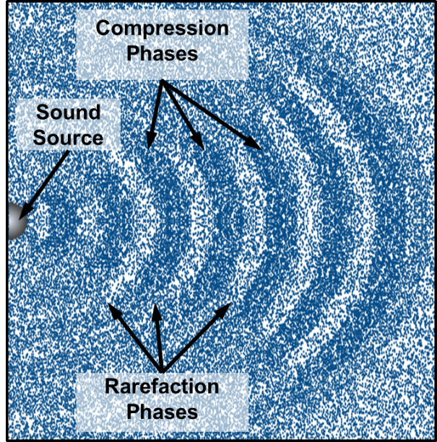
Figure A-1. Compression and rarefaction phases of a travelling sound wave.
The successive compressions and rarefactions result in sound waves. The speed at which these compressions and rarefactions travel away from the source depends on the compressibility and density of the medium and defines the speed of sound in that medium. Sound waves travel much faster in water than in air.
Sound is generally described in terms of frequency (or pitch), intensity, and temporal properties (e.g. short or long in duration, continuous or pulsed). The following text provides a general description of these terms. For more details, there are several publications and books that provide detailed overviews of underwater acoustics, such as Richardson et al. (1995) and Au and Hastings (2008), and some internet sources such as the Discovery of Sound in the Sea, www.dosits.org/, (DOSITS 2016) which is a highly recommended source of information on the subject.
Frequency is a measure of how many times the crest of a sound pressure wave passes a fixed point over the duration of a second; it is measured in Hertz (Hz). For example, when a drummer beats a drum, the skin of the drum vibrates a number of times per second. A particular beat rhythm that makes the drum skin vibrate 100 times per second generates a sound pressure wave with a frequency of 100 Hz, and this vibration is perceived as a tonal pitch of 100 Hz. Sound frequencies between 20 Hz and 20,000 Hz (20 kHz) are within the range of maximal sensitivity of the human ear while a range of 1 kHz to 4 kHz is generally considered the best hearing range of humans. Some mysticetes (baleen whales) produce and may hear sounds below 20 Hz, while odontocetes (toothed whales) produce and hear sounds at frequencies much higher (up to 180 kHz for some species).
Sound intensity is defined as the acoustic power per unit area. The intensity, power, and energy of a sound wave are proportional to the average of the squared pressure. Measurement instruments and most receivers (humans, animals) sense changes in pressure, which is measured in Pascals (Pa). While pressure changes due to sound waves can be measured in Pa they are more commonly expressed in decibels (dB). The decibel is a logarithmic scale that is based on the ratio of the sound pressure relative to a standard reference pressure. The logarithmic decibel scale is used to allow comparison of extremely large sound pressure differences between sources (Figure A-2.).
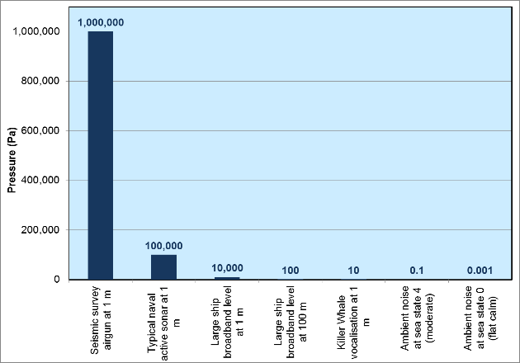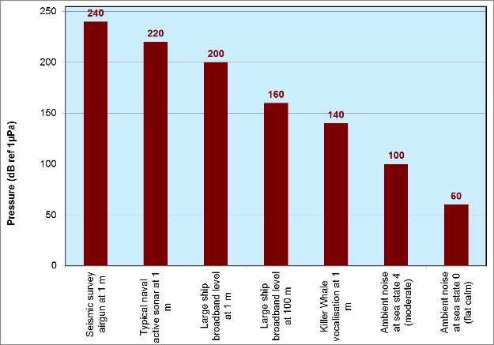
Figure A-2. Comparing pressure differences of various sound sources occurring in the ocean using the Pascal scale (left) and the referential decibel scale (right).
Different standard reference pressures are used for airborne sounds and underwater sounds. The airborne standard pressure reference is pref(air) = 20 micropascals (µPa), where 1 µPa = 0.000001 Pa. The underwater standard reference pressure is pref(water) = 1 µPa. The formula used to convert a pressure p measured in µPa to sound pressure level P measured in dB is P = 20 log10 [p/pref]. Because of the logarithmic nature of the decibel scale, sound levels cannot be added or subtracted directly. If a sound’s pressure is doubled, its sound level increases by 6 dB, regardless of the initial sound level. This can be illustrated by considering a sound having pressure p1; it has decibel level P1 = 20 log [p1/ p_{ref}]. Now consider a sound with twice the pressure: p2 = 2p1. It has decibel level P2 = 20 log [p2/pref] = 20 log [2p1/pref] = 20 log [p1/ p_{ref}] + 20 log (2) = P1 + 6 dB.

Particle motion
An edited extract from (Martin et al. 2016) is provided below. A similar explanation is provided in Nedelec et al. (2016).
Most fish do not have hearing organs that allow detection of pressure differences due to sound pressure waves, but rely on receptors that detect particle motion in the water column to detect sound; the relevant exposure metric for most fish is therefore particle motion. There is little regulatory guidance, however, with respect to setting criteria for particle motion impact. Few particle motion measurements have been collected in conditions typically encountered in monitoring situations, due in part to limitations in the available instrumentation and a general lack of experience in recording this quantity. An introduction to particle motion is included in this section, and it is included in the modelling (Appendix G) and measurement sections (Appendix H) where required.
Acoustic energy is transmitted mechanically by compression and rarefaction of the supporting medium, as previously mentioned. Associated with a change in density there is also a movement of the particles making up the media. This particle motion can be detected and measured directly with vector detectors such as accelerometers or velocity sensors; alternatively it can be inferred from pressure gradient measurements. Using Newton’s laws of motion and the equations of classical mechanics, a wave equation can be derived to fully describe a sound wave (see for example Section 2 in Beranek 1993). A simplified description relating sound pressure and particle motion is Euler’s equation of motion (1) for fluids, that is closely related to Newton’s second law, F=ma, for motion of point sources. Euler’s equation states that a gradient in pressure ($∇$p) across a volume is equal to the density (p_{o}) of the medium times the change in particle velocity ( $\frac{∂u}{∂t }$ ,i.e. particle acceleration).
$-∇p=ρ_{0}\frac{∂u}{∂t}$ (
1)
Therefore, particle acceleration can be found by computing the difference in pressure across a volume, which can be measured using hydrophones at two or more locations. Particle motion in three dimensions can be obtained from an array of four hydrophones with one hydrophone at the origin and the other three along the X, Y, and Z axes (MacGillivray and Racca 2006). Particle acceleration can be integrated with respect to time to obtain the particle velocity, and integrated twice with respect to time to obtain the particle displacement. Particle motion is a vector description of sound, so it is noted that particle motion provides information on the direction of the source as well as its intensity.
Assuming a sound wave is measured far from the source (far field), and that the intensity of the sound is low (i.e., the pressure and density are directly related by the adiabatic bulk modulus), then Euler’s equation can be simplified to an expression that directly relates the pressure and particle velocity (2).
$u=p/{ρc}$ (
2)
Where u is the particle velocity, p is the pressure, ρ is the density, and c is the speed of sound. Equation 2 can be rearranged to provide a metric to determine how well an estimate of particle velocity matches the far-field assumption (3).
$ρcu-p=0$ (
3)

Metrics

Sound metrics
Three metrics are commonly used for the analysis of underwater sound propagation and the evaluation of underwater sound impacts on marine wildlife: peak pressure (PK), sound pressure level (SPL), and sound exposure level (SEL). Terminology in this field should refer to the ISO standard International Organization for Standardization (2017). For impulsive sources, SPL is gradually being supplemented or replaced by fast time-weighted average SPL.
Figure A-3 shows a representation of a sinusoidal (single-frequency) pressure wave to illustrate the various metrics. The amplitude of the pressure is shown along the vertical axis, and time is shown along the horizontal axis. The pressure of the wave fluctuates around the neutral point. The peak sound pressure is the absolute value of the maximum variation from the neutral position of a wave oscillation; therefore, it can result from either compression or a rarefaction. The peak-to-peak sound pressure is the difference between the maximum and minimum pressures. The average amplitude is the average of absolute value of pressure over the period of interest.
The rms amplitude is a type of average that is determined by squaring all of the amplitudes over the period of interest, determining the mean of the squared values, and then taking the square root of this mean. The rms amplitude of an impulsive signal will vary significantly depending on the length of the period of interest.
SEL is a metric that is related to the sound energy per area received over time, though it does not have energy units; it is proportional to the square of the sound pressure and the time over which a sound is received.
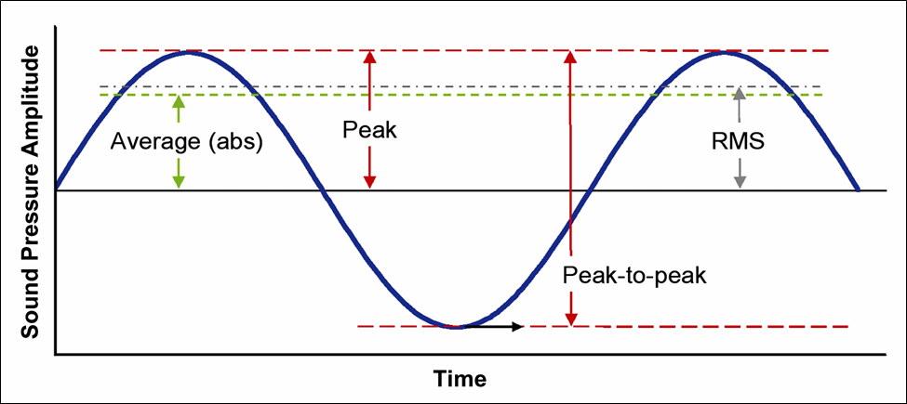
Figure A-3. Sound level metrics.
Peak Pressure (PK)
The zero-to-peak pressure (PK) (dB re 1 µPa), is the maximum instantaneous sound pressure level in a stated frequency band attained by an acoustic pressure signal, p(t):
PK = (
4)
The PK metric is commonly quoted for impulsive sounds, but it does not account for the duration or bandwidth of the noise. At high intensities, the PK can be a valid criterion for assessing whether a sound is potentially injurious; however, because the PK does not account for the duration of a noise event, it is a poor indicator of perceived loudness.
Sound Pressure Level (SPL)
The SPL (dB re 1 µPa) is the root-mean-square (rms) pressure level in a stated frequency band over a time window (T, s) containing the acoustic event:
SPL = (
5)
The SPL is a measure of the average pressure or of the effective pressure over the duration of an acoustic event, such as the emission of one acoustic pulse. Because the window length, T, is the divisor, events more spread out in time have a lower SPL for the same total acoustic energy density. Noise generated by ship traffic, a continuous noise source, is sometimes reported using the SPL metric. It is important to note that if used for continuous sounds this metric should be reported together with a duration over which the root means square measure was calculated.
In studies of impulsive noise, T is often defined as the “90% energy pulse duration” (T90): the interval over which the pulse energy curve rises from 5% to 95% of the total energy. The SPL computed over this T90 interval is commonly called the 90% SPL (dB re 1 µPa):
90% SPL = (
6)
In practical terms, 90% energy impulse durations are much shorter than integration times of mammalian auditory systems—assumed to be around 0.125–200 ms for cetaceans (Madsen 2005, Kastelein et al. 2010, Tougaard et al. 2015)—and the resulting 90% SPL magnitudes likely do not reflect how these very short impulses would be perceived.
Fast-time-weighted SPLs, computed over a fixed time window of 125 ms, are a better representation of perceived sound levels than the 90% SPL. Also, the constant integration time window makes the fast-time-weighted level a more consistent estimator of SPL as a function of range because propagation effects do not influence this metric as they do the 90% SPL.
The use of fast, slow, or impulse exponential-time-averaging or other time-related characteristics should else be specified.
In the audiogram-weighted, fast-averaged SPL is defined using the exponential function from Plomp and Bouman (1959):
(
7)
where d is the duration in seconds, τ is the time constant of 0.125 s representing marine mammal auditory integration time, L_{p.ht} is the audiogram-weighted SPL over pulse duration, and T is the pulse repetition period. This metric takes into account the hearing sensitivity of specific species through frequency weighting, and results in reduced perceived loudness (i.e., sensation level) for pulses shorter than auditory integration time (τ).
Sound Exposure Level (SEL)
The sound exposure level (SEL, dB re 1 µPa2·s) is a measure of the total acoustic energy contained in one or more acoustic events. The SEL for a single event is computed from the time-integral of the squared pressure over the full event duration (T100):
SEL = (
8)
where T0 is a reference time interval of 1 s. The SEL represents the total acoustic energy received at some location during an acoustic event; it measures the total sound energy that an organism at that location would be exposed to.
SEL can be calculated over periods with multiple acoustic events. The SEL over multiple events (dB re 1 µPa2·s) can be computed by summing (in linear units) the SELs of the N individual events:
Cumulative SEL = (
9)
Because the SPL and SEL are both computed from the integral of square pressure, these metrics are related by the following expression, which depends only on the duration of the energy time window T:
SPL (
10)
SPL = (
11)
where the 0.458 dB factor accounts for the SPL containing 90% of the total energy from the per-pulse SEL.

Source level
Sources of underwater noise, such as ships’ propellers or marine mammals’ calls, generate radiating sound waves whose intensity generally decays with distance from the source. The reduction in sound level measured in dB that results from propagation of sound away from an acoustic source is called propagation loss or transmission loss (TL). The loudness or intensity of a noise source is quantified in terms of the source level (SL), which is the sound level referenced to some fixed distance from a noise source. The standard reference distance for underwater sound is 1 m. By convention, transmission loss is quoted in units of dB re 1 m and underwater acoustic source levels are specified in units of dB re 1 μPa at 1 m. In the source-path-receiver model of sound propagation, the sound level L at some receiver position r is equal to the source level minus the transmission loss along the propagation path between the source and the receiver:
(12)
For some sources, such as a very small transducer, the actual intensity can be measured at 1 m, but when considering a much larger source, such as a ship, the sound energy radiates from a wide expanse of hull surfaces and sources inside the vessel and not from a single point on the ship’s hull. Cavitation noise is also not a point source as the noise source is a trailing vortex of bubbles created by the propeller blades.
Vessel source levels are normally determined by measuring noise at some distance from the ship’s hull (several hundred meters) and then the recorded levels are back propagated to 1 m from the source to account for propagation loss. This ensures that noise from every source inside and outside the vessel is captured as a whole, and it prevents near-field interference effects from distorting the measurements at lower frequencies.
The most commonly used metrics to measure vessels source levels are 1/3-octave-band levels (dB re 1µPa) or power spectrum density (PSD) levels (dB re 1µPa2/Hz).
The discussion of noise measurement presented so far has not addressed the issue of frequency dependence. The sound power per unit frequency of an acoustic signal is described by the power spectral density (PSD) function. The PSD for an acoustic signal is normally computed via the Discrete Fourier Transform (DFT) of time-sampled pressure data. The units of power spectral density are µPa2/Hz or dB re 1 µPa2/Hz. For quantitative spectral analysis a coarser representation of the sound power distribution is often more practical and more appropriate as it relates better to hearing. As Appendix D explains in more detail, a fractal octave filter is a better representation of how animal perceives sound pressure differences across the audible frequency range.
When a 1/3-octave frequency band analysis is performed, an acoustic signal is filtered into multiple, non-overlapping pass-bands before computing the SPL. 1/3-octave bands are defined so that three adjacent bands span approximately one octave (i.e., a doubling) of frequency. Figure A-4 shows an example of power spectral density levels and corresponding 1/3-octave band pressure levels for an ambient noise recording.
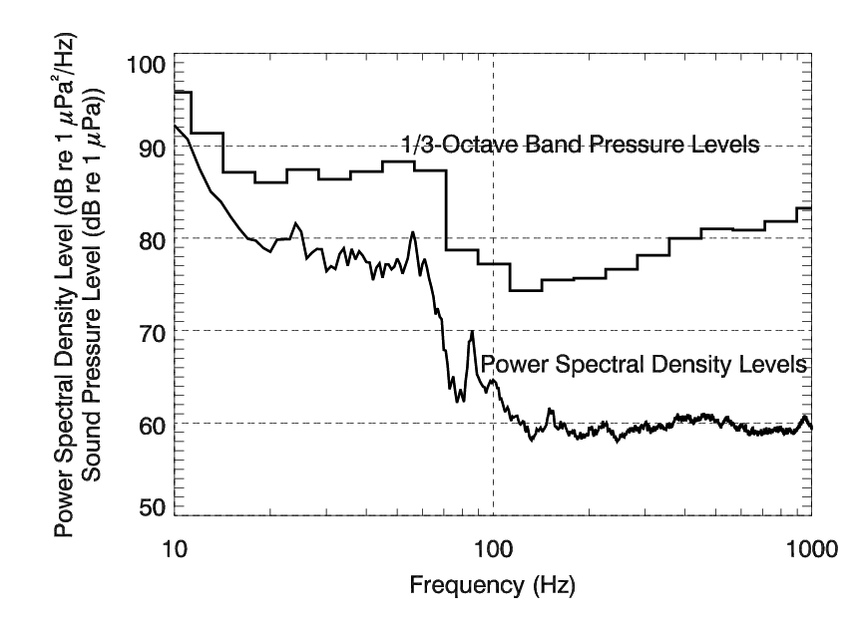
Figure A-4. Plot of an ambient noise power spectrum and corresponding 1/3-octave band levels. Frequency is plotted on a log scale so 1/3-octave bands are wider at higher frequencies.
Standard centre frequencies for 1/3-octave pass bands are given by the following formula:
(
13)
Nominal 1/3-octave band centre frequencies, according to ISO standards, for the range relevant to this study are listed in Table A-1. The SPL inside a 1/3-octave band, L_{pb}(f_{c}), is related to the average PSD level inside that frequency band, L_{ps}^{(avg)}(f_{c}), by the bandwidth, Δf:
(
14)
The bandwidth of a 1/3-octave band is equal to 23.1% of the band centre frequency (i.e., Δf = 0.231f_{c}). Spectrum density levels and band levels are not limited to measurements of sound pressure: they may also, with appropriate selection of reference units, be given for SEL and particle velocity measurements.
Table A-1. Nominal 1/3-octave band centre frequencies from 10 Hz to 8 kHz.
Band Number | Centre Frequency (Hz) | Band Number | Centre Frequency (Hz) | Band Number | Centre Frequency (Hz)
10 | 10 | 20 | 100 | 30 | 1000
11 | 12.5 | 21 | 125 | 31 | 1250
12 | 16 | 22 | 160 | 32 | 1600
13 | 20 | 23 | 200 | 33 | 2000
14 | 25 | 24 | 250 | 34 | 2500
15 | 31.5 | 25 | 315 | 35 | 3150
16 | 40 | 26 | 400 | 36 | 4000
17 | 50 | 27 | 500 | 37 | 5000
18 | 63 | 28 | 630 | 38 | 6300
19 | 80 | 29 | 800 | 39 | 8000

Types of sound
Anthropogenic sounds can affect marine life in a variety of ways, and these effects have been the focus of numerous scientific investigations, reviews and workshops over the past 40 years (Payne and Webb 1971, Fletcher and Busnel 1978, Richardson et al. 1995, MMC 2007, Nowacek et al. 2007, Southall et al. 2007, Weilgart 2007, Tyack 2008). When measuring the impact of anthropogenic sound on marine life, sounds have been divided into two main categories: pulsed (with pulses divided into single and multiple pulses) and non-pulsed or continuous sounds (Southall et al. 2007). Pulsed or impulsive sounds occur during pile driving and seismic explorations (airgun shots) as well as some sonar operations produce pulses, while non-pulsed, continuous-type sounds occur during sonar operations, vibratory pile driving and drilling, dredging and vessel propulsion.
Pulsed and non-pulsed sounds are distinguished through various definitions and through mathematical distinctions (e.g. Burdic 1984). Southall et al. (2007) adopted a measurement-based distinction proposed by Harris (1998) that a ≥ 3 dB difference in measurements between the continuous and impulse sound level metre settings indicates that a sound is pulsed, while a < 3 dB difference indicates a sound is non-pulsed. The distinction between these two sound types is not always obvious. Certain signals (e.g., acoustic deterrent and harassment devices) share properties of both pulsed and non-pulsed sounds. Near the source, a pulse may be produced, but farther from the source the signal may be categorised as non-pulsed due to propagation effects (e.g. Greene and Richardson 1988).
It is important to note that that source-path-receiver model discussed below describes how a sound is perceived by a receiver which is sometimes different from how it was emitted by the sender. For example, sounds from a ship underway is continuous at the source, but transient in relation to a stationary receiver. The cumulated sounds of many ships travelling and received at greater distance, however, will always be perceived as continuous sound. In contrast, the transient sounds that airguns produce which are impulsive sounds at the source and up to certain distance from the source, will be perceived as continuous sound at a farther distance by a receiver due to the many factors that influence propagation. As described in detail in Southall et al. (2007), pulses are transient sounds with rapid rise-time and high peak pressures and are due to their high sound energy potentially highly injurious to mammalian hearing exposed to them at distances that at which the sound exceeds safe exposure levels. Non-pulsed sounds often may not result in injury unless the animals are very close to the sources, but may still cause behavioural changes that can have long term effects on individual and population health. Continuous sounds at levels close to injury thresholds may also cause non-auditory health effects.
Ambient noise is the background noise, encompassing all noise sources. Noise sources may include natural and anthropogenic sources near and far. Ambient noise varies with season, location, time of day, and frequency. The ambient noise in an environment will influence how well a receiver may detect a sound source of interest.

Propagation of sound
Transmission loss underwater is the decrease in acoustic intensity as a sound wave propagates out from a source through spreading loss, reflection, or absorption. Simply, spreading loss refers to the decrease in pressure that results from the increasing surface area a sound wave covers as it moves further from the source. The sound energy becomes spread over larger areas, so the energy per area, and consequently pressure, decreases. In a uniform medium, sound spreads out from the source in spherical waves–sound levels in this situation typically diminish by 6 dB due to spreading loss when the distance is doubled. Reflection (sound waves “bouncing” off a surface) and refraction (bending of the propagation path) affect sound propagation and can lead to areas of higher or lower sound level than if they were not present. Absorption is the loss of acoustic energy by internal scattering and conversion of pressure energy into heat within the propagation medium. Transmission loss parameters underwater vary with frequency, temperature, sea conditions, source and receiver depth, water chemistry, and bottom composition and topography. It is important to note that when comparing different sound levels, attention must be paid to the reference pressure, distance from the source to the receiver, units, and frequencies.
Richardson et al. (1995) described a useful method for considering the process of sound generation, propagation and perception. This method is referred to as the “source-path-receiver” model:
Source: the source of the emitted sound (such as an airgun or drillship). It has particular acoustic characteristics including its pitch and intensity.
Path: the route from source to the receiver of the sound wave. The path may alter the nature of the source sound as it travels from the source to the receiver (terms often used are transmission or propagation). The path can include segments through air or water, or both.
Receiver: the human or animal that perceives the sound after it has left the source and propagated over the path. Receivers have specific detection abilities, so not all receivers will detect or perceive a sound the same way.

Sources of underwater noise
This section aims to introduce the key sources of anthropogenic noise within the World Heritage Area, relating to the key Reef activity sectors of ports, shipping, recreation, tourism, research, fishing and defence.
Sources of noise which are unlikely to cause effects on marine fauna, such as those associated with oceanographic research, such as Acoustic Doppler Current Profilers (ADCPs), acoustic locator beacons, and close range imaging sonar, or ecological research, such as acoustic tags, are not included. Also, not included are pingers that mitigate bycatch of marine mammals in fishing equipment or Queensland shark control apparatus, and as depredation mitigation devices around fishing operations.

Vessels
The intensity and spectral content of vessel-radiated noise varies markedly between different classes of ships, but in general, the underwater acoustic output of large vessels is dominated by broadband cavitation noise from propellers and a set of complex, often tonal noises from engines, drive train components and auxiliary machinery, which contribute to the signature at lower frequencies.
Low-frequency sounds from larger vessels can travel hundreds of kilometres and can increase ambient noise levels over large areas of the ocean, interfering with sound communication in species using the same frequency range (see Southall 2005). Tens of thousands of large commercial vessels are typically underway at any point in time, concentrated in high-traffic sea-lanes and ports, constituting an effectively continuous noise source in many parts of the ocean. The propagation of shipping noise into some confined geographic regions including parts of the GBRWHA may be substantially limited by topographic features such as islands and reefs
As an example of a merchant vessel noise signature, Figure B-5 shows a spectrogram of a container ship transiting past a fixed recorder in Haro Strait, a passage along the western coastlines of the USA and Canada. The vessel passed at 22.4 kn, which is a typical transit speed for a modern container ship (bulk carriers can typically travel at 12-14 kn, (McKenna et al. 2012). The diffuse horizontal tones and harmonics are associated with the vessel’s engine and machinery. The broadband propeller cavitation nose, with characteristic ‘U’ shaped Lloyd’s Mirror interference field, increasingly dominates the spectrum as the vessel approaches and passes its closest point of approach to the hydrophone (CPA: 810 m) at approximately 10:46.The spectrogram displays the received noise at the recorder in PSD level (dB re 1µPa2/Hz (Warner et al. 2014).
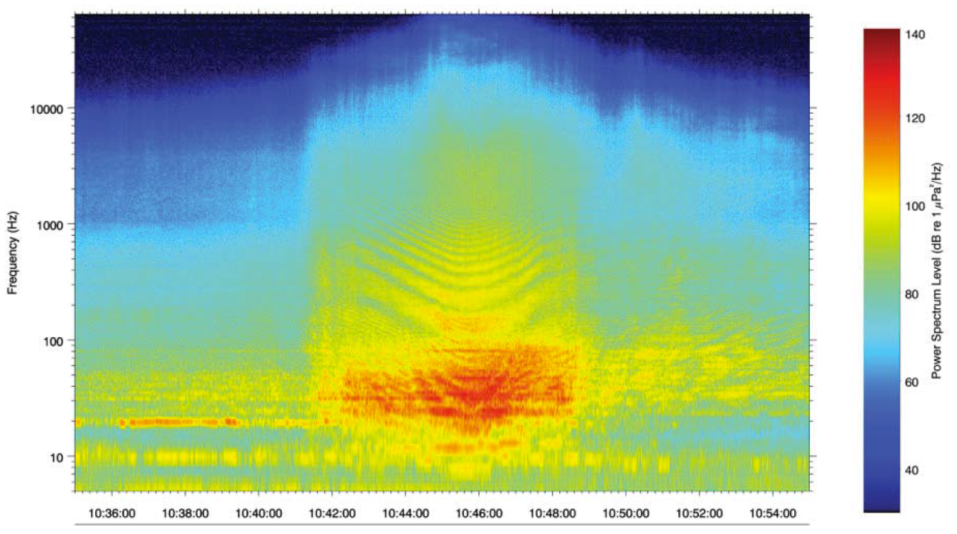
Figure B-1. Spectrogram of a container ship transiting Haro Strait at 22.4 kn (Warner et al. 2014).

Vessel noise sources

Cavitation noise
Cavitation is a phenomenon associated with the rapid changes in pressure on the tips and surfaces of propellers as they rotate through the water. The low-pressure field on the back surface of the blade creates vapour cavities or bubbles in the water, which subsequently implode against the propeller blade itself or when the ambient pressure returns. The resulting noise is broadband and continuous and often described as a hissing sound (Urick 1983). Cavitation noise levels for a single vessel vary with changes to the pressure field around the propeller blades. Events such as starting, accelerating, pitching, or changes to loading through wave action combine to influence the noise level.
Merchant vessels typically travel at a constant fuel-efficient speed, and therefore cavitation noise remains relatively stable in spectral content and intensity (assuming the vessel is traveling above cavitation inception speed). Increased wave height and swell in the open ocean can change cavitation noise characteristics due to a combination of variability in loading for the propeller and through changes to the ambient pressure field around the propeller as the stern of the vessel rises and falls. Within the Reef, sea states are unlikely to be sufficiently high to create these open ocean phenomena for the vessel size under consideration, and so cavitation noise variability is likely to be associated more with changes to vessel speed in compliance with navigational and rule-of-the-road obligations.
Historical studies indicate that the intensity of cavitation and vessel noise is closely related to the speed of rotation of the propeller (tip speed), the number of propeller blades and the propeller diameter (Ross 1976). This relationship was developed further by Scrimger and Heitmeyer (1991) and Hamson (1997) to provide an estimate source level for large merchant ships:
$$SL=SV \left(f\right)+60 log(V/{12)+20 log⁡({Le}/{300)}}$$
Where V is the vessel speed (knots), Le is the length overall (feet), and SV(f) is the reference level for a merchant vessel noise spectrum. The reference spectrum was based on 50 recorded spectra of merchant ships (Hamson 1997), but this sample now represents an older generation of vessels and the market trend in building increasingly large ships may be progressively reducing the validity of these data.

Engine and auxiliary machinery noise
Most of the larger Panamax and Capemax bulk-carriers use a single, slow speed, cross-head, two-stroke, turbo-charged diesel engine for propulsion. The engine is directly connected to the propeller shaft without an intermediate gearbox. Engine revolutions are therefore matched by shaft revolutions, and propeller blades are usually fixed (although some smaller vessels may use a variable pitch propeller). Engine and shaft revolutions are relatively low, with larger units running at an average of 90 rpm to achieve a typical hull speed of 13 to 14 kn. Rotating machinery generates sound with tonal qualities that reflect the consistency of the mechanical source.
In addition to the main engine and drive train, large merchant vessels are fitted with auxiliary machinery (e.g., ship service generators, fuel and fire pumps, and hydraulic systems), which operates independently from the main engine and contributes to the overall noise signature. Determining the magnitude and frequency characteristics of main engine and auxiliary machinery noise is complicated without direct measurements, and there is no simple relationship between vessel size and noise level. In most cases, vessel speed changes are most likely to have the greatest effect on the frequency, and to a lesser degree the intensity of most engine tones, but not on the more stable noise from auxiliary machinery.
Ship service is usually powered by four-stroke diesel engines. The number and capacity of auxiliary engines are determined by the vessel’s electrical demands. Rigidly mounted four-stroke engines operating without an acoustic noise reduction module can be a major contributor to vessel noise. Furthermore, smaller bulkers may also have four-stroke main engines, rather than two-stroke engines, and these vessels can present a signature that includes an enhanced level of engine related tones and noise (Arveson and Vendittis 2000).
Unlike cavitation noise, which is generated outside the ship’s hull around the propeller(s), machinery noise is generated inside the vessel and radiates through a number of paths and mechanisms to the hull and thence into the surrounding water. Variations in ship hull design and engine space layout all contribute to differences in the amount and directionality of noise radiating into the surrounding water. However, although differences inevitably occur between the engine and auxiliary equipment fit in ships from different manufacturers, there is insufficient data on the resulting underwater acoustic signatures from each design to allow any detailed investigation of potential variability. Without performing a dedicated measurement study, it is not realistic to attempt to differentiate beyond a generic signature for all Terminal vessels.

Directionality of radiated noise and bow blanking
Vessel radiated noise often displays a degree of directional dependence (directionality). Directionality in radiated intensities is caused by a combination of factors including the location of principle noise sources in the vessel, hull shape, and masking of the propeller(s), vessel type, cargo, and vessel size.
Conventional ship designs usually locate the main machinery spaces at the very stern of the vessel to reduce shaft length/drive train to the propeller(s) and maximize cargo capacity. Lateral radiation of noise from the hull around the engine and machinery spaces, perpendicular to the direction of travel, is unhindered by obstruction and cavitation noise from the propeller(s) is also able to propagate unhindered by physical obstructions both laterally and toward the stern, with the possible exception of the rudder and associated structures. However, the large volume of the cargo section, forward of the main engine space and propellers, creates in some designs and vessel types a masking effect for noise sources at the stern and results in a bow null in the radiated noise pattern. This effect is known as bow blanking. The extent of blow-blanking directivity characteristics in large bulk-carriers is unknown and specific recording geometries are required to obtain the data necessary to measure this phenomenon accurately.

Bulk- carrier acoustic signatures

Bulk-carriers recorded in Haro Strait
From 2011 to 2013, the Whale Museum and the Beam Reach Marine Science and Sustainability School (TWMBR) recorded 5,993 ship transits through Haro Strait from a near-shore hydrophone positioned at the Lime Kiln state park (Hemmera Envirochem Inc. et al.). Data from this program provided a set of generic radiated noise spectra for several vessel classes. Vessel source levels below 50 Hz are not provided in the TWMBR data, due to concerns surrounding the ability of these lower frequencies to propagate in the shallow water along the margin of Haro Strait. This was confirmed by more recent measurements of container ships, performed directly in the shipping lanes of Haro Strait, which indicated that substantial low-frequency sound energy from shipping did not propagate to the Lime Kiln hydrophone (Warner et al. 2014).
Regardless of questions surrounding the low-frequency vessel source levels, the TWMBR data represents a large statistical survey and provides valuable set of aggregated ship signatures, which can be compared to identify spectral differences between vessel classes.
Figure B-2 shows the 1/3-octave-band source levels for the range of different vessel classes, including three different sizes of bulk carrier (200, 200–250, and > 250 m). Panamax vessels are typically bigger than 250 m, and so the two vessel sizes expected to call at the Terminal (Panamax and Capesize) are best represented by the largest class of bulk-carrier, > 250 m.
The noticeable peak in a number of vessel type signatures, between 250 Hz and 500 Hz, is associated with higher levels of propeller cavitation noise. The rising levels toward to bottom end of the spectrum, below 150 Hz, are associated with engine, drive train, and power generation noise.
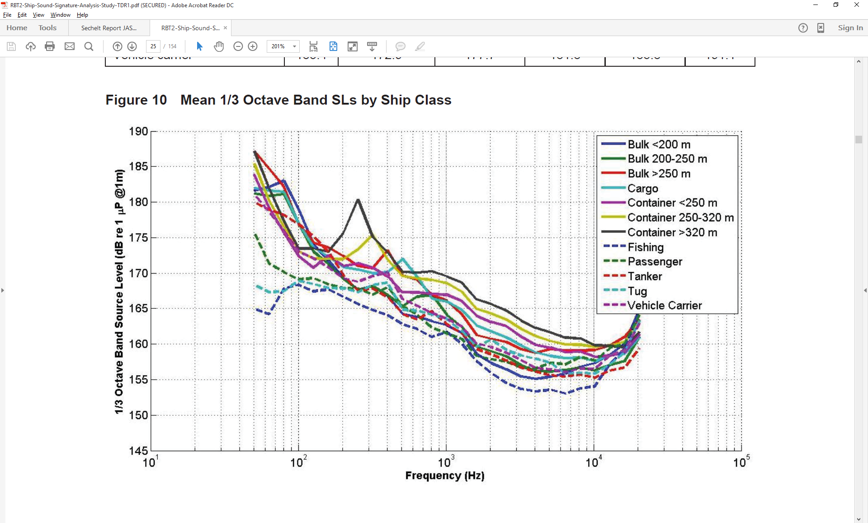
Figure B-2. TWMBR recorded mean 1/3-octave-band source levels for different vessel types (Hemmera Envirochem Inc. et al.). © JASCO.
The highest cavitation noise peaks were for the two largest classes of container ship. These vessels tend to be narrower than bulk-carriers and have powerful engines enable them to transit at higher speeds (22–24 kn) than other merchant traffic. Higher levels of cavitation noise from container ships, suggested in the data, is therefore unsurprising. Bulk-carriers, with their broad, blunt hull design, transit at lower speeds (14 kn), and this may explain why a cavitation peak is not as apparent in this data for the two smaller sizes of this vessel type. Only the largest of the bulk-carrying class, > 250 m, shows an elevated level of cavitation noise at 300 Hz.
The overall impression from Figure B-2 is that container ships, transiting Haro Strait, generate the loudest levels of radiated noise with the three classes of bulk-carrier falling some 2 to 6 dB below those levels, but generally above those for tankers.

Bulk-carriers recorded during port entry in Australia
A very shallow water measurement program was conducted in Dampier, Western Australia (Hallet 2004) which captured data for six bulk-carriers and one ore-carrier as they entered or left the port area. Vessels ranged in size from 15,000 DWT to 201,000 DWT and recordings were made in very shallow water (~20 m) and at very short range from the vessels (~100 m). The very short, near field range to the vessel may have imposed some degree of uncertainty at the lower frequencies but the results remain relevant for shallow water settings for the majority of the spectrum and therefore applicable for the transit routes through the Great Barrier Reef.
Figure B-3 shows the spectra for individual ships with an average overlaid. The source levels in this report are provided in PSD (dB re 1µPa2/Hz at 1 m) and so are not directly comparable with the 1/3-octave-band data in Figure B-2.
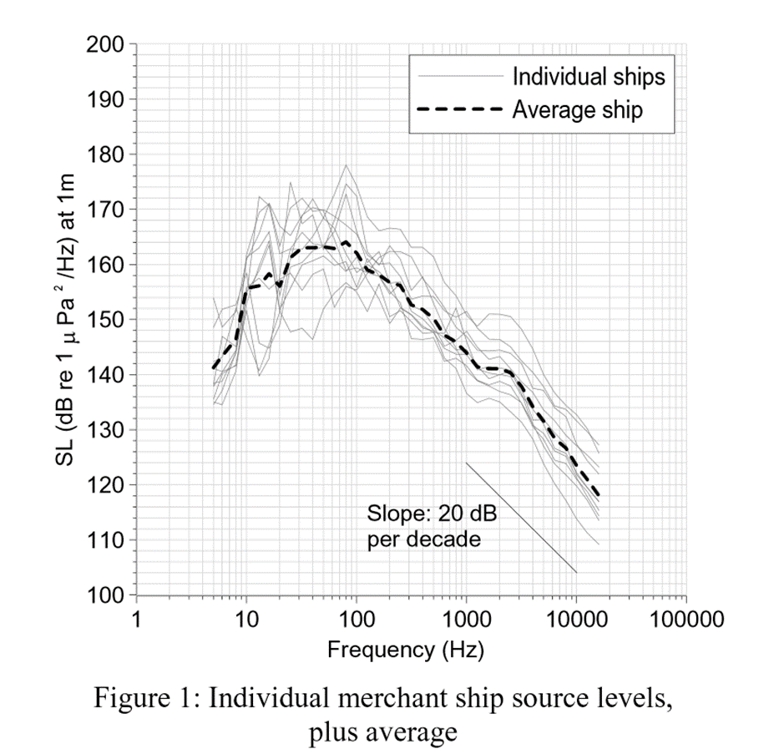
Figure B-3. Measured ship source levels and averaged level (Hallet 2004).
The speed of the individually recorded vessels ranged from 7.5 kn and 14.6 kn with a mean of 10 kn. It is possible that average speed for bulk-carrying traffic in the World Heritage Area may be slightly higher than 10 kn but it has been established by Wales and Heitmeyer (2002) that the positive relationship between speed and overall noise level for individual ships does not necessarily hold true for an averaged noise spectrum derived from a number of ships. Consequently, by taking the average ship source level from Figure B-3, rather than individual ship signatures, we can assume that it remains relevant for bulk carriers transiting in shallow water at slightly higher speeds.

Bulk-carriers measured in the Santa Barbara Channel
McKenna et al. (2012) recorded acoustic signatures (< 1,000 Hz) in the Santa Barbara Channel, CA from passing vessels, which were subsequently identified by AIS data for classification of type. The recording instrument was placed at a depth of 580m in the coastal shelf waters between Santa Barbara and Santa Rosa Island. Vessels passed the recorder with an approximate CPA of 3km and data was analysed to exclude contamination from other vessels if their passage was within 1.5 hours of the target vessel, or if marine mammal vocalizations were present. Transmission loss was modelled using a range-dependent parabolic equation approach to back propagate received levels to derive source levels.
Of the total twenty-nine recorded vessels, five were bulk carriers ranging in size from 16,300 Gross Tonnes to 42,900 Gross Tonnes. For comparison purposes in this memorandum, the Stopford (2009) conversion factor for bulk carrier gross tonnage to DWT (1.7) indicates that the vessel range was therefore between 27,710 DWT and 72,930 DWT. Figure B-4 shows the resulting mean signature, with standard errors, for bulk-carriers from the McKenna study.
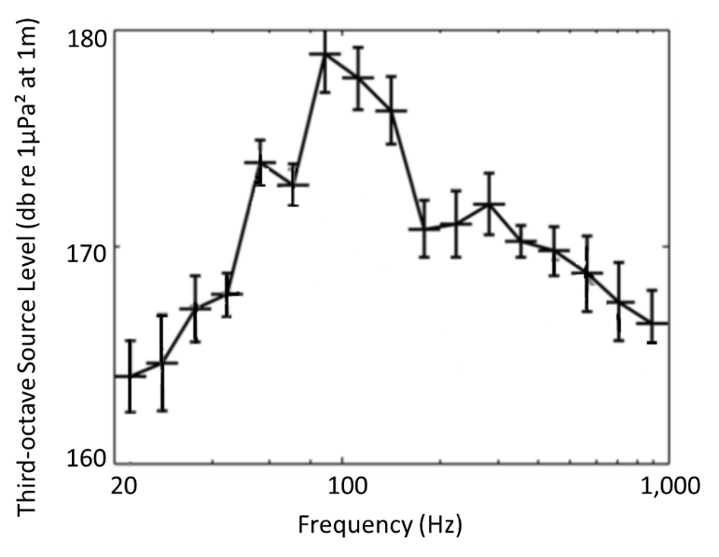
Figure B-4. Representative 1/3-octave source levels for five bulk-carriers recorded by McKenna et al. (2012).
When plotted against other vessel types captured in the recording program, McKenna indicated that bulk-carriers exhibited the highest source levels of any ship class other than container vessels, which were of a similar magnitude. Figure B-5 shows the broadband ship source levels recorded by McKenna. The bubble size signifies relative ship size. It is notable that the smallest bulk-carrier in the study had the highest broadband source level of that class, 187.4 dB re 1µPa2 (20–1000 Hz), and only one container ship had a higher broadband source level, 188.1 dB re 1µPa2 (20–1000 Hz).
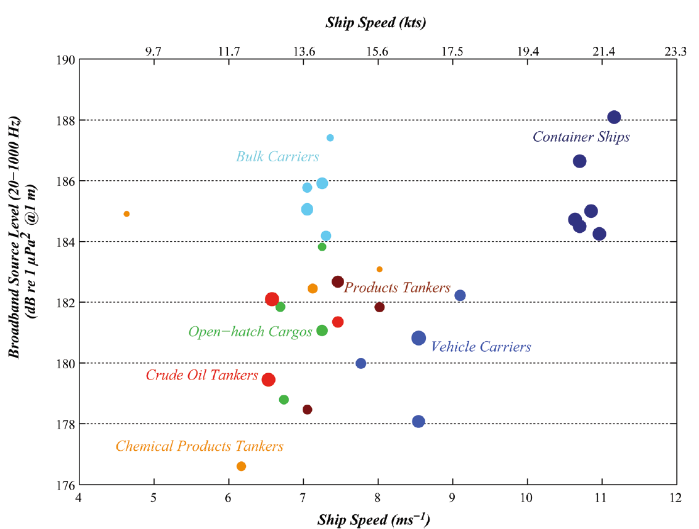
Figure B-5. Broadband source level compared to ship speed
(McKenna et al. 2012).

High speed tourist ferries
The Great Barrier Reef has many high-speed catamaran vessels that service the reef tourist trade. Propulsion for high-speed catamaran vessels may vary from jet to propeller driven systems. Allen et al. (2012) documented noise levels by vessel type, length, speed and orientation for classes of propeller driven commercial vessels, jet driven high-speed commercial vessels, jet and propeller driven tourist ferries/catamarans and propeller driven fishing vessels (displacement and semi-planing hulls). The sound propagation by vessel orientation of a 34 m jet powered catamaran, such as occurs in tourist areas of the World Heritage Area, travelling at 27.4 kn was recorded by a hydrophone at a depth of 15 m (Figure B-6, extracted from Figure 2 in Allen et al. 2012). The high-speed catamarans generally had a higher frequency range than other vessel types, with maximums well over 10 kHz. Other recent studies, including Hermannsen et al. (2014) have examined the wide frequency range of vessels, including high speed ferries and found substantially elevated ambient noise levels across their entire recording frequency range, 0.025 to 160 kHz. However, there is a lack of knowledge about the specific ferries that are used in the Reef due to the size, typical speed and propulsion system variability.

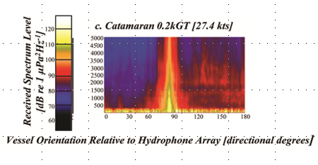
Figure B-6. Spectrogram of a 34 m jet powered catamaran travelling at 27.4 kn, extract from Figure 2 in Allen et al. (2012).

Outboard powered vessels
Outboard powered vessels are extremely common in in the World Heritage Area. A number of studies have examined the noise of small vessels, predominantly associated with studies of the impact of vessels on marine fauna, including Erbe (2002), Holles et al. (2013) and Lemon et al. (2008). Other studies including Erbe (2013), Kipple and Gabriele (2003) and (2007) and Sutin et al. (2013) focused primiarly on the vessel noise characteristics themselves.
Kipple and Gabriele (2003, 2007) studied a large number of vessels (14 and 38 respectively) under standardised distances and vessel speeds in Glacier Bay National Park and Preserve. The range of vessel types included many operating in Great Barrier Reef waters, and included a number of small vessels with high-speed engines from 4.3 to 10.4 m in length and were powered by outboards, inboards and jets of 20 to 420 horsepower. Comparisons were made of vessel noise at speeds of 10, 14 and 20 kn (where possible) and SPLs examined. As a group, high-speed vessels under 6 m in length and 100 horsepower produced the lowest sound levels, followed closely by the jet powered craft. Perhaps not surprisingly high-speed craft with engine power over 100 horsepower produced the highest noise levels. The large diesel fishing type boats generating less noise than large outboards. Noise levels also depended on vessel speed, on the average, vessel sound levels were about 4 dB greater at 20 kn compared to 10 kn. Noise at idle or slow navigation speed would be lowest although not estimated by Kipple and Gabriele (2003, 2007).
A vessel representative of many privately registered vessels used in the World Heritage Area, primarily based on hull length and propulsion system, was the aluminium construction MV Sand Lance is shown in Figure B-7.
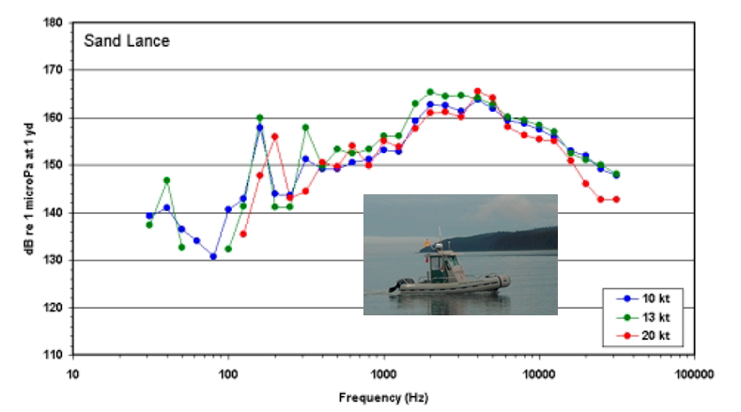
Figure B-7. The 5.8 m 115 hp powered MV Sand Lance’s 1/3-octave spectrum levels at three speeds (Figures 1 and 13, Kipple and Gabriele 2003).

Prawn trawlers
Most trawling activity in Reef waters is by vessels to 25 m, diesel powered and operating in waters to approximately 35 m depth. No publicly available acoustic measurement programs have been conducted on prawn trawl vessels in Australian waters that the authors are aware of.
The sound spectrum of a 23 m Belgian prawn trawl vessel was described under free and load conditions by Fontenye (1973). There are variations in the units of measurement (dB re 1µbar at 1 m instead of dB re 1µPa at 1 m) although the spectrum levels referenced to 1 m indicates that a prawn trawler under towing load would generate most noise at frequencies below 1 kHz.
Yoon (1980) noted that peak noise at the net of a towed fish trawl net was 137 dB re 1µPa between 100 to 200 Hz. The noise of the towing vessel at the net was at least 10 dB lower. Towed, paired, prawn trawl nets would most likely be in the same frequency range as determined by Yoon (1980).
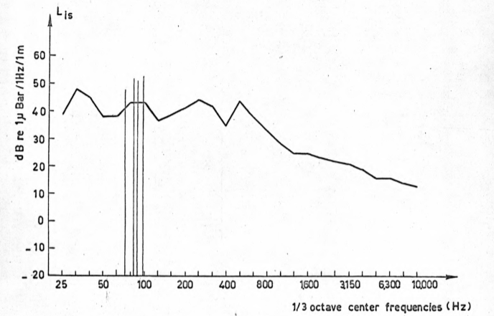
Figure B-8. 1/3-octave sound spectrum of a Belgian prawn trawler under towing load at 750 rpm (Figure 9 in Fontenye 1973).

Diesel powered troll vessels
The pelagic fishery for narrow barred Spanish mackerel in reef waters is conducted by vessels using a range of propulsion methods. Vessels that use propulsion during fishing operations include diesel powered vessels to perhaps 15 m, smaller dories to 6 m and outboard powered vessels.
The acoustic signature of hydro-dynamically efficient, displacement albacore tuna troll fishing vessels 10 to 18 m in length have a low broadband SPL approaching 90 dB re 1µPa at 1 yard (note less than 1 dB lower a 1 m) while operating at 10 to 12 kn (Erickson 1979). Queensland narrow barred Spanish mackerel (a member of the tuna family of fishes) fishery vessels, though perhaps not as hydro-dynamically efficient, conduct fishing operations at more like 4 to 5 kn.
Erickson (1979) determined that sound intensity was not a factor that influenced fish catch. The presence of vessel noise above 1.5 kHz and time variation in the noise had more influence on reduced fish catch, equivalent to fish avoidance as fishing gear was standardised. Small trolling vessels such as 8 m dories would have lower source levels.

Dredging
Several types of dredge that can be used within ports surrounding the Marine Park. Figure B-9 shows the four main types of dredging equipment used globally, along with the principal sources of sound associated with their operation.
Cutter suction, trailing suction hopper, and backhoe dredges are the more likely types to be used within the World Heritage Area. Closely related to cutter suction dredges are hydraulic pipeline cutterhead dredges, which pump the resultant sediment-water slurry through floating pipelines for distances of up to several miles. In addition to propeller drive, some dredges can advance by alternately swivelling on posts called “spuds” while anchored cables on each side of the dredge control lateral movement. Winch and other propulsion machinery sounds transmitted through the hull of the dredge are a typical form of underwater noise associated with this type of dredging operation.
When monitoring sound from most types of dredging, it can be difficult to separate the individual processes involved based on their temporal location in the acoustic record.
The major processes contributing to dredging sounds include:
- dredged material ablation and collection sounds that result from the dredgehead coming in contact with the sediment bed and, for a suction dredge, the intake of the sediment-water slurry,
- sounds generated by the pumps and impellers driving the suction of material through the pipes,
- transport sounds involving the movement of sediment through the pipes, and
- ship and machinery sounds, including those associated with the lowering and lifting of spuds and moving of anchors by dredge tenders.
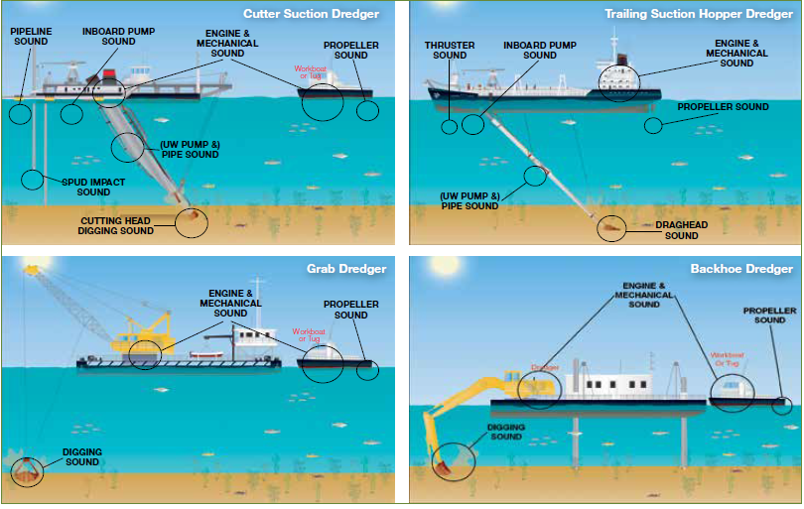
Figure B-9. Sound sources for main dredging types (Figure 4 in World Organisation of Dredging Associations 2013).
Source levels for dredging operations vary depending upon the size and type of dredge and the substrate that is being extracted. Some examples are provided below.
Suction dredges utilise a wide pipe (up to 1 m in diameter) and a high power pump to suck the water and bottom material into a hopper or onto shore. A cutter head can be used to help loosen up the sediments. The pipe can be steered using cables and winches or thrusters. Generally, trailing suction hopper dredges (TSHDs) navigate using the vessel’s main propulsion system (propeller and/or thrusters), while cutter suction dredges (CSDs) often don’t have a propulsion system. They use instead legs known as spuds, winched cables between anchors, or tugs.
Robinson et al. (2011) studied underwater noise levels radiated from marine aggregate dredgers (mainly TSHDs) in the UK fleet during normal operation. They concluded that:
- noise radiated at < 500 Hz is similar to that of a merchant vessel “travelling at modest speed” (for self-propelled dredges),
- during dredging operations, noise levels above that of merchant vessel is radiated at > 1 kHz,
- the major source of noise at > 1 to 2 kHz is generated by the impact and abrasion of the sediment passing through the draghead, suction pipe, and pump, and
- source levels depend on the type of sediment being extracted.
Figure B-10 presents a series of spectra for suction dredges found in a literature review, including Robinson et al. (2011), and SL estimated from JASCO recordings, with the sources specified in Table B-1.
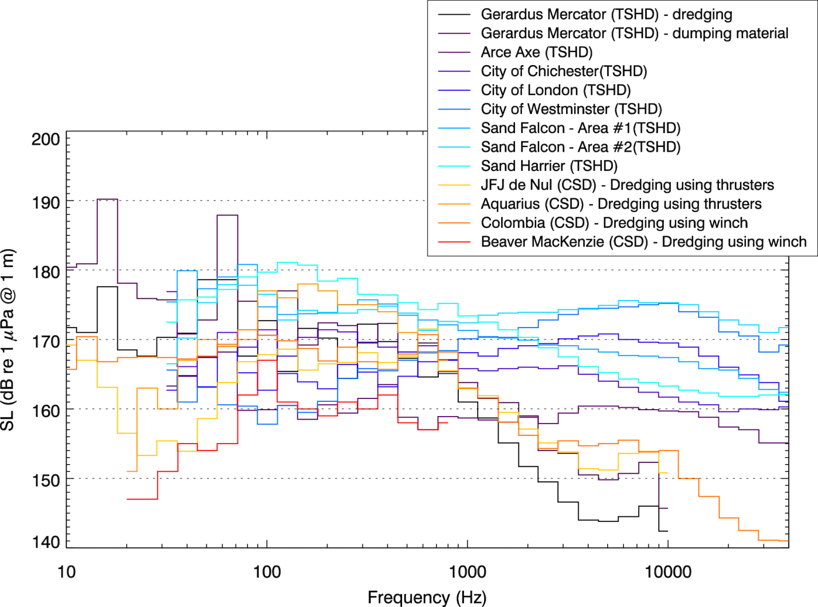
Figure B-10. Comparison between 1/3-octave band levels for suction dredges. See Table B-1 for vessel specifications (Zykov et al. 2007).
Table B-1. Suction dredges specifications.
Dredge Name | Type | Length x breath x draft (m) | Capacity | Dredging depth (m) | Estimated broadband level (dB re 1 µPa @ 1 m) | Reference
Sand Harrier | TSHD | 99 | 4671 t | 33 (max) | 190.0 | Robinson et al. (2011)
Sand Falcon | TSHD | 120 | 8359 t | 50 (max) | 188.8 / 189.3 | Robinson et al. (2011)
Arco Axe | TSHD | 98.3 | 5000 t | 48 (max) | 176.2 | Robinson et al. (2011)
City of Chichester | TSHD | 72 | 2300 t | 35 (max) | 183.3 | Robinson et al. (2011)
City of London | TSHD | 99.9 | 4750 t | 46 (max) | 182.4 | Robinson et al. (2011)
City of Westminster | TSHD | 99.7 | 5200 t | 46 (max) | 185.6 | Robinson et al. (2011)
Gerardus Mercator | TSHD | 152.9 x 29 x 11.51 | hopper size: 18,000 m³ | 35 / 50 / 55 / 105 / 112 | 193.5 (dredging)  185.6 (dumping material) | Hannay et al. (2004) and Sakhalin Energy
JFJ de Nul | CSD using thruster to move cutterhead | 124.4 x 27.8 x 6.51 |  | 6 (min)  35 (max) | 179.6 | Hannay et al. (2004) and Sakhalin Energy
Aquarius | Self-propelled CSD using thrusters to move cutterhead | 107 x 19 x 4.85 | 12889 KW (?) | 25 (max) | 185.5 | Malme et al. (1989)
Columbia | CSD using winch to move cutterhead | 49 x 13.4 x 2.14 |  | 18 (max) | 181.8 | McHugh et al. (2007) in Matthews and Zykov (2013)
Beaver MacKenzie | CSD using winch to move cutterhead | 86.5 x 15.44 x 4 | (Gross tonnage: 2148.5 t) | 45 (max) | 172.1 | Malme et al. (1989)

There is no information available for the noise associated with the disposal of dredging material. It is expected that the noise will be generally dominated by sound generated by the disposal vessels’ propulsion systems, e.g., main propellers and bow thrusters, and that the substrate material will contribute very little.

Pile driving
An overview of pile driving is provided below. A detailed compendium on pile driving and topics relating to underwater sound and fish is the Caltrans Technical Guidance (Buehler et al. 2015).

Impact pile driving
Impact pile driving is carried out using an impact hammer, which consists of a falling ram that strikes repeatedly the top of a pile and drives it into the ground (Figure B-11). The ram is lifted or driven by one of several methods, including mechanical winching, diesel combustion, pneumatic air pressure, or hydraulic pressure.
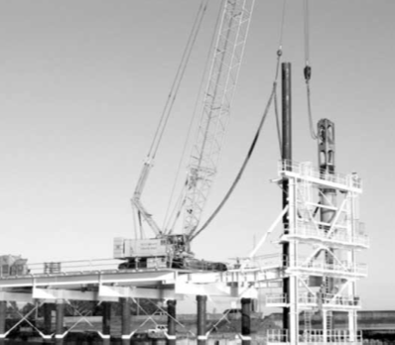
Figure B-11. Photo of a temporary pile being driven by a hydraulic impact hammer during construction of a highway bridge in Queensland, Australia (from Erbe 2009).
When the ram strikes the pile the impact creates stress waves traveling down the length of the pile, which couples with the surrounding medium, radiating acoustic energy into the water. Pile driving also generates vibration waves in the sediment, which can radiate acoustic energy back into the water from the seabed. The sound from impact pile driving is transient, repetitive, and discontinuous, i.e., pulsed (Figure B-12). Hydrophone array measurements (Reinhall and Dahl 2011) and computational acoustic models (Zampolli et al. 2013) have been used to investigate the different propagation paths of underwater sound waves generated by impact pile driving.
Figure B-12. Example of waveform, power spectrum and spectrogram of pulsed sounds produced by impact pile driving. Panel (a) shows a pile driving pressure pulse (blue), with horizontal lines indicating the peak pressure (red) and 90% rms pressure (black). Panel (b) shows the acoustic frequency spectrum. Panel (c) shows the spectrogram of a series of pile driving pulses. © JASCO.
Figure B-12(a) depicts two typical broadband (across a range of frequencies) measurement metrics (peak pressure and rms pressure) that are generally reported in dB re·1µPa over the duration of a single pulse. Other standard metrics of impact pile driving sound levels include the following:
- Peak-to-peak sound pressure level: the pressure difference between lowest and highest pressures
- Sound exposure level (SEL): reflects the cumulative acoustic energy emitted by the source over a specified time period; either from a single strike, or from an entire pile driving event
The above levels are measured as received levels and, as such, are affected by the transmission loss between the source and receiver locations.

Vibratory pile driving
Vibratory pile driving is conducted using a vibrating hammer that is clamped at the top of the pile. Oscillating elliptical weights or a similar alternating mechanism in the hammer generate strong vibrations in the pile, which liquefy the surrounding sediments and allow the weight of the hammer to push the pile into the ground. Vibratory drivers can also be used to loosen piles to be extracted. As with impact driving, the vibration of the pile radiates acoustic energy into the surrounding water. Unlike impact driving, sound from vibratory driving is steady and continuous (Figure B-13). Vibratory driving peak and rms sound levels are typically lower than impact driving sound levels. However, the total energy imparted, or SEL, can be comparable to impact driving because the vibratory hammer operates continuously and requires more time to install the pile (ICF Jones & Stokes and Illingworth and Rodkin 2009).
Vibratory hammers are routinely used on smaller piles; the method, however, is most effective in granular soils and in driving non-displacement piles (Spence et al. 2007). In some cases, it is difficult to vibration drive a pile to a depth where it can reach load-bearing capacity; in these cases, impact methods must be used to set the pile (Spence et al. 2007).
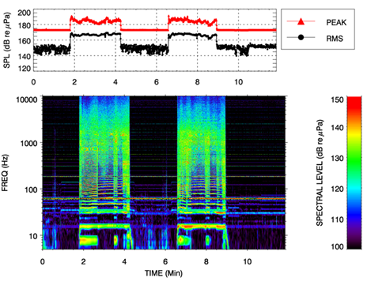
Figure B-13. Example of broadband levels (peak and rms) and spectrogram of two intervals of non-pulsed (continuous) sounds produced during vibro-hammering (Racca et al. 2007). © JASCO.

Pile drilling
Pile drilling generally refers to auger drilling or down-the-hole (DTH) drilling, which are used to create pile sockets and to install pile anchors. Limited information exists on noise generated by pile drilling, but the available data suggest that sound levels generated by drilling are lower than either impact or vibratory pile driving. DTH drilling employs a pneumatic percussion hammer (i.e., jack hammer) to chip away rock and other material at the base of a pile. Auger drilling employs a rotating auger bit to drill away material at the base of a pile. Sound from drilling is generally continuous (non-pulsed), though DTH drilling may produce pulses in addition to continuous sound.

Rock dumping
The overall sound field from rock dumping vessels is generally similar to the noise of a vessel under dynamic positioning, however can be louder at certain parts of the spectrum (Figure B-14).
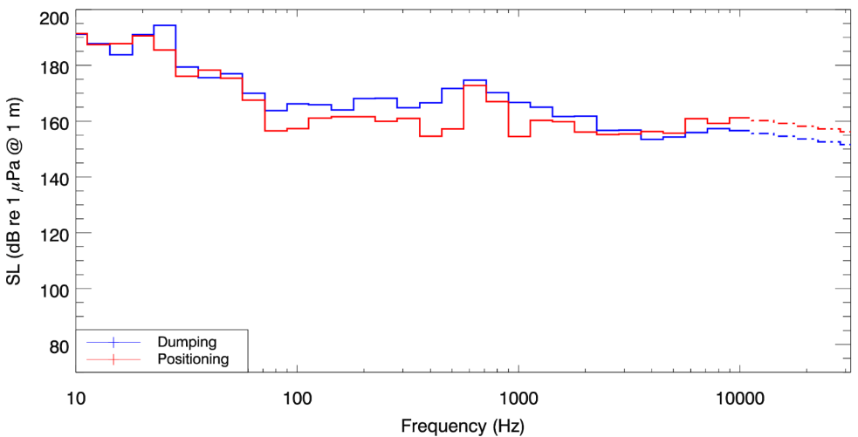
Figure B-14. Estimated source levels (SLs) for rock dumping. Extrapolated levels above 10 kHz are shown as dot-dashed lines. © JASCO.

Blasting
Blasting can be part of construction projects. Blasting both on-land and in-water involves installing explosive charges in pre-drilled holes. An arbitrary example is provided for context, using examples of 6 kg and 12 kg of ammonium nitrate/fuel oil (ANFO) explosive (equivalent to 5 kg and 10 kg of TNT, respectively), placed in drill holes at 3 m below the surface of the rock.
The pressure wave from an explosive charge buried in a substrate, like rock, can be modelled with the Conventional Weapons Effects (ConWep) model (Hyde 1988, 1992). ConWep uses empirical equations and curves to model the effects from various conventional explosive weapons, including explosives detonated in bedrock. ConWep includes a database of the yield and detonation rates for several explosive compounds. In ground-shock mode, ConWep predicts the peak pressure and peak particle velocity at a chosen receiver range and depth in the substrate. The input parameters include the type of explosive, the charge weight, the geometry of the detonation (depth of the charge, distance to the receiver, and depth of the receiver in the substrate), and the geoacoustic parameters of the substrate (density, compressional-wave/P-wave speed, and attenuation coefficient). The model accommodates surface (unconfined), partially buried, and fully buried charges to accommodate source confinement.
Histories of pressure as a function of time were computed using ConWep for a receiver located 10 m from the charge, as would be measured near the rock-water interface. Reflections from all other layers were excluded from modelling at this stage. The amplitude of the pressure curve was then back-propagated to a range of 1 m from the source assuming spherical spreading loss (Figure B-15). Taking the Fourier transform of the back-propagated pressure histories yields 1/3-octave-band source levels shown in Figure B-16.
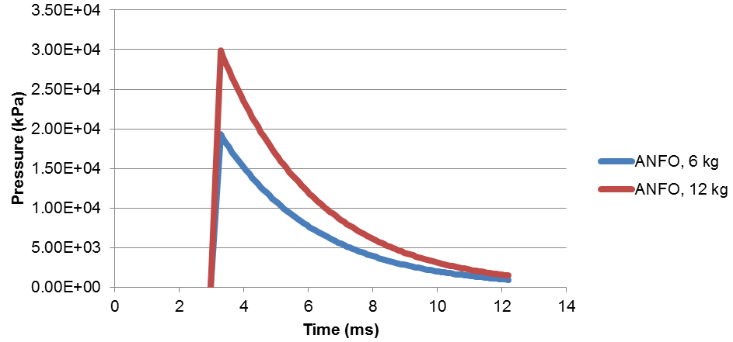
Figure B-15. Estimated pressure wave at 1 m from an explosive charge buried 3 m in bedrock, for 6 kg and 12 kg of ammonium nitrate/fuel oil (ANFO). © JASCO.
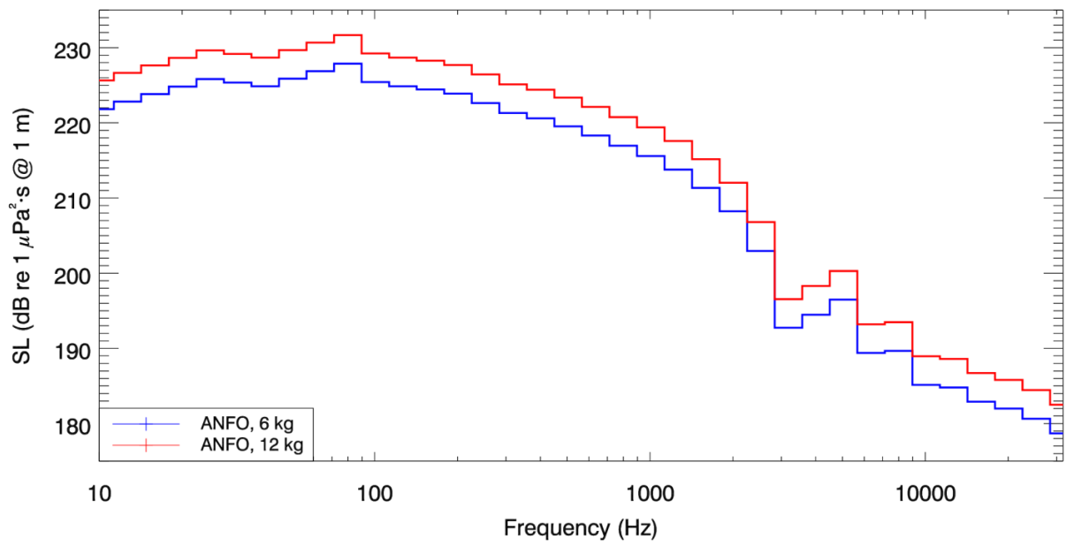
Figure B-16. Estimated source levels (SLs) from an explosive charge buried 3 m in bedrock, for 6 kg and 12 kg of ammonium nitrate/fuel oil (ANFO). © JASCO.

Geotechnical exploration
Bathymetric surveys image the topography of the seafloor. Acoustic sources include single or multibeam echosounders, side-scan sonar, and swath bathymetry systems. The working frequencies for these sources are from 10 kHz to 1 MHz. Typically, transducers utilised in bathymetry systems can also act as receivers.
Small scale surveys are used as part of geotechnical investigations, to image sub-bottom features in the top few hundred meters of the seabed that could pose hazards to construction, future drilling, and/or to the structural support of bottom-mounted infrastructure. They are commonly performed along survey lines with tight spacing of 10-50 m over spatial areas a few kilometres across. The sources can consist of small seismic arrays of 1 to 4 airguns with total volume typically less than 100 in3. While the seismic sources are not typically used, they should still be considered. Typically these surveys can also involve sparkers, boomers, and chirp sonar, producing frequencies from several hertz to 10 kHz. Since the penetration depth of airgun sound decreases with increasing frequency, seismic sources do not typically operate at frequencies above 10 kHz, though some emit acoustic energy in that band as a side-effect. However, small airguns generate relatively more noise energy at higher frequencies and with larger bandwidth than larger airguns, which provides better resolution of small structures in the upper sediments. Additionally, electroacoustic sources often have directivity that focuses sound vertically, thereby reducing levels in horizontal directions. Typically seismic sources cannot act as receivers. A hydrophone or hydrophone array is used to record the reflected acoustic pulses.

Chirp sub-bottom profilers
Compressed High Intensity Radar Pulse (CHIRP) systems produce a swept-frequency signal, i.e., the transmitted signal is emitted over time and over a specific frequency range. The pulse length, frequency bandwidth, and phase/amplitude characteristics of the pulse of the chirp sub-bottom profiler are selectable. CHIRP systems usually employ various types of transducers as the source. The transducer that emits the acoustic energy also receives the reflected signal.
CHIRP signals do not penetrate as deep into the seabed as do impulse sources (e.g., airguns, sparkers, boomers) and usually are used for mapping shallow soft sediments. Newer systems have penetration depths comparable to the boomer. CHIRP systems provide significantly better resolution than boomers. The operating frequency varies from 500 Hz to 24 kHz. The maximum source levels are about 200-205 dB re 1 µPa @ 1 m. The frequency spectrum depends on the settings and can be either flat or with highly pronounced centre frequency.
Since the CHIRP systems employ transducers as a sound source, their beam patterns can be calculated using transducer theory. The beamwidth is usually between 15° and 55°. CHIRP system transducers are usually circular and point downward.
An example is provided for a Knudsen Chirp 3260 sub-bottom profiler (Figure B-17 and Figure B-18), with ranges shown in Table B-2.
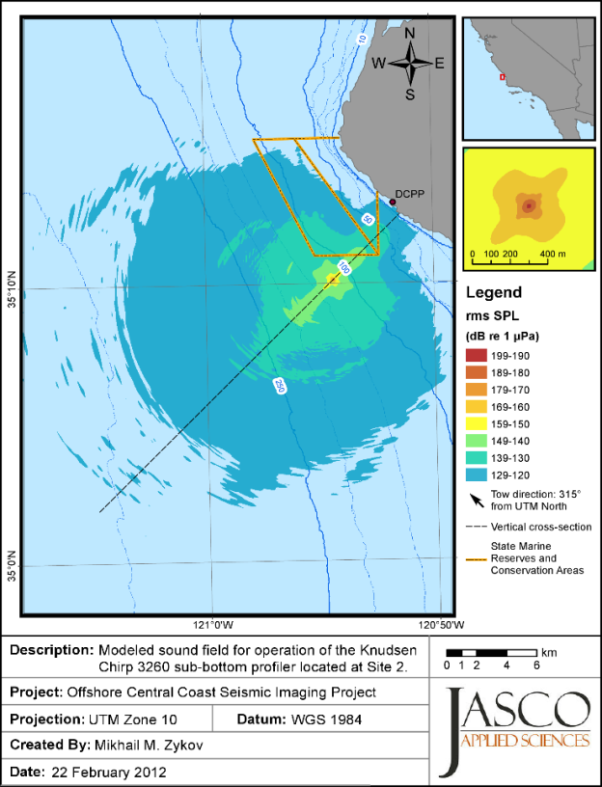
Figure B-17. Knudsen Chirp 3260 sub-bottom profiler: Maximum-over-depth broadband (3.5, 12, and 200 kHz) sound pressure levels around the source. Bathymetry contours (m) are shown in blue (Zykov et al. 2012).
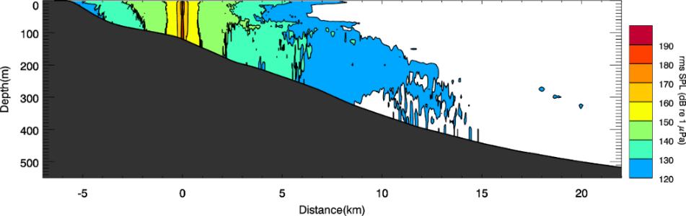
Figure B-18. Knudsen Chirp 3260 sub-bottom profiler: Vertical cross-section of the broadband (3.5, 12, and 200 kHz) sound pressure levels, up to 22 km from the source (Zykov et al. 2012).
Table B-2. Knudsen Chirp 3260 sub-bottom profiler: Maximum (R_{max}, m) and 95% (R_{95%}, m) horizontal distances from the source to modelled maximum-over-depth sound level thresholds (3.5, 12, and 200 kHz simultaneously), with and without M-weighting applied (Zykov et al. 2012).
 | Un-weighted |  | LFC |  | MFC |  | HFC
 | R_{max} | R_{95%} | R_{max} | R_{95%} | R_{max} | R_{95%} | R_{max} | R_{95%}
SEL dB re 1 µPa²·s
198
192
186
179 | < 10 | < 10 | – | – | < 10 | < 10 | < 10 | < 10
SPL (dB re 1 µPa)
208 | < 10 | < 10
190 | 14 | 14 | 10 | 10 | 14 | 14 | 14 | 14
180 | 36 | 36 | 32 | 32 | 36 | 36 | 36 | 36
160 | 276 | 230 | 226 | 191 | 276 | 228 | 276 | 228
140 | 3,926 | 3,575 | 3,883 | 3,147 | 3,926 | 3,574 | 3,926 | 3,574
120 | 21,748 | 14,425 | 21,063 | 13,956 | 21,744 | 14,393 | 21,741 | 14,376

Sparkers
Sparkers are seismic sources that create an electric arc between electrodes with a high voltage energy pulse. The arc momentarily vaporises water in a localized volume and the vapour expands, generating a pressure wave. The generated frequencies are generally between 50 and 4000 Hz. The source level depends on the input energy and is between 215 and 225 dB re 1 µPa @ 1 m. The receiver for the sparker system is usually a hydrophone or hydrophone array.

Boomers
Boomers consist of a circular piston moved by electro-magnetic force. The high voltage energy that excites the boomer plate is stored in a capacitor bank. The typical frequency spectrum of boomer systems spreads between 0.2 and 10 kHz, with an effective bandwidth of 1 to 10 kHz. The source level depends on the amount of discharged energy and can vary from 100 to 220 dB re 1 µPa @ 1 m.
Boomer sources show some directionality, which increases with frequency. Although they can be considered omnidirectional for frequencies below 2 kHz, they are actually quite directional in the vertical. That is because they are typically towed just a few cm deep and the directivity arises from Lloyd’s mirror effect (not just the transducer itself).

Civilian sonar

Overview
Extracted from Popper et al. (2014):
Active sonar and echo sounders are in operation throughout the world’s oceans as well as in freshwater lakes and rivers. The primary sonar characteristics that vary with application are the frequency band, signal type (pulsed or continuous), rate of repetition, and source level. They can be roughly divided into three categories depending on their primary frequency of operation; low-frequency (LF) for 1 kHz and less, mid-frequency (MF) for 1 kHz to 10 kHz, and high-frequency (HF) for 10 kHz and greater. Low, and possibly mid, frequency sonars are most relevant to fishes and sea turtles because of the low-frequency hearing ranges of these animals (e.g. Popper et al. 2007, Halvorsen et al. 2012b). Sonar usually operates with duty cycles (transmission time/total time) below 10 to 20% and with generally brief durations. However, multipath propagation can often be substantial for many of these systems, effectively prolonging the sonar sounds well beyond their nominal durations.
Low-frequency systems are designed for long-range detection. For example, the U.S. Navy SURTASS LFA (low-frequency active) system is described by Friedman (2006) as a vertical line array (VLA) of 18 elements operating between 100 and 500 Hz. Signals projected include combinations of swept frequency (FM) and tones pulses, totalling up to 100 s in length with individual signals of the order of 10 s. The interval between transmissions varies between 6 and 15 minutes.

Side-scan sonar
Side-scan sonar systems are commonly used for bathymetric surveys or for mapping objects on the seafloor. Side-scan sonar utilises a pair of rectangular transducers oriented away from the sides of the vessel. Side-scan sonar transducers usually have a narrow beam pattern in the along-track direction (typically 0.5°–1.5°) and a wide beam pattern in the vertical direction (50°–70°). The central axis of the transducers is oriented perpendicular to the towing direction of the system and tilted below the horizontal (typically 10°–25°) to reduce cross-talk between transducers. The source levels of side-scan transducers are between 210 and 220 dB re 1 µPa @ 1 m. Common operating frequencies are 70 kHz, 110 kHz, 220 kHz and 440 kHz, but some can reach up to 1,600 kHz

Multibeam sonar
Multi-beam echosounders utilise multiple beams per ping, ranging from one to several hundreds of beams per echosounder head. Dual-head systems which can produce more than 500 individual beams are common (e.g., Kongsberg EM3002-D). The systems operate at high frequencies of 100 to 900 kHz, allowing narrow beamwidths ranging from one-tenth to several degrees. The beam fan of each head provides vertical coverage for a 100°–130° sector in the plane perpendicular to the towing direction. If two heads are used, the coverage sectors of the heads overlap giving a combined coverage as wide as 200°. The beam pattern of a multi-beam system is highly anisotropic, with the most acoustic energy emitted in the across-track direction.
Additionally, some very high-power multibeams operating at 10-20 kHz are used for deepwater bottom profiling. For example, the Kongsberg Simrad EM 120 is a multibeam echosounder that operates at a nominal centre frequency of 12 kHz for accurate sounding of the deep ocean. The transducer arrays for the sonar are hull mounted (Figure 6). The system is capable of producing 191 individual beams with a maximum angular coverage in the cross-track direction of 150°. Each individual beam has a possible width of 1° or 2°. Technical notes obtained from the manufacturer’s website specify an SPL of 242 and 236 dB re 1 μPa @ 1 m for 1° and 2° beams, respectively (Hammerstad 2005, Kongsberg 2005). A summary of the acoustic model parameters for the Kongsberg Simrad EM 120 are presented in Table B-3. The beam patterns from the 191 simultaneously engaged beams of 2° × 2° beamwidth were calculated and summed to produce the total beam pattern (150° equi-angled swath; Figure B-19, Figure B-20).
These deep-ocean multibeam sonars have been implicated as a possible cause of at least one stranding event in Madagascar (Southall et al. 2013). These types do have potential injury zones that must be considered. Directly within in the beam of a large multi-beam sonar (e.g., 12khz EMN120 system) animals would be exposed to sound levels greater than most air-gun based seismic surveys. It was noted that these have a standard source and beam pattern, burst shape etc. as opposed to standard seismic sources. One result of the beam patterns is that multibeam sonar will have very small injury footprints, but can have very large disturbance footprints in one direction (sideways from the vessel) while providing little or no ‘warning’ to marine mammals in the other direction – notably ahead of the vessel.
Table B-3. Kongsberg Simrad EM 120 multibeam sonar parameters, operating at 12 kHz (Zykov 2012). A 2° beamwidth was assumed for all model scenarios.
Pulse duration (ms) | 2, 5, or 15
Pulse rate (Hz) | ≤5
Transducers beamwidth | 1° | 2°
SPL (dB re 1 μPa @ 1 m) | 242 | 236
SEL per pulse (dB re 1 μPa²·s @ 1 m) | 224* | 218*
Number of beams | 191
Across-track beam fan width | 150°
* Source level calculated using a pulse duration of 15 ms.
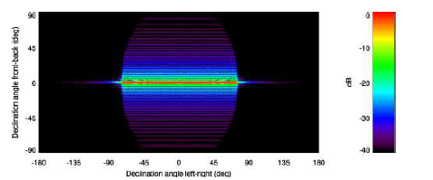
Figure B-19. Calculated beam pattern for the transducer of the Kongsberg Simrad EM 120 multibeam sonar at 12 kHz (Zykov 2012). The beam power function is shown relative to the on-axis level using the Robinson projection.
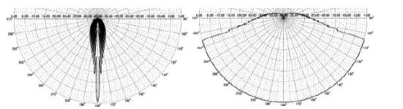
Figure B-20. Calculated beam pattern vertical slice for the Kongsberg Simrad EM 120 multibeam sonar at 12 kHz (Zykov 2012).
From a modelling perspective, a multibeam is much easier to model than an airgun array because its acoustic characteristics and beam pattern are well defined, the frequency bandwidth is narrow, and the frequencies are high enough that ray models are applicable. Examples of single shots are provided in Figure B-21 and
Figure B-22 with corresponding radii shown in Table B-4. Figure B-23 shows zones associated with an accumulated track line from the Madagascar stranding investigation (Zykov 2012).

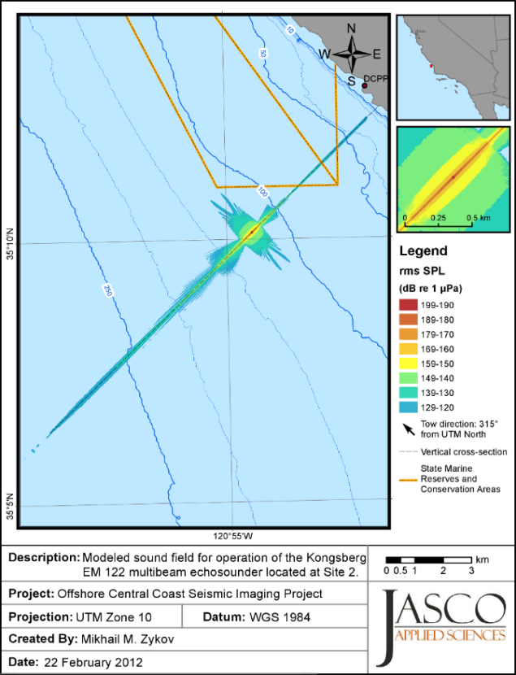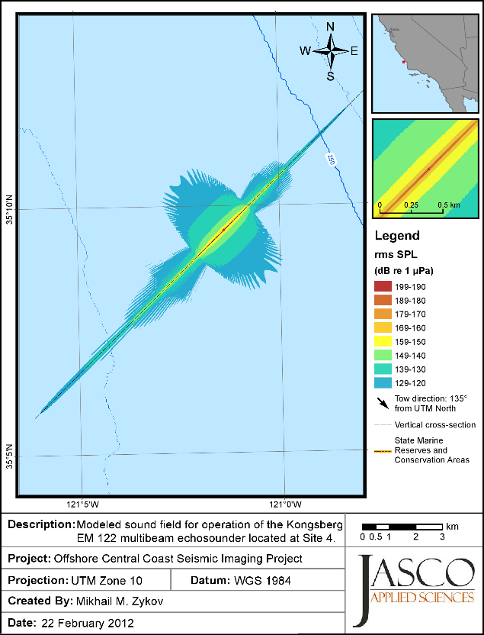
Figure B-21. Kongsberg EM 122 multibeam sonar Maximum-over-depth (12 kHz) sound pressure levels around the source in 109 m (left) and 385 m (right). Bathymetry contours (m) are shown in blue (Zykov et al. 2012).

Figure B-22. Kongsberg EM 122 multibeam sonar: Vertical cross-section of the (12 kHz) sound pressure levels, up to 10 km from the source in 109 m (top) and 385 m (bottom) (Zykov et al. 2012).
Table B-4. Kongsberg EM 122 multibeam sonar: Maximum (R_{max}, m) and 95% (R_{95%}, m) horizontal distances from the source to modelled maximum-over-depth sound level thresholds (12 kHz), with and without M-weighting applied.
 | Un-weighted |  | LFC |  | MFC |  | HFC
 | R_{max} | R_{95%} | R_{max} | R_{95%} | R_{max} | R_{95%} | R_{max} | R_{95%}
109 m depth
SEL dB re 1 µPa²·s
198
192
186 | < 10 | < 10 | < 10 | < 10 | < 10 | < 10 | < 10 | < 10
179 | 36 | 36 | 22 | 22 | 36 | 36 | 36 | 36
SPL (dB re 1 µPa)
208 | < 10 | < 10
190 | 164 | 162 | 121 | 119 | 164 | 162 | 164 | 162
180 | 430 | 388 | 416 | 374 | 430 | 388 | 430 | 388
160 | 1,477 | 1,180 | 1,222 | 1,016 | 1,477 | 1,180 | 1,477 | 1,180
140 | 3,966 | 2,905 | 3,570 | 2,622 | 3,966 | 2,905 | 3,966 | 2,905
120 | 11,376 | 8,378 | 10,627 | 7,537 | 11,306 | 8,357 | 11,306 | 8,364
385 m depth
SEL dB re 1 µPa²·s
198
192
186 | < 10 | < 10 | < 10 | < 10 | < 10 | < 10 | < 10 | < 10
179 | 36 | 36 | 22 | 22 | 36 | 36 | 36 | 36
SPL (dB re 1 µPa)
208 | < 10 | < 10
190 | 164 | 162 | 121 | 119 | 164 | 162 | 164 | 162
180 | 531 | 501 | 404 | 388 | 531 | 501 | 531 | 501
160 | 1,760 | 1,385 | 1,434 | 1,237 | 1,760 | 1,378 | 1,760 | 1,378
140 | 4,963 | 3,839 | 4,899 | 3,839 | 4,963 | 3,839 | 4,963 | 3,839
120 | 9,891 | 5,927 | 9,503 | 5,387 | 9,891 | 5,918 | 9,891 | 5,920

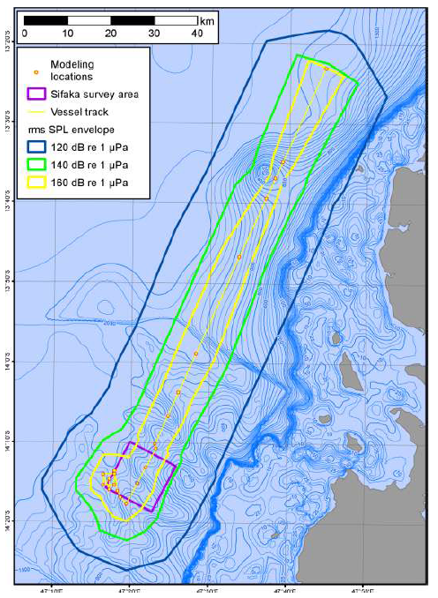
Figure B-23. Maximum extension of distances to specific maximum-over-depth root-mean-square (rms) sound pressure level (SPL) thresholds around the vessel while it was operating the multibeam sonar (Zykov 2012).

Underwater communication systems
Underwater communication systems provide data exchange with remotely operated underwater vehicles or recording systems. This group includes various acoustic modems. The same transducer used to generate an acoustic wave is also used to receive the acoustic information.
Underwater communication systems provide wireless command or data transfer between control ship and underwater recording system or remotely operated vehicle. They employ a transducer for generating and receiving acoustic signals. Transducers used for underwater communication vary in beamwidth, typically from 30° to 90°, though systems may have a wider beam (120°) or may be omnidirectional. The transducers are oriented vertically upward or downward. The operating frequency of communication systems is usually between 7.5 and 44 kHz, though some systems operate at frequencies as high as 89 kHz. Source levels produced by these systems are typically between 180 and 205 dB re 1 µPa @ 1 m.

Renewable power generators
Possible marine renewable power sources include wind turbines and subsea tidal or current sources. There is a significant variety of sources, therefore a significant variety of sounds associated with them. All sources have installation and operational associated sounds. While many of the installation techniques would involve pile driving (characterised in Appendix B.3), and the operational noises of wind farms are known, the operational noises of other potential sources are highly dependent upon the individual source.
Information on specific sources should be provided by the proponent, and be presented in a fashion that allow it to be assessed against leading practice assessment guidelines.
As none of these sources are currently operational in the Marine Park, and are unlikely to be installed for policy reasons as well as not being included in the scope of work, they are not addressed further.

Defence
The Strategic Environmental Assessment of Defence Activities in the Great Barrier Reef World Heritage Area (URS Australia Pty Ltd 2006) summarises the sound sources and activities of defence activities in the World Heritage Area. The updated 2014 version, not seen by the authors, should be referred to understand the current defence activities.
The URS Australia Pty Ltd (2006) assessment states:
“activities in the World Heritage Area and contiguous areas, identifies potential vectors for degradation of the Reef’s World Heritage values arising from these activities, and concludes with analysis of the actual risk of adverse environmental outcomes arising from these actions. A substantial proportion of the technical information and analyses supporting the assessments made in this section is to be found in the Initial Environmental Review of the ADFMA EMP (URS 2004), particularly Appendices P and S.
As previously noted, Defence activities in the Reef region range from simple ‘evolutions’ (i.e. any exercise or training activity) involving single units, to large, complex, multi-faceted activities involving many air, sea and amphibious units spread over a number of days or sometimes weeks. Nevertheless, all of these activities can be reduced to a number of discrete actions, which are then compiled in the desired manner to produce the intended activity.”
The activities undertaken by defence are extensive and continually evolving, and if the 2014 review is as detailed as the URS Australia Pty Ltd (2006) review, then it should be used to understand the potential sources and impacts of them. Any impact assessment process should consider the latest literature, with a substantial amount of work sponsored by the United States Navy such as behavioural response studies (Deruiter et al. 2013), and studies such as the assessment of marine mammal impact zones for use of military sonar (Andersson and Johansson 2016).
The use of civilian sonar systems by defence can be understood through the sources introduced in Appendix B.7.

Helicopters and aircraft
Helicopters and aircraft noise can be heard by marine fauna. Management of these sources is typically done through minimum approach distances, such as stipulated within the EPBC Act (Commonwealth of Australia 1999). An overview is provided to demonstrate that in-air signatures of helicopters and aircraft can be used to determine their in-water sound footprint.
The large difference in acoustic impedance between air and water limits the amount of sound energy that can penetrate the sea surface and propagate underwater. Some energy at certain angles will be totally reflected but may penetrate in high sea state; however, most of the received energy far from the source is transmitted through direct- and bottom-reflected paths (1 to 3 in Figure B-24).
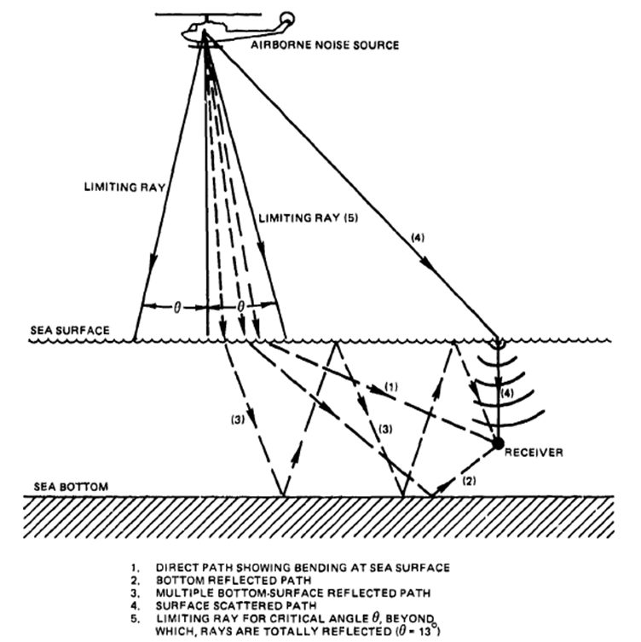
Figure B-24. Ray-path diagram for air-water propagation from an airborne source. Source: Gales (1982), based on Urick (1972).
Received underwater sound levels strongly depend on the altitude of the aircraft and the water depth; received levels tend to be higher in shallow environments with a reflective bottom. However, reported underwater received levels are low (Urick 1972, Young 1973, Greene 1985, Richardson and Malme 1993, Richardson et al. 1995). For example, Greene (1985) reports:
- Recorded levels of no higher than 111 dB re 1 µPa at 9 m below the surface, directly under a Bell 212 helicopter flying at an altitude of 305 m.
- Recorded levels no higher than 111 dB re 1 µPa at 9 m below the surface, at a lateral distance of 50 m from a Sikorsky 61 helicopter flying at an altitude of 152 m.
Richardson et al. (1995) also presents relatively low levels for three types of helicopters flying at an altitude of 300 m (Figure B-25).
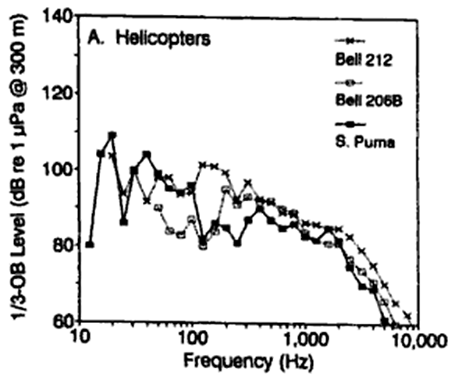
Figure B-25. Derived 1/3-octave band levels at the water surface, directly below helicopters flying at an altitude of 300 m. Source: (Richardson et al. 1995), Figure 6.4.
Underwater received levels from an airborne source may be estimated using Young’s equation (1973), which produces results consistent with empirical data (Richardson et al. 1995). Young’s equation estimates underwater acoustic (broadband) levels from an airborne source through the computation of a virtual source. This virtual source accounts for the changes in sound speed and path angles due to changes in impedance between air and water.

Soundscapes within the world heritage area
A soundscape is the combination of sounds that surround an object in an immersive environment. The soundscape consists of three components:
- Geophony: natural sounds, such as wind, rain, and waves
- Biophony: animal sounds, including communication and feeding
- Anthrophony: manmade sounds, including vessels and construction operations
Recently the term ‘ecoacoustics’ has gathered momentum in published literature (Sueur and Farina 2015). This field includes statistical analysis of soundscape data to assess biodiversity or ecosystem health. This can be referred to as soundscape ecology, which is the study of the ‘temporal and spatial distribution of sound through a landscape, reflecting important ecosystem processes and human activities’ Towsey et al. (2014), referencing Pijanowski et al. (2011a), Pijanowski et al. (2011b), Kasten et al. (2012). This term might be more applicable moving forwards.

Overview
Detailed (spatial and temporal) acoustic characterisation programs have not been conducted on the Great Barrier Reef. The oldest long term study the authors are aware of was conducted from 1987 – 1994 off Cowley Beach, near Innisfail. This was funded by the Defence Science and Technology Organisation, and summarised in McCauley and Cato (2000) and McCauley (2001). This study had a significant temporal scale, however was spatially restricted.
There have been a number of short term studies conducted as parts of research projects on fish vocalisations and biological sea noise (McCauley 2001), minke whale vocalisations (Gedamke et al. 2001), interactions between marine mammals and longline tuna fisheries (McPherson et al. 2008), and one long term (three months or more) recording program (MacGillivray et al. 2014b). The authors of the current report are unaware of any other recent long term acoustic recordings from the Reef, other than the recording program detailed in MacGillivray et al. (2014b) and McWilliam et al. (2017).
There is expected to be a high level of variability in the soundscapes found in the Reef, and therefore providing a summary to GBRMPA of the possible soundscapes with the limited data available is not possible. A number of studies have examined the temporal and spatial variability of tropical reef soundscapes, including Kennedy et al. (2010) and Nedelec et al. (2015). Other studies have included examinations of the differences between adjacent bays on a single Hawaiian island (Heenehan et al. 2015), with general characterisation studies (Au and Richlen 2009, Freeman et al. 2014b, 2014a, Kaplan et al. 2015, Staaterman and Paris 2015). Other studies have focused on the soundscape relevant to particular species, such as Guan et al. (2015a) who analysed soundscapes in Taiwan with relevance to Indo-Pacific Humpback dolphins, and Lillis and Mooney (2016) who have discussed the variability of snapping shrimp rhythms over short spatial scales (e.g., opposite diurnal patterns between nearby reefs) and shift substantially over time (e.g., daytime versus night-time dominance during different seasons). The value of characterising soundscapes is substantial, including for acoustic diversity and health indicators, and has been discussed in many publications (e.g. Kaplan et al. 2013, Parks et al. 2014, Hastings and Širović 2015, Kaplan et al. 2015, Merchant et al. 2015, Bertucci et al. 2016, McPherson et al. 2016b). The possibility of rapid, inexpensive and spatially integrative remote sensing of the ecological state of coral reefs through acoustics has recently been raised by Freeman and Freeman (2016).
Grey literature that includes characterisation of tropical environments in Australia includes Shell Development (Australia) Pty Ltd (2009), Erbe and McPherson (2011), Erbe et al. (2011), McCauley (2011), McPherson et al. (2012), McPherson et al. (2014), Salgado-Kent et al. (2015), and McPherson et al. (2016a). The Kimberly IMOS recorders are also an important contribution to the understanding of tropical Australian soundscapes, however they have not been analysed at this stage to the awareness of the authors.
This document does not outline the typical soundscapes that might be present at various times across the GBRWHA, and the authors are very hesitant to predict soundscapes, given the high level of variability between individual locations or regions.
An example full deployment spectrogram from the JASCO deployment at Wheeler Reef is shown in Figure C-1.
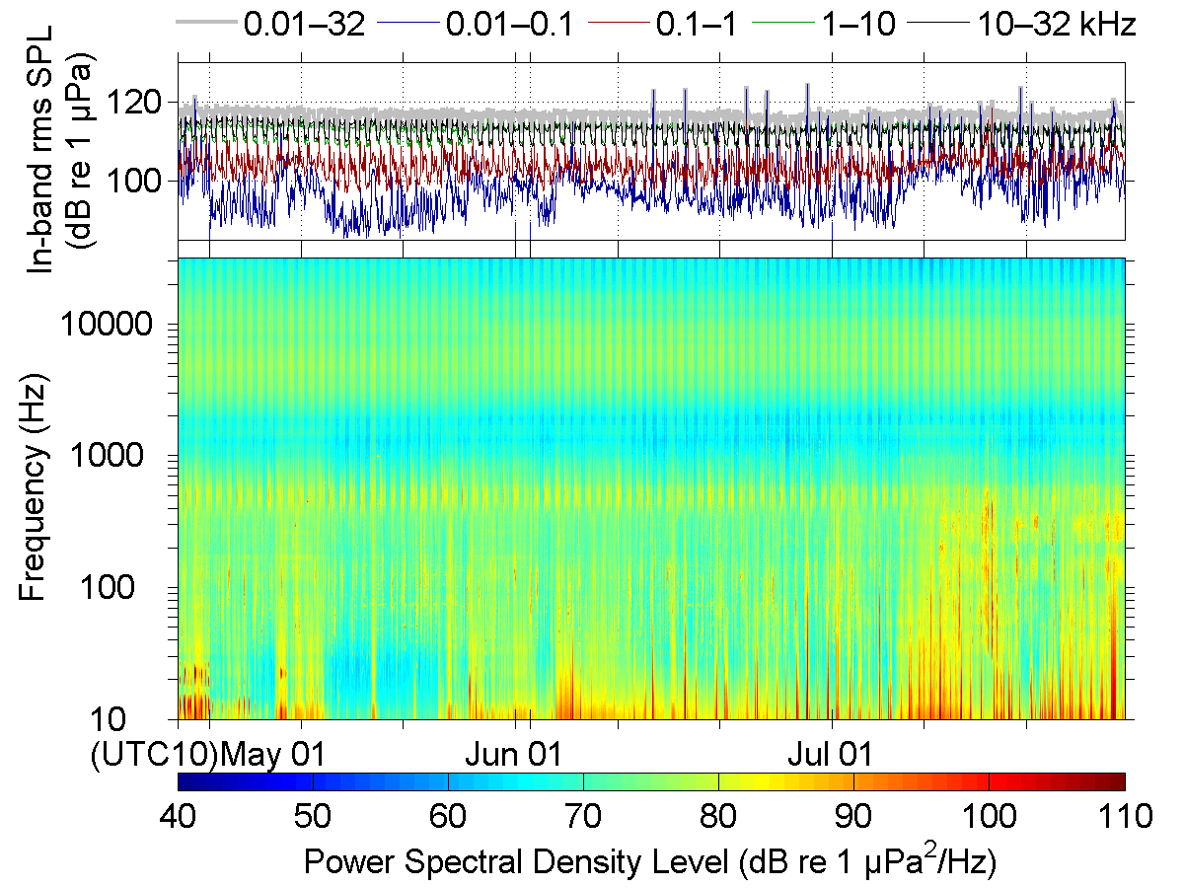
Figure C-1. Broadband and decade-band sound pressure levels (SPL) (above), spectrogram of underwater sound (below), JASCO AMAR deployment at Wheeler Reef, 27 April to 29 July 2013. © JASCO.

Overview of hearing of key reef species
Because sounds can propagate well underwater and over large distances, many marine species use underwater acoustic signals as their principal mode of information transmission and situation awareness. Listening to the environment or active signalling requires well-developed hearing abilities. Cetaceans, in particular, depend heavily on hearing and sound to communicate, avoid predators, and forage but also fish and invertebrates have acute acoustic detection abilities.

Summary
To evaluate the effects of noise on the health of Reef marine species, it is important to understand the hearing abilities and signal usage of as many of the species that occur on the reef as possible due to vast variation that exists for these traits among species, populations, and even between individuals within the same population. The content of this section on hearing and the following on sound production are primers for the sections that describe noise effects (Appendix F) and how to assess impact (Section 6).
As described in this section, the Great Barrier Reef is habitat to a diverse assembly of marine species with acute hearing senses, which in many species is closely tied to their survival and reproduction. It is well known that marine mammals have advanced hearing abilities, which they use to find food and mates; however, it is less well known that numerous fish and invertebrate species utilise sound in many ways. This includes using the distinct soundscape of the reef (or individual reefs) for orientation, in addition to using sounds for courtship displays; some might even use hearing to avoid predators such as marine mammals.

Marine mammals
GBRMPA and the DoE EPBC Protected Matters Search Tool (2016) identify the marine mammal species in Table D-1 as being within the World Heritage Area.
Table D-1. Marine mammal species of occurrence in the GBRWHA (Department of Environment 2016).
Species | Common name
Mysticetes
Balaenoptera acutorostrata | Minke whale
Balaenoptera bonaerensis | Antarctic minke whale, dark shoulder minke whale
Balaenoptera edeni | Bryde’s whale
Balaenoptera musculus | Blue whale
Megaptera novaeangliae | Humpback whale
Large odontocetes
Orcinus orca | Orca, killer whale
Globicephala macrorhynchus | Short-finned pilot whale
Pseudorca crassidens | False killer whale
Kogia breviceps | Pygmy sperm whale
Kogia simus | Dwarf sperm whale
Physeter macrocephalus | Sperm whale
Ziphius cavirostris | Cuvier's beaked whale, goose-beaked whale
Mesoplodon densirostris | Blainville's Beaked Whale, Dense-beaked Whale
Mesoplodon layardii | Strap-toothed Beaked Whale, Strap-toothed Whale,  Layard's Beaked Whale
Small odontocetes
Feresa attenuata | Pygmy killer whale
Peponocephala electra | Melon-headed whale
Delphinus delphis | Common dolphin, short-beaked common dolphin
Grampus griseus | Risso's dolphin, grampus
Lagenodelphis hosei | Fraser's dolphin, Sarawak dolphin
Stenella attenuata | Spotted dolphin, pantropical spotted dolphin
Stenella coeruleoalba | Striped dolphin, euphrosyne dolphin
Stenella longirostris | Long snouted spinner dolphin
Steno bredanensis | Rough-toothed dolphin
Orcaella brevirostris | Snubfin or Irrawaddy Dolphin
Sousa chinensis /  Sousa sahulensis | Indo-Pacific Humpback Dolphin
Tursiops aduncus | Indian Ocean bottlenose dolphin, spotted bottlenose dolphin
Tursiops truncatus s. str. | Common bottlenose dolphin
Sirenian
Dugong dugon | Dugong

Marine mammal species evolved from terrestrial mammals and share basic hearing anatomy and physiology with their terrestrial ancestors. Marine mammals, however, have broader hearing frequency ranges than are typical of terrestrial mammals, which is due to much higher sound speed underwater compared to in air that results in better resolution of higher frequencies than in air. The wavelength of sound in water is about 4 times longer than in air and the acoustic impedance of the animal’s body (i.e., its ability to conduct sound) is nearly the same as the water. Because of the longer underwater wavelength, hearing in aquatic mammalian species has adapted to function at higher frequencies than in their terrestrial counterparts. This is because hearing functions, such as echolocation, must operate at higher frequencies in order to achieve a similar spatial resolution as in air. The apparent ability of marine mammals, particularly odontocetes to discriminate between sounds at much higher frequencies is as an indicator of how important sound is to them.
Divergence between terrestrial and marine mammal hearing physiology occurs primarily in the outer ear structures, which are absent in most marine mammal species, and in the middle ear, which is modified in marine mammals. Mooney et al. (2012) reviewed and summarised the current literature on cetacean hearing and auditory physiology. All detailed hearing data came from a subset of trained cetaceans, small enough to house and amenable to training while captive, e.g., dolphins and beluga whales (Delphinapterus leucas). Direct hearing data are not available for most species, but audiograms for some species have been derived from biophysical and mathematical models (e.g. Tubelli et al. 2012). In addition, auditory-evoked potential (AEP) techniques have been successful when applied to some stranded animals (Mooney et al. 2012, Cranford and Krysl 2015).

Marine mammal hearing with a focus on cetaceans
The functional hearing of cetaceans is characterised by a shift of the area of best hearing to higher frequencies (esp. odontocetes) and lower frequencies (esp. mysticetes) compared to typical land mammals thereby expanding the hearing ranges of cetaceans considerably (Wartzok and Ketten 1999, Mooney et al. 2012). For example, the frequency range of smaller odontocetes expands to roughly 12 octaves or from a few 100Hz to over 160 kHz (Madsen et al. 2006). This ability has evolved through hearing adaptations to aquatic environments such as high-frequency sound acquisition through the lower jaw instead of the ear canal which in many cetaceans is blocked (Norris 1968). Mysticetes and potentially odontocetes increased their ability to receive sound through the skull and both modified their middle ear structures to increase the amplitude of sounds especially of low-frequency sounds (Ketten 1992, Cranford and Krysl 2015).
The part of the inner ear responsible for sound reception, cochlea, is, however, quite similar in land and aquatic mammals (Ketten 1992). The shape of the cochlea looks like a snail shell housing a basilar membrane that oscillates in response to pressure changes produced by incoming sound waves. The other important cochlea component is the Golgi apparatus, which contains hair cell bundles that perceive movement of different parts of the basilar membrane by bending in a particular direction. Ganglion cells detect the bending movement of the hair cells and translate the bending degree into electrical potentials which then are transmitted as signals to the auditory cortex via attached nerve endings (Ketten 1992).
The basilar membrane changes gradually in width and thickness along its length from its base where the membrane is narrow and thick to its apical end where the membrane is wider and thinner. This gives the membrane a gradient in stiffness from base to top. The stiffness gradient is responsible for splitting the sound into spectral components because stiffer parts oscillate respond to different oscillation frequencies of the incoming sound wave than more flexible parts (eg. Mooney et al. 2012), therefore high frequencies will cause the membrane to oscillate at the stiffer base while increasingly lower frequencies excite more flexible parts further away from the base.
The process of separating a sound into its spectral components in the cochlea is not linear, i.e. not sensing sound pressure changes over frequency in linear units, such as measured by the power spectral density of sounds in dB re µPa² in 1 Hz bands. Instead, the cochlea perceives frequency bands relevant for hearing important biological sounds (Madsen et al. 2006). Hair cells are evenly distributed along the length of the membrane. Because lower frequencies are associated with longer sound waves, those waves travel longer distances along the basilar membrane and cause more of the membrane to oscillate thereby allowing for a higher resolution of pressure changes in lower frequencies in comparison to higher frequencies. Higher frequency detection in turn is done with much greater temporal accuracy because only short sections of the membrane near the base are responding to smaller frequency bandwidths (Mooney et al. 2012). As a consequence, frequencies are perceived via a set of frequency bandpass filters described as auditory filters or critical bands, which in land mammals are proportional in size to 1/3-octave bands. Because the cochlea of cetaceans is structurally similar to that of land mammals, a 1/3-octave size critical band is often assumed to be representative for cetaceans.
This, however, may not be a correct description of the critical bandwidth for the whole frequency range that cetaceans can hear. Particularly, odontocetes whose tone detection thresholds were tested with masking noise at increasing bandwidths, showed a switch from a proportionally increasing critical bandwidth size to a constant size once a certain frequency was reached (Lemonds et al. 2011, Mooney et al. 2012). The frequency at which the switch occurs might be species specific.
Any analysis that results in a proposition of a dB threshold marking the onset of noise impact based on hearing ability or hearing threshold should therefore be species specific and account for critical bandwidth filter size.
If high accuracy needs to be achieved to determine the onset of behavioural disturbance either in form of a sound pressure threshold and/or a distance threshold from the sound source, an assessment would greatly benefit from a spectral analysis of the noise signal over the frequency range that is important for the species impacted. Furthermore, sound pressure levels of the noise signal should be reported over the correct critical bandwidth filter size according to the species full partial hearing range, e.g. 1/3-octave for lower frequencies roughly to about 25 kHz and either a 1/6 or 1/12-octave band (Erbe 2002) or a constant 1 kHz bandwidth filter for frequencies above 25 kHz (Lemonds et al. 2011). This is because broadband noise measurements may not accurately predict behavioural responses because animals may react to certain frequencies more than others (Kastelein et al. 1995). The spectral composition of the noise signal rather than the overall sound pressure level may allow a more accurate assessment of behavioural disturbance triggers.
The effects of anthropogenic and natural ambient sounds on hearing can be cumulative and can be further increase if more than one sound generating project is present over the range of the typical habitat of a marine mammal. This may be the case even when each of the sound generating activities alone may not cause impact. Accumulation of effects can have far-reaching but difficult to establish implications for the health of individuals and populations (Nowacek et al. 2007).

Mysticetes
A sample audiogram (test of hearing sensitivity) of a low-frequency cetacean (Figure D-1), note, only modelled audiograms are available for baleen whales. An audiogram depicts the hearing sensitivity (y-axis) across the frequency hearing range (x-axis) and allows determination of the loudness or intensity of a sound at a certain frequency that needs to be exceeded for the animal to hear the sound.
The hearing curves shown below demonstrate that the higher hearing sensitivity for low frequencies in the baleen whales translates into higher impact susceptibility for low-frequency sounds such as shipping sounds. Mid-frequency cetaceans can still be affected but usually only from sounds above 200 Hz.
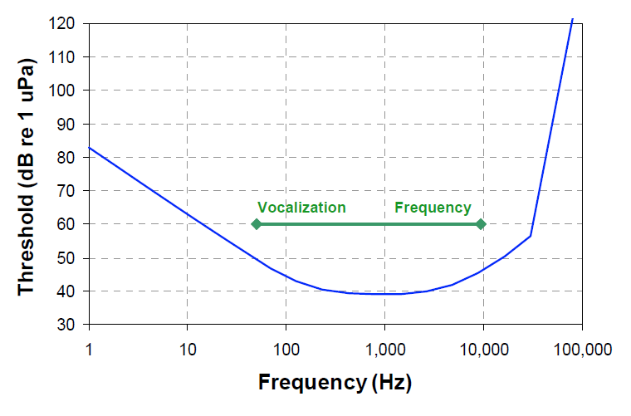
Figure D-1. Modelled audiogram of a minke whale from Ketten and Mountain (2012).

Odontocetes
The bottlenose dolphin (Tursiops truncatus) is perhaps the most-studied marine mammal in terms of hearing. Johnson Johnson (1967) produced the first detailed audiogram for bottlenose dolphins (Figure D-1) and this is still the standard today. Johnson Johnson (1967) found that bottlenose dolphins have functional hearing from 100 Hz to 150 kHz, with best sensitivity between 15 and 110 kHz. Behavioural and AEP measurements of the hearing capabilities of bottlenose dolphins made since Johnson (1967) show similar results (Brill et al. 2001, Houser and Finneran 2006, Popov et al. 2007, Houser et al. 2008).
While audiograms measured from bottlenose dolphins generally exhibit the same shape and similar thresholds, it is important to note that there is variability among individuals. For example, bottlenose dolphins exhibit high-frequency hearing loss with age and males tend to lose their hearing at an earlier age than females (Brill et al. 2001, Houser and Finneran 2006). Older dolphins had higher hearing thresholds, especially above 50 kHz, as compared to younger dolphins. Another source of variability is geographic variation. For example, Pacific bottlenose dolphins had significantly lower hearing thresholds at 40 kHz and 60-155 kHz when compared to Atlantic bottlenose dolphins (Figure D-3). Houser et al. (2008) hypothesised that these differences reflect genetic differences between the two populations. Bottlenose dolphins are the only species in which audiograms have been produced for large groups of individuals. It is important to keep possible inter-individual and inter-population variability in mind when examining hearing data for other species. Small sample sizes likely do not provide a complete picture of the hearing capabilities of an entire species.
There has been two studies on the hearing capabilities of Indo-Pacific humpback dolphins (Li et al. 2012, Li et al. 2016). The audiogram of a younger animal (Li et al. 2012) was a U-shape with a region of highest hearing sensitivity (within 20 dB of the lowest threshold) between approximately 20 and 120 kHz. There are no audiograms for snubfin or Irrawaddy dolphins, whose clicks range from 22 kHz to 130 kHz. Audiograms of false killer whales (Figure D-5) and killer whales (Figure D-6) are included for reference to larger odontocetes.
Figure D-2. The standard audiogram for the bottlenose dolphin (from Brill et al. 2001, after Johnson 1967).
Figure D-3. Comparison of audiograms measured from Pacific bottlenose dolphins (filled triangles) and Atlantic bottlenose dolphins (open circles). Asterisks denote significant differences between the two populations (from Houser et al. 2008).
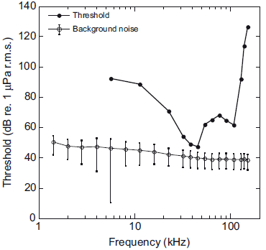
Figure D-4. Audiogram of the Indo-Pacific humpback dolphin studied (Li et al. 2012) and the spectrum density of the background noise in the experimental pool.
Figure D-5. AEP audiograms measured over three years from a captive false killer whale in Kaneohe Bay, Hawaii. The fourth curve shows the average value of all three audiograms (from Yuen et al. 2005).
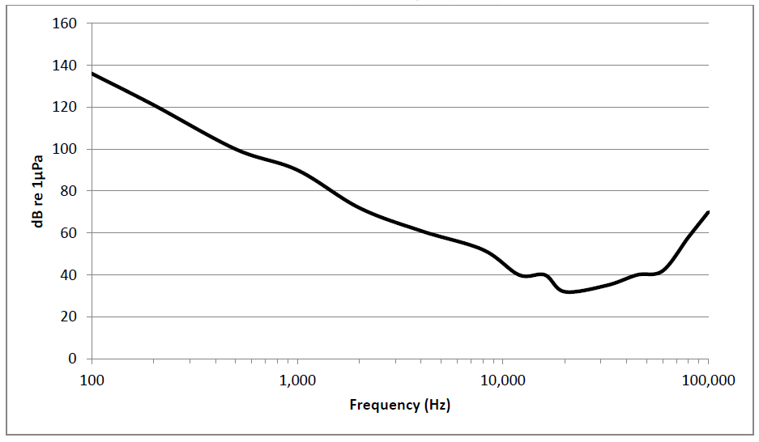
Figure D-6. Representative audiogram of resident killer whale adapted by H. Yurk, J. Wood, and D. Bain. In SMRU Ltd (2014).

Dugongs
No information is available on the hearing capabilities of dugongs. Gerstein et al. (1999) measured underwater behavioural audiograms from two manatees (Trichechus manatus) in captivity. These manatees had good sensitivity at high frequencies and very limited low-frequency hearing (Figure D-7). Similar results were reported by Klishin et al. (1990) based on AEP measurements taken from an Amazonian manatee (T. inunguis). In both of these studies, the auditory stimulus was projected underwater in a small tank.
Figure D-8 shows third order polynomials fit to published curves of underwater audiograms for sirenians, odontocetes, and pinnipeds. These curves illustrate general trends in hearing sensitivity. Manatee hearing lies in between that of amphibious pinnipeds and fully aquatic, echolocating cetaceans. Based on the similarities among marine mammal audiogram curves, it is not unreasonable to assume that dugong hearing also falls somewhere between pinnipeds and cetaceans, however until proper studies are conducted, impact assessments should make conservative assumptions such as using a combination of low and mid-frequency cetaceans.
Figure D-7. Behavioural audiograms for two manatees (Stormy and Dundee). Ambient noise in the pool where the audiograms were measured is also shown on the graph (from Gerstein et al. 1999).
Figure D-8. Third order polynomial curves fit to sirenian, pinniped, and odontocete audiograms taken from the literature. Shallow water and noise curves are taken from Urick (1983) and Gerstein et al. (1999).

Sea turtles
There is little information on sea turtle hearing. Morphological studies of green and loggerhead sea turtles (Ridgway et al. 1969, Wever 1978, Lenhardt et al. 1985) found that the sea turtle ear is similar to other reptile ears, but has some adaptations for underwater listening. A thick layer of fat may conduct sound to the ear in a similar manner as the fat in jawbones of odontocetes (Ketten et al. 1999), but sea turtles also retain an air cavity that presumably increases sensitivity to sound pressure. They have lower underwater hearing thresholds than those in air, owing to resonance of the aforementioned middle ear cavity, and as they hear best underwater, are likely more sensitive to underwater noise (Willis 2016).
Electrophysiological and behavioural studies on green and loggerhead sea turtles found their hearing frequency range to be approximately 50–2000 Hz, with highest sensitivity to sounds between 200 and 400 Hz (Ridgway et al. 1969, Bartol et al. 1999, Ketten and Bartol 2005, Bartol and Ketten 2006, Yudhana et al. 2010, Piniak et al. 2011, Lavender et al. 2012, Lavender et al. 2014), although these studies were all conducted in-air.
Underwater audiograms are only available for three species. Two of these species, the red-eared slider (Christensen-Dalsgaard et al. 2012), the loggerhead turtle (Martin et al. 2012b), both demonstrated higher sensitivity at around 500 Hz (Willis 2016). Recent work on green turtles has refined their maximum underwater sensitivity to be between 200 and 400 Hz (Piniak et al. 2016).
Very little work has been done on the hearing capabilities of hawksbill turtles. (Yudhana et al. 2010) measured auditory brainstem responses from two hawksbill turtles in Malaysia and found that peak frequency sensitivity occurred at 457 Hz in one turtle and at 508 Hz in the other.

Fish
Hearing capabilities have been determined for only ~100 of the 27,000+ species of fish (Fay 1988, Popper et al. 2003) so extrapolation of hearing capabilities between different species, especially those that are taxonomically distant, must be done cautiously. The general pattern that is emerging indicates that pressure-sensitive species detect sounds up to ~4 kHz, while fish that are sensitive to particle motion only are generally limited to a frequency band < 1 kHz.
Higgs and Radford (2013) suggested that in natural situations both the ear and lateral line likely play an integrative role in detecting and localising many types of ‘acoustic’ stimuli.
All fishes can detect motion of particles from a sound wave in the form of the acceleration of the particles in the medium as the sound wave passes. This is accomplished by three otolithic endorgans on each side of the body (Fay 1984).
Some fish species have additional specialised adaptations that allow them to detect sound pressure changes (Popper and Fay 1993). Pressure sensitivity is conferred by a gas-filled chamber, such as the swim bladder, close to the ears, or via mechanical connection to the ears. Pressure sensitivity in fish increases their hearing frequency range and can decrease their detection thresholds.

Background
Within the World Heritage Area fish species are present from a vast assemblage of species over a wide variety of habitats. The interpretations of categories may vary slightly. Each region has its own soundscape and anthropogenic noise sources. Juvenile and adult stages of individual species may utilise a variety of habitats throughout their lifetime spending different periods within different soundscapes.
The life history of the red emperor (important from a commercial and recreational fishery perspective), the inter-reef lutjanid species, red emperor is best described in the 'Crossing the Blue Highway' poster of Russell Kelley (published by the Australian Coral Reef Society (Figure D-9) where the same species may inhabit a variety of demersal and pelagic habitats throughout its life cycle. Wright et al (2010) mentioned the pelagic larval stage of the many demersal reef fish including the most important demersal reef fish in the Reef waters the coral trout while McPherson (1997) had noted the open water pelagic life cycle of larvae and adult narrow barred Spanish mackerel the most important pelagic species in Reef waters in terms of fishing value.
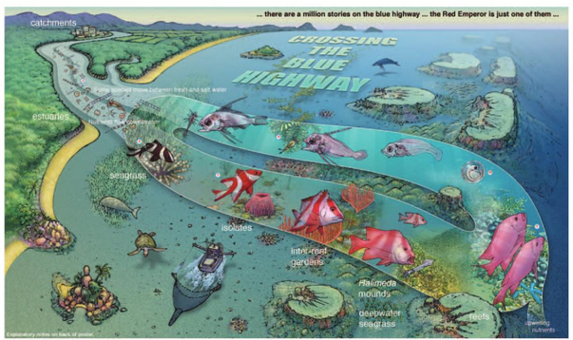
Figure D-9. Part of 'Crossing the Blue Highway', a poster by Russell Kelley (www.byoguides.com) published by the Australian Coral Reef Society (Kelley).
A pelagic life cycle with inshore and offshore components may be a feature of many important Reef fishes. In turn, the different life stages may be part of a number of different sound scapes in Reef waters.
When evaluating a proposed or operational activity to evaluate the risk of noise impacts on fish it would be an option to consider grouping fish up into three representative ecological areas. These non-exclusive groups may be as follows:
- Inter-reef area
  - Demersal species (families such as Lutjanidae)
  - Semi pelagic species (families such as Carangidae with smaller trevallies and finny scads, and Clupeidae with sardines)
  - Larvae of inter-reef and coral reef fish species before they settle or remain in a pelagic stage
- Coral reef area
  - Demersal species (families such as Lutjanidae, Lethrididae, Serranidae)
- Pelagic area
  - Pelagic spices (families such as Scombridae, Carangidae)
Wherever possible aspects of fish hearing, acoustic associations with reefs, noise mediated masking of the natural the soundscape (reef detection, social communication, approaching predator detection) and behaviour change will be associated with these soundscape regions.

Hearing
Fishes have the same basic acoustic capabilities as other vertebrates, including mammals (reviewed by Popper et al. 2003, Ladich and Popper 2004). Fish use sounds in a wide variety of behaviours including aggression, territory protection, defence, and reproduction (reviewed by Zelick et al. 1999). Fish can discriminate between sounds of different magnitudes and frequencies, detect a sound in the presence of other signals, and determine the direction of a sound source (Popper et al. 2003). As with other species, it is important that fish respond appropriately to the sounds in their environment. It is likely fish possess the same high-level processing capabilities as other vertebrates that allow them to discriminate between sounds made by predators and prey, and determine the direction of a sound emitted by potential predators or prey.
A fish’s inner ear is located in the cranial (brain) cavity of the head just behind the eye. The fish’s inner ear is sensitive to the displacement of the media, particle motion that occurs during an acoustic disturbance. Because all the fish inner ears are sensitive to particle motion (Fay 1984), they can be thought of as accelerometers (measuring acceleration). To sense the pressure component of the acoustic disturbance a deformable gas-filled cavity is required (see Popper et al. (2003)). The swim bladder of some fish species lies close enough to the ears that energy is radiated to the inner ear as the bladder deforms in response to pressure fluctuations. A subset of species has specialised mechanical connections from the swim bladder to the inner ears. These enhancements in pressure reception tend to increase the effective hearing frequency range and decrease the hearing threshold levels (when measured in pressure). Fish with no swim bladder or other gas-filled cavities are sensitive only to particle motion.
The limited behavioural data available suggest that frequency and intensity discrimination performance may be less acute in non-specialists (Fay 1988). The majority of fish do not have specialisations that enhance their hearing and are, therefore, likely to have poor or no pressure sensitivity with a relatively narrow bandwidth. However, the majority of results for fish hearing experiments have been presented in terms of sound pressure, as most investigators have not had the equipment to measure particle motion.
By the early 1980s auditory evoked potential (AEP) techniques based on acoustic pressure detection using electrodes placed near auditory mechanisms (in units of dB re 1 µPa) were readily utilised to determine acoustic audiograms. Particle acceleration (and motion) techniques had been in use for many invertebrates for an even longer period (in units of dB re 1µPa/s2). Using different acoustic pressure and particle acceleration techniques to assess hearing capability often resulted in two similar audiograms in terms of frequency but not comparable in terms of sensitivity.
Radford et al. (2012) compared the particle acceleration and pressure auditory thresholds of three species of fish “with differing hearing specialisations, namely the goldfish (Carassius auratus, with Weberian ossicles), the bigeye (Pempheris adspersus, with ligamentous hearing specialisation) and a third species with no swim bladder, the common triplefin (Forstergyian lappillum)”. They determined that the goldfish auditory thresholds were the most sensitive, followed by bigeye and with triplefin the least sensitive. In terms of particle acceleration however, all three fish species were determined to have similar hearing thresholds. They hypothesised that all fish have a similar ability to detect the particle motion component of the sound field.
Wright et al. (2008), and Wright et al. (2009) examined the auditory sensitivity of settlement stage Plectropomus leopardus and a range of other reef fish recognised as adult demersal species. The peak hearing sensitivity based on pressure detection was in the 100 to 200 Hz range (Figure D-10).
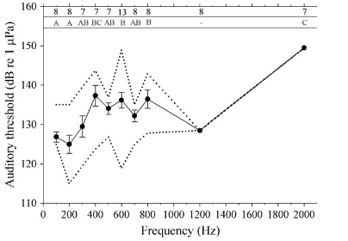
Figure D-10. Auditory sensitivity of settlement stage Plectropomus leopardus (from Wright et al. (2008)).
Strong within-species differences were found in hearing sensitivity both among the coral reef species and among the pelagic species (Wright et al. 2009). Larvae of coral reef region species had more sensitive hearing than did larvae of pelagic region species (Figure D-11). This is a comparison of demersal and pelagic larvae (one pelagic was golden trevally). If the adaptive advantage of a coral reef region larva was to hear a reef, then it is appropriate that a pelagic region larva does not detect the reef well and orient towards it.
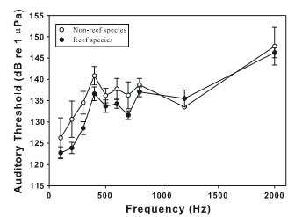
Figure D-11. Auditory thresholds for reef species (filled circle) and pelagic species (open circle) (Figure 4, (Wright et al. 2009)).
An initial uncertainty about hearing sensitivity of reef fishes being adequately assessed by Audio Evoked Potential methods with the pelagic larval stages of fishes was the question if larval and juvenile hearing sensitivity reflected that of adults. Differential hearing issues involved larval acoustic detection of the sound of reefs and adult social and spawning communication.
Egner and Mann (2005) found the mean pressure based hearing thresholds for all the damselfish were most sensitive at the lower frequencies tested as observed by Wright et al. (2009). However, by comparing three size groups from post settlement Egner and Mann (2005) found all fish size groups demonstrated lowest hearing thresholds at the lower frequencies (namely 100 to 400 Hz) the smaller size post settlement juveniles had substantially better hearing sensitivity below 1000 Hz.
Potentially the greatest fish biomass within the inter-reef region would be the small semi pelagic fishes (families Carangidae, Clupeidae etc). McPherson (1987) determined that the main prey item of the scombrid narrow barred Spanish mackerel in the northern pelagic zone Reef waters was the clupeid Sardinella sirm (Figure D-12).
Hearing sensitivity data are not available for Sardinella sirm in Australian waters. However, Akamatsu et al. (2003) determined the audiogram for a similar species, the spotlined sardine (Sardinops melanostictus). It is to be assumed that the peaking hearing a pressure sensitivity of the spotlined sardine is 100 Hz at 127.5 dB.
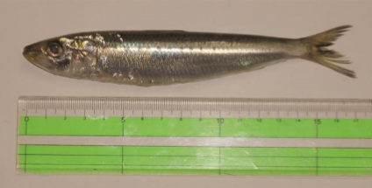
Figure D-12. Spot-lined sardine from Akamatsu et al. (2003), a species closely related to the Reef Sardinella sirm.
Dale et al. (2015) provided a behavioural audiogram of a northern hemisphere Bluefin tuna species developed using standardised pressure and particle acceleration fields in a large test tank. The pressure audiogram mirrored the axial and vertical particle acceleration audiograms. The particle acceleration audiogram was considered a reasonable proxy for hearing with peak sensitivity between 400 and 500 Hz with a pressure sensitivity at 83 dB re 1µPa. The pressure audiogram also reflected hearing sensitivity for a fast swimming tuna as water flow would interfere with fast water flow.
Dale et al. (2015) also noted that the pressure audiogram for Bluefin was far more sensitive than those for other tuna species with reduced or no swim bladder. They believed that the pressure sensitivity for the Bluefin was an advantage when the species was swimming at fast speed and flowing water would have dramatically reduced the sensitivity of a particle acceleration audiogram.
As narrow barred Spanish mackerel, the dominant pelagic in Reef waters, is a scombrid fish with no swim bladder it is noteworthy that the species is not adapted to fast swimming (Sharp and Dizon 1978) and it is often seen swimming slowly or stationary on the bottom at specific tide cycles in Reef waters It may be reasonable to presume that the pressure hearing sensitivity of narrow barred Spanish mackerel may be poor with far better particle acceleration sensitivity for slow speed swimming. As Dale et al. (2015) considered that pressure sensitivity was a good proxy for particle acceleration sensitivity, then in turn the pressure sensitivity proxy for narrow barred Spanish mackerel may be in the order of a peak between 400 to 500 Hz and a sensitivity of 83 dB re 1 µPa.

Acoustic association with reefs
Studies conduced on coral reef fishes and larvae, including from studies conducted within the World Heritage Area, have demonstrated the importance of the sounds of reefs in attracting settlement of pelagic fish larvae within the inter-reef region (e.g. Simpson et al. 2004, Wright et al. 2008).
Gagliano et al. (2008) refined the reef noise attraction concept to the level that explained how fish with naturally occurring differences between their sound detecting otoliths would not localise the sound source of reefs as well as others with more asymmetrical otoliths. Estimates of otolith asymmetry up to 20% for most fish families (Lychakov and Rebane 2005) with recognised acoustic detection asymmetries and stress.
As the acoustic basis for acoustic mediated larval attraction and settlement became established, later studies (e.g. Leis et al. 2003) demonstrated that they also attracted to specific areas of the reef with specific acoustic signatures (Simpson et al. (2010). These areas were within scales of 100's of metres such as the fringing reef, back reef and lagoon. Radford et al. (2014) found that fish made more noise during the day at frequencies below 1000 Hz, and vertebrates made more during the night at frequencies above 1000 Hz. Piercy et al. (2016) additionally concluded that reef fish larvae were attracted to the specific localities by the sounds of invertebrates greater than 1000 Hz, and in turn attracted to specific areas by the sounds of fish less than 1000 Hz from different reef types, in both day and night.
Some authors have suggested that the ability of larvae to detect sound of reefs would only be detectable to fish at distances of less than 500 m (Radford et al. 2011), a distance too short to provide sufficient time to attract swimming larvae. They demonstrated that a reef is a broad acoustic source with sound propagating without loss to a scale for the dimension of the reef before propagating at recognised acoustic propagation rates. Using hearing sensitivities from Wright et al. (2009), reef detection was considered as loss from a point source usually to a point predicted by water depth or multiples of the sound wavelength. Beyond this zone, the sound level decreased with cylindrical spreading plus any seafloor attenuation. This near ‘reef effect’ of (Radford et al. 2011) means that the sound from a reef would be detectable at a much greater distance from the reef than would be estimated from a spot measurement near the reef or by using theoretical models of sound spreading from a point source.
The greater the acoustic reach for sound emanating from a reef means that reef noise could play a more to be in the order of 5,000 m than 500m. Additional acoustic propagation modelling would be required to further test this assessment.
The noise generated by a reef is in effect an indication of its health. Piercy et al. (2016) noted that while coral reef noise is an important navigation cue for settling reef fish larvae and as such a possible driver of reef population dynamics. Of real significance to GBRMPA was that higher-quality reefs were significantly louder and richer in acoustic events than degraded reefs

Elasmobranchs
The hearing of elasmobranchs (sharks and rays) has been reviewed a number of times. In general elasmobranchs have a relatively narrow hearing range with relatively poor sensitivity, particularly compared with many teleosts. Recent assessments by shark hearing specialists (Casper and Mann 2009, Tricas and Gruber 2013, Hart and Collin 2015) discuss the pressure and particle acceleration nature of elasmobranch acoustic detection. Sharks do have other sensory systems that assist with close range prey detection, including acoustics
Elasmobranchs detect sound though two endorgan pathways, being a combination of otolith equivalent structures (called otoconia and composed of calcium to provide a greater density to the rest of the shark and surrounding water) and tissue above the otoconia (the macula neglecta that senses flow rates of liquid in the overall otolith structure). Best sensitivity is with particle acceleration detection always within the near field, a parameter defined by the specific sound wavelength and approximately 15 m for 100 Hz.
Detection of close by prey also involves a lateral line system utilising a combination of acoustic, olfaction and electromagnetic detection functions. Detection by specific endorgans may vary depending of the habit of the shark or ray.
Sensitivity of the detection system (sound particle acceleration or pressure) may vary while detection frequency has been shown to decrease with research since the 1960’s. The family Carcharinidae forms the largest biomass of elasmobranchs in the Reef. Casper and Mann (2009) produced an audiogram for the sharpnose carcharhinid shark (Rhizoprionodon terranovae) for northern hemisphere waters, a species from a very common inshore Reef carcharhind Genus. Peak sensitivity was at 20 Hz the lowest frequency examined while sensitivity was highest generally less than 200 Hz.
The earliest consideration of shark hearing in Reef waters was for the Queensland Shark Control Programme from 1991. The earliest humpback whale bycatch mitigation acoustic alarms had broadband signal extending down to 100 Hz while initial replacement alarms produced low-frequency components extending down to 100 Hz, in the switching circuit for the latter alarm. Shark catch had declined precipitously with the use of alarms with frequency extending to 100 Hz. The acoustic pressure behavioural audiogram of the bull shark Carcharhinus leucas Kritzler and Wood (1961) provided estimates for upper effective and peak sensitivity of 1500 and 600 Hz respectively although without absolute SPL sensitivity levels.

Invertebrate taxa
The diversity of sound detection mechanisms in marine invertebrates is perhaps matched by the diversity and the incompleteness of the available reviews. Popper et al. (2001) provided a review of hearing abilities for decapod crustaceans while Samson et al. (2016) increased our understanding of cephalopod hearing. Both reviews focused on particle acceleration as the method of sound detection irrespective of whether acoustic stimuli were water borne, substrate borne or from self-generated water flow. Edmonds et al. (2016) undertook a review and critical evaluation of crustacean sensitivity to loud impulsive, low frequency underwater noise typically produced by seismic surveys. They identified that sensitivity to underwater noise is shown by the Norway lobster and closely related crustacean species, including juvenile stages. They concluded that current evidence supports physiological sensitivity to local, particle motion effects of sound production.

Substrate vibration detection
Marine invertebrates lack a gas-filled bladder and are thus unable to detect the pressure component of sound waves. However, all cephalopods as well as some bivalves, echinoderms and crustaceans have a sac-like structure called a statocyst which includes a mineralised mass (statolith) and associated sensory hairs (Carroll et al. 2016b). Cephalopods have epidermal hair cells which help them to detect particle motion in their immediate vicinity (Kaifu et al. 2008). Decapods have similar sensory setae on their body (Popper et al. 2001) and antennae which may be used to detect low-frequency vibrations (Montgomery et al. 2006).
The statocyst organs, found in a wide range of invertebrates, are utilised by animals to maintain their equilibrium and orientation and to direct their movements through the water. Their functions include the detection of gravitational forces and linear accelerations. Although there is little information available on the functioning of these sensory organs, it has been suggested that marine invertebrates are sensitive to low-frequency sounds and that this sensitivity is not directly linked to sound pressure but to particle motion detection (Andre et al. 2016, Edmonds et al. 2016, Roberts et al. 2016). The statocysts may play a key role in controlling the behavior responses of invertebrates to a wide range of stimuli.
Most invertebrates living on the substrate are sensitive to vibrational waves. Roberts and Breithaupt (2016) demonstrated that hermit crabs show a wide range of behavioural changes in response to substrate borne vibrations that produced waves with frequencies up to 200 Hz. Prawns such as the northern prawn Crangon crangon responded to vibrations with a broad frequency peak between 100 and 170 Hz. Substrate vibration detection also exist in mussels such as the common bivalve Mytilus edulis which responded to substrate vibrations producing waves with a frequency range of 5 to 410 Hz but showed highest sensitivity to those with a slight peak in frequency at 10 Hz (Roberts et al. 2015).

Water particle movement and pressure change detection
Squid and Corals all detect water particle acceleration differences. Mooney et al. (2010) described the acoustic sensitivity of the longfin squid using corresponding pressure and particle motion and acceleration to acoustic stimuli. Statoliths responded to particle movement and pressure changes produced by sound waves with frequencies between 30 and 500 Hz and showed highest sensitivity to waves with peak frequencies between 100 and 200 Hz. In contrast one type of copepod, the parasitic copepod Lepeophtheirus salmonis detected uniform water accelerations via antennas which were produced in response to very low frequencies of 1-3 Hz (Heuch and Karlsen 1997). The frequencies and resulting water accelerations corresponded to movements of approaching potential prey.
Vermeij et al. (2010) discovered that coral larvae were attracted to the sound of reefs and not by a random or perhaps water pressure entrainment processes. The study by Vermeij et al. (2010) was the first to describe an auditory response in the invertebrate phylum Cnidaria, which includes jellyfish, anemones, hydroids, and corals. This was a highly significant finding as it shows that acoustics play perhaps a significant role in the maintenance of the Great Barrier Reef.

Overview of sound production of key reef species
This appendix summarises marine mammal vocalisations (Section E.1), turtles (Section E.3), and fish sound production within the Reef (Section E.2), concentrating on key species where possible.

Marine mammals
Table E-1. Species present within the World Heritage Area (DoE 2016) and approximate vocalisation ranges.
Species | Presence | Frequency Range | Vocalisation Rates
Mysticetes
Blue whale | Offshore only  April – August (northbound)  October- December/January (southbound) | 15–92 Hz | High
Humpback whale | June-October | 20 Hz – 20 kHz | High
Antarctic minke whale |  | 50 Hz – 300 Hz | Unknown, possibly high in winter
Minke whale | May-September | 50 Hz – 9.4 kHz | Unknown, possibly high in winter
Bryde’s whale | Year round | 40 – 150 Hz | High
Odontocetes
Pygmy sperm whale | Potentially year-round | HF clicks (peak energy at 125 kHz) | Unknown, associated with foraging
Dwarf sperm whale | Potentially year-round | HF clicks (Frequency unknown, likely similar to pygmy sperm whale | Associated with foraging
Sperm whale | Potentially year-round | Clicks  400Hz to 15 kHz | High
Cuvier's beaked whale, goose-beaked whale | Potentially year-round | FM clicks  20 – 50 kHz | Unknown, associated with foraging dives
Blainville's Beaked Whale | Potentially year-round | FM clicks  20 – 80 kHz
Strap-toothed Beaked Whale | Potentially year-round | Unknown
Pygmy killer whale | Potentially year-round | Whistles (majority):  ~ 5–20 kHz  Whistles (killer and pilots):  ~ 500 Hz–20 kHz  Clicks:  ~ 15 kHz–65 kHz | Unknown
Melon-headed whale | Potentially year-round |  | Unknown
Orca, killer whale | Potentially year-round |  | moderate
Short-finned pilot whale | Potentially year-round |  | Moderate to high
False killer whale | Potentially year-round |  | Unknown
Common dolphin, short-beaked common dolphin | Potentially year-round |  | high
Risso's dolphin, grampus | Potentially year-round |  | Unknown, presumably high
Fraser's dolphin, Sarawak dolphin | Potentially year-round |  | Unknown, presumably high
Spotted dolphin, pantropical spotted dolphin | Potentially year-round |  | Unknown, presumably frequent
Striped dolphin, euphrosyne dolphin | Potentially year-round |  | Unknown, presumably high
Long snouted spinner dolphin | Potentially year-round |  | Unknown, presumably high
Rough-toothed dolphin | Potentially year-round |  | Unknown, presumably high
Indian Ocean bottlenose dolphin, spotted bottlenose dolphin | Potentially year-round | Clicks: ~ 12 kHz–200 kHz  Whistles: ~ 1 kHz – ~15 kHz | High
Common bottlenose dolphin | Potentially year-round | Clicks: ~ 12 kHz–200 kHz  Whistles: ~ 1 kHz – ~15 kHz | High
Snubfin or Irrawaddy Dolphin | Potentially year-round | Clicks: Uncharacterised  Whistles: ~ 1–8 kHz | High
Indo-Pacific Humpback Dolphin | Potentially year-round | Clicks: ~ 12 kHz–200 kHz  Whistles: ~ 1 kHz – 33 kHz | High
Sirenian
Dugong | Year round | 1–18kHz | Highest at night

Fish
All fish have hearing capability through their otolith hearing and balance systems but not all fishes have to date been attributed with a sound generation. Sounds when generated are made through combinations of grinding of bony parts or musculature drumming of the swim bladder, with the magnitude of the sound determined by specialisations associated with the swim bladder if present.
Fish sounds range from approximately 50 Hz (Allen and Demer 2003) to 22 kHz (Wilson et al. 2004).
Fish make sounds based on the following four general categories:
School integrity
Low intensity and low complexity sounds made in order to maintain appropriate proximity to other individuals within a school provides spatial orientation advantages, especially at night, when the school dynamic is changing under the influence of environmental, navigational and predatory pressures (Allen and Demer 2003, Wilson et al. 2004, van Oosterom et al. 2016).
Predatory minimisation
Some herring species release gas bubbles that generate an impulsive broad frequency range sound. Gas release in association with releases from other fish in the school produce an acoustic masking defence to reduce the clarity of toothed whale echolocation clicks while predating on the fish school (Wilson and Dill 2002).
Social sounds
Social sounds may be part of conspecific aggression (usually other males in nest or territory defence) or space protection (Colleye and Parmentier 2012). Reef fish have been found to make sounds in relation to agonistic interactions, resource defence, nest defence, feeding, and vigilance behaviours (Tricas and Boyle 2014).
Spawning sounds
Sounds may be made by males to commence aggregation behaviour, to signal spawning readiness or to trigger gamete release to participating females (Lobel 1992, Nelson et al. 2011). The evening and morning chorus of some fish species may be associated with reproductive aggregation behaviour (McCauley 2001). Serranids in tropical waters have been demonstrated to make sounds throughout the year, but at a higher occurrence during the spring summer spawning period (Locascio and Burton 2016).

Turtles
Turtles likely vocalise. Freshwater turtles emit frequency-modulated as well as pulsed calls underwater (Giles et al. 2009), and some have also been shown to use sounds for social communication purposes (Ferrara et al. 2014b).
A limited number of studies exist for marine turtles. Embryos and hatchlings of leatherback turtles have been shown to emit sounds (Ferrara et al. 2014a), along with hatchings of Flatback (Natator depressus) and Olive Ridley (Lepidochelys olivacea) turtles (Guinea et al. 2014).

Summary of effects of noise on marine fauna
The effects of sound exposure on marine fauna can be categorised into those that can:
- Cause temporary or permanent injury or are implicated in other forms of health effects on individuals (physical trauma, hearing loss),
- Due their prolonged presence, unfamiliarity, or potentially annoying quality to individual animals or groups, could cause them to temporarily or permanently change their behaviour, temporarily or permanently avoid an area (non-auditory health effects, behavioural change, behaviourally-mediated effects),
- Reduce an animal’s ability to socialise or find food (signal masking) if sounds mask their communication and other biologically important acoustic signals.
Some of the effects of considerable concern for individuals, groups of animals or whole populations in relation to the noise sources outlined in are listed in Table F-1. Unlike some impacts on marine fauna, the effects of sound exposure are Appendix B.
Table F-1. Source and Effects (Adapted from Boyd et al. (2008), including non-auditory health effects Wright et al. (2007), and specialised for the context of the sources considered in this paper and relevance to the Reef.
Source | Effects of predominant concern
Vessels, including commercial shipping, dredges, tourism vessels, fishing vessels and recreational boats. | Non-auditory health effects
 | Behavioural change
 | Habitat displacement
 | Signal masking
 | Behaviourally-mediated effects
Military Activities | Physical trauma
 | Hearing loss
 | Non-auditory health effects
 | Behavioural change
 | Signal masking
 | Behaviourally-mediated effects
Pile driving | Physical trauma
 | Hearing loss
 | Non-auditory health effects
 | Behavioural change
 | Signal masking
 | Behaviourally-mediated effects
Rock Dumping | Non-auditory health effects
 | Behavioural change
 | Habitat displacement
 | Signal masking
 | Behaviourally-mediated effects
Blasting | Physical trauma
 | Hearing loss
 | Non-auditory health effects
 | Behavioural change
 | Behaviourally-mediated effects
Geotechnical exploration and associated sonars (depth sounders, fish finders) | Temporary Hearing loss
 | Non-auditory health effects
 | Signal masking
 | Behavioural change
 | Behaviourally-mediated effects
Other Sonars (depth sounders, fish finders) | Signal masking
 | Behavioural change
 | Behaviourally-mediated effects
Underwater Communication Systems | Behavioural change
 | Behaviourally-mediated effects
Renewable Power Generators (encompasses all possible systems, not all will generate all listed effects) | Hearing loss
 | Non-auditory health effects
 | Behavioural change
 | Signal masking
 | Behaviourally-mediated effects
Over flying aircraft (including sonic booms) | Behaviourally-mediated effects

A simplistic schematic diagram showing hypothetical zones of impact around a high energy underwater sound source is shown in Figure F-1. This does not account for local propagation and individual hearing ability or response, and that hypothetical zones of impact may merge with or overlap one another; however, it is provided for reference.

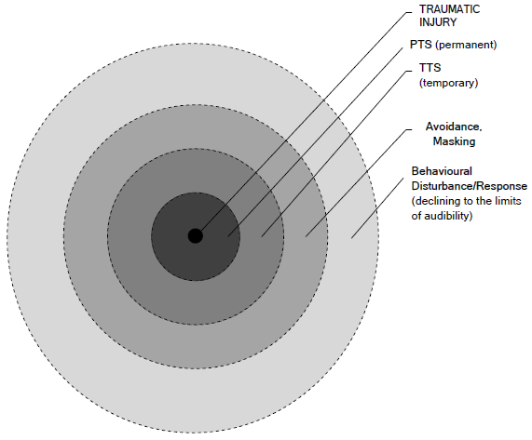
Figure F-1. Schematic diagram showing hypothetical zones of impact around a high energy underwater sound source (at centre) and listing the potential effects upon a receiving animal, assuming spherical spreading. PTS = Permanent Threshold Shift; TTS = Temporary Threshold Shift, in National Parks and Wildlife Service (2014), after NRC (2005).

Marine mammals

Overview
Due to fast diminishing light with increasing depth and influenced by the amount of suspended particles in the water column sound transmission is a more reliable information transfer method, which is likely why cetaceans have evolved acute acoustical senses. Because the sounds that marine mammals hear and generate carry information important for their survival, variation in the acoustic characteristics of these sounds, such as fundamental frequency, frequency bandwidth, spectral energy, temporal patterning, and directivity as well the behavioural context in which sounds are produced, e.g. foraging, socialising, resting, travelling is also relevant. While ambient sound due to precipitation, wind, natural seismic events among other natural events is present anywhere in the ocean and varies in sound pressure over time, cetaceans like all other mammals have evolved the ability to detect signals in noise (Heffner and Heffner 2016). Marine mammal hearing, however, shows remarkable adaptation to underwater hearing, more so in the full aquatic species but also in those species that live both on land and in water albeit to lesser degree (Tougaard et al. 2015).
The following sections describe some of the important potential impacts of a noise that may have health implications, followed by a summary of the circumstances under which marine mammals could be exposed to anthropogenic sound sources.

Acoustic masking
Acoustic masking occurs when sounds interfere with an animal’s ability to perceive biologically relevant sounds. For example, acoustic masking can decrease the range over which an animal could otherwise communicate with its peers, or detect predators or prey, by decreasing their listening space or total active acoustic space (Clark et al. 2009). Masking can occur naturally from wind, precipitation, wave action, seismic activity, and other natural phenomena. For example the ranges over which fish-eating killer whales use echolocation clicks to detect chinook salmon can be reduced by more than 50% in moderate rain (Au et al. 2004). Biological sounds can also naturally mask signals. Some fish, for example, create low-frequency sounds (50–2000 Hz, but most often 100–500 Hz) that can form a significant component of local ambient sound levels (Zelick et al. 1999). Snapping shrimp in many locations produce high-amplitude sounds over a broad range of frequencies that often dominate the underwater sound field.
It can be safely assumed that marine wildlife have adapted to naturally occurring signal masking (Brumm and Slabbekoorn 2005), yet the reduced active acoustic space in addition to naturally occurring noise conditions is a physical constraint that may not be overcome completely due to physiological and ecological constraints (Slabbekoorn et al. 2010) and therefore masking due to anthropogenic activity must be taken into consideration as a cumulative impact in acoustic impact assessment studies (Boyd et al. 2011). Anthropogenic sounds contribute to the ambient soundscape, and can mask biologically important sounds, potentially reducing the active (perception) space to levels that can’t support active foraging and socialising (Clark et al. 2009). The amount of masking an animal experiences is determined by signal and noise attributes, such as the amplitude/source level of noise and the signal, the timing, direction, spatial distribution and frequency content of the transmitted signals and interfering sounds, as well as how sounds are perceived by the receiver, which is influenced by absolute hearing sensitivity, critical bandwidths and ratios determining hearing ability of signals in noise, auditory integration times, directional hearing, and anti-masking mechanisms (Erbe et al. 2015).
Studies about acoustic masking in the ocean have traditionally focused on mysticetes (a suborder of cetaceans that use baleen plates to filter their food; includes humpbacks, rorquals, blue, fin, and right whales) and shipping sounds (Clark et al. 2009). Mysticetes communicate using calls with energy primarily in low-frequency bands that overlap completely with the frequencies carrying the main energy of shipping sounds (Arveson and Vendittis 2000, Allen et al. 2012, Bassett et al. 2012). Over the past 50 years, commercial shipping, the largest contributor of continuous noise (McDonald et al. 2008), has increased the ambient sound levels in the deep ocean at low frequencies by 10–15 dB (Hatch and Wright 2007). Hatch et al. (2012) estimated that shipping noise could be responsible for North Atlantic right whales (Eubalaena glacialis) losing, on average, 63–67% of their communication space. Dunlop (2016) suggested that humpback whales may not be able to cope with an increase in anthropogenic noise in the same way they cope with an increase in natural noise when comparing communication source levels and repertoire. This may be due to the specific overlap of noise in important frequency bands.
Sound output from ships can also extend to relatively high frequencies (e.g., up to 30 kHz, Arveson and Vendittis 2000, and up to 44.8 kHz, Aguilar Soto et al. 2006) and thus can affect odontocetes (toothed whales) especially at shorter ranges. Aguilar Soto et al. (2006) used a Digital Acoustic Recording Tag (DTAG) attached to a Cuvier’s beaked whale (Ziphius cavirostris) to record a passing vessel, which demonstrated that vessel sounds masked the whale’s ultrasonic vocalisations and reduced the whale’s maximum communication range by 82% when it was exposed to a 15 dB increase in ambient sound levels at the vocalisation frequencies. The study also determined that the effective detection distance of Cuvier’s beaked whales’ echolocation clicks by conspecifics would be reduced by 58%. Noise profiles from ships are highly variable, and high-frequency components attenuate more rapidly than do low frequencies (Hatch and Wright 2007), which limits the area over which Cuvier’s beaked whales would be affected.
The presence of humpback whale mother-calf whales in the Cairns region was presented to a Cairns Local Area Advisory Committee meeting in Cairns in 2014 (C. McPherson pers comm). Basic acoustic models were used for arbitrary whale locations off Cairns in relation to passing ships with estimated humpback Source Levels from Dunlop et al. (2013b). It was estimated that vessel noise reduced the mother-calf communication space to significantly less than 1000 m.
Braithwaite et al. (2012) described an acoustically mediated spacing behaviour of humpback mothers with calves off Western Australia essentially to keep calves from social contact with other whales. (Dunlop et al. 2013a) showed that only song elements and calls of humpback whales with high source levels (> 145 dB) can be received further than 2 km from the calling whale and other signals will get masked.
Sound from seismic surveys contribute to ocean-wide acoustic masking (Hildebrand 2009), and are considered to have the potential to displace some species and populations from their habitats (Nowacek et al. 2015). Little is known, however, about the masking effects of seismic sounds other than aggregate noise from multiple seismic surveys and shipping can lead to higher sound levels, resulting in increased masking (Nowacek et al. 2015).
Some cetaceans might compensate for masking, to a limited degree, either by increasing the amplitude of their calls (Lombard effect) or by changing their spectral (frequency content) or temporal vocalisation properties (Hotchkin and Parks 2013). North Atlantic right whales produced calls with a higher average fundamental frequency and lowered their call rate in high noise conditions (Parks et al. 2007), whereas blue whales increased their discrete, audible calls during a seismic survey (Di Iorio and Clark 2010), or when ship sounds were nearby (Melcon et al. 2012).
The understanding, and even more so the quantification, of not only communication but the broader and more important listening space and masking is still in its early stages but is the subject of ongoing research effort and rapidly evolving to a mature and usable body of knowledge. Regulatory agencies in the USA have specifically included loss of communication space among the criteria being considered in the assessment of acoustic impact in recent studies of large-scale operations (including those detailed in Section 6.5.3). An adaptive conservation management, if adopted, would allow adjusting regulations when greater knowledge of listening space becomes available.

Behavioural disturbance
Behavioural responses to underwater sound are difficult to determine because animals vary widely in their response type and strength, and conspecifics who are exposed to the same sound react differently (Nowacek et al. 2004, Gomez et al. 2016, Southall et al. 2016). An individual’s response to a stimulus is influenced by the context in which the animal receives the stimulus and how relevant the individual perceives the stimulus to be. A number of biological and environmental factors can affect an animal’s response—behavioural state (e.g., foraging, travelling or socialising), reproductive state (e.g., female with or without calf, or single male), age (juvenile, sub-adult, adult), and motivational state (e.g., hunger, fear of predation, courtship) at the time of exposure as well as perceived proximity, motion, and biological meaning of the sound and nature of the sound source.
Animals might temporarily avoid anthropogenic sounds, but could display other behaviours such as approaching novel sound sources, increasing vigilance, hiding and/or retreating, that might decrease their foraging time (Purser and Radford 2011). In some cases marine mammals have reduced their vocalisations in response to anthropogenic sounds, sometimes ceasing to call for weeks or months (IWC 2007). Whales seemed most reactive when the sound level was increasing, which they could perceive as an approaching sound. An animal could exhibit a startle effect at the onset of a sound. Although limited data are available, cetaceans respond less to stationary industrial activities that produce continuous sounds (such as dredging, drilling, and oil-production-related activities) than they do to moving and/or transient sound sources, including seismic surveys and ships (Richardson et al. 1995). Some cetaceans may partially habituate to continuous sounds (Richardson et al. 1995).
For pulsed sounds specifically, there is evidence that it is the combined effects of baleen whales’ behavioural states (McCauley et al. 1998, Gordon et al. 2003) and their proximity to airgun sounds, that affects how the whales react. Several species of baleen whales showed avoidance behaviour to sounds generated by seismic surveys (Richardson et al. 1995), including bowhead whales (Balaena mysticetus), who avoided distant seismic airguns at received levels of root-mean-squared Sound Pressure Level (SPL) of 120–130 dB re 1 µPa during their fall migration (Richardson et al. 1999). However, these levels should be viewed as conservative for non-migrating whales because feeding whales do not generally avoid sounds, whereas migrating whales are more likely to exhibit a temporary migration deflection to avoid sounds. Feeding bowhead whales in the summer tolerated airgun sounds better than their winter counterparts by avoiding airguns only when received levels reached 152–178 dB re 1 µPa (Richardson et al. 1995). Resting female humpback whales re-routed by 7–12 km away from the sound source, although males were occasionally attracted to seismic survey sounds (McCauley et al. 2000). During the first 72 h of a 10-day seismic survey, fin whales appeared to move away from the airgun array, a displacement that persisted well beyond the 10-day duration of the seismic airgun survey (Castellote et al. 2012). The authors acknowledged, however, that it was unknown if the whales were avoiding the sound or following another cue such as prey. Brandt et al. (2011) and Dähne et al. (2013) reported that pile driving, another repeated impulsive sound, displaced harbour porpoises.
The BRAHSS (Behavioural Response of Australian Humpback whales to Seismic Surveys) project conducts studies at Peregian Beach, Qld, and Dongara, WA, to better understand the behavioural responses of humpback whales to noise from the operation of seismic air gun arrays (Cato et al. 2013). Results from the first sets of experiments have recently been published (Dunlop et al. 2015, Dunlop et al. 2016, Godwin et al. 2016), together with concurrent studies of the effects of vessel noise on humpback whale communications (Dunlop 2016). Dunlop et al. (2016) used land based observations of behavioural responses in migrating humpback whales to playbacks of the first stages of air-gun ramp-up operations and playbacks of ‘constant’ source sounds, and compared the results with the observed behaviours during ‘controls’ in which shipping sounds where present and the array was towed but not operated. The behavioural baseline used for the identification of responses was established using observations of groups in the absence of the source vessel. In most exposure scenarios a distance increase from the sound source was observed and interpreted as potential avoidance. The study, however, found no difference in the 'avoidance' response to either ‘ramp-up’ or the constant source producing sounds at a higher level than early ramp-up stages. In fact, a small number of groups showed inspection behaviour of the source during both treatment scenarios. ‘Control’ groups also responded, which suggested that the presence of the source vessel alone had some effect on the behaviour of the whales. Despite this, the majority of groups appeared to avoid the source vessel at distances greater than the radius of most injury based mitigation zones. The behavioural dose–response relationship to airgun noise and source proximity has been examined by the study for the small airguns, and they found that humpback whales were more likely to avoid the air gun arrays (but not the controls) within 3 km of the source at levels over 140 dB re 1 μPa2-s (Dunlop et al. 2017).
Small odontocetes responded to airgun sounds by moving laterally away from the sound, showing the strongest lateral spatial avoidance compared to mysticetes and killer whales which showed more localised spatial avoidance. Other larger odontocetes studied included long-finned pilot whales (Globicephala melas) which only changed their orientation in response, while sperm whales did not significantly avoid the sound (Stone and Tasker 2006). A recent report from Bureau of Ocean Energy Management (BOEM) (Barkaszi et al. 2012) indicated that defined species groups (all cetaceans) were sighted at significantly greater distances from seismic sources during full power than during silence, illustrating a level of spatial avoidance to the seismic sources. The UK Joint Nature Conservation Committee (Stone 2003) analysed reports of observers on seismic vessels in UK waters and noted that odontocetes probably avoid active seismic sources.
Other observations, however, have suggested that sperm whales respond little, if at all, and are not excluded from their habitat by seismic surveys (e.g., Rankin and Evans 1998). The Sperm Whale Seismic Study (Jochens et al. 2008) conducted some controlled-exposure experiments to determine the direction of movement of eight tagged sperm whales over a series of 30-minute intervals during pre-exposure, ramp-up, and full-array firing. Results showed no horizontal avoidance to airgun exposure of < 150 dB re 1 µ Pa (SPL); only one individual altered its diving and foraging rates exhibited by a longer resting period at the surface and diving immediately following the final airgun transmission.
In response to Ocean Acoustic Waveguide Remote Sensing (OAWRS) frequency-modulated pulses, male humpback whales at distances of 200 km away from the sound source either moved out of the study area or sang less (Risch et al. 2012). Humpback whales also lengthened their mating songs during exposure to low-frequency active (LFA) sonar (Miller et al. 2000), while long-finned pilot whales produced more whistles in response to military mid-frequency sonar (Rendell and Gordon 1999). McDonald et al. (1995) observed that a blue whale stopped vocalising when it was within 10 km of an active seismic vessel. Recent work has shown that fin whales shortened the duration, decreased the frequency range, and lowered the centre and peak frequencies of their calls in response to shipping and airgun noise (Castellote et al. 2012). Bowhead whale calling rates initially increased alongside seismic sound exposures, but call rates levelled off and peaked as seismic levels increased and then began to decrease when the cumulative Sound Exposure Level (SEL) 1-min values increased above 118 dB re 1 μPa2-s, until they are silent when cumulative SEL 10-min values were above ~160 dB re 1 μPa2-s (Blackwell et al. 2015).
With regard to continuous sounds such as produced by ships, the review by Southall et al. (2007) found no responses or limited responses by low-frequency cetaceans to continuous (non-pulsed) received levels up to 120 dB re 1 µPa, but an increasing probability of avoidance and other behavioural responses beginning at 120 to 160 dB re 1 µPa. In relation to high-frequency cetaceans, in the Bay of Fundy, Nova Scotia, Polacheck and Thorpe (1990) noted that harbour porpoises, which are high-frequency cetaceans, tended to swim away from approaching vessels. Off the western coast of North America, Barlow (1988) observed that harbour porpoises within 1 km of a survey vessel moved rapidly out of its path. Cuvier’s beaked whales responded to ship sounds by decreasing their vocalisations when they attempted to catch prey (Aguilar Soto et al. 2006). Foraging changes were observed in Blainville’s beaked whales (Mesoplodon densirostris) when they were exposed to vessel noise (Pirotta et al. 2012). Groups of Pacific humpback dolphins (Sousa chinensis) that contained mother-calf pairs increased their rate of whistling after a boat had transited the area (Van Parijs and Corkeron 2001). The authors postulated that vessel sounds disrupted group cohesion, especially between mother-calf pairs, requiring them to re-established by vocal contact after boat noise masked their communication. Lesage et al. (1999) revealed that belugas reduced their overall call rate in the presence of vessels, but increased the emission and repetition of specific calls and shifted to higher frequency bands. In response to high levels of boat traffic, killer whales increased the duration (Foote et al. 2004) or the amplitude (Holt et al. 2009) of their calls. Bottlenose dolphins (Tursiops truncatus) produced more whistles when boats approached (Buckstaff 2004) and emitted lower frequency and longer whistles when interacting with dolphin-watching boats, particularly during foraging activities (May-Collado and Quiñones-Lebrón 2014). The authors suggested that dolphin-watching boats disrupt communication of bottlenose dolphins. Furthermore, Luís et al. (2014) discovered that mean overall call rates decreased significantly in the presence of operating vessels. These changes in call emission rates and temporary shifts in whistles characteristics may be a vocal response to the proximity of operating vessels, facilitating communication in this busy, noisy estuary. Similarly, high speed ferry noise has been demonstrated to have implications for harbour porpoise (Hermannsen et al. 2014),
Ando-Mizobata et al. (2014) observed that dugong in Thai waters altered vocalisation rates when exposed to outboard powered vessels. Duration of calls lengthened and the number of recorded harmonics changed. Reasons for the changes with boat noise exposure were suggested as including that the individual dugongs altered their calls, the distances between calling dugongs and the hydrophone receiver changed and that the original close calling dugongs stopped and more distant dugongs were detected instead.

Non-auditory effects
Non-auditory physiological responses to noise exposure have been studied mainly in humans (Stansfeld and Matheson 2003), but some studies exist on physiological stress response to noise in captive marine mammals.
Thomas et al. (1990) played recorded drilling sounds to four captive beluga whales and found no changes in their blood adrenaline or noradrenaline levels, measured immediately after the playback. Romano et al. (2004) found detrimental changes in some hormones or blood cell counts when they exposed a captive bottlenose dolphin and a captive beluga whale to sounds from a seismic watergun. The bottlenose dolphin showed changes in its aldosterone and monocytes levels while the beluga’s epinephrine, norepinephrine, and dopamine levels rose. Miksis et al. (2001) found that the heart rate in a captive bottlenose dolphin increased in response to threat sounds produced by other dolphins. Rolland et al. (2012) concluded that right whales might feel chronic stress when they are exposed to low-frequency ship noise.
Some marine mammal strandings are thought to be related to acoustic exposure, particularly military mid-frequency sonar and beaked whales (D'Amico et al. 2009) and common dolphin (Jepson et al. 2013). Other cetacean species have also been involved in strandings that may be associated with acoustic exposure. The sound characteristics and behavioural and physiological mechanisms that lead to strandings are not fully understood.

Temporary and permanent hearing loss
Physiological impacts such as physical damage to the auditory apparatus, e.g., loss of hair cells or temporally of permanently fatigued hair cell receptors, can occur in marine mammals when they are exposed to intense or moderately intense sound levels resulting in temporary or permanent loss of hearing sensitivity. While the loss of hearing sensitivity is usually strongest in the frequency range of the emitted noise, it is not limited to the frequency bands where the noise occurs but can affect a broader hearing range. This is because animals perceive sound structured by a set of auditory bandwidth filters that proportionately increase in width with frequency.
A temporary threshold shift (TTS) is hearing loss from which an animal recovers, usually within a day at most, whereas permanent threshold shift (PTS) is hearing loss from which an animal does not recover (permanent hair cell or receptor damage). The severity of TTS is expressed as the duration of hearing impairment and the magnitude of the shift in hearing sensitivity relative to pre-exposure sensitivity, in dB. TTS occurs at lower exposure levels than PTS. The cumulative effects of repeated TTS, especially if the animal receives another sound exposure near or above the TTS threshold before recovering from the previous sensitivity shift, could cause PTS. If the sound is intense enough, an animal could succumb to PTS without first experiencing TTS (Weilgart 2007). Though the relationship between the onset of TTS and the onset of PTS is not fully understood, a specific amount of TTS can be used to predict sound levels that are likely to result in PTS. For example, in establishing PTS thresholds, Southall et al. (2007) assume that PTS occurs with 40 decibels of TTS.
Experiments with captive bottlenose dolphins have shown that short tonal sounds can cause TTS (Schlundt et al. 2000). Mild TTS has also been demonstrated in dolphins exposed to lower sound levels for periods up to 50 min (Finneran et al. 2005, Kastak et al. 2005). Impulsive sounds from a watergun (Finneran et al. 2002) or airgun (Lucke et al. 2009) caused TTS in beluga whales and harbour porpoises respectively, although the levels required for impulsive sounds to do so were much higher than the 1 s tonal signals. TTS growth, which represents the amount that sensitivity shifts upward with increasing noise levels, can however, be much steeper for impulsive sound sources than for continuous sound sources (Lucke et al. 2009).
Temporary threshold shifts (TTS) may be the result of a combination of noise level and duration that when combined into a single metric, sound exposure level (SEL), can be used to describe TTS. Supin et al. (2016) investigated TTS in beluga whales (Delphinapterus leucas) over a range of SPLs over duration ratios where SEL remained constant. The study revealed that at low SPL-to-duration ratios, the TTS dependence was positive, i.e. shorter high-level sounds produced greater TTSs than long low-level sounds of the same SEL. At high SPL-to-duration ratios, the TTS dependence, however, was negative, which means long low-level sounds produced greater TTSs than short high-level sounds of the same SEL. Supin et al. (2016) suggested that while SEL is an appropriate technique to assess TTS, long duration low SPL level sounds may cause TTS even when SEL remain below a threshold considered to be an onset level. This has implications for long term sound exposure at below SEL threshold levels, such as is the case in areas with marine shipping.
Reduced hearing sensitivity or hearing loss especially at the higher frequencies has been shown to be age related in all mammals, including humans (Kujawa and Liberman 2006). Li et al. (2016) demonstrated that Chinese humpback dolphins show typical mammalian age related hearing loss, in both reduced overall sensitivity and loss of sensitivity to higher frequency. Cook (2006) suggested that captive odontocetes typically had more hearing loss than similar-aged free-ranging dolphins, which may be related to the fact that many tested captive animals are older and that older mammals.
Impact assessment and mitigation of impact schemes should therefore consider the change in hearing sensitivity with increasing age in dolphins if not all cetaceans. The approach to audiogram data use for impact assessment should consider population variability with regard to hearing. This could mean that older dolphins rely more on hearing lower frequencies and therefore are more susceptible to masking of lower frequency sounds than younger animals.

Reduction of prey availability or ability to find prey
Sound might indirectly affect marine mammals by affecting the abundance of their prey. Fish and squid form a major part of the diet of marine mammals. Because marine fish are typically sensitive to the 100–500 Hz range, where most anthropogenic sound is produced, increasing sound levels above typical ambient levels are a concern for fish populations (e.g., McCauley et al. 2003, Popper and Hastings 2009, Slabbekoorn et al. 2010).
An example of how increased anthropogenic sound levels could affect how marine mammals find prey is mentioned in Wang et al. (2016). Herring, which is one of the major species in the North Atlantic produce a variety of sounds detectable by marine mammals (Wilson et al. 2004). Marine mammals may use passive listening to find large aggregations of herring instead of using active sonar which carries a much higher metabolic cost. Low-frequency anthropogenic sounds particularly those from distant seismic operations and from shipping could both have behavioural implications for the fish, as discussed above, or mask their detection by marine mammals.

Fish

Overview
A working group of experts reviewed available data and determined broadly applicable sound exposure guidelines for fishes and sea turtles. The working group’s recommendations are available in a technical report, Popper et al. (2014), which was developed and approved by the Accredited Standards Committee S3/SC 1 Animal Bioacoustics and registered with the American National Standards Institute (ANSI). The technical report contains the most recent and thorough synthesis of available information, recommending sound exposure guidelines which were used as the criteria to assess the potential for noise impacts on fish.
There are many sources of anthropogenic sounds. Popper et al. (2014) classified sound sources by the type of sound produced (e.g. continuous versus impulsive), and separately evaluated impacts from data available for common sources such as pile driving, seismic airguns and vessels. There are a great many species of fish that use sound in different ways. Susceptibility of fish to noise likely varies considerably between species, and the effects also vary depending upon the location. Others might be more affected through subtler, longer-term effects such as behavioural changes, including being displaced from a preferred area.
Popper et al. (2014) categorised fishes according to their likely hearing abilities based primarily on the presence or absence of a swim bladder as that organ plays a strong role in hearing.
Fish with no swim bladder are least susceptible to injury from sound exposures; however many bony fish (teleostei) have a swim bladder used to regulate their buoyancy. A swim bladder or other gas-filled chamber can be compressed by large pressure changes. Compression can injure surrounding tissue, making these fish more susceptible to trauma from sudden pressure changes. The swim bladders in some fishes are directly linked to their ears and form part of their hearing organs. This anatomy increases fishes’ pressure sensitivity and extends their hearing frequency range. Because of these adaptations, more so than any other group, fish species that use a swim bladder to hear are the most sensitive to sound.
Fish eggs and fish larvae are considered as a separate category of fauna. Negative impacts of acoustic exposure on larvae can range from immediate effects such as death, hearing impairment such as temporary threshold shift (TTS), or masking their communication space, while it is restricted to death for fish eggs (Popper et al. 2014).
Several of the above-mentioned potential effects are reviewed below and discussed in the context of exposures to sounds, drawing substantially from Popper et al. (2014).
It should be noted that there is a lack of information regarding fish compared to marine mammals (Hawkins et al. 2014, Popper et al. 2014). Hawkins and Popper (2016) recently provided a useful paper regarding the assessment of the impact of underwater noise on marine fishes and invertebrates. This work discusses the problems with completing these assessments, and procedures that will help protect these animals. Importantly, it also provides guidance on directions for research and planning.

Mortality and temporary hearing loss
Death and injury can result from exposure to very high amplitude sounds (Carlson and Johnson 2010). In addition, the effects of changes in pressure (barotrauma) must also be considered, especially for impulsive sounds.
Barotrauma is tissue injury that results from rapid pressure changes (e.g., forced change in depth, explosions, and intense sound) (e.g. Halvorsen et al. 2011, Halvorsen et al. 2012a). Rapid changes in pressure can cause blood gases to come out of solution. Rapid pressure changes can also cause gas volumes (i.e., swim bladders) to expand and contract rapidly, thereby damaging surrounding tissues and organs, and sometimes causing rupture of the swim bladder itself.
Some studies have shown mortality of fish within close range of a large pile (Caltrans 2004), but the data on exposure levels or extent are limited. Other studies have shown that at greater distances there was no mortality or damage that could be clearly associated with piling (e.g. Houghton et al. 2010). Wave tube based experiments that allow controlled exposure of fish to signals replicated from actual pile driving operations have found that the extent of injury to fish increased with sound exposure levels and number of pile driving strikes (Halvorsen et al. 2011, Halvorsen et al. 2012a).
Damage to a fish’s sensory hair cells of the otolithic endorgans, or disruption of the gas chamber or mechanical connections due to noise, could cause hearing loss (Popper et al. 2014). Unlike mammals, fishes replace their sensory hair cells once they’re damaged, thus mitigating sound-induced hair cell death (Popper et al. 2014).
Some fishes have succumbed to Temporary Threshold Shift (TTS)—its extent of variable duration and magnitude. This has resulted from either temporary changes in sensory hair cells of the inner ear and/or damage to auditory nerves innervating the ear (McCauley et al. 2003, Smith et al. 2006, Liberman 2014). After a sound that caused TTS terminates, a fish’s normal hearing ability returns. The return to normality depends on several factors, including the duration and intensity of the sound exposure. While experiencing TTS, fishes’ fitness could decrease in terms of communication, detecting predators or prey, and/or assessing their environment (Popper et al. 2014).
While it has been found that fish can recover from non-mortal injuries in a laboratory (Casper et al. 2013), Popper et al. (2014) hypothesised that in the natural environment even these recoverable injuries could reduce fitness and lead indirectly to mortality. High-intensity mid-frequency sonar is thought to have a low chance of inducing TTS in fish in field conditions (Popper et al. 2014).

Behaviour
The National Research Council (2005) discussed the possible effects of sound on marine mammal behaviour, including on communication between conspecifics and on detection of predators and prey. Popper et al. (2014) summarised, “In its report, the NRC states that an action or activity becomes biologically significant to an individual animal when it interferes with normal behaviour and activity, or affects the animal’s ability to grow, survive, and reproduce. Such effects might have consequences at the population-level and might affect the viability of the species (NRC 2005).”
Studying the responses of fish to anthropogenic sound is difficult. Many factors could influence the results conducted in controlled or wild situations from the reproducibility of the sound source, the duration of exposure that demonstrated an impact to the context of an anthropogenic sound. Slabbekoorn (2016) considered the advantages and constraints for controlled and field conducted noise exposure studies noting that there was a need and a requirement to balance acoustic and behavioural validity with experimental control to achieve scientific progress.
A range of responses has been observed when the behaviour of wild fishes has been studied in the presence of anthropogenic sounds. Studies suggest that fish will generally display startle reflexes and move away from a loud acoustic source in order to minimise their exposure, but this response might depend on the animal’s motivational state. Anthropogenic sounds have been shown to cause changes in schooling patterns and distribution, including in relation to airgun operations (Engås et al. 1996, Engås and Løkkeborg 2002, Slotte et al. 2004, Løkkeborg et al. 2012b, 2012a, Popper et al. 2014). Other studies, specifically related to a coral reef-associated fish community—found no detectable effect on species richness or abundance (Woodside 2007, Miller and Cripps 2013).
Løkkeborg et al. (2012b) noted that reduced fish catches have been observed in commercial line and trawl fisheries during and after seismic surveys, but that catches also increased in some cases, with the increase attributed to a change in fish behaviour in response to the airgun sounds.
Vessel noise (from trawlers, ferries, research vessels and bulk carriers) has also been shown to induce a behavioural response, such as inducing avoidance, altering swimming speed and direction, and schooling behaviour (Engås et al. 1995, Engås et al. 1998, Sarà et al. 2007, De Robertis and Handegard 2013). Studies involving research vessels both were found to induce a response (Mitson 1993), and sometimes that response was even greater than for other vessels (Ona et al. 2007). The Sarà et al. (2007) work observed the behavioural impact of passing shipping, and outboard noise of northern Atlantic bluefin in offshore growout cages. Responses ranged from school structure being reduced, to uncoordinated swimming and agonistic interactions between individuals. Simpson et al. (2016b) found that power boat exposure, both playback and field trials, induced a behavioural state change in Great Barrier Reef damselfish as indicated by an increase in active metabolic rate of individuals when exposed to different playbacks of noise.
Pile driving has been shown to cause fish to move away from the source (Feist 1992). Anderson (1990), Feist (1992), Mueller-Blenkle et al. (2010) found that pile-driving noise from offshore windfarm construction, both in terms of received sound pressure and particle motion levels triggered behavioural responses in sole and cod. The results implied a relatively large zone of behavioural response to pile-driving sounds in marine fish; however, the exact nature and extent of the behavioural response required further investigation.
Behavioural studies of fish in relation to high-intensity mid-frequency sonar are limited, as discussed in Popper et al. (2014). Despite this, the only fishes in which behaviour is potentially affected by mid-frequency sonar are those that have specialisations that enable them to hear sounds above about 2,500 Hz (Halvorsen et al. 2012b). High-frequency sonar (e.g., above 10 kHz) can also affect shads and menhadens, and induce behavioural responses in herring (Nestler et al. 1992).

Masking
Masking impairs an animal’s hearing with respect to the relevant sounds normally detected within the environment and can have long lasting effects on survival, reproduction and population dynamics of fishes (Popper et al. 2014). The consequences of masking for fishes, however, have not yet been fully examined. Popper et al. (2014) surmised, “It is likely that increments in background sound within the hearing bandwidth of fishes and sea turtles may render the weakest sounds undetectable, render some sounds less detectable, and reduce the distance at which sound sources can be detected. Energetic and informational masking may increase as sound levels increase, so that the higher the sound level of the masker, the greater the masking.”
Popper et al. (2014) also stated that one of the most serious implications of shipping noise is the impact it may have in masking sounds of biological importance, including sounds made by fishes.

Social communication
North American spawning aggregations of coral reef serranid fishes (of which the coral trout Plectropomus leopardus is the GBRs’ prime species) have been passively acoustically monitored since at least 2000 (Rowell et al. 2011). Nelson et al. (2011) demonstrated this for red grouper including for sites too deep for divers providing a far better estimate of aggregation distribution. They matched different acoustic pulses with patrolling and courting males centred on 180 Hz, with SL’s estimated to be in the order of 142 re 1 µPa at 1m. Given the radiated noise levels of shipping (Appendix B.1), in particular bulk-carriers, cargo vessels and high speed ferries, the there is a high potential for masking.
Allen and Demer (2003) identified a Pacific bluefin communication sound believed to be used for maintenance of school integrity and particularly for schooling and spawning after dark. The signal was associated with a 'coughing' or 'yawning' movement of the jaws and operculum. The 'cough' was associated with a 0.1 sec impulsive signal centred around 50 Hz. The source levels of the call from open water and an aquarium were 103 to 129 dB re 1 µPa re 1m.
Given the narrow barred Spanish mackerel also ''cough' in open water and would benefit from such a behaviour to maintain location integrity after dark during spawning then it is likely that a comparable sound generation occurs in Spanish mackerel, common on the Reef. The species does not have a swim bladder therefore potential Source Levels may be reduced for the species.
It has been demonstrated that oyster toadfish respond to vessel disturbances by calling less when vessels are present, and the authors suggested that toadfish cannot call over loud vessel noise, reducing the overall calling rate, and may have to call more often when vessels are not present (Luczkovich et al. 2016).

Predator detection
Radford and Montgomery (2016) hypothesised that early prey identification by top predators (including marine mammals, sharks and fish) using passive acoustic means would provide them with a competitive advantage. Their hypothesis, though perhaps not original, was that food patches have specific sound signatures that marine predators could detect. What makes the hypothesis of Radford and Montgomery (2016) interesting is they provided a complex example of diving gannets, pelagic fish and dolphins feeding on prey as an indicator of available prey with a distinct spectral signature between 80 and 1500 Hz depending on the species involved in the feeding. Their hypothesis provides for the potential masking of prey attraction processes caused by shipping at close range (100 m) and at a range as far as 15 km.
Simpson et al. (2016b) documented the effect of motor boat noise on fish predation on the Great Barrier Reef, The noise of a representative 30 hp outboard motor was used in tank and field situations. Arguably, 30 hp is a relatively small outboard to reach most reefs from the mainland so larger motors may be appropriate. (Simpson et al. 2016b) observed that the Ambon damselﬁsh (Pomacentrus amboinensis) responded less often and less rapidly to simulated predatory strikes by their natural predator the dusky dottyback (Pseudochromis fuscus) when exposed to vessel noise. Prey were therefore captured more readily by their natural predator and by more than twice as many prey were consumed by the predator in ﬁeld experiments when motorboats were passing. They suggested that a common noise source in the Great Barrier Reef soundscape had the potential to impact one aspect of fish behaviour there are many other noise sources that may have even more impact. The specific sound of the predator in the experiments of Simpson et al. (2016b) was not indicated.
The observed masking of the approach of predators should not be surprising. Bleckmann et al. (1991) and many authors since have documented the tail beats and pressure wave of approaching predators and all were well less than 100 Hz where masking levels of boat noise are high.

Elasmobranchs
The effect of anthropogenic noise on elasmobranchs is virtually unknown. Elasmobranchs are not known to utilise acoustic communication, and therefore anthropogenic noise would most likely be an issue for masking of the sounds of prey species. Bullock and Corwin (1993) noted a degree of acoustic masking in Carcharhinidae and Triakidae tropical sharks with sounds of flowing water, white noise and with swimming, artificial white noise and of relevance to anthropogenic noise from shipping masking around 100 Hz by a 100 Hz tone. There are no stress studies examining the effect of noise on elasmobranchs.
Casper and Mann (2009) demonstrated that the Atlantic sharpnose (Carcharhinidae) had a peak sensitivity at 20 Hz in terms of particle acceleration which when converted to pressure units was comparable to an ambient signal level of 83 dB re 1 µPa, a level readily exceeded by many vessels at a broad range of distances.
Casper et al. (2012) considered that little information was available to consider noise masking of elasmobranchs

Marine reptiles

Turtles
The Popper et al. (2014) report examined sea turtles and fish, ultimately recommending criteria to assess the potential for noise impacts on turtles. Data on sea turtles are less conclusive than for other species, from the perspective of both the level of harm inflicted and the animal’s reaction to sound. Recommendations on studies that could be done to increase the understanding of the impact of anthropogenic noise on turtles are provided in Willis (2016). Nelms et al. (2016) conducted a review of seismic surveys and turtles, a common theme in this work is the complex nature of the studies, from the interpretation of behavioural responses, determining responses due to airguns or vessel noise/presence, through to difficulties in visually detecting animals. Most studies looking at the effect of seismic noise on marine turtles have focused on behavioural responses as physiological impacts are more difficult to observe in living animals.
The majority of studies have focus on airguns, which can be applied to other impulsive sources such as pile driving. Turtles have been shown to avoid low-frequency sounds (Lenhardt 1994) and sounds from an airgun (O'Hara and Wilcox 1990), but these reports did not note received sound levels. Moein et al. (1995) found that penned loggerhead turtles initially reacted to an airgun but then showed low or no response to the sound (habituated to it). Caged green and loggerhead sea turtles increased their swimming activity in response to an approaching airgun when the received SPL was above 166 dB re 1 μPa and they behaved erratically when the received SPL was approximately 175 dB re 1 μPa (McCauley et al. 2000).

Sea snakes
There is no current information on how sea snakes use sound or how susceptible they might be to underwater noise, although this is an area of current research.

Invertebrate taxa
Very few peer-reviewed papers investigating how invertebrates may be impacted by anthropogenic noise exist (Morley et al. 2014). Reviews of the effects and impacts of anthropogenic noise on marine invertebrates considering a broad range of taxa and their ontogenetic stages have been conducted by a number of authors (Carroll et al. 2016b, de Soto 2016, Edmonds et al. 2016, Hawkins and Popper 2016). In a field experiment Nedelec et al. (2014) used playbacks to investigate the effect of boat noise on the early life and survival of a coral reef marine invertebrate, the sea hare Stylocheilus striatus. Nedelec et al. (2014) found that exposure of the nudibranch to small boat-noise playback compared to ambient-noise playback, stopped development of nudibranch embryos by 21%. For the nudibranch embryos remaining, a further mortality of 22% occurred for hatched larvae. Little is known of the spawning periodicity of this or any other microalgae eating nudibranch on the Great Barrier Reef.
In contrast, Day et al. (2016b) found that embryonic spiny lobster were resilient to air gun signals, and highlighted the caution necessary in extrapolating results from the laboratory to real world scenarios or across life history stages. This isn’t surprising, as they are quite jelly like at this stage, and unlikely to be effected.
Reviews from Carroll et al. (2016a) and Edmonds et al. (2016) have examined in detail the seismic noise impacts to invertebrates. Hawkins and Popper (2016) expand on methods to assess the impact of underwater noise on marine fishes and invertebrates. Studies such as Day et al. (2016a) have indicated the potential for effects on lobster and scallops from seismic surveys, and this is notable as the first study to indicate this.

Effects on behaviour
Decapods including various lobsters, crabs and shrimps/prawns show a wide variety of biochemical and behavioural changes in association with sound exposure.

Squid
Studies on cephalopods have demonstrated a light startle response before remaining motionless on the bottom of a tank during a study, and then no longer eating, mating or laying eggs until being killed 96 h later (Solé et al. 2013). Changes in swimming behaviour and immobility in squids exposed to seismic sounds has also been reported (Fewtrell and McCauley 2012).

Lobsters
Studies by researchers from Fisheries & Oceans Canada (Payne et al. 2007, Payne et al. 2008) noted significant behavioural changes of American rock lobster during seismic surveys that lasted well beyond the assessment period. Using CPUE data the studies showed that there was no sign of reduction in altered behaviour over long periods of time during and after exposure and noted that blood biochemistry changed significantly and that these effects could sometimes be observed weeks to months after low-level acoustic exposures. In addition, elevated deposits of carbohydrate were also noted in the liver/pancreas region of animals exposed 4 months previously. In their published work (Payne et al. 2007, Payne et al. 2008) the authors also criticised a study conducted by CSIRO personnel (Parry and Gason 2006) using CPUE data to explore effects on Australian southern rock lobster after exposure to an airgun, which did not did not alter their behaviour after seismic exposure, for not describing the airgun capacity in their methods.
Filiciotto et al. (2014) and Celi et al. (2014) conducting exposure studies with European panilurid lobster to short duration shipping sounds meanwhile observed significant biochemic and immune response effects. Furthermore, simulated exposure of the Norway lobster (Nethrops norvegicus) to continuous ship noise (equivalent to 100 m distance) or pile driving sound (equivalent to 60 m distance) for seven days repressed burying and bio irrigation behaviour with both treatments, and reduced locomotor activity compared to controls (Solan et al. 2016).

Prawns
Lagardère (1982) reproduced shipping noise at 30 dB above ambient sound levels for 3 months across the known hearing range of the northern hemisphere prawn Crangon crangon and noted a significant reduction in growth and reproduction rates of the prawn and to a lesser extent increased cannibalism.
The common decapod European prawn Paleomon serratus, is an animal that usually burrows or takes shelter in rocky crevices. When exposed to as little as 30 minutes of a range of vessel noises it was noted that the prawn remained out of available shelters possibly due to acoustic resonance (increased Sound Pressure Level) within the structures, and showed a wide range of significant biochemical changes (Filiciotto et al. 2016). This prawn is related to Australia’s freshwater and brackish Macrobranchium,

Crabs
Very little is known about the effects of noise on crabs. Pine et al. (2012) explored the impact of noise from marine turbines and the underwater propagation of industrial wind turbines on estuarine crabs by investigating the impact of turbine noise on the time-to-metamorphosis (TTM). The crabs showed a significantly shorter median TTM when exposed to mudflat sound compared to a silent control. The TTM was faster than during control condition by 21–31%. Tidal turbine sound at levels of 145 dB re 1 mPa were associated with significantly longer median TTM by 38–47%. Wind turbine sound at levels of 145 dB re 1 mPa were associated with significantly longer median TTM by 46–60%. Longer settlement time associated with noise in a dynamic current area also appeared to be associated with a change in preferred settlement area (Wahlberg and Westerberg 2005).
Wale et al. (2013a) demonstrated a potential association between shipping noise and a predation risk increase in small shore crabs due to a behaviour change. While shipping noise did not alter the speed and success of crabs targeting their prey, the noise was associated with a reduced rate of crabs righting themselves (such as may occur in a predatory attack) and a slower rate of seeking shelter after an attack.
Underwater playback of ship noise to shore crabs demonstrated an increase in oxygen uptake potentially indicating increased stress (Wale et al. 2013b), and hermit crabs (Pagurus bernhardus) have been shown to be sensitive to substrate-borne vibration and anthropogenic noise (Roberts et al. 2016).

Bivalves
Exposure of the bivalve clam Ruditapes philippinarum to simulated continuous ship noise (equivalent to 100 m distance) or simulated pile driving sounds typical during offshore wind turbine construction (equivalent to 60 m distance) for seven days appeared to effect the clams behaviour by repressing the burying and bio irrigation behaviour, and potentially reducing locomotor activity compared to controls (Solan et al. 2016). The observed behaviour changes increased predation risk, demonstrated a potential concern for shell degradation through acidosis and potentially modified the soil environment.

Underwater acoustic modelling
Acoustic modelling is conducted to determine the “footprint” of anthropogenic acoustic sources. Modelling is not undertaken for its own sake, but to help comprehend the acoustic footprint of a specific source in a specific bathymetric environment with unique environmental parameters, such as sound speed profile and geology. This is because every individual acoustic footprint is different due to variables including:
- Source details
- Bathymetry
- Substrate
- Sound profile, which is dependent upon temperature and salinity profiles that may be seasonally variable
The environment within the GBRHWA is complex, and thus it is a complex to model the propagation within it.
There have been some recent reviews published regarding acoustic modelling, including Farcas et al. (2016). They summarise that ‘The basic objective of noise modelling for EIAs is to predict how much noise a particular activity will generate in the surrounding area. More formally, the aim is to model the received noise level (RL) at a given point (or points), based on the sound source level (SL) of the noise source, and the amount of sound energy which is lost as the sound wave propagates from the source to the receiver (propagation loss; PL).’
This review discusses model selection, along with the input parameters, model validation, time-varying environmental conditions, and the consequences of error. While Farcas et al. (2016) is worthwhile in many aspects, the compressional wave speed used to examine their modelling scenarios are too low for pure sand, and appear to have been selected specifically for picked this example to show a large error.
Many grey literature reports a comprehensive in their analysis of anthropogenic activities. An example publicly available leading practice pile driving assessment report, focusing on the impacts on fish, is MacGillivray et al. (2011) relating to the Tappan Zee Bridge Pile Installation Demonstration Project. This report is of value as it includes a detailed examination of the application of different mitigation techniques applicable to near-shore piling. The modelling report is also paired with a comprehensive publicly available measurement report Martin et al. (2012a). Both reports can be accessed through the URL in the reference. Modelling of shipping on the Reef has been undertaken in MacGillivray et al. (2014b). A leading practice examination of cumulative pile driving within the GBRHWA is presented in McCauley et al. (2012).
An overview of acoustic modelling as relevant to GBRMPA’s understanding is included in this section, this includes the technical background of acoustic modelling, and the considerations and outputs that should be expected. The GBRHWA contains a wide range of propagation environments, and it is not in scope to provide a summary of how sound propagates in each of these, which would require modelling of a range of sources in each of these environments. Given the complexity of the environment, there is a significant need to combine measurement studies, including sound source verification or characterisation studies, or transmission loss measurements, with modelling studies, to validate results. This section is not intended to provide an instruction manual for non-experts to carry out modelling studies.

Requirement for modelling

Metrics
Recommended assessment metrics and methods include:
For impulsive sources:
  - PK per impulse
  - SPL / fast time weighted SPL per impulse
  - SEL per impulse (1 second) and accumulated over operation length / 24 h period
For continuous sources:
- SPL / fast time weighted SPL (over specified time period)
- SEL accumulated over operation length / 24 h period

Assessing sound exposure level
Two aspects relate to SEL, cumulative exposures and integration time window.
The SEL metric serves as an index for accumulated sound energy, and enables the integration of sound energy across multiple exposures from sources. The period over which the SEL is accumulated must be specified.
The cumulative exposures are calculated from multiple events over longer time periods than a single event. The length of this accumulation window needs to be defined. It is recommended that it be either a standard period (e.g. 24 hours), the duration of activity (e.g. the driving of an entire pile–as recommended in Southall et al. (2007) and Popper et al. (2014)) or for the total period that any animals will be exposed. Alternatively, the exposure could be calculated using animat (simulated animal) models based on the times that animats receive significant exposures without a recovery period (Zeddies et al. 2015). The cumulative exposures are calculated from multiple events over longer time periods than a single event.
A simplistic and often reasonable approach for calculating exposures is to assume an animal remains in a fixed position while the event occurs. This approach is valid mainly because most of the exposure accumulates when the animal is closest to the source. With this assumption, the distance from the source at which a threshold is reached over the operational period could define the exclusion zone. Therefore, in terms of acoustic impacts, the resulting summed sound field can be interpreted as the total sound energy that an animal at a given range and depth from the source would experience if it did not move as the source travelled past. This is not a conservative estimate, as it doesn’t account for the animal moving in the same direction as the source, but could be considered a reasonable approximation.
Whether an animal would be exposed to a full period of sound activity will depend on its behaviour, including whether it stays in the vicinity of the sound or moves away. Movement of the source itself will also have an effect.
To understand the biological relevance of the sound, complete characterisation of SEL is required, including not only the number of sound events, but also the time period over which the summation is performed, the distribution of sound events within that period, and changes in the magnitude of the individual sound events.
If GBRMPA is looking to avoid detailed animat modelling, for simplicity, based on current guidelines it is recommended that the period set at 24 hrs or the duration of the activity (Southall et al. 2007, Popper et al. 2014).
For reporting, it is suggested that the following be included. These should be calculated as ‘maximum-over-depth’, as this is typically the most conservative assessment. For site specific fish species that only inhabit the seafloor however, it might be more appropriate to report sea-floor levels.
- Distance to isopleths (210 – 120 dB SEL in 10 dB increments, unweighted/weighted (as appropriate) – reported as maximum and 95% radius.
Exposure over activity duration scenarios (excluding animat methodology):
- Ensonified areas within isopleths – unweighted and weighted (if weighting applied) – reported in square km. Isopleths considered should include PTS thresholds at a minimum. It may be beneficial to report the distances to other isopleths, such as TTS thresholds, in an Appendix. This is because TTS is not typically used for any regulatory assessment, and it is not typically possible to mitigate the impact of TTS during an ongoing operation.
- If requiring assessment of specific level for exclusion zone determination purposes, for example a PTS level (unweighted or weighted), provide the maximum perpendicular distance from the source to the isopleth, this will determine the ‘exclusion zone’ for PTS impacts. This is the closest point of approach an animal can achieve over the length of the scenario without sustaining PTS.

Required inputs to a propagation model include:
On a simplistic level, the following are inputs to models.
Source Data:
- Source parameter examples include:
  - Vessels and geophysical exploration sources–Monopole Source Level
  - Piles
    - Monopole Source Level from measurements (inclusive of particle motion component)
    - Source level determined by source model, such as a physical model of pile vibration and near-field sound radiation
  - Sonar – Source parameters as per Appendix B.7, Monopole Source Level beam pattern
- Location
Environmental Data:
- Geoacoustic properties including bottom sediment types and their layer depths for the region to be modelled, ideally down to several hundred metres into the bottom.
- Bathymetry – recommended minimum resolution to use would be the Australian Bathymetry and Topography Grid (Whiteway 2009) grid, which has an approximate grid cell size of 250m, although it is relatively inaccurate, and higher resolution bathymetry, such that from the JCU Deepreef Explorer project (2014) should be used where possible.
- Sound Speed Profiles —seasonally relevant SSP’s or salinity, temperature, depth data (in tabulated form).
Effort should be made to utilise the most accurate environmental data possible.
While the bathymetry and geoacoustics will be constant regardless of timing, the SSP’s are seasonal. Modelling must be conducted either for the season that the operation will be conducted in, or for the most biologically relevant conservative SSP – accounting for seasonal temperature gradients. Due to the large number of species present in Reef waters, and the use of the entire water column, it is suggested that instead of attempting to estimate a single biologically relevant conservative SSP, the modelling is instead conducted for the most conservative SSP for both the two main seasons (i.e. winter and summer).
Geoacoustics are one of the most important inputs to the modelling process for anywhere on the continental shelf and out to water depths of at least 1000m, and perhaps deeper. Unfortunately they are usually also the least well known – and are ideally required to be understood from the seabed surface to several hundred metres into the bottom. A detailed justification for the parameters used needs to be included. If there is uncertainty about the geoacoustics, and it is expected that they will have a dominant effect on the propagation modelling, an uncertainty analysis may be required.
The operational nature of modelling for comprehension of the impact radii might not allow for the sensitivity analysis desired in a more detailed examination, therefore if there is uncertainly, conservative assumptions based on regional knowledge should be used and justified.

Input assumptions
If assumptions are made regarding the inputs, they need to be clearly stipulated and justified. This is important, both for understanding the scientific validity of the assumptions (i.e. during a review by GBRMPA), or if the results from a measurement program are different and the modelling work needs to be revisited to understand these differences.

Overview
The purpose of this section is to provide GBRMPA with an understanding of the models that are used in underwater acoustics. These consist of source and transmission loss models. While this section provides a high level outline of some of the models and scenarios for use, it is critical that GBRMPA understand that just using a reputable model is not, in itself, sufficient. The modeller also needs to have sufficient knowledge and experience with the model(s) they are using, and sufficient understanding of the physics of underwater acoustic propagation to ensure that the results being produced by the models are accurate and make physical sense. There are many adjustable parameters that must be chosen and decisions on input parameters that must be made when setting up a model for a given scenario, and many ways of going wrong. The onus will be on proponents and GBRMPA to ensure that modelling reports are completed by personnel of sufficient experience. It should be noted that a modeller of the requisite experience should be expected to use models sufficient for the modelling task.
In World Heritage Area waters, modelling projects will cover a wide range of environmental conditions, from extremely shallow to deep water, highly variable or very constant topography, specific complex locations such as around reefs, significant sound speed profile features and varying geoacoustic parameters.
In this section, the terms ‘low’ and ‘high’ frequencies will be used regularly. Low is defined in this context as below 2 kHz, and high is 2 – 200 kHz.
The models will also need to handle the wide range of frequencies that are biologically relevant. However, knowing that the range of marine mammals in possibly present, for the purpose of this outline the requirement to model frequencies from 1 Hz through to 200 kHz is assumed. The range of frequencies is important. An example of how sources commonly referred to as having 'low-frequency' components contain considerable energy at higher frequencies can be found in airguns. While commonly airguns are referred to as only including components below 1 kHz, studies have shown that in fact considerable energy is also present beyond 10 kHz for ranges beyond 1300 m, even for only a single airgun (Hermannsen et al. 2015), and JASCO has also identified significant components at high frequencies in numerous studies. Although transmission can be modelled over all frequencies of interest, currently airgun source models are have an approximate maximum frequency of 25 kHz. High frequencies can be extremely computationally intensive to model, although this is not a reason to not consider them.
Higher frequencies attenuate rapidly, and therefore are likely to only be relevant for the consideration of the PTS and TTS thresholds, with the longer range behavioural response thresholds primarily requiring consideration of low frequencies. This will guide the models and techniques used.
Models will need to be selected based upon their treatment of the environmental conditions (listed above), and an appropriate rationale supplied in the modelling report. One specific environment is limestone outcrops and the complex nature of the bathymetry around the reefs. This is because of the complex nature of the sound interactions within the bathymetric features, and the location specific ecology and species that often are present in these locations.

Relevance and applicability of modelling
Typically modelling is specific to a source, physical location, and environmental conditions such as SSP. If the conditions of modelling have changed from any previous effort then modelling would need to be undertaken again going forward in order to accurately characterise the propagation.
It is not possible to transfer model results across different bathymetric conditions – although you can transfer a model between them. However, what constitutes ‘different’ bathymetric conditions is more substantial in deep water (>700-1000m), as greater absolute changes are needed to induce the same percentage change. This would allow ‘sampling’, or consistency of large areas of water as you go deeper – typically well off the slope and on the abyssal plain (assuming consistent SSP and geoacoustic properties).
When considering slope rate, if gradient and geoacoustics are the same, you can at times compare one area with another along the same isopleth.

Discussion topics

Particle motion
If sound is assumed to be a plane wave, then there is a simple way to derive particle velocity from the numerical gradient of the acoustic pressure (Appendix A.2). This allows particle motion to be derived, as outlined for pile driving in Section 3.8 of MacGillivray et al. (2011).
While this is possible, and good for an initial estimate, it has recently been suggested that for leading practice, measurement is the only way to determine the particle motion component in shallow water (Popper et al. 2014, Nedelec et al. 2016). This is because the sound will not propagate as a plane wave and particle motion cannot be calculated from pressure.
Therefore, estimation of the particle motion, which is the relevant exposure metric for most fish, in shallow water, should always be validated through measurement programs to determine the actual effect range.

Frequency range
While the frequency range was defined above, in terms of acoustic models, it likely should be based around the physical properties of sound waves. Therefore, the only truly reliable definition would be that high frequencies are frequencies for which wave effects are unimportant. In practice you would find this out by running both ray or wave model types at successively higher frequencies until they agree, and then you can reasonably assume the high-frequency model will be accurate at frequencies above this. As a rough guide, in water depths of from a few tens of metres to a few hundred metres it is reasonably safe to assume that a ray model will be fine for frequencies of 10 kHz and above, and that a wave model would be used for frequencies of 1 kHz or less. Between 1 kHz and 10 kHz the answer would be: "it depends". In deeper water you may or may not be able to push the lower frequency limit of the ray model down, depending on the sound speed profile.
Crossover analysis like this also typically happens between short and long range transmission loss models, in order to determine the range at which you change from using one model to the other, while ensuring a smooth transition.

Modelled frequencies
Due to the large range of frequencies that are required to be modelled, it is recommended that modelling be done by computing acoustic transmission loss at the centre frequencies of 1/3-octave-bands. Typically, what is done is that sufficiently many 1/3-octave-bands, starting at 10 Hz, are modelled to include the majority of acoustic energy emitted by the source.
The 1/3-octave-band received per-pulse SELs are computed by subtracting the band transmission loss values from the directional source level in that frequency band. Composite broadband received SELs are then computed by summing the received 1/3-octave-band levels.

Receiver depths
Receiver depths for the model need to be considered in relation to biologically relevant depths. Ideally the sound field should be sampled at various depths, with the step size between samples increasing with depth below the surface. The rationale for this is that step sizes are chosen to provide increased coverage near the depth of the source and at depths of interest in terms of the sound speed profile. It should also be possible to, if there is a specific requirement, to quantify the sound level at specific depths of interest – i.e. 10m depth or at sea floor for example.
If the modelling is being conducted in conjunction with the planning of a measurement study, and it is known that this study will place sensors at specific depths / locations, the it should be ensured that these are incorporated into the model.

Transects
Some acoustic models are extremely computationally intensive, and thus typically only analysed over specific transects from the source in a cardinal direction(s) of interest. An example of such an application would be for SEL to SPL conversion transects. However, these are typically linked with models that model the sound in radials covering a 360° swath from the source. The resolution of these transects should be considered, as a coarse resolution, such as every 45°, is very ineffective. All 360° examinations should consider the use the method of tessellation, in order to increase accuracy at distances further from the source.
It is important to understand the sound propagation in 360° due to source and bathymetric effects.

Reverberation
Reverberation refers to the components of the underwater sound field that arise from reflections and scattering of sound off the seabed. It is sometimes divided into coherent and incoherent subcomponents. The coherent subcomponent arises from specular reflections, mainly in the vertical plane of the incident wave propagation direction. The incoherent subcomponent arises from non-specular reflections or scattering, where the vertical incident angle is different than the reflected wave angle, and from out of plane scattering where the reflected wave propagates in an entirely different direction than the incident wave.
All of the acoustic models previously discussed are designed to calculate the coherent reverberation component. We are not aware of any that directly deal with incoherent reverberation or scattering, but some of the models can account for acoustic energy lost from seabed and surface reflections due to scattering.
Coherent reverberation includes all of the acoustic multipaths that reflect specularly from the surface and seabed. In deep water these multipaths are separated in time and are often easily distinguished from each other. In shallow water they may be identified as separate arrivals at close ranges from the source, but they generally merge into a continuous signal lasting up to 1-2 seconds at longer distances. The coherent reverberation usually accounts for the majority of sound energy from a pile strike or seismic pulse. Pile driving in shallow water has substantial reverberation (Robinson et al. 2013), and seismic pulse measurements in shallow water often include substantial incoherent reverberation that can last more than 15 seconds. This sound energy often keeps the overall signal level above ambient through the entire interpulse period (which may be up to about 20 seconds). Literature on this topic includes recent publications by Guan et al. (2015b) and McPherson et al. (2016c).
The low-level sounds arising from incoherent reverberation are lower than those that might cause trauma or acute behavioural effects. They, however, could lead to masking of communications that might produce chronic effects. Because the current models do not treat incoherent reverberation, it may have to be estimated from measurements made from similar sources in each type of environment.

Source models
An extremely brief overview of source models is provided here for reference.

Pile driving
Extracted from MacGillivray (2014):
Although practical spreading loss models are widely applied in environmental assessments (ICF Jones & Stokes and Illingworth and Rodkin 2009), their ability to predict noise is limited because they only extrapolate from existing data. Recently, more sophisticated acoustic models of pile driving have been developed using finite element methods (Reinhall and Dahl 2011) and semi-analytical approaches (Hall 2013).
MacGillivray (2014) described a computational model that combines a finite difference model of hammer and pile vibration with a near-field wave-number integration model for coupling the pile wall vibration to the surrounding acoustic medium. The model generates a vertical array of monopole sources, which can then be input into standard ocean acoustic propagation models to predict the radiated sound field of the pile.
Techniques such as these have been validated in field testing (Zampolli et al. 2013, Warner et al. 2017).
A lack of measurement data in Australian waters, including within the World Heritage Area, significantly limits the accuracy of extrapolation from existing data. The only published measurement study the authors are aware of is Erbe (2009). If extrapolated source levels are used, validation measurement programs (Appendix H.3.8) are highly recommended, if not essential. This is also in line with the recommendation in Nedelec et al. (2016) that for about realistic scenarios direct measurement of particle motion is the only reliable method.
Although finite element methods are more accurate at source level prediction, due to the scarcity of validation measurements to compare them to in Queensland waters, measurement programs are also recommended.

Vessel and dredge sources
Ideally the Monopole Source Level, determined through a measurement program on the vessel being modelling is used as the source level for the propagation model.
If this is not possible, then the source level of the vessel of interest can be estimated substituting for them the source level from a proxy vessel with similar specifications, for which measurements are available. When a proxy vessel is used, its specifications—type of vessel, propulsion power, deadweight, and length—are considered. In case the proxy vessel had different propulsion power specifications, the broadband source level can be adjusted using simple formula:
(
15)
Here, the broadband source level (SL) of the vessel of interest operating at a given propulsion power (P) is estimated from the source level of a similar reference vessel (SLref) with a different propulsion power installed (Pref). The same equation can be used to scale down the broadband source level for the same vessel operating at reduced propulsion power.
The accuracy of this method can depend upon the extrapolation required. For accuracy and leading practice, verification study measurements are recommended.

Propagation models
There are five main categories of acoustic propagation models primarily used in underwater acoustics: ray models, normal mode, finite element, wavenumber integration (or fast field), and finite difference (of which parabolic equation (PE) models dominate). Each of these methods represents a different approach to simplifying either the acoustic wave equation (the fundamental mathematical equation that contains all the basic physics of sound propagation) or the model of the environment, or both.
Many propagation models are publicly available as either documented source code or as ready to use executables for various computer platforms. The on-line Ocean Acoustics Library, supported by the Office of Naval Research, is a valuable repository of a variety of modelling codes and related documentation. It is accessible at the URL http://oalib.hlsresearch.com/. Table G-1 provides a current list, as of this writing, of the acoustic model implementations available on that site.
Table G-1. Underwater sound propagation models available from the Ocean Acoustics Library ([NOAA] National Oceanic and Atmospheric Administration 2017).
Category | Models
Ray theory | BELLHOP, HARPO, RAY, TRIMAIN
Normal mode | AW, COUPLE, KRAKEN, MOATL, NLAYER, WKBZ
Wavenumber integration | OASES, RPRESS, SCOOTER, SPARC
Parabolic equation | FOR3D, MMPE, PDPE, PECan, RAM, UMPE

The domain of applicability of the various model types previously described is summarised in Table G-2 (from Etter (1996)). For each technique the possible application regimes are categorized in a binary tree in terms of water depth (shallow or deep), frequency (low or high), and range dependence (range independent or range dependent ocean environment). We have set the demarcation between low and high-frequency at 2000 Hz whereas Etter (1996) places it at 500 Hz; this adjustment recognises the fact that the increasing speed of readily available computer platforms extends to higher frequencies the practicality of computationally intensive methods such as PE. The distinction between shallow and deep water is based on acoustic considerations, whereby shallow water conditions should be assumed when the sound can be expected to have significant interactions with the sea floor. Generally, shallow water is restricted to consideration of the continental shelves with depths less than 200 m. The environmental range dependence encompasses variations in vertical sound speed profile and/or bathymetry with horizontal distance from the source.
Table G-2. Domains of applicability of underwater sound propagation models (from Etter (1996)). Currently 2000 Hz is typically used as the cut off.: Domains of applicability of underwater sound propagation models (from Etter (1996)). Currently 2000 Hz is typically used as the cut off.
MODEL TYPE | APPLICATION
MODEL TYPE | SHALLOW WATER |  |  |  | DEEP WATER
MODEL TYPE | LOW  FREQUENCY |  | HIGH-FREQUENCY |  | LOW  FREQUENCY |  | HIGH-FREQUENCY
MODEL TYPE | R. IND. | R. DEP. | R. IND. | R. DEP. | R. IND. | R. DEP. | R. IND. | R. DEP.
RAY THEORY
NORMAL MODE
MULTIPATH EXPANSION
WAVENUMBER INTEGRATION
PARABOLIC EQUATION
 | Low-frequency: < 1000 Hz |  |  | R. Ind.: Range Independent Environment  R. Dep.: Range Dependent Environment
Modelling approach is both physically applicable and computationally practical
Modelling approach has limitations in accuracy or computational performance
Modelling approach is not applicable
The classification of model applicability for a particular regime as presented in Table G-2 is a relative evaluation among the various types rather than an absolute assessment. In other words there is always at least one method ranked as best applicable in each column, but the performance or accuracy of the best model may differ among regimes.
In addition to model applicability based on generalized environment conditions it is useful to look at the use of different methods in the context of actual oceanic environments. Etter (1996) provides an overview of some relevant cases, summarised below, based both on theoretical considerations and on reported applications of particular models in the literature.
- Surface duct propagation. Characterised by no bottom interaction (sound is refracted upwards at the lower boundary of the duct and reflected at the surface). Models: ray theory, normal mode, PE.
- Shallow water duct propagation. Dominated by repeated interactions with the sea floor (significant range dependence). Models: ray theory, range dependent normal mode, PE.

Accuracy quantification
When underwater noise can be assumed to originate from a single identifiable source of specified directivity and given transmitted spectral content, high-quality models exist to predict the spectral levels of the received signal. Propagation models utilise bathymetric databases, geoacoustic information, oceanographic parameters, and boundary roughness models to produce estimates of the acoustic field at any point far from the source. The quality of the estimate is directly related to the quality of the environmental information used in the model. For example, in continental shelf waters, geoacoustic parameters such as compressional sound speed, attenuation, and sediment density can significantly affect the acoustic propagation. The predicted transmission loss can be incorrect by as much as 20 dB at ranges of several kilometres as a result of inaccurate geoacoustic parameters.
Typically a sensitivity analysis is not commissioned for modelling studies, however it would be the most informative way to understand the accuracy of the results. This is primarily focused on the assumed environmental parameters (especially sound speed profile and seabed geoacoustics).
Such an analysis would include modelling sound levels using the extremities of the parameter space–e.g. most upward refracting and least upward refracting sound speed profile you expect in the area, most reflective and least reflective seabed etc. This is very time consuming because the complete modelling effort has to be replicated multiple times, so in most cases modellers will chose what they consider to be the "worst case" parameter set and just use that. This enables cost limitations and timelines to be met.
There is also the problem of quantifying the uncertainties in the input parameters in the first place. No two measured sound speed profiles are the same, and it can be hard to know if the modelling is being conducted with the most reflective seabed in the area. Virtually all the published shallow geological information for Reef waters is from surficial sampling, and while the presence of reefs in bathymetry maps is a good indication, it is hard to know if there isn't a layer of highly reflective coarse sand 50m below the silt? There is also a lot of localised variability in seabed reflectivity.
To solve this problem, it is possible to conduct modelling of a large number of points within a survey region to assist this process. One treats model input parameters as random variables, model sound levels from lots of realisations of those variables, and then examine resulting distributions of levels or threshold distances. This approach can be used to quantify uncertainty due to source/receiver geometry and environment, assisting with comprehension of the magnitude of uncertainty, which is something that cannot be done with only a few scenarios. It allows the modelling of many radials with different parameters instead of many radials with the same parameters, makes it easier to understand and justify model inputs, while being easier to compare to measurements.
An example of modelling results comparison to measurements from Greenland (Martin et al. 2015) asked the question ‘How are acoustic propagation models affected by the fidelity of the available environmental data (temperature / salinity profiles, bathymetry, sub-bottom properties)?’ The answer was that accurate prediction at a particular depth in Greenland waters is most dependent on the geo-acoustic profile of the bottom, followed by source depth and accurate source level modelling as second order variables. Interestingly, even dramatically different SSP did not affect results significantly. In the areas that were modelled, the bathymetry didn’t matter as much. The work confirmed that accurate SPL modelling requires full-waveform modelling.
In Greenland, guidelines for Environmental Impact Assessments of seismic and drilling activities require that each applying proponent models the noise exposure expected from its planned activity, as well as the cumulative noise exposure from all concurrent activities proposed in the same general area (Kyhn et al. 2011). Since this requirement is new to Greenland, they conducted an evaluation to see whether it is justified given the currently available data.
Therefore, they conducted a review of modelling as part of the EIA process, conducted their own 3D modelling post survey using bathymetry obtained during the seismic surveys, and examined the measurements from 21 acoustic dataloggers deployed during the surveys to verify the modelling (Wisniewska et al. 2014). This report summarised in relation to the ‘Predictive modelling in the EIA process’ that estimates of the noise exposure from the planned seismic operations were fairly accurate. It also says that the results indicate that the requirement of predictive modelling as part of the EIA is worthwhile, even for areas that are relatively poorly characterised in terms of, for example, bathymetry.

Animal exposure assessment

Frequency weighting
Model outputs will need to be able to present unweighted and weighted SELs to meet requirements, such as M-weighting from Southall et al. (2007).

Animats
Modelling of moving animals is possible, however exposure footprints are simpler and are not so data hungry (note: Southall et al. (2007) assumed a stationary receiver which is extremely simple to implement).
There is the possibility of the assessment of the ‘take’ of marine mammals. This is a crucial driver of US regulation, however it is dependent upon knowledge of marine mammal distributions, locations and movement, which are limited in the Reef for certain species.
Several models for marine mammal movement have been developed (Ellison et al. 1987, Frankel et al. 2002, Houser 2006). These models use an underlying Markov chain to transition from one state to another based on probabilities determined from measured swimming behaviour. The parameters may represent simple states, such as the speed or heading of the animal, or complex states, such as likelihood of an animal foraging, playing, resting, or traveling. The Marine Mammal Movement and Behaviour (3MB) model developed by Houser (2006) is commonly used. 3MB is included in the Effects of Sound on the Marine Environment (ESME) interface developed by the Office of Naval Research (ONR) and Boston University (Gisiner et al. 2006, Shyu and Hillson 2006). Modifications of 3MB exist such that it can use sound fields from specific study areas. 3MB uses a number of parameters to simulate realistic animal movement. It is necessary to determine these parameters from published studies for the species to be simulated.
This method is a key part of the BP and Shell funded Expert Working Group (EWG)’s analytical framework to estimate the risk to marine mammal populations from seismic operations in the Gulf of Mexico (Southall et al. 2014). It has been applied by the U.S. Bureau of Ocean Energy Management (BOEM) in the Draft Programmatic Environmental Impact Statement for the Gulf of Mexico (Zeddies et al. 2015).

Animal listening and communication space and detection of source
Animal listening and communication space are key parts of the masking effect discussed in Appendix F.1.2 for marine mammals. A key input into the calculation are the ambient noise levels, such as the mean ambient spectra in 1/3-octave-bands.
This can be modelled and assessed empirically, and JASCO has been involved in the assessment of these items under contract to NOAA in 2015 and 2015 for the Arctic and the Gulf of Mexico (Matthews et al. 2015, Zeddies et al. 2015, Hannay et al. 2016). These modelling methods are part of the new, leading practice methods that are emerging.

Listening area
The term listening area refers to the area associated with the maximum detection distance of a signal by an animal. A listening area assessment considers the region of ocean where marine fauna can detect sounds from conspecifics, as well as from predators and prey (Figure G-1). The introduction of noise in the same frequency band as the signal may reduce an animal’s ability to detect the signal, and therefore decreases the maximum detection distance and reduces the listening area (Matthews et al. 2015, Hannay et al. 2016).
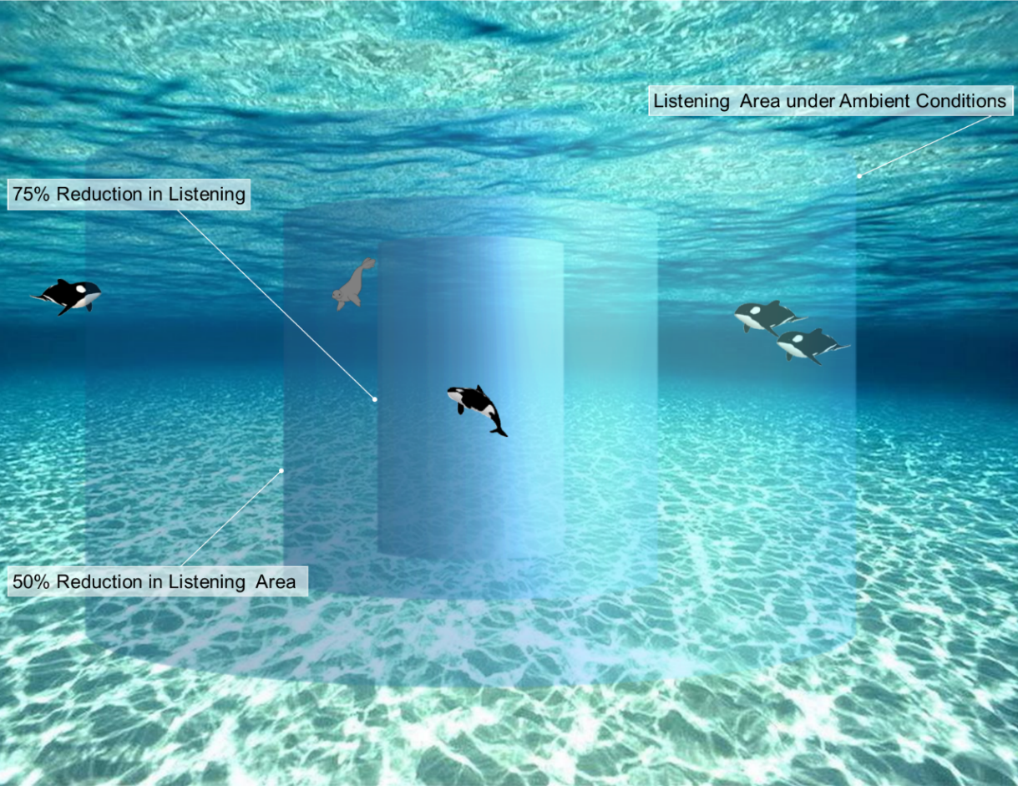
Figure G-1. Schematic representation of changes in listening area around a marine mammal.
Under ambient conditions, an animal may be able to listen to conspecifics, as well as predators and preys. When the noise level increases, the listening space area is reduced. (Figure adapted from NPS 2010.),,
The remaining fraction of the listening area due to an increase in noise level can be calculated without prior knowledge of the signal source level and detection distance by approximating the transmission loss (TL) as:
. (
16)
The maximum detection distance of the signal (R_{o}), associated with a source level, SL, will result in a received level RL_{o}:
. (
17)
The maximum detection distance (R) associated with an increase in noise level will result in a received level (RL):
. (
18)
The remaining fraction of listening area after an increase in noise level is therefore:
. (
19)
where Δ is equal to the increase in noise level, in dB. Results are presented in fractions (percentage) of the listening area that is left after an increase in noise level.
This concept was applied by Barber et al. (2010) to terrestrial organisms, but to our knowledge, this concept has not yet been applied to marine animals. Unlike the assessment of communication space, the assessment of change in listening area does not required prior knowledge parameters such as the signal source levels, detection thresholds based on the receiver perception capabilities, signal directivity, noise and signal duration, and band-specific (spectral) noise levels. This assessment can be done for specific frequency bands, or by taking into consideration the animal’s auditory system and applying a relevant filter to the noise level.
This equation is expected to overestimate the reduction in listening area in the majority of cases, where the transmission loss (TL) is better estimated by an equation of the form:
. (
20)
N at can be estimated at sites of interest by curve fitting the modelled TL from the receiver at ranges ≤ 75 km. The noise level increase, Δ, is the difference between the estimated ambient level and L_{eq} or between two alternatives being compared. The approach considers the additive nature of ambient noise to L_{eq} in decibel space (for example, if L_{eq} and ambient levels were equal, then Δ would be 3 dB). While that may seem counterintuitive, recall that the decibel sum of two equal sound levels is their individual value plus 3 dB.

Communication space
A communication space assessment considers the region of ocean within marine fauna can detect calls from conspecifics. Masking can be defined as a reduction in communication space (active acoustic space) that an individual experiences due to an increase in background noise (ambient and anthropogenic) in the frequency bands relevant for communicating. Reductions in communication space due to anthropogenic sounds cannot be determined based on the broadband cumulated sound exposure level, because the effect depends on the spectral noise level within the frequency band of the sounds in question and therefore varies dynamically with receiver distance from the sound (noise) source. To estimate the communication space quantitatively, it is necessary to account for parameters such as call source levels, detection thresholds based on the receiver perception capabilities, signal directivity, band-specific (spectral) noise levels, and noise and signal duration.
The communication space can be estimated using a similar approach to that employed by Clark et al. (2009). This can be focused by applying the analysis in either a single or representative 1/3-octave-bands, rather than to broadband levels. This approach is based on a form of the sonar equation that considers the maximum distance an animal can detect a signal in the presence of masking noise. The form of the sonar equation employed is:
. (
21)
The signal excess (SE) is the signal excess above detectability. The source level (SL) is the animal call source level. Transmission loss (TL) is the acoustic transmission loss between the calling and listening whales (a function of the distance of their separation). The noise level (NL) in the same frequency band as the source level. The detection threshold (DT) of the animal represents the amount above ambient level the sound must be in order for it to be detected. The directivity index (DI) represents the animal’s ability to discriminate sounds coming from a specific direction, in the presence of masking noise arriving uniformly from all directions. The signal gain (SG) indicates the animal’s ability to use its knowledge of the time-frequency structure of the call to differentiate it from background noise.

Method for computing zone of audibility
Typically, modelled areas of ensonification show the estimated absolute sound levels from the modelled sources but do not represent areas where animals can hear the sounds. If sound levels from a noise source are lower than the ambient underwater noise level or fall below the hearing threshold of an animal, that animal will not hear that sound and will not react unless the disturbance is also non-acoustic (e.g., visual). Regions where sound levels were greater than ambient noise and species-specific audiograms, referred to as zones of audibility (ZOA), indicate areas where an animal may detect noise from the modelled sound source.
ZOAs are typically computed where an animal was assumed to detect noise only if the SPL exceeded the ambient noise and the audiogram in any 1/3-octave frequency band. This assumption is typically conservative since, audibility is computed over all modelled frequency bands, ambient noise was the lowest 5th percentile of measured levels, and SPLs used are normally the maximum over all modelled depths.
This can be computed for all marine fauna with known or estimated audiograms.

Underwater acoustic measurement
It has been recommended that international standards be developed for the measurement, modelling and data storage of ambient noise (Dekeling et al. 2014c). While standards for the measurement of radiated sound from ships and impact pile driving are under development by ISO (deep water vessels standard (ANSI/ASA S12.64/Part 1 R2014 2009), standards for the measurement of radiated sound from important sources such as airgun arrays and underwater explosions are also recommended (Dekeling et al. 2014c).
No standards or formal guidelines exist for equipment, methods, or reporting in relation to monitoring programs. NOAA has produced guidelines for those involved in monitoring for mitigation programs (Lecky and Basta. 2008). Mitigation in this context is defined as being ‘designed to minimise or document impacts from noise upon marine mammals’. The guidelines serve to aid in the development of PAM plans and to promote consistency across NOAA PAM plans. These guidelines serve as recommendations for general procedures, system requirements, and reporting needs in planning or designing PAM. They recognise the case-by-case nature of PAM planning and design, and provide recommendations for a minimum set of procedures and system requirements. Detailed guides or recommendations have been published by other organisations (e.g. Dekeling et al. 2014c, Robinson et al. 2014), and are valuable contributions to understanding the field.
This section presents a summarised leading practice overview of methods according to the experience of the authors and JASCO Applied Sciences in general. It is highly recommended that the aforementioned guides be read for background information, and the intention of this document was to avoid duplication. While the authors and JASCO Applied Sciences in general agree with many of the aspects presented in other guides, some of the recommendations in this section may differ. This section was not designed to provide an instruction manual for non-experts to carry out measurement programs as underwater acoustic measurements are complex.

Data representations
Standardised representations of data should include:
- Percentile plots (1-minute average) of 1/3-octave band levels and power spectral density
- SPL in several frequency bands (decade or other relevant bands)
- Power spectral density spectrogram of measured sound levels
Cumulative distributions of SPL and SEL (per period of interest, or day) and box plot representations are also valuable inclusions.
New methods of representing contributors to the environment are emerging through the field of ecoacoustics.
Percentile Statistics
The sound level statistics can be presented by one of two conventions in common use: percentiles or exceedances. The convention being used must be clearly stated.
The percentile convention is to present the statistics such that the nth percentile level (Ln) is the SPL or SEL below which n% of data falls, such as:
- Lmax, the maximum recorded sound level
- L95, the sound level which the data is below 95% of the time
- L75, the sound level which the data is below 75% of the time
- L50, the median sound level
- L25, the sound level which the data is below 25% of the time
- L5, the sound level which the data is below 5% of the time
The exceedance convention is to present statistics such that the nth percentile level (Ln) is the SPL or SEL exceeded by n% of the data, such as:
- Lmax, the maximum recorded sound level
- L5, the sound level exceeded 5% of the time
- L25, the sound level exceeded 25% of the time
- L50, the median sound level
- L75, the sound level exceeded 75% of the time
- L95, the sound level exceeded 95% of the time
Also, the mean sound levels (Lmean) as the linear arithmetic mean of the sound power, should be computed, which can be significantly different from the median sound level (L50).

Baseline / ambient
The importance of ambient monitoring programs, and the information that can be obtained from the is contained in both peer reviewed (e.g. Cato 1997, Curtis et al. 1999, Andrew et al. 2002, Dahl et al. 2007, Cato 2008, Hildebrand 2009, Martin 2009, Bassett 2010, Carey and Evans 2011, Chapman and Price 2011, Vračar and Mijić 2011, Klinck et al. 2012, Roth et al. 2012, Hannay et al. 2013, Martin et al. 2013, Merchant et al. 2015, Erbe et al. 2016) and grey literature (e.g. Shell Development (Australia) Pty Ltd 2009, Erbe and McPherson 2011, Erbe et al. 2011, McCauley 2011, McPherson et al. 2012, Delarue et al. 2014, McPherson et al. 2014, Delarue et al. 2015, Salgado-Kent et al. 2015, McPherson et al. 2016a).
A derived summary of ambient noise measurement from Robinson et al. (2014) is provided as a case study.
Summary: Ambient noise measurement
- Ensure that the objectives of the measurements are clear and that the monitoring and deployment configuration is appropriate for those objectives
- Ensure that the temporal sampling regime is appropriate for the objectives, and that the duration and duty cycle are appropriately chosen
- Ensure that the spatial sampling regime is appropriate for the objectives, and that the locations of monitoring stations are appropriately chosen
- Ensure that the instrumentation is correctly specified for the application (for example, in terms of frequency range, dynamic range and self-noise)
- Ensure the deployment minimises measurement artefacts and pseudo-noise
- Document and justify choice of data analysis methodology in terms of:
  - Metrics – arithmetic mean and exceedance percentiles are recommended
  - Statistical representation of data – representing dispersion of data by use of analysis such as box-plots, and cumulative distributions
  - Anthropogenic activity (if required)
  - Marine fauna presence (if required)
- Specific representations should include at a minimum:
  - Percentile plots (1-minute average) of 1/3-octave band levels and power spectral density
  - SPL spectra in several frequency bands (decade or other relevant bands)
  - Power spectral density spectrogram of measured sound levels
- Record all relevant auxiliary data and metadata including data which may correlate with acoustic data (ship traffic data, weather data, etc.).

Long-term studies
A leading practice long-term ambient characterisation program will quantify the following:
- Total ocean noise, which will include the quantification of contributions from geophony related sources (wind, waves etc.)
- Daily contribution per anthropogenic source, compared to total sound levels.
- Detections per hour and per day of sources such as:
  - Vessels
  - Construction activities
  - Geophysical surveys
- Presence of fish and invertebrates, including fish chorusing events.
- Detector performance statistics.
Programs can have many goals, as outlined in the literature referenced above. These can include:
- Defining the temporal extent of migrations and species presence
- This includes approximating any migration routes (if possible) and timings
- Refining information about the vocalisation characteristics of species in the area
- Localisation and tracking of marine mammals

Program design process
Consideration of the aims of the program is essential part of the design process. To ensure the success of a program regardless of scope, the following are important considerations.
- Compilation and analysis of all relevant environmental data, including currents, bathymetry and sound speed profiles. These parameters generally have quite strong influence on ambient noise.
- Expert opinion and/or modelling to assist in determining optimal recorder locations, considering items such as:
  - accounting for the expected ambient noise conditions (natural and anthropogenic) – calculate the listening/detection ranges of each recorder
  - accounting for vocalisation signal-to-noise ratios required for detection
  - expected movement areas for marine mammals
  - shipping lanes
  - optimisation analysis to determine best recorder placements
- Mooring designs and modelling of mooring performance using environmental data.
- Recorder configuration design (duty cycle configuration, sampling frequency).
- Determination of the timing of the program, and the length of deployments

Program duration
The monitoring program should be designed to characterise the soundscape for a relevant period. If the information will be used to inform impact assessments that consider the entire year, or multiple years, due to the scale of activities, such as for an LNG terminal, then the monitoring program should be at least one year in length, like many of the reports referenced at the start of this section.
If the activities are of a smaller scale, then the monitoring program can be adjusted to suit. An example of this is the NMFS guidance document (NMFS 2012a) which recommends three 24 h periods of monitoring in the appropriate season, however the goals of this work are specific to only quantifying the ambient noise with relevance to a short term activity, not conducting a detailed soundscape characterisation program.
Seasonality of the program is important–characterising the soundscape during the wet season will lead to different results than if it was conducted in the dry season. Therefore, programs should be conducted in the season that the work will be conducted in. The planning aspect of ambient work programs of length can be difficult for proponents, however are possible it realistic timelines are considered as part of the EIS process, with many operators finding it possible to achieve.
The length of the monitoring program should be decided through an analysis of the goals the program is required to achieve, existing information, and the length of any development activities that the program is relevant to.
Short term programs related to small scale specific events, such as pile driving for a small jetty, are valid, if the only item of interest is characterising the 'total ocean noise' component, which can then be used to assist in the assessment of impacts. This is similar to that outlined in (NMFS 2012a), which is characterising background sound relevant to marine mammals.
Regardless of the activity duration, multiple, single point measurements of short duration, conducted seasonally, is not an appropriate measurement technique, and not considered acceptable leading practice. There are examples of this being conducted in association with Gladstone Harbour monitoring programs.

Factors for consideration
The design of programs should consider the following factors at a minimum:
Current
Understanding the current patterns, depth stratification, and speeds is essential to designing and deploying the correct mooring that minimises the impact of flow noise on recordings. Flow shields should be installed over the hydrophones.
Impact: Not considering currents could cause the mooring to contribute significant self-noise to the recording, particularly below 1000 Hz.
Bathymetry / Sea floor
Bathymetry variations between the sound source and hydrophone can block sounds from reaching the measurement hydrophones. Placement of hydrophones on bathymetric hilltops (if sufficiently deep) can mitigate this potential issue. Understanding the sea floor ensures that the mooring designed will work on the seabed at the site – certain moorings are not suitable for areas covered in coral heads.
Sound Speed Profile
Sound speed profiles can cause propagation effects such as sound channelling and acoustic shadow zones. The effect of local sound speed profile should be investigated through computer modelling to predict potential effects of acoustic refraction in choosing optimal recorder monitoring station locations.
Existing soundscape
The soundscape will vary with proximity to reefs, rivers or other physical oceanographic features that affect the propagation of natural sounds, such as from weather events, and of anthropogenic sounds.
Marine fauna detectability
The placement of the recording stations affects the ability to detect marine fauna. Water depth, animal calling depth, animal call amplitude and call frequencies, proximity of shoals, and in-water acoustic refraction effects should be considered when choosing optimal deployment locations.
Equipment
All equipment, including hydrophones and related recorders, or software if relevant, needs to be calibrated and the performance systematically measured and optimised. This includes characterising the sensitivity.
The equipment must also be able to record the frequency bandwidths of interest for the particular activity, species or ambient environment. An example of this is sampling at a lower frequency, such as 48 or 64 kHz to quantify the majority of ambient noise energy density in the ocean. This bandwidth will capture most of the spectrum of shipping and recreational vessel traffic noise, and it will detect vocalisations from most of the cetacean species expected to occur in the World Heritage Area. This band also covers frequencies used by most crustaceans and fish that generate sound. In order to record echolocation clicks for all species, recording at higher frequencies such as 250 kHz, is recommended.
Recording station placement
To achieve the determination of whale presence and/or habitat health it is recommended that the utilisation of recorders inside and outside any particular area of interest be considered to allow a comparison of detections and soundscape statistics on recorders inside and outside the area of interest to be conducted, thus providing a better understanding of the area of interest.
Operational proximity
The ambient noise environment is strongly influenced by anthropogenic contributors. For long-term programs consistency of recorder placement is essential. The ambient noise environment near the ports, shipping lanes or construction activities will change, with vessels increasing ambient levels, and therefore reducing detection ranges. Recorder placement should consider the possibility of modified ambient noise levels due to introduced anthropogenic sound.

Terminology and background
There is a wide range of passive acoustic recorders available, not all have the ability that to achieve that expected of leading practice programs. The most recent extensive review of underwater recorders is contained in Sousa-Lima et al. (2013), although the quality of commercial acoustic recorders is constantly improving. The following key factors require consideration when selecting the equipment for a program:
- Sensitivity
  - Sensitivity of an acoustic recording system is a measure of the voltage output of a system in terms of the acoustic pressure. For example, for a hydrophone, the sensitivity is equal to the voltage output divided the acoustic pressure. A measure of the maximum sound level that can be recorded without clipping or distortion is the overload point, i.e. the upper limit of the dynamic range of the system. The sensitivity of a hydrophone should remain close to the sensitivity measured at deployment over the entire deployment. Changes in sensitivity must be accounted for.
- Noise floor
  - High noise floor significantly reduces the detection ability of the recorder, and thus the listening area. Below sea state 0 noise is essential.
- Data resolution
  - The resolution of the recording system, in terms of the analog to digital converter, is important, and the greater effective bits, the higher the quality of the recording. 24-bit is the typical resolution with most professional recorders, and these will typically provide at least 16 effective bits.
- Recorder self-noise
  - The system self-noise is a key parameter and this information should be supplied. High self-noise can originate from poor choice of hydrophone and amplifiers, or from pick-up of electrical noise generated by the electronics and data storage system (the latter can sometimes generate electrical spikes which are recorded as spurious signals).
  - The self-noise floor of the recording system should be compared with the lowest spectral level measured in the field to illustrate that the reported levels are not limited by equipment performance.
- Mooring self-noise
  - Mooring self-noise, or Pseudo-noise as it is known, is caused by signals originating from the deployment method for the hydrophone /recorder and its interaction with the surrounding environment (e.g. current, wave action, etc.). Considerations for fixed moorings include flow noise, cable strum, and sound reflection.
- Flow noise
  - Flow shielding, even to the point of specialised bottom moorings with dual hydrophones, one protected for each part of the tidal cycle.
  - Minimise mooring motion from current drag. Motion causes flow noise that can occur even in very modest currents due to vortex shedding.
- Cable strum
  - Anti-strum wires if vertical moorings used.
- Sound reflection
  - Mount hydrophone(s) away from surfaces that could cause unwanted reflected sound. Recommend flow shielding and mechanical isolation minimise noise from natural current flow and any residual mooring motion.
- Flexible duty cycle configurations per period/channel
  - To maximise the value of the recording equipment, being about to operate different recording duty cycles either over time (from continuous recording to just sleeping, and anything in-between), or on different channels (e.g. one channel continuous, one channel cycling), adds significant value.
- Calibration
  - The recorder should be supplied with a full system calibration including all information required to determine the absolute levels of the measured data (including hydrophone calibration, amplifier gains, ADC scale factors, etc.). Calibrations should be traceable, and a check with a calibrator, such as a pistonphone, should occur immediately prior to and after a deployment.
- Multiple channels
  - Multiple channel recording allows single channel to be dedicated to shipping or mysticetes, while having another sampling at much higher rates on a duty cycle for odontocetes.
  - Multiple channels can also be used to increase the dynamic range of the system, and allow for a less sensitive channel/hydrophone to be used to accurately quantify close range anthropogenic sources while still conducting a valid ambient program.
- Sampling frequencies
  - The equipment must also be able to record the frequency bandwidths of interest for the particular activity, species or ambient environment.
- Storage capacity
  - Storage capacity can decide the duty cycling/sampling frequency/deployment period, the greater the capacity for storage, the less it is a consideration.
- Power draw / battery flexibility
  - Similar restrictions to storage capacity. Lower power draw is ideal, allows for long periods of operation. The ability to be flexible and add battery capacity / external power as required allows it to become less of a consideration
- Hydrophone/non-acoustic sensor flexibility
  - Flexibility to add different hydrophones / external non-acoustic sensors as required can increase the value of the recorder. The ability to change either the model or number of hydrophones easily increases the flexibility of the recorder.
- Timing accuracy
  - Time drift is a consideration, as the smaller or more consistent the clock drift, the greater the ability to correlate data between stations, or potentially achieve localisation. The clocks used in the recorders should be of a quality that they do not have significant drift, or at least significant differential drift between different recorders.
  - Methods for reducing clock drift can include:
    - PLL calibration.
    - RTC calibration.
  - Chip Scale Atomic Clocks have been shown to reduce the measured clock drift at 5 degrees Celsius to 132 µs per week (0.0194 ms per day or 0.000218 ppm). According to the data sheet, the aging of the CSAC is less than .0003ppm per month, however it is recommended to use the measured values at present.

Marine mammal detection performance statistical measurement
In order to provide details that would allow the program to be assessed for scientific rigour, the performance of all detectors used in the scope of work should be evaluated during the reporting process. This is because the detection performance will depend on the signal-to-noise ratio of the marine mammal vocalisations and the ambient environment. Detectors can be designed to maximise either precision or recall, based on requirements. Detector performance is typically evaluated based upon their precision, recall and F-score.

Examples

Total ocean noise
Quantify the total ocean noise levels at a 1 Hz frequency resolution, averaged to produce sound pressure density values for each 1 Hz step of the recorded bandwidth over each minute of recording. Analysis should also be conducted in at a minimum 1/3-octave and decade bands.
Example results for a single monitoring station from McPherson et al. (2016a) are provided below for reference. Results from a single station are presented to assist in comprehension. Included are received sound levels (Figure H-1), 1/3-octave-band SPL and exceedance PSDs (1-minute average) (Figure H-2), and distribution of sound exposure levels (SELs) (Figure H-3).
Figure H-1. Broadband and decade-band sound pressure levels (SPL) (above), spectrogram of underwater sound (below) (McPherson et al. 2016a). © JASCO
Figure H-2. (Above) 1/3-octave-band sound pressure levels (SPL) in quartiles. (Below) Quartile 1 min exceedances and power spectral density levels. Dashed lines are the limits of prevailing noise from the Wenz curves (McPherson et al. 2016a). © JASCO.
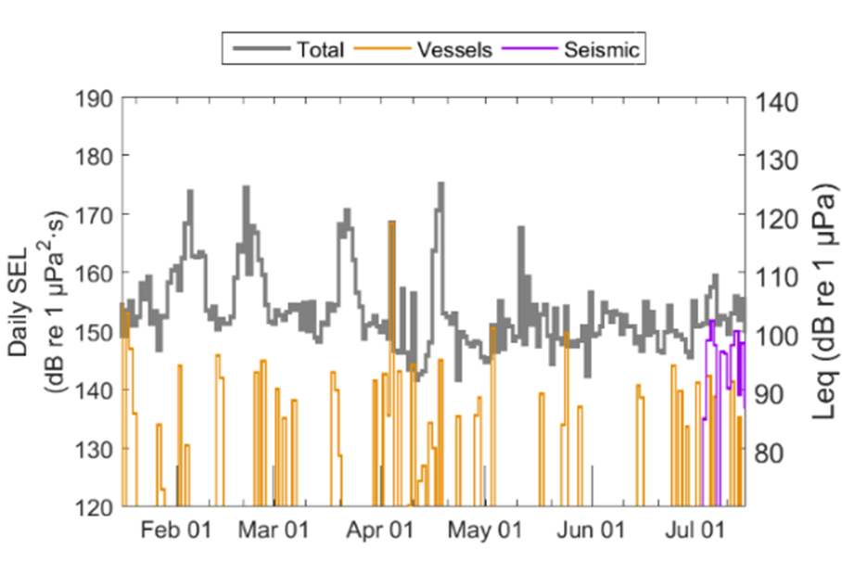
Figure H-3. Daily cumulative sound exposure level (SEL (24 h)) distributions.
The data are divided into total, shipping, and seismic classes (McPherson et al. 2016a). © JASCO.

Vessel detections
Shipping detections are important for understanding the contribution of the most predominant anthropogenic sound source to the ocean soundscape. Detectors are often based around examining the SPL in a frequency band relevant to shipping, counting the number of shipping tonals in the data, and comparing the SPL in the shipping band to the total SPL. The results can be meaningfully presented on a per-hour basis, as shown in the example in Figure H-4 from Delarue et al. (2015).
Figure H-4. Vessel detections each hour (vertical axis) versus date (horizontal axis) at eight stations—B5 to WN80—25 Jul to 23 Oct 2014.
The grey areas indicate hours of darkness. Vertical dashed lines indicate AMAR deployment and retrieval (Delarue et al. 2015). © JASCO.

Marine mammals
If marine mammals are of interest to the ambient program, then the detections of the whales present in the area, based on the number of detected vocalisations, should be presented. Where possible, detections should be based upon a combination of manual analyses and automated detector/classifiers. If not possible to apply automated techniques, manual analysis only should be used.
The results of marine mammal acoustic occurrence at each recording station should presented as the daily proportion of sound files / hours with manual detections for each species. Species-specific detections should be described using the daily average number of automatic detections corrected by performance indicators, or the sum of call counts per period. Automated detections should be compiled based on manual detection results, i.e., automated detections for a given file should only be counted only if a call was manually detected within that file/time period for a given species. The corrected numbers of automated detections more closely represented the actual number of vocalisations for a species. Call counts can then be averaged over periods that reflect temporal trends in detections, and subsequently mapped.
The influence of ambient noise on whale detections can also be conducted, and is recommended for examining the influence of any anthropogenic activity on detections. This analysis should be conducted statistically, but graphical representations also assist.
Examples from Delarue et al. (2015) are provided for context, showing mean daily detections per station (Figure H-5), daily detections based upon manual analysis results (Figure H-6), and whale call counts and broadband SPL (Figure H-7). Other recommended inclusions are detection results based on automated detections (Figure H-8), included from other JASCO work, and example vocalisations of the whale species being discussed (Figure H-9), from the monitoring program at Wheeler Reef described in (MacGillivray et al. 2014b).
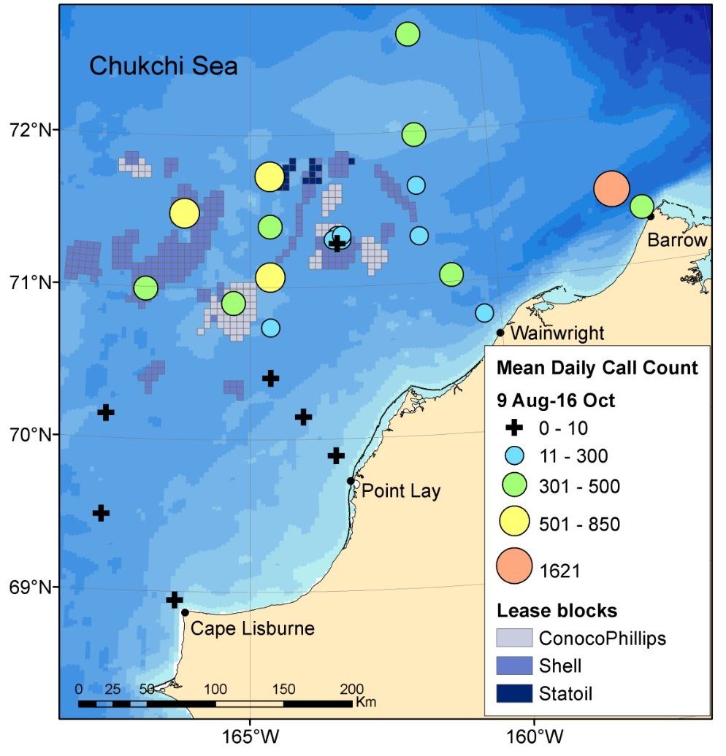
Figure H-5. Mean daily bowhead whale call counts
(calculated as the sum of automated call detections in all files with manual detections divided by the number of active recording days) for 9 Aug to 16 Oct at all summer 2014 stations in the northeastern Chukchi Sea (Delarue et al. 2015). © JASCO.
Figure H-6. Summer 2014 daily bowhead call detections in the northeastern Chukchi Sea
: Daily proportion of sound files with call detections based on the manual analysis of 5% of the acoustic data recorded late July through mid-November 2014. Forty-eight sound files were recorded each day. Vertical red dashed lines indicate record start and end. Stations are ordered from (top) northeast to (bottom) southwest. Stations without call detections are omitted (Delarue et al. 2015). © JASCO.
Figure H-7. Time series of daily bowhead whale call counts and broadband SPL (from top to bottom) at PLN40, CLN120, B15, and W30 (Delarue et al. 2015). © JASCO.
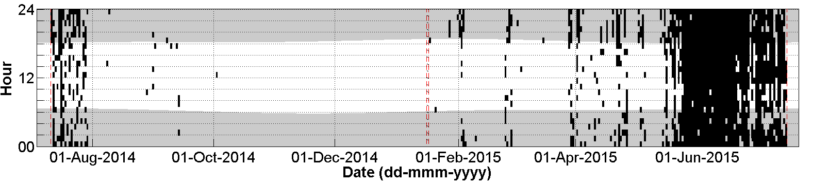
Figure H-8. Hourly (expressed as an index) and daily presence of automatically detected Omura’s whales at a single acoustic monitoring station in the Timor Sea (McPherson et al. 2016a) © JASCO.
Presence of automatically detected calls normalised on a 1 h basis. The grey areas indicate hours of darkness from sunset to sunrise (Ocean Time Series Group 2009). The red dashed lines indicate the start and end of recording time.
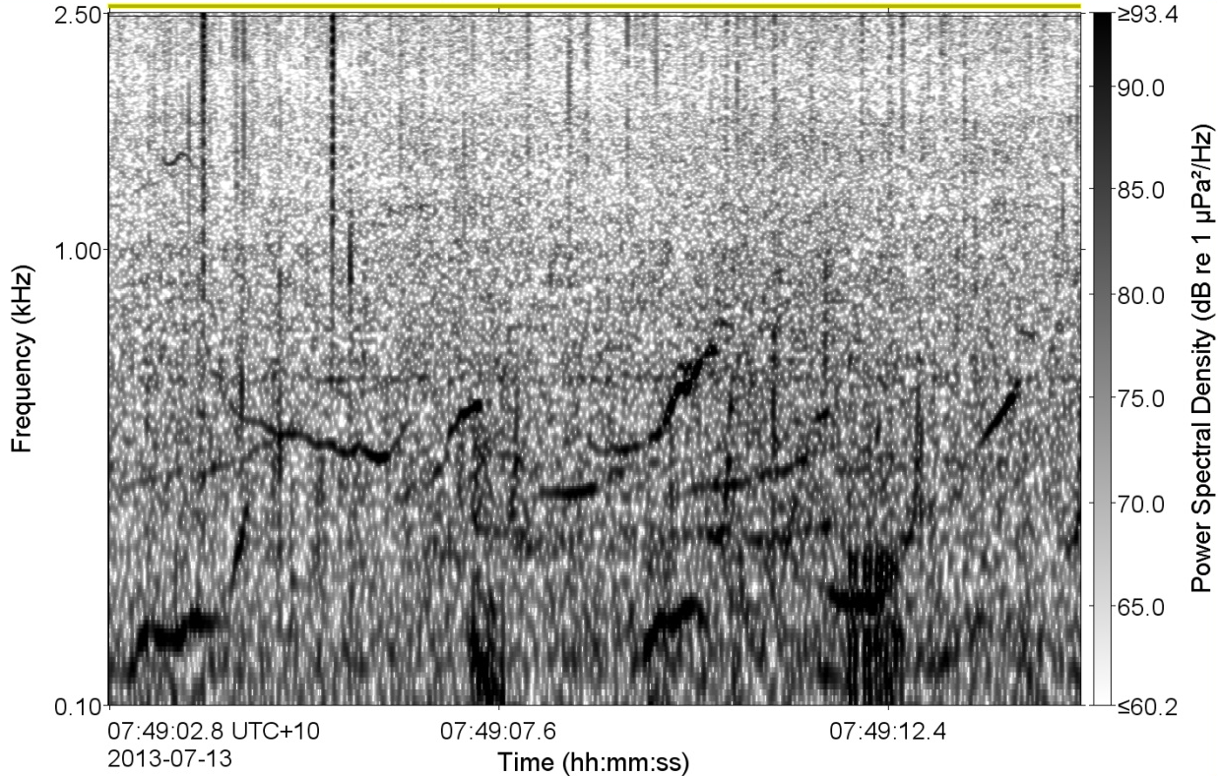
Figure H-9. Spectrogram of humpback whale vocalisations recorded at Wheeler Reef.
(3.91 Hz frequency resolution, 0.1 s time window, 0.01 s time step, Hamming window). © JASCO.

Ambient / marine mammal reporting
The example Report and Appendix outlines of a comprehensive report that proponents could submit are provided below. These have been derived from detailed publicly available reports submitted by JASCO, including those from the ConocoPhillips, Shell, and Statoil sponsored Northeastern Chukchi Sea Joint Acoustic Monitoring Program (Delarue et al. 2010, Delarue et al. 2011, Delarue et al. 2012, Delarue et al. 2013, Delarue et al. 2014, Delarue et al. 2015).

Report outline
1. Introduction
1.1. Objectives of the Acoustic Monitoring Program
1.2. Overview of Marine Mammals Results
1.3. Recorder Deployments
2. Methods
2.1. Data Acquisition
2.1.1. Acoustic Recorders
2.1.2. Current Recording Period
2.2. Data Analysis Overview
2.2.1. Acoustic Metrics
2.3. Manual Data Analysis
2.3.1. Manual Analysis Protocol
2.3.2. Analysis Validation
2.4. Automated Data Analysis
2.4.1. Total Ocean Noise and Time Series Analysis
2.4.2. Vessel Noise Detection
2.4.3. Seismic Survey Event Detection
2.4.4. Generic Marine Mammal Call Detection
2.4.5. Odontocete Whale Call Detection
2.4.6. Specific Whale Detection
2.4.8. Detector and Classifier Performance Evaluation
3. Results
3.1. Received Ocean Sound Levels
3.2. Seismic Survey Event Detections
3.3. Vessel Noise Detections
3.4. Marine Mammal Call Detections
3.5. Fish and other marine fauna
3.6. Environmental Data
4. Discussion
4.1. Received Ocean Noise
4.2. Marine Mammal Call Detections
4.3. Anthropogenic Activity
5. Conclusions
6. Abbreviations & Glossary
7. Literature Cited

Appendix outline
Appendix A. Automated Detection and Classification of Marine Mammal Vocalisations and Anthropogenic Noise
A.1. Introduction
A.2. Per Species Call Detection and Classification (repeat section for each species)
A.2.1. Step 1: Spectrogram Processing
A.2.2. Step 2: Contour Extraction
A.2.3. Step 3: Feature Extraction
A.2.4. Step 4: Classification
A.2.5. Step 5: Post-Processing
A.3. Performance Evaluation
A.3.1. Test Datasets
A.3.2. Performance Metrics
A.3.3. Precision and Recall
A.3.4. Signal-to-Noise Ratio
A.4. Call Count Estimation
A.5. Detector/Classifier Performance
A.5.1. Per Species
A.5.2. Summary
A.6. Probability of Detection by Manual Analysis
A.6.1. Manual Analysis Detection Probability
A.7. Vessel Noise Detection
A.8. Seismic Survey Detection
A.9. Notes on Spectrogram Processing
Appendix B. Ambient Noise Results
B.1. Analysis Methods
B.2.1. One-Third-Octave-Band Sound Pressure and Power Spectral Density Levels
B.2.2. Broadband and Decade-Band Sound Pressure Levels and Spectrograms
B.3.3. Daily Cumulative Sound Exposure Level
B.3.4. Vessel Noise Detection
Appendix C. Marine Mammal Detection Results
Appendix D. Estimating the Detection Range of (relevant species) Moans
D.1. Methods
D.2. Results
D.3. Discussion
Appendix E. Interpolation Techniques
Appendix F. Localisation Techniques
F.1. Source Localisation
References

Radiated noise sources
Radiated noise is the sound radiated by a specific source. This is distinct from ambient noise, which is the noise received from many indistinguishable sources.
The noise source in question could be a source such as a ship, a dredge, a development or a port. The noise of interest could be construction noise (for example, marine pile driving or drilling), or it could be noise radiated during operation. To characterise the noise radiated by the source, it is necessary to consider a number of factors as summarised in (Robinson et al. 2014):
- Frequency content
- Temporal variation
- Source directivity
- Near-field and far field
- Source level metrics including
  - Received level at a fixed location
  - Radiated noise level
  - Source level
Typically, a program relating specifically to the measurement of radiated noise sources is referred to as a Sound Source Characterisation (SSC) program if the source hasn’t been measured before, or a Sound Source Verification (SSV) program if the point is to verify modelled results.
The following section summarises information about key noise sources relevant to the World Heritage Area. For many of the sources, the following considerations, again expanded upon in Robinson et al. (2014) are below.

Temporal sampling
To characterise the source output as a function of time, measurements need to be undertaken for an extended period which covers the expected output variation of the source. This is best undertaken with an autonomous recorder at a fixed range. Examples of where this is useful includes:
- Port operations (Warner et al. 2013, 2014)
- Platforms such as drilling operations (Austin 2014, Austin and Li 2016)
- Pile driving (Martin et al. 2012a, Robinson et al. 2013)
- Levels from an operation received within an area of specific interest (Racca et al. 2015)

Spatial sampling
To empirically determine the propagation loss for deriving the source level of the source, essential for validating modelling results, sampling over a sufficient spatial scale is required. Leading practice is typically a series of autonomous recorders (acceptable minimum of 3) stationed along a linear transect from the source, simultaneously measuring the radiated noise along a transect. The specific positioning of these recorders should be defined to sample locations to span the expected distances of important sound level thresholds. The spacing of the monitoring stations horizontally should be logarithmic in distance from the source of interest. Examples of the outputs of such a program are presented in Appendix H.3.6.1 from Austin and Li (2016), and in Martin et al. (2012a), Robinson et al. (2013).
The deployment of multiple autonomous recorders is not always feasible, and in these scenarios, good practice should involve a combination of at minimum a single autonomous recorder with a mobile measurement platform. The mobile measurement platform, such as a small vessel, moves along a linear transect away from the source, stopping to measure at a number of ranges from the source. While conducting measurements from a mobile source, such as a vessel, considerations must be given to noise from the mobile source, and the measurement system used. This is addressed in detail in Robinson et al. (2014).
High flow environments require specialist techniques (Martin et al. 2013, Wilson et al. 2014).

Comparison with modelling results
To facilitate a comparison of the results with modelling performed, modelling using the measured results is recommended technique. Verification modelling is required to incorporate coefficients from the best-fit, empirical Transmission Loss (TL) curves to estimate the received sound levels at a grid of points surrounding the sound source. The total sound footprint for discrete time periods relevant to the source of interest can be determined using the following procedure:
- Use a source location, such as a pile driving location or a nominal position and heading for a vessel from time-stamped GPS logs.
- Assign an activity state to the source based on time-stamped logs.
- Look-up the appropriate activity-dependent, empirical TL coefficients from the collection of SSC results.
- Use the TL coefficients, the range from the source to each point in the computation grid to estimate the sound contribution at each grid point.
- Generate sound level contours from the grid of computed sound levels

Summary case study
A derived summary of an SSV or SSC from Robinson et al. (2014) is provided as a case study.
Summary: Radiated noise measurement (SSC or SSV)
- Ensure that the objectives of the measurements are clear and that the monitoring and deployment configuration is appropriate for those objectives
- Ensure that the source output metrics are appropriate for the objectives, and that the measurement configuration enables the chosen metrics to be derived
- Ensure that the instrumentation is correctly specified for the application (for example, in terms of frequency range, dynamic range and self-noise)
- Ensure the deployment minimises measurement artefacts and pseudo-noise
- If a source level is calculated, ensure that an appropriate propagation model is used which accounts for the relevant physical propagation phenomena
- Ensure that the measurements satisfy the requirements of the objectives such that:
  - the instrumentation is correctly specified for the application in terms of frequency range, dynamic range and self-noise
  - spatial sampling is appropriate to ensure far-field conditions and (if required) to provide an empirical check on propagation
  - the temporal sampling captures any variation in acoustic output using fixed (static) recording position(s)
- Document and justify choice of data analysis methodology in terms of:
  - Metrics – arithmetic mean and exceedance percentiles are recommended
  - Statistical representation of data – representing dispersion of data by use of analysis such as box-plots, and cumulative distributions
- Specific representations should include at a minimum:
  - Percentile plots (1-minute average) of 1/3-octave band levels and power spectral density
  - SPL in several frequency bands (decade or other relevant bands)
  - Power spectral density spectrogram of measured sound levels
- Record all relevant auxiliary data and metadata including data which may correlate with acoustic data (operations data, locations of sampling and source points, weather data, etc.)

Example report outline
The measurement and analysis of underwater noise from sources of interest such as vessels or pile driving requires a thorough understanding of basic acoustic principles and specific training in the use of the required instrumentation.
Typically, at the conclusion of a project, a final report is prepared. The final report should include:
- an introduction describing the project and its objectives
- a methodology section that describes measurement positions, measurement equipment, metrics, and the methods used to manage measurement data
- a complete report of measured data, including determination of the source levels
- a report of the performance of attenuation systems, if applicable (particularly for piling)
- modelling of the sound footprint, if applicable, to validate distances to thresholds
- a list of abbreviations and glossary
- an analysis of the data with respect to any specific orders from GBRMPA

Shipping

Individual ships
The ANSI standard measurement guidelines for vessels in shallow water is currently being developed. Until then, the deep water standard, (ANSI/ASA S12.64/Part 1 R2014 2009), should be utilised and adapted for specific scenarios. The placement of a single hydrophone system on the seafloor that the vessel transits past, and travels over or extremely close to during the transit, is the recommended methodology for shallow water (Figure H-10). A suggested approach distance is one ship length or 100 m. This type of bottom-deployed recorder may be suitable for measuring vessels or other similar sources in shallow water.
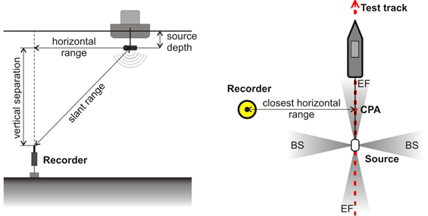
Figure H-10. Typical geometry of sound source characterisation (SSC) measurements and the associated terminology. Abbreviations: BS, broadside, CPA, closest point of approach; and EF, endfire. © JASCO.
Deep water vessel measurements should be carried out in accordance with standards for measuring noise levels of vessels. A relevant standard is ANSI/ASA S12.64/Part 1 R2014 (2009, R2014), which is designed for moving vessels. The standard provides some guidance here with three simultaneous hydrophone depths (Figure H-11). This could be augmented by adding hydrophones positioned at multiple distances from the vessel.
This standard forms the basis for ISO/PAS 17208-1:2012, Acoustics–Quantities and procedures for description and measurement of underwater sound from ships. Part 1: General requirements for measurements in deep water.
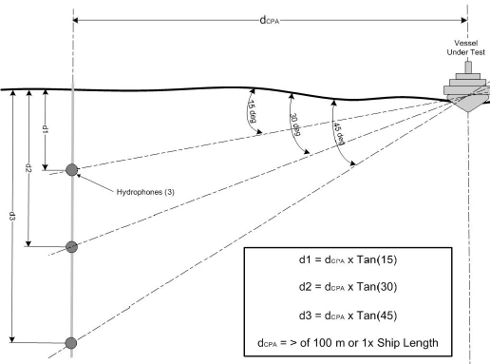
Figure H-11. Grades A and B hydrophone geometry. ANSI Standard (ANSI/ASA S12.64/Part 1 R2014 2009). Figure 1 reprinted from ANSI/ASA S12.64-2009. R2014/Part 1 Quantities and Procedures for Description and Measurement of Underwater Sound from Ships – Part 1: General Requirements, with the permission of the Acoustical Society of America, 1305 Walt Whitman Road, Suite 300, Melville, NY 11747
The characterisation measurements program should be designed to account for local environmental influences on sound propagation, including local bathymetry, seabed geoacoustic information and ocean sound speed profile. These parameters are not addressed in the vessel source measurement standard that focusses on emission levels measured close to the vessel.
The quantification of the impact of particle motion on fish is important. Recent publications (Nedelec et al. 2016, Simpson et al. 2016a, Gray et al. In Press) discuss the importance of the assessment occurring, and also that it occur properly. This is because the measurement of particle motion in any of its forms (acceleration, velocity, or displacement) is subject to a range of errors whose significance depends on the sound source and the environment in which it is recorded. Methodologies for measuring particle motion accurately and effectively are currently under investigation (e.g. Martin et al. 2016), however with sufficient knowledge of the field and techniques, the levels can be characterised. This is likely applicable to shallow water shipping lanes through passages in the Reef.
Reporting
Report all levels, received or source, as broadband levels, and provide spectral plots (1/3-octave and 1 Hz bands), and decade-band levels where appropriate. For the source levels, also provide 1/3-octave band tables of Monopole Source Level and Radiated Noise Level. Example reporting requirements are also provided in ANSI/ASA S12.64/Part 1 R2014 (2009, R2014).
The data should be presented as:
- Percentile or exceedance plots (1-minute average) of 1/3-octave-band levels and power spectral density for the recording period / period of characterisation
- SPL in several frequency bands (decade or other relevant bands)
- Power spectral density spectrogram of measured sound levels
- Broadband level vs range plots
- Plot of predicted source spectra–1/3-octave bands (MSL)
Examples from the characterisation of a stationary drill rig the Polar Pioneer (Austin and Li 2016) are provided for comprehension of what should be provided. These include examples of power spectral density (Figure H-12), SPL in decade bands (Figure H-13), source spectra in 1/3-octave bands (MSL) (Figure H-14), and level vs range plots (Figure H-15). An example compliant report outline is provided below.
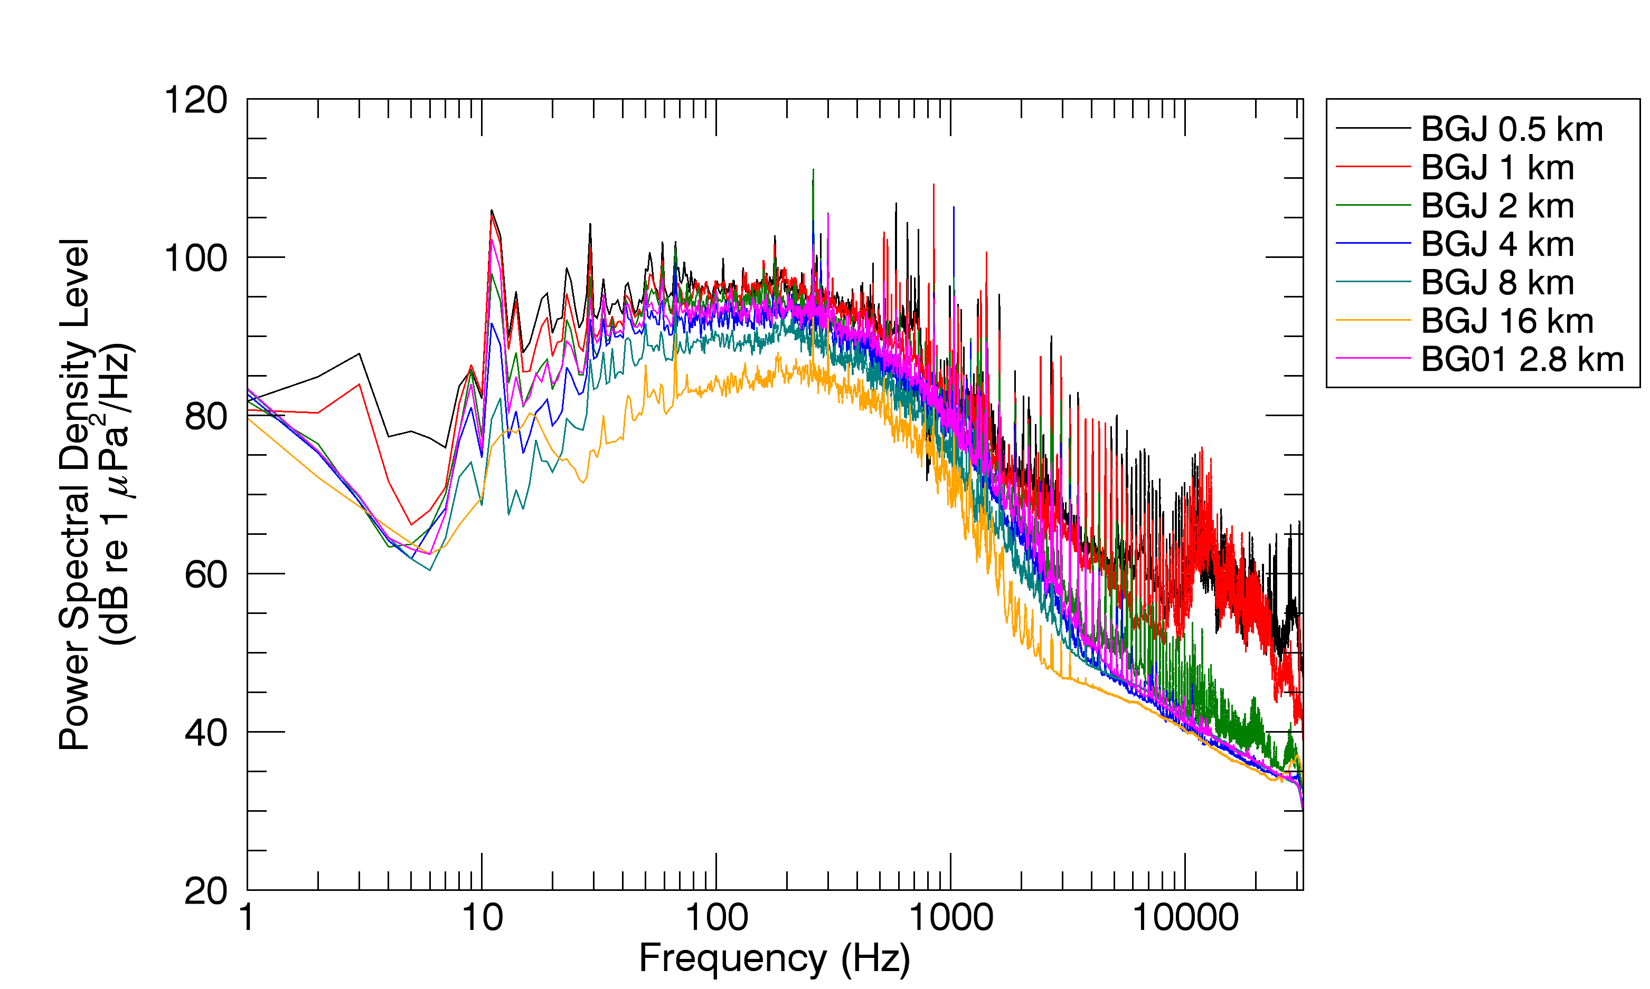
Figure H-12. Power spectral density at multiple distances from drillship operations in the Arctic. (Report Figure 3.13, Austin and Li (2016)). © JASCO.
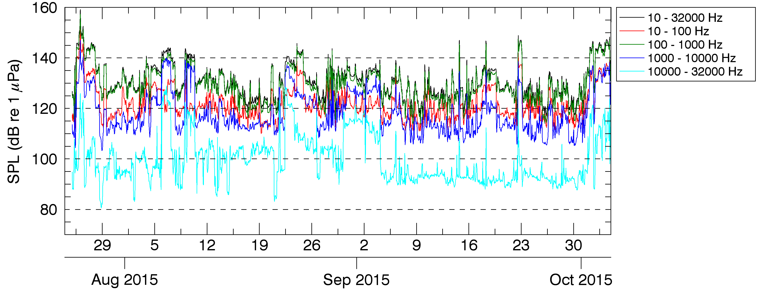
Figure H-13. Hourly SPLs in decade frequency bands (24 July to 4 October 2015 UTC) at 1 km (0.6 mi) from Shell’s Burger J drillsite in the Chukchi Sea. (Report Figure 3.6, Austin and Li (2016)). © JASCO.
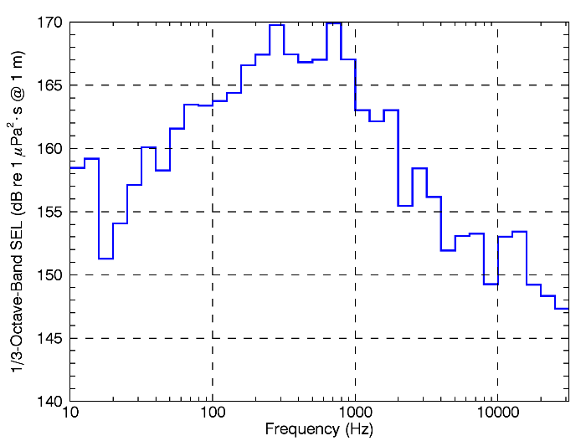
Figure H-14. 1/3­octave band source level for the Polar Pioneer drilling (Report Figure 3.15 Austin and Li (2016)). © JASCO.
(a) (b)
Figure H-15. SPL versus range recorded at seven ranges while the Polar Pioneer was (a) drilling and (b) involved in MLC construction (Report Figure 3.12 Austin and Li (2016)). © JASCO.

Large scale ship characterisation
An example program that characterises vessels on a large scale and in real-time, characterising every vessel entering and leaving the Port of Vancouver, is the Port of Vancouver Enhancing Cetacean Habitat and Observation (ECHO) (The Port of Vancouver 2016 ). The system is also able to detect and localise marine mammals, therefore the results are important for assessing marine fauna exposures to noise throughout the Salish Sea and for designing and testing possible vessel noise mitigation strategies. The system is also a proof-of-concept for the Draft ANSI Standard S12.64-200X Revision 11B Compliant Vessel Noise Measurements (Moloney et al. 2016).
This system acquires data using procedures conforming approximately with Grade C–Survey Method from ANSI/ASA S12.64/Part 1 R2014 (2009, R2014).
The system automatically determines source levels of all vessels passing over the recorders, using the Automatic Identification System (AIS) records from the vessel at the time of measurement and the acoustic data. This data is presented as:
- SPL spectra in 1/3-octave bands for Radiated Noise Level and Monopole Source Level (Figure H-16).
- Power spectral density (1 Hz bins) for the measurement window (Figure H-17).
- Power spectral density spectrogram of measured sound levels showing the acoustic Closest Point of Approach (CPA) and measurement window (Figure H-18).
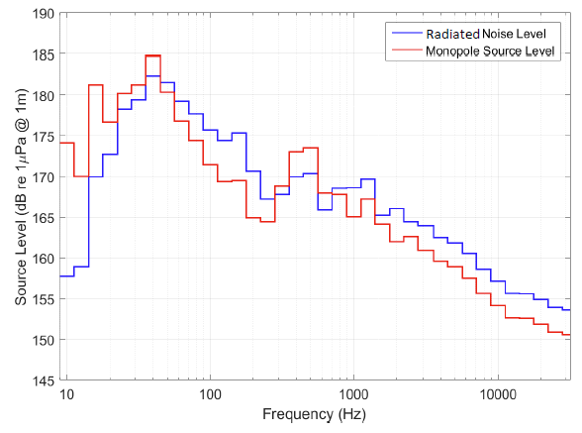
Figure H-16. Radiated Noise Level and Monopole Source Level of a container ship, 339 m in length, 46 m in breadth and with an 11.9 m draft travelling at an average speed of 20.1 kn. © JASCO.
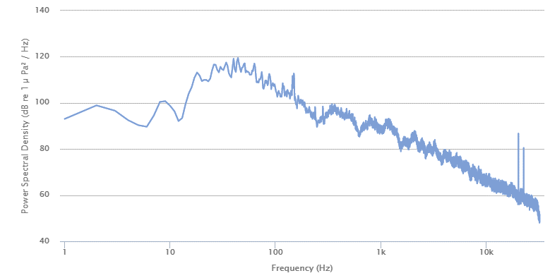
Figure H-17. Power spectral density (1 Hz bins) of a container ship, 339 m in length, 46 m in breadth and with an 11.9 m draft travelling at an average speed of 20.1 kn. © JASCO.
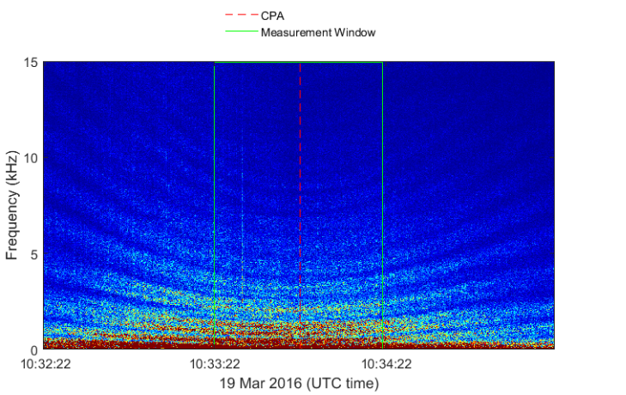
Figure H-18. Power spectral density spectrogram showing CPA and measurement window, of a container ship, 339 m in length, 46 m in breadth and with an 11.9 m draft travelling at an average speed of 20.1 kn. © JASCO.

Dredging
Refer to requirements for measurement of shipping, Section H.3.6.
The World Organisation of Dredging Associations (2013), based upon work done by others, including Robinson et al. (2011), recommends a single hydrophone deployed from a quiet vessel, buoy, or mounted on the seafloor at a minimal distance of one ship length from the dredger. Data should be collected while the dredge passes at a number of distances, or from a number of measurement positions from the stationary operating dredge. These measurements should be conducted at increasing logarithmic spaced distances from the dredge. The hydrophone positions should be monitored by GPS.
Methods similar to those in the ANSI standard (ANSI/ASA S12.64/Part 1 R2014 2009), which provides protocols and guidelines for the measurement of a moving vessel, are applicable and recommended.

Pile driving
An ISO Standard is currently under development for the ‘Measurement of underwater radiated sound from percussive pile driving’ (ISO/DIS 18406 Underwater acoustics). The timeline for this standard is unknown.
A number of measurement or characterisation guidelines exist for pile driving, including those from the California Department of Transportation (Buehler et al. 2015), National Marine Fisheries Service (NMFS 2012b). These include recommendations such as that the recording system should sample at a rate of at least 44 kHz, have a dynamic range of at least 80 dB, and meet numerous other specifications for precision professional data recording.
Pile driving measurements should follow the methods outlined in Sections H.3.1 and H.3.2. As recommended in Nedelec et al. (2016) and Popper et al. (2014), and demonstrated in MacGillivray and Racca (2006), Martin et al. (2016) and (Warner et al. 2017), particle motion should also be measured. This is likely to be most effective through an autonomous recording station (MacGillivray and Racca 2006, Martin et al. 2016).
Pile driving monitoring recorders should carefully consider sensitivity and hydrophone choice. Dual channel systems with different sensitivities are highly recommended, as demonstrated in Martin et al. (2012a).
Real-time systems are useful for instant level verification, and these can be either telemetered, or used from a mobile measurement platform. Buehler et al. (2015) recommends that if a real-time system is used, it must be able to measure in sequential one-second or shorter intervals, measure the linear (un-weighted) peak pressure accurately, and measure either the un-weighted (RMS) sound pressure level using the standard “impulse” time constant. In addition it should also quantify the per-strike SEL.
It is important to record the hydroacoustic data from a pile driving project so that subsequent detailed analyses of the signals can be completed. An accurate real-time measurement of the relevant metrics (SEL per strike, accumulated SEL, PK, SPL, time-weighted SPL) should be made. The data can be utilised for:
- Creating a library of source levels
- Validating or determining mitigation and monitoring range
- Determining the effectiveness of mitigation measures in the field

Sampling locations
Consideration of measurement sampling positions is critical for pile driving, and can include the following:
- Safety for the operator and instrumentation
  - Hearing damage is a concern for operator, or damage of instrumentation
- Consistency with other studies
  - Using a consistent reference distance such as 10m for all measurement programs (NMFS 2012b, Buehler et al. 2015)
  - This might have to sometimes be 20m due to mitigation systems (Buehler et al. 2015)
- Measurement positions as described in Sections H.3.1 and H.3.2
  - The minimum number of measurement locations to establish attenuation rates is three
- Measurement depth – depth of hydrophone in water column
  - Determined through consideration of typical depth of species of concern, effects of surface proximity or bottom on measurement.
  - Recommended to ensure avoid any measurements at depths of less than 1m
  - In water that is more than 1 metre deep and less than 3 meters deep, a single measurement at low-depth is appropriate to characterise hydroacoustic pressures in the water column (Buehler et al. 2015)
- In order to properly characterise the piling operations, and account for the Mach Cone effect, either a single measurement location at mid-water, or a location at mid-water and 1 m from the bottom are recommended. While some guides recommend a measurement location 1 m from the surface (Buehler et al. 2015), this is not considered to provide useful data.
- Environmental factors at the job site
- Pile driving scenario
- Meeting threshold requirements

Example program results
Examples from (Martin et al. 2012a) are provided below to demonstrate a number of the items discussed above:
- deployment location concepts (Figure H-19)
- variability in background noise levels and correlation with operations (Figure H-20 and Figure H-21)
- impact piling recorded simultaneously at multiple ranges, with and without mitigation systems operational (Figure H-22)
- vibratory piling recorded simultaneously at multiple ranges (Figure H-23)

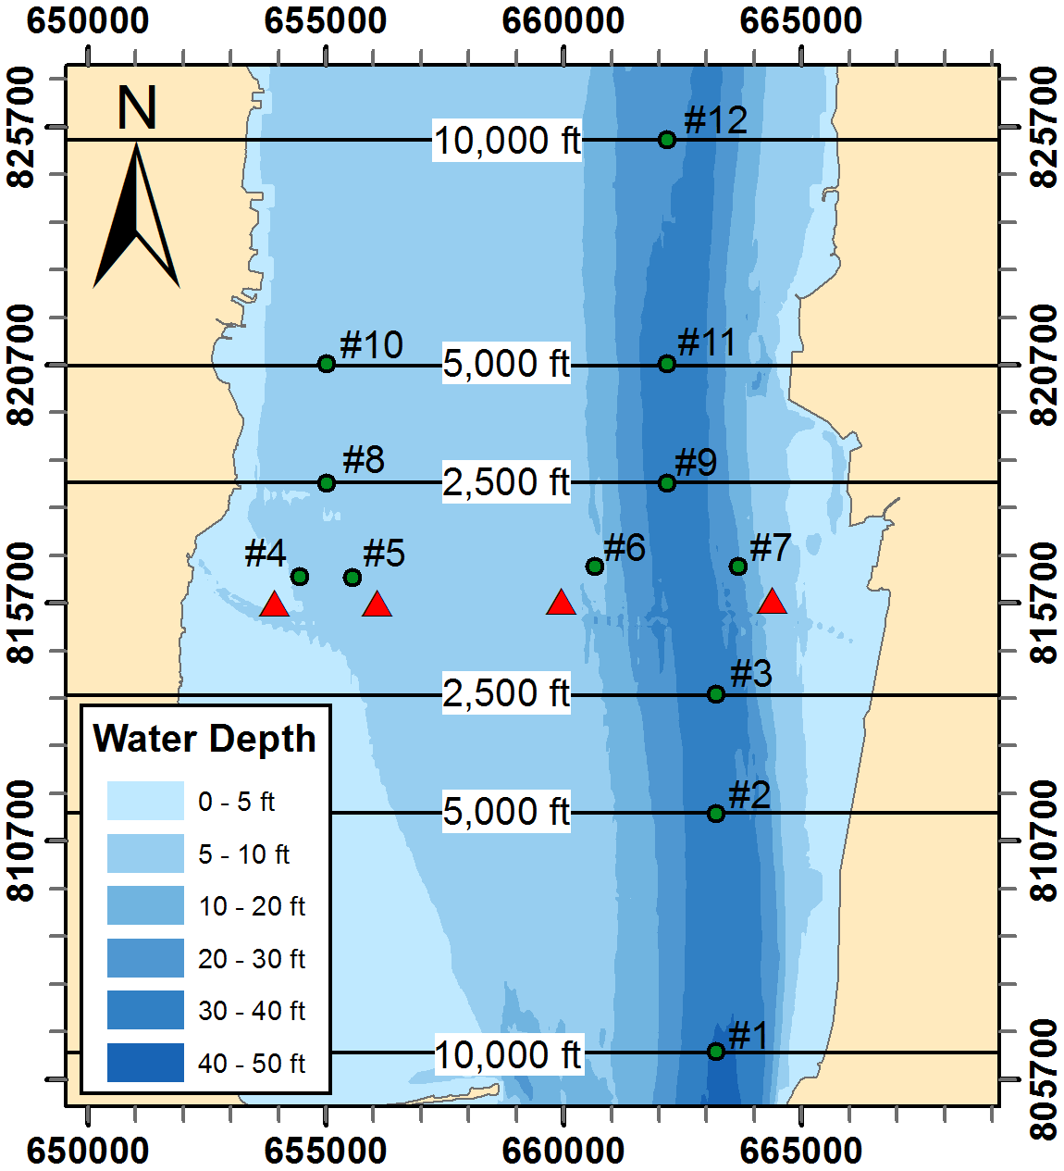
Figure H-19. AMAR stations (green circles) and pile locations (red triangles) in Tappan Zee Reach. Distances shown on the map are measured upriver and downriver from the test piles. Coordinates are NY State Plane East (NAD83). Figure 12 from Martin et al. (2012a). © JASCO.
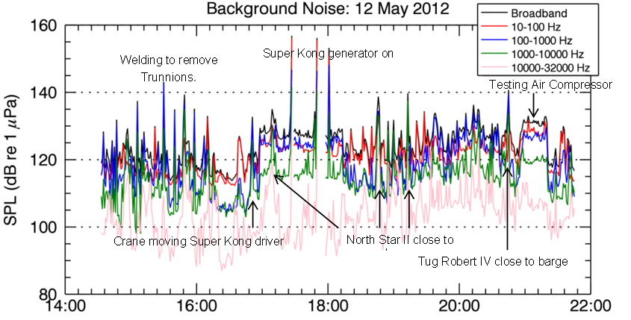
Figure H-20. Background sound levels during short-range monitoring at Test Pile 4A, 12 May 2012, annotated with events from JASCO logs. Figure 24 from (Martin et al. 2012a). © JASCO.
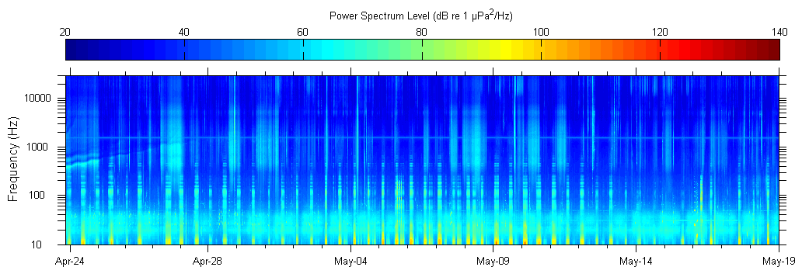
Figure H-21. Spectrogram of background sound levels at Station 10 throughout the PIDP. All dates are UTC. Figure 27 from Martin et al. (2012a). © JASCO.
Figure H-22. Plots of received sound levels for impact pile driving at Test Pile 2B, 16 May 2012, with MENCK MHU 270T hydraulic impact hammer and an Isolation Casing and Bubble System. (Top Left) Short-range monitoring at 35.4 ft horizontal distance. (Top Right) Long-range monitoring at Station 4. (Bottom Left) Long-range monitoring at Station 6. (Bottom Right) Long-range monitoring at Station 8. Figure 85 from Martin et al. (2012a). © JASCO.
Figure H-23. Plots of received sound levels for vibratory pile driving at Test Pile 2A, 16 May 2012. (Top Left Short-range monitoring at 34.1 ft horizontal distance. (Top Right) Long-range monitoring at Station 4. (Bottom Left) Long-range monitoring at Station 6. (Bottom Right) Long-range monitoring at Station 8. Figure 115 from Martin et al. (2012a). © JASCO.

Validation of mitigation systems
Through the above methodology, it is possible to validate different mitigation systems. Not all mitigation systems are appropriate for all scenarios, and in different geoacoustic and bathymetric environments, they can perform differently. An example of the importance of validation and assessment is shown in Figure H-24.
The ability to understand mitigation systems in different environments, especially for large scale projects where piling operations will last an extended period of time, the setting of a minimum standard by GBRMPA is possible. The operator is then able to access the option of trailing a number of possible systems, as was done in Martin et al. (2012a), to determine their effectiveness to meet that standard, and thus the final system(s) to be applied. This links operational efficiencies and possibilities to environmental standard achievement.
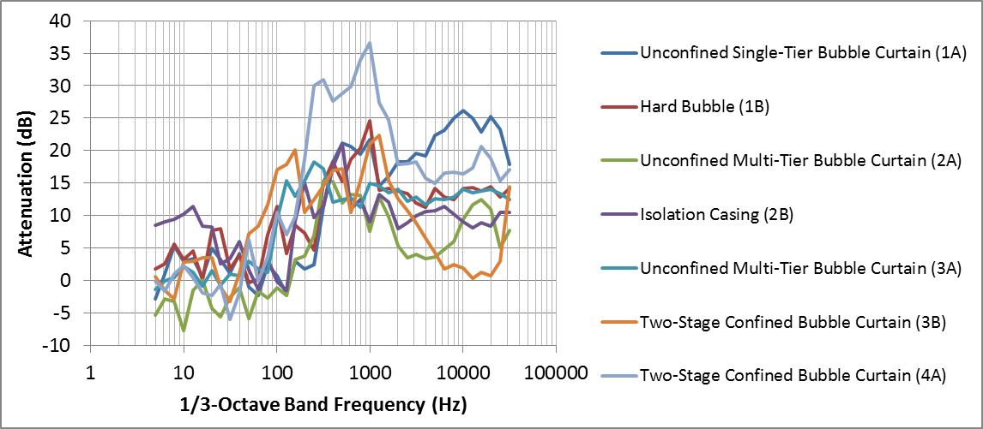
Figure H-24. Mean 1/3-octave band NAS attenuation as measured at short-range (33 ft) from impact hammer pile driving. Attenuation levels are averaged over different airflow/pressure settings. Figure 36 from (Martin et al. 2012a). © JASCO.

Page intentionally left blank

Seal [online image]. Retrieved November 2015, from http://fursealworld.com/?p=128.
Killer whales [online images] Retrieved November 2015 from clip art.
Background [online image]. Retrieved November 2015 from http://theartmad.com/wp-content/uploads/2015/09/Ocean-Underwater-Wallpaper-Widescreen-3.jpg.

