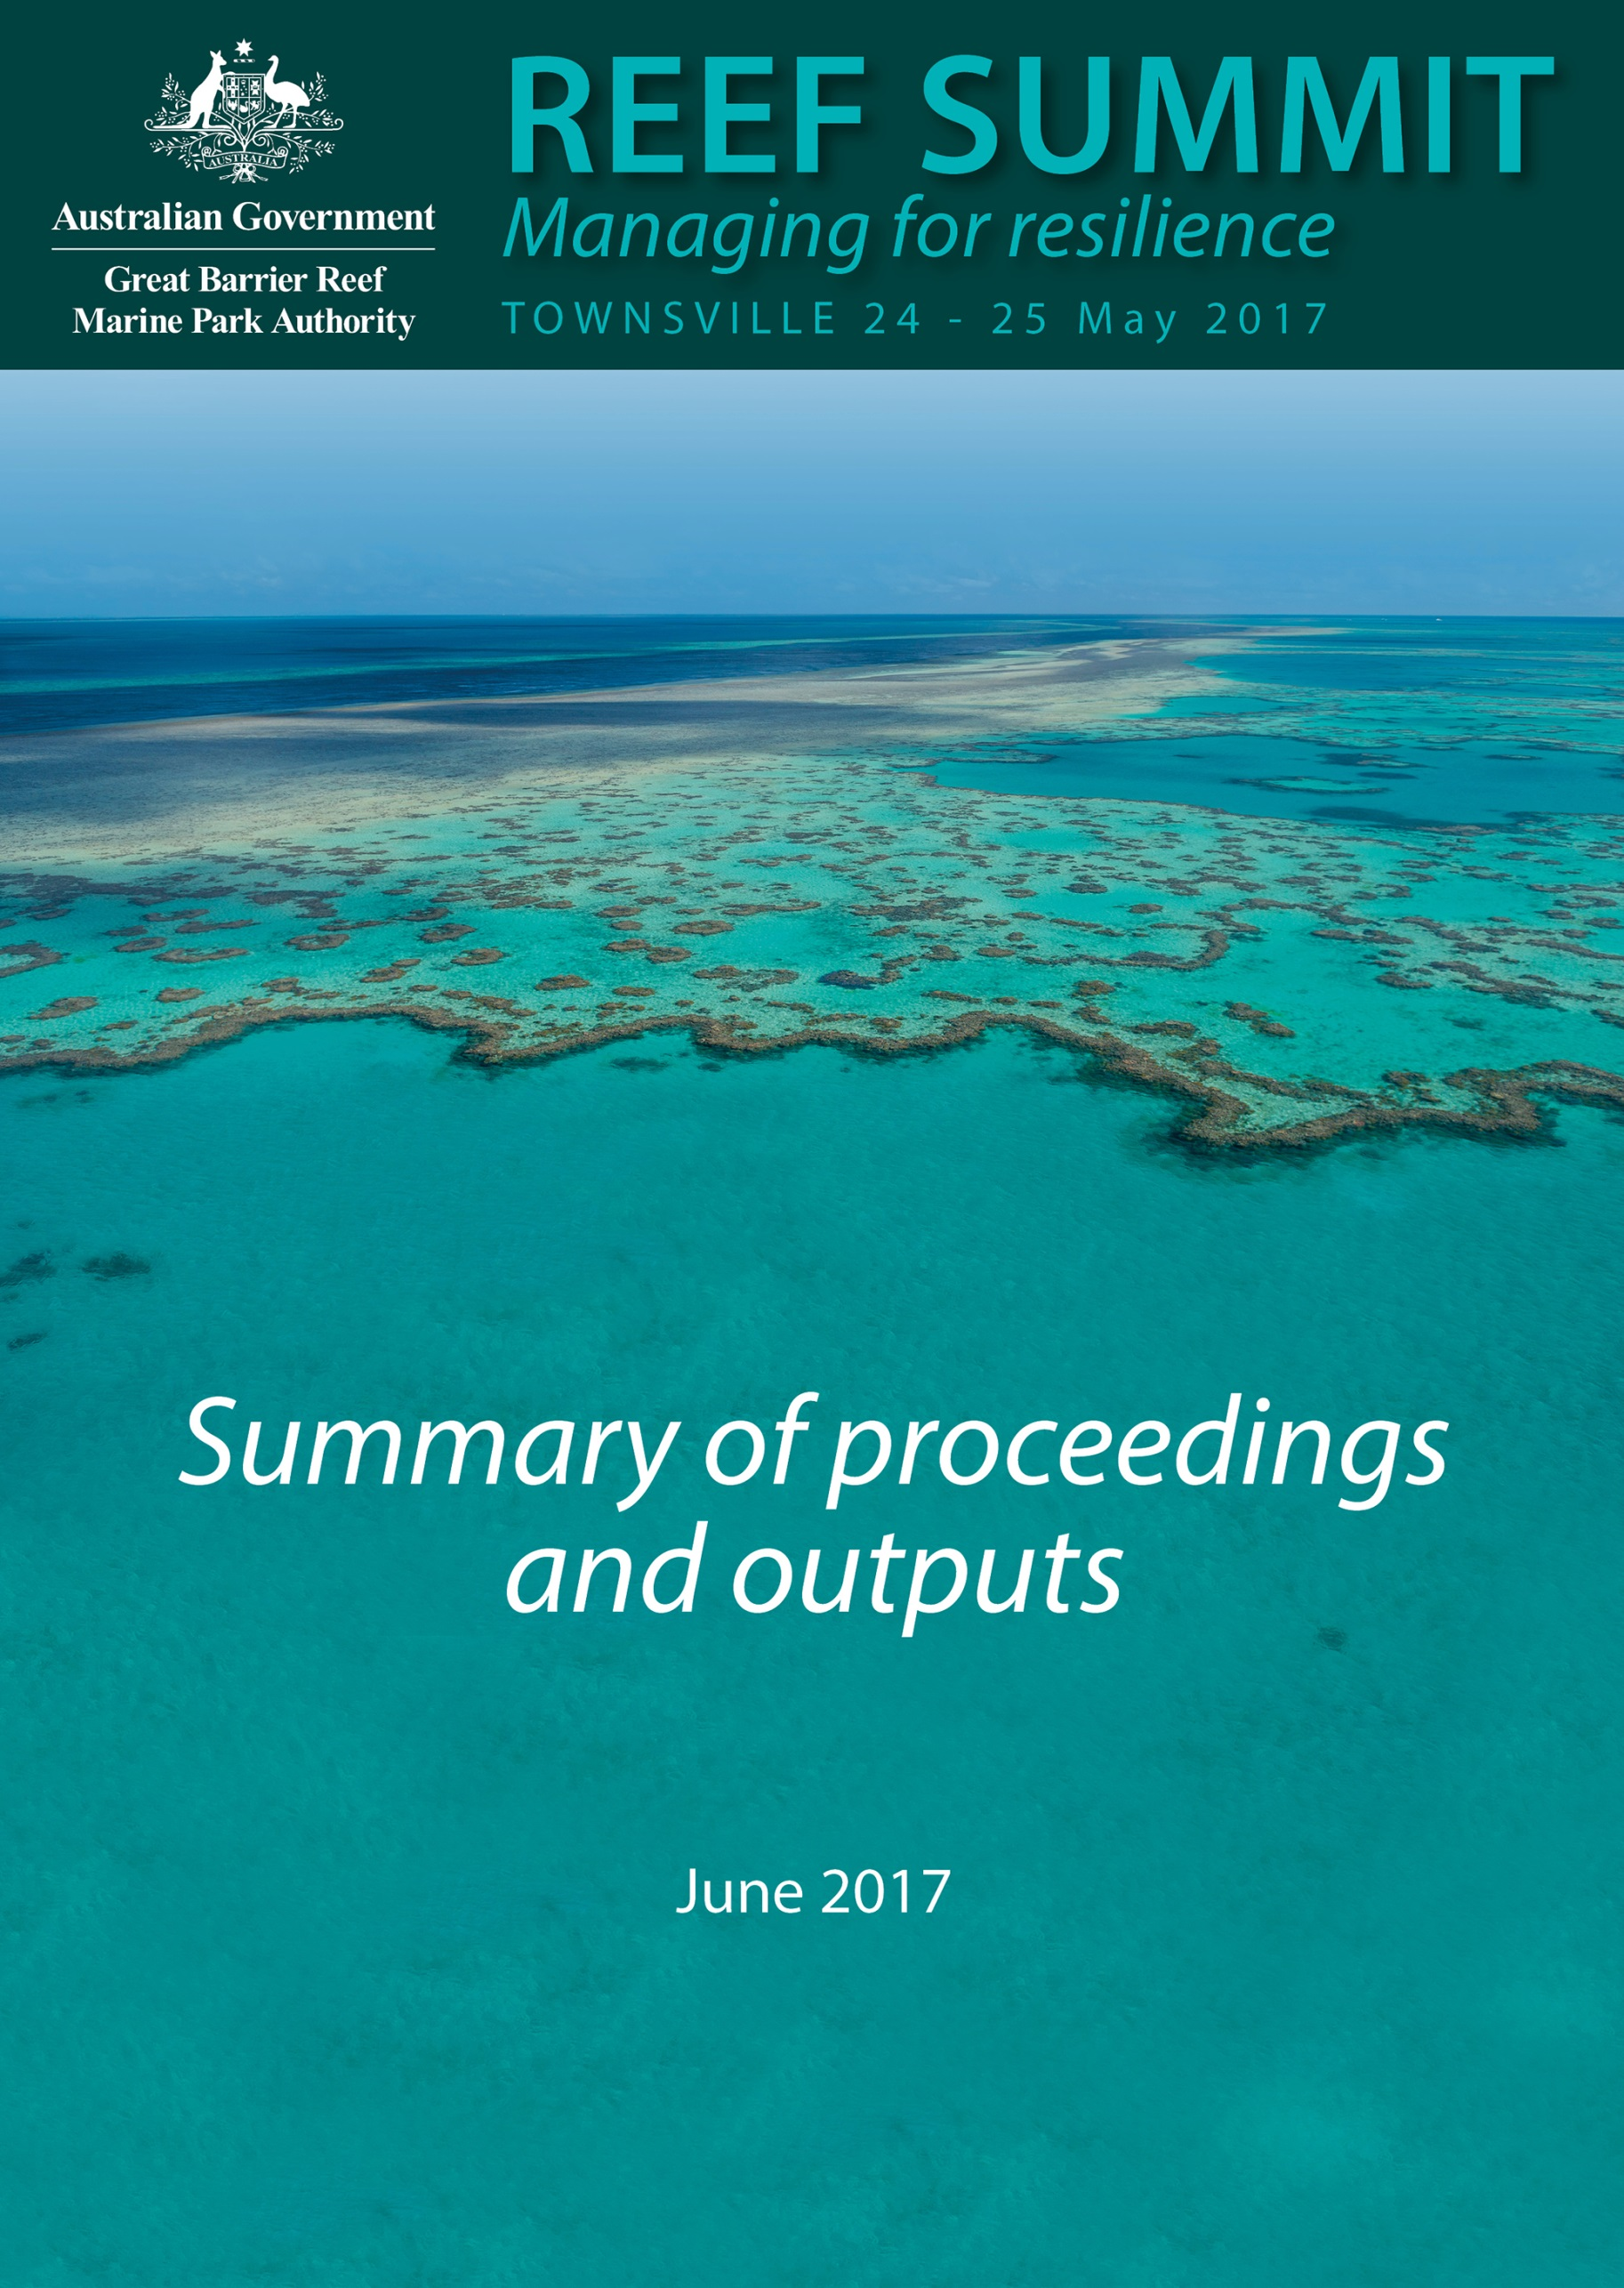

© Commonwealth of Australia 2017
Published by the Great Barrier Reef Marine Park Authority
This publication is licensed by the Commonwealth of Australia for use under a Creative Commons By Attribution 4.0 International licence with the exception of the Coat of Arms of the Commonwealth of Australia, the logo of the Great Barrier Reef Marine Park Authority, any other material protected by a trademark, content supplied by third parties and any photographs. For licence conditions see: http://creativecommons.org/licences/by/4.0


This publication should be cited as:
Great Barrier Reef Marine Park Authority 2017, Reef Summit: Managing for resilience. Summary of proceedings and outputs, 24 – 25 May 2017, Townsville, GBRMPA, Townsville.
Acknowledgements
This report is based on a collation and summary of proceedings prepared by the Nous Group commissioned by the Great Barrier Reef Marine Park Authority.

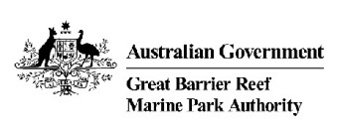
Great Barrier Reef Marine Park Authority
2–68 Flinders Street
(PO Box 1379)
Townsville QLD 4810, Australia

Phone: (07) 4750 0700
Fax: (07) 4772 6093
Email: info@gbrmpa.gov.au
www.gbrmpa.gov.au

The Great Barrier Reef Marine Park Authority acknowledges the continuing sea country management and custodianship of the Great Barrier Reef by Aboriginal and Torres Strait Islander Traditional Owners whose rich cultures, heritage values, enduring connections and shared efforts protect the Reef for future generations.
This page is intentionally blank.
Contents
Summit opening and Welcome to Country 1
Session 1: Understanding the current state of the system and the need to respond 3
Session 2: Drawing on lessons learnt from resilience-based management 6
Session 3: Optimising the Authority’s management tools and approaches 9
Session 4: Generating new ideas and innovations 10
Session 5: Developing a blueprint for change 13
Session 6: Reviewing and refining management principles 21
Session 7: Ensuring effective communication 24
Appendix A Participant list 25
Appendix B Indigenous Reef Advisory Committee statement 29

Summit opening and Welcome to Country
On 24 and 25 May 2017, over 70 regional, national and international delegates representing marine park managers, Traditional Owners, government agencies, research institutions, industry groups, Reef users and other stakeholders participated in the Great Barrier Reef Summit – Managing for Resilience (0 outlines the Summit participant list).
Dr Russell Reichelt, Chairman and CEO of the Great Barrier Reef Marine Park Authority (the Authority), opened the Summit with an overview of the current situation and the Summit’s purpose. Dr Reichelt welcomed participants and introduced Dorothy Smith and Brenton Creed, who conducted a Welcome to Country on behalf of the Bindal and Wulgurukaba Traditional Owners of the Townsville region.
The key objective of the Summit was to develop a blueprint for the Authority and its partners in response to mass coral bleaching and cumulative impacts on the Great Barrier Reef. An important part of the key objective was to develop resilience initiatives, with a focus on coral reef habitats, acknowledging they are a foundational component of the broader Reef ecosystem.
Participants discussed the scope of proceedings using the graphic outlined in Figure 1 to test views. While there was agreement on the need to focus on what Reef managers and partners can do inside the Marine Park to address cumulative impacts, there was a strong sentiment on the need for these discussions to occur in the context of external drivers affecting the Reef.
Figure 1: The initial scope of the Summit discussion

This short report summarises the outputs of the Summit.

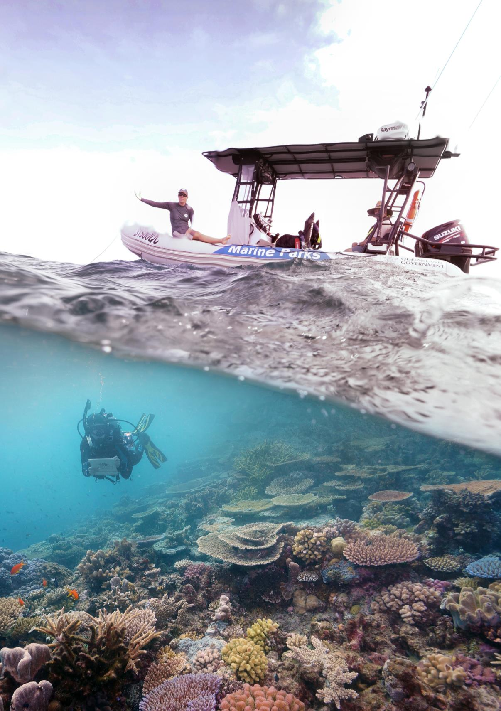

Session 1: Understanding the current state of the system and the need to respond
The case for action
The purpose of Session 1 was to provide participants with an overview of the state of the Great Barrier Reef and outline the urgent need for action.
Dr Reichelt outlined how the unprecedented effect on the Reef of back-to-back coral bleaching, tropical cyclones and associated widespread coral mortality, underpins the need to take local action to build the Reef’s resilience. Dr Reichelt also noted climate change is the key threat to all reefs worldwide and the world must take urgent action to meet the targets set out in the Paris Agreement. He outlined the intent that the Summit draw on the strong legacy of leadership and innovation to establish a blueprint to refine and enhance our reef management.
Indigenous Reef Advisory Committee call for urgent action
Angie Akee and Gavin Singleton delivered an inspiring statement on the need for urgent intervention to improve the health of the Reef on behalf of the Indigenous Reef Advisory Committee (0 provides a copy of the statement). The statement highlighted the spiritual and physical connection Traditional Owners’ have with the Reef and raised a call to action.
“…We the first nations people of Australia, acknowledge the Great Barrier Reef World Heritage Area is a natural wonder and a global asset and as such requires solutions to come from the global village to stop this tragedy from happening in our lifetime.
Let us be a generation of action and restoration. We must ensure the universal songlines of the Great Barrier Reef continue to endure for many generations to come.”
The current state of the system
Dr David Wachenfeld, A/Director of Reef HQ Aquarium, provided participants with an overview of the current state of the Reef. Dr Wachenfeld outlined how the biodiversity of the Reef is declining in the face of significant threats. However, the Reef has shown it can respond if we successfully manage these threats. Recent extreme weather, including the compounding effects of 10 severe tropical cyclones in 12 years, droughts and floods, have negatively affected the Reef. Unprecedented back-to-back mass coral bleaching in 2016 and 2017, almost certainly as a result of climate change, has had severe effects across the Reef. The overall effect of these events means the Reef is in crisis and the Authority and its partners must take action now.
The key messages from the presentation and the discussion that followed were:
- The intensity of extreme events has been increasing in recent years – for example, there have been 10 severe category cyclones since 2005 which (collectively) have affected virtually the whole Reef.
- The two recent coral bleaching events are ‘a game changer’.
  - There was a loss of 29 per cent of shallow water coral in 2016, and while we do not yet have the full data for 2017, we know the heat stress was substantially higher.
  - The extreme heating associated with these events is almost certainly a result of climate change.
  - While we have seen strong recovery in the past, we can no longer rely on the ‘getting out nature’s way’ strategy – we do not have the stability in the system for that anymore.
- There is no doubt climate change is the key threat to the Reef and the future of the Reef depends on strong climate change mitigation.
- Specifically, the long-term survival of coral reefs is dependent on reducing the rate and magnitude of climate change, in-line with the Paris Agreement’s 1.5 degree scenario (RCP2.6).
- It is also critical that we take local action to increase the resilience of coral reefs – the focus of this Summit.
- There is evidence we still have resilience in parts of the system, for example, the strong rebounds in the central reef from recent cyclones. Coral reefs in many parts of the world have lost this resilience.
- This means there is still hope – we have not crossed the resilience thresholds yet for at least some parts of the Reef, but we won’t know where the resilience thresholds are until we cross them.
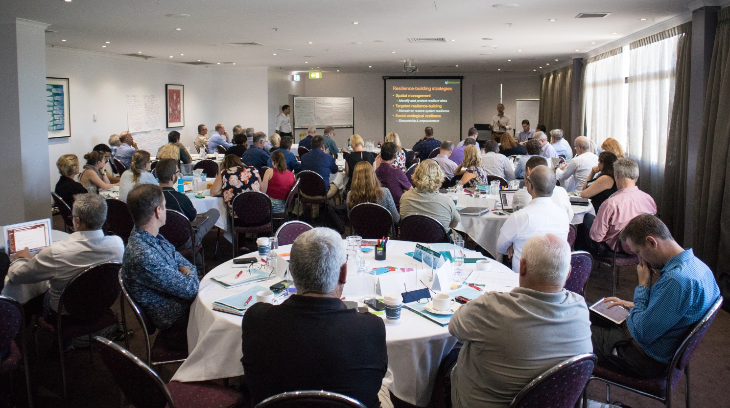
Participants then considered following question:
Given recent events, how dramatic are the changes we need to make to the way we manage the Reef?
Participants responded on a five point scale, outlined below:
- Insignificant – ‘evolution’
- Minor
- Moderate
- Major
- Dramatic – ‘a revolution’
Figure 2 provides a summary of the results.

Figure 2: Given recent events, how dramatic are the changes we need to make to the way we manage the Reef?
Most participants supported describing the change required as ‘major’ (D) or greater. A minority expressed some caution, noting that:
- it is unclear if the Authority has the ‘levers’ (i.e. management tools and jurisdiction) to execute the required shift
- we need to be realistic and pragmatic – words like ‘revolutionary’ may alarm people
- a revolution suggests we need to throw everything out and start again, whereas we need to build on the well-regarded foundational management we already have.
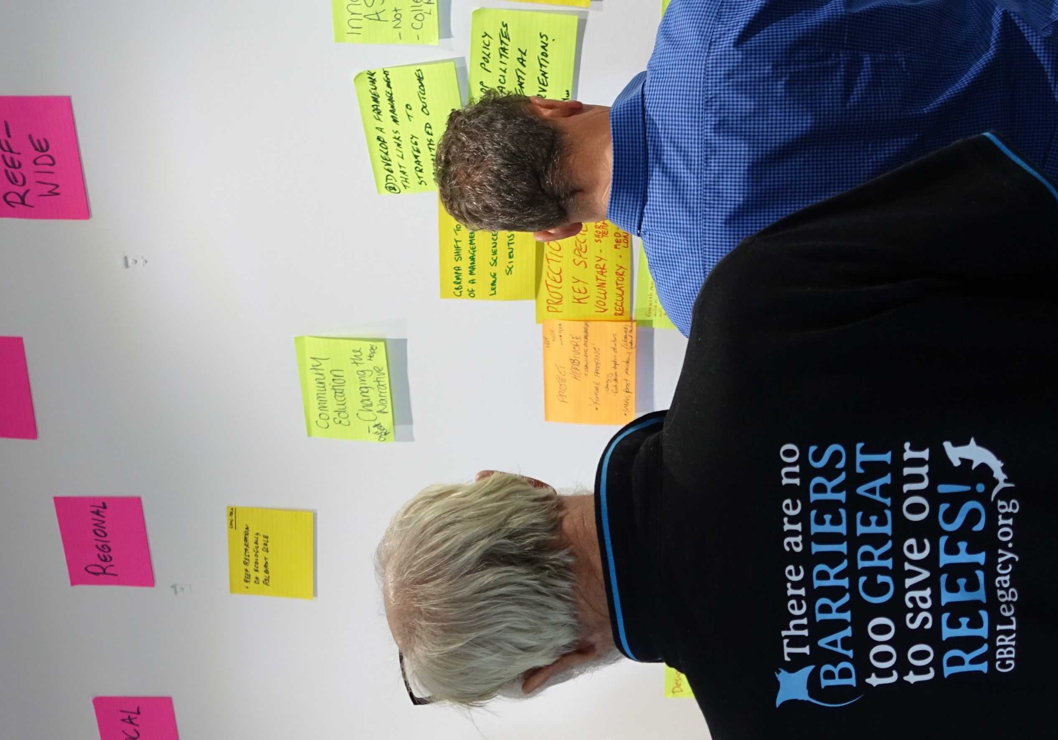

Session 2: Drawing on lessons learnt from resilience-based management
The purpose of Session 2 was to provide Summit participants with an overview of the concepts behind resilience-based management, examples of how resilience-based management have been applied globally and to consider its application to management of the Great Barrier Reef.
Dr Roger Beeden, Director of the Reef Integrated Monitoring and Reporting Program at the Authority and Dr Paul Marshall, Director, Reef Ecologic, provided an overview of resilience-based management and presented some practical examples of its application around the world. Dr Beeden outlined how resilience-based management is ‘future-focused adaptive management’ that enables managers to target existing and emerging tools to protect and enhance the recovery capacity of the Reef. Technological advancements, like the Reef Integrated Monitoring and Reporting Program, will incrementally improve resilience-based management of the Reef over time.
Dr Marshall outlined how others around the world have managed coral reefs in crisis. Spatial management approaches involving the application of particular tools based on a specific location have been used in Moorea to map socio-ecological vulnerability of particular reefs. In Belize, reef managers have targeted their resilience building on particular species through efforts to protect herbivores. In Oracabessa Bay in Jamaica, a small non-government organisation worked with the fishing industry to build social resilience and in turn addressed over-fishing.
The key messages from the presentations and the discussions that followed were:
- There is broadly strong support from Summit participants for framing our response to the current crisis using the principles and practices of resilience-based management.
- Resilience-based management can be applied to all species and habitats in and around the Great Barrier Reef Marine Park, including for land-based initiatives to address critical issues like water quality.
- Much can be learnt from approaches taken overseas, noting there will be material differences between the Great Barrier Reef and other coral reefs.
  - we looked at the experiences of reef managers in Hawaii, Tahiti, Belize, Granada and Jamaica as sources of inspiration
- Resilience-based management involves targeted, future-focused, adaptive management, using new technologies and science to find the ‘bright spots’ on the Reef and then doing everything we can to ‘fix them’.
- However, there are some qualifiers:
  - resilience-based management cannot just be ‘the next trend’
  - there is value in focusing on particular reefs, or ‘the bright spots’, but the criteria for determining what constitutes a ‘bright spot’ needs to be broader than just ecological value – it needs to include cultural and socioeconomic values as well
  - a reef that is a bright spot in one year may not be a bright spot in the next year, given the high variability of coral bleaching
  - we continue to have responsibility for protecting the whole Reef through our key compliance and enforcement programs
- Traditional Owners have a crucial role to play in resilience-based management through their long cultural connection to Sea Country and extensive understanding of climate.
Participants then considered the following question:
How ‘strong’ is your support for using resilience-based management to guide our response to this crisis?
Participants responded on a five point scale, outlined below:
- Very weak
- Weak
- Moderate
- Strong
- Very strong
Figure 3 provides an overview of the results.
Figure 3: How ‘strong’ is your support for using resilience-based management to guide our response to this crisis?
The minority of participants who described their support for using resilience-based management to guide the response to the crisis as ‘moderate’ (C) or ‘weak’ (B) had three main concerns:
- the response needs to be broader than resilience-based management and include other approaches – resilience-based management is just one tool in the toolbox
- the principles are good but nothing will be achieved without a strong focus on engagement
- we need to be careful that resilience-based management isn’t the ‘next bright shiny thing’ – if we focus on this we cannot ignore the work that must continue in other areas, such as water quality and land clearing.

Session 3: Optimising the Authority’s management tools and approaches
The purpose of Session 3 was to provide an overview of the Authority’s management tools and consider how these could be best applied to protect the Great Barrier Reef and build resilience.
Dr Kirstin Dobbs, Director of Environmental Assessment and Protection at the Authority, provided an overview of the suite of management tools used by the Authority. Dr Dobbs outlined how it is important to start with the desired outcome and then determine which tool or combination of tools is most appropriate to achieve the desired outcome, rather than simply ‘jumping to a tool’. When deciding which tool(s) to apply, it is also important to consider the effect on industry from regulation and legislation.
The key messages from the presentation and the discussion that followed were:
- In developing specific resilience-based management initiatives, we have most of the tools we need – the focus is on selecting the right tool(s) for the outcomes we are trying to achieve.
  - For example, tools already exist to enable interventions that are protective (for example, herbivores), restorative (for example, coral farming) or enhancing (for example, coral nurseries).
- We have shown we can implement tools and approaches quickly when we need to and there is a strong commitment from decision makers (for example, we have previously implemented Reef-wide regulations in six months).
- In considering what tool to use it is also important to consider implications for industry and Reef users – this is formalised through the Commonwealth government regulatory impact and burden measurement processes, cost recovery guidelines and fisheries and environmental protection legislation.
- Community buy-in and support is critical to the success of every management tool and approach.
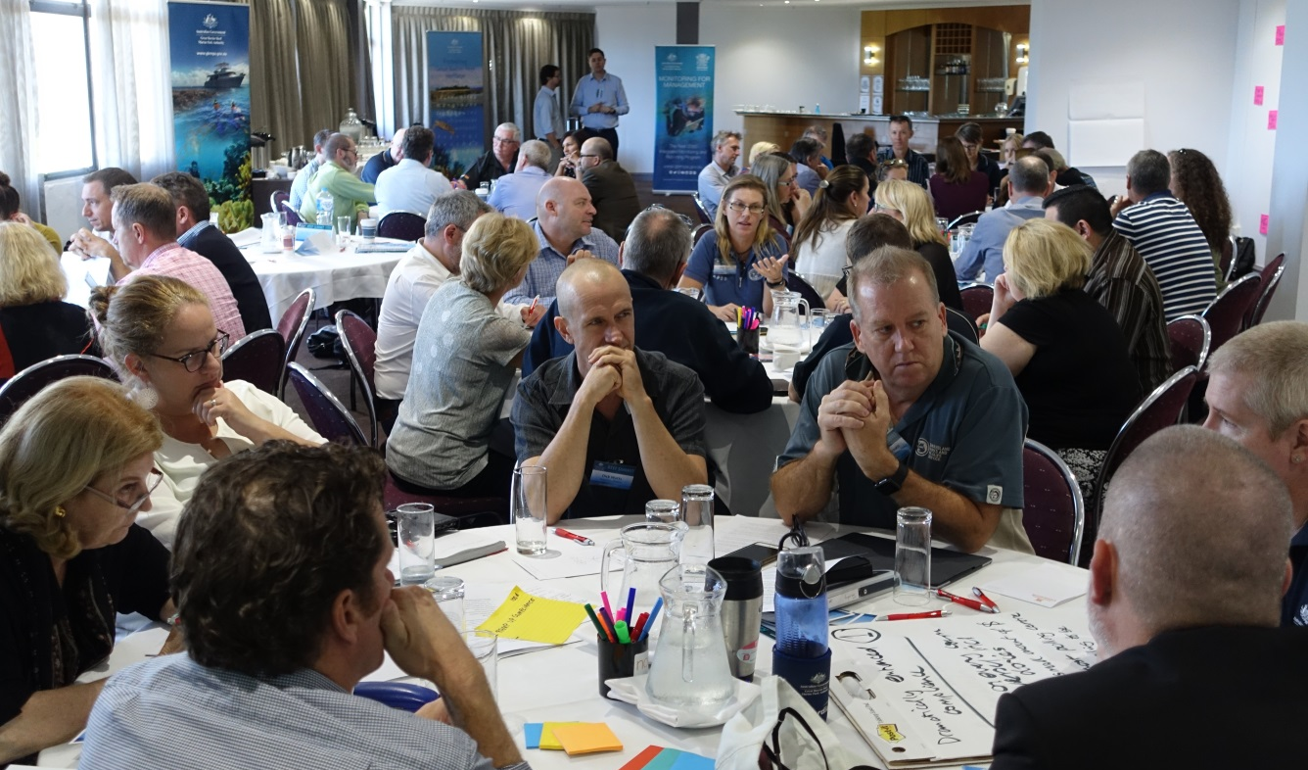
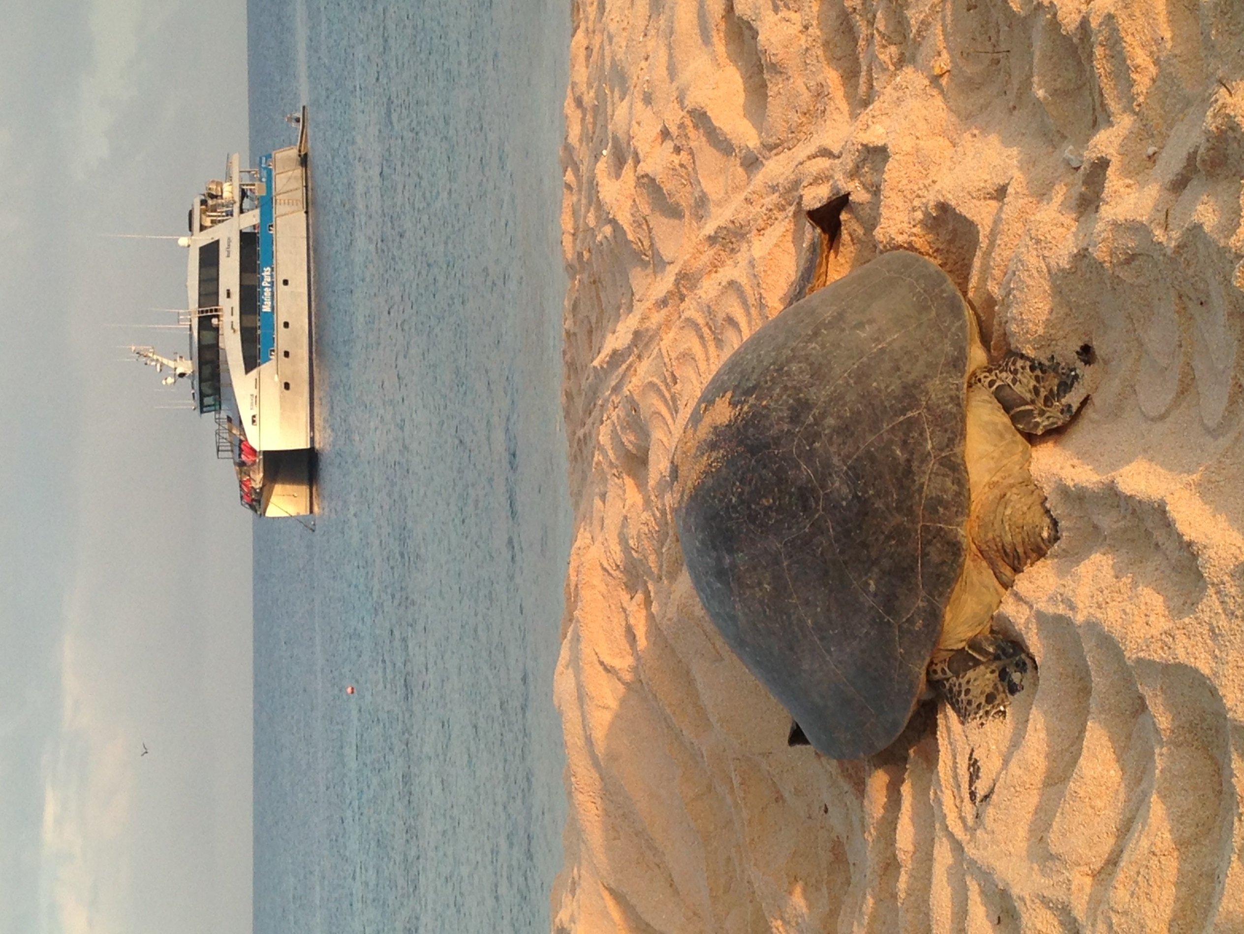

Session 4: Generating new ideas and innovations
The purpose of Session 4 was to begin development of the blueprint for action by generating and recording new ideas and innovations that could potentially be applied in response to mass bleaching and cumulative impacts on the Great Barrier Reef.
Participants began the task of generating new ideas by considering the following question:
What’s the best idea you’ve heard so far for how reef managers can better build coral reef resilience inside the Marine Park?
Table 1 outlines the participants’ early ideas for building reef resilience.
Table 1: Participants’ early ideas
Participants’ early ideas
No holds barred approach to culling crown-of-thorns starfish | Protect the bright spots/resilience spots/hope spots
Improving real time monitoring and feedback | Develop a scalable approach to improving real time data modelling
Take a broader view of what needs to happen in the wider ecosystem first and then consider what reef managers need to do | Look to the assets beyond the experts at the summit – to other operators and citizens
Enhancing reef managers’ capacity to respond instantly to events like bleaching and cyclones | Share the results of approaches on the Reef around the world
Identify and protect the ‘lucky, connected and resilient’ reefs | Develop a new approach for people to rally around
Ensuring the integrity of the green zones through a comprehensive compliance regime | Increase the speed of communication for evidence based decisions to improve transparency
Tracking systems on every vessel entering the marine park | Focus on the policies required to deliver revolutionary change
Start by admitting there is an issue to be addressed | Develop public/private partnership approaches to support management

Participants then developed these ideas further, and created new ideas and innovations, by considering the most promising, specific, tangible things reef managers (the Authority and its partners) could do to increase the resilience of coral reefs. Participant group consolidated the ideas generated by individuals into their top three innovations.
Each participant group then categorised the innovations and ideas by:
- time to impact or outcome (short term - years, medium term – years to decades, long term – decades to centuries)
- spatial scale (local, regional, reef-wide and global)
Many of the ideas and innovations were similar and were subsequently grouped by common outcomes and themes. Table 2 outlines the participants’ consolidated innovations and ideas categorised by time to impact and spatial scale.

Table 2: Matrix of innovations and ideas by time and scale
Long term (decades to centuries |  | - Reef restoration on ecologically relevant scale |  | - Climate neutral GBR
Medium term (years to decades) | - Active, localised restoration  - Designate innovation/research and development (R&D) reefs  - Protecting the ‘bright spots’/refugia (“find ‘em and fix ‘em”) | - Develop a rapid response capability for coral bleaching  - Protect herbivores and other key species  - Build/enhance partnerships for local action  - Significantly amplify efforts to improve water quality impact on inshore reefs | - Develop a coordinated R&D program to develop and test new intervention technology  - Improve real-time monitoring enabled by data analytics  - Develop a framework that links management strategy to prioritised outcomes  - The Authority shift to more of a management role – leave the science to the scientists  - Pursue a flexible re-zoning process based on reef resilience  - Innovation ASAP | - Influence through education, information and outreach
Short term (years) | - Reef recovery toolkits | - All-out attack on crown-of-thorns starfish | - Policy that supports change/intervention  - Dramatically enhance compliance | - Increase speed of communication and increase transparency  - Policy on climate change
Time to impact | Local | Regional | Reef-wide | Global
Time to impact | Spatial scale

Session 5: Developing a blueprint for change
The purpose of Session 5 was to draw together ideas, innovations and considerations to begin the development of a blueprint for the Authority and its partners in response to mass bleaching and cumulative impacts on the Great Barrier Reef. Session 5 began by further clarifying some of the ideas generated so far.
Table 3 outlines the further detail for each of those innovations and ideas.
Table 3: Innovations and ideas requiring further detail
Innovation | Further detail from participants
Policy supporting change/intervention | - a policy that makes it very clear there is a mandate for intervention  - the Authority’s Board needs to provide the authority for that change and will consider the matter at its next meeting  - the Authority should review all of its policies to see if they are impediments to innovation (for example, coral nurseries and the way plans of management facilitate emergency responses)
Designate innovation/R&D reefs | - the Authority currently has a low risk tolerance for new interventions and innovations because it is an unknown  - identify some reefs where more risks could be taken through trials – these could be ‘safe to fail’ reefs that are not important to the ecosystem, culture or local economy  - create a mechanism for obtaining a permit within a day – for example, to collect data
The Authority to shift to more of a management role – “leave the science to the scientists” | - ensure we are not placing too much emphasis on science over management – the public does not always see the Authority as the managers  - science and management go hand-in-hand and need to work more closely together to ensure faster responses to issues  - the Authority will always need to be a science-based agency and the question is what role it plays in collecting, understanding and communicating the science
Innovation ASAP | - connect all relevant parties, including scientists, engineers (where applicable) and other organisations together quickly rather than waiting for years for research to turn into action  - increase the use of pilot projects and trials
Reef restoration on an ecologically relevant scale | - restoration is on a small scale at the moment and it needs to be increased to the reef-wide scale  - this is a significant R&D challenge and needs innovation, including through selecting sites to intervene

The Authority identified seven specific innovations and ideas to develop further for the blueprint. These seven were not identified as the only ones to be included in the blueprint – they represented issues the Authority wanted to explore further with the experts at the Summit, or that participants wished to explore more fully.
To explore the seven specific innovations and ideas in detail, participants were asked to imagine they were in the year 2020 and visualise the outcome they had achieved by considering the following questions:
- What results have been produced?
- What barriers have been overcome?
- What key innovations have been created?
- Who have been the key partners?
- How did we fund this?
- What specific, practical actions did we take in 2017 to get traction?
Participants divided into seven groups and each group considered the above questions for one innovation.

Table 4 provides a summary from participant groups of their responses to the questions (i.e. vision of success and steps to achieving success) for each of the seven innovations.
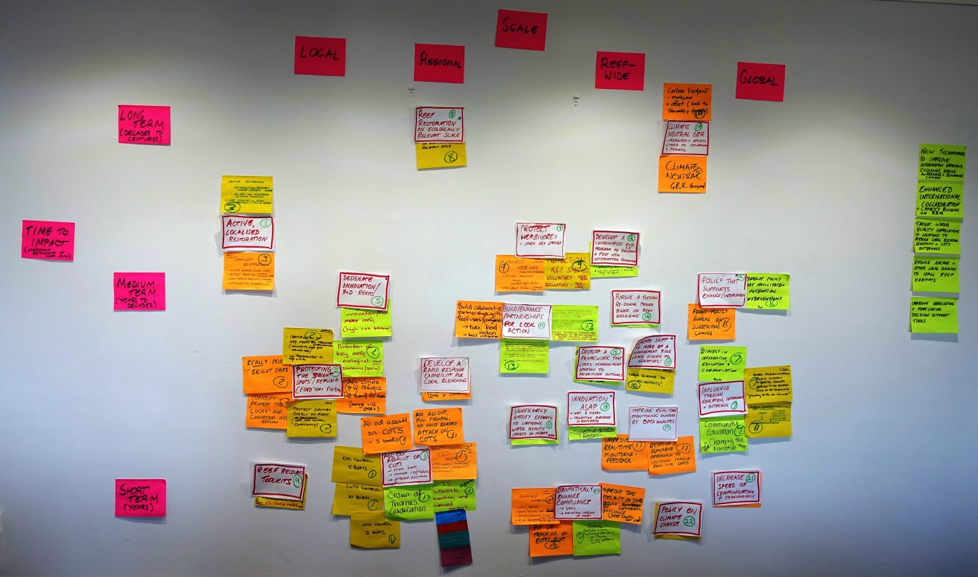

The spatial and temporal innovations and ideas collated into themes at the Reef Summit. The notes were the basis for discussion from session 4 onwards, and are summarised into Table 2.
Table 4: Draft blueprint innovations and ideas and their vision of success
Innovation | Vision of success and steps to achieving success
All-out attack on crown-of-thorns starfish | - Success: By 2020, the COTS population will be supressed, coral cover maintained or improved (subject to weather events) and effective biological controls introduced  - no one organisation can fix this, we need an integrated COTS control strategy, although in the short-term we need more boats  - greater COTS control is required given the recent extreme events  - the preferred option is more engagement with commercial operators and more R&D  - we need greater community engagement, but there are concerns with members of the community engaging in it safely, so we need to develop a code of practice for occupational diving and killing COTS  - the practical step is investing in more boats on the water to kill COTS (10 boats would assist greatly)  - some species can assist with COTS control and some no-take areas and bag limits on species may be needed, such as Red Throat Emperor and Tricky Snapper, and zoning could also assist  - government funding (Commonwealth and state funding) for COTS is needed with in-kind support from industry – in the model of a ‘bush fire fund’  - an integrated COTS control management strategy would draw together all of the ideas, with a committee to conduct regular evaluations and reviews  - enhanced R&D, quicker improvements in water quality and more timely effort on defined initiatives will all assist
Dramatically enhance compliance | - Success: Rates of non-compliance are dramatically reduced  - this is achievable with multiple tangible benefits  - requiring real-time or near real-time tracking systems on vessels entering the Marine Park is affordable but there are some barriers to overcome (including legislation) – priority should be on commercial fishing vessels initially, with ongoing application to other users  - there would be a relatively small cost for tracking systems and the technology exists, but legislative support will be needed to make it mandatory  - tracking would increase the capacity to prioritise resources and fleet monitoring, would enhance compliance and increase the integrity of Marine Park zones  - lower the bar for first time offenders and have stronger penalties for recidivists (dollar fines and forfeiture of equipment)  - need to work with the judicial system to make judges aware of the importance and value of protecting natural values and for them to apply penalties that increase the disincentive for offending  - drones, flexible legislation, initiatives like excluding netting north of Cooktown all have multiple benefits  - a recreational fishing licence would improve non-compliance and have multiple benefits and models already exist in other jurisdictions
Protecting the ‘bright spots’/refugia (find ‘them and fix ‘them) | - Success: Conduct a pilot program by 2020 on at least 10 reefs that has used the right tools to develop a recipe of interventions for each specific reef  - this is about finding the ‘bright/resilience/hope’ spots and fixing them. If there is a silver lining to this cloud, it is the great ideas that are impossible to do at scale at the moment can be piloted on 10-100 target reefs (e.g. COTS control, substrate stabilisation, shading and cooling)  - ‘finding’ is about value and vulnerability, ‘fixing’ is about protecting, defending and restoring  - the first step is finding the reefs that are disproportionately important to the ecosystem and society (value and vulnerability) and then determine how to maximise their contribution (protect, defend, restore)  - we need to map exposure and connectivity, prioritise and select and then validate  - many of our innovative ideas are difficult to execute at scale but can be done at a localised level  - we need to review, revise and enable regulations and policies and identify funding sources for actions  - a pilot project will be funded by a number of partners with an indicative cost of $500,000 over three years  - pilot should commence before the end of 2017
Active, localised restoration | - Success: By 2020 we will have a number of demonstration sites (selected using scientific criteria) through a combination of methods, including proof of concept and robust evaluation  - we have tried and tested techniques and we can start now if the policy and regulatory enablers are in place and then develop more innovative solutions  - we need to remove the policy and legislative impediments to the extent possible and move to more flexible permits and regulations  - we do not need to reinvent the wheel – we can learn from international experiences and apply existing knowledge to the Reef  - we have established a science based criteria for selection, based on social and ecological factors  - we start with tried and tested initiatives and move to more innovative approaches over time  - a coordinated strategic approach is needed from all partners – regulators need to be involved, industry and NGOs will play a role in deploying techniques and engineers will develop solutions, with Traditional Owners involved in deployment and site selection  - funding could come from low-interest loans for initiatives, cost recovery, a legislative offset fund, co-funded grants and programs, and public/private partnerships  - by the end of 2017, the Authority has finalised a policy, granted the relevant permits and identified the suite of test sites, with a larger R&D program under way  - a series of technical workshops aimed at scientists and engineers to develop blue sky solutions could be run over the longer-term  - policy and legislative frameworks enable the demonstrations  - a number of innovative technologies will have been trialled and evaluated
Influencing climate change | - Success: We want government and community on the same page in addressing climate change, with the Reef the key symbol for action, and a reduction in carbon emissions through mainstream support  - we must focus on the external drivers, and particularly climate change, if there is to be any hope for the Reef, but we shouldn’t underestimate the symbolic power of the Reef in driving change – we need to frame the story properly  - we need to navigate the current political environment, media landscape and community sentiment by framing the issue in a way that cuts through the negatives (e.g. highlighting economic and social benefits of climate change action)  - a key step is ensuring the Reef 2050 Plan has actions to address climate change  - industry and individuals need to be engaged through practical initiatives, including through using high profile spokespeople to drive community perspectives and focusing on education of both the young and the old  - practical initiatives could include an information poster on every vessel, ‘fishers and tourism industry for climate action’, and top 50 companies supporting climate change action  - the framing of the story is critical and should be driven through the Citizens of the Great Barrier Reef – it should focus on hope and the need for action
Partnerships and stewardship | - Success: People, both local and internationally, are actively engaged, part of the solution, and inspire intergenerational change  - we have the platforms for local engagement, let’s tighten and focus them, and work to engage a proportion of the other 7 billion people  - the framework already exists, but we are not utilising it effectively or coordinating our efforts – we need to expand our reach  - people want to be part of the solution and a coordinated effort is required to achieve that  - we can be innovative by focusing, raising awareness, setting targets, and uniting our efforts and actions  - the first step is to review what is in place and identify gaps, with the Authority coordinating the response
Protecting the herbivores and other key species | - Success: The role of herbivores in promoting reef recovery is not compromised by unsustainable take  - we can do this easily, but we need to be clear about whether the risk warrants regulation  - herbivores are critical to the ecosystem and we need to reduce how many are removed, but in practice few are taken through fishing  - the risk is low at the moment, although could increase in the future  - need to determine what tool is the most appropriate and then bring the community along through consultation, especially with recreational and commercial fishers  - this could be done within current budget

Participants scored their satisfaction with the blueprint as a starting point for the practical solutions required to build coral reef resilience on a scale of 1 to 10, with 1 representing no satisfaction and 10 representing complete satisfaction. Figure 4 depicts the participants’ scores.
Figure 4: Participants’ satisfaction with initial blueprint
They key messages from the development of blueprint innovations and the discussions that followed were:
- We identified the most promising specific, tangible initiatives Reef managers (the Authority and partners) can do to increase the resilience of the coral reefs and thought about the scale and timing of the associated impact.
- We developed the following initiatives in detail:
  - an “all-out attack” on the crown-of-thorns starfish
  - a dramatic enhancement of compliance
  - protecting the bright spots/refugia – “find ‘em and fix ‘em”
  - active, localised restoration
  - influencing climate change
  - partnerships and stewardship
  - protecting herbivores and other key species
- The other identified initiatives included:
  - reef recovery toolkits
  - designate innovation/ R&D reefs
  - develop a rapid response capability for coral bleaching
  - influence through education, information and outreach
  - the Authority to “shift to more of a management role – leave science to scientists”
  - pursue a flexible re-zoning process based on reef resilience
  - develop a framework that links management strategy to prioritised outcomes
  - policy that supports change/intervention
  - improve real-time monitoring enabled by data analytics
  - increase speed of communication and transparency
  - policy on climate change
- In developing these initiatives further, it is important not to lose sight of:
  - our Reef-wide legislative responsibilities and international obligations
  - the importance of managing the key external threats
  - the solid foundations of our current programs and initiatives.
- However, we all agree the current crisis requires substantial changes in the way we manage coral reefs to increase resilience. Current management practices are not enough. We must do more than we have done before through implementing new innovations and ideas and start now.
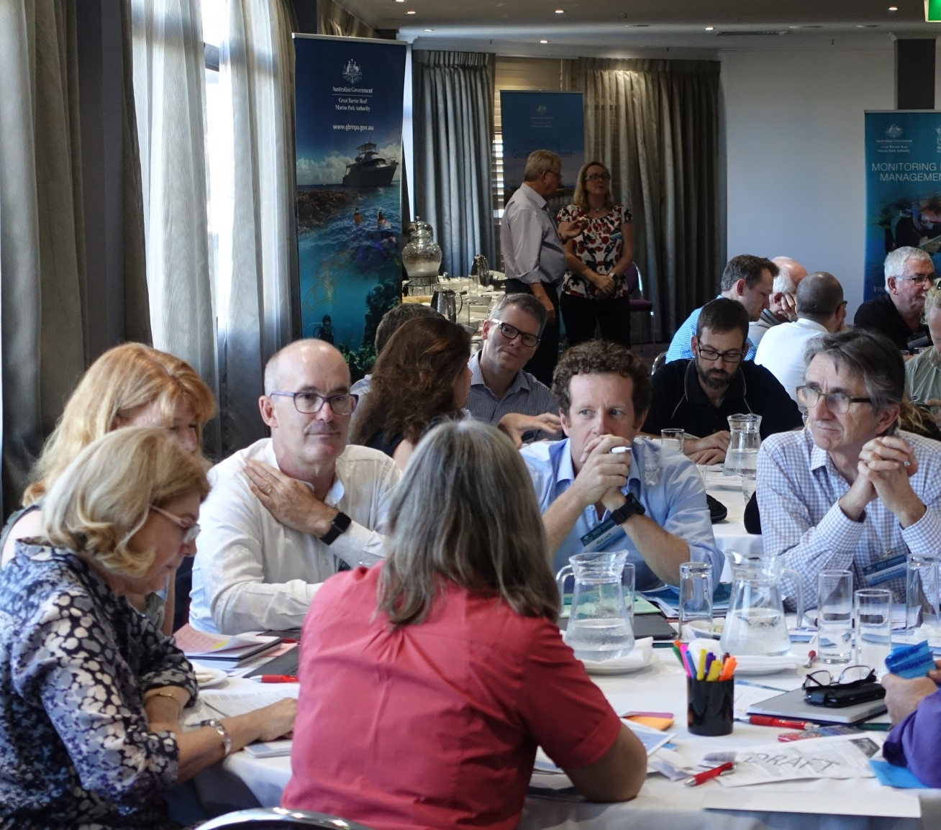
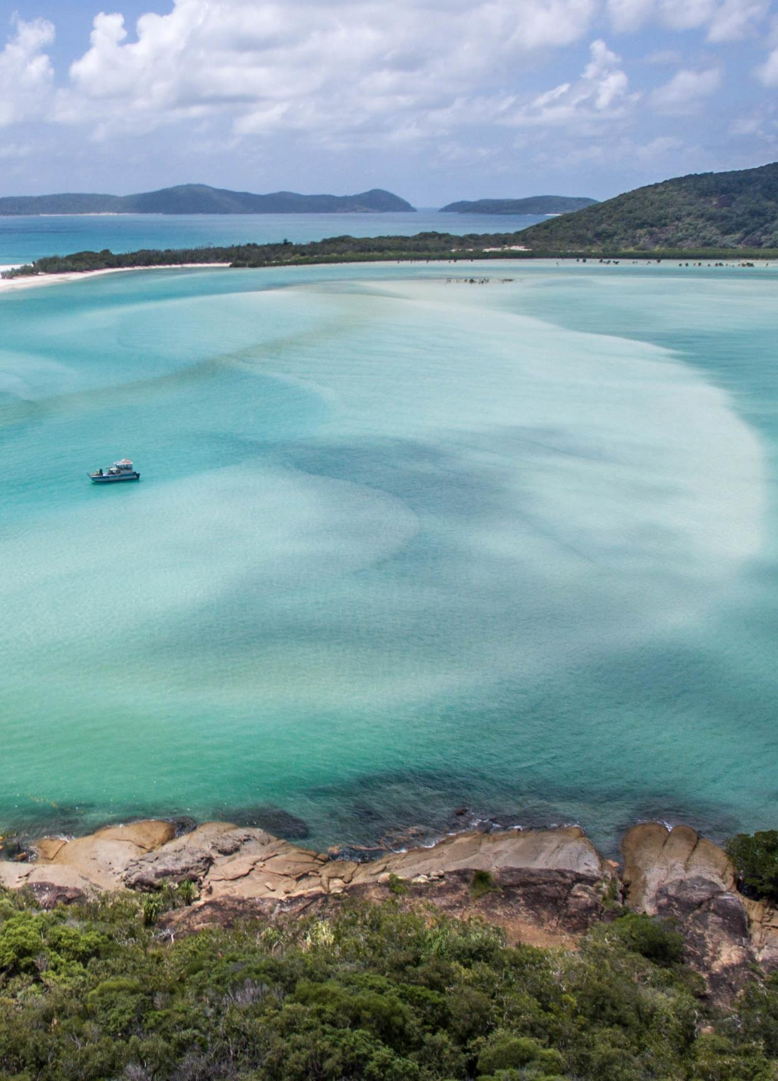

Session 6: Reviewing and refining management principles
The purpose of Session 6 was to provide an overview of the principles the Authority uses to guide management interventions (using the Raine Island recovery project as an example) and to seek input on how they may be adapted or added to.
Dr Mark Read, A/Director of Reef Recovery at the Authority, provided an overview of lessons from the Raine Island Recovery project, a practical example of resilience-based management on the Reef. He outlined how the Authority identified a catalyst for intervention on the Island. There were concerning trends indicating the population of green turtles that nest on the Island were undergoing a decline and there were problems with nesting and hatching success. The Authority then went through a process of ensuring it could intervene on the island through a vulnerability assessment, identifying intervention options and analysing risks of implementing those actions.
The Authority first implemented ‘safe to fail’ interventions and moved to more risky options over time. Dr Read outlined how this example shows intervening in natural systems has to become part of ‘business as usual’ management.
Participants then discussed the Authority’s suggested principles for applying resilience-based management interventions. The principles are set out below:
- outcome focus – interventions should have clearly defined objectives and outcomes
- systems perspective – the approach to applying interventions should recognise the cause-and-effect relationships between drivers and pressures on the state of the system and impacts on the benefits the system provides
- scale – interventions should be commensurate to the spatial scale of the impact being addressed or specific objective or desired outcome sought
- strategic approaches – interventions should include a variety of options to manage uncertainty, address risk, and facilitate learning, adaptive management, coordination, collaboration and trial of new and novel approaches
- collaboration potential – interventions should consider opportunities to align effort, share information, and integrate and facilitate efficient and effective delivery at the most relevant scale across multiple actions
- cost – interventions should be costed over their full life cycle
- effectiveness – interventions should include proof of concept and field trials for novel actions
- risk – interventions should include means of understanding and managing risk, including uncertainties and the risk of not acting
- feasibility – interventions should include consideration of capacity to achieve objectives and outcomes within agreed timeframes and ensure risk is appropriately considered and managed
- evaluation and adaptive management – interventions should include means to monitor performance and drive continuous improvement.
Participants believed the list was a good starting point and the Authority could strengthen it in the following ways:
- Emphasise that evidence-based management is the preferred option, but acknowledge it is not always practical or feasible to have all the evidence before making a decision.
- Acknowledge cumulative effects as part of the systems perspective.
- Ensure collaboration extends beyond regulatory agencies, and being clear on the roles and responsibilities of partners in collaboration.
- Extend ‘scale’ to cover both temporal and spatial scale.
- Emphasise the importance of communication.
- Highlight the importance of timing and the need for rapid responses where appropriate.

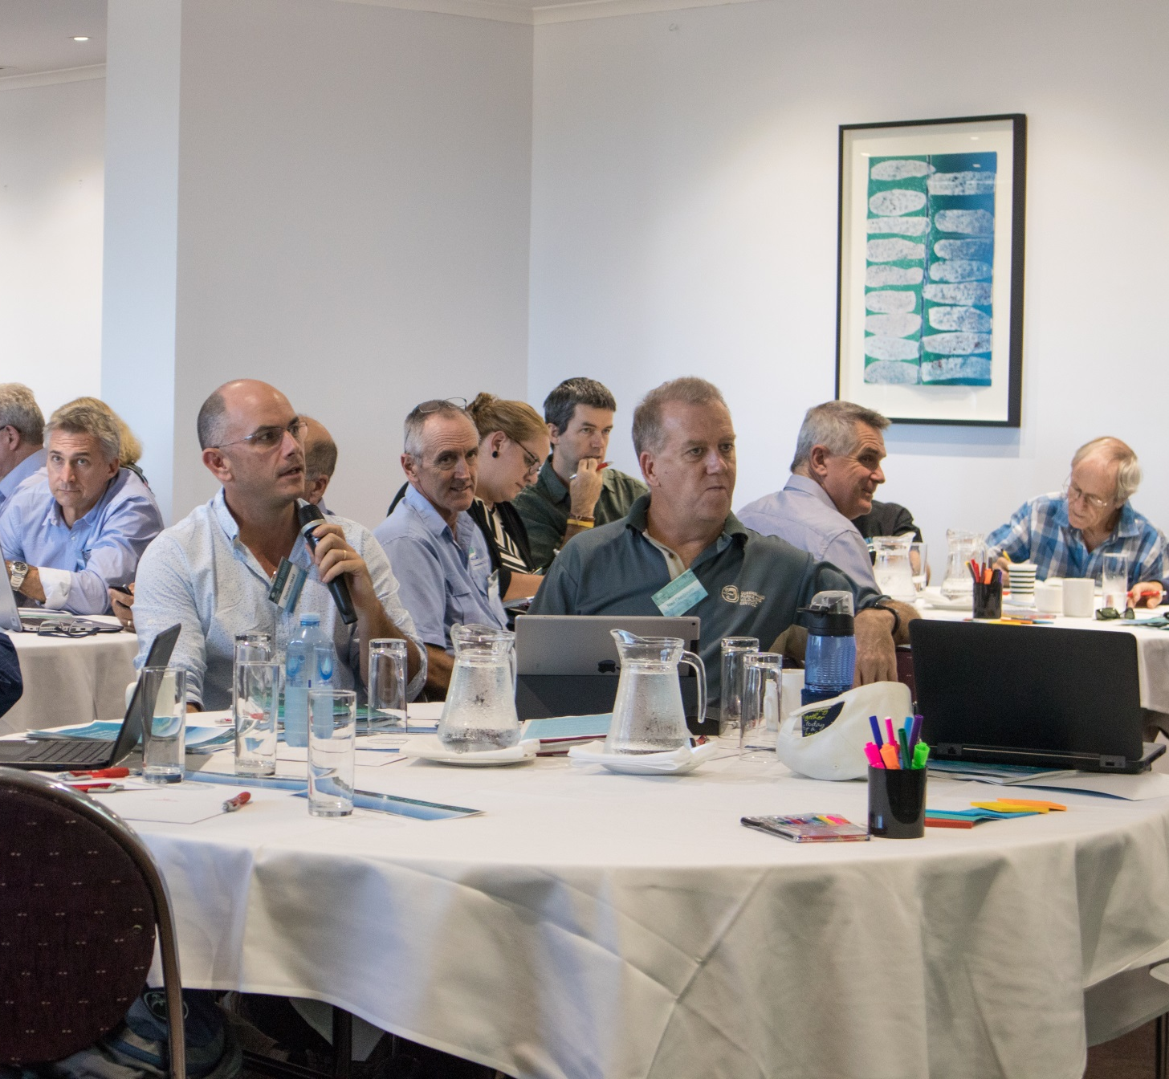

Session 7: Ensuring effective communication
The purpose of Session 7 was to share experiences of effective communication and identify how Reef managers and their partners can communicate more effectively and engage a broader range of people.
A panel of participants with expertise in communication participated in a facilitated discussion on the following key question:
How can we communicate more effectively?
The panel featured:
  - Peter Gash – Managing Director, Lady Elliot Island Eco-resort
  - Anna Marsden – CEO, Great Barrier Reef Foundation
  - Andy Ridley – CEO, Citizens of the Great Barrier Reef
  - Karen Markwort – Director of Communications and Parliamentary, the Authority
The key messages from the panel discussion are summarised below:
- We need to think global.
  - We need to build a long lasting global movement rather than a short localised campaign and the key is to create a shared sense of a common purpose, but this will take time.
  - The symbol of the Reef is a powerful tool and should be at the centre of how we connect with the public – it is the rallying point.
  - Social media can help us connect to a wide global audience at relatively low cost.
- Consistency, consistency, consistency.
  - Consistent communication is key to connecting with the public and we have not landed on a consistent message – we have not put enough effort in and the experts at the Summit are best placed to achieve this.
  - No single organisation or individual can successfully communicate the challenge. The response should include the sum of all our parts – this will deliver wide engagement.
- The message must be one of hope and action.
  - We need to combat apathy and ensure we do not cause people to think they cannot do anything to save the Reef – the message needs to be one of hope.
  - Our communication must establish trust and credibility and empower people to act.
  - Action needs to underpin our messages and we need to target our communications to segments of the community.

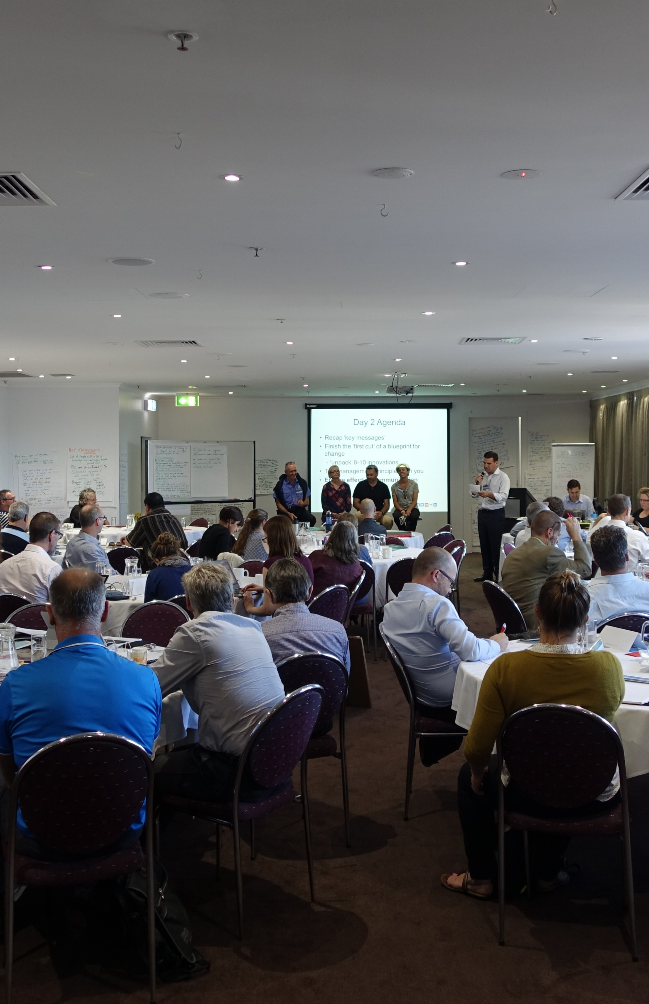

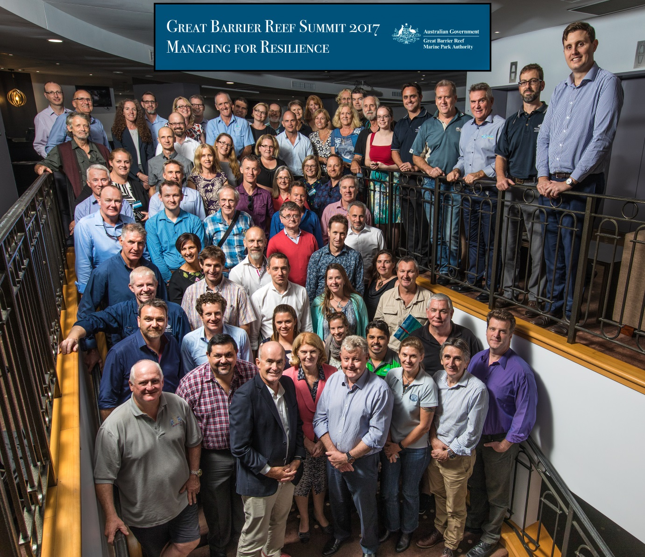
Appendix A Participant list

Organisation | Name
Association of Marine Park Tourism Operators | Peter Boundy
Association of Marine Park Tourism Operators | Steve Moon
Australian Coral Reef Society | Andrew Hoey
The Australian Institute of Marine Sciences | John Gunn
The Australian Institute of Marine Sciences | Britta Schaffelke
The Australian Institute of Marine Sciences | David Souter
Australian Research Council Centre of Excellence for Coral Reef Studies | Terry Hughes
Biosecurity Australia | Dick Watts
Bureau of Meteorology | Greg Stuart
Cairns Marine | Ryan Donnelly
Citizens of the Great Barrier Reef | Andy Ridley
CSIRO | Rebecca Bartley
CSIRO | Erin Bohensky
Department of the Environment and Energy (Commonwealth) | Dean Knudson
Department of the Environment and Energy (Commonwealth) | Stephen Oxley
Department of the Environment and Energy (Commonwealth) | Rachel Parry
Department of the Environment and Energy (Commonwealth) | Mahani Taylor
Department of the Environment and Energy (Commonwealth) | Craig Moore
Department of Foreign Affairs and Trade | Heidi Prislan
Department of National Parks, Sport and Racing (Queensland) | Neil Cambourn
Department of National Parks, Sport and Racing (Queensland) | Damien Head
Department of Prime Minister & Cabinet | Joanna Irving
Explore Whitsundays | Al Grundy
Fisheries Queensland | Scott Spencer
Great Barrier Reef Foundation | Anna Marsden
Great Barrier Reef Foundation | Theresa Fyffe
Great Barrier Reef Legacy | John Rumney
Great Barrier Reef Marine Park Authority | Russell Reichelt
Great Barrier Reef Marine Park Authority | Margaret Johnson
Great Barrier Reef Marine Park Authority | Simon Banks
Great Barrier Reef Marine Park Authority | Bruce Elliot
Great Barrier Reef Marine Park Authority | Josh Gibson
Great Barrier Reef Marine Park Authority | Fred Nucifora
Great Barrier Reef Marine Park Authority | Karen Markwort
Great Barrier Reef Marine Park Authority | Kirstin Dobbs
Great Barrier Reef Marine Park Authority | Roger Beeden
Great Barrier Reef Marine Park Authority | Liz Wren
Great Barrier Reef Marine Park Authority | Richard Quincey
Great Barrier Reef Marine Park Authority | Mark Read
Great Barrier Reef Marine Park Authority | David Wachenfeld
Great Barrier Reef Marine Park Authority | Jason Vains
Great Barrier Reef Marine Park Authority Board | Margie McKenzie
International Coral Reef Initiative | Francis Staub
James Cook University | Mark Hamann
James Cook University | Rob Coles
James Cook University | Margaux Hein
Lady Elliot Island Eco Resort | Peter Gash
National Oceanic and Atmospheric Administration | Jennifer Koss
Office of the Great Barrier Reef, Department of Environment and Heritage Protection (Queensland) | Kirstin Kenyon
Queensland Ports Association | Paul Doyle
Queensland Tourism Industry Council | Daniel Gschwind
Queensland University of Technology | Mark Gibbs
Reef 2050 Advisory Committee | Penny Wensley
Reef and Rainforest Research Centre | Suzanne Long
Reef Ecologic | Adam Smith
Reef Ecologic | Paul Marshall
Reef Restoration Foundation | Stewart Christie
Tangaroa Blue Foundation | Heidi Taylor
Torres Strait Regional Authority | John Rainbird
Torres Strait Regional Authority | Tristan Simpson
Traditional Owner Representative | Angelina Akee
Traditional Owner Representative | Gavin Singleton
TropWATER | Damien Burrows
United Nations Environment Programme | Jerker Tamelander
University of Hawaii | Anne Rosinski
University of Queensland | Ove Hoegh-Guldberg
University of Queensland | Pete Mumby
WWF Australia | Richard Leck


Appendix B Indigenous Reef Advisory Committee statement

First nations people of Australia continue an age old long established spiritual and physical bond with the Great Barrier Reef that has existed for over 60,000 years. The Reef is a place that is highly significant for sustaining cultural celebration and community well-being for over 70 Traditional Owner groups.

Recent events occurring on the Reef, both natural and manmade have had a disastrous impact on its state of health. Our tears of joy when connecting with the reef as young people has turned to tears of deep sadness as elders. We watch this wonder of the natural world show us that it needs our immediate care.

We the first nations people of Australia send an urgent call to all people of the world to please give us your help to turn back the clock of deterioration.

We believe it is no longer a question of resilience but a desperate need for intervention. With deep respect, we call out to all global citizens and international story tellers who have, in the past, and wish to in the future, experience the majesty of the Reef, to walk with us on this journey of courage, to give back her dignity, by nursing her back to health.

We the first nations people of Australia, acknowledge the Great Barrier Reef World Heritage Area is a natural wonder and a global asset and as such requires solutions to come from the global village to stop this tragedy from happening in our lifetimes.

Let us be a generation of action and restoration. We must ensure the universal songlines of the Great Barrier Reef continue to endure for many generations to come.

Indigenous Reef Advisory Committee
(Great Barrier Reef Marine Park Authority) 2017



The 2014 Outlook Report identified the major threats to the Reef as climate change, water quality, coastal development and the remaining impacts of fishing.

