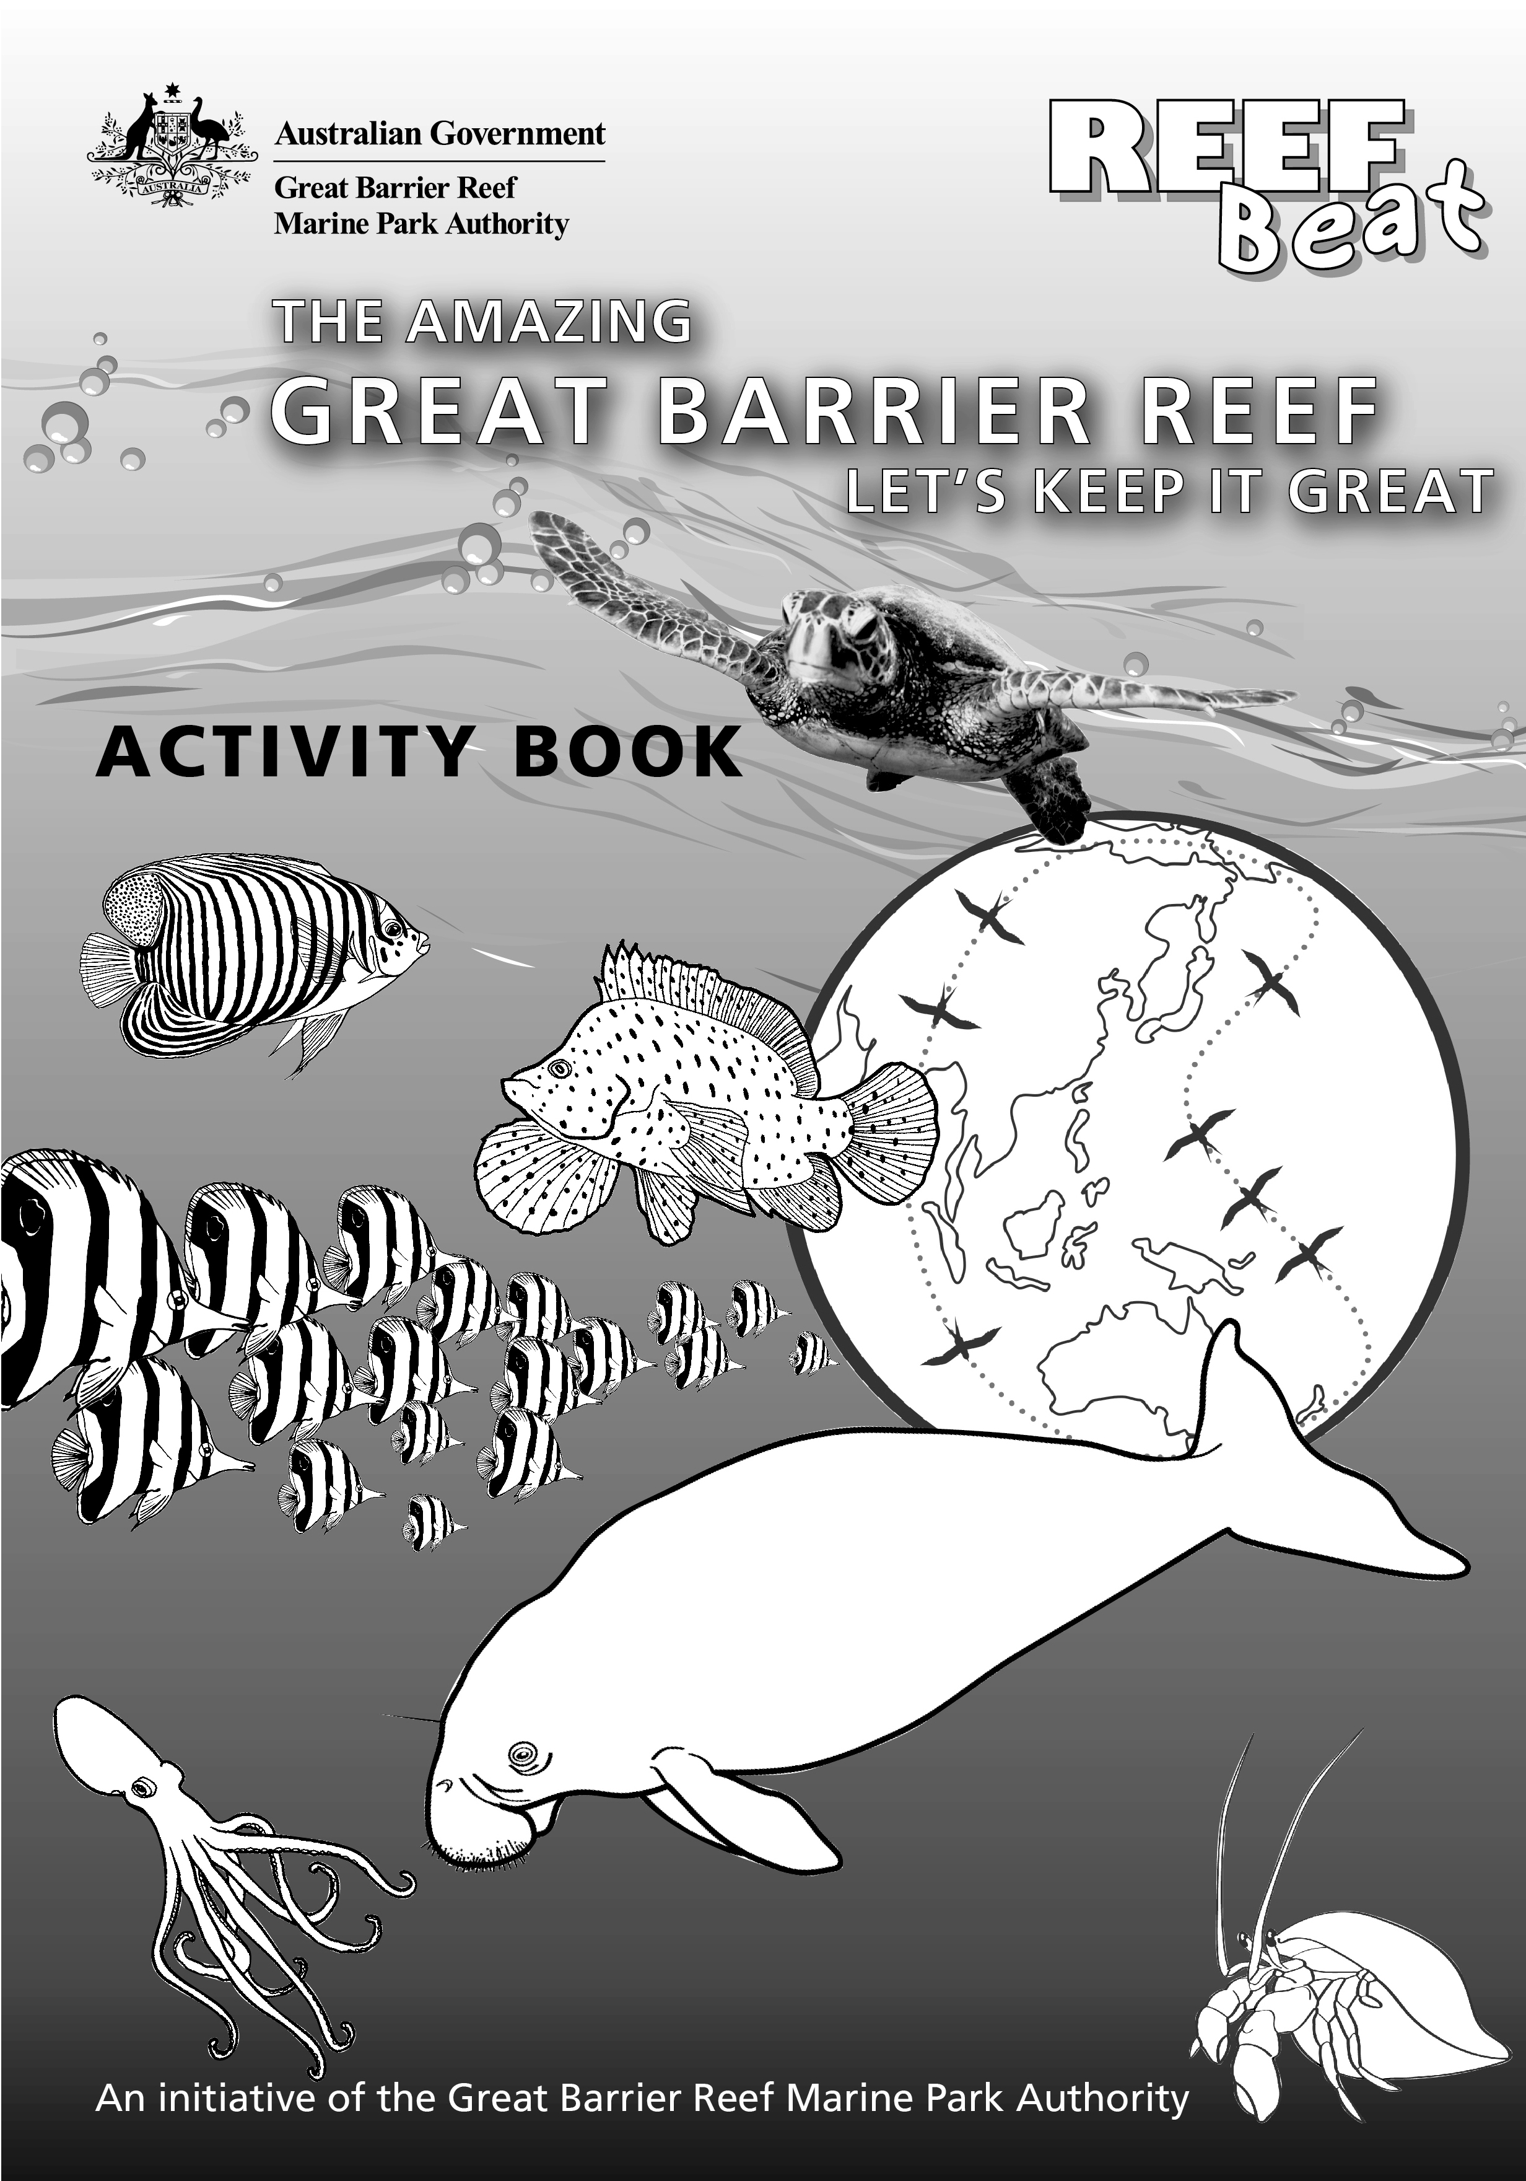

Curriculum content correct at the time of production (May 2013). Curriculum content sourced from The Australian Curriculum www.australiancurriculum.edu.au and the Queensland Studies Authority www.qsa.qld.edu.au.
© Commonwealth of Australia 2013
Published by the Great Barrier Reef Marine Park Authority
ISBN: 978-1-922126-05-4
Reef Beat 2013 poster design assisted by 121creative, Townsville www.121creative.com.au
Geography activities on pages 4, 12, 19 and 21 developed in assistance with Mick Law, Contour Education www.contoureducation.com
Illustrations on pages 4, 18, 23 and 28 by Chris Brunton
Illustrations on pages 5, 6, 7, 11, 13, 14, 16, 19, 21, 25, 26 and 27 by Fiona Alongi
Illustrations on pages 9 and 10 by Patricia Galvin

Photograph on the 2013 Reef Beat poster of four boys enjoying the waters at Munbah, taken by Kathi Gibson-Steffensen
Map on 2013 Reef Beat poster courtesy of the Great Barrier Reef Marine Park Authority’s Spatial Data Centre ©2013
This work is copyright. Apart from any use as permitted under the Copyright Act 1968, no part may be reproduced by any process without the prior written permission of the Great Barrier Reef Marine Park Authority. Permission is given to educators to make copies from this book for classroom use.
Comments and enquiries on the 2013 Reef Beat education series are welcome. Requests concerning reproduction and rights should be addressed to:
Director, Communication
2-68 Flinders Street
PO Box 1379
TOWNSVILLE QLD 4810
Australia
Phone: (07) 4750 0700
Fax: (07) 4772 6093
info@gbrmpa.gov.au
Contents
Introduction 1
How to use the 2013 Reef Beat education series 2

Activities and key messages
Multiple-use Great Barrier Reef Marine Park 3
Year 10 Geography — Exploring how the Reef is managed 4
The Great Barrier Reef’s outstanding biodiversity 5
Early Years (pre-Prep) — In an octopus’s garden 6
Year 1 Science — Habitats of the Great Barrier Reef 7
Traditional Owners of the Great Barrier Reef 8
Year 3 Science and History — Importance of Traditional Owners 8
Year 4 Science and History — Australia’s Indigenous people are connected to country and place 10
Ongoing processes 11
Year 8 Geography — How did the Great Barrier Reef form? 12
Year 10 Science — Responsible global practices 13
Protected species 14
Year 6 Science — A whale of a good time 15
Year 9 Science — A healthy Great Barrier Reef for dugongs 16
The Reef’s social and economic values and attributes 18
Year 5 Geography — How can we improve uses of the Reef? 19
Heritage of the Great Barrier Reef 20
Year 2–3 Geography — The Reef is a special place 21
It’s all connected 22
Year 4 Science — Animals rely on a healthy environment for survival 22
Year 11–12 Marine Science — Cumulative uses and impacts on the Great Barrier Reef 24
Visit the amazing Great Barrier Reef 25
Year 7 Science — What makes the Great Barrier Reef so special? 26
Year 6 Science — Fishing responsibly on the Great Barrier Reef 28

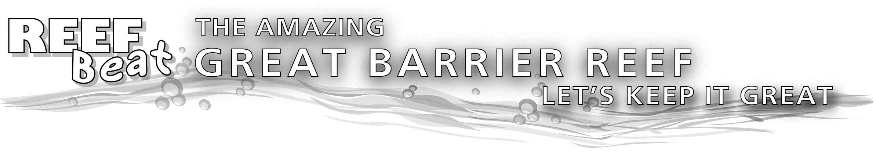Introduction
The Great Barrier Reef Marine Park Authority’s 2013 Reef Beat education series, the amazing Great Barrier Reef — let’s keep it great, includes a poster (best viewed and printed in A0 size) and this activity book. It takes us on a journey of why the Great Barrier Reef is amazing, both in beauty and scale, and highlights its importance as a national and international icon. Together, we will explore the Reef’s environmental, social and economic values and attributes, Traditional Owner connections to sea country and how the Reef is managed.
There are thousands of different species which call the Reef home. We can only introduce you to some of the Great Barrier Reef’s biodiversity in this education series; however we encourage you to explore the Reef further using the resources suggested in each activity. We also have some tips for you if you are lucky enough to visit the Great Barrier Reef.
Areas of the Great Barrier Reef Region have been progressively included in the Great Barrier Reef Marine Park since the 1970s. The Great Barrier Reef Marine Park Authority (GBRMPA) is responsible for managing the Great Barrier Reef Marine Park so it is protected for the future. The Marine Park contains almost the entire Great Barrier Reef ecosystem covering 344,400 square kilometres at a width of between 80–250 kilometres. It spans more than 2300 kilometres along two-thirds of the east coast of Queensland from the northern tip of north-eastern Australia to just north of Bundaberg. It includes the world’s largest living structure — almost 3000 coral reefs in total, which represents about 10 per cent of all the coral areas in the world. While coral reefs make the Great Barrier Reef famous, they only make up about seven per cent of the area of the Marine Park.
The Great Barrier Reef is an amazing place:
- It includes a stunning array of marine creatures, including 600 types of soft and hard corals, more than 100 species of jellyfish, 3000 varieties of molluscs, 500 species of worms, 1625 types of fish, 133 varieties of sharks and rays and more than 30 species of whales and dolphins.
- It has an average depth of 35 metres in its inshore waters, while on outer reefs, continental slopes extend down to depths of more than 2000 metres.
- It was established as a Marine Park in 1975 through the Great Barrier Reef Marine Park Act.
- The Marine Park extends into the airspace above the ocean and into the Earth beneath the seabed.
- It is a multiple-use Marine Park, supporting many different types of uses such as tourism, fishing, Defence activities, ports and shipping, recreation, Indigenous traditional use and scientific research.
- It is the largest and best known coral reef ecosystem in the world and can be seen from space.
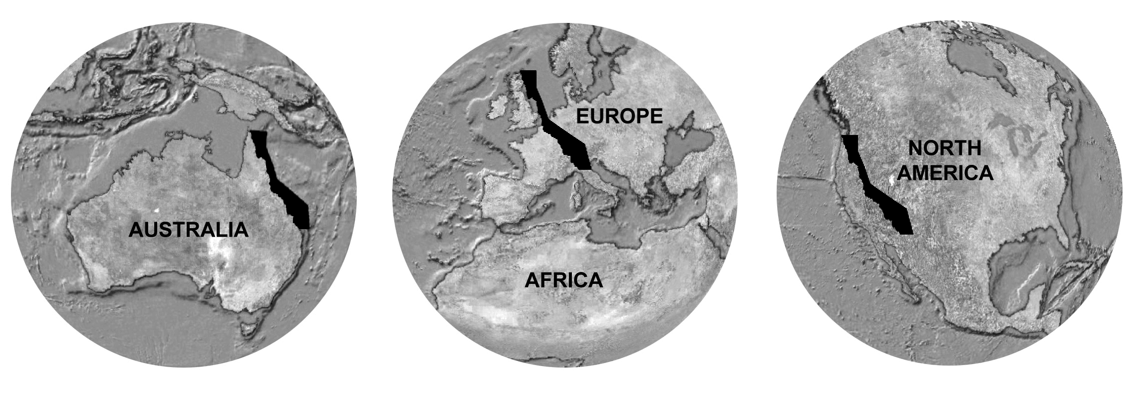
Above shows relative size of the Great Barrier Reef World Heritage Area
The Great Barrier Reef was declared a World Heritage Area in 1981 because of its ‘outstanding universal value,’ the first coral reef ecosystem in the world to receive this international recognition. While larger World Heritage areas have subsequently been inscribed on the World Heritage List, no other World Heritage property contains such biodiversity. About 99 per cent of the World Heritage Area is included within the Great Barrier Reef Marine Park (see the Marine Park and World Heritage Area boundaries in the 2013 Reef Beat poster). This Commonwealth Marine Park is mirrored by complementary Queensland (State) zoning in the Great Barrier Reef Coast Marine Park in adjacent Queensland coastal waters.
The Great Barrier Reef is one of only a small number of marine World Heritage properties that have been inscribed for meeting all four natural criteria for World Heritage. When the area’s outstanding universal value was recognised in 1981, the four natural criteria for which the Reef was listed were:
- outstanding examples representing the major stages of Earth’s evolutionary history
- outstanding examples of significant ongoing geological processes, biological evolution and human interaction with the natural environment
- unique, rare natural phenomena and features of exceptional natural beauty
- habitats where populations of rare or endangered species of plants and animals survive.
The wording and numbering of the natural World Heritage criteria have evolved so the criteria used for World Heritage properties differs slightly today. Nevertheless, the international significance of the Great Barrier Reef remains with its World Heritage listing and Australia’s consequent obligation to protect and conserve the Great Barrier Reef for all future generations to explore and enjoy.

GBRMPA’s Reef Guardians program engages schools, councils, farmers, graziers and fishers in playing an active role in protecting the health and resilience of the Great Barrier Reef. We recognise those people who take a hands-on stewardship approach, from school students protecting marine turtles through regular beach clean-ups, to farmers stabilising river banks through planting trees to reduce erosion and improve water quality. We each have a part to play in keeping the Great Barrier Reef great.
There are currently 293 schools and over 114,900 students helping to protect the resilience and health of the Great Barrier Reef through their involvement in the Reef Guardian Schools program. Each year, Reef Guardian Schools receive a free printed version of the Reef Beat education series to help embed learning about the Reef and sustainability into curriculum at their school. We also have other curriculum resources available to help you learn more about the Reef and how you can protect it at www.gbrmpa.gov.au.

How to use the 2013 Reef Beat education series
This resource is designed to be used as a teaching tool in the classroom. The activities in this book are linked to the Australian Curriculum Science and History (version 4.2) and Australian Curriculum Geography (May 2013). The science and history activities describe relevant content descriptions for the targeted year levels. The curriculum content was correct at the time of production (May 2013) but may change (check www.australiancurriculum.edu.au for current content descriptions). The content descriptions define how the activities might be completed in the classroom, however all activities can be modified for any learning stage, with any group. We have also provided an indication of the relevant year levels (Early Years to Year 12) for each activity based on the curriculum outcomes, however the activities can be modified to suit any year level. The cross-curriculum priorities of Aboriginal and Torres Strait Islander histories and cultures, and sustainability also feature in the poster and activity book, as does building students' scientific investigation skills.
There is also a Year 11–12 Marine Science activity included in the activity book linked to the Marine Science Senior Syllabus 2013. We have tried to make this year’s resource more accessible to teachers in a range of subject areas. We encourage you to share the 2013 Reef Beat education series with other staff at your school and have it located where all staff can access it, for example at your school library.
The 2013 Reef Beat poster (best viewed and printed in A0 size) and activity book are designed to encourage students to use inquiry-based learning. The Reef Beat poster complements the activity book and they are designed to be used together as a valuable learning resource. The poster shows a map of the Great Barrier Reef Region and contains information to help students explore the amazing Great Barrier Reef and work through the suggested activities.
The 2013 Reef Beat posters, activity book and additional curriculum resources are available online on the GBRMPA website www.gbrmpa.gov.au.


Multiple-use Great Barrier Reef Marine Park

Key messages:
- Managing the Great Barrier Reef is a challenging task due to its size and diversity, its economic importance and different local, state, national and international interests in the area.
- As outlined under the Great Barrier Reef Marine Park Act 1975, GBRMPA is responsible for managing the Marine Park so it's protected for the future.
- Management is guided by the Great Barrier Reef Outlook Report (published every five years) which highlights that although the Reef is one of the best managed reefs in the world, it faces some significant challenges.
- Climate change, continued declining water quality from catchment run-off, loss of coastal habitats from coastal development and a small number of impacts from fishing are the key threats to the Reef identified in the Great Barrier Reef Outlook Report 2009.
- Activities such as the comprehensive strategic assessment being conducted by the Australian and Queensland governments are aimed at helping to reduce these impacts.
- The strategic assessment will identify the Reef’s values that need protecting, the threats to those values and what we need to do to address those threats.
- This assessment presents an incredible opportunity to shape the management of the Great Barrier Reef for the next 25 years — ensuring a sustainable future for the Reef’s stunning biodiversity, as well as for the people who visit it, and the communities and industries that rely on it.
- The ecosystem-based management approach used to manage the Marine Park recognises the different interactions within the ecosystem, including with humans; rather than managing single threats, species, or ecosystem services in isolation.
- For more than 30 years, the Marine Park has been a multiple-use area, providing protection, ecologically sustainable use and enjoyment for many people.
- A range of communities and industries depend on the Reef for their livelihood or recreational activities such as tourism, fishing, boating and shipping.
- The Great Barrier Reef Marine Park Zoning Plan 2003 helps to manage uses of the Reef and protect the values of the Marine Park.
- The zoning plan separates potentially conflicting uses and preserves 33 per cent of the Marine Park as marine national park where extractive activities are not permitted.
- The 2013 Reef Beat poster includes an example of zoning around Lizard Island.
- Before heading out on the water, pick up a zoning map or visit www.gbrmpa.gov.au to help you get to know the Marine Park zones and what activities are permitted at the places you might visit.
- Significant penalties may be imposed for people who do not comply with Marine Park legislation, for example carrying out activities that are not permitted in certain zones.
- High use areas of the Marine Park, such as those near Cairns and the Whitsunday Islands, have special plans of management in addition to the relevant zoning plan.
- There are also other types of protection, including dugong protection areas.
- In most of the adjoining State waters, the Queensland Government zoning mirrors the Commonwealth zoning so that virtually all waters of the World Heritage Area have complementary management arrangements.
- Out in the Marine Park, Queensland and Australian government agencies monitor and enforce zoning rules.
- Monitoring of the current conditions and activities on the Reef by the community, industry and government is important as it allows GBRMPA to identify issues at an early stage, for example coral bleaching, and develop the best management strategy to respond to this risk.
- GBRMPA values partnerships with organisations, industries, Traditional Owners, government and community in the protection of the Marine Park as many threats to the Great Barrier Reef ecosystem are the result of actions beyond the boundaries of the Great Barrier Reef Region and legislation associated with protecting this Region.

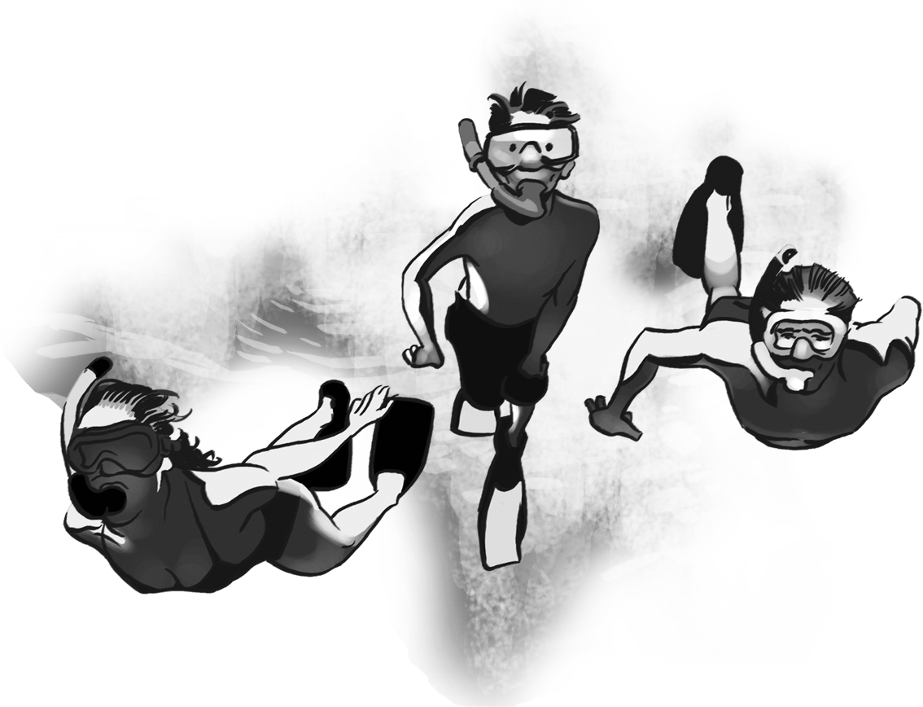
Linked activity

Exploring how the Reef is managed

Learning area
Content descriptions:
See www.australiancurriculum.edu.au for the latest Geography curriculum content descriptions.

Geography

Year level
Year 10 (Environmental Change and Management)

Overview
Students identify key threats to the Great Barrier Reef and examine the potential impacts to the Reef from these threats and other threats identified during investigations. Students examine the current management strategies used to protect and manage the uses of the Reef before making suggestions on how to improve management of the Reef using a chosen area as an example.

Inquiry questions
- What are the four key risks to the Great Barrier Reef identified in the Great Barrier Reef Outlook Report 2009?
- Are there any new threats to the Reef that have been identified since 2009?
- Why does the Great Barrier Reef Marine Park need management?
- Who is responsible for managing the Reef?
- What are the management techniques used to reduce threats to the Reef?

Resources
- The GBRMPA website www.gbrmpa.gov.au — for information on zoning, uses and threats to the Marine Park
- The GBRMPA 2013 Reef Beat poster
- A zoning map for your chosen area (use a zoning map for your local area if you are located close to the Marine Park)
- Information on management of your local catchment to protect the Reef, for example your local council website.

What to do
You have been asked by GBRMPA to review the management strategies of a chosen area of the Marine Park. This could be a part of the Reef close to your school or another part of the Marine Park if you are not located near the Reef. Keeping in mind the main threats to the Reef and main uses of your chosen Reef area, how would you improve management to address predicted changes over time? Justify each recommendation with a reasoned argument.
Research the topic:
- Go to the GBRMPA website and select the ‘Outlook for the Reef’ section. Students should note the major threats to the long-term health of the Reef using dot points. They should also suggest some ways the health of the Reef could be changed by these threats.
- Investigate the different management strategies used to protect the Great Barrier Reef (use the ‘About the Reef’ and ‘Zoning, Permits and Plans’ sections on the GBRMPA website). Compare these management strategies with another marine protected area either around Australia or overseas.
- Examine the zoning in the Marine Park. What activities are permitted in your chosen area of the Marine Park? What management zones are more prominent here than in other Marine Park areas? Are there also management strategies in the adjacent catchment area used to protect the Reef, for example, by your local council?
- Prepare a report or presentation, using mapping and other types of visual aids where appropriate, explaining your recommendations and arguments.

The Great Barrier Reef’s outstanding biodiversity

Key messages:
- Biodiversity is the term used to describe the variety of life on Earth at all its levels; this includes genes, ecosystems, and the evolutionary and ecological processes that support life.
- It is not only a measure of how many different types of species there are, from whales to small microbes, but also describes natural variation such as genetic differences within a species or across one habitat type.
- The Great Barrier Reef World Heritage Area is internationally recognised for its amazing biodiversity.
- This extraordinary biodiversity and interconnectedness between different species and habitats makes the Great Barrier Reef one of the most complex ecosystems on the planet.
- The Reef is more than just coral and fish. There are so many species that we can’t possibly describe them all for you in this activity book. We have provided you with a snapshot of the different types of animals found on the Great Barrier Reef below:
    - Marine mammals such as whales, dolphins and dugongs
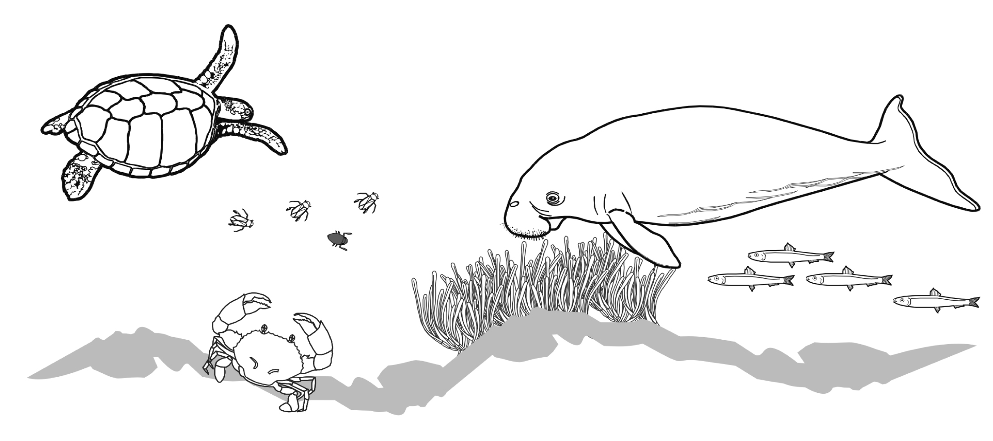
    - Birds, seabirds and shorebirds
    - Marine turtles
    - Estuarine crocodiles
    - Sea snakes
    - Sharks and rays
    - Fishes including 1625 bony fish species
    - Echinoderms, such as sea stars
    - Crustaceans, including crabs and prawns
    - Bivalves, for example, oysters and clams
    - Animals such as octopus, nudibranchs and snails which are part of the mollusc family
    - Hard corals, soft corals and sea pens
    - Sea anemones and sponges
    - Jellyfish.
- The Great Barrier Reef is a refuge for many weird and wonderful creatures. The 2013 Reef Beat poster shows some examples of the amazing biodiversity found on the Reef.
- Besides the many different species of animals found on the Reef, there are also lots of different types of habitats, covering 2300 square kilometres, which represents 54 per cent of the world’s mangrove diversity.
- A healthy, functioning Great Barrier Reef environment relies on its biodiversity to function properly.
- Humans, who use or rely on the Reef through commercial or recreational activities, also rely on the Reef’s health and biodiversity to continue their activities.
- Maintaining biodiversity within the Great Barrier Reef ecosystems and with connecting marine, freshwater and terrestrial ecosystems outside of the Marine Park is important so the Reef can better recover or adapt to impacts such as climate change and coastal development.
- GBRMPA works with many other organisations, industries, Traditional Owners, government agencies and the community to protect biodiversity as this task can’t be completed without partnerships.
- We also use a range of management tools to protect the Reef’s biodiversity such as legislation, zoning, permits for a variety of uses including tourism, fishing, research and development; as well as educating people to act responsibly on the Reef and to comply with rules and regulations.
- The majority of the Great Barrier Reef’s most vulnerable habitats and species occur in inshore areas as outlined in the Great Barrier Reef Biodiversity Conservation Strategy 2013, available on the GBRMPA website www.gbrmpa.gov.au.

Linked activity

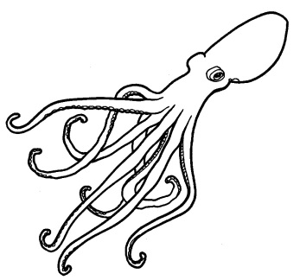
In an octopus’s garden

Learning area
Early Years learning framework
Active learning processes
Investigating environments
Investigating the natural world
Imagining and responding

Science

Year level
Early Years (pre-Prep)

Overview
Students create a classroom habitat inspired by the Great Barrier Reef. They use creativity to show how the habitat and animals might look. Through creating their own versions of animals, students describe what they need to survive as well as what might happen if their home is impacted by an event such as a cyclone. Students are given the opportunity to learn scientific words to describe their animal and its habitat. They are also encouraged to share their personal feelings about the Great Barrier Reef, experiences they have had there and ways to help protect the Reef.

Inquiry questions
- What is your favourite animal on the Great Barrier Reef and why?
- What features does your favourite animal have compared to other students’ favourite Reef creatures?
- How does your creature move and feed?
- If you could create a new Reef animal, what essential features would it need to survive?
- What might happen to your Reef habitat or animal after a big cyclone?
- What positive actions can we take to protect the Reef? How can we live sustainably at home, at school or in our community to protect the Reef?

Resources
- Story-books, pictures and movies about the Great Barrier Reef and Reef animals
- YouTube Reef animations such as following what happens to Hermie the hermit crab in the ocean acidification video on the GBRMPA YouTube Channel www.youtube.com/user/TheGBRMPA
- Pen and paper to create a display chart of what students know
- A range of craft materials to make the Reef habitat and creatures including coloured pens or pencils, scissors, glue and cardboard (use recycled materials where possible).

What to do
- Read books, look at pictures, watch movies and YouTube videos on the Reef, for example, the movie Finding Nemo.
- Have students discuss what their favourite animal is on the Great Barrier Reef and identify its special features, for example, fins or beak. How does it move and eat? Students could role play the movement of their favourite animal.
- As a class, discuss what features you are going to represent in your reef habitat, what they look like and what purpose they have in maintaining the function of the ecosystem.
- Explain to students that they will be creating their own animal. Students can create a new animal or base their creation on an existing reef animal.
- Have students create their own animals (using the materials available). They may need to draw the animal first to think about what features it needs to survive, for example to eat.
- As a class, create the reef habitat. Add the students’ reef creatures.
- Play some sea themed songs such as Octopus’s Garden or Under the Sea and have students move like their sea creature. How do the students feel about their new reef habitat?
- Have a pretend cyclone come through. Discuss what might happen to the animals and habitat. How does this make the students feel?
- Discuss other human influences that can impact the Great Barrier Reef such as fishing, pollution and boating. What can we do to help protect and reduce our impacts on the Reef?

Linked activity

Habitats of the Great Barrier Reef
Content descriptions:
Science
Science understanding
Biological sciences (ACSSU017)
Biological sciences (ACSSU211)
Science as a human endeavour
Nature and development of science (ACSHE021)
Use and influence of science (ACSHE022)
Science inquiry skills
Communicating (ACSIS029)

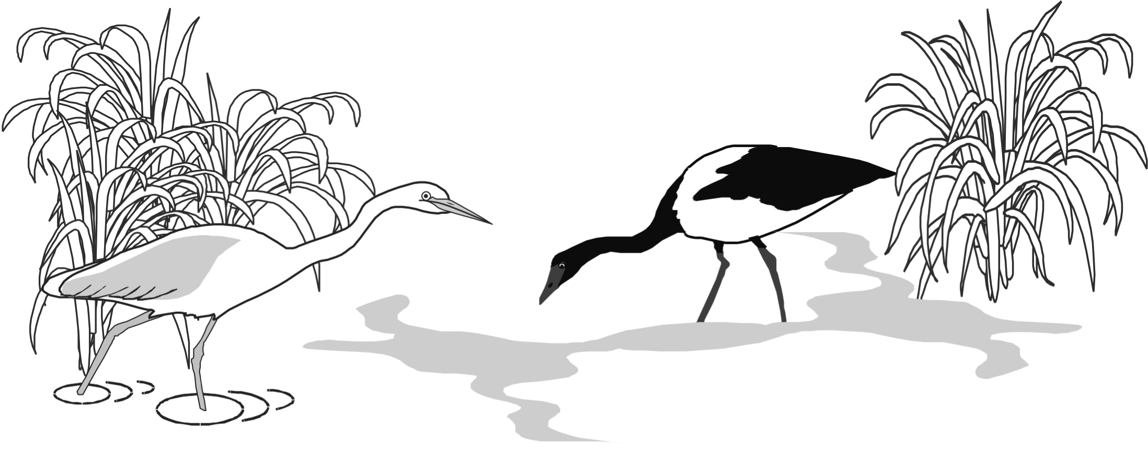
Learning area
Science

Year level
Year 1

Overview
Habitats of the Great Barrier Reef are diverse and have a variety of features. The diversity of habitats on the Reef provides shelter, food and habitat for animals. They also enable the Great Barrier Reef to be one of the most diverse places on Earth and create complex relationships between plants, animals, habitats and ecosystems. Students investigate an animal that uses a number of habitats, including within the Marine Park, during its lifecycle. As a class, students create a picture book following the journey of the animal throughout its lifecycle and the habitats it uses. Students describe the features of the animal and what the different habitats provide for the animal, for example, shelter. They discuss what may happen if the animal’s needs are not met, such as if a habitat is destroyed. Students suggest ways to help protect habitats and animals of the Great Barrier Reef to maintain the diversity of life.

Inquiry questions
- Is the Great Barrier Reef only made up of coral habitats?
- What animals live on the Great Barrier Reef? Do they only live in one place?
- What animals live in different habitats (including within the Marine Park) at different stages of their life?
- What would happen to your chosen animal if a habitat they used was impacted? Would they find another place to fulfil their needs? Would this also impact the health of the animal?
- What actions can you take to help protect the habitats and animals in the Great Barrier Reef Marine Park?

Resources
- Reef story books, pictures, photos or movies on the Great Barrier Reef. Mr Seahorse or A House for Hermit Crab (Eric Carle), or Dhyum the Dugong (Marian Fuentes) may be good books to explore reef animals.
- A large blank book, such as A3 size, to create the story-book (or an electronic equivalent such as PowerPoint)
- Pens, pencils and other materials to create the story-book.

What to do
- Have students investigate the biodiversity of the Great Barrier Reef using available resources. What are the different animals of the Reef? Are there only coral habitats found on the Reef?
- Have students discuss what different animals need to survive. For example, to eat and avoid predators.
- Compare those animals that mostly live in one habitat during their lifecycle and those that need more than one habitat during their lifecycle.
- Discuss how these habitats are different and what needs of the animal these different habitats meet.
- As a class, choose an animal that uses a number of habitats (including the Great Barrier Reef) across its lifecycle. You may choose to allocate a particular habitat/stage of the life cycle to a group of students to work on together.
- Students find pictures or photos of the animal across its lifecycle such as young, larval fish and mature, adult fish. They also find a variety of pictures or photos of the different habitats the animal journeys to during its lifecycle.
- Using the information collected, as a class, create a story-book following the journey of the animal through different habitats during its lifecycle. Using pictures, drawings or words, students should describe what needs the different habitats are providing for the animal.
- What would happen if one of the habitats the animal uses was damaged? Could the animal still survive? Would it move to another place?
- Have students identify the threats to the animal and different habitats (using pictures, drawing or words) during its lifecycle in the story-book.
- Discuss ways to protect the animal and the habitats it uses in the story-book.

Traditional Owners of the Great Barrier Reef

Key messages:
- Aboriginal people are the first Australians and are widely recognised as the oldest civilisation in the world.
- Torres Strait Islander people are related to the Melanesians of the south-west Pacific. The Great Barrier Reef begins north-east of Murray Island (Mer) in the Torres Strait.
- Aboriginal and Torres Strait Islander people are the Traditional Owners of the Great Barrier Reef Region with evidence of their sea country connections dating back over 60,000 years.
- There are more than 70 Aboriginal and Torres Strait Islander Traditional Owner clan groups, from the Torres Strait Islands in the north to near Bundaberg in the south, whose sea country includes the Great Barrier Reef Marine Park.
- Great Barrier Reef Traditional Owners continue their close connection to sea country areas of the Marine Park to practice their living maritime culture and maintain their heritage values. These may be cultural, natural, spiritual, economic, social or physical.
- The colonisation of Australia after 1788, led to major changes in Aboriginal and Torres Strait Islander societies, cultures, lifestyles and use of sea country including the introduction of new technologies we see today. An example of new technology used by Traditional Owners are tracking systems which can map traditional areas and assist with research and monitoring.
- When Europeans first came to Australia, a lot of evidence of traditional sites and uses by Aboriginal and Torres Strait Islander people were destroyed or removed. However, there are still many cultural heritage sites remaining which show how Traditional Owners lived, made tools or weapons, practiced ceremonies or ate food from the sea.
- Middens (areas where Aboriginal and Torres Strait Islander people lived in coastal environments) are an example of a cultural heritage site that tells us what type of food was eaten and information about the people who inhabited the area.
- According to their customs, Aboriginal and Torres Strait Islander Traditional Owners still use natural marine resources today through activities such as fishing, collecting, hunting and looking after cultural heritage places.
- Through traditional use, Aboriginal and Torres Strait Islander Traditional Owner groups have an extensive knowledge of the history, ecosystems, habitats and species of the Great Barrier Reef.
- Great Barrier Reef Traditional Owners recognise the significant challenges the Reef faces today and want to be involved in the future management of their sea country for example, through a number of Marine Park management initiatives.
- One example of how GRBMPA is working with Traditional Owner clan groups to manage their sea country areas is through a Traditional Use of Marine Resources Agreement.

Linked activity
Content descriptions:
History
Historical knowledge and understanding
Community and remembrance (ACHHK060)
Community and remembrance (ACHHK062)
Historical skills
Explanation and communication (ACHHS070)
Science
Science as a human endeavour
Use and influence of science (ACSHE051)

Importance of Traditional Owners

Learning areas
Science and History

Year level
Year 3

Overview
Students investigate the history of their local area. They write a short narrative from the perspective of an Indigenous person (in 1788) about why the local area is special (this may be a local area of the Great Barrier Reef Marine Park), describe local characteristics such as plants and animals, activities they are doing and how they feel about the Europeans arriving in their country.

Inquiry questions
- What does it mean to be a Traditional Owner?
- Who are your local Traditional Owners and are they Traditional Owners of the Great Barrier Reef?
- How far does evidence of Aboriginal and Torres Strait Islander presence on the Great Barrier Reef and in your local area date back?
- What are special places to Traditional Owners and other people and why?
- How has our community changed? What features have been lost and what features have been retained?

Resources
- The GBRMPA Story Place is a good database to search for stories about Aboriginal and Torres Strait Islander people and the Great Barrier Reef www.gbrmpa.gov.au/our-partners/traditional-owners/story-place.
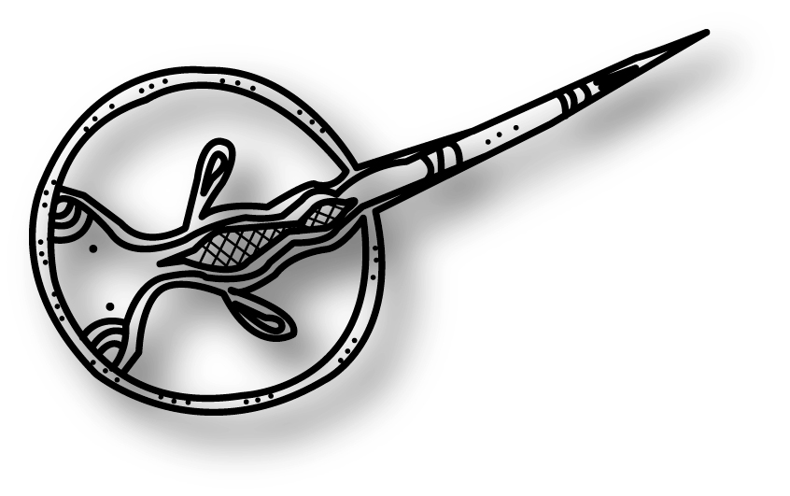
- The GBRMPA website www.gbrmpa.gov.au identifies some of the Aboriginal and Torres Strait Islander Traditional Owner clan groups and nations of the Great Barrier Reef. Look under the ‘Our Partners’ section then explore Traditional Owner connections to sea country.
- The GBRMPA 2013 Reef Beat poster
- Maps, stories, legends, information or first-hand knowledge of Indigenous interaction with the environment in your local area
- Information on local plant and animal species including the Indigenous names
- The GBRMPA 2010 Reef Beat Sea Country Connections www.gbrmpa.gov.au/resources-and-publications/student-and-teacher-resources/reef-beat-series
- Australian Museum website www.australianmuseum.net.au/stories-of-the-dreaming.

What to do
- Read a Traditional Owner story about the Great Barrier Reef. Use a local story if possible or find a story from the library or the GBRMPA Story Place. Use the GBRMPA 2010 Reef Beat — Sea Country Connections, for ideas on discussion topics with students.
- Discuss what it means to be a Traditional Owner and why they tell stories. What is the significance to Traditional Owners of the story?
- Examine the evidence that exists about the history of human presence in your local area and on the Great Barrier Reef. Have there been changes to the community over time? Have there been changes to the uses of the area over time?
- Try to create a timeline of events for your local area including when Europeans colonised your region.
- Research your local area Traditional Owners (this may be a Traditional Owner clan group of the Great Barrier Reef Marine Park if you live close to the Reef).
- Have students write a narrative from the perspective of a local Indigenous person in 1788 describing why their local area of the Great Barrier Reef is special. If you are not located near the Queensland coast, students could describe how their local area is special.
- Encourage students to use the correct Indigenous words for plants and animals when they are describing their special place (if they have access to them) as well as use the correct names for local natural features.
- Extension activities could include inviting a local Traditional Owner to come and talk to the class about the history of their local area and of their special connections to the Great Barrier Reef. You could also go on an excursion to a local Traditional Owner site if you have permission, for example middens, nature trails, fish traps or ancient fire pits.

Linked activity

Australia’s Indigenous people are connected to country and place
Content descriptions:
History
Historical knowledge and understanding
First contacts (ACHHK077)
Science
Science as a human endeavour
Nature and development of science (ACSHE061)

Learning areas
Science and History

Year level
Year 4

Overview
Students investigate the history of Aboriginal and Torres Strait Islander people before and after the arrival of Europeans. They explore the cultural sites both tangible (physical) and intangible (such as places where events and stories took place) in their local area of the Great Barrier Reef World Heritage Area in the history of Aboriginal and Torres Strait Islander people and Europeans. Students showcase their knowledge of past and present Traditional Owner and European connection to the local environment by creating a map of their local area of the World Heritage Area showing areas of interest.

Inquiry questions
- What was life like for Aboriginal and Torres Strait Islander people before the arrival of Europeans?
- What was the consequence of contact between Aboriginal and Torres Strait Islander people and early traders, explorers and settlers? What events took place in history to mark this interaction and the changes that took place?
- What significant cultural sites, both tangible and intangible, are found in your local area of the World Heritage Area which tell a story of activities or events that took place in European, Aboriginal and Torres Strait Islander society in the history of the Great Barrier Reef?

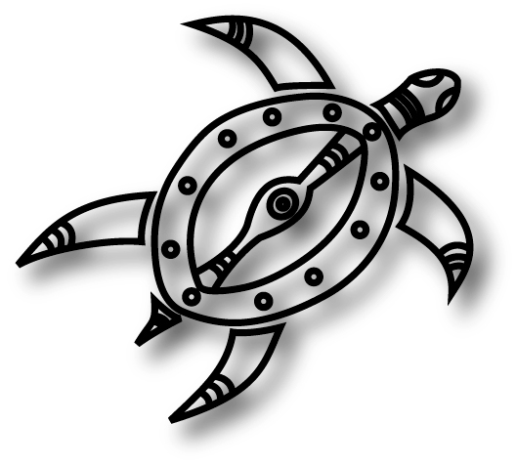
Resources
- The GBRMPA 2013 Reef Beat poster
- The GBRMPA website to explore Traditional owner connections to sea country — www.gbrmpa.gov.au, under the ‘Our Partners’ section
- GBRMPA 2010 Reef Beat Sea Country Connections www.gbrmpa.gov.au/resources-and-publications/student-and-teacher-resources/reef-beat-series
- Transparent plastic sheet to cover the 2013 Reef Beat poster and whiteboard markers.

What to do
- Have students find out more about the history of their local area and the World Heritage Area including significant cultural sites such as artefacts and sites where events and stories took place in European, Aboriginal and Torres Strait Islander society.
- Students could visit the library, local museum or the GBRMPA website to find out more about the history, the location of special cultural places or places where events and stories have originated.
- Place the transparent plastic sheet over the 2013 Reef Beat poster.
- Using information from their research, ask students to use whiteboard markers to indicate significant sites within and surrounding the Great Barrier Reef World Heritage Area.
- Have students create their own simple, hand-drawn map of a section of the World Heritage Area located close to your school (or chosen area if you do not live close to the Reef) with important sites described. They can use pictures or words to describe these places, events or stories. The map should include relevant map features including a key, a title, a scale, north point, and place names.
- Students present their map to classmates during a poster presentation (approximately five minutes duration) and describe the features of their map.

Ongoing processes

Key messages:
- Beneath the vast surface of the ocean, there are spectacular collections of coral and reef fish in many amazing colours, shapes and sizes.
- The Great Barrier Reef has evolved over millennia. The forces of wind, water, and at least four ice ages have shaped the islands, reefs and seascapes we see today.
- The Traditional Owners of the Great Barrier Reef have beliefs and creation stories about the formation of the Great Barrier Reef.
- The Great Barrier Reef World Heritage Area contains the single largest coral reef system on Earth, comprising almost 3000 coral reefs in total and extending over 14 degrees of latitude.
- Within the Great Barrier Reef system there are more than 300 coral cays and 600 continental islands and a further 150 mangrove islands. The continental islands are mostly comprised of massive granites or silicic volcanic rock.
- The interplay of coastal and marine geomorphological elements is one of the reasons the area is recognised as being of outstanding universal value and declared a World Heritage Area.
- The processes of evolution in this system are represented in many different ways including linking islands, cays, reef and changing sea levels, sand barriers and associated dune systems.
- The World Heritage Area provides a unique research site to study, for example, conditions necessary for the development of coral reefs and how they change over time.
- Major changes in sea level are recorded in the Reef’s structure and nearly all stages of reef development are represented within the Great Barrier Reef.
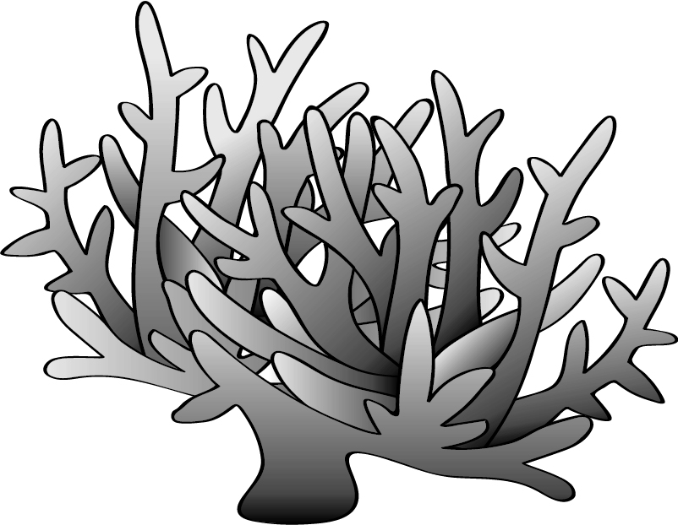
- The Great Barrier Reef World Heritage Area covers 348,000 square kilometres and extends from sea level (seabed) to 1142 metres in elevation (Mount Bowen).
- It shows outstanding examples of ongoing geological processes, biological evolution and human interactions with the natural environment.
- Continental islands were once part of the mainland and occur on the continental shelf.
- Coral cays form over time through the build-up of materials such as sand transported through ocean currents.
- There are lots of different types of corals found on the Great Barrier Reef. Corals are divided into hexacorals (hard corals) and octocorals (sea pens, blue corals, soft corals and sea fans).
- As well as human impacts on the Great Barrier Reef, the Reef is also changing constantly due to natural processes such as currents, sea level changes and weather events such as cyclones.

Linked activity

How did the Great Barrier Reef form?

Learning area
Content descriptions:
See www.australiancurriculum.edu.au for the latest Geography curriculum content descriptions.

Geography

Year level
Year 8 (Landscapes)

Links to other subject areas
- Year 8 Earth and Space Sciences (ACSSU153)
- Year 9 Earth and Space Sciences (ACSSU180)

Overview
Students examine the bathymetry of the Great Barrier Reef using geospatial technologies. Bathymetry is the study and mapping of the seafloor including measuring ocean depth. Students explore the geomorphology (the scientific study of landforms and the processes that shape them) of the Reef to uncover how it was formed and identify alternative perceptions of the Reef’s formation. They discuss the values and uses of the Reef from past to present.

Inquiry questions
- How did the Great Barrier Reef form?
- What does the Reef look like in my local area?
- How do others believe the Great Barrier Reef formed?
- How do we use and value the Reef and how has this changed over time?

Resources
- The GBRMPA 2013 Reef Beat poster
- A computer with Google Earth installed for each student or pair of students www.google.com/earth
- Access to the Deepreef Explorer website www.deepreef.org
- The GBRMPA website www.gbrmpa.gov.au for more information on zoning, reef structure and Traditional Owner stories about the Great Barrier Reef. The Gabul is an example of an Indigenous creation story which is well-known in North Queensland.
- The GBRMPA Story Place is a good database to search for stories about Aboriginal and Torres Strait Islander people and the Great Barrier Reef www.gbrmpa.gov.au/our-partners/traditional-owners/story-place
- Books, movies and scientific journals on how the Great Barrier Reef was formed.

What to do
- Open Google Earth, sign in and open the Earth Gallery from the left hand menu (under ‘Layers’). Search for the ‘global bathymetry’ map and view it in Google Earth. Depths move from shallow to deep, through red, orange, yellow, green, blue, violet. Ask students to describe the relative depths along the coastline of Queensland.
- Go to the Deepreef Explorer website. Under the ‘Bathymetry’ section, select ‘Great Barrier Reef and Coral Sea bathymetry’. Find your local area of the Marine Park or an area known to your students. A zoning map may also be useful to help you examine your local area.
- Using the resources available, ask students to research the formation of the Great Barrier Reef including earth movements and erosion and weathering. Students should describe how the Reef was formed using the following terms in their answer: Great Dividing Range, fringing reef, barrier reef and atoll, coastal plain, erosion, tropical or warm waters.
- Ask students to research the different types of reefs of the Great Barrier Reef. Students should draw a figure for each type with labels that outline its formation process.
- Have students research a Dreamtime story on how the Reef was formed. The GBRMPA online Story Place is a good database to search for stories about Aboriginal and Torres Strait Islander people and the Great Barrier Reef. Ask students to consider how the Reef was used and valued before European arrival and compare this to how people use and value the Reef today.

Linked activity
Content descriptions:
Science
Science understanding
Biological sciences (ACSSU185)
Earth and space sciences (ACSSU189)
Science as a human endeavour
Use and influence of science (ACSHE194)
Use and influence of science (ACSHE230)
Science inquiry skills
Evaluating (ACSIS206)
Communicating (ACSIS208)

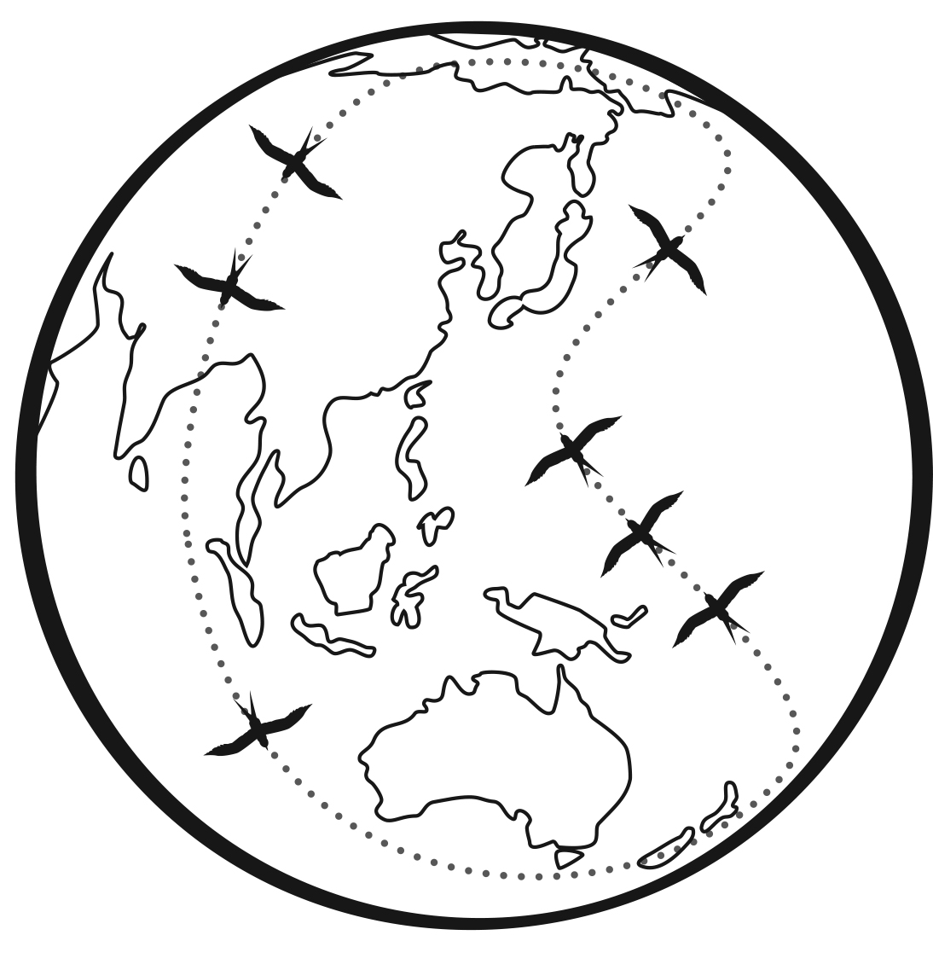
Responsible global practices

Learning area
Science

Year level
Year 10

Overview
The Great Barrier Reef’s outstanding biodiversity can be attributed to changes in species over time due to natural selection — the key process of evolution where some traits become either more or less common. Sea levels over vast periods of time have changed extensively in Great Barrier Reef Region, and the Reef and its associated animals, habitats and ecosystems, have adapted along with it. Historical records of how climate conditions change over time, including sea level, floods and global temperature, have been recorded in corals forming layers of evidence much like tree rings. Climate change (and the greenhouse effect) is already affecting coral health and is one of the greatest risks to the future of our Great Barrier Reef.

Inquiry questions
- What is the carbon cycle?
- What are the causes and effects of the greenhouse effect?
- How have changes in climate conditions, for example sea level or global temperature, affected the Reef?
- What may be some long-term effects of the loss of biodiversity on the Great Barrier Reef?
- What are the factors that drive deep ocean currents, its role in regulating global climate, and effects on marine life?
- What kinds of scientific developments have led to our current knowledge of climate change causes and effects? Who has carried out this research?

Resources
- Books, websites and videos on the carbon cycle
- Climate change resources such as books, scientific journals and websites such as the Great Barrier Reef Climate Change Adaptation Strategy and Action Plan 2012-2017 (available at www.gbrmpa.gov.au/outlook-for-the-reef/climate-change), the Climate Commission http://climatecommission.gov.au/report/extreme-weather/ or CSIRO Marine and Atmospheric Research www.cmar.csiro.au/research/co2/co2.html.

What to do
- As a class, examine the carbon cycle through the biosphere including the role that increasing carbon dioxide has in climate change and ocean acidification.
- Discuss how human activity has affected this global system.
- Have students study scientific evidence for climate change.
- As a class, discuss the validity of the claims presented by varying scientists about the future impacts of climate change on the Reef.
- Explain to students that they are going to explore the topic of climate change through a class debate. In small groups, students will research and debate a topic of interest relating to climate change. Some debate topics may include:
    - the Reef’s biodiversity will/won’t adapt over time, just as it has historically
    - climate change is a natural phenomenon
    - the effects of extreme weather on the Reef will alter its future.
- Students will need to choose the supporting or refuting side of the argument for their debate.
- Teams will have five minutes each to debate the chosen topic followed by a class discussion on the issues identified.

Protected species

Key messages:
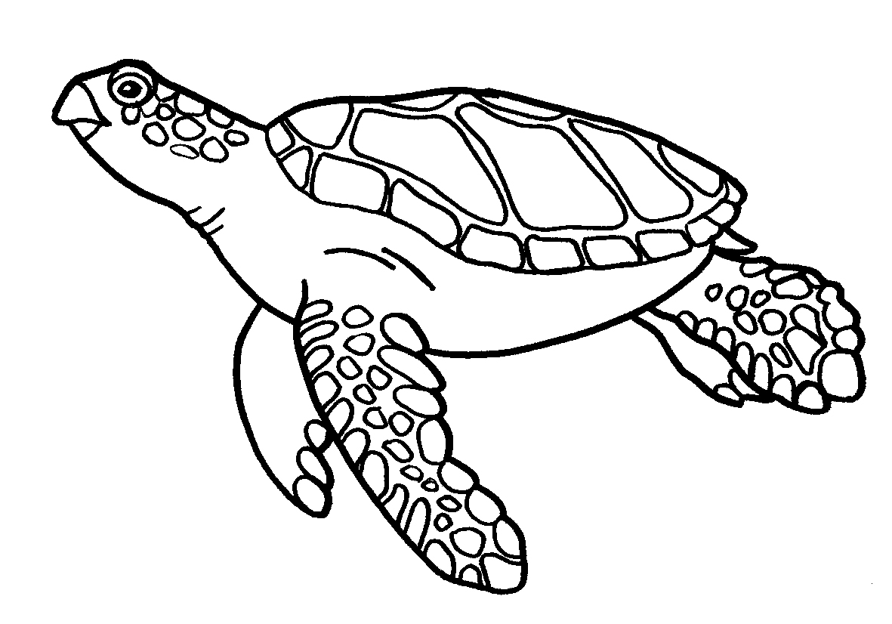
- The list of protected species for the Marine Park includes:
  - some shells — helmet shells, triton shells, giant clams
  - some fish — seahorses, pipefish, sea dragons, potato cod, Queensland groper, barramundi cod, Maori wrasse, all groupers (Epinephelus) more than 100 centimetres long
  - some sharks — whale shark, grey nurse shark, great white shark, largetooth (freshwater) and green sawfish
  - sea snakes
  - estuarine crocodiles
  - marine turtles
  - birds
  - seals
  - whales, dolphins and dugongs.
- A protected species is a plant or animal that is protected by law and needs special management because the survival of its population is under threat. Species may be protected at an international, national, state or local level:
  - International level: species that are listed as vulnerable, endangered or critically endangered under the International Union for the Conservation of Nature Red Data Book.
  - National level: species that are a listed threatened species, a listed migratory species or a listed marine species under the Environment Protection and Biodiversity Conservation Act 1999
  - State level: species of marine mammal, bird or reptile that are described as endangered, vulnerable, near threatened and least concern under the Nature Conservation Act 1992 (Qld)
  - Local level: species mentioned in Table 29 of the Great Barrier Reef Marine Park Regulations 1983.
- A protected species in the Marine Park is classified as threatened if its population has declined within and adjacent to the Great Barrier Reef
- A protected species is classified as iconic if it is one of Australia’s most well-known plants or animals and requires special management in the Marine Park
- A protected species in the Marine Park is classified as at risk if it faces pressure from human-related activities within and adjacent to the Great Barrier Reef.
- The Great Barrier Reef is home to one of the world’s most important dugong populations and six of the world’s seven species of marine turtles.
- Dugongs play an important ecological role in coastal marine ecosystems. They can be used as an indicator of general ecosystem health.
- While dugongs are threatened on a worldwide scale, Australia has a large proportion of the remaining population. This makes Australia the largest, and globally most important, refuge for them.
- To Traditional Owners, dugongs are culturally valuable resources that are traditionally used by some clan groups as totems, a food resource and in traditional activities or storytelling. Dugongs are an essential part of Aboriginal and Torres Strait Islander people’s heritage and maritime estates in the Great Barrier Reef World Heritage Area.
- Dugong numbers are monitored by some Traditional Owner clan groups as part of the effort to conserve them for future generations.
- There are many special visitors that migrate to the Great Barrier Reef each year such as humpback whales, which come from Antarctic waters to the Great Barrier Reef World Heritage Area from May to September to calve, mate and socialise over the tropical winter before they return to the Antarctic to feed over the summer
- Around 30 species of whales and dolphins are found in the Marine Park.
- Many species that rely on inshore habitats of the Great Barrier Reef are impacted by a range of threats (from outside of the Marine Park) including water quality due to catchment run-off, loss of habitats due to coastal and port development and climate change. Illegal fishing and poaching also have some impact.
- The Great Barrier Reef Biodiversity Conservation Strategy 2013 provides a framework for improving biodiversity conservation in the Great Barrier Reef Region. GBRMPA is currently completing vulnerability assessments for habitats, species and groups of species that are potentially at risk. This identifies action to reduce threats and pressure to the Great Barrier Reef’s biodiversity.

Linked activity

A whale of a good time
Content descriptions:
Science
Science understanding
Biological sciences (ACSSU094)
Science as a human endeavour
Nature and development of science (ACSHE098)
Science inquiry skills
Communicating (ACSIS110)

Learning area
Science

Year level
Year 6

Overview
The Great Barrier Reef hosts special marine visitors annually, such as humpback whales, which come to the warm, tropical waters with their young during winter to calve, mate and socialise. This activity investigates the migration journey of whales visiting the Great Barrier Reef and how we can help to improve conditions for these majestic animals along the way.

Inquiry questions
- Why do whales visit the Great Barrier Reef?
- What are the different types of whales that visit the Great Barrier Reef?
- What is the biology, movements, diet and breeding processes of different whale species that visit the Reef?
- Where do they spend summer (where are they when they are not here)?
- Where do whales congregate (gather) in tropical waters?
- What are possible threats to whales during their migration both through the Great Barrier Reef and other places they visit?
- What responsible reef practices are in place for when you see a whale in the Great Barrier Reef?

Resources
- The GBRMPA 2013 Reef Beat poster
- Information on whales on the GBRMPA website www.gbrmpa.gov.au and in books
- Paper mache materials, paint and imagination!
- Whale information and tracking websites such as the White Whale Research Centre (tracking Migaloo) www.migaloo.org.au and the Dwarf Minke Project www.minkewhaleproject.org
- The Department of Sustainability, Environment, Water, Population and Communities species profiles and threats database at www.environment.gov.au (under ‘Biodiversity,’ ‘Threatened species and ecological communities’ and then select SPRAT at the bottom right hand corner of the page).
- Newspapers either online or in print
- Responsible reef practices around whales at www.gbrmpa.gov.au under ‘Visit the Reef’ and ‘Responsible Reef Practices.’

What to do
- As a class, discuss possible reasons why whales might head to the warm waters of the Great Barrier Reef in winter. Are there physical conditions that cause whales to migrate?
- Explore the different species of whales that visit the Great Barrier Reef.
- Have students choose a species of whale, for example a humpback whale or dwarf minke whale. Students will investigate their chosen whale species including its biology, diet, breeding processes and threats.
- If possible, have students track their whale species as it progresses through the Marine Park in real time. It may be easier to use a famous whale such as Migaloo the white whale (www.migaloo.org.au).
- Based on information available, decide as a class which species of whale you would like to track for a period of time and have students create/select an icon for the whale, for example a picture of a whale or coloured thumb tacks. Using the 2013 Reef Beat poster, plot the whales journey through the Great Barrier Reef using past and current documented information, such as newspaper reports and sightings networks. This is an activity you can continue with the class over time as new information becomes available.
- Create a large collage or paper mache of the whale species your class has chosen. Have students attach small notes with explanations of features of the whale, its diet, biology, migration (including other places it visits) and breeding patterns. Hang the whale near the map showing the whale’s migration.
- Ask students to research possible threats to the whale species during its migration as well as ways to mitigate those threats. Are the threats to young whale calves and mature adult whales different?

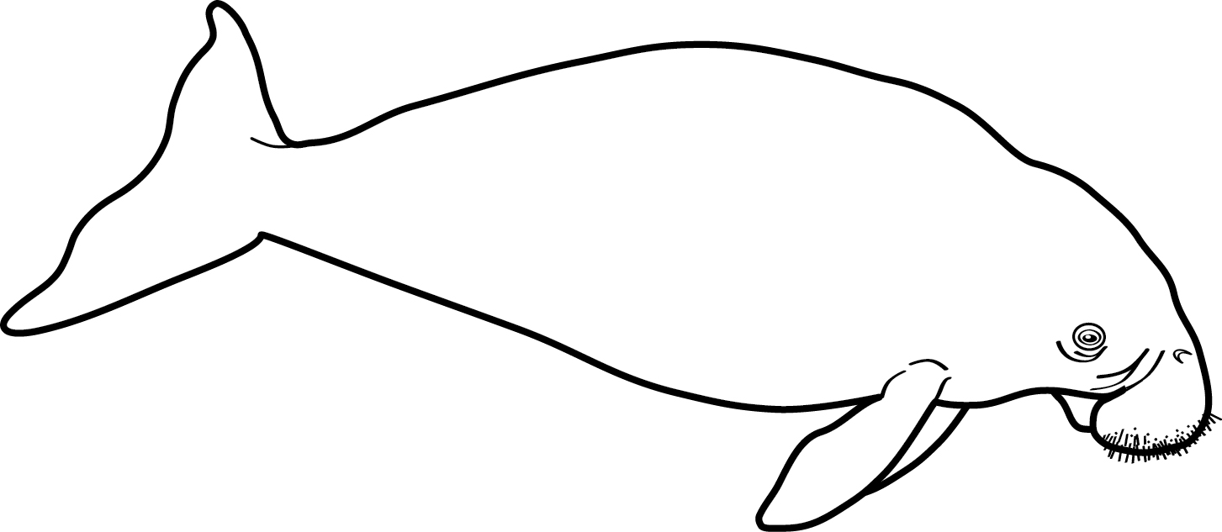
Linked activity

A healthy Great Barrier Reef for dugongs

Learning area
Content descriptions:
Science
Science understanding
Biological sciences (ACSSU176)
Science as a human endeavour
Use and influence of science (ACSHE160)
Science inquiry skills
Communicating (ACSIS174)

Science

Year level
Year 9

Overview
The Great Barrier Reef consists of interconnected ecosystems and communities of interdependent organisms. All of these ecosystems rely on each other as energy flows (via the pathway of food webs) between systems. There are a range of factors that can influence the success of species such as dugongs, including the health of seagrasses which are their primary food source. To maintain the sustainability of the dugong population on the Great Barrier Reef, students must consider how energy flows into and out of an ecosystem via the pathways of food webs, how energy can be replaced to maintain the sustainability of the system, as well as how ecosystems change as a result of events such as cyclones and flooding.

Inquiry questions
- What is the dugong’s conservation status (at a local, state, national and international level)? What factors lead to this?
- What are the environmental factors that seagrasses need to survive?
- What are some possible threats to seagrasses?
- The dugong is recognised as one of the values for which the Great Barrier Reef was listed as a World Heritage Area. Why has the dugong on the Great Barrier Reef received this recognition?
- What stewardship actions and regulations will ensure dugongs survive in the future?

Resources
- Books, scientific journals, and websites on dugong biology, habitats, threats and species management plans
- Useful websites for information on dugongs include the GBRMPA website www.gbrmpa.gov.au, CRC Reef Research Centre online www.reef.crc.org.au/discover, the Department of Sustainability, Environment, Water, Population and Communities species profiles and threats database www.environment.gov.au and dugongs of Moreton Bay www.nprsr.qld.gov.au.
- The Great Barrier Reef Outlook Report 2009 and dugong protection areas at www.gbrmpa.gov.au
- Year 9 — Ecosystems of the Great Barrier Reef activity in the 2012 Reef Beat activity book (www.gbrmpa.gov.au).

What to do
- Have students research dugong populations at a worldwide and Great Barrier Reef Marine Park scale. Are dugongs found in their local area? What is the status of dugongs at a local, state, national and international level?
- Using resources available, ask students to identify the dugong protection areas in the Marine Park on the 2013 Reef Beat poster.
- Study management plans and policies for protecting dugongs on the Great Barrier Reef.
- What is the status of seagrasses in the Marine Park? Students should consider how energy flows into and out of the seagrass ecosystem and what impacts or events may affect these energy flows.
- Compare management strategies of dugongs and seagrasses to other locations outside of the Marine Park, for example Moreton Bay.
- What are possible threats to dugongs and seagrasses and what stewardship actions or regulations can we implement to protect their heath?
- Have students develop a presentation outlining the dugong’s life history, current status, threats and populations over time. Students should outline management strategies (regulatory and voluntary) to maintain or improve dugong populations and the health of seagrasses into the future. These can be new initiatives. Students may present their information as a poster, a PowerPoint, a short movie, a scientific report, a television commercial or newspaper advert.

The Reef’s social and economic values and attributes

Key messages:
- The Great Barrier Reef Marine Park is important to many coastal communities that depend on the Reef for recreation and their livelihoods.
- Starting with the Traditional Owners thousands of years ago, the Great Barrier Reef has long been an important resource and a valued place for people to visit, share and enjoy.
- The Great Barrier Reef supports significant commercial industries, especially tourism and fishing, and supports employment equal to over 68,000 full-time positions.
- Shipping activity through the Marine Park is a vital link in the production chain for many industries and services regional centres.
- Oil drilling, mining and exploration have been prohibited in the Marine Park since proclamation of the Great Barrier Reef Marine Park Act in 1975.
- Tourism is by far the largest contributor to economic activity in the Marine Park accounting for over 90 per cent of the direct economic activity in the Great Barrier Reef Region. Other important Reef-dependent industries and activities are commercial fishing, recreation and scientific research.
- Use of the Great Barrier Reef Region goes well beyond commercial activities; it is central to the culture of Traditional Owners, a major recreational area, an internationally important scientific resource and an important area for Defence training.
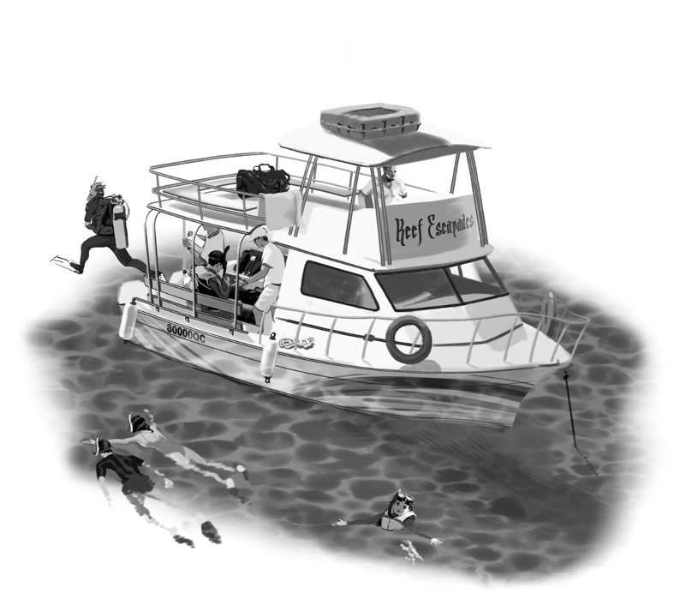
- It is estimated that there are up to 14 million recreational visits to the Marine Park by residents living within the Great Barrier Reef catchment every year, in addition to other visitors.
- The estimated population of the Great Barrier Reef catchment is 1,138,532 (as of 30 June, 2011). This is compared to 4,474,098 across all of Queensland.
- The Great Barrier Reef is valued by millions of people in Australia and around the world simply because it exists, even if they may never have the opportunity to visit it or derive an income from it.
- The Marine Park is a multiple-use area. The Great Barrier Reef Marine Park Zoning Plan 2003 provides for a range of ecologically sustainable recreational, commercial and research opportunities and for the continuation of traditional activities.
- In managing the ecosystem, environmental, economic and social benefits and impacts are all considered in pursuing the best outcomes for both the Great Barrier Reef and the community.
- GBRMPA is working with many people in the community and industry to ensure the Great Barrier Reef is protected for the future, for example through Local Marine Advisory Committees, communities and industries reporting incidents out on the water and providing feedback through our Eye on the Reef monitoring programs, and people taking positive stewardship actions to protect the Reef through the Reef Guardian program.

Linked activity

How can we improve uses of the Reef?

Learning area
Content descriptions:
See www.australiancurriculum.edu.au for the latest Geography curriculum content descriptions.

Geography

Year level
Year 5

Links to other subject areas
- Year 4 Biological Sciences (ACSSU072, ACSSU073)
- Year 4 Earth and Space Sciences (ACSSU075)

Overview
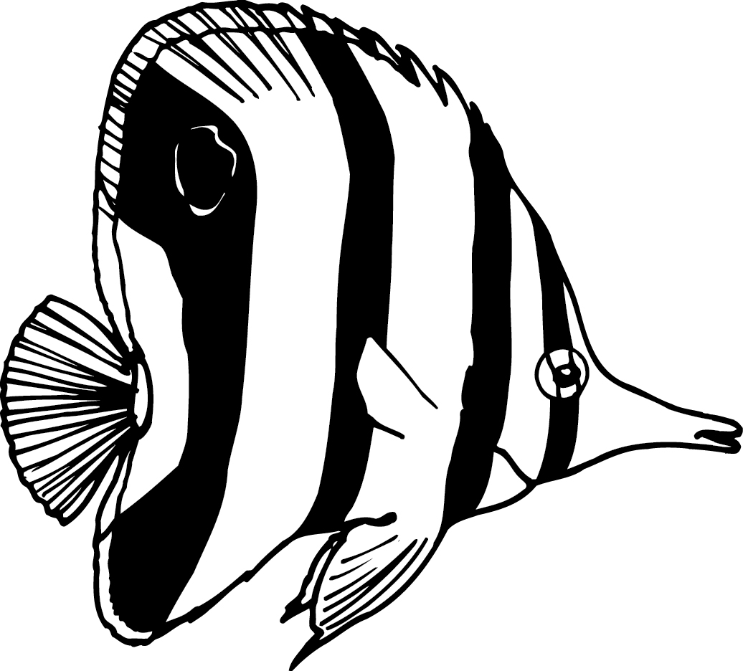
This activity is a structured geographical inquiry. A geographical inquiry is used to help structure investigations in geography. Students gather information and come to conclusions related to how we use the Great Barrier Reef and our positive and negative impacts on the Reef. They also devise strategies to improve our uses of the Reef including using existing or new management strategies. A geographical inquiry could easily be adapted into a scientific inquiry.

Inquiry questions
- What are uses of the Marine Park?
- What are positive and negative impacts of these uses?
- How can we improve uses of the Marine Park to protect its health and resilience to challenges it faces?

Resources
- There is lots of information available for teachers on geographical inquiry, for example Geography Teachers’ Association of Queensland Journal Articles www.gtaq.com.au
- The GBRMPA website www.gbrmpa.gov.au has lots of information on the range of uses of the Marine Park
- Zoning map for your local area of the Marine Park (electronic copy available at www.gbrmpa.gov.au)
- The 2013 Reef Beat poster.

What to do
- Ask students to consider the question, ‘how can we improve uses of the Reef?’ before developing their specific inquiry questions with guidance from the teacher.
- Students need to collect data and information from a range of reliable resources to help their inquiry. The GBRMPA website has information on uses of the Marine Park that may be relevant to students’ investigations. Your local Marine Park zoning map may also be helpful. Remind students to focus on collecting information related to their inquiry questions and that their data can come in a range of forms such as text, maps, facts and figures.
- Once students have collected information, they need to analyse it for trends, patterns or relationships before coming to any conclusions. Ensure that students check the reliability of any data before analysis. Ask students if they have covered all viewpoints and impacts, positive and negative, in relation to the uses of the Reef.
- Students could communicate their findings in a range of ways (determined by the amount of time available for their geographical inquiry). Consider having students respond via a presentation or by using digital media such as a short video or a Google Map. They could also display information on the 2013 Reef Beat poster.
- Encourage students to include actions to improve the uses of the Great Barrier Reef in the future. Make sure students also reflect on what difference they and your class can make in protecting the Great Barrier Reef (this may be how you use the Reef and/or actions such as picking up rubbish at school which will improve the health of the Reef).
- Ask students to reflect on how they could improve their geographic inquiry for future investigations.

Heritage of the Great Barrier Reef

Key messages:
- "Heritage is our legacy from the past, what we live with today, and what we pass onto future generations" – UNESCO. Legacy is something handed down between generations by ancestors or predecessors.
- The long-term protection and conservation of heritage values within the Marine Park is today regarded as important as the protection and conservation of the environment or biodiversity values of the area.
- This was reflected in the 2008 amendments to the Great Barrier Reef Marine Park Act, so today the main object of the Act reads: “…to provide for the long-term protection and conservation of the environment, biodiversity and heritage values of the Great Barrier Reef Region”
- Heritage includes places, values, traditions, events and experiences, and both natural and cultural places or values.
- For the purposes of this activity book, heritage in the Great Barrier Reef has been categorised as natural heritage, Indigenous heritage (as discussed previously) and historic heritage; for Indigenous and historic heritage, this can include both tangible heritage (for example, places) and intangible (such as experiences, traditions, events and stories).
- For many Australians, particularly Indigenous Australians, the divide between nature and culture is artificial and the environment is one interlinked, complex, cultural and diverse landscape created and lived in by ancestors and the community.
- Traditional Owners of the Great Barrier Reef express their cultural heritage through their relationship with country, people, beliefs, knowledge, lore, language, symbols, objects, ways of living, and land and sea — all of which arise from Indigenous spirituality.
- What the Great Barrier Reef is like today has been shaped by its natural and cultural heritage; importantly, how its heritage is managed in our lifetime will determine its state and condition when future generations inherit it.
- It is also important to recognise that both historic and Indigenous heritage will continue to evolve to represent the flow of history, changing community perceptions and the environment.
- The Great Barrier Reef is truly a special place; it was declared a World Heritage Area in 1981, recognised for its outstanding universal value, meeting all four natural criteria for World Heritage listing.
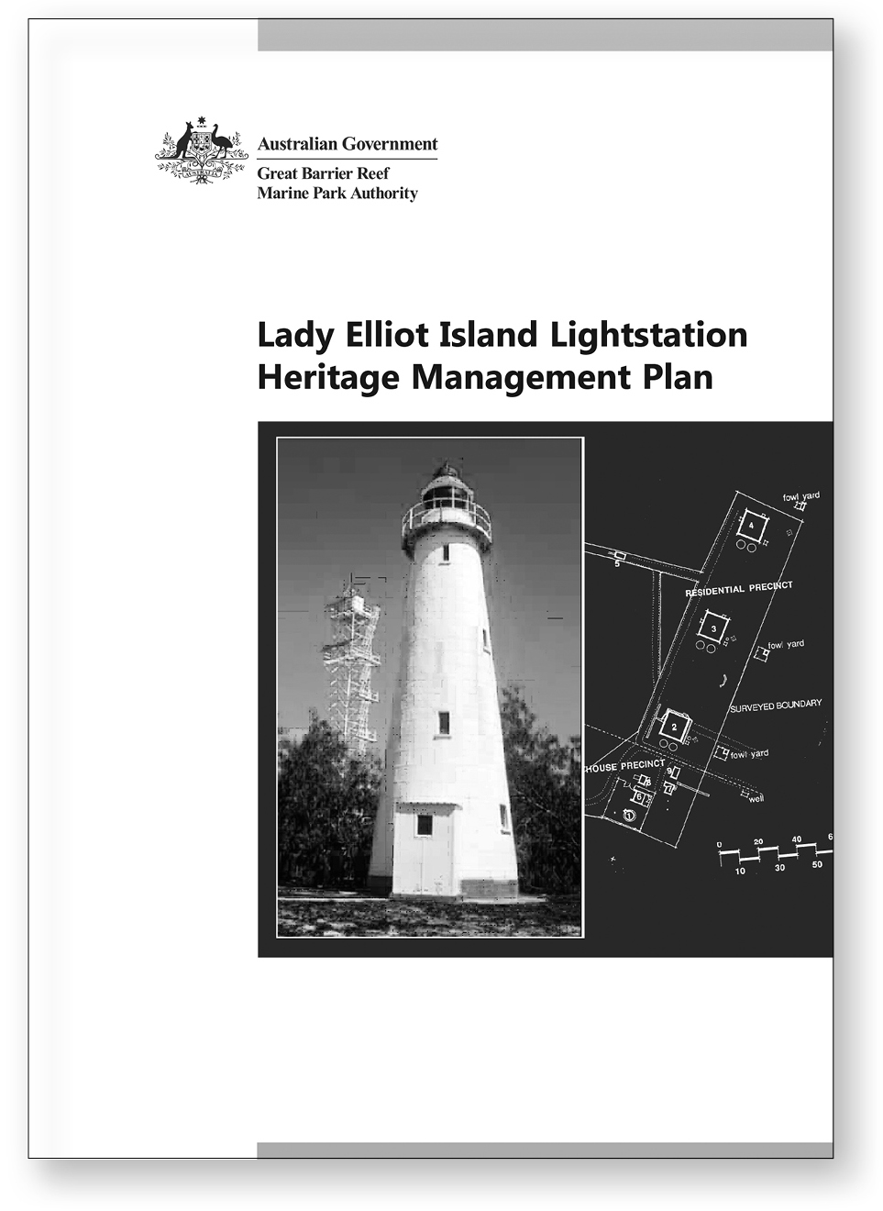
- Today nearly 99 per cent of the World Heritage Area is within the multiple-use Great Barrier Reef Marine Park.
- Australia is committed to ensuring the Great Barrier Reef retains the values for which it received World Heritage listing. The Australian Government, including GBRMPA and the Queensland Government, are undertaking a comprehensive strategic assessment of the Great Barrier Reef World Heritage Area and coastal zone, identifying potential impacts on the Reef's outstanding universal value from planned and potential future development to enable a long-term plan for sustainable development.
- Historic heritage includes places associated with the cultural heritage of Australia encompassed in the country's history.
- Historic places tell us about national and social developments in Australia over time, technical and creative achievements, and provide a tangible link to past events, processes and people.
- An example of a listed heritage site is Lady Elliot Island Lightstation. It is a Commonwealth Island at the southernmost end of the Great Barrier Reef and was listed on the Commonwealth Heritage List in 2004.
- Lady Elliot Island Lightstation, established in 1866, forms an integral part of history in aiding navigation along the Queensland coast through the Great Barrier Reef.
- There is a special plan of management, the Lady Elliot Island Lightstation Heritage Management Plan, which ensures that its heritage values are managed and protected.

Linked activity

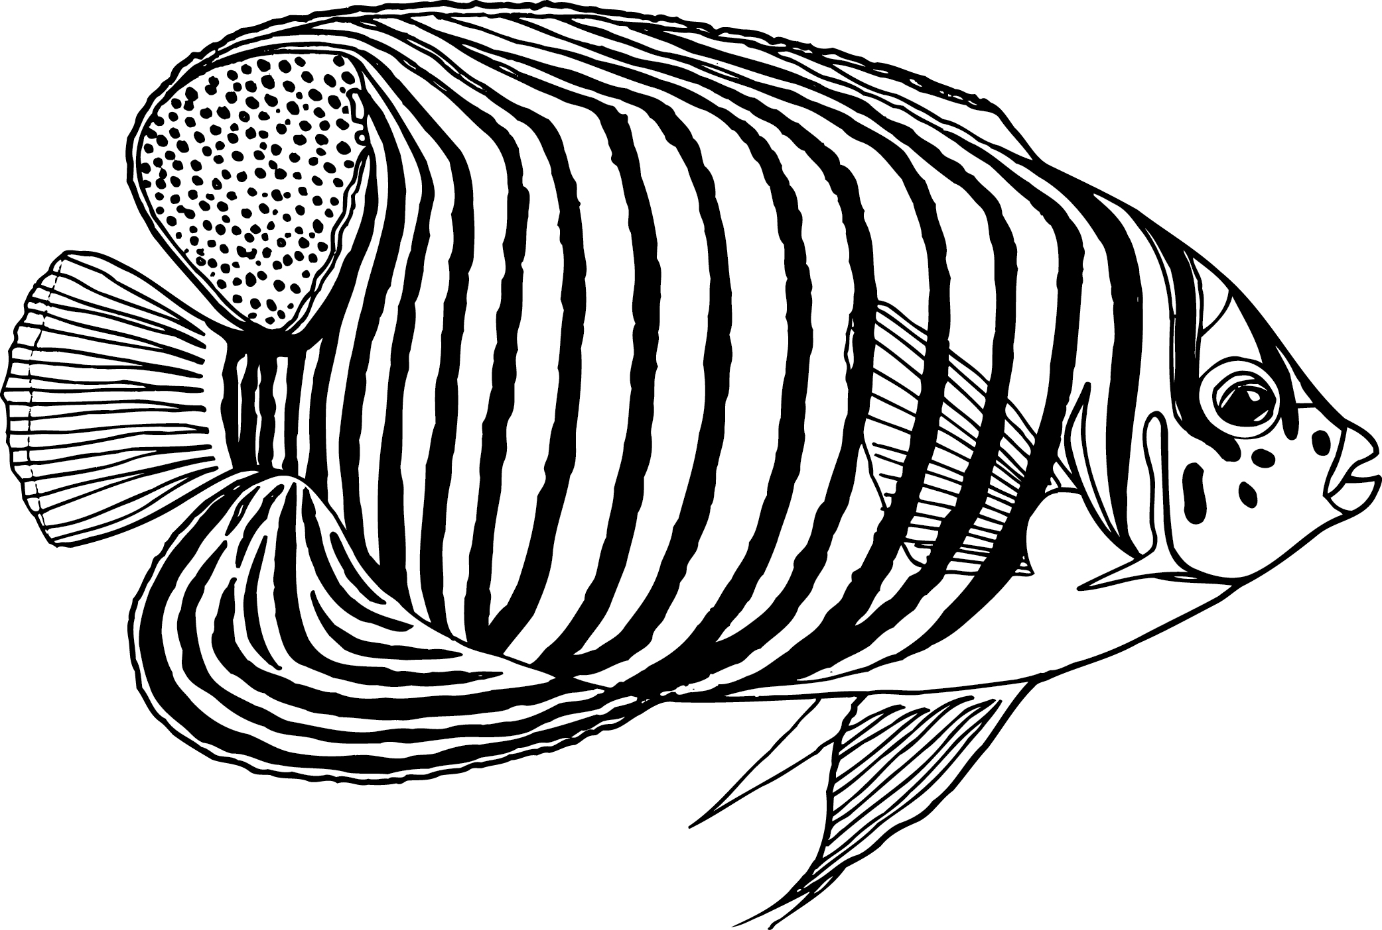
The Reef is a special place
Content descriptions:
See www.australiancurriculum.edu.au for the latest Geography curriculum content descriptions.

Learning area
Geography

Year level
Year 2–3

Overview
Students gain an understanding of special places and what makes World Heritage Areas such as the Great Barrier Reef so special. They explore why reefs are special places and exist only in certain climatic conditions and examine why they think the Great Barrier Reef is a special place as well as why other people in our society think it is special.

Inquiry questions
- Where do reefs occur and why?
- What makes places special and why are different places, particularly reefs, important?
- What makes the Great Barrier Reef so special?
- How do we look after special places?

Resources
- A data projector or interactive white board
- An internet enabled computer (this could be for each student, in pairs or done as a class)
- ReefBase (a global mapping system for coral reefs) http://reefgis.reefbase.org/
- The GBRMPA 2013 Reef Beat poster
- Google Maps www.maps.google.com.au
- Images, movies or video or the Great Barrier Reef such as the Caitlin Seaview Survey website www.catlinseaviewsurvey.com or Google Maps Street View World Wonders Project www.google.com/culturalinstitute/worldwonders/great-barrier-reef/
- Information on the Great Barrier Reef World Heritage Area from websites such as UNESCO http://whc.unesco.org/en/list/154 (it is recommended to use Mozilla internet browser to access this information in the highest quality) or the GBRMPA website www.gbrmpa.gov.au.

What to do
- Ask students where they think reefs occur around the world. Are corals plants or animals? What do reefs need to grow and survive? Using a data projector or interactive white board and an internet enabled computer; open ReefBase. Students view the location of reefs around the world (shown in grey by default on the map). Ask students to identify any patterns in the distribution of reefs around the world. Are they found in warm or cold places?
- Discuss where reefs form around the world (around the equator, the middle of the earth) and why that might be. Ask students to imagine the Earth in profile view and point out that the equator ‘sticks out’ and is closer to the sun. Ask your students to describe what the climate might be like around the equator.
- Zoom in to the Great Barrier Reef on ReefBase using either the drop down menu in the top-left corner of your screen or the zoom in tool (magnifying glass icon with a plus sign).
- Find the Great Barrier Reef World Heritage Area on the GBRMPA 2013 Reef Beat poster or using an online tool such as Google Maps. How far is your school located from the Great Barrier Reef? Share pictures, movies or video of the Great Barrier Reef.
- Ask students to share their special experiences on the Reef or why they think the Reef is special if they have not been there. Besides school students, who else might think the Reef is special? Tell them that many other people think the Reef is special, including Traditional Owners and they use it in different ways. Discuss the local, state, national and international recognition of the Great Barrier Reef including its World Heritage status. The depth of students’ explanations will depend on your class.
- Ask students to describe a special place they have been on the Reef. If they have not visited the Reef they can use the resources provided to choose a special location on the Reef. What does the special place look, smell, sound, feel like? Students should draw a field sketch of their special place with labels showing at least three features that make it special.
- Many people are working together to look after the Reef, including GBRMPA in partnership with government, community, industry, Traditional Owners and Reef Guardians. As a class, discuss how we can protect special places on the Great Barrier Reef through being Reef Guardians.

It’s all connected

Key messages:
- The Great Barrier Reef receives run-off from 35 major basins (catchments, rivers and estuarine systems) that drain an area of 424,000 square kilometres of coastal Queensland.
- Activities that occur in the catchment, such as land clearing, affect the health of rivers, floodplains, freshwater wetlands, estuarine and inshore systems and ultimately, the Great Barrier Reef.
- The majority of the Great Barrier Reef’s most vulnerable habitats and species occur in inshore areas.
- Some inshore species, such as the Australian snubfin dolphin, are particularly vulnerable to threats due to their life history traits, food requirements and small home ranges.
- Inshore species and ecosystems have strong physical, chemical and ecological links across the landscape from catchment to reef.
- Coastal ecosystems provide a range of ecological functions and services that support the Reef, including water distribution, food and habitat, and nutrient and chemical cycling.
- It is for this reason that protecting the health and resilience of vulnerable coastal ecosystems and species is a key management focus for GBRMPA. Recent management responses on the status and threats to the Great Barrier Reef from the catchment include the Informing the outlook for the Great Barrier Reef coastal ecosystems technical report available at www.gbrmpa.gov.au.
- Maintaining the Reef’s biodiversity is critical for providing ecosystem services such as commercial and recreational fishing.
- The Australian and Queensland governments are undertaking a comprehensive strategic assessment of the Great Barrier Reef World Heritage Area and adjacent coastal zone including assessing the cumulative uses and impacts.
- Many marine animals use both coastal and Reef ecosystems during their life cycle. An example of this is the red emperor which spawns on the outer reefs, the drifting larval fish find their way inshore to feed and grow before beginning the cycle again on the Reef as adults.
- Everyone has a role to play in ensuring the future health and resilience of the Great Barrier Reef.
- Working together is the key to the protecting the Reef for us all to enjoy into the future.

Linked activity

Animals rely on a healthy environment for survival
Content descriptions:
Science
Science understanding
Biological sciences (ACSSU072)
Biological sciences (ACSSU073)
Science as a human endeavour
Use and influence of science (ACSHE062)
Science inquiry skills
Communicating (ACSIS071)

Learning area
Science

Year level
Year 4

Overview
In this activity, students describe relationships that assist the survival of living things and sequence key stages in the life cycle of a reef animal. Students complete a simple drawing and present their results to communicate their findings about the Reef animal’s life cycle and identify the living and non-living parts of this environment, for example other animals, plants, structures or habitats essential for the animal’s survival. Students identify potential threats to the animal during its life cycle and what effect this may have on the survival of the animal. They develop actions essential to protect the animal and its environment.

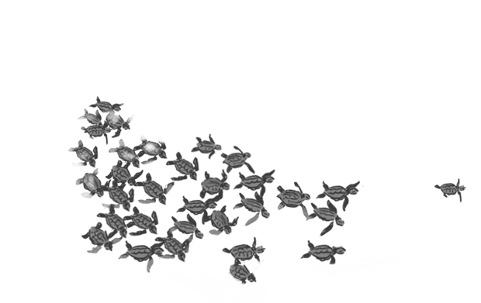
Inquiry questions
- What different animals live on the Great Barrier Reef?
- What is the life cycle of particular animals?
- What are the living parts of the animals’ lifecycle and non-living parts of the environment which they interact with?
- What are the interactions within this system, including inter-relationships essential for the survival of living things and those involving humans?
- What are potential threats to the animal and the environment it lives in?
- How could these threats impact on the survival of the animal?
- How can we help to protect animals and the systems they live in on the Great Barrier Reef?

Resources
- Pictures, movies, books and YouTube videos on the Reef and reef animals such as the GBRMPA YouTube Channel www.youtube.com/user/TheGBRMPA. Dyhum the Dugong by Mariana Fuentes or The Treacherous Travels of Tasman Turtle (Simon McLean) may be good reference books to introduce students to Reef creatures.
- Books, pictures or videos on different life cycles of marine animals on the Great Barrier Reef. For example, the life cycle of marine turtles in the GBRMPA Science Teaching Unit — Year 4 Endangered Species: marine turtles, available at www.gbrmpa.gov.au. Also see example diagrams of mangrove jack and barramundi life cycles on the GBRMPA website, under ‘Outlook for the Reef,’ then select ‘Great Barrier Reef coastal ecosystems.’

What to do
- As a class, research different types of animals on the Great Barrier Reef.
- Use resources available to show the life cycle of a marine turtle discuss this as a class. For example, what do marine turtles eat? Where do they live? What threatens marine turtles at different stages of their life cycle?
- Students need to choose an animal found on the Great Barrier Reef and conduct a lifecycle investigation of this species. This may be a special reef animal that they have seen on the Great Barrier Reef, a protected species, an iconic species or a species that not many people know about such as the pygmy seahorse.
- Ask students to draw the life cycle of the animal and identify the different living and non-living parts. For example, red emperor need fresh water as well as marine environments during their life cycle. Does the animal rely on other species to be healthy (such as prey or plant species in a habitat)?
- Students should reflect on the interaction between the animals and other parts of the system essential for survival.
- Students should label the threats to their animal during different stages of their life cycle. Students should reflect on whether possible threats could affect the animals’ population on the Great Barrier Reef.
- Students should devise at least three actions to reduce the possible threats to the animal and its environment during its life cycle.
- They can present their results in a range of forms, for example a poster, PowerPoint or report to the class.

Linked activity

Cumulative uses and impacts on the Great Barrier Reef

Learning area
Marine Science
Queensland Marine Science senior syllabus
Conservation and sustainability (CS)
CS1.5, CS2.3 - CS2.7, CS3.4, CS3.6.
Go to www.qsa.qld.edu.au for more information on links to senior science subjects.

Year level
Year 11–12 investigation task

Overview
Students gather information on the uses and threats within their local area of the Great Barrier Reef Marine Park and catchment. Based on their research, they assess the health of their local area of the Great Barrier Reef. Students reflect on the cumulative uses and threats that impact on the Reef including those activities within their local area of the Great Barrier Reef catchment area. Students devise management strategies to protect the Great Barrier Reef considering environmental, cultural, social and economic implications.

Inquiry questions
- What are the values of the Great Barrier Reef World Heritage Area?
- What are the different uses of your local area of the Marine Park?
- What are the different types of land uses and activities within your catchment?
- What are the threats to your local area of the Marine Park (both from activities within the Marine Park and from the catchment area)?
- Do any uses or threats have cumulative impacts on the health of the Great Barrier Reef? Cumulative impacts arise over time from a combination of impacts on the environment.
- What management strategies are in place or could be devised to protect the Great Barrier Reef?

Resources
- Information on uses of your local area of the Marine Park such as a zoning map (electronic copy available at www.gbrmpa.gov.au)
- Information on the identified threats to the Great Barrier Reef such as in the Great Barrier Reef Outlook Report 2009 and actions to help protect the health and resilience of the Reef available at www.gbrmpa.gov.au
- Information on land uses and activities within your catchment (for example, from your local council or regional natural resource management agency).

What to do
Students should write a brief report which:
  - provides a summary of the main uses of their local/chosen area of the Marine Park (a zoning map is a good way to describe this area)
  - provides a summary of the land uses and activities within your catchment
  - outlines the threats to the health of the Marine Park based on findings of uses and threats both within the Marine Park and in the adjacent catchment area
  - identifies any cumulative impact on the Great Barrier Reef that have arisen from uses or a combination of threats
  - describes management strategies (economic, environmental, social and cultural) to improve the health of the Marine Park.

Visit the amazing Great Barrier Reef

Key messages:
- Zoning of the Marine Park provides for reasonable use of the region.
- Marine Park management zones protect biodiversity by restricting a range of extractive activities, such as fishing.
- GBRMPA is working to ensure that all fishing activities in the Marine Park and World Heritage Area are ecologically sustainable.
- With an increasing national and global demand on fish resources and an increasing Queensland population, it is important to develop a strategic and collaborative approach to the management of commercial, recreational and Indigenous fishing on the Reef to achieve ecological sustainability.
- It is possible to visit the Reef throughout the year and participate in a number of the activities available. If you’re lucky enough to visit the Reef, you can ensure your visit does not negatively impact on the health of the Reef.
- Before you visit the Reef make sure you:
  - learn about the World Heritage Area and what makes it so special.
  - explore the many experiences on offer from fishing to diving and hanging out on one of the many islands. GBRMPA recognises tourism operators who go the extra mile in providing ecologically sustainable tourism experiences for visitors through the High Standard Tourism Operators Program. Before you visit the Reef, check out these operators at www.gbrmpa.gov.au.
  - plan for your activities on the Great Barrier Reef by checking your local area zoning map and what activities are permitted where. Some locations also have special management plans so check out some background resources on where you are going in the Marine Park at www.gbrmpa.gov.au.
- If you can’t get to the Reef, you can visit Reef HQ Aquarium in Townsville or organise a videoconference with them from your school or local videoconferencing facility. As the world’s largest living coral reef aquarium, you will be sure to have a fantastic time exploring the diversity of life on the Reef. For more information go to www.reefhq.com.au.
- Everyone can become involved in protecting the Reef. Reef Guardians is a voluntary stewardship program showcasing those actions that schools, council, fishers, farmers and graziers are doing in the Marine Park or throughout Queensland, to protect the Reef. To find out more about Reef Guardians, go to www.gbrmpa.gov.au.
- When you return from your Reef trip or Reef HQ Aquarium visit, you can make good environmental choices at home, school and in your community which will benefit the Reef, for all, for the future.

Linked activity
Content descriptions:
Science
Science understanding
Biological sciences (ACSSU111)
Biological sciences (ACSSU112)
Science as a human endeavour
Nature and development of science (ACSHE119)
Nature and development of science (ACSHE223)
Use and influence of science (ACSHE120)

What makes the Great Barrier Reef so special?

Learning area
Science

Year level
Year 7

Overview
The Great Barrier Reef is a complex and unique ecosystem made up of extensive habitat diversity. Over the years of research on the Reef, science understanding has improved and influenced the development of management practices within the Marine Park and associated ecosystems such as the catchment area.
At a basic level, interactions between organisms can be described in terms of food chains and food webs and human activity can affect these interactions. Scientists called ecologists, study the relationships between living organisms and their interactions with their abiotic (non-living) and biotic (living) environment. Scientists, called biologists, study living organisms and their relationship to their environment. This information and the role of classification through ordering and organising information, improves our understanding of the Great Barrier Reef’s extensive biodiversity. This activity introduces students to the diversity of life on the Reef and interactions within systems.

Inquiry questions
- What keeps an ecosystem healthy and functioning?
- What are food chains and food webs and what are the essential interactions that maintain these processes?
- How does classification help us to organise diversity?
- How does classification help us to manage diversity of life on the Great Barrier Reef?
- Which ecosystems of the Great Barrier Reef are most at risk from threats?
- What can students do to help protect vulnerable ecosystems and species?

Resources
- Information on the Great Barrier Reef and reef animals such as the GBRMPA website www.gbrmpa.gov.au, GBRMPA YouTube videos www.youtube.com/user/TheGBRMPA, other videos or documentaries
- The GBRMPA 2012 Reef Beat posters, The Inshore Great Barrier Reef—Bursting with Biodiversity (electronic version available at www.gbrmpa.gov.au)
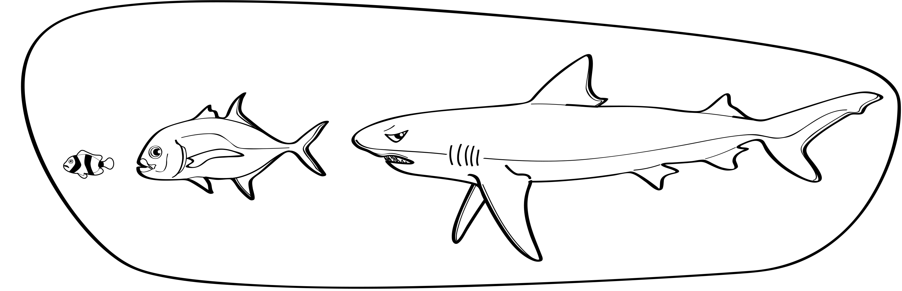
- A ball of string or a roll of (non-sticky) stretch tape and some space for students to move (approximately arm width apart).

What to do
- Have students play the ‘what makes an ecosystem?’ game:
  - Have students think about an ecosystem. It can be an ecosystem within the Marine Park or a place in your local area.
  - As a class, discuss what makes up an ecosystem. Where does photosynthesis occur? What are producers and consumers?
  - Using a ball of string or stretchy (non-sticky) tape, students will explore how energy moves through the ecosystem. The first student will identify themselves as a part of the ecosystem (for example, I am a tree. I provide oxygen to the environment and help to stabilise the soil). Holding onto the end of the string/tape, they will then pass it to someone else so that they are now connected. It is now the next persons turn to identify themselves as a part of the system and what role they play (for example, I am a worm and I help increase nutrients in the environment).
  - Once you have got through the whole class (making sure that each person keeps a part of the string after their turn) all the students should be connected by the string/tape.
  - Before ending the game discuss what impacts might affect the health of the ecosystem. What would happen if there were no trees (the person identified as the tree can cut their part of the string/tape connected to other parts of the ecosystem to demonstrate the loss of connectivity)?
- If you do not have the space or opportunity to play the ‘what makes an ecosystem?’ game, an alternative activity could be creating a food web (using string and tacks) on the 2012 Reef Beat posters.
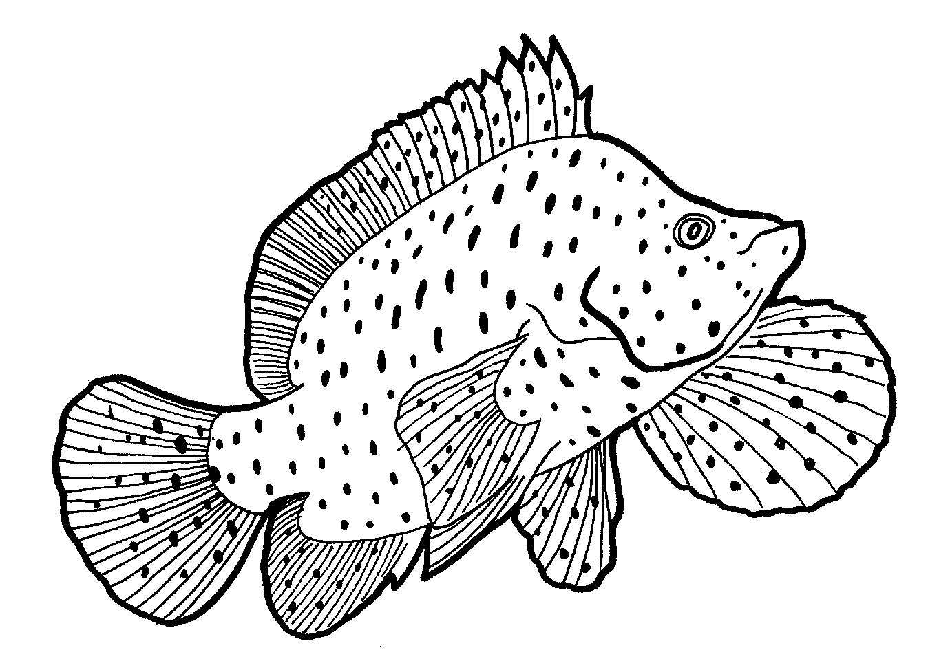
- Have students choose an animal of the Great Barrier Reef and identify a food chain which includes this animal.
- Students will need to research the interactions between their chosen animal and other animals and plants in the ecosystem.
- Students should consider how human activity in the catchment and Marine Park can have positive and negative effects on the health and function of the food chain.
- Have students develop a series of strategies to help protect the animal and other species or ecosystems it relies on. Students could present their findings as a report or presentation. They could also share their findings in the school newsletter or on parade.

Linked activity

Fishing responsibly on the Great Barrier Reef
Content descriptions:
Science
Science understanding
Biological sciences (ACSSU094)
Science as a human endeavour
Use and influence of science (ACSHE220)
Science inquiry skills
Communicating (ACSIS110)

Learning area
Science

Year level
Year 6

Overview
Caring for species of fish found on the Great Barrier Reef is important to the overall health of the Reef. This activity allows students to explore one use of the Marine Park—fishing. It encourages them to not only have fun while fishing in the Marine Park, but to plan their trip (and what they can do) and carry out their activity responsibly. Students prepare a short story about a fishing trip to the Marine Park and share this with the class.

Inquiry questions
- Why do we fish and where do we fish?
- Where does fishing occur in the Marine Park?
- What type of fish live on the Great Barrier Reef? Can we catch them all?
- What do you need to do when planning a trip to the Marine Park to fish?
- What responsible reef practices should you follow when fishing in the Marine Park so you and the plants and animals of the Great Barrier Reef stay happy and healthy?

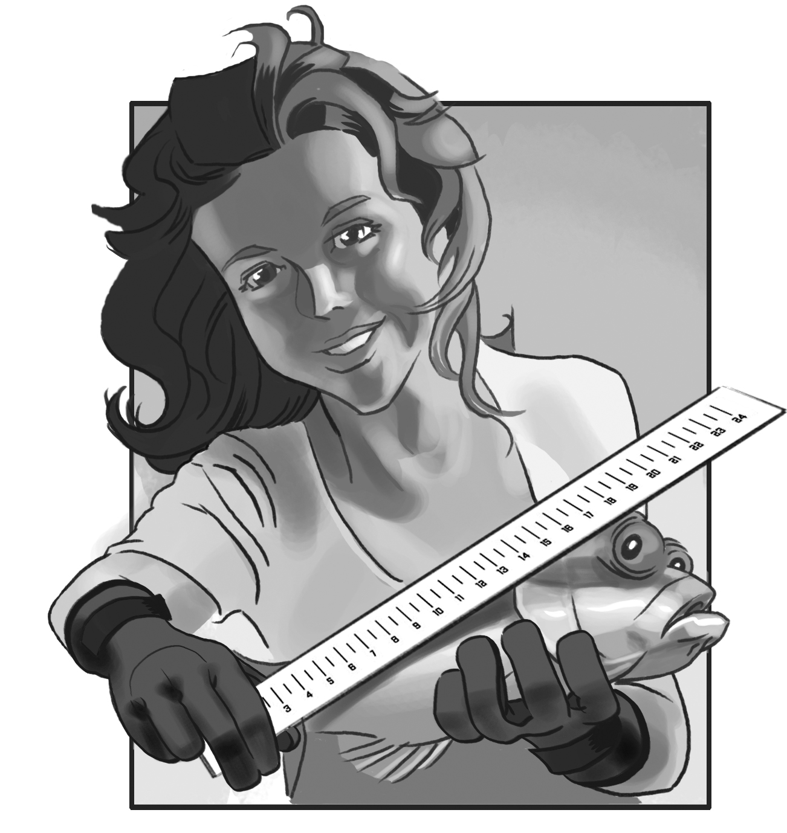
Resources
- Fishing stories or experiences on the Great Barrier Reef, for example from YouTube or fishing magazines
- A zoning map for your local Marine Park area available at www.gbrmpa.gov.au, under ‘Visit the Reef’ and then explore zoning
- Queensland Government fishing rules at www.daff.qld.gov.au
- Responsible reef practices guidelines for visiting the Reef at www.gbrmpa.gov.au, under ‘Visit the Reef.’

What to do
- Ask students to share their fishing experiences in the Marine Park with the class. If they have not been fishing in the Marine Park they can share their experiences fishing locally (such as in creeks and rivers) or stories from friends or family members.
- Using your local Marine Park area zoning map, have a discussion with students about fishing:
  - Why do we fish?
  - Where can people fish?
  - What different types of fishing are there?
  - What type of fish can be caught in the Marine Park?
  - How do you prepare for a fishing trip in the Marine Park?
- Tell students they are going to write a short story about a day out fishing in the Marine Park. This should include evidence of their planning for a responsible reef trip, a description of the activity, for example what they caught, and a reflection on the success of the day and their experience. The story can be based on a day that the students have already experienced within the Marine Park or a day they imagine. Students should refer to the zoning plan and Queensland Government fishing rules when describing fishing activity permitted in the Marine Park and their preparations to make for a responsible and successful fishing trip.
- The short story can include maps, pictures and other media.
- Students should share their short story with the class.

Director, Communication
2 — 68 Flinders Street
PO Box 1379
TOWNSVILLE QLD 4810
Australia
Phone: (07) 4750 0700
Fax: (07) 4772 6093
info@gbrmpa.gov.au

Also available in electronic copy from www.gbrmpa.gov.au

