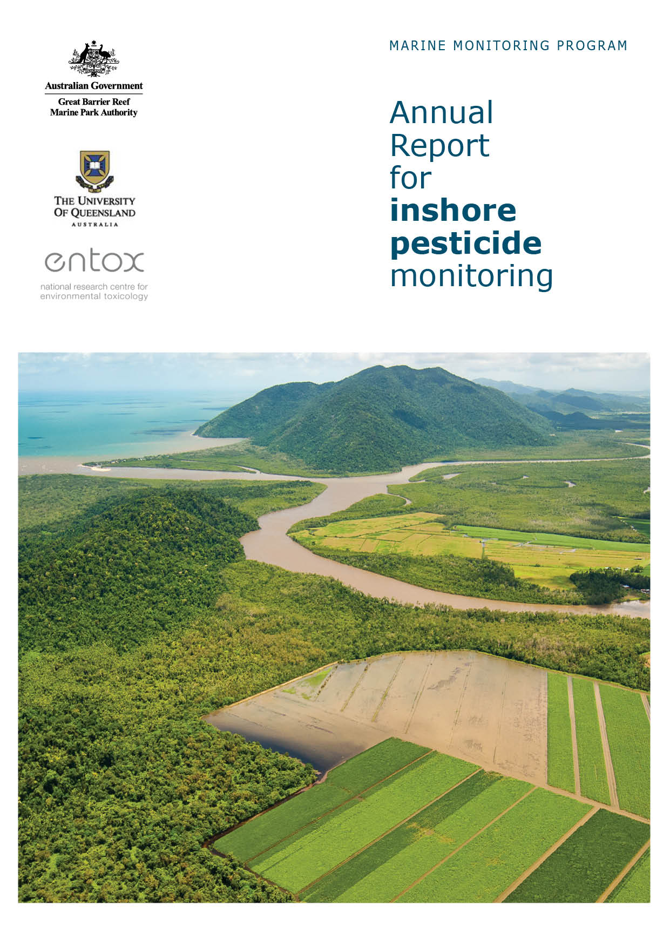
2 0 1 4 - 2 0 1 5

Christie Gallen, Kristie Thompson, Chris Paxman, Jochen Mueller

Project Team - Inshore Marine Water Quality Monitoring - Christie Gallen¹, Chris Paxman¹, Kristie Thompson¹, Elissa O’Malley¹, Natalia Montero Ruiz¹, Jochen Mueller¹
Project Team - Assessment of Terrestrial Run-off Entering the Reef: Christie Gallen¹, Kristie Thompson¹, Chris Paxman¹, Jochen Mueller¹, Eduardo Da Silva², Dominique O’Brien², Dieter Tracey², Caroline Petus², Michelle Devlin²

¹The National Research Centre for Environmental Toxicology (Entox)
The University of Queensland
39 Kessels Rd
Coopers Plains Qld 4108

² The Centre for Tropical Water & Aquatic Ecosystem Research (TropWATER),
Catchment to Reef Processes Research Group,
James Cook University
Townsville, Qld 4811

© Copyright University of Queensland 2016
All rights are reserved and no part of this document may be reproduced, stored or copied in any form or by any means whatsoever except with the prior written permission of the University of Queensland.

ISBN: 9781742721668

Report should be cited as:
Gallen, C., Thompson, K., Paxman, C., Devlin, M., Mueller, J. (2016) Marine Monitoring Program. Annual Report for inshore pesticide monitoring: 2014 to 2015. Report for the Great Barrier Reef Marine Park Authority. The University of Queensland, The National Research Centre for Environmental Toxicology (Entox), Brisbane.

Front cover image: View south towards the Russell River National Park and the junction of the Russell and Mulgrave Rivers over flooded sugar fields © Dieter Tracey, 2015.

DISCLAIMER
While reasonable efforts have been made to ensure that the contents of this document are factually correct, Entox does not make any representation or give any warranty regarding the accuracy, completeness, currency or suitability for any particular purpose of the information or statements contained in this document. To the extent permitted by law Entox shall not be liable for any loss, damage, cost or expense that may be occasioned directly or indirectly through the use of or reliance on the contents of this document.

Direct Enquiries to –
Professor Jochen Mueller
Phone: +61 7 3000 9197
Fax: +61 7 3274 9003
Email: j.mueller@uq.edu.au
Web: www.entox.uq.edu.au

Table of Contents
Contents
1 EXECUTIVE SUMMARY 1
2 INTRODUCTION 6
3 METHODOLOGY 8
3.1 Sampling sites 8
3.1.1 Fixed site monitoring (passive samplers) 8
3.1.2 Flood plume sampling (grab and passive samplers) 12
3.2 Fixed site monitoring for long-term trends 14
3.3 Flood plume sampling 15
3.4 Target Chemicals 15
3.5 Mapping the frequency and extent of flood plumes (frequency maps) 16
3.6 Reporting Metrics 16
4 RESULTS 18
4.1 Pressures influencing pesticide concentrations in the Reef 18
4.1.1 Rainfall 18
4.1.2 Cyclones 21
4.1.3 River discharge 22
4.1.4 Pesticide loads 23
4.1.5 Land use 24
4.1.6 Other pressures 27
4.2 Reef-wide results 2014-2015 27
4.2.1 Fixed site passive sampler return record 27
4.2.2 Reef-wide summary pesticide results 29
4.3 Regional results and discussion 31
4.3.1 Wet Tropics 31
4.3.2 Burdekin Region 35
4.3.3 Barratta Creek case study 37
4.3.4 Mackay Whitsunday Region 39
4.3.5 Fitzroy Region 40
5 Discussion 42
6 SUMMARY 46
7 DIRECTIONS FOR MONITORING 47
8 REFERENCES 49
9 APPENDIX A: Complete analyte list for LCMS and GCMS analysis 53
9.1 Sources of uncertainty 53
9.2 Analytical details, target chemicals and quality assurance quality control (QAQC) 55
9.3 Flood plume mapping 59
10 APPENDIX B – supporting literature for PSII-HEq Index 62
10.1 Calculating PSII-HEq concentrations and assessing risk using the PSII Herbicide Index 66
11 APPENDIX C - freshwater discharge (ML), plume colour class and weekly rainfall in Reef catchments 69
12 APPENDIX D – Fixed monitoring – Individual site results 73
13 APPENDIX E – Terrestrial run-off assesment- Results 90
14 APPENDIX F – Mean flow rates, PSII-HEq of passive samplers and Plume colour class of major rivers 91
15 APPENDIX G – Historical concentration profiles at fixed monitoring sites 107
16 APPENDIX H - Land and herbicide use in the Reef catchments adjacent to fixed monitoring sites 123
17 APPENDIX I – CASE STUDY: Comparison of the multi-substance potentially affected fraction (ms-PAF) and PSII-HEQ methods 124

List of figures
Figure 1 The temporal trends in PSII-HEq Max at fixed monitoring sites in inshore waters of the Reef determined using time-integrative sampling 2005 – 2015 (top – Wet Tropics region, bottom – Burdekin, Mackay Whitsunday and Fitzroy regions). 4
Figure 2 Locations of current inshore Reef fixed monitoring sites where time-integrated sampling of pesticides occurred in 2014-2015 9
Figure 3 Locations of Barratta Creek passive sampling sites 11
Figure 4 Locations of grab and passive samplers collected on the Russell-Mulgrave River transect (top) and Tully River transect (Bottom), and the frequency of flood plumes over the 2014-2015 wet season. 13
Figure 5 Monthly rainfall totals during the wet season (November 2014 – April 2015). 19
Figure 6 Total rainfall recorded for the week ending 24th February 2015 (left) associated with TC Marcia; and for the week ending 17th March 2015 (right) prior to landfall of TC Nathan 21
Figure 7 Total annual discharge of all gauged rivers located in Reef catchments into the inshore waters of the Reef (ML) 22
Figure 8 Historical PSII herbicide loads from monitored Reef catchment rivers (2009 – 2015) 24
Figure 9 Land use in the Reef catchments. 26
Figure 10 Maximum concentrations of individual herbicides at fixed monitoring sites from the commencement of sampling to 2014-2015 30
Figure 11 PSII-HEq Max at each fixed monitoring site since monitoring commenced to 2014-2015 31
Figure 12 Seasonal average PSII-HEq for Wet Tropics sites since monitoring commenced 34
Figure 13 Seasonal average PSII-HEq for Burdekin sites since monitoring commenced 37
Figure 14 Seasonal average PSII-HEq for Mackay Whitsunday sites since monitoring commenced 40
Figure 15 Seasonal average PSII-HEq for North Keppel Island in the Fitzroy region since monitoring commenced 42

List of Appendix Figures
Figure A 1 Rainfall decile ranges for the dry season between May 2014- Oct 2014 (left) and wet season between Nov 2014 – 30 April 2015 (right). 71
Figure A 2 One year inter-annual rainfall difference between the previous monitoring year (2013-14) and the current monitoring year (2014-15). 72
Figure A 3 Timing and location of grab (top) and passive (bottom) samples collected on the Russell-Mulgrave River transect, Wet Tropics, between 2013-2015 79
Figure A 4 Timing and location of grab (top) and passive (bottom) samples collected on the Tully River transect, Wet Tropics, between 2010-2015 80
Figure A 5 Temporal trends in PSII-HEq with respect to flow rate of rivers influencing passive sampler site at Low Isles in the Wet Tropics region since monitoring commenced 91
Figure A 6 Temporal trends in PSII-HEq with respect to flow rate of rivers influencing passive sampler site at Green Island in the Wet Tropics region since monitoring commenced 92
Figure A 7 Temporal trends in PSII-HEq with respect to flow rate of rivers influencing Fitzroy Island passive sampler site in the Wet Tropics region since monitoring commenced 93
Figure A 8 Temporal trends in PSII-HEq with respect to flow rate of rivers influencing Dunk Island passive sampler site in the Wet Tropics region since monitoring commenced 94
Figure A 9 Temporal trends in PSII-HEq with respect to flow rate of rivers influencing the Normanby Island passive sampler site in the Wet Tropics region since monitoring commenced 95
Figure A 10 Temporal trends in PSII-HEq with respect to flow rate of rivers influencing the Lucinda passive sampler site in the Burdekin region since monitoring commenced 96
Figure A 11 Temporal trends in PSII-HEq with respect to flow rate of rivers influencing the Orpheus Island passive sampler site in the Burdekin region since monitoring commenced 97
Figure A 12 Temporal trends in PSII-HEq with respect to flow rate of rivers influencing the Cape Cleveland passive sampler site in the Burdekin region since monitoring commenced 98
Figure A 13 Temporal trends in PSII-HEq with respect to flow rate of rivers influencing the Barratta Creek mouth passive sampler site in the Burdekin region since monitoring commenced 99
Figure A 14 Temporal trends in PSII-HEq with respect to flow rate of rivers influencing the Barratta Creek case study passive sampler site in the Burdekin region 100
Figure A 15 Temporal trends in PSII-HEq with respect to flow rate of rivers influencing the Outer Whitsunday passive sampler site in the Mackay Whitsunday region since monitoring commenced 101
Figure A 16 Temporal trends in PSII-HEq with respect to flow rate of rivers influencing the Repulse Bay passive sampler site in the Mackay Whitsunday region since monitoring commenced 102
Figure A 17 Temporal trends in PSII-HEq with respect to flow rate of rivers influencing the Round/ Flat Top passive sampler site in the Mackay Whitsunday region since monitoring commenced 103
Figure A 18 Temporal trends in PSII-HEq with respect to flow rate of rivers influencing the Sandy Creek passive sampler site in the Mackay Whitsunday region since monitoring commenced 104
Figure A 19 Temporal trends in PSII-HEq with respect to flow rate of rivers influencing the Sarina Inlet passive sampler site in the Mackay Whitsunday region since monitoring commenced 105
Figure A 20 Temporal trends in PSII-HEq with respect to flow rate of rivers influencing the North Keppel Island passive sampler site in the Fitzroy region since monitoring commenced 106
Figure A 21 Temporal concentration profiles of individual herbicides at Low Isles in the Wet Tropics region 107
Figure A 22 Temporal concentration profiles of individual herbicides at Green Island in the Wet Tropics region 108
Figure A 23 Temporal concentration profiles of individual herbicides at Fitzroy Island in the Wet Tropics region 109
Figure A 24 Temporal concentration profiles of individual herbicides at Dunk Island in the Wet Tropics region 110
Figure A 25 Temporal concentration profiles of individual herbicides at Normanby Island in the Wet Tropics region 111
Figure A 26 Temporal concentration profiles of individual herbicides at Lucinda in the Wet Tropics region 112
Figure A 27 Temporal concentration profiles of individual herbicides at Orpheus Island in the Burdekin region 113
Figure A 28 Temporal concentration profiles of individual herbicides at Cape Cleveland in the Burdekin region 114
Figure A 29 Temporal concentration profiles of individual herbicides at Barratta Creek mouth in the Burdekin region 115
Figure A 30 Temporal concentration profiles of individual herbicides at the Barratta Creek case study sites in the Burdekin region 116
Figure A 31 Temporal concentration profiles of individual herbicides at Outer Whitsunday in the Mackay Whitsunday region 117
Figure A 32 Temporal concentration profiles of individual herbicides at Repulse Bay in the Mackay Whitsunday region 118
Figure A 33 Temporal concentration profiles of individual herbicides at Round/ Flat Top Island in the Mackay Whitsunday region 119
Figure A 34 Temporal concentration profiles of individual herbicides at Sandy Creek in the Mackay Whitsunday region 120
Figure A 35 Temporal concentration profiles of individual herbicides at Sarina Inlet in the Mackay Whitsunday region 121
Figure A 36 Temporal concentration profiles of individual herbicides at North Keppel Island in the Fitzroy region 122
Figure A 37 Land Use map of the Reef catchment (2009). 123
Figure A 38 SSDs of chemicals for multiple species (left) which are then normalized to hazard units, relative to the median of species affected to calculate a mean SSD (right). 126

List of Tables
Table 1 Location of fixed passive sampling sites and closest influencing river 10
Table 2 The types of passive samplers deployed at each fixed monitoring site in 2014-2015 14
Table 3 Weekly mean catchment rainfall (mm) in catchments adjacent to fixed passive sampler sites during the 2014 – 2015 wet season (beginning 1 December 2014). 20
Table 4 Comparison of long-term median flows in major rivers with total discharge in the 2014-2015 water year 23
Table 5 Passive sampling return record for the 2014-2015 monitoring year 28
Table 6 Summary statistics for the PSII-HEq Max and PSII-HEq Wet Avg (ng L⁻¹) since monitoring commenced in the Wet Tropics. 33
Table 7 Summary statistics for the PSII-HEq Max and Wet Season Average (ng L⁻¹) since monitoring commenced in the Burdekin region. 36
Table 8 Summary statistics for the PSII-HEq Max and Wet Season Average (ng L⁻¹) since monitoring commenced in the Mackay Whitsunday region 40
Table 9 Summary statistics for the PSII-HEq Max and Wet Season Average (ng L⁻¹) since monitoring commenced in the Fitzroy region 41
List of Appendix Tables
Table A 1 Entox LCMS analyte list for positive and negative mode analysis 56
Table A 2 Entox GCMS analyte list for PDMS extracts 57
Table A 3 Proposed priority pesticides and herbicides specified under the MMP (proposed at PWG 18 Aug 2015) and their approximate limits of reporting (ng L⁻¹) 57
Table A 4 Other pesticides of interest for potential inclusion in monitoring and reporting activities (feedback from the Paddock to the Reef program). 58
Table A 5 Summary of variability (% coefficient of variation) of replicate ED analysis, analysed by Entox 58
Table A 6 Summary of inter-laboratory comparison of ED extracts (% coefficient of variation) 59
Table A 7 Water quality guideline values available for pesticides and herbicides (ng L⁻¹) 61
Table A 8 Scientific publications indicating the effect concentrations and the end-points for the reference PSII herbicide diuron used to define specific PSII-HEq Index categories as an indicator for reporting purposes 62
Table A 9 Preliminary effects of diuron in marine organisms 65
Table A 10 Relative potency factors (RPF) for PSII herbicides and selected transformation products 67
Table A 11 PSII-Herbicide Equivalent Index developed as an indicator for reporting of PSII herbicides across the MMP 68
Table A 12 Annual freshwater discharge of rivers influencing fixed monitoring sites (ML) and long-term median discharge 69
Table A 13 Weekly flood plume colour class (1 – 6) for fixed site passive sampler locations during the 2014-2015 wet season (beginning 1 December 2014) 70
Table A 14 Low Isles, Wet Tropics region – Concentration in water (ng L⁻¹) 73
Table A 15 Green Island, Wet Tropics region – Concentration in water (ng L⁻¹) 74
Table A 16 Fitzroy Island, Wet Tropics region – Concentration in water (ng L⁻¹) 75
Table A 17 Dunk Island, Wet Tropics region – Concentrations in water (ng L⁻¹) 76
Table A 18 Normanby Island, Wet Tropics region – Concentrations in water (ng L⁻¹) 77
Table A 19 Lucinda, Wet Tropics region – Concentrations in water (ng L⁻¹) 78
Table A 20 Orpheus Island, Burdekin region – Concentrations in water (ng L-1) 81
Table A 21 Cape Cleveland, Burdekin Region – Concentrations in water (ng L⁻¹) 82
Table A 22 Barratta Creek, Burdekin Region – Concentrations in water (ng L⁻¹) 83
Table A 23 Barratta Creek case study, Burdekin region – Water concentrations (ng L⁻¹) 84
Table A 24 Outer Whitsunday, Mackay Whitsunday region – Concentrations in water (ng L⁻¹) 85
Table A 25 Repulse Bay, Mackay Whitsunday region – Concentrations in water (ng L⁻¹) 85
Table A 26 Round/ Flat Top, Mackay Whitsunday region – Concentrations in water (ng L⁻¹) 86
Table A 27 Sarina Inlet, Mackay Whitsunday region – Concentrations in water (ng L⁻¹) 87
Table A 28 Sandy Creek, Mackay Whitsunday region – Concentrations in water (ng L⁻¹) 88
Table A 29 North Keppel Island, Fitzroy Region – Concentrations in water (ng L⁻¹) 89
Table A 30 Concentrations in water (ng L⁻¹) measured along the Tully River and Russell-Mulgrave River transects using passive samplers during the wet season 90
Table A 31 Concentrations in water (ng L⁻¹) measured at various locations along the river transects using 1 L grab samples during the wet season 90
Table A 32 Interim risk categories for marine waters using the ms-PAF method, (percentage of species potentially affected and the corresponding equivalent diuron concentration (ng L⁻¹) 127
Table A 33 Comparison of PSII-HEq Max (ng/L) and ms-PAF Max (% species affected) values for all fixed monitoring sites since monitoring commenced. 127
Table A 34 Comparison of PSII-HEq Max (ng/L) and ms-PAF Max (% species affected) values for passive samplers and grab samples collected on river transects during the 2014-15 wet season. 128
Table A 35 Comparison of PSII-HEq Max (ng/L) and ms-PAF Max (% species affected) values for passive samplers deployed in the Barratta Creek 129
Table A 36 Comparison of the ms-PAF values of various hypothetical herbicide profiles (ng L⁻¹) 130
Acronyms
2,4-D | 2,4-dichlorophenoxyacetic acid
ANZECC | Australian and New Zealand Environment and Conservation Council
ARMCANZ | Agriculture and Resource Management Council of Australia and New Zealand
%CV | per cent coefficient of variation
C_{W} | Concentration in water
DSITI | Department of Science, Information Technology and Innovation
EC_{x} | x per cent maximal effective concentration is observed
ED | Empore DiskTM passive sampler
Entox | National Research Centre for Environmental Toxicology
GBRCLMP | Great Barrier Reef Catchment Loads Monitoring Program
GBRMPA | Great Barrier Reef Marine Park Authority
GC-MS | Gas Chromatography-Mass Spectrometry
GPC | Gel Permeation Chromatography
GVs | Guideline Values
IC_{x} | x per cent of the maximal inhibitory concentration is observed
IWL | Interim working level
K_{OW} | Octanol-water partition coefficient
LC_{x} | x per cent of the lethal concentration is observed
LC-MS | Liquid Chromatography-Mass Spectrometry
LOD | Limit of Detection
LOR | Limit of Reporting
MCPA | 2-methyl-4-chlorophenoxyacetic acid
MMP | Marine Monitoring Program
ms-PAF | Multi-substance potentially affected fraction
NOEC | No Observed Effect Concentration
PDMS | Polydimethylsiloxane passive sampler
PFM | Passive/Plaster Flow Monitor
PSII-HEq | Photosystem II -Herbicide Equivalent Concentration
PTFE | Polytetrafluoroethylene : Common brand name - Teflon
PWG | Pesticide Working Group
QAQC | Quality Assurance Quality Control
QHFSS | Queensland Health Forensic & Scientific Services
RPF | Relative Potency Factor
RWQPP | Reef Water Quality Protection Plan
SDB-RPS | Poly(styrenedivinylbenzene) copolymer – reverse phase sulfonated
SOP | Standard Operation Procedure
SSD | Species Sensitivity Distribution

EXECUTIVE SUMMARY
Declining water quality influenced by land-based activities and run-off has been identified as a significant threat to the health and resilience of the Great Barrier Reef (the Reef). Sediment, nutrients and pesticides remain the key water quality issues and may have negative impacts on marine plants and animals (primarily corals and seagrass) that are exposed to run-off plumes in inshore marine areas. The Reef Water Quality Protection Plan (Reef Plan) is a collaborative program designed to improve the quality of water in the Reef though improved land management practises. In 2014-2015, Entox carried out water quality monitoring activities in the Great Barrier Reef Marine Park (the Marine Park) as part of the Marine Monitoring Program (MMP) under Reef Plan. The key objectives of the project are to monitor and assess trends in inshore water quality (i.e. concentrations of pesticides/ herbicides) against the Marine Park Water Quality Guidelines, and link inshore concentrations and their transport with end-of-catchment loads.

A combination of grab sampling and passive sampling techniques are utilised to monitor spatial and temporal trends in pesticide concentrations. Pesticides included in these monitoring activities include photosystem II (PSII) inhibiting herbicides (ametryn, atrazine, diuron, hexazinone and tebuthiuron) which have been identified as priority chemicals for monitoring due to their heavy usage in GBR catchments in the sugar cane, horticulture and grazing industries. In recent years, emerging ‘alternatives’ to the traditional five priority PSII herbicides (which include pre- and post-emergent ‘knockdown’ herbicides) are being increasingly adopted by industry, and subsequently have been identified as monitoring priorities. Passive samplers which provide a time-averaged estimate of water concentration were deployed at fifteen fixed (i.e. ‘permanent’) sites located in four Natural Resource Management (NRM) regions (the Wet Tropics, Burdekin, Mackay Whitsunday and Fitzroy). Following a review of the program in 2013-2014, this year five new monitoring sites were established in the Wet Tropics and Mackay Whitsunday regions to improve estimates of risk in regions of known high pesticide use, and to better align with seagrass monitoring sites and end-of-catchment pesticide loads monitoring activities as part of the Paddock to Reef Program (also conducted under Reef Plan). Exposure to pesticides from terrestrial run-off entering the Reef lagoon was also assessed using both passive samplers and grab samples (which provide a point-in-time snapshot of concentrations) along transects extending from the Tully and Russell-Mulgrave Rivers in the Wet Tropics region.

The concentrations of herbicides have been expressed both as water concentrations (ng L⁻¹) and PSII herbicide equivalent concentrations (PSII-HEq) (also in ng L⁻¹), which incorporate both the potency and abundance of individual PSII herbicides relative to the reference PSII herbicide diuron. The PSII-HEq Max is the maximum PSII-HEq concentration detected at a fixed monitoring site in a given monitoring year. The PSII-HEq Index was developed as an indicator of the potential for PSII inhibition caused by the additive effects of mixtures of herbicides (Figure 1) with a Category 1 (≥900 ng L⁻¹) equivalent to exceeding the Marine Water Quality Guideline for diuron. It must be noted that the National Marine Water Quality Guidelines are now currently under review, however all comparisons in this report are to the current Guideline values. The derivation of new Guideline values (GVs) utilises a revised version of the multi-substance potentially affected fraction (ms-PAF) method of quantifying ecological risk through species sensitivity distributions (SSDs) that determine the percentage of species that is expected to be affected above its no observed effect concentration (NOEC), at a given environmental concentration. The use of the ms-PAF method to revise GVs allows the inclusion of new datasets and advances in research, can account for mixture toxicity affects (relevant as an apparent shift to the use of alternative herbicides occurs), aligns with the risk-based methods also adopted by the Paddock to Reef Program, and considers ecologically relevant assessment end points which better suit the goals of Reef Plan. As a trial this monitoring year, concentration data for the five priority PSII herbicides have also been reported as interim ms-PAF values and ms-PAF Max values (the maximum ms-PAF value detected at a fixed monitoring site in a given monitoring year) using SSDs provided by the Department of Science, Information Technology and Innovation (DSITI). This is presented as a small separate case study in Appendix I.

A wide range of PSII herbicides and other pesticides were frequently detected at fixed inshore monitoring sites in 2014-2015 using passive sampling techniques, however none of the chemicals detected were at concentrations that exceeded GVs (ANZECC & ARMCANZ, 2000; GBRMPA, 2010). In this current monitoring year (and since monitoring commenced), the PSII herbicide diuron was again the dominant contributor to the maximum PSII-HEq concentrations (PSII-HEq Max) detected at fixed sites due to its abundance and potency as a PSII inhibitor (Figure 1). Diuron, atrazine and hexazinone were the most frequently detected and abundant herbicides at the fixed sites in the Wet Tropics, Burdekin and Mackay Whitsunday regions, with the highest concentrations (59, 24 and 16 ng L⁻¹ respectively) detected at the newly established Sandy Creek site in the Mackay Whitsunday region. Tebuthiuron, atrazine and diuron were most frequently and abundantly detected at the fixed site located in the Fitzroy region. Other emerging ‘alternative’ herbicides (2,4-dichlorophenoxyacetic acid (2,4-D), 2-methyl-4-chlorophenoxyacetic acid (MCPA), chlorpyrifos and pendimethalin) were also frequently detected in passive samplers at fixed sites, at low or sub ng L⁻¹ concentrations. Passive samplers deployed at two locations upstream in the Barratta Creek during the wet season, were dominated by atrazine (maximum of 9800 ng L⁻¹), diuron (maximum of 3400 ng L⁻¹) and desethyl atrazine (1400 ng L⁻¹), with atrazine, chlorpyrifos and tebuthiuron meeting or exceeding 99% species protection freshwater guideline values; and diuron and metolochlor exceeding Interim Working Levels (IWLs) (low reliability freshwater guideline values) (ANZECC and ARMCANZ 2000) in at least one sampler. Historically and also observed in this current monitoring year, sites located in inshore areas of the Mackay Whitsunday region had the highest concentrations of herbicides.

Diuron, atrazine and hexazinone were also the most abundant herbicides detected in passive samplers deployed in transects extending from two rivers located in the Wet Tropics. Pesticides detected in grab samples collected from the Russell-Mulgrave River mouth were present in biologically relevant concentrations reaching a maximum of Category 2 on the PSII-HEq Index. The concentration of diuron exceeded the marine IWLs in a single grab sample, collected at the Russell-Mulgrave River mouth.

The profiles of pesticides detected using passive samplers are consistent with the profiles reported in end-of-catchment pesticide loads monitoring activities and reflect the known pesticide use in the dominant agricultural land-uses on the adjacent catchment areas. Continuing average and below average rainfall across many Reef catchments, reduced total freshwater discharge entering the Reef lagoon to below the long-term median, and reduced end-of-catchment loads in numerous rivers have likely contributed to the overall low concentrations of pesticides observed in the inshore marine environment this monitoring year.

Figure 1 The temporal trends in PSII-HEq Max at fixed monitoring sites in inshore waters of the Reef determined using time-integrative sampling 2005 – 2015 (top – Wet Tropics region, bottom – Burdekin, Mackay Whitsunday and Fitzroy regions).
Acknowledgements
Other contributors to this work include-
- Carol Honchin of GBRMPA for her work on the PSII-HEq Index in 2010.
- The staff of Australian Institute of Marine Sciences and James Cook University for the assessment of long term discharge data, and mapping.
- Steve Carter of Queensland Health Forensic and Scientific Services for the analysis and reporting of inter-laboratory data.
- The early work of David Haynes, Joelle Prange and Deb Bass of GBRMPA in establishing and managing this monitoring program.
These monitoring activities have been undertaken in some form since 2005 and we acknowledge -
Dr Karen Kennedy, Andrew Dunn, Dr Michael Bartkow, Dr Tatiana Komarova, Dr Melanie Shaw, Anita Kapernick, Jake O’Brien, Andrew Banks, Carol Marshall. Thanks also to Rachael Smith, Michael Warne and Olivia King (Department of Science, Information Technology and Innovation) who provided ms-PAF data.

The assistance of the numerous volunteers who have deployed passive samplers is gratefully acknowledged –
Cahills Couriers | Hamilton Island Enterprises | Great Barrier Reef Marine Park Authority
Mission Beach/ Dunk Island Water Taxi | Ingham Travel | Centre for Tropical Water & Aquatic Ecosystem Research (TropWater)
Sarina Bait Supplies | Frankland Island Cruise & Dive | North Keppel Island Environmental Education Centre
Jace Services | Mission Beach Charters | Cairns Dive Centre (Fitzroy Island)
Reef Fleet Terminal | Orpheus Island Research Station | Australian Institute of Marine Science
Quicksilver Connections | Big Cat Green Island | CSIRO Land and Water
In particular Entox thanks GBRMPA Program Manager Katherine Martin and GBRMPA Regional coordinators for the role they have played in managing and facilitating this monitoring program throughout the years: Carolyn Thompson, Cath McLean, Phil Laycock, Warwick Sheldon

About the MMP –
The MMP is a water quality and ecosystem health long-term monitoring program in the Reef lagoon to track the effectiveness of the Reef Plan. This project is supported by the Great Barrier Reef Marine Park Authority (GBRMPA), through funding from the Australian Government’s Caring for Our Country.

INTRODUCTION
The World Heritage Great Barrier Reef Marine Park covers an area of 344,400 km² and spans 2,300 km along the Queensland coast in Eastern Australia. The Reef is the largest living structure on Earth, and supports a rich and diverse ecosystem of marine organisms including many endangered species and is recognised as having outstanding universal value (GBRMPA, 2014). High-level drivers such as climate change, as well as Reef-based activities such as coastal and industrial development, agriculture, aquaculture and shipping, which all simultaneously occur at local to reef-wide scales, pose risks to the values of the Reef (GBRMPA, 2014, GBRMPA, 2013a). More than 40 past or present pressures (or impacts) resulting from the drivers and activities on the Reef have been identified, and are broadly classified as related to climate change, catchment run-off, degradation of coastal ecosystems and direct use (GBRMPA, 2014). Specifically, the delivery of anthropogenic pollutants (sediments, nutrients, pesticides and other chemicals) resulting from activities such as sewerage, aquaculture, urban use and agriculture adjacent to the Reef are deemed to have key impacts on the Reef’s ecological, economic, heritage and social values.

The declining quality of water entering the Reef lagoon as run-off from activities on adjacent catchments has been identified as a key pressure on its long-term health and resilience. In response to this poor water quality, the 2003 Reef Water Quality Protection Plan (RWQPP) (updated as Reef Plan in 2009 and 2013) was implemented with the goal to ensure that by 2020 the quality of water entering the Reef from broadscale land use has no detrimental impact on the health and resilience of the GBR (GBRMPA, 2013b). A range of land uses occur within the Reef catchments with approximately 76 % of the land used for agricultural activities (including sugar cane, beef grazing, horticulture, cropping, pastures and cotton) (Smith et al., 2012). Agricultural chemicals used in these adjacent catchments are introduced into the inshore waters of the Reef in river run-off primarily during the wet season, and often reside at elevated concentrations in the marine environment for extended periods of time (Devlin and Schaffelke, 2009). Modelling of herbicides loads in 2013, suggests that at least 12,114 kg are now introduced into the Reef annually (Waters et al., 2014). The detection of pesticides in the rivers, streams and estuaries that drain into the Reef marine environment has been widespread and in some cases elevated above guideline levels in catchments adjacent to intensive agricultural activity (O’Brien et al., 2016, DSITI, 2015). Overall concentrations of pesticides in the marine environment compared to rivers are generally low (Devlin et al., 2015), although the chronic effects of low level pesticide exposure to corals and seagrass in combination with other local and global stressors are still not well understood on the Reef. Under Reef Plan, governments are working with farmers and graziers to halt and reverse the decline in the quality of water entering the Reef, by setting specific land and catchment management targets as well as water quality targets by 2018, including a minimum reduction in end-of-catchment pesticide (herbicide) loads of 60 % (GBRMPA, 2013b).

The MMP covers the Reef inshore environment and is a collaborative effort between the Australian Government and several researchers to assess the long-term changes (trends) in the condition of inshore water quality, with the aim to link this to changes in the health of key inshore environments (coral reefs and seagrass). Information from the MMP is combined with data collected at the paddock and catchment level to produce an annual report card (produced through the Paddock to Reef Program) that summarises the health of the Reef and its catchments, reports actions being taken to reduce the loads of pollutants, and assesses progress towards Reef Plan’s long-term goal by 2020.

The objectives of the pesticide monitoring component of the MMP are to
- Monitor and assess trends in inshore concentrations of pesticides against the Water Quality Guidelines for the Marine Park and
- Link inshore concentrations of pesticides and their end-of-catchment loads.

Monitoring activities occur at sites across four Natural Resource Management (NRM) regions – the Wet Tropics, Burdekin, Mackay Whitsunday and Fitzroy. Long-term spatial and temporal trends in pesticide concentrations are assessed through the use of passive samplers deployed at fixed sites which provide a time-weighted estimate of pesticide concentrations over a given deployment period. In 2014-2015, passive samplers were deployed at fifteen sites, ten of which had largely continuous monitoring occurring for between six to ten years. Five new fixed sites were established during this current monitoring year to provide pesticide concentration information in areas where seagrass sampling and Paddock to Reef monitoring activities were also being conducted to build linkages between land-based activities, the condition of marine water quality and impacts on ecosystem health. Grab (or snap-shot) sampling in addition to passive sampling conducted during periods of freshwater river discharge during the wet season, was undertaken develop and validate models describing the movement of water and transport of land-based pollutants throughout the inshore marine environment. In 2014-2015, transects extending from two rivers in the Wet Tropics region were targeted for monitoring activities.

METHODOLOGY
Water quality monitoring at fixed sites was conducted using passive sampling techniques. These samplers accumulate chemicals into a sorbing material from water via passive diffusion. The passive sampling techniques which are utilized in this component of the MMP include:

- SDB-RPS EmporeTM Disk (ED) polar passive samplers for relatively hydrophilic organic chemicals with relatively low octanol-water partition coefficients (logK_{OW}) such as the PSII herbicides (e.g. diuron).

- Polydimethylsiloxane (PDMS) non-polar passive samplers for organic chemicals which are relatively more hydrophobic (higher log K_{OW}) such as chlorpyrifos.
Terrestrial run-off assessments are conducted during the wet season use passive sampling as well as grab sampling techniques. Full details regarding these methodologies have been described in the Marine monitoring program quality assurance and quality control manual 2014/2015 (GBRMPA, 2011) and in previous reports (Kennedy et al., 2012, Gallen et al., 2013, Gallen et al., 2014).

The participation of volunteers from various community groups, agencies and tourist operations is a key feature of the fixed site pesticide monitoring program and integral to the success of maintaining the program in often remote locations. These volunteers assist by receiving, deploying, retrieving and returning the passive samplers to Entox for subsequent extraction and analysis. Passive samplers collected as part of the terrestrial run-off assessments are serviced by the team from James Cook University. This active participation of volunteers within the program is made possible by training from GBRMPA and/or Entox staff in Standard Operating Procedures (SOPs) to ensure a high level of continuous sampling and high quality usable data is obtained from these deployments. Passive samplers that show evidence of inappropriate storage during transportation that may lead to contamination (such as transport lids not attached or EDs returned dry) or damage during deployment (mud underneath membrane or severe biofilm that impedes water flow) are excluded from analysis.

Sampling sites

Fixed site monitoring (passive samplers)
Passive samplers were deployed at fifteen inshore Reef sites in 2014-2015, with five sites located in the Wet Tropics region, four sites in the Burdekin region, five sites in the Mackay Whitsundays region and one site in the Fitzroy region (Figure 2).
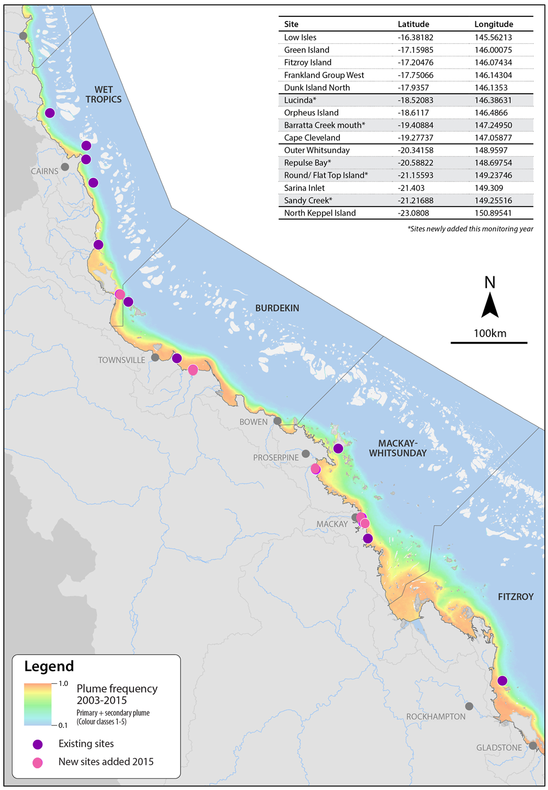
Figure 2 Locations of current inshore Reef fixed monitoring sites where time-integrated sampling of pesticides occurred in 2014-2015
Grey dots indicate towns. (Source – Dieter Tracy, James Cook University)
Sites are located within the extent of flood plumes from rivers that drain a variety of land-uses on the adjacent catchment areas, and discharge into the Reef lagoon (Table 3).

Table 1 Location of fixed passive sampling sites and closest influencing river
NRM region | Basin | Major River/ Creek | Fixed site name
Wet Tropics | Mossman | Mossman River | Low Isles
 | Barron | Barron River | Green Island
 | Mulgrave-Russell | Mulgrave River/ Russell River | Fitzroy Island
 | Mulgrave-Russell | Mulgrave River/ Russell River | Normanby Island
 | Tully | Tully River | Dunk Island north
Burdekin | Herbert | Herbert River | Lucinda
 | Herbert | Herbert River | Orpheus Island
 | Haughton | Haughton River | Cape Cleveland
 | Burdekin | Barratta Creek | Barratta Creek mouth
Mackay Whitsunday | Proserpine/ O’Connell | Proserpine River/ O’Connell River | Repulse Bay
 | Proserpine/ O’Connell | Proserpine River/ O’Connell River | Outer Whitsundays
 | Pioneer/ Plane | Pioneer River/ Sandy Creek | Round/ Flat Top
 | Plane | Sandy Creek | Sandy Creek
 | Plane | Plane Creek | Sarina Inlet
Fitzroy | Fitzroy | Fitzroy River | North Keppel Island

The Wet Tropics region encompasses eight catchment areas, covering approximately 2.2 million hectares (ABS, 2010). Approximately 44 % of land is set aside as conservation and natural environment areas, however beef cattle grazing (30 % of total land use) and sugar cane (7% of total land use) are the primary agricultural activities (DSITIA, 2012b). Fixed sampling sites in the Wet Tropics region in 2014-2015 were at Low Isles, Green Island, Fitzroy Island, Normanby Island, Dunk Island and Lucinda (Figure 2). Low Isles and Fitzroy Island have been monitored since 2005, Dunk Island since 2008 (once in 2007), Green Island since 2009 and Lucinda was established this monitoring year.

The Burdekin region spans five catchments and covers 14 million hectares, of which 90 % is used for agricultural purposes, with grazing primarily inland and some sugar cane and horticulture along the coast (DSITIA, 2012c, ABS, 2010). Sampling sites in the Burdekin region in 2014-2015 were Orpheus Island, Barratta Creek mouth and Cape Cleveland (Figure 2). Orpheus Island has been monitored since 2005, Cape Cleveland has been monitored since 2007, and the Barratta Creek mouth site was established this year.

This monitoring year, two additional passive samplers were deployed upstream in the Barratta Creek catchment, during the wet season between November 2014 and February 2015 (Figure 3). Barratta Creek is a small sub-catchment, located in the Lower Burdekin Basin. The primary land use is grazing on native pastures, with 31 % of land used for irrigated sugar production and less than 6 % is set aside for conservation purposes (Dight, 2009). Extensive development of irrigation channels and discharge of tailwaters has altered the natural seasonal flow of the Barratta Creek, to one of perennial flow. The estuarine wetland area within Bowling Green Bay National Park has been recognised as a Ramsar wetland and is an important breeding and feeding area for bird and aquatic life. The mid to lower reaches of the creek that are influenced by tailwater are considered to be highly disturbed, and elevated concentrations of PSII herbicides and other pesticides (in both grab and passive samplers) have been consistently detected in previous sampling programs (Dight, 2009, O’Brien et al., 2016). The marine area of Bowling Green Bay is home to dugong and turtle feeding grounds and thus, reducing the use and run-off of herbicides in the area of heavy sugar production surrounding the creek is now a management priority.
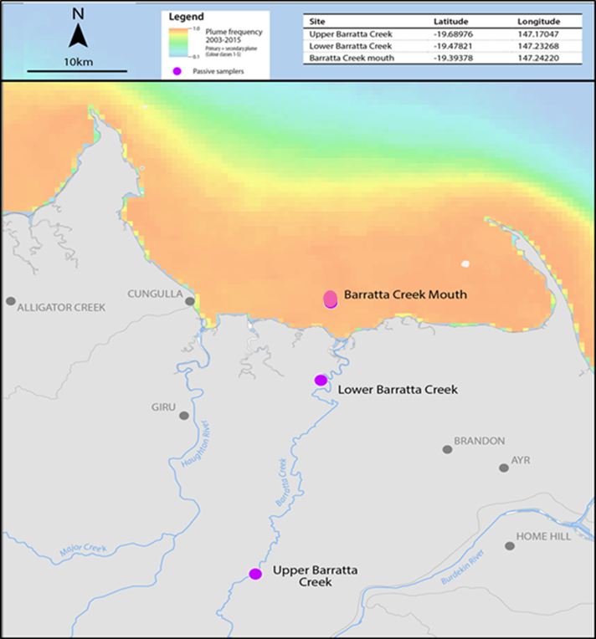
Figure 3 Locations of Barratta Creek passive sampling sites
The Mackay Whitsunday region is the smallest NRM region, spanning four catchments with an area of approximately 900,000 hectares (ABS, 2010). This region is dominated by the sugar cane industry, which comprises 18% of the region’s land use (DSITIA, 2012e). Sampling sites in the Mackay Whitsunday region in 2014-2015 were Outer Whitsunday, Sandy Creek, Repulse Bay, Round/ Flat Top Island and Sarina Inlet (Figure 2). The Outer Whitsunday site has been monitored since 2006, Sarina Inlet site was established in 2009 and the remaining sites were established this year. The Fitzroy region spans six catchments and covers an area of 15.6 million hectares (ABS, 2010). Cattle grazing is the most prevalent industry (78 % of the land use), with broad acre cropping (5 % of the land use) and cotton farming also present (DSITIA, 2012a). The only monitoring site in the Fitzroy region is at North Keppel Island (Figure 2). This site has been monitored since 2005 although it has had broken periods of sampling throughout some years.

Five sites (Low Isles, Green Island, Dunk Island, Outer Whitsunday and Sarina Inlet) are seagrass monitoring sites within the MMP. Five sites (Lucinda, Barratta Creek mouth, Repulse Bay, Round/ Flat Top Island and Sandy Creek) were newly established this year, with a further five sites (Green Island, Fitzroy Island, Cape Cleveland, Orpheus Island and Outer Whitsunday) to cease operation in the following monitoring year. The redesign of passive sampling sites was one of the outcomes of a review of the pesticide monitoring component of the MMP program in 2013 (Kuhnert et al., 2014). The decision to redesign the passive sampling sites was based on the desired outcomes of prioritising sites that provide better integration with other components of the MMP (such as seagrass monitoring), integrate with other monitoring activities such as the end-of-catchment loads monitoring, are located adjacent to catchments that have been identified as high risk for exposure to pesticides (Brodie et al., 2013), and have adequate statistical power to detect trends in pesticide concentrations.

Flood plume sampling (grab and passive samplers)
The locations and timing of the flood plume sampling is changed on a yearly basis, as it is largely event-driven and requires a rapid response (which is also subject to sampling personnel safety and the availability of sampling vessels). In 2014-2015, sampling was undertaken in transects extending from two rivers – the Tully River and Russell-Mulgrave rivers, both located in the Wet Tropics region (Figure 4). Both transects have been sampled in previous monitoring years, with the Russell-Mulgrave transect first sampled in 2013 and the Tully transect first sampled in 2010.

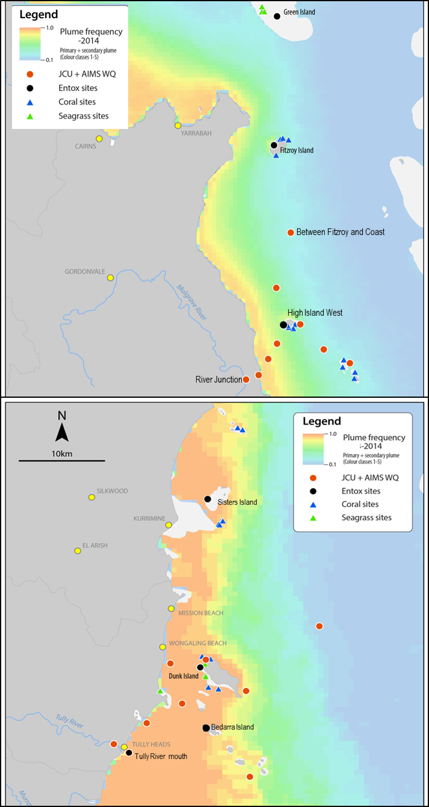
Figure 4 Locations of grab and passive samplers collected on the Russell-Mulgrave River transect (top) and Tully River transect (Bottom), and the frequency of flood plumes over the 2014-2015 wet season.
Unlabelled red circles indicate the locations where grab samples were collected as part of the Inshore Marine Water Quality Component of the MMP in 2014-2015. Maps provided by Dieter Tracey, James Cook University

Fixed site monitoring for long-term trends
Pesticide monitoring at fixed sites is reported for the year to end of June 2015. The year is divided into “Dry 14” (May 2014 to October 2014) and “Wet 14-15” (November 2014 – April 2015) sampling periods for reporting purposes. Within each dry season deployment period, samplers are typically deployed for two months (maximum of three deployment periods each monitoring year) and within each wet season deployment period, samplers are typically deployed for one month (maximum of six deployment periods within each monitoring year). The maximum number of samples which should be obtained from each location within each monitoring year is nine.

All fifteen fixed sites are monitored in both the dry and wet periods using EDs (Table 2), for analysis of target polar pesticides (Appendix A, Table A1). Eleven sites had PDMS samplers deployed during the wet season only (Table 2), for analysis of target non-polar pesticides (Appendix A, Table A2). PDMS samplers were co-deployed at sites located in the Wet Tropics region (five sites), the Burdekin region (two sites) and the Mackay Whitsunday region (four sites), and were selected based on the intensity of land-use and high historical loads of pesticides exported from the adjacent catchments (such as Barratta Creek and sites in the Mackay Whitsunday), as well as providing coverage from northern to southern regions. The sampling records, deployment dates and results for each fixed monitoring site are provided in Appendix D, Tables A14 – A29.
Table 2 The types of passive samplers deployed at each fixed monitoring site in 2014-2015

Flood plume sampling
Sampling activities targeting discharge events from major Reef catchment rivers occurs during the wet season (November 2014 to April 2015), and typically coincide with large rainfall events on the adjacent catchment area. Grab samples (1 L) are collected along transects extending from river mouths to capture peaks (and potential Guideline exceedances) and assess the extent of gradients of pesticide concentration. Grab sampling may also capture herbicides not adequately sampled by passive samplers, due to their high water solubility. Passive samplers (EDs only) were deployed at locations along these transects to provide a complete pesticide profile over the discharge period that may be useful to compare against pesticide loads data.

A total of nine 1 L grab samples were collected to monitor terrestrial run-off from two rivers (the Tully and Russell-Mulgrave) during flood plume events in the 2014-2015 wet season. Passive samplers were deployed at one location extending from the Russell-Mulgrave River (High Island west), and at three locations extending from the Tully River (Tully River mouth, Bedarra Island, Dunk Island north). Further details for these samples including the date and time of collection, co-ordinates and results for individual herbicides detected are provided in Appendix E, Tables A30 - 31.

Target Chemicals
The list of target chemicals originally derived at the commencement of the MMP through consultation with GBRMPA was based on the following criteria: pesticides detected in recent studies, those recognised as a potential risk, analytical affordability, pesticides within the analytical capabilities of Queensland Health and Forensic Scientific Services (QHFSS, who formerly conducted all analysis) and those likely to be accumulated within one of the passive sampling techniques (i.e. that exist as neutral species and are not too polar). In 2015 in consultation with the Pesticide Working Group (PWG) and GBRMPA, the list of target chemicals was further expanded to include a number of ‘alternative’ pre- and post-emergent herbicides (Appendix A, Table A3 – A4). The criteria by which these new target chemicals have been included are: registered for use in Reef catchments to supplement or replace the use of some traditional PSII’s, included in the suite for PSII end-of-catchment loads monitoring and catchment pesticide modelling programs conducted by other agencies (and thus better harmonisation across complimentary monitoring programs) and detected in recent studies and monitoring programs.

Analysis of non-polar pesticides using gas chromatography-mass spectrometry (GC-MS) and herbicides liquid chromatography-mass spectrometry (LC-MS) in passive samplers (PDMS and EDs) and grab samples is conducted at Entox. Sample analysis was previously conducted by QHFSS. This is the first monitoring year in which GC-MS analysis has been conducted by Entox, and the second monitoring year in which LC-MS analysis has been conducted by Entox. Analytical quality assurance quality control (QAQC) includes the extraction and analysis of replicate ED samplers (Appendix A, Table A5) together with an inter-laboratory comparison of a subset of ED extracts, at QHFSS (Appendix A, Table A6).

Mapping the frequency and extent of flood plumes (frequency maps)
River flood plumes are the primary vehicles that deliver catchment-derived pollutants to the Reef lagoon. Mapping the frequency, spatial extent and duration of these flood events is essential when developing risk models that can inform management about the areas that may be the most at risk from acute or chronic effects of pollutant exposure resulting from river discharge. Additionally, these maps can provide an indication of the frequency and duration at which a fixed monitoring site was influenced by plume waters, and potentially exposed to elevated levels of pollutants.
One of the outputs of the Inshore Marine Water Quality component of the MMP is mapping the frequency and extent of (surface) flood plumes using ocean colour (that corresponds to different water types) collected via satellite imagery that exploits differences in colour of plume waters from ambient marine waters in 1km² ‘pixels’ (Devlin et al., 2012). Plumes are classified into three water types:
- Primary - very high turbidity, low salinity (0 to 10 ppt), and very high values of colour dissolved organic matter (CDOM) and TSS;
- Secondary - intermediate salinity, elevated CDOM concentrations, and reduced TSS due to sedimentation, where phytoplankton growth is prompted by the increased light (due to lower TSS) and high nutrient availability delivered by the river plume;
- Tertiary - exhibits no or low TSS associated with the river plume, and above-ambient concentrations of chlorophyll a (Chl-a) and CDOM.
Weekly flood plume colour class data was recorded for each of the fixed monitoring sites for the wet season (details provided in Appendix A, Table A13). Reef-wide, annual and multi-annual frequency maps were also obtained (all plume frequency maps were prepared by Dieter Tracy (JCU)). It must be noted that plume exposure mapping may be complicated by the resuspension of fine sediments during periods of high winds and waves (rather than periods of actual river discharge) as well as cloud cover.

Reporting Metrics
Measured concentrations of pesticides and herbicides were compared to GVs (GBRMPA, 2010, ANZECC and ARMCANZ, 2000) (Appendix A, Table A7). The GVs chosen are conservative and protective of 99 % of species. This level of protection was judged the most suitable for this World Heritage Area, which is classified as having outstanding universal value and no change in the indicators of biological diversity beyond the natural variation is recommended. In certain cases, only freshwater guidelines, “low reliability” Guidelines or “interim working levels” (IWLs) were available for assessing the concentrations of specific chemicals (ANZECC and ARMCANZ, 2000).

In many cases, no GVs are available to assess the concentrations of specific chemicals detected in this current monitoring year. It must be noted that the Guidelines are currently under review to include many more of the herbicides detected in this MMP (DoE, 2016) however for the purposes of this report, data is compared against the existing Guideline values.

The risk of PSII inhibition may be underestimated when concentrations of herbicides are considered individually rather than as part of a more complex mixture. In this report, PSII herbicide concentrations (ng L⁻¹) are also expressed as PSII herbicide equivalent concentrations (PSII-HEq) (also in ng L⁻¹). PSII-HEq concentrations are derived using relative potency factors (RPF) for each individual PSII herbicide with respect to a reference PSII herbicide diuron (Appendix B, Table A10), and is the sum of the individual RPF-corrected concentrations of each individual PSII herbicide detected in each sample (either grab sample or passive sampler). Also reported are the PSII-HEq Max values (the maximum PSII-HEq concentration detected at a given fixed monitoring site in a monitoring year) and PSII-HEq Wet Avg values (the average PSII-HEq concentration detected at a given fixed monitoring site during the wet season (November to April). These values allow a fast assessment of the worst case scenario of PSII herbicide exposure encountered during a monitoring year, the seasonal variation in the risk of PSII inhibition respectively, and their trends over time.

To interpret the PSII-herbicide data reported as PSII-HEq, the PSII Herbicide Index has been compiled (with GBRMPA) as an indicator of PSII inhibition to report against across the MMP (Appendix B, Table A11). Classifying the data generated in this MMP into Index categories (which are based on published toxicity data using Reef relevant species) provides an indication of the additive effects of PSII herbicides on plants, animals or algae, based on the concentrations and relative potencies of the individual herbicides detected (Appendix B, Tables A8 – A9). The Index can quickly indicate the extent of PSII inhibition encountered at a given site (and its potential consequences), and a rapid indication of the duration (i.e. length of deployment periods) and/or frequency that a site is exposed to elevated levels of PSII herbicides.

RESULTS

Pressures influencing pesticide concentrations in the Reef
Pesticide run-off from diffuse land uses has been identified as a high risk threat to Reef ecosystems and heritage values (GBRMPA, 2014). Agricultural activities (particularly sugar cane cultivation) are the major diffuse source of pesticides in run-off and the focus of Reef Plan initiatives however, it must be noted that other point-sources of pesticide run-off may result from urban and industrial activities (GBRMPA, 2013a). Key pressures (or factors) influencing pesticide and herbicide detections in the Reef lagoon derived from diffuse agricultural activities include pesticide usage, agricultural land use area, rainfall, timing and method of herbicide application, herbicide run-off behavior, herbicide persistence, rates of herbicide loss from paddocks, volume of water discharged from rivers, proximity of samplers to rivers, frequency of flood plume impacts at the site, the timing of passive sampler deployments and adoption of best management practices for land management (including chemical use, surface and irrigation water management).

It can be difficult to elucidate meaningful trends and assess the progress of Reef Plan when concurrent changes to these pressures occur simultaneously. Quite often, the necessary data needed to interpret these changes (particularly pesticide usage and application rates) are either not available or only updated periodically. All of these factors make it difficult to quantitatively assess the link between improved land management practises as a direct result of Reef Plan initiatives and changes in water quality. The relevant pressures we have addressed in this report include rainfall, cyclones, freshwater river discharge, end of catchment pesticide loads and agricultural land use.

Rainfall
The 2014-2015 monitoring year was characterised by the establishment of El Niño climatic conditions which lasted from approximately March 2014 until its peak in December 2014 (BOM, 2016b). Typically, an El Niño summer is associated with below-average rainfall in northern Queensland and Eastern Australia, although its influence has been variable in past events. From January 2016, climate models suggested that El Niño was in decline, returning to neutral conditions in the second quarter of 2016. Neutral or La Nina conditions are expected for the second half of 2016 (BOM, 2016b). In 2014-2015, the Reef catchment areas adjacent to fixed monitoring sites were characterised by below average rainfall (Appendix C, Figure A1) for much of the wet season and was also lower than the total rainfall in the previous monitoring year (May 2013 - April 2014) (Appendix C, Figure A2).

Weekly mean catchment rainfall data (provided by Dieter Tracey, JCU) (Table 3) and total monthly rainfall maps (Figure 5) (BOM, 2016a) were collected for the Reef catchments adjacent to passive samplers over the wet season (weekly data beginning 1 December 2014). Significant rainfall did not begin in the coastal areas until January 2015 and persisted until March 2015 only in the most northern catchments (i.e.in the Cape York and Wet Tropics regions) (Figure 5).

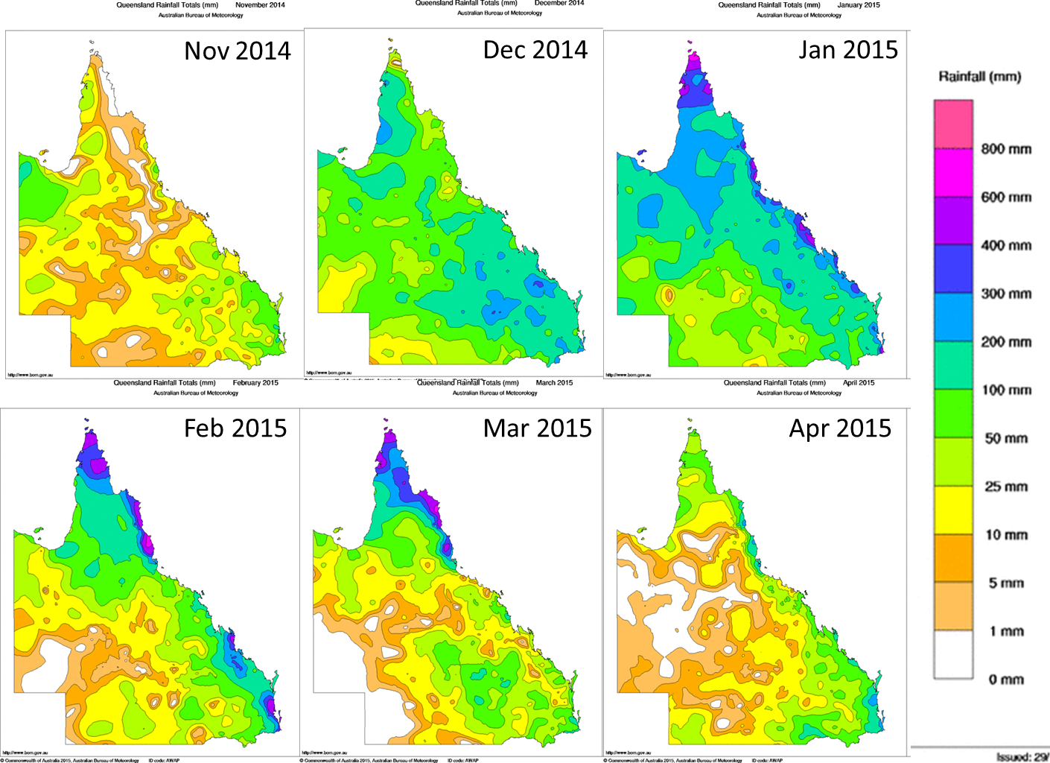
Figure 5 Monthly rainfall totals during the wet season (November 2014 – April 2015).
Maps provided by Bureau of Meteorology (BOM)
Overall, the Wet Tropics region received the highest weekly rainfall with the Russell-Mulgrave River the wettest catchment having five weeks of mean rainfall >100 mm, including two weeks >300 mm (Table 3). The Herbert River catchment was the driest in the region, with only a single week of high rainfall, late in the season, in early March. Generally, there were three pulses of elevated rainfall in the region, occurring in late December, early February and early March.

In the Burdekin region catchments, moderate rainfall only began falling throughout December, reaching a peak in January. There was only a single week in mid-January where rainfall exceeded 100 mm in the Haughton River catchment. Throughout February and March, rainfall was low, and did not exceed 25 mm. Similarly in the Mackay Whitsunday region, weekly rainfall only exceeded 100 mm for one week also in mid-January, with the remainder of the wet season comparatively drier. There was also only one week of high rainfall occurring in the Fitzroy River catchment, although this occurred earlier in early December, with prolonged dry periods of little rainfall in the months following.

Table 3 Weekly mean catchment rainfall (mm) in catchments adjacent to fixed passive sampler sites during the 2014 – 2015 wet season (beginning 1 December 2014).
Colour gradient: Red indicates the highest value, yellow represents the 50th percentile and green represents the lowest value

Cyclones
Tropical cyclones in the Queensland region mostly form from lows within the monsoon trough, between November and April, producing damaging winds, heavy rainfall and often major flooding. On average 4.7 tropical cyclones per year affect the Queensland Tropics. There is a strong relationship with eastern Australian tropical cyclone impacts and the El Niño-Southern Oscillation phenomenon, with almost twice as many impacts during La Niña than during El Niño. In 2014- 2015, two severe tropical cyclones Marcia and Nathan impacted the Reef (BOM, 2016e).

Tropical Cyclone Marcia made landfall near Yeppoon on the 20th February 2015 as a Category 5 system (BOM, 2016c). Heavy rainfall fell in the catchments between the Fitzroy River and Upper Brisbane River (Figure 6) and flooding occurred in several rivers within the Fitzroy River catchment, and the Burnett-Mary region. Up to 300 mm of rainfall was recorded in six to eight hours on the 20th of February in parts of the Fitzroy River catchment.

Tropical Cyclone Nathan began as a slow moving tropical low on the 9th of March 2015, stalling off the Cape York Peninsula for several days as a Category 2 system (BOM, 2016d). Rainfall totals in northern Reef catchments located in the Cape York and Wet Tropics regions during this period exceeded 200 mm (Figure 6). Nathan finally made landfall north of Cooktown in the Cape York region on the 20th of March 2015 as a Category 4 system, before rapidly declining to a Category 1 as it entered the Gulf of Carpentaria on the 21st of March.
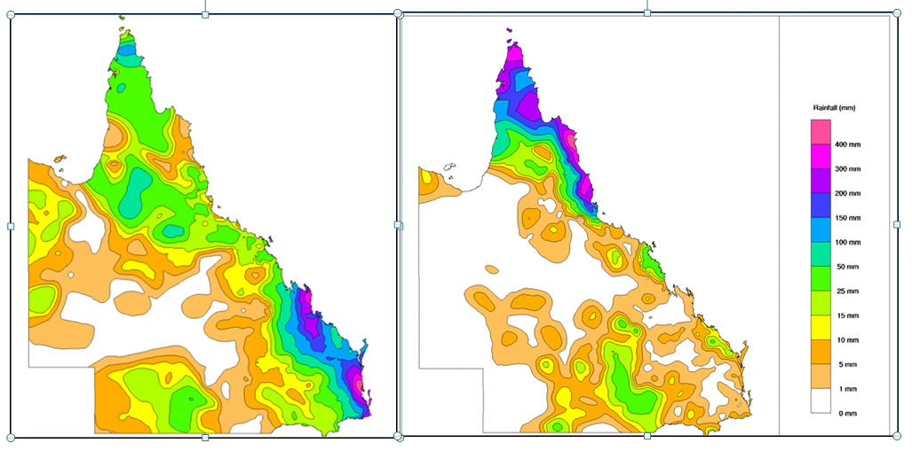
Figure 6 Total rainfall recorded for the week ending 24th February 2015 (left) associated with TC Marcia; and for the week ending 17th March 2015 (right) prior to landfall of TC Nathan

River discharge
For the fourth consecutive year, total annual discharge of freshwater into the Reef had decreased to approximately 18.5 x 10⁶ ML (Figure 7; Appendix C, Table A12) and for the first time since 2004-2005, was below the long-term median discharge (approximately 22 x 10⁶ ML).
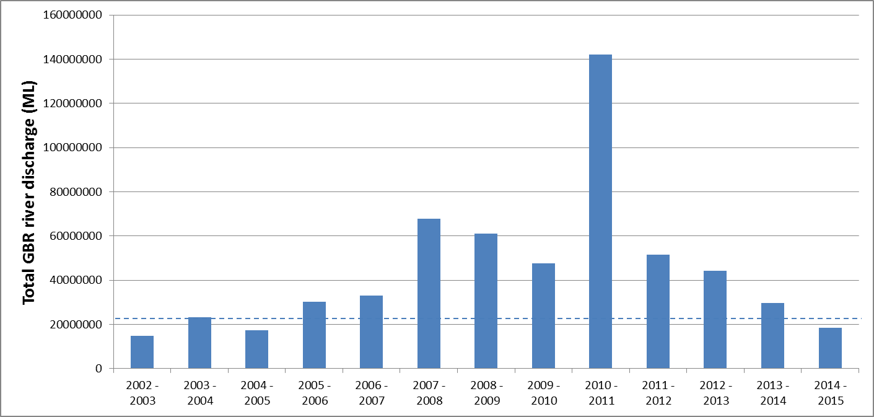
Figure 7 Total annual discharge of all gauged rivers located in Reef catchments into the inshore waters of the Reef (ML)
Data provided by Michelle Devlin (unpublished). The water year is considered October 1st to September 30th the following year. The discharge data provided for the current year is complete. Dotted line represents the long-term median discharge.

The ratio of freshwater discharge in 2014-2015 of selected Reef catchment rivers potentially impacting fixed passive sampler sites to the long-term median discharge, ranged from 0.13 (O’Connell River) – 5.2 (Pioneer River), with the majority of individual rivers discharging less than their long term median (Table 4).
Table 4 Comparison of long-term median flows in major rivers with total discharge in the 2014-2015 water year
River discharge data compiled by Eduardo da Silva (JCU). (Data Source Department of Environment and Resource Management, Stream Gauging Network). Long-term median flow data was provided by (Schaffelke et al., 2011) and determined from the commencement of river monitoring up to the year 2000. Water years are from October 1st to September 30th the following year.

Rivers located in the northern catchments typically flow year-round, whereas rivers located in the southern drier catchments only flood periodically following large rain events during summer (Lewis et al., 2006, Larson et al., 2013). This monitoring year, gauged rivers in the Wet Tropics contributed 37.5% of the total volume of freshwater discharge into the Reef, rivers in the Burdekin region contributed 4.9%, rivers in the Mackay Whitsunday region contributed 9.4% and rivers in the Fitzroy region contributed 14.6%. The timing, duration and intensity of rainfall between the northern and southern Reef catchments differs significantly, driving river flow and thus delivery of pollutants to the marine environment over different time scales.

Pesticide loads
Annual loads (kg) of five PSII herbicides (ametryn, atrazine, diuron, hexazinone and tebuthiuron) were monitored at 10 end-of-system sites and six sub-catchment sites by the Great Barrier Reef Catchment Loads Monitoring Program (GBRCLMP) as part of the Reef Plan, in 2014–2015 (Wallace et al., 2016). In 2014-2015, the total monitored annual loads of PSII herbicides were: 1400 kg of total atrazine; 810 kg of total diuron; 280 kg of hexazinone; 410 kg of tebuthiuron; and 7.7 kg of ametryn. Atrazine and diuron were the only PSII herbicides detected at all monitoring sites. Compared to the previous year, loads of diuron and ametryn had decreased slightly (from 890 kg and 11 kg respectively). Despite the overall decreased rainfall and river discharge observed this monitoring year, annual loads of atrazine, hexazinone and tebuthiuron had increased when compared to the previous year. The Fitzroy River and Barratta Creek contributed over half of the total monitored atrazine load (520 kg and 260 kg respectively). The largest load of diuron (200 kg) was exported from the Russell River, followed by the Tully River (140 kg) and Pioneer River (100 kg). The Tully River and Russell River were the largest contributors of total monitored hexazinone loads (48 % of total). Similarly to the previous year, the largest annual load of tebuthiuron (390 kg) was derived from the Fitzroy River, which has historically been the largest contributor of tebuthiuron loads. The profiles of PSII herbicides loads varies significantly between catchments and reflects the known land uses occurring within the monitored catchment (e.g. increased tebuthiuron loads in catchments with high proportions of grazing activities) (Figure 8).

An expanded suite of additional PSII herbicides, herbicide metabolites and emerging ‘alternative’ pesticides and herbicides were also monitored as part of the program. Of the additional chemicals, metolachlor (570 kg), imidacloprid (310 kg) and 2,4-D (300 kg) had the highest monitored loads. The Fitzroy River contributed the highest loads of both metolachlor (440 kg) and 2,4-D (50 kg) whereas the Tully River contributed almost half (120 kg) of the total monitored load of imidacloprid. Similarly to the previous year, Sandy Creek in the Plane catchment had the highest number of additional chemicals detected (19) with Barratta Creek in the Haughton catchment having the second highest (16).

Figure 8 Historical PSII herbicide loads from monitored Reef catchment rivers (2009 – 2015)
Data collated from GBRCLMP reports (Turner et al. 2012, Turner et al. 2013, Wallace et al. 2014, Garzon-Garcia et al. 2015, Wallace et al. 2015, Wallace et al. 2016)

Land use
A wide range of land uses occur in the Reef catchments, with great diversity between NRM regions (Figure 9; Appendix H, Figure A37).
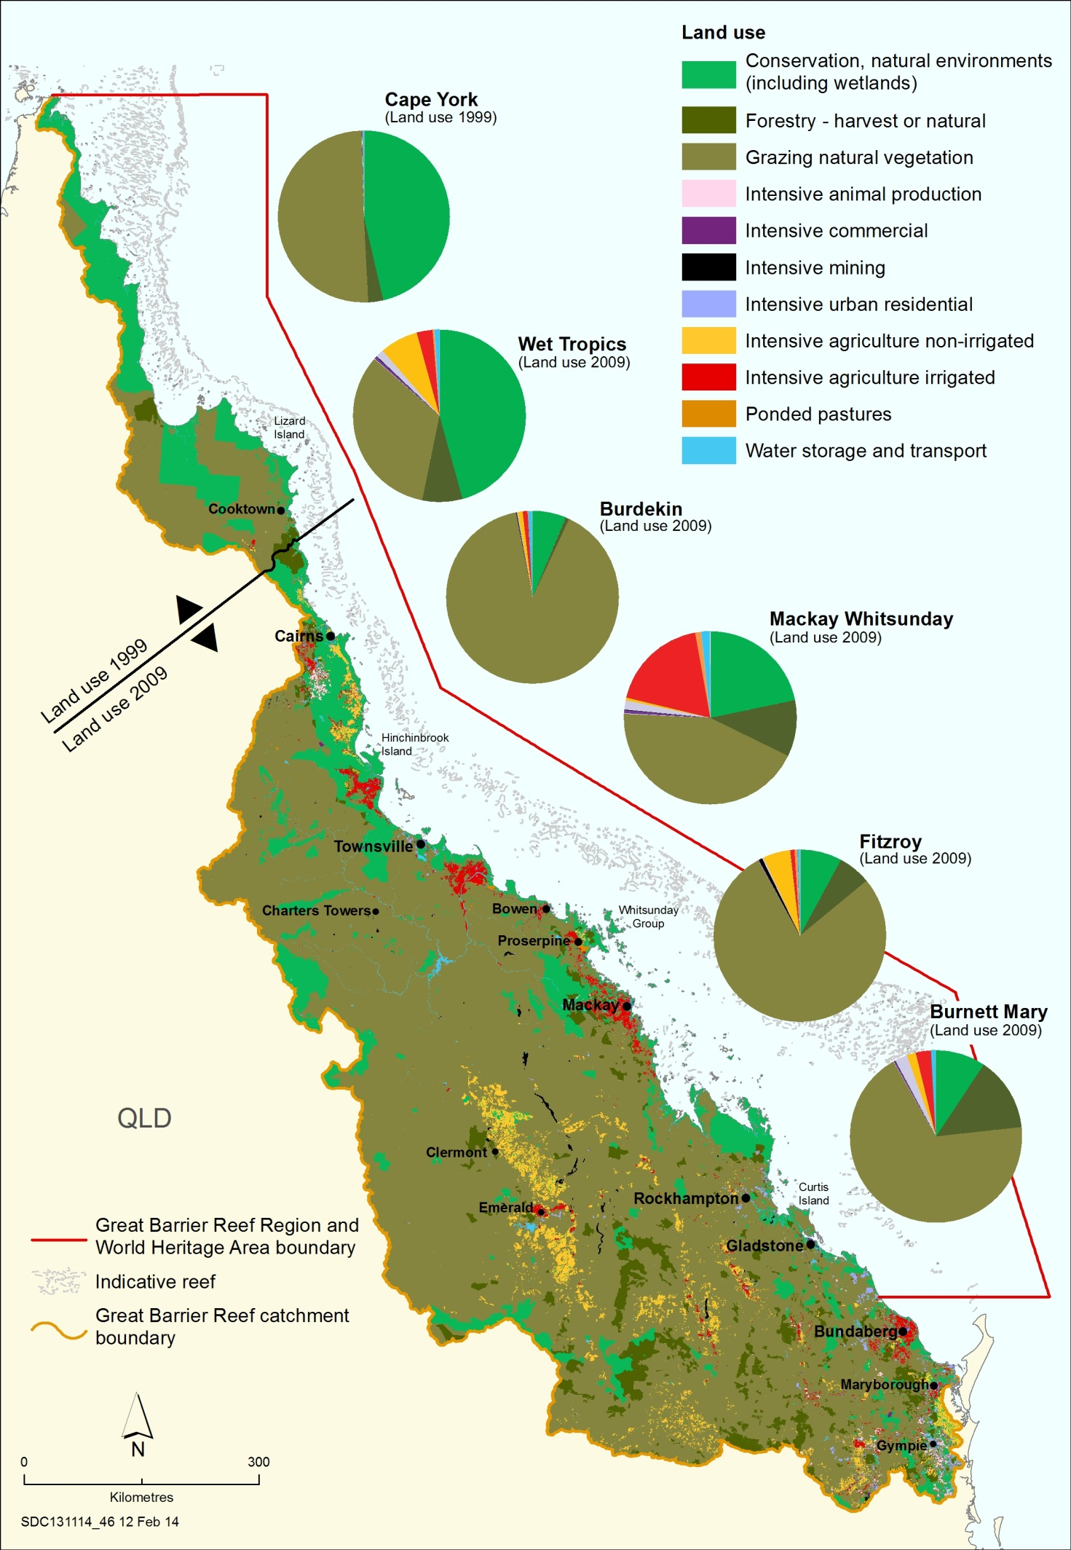

Figure 9 Land use in the Reef catchments.
Source: (GBRMPA, 2014)
Certain regions and/or smaller coastal catchments can represent areas of higher localised risk of pesticide run-off due to high rainfall as well as the intensity and nature of agricultural activities (such as sugar cane cropping) occurring in coastal areas (Brodie et al., 2013). In total, 80 % of the Reef catchments support agricultural activities with cattle grazing the most extensive land use, particularly in the drier Burdekin and Fitzroy regions of which 90 % and 77% respectively are utilised for this purpose (DSITIA, 2012c, DSITIA, 2012a). The Wet Tropics and Mackay Whitsunday regions also have grazing activities (31 % and 42 % respectively) however other uses such as nature conservation (33 % of land use in the Wet Tropics) and irrigated cropping (sugarcane) (18% of land use in the Mackay Whitsundays) are also significant (DSITIA, 2012e, DSITIA, 2012b).

Other pressures
Following considerable paddock-scale research in the past five to ten years, the date of herbicide application, and timing of rainfall or irrigation following application continues to be one of the most critical factors in herbicide losses into waterways and subsequent detection in marine environments (Devlin et al., 2015). However the proportion of run-off is additionally influenced by soil type, climate and overall farming systems (on‐farm hygiene, timing of application and product selection, getting on top of weeds early in the plant crop cycle and precision/ targeted application) which differ between geographical regions and crop types. Further work to understand the persistence of herbicides under local tropical conditions is necessary to accurately predict the transport, fate and ecological risk to marine aquatic life, as Reef field data is limited (Smith et al., 2015).

Reef-wide results 2014-2015

Fixed site passive sampler return record
This monitoring year, 83 % of fixed site passive sampler sets sent to volunteers were successfully deployed and returned (Table 5). (In comparison, successful sampler returns for the two years previous were 75 % and 84 %). The remainder of samplers were unsuccessful for a number of reasons, but were typically as a result of a lost mooring following bad weather. Four sites (Green Island, Lucinda, Orpheus Island) had excellent sampling records in 2014-2015, with no missed deployments.

Due to various issues, Normanby Island had only three successful deployments in the wet season and none in the dry season, whilst only two successful deployments occurred at Barratta Creek mouth due to sampler losses and late return of equipment. Both Outer Whitsunday and Sarina Inlet experienced several long deployments of samplers, and due to the late establishment of sites, only wet season sampling occurred at the new sites. There was only one sampler loss this year at the site located in the Fitzroy region.

Table 5 Passive sampling return record for the 2014-2015 monitoring year

Reef-wide summary pesticide results
The PSII herbicides detected at inshore reef locations in the current monitoring year using EDs were ametryn, atrazine (and its breakdown products), bromacil (detected once only), diuron, hexazinone, prometryn (detected twice), simazine and tebuthiuron. Other non-PSII emerging ‘alternative’ herbicides detected were metolachlor, 2,4-D, MCPA, imidacloprid, propazine, haloxyfop (detected three times) and metribuzin (detected three times), and metsulfuron-methyl (detected twice). Fluazifop and imazapic were detected once only. Using PDMS samplers, chlorpyrifos, pendimethalin and propazine were frequently detected at all sites where samplers were deployed. Trifluralin was detected five times.

The most frequently detected and highest concentration herbicides in this current monitoring year were diuron (maximum concentration of 59 ng L⁻¹), atrazine (maximum concentration of 24 ng L⁻¹) and hexazinone (maximum concentration of 16 ng L⁻¹), all detected at Sandy Creek. The alternative herbicides 2,4-D, imidacloprid, MCPA and metolachlor were also detected frequently although at relatively low concentrations (typically < 1 ng L⁻¹). At fixed monitoring sites, no herbicides with an individual GV to assess against exceeded its GV (Figure 10).

Diuron was the dominant contributor to the PSII-HEq Max at every fixed monitoring site due to its potency as a PSII inhibitor and its relatively higher concentrations (Figure 1). Diuron contributed an average of 81 % to the PSII-Max in the Wet Tropics, 73 % in the Burdekin, 82 % in the Mackay Whitsundays and 47 % at North Keppel Island in the Fitzroy region. The contribution of diuron was similar between the individual sites within the Wet Tropics (72 % - 80 %) and Burdekin regions (65 % - 78 %), and varied slightly more in the Mackay Whitsunday region (73 % - 88 %).

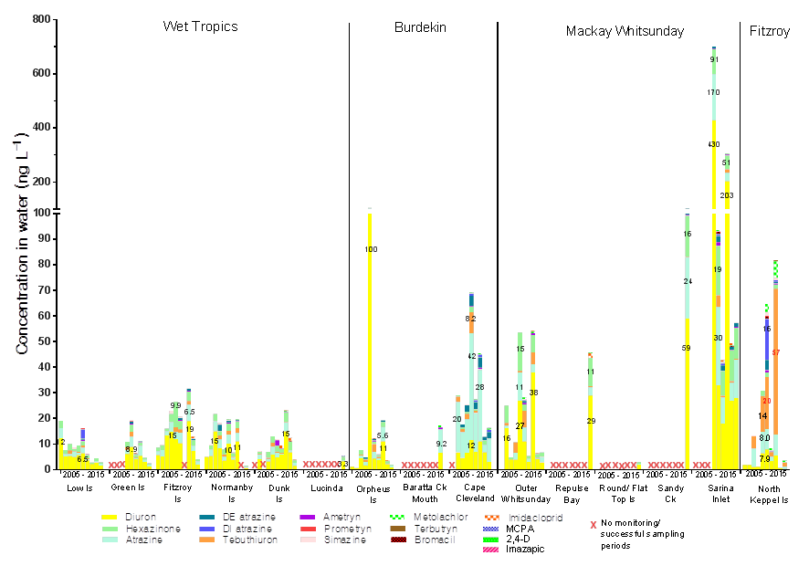
Figure 10 Maximum concentrations of individual herbicides at fixed monitoring sites from the commencement of sampling to 2014-2015

There was a possible decrease in the maximum concentrations of herbicides detected at five sites (Low Isles, Green Island, Fitzroy Island, Dunk Island and Orpheus Island) when compared to the previous monitoring year (Figure 10). Four sites (Cape Cleveland, Outer Whitsunday, Sarina Inlet and North Keppel Island) had similar or possibly increased maximum concentrations.

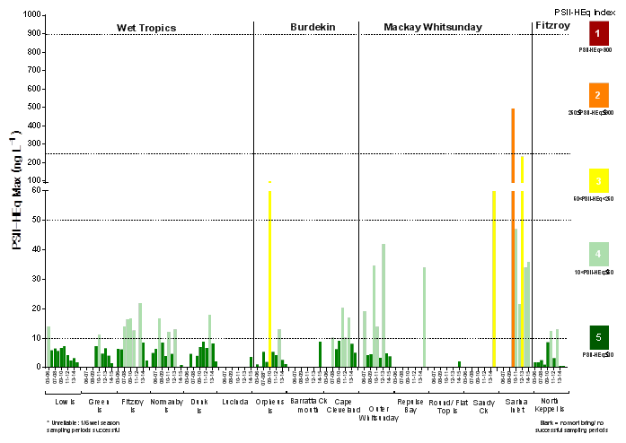
Figure 11 PSII-HEq Max at each fixed monitoring site since monitoring commenced to 2014-2015

In 2014-2015, the PSII-HEq Max for the regions ranged from 0.88 – 3.7 ng L⁻¹ in the Wet Tropics, 1.3 – 8.8 ng L⁻¹ in the Burdekin Region, 2.2 - 70 ng L⁻¹ in the Mackay Whitsunday and was 0.66 ng L⁻¹ in the Fitzroy region. These values indicate maximum PSII-HEq Index Categories of 5 for the Wet Tropics, Burdekin and Fitzroy regions; and Category 3 in the Mackay Whitsunday region (Figure 11).

Regional results and discussion

Wet Tropics
In 2014-2015, concentrations of PSII herbicides during the wet season were generally equal to or lower than concentrations detected in the previous monitoring year (Table 6; for historical data, see Appendix G, Figures A21 – A26). The overall low concentrations of herbicides coincided with reduced flows of major rivers influencing the passive samplers that were below the long-term median (Appendix F, Figures A5 – A10).
PSII herbicides (and transformation products) detected using EDs in the Wet Tropics region in 2014-2015 include ametryn, atrazine, desethyl atrazine, desisopropyl atrazine, diuron, hexazinone, simazine (two detections only) and tebuthiuron (Appendix D, Tables A14 – 19). The most frequently detected PSII herbicides in the Wet Tropics were diuron (detected in 81 % of samplers; maximum concentration 3.3 ng L⁻¹ at Lucinda), hexazinone (detected in 69 % of samplers; 0.98 ng L⁻¹ at Dunk Island) and atrazine (detected in 67 % of samplers; 1.5 ng L⁻¹ at Lucinda). The alternatives 2,4-D, imidacloprid, MCPA and metolachlor were also detected in the region (38 % - 12 % of samplers respectively). The spike in tebuthiuron concentrations observed in the 2013-2014 dry season at Green Island, Low Isles, Fitzroy Island and Dunk Island was absent in this monitoring year.

Annual flood plume frequencies (i.e. the proportion of weeks a site was exposed to primary or secondary plume waters as determined by ocean colour class) were calculated for 22 weeks of the wet season (beginning 1 December 2014) (Table 6). Plume frequencies ranged from low (0.18 at Normanby Island) to high (1.0 at Dunk Island) with the northernmost sites (Low Isles to Normanby Island) experiencing the lowest plume frequencies of all monitored sites, consistent with the below long-term median river discharge this monitoring year. Of the 34 rivers where flow is monitored by gauging stations, the ten rivers in the Wet Tropics contributed 37.5 % of the total volume of freshwater discharged into the Reef, the highest contribution of all NRM regions.

Land use in the Wet Tropics differs between its northern and southern catchments with the northern Daintree and Mossman River catchments largely comprised of national parks and state forests; and large areas of land used for sugarcane growing clustered around Cairns, Innisfail, Tully and Ingham in the southern catchments (ABS, 2013). Although Dunk Island and Lucinda appear to be impacted by plumes more frequently than other sites located in the Wet Tropics (Appendix C, Table A13), the PSII herbicide profiles (Figure 10) and PSII-Max values (Table 6) did not differ significantly from the other fixed Wet Tropics monitoring sites and remain low overall. Wind or wave-induced resuspension of sediments, dredging and other activities and the location of samplers in shallow water may have contributed to the high plume frequency values at these sites.

Table 6 Summary statistics for the PSII-HEq Max and PSII-HEq Wet Avg (ng L⁻¹) since monitoring commenced in the Wet Tropics.
Wet Avg are the averages indicated for PSII-HEq for the wet season sampling periods only. Block colours indicate the maximum PSII-Heq Index category for that year. Values in italics indicate a single measurement for that year

Since monitoring commenced, 74 % of PSII-HEq Max values in the Wet Tropics have been Category 5, and 26% have been Category 4 (Figure 11). Maximum concentrations of diuron at sites were lower than the previous year, by approximately 1.8 to 4.5 times (excluding sites that were established only this year). The PSII-HEq Max and Wet Avg values in 2014-2015 were all Category 5 on the PSII-HEq Index, with no clear trend apparent since monitoring commenced (Table 6, Figure 12).

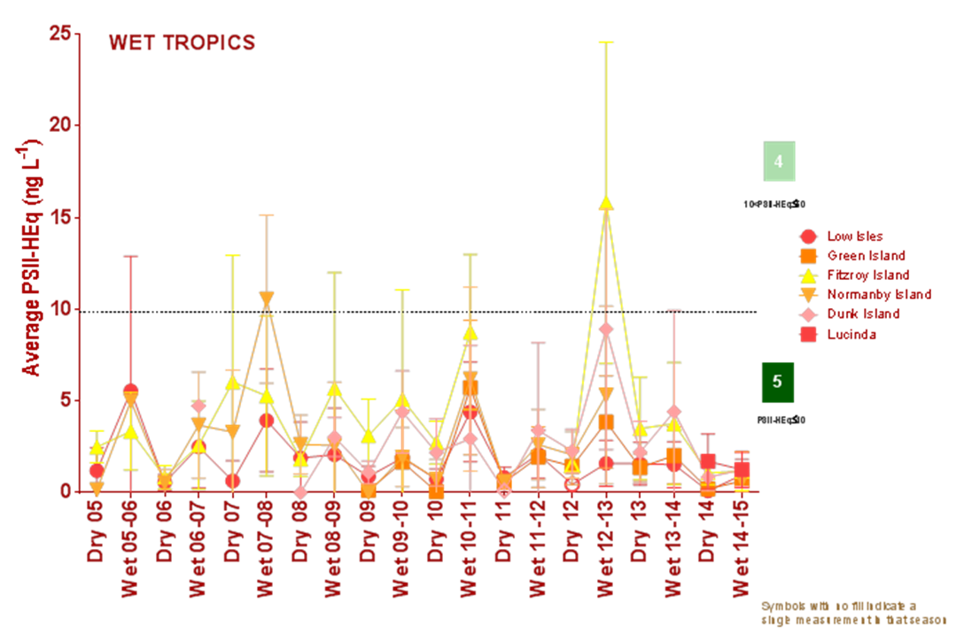
Figure 12 Seasonal average PSII-HEq for Wet Tropics sites since monitoring commenced

The chemicals detected using PDMS samplers (none deployed at Low Isles) were chlorpyrifos, pendimethalin, propazine and trifluralin. All were detected at concentrations <1 ng L⁻¹ (data summarised in Appendix D, Tables A14 – A19). Chlorpyrifos and pendimethalin were very frequently detected at very low levels in 92 % and 87 % of samplers respectively.

This year, a passive sampler was deployed at a single location (High Island West) on a transect extending from the Russell-Mulgrave River, closely following the second major flow event of the season. Two grab samples were collected from the river mouth (on the 7th of January and 12th of February 2015). The PSII herbicides hexazinone (0.75 ng L⁻¹), diuron (0.64 ng L⁻¹) and atrazine (0.40 ng L⁻¹) were the dominant herbicides detected in both the passive and grab samples (Appendix E, Tables A30 – A31) although the PSII-HEq concentrations were very low (Category 5). Grab samples and passive samplers collected in previous monitoring years have reached maximum PSII-HEq Index Categories of 2 and 4 respectively (Appendix D, Figure A3).

This year, passive samplers were deployed at three locations (Tully River mouth, Bedarra Island and Dunk Island North) along a transect extending from the Tully River. Five grab samples were collected on the 6th of January and 20th of February 2015). There was only a single detection of prometryn in grab samples, and the maximum PSII-HEq concentration detected in passive samplers was 21 ng L⁻¹ at the Tully River mouth (Appendix E, Tables A30 – A31).

Since monitoring commenced, PSII herbicides have been detected in grab samples collected at all transect locations, with the highest PSII-HEq concentration of 390 ng L⁻¹ detected at the Tully River mouth in 2013-14 (Appendix D, Figure A4) where PSII-HEq Categories ranged from Category 5 to Category 2. Other non-PSII indexed herbicides have been frequently detected including metolachlor, imidacloprid and metribuzin. Both diuron and metolachlor have exceeded the low reliability IWLs for marine waters collected at the Tully River mouth in previous monitoring years (ANZECC and ARMCANZ, 2000, Gallen et al., 2014). PSII herbicides have also been detected at all transect locations using passive samplers with the highest concentration detected also at the Tully River mouth (PSII-HEq Max of 238 ng L⁻¹) in 2013-14.

Burdekin Region
In 2014-2015, concentrations of PSII herbicides during the wet season were generally equal to or lower than concentrations detected in the previous monitoring year (Table 7; for historical data, see Appendix G, Figures A27 – A29). The overall decreased concentrations of herbicides coincided with reduced flows of major rivers influencing the passive samplers that were below the long-term median (Appendix F, Figures A11 – A13). The PSII herbicides (and transformation products) detected at sites in this region include ametryn, atrazine (and its breakdown products), diuron, hexazinone, simazine and tebuthiruon. The ‘alternative’ herbicides 2,4-D, MCPA and metolachlor were frequently detected at all sites, and both fluazifop and haloxyfop were detected at Cape Cleveland only (Appendix D, Tables A20 – A23). Similarly to the Wet Tropics region, the increased concentrations of tebuthiuron observed in the previous dry season, were absent. Using PDMS samplers (not deployed at Orpheus Island), chlorpyrifos and pendimethalin were frequently detected at very low concentrations in the wet season (Appendix D, Tables A20 – A23).

The most frequently detected PSII herbicides in this region were (on average) diuron (88 % of samplers; maximum concentration 6.6 ng L⁻¹ at Barratta Creek mouth), hexazinone (88 % % of samplers; maximum concentration 0.72 ng L⁻¹ at Cape Cleveland) and atrazine (detected in 77 % of samplers; maximum concentration 9.2 ng L⁻¹ at Barratta Creek mouth). Historically, atrazine and atrazine breakdown products dominate the herbicide profile at Cape Cleveland.

Annual flood plume frequencies were higher than those in the Wet Tropics and ranged from 0.82 to 1.0, despite comparatively lower annual average rainfall, and river discharge considerably less than the long term median. Similarly to several sites in the Wet Tropics region, it’s difficult to pinpoint the reason for these higher plume frequency values, however wind or wave-induced resuspension of sediments, dredging and other activities, the location of samplers in shallow water as well as the northward drift of the large discharge (5.2 times the long-term median) from the Pioneer River may potentially be affecting these values.

The Burdekin River is historically the river with the highest long-term median discharge volume, however above median discharge is intermittent and highly reliant on large rainfall events in the catchment (as seen in the La Nina years of 2007-08, 2008-09, 2010-12 with >3 times long term median annual discharge volumes) (Appendix C, Table A12). A review on the extent of the Burdekin flood plume indicates that the maximum northward distance for extreme large flood events could reach approximately 500 km, and approximately 200 km for average flood events meaning it likely impacts each of the fixed sampling sites located in the region during years of flood (Lewis et al., 2006). In this dry year, the PSII-HEq Max values of the three sites located in this region remained Category 5 on the PSII Index (Table 7; Figure 13).

Since monitoring commenced in the Burdekin region, 67 % of PSII-HEq Max values have been Category 5, 28 % of PSII-HEq Max values have been Category 4 on the PSII-HEq Index with a single instance of a Category 3 (Figure 5) (this excludes the Magnetic Island site which was discontinued in this year). Possible decreases in the maximum concentrations of herbicides were observed at all established sites. At Orpheus Island, the maximum concentrations of both diuron and atrazine decreased when compared to the previous monitoring year by approximately half. The PSII-HEq Max and Wet Avg values at all sites remained as Category 5, when compared to the previous monitoring year (Table 7).

Table 7 Summary statistics for the PSII-HEq Max and Wet Season Average (ng L⁻¹) since monitoring commenced in the Burdekin region.
Wet Avg are the averages indicated for PSII-HEq for the wet season sampling periods only. Block colours indicate the maximum PSII-Heq Index category for that year.

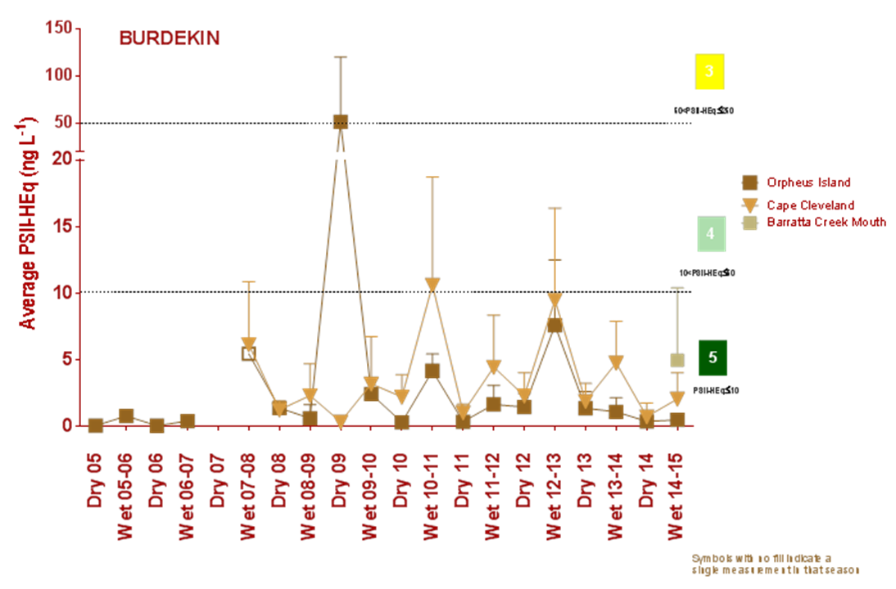
Figure 13 Seasonal average PSII-HEq for Burdekin sites since monitoring commenced

Barratta Creek case study
The concentrations of PSII herbicides were the highest detected of all monitoring sites, with concentrations typically the highest at the Upper Barratta site (Appendix D, Table A23). Atrazine was the dominant herbicide detected (maximum concentration of 9800 ng L⁻¹), followed by diuron (maximum concentration of 3400 ng L⁻¹) and the atrazine breakdown-product desethyl atrazine (maximum concentration of 1300 ng L⁻¹) (Appendix G, Figure A30). PSII-HEq concentrations ranged from 8.9 ng L⁻¹ (Barratta Creek mouth) to 4757 ng L⁻¹ (Upper Barratta Creek), a Category 1 on the PSII Index, indicating that effects on the growth and death of aquatic plants and animals may be occurring. There appeared to be a clear dilution effect on the concentrations of pollutants as they move from the upper to lower estuarine area.

There was minimal flow occurring in the creek (with the exception of a small flow event in mid-September 2014) leading up to the first deployment (Appendix F, Figure A14). Regular pulses of flow began occurring in early December 2014, and continued into early February 2015. Over this time PSII-HEq concentrations at the Upper site reduced by approximately six times and conversely, concentrations at the Lower Barratta site increased by approximately five times as the system was flushed. The samplers at the marine site were lost for two of the three sampling periods, and as such we were unable to observe the magnitude of any potential increase in concentrations in the near shore area, which presumably would have exceeded Category 5 on the PSII-HEq Index.
Concentrations of diuron, atrazine, metolachlor and tebuthiuron detected at the two upstream sites exceeded ANZECC and ARMCANZ freshwater GVs for either 95 % species protection (atrazine) or 99 % species protection (tebuthiuron) (Appendix A, Table A7). Numerous ‘alternative’ herbicides were detected at elevated levels including 2,4-D haloxyfop, MCPA, asulam, imazapic, imidacloprid, metribuzin and propazine.

Mackay Whitsunday Region
In 2014-2015, concentrations of PSII herbicides during the wet season were generally equal to or lower than concentrations detected in the previous monitoring year (Table 8; for historical data, see Appendix G, Figures A31 – A35). The overall decreased concentrations of herbicides coincided with reduced flows of major rivers influencing the passive samplers (Appendix F, Figures A15 – A19). PSII herbicides (and transformation products) detected at sites in this region include ametryn, atrazine (and its breakdown products), diuron, hexazinone, simazine and tebuthiuron (Appendix D, Tables A24 – A28). The most frequently detected PSII herbicides in this region are diuron (detected in 100 % of samplers; maximum concentration 59 ng L⁻¹ at Sandy Creek), hexazinone (detected in 95 % of samplers; maximum concentration 16 ng L⁻¹ at Sandy Creek) and atrazine (detected in 87 % of samplers; maximum concentration 2 ng L⁻¹ at Sandy Creek). Other herbicides imidacloprid, 2,4-D and metolachlor were regularly detected, and metsulfuron-methyl and metribuzin were detected in this region only. Using PDMS samplers, propazine, pendimethalin and chlorpyrifos were detected at very low concentrations.

Annual flood plume frequencies were relatively high, at 0.82 at Outer Whitsunday and 1.0 at all other sites (Table 8). PSII-HEq Max values at sites located in this region are consistently higher than sites located in other regions (Figure 11), which may reflect both the land use, pesticide usage and land management practices of the adjacent catchment as well as the ideal positioning of the sites to intercept flood plumes from nearby rivers (of particular note is the large discharge from the Pioneer River this year) (Appendix C, Table A12). Despite highest PSII-HEq concentration having been detected at Sandy Creek, weekly ocean colour classes suggest that Sarina Inlet was most frequently impacted by primary plume waters (Classes 1 – 4) (Appendix F, Figure F19), whereas Sandy Creek was consistently exposed to Class 5 (secondary plume waters) for the duration of the wet season (Appendix F, Figure A18).

Sandy Creek has the highest concentration of diuron of any other site and subsequently, it also has the highest PSII-HEq Max of 70 ng L⁻¹, which is a Category 3 risk of herbicide exposure on the PSII-HEq Index (Table 8). Since monitoring commenced, 32 % of PSII-HEq Max values in the Mackay Whitsunday region have been classified as Category 5, 47 % of values have been Category 4 and a further 22 % as either Category 2 or 3 (Figure 11). The PSII-HEq Max and Wet Avg values detected at both Sarina Inlet and Outer Whitsunday were similar when compared to the previous monitoring year (Table 8, Figure 14). The Sandy Creek site had the highest maximum concentrations of all sites meaning that for a sixth consecutive year, the Mackay Whitsunday region had the site with the highest PSII-HEq Max concentration.
.

Table 8 Summary statistics for the PSII-HEq Max and Wet Season Average (ng L⁻¹) since monitoring commenced in the Mackay Whitsunday region
Wet Avg are the averages indicated for PSII-HEq for the wet season sampling periods only. Block colours indicate the maximum PSII-Heq Index category for that year

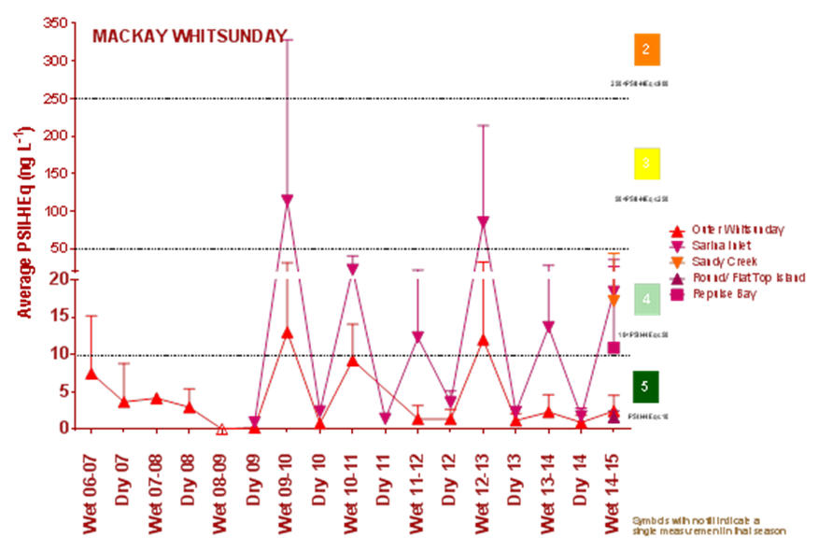
Figure 14 Seasonal average PSII-HEq for Mackay Whitsunday sites since monitoring commenced

Fitzroy Region
In 2014-2015, concentrations of PSII herbicides during the wet season were similar to concentrations detected in the previous monitoring year (Table 9; for historical data see Appendix G, Figure 36) and coincided with low flow from the Fitzroy River (Appendix F, Figure A20). PSII herbicides (and transformation products) detected at this site in 2014-2015 include atrazine (and its breakdown products), diuron, hexazinone and tebuthiuron (Appendix D, Table A29). The PSII herbicides detected with the equal greatest frequency (57 % of samplers) were atrazine (maximum concentration 0.84 ng L⁻¹), diuron (maximum concentration 0.31 ng L⁻¹) and tebuthiuron (maximum concentration 1.5 ng L⁻¹). Tebuthurion typically dominates the PSII herbicide profile at this site (Appendix G, Figure A36). No PDMS sampling is undertaken at North Keppel Island.

Annual flood plume frequencies were 1.0 at North Keppel Island, with secondary plume waters dominating for the majority of the wet season (colour class 5). The PSII-HEq Max value has been consistently a low Category 4 or 5 since monitoring commenced in 2005 (Table 9).
Table 9 Summary statistics for the PSII-HEq Max and Wet Season Average (ng L⁻¹) since monitoring commenced in the Fitzroy region
Wet Avg are the averages indicated for PSII-HEq for the wet season sampling periods only; In 2008-2009 North Keppel Island PSII HEq maximum was derived from 4 dry season sampling periods and 2 wet season sampling period, the average for the wet season is therefore from only two sampling periods. Block colours indicate the maximum PSII-Heq Index category for that year.

Since monitoring commenced, 80 % of PSII-HEq Max values at North Keppel Island in the Fitzroy region have been Category 5 and 20 % have been Category 4 on the PSII-HEq Index (Figure 11). Similarly to the previous monitoring year, the PSII-HEq Max was the lowest of all fixed sites. The PSII-HEq Wet Avg has been consistently Category 5 since monitoring commenced (Figure 18), with no apparent seasonal differences in concentrations.
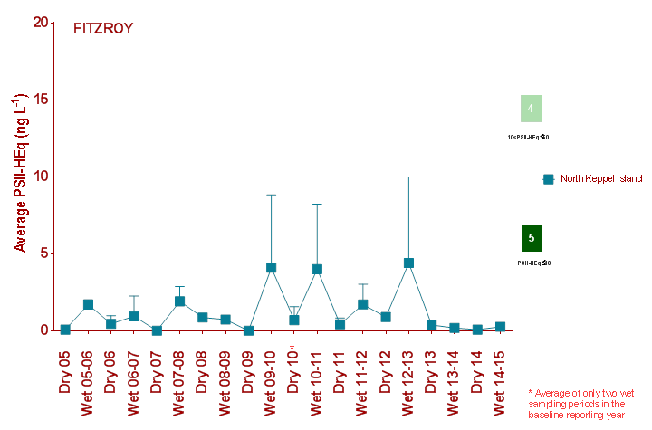
Figure 15 Seasonal average PSII-HEq for North Keppel Island in the Fitzroy region since monitoring commenced

Discussion
A range of PSII herbicides and other emerging ‘alternative’ pesticides were detected using passive samplers and grab samples this monitoring year. Similarly to previous monitoring years, diuron, atrazine and hexazinone were the most frequently detected and abundant PSII herbicides (Gallen et al., 2014, Gallen et al., 2013, Bentley et al., 2012, Kennedy et al., 2010, Kennedy et al., 2012). PSII-HEq concentrations were generally similar to or lower than the previous monitoring year, a likely result of the decrease in rainfall, river discharge and herbicide loads exported from adjacent Reef catchments.

The PSII herbicide profiles detected with the passive samplers are comparable to those detected during annual PSII herbicide loads monitoring undertaken by GBRCLMP and appear consistent with the land use in the adjacent catchment areas. In major rivers that are likely to impact passive sampler sites in the Wet Tropics and Mackay Whitsunday regions, a large proportion of the total loads of PSII herbicides were diuron. This is consistent with the intensive sugar caning activity in proximity to the coast in the Tully River, Herbert River, Pioneer River and Sandy Creek catchments, and also reflected in historical maximum concentrations of passive samplers dominated by diuron. Atrazine contributed the greatest proportion to PSII loads in the Barratta and Burdekin catchments which is reflected in the passive samplers deployed at the upstream Barratta Creek sites this monitoring year, at nearby Cape Cleveland, and in previous passive sampling activities in the Barratta Creek catchment (O’Brien et al. 2016). Loads of tebuthiuron have been greatest in the Burdekin and Fitzroy River catchments where land use is dominated by grazing and the passive sampler deployed at North Keppel Island in the Fitzroy region has been characterised by relatively high concentrations of tebuthiuron in previous monitoring years, including an exceedance of the GBRMPA guidelines in 2013 (Gallen et al., 2013).

The frequency of detection of many PSII herbicides was similar when compared to the previous monitoring year, however the detection of tebuthiuron was notably less frequent in the Wet Tropics (mean frequency reducing from 47 % of samplers to 18 %) and Burdekin regions (mean frequency reducing from 61 % to 42 %) (Gallen et al., 2014). In the dry season of the previous monitoring year, an unusual increase in the concentration of tebuthiuron was observed at Green Island, Low Isles, Fitzroy Island and Dunk Island despite negligible use in the Wet Tropics region as indicated by previous PSII loads monitoring reports (Turner et al., 2012, Turner et al., 2013, Wallace et al., 2014, Wallace et al., 2015, Garzon-Garcia et al., 2015), and smaller areas of land utilized for grazing (DSITIA, 2012b). Very large loads of tebuthiuron were discharged from the Fitzroy (a total of 11890 kg) and Burdekin Rivers (a total of 1070 kg) between 2010 – 2013, suggesting possible long-range transport to the Wet Tropics region, as well as long residence time and slow degradation of herbicides occurring in the Reef lagoon.

This is consistent with the long half-life of tebuthiuron (under Reef relevant conditions) which was recently determined to be over 900 days (Negri et al., 2014), a likely contributing factor in its ability to be detected far from its land-based origin. The decrease in tebuthiuron concentrations and detections observed at the same Wet Tropics sites this year (more than two years following the large Fitzroy River load) may be further evidence of its slow degradation rate. The observed decrease in tebuthiuron detections may also be due to smaller loads being input into the marine environment in recent years (only 140 kg discharged from the Fitzroy River in 2013-2014), a result of either lower usage or simply an artefact of decreased rainfall and river discharge. Despite its widespread usage in grazing areas, there is little data relating to tebuthiuron application in the Reef and its movement in run-off (Devlin et al., 2015).

Overall, the risk of exposure to PSII herbicides at fixed monitoring sites located in the Wet Tropics regions appears the lowest. The sites located in the Mackay Whitsundays region have encountered the greatest risk of exposure to PSII herbicides in this current year, with concentrations detected in previous years that have been shown to inhibit photosynthesis in some species of coral and seagrass (Category 2 and 3 on the PSII Herbicide Index) (Flores et al., 2013). In previous monitoring years, Sarina Inlet has consistently had the highest frequencies and concentrations of PSII herbicides detected, most likely related to the density of sugarcane farming in such proximity to the coast, and the high frequency of primary flood plume waters impacting the sampling site. Furthermore, 34 % of the Plane Creek catchment land area (adjacent to the Sarina Inlet site) is used for sugarcane farming (ABS, 2013). Based on a risk assessment of the priority PSII herbicides, the Mackay Whitsundays region has been identified as having the highest risk of toxic effects to coral reefs and seagrasses and the reduction of pesticides in this region is a management priority (Brodie et al., 2013). It must be noted that the locations of the passive samplers close to river and creek mouths likely skew the data towards a higher number of herbicide detections (and at higher concentrations) at sites located in the Mackay Whitsunday region, compared to other regions.

The major land uses within the Reef catchments are agricultural cropping, livestock grazing and other primary production (such as forestry) (DSITIA, 2012d, ABS, 2010). Sugar cane farming is clustered heavily along the Tully River (Wet Tropics region), Burdekin River (Burdekin region) and Pioneer River (Mackay-Whitsunday region), with 18 % of the Mackay Whitsunday region alone used for sugar cane farming (Lewis et al., 2009, DSITIA, 2012b, DSITIA, 2012c, DSITIA, 2012e). The herbicide residues detected in the greatest abundance in this MMP (diuron, atrazine and hexazinone) are consistent with applications primarily in the sugar cane, horticulture and grain cropping industries (Bainbridge et al., 2009, Devlin et al., 2015, Kroon et al., 2013, Lewis et al., 2009). Recent modelling indicates that sugar cane contributes >90 % of the annual load of PSII herbicides transported into waterways and marine areas from GBR catchments (Kroon et al., 2012).

Land use in the Reef catchments continues to change, and thus the impacts of these activities on the surrounding environment are also changing. With changing land use, it is likely that changes in both the amounts and types of agricultural chemicals being used, as well as the timing and methods of application will influence environmental levels and the level of risk to aquatic marine life. There are no figures available for the current local-scale usage of agricultural chemicals in the Reef catchments, apart from limited estimates in the 1990’s and more general estimates from 2008- 2009 that are unlikely to still be accurate (Devlin et al., 2015, ABS, 2010). This severely limits assessments of pesticide losses (relative to the amount applied) as well as accurate modelling of pesticide loads at a catchment scale. Usage is dynamic and can fluctuate yearly based on specific pest pressures, climatic conditions, regulatory action (such as the restriction on diuron use in 2012), use of resistant crop varieties or the development of herbicide resistance in weeds (Devlin et al., 2015). Monitoring waterways (i.e end-of-catchment loads) and near shore areas continues to be the most reliable method to assess change in pesticide usage. Industry extension staff and updated land use maps would also be a useful resource in identifying changes in pesticide usage. Correlation of catchment rainfall maps to land use maps may be useful to identify sub-catchment sources of herbicides, particularly to profile emerging alternative herbicides where no usage data is available from industry. The Barratta Creek study undertaken this year successfully identified a hotspot of herbicide use, detecting numerous alternative herbicides that were unable to be identified by fixed site sampling in the marine areas, a likely result of dilution.

In recent years, many Reef-based agricultural industries (particularly sugar cane cultivation) have begun a transition into the use of alternative herbicides (such as 2,4-D, glyphosate) in response to the uptake of farming best management practices and legislatively imposed restriction on the use of the five priority PSII herbicides, targeted for reduction in Reef Plan (GBRMPA, 2013b, Smith et al., 2015). Other alternative products believed to be used in Reef catchments in recent years include imazapic, metolachlor, metribuzin, pendimethalin and metsulfuron-methyl, all of which were detected at least once in passive samplers this monitoring year. Routine analysis of these alternative herbicides in both passive and grab samples was initiated this year, with 2,4-D, MCPA (both auxin growth inhibitors) and metolachlor (a long chain fatty acid inhibitor) the most frequently detected in the ED passive samplers.

In response to this increasing usage, the prevalence and loads of alternative herbicides were monitored in grab samples collected in six Reef catchment rivers by GBRCLMP in 2012-2013 and again for 11 Reef catchment rivers in 2013-2014 (Smith et al., 2015, Garzon-Garcia et al., 2015). In 2012-2013, 2,4-D was frequently detected in all rivers (52% - 90% of samples). Metolachlor and MCPA were also widely detected in five of the six rivers, with the highest frequencies in Barratta and Sandy Creeks. Barratta Creek had the highest number of alternatives including fluroxypyr, bromacil and acifluorfen which were detected at this site only. The additional contribution of alternative herbicides to the total load of herbicides in the monitored rivers ranged between 12 – 21 %. In 2013 – 2014, 2,4-D and metolachlor were again frequently detected in most catchments with the Tully River contributing the highest annual loads of both (120kg and 54kg respectively). Similarly to the previous year, Sandy Creek had the highest number of alternative herbicides detected, followed by Barratta Creek. Imidacloprid had the highest total load (530 kg) of all the monitored alternatives, with the Tully River again the largest contributor (the load of imidacloprid was not reported in 2012-2013). The frequency of detection of these alternative chemicals combined with loads that are (in the case of imidacloprid) comparable to those of the priority PSII’s reinforces the importance of continued monitoring of these chemicals. It is evident that rivers are delivering diverse mixtures of herbicides with multiple modes of action into the marine environment, and the increasing use of these types of chemicals in future may present a combined toxicity risk to aquatic life.

There is little passive sampler calibration data available for many of the alternative herbicides now in use in catchments adjacent to the Reef. A combination of both grab and passive sampling will likely be necessary to increase the probability of detecting alternative herbicides as several (e.g. asulam) are highly water soluble and unlikely to accumulate in passive samplers. Calibration studies in the field are labour intensive, however they may need to be considered in the future to better understand the uptake of these chemicals into passive samplers, and more accurately estimate water concentrations.

The use, run-off potential, transport, fate and ecotoxicity of alternative herbicides is not well understood, despite them already being in use, and is essential to determine whether they may have negative effects on the health and resilience of the Reef. A desktop assessment of the relative risk of alternative herbicides (considering the risks of off-site run-off and toxicity across a range of indicative trophic levels) found that several of the proposed alternatives presented a risk comparable to those of the priority PSII herbicides they were replacing (Davis et al., 2014). It must be noted that in this assessment, 2,4-D and MCPA which were the most frequently detected alternatives in passives samplers this year, were predicted to have lower environmental risks than the priority PSIIs. It appears that care must be taken when restricting or prohibiting the use of certain problematic herbicides as alternatives may not be having the desired result of reducing off-site environmental impacts. Rather than shifting usage to herbicides with potentially similar risk profiles, improved management practices with an emphasis on those that are the most cost effective may prove more useful in reaching Reef Plan targets by 2018 (Davis et al., 2014, Lewis et al., 2013, Lewis et al., 2014).

The sampling conducted as part of the terrestrial run-off component since 2010 shows that localised areas of highly elevated PSII herbicide concentrations occurs near river mouths within regions where fixed site monitoring in near shore areas indicate a lower risk to PSII herbicides (i.e. the Wet Tropics). (It must be noted that some of these passive samplers were deployed between 3 – 14 days to specifically target peaks in concentration, and thus the averaging effect seen in the fixed site samplers is decreased). Grab and passive samples collected on transects extending from rivers during high river flow events show a clear dilution effect with increasing distance from a river mouth, however concentrations at even the most distant sites (for e.g. up to 30 km in the case of Sisters Island on the Tully River transect) have clearly increased when compared to pre-event concentrations. In some catchments, the concentrations of herbicides are more constantly elevated, such at Barratta Creek where flow is less seasonally driven. At the upstream sampling sites, time-weighted PSII-HEq concentrations were elevated for at least 13 weeks this wet season. Whilst the frequency and intensity of concentration pulses are reduced with distance from river sources, the low-level chronic exposure of herbicides in near shore marine areas as demonstrated in this MMP may still have significant impacts including changes in microbial communities (Magnusson et al., 2012), effects on seagrass energetics and growth (Negri et al., 2015), reduced photosynthesis and reproductive output of corals (Cantin et al., 2007, Negri et al., 2005), as demonstrated in Reef/ tropical photosynthetic species. Furthermore, the cumulative impacts of herbicide exposure and other external stressors (such as rising sea surface temperature) have been demonstrated and are likely to increase in the future based on current climate trends (Negri et al., 2011, van Dam et al., 2012, van Dam, 2012). These interactions reemphasise the importance of programs such as Reef Plan and the MMP in implementing effective land management practices and measuring the resulting trends in water quality, thus protecting sensitive marine organisms against the consequences of global stressors such as climate change.

SUMMARY
Passive sampling in the fixed site monitoring component of the program showed that diuron continued to be the dominant PSII herbicide detected in all four NRM regions. Due to its potency, it was also the major contributing PSII herbicide to the PSII-HEq Max concentrations at each site. The PSII-HEq Max and Wet Avg values were similar to or lower than the previous monitoring year, and decreased rainfall and below-median river discharge was a likely contributing factor. PSII-HEq Max values at fixed sites ranged from Category 5 to 3 on the PSII-HEq Index, with the newly established site at Sandy Creek having the highest concentrations. No PSII herbicides with a GBRMPA guideline exceeded its guideline value in the fixed site monitoring component, however passive sampling conducted at upstream locations in the Barratta Creek detected PSII herbicides at concentrations above GBRMPA guideline levels, reaching Category 1 on the PSII Index. The PSII herbicides diuron, atrazine and hexazinone were again the most frequently detected and abundant herbicides in polar passive samplers, however there were frequent detections of emerging alternative herbicides such as metolachlor, 2,4-D and MCPA in the ED passive samplers; and pendimethalin in the non-polar passive samplers. Diuron, atrazine and hexazinone were also the dominant herbicides detected in passive samplers collected along transects extending from rivers to monitor terrestrial run-off in the Wet Tropics. PSII-HEq values ranged from 0.41 ng L⁻¹ (Category 5) to 21 ng L⁻¹ (Category 4). Diuron exceeded the ANZECC & ARMCANZ marine IWLs in a single grab sample, located at the Russell-Mulgrave River.

Despite most sites detecting relatively low levels of PSII herbicides, low level chronic exposure to PSII herbicides may still have a profound effect on this fragile ecosystem. In particular, the compound effects of simultaneous stressors on key organisms on the Reef including the effects of global climate change (increasing sea temperatures, ocean acidification), an increase in the severity and frequency of damaging weather events such as cyclones, and increases in the frequency of flood events are not fully understood. In view of these multiple driving factors for change, interpreting trends remains difficult, but is essential when ascertaining whether improving or declining water quality is driven by land management practices and success of Reef Plan initiatives or is an artefact of weather conditions. Further access to data for potential pressures (updated land use maps, pesticide usage and feedback regarding the uptake of land management practices) would be useful in further interpreting these trends. The long-term continuous data sets collected are of significant depth to provide insight into impacts on ecosystem health, and assist in prioritising management action. Monitoring an area as vast and complex as the Reef remains a challenge however, long-term monitoring programs such as the MMP are valuable and sensitive tools that can assist in protecting such a significant ecosystem.

DIRECTIONS FOR MONITORING
A review of the MMP in 2013 provided a number of recommendations to the design of the MMP to ensure that the future program design is fit for purpose to meet Reef Plan objectives and delivers scientifically robust information in the most cost-effective manner (Kuhnert et al. 2013). A number of these recommendations were initiated in the 2014-2015 monitoring year and included;
- Relocating monitoring sites to positions that are more sensitive to changes in pesticide types and concentrations (such as closer to river mouths or intercepting flood plumes). These new sites included three in the Mackay Whitsunday region, to provide better spatial coverage in a region identified as high risk of PSII herbicide exposure from the 2013 Water Quality Risk Assessment
- Prioritising sampling during the wet season rather than the dry season – the periods of the year that are most sensitive to changing pesticide profiles. This includes deploying non-polar passive samplers during the wet season only, and conducting targeted grab sampling during flow events at up to four focus regions to add to long-term data sets and better characterise flood plumes
- Ongoing inter-laboratory analysis of samples and replication to better understand the statistical power and variability of data

Continual efforts will be made to seek opportunities to collaborate with other Reef Plan programs (such as the Paddock to Reef and GBRCLMP) to provide a more integrated view of management practice adoption, paddock scale monitoring, catchment monitoring and marine monitoring that will improve information on the impacts of key pollutants on critical ecosystems. Other areas of focus will be to
- continue to develop analytical methods to capture emerging alternative herbicides which are likely to have an increasing contribution to herbicide loads into the Reef
- consider conducting further field calibration studies to measure the uptake of emerging alternative herbicides and provide better estimates of water concentration; and to
- assist in developing a pesticide reporting metric for inclusion into the annual Report Card.

REFERENCES
ABS. 2010. 4619.0 - Land Management Practices in the Great Barrier Reef Catchments, Preliminary, 2008-09 [Online]. Australian Bureau of Statistics, Canberra. [Accessed 6 November 2014].
ÁLVAREZ-ROMERO, J. G., DEVLIN, M., DA SILVA, E. T., PETUS, C., BAN, N. C., PRESSEY, R. L., KOOL, J., ROBERTS, J. J., CERDEIRA-ESTRADA, S. & WENGER, A. S. 2013. A novel approach to model exposure of coastal-marine ecosystems to riverine flood plumes based on remote sensing techniques. Journal of environmental management, 119, 194-207.
ANZECC & ARMCANZ 2000. Australian and New Zealand Guidelines for Fresh and Marine Water Quality. Volumes 1 (& 2) The Guidelines. National Water Quality Management Strategy No. 4. Australian & New Zealand Environment & Conservation Council and the Agriculture & Resource Management Council of Australia & New Zealand.
BAINBRIDGE, Z. T., BRODIE, J. E., FAITHFUL, J. W., SYDES, D. A. & LEWIS, S. E. 2009. Identifying the land-based sources of suspended sediments, nutrients and pesticides discharged to the Great Barrier Reef from the Tully–Murray Basin, Queensland, Australia. Marine and Freshwater Research, 60, 1081-1090.
BATLEY, G. E., VAN DAM, R., WARNE, M. S. J., CHAPMAN, J. C., FOX, D. R., HICKEY, C. W. & STAUBER, J. L. 2014. Revision of the Method for Deriving Water Quality Guideline Values for Toxicants. A Water for a Healthy Country Flagship Report. Prepared for the Council of Australian Government’s Standing Council on Environment and Water (SCEW). CSIRO.
BENTLEY, C., DEVLIN, M., PAXMAN, C., CHUE, K. & MUELLER, J. 2012. Pesticide monitoring in inshore waters of the Great Barrier Reef using both time-integrated and event monitoring techniques (2011-2012).
BOM. 2016a. Daily rainfall totals for Australia [Online]. Bureau of Meteorology. Available: http://www.bom.gov.au/jsp/awap/rain/index.jsp [Accessed 15 June 2016].
BOM. 2016b. ENSO Wrap-Up [Online]. Bureau of Meteorology. Available: http://www.bom.gov.au/climate/enso/ [Accessed 17 June 2016].
BOM. 2016c. Severe Tropical Cyclone Marcia [Online]. Bureau of Meteorology, Canberra. Available: http://www.bom.gov.au/cyclone/history/marcia.shtml [Accessed 6 June 2016].
BOM. 2016d. Severe Tropical Cyclone Nathan [Online]. Bureau of Meteorology, Canberra. Available: http://www.bom.gov.au/announcements/sevwx/qld/qldtc20150310.shtml [Accessed 6 June 2016].
BOM. 2016e. Tropical Cyclones in Queensland [Online]. Bureau of Meteorology, Canberra. Available: http://www.bom.gov.au/cyclone/about/eastern.shtml#history [Accessed 14 June 2016].
BOOIJ, K., SMEDES, F. & VAN WEERLEE, E. M. 2002. Spiking of performance reference compounds in low density polyethylene and silicone passive water samplers. Chemosphere, 46, 1157-1161.
BRODIE, J., WATERHOUSE, J., SCHAFFELKE, B., KROON, F., THORBURN, P., ROLFE, J., JOHNSON, J., FABRICIUS, K., LEWIS, S., DEVLIN, M., WARNE, M. & MCKENZIE, L. 2013. Scientific Consensus Statement. Land use impacts on Great Barrier Reef water quality and ecosystem condition. The State of Queensland, Reef Water Quality Protection Plan Secretariat.
CANTIN, N. E., NEGRI, A. P. & WILLIS, B. L. 2007. Photoinhibition from chronic herbicide exposure reduces reproductive output of reef-building corals. Marine Ecology Progress Series, 344, 81-93.
DAVIS, A. M., LEWIS, S. E., BRODIE, J. E. & BENSON, A. 2014. The potential benefits of herbicide regulation: A cautionary note for the Great Barrier Reef catchment area. Science of The Total Environment, 490, 81-92.
DEVLIN, M., LEWIS, S., DAVIS, A., SMITH, R., NEGRI, A., THOMPSON, M. & POGGIO, M. 2015. Advancing our understanding of the source, management, transport and impacts of pesticides on the Great Barrier Reef 2011 - 2015. . Tropical Water and Aquatic Ecosystem Research (TropWATER), James Cook University, Cairns.
DEVLIN, M. & SCHAFFELKE, B. 2009. Spatial extent of riverine flood plumes and exposure of marine ecosystems in the Tully coastal region, Great Barrier Reef. Marine and Freshwater Research, 60, 1109-1122.
DEVLIN, M. J., WENGER, A., PETUS, C., DA SILVA, E. T., DEBOSE, J. & ÁLVAREZ-ROMERO, J. 2012. Reef Rescue Marine Monitoring Program. Final Report of JCU Activities 2011/12– Flood Plumes and Extreme weather monitoring for the Great Barrier Reef Marine Park Authority. James Cook University. Townsville.
DIGHT, I. 2009. Burdekin Water Quality Improvement Plan, NQ Dry Tropics. Townsville.
DOE. 2016. National Water Quality Management Strategy [Online]. Department of the Environment, Canberra. Available: https://www.environment.gov.au/water/quality/national-water-quality-management-strategy#process [Accessed 14 June 2016].
DSITI 2015. Notification of Reported Exceedances of Pesticide Water Quality Guidelines in 2015–16 No.7. Deparment of Science, Information Technology and Innovation, Brisbane.
DSITIA 2012a. Land use summary 1999–2009 for the Fitzroy NRM region. Queensland Department of Science, Information Technology, Innovation and the Arts, Brisbane.
DSITIA 2012b. Land use summary 1999–2009 for the Wet Tropics NRM region. Queensland Department of Science, Information Technology, Innovation and the Arts, Brisbane.
DSITIA 2012c. Land use summary 1999–2009: Burdekin NRM region. Queensland Department of Science, Information Technology, Innovation and the Arts, Brisbane.
DSITIA 2012d. Land use summary 1999–2009: Great Barrier Reef catchments. Brisbane: Queensland Department of Science, Information Technology, Innovation and the Arts.
DSITIA 2012e. Land use Summary 1999–2009: Mackay–Whitsunday NRM Region. Queensland Department of Science, Information Technology, Innovation and the Arts, Brisbane.
ESCHER, B. I., QUAYLE, P., MULLER, R., SCHREIBER, U. & MUELLER, J. F. 2006. Passive sampling of herbicides combined with effect analysis in algae using a novel high-throughput phytotoxicity assay (Maxi-Imaging-PAM). Journal of Environmental Monitoring, 8, 456-464.
FLORES, F., COLLIER, C. J., MERCURIO, P. & NEGRI, A. P. 2013. Phytotoxicity of Four Photosystem II Herbicides to Tropical Seagrasses. 8.
GALLEN, C., DEVLIN, M., PAXMAN, C., BANKS, A. & MUELLER, J. 2013. Pesticide monitoring in inshore waters of the Great Barrier Reef using both time-integrated and event monitoring techniques (2012-2013). The University of Queensland, The National Research Centre for Environmental Toxicology (Entox).
GALLEN, C., DEVLIN, M., THOMPSON, K., PAXMAN, C. & MUELLER, J. 2014. Pesticide monitoring in inshore waters of the Great Barrier Reef using both time-integrated and event monitoring techniques (2013 - 2014). The University of Queensland, The National Research Centre for Environmental Toxicology (Entox).
GARZON-GARCIA, A., WALLACE, R., HUGGINS, R., TURNER, R., SMITH, R. A., ORR, D., FERGUSON, B., GARDINER, R., THOMSON, B. & WARNE, M. S. J. 2015. Total suspended solids, nutrient and pesticide loads (2013–2014) for rivers that discharge to the Great Barrier Reef – Great Barrier Reef Catchment Loads Monitoring Program. Department of Science, Information Technology and Innovation. Brisbane.
GBRMPA 2010. Water Quality Guidelines for the Great Barrier Reef Marine Park. Revised Edition 2010. Great Barrier Reef Marine Park Authority, Townsville.
GBRMPA 2013a. Great Barrier Reef Region Strategic Assessment: Strategic assessment report. Great Barrier Reef Marine Park Authority, Townsville.
GBRMPA 2013b. Reef Water Quality Protection Plan 2013. Reef Water Quality Protection Plan Secretariat, July 2013. Great Barrier Reef Marine Park Authority, Townsville.
GBRMPA 2014. Great Barrier Reef Outlook Report 2014. Great Barrier Reef Marine Park Authority, Townsville.
JONES, R. J. & KERSWELL, A. P. 2003. Phytotoxicity of photosystem II (PSII) herbicides to coral. Marine Ecology Progress Series, 261, 149-159.
KASERZON, S., HAWKER, D. W., KENNEDY, K., BARTKOW, M., CARTER, S., BOOIJ, K. & MUELLER, J. 2014. Characterisation and comparison of the uptake of ionizable and polar pesticides, pharmaceuticals and personal care products by POCIS and Chemcatchers. Environmental Science: Processes & Impacts, 16, 2517-2526.
KENNEDY, K., BENTLEY, C., PAXMAN, C., DUNN, A., HEFFERNAN, A., KASERZON, S. & MUELLER, J. 2010. Final Report-Monitoring of organic chemicals in the Great Barrier Reef Marine Park using time integrated monitoring tools (2009-2010).
KENNEDY, K., DEVLIN, M., BENTLEY, C., PAXMAN, C., CHUE, K. & MUELLER, J. 2012. Pesticide monitoring in inshore waters of the Great Barrier Reef using both time-integrated and event monitoring techniques (2010-2011). The University of Queensland, The National Research Centre for Environmental Toxicology (Entox).
KROON, F., TURNER, R., SMITH, R., WARNE, M., HUNTER, H., BARTLEY, R., WILKINSON, S., LEWIS, S., WATERS, D. & CARROLL, C. 2013. 2013 Scientific Consensus Statement: Chapter 4 Sources of sediment, nutrients, pesticides and other pollutants in the Great Barrier Reef catchment.
KROON, F. J., KUHNERT, P. M., HENDERSON, B. L., WILKINSON, S. N., KINSEY-HENDERSON, A., ABBOTT, B., BRODIE, J. E. & TURNER, R. D. 2012. River loads of suspended solids, nitrogen, phosphorus and herbicides delivered to the Great Barrier Reef lagoon. Marine pollution bulletin, 65, 167-81.
KUHNERT, P. M., LIU, Y., HENDERSON, B., DAMBACHER, J., LAWRENCE, E. & KROON, F. 2014. Review of the Marine Monitoring Program (MMP), Final Report for the Great Barrier Reef Marine Park Authority (GBRMPA). CSIRO, Australia.
LARSON, J., LEON, J., MCGRATH, C. & TRANCOSO, R. 2013. Review of the catchment processes relevant to the Great Barrier Reef region. Great Barrier Reef Marine Park Authority, Townsville.
LEWIS, S., BRODIE, J., ANDERSEN, J., ARMOUR, J., BAILLIE, C., DAVIS, A., EAGLESHAM, G., ELLEDGE, A., FILLOLS, E., FLORES, F., GALLEN, C., KOOKANA, R., MCHUGH, J., MASTERS, B., MERCURIO, P., MORTIMORE, C., MUELLER, J., NEGRI, A., O’BRIEN, D., OLIVER, D., PACKETT, B., PAXMAN, C., ROJAS-PONCE, S., SHAW, M., SILBURN, M., SMITH, R., THORNTON, C., TURNER, R. & WARNE, M. 2014. Pesticide Dynamics in the Great Barrier Reef Catchment and Lagoon: Management Practices (Sugar, Grazing, Bananas) and Risk Assessments: Overview report for project number RRRD037 and RRRD038. Report to the Reef Rescue Water Quality Research & Development Program. Reef and Rainforest Research Centre , Cairns
LEWIS, S., BRODIE, J. E., LEDEE, E. & ALEWIJNSE, M. 2006. The Spatial Extent of Delivery of Terrestrial Materials from the Burdekin Region in the GBR Lagoon ACTFR Report No. 06/02 Australian Centre for Tropical Freshwater Research, Burdekin Dry Tropics NRM.
LEWIS, S. E., BRODIE, J. E., BAINBRIDGE, Z. T., ROHDE, K. W., DAVIS, A. M., MASTERS, B. L., MAUGHAN, M., DEVLIN, M. J., MUELLER, J. F. & SCHAFFELKE, B. 2009. Herbicides: a new threat to the Great Barrier Reef. Environmental Pollution, 157, 2470-2484.
LEWIS, S. E., SILBURN, D. M., SHAW, M., DAVIS, A., O’BRIEN, D. S., OLIVER, D., BRODIE, J. E., ANDERSEN, J. S., KOOKANA, R., FILLOLS, E., ROJAS-PONCE, S., MCHUGH, J. & BAILLIE, C. 2013. Pesticides in the sugarcane industry: an evaluation of improved management practices. Report to the Reef Rescue Water Quality Research & Development Program. Reef and Rainforest Research Centre, Cairns.
MAGNUSSON, M., HEIMANN, K., QUAYLE, P. & NEGRI, A. P. 2010. Additive toxicity of herbicide mixtures and comparative sensitivity of tropical benthic microalgae. Marine Pollution Bulletin, 60, 1978-1987.
MAGNUSSON, M., HEIMANN, K., RIDD, M. & NEGRI, A. P. 2012. Chronic herbicide exposures affect the sensitivity and community structure of tropical benthic microalgae. Marine pollution bulletin, 65, 363-372.
MULLER, R., SCHREIBER, U., ESCHER, B. I., QUAYLE, P., NASH, S. M. B. & MUELLER, J. F. 2008. Rapid exposure assessment of PSII herbicides in surface water using a novel chlorophyll a fluorescence imaging assay. Science of the Total Environment, 401, 51-59.
NASH, S. B., MCMAHON, K., EAGLESHAM, G. & MÜLLER, J. 2005. Application of a novel phytotoxicity assay for the detection of herbicides in Hervey Bay and the Great Sandy Straits. Marine Pollution Bulletin, 51, 351-360.
NEGRI, A., VOLLHARDT, C., HUMPHREY, C., HEYWARD, A., JONES, R., EAGLESHAM, G. & FABRICIUS, K. 2005. Effects of the herbicide diuron on the early life history stages of coral. Marine Pollution Bulletin, 51, 370-383.
NEGRI, A. P., FLORES, F., MERCURIO, P., MUELLER, J. F. & COLLIER, C. J. 2015. Lethal and sub-lethal chronic effects of the herbicide diuron on seagrass. Aquatic Toxicology, 165, 73-83.
NEGRI, A. P., FLORES, F., RÖTHIG, T. & UTHICKE, S. 2011. Herbicides increase the vulnerability of corals to rising sea surface temperature. Limnology and Oceanography, 56, 471-485.
NEGRI, A. P., MERCURIO, P., FLORES, F. & MUELLER, J. F. 2014. Pesticide dynamics in the Great Barrier Reef catchment and lagoon: grazing, bananas and grain. Herbicide persistence in the marine environment. Report to the Reef Rescue Water Quality Research & Development Program. Reef and Rainforest Research Centre Limited, Cairns
O’BRIEN, D., BARTKOW, M. & MUELLER, J. F. 2011a. Determination of deployment specific chemical uptake rates for SDB-RPD Empore disk using a passive flow monitor (PFM). Chemosphere, 83, 1290-1295.
O’BRIEN, D., LEWIS, S., DAVIS, A., GALLEN, C., SMITH, R., TURNER, R., WARNE, M., TURNER, S., CASWELL, S. & MUELLER, J. F. 2016. Spatial and temporal variability in pesticide exposure downstream of a heavily irrigated cropping area: application of different monitoring techniques. Journal of agricultural and food chemistry, 64, 3975-3989.
O’BRIEN, D. S., BOOIJ, K., HAWKER, D. W. & MUELLER, J. F. 2011b. Method for the in situ calibration of a passive phosphate sampler in estuarine and marine waters. Environmental science & technology, 45, 2871-2877.
SCHAFFELKE, B., CARLETON, J., DOYLE, J., FURNAS, M., GUNN, K., SKUZA, M., WRIGHT, M. & ZAGORSKIS, I. 2011. Reef Rescue Marine Monitoring Program. Final Report of AIMS Activities 2010/11– Inshore Water Quality Monitoring. Australian Institute of Marine Science, Townsville.
SCHMIDT, S. 2005. Development and evaluation of the Maxi-Imaging-PAM algae assay using 96 well plates. The National Research Centre for Environmental Toxicology.
SHAW, M., EAGLESHAM, G. & MUELLER, J. F. 2009. Uptake and release of polar compounds in SDB-RPS Empore™ disks; implications for their use as passive samplers. Chemosphere, 75, 1-7.
SHAW, M. & MUELLER, J. F. 2009. Time Integrative Passive Sampling: How Well Do Chemcatchers Integrate Fluctuating Pollutant Concentrations? Environmental Science & Technology, 43, 1443-1448.
SMITH, R., MIDDLEBROOK, R., TURNER, R., HUGGINS, R., VARDY, S. & WARNE, M. 2012. Large-scale pesticide monitoring across Great Barrier Reef catchments–paddock to reef integrated monitoring, modelling and reporting program. Marine pollution bulletin, 65, 117-127.
SMITH, R., TURNER, R., VARDY, S., HUGGINS, R., WALLACE, R. & WARNE, M. S. J. 2015. An evaluation of the prevalence of alternate pesticides of environmental concern in Great Barrier Reef catchments: RP57C. . Department of Science, Information Technology, Innovation and the Arts. Brisbane.
STEPHENS, B. S., KAPERNICK, A., EAGLESHAM, G. & MUELLER, J. 2005. Aquatic passive sampling of herbicides on naked particle loaded membranes: accelerated measurement and empirical estimation of kinetic parameters. Environmental science & technology, 39, 8891-8897.
STEPHENS, B. S., KAPERNICK, A. P., EAGLESHAM, G. & MUELLER, J. F. 2009. Event monitoring of herbicides with naked and membrane-covered Empore disk integrative passive sampling devices. Marine pollution bulletin, 58, 1116-1122.
TRAAS, T. P., VAN DE MEENT, D., POSTHUMA, L., HAMERS, T., KATER, B. J., DE ZWART, D. & ALDENBERG, T. 2002. The potentially affected fraction as a measure of ecological risk. CRC Press: Boca Raton, FL.
TURNER, R., HUGGINS, R., WALLACE, R., SMITH, R., VARDY, S. & WARNE, M. S. J. 2012. Sediment, nutrient, and pesticide loads: Great Barrier Reef Catchment Loads Monitoring Program 2009–2010. Department of Science, Information Technology, Innovation and the Arts, Brisbane.
TURNER, R., HUGGINS, R., WALLACE, R., SMITH, R. & WARNE, M. S. J. 2013. Total suspended solids, nutrient and pesticide loads (2010-2011) for rivers that discharge to the Great Barrier Reef Great Barrier Reef Catchment Loads Monitoring 2010-2011. Department of Science, Information Technology, Innovation and the Arts, Brisbane.
VAN DAM, J. W. 2012. Combined effects of temperature and herbicides on symbiont-bearing calcifying reef organisms. PhD.
VAN DAM, J. W., NEGRI, A. P., MUELLER, J. F., ALTENBURGER, R. & UTHICKE, S. 2012. Additive Pressures of Elevated Sea Surface Temperatures and Herbicides on Symbiont-Bearing Foraminifera. PLoS ONE, 7, e33900.
VERMEIRSSEN, E. L., BRAMAZ, N., HOLLENDER, J., SINGER, H. & ESCHER, B. I. 2009. Passive sampling combined with ecotoxicological and chemical analysis of pharmaceuticals and biocides–evaluation of three Chemcatcher™ configurations. Water research, 43, 903-914.
WALLACE, R., HUGGINS, R., KING, O., GARDINER, R., THOMSON, B., ORR, D., FERGUSON, B., TAYLOR, C., SEVERINO, Z., SMITH, R. A., ST. J. WARNE, M., TURNER, R. D. R. & MANN, M. 2016. Total suspended solids, nutrient and pesticide loads (2014–2015) for rivers that discharge to the Great Barrier Reef – Great Barrier Reef Catchment Loads Monitoring Program. Department of Science, Information Technology and Innovation. Brisbane.
WALLACE, R., HUGGINS, R., SMITH, R., TURNER, R., VARDY, S. & WARNE, M. S. J. 2014. Total suspended solids, nutrient and pesticide loads (2011–2012) for rivers that discharge to the Great Barrier Reef – Great Barrier Reef Catchment Loads Monitoring Program 2011 – 2012. Department of Science, Information Technology, Innovation and the Arts. Brisbane.
WALLACE, R., HUGGINS, R., SMITH, R. A., TURNER, R., GARZON-GARCIA, A. & WARNE, M. S. J. 2015. Total suspended solids, nutrient and pesticide loads (2012–2013) for rivers that discharge to the Great Barrier Reef – Great Barrier Reef Catchment Loads Monitoring Program 2012–2013. Department of Science, Information Technology and Innovation. Brisbane.
WARNE, M. S. J., BATLEY, G. E., BRAGA, O., CHAPMAN, J. C., FOX, D. R., HICKEY, C. W., STAUBER, J. L. & VAN DAM, R. 2014. Revisions to the derivation of the Australian and New Zealand guidelines for toxicants in fresh and marine waters. Environmental Science and Pollution Research, 21, 51-60.
WARNE, M. S. J., BATLEY, G. E., VAN DAM, R. A., CHAPMAN, J. C., FOX, D. R., HICKEY, C. W. & STAUBER, J. L. 2015. Revised Method for Deriving Australian and New Zealand Water Quality Guideline Values for Toxicants. Prepared for the Council of Australian Government’s Standing Council on Environment and Water (SCEW). . Department of Science, Information Technology and Innovation, Brisbane.
WATERS, D. K., CARROLL, C., ELLIS, R., HATELEY, L., MCCLOSKEY, J., PACKETT, R., DOUGALL, C. & FENTIE, B. 2014. Modelling reductions of pollutant loads due to improved management practices in the Great Barrier Reef catchments: Whole GBR, Volume 1. Department of Natural Resources and Mines, Brisbane.

APPENDIX A: Complete analyte list for LCMS and GCMS analysis

Sources of uncertainty
In order to interpret both trends in the long-term data and true changes in concentrations year to year, there must be an understanding of the inherent variability of the data. Possible sources of uncertainty when using the passive samplers may include (but are not limited to) the effects of salinity and water temperature on chemical uptake into the sampler, accurate measurement of exposure time, the integrity of the flow-limiting membrane over the deployment period, degree of biofouling on the surface of the sampler and its effect on the sampling area, analytical error and variability in the dissolution of the PFM used to approximate water flow (and sampling rates).

Salinity (ionic strength) has been found to have a very small effect on the solubility of the gypsum contained in the PFM, which is subsequently used to estimate sampling rates with respect to the water flow at a given site (O’Brien et al., 2011b). The effect of salinity on a hypothetical calculation of water concentration from an ED, found that a change in salinity from 5 g L⁻¹ (freshwater) to 35 g L⁻¹ (marine water) did not change the estimated flow rate (to two significant figures) under either low or high dissolution rate conditions. The effect of water temperature on the dissolution of the PFM is not well understood, but as water temperature remains relatively constant between the wet and dry seasons (20 – 25 degrees) it is assumed to have a negligible effect.

Replicate PFMs are deployed at each passive sampler site, and the mass lost per day is used to estimate the sampling rate of chemicals. Normalised difference percentages between duplicate PFMs deployed at each site this monitoring year ranged between <1 and 68 % (mean of 7.3%), showing good agreement (this excludes 27 sampler sets where PFM duplicates were both empty upon retrieval).

Duplicate EDs are deployed at each sampling site, and approximately one in every 10 samples has a duplicate sampler also analysed to determine the variability in the overall performance (chemical uptake) of the EDs (Appendix A; Table 16). This monitoring year, 17 ED sampler sets were analysed in duplicate, with 126 herbicide detections in both duplicates and 32 herbicide detections in only one of the duplicates. Mean coefficients of variation (% CVs) for chemicals (which includes detections in both duplicates only), ranged from 2.9 % (haloxyfop) to 44 % (prometryn). Variability in the estimated water concentrations of diuron, hexazinone and atrazine was 16 %, 14 % and 27 % respectively.

Fifteen ED extracts were selected for comparative interlaboratory analysis between Entox and Queensland Health Forensic Scientific Services (QHFSS) to compare the analytical accuracy of Entox methods (Appendix A; Table 17). Twenty-one analytes were analysed by both QHFSS and Entox. There were 109 detections using the Entox method and 143 detections using the QHFSS method. Desethyl atrazine, metolachlor, 2,4-D, fluroxypyr and MCPA were detected relatively more frequently by QHFSS than Entox, however it must be noted that they were typically at very low concentration. There were 16 times where an analyte was detected by Entox and not by QH. Comparison of the results found that mean %CVs of analytes ranged from 5 % - 51 %, (excluding instances where there was only a single detection from one laboratory). Variability of diuron, atrazine and hexazinone (which are detected most frequently in this monitoring program) were 16, 11 and 11 % respectively. The overall variability (%CVs) in the duplicate analysis at Entox (2.9 – 44%) and the interlaboratory analysis between Entox and QHFSS (5 – 51%) were very comparable, as was analysis of the analysis of key herbicides diuron (both 16%), atrazine (11 and 14%) and hexazinone (11 and 27%). Interlaboratory analysis will be continued to determine whether trends/ bias emerge in the detection/ non-detection of certain chemicals. Duplication of samplers is key to understanding within site variability and the statistical power in detecting true change in pesticide concentrations at a given monitoring site over time.

The objective of most passive sampling field studies is to derive an accurate estimate of the concentration of pollutants present in the environment. However, the environmental concentrations obtained from passive sampling can only be accurate when appropriate calibration data (i.e. sampling or chemical uptake rates usually in units of L day⁻¹) is used to derive these values. Sampling rates are influenced by the prevailing conditions at a sampling site and include temperature, water flow and the degree of sampler biofouling, and cannot be easily predicted based on a chemical’s physico-chemical properties. Whilst there is an ever-increasing amount of calibration data available for commonly detected anthropogenic chemicals, calibration data is still lacking for many, particularly for new and emerging chemicals.

The sampling rates (R_{s}) of many polar chemicals relevant to the Reef have been reported in both field and laboratory calibration experiments throughout the literature (Shaw and Mueller, 2009, Shaw et al., 2009, Stephens et al., 2009, Stephens et al., 2005, Booij et al., 2002, O’Brien et al., 2011a, Vermeirssen et al., 2009, Kaserzon et al., 2014), although rates vary due to the conditions under which they were conducted. Atrazine was common to all of these studies and was chosen as a reference point to estimate compound specific sampling rates of other herbicides on a proportional basis (i.e. R_{s} of chemical X / R_{s} of atrazine).

The relationship between the sampling rate of atrazine and flow effects has been extensively investigated (O’Brien et al., 2011a). Using this relationship, a sampling rate for each herbicide was calculated, specific to the flow conditions encountered at a particular site during each deployment. By inserting the relevant water velocity (estimated from PFM loss rate) into the equation and adjusting the resulting sampling rate by their proportion relative to atrazine, compound specific sampling rates were estimated for other herbicides, to provide estimates of herbicide water concentrations. For herbicides where no calibration data is available, the sampling rate of atrazine has been assumed. Whilst there is always variability in calibration data, regardless of whether calibration data is available or has been assumed, the objectives of the pesticide monitoring component (to monitor trends in pesticide concentrations) of the MMP can be achieved, provided the same calibration data is used year-on-year.

Analytical details, target chemicals and quality assurance quality control (QAQC)
Entox now undertakes all herbicide analysis of passive and grab samples using liquid chromatography-mass spectrometry (LCMS/MS). Inter-laboratory comparisons between QHFSS and Entox were completed this year. The limits of reporting (LOR) for the LCMS/MS instrument data have been defined by QHFSS laboratory as follows: The LORs are determined by adding a very low level of analyte to a matrix and injecting 6-7 times into the analytical instrument. The standard deviation of the resultant signals is obtained and a multiplication factor of 10 is applied to obtain the LOR.

ED extract analysis for herbicides were conducted on an AB/Sciex API6500Q mass spectrometer (AB/Sciex, Concord, Ontario, Canada) equipped with an electrospray (TurboV) interface coupled to a Shimadzu Nexera HPLC system (Shimadzu Corp., Kyoto, Japan). Separation was achieved using a 2.6 micron 50x2.0mm Phenomenex Biphenyl column (Phenomenex, Torrance, CA) run at 45˚C, and a flow rate of 0.3 mL min-1 with a linear gradient starting at 5% B, ramped to 100% B in 5.2 minutes then held at 100% for 4.3 minutes followed by equilibration at 5% B for 3.5 minutes. (A = 1% methanol in HPLC grade water, B = 95% methanol in HPLC grade water, both containing 0.1% acetic acid). The mass spectrometer was operated in both positive and negative ion multiple reaction-monitoring mode, using nitrogen as the collision gas monitoring two transitions for each analyte.

Grab samples were analysed using the AB Sciex QTRAP 5500 mass spectrometer (AB Sciex, Concord, Ontario, Canada) equipped with an electrospray (TurboV) interface coupled to a Shimadzu Nexera HPLC system (Shimadzu Corp., Kyoto, Japan). The mass spectrometer was operated in both positive and negative ion multiple reaction-monitoring mode, using nitrogen as the collision gas, monitoring two transitions for each analyte. Separation was achieved using a 2.6 micron 50x2.0mm Phenomenex Biphenyl column (Phenomenex, Torrance, CA) run at 45˚C, and a flow rate of 0.3 mL min-1 with a linear gradient starting at 5% B, ramped to 100% B in 5.2 minutes then held at 100% for 4.3 minutes followed by equilibration at 5% B for 3.5 minutes. (A = 1% methanol in HPLC grade water, B = 95% methanol in HPLC grade water, both containing 0.1% acetic acid). Positive results were confirmed by retention time and by comparing transition intensity ratios between the sample and an appropriate concentration standard from the same run. Samples were reported as positive if the two transitions were present (with peaks having a signal to noise ratio greater than 3), retention time was within 0.15 minutes of the standard and the relative intensity of the confirmation transition was within 20% of the expected value. The value reported was that for the quantitation transition.

Analysis of PDMS extracts for non-polar pesticides was conducted on a Thermo Scientific TSQ Quantum XLS Triple Quadrupole GC-MS/MS. The mass spectrometer was operated in positive ion, multiple reaction monitoring mode, using argon as the collision gas. Prior to introduction into the mass spectrometer, compounds were separated on an Agilent J & W DB5-MS (25m; 0.25mm i.d.; 0.25µm film thickness) column. Samples were injected in PTV mode at 80°C. The GC oven was held at 80°C for 2 minutes and ramped to 180°C at 20°C/minute; held for 0.5 minutes and ramped to 300°C at 10°C/minute and held for 10.5 minutes. The transfer line and ion source were heated at 280°C and 280°C respectively. Helium was used as the carrier gas at a rate of 1.0ml/minute. A quantitative and qualitative ion transition was monitored for each compound.
Table A 1 Entox LCMS analyte list for positive and negative mode analysis

Table A 2 Entox GCMS analyte list for PDMS extracts
^Propiconazole is included in the analytical method however the extraction method has not yet been optimized and is not reported in the results
Table A 3 Proposed priority pesticides and herbicides specified under the MMP (proposed at PWG 18 Aug 2015) and their approximate limits of reporting (ng L⁻¹)
*Not currently analysed by Entox; Shaded chemicals are included as part of the Paddock 2 Reef Integrated Monitoring, Modelling and Reporting Program; Limits of reporting were calculated by assuming a 30 day deployment, flow rate of 24 cm/s and the value of the lowest standard that could be quantified as the mass accumulated in the sampler; Red text indicates that the sampling rate of atrazine has been assumed
Table A 4 Other pesticides of interest for potential inclusion in monitoring and reporting activities (feedback from the Paddock to the Reef program).

Table A 5 Summary of variability (% coefficient of variation) of replicate ED analysis, analysed by Entox
Only instances where a chemical was detected in both replicates has been included

Table A 6 Summary of inter-laboratory comparison of ED extracts (% coefficient of variation)
Only instances where a chemical was detected in both replicates has been included

Flood plume mapping
Six colour classes have been defined that correspond to three water types – primary, secondary and tertiary. Each water type is associated with different levels and combination of pollutants which potentially have different impacts on Reef ecosystems (Álvarez-Romero et al., 2013, Devlin et al., 2012). For each of the fixed monitoring sites, the weekly colour class (i.e. the minimum colour class at each pixel recorded for the week) was recorded, for 22 weeks of the wet season (beginning on the 1st of December 2014) (Appendix C, Table 23). Weeks that have no data (a value of 7) indicate that the sites were beyond the plume extent for those weeks. Two of the sites (Fitzroy Island and Cape Cleveland) are in the land masked area, but are adjacent to data pixels and so have been interpolated outward by 1 pixel at the edge of the data. The annual frequency of occurrence for primary and secondary water types (colour classes 1 – 5) were calculated for each fixed monitoring sites by dividing the number of weeks that a pixel was retrieved as either primary or secondary water types, by the maximum number of weeks (i.e. 22) in a wet season (Appendix D, Tables 25 – 40). The frequency of occurrence of flood plumes can then be aggregated into frequency classes of low risk (frequency of 0.1) to high risk (frequency of 1) to create frequency maps for primary and secondary water types.

Annual plume frequency maps can then be prepared by overlaying weekly composite maps as the number of weeks that a pixel was retrieved as either primary, secondary or tertiary water type, divided by the maximum number of weeks in a wet season (Figure 2). Annual exposure maps are useful to identify the year to year variation of the surface water types but can also be useful to develop a long-term surface exposure map that can identify areas that are at higher risk of exposure to surface pollutants over a longer temporal scale. To create multi-annual exposure maps, the annual frequency maps are overlaid and the water type category for each pixel reclassified using the median pixel value (all plume frequency maps were prepared by Dieter Tracy (JCU)).

Table A 7 Water quality guideline values available for pesticides and herbicides (ng L⁻¹)
Chemical | GBRMPAª |  | ANZECC and ARMCANZ^{b}
Chemical | Trigger Values | Notes | Trigger Values | Notes
Dinitroaniline Herbicides
Trifluralin |  |  | 2600 | 99% species protection; Freshwater
Organophosphate Pesticides
Chlorpyrifos | 0.5 | 99% species protection; High reliability | 0.5 | 99% species protection; Marine water
 | 9 | 95% species protection; High reliability | 9 | 95% species protection; Marine water
 |  |  | 0.04 | 99% species protection; Fresh water
 |  |  | 10 | 95% species protection; Fresh water
Choracetanilide herbicides
Metolachlor |  |  | 20* | Low reliability; Fresh water
 |  |  | 20* | Low reliability; Marine water
Triazine or Triazinone Herbicides
Atrazine | 600 | 99% species protection; Moderate reliability | 700 | 99% species protection; Fresh water
 | 1400 | 95% species protection; Moderate reliability | 1300 | 95% species protection; Fresh water
Hexazinone | 1200 | Low reliability
Simazine | 200 | 99% species protection; Low reliability | 200 | 99% species protection; Fresh water
 |  |  | 3200 | 95% species protection; Fresh water
Ametryn | 500 | 99% species protection; Moderate reliability
 | 1000 | 95% species protection; Moderate reliability
Urea Herbicides
Diuron | 900 | 99% species protection; Moderate reliability | 200 * | Low reliability ; Fresh water
 | 1600 | 95% species protection; Moderate reliability | 200 * | Low reliability ; Marine water
Tebuthiuron | 20 | 99% species protection; Low reliability | 20 | 99% species protection; Fresh water
 |  |  | 2200 | 95% species protection; Fresh water
Transformation Product
3,4-dichloroaniline |  |  | 85000 | 99% species protection; Marine water

ª Sourced from Table 26 & Table 27 of the Water Quality Guidelines for the Great Barrier Reef Marine Park 2010 (GBRMPA, 2010) ; ^{b} Sourced from Table 3.4-1 of the ANZECC and ARMCANZ Guidelines (ANZECC & ARMCANZ, 2000); “*” indicates values which are Interim Working Levels rather than Guidelines as indicated in Chapter 8.3.7 Volume 2 of the ANZECC and ARMCANZ Guidelines.

APPENDIX B – supporting literature for PSII-HEq Index
Table A 8 Scientific publications indicating the effect concentrations and the end-points for the reference PSII herbicide diuron used to define specific PSII-HEq Index categories as an indicator for reporting purposes
Category | PSII-HEq Range  (ng L⁻¹) |  | Supporting Literature with Respect to the Reference Chemical Diuron
Category | PSII-HEq Range  (ng L⁻¹) | Description | Species | Effects Concentration (ng L⁻¹) | Endpoint | Toxicity measure | Reference
5 | HEq ≤ 10 | No published scientific papers that demonstrate any effects on plants or animals based on toxicity or a reduction in photosynthesis. The upper limit of this category is also the detection limit for pesticide concentrations determined in field collected water samples.
4 | 10 < HEq ≤ 50 | Published scientific observations of reduced photosynthesis for two diatoms. | Diatoms
4 | 10 < HEq ≤ 50 |  | D. tertiolecta | 50 | ↓photosynthesis | LOEC | Bengston Nash et al 2005
4 | 10 < HEq ≤ 50 |  | N. closterium | 50 | Sensitivity | LOEC | Bengston Nash et al 2005
3 | 50 < HEq < 250 | Published scientific observations of reduced photosynthesis for two seagrass species and three diatoms. | Seagrass
3 | 50 < HEq < 250 |  | H. ovalis | 100 | ↓photosynthesis | LOEC | Haynes et al 2000
3 | 50 < HEq < 250 |  | Z. capriconi | 100 | ↓photosynthesis | LOEC | Haynes et al 2000
3 | 50 < HEq < 250 |  | Diatoms
3 | 50 < HEq < 250 |  | N. closterium | 100 | Sensitivity | IC10 | Bengston Nash et al 2005
3 | 50 < HEq < 250 |  | P. tricornutum | 100 | Sensitivity | IC10 | Bengston Nash et al 2005
3 | 50 < HEq < 250 |  | D. tertiolecta | 110 | ↓photosynthesis | IC10 | Bengston Nash et al 2005
2 | 250≤ HEq ≤ 900 | Published scientific observations of reduced photosynthesis for three coral species. | Coral - Isolated zooxanthellae
2 | 250≤ HEq ≤ 900 |  | S. pistillata | 250 | ↓photosynthesis | LOEC | Jones et al 2003
2 | 250≤ HEq ≤ 900 |  | Coral - Adult colonies
2 | 250≤ HEq ≤ 900 |  | A. formosa | 300 | ↓photosynthesis | LOEC | Jones & Kerswell, 2003
2 | 250≤ HEq ≤ 900 |  | S. hystrix | 300 | ↓photosynthesis | LOEC | Jones et al 2003
2 | 250≤ HEq ≤ 900 |  | S. hystrix | 300 | ↓photosynthesis | LOEC | Jones & Kerswell, 2003
1 | HEq > 900 | Published scientific papers that demonstrate effects on the growth and death of aquatic plants and animals exposed to the pesticide. This concentration represents a level at which 99 per cent of tropical marine plants and animals are protected, using diuron as the reference chemical. | Seagrass
1 | HEq > 900 |  | Z. capriconi | 1000 | ↓photosynthesis | LOEC | Chesworth et al 2004
1 | HEq > 900 |  | Z. capriconi | 5000 | ↓growth | LOEC | Chesworth et al 2004
1 | HEq > 900 |  | Z. capriconi | 10000 | ↓photosynthesis | LOEC | Macinnis-Ng & Ralph, 2004
1 | HEq > 900 |  | C. serrulata | 10000 | ↓photosynthesis | LOEC | Haynes et al 2000b
1 | HEq > 900 |  | Coral - Isolated zooxanthellae
1 | HEq > 900 |  | M. mirabilis | 1000 | ↓C¹⁴ incorporation | LOEC | Owen et al 2003
1 | HEq > 900 |  | F. fragum | 2000 | ↓C¹⁴ incorporation | LOEC | Owen et al 2003
1 | HEq > 900 |  | D. strigosa | 2000 | ↓C¹⁴ incorporation | LOEC | Owen et al 2003
1 | HEq > 900 |  | Larvae
1 | HEq > 900 |  | A. millepora | 300 | ↓ Metamorphosis | LOEC | Negri et al 2005
1 | HEq > 900 |  | Coral recruits
1 | HEq > 900 |  | P. damicornis | 1000 | ↓ photosynthesis | LOEC | Negri et al 2005
1 | HEq > 900 |  | P. damicornis | 10000 | Loss of algae | LOEC | Negri et al 2005
1 | HEq > 900 |  | Coral - Adult colonies
1 | HEq > 900 |  | A. formosa | 1000 | ↓ photosynthesis | LOEC | Jones et al 2003
1 | HEq > 900 |  | P. cylindrica | 1000 | ↓ photosynthesis | LOEC | Jones et al 2003
1 | HEq > 900 |  | M. digitata | 1000 | ↓ photosynthesis | LOEC | Jones et al 2003
1 | HEq > 900 |  | S. hystrix | 1000 | ↓ photosynthesis | LOEC | Jones et al 2003, Jones 2004
1 | HEq > 900 |  | A. millepora | 1000 | ↓ photosynthesis | LOEC | Negri et al 2005
1 | HEq > 900 |  | P. damicornis | 1000 | ↓ photosynthesis | LOEC | Negri et al 2005
1 | HEq > 900 |  | S. hystrix | 2300 | ↓ photosynthesis | EC50 | Jones et al 2003
1 | HEq > 900 |  | A. formosa | 2700 | ↓ photosynthesis | EC50 | Jones & Kerswell, 2003
1 | HEq > 900 |  | M. digitata | 10000 | Loss of algae | LOEC | Jones et al 2003
1 | HEq > 900 |  | P. damicornis | 10000 | Loss of algae | LOEC | Negri et al 2005
1 | HEq > 900 |  | S. hystrix | 10000 | Loss of algae | LOEC | Jones 2004
1 | HEq > 900 |  | P. cylindrica | 10000 | GPP* rate, GPP to respiration ration, effective quantum yield | LOEC | Råberg et al 2003
1 | HEq > 900 |  | Macro Algae
1 | HEq > 900 |  | H. banksii | 1650 | ↓ photosynthesis | EC50 | Seery et al 2006
1 | HEq > 900 |  | Red Algae
1 | HEq > 900 |  | P. onkodes | 2900 | ↓ photosynthesis | LOEC | Harrington et al 2005
1 | HEq > 900 |  | Diatoms
1 | HEq > 900 |  | Navicula sp | 2900 | ↓ photosynthesis | IC50  Acute, 6 m | Magnusson et al 2006
1 | HEq > 900 |  | P. tricornutum | 3300 | ↓ photosynthesis | I50 | Schreiber et al 2002
1 | HEq > 900 |  | Mangroves
1 | HEq > 900 |  | A. marina | 1100 | Health | NOEC | Duke et al 2003, 2005
1 | HEq > 900 |  | A. marina | 1500 | Reduced health | LOEC | Duke et al 2003, Bell & Duke 2005
1 | HEq > 900 |  | A. marina | 2000 | Dieback/ absence | Mortality | Duke et al 2003, Bell & Duke 2005
1 | HEq > 900 |  | A. marina | 1500 | Reduced health | LOEC | Duke et al 2003, Bell & Duke 2005
ANZECC (Australian and New Zealand Environment and Conservation Council) and ARMCANZ (Agriculture and Resource Management Council of Australia and New Zealand) (2000). Australian and New Zealand guidelines for fresh and marine water quality. National Water Quality Management Strategy. Australian and New Zealand Environment and Conservation Council and Agriculture and Resource Management Council of Australia and New Zealand, Canberra.
APVMA (Australian Pesticides and Veterinary Medicines Authority (2005). The Reconsideration of Approvals of the Active Constituent Diuron, Registration of Products containing Diuron and their Associated Labels. Preliminary Review Findings. Volume I and II.
Bell A and Duke N (2005). Effects of Photosystem II inhibiting herbicides on mangroves – preliminary toxicology trials. Marine Pollution Bulletin 51(1-4):297-307.
Bengston-Nash S, Quayle PA, Schreiber U and Muller JF (2005).The selection of a model microalgal species as biomaterial for a novel aquatic phytotoxicity assay. Aquatic Toxicology72:315-326.
Chesworth JC, Donkin ME and Brown DT (2004). The interactive effects of the antifouling herbicides Irgarol 1051 and Diuron in the seagrass Zostera marina (L.). Aquatic Toxicology 66:293-305.
Duke N, Bell A, Pederson D, Roelfsema CM, Nash SB, Godson LM, Zahmel KN and Mackenzie J (2003). Mackay mangrove dieback. (Investigations in 2002 with recommendations for further research, monitoring and management).
Duke N, Bell A, Pederson D, Roelfsema CM, Nash SB (2005). Herbicides implicated as the cause of severe mangrove dieback in the Mackay region, NE Australia: consequences for marine plant habitats o the Great Barrier Reef World Heritage Area. Marine Pollution Bulletin 51(1-4):308-324.
Harrington L, Fabricius K, Eaglesham G, Negri A (2005). Synergistic effects of diuron and sedimentation on photosynthesis and survival of crustose coralline algae. Marine Pollution Bulletin 51:415-427.
Haynes D, Ralph P, Prange J and Dennison B (2000). The impact of the Herbicide Diuron on Photosynthesis in Three Species of Tropical Seagrass. Marine Pollution Bulletin 41(7-12):288-293.
Jones RJ (2004). Testing the ‘photoinhibition’ model of coral bleaching using chemical inhibitors. Marine Ecology Progress Series 284:133-145.
Jones RJ (2005). The ecotoxicological effects of Photosystem II herbicides on corals. Marine Pollution Bulletin 51(5-7):495-506.
Jones RJ and Kerswell AP (2003). Phytotoxicity of Photosystem II (PSII) herbicides to coral. Marine Ecology Progress Series 261 (October 17):149-159.
Jones R, Muller J, Haynes D, Schreiber U (2003). Effects of herbicides diuron and atrazine on corals of the Great Barrier Reef, Australia. Marine Ecology Progress Series 251:153-167.
Macinnis-Ng CMO and Ralph PJ (2003). Short term response and recovery of Zostera capricorni photosynthesis after herbicide exposure. Aquatic Botany 76:1-15.
Magnusson M, Heimann K, Negri A, Ridd M (2006). Pesticide Toxicity to estuarine benthic microflora in tropical Queensland. Oral Presentation, Australian Marine Sciences Association, 9-13 July 2006, Cairns Convention Centre, Queensland, Australia.
Negri A , Vollhardt C, Humphrey C, Heyward A, Jones R, Eaglesham G and Fabricius K (2005). Effects of the herbicide diuron on the early life history stages of coral. Marine Pollution Bulletin 51:370-383.
Owen R, Knap A, Ostrander N and Carbery K (2003). Comparative acute toxicity of herbicides to photosynthesis of Coral Zooxanthellae. Bulletin of Environmental Contamination and Toxicology 70:541-548.
Råberg S, Nystrom M, Eros M and Plantman P (2003). Impact of the herbicides 2,4-D and diuron on the metabolism of the coral Porites cylindrical. Marine Environmental Research 503-514.
Schreiber U, Muller JF, Haugg A and Gademann R (2002). New type of dual-channel PAM chlorophyll fluorometer for highly sensitive water toxicity biotests. Photosynthesis Research 74:317-330.
Seery CR, Gunthorpe L and Ralph PJ (2006). Herbicide impact on Hormosira banksii gametes measured by fluorescence and germination bioassays. Environmental pollution 140:43-51.
Sunsderam RIM, Warne MSJ, Chapman JC, Pablo F, Hawkins J, Rose RM, Patra RW (2000). The ANZECC and ARMCANZ water quality guideline database for toxicants. Supplied as a CD-rom in the ANZECC and ARMCANZ (2000) Australian and New Zealand Guidelines for Fresh and Marine Water Quality.

Additionally the following marine data is an excerpt from the Australian Pesticides and Veterinary Medicines Authority (APVMA 2005), Volume I and II as preliminary findings for diuron. Effects concentrations are reported in µg.L⁻¹. This data set has also been used in the derivation of Category 1 of the PSII-HEq Index.
Table A 9 Preliminary effects of diuron in marine organisms
Organisms and comments | Toxicity (ug.L⁻¹) test substance (95% CL) | Year reported | US EPA category
Fish
M. cephalus (striped mullet) tech. (95%) static | 6300 (NR)  48h, acute | 1986 | S
C. variegates (Sheephead minnow) 99% active constituent; static | 6700 (NR)  96h, acute  NOEC = 3600 | 1986 | Core
Invertebrates
M. bahia (Mysid shrimp) 99% active constituent; static | LC50 = 110  96h, acute  NOEC = 1000 | 1987 | Core
M. bahia (Mysid shrimp) 96.8% active constituent; early life stage; static | 28d LOEC = 110  560  NOEC = 270 | 1992 | Core
P. aztecus (Brown shrimp) 95% active constituent; flow through | LC50 = 1000  48h acute | 1986 | S
C. virginica (Eastern oyster) 96.8% active constituent; flow through | EC50 = 4800  96h, acute  NOEC = 2400 | 1991 | Core
C. virginica (Eastern oyster) 96.8% active constituent; flow through | EC50 = 3200  96h acute | 1986 | Core
Algae
D. tertiolecta 95% active constituent; static | EC50 = 20  240h chronic | 1986 | S
Platmonas sp 95% active constituent; static | EC50 = 17  72h chronic | 1986 | S
P. cruentum (red algae) 95% active constituent; static | EC50 = 24  72h chronic | 1986 | S
M. lutheri 95% active constituent; static | EC50 = 18  72h chronic | 1986 | S
I. galbana 95% active constituent; static | EC50 = 10  72h chronic | 1986 | S
Marine diatoms
N. incerta 95% active constituent; static | EC50 = 93  72h chronic | 1986 | S
N. closterium 95% active constituent; static | EC50 = 50  72h chronic | 1986 | S
P. tricornutum 95% active constituent; static | EC50 = 10  240h chronic | 1986 | S
S. amphoroides 95% active constituent; static | EC50 = 31  72h chronic | 1986 | S
T. fluviatilis 95% active constituent; static | EC50 = 95  72h chronic | 1986 | S
C.nana 95% active constituent; static | EC50 = 39  72h chronic | 1986 | S
A. exigua 95% active constituent; static | EC50 = 31  72h chronic | 1986 | S

Calculating PSII-HEq concentrations and assessing risk using the PSII Herbicide Index
A given PSII herbicide with an RPF of 1 is equally as potent as diuron. If it is more potent than diuron it will have an RPF of >1, while if it is less potent than diuron it will have an RPF of <1. To calculate the PSII-HEq concentration of a given grab or passive sample, it is assumed that these herbicides act additively (Escher et al., 2006, Magnusson et al., 2010, Muller et al., 2008). The PSII-HEq (ng L⁻¹) is therefore the sum of the individual RPF-corrected concentrations of each individual PSII herbicide (Ci, ng L⁻¹) detected in each sample using Equation 1.
PSII-HEq = ∑ C_{i} x RPF_{i} Equation 1
RPF values for the chemicals of interest were obtained from relevant laboratory studies (Table 4). For the initial determination of RPF consensus values, average values from studies obtained using corals, Phaeodactylum and Chlorella were used (different organisms were not weighted). The PSII-HEq concentrations in this report were then predicted using these mean preliminary consensus RPF values giving equal weight to EC₅₀ and EC₂₀ values. These initial consensus values were developed and applied to determine PSII-HEq since the baseline reporting year 2008-09 and have not been updated for the sake of consistency. However it should be acknowledged that as more data continues to be published (Magnusson et al., 2010), it is likely that these values would benefit from review and updating in the future to include not only more data for these chemicals but also additional PSII herbicides that are detected in the Reef lagoon.

Table A 10 Relative potency factors (RPF) for PSII herbicides and selected transformation products
PSII  Herbicides | Relative potency (range) |  | Relative potency (mean based on various EC values)
PSII  Herbicides | Zooxanthellae (Corals) ª | Phaeodactylum tricornutum^{bcd} |  | Chlorella vulgaris^{bde} | Zooxanthellae (Corals) ª | Phaeodactylum tricornutum^{bcd} | Chlorella vulgaris^{bde} | Mean/  Preliminary consensus ª  RPF
Diuron (reference) | 1 | 1 |  | 1 | 1 | 1 | 1 | 1
Ametryn | 1.2-1.35 | 0.94 |  | 0.9 -2.7 | 1.28 | 0.94 | 1.71 | 1.31
Atrazine | 0.05-0.06 | 0.1-0.4 |  | 0.15 -0.3 | 0.05 | 0.22 | 0.21 | 0.16
Desethyl-atrazine |  |  |  | 0.01-0.2 |  |  | 0.105 | 0.11
Desisopropyl- atrazine |  |  |  | 0.003 |  |  | 0.003 | 0.003
Flumeturon |  |  |  | 0.04 |  |  | 0.04 | 0.04
Hexazinone | 0.2-0.26 | 0.27-0.82 |  | 0.17-0.95 | 0.23 | 0.46 | 0.44 | 0.38
Prometryn |  |  |  | 1-1.1 |  |  | 1.05 | 1.05
Simazine | 0.02 | 0.03-0.05 |  | 0.02-0.26 | 0.02 | 0.04 | 0.14 | 0.07
Tebuthiuron | 0.01 | 0.07 |  | 0.11-0.2 | 0.01 | 0.07 | 0.15 | 0.08
Terbuthylazine |  |  |  | 0.3 |  |  | 0.3 | 0.3
ª(Jones and Kerswell, 2003);^{b} (Muller et al., 2008); ^{c} (Nash et al., 2005); ^{d} (Schmidt, 2005⁾; ^{e} Macova et al., unpublished data (Entox); ^{f}Based on a preliminary summary of available data when derived in 2009 - it should be noted that bromacil (routinely analysed for since 2009-2010) and terbutryn (routinely analysed for from the end of 2010-2011) are also PSII herbicides and not currently incorporated into PSII-HEq estimates (no RPF).

This index uses published scientific evidence with respect to the effects of the reference PSII herbicide diuron (summarized for each index category in Appendix A, Table 19-20). These index criteria have been slightly modified from those indicated in the baseline reporting year 2008-2009 (Kennedy, Paxman, Dunn, O'Brien, & Mueller, 2010). Note that an increase in the concentrations of herbicides detected, which translates to an increase in PSII-HEq, can subsequently result in a decline in Index category (for e.g. Category 5 to Category 4).

The Index consists of five Categories which range from Category 1 (> 900 ng L⁻¹), which represents the highest risk of exposure (above the 99 % species protection trigger value derived for the reference PSII herbicide diuron (GBRMPA, 2010), to Category 5 (≤10 ng L⁻¹), which represents concentrations below which no published PSII inhibition effects have been observed.

Table A 11 PSII-Herbicide Equivalent Index developed as an indicator for reporting of PSII herbicides across the MMP
Category | Concentration  (ng L⁻¹) | Description
5 | PSII-HEq ≤ 10 | No published scientific papers that demonstrate any effects on plants or animals based on toxicity or a reduction in photosynthesis. The upper limit of this category is also the detection limit for pesticide concentrations determined in field collected water samples
4 | 10 < PSII-HEq ≤ 50 | Published scientific observations of reduced photosynthesis for two diatoms.
3 | 50 < PSII-HEq < 250 | Published scientific observations of reduced photosynthesis for two seagrass species and three diatoms.
2 | 250 ≤ PSII-HEq ≤ 900 | Published scientific observations of reduced photosynthesis for three coral species.
1 | PSII-HEq > 900 | Published scientific papers that demonstrate effects on the growth and death of aquatic plants and animals exposed to the pesticide. This concentration represents a level at which 99 per cent of tropical marine plants and animals are protected, using diuron as the reference chemical.

For categories 2 – 4:
- The published scientific papers indicate that this reduction in photosynthesis is reversible when the organism is no longer exposed to the pesticide;

- Detecting a pesticide at these concentrations does not necessarily mean that there will be an ecological effect on the plants and animals present;

- These categories have been included as they indicate an additional level of stress that plants and animals may be exposed to in the Marine Park. In combination with a range of other stressors (e.g. sediment, temperature, salinity, pH, storm damage, and elevated nutrient concentrations) the ability of these plant and animal species to recover from impacts may be reduced.

APPENDIX C - freshwater discharge (ML), plume colour class and weekly rainfall in Reef catchments
Table A 12 Annual freshwater discharge of rivers influencing fixed monitoring sites (ML) and long-term median discharge
Table provided by Schaffelke, B. Shaded cells highlight years for which river flow exceeded the median annual flow as estimated from available long-term time series for each river (LT median; from earliest available records to September 2000): yellow= 1.5 to 2-times LT median, orange= 2 to 3-times LT median, red= >3-times LT median. Discharge data were supplied by the Queensland Department of Natural Resources and Mines (gauging station codes given after river names). Missing values represent years for which >15% of daily flow estimates were not available. Daily discharge for Euramo site (Tully River) from July, 2011 to November, 2012 and from October, 2014 to August, 2015 were estimated from Gorge station (Tully River) using: Euramo Disch = Gorge Disch * 3.5941; Daily discharge for Pioneer river now includes Miriani station, allowing flow record since 1977-11-09. Dumbleton and Miriani stations are corelated by the following equation: Dumbleton Disch = Miriani Disch * 1.4276; All data from the Ross gauge station, which ceased in 2007-08-01 with no substitute in the same river, was replaced by Bohle gauge station; Boyne gauge station was ceased in 2012-06-30 with no substitute in the vicinities of the closed station; Endevour gauge station was ceased in 2015-05-10 with no substitute in the vicinities of the closed station Proserpine gauge station was ceased in 2014-06-03 with no substitute in the vicinities of the closed station; Long-term median was calculated from water year 1970-1971 to 1999-2000. The full dataset does not exist for the Normanby gauging station;
Table A 13 Weekly flood plume colour class (1 – 6) for fixed site passive sampler locations during the 2014-2015 wet season (beginning 1 December 2014)
A value of 7 indicates no data available (e.g. due to cloud cover or the pixel was beyond the plume area). Weekly data comprises the minimum colour class at each pixel recorded for the week. Dark blue colour class (6) = tertiary plume water; light blue (colour class 5) = secondary plume water; Green, yellow, orange and red (colour classes 4 to 1 respectively) = primary plume water.

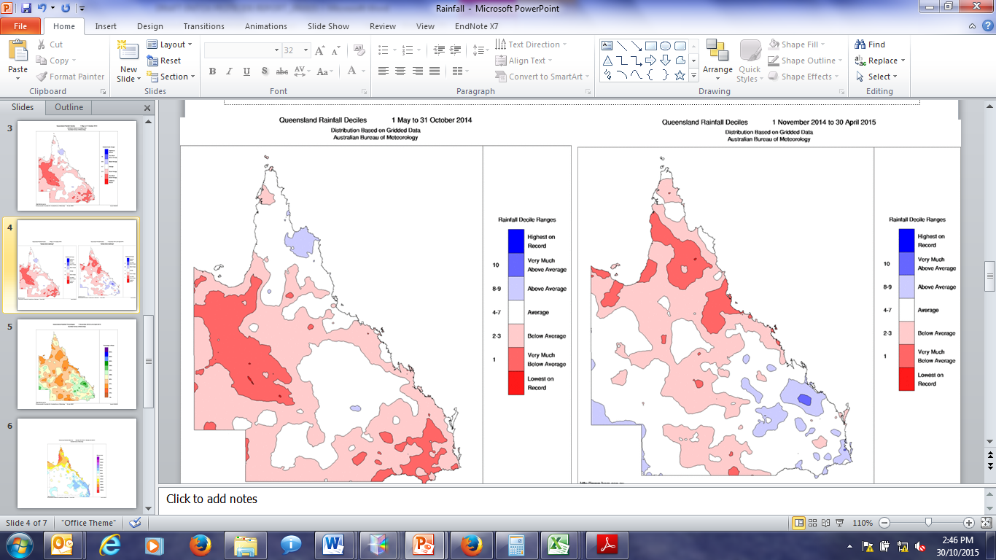
Figure A 1 Rainfall decile ranges for the dry season between May 2014- Oct 2014 (left) and wet season between Nov 2014 – 30 April 2015 (right).
Figure provided by Bureau of Meteorology

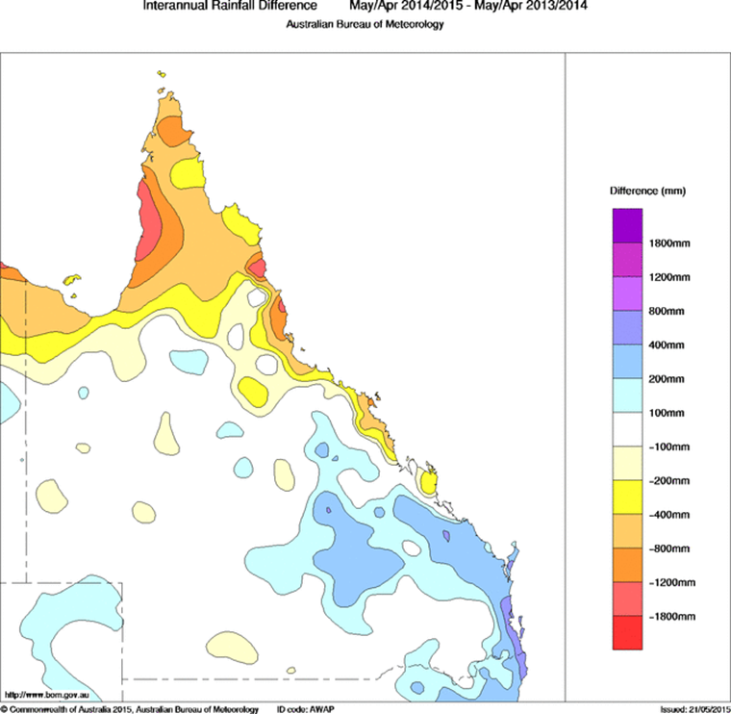
Figure A 2 One year inter-annual rainfall difference between the previous monitoring year (2013-14) and the current monitoring year (2014-15).
Figure provided by Bureau of Meteorology

APPENDIX D – Fixed monitoring – Individual site results
Table A 14 Low Isles, Wet Tropics region – Concentration in water (ng L⁻¹)
Concentrations are time-integrated estimates; Concentrations in italics did not exceed 3 x blank levels and are included as n.d. in summary statistics; Shaded pesticides and herbicides indicate that no calibration data is available and the sampling rate of atrazine was assumed. Water estimations are approximate; Results are rounded to two significant figures; **Concentration is average of duplicate samplers

Table A 15 Green Island, Wet Tropics region – Concentration in water (ng L⁻¹)
Concentrations are time-integrated estimates; Concentrations in italics did not exceed 3 x blank levels and are included as n.d. in summary statistics; Shaded pesticides and herbicides indicate that no calibration data is available and the sampling rate of atrazine was assumed. Water estimations are approximate; Results are rounded to two significant figures

Table A 16 Fitzroy Island, Wet Tropics region – Concentration in water (ng L⁻¹)
Concentrations are time-integrated estimates; Concentrations in italics did not exceed 3 x blank levels and are included as n.d. in summary statistics; Shaded pesticides and herbicides indicate that no calibration data is available and the sampling rate of atrazine was assumed. Water estimations are approximate; Results are rounded to two significant figures; **Concentration is average of duplicate samplers

Table A 17 Dunk Island, Wet Tropics region – Concentrations in water (ng L⁻¹)
Concentrations are time-integrated estimates; Concentrations in italics did not exceed 3 x blank levels and are included as n.d. in summary statistics; Shaded pesticides and herbicides indicate that no calibration data is available and the sampling rate of atrazine was assumed. Water estimations are approximate; Results are rounded to two significant figures

Table A 18 Normanby Island, Wet Tropics region – Concentrations in water (ng L⁻¹)
Concentrations are time-integrated estimates; Concentrations in italics did not exceed 3 x blank levels and are included as n.d. in summary statistics; Shaded pesticides and herbicides indicate that no calibration data is available and the sampling rate of atrazine was assumed. Water estimations are approximate; Results are rounded to two significant figures

Table A 19 Lucinda, Wet Tropics region – Concentrations in water (ng L⁻¹)
Concentrations are time-integrated estimates; Concentrations in italics did not exceed 3 x blank levels and are included as n.d. in summary statistics; Shaded pesticides and herbicides indicate that no calibration data is available and the sampling rate of atrazine was assumed. Water estimations are approximate; Results are rounded to two significant figures; **Concentration is average of duplicate samplers;? = MCPA was detected at relatively elevated concentration in one replicate only and has not been reported.
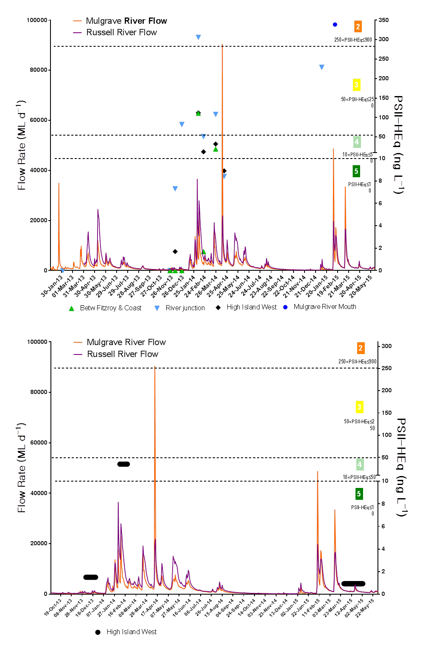
Figure A 3 Timing and location of grab (top) and passive (bottom) samples collected on the Russell-Mulgrave River transect, Wet Tropics, between 2013-2015

Figure A 4 Timing and location of grab (top) and passive (bottom) samples collected on the Tully River transect, Wet Tropics, between 2010-2015
Table A 20 Orpheus Island, Burdekin region – Concentrations in water (ng L-1)
Concentrations are time-integrated estimates; Concentrations in italics did not exceed 3 x blank levels and are included as n.d. in summary statistics; Shaded pesticides and herbicides indicate that no calibration data is available and the sampling rate of atrazine was assumed. Water estimations are approximate; Results are rounded to two significant figures

Table A 21 Cape Cleveland, Burdekin Region – Concentrations in water (ng L⁻¹)
Concentrations are time-integrated estimates; Concentrations in italics did not exceed 3 x blank levels and are included as n.d. in summary statistics; Shaded pesticides and herbicides indicate that no calibration data is available and the sampling rate of atrazine was assumed. Water estimations are approximate; Results are rounded to two significant figures; **Concentration is average of duplicate samplers

Table A 22 Barratta Creek, Burdekin Region – Concentrations in water (ng L⁻¹)
Concentrations are time-integrated estimates; Concentrations in italics did not exceed 3 x blank levels and are included as n.d. in summary statistics; Shaded pesticides and herbicides indicate that no calibration data is available and the sampling rate of atrazine was assumed. Water estimations are approximate; Results are rounded to two significant figures; **Concentration is average of duplicate samplers

Table A 23 Barratta Creek case study, Burdekin region – Water concentrations (ng L⁻¹)
Concentrations are time-integrated estimates; Concentrations in italics did not exceed 3 x blank levels and are included as n.d. in summary statistics; Shaded pesticides and herbicides indicate that no calibration data is available and the sampling rate of atrazine was assumed.
Water estimations are approximate; Results are rounded to two significant figures; **Concentration is average of duplicate samplers

Table A 24 Outer Whitsunday, Mackay Whitsunday region – Concentrations in water (ng L⁻¹)
Concentrations are time-integrated estimates; Concentrations in italics did not exceed 3 x blank levels and are included as n.d. in summary statistics; Shaded pesticides and herbicides indicate that no calibration data is available and the sampling rate of atrazine was assumed. Water estimations are approximate; Results are rounded to two significant figures; **Concentration is average of duplicate samplers
Table A 25 Repulse Bay, Mackay Whitsunday region – Concentrations in water (ng L⁻¹)
Concentrations are time-integrated estimates; Concentrations in italics did not exceed 3 x blank levels and are included as n.d. in summary statistics; Shaded pesticides and herbicides indicate that no calibration data is available and the sampling rate of atrazine was assumed. Water estimations are approximate; Results are rounded to two significant figures; **Concentration is average of duplicate samplers
Table A 26 Round/ Flat Top, Mackay Whitsunday region – Concentrations in water (ng L⁻¹)
Concentrations are time-integrated estimates; Concentrations in italics did not exceed 3 x blank levels and are included as n.d. in summary statistics; Shaded pesticides and herbicides indicate that no calibration data is available and the sampling rate of atrazine was assumed. Water estimations are approximate; Results are rounded to two significant figures; **Concentration is average of duplicate samplers

Table A 27 Sarina Inlet, Mackay Whitsunday region – Concentrations in water (ng L⁻¹)
Concentrations are time-integrated estimates; Concentrations in italics did not exceed 3 x blank levels and are included as n.d. in summary statistics; Shaded pesticides and herbicides indicate that no calibration data is available and the sampling rate of atrazine was assumed. Water estimations are approximate; Results are rounded to two significant figures; **Concentration is average of duplicate samplers
Table A 28 Sandy Creek, Mackay Whitsunday region – Concentrations in water (ng L⁻¹)
Concentrations are time-integrated estimates; Concentrations in italics did not exceed 3 x blank levels and are included as n.d. in summary statistics; Shaded pesticides and herbicides indicate that no calibration data is available and the sampling rate of atrazine was assumed. Water estimations are approximate; Results are rounded to two significant figures; **Concentration is average of duplicate samplers
Table A 29 North Keppel Island, Fitzroy Region – Concentrations in water (ng L⁻¹)
Concentrations are time-integrated estimates; Concentrations in italics did not exceed 3 x blank levels and are included as n.d. in summary statistics; Shaded pesticides and herbicides indicate that no calibration data is available and the sampling rate of atrazine was assumed. Water estimations are approximate; Results are rounded to two significant figures; **Concentration is average of duplicate samplers

APPENDIX E – Terrestrial run-off assesment- Results
Table A 30 Concentrations in water (ng L⁻¹) measured along the Tully River and Russell-Mulgrave River transects using passive samplers during the wet season
Concentrations are time-integrated estimates; Concentrations in italics did not exceed 3 x blank levels and are included as n.d. in summary statistics; Shaded pesticides and herbicides indicate that no calibration data is available and the sampling rate of atrazine was assumed. Water estimations are approximate; Results are rounded to two significant figures; **Concentration is average of duplicate samplers

Table A 31 Concentrations in water (ng L⁻¹) measured at various locations along the river transects using 1 L grab samples during the wet season

APPENDIX F – Mean flow rates, PSII-HEq of passive samplers and Plume colour class of major rivers
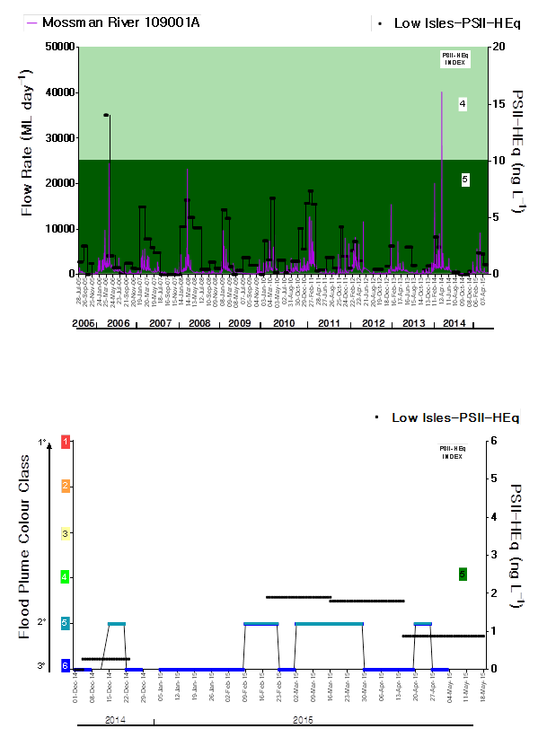
Figure A 5 Temporal trends in PSII-HEq with respect to flow rate of rivers influencing passive sampler site at Low Isles in the Wet Tropics region since monitoring commenced
(Flow data provided by Department of Environment and Resource Management, Stream Gauging Network), Colour class data provided by Dieter Tracey (JCU)
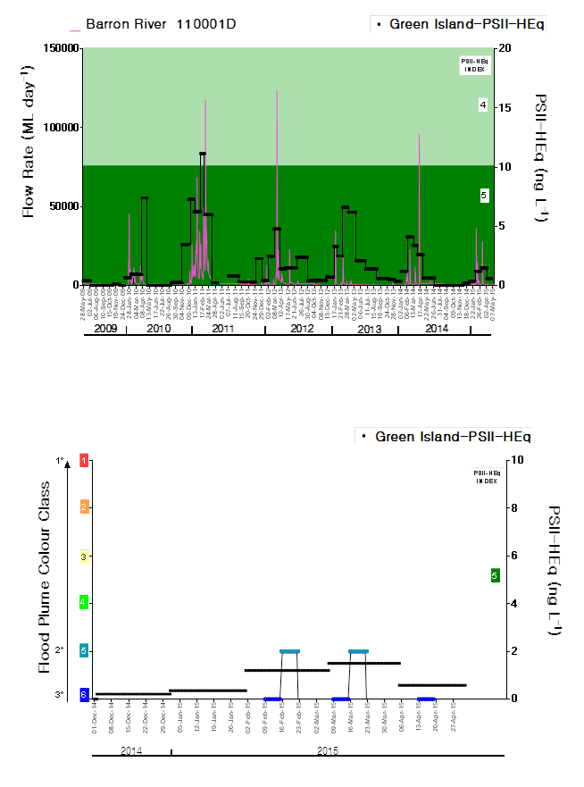
Figure A 6 Temporal trends in PSII-HEq with respect to flow rate of rivers influencing passive sampler site at Green Island in the Wet Tropics region since monitoring commenced
(Flow data provided by Department of Environment and Resource Management, Stream Gauging Network), Colour class data provided by Dieter Tracey (JCU)

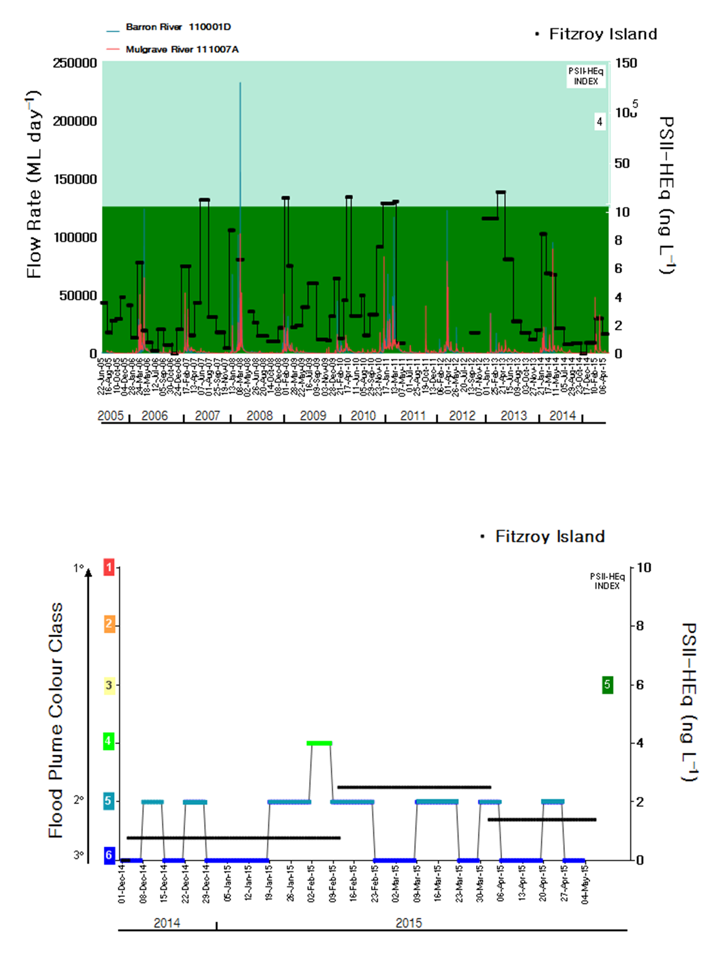
Figure A 7 Temporal trends in PSII-HEq with respect to flow rate of rivers influencing Fitzroy Island passive sampler site in the Wet Tropics region since monitoring commenced
(Flow data provided by Department of Environment and Resource Management, Stream Gauging Network) Colour class data provided by Dieter Tracey (JCU)

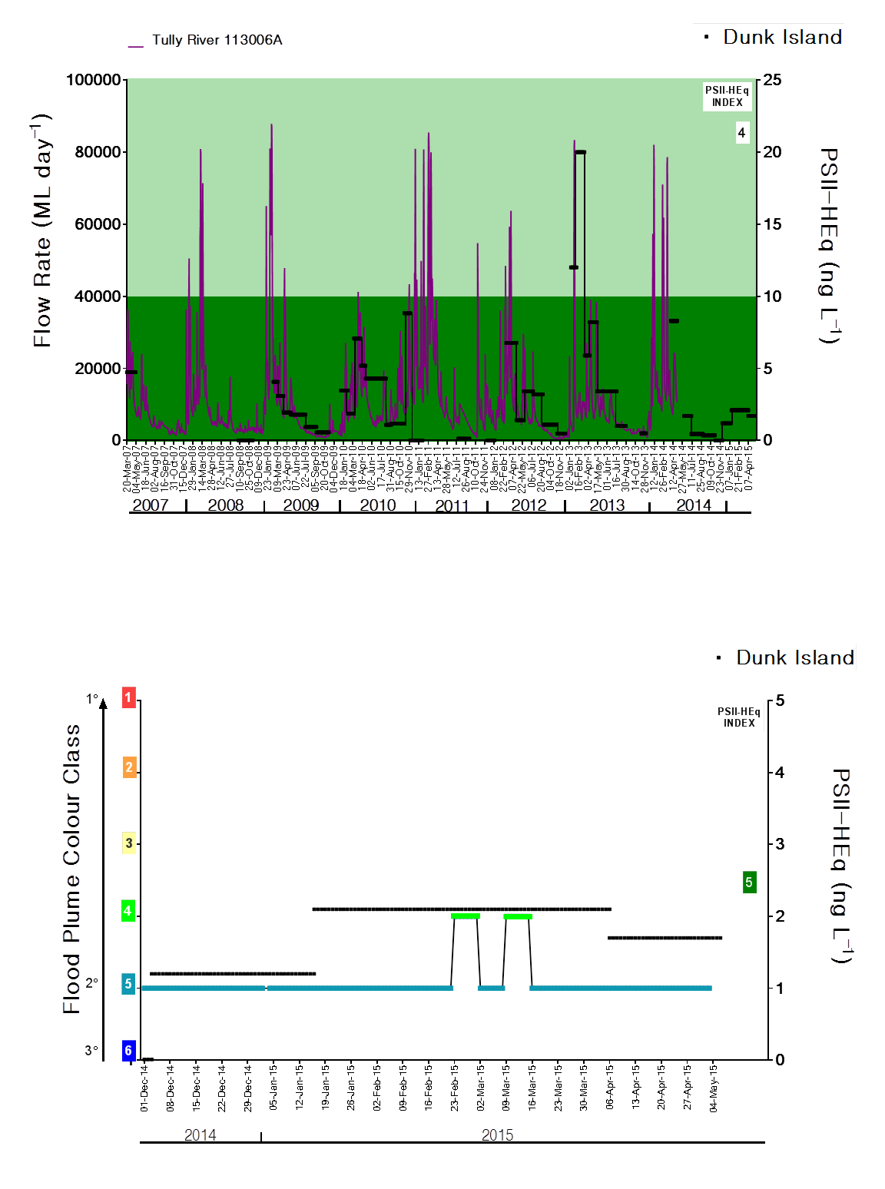
Figure A 8 Temporal trends in PSII-HEq with respect to flow rate of rivers influencing Dunk Island passive sampler site in the Wet Tropics region since monitoring commenced
Flow data provided by Department of Environment and Resource Management, Stream Gauging Network) Colour class data provided by Dieter Tracey (JCU)
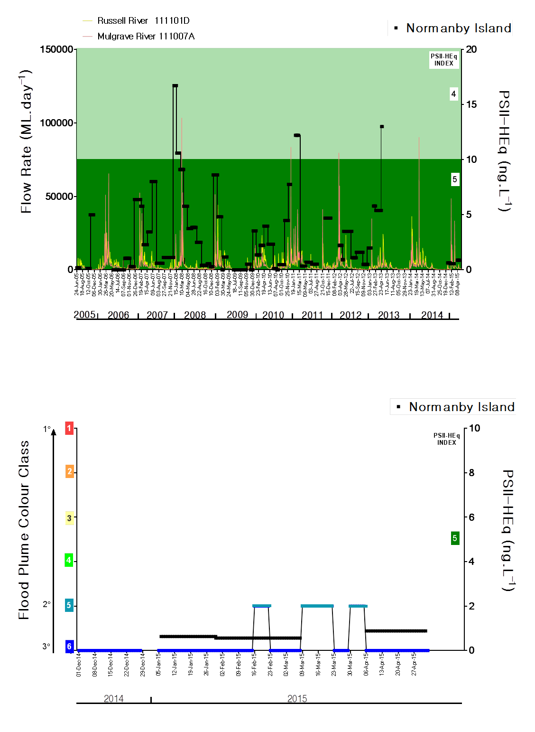
Figure A 9 Temporal trends in PSII-HEq with respect to flow rate of rivers influencing the Normanby Island passive sampler site in the Wet Tropics region since monitoring commenced
(Flow data provided by Department of Environment and Resource Management, Stream Gauging Network) Colour class data provided by Dieter Tracey (JCU)

Figure A 10 Temporal trends in PSII-HEq with respect to flow rate of rivers influencing the Lucinda passive sampler site in the Burdekin region since monitoring commenced
(Flow data provided by Department of Environment and Resource Management, Stream Gauging Network)
Colour class data provided by Dieter Tracey (JCU)

Figure A 11 Temporal trends in PSII-HEq with respect to flow rate of rivers influencing the Orpheus Island passive sampler site in the Burdekin region since monitoring commenced
(Flow data provided by Department of Environment and Resource Management, Stream Gauging Network) Colour class data provided by Dieter Tracey (JCU)
Figure A 12 Temporal trends in PSII-HEq with respect to flow rate of rivers influencing the Cape Cleveland passive sampler site in the Burdekin region since monitoring commenced
(Flow data provided by Department of Environment and Resource Management, Stream Gauging Network) Colour class data provided by Dieter Tracey (JCU)
Figure A 13 Temporal trends in PSII-HEq with respect to flow rate of rivers influencing the Barratta Creek mouth passive sampler site in the Burdekin region since monitoring commenced
(Flow data provided by Department of Environment and Resource Management, Stream Gauging Network) Colour class data provided by Dieter Tracey (JCU)
Figure A 14 Temporal trends in PSII-HEq with respect to flow rate of rivers influencing the Barratta Creek case study passive sampler site in the Burdekin region
(Flow data provided by Department of Environment and Resource Management, Stream Gauging Network) Colour class data provided by Dieter Tracey (JCU)
Figure A 15 Temporal trends in PSII-HEq with respect to flow rate of rivers influencing the Outer Whitsunday passive sampler site in the Mackay Whitsunday region since monitoring commenced
(Flow data provided by Department of Environment and Resource Management, Stream Gauging Network) Colour class data provided by Dieter Tracey (JCU)
Figure A 16 Temporal trends in PSII-HEq with respect to flow rate of rivers influencing the Repulse Bay passive sampler site in the Mackay Whitsunday region since monitoring commenced
(Flow data provided by Department of Environment and Resource Management, Stream Gauging Network) Colour class data provided by Dieter Tracey (JCU)
Figure A 17 Temporal trends in PSII-HEq with respect to flow rate of rivers influencing the Round/ Flat Top passive sampler site in the Mackay Whitsunday region since monitoring commenced
(Flow data provided by Department of Environment and Resource Management, Stream Gauging Network) Colour class data provided by Dieter Tracey (JCU)
Figure A 18 Temporal trends in PSII-HEq with respect to flow rate of rivers influencing the Sandy Creek passive sampler site in the Mackay Whitsunday region since monitoring commenced
(Flow data provided by Department of Environment and Resource Management, Stream Gauging Network) Colour class data provided by Dieter Tracey (JCU)

Figure A 19 Temporal trends in PSII-HEq with respect to flow rate of rivers influencing the Sarina Inlet passive sampler site in the Mackay Whitsunday region since monitoring commenced
(Flow data provided by Department of Environment and Resource Management, Stream Gauging Network) Colour class data provided by Dieter Tracey (JCU)

Figure A 20 Temporal trends in PSII-HEq with respect to flow rate of rivers influencing the North Keppel Island passive sampler site in the Fitzroy region since monitoring commenced
(Flow data provided by Department of Environment and Resource Management, Stream Gauging Network) Colour class data provided by Dieter Tracey (JCU)

APPENDIX G – Historical concentration profiles at fixed monitoring sites
Figure A 21 Temporal concentration profiles of individual herbicides at Low Isles in the Wet Tropics region

Figure A 22 Temporal concentration profiles of individual herbicides at Green Island in the Wet Tropics region
Figure A 23 Temporal concentration profiles of individual herbicides at Fitzroy Island in the Wet Tropics region
Figure A 24 Temporal concentration profiles of individual herbicides at Dunk Island in the Wet Tropics region
Figure A 25 Temporal concentration profiles of individual herbicides at Normanby Island in the Wet Tropics region
Figure A 26 Temporal concentration profiles of individual herbicides at Lucinda in the Wet Tropics region
Figure A 27 Temporal concentration profiles of individual herbicides at Orpheus Island in the Burdekin region
Figure A 28 Temporal concentration profiles of individual herbicides at Cape Cleveland in the Burdekin region
Figure A 29 Temporal concentration profiles of individual herbicides at Barratta Creek mouth in the Burdekin region

Figure A 30 Temporal concentration profiles of individual herbicides at the Barratta Creek case study sites in the Burdekin region

Figure A 31 Temporal concentration profiles of individual herbicides at Outer Whitsunday in the Mackay Whitsunday region
Figure A 32 Temporal concentration profiles of individual herbicides at Repulse Bay in the Mackay Whitsunday region
Figure A 33 Temporal concentration profiles of individual herbicides at Round/ Flat Top Island in the Mackay Whitsunday region
Figure A 34 Temporal concentration profiles of individual herbicides at Sandy Creek in the Mackay Whitsunday region
Figure A 35 Temporal concentration profiles of individual herbicides at Sarina Inlet in the Mackay Whitsunday region
Figure A 36 Temporal concentration profiles of individual herbicides at North Keppel Island in the Fitzroy region

APPENDIX H - Land and herbicide use in the Reef catchments adjacent to fixed monitoring sites
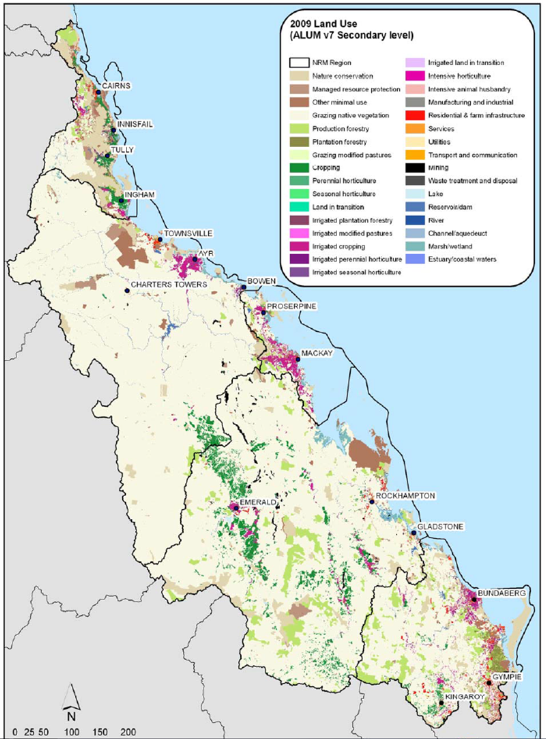
Figure A 37 Land Use map of the Reef catchment (2009).

17 APPENDIX I – CASE STUDY: Comparison of the multi-substance potentially affected fraction (ms-PAF) and PSII-HEQ methods
The Australian and New Zealand Guidelines for Fresh and Marine Water Quality, originally released in 2000 are currently under review (co-ordinated by the Australian Department of Sustainability, Environment, Water, Population and Communities) to ensure they remain updated with the most recent advances in science, are relevant and still reflect the best practise tool for managing the quality of water in Australia. Some of the key changes to the previous version of the Guidelines will be to
- increase the types and sources of data that can be used;
- working collaboratively with industry to permit the use of commercial-in-confidence data;
- increasing the minimum data requirements;
- including a measure of the uncertainty of the trigger value;
- improving the software used to calculate trigger values;
- increasing the rigour of site-specific trigger values;
- improving the method for assessing the reliability of the trigger values;
- and providing guidance of measures of toxicity and toxicological endpoints that may, in the near future, be appropriate for trigger value derivation (Warne et al., 2014).

The revision of the GVs will improve the number of and quality of GVs that can be derived (in part due to the inclusion of previously excluded data-sets), will be more user-friendly and assist managers in implementing them in a scientifically rigorous manner by considering more ecologically relevant endpoints. The preferred method for deriving these GVs is based on the use of species sensitivity distributions (SSDs) of chronic toxicity data, which has been revised and improved (as above) for this iteration of GVs (Batley et al., 2014, Warne et al., 2015).

SSDs are derived by collating toxicity data of individual chemicals from sources which has now been expanded to include data outside of peer-reviewed publications as well as data of non-traditional endpoints that have demonstrated ecological relevance for keystone species. The data (preferentially chronic no observed effect concentration (NOEC) and EC/IC or LC₁₀ data) are screened and assessed for quality (Batley et al., 2014), converted to a single value per species, assessed for modality and plotted using BurrliOz software, used to derive the GVs. SSDs for both marine and freshwater environments are being derived however, in cases where the minimum data requirements to generate a reliable marine SSD could not be met, toxicity data for freshwater and estuarine species were added to expand the dataset, meet the minimum data requirements and improve the reliability classification. Further details regarding the methods for deriving SSDs including the weighting of data and requirements for data inclusion (considering geography and climate of species) are provided in (Batley et al., 2014).

The PSII-HEq method is currently used in the MMP for estimating the hazard of herbicide mixtures to marine ecosystems by calculating diuron-equivalent herbicide concentrations. Despite being widely used and simple to calculate, the current method is limited by its requirement for matched toxicity data sets; i.e. to calculate the relative potency of a herbicide to diuron. Unfortunately, matched toxicity data within the literature is sparse and are typically limited to only a few select compounds and species. Alternatively, the Multisubstance-Potentially Affected Fraction (ms-PAF) method (Traas et al., 2002) uses SSDs of individual compounds, comparable to those used for generating water quality guideline values, the data for which are more commonly found in the literature. Thus, to align with the revised methods for GV derivation, as well as the hazard-based approach adopted by the Paddock to Reef program, the ms-PAF method has been proposed for estimating the potential ecological impacts of pesticide mixtures in the marine zone.

Unlike the HEq method, ms-PAF can account for mixtures of chemicals with both similar and dissimilar modes of action (however only the additive model which accounts for chemicals with similar modes of action is considered in this report), an important consideration given the increasing use of alternative pesticides with different modes of action in the Reef catchments. The ms-PAF concentration addition method is based on the premise that toxicants with similar modes of action will have parallel SSDs, and therefore, upon transforming the toxicity data to a relative scale (hazard units), the SSDs for each toxicant are equivalent (Figure A 38).

A SSD is a cumulative frequency distribution of the toxicity of a contaminant to a range of species which represent a specified number of taxonomic groups. They are used to determine a contaminant concentration that is theoretically protective of a given percentage (x) of species. The ANZEC and ARMCANZ (2000) water quality guidelines generate contaminant trigger values based on four different protection levels, which are recommended to be applied according to the following: the protection of 99% of species is recommended for high conservation value ecosystems (this is the protection level most relevant to the Reef), protection of 95% of species for slightly to moderately disturbed ecosystems, and the protection of 90% or 80% of species for highly disturbed ecosystems (Batley et al., 2014). It should be noted that the same protection levels will continue to be used in the revised water quality guidelines.

Briefly, each SSD is normalised to the midpoint of the distribution, such that the centre of the SSD takes the value of 1 (Figure A 38(b)). The units of this normalised scale are termed as hazard units, i.e. one hazard unit of a contaminant is equal to the concentration of the contaminant that affects 50% of species. For example, one hazard unit for Chemical A (in Figure A 38(a)) is equal to 10 ug/L of Chemical A, which is the concentration of chemical A that affects 50% of species. As such, the SSDs of each chemical are normalised to the same scale and centred at x=1, and as previously mentioned, those with the same mode of action will overlay each other (as shown in Figure A 38(b)) and can therefore be combined to generate one SSD representative of the contaminant mixture (the mixture SSD). To then determine the ms-PAF of a field sample, the concentration of each contaminant (with the same mode of action) detected in the sample is converted to a hazard unit using the midpoint of the contaminant’s SSD. The hazard units of each contaminant are then summed to produce a HU of the mixture. The mixture HU can then be checked against the mixture SSD to calculate the per cent of species potentially affected by the mixture.
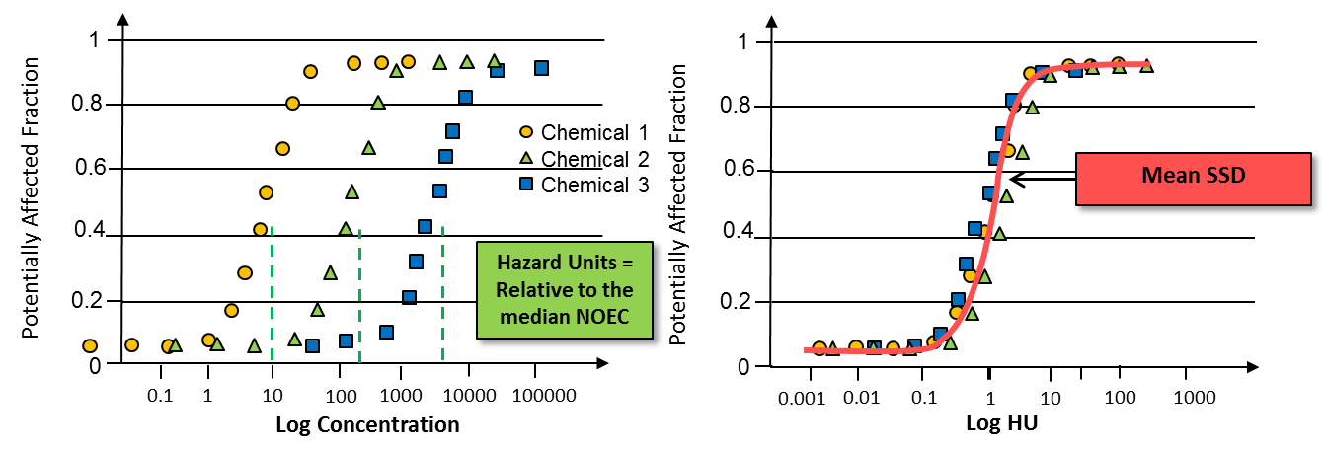
Figure A 38 SSDs of chemicals for multiple species (left) which are then normalized to hazard units, relative to the median of species affected to calculate a mean SSD (right).

SSDs for five PSII herbicides – ametryn, atrazine, diuron, hexazinone and tebuthiuron – all of which are reported both by the MMP and the Paddock to Reef program as priority herbicides have been provided to Entox. It is anticipated that these SSDs will be updated before the end of the year to include additional species to improve the reliability of the SSD. For the purposes of this report, the ms-PAF values have been categorised into five interim risk categories (Table 6), corresponding to the 99 %, 95 %, 90 % and 80 % species protection levels used by the ANZECC and ARMCANZ (2000) water quality guidelines. The concentrations of diuron equivalent to these risk classes (i.e. the concentration of diuron that is required to exceed x % of species protection) are presented also. It is important to note that the risk classes need to be validated against relevant Reef species for ecologically relevant tipping points in order to determine whether they are meaningful. The inclusion of new chronic data (Negri et al., 2015) (excluded from previous GVs but of demonstrated local relevance) may improve reliability of the SSDs and confidence in risk classes.

Each method has five risk categories, which are protective of varying percentages of species, with 99% species protection being the benchmark for the Reef. Four of the five risk categories for the PSII-HEq Index are more conservative than the 99% species protection value (based on diuron equivalent concentrations), whereas four of the five interim ms-PAF risk categories are less conservative than the 99% species protection trigger value. This inconsistency in scaling of the risk categories above/ below the 99 % trigger value means that there is no pre-warning of concentrations that are approaching the trigger value for the ms-PAF method, which is currently present in the PSII-HEq Index.

As a case study, the two methods of assessing the environmental hazard of additive herbicide mixtures (the PSII-HEq Index and ms-PAF method) were compared this monitoring year. PSII-HEq concentrations and ms-PAF values were calculated for all fixed monitoring sites (passive samplers) (Table A 33) and for grab samples and passive samplers collected and deployed along transects extending from rivers as part of the terrestrial run-off component of the project (Table A 34). The ms-PAF values were calculated based on the maximum estimated water concentrations of individual herbicides detected (ng L⁻¹) during a given monitoring year and not PSII-HEq concentrations.

Table A 32 Interim risk categories for marine waters using the ms-PAF method, (percentage of species potentially affected and the corresponding equivalent diuron concentration (ng L⁻¹)

Table A 33 Comparison of PSII-HEq Max (ng/L) and ms-PAF Max (% species affected) values for all fixed monitoring sites since monitoring commenced.

For all sites in the Wet Tropics since monitoring commenced (Table A 33, Low Isles – Dunk Island?), the ms-PAF Max values were in the ‘Very Low Risk’ Category, ranging from <0.01 % to 0.16 % of species potentially affected. For the same period, PSII-HEq concentrations ranged from 0.88 to 22 ng L⁻¹, corresponding to Categories 4 to 5 on the PSII Index. In the Burdekin region (Table A 33, Lucinda? – Barratta Creek mouth), the ms-PAF Max values were also in the ‘Very Low Risk’ Category, ranging from <0.01 % to 0.08 % of species potentially affected (excluding the potential outlier at Orpheus Island in 2009-10). This corresponded to PSII-HEq concentrations of 0.67 to 20 ng L⁻¹ (also Category 4 to 5 on the PSII Index). Maximum ms-PAF values for this monitoring year were the highest in the Mackay Whitsunday region (Table A 33, Outer Whitsunday – Sarina Inlet) (maximum of 0.55 % at Sandy Creek), historically reaching a maximum of 11 % at Sarina Inlet in 2009 -10. PSII-HEq concentrations ranged from 2.2 to 495 ng L⁻¹, Category 2 to 5 on the PSII Index. Maximum ms-PAF values were also ‘Very Low’ at the single site in the Fitzroy region (Table A 33, North Keppel Island), ranging from <0.01 % to 0.03 %, or Category 4 to 5 on the PSII Index.

Table A 34 Comparison of PSII-HEq Max (ng/L) and ms-PAF Max (% species affected) values for passive samplers and grab samples collected on river transects during the 2014-15 wet season.

Passive samplers deployed along river transects (top of Table A 34) reached a maximum of ‘Very Low’ (0.02 % of species potentially affected) or Category 4 (Low) on the PSII Index. Grab samples (bottom of Table A 34) reached a maximum ‘Low’ (4.3 % of species potentially affected) using the ms-PAF method or Category 2 (High) on the PSII Index. Two grab samples exceeded the 1% species protection level (calculated based on ms-PAF) , and one grab sample exceeded the marine IWL for diuron.

Table A 35 Comparison of PSII-HEq Max (ng/L) and ms-PAF Max (% species affected) values for passive samplers deployed in the Barratta Creek

At the Upper Barratta Creek site, up to 79 % of species (Very High) were potentially affected based on the results of the ms-PAF method, corresponding to a Category 1 (Very High) on the PSII Index. A substantial dilution of herbicide concentrations (and thus risk categories) can be seen, moving downstream and into the marine environment. Whilst only a single passive sampler was successfully deployed at the marine site, the ms-PAF value had decreased to below the proposed protection level of 99% species protection (0.02 % of species).

Using the interim ms-PAF risk categories, the majority of herbicide detections using passive samplers (with the exception of Barratta Creek) resulted in a ‘Very Low’ Category, with little visual distinction between sites or sampling periods, despite clearer differences in the concentrations of herbicides when considering raw water concentrations or PSII-HEq concentrations. For example, a site such as the Outer Whitsunday, which has had historical PSII-HEq Max concentrations that range between 3.4 – 42 ng L⁻¹ (Categories 4 and 5 on the PSII Index), correspond to ms-PAF Max values of between <0.01 - 0.20 %. In this case, the PSII-HEq Max concentrations (ng/L) reach only 5 % of the (current) marine trigger value for diuron yet have triggered a higher level of risk, whereas the ms-PAF Max values reach 20 % of the proposed new National Water Quality GV (under development) but are categorised as Low Risk.

It must be noted that the use of individual herbicide concentrations versus diuron equivalent concentrations will produce different ms-PAF values, as each individual herbicide contributes to the beta value or slope of the SSD. For example, each of the samples below have concentrations of herbicides that are equivalent to a PSII-HEq concentration of 500 ng L⁻¹. When using only the diuron equivalent concentration (example 1), the corresponding ms-PAF value is 6.1 %. If the individual concentrations of each herbicide are considered (examples 2 – 7), the resulting ms-PAF values can range widely (from 6.9 % to 14 %), depending on the profiles of herbicides present.
Table A 36 Comparison of the ms-PAF values of various hypothetical herbicide profiles (ng L⁻¹)

It is clear that further careful consideration of the risk categories must be undertaken to capture the most ecologically relevant, reasonable and protective tipping points. Over-estimations of herbicide exposure can be politically challenging if imposing increasing regulation onto major industries.. Furthermore, it may unintentionally create difficulties in identifying and prioritising areas of greatest management concern as a higher number of sites may appear to be at risk. An under-estimation of herbicide exposure could be catastrophic for the health and resilience of a fragile ecosystem already subjected to multiple local and global stressors. Risk categories need to link to true change in land management practices (and specific targets set out by Reef Plan), be wide enough to include the inherent uncertainty in the method (which increases as the 99 % protection level is approached) but refined enough to capture improvements in water quality and meet the objectives of Reef Plan. Before adopting the ms-PAF as part of the MMP’s annual reporting, it is pertinent to wait until GVs have been approved and SSDs for all chemicals earmarked for inclusion have been constructed to prevent any retrospective adjustments and a more accurate assessment of the hazard of environmental mixtures present.

